Teachers with Disabilities’ Perceived Work Experiences and Job Satisfaction

A Dissertation Presented for the
Doctor of Philosophy
Degree
The University of Tennessee, Knoxville

Amanda Michelle Carter
December 2024

Copyright © 2024 by Amanda Michelle Carter
All rights reserved.

DEDICATION
This dissertation is dedicated to the loving memory of my mother, Donna Jean Roland. Without you, Mom, I would not have made it this far. I remember the time when you encouraged me to pursue my dreams, even when I doubted myself. Your actions, like the time you stood up for what you believed in, showed me what it means to be a strong person. Through your words, you taught me how to stand up for myself. You have always been there for me, even when I felt like I had no one else. You cheered me on as I started this PhD, and I had hoped that you would have been able to live long enough to watch me graduate. However, God had other plans for you.

ACKNOWLEDGEMENTS
I want to thank the following people, without whom I would not have been able to complete this research and without whom I would not have made it through my doctoral program!
To my committee chair and members, Dr. Mari Beth Coleman, Dr. Tara Moore, Dr. Jennifer A. Morrow, and Dr. Ashlee Anderson, thank you for your support. To Dr. Mari Beth Coleman, my chair, thank you for all your words of encouragement, feedback, and help with the survey design. Your advice on structuring the literature review was particularly insightful. To Dr. Tara Moore, thank you for your research design knowledge, feedback, and encouragement. Your guidance on data analysis methods was invaluable. To Dr. Jennifer A. Morrow, thank you for your expert knowledge in survey design and research, feedback, and encouragement. Your suggestions on refining the research questions were crucial. To Dr. Ashlee Anderson, thank you for your expertise on social justice issues, feedback, and encouragement.
To my 5th grade teacher, Mrs. Patricia Pursley, I am deeply grateful for your belief in me and for including me in your classroom. To my 8th grade science teacher, Mrs. Edie Williams, your emotional support meant the world to me. To all my high school teachers, I am thankful for the safe space you created for me to learn. To Dr. James A. Black, my sociology criminology professor, I am grateful for the way you opened my eyes to the school-to-prison pipeline. To Dr. Ralph Brockett and Dr. Amy Skinner, my master's professors, I am thankful for your wealth of expertise in education and rehabilitation. To Dr. Sherry Bell, one of my educational specialist professors, I am grateful for your unwavering belief in me.
To my graduate support group, Shikha and Rachel, thank you for being there for me during difficult times, especially the passing of my mom, and for your emotional support. To my DGB friends, Jose, Ivan, Rudy, and Regina, thank you for all your encouraging words and funny times hanging out. To my college friends, Jenny and Lena, thank you for all your support and listening to me vent.
A heartfelt thanks to my family for the diverse ways you've supported me over the past five and a half years. To my sisters and stepsiblings, Amber, Brittany, Jaimee, Jami, Jessica, and Jeffrey (Brittany), your encouragement and understanding have been a constant. To my Dad, Mike, your help with my final semester and your words of encouragement have been a guiding light. To my stepdad, Jeff, your assistance with my transportation issues has been a huge relief. To my father, George, thank you for bringing me into this world. To my in-laws, George and Rita, your encouragement and help with our housing and transportation issues have been a blessing. Thank you for your encouragement to my aunts, uncles, cousins, brothers-in-law, and sisters-in-law. And to my cats, Isabelle and Sassy, your emotional support and comfort
have been a solace.
Thomas, my love, the depth of my gratitude to you is immeasurable. Your emotional, financial, and physical support have been my rock. You've been there for me in the darkest of times, always offering words of encouragement and a listening ear, free of judgment. You are not just my husband, but my best friend, and I cannot imagine my life without you.
ABSTRACT
Despite laws such as the Rehabilitation Act of 1973 and the Americans with disabilities, employment levels for people with disabilities remain low. One of those employment sectors were employments levels for people with disabilities is lower than the average is education. However, there is little information on the teachers with disabilities, and therefore, no evidence to help explain so low levels. Prior research conducted has focused mainly on the dilemma of disclosing teachers’ disabilities. What has not been explored is teachers with disabilities’ perceived work experiences and teachers with disabilities’ job satisfaction levels. This survey study explored teachers with disabilities’ perceived work experiences and job satisfaction levels in order to provide information for future research on the employment of teachers with disabilities. The results from this study indicated that teachers with disabilities’ perceptions of their work experiences are far from positive although teachers with disabilities have average to above average job satisfaction levels. The implications of this study are as follows: 1) addresses the gap in the literature on teachers with disabilities, 2) provides new information on the work experiences of teachers with disabilities, 3) provides information on teachers with disabilities’ job satisfaction levels, 4) provides some information on the workplace culture of K-12 schools, and 5) provides a census.

TABLE OF CONTENTS
CHAPTER ONE INTRODUCTION TO THE STUDY 1
Historical Background and Disability Employment Laws 1
Sections 501 and 503 of the Rehabilitation Act of 1973 2
The Americans with Disabilities Act of 1990 4
The Americans with Disabilities Act Amendments Act of 2008 7
Statement of Problem 7
Employment of People with Disabilities 7
Employment of Teachers with Disabilities 8
The Purpose of the Study 8
The Significance of the Study 9
Research Questions 10
Theoretical Framework 10
Key Terms and Definitions 11
Assumptions, Delimitations, and Limitations 12
Assumptions 12
Delimitations 12
Limitations 13
Chapter Summary 13
CHAPTER TWO LITERATURE REVIEW 15
The Employment of People with Disabilities 15
Work Experiences and Job Satisfaction………………………………………… 15
General Workplace Supports and Work Conditions 16
Disclosure Dilemma 18
Organizational Culture 20
Workplace Accommodations 21
Discrimination and Discrimination Rates 23
Employers’ Attitudes, Beliefs, and Perceptions 24
Differences in Industries 25
Impact on Employees with Disabilities’ Well-Being and Their Lives 28
The Employment of Teachers with Disabilities 29
Teachers without Disabilities 30
Special Education Teachers 30
Black and Hispanic Teachers 33
Teachers with Disabilities 34
Disclosure Dilemma 34
Other Ethical Dilemmas 35
Experiences of Teachers with Disabilities 36
Coping Strategies, Family and Support, and Teaching Practices 38
Litigation 38
Gaps in the Literature 39
Theoretical Framework 40
The Medical Model of Disability 40
The Social Model of Disability 41
Critical Disability Studies Model of Disability 43
Disability Models Shaping Perceptions of PWD 44
Positionality 45
Chapter Summary 47
CHAPTER THREE METHODS 48
Research Design and Rationale 48
Sampling Methods, Recruitment, and Data Collection 49
Survey Design and Measurements 52
Chronic Work Discrimination and Harassment Scale 53
Requesting Permission 54
Reliability and Validity 55
The Everyday Discrimination Scale 56
Requesting Permission 57
Reliability and Validity 57
Support for Workers with Disability Scale 57
Requesting Permission 58
Reliability and Validity 59
Mohrman-Cooke-Mohrman Job Satisfaction Scales 59
Requesting Permission 60
Reliability and Validity 60
Design Layout and Participation Procedures 60
Data Collection Timeframe 63
Data Analysis 63
Chapter Summary 64
CHAPTER FOUR ANALYSIS AND FINDINGS 65
Data Cleaning and Analysis 66
Quantitative Data 68
Quantitative Data 68
Results 69
Demographics and Background Characteristics of Participants 69
Position Areas Educators Teach or Have Taught 69
Grade Levels Taught 70
School Setting 72
Educational Attainment 72
The Main Effect or Nature of Disability 72
Disability Visibility 75
Disability Disclosure 75
Requesting Accommodations 78
Gender 78
Race/Ethnicity 81
Number of Years Taught 81
Data Analysis of the Research Questions 81
Perceptions of Work Experiences 81
Situations Arising At Work 85
Unfairly Given Tasks 85
Opinion Not Asked For 86
Watched More Closely 89
Disability-Related Derogatory Remarks 89
Derogatory Remarks Towards Participants 89
Working Twice as Hard 92
Ignored or Not Taken Seriously 92
Not Receiving Leadership Opportunities 95
Being Humiliated 95
Lower Job Status 98
Treated with Less Respect 98
Less Smart 102
Afraid or Uncomfortable 102
Threatened or Harassed 102
Administrative Support 105
Knowledge of Disability 105
Not Patronizing or Condescending 107
Value Contributions 107
Fair Feedback on Job Performance 111
Providing Accommodations After Requesting Them 111
Accommodations Provided in a Timely Manner 111
Demonstrates Trust in Job Performance 114
Supportive of Accommodations Needed 114
Talking about My Concerns 114
Main Reason for Experiences 118
Level of Job Satisfaction 118
The Feelings of Self-Esteem or Self-Respect 122
Growth and Development 122
Worthwhile Accomplishment 122
Expectations of Job 122
Amount of Respect and Fair Treatment 123
The Feeling of Being Informed 123
Amount of Supervision Received 123
Opportunity for Participation 123
Chapter Summary 125
CHAPTER FIVE DISCUSSION, IMPLICATIONS, AND FUTURE RESEARCH 126
Summary of Results 126
Perceptions of Work Experiences 126
Situations That Arise At Work 126
Administrative Support 129
Main Reason for These Experiences 131
Job Satisfaction Levels 132
Limitations 133
Implications 135
Future Research 137
REFERENCES 138
APPENDICES 177
Appendix A 177
Appendix B 196
Appendix C 197
Appendix D 199
VITA 200

LIST OF TABLES
Table 1. Number of Years Worked 84
Table 2. Themes for Experiences 120
Table 3. Level of Satisfaction of Various Facets of Job………………………………. 124

LIST OF FIGURES
Figure 1. Teaching Areas 71
Figure 2. School Setting 73
Figure 3. Educational attainment 74
Figure 4. Nature of disability 76
Figure 5. Visibility of disability 77
Figure 6. Disability disclosure 79
Figure 7. Requested accommodations 80
Figure 8. Gender 82
Figure 9. Race/ethnicity 83
Figure 10. Unfairly given tasks no one else wants to do 87
Figure 11. Opinions are not asked 88
Figure 12. Are watched more closely than others 90
Figure 13. Supervisors use disability-related derogatory remarks 91
Figure 14. Supervisors direct disability-related derogatory remarks at them 93
Figure 15. Have to work twice as hard as others work 94
Figure 16. Ignored or not taken seriously 96
Figure 17. Not receiving leadership opportunities 97
Figure 18. Humiliated in front of others at work 99
Figure 19. Lower status job 100
Figure 20. Being treated with less respect 101
Figure 21. Acts as if they think participants are not smart 103
Figure 22. Are afraid of or uncomfortable with your disability 104
Figure 23. Been threatened or harassed by your supervisor 106
Figure 24. Knowledge of my disability 108
Figure 25. Not patronizing or condescending towards me 109
Figure 26. Lets me know my contributions are valued 110
Figure 27. Provides me with fair feedback on my job performance 112
Figure 28. Provides me with accommodations after I request them 113
Figure 29. Ensures accommodations are provided in a timely manner 115
Figure 30. Demonstrates that they trusts my job performance 116
Figure 31. Supportive of accommodations that I need 117
Figure 32. Open to talking about my concerns 119

Introduction and General Information
This chapter examines why teachers with disabilities would have certain perceptions of work experiences and levels of job satisfaction. This chapter also introduces the research approach for this study, a survey, to learn more about teachers with disabilities' perceptions of their work experiences, what teachers with disabilities think are the main reasons for the experiences, and teachers with disabilities' levels of job satisfaction. This chapter will address the following: 1) the historical background of employment for persons with disabilities and the laws surrounding employment for persons with disabilities, 2) a statement of the problem, 3) the purpose of the study, 4) the significance of the study, 5) theoretical framework guiding the study, 6) research questions, 7) key terms and definitions, and 8) assumptions, limitations, and delimitations.
Historical Background and Disability Employment Laws
People, regardless of their abilities, share a common desire to work and find fulfillment, identity, and social connection through their jobs. This is no different for people with disabilities. However, since the 1970s, they have faced and continue to face significant challenges in their quest for employment rights.
Beginning in the 1970s with the disability rights movement, a series of laws were enacted to ensure that people with disabilities would have the right to work the same as those without disabilities. The first significant legislation regarding this issue was the Rehabilitation Act of 1973. This law gave people with disabilities the right to access and participate in programs that were receiving federal funding. In 1990, the Americans with Disabilities Act was signed into law. This Act stated that people with disabilities have the right to work in the public and private sectors. And finally, the Americans with Disabilities Act Amendments Act of 2008 was signed into law. This Act was intended to make it easier for people with disabilities to claim a disability and to provide additional protections against discrimination. All acts were designed to make it easier for people with disabilities to gain access to employment without being discriminated against by employers. However, having these acts in place has not increased employment for those with disabilities.
Sections 501 and 503 of the Rehabilitation Act of 1973
The Rehabilitation Act of 1973 resulted from the Civil Rights movement of the 1960s (Marini et al., 2017). In the 1960s, Congress created several pieces of legislation prohibiting discrimination, including the Civil Rights Act of 1964 and the Fair Housing Act of 1968 (Marini et al., 2017). In 1972, Senator Hubert Humphrey wanted to amend the Civil Rights Act to include people with disabilities (Marini et al., 2017). However, many other legislators disagreed with him, saying that it diluted the Act, so Senator Humphrey decided to add a bill called the Rehabilitation Act (Marini et al., 2017). This Act was vetoed twice by President Richard Nixon (Marini et al., 2017). President Nixon thought the bill was financially irresponsible because the bill proposed funding for independent living centers (Marini et al., 2017). In May of 1973, the bill was reintroduced by Congressman John Brademas without funding the independent living centers (Marini et al., 2017). This bill was passed on September 26, 1973 (Marini et al., 2017).
The Rehabilitation Act prohibited only those organizations receiving funding, including those employers receiving federal funding. The Rehabilitation Act marked the first time people with disabilities could enter into employment. Sections 501 and 503 specifically target employers, including contractors and subcontractors, that receive federal funding, and provide guidelines that are meant to prohibit discrimination. Section 501 provides guidelines for federal agencies. Section 503 provides guidelines for federal contractors and subcontractors. Those guidelines include 1) protection against disparate and harassment (United States Equal Employment Opportunity Commission, 2023), 2) providing reasonable accommodations to individuals with physical and mental limitations without causing undue hardship to the federal agencies, contractors, and subcontractors (United States Equal Employment Opportunity Commission, 2023), 3) limiting the ability of the federal agencies, contractors, and subcontractors to ask individuals questions about their disability or require individuals to take a medical exam (United States Equal Employment Opportunity Commission, 2023), 4) requiring federal agencies, contractors, and subcontractors to keep medical records confidential (United States Equal Employment Opportunity Commission, 2023), 5) prohibiting retaliation against any applicants or employees who participate in the Equal Employment Opportunity complaint due to unlawful actions of the employer (United States Equal Employment Opportunity Commission, 2023), and 6) requiring federal agencies to recruit and retain individuals with disabilities.
Although these guidelines helped increase the employment of individuals with disabilities, Sections 501 and 503 of the Rehabilitation Act still restricted employment for individuals with disabilities for two reasons. First, this Act was intended for employers receiving federal funds. In other words, employers that did not receive federal funds were exempt from this Act. The second reason is that the Act did not clearly define a disability (Johnson, 1981). Even when a new definition was created in 1974 for the Act, the definition was still very vague and left room for interpretation (Johnson, 1981). Many criticized the Act for being overly inclusive, arguing that it could potentially cover conditions that did not significantly limit a person's ability to work (Johnson, 1981).
Because the Rehabilitation Act of 1973 was vague and only pertained to federal employers, contractors, and subcontractors, beginning in the 1980s, legislators, the National Council on Disability, a federal agency that advises the President, Congress, and other federal agencies on disability policy, and people with disabilities made many attempts to create a law with clear definitions of disability (Fleischer & Zames, 2011). In addition to providing explicit definitions of disability, the law would enhance the Rehabilitation Act by adding regulations for employers who do not receive federal funding. This law was called the Americans with Disabilities Act of 1990.
The Americans with Disabilities Act of 1990
The Americans with Disabilities Act of 1990 (ADA) expanded the Rehabilitation of 1973. However, the ADA was much more complex in its definition of disability and regulations. The ADA had a three-prong definition of disability. The three prongs definition was as follows: 1) “a person with a physical or mental impairment that substantially limits one or more major life activities; or 2) a person with a record of such a physical or mental impairment; or 3) a person who is regarded as having such an impairment” (Golden et al., 1994, p.4).
Within this three-prong definition, the ADA of 1990 goes on to define what "physical or mental impairment" (Golden et al., 1994, p. 5) and "substantially limit" (Golden et al., 1994, p. 5) means. The ADA of 1990 defined a physical or mental impairment as: 1) "any physiological disorder or condition, cosmetic disfigurement, or anatomical loss affecting one or more of the [body systems]" (Golden et al., 1994, p.4) or 2) "any mental or psychological disorder, such as [intellectual disability], organic brain syndrome, emotional or mental illness, and specific learning disabilities" (Golden et al., 1994, p.5). The ADA of 1990 defined that an impairment must substantially limit "some form of major life activity, such as caring for oneself, performing manual tasks, walking, seeing, hearing, speaking, breathing, learning, or working" (Golden et al., 1994, p.5) or "significantly restricted as to the condition, manner, or duration under which an individual can perform a particular major life activity as compared to the condition, manner, or duration under which the average person in the general population can perform the same major life activity" (Golden et al., 1994, p.11).
In addition to the definitions of disability being more complex, so were the ADA of 1990 regulations. The ADA of 1990 regulations consist of five titles: 1) Title I - Employment, 2) Title II - Access to state and local government services and programs, including public transportation, 3) Title III – "Public accommodations and services operated by private entities," (adata.org) including private transportation, 4) Title IV – Telecommunications, and 5) Title V – Miscellaneous provisions (Americans with Disabilities Act National Network, 2017).
For this survey research study, the focus will be on Title I for employment. Under Title I, any employer with 15 or more employees must adhere to the regulations of the ADA of 1990 (Golden et al., 1994). Employers cannot discriminate against any qualified individuals with disabilities during the job application process, hiring and firing employees, compensation, advancement, etc. (Golden et al., 1994).
The ADA of 1990 goes on to define what the term “qualified individual with a disability” means: “an individual with a disability who satisfies the requisite skill, experience, education, and other job-related requirements of the employment position such individuals holds or desires, and who, with or without reasonable accommodation, can perform the essential functions of such position” (Golden et al., 1994, p.18). The ADA of 1990 goes on to define what the term “essential functions” of the job means: “job tasks that are fundamental and not marginal” (Golden et al., 1994, p.19).
Title I also expects employers to offer reasonable accommodations to all qualified applicants or employees (Golden et al., 1994). Under the ADA of 1990, the term "reasonable accommodations" means 1) "modifications or adjustments to a job application process, 2) modifications or adjustments to the work environment, or 3) modifications or adjustments that enable an employee with a disability to equal benefits and privileges" (Golden et al., 1994, p.22). For the employer, "reasonable accommodations" also mean providing changes to help employees with disabilities do their job without creating undue hardships for the employer (Golden et al., 1994). These undue hardships could mean the accommodations are too challenging to implement or too expensive for the employer (Golden et al., 1994).
The Americans with Disabilities Act Amendments Act of 2008
After some time, the ADA of 1990 began to be seen as too complex and restrictive, particularly in its definition of disability. Because of its restrictive definition, Congress decided to amend the ADA of 1990, and on September 25, 2008, President Barrack Obama signed into law the Americans with Disabilities Act Amendments Act of 2008 (United States Equal Employment Opportunity Commission, 2023). This Act broadened the definition of disability. This change is supposed "to make it easier for an individual seeking protection under the ADA" (United States Equal Employment Opportunity Commission, 2023).
Statement of the Problem
Employment of People with Disabilities
However, the number of people with disabilities currently working has changed very little since the enactment of those laws. Despite wanting to work and having the ability to work, people with disabilities continue to have lower rates of employment compared to people without disability. 21.3% of individuals with disabilities were employed in 2022, compared to 65.4% of individuals without disabilities (Erickson et al., 2022). This percentage has remained unchanged since 1981 (United States Department of Labor, 2020), and by some estimates since the United States Civil War over 150 years ago (Friedman, 2020).
Further evidence indicates that those with disabilities have a lower chance of obtaining a job compared to those without disabilities. The University of New Hampshire's Institute on Disability (2023) found that individuals with disabilities have a 41% chance of obtaining a job. Individuals without disabilities, however, have a 77% chance of obtaining a job. In other words, individuals with disabilities have a 36% lower chance of obtaining a job compared to individuals without disabilities.
Employment of Teachers with Disabilities
One employment sector where people with disabilities particularly have low levels of employment is education. Indeed, teachers with disabilities in K-12 settings represent four to five percent of the teaching population. Compared to other employment sectors, very little research has been done examining teachers with disabilities' perceptions of their work experiences, the main reason for these experiences, and teachers with disabilities' levels of job satisfaction, particularly in K-12 settings. The research has consisted of qualitative studies focusing mainly on disclosing teachers' disabilities and perceived attitudinal barriers. Currently, no survey research studies have been conducted on teachers with disabilities' work experiences and job satisfaction. Many studies have demonstrated a correlation between school administration support and the impact of teachers without disabilities’ working conditions, job satisfaction, attrition, and retention.
The Purpose of the Study
The purpose of the survey study is to determine teachers with disabilities’ perceived levels of support from administrators and whether the perceived amount of support impacts their working conditions and job satisfaction. The independent variables are situations that arise at work, the level of support by the supervisor, and various facets of the job. The dependent variables are working conditions and overall job satisfaction.
The Significance of the Study
This study is critical because it will help determine how much or little support teachers with disabilities receive. This information will be useful to school administrators and school districts looking to diversify their workforce by including teachers with disabilities. The study will help them understand how to support teachers with disabilities so that they can be successful in the classroom. This study will also help create an inclusive school environment and/or school district by providing information on areas of strength and areas needing improvement.
The results could also benefit teachers with disabilities. It could show that their experiences are not isolated. Knowing their experiences are not isolated, teachers with disabilities may feel more confident in their teaching ability. This increase in confidence could help them better advocate for themselves, their needs, their students, and their students' needs.
This study will contribute to the field of education by highlighting the importance of having teachers with disabilities. It will show that by supporting teachers with disabilities, we are providing a more inclusive environment in which children with disabilities can see themselves working, thus increasing potential future teachers in a field where there is a shortage crisis. This study will show that supporting teachers with disabilities would help to eliminate institutional ableism.
Research Questions
- What are current, former, and retired teachers with disabilities’ perceptions of their work experiences in K-12 schools?
- What do current, former, and retired teachers with disabilities think is the main reason for these experiences?
- How satisfied are/were current, former, and retired teachers with disabilities with their jobs in K-12 schools?
Theoretical Framework
To understand what and why teachers with disabilities would have certain perceptions of work experiences and job satisfaction, this study explores four theoretical frameworks: 1) the medical model of disability, 2) the social model of disability, and 3) the critical disability studies model of disability. The medical model of disability is the theoretical model of disability that states that the disabled body is abnormal, damaged, and unhealthy (Ma & Mak, 2024) and that the individual with the disability must be cured, fixed, or rehabilitated to a healthy, standard, and undamaged state (Guevara, 2021; Degener, 2016). Because of this theoretical view, the medical model is often considered a deficit model (Guevara, 2021). The social model of disability is the theoretical model of disability that states that the disabled body itself is not the issue, but rather society itself because of all of the barriers in society that kept people with disabilities from fully participation (Dirth & Branscombe, 2017; Borsay, 1984). The critical disability studies (sometimes referred to as critical disability theory and not to be confused with the disability studies view beginning in the 1970s that is associated with the social model of disability or DisCrit) model of disability is a theoretical model that includes both the social oppression of those with disabilities and the impairment of disability as well as including the intersectionality of race, gender, sexual orientation, and social class (Meekosha & Shuttleworth, 2017; Hosking, 2008). These theoretical models of disability can be used to help discover what and why teachers with disabilities have certain perceptions of their work experiences and job satisfaction.
Key Terms and Definitions
The following is a list of key terms, and their definitions used throughout this study:
Ableism – “the widespread preference for "healthy" (not having [a disability or] any impairments) individuals that are considered to be normative along with a wide range of stigma against people with disabilities" (Campbell, 2009; Ma & Mak, 2024)
Critical disability studies model of disability – a theoretical model that includes both the social oppression of those with disabilities and the impairment of disability, as well as including the intersectionality of race, gender, sexual orientation, and social class (Meekosha & Shuttleworth, 2017; Hosking, 2008).
Disability disclosure – disclosing the diagnosis or disability in order to receive accommodations (Reed et al., 2017)
The medical model of disability – a theoretical model of disability that states that the disabled body is abnormal, damaged, and unhealthy (Ma & Mak, 2024; Zaks, 2023) and that the individual with the disability must be cured, fixed, or rehabilitated to a healthy, standard, and undamaged state (Guevara, 2021; Degener, 2016)
Reasonable Accommodations – "modifications or adjustments to a job application process, [the work environment, or that enable an employee with a disability to have equal benefits and privileges] (Golden et al., 1994, p.22); also mean providing changes to help employees with disabilities do their job without creating undue hardships for the employer (Golden et al., 1994).
Social model of disability – theoretical model of disability that states that the disabled body, itself, is not the issue, but rather society, itself, because of all of the barriers in society that kept people with disabilities from fully participation (Dirth & Branscombe, 2017; Borsay, 1984)
Teachers with disabilities - educators in kindergarten through 12th-grade settings who have been diagnosed with a disability or self-identify as having a disability.
Assumptions, Delimitations, and Limitations
Assumptions
The first assumption is that this is a sample of current, former, and retired teachers with disabilities. The second assumption is that the teachers with disabilities respond to the survey accurately, which will help us better understand their perceptions of their work experiences and job satisfaction levels.
Delimitations
This survey only included teachers with disabilities who use social media, teachers with disabilities who belong to specific professional organizations, and teachers with disabilities pursuing graduate degrees. This survey only focuses on current, former, and retired teachers with disabilities' perceptions of work experiences and job satisfaction levels.
Limitations
This study has several limitations. The first limitation is the research design. The research design is a survey design. Data from surveys often only produce surface-level information and nothing too in-depth. However, this survey has two open-ended questions. With these questions, participants can provide more information. The second limitation is the sample size. The sample size consists of participants who use Facebook, belong to specific professional organizations, and are pursuing graduate degrees. The third and final limitation is the possibility for participants to respond to the survey in a way that is considered socially desirable.
Chapter Summary
This chapter provided brief information on the historical background and disability employment laws surrounding employees with disabilities. This chapter also described the purpose of this survey research study: to learn about teachers with disabilities' overall perceptions of their work experiences, the main reason for such experiences, and their job satisfaction levels. This chapter also reviewed the study's significance and the theoretical framework guiding this study. The research questions, key terms, and definitions were given. Finally, the study's assumptions, delimitations, and limitations were discussed. The next chapter reviews key literature on employees with disabilities, including teachers with disabilities, and will discuss how this study will help fill the gaps in the existing literature.

Literature Review
This chapter discusses the literature on the employment experiences of people and teachers with disabilities. First, the chapter discusses the literature on the employment experiences of people with disabilities, including reasons for lack of employment like lack of support. Then, the chapter discusses the literature on the employment experiences of teachers with disabilities. This discussion includes literature on the employment experiences of teachers without disabilities and teachers from other marginalized groups due to a gap in the literature regarding the employment experiences of teachers with disabilities. Following that literature review, the chapter discusses the use of this survey to fill the gap in the literature regarding the lack of employment experiences of teachers with disabilities. Next, the theoretical framework guiding this survey is examined. Finally, this chapter ends with my position and a summary.
The Employment of People with Disabilities
People with disabilities have always struggled with gaining meaningful employment. Even after the enactments of Sections 501 and 503 of the Rehabilitation Act of 1973, the ADA of 1990, and the ADAAA of 2008, the employment rate for persons with disabilities continues to be less than half of people without disabilities (United States Department of Labor’s Bureau of Labor Statistics, 2022). What could be some potential factors for such low employment rates?
Examining the literature revealed several potential factors contributing to the lower employment rates. These factors included 1) general workplace supports and working conditions, 2) disclosure dilemma, 3) organizational culture, 4) workplace accommodations, 5) discrimination and discrimination rates, 6) employers' attitudes, beliefs, and perceptions, 7) differences among industries, and 8) the impact of discrimination on employees with disabilities' health and well-being.
Many of these factors are either directly or indirectly linked to discrimination against individuals with disabilities, which could be contributing to their lack of employment. Many of these factors could be contributing to or be a part of their perceived work experiences, such as situations rising at work and administrative support, and their level of job satisfaction. However, many factors are intertwined and can impact both variables, making categorizing the factors into work experiences or job satisfaction difficult.
Work Experiences and Job Satisfaction
General Workplace Supports and Working Conditions
Padkapayeva et al. (2017) identified several studies discussing the benefits of 'natural workplace support ', which refers to the informal assistance and encouragement provided by coworkers and supervisors. Padkapayeva et al. (2017) found that studies indicated that having coworkers who assisted employees with disabilities were effective natural supports. Padkapayeva et al. (2017) also found mentoring to be an effective natural support (Erickson et al., 2014; Klimoski & Donahue, 1997; Lee et al., 1997; Weiner & Zivolich, 1998; Younes, 2001). A positive attitude and equal opportunities were also cited as effective natural supports (Detaille et al., 2003; Klimoski & Donahue, 1997).
Schaap et al. (2022) examined the relationships between natural support, working conditions, and sustainable employment for individuals with disabilities. Schaap et al. (2022) found that the tasks and conditions of the jobs impacted sustainable employment. Optimal work conditions included the availability to work independently, the ability to work at one's own pace, and having diverse tasks. Less than favorable working conditions included completing tedious and energy-draining tasks, concentrating a lot, working many hours, and working outside in bad weather. For natural support, Schaap et al. (2022) specifically looked at the relationships between supervisors and their employees with disabilities. Schaap et al. (2022) found that the relationships between supervisors and employees with disabilities impacted their sustainability. Schaap et al. (2022) identified specific supervisor support as particularly important. Those supports included showing appreciation for the work completed by employees with disabilities, providing help when needed, dealing with issues, having good communication skills, and having a positive attitude towards their employees with disabilities.
Lindsay et al. (2023) identified seven studies examining the lack of general support (Bevan, 2014; Brown et al., 2006; Guitard et al., 2010; Lund et al., 2014; Matt, 2008; Neal-Boylan & Guillett, 2008; Smith et al., 2016) in the health science fields. One study described rehabilitation science students as having difficulties accessing the university's disability services. Another study discussed nursing students with physical disabilities' experiences with faculty and supervisors who lacked awareness and knowledge about disabilities and how that created an unsupportive work (Neal-Boylan & Guillett, 2008). However, another study described how many psychology students with disabilities lacked mentorships in their programs (Brown et al., 2006). Finally, two studies described the lack of general support (e.g., providing feedback and empowerment) from supervisors (Brown et al., 2006; Matt, 2008).
Disclosure Dilemma
Reed et al. (2017) conducted a qualitative study on the perspectives of disclosure on workers with multiple sclerosis. Reed et al. (2017) interviewed 74 participants and discovered multiple themes regarding disclosure. Reed et al. (2017) found that one theme was educating, preparing, and explaining. Some participants wanted to disclose their condition to explain their symptoms. The participants stated that their symptoms got in the way of their work. When this happened, the participants felt they had to explain the cause of their MS. Some wanted to educate their employers because they were either unaware of or uneducated about MS. Still, some wanted to prepare their employers for future flare-ups. General Disclosure – Some individuals with MS had no general concerns about disclosure. Some stated they did not fear disclosure, and some even told their employers from the beginning. Some individuals stated that they did not care if their employers had a negative reaction or not. They wanted to get it over with anyway. Right Away, Limit, or Delay – Some participants chose not to disclose immediately because they were unsure how they might be treated. Some participants decided to limit who they told to people they could trust. Some participants decided to delay disclosure until after they were hired, when their symptoms were flaring up, or they needed accommodations.
Similarly, some participants decided to delay disclosure until symptoms showed up, and then, they had to explain why they had those symptoms. However, some participants delayed disclosure because they wanted to be in control over their narrative. Reactions – Some participants experienced negative reactions upon disclosing to their previous employers. Therefore, the same participants felt they would fear future employers would discriminate against them. Many participants stated they received positive reactions when disclosing to employers, co-workers, and supervisors. Some stated they received no positive or negative reactions after disclosure, while others stated they received mixed reactions after disclosure.
Lindsay et al. (2023) found that disclosure was the most reported issue after conducting a systematic review of the literature on healthcare professionals with disabilities in Australia (Battalov et al., 2020; Bevan, 2014; Brown et al., 2006; Bulk et al., 2020; Elliott & Ragsdale, 2020; Harris & Sholtis, 2016; Jain, 2020; Jung et al., 2014; Lindsay et al., 2019; Luckowski, 2016; Lund et al., 2008; Kiesel et al., 2018; Kiesel et al., 2019; Miller et al., 2009; Morris & Turnbull, 2006; Morris & Turnbull, 2007; Neal-Boylan et al., 2012; Neal-Boylan, 2012; Neal-Boylan & Guillett, 2008; Neal-Boylan & Miller, 2017; Shaw & Anderson, 2018; Stanley, 2011; Waugh et al., 2017). Professions ranged from social worker to health care assistants and included a range of disabilities, the two most common being dyslexia (Evans, 2014; Illingworth, 2005; Morris & Turnbull, 2006; Morris & Turnbull, 2007; Ridley, 2011; Shaw & Anderson, 2018) and mental health disorders (Elliott & Ragsdale, 2020; Harris et al., 2016; Joyce & McMillan, 2007; Waugh et al., 2017). Studies indicated a variety of reasons for nondisclosure. Reasons included: 1) supervisor's lack of awareness and knowledge (Brown et al., 2006), 2) competitive and professional cultures in the work environment allow for stigma to remain or increase (Battalova et al., 2020; Harris et al., 2016; Shaw & Anderson, 2018), 3) co-worker’s attitudes, 4) patient safety, 5) perceived expectations of support, 6) fear of rejection, 7) problems with confidentiality, and 8) fear of discrimination (Evans, 2014; Hill & Roger, 2016; Jung et al., 2014; Morris & Turnbull, 2006; Morris & Turnbull, 2007; Neal-Boylan & Guillett, 2008; Neal-Boylan & Miller, 2017; Yeowell et al., 2018).
Organizational Culture
Padkapayeva et al. (2017) synthesized the literature on workplace accommodations for individuals with physical disabilities. Organizational culture merged as one theme. Discussions on disability in organizations varied. Some studies indicated that some organizations tried to employ various strategies to reduce negative attitudes toward employees with disabilities. Such strategies included training human resource specialists to be more knowledgeable about various disabilities and the Americans with Disabilities Act in order for them to promote disability inclusivity in the workplace. Other suggestions included: 1) have employees with disabilities be a part of the decision-making process, including any development of policies and procedures regarding employees with disabilities, 2) provide discussion time to promote social inclusion, and 3) provide positive stories of individuals with disabilities during meetings.
Lindsay et al. (2023), in continuing their review of healthcare providers with disabilities, uncovered nine studies that examined institutional ableism and the organizational culture of healthcare institutions and facilities (Beagan & Chacala, 2012; Bevan, 2014; Broad et al., 2018; Bulk et al., 2017; Carter et al., 2015; Neal-Boylan, 2012; Neal-Boylan et al., 2012; Neal-Boylan & Miller, 2015; Stergiopoulos et al., 2018). One study (Bulk et al., 2017) found evidence of students with disabilities in various healthcare majors struggling in their programs due to a lack of flexibility within the programs. The same study and another cited difficulties in disclosing disability status due to complex bureaucracies, thus impacting the ability to request accommodations and access information and other services (Bevan, 2014; Bulk et al., 2017). Yet, another study described how medical students with various disabilities experienced explicit and implicit school messages of preferring able-bodied students and linking being able-bodied to good academic performance (Stergiopoulos et al., 2018). Additionally, Lindsay et al. (2023) found studies providing evidence of healthcare providers with disabilities receiving messages of what is considered normal social interactions, practicing styles, and communication (Beagan & Chacala, 2012; Neal-Boylan et al., 2012; Neal-Boylan, 2012;).
Workplace Accommodations
Evidence from academic and industry literature suggests that most employees with disabilities require no workplace accommodations. If requested, the average cost associated with providing accommodations is relatively low. However, some industry literature suggests that this is still not widely known among employers (Baker et al., 2006; Linden, 2014; Loy, 2015; Moon & Baker, 2012).
Dong et al. (2012) conducted a study to compare employees with disabilities', employers', and service providers 'perceptions of the job accommodation process. Dong et al. (2012) found that employers and employees thought communication influenced the accommodation process. Dong et al. (2012) found that some studies showed that breakdowns and miscommunications during the accommodation process led to unsuccessful accommodation requests and employees with disabilities receiving accommodations that did not fit them or their jobs. Additionally, Dong et al. (2012) found that employees were more likely to request accommodations if they thought they were easy to use.
Cheng et al. (2022) reviewed the literature on people with inflammatory bowel disease and their work challenges, support, and accommodation. Cheng et al. (2022) discovered themes of workplace flexibility and accommodations, social support, and physical environment. Studies revealed that employees with severe IBD symptoms and higher levels of distress had a higher need for accommodations and needed a more significant number of accommodations. Of those people, nearly all needed at least one accommodation, and at least 80 % needed two. Many studies indicated that many employees with IBD did not make arrangements for their symptoms nor take time off. Some employees only leave work when they need surgery. Studies indicate that most employees had supportive employers.
In their review of the literature on employees with physical disabilities, Padkapayeva et al. (2017) discovered three broad categories of accommodations being addressed: 1) physical and technological accommodations for reducing physical barriers and enhancing the employee’s workspace, 2) work flexibilities and autonomy, and 3) social accommodations. Regarding physical and technological accommodations, studies revealed that many employers lack the training and knowledge to accommodate employees with disabilities best. This led to employees with disabilities frequently receiving accommodations that did not meet their needs. In order to address these issues, studies have indicated that on-site training and evaluations work best. Some studies indicated that providing workstation modifications, including ergonomic adjustments and positioning stations, helped promote the collaboration with and inclusion of employees with disabilities.
Discrimination and Discrimination Rates
Friedman (2020) conducted a study to determine if there was a relationship between disability prejudice and employment rates. Using data from the Annual Disability Statistics Compendium on disability employment rates and The Project Implicit’s Disability Attitudes Implicit Association Test from 270,000 people without disabilities residing in all 50 states and the District of Columbia, Friedman found that there is a relationship between disability prejudice and employment rates. Information revealed that states with higher levels of disability prejudice had lower levels of employment for people with disabilities.
Lindsay et al. (2023), in their systematic review of healthcare providers with disabilities, discovered studies that examined the rates of discrimination among such workers. The studies indicated that rates of discrimination were higher in health institutions with healthcare providers with disabilities than in health institutions with healthcare providers without disabilities. Healthcare providers with disabilities saw higher rates in these particular areas: 1) bullying, 2) harassment, 3) microaggressions, 4) retaliation, and 5) stereotyping.

Employers’ Attitudes, Beliefs, & Perceptions
Chan et al. (2010) conducted a study to determine the relationship between demand-side issues (e.g., knowledge of the ADA, work accommodations, managing people with disabilities, employers' attitudes towards individuals with disabilities, and organizational culture) and companies' and managers' intentions to hire and retain individuals with disabilities. Chan et al. (2010) found that overall, managers were neutral in how productive and reliable they thought individuals with disabilities were, their knowledge about the ADA, and the companies' efforts to include disability in increasing diversity or retaining diversity in their organizational culture. Chan et al. (2010) found that managers and companies with an inclusive mindset or culture that included people with disabilities were likelier to hire individuals with disabilities. After running a hierarchical regression, Chan et al. (2010) found that the demand-side issues impacted managers' and companies' commitment to hiring and retaining individuals with disabilities. Three demand-side issues significantly contributed to those efforts: 1) Managers knowledgeable about the ADA hired and retained individuals with disabilities more often than those who did not; 2) Managers who were more likely to accommodate individuals with disabilities were more likely to hire and retain them; and 3) Companies committed to having a disability-inclusive environment were more likely to hire and retain individuals with disabilities. Finally, Chan et al. (2010) found that managers generally do not view individuals with disabilities as productive or reliable workers.
Copeland et al. (2010) conducted a study "assessing cognitive and affective reactions of employers toward people with disabilities in the workplace" (p. 427). Copeland et al. (2010) found that employers did not have significant negative ideas, beliefs, feelings, and reactions toward employees with disabilities. Copeland et al. (2010) found that employers had a moderately positive attitude toward providing accommodations for individuals with disabilities. Copeland et al. (2010) found that employers have high positive attitudes towards employees with disabilities.
Differences in Industries
Kontosh et al. (2007) studied workplace issues related to registered nurses with disabilities. Kontosh et al. (2007) are particularly interested in the perceptions of two groups towards nurses with disabilities: 1) employers and 2) co-workers or other nurses. Kontosh et al. (2007) found that co-workers were more likely to work with nurses with disabilities if they had previously worked with them. Kontosh et al. (2007) found that the nurses with disabilities they interviewed did not feel discriminated against but said that the jobs they were in were the only jobs available to them. Kontosh et al.'s (2007) other findings indicate that nurses were willing to work with specific types of disabilities and not others. Nurses stated that they would work with accommodated nurses with wheelchairs and walkers. However, nurses said they would not work with other nurses who have back and neck problems. Kontosh et al. (2007) found that 11 administrators and personnel directors in the study were willing to hire nurses with disabilities. Those administrators and personnel directors believed the job performances of nurses with disabilities were consistent with those of nurses without disabilities. The same administrators and personnel directors indicated that they would hire nurses with disabilities in the future.
Lindsay et al. (2023) concluded a systematic review of the work experiences and discrimination against healthcare providers with disabilities. Upon the review, several themes merged. Those themes included what Lindsay et al. (2023) considered to be two broad categories: institutional ableism and individual-level ableism. Each category included subthemes. Institutional ableism included inaccessible and unsupportive work environments and actual physical barriers. Lindsay et al. (2023) identified thirty studies reporting individual-level ableism. Four studies found negative attitudes common (Bevan, 2014; Chacala et al., 2014; Miller et al., 2009; Waugh et al., 2017). Fourteen studies described stigmas as being familiar (Brown et al., 2006; Easterbrook et al., 2015; Elliott & Ragsdale, 2020; Harris et al., 2016; Illingworth, 2005; Jain, 2020; Joyce et al., 2007; Lund et al., 2016; Morris & Turnbull, 2006; Morris & Turnbull, 2007; Neal-Boylan & Guillett, 2008; Shaw & Anderson, 2018; Waugh et al., 2017; Yeowell et al., 2018). Six identified bullying (Beagan & Chacala, 2012; Carter et al., 2013; Kattari et al., 2020; Shaw & Anderson, 2018; Smith et al., 2016; Yeowell et al., 2018). Two indicated harassment towards employees with disabilities as being familiar (Broad et al., 2018; Cencirulo et al., 2021). Fifteen studies identified issues of overt and covert discrimination, including being rejected, receiving retaliation, being stonewalled, and experiencing prejudice and intolerance (Beagan & Chacala, 2012; Broad et al., 2018; Elliot & Ragsdale, 2020; Joyce et al., 2007; Lund et al., 2014; Miller et al., 2009; Morris & Turnbull, 2006; Neal-Boylan & Miller, 2015; Ridley, 2011; Neal-Boylan & Miller, 2017; Shaw & Anderson, 2018; Waugh et al., 2017; Yeowell et al., 2018). Eleven other studies reported incidences of exclusion, microaggressions, being marginalized, inappropriate comments, and hostile work environments (Beagan & Chacala, 2012; Brown et al., 2006; Cencirulo et al., 2021; Chacala et al., 2014; Easterbrook et al., 2015; Illingworth, 2005; Kattari et al., 2020; Morris & Turnbull, 2006; Neal-Boylan & Miller, 2015; Neal-Boylan & Miller, 2017; Ridley, 2011).
Foster and Hirst (2022) studied legal professionals with disabilities and their experiences in England and Wales. Foster and Hirst (2022) found that legal professionals with disabilities faced issues of disclosure dilemmas, negative perceptions of individuals with disabilities in the profession, trying to request and receive accommodations, and a professional culture that promotes ableism due to competition. More than half of them decided not to disclose their disabilities for the following reasons: 1) past negative experiences, 2) beliefs that the legal profession views having a disability as a penalty, 3) fear of being stigmatized, and 4) fear of being discriminated. Many cited experiencing refusals for accommodations or receiving partial accommodations. Some cited receiving accommodations that were no longer needed due to waiting a long time to receive the accommodations. Some even mentioned receiving the wrong accommodations.
Additionally, the participants described the legal profession as having a competitive merit-based culture, and because of this, the culture was rooted in ableism (Foster & Hirst, 2022). Participants cited incidences of being made fun of, undermined, and experiencing attitudinal barriers. Participants stated that many policies and procedures did not allow flexibility due to the competitive environment. Many described the atmosphere as more business-like and less focused on social justice issues (Foster & Hirst, 2022).
Oud (2019) conducted a study to examine academic librarians with disabilities' work experiences and any potential systemic barriers they faced. From the findings, several significant themes merged: 1) lack of disability awareness, 2) negative cultural stereotypes about disabilities, 3) structural workplace barriers, 4) competitive workplace, and 5) impacts and implications of barriers. Participants stated that their supervisors were sympathetic but lacked awareness about disabilities, mainly invisible disabilities. Participants explained how they felt they were being judged by their ability to control their disability. Participants with invisible disabilities reported more incidences of negative judgments by supervisors and co-workers. The participants also mentioned how competitive the workplace had become. This meant the librarians had to increase their speed and turnaround time, making their jobs more difficult. The participants mentioned having an ambiguous work structure and how that made their job more difficult. They stated that there was a lack of structural support for those with disabilities. Additionally, the participants discussed issues of dealing with the discomfort of their co-workers and supervisors when mentioning their disability, the dilemma of disclosure, and a reluctance to request accommodations.
Impact on Employees with Disabilities’ Well-Being and Their Lives
Koch et al. (2022) discovered that mistreatment and discrimination can have an impact on employees with disabilities’ well-being and their lives. Employees reported having lower levels of self-efficacy. Employees reported having to focus solely on their work and keep to themselves. Employees with disabilities struggled with loneliness. Employees with invisible disabilities reported being treated even more poorly than those with visible disabilities. Many employees with disabilities did not report the mistreatment because they feared losing their jobs. Some employees with disabilities reported the mistreatment, and nothing was done.
Lindsay et al. (2023) found eight studies examining the impact of discrimination and workplace ableism on health and well-being. Several themes merged: 1) poor mental health (Carter et al., 2013; Cencirulo et al., 2021; Neal-Boylan et al., 2012; Neal-Boylan, 2012; Smith et al., 2016), 2) learned helplessness (Cencirulo et al., 2021; Shaw & Anderson, 2018), 3) feeling vulnerable (Battalova et al., 2020; Cencirulo et al., 2021), and feeling devalued (Bulk et al., 2017). Several factors contributed to these issues that have merged. Those factors included: 1) being bullied, 2) being under-utilized, 3) lacking understanding from managers and supervisors, and 4) having to share their experiences as a person with a disability (Bulk et al., 2017; Neal-Boylan et al., 2012; Neal-Boylan, 2012).
The Employment of Teachers with Disabilities
Currently, there is very little literature on teachers with disabilities, and there is no literature on work experiences that include administrative support. Therefore, an examination of the literature on work experiences that include administrative support for other marginalized teacher groups, special education teachers, and teachers, in general, was conducted in order to get a general idea of how administrators support teachers and how the support might affect teachers with disabilities. Also, an examination of the research literature on teachers with disabilities was conducted in order to get a general idea of the research that has already been done.
Teachers without Disabilities
Martinez and McAbee (2020) systematically reviewed school administrators supporting teachers. From the review, Martinez and McAbee (2020) identified beneficial support and lack of support as well as the impacts of such support. Beneficial supports included hiring and training, mentoring, encouraging support among teachers, changing course assignments if necessary, providing resources and professional development opportunities, increasing autonomy and agency, providing beneficial evaluations, lessening workload requirements, supporting teachers' discipline policies, and providing support when working with challenging parents. Beneficial administrative supports were linked to positive job satisfaction and increased job retention (Boyd et al., 2011; Curtis, 2012; Djonko-Moore, 2016; Ingersoll, 2003; Johnson & Birkeland, 2003; Podolsky et al., 2016; Redding & Henry, 2018; Ronfeldt & McQueen, 2017; Tickle et al., 2011). Lack of support and lack of communication included not being included in the decision-making process. Both were linked to job dissatisfaction and decreased retention (Boyd et al., 2011; Dizon-Ross, 2018; Ingersoll, 2003; Ladd, 2011; Smith & Ingersoll, 2004).
Special Education Teachers
Gilmour and Sandilos (2023) conducted a literature review on administrative support for special education teachers instructing students with emotional and behavioral disorders. Gilmour and Sandilos (2023) identified school administrators as having the most critical impact on working conditions. Gilmour and Sandilos (2023) defined working conditions as “collegial supports, workload and time pressure, professional development and in-service training, and safety, and teachers’ affect and training” (p.108). Gilmour and Sandilos (2023) also indicated that the relationships between school administrators and teachers impact the school's climate and culture (Hoy et al., 2002; Kraft et al., 2016; Supovitz et al., 2010).
Aldosiry (2022) conducted a nationwide survey to determine the types of support school administrators provide to special education teachers in Saudi Arabia using House's (1981) theory of social support. This theory consists of four types of support: 1) emotional support, 2) instructional support, 3) instrumental support, and 4) appraisal support. Emotional support is "showing appreciation, maintaining open communication or being attentive to teachers' work" (Aldosiry, 2022, p. 1874; House, 1981). Instrumental support is defined as providing time, required materials, space, resources, helping teachers deal with discipline problems, and confrontations with parents,” (Aldosiry, 2022, p. 1874; House, 1981). Informational support is defined as “offering helpful information, which they can use to improve classroom programs and practices, in-service training, workshops, opportunities to attend conferences, and develop workshops,” (Aldosiry, 2022, p. 1874; House, 1981). Appraisal support is defined as “showing trust and confidence in teachers’ actions and decisions along with providing them with constant meaningful feedback and personal appraisal,” (Aldosiry, 2022, p. 1874; House, 1981). Aldosiry’s (2022) findings indicate that all supports were important in special education teachers' job satisfaction, work well-being, attrition, and retention. However, the findings indicate that emotional and appraisal support are the most contributing factors.
Conley and You (2017) studied why secondary special education teachers often left their positions. Their findings indicated several work environment factors that contributed to whether they stayed. Two factors included administrative support and teacher team efficacy (collegial support). Conley and You (2017) defined administrative support as "supportive behaviors, backing teachers up when needed, communicating the kind of school the principal wants, and recognizing staff members" (p. 533). Conley and You (2017) defined teacher team efficacy as "supportive and cooperative colleagues [that] encourage or assist special education teachers' work efforts" (p. 534). Results indicated that those two factors directly affected secondary special education teachers' decision to leave.
Billingsley et al. (2020) reviewed the literature regarding special education teachers' working conditions. A central theme in their findings was having multiple supports. Those supports included school culture and leadership, colleagues and collaboration, professional development, and logistical support. Billingsley et al. (2020) also found that school leadership significantly contributed to Special Education Teachers' work conditions. Those contributions included impacts on school culture, a sense of purpose, opportunities for additional training, relations with colleagues, supporting special education teachers' work, allowing autonomy and vision for the school and the students, allowing special education teachers to be part of the decision-making progress, and special education teachers' well-being (Bettini et al., 2017; Bettini et al., 2019; DeMathews, 2014; Gersten et al., 2001; Hoppey & McLeskey, 2013; McLeskey et al., 2014; Waldron et al., 2011).
Recently, Brunsting et al. (2023) conducted a longitudinal study on the working conditions and burnout of special education teachers who taught students with emotional and behavioral disorders. Their results indicated that administrative support given in the fall impacted the teachers' emotional exhaustion and personal accomplishments in the winter and spring. Brunsting et al. (2023) defined administrative support as "autonomy support, emotional support, appraisal support, and instrumental support" (p. 52). Brunsting et al. (2023) found that no single type of administrative support was as effective as another.
Black and Hispanic Teachers
Stanley (2021) conducted a qualitative case study using five black teachers to identify a relationship between administrative support and teacher turnover. Stanley (2021) identified three key themes. One was administrators' efforts to prevent social justice efforts from being carried out by the teachers. Second, there was little to no support from the administration in disciplining the students. Third was the lack of or bad relationships with the administrators. This lack of or bad relationships with administrators was due to teachers feeling like they were not a part of the decision-making process on discipline procedures and policies, feeling invisible, and lack of instructional support.
Aguirre-Munoz et al. (2023) conducted a qualitative case study of two bilingual education teachers. From semi-structured interviews, Aguirre-Munoz et al. (2023) identified several themes. One theme was having unique instructional demands, such as double differentiation as bilingual education teachers compared to general education teachers, which essentially goes unseen by administrators. A second theme was having to advocate for their students because they were not considered in the critical program decision-making process. A third theme was experiencing workplace bullying, such as microaggressions, mobbing, and verbal bullying by administrators and colleagues. A final theme was the lack of administrative support, meaning that the teachers were excluded from decision-making and leadership positions.
Teachers with Disabilities
Disclosure Dilemmas
Marshall et al. (2020) conducted a study using semi-structured interviews to explore the issues around teachers' disability disclosures in vocational and technical schools in England. Marshall et al. (2020) interviewed administrators and teachers. Key findings included wanting teachers with disabilities to disclose their disabilities and perceptions of disability. The majority of the teachers believed teachers needed to disclose but believed they would not, particularly those with mental health disabilities. Interestingly, half of the participants stated that they had disabilities but did not know of others that they worked with that also had a disability. Four participants stated that they regretted disclosing their disabilities. Two participants with physical disabilities stated that they had received the resources they needed in order to be successful and, therefore, felt supported, while four participants with disabilities stated that they did not.
Neca et al. (2022) conducted a literature review on teachers with disabilities. One of the themes throughout the literature was the dilemma of disclosure. Findings indicated that factors in disclosing were complex. Some teachers did not want to be seen as incompetent by school administrators and colleagues (Valle et al., 2004) because they are considered good teachers (Riddick, 2003). Some teachers indicated that the school climate was hostile towards people with disabilities because of the way school administrators and teachers labeled students with disabilities as being dumb (Valle et al., 2004). Disclosing could impact their sense of self-esteem (Valle et al., 2004), as well as being unable to obtain recognition for their work and being pushed into working in special education (Ferri et al., 2001).
Other Ethical Dilemmas
In addition to disclosure, Tal-Alon and Shapira-Lishchinsky also examined other ethical dilemmas teachers with disabilities faced. Using in-depth interviews, Tal-Alon and Shapira-Lischinsky's (2019) findings indicated four ethical dilemmas: "the coming out of the disability closet dilemma, the classroom management dilemma, the equality/equity dilemma, and the healthy/self-dilemma" (p. 5). With "the coming out of the disability closet dilemma," teachers with disabilities struggled with hiding or not hiding their disabilities. Hiding their disabilities made them feel that they were being dishonest with school administrators and colleagues. Hiding also meant they could not get the resources needed to be good teachers. However, they are worried about losing their jobs if they disclose the information. With the classroom management dilemma, teachers with disabilities struggled with teaching the standard curriculum or using their disability for learning purposes. With the equality/equity dilemma, teachers with disabilities struggled with taking advantage of accommodations or forgoing accommodations, and with the healthy/self-dilemma, teachers with disabilities struggled with wanting to live a full life or taking care of their health.
Brock (2007) also conducted a study where the dilemma of disclosure was also a theme. All participants with invisible disabilities chose not to disclose their disabilities for fear of looking incompetent, less talented, or less reliable. However, some with disabilities did disclose their disabilities, particularly those with visible disabilities, stating that honesty is the best policy.
Macleod and Cebula (2009) conducted a study to determine factors surrounding disability disclosures and the positive and negative experiences at a Scottish university and teaching placements for student teachers with disabilities. Their findings indicated that 58.3% of the student teachers chose to disclose. Out of the remaining, those who did not want to disclose their disability cited negative previous experiences of disclosure. Such experiences included fear of not being believed, not having control over confidentiality, lack of understanding or knowledge about disabilities, and stigmatization surrounding their disabilities. Regarding experiences, most student teachers did not have negative experiences attending the university or at their teaching placements. All but one student had positive experiences at their placement. Of those who had negative experiences at the university, their struggles included attending classes, completing assignments, and using the university's facilities.
Experiences of Teachers with Disabilities
One theme that occurred in the literature was teachers with disabilities' own school experiences impacting their lives and, therefore, their career decisions. In reviewing the literature on teachers with disabilities, Neca et al. (2022) discovered results from several studies revealed that teachers with disabilities often chose the teaching field because they, as students, had teachers who had low expectations of them (Duquette, 2000; Hankebo, 2018; Riddick, 2003; Vogel & Sharoni, 2011). These low expectations often contribute to low self-esteem (Glazzard & Dale, 2015; Vogel & Sharoni, 2011). However, they knew they could provide a better educational experience than they had received (Duquette, 2000; Dvir, 2015; Ferri et al., 2001; Riddick, 2003).
Ware et al. (2022) conducted a study on the working lives of teachers with disabilities. In their interviews, Ware et al. (2022) discovered the following themes: "reasons for becoming a teacher; teaching experiences; and changes needed in order to make schools more inclusive for teachers with disabilities" (p. 1422). When asked why they became teachers, participants stated three reasons: personal (a childhood dream, loved learning, sharing passion about the subject, and having teaching skills), social justice (being a role model and empowering students), and pragmatic (cannot work other types of jobs). When discussing relationships with their experiences with students, again, the topic of social justice came up with teachers with disabilities stating they see themselves as role models and want to empower students. They also mentioned wanting to make a difference in the student's educational experience (unlike the ones they had had) and using their disability for teachable moments. However, they discussed students struggling with the teachers being absent a lot.
When asked about their experiences with school administration, the teachers with disabilities in Ware et al.’s (2023) study stated they felt undervalued by them. Some teachers with disabilities indicated that they had faced formal disciplinary action. Some indicated being forced out or being forced to work part-time. All indicated that the school administrators frequently dismissed their needs or concerns, including requests for accommodations. Some cited that school administrators would be more than willing to accommodate students with disabilities but not them.
Coping Strategies, Family and Social Support, and Teaching Practices
Neca et al. (2022) discovered three other themes that reoccurred in the literature on teachers with disabilities. Those were coping strategies, family and social support, and teaching practices. Teachers in those studies described specific strategies that helped them persevere through the attitudinal and physical barriers they faced (Burns et al., 2013; Duquette, 2000; Griffiths, 2012; Lamichhane, 2016; Solis, 2006; Vogel & Sharoni, 2011). Some teachers with disabilities indicated that having family and social support while growing up, during their academic studies, and carrying out tasks related to teaching contributed to their success as teachers (Burns et al., 2013; Duquette, 2000; Grenier et al., 2014; Vogel & Sharoni, 2011). Teachers with disabilities listed specific strategies, new pedagogical practices, and showing empathy as ways to help them teach and connect with the students that teachers without disabilities do not teach (Brueggamann et al., 2005; Burns et al., 2013; Duquette, 2000; Ferri et al., 2001; Gabel, 2001; Glazzard & Dale, 2015; Griffiths, 2012; Hickman & Brens, 2014; Riddick et al., 2003; Solis, 2006).
Litigation
Chan et al. (2021) systematically reviewed discrimination litigation among teachers with disabilities. After conducting a thorough review, they examined 116 cases. Of the 116, most plaintiffs were female, making up 91 cases. The most common disabilities were mental health disabilities/disorders, visual impairment, attention deficit-hyperactivity disorder, deafness, and diabetes. Ninety-one of the cases of ADA discrimination claims were failure to accommodate, followed by adverse employment action, wrongful termination, constructive discharge, disparate treatment, hostile work environment, denial of meaningful access, and interference, coercion, and intimidation leading to the prevention of the use of the ADA. The courts typically sided with the schools, winning 62% of the cases. Schools won 50 out of 91 cases due to the failure to accommodate claims. In adverse employment action claims, schools won 21 out of 37. Schools won 17 out of 26 of the wrongful termination cases. Schools won 14 out of the 21 cases of constructive discharge. Schools won 17 out of 21 disparate treatment cases, 16 out of 20 in the hostile work environment cases, and one out of one in the interference, coercion, and intimidation cases. In denying meaningful access cases, the plaintiff won the only cases. In order to file a discrimination claim, teachers must be able to prove that the school district discriminated against them because of their disability and not for some other reason. For example, if a teacher with a disability received poor evaluations and was terminated, the teacher would have to prove that the evaluations were due to his/her/their disability and not because of lacking teaching skills or classroom behavior management. Even with proof, though, there is no guarantee that the teacher will win his/her/their case.
Gaps in the Literature
As previously mentioned, there is very little literature on teachers with disabilities and their work experiences, including administrative support. This study intends to fill that gap in the literature and expand on the existing literature on teachers with disabilities.
Theoretical Framework
A theoretical framework can help understand people's perceptions of disability in the workplace. Here are three theoretical frameworks that might guide such perceptions: 1) the medical model of disability, 2) the social model of disability, and 3) the critical disability studies model. All three models of disability are connected to ableism. "Ableism is broadly defined as the widespread preference for "healthy" (not having [a disability or] any impairments) individuals that are considered to be normative along with a wide range of stigma against people with disabilities" (Campbell, 2009; Ma & Mak, 2024). One of the models is based on ableism. Two of the models seek to dismantle ableism.
The Medical Model of Disability
Although the medical model of disability has been around since the advent of modern medicine in the 1800s (Mackleprang & Salsgiver, 2009; Peterson & Aguiar, 2004; Williams, 2001; Zaks, 2023), the use of the medical model did not become more formalized until after World War II (Williams, 2001). At that time, assessments for bodily and mental functions began to be used (Williams, 2001). "The assumption was measuring the impairment was a sufficient basis to ass the needs of [a person with a disability]" (Williams, 2001). Though the medical model had become more formalized. The term, medical model was not coined until the mid-1950s by a psychiatrist, Dr. Thomas Szasz, who spoke out against the medical model (Zaks, 2023). Despite Dr. Szasz speaking out against the model, many professionals widely used the term throughout the United States and the Western world (Zaks, 2023).
However, by the 1970s, people realized that the medical model was problematic. The problem with the medical model of disability is that under the model, the disabled body is seen as abnormal, damaged, and unhealthy (Ma & Mak, 2024; Zaks, 2023) and that the individual with the disability must be cured, fixed, or rehabilitated to a healthy, standard, and undamaged state (Guevara, 2021; Degener, 2016). The medical model manifests the ableist norm of bodily expressions that only recognize typically 'healthy' individuals who are believed to have average [emotional, intellectual, and] physical fitness and ability (Friedman & Owen, 2017; Hansen & Philo, 2007; Ma & Mak, 2024). This ableist view of the disabled body leads to the institutionalization of people with disabilities, such as in mental health institutions, and the use of eugenics to eliminate people with disabilities, as seen in historical practices like forced sterilization (Zaks, 2023). Also, during the 1970s, people began to question whether the environment played a role in causing the disability. With this view on disability, a new term was introduced: the social model of disability (Oliver, 1983).
The Social Model of Disability
Greatly influenced by the other civil rights movements of the 1960s and 1970s (Zaks, 2023), a group of activists with disabilities in the United Kingdom formed an organization in 1974 called the Union of the Physically Impaired Against Segregation (UPIAS) (Barnes, 2019). The UPIAS mission was to increase the disability income for people with disabilities in the United Kingdom, many living in poverty (Barnes, 2019). The UPIAS's argument for the lack of income for people with disabilities was that society put up many barriers, including economic ones, that prevented people with disabilities from obtaining an equal income (Barnes, 2019; Zaks, 2023). Thus, the society caused the disability. "UPIAS [also] produced a sociopolitical definition of disability that made a crucial distinction between the biological (impairments) and the social (disability)" (Barnes, 2019). However, the term social model of disability did not get coined until shortly after by a UK sociologist with disability by the name of Michael Oliver (Zaks, 2023). Soon after, the term spread to the United States and the rest of the Western World (Barnes, 2019; Zaks, 2023).
The social model of disability, a model of inclusivity, redefines the issue. It's not the disabled body that's the problem, but rather the societal barriers that hinder full participation (Dirth & Branscombe, 2017; Borsay, 1984). This model, in essence, accepts and values individuals with disabilities by challenging the notion of ableism, the foundation of the medical model of disability, and highlighting the exclusivity of society.
The social model assumes that society creates inability (Barnes, 2019; Zaks, 2023). For example, "if workers [according to society] are expected to energetically labor for many hours with few breaks under strenuous conditions, individuals with body and brain differences may not be able to participate, leaving them vulnerable to poverty and reinforcing the notion that they are unemployable; yet, if the same individuals can access slower-paced or less physically rigorous economic opportunities, they may participate with ease" (Zaks, 2023, p. 7). The social model of disability led to many social reforms, including more social services and enacted laws (Barnes, 2019; Zaks, 2023). However, over time, many people began to see the flaws in the model, such as the lack of acknowledgment of impairment and the failure to address the lack of equal human rights for people with disabilities (Barnes, 2019; Zaks, 2023). Because of these flaws, in the 2000s, another model was created, the critical disability studies model.
Critical Disability Studies Model of Disability
Critical disability studies model of disability is one of the newer theoretical models of disability. This model is a response to systemic ableism found in society. “From a critical disabilities studies perspective, ableism represents an ideological phenomenon, steeped in the overvaluation of ability or ableness and the ways in which the norms of abled bodies are afforded legitimacy in social policy, laws, and cultural values” (Campbell, 2009; Ma & Mak, 2024). The origins of CDT can first be traced to critical legal studies and then to critical theory (Hosking, 2008; Meekosha & Shuttleworth, 2017;). In the 1970s, legal scholars created a Critical legal studies (CLS) theoretical framework to challenge the traditional notions of judges arriving at their judgment (Hosking, 2008). CLS scholars argued that "legal rules are indeterminate and political and social factors outside of those rules have a significant influence on legal outcomes" (Hosking, 2008, p. 4). CDT rose out of the inability of CLS to address ableism in legal outcomes (Hosking, 2008).
As previously mentioned, critical disability theory derives from critical theory. This derivation includes the basic building blocks of critical theory. Critical theory states that theory and practice unite to emancipate oppressed groups (Crotty, 1998). Additionally, critical theory seeks to challenge the standard embedded assumptions in society and provide agency to those being oppressed (Crotty, 1998; Pothier & Devlin, 2006). In critical disability studies, the oppressed group needing to be emancipated includes people with disabilities. Critical disability studies outlines how.
The outline begins by challenging society's beliefs on what is considered to be the standard body and stigmatizing those without standardized bodily attributes (Schalk, 2017). In other words, CDS seeks to identify any ableist ideology. If ableism is identified, it is to be dismantled. Often, the dismantling comes from exposing the attitudinal, physical, and systemic barriers preventing people with disabilities from becoming fully emancipated and being a part of their community. This identification includes sources of oppression within the laws and institutions, including but not limited to current legislation and educational institutions (Hosking, 2008). Critical disability studies seeks to identify current and potential positive interventions or supports for aiding the emancipation of individuals with disabilities.
Disability Models Shaping Perceptions of PWDs
According to Smart (2004), models of disability can impact people’s perceptions of PWDs (Letšosa & Retief, 2018). Smart (2004) states that models of disability can shape policy, are not neutral, "can cause prejudice and discrimination, [and] shape the self-identity of PWDs" (Letšosa & Retief, 2018, p.1). If models of disability can impact people's perceptions of PWDs, then the models of disability could impact people's perceptions of PWDs in the workplace. These models could impact teachers with disabilities and school administrators' perceptions of the workplace. Teachers with disabilities may have a medical, social, or CDS model view of themselves or perceive that educational institutions or school administrators have a medical, social, or CDS model view.
Positionality
The journey to discovering why teachers with disabilities have certain perceptions of their work experiences and job satisfaction has been personal. I am a person with multiple disabilities. I was born with mild spastic hemiplegic cerebral palsy, and in my 20s, I was diagnosed with chronic depression and general anxiety disorder. I also believe I have either a learning disability or a processing disorder that has primarily gone undiagnosed due to my receiving educational services for my physical and emotional health disabilities. In my 20s, I worked for a center for independent living in the southeast part of the United States. While there, I discovered my passion for teaching people with disabilities and learned about the extensive history of disability and disability civil rights, and the medical and social models of disability.
After working at the Center for Independent Living, I went back to school to obtain my teaching license and earn an educational specialist degree in special education. After obtaining my license and degree, I spent another five years trying to get a special education teaching job. After trying for so long, I finally obtained a job as an elementary resource special education teacher in a school district in the southeastern part of the United States.
My first four years of teaching went well. Then, during my fifth year, the new administration put up barriers that prevented me from doing my job to the best of my ability. I was moved further away from my students and the IEP meeting room, which caused me to be exhausted all of the time. My teaching assistant was taken from me because the head of administration thought having a teaching assistant was unnecessary despite my having students with severe emotional and behavioral disorders. I was being evaluated almost daily, sometimes twice daily, by evaluators who often had opposing views on my teaching ability. Near the end of the school year, the head administrator decided not to renew my teaching contract.
This experience had a lasting impact on my life, and I began to reflect upon the experience. After reflection, I realized my former head administrator and I had different perceptions of disability. My former head administrator operated under the medical model of disability framework. She saw me as an individual who was broken and unfit for what she considered a normal life. Her perception was that people with disabilities could not be a part of the rest of society, including students with disabilities. This perception was evident to me in the procedures and policies she put in place in order to prevent students and teachers with disabilities from being a part of the rest of the school and interacting with those without disabilities. Teachers and students with disabilities were placed in trailers outside of the school.
At that time, I operated under the social model of disability framework. I believed my disability was due to barriers that prevented me from being able to participate in society and the workforce. The more my head administrator put up barriers, the more difficult my job became and the less opportunity I had to participate.
After that job, I decided to go to graduate school to purse a PhD. Once I was in graduate school, I learned about the CDS model of disability. This model began to shape my perception of disability and disability in the workplace. This survey was created under the guidance of that model.
Chapter Summary
This chapter began with a discussion of the literature on the employment experiences of people with disabilities, particularly the lack of employment due to lack of support. After that discussion, the chapter discussed the literature on the employment of teachers with disabilities. This discussion had to include literature on the employment experiences of teachers without disabilities and teachers from other marginalized groups due to the lack of literature on the employment experiences of teachers with disabilities. Then, the chapter discussed using this survey to fill a gap in the literature regarding the lack of employment experiences of teachers with disabilities. Next, the theoretical framework guiding this survey is examined. Moreover, finally, this chapter ends with my positionality and a summary.

Materials and Methods
This chapter describes the research methodology used for this study. This chapter begins with the research design and rationale. Afterward, this chapter discusses the sampling methods, recruitment, and data collection processes for this survey study, including the scales that were adapted for the survey, requesting permission to adapt the scales, and the reliability and validity of each scale. Then, this chapter discusses the survey's design layout and participation procedures. Next, this chapter reviews the timeframe in which the data was collected. Finally, this chapter discusses how the data was analyzed.
Research Design and Rationale
The research design for this study employed a survey research design. The survey research study examined teachers with disabilities' perceptions of their work experiences, including the main reason for such experiences, school administrative support, and job satisfaction levels. Although there are a few qualitative studies on teachers with disabilities that address issues such as the disclosure dilemma and family support, there are no survey research studies that address teachers with disabilities' perceptions of their work experiences. By conducting this survey research study, this study was able to provide basic information on teachers with disabilities' perceptions of their work experiences in order to fill in the gap in the literature. The following questions guided this study:
- What are current, former, and retired teachers with disabilities’ perceptions of their work experiences in K-12 schools?
- What do current, former, and retired teachers with disabilities think is the main reason for these experiences?
- How satisfied are/were current, former, and retired teachers with disabilities with their jobs in K-12 schools?
The design was chosen to provide insight and value through the inspection of a large data set to answer the research questions. There are other advantages to using surveys, too. Unlike qualitative research, where sample population sizes are usually small, the survey can provide a large amount of data for each of the research questions (Creswell, 2015). Surveys can be administered in a short amount of time (Choy, 2014; Morrow, 2020). Surveys that can be administered in a short amount of time can be beneficial to participants with physical and other health impairments because the surveys can help reduce fatigue (Carey, 2018) as compared to other research designs like interviews that can be lengthy. Surveys can also help with researcher bias (Creswell, 2015).
Sampling Methods, Recruitment, and Data Collection
The participants for this study included teachers with disabilities who use Facebook, teachers with disabilities who belong to professional organizations, and teachers with disabilities who are in graduate school in order to get an advanced degree. Because teachers with disabilities are a hard-to-reach population, trying to obtain a targeted sample size was not possible.
To recruit respondents, nonprobability sampling methods, convenience sampling (Fink, 2013), and purposive sampling (Rhea & Parker, 2014), were used. Probability sampling methods were not used because the respondents were a hard-to-reach population. Often, hard-to-reach populations have low response rates on surveys, and therefore, such populations are difficult to randomize.
First, convenience sampling was utilized to recruit the respondents. A social media script, a QR code, and a link were posted on Facebook, Facebook group pages, and professional organizations' Facebook pages asking respondents to participate in an anonymous online survey (see Appendix A). However, 99.6% of respondents were bots. Therefore, the link was moved up on the social media script to where the link was to increase visibility, and respondents potentially had a better chance of responding to the survey. Then, the survey was posted again on Facebook, Facebook group pages, and professional organizations' Facebook pages. However, all the respondents from these Facebook postings were bots. Of all of the Facebook postings, only six respondents were humans.
Since the convenience sampling using Facebook only generated six human participants, purposive sampling was used to recruit teachers with disabilities in graduate teacher education programs and respondents from the Council for Exceptional Children's (CEC) Educators with Disabilities Affinity Group.
Teachers with disabilities in graduate teacher education programs were chosen because research indicates that college students are more likely to participate in surveys than the general population (Hunt-Park et al., 2019) due to their willingness to obtain a degree, social environment, computer literacy skills, and technological environment (Hunt-White, 2007). In order to recruit these respondents, the email script (see Appendix B) was sent to the chairs and department heads of 264 graduate teacher education programs across the United States. Recruiting through graduate teacher education programs generated 30 human participants, making up 61% of the overall final participation in the survey.
In an effort to increase participation, the email script was sent to the president of CEC's Educators with Disabilities Affinity Group. The president posted the survey on the CEC forum internet page. Recruiting through the CEC Educators with Disabilities Affinity Group generated eight participants, making up 16% of the overall final participation in the survey.
Five $25 Amazon gift cards were presented to all participants as an incentive to participate in the survey. To receive the gift card, participants had to enter their email addresses into a separate Qualtrics form, which allowed them to keep their anonymity.
However, in addition to those participants who participated in the survey being allowed to enter the drawing, the University of Tennessee's Institutional Review Board (IRB) required that participants who were not interested in participating in the survey be allowed to enter the drawing. The only requirement to enter the drawing if a participant decided not to participate in the survey was the participant had to be a teacher with a disability. In order to participate in the drawing but not the survey, participants had to have answered:
“No. I do not consent to participate in the research study but want to enter the gift card drawing" to question number two on the survey after the consent form.
After receiving the responses and seeing that almost all respondents were bots, the email addresses had to be filtered out into bot or human responses. In order to filter out, the I.P. addresses of human participants had to match the I.P. addresses of the email addresses that participated in the drawing. After having to match the I.P. addresses, the I.P. addresses were deleted from the survey Excel spreadsheet and the entry for drawing Excel spreadsheet and then wiped from the computer's hard drive. By deleting the I.P. addresses, the participants were able to keep their anonymity.
Survey Design and Measurements
The survey consisted of three adapted instruments as well as demographic items. The first instrument used in the survey was adapted from the Chronic Work Discrimination and Harassment Scale (Williams, n.d.), which was adapted from the Perceived Racism Scale (Bobo et al., 2002; McNeilly et al., 1996). However, a few of the items were taken directly from the scale. The second instrument used in the survey was adapted from the Everyday Discrimination Scale (Williams et al., 2012). The third instrument used in the survey was adapted from the Support for Workers with Disability Scale (SWDS) (Lysaght et al., 2012). The fourth instrument used in the survey was adapted from Mohrman-Cooke-Mohrman Job Satisfaction Scales (MCMJSS) (Mohrman et al., 1977). Parts of these scales were adapted and used to measure perceived workplace experiences, supervisor support, and job satisfaction. Some items from the scales were used directly in this survey study to measure the same variables.
Chronic Work Discrimination and Harassment Scale
The Chronic Work Discrimination and Harassment Scale (Williams, 2007) was adapted to measure teachers with disabilities' perceived workplace experiences. The Chronic Work Discrimination and Harassment Scale itself was adapted from the Perceived Racism Scale—Racism on the Job subscales (Bobo et al., 2002; Brandford et al., 2024; McNeilly et al., 1996).
The Chronic Work Discrimination and Harassment Scale consists of 12 items. Ten out of the 12 items were used for this survey. Those items were: 1) how often are you UNFAIRLY given the jobs that no one else wants to do, 2) at work when different opinions would be helpful, how often is your opinion not asked for, 3) how often are you watched more closely than others, 4) how often does your supervisor or boss use racial or ethnic slurs or jokes, 5) how often does your supervisor or boss direct racial or ethnic slurs or jokes at you, 6) how often do you feel that you have to work twice as hard as others work, 7) how often do you feel that you are ignored or not taken seriously by your boss, 8) how often do others assume that you work in a lower status job than you do and treat you as such, 9) how often has a coworker with less experience and fewer qualifications gotten promoted before you, and 10) how often have you been unfairly humiliated in front of others at work?
Five out of the ten items were adapted for this survey. The other seven items were directly used for the survey. The three adapted items were: 1) how often does your supervisor or boss use racial or ethnic slurs or jokes? 2) how often does your supervisor or boss direct racial or ethnic slurs or jokes at you? 3) how often has a coworker with less experience and fewer qualifications gotten promoted before you? 4) how often do you feel that you are ignored or not taken seriously by your boss and 5) how often have you been unfairly humiliated in front of others at work? The two items using the words "racial or ethnic slurs or jokes" were changed to "disability-related derogatory remarks" to reflect the type of participants being surveyed, people with disabilities, and the type of discrimination being surveyed, disability discrimination. The item on the coworker being promoted was changed to "How often has a coworker with less experience and fewer qualifications received more leadership opportunities instead of you?" because teachers do not get promoted but are often given leadership opportunities for being seen as good employees by school administrators. The only change for the items on being ignored and humiliated was to add the phrase "because of your disability" to reflect the type of participants being surveyed, people with disabilities, and the type of discrimination being surveyed, disability discrimination.
The item responses from the Chronic Work Discrimination and Harassment Scale were also used for this study. The item responses consist of 1) once a week or more, 2) a few times a month, 3) a few times a year, 4) less than once a year, and 5) never. However, unlike the Chronic Work Discrimination and Harassment Scale, the item responses were not numbered for this survey study.
Requesting Permission
Prior to using the Chronic Work Discrimination and Harassment Scale, I emailed its developer, Dr. David R. Williams, a public health professor at Harvard University, to get permission (see Appendix). However, Dr. Williams emailed me back, saying permission was unnecessary because he made the scale publicly available (see Appendix C).
Reliability and Validity for the Chronic Work Discrimination and Harassment Scale
The reliability and validity of the Chronic Work Discrimination and Harassment Scale could not be found in the literature. However, when creating the Chronic Work Discrimination and Harassment Scale, Dr. Williams borrowed items from the Perceived Racism Scale – Racism on the Job Subscales (McNeilly et al., 1996). The items Dr. Williams borrowed were almost worded verbatim from the Perceived Racism Scale – Racism on the Job Subscales (McNeilly et al., 1996), so this scale was used to determine the reliability and validity of the Chronic Work Discrimination and Harassment Scale (Williams, 2007).
Reliability. At least two studies have tested the reliability of the PRS – Racism on the Job Subscales. The subscales consist of racism on the job yearly (ROTJ-Y) and racism on the job lifetime (ROTJ-L) (Brandford et al., 2024; McNeilly et al., 1996). First, the creators of the scale, McNeilly et al., 1996, tested the reliability. McNeilly et al. (1996) determined that both scales had a coefficient alpha of .91. Then, Brandford et al. (2024) tested the reliability of the subscales. Brandford et al. (2024) found the coefficient alpha to be .93 for ROTJ-Y and .91 for ROTJ-L. Scores above .80 are considered desirable and, therefore, reliable (Brandford et al., 2024). Thus, PRS – Racism on the Job Subscales are reliable.
Validity. Brandford et al. (2024) used exploratory factor analysis to determine the construct validity of ROTJ-Y and ROTJ-L. Brandford et al. (2024) found the results revealed one factor for ROTJ-Y and ROTJ-L and the percentage of variance to be 64% and 59%, respectively. Brand et al. (2024) found both subscales to be unidimensional. Thus, PRS – Racism on the Job Subscales are constructively valid.
The Everyday Discrimination Scale
The Everyday Discrimination Scale (EDS) measures discrimination in a person's day-to-day life (William, 1997). The scale comprises nine items and six-item responses (Williams, 1997). Four of the nine items from the EDS (Williams, 1997.) were adapted for this survey. Those items were: 1) you are treated with less respect than others, 2) people act as if they think you are not smart, 3) people act as if they are afraid of you, and 4) you are threatened and harassed. The item "you are treated with less respect than people are" was changed to state "you are treated with less respect by your supervisor than other people are." The item "people act as if they think you are not smart" was changed to state "your supervisor acts as if they think you are not smart." The item "people act as if they are afraid of you" was changed to state "your supervisor acts as if they are afraid of or uncomfortable with your disability." The item "you are threatened and harassed" was changed to state "you have been threatened or harassed by your supervisor." These changes were necessary in order to measure teachers with disabilities' perceived work experiences.
The EDS has six item responses. Those item responses are: 1) almost every day, 2) at least once a week, 3) a few times a month, 4) a few times a year, 5) less than once a year, and 6) never. All item responses were used except for 1) almost every day and 2) at least once a week. The item response, almost every day, was not used in this survey, and the item response, at least once a week, was changed to once a week or more.
Requesting Permission
Before modifying the scale for this survey, I requested permission from Dr. David R. Williams. However, he said requesting permission is unnecessary because the scale is part of the public domain (See Appendix C).
Reliability and Validity for the EDS
The reliability estimates were calculated, “yielding a single factor with high internal consistency (α = .92)” (Gonzales et al., 2016, p. 51). EDS had a convergent validity of p < .001. Divergent validity has also been determined. Gonzales et al. (2016) determined in their study “Assessing the Everyday Discrimination Scale Among American Indians and Alaska Natives” that “divergent validity was evidenced by the absence of an association between EDS and resilient coping” (p. 51). Hence, EDS is reliable and valid.
Support for Workers with Disability Scale
The Support for Workers with Disability Scale (SWDS) (Lysaght et al., 2012) was designed to measure social support for people with disabilities in the workplace to determine their ability to manage work demands and stress. Lysaught et al. (2012) state, "Social support in the workplace has been demonstrated to serve as a contributor to a worker's ability to manage work demands and to manage stress" (p. 376). The scale measures social support from supervisors, coworkers, and family/friends. The scale consists of 41 items and a 5-point Likert scale for the item responses.
Nine of the 41 items were adapted for this survey. The nine items measured social support from the participants' supervisors and not from coworkers or family/friends. The nine adapted items were 1) demonstrates knowledge of my disability, 2) is not patronizing or condescending towards me due to my disability, 3) lets me know my contributions are valued, 4) provides me with fair feedback on my job performance, 5) provides me with accommodations after I request them, 6) ensures accommodations are provided in a timely manner, 7) demonstrates that they trust my job performance, 8) is supportive of accommodations that I need, and 9) is open to talking about my concerns.
Requesting Permission
Obtaining permission to use SWDS (Lysaught et al., 2012) proved to be challenging not only to obtain but also to modify. Initially, I tried to request permission from Dr. Rosemary Lysaught, the developer of the scale; however, Dr. Lysaught had passed and had given the copyrights of the scale to Sage Publishing, so I emailed Sage Publishing. Sage Publishing denied my request to use the scale. Nevertheless, I could use a small portion of the scale due to Section 107 of the U.S. Copyright Act, otherwise known as the Fair Use Doctrine. Fair use is determined by the purpose, the nature, the amount and substantiality, and the effect of use (FindLaw.com).
The purpose of this survey was to conduct research and use the scale to serve a new purpose in academia. The nature of the copyrighted material being used for this survey was to publish the survey and provide factual information. The amount being copied for this survey is a small portion and is not central to the entire survey. Also, the amount being copied is appropriate for education purposes. The Fair Use Doctrine covers all of these uses (U.S. Code, 2006).
Reliability and Validity of SWDS
The Cronbach's Alpha for the scale is .954, meaning the scale is reliable (Lysaught et al., 2012). The content validity of the supervisor subscales reveals "moderately high correlations between [the] scale and alternate measures suggest this factor includes relevant content concerning supervisory input but contributes a reasonable portion of unique content relative to the notion of disability support" (Lysaught et al., 2012, p. 379). In other words, the scale is valid.
Mohrman-Cooke-Mohrman Job Satisfaction Scales
I used the Mohrman-Cooke-Mohrman Job Satisfaction Scales (MCMJSS) to evaluate teachers with disabilities' job satisfaction (Mohrman et al., 1977). MCMJSS consists of two sections of four items for a total of eight items. Each item consists of a six-point Likert-type scale, with one being the lowest and six being the highest. One scale measures intrinsic satisfaction. For this instrument, intrinsic satisfaction consists of self-esteem, accomplishment, personal growth and development, and fulfilling expectations (Hardman, 1996; McKee, 1991; Herzberg, 1966). Another scale measures extrinsic satisfaction. For this instrument, extrinsic satisfaction consists of respect and fair treatment from superiors, being informed, the amount of supervision received, and being able to participate in determining methods, procedures, and goals.

Requesting Permission
I requested permission from Dr. Susan Mohrman to use the MCMJSS. However, the request was not necessary, as Dr. Susan Mohrman informed me that the instrument is now in the public domain (See Appendix D).
Reliability and Validity for MCMJSS
The MCMJSS has an established construct validity because MCMJSS is based on Herzberg's motivation-hygiene theory (Alfaydi, 2017). The instrument's reliability was measured using Cronbach's alpha, ranging from 0.81 to 0.87 for the intrinsic scale and from 0.77 to 0.82 for the extrinsic scale (Mohrman et al., 1977).
Design Layout and Participation Procedures
An anonymous online survey was created using the scales mentioned above and Qualtrics. The survey (see Appendix A) had 24 items, including a consent form and two screening questions, and consisted of five sections: 1) work experiences, 2) supervisory support, 3) job satisfaction, 4) demographics, and 5) additional information. Before beginning the survey, participants were required to read the consent form and indicate whether they agreed to participate in this survey. If participants indicated they did not want to participate, they had the option of being able to still participate in the drawing for an Amazon gift card. Of course, all the participants who consented had the option to participate, too. After reading the consent form, participants had to answer a screening question to indicate whether they were teachers with a disability. If the participants indicated no, they were exited from the survey unless they wanted to participate in the drawing. If they participated in the drawing, they were sent to another screen where they had to put in their email address. The same went for teachers with disabilities who were participating in the drawing. Once they had completed the survey, the teachers with disabilities were sent to another screen where they had to put their email addresses. Halfway through data collection, another screening question was added to the survey to help determine whether participants were bots.
The first section of the survey concentrated on perceived work experiences by asking questions regarding how often certain situations arise at work. This section comprised 16 questions (15 closed-ended and one open-ended question). The questions were developed by adapting items from the Chronic Work Discrimination and Harassment Scale and the EDS. The questions in this section strived to understand teachers with disabilities' perceived work experiences, including experiences with their supervisors. For example, there are two questions regarding how often teachers with disabilities have heard disability-related derogatory remarks, and there is another question regarding how often teachers with disabilities have been threatened or harassed by their supervisors.
The second section of the survey focused on perceived work experiences by asking whether teachers with disabilities supervisors were supportive. This section consisted of nine questions, all closed ended, adapted from the SWDS. The purpose of asking such questions was to understand whether teachers with disabilities thought their supervisors were supporting them. For example, there were three questions on accommodation support from supervisors and two questions evaluating teachers with disabilities' job performance by their supervisor.
The third section consisted of eight questions, all closed ended, that were adapted from MCMJSS. The purpose of this section was to determine teachers with disabilities' job satisfaction levels and to understand how satisfied teachers with disabilities are with their jobs. For example, there was a question that focused on the self-esteem or self-respect teachers with disabilities get from their jobs, and another question focused on the feeling of worthwhile accomplishment teachers with disabilities get from their jobs.
The fourth section of the survey focused on the participant's demographics. There were 11 demographic questions (ten closed-ended and one open-ended). Those demographics were regarding: 1) type of educator, 2) grade levels taught, 3) teaching setting, 4) highest level of education, 5) number of years taught, 6) type of disability, 7) visibility of disability, 8) disability disclosure to supervisor, 9) requesting accommodations, 10) gender, and 11) race/ethnicity.
The fifth and final section only had one open-ended question. Participants had a chance to provide additional information. There were no specifics surrounding this question, so participants could provide any additional information they wanted.
Before the survey was created in Qualtrics, I sought IRB approval and received it. Then, the survey was created. Questions were developed using Qualtrics desktop and mobile views during creation to ensure compatibility on both devices. After the survey was created, participants were first recruited through Facebook, Facebook groups, and professional organizations on Facebook by posting the social media script (see Appendix B) along with a Q.R. code and a survey link. The script was developed for social media and email and included the purpose and description of the survey, eligibility requirements, how to participate, and who to contact if participants had questions. After recruiting through Facebook, participants were recruited by sending the email script to chairs and department heads of teacher education graduate programs to distribute to their graduate students and the president of the CEC's Educators with Disabilities Affinity Group.
Data Collection Timeframe
Data was collected through Qualtrics over two and a half months. That timeframe was necessary because teachers with disabilities are a hard-to-reach population, and recruitment and reachability take longer. Once the data was collected, a determination had to be made as to whether the responses were bots or humans. Responses determined to be bots were labeled bad, and responses determined to be humans were labeled good. Then, the responses that were labeled good were filtered out.
Data Analysis
After the labeled good responses were filtered out, they were exported from Qualtrics into an Excel spreadsheet to be organized for analysis. Before the analyses were conducted, the data was cleaned using Morrow's and Skolits’ (2017) guidelines for cleaning data. The data that was left after cleaning were considered to be the final results.
Basic descriptive statistics were used to summarize the results from the closed-ended questions. Percentages were used to summarize the questions on work experiences and administrative support. These percentages were displayed using pie charts. Calculations using mean and standard deviation were used to summarize the questions regarding job satisfaction. These calculations were done because participants responded using numbers. The table consisted of four columns. The first column was questions related to various facets of the job. The second column was the mean score for each question. The third column was the median score for each question. The fourth column was the standard deviation score for each question. A thematic analysis was used to analyze the qualitative data collected from the open-ended questions. Results from these questions were entered into a Word table and then analyzed using frequency counts to determine patterns and themes.
Chapter Summary
This chapter described the research methodology that used for this survey. This chapter began with the research design and rationale as well as stating the research questions. Afterward, this chapter discussed the sampling methods, recruitment, and data collection processes for this survey study, including the scales modified for the survey, requesting permission to modify the scales, and the reliability and validity of each scale. Then, this chapter discussed the survey's design layout and participation procedures. Next, this chapter reviewed the timeframe in which the data was collected. Finally, this chapter discussed how the data was analyzed.

Chapter 4

Results and Discussion
This chapter presents the findings or results generated from the descriptive survey study. The descriptive survey study examined of current, former, and retired teachers with disabilities’ perceptions of their work experiences in K-12 schools, the main reason for these experiences, and current, former, and retired teachers with disabilities’ levels of job satisfaction. The survey study was conducted in order to gather additional information on current, former, and retired teachers with disabilities’ work experiences and job satisfaction levels to inform gaps in the literature. The survey was anonymous and online and had a total of 50 participants. The following questions provided the framework and purpose of the research:
- What are current, former, and retired teachers with disabilities’ perceptions of their work experiences in K-12 schools?
- What do current, former, and retired teachers with disabilities think is the main reason for these experiences?
- How satisfied are/were current, former, and retired teachers with disabilities with their jobs in K-12 schools?
This chapter describes the results of the study and is arranged into several parts. The first part describes the cleaning of the data once the survey ended. The second part describes the participants’ demographics in detail. The next few parts focus on the data analyses that corresponds to each of the research questions. The final section of this chapter includes a summary of the overall key findings from the data analysis.
Data Cleaning and Analysis
Once the survey concluded, survey responses were examined to determine if the respondents were bots or humans. The examination was done using a three-step process. First, a checklist was used to make this determination. The criteria included the reCAPTCHA score, relevant ID duplicate score, relevant ID fraud score, email addresses, and IP addresses. Second, a question was added to the survey asking where the respondents heard about the survey to further eliminate responses from bots. Third, the combination of the previous checklist and the additional question was further used to eliminate bot responses.
During the first step, each criteria According to Qualtrics, any survey response with a reCAPTCHA score of less than 0.5 is considered to be from a bot. Any survey response with a relevant ID duplicate score of “greater than or equal to 75 means the response is likely a duplicate” (2024). Any survey response with a relevant ID fraud score greater than or equal to 30 means the response is considered to be from a bot (Qualtrics, 2024). Any email addresses with any abnormalities with spelling, lettering, numbering, and punctuating were considered from potential bots. Any survey response with identical IP addresses were considered to be from potential bots. If any survey response met one of the criteria for being a bot, the response was labeled “bad” quality within the Qualtrics platform.
Once the first step was completed, a second step was completed to determine if the responses were bots. This step involved adding a question asking where the respondents heard about the survey in order to determine whether the respondents were bots. An additional question was necessary. After the first time the survey was distributed, over 900 participants responded. The large response was unusual for such a hard-to-reach population, and the responses to the open-ended questions were well-written and well-thought out. The criteria for bot detection set forth by Qualtrics could not accurately determine whether every response with well-written and well-thought out to open-ended questions were bots, so before the survey was sent out again, the additional question was added. For the question, the participants selected an answer from the following options: 1) Snapchat, 2) TikTok, 3) Facebook, 4) Instagram, 5) X (formerly known as Twitter), 6) a person, or 7) other. Any respondents that selected 1) Snapchat, 2) TikTok, 4) Instagram, or 5) X (formerly known as Twitter) were automatically eliminated.
For third step, a combination of criteria, particularly with any of the relevant ID scores with the reCAPTCHA scores, as well as the question regarding where participants heard of the survey was used. If the responses were still determined to be bots, the “bad” quality labels for the responses remained unchanged. All other responses were determined to be from humans and were considered of “good” quality. Out of the 2315 survey responses, 49 responses were determined to be of “good” quality. The other 2,266 responses were determined to be of “bad” quality. In addition to checking for bots, any responses where the respondent optioned not to respond, or the respondent only wanted to enter the drawing were considered to be of “bad” quality, too.
Out of 49 respondents, 31 respondents fully completed the survey. Ten respondents only completed the closed-ended questions. Another eight respondents did not answer some of the closed-ended questions. Only responses to questions were included in the descriptive analysis. No blank responses were included in the results.
Quantitative Data
Of the 24 questions, 21 were closed-ended questions, and 19 of the 21 questions were used for data analysis. Excel was used to conduct descriptive statistics, frequencies, and percentages on all 19 questions, including the sub questions. For all sub questions, pivot tables located in Excel were used to calculate the percentages (Morrow, 2020). Each sub question was cleaned by removing certain themes like titles of questions and blank responses (Morrow, 2020).
Qualitative Data
The survey consisted of mostly closed-ended questions with Likert-scales. However, the survey did have two open-ended questions. Some participants did not answer the open-ended questions, thus leaving the open-ended questions blank. All of the open-ended questions that were left blank were deleted before an analysis. To analyze the data from the open-ended questions, a thematic analysis (Braun & Clarke, 2006) using an open-coding method (Saldana, 2013) was performed. The responses from the questions were analyzed by question within a table in Excel. The first round of open coding involved reviewing each response and identifying basic themes. The second round of open coding involved reviewing each response in the basic themes and identifying specific themes.

Results
Demographic and Background Characteristics of Participants
The survey in this study included a demographic section that consisted of 11 questions focusing on 11 variables: 1) educator position, 2) grade levels taught, 3) school setting, 4) highest degree or level of education completed, 5) number of years taught, 6) nature of disability, 7) visibility of disability, 8) disability disclosure, 9) request of accommodations, 10) gender, and 11) race/ethnicity. Eight of the ten questions were closed-ended. One question was open-ended. That question was about the number of years participants taught. Another question was allowed participants to provide multiple answers. That question covered the grade levels taught.
Position Areas Educators Teach or Have Taught
The first demographic question regarded what position area the participants teach or have taught. 47 out of 49 participants responded to the question. The response options included: 1) general education across content areas, 2) general education specific content areas, 3) special education students with mild/moderate learning difficulties, 4) special education students with extensive support needs, 5) special areas music, art, PE, computer lab, etc., and 6) other. Participants who teach or have taught general education specific content area made up the largest percentage of participants at 26%. Participants who teach or have taught special education students with mild/moderate learning difficulties made up the second largest percentage of participants at 23%. Participants who teach or have taught special education students with extensive support needs made up the third largest at 19%. Participants who teach or have taught general education across content areas made up the fourth largest at 15%, followed by participants who teach or have taught in other areas at 13%, and then by participants who teach or have taught special areas at 4%. See Figure 1.
Grade Levels Taught
The second demographic question was in regards to what grade levels participants taught. 48 out of 49 participants responded to the question. The choices were: 1) preschool, 2) elementary (Kindergarten – 5th grade), 3) middle school/junior high school (6th - 8th grade or 7th - 9th grade), 4) high school (9th – 12th grade), and 5) other. For this question, participants had the opportunity to select more than one option. The option with the highest response rate was elementary (Kindergarten – 5th grade) at 23%. The option with the second highest rate was high school at 21%. The option with the third highest response was middle school or junior high school at 15%. The fourth highest response was elementary school and middle school at 7%. The fifth highest response rate was high school and other at 6%. The response that were second from the lowest at 4% were: 1) elementary school, middle/junior school, and high school, 2) middle/junior high school and high school, 3) other, 4) preschool and elementary, and 5) preschool. Responses with the lowest response rate were responses where participants selected three or more options with the exception of elementary and other. All of these responses had a percentage of 2%.

Figure 1. Teaching Areas

School Setting
The third demographic question was in relation to what type of school settings respondents taught in. 44 out of 49 respondents answered the question. The respondents’ choices were: 1) rural, 2) suburban, 3) urban, or 4) other. Most respondents taught in suburban school settings at a rate of 46%. Respondents who taught in urban schools accounted for the second largest percentage at a rate of 36%. Respondents who taught in rural schools accounted for 16% of the respondents. And finally, respondents who taught in other types of schools accounted for 2% of the respondents. See Figure 2.
Educational Attainment
The fourth demographic question was in regards to respondents’ level of education or educational attainment. 48 out of 49 respondents answered the question. Respondents choices were: 1) bachelor's degree, 2) master’s degree, 3) educational specialist or advanced graduate degree, or 4) a PhD or an EDD degree. The highest level of education or educational attainment respondents had was a master’s degree at a rate of 48%. The next most common level of education or educational attainment was a PhD or an EDD degree at a rate of 21%, followed by a bachelor’s degree at a rate of 19%, and then finally, an educational specialist or advanced graduate degree at a rate of 12%. See Figure 3.
The Main Effect or Nature of Disability
Participants were asked about the main effect or nature of the participants’ disability or health condition. 48 out of 49 participants responded. The participants’ options were: 1) physical/motor disabilities, 2) academic disabilities (e.g., specific

Figure 2. School Setting

Figure 3. Educational Attainment

learning disability, dyslexia, dysgraphia, dyscalculia, etc.), 3) health/medical conditions, 4) emotional/mental health conditions, or 5) other. The option with the highest rate was emotional/mental health conditions with a rate of 29%. The option with the second highest rate was health/medical conditions with a rate of 25%. The option with the third highest rate was academic disabilities with a rate of 19%. The option with the fourth highest rate was physical or motor disabilities with a rate of 17%. The option with the least number of responses was other with a rate of 10%. See Figure 4.
Disability Visibility
Once participants were asked about the nature of the participants’ disability or health condition, participants were then asked the level of visibility of the disability or health condition. 48 out of 49 participants responded. The participants’ options were: 1) not at all, 2) somewhat if people spend time with me, or 3) very visible. The option with the highest number of responses was somewhat if people spend time with me. The response rate for that option was 58%. The option with the second highest number of responses was not at all. The response rate for that option was 34%. The option with the least number of responses was very visible. The response rate for that option was 8%. See Figure 5.
Disability Disclosure
A question regarding whether participants disclosed the participants’ disability was included in the demographic section. 48 out of 49 participants responded. For this question, participants had three options: 1) I have officially told my supervisor I have a disability; 2) I have unofficially told my supervisor I have a disability; and 3) I have not

Figure 4. Nature of Disability

Figure 5. Visibility of Disability

told my supervisor I have a disability. More than half (56%) of all participants stated they had officially told their supervisors they had a disability. Another 33% stated they had unofficially told their supervisors they had a disability. Only 11% of all the participants indicated they had not told their supervisors at all. See Figure 6.
Requesting Accommodations
After participants indicated whether participants disclosed their disability, participants were then asked if participants had requested accommodations. 48 out of 49 participants responded. For this question, participants had four options: 1) I have officially requested accommodations; 2) I have informally requested accommodations; 3) I have not requested accommodations, but I could benefit from them; and 4) I have not requested accommodations because I do not need any. The most common response was “I have officially requested accommodations” at a rate of 37%. The second most common response was “I have not requested accommodations, but I probably could benefit from them” with a rate of 27%. The second to least common response was “I have informally requested accommodations” with a rate of 19%. The least common response was “I have not requested accommodations because I do not need any” at a rate of 17%. See Figure 7.
Gender
Participants were asked about their gender. 47 out of 49 participants responded. Participants’ options were 1) male, 2) female, 3) non-binary/third gender, and 4) prefer not to say. The majority of participants (92%) indicated they were female. Only 6% of participants indicated they were male. And lastly, only 2% of participants indicated they

Figure 6. Disability Disclosure

Figure 7. Requested Accommodations

were non-binary/third gender. No participant selected prefer not to say. See Figure 8.
Race/Ethnicity
Participants were asked to selected their race or ethnicity. 48 out of 49 participants responded. Participants’ choices were: 1) White, 2) Black/African American, 3) Hispanic/Latino, 4) Asian, 5) Native American, 6) Pacific Islander, 7) Multiracial, 8) Other, and 9) prefer not to say. The majority of participants (90%) indicated they were white. The second most common response was multiracial at 4%, followed by Asian (2%), Black/African American (2%), and Hispanic/Latino (2%). No participant selected Native American, Pacific Islander, Other, or Prefer not to say. See Figure 9.
Number of Years Taught
The question regarding the number of years taught was open-ended, the only requirement being that the response be numerical. 45 out of 49 respondents answered the question. Respondents gave a wide range of responses from one and a half years to 45 years. More than half of the respondents (31 participants) have taught or have been teaching for 15 years or less. The number of respondents who had taught or have been teaching for more than 15 years was less than half (14 participants). However, the mean for years taught or have been teaching was 17 years. See Table 1.
Data Analysis of the Research Questions
Perceptions of Work Experiences
The first research question focused on teachers with disabilities’ perceptions of their work experiences in K-12 schools, and four questions, each with sub questions and

Figure 8. Gender

Figure 9. Race/Ethnicity

Table 1. Number of Years Worked
Years Worked | # of Participants
1 to 5 | 10
6 to 10 | 12
11 to 15 | 9
16 to 20 | 3
21 to 25 | 4
26 to 30 | 2
31 to 35 | 2
36 to 40 | 2
41 to 45 | 1

a five-point Likert scale, were linked to this research question. Results are provided in the following information.
Situations Arising at Work
The first, second, and third questions have to do with some situations that can arise at work. The sub questions were as follows: 1) how often are you UNFAIRLY given tasks that no one else wants to do; 2) at work, when different opinions would be helpful, how often is your opinion not asked for; 3) how often are you watched more closely than others; 4) how often does your supervisor or boss use disability-related derogatory remarks; 5) how often does your supervisor or boss direct disability-related derogatory remarks at you; 6) how often do you feel you have to work twice as hard as others work; 7) how often do you feel you are ignored or not taken seriously by your supervisor because your disability; 8) how often has a coworker with less experience and fewer qualifications received more leadership opportunities instead of you; and 9) how often have you been humiliated in front of others at work because your disability?
For the first, second, and third questions, the Likert scale consisted of five options. The five options were: 1) never, 2) less than once a year, 3) a few times a year, 4) a few times a month, and 5) once a week or more.
Unfairly Given Task
The first sub question was “How often are you unfairly given the tasks that no one else wants to do” (Carter & Coleman, 2024)? 49 out of 49 participants responded to the question. 29% of participants indicated they had never unfairly been given tasks that no one else wanted to do. 20.5% of participants indicated that they have unfairly been given tasks that no one else wanted to do less than once a year. Another 20.5% of participants indicated they had been unfairly given tasks that no one else wanted to do only a few times a year. 16% of participants indicated they had been unfairly given tasks that no one else wanted to do a few times a month. 14% indicated they had been unfairly given tasks that no one else wanted to once a week or more. See Figure 10.
Opinion Not Asked For
The second sub question was “At work, when different opinions would be helpful, how often is your opinion not asked for” (Carter & Coleman, 2024)? 49 out of 49 participants responded to the question. 33% or 16 participants indicated this situation occurred a few times a year. 23% or 11 participants said once a week or more. 15.5% of participants said less than once a year. Another 15.5% of participants said a few times a month. 12% of participants said never. See Figure 11.

Figure 10: Unfairly Given Tasks

Figure 11. Opinions Are Not Asked

Watched More Closely
The third sub question was “How often are you watched more closely than others” (Carter & Coleman, 2024)? 48 out of 49 participants responded to this question. 40% of participants said never. 27% of participants said once a week or more. 19% of participants said a few times a year. 12% said less than once a year. Only 2% said a few times a month. See Figure 12.
Disability-Related Derogatory Remarks
The fourth sub question was “How often does your supervisor or boss use disability-related derogatory remarks” (Carter & Coleman, 2024)? 49 out of 49 participants responded to the question. 61% of participants indicated that their supervisor or boss never used disability-related derogatory remarks. 25% of participants indicated that their supervisor or boss used disability-related derogatory remarks a few times a year. Another 6% of participants indicated that their supervisor or boss used disability-related derogatory remarks less than once a year. Only 4% indicated that their supervisor or boss used disability-related derogatory remarks a few times a month. Another 4% of participants indicated that their supervisor or boss used a disability-related derogatory remarks once a week. See Figure 13.
Derogatory Remarks Towards Participants
The fifth sub question was “How often does your supervisor or boss direct disability-related derogatory remarks at you” (Carter & Coleman, 2024)? 49 out of 49 participants responded to this question. The majority of participants (72%) indicated that their supervisor or boss never directed disability-related remarks at them.

Figure 12. Are Watched More Closely Than Others

Figure 13. Supervisors or Bosses Use of Disability-Related Derogatory Remarks

14% of participants indicated that their supervisor or boss had directed disability-related derogatory remarks at them a few times a year. 8% of participants indicated that their supervisor or boss had directed disability-related derogatory remarks at them less than once a year. 4% of participants indicated that their supervisor or boss had directed disability-related derogatory remarks at them once a week or more. Only 2% of participants indicated that their supervisor or boss had directed disability-related derogatory remarks at them a few times a month. See Figure 14.
Working Twice as Hard
The sixth sub question was “How often do you feel that you have to work twice as hard as others work” (Carter & Coleman, 2024)? 49 out of 49 respondents answered the question. The most common response was once a week or more at a rate of 43%. The second most common response was a few times a month at a rate of 29%. The third most common response was a few times a year at a rate of 20%. The fourth most common response was never at the rate of 6%. The fifth most common response was less than once a year at a rate of 2%. See Figure 15.
Ignored or Not Taken Seriously
The seventh sub question was “How often do you feel that you are ignored or not taken seriously by your supervisor because of your disability” (Carter & Coleman, 2024)? 49 out of 49 participants responded to the question. 37% of participants said they never felt they were ignored or not taken seriously by their supervisor because of their disability. 25% of participants said they felt they were ignored or not taken seriously by

Figure 14. Supervisors or Bosses Direct Disability-Related Derogatory Remarks at Them

Figure 15. Feel That You Have to Work Twice as Hard as Others Work

their supervisor because of their disability a few times a year. 14% of participants said they felt they were ignored or not taken seriously by their supervisor because of their disability less than once a year. 12% said they felt they were ignored or not taken seriously by their supervisor because of their disability less than once a year. 12% said they felt they were ignored or not taken seriously by their supervisor because of their disability once a week or more. See Figure 16.
Not Receiving Leadership Opportunities
The eighth sub question was “How often has a coworker with less experience and fewer qualifications received more leadership opportunities instead of you” (Carter & Coleman, 2024)? 49 out of 49 respondents answered the question. The most common response was never at the rate of 37%. The second most common response was a few times a year at a rate of 21%. The third most common response was a few times a month at a rate of 18%. The fourth most common response was once a week or more at a rate of 14%. The fifth most common response was less than once a year at a rate of 10%. See Figure 17.
Being Humiliated
The ninth sub question was “How often have you been humiliated in front of others at work because of your disability” (Carter & Coleman, 2024)? 49 out of 49 respondents answered the question. More than half or 55% of respondents indicated they had never been humiliated in front of others at work because of their disability. A quarter of respondents, or 25%, indicated they had been humiliated in front of others at work because of their disability a few times a year. 10% of respondents indicated they had

Figure 16. Feel Ignored or Not Taken Seriously By Their Supervisor Because of Their Disability

Figure 17. Coworker with Less Experience and Fewer Qualifications Received More Leadership Opportunities Instead of Them

been humiliated in front of others at work because of their disability less than once a year. 8% of respondents indicated they had been once a week or more. 2% of respondents indicated they had been a few times a month. See Figure 18.
Lower Job Status
The tenth sub question was “How often do others assume that you work in a lower status job that you do and treat you as such” (Carter & Coleman, 2024)? 48 out of 49 participants responded to this question. The most common response was never at a rate of 42%. The second most common response was a few times a month at a rate of 17%. The two responses came in third. Those responses were a few times a year and less than once a year. Both responses had a rate of 14.5%. The least common response was once a week or more at a rate of 12%. See Figure 19.
Treated with Less Respect
The eleventh sub question was a statement and stated: You are treated with less respect by your supervisor than other people are (Carter & Coleman, 2024). 48 out of 49 respondents answered the question. More than half or 52% of respondents stated that they were never treated with less respect by their supervisors than other people were. Less than 20% (19% to be exact) stated that they were treated with less respect by their supervisors once a week or more. 15% stated that they were treated with less respect by their supervisors a few times a year. 10% stated that they were treated with less respect by their supervisors a few times a month. Only 4% stated that they were treated with less respect by their supervisors less than once a year. See Figure 20.

Figure 18. Being Humiliated in Front of Others at Work Because of Their Disability

Figure 19. Others Assume You Work in a Lower Status Job and Treat You as Such

Figure 20. Participants Being Treated with Less Respect By Their Supervisor Than Others

Less Smart
The twelfth sub question was a statement. The statement was: Your supervisor acts as if they think you are not smart (Carter & Coleman, 2024). 47 out of 49 respondents answered the question. More than half or 55% of respondents indicated their supervisors never acted as if they thought they were not smart. 15% of respondents indicated that their supervisors acted as if they thought they were not smart once a week or more. 11% indicated less than once a year. Another 11% indicated a few times a year. Only 8% indicated a few times a month. See Figure 21.
Afraid or Uncomfortable
The thirteenth sub questions was a statement. The statement was: “Your supervisor acts as if they are afraid of or uncomfortable with your disability” (Carter & Coleman, 2024). 48 out 49 participants responded to this statement. The most common response was never with a response rate of 46%. The second most common response was a few times a year with a response rate of 23%. The third most common response was less than once a year with a response rate of 13%. The fourth most common response was once a week or more with a response rate of ten percent. The fifth most common response was a few times a month with a response rate of eight percent. See Figure 22.
Threatened or Harassed
The fourteenth sub question was a statement. The statement was: “You have been threatened or harassed by your supervisor” (Carter & Coleman, 2024). 47 out of 49

Figure 21. Participants’ Supervisors Acts as If They Think Participants Are Not Smart

Figured 22. Your supervisor acts as if they are afraid of or uncomfortable with your disability

participants responded. The most common response was never with a response rate of 66%. The second most common response was a few times a year with a response rate of 17%. Two response were tied for the third most common response. Those responses were less than once a year and once a week or more, both with a response rate of six and a half percent each. The fourth most common response was a few times a month with a response rate of four percent. See Figure 23.
Administrative Support
For the fourth question, respondents had to indicate whether they strongly agreed, agreed, were neutral, disagreed, or strongly disagreed with the following statements about their supervisor: 1) My supervisor demonstrated knowledge of my disability; 2) My supervisor is not patronizing or condescending towards me due to my disability; 3) My supervisor lets me know my contributions are valued; 4) My supervisor provides me with fair feedback; 5) My supervisor provides me with accommodations after I request them; 6) My supervisor ensures that accommodations are provided in a timely manner; 7) My supervisor demonstrates that they trust my job performance; 8) My supervisor is supportive of accommodations that I need; and 9) My supervisor is open to talking about my concerns.
Knowledge of Disability
For the first statement, respondents had to indicate whether they agreed with how well their supervisor demonstrated their knowledge of their disability. 48 out of 49 participants responded. The most common response was disagree with a response rate of 27%.

Figure 23. You have been threatened or harassed by your supervisor

The second most common was neutral with a response rate of 25%. The third most common response was agree with a response rate of 21%. The fourth most common response was strongly disagree with a response rate of 17%. The least common response was strongly agree with a response rate of ten percent. See Figure 24.
Not Patronizing or Condescending
For the second statement, respondents had to indicate whether they agreed with whether their supervisor is not patronizing or condescending towards them due to their disability. 48 out of 49 participants responded. 35% of respondents strongly agreed that their supervisor was not patronizing or condescending towards them due to their disability. 21% of respondents agreed with that statement. 17% of respondents were neutral. 15% of respondents disagreed. 12% of respondents strongly disagreed. See Figure 25.
Value Contributions
The third statement stated: “My supervisor lets me know my contributions are valued” (Carter & Coleman, 2024). 48 out of 49 participants responded. The most common response was strongly agree with a response rate of 29%. The second most common response was agree with a response rate of 27%. The third most common response was disagree with a response rate of 17%. The fourth most common response was neutral with a response rate of 15%. The least common response was strongly disagree with a response rate of 12%. See Figure 26.

Figure 24. My supervisor demonstrates knowledge of my disability

Figure 25. My supervisor is not patronizing or condescending towards me due to my disability

Figure 26. My supervisor lets me know my contributions are valued

Fair Feedback on Job Performance
For the fourth statement, respondents had to indicate whether they agreed with whether their supervisor provided them with fair feedback on their job performance. 48 out of 49 participants responded. The most common response was agree, with 31% of the respondents indicating they agree their supervisor provides them with fair feedback on their job performance. Another 29% of respondents said they Strongly Agree that their supervisor provides them with fair feedback on their job performance. 15% of respondents were Neutral. Another 15% of respondents strongly disagreed. And only ten percent of respondents disagreed. See Figure 27.
Providing Accommodations After Requesting Them
The fifth statement was “My supervisor provides me with accommodations after I request them” (Carter & Coleman, 2024). 48 out of 49 participants responded. The most common response was Neutral with a response rate of 31%. The second most common response was Strongly Agree with a response rate of 27%. The third most common response was Strongly Disagree with a response rate of 19%. The second to least common response was Agree with a response rate of 13%. The least common response was Disagree with a response rate of ten percent. See Figure 28.
Accommodations Provided in a Timely Manner
For the sixth statement, participants had to indicate whether they agreed that their supervisors provided their accommodations in a timely manner. 48 out of 49 participants responded. More than a quarter or 27% of respondents were Neutral. 21% of

Figure 27. My supervisor provides me with fair feedback on my job performance

Figure 28. My supervisor provides me with accommodations after I request them

respondents strongly agreed. 19% of respondents strongly disagreed. 16.5% agreed, and another 16.5% disagreed. See Figure 29.
Demonstrates Trusts in Job Performance
The seventh statement stated: “My supervisor demonstrates that they trust my job performance” (Carter & Coleman, 2024). 48 out of 49 participants responded. The most common response was strongly agree with a rate of 29%. The second most common response was agree with a rate of 27%. The third most common response was disagree with a rate of 17%. The second to least common response was neutral with a rate of 15%. The least common response was strongly disagree with a response rate of 12%. See Figure 30.
Supportive of Accommodations Needed
For the eighth statement, participants had to indicate whether their supervisor was supportive of the accommodations that they needed. 48 out of 49 participants responded. There were two sets of tied responses. Strongly agreed and neutral were tied for the most common responses. Both had a response rate of 25%. Agree and strongly disagree were tied for the second highest response. Both had a response rate of 19%. The least common response was disagree with a response rate of 12%. See Figure 31.
Talking about My Concerns
The last statement was: “My supervisor is open to talking about my concerns” (Carter & Coleman, 2024). 48 out of 49 participants responded. The most common response was strongly agree with a response rate of 35%.

Figure 29. My supervisor ensures accommodations are provided in a timely manner

Figure 30. My supervisor demonstrates that they trusts my job performance

Figure 31. My supervisor is supportive of accommodations that I need

The second most common response was disagree with a response rate of 21%. There was a three-way tie between agree, neutral, and strongly disagree with a response rate of 14% for each. See Figure 32.
Main Reason for Experiences
After a series of closed-ended questions about potential situations rising at work, participants had the opportunity to respond to an open-ended question asking the participants what the participants think is the main reason for these experiences. Approximately, 74% of participants responded to the question. By conducting a thematic analysis, three overarching themes were identified. These themes were: 1) negative experiences being attributed by lack of knowledge and understanding about participants’ disabilities, 2) neutral or positive experiences being attributed to having an invisible disability and not yet disclosing the disability, and 3) positive experiences being attributed to being supportive and understanding. See Table 2.
Level of Job Satisfaction
For the fifth question, participants had to indicate their level of satisfaction to a series of statements, by selecting a number on a six-point numeric scale, one being the lowest level of satisfaction and six being the highest level of satisfaction. The statements are as follows: 1) the feelings of self-esteem or self-respect you get from being in your job, 2) the opportunity for personal growth and development in your job, 3) the feeling of worthwhile accomplishment in your job, 4) your present job when you consider the expectations you had when you took the job, 5) the amount of respect and fair treatment

Figure 32. My supervisor is open to talking about my concerns

Table 2. Themes for Experiences
Themes | Related Participants’ Quotes
Negative Experiences Being Attributed By Lack of Knowledge and Understanding about Participants’ Disabilities | “I am hearing impaired and have a chronic pain syndrome. For both, the disabilities are relatively invisible. For the former, people are misinformed about hearing disabilities and hearing aids. They think that hearing aids restore hearing; they do not, although they will help with volume of the ranges one does have, they do not restore hearing.”  “I have MS, and I think it is because I don't "look disabled" always on the outside. Many of my symptoms are internal or they are hidden by what is required of me at work. My supervisor doesn't understand these issues. My biggest problem is that she doesn't like for me to miss work for a half day each month when I have to travel to receive my medicine infusions.”  “I believe it is because they lack understanding of viewing a person without seeing their disabilities. I have Autism and ADHD and teach children with Autism and ADHD. In my last teaching position, I was viewed and compared to the children I taught and treated much like them. I was then terminated on Probationary Separation for "not meeting expectations" after an administrative investigation for false allegations made by a colleague that were could not be legitimized due to lack of evidence and only one statement against me. I was also forced to notify the entire school staff of my disability prior to these allegations after complaints were made about my lack of social skills, as a way to "lessen tension among staff" and "create understanding".”

Table 2. Continued

Neutral or Positive Experiences Being Attributed to Having an Invisible Disability and/or Not Yet Disclosing the Disability | “I think I'm privileged, as I have an invisible disability. I have high functioning anxiety and major depressive disorder. I don't even know that anyone outside of my department chair knows I even suffer.”  “I have had positive experiences, generally. I have an invisible disability, so that may impact how people see me. I have had one administrator overly focus on my need for time off, making me get a doctor note for every absence.”  “As a teacher I think the job itself is what we don't get respected for. Based on inservice/PD/talking to teachers, neurotypical teachers seem to have the same experience as I do, including the bad ones. Administrators act like they know what is best when they haven't been in a classroom in decades, and they often don't respect teacher opinions. I don't even think my admins remember I have a disability because it's not visible and I am good at my job.”
Positive Experiences Being Attributed to Being Supportive and Understanding | “My admin is extremely supportive, when I have to miss work for appointments or when I am having a really rough day physically, he seldom even wants me to put in for a sub (we have in-house floating subs). He even held my hand after calling an ambulance to school for me. My team is the same;”  “My supervisor has children who have disabilities, so I believe that my experiences are better than others because they are more aware of how disability and people with disabilities are often treated. I have worked in different school settings where my experiences were much worse than where I currently am.”

you have received from your superiors, 6) the feeling of being informed in your job, 7) the amount of supervision you receive, and 8) the opportunity for participation in the determination of methods, procedures, and goals. See Table 3.
The Feelings of Self-Esteem or Self-Respect
For the statement, “the feelings of self-esteem or self-respect you get from being in your job,” the overall mean (M) was a 3.96, meaning that overall, participants have or had slightly above average feelings of self-esteem or self-respect from working at their job. The median (Mdn) was 4.00. The standard deviation (SD) was 1.40.
Growth and Development
For the statement, “the opportunity for personal growth and development in your job,” the overall M was 3.88, meaning that overall, participants believed that they have or had slightly above average opportunity for personal growth and development in their job. Mdn was 4.00. SD was 1.30.
Worthwhile Accomplishment
For the state, “the feeling of worthwhile accomplishment in your job,” the overall M score was 4.23. This score means that participants have or had above average feelings of worthwhile accomplishment in their job. The Mdn was 4.00. The SD was 1.19.
Expectations of Job
For the statement, “your present job when you consider the expectations you had when you took the job,” the overall M score was 3.58. This score means that overall, participants’ expectations about the job when they first took the job were about average. Mdn score was 4.00. SD was 1.51.
Amount of Respect and Fair Treatment
For the statement, “the amount of respect and fair treatment you receive from your superiors,” the overall M score was 3.81. This score indicates that overall participants felt like they receive a slightly above average amount of respect and fair treatment from their superiors. Mdn score was 4.00. SD was 1.55.
The Feeling of Being Informed
For the statement, “the feeling of being informed in your job,” the overall M score was 3.64. This score indicates that overall participants feel or felt they are or were being informed in their job at an average level. Mdn score was 4.00. SD was 1.51.
Amount of Supervision Received
For the statement, “the amount of supervision you receive,” the overall M score was 3.75. This score indicates that overall participants feel or felt that the amount of supervision they receive is or was slightly above average. Mdn score was 4.00. The SD was 1.44.
Opportunity for Participation
For the statement, “the opportunity for participation in the determination of methods, procedures, and goals,” the overall M score was 3.79. This score indicates that overall participants feel or felt that their opportunity for participation in the determination of methods, procedures, and goals is or was slightly above average. Mdn score was 4.00. SD was 1.38.

Table 3. Level of Satisfaction of Various Facets of Job
Various Facets of Job | M | Mdn | SD
The feelings of self-esteem or self-respect you get from being in your job | 3.96 | 4.00 | 1.40
The opportunity for personal growth and development in your job | 3.88 | 4.00 | 1.30
The feeling of worthwhile accomplishment in your job | 4.23 | 4.00 | 1.19
Your present job when you consider the expectations you had when you took the job | 3.58 | 4.00 | 1.51
The amount of respect and fair treatment you receive from your superiors | 3.81 | 4.00 | 1.55
The feeling of being informed in your job | 3.64 | 4.00 | 1.51
The amount of supervision you receive | 3.75 | 4.00 | 1.44

Chapter Summary
In summary, this chapter described the results from a descriptive survey study on current, former, and retired teachers with disabilities. Respondents demographics were reviewed in detail, including 1) educator position, 2) grade levels taught, 3) school setting, 4) highest degree or level of education completed, 5) number of years taught, 6) nature of disability, 7) visibility of disability, 8) disability disclosure, 9) request of accommodations, 10) gender, and 11) race/ethnicity. Data was collected for each of the three research questions (perceived workplace experiences, main reason for workplace experiences, and job satisfaction). The results from the data on the three research questions were discussed, and a visualization of the data were represented in figures and tables. The findings from this study as well as its implications and limitations are discussed further in chapter 5.

chapter 5

discussion
This chapter, first, discusses the overall findings for each of the three research questions regarding perceptions of teachers with disabilities’ work experiences, including situations that arise at work and administrative support, the main reason for these experiences, and teachers with disabilities’ job satisfaction levels. After a discussion about the overall findings for each research question, the chapter discusses the study’s limitations and implications. This discussion is followed by a discussion on future research.
Summary of Results
Perceptions of Work Experiences
For the research question on teachers of disabilities’ perceptions of work experiences, there were two variables, each with sub questions. One variable was on situations that arise at work. The other variable was administrative support. The next two sections describe the results of each variable by examining the data from the responses from each sub question.
Situations That Arise at Work
The most common response for almost all the sub questions for situations that arise at work was never. Only two sub questions had different responses. Those sub questions were participants’ opinions not asked for and working twice as hard as others. The most common response for opinions not asked for was a few times a year. The most common response for working twice as hard as others was once a week or more.
The sub questions with never as the most common response, initially, gave the impression that teachers with disabilities have or had positive perceptions of most of the various situations that arise at the workplace. Indeed, nine out of the twelve sub questions with never as the response have a percentage rating below 60%. Only three sub questions with never as the response were above 60%. Those sub questions were 1) supervisors saying disability-related derogatory remarks (61%), 2) supervisors saying disability-related derogatory remarks at the participants (72%), and 3) supervisors threatening and harassing the participants (66%).
However, after a second examination of those sub questions, the evidence indicates that many teachers with disabilities had or have had such situations arising in their workplace, thus having negative perceptions of their work experiences. For all of the sub questions in this section, the other responses count for 28% to 71% of the total answer. These other responses include 1) less than once a year, 2) a few times a year, 3) a few times a month, and 4) once a week or more. No sub question in this section had a 100% response for never. For example, the most common response for the sub questions, being ignored or not taken seriously and having not received leadership opportunities despite being qualified, was never at 37%. However, 63% of the participants experienced being ignored or not taken seriously and did not received leadership opportunities despite being qualified sometime during the school year. Another examples include the sub questions regarding supervisors using disability-related derogatory remarks. For example, on the sub question on how often a participant’s supervisor uses a disability-related derogatory remarks, 61% said never. However, 39% did indicate that they did experience their supervisors using such remarks as little as less than once a year or as much as once a week. For the question on how often supervisors use disability-related derogatory remarks at participants, 72% said never. Nevertheless, 28% did experience receiving such remarks.
The qualitative studies and systematic reviews in the literature support some of these claims of negative experiences for employees with disabilities. Foster and Hirst (2022) found that in the law industry lawyers with disabilities experience being made fun of and being undermined. Six studies on healthcare providers with disabilities also identified bullying as an issue (Beagan & Chacala, 2012; Carter et al., 2013; Kattari et al., 2020; Shaw & Anderson, 2018; Smith et al., 2016; Yeowell et al., 2018). Eleven other studies on healthcare providers with disabilities cited incidences of exclusion, microaggressions, being marginalized, inappropriate comments, and hostile work environments (Beagan & Chacala, 2012; Brown et al., 2006; Cencirulo et al., 2021; Chacala et al., 2014; Easterbrook et al., 2015; Illingworth, 2005; Kattari et al., 2020; Morris & Turnball, 2006; Neal-Boyan & Miller, 2015; Ridley, 2011). Upon conducting a study examining academic librarians with disabilities’ work experiences, Oud (2019) found that librarians with disabilities dealt with their co-workers and supervisors being uncomfortable with their disabilities.
Nevertheless, literature could not be found either supporting or not supporting on the following sub questions conducted in this study: 1) How often are you unfairly given the tasks that no one else wants to do? 2) At work, when different opinions would be helpful, how often is your opinion not asked for? 3) How often are you watched more closely than others? 4) How often do you feel that you have to work twice as hard as others? 5) How often has a coworker with less experience and fewer qualifications received more leadership opportunities instead of you? and 6) How often do others assume that you work in a lower status job than you do and treat you as such? The data presented in this survey study is the first of its kind.
Administrative Support
The most common response to the sub questions on administrative support was strongly agree, accounting for four out of the nine questions, and once the response of strongly agree is combined with the response of agree, five out of the nine questions initially indicated teachers with disabilities do have or did have support from administrators and supervisors. However, upon another examination, those combined percentages account for 49% to 60% for the overall response for each of those sub questions, meaning the combined responses of neutral, disagree, and strongly disagree account for 40% to 51% for the overall response between all of those sub questions. These results indicated that administrators and supervisors are not or were not as supportive as they initially appeared. For example, 49% of participants responded either strongly agree or agree on the sub question regarding supervisors being open to talking about participant’s concerns. However, another 36% indicated that they either disagreed or strongly disagreed, meaning that about a third of all participants felt like they are not or were not supported by administrators and supervisors.
Prior research examines issues surrounding administrative support employees and teachers with disabilities. Schaap et al. (2022) found that letting employees with disabilities know their contributions are value is a very important supervisor support. In their study, Ware et al. (2023) found that teachers with disabilities felt undervalued. Chan et al., (2010) and Kontosh et al. (2007) discuss issues surrounding supervisors trusting employees with disabilities’ job performances. Koch et al. (2022) discusses issues surrounding supervisors being open to talking about employees with disabilities’ concerns.
The second most common response in this section of this study was neutral, accounting for two out of the nine questions. Neutral and strongly agree tied for the most common response on another question. All three questions were regarding accommodations. According to Cooper and Johnson (2016), the reasons why participants select neutral are that they think do not have enough information to make a decision or that they do not want to give what they think might be a less than socially desirable choice. Determining the reasons why the participants in this study chose neutral as their responses to questions about accommodations are difficult because those questions were closed ended. Plus, participants did not discuss their neutral responses in the open-ended questions.
Neutral or indecisive responses toward questions regarding accommodations do not appear in the literature. Nevertheless, there is a lot of research on accommodations, and most of the literature on employees and teachers with disabilities addresses the positive and negative experiences employees and teachers with disabilities have in trying to request, receive, and use accommodations (Cheng et al., 2022; Dong et al., 2012; Foster & Hirst, 2022; Marshall et al., 2020; Padkapayeva et al., 2017; Tal-Alon & Shapira-Lischinsky, 2019).
In this section one question was an outlier. The combined percentages of strongly disagree and disagree (44%) were higher than the combined percentages of strongly agree and agree (31%) on the question about whether administrators are knowledgeable about their employees with disabilities’ disabilities, and 25% of respondents were neutral on the question. These responses are similar to previous research on individuals with disabilities. Previous research shows that a lot of administrators and supervisors are not knowledgeable about their employees’ disabilities (Brown et al., 2006; Bulk et al., 2017; Lindsay et al., 2023; Neal-Boylan et al., 2012; Neal-Boylan, 2012; Oud, 2019; Padkapayeva et al., 2017; Reed et al., 2017).
Prior research on two of the sub questions in this section of the study could not be found in the literature either on employees with disabilities or teachers with disabilities. Those questions were about supervisors not being patronizing or condescending towards employees or teachers with disabilities and supervisors providing employees or teachers with disabilities.
Main Reason for These Experiences
After conducting a thematic analysis, administrators’ and supervisors’ lack of knowledge about their teachers with disabilities’ disabilities was the most common theme for participants’ responses to the open-ended question: What is the main reason for these experiences? Again, administrators and supervisors’ lack of knowledge about their employees and teachers with disabilities is a common theme throughout literature on the employment of people with disabilities (Brown et al., 2006; Bulk et al., 2017; Lindsay et al., 2023; Neal-Boylan et al., 2012; Neal-Boylan, 2012; Oud, 2019; Padkapayeva et al., 2017; Reed et al., 2017).
Job Satisfaction Levels
This study revealed that teachers with disabilities’ job satisfaction levels were between average to above average with the most common being slightly above average. These results indicate that the teachers with disabilities that took this survey are overall slightly satisfied with their jobs. Teachers with disabilities’ expectations about their jobs when they took them were average. Teachers with disabilities had slightly above average levels for the following aspects of their jobs: 1) the opportunity for personal growth and development in their jobs, 2) the amount of respect and fair treatment they receive from their superiors, 3) the felling of being informed in their jobs, 4) the amount of supervision they receive, and 5) the opportunity for participation in the determination of methods, procedures, and goals. Teachers with disabilities had above average feelings of self-esteem or self-respect from being in their jobs, and teachers with disabilities had above average feelings of worthwhile accomplishment from being in their jobs.
Unfortunately, prior research on teachers with disabilities’ job satisfaction levels could not be found. However, Martinez and McAbee (2020) conducted a systematic review on administrators supporting teachers without disabilities. They found that administrative supports such as providing resources and professional development opportunities and increasing autonomy and agency were linked to positive job satisfaction levels (Boyd et al., 2011; Curtis, 2012; Djonko-Moore, 2016; Ingersoll, 2003; Johnson & Birkeland, 2003; Podolsky et al., 2016; Redding & Henry, 2018; Ronfeldt & McQueen, 2017; Tickle et al., 2011). They also found that when teachers where not included in the decision-making process, they had lower job satisfaction levels (Boyd et al., 2011; Dizon-Ross, 2018; Ingersoll, 2003; Ladd, 2011; Smith & Ingersoll, 2004). Billingsley et al. (2020) reviewed the literature on special education teachers’ job satisfaction levels and found that when administrators provided special education teachers with a sense of purpose, additional training opportunities, and the ability to be part of the decision-making progress special education teachers had better working conditions which can lead to higher levels of job satisfaction (Bettini et al., 2017; Bettini et al., 2019; DeMathews, 2014; Gersten et al., 2001; Hoppey & McLeskey, 2013; McLeskey et al., 2014; Waldron et al., 2011). Research needs to be conducted to determine if such aspects are true for teachers with disabilities.
Limitations
This study has several limitations. One of those limitations was the time constraints. The distribution of the survey and the collection of data took place over the summer. A lot of teachers were on vacations during the summer, and therefore, not on social media. Because they were not on social media, meaning they were unavailable to complete a survey that was posted on social media. Also, the survey was distributed to graduate teacher education programs across the United States during the summer. Like teachers, a lot of the chairs and department heads of these programs were on vacation during the summer. Thus, a lot of the chairs and department heads were not available to distribute the survey. The lack of availability made collecting the data difficult. Perhaps, distributing the survey and collecting the data during the school year would have yielded better results.
A second limitation was a lack of previous research on the topic. This lack of previous research was a limitation for several reasons. First, the lack of previous research made developing a theoretical framework difficult. Second, the lack of previous research made connecting previous research to the results of this study very difficult. What little literature was available consisted of qualitative studies and systematic reviews of the qualitative studies that have been conducted, whereas the results from the study come from a survey. Third, what literature that was available did not always focus on the employees’ perspectives but instead focused on the employers’ perspectives, thus silencing employees’ voices. Fourth, most of the previous research that was available focused on employees with disabilities and were not specifically focused on teachers with disabilities.
A third limitation is surveys are subject to response biases. This survey could have been subjected to two response biases. One was recall bias (Davies, 2020). Participants were asked to self-report on situations that arise at work and whether they receive administrative support (Davies, 2020). Participants are human. Thus, participants do not have perfect memory (Davies, 2020). They may have forgotten about certain events or remember the events incorrectly (Davies, 2020). The second was mood bias. Participants could have responded in different ways based on their current mood. If they were stressed or angry, they could have responded one way. If they were happy, they could have responded in another way (Davies, 2020).
The fourth limitation of this study is the research design. This study uses survey research design. While surveys can help determine overall generalizations, the data they generate lacks the details or depth that are acquired through qualitative research methods. This study had two open-ended questions, providing an opportunity for participants to provide more details. However, the majority of the survey had close-ended questions that generated overall generalizations.
Implications
The implications of this study are as follows: 1) addresses the gap in the literature on teachers with disabilities, 2) provides new information on the work experiences of teachers with disabilities, 3) provides information on teachers with disabilities’ job satisfaction levels, 4) provides some information on the workplace culture of K-12 schools, 5) provides a census, and 6) indicates more research needs to be conducted.
The purpose of this study was to address the gap in the literature on teachers with disabilities. Teachers with disabilities are one of the most underrepresented groups in research. Very little research has been conducted on them in the past. The results from this study adds to the research on teachers with disabilities.
The results from this study provides new information such as teachers with disabilities’ perceived work experiences, such as situations that arise at work and administrator and supervisor support. Prior research only addressed issues regarding disability disclosure impacting employment, teachers with disabilities’ childhood school experiences impacting their lives and careers, and teachers with disabilities’ own abilities to stay in their careers. The new information on work experiences and supervisor support brought forth in this study add to the pre-existing research on teachers with disabilities, thus providing more depth research on teachers with disabilities.
The results from this study provide information on teachers with disabilities’ job satisfaction levels. No research has been conducted on their job satisfaction levels prior to this study. This study, therefore, provides new information to the current research on teachers with disabilities.
The results from this study potentially provide some insight into the workplace culture of K-12 schools. The results from this study have indicated that a lot of teachers with disabilities have negative perceptions of their work experiences. Though more research is needed, these negative perceptions provide insight into how inclusive the workplace culture of K-12 schools really are.
The results from this study provide a general census of teachers with disabilities’ work experiences and job satisfaction levels. Prior research only focused on qualitative studies and systematic reviews on qualitative studies. Though the information provided in the qualitative studies and systematic reviews provide insight into the lives and work experiences of teachers with disabilities, they only provide information on a small number of teachers with disabilities.
The results from this study indicate that the more research is needed to better understand teachers with disabilities’ work experiences and job satisfaction levels. The study provided additional and new information that needs to be explored.

Future Research
This study explored teachers with disabilities’ perceptions of work experiences such situations that arise at work and supervisor support, and this study also explored teachers with disabilities’ job satisfaction levels. Additional research needs to be conducted to expand on the information provided on these experiences. With additional information, future research could focus on correlations between teachers with disabilities’ work experiences and job satisfaction levels. Future research could also focus on correlations among the demographics of teachers with disabilities, teachers with disabilities’ work experiences, and job satisfaction levels. Further research is also needed to determine if these experiences and job satisfaction levels impact the employment of teachers with disabilities.

References
Aguirre-Munoz, Z., Esat, G., Smith, B., & Choi, N. (2023). Effects of teaching efficacy, advocacy, and knowledge on coping and well-being of dual language immersion teachers. Journal of Latinos and Education, 1-16. Doi:10.1080/15348431.2023.2189120
Albrecht, S. F., Jones, B. H., Mounsteven, J., & Olorunda, O. (2009). Working conditions as risk or resiliency factors for teachers of students with emotional and behavioral disabilities. Psychology in the Schools, 46, 1006-1002. Doi:10.1002/pits.20440
Aldosiry, N. (2022). The influence of support from administrators and other work conditions on special education teachers. International Journal of Disability, Development, and Education, 69(6), 1873-1887.
Allaire, S. H., Li, W., & LaValley, M. P. (2003). Work barriers experienced and job accommodations used by persons with arthritis and other rheumatic diseases. Rehabilitation Counseling Bulletin, 46(3), 147-156.
Americans with Disabilities Act National Network. (2017). An overview of the Americans With Disabilities Act. https://adata.org/factsheet/ADA-overview
Baker, P. M. A., Linden, M. A., LaForce, S. S., Rutledge, J., & Goughnour, K. P. (2018). Barriers to employment participation to individuals with disabilities: Addressing the impact of employer (mis)perception and policy. American Behavioral Scientist, 62(5), 657-675.
Baker, P. M. A., Moon, N. W., & Ward, A. C. (2006). Virtual exclusion and telework: Barriers and opportunities of technocentric workplace accommodation policy. Work, 27, 421-430.
Battalova, A., Bulk, L., Nimmon, L., Hole, R., Krupa, T., Lee, M., Mayer, Y., & Jarus, T. (2020). “I can understand where they’re coming from”: How clinicians’ disability experiences shape their interaction with clients. Qualitative Health Research, 30(13), 2064-2076.
Beagan, B. L., & Chacala, A. (2012). Culture and diversity among occupational therapists in Ireland: when the therapist is the ‘diverse’one. British Journal of Occupational Therapy, 75(3), 144-151.
Beattie, M. (2007). Adolescent perceptions of educators with physical challenges. Educational Considerations, 34(2), 21-24.
Berry, A. B. (2012). The relationship of perceived support to satisfaction and commitment for special education teachers in rural areas. Rural Special Education Quarterly, 31, 3-14. Doi:10.1177/875687051203100102
Bettini, E. A., Benedict, A., Thomas, R., Kimerling, J., Choi, N., & McLeskey, J. (2017). Cultivating a community of effective special education teachers: Local special education administrators’ roles. Remedial and Special Education, 38, 111-126. Doi:10.1177/0741932516664790
Bettini, E. A., Crockett, J. B., Brownell, M. T., & Merrill, K. L. (2016). Relationships between working conditions and special educators’ instruction. The Journal of Special Education, 50(3), 178-190.
Bettini, E. A., Cumming, M. M., O’Brien, K. M., Brunsting, N. C., Ragunathan, M., Sutton, R., & Chopra, A. (2020). Predicting special educators’ intent to continue teaching students with emotional or behavioral disorders in self-contained setting. Exceptional Children, 86(2), 209-228.
Bettini, E. A., Gilmour, A. F., Williams, T. O., & Billingsley, B. (2019). Predicting special and general educators’ intent to continue teaching conservation of resources theory. Exceptional Children, 86(3), 310-329.
Bettini, E. A., Wang, J., Cumming, M., Kimerling, J., & Schutz, S. (2019). Special educators’ experiences of roles and responsibilities in self-contained classes for students with emotional/behavioral disorders. Remedial and Special Education, 40, 177-191.
Bevan, J. (2014). Disabled occupational therapists–asset, liability… or ‘watering down ‘the profession? Disability & Society, 29(4), 583-596.
Billingsley, B., Bettini, E., Morris Mathews, H., & McLeskey, J. (2020). Improving working conditions to support special educators’ effectiveness: A call for leadership. Teacher Education and Special Education, 43(1), 7-27.
Billingsley, B., McLeskey, J., & Crockett, C. (2019). Conceptualizing principal leadership for effective inclusive schools. In J. Crockett, B. Billingsley, & M. L. Boscardin (Eds.), Handbook of leadership and administration for special education (2nd ed., pp. 306-332). Taylor & Francis.
Blinder, V., Eberle, C., Patil, S., Gany, F. M., Bradley, C. J. (2017). Women with breast cancer who work for accommodating employers more likely to retain jobs after treatment. Health Aff, 36(2), 274-281.
Bobo, L. D., & Suh, S. A. (2002). Surveying racial discrimination: Analyses from a multiethnic labor market. In Prismatic Metropolis (pp. 523–560). Sage.
Borsay, A. (1986). Personal trouble or public issue? Towards a model of policy for people with physical and mental disabilities. Disability, Handicap, & Society, 1(2), 179-195.
Bouknight, R. R., Bradley, C. J., Luo, Z., & Bouknight, R. R. (2006). Correlates of return to work for breast cancer survivors community-clinical collaboration view project correlates of return to work for breast cancer survivors. Journal of Clinic Oncology, 24, 345-353.
Boyd, D. Grossman, P., Ing, M., Lankford, H., Loeb, S., & Wyckoff, J. (2011). The influence of school administrators on teacher retention decisions. American Educational Research Journal, 48(2), 303-333. Doi:10.3102/0002831210380788
Brandford, A., Fernander, A., & Rayens, M. K. (2024). Reliability and Validity of the Perceived Racism Scale-Racism on the Job Subscale-in a Sample of Black Nurses. Journal of Nursing Measurement, 32(2), 157–164. https://doi.org/10.1891/JNM-2023-0067
Broad, J., Matheson, M., Verrall, F., Taylor, A. K., Zahra, D., Alldridge, L., & Feder, G. (2018). Discrimination, harassment, and non‐reporting in UK medical education. Medical education, 52(4), 414-426.
Brock, B. L. (2007). The workplace experiences of educators with disabilities: Insights for school leaders. Educational Considerations, 34(2), 9-14.
Brown, K., James, C., & MacKenzie, L. (2006). The practice placement education experience: an Australian pilot study exploring the perspectives of health professional students with a disability. British Journal of Occupational Therapy, 69(1), 31-37.
Brueggeman, B. J., Garland-Thomson, R., & Kleege, G. (2005). What her body taught (or, teaching about and with a disability): A conversation. Feminist Studies, 31(1), 13-33. Doi:10.2307/20459005
Bruins, M., Geertzen, J. H., Groothoff, J. W. & Schoppen, T. (2003). Vocational reintegration after a lower limb amputation: A qualitative study. Prosthetics and Orthotics International, 27(1), 4-10.
Brunsting, N. C., Sreckovic, M. A., & Lane, K. L. (2014). Special education teacher burnout: A synthesis of research from 1979 to 2013. Education & Treatment of Children, 37, 681-711. Doi:10.1353/etc.2014.0032
Bulk, L. Y., Tikhonova, J., Gagnon, J. M., Battalova, A., Mayer, Y., Krupa, T., ... & Jarus, T. (2020). Disabled healthcare professionals’ diverse, embodied, and socially embedded experiences. Advances in Health Sciences Education, 25, 111-129.
Burkhauser, R. V., Butler, J. S., & Kim, Y. W. (1995). The importance of employer accommodation on the job duration of workers with disabilities: A hazard model approach. Labor Economics, 2(2), 109-130.
Burkhauser, R. V., Butler, J. S., Kim, Y. W., & Weathers, R. R. (1999). The importance of accommodation on the timing of disability insurance applications: Results from the survey of disability and work and the health and retirement study. Journal of Human Resources, 34(3), 589-611.
Burkhauser, S. (2017). How much do school principals matter when it comes to teacher working conditions? Educational Evaluation and Policy Analysis, 39(1), 126-145.
Burns, E. & Bell, S. (2010). Voices of teachers with dyslexia in Finnish and English further and higher educational settings. Teachers and Teaching, 16(5), 529-543. Doi:10.1080/13540602.2010.507964
Burns, E. & Bell, S. (2011). Narrative construction of professional teacher identity of teachers with dyslexia. Teachers and Teaching, 27(5), 952-960. Doi:10.1016/j.tate.2011.03.007
Burns, E., Poikkeus, A. M., & Aro, M. (2013). Resilience strategies employed by teachers with dyslexia working tertiary education. Teaching and Teacher Education, 34, 77-85. Doi:10.1016/j.tate.2013.04.007
Butterfield, T. M. & Ramseur, J. H. (2004). Research and case study findings in the area of workplace accommodations including provisions for assistive technology. A literature review. Technology and Disability, 16(4), 201-210.
Campbell, F., & Campbell, F. K. (2009). Contours of Ableism: The Production of Disability and Abledness. Palgrave Macmillan UK.
Carey, A. C. (2022). Disability and the sociological imagination. Sage.

Carter, A. M. & Coleman, M. B. (2024). Teachers with Disabilities’ Perceived Work Experiences and Job Satisfaction Levels [Survey]. https://utk.co1.qualtrics.com/
Carter, M., Thompson, N., Crampton, P., Morrow, G., Burford, B., Gray, C., & Illing, J. (2013). Workplace bullying in the UK NHS: A questionnaire and interview study on prevalence, impact and barriers to reporting. BMJ open, 3(6), e002628.
Carver-Thomas, D. & Darling-Hammond, L. (2017). Teacher turnover: Why it matters and what we can do about it. Palo Alto, CA: Learning Policy Institute.
Cencirulo, J., McDougall, T., Sorenson, C., Crosby, S., & Hauser, P. (2021). Trainee experiences of racism, sexism, heterosexism, and ableism (the “ISMs”) at a Department of Veterans Affairs (VA) healthcare facility. Training and Education in Professional Psychology, 15(3), 242.
Chacala, A., McCormack, C., Collins, B., & Beagan, B. L. (2014). “My view that disability is okay sometimes clashes”: Experiences of two disabled occupational therapists. Scandinavian Journal of Occupational Therapy, 21(2), 107-115.
Chan, F., Strauser, D., Maher, P., Lee, E., Jones, R., & Johnson, E. T. (2010). Demand-side factors related to employment of people with disabilities: A survey of employers in the Midwest region of the United States. Journal of Occupational Rehabilitation, 20, 412-419.
Chan, P. E., Carlson, A., Katsyannis, A. & Hakala, A. (2021). Avoiding discrimination litigation with teachers with disabilities: A litigation review. NASSP Bulletin, 105(2), 130-146. Doi:10.1177/01926365211011258
Cheng, L., Jetha, A., Cordeaux, E., Lee, K. & Gignac, M. A. M. (2022). Workplace challenges, supports, and accommodations for people with inflammatory bowel disease: A scoping review. Disability and Rehabilitation, 44(24), 7587-7599.
Chhibba, T., Walker, J. R., Sexton, K., Restall, G., Ivekovic, M. Shafer, L. A., Singh, H., Targownik, L. E., & Bernstein, C. N. (2017). Workplace accommodation for persons with IBD: What is needed and what is accessed. Clinical Gastroenterology and Hepatology, 15(10), 1589-1595.
Choy, L. T. (2014). The strengths and weaknesses of research methodology: Comparison and complementary between qualitative and quantitative approaches. IOSR Journal of Humanities and Social Science, 19(4), 99-104.
Conley, S. & You, S. (2017). Key influences on special education teachers’ intentions to leave: The effects of administrative support and teacher team efficacy in a mediational model. Educational Management Administration & Leadership, 45(3), 521-540.
Cooper, I. D., & Johnson, T. P. (2016). How to use survey results. Journal of the Medical Library Association: JMLA, 104(2), 174–177. https://doi.org/10.3163/1536-5050.104.2.016
Copeland, J., Chan, F., Bezyak, J., & Fraser, R. T. (2010). Assessing cognitive and affective reactions of employers toward people with disabilities in the workplace. Journal of Occupational Rehabilitation, 20, 427-434. Doi:10.1007/s10926-009-9207-y
Creswell, J. (2015). A concise introduction to mixed methods. Sage.
Creswell, J. W. & Creswell, J. D. (2018). Research design: Qualitative, quantitative, and mixed methods approaches (5th ed.). Sage.
Crockatt, S. Y., Targett, P., Cifu, D., & Wehman, P. (2009). Return to work of individuals with arthritis: a review of job performance and retention. Journal of Vocational Rehabilitation, 30(2), 121-131.
Curtis, C. (2012). Keeping our nation’s mathematics teachers. International Scholarly Research Education, 12, 1-11. Doi: 10.5402/2012/424715
Daly, M. C., & Bound, J. (1996). Worker adaptation and employer accommodation following the onset of a health impairment. The Journals of Gerontology Series B: Psychological Sciences and Social Sciences, 51(2), S53-S60.
Damiani, M. & Harbour, W. S. (2015). Being the wizard behind the curtain: Teaching experiences of graduate teaching assistants with disabilities at U.S. universities. Innovative Higher Education, 40(5), 399-413.
Davies, R. S. (2020). Designing surveys for evaluations and research. EdTech Books. https://edtechbooks.org/designing_surveys
De Boer, A., Bennebroek Evertsz, F., Stokkers, P. C., Bockting, C. L., Sanderman, R., Hommes, D. W., Sprangers, M. A. G., & Frings-Dresen, M. H. W. (2016). Employment status, difficulties at work and quality life in inflammatory bowel disease patients. European Journal of Gastroenterology & Hepatology, 28(10), 1130-1136.
Degener, T. (2016). Disability in a human rights context. Laws, 5(3), 35.
DelPo Kulow, M. & Thomas, S. (2019). Assistive technology and the Americans with Disabilities Act: Endearing employers to those reasonable accommodations. Berkeley Journal of Employment & Labor Law, 40(2), 257-293.
DeMatthews, D. E. (2014). Deconstructing systems of segregation: Leadership challenges in an urban school. Journal of Cases in Educational Leadership, 17, 17-31.
DeMik, S. A. (2008). Experiencing attrition of special education teachers through narrative inquiry. The High School Journal, 92, 22-32. Doi:10.1353/hsj.0.0009
Detaille, S. I., Haafkens, J. A., & van Dijk, F. J. (2003). What employees with rheumatoid arthritis, diabetes mellitus and hearing loss need to cope at work. Scandinavian Journal of Work, Environment & Health, 134-142.
Dietz, M. W. (2007). Reasonable accommodations for attorneys with disabilities. Florida Bar Journal, 81(4), 66.
Dirth, T. P. & Branscombe, N. R. (2017). Disability models affect disability policy support through awareness of structural discrimination. Journal of Social Issues, 73(2), 413-442. Doi: 10.1111/josi.12224
Dizon-Ross, R. (2018). How does school accountability affect teachers? Evidence from New York City. Doi:10.3386/w24658
Djonko-Moore, C. M. (2016). An exploration of teacher attrition and mobility in high poverty racially segregated schools. Race, Ethnicity, and Education, 19(5), 1063-1087.
Djonko-Moore, C. M. (2012). The role of school environment in teacher dissatisfaction among U.S. public school teachers. SAGE Open. Doi:10.1177/2158244012438888
Dong, S., Oire, S. N., MacDonald-Wilson, K. L., & Fabian, E. S. (2012). A comparison of perceptions of factors in the job accommodation process among employees with disabilities, employers, and service providers. Rehabilitation Counseling Bulletin, 56(3), 182-189.
Duquette, C. (2000). Examining autobiographical influences on student teachers with disabilities. Teachers and Teaching, 6(2), 215-228. Doi:10.1080/713698718
Dvir, N. (2015). Does physical disability affect the construction of professional identity? Narratives of student teachers with physical disabilities. Teaching and Teacher Education, 52, 56-65. Doi:10.1016/j.tate.2015.09.001
Easterbrook, A., Bulk, L., Ghanouni, P., Lee, M., Opini, B., Roberts, E., ... & Jarus, T. (2015). The legitimization process of students with disabilities in health and human service educational programs in Canada. Disability & Society, 30(10), 1505-1520.
Elliott, M., & Ragsdale, J. M. (2020). Mental health professionals with mental illnesses: A qualitative interview study. American Journal of Orthopsychiatry, 90(6), 677.
Erickson, W., Lee, C., von Schrader, S. (2022). Disability statistics from the American community survey. Cornell University Yang-Tan Institute (YTI). https://www.disabilitystatistics.org/acs/2
Erickson, W. A., von Schrader, S., Bruyère, S. M., & VanLooy, S. A. (2014). The employment environment: Employer perspectives, policies, and practices regarding the employment of persons with disabilities. Rehabilitation Counseling Bulletin, 57(4), 195-208.
Everhardt, T. P. & de Jong, P. R. (2011). Return to work after long term sickness. Economist, 159(3), 361-380.
Ferri, B. A., Keefe, C. H., & Gregg, N. (2001). Teachers with learning disabilities: A view from both sides of the desk. Journal of Learning Disabilities, 34(1), 22-32. Doi:10.117/002221940103400103
FindLaw.com. 17 U.S.C. § 107 - U.S. Code - Unannotated Title 17. Copyrights § 107. Limitations on exclusive rights: Fair use - last updated January 01, 2024 | https://codes.findlaw.com/us/title-17-copyrights/17-usc-sect-107/
Fleischer, D. & Zames, F. (2011). The disability rights movement: From charity to confrontation. Temple University Press.
Friedman, C. (2020). The relationship between disability prejudice and disability employment rates. Work, 65, 591-598. Doi:10.3233/WOR-203113
Friedman, C., & Owen, A. L. (2017). Defining Disability: Understandings of and Attitudes Towards Ableism and Disability. Disability Studies Quarterly, 37(1). https://doi.org/10.18061/dsq.v37i1.5061
Ford, T. G., Urick, A., & Wilson, A. S. (2018). Exploring the effect of supportive teacher evaluation experiences on U.S. teachers’ job satisfaction. Education Policy Analysis Archives, 26, 59. Doi:10.14507/epaa.26.3559
Foster, D. & Hirst, N. (2022). Doing diversity in the legal profession in England and Wales: Why do disabled people continue to be unexpected? Journal of Law and Society, 49, 447-469.
Franche, R. L., Severin, C. N., Hogg-Johnson, S., Cote, P., Vidmar, M. & Lee, H. (2007). The impact of early workplace-based return-to-work strategies on work absence duration: A 6-month longitudinal study following an occupational musculoskeletal injury. Journal of Occupational Environmental Medicine, 49(9), 960-974.
Fraser, R. T., Johnson, K., Herbert, J., Ajzen, J., Copeland, J., Brown, P., & Chan, F. (2010). Understanding employers’ hiring intention in relation to qualified workers with disabilities: Preliminary findings. Journal of Occupational Rehabilitation, 20, 420-426.
Gabel, S. L. (2001). “I wash my face with dirty water”: Narratives of disability and pedagogy. Journal of Teacher Education, 52(1), 31-47. Doi:10.1177/0022487101052001004
Gay, M., Barrison, I., Bean, K., Bevan, S., Carroll, R., & Clark, S. (2011). Crohn’s, Colitis and Employment-from career aspirations to reality. Hertfordshire: Crohn’s and Colitis UK.
Gersten, R., Keating, T., Yovanoff, P., & Harniss, M. K. (2001). Working in special education: Factors that enhance special educators’ intent to stay. Exceptional Children, 67, 549-567.
Gignac, M. A., Cao, X., & McAlpine, J. (2015). Availability, need for, and use of work accommodations and benefits: are they related to employment outcomes in people with arthritis? Arthritis Care & Research, 67(6), 855-864.
Gilmour, A. F. & Sandilos, L. E. (2023). The crucial role of administrators in shaping working conditions for teachers of students with ebd. Journal of Emotional and Behavioral Disorders, 31(2), 109-119. Doi:10.1177/10634266221149933
Glazzard, J. & Dale, K. (2015). “It takes me half a bottle of whisky to get through one of your assignments”: Exploring one teacher educator’s personal experiences of dyslexia. Dyslexia, 21(2), 177-192. Doi:10.1002/dys.1493
Golden, M., Kilb, L., & Mayerson, A. B. (1994). Explanation of the contents of the Americans With Disabilities Act of 1990. Disability Rights Education and Defense Fund.
Gonzales, K. L., Noonan, C., Goins, R. T., Henderson, W. G., Beals, J., Manson, S. M., Acton, K. J., & Roubideaux, Y. (2016). Assessing the Everyday Discrimination Scale Among American Indians and Alaska Natives. Psychological Assessment, 28(1), 51–58. https://doi.org/10.1037/a0039337
Grenier, M. A., Horrell, A., & Genovese, B. (2014). Doing things my way: Teaching physical education with a disability. Adapted Physical Education Quarterly, 31(4), 325-342. Doi:10.1123/apaq.2013-0089
Griffith, K. G. & Cooper, M. J. (2002). Are educational administrators prepared to meet the needs of employees with disabilities? Rural Special Education Quarterly, 21(3), 21-28.
Griffiths, S. (2012). Being dyslexic doesn’t make me less of a teacher. School placement experiences of student teachers with dyslexia: Strengths, challenges, and a model for support. Journal of Research in Special Educational Needs, 12(2), 54-65. Doi:10.1111/j.1471-3802.2011.01201.x
Grissom, J. A. (2011). Can good principals keep teachers in disadvantaged schools? Linking principal effectiveness to teacher satisfaction and turnover in hard-to-staff environments. Teachers College Record, 113(11), 2552-2585.
Grissom, J. A., & Loeb, S. (2009). Triangulating principal effectiveness: How perspectives of parents, teachers, and assistant principals identify the central importance of managerial skills. PsycEXTRA Dataset. Doi:10.1037/e7221132011-001
Guevara, Angelica. (2021). The need to reimagine disability rights law because the medical model of disability fails us all. Wisconsin Law Review, 2021(2), 269-292.
Habeck, R., Hunt, A., Rachel, C. H., Kregel, J., & Chan, F. (2010). Employee retention and integrated disability management practices as demand site factors. Journal of Occupational Rehabilitation, 20, 443-455.
Hagner, D., Butterworth, J., & Keith, G. (1995). Strategies and barriers in facilitating natural supports for employment of adults with severe disabilities. Journal of the Association for Persons with Severe Handicaps, 20(2), 110-120.
Hagner, D., Dague, B., & Phillips, K. (2015). Including employees with disabilities in workplace cultures: Strategies and barriers. Rehabilitation Counseling Bulletin, 58(4), 195-202.
Hankebo, T. A. (2018). Being a deaf and a teacher: Exploring the experiences of deaf teachers in inclusive classrooms. International Journal of Instruction, 11(3), 477-490. Doi:10.12973/iji.2018.11333a
Hanselman, P., Grigg, J., Bruch, S., & Gamoran, A. (2016). The consequences of principal and teacher turnover for school social resources. Research in the Sociology of Education, 19(1), 49-89. Doi:10.1108/s1479-353920150000019004
Hardman, T. M. (1996). A study of job satisfaction of female public school administrators in West Virginia. Unpublished doctoral dissertation, West Virginia University, Morgantown, WV.
Harlan, S. L., & Robert, P. M. (1998). The social construction of disability in organizations. Work and Occupations, 25(4), 397+. https://link.gale.com/apps/doc/A21255890/AONE?u=tel_oweb&sid=googleScholar&xid=405012f1
Harris, J. I., Barnes, T., Boyd, J. E., Joseph, K., & Osatuke, K. (2022). Workplace bullying among mental health providers with lived experience of a mental health challenge. Psychological services, 19(1), 58.
Harris, J. I., Leskela, J., & Hoffman-Konn, L. (2016). Provider lived experience and stigma. American Journal of Orthopsychiatry, 86(6), 604.
Harris, K. I., & Sholtis, S. D. (2016). Companion angels on a leash: Welcoming service dogs into classroom communities for children with autism. Childhood Education, 92(4), 263-275.
Haselden, P. G., DeLoach, P. K., Miller, J., Campbell, M., Boyer, L., & Anderson, N. (2007). Systems of support: The educators with disabilities caucus and its mentoring program. Educational Considerations, 34(2), 36-48.
Hansen, N., & Philo, C. (2007). The Normality of doing things differently: Bodies, spaces, and disability geography. Tijdschrift Voor Economische En Sociale Geografie, 98(4), 493–506. https://doi.org/10.1111/j.1467-9663.2007.00417.x
Hearne, P. G. (1991). Employment strategies for people with disabilities: A prescription for change. The Milbank Quarterly, 69, 111-128.
Hernandez, R. & Watt, S. (2014). A top-down approach for diversity and inclusion in chemistry departments. In H. N. Cheng, S. Shah, & M. Li Wu (Eds.), Careers, entrepreneurship, and diversity: Challenges and opportunities in the global chemistry enterprise (pp. 207-224). Washington, DC: American Chemical Society.
Herzberg, F. (1996). Work and the nature of man. Word Publishing.
Hickman, R. & Brens, M. (2014). Art, pedagogy, and dyslexia. International Journal of Art and Design Education, 33(3), 335-344. Doi:10.1111/jade.12067
Hill, M. J., Maestas, N., & Mullen, K. J. (2016). Employer accommodation and labor supply disabled workers. Labor Economics, 41, 291-303.
Hill, S., & Roger, A. (2016). The experience of disabled and non-disabled students on professional practice placements in the United Kingdom. Disability & Society, 31(9), 1205-1225.
Hogelund, J. & Holm, A. (2014). Worker adaptation and workplace accommodations after the onset of an illness. IZA Journal of Labor Policy, 3(1), 17.
Hopper, E. B., Robinson, D., & Fitchett, P. (2022). Early career african American teachers and the impact of administrative support. Urban Education, 57(3), 401-431.
Hoppey, D. & McLeskey, J. (2013). A case study of principal leadership in an effective inclusive school. The Journal of Special Education, 45, 245-256.
Hosking, D. L. (2008). Critical disability theory (Paper presentation). Disability Studies Conference 4th Biennial, Lancaster University, United Kingdom.
Hoy, W. K., Smith, P. A., & Sweetland, S. R. (2002). The development of the organizational climate index for high schools: Its measure and relationship to faculty trust. The High School Journal, 86, 38-49.
Houtenville, A., Bach, S. & Paul, S. (2023). Annual report on people with disabilities in America: 2023. Durham, NH: University of New Hampshire, Institute on Disability.
Hunt-White, T. (2007). The influence of selected factors on student survey participation and mode of completion. National Center for Education Statistics. https://nces.ed.gov/FCSM/pdf/2007FCSM_Hunt-White-III-C.pdf
Illingworth, K. (2005). The effects of dyslexia on the work of nurses and healthcare assistants. Nursing Standard (through 2013), 19(38), 41.
Inge, K. J., Strobel, W., Wehman, P., Todd, J., & Targett, P. (2000). Vocational outcomes for persons with severe physical disabilities: Design and implementation of workplace supports. NeuroRehabilitation, 15(3), 175-187.
Inge, K. J., Wehman, P., Strobel, W., Powell, D., & Todd, J. (1998). Supported employment and assistive technology for persons with spinal cord injury: Three illustrations of successful work supports. Journal of Vocational Rehabilitation, 10(2), 141-152.
Ingersoll, R. M. (2003). Turnover and shortages among science and mathematics teachers in the United States. National Science Teachers Association.
Jain, N. R. (2020). Political disclosure: resisting ableism in medical education. Disability & Society, 35(3), 389-412.
Jakobsen, K., & Svendsen, E. (2013). Employers' perspective: When a return to work is the objective for persons with reduced mobility. Work, 44(2), 145-153.
Jansen, J., van Ooiien, R., Koning, P. W. C., Boot, C. R. L., & Brouwer, S. (2021). The role of the employer in supporting work participation of workers with disabilities: A systematic review of the literature review using an interdisciplinary approach. Journal of Occupational Rehabilitation, 31, 916-949.
Johnson, H. B. (1981). Who is handicapped? Defining the protected class under the employment provisions of title V of the rehabilitation act of 1973. Review of Public Personnel Administration, 2(1), 49-61.
Johnson, K. L., Yorkston, K. M., Klasner, E. R., Kuehn, C. M., Johnson, E., & Amtmann, D. (2004). The cost and benefits of employment: a qualitative study of experiences of persons with multiple sclerosis. Archives of Physical Medicine and Rehabilitation, 85(2), 201-209.
Johnson, S. M., & Birkeland, S. E. (2003). Pursuing a “sense of success”: New teachers explain their career decisions. American Educational Research Journal, 40(3), 581-617.
Johnson, S. M., Kraft, M., & Papay, J. P. (2012). How context matters in high-needs schools: The effects of teachers’ working conditions on their professional satisfaction and their students’ achievement. Teachers College Record, 114, 1-39.
Joyce, T., Hazelton, M., & McMillan, M. (2007). Nurses with mental illness: their workplace experiences. International Journal of Mental Health Nursing, 16(6), 373-380.
Ju, S., Roberts, E., & Zhang, D. (2013). Employer attitudes towards workers with disabilities. A review of research in the past decade. Journal of Vocational Rehabilitation, 38, 113-123.
Jung, B., Baptiste, S., Dhillon, S., Kravchenko, T., Stewart, D., & Vanderkaay, S. (2014). The Experience of Student Occupational Therapists with Disabilities in Canadian Universities. International Journal of Higher Education, 3(1), 146-154.
Kaplan, S., Weiss, S., Moon, N. W., & Baker, P. (2006). A framework for providing telecommuting as a reasonable accommodation: some considerations on a comparative case study. Work, 27(4), 431-440.
Kattari, S. K., Ingarfield, L., Hanna, M., McQueen, J., & Ross, K. (2020). Uncovering issues of ableism in social work education: A disability needs assessment. Social Work Education, 39(5), 599-616.
Khalema, N. & Shankar, J. (2014). Perspectives on employment integration, mental illness and disability, and workplace health. Advances in Public Health, 2014, Article ID 258614. Doi:10.1155/2014/258614
Kiesel, L. R., DeZelar, S., & Lightfoot, E. (2018). Challenges, barriers, and opportunities: Social workers with disabilities and experiences in field education. Journal of Social Work Education, 54(4), 696-708.
Kiesel, L. R., Dezelar, S., & Lightfoot, E. (2022). Equity in social work employment: opportunity and challenge for social workers with disabilities in the United States. Disability & Society, 34(9-10), 1399-1418.
Klimoski, R., & Donahue, L. (1997). HR strategies for integrating individuals with disabilities into the workplace. Human Resource Management Review, 7(1), 109-138.
Koch, L. C., Glade, R., Manno, C. M., Zaaandam, A., Simon, L. S., Rumrill, P. D., & Rosen, C. C. (2022). On-the-job treatment of employees with disabilities: A grounded theory investigation. Rehabilitation Counseling Bulletin, 65(4), 294-309.
Kontosh, L. G., Fletcher, I., Frain, M., & Winland-Brown, J. (2007). Work place issues surrounding healthcare professionals with disabilities in the current labor market. Work, 29, 295-302.
Kraft, M. A., Marinell, W. H., & Shen-Wei Yee, D. (2016). School organizational contexts, teacher turnover, and student achievement: Evidence from panel data. American Educational Research Journal, 53, 1411-1449.
Ladd, H. F. (2011). Teachers’ perceptions of their working conditions: How predictive of planned and actual teacher movement? Educational Evaluation & Policy Analysis, 33(2), 235-261. Doi:10.3102/0162373711398128
Lamichhane, K. (2016). Individuals with visual impairments teaching in Nepal’s mainstream schools: A model for inclusion. International Journal of Inclusive Education, 20(1), 16-31. Doi: 10.1080/13603116.2015.1073374
Linden, M., & Milchus, K. (2014). Teleworkers with disabilities: Characteristics and accommodation use. Work, 47(4), 473-483.
Le Berre, C., Peyrin-Biroulet, L., Buisson, A., Olympie, A., Ravel, M. H., Bienenfeld, C., & Gonzalez, F. (2019). Impact of inflammatory bowel diseases on working life: A French nationwide survey. Digestive and Liver Disease, 51(7), 961-966.
Letšosa, R., & Retief, M. (2018). Models of disability: A brief overview.
Hervormde Teologiese Studies, 74(1), 1–8. https://doi.org/10.4102/hts.v74i1.4738
Lee, B. A. (1996). Legal requirements and employer responses to accommodating employees with disabilities. Human Resource Management Review, 6(4), 231-251.
Lee, M., Storey, K., Anderson, J. L., Goetz, L., & Zivolich, S. (1997). The effect of mentoring versus job coach instruction on integration in supported employment settings. Journal of the Association for Persons with Severe Handicaps, 22(3), 151-158.
Lesage, A. C., Hagege, H., Tucat, G., & Gendre, J. P. (2011). Results of a national survey on quality of life in inflammatory bowel diseases. Clinics and Research in Hepatology and Gastroenterology, 35(2), 117-124.
Lewis, S., Corn, A. L., Erin, J. N., & Holbrook, M. C. (2003). Strategies used by visually impaired teachers of students with visual impairments to manage the visual demands of their professional role. Journal of Visual Impairment & Blindness, 111(6), 157-168.
Linden, M., & Milchus, K. (2014). Teleworkers with disabilities: Characteristics and accommodations use. Work, 47, 473-483.
Lindsay, D., Brennan, D., Lindsay, D., Holmes, C., & Smyth, W. (2019). Conceal or reveal? Patterns of self-disclosure of long-term conditions at work by health professionals in a large regional Australian health service. International Journal of Workplace Health Management, 12(5), 339-351.
Lindsay, S., Fuentes, K., Ragunathan, S., Lamaj, L., & Dyson, J. (2023). Ableism within health care professions: A systematic review of the experiences and impact of discrimination against health care providers with disabilities. Disability and Rehabilitation, 45(17), 2715-2731.
Lombard-Vance, R., Soye, E., Ferri, D., McEvoy, E., MacLachlan, M., & Sarlio-Siintola, S. (2023). Applying the human rights model of disability to informed consent: Experiences and reflections from the SHAPES project. Disabilities, 3(1), 28-47.
Lonnfors, S., Vermeire, S., & Avedane, L. (2014). IBD and health-related quality of life – Discovering the true impact. Journal of Crohn’s and Colitis, 8(10), 1281-1286.
Loy, B. (2015). Accommodation and compliance series workplace. Low cost, high impact. Morgantown, WV: Job Accommodation Network.
Luckowski, A. (2014). The lived experience in the clinical setting of nursing students with disabilities. Widener University School of Nursing.
Lund, E. M., Andrews, E. E., & Holt, J. M. (2016). A qualitative analysis of advice from and for trainees with disabilities in professional psychology. Training and Education in Professional Psychology, 10(4), 206.
Lund, E. M., Andrews, E. E., & Holt, J. M. (2014). How we treat our own: The experiences and characteristics of psychology trainees with disabilities. Rehabilitation Psychology, 59(4), 367.
Lysaght, R., Fabrigar, L., Larmour-Trode, S., Stewart, J., & Friesen, M. (2012). Measuring workplace social support for workers with disability. Journal of Occupational Rehabilitation, 22, 376-386.
Ma, G. Y. K. & Mak, W. W. S. (2024). Maintenance of ableist society for wheelchair users: Roles of medical model of disability and witnessed negotiation for accessibility. Disability & Society, 39(9), 2400 – 2425. doi=10.1080/09687599.2023.2209277
Macleod, G. & Cebula, K. R. (2009). Experiences of disabled students in initial teacher education. Cambridge Journal of Education, 39(4), 457-472.
Maier, N. A., Ulferts, G. W., & Howard, T. L. (2012). Organizational hiring practices of persons with disabilities: A study and review of corporations, small businesses, non-profit organizations, foundations, and the US government. Journal of Diversity Management (JDM), 7(2), 79-82.
Mancuso, C. A., Paget, S. A., & Charlson, M. E. (2000). Adaptations made by rheumatoid arthritis patients to continue working: a pilot study of workplace challenges and successful adaptations. Arthritis care & research, 13(2), 89-99.
Marini, I., Graf, N. M., & Millington, M. J. (2017). Psychological aspects of disability (2nd ed.). Springer.
Marshall, J. E., Fearon, C., Highwood, M., & Warden, K. (2020). “What should I say to my employer…if anything?” My disability disclosure dilemma. International Journal of Educational Management, 34(7), 1105-1117. Doi: 10.1108/IJEM-01-2020-0028
Martinez, J. & McAbee, S. (2020). School administrator support of teachers: A systematic review (2000-2019). ICPEL Education Leadership Review, 21(1), 230-254.
Martz, E. (2007). Facilitating inclusive employment: an examination of the accommodations for and the barriers to employment for Russians with disabilities. International Journal of Rehabilitation Research, 30(4), 321-326.
Mathews, H. M., Rodgers, W. J., & Youngs, P. A. (2017). Sense-making for beginning special educators: A systematic mixed studies review. Teaching and Teacher Education, 67, 23-36.
Mayberry, M. K., Probert, C., Srivastava, E., Rhodes, J., & Mayberry, J. F. (1992). Perceived discrimination in education and employment by people with crohn’s disease: A case control study of educational achievement and employment. Gut, 33(3), 312-314.
McLaren, C. F., Reville, R. T., & Seabury, S. A. (2017). How effective are employer return to work programs? International Review Law & Economics, 52, 58-73.
McLeskey, J., Waldron, N., & Redd, L. (2014). A case study of highly effective inclusive elementary school. The Journal of Special Education, 48, 59-70.
McKee, J. G. (1991). Leadership styles of community college presidents and faculty job satisfaction. Community/Junior College Quarterly of Research and Practice, 15(1), 33-46.
McNaughton, D., Rackensperger, T., Dorn, D., & Wilson, N. (2014). " Home is at work and work is at home": Telework and individuals who use augmentative and alternative communication. Work, 48(1), 117-126.
McNeilly, M.D., Anderson, N.B., Armstead, C.A., Clark, R., Corbett, M., Robinson, E.L., Pieper, C.F. & Lepisto, E.M. (1996). The perceived racism scale: A multidimensional assessment of the experience of white racism among African Americans. Ethnicity and Disease, 6(1,2), 154-166.
Meekosha, H., & Shuttleworth, R. (2009). What’s so ‘critical’ about critical disability studies? Australian Journal of Human Rights, 15(1), 47–75. https://doi-org.utk.idm.oclc.org/10.1080/1323238X.2009.11910861
Mehnert, A. (2013). Predictors of employment among cancer survivors after medical rehabilitation: A prospective study. Scandinavian Journal of Work Environmental Health, 39(1), 76-87.
Mendelson, C., Poole, J. L., & Allaire, S. (2013). Experiencing work as a daily challenge: the case of scleroderma. Work, 44(4), 405-413.
Miller, S. (2015). After mental health absence, some face stigma: Formal return-to-work policies. Alexandria, VA: Society for Human Resources Management.
Miller, S., Ross, S., & Cleland, J. (2009). Medical students’ attitudes towards disability and support for disability in medicine. Medical Teacher, 31(6), e272-e277.
Mitchell, C. E. (2017). Assessing the impact of Americans with Disabilities Amendments Act of 2008: An analysis of litigation efforts under title I of the act. Employee Relations Law Journal, 43(3), 36-55.
Mohrman, A. M., Cooke, R. S., Mohrman, S. A., Duncan, R. B. & Zaltman, G. (1977). An assessment of a structural task approach to organizational development in a school system. Washington, DC: National Institute of Education.
Moody, G. A., Probert, C. S. J., Jayanthi, V., & Mayberry, J. F. (1992). The attitude of employers to people with inflammatory bowel disease. Social Science & Medicine, 34(4), 459-460.
Moon, N., & Baker, P. (2012). Assessing stakeholder perceptions of workplace accommodations barriers: Results from a policy research instrument. Journal of Disability Policy Studies, 23, 94-109.
Morris, D., & Turnbull, P. (2006). Clinical experiences of students with dyslexia. Journal of Advanced Nursing, 54(2), 238-247.
Morris, D. K., & Turnbull, P. A. (2007). The disclosure of dyslexia in clinical practice: Experiences of student nurses in the United Kingdom. Nurse Education Today, 27(1), 35-42.
Morrow, J. A. (2020, June 1). [Lecture notes on resource allocation]. Quantitative vs. qualitative research notes on Canvas. Department of Educational Psychology & Counseling, University of Tennessee. https://utk.instructure.com/courses/98502/files/folder/Week%202%3A%20Introduction%20to%20the%20Research%20Process?preview=5764351
Morrow, J. A. (2020a). Lecture 1: Introduction to Survey Research. Personal Collection of Dr. Morrow, University of Tennessee, Knoxville, TN.
Morrow, J. A. (2020b). Week 3 Module: Measurement and Reliability/Validity. Personal Collection of Dr. Morrow, University of Tennessee, Knoxville, TN.
Morrow, J. A. (2020c). Week 4 Module: Survey Ethics and Data Collection Methods. Personal Collection of Dr. Morrow, University of Tennessee, Knoxville, TN.
Morrow, J. A. (2020d). Week 8 Module: Sampling. Personal Collection of Dr. Morrow, University of Tennessee, Knoxville, TN.
Morrow, J. A. (2020e). Lecture 4: Survey Data Analysis. Personal Collection of Dr. Morrow, University of Tennessee, Knoxville, TN.
Murray, B., & Kenny, S. (1990). Telework as an employment option for people with disabilities. International Journal of Rehabilitation Research, 13(3), 205-214.
Nagtegaal, R., de Boer, N., van Berkel, R., Derks, B., & Tummers, L. (2023). Why do employers (fail to) hire people with disabilities? A systematic review of capabilities, opportunities, and motivations. Journal of Occupational Rehabilitation, 33, 329-340
Neal-Boylan, L., Hopkins, A., Skeete, R., Hartmann, S. B., Iezzoni, L. I., & Nunez-Smith, M. (2012). The career trajectories of health care professionals practicing with permanent disabilities. Academic Medicine, 87(2), 172-178.
Neal‐Boylan, L., & Miller, M. D. (2015). Registered nurses with disabilities: legal rights and responsibilities. Journal of Nursing Scholarship, 47(3), 248-257.
Neal-Boylan, L., & Miller, M. (2017). Treat me like everyone else: The experience of nurses who had disabilities while in school. Nurse Educator, 42(4), 176-180.
Neca, P., Borges, M. L., & Pinto, P. C. (2022). Teachers with disabilities: A literature review. International Journal of Inclusive Education, 26(12), 1192-1210. Doi: 10.1080/13603116.2020.1776779
Neumark, D., Bradley, C. J., Henry, M., & Dahman, B. (2015). Work continuation while treated for breast cancer. ILR Review, 68(4), 916-954.
Nietupski, J. A. & Hamre-Nietupski, S. (2000). A systematic process for carving supported employment positions for people with severe disabilities. Journal of Developmental and Physical Disabilities, 12, 103-119.
Organization for Economic Cooperation and Development. (2014). TALIS 2013 Results: An international perspective on teaching and learning, OECD Publishing.
Otis-Wilborn, A., Winn, J., Griffin, C., & Kilgore, K. (2005). Beginning special educators’ forays into general education. Teacher Education and Special Education, 28, 143-152.
Padkapayeva, K., Posen, A., Yazdani, A., Buettegen, A., Mahood, Q., & Tompa, E. (2017). Workplace accommodations for persons with physical disabilities: Evidence synthesis of the peer-reviewed literature. Disability and Rehabilitation, 39(21), 2134-2147.
Painter, S. R. (2000). Principals’ perceptions of barriers to teacher dismissal. Journal of Personnel Evaluation in Education, 14(3), 253-64.
Park, K., Park, N., Heo, W., & Gustafson, K. (2019). What prompts college students to participate in online surveys? International Education Studies, 12(1), 69-79.
Pas, E. T., Bradshaw, C. P., & Hershfeldt, P. A. (2012). Teacher- and school-level predictors of teacher efficacy and burnout: Identifying potential areas for support. Journal of School Psychology, 50(1), 129-145.
Paul, S., Rafal, M., & Houtenville, A. (2020). Annual disability statistics compendium: 2020 (Table 6.1). University of New Hampshire, Institute on Disability. https://disabilitycompendium.org/compendium/2020-annual-disability-statistics-compendium?page=11
Paul, S., Rafal, M., & Houtenville, A. (2020). Annual disability statistics compendium: 2020 (Table 6.2). University of New Hampshire, Institute on Disability. https://disabilitycompendium.org/compendium/2020-annual-disability-statistics-compendium?page=11
Paul, S., Rafal, M., & Houtenville, A. (2020). Annual disability statistics compendium: 2020 (Table 6.3). University of New Hampshire, Institute on Disability. https://disabilitycompendium.org/compendium/2020-annual-disability-statistics-compendium?page=11
Paulides, E., Daker, C., Frampton, C., et al. (2020). Overcoming workplace disability in IBD patients: An observational study. Inflammatory Intestinal Diseases, 5(2), 84-92.
Podolsky, A., Kini, T., Bishop, J., & Darling-Hammond, L. (2016). Solving the teacher shortage: How to attract and retain excellent teachers. Palo Alto, CA: Learning Policy Institute.
Redding, C. & Henry, G. T. (2018). Leaving school early: An examination of novice teachers’ within- and end-of-year turnover. American Educational Research Journal.
Reed, K. S., Meade, M., Jarnecke, M., Rumrill, P., & Krause, J. S. (2017). Disclosing disability in the employment setting: Perspectives from workers with multiple sclerosis. Journal of Vocational Rehabilitation, 47, 175-184. Doi:10.3233/JVR-170893
Restall, G. J., Simms, A. M., Walker, J. R., et al. (2016). Understanding work experiences of people with inflammatory bowel disease. Inflammatory Bowel Diseases, 22(7), 1688-1697.
Riddick, B. (2003). Experience of teachers and trainee teachers who are dyslexic. International Journal of Inclusive Education, 7(4), 389-402. Doi: 10.1080/1360311032000110945
Ridley, C. (2011). The experiences of nursing students with dyslexia. Nursing Standard, 25(24).
Riesen, T., Morgan, R. L., & Griffin, C. (2015). Customized employment: A literature review. Journal of Vocational Rehabilitation, 43(3), 183-193.
Rudstam, H., Strobel-Gower, W., & Cook, L. (2012). Beyond yellow ribbons: Are employers prepared to hire, accommodate and retain returning veterans with disabilities? Journal of Vocational Rehabilitation, 36, 87-95.
Sandilos, L. E., & DiPerna, J. C. (2022). Initial development and validation of the Measures of Stressors and Supports for Teachers (MOST). Assessment for Effective Intervention, 47(4), 187-197.
Schaap, R., Stevels, V. A., de Wolff, M. S., Hazelzet, A., Anema, J. R., & Coenen, P. (2023). “I noticed that when I have a good supervisor, it can make a Lot of difference.” A Qualitative Study on Guidance of Employees with a Work Disability to Improve Sustainable Employability. Journal of Occupational Rehabilitation, 33(1), 201-212.
Scheeler, M. C., Markelz, A., Taylor, J. C., Deshpande, D. S., & Wolfe, P. (2021). Teacher workplace bullying: How pervasive is the problem? Teacher Education and Special Education, 45(2), 123-140.
Schoppen, T., Boonstra, A., Groothoff, J. W., de Vries, J., Goeken, L. N. H., & Eisma, W. H. (2001). Employment status, job characteristics, and work-related health experience of people with a lower limb amputation in the Netherlands. Archives of Physical Medicine and Rehabilitation, 82(2), 239-245.
Schur, L., Nishii, L., Adya, M., Kruse, D., Bruyere, S. M., & Blanck, P. (2014). Accommodating employees with and without disabilities. Human Resources Management, 53(4), 593-621.
Scullion, P. (2000). Disabled people as health service employees: How to break down the barriers. Nursing Management (through 2013), 7(6), 8.
Shaw, S. C., & Anderson, J. L. (2018). The experiences of medical students with dyslexia: An interpretive phenomenological study. Dyslexia, 24(3), 220-233.
Skaalvik, E. M., & Skaalvik, S. (2017). Teacher stress and teacher self-efficacy: Relations and consequences. In T. M. McIntyre, S. E. McIntyre, & D. J. Francis (Eds.), Educator stress (pp. 101-125). Springer.
Smith, F., Goldacre, M. J., & Lambert, T. W. (2016). Working as a doctor when chronically ill or disabled: comments made by doctors responding to UK surveys. JRSM open, 7(7), 2054270416649282.
Smith, T. M., & Ingersoll, R. M. (2004). What are the effects of induction and mentoring on beginning teacher turnover? American Educational Research Journal, 41(3), 681-714. Doi:10.3102/00028312041003681
Sokal, L., Woloshyn, D., & Wilson, A. (2017). Pre-service teachers with disabilities: Challenges and opportunities for directors of student teaching in western Canada. The Canadian Journal for the Scholarship of Teaching and Learning, 8(3). Doi.org/10.5206/cjsotl-rcacea.2017.3.7
Solovieva, T. I., Dowler, D. L., & Walls, R. T. (2011). Employer benefits from making workplace accommodations. Disability and Health Journal, 4(1), 39-45.
Solovieva, T. I., & Walls, R. T. (2013). Implications of workplace accommodations for persons with disabilities. Journal of Workplace Behavioral Health, 28(3), 192-211.
Solovieva, T. I., Walls, R. T., Hendricks, D. J., & Dowler, D. L. (2010). Workplace Personal Assistance Services for People with Disabilities: Making Productive Employment Possible. Journal of Rehabilitation, 76(4).
Solis, S. (2006). I’m “Coming Out” as disabled, but I’m “staying in” to rest: Reflecting on elected and imposed segregation. Equity and Excellence in Education, 39(2), 146-153. Doi:10.1080/10665680500534007
Solstad Vedeler, J., & Schreuer, N. (2011). Policy in action: Stories on the workplace accommodation process. Journal of Disability Policy Studies, 22(2), 95-105.
Smart, J. (2004). Models of disability: The juxtaposition of biology and social construction’. In T. Riggar & D. Maki (Eds.), Handbook of rehabilitation counseling, (1st ed., pp. 25–49). Springer.
Stanley, D. A. (2021). “I want to leave asap”: Teachers discuss the role of administrative support and teacher turnover. Journal of School Leadership, 31(3), 209-226.
Steinberg, A. G., Iezzoni, L. I., Conill, A., & Stineman, M. (2003). Accommodating medical school faculty with disabilities. LDI Issue Brief, 8, 1-4.
Stelitano, L., Perera, R., & Johnston, W. R. (2019). Supporting students with high-incidence disabilities in U. S. schools: National findings from the American educator panels. RAND Corporation. Retrieved from https://www.rand.org/pubs/research_reports/RR2992.html
Stergiou-Kita, M., Mansfield, E. & Colantonio, A. (2014). Injured workers’ perspectives on how workplace accommodations are conceptualized and delivered following electrical injuries. Journal of Occupational Rehabilitation, 24, 173-188.
Strensrud, R. (2007). Developing relationships with employers means considering the competitive business environment and the risk it produces. Rehabilitation Counseling Bulletin, 50(4), 226-237.
Supovitz, J., Sirinides, P., & May, H. (2010). How principals and peers influence teaching and learning. Educational Administration Quarterly, 46(1), 31-56.
Tal-Alon, N. & Shapira-Lischinsky, O. (2021). Employing teachers with disabilities: A multifaceted prism of school principals’ ethical dilemmas. Educational Management Administration & Leadership, 49(6), 940-957.
Tal-Alon, N. & Shapira-Lishchinksy, O. (2019). Ethical dilemmas among teachers with disabilities: A multifaceted approach. Teaching and Teacher Education, 86, 1-11.
Tickle, B. R., Chang, M. & Kim, S. (2011). Administrative support and its mediating effect on U.S. public school teachers. Teaching and Teacher Education, 27(2), 342-349. Doi:10.1016/j.tate.2010.09.002
Topal, F., Camyar, H., Saritas Yuksel, E., Gunay, S., Topal, F., & Gur, E. O. (2020). Work productivity loss in inflammatory bowel disease patients in Turkey. Gastroenterology Research and Practice.
United States Equal Employment Opportunity Commission. (2023). Employment protections under the rehabilitation act of 1973: 50 years of protecting Americans with disabilities in the workplace. https://www.eeoc.gov/employment-protections-under-rehabilitation-act-1973-50-years-protecting-americans-disabilities#:~:text=Sections%20501%20and%20503%20of,certain%20federal%20contractors%20and%20subcontractors.
United States Office of Personnel Management. (2014). Report on the employment of individuals with disabilities in the Federal Executive Branch of Fiscal Year 2013. Washington, D. C.: Author.
Valle, J. W., Solis, S., Volpitta, D., & Connor, D. J. (2004). The disability closet: Teachers with learning disabilities evaluate the risks and benefits of “Coming out.” Equity and Excellence in Education, 37(1), 4-17.
Vannest, K. J., & Hagan-Burke, S. (2010). Teacher time use in special education. Remedial and Special Education, 31, 126-142. Doi:10.1177/0741932508327459
Vedeler, J. S. & Schreur, N. (2011). Policy in action: Stories on the workplace accommodation process. Journal of Disability Policy Studies, 22(2), 95-105.
Vogel, G., & Sharoni, V. (2011). My success as a teacher amazes me each and every day – Perspectives of teachers with learning disabilities. International Journal of Inclusive Education, 15(5), 479-495. Doi:10.1080/13603110903131721
Waldron, N. L., McLeskey, J., & Redd, L. (2011). Setting the direction: The role of the principal in developing an effective, inclusive school. Journal of Special Education Leadership, 24(2), 51-60
Ware, H., Singal, N., & Groce, N. (2022). The work lives of disabled teachers: Revisiting inclusive education in English schools. Disability & Society, 37(9), 1417-1438. Doi:10.1080/09687599.2020.1867074
Waugh, W., Lethem, C., Sherring, S., & Henderson, C. (2017). Exploring experiences of and attitudes towards mental illness and disclosure amongst health care professionals: a qualitative study. Journal of Mental Health, 26(5), 457-463.
Wehman, P. (1999). Supported employment: Toward reducing the impact of disability. Journal of vocational rehabilitation, 12(3), 131-133.
Wehman, P. (2003). Workplace inclusion: Persons with disabilities and coworkers working together. Journal of Vocational Rehabilitation, 18(2), 131-141.
Weiner, J. S., & Zivolich, S. (1998). Universal access: A natural support corporate initiative at Universal Studios Hollywood. Journal of Vocational Rehabilitation, 10(1), 5-14.
White, M., & Mason, C. Y. (2006). Components of a successful mentoring program for beginning special education teachers: Perspectives from new teachers and mentors. Teacher Education and Special Education, 29, 191-201. Doi:10.1177/088840640602900305
Williams, D. R. (n.d.). Chronic Work Discrimination and Harassment Scale. https://scholar.harvard.edu/files/davidrwilliams/files/measuring_discrimination_resource_june_2016.pdf
Williams, D. R. (2007). The Everyday Discrimination Scale. https://scholar.harvard.edu/files/davidrwilliams/files/measuring_discrimination_resource_june_2016.pdf
Yelin, E., Sonneborn, D., & Trupin, L. (2000). The prevalence and impact of accommodations on the employment of persons 51–61 years of age with musculoskeletal conditions. Arthritis care & research, 13(3), 168-176.
Yeowell, G., Rooney, J., & Goodwin, P. C. (2018). Exploring the disclosure decisions made by physiotherapists with a specific learning difficulty. Physiotherapy, 104(2), 203-208.
Younes, N. (2001). Getting corporations ready to recruit workers with disabilities. Journal of Vocational Rehabilitation, 16(2), 89-91.
Zafar, N., Rotenberg, M., & Rudnick, A. (2019). A systematic review of work accommodations for people with mental disorders. Work, 64, 461-475.
Zaks, Z. (2023). Changing the medical model of disability to the normalization model of disability: Clarifying the past to create a new future direction. Disability & Society, 1-29. DOI: 10.1080/09687599.2023.2255926
Zand, A., van Deen, W. K., Inserra, E. K., et al. (2015). Presenteeism in inflammatory bowel diseases: A hidden problem with significant economic impact. Inflammatory Bowel Diseases, 21(7), 1623-1630.
Zeitzer, I. R. (1991). The role of assistive technology in promoting return to work for people with disabilities: The U. S. and Swedish systems. Social Security Bulletin, 54(7), 24-29.
Zolna, J. S., Sanford, J., Sabata, D., & Goldthwaite, J. (2007). Review of accommodation strategies in the workplace for persons with mobility and dexterity impairments: Application to criteria for universal design. Technology and Disability, 19(4), 189-198.

Appendices

Appendix A Informed Consent Form AND SURVEY
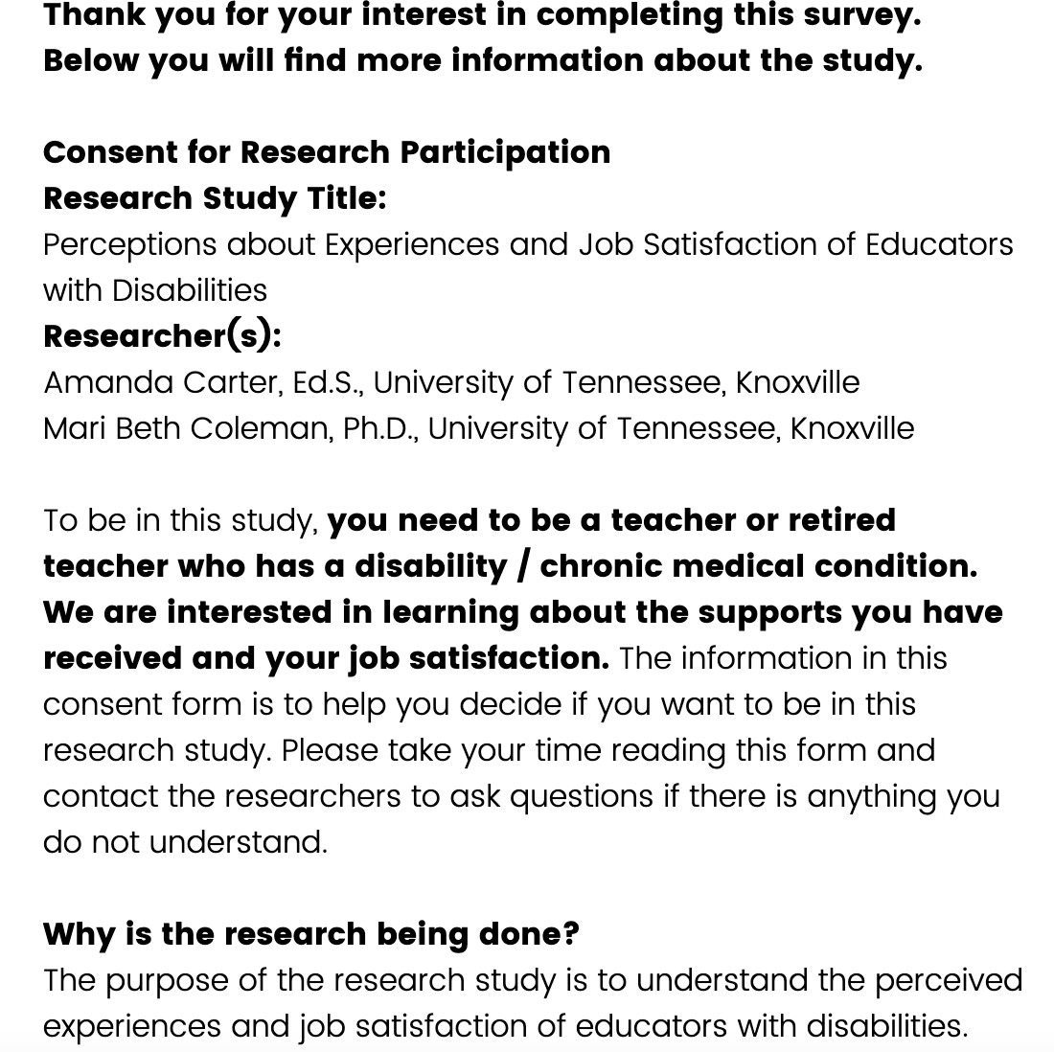
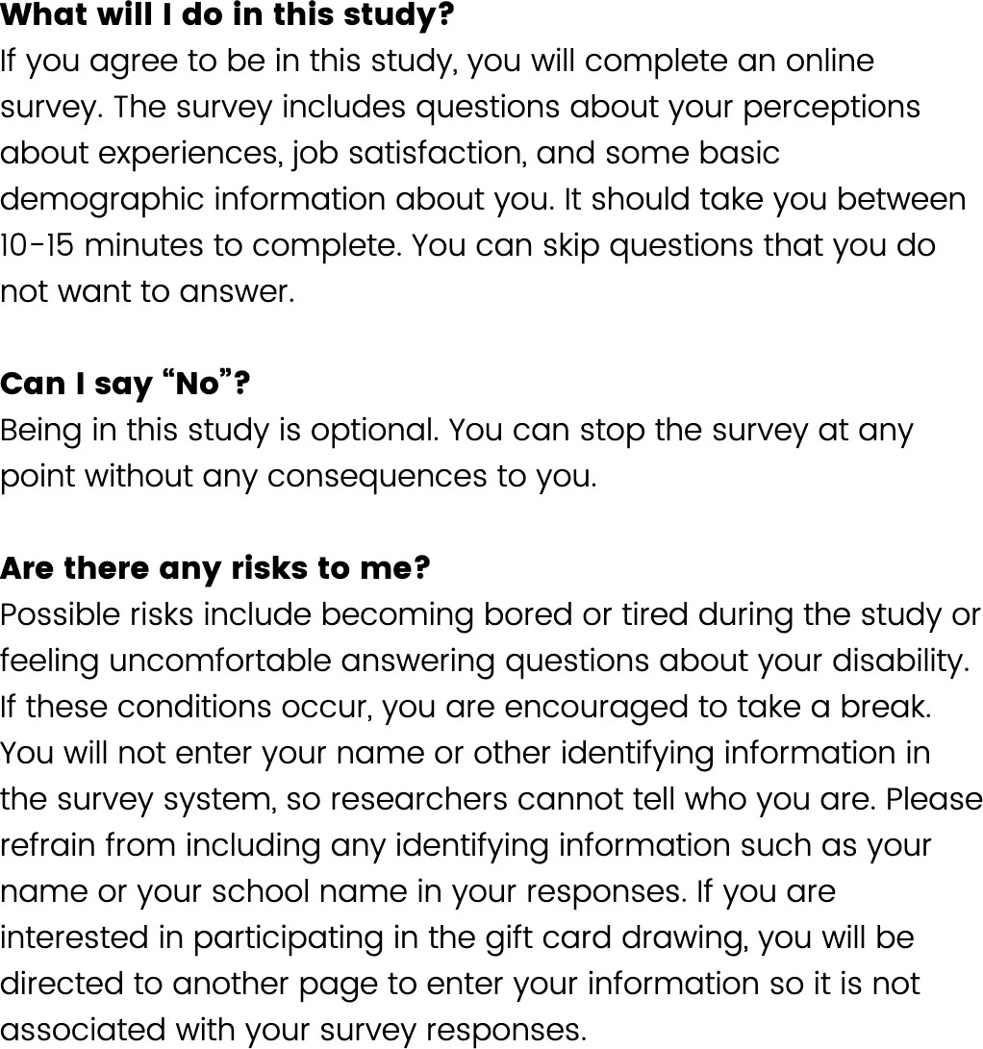

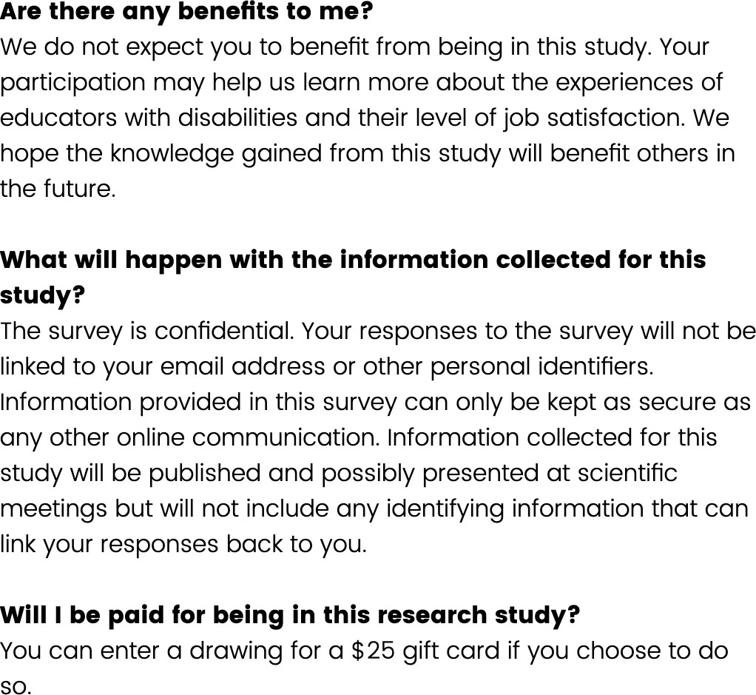

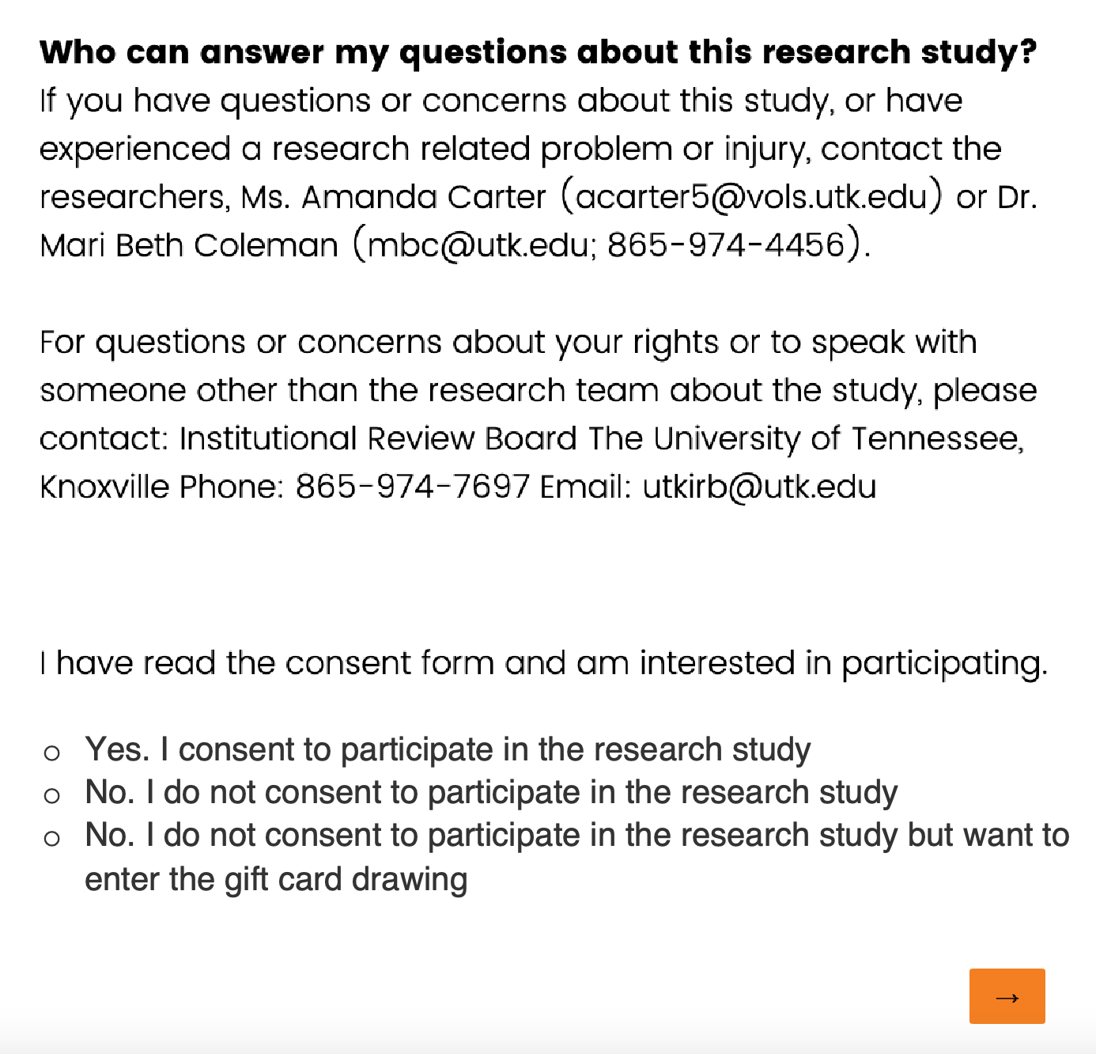

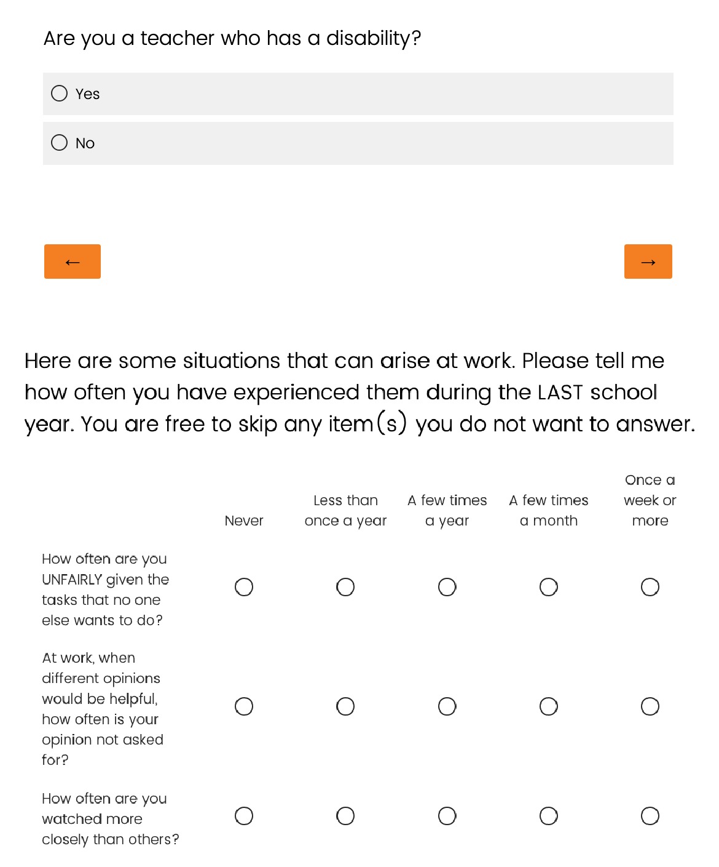

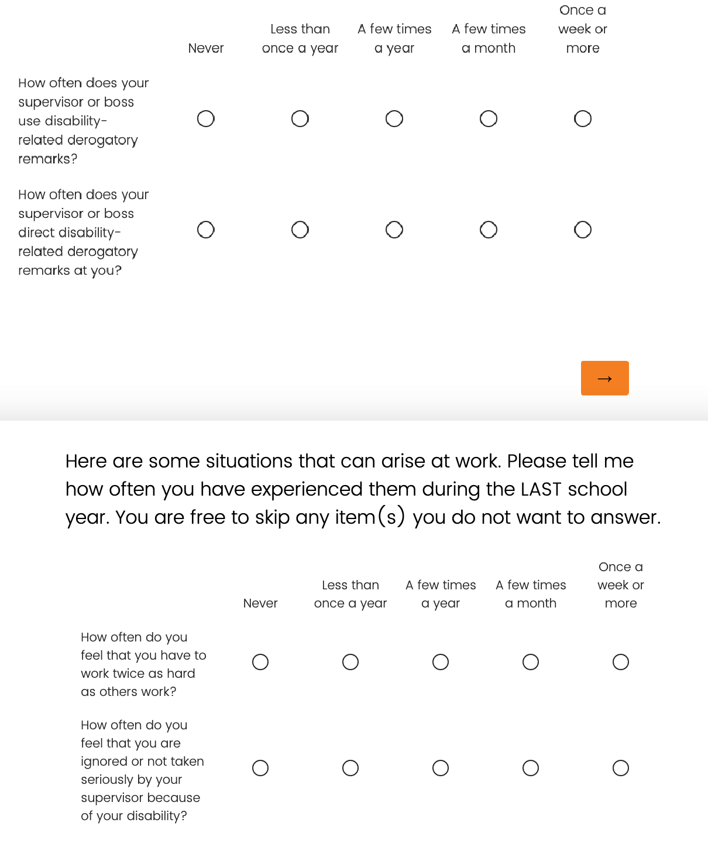

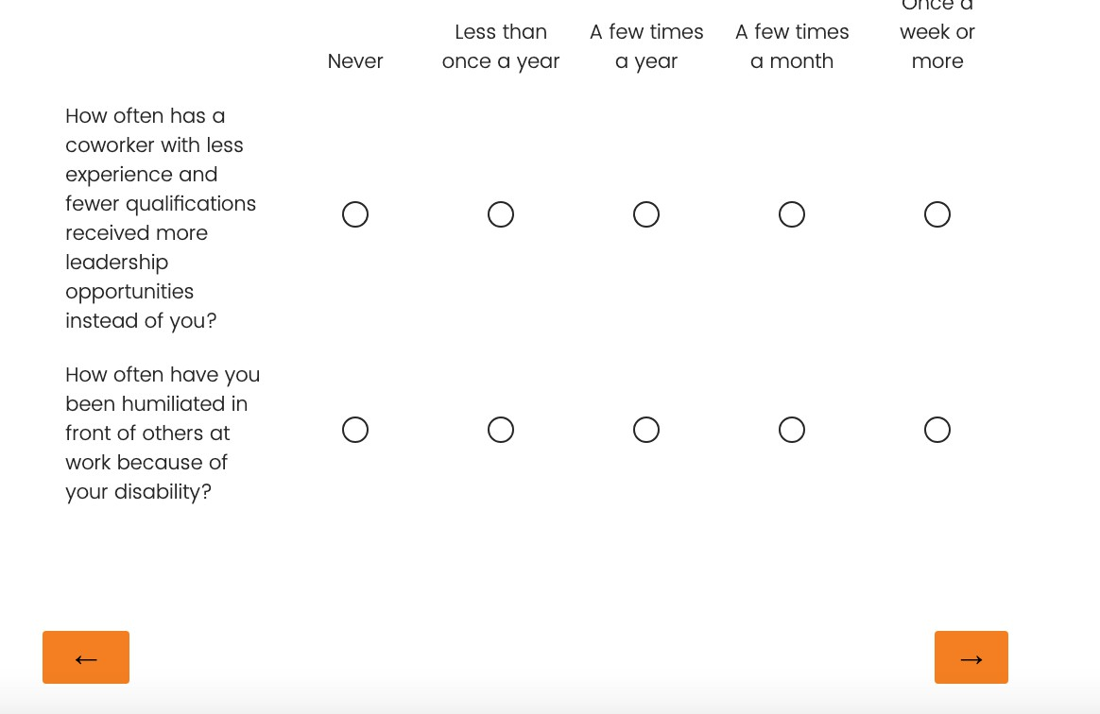

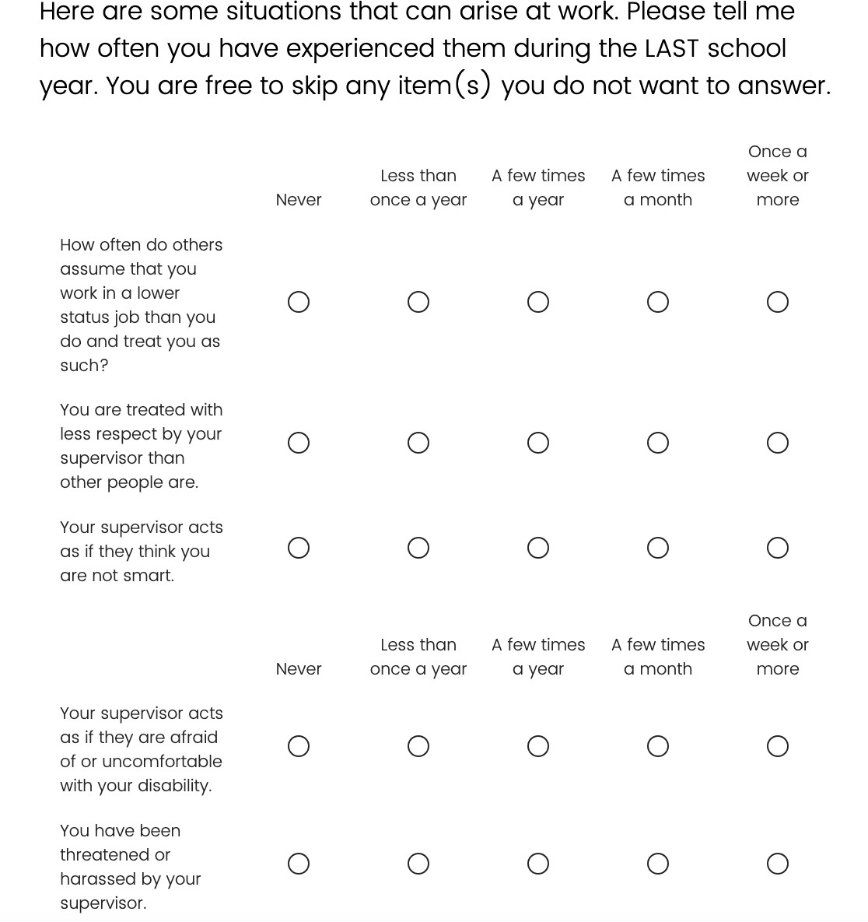

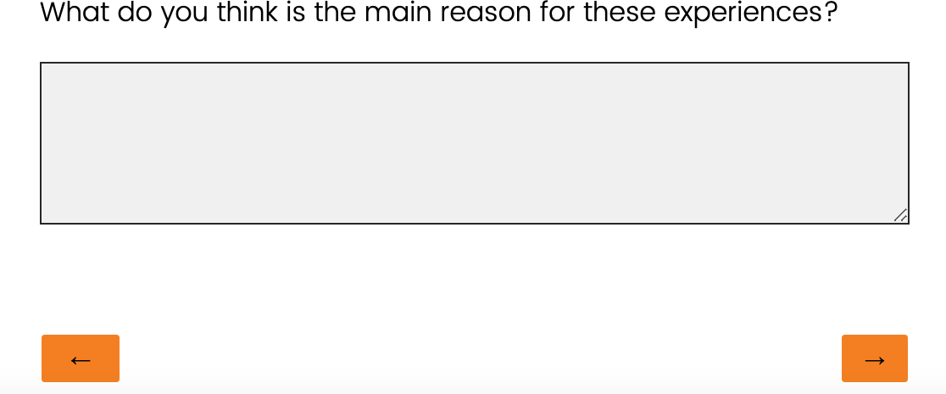

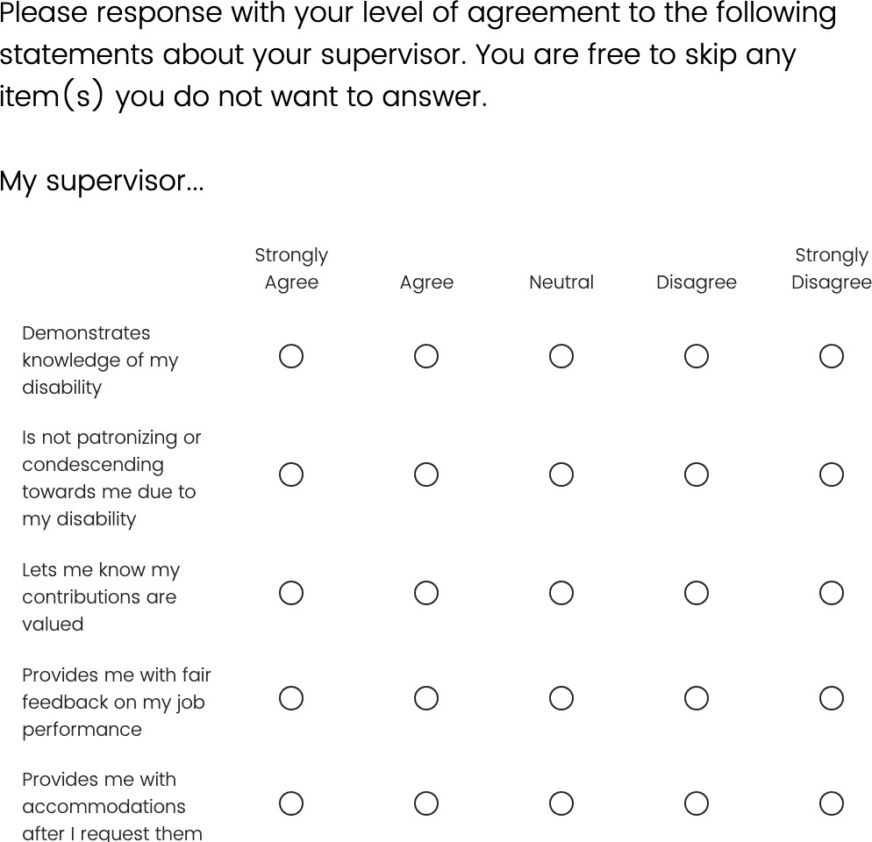

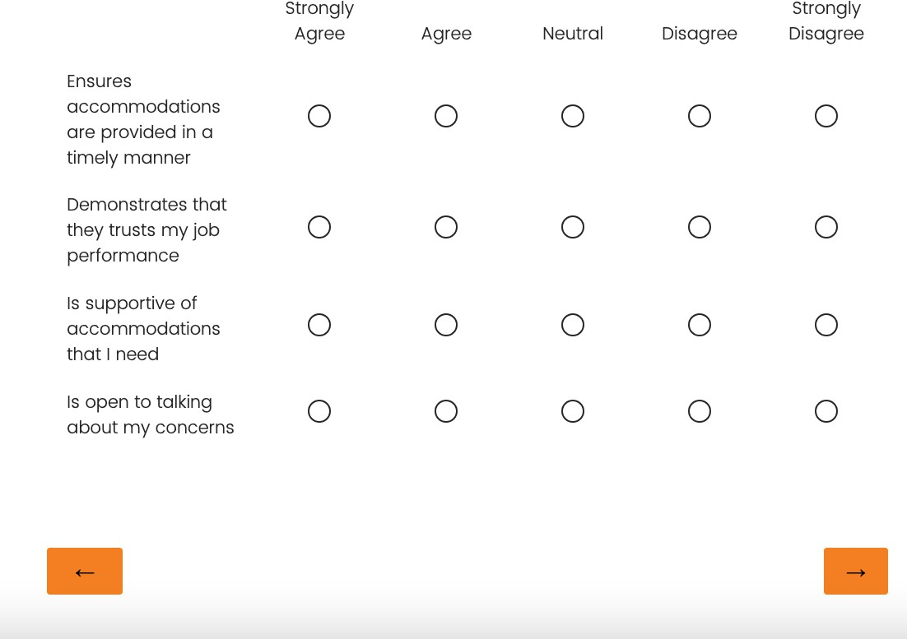

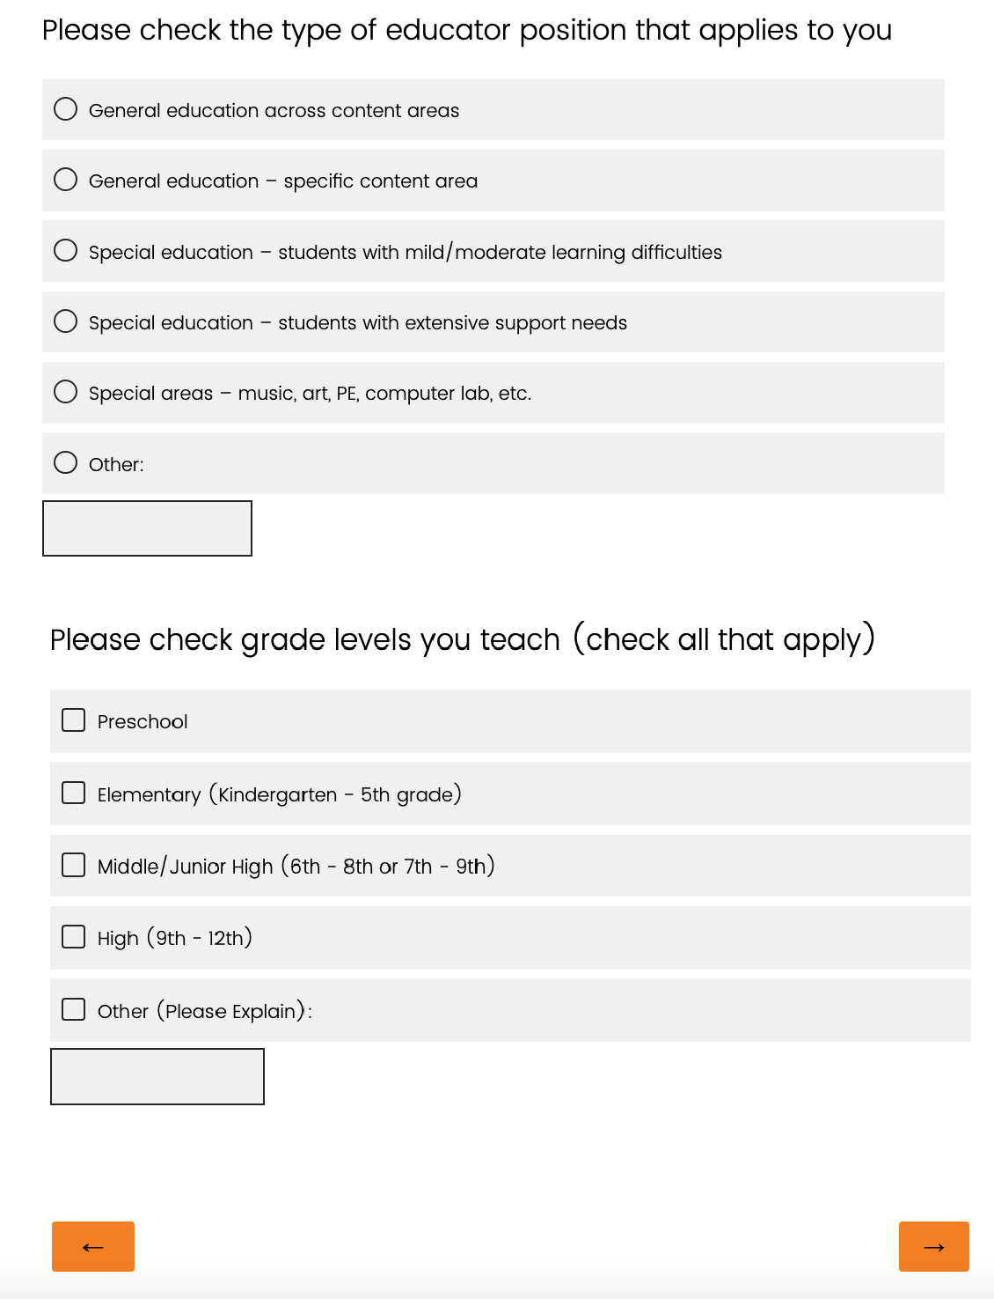

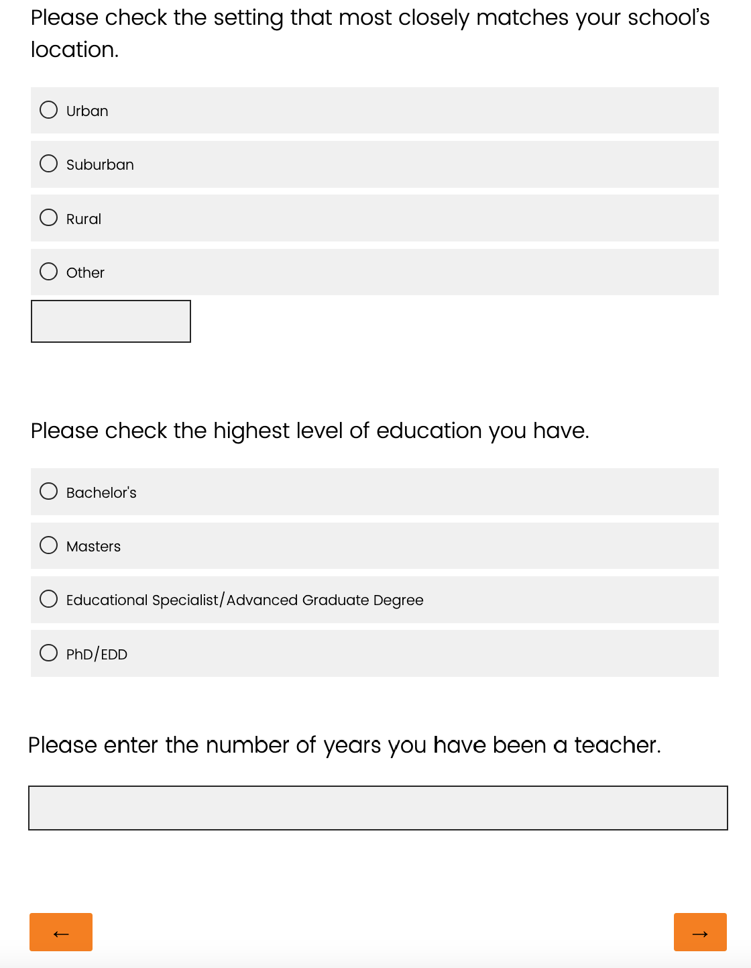

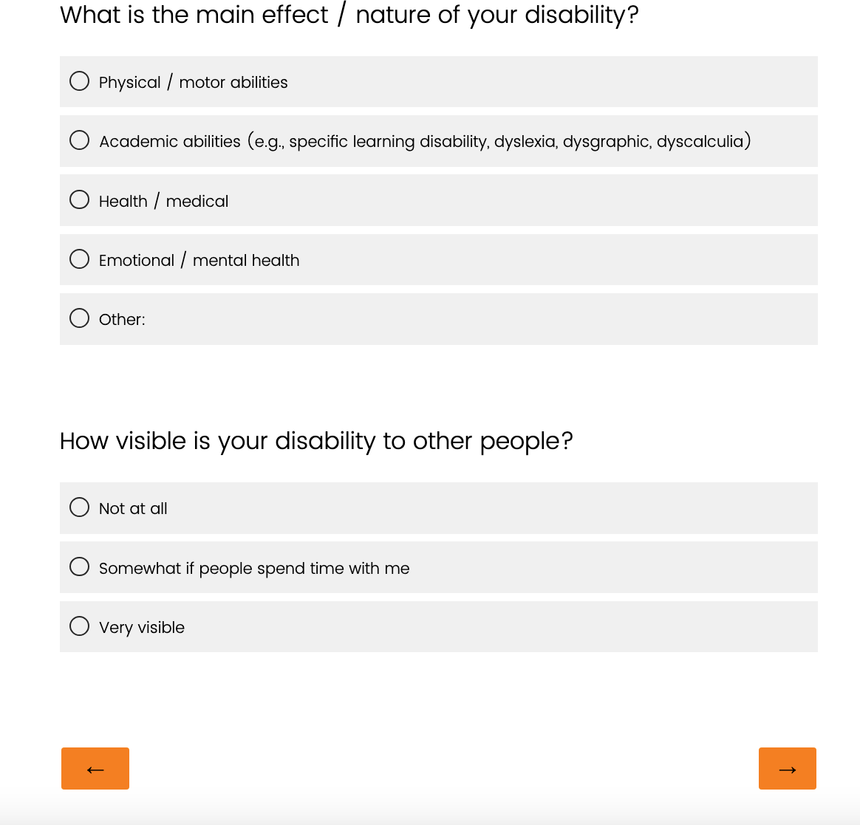

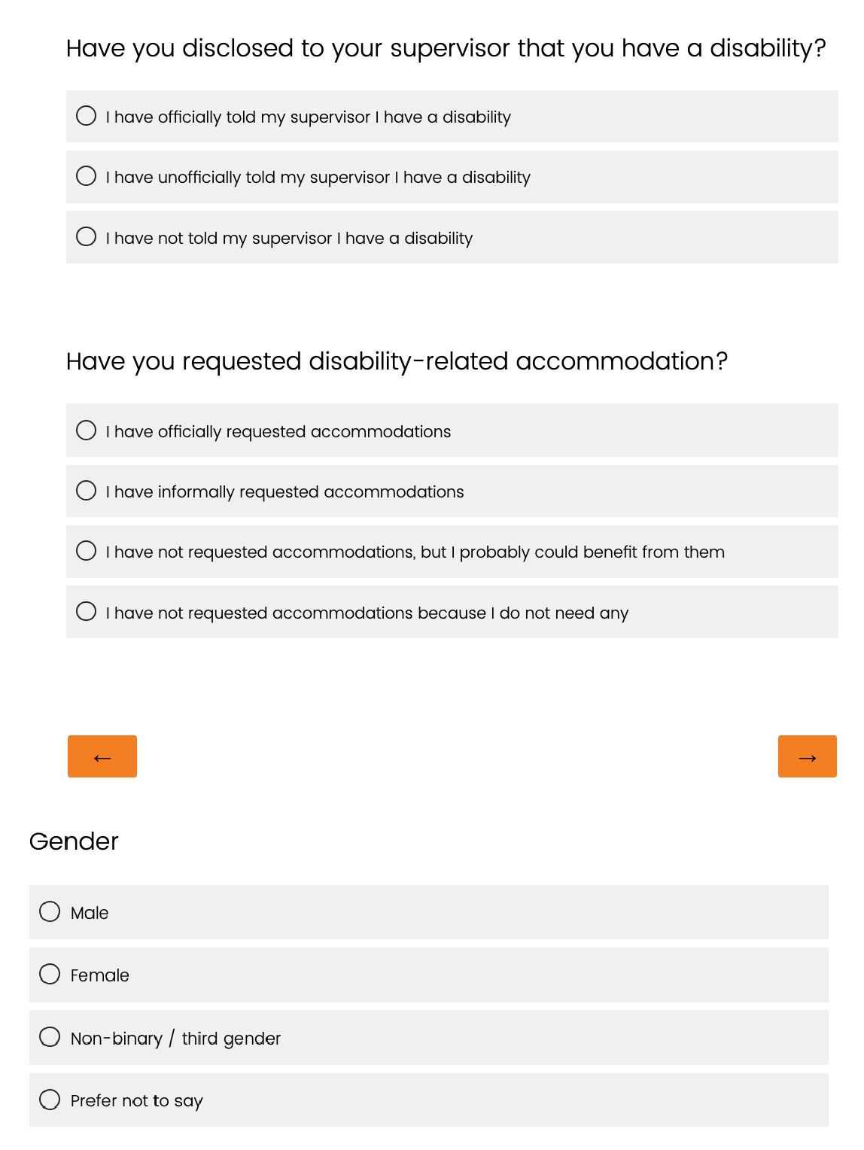

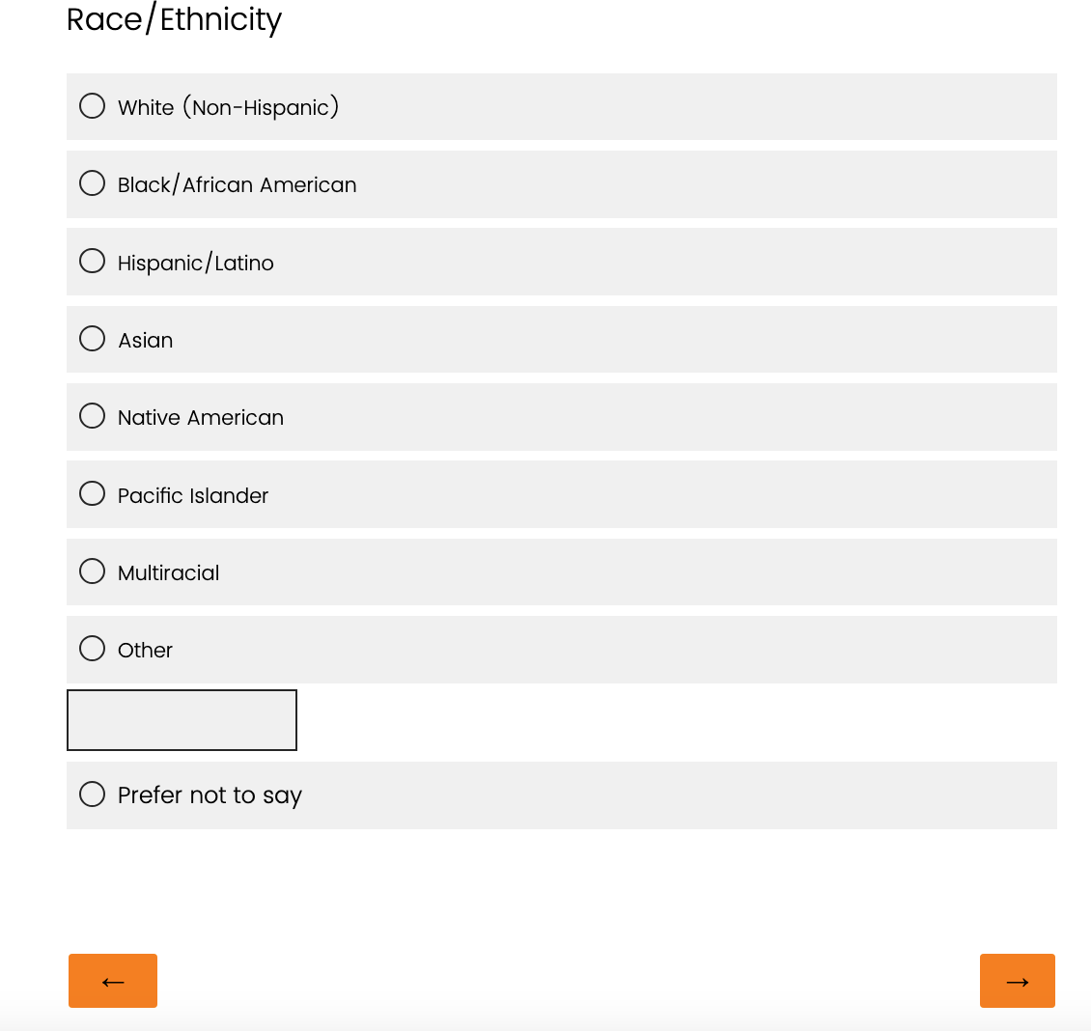

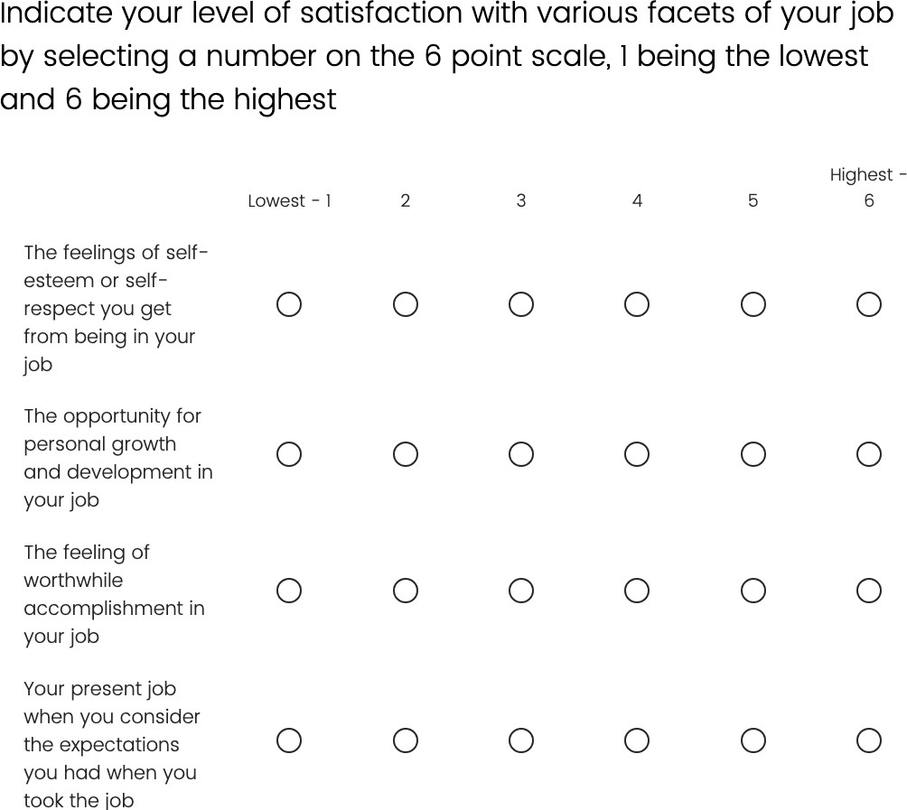

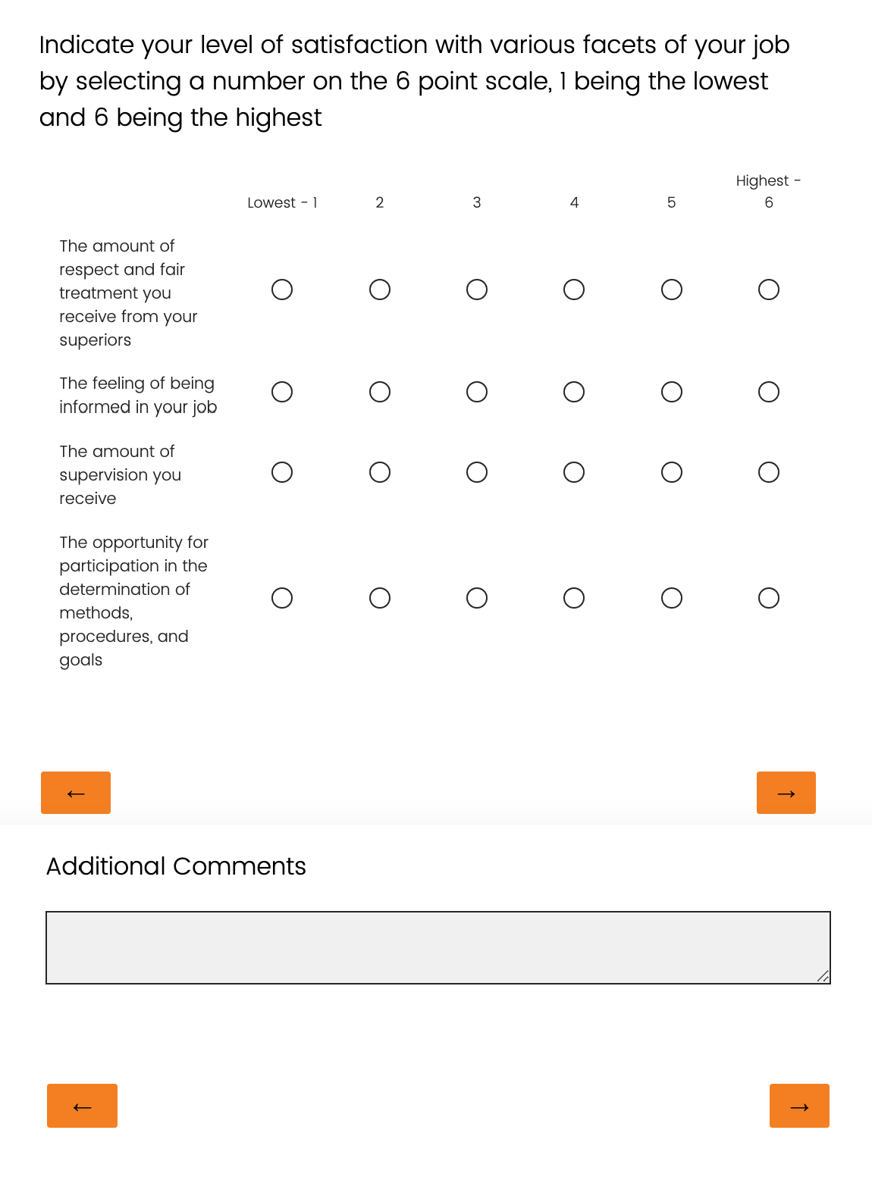

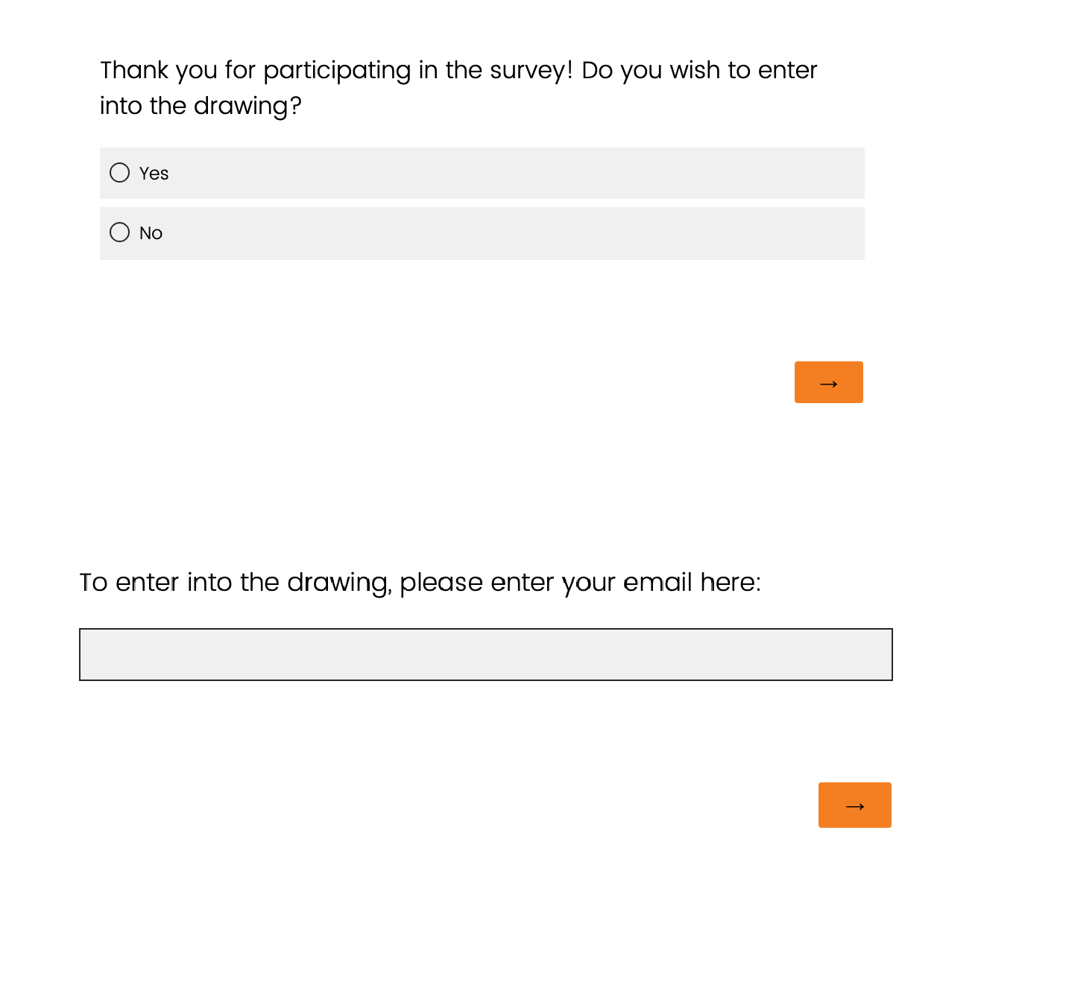

Appendix b Email and Social Media Recruitment
We are interested in surveying current or retired teachers who have disabilities to explore their experiences and job satisfaction. This research study has been approved by the UTK IRB office. Our survey will take approximately 10-15 minutes to complete. At the end of the survey, teachers can enter an optional drawing for a $25 Amazon gift card. (Survey data will be acquired separately from personal information entered for the drawing for confidentiality purposes.) Please consider completing the survey and please share this email/ post with other teachers who may have disabilities and may be interested in sharing their experiences.

If you have any questions, please reach out to us; we will be happy to answer your questions.

For questions or concerns about your rights or to speak with someone other than the research team about the study, please contact:
Institutional Review Board
The University of Tennessee, Knoxville Phone: 865-974-7697
Email: utkirb@utk.edu

Appendix C scales permission from dr. david r. Williams

Good to hear from you.
The scales are freely available. No permission is necessary.
More information about the Everyday Discrimination scale and other measures of Discrimination is available on the “Measuring Discrimination Resource” on my website below.

David

------------------—-----------------------------------
David R. Williams
(http://scholar.harvard.edu/davidrwilliams/)
Florence & Laura Norman Professor of Public Health
Chair, Department of Social & Behavioral Sciences, Harvard T.H. Chan School of Public Health
Professor of African and African American Studies and of Sociology
Harvard University
Address: Harvard T. H. Chan School of Public Health
Department of Social and Behavioral Sciences
677 Huntington Ave
Boston, MA 02115

Executive Assistant: Mei Y Chang (mchang@hsph.harvard.edu)
Telephone: 617-432-4794

For research-related assistance: Sandra Krumholz (krumholz@hsph.harvard.edu)

Tel. 617-432-6807
Fax 617-432-3755

"THE GREATEST EVIL is not done in those sordid dens that Dickens loved to paint, but is conceived and ordered (moved, seconded, carried, and minuted) in clear, carpeted, warmed, well-lighted offices, by quiet men with white collars and cut fingernails and smooth-shaven cheeks who do not need to raise their voices." C.S. Lewis

From: Carter, Amanda <acarter5@vols.utk.edu>
Date: Wednesday, May 1, 2024 at 3:17 PM
To: Williams, David <dwilliam@hsph.harvard.edu>
Subject: Discrimination Scales and Surveys
Hi Dr. William,
My name is Amanda Carter. I am a doctoral student at the University of Tennessee, Knoxville. My focus is on special education and cultural studies in education. I am writing my dissertation on teachers with disabilities and the potential discrimination and lack of support they may face. I am writing to you to request permission to use your discrimination scales and/or surveys.

Thank you,
Amanda

Amanda Carter, MS, EdS
Graduate Teaching Associate
Doctoral Candidate in TPTE
University of Tennessee, Knoxville
423 Jane Bailey Complex
Knoxville, Tennessee 37996

appendix d scale permission from dr. susan mohrman
Dear Amanda,

I’m very happy that you will be using the Job Satisfaction Scales in your dissertation, which sounds interesting and important. The scales are now in the public domain. I wish you luck in your dissertation.

Sue Mohrman

From: Carter, Amanda <acarter5@vols.utk.edu>
Sent: Monday, January 15, 2024 9:54 AM
To: Susan Mohrman <smohrman@usc.edu>
Subject: Requesting Permission

Dear Dr. Susan Mohrman,

I am writing to request permission to use the "Mohrman-Cooke-Mohrman Job Satisfaction Scales" as one of my survey instruments for my doctoral degree. I am completing my dissertation through the University of Tennessee, Knoxville. The title of my proposed research is "Teachers with Disabilities: Perceived Levels of Administrative Support and Job Satisfaction."

Thank you for your assistance with this request.

Sincerely,
Amanda

Amanda Carter, MS, EdS
Graduate Teaching Associate
Doctoral Candidate in TPTE
University of Tennessee, Knoxville
423 Jane Bailey Complex
Knoxville, Tennessee 37996

Vita
Amanda M. Carter is from Knoxville, Tennessee. She earned a Bachelor of Arts degree in Sociology, a Master of Science degree in Educational Psychology with a concentration in Adult Education and specialization in Rehabilitation Counseling, and an Educational Specialist degree in Teacher Education with a concentration in Special Education from the University of Tennessee, Knoxville. While working on her master’s degree, Amanda worked a center for independent living, a nonprofit that focuses on providing independent living services for adults with disabilities. While there, Amanda worked as an advocate to promote civil rights legislation for individuals with disabilities, a job readiness trainer, an independent living specialist, a grant writer, and a resource developer. During her time at the center, Amanda developed a passion for teaching people with disabilities, and therefore, decided to go back to school to get a degree in teaching. Upon completing her degree in teaching, Amanda taught elementary special education resource at a school in east Tennessee. After five years in this position, Amanda decided to go back to school to get a PhD in Special Education and a Graduate Certificate in Social Justice in Education. While working on her PhD, Amanda has taught college courses on special education to non-special education as well as special education majors and worked as a research assistant for.

