Neutron Beam Monitors:

High Count Rate Monitors for Scattering Facilities

A Thesis Presented for the
Master of Science
Degree
The University of Tennessee, Knoxville

Amanda Kay Barnett
May 2013

ACKNOWLEDGEMENTS

I would like to express my gratitude towards everyone who has helped me in my education and with the work on this thesis. In particular, I want to thank my advisors Dr. Jason Hayward and Dr. Yacouba Diawara for their support and guidance. Thanks also go to all the members of the detector group at Oak Ridge National Laboratory, including Vladislav Sedov and Loren Funk for their help with the electronic system, to Surendra Martha, Jagjit Nanda, and Shazad Akbar for their help with the Lithium Fluoride samples, and to Michael Cox for his help building the beam monitors.
ABSTRACT

Beam monitors are an important diagnostic tool in neutron science facilities. At high flux neutron scattering facilities, neutron beam monitors with very low intrinsic efficiency (10⁻⁵) are presently selected to keep the counting rate within a feasible range, even when a higher efficiency would improve the counting statistics and yield a better measurement of the incident beam. This report outlines a beam monitor with a parallel-plate avalanche chamber design that is capable of measuring a high count rate without saturation. Several versions of the beam monitor using different electrode materials were constructed and tested. Important beam monitor characteristics are given including intrinsic efficiency and count rate capability.

TABLE OF CONTENTS

CHAPTER I Introduction and General Information 8
CHAPTER II Beam Monitor Construction and experimental Setup 11
Parallel Plate Design 11
Electrodes 11
Anode 13
Cathode 13
Neutron Reactions 13
Helium-3 13
Solid Converters 14
Gas Mixture 14
Electronics 14
Theoretical Intrinsic Efficiency 16
Experimental Setup 16
High Flux Isotope Reactor 16
CHAPTER III Results and Discussion 19
Quartz – Aluminum – He3 19
Measurements from Analog Signals 19
Time-of-Flight 21
Alumina – Aluminum – He3 21
Alumina – Boron Doped Silicon 24
Silicon – Boron Doped Silicon – He3 25
Alumina – Aluminum – Lithium-6 Fluoride 28
Sample Preparation and Composition 28
Efficiency Tests 30
CHAPTER IV Summary and Conclusions 32
LIST OF REFERENCES 33
APPENDIX 35
Appendix A – Beam Monitor Assembly Drawings 36
Beam Monitor Body 37
Housing Lid 39
Feed-through Cap 40
Electronics Housing 41
Electronics Housing Lid 42
Spacer 43
Electrode Holder 44
Kapton Spacer 45
Anode 46
Cathode 47
Electrode Contact 48
Electronics Grounding Board 49
Vita 50

LIST OF FIGURES

Figure 1. Beam Monitor Design 12
Figure 2. External view of beam monitor. 12
Figure 3. Electronics box on beam monitor. 15
Figure 4. Beam monitor testing at CG-1D. 17
Figure 5. CG-1B Setup 18
Figure 6. CG-1D Setup 18
Figure 7. Shape of a typical analog signal from the beam monitor. 19
Figure 8. Fraction of pulses occurring at specified amplitude above the threshold. 20
Figure 9. Comparison between the current and prototype beam monitor. 21
Figure 10. Internal view of the beam monitor. 22
Figure 11. Typical pulse shape (yellow), and pulse height distribution (blue). 23
Figure 12. Count Rate as a function of threshold setting. 23
Figure 13. Time of fight spectrum of the alumina/aluminum beam monitor. 24
Figure 14. Count rate vs. voltage of beam monitor with silicon plates. 26
Figure 15. Count rate vs. threshold for beam monitor with silicon plates. 26
Figure 16. Averaged pulse shape from the beam monitor with silicon plates. 27
Figure 17. Time of Flight spectrum of the beam monitor with silicon plates. 28
Figure 18. LiF Sample 1. LiF particles are incorporated into the carbon fiber matrix. 29
Figure 19. LiF Sample 2. LiF particles deposited only on the carbon fiber surface. 29
Figure 20. LiF Sample Arrangement within the beam monitor active area. 30

CHAPTER I
Introduction and General Information

Neutron scattering facilities are used in many fundamental and applied research areas. Neutrons have many properties including a lack of charge, large penetration depth, magnetic moment, and spin that make them ideal for use in many research applications. Additionally neutrons are sensitive to light atoms, and cold and thermal neutrons have wavelengths and energies that match the scale of molecular structures and vibrations. The combinations of these properties have already led to and are being used to make further advancements in physics, chemistry, material science, biology, clean and alternative energy, and nanomaterials.

Neutron scattering experiments require high neutron fluxes. These high fluxes can be produced at either reactor facilities, such as the High Flux Isotope Reactor (HFIR), or accelerator facilities, such as the Spallation Neutron Source (SNS), both at Oak Ridge National Laboratory (ORNL). Operating at 85 MW, HFIR produces the highest neutron flux of any research reactor in the United States [1]. The HFIR core is a cylindrical flux trap design, where regions of high enriched uranium fuel surround a moderating region in the center of the core. This moderating region becomes a thermalizing trap for the fast neutrons from the fuel, and is used for isotope production. Neutron scattering experiments are made possible by inserting horizontal beam tubes into the beryllium reflector surrounding the fuel, and transporting the neutrons to the experimental beam lines. Three horizontal beam tubes lead to seven thermal neutron instrument beam lines and the fourth horizontal beam tube leads to five cold neutron instrument beam lines that utilize 4-25 Å neutrons [2].

SNS produces the most intense pulsed neutron beams in the world through the spalling of a mercury target [3]. Hydrogen ions are fed into a linear accelerator, where they are accelerated to 1 GeV. Leaving the linear accelerator, the ions pass through a foil that strips the electrons from the atoms, producing protons that are then collected in an accumulator ring. Sixty times a second, proton pulses from the accelerator ring hit the mercury target, causing neutrons to be spalled from the mercury target. Beam guides transport these neutrons to one of 16 operational beam lines [4]. The beam lines have a wide range of instruments including diffractometers, spectrometers, and reflectometers. Special sample environments allow scientists to study liquids, powders, or crystals, operate at very high or low temperatures, operate experiments in vacuum or at high pressure, and utilize magnetic fields.

Neutrons are transported to each of the individual beam lines through beam guides that are designed to minimize losses along the length of the guide. At the HFIR cold source, neutrons are transported 24 m away from the center of the reactor along a guide with curved section with an m=3 supermirror coating and ends in a straight section with an m=2 coating [5]. The supermirrors are complex multilayer coatings that reflect cold neutrons along the length of the guide but prevent high energy gammas and neutrons from reaching the experiments. HFIR is a continuous source of neutrons, but some beam lines require a pulsed beam for certain experiments involving time-of-flight measurements, so choppers are used to create a pulsed beam. Choppers are made of a neutron absorbing material with holes spaced so that as the chopper spins at a set frequency, neutrons are only able to pass through at that frequency, creating the initial bursts of neutrons for time of flight. Alternatively, at a pulsed source, choppers can be used to create a monochromatic beam by rotating from the source at a speed that only allows one frequency to pass through. Monochromators, typically made of graphite, beryllium, germanium, or silicon, can also be used to select certain wavelengths from the incident neutron beam. Monochomators select single wavelengths of neutrons through Bragg scattering,reflecting only the wavelength that matches the crystalline spacing of the monocromator. A wide range of wavelengths is possible depending on the material, crystal orientation, and incidence angle.

Beam monitors are another essential component of neutron scattering facilities. Beam monitors measure the incident neutron flux, allowing scientists to calibrate detectors and other beam line instrumentation, track beam stability, and make adjustments in real time. They need to have a low efficiency so that as little of the beam is blocked or scattered as possible, yet the count rate needs to be high enough to establish good counting statistics. Present beam monitors use either ionization chambers in integration mode, which are slow and have no timing information, or pulse counters which can easily be saturated by high beam intensities [5] [6]. As a result these monitors saturate if the count rate becomes too high, limiting the range in which these monitors are useful. At high flux neutron scattering facilities, neutron beam monitors with very low intrinsic efficiency (10⁻⁵) are presently selected to keep the counting rate within a feasible range, even when a higher efficiency would improve the counting statistics and yield a better measurement of the incident beam.

Additionally some of the current beam monitors use Helium-3 as the neutron conversion material. Helium-3 makes an excellent neutron conversion material for gaseous detectors due to its large thermal cross-section; however, due to the worldwide shortage of Helium-3, it is not practical to continue to build detectors based on this material. It is very difficult to purchase He-3, and if the Helium-3 can be obtained, it is extremely expensive. Therefore, beam monitors based on alternative neutron conversion materials need to be developed.

Parallel plate avalanche counters have been used in detectors requiring a high count rate and good time resolution, but without good energy resolution [7], [8]. The counter design involves two parallel plate electrodes separated by as small of a gap as possible. An electric field is applied between the two plates, so as a charged particle passes through the gap, a trail of electron-ion pairs are produced that are multiplied through the gas multiplication process.

CHAPTER II
Beam Monitor Construction and experimental Setup

Parallel Plate Design
The beam monitor is built in a parallel plate avalanche chamber design, shown in Figure 1. The two electrode plates are held 2 mm apart by a PEEK spacer. The resistive plate is kept at a high voltage (3.5 – 5 kV), to establish the needed electric field, while the conductive plate is kept at ground and is used for the signal readout. The small separation distance and large potential difference between the electrodes allows for neutron conversion and amplification to occur in the region between the two plates.

The beam monitor is enclosed in an airtight aluminum housing. It is shaped to present a flat face to the neutron beam, and the windows through which the beam passes are machined to be as thin as feasible to minimize scattering losses. Each of the plates is 5 cm x 11.5 cm, creating an active area of about 60cm², while the entire beam monitor (shown in Figure 2) is 19.4 cm x 11.5 cm x 2.2 cm without the electronics box, and is 27 cm long with the electronics box attached. Schematic drawings of all of the beam monitor components are in Appendix A .

Electrodes
The beam monitor was built and tested with different electrode materials to compare their effectiveness. The anode must be made of a resistive material to prevent electrical discharges, and the cathode must be conductive, so that the charge deposited can be transferred quickly to the electronics for better timing resolution.

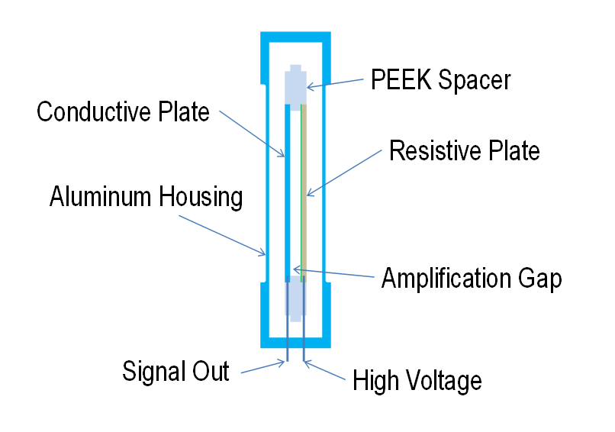
Figure 1. Beam Monitor Design

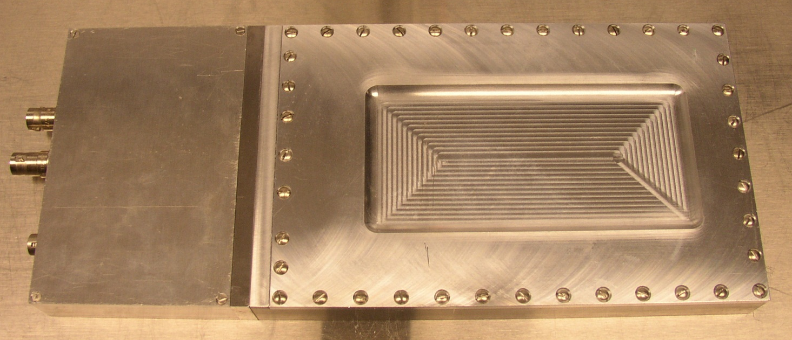

Figure 2. External view of beam monitor.

Anode
Several different materials were used as the anode for the beam monitor. These materials are alumina with a thin layer of cermet, undoped silicon, and quartz. The cermet has a sheet resistance of 100 MΩ/sq. Silicon has a resistivity of _____, and quartz has a resistivity of ____________.

Cathode
Two different materials were used as the cathode, aluminum and silicon doped with _____/cm³ natural Boron.

Neutron Reactions
As with any neutron detector, the beam monitor depends on the conversion of the incoming neutrons into charged particles that can be detected. Neutron conversion can be achieved through any one of the neutron interactions listed in Table 1.

Table 1. Neutron Conversion Reactions
Isotope | Nuclear Interaction | Cross Section at 1.8 Å [9]
Helium-3 | n + ³He → ³H + ¹p + 0.764 MeV | 5330 barns
Lithium-6 | n + ⁶Li → ⁴He + ³H + 4.79 MeV | 940 barns
Boron-10 | n + ¹⁰B → ⁴He + 2.3 MeV + 0.48 MeV γ  n + ¹⁰B → ⁴He + 2.79 MeV | 3840 barns (93%)  (7%)
Gadolinium-157 | γs + conversion electrons | 255,000 barns

Helium-3
Helium-3 was used in several of the beam monitors as the neutron conversion material. Due to its large cross-section at thermal energies, Helium-3 makes an ideal conversion material for neutron detectors. It is especially advantageous in gaseous detectors because the charged particles that are created are not trapped in a solid converter layer. However, due to the Helium-3 shortage discussed in the previous section, alternative neutron conversion materials are needed.

Solid Converters
Two different solid converters were tested in the beam monitor. Boron-10 was used in two of the tested beam monitors in the form of a boron doped silicon wafer. Lithium-6 was used in one of the tested beam monitors in the form of Li-6 enriched Lithium Fluoride powder deposited onto carbon paper.

Gas Mixture
In the beam monitor, the charged particles created by the neutron interactions create ion-pairs as they move through the gas volume. Due to the large electric field, as the electrons drift towards the anode, they gain enough energy to form secondary ion-pairs. The secondary electrons are also capable of creating additional ionizations resulting in an avalanche [10]. So regardless of the neutron conversion material (either gaseous Helium-3 or a solid material), a fill gas that can be ionized to produce the pulses is needed inside the beam monitor.

For these beam monitors, a mixture of 95% Xenon, 5% Carbon Dioxide was used as the fill gas. Xenon is used as the fill gas because it does not react chemically. Some of the charged particle interactions in the gas create excited rather than ionized gas molecules. A small percentage of carbon dioxide is needed as a quench gas to absorb any photons that are created by the deexcitation of those gas molecules.

The beam monitors filled only with Xe/CO₂ were filled at ORNL. After assembling the beam monitor, it remained on a vacuum pump for several days until reaching a pressure of below 10⁻⁶ Torr, at which point it was filled to 800 Torr Xe/CO₂. The beam monitors filled with Helium-3 were taken to Ordela, Inc. to be filled with 29.1 Torr of Helium-3, and 771 Torr of Xe/CO₂, for a total pressure of 800 Torr.

Electronics
As mentioned above, ion pairs are created in the gas volume. The positive ions and the electrons drift towards the opposite electrodes due to the high electric field. The electrons are able to traverse the 2 mm gap in tens of nanoseconds; however, due to the relatively large size of the positive ions, they take much longer to drift towards the cathode than the electrons take to reach the anode. To achieve a high counting rate, the beam monitor employs an electronic readout circuit which is sensitive to the induced charge from the drift of the electrons only. A custom, fast, low-noise pre-amplifier with a 30 ns shaping time is used to get good timing resolution.

The pre-amplifier is enclosed in an aluminum housing that is attached directly to beam monitor, to reduce electronic pick-up noise. The electronics box has connections for high voltage input (SHV) and signal output (BNC). It also uses an HRS 4-pin connector to supply +24.5 V and -7.5 V voltages to the pre-amplifier.

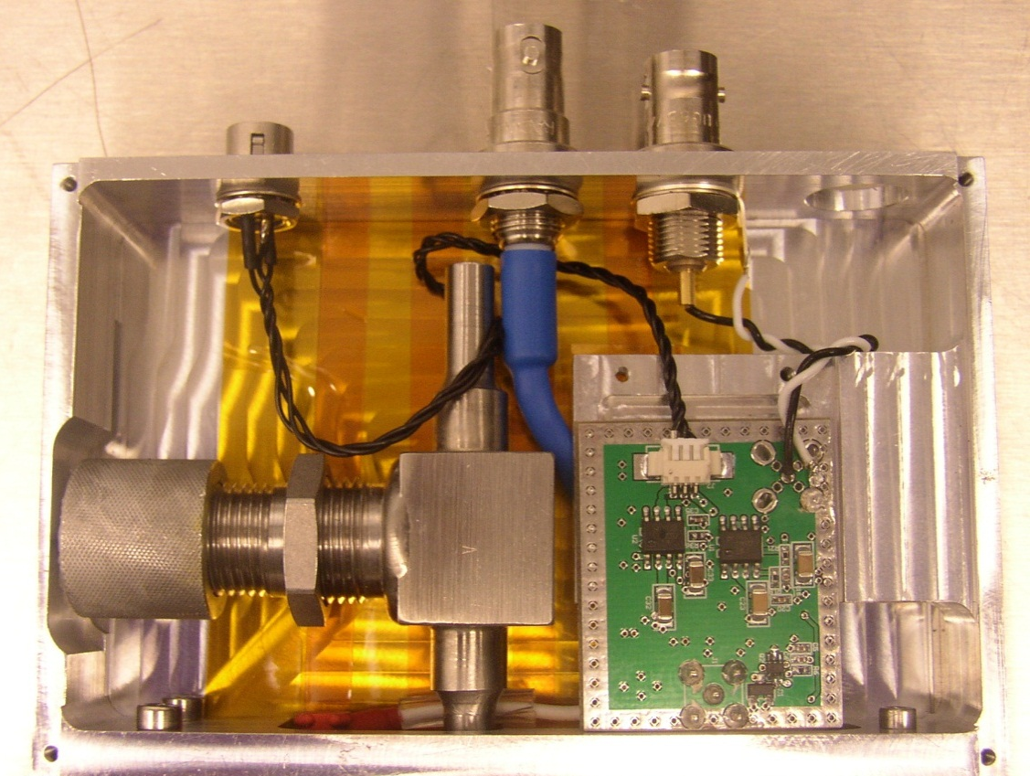
Figure 3. Electronics box on beam monitor.

Theoretical Intrinsic Efficiency
The intrinsic efficiency of the beam monitor is dependent on the pressure of the converter gas used, the thickness of the conversion region, and the wavelength of the incident neutrons according to equation 1, [11]

$η=1-e^{-μλρx}$ (1)
where
μ = gas absorption factor
λ = specified neutron wavelength
ρ = absolute counting pressure
x = depth of counting volume

For the beam monitors filled with Helium-3, the gas absorption factor is 0.0725 (atm cm Å)⁻¹. The beam monitor was built with a plate separation of 0.2 cm. So for thermal neutrons, a gas pressure of 0.0383 atm (29.1 Torr) results in an intrinsic efficiency of 10⁻³.

Experimental Setup
The beam monitors were initially tested in the lab at SNS with a 1 mCi Amerecium-241 source. Americium emits a 59.5 keV gamma, which can create ionization pairs leading to electron multiplication in the Xe/CO₂ gas in the region between the plates. Once tested with Americium to ensure the beam monitors were working properly and did not have a gas leak or bad electrical connection, they could be filled with Helium-3 if necessary for that beam monitor. A Californium-252 source, with strength 17.87 mCi in September 2011, was then used to test the beam monitors for neutron response. Then for high flux conditions, the beam monitor was taken to the HFIR for efficiency and count rate capability tests.

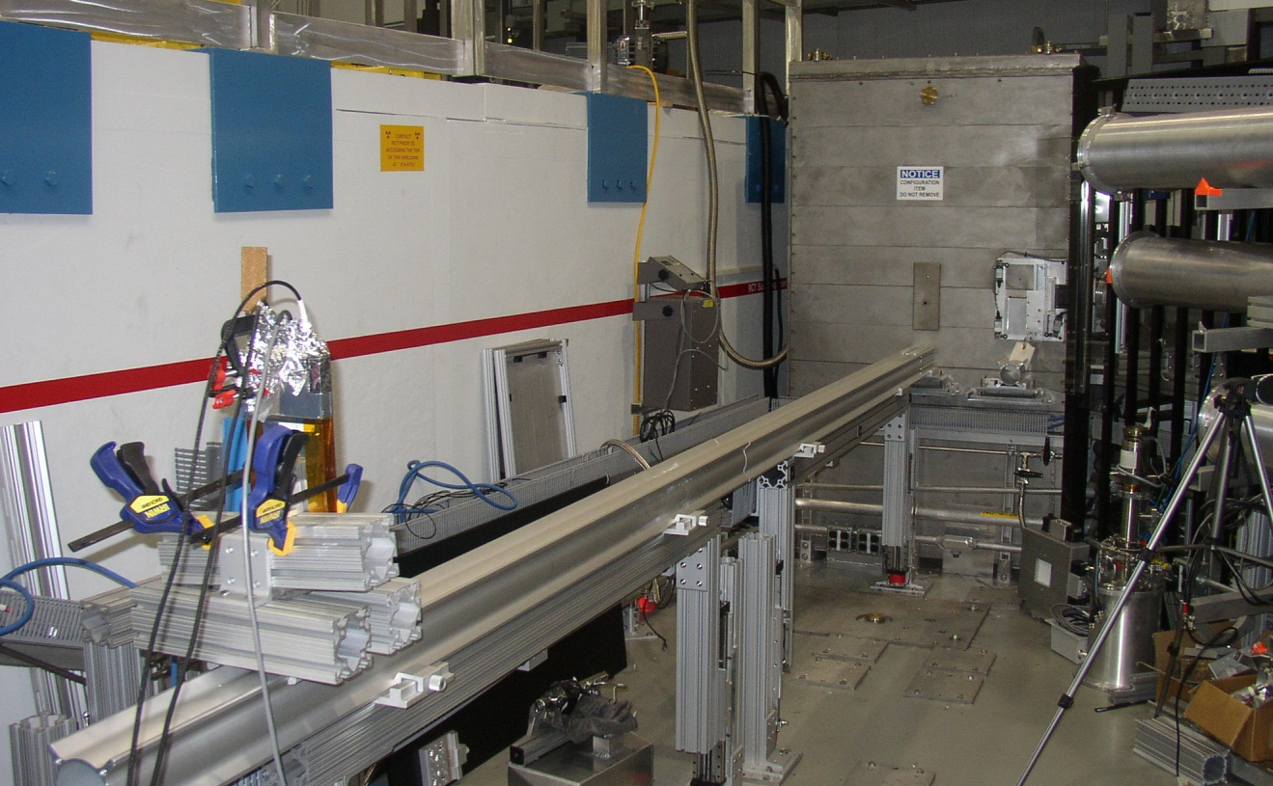
Figure 4. Beam monitor testing at CG-1D.

High Flux Isotope Reactor
The beam monitors were tested at HFIR at the Cold Guide 1 (CG-1) Beam Line. CG-1 is used for neutron instrumentation development and is split into four separate beam lines. CG-1D is able to be run in a white beam operation mode or in a pulsed mode when the chopper is operating. It has a neutron spectrum from 1.8 to 6 Å (0.025 to 0.002 eV) [12]. The white beam was used in order to find the maximum count rate capability and efficiency of the beam monitors, and the pulsed mode was used to make time-of-flight measurements. CG-1B is a monochromatic beam of 2.35 Å. Tests were done on this beam line to determine the count rate capabilities and efficiencies of the beam monitors.

The beam monitor output was measured with standard NIM electronics. When testing at CG-1B (shown in Figure 5), a Phillips 771 amplifier was used to amplify the signal so that it could be read on an Ortec 661 ratemeter. Alternatively, the signal was viewed directly using an Agilent MSO9104A oscilloscope.

When testing at CG-1D, the same setup involving the oscilloscope or amplifier and ratemeter was used, however, time-of-flight (TOF) measurements were also made. TOF measurements taken on CG-1D (setup shown in Figure 6) involved a chopper rotating at 40 Hz that also sent a timing signal to the data acquisition computer. The signal from the beam monitor was input into the discriminator in an ORTEC MCS-pci. The computer with the Multi-Channel Scaler card has software to analyze the TOF spectrum.
Figure 5. CG-1B Setup

Cold Source
Al
Windows
CG-1 Guide
(curved)
Beam Monitor
Custom Preamplifier
Oscilloscope
NIM Rate Meter
NIM Amplifier

Monochromator

Cold Source
Al
Windows
CG-1 Guide
(curved)
Chopper
Pulsed Beam
Beam Monitor
Custom Preamplifier
MCS Card in computer with TOF software
Discriminator on MCS Card
Figure 6. CG-1D Setup

CHAPTER III
Results and Discussion

Quartz – Aluminum – He3
The first working prototype parallel plate beam monitor was built using a quartz plate as the anode and an aluminum plate as the cathode. Ordela, Inc filled the beam monitor with 29.1 Torr Helium-3 and 771 Torr of a 95%/5% mixture of Xe/CO₂. As per Equation 1, it had a theoretical intrinsic efficiency of 10⁻³. The beam monitor was tested at HFIR CG-1D on April 3, 2012.

Measurements from Analog Signals
Initial measurements were made on the oscilloscope to analyze the height and full-width half-maximum (FWHM) of the analog signals from the beam monitor (see Figure 7). The threshold was set to 60 mV, and the analog pulses had an average FWHM of 30 ns and pulse height of 70 mV when a voltage of 3560 V was applied.

Figure 7. Shape of a typical analog signal from the beam monitor.

The size and duration of the pulses from a detected neutron vary somewhat from pulse to pulse. Some fraction of the pulses lie below the discriminator setting. Decreasing the discriminator setting improves the effective efficiency but increases the risk of detecting false events due to gamma rays or electronic noise. Increasing the bias voltage also improves the effective efficiency but increases the recovery time between events and the risk of recording false neutron events (due to gamma ray interactions). The effect of increasing the bias voltage is shown in Figure 8.

Figure 8. Fraction of pulses occurring at specified amplitude above the threshold.
The higher bias resulted in a larger distribution of pulses.

The pulse height variation seen in Figure 8 is due to the single conversion and multiplication region. A charged particle created near the cathode will travel the full distance of the gap, which allows for more multiplication than a particle created near the anode, resulting in a larger signal amplitude. However, the variation in pulse heights is not problematic for this beam monitor. As long as the threshold is optimized to just above the noise level, all signals from incident neutrons will be counted.

The analog output from the beam monitor was also viewed on a wider time scale on the oscilloscope to measure the high counting rate capabilities of the beam monitor. The size of the aperture in front of the incident neutron beam was varied, and at the maximum flux on beamline CG-1D, the beam monitor measured count rates up to over 1,000,000 counts per second without saturation. With the beam shutter closed, the count rate was below one count per second.

Time-of-Flight
The time-of-flight spectrum was also measured and compared to an Ordela 4511N wire proportional counter beam monitor. This Ordela beam monitor is one of the beam monitors currently being used at HFIR. It has a known intrinsic efficiency of 0.0045 at 1.8 Å. The neutron flux was lowered to a level that the Ordela beam monitor could measure without saturating. Both monitors were placed in the neutron beam and TOF spectrums were taken concurrently. The count rates were normalized due to the different efficiencies, and the results are plotted in Figure 9. Good agreement is seen between the two beam monitors.

Figure 9. Comparison between the current and prototype beam monitor.
The vertical lines indicate the position of the Aluminum Bragg Edges.

Additionally, the Ordela beam monitor was used to determine the intrinsic efficiency of the parallel plate beam monitor. Equal areas of the beam monitors were exposed to the beam, and the count rates were measured and compared. The parallel plate beam monitor’s efficiency was measured to be 0.00054, which is lower than the calculated value of 0.001.

Alumina – Aluminum – He3
The next design of the beam monitor kept the aluminum plate as the cathode, but used an alumina plate coated with cermet as the anode. The beam monitor is shown in Figure 10 after assembly, just before the housing lid is put on. It was again filled with 29.1 Torr Helium-3 and 771 Torr of a 95%/5% mixture of Xe/CO₂.

Figure 10. Internal view of the beam monitor.
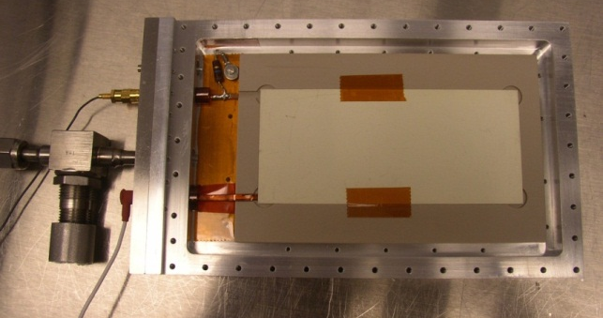
The beam monitor was tested at HFIR CG-1D on May 21, 2012. Running at a slightly higher voltage of 4075 V, it showed the same properties as the previous version with the quartz anode. A typical pulse is shown in the oscilloscope screen capture in Figure 11, with the wide pulse-height distribution shown in the blue histogram. The threshold was initially set at 30 mV, then increased incrementally to 100 mV. As expected the count rate decreased non-linearly with the increased threshold. A plateau is seen in the count rate plot in Figure 12, which indicates the optimal threshold setting region. Additionally, the TOF spectrum was measured, and is given in Figure 13. As with the previous design, this beam monitor matches the energy distribution from CG-1D including the aluminum Bragg peaks.

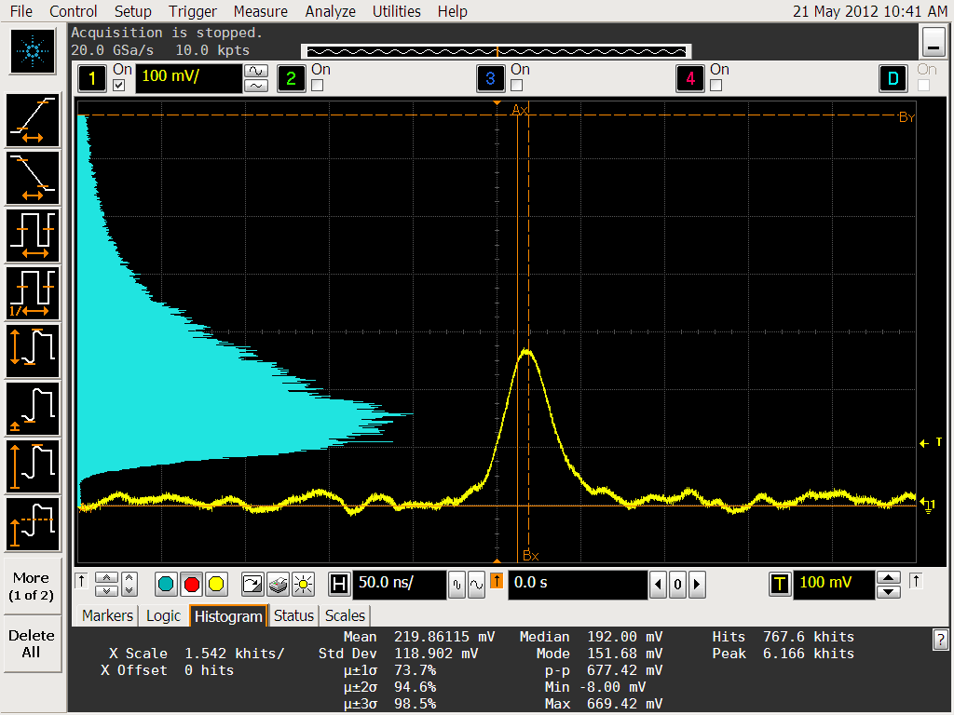
Figure 11. Typical pulse shape (yellow), and pulse height distribution (blue).

Figure 12. Count Rate as a function of threshold setting.

Figure 13. Time of fight spectrum of the alumina/aluminum beam monitor.

On August 23, 2012, the beam monitor was taken back to HFIR and tested on CG-1B to test the stability of the design. Operating at 3700 V, the beam monitor measured 250 cps with a 6.25 cm² aperture. The needed high voltage decreased by over 300 V in three months. This is most likely caused by a change in the gas quality or pressure inside the beam monitor. To address the possibility of a gas leak, the method of sealing the chamber was changed. The initial seal design used an indium wire with a groove in the chamber lid, which was difficult to use and create a good seal. The modified design utilizes an o-ring with a groove in the chamber body, making it much easier to form a vacuum seal.

Alumina – Boron Doped Silicon
The next beam monitor design to be tested relies on Boron-10 instead of Helium-3 as the neutron converter. Alumina coated with cermet is still used as an anode, but for the cathode a commercial p-type Silicon wafer doped with ______/cm³ natural Boron was used. The beam monitor was filled with 800 torr of Xe/CO₂ in a 95%/5% mixture.

The beam monitor was tested at HFIR CG-1D on May 25, 2012. It was set up directly in the neutron beam with a 1 in² aperture in front of it. Running at 4625 V, it measured a background rate of 0.28 cps with the beam shutter closed. With the shutter opened, the beam monitor measured 2.0 cps when the anode was facing the beam, and it measured 2.3 cps when the cathode was facing the beam.

An Ordela beam monitor was also used as a comparison measurement on the beam flux and recorded a count rate of 867 cps, and a background rate of 0.97 cps. The Ordela beam monitor has a known intrinsic efficiency of 4.5 x10⁻³ at 1.8 Å, so the parallel plate beam monitor has an efficiency of 1.1 x10⁻⁵ at the same wavelength.

Silicon – Boron Doped Silicon – He3
This beam monitor was built with undoped silicon as the anode and boron doped silicon as the cathode. It was filled with 29.1 Torr Helium-3 and 771 Torr of a 95%/5% mixture of Xe/CO₂. The beam monitor was tested at HFIR CG-1D on October 30, 2012.

The effects of several parameter settings on the beam monitor efficiency were studied. Initially, the threshold was set to 95 mV, and the count rate was measured as the high voltage was varied. As seen in Figure 14, the count rate reaches a plateau value around 4500 – 4600 V. At voltages above this plateau region, there is electric break down between the two parallel plates, so the voltage is limited to this point. To obtain consistent measurements with the beam monitor over time, an applied voltage within the plateau region should be used.

Figure 14. Count rate vs. voltage of beam monitor with silicon plates.

Once the required voltage setting was determined to be 4500 V, the count rate was measured as a function of threshold. It is clear from Figure 15 that as the threshold is increased above the noise level, the count rate drops sharply. Once above the noise level, the count rate levels off for a short range before slowly decreasing. The small plateau region between the electronic and gamma noise and the neutron peak is the desired operating range for the beam monitor. The optimized voltage and threshold settings give the averaged pulse shape shown in Figure 16.

Figure 15. Count rate vs. threshold for beam monitor with silicon plates.

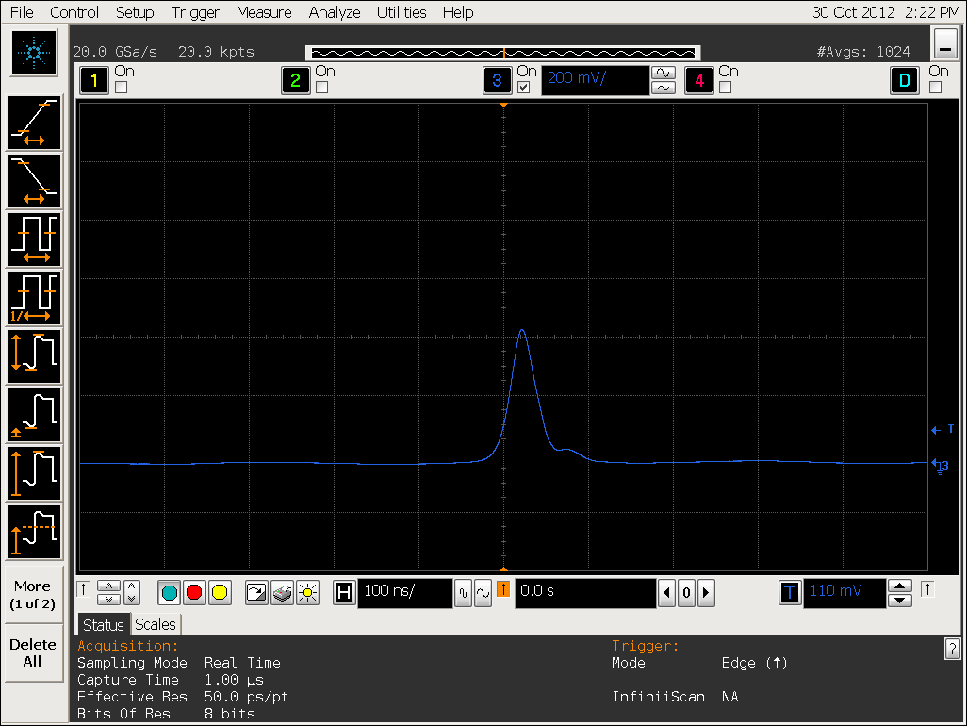
Figure 16. Averaged pulse shape from the beam monitor with silicon plates.

Additionally the TOF spectrum was measured, and is shown in Figure 17. As with the other beam monitor designs tested, the Bragg edges are visible in the spectrum, and the spectrum matches the expected output from the beam line.

Figure 17. Time of Flight spectrum of the beam monitor with silicon plates.

An Ordela beam monitor with efficiency ______ (10-3 nominally) was also measured for efficiency calculations. The Ordela beam monitor measured 76.4 cps, versus the parallel plate beam monitor with 3572 cps, giving it an efficiency of ________(.047).

Alumina – Aluminum – Lithium-6 Fluoride

Sample Preparation and Composition
This version of the beam monitor was constructed using alumina as the anode and aluminum as the cathode. Neutron conversion occurred through samples made with Lithium-6 enriched Lithium-Fluoride nanoparticles. The nanoparticles, manufactured by Eljen, are 100 nm in diameter and enriched to 95% Lithium-6. With help from members of the Materials Science Technology Division at Oak Ridge National Laboratory, the particles were mixed into poly(3,4-ethylenedioxythiophene)-poly(styrenesulfonate) from Sigma-Aldrich by thorough mixing using high-energy ball milling and mixing. The slurry was coated onto two different carbon fiber papers, a thermal graphite sheet from Panasonic Thermal Interface Products from Mouser Electronics and Toray Carbon Paper. After coating, any excess slurry was carefully removed from the surface and the sheet was dried at 90 ºC for a few hours. Sample 1 was made with 20% LiF on the Toray Carbon Paper. Sample 2 was made with 30% LiF on the thermal graphite sheet. The Lithium-Fluoride sheets were attached directly to the cathode in the amplification gap, so that the anode and the LiF sheets were separated by 2 mm.

After the beam monitor was tested at HFIR, the LiF samples were removed from the beam monitor and studied using a Scanning Electron Microscope (SEM). Although both types of carbon paper have fibers around 10 μm in diameter, the LiF particles did not have equal penetration into the carbon fiber matrix. It was found that the LiF particles were fully incorporated into the carbon fiber matrix of the Toray paper (Sample 1) as shown in Figure 18, but were only deposited on the surface of the graphite sheet (Sample 2) as shown in Figure 19.
Figure 18. LiF Sample 1. LiF particles are incorporated into the carbon fiber matrix.
Figure 19. LiF Sample 2. LiF particles deposited only on the carbon fiber surface.

Efficiency Tests
This beam monitor was tested at HFIR at CG-1B on August 23, 2012. The count rate was measured on the different regions of the beam monitor in order to determine the efficiency of the Lithium Fluorine samples. In order to test only one sample at a time, an adjustable aperture was used to define the area of the beam monitor exposed to the neutron beam. Regions in the center of each of the LiF samples were chosen, as illustrated in Figure 20. An area of 625 mm² was used for the LiF sheets, and an area of 525 mm² was used for the area without the sheets. The beam monitor face was 62 cm from the aperture opening.
Sample 1
Sample 2
Regions Tested
Figure 20. LiF Sample Arrangement within the beam monitor active area.

The electric field between the plates was varied, and the count rate was measured for both of the LiF samples and the region with no sample at each voltage setting. The results are shown in Figure 21.

Figure 21. Count Rates from Lithium Fluoride Samples

The count rates from an Ordela beam monitor with a known efficiency of 10⁻⁴ was also measured in order to determine the actual neutron flux and the efficiency of the LiF beam monitor. The Ordela monitor was placed 18 cm from the opening, also with a 625 mm² aperture in front of it. The beam monitor measured 41,000 cps. This gives a maximum efficiency of the LiF monitor of 2.2 x10⁻⁶.

Sample 1 had a larger counting efficiency than Sample 2, even though it had a smaller percentage of LiF particles. This is due to the particle distribution in the carbon papers. The Toray carbon paper has much smaller fibers than the thermal graphite sheet, which allowed the LiF particles to be distributed throughout the thickness of the paper instead of forming a layer on the surface. The larger range of interaction caused a higher conversion efficiency from the neutrons, resulting in a larger count rate.

CHAPTER IV
Summary and Conclusions

A new neutron beam monitor design was built and tested using five sets of different electrode and neutron conversion materials. With the parallel-plate design, the beam monitor is capable of measuring count rates in excess of 1,000,000 counts per second. Lithium-6 and Boron-10 were both successfully used as neutron converters, which eliminates the need for Helium-3. The efficiencies of the alternative converter materials used are on the order of 10⁻⁵ – 10⁻⁶. However, for a beam monitor application, a low efficiency is suitable, and further work to increase the efficiency of these converters could make them usable in a high-efficiency neutron detector.

From a production perspective, the parallel-plate design also has advantages over some of the current designs. Two electrodes are much easier to assemble than a proportional-wire beam monitor, decreasing the time needed to build a beam monitor. Additionally, the parallel-plate beam monitors are less expensive to produce, especially if using the silicon wafers.

Table 2. Summary of Beam Monitor Efficiencies
Beam Monitor Design | Intrinsic Efficiency
Quartz-Aluminum-He3 | 5.4 x 10-4
Alumina-Aluminum-He3 | --------
Aluminum-Boron Doped Silicon | 1.1 x 10-5
Silicon-Boron Doped Silicon-He3
Alumina-Aluminum-LiF | 2.2 x 10-6

LIST OF REFERENCES

[1] | "The High Flux Isotope Reactor at ORNL," [Online]. Available: http://neutrons.ornl.gov/facilities/HFIR/. [Accessed 27 October 2012].
[2] | "Instruments at the High Flux Isotope Reactor," [Online]. Available: http://neutrons.ornl.gov/instruments/HFIR/. [Accessed 27 October 2012].
[3] | "Spallation Neutron Source," [Online]. Available: http://neutrons.ornl.gov/facilities/SNS/. [Accessed 27 October 2012].
[4] | "Instruments at the Spallation Neutron Source," [Online]. Available: http://neutrons.ornl.gov/instruments/SNS/. [Accessed 27 October 2012].
[5] | "ISIS Neutron Beam Monitor," [Online]. Available: http://www.quantumdetectors.com/sites/default/files/Operational%20guide%20for%20the%20ISIS%20neutron%20bead%20monitor.pdf. [Accessed 16 September 2012].
[6] | "Ordela Model 4511N Neutron Beam Monitor," [Online]. Available: http://www.ordela.com/PDF/4511N.L.pdf. [Accessed 16 September 2012].
[7] | G. Hempel, F. Hopkins and G. Schatz, "Development of Parallel-Plate Avalanche Counters for the Detection of Fission Fragmets," Nuclear Instruments and Methods, vol. 131, pp. 445-450, 1975.
[8] | G. Charpak and F. Sauli, "The Multistep Avalanche Chamber: A New High-Rate, High-Accuracy Gaseous Detector," Physics Letter, vol. 78B, pp. 523-528, 1978.
[9] | "Evaluated Nuclear Data File," National Nuclear Data Center, December 2011. [Online]. Available: http://www.nndc.bnl.gov/sigma/. [Accessed 7 October 2012].
[10] | G. Knoll, Radiation Detection and Measurement, 4th ed., Wiley, 2010.
[11] | Ordela Inc., "Neutron Beam Monitor Instruction Manual," Oak Ridge, TN, 2010.
[12] | L. Crow, L. Robertson, H. Bilheux, M. Fleenor, E. Iverson, X. Tong, D. Stoica and W. T. Lee, "The CG1 instrument development test station at the high flux isotope reactor," Nuclear Instruments and Methods in Physics Research A, pp. S71-S74, 2011.

APPENDIX

Appendix A – Beam Monitor Assembly Drawings
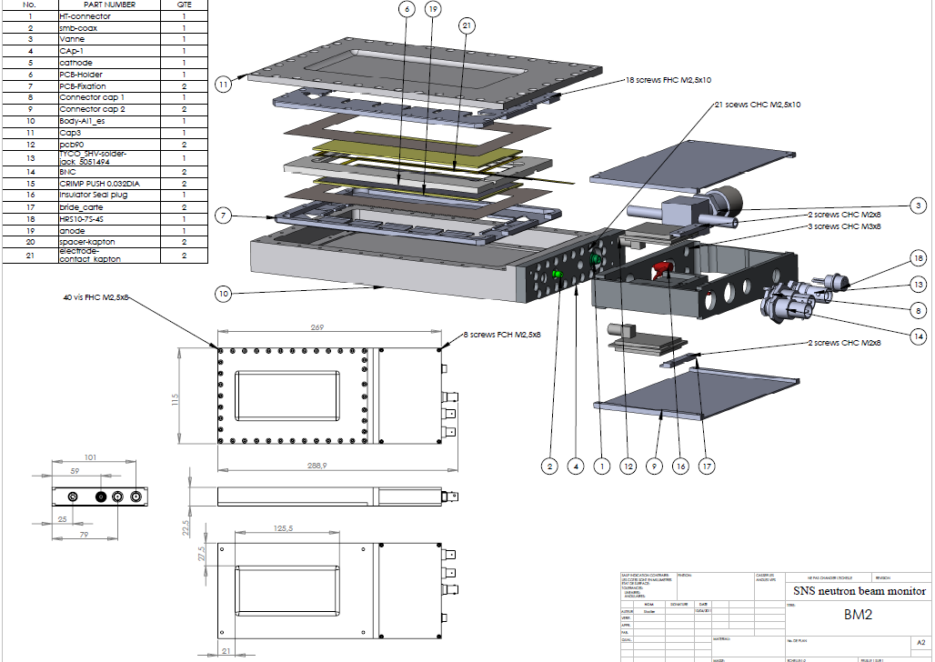
Assembly drawings done by

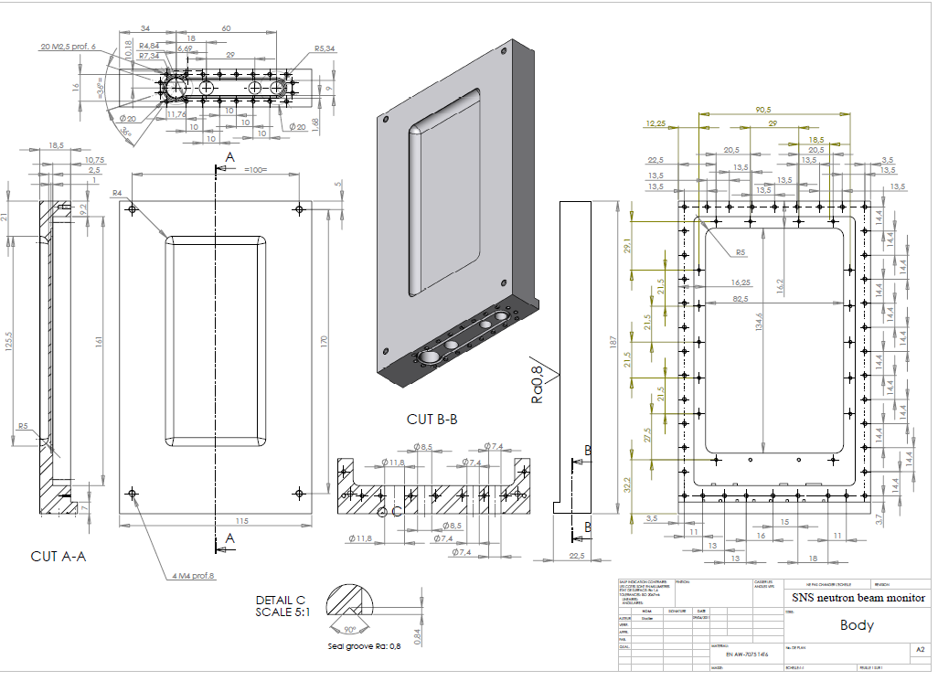
Beam Monitor Body
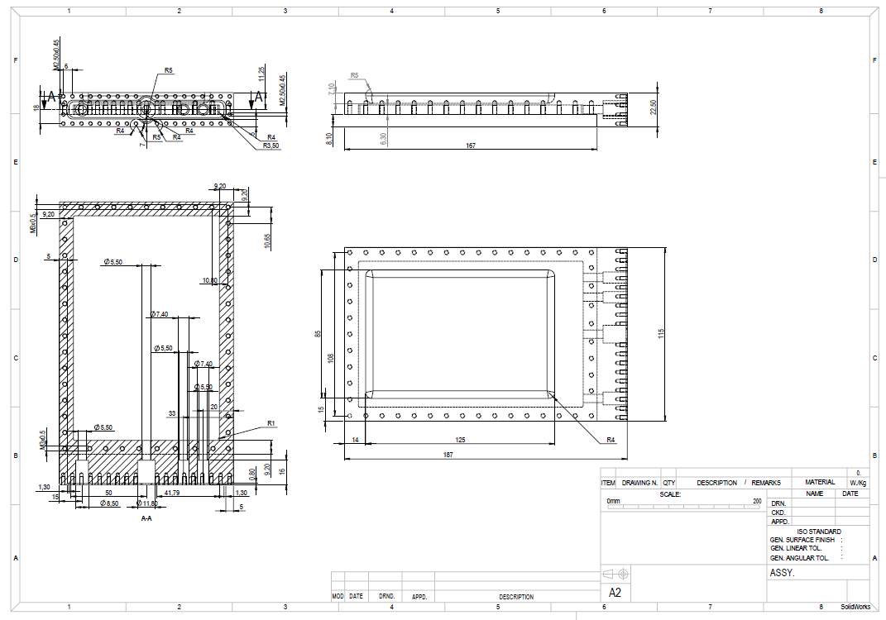

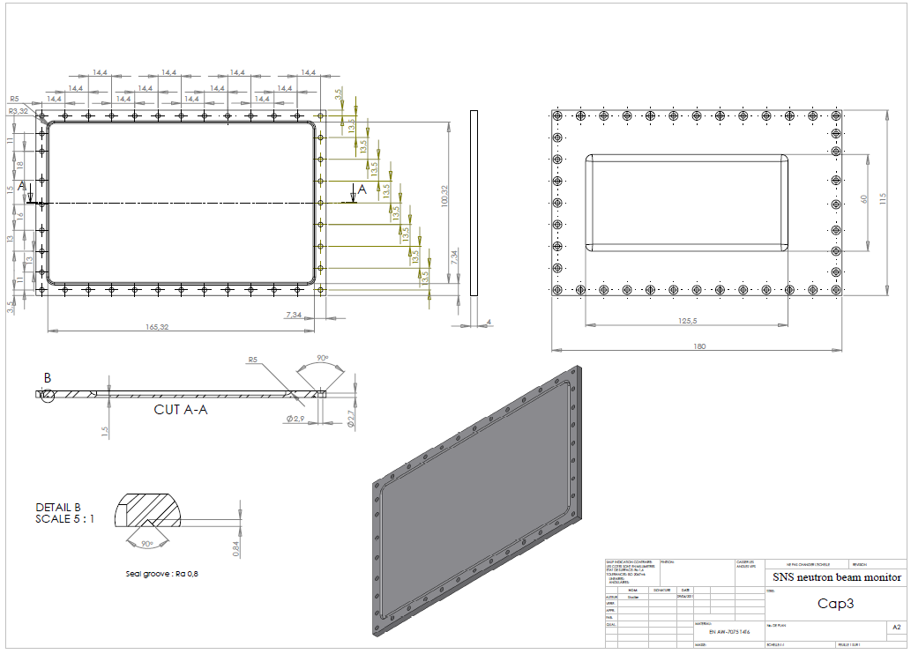
Housing Lid

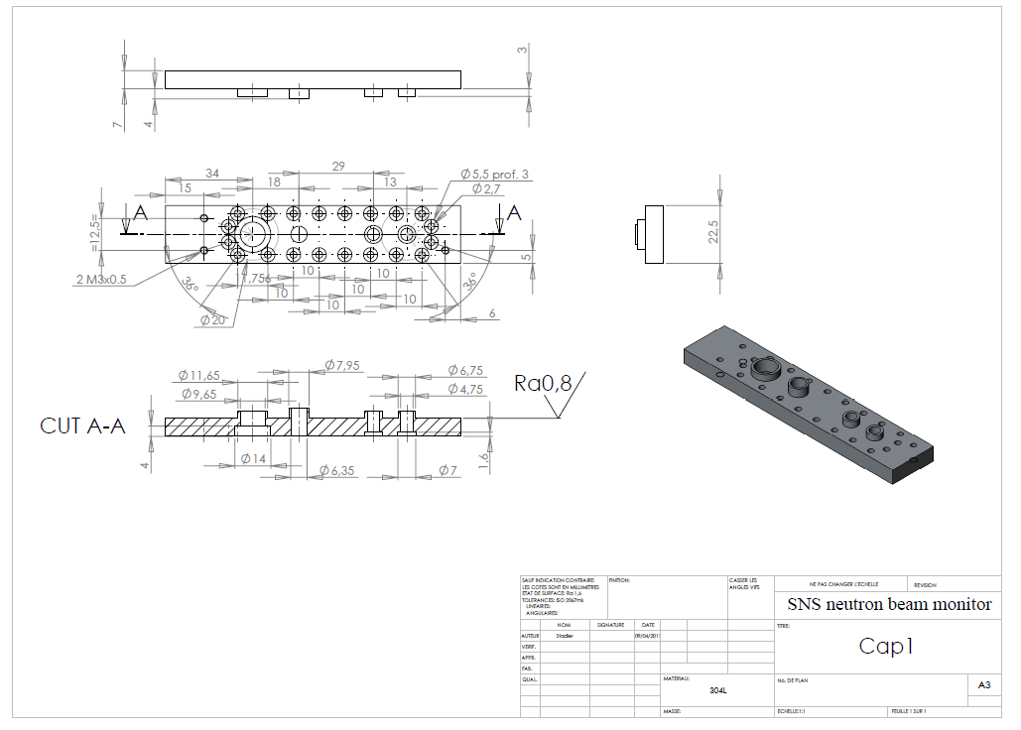
Feed-through Cap

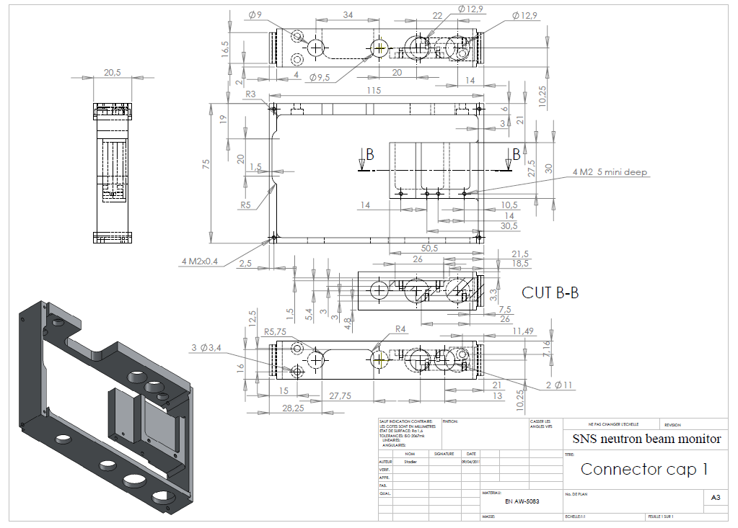
Electronics Housing

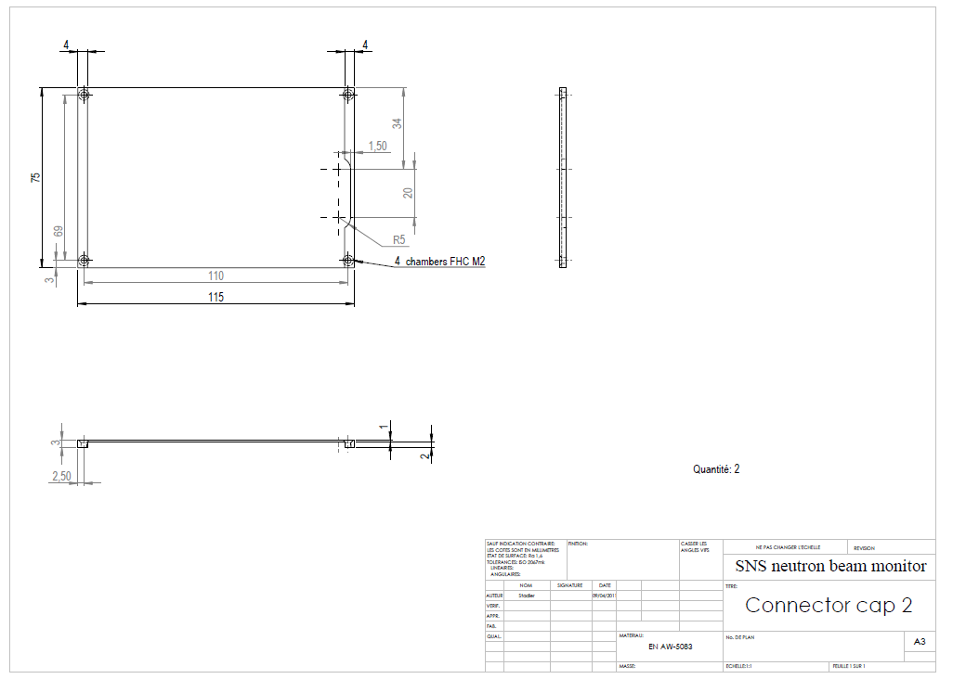
Electronics Housing Lid

Spacer


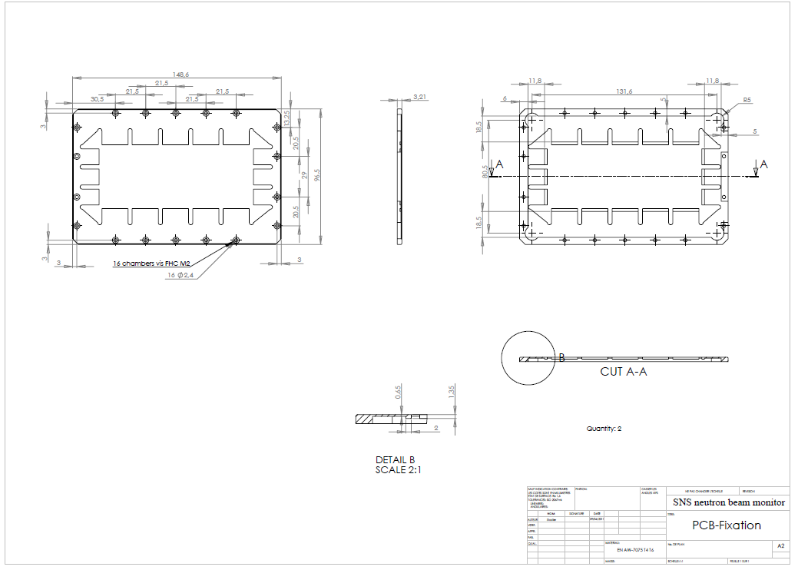
Electrode Holder

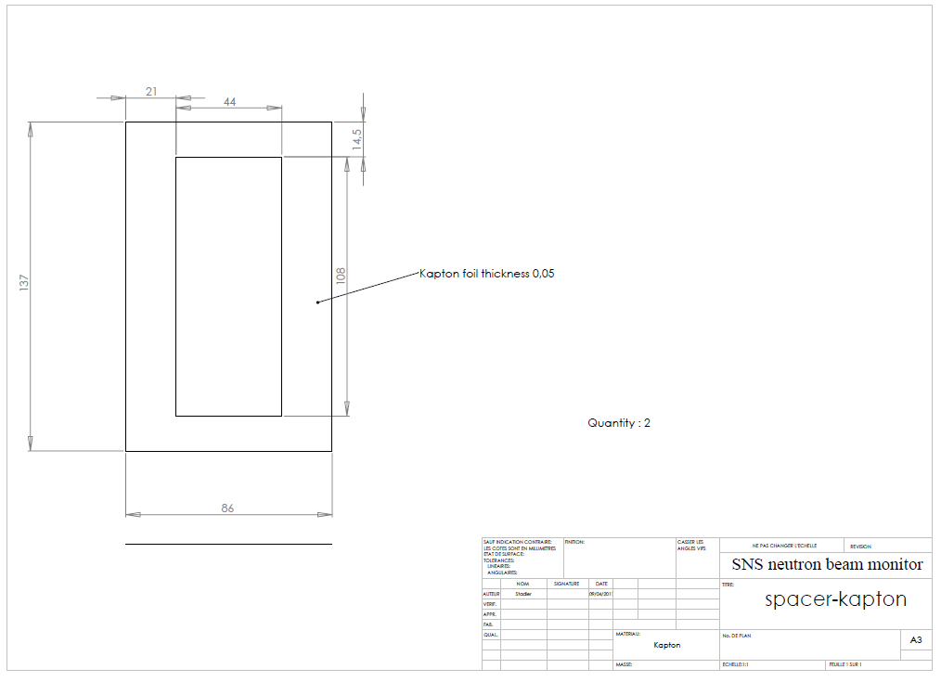
Kapton Spacer

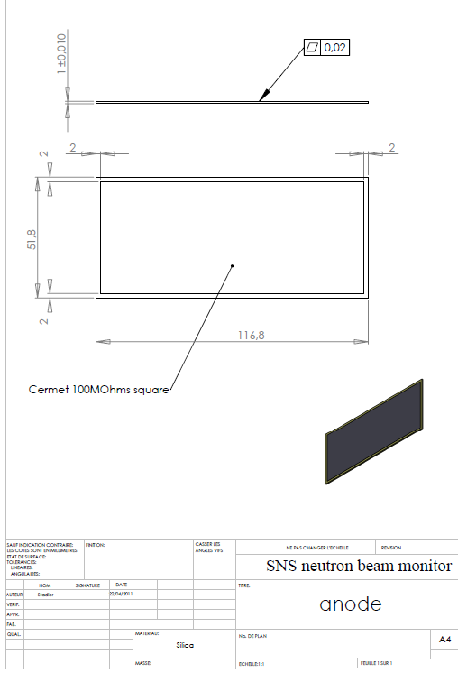
Anode

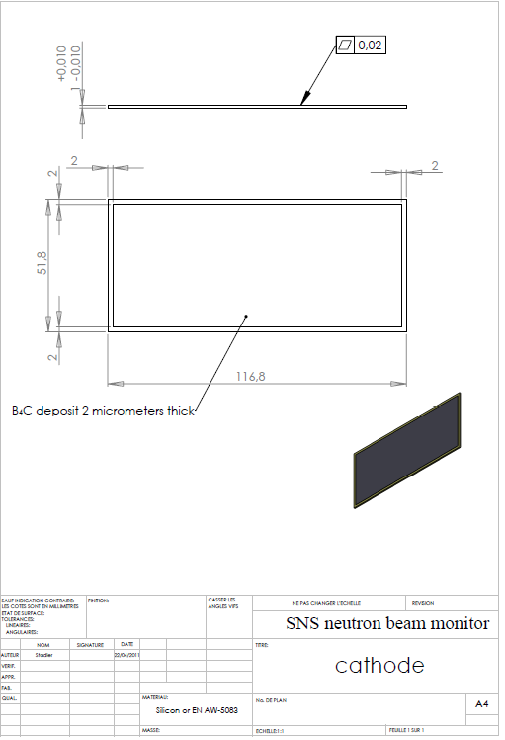
Cathode

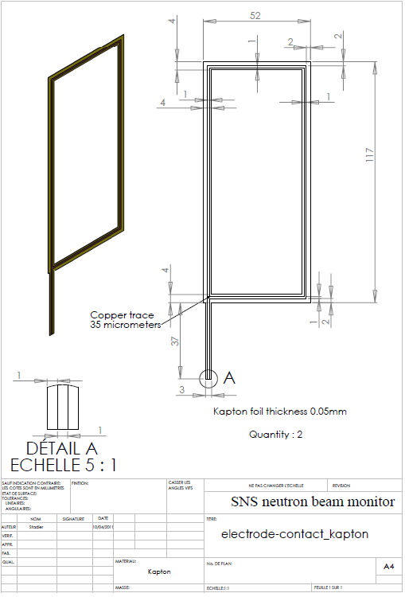
Electrode Contact

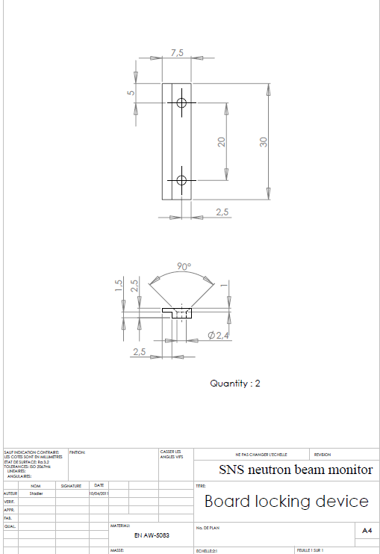
Electronics Grounding Board

Vita

Amanda K. Barnett was born in Indianapolis, Indiana on February 9, 1989. After graduating from Plainfield High School in 2007, she attended Rose-Hulman Institute of Technology, where she received a Bachelor of Science degree in Physics with minors in Mathematics and German in 2011. Amanda then attended The University of Tennessee Knoxville, and received a Master’s of Science degree in Nuclear Engineering in 2013.

