Impacts of Land Use Disturbance on Fish and Aquatic Macroinvertebrate Assemblages in the Nolichucky River Watershed

A Thesis Presented for the

Master of Science

Degree

The University of Tennessee, Knoxville

Hayley Sonia Gotwald

August 2016
Copyright © 2016 by Hayley Gotwald
All rights reserved.
DEDICATION

Dedicated to my father, Paul Michael Gotwald, for our outdoor adventures.
ACKNOWLEDGEMENTS

Although my name alone is listed on the cover of this thesis, the efforts of multiple parties have allowed it to come to fruition. I first would like to express my gratitude to my adviser Dr. Brian Alford for his positive encouragement and expertise in fisheries management.

A special thanks goes out to my thesis committee: Dr. Robert Washington-Allen for teaching me remote sensing techniques this past year and Dr. Andrea Ludwig for her insightful comments to improve the study.

Collection of the field data would not have been possible without Joyce Coombs for meticulously recording data and organizing our excursions. Justin Wolbert for identifying a multitude of fish and benthic macroinvertebrates. Lastly to those who volunteered their time with data collection: Keith Garner, Charlie Saylor, Dan Walker, Todd Amacker, Parker Hurst, and Kenneth McMahan.

Funding for this project was provided by the UT Institute of Agriculture and the Tennessee Water Resources Research Center.
ABSTRACT

Southern Appalachian watersheds of the United States are negatively affected by pesticides and fertilizers used in row crop agriculture. The objective was to determine if the amount of row crops is connected to changes in aquatic biotic assemblages draining the Nolichucky River watershed in east Tennessee. The hypothesis was the amount of row crops will negatively correlate with indices of biotic integrity (IBI) metrics for fish and benthic macroinvertebrates indicating healthy aquatic communities.
For 18 sample sites in 2014 and 2015, IBI metrics were calculated. Water quality and elevation measurements were made before conducting IBIs. To assess changes in and amounts of land use/land cover (LULC), maps from 1999 to 2014 were produced with Landsat satellite imagery. Pollutant estimates (sediment, phosphorus, and nitrogen) were calculated using the Soil & Water Assessment Tool (SWAT) model.
The area of row crops increased since 1999 (39 km² in 1999 to 71 km² in 2014). A principal component analysis was performed on LULC measurements from different scales (local, reach and catchment), water quality data, and elevation to produce a reduced set of explanatory variables that were uncorrelated but could be associated with IBI metrics.
A canonical correspondence analysis associated fish metrics with LULC types: Impervious surfaces, non-row crop fields, and forest (p = 0.04 for axis 1 eigenvalue, p = 0.05 for species-environment correlations). For the benthic macroinvertebrate metrics, nonmetric multidimensional scaling found metrics indicative of poor stream health (percentage of oligochaetes and chironomids, percentage of nutrient tolerant organisms) were strongly positively associated with increasing use of row crops, impervious surfaces (p ≤ 0.01), and pollutant estimates (p ≤ 0.004). A redundancy analysis found increasing pollutant estimates were associated with fish metrics indicative of poor stream health (percentages of hybrids, piscivores, diseased fish, and number of sunfish species) (p = 0.03). When watersheds of tributary streams are converted to impervious and non-row crop field LULC, they function biologically like the larger main stem river. Although fish and benthic macroinvertebrate metrics indicated the tributary and main stem Nolichucky sites were in relatively good condition, increases in land conversion can further degrade stream biotic integrity.

TABLE OF CONTENTS

CHAPTER I INTRODUCTION 1
Background 2
Practices of Row Cropping 7
The Index of Biological Integrity (IBI) 8
Management Implications 10
Hypotheses & Objectives 12
CHAPTER II LAND USE AND COVER IN THE NOLICHUCKY WATERSHED 16
Abstract 17
Methods 18
Study Area 18
Site Selection 20
Spatial Data Acquisition 21
Land Cover/Land Use Classification 22
Accuracy Assessment 27
NDVI Method 29
Scale Analysis 30
Statistical Analysis 34
Results 35
Land Cover/Land Use Change 35
2014 Analysis of LULC versus Environmental Variables 39
Discussion 44
Land Cover Time Series 44
2014 Relationship of LULC to Environmental Variables 45
Appendix A 47
Appendix B 55
Appendix C 58
Appendix D 61
Appendix E 64
CHAPTER III ASSOCIATION BETWEEN LAND USE AND METRICS OF BIOTIC INTEGRITY 80
Abstract 81
Methods 82
Field Data Acquisition 82
Fish IBI 82
Benthic Macroinvertebrate Metrics 83
Statistical Analysis 83
Results 87
Fish IBI 87
Benthic Macroinvertebrates 100
Discussion 102
Fish IBI 102
Benthic Macroinvertebrates 105
Appendix F 107
Appendix G 109
CHAPTER IV ASSOCIATION BETWEEN SWAT MODEL AND METRICS OF BIOTIC INTEGRITY 111
Abstract 112
Methods 113
SWAT Model 113
Statistical Analysis 115
Results 116
Discussion 125
Appendix H 131
CHAPTER V CONCLUSION 132
REFERENCES 136
VITA 151
LIST OF TABLES

Table 1 The water quality and elevation variables that were collected for each sample site in the Nolichucky River watershed. 21
Table 2 Spatial data used to create a thematic map of land use/land cover (LULC) in the Nolichucky river watershed. Data was used in the two-part classification using first a supervised classification using the maximum likelihood algorithm to produce a layer of forest cover for masking the density slicing of the normalized difference vegetation index (NDVI). Additional abbreviations are as follows *OLI/TIRS, Operational Land Imager/Thermal Infrared Sensor, **EROS, Earth Resources Observation and Science Center, ***USGS, US Geological Survey, #USDA, US Department of Agriculture. 23
Table 3 NDVI threshold values chosen in Landsat level two NDVI product where all values are scaled by a factor of 0.0001 (USGS 2016). 30
Table 4 The various spatial scales within which land use/land cover and the extent of riparian buffers for fish and benthic macroinvertebrate sample sites were measured in the Nolichucky River watershed of Tennessee. 33
Table 5 Area (km²) of the land use/land cover (LULC) classes in the Nolichucky watershed across the time series and the percent change (%CHANGE) between 2014 and 1999. Percent change calculated as the area of a LULC class in 2014 minus the area of the same LULC class in 1999. This difference is then divided by the area of the land use in 1999 and multiplied by 100. FOR = forest, IMP = impervious surface, OPN = open fields, ROW = row crop, and WTR = water. 36
Table 6 Measurements for area and patches of row crops in the entire Nolichucky River watershed from 1999 to 2014. A patch is defined as an area that must be relatively homogeneous and differ from the surrounding land use/land cover. 37
Table 7 To measure the impact of row crop agriculture on aquatic communities, a principal component analysis (PCA) was conducted on land use/land cover, water quality, and elevation variables that were collected at selected sample sites along the Nolichucky River watershed in 2014. The five axes explain over 80% with the first axis explaining the most and decreasing for the following axes. Variables that correlate strongly with the first axis explain more of the variation in the dataset than variables that do not correlate with the first axis. 40
Table 8 Eigenvectors from the first five axes of a principal component analysis (PCA) of water quality, elevation, and land use/land cover variables collected at selected sample sites in the Nolichucky River watershed. Eigenvectors of greater magnitude indicates a variable positively or negatively correlates with the axis (principal component) the PCA found 41
Table 9 Description of fish index of biotic integrity metrics and their abbreviations (TVA 2004). These metrics were associated with land use, water quality, and elevation in the Nolichucky River watershed. 84
Table 10 Description and abbreviations for the benthic macroinvertebrate index of biotic integrity metrics (TDEC 2011). These were associated with land use, water quality, and elevation in the Nolichucky River watershed. 85
Table 11 The correlation matrix produced as preliminary results in the canonical correspondence analysis. The land use/land cover and the environmental variables were collected at selected sample sites in the Nolichucky River watershed. Abbreviations are elevation (ELEV), row crop (ROW), temperature (TEMP), forest (FOR), impervious surfaces (IMP), acidity (PH), and open space (OPN). 88
Table 12 To measure how row crop agriculture impacts fish communities a canonical correspondence analysis (CCA) was performed on metrics from a fish index of biotic integrity (IBI) in relation to explanatory variables: land use/land cover, water quality, and elevation that were collected at selected sample sites in the Nolichucky River watershed. The three axes for the CCA of fish IBI metrics show 70.6% of the variance in the sample sites are explained by the explanatory variables (Spp-Envt). 89
Table 13 Multiple regression results from the canonical correspondence analysis (CCA) performed on fish index of biotic integrity (IBI) metrics in relation to explanatory variables: land use/land cover, water quality, and elevation that were collected at selected sample sites in the Nolichucky River watershed. Values are the regression of sample sites in the space of fish IBI metrics of on environmental variables. These values indicate the effectiveness of the explanatory variables in structuring the ordination and describing the relationships of the explanatory variables to the ordination axis. Abbreviations are elevation (ELEV), row crop (ROW), temperature (TEMP), forest (FOR), impervious surfaces (IMP), acidity (PH), and open space (OPN). 91
Table 14 The weighted averaging (WA) scores created by the canonical correspondence analysis (CCA) performed on fish index of biotic integrity (IBI) metrics in relation to explanatory variables: land use/land cover, water quality, and elevation that were collected at selected sample sites in the Nolichucky River watershed. Raw data totals (weights) are also given. 92
Table 15 The linear combination (LC) scores calculated by the canonical correspondence analysis (CCA) performed on fish index of biotic integrity (IBI) metrics in relation to explanatory variables: land use/land cover, water quality, and elevation that were collected at selected sample sites in the Nolichucky River watershed. Raw data totals (weights) are also given. These are the LC scores plotted in Figure 10. 93
Table 16 The weights for fish index of biotic integrity (IBI) metrics created by the canonical correspondence analysis (CCA) performed on fish IBI metrics in relation to explanatory variables: land use/land cover, water quality, and elevation that were collected at selected sample sites in the Nolichucky River watershed. Abbreviations for the fish metrics are in Table 9. 94
Table 17 The biplot scores and correlations with the three axes for the explanatory variables. Values were calculated by the canonical correspondence analysis (CCA) performed on fish index of biotic integrity (IBI) metrics in relation to explanatory variables: land use/land cover, water quality, and elevation that were collected at selected sample sites in the Nolichucky River watershed. Biplot scores are used to plot the vectors in the ordination diagram. Two kinds of correlations are shown, interset and intraset. Abbreviations are elevation (ELEV), row crop (ROW), temperature (TEMP), forest (FOR), impervious surfaces (IMP), acidity (PH), and open space (OPN). 95
Table 18 The Monte Carlo test of significance was performed to assess the statistical significance of the canonical correspondence analysis performed on the fish index of biotic integrity metrics in relation to explanatory variables: land use/land cover, water quality, and elevation that were collected at selected sample sites in the Nolichucky River watershed. The results for the eigenvalues and species-environment correlations based on 998 runs. 99
Table 19 A nonmetric multidimensional scaling ordination was performed on benthic macroinvertebrate index of biotic integrity metrics in relation to explanatory variables: land use/land cover, water quality, and elevation that were collected at selected sample sites in the Nolichucky River watershed. To test the significance of the stress in relation to dimensionality (number of axes), a Monte Carlo test was done comparing 250 runs on the real data to 250 runs on randomized data. The p-value is the proportion of randomized runs with stress less than or equal to the observed stress. 101
Table 20 Data used in the soil and water assessment tool (SWAT) model to estimate the amount of sediment, phosphorus, and nitrogen carried into the streams from catchments of various types of land use in the Nolichucky river watershed during 2014. 114
Table 21 The correlation matrix produced as preliminary results in the redundancy analysis. Sediment yield (SYLD), organic nitrogen (ORGN), and organic phosphorus (ORGP) were estimated using the Soil and Water Assessment Tool at selected sample sites in the Nolichucky River watershed. 118
Table 22 To measure how pollutants from row crop agriculture impacts fish communities a redundancy analysis (RDA) was performed on metrics from a fish index of biotic integrity (IBI) in relation to pollutant estimates from the Soil and Water Assessment Tool (SWAT) that were for selected sample sites in the Nolichucky River watershed. Axis summary statistics for the three axes the RDA found explain 38.4% of the variance in the sample sites are explained by the pollutant estimates (Spp-Envt). 119
Table 23 The randomization test of significance was performed to assess the statistical significance of the axes found in the redundancy analysis of fish index of biotic integrity metrics in relation to estimates of the pollutants (sediment, phosphorus, and nitrogen) at selected sites in the Nolichucky River watershed. 122
Table 24 The linear combination (LC) scores calculated by the redundancy analysis performed on fish index of biotic integrity metrics in relation to the estimated pollutants (sediment, phosphorus, and nitrogen) at selected sample sites in the Nolichucky River watershed. Abbreviations for the fish metrics are in Table 9. 122
Table 25 The linear combination (LC) scores calculated by the redundancy analysis performed on fish index of biotic integrity metrics in relation to the estimated pollutants (sediment, phosphorus, and nitrogen) at selected sites in the Nolichucky River watershed. These are the LC scores plotted in Figure 14 and 15. 123
Table 26 The standardized regression coefficient calculated in the redundancy analysis performed on the fish index of biotic integrity metrics in relation to estimates of the pollutants (sediment, phosphorus, and nitrogen) at selected sites in the Nolichucky River watershed. 124
Table 27 A nonmetric multidimensional scaling ordination was performed on benthic macroinvertebrate index of biotic integrity metrics in relation to in relation to pollutant estimates from the Soil and Water Assessment Tool (SWAT) that were for selected sample sites in the Nolichucky River watershed. To test the significance of the stress in relation to dimensionality (number of axes), a Monte Carlo test was done comparing 250 runs on the real data to 250 runs on randomized data. The p-value is the proportion of randomized runs with stress less than or equal to the observed stress. 126
LIST OF FIGURES

Figure 1. Visual representation of the river continuum concept that is used to characterize the structure of the Nolichucky river watershed, the study site for this research. Circles are functional groups of benthic macroinvertebrate communities from headwaters to the mouth of a river. Coarse particulate organic matter (CPOM) enter the river from the riparian vegetation and are ground into fine particulate organic matter (FPOM). The ratio of primary productivity (P) to respiration (R) changes along the stream due to the amount of sunlight availability. This figure is from Vannote et al. (1980) 5
Figure 2. The primary hypothesis of this study is presented in the above conceptual model to justify how LULC, particularly riparian row cropping can be used as a proxy for herbicide, fertilizer, and pesticide impacts on aquatic communities. White arrows indicate how pollutants make their way to streams and affect aquatic biodiversity. Dotted line arrow indicates the hypothesis tested: if there are high amount of active row crops, then it will be associated with low IBI metrics. 13
Figure 3 The location of the Nolichucky River watershed and the study sites in the Tennessee portion of the watershed within the south eastern USA. Sites were located along the main stem and several tributaries in the Tennessee portion of the watershed. 19
Figure 4 Work flow of the two-part classification using a maximum likelihood supervised classification and density slicing of a normalized difference vegetation index (NDVI) to produce a land use/land cover (LULC) map. Classes of final LULC map are row crops, open space, forest, impervious surfaces, and water. Steps 1-6 were completed in ENVI (dashed-line frames) while the remaining steps 7-11 were completed in ArcMap (solid-line frames). 26
Figure 5 Portion of the Landsat 8 image (row 35, path 18) in the Nolichucky River watershed. The overlaid green, blue, and gray polygons are the forest, hydrography, and impervious surfaces used to create the mask for the second part of the land use/land cover classification. 28
Figure 6 Measurements for the scale analysis in the Nolichucky River watershed for the 2014 map. Part A is at the local scale which are a 500-m and 100-m point buffers around the sample location. Visual representation of the spatial scales of measured land cover. Part C shows the area used to calculate percent land use of the entire catchment (left) and a 100-m buffer of the entire upstream riparian network (right). Part B shows the reach scale that includes a buffer that is 1000-m upstream and 500-m downstream of the sample location (left: where the dashed lines meet). A buffer of 125-m was created around the reach and the width of the riparian vegetation was measured perpendicular to the stream at 50-m increments from the upstream to downstream end of the reach (right). 31
Figure 7 Distribution of percentages of land use/land cover types for the entire Nolichucky River watershed across years. FOR = forest, IMP = impervious surface, OPN = open fields, ROW = row crop, and WTR = water. 35
Figure 8 Land use/land cover (LULC) percentage at each scale averaged across the sample sites in the Nolichucky River watershed in 2014. Confidence intervals are 95% and were calculated using bootstrapping. Classes of LULC are abbreviated as FOR = forest, IMP = impervious surface, OPN = open space, ROW = row crop, and WTR = water. 37
Figure 9 Patch dynamics of row crop land use in the entire Nolichucky River watershed from 1999 to 2014. Graph shows number of patches and average area of a row crop patch increased in the watershed. 38
Figure 10 Joint plots showing a canonical correspondence analysis ordination of fish index of biotic integrity metrics (A) and sample sites on the Nolichucky (B) in environmental space: land use/land cover, water quality, and elevation. Using linear combination scores scores, the joint plot overlay shows vectors related to the four strongest variables: (water temperature (TEMP), open space (OPN), forest (FOR), and impervious surfaces (IMP). Axes are scaled by raw scores. 97
Figure 11 The ordination of the benthic macroinvertebrate metrics of biotic integrity (A) and sites (B) in comparison to the land use, defined by a nonmetric multidimensional scaling ordination performed on benthic macroinvertebrate index of biotic integrity metrics in relation to explanatory variables: land use/land cover, water quality, and elevation that were collected at selected sample sites in the Nolichucky River watershed. Arrows are the vectors from the explanatory variablesmatrix that best explained the variation of the sample sites, row crops (ROW) and impervious surfaces (IMP). Vectors are rotated 20°. 103
Figure 12 The Soil and Water Assessment Tool (SWAT) was used to estimate the amount of sediment (SYLD), nitrogen (ORGN), and phosphorus (ORGP) over the year 2014 for the entire Nolichucky River watershed. 116
Figure 13 Distribution of sediment, nitrogen, and phosphorus across the Nolichucky River watershed in 2014 modeled by ArcSWAT. Values for each sub basin have been transformed by log(x)+1 for the map. 117
Figure 14 Joint plots showing a redundancy analysis ordination of sample sites of fish index of biotic integrity metrics along a gradient of sediment (SYLD), phosphorus (ORGP), and nitrogen (ORGN). The sites in the Nolichucky River watershed show three distinctive groups of (1) low impact tributaries, (2) moderately impacted tributaries, and main stem sites (regardless of impact level) with highly impacted tributaries (3). 120
Figure 15 Joint plot showing a redundancy analysis ordination of the fish metrics of biotic integrity calculated for several sample sites in the Nolichucky River watershed along a gradient of sediment (SYLD), phosphorus (ORGP), and nitrogen (ORGN). 121
Figure 16 The ordination of the benthic macroinvertebrate metrics of biotic integrity of selected sites in comparison to the land use, defined by a nonmetric multidimensional scaling ordination performed on benthic macroinvertebrate index of biotic integrity metrics in relation to pollutant estimates from the Soil and Water Assessment Tool that were for selected sample sites in the Nolichucky River watershed. 127
Figure 17 The nonmetric multidimensional scaling ordination of the benthic macroinvertebrate metrics of biotic integrity of benthic macroinvertebrate metrics in comparison in relation to pollutant estimates from the Soil and Water Assessment Tool that were for selected sample sites in the Nolichucky River watershed. 128

CHAPTER I
INTRODUCTION

Background

The Nolichucky River flows out of the Appalachian Mountains in North Carolina and into Tennessee. The watershed is part of eastern Tennessee’s rich history and was settled by American colonists in the 18th century (Tonn and Cottrill 2004). The Tennessee portion of the Nolichucky watershed is home to ten rare mussel species, seven known rare fish species, six known rare snail species, and three known rare amphibian species (Tennessee Department of Environment & Conservation, TDEC 2008). Of these rare, aquatic species, four are listed as critically endangered, seven as endangered, one is considered near threatened, and four are vulnerable according to the International Union for the Conservation of Nature’s (IUCN) Red List of Threatened Species (2015). Many of the aquatic animals in this watershed, such as the Sharphead Darter (Nothonotus acuticeps), are extremely localized, with their largest populations in the lower Nolichucky River (Etnier and Starnes 1993). This makes the Nolichucky River a valuable study site for the effects of land use change, as a small geographical range is the best indicator of extinction risk (Purvis et al. 2000). It is important to study how human activity affects these sensitive systems because watersheds in Tennessee and the southern Appalachians lack legal protection from non-point sources of pollution (e.g., agricultural runoff) and contain some of the highest fish and invertebrate diversity in the country (Jenkins et al. 2015).
The Tennessee portion of the watershed is dominated by agricultural land use. In 2008, TDEC estimated 47% of the watershed was in agricultural land use. Greene County, which makes up the majority of the watershed, is the leading county in Tennessee for cattle and hay production (TDA 2013). Starting around 2005, landowners in the watershed began converting pasture and hay fields to row crops which is of concern because row crops use more pesticides and fertilizer in their production. Without proper management, row crops may threaten the Nolichucky River fauna because they require high amounts of fertilizer and pesticides during the growing season, which coincides with fish and invertebrate reproductive periods (Baker 1985).
Fertilizer and pesticides harm aquatic fauna in several ways. Fertilizer contains nitrogen and phosphorus which are limiting nutrients for algae and aquatic plants. A water body that is polluted with high amounts of fertilizer becomes eutrophic, causing the aquatic plant and algae populations to rapidly increase in biomass. This may lead to a blanket of vegetation that as it decays its decomposition alters habitat quality by, decreasing the level of dissolved oxygen thus creating hypoxic conditions that suffocate aquatic fauna (Hatch et al. 2002). Pesticides can affect aquatic fauna both directly and indirectly. Direct effects include death and illness from poisoning and, indirect effects come from alteration of food webs (Gevao and Jones 2002). Pesticides are known to act as endocrine disrupters in aquatic fauna interfering with an organism’s hormone system to cause negative developmental, reproductive, immune, and neurological effects. Chemicals from pesticides and fertilizer may also bioaccumulate throughout the food web (Khan and Law 2005; Bortone and Davis 1994; Colborn et al. 1993). In addition to harming aquatic biota, pesticides in the US are frequently found in streams and, to a lesser extent, in ground water of watersheds with large amounts of agriculture and impervious surfaces. Although individual pesticides are seldom found at levels higher than water quality benchmarks for human health, they often occur as a mixture of multiple pesticide compounds. This could possibly lead to underestimations of toxicity, since assessments are often based on individual compounds (Gilliom 2007).
The Nolichucky River, like many other rivers in temperate deciduous forest biomes, follows the pattern hypothesized by the river continuum concept (RCC, Vannote et al. 1980) in which a river system has a continuous gradient of physical conditions, and the biotic community that lives in this river responds in a predictable pattern from the headwaters to the mouth. According to the RCC, a river is categorized into three broad characteristics based on Strahler’s stream order: headwaters (orders 1-3), medium-sized streams (orders 4-6), and large rivers (orders >6) (Figure 1, Strahler 1957). Numbers are assigned to a stream section based on the amount of tributaries that feed into it. Order increases where two tributaries of the same level converge. For example, two first order streams make a second order stream but a first order stream feeding into a third order stream does not increase the stream order to fourth order (Strahler 1957).
In the RCC, the headwater stream communities rely on riparian vegetation for nourishment in the form of leaf packs woody debris, and terrestrial organisms that enter the water (called coarse particulate organic matter or CPOM). Autotrophic respiration for aquatic plants and algae cannot produce sufficient nutrients for headwater stream communities because of tree shade. Thus, in small sized streams, the ratio of gross primary productivity (P) to community respiration (R) is less than one. The fish assemblage in headwater streams has lower species richness and is composed of cool water species (maximum July temperature < 22° C) that are mostly invertivores as compared to downstream assemblages. Downstream species of piscivores and invertivores make up midsized river assemblages while in large rivers more planktivorous species are found. The majority of the aquatic macroinvertebrates in headwaters are shredders and collectors. The shredders feed on the microbes that colonize the leaf packs and break the CPOM into smaller materials known as fine particulate organic matter (FPOM). The collectors then feed on the FPOM through nets and filters.
Moving down the continuum from headwaters to midsized streams, the river widens and the canopy opens allowing for photosynthesis to take place increasing the P/R to above one. The lack of CPOM coupled with the growth of periphyton and vascular hydrophytes on the river bottom leads to a change in the community’s composition. Shredders decrease while grazers and collectors increase. Larger bodied fish appear and biodiversity increases.
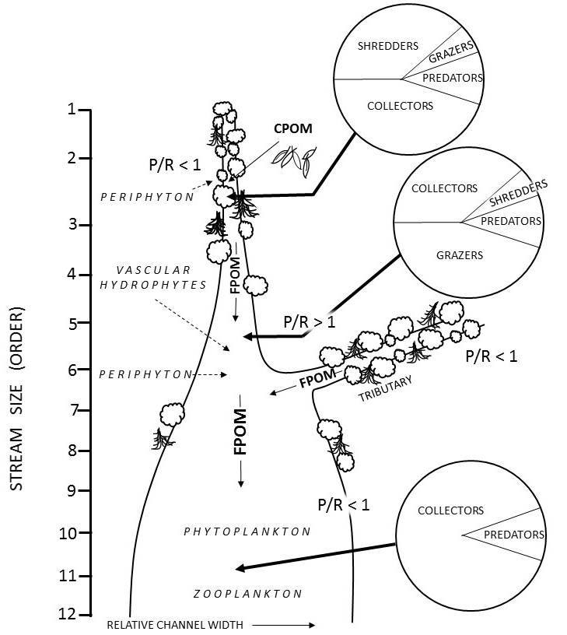
Figure 1. Visual representation of the river continuum concept that is used to characterize the structure of the Nolichucky river watershed, the study site for this research. Circles are functional groups of benthic macroinvertebrate communities from headwaters to the mouth of a river. Coarse particulate organic matter (CPOM) enter the river from the riparian vegetation and are ground into fine particulate organic matter (FPOM). The ratio of primary productivity (P) to respiration (R) changes along the stream due to the amount of sunlight availability. This figure is from Vannote et al. (1980)

As stream size continues to increase in order, the river deepens and light can no longer penetrate the bottom of the river. Phytoplankton and zooplankton become the primary producers in the river, and P/R returns to less than one because of the large amount of fine particulate organic matter (FPOM) from all the upstream branches. Biodiversity decreases, shredders and grazers disappear from the habitat, and only collectors and predators remain. Smaller-bodied riffle habitat fishes disappear as well, while large-body fish remain.
The primary hypothesis of this research is the hydrological and biogeochemical linkages between terrestrial and aquatic ecosystems where river waters are dependent on the amount of riparian forest along the banks as a source of energy for aquatic inhabitants, bank protection from erosion, and as a filter of polluted runoff. Disturbances such as agricultural land use activities, particularly in this instance: row cropping, lead to clearance of riparian vegetation and thus reduction of the riparian buffer. Polluted runoff partnered with a lack of a riparian buffer can decrease water quality and change the instream habitat so that sensitive species can no longer survive (Bollmohr and Schulz 2009; Valle et al. 2013). In terms of patch dynamics, patchiness is caused by disturbance (White 2013). For example, in an undisturbed riparian area, patches of forest are few in number but are large due contiguity and lack of fragmentation. When human disturbance occurs the patches of forest increase but their patch size decreases. This increasing patchiness of riparian areas may indicate increased runoff from disturbance.
Due to the nested nature of watersheds the stream systems can be classified as a hierarchy, where large spatiotemporal scales determine the physical attributes and thus the ecological community at smaller scales (Frissell et al. 1986). Attributes at large spatiotemporal scales are regional characteristics of the watershed such as geological history, climate, geomorphology, soils, and vegetation. Furthermore, watershed land cover and land use change can have top-down hierarchical constraints to microhabitat in stream reaches. Attributes of microhabitats, the smallest spatial scale, have the most direct influence on the daily survival, growth, and reproduction of fish and benthic invertebrates such as the substrate composition, flow, and water temperature.
Maintaining the riparian forest that acts as a buffer along rivers is also beneficial because buffers trap suspended particulates, phosphorus, and nitrate (Correll 2005). When buffers are removed or reduced the community structure of fish and insects become less healthy (Kiffney et al. 2003; Stauffer et al. 2000). If pesticides are applied aerially to crops, following a heavy precipitation event, surface runoff from the field will carry pollutants to the river, which can then cause acute mortalities in fish and invertebrates. For example, in the Nolichucky watershed, runoff from row crop farming has already been connected to a large fish kill in Washington County as a result of storm-induced inputs of pesticides applied to tomato fields (Jackson 2012).

Practices of Row Cropping

The methods used in row crop agriculture that affect aquatic communities include the type of tillage used, fertilizer and pesticide application, and best management practices to store or slow down polluted runoff. Conventional tillage is where the top foot of soil is flipped over by a plow before planting and is usually a practice for controlling weeds. Conservation tillage involves minimal to no disturbance of the top layer of soil before planting (Phillips 1984). Conservation tillage practices are known to reduce erosion and polluted runoff from row cropping fields (Fawcett et al. 1999). In Tennessee for the row crops soybeans, corn, cotton, and winter wheat, farmers used no-till methods on 70.7% of the acreage devoted to these crops (U.S. Department of Agriculture, USDA 2014). However, conservation tillage is not recommended for commercial tomato production in Tennessee, although there has been some success with minimal tillage methods later in the growing (Rutledge et al. 1999).
Three common fertilizer application methods include the broadcast method that spreads fertilizer over the surface of a field; subsurface banding that injects fertilizer into the soil using knives; and through the irrigation system (Western Plant Health Association 2002). Broadcast fertilizing has a higher impact on neighboring water bodies because fertilizer left on the surface is more susceptible to transport by runoff (Pote et al. 2009; Shah et al. 2004; Timmons et al. 1973). These methods are dependent on the equipment, time, and money a farmer has and all three methods are used in tomato farming. Pesticides and herbicides are sprayed on crops during the growing season and in no-till practices on weeds before planting (Rutledge et al. 1999).

The Index of Biological Integrity (IBI)

Alteration of the natural landscape by human activity is associated with negative impacts to neighboring stream biota because of increased loading of sediments and pollutants (Karr and Schlosser 1978). Agriculture in general is harmful to fish and macroinvertebrate diversity because it degrades water quality, decreases instream and riparian habitat quality, and changes the river’s natural flow (Allan 2004). One of the best predictors of biotic integrity (i.e., the condition of the biological community at a site relative to the expected least-disturbed state) is the percentage of agricultural land use in a catchment (Roth et al. 1996). Depressed levels of fish diversity are associated with increased agriculture (Gerwin and Lawrence 2013; Saalfeld et al. 2012). For benthic macroinvertebrates at the national and regional scale in the US, richness of Ephemeroptera, Plecoptera, and Trichoptera (EPT) were found to be negatively correlated with intensity of agriculture (Waite 2013). Smaller scale projects within or among a few watersheds found that human disturbance such as row cropping was positively associated with more tolerant taxa, such as Oligochaeta and Chironomidae (Johnson et al. 2013; Lenat and Crawford 1993) and negatively associated with more pollution-sensitive taxa, such as species within the orders Trichoptera and Ephemeroptera (Genito et al. 2011). In addition to impacts caused by runoff, destruction of riparian vegetation removes input of carbon from dead leaves and terrestrial insects, thus limiting the amount of food available for stream biota throughout the continuum. Without this organic input, fish diversity and body size tends to decrease (Kawaguchi 2003).
With limited energy resources and low water quality, sensitive species adapted to a narrow range of environmental conditions, known as specialists, tend to disappear. Meanwhile, the species able to survive or even thrive in a wide range of habitats, the generalists, remain. The Index of Biological Integrity (IBI, Karr et al. 1986) was created to quantify these changes in a stream’s biological community that occur as pollution increases in severity. It is a biologically-based tool to measure stream quality where previously only numerical concentrations or loads of point-source chemical inputs (e.g., nutrients, heavy metals) were measured. Monitoring numerical concentrations or loads alone is not effective for assessing biotic integrity of a waterway because it is not a direct measure of a biological or ecological condition (Herricks and Schaeffer 1985). These chemical measurements cannot convey habitat factors, such as the sinuosity and amount of aquatic vegetation, or community factors, such as fragmentation. However, the IBI is able to because it quantifies the community structure of a site at a specific point in time (Karr et al. 1986).
The fish IBI is a composite additive index of twelve metrics that have been developed and tested that reflect three different components of an aquatic ecosystem: (1) species composition, (2) trophic composition, and (3) abundance and health (Karr 1981). A score is given to each of these twelve metrics based on how much the site differs from the reference conditions of an undisturbed site in the same area and the twelve scores are totaled for a site. The lower the score, the greater the diversion from an undisturbed or least-disturbed condition (Karr et al. 1986). Although Karr et al. (1986) developed the IBI using fish, similar IBI methods have been successfully developed using other taxa including benthic macroinvertebrates, diatoms, periphyton, and amphibians (Rosenberg and Resh 1993; Stevenson and Yangdong 1999; Hill et al. 2000; Micacchion 2002).
Benthic macroinvertebrate assemblages are also used to develop IBIs for assessing water quality. They display traits along the continuum between generalist and specialist, and taxa exhibit a range of tolerances to pollution especially in the riffle habitat (Roy et al. 2003; Johnson et al. 1993). Benthic macroinvertebrates are advantageous for IBI development because they are easy to collect, are found everywhere, and, due to their mostly sedentary life, can be easily connected to disturbances to their habitat (Rosenberg and Resh 1993).
Species diversity and IBI scores have been linked to land use disturbances that change land cover and have a considerable impact on stream water quality (Osborne and Wiley 1988). Steedman (1988) found that the percentage of forest in a basin or riparian corridor to be positively correlated with IBI scores, and the percentage of urbanization in a basin to be negatively correlated with IBI scores. The IBI scores in agricultural watersheds were found to be lower if there was less riparian vegetation and the nearby soils were at risk for erosion (Stauffer et al. 2000). Macroinvertebrate assemblages reacted negatively to removal of forested vegetation within hundreds of meters from the stream bank (Sponseller et al. 2001; Valle et al. 2013).

Management Implications

Enacted in 1972, the Clean Water Act (CWA) is the primary law regulating the United States’ surface waters using water quality standards and technology-based effluent limitations as protection from pollution. The CWA gives the Environmental Protection Agency (EPA) the power to require permits for point-source discharges of water from businesses with a limit to the amount of pollutants called maximum daily loads (Copeland 2008). Point-source pollution according to the CWA is “waste discharged from discrete sources such as pipes and outfalls.” Pollution not discharged from a discrete source is nonpoint-source pollution. This is where precipitation moving over and through the landscape carries pollutants to water bodies.
In 1987, to address nonpoint sources of pollution, Congress amended the CWA by the addition of section 319. Section 319 allows for the EPA to distribute annual grants to states that actively develop and enact nonpoint source management programs (GAO 2012). In addition, there is regulation of nonpoint pollution from urban areas where cities have to use best management practices for storm water runoff and construction. However, there are no permit requirements for agricultural, nonpoint sources. The Tennessee Department of Agriculture’s (TDA) (2015) nonpoint source program (TDA-NPS) is non-regulatory and strives to promote voluntary participation by landowners through grants.
The majority of the funding goes to projects that implement best management practices with a goal of prevention or removal of water bodies from the 303(d) list of the CWA. This portion of the act requires states to report to the EPA all impaired and threatened waters. Where impaired waters are defined as water bodies that are too degraded to meet water quality standards (EPA 2012). Other funding goes to monitoring and educational and outreach projects (TDA 2015). Some 672 stream miles in the Nolichucky River watershed are on the 303(d) either due to cattle farming or crop production (TDEC 2014). Relating index of biotic integrity (IBI) values to row crop farming intensity in the Nolichucky River watershed would highlight to areas in the watershed in need of management. If farmers in the watershed are more knowledge about how agricultural land use affects aquatic communities, there might be more interest in preventative methods such pollution such as installing retention ponds between the farm and the waterbody, or installing pipes to channel the runoff from their fields and not in a direct path to the river.
The findings from this research could be useful to nonprofits such as the Middle Nolichucky Watershed Alliance which has already developed several watershed work plans for managing water quality in the Nolichucky. Fish and benthic macroinvertebrate IBI data as well as land cover data for the watershed can help in their outreach projects such as educating farmers about the value of riparian buffers and vegetated ditches. Regulatory agencies (e.g., TDEC or TDA) could use these results to help manage watersheds with incentives to farmers such that water quality and biotic integrity can be maintained. Riparian buffer establishment is known to lessen the impact of land cover disturbance on aquatic communities and stream quality (Teels et al. 2006). Also, vegetated agricultural ditches have been shown to decrease the toxicity of water passing through them from tomato and alfalfa fields (Werner et al. 2010). Consequently, the goal of this research is to determine if the intensity of land use/land cover change (LULCC), particularly row crop agriculture, is connected to structural shifts in aquatic biotic assemblages draining the Nolichucky River watershed in east Tennessee.

Hypotheses & Objectives

For my study, the main research hypothesis is that an increase in the number and area LULC classes, particularly row crop fields, will be associated with a decrease in stream biotic integrity. Given that the percent cover or area of LULC can be used as a proxy for pesticide and fertilizer runoff and interflow impacts to aquatic ecosystems (Figure 2), I predict that metrics used to quantify biotic integrity will have a negative association with increasing LULC in the
Figure 2. The primary hypothesis of this study is presented in the above conceptual model to justify how LULC, particularly riparian row cropping can be used as a proxy for herbicide, fertilizer, and pesticide impacts on aquatic communities. White arrows indicate how pollutants make their way to streams and affect aquatic biodiversity. Dotted line arrow indicates the hypothesis tested: if there are high amount of active row crops, then it will be associated with low IBI metrics.

Area of LULC/active row crops
Increased application of pesticides and fertilizer
Runoff and interflow transport pesticides and fertilizer to neighboring streams
Pesticides and fertilizers increase mortality/emigration rates and decrease recruitment rates of fish and benthic macroinvertebrates
Low IBI scores which indicates poor stream condition

Figure 2 Continued.
Nolichucky watershed. In order to test this hypothesis, the objectives of this study are to:

1) Use the IBI method to quantify biodiversity and functional traits of fish and benthic macroinvertebrate assemblages in stream segments draining the Nolichucky River watershed in 2014 and 2015;
2) Use remote sensing technology to map LULC, particularly row crops and the riparian buffer vegetation land cover in the Nolichucky River watershed from 1999 to 2014 and quantify the number, density, percent cover, and area of contributing LULC in each subwatershed within the main watershed;
3) Estimate sediment, nitrogen, and phosphorus loads for each sub watershed in 2014 using the Soil and Water Assessment Tool (SWAT, Texas A&M University) in ArcGIS 10.2 (ESRI, Redlands, CA).
4) Use multivariate statistical models such as principal components (PCA) and the canonical correspondence analyses (CCA) to determine the associations between the number, density, percent cover, and area of LULC, SWAT model estimates of the amount of pollutants, and the IBI values of the fish and benthic macroinvertebrates in 2014.

CHAPTER II
LAND USE AND COVER IN THE NOLICHUCKY WATERSHED

Abstract

A time series (1999 to 2014) of publicly available Landsat satellite data was used to map the spatial distribution of and quantify the percent cover (and area) of row crops. The goal was to detect if row crop agriculture in the watershed was increasing over time, and to detect at what spatial scale would be most appropriate for managing land use/land cover (LULC) disturbance. A maximum likelihood supervised classification method was performed to identify impervious, forest, row crop, and open space land cover types. Because all the LULC classes except for forest had low classification accuracy (<50%), an additional step of masking with ancillary data and the image segmentation of normalized difference vegetation index (NDVI) density slice classes for each LULC type was implemented to create the maps. Percentage cover of land use classes were measured at local, reach, and catchment scales for fish and benthic macroinvertebrate sample sites. The LULC measurements as well as water quality and elevation data were combined into one dataset and a principal component analysis (PCA) was performed. The PCA was used to determine the spatial scale that contained the greatest amount of variation. Row crop area in the watershed was found to have increased since 1999, but it was still a small portion of the overall land use. Most of the row crops for the sample sites were located near the river channel at the reach scale which was measured as a 125-m buffer that was 1500-m long with 1000-m of this buffer length being upstream of the sample site and being 500-m downstream of the sample site.

Methods

Study Area

The Nolichucky River watershed straddles the border of Tennessee (TN) and North Carolina (NC, Figure 3). It drains the Blue Ridge Mountains and is a tributary to the French Broad River. The IBI data used in this study came from the TN side of the watershed, in which there is a total of 3,803 stream kilometers (TDEC 2008). The watershed is located in the Eastern Temperate Forest ecoregion an Environmental Protection Agency level I ecoregion (Omernik 1987). It is composed of two level III ecoregions: the Blue Ridge Mountains to the east and the Ridge and Valley to the west (Commission for Environmental Cooperation, CEC 1997). The Blue Ridge Mountain landscape is mostly comprised of an oak-pine forest with a small amount of agriculture consisting of apple orchards and fields of tobacco and pasture. The Ridge and Valley ecoregion historically was covered with oak-pine forests that were interspersed with grassland barrens. Presently, half of the TN portion of the watershed is estimated to be under agriculture, mostly cattle pasture and hay production (TDEC 2008). The Ridge and Valley portion of the watershed is mainly underlain by highly soluble carbonate parent rock that can make the water slightly alkaline (Lloyd and Lyke 1995). The watershed is comprised of brown loamy soils and red clay soils. In the Blue Ridge Mountain ecoregion mean annual precipitation ranges from 1,020 to 1,270 mm with about 20 percent being snow fall. Mean annual temperature is from 10 to 16 °C. In the Ridge and Valley ecoregion mean annual precipitation ranges from 900 to 1,400 mm annually, and the mean annual temperature is from 13 to 16 °C (McNab 1996).

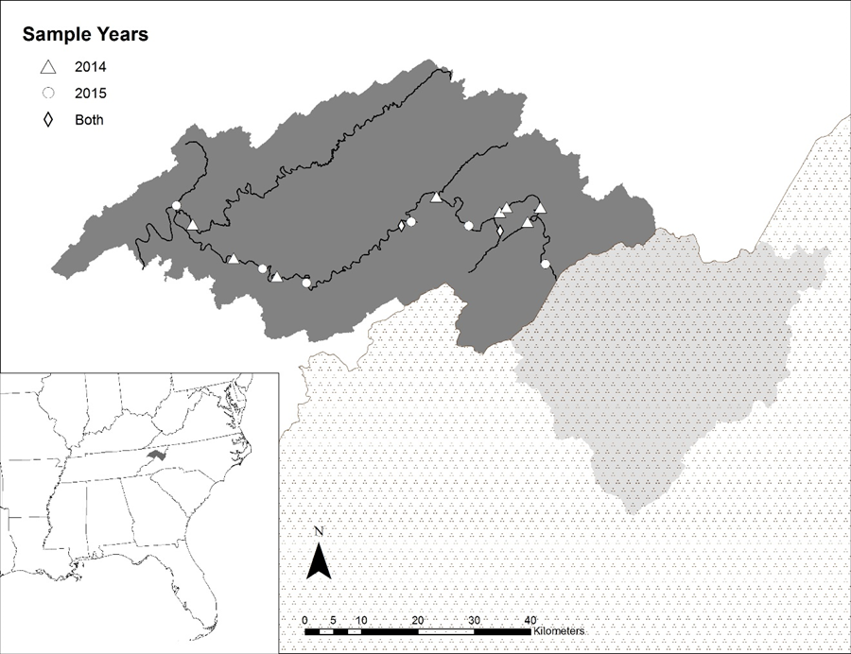
Tennessee
North Carolina
Figure 3 The location of the Nolichucky River watershed and the study sites in the Tennessee portion of the watershed within the south eastern USA. Sites were located along the main stem and several tributaries in the Tennessee portion of the watershed.

Site Selection

Sample sites were selected semi-qualitatively based on observation and ease of access. Observations of the relative amount of row crops near the stream channel were made by traveling throughout the watershed to choose sites that were subjectively categorized into three classes: (1) least-impacted (minimal land use within 30 m of the stream bank for 2 km upstream of the site and clear water), (2) moderately-impacted (some amount of land use within 30 m of the stream bank but still a forested riparian buffer and moderately clear water), and (3) most-impacted by land use (land use occurred up to the stream bank, water very turbid from suspended sediments, greater than 50% land use within 2 km upstream of site). All sites had to be easy to access to avoid trespassing.
Selection of sites were biased due to ease of access and by the observer presuming land use impacts to stream biota. Natural variation in stream biotic assemblages were accounted for by measuring elevation and by categorizing sites as tributary (low order creeks that drained into the Nolichucky main stem) and main stem Nolichucky sites. It is important to remove or account for effects of natural geomorphic variation of sites because fish and invertebrate assemblages are different with respect to changes in water temperature (e.g., higher elevation, shaded canopy sites), discharge (e.g., lower in tributary sites), and substrate size (e.g., larger substrates in tributaries) (Grubaugh et al. 1996). In terms of the first law of geography, all sample sites are in the same watershed and thus have common similarities, but those that are closer together are more similar (Tobler 1970). In this study the field data collected at these sites were fish species counts, samples of benthic macroinvertebrates, and water quality data. Before sampling for fish and benthic macroinvertebrates, water quality data was collected once and elevation was recorded as well (Table 1 and Appendix A).
Table 1 The water quality and elevation variables that were collected for each sample site in the Nolichucky River watershed.
Environmental Variable | Symbol | Units
Temperature | TEMP | Degrees Celsius
Dissolved Oxygen | DO | Parts per Million
Specific Conductivity | SPCOND | microSiemens/centimeter
Alkalinity/Acidity | PH | --
Total Dissolved Solids | TDS | Parts per Million
Elevation | ELEV | Feet

Spatial Data Acquisition

Landsat 5 Thematic Mapper (TM) and Landsat 8 Operational Land Imager (OLI) satellite data at path 18, row 35 with minimal cloud cover were acquired for the years 1999, 2004, 2007, 2010, and 2014 to produce five land use/land cover (LULC) thematic maps between the months of August to October (i.e., the visible growing season). Land cover is the ecological state and physical appearance of the land surface, e.g., grassland, savanna, or shrubland (Dale et al. 2000). Change in land cover converts land of one type of cover to another (Dale et al. 2000). Land use refers to the purpose to which land is put by humans (e.g., protected areas, forestry for timber products, plantations, row-crop agriculture, pastures, or urban areas) (Turner and Meyer 1994). Change in land use may or may not cause a significant change in land cover. For example, change from selectively harvested forest to protected forest will not cause much discernible cover change in the short term, but cultivated land will cause a large change in cover. Since the usage of land is not easily discernable from satellite images, the broad term LULC is utilized in this study.
Satellite images were preprocessed using the software ENVI version 4.8 (Exelis Visual Information Solutions 2010). Radiometric correction was performed to produce reflectance values, and atmospheric correction was completed with a dark body subtraction (Ex. Level II Normalized Difference Vegetation Index (NDVI, Rouse et al. 1977) scenes that were derived from Landsat surface reflectance images were acquired from the USGS’s Earth Resources Observation and Science Center (EROS) to aid the classification and differentiation between row crops and open spaces. Aerial photographs that were coincident with the satellite data were acquired to provide training areas for supervised classifications and ground truth sample sites for accuracy assessments of the resulting thematic maps.
To help separate row crops from open spaces, a mask was created for the NDVI time series using the 2001, 2006, and 2011 National Land Cover Dataset’s (NLCD) impervious surface layers, the National Hydrography Dataset’s (NHD) vector data of open water, and the forested land cover identified in the supervised classification. They were applied to the satellite images with the closest corresponding acquisition year. After the land cover maps were produced, the NHD flow lines were used to create 100-m and 125-m buffers around streams for measuring land cover percentage at the catchment and reach scale. Lastly, the data used to run the SWAT model were a 30-m digital elevation model (DEM) from USGS and a raster grid of the soil types in the watershed. All the spatial data and their uses are summarized in Table 2.

Land Cover/Land Use Classification

A maximum likelihood supervised classification approach in combination with a normalized difference vegetation index calibrated density slice (NDVI, Rouse et al. 1974, Tucker 1979) was used to produce row crop and non-row crop LULC maps from the processed Landsat time series (Figure 4). The maximum

Table 2 Spatial data used to create a thematic map of land use/land cover (LULC) in the Nolichucky river watershed. Data was used in the two-part classification using first a supervised classification using the maximum likelihood algorithm to produce a layer of forest cover for masking the density slicing of the normalized difference vegetation index (NDVI). Additional abbreviations are as follows *OLI/TIRS, Operational Land Imager/Thermal Infrared Sensor, **EROS, Earth Resources Observation and Science Center, ***USGS, US Geological Survey, #USDA, US Department of Agriculture.
Data | Source | Attributes | Purpose
OLI/TIRS* aboard Landsat 8 | http://earthexplorer.usgs.gov/ | 30-m pixel resolution, 7 spectral bands 2014 growing season satellite images | To map and quantify area of LULC types: agriculture, impervious, and forest
Landsat 5 Thematic Mapper (TM) | http://earthexplorer.usgs.gov/ | 30-m pixel resolution, 6 spectral bands satellite images from 1999, 2004, 2007, and 2010 growing season | To map and quantify area LULC types: agriculture, impervious, and forest
Landsat surface reflectance images from EROS** | http://eros.usgs.gov/ | 30-m pixel resolution, 1 band NDVI image from 1999, 2004, 2007, 2010, and 2014 growing season | Use NDVI values to separate active crop fields from fallow lands/pasture

Table 2 Continued.
Data | Source | Attributes | Purpose
National Agriculture Imagery Program (NAIP) Aerial Photography | http://www.fsa.usda.gov/programs-and-services/aerial-photography/imagery-programs/naip-imagery/index | During growing season 2007, 2010, and 2014 using color composite at 1-m spatial resolution | Training sites for land use classification and ground truth sites for the accuracy assessment of thematic maps
Google Earth Pro | Google, USGS***, USDA# Farm Service Agency | During years 1997, 1999, and 2005 using color as well as black and white composite at 1-m spatial resolution | Training sites for land cover classification and ground truth sites for the accuracy assessment of thematic maps
National Land Cover Dataset (NLCD) | http://www.mrlc.gov/ | 30-m pixel resolution, Impervious Surfaces During years 2001, 2006, and 2011 | To mask out impervious land cover type to identify active and fallow lands/pasture

Table 2 Continued.
Data | Source | Attributes | Purpose
National Hydrography Dataset’s (NHD) | http://nhd.usgs.gov/data.html | 1. Water bodies Shape file with polygon vectors  2. Stream flow lines Shape file with line vectors and flow network | 1. To mask out all open water LULC type to identify active and fallow lands/pasture  2. To create stream buffers

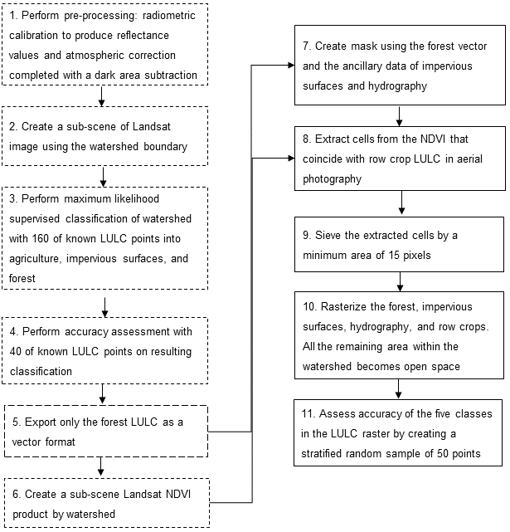
Figure 4 Work flow of the two-part classification using a maximum likelihood supervised classification and density slicing of a normalized difference vegetation index (NDVI) to produce a land use/land cover (LULC) map. Classes of final LULC map are row crops, open space, forest, impervious surfaces, and water. Steps 1-6 were completed in ENVI (dashed-line frames) while the remaining steps 7-11 were completed in ArcMap (solid-line frames).

likelihood supervised classification produced 4 classes: forest, impervious, row crop, and non-row crop.

Accuracy Assessment

Congalton and Green’s (2009) rule of thumb was used to find the number of random points needed for training data (Equation 1). The number of sample points was chosen because it is a balance between what is statistically sound and practical to evaluate (Jensen 2016).

Number of Training Sites = Number of LULC classes X 50 (1)

To identify forest, impervious, row crop, and non-row crop, two hundred random points were randomly distributed throughout the watershed and 160 of these points were used as training regions and the remaining 40 points were ground truth points used in an accuracy assessment. All points were assigned a LULC type by examining the aerial photography. Then, 160 of these points were used
in a supervised classification on the satellite images. Only the forest land cover type was accurately detected, so it was used to create a mask for the NDVI portion of the classification. A mask was created as part of the preprocessing method of the NDVI portion of the classification (S). The forest classification in conjunction with the percent NLCD impervious surfaces and the NHD hydrography were merged in Arcmap. The area not covered by the mask was assumed to be either row crops or open space (Figure 5). A thematic map of five classes was created from the mask and the NDVI threshold results. A stratified random sample of an additional 50 points (10 per class) were dropped into the map to determine the accuracy of the classification (Jenson 2016).
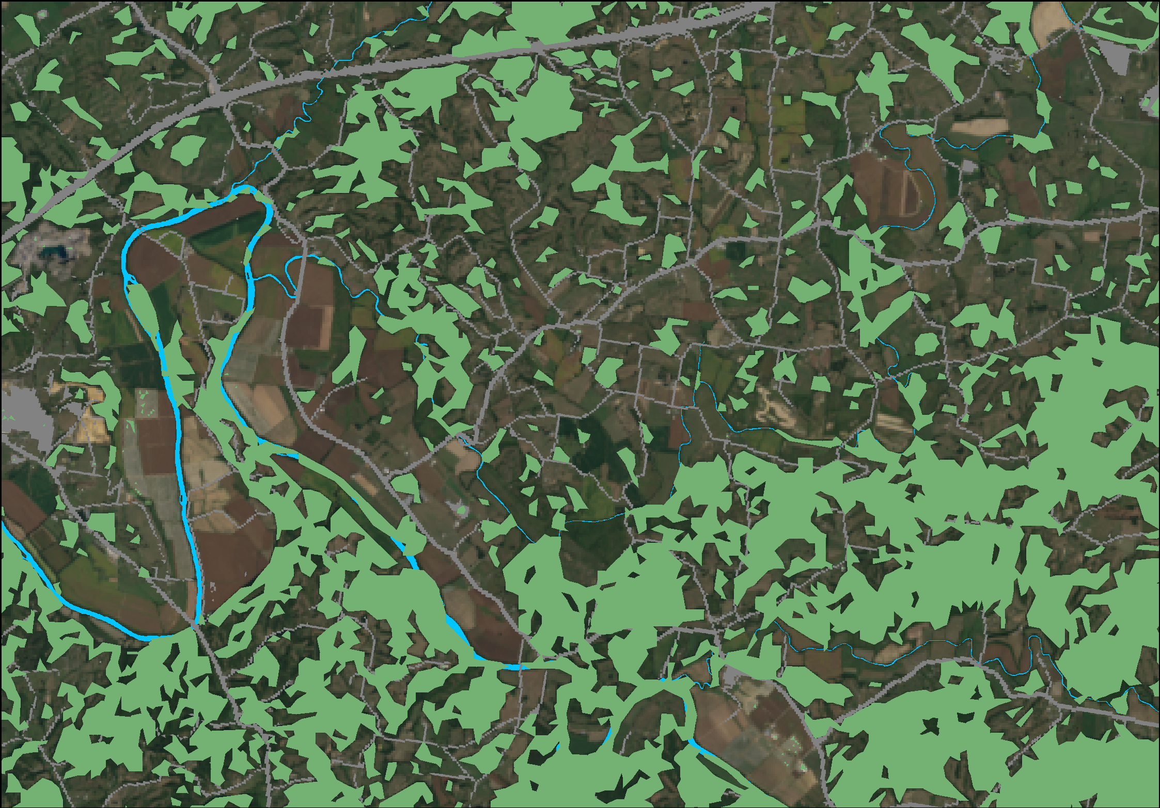
Figure 5 Portion of the Landsat 8 image (row 35, path 18) in the Nolichucky River watershed. The overlaid green, blue, and gray polygons are the forest, hydrography, and impervious surfaces used to create the mask for the second part of the land use/land cover classification.

After the first round of accuracy assessments, accuracy of the thematic maps ranged from 65% to 89%. However, due to the low amount of randomly chosen points intersecting the row crop patches, the NDVI threshold part of the classification was implemented. After the NDVI analysis was completed, overall accuracy ranged from 78% to 88% among the years (Appendix B)

NDVI Method

Vegetation indices are a great tool for detecting and measuring change in biophysical properties of the crop canopies. They are a combination of data from two spectral bands used to enhance the vegetation signal (Jackson and Huete 1991). The NDVI is a standardized ratio of the difference and the sum of the red reflected radiant flux (ρ _{red}) and the near infrared radiant flux (ρ _{nir}) (Equation 2).
 | $$NDVI= \frac{ρ_{nir}-ρ_{red}}{ρ_{nir}+ρ_{red}}$$ | (2)
The NDVI method converts multi-spectral data by calculating the same ratio by using the corresponding spectral bands. For the TM images this is the band 4 (b₄) for the near infrared radiant flux and band 3 (b₃) for the red reflected flux (Equation 3). For the OLI images this is the band 5 (b₅) for the near infrared radiant flux and band 4 (b₄) for the red reflected flux (Equation 4).
 | $${NDVI}_{TM}= \frac{b_{4}-b_{3}}{b_{4}+b_{3}}$$ | (3)
 | $${NDVI}_{OLI}= \frac{b_{5}-b_{4}}{b_{5}+b_{4}}$$ | (4)
Where b₃ and b₄ are band 3 and band 4 of the TM image and b₄ and b₅ are band 4 and band 5 of the OLI image (USGS 2016). Results fall between -1 and +1. The larger the pixel value, the higher the amount of vegetation greenness within the pixel. The NDVI scenes were examined against the aerial photos to determine the best partition threshold to separate row crops from pasture (Table 3), lawns, and fallow fields. All non-row crop area is referred to as open space in the remainder of this paper.

Scale Analysis

After the thematic map was created for 2014, several measurements were
taken at what will be referred to as three spatial scales: local, reach, and catchment (Figure 6). Table 4 shows the types of measurements taken at each scale. The catchment scale involves an analysis of all the land use in the catchment upstream of the sample site. Catchments for each site were delineated using the Arc Hydro toolset version 2.0 (Djokic et al. 2011). Catchment-scale buffers of 100-m were created around the entire NHD flow line network upstream of each study site. In addition to percentages of land use, patch density of row crops was measured. To be considered a patch, the area must be relatively homogeneous and differ from the surrounding land use (Forman 1995). The measurement for patches of row crops per one square kilometer (patches/km²) was used.
Land use at reach scale was characterized using Roth et al.’s (1996) method of examining a 1500-m long sample with 1000-m upstream of the sample

Table 3 NDVI threshold values chosen in Landsat level two NDVI product where all values are scaled by a factor of 0.0001 (USGS 2016).
Date | NDVI Threshold
September 20th, 2014 | 0.1706 to 0.5107
October 11th, 2011 | 0.2340 to 0.4902
August 16th, 2007 | 0.3580 to 0.5893
August 7th, 2004 | 0.3260 to 0.5630
September 11th, 1999 | 0.2000 to 0.3500
Figure 6 Measurements for the scale analysis in the Nolichucky River watershed for the 2014 map. Part A is at the local scale which are a 500-m and 100-m point buffers around the sample location. Visual representation of the spatial scales of measured land cover. Part C shows the area used to calculate percent land use of the entire catchment (left) and a 100-m buffer of the entire upstream riparian network (right). Part B shows the reach scale that includes a buffer that is 1000-m upstream and 500-m downstream of the sample location (left: where the dashed lines meet). A buffer of 125-m was created around the reach and the width of the riparian vegetation was measured perpendicular to the stream at 50-m increments from the upstream to downstream end of the reach (right).
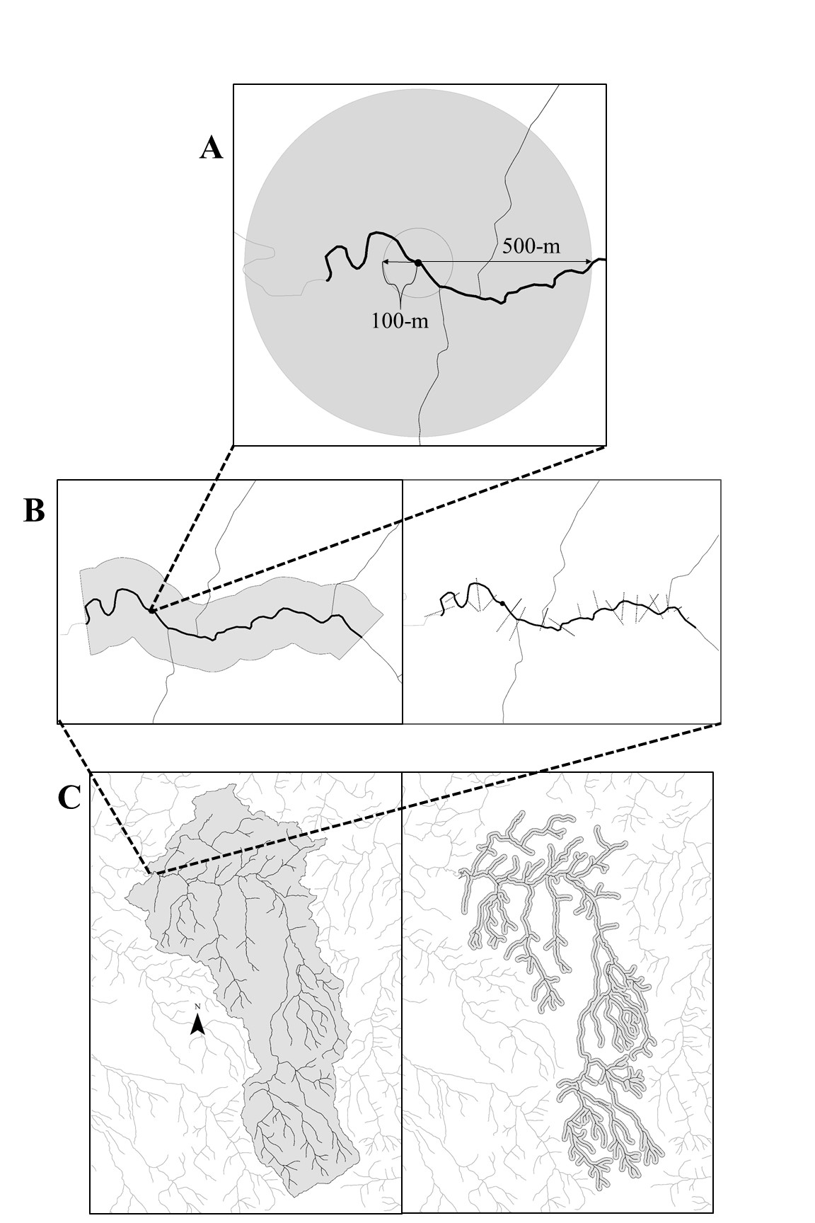
Figure 6 Continued.

Table 4 The various spatial scales within which land use/land cover and the extent of riparian buffers for fish and benthic macroinvertebrate sample sites were measured in the Nolichucky River watershed of Tennessee.
Scale | Method | Assessed stream length | Assessed buffer width or catchment size | Summary measures
Local | GIS | N/A | 100-m and 500-m | % area within buffer of a specified land cover
Reach | Aerial photographs | 1500-m | to edge of riparian vegetation and impervious, open space, or row crop land cover | Frequency of complete riparian vegetation
Reach | Aerial photographs | 1500-m | 125-m on each side of stream | % area within buffer of a specified land cover
Catchment | GIS | Entire upstream network | 100-m on each side of stream | % area within buffer of a specified land cover
Catchment | GIS | Entire upstream network | Entire upstream catchment | Patch per km of row crop
Catchment | GIS | Entire upstream network |  | % area within buffer of a specified land cover

site and 500-m downstream of the sample site. A buffer of 125-m was created for the reach. Using NAIP photos, land use was digitized and summed as percentages for each buffer length. In addition to the buffers, woody vegetation distance was measured perpendicular to the reach. At the reach scale, frequency of intact riparian habitat at 30-m buffer width (Wenger 1999), was calculated from the vegetative width measurements. For the local scale, a 100- and 500-m point buffer was created to measure land use percentage from the thematic map.

Statistical Analysis

A principal component analysis (PCA) was performed on a matrix of multi-scale LULC variables as well as water quality and elevation variables to find what variables explained most of the variation in the Nolichucky River watershed. In addition, the results from the PCA simplify the dataset for further analyses with the fish and benthic macroinvertebrate metrics. Transformations were made to attempt to eliminates skewness and kurtosis, the percentages of LULC were transformed using an arcsine square root transformation, while non-percentage data were ln(x+1)-transformed. This makes the dataset approach normality, which is required by the PCA. For the analysis, the form of the cross-products matrix was correlation coefficients. After running the PCA, the number of axes chosen for interpretation were the first several axes, when combined, explained over 80% of the variance in the dataset. A reduced set of explanatory variables were chosen semi-qualitatively. Explanatory variables were chosen based on high eigenvectors relative to other variables (EV>0.20) for each axis indicating it explained the majority of the variation. Many variables can load strongly on a particular axis in a PCA, meaning these variables are correlated with each other. To reduce this covariation in further analyses with biotic metrics, one variable was chosen to represent each axis that was interpreted. In addition, a variable was chosen to represent each LULC class as well.

Results

Land Cover/Land Use Change

The percent area of area of row crops, forest, and impervious surfaces increased from 1999 to 2014 across the time series (Figure 7). Open space was the only LULC class to have decreased in the entire watershed from 1999 to 2014. The row crop class had the most dramatic percent change of 83% between 1999 and 2014 (Table 5), even though the total composition of land cover as row crops was very small (<2%) compared to other land cover types.

Figure 7 Distribution of percentages of land use/land cover types for the entire Nolichucky River watershed across years. FOR = forest, IMP = impervious surface, OPN = open fields, ROW = row crop, and WTR = water.

Table 5 Area (km²) of the land use/land cover (LULC) classes in the Nolichucky watershed across the time series and the percent change (%CHANGE) between 2014 and 1999. Percent change calculated as the area of a LULC class in 2014 minus the area of the same LULC class in 1999. This difference is then divided by the area of the land use in 1999 and multiplied by 100. FOR = forest, IMP = impervious surface, OPN = open fields, ROW = row crop, and WTR = water.
 | 1999 | 2004 | 2007 | 2010 | 2014 | %CHANGE
FOR | 2,678 | 2,630 | 2,706 | 2,499 | 2,819 | 5
IMP | 196 | 227 | 216 | 248 | 235 | 20
OPN | 1,637 | 1,649 | 1,542 | 1,709 | 1,420 | -13
ROW | 39 | 38 | 87 | 82 | 71 | 83

When examining LULC at different spatial scales in 2014, the two measurements for the catchment scale did not appear to be different from each other, and the two measurements for the local scales did not have much difference between each other either. On average there were higher percentages of row crops at the reach scale than the other two spatial scales, suggesting that row crops were more prevalent for sample sites at the reach scale (Figure 8).
In addition to percentages of LULC classes, patch patterns of row crops were examined. In the whole watershed, number of patches of row crops had increased as well as the average area of a row crop patch (Table 6). In this time series, average area of row crops peaked in 2007 while number of patches of row crops steadily increased (Figure 9).

Figure 8 Land use/land cover (LULC) percentage at each scale averaged across the sample sites in the Nolichucky River watershed in 2014. Confidence intervals are 95% and were calculated using bootstrapping. Classes of LULC are abbreviated as FOR = forest, IMP = impervious surface, OPN = open space, ROW = row crop, and WTR = water.

Table 6 Measurements for area and patches of row crops in the entire Nolichucky River watershed from 1999 to 2014. A patch is defined as an area that must be relatively homogeneous and differ from the surrounding land use/land cover.
 | 1999 | 2004 | 2007 | 2010 | 2014
Total Area (km²) | 39 | 38 | 87 | 82 | 71
Number of Patches | 946 | 934 | 1,738 | 1,438 | 1,261
Average Patch Area (m²) | 35,277 | 33,912 | 42,402 | 50,072 | 50,993

Figure 9 Patch dynamics of row crop land use in the entire Nolichucky River watershed from 1999 to 2014. Graph shows number of patches and average area of a row crop patch increased in the watershed.

2014 Analysis of LULC versus Environmental Variables

The first five axes of the PCA were interpreted. These first five axes explained 83.8% of the cumulative variance with the first axis explaining 47% of the variance; the second axis explaining 14% of the variance; and the third axis explaining 8.6% of the variance (Table 7). Based on the loadings from each of the five axes, the original 27 variables (Table 1; Appendix A) were reduced to seven (Table 8).
For axis 1, the PCA ordinated sample sites along a gradient of increasing elevation (EV = 0.22) and decreasing cover of row crops at the catchment scale for patches of row crops per km² (EV = -0.26). In addition, axis 1 ordinated increasing forest with decreasing amounts of the other three land use classes at all spatial scales. Axis 2 represented a gradient of increasing water temperature (EV = 0.37) and increasing open space (EV = 0.26) at the reach scale, as well as decreasing reach-scale, riparian vegetation cover (EV = -0.32). Axis 3 showed an ordination of decreasing impervious surfaces (EV = -0.43) and increasing row crops (EV = 0.34) at the reach scale. Axis 4 ordinated sample sites along a gradient of decreasing alkalinity (EV = -0.58). Lastly axis 5 represented a gradient of decreasing open spaces (EV = -0.52) with increasing forest (EV = 0.33) at the 100-m local scale. These variables were subsequently used in analyses with fish and benthic invertebrate metrics. Another result of the PCA was the eigenvectors of greater magnitude were either site specific variables such as water quality and elevation or they were land use variables at the reach and local scales. This suggests there might be more value to focusing efforts on smaller spatial scales in the Nolichucky River watershed because smaller spatial scales explain most of the variation.

Table 7 To measure the impact of row crop agriculture on aquatic communities, a principal component analysis (PCA) was conducted on land use/land cover, water quality, and elevation variables that were collected at selected sample sites along the Nolichucky River watershed in 2014. The five axes explain over 80% with the first axis explaining the most and decreasing for the following axes. Variables that correlate strongly with the first axis explain more of the variation in the dataset than variables that do not correlate with the first axis.
Axis | Eigenvalue | % of Variance | Cum.% of Var. | Broken-stick Eigenvalue
1 | 13.19 | 47.10 | 47.10 | 3.93
2 | 3.98 | 14.21 | 61.30 | 2.93
3 | 2.40 | 8.60 | 69.90 | 2.43
4 | 2.08 | 7.42 | 77.33 | 2.09
5 | 1.81 | 6.45 | 83.78 | 1.84

Table 8 Eigenvectors from the first five axes of a principal component analysis (PCA) of water quality, elevation, and land use/land cover variables collected at selected sample sites in the Nolichucky River watershed. Eigenvectors of greater magnitude indicates a variable positively or negatively correlates with the axis (principal component) the PCA found
 |  |  |  | Axes
 | Variables | 1 | 2 | 3 | 4 | 5
Water quality and elevation
 | TEMP* | -0.06 | 0.37 | -0.21 | 0.14 | 0.31
 | DO | 0.03 | -0.06 | -0.27 | 0.55 | -0.03
 | SPCOND | -0.24 | -0.05 | -0.01 | 0.01 | -0.09
 | PH* | -0.01 | -0.02 | 0.09 | -0.58 | 0.22
 | TDS | -0.18 | 0.01 | 0.26 | -0.12 | -0.11
 | ELEV* | 0.22 | -0.0014 | 0.14 | -0.13 | -0.0016
Catchment entire
 | ROW | -0.25 | -0.16 | -0.11 | -0.02 | -0.07
 | OPN | -0.23 | -0.25 | 0.04 | 0.02 | -0.05
 | FOR | 0.24 | 0.23 | -0.01 | -0.01 | 0.02
 | IMP | -0.24 | 0.03 | -0.18 | -0.05 | 0.23
Table 8 Continued.
 |  |  |  | Axes
 | Variables | 1 | 2 | 3 | 4 | 5
Catchment Patch/km
 | ROW* | -0.26 | -0.17 | -0.05 | -0.02 | -0.03
Catchment 100-m Buffer Entire Upstream Network Percentage
 | ROW | -0.25 | -0.16 | -0.11 | 0.01 | -0.05
 | OPN | -0.24 | -0.23 | 0.02 | 0.02 | -0.0022
 | FOR | 0.25 | 0.20 | 0.01 | -0.02 | -0.04
 | IMP | -0.22 | 0.07 | -0.22 | -0.06 | 0.29
Reach-scale Buffer 125-m
 | ROW | -0.13 | 0.17 | 0.34 | 0.19 | 0.36
 | OPN | -0.19 | 0.15 | -0.22 | -0.25 | -0.23
 | FOR | 0.22 | -0.25 | -0.07 | 0.04 | -0.13
 | IMP* | -0.09 | 0.15 | -0.43 | -0.11 | 0.04

Table 8 Continued.
 |  |  |  | Axes
 | Variables | 1 | 2 | 3 | 4 | 5
Reach Riparian Measurement - Frequency of 30-m
 | FOR* | 0.11 | -0.32 | -0.13 | -0.09 | -0.21
Local 500-m Point Buffer
 | ROW | -0.20 | 0.06 | 0.33 | 0.16 | 0.09
 | OPN | -0.22 | 0.22 | 0.02 | -0.07 | -0.12
 | FOR | 0.23 | -0.21 | -0.08 | -0.02 | 0.07
 | IMP | -0.16 | 0.14 | -0.02 | -0.18 | -0.17
Local 100-m Point Buffer
 | ROW | -0.16 | -0.18 | 0.19 | 0.27 | 0.03
 | OPN* | -0.06 | 0.26 | 0.09 | 0.02 | -0.52
 | FOR | 0.11 | -0.30 | -0.11 | -0.17 | 0.33
 | IMP | -0.02 | -0.06 | 0.37 | -0.13 | 0.07
*Indicates chosen as one of the seven new explanatory variables

Discussion

Land Cover Time Series

To assess the land cover stressors to communities of fish and benthic macroinvertebrates it is important to understand how these stressors change spatiotemporally in a specific watershed. Through creating land use maps, I was able to see what was happening between 1999 and 2014. The hypothesis that row cropping had increased in the entire watershed was confirmed, although, the total amount of row crop land use is still small relative to other land uses. It had almost doubled since 2009, but it still seemed to be a relatively small portion of the entire watershed jumping from 1% in 1999 to 2% in 2014. Open space was the only class to have decreased in overall area from 1999 to 2014. This could be due to the hypothesis that farmers are converting their pastures and hay fields to row crops. Creation of land use change maps at from these data could give more detail as to specific locations where row crops occur and how much the change is happening. Although not completed in this study, the scale analysis could be applied to the older maps to examine where most of this change is occurring. Number of patches of row crops and average patch area in the watershed had increased. Patch numbers of row crops began to decrease after 2007 while average patch size continued to increase. This pattern could be occurring because farmers plant larger continuous plots of their lands as row crops thus decreasing patch number and increasing patch size.

2014 Relationship of LULC to Environmental Variables

The PCA demonstrated that all the environmental variables were highly correlated regardless of the axis (Table 8; Randomization test for axis 1 p = .001). Disturbances such as agriculture and urban development logically lead to a decreased amount of forest and other natural vegetation land covers (Krummel et al. 1987). In the Nolichucky River watershed, the amount of row cropping is more detectable when viewed at the reach scale than at local or catchment scales (Figure 8). Therefore, impacts of row cropping to stream biota are more likely to be detected at the reach scale.
The predictions of stream hierarchy theory (Frissell et al. 1986), particularly that large spatial scales (i.e., catchment) dictate the condition of smaller scales (i.e., in stream water quality) in the stream, was not congruent with the results in the Nolichucky watershed. Various studies have found reach riparian land use management may be more effective for stream biomonitoring than managing land use at larger spatial scales (i.e., catchment). For example, Alford (2014) found that the reach spatial scale was more influential to fish assemblage structure in streams than watershed or subwatershed spatial scales, which was attributed to land use activities occurring in riparian zones. When the land use at the reach scale is more strongly associated with stream conditions, normally a direct local pathway exists and the land use closer to the stream does not mirror that of the entire catchment (Rowe 2009; Allan 2004). When land use closer to the stream was dissimilar from the entire catchment reach scales seemed more influential (Shields et al. 2003; Wang et al. 2003). It must be noted that a natural geomorphic feature of the watershed is important to how land use is managed and assessed. Elevation was correlated positively with increasing forest cover and decreasing amounts of row crops and impervious surfaces. Naturally, the majority of disturbance is in the ridge and valley part of the watershed, where more arable lands exist for farmers and urban developers. Thus, in the Nolichucky River watershed land use closer to the river and at lower elevations contrast with the forested high elevation areas further from the sample sites.

Appendix A

Water quality, elevation, and land use variables of the Nolichucky watershed that were run through the principal component analysis to get a reduced dataset. Measurements of water quality were taken at one time (n=1) before sampling for fish and benthic macroinvertebrates began.

 |  |  |  |  | Water Quality and Elevation
Site Code | Water Body | Location | TEMP (C◦) | DO (ppm) | SPCOND (S/m) | PH | TDS (ppm) | ELEV (ft)
09NR | Nolichucky River | Chestoa Bridge | 22.7 | 13.04 | 64.9 | 7.84 | - | 2092
01CC | Clarks Creek | Clarks Creek Rd. | 18.2 | 8.21 | 16 | 6.66 | 12 | 2080
02CC | Clarks Creek | Clarks Creek Rd. | 18.4 | 13.6 | 24.4 | - | 20.4 | 2080
01BUM | Bumpus Cove Creek | Graveyard Hill Rd. | 16.6 | 8.28 | 225.9 | 7.8 | 165 | 2005
04NR | Nolichucky River | Riverpark Campground | 23.4 | 6.71 | 95.1 | 7.84 | 68.8 | 1873
03NR | Nolichucky River | Jackson Bridge | 23.8 | 6.62 | 88.9 | 9.16 | 400 | 1855
02NR | Nolichucky River | Jackson Island | 24.7 | 7.28 | 83.5 | 7.52 | 60.3 | 1811
01BL | Big Limestone Creek | Davy Crockett Birthplace State Park | 19.5 | 8.45 | 457.5 | 8.22 | 332 | 1467
01NR | Nolichucky River | HWY 107 | 23.5 | 8.63 | 123 | 7.94 | 82 | 1464
07NR | Nolichucky River | HWY 107 | 24.7 | 11.41 | 136.5 | - | 8.4 | 1464
11NR | Nolichucky River | Bailey’s Bridge | 27.04 | 8.6 | 131 | 8.36 | 82 | 1425
05NR | Nolichucky River | HWY 321 | 21.7 | 9.3 | 112 | 7.26 | 94.7 | 1354
01HC | Horse Creek | G’Fellers Rd. | 18.44 | 8.66 | 236 | 7.91 | 175 | 1342
01LC | Lick Creek | McDonald Rd./HWY 348 | 18.8 | 7.93 | 420 | 7.73 | 353 | 1177
08NR | Nolichucky River | Allens Bridge | 25.2 | 11.48 | 136.2 | 7.95 | 114 | 1171
10NR | Nolichucky River | Whittenburg Bridge | 25.7 | 11.15 | 176.9 | - | 147 | 1118
06NR | Nolichucky River | Bewleys Bridge | 20.3 | 8.04 | 143 | 7.65 | 122 | 1106
01BC | Bent Creek | Bent Creek Rd. | 22.8 | 12.22 | 406 | - | 356 | 1036
 |  |  |  |  | Catchment: Entire Upstream
Site Code |  |  | %Row | %Open | %Forest | %Impervious | Patch Row/ Km2
01BC |  |  | 1.42 | 29.02 | 64.45 | 4.98 | 0.6
01BL |  |  | 3.48 | 65.98 | 23.95 | 6.57 | 1.09
01BUM |  |  | 0.25 | 6.83 | 92.52 | 0.4 | 0.24
01CC |  |  | 0 | 9.64 | 90.36 | 0 | 0
01HC |  |  | 3 | 43.74 | 49.11 | 4.15 | 0.81
01LC |  |  | 1.71 | 50.32 | 42.13 | 5.76 | 0.84
01NR |  |  | 0.95 | 19.92 | 75.02 | 4 | 0.41
02CC |  |  | 0 | 9.64 | 90.36 | 0 | 0
02NR |  |  | 0.19 | 10.43 | 86.15 | 3.12 | 0.22
03NR |  |  | 0.2 | 10.44 | 86.13 | 3.12 | 0.22
04NR |  |  | 0.14 | 9.05 | 87.68 | 3.03 | 0.21
05NR |  |  | 1.09 | 23.23 | 70.86 | 4.69 | 0.48
06NR |  |  | 1.14 | 23.87 | 70.18 | 4.67 | 0.5
07NR |  |  | 0.95 | 19.92 | 75.02 | 4 | 0.41
08NR |  |  | 1.06 | 22.14 | 72.01 | 4.65 | 0.47
09NR |  |  | 0.14 | 9.4 | 87.69 | 2.66 | 0.2
10NR |  |  | 1.13 | 23.72 | 70.33 | 4.69 | 0.5
11NR |  |  | 0.3 | 11.13 | 85.37 | 3.09 | 0.25
 |  |  |  | Catchment: 100-m Buffer
Site Code |  |  | %Row | %Open | %Forest | %Impervious
01BC |  |  | 1.07 | 31.87 | 60.95 | 5.8
01BL |  |  | 2.41 | 67.36 | 22.35 | 7.84
01BUM |  |  | 0.26 | 7.49 | 91.89 | 0.36
01CC |  |  | 0 | 7.67 | 92.33 | 0
01HC |  |  | 1.42 | 37.86 | 55.81 | 4.91
01LC |  |  | 1.24 | 52.6 | 40.29 | 5.69
01NR |  |  | 0.72 | 22.4 | 71.23 | 5.4
02CC |  |  | 0 | 7.67 | 92.33 | 0
02NR |  |  | 0.14 | 12.23 | 82.65 | 4.71
03NR |  |  | 0.17 | 12.24 | 82.62 | 4.7
04NR |  |  | 0.1 | 10.76 | 84.19 | 4.68
05NR |  |  | 0.8 | 25.11 | 68 | 5.77
06NR |  |  | 0.86 | 25.81 | 67.3 | 5.71
07NR |  |  | 0.72 | 22.4 | 71.23 | 5.4
08NR |  |  | 0.78 | 24.03 | 69.1 | 5.76
09NR |  |  | 0.11 | 11.63 | 83.25 | 4.71
10NR |  |  | 0.85 | 25.65 | 67.42 | 5.76
11NR |  |  | 0.23 | 12.97 | 81.99 | 4.55
 |  |  | Reach: 125-m Buffer |  |  |  | Reach: Vegetation
Site Code |  |  | %Row | %Open | %Forest | %Impervious | % 30-m Measurements
01BC |  |  | 42.13 | 21.38 | 31.64 | 4.86 | 37.93
01BL |  |  | 29.38 | 25.49 | 42.4 | 2.73 | 72.41
01BUM |  |  | 0 | 12.56 | 85.2 | 2.25 | 72.41
01CC |  |  | 3.98 | 6.85 | 88.02 | 1.15 | 81.03
01HC |  |  | 2.11 | 62.03 | 29.01 | 6.85 | 43.1
01LC |  |  | 23.22 | 38.98 | 35.4 | 2.4 | 44.83
01NR |  |  | 5.71 | 45.5 | 44.4 | 4.38 | 75.86
02CC |  |  | 3.98 | 6.85 | 88.02 | 1.15 | 81.03
02NR |  |  | 64.71 | 11.23 | 22.7 | 1.36 | 31.03
03NR |  |  | 23.29 | 45.36 | 27.52 | 3.82 | 29.31
04NR |  |  | 11.73 | 15.01 | 68.76 | 4.49 | 72.41
05NR |  |  | 9.18 | 28.04 | 60.26 | 2.51 | 77.59
06NR |  |  | 2.3 | 35 | 59.12 | 3.58 | 81.03
07NR |  |  | 5.71 | 45.5 | 44.4 | 4.38 | 75.86
08NR |  |  | 36.56 | 22.73 | 36.54 | 4.17 | 29.31
09NR |  |  | 0 | 12.35 | 79.94 | 7.71 | 46.55
10NR |  |  | 15.44 | 35.55 | 46.19 | 2.82 | 36.21
11NR |  |  | 20.03 | 50.33 | 23.13 | 6.51 | 24.14
 |  |  | Local: 500-m Buffer
Site Code |  |  | %Row | %Open | %Forest | %Impervious
01BC |  |  | 13.06 | 64.03 | 7.56 | 5.96
01BL |  |  | 15.58 | 41.92 | 38.14 | 2.63
01BUM |  |  | 1.95 | 36.88 | 60.02 | 1.15
01CC |  |  | 0 | 5.5 | 91.75 | 2.75
01HC |  |  | 5.84 | 62.2 | 23.94 | 8.02
01LC |  |  | 15.35 | 54.07 | 18.56 | 11
01NR |  |  | 1.49 | 59.68 | 28.41 | 6.99
02CC |  |  | 0 | 5.5 | 91.75 | 2.75
02NR |  |  | 17.18 | 54.3 | 23.6 | 2.98
03NR |  |  | 0.69 | 46.74 | 48.22 | 3.32
04NR |  |  | 0 | 19.24 | 72.97 | 5.04
05NR |  |  | 0 | 39.86 | 52.23 | 5.27
06NR |  |  | 0 | 39.06 | 51.2 | 5.96
07NR |  |  | 1.49 | 59.68 | 28.41 | 6.99
08NR |  |  | 10.42 | 49.83 | 30.24 | 4.35
09NR |  |  | 0 | 4.58 | 93.59 | 0.57
10NR |  |  | 2.52 | 40.66 | 44.44 | 2.63
11NR |  |  | 5.5 | 70.9 | 8.93 | 11.45
 |  |  | Local: 100-m Buffer
Site Code |  |  | %Row | %Open | %Forest | %Impervious
01BC |  |  | 8.57 | 20 | 51.43 | 0
01BL |  |  | 5.71 | 22.86 | 71.43 | 0
01BUM |  |  | 0 | 42.86 | 57.14 | 0
01CC |  |  | 0 | 8.57 | 88.57 | 2.86
01HC |  |  | 0 | 40 | 54.29 | 5.71
01LC |  |  | 2.86 | 11.43 | 45.71 | 34.29
01NR |  |  | 0 | 25.71 | 60 | 0
02CC |  |  | 0 | 8.57 | 88.57 | 2.86
02NR |  |  | 0 | 17.14 | 40 | 8.57
03NR |  |  | 0 | 20 | 77.14 | 2.86
04NR |  |  | 0 | 8.57 | 91.43 | 0
05NR |  |  | 0 | 2.86 | 77.14 | 0
06NR |  |  | 0 | 0 | 100 | 0
07NR |  |  | 0 | 25.71 | 60 | 0
08NR |  |  | 0 | 0 | 91.43 | 0
09NR |  |  | 0 | 2.86 | 94.29 | 2.86
10NR |  |  | 0 | 40 | 0 | 0
11NR |  |  | 0 | 74.29 | 0 | 0

Appendix B

The first and second accuracy assessments for all the years classified into thematic maps for the Nolichucky River watershed. Values represent the pixels randomly chosen in the thematic map. The table shows what these pixels where classified as (rows) and what they actually were (columns) based on viewing the ground reference photos. The land use classes are forest (FOR) impervious surfaces (IMP), open spaces (OPN), and row crops (ROW).

 | Ground Reference - First Accuracy Assessment
Map Class | 2014
 | FOR | IMP | OPN | ROW | Sum
FOR | 21 | 2 | 1 | 0 | 24
IMP | 0 | 0 | 0 | 0 | 0
OPN | 3 | 1 | 6 | 1 | 11
ROW | 0 | 0 | 3 | 1 | 4
Sum | 24 | 3 | 10 | 2 | 39
 |  |  | 2010
FOR | 21 | 1 | 1 | 1 | 24
IMP | 3 | 1 | 2 | 1 | 7
OPN | 0 | 0 | 8 | 0 | 8
ROW | 0 | 0 | 0 | 1 | 1
Sum | 24 | 2 | 11 | 3 | 40
 |  |  | 2007
FOR | 18 | 0 | 0 | 0 | 18
IMP | 0 | 0 | 2 | 0 | 2
OPN | 1 | 1 | 15 | 0 | 17
ROW | 0 | 0 | 0 | 0 | 0
Sum | 19 | 1 | 17 | 0 | 37
1999
FOR | 22 | 2 | 3 | 0 | 27
IMP | 0 | 0 | 0 | 0 | 0
OPN | 0 | 4 | 8 | 0 | 12
ROW | 0 | 0 | 0 | 0 | 0
Sum | 22 | 6 | 11 | 0 | 39
 | Ground Reference - Second Accuracy Assessment
2014
 | FOR | IMP | OPN | ROW | WTR | Sum
FOR | 10 | 0 | 0 | 0 | 0 | 10
IMP | 0 | 6 | 4 | 0 | 0 | 10
OPN | 0 | 0 | 9 | 1 | 0 | 10
ROW | 0 | 2 | 1 | 7 | 0 | 10
WTR | 1 | 0 | 0 | 0 | 9 | 10
Sum | 11 | 8 | 14 | 8 | 9 | 50
2010
FOR | 10 | 0 | 0 | 0 | 0 | 10
IMP | 1 | 8 | 1 | 0 | 0 | 10
OPN | 1 | 0 | 9 | 0 | 0 | 10
ROW | 0 | 2 | 1 | 7 | 0 | 10
WTR | 0 | 0 | 0 | 0 | 10 | 10
Sum | 12 | 10 | 11 | 7 | 10 | 50
2007
FOR | 10 | 0 | 0 | 0 | 0 | 10
IMP | 0 | 8 | 2 | 0 | 0 | 10
OPN | 0 | 0 | 9 | 1 | 0 | 10
ROW | 0 | 1 | 3 | 6 | 0 | 10
WTR | 1 | 0 | 0 | 0 | 9 | 10
Sum | 11 | 9 | 14 | 7 | 9 | 50
2004
FOR | 10 | 0 | 0 | 0 | 0 | 10
IMP | 0 | 8 | 2 | 0 | 0 | 10
OPN | 0 | 1 | 9 | 0 | 0 | 10
ROW | 0 | 2 | 3 | 5 | 0 | 10
WTR | 0 | 0 | 0 | 0 | 10 | 10
Sum | 10 | 11 | 14 | 5 | 10 | 50
1999
FOR | 9 | 1 | 0 | 0 | 0 | 10
IMP | 0 | 8 | 2 | 0 | 0 | 10
OPN | 3 | 0 | 7 | 0 | 0 | 10
ROW | 0 | 1 | 2 | 7 | 0 | 10
WTR | 2 | 0 | 0 | 0 | 8 | 10
Sum | 14 | 10 | 11 | 7 | 8 | 50

Appendix C

Thematic maps of the Nolichucky River watershed from 1999 to 2014. Images show five land use classes: forest (FOR), row crops (ROW), open spaces (OPN), and water (WTR).
FOR ROW OPN IMP WTR
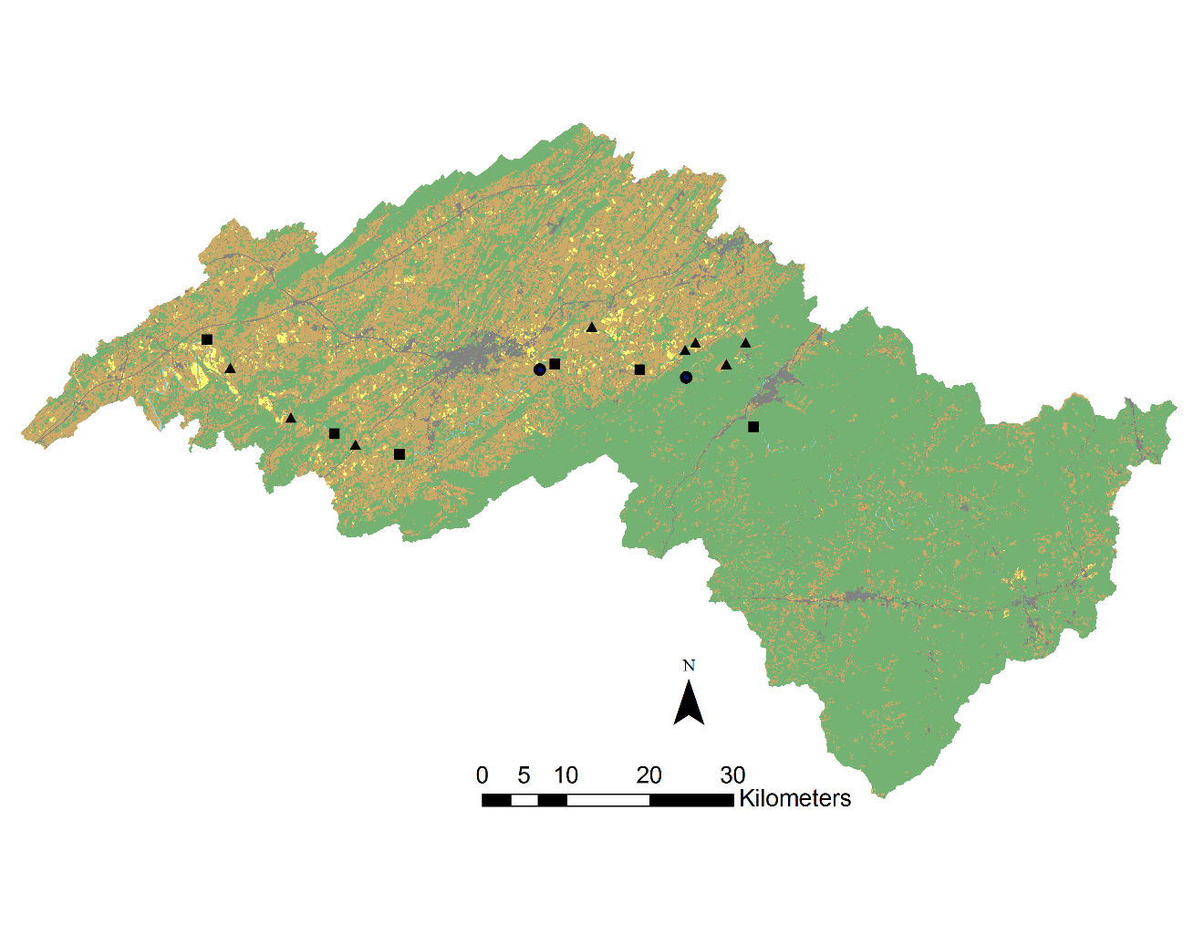
2014

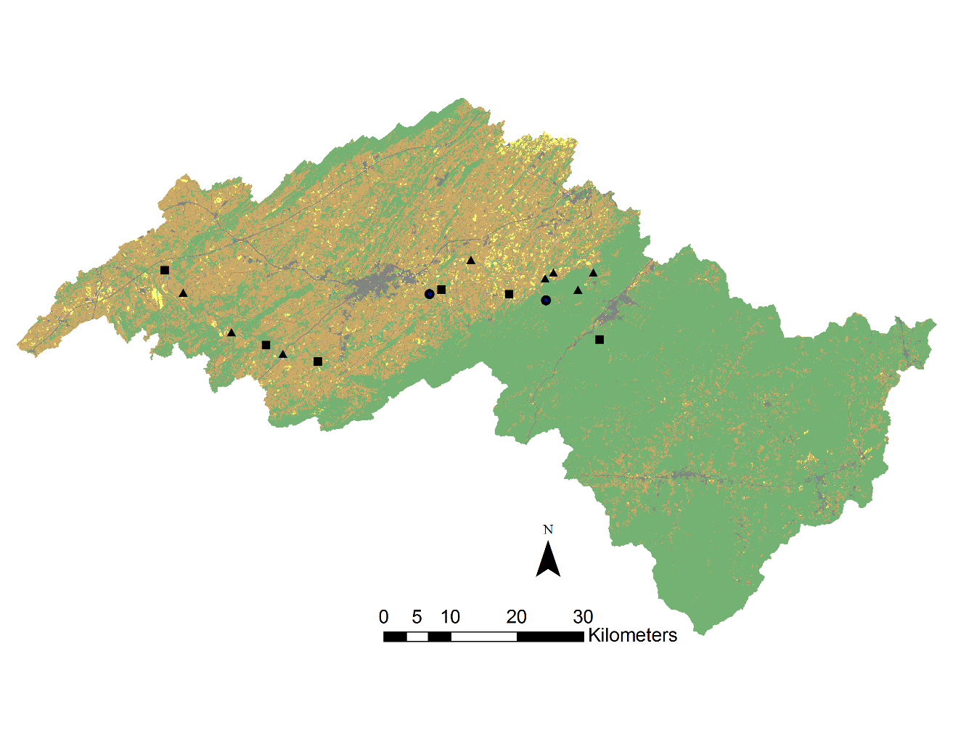
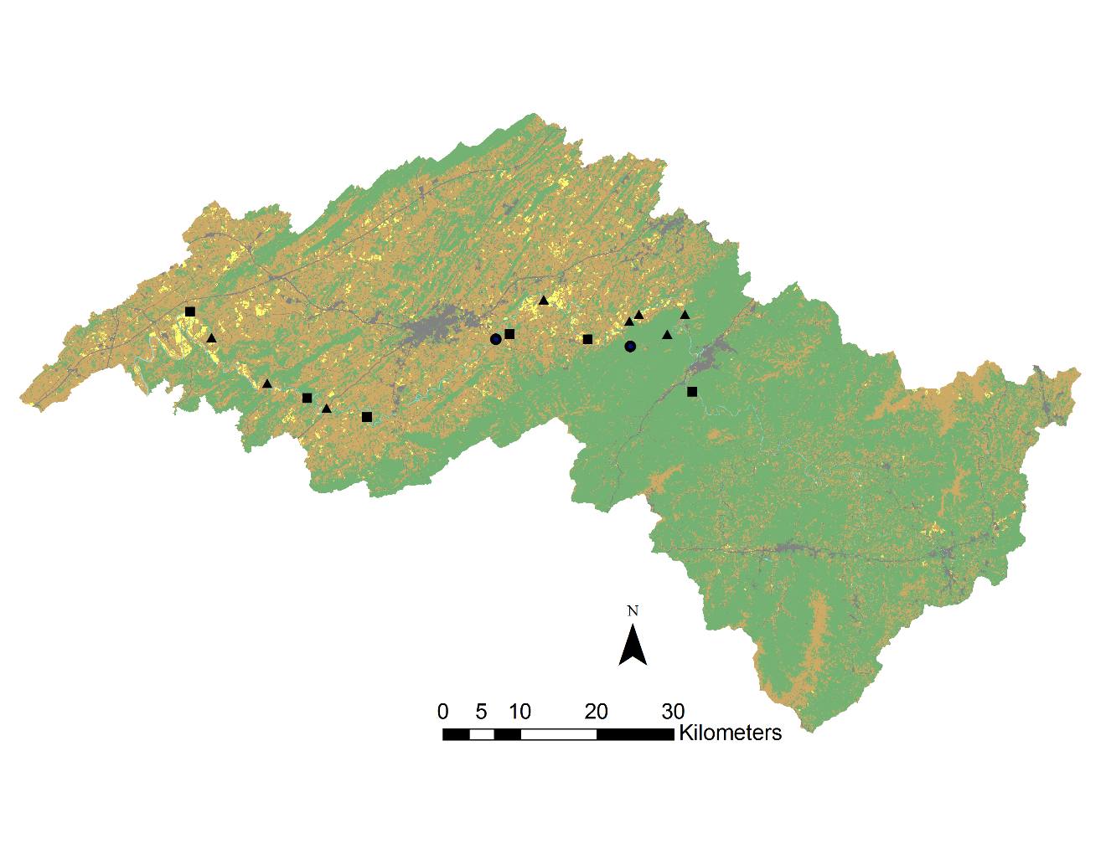
2007
2010

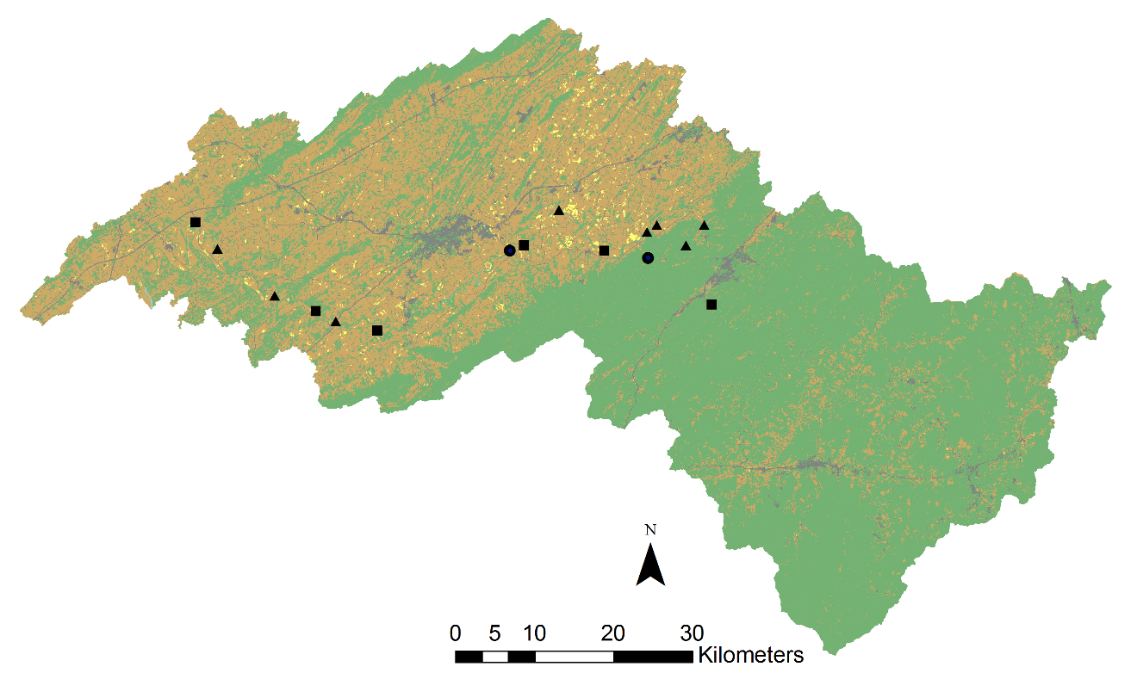
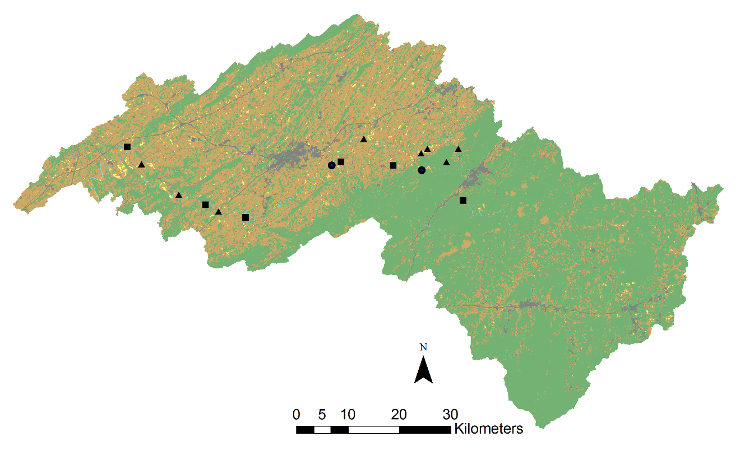
1999
2004

Appendix D

Additional information on the sample sites in the Nolichucky River watershed and their location in the watershed. Agricultural impact were subjectively categorized by traveling throughout the watershed and assigning a sample site into one of three groups: (1) least-impacted (minimal land use within 30 m of the stream bank for 2 km upstream of the site and clear water), (2) moderately-impacted (some amount of land use within 30 m of the stream bank but still a forested riparian buffer and moderately clear water), and (3) most-impacted by land use (land use occurred up to the stream bank, water very turbid from suspended sediments, greater than 50% land use within 2 km upstream of site).

Site Code | Collection Date | Latitude | Longitude | Agriculture Impact Rating | Area of Catchment (km²)
01BC | 10-Jul-2015 | 36.18438 | -83.1648 | 3 | 4229
01BL | 15-Aug-2014 | 36.20283 | -82.6559 | 2 | 204
01BUM | 20-Aug-2014 | 36.16558 | -82.4758 | 2 | 16
01CC | 16-Jul-2014 | 36.15054 | -82.5293 | 1 | 25
01HC | 30-Jul-2015 | 36.16231 | -82.7036 | 2 | 25
01LC | 3-Jun-2014 | 36.15173 | -83.1354 | 3 | 56
01NR | 17-Jul-2014 | 36.15708 | -82.7234 | 2 | 677
02CC | 6-Jul-2015 | 36.15054 | -82.5293 | 1 | 2795
02NR | 14-Aug-2014 | 36.18655 | -82.5193 | 2 | 2201
03NR | 17-Jun-2014 | 36.18036 | -82.531 | 3 | 2202
04NR | 23-Aug-2014 | 36.18319 | -82.4578 | 1 | 2085
05NR | 17-Sep-2014 | 36.07123 | -82.967 | 1 | 3258
06NR | 1-Oct-2014 | 36.0993 | -83.0534 | 2 | 3342
07NR | 8-Jul-2015 | 36.15708 | -82.7234 | 2 | 2795
08NR | 3-Jun-2015 | 36.06191 | -82.9073 | 1 | 3149
09NR | 8-Jun-2015 | 36.10073 | -82.4374 | 1 | 1646
10NR | 9-Jul-2015 | 36.08459 | -82.9951 | 3 | 3312
11NR | 27-Jul-2015 | 36.15795 | -82.5911 | 2 | 2308

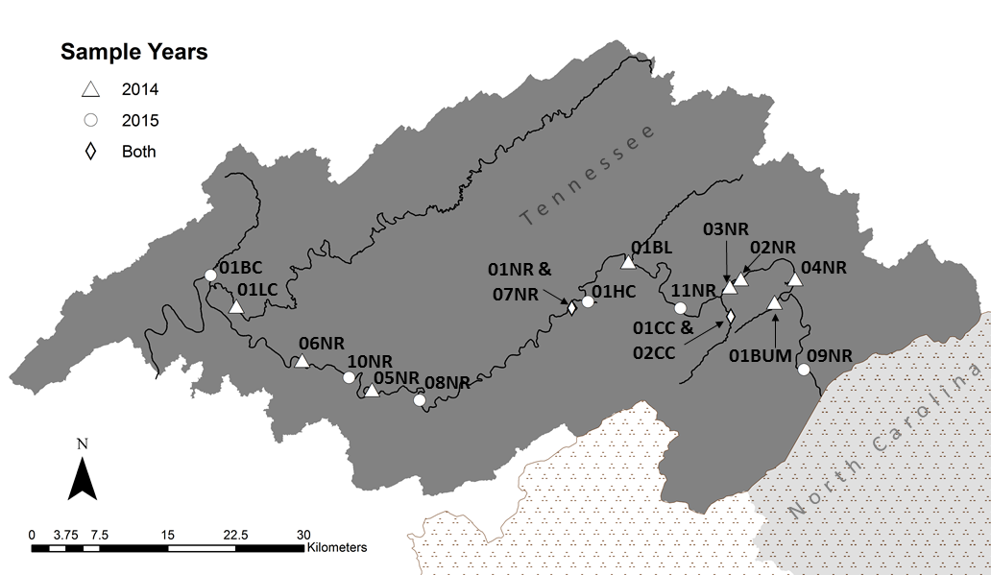
Locations and codes for the sample sites in the Nolichucky River watershed.

Appendix E

Photos of the 16 sample sites to illustrate the substrate, turbidity, and size of the river in the Nolichucky watershed.

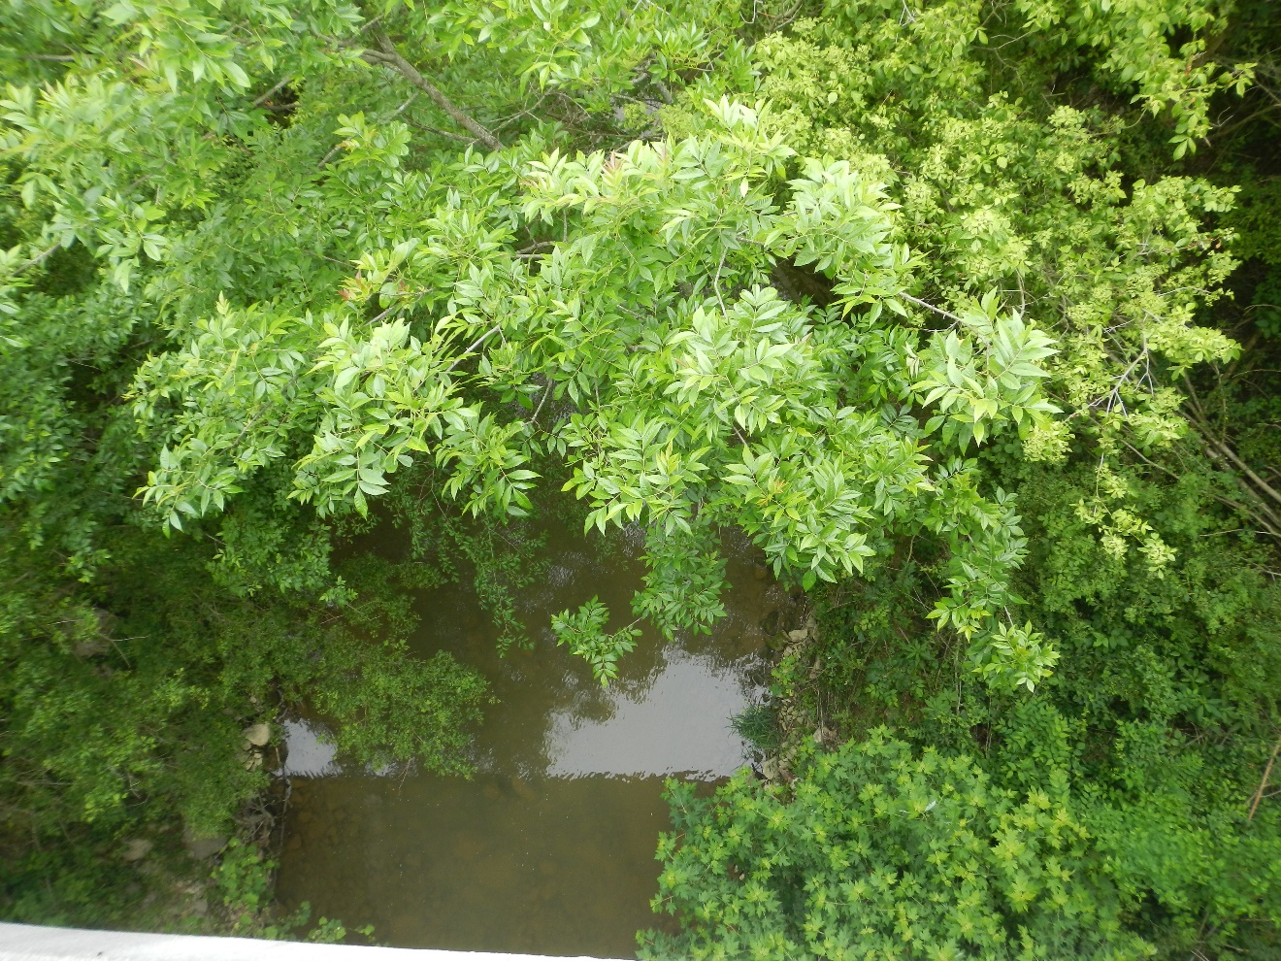
Photo from June, 3rd 2014 of Bent Creek (01BC) located in the lower portion of the Nolichucky river.

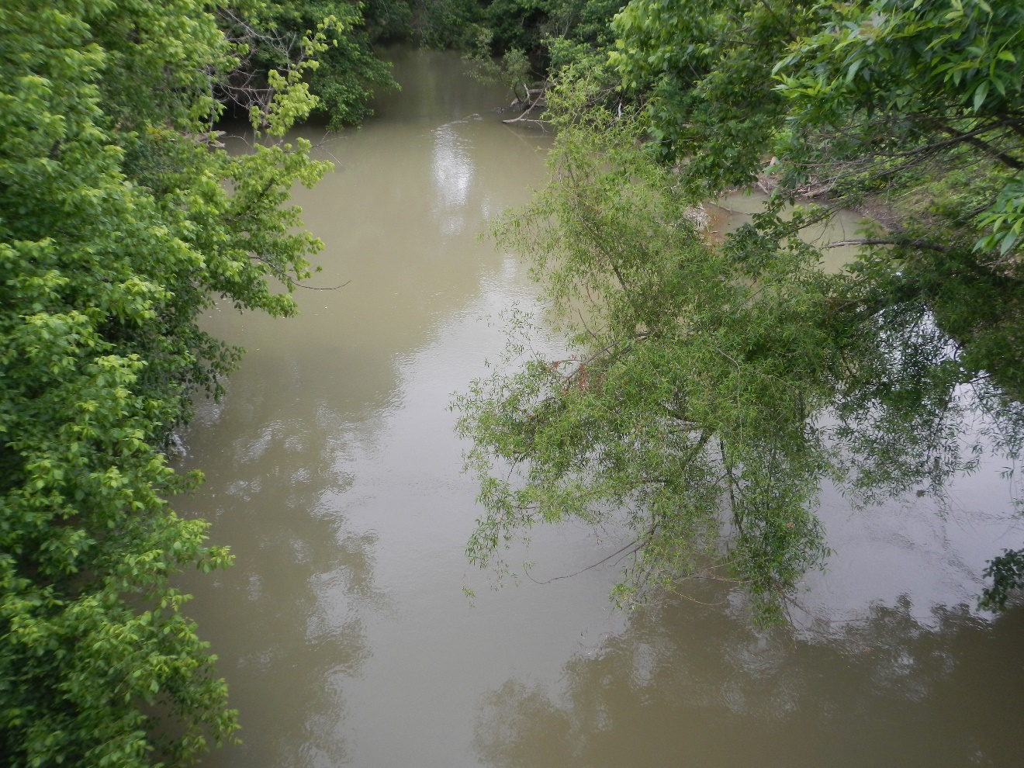
Photo from June, 3rd 2014 of Lick Creek (01LC) located in the lower portion of the Nolichucky river.

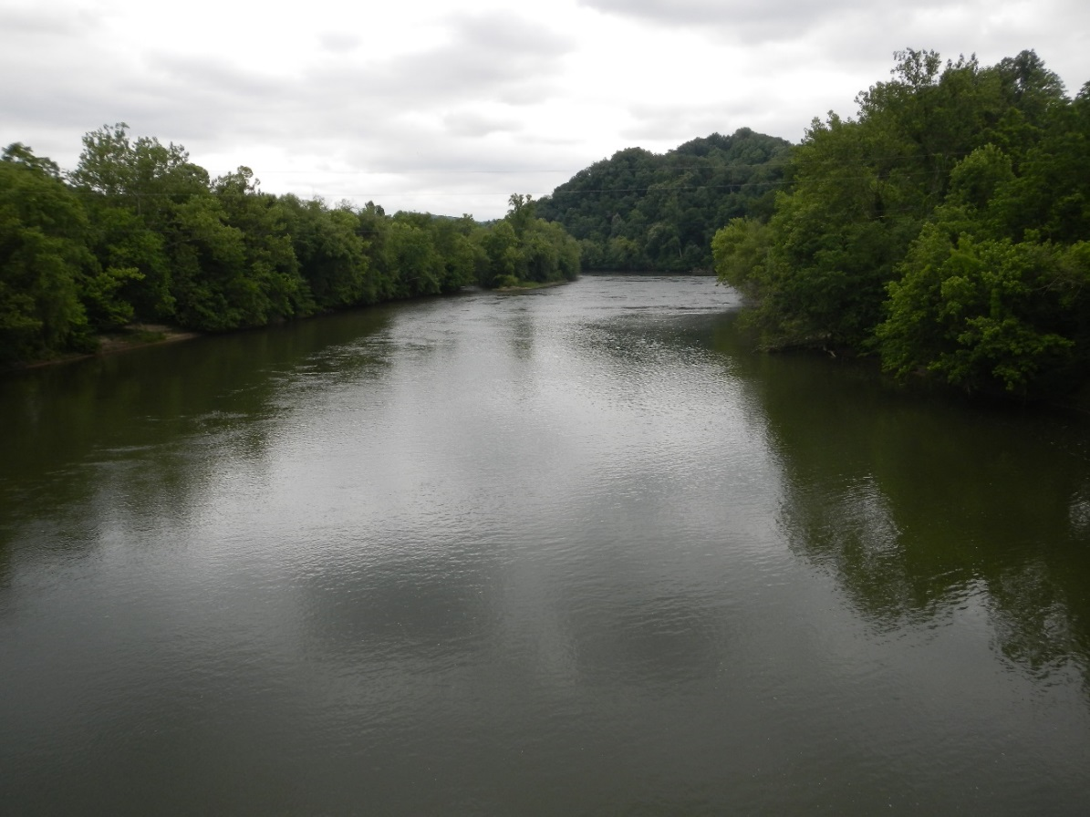
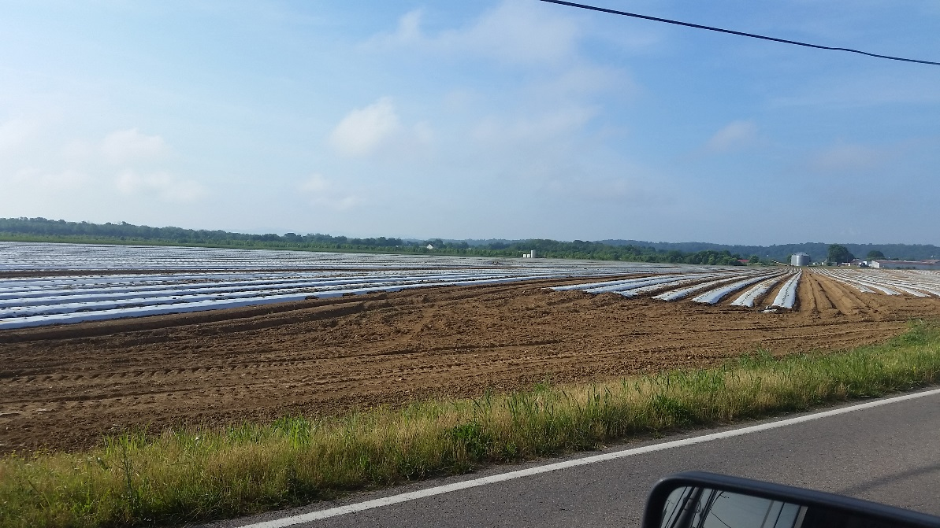
Upper photo from June 3rd 2014 of the Nolichucky River photographed from Bewley’s Bridge (06NR) located in the lower portion of the Nolichucky river. Lower photo from May 31, 2016, showing tomato fields near site prior to planting.

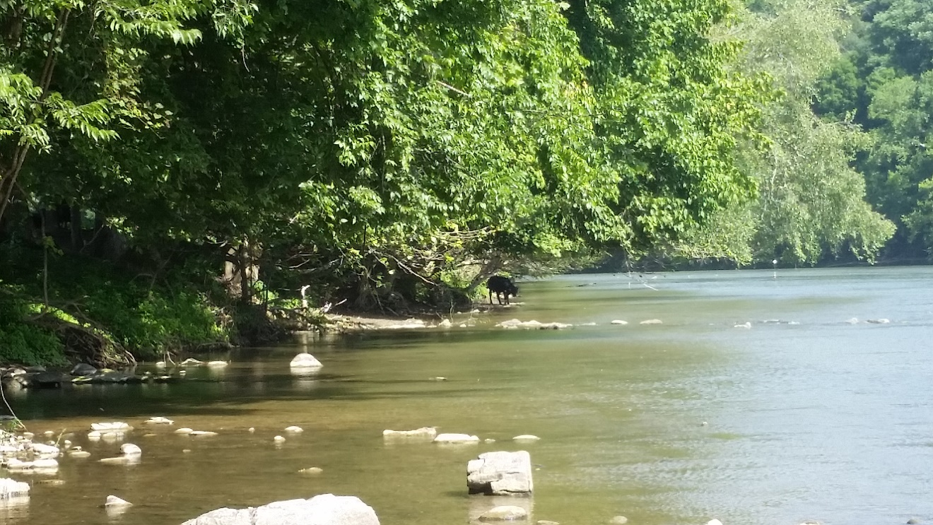
Photo from of the Nolichucky River photographed near Whittenburg Bridge (10NR) located in the lower portion of the Nolichucky river. Cattle pastures and corn fields are prevalent near the river at this site.

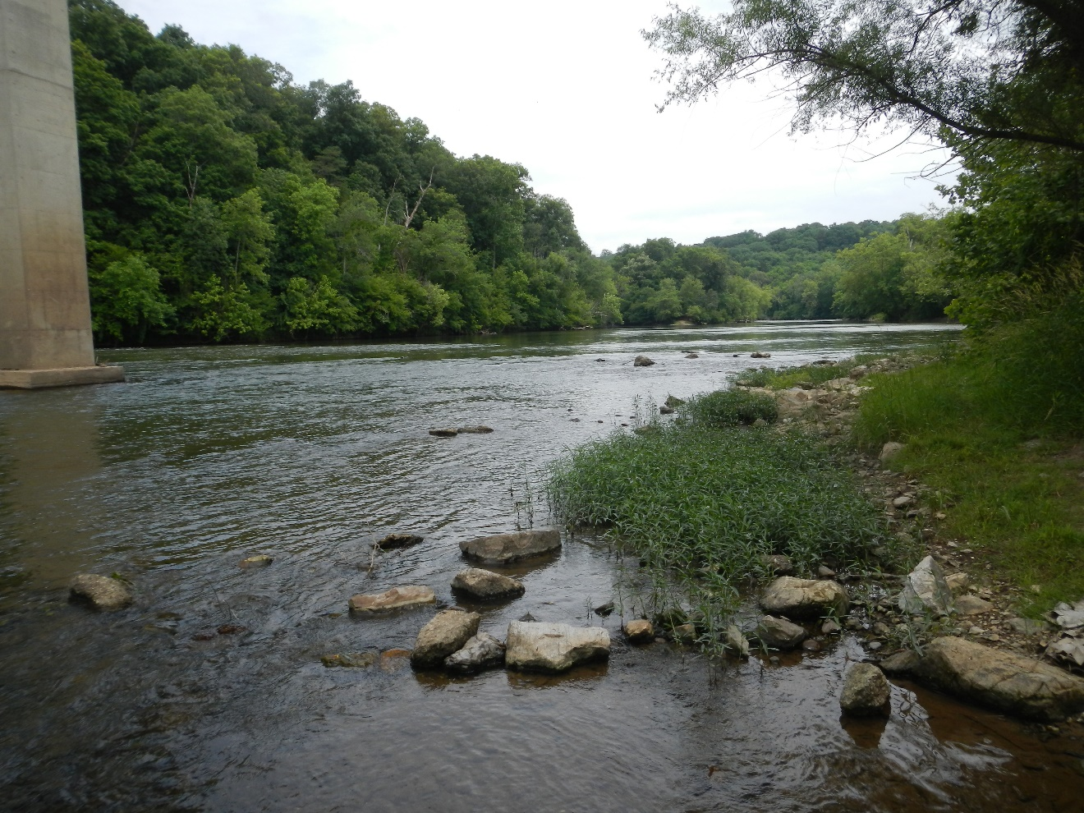
Photo from April, 22nd 2014 of the Nolichucky River photographed below the Highway 321 bridge (05NR) located in the lower portion of the Nolichucky river.
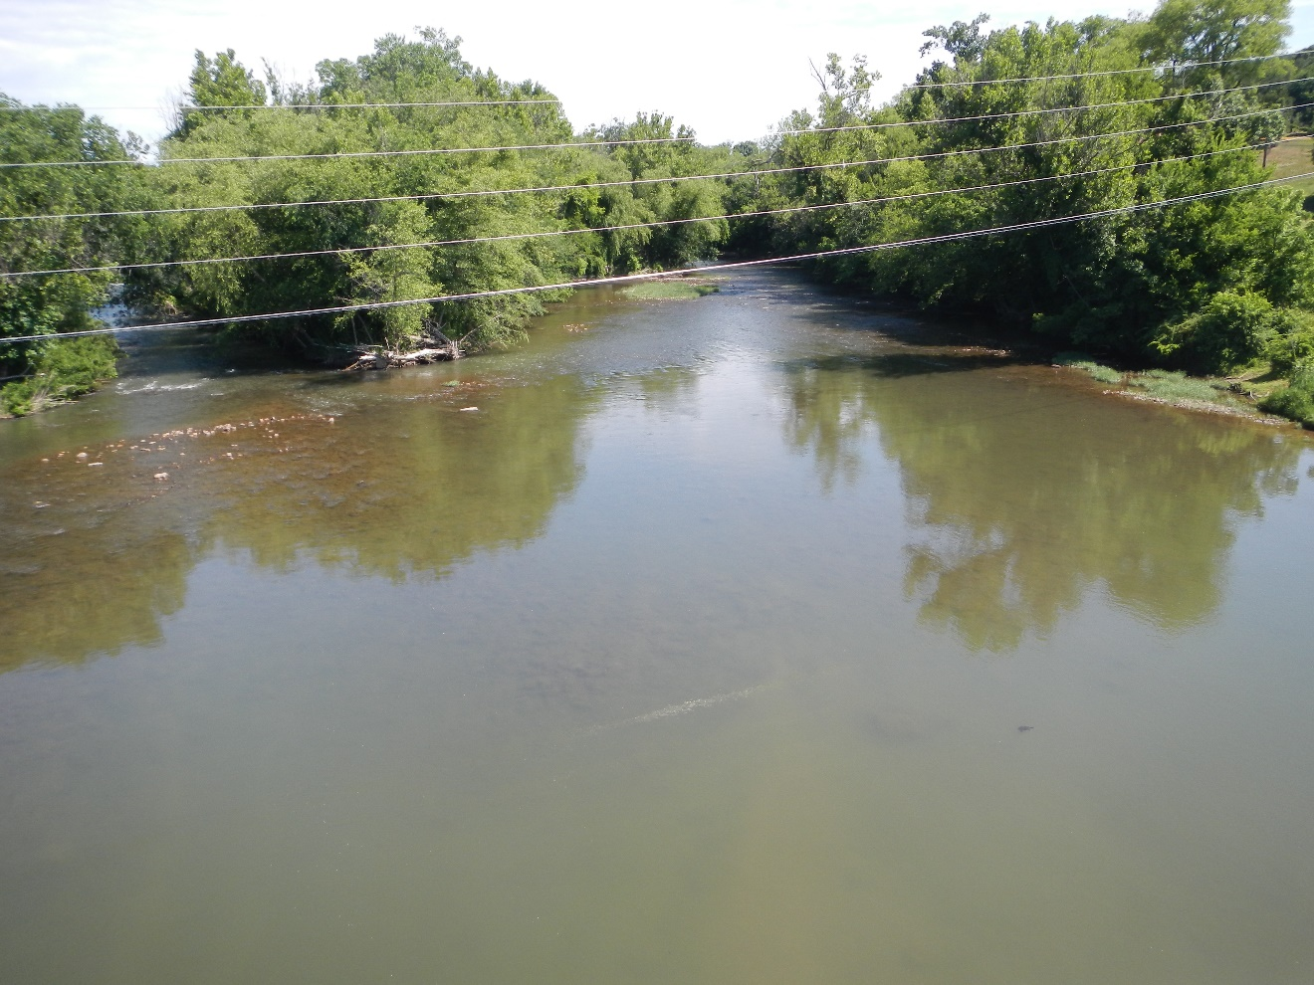
Photo from June, 10nd 2014 of the Nolichucky River photographed from Allen’s Bridge (08NR) located in the middle portion of the Nolichucky river.
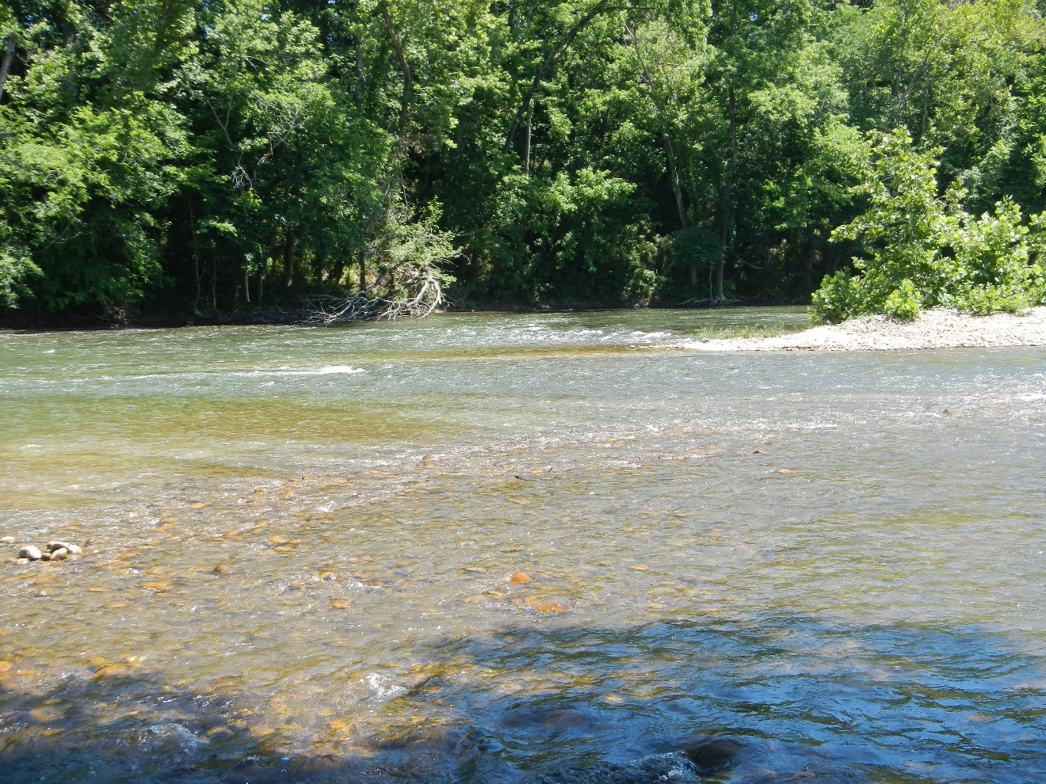
Photo from June, 10nd 2014 of the Nolichucky River photographed from below the Highway 107 bridge (01NR and 07NR) located in the middle portion of the Nolichucky river.

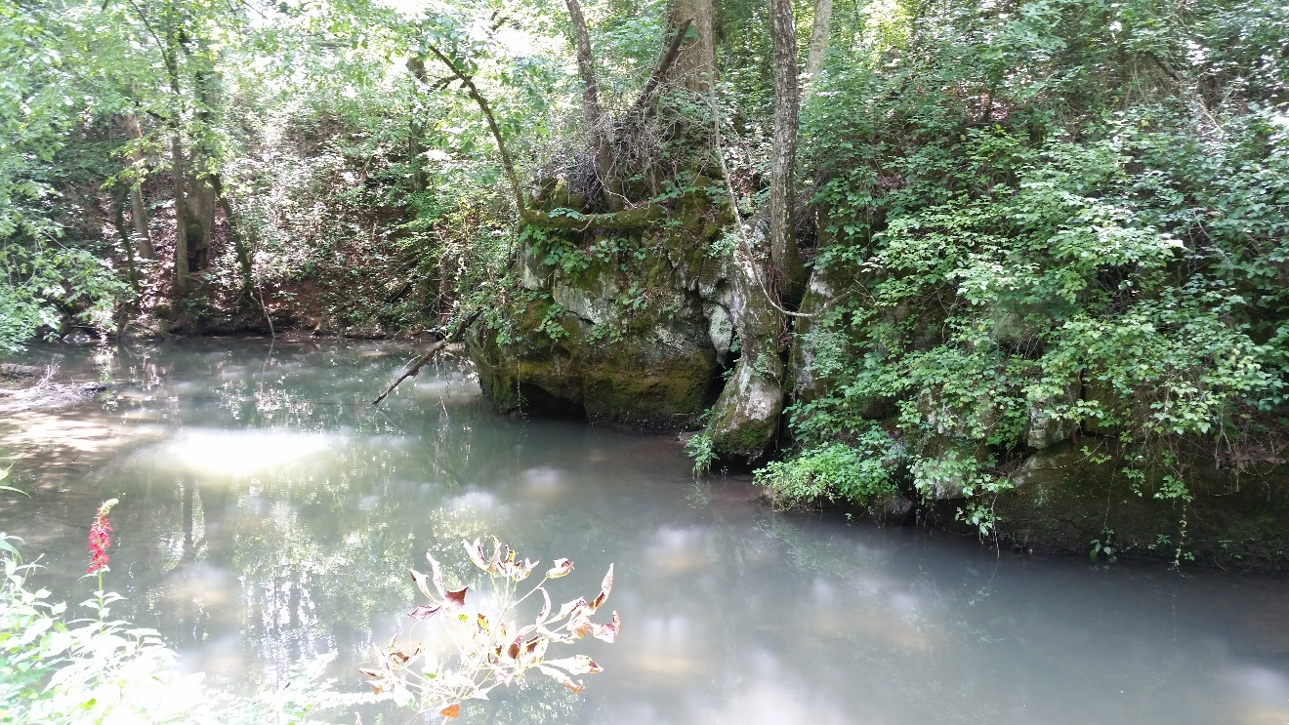
Photo from Horse Creek (01HC) located in the middle portion of the Nolichucky river.

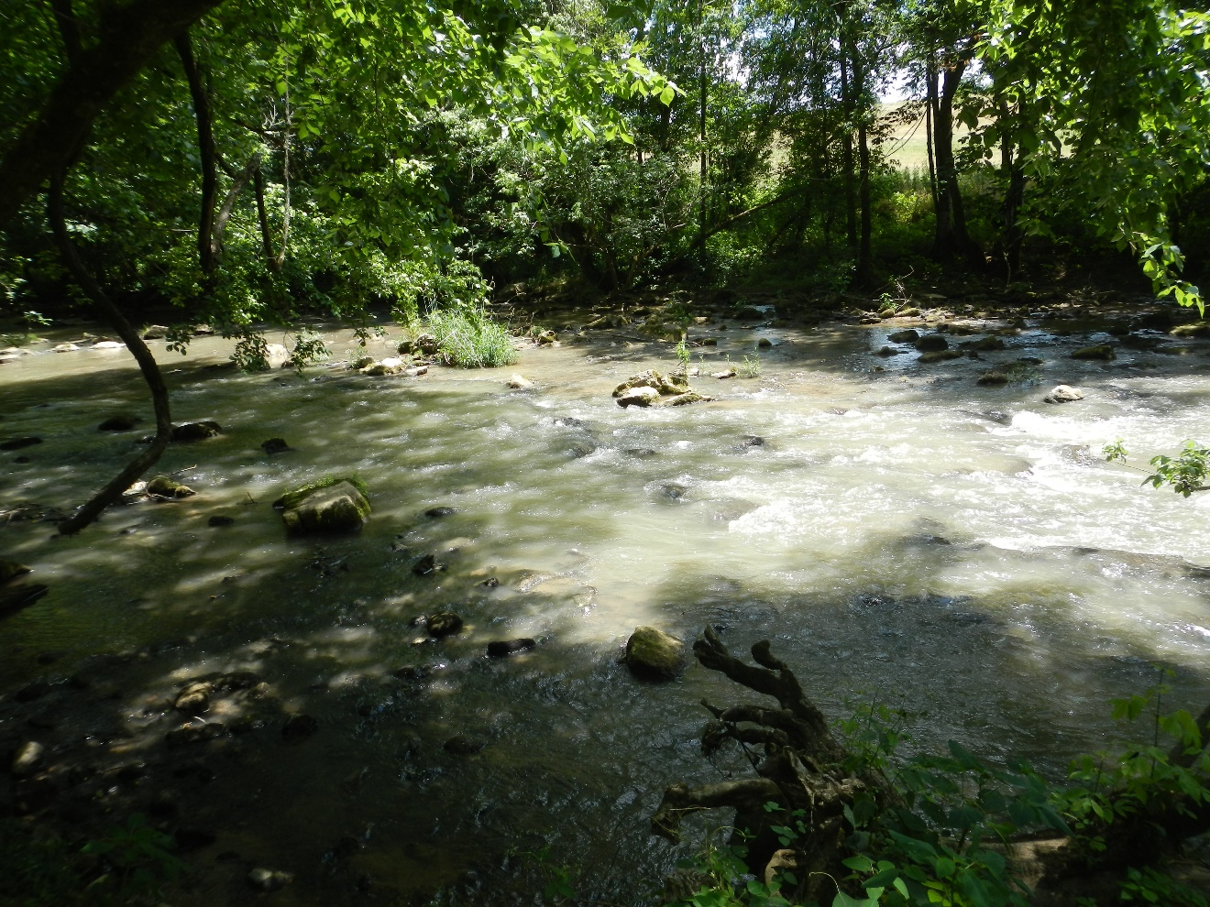
Photo from June, 10nd 2014 of Big Limestone Creek (01BL) located in the middle portion of the Nolichucky River watershed. Corn fields are adjacent to this site.
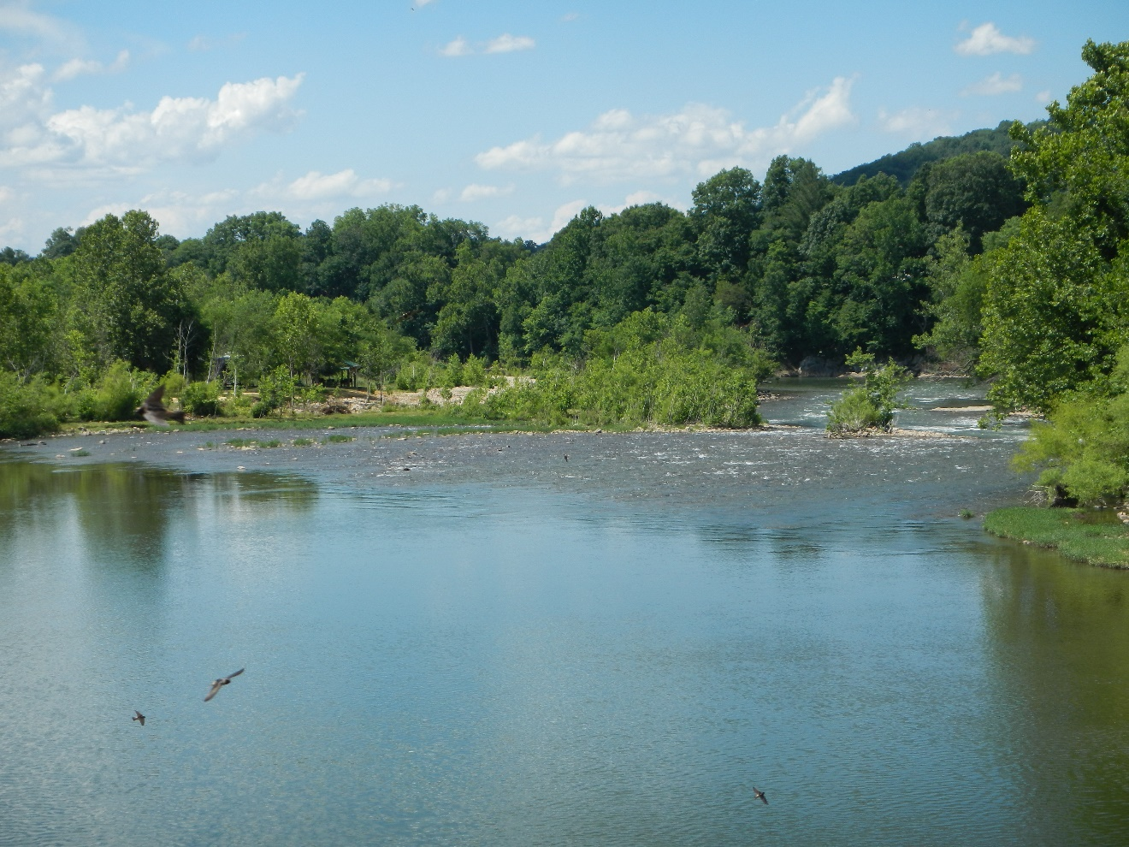
Photo from June, 10nd 2014 of the Nolichucky River photographed from below Bailey’s Bridge (11NR) located in the middle portion of the Nolichucky river.
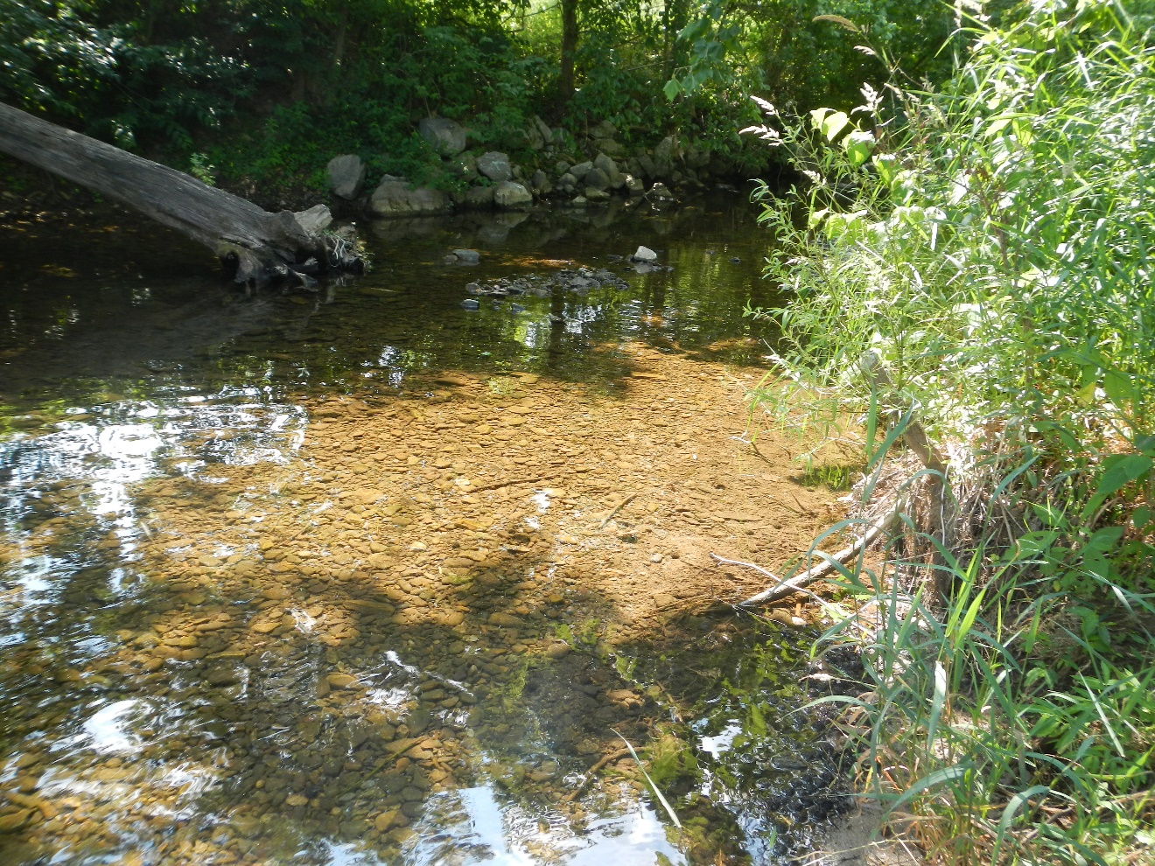
Photo from June, 17nd 2014 of Clarks Creek (01CC and 02CC) located in the upper portion of the Nolichucky River watershed.
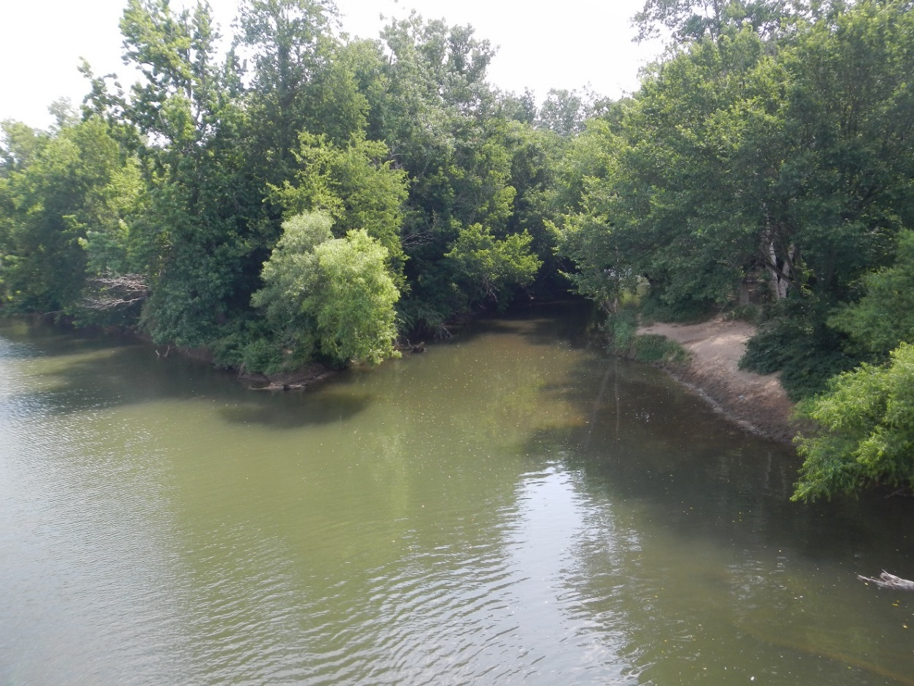
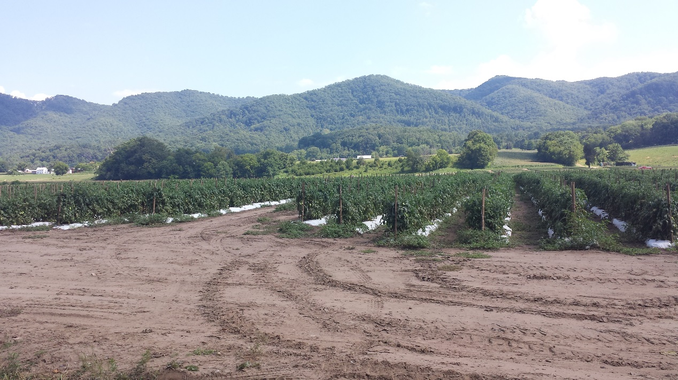
Upper photo from June, 17nd 2014 of the Nolichucky River from Jackson Bridge (03NR) located in the upper portion of the Nolichucky River watershed. Lower photo is from the stream bank showing tomato fields in production.
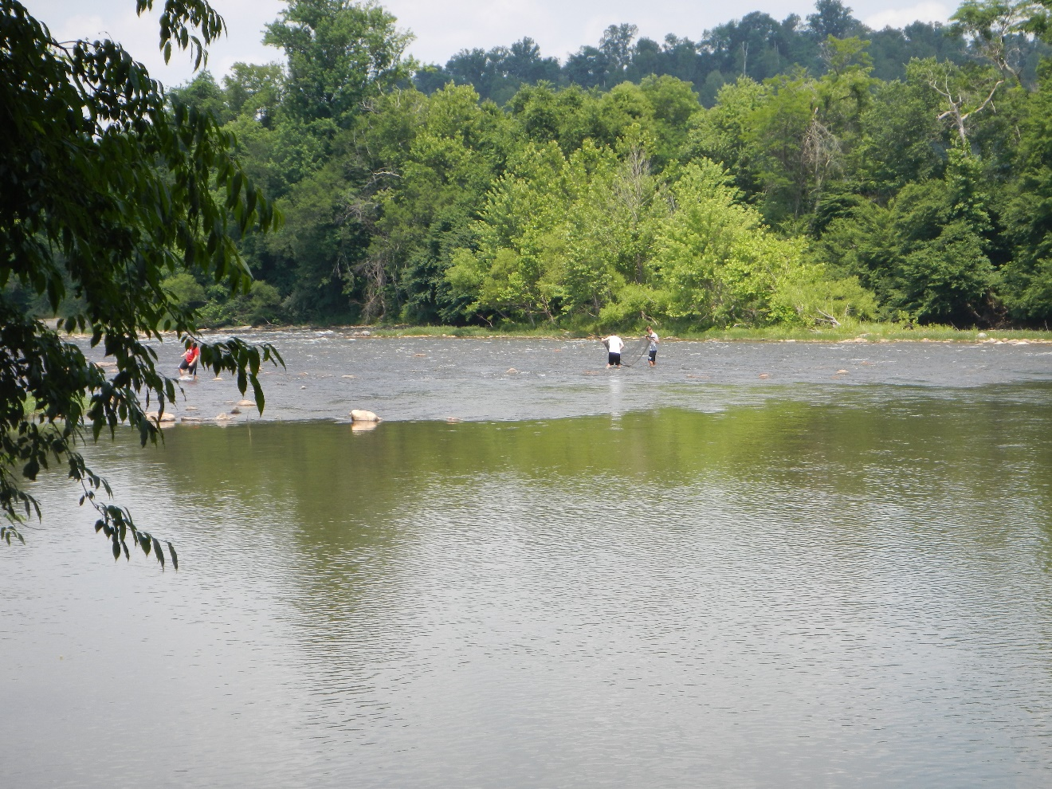
Photo from June, 17nd 2014 of the Nolichucky River upstream of Jackson Island (02NR) located in the upper portion of the Nolichucky River watershed.
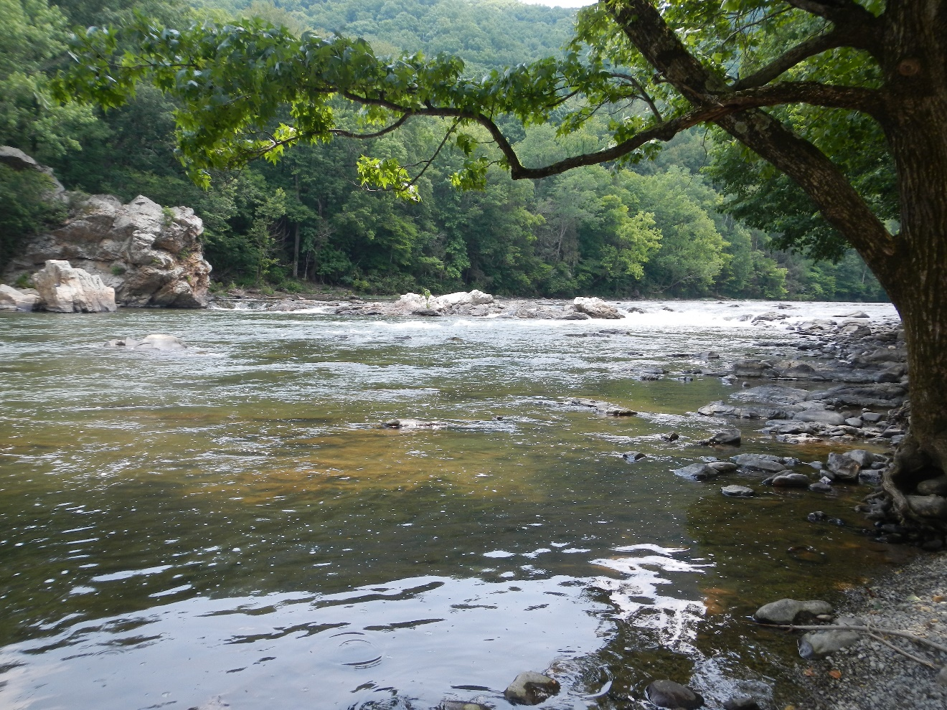
Photo from June, 17nd 2014 of the Nolichucky River from the banks of River Park Campground (04NR) located in the upper portion of the Nolichucky River watershed.
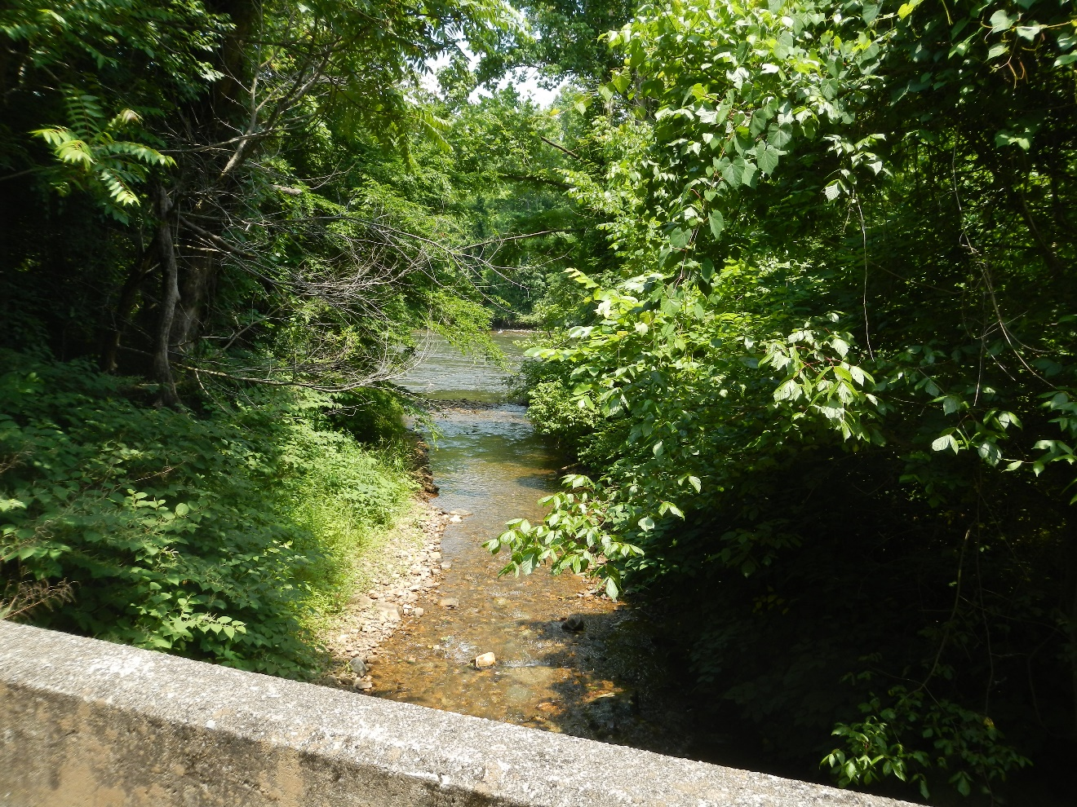
Photo from June, 17nd 2014 of Bumpus Cove Creek (01BUM) located in the upper portion of the Nolichucky River watershed.
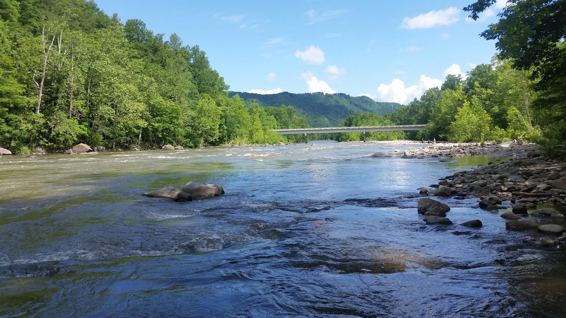
Photo of Chestoa Bridge (09NR) located in the upper portion of the Nolichucky River watershed.

CHAPTER III
ASSOCIATION BETWEEN LAND USE AND METRICS OF BIOTIC INTEGRITY

Abstract

Concern has been raised over increasing row cropping in the Tennessee portion of the Nolichucky River watershed and its negative impacts to aquatic life. The goal was to assess stream health with a series of fish index of biotic integrity (IBI) and benthic macroinvertebrate IBI surveys. These were conducted in the in the summers of 2014 and 2015. The biometrics from these samples were associated with a reduced dataset of explanatory variables of land use types at different scales, water quality, and elevation to investigate possible connections between the extent of land cover and stream health. It was hypothesized that increased land cover draining to sample sites would have poorer fish and benthic macroinvertebrate IBI scores.
Land use is associated with shifts in aquatic community structure in the Nolichucky River watershed. A canonical correspondence analysis showed the explanatory variables explained 70.6% of the variation in the fish metrics in the first three axes (Monte Carlo test p = 0.04 for eigenvalue; p = 0.05 for correlation). Percent cover of forest, open space, impervious surfaces, and water temperature were found to be the most influential explanatory variables on fish metrics. For benthic macroinvertebrate metrics, non-metric multidimensional scaling showed increasing patch density of row crops and percent cover of impervious surfaces were associated with greater percentages of oligochaetes, chironomids, and nutrient-tolerant genera while having an inverse relationship with the percentage of clinger genera (Monte Carlo test p ≤ 0.01). Row crops did have a significant association with the IBI scores for benthic macroinvertebrates while it was not a significant factor in the variation of fish IBI metrics.

Methods

Field Data Acquisition

Sixteen stream locations in the Tennessee side of the Nolichucky River watershed were sampled for fish and benthic macroinvertebrates (Figure 3). Ten of the sites were sampled in 2014, and eight of the sites were sampled in 2015 with two sites being sampled both years. These sites were selected semi-qualitatively based on observation and ease of access. Observations of the relative amount of row crops near the stream channel were made by traveling throughout the watershed to choose sites that were subjectively categorized into three classes: (1) least-impacted (minimal land use within 30 m of the stream bank for 2 km upstream of the site and clear water), (2) moderately-impacted (some amount of land use within 30 m of the stream bank but still a forested riparian buffer and moderately clear water), and (3) most-impacted by land use (land use occurred up to the stream bank, water very turbid from suspended sediments, greater than 50% land use within 2 km upstream of site). All sites had to be easy to access to avoid trespassing. Sites were also chosen to account for natural variation in fish and invertebrate assemblages as a function of stream size and elevation, because temperature- and flow-related habitat preferences can affect species occurrences regardless of land use type.

Fish IBI

Fish IBIs were conducted using the Tennessee Valley Authority’s (TVA) 2004 IBI protocol. Fish were collected using seining, dip net, and backpack electroshocking in four basic habitats: riffle, run, pool, and shoreline. All fish were identified to species in the stream while sampling and then returned to the stream
alive. Values for each metric were calculated for each site based on twelve metrics for non-headwater streams (Table 9). Since the protocol for boat shocking was omitted in this study because tributary sites were not navigable. To account for natural changes in fish assemblages with drainage size, metrics were then divided by the area of the sample site’s entire catchment upstream to normalize the scores between higher and lower order streams.

Benthic Macroinvertebrate Metrics

In conjunction with the fish IBI, macroinvertebrate surveys were conducted using the Tennessee Department of Environment and Conservation’s (TDEC) semi-quantitative kick-net biomonitoring protocol (2011). Macroinvertebrate collections were taken using a 500-µm mesh kicknet sample. One sample was taken in a “fast” riffle and another sample in a “slow” riffle, and these were pooled into one sample representing the site. The specimens were sorted in the field into taxonomic orders. They were stored in 70% isopropyl alcohol and brought back to the UT Fisheries Research Lab to be identified to genus/species level using light microscopy and a dichotomous key (Merrit et al. 2008; Brigham et al. 1982). Then macroinvertebrate index values were calculated for each site based on seven metrics that indicate a variety of trophic, behavioral, and pollution tolerance characteristics (Table 10).

Statistical Analysis

The reduced set of environmental variables from the PCA (see Chapter II) were related to the fish and benthic macroinvertebrate metrics using a canonical correspondence analysis (CCA) for the fish metrics and nonmetric multidimensional scaling (NMS) for the benthic macroinvertebrate metrics. Both
Table 9 Description of fish index of biotic integrity metrics and their abbreviations (TVA 2004). These metrics were associated with land use, water quality, and elevation in the Nolichucky River watershed.
NATIVE | Number of native species
DART | Number of native darter species
SUN | Number of native sunfish species (less Micropterus sp.)
SCK | Number of native sucker species
INTS | Number of intolerant species
TOL% | Percentage of fish as tolerant species
OMN% | Percentage of fish as omnivores and stoneroller species
SPINSCT% | Percentage of fish as specialized insectivores
PISC% | Percentage of fish as piscivores
CPUE | Catch rate (Total fish caught/Amount of efforts)
HYB% | Percentage of fish as hybrids
DIS% | Percentage of fish with disease, tumors, fin damage, and other anomalies

Table 10 Description and abbreviations for the benthic macroinvertebrate index of biotic integrity metrics (TDEC 2011). These were associated with land use, water quality, and elevation in the Nolichucky River watershed.
Biometric | Description
TR (Taxa Richness) | Total number of distinct genera found in the subsample.
EPT (Ephemeroptera Pelecoptera  Tricoptera Richness) | Total number of genera within the orders Ephemeroptera, Plecoptera, and Trichoptera.
%EPT-Cheum (EPT Abundance excluding Cheumatopsyche spp.) | $$\text{= }\frac{\text{Total }\left(\text{EPT}\right)\text{- Cheumatopsyche}}{\text{Total number of individuals in the subsample}}\text{ X 100}$$
%OC (Percent oligochaetes and chironomids) | $$\text{= }\frac{\text{Total number of Oligochaeta+Chironomidae}}{\text{Total number of individuals in the subsample}}\text{ X 100}$$
NCBI (North Carolina Biotic Index includes tolerance scores from other indices found in the EPA’s Rapid Bioassesment Protocols when no value is available for NC) | $$\text{= ∑ }\frac{{\text{x}}_{\text{i}}{\text{ t}}_{\text{i}}}{\text{N}}$$  where:  ${\text{x}}_{\text{i}}$ = number of individuals within a taxon  ${\text{t}}_{\text{i}}$ = tolerance value of a taxon  N = total number of individuals in a subsample that have been assigned a tolerance value
Table 10 Continued.
Biometric | Description
%Clingers (Percent contribution of organisms that build fixed retreats or have adaptations to attach to surfaces in flowing water) | $$\text{=}\frac{\text{Total number of clinger individuals}}{\text{Total individuals in the sample}}\text{ X 100}$$
%TNUTOL (Percentage of Total Nutrient Tolerant Organisms) | $$\text{= }\frac{\begin{aligned}\text{Total number of }\text{Cheumatopsyche}\text{, }\text{Stenelmis}\text{, } \\ \text{Polypedilum}\text{, }\text{Cricotopus}\text{, }\text{Orthocladius } \\ \text{Lirceus}\text{, }\text{Caenis}\text{, }\text{Elimia}\text{, }\text{Nais}\text{, }\text{Dero}\text{,} \\ \text{Undetermined }\left(\text{immature}\right)\text{Tubificidae}\end{aligned}}{\text{Total individuals in the sample}}\text{ X 100}$$
matrices of biometrics were ln(x+1)-transformed to eliminate skewness and kurtosis. For the CCA the main matrix was made up of the 18 sample sites (rows) and the 12 metrics (columns). The second matrix of explanatory variables was made up of the 18 sample sites (rows) and the 7 land use and environmental factors (columns). Community structure unrelated to explanatory variables was ignored because variables had been 1) already run through PCA to find which ones explained the majority of the variance, and 2) metrics related to row crops and other land cover types were only of interest. The axes were scaled to optimize samples and biplot scaling was used to plot the sample sites and variables. After examining the pH metric with scatter plots against the fish and benthic macroinvertebrate metrics, a low association was found so it was removed from the analysis (average values for fish metrics r = -0.26, p = 0.29; average values for benthic macroinvertebrate metrics r = 0.005, p = 0.29).
For the NMS ordination of the benthic macroinvertebrate metrics, the distance measure used was Sorensen (Bray-Curtis) method in PC-ORD version 6.15 (McCune and Mefford 2011; Mather 1976; Kruskal 1964) using the default settings in autopilot. Random starting configurations were chosen. The number of runs with real data was 250. The dimensionality (number of axes) was assessed by PC-ORD by comparing final stress values among the best solutionsOne best solution is chosen for each dimensionality (McCune and Grace 2002). The maximum amount of axes allowed was six and the ordination found up to that amount.

Results

Fish IBI

Sampling efforts found 57 unique species of fish and one hybrid with a total of 9,429 individuals collected during the 18 samples. The number of species per site ranged from 11 to 29, and the number of individuals ranged from 174 to 2,112. Before dividing by catchment area, the scores followed the pattern of the RCC with respect to more biodiversity and higher populations in larger order streams. For example, sample sites on higher order streams with a catchment of 2,000 km² or greater had high catch rates (CPUE) and numbers of native species (NATIVE) (Appendix F). After dividing the metrics by the catchment area, sample sites with lower amounts of disturbance had higher scores indicating good stream health (e.g., high catch rates, lower number of sunfish species). Disturbance is defined as remove of the natural land cover in the watershed (i.e. forest).
The CCA, which assumes a unimodal or Gaussian response between independent and dependent matrices, was found to be the best method to relate fish IBI metrics to land use. It had the lowest calculated probability when compared to other multivariate tests (e.g. redundancy analysis). The correlation matrix (Table 11) of the explanatory variables showed high correlation among

Table 11 The correlation matrix produced as preliminary results in the canonical correspondence analysis. The land use/land cover and the environmental variables were collected at selected sample sites in the Nolichucky River watershed. Abbreviations are elevation (ELEV), row crop (ROW), temperature (TEMP), forest (FOR), impervious surfaces (IMP), acidity (PH), and open space (OPN).
 | ELEV | ROW | TEMP | FOR | IMP | PH | OPN
ELEV | 1 | -0.87 | -0.46 | 0.77 | -0.77 | -0.29 | -0.30
ROW | -0.87 | 1 | 0.19 | -0.70 | 0.79 | 0.46 | 0.54
TEMP | -0.4 | 0.19 | 1 | -0.43 | 0.30 | -0.11 | -0.26
FOR | 0.77 | -0.70 | -0.43 | 1 | -0.84 | -0.37 | -0.50
IMP | -0.77 | 0.80 | 0.30 | -0.84 | 1 | 0.43 | 0.58
PH | -0.29 | 0.46 | -0.10 | -0.37 | 0.43 | 1 | 0.45
OPN | -0.30 | 0.54 | -0.26 | -0.50 | 0.58 | 0.45 | 1

several of the variables. Notably, elevation had a strong positive correlation with forest cover (r = 0.77) and had a strong negative correlation with row crop cover (r = -0.87) and impervious surfaces (r = -0.77). In turn, row crops were strongly associated with impervious surfaces (r = 0.80), while both row crops andimpervious surfaces had strong negative correlations with forest (r = -0.70; r = -0.84). Acidity, temperature, and open space land use did not have strong correlations with any other explanatory variables.
The CCA found three axes on which to ordinate the sample sites along gradients of the explanatory variables. The iteration report showed they were found with a tolerance level of 0.100000E-12 after 19, 7 and 16 for the first three axes. The total variance in the fish IBI metrics was 0.23, in turn summary statistics on the three axes are based on ratios of this number. The three axes explained a cumulative 70.6% of the variation with the first axis explaining 44.7% of the variance, the second axis explaining 18.9% of the variance, and the third axis explaining 7% of the variance (Table 12).

Table 12 To measure how row crop agriculture impacts fish communities a canonical correspondence analysis (CCA) was performed on metrics from a fish index of biotic integrity (IBI) in relation to explanatory variables: land use/land cover, water quality, and elevation that were collected at selected sample sites in the Nolichucky River watershed. The three axes for the CCA of fish IBI metrics show 70.6% of the variance in the sample sites are explained by the explanatory variables (Spp-Envt).
 | Axis 1 | Axis 2 | Axis 3
Eigenvalue | 0.10 | 0.043 | 0.016
Variance in species data
% of variance explained | 44.7 | 18.9 | 7
Cumulative % explained | 44.7 | 63.5 | 70.6
Pearson Correlation, Spp-Envt | 0.92 | 0.98 | 0.85
Kendall (Rank) Corr., Spp-Envt | 0.47 | 0.75 | 0.50
After the axis summary statistics, the multiple regression results are included (Table 13). The PCA calculates ordination scores known as weighted averaging (WA or intraset) scores and linear combination (LC or interset) scores that can be superimposed on an ordination diagram. The WA scores (Table 14) are for rows in the main matrix, sample sites, that are derived from columns in the main matrix, fish IBI metrics. The LC scores (Table 15) are values for rows in the main matrix, sample sites, that are linear combinations of the columns in the second matrix, LULC, water quality, and elevation data (McCune and Mefford 2011). The fish IBI metric weights are based on totals for each metric (Table 16). The biplot scores for environmental variables and correlations between axes and the explanatory variables (Table 17). The LC scores represent the best fit of fish IBI metrics to the explanatory variables and are used to create the joint plots (Figure 10). The weights for the fish IBI metrics are useful for interpreting the ordination. Higher raw data totals (e.g., CPUE and NATIVE) have a higher influence on the analysis. The biplot scores give the coordinates of the tips of the radiating lines in the joint plot (Figure 10).
The null hypothesis was rejected for the CCA that there is no relationship between the matrices of fish metrics and explanatory variables. The ordination suggested that there were four vectors that most strongly influenced the fish IBI metrics and the sample sites (Table 18 and Figure 10; Monte Carlo test, 998 runs, p = 0.04 for axis 1 eigenvalue, p = 0.05 for species-environment correlations). These vectors were temperature, forest, open spaces, and impervious surfaces. Most of the low-impact sites on tributaries, either in the Cherokee National Forest or having relatively undisturbed catchments (01CC, 02CC, and 01BUM), had cooler temperatures and more forest and were characterized by higher catch rates (CPUE). Sites on the main stem and some impacted tributaries (01HC, 01LC, and 01BL) are characterized by higher temperatures and increasing percentages of impervious surfaces and open space. These tributaries had low catch rates but greater numbers of sunfish
Table 13 Multiple regression results from the canonical correspondence analysis (CCA) performed on fish index of biotic integrity (IBI) metrics in relation to explanatory variables: land use/land cover, water quality, and elevation that were collected at selected sample sites in the Nolichucky River watershed. Values are the regression of sample sites in the space of fish IBI metrics of on environmental variables. These values indicate the effectiveness of the explanatory variables in structuring the ordination and describing the relationships of the explanatory variables to the ordination axis. Abbreviations are elevation (ELEV), row crop (ROW), temperature (TEMP), forest (FOR), impervious surfaces (IMP), acidity (PH), and open space (OPN).
 |  |  | Canonical Coefficients
 | Standardized |  |  |  | Original Units
Variable | Axis 1 | Axis 2 | Axis 3 |  | Axis 1 | Axis 2 | Axis 3 | St.Dev.
ELEV | 0.14 | 0.07 | -0.17 |  | 0.75 | 0.35 | -0.88 | 1.88E-01
ROW | 0.28 | 0.11 | -0.05 |  | 1.17 | 0.45 | -0.19 | 2.40E-01
TEMP | 0.21 | -0.10 | -0.13 |  | 2.31 | -1.06 | -1.45 | 9.05E-02
FOR | -0.05 | -0.01 | -0.13 |  | -0.49 | -0.06 | -1.30 | 1.02E-01
IMP | 0.003 | -0.05 | -0.10 |  | 0.10 | -1.54 | -3.01 | 3.37E-02
PH | 0.02 | 0.07 | -0.03 |  | 0.02 | 0.07 | -0.03 | 9.58E-01
OPN | 0.04 | 0.09 | -0.06 |  | 0.32 | 0.70 | -0.48 | 1.29E-01

Table 14 The weighted averaging (WA) scores created by the canonical correspondence analysis (CCA) performed on fish index of biotic integrity (IBI) metrics in relation to explanatory variables: land use/land cover, water quality, and elevation that were collected at selected sample sites in the Nolichucky River watershed. Raw data totals (weights) are also given.
 | WA Scores
 | Axis 1 | Axis 2 | Axis 3 | Raw Data Totals
01BC | 0.63 | -0.60 | 0.15 | 0.03
01BL | 0.51 | 0.13 | -0.07 | 0.29
01BUM | 0.02 | 0.33 | -0.09 | 1.19
01CC | -0.29 | -0.06 | -0.01 | 1.39
01HC | 0.25 | 0.09 | 0.17 | 0.60
01LC | 0.67 | 0.04 | 0.78 | 0.11
01NR | 0.25 | -0.25 | -0.13 | 0.05
02CC | -0.25 | -0.18 | 0.03 | 1.43
02NR | 0.78 | -0.18 | -0.06 | 0.05
03NR | 0.77 | -0.31 | -0.02 | 0.04
04NR | 0.93 | -0.22 | -0.27 | 0.05
05NR | 0.63 | -0.16 | -0.17 | 0.03
06NR | 0.66 | -0.26 | -0.10 | 0.04
07NR | 0.80 | -0.39 | -0.34 | 0.04
08NR | 0.39 | -0.34 | -0.10 | 0.04
09NR | 1.09 | -0.35 | -0.53 | 0.05
10NR | 0.89 | -0.43 | -0.12 | 0.03
11NR | 0.88 | -0.31 | -0.14 | 0.046

Table 15 The linear combination (LC) scores calculated by the canonical correspondence analysis (CCA) performed on fish index of biotic integrity (IBI) metrics in relation to explanatory variables: land use/land cover, water quality, and elevation that were collected at selected sample sites in the Nolichucky River watershed. Raw data totals (weights) are also given. These are the LC scores plotted in Figure 10.
 | Axis 1 | Axis 2 | Axis 3
01BC | 0.44 | -0.45 | 0.35
01BL | 0.61 | 0.16 | -0.05
01BUM | -0.07 | 0.30 | -0.04
01CC | -0.22 | -0.03 | -0.03
01HC | 0.39 | 0.11 | 0.13
01LC | 0.27 | 0.01 | 0.52
01NR | 0.56 | -0.24 | -0.37
02CC | -0.24 | -0.18 | 0.02
02NR | 0.78 | -0.22 | 0.01
03NR | 0.73 | -0.23 | -0.12
04NR | 0.51 | -0.33 | -0.44
05NR | 0.30 | -0.28 | 0.0008
06NR | -0.03 | -0.38 | 0.22
07NR | 0.63 | -0.44 | -0.37
08NR | 0.64 | -0.58 | 0.30
09NR | 0.58 | -0.38 | -0.37
10NR | 0.74 | -0.42 | 0.18
11NR | 0.98 | -0.25 | -0.31

Table 16 The weights for fish index of biotic integrity (IBI) metrics created by the canonical correspondence analysis (CCA) performed on fish IBI metrics in relation to explanatory variables: land use/land cover, water quality, and elevation that were collected at selected sample sites in the Nolichucky River watershed. Abbreviations for the fish metrics are in Table 9.
 | Axis 1 | Axis 2 | Axis 3 | Raw Data Totals
NATIVE | 0.05 | 1.23 | -0.003 | 1.66
DART | 0.75 | 0.05 | 0.06 | 0.28
SUN | 4.48 | 0.33 | 6.94 | 0.03
SCK | 0.30 | -1.56 | 2.14 | 0.12
INTS | 0.71 | 1.15 | -0.02 | 0.22
TOL% | 0.65 | -2.90 | 0.73 | 0.16
SPINSCT% | 1.67 | -0.39 | -0.63 | 0.47
OMN% | 0.92 | -0.63 | -0.12 | 0.25
PISC% | 5.63 | -2.68 | -6.41 | 0.03
CPUE | -0.90 | -0.52 | -0.11 | 2.24
HYB% | 2.63 | 0.23 | 32.23 | 0.001
DIS% | 1.19 | -1.41 | 2.05 | 0.05

Table 17 The biplot scores and correlations with the three axes for the explanatory variables. Values were calculated by the canonical correspondence analysis (CCA) performed on fish index of biotic integrity (IBI) metrics in relation to explanatory variables: land use/land cover, water quality, and elevation that were collected at selected sample sites in the Nolichucky River watershed. Biplot scores are used to plot the vectors in the ordination diagram. Two kinds of correlations are shown, interset and intraset. Abbreviations are elevation (ELEV), row crop (ROW), temperature (TEMP), forest (FOR), impervious surfaces (IMP), acidity (PH), and open space (OPN).
Variable |  | Axis 1 | Axis 2 | Axis 3
BIPLOT Scores
ELEV |  | -0.81 | 0.02 | -0.48
ROW |  | 0.83 | 0.36 | 0.31
TEMP |  | 0.65 | -0.72 | -0.15
FOR |  | -0.81 | -0.08 | -0.35
IMP |  | 0.79 | 0.19 | 0.11
PH |  | 0.39 | 0.61 | -0.09
OPN |  | 0.41 | 0.75 | -0.07
INTRASET correlations
ELEV |  | -0.26 | 0.004 | -0.06
ROW |  | 0.26 | 0.07 | 0.04
TEMP |  | 0.21 | -0.15 | -0.02
FOR |  | -0.26 | -0.02 | -0.04
IMP |  | 0.25 | 0.04 | 0.01
PH |  | 0.12 | 0.13 | -0.01
OPN |  | 0.13 | 0.16 | -0.01
INTERSET correlations
ELEV |  | -0.74 | 0.02 | -0.41
ROW |  | 0.76 | 0.35 | 0.26
TEMP |  | 0.60 | -0.71 | -0.12

Table 17 Continued.
Variable |  | Axis 1 | Axis 2 | Axis 3
INTERSET correlations
FOR |  | -0.74 | -0.07 | -0.29
IMP |  | 0.73 | 0.19 | 0.09
PH |  | 0.36 | 0.60 | -0.078
OPN |  | 0.36 | 0.74 | -0.06

Figure 10 Joint plots showing a canonical correspondence analysis ordination of fish index of biotic integrity metrics (A) and sample sites on the Nolichucky (B) in environmental space: land use/land cover, water quality, and elevation. Using linear combination scores scores, the joint plot overlay shows vectors related to the four strongest variables: (water temperature (TEMP), open space (OPN), forest (FOR), and impervious surfaces (IMP). Axes are scaled by raw scores.



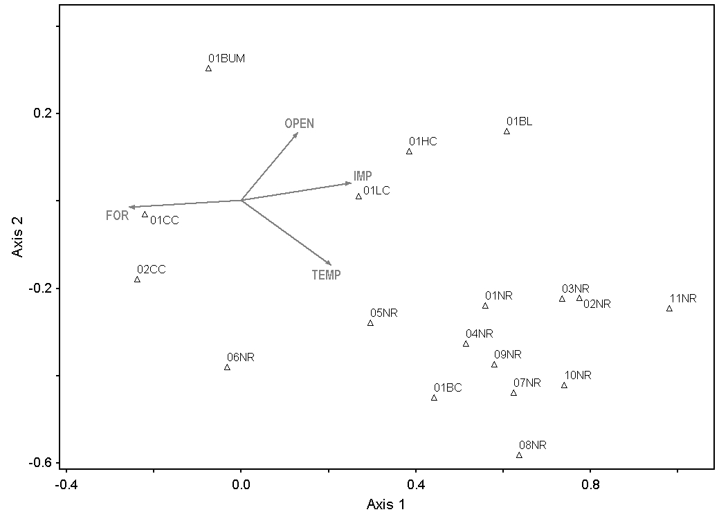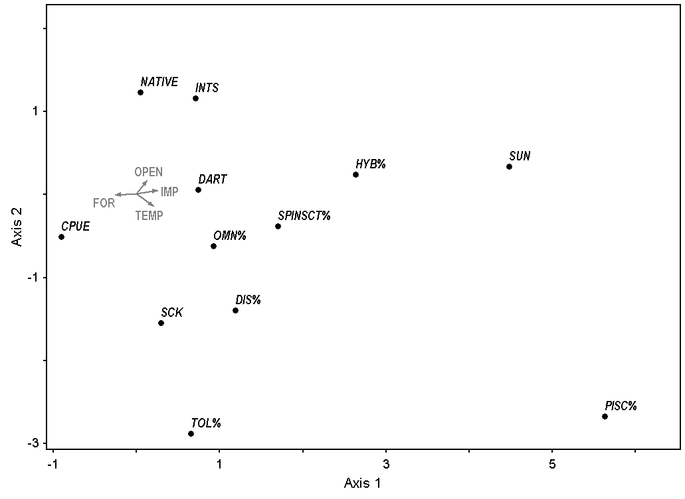
Figure 10 Continued.

Table 18 The Monte Carlo test of significance was performed to assess the statistical significance of the canonical correspondence analysis performed on the fish index of biotic integrity metrics in relation to explanatory variables: land use/land cover, water quality, and elevation that were collected at selected sample sites in the Nolichucky River watershed. The results for the eigenvalues and species-environment correlations based on 998 runs.
 |  |  |  | Randomized data
Axis | Real data |  | Mean | Minimum | Maximum | p
 | Eigenvalue
1 | 0.10 |  | 0.08 | 0.03 | 0.11 | 0.04
2 | 0.04 |  | 0.03 | 0.02 | 0.04
3 | 0.02 |  | 0.01 | 0.006 | 0.02
 | Spp-Envt Corr.
1 | 0.92 |  | 0.84 | 0.62 | 0.97 | 0.05
2 | 0.98 |  | 0.84 | 0.51 | 0.97
3 | 0.85 |  | 0.75 | 0.43 | 0.95

percentages of piscivores. One tributary site (01BUM) with low temperature and some disturbance close to the sample site (6.83% Open space in entire catchment; 36.88% Open space in local, 500-m buffer) was characterized by greater amounts of native species (11) and pollution-intolerant species (1).

Benthic Macroinvertebrates

A total of 142 unique benthic macroinvertebrate genera from 64 families were collected which included 9,918 individuals. The number of genera per site ranged from 21 to 43, and the number of individuals ranged from 85 to 1,079. Metrics values had minimal variation between the 18 samples. Although the species (Green Sunfish, Lepomis cyanellus; Redbreast Sunfish, Lepomis auritus; and the black basses, Micropterus spp.) and hybrids. Warmer main stem sites (e.g., 08NR, 10NR, 07NR) tended to have greater scores TDEC uses in their protocol to calculate the Tennessee macroinvertebrate index were not used in this analysis, they illustrate the similarity between sites. For example, metrics such as percentage of oligochaetes and chironomids was the same for every site (Appendix G).
For the NMS all axes were found to be statistically significant at (250 randomized runs, p ≤ 0.01) (Table 19). The best solution was found to be a 3-dimensional solution and it was achieved after 43 iterations. Sites were ordinated on a gradient of increasing row crops and impervious surfaces because this ordination produced the least amount of stress. The metrics most associated with high amounts of row crops and impervious surfaces were high percentages of total nutrient tolerant organisms (%TNUTOL) and percentages of oligochaetes and chironomids (%OC). Metrics most associated with low amounts of row crops and impervious surfaces were high percentages of clinger individuals

Table 19 A nonmetric multidimensional scaling ordination was performed on benthic macroinvertebrate index of biotic integrity metrics in relation to explanatory variables: land use/land cover, water quality, and elevation that were collected at selected sample sites in the Nolichucky River watershed. To test the significance of the stress in relation to dimensionality (number of axes), a Monte Carlo test was done comparing 250 runs on the real data to 250 runs on randomized data. The p-value is the proportion of randomized runs with stress less than or equal to the observed stress.
 | Stress in real data |  |  | Stress in randomized data  Monte Carlo test, 250 runs
Axes | Minimum | Mean | Maximum | Minimum | Mean | Maximum | p
1 | 26.61 | 44.30 | 54.43 | 26.50 | 46.73 | 54.43 | 0.01
2 | 11.46 | 13.89 | 33.58 | 11.63 | 20.14 | 37.23 | 0.004
3 | 6.36 | 6.96 | 25.76 | 6.26 | 10.95 | 19.40 | 0.008
4 | 3.84 | 3.99 | 20.13 | 4.28 | 6.65 | 8.86 | 0.004
5 | 2.81 | 2.95 | 3.44 | 2.76 | 4.31 | 15.77 | 0.02
6 | 1.64 | 1.92 | 14.59 | 1.56 | 2.74 | 11.45 | 0.012

(%CLINGER). Sites with high amounts of row crops and impervious surfaces (e.g., 01NR, 08NR, 10NR) had higher percentages of total nutrient-tolerant genera and higher percentages of Oligochaetes and Chironomids (Figure 11).

Discussion

Fish IBI

A mixture of natural and anthropogenic attributes were found to be significant influences on biotic integrity in the Nolichucky watershed. A significant association was found between fish IBI metrics and the LULC, water quality, and elevation variables. However, contrary to the initial impression that row crops were increasing in the catchment and were related to degraded fish assemblages, impervious surfaces, open space, forest, and temperature were found to be the primary factors that influenced the fish metrics. In the Nolichucky watershed the amount of impervious surfaces has increased from 4% to 5% with a percent change of 20%. This relatively small amount of change can be more detrimental to fishes compared to the same level of change in other land cover types. Other studies have found that impervious surfaces are more strongly associated with fish IBI metrics than agriculture. For example, Sawyer et al. (2004) found that of all the land use in their study site (forest, wetland, agriculture, and urban) fish assemblages were most responsive to percent urban land use occurring within 30-m of the stream edge. Snyder et al. (2003) showed that fish IBI scores were strongly associated with urban land use in individual catchments, and that sites with poor or very poor ratings had > 7% area of urban land use in their respective catchments. Although Wang (1997) did find inverse relationships for both agriculture and urban land use to fish IBI scores, urban land use showed a stronger negative relationship with biotic integrity.

Figure 11 The ordination of the benthic macroinvertebrate metrics of biotic integrity (A) and sites (B) in comparison to the land use, defined by a nonmetric multidimensional scaling ordination performed on benthic macroinvertebrate index of biotic integrity metrics in relation to explanatory variables: land use/land cover, water quality, and elevation that were collected at selected sample sites in the Nolichucky River watershed. Arrows are the vectors from the explanatory variablesmatrix that best explained the variation of the sample sites, row crops (ROW) and impervious surfaces (IMP). Vectors are rotated 20°.


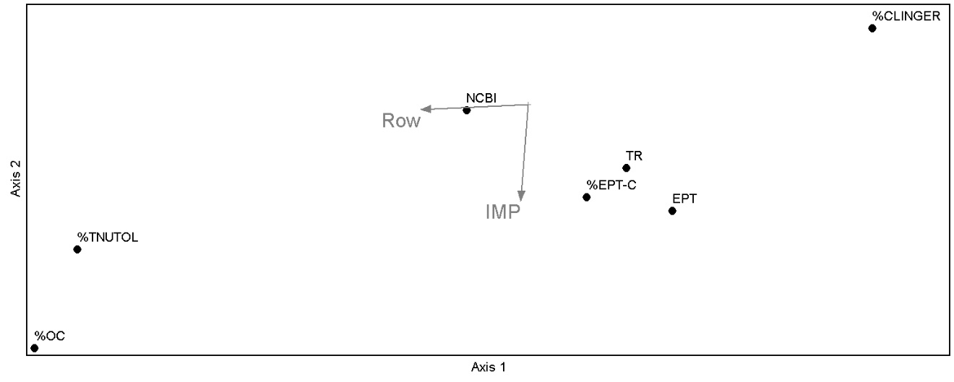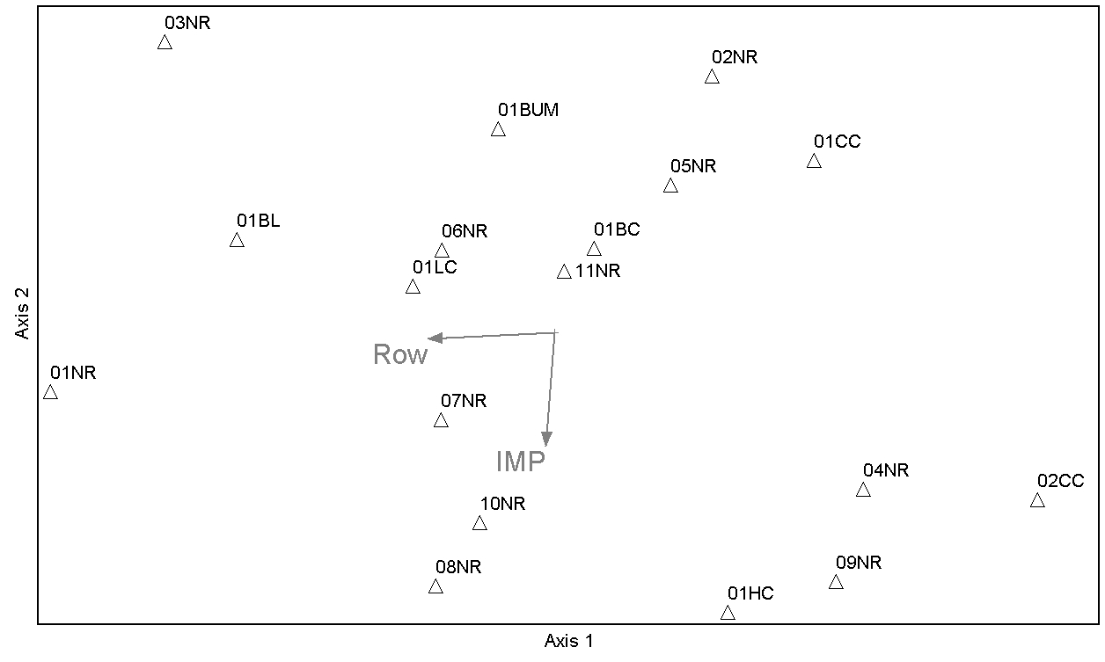
Figure 11 Continued.
Impervious surfaces in the Nolichucky watershed could have a greater impact on to water quality in streams because infiltration decreases while runoff increases due to the impenetrable surface (Corbett et al. 1997). Of all the rain falling during a precipitation event, impervious surfaces can increase the percentage of rain becoming runoff from 10% with natural cover to 55% (Tourbier 1994). On average impervious surfaces make up a low portion of the overall catchment area, but have a large, negative influence on water quality (Paul and Meyer 2001). Impervious surfaces decrease water quality through increasing loading of sediment, metals, salts, and other chemicals (Brabec et al. 2002; Arnold and Gibbons 1996). These pollutants suppress immunity in fish and cause endocrine disruption this leads to community that has lower diversity and is more tolerant of the impacted conditions (Bols et al. 2001; Jobling and Tyler 2003).
If riparian row cropping is relatively new to the watershed examining land use of the same year fish and macroinvertebrate were sampled might not reflect the changes in the watershed that can occur. Harding et al. (1998) found that in Western North Carolina rivers, land use data from the 1950s was a better predictor of current stream diversity of invertebrates and fish than land use data from the 1990s especially with agriculture. It might be possible the full effects will not be seen of the row cropping until decades from now.

Benthic Macroinvertebrates

This analysis suggests that there is a gradient in the benthic macroinvertebrate sample sites and that they do not occur out of chance. There is a divide between metrics that indicate poor habitat conditions, such as %TNUTOL and %OC, and metrics that indicate good habitat quality such as %CLINGER. After the ordination was completed, the NMS tried to assign an environmental gradient most relevant and it found that row crops and impervious surfaces (Fig. 8). Although the NMS suggests a general correlation with LULC variables, because it is an unconstrained ordination it is not directly associated to the row crop and impervious surface variables (McGarigal et al. 2000). Fish IBI metrics had a different association to LULC than benthic macroinvertebrate metrics. The disagreement might be because fishes are more mobile and not as susceptible to patchiness of in-stream habitat quality as the more sessile benthic macroinvertebrate community (Lammert and Allan 1999).
From a national perspective, the use of a benthic macroinvertebrate observed taxa versus predicted taxa (O/E) index, where lower values are reflective of degraded communities, has been connected to forest cover and impervious surfaces but not with agriculture. Although, O/E was found to have negative correlations with nutrient loading, a factor heavily influenced by agricultural land use (Sandefur et al. 2015). In smaller-scale studies, urbanization and forest were more closely linked to benthic macroinvertebrate community structure (Roy et al. 2003). Although studies do exist where row crops have a negative connection to stream biodiversity (Waite 2013; Johnson et al. 2012; Genito et al. 2011; Lenat and Crawford 1993) the Nolichucky watershed might not follow this pattern because over half of it is in forested land use. This further exemplifies that land use has complex spatial and patchy relationships with biota.

Appendix F

Fish IBI metrics and the size of the catchment in square kilometers for the 18 sample sites in the Nolichucky River watershed. Definitions of abbreviations of the metrics are found in Table 9.

 | NATIVE | DART | SUN | SCK | INTS | TOL% | SPINSCT% | OMN% | %PISC | CPUE | HYB% | DIS% | Km²
01BC | 20 | 5 | 3 | 2 | 1 | 25.98 | 39.15 | 42.97 | 0.00 | 24.03 | 0 | 0.00 | 4229
01BL | 21 | 6 | 1 | 2 | 4 | 0.36 | 71.58 | 20.86 | 3.60 | 12.09 | 0 | 0.72 | 204
01BUM | 11 | 1 | 0 | 0 | 1 | 1.15 | 52.30 | 7.47 | 0.00 | 7.25 | 0 | 0.00 | 16
01CC | 11 | 1 | 0 | 1 | 1 | 1.55 | 28.59 | 17.46 | 0.00 | 28.40 | 0 | 0.56 | 25
02CC | 10 | 2 | 0 | 1 | 1 | 26.22 | 19.24 | 17.55 | 0.00 | 27.82 | 0 | 1.48 | 25
01HC | 12 | 2 | 1 | 1 | 2 | 1.82 | 35.87 | 10.33 | 0.61 | 11.75 | 0 | 2.74 | 56
01LC | 26 | 5 | 3 | 5 | 3 | 5.26 | 56.25 | 14.14 | 0.00 | 8.44 | 0.33 | 0.33 | 677
01NR | 23 | 6 | 1 | 2 | 4 | 2.41 | 86.79 | 5.40 | 0.09 | 55.58 | 0 | 0.00 | 2795
02NR | 26 | 8 | 3 | 5 | 5 | 2.05 | 48.84 | 7.50 | 2.18 | 18.79 | 0 | 0.27 | 2201
03NR | 23 | 6 | 2 | 4 | 4 | 8.94 | 51.66 | 7.62 | 0.99 | 14.38 | 0 | 0.33 | 2202
04NR | 25 | 8 | 1 | 2 | 5 | 5.86 | 74.84 | 10.85 | 2.39 | 9.04 | 0 | 0.43 | 2085
05NR | 26 | 6 | 1 | 2 | 4 | 1.65 | 85.66 | 2.70 | 0.35 | 25.79 | 0 | 0.35 | 3258
06NR | 28 | 8 | 1 | 3 | 4 | 6.81 | 75.08 | 1.87 | 0.44 | 22.22 | 0 | 0.77 | 3342
07NR | 22 | 6 | 1 | 2 | 4 | 5.77 | 67.31 | 16.24 | 3.42 | 24.63 | 0 | 0.43 | 2795
08NR | 21 | 8 | 1 | 2 | 4 | 8.51 | 86.82 | 2.30 | 0.08 | 43.50 | 0.00 | 0.00 | 3149
09NR | 20 | 8 | 1 | 1 | 4 | 7.39 | 64.35 | 13.91 | 7.83 | 9.20 | 0.00 | 0.00 | 1646
10NR | 23 | 7 | 2 | 3 | 4 | 12.67 | 80.41 | 2.53 | 1.38 | 16.69 | 0.00 | 0.69 | 3312
11NR | 24 | 8 | 2 | 2 | 5 | 10.02 | 67.72 | 10.20 | 1.86 | 13.48 | 0.00 | 0.56 | 2308

Appendix G

Values for the benthic macroinvertebrate metrics of biotic integrity (TDEC 2011) at each sample site in the Nolichucky River watershed. Definitions of the abbreviations for the benthic macroinvertebrate metrics of biotic integrity are found in Table 10. The columns labeled S1 through S7 represent the scores assigned (0, 2, 4, or 6) based on comparison to the ecoregion and stream size to calculate the Tennesseee Macroinvertebrate Index (TMI).

 | TR | S1 | EPT | S2 | %EPT-C | S3 | %OC | S4 | NCBI | S5 | %CLINGER | S6 | %TNUTOL | S7 | TMI
01CC | 28 | 4 | 16 | 6 | 58.5 | 6 | 8.1 | 6 | 3.27 | 6 | 71.9 | 6 | 3.5 | 6 | 40
01NR | 21 | 4 | 11 | 6 | 60.9 | 6 | 15.3 | 6 | 4.88 | 4 | 14.1 | 0 | 32.3 | 4 | 30
03NR | 19 | 4 | 7 | 4 | 50.6 | 6 | 9.4 | 6 | 4.98 | 4 | 45.9 | 4 | 15.3 | 6 | 34
01BUM | 28 | 4 | 9 | 4 | 48.6 | 6 | 0.2 | 6 | 3.64 | 6 | 58.3 | 6 | 29.1 | 4 | 36
01BL | 22 | 4 | 11 | 6 | 45.6 | 6 | 0.8 | 6 | 4.64 | 6 | 35.3 | 2 | 36.1 | 4 | 34
01LC | 29 | 6 | 10 | 6 | 57.9 | 6 | 3.6 | 6 | 4.45 | 6 | 47.3 | 4 | 25.8 | 4 | 38
02NR | 27 | 4 | 13 | 6 | 44.9 | 6 | 1.1 | 6 | 4.04 | 6 | 71.5 | 6 | 5.3 | 6 | 40
04NR | 39 | 6 | 20 | 6 | 74 | 6 | 3.2 | 6 | 3.93 | 6 | 58.4 | 6 | 7.7 | 6 | 42
05NR | 29 | 6 | 12 | 6 | 73.5 | 6 | 2.3 | 6 | 3.46 | 6 | 55.9 | 6 | 6.1 | 6 | 42
09NR | 38 | 6 | 24 | 6 | 74.9 | 6 | 3.2 | 6 | 3.64 | 6 | 48.8 | 4 | 14.5 | 6 | 40
01HC | 41 | 6 | 25 | 6 | 49 | 6 | 0.9 | 6 | 4.35 | 6 | 44.4 | 4 | 28.5 | 6 | 40
07NR | 28 | 4 | 15 | 6 | 55.8 | 6 | 16.2 | 6 | 4.74 | 6 | 46.7 | 4 | 24.7 | 6 | 38
11NR | 28 | 6 | 15 | 6 | 46.5 | 6 | 0.8 | 6 | 4.56 | 6 | 63.4 | 6 | 24.8 | 6 | 42
01BC | 28 | 6 | 14 | 6 | 58.7 | 6 | 0.6 | 6 | 3.63 | 6 | 59.8 | 6 | 25.5 | 6 | 42
02CC | 43 | 6 | 25 | 6 | 55.8 | 6 | 2.7 | 6 | 3.1 | 6 | 78.5 | 6 | 9 | 6 | 42
10NR | 31 | 6 | 18 | 6 | 58.7 | 6 | 14.7 | 6 | 4.7 | 6 | 44.4 | 4 | 25.9 | 6 | 40
08NR | 35 | 6 | 15 | 6 | 78.8 | 6 | 12 | 6 | 4.72 | 6 | 38.9 | 4 | 36.3 | 4 | 38
06NR | 25 | 4 | 12 | 6 | 62.7 | 6 | 5 | 6 | 4.03 | 6 | 40.8 | 4 | 19.3 | 6 | 38

CHAPTER IV
ASSOCIATION BETWEEN SWAT MODEL AND METRICS OF BIOTIC INTEGRITY

Abstract

Human disturbances to natural vegetation through land use change have negative impacts on the neighboring streams’ biota and physiochemical conditions. detecting a strong link between these disturbances and changes in aquatic communities can be difficult due to lack of high-resolution datasets on hydrology and water quality. The United States Geological Survey’s National Water Information System has only four stations in the Nolichucky River watershed. They measure discharge and gage height on a daily time step with only one measuring suspended sediments from 1934 to 1965. None measure amounts of organic pollutants. Using models like the Soil and Water Assessment Tool (SWAT) higher resolution estimates can be made by using a LULC map, a soil dataset, elevation dataset, and weather dataset.
The SWAT model was used to estimate sediment, nitrogen, and phosphorus concentrations in the Nolichucky River watershed in Tennessee for the year 2014. Estimates were made for catchments where an index of biotic integrity (IBI) for fish and benthic macroinvertebrate macroinvertebrates had been conducted. These estimates were related to the IBI metrics. A redundancy analysis (RDA) showed that pollutant estimates explained 38.4% of the variation in the fish metrics in the first three axes. All three estimates of sediment, nitrogen, and phosphorus were found to be influential explanatory variables on fish metrics (Monte Carlo test p = 0.03 for eigenvalue). The RDA showed sample sites were ordinated linearly into three groups: (1) low impacted tributary sites, (2) moderately impacted tributary sites, and (3) highly impacted tributary sites and main stem sites. This indicated highly impacted tributaries in the Nolichucky were functioning biologically like larger order rivers in terms of fish community structure. Nonmetric multidimensional scaling was performed on benthic macroinvertebrate metrics (Monte Carlo test p ≤ 0.05). All three estimates of pollutants were found to be associated with higher percentages of chironomids, oligochaetes, and nutrient tolerant genera while having an inverse relationship with the intolerant metric the percentage of clinger genera. Use of SWAT model estimates can be a useful management tool to indirectly assess threats to fish and benthic macroinvertebrate health from nonpoint sources of pollution.

Methods

SWAT Model

The ArcSWAT 2012 model was used to simulate the amount of sediment yield for the watershed for 2014. Mandatory spatial input files needed for the model included the input digital elevation model (DEM), land use map, and soil layer (Table 20). Using the DEM a subbasin was created for each sample site. The subbasins were divided into hydrologic response units (HRUs) by land use/land cover (LULC), slope levels, and soil percentage. The HRUs are areas in the model that are calculated to have the same manner in which they conduct water through the system. Land use and slope were reclassified in the SWAT model. Land use was classified as agriculture row crops, mixed forest, water, residential medium/low density, and pasture. The slope was classified into five classes based on natural breaks in the percent rise value in the raster.
The SWAT output file was a measurement of sediment yield, organic nitrogen, and organic phosphorus for each subbasin. The model was run on a monthly time step. Sediment yield (SYLD) was reported as metric ton/ha and is the sediment from the subbasin that is transported into the reach during the time step. Organic nitrogen (ORGN) was reported as the ORGN transported out of the subbasin and into the reach during the time step. Organic phosphorus (ORGP) was reported as the amount of ORGP transported (Arnold et al. 2012). The measurements for all months were totaled and the amount of SYLD, ORGN, and

Table 20 Data used in the soil and water assessment tool (SWAT) model to estimate the amount of sediment, phosphorus, and nitrogen carried into the streams from catchments of various types of land use in the Nolichucky river watershed during 2014.
Data | Source | Attributes | Purpose
Land use map | Created in Chapter II | 30-m resolution  Raster dataset from 2014 | To estimate pollutants in carried from the land to the steams
Digital Elevation Model (DEM) | viewer.nationalmap.gov/basic/?basemap=b1&category=ned,nedsrc&title=3DEP View | 30-m resolution  Elevation raster dataset | To create sub watersheds at each sample site and input to SWAT model  To estimate pollutants in carried from the land to the steams
State Soil Geographic Dataset (STATSGO) | http://www.soilinfo.psu.edu/index.cgi?soil_data&statsgo | Soil Types at 30-m resolution  Raster dataset | To estimate how water moves through the watershed and carries pollutants from the land to the streams

ORGP transported with sediment into the reach during the year and were compared with the biometrics using multivariate ordination techniques.

Statistical Analysis

When the SWAT outputs were scatter plotted with the fish and macroinvertebrate metrics a linear relationship appeared with fish metrics so a redundancy analysis (RDA) was used to analyze these data. Neither a unimodal nor a linear response was observed when correlating benthic macroinvertebrate metrics with SWAT variables. Therefore, nonmetric multidimensional scaling (NMS) was performed to conduct an indirect gradient analysis on these data. The matrix of the SWAT output was ln(x)-transformed to eliminate skewness and kurtosis.
For the redundancy analysis (RDA), the main matrix was made up of the 18 sample sites (rows) and the seven land use and 12 fish metrics of biotic integrity (columns). The second matrix was made of the 18 sample sites (rows) and the three pollutant measurements from the SWAT model. In PC-ORD version 6.15 (McCune and Mefford 2011) the parameter set up for standardization of responses were centered but not standardized and the scaling was for the distance biplot.
The NMS used the distance measure Sorensen (Bray-Curtis) method in PC-ORD version 6.15 (McCune and Mefford 2011; Mather 1976; Kruskal 1964) using the default settings in autopilot. Random starting configurations were chosen. The number of runs with real data was 250. The dimensionality (number of axes) was assessed by PC-ORD by comparing final stress values among the best solutions. One best solution is chosen for each dimensionality (McCune and Grace 2002). The maximum amount of axes allowed was six and the ordination found up to that amount.

Results

Pollutants were entering the sample site watersheds primarily in March and July (Figure 12). From the perspective of the entire Nolichucky watershed, higher amounts of SYLD were found in the northwestern region, and higher amounts of ORGN and ORGP were found in the north-central region (Figure 13, Appendix H). Pollution is primarily taking place in the Ridge and Valley ecoregion that lies mostly in Tennessee. The amount of SYLD across sample site watersheds ranged from 0.21 metric tons/ha to 51.35 metric tons/ha; ORGN ranged from 0.64 kg/ha to 12.90 kg/ha; and ORGP ranged from 0.10 g/ha to 2.13 g/ha across sites.
For the RDA, the correlation matrix of the SWAT output indicated that all explanatory variables were highly correlated (Table 21). The first axis explained

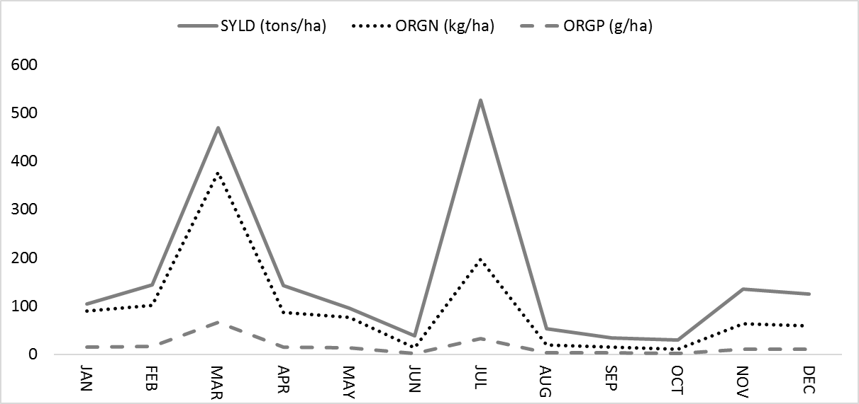
Figure 12 The Soil and Water Assessment Tool (SWAT) was used to estimate the amount of sediment (SYLD), nitrogen (ORGN), and phosphorus (ORGP) over the year 2014 for the entire Nolichucky River watershed.
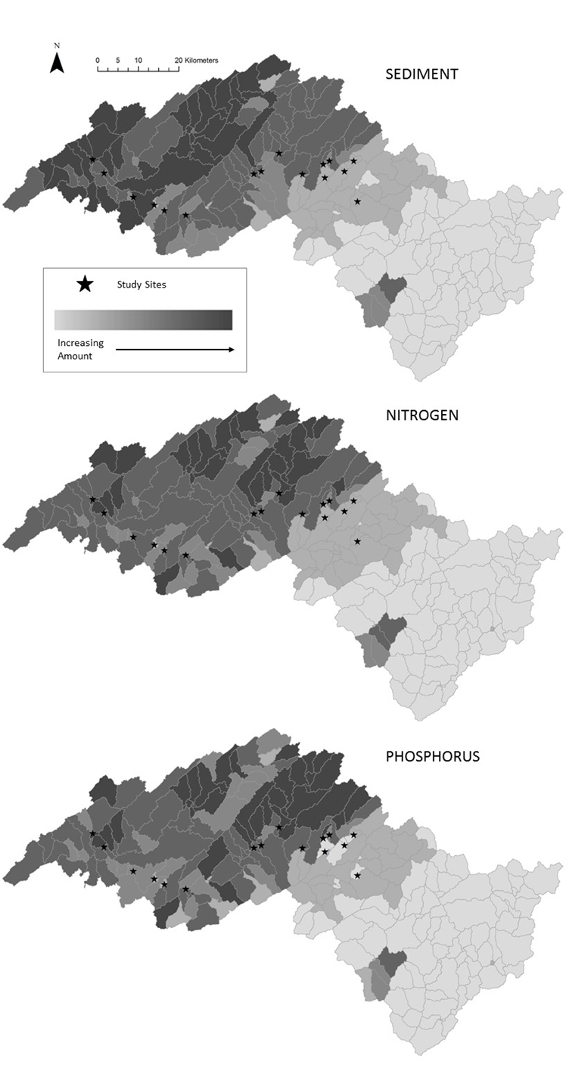
Figure 13 Distribution of sediment, nitrogen, and phosphorus across the Nolichucky River watershed in 2014 modeled by ArcSWAT. Values for each sub basin have been transformed by log(x)+1 for the map.
Table 21 The correlation matrix produced as preliminary results in the redundancy analysis. Sediment yield (SYLD), organic nitrogen (ORGN), and organic phosphorus (ORGP) were estimated using the Soil and Water Assessment Tool at selected sample sites in the Nolichucky River watershed.
 | ORGN | SYLD | ORGP
ORGN | 1 | 0.951 | 0.993
SYLD | 0.951 | 1 | 0.921
ORGP | 0.993 | 0.921 | 1

31.8% of the variance in the ordination with the second axis explaining 4.8% and the third explaining 1.8% (Table 22). All three SWAT outputs were strongly
associated with the first axis ordination of sample sites (Figure 14; Figure 15). The RDA revealed grouping of the sample sites. Low impacted tributary sites (02CC, 01CC, and 01BUM) were located on the negative ends of both axes one and two. These sites had low amounts of ORGP, SYLD, and ORGN. They were characterized by high amounts of native species, higher catch rates (CPUE), and percentages of specialized insectivores. Sites on moderately impacted tributaries (01HC and 01BL) were characterized by higher percentages of piscivorous fish and number of sunfish species. Main stem sites (e.g., 01NR an 04NR) and sites on impacted tributaries (01LC and 01BC) were the third group. They had higher amounts of ORGP, SYLD, and ORGN and were characterized by higher percentages of hybrids and low values for most other metrics that indicate pollution intolerance (e.g., number of darter species and number of natives, see Figure 15). The randomization test rejected the null hypothesis that there was no relationship between the two matrices (p = 0.03; 998 test runs) (Table 23). The final linear combination (LC) scores are shown for the fish metrics (Table 24), sites (Table 25), and standardized regression coefficients (Table 26).
Table 22 To measure how pollutants from row crop agriculture impacts fish communities a redundancy analysis (RDA) was performed on metrics from a fish index of biotic integrity (IBI) in relation to pollutant estimates from the Soil and Water Assessment Tool (SWAT) that were for selected sample sites in the Nolichucky River watershed. Axis summary statistics for the three axes the RDA found explain 38.4% of the variance in the sample sites are explained by the pollutant estimates (Spp-Envt).
 | Axis 1 | Axis 2 | Axis 3
Eigenvalue | 3.81 | 0.58 | 0.22
Variance in species data
% of variance explained | 31.8 | 4.8 | 1.8
Cumulative % explained | 31.8 | 36.6 | 38.4
Pearson Corr., Response-Pred.* | 0.76 | 0.56 | 0.45
Kendall Corr., Response-Pred. | 0.55 | 0.27 | 0.34

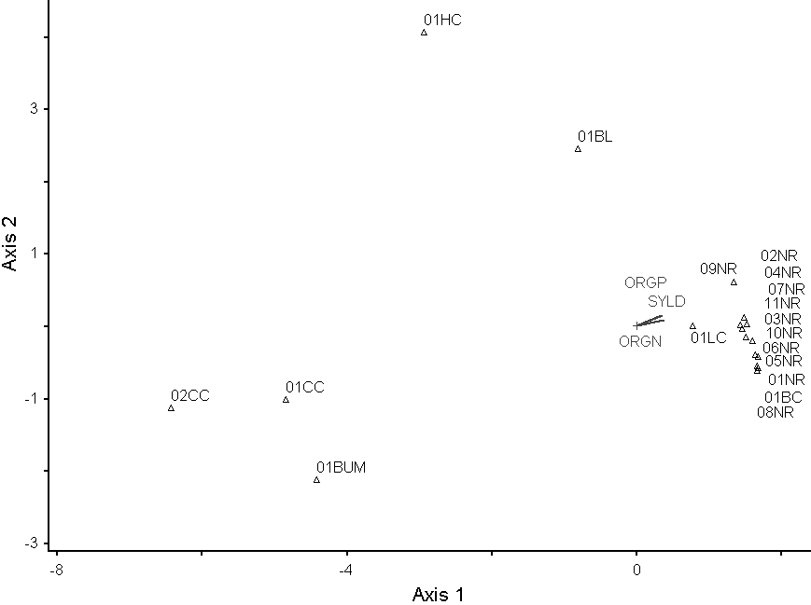
3
1
2
Figure 14 Joint plots showing a redundancy analysis ordination of sample sites of fish index of biotic integrity metrics along a gradient of sediment (SYLD), phosphorus (ORGP), and nitrogen (ORGN). The sites in the Nolichucky River watershed show three distinctive groups of (1) low impact tributaries, (2) moderately impacted tributaries, and main stem sites (regardless of impact level) with highly impacted tributaries (3).

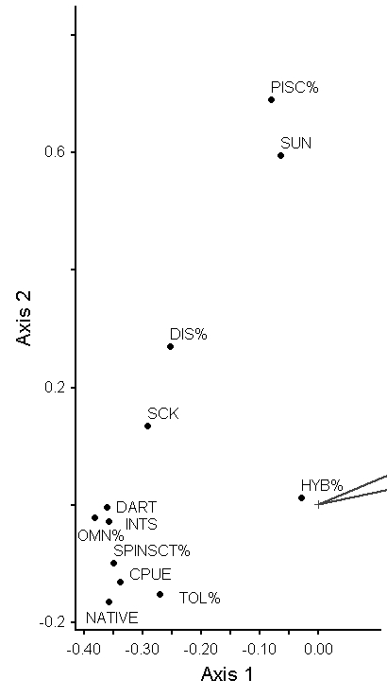
ORGP
SYLD
ORGN
Figure 15 Joint plot showing a redundancy analysis ordination of the fish metrics of biotic integrity calculated for several sample sites in the Nolichucky River watershed along a gradient of sediment (SYLD), phosphorus (ORGP), and nitrogen (ORGN).

Table 23 The randomization test of significance was performed to assess the statistical significance of the axes found in the redundancy analysis of fish index of biotic integrity metrics in relation to estimates of the pollutants (sediment, phosphorus, and nitrogen) at selected sites in the Nolichucky River watershed.
 |  | Randomized data
 | Real data | Randomization, test 998 runs
Axis | Eigenvalue | Mean | Minimum | Maximum | p
1 | 3.81 | 1.61 | 0.25 | 5.80 | 0.03
2 | 0.58 | 0.40 | 0.04 | 1.12
3 | 0.22 | 0.12 | 0.002 | 0.51

Table 24 The linear combination (LC) scores calculated by the redundancy analysis performed on fish index of biotic integrity metrics in relation to the estimated pollutants (sediment, phosphorus, and nitrogen) at selected sample sites in the Nolichucky River watershed. Abbreviations for the fish metrics are in Table 9.
 | Axis 1 | Axis 2 | Axis 3
NATIVE | -0.36 | -0.17 | -0.07
DART | -0.36 | -0.005 | -0.02
SUN | -0.06 | 0.59 | 0.21
SCK | -0.29 | 0.13 | 0.16
INTS | -0.36 | -0.03 | -0.08
TOL% | -0.27 | -0.15 | 0.03
SPINSCT% | -0.36 | -0.10 | -0.10
OMN% | -0.38 | -0.02 | 0.07
PISC% | -0.08 | 0.69 | -0.27
CPUE | -0.34 | -0.13 | -0.02
HYB% | -0.03 | 0.01 | 0.91
DIS% | -0.26 | 0.27 | 0.03
Table 25 The linear combination (LC) scores calculated by the redundancy analysis performed on fish index of biotic integrity metrics in relation to the estimated pollutants (sediment, phosphorus, and nitrogen) at selected sites in the Nolichucky River watershed. These are the LC scores plotted in Figure 14 and 15.
 | Axis 1 | Axis 2 | Axis 3
01BC | 1.20 | -0.32 | 1.10
01BL | -0.73 | 1.47 | 0.15
01BUM | -2.72 | -0.85 | -0.17
01CC | -2.82 | -0.19 | 0.02
01HC | -1.03 | 0.99 | -0.01
01LC | -0.44 | 0.02 | 0.80
01NR | 1.044 | 0.68 | -0.11
02CC | -2.82 | -0.19 | 0.02
02NR | 1.23 | 0.43 | 0.01
03NR | 1.50 | 0.17 | -0.32
04NR | -2.02 | -1.07 | -0.28
05NR | 0.60 | 0.55 | -0.10
06NR | 3.37 | -1.43 | 0.57
07NR | 1.04 | 0.68 | -0.11
08NR | 1.35 | 0.32 | 0.07
09NR | -2.63 | -0.36 | -0.04
10NR | 2.34 | -0.95 | -0.81
11NR | 1.56 | 0.05 | -0.80

Table 26 The standardized regression coefficient calculated in the redundancy analysis performed on the fish index of biotic integrity metrics in relation to estimates of the pollutants (sediment, phosphorus, and nitrogen) at selected sites in the Nolichucky River watershed.
Response | Predictors
 | ORGN | SYLD | ORGP
NATIVE | 6.63 | -1.85 | -5.42
DART | 7.50 | -2.22 | -5.84
SUN | 4.40 | -1.70 | -2.54
SCK | 7.30 | -2.11 | -5.56
INTS | 7.12 | -2.15 | -5.56
TOL% | 5.24 | -1.34 | -4.37
SPINSCT% | 6.61 | -1.94 | -5.27
OMN% | 8.25 | -2.32 | -6.51
PISC% | 3.25 | -1.99 | -1.20
CPUE | 6.58 | -1.81 | -5.35
HYB% | 4.18 | -0.25 | -3.77
DIS% | 6.46 | -2.16 | -4.60

The NMS ordination was performed for the benthic macroinvertebrate metrics and the pollutant estimates. The NMS ordination found up to the allowed number of axes. This time a 2-axis solution was recommended, and it was found after 35 iterations. The Monte Carlo test rejected the null hypothesis that there was no relation between the two matrices (p = 0.05; 998 runs; Table 27).
Sample sites were ordinated along a gradient of increasing ORGP, ORGN, and SYLD (Figure 16). No grouping was evident in the sample sites, although a gradient did appear again with the benthic macroinvertebrate IBI metrics (Figure 17). Sites with high estimates of ORGP, ORGN, and SYLD were found to have high percentages of oligochaetes and chironomids (%OC) and total nutrient-tolerant genera (%TNUTOL). Sites with low amounts of the estimated pollutants were found to have high percentages of clingers (%CLINGER).

Discussion

In this study, a SWAT model was built and run for the Nolichucky river watershed to estimate water quality conditions based on land use, soils, elevation, and weather. The outputs of the model were associated with benthic macroinvertebrate and fish IBI metrics to compare their links to land use variables. The interpretation of the relationship between fish biotic integrity and the SWAT output data was different compared to the findings of the measured land use and in situ water quality data in Chapter II. There was a unimodal relationship between fish metrics and percent land cover types and water quality at the site. When comparing the fish IBI metrics with the SWAT pollutant estimates, there was a linear relationship. The different relationships might have occurred because the SWAT output was a more complex calculation based off of

Table 27 A nonmetric multidimensional scaling ordination was performed on benthic macroinvertebrate index of biotic integrity metrics in relation to in relation to pollutant estimates from the Soil and Water Assessment Tool (SWAT) that were for selected sample sites in the Nolichucky River watershed. To test the significance of the stress in relation to dimensionality (number of axes), a Monte Carlo test was done comparing 250 runs on the real data to 250 runs on randomized data. The p-value is the proportion of randomized runs with stress less than or equal to the observed stress.
 | Stress in real data |  |  | Stress in randomized data  Monte Carlo test, 250 runs
Axes | Minimum | Mean | Maximum | Minimum | Mean | Maximum | p
1 | 21.89 | 41.50 | 54.44 | 23.27 | 45.42 | 54.43 | 0.004
2 | 9.09 | 10.10 | 36.70 | 10.41 | 16.83 | 37.21 | 0.004
3 | 6.07 | 6.71 | 26.59 | 5.71 | 8.83 | 16.17 | 0.02
4 | 3.98 | 4.37 | 20.03 | 2.91 | 5.56 | 15.41 | 0.03
5 | 2.63 | 2.90 | 3.95 | 2.02 | 3.66 | 12.36 | 0.05
6 | 1.56 | 1.92 | 2.97 | 1.26 | 2.34 | 4.1 | 0.02

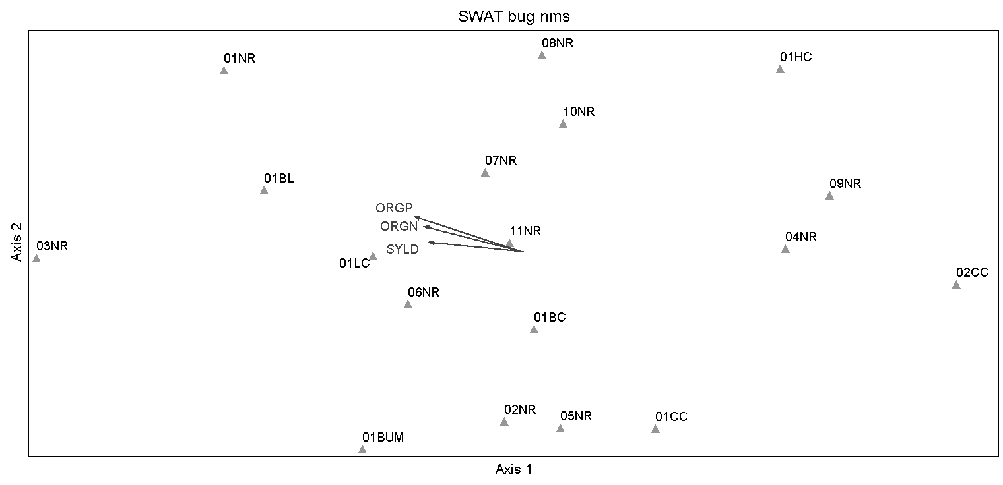
Figure 16 The ordination of the benthic macroinvertebrate metrics of biotic integrity of selected sites in comparison to the land use, defined by a nonmetric multidimensional scaling ordination performed on benthic macroinvertebrate index of biotic integrity metrics in relation to pollutant estimates from the Soil and Water Assessment Tool that were for selected sample sites in the Nolichucky River watershed.

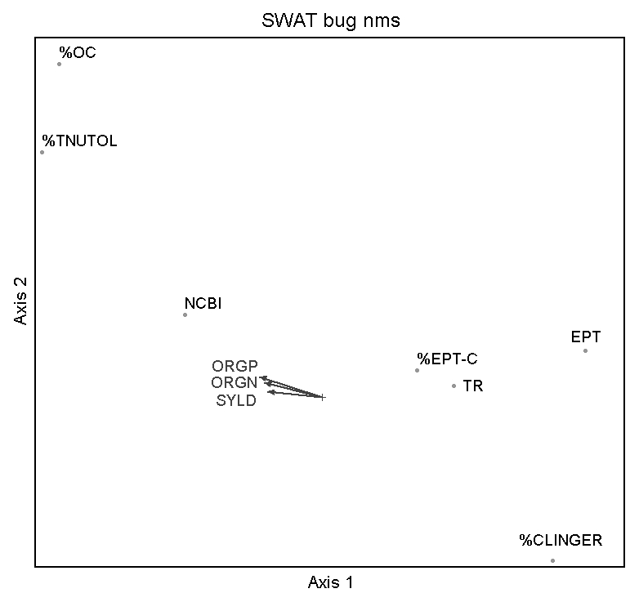
Figure 17 The nonmetric multidimensional scaling ordination of the benthic macroinvertebrate metrics of biotic integrity of benthic macroinvertebrate metrics in comparison in relation to pollutant estimates from the Soil and Water Assessment Tool that were for selected sample sites in the Nolichucky River watershed.
distance from stream, slope, soil type, and weather (Arnold et al. 2012). The measurements of LULC did not have any weighting other than running the measurements at different scales through a PCA and choosing the most appropriate variables based on eigenvalues and the necessity of representing each LULC class.
The RDA showed the sample sites for the fish biometrics falling into three groups (Figure 14). The highly impacted tributary sites (01LC and 01BC) behaved like main stem sites in that biologically they functioned like higher order main stem rivers when impacted by land use (Vanotte et al. 1980). These highly impacted sites should function like the low impacted tributary sites (01CC, 02CC, and 01BUM). This pattern has been seen in benthic macroinvertebrate communities in urban and rural watersheds. Smith and Lamp (2008) compared headwater and main-stem communities and found the proportion of headwater taxa shared with the main-stem communities was 1.8X greater for urban than rural sites. In addition, the high impacted tributary sites have high TDS and SPCOND which tend to indicate high surface runoff (Wetzel 2001). Ultimately, this is the link between land use, water quality, and their impacts to biotic integrity in the Nolichucky watershed.
The benthic macroinvertebrate metrics did not have a different association to the SWAT outputs compared to the variables from the PCA. The NMS was still the best ordination. Other ordinations (e.g. RDA and CCA) were not statistically significant when a Monte Carlo test was performed. Linear models were not appropriate, likely because the sample sites assessed were in an overall healthy biological condition, and lacked the variability necessary for these models to fit the data. Indeed, all of the sites were rated as “good” or “excellent” based on the TDEC metrics calculated for this study. However, the gradient in sites in terms of percentage of clingers and percentage of oligocaetes, chironomids, and total nutrient-tolerant species (Figure 17) indicated that sample sites with more pollutants favor more tolerant genera. Pollutants estimated by the SWAT model are all known to alter habitats and decrease dissolved oxygen in a river. When there is higher sediment loading, crevices in rocks are filled in and riffles inhabited by clinging benthic macroinvertebrates are slowed, causing prohibitively low dissolved oxygen levels necessary for sensitive taxa(Pollard and Yuan 2009). High amounts of nutrients can indirectly cause lower concentrations of dissolved oxygen in water through the pathway of exploding and decomposing primary producers such as benthic algae, macrophytes, and phytoplankton. When these producers die off, greater numbers of bacteria feed them, consuming oxygen that creates hypoxic zones. It is in these low oxygen conditions that is most suitable for benthic macroinvertebrate groups like oligochaetes and chironomids (Saether 1979). Overall, the use of SWAT model estimates was a useful tool to assess LULC impacts to biotic integrity in the Nolichucky watershed. It provides a low cost method (in terms of labor) for assessing threats to fish and benthic macroinvertebrate health and broad spatial scales without having to sample water directly, which can be expensive for natural resource agencies and nonprofit organizations.

Appendix H
Amount of nitrogen (ORGN), sediment (SYLD), and phosphorus (ORGP) estimated by the Soil and Water Assessment Tool (SWAT) model for each sample site in the Nolichucky River watershed.

Site Code | ORGN (kg/ha) | SYLD (tons/ha) | ORGP (kg/ha)
01BL | 11.32 | 8.11 | 2.13
02NR | 7.48 | 7.81 | 1.38
01BC | 12.91 | 51.35 | 1.85
03NR | 4.61 | 3.50 | 0.88
04NR | 0.64 | 0.21 | 0.10
11NR | 2.57 | 1.11 | 0.53
01NR | 7.63 | 6.49 | 1.47
07NR | 7.63 | 6.49 | 1.47
01BUM | 0.70 | 0.22 | 0.10
01LC | 7.71 | 13.76 | 1.14
01CC | 1.42 | 0.53 | 0.21
02CC | 1.42 | 0.53 | 0.21
01HC | 5.96 | 3.30 | 1.08
06NR | 5.64 | 21.56 | 0.85
10NR | 1.43 | 0.77 | 0.27
05NR | 6.13 | 4.76 | 1.14
09NR | 1.22 | 0.45 | 0.18
08NR | 7.57 | 8.84 | 1.38

CHAPTER V
CONCLUSION

In the Nolichucky River watershed, there was concern for how increasing row crop agriculture was affecting water quality and the biotic community. The Nolichucky River like many rivers in the southeastern United States follows the pattern of the River Continuum Concept (RCC, Vannote et al. 1980) where a river system displays a gradient of physical conditions, and the biotic community there responds to these conditions in a predictable pattern from the headwaters to the mouth. When disturbance to the natural vegetation occurs (e.g. row crop agriculture, urban development, forest clearing), runoff increases. With the increased runoff, there are increased loads in sediment, nutrients, and other pollutants (Karr and Schlosser 1978). This interrupts the pattern of the RCC by altering the physical conditions in streams and thus the biotic community.
In this study, the main research hypothesis is that an increase in the number and area of row crop fields would be associated with a decrease in stream biodiversity and change in functional traits of biotic assemblages. To measure the amount of land use/land cover (LULC) and if change was occurring, LULC was quantified over several years (1999 to 2014) in the Nolichucky River watershed. Five LULC classes were measured: row crops, open spaces, impervious surfaces, forest, and water. Open spaces are defined as all non-row crop area: pasture, lawns, hay fields, and fallow fields. Minimal land use changes were found even though the row crop LULC class had increased in area across the years. Using only the 2014 LULC data, measurements at different spatial scales were taken (site, reach, and catchment) at each sample site where fish and benthic macroinvertebrate indices of biotic integrity (IBI) were conducted. These measurements involved percentage cover, patch density of row crops (patches/km²), and vegetation width. Area of row crops were detected most at the reach scale, and patches of row crops had increased since 1999.
The field work in this study involved conducting fish and benthic macroinvertebrate IBIs at selected sample sites in the Nolichucky River watershed during the summers of 2014 and 2015. Before conduction IBIs water quality and elevation were recorded. Before the LULC measurements were compared to the IBI metrics, they were analyzed along with the water quality and elevation data using a principal component analysis (PCA). The PCA found that variables at smaller scales (reach and local) had higher eigenvalues suggesting there might be more value to focusing efforts on smaller spatial scales in the Nolichucky River watershed because smaller spatial scales explained most of the variation in the dataset. The PCA was also used to create a reduced dataset of LULC measurements, water quality values, and elevation to compare to the IBI metrics. Land use types: open space, forest, and impervious surfaces seemed to drive most of the variance in the fish metrics when analyzed with a canonical correspondence analysis. The benthic macroinvertebrate metrics seemed to fall on a gradient based on row crops and impervious surfaces but since the ordination was nonmetric multidimensional scaling.
In addition to the LULC comparison, the Soil and Water Assessment Tool (SWAT) model estimated the annual sediment, phosphorus, and nitrogen load for 2014. When these estimates were associated with fish metrics using a redundancy analysis (RDA), sample sites on impacted tributaries were found to be behaving biologically like sample sites on the main stem of the river. This was due to three groups found in RDA: (1) low impacted tributary sites, (2) moderately impacted tributary sites, and (3) high impacted tributary sites with main stem sites regardless of impact level. When the estimates were associated benthic macroinvertebrate metrics the same gradient appeared but instead on a continuum of increasing sediment, phosphorus, and nitrogen.
In the Nolichucky River watershed, other types of land cover disturbance (impervious surfaces, open spaces) affect biotic integrity more strongly than row crops. However, the results from the RDA performed on the fish IBI metrics and the pollutant estimates indicate that in the Nolichucky River watershed land cover disturbance that causes increased pollutant estimates interrupts the pattern of the RCC. That is, when watersheds of tributary streams are converted to impervious and open space land cover, then they function biologically more like the larger main stem river. Although fish and benthic macroinvertebrate metrics indicated that the tributary and main stem Nolichucky sites were in relatively good condition, increases in land conversion can further degrade stream biotic integrity. Using SWAT model estimates to assess potential threats to biotic integrity from nonpoint sources of sediments and nutrients can prove to be a valuable tool for natural resource managers attempting to assess and improve water quality for aquatic biota at broad spatiotemporal scales.

REFERENCES

Alford, J.B. 2014. Multi-scale assessment of habitats and stressors influencing stream fish assemblages in the Lake Pontchartrain Basin, USA. Hydrobiologia 738:129-146.
Allan, J.D. 2004. Landscapes and riverscapes: the influence of land use on stream ecosystems. Annual Review of Ecology, Evolution, and Systematics 35:257-284.
Arnold, C.L., and C.J. Gibbons. 1996. Impervious surface coverage: the emergence of a key environmental indicator. Journal of the American Planning Association 62(2):243-258.
Arnold, J.G., J.R. Kiniry, R. Srinivasan, J.R. Williams, E.B. Haney, and S.L. Neitsch. 2012. Soil and water assessment tool: input/output documentation. Temple, Texas. 650 pp.
Baker, D. B. 1985. Regional water quality impacts of intensive row-crop agriculture: a Lake Erie basin case study. Journal of Soil and Water Conservation 40(1):125-132.
Barbour, M.T., J. Gerritsen, B.D. Snyder, and J.B. Stribling. 1999. Rapid bioassessment protocols for use in streams and wadeable rivers. USEPA, Washington. 340 pp.
Bell, E. J. 1974. Markov analysis of land use change-an application of stochastic processes to remotely sensed data. Socio-Economic Planning Sciences 8(6):311-216.
Bollmohr, S., and R. Schulz. 2009. Seasonal changes of macroinvertebrate communities in a western Cape river, South Africa, receiving nonpoint- source insecticide pollution. Environmental Toxicology and Chemistry 28(4):809-817.
Bortone, S.A., and W.P. Davis. 1994. Fish intersexuality as indicator of environmental stress. BioScience 44(3):165-172.
Bols, N.C., J. L. Brubacher, R. C. Ganassin, L.E.J. Lee. 2001. Ecotoxicology and innate immunity in fish. Development and Comparative Immunology 25(8):853-873.
Brabec, E., S. Schulte, and P. L. Richards. 2002. Impervious surfaces and water quality: a review of current literature and its implications for watershed planning. Journal of Planning Literature 16(4):499-514.
Brigham, A.R, W.U. Brigham, and Gnilka, editors. 1982. Aquatic insects and oligochaetes of North and South Carolina. Midwest Aquatic Enterprises. Mahomet, Illinois.
CEC. 1997. Ecological regions of North America. Commission for Environmental Cooperation. Scale not given. http://www.epa.gov/wed/pages/ecoregions/na_eco.htm.
Colborn, T, F.S. vom Saal, and A. M. Soto. 1993. Developmental effects of endocrine-disrupting chemicals in wildlife and humans. Environmental Health Perspectives 101(5):378-384.
Congalton, R. G., and K. Green. 2009. Assessing the accuracy of remotely sensed data: principles and practices. 2nd Ed. Boca Raton: CRC Press, 183 p.
Copeland, C. 2008. Clean water act: a summary of the law. U.S. Congressional Research Service. Report number: RL30030. Available from: HeinOnline.
Correll, D.L. 2005. Principles of planning and establishment of buffer zones. Ecological Engineering 24(5):433-439.
Corbett, W.C., M. Whal, D.E. Porter, D Edwards, and C. Moise. 1997. Nonpoint source runoff modeling a comparison of a forested watershed and an urban. Journal of Experimental Marine Biology and Ecology 213(1):133-149.
Dale, V.H., S. Brown, R.A. Haeuber, N.T. Hobb, N. Huntly, R.J. Naiman, W.E. Riebsame, M.G. Turner, and T.J. Valone. 2000. Ecological principles and guidelines for managing the use of land. Ecological Applications 10(3):639-670.
Djokic, D., Z. Ye, and C. Dartiguenave. 2011. Arc Hydro tools overview. Esri, Redlands, California. 15 pp.
EPA. 2012. What is a 303(d) list of impaired waters? Environmental Protection Agency. http://water.epa.gov/lawsregs/lawsguidance/cwa/tmdl/overview.cfm
ESRI. 2014. ArcGIS Desktop: Release 10.3. Redlands, CA: Environmental Systems Research Institute.
ESRI. 2013. ArcGIS Desktop: Release 10.2. Redlands, CA: Environmental Systems Research Institute.
Etnier, D.A. and W.C. Starnes. 1993. The fishes of Tennessee. The University of Tennessee Press, Knoxville.
Exelis Visual Information Solutions. 2013. Using ENVI. Boulder, Colorado.
Fawcett, R. S., B. R. Christensen, and D. P. Tierney. 1999. The impact of conservation tillage on pesticide runoff into surface water: a review and analysis. Journal of Soil and Water Conservation. 49(2):126-135.
Forman, R.T.T. 1995. Land mosaics: the ecology of landscapes and regions. Cambridge University Press, Cambridge.
Frissell, C.A., W. J. Liss, C.E. Warren, and M.D. Hurley. 1986. A hierarchical framework for stream habitat classification: viewing streams in a watershed context. Environmental Management 10(2):199-214.
GAO. 2012. Nonpoint source water pollution: Greater oversight and additional data needed for key EPA water program. United States Government Accountability Office. 85pp.
Genito, D., W.J. Gburek, and A.N. Sharpley. 2011. Response of stream macroinvertebrates to agricultural land cover in small watersheds. Journal of Freshwater Ecology 17(1):109-119.
Gerwin, K.A. and P.L. Lawrence. 2013. Utilizing secondary and public data to examine relationships between watershed land cover and biotic integrity in the Lake Erie tributaries In: Lawrence PL (ed) Geospatial Tools for Urban Water Resources, 1st edn. Springer, Netherlands, pp 161-175.
Gevao, B, and K. C. Jones. 2002. Pesticides and persistent organic pollutants. Pages 83-100 in P. M. Haygarth and S. C. Jarvis, editors. Agriculture, hydrology, and water quality. CABI Publishing, New York, New York.
Gilliom, R.J. 2007. Pesticides in U.S. streams and groundwater. Environmental Science & Technology 41(10):3408-3414.
Grubaugh, J.W., J.B. Wallace, and E.S. Houston. 1996. Longitudinal changes of macroinvertebrate communities along an Appalachian stream continuum. Canadian Journal of Fisheries and Aquatic Sciences. 53(4):896-909.
Han, W., Z. Yang, L. Di, & R. Mueller. 2012. CropScape: a web service based application for exploring and disseminating US conterminous geospatioal cropland data products for decision support. Computers and Electronics in Agriculture 84:111-123.
Haralick, R. M., K. Shanmugam, and I. Dinstein. 1973. Textural features for image classification. IEEE Transactions on Systems, Man, and Cybernetics 3(6):610-621.
Harding, J.S., E.F. Benfield, P.V. Bolstad, G.S. Helfman, and E.B.D. Jones III. 1998. Stream biodiversity: the ghost of land use past. Proceedings of the National Academy of Sciences 95(25):14843-14847.
Hatch, D., K. Goulding, and D. Murphy. 2002. Nitrogen. Pages 7-25 in P. M. Haygarth and S. C. Jarvis, editors. Agriculture, hydrology, and water quality. CABI Publishing, New York, New York.
Herricks, E.E. and D.J. Schaeffer. 1985. Can we optimize biomonitoring? Environmental Management 9(6):487-492.
Hill, B. H., A. T. Herlihy, P. R. Kaufmann, R. J. Stevenson, F. H. McCormick, and C. B. Johnson. 2000. Use of periphyton assemblage data as an index of biotic integrity. Journal of the North American Benthological Society 19(1):50-67.
IUCN (2015) The International Union for Conservation of Nature’s Red List of Threatened Species. Version 2015-4. <http://www.iucnredlist.org>. Downloaded on 18 April 2016.
Jackson, G. 2012, September 14. Update: Washington county Tennessee residents concerned about large fish kill. The Bristol Herald Courier. Retrieved from http://www.tricities.com
Jackson, R.D. and A.R. Huete. 1991. Interpreting vegetation indices. Preventive Veternary Medicine 11(3):185–200.
Jensen, J. R. 2016. Introductory digital image processing. 4th Ed. Pearson Education, Inc., Glenview, Illinois.
Jenkins, C.N., K.S. Van Houtan, S. L. Pimm, and J.O. Sexton. 2015. US protected lands mismatch biodiversity priorities. Proceedings of the National Academy of Sciences 112(16):5081-5086.
Jobling, S., and C.R. Tyler. 2003. Endocrine disruption in wild freshwater fish. Pure and Applied Chemistry 75(11-12):2219-2234.
Johnson R.C., D. P. Smith, and C.E. McMichael. 2013. Scale dependence in relating land use/cover to stream macroinvertebrate communities in the central Appalachian mountains, USA. GIScience & Remote Sensing 49(1):53-70
Johnson. 2000. Use of periphyton assemblage data as an index of biotic integrity. Journal of the North American Benthological Society 19(1):50-67.
Johnson, R. K., T. Wiederholm, and D. M. Rosenberg. 1993. Freshwater biomonitoring using individual organism, populations, and species. Pages 40-158 in D. M. Rosenberg and V. H. Resh, editors. Freshwater biomonitoring and benthic macroinvertebrates. Chapman & Hall, New York, New York.
Karr, J. R. 1981. Assessment of biotic integrity using fish communities. Fisheries 6(6):21-27.
Karr, J. R., K. D. Fausch, P. L. Angermeier, P. R. Yant, and I. J. Schlosser. 1986. Assessing biological integrity in running waters: a method and its rationale. Illinois Natural History Survey Special Publication 5. 28pp.
Karr, J. R. and I. J. Schlosser. 1978. Water resources and the land-water interface. Science 201(4352):229-234.
Kawaguchi, Y., Y. Taniguchi, and S. Nakano. 2003. Terrestrial invertebrate inputs determine the abundance of stream fishes in a forested stream. Ecology 84(3):701-708.
Khan, M.Z., and F.C.P. Law. 2005. Adverse effects of pesticides and related chemicals on enzyme and hormone systems of fish, amphibians and reptiles: a review. Proceedings of the Pakistan Academy of Sciences. 42(4):315-323.
Kiffney, P.M., J.S. Richardson, and J. P. Bull. 2003. Responses of periphyton and insects to experimental manipulation of riparian buffer width along forest streams. Journal of Applied Ecology 40(6):1060-1076.
Krummel, J.R., R. H. Gardner, G. Sugihara, R.V. O’Neill, and P.R. Coleman. 1987. Landscape patterns in a disturbed environment. Nordic Society Oikos 48(3):321-324.
Kruskal, J.B. 1964. Nonmetric multidimensional scaling: a numerical method. Psychometrika 29(1):1-27.
Laben, C. A., and B. V. Brower. 2000. Process for enhancing the spatial resolution of multispectral imagery using pan-sharpening. U.S. patent 6,011,875. January 4, 2000.
Lammert, M., and J. D. Allan. 1999. Assessing biotic integrity of streams: effects of scale in measuring the influence of land use/cover and habitat structure on fish and macroinvertebrates. Environmental Management 23(2):257-270.
Lenat, D.R., and J. K. Crawford. 1993. Effects of land use on water quality and aquatic biota of three North Carolina piedmont streams. Hydrobiologia 294(3):185-199
LLoyd, O. B., and Lyke, W. L. 1995. Ground water atlas of the United States: segment 10, Illinois, Indiana, Kentucky, Ohio, Tennessee. No. 730-K. Geological Survey (US).
Mather, P.M. 1976. Computational methods of multivariate analysis in physical geography. Wiley & Sons, London. 532 pp.
McGarigal, K., S. Cushman, and S. Stafford. 2000. Multivariate statistics for wildlife and ecology research. Springer Science+Business Media, Inc. 283 pp.
McNab W.H. 1996. Chapter 20: southeastern mixed forest; and Chapter 18: central Appalachian broadleaf forest, coniferous forest, and meadow in Ecological subregions of the United States. Forest Service Department of Agriculture, Washington, D.C. Available: www.fs.fed.us/land/pubs/ecoregions/index.html. (July 2016).
Merritt, R.W., K.W. Cummins, and M.B. Berg. 2008. An introduction to the aquatic insects of North America, fourth edition. Kendall/Hunt Publishing, Dubuque, Iowa.
Micacchion, M. 2002. Amphibian Index of Biotic Integrity (AmphIBI) for Wetlands. Final Report to U. S. EPA Grant No. CD985875-01, Colombus, Ohio.
McCune, B., and J. B. Grace. 2002. Analysis of ecological communities. Gleneden Beach,OR: MjM Software Design.
McCune, B., and M. J. Mefford. 2011. PC-ORD v. 6.15. MjM Software. Gleneden Beach, Lincoln.
Midway, S. R., T. Wagner, and B. H. Tracy. 2014. A hierarchical community occurrence model for North Carolina stream fish. Transaction of the American Fisheries Society 142(5):1348-1357
Omernik, J. M. 1987. Map supplement: ecoregions of the conterminous United States. Annals of the Association of American Geographers 77(1)118-125.
Ortega-Huerta, M. A., O. Komar, K. P. Price, and H. J. Ventura. 2012. Mapping coffee plantations with Landsat imagery: an example from El Salvador. International Journal of Remote Sensing 33(1):220-242.
Osborne, L. L., and M. J. Wiley. 1988. Empirical relationships between land use/cover and stream water quality in an agricultural watershed. Journal of Environmental Management 26(1):9-27.
Paul, M. J., and J. L. Meyer. 2001. Streams in the urban landscape. Urban Ecology 32:333-365.
Phillips, SH. 1984. Introduction. Pages 1-12 in R. E. Phillips, and S.H. Phillips, editors, No-tillage agriculture: principles and practices. Springer Science and Business Media, New York, New York.
Pollard, A.I., and L.L. Yuan. 2010 Assessing the consistency of response metrics of the invertebrate benthos: a comparison of trait-and identity-based measures. Freshwater Biology 55(7)1420-1429.
Pote, D. H., T.R. Way, K.R. Sistani, and P.A. Moore Jr. 2009. Water-quality effects of a mechanized subsurface-banding technique for applying poultry litter to perennial grassland. Journal of Environmental Management. 90(11):3534-3539.
Purvis, A., J.L. Gittleman, G. Cowlishaw, and G.M. Mace. 2000. Predicting extinction risk in declining species. Proceedings of the Royal Society of London B: Biological Sciences 267(1456):1947-1952.
Rosenberg, D. M. and V. H. Resh. 1993. Introduction to freshwater biomonitoring and benthic macroinvertebrates. Pages 1-9 in D. M. Rosenberg and V. H. Resh, editors. Freshwater biomonitoring and benthic macroinvertebrates. Chapman & Hall, New York, New York.
Roth, N. E., J. D. Allan and D. L. Erickson. 1996. Landscape influences on stream biotic integrity assessed at multiple spatial scales. Landscape Ecology 11(3):141-156.
Rouse, J.W. Jr., R.H. Haas, D.W. Deering, J.A. Schell, and J.C. Harlan, 1974. Monitoring the Vernal Advancement and Retrogradation (Green Wave Effect) of Natural Vegetation, NASA/GSFC Type III FinalReport, Greenbelt, MD., 371p.
Rowe, D.C., C.L. Pierce, and T. F. Wilton. 2009. Fish assemblage relationships with physical habitat in wadeable Iowa streams." North American Journal of Fisheries Management 29(5):1314-1332.
Roy, A.H., A.D. Rosemond, D.S. Leigh, M.J. Paul, and J.T. Wallace. 2003. Habitat-specific responses of stream insects to land cover disturbance: biological consequences and monitoring implications. Journal of the North American Benthological Society 22(2):292-307
Roy, A.H., A.D. Rosemond, M.J. Paul, D.S. Leigh, and J.B. Wallace. 2003. Stream macroinvertebrate response to catchment urbanization (Georgia, USA). Freshwater Biology 48(2):329-346.
Rutledge, A.D., J. B. Wills, and S. Bost. 1999. Commercial tomato production. University of Tennessee Extension Publication. PB737.
Saalfeld, D.T., E. M. Reutebuch, J.R. Dickey, W.C. Seesock, C. Webber, and D.R. Bayne. 2012. Effects of landscape characteristics on water quality and fish assemblages in the Tallapoosa river basin, Alabama. Southeastern Naturalist 11(2):239-252.
Saether, O.A. 1979. Chironomid communities as water quality indicators. Ecography 2(2):65-74.
Sandefur, H.N., E. Cummings, R.Z. Johnston, M.D. Matlock, and D.I. Gustafson. 2015. Analyzing correlations between stream benthic macroinvertebrate community structure, water quality, and watershed land use in the continental United States. Biological Engineering Transactions 7(4):169-182
Sawyer, J.A., P.M. Stewart, M.M. Mullen, T.P. Simon, and H.H. Bennett. 2004. Influence of habitat, water quality, and land use on macro-invertebrate and fish assemblages of a southeastern coastal plain watershed, USA. Aquatic Ecosystem Health & Management 7(1):85-99.
Shah, S.B., M.D. Shamblin, H. N. Boone, S. A. Gartin, and D. K. Bhumbla runoff water quality impacts of different turkey litter application methods. Applied Engineering in Agriculture 20(2):207-210.
Shields, F.D., C.M. Cooper Jr., S.S. Knight, and M.T. Moore. 2003. Stream corridor restoration research: a long and winding road. Ecological Engineering20(5)441-454.
Smith, R.F., and W.O. Lamp. 2008. Comparison of insect communities between adjacent headwater and main-stem streams in urban and rural watersheds. Journal of the North American Benthological Society 27(1):161-175.
Snyder, C.D., J.A. Young, R. Villella, and D.P. Lamarie. 2003. Influences of upland and riparian land use patterns on stream biotic integrity. Landscape Ecology 18(7):647-644.
Sponseller, R. A., E. f. Benfield, and H. M. Valett. 2001. Relationships between land use, spatial scale and stream macroinvertebrate communities. Freshwater Biology 46(1):1409-1424.
Stauffer, J.C., R.M. Goldstein, R.M. Newman. 2000. Relationship of wooded riparian zones and runoff potential to fish community composition in agricultural streams. Canadian Journal of Fisheries and Aquatic Sciences 57(2):307-316
Steedman, R. J. 1988. Modification and assessment of an index of biotic integrity to quantify stream quality in southern Ontario. Canadian Journal of Fisheries and Aquatic Sciences 45(3):492-501.
Stevenson, J., and P. Yangdong. 1999. Assessing environmental conditions in rivers and streams with diatoms. Pages 11-40 in E. F. Stoermer and J. P. Smol, editors. The diatoms: applications for the environmental and earth sciences. Cambridge University Press, Cambridge, United Kingdom.
Strahler, A.N. 1957. Quantitative analysis of watershed geomorphology. Transactions American Geophysical Union 38(6):913-920.
Sweeny, B. W. 1992. Streamside forests and the physical, chemical, and trophic characteristics of piedmont streams in eastern North America. Water Sciences Technology 26(12):2653-2673.
TDA. 2013. Sharing in the Success! Tennessee Agriculture 2013: departmental Report & Statistical Summary. Tennessee Department of Agriculture. 43pp.
TDA. 2015. Nonpoint source program, EPA section 319. Tennessee Department of Agriculture. http://www.tn.gov/agriculture/water/nps.shtml
TDEC. 2014. Proposed final version of year 2014 303(d) list. Tennessee Department of Environment and Conservation, Division of Water Resources. Nashville, TN. 187 pp.
TDEC. 2011. Quality system standard operation procedure for macroinvertebrate stream surveys. Tennessee Department of Environment and Conservation, Division of Water Pollution Control. Nashville, TN. 214 pp.
TDEC. 2008. Nolichucky River Watershed of the Tennessee River Basin: Watershed Water Quality Management Plan. Tennessee Department of Environment and Conservation, Division of Water Pollution Control, Watershed Management Section. Nashville, TN. 63pp.
Teels, B. M., C. A. Rewa, and J. Myers. 2006. Aquatic condition response to riparian buffer establishment. Wildlife Society Bulletin 34(4)927-935.
Tobler, W.R. 1970. A computer movie simulating urban growth in the Detroit region. Economic Geography, 46(2):234-240.
Tonn, B. E. and C. Cottrill. 2004. An environmental plan for the middle Nolichucky River area. Environmental Practice 6(1):50-62.
Tillman, D., K. G. Cassman, P. A. Matson, R. Naylor, and S. Polansky. 2002. Agricultural sustainability and intensive production practices. Nature 418:671-677.
Timmons, E.R., R.E. Burwell, and R.F. Holt. 1973. Nitrogen and phosphorus losses in surface runoff from agricultural land as influence by placement of broadcast fertilizer. Water Resources Research 9(3):658-667.
Tourbier, J.T. 1994. Open space through stormwater manage-ment: helping to structure growth on the urban fringe. Journal of Soil and Water Conservation 49(1):14-22.
Tucker, C.J. 1979. Red and photographic infrared linear combinations for monitoring vegetation. Remote Sensing of the Environment 8(2):127-150.
Turner, B.L., and W.B. Meyer. 1994. Global land-use and land-cover change: an overview. Pages 3 -10 in Changes in land use and land cover: a global perspective. Cambridge University Press, New York, New York.
TVA. 2004. TVA Protocol for Conducting an Index of Biotic Integrity Biological Assessment. Tennessee Valley Authority. Knoxville, TN. 15pp.
USGS. 2016. Product guide: Landsat surface reflectance-derived spectral indices. US Geological Survey, Reston, Virginia. Available from http://landsat.usgs.gov/band_designations_landsat_satellites.php (accessed April 2016)
USEPA. 2013. Level III ecoregions of the continental United States. U.S. Environmental Protection Agency, National Health and Environmental Effects Research Laboratory. Map scale 1:7,500,000. http://www.epa.gov/wed/pages/ecoregions/level_iii_iv.htm.
USDA. 2014. Tennessee tillage systems: soybeans, corn, cotton, and winter wheat. U.S. Department of Agriculture. 2pp.
USDA. 2013. National agriculture imagery program (NAIP) information sheet. U.S. Department of Agriculture. 2pp.
Valle, I. C., D. F. Buss, and D. F. Baptista. 2013. The influence of connectivity in forest patches, and riparian vegetation with on stream macroinvertebrate fauna. Brazilian Journal of Biology 73(2):231-238.
Vannote, R. L., K. W. Cummins, J. R. Sedell, and C. E. Cushing. 1980. The river continuum concept. Canadian Journal of Fisheries and Aquatic Sciences 37(1):130-137.
Wang, L., J. Lyons, P. Kanehl, and R. Gatti. 1997. Influences of watershed land use on habitat quality and biotic integrity in wisconsin streams. Fisheries 22(6):6-12.
Wang, L., J. Lyons, P. Rasmussen, P. Seelbach, T. Simon, M. Wiley, P. Kanehl, E. Baker, S. Niemela, and P.M. Stewart. 2003. Watershed, reach, and riparian influences on stream fish assemblages in the Northern Lakes and Forest Ecoregion, USA. Canadian Journal of Fisheries and Aquatic Sciences60(5):491-505.
Waite, I.R. 2013. Development and application of an agricultural intensity index to invertebrate and algal metrics from streams at two scales. Journal of the American Water Resources Association 49(2):431-448.
Weng, Q. 2002. Land Use Change Analysis in the Zhujiang Delta of China Using Satellite Remote Sensing, GIS and Stochastic Modeling. Journal of Environmental Management 64(3):273-284.
Wenger, S. 1999. A review of the scientific literature on riparian buffer width, extent and vegetation. Office of Public Service & Outreach Institute of Ecology University of Georgia, Georgia.
Werner, I., L. A. Deanovic, J. Miller, D. L. Denton, D. Crane, A. Mekebri, M. T. Moore, and J. Wrysinski. 2010. Use of vegetated agricultural drainage ditches to decrease toxicity of irrigation runoff from tomato and alfalfa fields in California, USA. Environmental Toxicology and Chemistry 29(12)2859-2868.
Western Plant Health Association. 2002. Western Fertilizer Handbook, ninth edition. Waveland Press, Inc., Long Grove, Illinois.
Wetzel, R.G. 2001. Limnology: Lake and River Ecosystems. Academic Press, San Diego.
White, P.S. 2013. Natural disturbance and patch dynamics: an introduction. Pages 3-13 in T.A. Pickett, and P.S. White, editors, The ecology of natural disturbance and patch dynamics. Academic Press, San Diego, California.
Xie, H., Y. Q. Tian, J. A. Granillo, and G. R. Keller. 2007. Suitable remote sensing method and data for mapping and measuring active crop fields. International Journal of Remote Sensing 28(2):395-411.

VITA

Hayley Gotwald grew up in Brooklyn, New York. She attributes her love of the great outdoors to spending long days in Prospect Park with her father and brother. Her family moved to Charlotte, North Carolina when she was ten. She received her B.S. in Environmental Biology from the University of North Carolina at Greensboro in 2011 where she realized she wanted to work in aquatic ecology. Hayley returned to school in 2013 to get a Graduate Certificate in Geographic Information Systems from North Carolina State University, and in 2014 she began her master’s thesis at the University of Tennessee.

