Observing The Response of the Caspian Sea Microbiome to Crude Oil Amendment Under Oxic and Hypoxic Conditions

A Dissertation Presented for the

Doctor of Philosophy

Degree

The University of Tennessee, Knoxville

Zabrenna Georgiana Griffiths

August 2024
DEDICATION

I dedicate this doctoral thesis to my recently departed grandma, Aldith Tresselda Ebanks. May your love and prayers continue to cover me, even though you are no longer here. Rest in peace knowing I have reached the finish line.

“Aedificamus” – “We are building.”

ACKNOWLEDGEMENTS
I would like to acknowledge the efforts of my collaborators; their aid was critical in completion of this dissertation. Thanks to British Petroleum – Azerbaijan for sample collection, transport and provision of the crude oil. Hydrocarbon measurements, identification and the analysis of GC-MS spectra was dutifully performed by the team at the Environmental Analysis Research Lab at Florida International University. I would also like to thank the Institute for a Sustainable & Secure Environment for providing funding towards this project.
I would like to extend gratitude to my advisor, Dr. Hazen and all past and present members of the Hazen lab group for their help and support during my time at the University of Tennessee.
Special thanks to my family for always considering me and the love they have provided during this time. Lastly, thanks to my partner, Darius, for being my biggest cheerleader.
ABSTRACT
The Caspian Sea is the world’s largest landlocked saline lake positioned between Europe and Asia and for its historic and large-scale oil reserves. These vast oil reserves have led to the development of an intricate network of pipelines, and drilling operations causing the environmental deterioration of the waterbody. Drainage from surrounding river basins brings an influx of pollutants from residential, industrial and agricultural origins which further compounds this issue. The endorheic nature of this waterbody causes the retention and accumulation of these pollutants, ultimately reducing water quality.
The increased nutrient input has steadily intensified eutrophication in this waterbody resulting in hypoxic conditions in deeper, colder waters, creating an oxygen gradient. With both temperatures and dissolved oxygen decreasing around 50m in this waterbody, ee sought to capitalize on the highly adaptable nature of microorganisms to respond to environmental stressors. The unique temperature and oxygen stratification in this brackish environment presented an opportunity to explore the potential of the biodegradative capability of the indigenous microbial community. We hypothesized that the Caspian Sea microbial community possess different metabolic capabilities to degrade crude oil as they adapted to declining oxygen concentrations and temperatures with increasing depths.
Microcosms were assembled with surface waters (25m) and deep waters (350m) from Caspian Sea and 60ppm of native crude oil and observed over 115 days to represent oxic and hypoxic conditions respectively. Surface water microcosms were incubated at 28ºC and aerated while deep water microcosms were incubated at 8ºC under anaerobic conditions to simulate the temperature and oxygen extremes along the gradient as we tried to trigger the indigenous community’s response to crude oil.
A 16S rRNA analysis was conducted to determine taxonomic abundances, gas chromatography coupled with mass spectrometry was conducted to confirm degradation of hydrocarbon fractions in crude oil and metagenomic analysis was conducted to determine functional potential of observed taxa. These methods showed evidence of degradation of hydrocarbon fractions in both oxic and hypoxic conditions. The metabolic diversity of taxa varied in our differing oxygen conditions as well as the observed taxa. To further explore the potential diversity of hydrocarbon degradation in these microcosms, Hidden Markov Models were constructed and used to annotate observed metagenomic bins. This has allowed us to conclude that the microbial community of the Caspian has adapted to the presence of crude oil and is able to degrade this contaminant through different mechanisms based on oxygen concentration.
TABLE OF CONTENTS
CHAPTER I Background of the Study Site and Hydrocarbon Biodegradation 1
Introduction 2
Background of Study Site: 2
What Is Crude Oil? 5
Bioremediation of Crude Oil 7
Aerobic vs Anaerobic Degradation of Crude Oil 9
Aerobic Pathways 9
Anaerobic Pathways 10
References 11
CHAPTER II Comparing the Response of the Indigenous Microbial Community to Native Crude Oil Amendment in Oxic versus Hypoxic Conditions 18
Abstract 20
Introduction 21
Aerobic vs. Anaerobic Biodegradation of Crude Oil 23
Tackling Pollution with Bioremediation 24
Methods 25
Sample Collection: 25
Microcosm Experiments for 16S rRNA analysis: 25
Data Analysis: 26
Hydrocarbon Analysis: 26
Results 27
Community Structure of Microcosms: 27
Statistical Analysis: 28
Indicator Species Analysis: 29
Hydrocarbon Analysis: 29
Discussion 29
Conclusion 33
References 35
Appendix A 46
CHAPTER III Metagenomic Analysis of the Indigenous Microbial Community to Native Crude Oil Amendment in Oxic versus Hypoxic Conditions 60
Abstract 61
Introduction 63
Methods 65
Sample Collection: 65
Sequencing: 66
Data Analysis with Kbase: 66
Exploration of Hydrocarbon-Degrading Genes Using HMMER 3.1 and CANT-HYD database: 68
Results 69
Sequencing and Assembly Statistics 69
MAG Classification and Abundance 69
Functional Annotation to Determine Metabolic Potential of MAGs with DRAM 71
Functional Analysis of Identified Genes Utilizing RASTtk Annotations 72
Identification of Homologous Proteins Involved in Hydrocarbon Degradation with CANT-HYD Database 72
Discussion 73
Taxonomic Assessment of MAGs 73
Functional Analysis of Oxic and Hypoxic Microcosms 75
Conclusion 76
References 78
Appendix B 85
CHAPTER IV Creating Hidden Markov Models to Identify Homologous Hydrocarbon-Degrading Genes in Caspian Metagenome 105
Abstract 106
Introduction 107
What are Hidden Markov Models (HMMs)? 107
Sequence Homology 107
What is HMMER? 108
How the HMMER pipeline works 109
Application of profile HMM in Metagenome Annotation 109
Methods 111
Identification of Target Proteins 111
Building Multiple Sequence Alignments 111
Building HMMs 112
Analysis of the Caspian Microcosm Metagenome 112
Results 113
Discussion 114
Conclusion 118
Appendix C 125
CONCLUSION 157
VITA 160

LIST OF TABLES
Table 1: Initial environmental parameters of Caspian seawater based on depth. Water was collected from 25m and 350m for experiment microcosms. 46
Table 2: Showing top 6 results of indicator species analysis in oxic microcosms (p < 0.05). 47
Table 3: Showing top 6 results of indicator species analysis in hypoxic microcosms (p <0.05). 48
Table 4: Showing enzymes involved in aerobic and anaerobic hydrocarbon degradation 85
Table 5: Results of NovaSeq sequencing and metagenomics pipeline in Kbase for oxic (represented with the prefix “o_”) and hypoxic (represented with the prefix “a_”) microcosms. 87

LIST OF FIGURES
Figure 1: Showing environmental hazards in the Caspian Sea. Industrial activities, especially oil extraction, are the main sources of water and land pollution in the region. Off-shore oil extraction, pipeline transport and oil refineries have generated large quantities of toxic waste and oil contamination that remains trapped within the Caspian Sea because of its endorheic nature. Philippe Rekacewicz (le Monde Diplomatique) assisted by Laura Margueritte and Cecile Marin (2012) 50
Figure 2: Crude oil is composed of different hydrocarbon fractions, a mix of metals and other compounds. As a result, crude oil has a complex chemistry. Adapted from Mahjoubi et al. (2018). Figure made with Biorender.com 51
Figure 3 A & B: Showing the fate of oil spills in a marine ecosystem. Aerobic biodegradation will proceed in surface waters but as oxygen concentration decreases with depth, so does the rate of aerobic biodegradation. Anaerobic biodegradation will proceed based on the redox potential of available compounds at deeper depths. Source: (Daghio et al., 2017) 52
Figure 4: Pathways for the aerobic and anaerobic biodegradation of hydrocarbon compounds. Figure made with Biorender.com 53
Figure 5 A & B: Showing relative abundance of bacterial orders in oxic microcosms, (B) Showing relative abundance of bacterial families in oxic microcosms. 54
Figure 6 A & B: Showing relative abundance of bacterial orders in hypoxic microcosms, Showing relative abundance of bacterial families in hypoxic microcosms. 55
Figure 7: NMDS plotted with vegan package in R in 2 dimensions. Stress = 0.08444561. Oxic microcosms are denoted with a black triangle while hypoxic microcosms are represented by a black dot. Experiment microcosms are labelled with their corresponding day while control microcosms are labelled with their corresponding day_CTRL. Red and blue circles represent the 95% confidence intervals. 56
Figure 8: Showing relative abundance of aliphatic hydrocarbons measured by GC-MS in oxic and hypoxic microcosms. All results are semi quantitative and based on ratios to the recalcitrant biomarker C30-Hopane. Data is aggregated by groupings based on number of carbon atoms. 57
Figure 9: Showing relative abundance of aromatic hydrocarbons measured by GC-MS in oxic and hypoxic microcosms. All results are semi quantitative and based on ratios to the recalcitrant biomarker C30-Hopane. Data is aggregated by groupings based on number of rings. 58
Figure 10: Showing full scan GC-MS spectra (m/z 50 to 450) of Caspian Oil in seawater under different conditions. Red boxes indicate the presence of the unresolved complex mixture on spectra 59
Figure 11: Krona plot of oxic day 0 microcosms with the proportion of MAGS represented at the family (top) and class (bottom) levels classified by GTDB-TK in Kbase. 88
Figure 12: Krona plot of oxic day 5 microcosms at family (top) and class (bottom) levels produced by GTDB-TK in Kbase. 89
Figure 13: Krona plot of oxic day 15 microcosms with the proportion of MAGS represented at the family (top) and class (bottom) levels classified by GTDB-TK in Kbase. 90
Figure 14: Krona plot of oxic day 115 microcosms with the proportion of MAGS represented at the family (top) and class (bottom) levels classified by GTDB-TK in Kbase. 91
Figure 15: Krona plot of oxic day 0 control microcosms with the proportion of MAGS represented at the family (top) and class (bottom) levels classified by GTDB-TK in Kbase. 92
Figure 16: Krona plot of oxic day 115 control microcosms with the proportion of MAGS represented at the family (top) and class (bottom) levels classified by GTDB-TK in Kbase.Figure 17: Krona plot of MAGs in hypoxic day 0 microcosms with the proportion of MAGS represented at the family (top) and class (bottom) levels classified by GTDB-TK in Kbase. 93
Figure 18: Krona plot of MAGs in hypoxic day 5 microcosms with the proportion of MAGS represented at the family (top) and class (bottom) levels classified by GTDB-TK in Kbase. 95
Figure 19: Krona plot of MAGs in hypoxic day 10 microcosms with the proportion of MAGS represented at the family (top) and class (bottom) levels classified by GTDB-TK in Kbase. 96
Figure 20: Krona plot of MAGs in hypoxic day 15 microcosms with the proportion of MAGS represented at the family (top) and class (bottom) levels classified by GTDB-TK in Kbase. 97
Figure 21: Krona plot of MAGs in hypoxic day 115 microcosms with the proportion of MAGS represented at the family (top) and class (bottom) levels classified by GTDB-TK in Kbase. 98
Figure 22: Krona plot of MAGs in hypoxic day 0 control microcosms with the proportion of MAGS represented at the family (top) and class (bottom) levels classified by GTDB-TK in Kbase. 99
Figure 23: Krona plot of MAGs in hypoxic day 115 control microcosms with the proportion of MAGS represented at the family (top) and class (bottom) levels classified by GTDB-TK in Kbase. 100
Figure 24: DRAM product output showing percentage completion of energy-deriving pathways and electron transport chain components in co-assembled oxic microcosms. 101
Figure 25: DRAM product output showing percentage completion of energy-deriving pathways and electron transport chain components in co-assembled hypoxic microcosms. 102
Figure 26: DRAM product output showing presence or absence of genes related to metabolism of dbCAZY molecules, nitrogen and sulphur in co-assembled oxic microcosms. 103
Figure 27: DRAM product output showing presence or absence of genes related to metabolism of dbCAZY molecules, nitrogen and sulphur in co-assembled hypoxic microcosms. 104
Figure 28: A representation of a Hidden Markov Model (HMM) built from a multiple sequence alignment (MSA). Amino acids or nucleotide bases are given a score at each position within the alignment. From this, the likelihood of one amino acid or nucleotide base are next to each other as well as the probability on insertions or deletions in the sequence are calculated (EMBL-EBI, 2023). 125
Figure 29: Distribution of scores and e-values for target proteins in AromaDeg.hmm for hypoxic microcosms on day 0. The range of scores was calculated from the percent quartiles where low, medium, high and very high correspond to the different quartile ranges. The size of the points corresponds to the number of hits to contigs found within each metagenomic bin. 126
Figure 30: Distribution of scores and e-values for target proteins in AromaDeg.hmm for hypoxic microcosms on day 5. The range of scores was calculated from the percent quartiles where low, medium, high and very high correspond to the different quartile ranges. The size of the points corresponds to the number of hits to contigs found within each metagenomic bin. 127
Figure 31: Distribution of scores and e-values for target proteins in AromaDeg.hmm for hypoxic microcosms on day 10. The range of scores was calculated from the percent quartiles where low, medium, high and very high correspond to the different quartile ranges. The size of the points corresponds to the number of hits to contigs found within each metagenomic bin. 128
Figure 32: Distribution of scores and e-values for target proteins in AromaDeg.hmm for hypoxic microcosms on day 15. The range of scores was calculated from the percent quartiles where low, medium, high and very high correspond to the different quartile ranges. The size of the points corresponds to the number of hits to contigs found within each metagenomic bin. 129
Figure 33: Distribution of scores and e-values for target proteins in AromaDeg.hmm for hypoxic microcosms on day 115. The range of scores was calculated from the percent quartiles where low, medium, high and very high correspond to the different quartile ranges. The size of the points corresponds to the number of hits to contigs found within each metagenomic bin. 130
Figure 34: Distribution of scores and e-values for target proteins in AromaDeg.hmm for hypoxic control microcosms on day 0. The range of scores was calculated from the percent quartiles where low, medium, high and very high correspond to the different quartile ranges. The size of the points corresponds to the number of hits to contigs found within each metagenomic bin. 131
Figure 35: Distribution of scores and e-values for target proteins in AromaDeg.hmm for hypoxic control microcosms on day 115. The range of scores was calculated from the percent quartiles where low, medium, high and very high correspond to the different quartile ranges. The size of the points corresponds to the number of hits to contigs found within each metagenomic bin. 132
Figure 36: Distribution of scores and e-values for target proteins in AromaDeg.hmm for oxic microcosms on day 5. The range of scores was calculated from the percent quartiles where low, medium, high and very high correspond to the different quartile ranges. The size of the points corresponds to the number of hits to contigs found within each metagenomic bin. 133
Figure 37: Distribution of scores and e-values for target proteins in AromaDeg.hmm for oxic microcosms on day 10. The range of scores was calculated from the percent quartiles where low, medium, high and very high correspond to the different quartile ranges. The size of the points corresponds to the number of hits to contigs found within each metagenomic bin. 134
Figure 38: Distribution of scores and e-values for target proteins in AromaDeg.hmm for oxic microcosms on day 15. The range of scores was calculated from the percent quartiles where low, medium, high and very high correspond to the different quartile ranges. The size of the points corresponds to the number of hits to contigs found within each metagenomic bin. 135
Figure 39: Distribution of scores and e-values for target proteins in AromaDeg.hmm for oxic microcosms on day 115. The range of scores was calculated from the percent quartiles where low, medium, high and very high correspond to the different quartile ranges. The size of the points corresponds to the number of hits to contigs found within each metagenomic bin. 136
Figure 40: Distribution of scores and e-values for target proteins in AromaDeg.hmm for oxic control microcosms on day 0. The range of scores was calculated from the percent quartiles where low, medium, high and very high correspond to the different quartile ranges. The size of the points corresponds to the number of hits to contigs found within each metagenomic bin. 137
Figure 41: Distribution of scores and e-values for target proteins in AromaDeg.hmm for oxic control microcosms on day 115. The range of scores was calculated from the percent quartiles where low, medium, high and very high correspond to the different quartile ranges. The size of the points corresponds to the number of hits to contigs found within each metagenomic bin. 138
Figure 42: Distribution of scores and e-values for target proteins in AnHyDeg.hmm for hypoxic microcosms on day 0. The range of scores was calculated from the percent quartiles where low, medium, high and very high correspond to the different quartile ranges. The size of the points corresponds to the number of hits to contigs found within each metagenomic bin. 139
Figure 44: Distribution of scores and e-values for target proteins in AnHyDeg.hmm for hypoxic microcosms on day 10. The range of scores was calculated from the percent quartiles where low, medium, high and very high correspond to the different quartile ranges. The size of the points corresponds to the number of hits to contigs found within each metagenomic bin. 141
Figure 45: Distribution of scores and e-values for target proteins in AnHyDeg.hmm for hypoxic microcosms on day 15. The range of scores was calculated from the percent quartiles where low, medium, high and very high correspond to the different quartile ranges. The size of the points corresponds to the number of hits to contigs found within each metagenomic bin. 142
Figure 46: Distribution of scores and e-values for target proteins in AnHyDeg.hmm for hypoxic microcosms on day 115. The range of scores was calculated from the percent quartiles where low, medium, high and very high correspond to the different quartile ranges. The size of the points corresponds to the number of hits to contigs found within each metagenomic bin. 143
Figure 47: Distribution of scores and e-values for target proteins in AnHyDeg.hmm for hypoxic control microcosms on day 0. The range of scores was calculated from the percent quartiles where low, medium, high and very high correspond to the different quartile ranges. The size of the points corresponds to the number of hits to contigs found within each metagenomic bin. 144
Figure 48: Distribution of scores and e-values for target proteins in AnHyDeg.hmm for hypoxic control microcosms on day 115. The range of scores was calculated from the percent quartiles where low, medium, high and very high correspond to the different quartile ranges. The size of the points corresponds to the number of hits to contigs found within each metagenomic bin. 145
Figure 49: Distribution of scores and e-values for target proteins in AnHyDeg.hmm for oxic microcosms on day 0. The range of scores was calculated from the percent quartiles where low, medium, high and very high correspond to the different quartile ranges. The size of the points corresponds to the number of hits to contigs found within each metagenomic bin. 146
Figure 50: Distribution of scores and e-values for target proteins in AnHyDeg.hmm for oxic microcosms on day 5. The range of scores was calculated from the percent quartiles where low, medium, high and very high correspond to the different quartile ranges. The size of the points corresponds to the number of hits to contigs found within each metagenomic bin. 147
Figure 51: Distribution of scores and e-values for target proteins in AnHyDeg.hmm for oxic microcosms on day 10. The range of scores was calculated from the percent quartiles where low, medium, high and very high correspond to the different quartile ranges. The size of the points corresponds to the number of hits to contigs found within each metagenomic bin. 148
Figure 52: Distribution of scores and e-values for target proteins in AnHyDeg.hmm for oxic microcosms on day 15. The range of scores was calculated from the percent quartiles where low, medium, high and very high correspond to the different quartile ranges. The size of the points corresponds to the number of hits to contigs found within each metagenomic bin. 149
Figure 54: Distribution of scores and e-values for target proteins in AnHyDeg.hmm for oxic control microcosms on day 0. The range of scores was calculated from the percent quartiles where low, medium, high and very high correspond to the different quartile ranges. The size of the points corresponds to the number of hits to contigs found within each metagenomic bin. 151
Figure 55: Distribution of scores and e-values for target proteins in AnHyDeg.hmm for oxic control microcosms on day 115. The range of scores was calculated from the percent quartiles where low, medium, high and very high correspond to the different quartile ranges. The size of the points corresponds to the number of hits to contigs found within each metagenomic bin. 152
Figure 56: Average number of hits per contig in the metagenomic bins to the target proteins in AromaDeg.hmm for hypoxic microcosms over the microcosm experiment time course. 153
Figure 57: Average number of hits per contig in the metagenomic bins to the target proteins in AromaDeg.hmm for oxic microcosms over the microcosm experiment time course. 154
Figure 58: Average number of hits per contig in the metagenomic bins to the target proteins in AnHyDeg.hmm for hypoxic microcosms over the microcosm experiment time course. 155
Figure 59: Average number of hits per contig in the metagenomic bins to the target proteins in AnHyDeg.hmm for oxic microcosms over the microcosm experiment time course. 156
Figure 60: Showing systems biology approach which utilizes combination of “omics” technologies to better inform Spill Impact Mitigation Assessment and Monitoring (Harik et al., 2022). 158

CHAPTER I

Background of the Study Site and Hydrocarbon Biodegradation

INTRODUCTION

Background of Study Site:
The Caspian Sea is the world’s largest inland waterbody located between 36° and 47° N latitude and 46° and 54° E longitude with an approximate area of 143,244 square miles and a volume close to 19,000 cubic miles (Bolgov, 2012; ESA, 2004; Owen et al., 2023). This large body of water lies between Europe and Asia and is bordered by five countries along its coast – Russia, Azerbaijan, Iran, Kazakhstan, and Turkmenistan (Figure 1). The unique properties of the Caspian Sea in addition to its large size and depths has led to varying descriptions whether this is waterbody is a sea or a lake. The waters of the Caspian can be described as brackish with a salinity approximately one third of normal seawater (Owen et al., 2023). This salinity is derived from the Caspian’s link to the prehistoric Paratethys Sea which was once connected to the Atlantic Ocean and Mediterranean Sea. Continental drift and tectonic upliftment contributed to the isolation of the Caspian Sea (Aladin & Plotnikov, 2004; Dumont et al., 2004; Esin et al., 2018). Consequently, this waterbody is endorheic and has no outlets or direct connection to an ocean. The salinity of this basin is diluted with the freshwater inputs from the more than 130 rivers that flow into the Caspian Sea (Dumont, 1995; Owen et al., 2023).
The Caspian Sea can be divided into three main geological basins – the northern, middle, and southern Caspian basins. The northern basin contains the shallowest waters with an average depth of 6 meters (Aladin & Plotnikov, 2004). Water depths and salinity increase in the middle and southern basins reaching a maximum depth of 1025 meters (Bolgov, 2012; Owen et al., 2023). With its large size, this waterbody experiences different climatic zones influenced by cold, artic air, dry continental air and warm tropical air. This has caused variation in surface water temperatures with a seasonal thermocline around 20-30 meters (Dumont et al., 2004). While the upper layers show some seasonal variability, below 100m, temperatures remain consistently cooler.
The Caspian basin is one of the oldest oil-producing regions in the world. This region is particularly known for its considerable oil reserves (≥250 billion barrels) and significant contribution to the global energy supply (Holstein et al., 2018; Mityagina et al., 2019). In 2012, the US Energy Information Administration estimated that an average of 2.6 million barrels/day of crude oil was produced by the Caspian basin. This large-scale industry has contributed to the environmental decline of the waterbody and approximately one million tons of this oil leaks into the Caspian annually (Modabberi et al., 2020). This region faces challenges with the transportation of the oil extracted and produced since its hydrocarbon reserves are located relatively far from export markets. This requires shipping and pipeline infrastructure to transport oil which is the main source of oil pollution (Holstein et al., 2018). Oil and petroleum hydrocarbon derivatives enter this waterbody through the following processes: i) the presence of natural seeps along the seafloor, ii) oil extraction, iii) refining and transportation, iv) underwater mud volcanoes, v) wastewater discharge from ships and vi) river runoff (Holstein et al., 2018; Mityagina et al., 2019; Zonn, 2005). The highest levels of petroleum hydrocarbons are found in the Southern Caspian basin where most of the extraction and drilling platforms are located (Figure 1). Kadyrova (2022) found the presence of 15 polycyclic aromatic hydrocarbons and 11 phenolic compounds in high concentrations in the first 0.5m of surface waters around two drilling platforms where some concentrations exceeded maximum contaminant allowed levels which the USEPA lists as 1ppb for phenols and 0.2ppb for PAHs in water.
The Caspian Sea is surrounded by urban, industrial, and agricultural areas. In addition to oil pollution from the petroleum industry, drainage from various river basins brings an influx of untreated sewage, industrial and agricultural effluents that induce eutrophication which causes anoxic (low oxygen) conditions in deeper, colder waters (Miller et al., 2020; Modabberi et al., 2020; Zonn, 2005). Oxygen saturation has dropped to around ~5% in deeper waters. Such anoxic conditions affect the mortality of benthic marine organisms and alter biogeochemical cycling (Aladin & Plotnikov, 2004). Modabberi et al. (2020) used variations in chlorophyll-a as an indicator of eutrophication in the Caspian Sea based off satellite data. They found that the levels of chlorophyll-a in the Caspian Sea steadily increased over a 14 year study period as a result of increasing nutrient inputs from natural and anthropogenic sources (Modabberi et al., 2020). The lack of outlets, weak tidal forces and increasing evaporation rates encourage the accumulation of pollutants in the waters and benthic sediments of the Caspian Sea (Mishra et al., 2017; Nasrollahzadeh, 2010; Zonn, 2005). The confined nature of the Caspian Sea amplifies the processes of bioaccumulation and biomagnification of toxins in this ecosystem compared to that of open ocean where dilution and powerful currents resist such localization.
Intensive oil extraction and transportation activities coupled with contaminants from river discharge have resulted in widespread pollution, with hydrocarbon contamination affecting water and sediment quality. As a result, the flora and fauna of the Caspian ecosystem has become stressed from this environmental decline. This degradation has stirred fears of becoming a “dead sea”, which is concerning for the Caspian region since it possesses a unique biodiversity and economic value to its coastal cities (Nejat et al., 2018). The biodiversity of Capsian ecosystem is characterized by the presence of around 400 endemic organisms due its geological isolation (Barannik et al., 2004; Monakhov et al., 2015). Commercial fishing is another important economic activity to the Caspian region. There are three prominent species of sturgeon from which expensive, high-quality caviar is derived (Barannik et al., 2004; Modabberi et al., 2020; Zonn, 2005). However, their populations have been in decline with over-fishing and increasing pollution (Barannik et al., 2004; Dumont, 1995; Modabberi et al., 2020). Large quantities of oil have notably been shown to harm aquatic ecosystems with public attention to large slicks on open water, oil-covered shorelines and animals coated in oil. However, the long-term release of oil into the environment results in chronic exposure affecting the fitness of organisms and their reproductive capabilities, hence, disrupting the structure and functioning of the ecosystem (Oil in the Sea III: Inputs, Fates, and Effects, 2003). Hydrocarbon pollution in the Caspian basin affects the whole biological community, from bacteria to phytoplankton to larger organisms such as fish or the endemic Caspian seal. Bakhshalizadeh et al. (2024) found aliphatic hydrocarbons, mercury and arsenic in the marginal pectoral fins of adult sturgeons introduced into the Caspian through a repopulation program, highlighting the bioaccumulative effect of these pollutants.
Efforts to mitigate these impacts are ongoing but are often hindered by the complex geopolitical dynamics of the region, as the Caspian Sea is bordered by five different countries with varying environmental regulations and enforcement capabilities. Therefore, comprehensive and cooperative regional strategies are needed to address the environmental challenges posed by the oil industry. Bioremediation has been incorporated into the spill response plans by oil extraction companies as its positive impact was noted during the clean-up efforts of Exxon Valdez and DeepWater Horizon (DWH) Spill (Atlas & Hazen, 2011). Bioremediation has been hailed as a cost-effective, eco-friendly approach in the decontamination of polluted sites (Ganesan et al., 2022; Mahjoubi et al., 2018). Bioremediation capitalizes on the potential of the biodegradative processes carried out by the indigenous microbial community (Prince et al., 2016). Some microorganisms can utilize oil found in seawater and marine sediments as an energy source, subsequently reducing its concentration in the environment, i.e. biodegradation (Hassanshahian & Cappello, 2013). Several studies have shown the increases in the abundance of specific microorganisms in oil-impacted environments to high levels of hydrocarbons and a corresponding decrease in concentration of these contaminants (Hazen & Techtmann, 2018; Head et al., 2006; Prince et al., 2016).
The microbial community of the Caspian Sea has faced repeated crude oil exposure from extraction activities and natural seeps leading to the formation of a “memory response”. Routine satellite monitoring of the region has heavily highlighted the occurrences of natural discharges of oil from natural seeps and mud volcanoes (Mityagina & Lavrova, 2016, 2022; Mityagina et al., 2019). This indigenous Caspian community should be able to metabolize this contaminant to use it as an energy source for growth. The “memory response” of an indigenous microbial community has been observed before during the DWH spill. Complex chemosynthetic communities were associated with natural seeps in the Gulf of Mexico were able to effectively degrade hydrocarbons within the deep-sea plume at cold temperatures as these communities had been primed through repeated exposure (Hazen et al., 2010; Hazen et al., 2016; Kimes et al., 2014). Ideally, crude oil is transformed into less complex hydrocarbons, carbon dioxide or microbial biomass via biodegradation. However, the extent of degradation is dependent on numerous factors considering the complexity of crude oil. Some substrates may be mineralized where the original hydrocarbon will be oxidized to carbon dioxide and water, while other hydrocarbons may only experience transformations through partial oxidations into daughter products and hydrocarbon intermediates (Head et al., 2006; Oil in the Sea IV: Inputs, Fates, and Effects, 2023).

What Is Crude Oil?
Crude oil is a naturally occurring mixture composed primarily of hydrocarbons that has been formed over millions of years. The physical and chemical properties will vary based on the geographic source and origins of the petroleum reservoir (Ganesan et al., 2022; Hassanshahian & Cappello, 2013). This complex mixture is comprised of thousands of organic compounds mainly containing covalently bonded hydrogen and carbon atoms, which is highlighted in Figure 2 (Hassanshahian & Cappello, 2013; Mahjoubi et al., 2018). Crude oil also contains derivatives of nitrogen-, sulphur- and oxygen- containing compounds (Morgan & Watkinson, 1994; Stauffer et al., 2008). Metals and other inorganic compounds may also be present but at very low concentrations. Crude oil is a heterogenous mixture since it has varying constituents and proportions.
Crude oils are formed from the long-term deposition of organic matter into sediments under intense heat and pressure. Increasing sedimentation and temperatures coupled with geochemical processes (abiotic transformation, tectonic activity) encourage the maturation of this organic matter into petroleum hydrocarbon compounds (Ali, 2017; Hsu & Robinson, 2017). As a result of this process, the composition of hydrocarbon molecules found in crude oil are greatly influenced by the source rock where crude oil is formed and the type of organic matter deposited (Al-Areeq, 2018; Ali, 2017; Philp, 2020). The anoxic conditions caused by layers of sedimentation contributes to the preservation of the hydrogen-carbon bonds (Bjørlykke, 2015; Walters, 2017). Hence, oxygen concentration of these oil-producing basins also contributes to the composition of crude oil.
Crude oil can be classified into two main types based on their density and viscosity: light or heavy crude oil. Light crude oil has a lower density and lower viscosity, making it easier to extract and process. Heavy crude oil, has a higher density and higher viscosity, making it more difficult to extract and refine (Philp, 2020). The formation of light or heavy crude oil is largely dependent on the source rock and the maturation process. Organic matter with high hydrogen-to-carbon ratios tends to produce lighter crude oils, while organic matter with lower hydrogen-to-carbon ratios tends to produce heavier crude oils (Al-Areeq, 2018). Maturity of the source rocks also leads to the thermal degradation of organic material. With increasing maturity, there is a corresponding increase in cracking of the organic material (Philp, 2020; Walters, 2017). This causes a shift in the distribution of the hydrocarbons to lower carbon numbers, initially forming a condensate then ultimately methane with at very high levels of maturity (Philp, 2020). Biodegradation in the reservoirs also affects crude oil composition (Head et al., 2010). The subsequent removal of more metabolizable hydrocarbons results in heavier and more viscous oils (Bjørlykke, 2015; Hsu, 2017; Philp, 2020).
While each crude oil type will have its own unique molecular and chemical characteristics, they can be divided into four fractions: including saturated hydrocarbons, aromatics, resins, and asphaltenes (Fingas, 2020; Stauffer et al., 2008). Saturated hydrocarbons (alkanes/paraffins and cycloalkanes) do not have a double bond and are usually the major component of most crude oils (Abbasian et al., 2015; Ganesan et al., 2022; Varjani, 2017). Aromatic hydrocarbons include one or more fused benzene rings that are often replaced with various alkyl groups. Those with more than one ring are referred to as polycyclic aromatic hydrocarbons (PAHs) (Meckenstock et al., 2016). Resins are the polar, nonvolatile components of crude oil while asphaltenes include non-polar, nonvolatile components molecules in crude oil. Resins are highly attracted to asphaltenes and may have a role in their stabilization (Azizian & Khosravi, 2019; Fakher et al., 2020). Resins and asphaltenes contain extremely complicated and multimolecular aggregated carbon structures that may include nitrogen, sulfur, and oxygen atoms (Azizian & Khosravi, 2019; Chandra et al., 2013; Ganesan et al., 2022; Harayama et al., 2004; Varjani, 2017). Azeri light crude oil is extracted offshore near Azerbaijan’s shoreline of the Caspian Sea (Figure 1). It is a well-balanced, sweet (low sulphur content) crude that is valued since a greater percentage of it can be refined into desirable petroleum products.
This complex chemistry of crude oil needs a diverse community of microorganisms to degrade it since each component has a distinct chemical property that influences its biodegradability. No single organism will be able to metabolize all hydrocarbon fractions in crude oil (Hazen, 2018; Hazen et al., 2016; Head et al., 2006). The more bioavailable/easily used fractions (order of susceptibility to microbial degradation: n-alkanes > branched alkanes > aromatics > cyclic alkanes > polycyclic aromatic hydrocarbons > resins and asphaltenes) will be consumed first resulting in a cycle of microbial bloom and death as compounds are consumed (Hazen et al., 2016; Mahjoubi et al., 2018; Olajire & Essien, 2014). This consumption of hydrocarbons will also produce intermediates or daughter products that other microbes within the community can metabolize as well. Hence, these microbes are working in conjunction with each other with their varying enzymatic capabilities to provide a dynamic community response to this contaminant (Head et al., 2006). This co-operative action works to increase the efficiency of degradation.

Bioremediation of Crude Oil
Crude oil and petroleum-derived chemicals are widespread environmental pollutants. This is unsurprising since the world's economy is highly dependent on crude oil for energy production. Though current trends are exploring the increasing use of alternative or renewable energy sources, crude oil still plays a major role in the global energy supply. The Oil Producing Exporting Countries (OPEC) monthly report tracked the global oil demand to ~100 million barrels per day in 2023 (OPEC, 2024). The use of crude oil has significant social and environmental impacts. The risks associated with activities such as seismic exploration, drilling, and extraction contribute to the pollution of the environment. The storage, transportation and refinery of petroleum hydrocarbons are other sources of oil entering the environment as well. The release of massive amounts of hydrocarbons into the environment have been damaging to ecosystems. Exposure to these chemicals can induce carcinogenic or teratogenic effects in living organisms. The combustion of crude oil releases carbon dioxide, hydrocarbons and other greenhouse gases into the atmosphere (Robinson, 2017).
The environmental impact of crude oil release might be mitigated through the use of microbial remediation. Microorganisms already play a vital role in the cycling of nutrients and sustaining the biosphere. As previously mentioned, microbes can degrade crude oil produced in oil-producing reservoirs to change its chemical composition (Head et al., 2010). This process will also occur in petroleum-contaminated environments to effectively reduce the concentration of this contaminant in the environment. Biodegradation efficacy is dependent on the physical and chemical condition of the environment. Certain factors might negatively affect the rate of microbial metabolism. These factors include nutrient availability, bioavailability of hydrocarbons, temperature, salinity, pressure, oxygen concentration, pH and pollutant toxicity (Mahjoubi et al., 2018; Oil in the Sea IV: Inputs, Fates, and Effects, 2023; Varjani & Upasani, 2017).
The presence of oxygen is a critical factor in hydrocarbon degradation since the initial steps of metabolizing these compounds involve the action of oxygenase enzymes that attack the carbon-hydrogen bond and as a terminal electron acceptor (Abbasian et al., 2015; Varjani, 2017). Anaerobic hydrocarbon degradation is often a much slower process as it is more difficult to overcome the initial energy barrier of breaking the C-H bond (Boll and Heider, 2010; Ghosal et al, 2016; Mahjoubi et al, 2017). Alternate electron acceptors (NO₃⁻, Fe³⁺, SO₄²⁻, CO₂) are also needed to complete this process in the absence of oxygen (Hazen et al., 2016). Figure 3 illustrates the changing biochemical demands of oil biodegradation with decreasing oxygen concentrations. Other environmental variables, such as temperature, can also influence this oil biodegradation. Temperature not only affects the metabolic rate of these hydrocarbon degrading organisms (metabolism decreases with decreasing temperatures), but also the physicochemical characteristics (oil viscosity increases with decreasing temperature) of the oil (Ribicic et al., 2018). Temperature will also influence the microbial community structure since some organisms have adapted to these conditions (Brown et al., 2020). Hence, the biodegradation will proceed differently in surface waters (warmer, well oxygenated) versus deep waters (cold, anoxic conditions) of the Caspian Sea. This study aims to observe the changes in community structure and biodegradative capabilities of the indigenous microbial community from the Caspian Sea in response to crude oil in aerobic vs anaerobic conditions.

Aerobic vs Anaerobic Degradation of Crude Oil
In the presence of oxygen, bacteria will use oxygenases to initiate the reaction by adding one or two atoms of oxygen to the hydrocarbon to form an alcohol. This initial step increases the reactivity of both aliphatic and aromatic hydrocarbon molecules by creating a weaker point of attack with an -OH bond, allowing further conversion (Rojo, 2010). Alkanes are typically oxidized into aldehydes or ketones which are further converted to fatty acids (Oil in the Sea IV: Inputs, Fates, and Effects, 2023; Rojo, 2010). These fatty acids are then metabolized through the β-oxidation pathway which results in the formation and removal of acetyl coenzyme-A and the subsequent shortening of the fatty acid chain (Rojo, 2010; Varjani, 2017).
Aerobic degradation of aromatic hydrocarbons involves a similar oxygen-dependent activation process where oxygen is introduced into the aromatic ring to form an alcohol intermediate (Duarte et al., 2014). This intermediate is then converted to different ring cleavage products such as catechol and protocatechuate that can be further converted to substrates for the tricarboxylic acid (TCA) cycle (Ghosal et al., 2016; Haddock, 2010; Varjani, 2017).

Aerobic Pathways
In the presence of oxygen, bacteria will use oxygenases to initiate the reaction by adding one or two atoms of oxygen to the hydrocarbon to form an alcohol. This initial step increases the reactivity of both aliphatic and aromatic hydrocarbon molecules by creating a weaker point of attack with an -OH bond, allowing further conversion (Rojo, 2010). Alkanes are typically oxidized into aldehydes or ketones which are further converted to fatty acids (Oil in the Sea IV: Inputs, Fates, and Effects, 2023; Rojo, 2010). These fatty acids are then metabolized through the β-oxidation pathway which results in the formation and removal of acetyl coenzyme-A and the subsequent shortening of the fatty acid chain (Rojo, 2010; Varjani, 2017).
Aerobic degradation of aromatic hydrocarbons involves a similar oxygen-dependent activation process where oxygen is introduced into the aromatic ring to form an alcohol intermediate (Duarte et al., 2014). This intermediate is then converted to different ring cleavage products such as catechol and protocatechuate that can be further converted to substrates for the tricarboxylic acid (TCA) cycle (Ghosal et al., 2016; Haddock, 2010; Varjani, 2017).

Anaerobic Pathways
Anaerobic degradation of hydrocarbons presents a different set of energetic and mechanistic challenge for organisms due to chemical inertness of the molecule (Meckenstock et al., 2016; Rabus et al., 2016; Tierney & Young, 2010). This often makes it a slower process (Wartell et al., 2021). The organisms involved in these processes are metabolically diverse since anaerobic mechanisms involves the coupling of reactions to introduce polar groups into the hydrocarbon (Boll et al., 2020; Wartell et al., 2021; Widdel & Musat, 2010). Different mechanisms have been proposed for the initial attack of hydrocarbons proceeds under anaerobic conditions, but there is still a fair amount of uncertainty. Figure 4 highlights some of these proposed mechanisms for initialization include the addition of hydrocarbon fractions to fumarate by glycyl-radical enzymes, methylation of unincorporated fractions, or hydroxylation with water via enzymes with molybdenum or flavin cofactors, carboxylation (Boll et al., 2020; Meckenstock et al., 2016; Sierra-Garcia et al., 2017; Varjani, 2017; Wartell et al., 2021). The compounds produced from these activation reactions are funneled into pathways that involve: ring-cleavage, production of central metabolites and β-oxidation (Oil in the Sea IV: Inputs, Fates, and Effects, 2023; Varjani & Upasani, 2017). Downstream metabolism to fatty acids or complete degradation to carbon dioxide require the use of different terminal electron acceptors such as nitrate, ferrous iron, sulphate, or carbon dioxide (in order of energy gain) (Tierney & Young, 2010). The electron acceptors are converted to a reduced form and these reduction reactions provide energy to simultaneously breakdown hydrocarbons (Wartell et al., 2021; Widdel et al., 2007).

References

Abbasian, F., Lockington, R., Mallavarapu, M., & Naidu, R. (2015). A Comprehensive Review of Aliphatic Hydrocarbon Biodegradation by Bacteria [Review]. Applied Biochemistry and Biotechnology, 176(3), 670-699. https://doi.org/10.1007/s12010-015-1603-5

Al-Areeq, N. M. (2018). Petroleum Source Rocks Characterization and Hydrocarbon Generation | IntechOpen. Recent Insights in Petroleum Science and Engineering. https://doi.org/10.5772/intechopen.70092

Aladin, N. V., & Plotnikov, I. S. (2004). Hydrobiology of the Caspian Sea [Proceedings Paper]. Dying and Dead Seas: Climatic Versus Anthropic Causes, 36, 185-226. https://doi.org/https://doi.org/10.1007/978-94-007-0967-6_8

Ali, H. (2017). Fundamentals of Petroleum Geology. In (pp. 321-357). https://doi.org/10.1007/978-3-319-49347-3_9

Atlas, R. M., & Hazen, T. C. (2011). Oil Biodegradation and Bioremediation: A Tale of the Two Worst Spills in U.S. History. Environmental Science & Technology, 45(16), 6709-6715. https://doi.org/10.1021/es2013227

Azizian, S., & Khosravi, M. (2019). Advanced oil spill decontamination techniques. In G. Z. Kyzas & A. C. Mitropoulos (Eds.), Advanced Low-Cost Separation Techniques in Interface Science (Vol. 30, pp. 283-332). Elsevier Academic Press Inc. https://doi.org/10.1016/b978-0-12-814178-6.00012-1

Bakhshalizadeh, S., Nasibulina, B., Kurochkina, T., Ali, A., Mora-Medina, R., Ayala-Soldado, N., Bakhshalizadeh, S., Nasibulina, B., Kurochkina, T., Ali, A., Mora-Medina, R., & Ayala-Soldado, N. (2024). Aliphatic hydrocarbons in fin spines of adult sturgeon (Acipenser stellatus) and their relationship with potentially toxic elements in the northern and southern regions of the Caspian Sea. Environmental Science and Pollution Research 2024 31:16, 31(16). https://doi.org/10.1007/s11356-024-32653-y

Barannik, V., Borysova, O., & Stolberg, F. (2004). The Caspian Sea Region: Environmental Change. AMBIO: A Journal of the Human Environment, 33(1), 45-51. https://doi.org/10.1579/0044-7447-33.1.45

Bjørlykke, K. (2015). Introduction to Petroleum Geology. Petroleum Geoscience. https://doi.org/10.1007/978-3-642-34132-8_1

Bolgov, M. V. (2012). Caspian Sea. In L. Bengtsson, R. W. Herschy, & R. W. Fairbridge (Eds.), Encyclopedia of Lakes and Reservoirs (pp. 136-141). Springer Netherlands. https://doi.org/10.1007/978-1-4020-4410-6_55

Boll, M., Estelmann, S., & Heider, J. (2020). Anaerobic Degradation of Hydrocarbons: Mechanisms of Hydrocarbon Activation in the Absence of Oxygen. In Anaerobic Utilization of Hydrocarbons, Oils, and Lipids (pp. 3-29). Springer International Publishing. https://doi.org/10.1007/978-3-319-50391-2_2

Brown, D. M., Camenzuli, L., Redman, A. D., Hughes, C., Wang, N., Vaiopoulou, E., Saunders, D., Villalobos, A., & Linington, S. (2020). Is the Arrhenius-correction of biodegradation rates, as recommended through REACH guidance, fit for environmentally relevant conditions? An example from petroleum biodegradation in environmental systems. The science of the total environment., 732, 139293. https://doi.org/10.1016/j.scitotenv.2020.139293

Chandra, S., Sharma, R., Singh, K., & Sharma, A. (2013). Application of bioremediation technology in the environment contaminated with petroleum hydrocarbon. Annals of Microbiology, 63(2), 417-431. https://doi.org/10.1007/s13213-012-0543-3

Duarte, M., Jauregui, R., Vilchez-Vargas, R., Junca, H., & Pieper, D. H. (2014). AromaDeg, a novel database for phylogenomics of aerobic bacterial degradation of aromatics. Database, 2014(0), bau118-bau118. https://doi.org/10.1093/database/bau118

Dumont, H. (1995). ECOCIDE IN THE CASPIAN SEA [Editorial Material]. Nature, 377(6551), 673-674. https://doi.org/10.1038/377673a0

Dumont, H., Shiganova, T. A., & Niermann, U. (2004). Aquatic Invasions in the Black, Caspian, and Mediterranean Seas (1 ed.). Springer Dordrecht. https://doi.org/https://doi.org/10.1007/1-4020-2152-6

ESA. (2004, 17/12/2004). The Caspian Sea. European Space Agency. Retrieved March from https://www.esa.int/Applications/Observing_the_Earth/The_Caspian_Sea

Esin, N. V., Yanko-Hombach, V. V., & Esin, N. I. (2018). Evolutionary mechanisms of the Paratethys Sea and its separation into the Black Sea and Caspian Sea [Article; Proceedings Paper]. Quaternary International, 465, 46-53. https://doi.org/10.1016/j.quaint.2016.06.019

Fakher, S., Ahdaya, M., Elturki, M., & Imqam, A. (2020). Critical review of asphaltene properties and factors impacting its stability in crude oil [Review]. Journal of Petroleum Exploration and Production Technology, 10(3), 1183-1200. https://doi.org/10.1007/s13202-019-00811-5

Fingas, M. (2020). Introduction to Oil Chemistry and Properties Related to Oil Spills. In H. Wilkes (Ed.), Hydrocarbons, Oils and Lipids: Diversity, Origin, Chemistry and Fate (pp. 49-79). Springer International Publishing. https://doi.org/10.1007/978-3-319-90569-3_29

Ganesan, M., Mani, R., Sai, S., Kasivelu, G., Awasthi, M. K., Rajagopal, R., Azelee, N. I. W., Selvi, P. K., Chang, S. W., & Ravindran, B. (2022). Bioremediation by oil degrading marine bacteria: An overview of supplements and pathways in key processes [Article]. Chemosphere, 303, 11, Article 134956. https://doi.org/10.1016/j.chemosphere.2022.134956

Ghosal, D., Ghosh, S., Dutta, T. K., & Ahn, Y. (2016). Current State of Knowledge in Microbial Degradation of Polycyclic Aromatic Hydrocarbons (PAHs): A Review. Frontiers in microbiology., 7. https://doi.org/10.3389/fmicb.2016.01369

Haddock, J. D. (2010). Aerobic Degradation of Aromatic Hydrocarbons: Enzyme Structures and Catalytic Mechanisms. In (pp. 1057-1069). Springer Berlin Heidelberg. https://doi.org/10.1007/978-3-540-77587-4_74

Harayama, S., Kasai, Y., & Hara, A. (2004). Microbial communities in oil-contaminated seawater. Current opinion in biotechnology., 15(3), 205-214. https://doi.org/10.1016/j.copbio.2004.04.002

Hassanshahian, M., & Cappello, S. (2013). Crude Oil Biodegradation in the Marine Environments. In Biodegradation - Engineering and Technology. InTech. https://doi.org/10.5772/55554

Hazen, T. C. (2018). Lessons from the 2010 Deepwater Horizon Accident in the Gulf of Mexico. In Hydrocarbons, Oils and Lipids: Diversity, Origin, Chemistry and Fate (pp. 1-19). Springer International Publishing. https://doi.org/10.1007/978-3-319-54529-5_31-1

Hazen, T. C., Dubinsky, E. A., Desantis, T. Z., Andersen, G. L., Piceno, Y. M., Singh, N., Jansson, J. K., Probst, A., Borglin, S. E., Fortney, J. L., Stringfellow, W. T., Bill, M., Conrad, M. E., Tom, L. M., Chavarria, K. L., Alusi, T. R., Lamendella, R., Joyner, D. C., Spier, C., . . . Mason, O. U. (2010). Deep-Sea Oil Plume Enriches Indigenous Oil-Degrading Bacteria. Science, 330(6001), 204-208. https://doi.org/10.1126/science.1195979

Hazen, T. C., Prince, R. C., & Mahmoudi, N. (2016). Marine Oil Biodegradation. Environmental Science & Technology, 50(5), 2121-2129. https://doi.org/10.1021/acs.est.5b03333

Hazen, T. C., & Techtmann, S. M. (2018). Oil Biodegradation in Deep Marine Basins. In Consequences of Microbial Interactions with Hydrocarbons, Oils, and Lipids: Biodegradation and Bioremediation (pp. 1-18). Springer International Publishing. https://doi.org/10.1007/978-3-319-44535-9_22-1

Head, I. M., Jones, D. M., & Röling, W. F. M. (2006). Marine microorganisms make a meal of oil. Nature Reviews Microbiology, 4(3), 173-182. https://doi.org/10.1038/nrmicro1348

Head, I. M., Larter, S. R., Gray, N. D., Sherry, A., Adams, J. J., Aitken, C. M., Jones, D. M., Rowan, A. K., Huang, H., & Röling, W. F. M. (2010). Hydrocarbon Degradation in Petroleum Reservoirs. In (pp. 3097-3109). Springer Berlin Heidelberg. https://doi.org/10.1007/978-3-540-77587-4_232

Holstein, A., Kappas, M., Propastin, P., & Renchin, T. (2018). Oil spill detection in the Kazakhstan sector of the Caspian Sea with the help of ENVISAT ASAR data. Environmental Earth Sciences, 77(5). https://doi.org/10.1007/s12665-018-7347-0

Hsu, C. S. (2017). Molecular Science, Engineering and Management. In C. S. Hsu & P. R. Robinson (Eds.), Springer Handbook of Petroleum Technology (pp. 151-172). Springer International Publishing. https://doi.org/10.1007/978-3-319-49347-3_3

Hsu, C. S., & Robinson, P. R. (2017). Springer Handbook of Petroleum Technology. Springer International Publishing AG. http://ebookcentral.proquest.com/lib/utk/detail.action?docID=5215325

Kadyrova, E. M. (2022). Pollution Levels of Different Areas of the Caspian Sea. Russian Journal of General Chemistry, 92(13), 3143-3147. https://doi.org/10.1134/s1070363222130163

Kimes, N. E., Callaghan, A. V., Suflita, J. M., & Morris, P. J. (2014). Microbial transformation of the Deepwater Horizon oil spill - past, present, and future perspectives. Frontiers in Microbiology, 5. https://doi.org/10.3389/fmicb.2014.00603

Mahjoubi, M., Cappello, S., Souissi, Y., Jaouani, A., & Cherif, A. (2018). Microbial Bioremediation of Petroleum Hydrocarbon– Contaminated Marine Environments. In Recent Insights in Petroleum Science and Engineering. InTech. https://doi.org/10.5772/intechopen.72207

Meckenstock, R. U., Boll, M., Mouttaki, H., Koelschbach, J. S., Cunha Tarouco, P., Weyrauch, P., Dong, X., & Himmelberg, A. M. (2016). Anaerobic Degradation of Benzene and Polycyclic Aromatic Hydrocarbons. Microbial physiology., 26(1-3), 92-118. https://doi.org/10.1159/000441358

Miller, J. I., Techtmann, S., Joyner, D., Mahmoudi, N., Fortney, J., Fordyce, J. A., GaraJayeva, N., Askerov, F. S., Cravid, C., Kuijper, M., Pelz, O., & Hazen, T. C. (2020). Microbial Communities across Global Marine Basins Show Important Compositional Similarities by Depth. mBio, 11(4), e01448-01420. https://doi.org/10.1128/mBio.01448-20

Mishra, S., Wefers, P., Schmidt, M., Knittel, K., Kruger, M., Stagars, M. H., & Treude, T. (2017). Hydrocarbon Degradation in Caspian Sea Sediment Cores Subjected to Simulated Petroleum Seepage in a Newly Designed Sediment-Oil-Flow-Through System [Article]. Frontiers in Microbiology, 8, 16, Article 763. https://doi.org/10.3389/fmicb.2017.00763

Mityagina, M., & Lavrova, O. (2016). Satellite Survey of Inner Seas: Oil Pollution in the Black and Caspian Seas. Remote Sensing, 8(10), 875. https://doi.org/10.3390/rs8100875

Mityagina, M., & Lavrova, O. (2022). Satellite Survey of Offshore Oil Seep Sites in the Caspian Sea. Remote Sensing, 14(3), 525. https://doi.org/10.3390/rs14030525

Mityagina, M. I., Lavrova, O. Y., & Kostianoy, A. G. (2019). Main Pattern of the Caspian Sea Surface Oil Pollution Revealed by Satellite Data. Ecologica Montenegrina, 25, 91-105. https://doi.org/10.37828/em.2019.25.9

Modabberi, A., Noori, R., Madani, K., Ehsani, A. H., Danandeh Mehr, A., Hooshyaripor, F., & Kløve, B. (2020). Caspian Sea is eutrophying: the alarming message of satellite data. Environmental Research Letters, 15(12), 124047. https://doi.org/10.1088/1748-9326/abc6d3

Monakhov, S., Postnov, A., Ostrovskaya, E., & Kholina, O. (2015). CASPCOM: Regional Cooperation in the Caspian Sea.

Morgan, P., & Watkinson, R. J. (1994). Biodegradation of components of petroleum. In Biochemistry of microbial degradation (pp. 1-31). Springer Netherlands. https://doi.org/10.1007/978-94-011-1687-9_1

Nasrollahzadeh, A. (2010). Caspian Sea and its Ecological Challenges. Caspian Journal of Envrionmental Sciences, 8(1), 97-104.

Nejat, S. A., Bavand, D. H., & Farshchi, P. (2018). Environmental challenges in the Caspian Sea and international responsibility of its littoral states. caspian journal of environmental sciences, 16, 97-110.

Oil in the Sea III: Inputs, Fates, and Effects. (2003). Washington (DC): National Academies Press Retrieved from https://dx.doi.org/10.17226/10388

Oil in the Sea IV: Inputs, Fates, and Effects. (2023). Washington (DC): National Academies Press (US)

Olajire, A., & Essien, J. (2014). Aerobic Degradation of Petroleum Components by Microbial Consortia. Journal of Petroleum & Environmental Biotechnology, 05(05). https://doi.org/10.4172/2157-7463.1000195

OPEC. (2024). OPEC 2023 Annual Report. O. o. t. P. E. Countries. https://www.opec.org/opec_web/static_files_project/media/downloads/AR%202023.pdf

Owen, L., Leontiev, O. K., & Kosarev, A. N. (2023). Caspian Sea. In T. E. o. E. Britannica (Ed.), Encyclopedia Britannica. https://www.britannica.com/place/Caspian-Sea: Encyclopedia Britannica.

Philp, R. P. (2020). Composition and Properties of Petroleum. In H. Wilkes (Ed.), Hydrocarbons, Oils and Lipids: Diversity, Origin, Chemistry and Fate (pp. 269-310). Springer International Publishing. https://doi.org/10.1007/978-3-319-90569-3_13

Prince, R. C., R.R., L., & Clark, J. (2016). Bioremediation of Marine Oil Spills. In Consequences of Microbial Interactions with Hydrocarbons, Oils, and Lipids: Biodegradation and Bioremediation (pp. 1-25). Springer International Publishing. https://doi.org/10.1007/978-3-319-44535-9_13-1

Rabus, R., Boll, M., Heider, J., Meckenstock, R. U., Buckel, W., Einsle, O., Ermler, U., Golding, B. T., Gunsalus, R. P., Kroneck, P. M. H., Krüger, M., Lueders, T., Martins, B. M., Musat, F., Richnow, H. H., Schink, B., Seifert, J., Szaleniec, M., Treude, T., . . . Wilkes, H. (2016). Anaerobic Microbial Degradation of Hydrocarbons: From Enzymatic Reactions to the Environment. Journal of Molecular Microbiology and Biotechnology, 26(1-3), 5-28. https://doi.org/10.1159/000443997

Ribicic, D., Netzer, R., Hazen, T. C., Techtmann, S. M., Drablos, F., & Brakstad, O. G. (2018). Microbial community and metagenome dynamics during biodegradation of dispersed oil reveals potential key-players in cold Norwegian seawater [Article]. Marine Pollution Bulletin, 129(1), 370-378. https://doi.org/10.1016/j.marpolbul.2018.02.034

Robinson, P. R. (2017). Safety and the Environment. In C. S. Hsu & P. R. Robinson (Eds.), Springer Handbook of Petroleum Technology (pp. 85-147). Springer International Publishing. https://doi.org/10.1007/978-3-319-49347-3_2

Rojo, F. (2010). Enzymes for Aerobic Degradation of Alkanes. In (pp. 781-797). Springer Berlin Heidelberg. https://doi.org/10.1007/978-3-540-77587-4_59

Sierra-Garcia, I. N., Dellagnezze, B. M., Santos, V. P., Chaves, M. R., Capilla, R., Neto, E. V. S., Gray, N., & Oliveira, V. M. (2017). Microbial diversity in degraded and non-degraded petroleum samples and comparison across oil reservoirs at local and global scales [Article; Proceedings Paper]. Extremophiles, 21(1), 211-229. https://doi.org/10.1007/s00792-016-0897-8

Stauffer, E., Dolan, J. A., & Newman, R. (2008). Flammable and Combustible Liquids. In Fire Debris Analysis (pp. 199-233). Elsevier Science Bv. https://doi.org/10.1016/b978-012663971-1.50011-7

Tierney, M., & Young, L. Y. (2010). Anaerobic Degradation of Aromatic Hydrocarbons. In (pp. 925-934). Springer Berlin Heidelberg. https://doi.org/10.1007/978-3-540-77587-4_65

Varjani, S. J. (2017). Microbial degradation of petroleum hydrocarbons. Bioresource Technology, 223, 277-286. https://doi.org/10.1016/j.biortech.2016.10.037

Varjani, S. J., & Upasani, V. N. (2017). A new look on factors affecting microbial degradation of petroleum hydrocarbon pollutants. International Biodeterioration & Biodegradation, 120, 71-83. https://doi.org/10.1016/j.ibiod.2017.02.006

Walters, C. C. (2017). Origin of Petroleum. In C. S. Hsu & P. R. Robinson (Eds.), Springer Handbook of Petroleum Technology (pp. 359-379). Springer International Publishing AG. https://doi.org/10.1007/978-3-319-49347-3_10

Wartell, B., Boufadel, M., & Rodriguez-Freire, L. (2021). An effort to understand and improve the anaerobic biodegradation of petroleum hydrocarbons: A literature review. International Biodeterioration & Biodegradation, 157, 105156. https://doi.org/https://doi.org/10.1016/j.ibiod.2020.105156

Wegener, G., Laso-Pérez, R., Orphan, V. J., & Boetius, A. (2022). Anaerobic Degradation of Alkanes by Marine Archaea. Annual Review of Microbiology, 76(1), 553-577. https://doi.org/10.1146/annurev-micro-111021-045911

Widdel, F., & Musat, F. (2010). Diversity and Common Principles in Enzymatic Activation of Hydrocarbons. In (pp. 981-1009). Springer Berlin Heidelberg. https://doi.org/10.1007/978-3-540-77587-4_70

Widdel, F., Musat, F., Knittel, K., & Galushko, A. (2007). Anaerobic degradation of hydrocarbons with sulphate as electron acceptor. In L. L. Barton & W. A. Hamilton (Eds.), Sulphate-Reducing Bacteria: Environmental and Engineered Systems (pp. 265-304). Cambridge University Press. https://doi.org/DOI: 10.1017/CBO9780511541490.010

Zonn, I. S. (2005). Environmental Issues of the Caspian. In The Handbook of Environmental Chemistry (Vol. 5P, pp. 223-242). Springer Berlin Heidelberg. https://doi.org/10.1007/698_5_012

CHAPTER II
Comparing the Response of the Indigenous Microbial Community to Native Crude Oil Amendment in Oxic versus Hypoxic Conditions
A version of this chapter has been originally published at:
Griffiths ZG, Putt AD, Miller JI, Campa MF, Joyner DC, Pelz O, Garajayeva N,
Ceccopieri M, Gardinali P and Hazen TC (2023) Comparing the response of the indigenous microbial community to crude oil amendment in oxic versus
hypoxic conditions. Front. Microbiomes 2:1270352. doi: 10.3389/frmbi.2023.1270352

Author Contributions:
Writing: ZGG, TCH; Sample Collection: OP, NG; Microcosm design & assembly: ZG, JIM, MFC; Data Analysis: ZGG, ADP; Hydrocarbon Analysis: PG, MC; Project Management: TCH, DCJ

Abstract
The Caspian Sea is the world’s largest landlocked saline lake which lies between Europe and Asia. This region is particularly known for its large-scale oil reserves, pipelines, and drilling activities, which have contributed to the environmental decline of this lake. In addition to pollution from the petroleum industry, drainage from various river basins brings an influx of residential, industrial, and agricultural effluents that induce eutrophication and hypoxic conditions in deeper, colder waters, creating an oxygen gradient. The temperature and oxygen stratification in this environment has presented a unique opportunity to investigate the potential of the biodegradative processes carried out by the indigenous microbial community. We believe these indigenous microbes possess different metabolic capabilities to degrade oil as they adapted to declining oxygen concentrations and temperatures with increasing depths over a prolonged period. Hence, community structure and composition will vary with depth. Microcosms were set up to observe the indigenous microbial reaction after a 60ppm native crude oil amendment over 115 days. Surface water microcosms were incubated at 28ºC and aerated while deep water microcosms were incubated at 8ºC under anaerobic conditions. These two environmental conditions represent the temperature and oxygen extremes along the gradient and were selected as we try to simulate the indigenous community’s response to this oil contamination. DNA was extracted and amplified from these microcosms and sequenced. Bioinformatic analysis was performed to track changes in the abundance of taxa present and biodiversity over different time points to show the progression of community structure. All microcosms showed the presence of hydrocarbon-degrading phyla, whose presence is consistent with other reports from oil-enriched environments. However, distinct communities were observed in oxic versus hypoxic microcosms. Orders of Bacteria related to sulfate and nitrogen cycling were found in hypoxic microcosms, indicating a possible mechanism for the anaerobic biodegradation of crude oil. GC-FID/MS analysis of initial and final microcosms also provided evidence of degradation of hydrocarbon fractions in both warm, oxic and cold, hypoxic conditions.

Introduction
The Caspian Sea is the world’s largest brackish lake with a salinity of approximately one-third of normal seawater (Leroy et al., 2007; Owen et al., 2023). This lake lies between Europe and Asia and borders five (5) countries along its coast – Russia, Azerbaijan, Iran, Kazakhstan, and Turkmenistan (Figure 1). The Caspian Sea is an endorheic lake with no outlets or direct connection to an ocean; however, more than 130 rivers flow into the Caspian Sea (Owen et al., 2023). The Caspian Sea is divided into three main geological basins – the northern, middle, and southern basins. Water depths increase towards the southern end of this basin, reaching a maximum depth of 1025 meters (Dumont et al., 2004; EIA, 2013; Owen et al., 2023).
The Caspian basin is one of the oldest oil-producing regions in the world (Effimoff, 2000; Katz et al., 2000). This region is well known for its considerable oil reserves with an estimated 48 billion barrels of oil and 292 trillion cubic feet of natural gas in proven and probable reserves (EIA, 2013; Holstein et al., 2018). The Caspian basin also contributes to the global energy supply with an average production of 2.6 million barrels/day according to the US Energy Information Administration EIA (2013). Azeri light crude oil is extracted offshore near Azerbaijan’s shoreline of the Caspian Sea (Figure 1). It is a well-balanced, sweet (low sulfur content) crude that is valued since a greater percentage of it can be easily refined into desirable petroleum products, for example naphtha (for solvents), gasoline and other fuel oils. The large scale of this industry has contributed to the waterbody’s environmental decline. This region faces challenges with the transportation of the oil extracted and produced since its hydrocarbon reserves are relatively far from export markets. These long distances require shipping and pipeline infrastructure to transport oil which a significant source of oil pollution (Holstein et al., 2018). Crude oil is both a natural and anthropogenic contaminant within the Caspian Sea. Oil also enters the Caspian through natural seepages from the seabed and mud volcanoes (Mityagina et al., 2019). Approximately one million tons of this oil leaked into the Caspian annually from these various sources (Mityagina et al., 2019; Modabberi et al., 2020). The Caspian Sea is surrounded by urban, industrial, and agricultural areas. In addition to oil pollution from the petroleum industry, drainage from various river basins brings an influx of untreated sewage, industrial and agricultural effluents that induce eutrophication which causes anoxic (low oxygen) conditions in deeper, colder waters (Miller et al., 2020; Modabberi et al., 2020). Oxygen saturation has dropped to around ~3% in deeper waters (Table 1). Such anoxic conditions affect the mortality of benthic marine organisms and alter biogeochemical cycling (Aladin & Plotnikov, 2004). Since the Caspian Sea is an enclosed waterbody, it acts as a reservoir for pollutants where they begin to accumulate, making it particularly vulnerable to human influence. The lack of outlets, weak tidal forces, and increasing evaporation rates encourage the accumulation of pollutants in the waters and benthic sediments of the Caspian Sea (Medvedev et al., 2017; Mishra et al., 2017; Nasrollahzadeh, 2010).
Crude oil is a complex mixture of thousands of organic compounds containing mainly hydrogen and carbon, which is highlighted in Figure 2 (Hassanshahian & Cappello, 2013; Mahjoubi et al., 2018; Wang et al., 2021). Depending on their chemical structure, these hydrocarbons can be classified into alkanes, alkenes, cycloalkanes, and aromatics (Stauffer et al., 2008). Crude oil also contains derivatives of nitrogen-, sulfur- and oxygen-containing compounds (Morgan & Watkinson, 1994; Stauffer et al., 2008). Metals and other inorganic compounds may also be present at very low concentrations. The complex chemistry of crude oil needs a complex community of microorganisms to degrade it since each component has a distinct chemical property that influences its biodegradability. No single organism is able to metabolize all hydrocarbon fractions in crude oil. Microbial degradation of the crude oil fractions follows an ease of degradation from bioavailable to recalcitrant compounds, typically in the order of n-alkanes > branched alkanes > aromatics > cyclic alkanes > polycyclic aromatic hydrocarbons > resins and asphaltenes (Das & Chandran, 2011; Varjani, 2017; Varjani & Upasani, 2017). This results in a succession of microbial bloom and death as compounds are consumed (Hazen et al., 2010; Mahjoubi et al., 2018; Olajire & Essien, 2014). Hence, these microbes are working in conjunction with each other with their varying enzymatic capabilities to provide a dynamic community response to this contaminant.
Figure 3 illustrates the changing biochemical demands of oil biodegradation with decreasing oxygen concentrations. Alternate electron acceptors (NO₃⁻, Fe³⁺, SO₄²⁻, CO₂) are needed to complete this process in the absence of oxygen (Hazen et al., 2016). Other environmental variables, such as temperature, can also influence oil biodegradation. Temperature normally affects the metabolic rate of these hydrocarbon-degrading organisms with metabolism decreasing with decreasing temperatures (Das & Chandran, 2011). However, over long periods of time, changes in enzymatic ability to degrade at low temperatures will increase and the organisms will become psychrophiles and will degrade oil faster at colder temperatures (Brown et al., 2020; Hazen, 2018; Hazen et al., 2010). The physicochemical characteristics of the oil are also affected by temperature where oil viscosity increases with decreasing temperature (Ribicic, Netzer, et al., 2018). Hence, the biodegradation will proceed differently in surface waters (warmer, well-oxygenated) versus deep waters (cold, anoxic conditions) of the Caspian Sea.

Aerobic vs. Anaerobic Biodegradation of Crude Oil
Bacteria can biodegrade the hydrocarbon fractions found in crude oil in both aerobic and anaerobic conditions (Figure 4). This process will usually proceed more quickly in aerobic conditions. As previously mentioned, the biochemical demands of hydrocarbon degradation will vary with oxygen concentration. In aerobic conditions, oxygen is needed, both as a terminal electron acceptor and an activator, to begin hydrocarbon degradation. Metabolism of aliphatic hydrocarbons is usually initiated by the action of different oxidase and peroxidase enzymes to form a primary alcohol (Sierra-Garcia et al., 2017; Stroud et al., 2007). Further oxidation occurs, converting the hydrocarbons into fatty acids and other intermediate products that can be further utilized in the tricarboxylic acid (TCA) cycle (Hassanshahian et al., 2012). Aromatic hydrocarbons undergo a similar process where oxygen is introduced into the ring structure via the action of oxygenase enzymes. The ring is then cleaved, and there is further transformation of the intermediate products which are eventually passed into the TCA cycle (Hassanshahian et al., 2012; Perez-Pantoja et al., 2019; Varjani, 2017).
Anaerobic respiration proceeds differently with a reductive reaction. It is often a much slower process as it is more difficult to overcome the initial energy barrier of breaking the C-H bond (Boll & Heider, 2010; Ghosal et al., 2016; Mahjoubi et al., 2018). Organisms will generate energy by either coupling hydrocarbon oxidation to respiration via the reduction of an alternate terminal electron acceptor (e.g., nitrate, sulfate, iron) or using a fermentation pathway (Wartell et al., 2021). When the concentration of terminal electron acceptors has been exhausted, some microbes will use methanogenesis (using CO₂ as terminal electron acceptor) to degrade various hydrocarbons. The complex hydrocarbons found in crude oil will be oxidized to methanogenic substrates, which can be further converted into methane (Laczi et al., 2020; Sengupta & Pal, 2021; Wartell et al., 2021). Different mechanisms have been proposed for how the initial attack of hydrocarbons proceeds in these conditions, but there is still a fair amount of uncertainty. Figure 4 highlights some of these proposed mechanisms for initialization include the addition of hydrocarbon fractions to fumarate, methylation of unincorporated fractions, or hydroxylation with water (Sierra-Garcia et al., 2017; Wartell et al., 2021).

Tackling Pollution with Bioremediation
As a major oil production site, the Caspian region has been exposed to large pollution loads originating from oil and gas industries and natural seepages for a prolonged period (Holstein et al., 2018; Mityagina et al., 2019; Nasrollahzadeh, 2010). As a result, the microbial community within this region has had time to adapt to the presence of this pollutant through repeated exposure over thousands of years via natural selection. With this “memory response,” this indigenous community should be able to metabolize this contaminant and transform into less complex hydrocarbons, carbon dioxide, or microbial biomass via biodegradation.
Bioremediation presents a less invasive, environmentally friendly, and cost-effective option to tackle this oil pollution (Mahjoubi et al., 2018). As a result, it has been proposed as a strategy to combat rising oil pollution in the Caspian Sea over chemical or mechanical removal techniques (burning, skimming, dispersants), especially at increased depths. During oil spills, an influx of hydrocarbons enters the surface environment of the waterbody and into the oxygenated water column, where aerobic degradation can occur with oxygen as the final electron acceptor. However, oil escaping from natural seeps or leaking from underwater pipelines enters the environment at deeper depths into the low oxygen zone, where anaerobic degradation takes over, and alternate terminal electron acceptors are needed (Figure 3). This study aims to identify the unique community structure of the oxic versus the hypoxic environments and compare the biodegradative capabilities of each community in response to crude oil amendment. Understanding how the indigenous community responds in surface waters (warm, oxic conditions) versus deeper waters (cold, hypoxic, to anoxic conditions) will enable us to address difficulties associated with the biodegradation of crude oil.

Methods

Sample Collection:
Microcosm experiments were conducted using seawater collected from the Caspian Sea approximately 120km east of Baku, Azerbaijan by British Petroleum (BP) Azerbaijan (Figure 1). Observation station 22 was designated as the sample collection site. The sediments at this site have consistently shown a high hydrocarbon content. This contamination is a result of a natural source, a mud volcano, and is unrelated to extraction activities (BP-Azerbaijan, 2019). Water was collected from ~25m (near surface) and below the thermocline at ~350m (near bottom) to represent oxic and hypoxic conditions, respectively. Seawater was collected in Niskin bottles affixed to a rosette carriage and brought onboard the ship for preservation. Samples were transferred to 1L amber bottles while minimizing exposure to the ambient environment and preserved at 4°C. Methods for sample collection were adapted from Miller et al. (2019).

Microcosm Experiments for 16S rRNA analysis:
Experiment microcosms were set up in triplicate and with 110mL of seawater and inoculated with 60ppm of Azeri crude oil provided by BP. Oxic microcosms were assembled under a Biosafety cabinet and shaken at 24°C, while hypoxic microcosms were assembled and sealed in an anaerobic chamber and then shaken at 8°C in the dark. This was done to represent the ambient environmental conditions of the collection sites (Table 1). A control microcosm (in triplicates) comprised of seawater with no added crude oil was used to establish baseline conditions, representing no oil pollution. These microcosms were destructively sampled at 0 days, 5 days, 10 days, 15 days, and 115 days. Microcosm seawater was filtered through a 142 mm nylon filter with a pore size of 0.2μm filter, and DNA was extracted from the filter using the Qiagen DNeasy PowerSoil extraction kit according to the manufacturer’s instructions (Valencia, CA). We targeted the V3-V4 hypervariable region of the 16s rRNA gene using the 515F and 806R primers developed by Caporaso et al. (2012) to amplify the extracted DNA using polymerase chain reaction (PCR) with Phusion Master Mix (Thermo Fisher Scientific, Waltham, MA). Samples were barcoded with a unique 12 base pair index to multiplex samples for sequencing. Library preparation for sequencing was done according to the standard Illumina-MiSeq protocol with a 300 cycle v2 reagent kit (San Diego, CA). Microcosms were set up in triplicates for statistical analysis and determination of significant differences between communities. FASTQ files for each replicate was uploaded to the NCBI short read archive under accession number PRJNA1026539.

Data Analysis:
Mothur v.1.46.1 (Schloss et al., 2009) was used for bioinformatic processing where sequences. Paired-end sequences were joined, trimmed, screened and aligned following the Mothur MiSeq standard operating procedure (https://mothur.org/wiki/miseq_sop/). Sequences were assigned to amplicon sequencing variants (ASVs) with Silva 138 as the reference database for taxonomic identification. Different statistical analyses were calculated using different data packages with R software. PERMANOVA analysis using the vegan package in R was performed to analyze differences in microbial community composition based on oxygen/temperature and oil amendment (Oksanen et al., 2022). A Wilcoxon test was performed to compare significant differences in genera in oxic versus hypoxic samples. An “indicator species analysis” was also done to identify any microbial species that were positively correlated to experimental conditions (De Cáceres et al., 2010).

Hydrocarbon Analysis:
Three experimental replicates (seawater amended with Azeri crude) for the initial (day 0) and final (day 115) time points were sent to the Environmental Analysis Research Lab at Florida International University. Samples (100 mL) were processed by liquid-liquid extraction in methylene and concentrated to a final volume of 1 mL to estimate total petroleum hydrocarbons (TPH) via gas chromatograph-mass spectrophotometry (GC/MS) analysis. A full scan acquisition was done for the analysis of aliphatic hydrocarbons, the distribution of homologous series, and C30-Hopane. A selected ion monitoring method (SIM) was used for the analyses of PAHs and their alkylated homologs. All results are semi-quantitative and are based on ratios to the recalcitrant biomarker C30-Hopane that should not be affected by significant degradation i.e., the normalized relative abundance.

Results

Community Structure of Microcosms:
Two hundred and ninety (290) different phyla were identified across these oxic and hypoxic microcosms, with 29 phyla representing most of the biodiversity found in these samples. Oxic microcosms contained more phyla and displayed a greater biodiversity than their hypoxic counterparts, as indicated by the Shannon Diversity Index, which is an alpha-diversity metric. A greater biodiversity of microorganisms was observed in control microcosms than in oil-spiked microcosms. Oxic (Figure 4) and hypoxic (Figure 5) microcosms shared some similarities in the taxa present on Day 0 of the experiment and in their respective initial controls, but this distribution consistently changed as the experiment progressed.
The crude oil amendment caused a shift in the microbial community and significant differences were observed between oxic and hypoxic microcosms (p < 0.05). Additionally, the communities represented in the initial (day 0) and final (day 115) controls are vastly different from the communities observed in the experiment microcosms that were spiked with crude oil under oxic and hypoxic conditions (p ≤ 0.05). Different phyla were enriched by the presence of crude oil, while others showed a decrease in their relative abundance when compared to the controls. There was also an observable pattern of sequential bloom and succession of microorganisms at different time points in both oxic and hypoxic conditions. Different ASVs of an unclassified Gammaproteobacteria was highly influenced by the presence of crude oil, as its relative abundance increased by 71% in hypoxic microcosms and 50% in oxic microcosms within the first five days (Figure 5 & 6). This taxon remained dominant in hypoxic microcosms until the final timepoint; however, in oxic microcosms, this dominance was diminished after day 15 when community diversity increased.
In oxic microcosms (Figure 5), the orders of Rhodobacterales and Flavobacteriales showed a relative increase in their abundances from the initial timepoint (day 0) up to day 15. However, their presence was diminished by day 115. The taxa Caulobacter seemed to be enriched by the oil amendment as well. The relative abundance of this taxa increased by approximately 7.5% from day 5 to day 15 of the experiment, and it was still present at the final timepoint (day 115). The presence of Rhizobiales and Burkholderiales increased slowly from day 10, with their highest abundances being observed at day 115. Oceanospirallales and Pseudomondales were temporarily impacted by the initial amendment of crude oil, and their abundance relatively decreased from day 0 to day 5. However, by day ten (10), their presence had rebounded and remained consistent until the final time point. The relative abundance of an unclassified Alphaproteobacteria remained relatively low for the experiment duration until the final time point, where it represented ~35% of the observed diversity. Plantomycetales, Synechococcales, and Micrococcales experienced a decline in their abundance over the experiment duration.
Figure 6 shows the relative abundance of taxa found in hypoxic microcosms. The taxa Alteromondales was mainly found in hypoxic microcosms, and its relative abundance increased by 30% by day 10 in our experimental microcosms compared to the initial timepoint and the initial control. It then started to decrease in its abundance after this time, and by day 115, its relative abundance was similar to that of day 0. The presence of Campylobacter increased at later time points, and a bloom was observed on day 15 of the experiment. Desulfobulbales and Bacteroidales experienced a bloom on day 115 when compared to their negligible initial relative abundances. The taxa Rhodospiralles and Nitrosopumilales experienced a relative decline in their abundance from the initial time point until their disappearance after day 10.

Statistical Analysis:
To further investigate differences in community structure, a pairwise Wilcoxon test (p < 0.05) was performed to evaluate significant differences in taxa present in oxic and hypoxic conditions. Microbes (Sulfurimonas, MND1, Nitrosopumilaceae) previously implicated in nitrogen and sulfur cycling were significantly correlated in hypoxic microcosms with the crude oil amendment (p < 0.05). The presence of Colwellia and Chloroflexi were also more correlated with the low temperature, hypoxic microcosms (p < 0.05). The difference in community structure between oxic and hypoxic microcosms was also shown using a Non-Metric Multidimensional Scaling (NMDS) plot with the Bray-Curtis dissimilarity matrix (Figure 7). NMDS is an ordination technique used to visualize the differences amongst samples in a low dimensional space. While there is some similarity in initial time points, after day 5, there is a clear distinction between the communities in oxic and hypoxic microcosms. This plot also shows the similarity in communities from the initial controls and the day 0 time points. However, later time points show less similarity highlighting the influence of crude oil amendment on these communities as time progressed.

Indicator Species Analysis:
The R code indicspecies developed by De Cáceres et al. (2010) was used to identify indicator species in the oxic (Table 2) and hypoxic (Table 3) microcosms amended with crude oil. Colwellia was once again highlighted as an important species in hypoxic microcosms as well as other taxa related to hydrocarbon degradation under deep-sea conditions. Indicator species identified in oxic microcosms also showed possible relation to hydrocarbon degradation in previous studies.

Hydrocarbon Analysis:
After 115 days, oxic microcosms showed a change in chemical composition and a decrease in the relative concentration of the measurable hydrocarbons. Aliphatic hydrocarbons within the range C8-C14 were mainly depleted by day 115 (Figure 8). A similar trend was observed for aromatic hydrocarbons and cycloalkanes, with their disappearance being noted after 115 days (Figure 9). The hypoxic microcosms displayed a reduction in the relative abundance of aliphatic hydrocarbons with over 50% reduction in the total measured aliphatic hydrocarbons (Figure 8). The measured aromatic hydrocarbons and cycloalkanes showed a variation of responses. Naphthalene, its alkylated homologs, and the cycloalkane intermediates related to its degradation showed a noticeable increase in relative concentration after 115 days (Figure 8).

Discussion
This study aims to characterize the in-situ community structure of the Caspian Sea and to investigate the ability of the indigenous microbial community to degrade crude oil under oxic or hypoxic conditions. We observed changes in the community composition in response to crude oil amendment as well as a decrease in hydrocarbon fractions in both sets of microcosms. The environmental conditions (brackish water, oxygen/temperature gradient, eutrophication) in the Caspian Sea could potentially limit the extent of crude oil biodegradation (Varjani & Upasani, 2017). Hence, studying community structure and the potential “memory response” of these indigenous microbes will aid in elucidating their metabolic potential and adaptation to this pollutant.
Our seawater microcosms were kept at their ambient environmental conditions to best mimic the native temperature and oxygen conditions under which biodegradation would proceed at these varying depths. Figures 5 and 6 highlight the variation in the response of the microbial community to the crude oil amendment based on oxygen concentration and temperature. These differing community structures are indicative of the different metabolic strategies needed to degrade the hydrocarbons found in crude oil. Hydrocarbon degraders are typically present at low abundances in the environment; however, their presence will increase with increasing concentrations of hydrocarbons (Head et al., 2006). This trend was also observed in our experimental microcosms. The impact of crude oil amendment increased the relative abundance of different hydrocarbon-degrading taxa in our experiment microcosms when compared to the control microcosms with no oil.
Figures 5 and 6 show evidence of microbial bloom and succession in the experimental microcosms where the relative abundance of different taxa changed during days 5 to 15 in both oxic and hypoxic microcosms. Community dynamics shifted as the microbial community jointly acted on the different hydrocarbons found in crude oil (Hazen et al., 2016; Varjani & Upasani, 2017; Xu et al., 2018). As the preferred substrates are consumed the microbes specialized to metabolize those compounds exhaust their carbon source and are replaced by microbes able to utilize the remaining compounds resulting in a cycle of bloom and succession (Dubinsky et al., 2013; Hazen et al., 2016; Ribicic, Netzer, et al., 2018). Secondary consumers are also necessary to metabolize the daughter products from the crude oil which contributes to this microbial network (Head et al., 2006).
All microcosms showed the presence of some hydrocarbon-degrading phyla, which have been previously identified in other oil-contaminated environments, most noticeably after the DeepWater Horizon oil spill (Dubinsky et al., 2013; Hazen, 2018; King et al., 2015; Mason et al., 2012). The greatest biodiversity was observed in microcosms without any crude oil amendment in both oxic and hypoxic conditions. This is unsurprising as some hydrocarbons and their intermediates are toxic to some microorganisms and the action of hydrocarbon-degraders is not induced until carbon enrichment occurs (Xu et al., 2018). The shift in community structure by day 5 shows that an influx of hydrocarbons will affect biodiversity regardless of oxygen condition. The observed reduction in biodiversity is due to the selection pressure for hydrocarbon-degraders after crude oil enrichment in these microcosms. Additionally, significant differences were noted in community structures in oxic versus hypoxic conditions. This was further indicated by our NMDS plot (Figure 7), where there is a clear distinction in the clustering of samples based on oxygen condition and crude oil amendment. Figure 7 shows a difference in communities in our experimental microcosms at various time points. Initial sampling points are clustered closer together, indicating the early microbial communities share some similarities; however, after day 5, this community changes significantly. Later time points are clustered further away from each other, and distinct groupings between the oxic and hypoxic samples can be observed (Figure 7).
Greater biodiversity was observed in oxic microcosms. This may be explained by the typical aerobic degradation pathway of hydrocarbons which involves an oxidative reaction via oxygenase enzymes. This initial oxidation causes the hydrocarbon to become more water soluble and introduces a new reaction point for other species (Hassanshahian & Cappello, 2013). In oil-spiked oxic microcosms, there was an increased presence of hydrocarbonoclastic bacteria, which are often described as obligate hydrocarbon degraders (Figure 5 A&B). Alkane-degrading families, such as Alcanivorax and Flavobacterium, and PAH-degrading strains, such as Micrococcales and Oceanicola, could indicate the biodegradation of the different hydrocarbon fractions found in crude oil. In addition to the increased biodiversity, aerobic biodegradation has a lower energy input for a higher energy output when compared to anaerobic biodegradation of hydrocarbons (Olajire & Essien, 2014). These factors could play a role in the hydrocarbon degradation patterns measured by the GC-MS where the relative abundance of aliphatic and aromatic hydrocarbons were both significantly reduced by day 115 (Figure 8 & 9).
Anaerobic biodegradation of crude oil in the Caspian Sea is impacted by its environmental conditions: salinity, hypoxic to anoxic conditions and low temperatures. These harsher conditions may hinder the remediation potential of microbes by slowing their rate of metabolism. Colder temperatures also increase the viscosity of crude oil, making it more difficult to be solubilized and degraded (Das & Chandran, 2011; Ribicic, Mcfarlin, et al., 2018). Under these conditions, the anaerobic biodegradation of hydrocarbons may be incomplete, resulting in the accumulation of daughter products or intermediates (Meckenstock et al., 2015; Parisi et al., 2009). The complexity of anaerobic biodegradation is especially highlighted with PAHs. Their low solubility and stable ring structures make these compounds less bioavailable (Boll & Estelmann, 2018). Unlike aerobic biodegradation, which relies on the presence of oxygen as a terminal electron acceptor, anaerobic biodegradation uses alternative electron acceptors such as nitrate or sulfate (Figure 3). Taxa related to sulfate reduction (Desulfocapsaceae, Desulfovibri) and nitrogen cycling (Nitrosococcales) were found in hypoxic microcosms spiked with crude oil (Figure 6B). These bacteria are possibly coupling these metabolic processes while using carbon as an energy source, indicating that anaerobic biodegradation may be occurring. Sulfate-reducing bacteria can degrade a wide range of substrates including alkanes, benzene, and PAHs (Mahmoudi et al., 2015). Our findings are consistent with other studies at the lower depths of the Caspian who also reported the dominance of Gammaproteobacteria in addition to the presence of sulfate-reducing taxa and ammonia-oxidizers (Hazen & Techtmann, 2018; Mahmoudi et al., 2015). Psychrophilic and oil-degrading taxa, such as Colwellia and Cycloclasticus, were primarily found in hypoxic microcosms which were kept at low temperatures (Figure 6B). The presence of hydrocarbon-degrading taxa after oil amendment should signal that degradation is occurring. Figure 8 shows evidence of the decrease in relative abundance of aliphatic hydrocarbons. The dampening of peaks within the GC-MS spectra and an increase in the unresolved complex mixture (UCM) might also indicate biodegradation of the oil under these cold, hypoxic conditions as well (Figure 10C).
Although we identified the presence of PAH-degrading taxa, reduced biodiversity coupled with the complexities of anaerobic biodegradation of PAHs may contribute to the inconclusive trend noticed in Figure 9. The increase in the relative concentration of naphthalene, its alkylated homologs, and cycloalkane intermediates suggests the possible occurrence of biotransformation of crude oil rather than complete degradation within these microcosms (Meckenstock et al., 2004). Incomplete biodegradation of aromatic hydrocarbons could occur under these hypoxic conditions leading to the production of daughter products or dead-end metabolites which can inhibit biodegradation (Nzila, 2018). These products typically have similar structures to their parent compound causing difficulties during separation and identification using the GC-MS (Annweiler et al., 2002; Marshall & Rodgers, 2008; Nzila, 2018). The presence of such multiple overlapping compounds increases the appearance of the UCM in the GC-MS spectra by producing discernable humps as noticed Figure 10. These results are contrary to a previous study carried out by previous members of this group. Miller et al. (2019) found that rates of anaerobic biodegradation exceeded those of aerobic biodegradation in Caspian seawater microcosms amended with oil and a dispersant over a time period of seventeen (17) days. Dispersants can enhance the biodegradation of crude oil by reducing the surface tension to cause the formation of smaller oil droplets. These smaller droplets provide a larger surface area for microbial interaction (National Academies of Sciences & Medicine, 2020). The “bottle effect” due to long travel and holding times during the global pandemic may have also played a role in these differing results. However, this warrants further study into the mechanisms behind anaerobic degradation within this environment.
Indicator species can be used as ecological indicators of habitat types or environmental conditions due to their niche preferences. They are usually determined by analyzing the relationship between the observed species (based on abundance data) in a set of sampled sites and a user-defined classification of those sites. (De Cáceres et al., 2010). We wanted to further elucidate the microbial response to our oxygen conditions in the presence of crude oil. The identification of halotolerant species in both oxic and hypoxic indicates the adaptation of the indigenous microbes to the brackish conditions within the Caspian. Oxic microcosms (Table 2) show the presence of aerobic bacteria previously correlated to hydrocarbon degradation. Hypoxic microcosms (Table 3) were more correlated with the presence of mixotrophs and psychrophilic taxa which could indicate possible microaerophilic conditions in these microcosms. Taxa involved in sulfate cycling were also more correlated with hypoxic microcosms, potentially highlighting a metabolic strategy for hydrocarbon degradation via an alternate terminal electron (Figure 3). Notably, our indicator species analysis also identified an ASV associated with the unclassified Gammaproteobacteria (stat = 0.885) that dominated hypoxic microcosms.

Conclusion
Microcosms showed greater similarity to each other based on oxygen concentration as opposed to hydrocarbon amendment. The variation in metabolic strategies needed to degrade oil in oxic and hypoxic conditions could account for these differences. The microbes within assembled microcosms showed some adaptation to their simulated environmental conditions and displayed degradation of hydrocarbon fractions found within crude oil. Distinct communities were present in surface waters and deeper waters of the Caspian Sea. These communities have been influenced by the continuous presence of oil in the water body and contain a mix of different microorganisms that have been shown to degrade hydrocarbons themselves or have been found in other hydrocarbon-enriched environments. The structure of these communities changed over time after crude oil amendment, which was indicative of a pattern of bloom and succession typically noticed in places that have experienced an oil spill. Metagenomic analysis of these microcosms was performed to further elucidate the possible functional role of the identified species to crude oil amendment in differing oxygen conditions. These results and analyses are included in Chapter Three of this dissertation.

References
Aladin, N. V., & Plotnikov, I. S. (2004). Hydrobiology of the Caspian Sea [Proceedings Paper]. Dying and Dead Seas: Climatic Versus Anthropic Causes, 36, 185-226. https://doi.org/https://doi.org/10.1007/978-94-007-0967-6_8
Annweiler, E., Michaelis, W., & Meckenstock, R. U. (2002). Identical Ring Cleavage Products during Anaerobic Degradation of Naphthalene, 2-Methylnaphthalene, and Tetralin Indicate a New Metabolic Pathway. Applied and Environmental Microbiology, 68(2), 852-858. https://doi.org/10.1128/aem.68.2.852-858.2002
Boll, M., & Estelmann, S. (2018). Catabolic Pathways and Enzymes Involved in the Anaerobic Degradation of Polycyclic Aromatic Hydrocarbons. In Anaerobic Utilization of Hydrocarbons, Oils, and Lipids (pp. 1-17). Springer International Publishing. https://doi.org/10.1007/978-3-319-33598-8_7-1
Boll, M., & Heider, J. (2010). Anaerobic Degradation of Hydrocarbons: Mechanisms of C–H-Bond Activation in the Absence of Oxygen. In Handbook of Hydrocarbon and Lipid Microbiology (pp. 1011-1024). Springer Berlin Heidelberg. https://doi.org/10.1007/978-3-540-77587-4_71
BP-Azerbaijan. (2019). Overview of Environmental Monitoring. In: BP Azerbaijan.
Brown, D. M., Camenzuli, L., Redman, A. D., Hughes, C., Wang, N., Vaiopoulou, E., Saunders, D., Villalobos, A., & Linington, S. (2020). Is the Arrhenius-correction of biodegradation rates, as recommended through REACH guidance, fit for environmentally relevant conditions? An example from petroleum biodegradation in environmental systems. The Science of the Total Environment., 732, 139293. https://doi.org/10.1016/j.scitotenv.2020.139293
Caporaso, J. G., Lauber, C. L., Walters, W. A., Berg-Lyons, D., Huntley, J., Fierer, N., Owens, S. M., Betley, J., Fraser, L., Bauer, M., Gormley, N., Gilbert, J. A., Smith, G., & Knight, R. (2012). Ultra-high-throughput microbial community analysis on the Illumina HiSeq and MiSeq platforms. The ISME Journal, 6(8), 1621-1624. https://doi.org/10.1038/ismej.2012.8
Daghio, M., Aulenta, F., Vaiopoulou, E., Franzetti, A., Arends, J. B. A., Sherry, A., Suárez-Suárez, A., Head, I. M., Bestetti, G., & Rabaey, K. (2017). Electrobioremediation of oil spills. Water Research, 114, 351-370. https://doi.org/https://doi.org/10.1016/j.watres.2017.02.030
Das, N., & Chandran, P. (2011). Microbial Degradation of Petroleum Hydrocarbon Contaminants: An Overview. Biotechnology Research International, 2011, 1-13. https://doi.org/10.4061/2011/941810
De Cáceres, M., Legendre, P., & Moretti, M. (2010). Improving indicator species analysis by combining groups of sites. Oikos, 119(10), 1674-1684. https://doi.org/https://doi.org/10.1111/j.1600-0706.2010.18334.x
Doyle, S. M., Whitaker, E. A., De Pascuale, V., Wade, T. L., Knap, A. H., Santschi, P. H., Quigg, A., & Sylvan, J. B. (2018). Rapid Formation of Microbe-Oil Aggregates and Changes in Community Composition in Coastal Surface Water Following Exposure to Oil and the Dispersant Corexit. Frontiers in Microbiology., 9. https://doi.org/10.3389/fmicb.2018.00689
Dubinsky, E. A., Conrad, M. E., Chakraborty, R., Bill, M., Borglin, S. E., Hollibaugh, J. T., Mason, O. U., M Piceno, Y., Reid, F. C., Stringfellow, W. T., Tom, L. M., Hazen, T. C., & Andersen, G. L. (2013). Succession of Hydrocarbon-Degrading Bacteria in the Aftermath of the Deepwater Horizon Oil Spill in the Gulf of Mexico. Environmental Science & Technology., 47(19), 10860-10867. https://doi.org/10.1021/es401676y
Dueholm, M. S., Nierychlo, M., Andersen, K. S., Rudkjobing, V., Knutsson, S., Albertsen, M., Nielsen, P. H., & Mi, D. A. S. G. C. (2022). MiDAS 4: A global catalogue of full-length 16S rRNA gene sequences and taxonomy for studies of bacterial communities in wastewater treatment plants [Article]. Nature Communications, 13(1), 15, Article 1908. https://doi.org/10.1038/s41467-022-29438-7
Dumont, H., Shiganova, T. A., & Niermann, U. (2004). Aquatic Invasions in the Black, Caspian, and Mediterranean Seas (1 ed.). Springer Dordrecht. https://doi.org/https://doi.org/10.1007/1-4020-2152-6
Effimoff, I. (2000). The oil and gas resource base of the Caspian region. Journal of Petroleum Science & Engineering, 28(4), 157-159. https://doi.org/10.1016/S0920-4105(00)00075-9
EIA, U. S. (2013, August 26, 2013). Overview of oil and natural gas in the Caspian Sea Region. U.S. Energy Information Administration.
Ghosal, D., Ghosh, S., Dutta, T. K., & Ahn, Y. (2016). Current State of Knowledge in Microbial Degradation of Polycyclic Aromatic Hydrocarbons (PAHs): A Review. Frontiers in Microbiology., 7. https://doi.org/10.3389/fmicb.2016.01369
Guo, N., Wu, Q., Shi, F., Niu, J., Zhang, T., Degen, A. A., Fang, Q., Ding, L., Shang, Z., Zhang, Z., & Long, R. (2021). Seasonal dynamics of diet–gut microbiota interaction in adaptation of yaks to life at high altitude. npj Biofilms and Microbiomes, 7(1). https://doi.org/10.1038/s41522-021-00207-6
Hassanshahian, M., & Cappello, S. (2013). Crude Oil Biodegradation in the Marine Environments. In Biodegradation - Engineering and Technology. InTech. https://doi.org/10.5772/55554
Hassanshahian, M., Emtiazi, G., & Cappello, S. (2012). Isolation and characterization of crude-oil-degrading bacteria from the Persian Gulf and the Caspian Sea. Marine Pollution Bulletin, 64(1), 7-12. https://doi.org/https://doi.org/10.1016/j.marpolbul.2011.11.006
Hazen, T. C. (2018). Lessons from the 2010 Deepwater Horizon Accident in the Gulf of Mexico. In Hydrocarbons, Oils and Lipids: Diversity, Origin, Chemistry and Fate (pp. 1-19). Springer International Publishing. https://doi.org/10.1007/978-3-319-54529-5_31-1
Hazen, T. C., Dubinsky, E. A., Desantis, T. Z., Andersen, G. L., Piceno, Y. M., Singh, N., Jansson, J. K., Probst, A., Borglin, S. E., Fortney, J. L., Stringfellow, W. T., Bill, M., Conrad, M. E., Tom, L. M., Chavarria, K. L., Alusi, T. R., Lamendella, R., Joyner, D. C., Spier, C., . . . Mason, O. U. (2010). Deep-Sea Oil Plume Enriches Indigenous Oil-Degrading Bacteria. Science, 330(6001), 204-208. https://doi.org/10.1126/science.1195979
Hazen, T. C., Prince, R. C., & Mahmoudi, N. (2016). Marine Oil Biodegradation. Environmental Science & Technology, 50(5), 2121-2129. https://doi.org/10.1021/acs.est.5b03333
Hazen, T. C., & Techtmann, S. M. (2018). Oil Biodegradation in Deep Marine Basins. In Consequences of Microbial Interactions with Hydrocarbons, Oils, and Lipids: Biodegradation and Bioremediation (pp. 1-18). Springer International Publishing. https://doi.org/10.1007/978-3-319-44535-9_22-1
Head, I. M., Jones, D. M., & Röling, W. F. M. (2006). Marine microorganisms make a meal of oil. Nature Reviews Microbiology, 4(3), 173-182. https://doi.org/10.1038/nrmicro1348
Holstein, A., Kappas, M., Propastin, P., & Renchin, T. (2018). Oil spill detection in the Kazakhstan sector of the Caspian Sea with the help of ENVISAT ASAR data. Environmental Earth Sciences, 77(5). https://doi.org/10.1007/s12665-018-7347-0
Jacquin, J., Callac, N., Cheng, J., Giraud, C., Gorand, Y., Denoual, C., Pujo-Pay, M., Conan, P., Meistertzheim, A.-L., Barbe, V., Bruzaud, S., & Ghiglione, J.-F. (2021). Microbial Diversity and Activity During the Biodegradation in Seawater of Various Substitutes to Conventional Plastic Cotton Swab Sticks. Frontiers in Microbiology., 12. https://doi.org/10.3389/fmicb.2021.604395
Kappell, A. D., Wei, Y., Newton, R. J., Van Nostrand, J. D., Zhou, J., McLellan, S. L., & Hristova, K. R. (2014). The polycyclic aromatic hydrocarbon degradation potential of Gulf of Mexico native coastal microbial communities after the Deepwater Horizon oil spill. Frontiers in Microbiology., 5. https://doi.org/10.3389/fmicb.2014.00205
Katz, B., Richards, D., Long, D., & Lawrence, W. (2000). A new look at the components of the petroleum system of the South Caspian Basin. Journal of Petroleum Science & Engineering, 28(4), 161-182. https://doi.org/10.1016/S0920-4105(00)00076-0
King, G. M., Kostka, J. E., Hazen, T. C., & Sobecky, P. A. (2015). Microbial Responses to the Deepwater Horizon Oil Spill: From Coastal Wetlands to the Deep Sea. Annual Review of Marine Science, 7(1), 377-401. https://doi.org/10.1146/annurev-marine-010814-015543
Laczi, K., Erdeiné Kis, Á., Szilágyi, Á., Bounedjoum, N., Bodor, A., Vincze, G. E., Kovács, T., Rákhely, G., & Perei, K. (2020). New Frontiers of Anaerobic Hydrocarbon Biodegradation in the Multi-Omics Era. Frontiers in Microbiology., 11. https://doi.org/10.3389/fmicb.2020.590049
Lai, Q., Li, G., Liu, X., Du, Y., Sun, F., & Shao, Z. (2015). Pseudooceanicola atlanticus gen. nov. sp. nov., isolated from surface seawater of the Atlantic Ocean and reclassification of Oceanicola batsensis, Oceanicola marinus, Oceanicola nitratireducens, Oceanicola nanhaiensis, Oceanicola antarcticus and Oceanicol. Antonie van Leeuwenhoek, 107(4), 1065-1074. https://doi.org/10.1007/s10482-015-0398-2
León‐Zayas, R., Peoples, L., Biddle, J. F., Podell, S., Novotny, M., Cameron, J., Lasken, R. S., & Bartlett, D. H. (2017). The metabolic potential of the single cell genomes obtained from the Challenger Deep, Mariana Trench within the candidate superphylum Parcubacteria (OD1). Environmental Microbiology, 19(7), 2769-2784. https://doi.org/10.1111/1462-2920.13789
Leroy, S. A. G., Marret, F., Gibert, E., Chalié, F., Reyss, J.-L., & Arpe, K. (2007). River inflow and salinity changes in the Caspian Sea during the last 5500 years. Quaternary Science Reviews, 26(25-28), 3359-3383. https://doi.org/10.1016/j.quascirev.2007.09.012
Mahjoubi, M., Cappello, S., Souissi, Y., Jaouani, A., & Cherif, A. (2018). Microbial Bioremediation of Petroleum Hydrocarbon– Contaminated Marine Environments. In Recent Insights in Petroleum Science and Engineering. InTech. https://doi.org/10.5772/intechopen.72207
Mahmoudi, N., Robeson, M. S., Castro, H. F., Fortney, J. L., Techtmann, S. M., Joyner, D. C., Paradis, C. J., Pfiffner, S. M., & Hazen, T. C. (2015). Microbial community composition and diversity in Caspian Sea sediments. FEMS Microbiology Ecology., 91(1), 1-11. https://doi.org/10.1093/femsec/fiu013
Marshall, A. G., & Rodgers, R. P. (2008). Petroleomics: Chemistry of the underworld. Proceedings of the National Academy of Sciences, 105(47), 18090-18095. https://doi.org/10.1073/pnas.0805069105
Mason, O. U., Han, J., Woyke, T., & Jansson, J. K. (2014). Single-cell genomics reveals features of a Colwellia species that was dominant during the Deepwater Horizon oil spill. Frontiers in Microbiology., 5. https://doi.org/10.3389/fmicb.2014.00332
Mason, O. U., Hazen, T. C., Borglin, S., Chain, P. S. G., Dubinsky, E. A., Fortney, J. L., Han, J., Holman, H.-Y. N., Hultman, J., Lamendella, R., Mackelprang, R., Malfatti, S., Tom, L. M., Tringe, S. G., Woyke, T., Zhou, J., Rubin, E. M., & Jansson, J. K. (2012). Metagenome, metatranscriptome and single-cell sequencing reveal microbial response to Deepwater Horizon oil spill. The ISME Journal, 6(9), 1715-1727. https://doi.org/10.1038/ismej.2012.59
Meckenstock, R. U., Elsner, M., Griebler, C., Lueders, T., Stumpp, C., Aamand, J., Agathos, S. N., Albrechtsen, H.-J., Bastiaens, L., Bjerg, P. L., Boon, N., Dejonghe, W., Huang, W. E., Schmidt, S. I., Smolders, E., Sørensen, S. R., Springael, D., & Van Breukelen, B. M. (2015). Biodegradation: Updating the Concepts of Control for Microbial Cleanup in Contaminated Aquifers. Environmental Science & Technology, 49(12), 7073-7081. https://doi.org/10.1021/acs.est.5b00715
Meckenstock, R. U., Safinowski, M., & Griebler, C. (2004). Anaerobic degradation of polycyclic aromatic hydrocarbons. FEMS Microbiology Ecology., 49(1), 27-36. https://doi.org/10.1016/j.femsec.2004.02.019
Medvedev, I. P., Kulikov, E. A., & Rabinovich, A. B. (2017). Tidal oscillations in the Caspian Sea. Oceanology, 57(3), 360-375. https://doi.org/10.1134/s0001437017020138
Miller, J. I., Techtmann, S., Fortney, J., Mahmoudi, N., Joyner, D., Liu, J., Olesen, S., Alm, E., Fernandez, A., Gardinali, P., GaraJayeva, N., Askerov, F. S., & Hazen, T. C. (2019). Oil Hydrocarbon Degradation by Caspian Sea Microbial Communities [Original Research]. Frontiers in Microbiology, 10. https://doi.org/10.3389/fmicb.2019.00995
Miller, J. I., Techtmann, S., Joyner, D., Mahmoudi, N., Fortney, J., Fordyce, J. A., GaraJayeva, N., Askerov, F. S., Cravid, C., Kuijper, M., Pelz, O., & Hazen, T. C. (2020). Microbial Communities across Global Marine Basins Show Important Compositional Similarities by Depth. mBio, 11(4), e01448-01420. https://doi.org/10.1128/mBio.01448-20
Mishra, S., Wefers, P., Schmidt, M., Knittel, K., Kruger, M., Stagars, M. H., & Treude, T. (2017). Hydrocarbon Degradation in Caspian Sea Sediment Cores Subjected to Simulated Petroleum Seepage in a Newly Designed Sediment-Oil-Flow-Through System [Article]. Frontiers in Microbiology, 8, 16, Article 763. https://doi.org/10.3389/fmicb.2017.00763
Mityagina, M. I., Lavrova, O. Y., & Kostianoy, A. G. (2019). Main Pattern of the Caspian Sea Surface Oil Pollution Revealed by Satellite Data. Ecologica Montenegrina, 25, 91-105. https://doi.org/10.37828/em.2019.25.9
Modabberi, A., Noori, R., Madani, K., Ehsani, A. H., Danandeh Mehr, A., Hooshyaripor, F., & Kløve, B. (2020). Caspian Sea is eutrophying: the alarming message of satellite data. Environmental Research Letters, 15(12), 124047. https://doi.org/10.1088/1748-9326/abc6d3
Morgan, P., & Watkinson, R. J. (1994). Biodegradation of components of petroleum. In Biochemistry of Microbial Degradation (pp. 1-31). Springer Netherlands. https://doi.org/10.1007/978-94-011-1687-9_1
Nasrollahzadeh, A. (2010). Caspian Sea and its Ecological Challenges. Caspian Journal of Envrionmental Sciences, 8(1), 97-104.
National Academies of Sciences, E., & Medicine. (2020). The Use of Dispersants in Marine Oil Spill Response. The National Academies Press. https://doi.org/doi:10.17226/25161
Nierychlo, M., Andersen, K. S., Xu, Y. J., Green, N., Jiang, C. J., Albertsen, M., Dueholm, M. S., & Nielsen, P. H. (2020). MiDAS 3: An ecosystem-specific reference database, taxonomy and knowledge platform for activated sludge and anaerobic digesters reveals species-level microbiome composition of activated sludge [Article]. Water Research, 182, 12, Article 115955. https://doi.org/10.1016/j.watres.2020.115955
Nzila, A. (2018). Biodegradation of high-molecular-weight polycyclic aromatic hydrocarbons under anaerobic conditions: Overview of studies, proposed pathways and future perspectives [Review]. Environmental Pollution, 239, 788-802. https://doi.org/10.1016/j.envpol.2018.04.074
Oksanen, J., Simpson, G., Blanchet, F., Kindt, R., Legendre, P., Minchin, P., O'Hara, R., Solymos, P., Stevens, M., Szoecs, E., Wagner, H., Barbour, M., Bedward, M., Bolker, B., Borcard, D., Carvalho, G., Chirico, M., De Caceres, M., Durand, S., . . . Weedon, J. (2022). vegan: Community Ecology Package. R package version 2.6-4. In.
Olajire, A., & Essien, J. (2014). Aerobic Degradation of Petroleum Components by Microbial Consortia. Journal of Petroleum & Environmental Biotechnology, 05(05). https://doi.org/10.4172/2157-7463.1000195
Owen, L., Leontiev, O. K., & Kosarev, A. N. (2023). Caspian Sea. In Encyclopedia Britannica. https://www.britannica.com/place/Caspian-Sea: Encyclopedia Britannica.
Parisi, V. A., Brubaker, G. R., Zenker, M. J., Prince, R. C., Gieg, L. M., Da Silva, M. L. B., Alvarez, P. J. J., & Suflita, J. M. (2009). Field metabolomics and laboratory assessments of anaerobic intrinsic bioremediation of hydrocarbons at a petroleum-contaminated site. Microbial Biotechnology, 2(2), 202-212. https://doi.org/10.1111/j.1751-7915.2009.00077.x
Peeb, A., Dang, N. P., Truu, M., Nõlvak, H., Petrich, C., & Truu, J. (2022). Assessment of Hydrocarbon Degradation Potential in Microbial Communities in Arctic Sea Ice. Microorganisms, 10(2), 328. https://doi.org/10.3390/microorganisms10020328
Perez-Pantoja, D., Gonzalez, B., & Pieper, D. H. (2019). Aerobic Degradation of Aromatic Hydrocarbons. In F. Rojo (Ed.), Aerobic Utilization of Hydrocarbons, Oils, and Lipids (pp. 157-200). Springer International Publishing Ag. https://doi.org/10.1007/978-3-319-50418-6_10
Pester, M., Schleper, C., & Wagner, M. (2011). The Thaumarchaeota: an emerging view of their phylogeny and ecophysiology. Current opinion in Microbiology., 14(3), 300-306. https://doi.org/10.1016/j.mib.2011.04.007
Philippe Rekacewicz (le Monde Diplomatique) assisted by Laura Margueritte and Cecile Marin, l. u. b. R. P. G.-A., Viktor Novikov (Zoi Environment Network). (2012). Hazards in and around the Caspian. Zoï Environment Network and GRID-Arendal. https://www.grida.no/resources/5749
Pineiro, S. A., Stine, O. C., Chauhan, A., Steyert, S. R., Smith, R., & Williams, H. N. (2007). Global survey of diversity among environmental saltwater Bacteriovoracaceae. Environmental Microbiology, 9(10), 2441-2450. https://doi.org/10.1111/j.1462-2920.2007.01362.x
Redmond, M. C., & Valentine, D. L. (2012). Natural gas and temperature structured a microbial community response to the Deepwater Horizon oil spill. Proceedings of the National Academy of Sciences, 109(50), 20292-20297. https://doi.org/10.1073/pnas.1108756108
Ribicic, D., Mcfarlin, K. M., Netzer, R., Brakstad, O. G., Winkler, A., Throne-Holst, M., & Størseth, T. R. (2018). Oil type and temperature dependent biodegradation dynamics - Combining chemical and microbial community data through multivariate analysis. BMC Microbiology, 18(1). https://doi.org/10.1186/s12866-018-1221-9
Ribicic, D., Netzer, R., Hazen, T. C., Techtmann, S. M., Drablos, F., & Brakstad, O. G. (2018). Microbial community and metagenome dynamics during biodegradation of dispersed oil reveals potential key-players in cold Norwegian seawater [Article]. Marine Pollution Bulletin, 129(1), 370-378. https://doi.org/10.1016/j.marpolbul.2018.02.034
Schloss, P. D., Westcott, S. L., Ryabin, T., Hall, J. R., Hartmann, M., Hollister, E. B., Lesniewski, R. A., Oakley, B. B., Parks, D. H., Robinson, C. J., Sahl, J. W., Stres, B., Thallinger, G. G., Horn, D. J. V., & Weber, C. F. (2009). Introducing mothur: Open-Source, Platform-Independent, Community-Supported Software for Describing and Comparing Microbial Communities. Applied and Environmental Microbiology, 75(23), 7537-7541. https://doi.org/doi:10.1128/AEM.01541-09
Sengupta, K., & Pal, S. (2021). A review on microbial diversity and genetic markers involved in methanogenic degradation of hydrocarbons: futuristic prospects of biofuel recovery from contaminated regions. Environmental Science and Pollution Research, 28(30), 40288-40307. https://doi.org/10.1007/s11356-021-13666-3
Sierra-Garcia, I. N., Dellagnezze, B. M., Santos, V. P., Chaves, M. R., Capilla, R., Neto, E. V. S., Gray, N., & Oliveira, V. M. (2017). Microbial diversity in degraded and non-degraded petroleum samples and comparison across oil reservoirs at local and global scales [Article; Proceedings Paper]. Extremophiles, 21(1), 211-229. https://doi.org/10.1007/s00792-016-0897-8
Spring, S., Bunk, B., Spröer, C., Schumann, P., Rohde, M., Tindall, B. J., & Klenk, H.-P. (2016). Characterization of the first cultured representative of Verrucomicrobia subdivision 5 indicates the proposal of a novel phylum. The ISME Journal, 10(12), 2801-2816. https://doi.org/10.1038/ismej.2016.84
Stauffer, E., Dolan, J. A., & Newman, R. (2008). Flammable and Combustible Liquids. In Fire Debris Analysis (pp. 199-233). Elsevier Science Bv. https://doi.org/10.1016/b978-012663971-1.50011-7
Stroud, J. L., Paton, G. I., & Semple, K. T. (2007). Microbe-aliphatic hydrocarbon interactions in soil: implications for biodegradation and bioremediation. Journal of Applied Microbiology, 102(5), 1239-1253. https://doi.org/10.1111/j.1365-2672.2007.03401.x
van Vliet, D. M., Palakawong Na Ayudthaya, S., Diop, S., Villanueva, L., Stams, A. J. M., & Sánchez-Andrea, I. (2019). Anaerobic Degradation of Sulfated Polysaccharides by Two Novel Kiritimatiellales Strains Isolated From Black Sea Sediment [Original Research]. Frontiers in Microbiology, 10. https://doi.org/10.3389/fmicb.2019.00253
Varjani, S. J. (2017). Microbial degradation of petroleum hydrocarbons. Bioresource Technology, 223, 277-286. https://doi.org/10.1016/j.biortech.2016.10.037
Varjani, S. J., & Upasani, V. N. (2017). A new look on factors affecting microbial degradation of petroleum hydrocarbon pollutants. International Biodeterioration & Biodegradation, 120, 71-83. https://doi.org/10.1016/j.ibiod.2017.02.006
Wang, W., Li, Z., Zeng, L., Dong, C., & Shao, Z. (2020). The oxidation of hydrocarbons by diverse heterotrophic and mixotrophic bacteria that inhabit deep-sea hydrothermal ecosystems. The ISME Journal, 14(8), 1994-2006. https://doi.org/10.1038/s41396-020-0662-y
Wang, W., Wang, T., Li, M., Mao, F., Liu, J., Xiao, H., Lai, H., & Ai, X. (2021). The origins of biodegraded oils in sandstone reservoirs in the Termit Basin. Journal of Petroleum Science and Engineering, 207, 109130. https://doi.org/https://doi.org/10.1016/j.petrol.2021.109130
Wartell, B., Boufadel, M., & Rodriguez-Freire, L. (2021). An effort to understand and improve the anaerobic biodegradation of petroleum hydrocarbons: A literature review. International Biodeterioration & Biodegradation, 157, 105156. https://doi.org/https://doi.org/10.1016/j.ibiod.2020.105156
Welsh, R. M., Zaneveld, J. R., Rosales, S. M., Payet, J. P., Burkepile, D. E., & Thurber, R. V. (2016). Bacterial predation in a marine host-associated microbiome. The ISME Journal, 10(6), 1540-1544. https://doi.org/10.1038/ismej.2015.219
Xu, X., Liu, W., Tian, S., Wang, W., Qi, Q., Jiang, P., Gao, X., Li, F., Li, H., & Yu, H. (2018). Petroleum Hydrocarbon-Degrading Bacteria for the Remediation of Oil Pollution Under Aerobic Conditions: A Perspective Analysis. Frontiers in Microbiology., 9. https://doi.org/10.3389/fmicb.2018.02885
Zhong, H., Lehtovirta-Morley, L., Liu, J., Zheng, Y., Lin, H., Song, D., Todd, J. D., Tian, J., & Zhang, X.-H. (2020). Novel insights into the Thaumarchaeota in the deepest oceans: their metabolism and potential adaptation mechanisms. Microbiome, 8(1). https://doi.org/10.1186/s40168-020-00849-2

Appendix A

Table 1: Initial environmental parameters of Caspian seawater based on depth. Water was collected from 25m and 350m for experiment microcosms.

Table 2: Showing top 6 results of indicator species analysis in oxic microcosms (p < 0.05).
* A stat value of 1 signifies that this species was found in all samples within these microcosms
Genus | *statistic | Suspected Functional Role | Source
Pseudooceanicola | 1 | Reclassification from Oceanicola. Species from this taxon had previously been isolated from marine environments as aerobes or facultative anaerobes. | (Lai et al., 2015; Peeb et al., 2022)
Phycisphaeraceae unclassified | 0.999 | Taxa has been previously correlated to nitrogen removal/cycling and degradation of petroleum by-products/polymers. | (Liu et al., 2020)
Litoricola | 0.999 | Species within the Oceanospirillales family (which are typically classed as professional hydrocarbon degraders and have been found in other oil-contaminated environments, most notably after the Deepwater Horizon oil spill). | (Doyle et al., 2018; Hazen et al., 2010)
Hyphomonas | 0.999 | Taxon has been previously detected in oil-amended microcosms and mesocosms, suggesting possible involvement in hydrocarbon degradation. | (Kappell et al., 2014; Ribicic, Mcfarlin, et al., 2018)
Bacteriovoracaceae unclassified | 0.999 | Salt tolerant, predatory taxon that possibly regulates the structure of bacterial communities through predation. | (Pineiro et al., 2007; Welsh et al., 2016)
Polyangiales unclassified | 0.999 | Microbial predators with the capability to degrade complex molecules with hydrolytic enzymes, proteases, cellulase, etc. | (Dueholm et al., 2022; Nierychlo et al., 2020)

Table 3: Showing top 6 results of indicator species analysis in hypoxic microcosms (p <0.05).
*A stat value of 1 signifies that this species was found in all samples within these microcosms.
Genus | *statistic | Suspected Functional Role | Source
WCHB1-41_ge | 1* | Suspected to contribute to arginine and fatty acid synthesis to provide energy for growth. Other bacteria within the order Kiritimatiellae have been associated with sulfated polysaccharides metabolism under anaerobic conditions. | (Guo et al., 2021; Spring et al., 2016; van Vliet et al., 2019).
Sulfurimonas | 0.999 | Mixotroph associated with deep-sea hydrothermal vents. Wang et al. (2020) isolated strains capable of utilizing n-alkanes and naphthalene and phenanthrene as a sole carbon source high pressure and low temperature. | (Wang et al., 2020)
Spongiibacteraceae unclassified | 0.999 | This taxon has been linked to aromatic and n-alkane hydrocarbon degradation in seawater at low temperatures and high pressures. Members have this taxon have also been implicated in biofilm formation on biopolymers in seawater. | (Jacquin et al., 2021; Ribicic, Netzer, et al., 2018; Wang et al., 2020)
Nitrosopumilaceae unclassified | 0.999 | ammonia-oxidizing archaea implicated in nitrogen cycling and carbon fixation that has shown adaptations to low oxygen environments. | (Pester et al., 2011; Zhong et al., 2020)
Patescibacteria  unclassified | 0.998 | Ultra-small bacteria with possible adaptations to low oxygen, low nutrient conditions in water environments. Related taxa found in sediments from the Marianas Trench with possible capability to metabolize organic compounds via fermentative processes and genes associated with respiratory nitrate reduction. | ( Zhong et al., 2020)
Colwellia | 0.998 | This taxon is cold adapted and capable of degrading short chain alkanes and possibly aromatic hydrocarbons. It was identified as a late bloomer found deep within the plume of the Deepwater Horizon oil spill. | (Mason et al., 2014; Redmond & Valentine, 2012)
Table 3 Continued

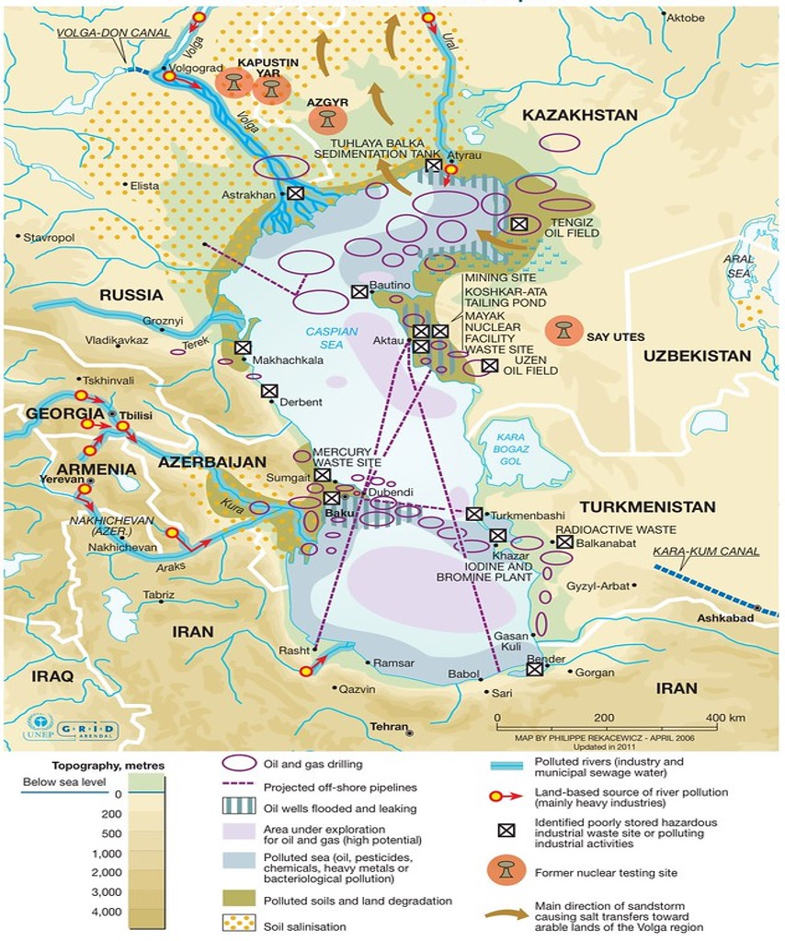
Figure 1: Showing environmental hazards in the Caspian Sea. Industrial activities, especially oil extraction, are the main sources of water and land pollution in the region. Off-shore oil extraction, pipeline transport and oil refineries have generated large quantities of toxic waste and oil contamination that remains trapped within the Caspian Sea because of its endorheic nature. Philippe Rekacewicz (le Monde Diplomatique) assisted by Laura Margueritte and Cecile Marin (2012)

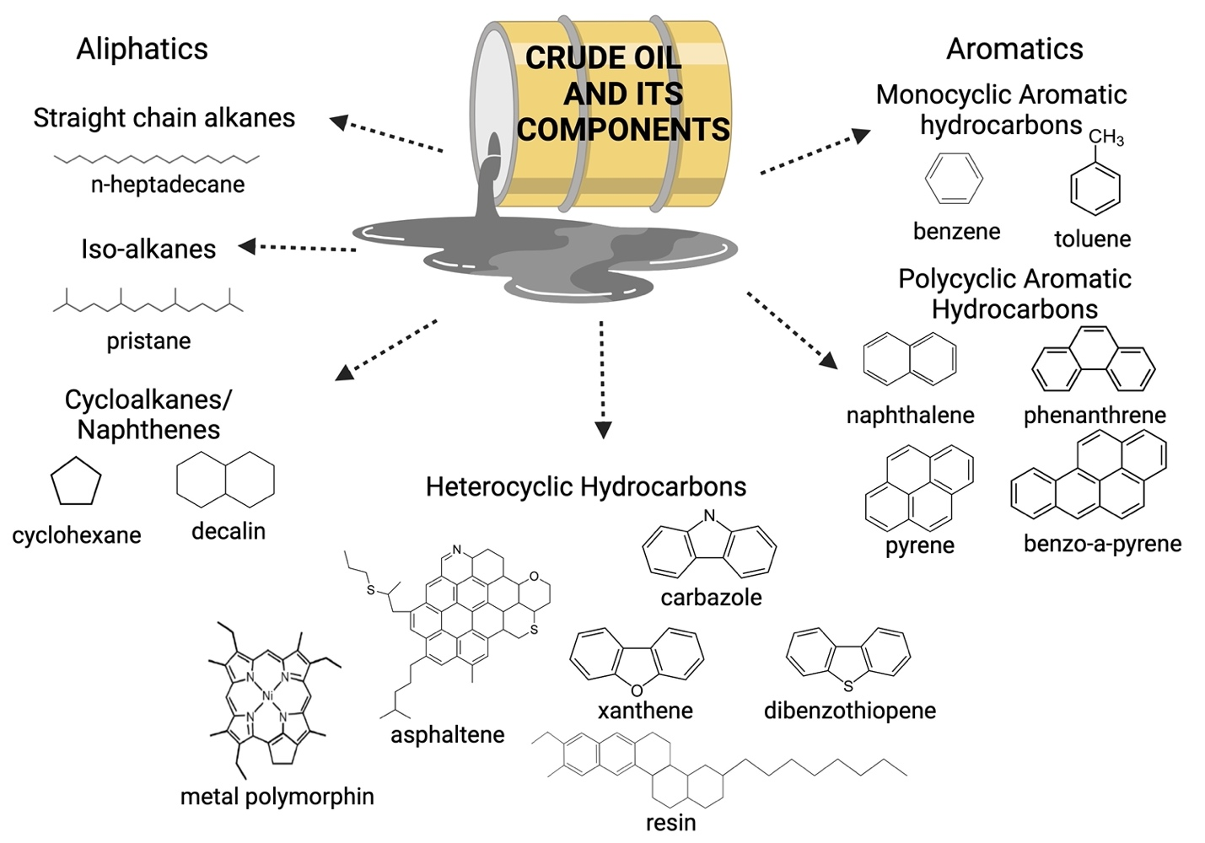
Figure 2: Crude oil is composed of different hydrocarbon fractions, a mix of metals and other compounds. As a result, crude oil has a complex chemistry. Adapted from Mahjoubi et al. (2018). Figure made with Biorender.com

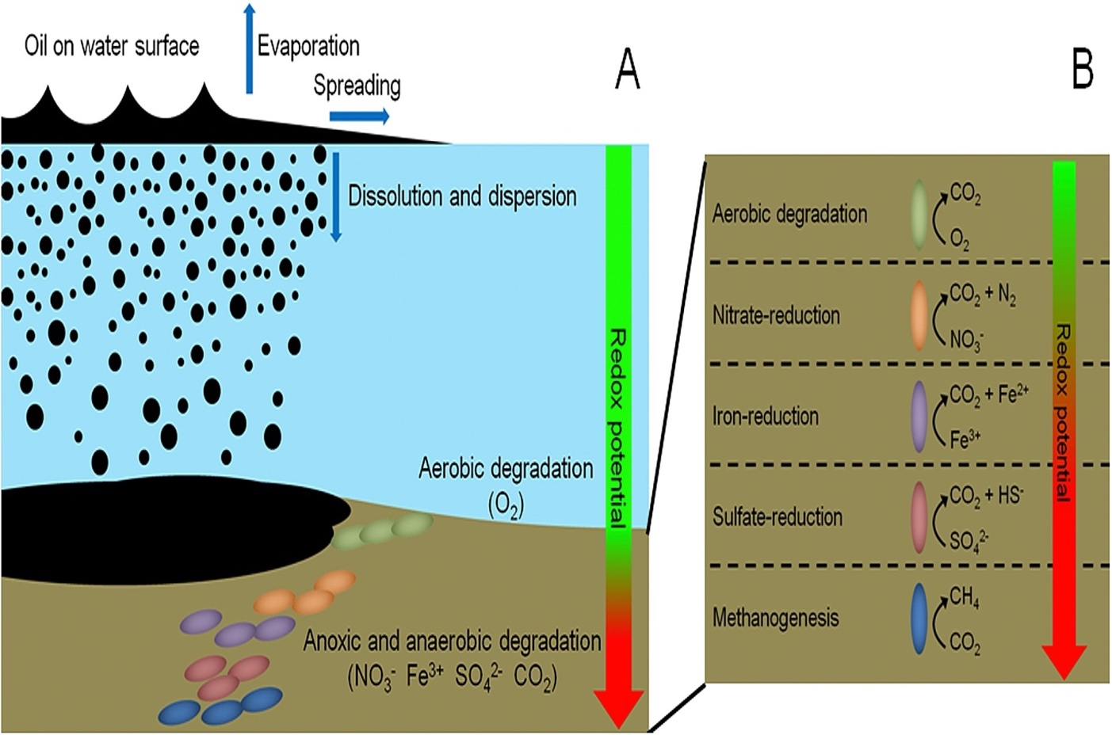
Figure 3 A & B: Showing the fate of oil spills in a marine ecosystem. Aerobic biodegradation will proceed in surface waters but as oxygen concentration decreases with depth, so does the rate of aerobic biodegradation. Anaerobic biodegradation will proceed based on the redox potential of available compounds at deeper depths. Source: (Daghio et al., 2017)

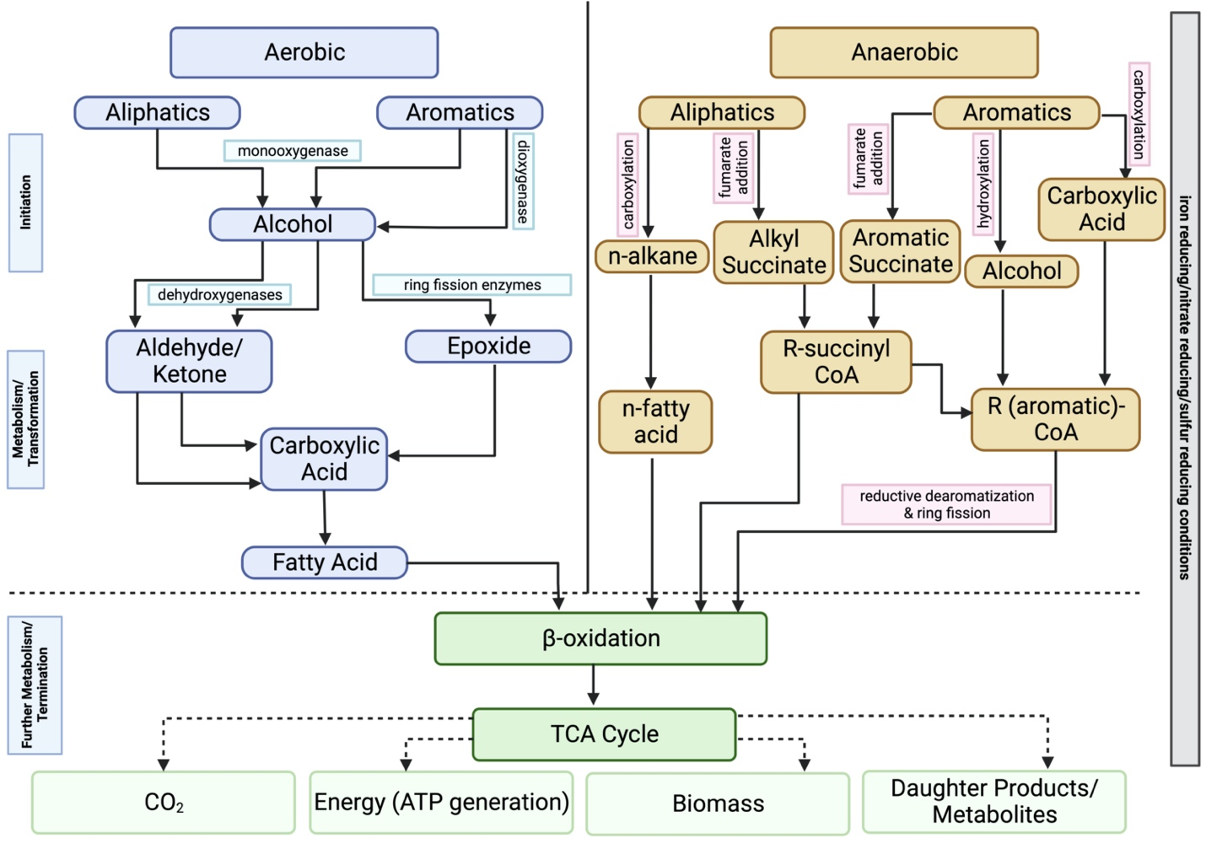
Figure 4: Pathways for the aerobic and anaerobic biodegradation of hydrocarbon compounds. Figure made with Biorender.com

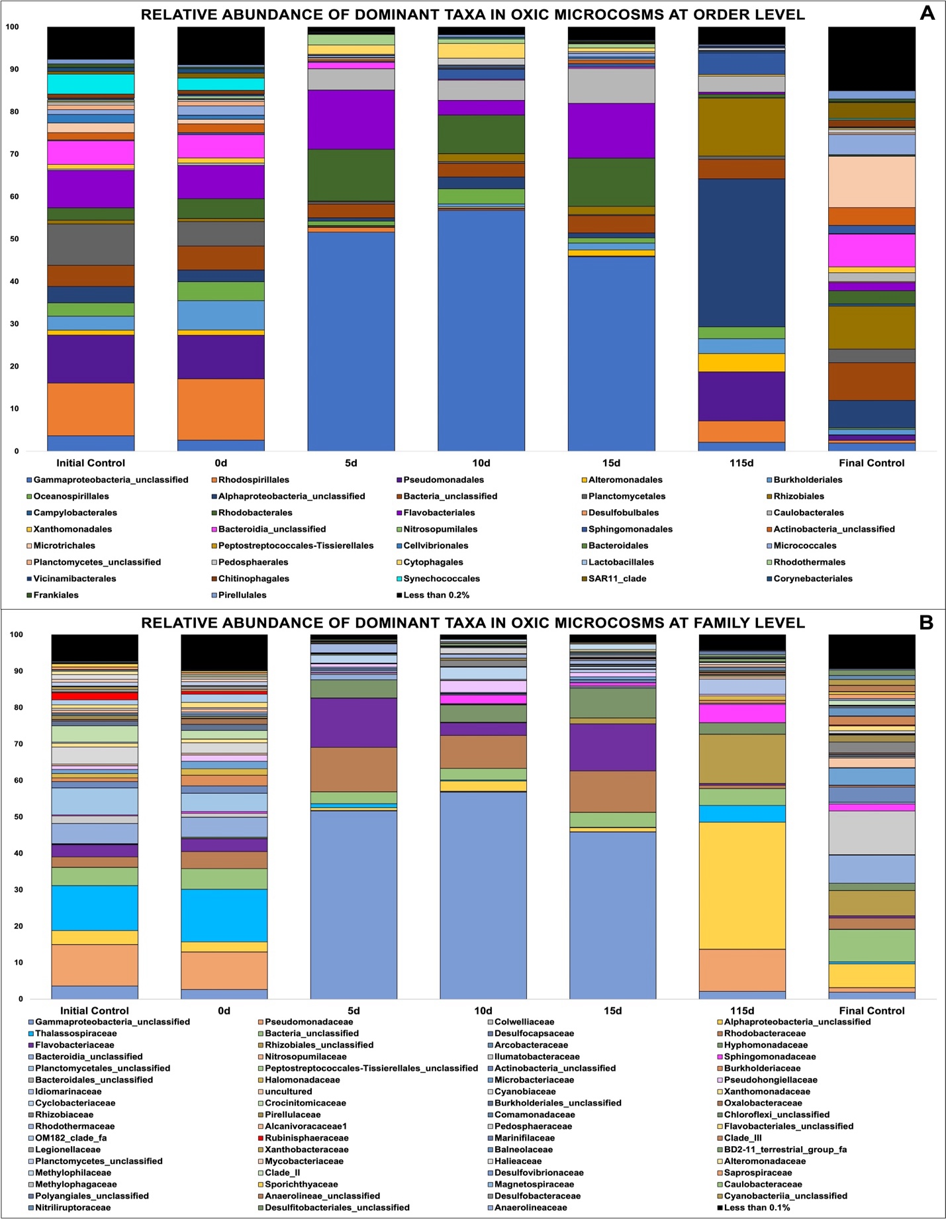
Figure 5 A & B: Showing relative abundance of bacterial orders in oxic microcosms, (B) Showing relative abundance of bacterial families in oxic microcosms.
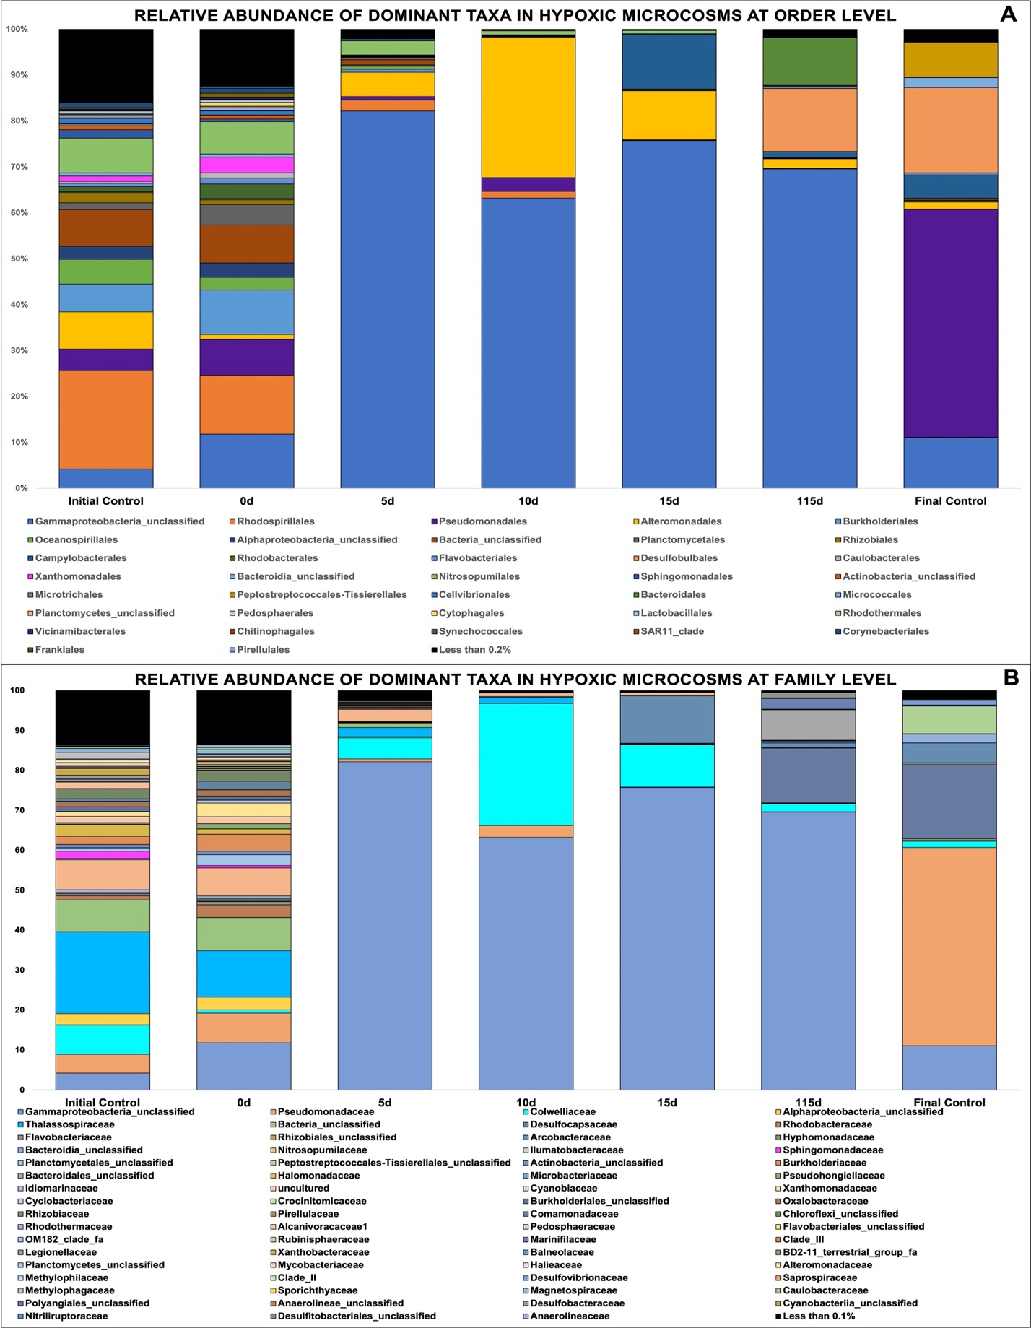
Figure 6 A & B: Showing relative abundance of bacterial orders in hypoxic microcosms, Showing relative abundance of bacterial families in hypoxic microcosms.
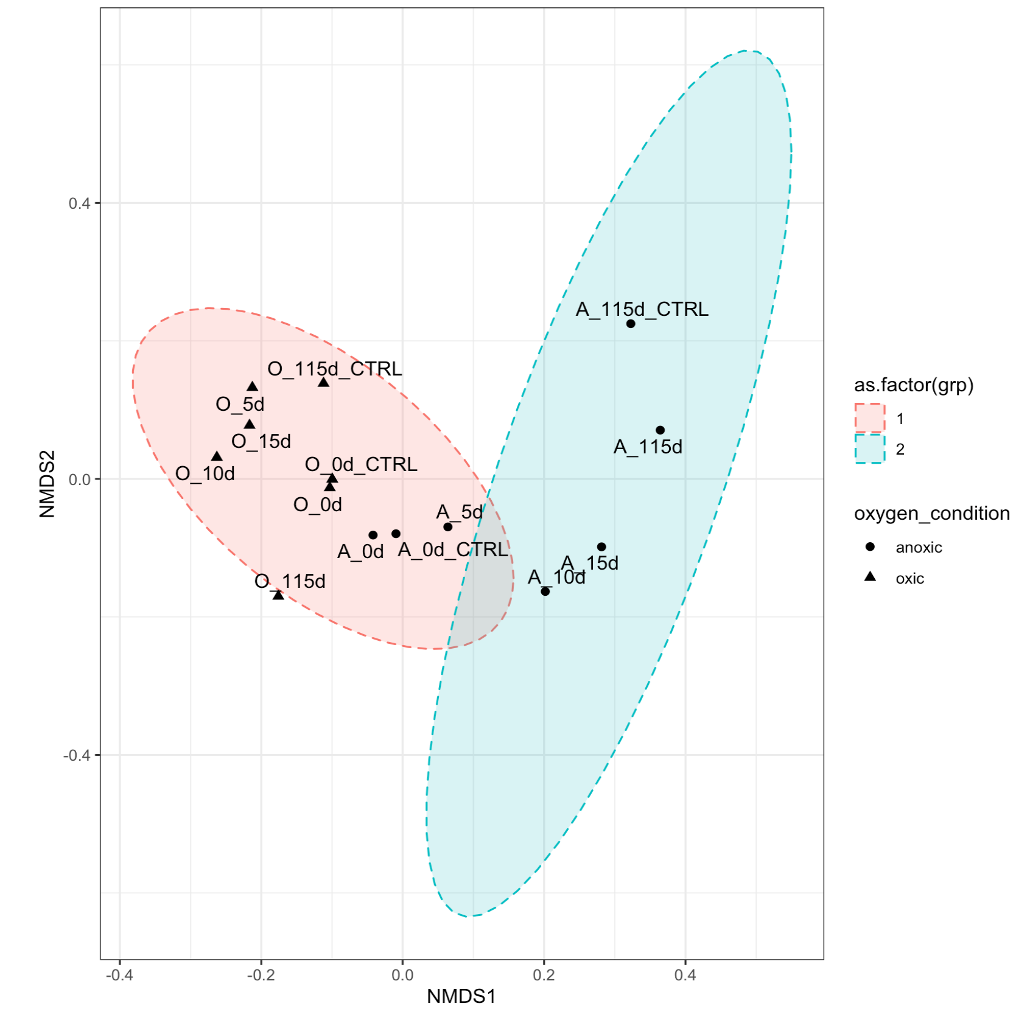
hypoxic
oxic
Figure 7: NMDS plotted with vegan package in R in 2 dimensions. Stress = 0.08444561. Oxic microcosms are denoted with a black triangle while hypoxic microcosms are represented by a black dot. Experiment microcosms are labelled with their corresponding day while control microcosms are labelled with their corresponding day_CTRL. Red and blue circles represent the 95% confidence intervals.

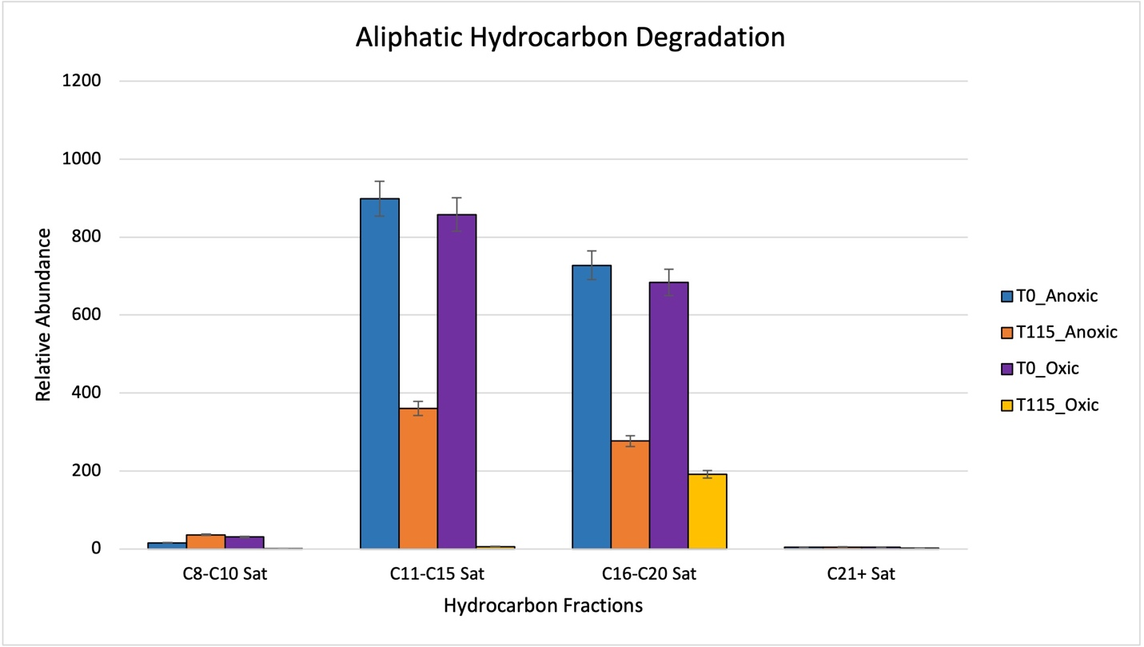
Figure 8: Showing relative abundance of aliphatic hydrocarbons measured by GC-MS in oxic and hypoxic microcosms. All results are semi quantitative and based on ratios to the recalcitrant biomarker C30-Hopane. Data is aggregated by groupings based on number of carbon atoms.

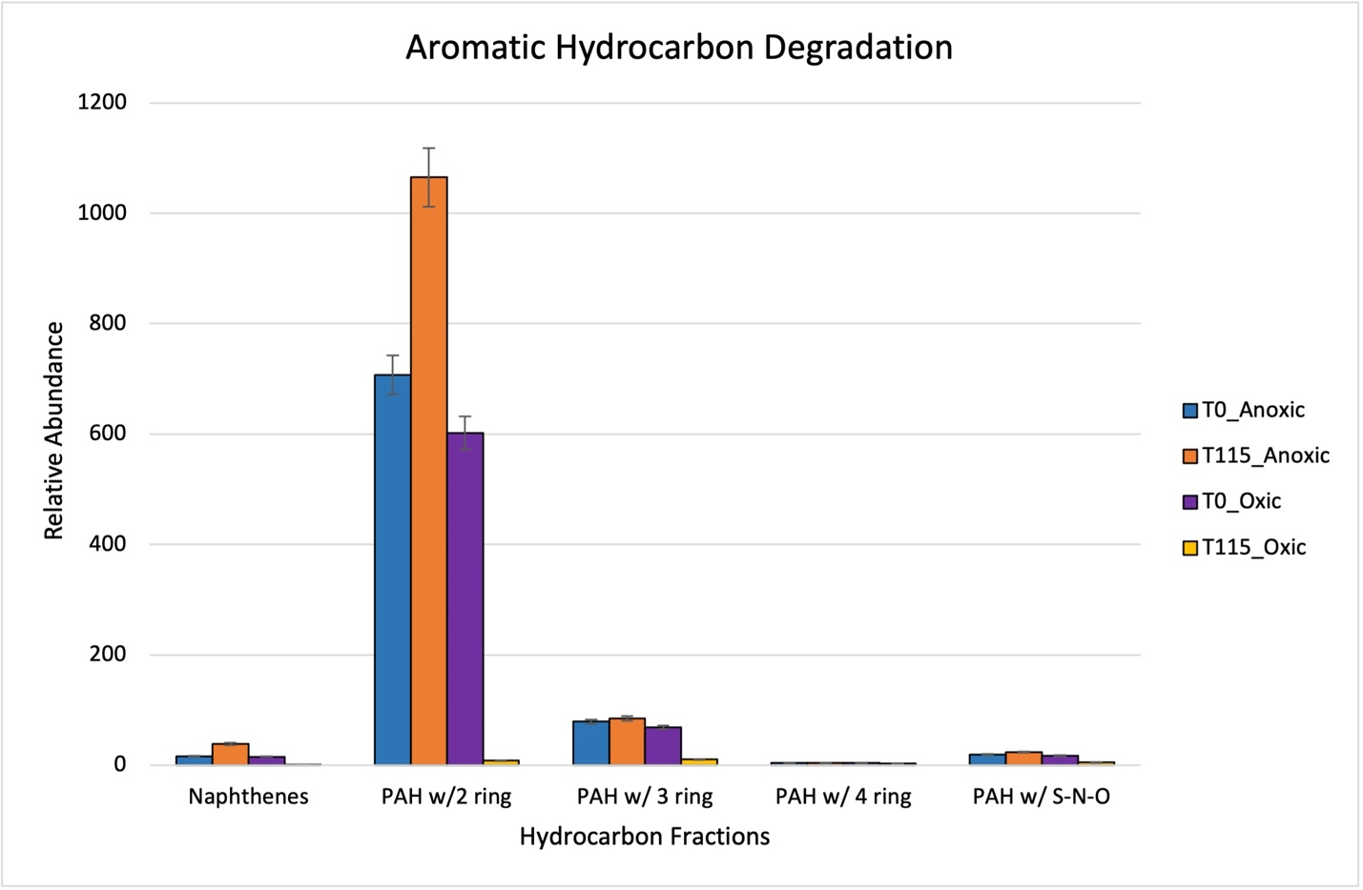
Figure 9: Showing relative abundance of aromatic hydrocarbons measured by GC-MS in oxic and hypoxic microcosms. All results are semi quantitative and based on ratios to the recalcitrant biomarker C30-Hopane. Data is aggregated by groupings based on number of rings.

Figure 10: Showing full scan GC-MS spectra (m/z 50 to 450) of Caspian Oil in seawater under different conditions. Red boxes indicate the presence of the unresolved complex mixture on spectra
A) Full scan GC/MS chromatogram for the Caspian Oil
B) Full scan GC/MS chromatogram oxic microcosms after 115 days
C) Full scan GC/MS chromatogram hypoxic microcosms after 115 days

CHAPTER III
Metagenomic Analysis of the Indigenous Microbial Community to Native Crude Oil Amendment in Oxic versus Hypoxic Conditions

Abstract
The Caspian Sea is the world’s largest landlocked saline lake which lies between Europe and Asia. This region is particularly known for its large-scale oil reserves, pipelines, and drilling activities, which have contributed to the environmental decline of this lake. In addition to pollution from the petroleum industry, drainage from various river basins brings an influx of residential, industrial, and agricultural effluents that induce eutrophication and hypoxic conditions in deeper, colder waters, creating an oxygen gradient. The temperature and oxygen stratification in this environment has presented a unique opportunity to investigate the potential of the biodegradative processes carried out by the indigenous microbial community. Our previous experiments from Chapter 2 utilized 16S rRNA sequencing to observe differences in community structure under oxic versus hypoxic conditions using Caspian seawater collected from 25m and 350m. We sought to perform a functional analysis to further extract differences between these communities. The inconclusiveness of aromatic hydrocarbon degradation in hypoxic microcosms shown from our GC-MS results also warranted further research to assess the functional ability of these microbes. Water filters from the microcosms from this previous experiment setup were preserved in RNALater for metagenomic analysis. Metagenomics has become a useful technique to uncover functional assessment of microbial communities since it provides an answer to two questions: who is there and what they are potentially doing. Functional annotation of oxic and hypoxic microcosms revealed an immense diversity in the metabolic potential of the Caspian Sea microbiome. Many taxa possessed multiple genes related to nutrient cycling and xenobiotic degradation. The presence of such genes indicates the likely adaptation of this microbiome to the increasing eutrophic conditions and pollutant concentrations in this waterbody. Pseudomonadata was found to be an important bacterial phylum in both oxic and hypoxic conditions. This phylum is comprised of diverse microorganisms whose metabolisms range from aerobes, facultative anaerobes, chemolithoautotrophs and heterotrophs. Metagenome-assembled genomes (MAGs) showed the presence of genes related sulfate and nitrogen cycling and fumarate recycling in hypoxic microcosms, indicating a possible mechanism for the anaerobic biodegradation of crude oil. A comparison of protein annotations to the manually curated database (CANT-HYD) of hydrocarbon-degrading enzymes showed evidence of succession in the degradation of hydrocarbons (alkanes degraded before aromatic hydrocarbons). This comparison also revealed the significance of cytochrome P450 alkane hydroxylase in both oxic and hypoxic conditions. This enzyme has been previously implicated in the detoxification of xenobiotics to generate secondary metabolites. This could be an important indicator in the mechanisms of hydrocarbon degradation in the Caspian Sea for the production of daughter products and hydrocarbon intermediates.

Introduction
Hydrocarbons are ubiquitous in our environment and have had a long-term presence since the inception of the biosphere via biosynthesis or fossil fuel generation (Prince & Walters, 2016). Marine ecosystems are particularly vulnerable to the presence of hydrocarbons or hydrocarbon mixtures from various sources: biosynthesis and biotransformation of alkanes and alkenes by plants and marine organisms, microbial biochemical and geochemical transformation of organic matter/detritus into different fossil fuel types (oil, coal, gas), natural seepages from fractures in the Earth’s crust, river discharge from residential areas and industrial processes and inputs associated with the extraction, refinery, transport and combustion of crude oil and petroleum (National Academies of Sciences & Medicine, 2020). Microbial adaptation from these prior exposures resulted in the selective enrichment of hydrocarbon-degrading microorganisms despite the high energy costs to break the carbon-hydrogen bond (Leahy & Colwell, 1990; National Academies of Sciences & Medicine, 2020; Yakimov et al., 2007). The adaptation of these microbes has created a community with diverse metabolic capabilities that is able to use hydrocarbons as an energy source through aerobic or anaerobic pathways.
The fate of oil in the environment depends upon combination of dynamic physical, chemical and biological processes (ambient temperatures, UV exposure, physical and chemical weathering and biological action of microbes) which alter the state of the oil over time (Prince & Lessard, 2014; Ribicic et al., 2018). However, only the biological action of microbes will result in the degradation and utilization these petroleum hydrocarbons to ultimately reduce their concentration in the environment (Ławniczak et al., 2020; Ribicic et al., 2018). The utilization of these hydrocarbons is performed through the action of different sets of enzymes produced by the organisms.
Like many other petroleum reserves in marine environments, some of the hydrocarbon input in the Caspian Sea can be attributed to natural seeps along the seafloor (Mityagina et al., 2019). The site of sample collection was near a natural seep and an underwater mud volcano, both of which are features associated with natural releases of hydrocarbons. The microbial community associated with marine natural seeps offers an opportunity to study microbial adaptations to petroleum hydrocarbons in different environmental conditions. Oil and gas leaking from these seeps will dissolve along the depth of the water column, however, some will be released to the surface forming slicks in upper waters which can then spread to other areas in the waterbody (Mityagina & Lavrova, 2022). The continuous presence of oil in the water column has influenced hydrocarbon degradation based on temperature and oxygen conditions leading to the presence of halotolerant, psychrophilic, aerobic, anaerobic or facultative anaerobic taxa (Hazen et al., 2016).
Petroleum hydrocarbons can be degraded under both aerobic and anaerobic conditions, however, the gradual depletion of oxygen as a terminal electron acceptor will increase energy constraints on the microbial community (National Academies of Sciences & Medicine, 2022; Teske, 2013). Aerobic degradation of polycyclic aromatic hydrocarbons (PAHs) is a process by which microorganisms use molecular oxygen (O₂) to break down and metabolize PAHs into simpler, less toxic compounds. This process typically occurs in the presence of oxygen-rich environments, such as soils, sediments, and water bodies. The aerobic degradation of hydrocarbons begins with the uptake of these molecules followed by a series of enzymatic reactions that ultimately lead to the formation of carbon dioxide (CO₂) and water (H₂O). The initial step in the aerobic degradation of hydrocarbons is the oxidation of these molecule by an oxygenase enzyme. The oxygenase enzyme adds a hydroxyl group (-OH) to create an intermediate compound that is more water-soluble and can be more easily metabolized by microorganisms. This process is called the "initial attack" phase. In the aerobic degradation of PAHs is the "cleavage" phase, where the PAH molecule is further broken down into smaller compounds. This phase is catalyzed by a range of enzymes, including ring-hydroxylating dioxygenases (RHDs), extradiol dioxygenases, and intradiol dioxygenases (Table 4).. These enzymes break the PAH molecule into two or more smaller compounds, such as phenolic compounds, aldehydes, and ketones. In the final stage of the aerobic degradation of PAHs, the smaller compounds produced in the cleavage phase are further metabolized into carbon dioxide and water through a process known as mineralization. Mineralization occurs through the action of a range of enzymes, such as dehydrogenases and oxidoreductases, which catalyze the conversion of the smaller compounds into CO₂ and H₂O.
Investigating hydrocarbon biodegradation faces significant challenges due to the limitations of culture-dependent methods in investigating microbial communities. Genomic, transcriptomic, and proteomic techniques offer insights into hydrocarbon biodegradation in pure cultures, but the majority of these microorganisms are resistant to traditional laboratory cultivation techniques (Chauhan, 2019). This hinders a comprehensive understanding of their functions and the likelihood of identification in curated 16S rRNA databases (Poretsky et al., 2014). This limitation in taxonomic identification was observed in the previous chapter with the dominance of an uncultured Gammaproteobacteria taxa in the microcosm communities. To overcome these limitations, "meta-omics" approaches – metagenomics, metatranscriptomics, and metaproteomics – have emerged as culture-independent techniques which can be used to study the taxonomic and metabolic diversity of hydrocarbon degraders (Harik et al., 2022). Shotgun metagenomics not only provides a taxonomic snapshot of the whole environmental community, it can also reveal important information about the metabolic/functional capabilities of this community as well (Nayfach & Pollard, 2016). However, challenges persist, especially in diverse environments where a substantial percentage of microbes lack sequenced genomes at the species level (Lloyd et al., 2018; Nayfach & Pollard, 2016). Despite these challenges, advancements in high-throughput technologies and bioinformatic tools hold promise for unraveling the complexities of uncultivated microbial communities engaged in hydrocarbon biodegradation.
Shotgun metagenomics was used to elucidate the potential role and identity of these Caspian Sea microorganisms in these microcosm communities. A functional assessment was conducted to determine the influence of source environment and the metabolic adaptations to the presence of hydrocarbons under warm, oxic and cold, hypoxic conditions.

Methods

Sample Collection:
Halves from the filter membranes from the previous microcosm experiment – days 0, 5, 10, 15 and 115 (with oil amended) and their respective controls (day 0 and day 115 with no oil amendment) – were preserved in RNALater and stored at -80ºC prior to metagenomic analyses. DNA from these filters were extracted using a modified phenol-chloroform extraction method after multiple washes with ice-cold 10% phosphate buffer solution (PBS) to rinse off the salts from RNALater (Appendix 1). Extracted DNA from sample replicates were then pooled together and their concentration measured using the Qubit fluorometer (Thermo Fisher Scientific, MA, U.S.A.). After pooling and concentration measurements, fourteen samples were passed onto the library preparation stage (7 for each oxygen condition).

Sequencing:
Library preparation was completed using the Nextera XT Kit (Illumina, CA, U.S.A.) following the manufacturer’s protocol. Illumina DNA UD Indexes Set C was used to tag individual samples for multiplexing during sequencing. Quality control to confirm proper tagmentation of samples was performed using the Agilent 2100 Bioanalyzer system (Agilent Technologies, CA, U.S.A.). DNA was quantified after library preparation to determine concentration using the Qubit fluorometer (Thermo Fisher Scientific, MA, U.S.A.). Sample DNA was pooled together for sequencing and the concentration was measured using the KAPA Library Quantification Kit (Roche Sequencing Solutions, IN, U.S.A.) due to its sensitivity to quantify only the PCR-amplifiable library molecules. Paired-end sequencing (2 x 250nt) was done using one lane on the Illumina NovaSeq flow cell (Illumina, CA, U.S.A.) at the University of Tennessee Genomics Core (TN, U.S.A.).

Data Analysis with Kbase:
Bioinformatic analysis was performed with applications (apps) from the online platform Kbase (Arkin et al., 2018). The suggested protocol to extract metagenome assembled genomes (MAGs) published by Chivian et al. (2023) was used as the bioinformatic pipeline. Shotgun metagenomic reads were uploaded to a Kbase narrative as paired-end reads from the data staging area using the app Import NonInterleaved FASTQ Files as Reads from Staging Area v1.0.57 with Illumina selected as the relevant sequencing technology. Quality checks for paired-end reads was performed with FastQC v0.12.1 (Andrews, 2010). After quality assessment, paired-end reads were appropriately trimmed and filtered using Trimmomatic v0.36 with the following parameters – adapter removal for Nextera adaptors, sliding window minimum quality - 15, head crop length - 20 and minimum read length – 36 (Bolger et al., 2014). The remaining sequences underwent another quality check using FastQC v0.12.1 (Andrews, 2010). Initial taxonomic classification was performed on these trimmed reads with Kaiju v1.9.0 and GOTTCHA2 v2.1.7 (Menzel et al., 2016; Tracey et al., 2015).

Paired-end reads were then merged with the Kbase app Merge Reads Libraries v1.2.2 into 4 different combined libraries based on the following conditions, oxic with oil-amendment, oxic without oil amendment (controls), hypoxic with oil-amendment, hypoxic without oil amendment (controls) to analyze overall trends in these microcosms. To assess timeline trends, paired-end reads for each day were also passed through the rest of the pipeline without merging. Assembly of paired-end reads and co-assembly of merged libraries was done using metaSPAdes v3.15.3. The quality of assembled contigs was checked with QUAST v4.4 before binning (Gurevich et al., 2013). MaxBin2 v2.2.4, MetaBAT2 Contig Binning v1.7 and CONCOCT v1.1 were used to group assembled contigs into bins (Alneberg et al., 2014; Kang et al., 2015; Wu et al., 2016; Wu et al., 2014). These bins were then optimized using the DAS Tool v1.1.2 to create a non-redundant set of bins (Sieber et al., 2018). Since merged libraries had better assemblies, bins with >90% completion and <5% contamination were checked and filtered using the CheckM v1.0.18 apps (Parks et al., 2015). For bins from the non-merged reads, the CheckM v1.0.18 apps checked and filtered bins with >50% completion and <10% contamination. Bins that met this quality assessment were extracted as an assembly group using Extract Bins as Assemblies from BinnedContigs v1.0.2 for further analysis and functional annotation.

Two different functional annotation apps were used to annotate extracted assemblies: RASTtk v1.073 and Annotate and Distill Assemblies with DRAM (Distilled and Refined Annotation of Metabolism) v0.1.2 (Aziz et al., 2008; Brettin et al., 2015; Overbeek et al., 2014; Shaffer et al., 2020). Annotations made with DRAM were used for functional analysis and the output file of protein sequences was downloaded and taken out of Kbase for further processing. DRAM annotations were preferred since they provide comprehensive annotations of metagenomic bins using multiple using multiple databases while summarizing the results to facilitate exploration of their functional and structural traits, including the use of functional marker genes to infer metabolic descriptors of these bins. The presence of 23S, 16S, and 5S ribosomal RNA (rRNA) genes, as well as transfer RNAs (tRNAs) in each MAG, was also verified using DRAM. Annotations made with RASTtk v1.073 were used to form a genome set in the app as an input for other applications, e.g. Summarize GenomeSet v1.8.0 (Parks et al., 2015). Taxonomic classification of the remaining bins was performed using Classify Microbes with GTDB-Tk v2.3.2 or GTDB-Tk v1.7.0 (in the beta mode of Kbase) and their resulting Krona plots were downloaded (Chaumeil et al., 2022; Chivian et al., 2023; Parks et al., 2022).

Exploration of Hydrocarbon-Degrading Genes Using HMMER 3.1 and CANT-HYD database:
The resulting protein sequence files from the DRAM output for the non-merged assemblies were analyzed with HMMER 3.4 (Eddy, 2011) to identify homologous proteins related to hydrocarbon degradation. HMMER employs probabilistic models known as Hidden Markov Models (HMMs) to represent the conserved patterns and motifs in biological sequences. These HMMs are derived from multiple sequence alignments that can unveil distinct patterns of evolutionary conservation that is specifically associated with the structure and function of the targeted domain (Eddy, 2011). Genes involved in hydrocarbon degradation can share sequence similarities to other genes from different metabolic pathways, causing issues with annotation. Khot et al. (2022) recognized this issue and developed the CANT-HYD (Calgary approach to ANnoTating HYDrocarbon degradation genes) database – a set of 37 HMMs designed to target and annotate marker genes associated with aerobic and anaerobic degradation of aliphatic and aromatic hydrocarbons. The amino acid sequences derived from the DRAM output was searched against the CANT-HYD database using the hmmpress and hmmscan commands from HMMER 3.4 and only hits scoring above the trusted noise cut-off were passed to the resulting table outputs.

Results

Sequencing and Assembly Statistics
The shotgun metagenomic sequencing of the oxic and hypoxic microcosms yielded 465,209,612 and 564,093,188 paired-end reads with an average of 66.5 million reads and 80.6 million reads per sample respectively. After quality control and trimming with Trimmomatic, 448,206,180 and 545,694,302 paired-end reads were kept for further analysis for oxic and hypoxic microcosms with an average of 64 million reads and 78 million reads per sample. Individual assembly of these microcosm communities generated a total of 289442 and 166282 contigs for oxic and hypoxic samples. Optimization of metagenomic binning using DAS Tool yielded 310 bins for oxic microcosms and 226 bins hypoxic microcosms of which 286 and 207 bins passed the quality filter of ≥50% of completeness and ≤10% of contamination (Table 5).

MAG Classification and Abundance
Taxonomic classification of the combined 493 bins most commonly belonged to eight different bacterial phyla: Psuedomondata, Chloroflexota, Planctomycetota, Bacteroidota, Patescibacteria, Actinomycetota, Myxococcota and Verrucomicrobiota. Hypoxic microcosms also recovered two archaeal phyla, Thermoproteota and Nanoarchaeota, as well as the presence of the bacterial phyla Desulfobacterota. The most dominant phyla for both oxic and hypoxic microcosms was Pseudomonadota as it was found recovered from all timepoints in this experiment. Taxonomic classification with GTDB-Tk v2.3 for experiment timepoints assigned 264 bins to the genus level and 89 bins to the species level for oxic microcosms and 196 bins to the genus level and 63 bins to the species level for hypoxic microcosms.
Krona plots produced using GTDB-Tk v2.3 (Figures 11-22) shows the abundance of all classified metagenomic bins for each timepoint to the family and class level. The community structure was altered by the addition of oil as seen by the changing distributions of bacterial phyla over the 115 days. These plots also show evidence of microbial succession over the experiment time course as different taxa were identified or disappeared at various timepoints for both oxygen levels.
In hypoxic microcosms, bacterial taxa under the Pseudomonadota phylum established dominance. The abundance of MAGS classified to this phylum steadily increased from day 0 (32% of bins) to day 15 (100% of bins). Notable genera identified under this phylum were further identified as: Colwellia (bin.004.fasta_assembly-hypoxic_day15), Thalassolituus (bin.005.fasta_assembly-hypoxic_day15) and Neptunomonas (bin.002.fasta_assembly-hypoxic_day15). The abundance of bins classified to the bacterial taxa related to the Actinomycetota phylum fluctuated in hypoxic microcosms with a peak on day 10 where it represented 20% of MAGs and the subsequent disappearance of this phylum until the final timepoint. This fluctuation might signify a complex response to the introduced oil. Notably, Planctomycetota, Patescibacteria, and Chloroflexota exhibited declining trends over time and no MAGs related to these phyla were detected past day 5 in hypoxic microcosms. The taxa Nitrospirales (bin.030.fasta_assembly-hypoxic_day5) was observed at day 5 at 95% completeness and less than 1% contamination. Members of this taxa are often found in marine ecosystems and are able to use nitrate as a terminal electron acceptor (Mueller et al., 2023). The bacterial genus Desulforhopalus (bin.005.fasta_assembly-hypoxic_day115 and bin.007.fasta_assembly-hypoxic_day115) was observed in day 115 microcosms at over 95% completeness and less than 5% contamination. This understudied taxa is a strictly anaerobic and psychrophilic and is capable of using propionate, lactate, pyruvate, ethanol, and 1-propanol as electron donors and carbon sources (Galushko & Kuever, 2019). The sustained presence of Pseudomonadota, coupled with the fluctuations in Actinomycetota and declines in other phyla, highlights the intricate response of microbial succession to hydrocarbon amendment.
The dominance of the phylum Pseudomonadota was also observed in oxic microcosms where 52% of MAGS were classified to this phylum by day 15. The taxonomic diversity within this phylum was greater in oxic microcosms than that observed in hypoxic microcosms. Within this phylum, MAGs related to different bacterial orders (Burkholderiales, Pseudomonadales, Sphingomonadales, Pelagibacterales, Rhodospirillales, Caulobacterales, Enterobacterales_A, Rhodobacterales, Methylococcales, Rhizobiales) across all timepoints at over 70% completeness and 5% contamination with most bins achieving 90% completeness. The abundances of MAGs assigned under the phylum Bacteroidota declined steadily over time (29% at day 0 to 3% day 115), however, their presence was never diminished. In particular, the consistent presence of the bacterial order Flavobacteriales was observed across all timepoints, suggesting its possible importance in hydrocarbon metabolism under oxic conditions. Verrucomicrobiota maintains a consistent presence with the bacterial order Methylacidiphilales until day 15. This order has been described as a methanotroph, however, functional analysis with DRAM did not identify the methane monooxygenase gene within this bin (Op den Camp et al., 2009).

Functional Annotation to Determine Metabolic Potential of MAGs with DRAM
For further analysis, microcosm timepoints were co-assembled based on their experimental conditions (oxygen conditions and oil amendment). Bins with 90% completeness and 5% contamination were extracted from these assemblies for functional annotation. Functional analysis was performed using DRAM to determine the metabolic potential of the metagenomic bins in oxic and hypoxic conditions in response to crude oil amendment. Genes related to core metabolisms such as, glycolysis, pentose phosphate pathway, Krebs cycle, Calvin cycle, Entner-Doudoroff pathway, glyoxylate cycle, Arnon-Buchanan cycle, dicarboxylate-hydroxybutyrate cycles and the Wood–Ljungdahl pathway, were found in most selected MAGs for both oxic and hypoxic co-assemblies. Some bins even featured all subunits for predicted genes for the full metabolic pathways (Figure 24 & 25).
Evidence of genes related to electron transport chain (ETC) complexes that are associated with aerobic respiration were found in oxic co-assemblies (Figure 23). DRAM also identified multiple subunits of genes related to the electron transport chain complexes used by anaerobes or facultative anaerobes in hypoxic co-assemblies. In particular, almost all MAGs in hypoxic co-assemblies possessed multiple subunits for the ETC complex NADH quinone oxidoreductase. Fumarate reductase and succinate dehydrogenase were also found in multiple bins from hypoxic co-assemblies (Figure 15). These ETC complexes highlight the possible initial metabolism of hydrocarbons under anaerobic condition via fumarate addition.
The ability to degrade organic molecules may provide a possible link to the capability to degrade the more complex compounds found in crude oil. We further investigated the presence of carbohydrate-active enzymes (CAZymes) genes in the co-assembled MAGs, revealing genes related to the cleavage of polyphenolics and complex carbohydrates (Figure 26 & 27). In co-assembled hypoxic microcosms, the ability to cleave polyphenols, amorphous cellulose and arabinan was identified while possible cleavage of polyphenols, amorphous cellulose, xyloglucan and arabinan was identified in co-assembled oxic microcosms.
Thiosulphate oxidation to sulphate through the sulphur oxidation enzyme system was found in some oxic MAGs while only hypoxic MAGs had genes related to dissimilatory sulphate reduction to sulphide and thiosulphate reduction to sulphite (Figure 26 & 27). This could be indicative of a possible metabolic strategy for hydrocarbon degradation under hypoxic conditions. Genes related to nitrogen-transforming processes – such as nitrogen fixation, nitrification, denitrification, ammonia oxidation and dissimilatory nitrate reduction to ammonium – could also be detected in both sets of MAGs.

Functional Analysis of Identified Genes Utilizing RASTtk Annotations
The genomes from the co-assembled contigs from each microcosm were also annotated using RASTtk to further explore the structural and functional features. These annotations made with RASTtk served to further predict gene functions, to uncover important pathways and to model possible metabolism of bins.
Interestingly, the presence the gene RuBisCO (ribulose-1,5-bisphosphate carboxylase/oxygenase), which is involved in carbon assimilation, was found in both co-assemblies. This enzyme is responsible for carbon fixation into organic biomass via the Calvin cycle (Badger & Bek, 2008). A literature review of genomes published on Joint Genome Institute (JGI) by Badger and Bek (2008) found the presence of multiple or single Rubisco forms described in aerobes, anaerobes and facultative anaerobes. Genes related to anaerobic carbon-monoxide dehydrogenase (cooS) and acetyl-CoA decarbonylase/synthase (acsD) were found in two bins in the hypoxic co-assembly (Bin.012.fasta_assembly.RAST and Bin.057.fasta_assembly.RAST). The proteins produced by these two genes are typically linked to carbon assimilation in anaerobic bacteria (De Souza & Rosado, 2019).

Identification of Homologous Proteins Involved in Hydrocarbon Degradation with CANT-HYD Database
To further investigate the metabolic capabilities specifically related to hydrocarbon degradation, HMMER3.0 was used to identify homologous proteins based on conserved patterns in the protein sequence. A literature search by Khot et al. (2022) led to the identification of 105 genes involved in aerobic and anaerobic degradation of alkanes and aromatic hydrocarbons. With these genes as the starting point, 37 Hidden Markov Models (HMMs) were made to describe these 105 functional genes associated with aerobic and anaerobic degradation of alkanes and aromatic hydrocarbons to form the CANT-HYD database. Protein annotations made with DRAM from experiment timepoints under oxic and hypoxic conditions were compared to the CANT-HYD database. Mainly proteins related to aerobic degradation of alkanes and aromatic hydrocarbons were identified in both oxic and hypoxic conditions when utilizing the suggested noise cut-off limits. When the noise cut-off was ignored, enzymes (e-value <<1) related to anaerobic degradation of both alkanes and aromatic hydrocarbons were identified in hypoxic microcosms. The aerobic enzyme cytochrome P450 alkane hydroxylase was the most commonly identified enzyme across both oxygen conditions. This enzyme has been previously shown to have a major role in the metabolism of complex xenobiotics. Another trend of possible succession of hydrocarbon degradation was also noticed in both oxic and hypoxic conditions. In oxic microcosm, alkane degrading proteins were identified in early timepoints (day 0 to 5) while later timepoints (day 10 to day 115) had significant hits to aromatic hydrocarbon-degrading proteins.
A similar trend was also noticed in hypoxic microcosms, except significant hits to these aromatic-degrading proteins were identified from day 5 to day 15. Interestingly, one bin for the day 115 oxic microcosm (bin.027.fasta_assembly-oxic_day115) had a significant hit to two proteins related to anaerobic hydroxylation and multiple significant hits to aerobic aromatic degrading proteins.

Discussion

Taxonomic Assessment of MAGs
Hydrocarbon-degrading bacteria are ubiquitous in the environment, especially in areas with chronic (natural or anthropogenic) hydrocarbon pollution, like the Caspian Sea (Hassanshahian et al., 2012; Hazen et al., 2016; Miller et al., 2019). These taxa are typically present at low abundances until they become enriched by the increased hydrocarbon concentrations within their environment (Hazen et al., 2010; Ribicic et al., 2018; Yakimov et al., 2007). In marine ecosystems, the bulk of hydrocarbon biodegradation can be attributed to a group of bacteria recognized as obligate hydrocarbonoclastic bacteria (OHCB). These organisms have consistently shown preferential utilization of different hydrocarbon fractions as a source of carbon and energy (Jagtap et al., 2021; Yakimov et al., 2022; Yakimov et al., 2007). The eleven recognized genera to the OHCB group are: Firmucutes (Planomicrobium); Cellvibrionales (Porticoccus); Nevskiales (Algiphilus and Polycyclovorans); Oceanospirillales (Alcanivorax, Neptumonas, Oleibacter, Oleiphilus, Oleispira and Thalassolitus) and Thiothrichales (Cycloclasticus) (Yakimov et al., 2022; Yakimov et al., 2007). Though the Caspian Sea only has one-third the salinity of regular seawater, members of this marine bacterial grouping were found in both oxic and hypoxic conditions. From this, we can infer that the microbial community of this waterbody is pre-adapted to the presence of oil and is able to exhibit a faster response time this contaminant, i.e. a “memory response”. These bacterial genera have also been identified in other attempts at microbial community profiling (16S and metagenome) in the Caspian Sea, indicating a consistent community of organisms that plays an important role in pollutant degradation and nutrient cycling (Goodarzi et al., 2022; Hassanshahian et al., 2012; Hazen & Techtmann, 2018; Mahmoudi et al., 2015; Mehrshad et al., 2016; Miller et al., 2019). It has been reported that areas facing chronic hydrocarbon pollution, 10% of their microbial community will be comprised of hydrocarbon degraders compared to 1% in non-polluted areas (Hassanshahian & Cappello, 2013). The presence of OHCB was also noted during the Deepwater Horizon (DWH) spill in the Gulf of Mexico (Hazen, 2018; Hazen et al., 2016; Lamendella et al., 2014; Mason et al., 2012; Mason et al., 2014; Redmond & Valentine, 2012).
Evidence of microbial succession during hydrocarbon degradation was also observed in both sets of microcosms over the experiment duration. The bioavailability (based upon molecular weight and chemical structure and complexity) will influence the order of susceptibility to microbial degradation (Das & Chandran, 2011; Varjani & Upasani, 2017). Since crude oil is such a complex mixture, a community of organisms with different metabolic capabilities are needed to transform the hydrocarbon fractions (Hazen et al., 2016). The order of susceptibility of hydrocarbons typically ranges from linear alkanes > branched alkanes > low-molecular-weight alkyl aromatics > monoaromatics > cyclic alkanes > polyaromatics > asphaltenes (Varjani & Upasani, 2017). This bacterial succession, characterized by a dynamic process of bloom and succession indicates a shift in microbial communities where oil degraders begin to decline and other organisms able to utilize secondary metabolites or daughter products begin to increase in abundances (Hazen, 2018; Hazen et al., 2016; Head et al., 2006). The decline of microbes specialized in consuming certain substrates provided an energy/carbon for those adapted to utilize the remaining compounds. In oxic microcosms, abundances of PAH-degrading strains (Thalassolituus, Alteromonas, Cycloclasticus) were prominent by day 15. In hypoxic microcosms, PAH-degrading taxa (Oleispira, Colwellia, Thalassolituus, Neptunomonas) were observed by day 10 and their presence dominated day 15 hypoxic microcosms. Oil-degrading genera that are commonly detected by during low-temperature biodegradation in polar marine environments include members of the family Oceanospirillaceae such as the psychrophilic obligate hydrocarbon-degraders Oleispira, Oleiphilus, and Thalassolituus (Brakstad et al., 2008; Hazen & Techtmann, 2018; National Academies of Sciences & Medicine, 2022). This changing dynamic was also noticed during DWH spill where taxa able to preferentially metabolize alkanes were amplified at early timepoints in the spill then were gradually replaced by taxa able to metabolize aromatic hydrocarbons or degradation products associated with the use of dispersants (Hazen, 2018; Mason et al., 2012; Redmond & Valentine, 2012).
The influence of Colwellia and Thalassolituus on hypoxic microcosms cannot be underscored. These two genera comprised the majority of the relative abundances predicted by GTDB-Tk. Members of Colwellia have been enriched as cold-adapted hydrocarbonoclastic bacteria in polar marine environments as well as in the deep-sea plume and sediments from the DWH spill (Brakstad et al., 2008; Mason et al., 2012; Mason et al., 2014).

Functional Analysis of Oxic and Hypoxic Microcosms
Two different MAGs identified in co-assembled hypoxic microcosms under the genus Motiliproteus had multiple genes related to the complete benzoate reduction pathway. This is a microbial strategy for aromatic hydrocarbon degradation under anaerobic conditions as these compounds are converted to benzoyl-CoA (Kuntze et al., 2008; Peixoto et al., 2011). Benzoyl-CoA reductase is a crucial enzyme in the reductive ring cleavage pathway, leading to the formation of cycloalkanes as intermediate products. This genus has been previously described as a halotolerant facultative aerobe that is oxidase and catalase positive with the capability for nitrate reduction (Wang et al., 2014). Such mechanisms could serve as an adaptation to hydrocarbon degradation under microaerophilic conditions in hypoxic microcosms. The presence of genes related to this pathway were not observed in any oxic MAGs. The presence of this pathway in hypoxic MAGs could possibly explain some of the inconclusiveness in GC-MS data where the concentrations of naphthenic compounds increased in the final timepoints. Cold temperatures along with more recalcitrant hydrocarbon fractions could induce biotransformation instead of biomineralization in some cases (Brakstad et al., 2008; National Academies of Sciences & Medicine, 2022). Some bacterial species can detect and move towards oil droplets (using chemotaxis and flagellar structures) to maximize their selective advantage over other cells (National Academies of Sciences & Medicine, 2020). This was seen in the DRAM metabolism summary for multiple MAGs across both oxygen conditions, suggesting a response of cellular motility as a mechanism of accessibility for cells to locate, aggregate and begin degradation in response to hydrocarbon amendment (Ibrar et al., 2022; Mason et al., 2012).

Conclusion
The metagenome data from the Caspian Sea microbial communities reveal a remarkable metabolic diversity, reflecting the complex environmental conditions and adaptive strategies of these microbes. Genes related to central metabolic pathways, such as glycolysis, the pentose phosphate pathway, the Krebs cycle, and various specialized cycles, were prevalent in both oxic and hypoxic co-assemblies. This extensive array of metabolic capabilities, including the full complement of genes for certain pathways, suggests that these microbes are well-equipped to exploit diverse energy sources and thrive in varying environmental conditions.
The detection of genes associated with the electron transport chain (ETC) highlights the dual metabolic potential of these microbial communities. In oxic co-assemblies, genes for ETC complexes associated with aerobic respiration were predominant, whereas in hypoxic co-assemblies, genes for anaerobic ETC complexes, such as NADH quinone oxidoreductase, fumarate reductase, and succinate dehydrogenase, were abundant. This indicates a flexible metabolic strategy, enabling microbes to switch between aerobic and anaerobic respiration depending on the availability of oxygen. The presence of the aerobic enzyme cytochrome P450 alkane hydroxylase across both conditions underscores its crucial role in hydrocarbon metabolism, particularly in degrading complex xenobiotics. Further evidence of microbial succession was noticed which suggests a dynamic microbial response to hydrocarbon exposure. The well-noted trend of initial degradation of simpler alkanes followed by the breakdown of more complex aromatic compounds was observed.
The metabolic diversity observed in the Caspian Sea microbes could be attributed to their prolonged isolation, allowing them to adapt specifically to their unique environment. Furthermore, eutrophication, leading to fluctuating oxygen levels, may have driven the evolution of facultative anaerobes capable of surviving both oxic and hypoxic conditions. These findings provide valuable insights into the adaptive mechanisms of microbial communities in the Caspian Sea, emphasizing their potential role in bioremediation and the natural attenuation of hydrocarbon pollutants.

References

Abbasian, F., Lockington, R., Mallavarapu, M., & Naidu, R. (2015). A Comprehensive Review of Aliphatic Hydrocarbon Biodegradation by Bacteria [Review]. Applied Biochemistry and Biotechnology, 176(3), 670-699. https://doi.org/10.1007/s12010-015-1603-5
Al-Hawash, A. B., Dragh, M. A., Li, S., Alhujaily, A., Abbood, H. A., Zhang, X., & Ma, F. (2018). Principles of microbial degradation of petroleum hydrocarbons in the environment. The Egyptian Journal of Aquatic Research, 44(2), 71-76. https://doi.org/10.1016/j.ejar.2018.06.001
Alneberg, J., Bjarnason, B. S., De Bruijn, I., Schirmer, M., Quick, J., Ijaz, U. Z., Lahti, L., Loman, N. J., Andersson, A. F., & Quince, C. (2014). Binning metagenomic contigs by coverage and composition. Nature Methods, 11(11), 1144-1146. https://doi.org/10.1038/nmeth.3103
Andrews, S. (2010). FastQC: A Quality Control Tool for High Throughput Sequence Data. In: Available online at: http://www.bioinformatics.babraham.ac.uk/projects/fastqc/.
Arkin, A. P., Cottingham, R. W., Henry, C. S., Harris, N. L., Stevens, R. L., Maslov, S., Dehal, P., Ware, D., Perez, F., Canon, S., Sneddon, M. W., Henderson, M. L., Riehl, W. J., Murphy-Olson, D., Chan, S. Y., Kamimura, R. T., Kumari, S., Drake, M. M., Brettin, T. S., . . . Yu, D. (2018). KBase: The United States Department of Energy Systems Biology Knowledgebase. Nature Biotechnology, 36(7), 566-569. https://doi.org/10.1038/nbt.4163
Aziz, R. K., Bartels, D., Best, A. A., Dejongh, M., Disz, T., Edwards, R. A., Formsma, K., Gerdes, S., Glass, E. M., Kubal, M., Meyer, F., Olsen, G. J., Olson, R., Osterman, A. L., Overbeek, R. A., McNeil, L. K., Paarmann, D., Paczian, T., Parrello, B., . . . Zagnitko, O. (2008). The RAST Server: Rapid Annotations using Subsystems Technology. BMC Genomics, 9(1), 75. https://doi.org/10.1186/1471-2164-9-75
Baburam, C., & Feto, N. A. (2021). Mining of two novel aldehyde dehydrogenases (DHY-SC-VUT5 and DHY-G-VUT7) from metagenome of hydrocarbon contaminated soils. BMC Biotechnology, 21(1). https://doi.org/10.1186/s12896-021-00677-8
Badger, M. R., & Bek, E. J. (2008). Multiple Rubisco forms in proteobacteria: their functional significance in relation to CO2 acquisition by the CBB cycle. Journal of Experimental Botany, 59(7), 1525-1541. https://doi.org/10.1093/jxb/erm297
Bolger, A. M., Lohse, M., & Usadel, B. (2014). Trimmomatic: a flexible trimmer for Illumina sequence data. Bioinformatics, 30(15), 2114-2120. https://doi.org/10.1093/bioinformatics/btu170
Brakstad, O. G., Nonstad, I., Faksness, L.-G., & Brandvik, P. J. (2008). Responses of Microbial Communities in Arctic Sea Ice After Contamination by Crude Petroleum Oil. Microbial Ecology, 55(3), 540-552. https://doi.org/10.1007/s00248-007-9299-x
Brettin, T., Davis, J. J., Disz, T., Edwards, R. A., Gerdes, S., Olsen, G. J., Olson, R., Overbeek, R., Parrello, B., Pusch, G. D., Shukla, M., Thomason, J. A., Stevens, R., Vonstein, V., Wattam, A. R., & Xia, F. (2015). RASTtk: A modular and extensible implementation of the RAST algorithm for building custom annotation pipelines and annotating batches of genomes. Scientific Reports, 5(1), 8365. https://doi.org/10.1038/srep08365
Chauhan, N. S. (2019). Metagenome analysis and interpretation. In (pp. 139-160). Elsevier. https://doi.org/10.1016/b978-0-12-816548-5.00010-1
Chaumeil, P.-A., Mussig, A. J., Hugenholtz, P., & Parks, D. H. (2022). GTDB-Tk v2: memory friendly classification with the genome taxonomy database. Bioinformatics, 38(23), 5315-5316. https://doi.org/10.1093/bioinformatics/btac672
Chivian, D., Jungbluth, S. P., Dehal, P. S., Wood-Charlson, E. M., Canon, R. S., Allen, B. H., Clark, M. M., Gu, T., Land, M. L., Price, G. A., Riehl, W. J., Sneddon, M. W., Sutormin, R., Zhang, Q., Cottingham, R. W., Henry, C. S., & Arkin, A. P. (2023). Metagenome-assembled genome extraction and analysis from microbiomes using KBase. Nature Protocols, 18(1), 208-238. https://doi.org/10.1038/s41596-022-00747-x
Das, N., & Chandran, P. (2011). Microbial Degradation of Petroleum Hydrocarbon Contaminants: An Overview. Biotechnology Research International, 2011, 1-13. https://doi.org/10.4061/2011/941810
De Souza, Y. P. A., & Rosado, A. S. (2019). Opening the Black Box of Thermophilic Autotrophic Bacterial Diversity. In (pp. 333-343). Elsevier. https://doi.org/10.1016/b978-0-12-814849-5.00019-8
Eddy, S. R. (2011). Accelerated Profile HMM Searches. PLoS Computational Biology, 7(10), e1002195. https://doi.org/10.1371/journal.pcbi.1002195
Galushko, A., & Kuever, J. (2019). D esulforhopalus. Bergey's Manual of Systematics of Archaea and Bacteria, 1-5. https://doi.org/10.1002/9781118960608.gbm01026.pub2
Ghosal, D., Ghosh, S., Dutta, T. K., & Ahn, Y. (2016). Current State of Knowledge in Microbial Degradation of Polycyclic Aromatic Hydrocarbons (PAHs): A Review. Frontiers in microbiology., 7. https://doi.org/10.3389/fmicb.2016.01369
Goodarzi, Z., Asad, S., & Mehrshad, M. (2022). Genome-resolved insight into the reservoir of antibiotic resistance genes in aquatic microbial community. Scientific Reports, 12(1). https://doi.org/10.1038/s41598-022-25026-3
Gurevich, A., Saveliev, V., Vyahhi, N., & Tesler, G. (2013). QUAST: quality assessment tool for genome assemblies. Bioinformatics, 29(8), 1072-1075. https://doi.org/10.1093/bioinformatics/btt086
Harik, A.-M. G., Griffiths, Z., & Hazen, T. C. (2022). Omics of oil biodegradation. Current Opinion in Chemical Engineering, 36, 100800. https://doi.org/10.1016/j.coche.2022.100800
Hassanshahian, M., & Cappello, S. (2013). Crude Oil Biodegradation in the Marine Environments. In Biodegradation - Engineering and Technology. InTech. https://doi.org/10.5772/55554
Hassanshahian, M., Emtiazi, G., & Cappello, S. (2012). Isolation and characterization of crude-oil-degrading bacteria from the Persian Gulf and the Caspian Sea. Marine Pollution Bulletin, 64(1), 7-12. https://doi.org/https://doi.org/10.1016/j.marpolbul.2011.11.006
Hazen, T. C. (2018). Lessons from the 2010 Deepwater Horizon Accident in the Gulf of Mexico. In Hydrocarbons, Oils and Lipids: Diversity, Origin, Chemistry and Fate (pp. 1-19). Springer International Publishing. https://doi.org/10.1007/978-3-319-54529-5_31-1
Hazen, T. C., Dubinsky, E. A., Desantis, T. Z., Andersen, G. L., Piceno, Y. M., Singh, N., Jansson, J. K., Probst, A., Borglin, S. E., Fortney, J. L., Stringfellow, W. T., Bill, M., Conrad, M. E., Tom, L. M., Chavarria, K. L., Alusi, T. R., Lamendella, R., Joyner, D. C., Spier, C., . . . Mason, O. U. (2010). Deep-Sea Oil Plume Enriches Indigenous Oil-Degrading Bacteria. Science, 330(6001), 204-208. https://doi.org/10.1126/science.1195979
Hazen, T. C., Prince, R. C., & Mahmoudi, N. (2016). Marine Oil Biodegradation. Environmental Science & Technology, 50(5), 2121-2129. https://doi.org/10.1021/acs.est.5b03333
Hazen, T. C., & Techtmann, S. M. (2018). Oil Biodegradation in Deep Marine Basins. In Consequences of Microbial Interactions with Hydrocarbons, Oils, and Lipids: Biodegradation and Bioremediation (pp. 1-18). Springer International Publishing. https://doi.org/10.1007/978-3-319-44535-9_22-1
Head, I. M., Jones, D. M., & Röling, W. F. M. (2006). Marine microorganisms make a meal of oil. Nature Reviews Microbiology, 4(3), 173-182. https://doi.org/10.1038/nrmicro1348
Ibrar, M., Khan, S., Hasan, F., & Yang, X. (2022). Biosurfactants and chemotaxis interplay in microbial consortium-based hydrocarbons degradation. Environmental Science and Pollution Research, 29(17), 24391-24410. https://doi.org/10.1007/s11356-022-18492-9
Jagtap, C. B., Ram, R. M., Tiwari, O. K., Titus, S., & Lodha, T. (2021). Genome sequence of an obligate hydrocarbonoclastic bacterium Alcanivorax marinus NMRL4 isolated from oil polluted seawater of the Arabian Sea. Marine Genomics, 60, 100875. https://doi.org/10.1016/j.margen.2021.100875
Kang, D. D., Froula, J., Egan, R., & Wang, Z. (2015). MetaBAT, an efficient tool for accurately reconstructing single genomes from complex microbial communities. PeerJ, 3, e1165. https://doi.org/10.7717/peerj.1165
Khot, V., Zorz, J., Gittins, D. A., Chakraborty, A., Bell, E., Bautista, M. A., Paquette, A. J., Hawley, A. K., Novotnik, B., Hubert, C. R. J., Strous, M., & Bhatnagar, S. (2022). CANT-HYD: A Curated Database of Phylogeny-Derived Hidden Markov Models for Annotation of Marker Genes Involved in Hydrocarbon Degradation. Frontiers in Microbiology, 12. https://doi.org/10.3389/fmicb.2021.764058
Kuntze, K., Shinoda, Y., Moutakki, H., McInerney, M. J., Vogt, C., Richnow, H. H., & Boll, M. (2008). 6‐Oxocyclohex‐1‐ene‐1‐carbonyl‐coenzyme A hydrolases from obligately anaerobic bacteria: characterization and identification of its gene as a functional marker for aromatic compounds degrading anaerobes. Environmental Microbiology, 10(6), 1547-1556. https://doi.org/10.1111/j.1462-2920.2008.01570.x
Lamendella, R., Strutt, S., Borglin, S., Chakraborty, R., Tas, N., Mason, O. U., Hultman, J., Prestat, E., Hazen, T. C., & Jansson, J. K. (2014). Assessment of the Deepwater Horizon oil spill impact on Gulf coast microbial communities. Frontiers in microbiology., 5. https://doi.org/10.3389/fmicb.2014.00130
Ławniczak, Ł., Woźniak-Karczewska, M., Loibner, A. P., Heipieper, H. J., & Chrzanowski, Ł. (2020). Microbial Degradation of Hydrocarbons—Basic Principles for Bioremediation: A Review. Molecules, 25(4), 856. https://doi.org/10.3390/molecules25040856
Leahy, J. G., & Colwell, R. R. (1990). Microbial degradation of hydrocarbons in the environment. Microbiological Reviews, 54(3), 305-315. https://doi.org/10.1128/mr.54.3.305-315.1990
Lee, Y., Lee, Y., & Jeon, C. O. (2019). Biodegradation of naphthalene, BTEX, and aliphatic hydrocarbons by Paraburkholderia aromaticivorans BN5 isolated from petroleum-contaminated soil. Scientific Reports, 9(1). https://doi.org/10.1038/s41598-018-36165-x
Lloyd, K. G., Steen, A. D., Ladau, J., Yin, J., & Crosby, L. (2018). Phylogenetically Novel Uncultured Microbial Cells Dominate Earth Microbiomes. mSystems, 3(5). https://doi.org/10.1128/msystems.00055-18
Mahmoudi, N., Robeson, M. S., Castro, H. F., Fortney, J. L., Techtmann, S. M., Joyner, D. C., Paradis, C. J., Pfiffner, S. M., & Hazen, T. C. (2015). Microbial community composition and diversity in Caspian Sea sediments. FEMS microbiology ecology., 91(1), 1-11. https://doi.org/10.1093/femsec/fiu013
Mason, O. U., Hazen, T. C., Borglin, S., Chain, P. S. G., Dubinsky, E. A., Fortney, J. L., Han, J., Holman, H.-Y. N., Hultman, J., Lamendella, R., Mackelprang, R., Malfatti, S., Tom, L. M., Tringe, S. G., Woyke, T., Zhou, J., Rubin, E. M., & Jansson, J. K. (2012). Metagenome, metatranscriptome and single-cell sequencing reveal microbial response to Deepwater Horizon oil spill. The ISME Journal, 6(9), 1715-1727. https://doi.org/10.1038/ismej.2012.59
Mason, O. U., Scott, N. M., Gonzalez, A., Robbins-Pianka, A., Bælum, J., Kimbrel, J., Bouskill, N. J., Prestat, E., Borglin, S., Joyner, D. C., Fortney, J. L., Jurelevicius, D., Stringfellow, W. T., Alvarez-Cohen, L., Hazen, T. C., Knight, R., Gilbert, J. A., & Jansson, J. K. (2014). Metagenomics reveals sediment microbial community response to Deepwater Horizon oil spill. The ISME Journal, 8(7), 1464-1475. https://doi.org/10.1038/ismej.2013.254
Mehrshad, M., Amoozegar, M. A., Ghai, R., Shahzadeh Fazeli, S. A., & Rodriguez-Valera, F. (2016). Genome Reconstruction from Metagenomic Data Sets Reveals Novel Microbes in the Brackish Waters of the Caspian Sea. Applied and Environmental Microbiology, 82(5), 1599-1612. https://doi.org/10.1128/aem.03381-15
Menzel, P., Ng, K. L., & Krogh, A. (2016). Fast and sensitive taxonomic classification for metagenomics with Kaiju. Nature Communications, 7(1), 11257. https://doi.org/10.1038/ncomms11257
Miller, J. I., Techtmann, S., Fortney, J., Mahmoudi, N., Joyner, D., Liu, J., Olesen, S., Alm, E., Fernandez, A., Gardinali, P., GaraJayeva, N., Askerov, F. S., & Hazen, T. C. (2019). Oil Hydrocarbon Degradation by Caspian Sea Microbial Communities [Original Research]. Frontiers in Microbiology, 10. https://doi.org/10.3389/fmicb.2019.00995
Mityagina, M., & Lavrova, O. (2022). Satellite Survey of Offshore Oil Seep Sites in the Caspian Sea. Remote Sensing, 14(3), 525. https://doi.org/10.3390/rs14030525
Mityagina, M. I., Lavrova, O. Y., & Kostianoy, A. G. (2019). Main Pattern of the Caspian Sea Surface Oil Pollution Revealed by Satellite Data. Ecologica Montenegrina, 25, 91-105. https://doi.org/10.37828/em.2019.25.9
Mueller, A. J., Daebeler, A., Herbold, C. W., Kirkegaard, R. H., & Daims, H. (2023). Cultivation and genomic characterization of novel and ubiquitous marine nitrite-oxidizing bacteria from the <i>Nitrospirales</i>. The ISME Journal, 17(11), 2123-2133. https://doi.org/10.1038/s41396-023-01518-6
National Academies of Sciences, E., & Medicine. (2020). The Use of Dispersants in Marine Oil Spill Response. The National Academies Press. https://doi.org/doi:10.17226/25161
National Academies of Sciences, E., & Medicine. (2022). Oil in the Sea IV: Inputs, Fates, and Effects. The National Academies Press. https://doi.org/doi:10.17226/26410
Nayfach, S., & Pollard, K. S. (2016). Toward Accurate and Quantitative Comparative Metagenomics. Cell, 166(5), 1103-1116. https://doi.org/10.1016/j.cell.2016.08.007
Op den Camp, H. J., Islam, T., Stott, M. B., Harhangi, H. R., Hynes, A., Schouten, S., Jetten, M. S., Birkeland, N. K., Pol, A., & Dunfield, P. F. (2009). Environmental, genomic and taxonomic perspectives on methanotrophic Verrucomicrobia. Environ Microbiol Rep, 1(5), 293-306. https://doi.org/10.1111/j.1758-2229.2009.00022.x
Overbeek, R., Olson, R., Pusch, G. D., Olsen, G. J., Davis, J. J., Disz, T., Edwards, R. A., Gerdes, S., Parrello, B., Shukla, M., Vonstein, V., Wattam, A. R., Xia, F., & Stevens, R. (2014). The SEED and the Rapid Annotation of microbial genomes using Subsystems Technology (RAST). Nucleic acids research, 42(D1), D206-D214. https://doi.org/10.1093/nar/gkt1226
Parks, D. H., Chuvochina, M., Rinke, C., Mussig, A. J., Chaumeil, P.-A., & Hugenholtz, P. (2022). GTDB: an ongoing census of bacterial and archaeal diversity through a phylogenetically consistent, rank normalized and complete genome-based taxonomy. Nucleic acids research, 50(D1), D785-D794. https://doi.org/10.1093/nar/gkab776
Parks, D. H., Imelfort, M., Skennerton, C. T., Hugenholtz, P., & Tyson, G. W. (2015). CheckM: assessing the quality of microbial genomes recovered from isolates, single cells, and metagenomes. Genome Research, 25(7), 1043-1055. https://doi.org/10.1101/gr.186072.114
Peixoto, R. S., Vermelho, A. B., & Rosado, A. S. (2011). Petroleum-Degrading Enzymes: Bioremediation and New Prospects. Enzyme Research, 2011, 1-7. https://doi.org/10.4061/2011/475193
Poretsky, R., Rodriguez-R, L. M., Luo, C., Tsementzi, D., & Konstantinidis, K. T. (2014). Strengths and Limitations of 16S rRNA Gene Amplicon Sequencing in Revealing Temporal Microbial Community Dynamics. PLOS ONE, 9(4), e93827. https://doi.org/10.1371/journal.pone.0093827
Prince, R. C., & Lessard, R. R. (2014). Crude Oil Releases to the Environment: Natural Fate and Remediation Options. Earth Systems and Environmental Sciences, 1. https://doi.org/10.1016/b978-0-12-409548-9.09112-0
Prince, R. C., & Walters, C. C. (2016). Biodegradation of oil hydrocarbons and its implications for source identification. Standard Handbook Oil Spill Environmental Forensics, 869-916. https://doi.org/10.1016/B978-0-12-803832-1.00019-2
Rabus, R., Boll, M., Heider, J., Meckenstock, R. U., Buckel, W., Einsle, O., Ermler, U., Golding, B. T., Gunsalus, R. P., Kroneck, P. M. H., Krüger, M., Lueders, T., Martins, B. M., Musat, F., Richnow, H. H., Schink, B., Seifert, J., Szaleniec, M., Treude, T., . . . Wilkes, H. (2016). Anaerobic Microbial Degradation of Hydrocarbons: From Enzymatic Reactions to the Environment. Journal of Molecular Microbiology and Biotechnology, 26(1-3), 5-28. https://doi.org/10.1159/000443997
Redmond, M. C., & Valentine, D. L. (2012). Natural gas and temperature structured a microbial community response to the Deepwater Horizon oil spill. Proceedings of the National Academy of Sciences, 109(50), 20292-20297. https://doi.org/10.1073/pnas.1108756108
Ribicic, D., Netzer, R., Hazen, T. C., Techtmann, S. M., Drabløs, F., & Brakstad, O. G. (2018). Microbial community and metagenome dynamics during biodegradation of dispersed oil reveals potential key-players in cold Norwegian seawater. Marine Pollution Bulletin, 129(1), 370-378. https://doi.org/10.1016/j.marpolbul.2018.02.034
Shaffer, M., Borton, M. A., McGivern, B. B., Zayed, A. A., Sabina, Solden, L. M., Liu, P., Narrowe, A. B., Rodríguez-Ramos, J., Bolduc, B., Gazitúa, M. C., Daly, R. A., Smith, G. J., Vik, D. R., Pope, P. B., Sullivan, M. B., Roux, S., & Kelly. (2020). DRAM for distilling microbial metabolism to automate the curation of microbiome function. Nucleic acids research, 48(16), 8883-8900. https://doi.org/10.1093/nar/gkaa621
Sieber, C. M. K., Probst, A. J., Sharrar, A., Thomas, B. C., Hess, M., Tringe, S. G., & Banfield, J. F. (2018). Recovery of genomes from metagenomes via a dereplication, aggregation and scoring strategy. Nature Microbiology, 3(7), 836-843. https://doi.org/10.1038/s41564-018-0171-1
Teske, A. (2013). Marine Deep Sediment Microbial Communities. In (pp. 123-138). Springer Berlin Heidelberg. https://doi.org/10.1007/978-3-642-30123-0_42
Tracey, Li, P.-E., Scholz, M. B., & Patrick. (2015). Accurate read-based metagenome characterization using a hierarchical suite of unique signatures. Nucleic acids research, 43(10), e69-e69. https://doi.org/10.1093/nar/gkv180
Vaillancourt, F. H., Bolin, J. T., & Eltis, L. D. (2006). The Ins and Outs of Ring-Cleaving Dioxygenases. Critical reviews in biochemistry and molecular biology., 41(4), 241-267. https://doi.org/10.1080/10409230600817422
Varjani, S. J. (2017). Microbial degradation of petroleum hydrocarbons. Bioresource Technology, 223, 277-286. https://doi.org/10.1016/j.biortech.2016.10.037
Varjani, S. J., & Upasani, V. N. (2017). A new look on factors affecting microbial degradation of petroleum hydrocarbon pollutants. International Biodeterioration & Biodegradation, 120, 71-83. https://doi.org/10.1016/j.ibiod.2017.02.006
Wang, Z.-J., Xie, Z.-H., Wang, C., Du, Z.-J., & Chen, G.-J. (2014). Motiliproteus sediminis gen. nov., sp. nov., isolated from coastal sediment. Antonie van Leeuwenhoek, 106(4), 615-621. https://doi.org/10.1007/s10482-014-0232-2
Wu, Y.-W., Simmons, B. A., & Singer, S. W. (2016). MaxBin 2.0: an automated binning algorithm to recover genomes from multiple metagenomic datasets. Bioinformatics, 32(4), 605-607. https://doi.org/10.1093/bioinformatics/btv638
Wu, Y.-W., Tang, Y.-H., Tringe, S. G., Simmons, B. A., & Singer, S. W. (2014). MaxBin: an automated binning method to recover individual genomes from metagenomes using an expectation-maximization algorithm. Microbiome, 2(1), 26. https://doi.org/10.1186/2049-2618-2-26
Xu, X., Liu, W., Tian, S., Wang, W., Qi, Q., Jiang, P., Gao, X., Li, F., Li, H., & Yu, H. (2018). Petroleum Hydrocarbon-Degrading Bacteria for the Remediation of Oil Pollution Under Aerobic Conditions: A Perspective Analysis. Frontiers in microbiology., 9. https://doi.org/10.3389/fmicb.2018.02885
Yakimov, M. M., Bargiela, R., & Golyshin, P. N. (2022). Calm and Frenzy: marine obligate hydrocarbonoclastic bacteria sustain ocean wellness. Current Opinion in Biotechnology, 73, 337-345. https://doi.org/10.1016/j.copbio.2021.09.015
Yakimov, M. M., Timmis, K. N., & Golyshin, P. N. (2007). Obligate oil-degrading marine bacteria. Current Opinion in Biotechnology, 18(3), 257-266. https://doi.org/10.1016/j.copbio.2007.04.006

Appendix B
Table 4: Showing enzymes involved in aerobic and anaerobic hydrocarbon degradation. Enzymes related to aerobic degradation are in blue. Enzymes related to anaerobic degradation are shaded in purple.
Hydrocarbon Class | Enzyme | Action on Hydrocarbons | References
Aliphatics | alkane 1-monooxygenase | C5-C16 alkanes, alkyl benzenes, cycloalkanes | (Abbasian et al., 2015; Varjani, 2017)
Aliphatics | alcohol dehydrogenase | oxidation of hydrocarbon intermediates to fatty acids | (Abbasian et al., 2015; Baburam & Feto, 2021)
Aliphatics | soluble/particulate methane monooxygenase | C1-C8 alkanes, C1-C5 halogenated alkanes, alkenes, cycloalkanes | (Abbasian et al., 2015; Varjani, 2017)
Aliphatics | eukaryotic cytochrome P450 hydroxylases | C10-C16 alkanes, Fatty acids | (Al-Hawash et al., 2018)
Aliphatics | bacterial cytochrome P450 hydroxylases | C5-C16 alkanes, cycloalkanes, C15-C30 alkanes | (Abbasian et al., 2015)
Aliphatics | dioxygenases | C10-C30 alkanes | (Abbasian et al., 2015)
Aliphatics | alkyl- and arylalkyl-succinate synthases | n-alkanes | Rabus et al. (2016)
Aromatics | naphthalene 1,2-dioxygenase | addition of molecular oxygen to low molecular weight aromatic hydrocarbons to form alcohol intermediate | (Lee et al., 2019; Xu et al., 2018)
Aromatics | benzene dioxygenase |  | (Lee et al., 2019; Xu et al., 2018)
Aromatics | toluene dioxygenase |  | (Lee et al., 2019; Xu et al., 2018)
Aromatics | ring-cleaving dioxygenases (intradiol and extradiol dioxygenases) | ring cleavage of catecholic compounds (main intermediate in the biodegradation of aromatic hydrocarbons) | (Ghosal et al., 2016; Vaillancourt et al., 2006)
Aromatics | eukaryotic cytochrome P450 hydroxylases | transformation of aromatic hydrocarbons to trans-dihydrodiol | (Ghosal et al., 2016; Vaillancourt et al., 2006)
Aromatics | ethylbenzene dehydrogenase | hydroxylation of aromatic hydrocarbons | (Abbasian et al., 2015; Rabus et al., 2016)
Aromatics | alkyl- and arylalkyl-succinate synthases | fumarate addition to aromatic hydrocarbons, alkyl-aromatic hydrocarbons | (Abbasian et al., 2015; Rabus et al., 2016)
Aromatics | benzoyl-CoA reductase | aromatic compounds are converted into benzoyl-CoA under limited oxygen availability | (Poretsky et al., 2014)
Table 4 Continued

Table 5: Results of NovaSeq sequencing and metagenomics pipeline in Kbase for oxic (represented with the prefix “o_”) and hypoxic (represented with the prefix “a_”) microcosms.

Sample | # of raw reads | # of reads_post Trim | read_length_mean_post Trim | assembly contigs | N50 | L50 | # of MAGs | Bins with ≥50% of completeness and ≤10% of contamination
a_0d | 72547464 | 69946088 | 193.0499 | 55106 | 9645 | 7254 | 79 | 72
a_5d | 75992434 | 73761696 | 197.8403 | 25143 | 6391 | 4463 | 31 | 29
a_10d | 88762890 | 86108476 | 193.8296 | 4699 | 12918 | 577 | 5 | 5
a_15d | 74039242 | 71925386 | 198.8622 | 5125 | 5355 | 1201 | 5 | 3
a_115d | 79069476 | 76704332 | 192.7509 | 9504 | 7913 | 1473 | 8 | 7
a_0d-ctrl | 85275302 | 81716642 | 179.5693 | 48141 | 9792 | 5959 | 74 | 71
a_115d-ctrl | 88406380 | 85531682 | 192.6465 | 18564 | 8535 | 7797 | 24 | 20
o_0d | 62856944 | 60139458 | 201.6994 | 61064 | 6545 | 10028 | 49 | 40
o_5d | 62757082 | 60481596 | 204.7347 | 20219 | 8497 | 2673 | 30 | 29
o_10d | 69323038 | 67297082 | 212.0384 | 38343 | 8450 | 5285 | 46 | 42
o_15d | 80668032 | 77789554 | 199.9793 | 36428 | 8685 | 4958 | 50 | 48
o_115d | 63306928 | 61295338 | 206.5936 | 26615 | 11425 | 3054 | 36 | 35
o_0d-ctrl | 52074754 | 49793416 | 204.1606 | 57316 | 6446 | 10115 | 45 | 42
o_115d-ctrl | 74222834 | 71409736 | 186.0336 | 49457 | 7607 | 7435 | 54 | 50

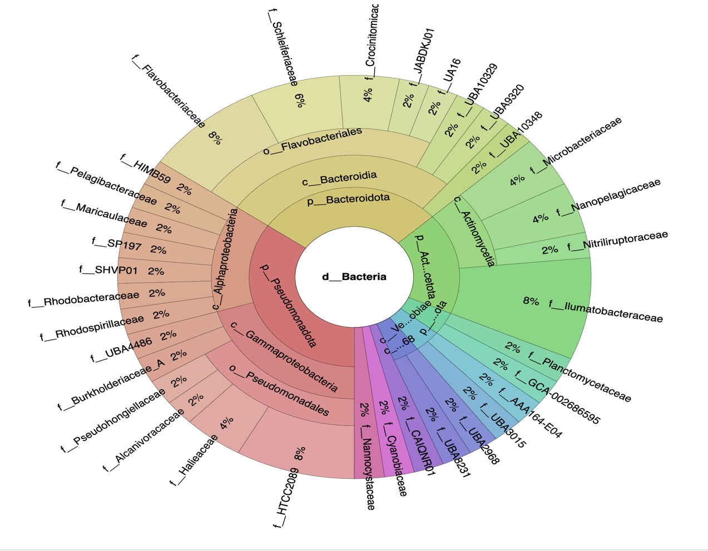
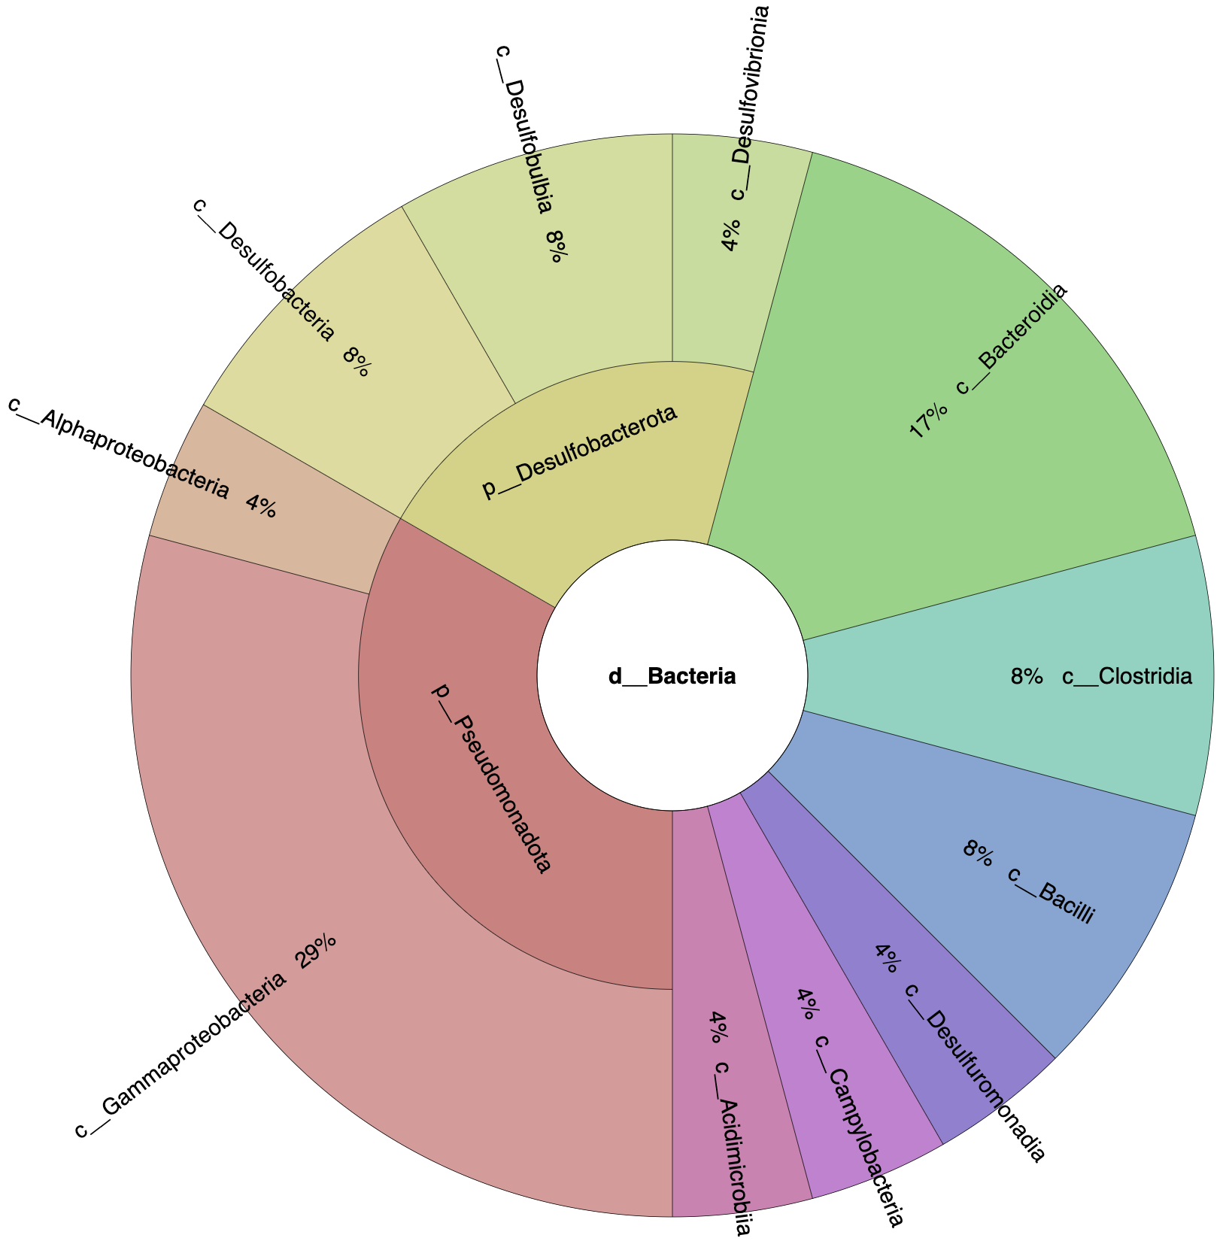
Figure 11: Krona plot of oxic day 0 microcosms with the proportion of MAGS represented at the family (top) and class (bottom) levels classified by GTDB-TK in Kbase.
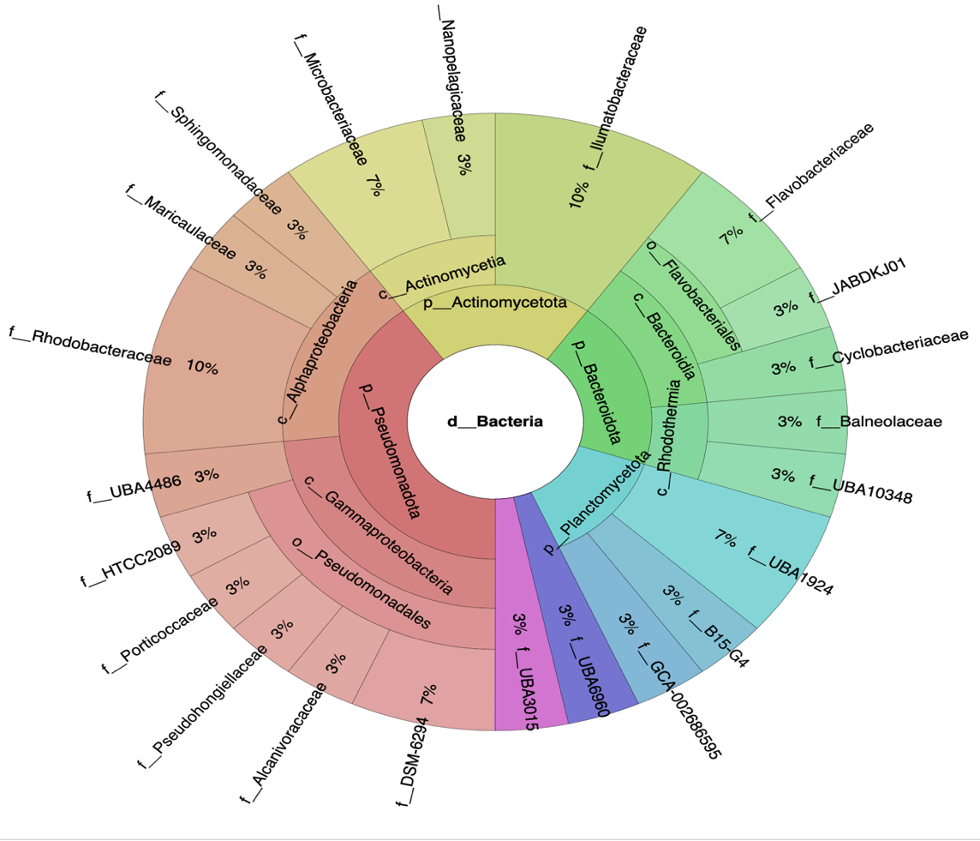
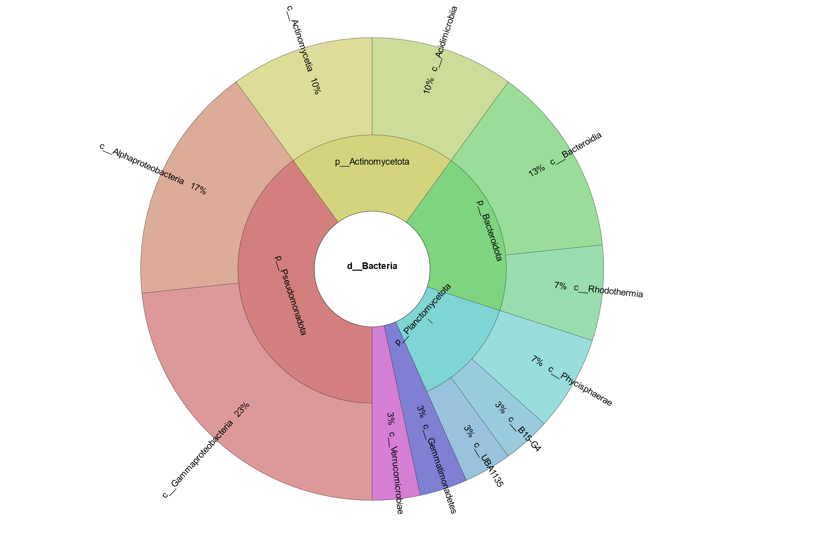
Figure 12: Krona plot of oxic day 5 microcosms at family (top) and class (bottom) levels produced by GTDB-TK in Kbase.
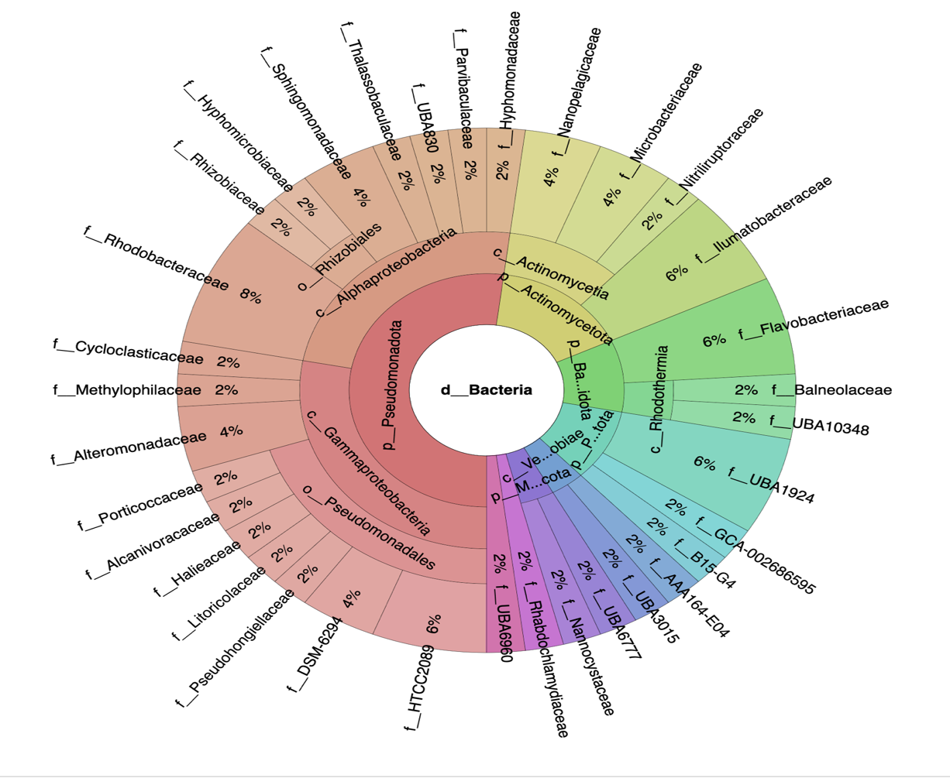
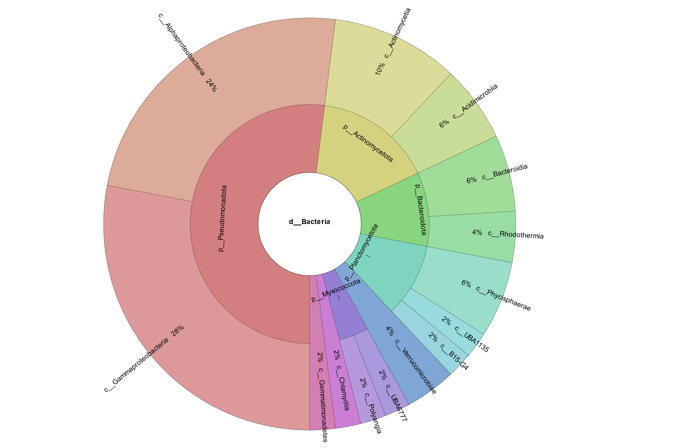
Figure 13: Krona plot of oxic day 15 microcosms with the proportion of MAGS represented at the family (top) and class (bottom) levels classified by GTDB-TK in Kbase.
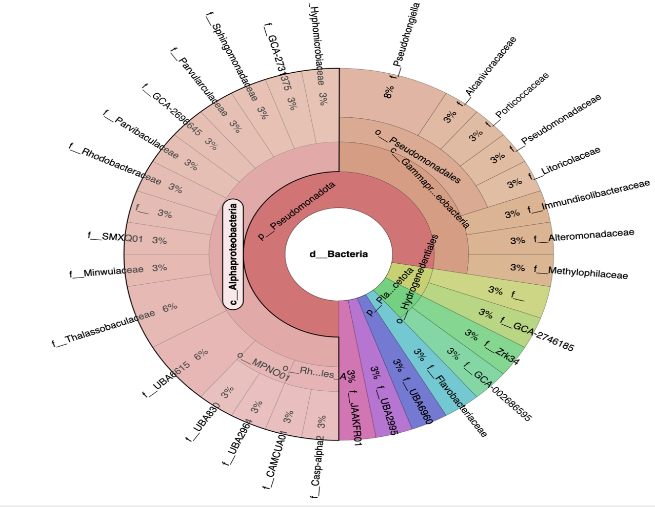
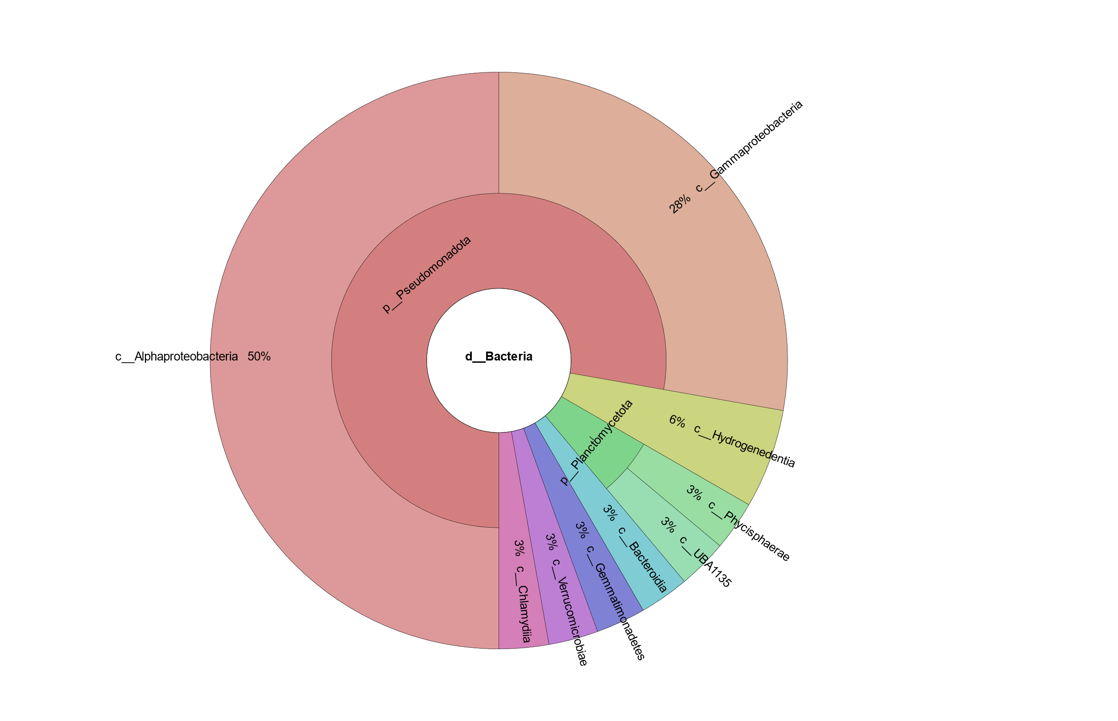
Figure 14: Krona plot of oxic day 115 microcosms with the proportion of MAGS represented at the family (top) and class (bottom) levels classified by GTDB-TK in Kbase.
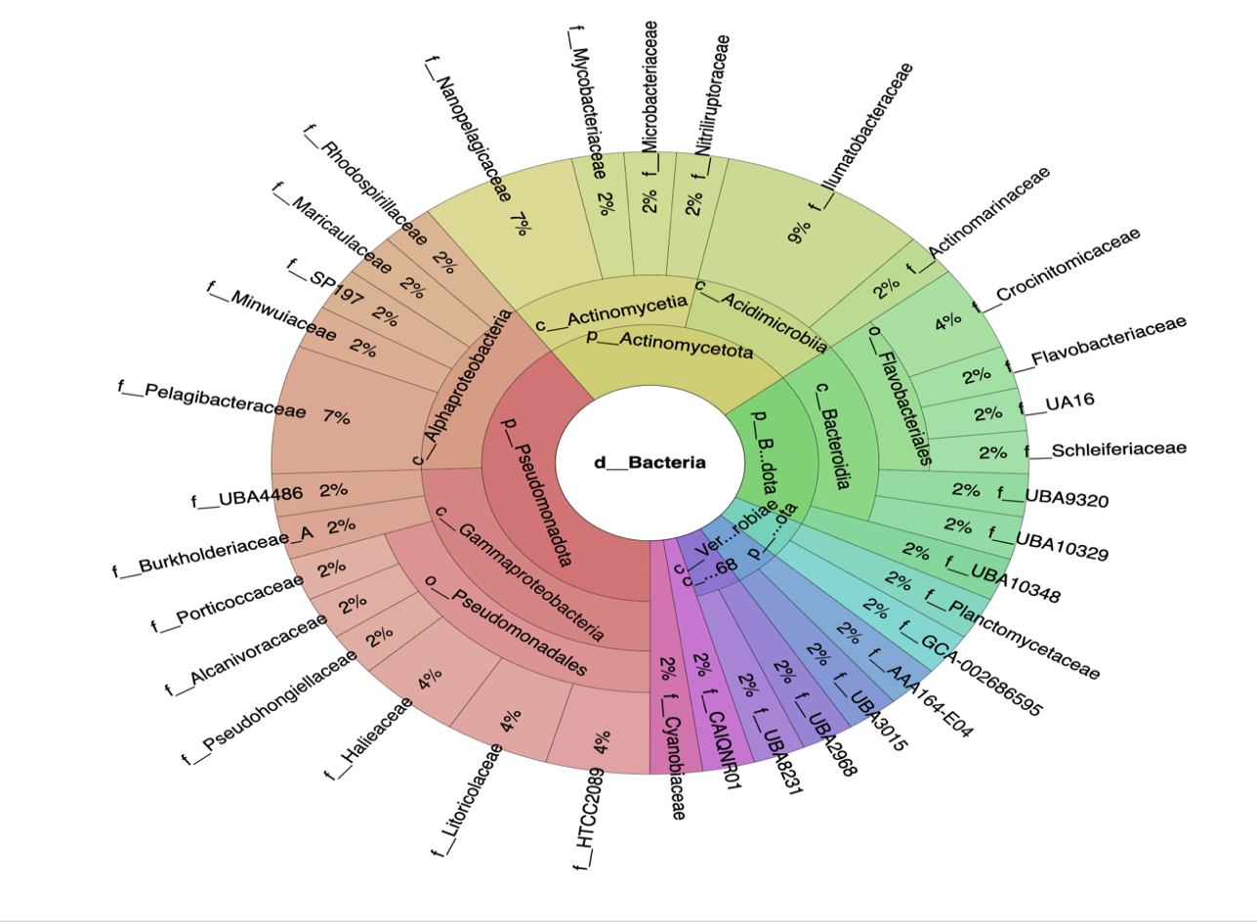
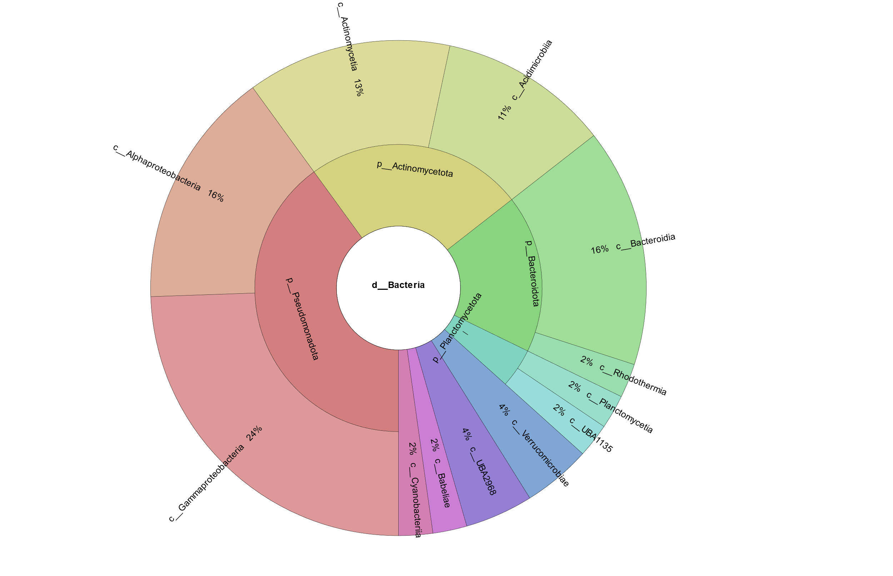
Figure 15: Krona plot of oxic day 0 control microcosms with the proportion of MAGS represented at the family (top) and class (bottom) levels classified by GTDB-TK in Kbase.
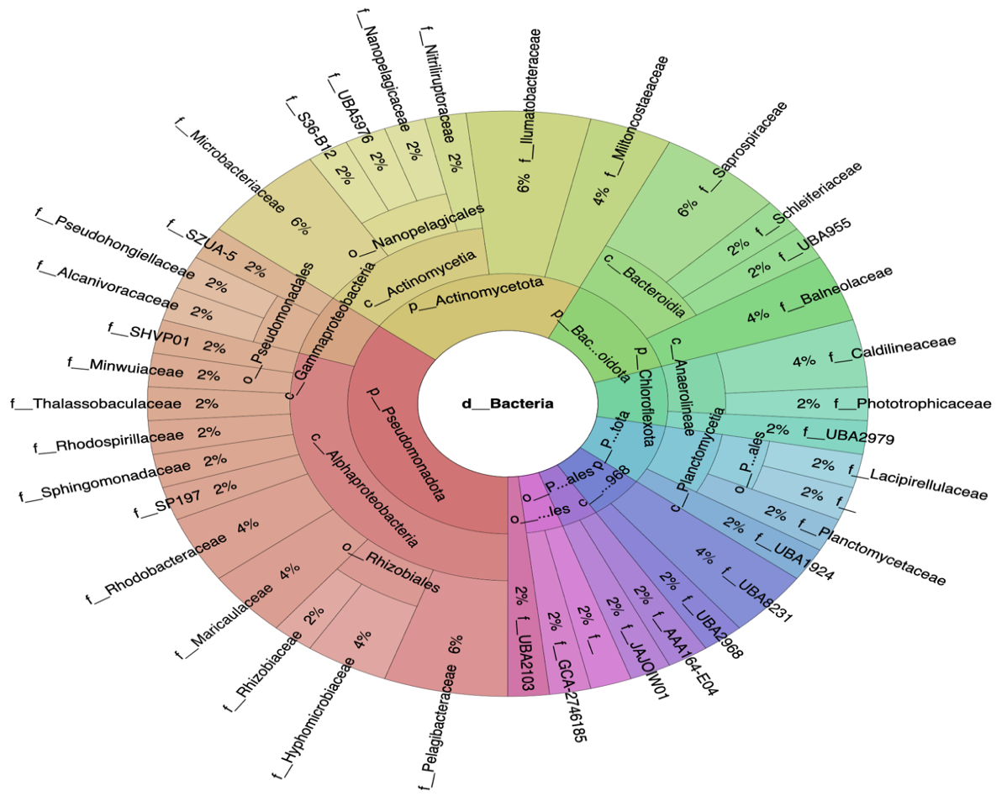
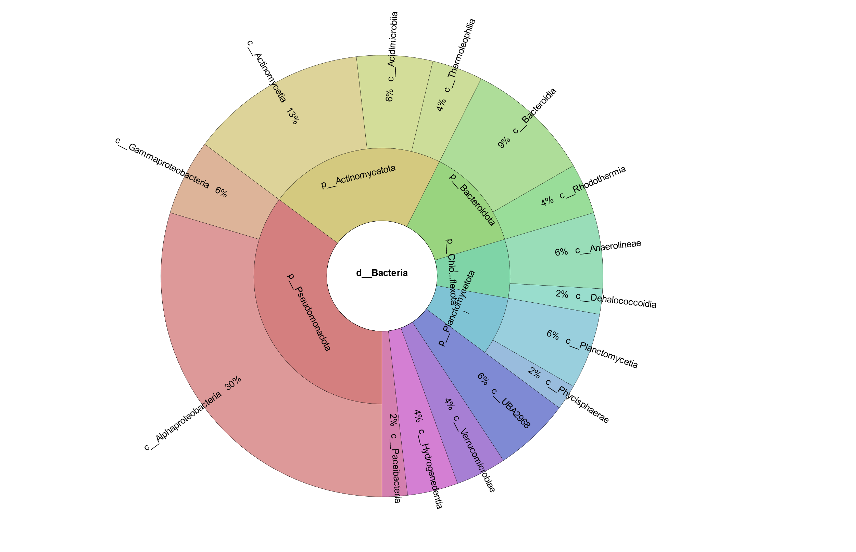
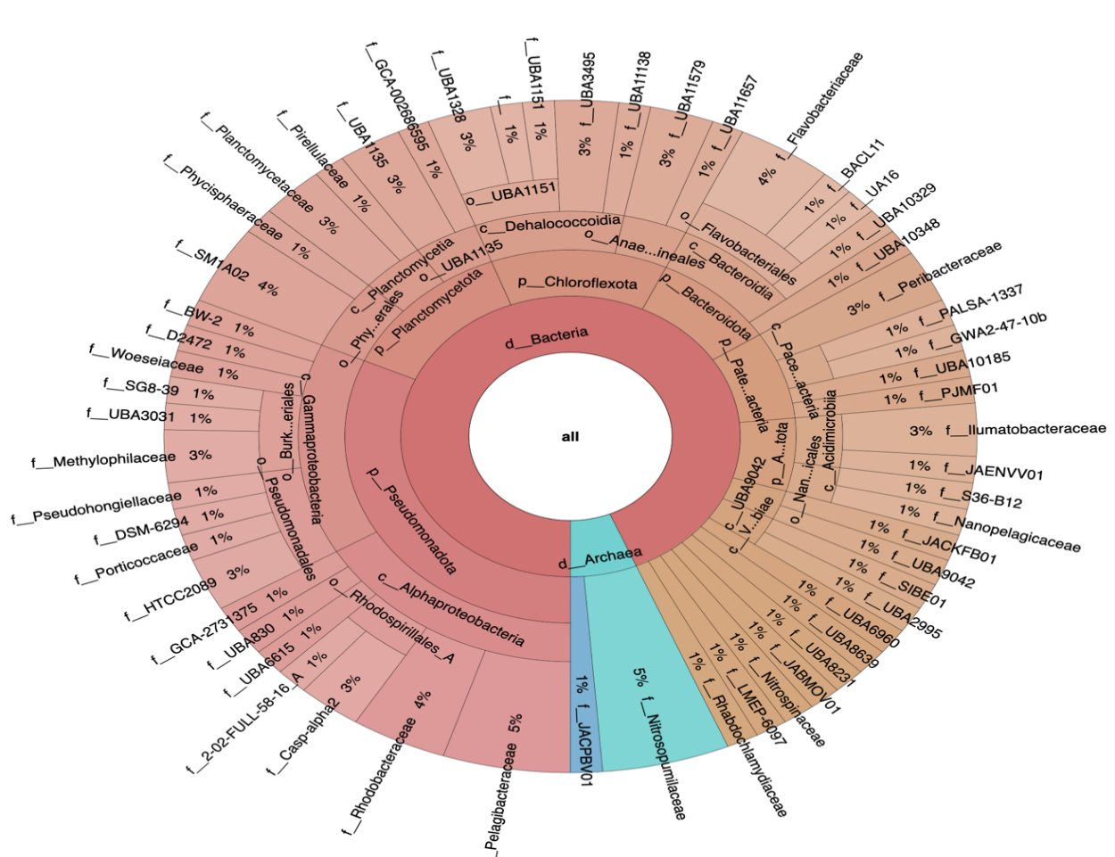
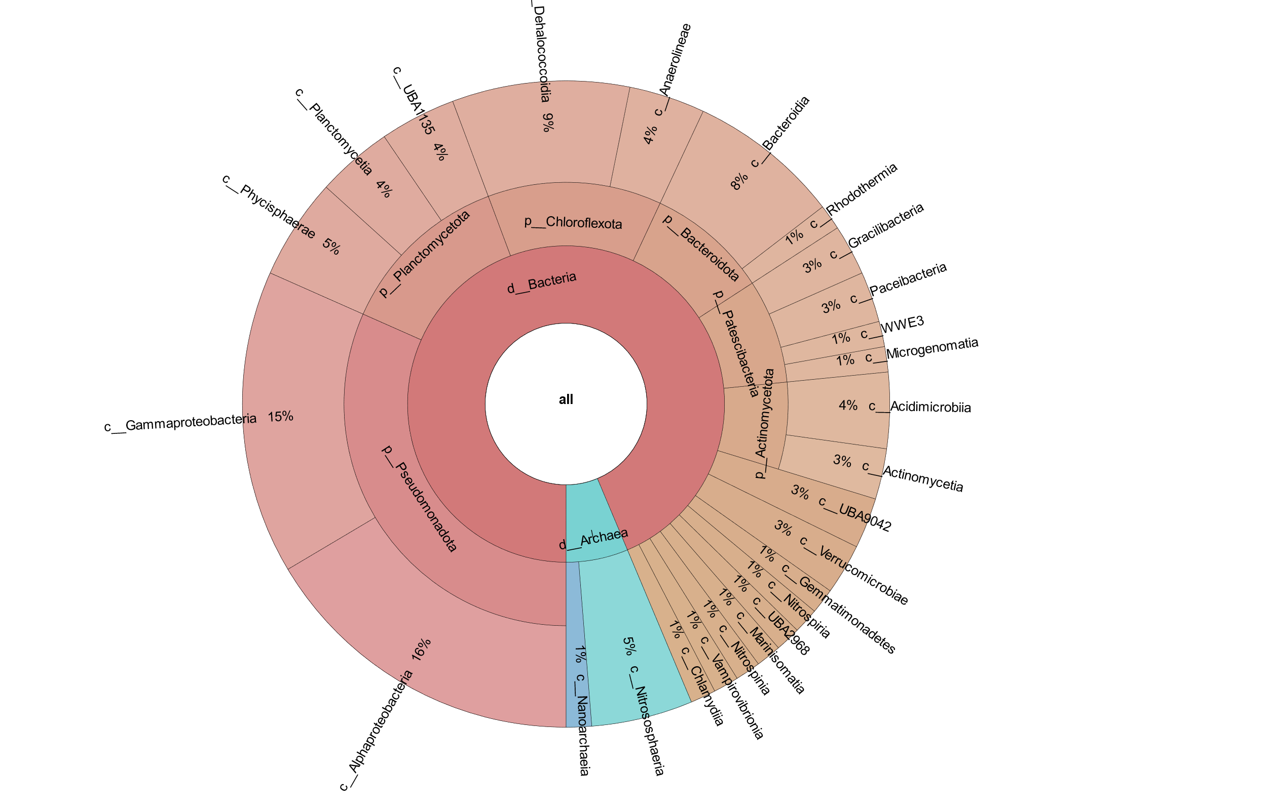
Figure 16: Krona plot of oxic day 115 control microcosms with the proportion of MAGS represented at the family (top) and class (bottom) levels classified by GTDB-TK in Kbase.
Figure 17: Krona plot of MAGs in hypoxic day 0 microcosms with the proportion of MAGS represented at the family (top) and class (bottom) levels classified by GTDB-TK in Kbase.
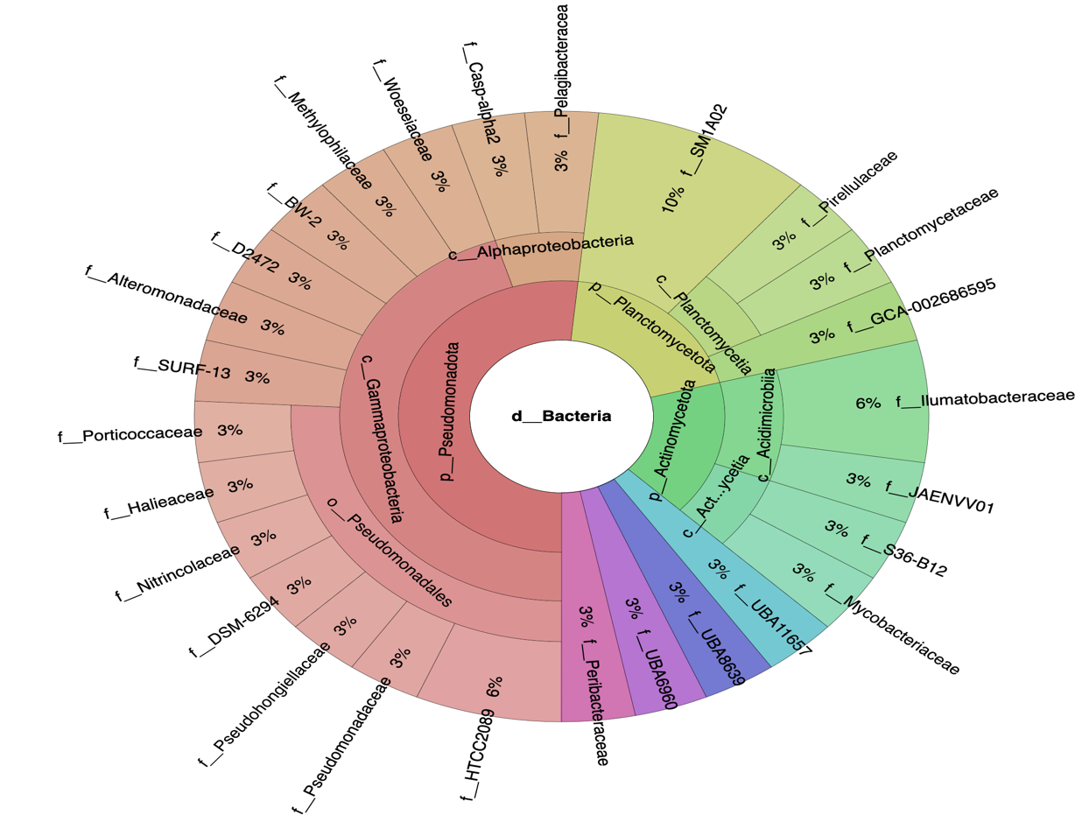
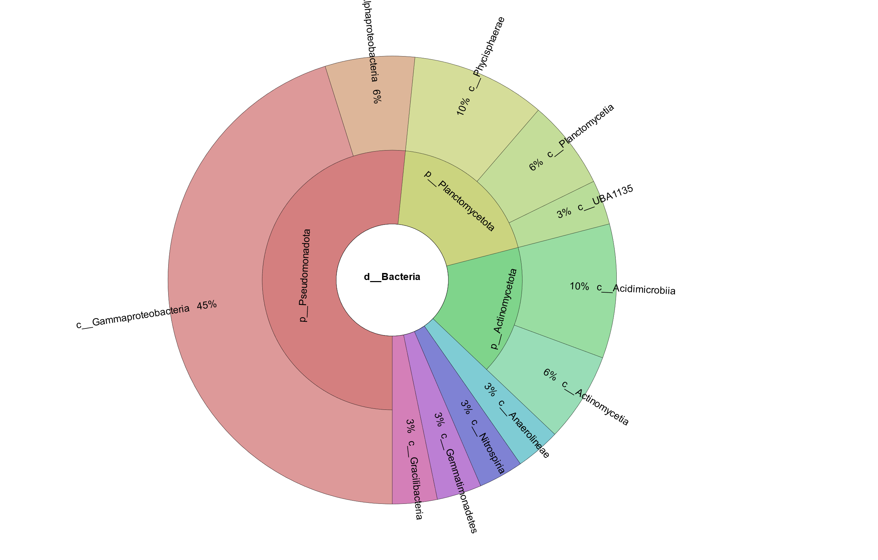
Figure 18: Krona plot of MAGs in hypoxic day 5 microcosms with the proportion of MAGS represented at the family (top) and class (bottom) levels classified by GTDB-TK in Kbase.
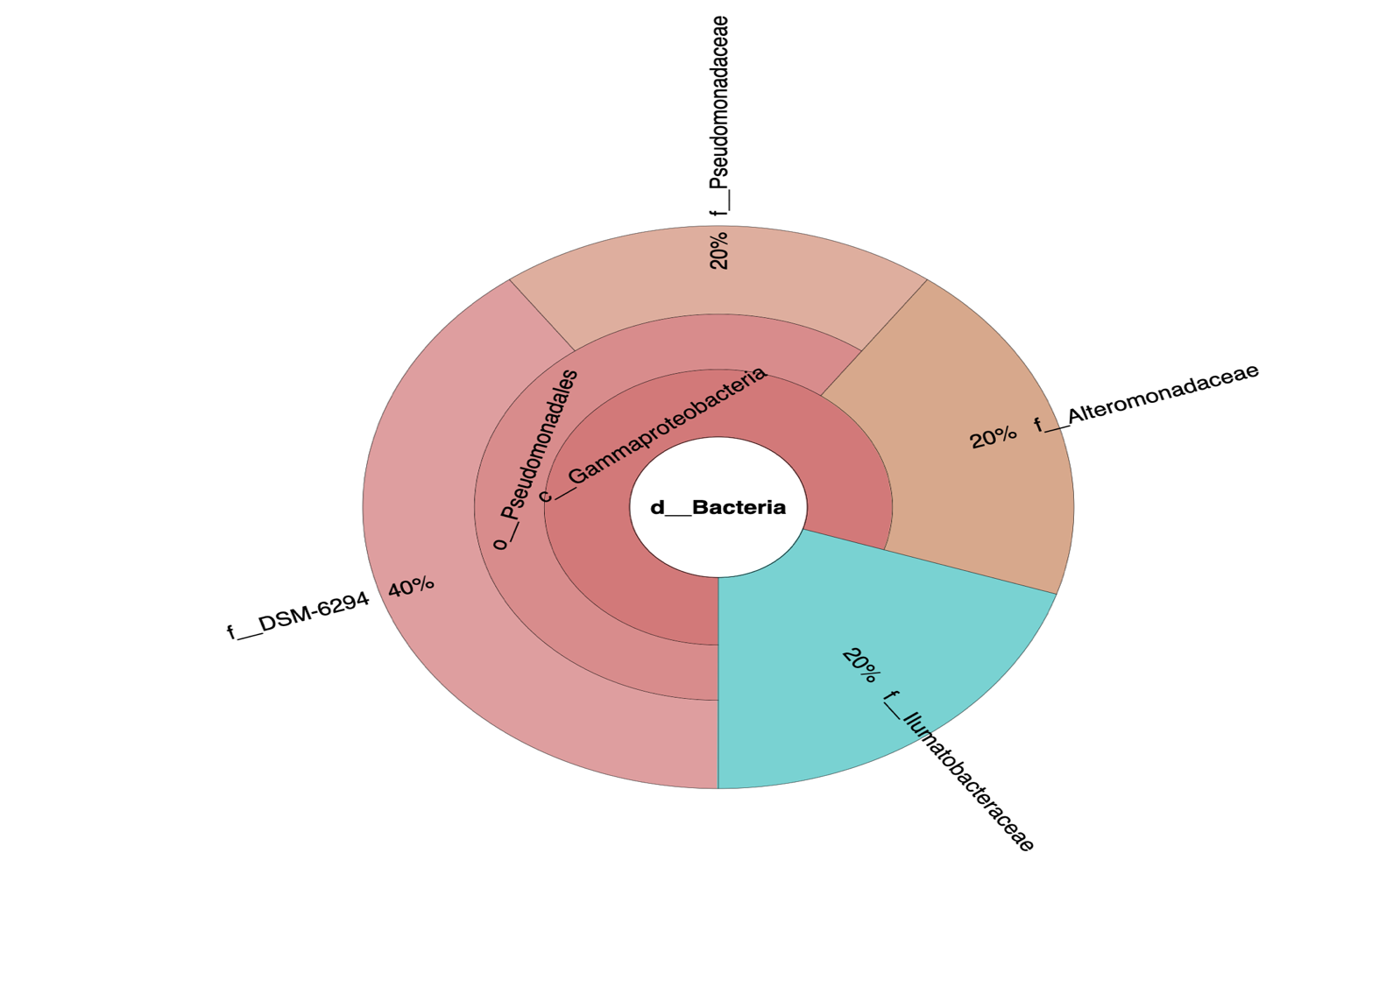
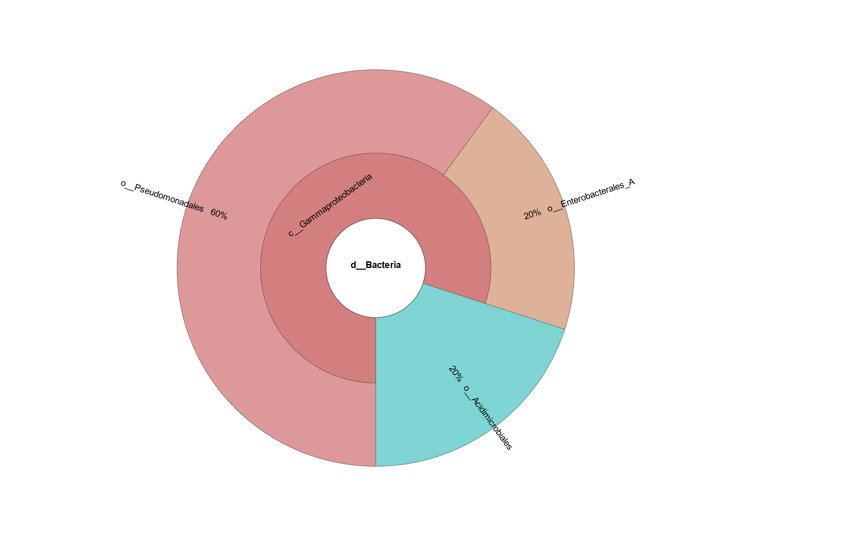
Figure 19: Krona plot of MAGs in hypoxic day 10 microcosms with the proportion of MAGS represented at the family (top) and class (bottom) levels classified by GTDB-TK in Kbase.
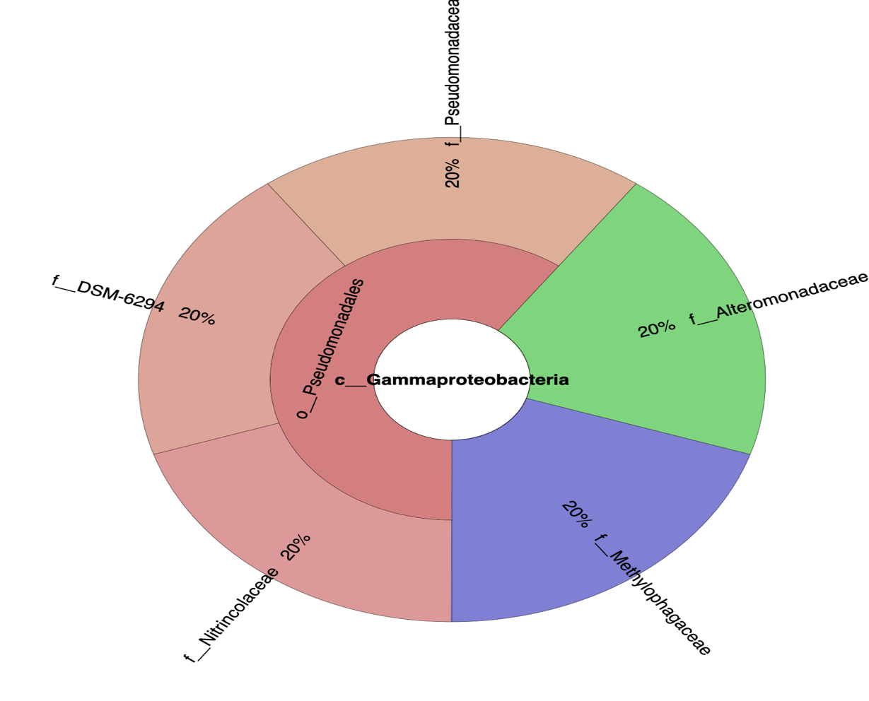
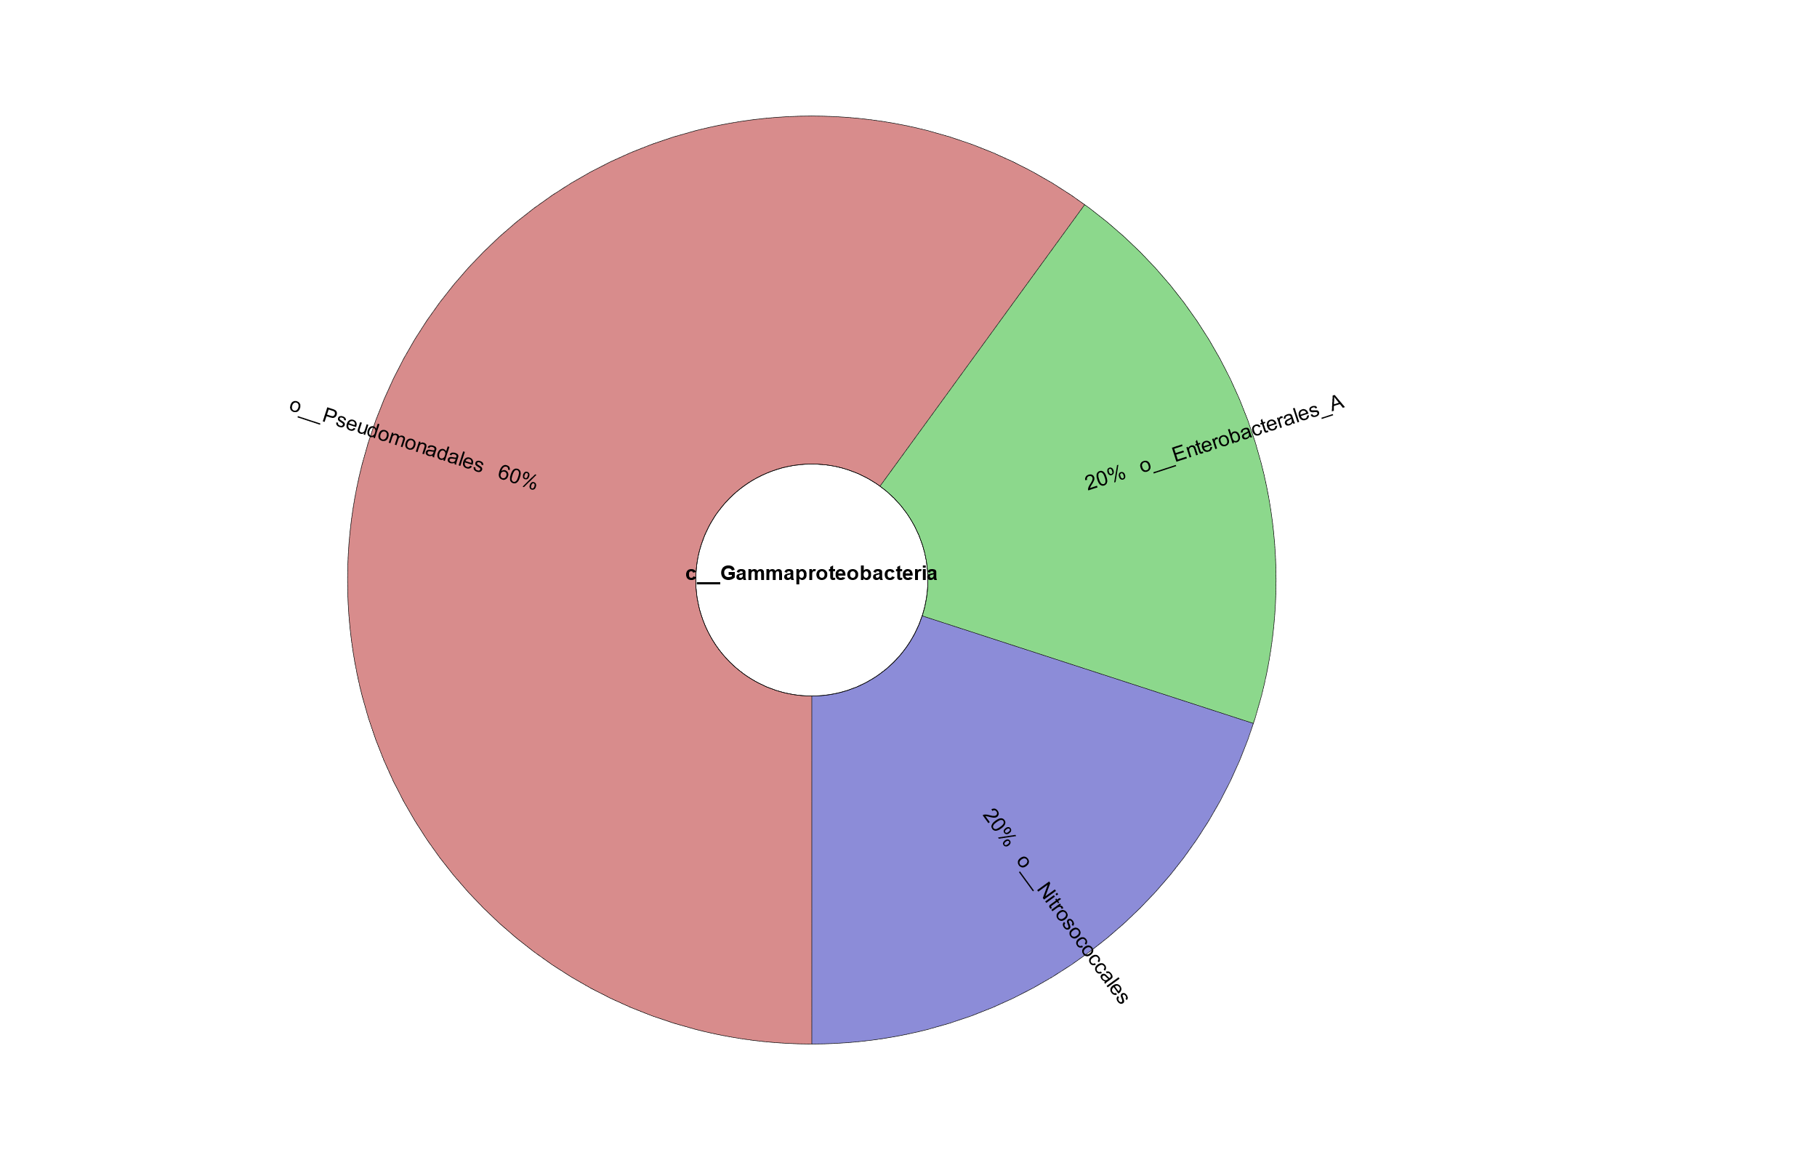
Figure 20: Krona plot of MAGs in hypoxic day 15 microcosms with the proportion of MAGS represented at the family (top) and class (bottom) levels classified by GTDB-TK in Kbase.
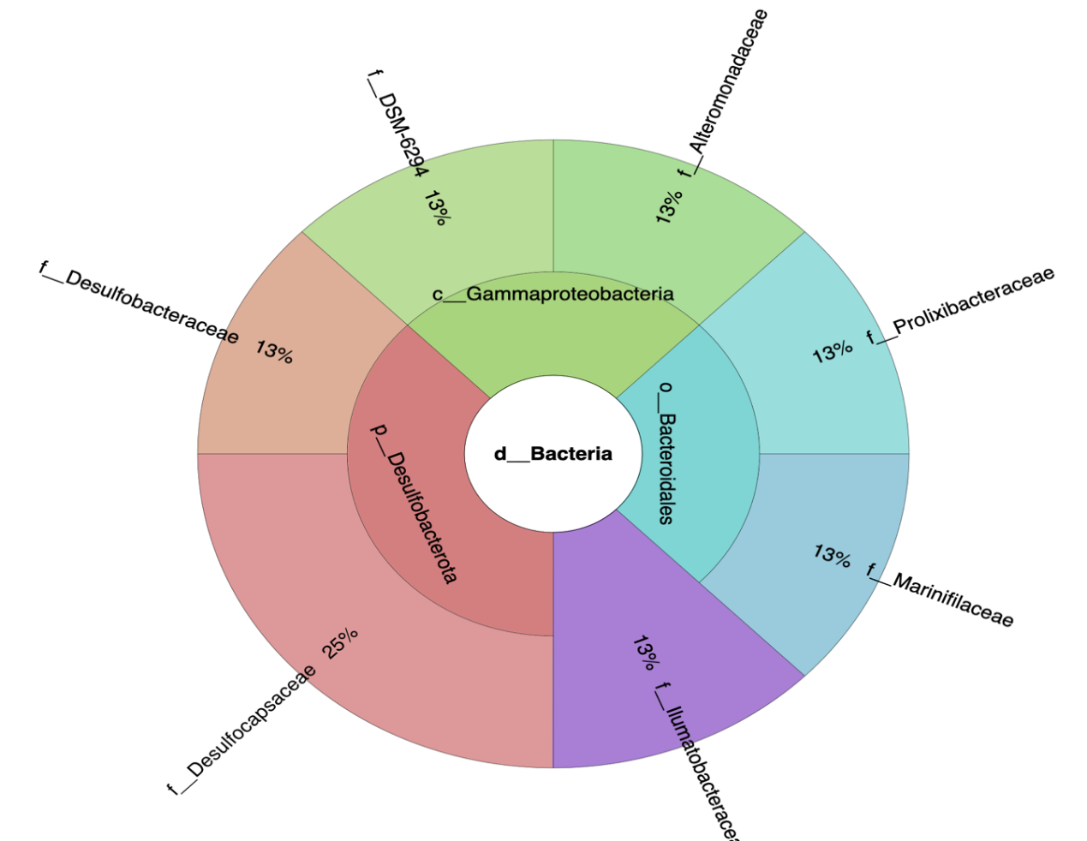
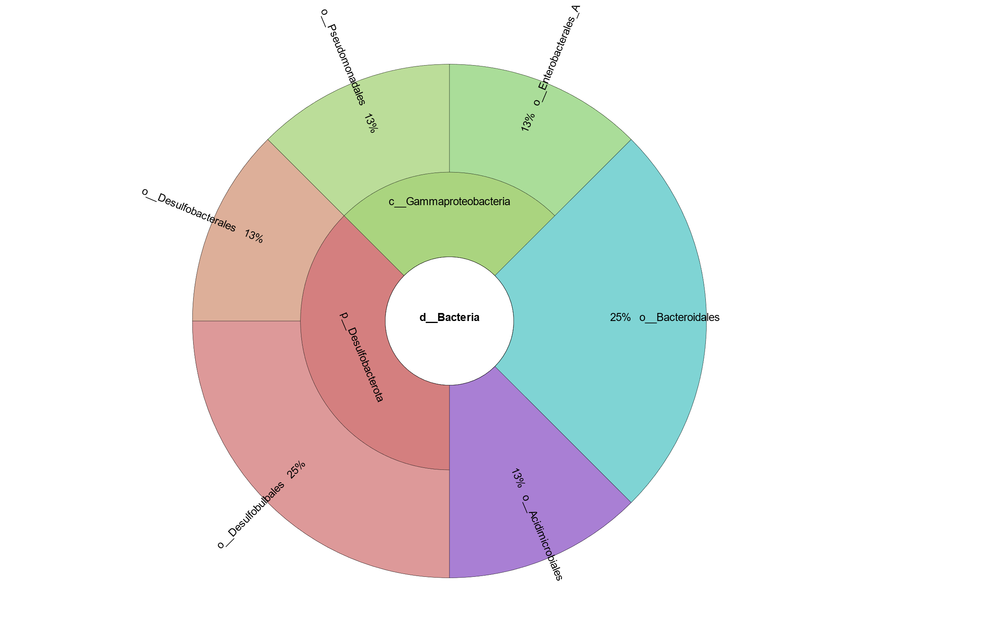
Figure 21: Krona plot of MAGs in hypoxic day 115 microcosms with the proportion of MAGS represented at the family (top) and class (bottom) levels classified by GTDB-TK in Kbase.
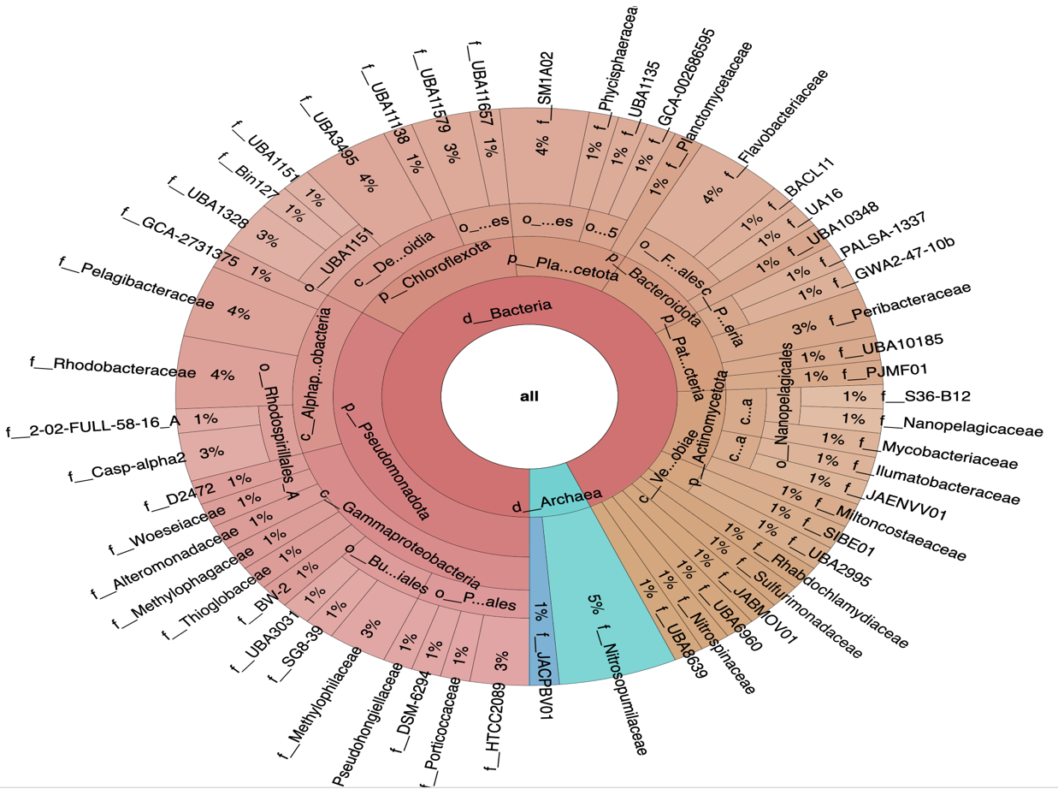
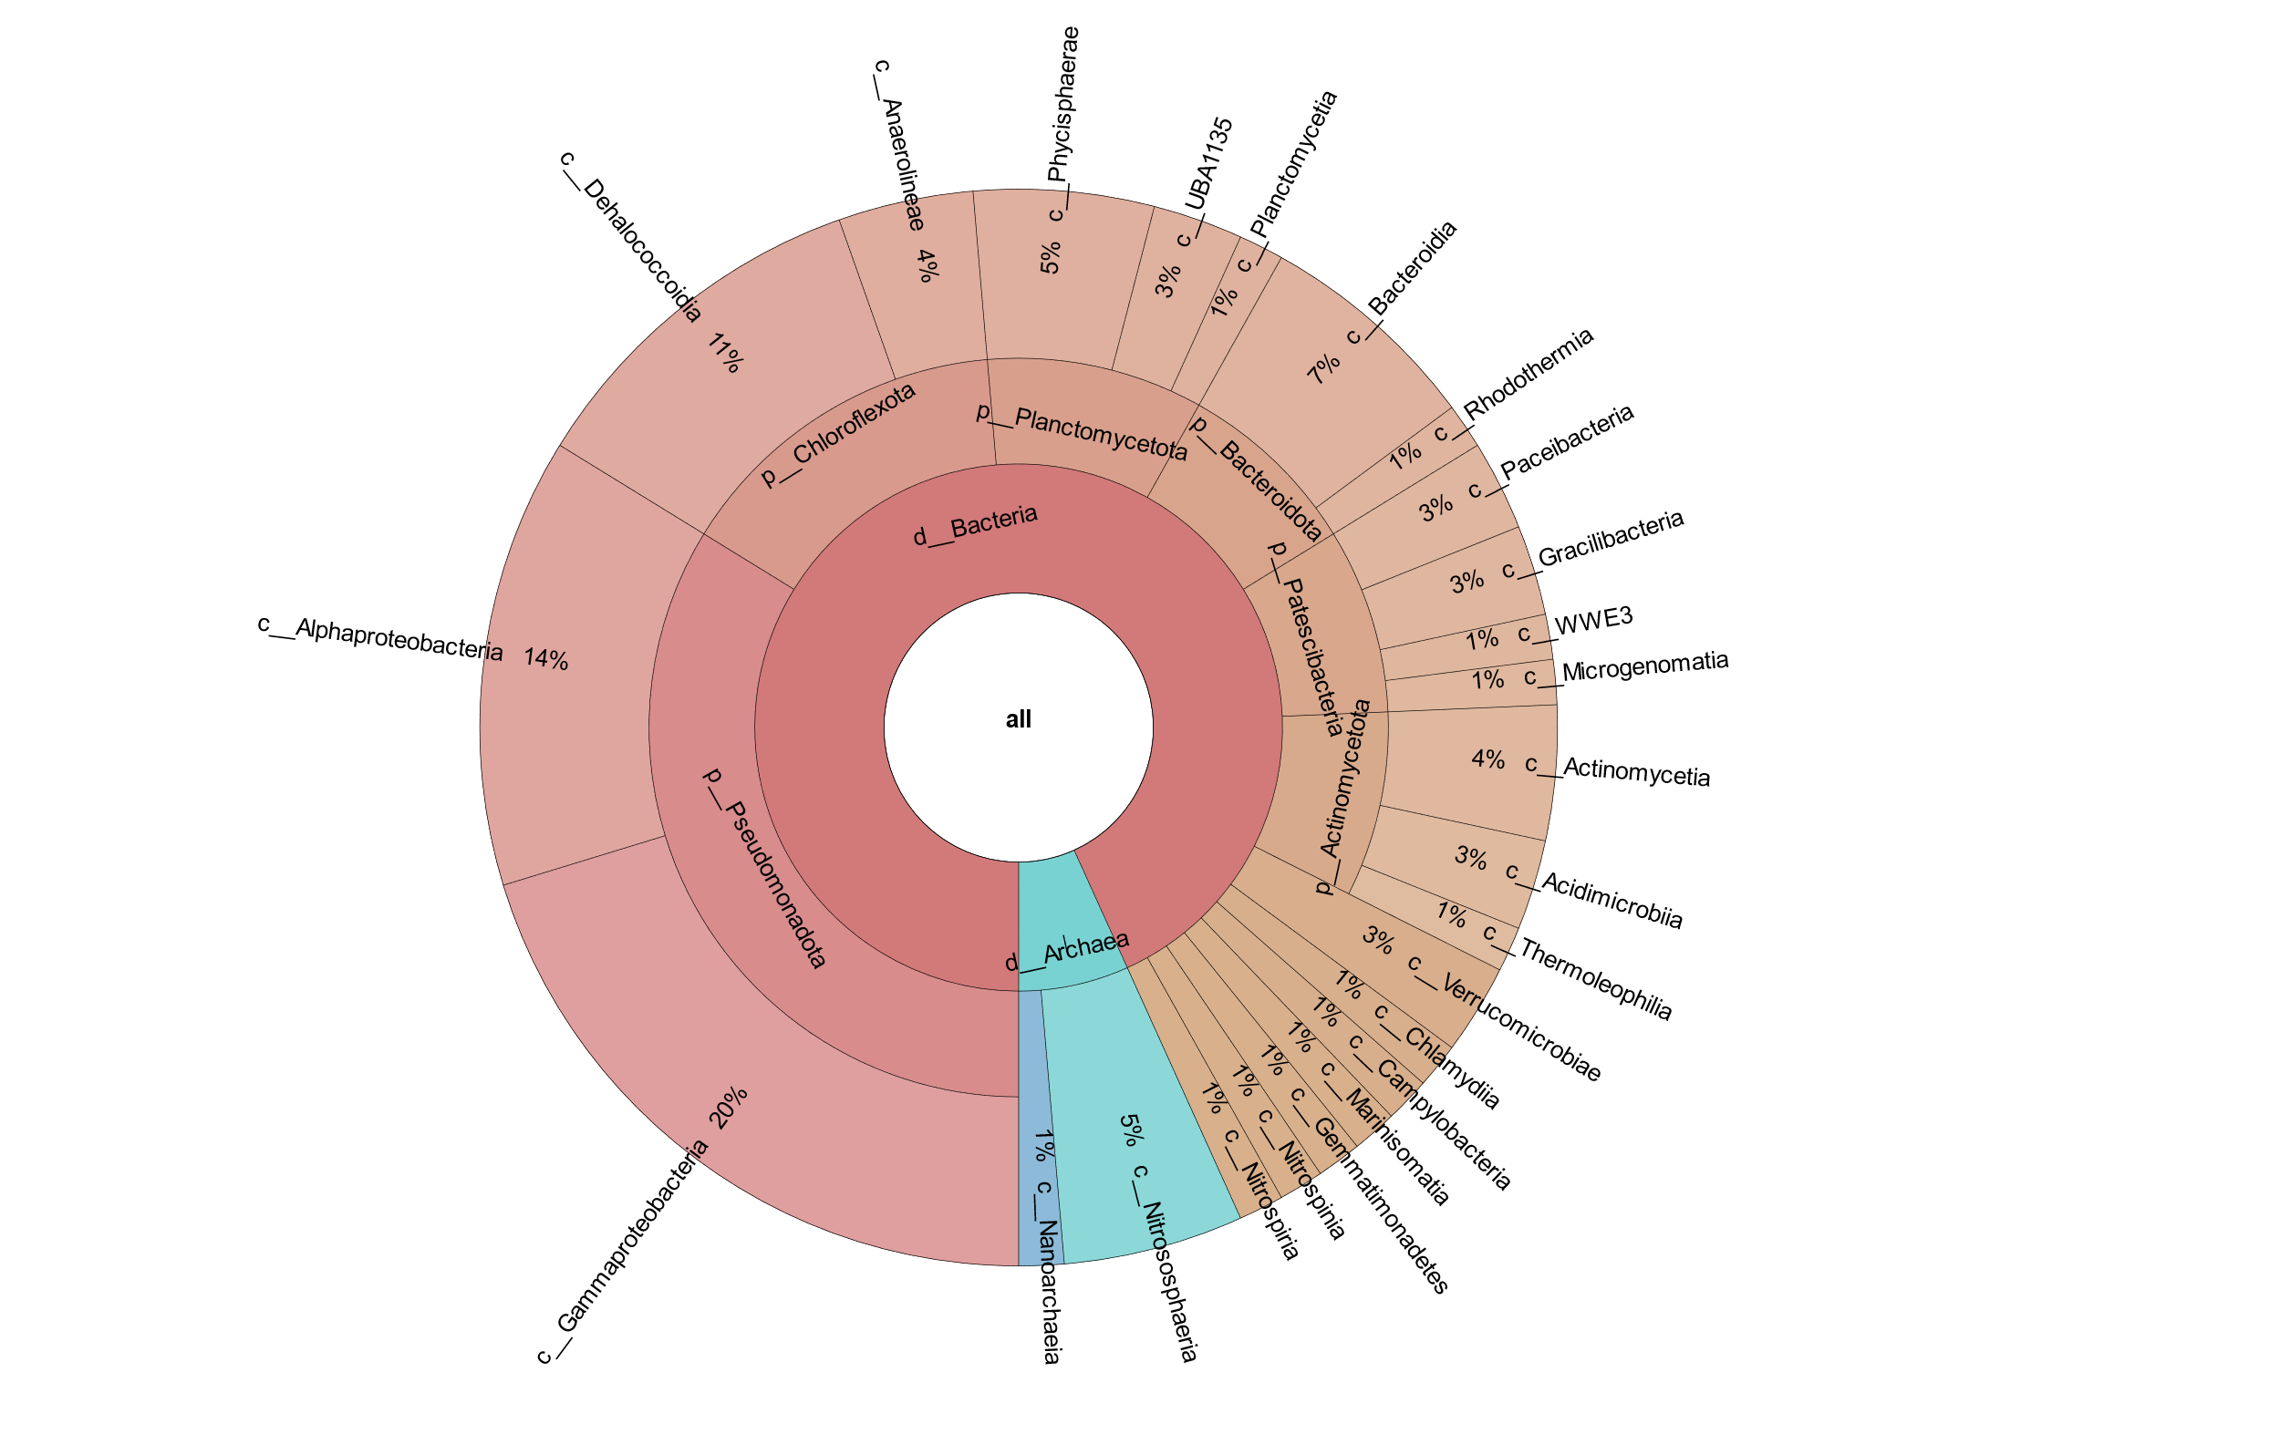
Figure 22: Krona plot of MAGs in hypoxic day 0 control microcosms with the proportion of MAGS represented at the family (top) and class (bottom) levels classified by GTDB-TK in Kbase.
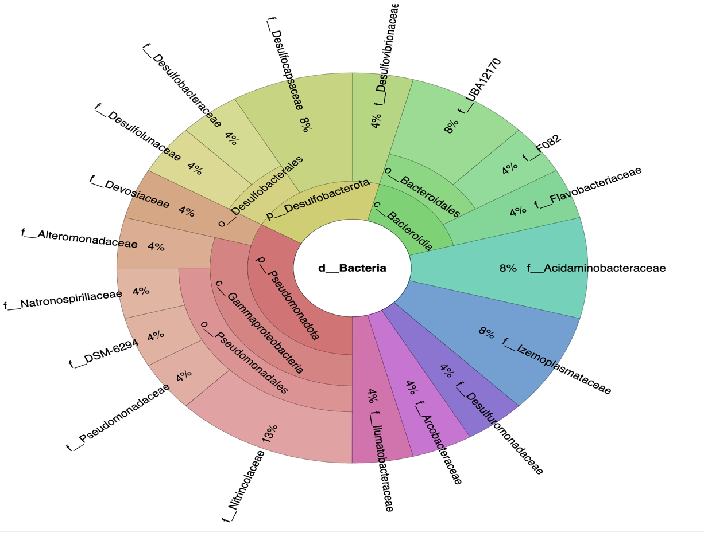
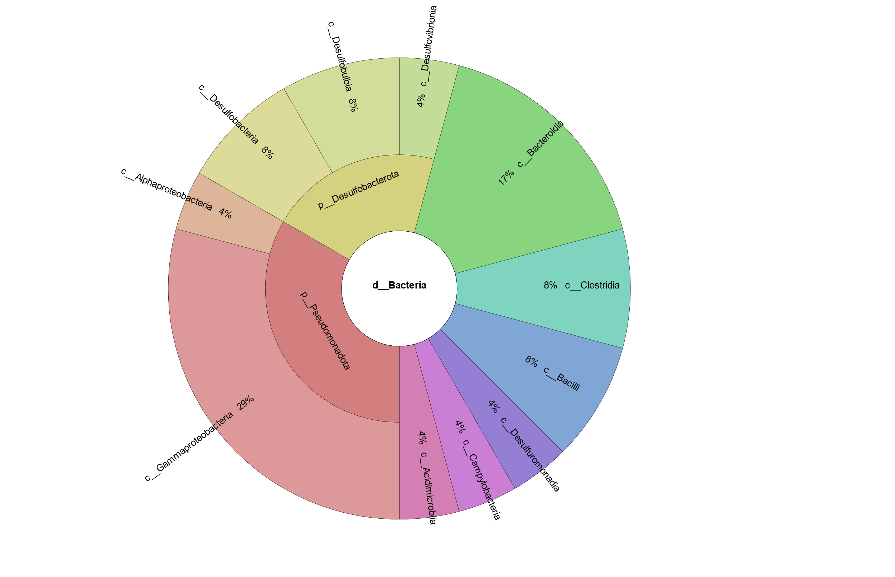
Figure 23: Krona plot of MAGs in hypoxic day 115 control microcosms with the proportion of MAGS represented at the family (top) and class (bottom) levels classified by GTDB-TK in Kbase.

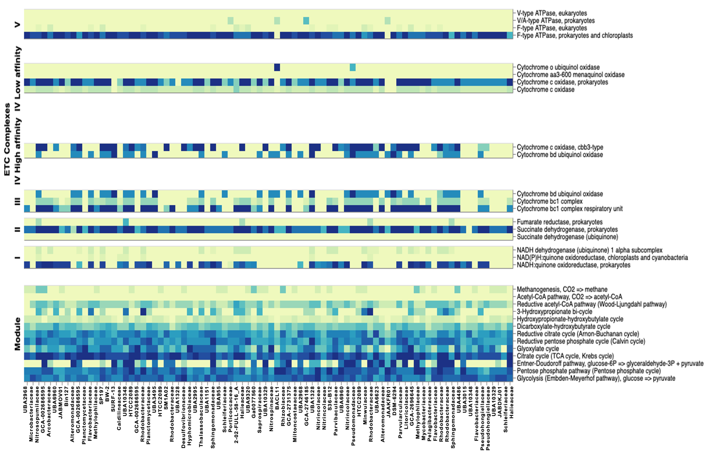
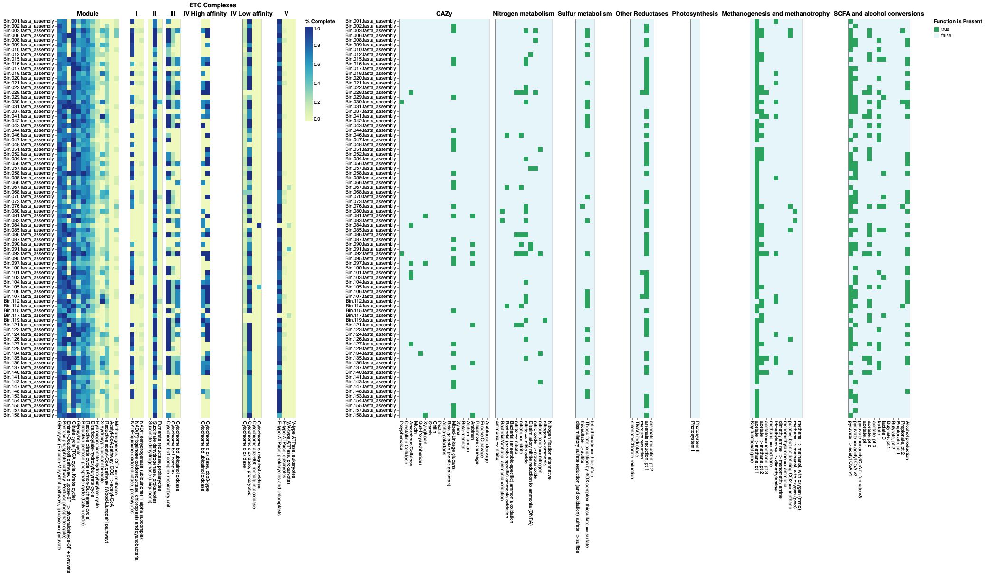
Figure 24: DRAM product output showing percentage completion of energy-deriving pathways and electron transport chain components in co-assembled oxic microcosms.

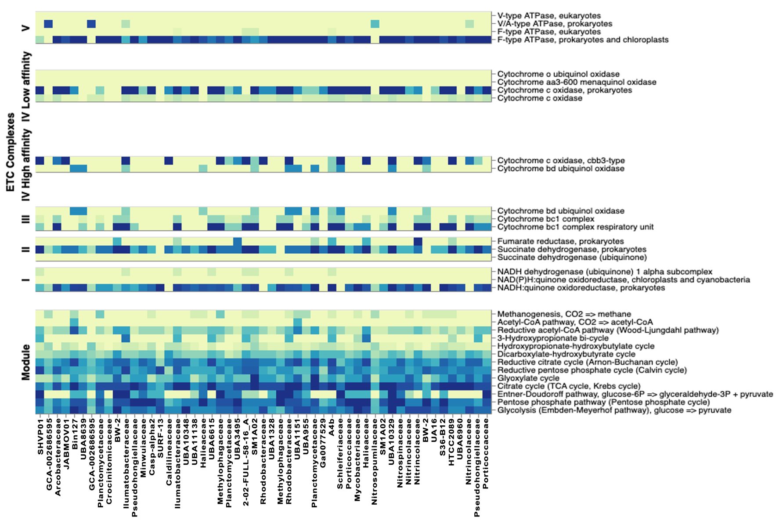
Figure 25: DRAM product output showing percentage completion of energy-deriving pathways and electron transport chain components in co-assembled hypoxic microcosms.
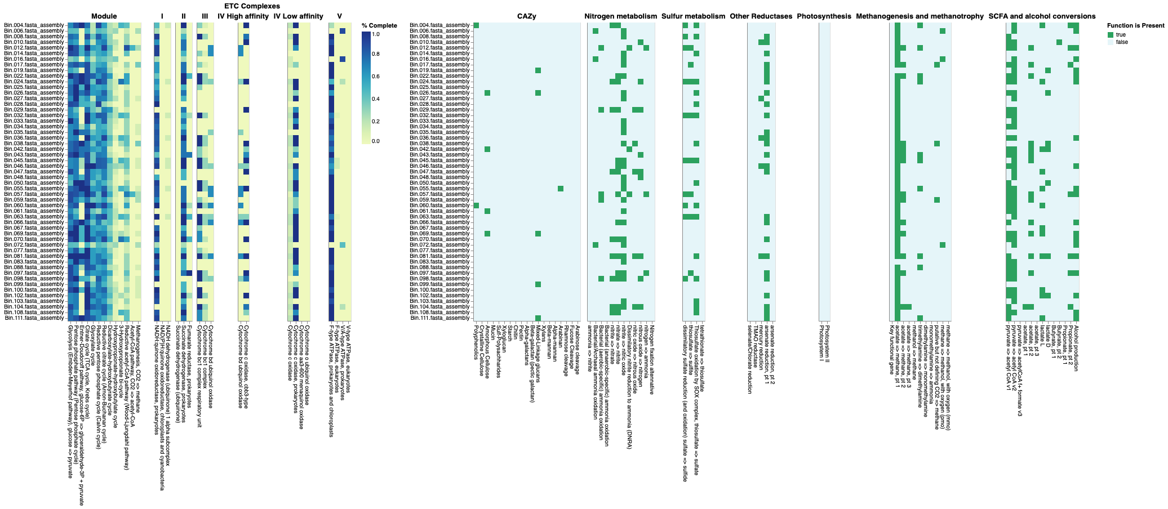
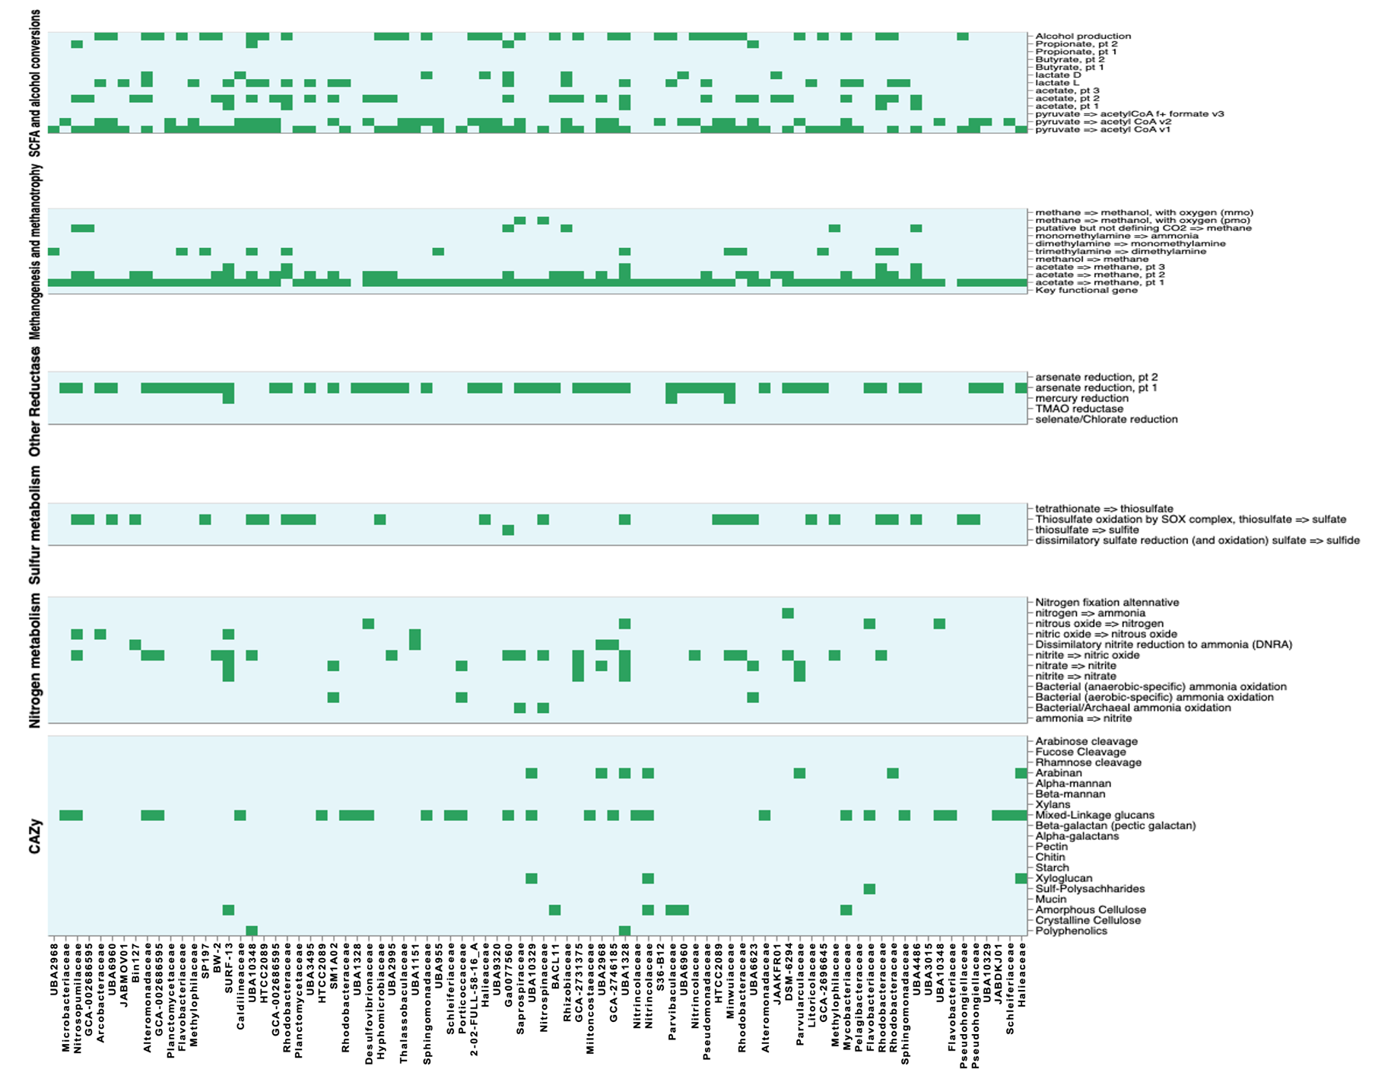
Figure 26: DRAM product output showing presence or absence of genes related to metabolism of dbCAZY molecules, nitrogen and sulphur in co-assembled oxic microcosms.
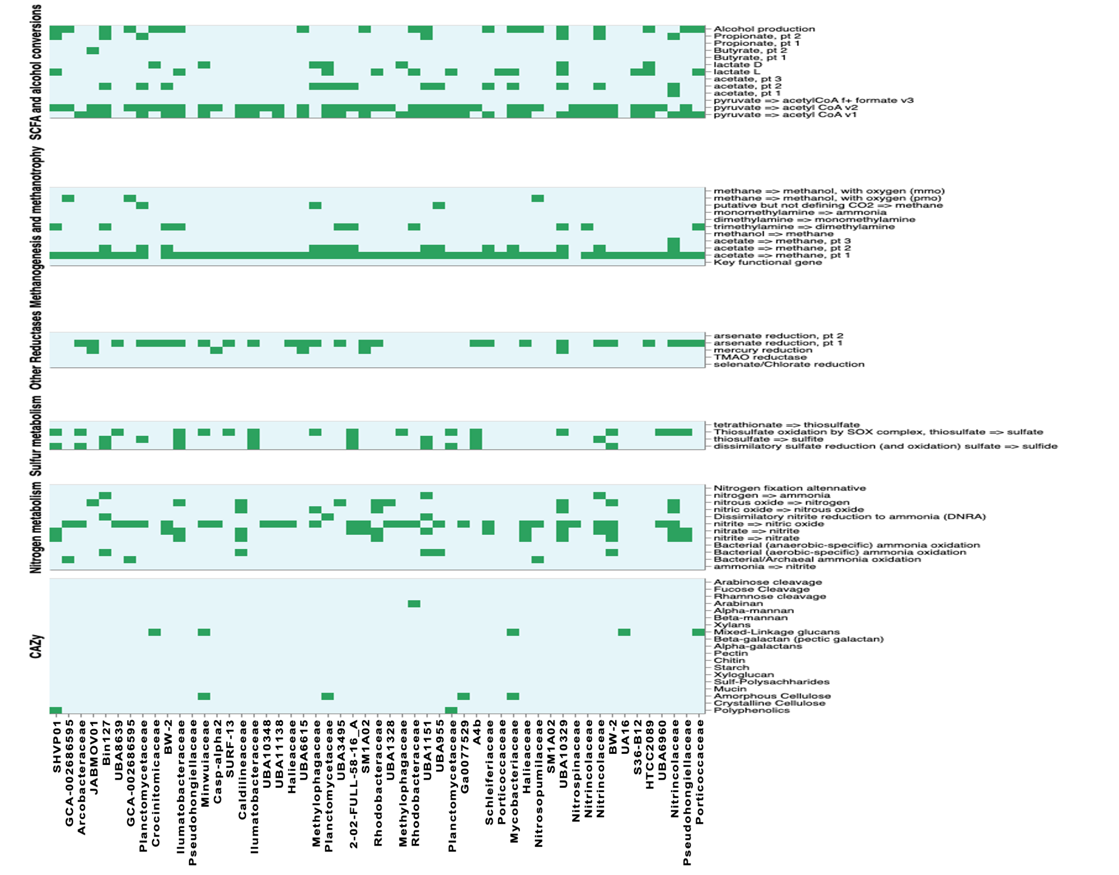
Figure 27: DRAM product output showing presence or absence of genes related to metabolism of dbCAZY molecules, nitrogen and sulphur in co-assembled hypoxic microcosms.

CHAPTER IV
Creating Hidden Markov Models to Identify Homologous Hydrocarbon-Degrading Genes in Caspian Metagenome

Abstract

Functional genes are often used as biomarkers in the assessment of hydrocarbon metabolism. Metagenomic techniques have enhanced our ability to integrate information about hydrocarbon-degrading consortia with their environmental systems while expanding the information available in public databases. However, the lack of manual curation of ‘omic’ datasets has led to the mis-annotation of some these gene and protein sequences in several of these public databases. Genes involved in hydrocarbon degradation share sequence similarity to genes from other metabolic pathways which consequently results in frequent mis-annotation (Khot et al., 2022). Another major limitation in the functional annotation of hydrocarbon-degrading organisms is the lack of sufficient matches to newly sequenced or highly diverse organisms. Ramsden (2015) highlighted that a third of the sequences from newly sequenced organisms do not produce sufficiently similar matches to known sequences in existing databanks to allow for definitive annotation. Additionally, errors in the sequences uploaded to databases can also affect sequence identification and annotation. These errors not only impact the subject organism, but may propagate to subsequent annotations of new organisms (Ramsden, 2015). We noticed these limitations during the functional annotation of the metagenomes derived from the Kbase pipeline in the previous chapter. Functional annotations made with DRAM and RAST were the first steps in our annotation process, but there was a need to derive a method for more specific functional annotation directed at hydrocarbon degradation.
There have been limited attempts at manually cataloging hydrocarbon-degrading genes and proteins which have resulted in the compilation of a few databases: AnHyDeg (Callaghan & Wawrik, 2016), AromaDeg (Duarte et al., 2014), CANT-HYD (Khot et al., 2022) and HADEG (Rojas-Vargas et al., 2023). Most of these curated databases were compiled with sequences obtained from public databases of experimentally verified or putative hydrocarbon degrading enzymes. Typically, BLAST is used to compare sequence similarities between these manually curated or public databases and project sequence data. However, the issues of mis-annotation may still arise with the immense diversity in hydrocarbon-degrading organisms and their metabolic pathways. An alternate approach to using local alignments, such as BLAST, to compare sequence similarities and annotate genomes is the use of probabilistic models known as Hidden Markov Models (HMMs) (Gollery, 2008).
HMMs are particularly useful for enzymes like those involved in hydrocarbon degradation, where studies have shown mis-annotation in public databases and/or sequence divergence in microbial species. An HMM trained on well-characterized hydrocarbon degradation enzymes can effectively identify functionally similar sequences and can be a useful tool to aid in functional prediction for metagenomes. The Caspian Sea has been isolated from other water bodies for millions of years. Thus, the distribution and diversity of hydrocarbon-degrading organisms might be overlooked due to distant evolutionary relationships or the lack of cultured and identified organisms in the databases. The use of HMMs as a tool to analyze the likelihood of different hidden states to predict functional capabilities will aid in the classification of our metagenomic data.

Introduction

What are Hidden Markov Models (HMMs)?
Hidden Markov Models (HMMs) are statistical models that calculate probabilities of observable outputs/emissions from systems with “hidden” or unobservable states (Gollery, 2008; Yoon, 2009). The “Markov” property refers to the nature of these transitions, where the probability of transitioning to a new state is only dependent upon the current state and not the states that preceded it (Eddy, 2004; Gollery, 2008; Jurafsky & Martin, 2008). HMMs will have the following properties: hidden states, observations, transition probabilities, emission probabilities and initial probabilities associated with the initial and final states (Jurafsky & Martin, 2008; Rabiner, 1989). Originally, HMMs were used in speech recognition where the hidden states were words/phonetic units (Jurafsky & Martin, 2008; Visser & Speekenbrink, 2010). Due to their usefulness in pattern recognition, their popularity spread to other fields including their usage in biological sequence analysis (Eddy, 2004; Gollery, 2008; Visser & Speekenbrink, 2010; Yoon, 2009). In the case of gene sequences, the hidden states might represent different types of sequence regions (e.g., exons versus introns in a gene) and the observed states are the nucleotide bases in the gene itself or amino acids it encodes for a given enzyme or protein.

Sequence Homology
Sequence homology in DNA, RNA and protein sequences refer to sharing a common ancestor or evolutionary origin (Koonin E.V. & M.Y., 2003; Mier et al., 2018). Homology in genetics might presume that two genes with similar sequences will have similar functions and a common ancestor from which they descended (Pearson, 2013). However, the relationships between homology and function are complex and even homologous protein sequences may not always share enough significant sequence similarities to allow for their annotation, especially in distantly related organisms. Evolutionary changes from the ancestral organism might have resulted in the accumulation of mutations (insertions, duplications or deletions) that have no effect on protein function while reducing sequence similarity (Durbin, 1998; Gollery, 2008; Pearson, 2013). Making use of algorithms and software to detect the distant relationships between these organism is crucial for understanding evolutionary relationships, predicting protein function and annotating genomes (Eddy, 2009). To identify these homologous regions, profile HMMs are constructed from multiple sequence alignments (MSA) of known related sequences that are of interest. These MSAs may be constructed from a full length protein sequence, specific conserved domains, enzyme active sites or variable regions (Gollery, 2008). The profile HMMs can then be used to model the statistical properties of the sequence alignments to capture the variability and conservation patterns across different biological sequences (Figure 28). By modeling these regions, HMMs provide valuable insight into the molecular and biological activities of proteins which aids functional prediction.

What is HMMER?
To utilize the potential of HMMs in sequence analysis or protein annotation, HMMER was developed by Eddy and company. HMMER is a powerful tool that is able to make these probabilistic models (HMMs) and then use it to search sequence databases or other curated databases for homologous protein or DNA sequences. The use of HMMs has expanded since their first introduction into the biological sciences. Protein family databases such as Pfam and InterPro heavily utilize the HMMER software to align and identify target sequences to protein domains (Finn et al., 2011; Sonnhammer, 1998). HMMER utilizes a set of algorithms to consider all possible alignments to provide a score that rates the relative likelihood or confidence that there is a match within the alignment. These properties are what makes HMMER useful in determining the relationships between distantly related sequences, even when there is no optimal alignment (Eddy, 2023).

How the HMMER pipeline works
The Eddy Lab provided a very detailed description into how HMMER operates in the software user guide and its applications in sequence analysis. As previously mentioned, HMMER produces its results through a pipeline of different algorithms that calculates the probability score over an ensemble of alignments and the expectation values (e-values) for these scores. This expectation value represents the statistical significance of the target from the rate of false positives observed. First HMMER calculates a score for the “null hypothesis” which assumes the target sequence(s) is unrelated to the profile HMM. This score correction helps to convert the scores into a log-odds score that shows the likelihood the target sequence(s) is a match. The Multiple Segment Viterbi (MSV) algorithm then looks for high-scoring matches with ungapped alignments. If the score passes a certain threshold, the sequence passes to the next step – the bias filter. To reduce false positives due to biased sequence composition, a correction step is applied to adjust the MSV score. If this corrected score is still above the threshold, the sequence(s) continues through the pipeline. The target sequence(s) is then aligned to the profile HMM using a stringent yet accelerated Viterbi algorithm which calculates an optimal gapped alignment score. Sequences with scores that met the threshold are then aligned to the profile HMM using the full Forward algorithm. The full probability of the target sequence(s) is calculated while considering all possible alignments. The results from the Forward filter/parser are then combined with those of its counterpart, the Backward parser. The Forward/Backward evaluates these alignments by calculating the likelihood of all prefixes and suffixes of the target sequence(s) respectively. These two algorithms work in conjunction with each other to identify the likely domains that match the target sequence(s) to the profile HMM. This domain definition pipeline then identifies homologous regions in a series of steps that utilize the Forward/Backward parsing, posterior decoding and calculating the maximum expected accuracy alignment (Eddy, 2011; Eddy, 2023). This process ensures precise identification and alignment of domains within the target sequence(s), allowing for sensitive and accurate interpretation of sequence homology and function.

Application of profile HMM in Metagenome Annotation
The use of large-scale databases affects the quality of metagenome annotations either through overprediction or underprediction of functions. Misannotations in metagenomes occur despite the use of HMMs in databases like Pfam due to factors such as incomplete or biased training data, significant sequence divergence, and the presence of novel or complex protein domains (Schnoes et al., 2009). Additionally, low-quality data and ongoing discoveries in protein functions contribute to the challenges of accurate annotation. These limitations mean that even advanced models can struggle to correctly identify and categorize all proteins in diverse and evolving microbial communities. Building your own HMMs may offer some advantages in sequence analysis and the functional annotation of metagenomes:
1) The high sensitivity in detecting homologous sequences may be useful with the expanding list of newly sequenced genomes (Yoon, 2009),
2) The ability to handle matches, mismatches, insertions and deletions through position-specific scoring enhances it accuracy in modeling sequences (Eddy, 2023)
3) The ability to identify divergent sequences or distantly related organisms is crucial for improved functional annotation and evaluation of evolutionary relationships (Oliveira et al., 2023)
4) HMMs have some flexibility and are able to process noisy or incomplete data, making them suitable for analyzing metagenome sequences or annotations which often contain sequences that are fragmented or from mixed-origin due to issues with binning (Tamposis et al., 2019)
Though the presence of hydrocarbons is ubiquitous in the environment, our understanding of the mechanisms behind their degradation are still under-characterized. This is particularly relevant when studying microbial community dynamics during hydrocarbon degradation in the environment. Identifying these proteins from sequence databases can be challenging due to the diversity of these proteins and the lack of well-annotated reference sequences. Additionally, some of the organisms found in hydrocarbon-enriched environments are isolated and might be under stressful environmental conditions, allowing for the evolution of novel pathways. HMMs can help overcome these challenges by capturing the statistical properties of these proteins and using them to identify similar proteins in the database.
Microbial communities, especially those in unique environments like the Caspian Sea, may have proteins resulting from horizontal gene transfer or novel evolutionary adaptations. Such sequences may not have well-characterized homologs in existing databases, leading to potential misannotation. We attempted to resolve our issues in functional prediction through the creation of HMM profiles from manually curated hydrocarbon degradation databases. We hoped that building these HMMs from these more specific databases would improve functional prediction by reducing noise and functional domain complexities in larger public databases.

Methods

Identification of Target Proteins
A literature search revealed that there have been limited attempts at manually cataloging hydrocarbon-degrading genes and proteins which have resulted in the compilation of a few databases:
- AnHyDeg which focuses on proteins associated with anaerobic hydrocarbon degradation (Callaghan & Wawrik, 2016),
- AromaDeg which focuses phylogenetic groupings of proteins involved in aerobic degradation of aromatic hydrocarbons (Duarte et al., 2014),
- CANT-HYD which is an HMM profile database focusing on proteins associated with aerobic and anaerobic degradation of aliphatic and aromatic hydrocarbons (Khot et al., 2022) and
- HADEG which focuses proteins involved in aerobic degradation of hydrocarbons and plastics (Rojas-Vargas et al., 2023).

Building Multiple Sequence Alignments
Sequences from the AromaDeg and AnHyDeg databases were accessed and used to build multiple sequence alignments (MSA) in ClustalW format with MUSCLE via the EMBL-EBI online tool (Madeira et al., 2024; Thompson et al., 1994). Additional protein sequences were sourced with the UNIPROT website to expand the AnHyDeg database before creating the MSAs (Bateman et al., 2023). Proteins within the same domain that shared 50% identity with those identified by Callaghan and Wawrik (2016) were added to create an expanded list to include more sequences in their respective alignments. After the creation of the initial alignments with MUSCLE for the proteins in AromaDeg and AnHyDeg, these files were then converted to Stockholm format, which is preferred by HMMER. The resulting files from the MUSCLE alignments, including phylogenetic trees of sequences used have been uploaded to https://github.com/zggriffiths/HMM_Development.

Building HMMs
HMMER 3.1b developed by Eddy (2011) was downloaded and used to build individual HMMs for each protein from the aligned sequences using the command “hmmbuild”. The HMMs created from this step were then used to run a search on the sequences they were built upon using the command “hmmsearch”. The lowest scoring sequence was then used to identify a trusted cutoff score which was added to the description of the Stockholm alignment file. A noise cutoff score was calculated comparing the HMMs to a set of background sequences that represented the background noise or non-homologous sequences using the command “hmmsearch”. The distribution of scores from these background sequences were used to determine an appropriate noise cutoff score that separated relevant higher scoring hits from the bulk of the random noise. This noise cutoff score was then added to the Stockholm alignment file and the HMM was reformed to include these scores. Overall, 113 individual HMMs were produced from these two databases. Individual HMMs were then concatenated to form profile HMMs (a collection of individual HMMs for ease of searching) for each database respectively. The command “hmmpress” was used to prepare the profile HMM by constructing the necessary data files needed by HMMER. The individual HMMs and concatenated profile HMMs have been uploaded to https://github.com/zggriffiths/HMM_Development.

Analysis of the Caspian Microcosm Metagenome
To further explore the diversity in the response of the Caspian metagenome to crude oil amendment, DRAM protein annotation outputs from Kbase for each day (0d, 5d, 10d, 15d, 115d) under the different microcosm conditions (oxic versus hypoxic) were assessed with each profile HMM. The command “hmmscan” was to compare sequence similarities between these annotations and the target proteins in the databases AromaDeg and AnHyDeg. The tabular outputs from HMMER were processed in R to clean and organize the data for further analysis. The distribution of scores and e-values for each predicted protein was examined, with data aggregated to count the number of hits per target. Scores were then sorted into percent quartiles, and the mean e-value for each metagenome bin across the experiment was calculated. These were visualized using dot plots where the size of the dot corresponds to the number of predicted hits and the shape and color of the dot signify the quality of the score and the e-value. Figures 29-41 are the dot plots for AromaDeg.hmm and Figures 42-55 are the dot plots for AnHyDeg.hmm for oxic and hypoxic microcosms. Additionally, the top 10 predicted genes for each metagenome bin in both oxic and hypoxic conditions were aggregated to determine the average number of predicted hits per target protein over the course of the experiment time course. Dot plots was also used to visualize this data where the size of the dot corresponds to the average number of predicted hits per target protein observed on each day in oxic versus hypoxic conditions (Figure 56-59).

Results
Utilizing the calculated trusted and noise cutoff values did not yield many hits to the targeted proteins in the profile HMMs. This could be due to the quality and representativeness of the training data used to build the model. HMMs may build models that overfit to the training data, especially if the training set is small or highly specific (Van Havre et al., 2016). Overfitting makes the model less generalizable to new, unseen sequences. As mentioned before, public databases may contain misannotated or incomplete sequences, which can lead to erroneous predictions and interpretations when using HMMs. Creating appropriate MSAs are critical for building HMMs, but alignments can be challenging to optimize. The MSAs used could be another possible limitation and source of error affecting the calculation of the cutoff scores. Despite the lack of hits above these scores, multiple significant hits to target proteins were still observed with e-values << 10⁻³ and large sequence bit scores. The e-value is a measure of significance for estimating the quality of the sequence alignment and similarities by indicating the chance of finding a similar sequence in another database of similar size (Choudhuri, 2014).
In the provided dot plots for hydrocarbon-degrading proteins, both hypoxic and oxic conditions show a wide variety of targets involved in these processes, indicating a diverse range of enzymatic activities. Figures 29-41 and Figures 42-48 highlight the distribution of scores and e-values for each day of the Caspian microcosm experiment for the AromaDeg and AnHyDeg profile HMMs respectively. Multiple bins had several contigs with high-scoring matches and low e-values, suggesting a possible relationship between the metagenomic bins and the target sequence. For the AromaDeg HMM, Gammaproteobacteria from the order Pseudomonadales were predicted to encode a wide diversity of aromatic hydrocarbon degrading proteins across the experiment time course for hypoxic microcosms. For oxic microcosms, similar genes were predicted to be present in Alphaproteobacteria from multiple different orders (Rhodobacterales, Rhizobales, Sphingomondales, Caulobacterales, MPNO01). For the AnHyDeg HMM, the potential identification of phenylethanol dehydrogenase (PEDH) across multiple bins in both oxygen conditions could highlight its importance to these taxa in downstream metabolite processing during hydrocarbon degradation. The chaperone/activating subunit for well-known glycyl-radical activating enzymes seemed to present across multiple bins. These glycyl-radical activating enzymes have an important role in the activation of hydrocarbon degradation under anaerobic conditions via fumarate addition.
Temporal patterns across different time points reveal variations in the average number of predicted genes, suggesting dynamic changes in possible protein presence or activity over time through changing abundances of microorganisms (Figure 56-59). Certain targets such as phenylethanol dehydrogenase, p-cresol methylhydroxylase and phenylphosphate carboxylase consistently show a higher number of hits compared to others, suggesting that these proteins might be more active or abundant in hypoxic conditions (Figure 59-59). Similarly, the presence of catechol 2,3-dioxygenases has more hits after day 5 in hypoxic conditions. Terephthalate dioxygenases and 2,4,5-trihydroxytoluene dioxygenases and related enzymes, while mid-stages (day 10-15) show a spread of hits across various targets, indicating diverse enzymatic activities. For oxic conditions, terephthalate dioxygenases again show high hits across several time points, emphasizing its importance under both conditions. Multiple other oxygenases within the Rieske nonheme iron oxygenase families also had several hits over the experiment time course under oxic conditions. Anaerobic targets phenylethanol dehydrogenase, acetophenone carboxylase and benzene carboxylase displayed a higher number of hits compared to others, suggesting an interesting response to aromatic hydrocarbon degradation in these oxic microcosms.

Discussion
Hydrocarbons are a ubiquitous component of the environment, found in various forms across the globe, from both natural and anthropogenic sources (Hazen et al., 2016; Kimes et al., 2014). Natural sources include processes such as forest fires, volcanic eruptions, and organic matter decomposition, while anthropogenic sources include industrial emissions, fossil fuel combustion, and oil spills (Oil in the Sea IV: Inputs, Fates, and Effects, 2023). Cyanobacteria and eukaryotic phytoplankton contribute to the global carbon cycle through the production of various forms of hydrocarbons (Heider et al., 1998). This production and subsequent degradation by microbial populations form a “cryptic hydrocarbon cycle” (Valentine & Reddy, 2015; Vigneron et al., 2023; Yakimov et al., 2022). The catabolism and anabolism of these biogenic hydrocarbons involve a set of enzymes responsible for hydrocarbon metabolism. Thus, microorganisms have been utilizing these compounds and it is unsurprising that such organisms have adapted their ability to utilize the diverse components of crude oil (Hazen et al., 2016).
Functional genes are often used as biomarkers in the assessment of hydrocarbon metabolism. Metagenomic techniques have enhanced our ability to integrate information about hydrocarbon-degrading consortia with their environmental systems while expanding the information available in public databases. Different catabolic enzymes are responsible for the microbial degradation of petroleum hydrocarbons. Both aerobic and anaerobic degradation processes involve several metabolic reactions of contaminants, such as oxidation, reduction, hydrogenation, decarboxylation, radical-catalyzed addition and dehydrogenation (Das & Chandran, 2011). However, the lack of manual curation of ‘omic’ datasets has led to the mis-annotation of some these gene and protein sequences in several of these public databases. The limited experimental validation of protein sequences in public databases coupled with the trend of only using simple sequence similarities to assign functional annotation has resulted in errors in molecular function prediction (Schnoes et al., 2009). Genes involved in hydrocarbon degradation share sequence similarity to genes from other metabolic pathways and consequently which results in this mis-annotation (Khot et al., 2022). Another major limitation in the functional annotation of hydrocarbon-degrading organisms is the lack of sufficient matches to newly sequenced or highly diverse organisms. Ramsden (2015) highlighted that a third of the sequences from newly sequenced organisms do not produce sufficiently similar matches to known sequences in existing databanks. Additionally, errors in the sequences uploaded to databases can also affect sequence identification and annotation (Ramsden, 2015).
We attempted to capitalize on the ubiquitous nature of hydrocarbon-degrading organisms and their associated enzymes while expanding on the work done by Khot et al. (2022) in the development of the CANT-HYD profile HMM. We hoped to address the diversity and novelty of hydrocarbon-degrading organisms and their metabolic pathways in the Caspian basin to identify any distantly related proteins under hydrocarbon degradation. Transforming the curated databases AromaDeg and AnHyDeg into probabilistic profile HMMs helped to identify potential misannotated proteins. Thus, we have expanded the use of the profile HMM CANT-HYD to assess hydrocarbon degradation with the inclusion of five (5) additional proteins and their associated HMMs of targeting anaerobic proteins for hydrocarbon degradation and thirty-one (31) additional proteins and their associated HMMs related to the biotransformation of different aromatic compounds.
For hypoxic microcosms, the AromaDeg Hidden Markov Models (HMMs) revealed that Gammaproteobacteria, specifically from the order Pseudomonadales, harbor a wide diversity of aromatic hydrocarbon-degrading proteins. This diversity is maintained throughout the experiment, suggesting that Pseudomonadales play a crucial role in hydrocarbon degradation under low oxygen conditions. These bacteria are known for their metabolic versatility, particularly in degrading complex organic compounds, which aligns with their observed protein profiles (Pacwa-Płociniczak et al., 2014). The presence of high-scoring matches and low e-values across multiple bins indicates a strong correlation between the metagenomic bins and target sequences, reinforcing the idea that these microorganisms are actively engaged in hydrocarbon degradation. Relevant bins that produced these hits belonged to taxa, such as, Neptumonas, Colwellia and Pseudomonas (members of the obligate hydrocarbonoclastic bacterial grouping) (Head et al., 2006).
Under oxic conditions, the AromaDeg HMMs showed significant hits to hydrocarbon-degrading proteins in Alphaproteobacteria from orders such as Rhodobacterales, Rhizobales, Sphingomondales, Caulobacterales, and the MPNO01 group. This shift suggests that different microbial taxa dominate hydrocarbon degradation processes depending on the oxygen availability. Alphaproteobacteria, known for their ability to degrade a wide range of organic pollutants, appear to be well-suited for oxic conditions (Kertesz et al., 2019). Their enzymatic machinery, including various oxygenases, facilitates the breakdown of aromatic hydrocarbons, supporting the microbial community's adaptation to oxygen-rich conditions (Kim & Kwon, 2010). The presence hits to target proteins in taxa related to Alphaproteobacteria and Gammaproteobacteria matches their involvement in other hydrocarbon degradation studies. Kostka et al. (2011) found the increased presence of related taxa in the oiled sands of beaches after the DWH Spill.
Terephthalate dioxygenases and other Rieske nonheme iron oxygenase show high hits across several time points, emphasizing their importance in both hypoxic and oxic conditions. Enzymes from this family are known for their ability to cleave aromatic rings and play a crucial role in the biodegradation of xenobiotics (Bopp et al., 2022; Duarte et al., 2014; Özgen & Schmidt, 2019). Hits to multiple oxygenases in this family over the experiment time course for oxic microcosms. highlights a possible role in aerobic hydrocarbon degradation through the hydroxylation of the aromatic ring into phenolic/hydroxylated ring compounds (Barry & Challis, 2013). These enzymes also catalyze other transformations, including oxidative carbocyclisation, N-oxygenation, C-hydroxylation and C–C desaturation, highlighting a potential usefulness in hydrocarbon bioremediation efforts (Perry et al., 2018; Runda et al., 2023).
The AnHyDeg HMM highlights the presence of phenylethanol dehydrogenase (PEDH) across multiple bins under both hypoxic and oxic conditions, suggesting its importance in downstream metabolite processing during hydrocarbon degradation. PEDH's widespread annotation indicates that it is a critical enzyme for various taxa, enabling the conversion of intermediates in hydrocarbon degradation pathways (Höffken et al., 2006). Additionally, the detection of glycyl-radical activating enzymes and their chaperone/activating subunits across multiple bins underscores their importance in anaerobic hydrocarbon degradation. These enzymes, which catalyze fumarate addition reactions, are essential for breaking down hydrocarbons in the absence of oxygen (Boll et al., 2020; Laczi et al., 2020; Rabus et al., 2016).
Interestingly, hits to other anaerobic targets such as acetophenone carboxylase, and benzene carboxylase were observed in oxic microcosms, suggesting a nuanced microbial response to hydrocarbon degradation. This observation could indicate the presence of facultative anaerobes or opportunistic aerobes that can switch metabolic pathways depending on oxygen availability. Facultative anaerobes, such as some Pseudomonas species, are capable of surviving in both aerobic and anaerobic environments, allowing them to exploit different enzymatic pathways to degrade hydrocarbons efficiently (Kampers et al., 2021). While some microorganisms may exhibit preferences for hydrocarbons, other hydrocarbon- degrading bacteria are generalists that can grow on a variety of organic substrates. These taxa are opportunistic generalists or “facultative” oil-degraders (Oil in the Sea IV: Inputs, Fates, and Effects, 2023).
In summary, the use of HMMs revealed that hydrocarbon degradation under hypoxic and oxic conditions involved the complex interactions of various microorganisms and their enzymes. This is a common theme in crude oil degradation where no single organism possesses the ability to completely metabolize all the hydrocarbon fractions (Head et al., 2006). Gammaproteobacteria and Alphaproteobacteria play significant roles under hypoxic and oxic conditions, respectively, with a range of enzymes facilitating the degradation of aromatic hydrocarbons. The temporal dynamics highlight the microbial community's adaptability and the induction of specific pathways over time, underscoring the importance of both aerobic and anaerobic processes in hydrocarbon degradation. These findings contribute to our understanding of microbial ecology and enzymatic functions in hydrocarbon-contaminated environments affected by lowering oxygen concentrations via eutrophication.

Conclusion

While BLAST is still widely used and accepted to determine sequence similarity, HMMs offer a distinct advantage to identify homologous protein sequences from evolutionary relationships, particularly for functional prediction (Kirsip & Abroi, 2019). Since BLAST relies on direct sequence similarity, distant homologs might be overlooked through sequence divergence though the critical functional regions (active sites) remain conserved. An HMM doesn't directly model the observed amino acid sequence, but rather a series of “hidden states” that represent conserved functional or structural regions within the protein sequence (Eddy, 2004). The model calculates the probability of transitioning between these states and the probability of emitting a specific amino acid from each state. Through this process, HMMs can probabilistically model the appearance of insertions and deletions to account for sequence variations (Durbin, 1998; Gollery, 2008). This is particularly relevant for enzymes like those involved in hydrocarbon degradation, where studies have shown mis-annotation in public databases or sequence divergence in microbial species. An HMM trained on well-characterized hydrocarbon degradation enzymes can effectively identify functionally similar sequences and can be a useful tool to aid in functional prediction for metagenomes. The Caspian Sea has been isolated from other water bodies for millions of years. The distribution and diversity of hydrocarbon-degrading organisms might be overlooked due to distant evolutionary relationships or the lack of cultured and identified organisms in the databases. HMMs were found to be a useful tool that helped reveal functional capabilities and aided in the classification of our metagenomic data. Our creation of the two profile HMMs (AnHyDeg.hmm and AromaDeg.hmm) builds upon the previous work done in CANT-HYD by Khot et al. (2022), which is another hydrocarbon degradation profile HMM. We have expanded the HMMs of targeted anaerobic proteins for hydrocarbon degradation with the inclusion of five (5) additional proteins. We also vastly expanded the number of HMMs related to aromatic hydrocarbon degradation through the inclusion of thirty-one (31) additional proteins related to the biotransformation of different aromatic compounds. Multiple high-scoring sequence segments with low e-values were aligned to the target sequences in both AnHyDeg.hmm and AromaDeg.hmm. This further supports the overall hypothesis that the microbes of the Caspian Sea are well adapted to the presence of crude oil and possess the relevant mechanisms to degrade this contaminant.

References
Barry, S. M., & Challis, G. L. (2013). Mechanism and Catalytic Diversity of Rieske Non-Heme Iron-Dependent Oxygenases. ACS Catalysis, 3(10), 2362-2370. https://doi.org/10.1021/cs400087p
Bateman, A., Martin, M.-J., Orchard, S., Magrane, M., Ahmad, S., Alpi, E., Bowler-Barnett, E. H., Britto, R., Bye-A-Jee, H., Cukura, A., Denny, P., Dogan, T., Ebenezer, T., Fan, J., Garmiri, P., Da Costa Gonzales, L. J., Hatton-Ellis, E., Hussein, A., Ignatchenko, A., . . . Zhang, J. (2023). UniProt: the Universal Protein Knowledgebase in 2023. Nucleic acids research, 51(D1), D523-D531. https://doi.org/10.1093/nar/gkac1052
Boll, M., Estelmann, S., & Heider, J. (2020). Anaerobic Degradation of Hydrocarbons: Mechanisms of Hydrocarbon Activation in the Absence of Oxygen. In Anaerobic Utilization of Hydrocarbons, Oils, and Lipids (pp. 3-29). Springer International Publishing. https://doi.org/10.1007/978-3-319-50391-2_2
Bopp, C. E., Bernet, N. M., Kohler, H.-P. E., & Hofstetter, T. B. (2022). Elucidating the Role of O2 Uncoupling in the Oxidative Biodegradation of Organic Contaminants by Rieske Non-heme Iron Dioxygenases. ACS Environmental Au, 2(5), 428-440. https://doi.org/10.1021/acsenvironau.2c00023
Callaghan, A. V., & Wawrik, B. (2016). AnHyDeg: A Curated Database of Anaerobic Hydrocarbon Degradation Genes (https://doi.org/https://doi.org/10.5281/zenodo.61278
Choudhuri, S. (2014). Sequence Alignment and Similarity Searching in Genomic Databases. In (pp. 133-155). Elsevier. https://doi.org/10.1016/b978-0-12-410471-6.00006-2
Das, N., & Chandran, P. (2011). Microbial Degradation of Petroleum Hydrocarbon Contaminants: An Overview. Biotechnology Research International, 2011, 1-13. https://doi.org/10.4061/2011/941810
Duarte, M., Jauregui, R., Vilchez-Vargas, R., Junca, H., & Pieper, D. H. (2014). AromaDeg, a novel database for phylogenomics of aerobic bacterial degradation of aromatics. Database, 2014(0), bau118-bau118. https://doi.org/10.1093/database/bau118
Durbin, R. (1998). Biological Sequence Analysis: Probabilistic Models of Proteins and Nucleic Acids. Cambridge University Press. https://books.google.com/books?id=R5P2GlJvigQC
Eddy, S. R. (2004). What is a hidden Markov model? Nature Biotechnology, 22(10), 1315-1316. https://doi.org/10.1038/nbt1004-1315
Eddy, S. R. (2009). A new generation of homology search tools based on probabilistic inference. Genome Inform, 23(1), 205-211.
Eddy, S. R. (2011). Accelerated Profile HMM Searches. PLoS Computational Biology, 7(10), e1002195. https://doi.org/10.1371/journal.pcbi.1002195
Eddy, S. R. (2023). HMMER User’s Guide - Biological Sequence Analysis Using Profile Hidden Markov Models. In (Version Version 3.4) Howard Hughes Medical Institute. http://hmmer.org
EMBL-EBI. (2023). What are HMMs? European Bioinformatics Institute.
Finn, R. D., Clements, J., & Eddy, S. R. (2011). HMMER web server: interactive sequence similarity searching. Nucleic acids research, 39(suppl), W29-W37. https://doi.org/10.1093/nar/gkr367
Gollery, M. (2008). Handbook of Hidden Markov Models in Bioinformatics. Taylor & Francis Group. https://doi.org/10.1201/9781420011807
Hazen, T. C., Prince, R. C., & Mahmoudi, N. (2016). Marine Oil Biodegradation. Environmental Science & Technology, 50(5), 2121-2129. https://doi.org/10.1021/acs.est.5b03333
Head, I. M., Jones, D. M., & Röling, W. F. M. (2006). Marine microorganisms make a meal of oil. Nature Reviews Microbiology, 4(3), 173-182. https://doi.org/10.1038/nrmicro1348
Heider, J., Spormann, A. M., Beller, H. R., & Widdel, F. (1998). Anaerobic bacterial metabolism of hydrocarbons. FEMS Microbiology Reviews, 22(5), 459-473. https://doi.org/10.1111/j.1574-6976.1998.tb00381.x
Höffken, H. W., Duong, M., Friedrich, T., Breuer, M., Hauer, B., Reinhardt, R., Rabus, R., & Heider, J. (2006). Crystal Structure and Enzyme Kinetics of the (S)-Specific 1-Phenylethanol Dehydrogenase of the Denitrifying Bacterium Strain EbN1. Biochemistry, 45(1), 82-93. https://doi.org/10.1021/bi051596b
Jurafsky, D., & Martin, J. (2008). Speech and Language Processing: An Introduction to Natural Language Processing, Computational Linguistics, and Speech Recognition (Vol. 2). Prentice Hall.
Kampers, L. F. C., Koehorst, J. J., Van Heck, R. J. A., Suarez-Diez, M., Stams, A. J. M., & Schaap, P. J. (2021). A metabolic and physiological design study of Pseudomonas putida KT2440 capable of anaerobic respiration. BMC Microbiology, 21(1). https://doi.org/10.1186/s12866-020-02058-1
Kertesz, M. A., Kawasaki, A., & Stolz, A. (2019). Aerobic Hydrocarbon-Degrading Alphaproteobacteria: Sphingomonadales. In (pp. 105-124). Springer International Publishing. https://doi.org/10.1007/978-3-030-14796-9_9
Khot, V., Zorz, J., Gittins, D. A., Chakraborty, A., Bell, E., Bautista, M. A., Paquette, A. J., Hawley, A. K., Novotnik, B., Hubert, C. R. J., Strous, M., & Bhatnagar, S. (2022). CANT-HYD: A Curated Database of Phylogeny-Derived Hidden Markov Models for Annotation of Marker Genes Involved in Hydrocarbon Degradation. Frontiers in Microbiology, 12. https://doi.org/10.3389/fmicb.2021.764058
Kim, S. J., & Kwon, K. K. (2010). Marine, Hydrocarbon-Degrading Alphaproteobacteria. In (pp. 1707-1714). Springer Berlin Heidelberg. https://doi.org/10.1007/978-3-540-77587-4_120
Kimes, N. E., Callaghan, A. V., Suflita, J. M., & Morris, P. J. (2014). Microbial transformation of the Deepwater Horizon oil spill - past, present, and future perspectives. Frontiers in Microbiology, 5. https://doi.org/10.3389/fmicb.2014.00603
Kirsip, H., & Abroi, A. (2019). Protein Structure-Guided Hidden Markov Models (HMMs) as A Powerful Method in the Detection of Ancestral Endogenous Viral Elements. Viruses, 11(4), 320. https://doi.org/10.3390/v11040320
Koonin E.V., & M.Y., G. (2003). Evolutionary Concept in Genetics and Genomics. In Sequence - Evolution - Function: Computational Approaches in Comparative Genomics. Kluwer Academic. https://www.ncbi.nlm.nih.gov/books/NBK20255/
Kostka, J. E., Prakash, O., Overholt, W. A., Green, S. J., Freyer, G., Canion, A., Delgardio, J., Norton, N., Hazen, T. C., & Huettel, M. (2011). Hydrocarbon-Degrading Bacteria and the Bacterial Community Response in Gulf of Mexico Beach Sands Impacted by the Deepwater Horizon Oil Spill. Applied and Environmental Microbiology, 77(22), 7962-7974. https://doi.org/10.1128/aem.05402-11
Laczi, K., Erdeiné Kis, Á., Szilágyi, Á., Bounedjoum, N., Bodor, A., Vincze, G. E., Kovács, T., Rákhely, G., & Perei, K. (2020). New Frontiers of Anaerobic Hydrocarbon Biodegradation in the Multi-Omics Era. Frontiers in microbiology., 11. https://doi.org/10.3389/fmicb.2020.590049
Madeira, F., Madhusoodanan, N., Lee, J., Eusebi, A., Niewielska, A., Tivey, A. R. N., Lopez, R., & Butcher, S. (2024). The EMBL-EBI Job Dispatcher sequence analysis tools framework in 2024. Nucleic acids research. https://doi.org/10.1093/nar/gkae241
Mier, P., Pérez-Pulido, A. J., & Andrade-Navarro, M. A. (2018). Automated selection of homologs to track the evolutionary history of proteins. BMC Bioinformatics, 19(1). https://doi.org/10.1186/s12859-018-2457-y
Oil in the Sea IV: Inputs, Fates, and Effects. (2023). Washington (DC): National Academies Press (US)
Oliveira, L., Reyes, A., Dutilh, B., & Gruber, A. (2023). Rational Design of Profile HMMs for Sensitive and Specific Sequence Detection with Case Studies Applied to Viruses, Bacteriophages, and Casposons. Viruses, 15, 519. https://doi.org/10.3390/v15020519
Özgen, F. F., & Schmidt, S. (2019). Rieske Non-Heme Iron Dioxygenases: Applications and Future Perspectives. In (pp. 57-82). Springer International Publishing. https://doi.org/10.1007/978-3-030-25023-2_4
Pacwa-Płociniczak, M., Płaza, G. A., Poliwoda, A., & Piotrowska-Seget, Z. (2014). Characterization of hydrocarbon-degrading and biosurfactant-producing Pseudomonas sp. P-1 strain as a potential tool for bioremediation of petroleum-contaminated soil. Environmental Science and Pollution Research, 21(15), 9385-9395. https://doi.org/10.1007/s11356-014-2872-1
Pearson, W. R. (2013). An Introduction to Sequence Similarity (“Homology”) Searching. Current Protocols in Bioinformatics, 42(1), 3.1.1-3.1.8. https://doi.org/10.1002/0471250953.bi0301s42
Perry, C., Emmanuel, Alkhalaf, L. M., & Challis, G. L. (2018). Rieske non-heme iron-dependent oxygenases catalyse diverse reactions in natural product biosynthesis. Natural Product Reports, 35(7), 622-632. https://doi.org/10.1039/c8np00004b
Rabiner, L. R. (1989). A tutorial on hidden Markov models and selected applications in speech recognition. Proceedings of the IEEE, 77(2), 257-286. https://doi.org/10.1109/5.18626
Rabus, R., Boll, M., Heider, J., Meckenstock, R. U., Buckel, W., Einsle, O., Ermler, U., Golding, B. T., Gunsalus, R. P., Kroneck, P. M. H., Krüger, M., Lueders, T., Martins, B. M., Musat, F., Richnow, H. H., Schink, B., Seifert, J., Szaleniec, M., Treude, T., . . . Wilkes, H. (2016). Anaerobic Microbial Degradation of Hydrocarbons: From Enzymatic Reactions to the Environment. Journal of Molecular Microbiology and Biotechnology, 26(1-3), 5-28. https://doi.org/10.1159/000443997
Ramsden, J. (2015). Genomics. In Bioinformatics: An Introduction (pp. 203-221). Springer London. https://doi.org/10.1007/978-1-4471-6702-0_13
Rojas-Vargas, J., Castelán-Sánchez, H. G., & Pardo-López, L. (2023). HADEG: A curated hydrocarbon aerobic degradation enzymes and genes database. Computational Biology and Chemistry, 107, 107966. https://doi.org/10.1016/j.compbiolchem.2023.107966
Runda, M. E., De Kok, N. A. W., & Schmidt, S. (2023). Rieske Oxygenases and Other Ferredoxin‐Dependent Enzymes: Electron Transfer Principles and Catalytic Capabilities. ChemBioChem, 24(15). https://doi.org/10.1002/cbic.202300078
Schnoes, A. M., Brown, S. D., Dodevski, I., & Babbitt, P. C. (2009). Annotation Error in Public Databases: Misannotation of Molecular Function in Enzyme Superfamilies. PLoS Computational Biology, 5(12), e1000605. https://doi.org/10.1371/journal.pcbi.1000605
Sonnhammer, E. (1998). Pfam: multiple sequence alignments and HMM-profiles of protein domains. Nucleic acids research, 26(1), 320-322. https://doi.org/10.1093/nar/26.1.320
Tamposis, I. A., Tsirigos, K. D., Theodoropoulou, M. C., Kontou, P. I., & Bagos, P. G. (2019). Semi-supervised learning of Hidden Markov Models for biological sequence analysis. Bioinformatics, 35(13), 2208-2215. https://doi.org/10.1093/bioinformatics/bty910
Thompson, J. D., Higgins, D. G., & Gibson, T. J. (1994). CLUSTAL W: improving the sensitivity of progressive multiple sequence alignment through sequence weighting, position-specific gap penalties and weight matrix choice. Nucleic acids research, 22(22), 4673-4680. https://doi.org/10.1093/nar/22.22.4673
Valentine, D. L., & Reddy, C. M. (2015). Latent hydrocarbons from cyanobacteria. Proceedings of the National Academy of Sciences, 112(44), 13434-13435. https://doi.org/10.1073/pnas.1518485112
Van Havre, Z., Rousseau, J., White, N., & Mengersen, K. (2016). Overfitting hidden Markov models with an unknown number of states.
Vigneron, A., Cruaud, P., Lovejoy, C., & Vincent, W. F. (2023). Genomic insights into cryptic cycles of microbial hydrocarbon production and degradation in contiguous freshwater and marine microbiomes. Microbiome, 11(1). https://doi.org/10.1186/s40168-023-01537-7
Visser, I., & Speekenbrink, M. (2010). depmixS4: An R Package for Hidden Markov Models. Journal of Statistical Software, 36(7), 1 - 21. https://doi.org/10.18637/jss.v036.i07
Yakimov, M. M., Bargiela, R., & Golyshin, P. N. (2022). Calm and Frenzy: marine obligate hydrocarbonoclastic bacteria sustain ocean wellness. Current Opinion in Biotechnology, 73, 337-345. https://doi.org/10.1016/j.copbio.2021.09.015
Yoon, B.-J. (2009). Hidden Markov Models and their Applications in Biological Sequence Analysis. Current Genomics, 10(6), 402-415. https://doi.org/10.2174/138920209789177575

Appendix C
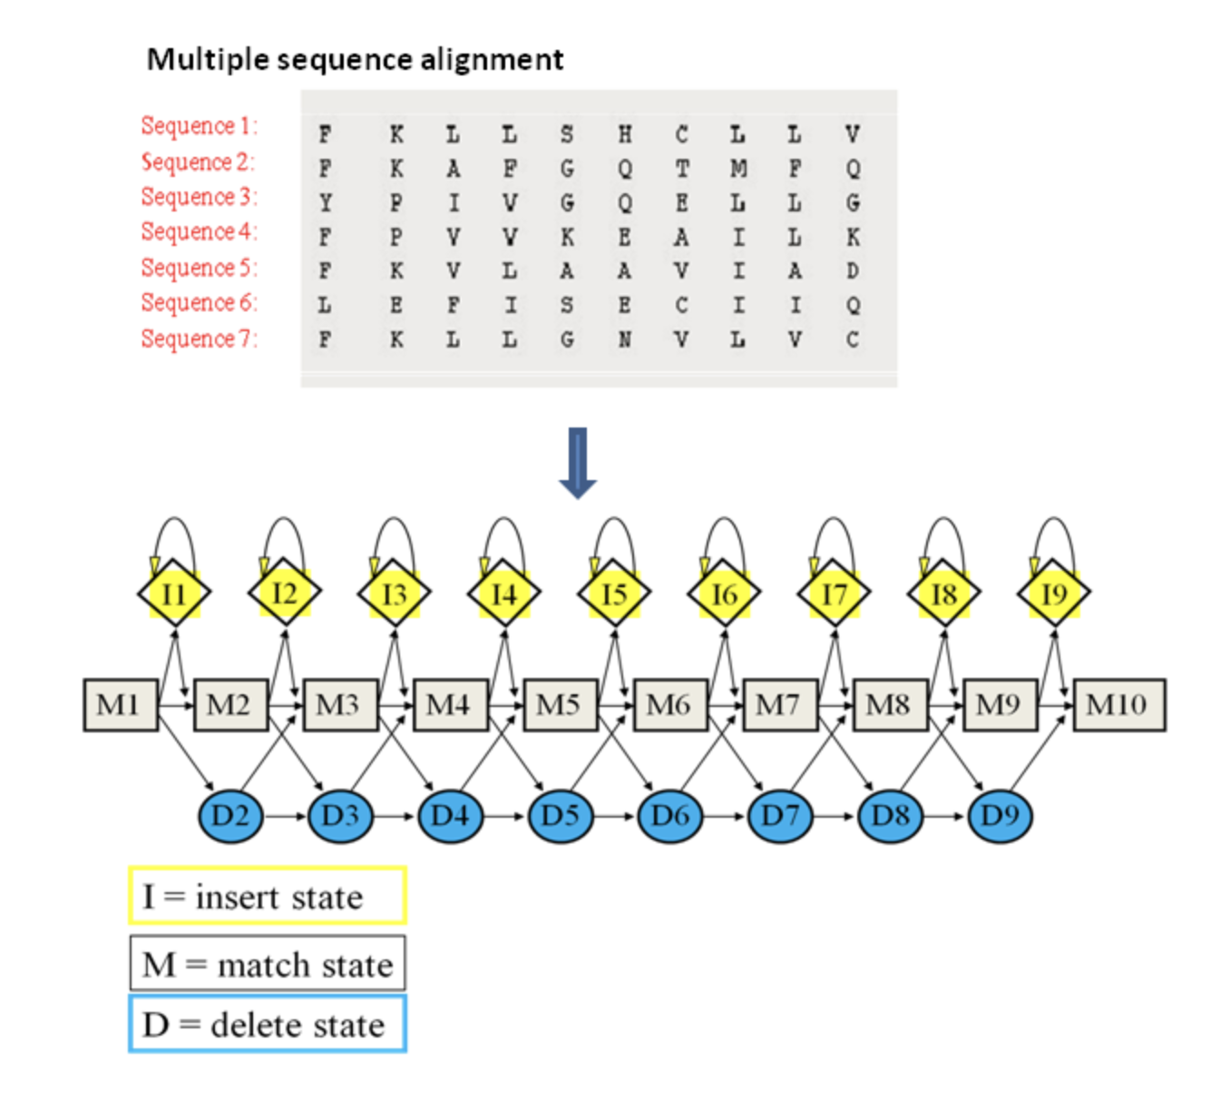

Figure 28: A representation of a Hidden Markov Model (HMM) built from a multiple sequence alignment (MSA). Amino acids or nucleotide bases are given a score at each position within the alignment. From this, the likelihood of one amino acid or nucleotide base are next to each other as well as the probability on insertions or deletions in the sequence are calculated (EMBL-EBI, 2023).

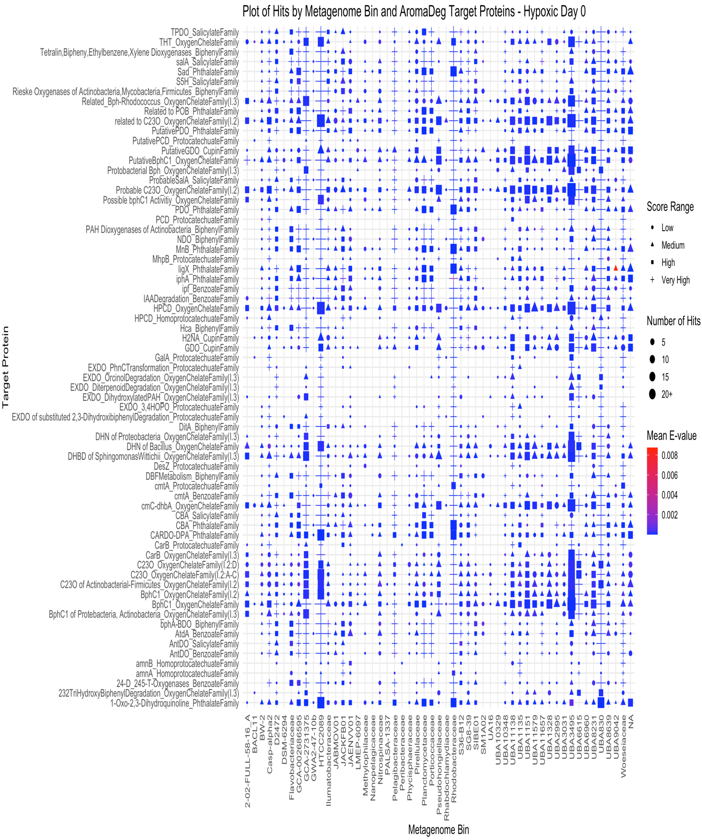
Figure 29: Distribution of scores and e-values for target proteins in AromaDeg.hmm for hypoxic microcosms on day 0. The range of scores was calculated from the percent quartiles where low, medium, high and very high correspond to the different quartile ranges. The size of the points corresponds to the number of hits to contigs found within each metagenomic bin.
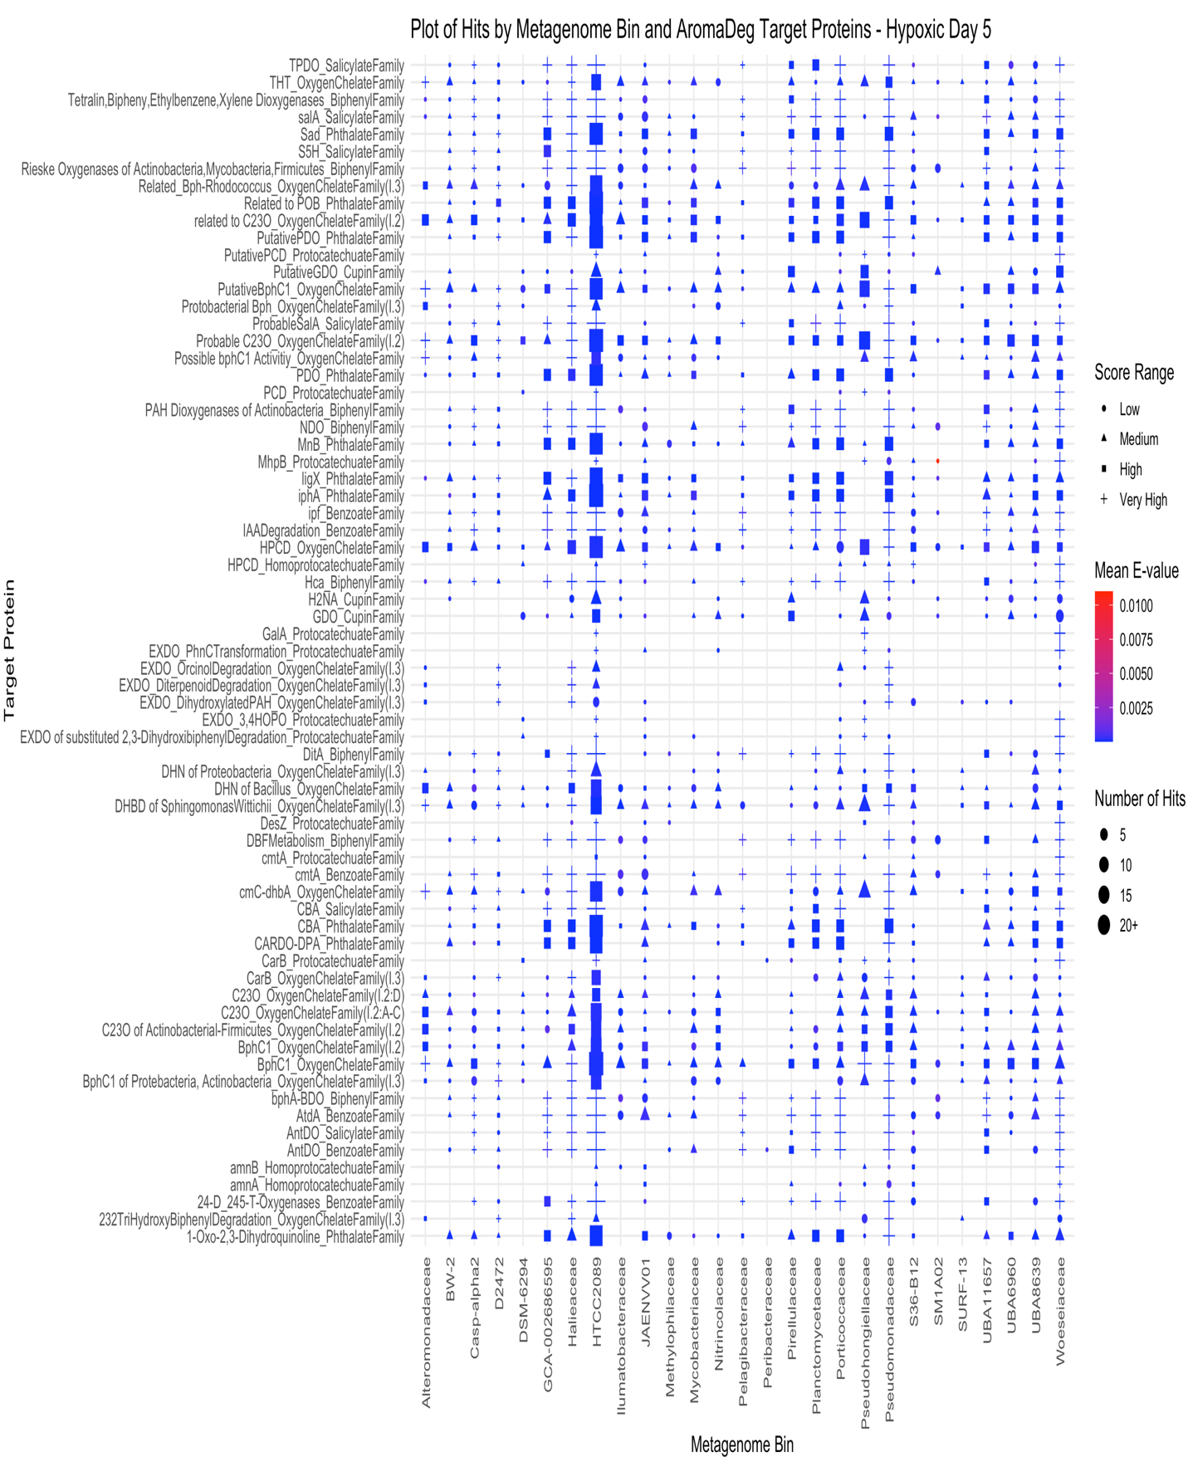
Figure 30: Distribution of scores and e-values for target proteins in AromaDeg.hmm for hypoxic microcosms on day 5. The range of scores was calculated from the percent quartiles where low, medium, high and very high correspond to the different quartile ranges. The size of the points corresponds to the number of hits to contigs found within each metagenomic bin.
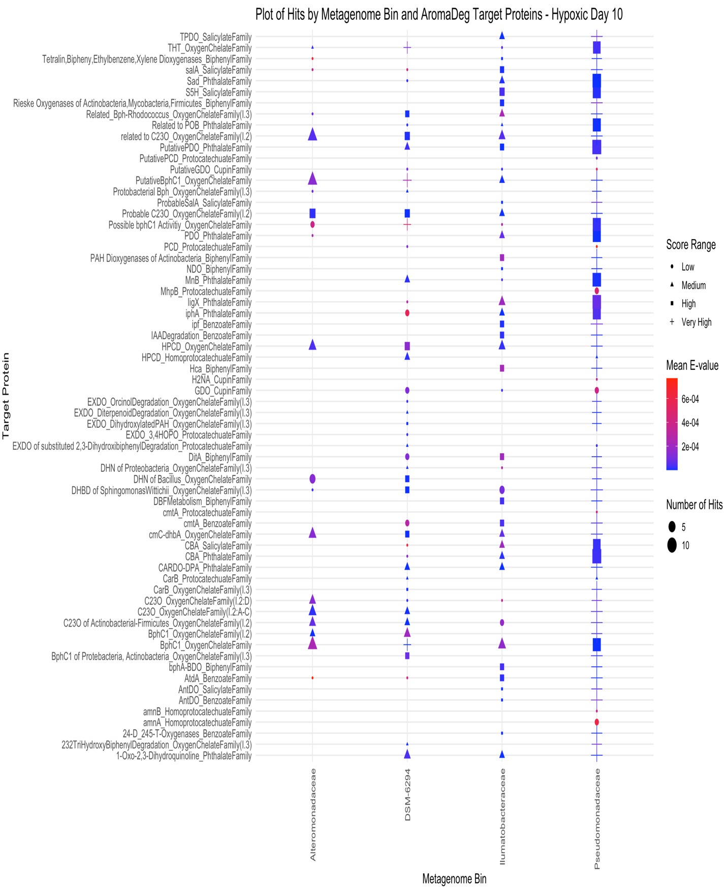
Figure 31: Distribution of scores and e-values for target proteins in AromaDeg.hmm for hypoxic microcosms on day 10. The range of scores was calculated from the percent quartiles where low, medium, high and very high correspond to the different quartile ranges. The size of the points corresponds to the number of hits to contigs found within each metagenomic bin.
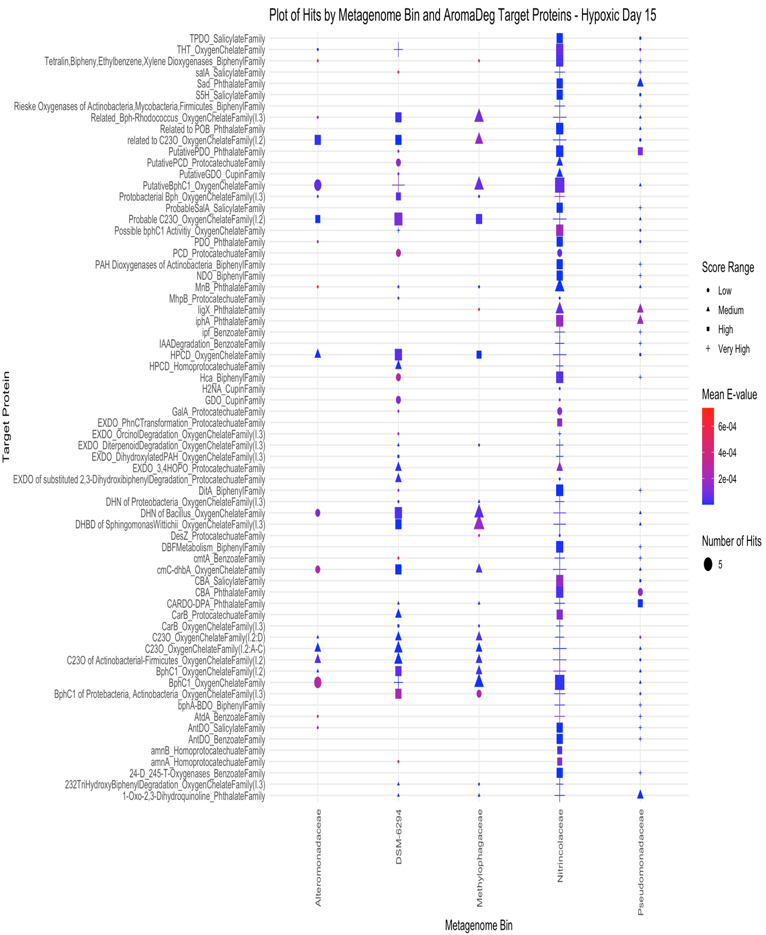
Figure 32: Distribution of scores and e-values for target proteins in AromaDeg.hmm for hypoxic microcosms on day 15. The range of scores was calculated from the percent quartiles where low, medium, high and very high correspond to the different quartile ranges. The size of the points corresponds to the number of hits to contigs found within each metagenomic bin.
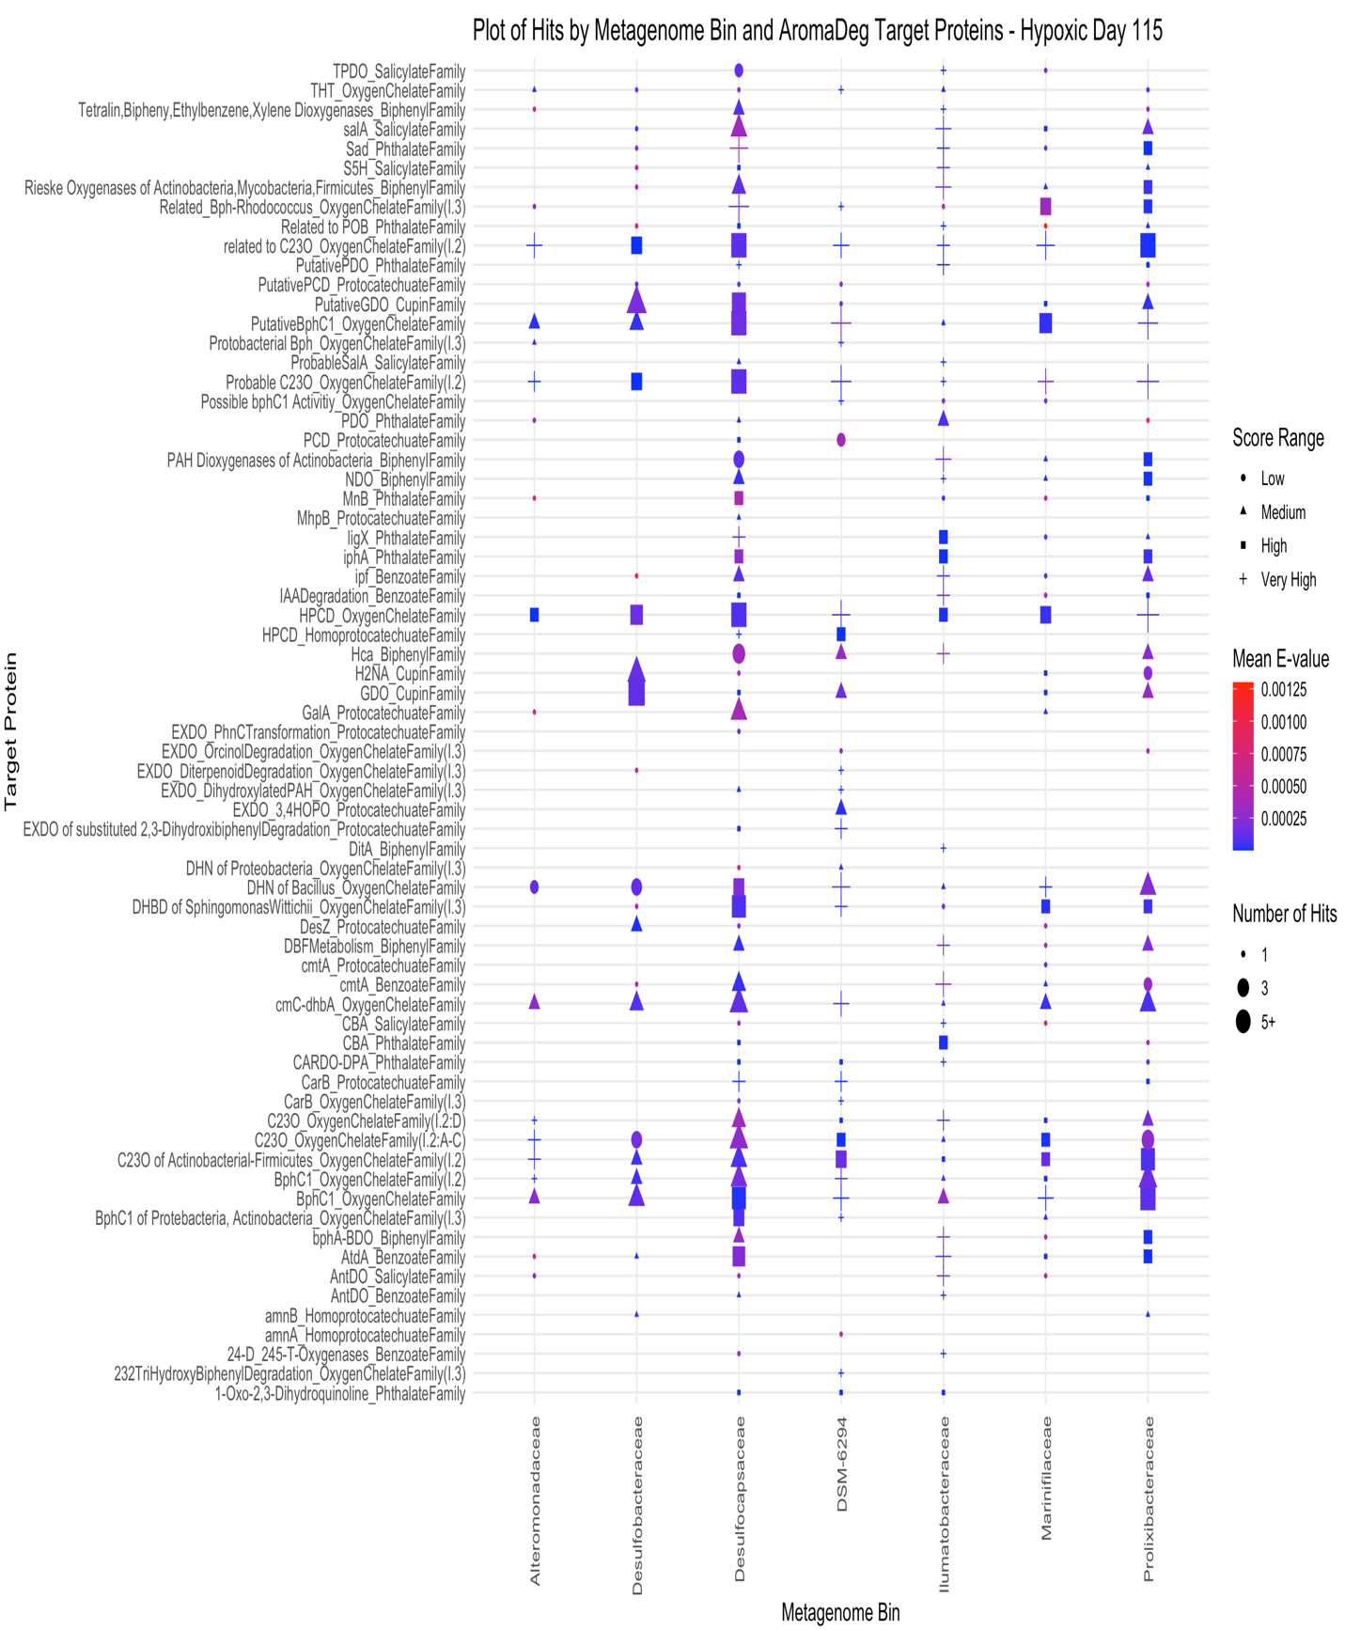
Figure 33: Distribution of scores and e-values for target proteins in AromaDeg.hmm for hypoxic microcosms on day 115. The range of scores was calculated from the percent quartiles where low, medium, high and very high correspond to the different quartile ranges. The size of the points corresponds to the number of hits to contigs found within each metagenomic bin.
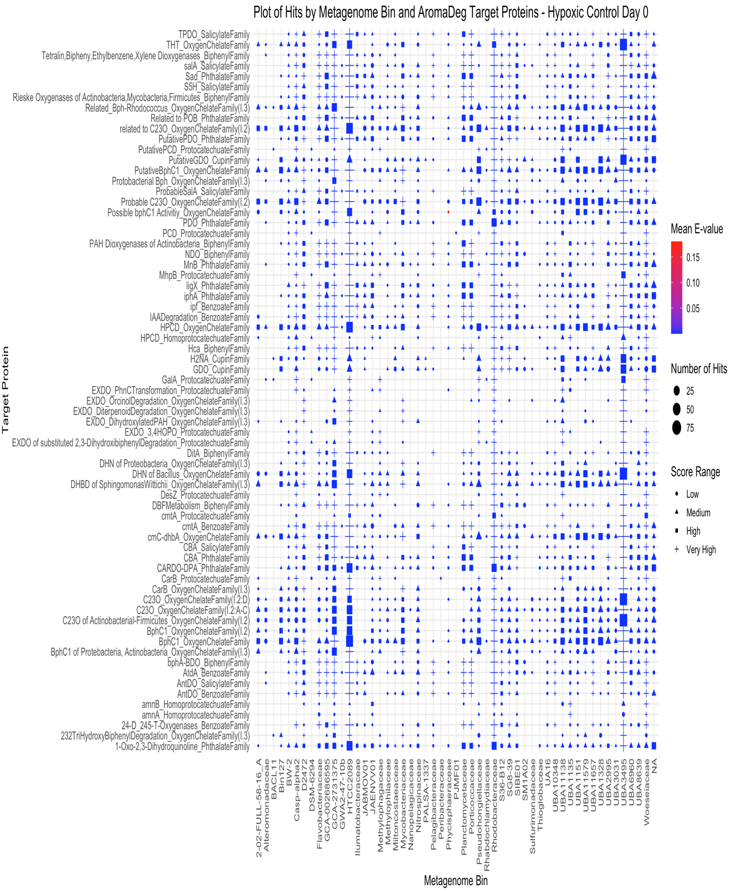
Figure 34: Distribution of scores and e-values for target proteins in AromaDeg.hmm for hypoxic control microcosms on day 0. The range of scores was calculated from the percent quartiles where low, medium, high and very high correspond to the different quartile ranges. The size of the points corresponds to the number of hits to contigs found within each metagenomic bin.
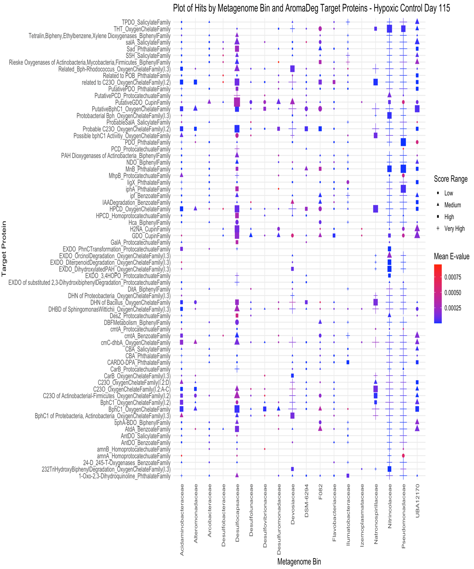
Figure 35: Distribution of scores and e-values for target proteins in AromaDeg.hmm for hypoxic control microcosms on day 115. The range of scores was calculated from the percent quartiles where low, medium, high and very high correspond to the different quartile ranges. The size of the points corresponds to the number of hits to contigs found within each metagenomic bin.
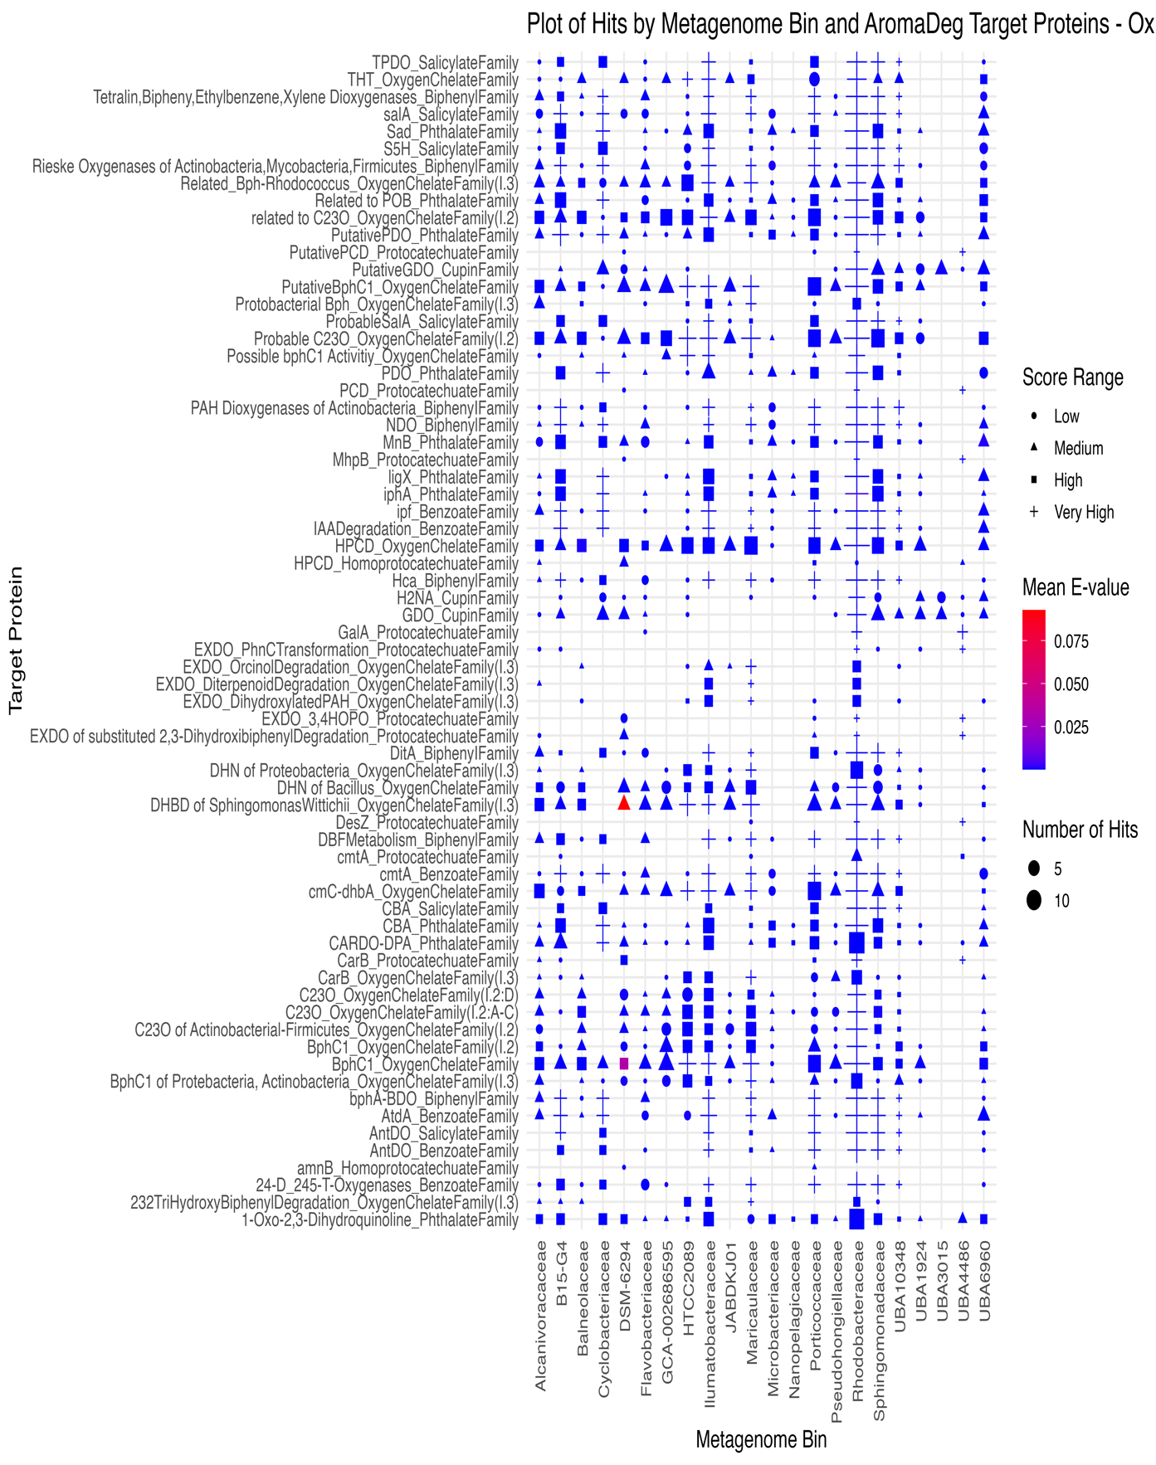
Figure 36: Distribution of scores and e-values for target proteins in AromaDeg.hmm for oxic microcosms on day 5. The range of scores was calculated from the percent quartiles where low, medium, high and very high correspond to the different quartile ranges. The size of the points corresponds to the number of hits to contigs found within each metagenomic bin.
Plot Hits by Metagenome Bin and AromaDeg Target Proteins – Oxic Day 5
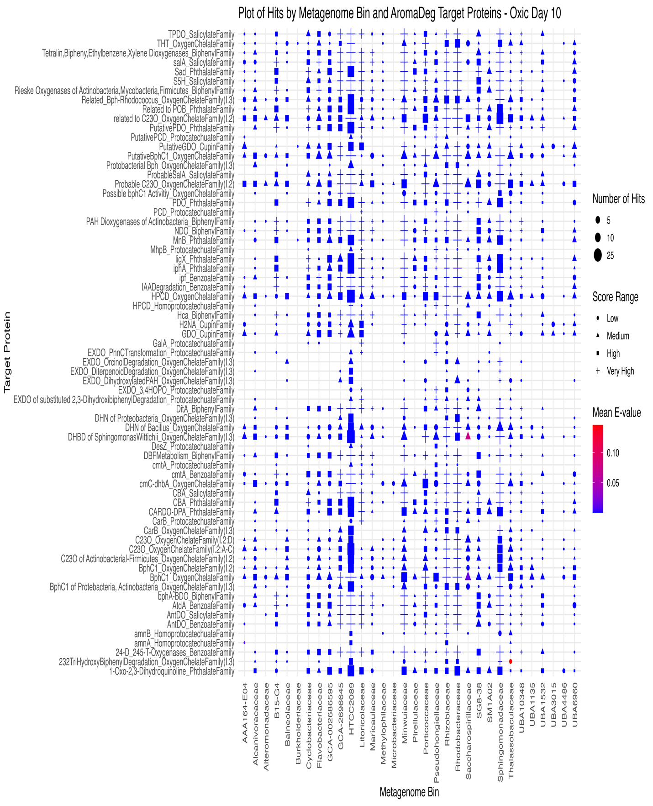
Figure 37: Distribution of scores and e-values for target proteins in AromaDeg.hmm for oxic microcosms on day 10. The range of scores was calculated from the percent quartiles where low, medium, high and very high correspond to the different quartile ranges. The size of the points corresponds to the number of hits to contigs found within each metagenomic bin.
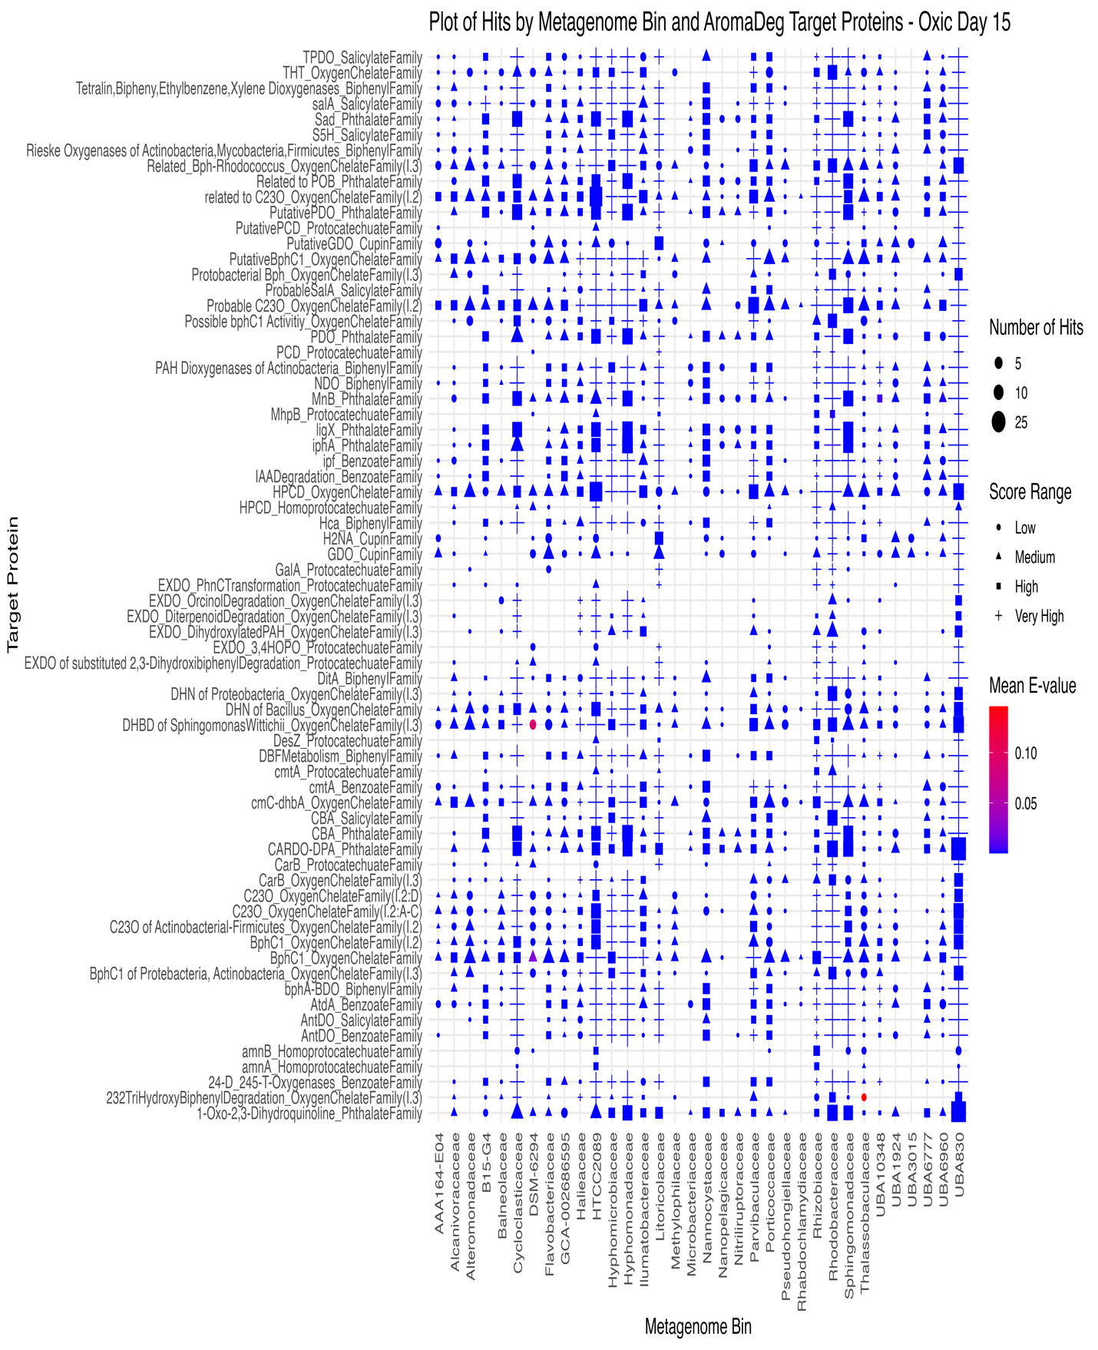
Figure 38: Distribution of scores and e-values for target proteins in AromaDeg.hmm for oxic microcosms on day 15. The range of scores was calculated from the percent quartiles where low, medium, high and very high correspond to the different quartile ranges. The size of the points corresponds to the number of hits to contigs found within each metagenomic bin.
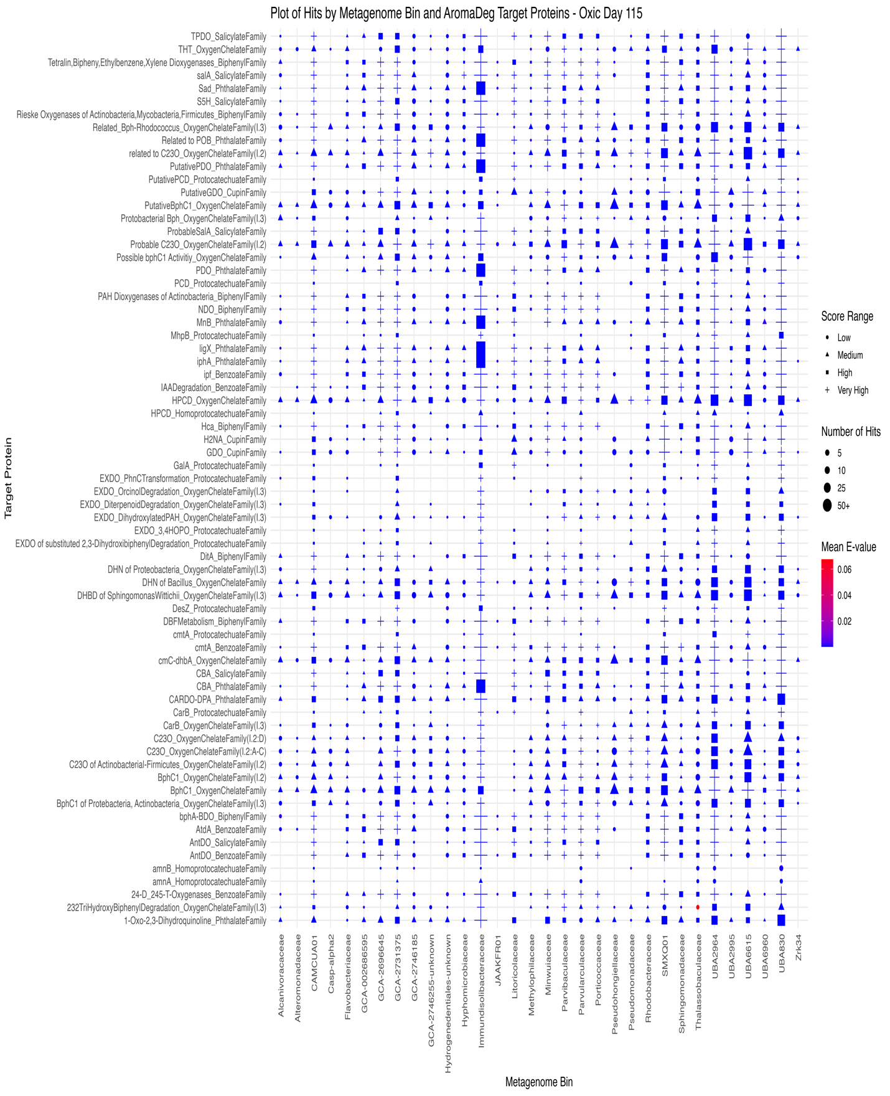
Figure 39: Distribution of scores and e-values for target proteins in AromaDeg.hmm for oxic microcosms on day 115. The range of scores was calculated from the percent quartiles where low, medium, high and very high correspond to the different quartile ranges. The size of the points corresponds to the number of hits to contigs found within each metagenomic bin.
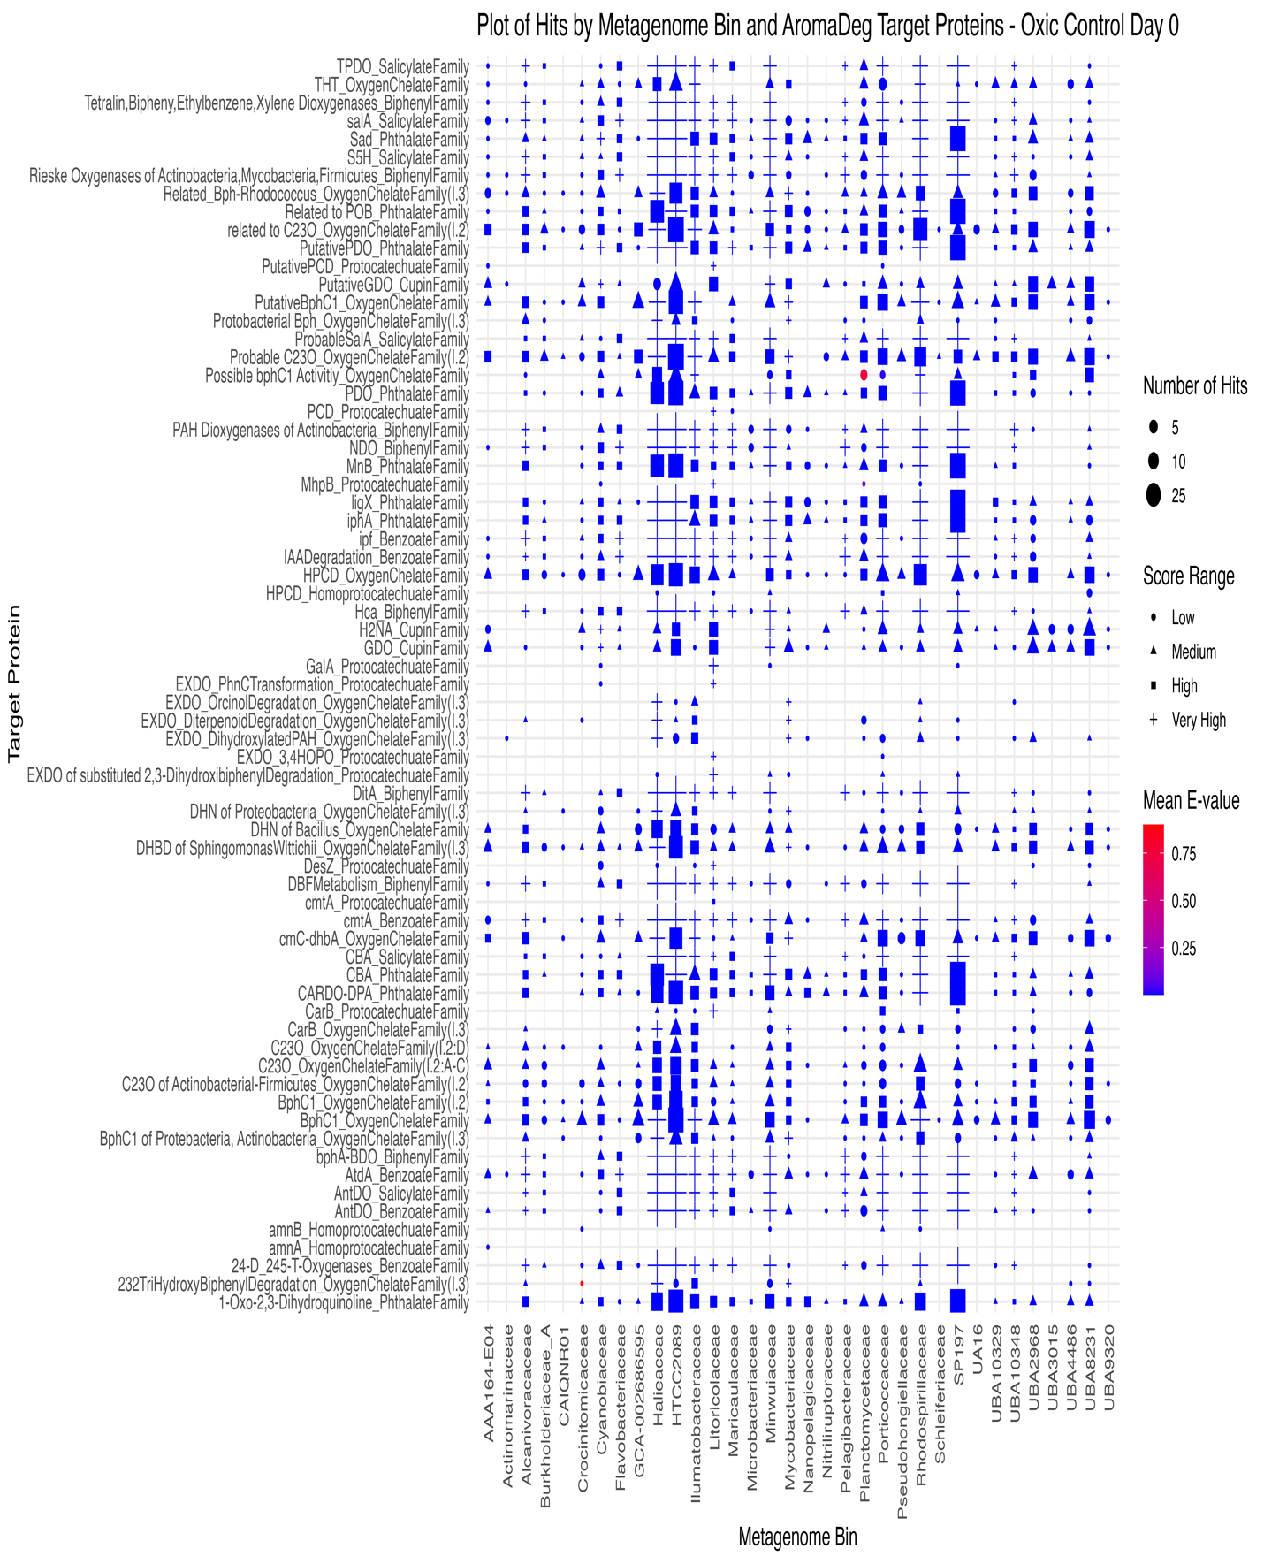
Figure 40: Distribution of scores and e-values for target proteins in AromaDeg.hmm for oxic control microcosms on day 0. The range of scores was calculated from the percent quartiles where low, medium, high and very high correspond to the different quartile ranges. The size of the points corresponds to the number of hits to contigs found within each metagenomic bin.
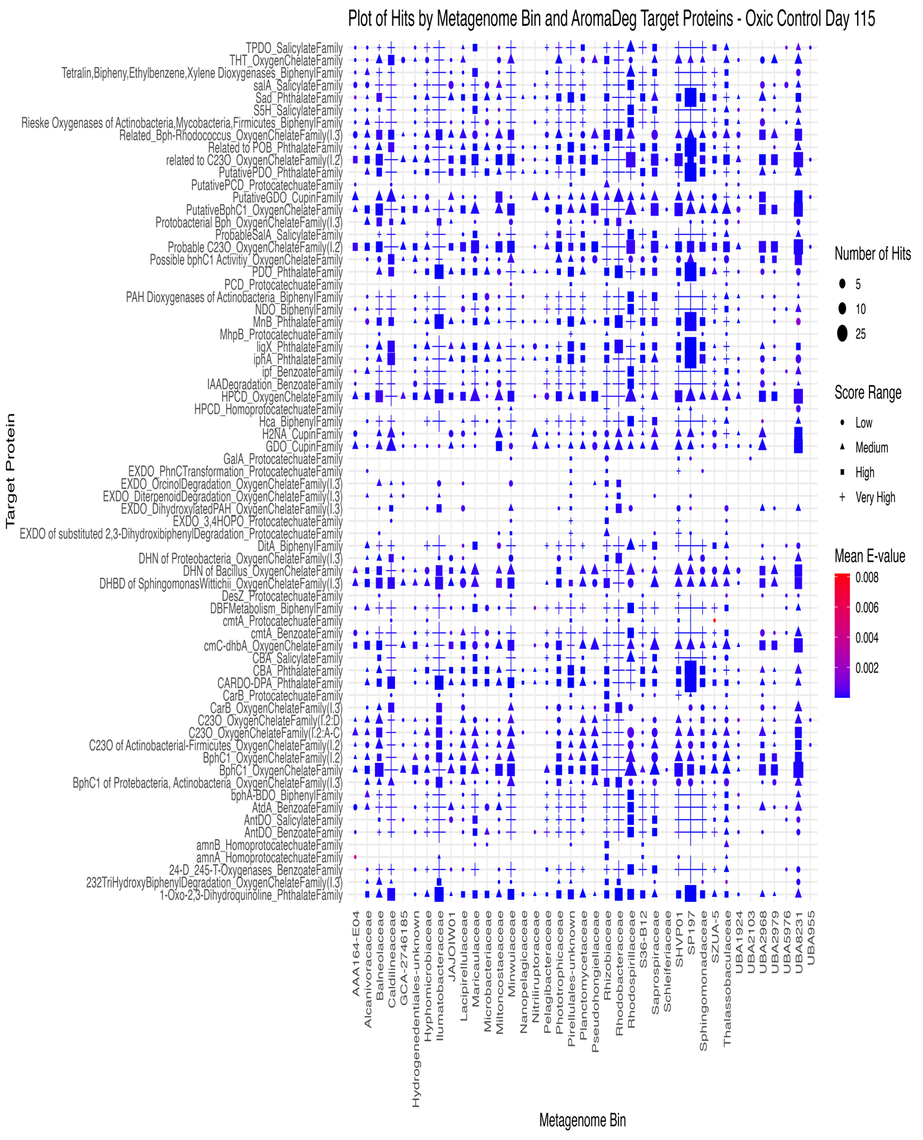
Figure 41: Distribution of scores and e-values for target proteins in AromaDeg.hmm for oxic control microcosms on day 115. The range of scores was calculated from the percent quartiles where low, medium, high and very high correspond to the different quartile ranges. The size of the points corresponds to the number of hits to contigs found within each metagenomic bin.
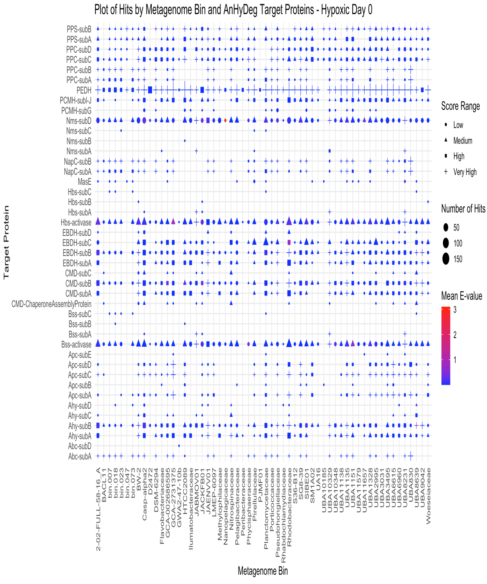
Figure 42: Distribution of scores and e-values for target proteins in AnHyDeg.hmm for hypoxic microcosms on day 0. The range of scores was calculated from the percent quartiles where low, medium, high and very high correspond to the different quartile ranges. The size of the points corresponds to the number of hits to contigs found within each metagenomic bin.
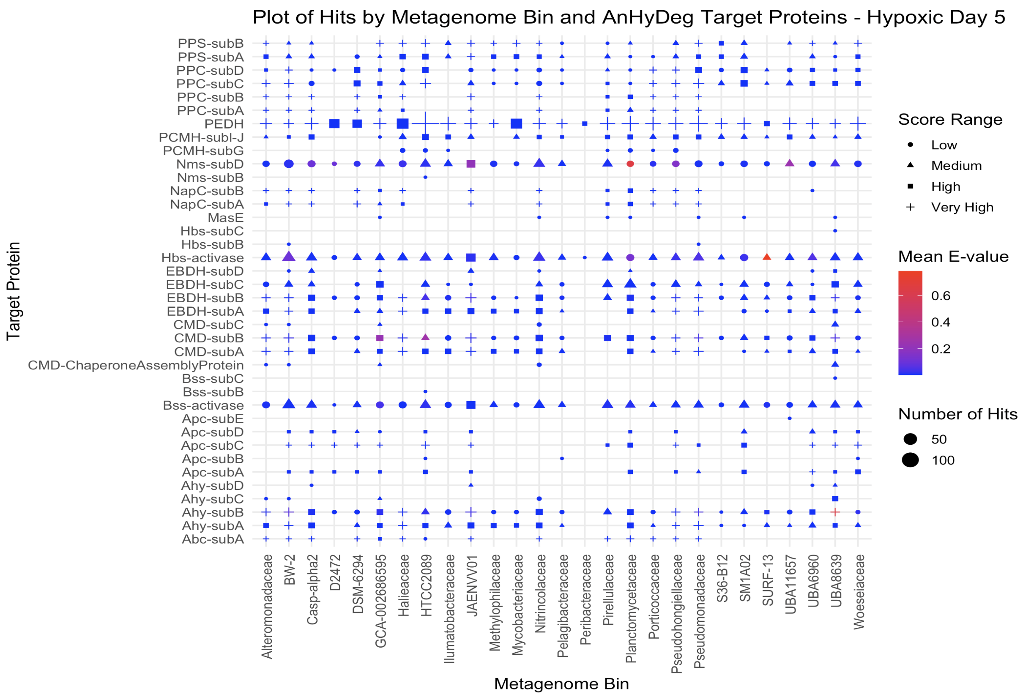
Figure 43: Distribution of scores and e-values for target proteins in AnHyDeg.hmm for hypoxic microcosms on day 5. The range of scores was calculated from the percent quartiles where low, medium, high and very high correspond to the different quartile ranges. The size of the points corresponds to the number of hits to contigs found within each metagenomic bin.
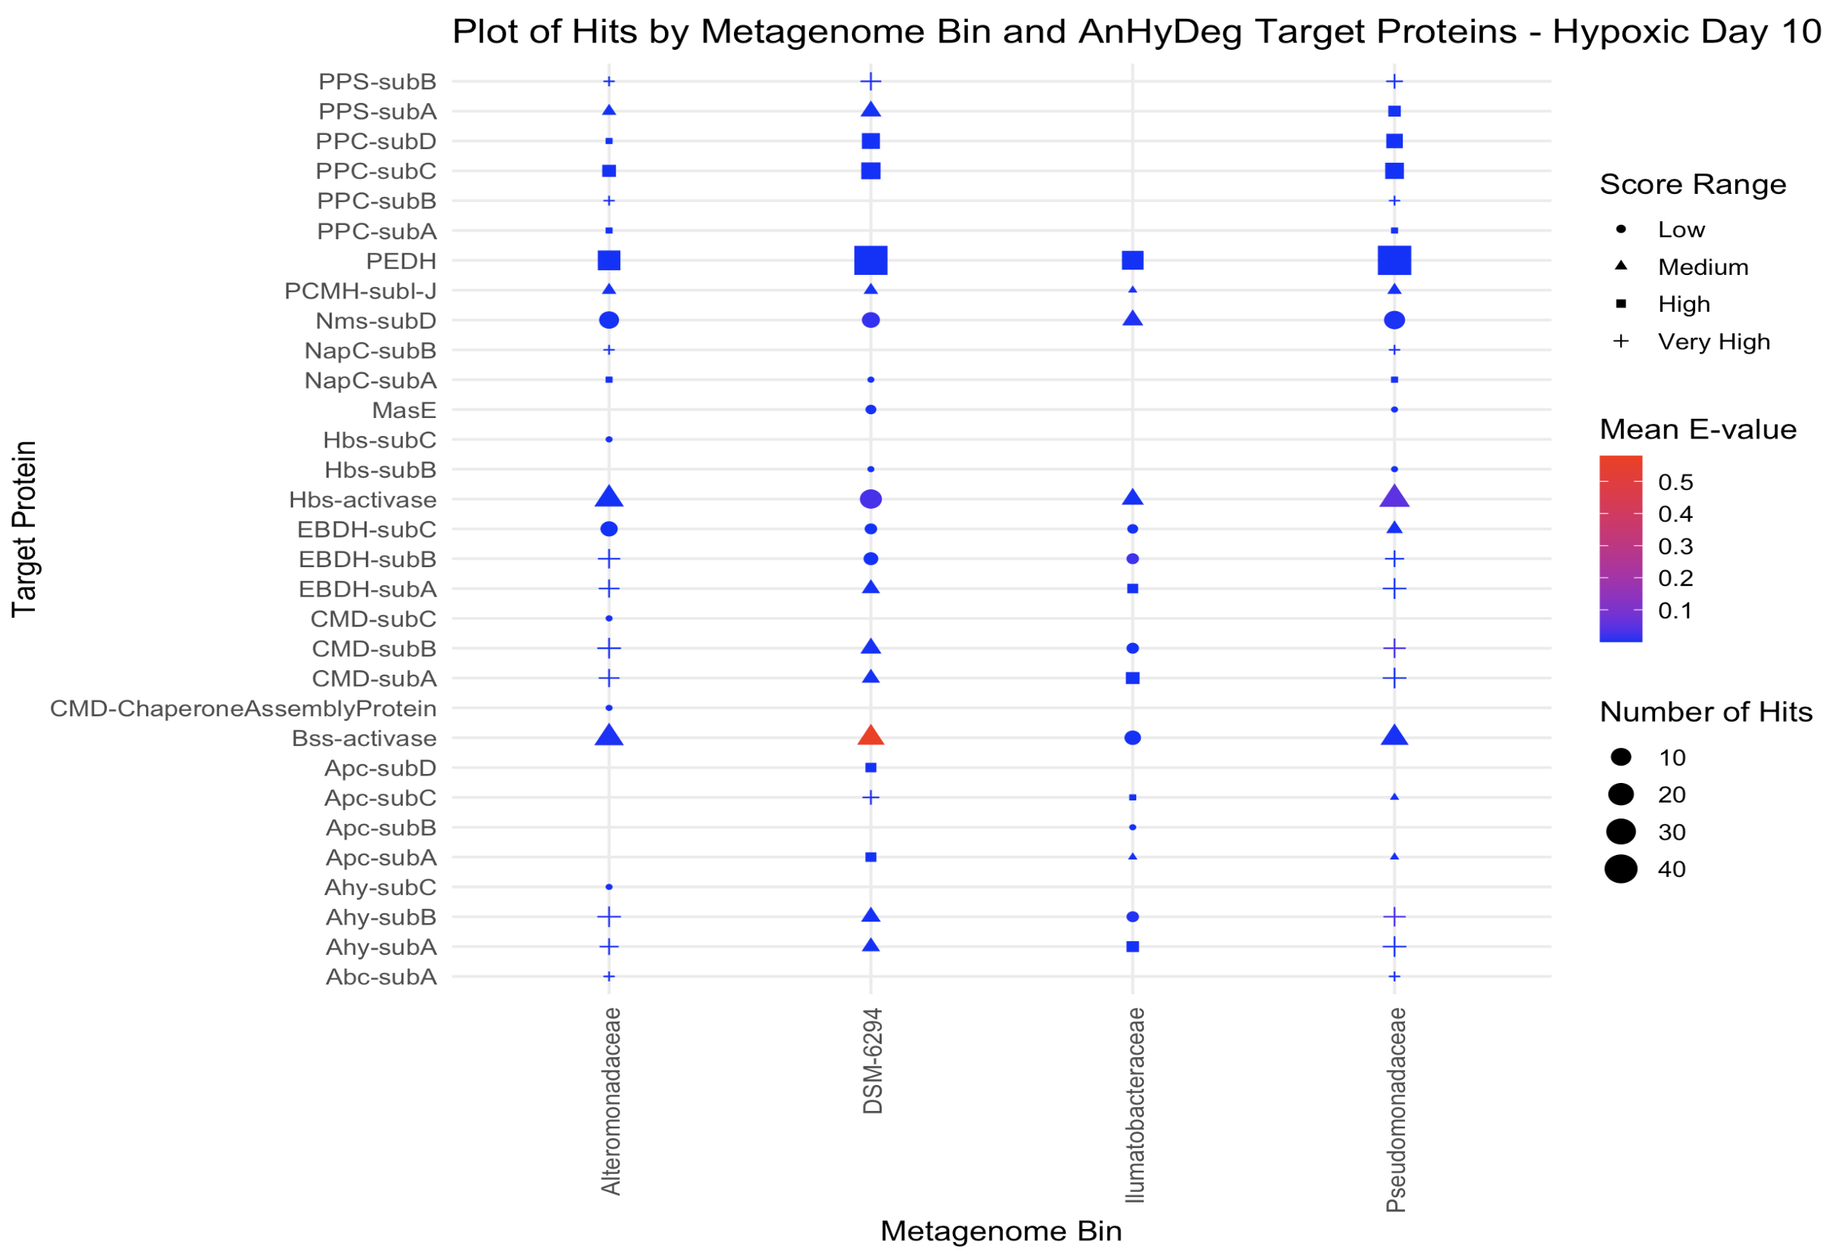
Figure 44: Distribution of scores and e-values for target proteins in AnHyDeg.hmm for hypoxic microcosms on day 10. The range of scores was calculated from the percent quartiles where low, medium, high and very high correspond to the different quartile ranges. The size of the points corresponds to the number of hits to contigs found within each metagenomic bin.
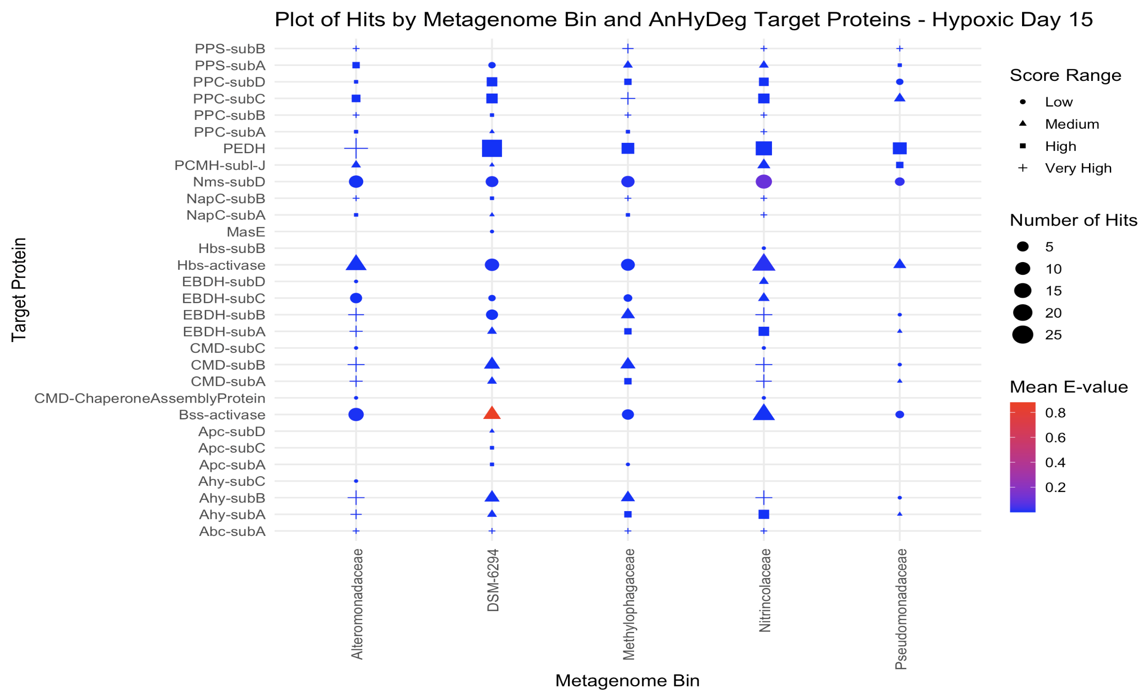
Figure 45: Distribution of scores and e-values for target proteins in AnHyDeg.hmm for hypoxic microcosms on day 15. The range of scores was calculated from the percent quartiles where low, medium, high and very high correspond to the different quartile ranges. The size of the points corresponds to the number of hits to contigs found within each metagenomic bin.
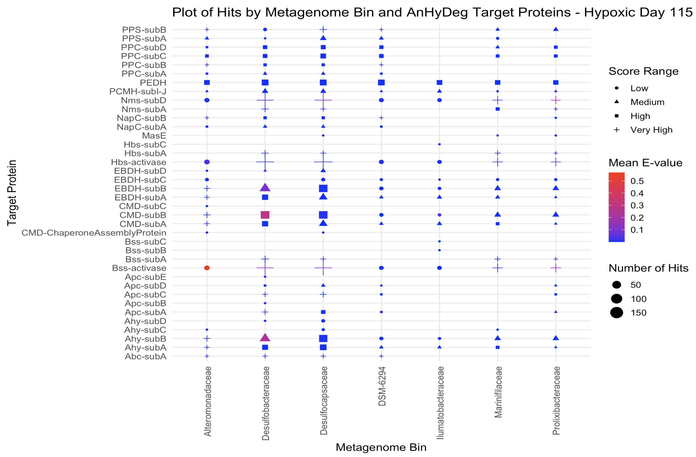
Figure 46: Distribution of scores and e-values for target proteins in AnHyDeg.hmm for hypoxic microcosms on day 115. The range of scores was calculated from the percent quartiles where low, medium, high and very high correspond to the different quartile ranges. The size of the points corresponds to the number of hits to contigs found within each metagenomic bin.
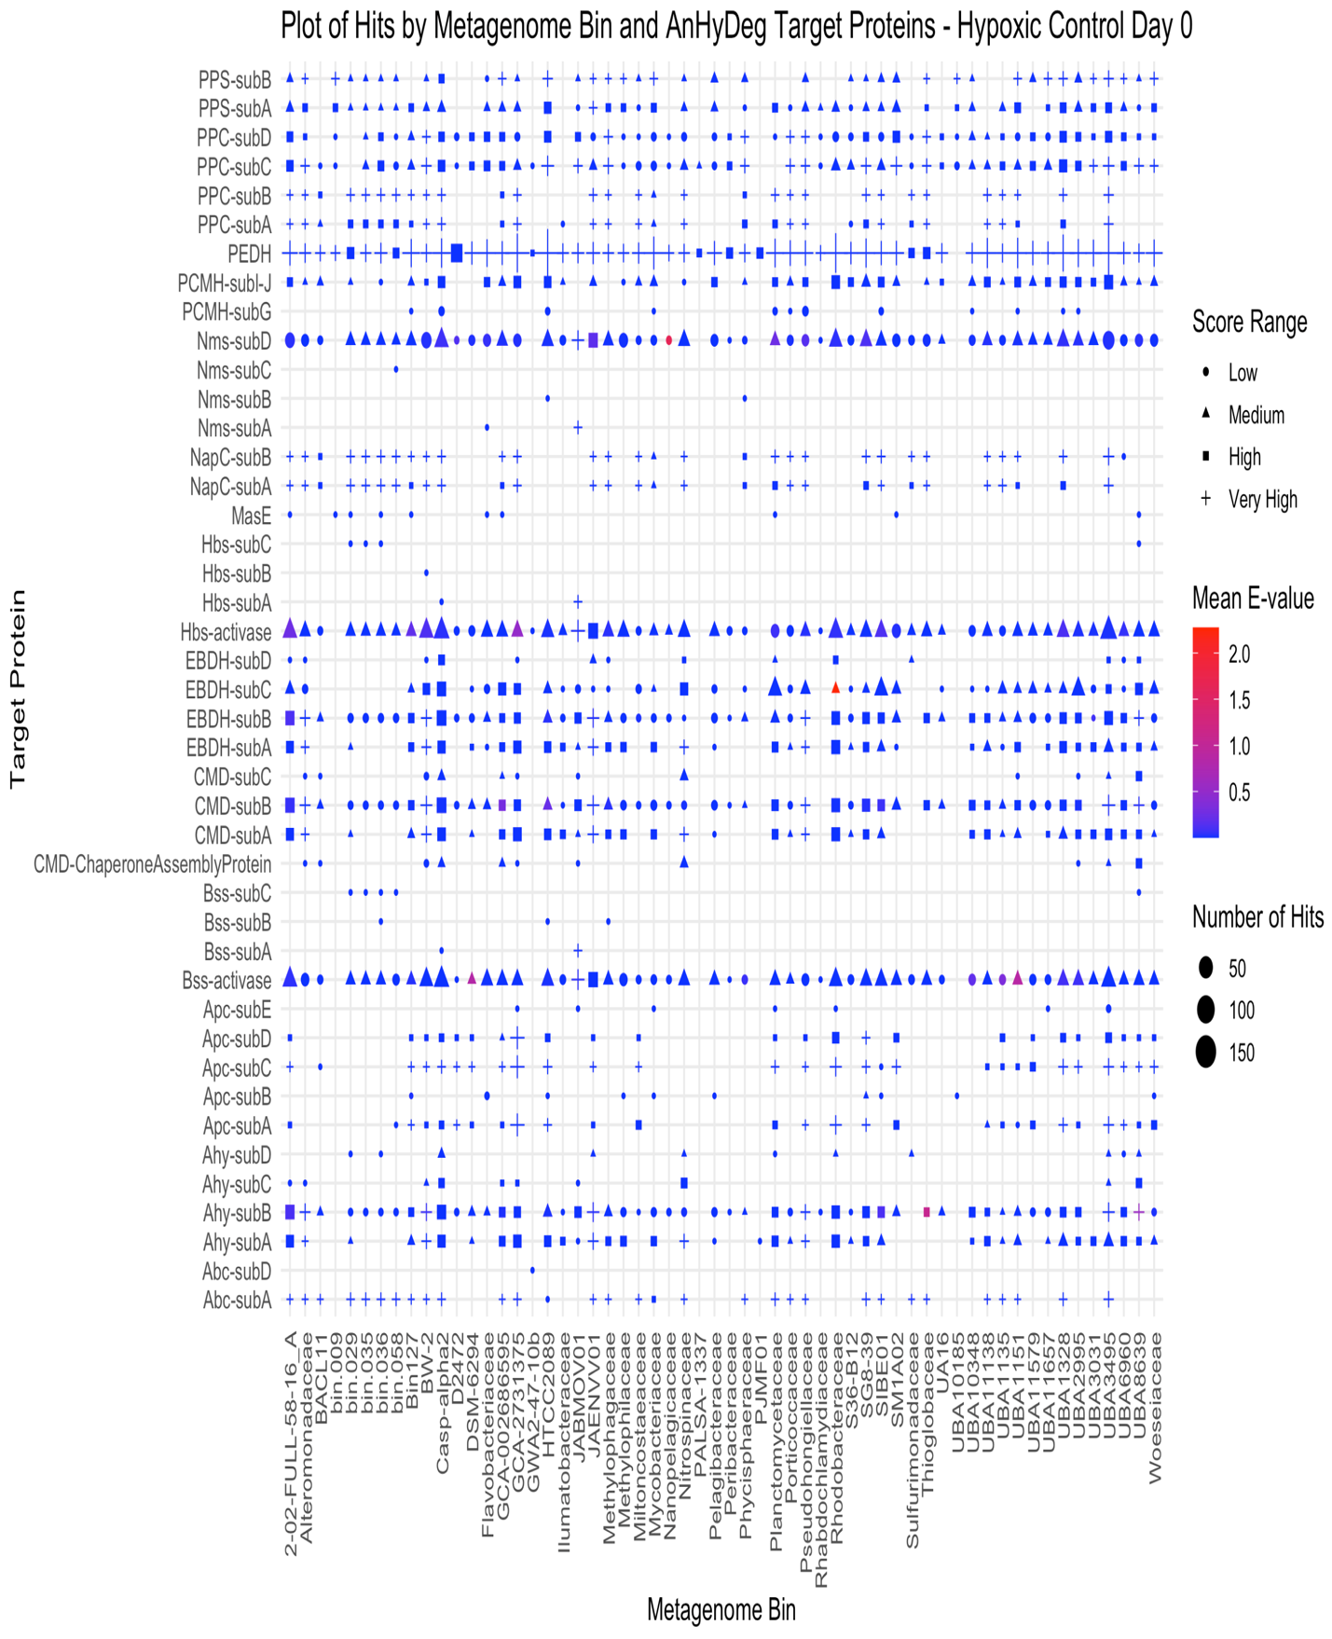
Figure 47: Distribution of scores and e-values for target proteins in AnHyDeg.hmm for hypoxic control microcosms on day 0. The range of scores was calculated from the percent quartiles where low, medium, high and very high correspond to the different quartile ranges. The size of the points corresponds to the number of hits to contigs found within each metagenomic bin.
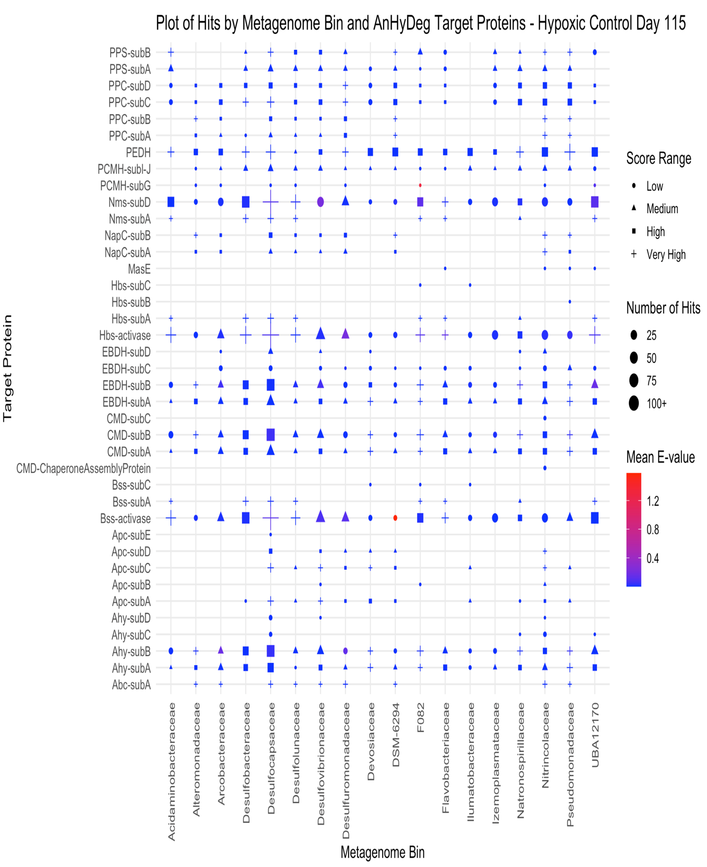
Figure 48: Distribution of scores and e-values for target proteins in AnHyDeg.hmm for hypoxic control microcosms on day 115. The range of scores was calculated from the percent quartiles where low, medium, high and very high correspond to the different quartile ranges. The size of the points corresponds to the number of hits to contigs found within each metagenomic bin.
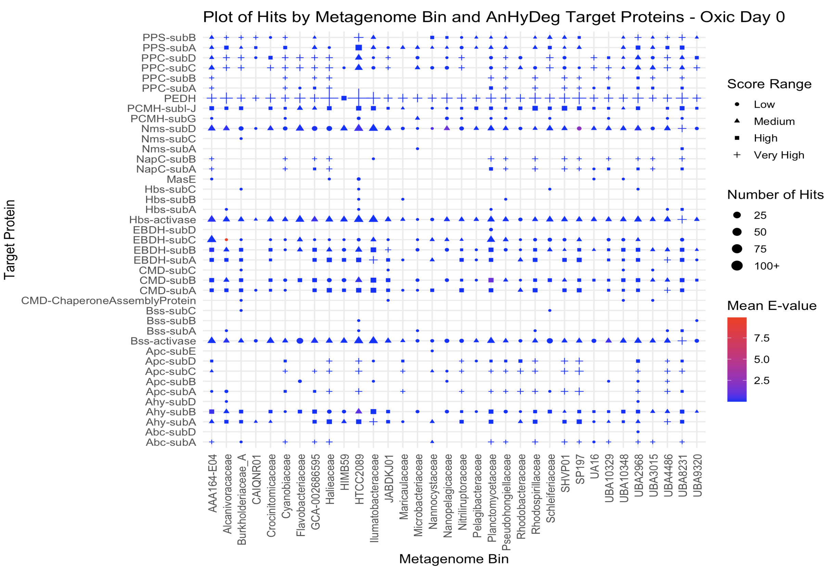
Figure 49: Distribution of scores and e-values for target proteins in AnHyDeg.hmm for oxic microcosms on day 0. The range of scores was calculated from the percent quartiles where low, medium, high and very high correspond to the different quartile ranges. The size of the points corresponds to the number of hits to contigs found within each metagenomic bin.
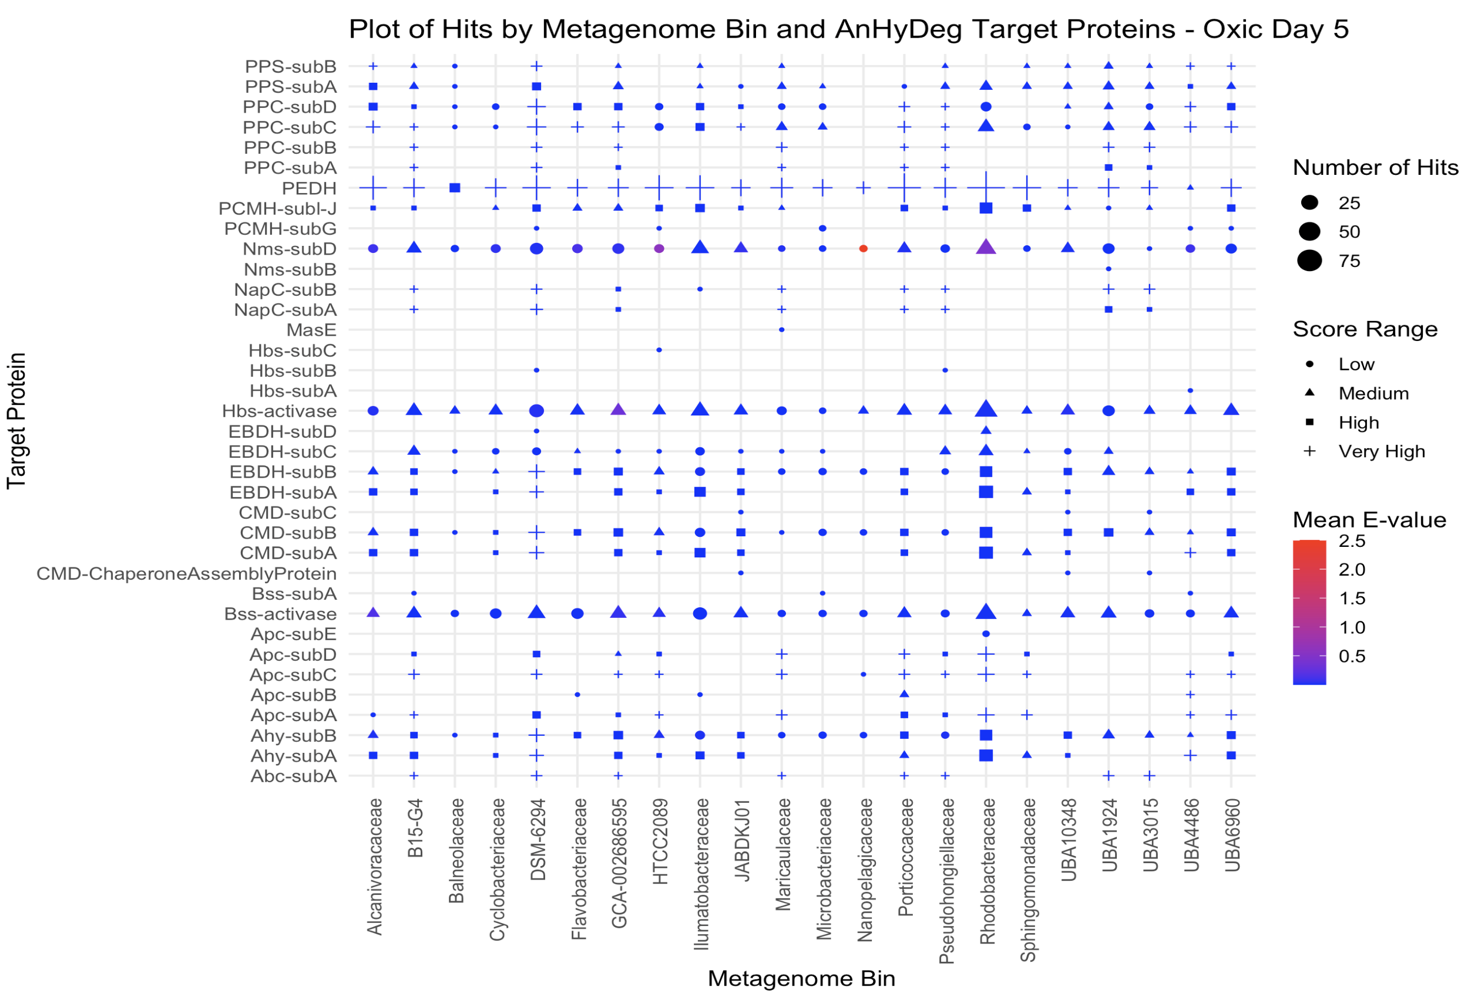
Figure 50: Distribution of scores and e-values for target proteins in AnHyDeg.hmm for oxic microcosms on day 5. The range of scores was calculated from the percent quartiles where low, medium, high and very high correspond to the different quartile ranges. The size of the points corresponds to the number of hits to contigs found within each metagenomic bin.
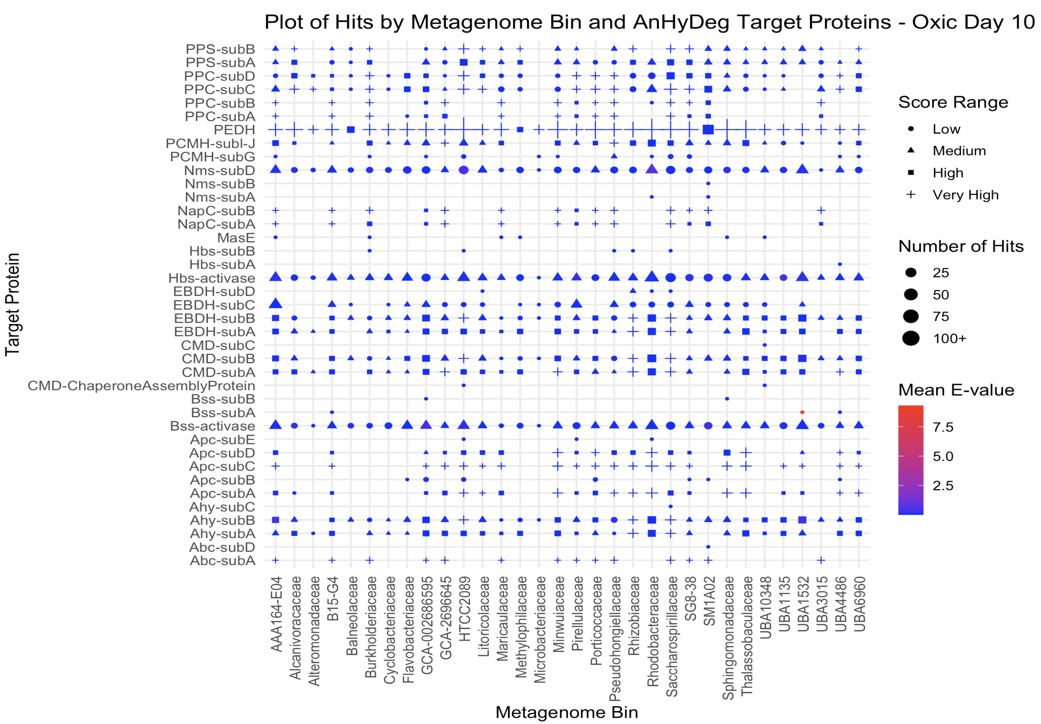
Figure 51: Distribution of scores and e-values for target proteins in AnHyDeg.hmm for oxic microcosms on day 10. The range of scores was calculated from the percent quartiles where low, medium, high and very high correspond to the different quartile ranges. The size of the points corresponds to the number of hits to contigs found within each metagenomic bin.
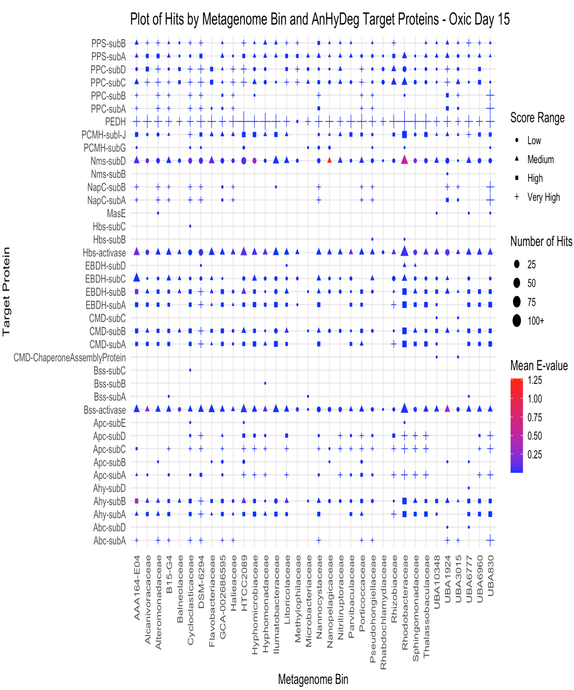
Figure 52: Distribution of scores and e-values for target proteins in AnHyDeg.hmm for oxic microcosms on day 15. The range of scores was calculated from the percent quartiles where low, medium, high and very high correspond to the different quartile ranges. The size of the points corresponds to the number of hits to contigs found within each metagenomic bin.
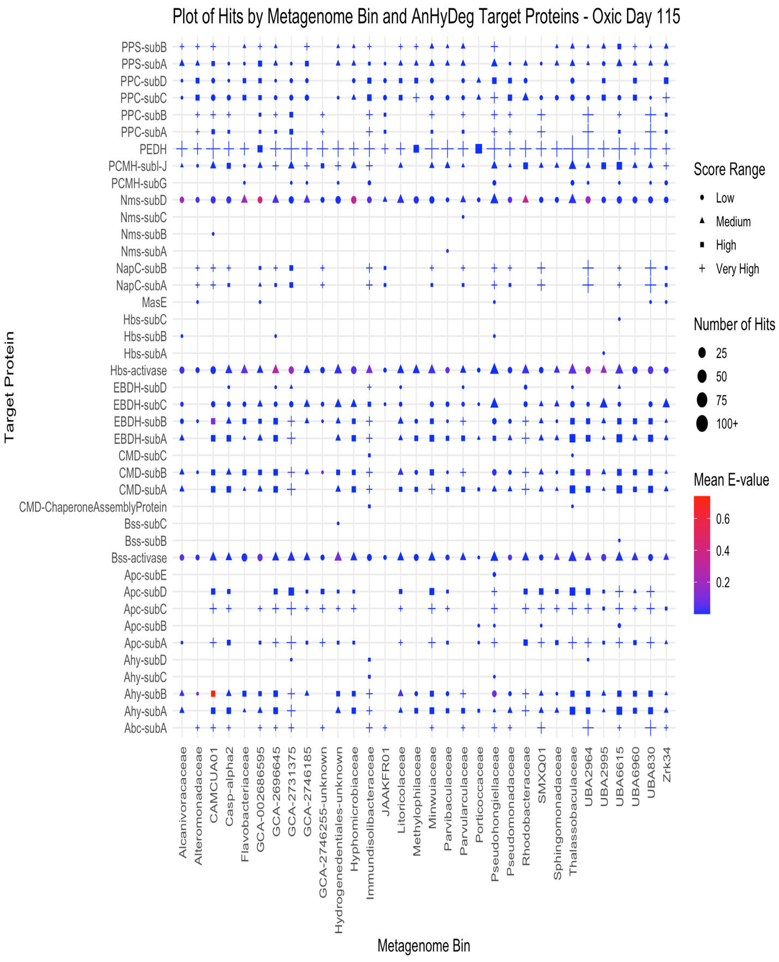
Figure 53: Distribution of scores and e-values for target proteins in AnHyDeg.hmm for oxic microcosms on day 115. The range of scores was calculated from the percent quartiles where low, medium, high and very high correspond to the different quartile ranges. The size of the points corresponds to the number of hits to contigs found within each metagenomic bin
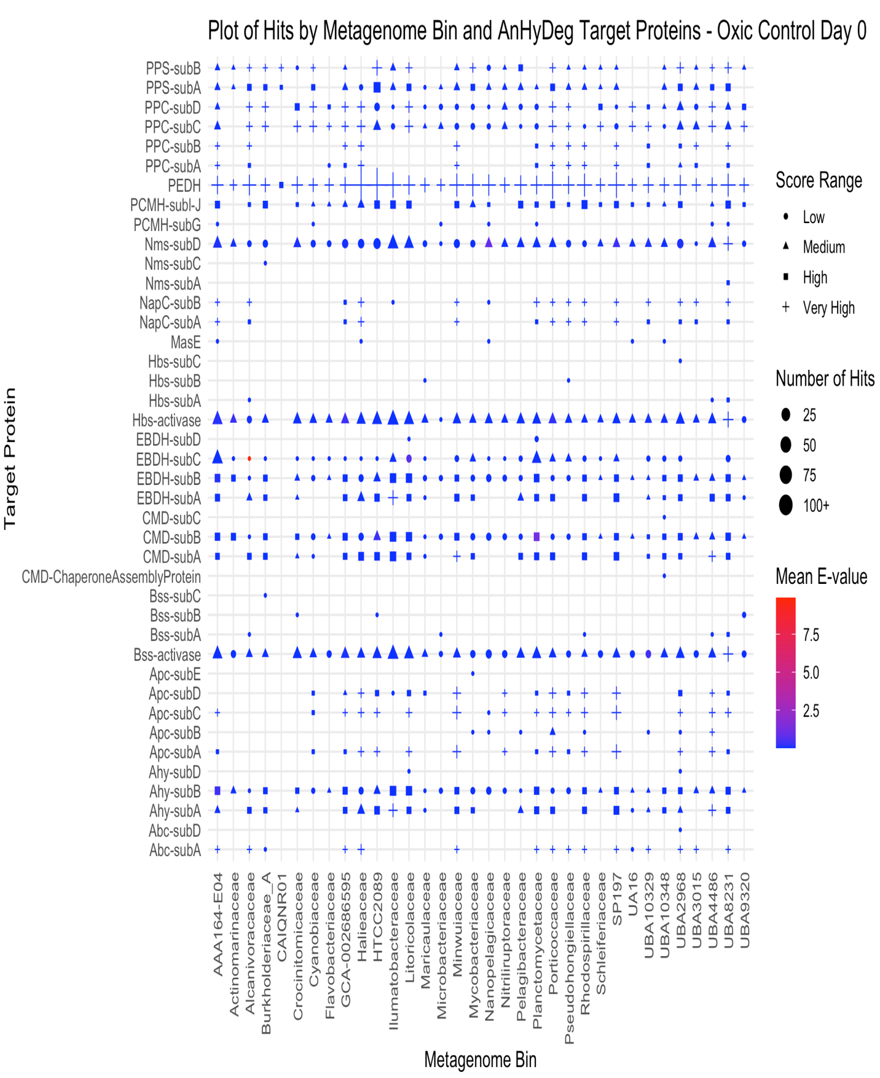
Figure 54: Distribution of scores and e-values for target proteins in AnHyDeg.hmm for oxic control microcosms on day 0. The range of scores was calculated from the percent quartiles where low, medium, high and very high correspond to the different quartile ranges. The size of the points corresponds to the number of hits to contigs found within each metagenomic bin.
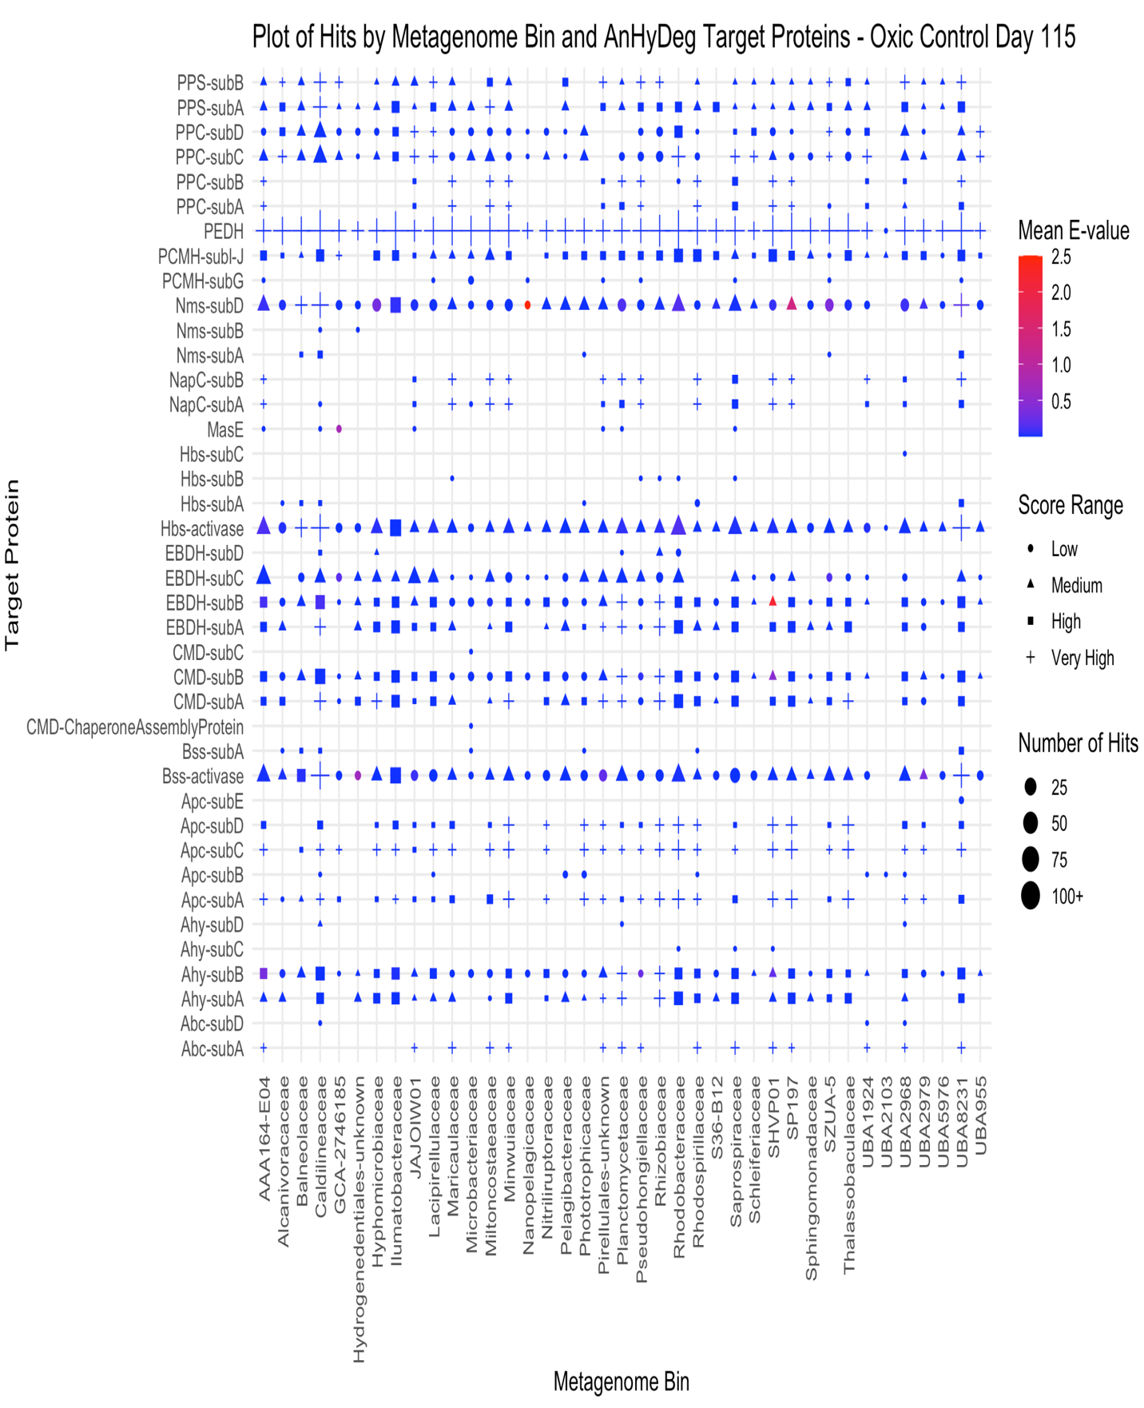
Figure 55: Distribution of scores and e-values for target proteins in AnHyDeg.hmm for oxic control microcosms on day 115. The range of scores was calculated from the percent quartiles where low, medium, high and very high correspond to the different quartile ranges. The size of the points corresponds to the number of hits to contigs found within each metagenomic bin.
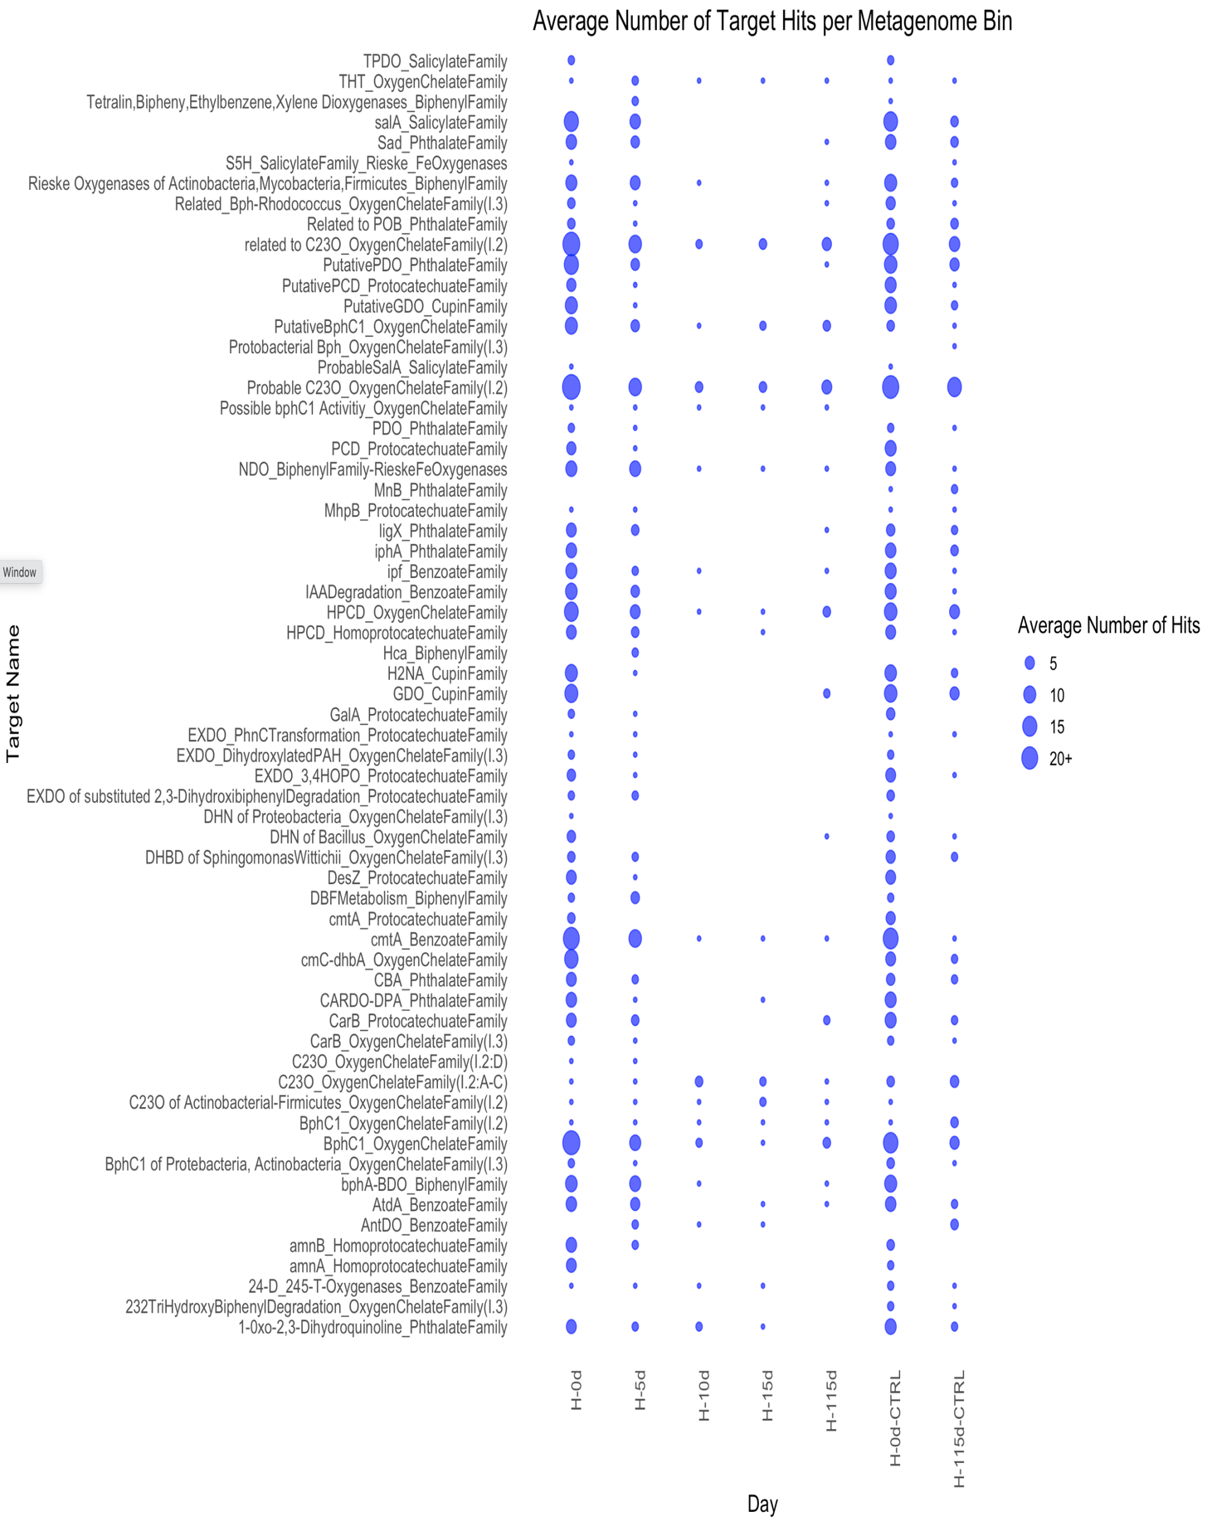
Figure 56: Average number of hits per contig in the metagenomic bins to the target proteins in AromaDeg.hmm for hypoxic microcosms over the microcosm experiment time course.
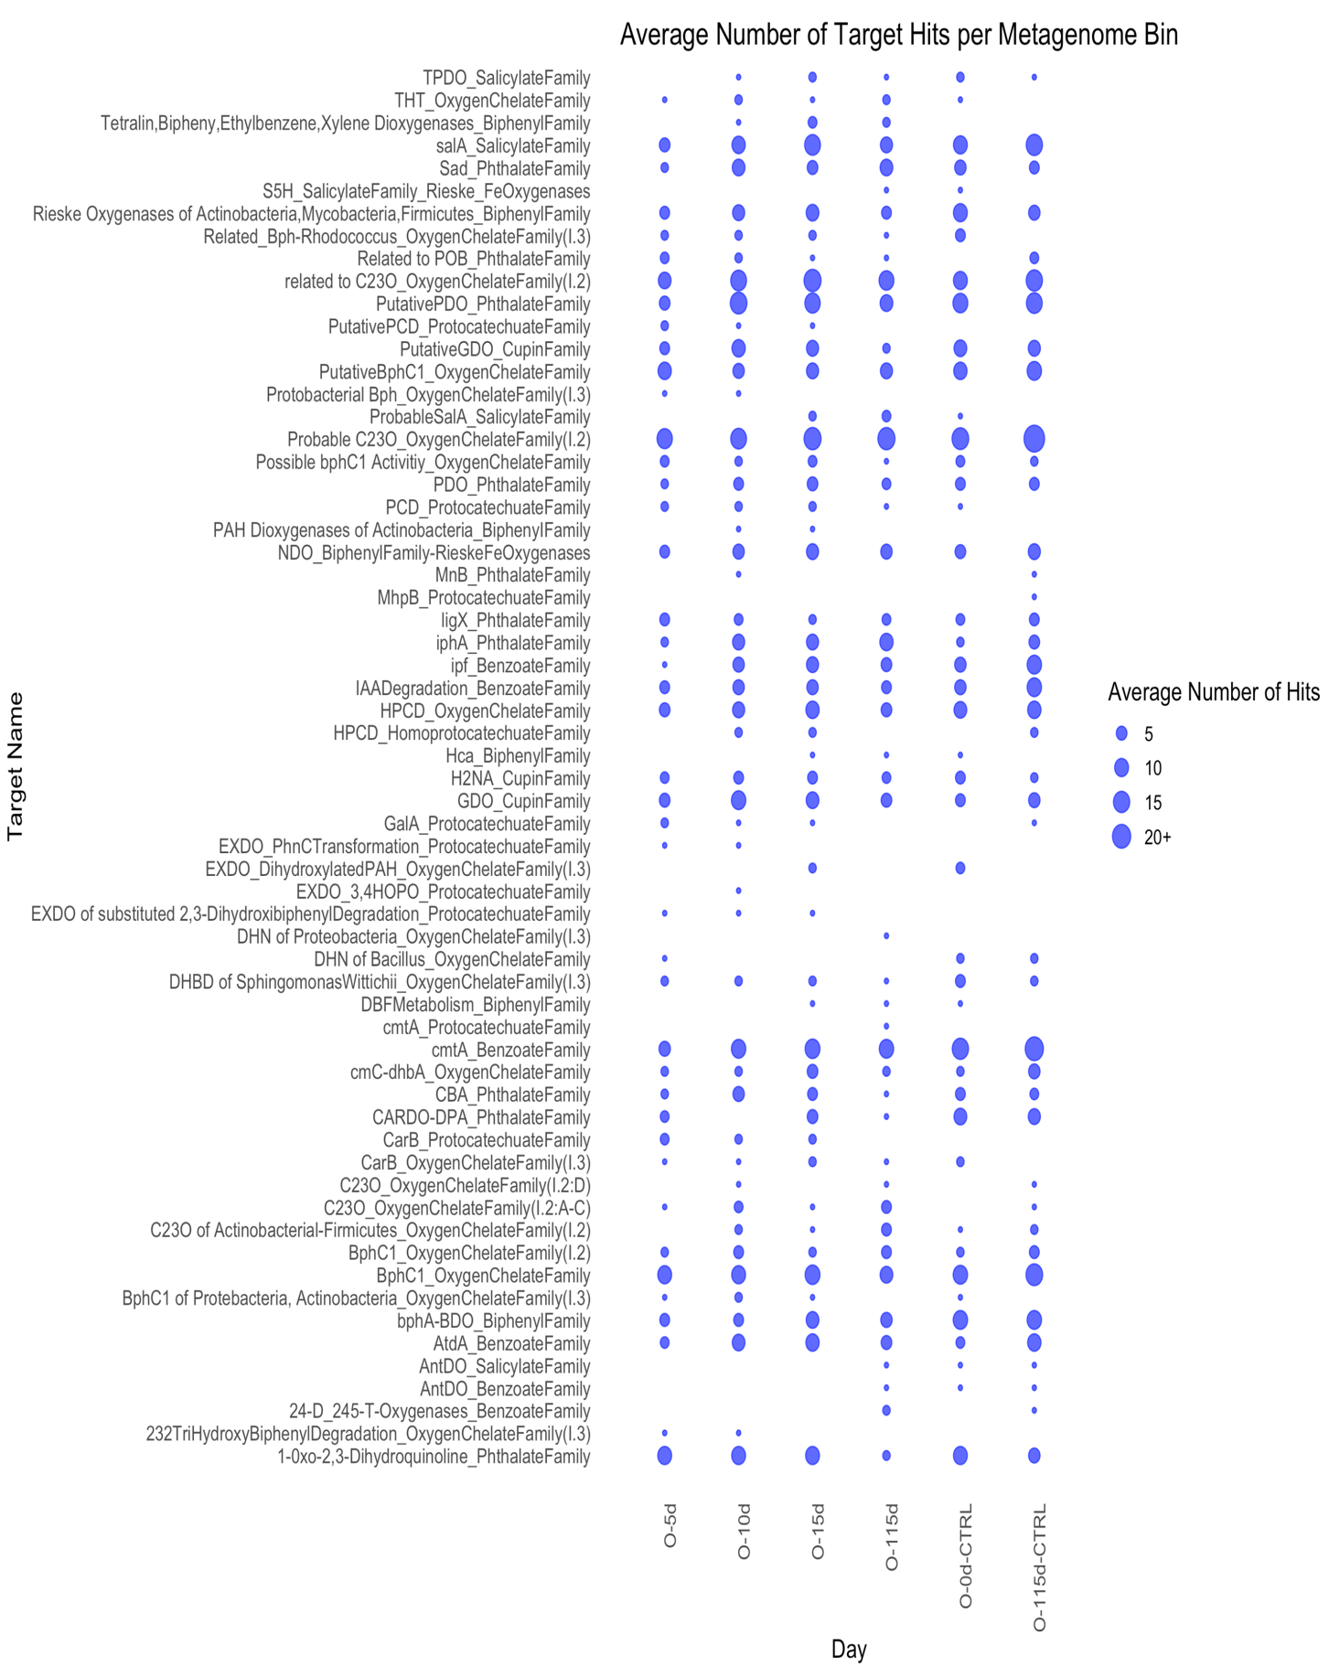
Figure 57: Average number of hits per contig in the metagenomic bins to the target proteins in AromaDeg.hmm for oxic microcosms over the microcosm experiment time course.
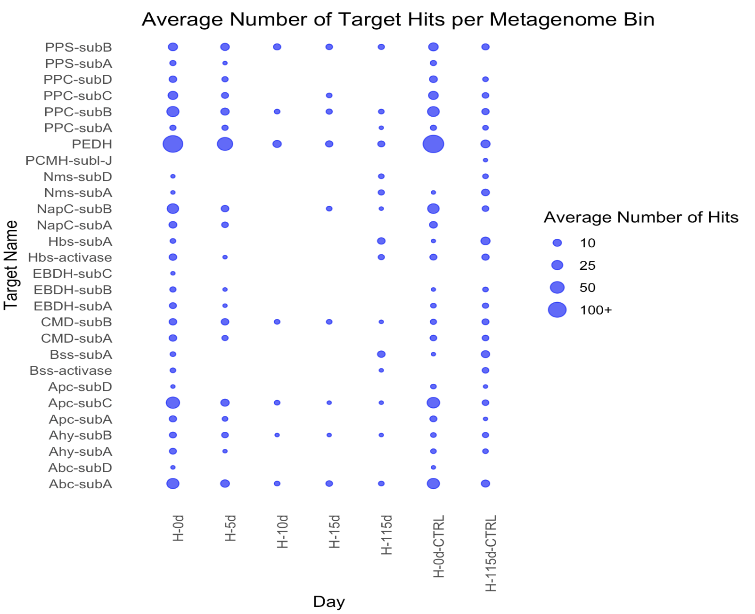
Figure 58: Average number of hits per contig in the metagenomic bins to the target proteins in AnHyDeg.hmm for hypoxic microcosms over the microcosm experiment time course.
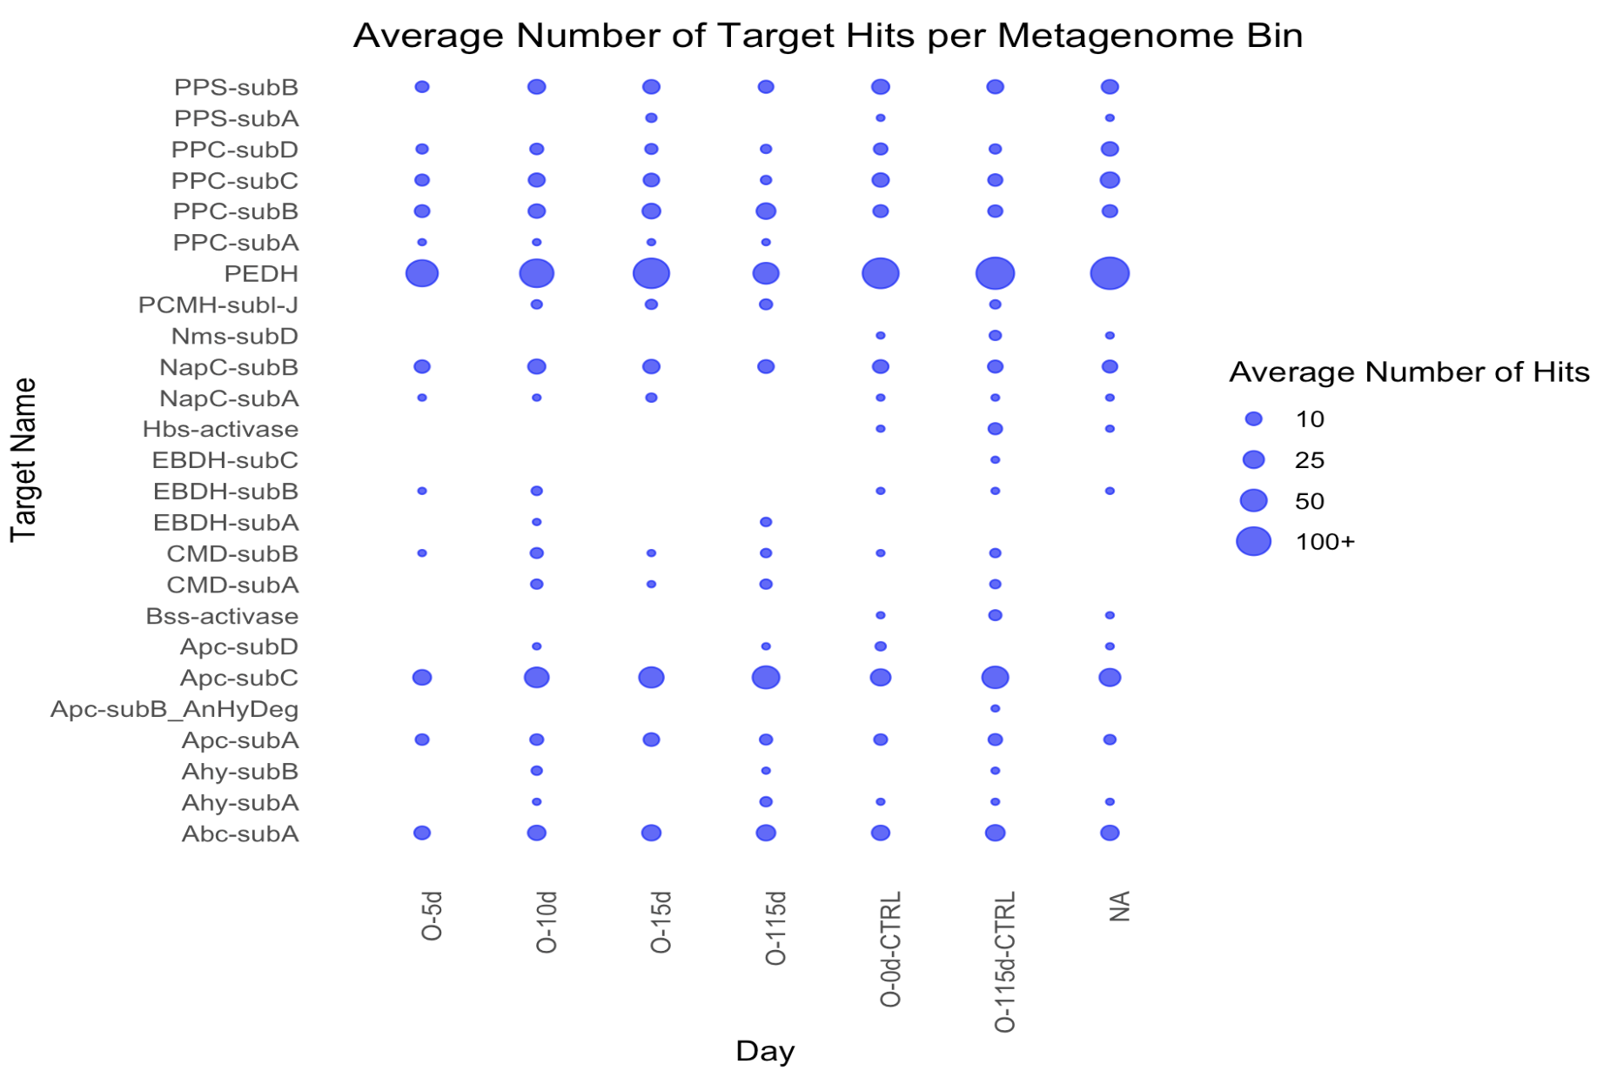
Figure 59: Average number of hits per contig in the metagenomic bins to the target proteins in AnHyDeg.hmm for oxic microcosms over the microcosm experiment time course.

CONCLUSION

This dissertation has revealed the intricate dynamics of microbial communities in the Caspian Sea, particularly their roles in hydrocarbon degradation, through a multifaceted analysis involving Hidden Markov Models (HMMs), metagenomics, gas chromatography and microcosm studies.
The microcosm experiments demonstrated that the microbial communities adapted their metabolic strategies based on oxygen availability rather than hydrocarbon presence. The dynamic shifts in community structure and the observed patterns of bloom and succession post crude oil amendment align with behaviors seen in other oil-contaminated environments. These studies collectively provide valuable insights into the adaptive mechanisms of Caspian Sea microbes, emphasizing their significant potential in the natural attenuation and bioremediation of hydrocarbon pollutants.
The metagenomic data revealed a profound metabolic diversity within the Caspian Sea microbial communities, indicative of their complex adaptive strategies to environmental conditions. These microbes seemed to exhibit a versatile set of metabolic capabilities, including both aerobic and anaerobic respiration, allowing them to thrive under fluctuating oxygen levels. The presence of crucial enzymes, such as cytochrome P450 alkane hydroxylase, further underscores their capacity to degrade hydrocarbons, supporting their potential role in bioremediation.
The limitations of identifying distant homologs presented an issue in the functional annotation of the Caspian microcosm metagenomes. The advantages of the probabilistic models, HMMs, was capitalized upon to recognize homologous protein sequences through conserved genetic regions. The use of HMMs was particularly helpful for enzymes involved in hydrocarbon degradation, as evidenced by the mis-annotations and sequence divergences in public databases. HMMs were proven to be effective in identifying functionally similar sequences, thereby aiding functional predictions for metagenomes.
Different “omics” technologies offer powerful tools for understanding the complex biological processes involved in the microbial responses to petroleum hydrocarbon contamination, making them invaluable for Spill Impact Mitigation Assessment (Figure 60). By integrating metagenomics, transcriptomics, and proteomics, we can gain a comprehensive
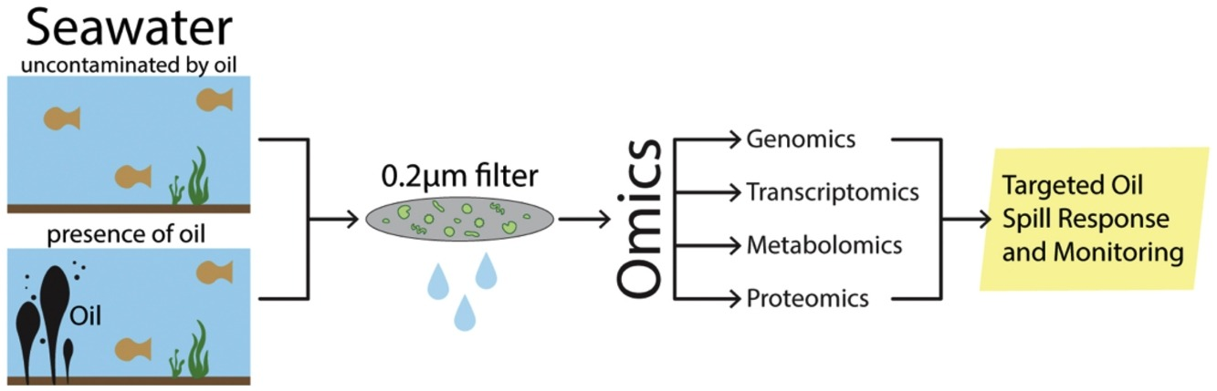

Figure 60: Showing systems biology approach which utilizes combination of “omics” technologies to better inform Spill Impact Mitigation Assessment and Monitoring (Harik et al., 2022).

understanding of both the baseline conditions in environments like the Caspian Sea and the dynamic changes that occur during hydrocarbon degradation. Metagenomic analysis reveals the structure and functional potential of microbial communities, while transcriptomics and proteomics provide insight into the active metabolic pathways and proteins involved in the degradation process. To further improve analysis of oil biodegradation in this environment, a combination of these approaches is needed. This allows us to track how microbial communities respond over time, revealing the stages of hydrocarbon degradation and the succession of microbial populations involved, i.e. a systems biology approach.

The timeline data generated through the analyses in this dissertation is particularly valuable in understanding the sequential stages of microbial response to hydrocarbon exposure and possible biotransformation of these hydrocarbons. This information not only enhances our knowledge of microbial adaptation to oil pollution but also improves the accuracy of oil biodegradation models, which have typically been confounded by the effects of cold temperatures on microbial activity. Traditional models often rely on the Q10 temperature coefficient, which assumes that biochemical reaction rates double with every 10°C increase in temperature. However, this oversimplification fails to account for the metabolic diversity and adaptations of microbial communities in cold environments, such as those in the Caspian Sea. By incorporating data from omics studies, we can refine these models to better predict the rates and pathways of oil biodegradation under varying environmental conditions, including low temperatures. This, in turn, aids in the development of more effective bioremediation strategies tailored to the unique challenges posed by oil spills in cold and isolated regions like the Caspian Sea.
In conclusion, this dissertation contributes to the understanding of microbial adaptation to hydrocarbon-rich environments and the potential metabolic flexibility of microbial communities in the Caspian Sea. As a relatively understudied habitat, more research is needed to increase the understanding of the metabolic diversity of these communities, especially at increased water depths. This will help us to better identify novel species or biochemical pathways and microorganisms that may be useful in oil spill responses.

VITA

Zabrenna Griffiths is PhD candidate in the Genome Science & Technology program who is originally from Jamaica. She is part of the Hazen Laboratory team where she has built upon previous studies investigating crude oil biodegradation in marine ecosystems. Her interest in the bioremediation potential of microbes began during her undergraduate tenure at Florida A&M University where she received her BSc in Environmental Science with a concentration in restoration and remediation. Here she studied microbes capable of transforming mercury and uranium into less bioavailable forms. During her undergraduate degree, she participated in various internship programs (Petrojam Limited) and undergraduate research programs (Sustainable Climate Risk Management, Great Lakes Bioenergy Research Center). These experiences encouraged her to pursue a doctoral degree to study the metabolic capabilities of microorganisms and their environmental applications. Zabrenna has used different molecular techniques to investigate the changes in the microbial community composition and oil-degrading genes after the addition of crude oil, both aerobically and anaerobically. She aims to increase the understanding of these biodegradation pathways to address water quality issues associated with the oil and gas industry. Human health and safety are influenced by the air, water and soil around us, and her curiosity has been piqued by pollutants cycling through our ecosystem.

Figures for this section are located in Appendix A
All tables and figures for this chapter are located in Appendix A
All tables and figures for this chapter are included in Appendix B
All tables and figures for this chapter are included in Appendix B
All figures for this chapter are located in Appendix C

