A Roadmap for the Restoration
of the Freshwater Mussel Fauna of Abrams Creek

A Thesis Presented for the
Master of Science
Degree
The University of Tennessee, Knoxville

Caleb Evan Moses
December 2025
Copyright © 2025 by Caleb E. Moses
All rights reserved.

ACKNOWLEDGEMENTS
First, I want to thank Rebekah and Sam for supporting me through every step of this journey. Their support, love, and friendship have kept me going even in the moments when it was hardest.
I would like to express my sincere gratitude to my advisor, Dr. Augustin Engman, for his guidance and encouragement throughout my graduate studies. His mentorship has shaped my development as both a scientist and conservationist.
I extend my thanks to my committee members, Gerry Dinkins and Matt Kulp, for their invaluable expertise, feedback, and support throughout this project. I am especially grateful to the National Park Service, Tennessee Wildlife Resources Agency, and NC Wildlife for their collaboration and ongoing commitment to aquatic conservation in the region.
Special thanks are due to Brittany Bajo-Walker, the Tennessee state Mussel Coordinator, for support both in the field and in the design of this study; and to Luke Etchison, Chantelle Rondel, and Dylan Owensby of the North Carolina Wildlife Resources Commission, for their assistance in sourcing and collecting mussels for our in-situ experiment. I also would like to thank Todd Amacker and Matt Reed of the Tennessee Valley Authority for their help in the field and for providing valuable insight that strengthened the design and interpretation of this work.
I am grateful to my fellow students and the faculty and staff in the Fisheries and Aquatic Conservation Ecology Lab for their collaboration, encouragement, and friendship during long field seasons and late nights. Finally, I want to thank my family and friends for their unwavering love, patience, and belief in my work.

ABSTRACT
Freshwater mussels are among the most imperiled faunal groups in North America and can be a vital component of a healthy aquatic ecosystem. Abrams Creek, a tributary of the Little Tennessee River in Great Smoky Mountains National Park, was historically one of the most biodiverse rivers in the park, until 1957 when a rotenone treatment and subsequent impoundment of its lower 3.2 km eliminated much of its native ichthyofauna. This study characterizes the Abrams Creek mussel assemblage, evaluates landscape scale environmental factors influencing species richness and abundance, and identifies candidate species for translocation to guide future restoration efforts. Using timed searches, five extant species were documented, including Cambarunio iris, Leaunio vanuxemensis, Lampsilis fasciola, Medionidus conradicus, and Pleurobema oviforme; species accumulation analyses indicated that this survey effort captured the full assemblage. Multiple models were created to evaluate environmental factors that may influence both the species richness and abundance of the mussel fauna of this system; model selection identified catchment area and available water supply as the strongest predictors of mussel abundance and species richness, highlighting the importance of watershed scale management and maintaining adequate baseflow in supporting viable mussel populations. Using a tiered framework based on habitat associations, host fish availability, proximity to source populations, and restoration feasibility, fourteen candidate species were prioritized for reintroduction. Eurynia dilatata and Pressodonta viridis were selected from this list and tested with an in-situ experiment to evaluate translocation potential. Although vandalism reduced experimental sample sizes, surviving individuals remained healthy after one year, supporting the viability of translocation as a tool for future restoration efforts. Together these results provide a roadmap for restoring mussel biodiversity in Abrams Creek.
TABLE OF CONTENTS
CHAPTER 1: GENERAL INTRODUCTION 1
I. Background and Study Significance 1
A. Status and Ecology of Freshwater Mussels 1
B. Study System: Abrams Creek Characteristics and Management History 3
C. Mussels of Abrams Creek 4
II. Research Objectives 6
A. Primary Research Questions 6
B. Research Objectives 6
C. Project Justification 6
CHAPTER 2: THE DIVERSITY AND DISTRIBUTION OF THE MUSSEL FAUNA OF ABRAMS CREEK 8
I. Chapter Abstract 9
II. Introduction 9
III. Methods 11
A. Study Area and Site Selection 11
B. Timed Searches 12
C. Quantitative Transect Surveys 13
D. Data Analysis and Visualization 14
IV. Results 15
A. Assemblage Characterization and Population Characteristics 15
B. Transect Survey Results 16
C. Environmental Factors Affecting Mussel Assemblage 17
V. Discussion 18
A. The Abrams Creek Mussel Assemblage 18
B. Landscape Scale Drivers of Assemblage Characteristics 21
C. Quantitative Transect Surveys 22
D. Study Limitations and Future Directions 22
CHAPTER 3: PRIORITIZATION OF VIABLE SPECIES FOR BIODIVERSITY RESTORATION IN ABRAMS CREEK 24
I. Chapter Abstract 25
II. Introduction 25
III. Methods 27
A. Candidate Species Selection 27
B. In-situ Experiment of Translocation Viability 29
IV. Results 31
- Candidate Species for Restoration 31
B. In-situ Experiment of Translocation Viability 32
V. Discussion 33
A. Candidate Species for Restoration 33
B. In-situ Experiment of Translocation Viability 34
CHAPTER 4: CONCLUSION AND MANAGEMENT IMPLICATIONS 36
A. Restoration Potential Summary 36
B. Management Considerations 36
LIST OF REFERENCES 38
APPENDIX 49
Tables 49
Figures 56
VITA 62

LIST OF TABLES
Table 1. Species, tribes, occurrence, relative abundances, and sex composition of freshwater mussels collected in timed searches 51
Table 2. Location of sites used in this study with the freshwater mussel species richness and diversity observed in timed search sampling 52
Table 3. AIC model selection results for negative binomial regressions predicting total freshwater mussel abundance across sites. This table summarizes the top-ranked models and identifies the predictor variables that best explain variation in abundance 53
Table 4. AIC model selection results for Poisson regressions predicting freshwater mussel species richness across sites. This table summarizes the top-ranked models and identifies the predictor variables that best explain variation in richness 54
Table 5. Summary of quantitative transect survey results indicating locations, number of 0.25 m² quadrats sampled, species observed including total number and ranges of lengths in parenthesis and observed mean densities 55
Table 6. Design of in-situ experiment of growth and health of two candidate species for translocation to Abrams Creek 55
Table 7. Prioritized list of candidate freshwater mussels for translocation or stocking in Abrams Creek. Conservation status identifies federal status (USFWS) including Listed Endangered (LE), Listed Threatened (LT), Proposed Endangered (PE), and state status as detailed in the Tennessee State Wildlife Action Plan including Endangered (E), Threatened (T). Habitat associations are summarized from species references and personal communications with experts. Potential source stocks include extant populations from nearby rivers and propagation facilities, including the Virginia Department of Wildlife Resources Aquatic Wildlife Conservation Center (AWCC) and the Freshwater Mollusk Conservation Center (FMCC) at Virginia Tech. Host fishes are species documented to occur in Abrams Creek and are listed as known hosts in INHS Mussel Host Database (Freshwater Mussel Host Database; https://mollusk.inhs.illinois.edu/freshwater-mussel-host-database/) or from personal communications with experts. Tiers represent result of prioritization with Tier 1 considered the most likely candidates to contribute to successful augmentation of species diversity in Abrams Creek 56
LIST OF FIGURES
Figure 1. Map of Abrams Creek study system including survey locations, survey types, and key features. Locations where timed search occurred are denoted by circles, locations where timed search sites and in-situ experiments occurred are marked with squares, and locations where timed searches and quantitative transect sampling occurred are marked with triangles. The study area is divided into three sections: Upper, Middle, and Lower Abrams Creek, which are marked in orange, green and yellow, respectively. The 1957 rotenone treatment included these same sections but continued into what is now impounded by Chilhowee Reservoir which is marked with a red line. Abrams Falls, the upper boundary of this treatment, is denoted by a yellow star. Abrams Creek and its tributaries outside of the study area are shown in blue lines, the boundary of GSMNP is shown in light gray, and Chilhowee Reservoir is represented in dark gray from the point that it impounds lower Abrams Creek 58
Figure 2. Species accumulation curve for timed searches conducted in Abrams Creek 59
Figure 3. Relative abundances and species composition of freshwater mussels observed during the 30 timed searches conducted in Abrams Creek below Abrams Falls. Each pie chart represents the species composition at each survey site, with chart size scaled to overall relative abundance (i.e., larger circles represent observations of a greater number of mussels). Grey points denote sites where no mussels were observed in a timed search 60
Figure 4. Length-frequency distributions of four freshwater mussel species collected during timed search at 33 sites distributed throughout Abrams Creek 61

Figure 5. Observed values versus those predicted by a negative binomial (NB) model of freshwater mussel relative abundance and a Poisson model of species richness. Dotted line is a line of one-to-one correspondence between observed and predicted values62
Figure 6. Photo of in situ-experiment of translocation viability demonstrating one mussel silo and two sediment cages 63

CHAPTER ONE
GENERAL INTRODUCTION
I. Background and Study Significance
A. Status and Ecology of Freshwater Mussels
Freshwater mussels are a diverse group of mollusks that have experienced widespread declines due to many factors. North America has the highest diversity of freshwater mussels globally, hosting 301 of approximately 800 species worldwide (Bogan 2008; Hopper et al. 2023; Graf and Cummings 2007). The southeastern United States is the locus of mussel diversity in North America, but ongoing land use changes in this region have produced an environment that is detrimental to this imperiled group (Haag 2009). Of the 301 native North American species, 144 occur in Tennessee, 178 occur in Alabama, and 129 occur in Georgia (Gerald Dinkins, McClung Museum, UTK, Personal Communication). Freshwater mussels (hereafter referred to as “mussels”) have declined in both diversity and abundance across most assemblages, and currently approximately 70% of species in North America are classified by the US Fish and Wildlife Service (USFWS) as near threatened, vulnerable, or endangered (Brian and Aldridge 2023; Williams et al. 1993). The exact cause of observed declines is not well understood, but it is widely accepted that overharvest by the button industry during the 1800 - 1900s (Smith 1919; Coker 1916; Haag 2009), widespread habitat loss due to dam construction in the 1900s (Vaughn and Taylor 1999; Wu et al. 2019), and habitat destruction, water quality degradation, and changes in flow regimes caused by ongoing land use changes (Downing et al. 2010; Nobles and Zhang 2011) are major contributing factors.
Mussels utilize a reproductive strategy that requires an external organism as a host, which can complicate ongoing management and conservation initiatives. When mussels produce larvae (called glochidia), they attach these larvae to their preferred host species to disperse their young (Schwalb et al. 2011). Mussels can attract host species and apply their glochidia in a variety of ways, including using lures to temporarily trap the host, lures that entice the host to strike mantle tissue, and by releasing conglutinates from their gills that imitate a food source (Modesto et al 2018; Melchior et al. 2021; Sietman et al. 2012). Other species utilize more passive methods including suspending glochidia in mucus to entangle their host fish, or free releasing their glochidia to be passively encountered (Barnhart et al. 2008). The attached glochidia consume small amounts of blood from the host for several weeks (Filipsson et al. 2017; Marwaha et al. 2017) until they mature and fall to the substrate. Many species require a specific host and produce a lure specific to an individual species of fish (Haag 2012; Wacker 2019). This relationship complicates the conservation of mussels, as conservation planning must account for both mussels and their host species. If the relationship between mussel and host fish is interrupted or severed entirely, the species using this host to complete its reproduction cycle could experience further declines or extirpation (Modesto et al. 2018; Haag 2012).
Mussels are vital organisms in many aquatic communities and provide many ecosystem functions, primarily by supporting water quality and substrate conditions through filter feeding; and by acting as a food source (Vaugn 2018; Bakshi et al. 2023). Mussels constantly filter water to feed, with some species filtering up to a liter of water an hour, and remove algae, bacteria, and organic matter which maintains water quality and microhabitat conditions that many other organisms rely on for survival (Kreeger et al. 2017; Vaugn 2018). While feeding some inorganic matter is consumed and sequestered in the substrate as waste, which can improve both water quality and substrate conditions (Gal 2025; Grabarkieuicz and Danis 2008). This group is also a food source for many predator species, including muskrats, otters and freshwater drum (Vaugn 2018).
B. Study System: Abrams Creek Characteristics and Management History
The Abrams Creek watershed occurs within the Blue Ridge physiographic province and is contained within Great Smoky Mountains National Park (GSMNP). Its headwaters flow through geologic layers of Precambrian sandstone and Paleozoic limestone (Moore 1988), which increases availability of minerals and nutrients available for primary production and maintains its pH and water quality (Adham and Kobayashi 2009; Arce and Boyd 1975, Simbeck 1990). The land cover of the Abrams Creek watershed is primarily forest, which benefits the aquatic fauna here by providing terrestrial food sources and nutrients and mitigating external pollutants (Fiquepron et al. 2013; Grace 2005). These qualities produced one of the most diverse aquatic communities in the GSMNP, with over 67 species of fish historically present (Simbeck 1990).
While the physical characteristics of this system supported a diverse aquatic community, the previous management of both this stream and its watershed have led to the decline of its biodiversity. The Abrams Creek watershed was heavily logged prior to the creation of the GSMNP in the 1930s (Silsbee and Larson 1988). This logging led to the widespread decline of Salvelinus fontinalis (Mitchill) (Brook Trout), so logging companies were required to restore trout to any affected streams (Tebo 1955). Oncorhynchus mykiss (Walbaum) (Rainbow Trout) are easier to produce, which led to many companies favoring this species (Needham and Behnke 1962). Due to both the popularity of Rainbow Trout as a game fish and the noticeable productivity occurring in this stream, Abrams Creek was selected to become a trophy trout stream to take advantage of the conditions there (Lennon and Parker 1919). A rotenone treatment was conducted in Abrams Creek in 1957 prior to the closing of Chilhowee Dam to permanently remove species thought to compete with Rainbow Trout; this treatment started at Abrams Falls and continued to the Little Tennessee River, a reach of approximately 28.5 kilometers (Lennon and Parker 1959). Chilhowee Dam was also completed in 1957 (McCaffrey et al. 2019) which prevents natural recolonization of many extirpated species (Larinier 2000). As a result of this treatment, it is believed that 32 of the 67 fish species present prior to this treatment were extirpated (Simbeck 1990).
Through natural recolonization, and the efforts of the National Park Service (NPS), USFWS, and other collaborators, several species of fish extirpated by this treatment have been successfully restored to the Abrams Creek system (Shute et al. 2005, Simbeck 1990). While rotenone is an effective piscicide, the duration of its effects are relatively short and many species were likely able to recolonize shortly after this treatment (Ling 2003). Subsequent restoration efforts beginning in the 1980s accelerated restoration, with several species being reintroduced with translocations from Citico Creek (Shute et al. 2005). Eight species in total extirpated by this treatment have been restored with translocations from Citico Creek and Little River (Matt Kulp, NPS, Personal Communication; Shute et al. 2005). Continued monitoring by the NPS and partners has documented the successful establishment of these translocated populations, with present-day surveys indicating that the fish assemblage now reflects much of its historic diversity (Matt Kulp, Personal Communication). This restoration of much of the fish assemblage of Abrams Creek provides the host assemblage necessary to support the restoration of mussels (Modesto et al. 2018).
C. Mussels of Abrams Creek
Prior to this study there have been very few collections of mussels from Abrams Creek, with most being incidental collections; no formal survey of the mussel fauna was conducted until 2016. Before the 1957 rotenone treatment, few malacologists recorded mussels from this system. A. E. Ortmann collected one species, Pleuronaia barnesiana (Lea) (Tennessee Pigtoe), at an unknown location in Abrams Creek in 1914 (Ortmann 1918). Pleurobema oviforme (Conrad) (Tennessee Clubshell) was collected from the confluence of Abrams Creek and the Little Tennessee River in the 1800s, and the specimen is part of the Showalter collection at University of Michigan Museum of Zoology, Division of Mollusks (UMMZ; InvertEBase Portal, https://invertebase.org/portal). Cambarunio iris (Lea) (Rainbow) was also collected near this point in the 1900s, and the specimen is part of the Frierson collection at UMMZ (InvertEBase Portal). Mussels collected after the rotenone treatment include C. iris, P. oviforme, Lampsilis fasciola Rafinesque (Wavyrayed Lampmussel), and Medionidus conradicus (Lea) (Cumberland Moccasinshell), collected between 1982 and 2023 (InvertEBase Portal).
Recent surveys of the mussel fauna were either limited in range or were not targeting mussels but can still provide additional insight into the status of the mussel fauna of Abrams Creek. University of Tennessee Master’s student Stephen Fraley encountered C. iris above Abrams Falls while sampling for aquatic macroinvertebrates (Fraley 1998). In 2016, EnviroScience, Inc. conducted a series of timed search surveys between Abrams Creek campground and Mill Branch, and collected five species- C. iris, Leaunio vanuxemensis (Lea) (Mountain Creekshell), L. fasciola, M. conradicus, and P. oviforme (EnviroScience 2016). A subsequent survey by Dinkins and Alford (2018) also examined the lower section of this creek and reported a similar assemblage: C. iris, L. fasciola, and M. conradicus (Dinkins and Alford 2018). In addition to these species, Utterbackia imbecillis (Say) (Paper Pondshell) was collected from the section of Abrams Creek now flooded by the Chilhowee Lake impoundment (Dinkins and Alford 2018). Although these studies confirmed a persisting mussel assemblage, their limited scope reflects the need for a full characterization of the mussel fauna of Abrams Creek to better understand the existing assemblage and identify areas viable for restoration.
While mussels occur throughout Abrams Creek today, the effect of the 1957 rotenone treatment on this mussel assemblage is unknown. Mussels can tolerate rotenone at a concentration typically used in fisheries management (Hart et al. 2001; Dolmen et al. 1995), but several of the species of fish extirpated by this treatment are common hosts for several mussel species (Simbeck 1990, Freshwater Mussel Host Database, https://mollusk.inhs.illinois.edu/freshwater-mussel-host-database/). Widespread loss of available host species would limit reproduction and may lead to extirpation of mussel fauna if host species were lost (Modesto et al. 2018).
II. Research Objectives
A. Primary Research Questions
- What mussel species currently inhabit Abrams Creek?
- Which mussel species are viable for restoration in Abrams Creek?
B. Research Objectives
- Comprehensively characterize the mussel assemblage of Abrams Creek.
- Identify species that may be successful upon translocation in Abrams Creek.
- Evaluate the restoration potential of a subset of these species via an in-situ experiment.
C. Project Justification
Investigating the viability of restoring other aquatic fauna is vital to the continued management of Abrams Creek. Much of the fish assemblage present prior to the 1957 rotenone treatment has either recolonized or been restored; this system currently hosts 43 species of fish, including four that are listed threatened or endangered by USFWS: Noturus baileyi Taylor (Smoky Madtom), Noturus flavipinnis Taylor (Yellowfin Madtom), Etheostoma sitikuense Blanton (Citico Darter ) and Percina burtoni Fowler (Blotchside Logperch) (Matt Kulp, Personal Communication; Shute et al. 2005, Simbeck 1990). The restoration of E. sitikuense, P. burtoni, Etheostoma blennioides Rafinesque (Greenside Darter) and Cottus carolinae (Gill) (Banded Sculpin) may support mussel reproduction by increasing host fish availability (Modesto et al 2018). Several mussel species have been collected in Abrams Creek, including C. iris, L. vanuxemensis, L. fasciola, and two species proposed for listing under the Endangered Species act, M. conradicus and P. oviforme (US Fish and Wildlife Service, 2023). Characterizing the mussel assemblage of Abrams Creek and identification of species with high potential for translocation success is necessary to develop a management plan for the mussel fauna of Abrams Creek.

CHAPTER 2
DIVERSITY AND DISTRIBUTION OF THE
ABRAMS CREEK MUSSEL FAUNA

I. CHAPTER ABSTRACT
The mussel assemblage of Abrams Creek was characterized with a scientifically-sound study design. Mussel densities were estimated at two sites using a quantitative transect method, and relationships between assemblage structure and environmental variables were explored with generalized linear modelling. The relative abundances and sex and size structure at each site was sampled with timed search surveys in a stratified-randomized sampling design that included 33 sites, providing spatial coverage of potentially viable mussel habitat. Five species were confirmed to be extant in the Abrams Creek assemblage: C. iris, L. vanuxemensis, L. fasciola, M. conradicus, and P. oviforme. A species accumulation curve and Chao1 estimator supported the observed total richness of five species. A sixth species, P. barnesiana, last observed in 1914, appears to be extirpated. Cambarunio iris and L. vanuxemensis were the most abundant and widespread species in this assemblage, L. fasciola occurred at an intermediate number of locations and in intermediate abundances, and M. conradicus and P. oviforme were patchily distributed in very low abundances. Model selection identified catchment area and groundwater depth as predictors of overall abundance and richness. The population structures of the most common species were examined with shell length-frequency distributions and sex ratios. Overall, the current mussel assemblage exhibits relatively low species richness, but the relative abundances, distributions, size structures, and sex ratios of the more common species are indicative of viable populations. These findings establish a baseline for restoration goals and monitoring of future changes to the mussel assemblage.
II. INTRODUCTION
The southeastern United States hosts the greatest diversity of mussels globally (Hopper et al. 2023; Graf and Cummings 2007); the Tennessee River system alone supported approximately 107 species (Haag 2012; Parmalee & Bogan, 1998). However, this diversity is facing widespread declines as mussels are threatened by dams, habitat modification, and water quality degradation across the region (Downing et al. 2010; Nobles and Zhang 2011).
Abrams Creek is located in the Great Smoky Mountains National Park (GSMNP) and was historically the park’s most biodiverse stream (Simbeck 1990). This was likely due to the exposure of its headwaters to limestone, which supports primary production (Arce and Boyd 1975). While this stream maintains good water quality and largely intact habitat, it has also experienced three major disturbances that contributed to the degradation of the aquatic fauna here. First, this watershed was heavily logged through the 1930s (Silsbee and Larson 1983), likely causing sedimentation and channel instability (Graynoth 1979; Tebo 1955). Second, a large-scale rotenone treatment in 1957 temporarily eliminated much of the ichthyofauna between Abrams Falls and the Little Tennessee River, approximately 28.5 km (Figure 1). Third, the completion of Chilhowee Dam later in 1957 impounded the lower 3.2 km of Abrams Creek and severed natural recolonization pathways for both mussels and their host fishes (Larinier 2000).
Because no comprehensive mussel survey was conducted before these disturbances, the historical assemblage of Abrams Creek is poorly documented. Arnold Ortmann collected P. barnesiana at an unknown site in Abrams Creek in 1914 (Ortmann 1918); this species has not been collected from this system since. Modern surveys prior to this study were either spatially limited or were not targeting mussels; Stephen Fraley (1998) collected one species above Abrams Falls while sampling for macroinvertebrates, EnviroScience (2016) surveyed between Abrams Creek campground and Mill Branch, and Dinkins and Alford (2018) sampled lower Abrams below Mill Branch, including the impounded lower reach during a temporary reservoir drawdown. However, no effort had previously surveyed the entire stream or characterized the full assemblage across all potentially viable habitat.
Many of the fish species extirpated by the rotenone treatment have either recolonized or been reintroduced (Matt Kulp, Personal Communication; Schute 2005; Simbeck 1990) Given the intact habitat conditions, the unknown level of degradation of the mussel fauna, and the restoration of multiple host fish species, Abrams Creek is a strong candidate for mussel restoration. A comprehensive assessment of species presence, distribution, and relative abundance is therefore essential to inform restoration planning.
The objectives of this study were to fully characterize the Abrams Creek mussel assemblage, identify environmental variables related to mussel assemblage structure, and identify potential restoration and long-term monitoring sites. This study provides baseline data for conservation efforts and establishes protocols for long-term monitoring of mussels in Abrams Creek.
III. METHODS
A. Study Area and Site Selection
Abrams Creek is a major tributary of the Little Tennessee River and is contained in the GSMNP. This stream runs approximately 44.5 km from its headwaters to the confluence with the Little Tennessee River at Chilhowee Lake. This study focused on the 26.5 km section between Abrams Falls and the Chilhowee Lake impoundment. Except for approximately 3.2 km of lower Abrams Creek that is impounded by Chilhowee Dam, this section corresponds to the boundaries of the 1957 chemical treatment (Figure 1). This section also supports the highest biodiversity in the system, making it the focus of most ongoing monitoring and management efforts (Matt Kulp, Personal Communication). Abrams Falls is a likely natural barrier to most mussel distributions within this system, further supporting limiting survey efforts to below this point. An additional study reach was selected above this point to determine if mussels currently occur beyond this physical barrier.
Thirty sites were selected between Abrams Falls and the impoundment using a stratified randomized design in ArcGIS (Figure 1). To determine if mussel distributions extend above the Abrams Falls barrier, three supplemental sites were selected upstream of this point. To create strata, the complete length of the study area was measured and divided into three equal-length sections; for the remainder of this thesis these sections will be referred to as the upper, middle, and lower sections of Abrams Creek (Figure 1). Each section was then further divided into 295 m sites, and ten sites were randomly selected to be sampled from each section. A specific reach within each site was selected to be searched for mussels based on visual evaluation of available habitat within the site.
B. Timed Searches
Timed searches were used to characterize the mussel fauna at all 33 selected sites. Standardized timed search surveys are an effective way to characterize a mussel assemblage; although timed searches do not yield data on species density or total abundance, they offer a reliable approach for assessing species diversity, distribution, and relative abundance (Obermeyer 1998; Vaughn et al. 1997).
Each 295 m reach selected was visually surveyed to identify viable habitat, which was measured to establish a study area between 30 – 120 m. All sites were searched with skin diving gear (mask and snorkel), with one person-hour of effort applied per site, most often using two surveyors. Surveyor ability, survey conditions, and effort were comparable across all sites. Surveyors began at the most downstream point of the study reach and moved upstream in a weaving pattern to cover all habitat present within the site. Surveyors visually scanned the streambed, tactilely searched fine sediment, flipped large rocks, and moved woody debris. All mussels found were retained until the end of the survey, and all individuals were identified, measured to the nearest millimeter, and sexed if dimorphic. All individuals encountered except for juveniles less than 20 mm in length were tagged with a Hallprint alphanumeric tag. Relic shells collected were stored at the McClung Museum malacological collection at the University of Tennessee, Knoxville. Additional site data included coordinates, locality relative to any major trails or other landmarks, and visual estimates of flow, underwater visibility, bank erosion, bank height, and depth were collected.
C. Quantitative Transect Surveys
In addition to timed searches, two sites were sampled with quantitative transect surveys to determine species densities. Both sites were selected to overlap with a timed search where high relative abundances were observed, one from middle Abrams and one from lower Abrams (Figure 1).
At each site, twelve randomly placed transects were placed perpendicular to the direction of water flow and sampled using 0.25 m² quadrats, following a modified protocol described in Strayer and Smith (2003). To survey each transect, ten 0.25 m2 quadrats were evenly distributed across the transect; in the case that a transect was too long or short for exactly ten quadrats, surveyors placed quadrats to the edge of the wetted width regardless of transect length. A minimum of 100 quadrats were sampled at each site. To sample each quadrat, surveyors first visually scanned the substrate within each quadrat and collected any mussels at the surface; the surveyors then moved any large rocks, detritus, or loose woody debris and conducted another visual search. Next, surveyors excavated the substrate to a depth of 5–10 cm, removed all mussels, then returned all substrate and woody debris to the quadrat. Surveyors identified, sexed, and measured all mussels before returning them to the substrate where they were found.
D. Data Analysis and Visualization
Multiple analyses were used to summarize the characteristics of this assemblage and evaluate the effectiveness of these surveys. An assemblage summary table was created to reflect the tribe, number of individuals collected, and observed sex ratios of each species collected during timed searches (Table 1). A species accumulation curve and Chao1 estimator were used to estimate the likelihood of additional undetected species based on the timed search effort (Figure 2). The species composition and relative abundance of each timed search site was visualized using pie charts (Figure 3). Species richness and Shannon diversity indices were calculated for each site (Table 2). The observed size structure of each population was visualized using length-frequency histograms (Figure 4).
The effect of multiple landscape-scale predictors on total relative abundance and species richness was evaluated using a generalized linear modeling approach. Total relative abundance was modeled using negative binomial regression to account for overdispersion in abundance counts (Table 3); species richness was modeled with a Poisson regression as richness represents a discrete count variable (Table 4).
Candidate predictor variables were selected based on ecological relevance and prior research on mussel distribution in southeastern streams including variables representing stream size (catchment area, average stream width), groundwater stability (available water supply at 150 cm depth and landscape context (distance to the downstream impoundment, distance to the nearest upstream tributary, and dominant soil and forest types). Before modeling, all predictors were assessed for collinearity and variables with variance inflation factors (VIF) greater than five were removed to reduce redundancy (Senaviratna and Cooray 2019).
A global model that included all remaining predictors was constructed for both response variables, then an all-subsets model selection procedure was performed using the MuMIn package in R. All models were ranked using corrected Akaike Information Criterion (AICc), and models within two ΔAICc units of the top model were considered to be equally supported. A corrected AIC was used to rank these models to account for small sample sizes (Hurvich and Tsai 1991). Both a Nagelkerke and McFadden pseudo-R² value were used to evaluate model fit, and the p-value of each model was presented to reflect model significance. Model residuals were used to verify homogeneity and independence dispersion parameters were assessed to confirm model fit. Model performance was also evaluated with observed vs. predicted plots (Figure 5).
IV. RESULTS
A. Assemblage Characterization and Population Characteristics
During the timed search effort, 201 mussels representing five species were observed in Abrams Creek. These included C. iris, L. fasciola, L. vanuxemensis, M. conradicus, and P. oviforme (Table 1). The species accumulation curve from these sites shows a rapid initial increase in detections, with four of the five species observed within the first ten sites; the curve then gradually reaches five species (Figure 2). The Chao1 richness estimator also predicted five species with a 95% confidence interval of 4.1 to 5.9.
The relative abundance and distribution of each species in this assemblage varied widely. Cambarunio iris and L. vanuxemensis were relatively abundant and widely distributed and comprised 83.6 % of all individuals encountered. Lampsilis fasciola was moderately abundant but displayed a patchy distribution and comprised 12% of individuals. Medionidus conradicus and P. oviforme were rare, with only seven individuals of M. conradicus and one individual of P. oviforme collected across all sites combined, making up 3.5% and 0.5% of individuals collected, respectively (Table 1). Leaunio vanuxemensis occurred farther upstream than any other species, and C. iris was the only other species present in upper Abrams Creek. The upstream limit of all other species occurred in middle or lower Abrams Creek (Figure 3). Site-level diversity ranged from 0 to 1.036 (mean = 0.45 ± 0.39 SD; Table 2).
Length frequency distributions of C. iris and L. vanuxemensis appeared to be normally distributed. The distribution for L. fasciola appeared skewed toward larger individuals. Very few M. conradicus were encountered, which limited interpretation of length patterns, but all individuals were similar in size (Figure 4). The sex ratios of C. iris, L. fasciola, and L. vanuxemensis all deviated from 1:1 (M:F) (Table 1). Cambarunio iris exhibited male skewed populations across surveyed sites (1.14:1 M:F), while L. fasciola and L. vanuxemensis showed female skewed ratios (0.61:1 M:F). The presence of juvenile C. iris, L. fasciola, and L. vanuxemensis indicates ongoing recruitment in these populations.
B. Transect Survey Results
Across both sites, 330 quadrats (0.25 m² each) were excavated, giving a total sampled area of 82.5 m². Only two species were detected: C. iris and L. fasciola. A single juvenile C. iris was encountered at each site. At the upper site, 157 quadrats yielded 13 individuals of C. iris, resulting in a mean density of 0.33 individuals/m². At the lower site, 173 quadrats produced six C. iris with a density of 0.14 individuals/m² and two L. fasciola with a density of 0.04 individuals/m², for a combined density of 0.18 individuals/m² (Table 5). More than 90% of quadrats were unoccupied, and many mussels were confined to isolated patches of sand and silt along the margins of the stream.
C. Environmental Factors Affecting Mussel Assemblage
Model selection supported catchment area and available water supply at 150 cm depth (AWS150) as predictors of relative abundance and species richness in this system. The top model of abundance had a delta AICc value two higher than the next best model and included both catchment area and ASW150 as predictor variables. The top model of species richness only included catchment area as a predictor variable, but when ranked with AICc the second-best model including AWS150, and the global model that included AWS150 and distance to the nearest tributary both received comparable support. Since the global model and top model performed very similarly, the simpler model is preferred (Mills and Prasad 1992). The pseudo-R² values used to evaluate these models reflect that models moderately explain variance in these models. The p-value of both top models is well below 0.05, indicating that there is sufficient evidence to reject the null model. These results reflect that catchment area and AWS150 have a positive effect on both species richness and relative abundance. Models that included these two variables consistently outperformed both the null and reduced alternatives, indicating that watershed size and groundwater availability are the most influential environmental drivers currently evaluated for mussel distribution in Abrams Creek (Table 3; Table 4).
Observed versus predicted plots supported these findings, showing that both models captured general patterns in both relative abundance and species richness; the weak fit observed in these plots does indicate unexplained variance in the models (Figure 5). Species distribution maps further indicate that larger catchments consistently supported higher mussel abundance and richness, particularly in the lower and middle sections of Abrams Creek (Figure 3).
V. Discussion
A. The Abrams Creek Mussel Assemblage
The mussel assemblage of Abrams Creek is composed of five species: C. iris, L. vanuxemensis, L. fasciola, M. conradicus, and P. oviforme. This assemblage is notably less diverse than Little Tennessee River and other tributaries, indicating that some species may have been lost due to historical disturbances. The Little Tennessee River historically hosted 55 species (Gerald Dinkins, unpublished data); other nearby tributaries to the Little Tennessee and Tennessee River also hosted more species than Abrams Creek including Tellico River (n=13), Citico Creek (n=7), and Little River (n=14) (Johnson et al. 2005; Parmalee and Hughes 1993; Parmalee and Klippel 1984; Schilling et al. 2017). While minimal historical data exists for this stream, comparisons between Abrams Creek and other nearby systems seem to indicate that the mussel diversity of this stream may be reduced from historical levels.
Despite having low diversity when compared to other systems, it appears that the Abrams Creek fauna still maintains some functional diversity. The species in Abrams Creek are from two tribes, Lampsilini and Pleurobemini, indicating the success of multiple feeding preferences, habitat associations, and reproductive strategies within the system (Haag 2012). While C. iris, L. vanuxemensis and L. fasciola are three of the most common species throughout the Tennessee River drainage (Parmalee and Bogan 1998), the presence of M. conradicus and P. oviforme is evidence that Abrams Creek supports habitat for rare species (US Fish and Wildlife Service, 2023).
Size structure and sex ratio varied among mussel species. Cambarunio iris and L. vanuxemensis had broad size ranges, from juveniles (< 20 mm) to mature adults (> 60 mm). The shape of the size distributions appeared normal, which indicates ongoing recruitment and suggests that Abrams Creek can currently support reproduction and survival of mussels (Asher and Christian 2012; Ellwanger and Wagner 2022; Haag 2012). The sex ratio of C. iris was slightly male-skewed, a pattern consistent with reports for this species from other systems (Asher and Christian 2012); however this may be due to the difficulty of determining the sex of young individuals, which could result in false identifications of female mussels as male (Gerald Dinkins, Personal Communication; Haag and Rypel 2011). Leaunio vanuxemensis appeared to be female skewed, making up approximately 60% of individuals observed. The sexual dimorphism displayed in this species does make discerning sex easier, so this could represent an actual skew in the demographics of this population (Parmalee and Bogan 1998). Lampsilis fasciola displayed a right-skewed size distribution and a female skewed sex ratio; however the conspicuous mantle lure displayed by mature females likely increased detections of this size and sex class, which could influence observations of size and sex ratios for this species (Zanatta et al. 2007). Juveniles of this species were rarely encountered; however, this may be a result of the methods used to survey this assemblage and may not represent a lack of recruitment in this population (Hart et al. 2016). Mature adults of M. conradicus dominated observations of this species, and no juveniles were recorded; this may not represent a lack of recruitment but rather a low detection probability from low abundances (Smith 2006).
Spatial distributions differ widely between species, indicating each species may have variable habitat associations. Leaunio vanuxemensis and C. iris had the widest distributions but reached their greatest abundance in the middle section of Abrams Creek. Leaunio vanuxemensis extended further upstream, a commonly observed distributional pattern in this species (Parmalee and Bogan 1998). Lampsilis fasciola, M. conradicus, and P. oviforme occurred in patchy distributions, usually represented by only a few individuals. Mussels also appeared to be absent from several sites with suitable habitat, suggesting that factors beyond habitat quality, such as available food resources, availability of host fish, or other biological requirements may affect species distributions, a pattern observed in other systems (Vaughn and Taylor 1999; Haag 2012).
The only historically documented species not detected in this survey was P. barnesiana, which is now likely extirpated. This last observation of this species occurred in 1914 (Ortmann 1918); since that time, it has remained undetected by subsequent survey efforts, as well as any incidental collections (InvertEBase Portal). This loss is concerning as this species is endemic to the Tennessee River basin and is current proposed for listing as endangered alongside M. conradicus and P. oviforme (U.S. Fish and Wildlife Service, 2023). Although the direct cause of the disappearance of this species is unknown, it is possible that that combined effects of widespread logging, and both the direct effects of the 1957 rotenone treatment and the potential loss of host fish may have led to the extirpation of this species (Downing et al. 2010; Haag 20012).
The species accumulation curve and Chao1 estimator reflect that this sampling effort effectively captured the existing mussel assemblage of Abrams Creek (Thompson and Withers 2003). Observed richness closely aligned with richness estimates in both metrics, indicating that additional sampling would be unlikely to detect additional species (Chao et al. 2009).
B. Landscape Scale Drivers of Assemblage Characteristics
Analysis of the variables tested identified catchment area as the most consistent driver of increasing mussel abundance in Abrams Creek that was tested, with sites further downstream consistently supporting more diverse and abundant mussel fauna. While this could simply be a relationship between larger stream area and these variables, these patterns may reflect some shift in stream morphology that occurs with increasing catchment area (Strayer 2008). Available water supply at 150 cm depth (AWS150) also emerged as a factor influencing relative abundance. This variable represents groundwater depth which may be correlated with baseflow consistency, which may mitigate sudden variations in flow (Bottaro et al. 2003). Consistent baseflow supported by available groundwater can mitigate the worst effects of droughts and other low water events by maintaining sufficient depth and margin habitat commonly used by both juvenile fish and mussels, further supporting recruitment (Boulton 2003; Bower et al. 2019; Cushway et al. 2024) While species richness responded to the same predictors, its relationship with these variables is less clear than that of abundance. This suggests that the number of species currently present in Abrams Creek may be more strongly influenced by historical constraints- such as rotenone treatment and barriers to recolonization- than by current habitat conditions (Haag 2012; Wu et al. 2019).
Together these models highlight the importance of watershed-scale management in supporting mussel assemblage restoration. While the actual drivers of this relationship are unknown, maintaining catchment-scale processes, including natural hydrology (baseflow contributions, sediment transport) could support the long-term viability of this mussel assemblage.
C. Quantitative Transect Surveys
Quantitative transect surveys were conducted at sites that high relative abundance was noted during timed searches, but these transects did not produce comparable results. During this effort, very low densities were observed and only one to two species were observed at either site; timed searches at each of these sites observed high relative abundance and each encountered twice the number of species observed during the transect surveys. This likely reflects the patchy distribution of mussels in Abrams Creek, as randomly selected quadrats may miss preferred habitat that timed searches can selectively target (Obermeyer 1998; Vaughn et al. 1997). Although this effort failed to capture the density of mussels at each of these sites, it provides baseline data and a protocol for evaluating restoration success. Standardizing this effort enables consistency in comparisons throughout time and reduces the effect of observer bias and variations in sampling methods (Dunn 2000). Establishing permanent grid reference points also ensures that subsequent surveys can be conducted at the same locations, so comparisons over time detect changes in the mussel assemblage rather than differences in sampling location (Strayer and Smith 2003; Hornbach and Deneka 1996).
D. Study Limitations and Future Directions
This study provides a current assessment of the mussel assemblage in Abrams Creek; however, several limitations constrain interpretation. Timed searches do not provide density estimates, and patchy distributions reduced the effectiveness of statistical modeling (Vaugn et al. 1997). Additionally, the historical assemblage is unknown due to minimal survey data collected prior to 1957, which complicates comparisons of this stream to others nearby (InvertEBase Portal). Future research could expand this quantitative survey effort at additional sites in Abrams Creek to establish density baselines that could be compared to densities of mussel fauna throughout the Little Tennessee River basin. These efforts will improve restoration planning and support the selection of sites for translocations.

CHAPTER 3
PRIORITIZATION OF VIABLE SPECIES FOR BIODIVERSITY RESTORATION IN ABRAMS CREEK

I. CHAPTER ABSTRACT
This chapter identifies and prioritizes multiple mussel species for potential translocation or stocking that could be used to augment mussel diversity in Abrams Creek. All available data including InvertEBase collections, archaeological survey records, and current species distributions throughout the Little Tennessee River basin were combined to identify species that could be successfully translocated into this system. Five criteria were used to rank these species, including historical occurrence in the Little Tennessee basin, habitat associations, host fish availability, conservation status, and source stock availability. Fourteen species were identified as viable candidates, grouped into four tiers. A yearlong in-situ experiment testing the feasibility of translocation as a tool for restoration was also conducted using two species, Eurynia dilatata and Pressodonta viridis. While vandalism severely reduced the size of these experimental populations, remaining individuals were healthy after one year, indicating the potential for successful restoration under current habitat conditions. By integrating biological, logistical, and regulatory considerations, this chapter establishes a decision-making framework for restoring extirpated species and increasing species diversity in Abrams Creek.
II. INTRODUCTION
Abrams Creek is a major tributary of the Little Tennessee River in the Great Smoky Mountains National Park (GSMNP), where previous fish reintroductions have helped restore native fauna, and similar efforts to augment the mussel assemblage may now be necessary to recover lost biodiversity following historic ecological disturbance. Prior to 1957 this stream was notably diverse and supported 67 species of fish (Simbeck 1990). In 1957, the National Park Service (NPS) and US Fish and Wildlife Service (USFWS) conducted a rotenone treatment in this system intended to eliminate “rough” fish and create a recreational trout fishery (Lennon and Parker 1959). Chilhowee Dam was also completed the same year, which disconnects Abrams Creek from the Little Tennessee River (McCaffery et al. 2019; Wu et al. 2019). This treatment and its timing coinciding with the completion of Chilhowee Dam were intended to remove non-game fish that would compete with Rainbow Trout, but likely also led to the decline of the mussel fauna due to their dependence on those same fish species for reproduction (Modesto et al. 2019).
Despite this history of disturbance, Abrams Creek has recovered substantially due to its protected status within the GSMNP. Many fish species have recolonized naturally, and additional restoration efforts have successfully reestablished much of the former fish assemblage (Matt Kulp, Personal Communication; Schute et al. 2005). Unlike many rivers where ongoing habitat degradation continues to limit recovery (Haag 2009; Downing et al. 2010; Nobles and Zhang 2011), Abrams Creek now contains extensive viable habitat and a diverse fish assemblage capable of supporting mussel recruitment (Shute et al. 2005; Modesto et al. 2018; Melchior et al. 2021).
Although this mussel assemblage likely declined following the 1957 rotenone treatment and impoundment, multiple species persist. The Abrams Creek mussel assemblage was characterized in this study and consists of five species: C. iris, L. vanuxemensis, L. fasciola, M. conradicus, and P. oviforme. When comparing this assemblage to collections from this system prior to 1957, it appears that P. barnesiana was extirpated; this supports that at least one species was lost and may indicate that additional species were extirpated by these disturbances.
Increasing mussel biodiversity in Abrams Creek will require careful, species-specific evaluations to determine species that may contribute to successful restorations of richness through translocations or propagation and stocking. Species selection must incorporate biological, ecological, and logistical considerations that influence restoration feasibility (Rohr et al. 2018). Key biological and ecological criteria include historical occurrences within the Little Tennessee River basin, the presence of preferred host fish within Abrams Creek, and compatibility between each species’ habitat associations and the current conditions of this stream. Logistical considerations including the availability of viable source populations and the conservation status of these species are also necessary to incorporate.
This chapter identifies and prioritizes mussel species with potential for successful translocation into Abrams Creek. A ranked list of candidate species was created to guide restoration planning. Two species were selected from this list and tested through an in-situ experiment to evaluate the viability of restoration through translocations.
This study has two main objectives: to identify species that could be successfully translocated into this system based on current conditions, and to evaluate the potential success of translocation from viable mussel populations as a tool to expand the diversity of the mussel assemblage in Abrams Creek.
III. METHODS
A. Candidate Species Selection
Multiple sources were utilized to identify species that likely occurred in or near Abrams Creek. All previous species observations were used to evaluate this assemblage (Ortmann 1918; InvertEBase Portal, https://invertebase.org/portal). Archaeological evidence of the distribution of mussel fauna in this area is available from sites throughout the Little Tennessee River basin. Shell middens and other shell material have been collected at the Martin Farm site downstream of Abrams Creek (Schroedl et al 1985), the Citico Creek site, approximately 10 km from Abrams Creek, and the Chilhowee site, immediately downstream of Abrams Creek (Bogan 1990; Chapman and Newman 1979). Current and historical assemblage records of both the Little Tennessee River and nearby tributaries were also used to compare to the current Abrams Creek assemblage (Gerald Dinkins, Personal Communication; Johnson et al. 2005; Parmalee and Bogan 1998; Parmalee and Klippel 1979; Schilling et al. 2017). The mussel fauna of these systems was considered for viability under the current conditions present in Abrams Creek. These species were then ranked using five criteria to determine their restoration priority:
- Habitat Associations: Does the habitat in Abrams Creek mirror the species’ habitat associations?
- Host fish availability: Does a fish host for this species occur in Abrams Creek?
- Historical Occurrence: Did this species occur in or near Abrams Creek prior to 1957?
- Source Stocks: Are there available source stocks, wild or propagated?
- Conservation Status: Is this species state or federally listed?
Species ranked with these criteria were placed in Tiers one to four to provide managers insight into both the likelihood of translocation success and logistical challenges that may be involved when selecting restoration species. Tier one species are either known to be extirpated from Abrams Creek or are likely to contribute to successful restoration efforts based on habitat requirements and availability of source stocks. Tier two species could also be supported in this system based on current conditions, but identifying viable source populations may be more difficult for these species as their populations are either too small to support translocation efforts or are not currently being propagated. Tier three species were species of conservation concern that may be difficult to source based on the limitations of source stock of each species. Tier four species are separated from tier three species if no known wild or propagated source stocks occur.
B. In-situ Experiment of Translocation Viability
The viability of translocation as a method for restoration of the mussel fauna in Abrams Creek was experimentally tested with an in-situ study of two species. These two species were selected from the list of candidate species discussed in the previous section: Eurynia dilatata (Rafinesque) (Spike) and Pressodonta viridis (Rafinesque) (Slippershell). These species are known to occur in the Little Tennessee River basin, and testing species of different tiers allows for comparison of species from different tribes.
The individuals used in this experiment were sourced from the closest populations large enough to support removal of these animals (Luke Etchison, NC Wildlife, Personal Communication). Eurynia dilatata were sourced from the Needmore Tract in the upper Little Tennessee river. Sourcing P. viridis was more challenging, as secure populations in the Little Tennessee river basin are uncommon due to current declines observed in this species and is state listed through much of its range (Ruigrok 2019). The nearest population from which managers deemed removal of individuals feasible was in the Mills River, a tributary of the French Broad River (Luke Etchison, Personal Communication). Collection of these individuals was conducted in collaboration with North Carolina Wildlife biologists who had previously monitored mussels at these sites for invasive pests and health risks. No pest species or disease has been observed at either of these locations. Sixty-eight E. dilatata and 36 P. viridis were collected from these locations for use in this experiment.
Two sites were selected for this experiment based on accessibility, and representation of the range of habitat conditions available in Abrams Creek (Figure 1). The first site was lower Abrams Creek, approximately 100 meters above the high-water mark of Chilhowee reservoir. The second site was in middle Abrams Creek between the Abrams Creek campground and the Abrams Creek ranger station. Because few mussels were observed in upper Abrams Creek in the previous chapter, this section was excluded from this experiment. These sites represented conditions in middle and lower Abrams Creek, which allowed for evaluation of variation in species success across sections of the stream.
Experimental populations were deployed at each of these sites using two primary methods outlined by Haag et al. (2019). The primary method used for both species in this study was mesh sediment cages, which confined mussels while exposing them to substrate conditions (Figure 6); the secondary method was mussel silos which hold mussels above the substrate. Using both methods was expected to allow for comparisons of growth and overall health between methods, as these same methods were employed using P. viridis in the Upper Oconaluftee River (Ruigrok 2019). In addition to these retention methods, several individuals of both species had passive integrated transponder (PIT) tags attached and were released at each site. The release group served as a control for mussels held in silos and cages, providing a benchmark for which retention method best represents natural growth over longer periods. The distribution of individuals between each of these methods is described in Table 6.
This experiment was initiated on April 14, 2024, and was planned to span twelve months, with assessments of growth and condition conducted at six months. Sampling at six-month intervals accounted for the effect of post handling disturbance of growth (Griffin 2015). During the six-month sampling, it was discovered that cages and silos at sites had been vandalized; sediment cages had been cut open or set on rocks to dry, and silos were moved upstream into backwaters where they were buried and the individuals within were suffocated. In total, 24 individuals of P. viridis and 40 individuals of E. dilatata were lost. To prevent further loss, all remaining individuals were PIT tagged and free released into the streambed for the remainder of the experiment; this included 12 P. viridis and 28 E. dilatata. Six P. viridis and 11 E. dilatata were released at the middle site, and 6 P. viridis and one E. dilatata were released at the lower site (Table 6).
IV. RESULTS
A. Candidate Species for Restoration
Few historical collections occurred in Abrams Creek prior to the 1957 rotenone treatment, which limits restoration planning based on historical surveys; the most notable of these collections being P. barnesiana in 1914 (Ortmann 1918). Several other observations are also noted, with multiple collections of C. iris, L. fasciola, M. conradicus and P. oviforme between the 1800s and the present (InvertEBase Portal, https://invertebase.org/portal).
Archaeological evidence from sites throughout the Little Tennessee River basin also provides insight into the historical distribution of mussel species in this area. In particular, the Martin Farm site downstream of Abrams Creek contained a highly diverse mussel assemblage including Fusconaia subrotunda (Lea) (Long-solid), P. barnesiana, E. dilatata, and other species of conservation concern; this site represents multiple cultural periods, indicating long-term utilization of mussel resources and a historically rich fauna in this portion of the river basin (Schroedl et al 1985). Similarly, archaeological collections at the Citico Creek site, approximately 10 km from Abrams Creek, and the Chilhowee site, immediately downstream of Abrams Creek, documented extensive mussel diversity, further supporting the inference that Abrams Creek and adjacent tributaries once supported a diverse mussel assemblage (Bogan 1990; Chapman and Newman 1979).
Both current and historical assemblage records from the Little Tennessee River and nearby tributaries also indicate species that would likely have had access to this system prior to the construction of Chilhowee Dam. The number of species in the Little Tennessee River (n=55) and tributaries like Citico Creek (n=7), Tellico River (n=13), and Little River (n=14) appears to reflect that the Abrams Creek mussel assemblage (n=5) is reduced (Gerald Dinkins, Personal Communication; Johnson et al. 2005; Parmalee and Bogan 1998; Parmalee and Klippel 1979; Schilling et al. 2017).
Using the selected criteria to rank candidate species throughout the Little Tennessee River basin, 14 species were identified as viable candidates for translocation into Abrams Creek. Three species were ranked in tier one, six species in tier two, three in tier three, and one in tier four (Table 7). Each species’ habitat associations and known host fish that occur in Abrams Creek are also listed. Five of the 14 species identified are either proposed or currently listed threatened or endangered by USFWS. Potential source stocks including wild and propagated populations were identified for each species, except for Epioblasma aureola, Jones and Neves (Golden Riffleshell) which is likely extinct (Gerald Dinkins, Personal Communication) These species and the criteria used to evaluate them are detailed in Table 7.
B. In-situ Experiment of Translocation Viability
Although vandalism reduced the sample size of this experiment, several individuals of E. dilatata and P. viridis survived to the conclusion of the planned twelve-month duration of this experiment. At the final survey of these populations, three P. viridis and seven E. dilatata were recovered at the middle site, and one E. dilatata was recovered at the lower site. None of the individuals grew between release and the twelve-month check, but all were in good condition and demonstrated strong adductor muscle response.
V. DISCUSSION
A. Candidate Species for Restoration
The fourteen species identified with restoration potential in Abrams Creek could each be used to increase the diversity of mussel fauna in this system. The restoration potential of each species varies due to differences between both the extent that this system meets the biological requirements of the species, and the availability of source stocks for each species (Hyde and Jones 2025; Parmalee and Bogan 1998). Restoration of both tier one and tier two species appears viable given current conditions in Abrams Creek; however, differences in the availability of source stocks separate these two tiers. Tier three species are likely compatible with habitat conditions in this system, yet the availability of source populations is constrained by their protected status (ECOS database, https://ecos.fws.gov/ecp/). Epioblasma aureola, the tier four species, is presumed extinct and will not be viable for restoration into Abrams Creek unless a new population is discovered (Gerald Dinkins, Personal Communication).
From this list, P. barnesiana is the only species that is confirmed to have occurred in Abrams Creek and is likely now extirpated (Dinkins and Alford 2018; EnviroScience 2016; Ortmann 1918). Habitat commonly used by this species, as well as its host fish, Cyprinella galactura (Cope) (Whitetail Shiner), are widely available throughout Abrams Creek (Tim Lane, TWRA, personal communication; Simbeck 1990), further supporting its current viability here. Determining a source stock for translocation efforts may be challenging as many wild populations are declining (US Fish and Wildlife Service 2023); however the Virginia Department of Wildlife Resources Aquatic Wildlife Conservation Center (AWCC) has successfully propagated and released P. barnesiana in the past, indicating that propagation facilities may be a viable source for the restoration of this species in the future (Hyde and Jones 2025). Pleuronaia barnesiana is facing habitat loss and is declining across its range, so restoring a population based on a historical occurrence in a protected stream would support the conservation of this species (US Fish and Wildlife Service 2023).
While there are no records of occurrence of the other species on this list in Abrams Creek, they likely occurred in the Little Tennessee River near its confluence with Abrams Creek, and prior to the construction of Chilhowee Dam there were no physical barriers on the lower end of the stream preventing upstream migration (Gerald Dinkins, Personal Communication; Wu et al. 2019). Restoration would not only be beneficial to the Abrams Creek ecosystem but also could act as a refuge for the threatened or endangered species on this list that are declining throughout their range (Haag 2012; McGoldrick et al. 2009); extending species ranges into areas protected ongoing environmental degradation may also support the conservation of these species (Conant 1988; Schute et al. 2005).
B. In-situ Experiment of Translocation Viability
Although the loss of most of this experimental population due to vandalism limits the results, this experiment provided valuable insight into translocation and monitoring procedures and highlighted ways to improve future in-situ evaluations. Any additional in-situ studies should prioritize PIT tagging and full release of individuals, paired with long-term surveys to improve detection and reduce risk of equipment loss (Cope et al. 2003). Though no measurable growth was observed, individuals recovered both before and after the disturbance appeared healthy, anecdotally suggesting that P. viridis and E. dilatata may succeed if these species were fully established in Abrams Creek (Haag et al. 2019; Ruigrok 2019). These results are consistent with observations of P. viridis translocated to the Upper Oconaluftee River, where negligible growth was observed for this species but recovered individuals appeared healthy (Ruigrok 2019). Testing species of different tiers and tribes also provide insight into the different challenges for each group when planning future translocations (Haag 2012). Continuing this effort with additional species will support the species rankings developed in this chapter, reduce uncertainty of success for restoration planning, and ultimately support the selection of species most likely to establish self-sustaining populations in Abrams Creek.

CHAPTER FOUR
CONCLUSION AND MANAGEMENT IMPLICATIONS
A. Restoration Potential Summary
This study indicates that the mussel assemblage in Abrams Creek appears to be reduced compared to the diversity present elsewhere in the Little Tennessee river basin; however, this system retains many attributes necessary to support a more diverse mussel assemblage, including intact habitat and a diverse host fish assemblage (Matt Kulp, Personal Communication; Simbeck 1990). If the National Park Service elects to pursue mussel restoration in Abrams Creek, the candidate species identified in this study represent viable options. A selective approach to initial species translocations may be the most effective strategy should restoration be undertaken. Prioritizing a few viable species in the initial stages of this process would allow managers to concentrate effort and resources, evaluate the success of translocated populations, and refine monitoring methods before expanding restoration to include additional species. Initial trial populations may be most effective in the middle reaches of Abrams Creek, where habitat availability is high and the risk of displacement during high-flow events may be reduced. PIT tagging additional individuals of proposed species and releasing them directly into available habitat may support population recovery and minimize vulnerability to further vandalism.
B. Management Considerations if Restoration is Pursued
If restoration is pursued, maintaining the diversity of the host fish assemblage will remain vital, as successful mussel recruitment depends on the availability of these species (Modesto et al. 2018). Coordination with state and federal partners and mussel propagation facilities prior to restoration planning may also be valuable for identifying or developing viable source stocks when necessary to support restoration efforts. As restoration progresses, long-term monitoring will also be essential to evaluate growth, survival, reproduction, and recruitment of introduced species to adapt management strategies as conditions change.

LIST OF REFERENCES
Adham, A. K. M., & Kobayashi, A. (2009). Effect of Intensity and pH of Rain on the
Dissolution of Limestone. In ISOPE International Ocean and Polar Engineering
Conference (pp. ISOPE-I). ISOPE.
Arce, R. G., & Boyd, C. E. (1975). Effects of agricultural limestone on water chemistry,
phytoplankton productivity, and fish production in soft water ponds. Transactions of the American Fisheries Society, 104(2), 308-312.
Asher, A. M., & Christian, A. D. (2012). Population characteristics of the mussel Villosa iris
(Lea) (rainbow shell) in the Spring River watershed, Arkansas. Southeastern Naturalist, 11(2), 219-238.
Bakshi, B., Bouchard, Jr, R. W., Dietz, R., Hornbach, D., Monson, P., Sietman, B., & Wasley, D.
(2023). Freshwater mussels, ecosystem services, and clean water regulation in Minnesota: Formulating an effective conservation strategy. Water, 15(14), 2560.
Barnhart, M. C., Haag, W. R., & Roston, W. N. (2008). Adaptations to host infection and larval
parasitism in Unionoida. Journal of the North American Benthological Society, 27(2),
370-394.
Bogan, A. E. (1990). Stability of recent unionid (Mollusca: Bivalvia) communities over the past
6000 years. The Paleontological Society Special Publications, 5, 112-136.
Bogan, A. E. (2008). Global diversity of freshwater mussels (Mollusca, Bivalvia) in freshwater.
Hydrobiologia, 595(1), 139-147.
Bottaro, A., Corbett, P., & Luchini, P. (2003). The effect of base flow variation on flow stability. Journal of Fluid Mechanics, 476, 293-302.
Boulton, A. J. (2003). Parallels and contrasts in the effects of drought on stream
macroinvertebrate assemblages. Freshwater Biology, 48(7), 1173-1185.
Bower, L. M., Keppeler, F. W., Cunha, E. R., Quintana, Y., Saenz, D. E., Lopez‐Delgado, E. O.,
... & Winemiller, K. O. (2019). Effects of hydrology on fish diversity and assemblage
structure in a Texan coastal plains river. Transactions of the American Fisheries Society,
148(1), 207-218.
Brian, J. I., & Aldridge, D. C. (2023). Enigmatic freshwater mussel declines could be explained
by the biodiversity-disease relationship. Journal of Applied Ecology, 60, 1771–1777.
Chao, A., Colwell, R. K., Lin, C. W., & Gotelli, N. J. (2009). Sufficient sampling for asymptotic
minimum species richness estimators. Ecology, 90(4), 1125-1133.
Chapman, Jefferson and Newman, Robert (1979). Archaeological Investigations at the Citico
Site (40MR7). In The 1978 Archaeological Investigations at the Citico Site (40MR7),
edited by Jefferson Chapman, pp. 1-41. Report submitted to the Tennessee Valley Authority.
Coker, R. E. (1916). The utilization and preservation of fresh-water mussels. Transactions of the
American Fisheries Society, 46(1), 39-49.
Conant, S. (1988). Saving endangered species by translocation: are we tinkering with evolution?.
BioScience, 38(4), 254-257.
Cope, W. G., Hove, M. C., Waller, D. L., Hornbach, D. J., Bartsch, M. R., Cunningham, L. A., ...
& Kapuscinski, A. R. (2003). Evaluation of relocation of unionid mussels to in situ refugia. Journal of Molluscan Studies, 69(1), 27-34.
Cushway, K. C., Harris, A. E., Piercy, C. D., Mitchell, Z. A., & Schwalb, A. N. (2024). Go with
the flow: Impacts of high and low flow conditions on freshwater mussel assemblages and distribution. Plos one, 19(2), e0296861.
Dinkins, G. R., & Alford, J. B. (2018). Survey for freshwater mussels in the Little Tennessee
River and selected tributaries between Calderwood Dam and backwaters of Chilhowee
reservoir Blount and Monroe Counties, Tennessee. Report to Brookfield Renewable.
Dolmen, D., Arnekleiv, J. V., & Haukebø, T. (1995). Rotenone tolerance in the freshwater pearl
mussel Margaritifera margaritifera. Nordic journal of freshwater research.
Drottningholm, 70, 21-30.
Downing, J. A., Van Meter, P., & Woolnough, D. A. (2010). Suspects and evidence: a review of
the causes of extirpation and decline in freshwater mussels. Animal biodiversity and
conservation, 33(2), 151-185.
Dunn, H. L. (2000). Development of strategies for sampling freshwater mussels
(Bivalvia: Unionidae). In Freshwater Mollusk Symposia Proceedings Part II Proceedings of the 1st Freshwater Mollusk Conservation Society Symposium (pp. 161-167).
Filipsson, K., Brijs, J., Näslund, J., Wengström, N., Adamsson, M., Závorka, L., & Höjesjö, J.
(2017). Encystment of parasitic freshwater pearl mussel (Margaritifera margaritifera) larvae coincides with increased metabolic rate and haematocrit in juvenile brown trout
(Salmo trutta). Parasitology Research, 116, 1353-1360.
Fiquepron, J., Garcia, S., & Stenger, A. (2013). Land use impact on water quality: Valuing forest
services in terms of the water supply sector. Journal of environmental management, 126,
113-121.
Fraley, Stephen J., "A baseline survey of aquatic macroinvertebrate communities at seven sites in
the Abrams Creek system, Great Smoky Mountains National Park, Blount County,
Tennessee." Master's Thesis, University of Tennessee, 1998.
https://trace.tennessee.edu/utk_gradthes/6619
Gal, R. (2025). Ecosystem Engineering by Freshwater Mussels: Effects on Macroinvertebrate
Communities, Decomposition Processes and Fish Behaviour (Doctoral dissertation,
Karlstads universitet).
Grabarkieuicz, J. D., & Danis, W. S. (2008). An Introduction to freshwater mussels as Biological
Indicators. EPA.
Grace, J. M. (2005). Forest operations and water quality in the south. Transactions of the ASAE,
48(2), 871-880.
Graf, D. L., & Cummings, K. S. (2007). Review of the systematics and global diversity of
freshwater mussel species (Bivalvia: Unionoida). Journal of Molluscan Studies, 73(4),
291-314.
Graynoth, E. (1979). Effects of logging on stream environments and faunas in Nelson. New
Zealand journal of marine and freshwater research, 13(1), 79-109.
Griffin, L. M. (2015). Determining best practices for freshwater mussel relocation using
burrowing and behavior.
Haag, W. R. (2009). Past and future patterns of freshwater mussel extinctions in North America
during the Holocene. Holocene extinctions, 107-128.
Haag, W. R. (2012). North American freshwater mussels: natural history, ecology, and
conservation. Cambridge University Press.
Haag, W. R., Culp, J. J., McGregor, M. A., Bringolf, R., & Stoeckel, J. A. (2019). Growth and
survival of juvenile freshwater mussels in streams: Implications for understanding
enigmatic mussel declines. Freshwater Science, 38(4), 753-770.
Haag, W. R., & Rypel, A. L. (2011). Growth and longevity in freshwater mussels: evolutionary
and conservation implications. Biological Reviews, 86(1), 225-247.
Hart, R. A., Brastrup, T., Kelner, D. E., & Davis, M. (2001). The freshwater mussel fauna
(Bivalvia: Unionidae) of the Knife River, Minnesota, following a rotenone treatment. Journal of Freshwater Ecology, 16(4), 487-492.
Hart, M., Randklev, C., Dickson, J., Ford, N., Hernandez, B., & Schwalb, A. (2016). A literature
review of freshwater mussel survey and relocation guidelines.
Hennink, S., & Zeven, A. C. (1990). The interpretation of Nei and Shannon-Weaver within
population variation indices. Euphytica, 51(3), 235-240.
Hopper, G. W., Bucholz, J. R., DuBose, T. P., Fogelman, K. J., Keogh, S. M., Kubala, M. E. &
Atkinson, C. L. (2023). A trait dataset for freshwater mussels of the United States of
America. Scientific Data, 10(1), 745.
Hornbach, D. J., & Deneka, T. (1996). A comparison of a qualitative and a quantitative collection
method for examining freshwater mussel assemblages. Journal of the North American
Benthological Society, 15(4), 587-596.
Hurvich, C. M., & Tsai, C. L. (1991). Bias of the corrected AIC criterion for underfitted
regression and time series models. Biometrika, 78(3), 499-509.
Hyde, J.M. & Jones, J.W. 2025. Propagation and release of freshwater mussels (Bivalvia:
Unionidae) for two natural resource damage assessment and restoratioon cases in the Clinch and Powell Rivers in Virginia and Tennessee. Freshwater Mollusk Biology and Conservation 28:8-21, 2025.
Johnson, P. D., Aubin, C. S., & Ahlstedt, S. A. (2005). Freshwater mussel survey results for the
Cherokee and Chattahoochee districts of the United States Forest Service in Tennessee and Georgia. Unpublished report submitted to the US Forest Service, Tennessee Aquarium Research Institute, Cohutta, Georgia.
Kreeger, D. A., Gatenby, C. M., & Bergstrom, P. W. (2017). Comparative evaluation of native
bivalve species restoration for water quality improvement in the Chesapeake Bay and
other mid-Atlantic watersheds. Partnersh. Delaware Estuary Rep, 96.
Larinier, M. (2000). Dams and fish migration. World Commission on Dams, Toulouse, France.
Lennon, R. E., & Parker, P. S. (1959). The reclamation of Indian and Abrams Creeks, Great
Smoky Mountains National Park (No. 306). US Department of Interior, Fish and Wildlife Service.
Ling, N. (2003). Rotenone- review of its toxicity and use for fisheries management. Science for
conservation, 211, 1-40.
Marwaha, J., Jensen, K. H., Jakobsen, P. J., & Geist, J. (2017). Duration of the parasitic phase
determines subsequent performance in juvenile freshwater pearl mussels (Margaritifera
margaritifera). Ecology and evolution, 7(5), 1375-1383.
McCaffery, M., Shiers, P., Auser, J., & Johnson, M. (2019). Repair Process for an Embankment
Dam Affected by Internal Erosion. Journal of Dam Safety, 16.
McGoldrick, D. J., Metcalfe-Smith, J. L., Arts, M. T., Schloesser, D. W., Newton, T. J., Mackie,
G. L., ... & Johnson, K. (2009). Characteristics of a refuge for native freshwater mussels (Bivalvia: Unionidae) in Lake St. Clair. Journal of Great Lakes Research, 35(1), 137-146.
Melchior, M., Collier, K. J., & Clearwater, S. J. (2021). First record of complex release strategies
and morphometry of glochidia in sympatric Echyridella species (Bivalvia: Unionoida: Hyriidae). Hydrobiologia, 848(12-13), 3115-3126.
Mills, J. A., & Prasad, K. (1992). A comparison of model selection criteria. Econometric
reviews, 11(2), 201-234.
Modesto, V., Ilarri, M., Souza, A. T., Lopes‐Lima, M., Douda, K., Clavero, M., & Sousa, R.
(2018). Fish and mussels: importance of fish for freshwater mussel conservation. Fish
and Fisheries, 19(2), 244-259.
Moore, Harry. (1988). A Roadside Guide to the Geology of the Great Smoky Mountains National
Park. Knoxville: University of Tennessee Press. p. 29.
Needham, P. R., & Behnke, R. J. (1962). The origin of hatchery rainbow trout. The Progressive
Fish-Culturist, 24(4), 156-158.
Nobles, T., & Zhang, Y. (2011). Biodiversity loss in freshwater mussels: importance, threats, and
solutions. Biodiversity loss in a changing planet, 318, 17-162.
Obermeyer, B. K. (1998). A comparison of quadrats versus timed snorkel searches for assessing
freshwater mussels. The American Midland Naturalist, 139(2), 331-339.
Omayio, D., Mzungu, E., & Kakamega, K. (2019). Modification of shannon-wiener diversity
index towards quantitative estimation of environmental wellness and biodiversity levels under a non-comparative Scenario. Journal of Environment and Earth Science, 9(9), 46-57.
Ortmann, A. E. (1918). The nayades (freshwater mussels) of the upper Tennessee drainage. With
notes on synonymy and distribution. Proceedings of the American Philosophical Society, 57(6), 521-626.
Parmalee, P. W., & Bogan, A. E. (1998). The freshwater mussels of Tennessee. University of
Tennessee Press.
Parmalee, P. W., & Hughes, M. H. (1993). Freshwater mussels (Mollusca: Pelecypoda:
Unionidae) of Tellico Lake: twelve years after impoundment of the Little Tennessee
River. Annals of Carnegie Museum, 62(1), 81-93.
Parmalee, P. W., & Klippel, W. E. (1984). The naiad fauna of the Tellico River, Monroe County,
Tennessee. American Malacological Bulletin, 3(1), 41-44.
Rohr, J. R., Bernhardt, E. S., Cadotte, M. W., & Clements, W. H. (2018). The ecology and
economics of restoration. Ecology and Society, 23(2).
Ruigrok, M. S. (2019). In-Situ Feasibility Study of Freshwater Mussel Reintroduction: Survival
and Growth of the Slippershell (Alasmidonta viridis) in the Upper Oconaluftee River, NC
(Swain Co.). Masters Thesis, Western Carolina University.
Sanchez, B., & Schwalb, A. N. (2021). Detectability affects the performance of survey methods:
a comparison of sampling methods of freshwater mussels in Central Texas. Hydrobiologia, 848(12), 2919-2929.
Sarriquet, P. E., Bordenave, P., & Marmonier, P. (2007). Effects of bottom sediment restoration
on interstitial habitat characteristics and benthic macroinvertebrate assemblages in a
headwater stream. River research and applications, 23(8), 815-828.
Schroedl, G. F., Bogan, C. M., Bogan, A. E., Chapman, J., Boyd, C. Clifford., Davis, R. P.
Stephen., United States. National Park Service., Tennessee Valley Authority., University
of Tennessee, K. Department of Anthropology. (1985). Archaeological contexts and
assemblages at Martin farm. [Norris, Tenn.]: [Tennessee Valley Authority].
Schwalb, A. N., Cottenie, K. A. R. L., Poos, M. S., & Ackerman, J. D. (2011). Dispersal
limitation of unionid mussels and implications for their conservation. Freshwater Biology, 56(8).
Schilling, D. E., Jones, J. W., Hallerman, E. M., Phipps, A. T., & Dinkins, G. R. (2025).
Discovery of Cryptic Mussel Biodiversity in the Genera P. and P. Using Molecular Phylogenetics and Morphology, with Descriptions of a New Species and a Previously Synonymized Species. Diversity, 17(10), 739.
Schilling, D. E., Phipps, A. T., Jones, J. W., & Hallerman, E. M. (2017). A Survey of Freshwater
Mussels (Unionidae) in Little River, Blount County, Tennessee. Southeastern Naturalist, 16(1), 105-116.
Senaviratna, N. A. M. R., & Cooray, T. M. J. A. (2019). Diagnosing multicollinearity of logistic
regression model. Asian Journal of Probability and Statistics, 5(2), 1-9.
Shute, J. R., Rakes, P. L., & Shute, P. W. (2005). Reintroduction of four imperiled fishes in
Abrams Creek, Tennessee. Southeastern Naturalist, 4(1), 93-110.
Sietman, B. E., Davis, J. M., & Hove, M. C. (2012). Mantle display and glochidia release
behaviors of five quadruline freshwater mussel species (Bivalvia: Unionidae). American
Malacological Bulletin, 30(1), 39-46.
Silsbee, D. G., & Larson, G. L. (1983). A comparison of streams in logged and unlogged areas of
Great Smoky Mountains National Park. Hydrobiologia, 102, 99-111.
Simbeck, Damien J. (1990) Distribution of the Fishes of The Great Smoky Mountains National
Park. Master's Thesis, University of Tennessee. https://trace.tennessee.edu/utk_gradthes/2525
Smith, D. R. (2006). Survey design for detecting rare freshwater mussels. Journal of the North
American Benthological Society, 25(3), 701-711.
Smith, H. M. (1919). Fresh-water Mussels: A Valuable National Resource Without Sufficient
Protection (No. 43). US Government Printing Office.
Strayer, D. L. (2008). Freshwater mussel ecology: a multifactor approach to distribution and
abundance (Vol. 1). Univ of California Press.
Strayer, D. L., & Smith, D. R. (2003). A guide to sampling freshwater mussel populations. A
guide to sampling freshwater mussel populations.
Tebo, L. B. (1955). Effects of siltation, resulting from improper logging, on the bottom fauna
of a small trout stream in the southern Appalachians. The Progressive Fish-Culturist,
17(2), 64-70.
Thompson, G. G., & Withers, P. C. (2003). Effect of species richness and relative abundance on
the shape of the species accumulation curve. Austral Ecology, 28(4), 355-360.
Traister, E. M., McDowell, W. H., Krám, P., Fottová, D., & Kolaříková, K. (2013). Persistent
effects of acidification on stream ecosystem structure and function. Freshwater Science,
32(2), 586-596.
Vaughn, C. C. (2018). Ecosystem services provided by freshwater mussels. Hydrobiologia,
810(1), 15-27.
Vaughn, C. C., & Taylor, C. M. (1999). Impoundments and the decline of freshwater mussels: a
case study of an extinction gradient. Conservation Biology, 13(4), 912-920.
Vaughn, C. C., Taylor, C. M., & Eberhard, K. J. (1997). A comparison of the effectiveness of
timed searches vs. quadrat sampling in mussel surveys. In Proceedings of an Upper Mississippi River Conservation Committee (UMRCC) Symposium, 16–18 October 1995 St. Louis, Missouri (pp. 157-162).
Wacker, S., Larsen, B. M., Karlsson, S., & Hindar, K. (2019). Host specificity drives genetic
structure in a freshwater mussel. Scientific Reports, 9(1), 10409.
Williams, J. D., Warren Jr, M. L., Cummings, K. S., Harris, J. L., & Neves, R. J. (1993).
Conservation status of freshwater mussels of the United States and Canada. Fisheries,
18(9), 6-22.
Wu, H., Chen, J., Xu, J., Zeng, G., Sang, L., Liu, Q., ... & Ye, S. (2019). Effects of dam
construction on biodiversity: A review. Journal of cleaner production, 221, 480-489.
Zanatta, D. T., Fraley, S. J., & Murphy, R. W. (2007). Population structure and mantle display
polymorphisms in the wavy-rayed lampmussel, L. fasciola (Bivalvia: Unionidae). Canadian Journal of Zoology, 85(11), 1169-1181.

APPENDIX OF TABLES AND FIGURES
Species | Tribe | Relative Abundance | Site Occurrence | % Total Collected | %  Male | % Female | % Juvenile
C. iris | Lampsilini | 104 | 22 | 51.8 | 50 | 44 | 6
L. vanuxemensis | Lampsilini | 64 | 16 | 31.8 | 36 | 59 | 5
L. fasciola | Lampsilini | 25 | 11 | 12.4 | 36 | 60 | 4
M. conradicus | Lampsilini | 7 | 6 | 3.5 | / | / | /
P. oviforme | Pleurobemini | 1 | 1 | 0.5 | / | / | /
Table 1. Species, tribes, occurrence, relative abundances, and sex composition of all freshwater mussels collected in timed searches on Abrams Creek between Abrams Falls and on Chilhowee Reservoir.

Site | Latitude | Longitude | Timed Search | Quantitative Transect | In-Situ Experiment | Species Richness | Shannon Diversity Index
1 | 35.608 | -83.935 | X |  | X | 1 | 0
2 | 35.610 | -83.935 | X |  |  | 0 | 0
3 | 35.611 | -83.936 | X |  |  | 1 | 0
4 | 35.610 | -83.931 | X | X |  | 2 | 0.693
5 | 35.589 | -83.948 | X |  |  | 1 | 0
6 | 35.589 | -83.946 | X |  |  | 2 | 0.562
7 | 35.593 | -83.941 | X |  |  | 3 | 1.013
8 | 35.589 | -83.960 | X |  |  | 0 | 0
9 | 35.589 | -83.963 | X |  |  | 2 | 0.693
10 | 35.589 | -83.964 | X |  |  | 0 | 0
11 | 35.605 | -83.899 | X |  |  | 0 | 0
12 | 35.607 | -83.899 | X |  |  | 0 | 0
13 | 35.608 | -83.900 | X |  |  | 0 | 0
14 | 35.612 | -83.906 | X |  |  | 0 | 0
15 | 35.612 | -83.905 | X |  |  | 0 | 0
16 | 35.615 | -83.911 | X |  |  | 0 | 0
17 | 35.569 | -83.982 | X |  |  | 3 | 0.950
18 | 35.618 | -83.917 | X |  |  | 1 | 0
19 | 35.611 | -83.917 | X |  |  | 2 | 0.693
20 | 35.613 | -83.925 | X |  |  | 2 | 0.410
21 | 35.574 | -83.980 | X |  |  | 2 | 0.500
22 | 35.572 | -83.984 | X |  |  | 2 | 0.377
23 | 35.572 | -83.986 | X | X |  | 4 | 0.943
24 | 35.569 | -83.984 | X |  | X | 3 | 1.036
25 | 35.593 | -83.845 | X |  |  | 0 | 0
26 | 35.594 | -83.839 | X |  |  | 0 | 0
27 | 35.592 | -83.856 | X |  |  | 0 | 0
28 | 35.585 | -83.975 | X |  |  | 2 | 0.637
29 | 35.586 | -83.969 | X |  |  | 4 | 0.964
30 | 35.585 | -83.966 | X |  |  | 3 | 0.868
31 | 35.614 | -83.928 | X |  |  | 3 | 0.849
32 | 35.611 | -83.934 | X |  |  | 2 | 0.693
33 | 35.590 | -83.944 | X |  |  | 2 | 0.655
Table 2. Location of sites used in this study with the freshwater mussel species richness and diversity observed in timed search sampling.

Model | Intercept | AWS150 | Catchment Area | Distance to Tributary | AICc | ΔAICc | R² (McFadden) | R² (Nagelkerke) | LR χ² | DF | p-value
1 | -12.649 | 0.118 | 0.077 |  | 166.084 | 0 | 0.102 | 0.418 | 17.72 | 2 | 0.000142
2 | -7.335 |  | 0.054 |  | 168.528 | 2.443 | 0.073 | 0.32 | 12.67 | 1 | 0.000371
global | -11.973 | 0.111 | 0.074 | 0.0000867 | 168.529 | 2.444 | 0.104 | 0.424 | 18.07 | 3 | 0.000426
null | 1.718 |  |  |  | 178.772 | 12.688 | 0 | 0 | 0 | 0 | 1
Table 3. AIC model selection results for negative binomial regressions predicting total mussel abundance across sites. This table summarizes the top-ranked models and identifies the predictor variables that best explain variation in abundance.

Model | Intercept | AWS150 | Catchment Area | Distance to Tributary | AICc | ΔAICc | R² (McFadden) | R² (Nagelkerke) | LR χ² | DF | p-value
1 | -6.267 |  | 0.04 |  | 89.403 | 0 | 0.258 | 0.61 | 29.48 | 1 | 0.0000000564
2 | -8.529 | 0.048 | 0.05 |  | 89.965 | 0.562 | 0.274 | 0.633 | 31.35 | 2 | 0.000000156
global | -9.973 | 0.065 | 0.056 | 0.000129 | 90.722 | 1.319 | 0.29 | 0.655 | 33.19 | 3 | 0.000000293
null | 0.455 |  |  |  | 116.617 | 27.214 | 0 | 0 | 0 | 0 | 1
Table 4. AIC model selection results for Poisson regressions predicting mussel species richness across sites. This table summarizes the top-ranked models and identifies the predictor variables that best explain variation in richness.

Site | Locality | Latitude | Longitude | Quadrats | C. iris | L. fasciola | Mean Density (individuals/m²)
1 | Middle Abrams | 35.6101 | -83.9327 | 157 | 13 (20 - 53mm) | 0 | 0.33
2 | Lower Abrams | 35.5694 | -83.9839 | 173 | 6 (20 - 51mm) | 2 (65-65mm) | 0.18
Total | - | - | - | 330 | 19 (20-53mm) | 2 (65 - 65mm) | 0.25
Table 5. Summary of quantitative transect survey results indicating locations, number of 0.25 m² quadrats sampled, species observed including total number and ranges of lengths in parenthesis and observed mean densities.

Table 6. Design of in-situ experiment of growth and health of two candidate species for translocation to Abrams Creek.
Site | Species | Containment Method | Number of Individuals
Middle Abrams | Eurynia dilatata | Silo | 8
Middle Abrams | Eurynia dilatata | Sediment cage | 16
Middle Abrams | Eurynia dilatata | Free released with PIT tag | 8
Middle Abrams | Pressodonta viridis | Sediment cage | 16
Middle Abrams | Pressodonta viridis | Free released with PIT tag | 3
Lower Abrams | Eurynia dilatata | Silo | 8
Lower Abrams | Eurynia dilatata | Sediment cage | 16
Lower Abrams | Eurynia dilatata | Free released with PIT tag | 11
Lower Abrams | Pressodonta viridis | Sediment cage | 16
Lower Abrams | Pressodonta viridis | Free released with PIT tag | 1
Table 7. Prioritized list of candidate freshwater mussels for translocation or stocking in Abrams Creek.
Conservation status identifies USFWS status including Listed Endangered (LE), Listed Threatened (LT), Proposed Endangered (PE), and Tennessee state status as detailed in the Tennessee State Wildlife Action Plan including Endangered (E), Threatened (T). Habitat associations are summarized from species references and personal communications with experts. Potential source stocks include extant populations from nearby rivers and propagation facilities, including the Virginia Department of Wildlife Resources Aquatic Wildlife Conservation Center (AWCC) and the Freshwater Mollusk Conservation Center (FMCC) at Virginia Tech. Host fishes are fish species documented to occur in Abrams Creek and are listed as known hosts in INHS Mussel Host Database (Freshwater Mussel Host Database; https://mollusk.inhs.illinois.edu/freshwater-mussel-host-database/) or from personal communications with experts. Tiers represent result of prioritization with tier one considered the most likely candidates to contribute to successful augmentation of species diversity in Abrams Creek.
Species | Conservation Status | Habitat Associations | Source Stocks | Host Fishes in Abrams Creek | Tier
Eurynia dilatata |  | Medium streams to large rivers. Firm substrates with coarse sand and gravel, moderate flow. | Little River, Little Tennessee River, AWCC | Ambloplites rupestris, Campostoma anomalum, Cottus carolinae, Lepomis cyanellus, Lepomis macrochirus, Micropterus dolomieu, Percina caprodes, Percina evides | 1
Lampsilis ovata |  | Small to medium rivers. Gravel, sand, silt, and mud. | Little Tennessee River, AWCC, FMCC | Micropterus dolomieu | 1
Pleuronaia barnesiana | PE, E | Small streams to medium rivers. Coarse sand, silt, and gravel. | AWCC | Cyprinella spp. | 1
Alasmidonta marginata |  | Small to medium streams. Fine gravel and sand. | Little Tennessee River, Clinch River | Ambloplites rupestris, Catostomus commersonii, Cottus carolinae, Fundulus catenatus, Hypentelium nigricans | 2
Pressodonta viridis |  | Medium creeks to large rivers. Sand and fine gravel. | Mills River, AWCC | Cottus carolinae | 2
Potamilus alatus |  | Medium to large rivers. Silt and sandy banks to coarse gravel. | Little Tennessee River, FMCC | Aplodinotus grunniens | 2

Table 7 (Continued).
Species | Conservation Status | Habitat Associations | Potential Source Stocks | Host Fishes in Abrams Creek | Tier
Strophitus undulatus |  | Large creeks to medium rivers. Gravel and fine sand. | Citico Creek, Little Tennessee River, AWCC | Ambloplites rupestris, Campostoma anomalum, Etheostoma flabellare, Lepomis cyanellus, Lepomis macrochirus, Micropterus dolomieu, Nocomis micropogon, Percina caprodes, Rhinichthys atratulus | 2
Toxolasma lividum |  | Large creeks to large rivers. Silt, sand, and gravel. | Little Tennessee River | Lepomis cyanellus, Lepomis megalotis | 2
Venustaconcha trabalis | LE, E | Medium streams to small rivers. Sand and gravel. | Clinch River, Big South Fork, AWCC, FMCC | Cottus carolinae, Etheostoma blennioides, Etheostoma flabellare, Nothonotus rufilineatum, Etheostoma simoterum | 2
Epioblasma capsaeformis | LE, E | Large creeks to large rivers. Gravel and sand. | Clinch River, AWCC, FMCC | Cottus carolinae, Etheostoma blennioides, Etheostoma flabellare, Nothonotus rufilineatum | 3
Fusconaia subrotunda | LT, T | Small to medium rivers. Sand and gravel. | Little Tennessee River | Host Unknown | 3
Theliderma intermedia | LE, E | Medium to large rivers. Coarse sand and gravel. | Clinch River, FMCC | Erimystax dissimilis, Erimystax insignis | 3
Epioblasma aureola | Extinct | Medium creeks and small rivers. Stable sand and gravel. | No known populations | Cottus carolinae, Etheostoma blennioides, Etheostoma flabellare, Etheostoma simoterum, Nothonotus rufilineatum | 4

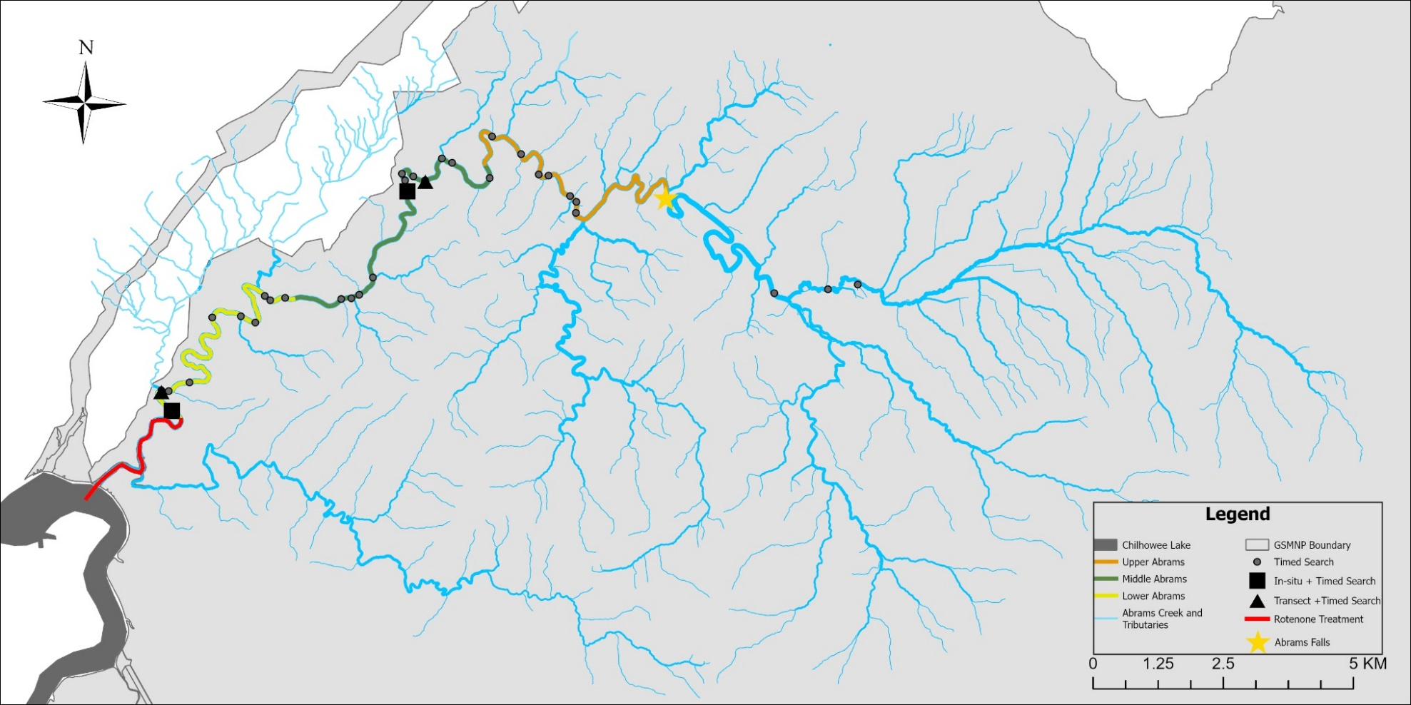

Figure 1. Map of Abrams Creek study system including survey locations, survey types, and key features. Locations where timed search occurred are denoted by circles, locations where timed search sites and in-situ experiments occurred are marked with squares, and locations where timed searches and quantitative transect sampling occurred are marked with triangles. The study area is divided into three sections: Upper, Middle, and Lower Abrams Creek, which are marked in orange, green and yellow, respectively. The 1957 rotenone treatment followed these same sections but continued into what is now impounded by Chilhowee Reservoir which is marked with a red line. Abrams Falls, the upper boundary of this treatment, is denoted by a yellow star. Abrams Creek and its tributaries outside of the study area are shown in blue lines, the boundary of GSMNP is shown in light gray, and Chilhowee Reservoir is represented in dark gray at its confluence with Abrams Creek.

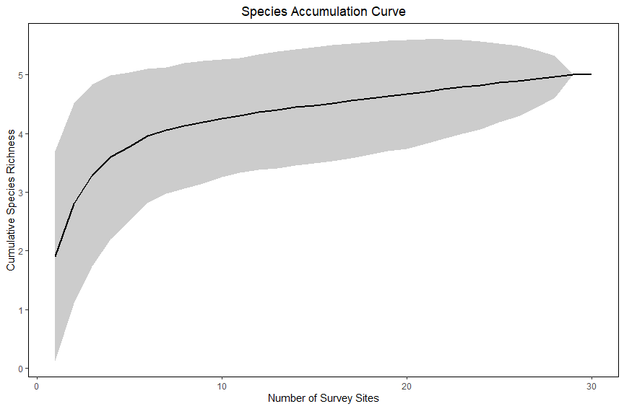
Figure 2. Species accumulation curve for timed searches conducted in Abrams Creek.

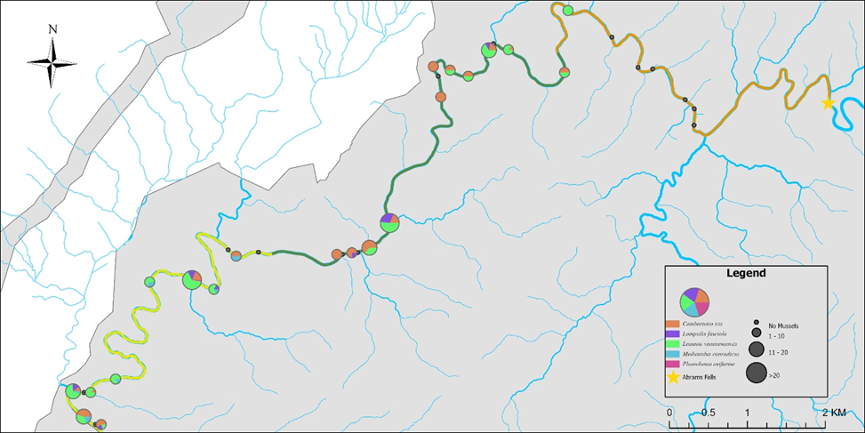
Figure 3. Relative abundances and species composition of mussels observed during the 30 timed searches conducted in Abrams Creek below Abrams Falls. Each pie chart represents the species composition at each survey site, with chart size scaled to overall relative abundance (i.e., larger circles represent observations of a greater number of mussels). Grey points denote sites where no mussels were observed in a timed search.
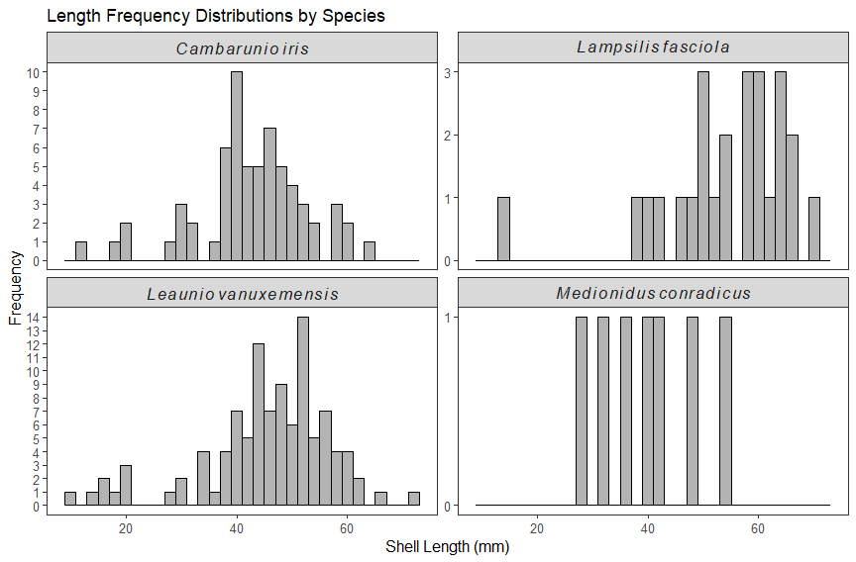

Figure 4. Length-frequency distributions of four mussel species collected during timed search at 33 sites distributed throughout Abrams Creek.

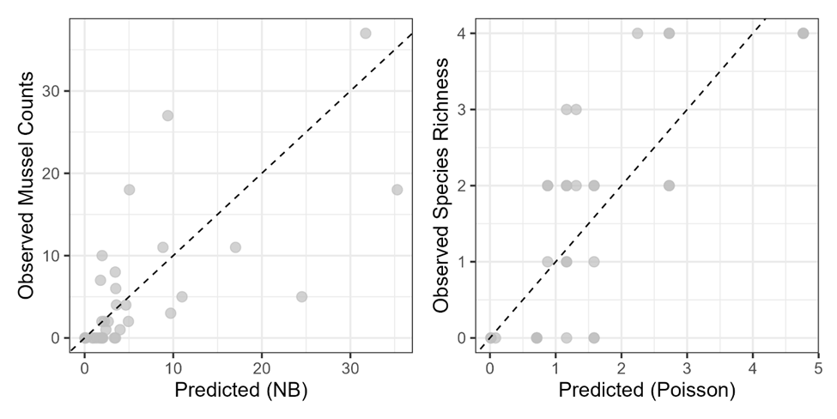

Figure 5. Observed values versus those predicted by a negative binomial (NB) model of mussel relative abundance and a Poisson model of species richness. Dotted line is a line of one-to-one correspondence between observed and predicted values.

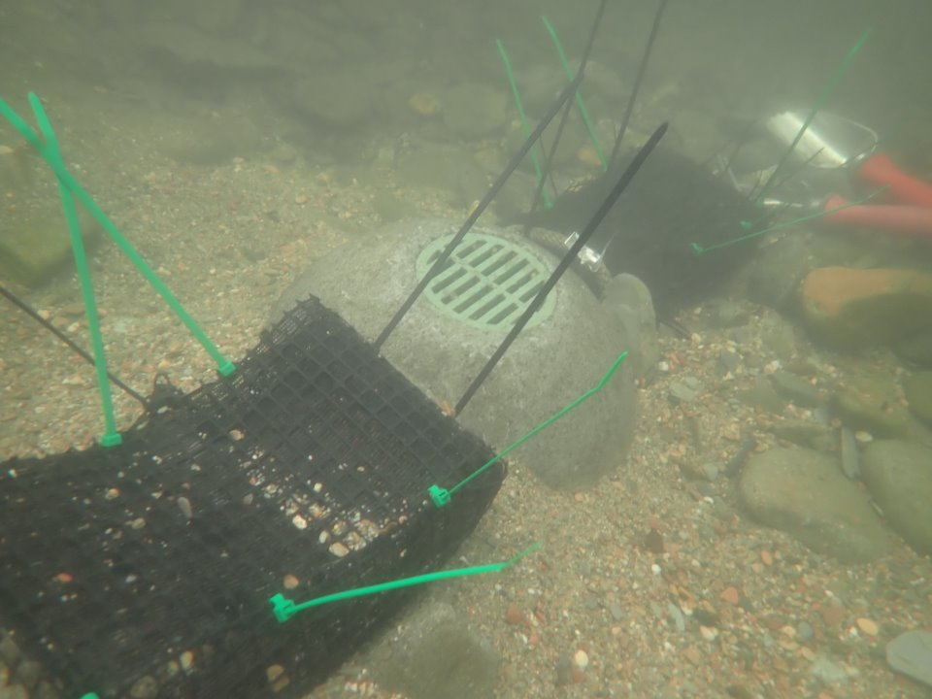
Figure 6. Photo of in situ-experiment of translocation viability demonstrating one mussel silo and two sediment cages.

VITA
Caleb Moses was born in Maryville, Tennessee, on March 20, 1999. He earned his Bachelor of Science in Wildlife and Fisheries Science from Tennessee Technological University in 2021. During his time at Tennessee Tech, he worked with the Cooperative Fisheries Research Unit and the Stream Ecology Lab, gaining foundational experience in freshwater ecology, field methodology, and species identification across southeastern river systems.
In 2023, Caleb began his graduate studies at the University of Tennessee, Knoxville, where he worked as a Graduate Research Assistant in the School of Natural Resources. His work broadly focused on freshwater mussel ecology, aquatic conservation, and the intersection of field-based research with applied resource management. Throughout his graduate program, he collaborated frequently with state and federal partners, contributing to biological surveys, habitat assessments, and conservation planning efforts across the region.
Caleb’s professional interests include freshwater biodiversity, conservation planning, ecological monitoring, and applied research that supports agency decision-making. He is committed to continuing his work in aquatic conservation and plans to pursue a Ph.D. in the future. Outside of research, Caleb is engaged in public outreach within the natural resources community. He aims to continue contributing to the conservation of southeastern aquatic ecosystems throughout his career.

