The Effect of Nuclear Perturbations in the 3D Organization of the Genome

A Thesis Presented for the

Doctor of Philosophy

Degree

The University of Tennessee, Knoxville

Rosela Golloshi

December 2020

Copyright © 2011 by Rosela Golloshi
All rights reserved.

DEDICATION

This dissertation is dedicated to my parents Dhionis and Rajmonda Golloshi and my late aunt Mariana Spahija for their continues support and never-ending love.

ACKNOWLEDGEMENTS

Thank you all for your help.

ABSTRACT

The folding of the genome inside the nucleus affects the physical properties of the nucleus and is important in gene regulation, DNA repair and replication. While current research approaches are being used to define the building blocks of the genome structure, little is known about how this structure responds to physical stresses the cell and the nucleus often experience. Disruptions in the organization of the genome leads to diseases such as cancer and therefore understanding the organizational principles of the genome is important. This dissertation investigates how the 3D genome organization is affected by perturbations of the nucleus such as cells undergoing constricted migration, cells treated with epigenetic active drugs and when the nuclei are stretched and expanded. We integrate live cell imaging, sequencing, and computational approaches to investigate disruptions in the 3D genome.

Using melanoma and breast cancer cells, we identify phenotypic differences in cells that have undergone constricted migration. These cells display elongated morphology, and distribution of nuclear architecture. Using Hi-C, we observe differences in chromosome spatial compartmentalization and related alterations in expression of genes associated with migration and metastasis. These sequentially constricted cells also show more nuclear deformations and altered behavior in a 3D collagen matrix. Our observations reveal a relationship between chromosome structure changes, metastatic gene signatures, and the altered nuclear appearance of aggressive cancers.

In contrast, when cancer cells are treated with cancer therapeutics, small local changes in the 3D genome organization are observed that correlate with changes in gene expression. However, the regions that seem to be affected the most do not show any correlation with the regions that change upon constricted migration.

Overall, the work presented in this dissertation provides new insights in understanding how the 3D genome structure accommodates cancer cell migration through tight spaces. Identifying elements of the genome structure that facilitate constricted migration would enable the development of therapies that alter the genome structure to prevent melanoma metastasis. Furthermore, this work has the potential of ushering a new era of cancer diagnosis by screening the 3D genome structure of patient skin biopsies to predict the risk of metastasis.

TABLE OF CONTENTS

INTRODUCTION 1
The role of Lamin A/C and chromatin in maintaining nuclear integrity 1
The effect of physical forces in organization of the nucleus 1
Epigenetic active drugs as a mechanism to alter chromatin state 1
Chromosome Conformation Capture followed by deep sequencing (HiC) to capture 3D organization of the nucleus 1
References 1
CHAPTER I CONSTRICTED MIGRATION CONSTRIBUTES TO PERSISTENT 3D GENOME STRUCTURE CHANGES ASSOCIATED WITH AN INVASIVE PHENOTYPE IN MELNOMA CELLS 2
Abstract 3
Introduction 3
Materials and Methods 6
Cell lines and cell culture 6
Sequential transwell migration assay 6
2D single cell migration 7
Immunocytochemistry 7
Western Blot 7
HiC 8
RNA-Seq 11
ATAC-Seq 12
3D Collagen Matrix 12
Agent Based Modeling of Constricted Migration 13
Results 14
Melanoma cells exhibit an increased migration efficiency and cell morphology differences after multiple rounds of constricted migration 14
Irregular distribution of Lamin A/C and peripheral localization of heterochromatin correlate with an increased constricted migration proficiency 18
Genomic regions change their compartmentalization after rounds of constricted migration 24
Gene expression changes after constricted migration reflect metastatic potential 28
Inter-compartment interactions increase after constricted migration 34
Global genomic rearrangements after constricted migration 39
Cells that have undergone constricted migration exhibit altered nuclear morphology in 3D collagen matrices 42
Agent based modeling reveals that heterogeneity and constricted migration induced changes could both contribute to morphological changes in A375 cells 45
Discussion 47
References 51
Appendix 58
CHAPTER II THE EFFECT OF CONSTRICTED MIGRATION IN THE 3D GENOME ORGANIZATION OF BREAST CANCER CELLS 60
Abstract 60
Introduction 60
Materials and Methods 60
Cell lines and cell culture 60
Sequential transwell migration assay 60
Immunocytochemistry 60
Western Blot 60
HiC 60
Results 60
Heading 3 60
Heading 3 60
Discussion 60
References 60
Appendix 60
CHAPTER III DECONDENSING THE CHROMATIN AND ITS EFFECT ON 3D GENOME ORGANIZATION 61
Abstract 62
Introduction 62
Materials and Methods 64
Cell lines and cell culture 64
Transwell migration assay 64
Immunocytochemistry 64
HiC 65
RNA-Seq 66
ATAC-Seq 67
Results 68
A375 cells exhibit subtle changes in global 3D genome architecture upon treatment with TSA 68
Subtle changes in compartment identity observed after treatment with TSA 71
Increase in long range interactions within and between A compartments observed after TSA treatment 73
Gene expression changes after TSA treatment reflect TSA gene signature in other cell lines 76
Local chromatin structure changes and disruption of chromatin loops upon treatment with TSA 78
Discussion 80
References 81
CONCLUSION 84
VITA 85

LIST OF TABLES

Table 1. Summary statistics for Hi-C sequencing experiments. 59
Table 2: Summary statistics for RNA sequencing experiments 60

LIST OF FIGURES

Figure 1. Shapes. 13

INTRODUCTION

The role of Lamin A/C and chromatin in maintaining nuclear integrity
This is the introduction to the entire paper. It can be chapter one, or just a stand-alone introduction chapter. In any case, it isn’t just an introduction to part 1.
You may use single, double, or 1.5 spacing. You may use any font of your choosing, but you must be consistent.

The effect of physical forces in organization of the nucleus

Use subheadings consistently. Check spacing, capitalization, and punctuation.

Epigenetic active drugs to alter chromatin state

Don’t forget to submit your thesis/dissertation to the thesis/dissertation consultant by the preliminary review deadline (this specific deadline can be found here: http://gradschool.utk.edu/ddategraduation.shtml)

Chromosome Conformation Capture followed by deep sequencing (HiC) to capture 3D organization of the nucleus

Don’t forget to submit your thesis/dissertation to the thesis/dissertation consultant by the preliminary review deadline (this specific deadline can be found here: http://gradschool.utk.edu/ddategraduation.shtml)

CHAPTER I

Constricted migration contributes to persistent 3D genome structure changes associated with an invasive phenotype in melanoma cells

A version of this chapter was originally published by Rosela Golloshi, Trevor Freeman, Priyojit Das, Thomas Raines, Christopher Playter, Rebeca San Martin, Delaney Thurston and Rachel Patton McCord:
Jane X. Doe, Juanita Q. Vera. “Towards A Theory of Page Rage.” Journal of Infomatic Bloat 221 (2009): 102-105.

Author contributions to this work: R.G. and R.P.M. conceived the project, designed the experiments, and wrote the paper with input from all authors. R.G. performed genomic, cell culture, and imaging experiments and bioinformatics data analysis. R.SM. advised on project and organoid design and performed 3D organoid experiments and histology. P.D. assisted with computational analysis. T.I.R. performed 3D collagen IF experiments and quantification. D.T provided experimental assistance in histology and helped with single cell migration video analysis. T.F. performed part of the sequential migration assays and Hi-C. C.P performed IF experiments and quantification of MDA-MB-231 nuclei.

Abstract

To spread from a localized tumor, metastatic cancer cells must squeeze through constrictions that cause major nuclear deformations. Since chromosome structure affects nucleus stiffness, gene regulation and DNA repair, here we investigate how confined migration affects or is affected by 3D genome structure. Using melanoma (A375) cells, we identify phenotypic differences in cells that have undergone multiple rounds of constricted migration. These cells display a stably higher migration efficiency, elongated morphology, and differences in the distribution of Lamin A/C and heterochromatin. Using Hi-C, we observe differences in chromosome spatial compartmentalization specific to cells that have passed through constrictions and related alterations in expression of genes associated with migration and metastasis. These sequentially constricted cells also show more nuclear deformations and altered behavior in a 3D collagen matrix. Our observations reveal a relationship between chromosome structure changes, metastatic gene signatures, and the altered nuclear appearance of aggressive melanoma.

Introduction

Despite significant improvements in the diagnosis and treatment of cancer, most patients with advanced metastatic disease face a terminal illness incurable by current therapeutic methods. The dissemination of cancer cells from the primary tumor and the formation of new tumor colonies at distant sites involves a complex multi-step invasion-metastasis cascade (Lambert et al., 2017, Gupta and Massague, 2006, Chambers et al., 2002, Fidler, 2003). To metastasize, cancer cells must squeeze through constrictions of the extracellular matrix or endothelial lining that are much smaller than their nucleus, causing major nuclear deformations. While the cell membrane and cytoplasm are quite elastic, the ability of the cell’s nucleus to withstand large deformations and squeeze through these small spaces is limited by its size and stiffness, posing challenges to confined migration (Davidson et al., 2014, Fu et al., 2012, Wolf et al., 2013, Friedl et al., 2011). Nuclear stiffness and deformability depend on two major components: lamin proteins (Lamin A/C and Lamin B) and the chromatin (Stephens et al., 2017, Harada et al., 2014, Davidson et al., 2014).
Lamin A/C expression and its stoichiometric relation to Lamin B contributes to nuclear mechanical properties (Harada et al., 2014, Swift et al., 2013). Low expression levels of Lamin A/C lead to decreased nuclear stiffness and increased deformability (Lammerding et al., 2006). Likely resulting from increased nuclear flexibility, decreased expression of Lamin A/C has been shown to promote the ability of mouse embryonic fibroblasts (MEFs) to undergo constricted migration (Davidson et al., 2014). Conversely, neutrophils show decreased constricted migration ability when expression of Lamin A/C is increased (Davidson et al., 2014, Rowat et al., 2013). Given this relation between lamin content and confined migration, it is not surprising that low levels of Lamin A/C are correlated with the increased aggressiveness of some cancers (Broers et al., 1993, Wazir et al., 2013). However, not all invasive cancers downregulate their Lamin A/C expression; in fact, an increase in Lamin A/C is associated with progression of aggressive cancers such as colorectal and skin basal cell carcinoma (Willis et al., 2008, Venables et al., 2001) and lower levels of Lamin A/C can decrease cell migration speed (Lee et al., 2007). Decreased lamin content during confined migration can even be deleterious as it jeopardizes the integrity of the nuclear envelope and increases the probability of nuclear rupture events as the nucleus passes through a constriction. Such nuclear rupture can lead to DNA damage, DNA loss, and genomic aberrations (Denais et al., 2016, Irianto et al., 2017a, Raab et al., 2016).
In addition to the complex role of lamin content, recent work emphasizes the additional role of chromatin in mechano-sensing, nuclear stiffness, and invasiveness (Miroshnikova et al., 2017, Stephens et al., 2017). The two-meter chromatin fiber is packaged into the nucleus in a complex 3D architecture that informs DNA replication, repair, and gene regulation (Marchal et al., 2019, Krijger and de Laat, 2016, Spielmann et al., 2018). Regions of the genome are marked with different histone modifications and become spatially compartmentalized into heterochromatin and euchromatin through different mechanisms, such as tethering to nuclear structures like the lamina, or due to phase separation (van Steensel and Belmont, 2017, Strom et al., 2017, Larson et al., 2017). Genes within less-accessible heterochromatin tend to be inactive while those localized to more accessible euchromatin tend to be active or poised for quick transcriptional activation (Gaspar-Maia et al., 2011, van Steensel and Belmont, 2017). Chromatin state has also been shown to influence nuclear physical properties: increasing heterochromatin increases nuclear stiffness while increasing euchromatin decreases stiffness and increases nuclear deformability (Stephens et al., 2017, Stephens et al., 2018). Such global changes in chromatin state can also influence confined migration. For example, increasing euchromatin or decreasing heterochromatin inhibits mouse melanoma cell migration (Gerlitz and Bustin, 2010, Maizels et al., 2017, Segal et al., 2018, Panagiotakopoulou et al., 2016, Krause et al., 2019). Mounting evidence also points to the effect that extracellular physical forces have on nuclear mechanics and chromosome structure. Nuclei aspirated into narrow micropipettes exhibit stretching of chromatin domains that is sometimes irreversible (Irianto et al., 2017b). External cellular forces can also affect gene expression through direct chromatin deformations (Tajik et al., 2016). Despite such connections between chromatin structure, nucleus deformation, and nucleus mechanics, it is not fully understood whether the 3D organization of the genome affects or is affected by confined migration.
Ever-improving microscopic techniques and the development of chromosome conformation capture approaches have revolutionized our understanding of 3D genome architecture in the past decade (Dekker et al., 2002, Bickmore and van Steensel, 2013, Rowley and Corces, 2018, Pombo and Dillon, 2015, Abbas et al., 2019). Chromosomes are folded at different length scales into loops, topologically associating domains (TADs), active and inactive (A/B) compartments, and chromosomal territories. How these layers of structure are affected by physical nucleus shape changes such as the kind experienced during constricted migration remains unknown. Previous work has shown that 3D chromosome organization changes correlate with the progression of cancer (Taberlay et al., 2016, Barutcu et al., 2015, Zhou et al., 2019) and that both the formation and downstream effect of chromosomal translocations in cancer progression is influenced by 3D genome structure (Zhang et al., 2012, Hnisz et al., 2016). In addition, some changes have been noted in the 3D genome structures of neutrophils that have undergone constricted migration (Jacobson et al., 2018). Taken together, previous evidence leads us to hypothesize that chromosome structure may influence a cancer cell’s ability to undergo confined migration, that changes in chromosome structure could be caused by nuclear deformation, and that such chromosome structure changes could influence gene regulation and cancer cell phenotype. In this study, we seek to unite these previous ideas and determine whether certain 3D genome structures of cancer cells facilitate or are changed by constricted migration.
Here, we use invasive human melanoma cells (A375) to investigate the properties of the nucleus and 3D chromosome structure that accompany confined migration. We find that A375 cells that have migrated numerous times through tight constrictions increase their migration efficiency and are phenotypically distinct from cells that do not pass through constrictions. These cells exhibit specific and stable alterations in 3D genome organization, particularly at the level of A/B compartmentalization, lamin localization, and gene expression patterns. Our results suggest that 3D genome architecture correlates with the ability of cancer cells to undergo constricted migration.

Materials and Methods

Cell Lines and Cell Culture
A375 and MDA-MB-231 cells were obtained from ATCC (CRL-1619 and HTB-26, respectively). Cells were grown using complete DMEM medium (Corning – 10-013-CV; 10% FBS, 1% Pen-Strep, 1% L-Glutamine) at 37ºC supplied with 5% CO₂.

Sequential Transwell Migration
For the sequential transwell migration, we used transwells with 12 μm (VWR-10769-224) and 5 μm pore sizes (VWR-10769-236). Briefly, the bottom of the transwells were coated with 40 μL of 10 μg/mL fibronectin for ~ 45 minutes. 24 well plates were prepared for transwell migration assay adding 500 μL of 1x DMEM (Corning) with full supplements per well. A375 cells were detached from culture dishes at 80-90% confluency and aliquoted to 100,000 cells per 100 μL of 1xDMEM. Each transwell was placed into its corresponding well of the 24 well plate and 100 μL of the cell suspension was added to the top of each filter. Cells were incubated at 37ºC, 5% CO₂ and allowed to migrate for 24 hours. After the 24-hour incubation, migration efficiency was quantified as follows. First, freely floating cells were removed from the top of the filter (unmigrated; “Top” cells) and from the well beneath the filter (migrated “Bottom” cells) and placed in two separate tubes. Then, 400 μL of trypsin was added into the bottom chamber of the 24 well plate and 200 μL of trypsin was added into the top chamber to detach any remaining attached cells. Recovered cells after trypsinization were added to the unmigrated or migrated tubes, accordingly. Cells were spun down (1000 rpm, 5min) and counted (using trypan blue) to calculate % migration such as: #bottom/(#top+#bottom). Additionally, a small aliquot of cells was saved for immunofluorescence (IF). The rest of the cells were seeded into wells of a 24-well plate to expand. When cells reached 80-90% confluency, another transwell migration was performed (R2). A375 Top and Bottom cells were detached and counted. Two transwell filters were prepared as previously described (one for Top and one for Bottom). Then 100,000 cells suspended in 100 μL of 1xDMEM without supplements were seeded into the transwell filters. After 24-hour incubation at 37ºC and 5% CO₂, cells were trypsinized as previously described to quantify migration efficiency. Only the cells that were always on top (Top of Top) and the cells that were always on the bottom (Bottom of Bottom) were saved and grown for further sequential rounds of migration. This process was repeated for 10 and 20 rounds of migration which lead to the generation of A375-Top5, Bottom-5, Top20-5, Bottom20-5, Top-12 and Bottom-12.

2D Single Cell migration
Live cell imaging
To track single cell movement in 2D, A375-Control, Top-5 and Bottom-5 cells were seeded on wells of a 6-well plate at a 30,000 cells/well density. After cells were attached, live cell imaging was performed using the EVOS FL Auto microscope at 40X magnification. Images were acquired every 10 minutes for a 24-hour time period.
Cell morphology analysis
Parameters that describe cell morphology such as solidity and aspect ratio were quantified using the Shape Descriptors plugin in ImageJ.

Immunocytochemistry
IF staining
Approximately 50,000 – 100,000 cells for each sub-population of A375 were seeded into either poly-D-lysine treated coverslips or 35-mm coverslip bottom dishes. Cells were allowed to attach overnight and then crosslinked with 4% formaldehyde for 10 min followed by three, 5-minute washes with PBS. After washing, cells were permeabilized with permeabilization buffer (10% goat serum, 0.5% Triton in PBS) for 1 hour at room temperature. After the incubation, primary antibodies (Lamin A – sc-376248, Lamin B1 – ab133741, H3K9me3 – ab176916), diluted in antibody dilution buffer (5% Goat serum, 0.25% Triton in PBS) were added and incubated overnight at 4ºC. After primary antibody incubation, cells were washed 3 times with PBS for 5 minutes for each wash. Cells were then incubated with secondary antibodies (Alexa Fluor 594 and Alexa Fluor 488) per manufacturer’s directions (2 drops of secondary antibody/1mL of PBS – R37117 and R37120) for 30 minutes at room temperature. After secondary antibody incubation, cells were washed 3 times with PBS and sealed using mounting media with DAPI. Slides were treated in the mounting media for 24 hours before imaging.
Cells were imaged using a Leica Sp8 Confocal microscope was equipped with a 63x oil immersion objective.
Nuclear morphology analysis
To analyze the diameter (minor axis), aspect ratio and standard deviation of maximum projected nuclei, Image J Shape Descriptor plugin was used. For analysis of 3D projected nuclei, Image J Nucleus J plugin was used with default parameters. Lamin A/C and H3K9me3 radial distribution was quantified using Measure Object Intensity Distribution module in Cell Profiler. The nuclei were separated into four equidistant bins. Mean fractional intensities for each bin (4 total bins; starting from innermost (bin1) to outermost (bin4) radial position) was plotted.

Western Blot
A375 cells were trypsinized as previously described, and approximately 5 million cells were collected by centrifugation (1000 rcf, 5 min, room temperature). The cell pellets were resuspended in 300 ml of RIPA buffer (Thermo Scientific, I89900), supplemented with protease inhibitors/EDTA (GenDepot 50-101-5485), and phosphatase inhibitors (GenDepot 50-101-5488). Cells were then incubated on ice for 10 minutes. DNA was degraded by adding 6 μl of micrococcal nuclease (0.5 U/ml stock, Thermo Scientific, FEREN0181) and 12 μl of calcium chloride (100 mM stock) to each lysate, followed by incubation at 37°C for 15 min. Nuclease activity was inhibited by subsequent incubations at 68 °C for 15 min, and ice for 10 min. Protein samples were stored at −80 °C until use. Protein concentration was measured using the BCA Protein Assay Kit. Thermo (234225), according to the manufacturer’s instructions.
Denatured protein samples were resolved using a mini gel tank (Invitrogen, A25977) for 35 min at 200V, using 4-12% Bis-Tris Plus gels (Invitrogen, NW04120BOX) for all targets. Protein was transferred to low fluorescence PVDF membranes using the mini Bolt Blotting System (Invitrogen, B1000), along with system-specific reagents. Blotting was performed using the Odyssey TBS blocking system (Licor, 927-400000), according to the manufacturer’s protocol. Briefly, membranes were activated with methanol after transfer (1 min, RT), washed twice with milliQ water (5 min), twice with TBS (2 min), and blocked with Odyssey TBS blocking solution for 1 hour at RT. Primary antibodies were diluted in blocking buffer (containing 0.2% Tween), and incubated over night at 4°C as follows: H3K9me3 (1:1000, ab176916), LaminA/C (1:1000, sc-376248) and LaminB1 (1:1000, ab133741). Beta actin was used as a loading control, using the appropriate antibody (1:10,000; rabbit polyclonal PA1-16889, Thermo Fisher or 1:10,000; mouse monoclonal MA1-140, Thermo Fisher) alongside with the targets of interest. Detection was carried out using the following secondary antibodies: goat anti-rabbit (1:10,000; IRDye 680RD [92568071]; Licor) and goat anti-mouse (1:10,000, IRDye 800CW [95-32210]; Licor). Secondary antibodies were diluted in Odyssey TBS blocking buffer containing 0.2% Tween and 0.01% SDS. Membranes were incubated in secondary antibody for 1 hour at RT, followed by three washes (TBST, 5 min each).
Images of near infrared fluorescent signal were acquired using an Odyssey scanner (Licor) in both the red and green channels. Signal was quantified using the Image Studio software (Licor).

Hi-C
Library Preparation

Hi-C libraries were prepared for each cell sub-population (A375-Control, Top-5, Bottom-5, Top20-5, Bottom20-5, Top-12 and Bottom-12) as previously described (Golloshi et al., 2018) including two biological duplicates for each condition. Briefly, 10 million cells were grown in T-75 cell culture flasks to 80-90% confluency and crosslinked with 1% formaldehyde for 10 min. Crosslinked cells were then suspended in lysis buffer to permeabilize the cell membrane and were dounce homogenized. Chromatin was then digested in-nucleus overnight using DpnII restriction enzyme. Digested ends were filled in with biotin-dATP, and the blunt ends of interacting fragments were ligated together. DNA was then purified by phenol-chloroform extraction. For library preparation, the NEBNext Ultra II DNA Library prep kit (NEB) was used for libraries with size ranges from 200-400bp. End Prep, Adaptor Ligation, and PCR amplification reactions were carried out on bead bound DNA libraries.
Sequencing was performed at the Oklahoma Medical Research Foundation Clinical Genomics facility using the Illumina HiSeq 3000 platform with 75 bp paired end reads or a NovaSeq 6000 with 50 bp paired end reads. Sequencing reads were mapped to the human genome (hg19), filtered, and iteratively corrected as previously described (Imakaev et al., 2012) (https://github.com/dekkerlab/cMapping). All Hi-C contact matrices were scaled to a sum of 1 million interactions to allow comparisons between conditions in downstream analysis. For library quality and mapping statistics see Table S1.

Compartment Analysis

Compartment analysis was performed by running principal component analysis using matrix2compartment.pl script in the cworld-dekker pipeline available on GitHub (https://github.com/dekkerlab/cworld-dekker). The PC1 value was then used to determine compartment identity for 100 and 250Kb binned matrices. We considered PC1 values greater than 0.01 to be A compartment and less than -0.01 to be B compartment for this analysis and determination of compartment switches.

Saddle Plots

Saddle plots were constructed to investigate changes in interaction frequency between or within compartments in highly migratory and non-migratory melanoma cells. Briefly, PCA analysis was performed on 100Kb binned matrices to assign compartment identity for each bin. For the analysis, interaction zScores, normalizing for interaction decay for genomic distance, were calculated according to the matrix2compartment.pl script in cworld-dekker. Zscore matrices were reordered based on compartment strength (from strongest B to strongest A using eigenvector values). Finally, matrices were smoothed at 500Kb bin size.

Interchromosomal Fraction (ICF)

Ratio of interchromosomal interactions relative to the total number of interactions for a given chromosome as previously described (Heinz et al., 2018).
ICF=Interchromosomal InteractionsInter+Intra chromosomal Interactions

deltaICF = ICFBottom - ICFTop
Distal to Local Ratio (DLR)

Log2 ratio of HiC interactions with distance greater than 3Mb relative to local interactions less than 3 Mb away. To find the change in DLR after constricted migration, delta DLR was calculated as DLR_{Bottom} – DLR_{Top} as previously described (Heinz et al., 2018).
DLR=log2Distal Interactions (>3Mb)Local Interactions (<3Mb)

deltaDLR=DLRTop−DLRBottom

Copy Number Variation Estimation

CNV estimation was performed using the approach available from https://github.com/nservant/cancer-hic-norm (Servant et al., 2018)
Translocation Detection and Frequency Calculation
For the novel translocation visibly evident in 2.5 Mb binned contact maps for Bottom-5 constricted migrated cells, we further pinpointed the specific break site on each chromosome (chr5 and chr13) using raw valid pair counts within the region. First, we filtered all valid pair interactions between chr5 and chr13 to include only regions of chr13 between 38.3 and 57.5 Mb (a range of coordinates upstream of the translocation site, which all interact more than expected with chr5). Then, we plotted a histogram of interaction frequencies between each locus along chr5 and this set of chr13 coordinates. We noted a sharp interaction drop within the region chr5:12.24-12.25 Mb, which represents the translocation breakpoint. We then reversed this process to determine the breakpoint along chr13.
To calculate the percent of chromosomes containing this chr5-13 translocation in each subpopulation, we first found the 2.5 Mb bin with the maximum raw Hi-C counts near the translocation site in Bottom-5 cells. We then calculated an average value for raw Hi-C counts between neighboring bins (one bin off diagonal) in cis on chr7. We then calculated the percent of chromosomes bearing the translocation in any given cell type as the ratio of raw interaction counts at the translocation bin over average interaction counts between neighbors in cis. Given the median triploid karyotype of A375 cells, we then multiplied this % of chromosomes by 3 to estimate a % of cells carrying the translocation.

Distance Decay Scaling Plots

Using 40 and 20 Kb binned iteratively corrected and scaled contact matrices, we extracted contact frequencies between bins at each genomic distance, excluding the diagonal bin (zero distance). A loess fit was then used to find a smooth curve describing interaction decay vs. distance (using the matrix2loess.pl script in cworld-dekker). The interaction frequencies were then normalized to set the maximum value (loess fit interaction value for the minimum distance) for each dataset to 1 and then plotted on a log scale vs. log genomic distance.

RNA-Seq
Library Preparation

For Control, Top-5 and Bottom-5 A375 cells, RNA was extracted, and the library was prepared in our laboratory. Briefly, RNA was extracted using Qiagen RNAeasy plus mini kit (Cat. No. 74134). Cells were lysed and homogenized, spun down in gDNA eliminator columns to remove any genomic DNA. All samples were washed with ethanol and the total RNA was eluted. The quality and quantity of the RNA were quantified using Agilent Bioanalyzer Nano RNA kit. All the libraries used were characterized by a RIN value between 9 and 10. rRNA was depleted using NebNext rRNA Depletion Kit (Cat. No. E6310S). Total RNA was hybridized to the probe followed by RNaseH and DNase I digestion. RNA was then purified using AmpureXP beads from Beckman Coulter (Ref. A63881) at a 2.2x concentration of beads. RNA libraries were prepared using NebNext Ultra II RNA library prep Kit (Cat. No. E7770G). After rRNA depletion, RNA was fragmented (~200 nt) and primed following first and second strand cDNA synthesis. The double stranded cDNA was then purified using AmpureXP beads at a 1.8X concentration. After purification, cDNA libraries were end prepped, ligated adapter and PCR amplified for 7 cycles to enrichment for adaptor ligated DNA using NebNext Multiplex Oligos for illumine (Cat. No. E7335G). cDNA librariers were then purified using AmpureXP beads at a 0.9X concentration and their quality was checked using Agilent Bioanalyzer high sensitivity DNA kit. cDNA samples were then sent to Oklahoma Medical Research Facility (OMRF) for high throughput sequencing.
For the rest of A375 libraries, Top20-5, Bottom20-5, Top-12 and Bottom-12, RNA was extracted using the Qiagen RNAeasy plus mini kit as described above. Total RNA was then sent for library preparation and sequencing at GeneWiz.

RNA-Seq Data Analysis

Quality of reads was checked using Fastqc and adapter sequences were trimmed using BBTools (https://github.com/kbaseapps/BBTools). Additionally, quality trimming of the reads was performed and any reads with a lower than 28 quality score were discarded. Reads were then aligned using STAR alignment (https://github.com/alexdobin/STAR) with an average alignment rate of 89%. The aligned reads were then sorted by genomic position and feature counts was performed using htseq 0.11.1(https://github.com/simon-anders/htseq). Differential expression of genes was determined by using DESeq through Galaxy.

ATAC-Seq
ATAC-Seq libraries for Top-5 and Bottom-5 cells was prepared as previously described (Buenrostro et al., 2015). Libraries were generated using Ad1_noMX and Ad2.1-2.3 barcoded primers from (Buenrostro et al., 2015) and were amplified for a total of 12-13 cycles. The quality and quantity of the libraries were measured using Agilent Bioanalyzer High Sensitivity DNA kit. Sequencing was performed at Oklahoma Medical Research Facility using HiSeq3000 with 75 bp paired end reads.

ATAC-Seq Data Analysis

Adapters and reads with a quality score less than 20 were trimmed from the final libraries using Skewer/0.2.2 (https://github.com/relipmoc/skewer). Trimmed reads were aligned to the hg19 genome using bowtie2 with default parameters (https://github.com/BenLangmead/bowtie2). Aligned reads were sorted, indexed and ChrM reads were removed using samtools. Duplicated reads were removed using Picard (https://github.com/broadinstitute/picard/blob/master/src/main/java/picard/sam/markduplicates/MarkDuplicates.java). Finally, peaks were called using MACS2 (https://github.com/taoliu/MACS) with the following parameters: --nomodel --extsize 300 -g hs --keep-dup all.

3D Collagen Matrix
Experiments investigating the morphology and migration of A375 subpopulation of cells in 3D environment were performed using single cell suspension in 3D collagen matrices (A375-Control, A375-Top5 A375-Bottom10 generated from passage of A375 through 5 and 12 μm sized pore transwells) as previously described (Denais et al., 2016). Briefly, 75,000 cells/condition were added into collagen matrices (Rat Tail, Corning 354236) with a density of 2.32 mg/ml. The pH of the collagen gels was normalized to a neutral pH and gels were incubated at 37⁰C for 30 min to gel. After the incubation, media with full supplements was supplied to the collagen gels. Cell were allowed to migrate through the collagen for 5 days before the cells were stained and imaged.

Immunofluorescence for cells embedded in 3D collagen matrices

Cells embedded on collagen were stained as previously described (Denais et al., 2016). Briefly, collagen matrices were fixed in 4% formaldehyde for 30 min at 37C. Collagen matrices were then washed with 1xPBS for 10 min for three times. Each collagen matrix was then incubated with blocking buffer (0.5% Triton, 10% Goat Serum in 1xPBS) overnight at 4C. After blocking, samples were then incubated with primary antibody (LaminA – sc376248) at a 1:500 dilution in 1xBlocking Buffer:1xPBS at 4C overnight. After incubation, aspirate primary antibody solution and wash three times with 1xPBS for 10 min each. Samples were then incubated in secondary antibody (2 drops/mL of PBS) for 1hr and room temperature. After secondary antibody incubation, samples were then washed with 1xPBS three times for 10 min each. Samples were incubated with DAPI (1μg/mL) for 30 min at RT. Collagen matrices were then washed three times with 1xPBS for 10 min each. Z-stacks of collagen matrices were taken with Leica SP8 confocal microscope at 40x water objective.

Image analysis for cells embedded in 3D collagen matrices

Aspect ratio and Lamin A/C standard deviation of maximum projected nuclei was quantified using ImageJ plugin Shape Descriptors. Tracking of cells migrating in 3D collagen matrices was performed using ImageJ Manual Tracking plugin. The resulting data was then used in Chemotaxis and Migration tool (Ibidi) to generate accumulated distance and velocity measurements.

Agent Based Modeling of Constricted Migration
We model constricted cell migration using an on-lattice two-dimensional (2D) agent-based model (ABM) system. In this model, cells are represented by agents. The basic building block of this agent-based system is obtained from the collective cell migration ABM (collectiveABM), available on GitHub (https://github.com/zcolburn/cell-sheet-abm) and necessary changes are made to model cell transmigration. Most of the parameter values and the model working procedures of collectiveABM are kept untouched unless otherwise mentioned. Since the collectiveABM models a wound healing assay, we exclude the wound scratch section of the code from our model. We also add two squared 2D grid spaces of size 20x20 to the agent-based system in place of a single 2D grid space, as we are using transwell migration assay in this work for the constricted migration. One of those two grid spaces represent the top compartment, where the cells are seeded at the beginning on each round of sequential migration and another grid space is used as the bottom compartment, where the cells transmigrate from the top compartment. The beginning of each round of sequential migration model starts with 2000 cells seeded on the top compartment. The population of the cells is either considered to be homogenous or heterogeneous depending on the transmigration probability (ptmig). A total of 25 timepoint iterations are implemented to mimic the ~24 hours duration of experimental rounds. After each round of sequential migrations, the proportion of different cells in the bottom or top compartment depending on the sequential transwell migration experiment type is measured and the same proportion is maintained during the cell seeding in the next round. The directionality of the transmigration is only from top to bottom compartment and once the cells reach the bottom compartment, they stay there. The constricted migration of a cell is modeled by comparing its assigned ptmig with a uniform random number drawn from the range [0,1). If the random number is less than ptmig, then that cell will transmigrate to the bottom compartment from the top. In addition to having models with fixed ptmig values, we also designed agent-based model systems having variable ptmig : 1) the ptmig value of bottom or bottom cells are boosted by random values after each round and 2) each cell has different ptmig, drawn from a normal distribution and after each round, the mean and standard deviation of top or bottom compartment cells depending on the sequential transwell migration experiment type will be used in next round’s normal distribution. The efficiency of migration is calculated at the end of each round by dividing the number of cells in the bottom compartment by total cells in the top and bottom compartments combined. For all the different test cases, three independent runs are performed by using different random number seeds.

Results

Melanoma cells exhibit an increase in migration efficiency and cell morphology changes after multiple rounds of constricted migration
To investigate whether the 3D genome organization is affected by constricted migration, we performed sequential rounds of migration of A375 cells through 5μm transwell filters (Figure 1A, see Materials and Methods for a detailed experimental design). The diameter of A375 nuclei ranges from 8-16μm (Figure S1A), so passing through these 5μm pores requires nuclear constriction and can lead in nuclear deformations. Interestingly, cells that successfully undergo constricted migration through 5µm pores in the first round, migrate more efficiently in subsequent rounds in the transwell chambers. The population of cells derived from those that have passed through the 5µm pores for 10 consecutive rounds (Bottom-5) migrate at high efficiency (~70%) as compared to the initial starting population (20%) (Figures 1B and S1B). In contrast, cells that failed to undergo constricted migration through 5-μm pores in the first round, show a progressive decrease in migratory efficiency, approaching 0% migration after 10 consecutive rounds (Top-5) (Figures 1B and S1B). The differences in migration efficiency correspond to other notable differences in cell phenotype. Phase contrast imaging of the A375 subpopulations shows that Bottom-5 cells exhibit a decrease in cell-cell adhesions and an elongated cell body (suggesting a more mesenchymal phenotype) when compared to Top-5 cells (Figures 1C,S1C and S1D). We extended the sequential transwell assay up to 20 rounds and observe similar elongated cell bodies in A375 cells that have undergone 20 rounds of 5μm transwell migration (Bottom20-5) (Figures S1C and S1D). These morphological characteristics and migration efficiency differences are maintained even after continuous passage (5 passages) or multiple freeze-thaw cycles, indicating stable phenotypes among Top-5 and Bottom-5 cells (Figure S1E). Live cell imaging of Top-5 and Bottom-5 cells migrating on a 2D surface shows that Bottom-5 cells maintain their elongated shapes and display lobopodia/lamellipodia-like migration, while Top-5 cells display amoeboid-like migration over a 13-hr migration period (Figure
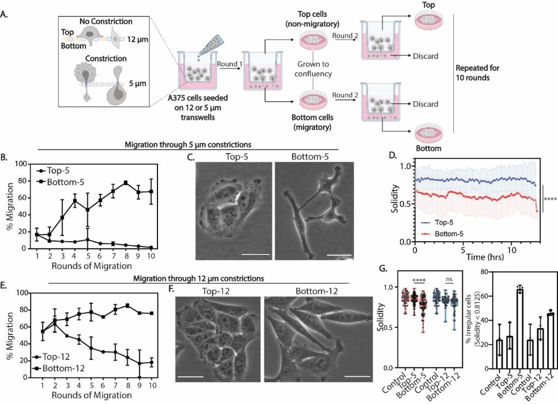

Figure 1. A375 cells exhibit morphological differences and increase in migration efficiency after sequential rounds of constricted migration. (A) Layout of sequential transwell migration experiment in A375 cells. (B) Migration efficiency (% of cells that migrated through filter pores in each round) of A375 cells during 5μm constricted migration. Error bars = mean ± SD for n = 3 biological replicates. (C) Phase contrast imaging of A375 cells that have not (Top-5) or have (Bottom-5) undergone 5-μm constricted migration. (D) Solidity measurements of A375 cells undergoing live-cell migration for 13 hours on a 2D surface (1 indicates ideally round and lower values indicate more irregularities and protrusions). Error bars = mean ± SD for n = 76 Top-5 cells and n = 77 Bottom-5 cells (p < 0.0001, two-tailed t-test). (E) Migration efficiency of A375 cells undergoing 12-μm transwell migration. (F) Phase contrast imaging of A375 cells that have not (Top-12) or have (Bottom-12) undergone 12-μm transwell migration. (G) (Left panel) Quantification of solidity measurements between A375 cells that have undergone migration through 5μm and 12μm pores. Box and whiskers plot showing all data points in Control (n = 52 cells), Top-5 (n = 99 cells), Bottom-5 (n = 98 cells), Top-12 (n = 43 cells) and Bottom-12 (n = 82 cells) (**** p < 0.0001, ns p = 0.0726, two-tailed t-test). (Right panel) % of A375 cells displaying irregular morphology (Solidity < 0.8125). Scale bars (white) indicate a length of 25μm.

1D and Movie S1 and S2). We then investigated whether loss of cell-cell adhesion in Bottom-5 cells corresponded to differences in focal adhesions by phalloidin stain. (Figure S1F). Bottom-5 cells exhibit a decrease in focal adhesion area while Control and top cells (Top-5 and Top20-5) exhibit larger focal adhesion area (Figure S1F, Focal adhesion area quantification). Decrease in focal adhesion size has been previously reported to correlate with increase in migration speed and cell motility (Kim and Wirtz, 2013). These results indicate that the morphological and/or genetic differences associated with passing through constrictions could promote migration in consecutive rounds. These phenotypes are consistent with previous studies showing that the degree of invasiveness is often correlated with changes in mechanical properties of cells and increase of cell shape irregularity (Lyons et al., 2016, Machesky, 2008).
It has been previously reported that A375 cells are heterogeneous in their metastatic ability (Kozlowski et al., 1984), so it is possible that the differences we observe are associated only with ability to migrate and are not specific to passing through a constriction. To investigate whether passing through a constriction smaller than the nucleus contributes to the differences in migratory ability observed among Top-5 and Bottom-5 cells, we repeated the sequential migration experiment using transwell filters with 12µm pores (Figures 1E and S1G). Migration through 12μm pores does not pose a major spatial barrier for the nucleus since the minimum diameter of the majority of A375 cells is smaller than the 12µm diameter of the pore (Figure S1A). Accordingly, A375 cells migrate at a much higher rate (~ 55-70%) in the first round of 12μm transwell pores (Figures 1E and S1G).
Strikingly, cells that were successful at migrating through 12-µm pores (Bottom-12) displayed only a minimal increase in migratory efficiency as compared to the more dramatic increase shown by Bottom-5 cells after each consecutive round (Figures 1E and S1G). In contrast, cells that failed to migrate through the 12-μm pores (Top-12), displayed a significant decrease in migration efficiency after 10 sequential rounds of migration (Figures 1E and S1G). Phase contrast imaging revealed that Top-12 cells display high cell-cell adhesion and more epithelial like phenotypes (similar to Top-5) when compared to Bottom-12 cells, which show a decrease in cell-cell adhesion and more elongated phenotypes (Figure 1F and Figure S1H). However, when quantifying solidity or aspect ratio (Figure 1G ) over a population average for all A375 sub-populations, it becomes clear that Bottom-5 cells exhibit more dramatic elongated phenotypes (~65% of cells with solidity < 0.8125) compared to Bottom-12 cells (~ 45% of cells with solidity < 0.8125) which show no significant difference compared to the Control, Top-5 and Top-12 cells (Figure 1G). When challenged to migrate through 5-μm pores, Bottom-12 cells showed a migration efficiency similar to the control population (~ 3-20 %). This suggests that one layer of heterogeneity in the A375 population distinguishes cells that cannot migrate (Top-12) from those that can, but that additional features are required for constricted migration that are not necessarily
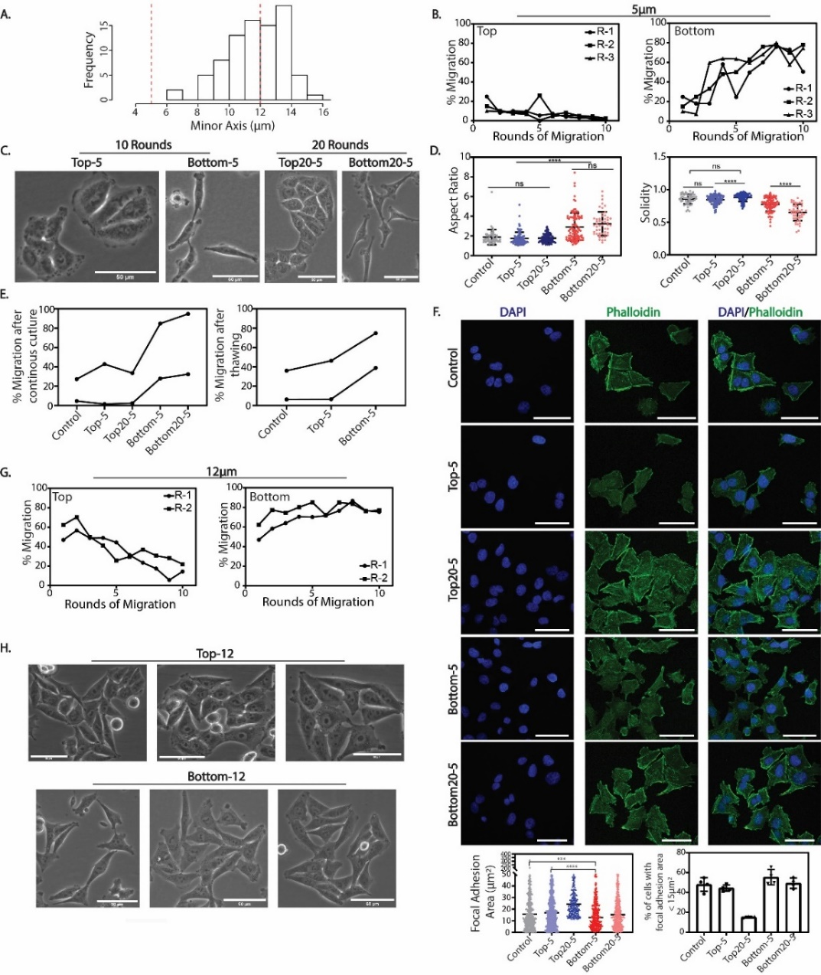
Supplementary Figure 1. A375 cells exhibit persistent increase in migration efficiency and morphological changes after 5µm constricted migration. (A) Minor axis (minimum diameter) measurements of A375 cell nuclei based on confocal z-stacks. N=85. (B) Migration efficiency of each biological replicate for 10 rounds of 5 µm transwell migration in Top (left) and Bottom (right) cells. (C) Phase contrast images of A375 cells exposed to 5µm transwell migration for 10 and 20 rounds. (D) Aspect ratio (left graph) and solidity (right graph) measurements of cells in A375 subpopulations that have undergone 10 rounds (Top-5 and Bottom-5) and 20 rounds (Top20-5 and Bottom20-5) of migration through 5µm constrictions (**** p < 0.0001; Control (n = 52), Top-5 (n = 99), Top20-5 (n = 93), Bottom-5 (n = 98), Bottom20-5 (n = 48); two – tailed t-test). (E) Migration efficiency of A375 cells after 5 passages of continuous culture (left graph) and after one cycle of freeze - thawing (right graph) in two replicates. (F) Confocal images of Phalloidin (green) and DAPI (blue) immunostained cells that have undergone constricted migration. Graphs represent quantification of focal adhesion area as determined by phalloidin staining (*** p = 0.0003, **** p < 0.0001; two-tailed t-test) and fraction of cells that display focal adhesion area < 15 μm². (G) Migration efficiency of each replicate for 10 rounds of 12-µm transwell migration. (H) Phase contrast images of A375 cells exposed to 12 µm transwell migration. Scale bars (white) indicate a length of 50 μm.
already present in the Bottom-12 subset of cells and could be induced from initial rounds of squeezing. Given the large degree of nuclear squeezing necessary to undergo constricted migration, we next turned to investigating the organization of the nucleus and chromosome structure of these different subgroups of A375 cells.

Irregular distribution of Lamin A/C and peripheral localization of heterochromatin correlate with an increased rate of constricted migration
Changes in nuclear morphology are consistently used as a diagnostic tool in cancer progression (Kadota et al., 2012).It has been reported that, during cancer cell constricted migration, the nuclear envelope can rupture (Denais et al., 2016, Raab et al., 2016), blebs can form, and DNA damage can occur (Irianto et al., 2017a, Davidson and Lammerding, 2014). These dramatic morphological alterations of the nucleus occur in part due to the stiffness of the nucleus contributed by Lamin A/C content and chromatin state which have been implicated in constricted migration. Therefore, we investigated the effect of sequential constricted migration on nuclear morphology of A375 subpopulation of cells by immunofluorescence imaging of Lamin A/C and constitutive heterochromatin (H3K9me3) 18 hours after constricted migration.
Using maximum projected images, Bottom-5 nuclei exhibited more elongated morphologies (~ 40% of average population) than Bottom-12 nuclei (~ 15%), but no significant difference compared to Control and Top-5 (Figure S2A). This observation is indicative of inherent heterogeneity of nuclear morphology in the original population that could potentially infer ability to undergo constricted migration. Additionally, we investigated nuclear morphology features on 3D projections (sphericity and elongation) which revealed no significant differences between Control, Top-5 and Bottom-5 cells (Figure S2B). , in agreement with previous reports showing that the morphological changes with constriction are reversible (Irianto et al., 2017a). We then investigated whether differences in Lamin A/C and constitutive heterochromatin distribution exist among A375 subpopulation of cells with different migratory ability (Figure 2A). High resolution confocal microscopy of immunostained A375 Control, Top-5 and Bottom-12 nuclei revealed a uniform distribution of Lamin A/C throughout the nuclear envelope (Figure 2A, middle panel). In contrast, Bottom-5 nuclei display an altered distribution of Lamin A/C with specific regions of the nuclear envelope devoid of it. (Figures 2A and 2B, indicated by white arrows, Movie S3 and S4). On average, ~ 50% of Bottom-5 nuclei employ abnormal distribution of Lamin A/C when compared to ~ 25 % of Bottom-12 nuclei (Figure 2C, maximum projections) suggesting that differences in distribution of Lamin A/C are specific to constricted migration. Quantification of Lamin A/C coefficient of variance in A375 subpopulations revealed that a larger fraction of Bottom-5 nuclei exhibit high Lamin A/C coefficient of variance when compared to Control, Top-5 and Bottom-12 cells (Figure 2D). This variation in Lamin A/C pixel
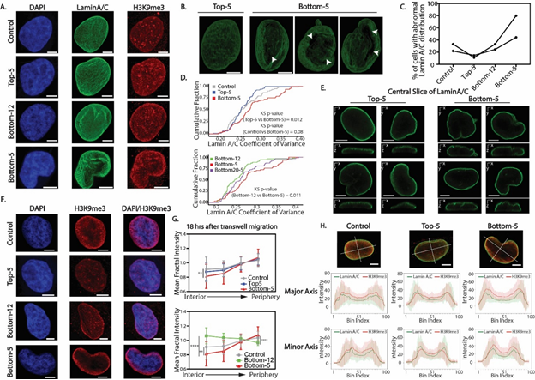

Figure 2. Irregular distribution of Lamin A/C and heterochromatin upon constricted migration. (A) A375 nuclei stained with DAPI (blue), Lamin A/C (green) and H3K9me3 (Red) in the indicated migration conditions. Images shown represent a maximum projection of z-stacks. (B) Snapshots of 3D reconstructed z-stacks of A375 nuclei stained with Lamin A/C. For full 3D visualization see Movie S3 and S4. White arrows indicate areas of irregular Lamin A/C distribution. (C) Fraction of A375 cells displaying irregular patterns of Lamin A/C in Control (n = 59), Top-5 (n = 63), Bottom-12 (n = 80) and Bottom-5 (n = 64) cells. Two replicates shown in the figure; lines connect A375 conditions that correspond to each replicate. (D) Cumulative distribution plots of Lamin A/C coefficient of variance in all indicated A375 subpopulation of cells. Kolmogorov-Smirnov test performed with indicated p-values in each plot. (E) Central orthogonal slices of Lamin A/C stained nuclei in Top-5 and Bottom-5 cells. (F) A375 nuclei stained with DAPI (blue) and H3K9me3 (red) for each indicated A375 cell subpopulations. Images represent maximum projection of z-stacks. (G) Quantification of radial intensity distribution of H3K9me3 signal in the nuclei of A375 subpopulations of cells. Top graph: H3K9me3 radial intensity distribution in Control (n = 59), Top-5 (n = 63) and Bottom-5 (n = 64) nuclei (** p = 0.0069, two-tailed t-test). Bottom graph: H3K9me3 radial intensity distribution in Control (n = 59), Bottom-12 (n = 80) and Bottom-5 (n = 64) nuclei (**** p < 0.0001, ** p = 0.0069; two-tailed t-test). Error bars = mean ± SD. (H) Intensity line scans across major and minor axis of Lamin A/C and H3K9me3 central slices in A375 Control, Top-5 and Bottom-5 nuclei. All scale bars (white) indicate a length of 5μm.

intensity could arise due to an increase in nuclear envelope invaginations and wrinkling in Bottom-5 nuclei as observed from central orthogonal slices of Lamin A/C stained nuclei (Figure 2E). At a population average level, this translates to a moderate difference in the distribution of Lamin A/C between cells that have undergone 5μm transwell migration (Bottom-5, Bottom20-5) to the ones that have failed to do so (Control, Top-5 and Bottom-5).
To investigate transient effects of constricted migration on nuclear and Lamin A/C morphology, we performed transwell migration of Bottom-12 and Bottom-5 cells for 3 and 5 hours after seeding on the transwell chambers. Independent of pore sizes, these cells do not exhibit significant differences in the shape of their nuclei as measured by sphericity and elongation parameters 3 hours after seeded on transwells (Figure S2C, top panel). In contrast, the nuclei of Bottom-5 cells are more elongated compared to Bottom-12 after undergoing transwell migration for 5 hours (Figure S2C, bottom panel). Bottom-5 cells exhibit a slightly higher variation in Lamin A/C distribution; however, Lamin A/C is irregularly distributed in Bottom-12 cells 5 hours after migration. While differences in Lamin A/C distribution are stable in Bottom-5 cells, overall Lamin A/C intensity and total protein levels do not differ between Control, Top-5 and Bottom-5 cells 18 hours after transwell migration assay (Figures S2E and S2G). Similar observations have been recently reported in mechanically stretched cells (Nava et al., 2020) and contrast other reports that suggest lower levels of Lamin A/C increase the ability to undergo constricted migration due to nuclear softening (Harada et al., 2014).
However, fluctuations in Lamin A/C levels could be transient as we observe a decrease of Lamin A/C intensity in Bottom-5 cells that have undergone migration for 3 hours but no significant difference between Bottom-12 cells 5 hours after transwell migration (Figure S2F). Furthermore, we investigated the protein levels of phosphorylated Lamin A/C given its role in regulating Lamin A/C solubility properties and we find no significant differences in protein levels (S2L). In addition, Lamin B1 protein levels also remain unchanged across the A375 subpopulation of cells (S2H).
Given the recently reported role of heterochromatin in mechanosensing and modulating nuclear stiffness, we immunostained A375 subpopulations with H3K9me3 to investigate the impact of nuclear squeezing on constitutive heterochromatin. Heterochromatic foci are randomly distributed throughout the nucleus in Control, Top-5and Bottom-12 cells (Figure 2A) with some foci localized to the nuclear periphery, in agreement with previous reports investigating the role of heterochromatin in maintaining the integrity/roundness of the nucleus (Gerlitz and Bustin, 2010, Stephens et al., 2019). In contrast, heterochromatin foci in Bottom-5 nuclei appear to be more dispersed and the majority of H3K9me3 signal is localized to the nuclear periphery (Figures 2A and 2F). Indeed, quantifying the radial distribution of H3K9me3 signal in the nucleus reveals that Bottom-5 nuclei display a lower H3K9me3 intensity in the interior of the nucleus when compared to Control and Top-5 nuclei (Figure 2G, top graph).
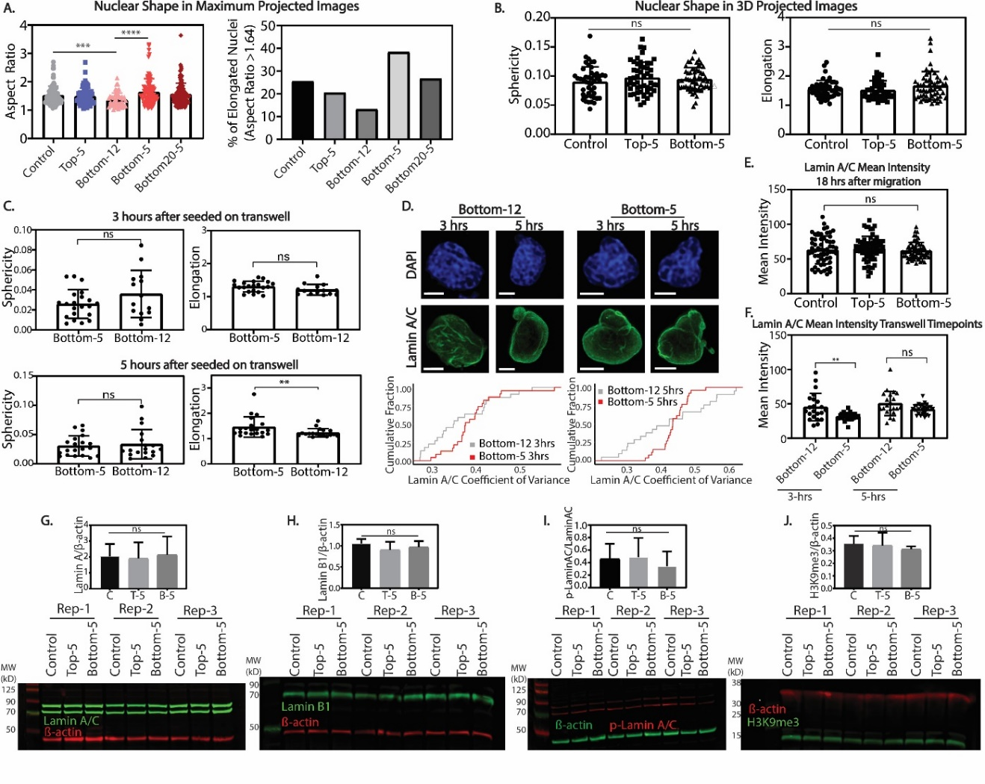
Supplementary Figure 2. Changes in nuclear morphology after constricted migration are not dependent on Lamin A/C or H3K9me3 protein levels. (A) Aspect ratio quantification of A375 maximum projected nuclei exposed to transwell migration ( (*** p = 0.0002, **** p < 0.0001, two-tailed t-test; Control = 59, Top-5 = 63, Bottom-12 = 80, Bottom-5 = 64, Bottom20-5 = 52 nuclei). (B) Nuclear shape measurements of 3D projected A375 nuclei. (C) Nuclear shape measurements of 3D projected nuclei at 3 and 5hrs after migrating through 5µm (Bottom-5) and 12μm (Bottom-12) transwell pores. (D) Top Panel: DAPI (blue) and Lamin A/C immunostained nuclei of A375 cells that have migrated through 5 and 12µm transwell pores for 3 and 5 hrs. Bottom Panel: Cumulative distribution plots of Lamin A/C coefficient of variance. (E) Lamin A/C mean intensity in A375 cells 18hrs after migrating through 5μm transwell chambers. (F) Lamin A/C mean intensity of A375 cells that have undergone migration through 5 and 12µm transwell chambers for 3 and 5 hours. (G-J) Western blot analysis of A375-Control, Top-5 and Bottom-5 cells probing for Lamin A/C, Lamin B1, p-Lamin A/C and H3K9me3.

These differences are more evident when compared to Bottom-12 cells which display a random distribution of H3K9me3 foci across the nucleus. and an increase in intensity at the periphery when compared to Control, Top-5, or Bottom-12 cells (Figure 2G, bottom graph) (Figure 2F). Similarly, when investigating central slices of the nucleus observations hold true when we perform line scan analysis of central nuclear slices through major and minor axis (Figure 2H). Bottom-5 cells exhibit a significant increase in heterochromatin localization to the nuclear periphery when compared to Control and Top-5 cells along the major and minor axis. Interestingly, Bottom-5 and Control cells exhibit lower intensity of Lamin A/C in the nuclear periphery across the central slices when compared to Top-5 cells.
Our observations imply that, in A375 cells, constricted migration proficiency is related to the distribution of Lamin A/C and heterochromatin, instead of total protein levels.
Given the variability in Lamin A/C expression across different cell lines and cancer types, we repeated the sequential migration experiments in MDA-MB-231 cells (Figure S3). These cells exhibit a higher efficiency in their ability to migrate through 5μm constrictions when compared to A375 cells. MDA-MB-231 cells that successfully undergo first round of 5μm constricted migration (Bottom), display a slight increase in migration efficiency after 10 consecutive rounds while cells that fail to undergo constricted migration the first round (Top) display a slight decrease in their migratory efficiency after 10 consecutive rounds of 5μm constricted migration (Figure S3A). In contrast to A375 cells, no significant separation between Top-5 and Bottom-5 migratory efficiency was observed when MDA-MB-231 cells undergo sequential rounds of migration through transwells with 12 um pore sizes. These observations suggest that MDA-MB-231 cells exhibit less heterogeneity within the initial population compared to A375 cells. Indeed, MDA-MB-231 cells exhibit more mesenchymal phenotypes with elongated cell bodies and low cell-cell adhesions independent of constricted migration (Figure S3B). However, 50% of Bottom-5 cells display a larger degree of elongation (aspect ratio measurements) after 10 rounds of constricted migration (Figure S3C).
We then investigated whether Lamin A/C and heterochromatin organization in the nucleus was affected by constricted migration in MDA-MB-231 cells (Figure S3D). The nuclei of MDA-MB-231 cells display more elongated phenotypes (aspect ratio measurements) compared to A375 cells. (Figure S3E). However, about 60% of the Bottom-5 nuclei display higher elongated phenotypes (> third quartile of Control) when compared to other MDA-MB-231 cell subtypes (Figure S3E).
These nuclei also display a variable distribution of Lamin A/C independent of constricted migration with no significant differences among Control, Top-5 and Bottom-5 cells (Figures S3D and S3F). This variable distribution of Lamin A/C could correlate with high nuclear wrinkling of the MDA-MB-231 cells. 75-80% of Control and Top-5 cells display wrinkled nuclei while ~90% of Bottom-5 cells
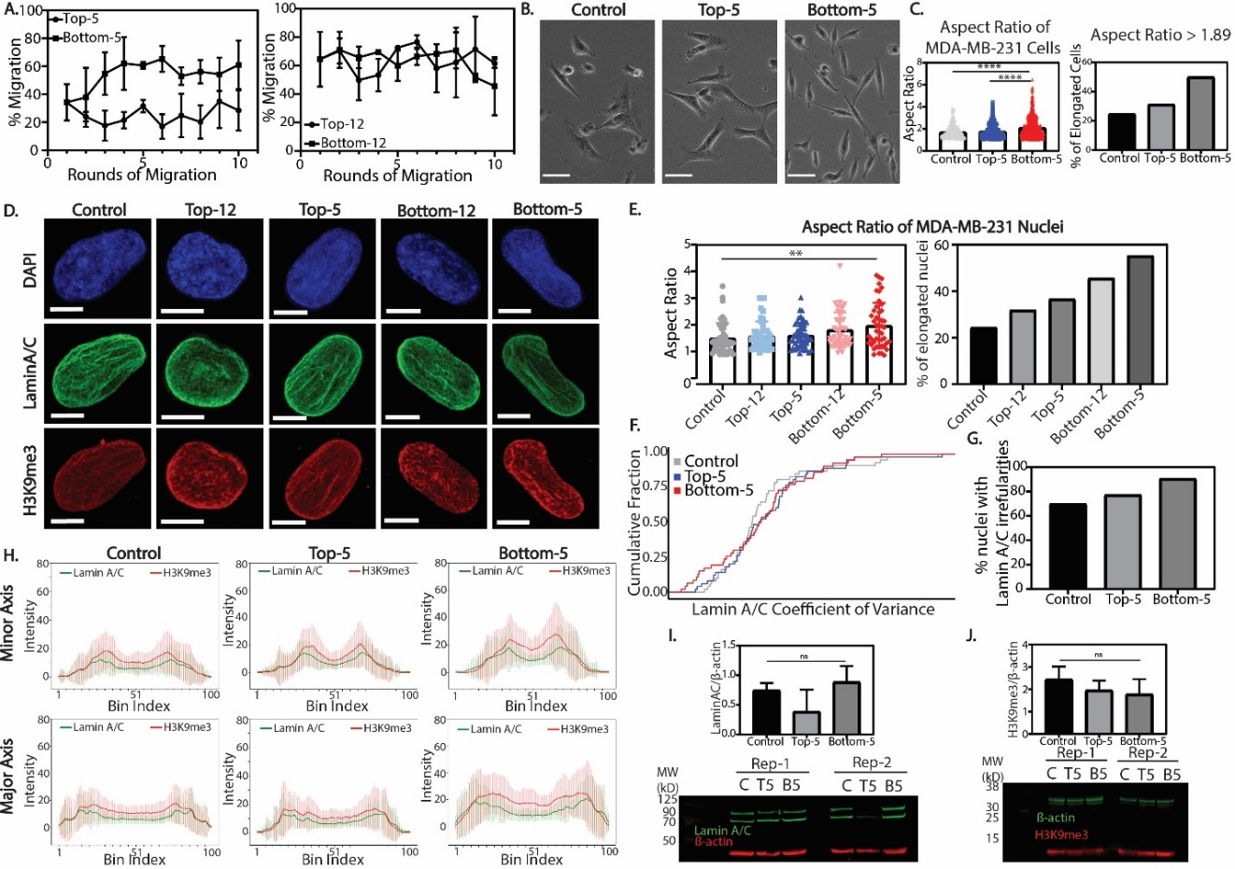

Supplementary Figure 3. Sequential rounds of constricted transwell migration separate two distinct populations of MDA-MB-231 cells. (A) Transwell migration efficiency of MDA-MB-231 cells through 5 and 12µm pore sizes for 10 transwell migration rounds. Error bars = mean ± SD of 5μm (3 biological replicates) and 12μm (2 biological replicates) transwell assays. (B) Phase contrast images of MDA-MB-231 cell subpopulation of cells. Scale bars (white) indicate a length of 50μm. (C) Left graph: Aspect ratio quantification of MDA-MB-231 cells for Control (n = 142), Top-5 (n = 393) and Bottom-5 (n = 621) (**** p < 0.0001; two-tailed t-test). Right graph: Fraction of MDA-MB-231 cell subpopulations with an aspect ratio > 1.89. (D) Maximum projected images of MDA-MB-231 nuclei immunostained with DAPI (blue), Lamin A/C (green) and H3K9me3 (red). Scale bars (white) indicate a length of 5μm. (E) Left graph: Aspect ratio quantification of MDA-MB-231 nuclei in Control (n = 49), Top-12 (n = 47), Top-5 (n = 49), Bottom-12 (n = 46) and Bottom-5 (n = 47) (** p = 0.0038; two-tailed t-test). Right graph: Fraction of MDA-MB-231 nuclei that have an aspect ratio > 1.803. (F) Cumulative distribution plot of Lamin A/C coefficient of variance in Control, Top-5 and Bottom-5 MDA-MB-231 cells. (G)Fraction of MDA-MB-231 nuclei displaying irregularities in Lamin A/C distribution. (H) Line scan intensity for H3K9me3 and Lamin A/C across major and minor axis of MDA-MB-231 cells. (I-J) Western blot analysis and quantification of MDA-MB-231 Control, Top-5 and Bottom-5 cells probing for Lamin A/C and H3K9me3.

exhibit wrinkled nuclei. Our results support previous observations in which elongated cell and nuclear shape could correlate with higher migration propensity in MDA-MB-231 cells (Baskaran et al., 2020).
While no striking differences were observed in H3K9me3 radial distribution in MDA-MB-231 subpopulation of cells, Bottom-5 cells displayed an increase in H3K9me3 intensity at the nuclear periphery across the major and minor axis when compared to Control and Top-5 (Figure S3H). This observation strengthens previous reports on the role of heterochromatin in maintaining the integrity of the nucleus.
In agreement with our observations from A375 cells, Lamin A/C or H3K9me3 protein levels in MDA-MB-231 subpopulations are not significantly changed independent on constricted migration (Figures S3I and S3J).
Overall, our observations suggest that modulating levels of Lamin A/C or H3K9me3 is not a stable effect of constricted migration but rather the re-distribution of these proteins in the nucleus could aid in maintaining nuclear integrity while facilitating migration through these constrictions. Given the role of lamins and heterochromatin in organizing the 3D genome structure, we next asked whether related changes are found in the 3D organization of chromosomes in cells that display differential distribution of these proteins.

Genomic regions change their compartmentalization after rounds of constricted migration
To measure changes in genome wide chromosomal contacts in A375 cells, we performed genome-wide chromosome conformation capture (Hi-C) on Control, Top-5, Bottom-5, Top-12 and Bottom-12 cells (see Materials and Methods and Table S1 for processing and statistics). Strikingly, using 250kb binned matrices, we observe regions of the genome that switch their compartment identity specifically in Bottom-5 cells but not in any of the other conditions (Figure 3A, example compartment switch indicated by black arrow). We then performed Principal Component Analysis (PCA) to classify regions according to A/B compartment identity. We identified regions of the genome that maintain a consistent compartment identity among all unconstricted conditions (Control, Top-12, Top-5, Bottom-12) but change compartment identity (A to B or B to A) in Bottom-5 cells (Figure 3B, highlighted region, for example). We determined that 1% of 250 kb regions across the genome switched from the B (typically more heterochromatic) to A (typically more euchromatic) compartment and about 2% of the 250Kb bins switched from A to B compartment in Bottom-5 cells (Figure 3C). We observed a comparatively very small number of compartment identity switches in all the other conditions (Figure 3C) implying that 3D genome structure changes could be specific to cells that have undergone constricted migration. We also extended migration through 5-µm pores up to 20 rounds (Bottom20-5) and observe similar compartment patterns and compartment identity switches, reinforcing the idea that these specific rearrangements of the genome are related to constricted migration (Figure 3C and S4).
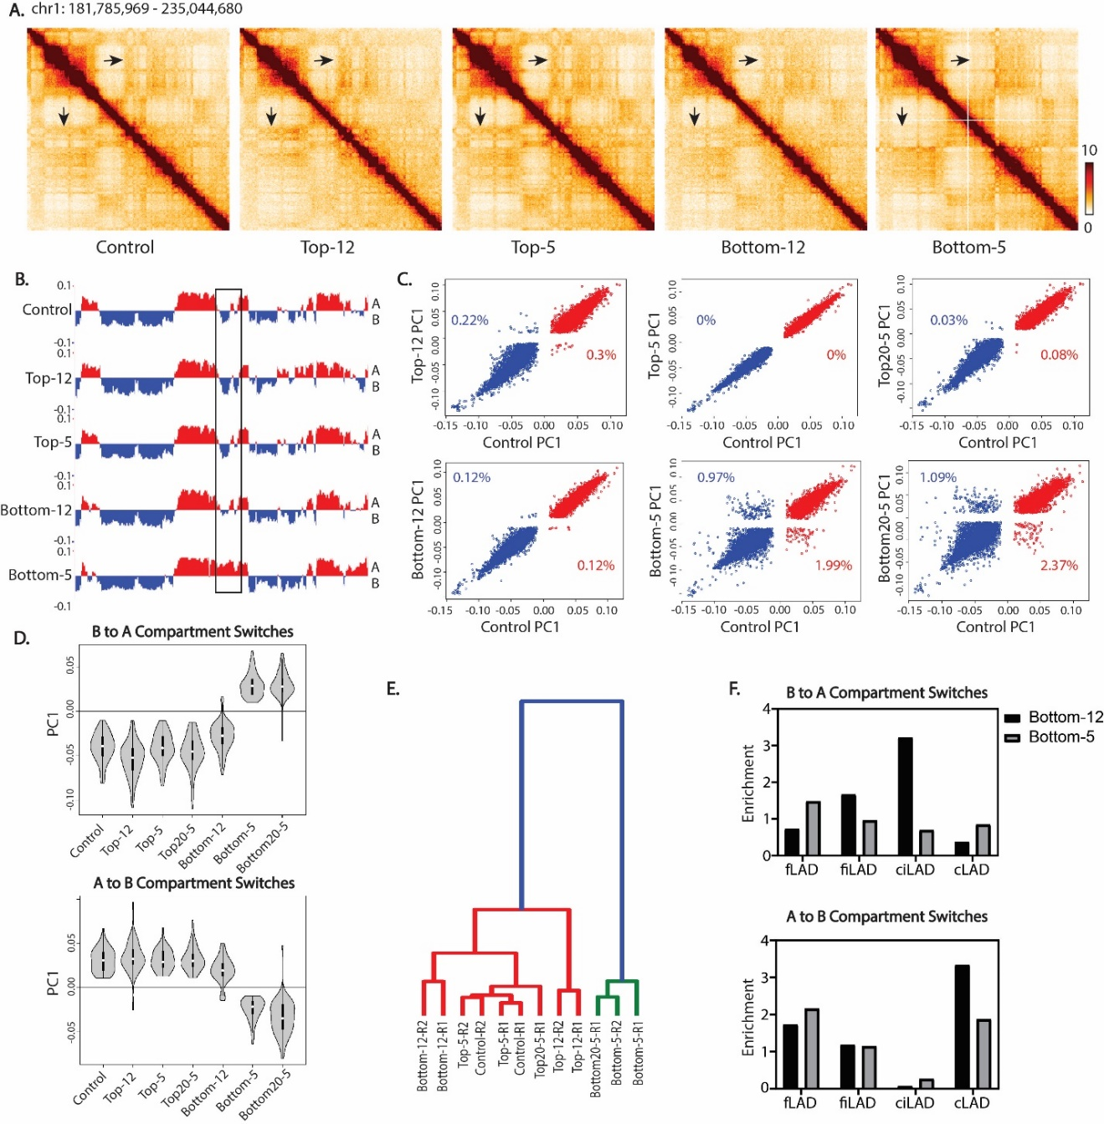

Figure 3. Compartment identity switches observed after constricted migration. (A) 250Kb binned Hi-C interaction heatmaps of chr1 (chr1:181,785,969 - 235,044,680) among all A375 subpopulations. Arrow indicates visible differences in heatmaps of Bottom-5 cells when compared to the rest. (B) PC1 track of compartment identity in the same region of chr1 among all A375 subpopulations. Compartment tracks are binned at 250Kb. Boxed region highlights to one of several compartment switches in this region, the same switch highlighted by arrows in (A). (C) Correlation between A375 Control PC1 with A375 cells that did not undergo transwell migration (top three panels) and A375 cells that did undergo transwell migration (bottom three panels). Percentage of bins that met the criteria for “compartment switch” from B to A (blue, PC1 > 0.01) or A to B (red, PC1 < (-0.01)) indicated on each panel. (D) Distribution of PC1 values across all A375 subpopulations for the regions that switched their compartment identity from B to A compartment (top panel) and A to B compartment (bottom panel) in Bottom-5 cells. (E) Clustering of all A375 subtypes by their compartment PC1. (F) Enrichment of different LAD types in regions that switch their compartments from B to A and A to B in Bottom-5 cells.
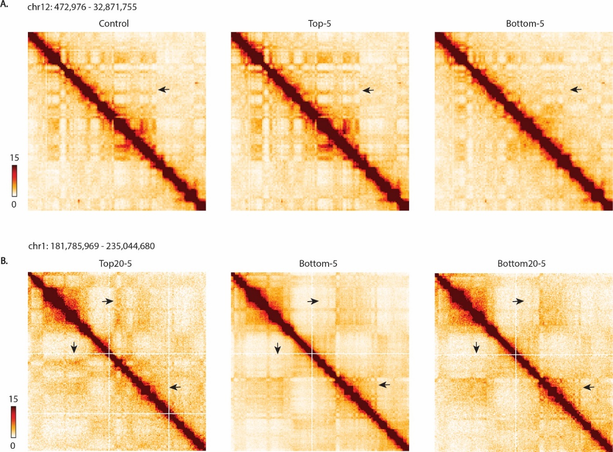

Supplementary Figure 4. Compartment identity switches persist after 20 rounds of 5-µm constricted migration. (A) Hi-C interaction heatmap of chr12 binned at 250Kb in A375-Control, Top-5 and Bottom-5. (B) Hi-C interaction heatmaps of chr1 (same chromosomal location as Figure 3A) in A375 cells that have undergone 20 rounds of 5-µm transwell migration. Black arrows indicate regions that exhibit changes in compartment profiles upon migration through 5-µm constrictions.

Even though most compartment switches were specific to Bottom-5 cells, we investigated the distribution of PC1 values of the regions that switched compartments in Bottom-5 among all the A375 conditions (Figure 3D). Regions of the genome that were previously in the B compartment in Control cells and switch to the A compartment in Bottom-5 cells show a negative distribution of PC1 values in non-migrating cells (Top-12 and Top-5), consistent with a B compartment identity, similar to the Control. As expected, the PC1 distribution switches to a positive mean in cells that have undergone constricted migration (Bottom-5 and Bottom20-5) (Figure 3D, top panel). However, while Bottom-12 cells exhibit a negative PC1 mean (still maintaining their original B compartment identity), it is less negative when compared to Control and Top cells (Figure 3D, top panel). A similar pattern is observed in regions of the genome that switch compartment identity from A to B type. While the mean of PC1 distribution is positive for Control and Top cells and negative for Bottom-5 and Bottom20-5 cells, Bottom-12 cells exhibit a less positive mean of PC1 distribution (Figure 3D, bottom panel). This observation could imply that shifts in genome structure begin to happen in cells that undergo migration with minor nucleus deformations, but are more dramatic with a narrow constriction, or that the Bottom-12 cell population exhibits heterogeneity in ability to successfully undergo confined migration.
Not only are compartment changes a visually apparent difference in constricted migrating cells, but also genome-wide hierarchical clustering analysis of the compartment eigenvectors segregates conditions according to whether they have undergone constricted migration or not, indicating that the changes in chromatin compartmentalization could be linked to migratory ability (Figure 3E). Given our observations on the increased peripheral localization of H3K9me3 distribution after confined migration (Figure 2), we sought to investigate whether genomic regions that change compartment identity correspond to certain lamin association types. We used a previously established LAD atlas across a cohort of nine different cell types that classify LADs as: cLADs (constitutive LADs; regions associated with the nuclear lamina in all cell types), ciLADs (constitutive inter LADs; regions located in the interior of the nucleus across all cell lines), fLADs and fiLADs (facultative LADs and facultative inter LADs; regions that are sometimes associated with the nuclear lamina across the cell types) (Kind et al., 2015, Carolyn de Graaf, 2019).We observed that regions that switched their compartment identity after constricted migration (Bottom-5) were enriched in fLADs both in B to A (Figure 3F, top panel) and A to B (Figure 3F, bottom panel) switches. The high incidence of compartment changes in fLAD regions might relate to the inherently bivalent state of fLADs, representing their ability to transition between lamina-association and dissociation. Additionally, Bottom-12 and Bottom-5 presented with an enrichment of cLADs in the regions that switch
from A to B compartment, suggesting a possible further spatial consolidation of heterochromatin regions corresponding to the coalescence of H3K9me3 at the nuclear periphery.
Interestingly, we observed an over-representation of ciLADs in regions switching their identity from B to A compartment between Top-12 and Bottom-12 (Figure 3F, top panel). Given that ciLADs are regions that do not associate with the nuclear lamina in all the examined cell types, we did not expect these regions to be in the B-compartment in the non-migratory cells. We have identified 96 bins that are classified as ciLADs residing in a B compartment in Top-12 cells but are found in the A compartment in all other conditions. Gene ontology enrichment analysis identified functions correlating to cell motility and the regulation of actin cytoskeleton for the genes found in these regions. Additionally, we also observed an over-representation of cLADs in regions that switched their compartment identity from A in the Top-12 to B in Bottom-12, encompassing 253 bins found in the A compartment in Top-12 and in the B compartment in all the other conditions. The genes in these regions were associated with melanogenesis and neuronal pathways. Taken together, these observations suggest that Top-12 cells (the least migratory in the constricted migration spectrum) harbor a 3D genome structure that separates them from the highly migratory cells (Bottom-5 and Bottom20-5) and likely reflects maintenance of melanocyte identity.

Gene expression changes after constricted migration reflect metastatic potential
To investigate potential changes in gene expression in cells that have undergone constricted migration, we performed RNA-Seq on all A375 subpopulations. We identified 977 and 1473 genes that were differentially expressed in Bottom-5 and Bottom20-5, respectively (Table S2). Hierarchical clustering of all conditions, starting with the subset of genes differentially expressed in Bottom-5 or Bottom20-5, revealed that cells that undergo constricted migration cluster separately from all other conditions (Figure 4A and Figure S5A). Overall, we observe three major gene clusters: cluster 1 included 482 genes that are upregulated in Bottom-5 and Bottom20-5 but seem to be mostly downregulated in all other cells. Pathway enrichment analysis identified upregulated pathways related to metastasis, such as TGF-beta, TNF-alpha, EGFR and Integrin β-4 signaling pathways (Figure 4B). On the other hand, cluster 2 included 368 genes that were downregulated in Bottom-5 and Bottom20-5 but upregulated among all other cells. Interestingly, enriched pathways are involved in developmental pathways such as neural development. Since melanoma cells originate from neural crest, these observations suggest that this cluster relates to melanocyte specific gene expression (Figure 4B). Finally, cluster 3 included 533 genes that were downregulated in Bottom20-5 and upregulated in Top-5 (Figure 4A). Some of these genes are involved in cell adhesion, which correlates with the differences we observe in cell-cell contacts between these subsets (Figure 1C). We next searched for other potential links between observed phenotypic differences (Figure 1 and Figure S5B) and changes in gene expression. We first compared cells which have migrated through non-constricted spaces to cells that
Figure 4. Changes in gene expression correlate with metastatic ability and chromosome structure changes. (A) Hierarchical clustering of RNA-Seq datasets based on differentially expressed genes of Bottom-20 cells (Log2FC > 1). (B) Pathway enrichment analysis of identified gene clusters from (A) using BioPlanet 2019 package from Enrichr. (C) Log2FC of expression in the indicated condition vs. Control for genes located in regions that switch compartments from A to B (top panel) and B to A (bottom panel) in Bottom-5 cells. (D) Enrichment of regions that switched from A to B compartment based on the presence or absence of genes within the bin. (E) 20Kb binned Hi-C matrices of upregulated (FBXL7) and downregulated (CCDC149) genes in Bottom-5 cells. Tracks over the matrices represent ATAC-Seq (black) and RNA-Seq (red). The tracks have been smoothed with 40Kb bins. Black arrows indicate known CTCF motif directionality sites.

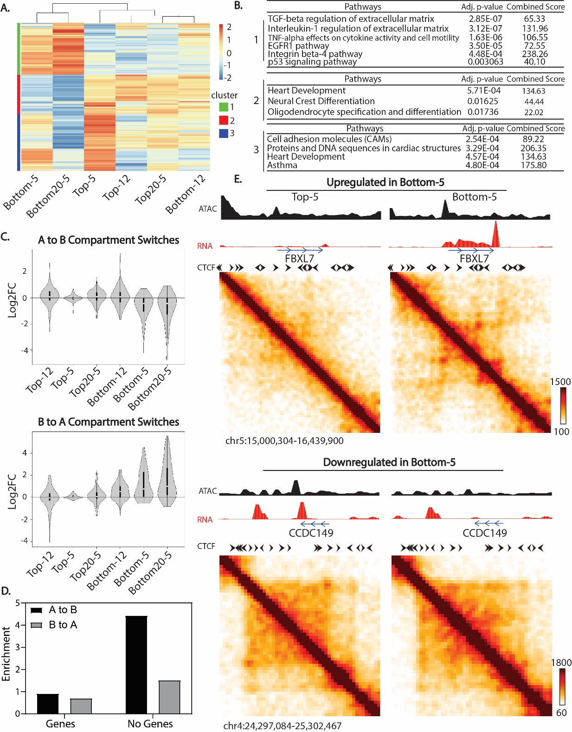

do not migrate at all (Bottom-12 vs Top-12, Figure S5B). The majority of genes that were upregulated in Bottom-12 cells were related to TGF-beta, EGFR, integrin and p-53 signaling, all pathways related to cancer cell migration and metastasis. To assess whether we observe constriction-specific changes in gene expression, we next compared cells which have migrated through 5µm constrictions to cells which migrated without constriction (Bottom-5 vs Bottom-12, Figure S5B). Interestingly, genes that were upregulated in Bottom-5 cells were related to focal adhesion pathways and regulation of actin cytoskeleton. These changes correlate with the increase in protrusions and changes in cell shape observed for Bottom-5 cells in Figure 1 and S1 (Figure S5B). Similarly, when we compared cells that underwent 5μm constricted migration (Bottom-5) with the ones that were not able to migrate independent of constrictions (Top-12), we found genes that were related to cancer invasiveness pathways such as EGF and VEGF. More importantly, the majority of genes upregulated in Bottom-5 were representative of focal adhesion pathways which correlate with the increase in focal adhesions as shown by phalloidin stain in Figure S1E and F (Figure S5B).
These gene expression changes also correlate with A/B compartment changes upon constricted migration (Fig. 4C). Genes found in regions that switch their compartment identity from A to B in Bottom-5 or Bottom20-5 cells display an overall decrease in expression when compared to all other conditions (Figure 4C, top panel). Similarly, genes found in regions that switch their identity from B to A compartment in Bottom-5 and Bottom20-5 cells display an overall increase in expression (Figure 4C, bottom panel). These observations suggest that some of the compartment changes after confined migration directly relate to changes in gene regulation.
We cannot definitively say whether certain key migration genes were, for example, already active and in the A compartment in a subset of A375 control cells, and these were selected by sequential migration, or whether some such genes became active after a compartment switch was induced by confined migration. However, we can conclude that at least part of the underlying biological function of the compartment switching we observe in confined migrating cells involves changes in gene expression. Interestingly, we found that a large proportion of the genomic bins that switch from A to B and B to A compartment contain no genes; fold enrichment of 4 and ~2, respectively (Figure 4D). This observation indicates that a substantial portion of structural changes after migration must be explained by something other than gene regulation changes. We hypothesize that these regions might change as a result of or to accommodate the physical strain on the chromatin fiber during constricted migration.
Additionally, to investigate whether the observed gene expression changes relate to local genome structure changes, we zoomed in to regions of the genome encompassing some of the highest upregulated or downregulated genes after constricted migration (Figure 4E). We initially explored genes that were upregulated (log2FC > 1) in cells that had undergone constricted migration
Supplementary Figure 5. Gene expression profile separately clusters cells that have undergone constricted migration (Bottom-5 and Bottom-20) from all other A375 subpopulations. (A) Hierarchical clustering of all A375 subset of cells based on genes that are differentially expressed in Bottom-5 cells (Log2FC >1). (B) Gene ontology analysis of differentially expressed genes when A375 cells undergo migration without constriction and 5µm constricted migration. Cell illustration indicates morphology differences we observe within each sub-population of A375 cells. (C) Hi-C contact matrices binned at 20Kb and smoothed at 40Kb bin size of upregulated genes (PLEKHA6, left two panels) and downregulated genes (PKDCC, right two panels) in Bottom-5 cells. Black track represents ATAC-Seq signal while the red track represents RNA-Seq signal. Black arrows indicate known CTCF motif directionality. (D) Correlation plots of differentially expressed genes between mechanically stretched cells (Nava et al., 2020) and A375 cells that have undergone constricted migration.

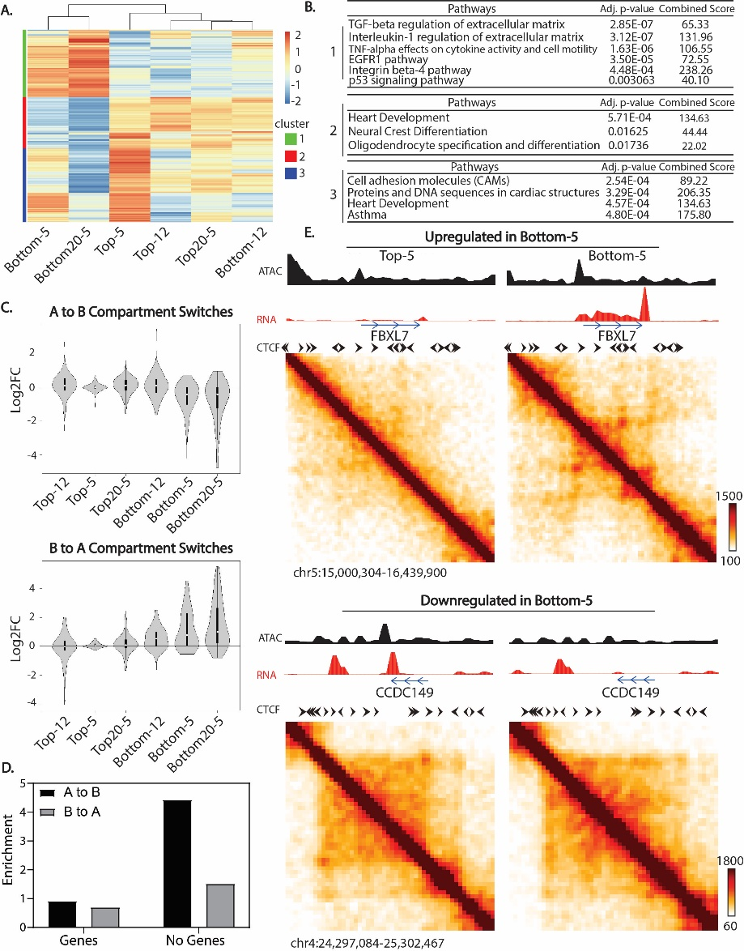

(Bottom-5 and Bottom20-5). When zooming in to the FBXL7 gene (~ 8-fold upregulated in Bottom-5 and Bottom20-5), we observed the emergence of a domain-like structure in Bottom-5 cells and an increase in chromatin accessibility (Figure 4E, top panel). Similarly, when exploring genes that were downregulated after constricted migration (Bottom-5 and Bottom20-5), we found genes whose local 3D structure was altered in Bottom-5 or Bottom20-5 cells with the disappearance of the loop present in Top-5 and a decrease in chromatin accessibility (SOD3 and CCDC149 3-15 fold downregulated; Figure4E, bottom panel). However, we also encountered cases in which the genes were differentially expressed such as PLEKHA6 (log2FC > 2 in Bottom-5 and Bottom20-5) and PKDCC (log2FC = -2.5 in Bottom-5 and Bottom-20) but their local genomic structures remained similar with modest changes in chromatin accessibility (Figure S5C).
We observe that the loss or formation of loops or domains associated with changes in transcription occurs in regions that had few or no other strong architectural loops, such as the kind mediated by CTCF. Genes that change expression without notable 3D looping changes, in contrast, were located in regions with many other loops and TAD boundaries. These observations support the idea that transcription driven domains can arise separately from CTCF-based domains (Rowley et al., 2017). Further, the transcription-associated CCDC149 loop occurs between an existing TAD boundary and a promoter, and could be explained by a collision between opposing direction loop extrusion and RNA polymerase activity, as suggested in other systems (Brandao et al., 2019).
To investigate whether the gene expression profile of Bottom5 or Bottom20-5 cells was specific to the constricted migration or a general cell response to mechanical stressors, we compared out RNA-Seq data with recently published data in mechanically stretched cells (Nava et al., 2020) (Figure S5D). No direct correlation was observed between differentially expressed genes in cells that have undergone constricted migration with cells that have been mechanically stretched. This points to differences between a cell being passively deformed and one that is actively coordinating its own migration through a tight constriction.

Inter-compartment interactions increase after constricted migration
While the switching of compartment identity after confined migration is a striking phenomenon, and clearly apparent by visual inspection of the contact maps, quantitatively, only ~ 3% of the genomic bins (250Kb bins) were affected by a complete compartment switch according to our thresholds. To evaluate how constricted migration impacted the rest of the chromosome contacts, we evaluated contacts not involved in compartment identity switches by reordering the 250Kb binned matrices from the strongest B to strongest A bins based on PC1 values (Figure 5A) (Imakaev et al., 2012). 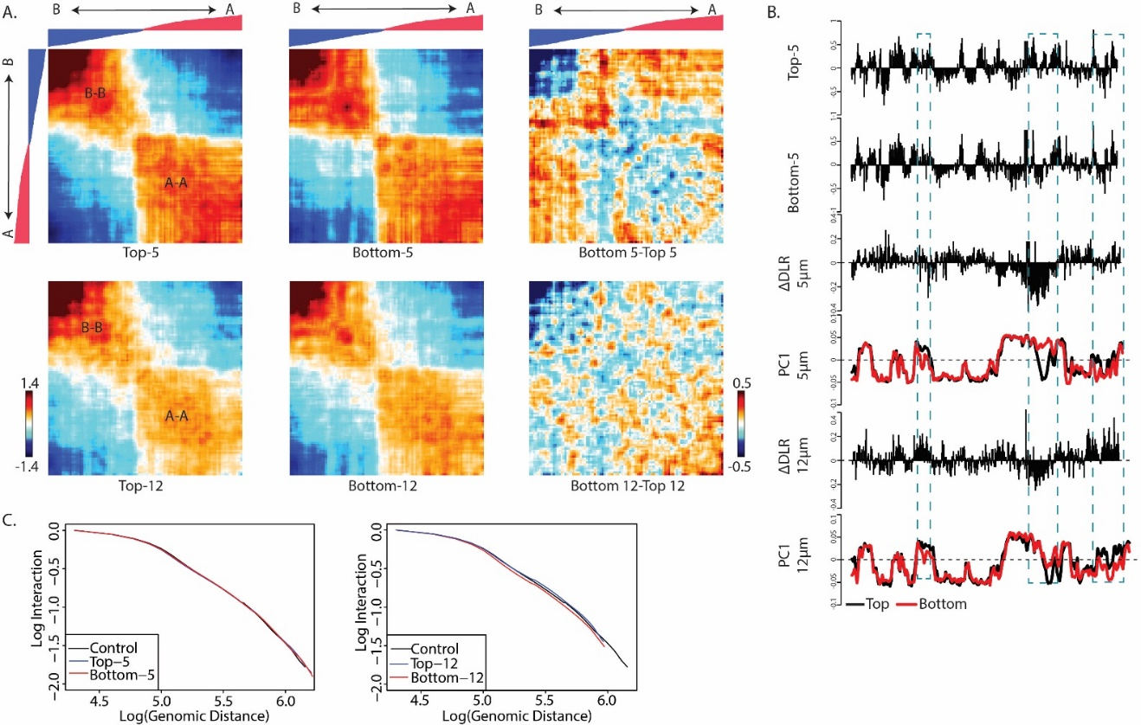 Figure 5. Increase in inter-compartment interactions upon constricted migration. (A) Compartmentalization saddle plots display interaction Z-score (interactions normalized by generic distance decay) between all bin pairs, reordered by PC1 values derived from A375 Control HiC data. Interactions between the strongest B regions are in the upper left corner while A-A interactions are in the lower right corner. The reordered Control PC1 values are displayed over the saddle plots. (B) Along chromosome 1 (chr1:170,000,001–225,000,000), from top to bottom: Distal to local (DLR; 100 kb bins) ratio for Top-5 cells; DLR of Bottom-5 cells; Delta DLR (Bottom-5 – Top5). Positive DLR values indicate a gain of distal interactions (>3Mb) while negative values indicate a loss of distal and gain of local interactions (<3Mb); PC1 values (250 kb bins) of Top-5 (black) and Bottom-5 (red) samples; Delta DLR (Bottom12-Top12); PC1 values of Top-12 (black) and Bottom-12 (red). Positive PC1 values represent A-compartment identity and negative PC1 values B-compartment identity. (C) Whole genome scaling plots at 20Kb bin size comparing A375 cells that have been exposed to 5-μm transwell migration (top plot) and 12-µm transwell migration (bottom).

We observe an evident separation between the B and A compartment in all subpopulations of A375 arising from 5µm (Figure 5A top panel and Figure S6A) and 12μm (Figure 5A bottom panel and Figure S6A) Transwell migration experiments. However, the relative strength of inter and intra-compartment contacts changes between Top and Bottom cells (Figure 5A, middle panels). Bottom-5 cells exhibit a loss in the strongest B-B interactions and an overall increase in interactions between the strongest B and strongest A compartments. This phenomenon has been previously reported in neutrophils after passage through small pores, suggesting it may be a general feature of confined migration genomic structural changes (Jacobson et al., 2018). This change in interaction frequency correlates with changes in gene expression. Regions that exhibit a strong B-B interaction loss display an overall increase in expression of genes found in these regions. Additionally, the expression of genes found in regions that display a gain in B-B interactions show an overall decrease in expression correlating with strengthening of the B-B interactions (Figure S6B). Interestingly, though there is increased mixing of the strongest A and B compartments after confined migration, there is actually increased segregation of regions that are weakly compartmentalized (eigenvector values near 0) in cells that did not pass through constrictions. It appears that the B compartment bins that were previously ambiguous or near compartment boundaries in Top cells are more strongly associated with the rest of the B compartment after confined migration. We also observe a loss of the strongest B-B contacts in Bottom-12 as compared to Top-12, though this effect is not as strong as in the constricted migration case. In contrast to Bottom-5 cells, Bottom-12 cells exhibit an increase of interactions between A-A contacts relative to Top-12.
To understand how these differences in compartment interaction frequencies relate to interactions with linearly local or distal chromosome regions, we calculated the distal-to-local ratio (DLR) of Hi-C interaction frequencies (Figure 5B). Here, distal is defined as interactions with regions more than 3 Mb away along the chromosome. This measure has previously been associated with changes in chromosome compaction (Heinz et al., 2018) and is related to a measure used to quantify loss of local chromosome structure with chromosome fiber digestion (Belaghzal et al., 2019). We find that in general, where regions along the chromosome strengthen or switch to A compartments, local interactions increase relative to distal (negative DLR value). Where regions increase their B compartmentalization or lose A identity, distal interactions increase (positive DLR). This could suggest that increased B compartmentalization often occurs when a region is brought closer to other heterochromatin regions far away on the chromosome, perhaps by co-localization at the nuclear lamina, while loss of B/increased A compartmentalization involves breaking distal contacts and increasing local contacts. (highlighted region, Figure 5B).
Although the DLR shows that local and distal interaction patterns of individual regions do change, the local decay of interactions with distance does not change
Supplementary Figure 6. Changes in compartment interaction strength correlates with overall gene expression pattern. (A) Saddle plots binned and smoothed using 500Kb bin size for chr18 reordered from strongest B to strongest A compartment. (B) Gene expression changes corresponding to strong B-B interaction loss (i), moderate B-B interaction gain (ii) and A-A interaction loss (iii). (C) Aggregate contact maps (40 kb bins) at TAD boundaries called by the Insulation Score method of cworld-dekker with strength greater than 1 of Top-5 (Top panel) and Bottom-5 (middle panel).

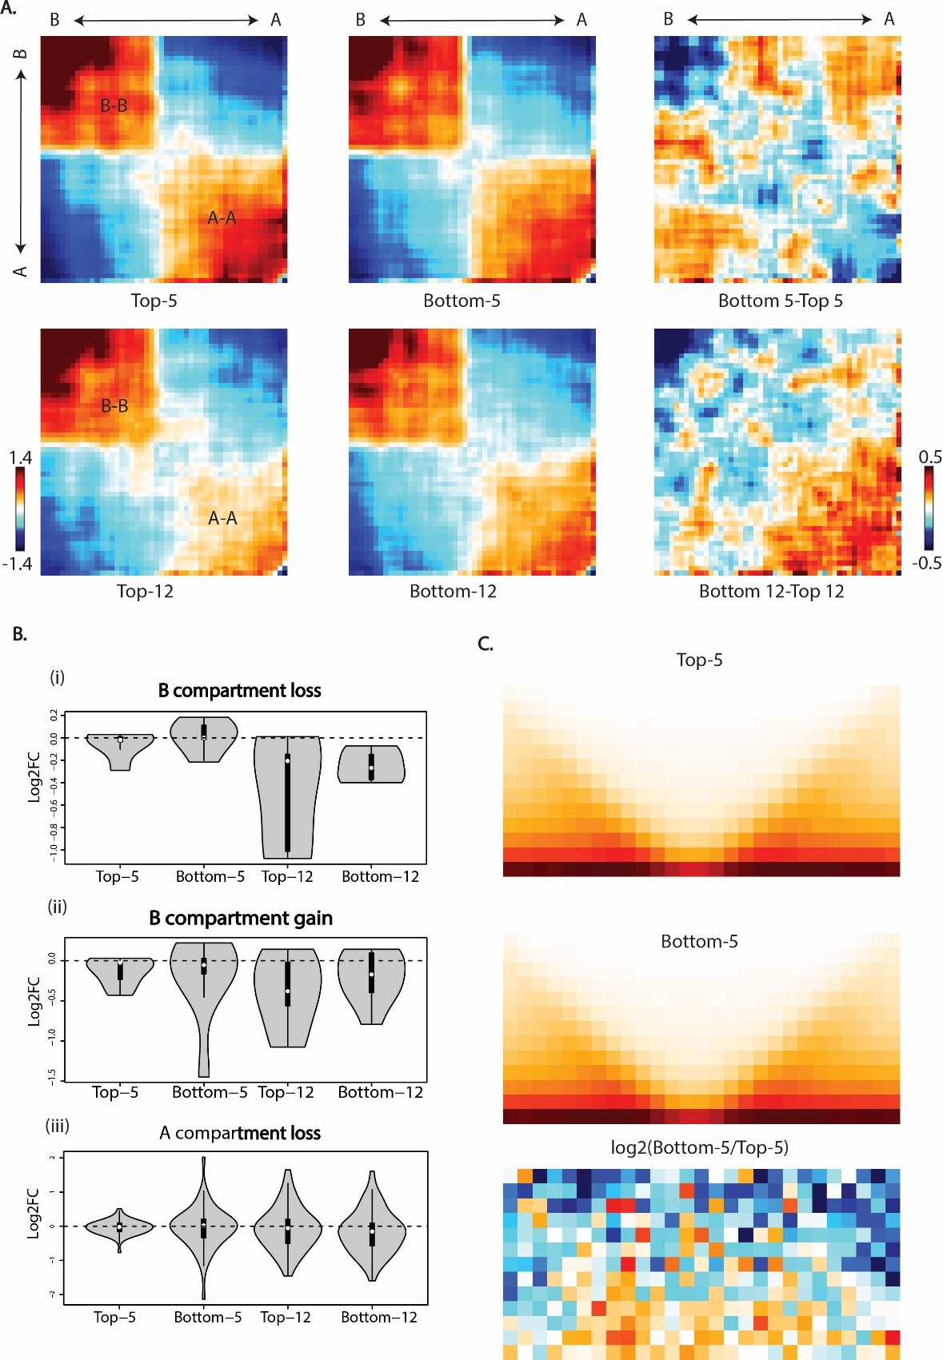among any of the A375 subpopulations (Figure 5C). This local interaction scaling reflects local chromatin compaction and average local loop size and density, and thus we show that constricted migration does not overall change these local chromosome features. Moreover, we investigated whether constricted migration disrupts TAD boundaries, and we observe no clear differences between any of the conditions (Figure S6C). These observations demonstrate that the major changes upon constricted migration occur in larger scale chromosome structures and are in line with previous reports that TAD-scale interactions are independent from compartment-scale interactions such that one can change without dramatically affecting the other (Nuebler et al., 2018).

Global genomic rearrangements after constricted migration
Constricted migration has previously been shown to result in DNA damage and genome instability (Irianto et al., 2017a). Since Hi-C can detect structural aberrations such as translocations, we examined interchromosomal interactions in 2.5 Mb binned matrices to search for potential genomic aberrations after confined migration (Figure 6).
At first glance, it is evident that translocations inherent to A375 are present in all sub-populations of cells (Figure 6A and S6). However, a new translocation between chr5 and chr13 (t(5;13)) is evident only in cells that had undergone constricted migration (Bottom-5 and Bottom20-5) (Figure 6B and S7). To narrow the specific breakpoint region of this translocation, we focused on Hi-C contact frequency between chr5 and chr13 (Figure S7). While in Top cells (Top-12, Top-5 and Top20-5) contact frequencies between chr5 and 13 remain uniform across the whole chromosome, in Bottom-5 cells we observe a high frequency of interaction between chromosome 5 and chromosome 13 followed by a sudden drop of interactions, indicating the translocation breakpoint (Figure S7). Interestingly, the translocation breakpoint falls in a gene poor region of both chromosomes.
We next used Hi-C contacts to estimate what fraction of the chromosomes in the population contain this translocation (Figure 6C, See Materials and Methods for detailed analysis approach). We found that this translocation was only present in 6.13% of chromosomes in Bottom-5 and 2.89% in Bottom-20. Since A375 cells have an average of 3 copies of each chromosome per cell, this can be extrapolated to this translocation occurring on one chromosome copy in ~18% of the Bottom-5 cells and 9% of the Bottom20-5 cells (Figure 6C). Interestingly, this translocation was not detected in the cells that did not undergo constricted migration (Top-12, Top-5, Top20-5 and Bottom-12) as the fraction of reads coming from the translocation site matched the random background level of interchromosomal interactions in the Hi-C contact map (Figure 6C, negative control). The absence of this translocation in non-migratory cells (Top-12, Top-5 and Top20-5) and in Bottom-12 cells suggests that the translocation event may have arisen due to the physical stress on the nucleus during constricted migration. However, it is also possible that this translocation was present at
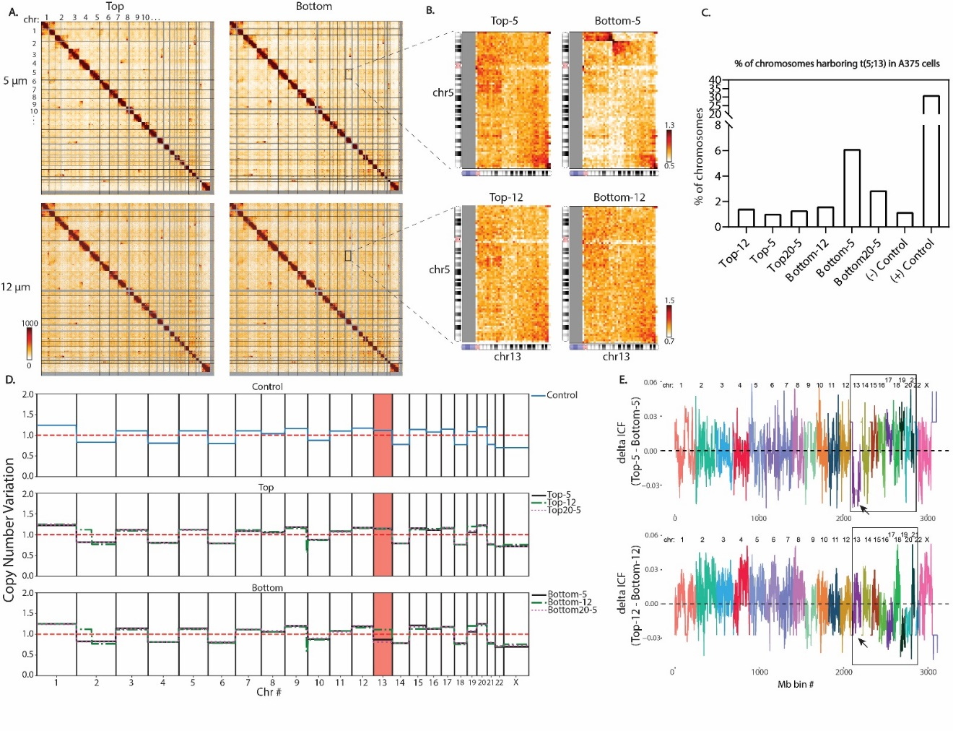

Figure 6. Global genomic rearrangements after constricted migration. (A) Whole genome 2.5Mb Hi-C interaction frequency maps for cells that have undergone 5 and 12-μm transwell migration. (B) Zoom-in of inter-chromosomal interactions between chr5 and chr13 for cells that have undergone 5 and 12-μm transwell migration. (C). Estimation of the % of chromosomes bearing the t(5;13) based on the frequency of the proposed translocation interaction divided by the average neighboring bin cis interactions. (D) Copy number variation among all A375 subtypes inferred from total raw Hi-C counts. Red dashed line represents the mean copy number level while the other lines represent the copy number of A375 cell subpopulations. The region highlighted in red shows that chr13 exhibits copy number loss after 10 rounds of constricted migration. (E) Plots represent the difference in inter-chromosomal fraction (delta ICF) in cells that have undergone migration through 5-μm constrictions (top plot) and cells that have undergone migration through 12-μm constrictions (bottom plot) using 1Mb binned Hi-C contacts. The boxed region highlights regions of difference between constricted and unconstricted migration.

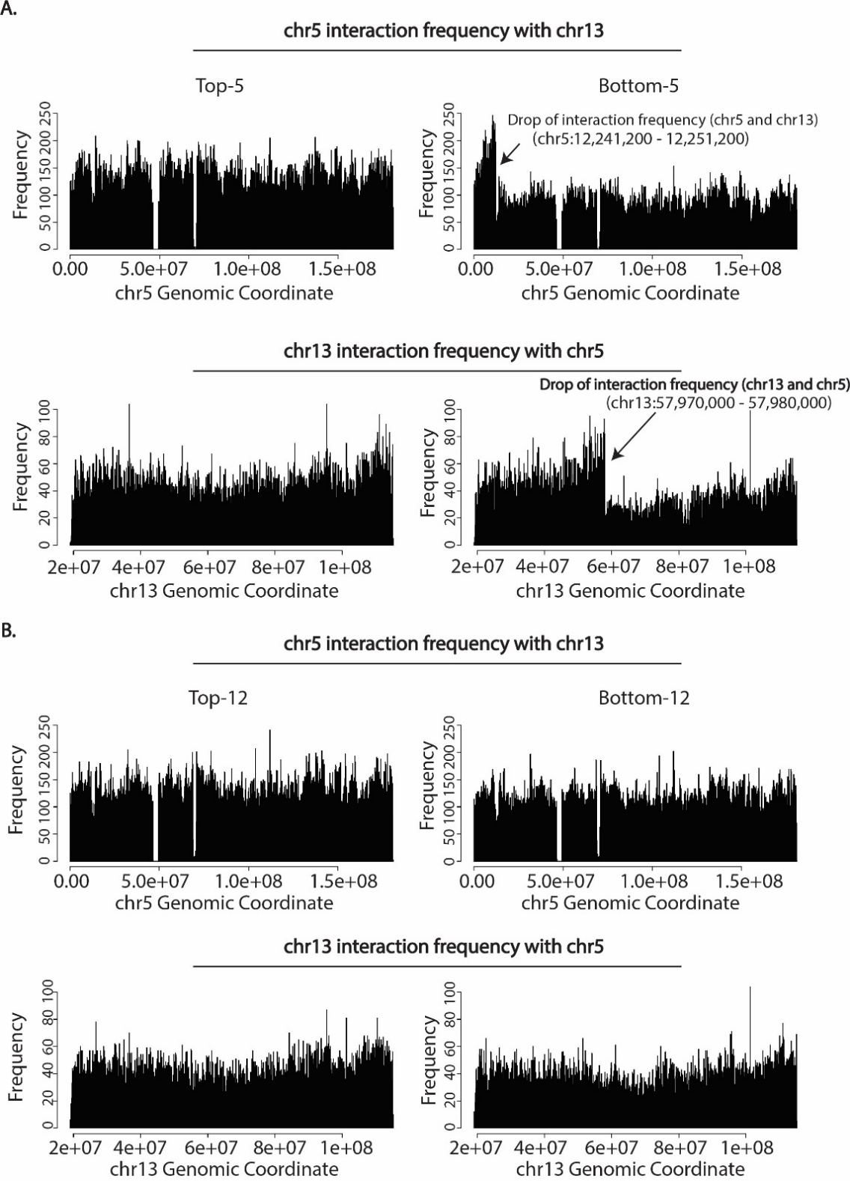
Supplementary Figure 7. Translocation between chr5 and chr13 is specific to migration through 5μm constrictions. (A) Top panel: Contact frequency of chr5 genomic coordinates with chr13 in Top-5 cells (left) and Bottom-5 cells (right). Bottom panel: Contact frequency of chr13 genomic coordinates with chr5 in Top-5 cells (left) and Bottom-5 cells (right). Black arrows indicate a decrease in contact frequency between chr5 and chr13 (Top panel) and chr13 and chr5 (Bottom panel) indicating the end of the translocated region. (B) Top panel: Contact frequency of chr5 genomic coordinates with chr13 in Top-12 cells (left) and Bottom-12 cells (right). Bottom panel: Contact frequency of chr13 genomic coordinates with chr5 in Top-12 cells (left) and Bottom-12 cells (right). A drop in contact interaction frequency is not observed due to undetectable t(5,13).
undetectable levels in the heterogeneous control A375 population, and we are selecting the cells with this translocation during sequential migration.
In addition to translocations, changes in chromosome copy number have been previously reported after constricted migration (Irianto et al., 2017a). We therefore followed a published approach (Servant et al., 2018) to use raw read counts from our Hi-C data to investigate possible copy number variations (CNV) due to constricted migration in A375 subpopulation of cells (Figure 6D). The control population of A375 cells already exhibits non-uniform copy number across chromosomes and chromosome regions (Figure 6D, top panel). When comparing the subpopulations of A375, most of the chromosomes maintained their copy numbers independent of constricted migration. However, cells that have undergone constricted migration (Bottom-5 and Bottom20-5) exhibit notable copy number loss in chr13 (Figure 6D, bottom panel).
Beyond revealing translocations, interchromosomal contact data can reveal changes in patterns of whole chromosome territory interactions between conditions. So, we next sought to explore how the interchromosomal fraction (ICF) of interactions (Heinz et al., 2018) across the genome varies among the cells that have undergone constricted migration (Figure 6E). Interestingly, we observe a decrease in delta ICF of chr13 (Figure 6E, top panel, indicated by black box) in Bottom-5 cells. This is not likely to be explained purely by copy number loss at chr13, as this would decrease both inter and intra-chromosomal contacts rather than changing the ratio between the two. Additionally, smaller chromosomes (chr14-chr22) display an overall increase in delta ICF in Bottom-5 cells (Figure 6E, top panel, indicated by black box) but a decrease of ICF in Bottom-12 cells (Figure 6E, bottom panel, indicated by black box). This measurement could indicate that smaller chromosomes differ in their relative compactness and intermixing depending on constricted migration.

Cells that have undergone constricted migration exhibit altered nuclear morphology in 3D collagen matrices
To investigate whether the cells that had undergone multiple rounds of constricted migration show metastatic behavior in more biologically-relevant environments, we embedded A375 Control, Top-5 and Bottom-5 cells expressing Dendra2-H4-GFP (histone-4 ) in 3D collagen gel matrices as described previously (Denais et al., 2016). Bottom-5 cells embedded in collagen with a density of 2.42 mg/mL, displayed long cytoplasmic protrusions and nuclear deformations after seeded (Figures 7A, right panel and Figure S8A), compared to Control and Top-5 which exhibited rounder cell and nuclear morphologies. Cell protrusions in Bottom-5 were evident even 5 hours after embedding the cells in collagen where ~ 15-35 % of Bottom-5 cells exhibited protrusions which were more evident as they were incubated in the 3D collagen matrix for 24 and 48 (up to 45%) hours (Figure 7B, top panel). In contrast, only a small fraction of cells that did not undergo constricted migration in the transwell (Top-5 and Control) exhibited cell protrusions even after 4 day incubation in 3D collagen matrices (~
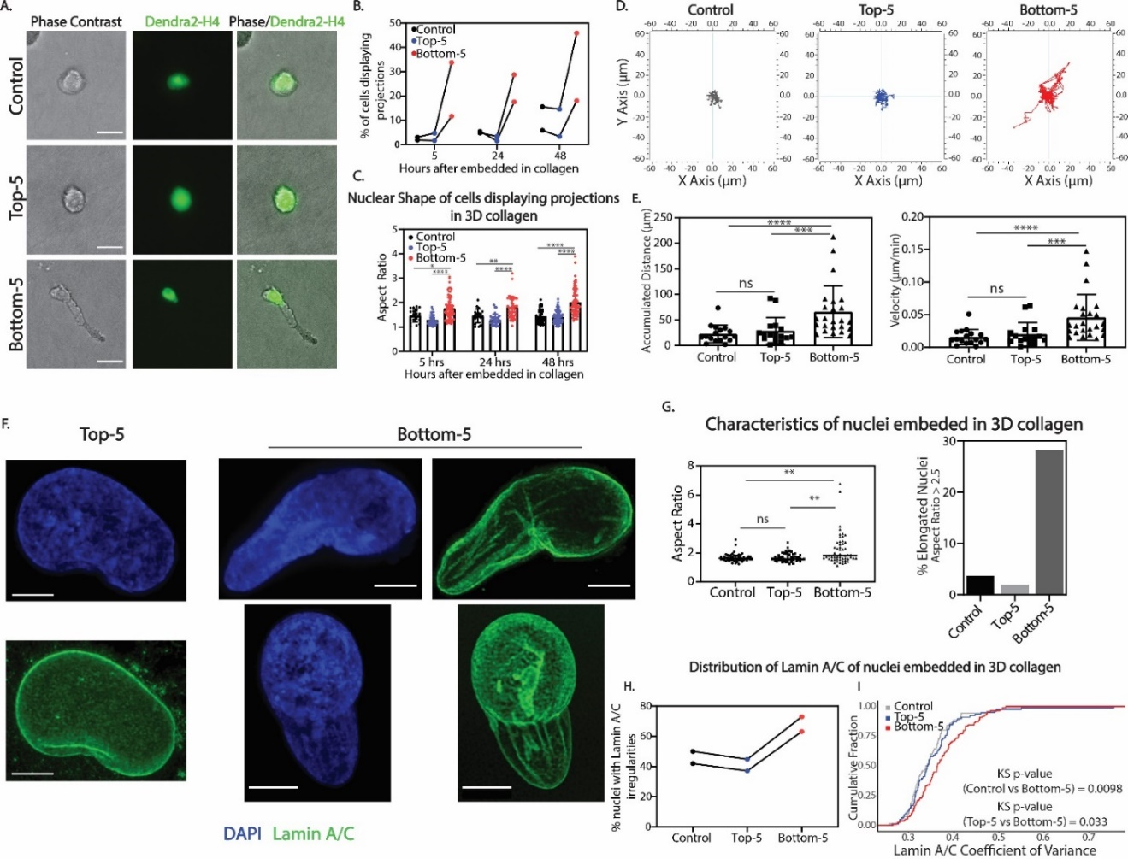

Figure 7. 3D collagen matrix models reveal metastatic phenotypes of cells that have undergone constricted migration. (A) Phase contrast images of A375 cells embedded in 3D collagen matrices show differences in their cell morphology. Dendra2-H4-GFP stains histone 4 to label the nucleus. (B) Fraction of Control, Top-5 and Bottom-5 cells displaying projections after timepoints when embedded in 3D collagen matrices. Each biological replicate is connected by the line. (C) Aspect ratio quantification of A375 nuclei after different timepoints when embedded in 3D collagen matrices for Control, Top-5 and Bottom-5 cells. (* p = 0.0168, ** p = 0.0016, **** p < 0.0001; two tailed t-test). (D) Tracking of Control, Top-5 and Bottom-5 cells migrating in 3D collagen matrices. (E) Quantification of accumulated distance and velocity of Control (n=17), Top-5 (n=17) and Bottom-5 (n=24) migrating in 3D collagen matrices. (F) Nuclei of Top-5 (left panel) and Bottom-5 cells (2 different cells, right panel) stained for DAPI (blue) and. Scale bars (white) indicate a length of 5μm. For 3D reconstruction visualization, see Movie S5 and S6. (G) Left panel: Measurements of nucleus elongation by aspect ratio (major axis/minor axis) in Control (n = 54), Top-5 (n = 52) and Bottom-5 (n = 53). Top-5 vs Control (p = 0.8232); Bottom-5 vs Top-5 (**p = 0.0054); Bottom-5 vs Control (**p = 0.0031) as calculated by two-tailed t-test. Right panel: Fraction of elongated nuclei of A375 Control, Top-5 and Bottom-5 in 3D collagen (Aspect Ratio > 2.5). (H) Fraction of nuclei that display irregularities in Lamin A/C distribution in Control, Top-5 and Bottom-5 cells embedded in 3D collagen. Each biological replicate connected by a line. (I) Cumulative distribution plot of Lamin A/C coefficient of variance in Control, Top-5 and Bottom-5 cells embedded in 3D collagen matrices.
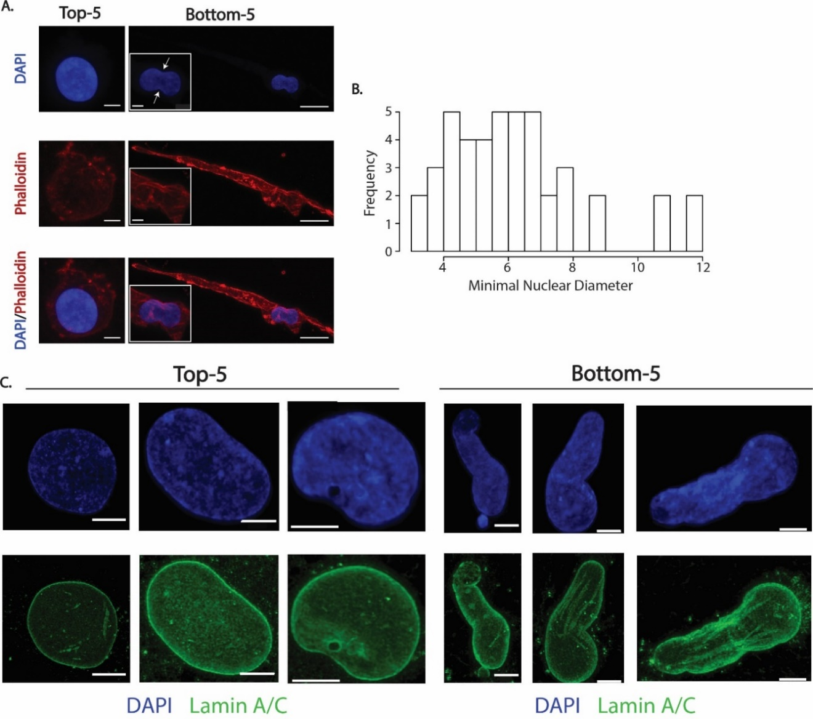

Supplementary Figure 8. A375 cells that have undergone sequential transwell migration display migratory phenotypes in 3D collagen matrices (A) Maximum projection confocal examples of Top-5 and Bottom-5 cells stained with DAPI (blue) and Phalloidin (red). (Insets) Zoom in of displayed Bottom-5 example. Scale bars (white) indicate 5μm for Top-5 and Bottom-5 insets; 20μm for Bottom-5 zoomed out images. White arrows in insets indicate the minimal nuclear diameter. (B) Distribution of minimal nuclear diameter of all elongated A375 nuclei embedded in 3D collagen. (C) Max projection confocal images of Top-5 (left panel) and Bottom-5 (right panel) nuclei visualizing DAPI (blue) and Lamin A/C (green). Scale bars (white) indicate a length of 5 µm.

1-15% of cells) (Figure 7B). With increasing incubation time in the 3D collagen matrices, the nuclei of Bottom-5 cells also appear to be more elongated than Control and Top-5 cells, suggesting that Bottom-5 cells could be migrating through the collagen fibers and therefore deforming their nuclei (Figure 7C). The collagen fiber meshwork provides constrictions that range from 3-11μm in diameter as determined by measurements of the minimal nuclear diameter of elongated nuclei (Figure S8B). These collagen constriction sizes are comparable with transwell pore sizes and physiological conditions and further suggest that for A375 cells to migrate, they have to squeeze through the collagen fibers.
Indeed, Bottom-5 cells display highly motile behavior in 3D collagen matrices compared to Control and Top-5 cells (Figure 7D, Movie S5 and S6). When migrating through collagen, Bottom-5 cells travel longer distances at a higher speed (Figure 7E).
Given the nuclear morphology differences we observed in Bottom-5 cells, we investigated these nuclear morphology differences in higher resolution. Bottom-5 cells display large deformation of the nucleus when compared to Control and Top-5 cells (Figures 7F, S8C, Movie S7 and S8). Quantification of nuclear elongation using aspect ratio measurements revealed that about 30% of Bottom-5 cells exhibit more elongated nuclear morphology in collagen while only 1-3% of Control and Top-5 cells exhibited elongated nuclei (Figure 7G).
Changes in nuclear morphology also correlated with changes in distribution of Lamin A/C in Bottom-5 nuclei embedded in 3D collagen. While nuclear wrinkling and therefore abnormal Lamin A/C patterns were evident in all A375 subpopulations, a higher fraction of Bottom-5 nuclei exhibit these irregularities (Figure 7H). Indeed, larger fraction of Bottom-5 cells exhibit a higher Lamin A/C coefficient of variance in the nucleus when compared to Control and Top-5 cells.
Overall, quantification of nuclear shape differences in collagen distinguished cells that had undergone constricted migration in transwell chambers from cells that did not, indicating that the ability to deform their nucleus and migrate in a 3D environment is a key distinguishing factor among the A375 cell subpopulations.

Agent based modeling reveals that heterogeneity and constricted migration induced changes could both contribute to morphological changes in A375 cells
The presence of Top-12 subpopulation of A375 cells indicates an inherent heterogeneity within the population in terms of migratory ability as it has been previously reported in this cell line (Kozlowski et al., 1984). However, it is not clear whether the increase in migratory efficiency and morphological changes in Bottom-5 and Bottom20-5 cells arise as a result of undergoing constricted migration or because of a heterogeneous population bearing these features (Figure S9A). We used agent-based modeling (ABM) to test a variety of parameters that would best recapitulate our experimental sequential migration results (Figure S9B; see Materials and Methods for more detail). To build this model, we considered multiple cellular states when making the choice to undergo
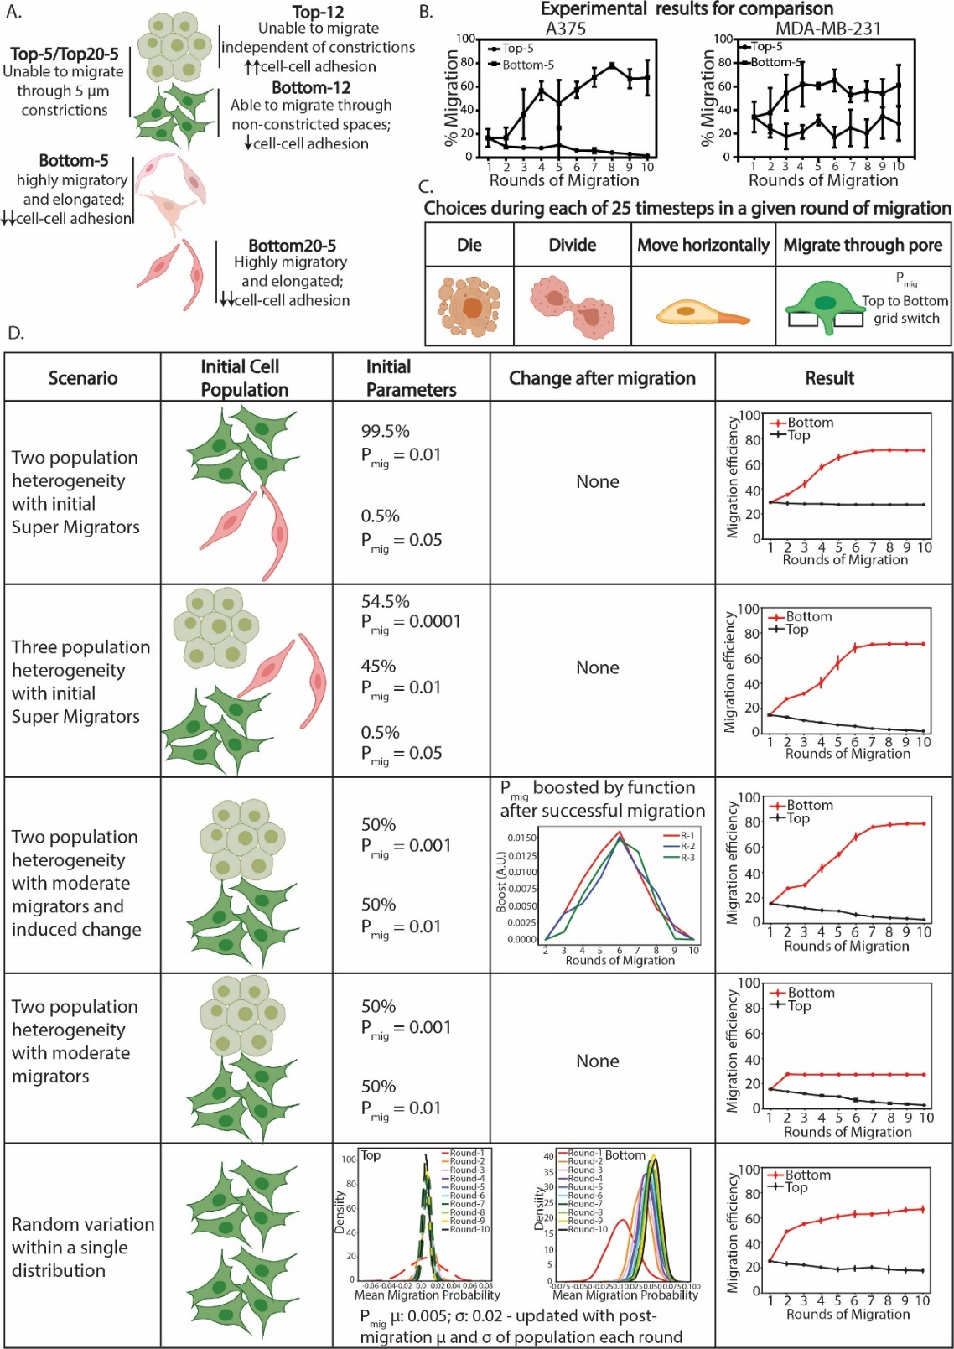

Supplementary Figure 9. Agent based modeling of cells that have undergone constricted migration. (A) Cell morphology differences observed within each subpopulation of A375 cells. (B) Sequential transwell migration through 5 μm constrictions of A375 (left) and MDA-MB-231 (right) cells. (C) Choices a cell can make after 25 iterative timestamps for each migration round. (D) Parameters used in the agent-based model to recapitulate sequential transwell migration.

transwell migration and iteratively repeated for 25 timesteps for one round of migration (Figure S9C). When we consider a heterogeneous population with moderate and super migrators, the migration efficiency of Top-5 cells remains flat which does not support our experimental results (Figures S9B and S9D, first panel). Interestingly, we observe that our experimental data is better represented when the initial starting population is composed of three heterogeneous subpopulations (no migrators, moderate migrators and super migrators) with moderate and super migrators representing 0.5% of the population (Figure S9D, second panel).
This scenario would indicate that the sequential rounds of transwell migration are simply selecting out the super migrators. However, we are also able to recapitulate our experimental data when considering initial heterogeneity in the population (no migrators + moderate migrators) with induced changes from the constricted migration (Figure S9D, third panel). In contrary, when we only considered heterogeneity in migratory ability (no migrators and moderate migrators) with no induced changes from constricted migration, the model did not accurately predict our A375 sequential migration efficiency (Figures S9B and S9D, fourth panel).
These results suggest that the changes we observe in Bottom-5 cells could be induced by both, the nuclear squeezing through constrictions and/or due to the inherent heterogeneity within the population, and indicate that teasing apart these two mechanism could be challenging due to the involvement of multiple factors.
Intriguingly, MDA-MB-231 sequential migration efficiency is best recapitulated when we consider a random variation within a single distribution (Figure S9D, fifth panel) which could suggest that this cell line displays less heterogeneity in cell morphology and migratory ability as supported by our experimental data.

Discussion
Constricted migration is an important phenomenon in cancer metastasis and presents a major challenge to nuclear mechanics. Major avenues of previous research have separately investigated the role of the nucleus in confined migration, the impact of migration on linear DNA integrity, and the role of 3D genome structure in cancer. Our present results bridge these fields, revealing changes in spatial chromosome compartmentalization specific to cells that have passed through numerous constrictions smaller than their nucleus. These genome structure changes are associated with a notable change in cell and nucleus phenotypes whether the cells are migrating on a 2D surface or squeezing through a collagen matrix. Cells proficient at confined migration more often deform their nuclei, elongate their cell body, and have fewer cell-cell attachments.
A major question raised by our results is whether the differences in 3D genome structure we see in cells that have undergone confined migration (Bottom-5 and Bottom20-5) result from a selection process on an initially heterogeneous population or a “training process” where confined migration itself causes chromosome structure changes. We first note that trying to determine “selection or training” is in many ways a false dichotomy. It is very plausible that cells which are initially primed for confined migration in a heterogeneous tumor begin to squeeze through tight junctions, and that then their chromosome structure is further rearranged as a result of the nucleus deformations. By ABM modeling, we also find that the increases in migration efficiency of Bottom cells can either be recapitulated with a small subpopulation of highly migratory cells or a more uniform set of moderately migratory cells that are induced to become better at migrating by the constriction (or a combination of both). Overall, our data provide evidence consistent with the idea that both processes are taking place.
First, our isolation of A375 cells that cannot migrate at all, even given 10 chances to go through a wide pore (Top-12 cells), is a clear demonstration that the initial A375 population is heterogeneous. These cells have been previously shown to display heterogeneity in their metastatic capacity (Kozlowski et al., 1984) and overall within melanoma lesions, a select group of cells can gain the ability to metastasize, and that further diversification and phenotype change can occur as a result of metastasis (Damsky et al., 2010). The genome structures and gene expression patterns specific to this subset informs us about the properties of cells that cannot migrate. On the other hand, the fact that Bottom-12 cells, which have passed through a large pore, present with genome structure differences compared to Bottom-5 cells shows that we are not simply distinguishing between cells with a pre-existing ability to migrate. There are cellular, nuclear, and genome organization properties that could be specific to confined migration. Further, some structures and phenotypes of Bottom-5 cells, such as the new chromosome 5-13 translocation and extremely elongated cell shapes, are not detectable in the original control population and could be a result of phenotype switching or random events that are further reinforced by a selection process. This suggests that confined migration itself can induce some of the changes we observe. As passage through a constriction physically moves the chromosomal regions leading to the possibility of physical mixing of of phase separated domains in the nucleus, certain interactions, such as the strongest B-B interactions in our data, may be pulled apart as suggested by chromatin stretching previously described (Irianto et al., 2017b) and loss of B-B interaction strength with confined migration observed in neutrophils (Jacobson et al., 2018). Meanwhile, loci previously more distant are given an opportunity to associate and may form new aggregates through phase separation. This may be an explanation for the strengthening of interactions we observe between previously weak B compartments and stronger B compartment regions.
Our results suggest that the confined migration-specific 3D genome structure serves several potential biological purposes. First, we observe an overall correlation between spatial compartmentalization changes and gene expression alterations, and the altered genes relate to migratory ability. For example, in Bottom-5 cells, we observe downregulation of a group of genes important for cell-cell/matrix adhesion (CADM3, CADM1, ITGA9). Why would 3D genome changes be needed to accompany gene expression changes? Altered local gene regulation alone can be sufficient to explain temporary changes in cellular behaviors in response to a stress or stimulus, and these changes do not require 3D genome rearrangement (Jin et al., 2013). But our data suggests that migration behaviors of the different A375 sub-populations are stably divergent. From our observations, we propose that the stability of this phenotype is encoded in the 3D genome structure change we measure, since moving whole genomic regions to different spatial and chromatin environments is less reversible than transiently regulating individual genes. Further, since these differences persist through several passages in culture, this raises the possibility that 3D genome changes after confined migration could underlie the distinct phenotype and increased in vitro invasiveness of cancer cells derived from metastatic sites compared to those from primary tumors or normal tissue (Oppenheimer, 2006).
Beyond gene regulation, our results suggest a role for chromosome structure change in modulating the physical properties of the cancer cell nucleus. Our results show that the nuclei of Bottom-5 cells deform more than Top-5 cells when embedded in a collagen matrix or even when spontaneously migrating on a 2D surface. Previous research has shown that nucleus stiffness can be altered by increasing or decreasing the overall expression of Lamin A/C or by changing overall levels of heterochromatin (Lammerding et al., 2006, Davidson et al., 2014, Stephens et al., 2017, Stephens et al., 2018). But, the apparent change in nucleus pliability observed in the current study cannot be explained by changes in overall Lamin A/C content or heterochromatin levels: Lamin A/C and H3K9me3 levels were constant as measured by both immunostaining and western blot. Instead, we observed a redistribution of Lamin A/C and H3K9me3 localization in the nucleus, with individual heterochromatin foci originally in the interior of the nucleus merging at the periphery and Lamin A/C becoming less evenly distributed. Our observations suggest that changing levels of Lamin A/C and heterochromatin are not always required to increase constricted migration potential and that re-localization of these proteins and chromosome regions can be important to provide a rigid enough nucleus to withstand physical deformations but also soft enough to be able to successfully undergo constricted migration. Future work will be required to determine how the 3D genome changes we observe translate into quantitative differences in nucleus physical properties. The altered heterochromatin localization we observe by imaging translates to, and is more deeply characterized by, the alterations in chromosome compartmentalization we observe with Hi-C. The observation that regions which increase their B compartment interactions also gain more distal interactions is consistent with our imaging observation that disparate heterochromatin foci come together at the nuclear periphery in confined migrating cells. Interestingly, many of the regions with altered compartmentalization do not show a connection to gene regulation. In fact, we observe a striking enrichment of regions with no genes at all among the set of regions that switch from the A to the B compartment in confined migration. This suggests that the genome structure changes we observe have a role beyond gene regulation, and we hypothesize that these switches are primarily involved in changing physical properties of the chromosome structure and therefore nucleus adaptability to constriction.
Our data also provide insight into some basic questions about 3D genome organization principles. As described above, our data allow conceptual links between changes in contacts observed in Hi-C data and the appearance and localization of chromatin types observed by imaging. Further, our observation that compartments, compartment strength, and whole chromosome interactions change while TADs are unaltered reinforces the idea that these are separate and largely independent layers of genome organization (Mirny et al., 2019, Schwarzer et al., 2017). These changes also suggest that the compartment and whole chromosome level of genome structure are more important in nucleus physics and deformation than is the TAD and loop level of organization. Meanwhile, our observation that local punctate interactions change around sites where gene expression changes echo previous evidence that collisions between loop extrusion and transcription can influence local contact patterns (Brandao et al., 2019).
Are the 3D genome changes we observe in our constricted migration cell population diagnostic of metastatic potential? Previous reports have sometimes detected gene expression signatures in primary tumors that may be predictive of metastasis (Ramaswamy et al., 2003). Nuclear morphology abnormalities (“nuclear atypia”) are also already used clinically as a marker of cancer aggressiveness (Kadota et al., 2012). Recent reports have taken advantage of microfluidic engineering to predict metastatic potential of breast cancer cells based on their morphological features (Yankaskas et al., 2019). But, beyond being a marker, the biological significance of such abnormalities and what chromosome structure changes accompany them have not been defined. Here, we provide evidence that chromosome structure changes could link metastatic gene expression signatures with the abnormal nuclear appearance of aggressive cancer. Our results reveal chromosome spatial compartmentalization changes in genomic regions related to metastatic potential in a highly invasive subset of A375 cells. Future work will be needed to investigate whether such changes are also observed in patient metastatic melanoma samples. Our data provides a foundation for future investigation of whether similar structural changes occur after constricted migration in other cancer types and therefore constitute 3D genome structure signatures of metastatic cancer potential.

References
ABBAS, A., HE, X., NIU, J., ZHOU, B., ZHU, G., MA, T., SONG, J., GAO, J., ZHANG, M. Q. & ZENG, J. 2019. Integrating Hi-C and FISH data for modeling of the 3D organization of chromosomes. Nat Commun, 10, 2049.
ANDERS, S., PYL, P. T. & HUBER, W. 2015. HTSeq--a Python framework to work with high-throughput sequencing data. Bioinformatics, 31, 166-9.
BARUTCU, A. R., LAJOIE, B. R., MCCORD, R. P., TYE, C. E., HONG, D., MESSIER, T. L., BROWNE, G., VAN WIJNEN, A. J., LIAN, J. B., STEIN, J. L., DEKKER, J., IMBALZANO, A. N. & STEIN, G. S. 2015. Chromatin interaction analysis reveals changes in small chromosome and telomere clustering between epithelial and breast cancer cells. Genome Biol, 16, 214.
BASKARAN, J. P., WELDY, A., GUARIN, J., MUNOZ, G., SHPILKER, P. H., KOTLIK, M., SUBBIAH, N., WISHART, A., PENG, Y., MILLER, M. A., COWEN, L. & OUDIN, M. J. 2020. Cell shape, and not 2D migration, predicts extracellular matrix-driven 3D cell invasion in breast cancer. APL Bioeng, 4, 026105.
BELAGHZAL, H., BORRMAN, T., STEPHENS, A. D., LAFONTAINE, D. L., VENEV, S. V., WENG, Z., MARKO, J. F. & DEKKER, J. 2019. Compartment-dependent chromatin interaction dynamics revealed by liquid chromatin Hi-C. bioRxiv, 704957.
BICKMORE, W. A. & VAN STEENSEL, B. 2013. Genome architecture: domain organization of interphase chromosomes. Cell, 152, 1270-84.
BRANDAO, H. B., PAUL, P., VAN DEN BERG, A. A., RUDNER, D. Z., WANG, X. & MIRNY, L. A. 2019. RNA polymerases as moving barriers to condensin loop extrusion. Proc Natl Acad Sci U S A, 116, 20489-20499.
BROERS, J. L., RAYMOND, Y., ROT, M. K., KUIJPERS, H., WAGENAAR, S. S. & RAMAEKERS, F. C. 1993. Nuclear A-type lamins are differentially expressed in human lung cancer subtypes. Am J Pathol, 143, 211-20.
BUENROSTRO, J. D., WU, B., CHANG, H. Y. & GREENLEAF, W. J. 2015. ATAC-seq: A Method for Assaying Chromatin Accessibility Genome-Wide. Curr Protoc Mol Biol, 109, 21 29 1-9.
CAROLYN DE GRAAF, J. K., LUDO PAGIE, DAAN PERIC HUPKES, BAS VAN STEENSEL. 2019. LAD Atlas [Online]. Available: https://osf.io/dk8pm/ [Accessed].
CHAMBERS, A. F., GROOM, A. C. & MACDONALD, I. C. 2002. Dissemination and growth of cancer cells in metastatic sites. Nat Rev Cancer, 2, 563-72.
DAMSKY, W. E., ROSENBAUM, L. E. & BOSENBERG, M. 2010. Decoding melanoma metastasis. Cancers, 3, 126-163.
DAVIDSON, P. M., DENAIS, C., BAKSHI, M. C. & LAMMERDING, J. 2014. Nuclear deformability constitutes a rate-limiting step during cell migration in 3-D environments. Cell Mol Bioeng, 7, 293-306.
DAVIDSON, P. M. & LAMMERDING, J. 2014. Broken nuclei--lamins, nuclear mechanics, and disease. Trends Cell Biol, 24, 247-56.
DEKKER, J., RIPPE, K., DEKKER, M. & KLECKNER, N. 2002. Capturing chromosome conformation. Science, 295, 1306-11.
DENAIS, C. M., GILBERT, R. M., ISERMANN, P., MCGREGOR, A. L., TE LINDERT, M., WEIGELIN, B., DAVIDSON, P. M., FRIEDL, P., WOLF, K. & LAMMERDING, J. 2016. Nuclear envelope rupture and repair during cancer cell migration. Science, 352, 353-8.
DOBIN, A., DAVIS, C. A., SCHLESINGER, F., DRENKOW, J., ZALESKI, C., JHA, S., BATUT, P., CHAISSON, M. & GINGERAS, T. R. 2013. STAR: ultrafast universal RNA-seq aligner. Bioinformatics, 29, 15-21.
FIDLER, I. J. 2003. The pathogenesis of cancer metastasis: the 'seed and soil' hypothesis revisited. Nat Rev Cancer, 3, 453-8.
FRIEDL, P., WOLF, K. & LAMMERDING, J. 2011. Nuclear mechanics during cell migration. Curr Opin Cell Biol, 23, 55-64.
FU, Y., CHIN, L. K., BOUROUINA, T., LIU, A. Q. & VANDONGEN, A. M. 2012. Nuclear deformation during breast cancer cell transmigration. Lab Chip, 12, 3774-8.
GASPAR-MAIA, A., ALAJEM, A., MESHORER, E. & RAMALHO-SANTOS, M. 2011. Open chromatin in pluripotency and reprogramming. Nat Rev Mol Cell Biol, 12, 36-47.
GERLITZ, G. & BUSTIN, M. 2010. Efficient cell migration requires global chromatin condensation. J Cell Sci, 123, 2207-17.
GOLLOSHI, R., SANDERS, J. T. & MCCORD, R. P. 2018. Iteratively improving Hi-C experiments one step at a time. Methods, 142, 47-58.
GUPTA, G. P. & MASSAGUE, J. 2006. Cancer metastasis: building a framework. Cell, 127, 679-95.
HARADA, T., SWIFT, J., IRIANTO, J., SHIN, J. W., SPINLER, K. R., ATHIRASALA, A., DIEGMILLER, R., DINGAL, P. C., IVANOVSKA, I. L. & DISCHER, D. E. 2014. Nuclear lamin stiffness is a barrier to 3D migration, but softness can limit survival. J Cell Biol, 204, 669-82.
HEINZ, S., TEXARI, L., HAYES, M. G. B., URBANOWSKI, M., CHANG, M. W., GIVARKES, N., RIALDI, A., WHITE, K. M., ALBRECHT, R. A., PACHE, L., MARAZZI, I., GARCIA-SASTRE, A., SHAW, M. L. & BENNER, C. 2018. Transcription Elongation Can Affect Genome 3D Structure. Cell, 174, 1522-1536 e22.
HNISZ, D., WEINTRAUB, A. S., DAY, D. S., VALTON, A. L., BAK, R. O., LI, C. H., GOLDMANN, J., LAJOIE, B. R., FAN, Z. P., SIGOVA, A. A., REDDY, J., BORGES-RIVERA, D., LEE, T. I., JAENISCH, R., PORTEUS, M. H., DEKKER, J. & YOUNG, R. A. 2016. Activation of proto-oncogenes by disruption of chromosome neighborhoods. Science, 351, 1454-8.
IMAKAEV, M., FUDENBERG, G., MCCORD, R. P., NAUMOVA, N., GOLOBORODKO, A., LAJOIE, B. R., DEKKER, J. & MIRNY, L. A. 2012. Iterative correction of Hi-C data reveals hallmarks of chromosome organization. Nat Methods, 9, 999-1003.
IRIANTO, J., XIA, Y., PFEIFER, C. R., ATHIRASALA, A., JI, J., ALVEY, C., TEWARI, M., BENNETT, R. R., HARDING, S. M., LIU, A. J., GREENBERG, R. A. & DISCHER, D. E. 2017a. DNA Damage Follows Repair Factor Depletion and Portends Genome Variation in Cancer Cells after Pore Migration. Curr Biol, 27, 210-223.
IRIANTO, J., XIA, Y., PFEIFER, C. R., GREENBERG, R. A. & DISCHER, D. E. 2017b. As a Nucleus Enters a Small Pore, Chromatin Stretches and Maintains Integrity, Even with DNA Breaks. Biophys J, 112, 446-449.
JACOBSON, E. C., PERRY, J. K., LONG, D. S., OLINS, A. L., OLINS, D. E., WRIGHT, B. E., VICKERS, M. H. & O'SULLIVAN, J. M. 2018. Migration through a small pore disrupts inactive chromatin organization in neutrophil-like cells. BMC Biol, 16, 142.
JIN, F., LI, Y., DIXON, J. R., SELVARAJ, S., YE, Z., LEE, A. Y., YEN, C. A., SCHMITT, A. D., ESPINOZA, C. A. & REN, B. 2013. A high-resolution map of the three-dimensional chromatin interactome in human cells. Nature, 503, 290-4.
KADOTA, K., SUZUKI, K., COLOVOS, C., SIMA, C. S., RUSCH, V. W., TRAVIS, W. D. & ADUSUMILLI, P. S. 2012. A nuclear grading system is a strong predictor of survival in epitheloid diffuse malignant pleural mesothelioma. Mod Pathol, 25, 260-71.
KIM, D. H. & WIRTZ, D. 2013. Focal adhesion size uniquely predicts cell migration. FASEB J, 27, 1351-61.
KIND, J., PAGIE, L., DE VRIES, S. S., NAHIDIAZAR, L., DEY, S. S., BIENKO, M., ZHAN, Y., LAJOIE, B., DE GRAAF, C. A., AMENDOLA, M., FUDENBERG, G., IMAKAEV, M., MIRNY, L. A., JALINK, K., DEKKER, J., VAN OUDENAARDEN, A. & VAN STEENSEL, B. 2015. Genome-wide maps of nuclear lamina interactions in single human cells. Cell, 163, 134-47.
KOZLOWSKI, J. M., HART, I. R., FIDLER, I. J. & HANNA, N. 1984. A human melanoma line heterogeneous with respect to metastatic capacity in athymic nude mice. J Natl Cancer Inst, 72, 913-7.
KRAUSE, M., YANG, F. W., TE LINDERT, M., ISERMANN, P., SCHEPENS, J., MAAS, R. J. A., VENKATARAMAN, C., LAMMERDING, J., MADZVAMUSE, A., HENDRIKS, W., TE RIET, J. & WOLF, K. 2019. Cell migration through three-dimensional confining pores: speed accelerations by deformation and recoil of the nucleus. Philos Trans R Soc Lond B Biol Sci, 374, 20180225.
KRIJGER, P. H. & DE LAAT, W. 2016. Regulation of disease-associated gene expression in the 3D genome. Nat Rev Mol Cell Biol, 17, 771-782.
LAMBERT, A. W., PATTABIRAMAN, D. R. & WEINBERG, R. A. 2017. Emerging Biological Principles of Metastasis. Cell, 168, 670-691.
LAMMERDING, J., FONG, L. G., JI, J. Y., REUE, K., STEWART, C. L., YOUNG, S. G. & LEE, R. T. 2006. Lamins A and C but not lamin B1 regulate nuclear mechanics. J Biol Chem, 281, 25768-80.
LANGMEAD, B. & SALZBERG, S. L. 2012. Fast gapped-read alignment with Bowtie 2. Nat Methods, 9, 357-9.
LARSON, A. G., ELNATAN, D., KEENEN, M. M., TRNKA, M. J., JOHNSTON, J. B., BURLINGAME, A. L., AGARD, D. A., REDDING, S. & NARLIKAR, G. J. 2017. Liquid droplet formation by HP1alpha suggests a role for phase separation in heterochromatin. Nature, 547, 236-240.
LEE, J. S., HALE, C. M., PANORCHAN, P., KHATAU, S. B., GEORGE, J. P., TSENG, Y., STEWART, C. L., HODZIC, D. & WIRTZ, D. 2007. Nuclear lamin A/C deficiency induces defects in cell mechanics, polarization, and migration. Biophys J, 93, 2542-52.
LI, H., HANDSAKER, B., WYSOKER, A., FENNELL, T., RUAN, J., HOMER, N., MARTH, G., ABECASIS, G., DURBIN, R. & GENOME PROJECT DATA PROCESSING, S. 2009. The Sequence Alignment/Map format and SAMtools. Bioinformatics, 25, 2078-9.
LOVE, M. I., HUBER, W. & ANDERS, S. 2014. Moderated estimation of fold change and dispersion for RNA-seq data with DESeq2. Genome Biol, 15, 550.
LYONS, S. M., ALIZADEH, E., MANNHEIMER, J., SCHUAMBERG, K., CASTLE, J., SCHRODER, B., TURK, P., THAMM, D. & PRASAD, A. 2016. Changes in cell shape are correlated with metastatic potential in murine and human osteosarcomas. Biol Open, 5, 289-99.
MACHESKY, L. M. 2008. Lamellipodia and filopodia in metastasis and invasion. FEBS Lett, 582, 2102-11.
MAIZELS, Y., ELBAZ, A., HERNANDEZ-VICENS, R., SANDRUSY, O., ROSENBERG, A. & GERLITZ, G. 2017. Increased chromatin plasticity supports enhanced metastatic potential of mouse melanoma cells. Exp Cell Res, 357, 282-290.
MARCHAL, C., SIMA, J. & GILBERT, D. M. 2019. Control of DNA replication timing in the 3D genome. Nat Rev Mol Cell Biol.
MIRNY, L. A., IMAKAEV, M. & ABDENNUR, N. 2019. Two major mechanisms of chromosome organization. Curr Opin Cell Biol, 58, 142-152.
MIROSHNIKOVA, Y. A., NAVA, M. M. & WICKSTROM, S. A. 2017. Emerging roles of mechanical forces in chromatin regulation. J Cell Sci, 130, 2243-2250.
NAVA, M. M., MIROSHNIKOVA, Y. A., BIGGS, L. C., WHITEFIELD, D. B., METGE, F., BOUCAS, J., VIHINEN, H., JOKITALO, E., LI, X., GARCIA ARCOS, J. M., HOFFMANN, B., MERKEL, R., NIESSEN, C. M., DAHL, K. N. & WICKSTROM, S. A. 2020. Heterochromatin-Driven Nuclear Softening Protects the Genome against Mechanical Stress-Induced Damage. Cell, 181, 800-817 e22.
NUEBLER, J., FUDENBERG, G., IMAKAEV, M., ABDENNUR, N. & MIRNY, L. A. 2018. Chromatin organization by an interplay of loop extrusion and compartmental segregation. Proc Natl Acad Sci U S A, 115, E6697-E6706.
OPPENHEIMER, S. B. 2006. Cellular basis of cancer metastasis: A review of fundamentals and new advances. Acta Histochem, 108, 327-34.
PANAGIOTAKOPOULOU, M., BERGERT, M., TAUBENBERGER, A., GUCK, J., POULIKAKOS, D. & FERRARI, A. 2016. A Nanoprinted Model of Interstitial Cancer Migration Reveals a Link between Cell Deformability and Proliferation. ACS Nano, 10, 6437-48.
POMBO, A. & DILLON, N. 2015. Three-dimensional genome architecture: players and mechanisms. Nat Rev Mol Cell Biol, 16, 245-57.
QUINLAN, A. R. & HALL, I. M. 2010. BEDTools: a flexible suite of utilities for comparing genomic features. Bioinformatics, 26, 841-2.
RAAB, M., GENTILI, M., DE BELLY, H., THIAM, H. R., VARGAS, P., JIMENEZ, A. J., LAUTENSCHLAEGER, F., VOITURIEZ, R., LENNON-DUMENIL, A. M., MANEL, N. & PIEL, M. 2016. ESCRT III repairs nuclear envelope ruptures during cell migration to limit DNA damage and cell death. Science, 352, 359-62.
RAMASWAMY, S., ROSS, K. N., LANDER, E. S. & GOLUB, T. R. 2003. A molecular signature of metastasis in primary solid tumors. Nat Genet, 33, 49-54.
ROWAT, A. C., JAALOUK, D. E., ZWERGER, M., UNG, W. L., EYDELNANT, I. A., OLINS, D. E., OLINS, A. L., HERRMANN, H., WEITZ, D. A. & LAMMERDING, J. 2013. Nuclear envelope composition determines the ability of neutrophil-type cells to passage through micron-scale constrictions. J Biol Chem, 288, 8610-8.
ROWLEY, M. J. & CORCES, V. G. 2018. Organizational principles of 3D genome architecture. Nat Rev Genet, 19, 789-800.
ROWLEY, M. J., NICHOLS, M. H., LYU, X., ANDO-KURI, M., RIVERA, I. S. M., HERMETZ, K., WANG, P., RUAN, Y. & CORCES, V. G. 2017. Evolutionarily Conserved Principles Predict 3D Chromatin Organization. Mol Cell, 67, 837-852 e7.
SCHWARZER, W., ABDENNUR, N., GOLOBORODKO, A., PEKOWSKA, A., FUDENBERG, G., LOE-MIE, Y., FONSECA, N. A., HUBER, W., HAERING, C. H., MIRNY, L. & SPITZ, F. 2017. Two independent modes of chromatin organization revealed by cohesin removal. Nature, 551, 51-56.
SEGAL, T., SALMON-DIVON, M. & GERLITZ, G. 2018. The Heterochromatin Landscape in Migrating Cells and the Importance of H3K27me3 for Associated Transcriptome Alterations. Cells, 7.
SERVANT, N., VAROQUAUX, N., HEARD, E., BARILLOT, E. & VERT, J. P. 2018. Effective normalization for copy number variation in Hi-C data. BMC Bioinformatics, 19, 313.
SPIELMANN, M., LUPIANEZ, D. G. & MUNDLOS, S. 2018. Structural variation in the 3D genome. Nat Rev Genet, 19, 453-467.
STEPHENS, A. D., BANIGAN, E. J., ADAM, S. A., GOLDMAN, R. D. & MARKO, J. F. 2017. Chromatin and lamin A determine two different mechanical response regimes of the cell nucleus. Mol Biol Cell, 28, 1984-1996.
STEPHENS, A. D., LIU, P. Z., BANIGAN, E. J., ALMASSALHA, L. M., BACKMAN, V., ADAM, S. A., GOLDMAN, R. D. & MARKO, J. F. 2018. Chromatin histone modifications and rigidity affect nuclear morphology independent of lamins. Mol Biol Cell, 29, 220-233.
STEPHENS, A. D., LIU, P. Z., KANDULA, V., CHEN, H., ALMASSALHA, L. M., HERMAN, C., BACKMAN, V., O'HALLORAN, T., ADAM, S. A., GOLDMAN, R. D., BANIGAN, E. J. & MARKO, J. F. 2019. Physicochemical mechanotransduction alters nuclear shape and mechanics via heterochromatin formation. Mol Biol Cell, 30, 2320-2330.
STROM, A. R., EMELYANOV, A. V., MIR, M., FYODOROV, D. V., DARZACQ, X. & KARPEN, G. H. 2017. Phase separation drives heterochromatin domain formation. Nature, 547, 241-245.
SWIFT, J., IVANOVSKA, I. L., BUXBOIM, A., HARADA, T., DINGAL, P. C., PINTER, J., PAJEROWSKI, J. D., SPINLER, K. R., SHIN, J. W., TEWARI, M., REHFELDT, F., SPEICHER, D. W. & DISCHER, D. E. 2013. Nuclear lamin-A scales with tissue stiffness and enhances matrix-directed differentiation. Science, 341, 1240104.
TABERLAY, P. C., ACHINGER-KAWECKA, J., LUN, A. T., BUSKE, F. A., SABIR, K., GOULD, C. M., ZOTENKO, E., BERT, S. A., GILES, K. A., BAUER, D. C., SMYTH, G. K., STIRZAKER, C., O'DONOGHUE, S. I. & CLARK, S. J. 2016. Three-dimensional disorganization of the cancer genome occurs coincident with long-range genetic and epigenetic alterations. Genome Res, 26, 719-31.
TAJIK, A., ZHANG, Y., WEI, F., SUN, J., JIA, Q., ZHOU, W., SINGH, R., KHANNA, N., BELMONT, A. S. & WANG, N. 2016. Transcription upregulation via force-induced direct stretching of chromatin. Nat Mater, 15, 1287-1296.
VAN STEENSEL, B. & BELMONT, A. S. 2017. Lamina-Associated Domains: Links with Chromosome Architecture, Heterochromatin, and Gene Repression. Cell, 169, 780-791.
VENABLES, R. S., MCLEAN, S., LUNY, D., MOTELEB, E., MORLEY, S., QUINLAN, R. A., LANE, E. B. & HUTCHISON, C. J. 2001. Expression of individual lamins in basal cell carcinomas of the skin. Br J Cancer, 84, 512-9.
WAZIR, U., AHMED, M. H., BRIDGER, J. M., HARVEY, A., JIANG, W. G., SHARMA, A. K. & MOKBEL, K. 2013. The clinicopathological significance of lamin A/C, lamin B1 and lamin B receptor mRNA expression in human breast cancer. Cell Mol Biol Lett, 18, 595-611.
WILLIS, N. D., COX, T. R., RAHMAN-CASANS, S. F., SMITS, K., PRZYBORSKI, S. A., VAN DEN BRANDT, P., VAN ENGELAND, M., WEIJENBERG, M., WILSON, R. G., DE BRUINE, A. & HUTCHISON, C. J. 2008. Lamin A/C is a risk biomarker in colorectal cancer. PLoS One, 3, e2988.
WOLF, K., TE LINDERT, M., KRAUSE, M., ALEXANDER, S., TE RIET, J., WILLIS, A. L., HOFFMAN, R. M., FIGDOR, C. G., WEISS, S. J. & FRIEDL, P. 2013. Physical limits of cell migration: control by ECM space and nuclear deformation and tuning by proteolysis and traction force. J Cell Biol, 201, 1069-84.
YANKASKAS, C. L., THOMPSON, K. N., PAUL, C. D., VITOLO, M. I., MISTRIOTIS, P., MAHENDRA, A., BAJPAI, V. K., SHEA, D. J., MANTO, K. M., CHAI, A. C., VARADARAJAN, N., KONTROGIANNI-KONSTANTOPOULOS, A., MARTIN, S. S. & KONSTANTOPOULOS, K. 2019. A microfluidic assay for the quantification of the metastatic propensity of breast cancer specimens. Nat Biomed Eng, 3, 452-465.
ZHANG, Y., LIU, T., MEYER, C. A., EECKHOUTE, J., JOHNSON, D. S., BERNSTEIN, B. E., NUSBAUM, C., MYERS, R. M., BROWN, M., LI, W. & LIU, X. S. 2008. Model-based analysis of ChIP-Seq (MACS). Genome Biol, 9, R137.
ZHANG, Y., MCCORD, R. P., HO, Y. J., LAJOIE, B. R., HILDEBRAND, D. G., SIMON, A. C., BECKER, M. S., ALT, F. W. & DEKKER, J. 2012. Spatial organization of the mouse genome and its role in recurrent chromosomal translocations. Cell, 148, 908-21.
ZHOU, Y., GERRARD, D. L., WANG, J., LI, T., YANG, Y., FRITZ, A. J., RAJENDRAN, M., FU, X., SCHIFF, R., LIN, S., FRIETZE, S. & JIN, V. X. 2019. Temporal dynamic reorganization of 3D chromatin architecture in hormone-induced breast cancer and endocrine resistance. Nat Commun, 10, 1522.

Appendix

Table 1. Summary statistics for Hi-C sequencing experiments.

Sample | Total Raw Reads | Both Sides Mapped | Valid Pairs | Unique Valid Pairs | % Cis Interactions | % Dangling Ends
Control-R1 | 201,352,157 | 124,670,760 | 123,653,686 | 107,358,325 | 61.2 | 0.35
Control-R2 | 200,881,087 | 102,710,892 | 101,397,252 | 80,394,938 | 47.7 | 0.31
Top5-R1 | 320,786,521 | 163,004,931 | 161,788,811 | 132,650,834 | 55.6 | 0.23
Bottom5-R1 | 386,733,576 | 193,207,211 | 191,853,175 | 152,440,505 | 60.3 | 0.21
Top5-R2 | 164,616,353 | 84,226,628 | 83,087,615 | 68,000,595 | 48.7 | 0.28
Bottom5-R2 | 107,320,517 | 54,380,776 | 53,662,580 | 43,911,557 | 49.2 | 0.45
Top20-5-R1 | 142,531,635 | 66,090,879 | 62,567,577 | 49,317,732 | 47.7 | 0.60
Bottom20-5-R1 | 159,577,275 | 73,992,021 | 70,695,806 | 57,329,882 | 49.7 | 0.44
Top12-R1 | 117,695,787 | 90,932,905 | 90,442,670 | 81,815,020 | 43.0 | 0.39
Bottom12-R1 | 110,637,334 | 85,346,366 | 84,975,979 | 76,728,534 | 37.0 | 0.30
Top12-R2 | 145,063,083 | 110,772,496 | 110,380,318 | 98,396,558 | 40.4 | 0.26
Bottom12-R2 | 126,055,079 | 96,662,104 | 96,161,324 | 86,277,860 | 43.5 | 0.34

Table 2. Summary Statistics for RNA Sequencing Experiments, Related to STAR Methods.

Sample | Total Reads after rRNA removal | Mapped Reads | Percent Mapped Reads
Control-R1 | 25,802,932 | 23,454,526 | 90.9
Control-R2 | 44,936,964 | 39,168,478 | 87.16
Top5-R1 | 57,420,692 | 49,189,316 | 85.66
Top5-R2 | 40,240,820 | 34,943,927 | 86.84
Bottom5-R1 | 44,784,816 | 37,982,597 | 84.81
Bottom5-R2 | 42,149,066 | 36,445,763 | 86.47
Top20-5-R1 | 39,235,465 | 36,102,375 | 92.01
Top20-5-R2 | 97,958,087 | 89,841,371 | 91.71
Bottom20-5-R1 | 107,282,198 | 98,413,826 | 91.73
Bottom20-5-R2 | 54,332,623 | 49,381,035 | 90.89
Top12-R1 | 47,231,386 | 42,228,487 | 89.41
Top12-R2 | 44,863,196 | 41,601,169 | 92.73
Bottom12-R1 | 43,203,103 | 38,744,667 | 89.68
Bottom12-R2 | 8,436,059 | 7,655,956 | 90.75

CHAPTER II
The effect of constricted migration on breast cancer cells

CHAPTER III
Decondensing the chromatin and its effect on 3D genome organization

A version of this chapter has been submitted for publication by Rosela Golloshi, Priyojit Das and Rachel Patton McCord:
Rosela Golloshi, Priyojit Das and Rachel Patton McCord. “Decondensing the chromatin and its effect on 3D genome organization”, Submitted at Nucleic Acid Research

Author contributions to this work: R.G. and R.P.M. conceived the project, designed the experiments, and wrote the paper with input from all authors. R.G. performed genomic, cell culture, and imaging experiments and bioinformatics data analysis. P.D. assisted with computational analysis.

Abstract
Insert abstract here

Introduction
Cancer has been traditionally thought to arise from genetic alterations such as amplifications, rearrangements, mutations of the DNA which lead to the aberrant expression of tumor suppressor and oncogenes. However, it has been established that besides changes to the DNA sequence, epigenetic alterations contribute to initiation and progression of cancer (Baylin and Jones, 2011). Many cancers exhibit aberrant DNA methylation and aberrant expression of histone modifier enzymes such as demethylases (DNMT) and histone deacetylases (HDACs)(Berdasco and Esteller, 2010). In fact, HDACs have been found to be overexpressed in many cancers which could lead to inappropriate expression of oncogenes or tumor suppressors, a signature of cancer. In contrast to mutation in the DNA, these epigenetic alterations are thought to be reversible and therefore have become an attractive target for cancer therapy. Four classes of HDACs have been reported including Class I (comprised of HDAC 1, 2 ,3 and 8), Class II (comprised of HDAC 4, 5, 6,7, 9 and 10), Class III (comprised of seven mammalian sirtuins SIRT1-7) and Class IV (comprised of HDAC 11)(de Ruijter et al., 2003). Apart from regulating histone modification, HDACs also regulate the post-translational acetylation status of many non-histone proteins, including transcription factors, chaperones, and signaling molecules, resulting in changes in protein stability, protein-protein interactions, and protein-DNA interactions (Glozak et al., 2005). For example, maintaining the acetylation status of RUNX3, a tumor suppressor and transcription factor, is important for its stability and transcriptional activity. Furthermore, deacetylation of HSP90 by HDAC6 is essential for the stability and function of other proteins such as Bcr-Abl, c-Raf, and AKT(Bali et al., 2005).Various HDAC inhibitors (HDACi) have been developed and described to induce cell cycle arrest, differentiation, and apoptosis in cell lines (Mariadason et al., 2001, Litvak et al., 1998). Most of these have potent antitumor activities in vivo and in vitro (Marks et al., 2001, Marks et al., 2000). One of the most effective and best studied HDAC inhibitor is trichostatin A (TSA) (Yoshida et al., 1990, Inoue et al., 2006).
Trichostatin A (TSA), a class I and II HDAC inhibitor, exerts anti-tumor effects in colon carcinoma, breast adenocarcinoma, esophageal squamous cells, prostate and mouse melanoma cells by differential expression of genes related to cell proliferation, cell cycle inhibition, apoptotic pathways and inhibition of cell migration (Sun et al., 2014, Watson et al., 2010, Ma et al., 2015, Gerlitz and Bustin, 2010). It has also been revealed by high resolution microscopy image analysis that treatment with TSA causes a global increase in acetylation levels and decondensation of the chromatin fiber (Toth et al., 2004, Watson et al., 2010). Additionally, nuclei of cells treated with TSA decrease their stiffness in line with the idea that the chromatin fiber is more relaxed upon decondensation (Biggs et al., 2019). It has been previously postulated that the increase in chromatin decondensation could increase the accessibility of regulatory elements to bind to specific genes and therefore alter their expression. However, it is not clear how these changes in chromatin compaction, gene expression and physical properties of the nucleus affect the higher order organization of the chromatin upon treatment with TSA.
The two-meter chromatin fiber is packaged into the nucleus in a complex 3D conformation that is essential for DNA replication, repair, and gene regulation (Marchal et al., 2019, Krijger and de Laat, 2016, Spielmann et al., 2018). Regions of the genome marked with different histone modifications (such as methylation or acetylation) become spatially compartmentalized into heterochromatin and euchromatin through different mechanisms, such as tethering to nuclear structures like the lamina, or due to phase separation (van Steensel and Belmont, 2017, Strom et al., 2017, Larson et al., 2017). Genes within less-accessible heterochromatin tend to be inactive while those localized to more accessible euchromatin tend to be active or poised for quick transcriptional activation (Gaspar-Maia et al., 2011, van Steensel and Belmont, 2017).
Ever-improving microscopic techniques and the development of chromosome conformation capture approaches have revolutionized our understanding of 3D genome architecture in the past decade (Dekker et al., 2002, Rowley and Corces, 2018, Abbas et al., 2019). Chromosomes are folded at different length scales into loops, topologically associating domains (TADs), active and inactive (A/B) compartments, and chromosomal territories.
Here we investigate the effect of TSA treatment on 3D organization of invasive melanoma cancer cells (A375). In agreement with previous reports, we find that treatment with TSA increases global acetylation levels of A375 cells. Interestingly, this global decompaction of the DNA does not cause any apparent changes in the global 3D organization of the genome. The biggest differences are observed at local scale where loops are disrupted upon TSA treatment correlating with changes in gene expression and local changes in chromatin accessibility.

Materials and Methods

Cell lines and cell culture
A375 human melanoma cells were obtained from ATCC (CRL-1619). Cells were grown using complete DMEM medium (Corning – 10-013-CV; 10% FBS, 1% Pen-Strep, 1% L-Glutamine) at 37oC supplied with 5% CO2.

Transwell Migration Assay
For the transwell migration assay, we used transwells with 5 μm pore sizes (VWR-10769-236). Briefly, the bottom of the transwells were coated with 40 μL of 10 μg/mL fibronectin for ~ 45 minutes. 24 well plates were prepared for transwell migration assay adding 500 μL of 1x DMEM (Corning) with full supplements per well. A375 cells were detached from culture dishes at 80-90% confluency and aliquoted to 100,000 cells per 100 μL of 1xDMEM. Each transwell was placed into its corresponding well of the 24 well plate and 100 μL of the cell suspension was added to the top of each filter. Cells were incubated at 37ºC, 5% CO2 and allowed to migrate for 24 hours. After the 24-hour incubation, migration efficiency was quantified as follows. First, freely floating cells were removed from the top of the filter (unmigrated; “Top” cells) and from the well beneath the filter (migrated “Bottom” cells) and placed in two separate tubes. Then, 400 μL of trypsin was added into the bottom chamber of the 24 well plate and 200 μL of trypsin was added into the top chamber to detach any remaining attached cells. Recovered cells after trypsinization were added to the unmigrated or migrated tubes, accordingly. Cells were spun down (1000 rpm, 5min) and counted (using trypan blue) to calculate % migration such as: #bottom/(#top+#bottom).

Immunocytochemistry

IF staining

Approximately 50,000 – 100,000 cells for A375 Control and TSA treated were seeded into 35-mm coverslip bottom dishes (MatTek). Cells were allowed to attach overnight and then crosslinked with 4% formaldehyde for 10 min followed by three, 5-minute washes with PBS. After washing, cells were permeabilized with permeabilization buffer (10% goat serum, 0.5% Triton in PBS) for 1 hour at room temperature. After the incubation, primary antibody (H3K9ac), diluted in antibody dilution buffer (5% Goat serum, 0.25% Triton in PBS) was added and incubated overnight at 4ºC. After primary antibody incubation, cells were washed 3 times with PBS for 5 minutes each wash. Cells were then incubated with secondary antibodies (either Alexa Fluor 594 or Alexa Fluor 488) per manufacturer’s directions (2 drops of secondary antibody/1mL of PBS – R37117 and R37120) for 30 minutes at room temperature. After secondary antibody incubation, cells were washed 3 times with PBS and sealed using mounting media with DAPI. Slides were treated in the mounting media for 24 hours before imaging.
Cells were imaged using a Leica Sp8 Confocal microscope equipped with a 63x oil immersion objective.

HiC

Library Preparation

Hi-C libraries were prepared for each cell sub-population (A375-Control, Top-5, Bottom-5, Top20-5, Bottom20-5, Top-12 and Bottom-12) as previously described (Golloshi et al., 2018) including two biological duplicates for each condition. Briefly, 10 million cells were grown in T-75 cell culture flasks to 80-90% confluency and crosslinked with 1% formaldehyde for 10 min. Crosslinked cells were then suspended in lysis buffer to permeabilize the cell membrane and were dounce homogenized. Chromatin was then digested in-nucleus overnight using DpnII restriction enzyme. Digested ends were filled in with biotin-dATP, and the blunt ends of interacting fragments were ligated together. DNA was then purified by phenol-chloroform extraction. For library preparation, the NEBNext Ultra II DNA Library prep kit (NEB) was used for libraries with size ranges from 200-400bp. End Prep, Adaptor Ligation, and PCR amplification reactions were carried out on bead bound DNA libraries.
Sequencing was performed at the Oklahoma Medical Research Foundation Clinical Genomics facility using the Illumina HiSeq 3000 platform with 75 bp paired end reads or a NovaSeq 6000 with 50 bp paired end reads. Sequencing reads were mapped to the human genome (hg19), filtered, and iteratively corrected as previously described (Imakaev et al., 2012) (https://github.com/dekkerlab/cMapping). All Hi-C contact matrices were scaled to a sum of 1 million interactions to allow comparisons between conditions in downstream analysis.

Compartment Analysis

Compartment analysis was performed by running principal component analysis using matrix2compartment.pl script in the cworld-dekker pipeline available on GitHub (https://github.com/dekkerlab/cworld-dekker). The PC1 value was then used to determine compartment identity for 100 and 250Kb binned matrices. We considered PC1 values greater than 0.01 to be A compartment and less than -0.01 to be B compartment for this analysis and determination of compartment switches.

Saddle Plots
Saddle plots were constructed to investigate changes in interaction frequency between or within compartments in highly migratory and non-migratory melanoma cells. Briefly, PCA analysis was performed on 100Kb binned matrices to assign compartment identity for each bin. For the analysis, interaction zScores, normalizing for interaction decay for genomic distance, were calculated according to the matrix2compartment.pl script in cworld-dekker. Zscore matrices were reordered based on compartment strength (from strongest B to strongest A using eigenvector values). Finally, matrices were smoothed at 500Kb bin size.

Interchromosomal Fraction (ICF)

Ratio of interchromosomal interactions relative to the total number of interactions for a given chromosome as previously described (Heinz et al., 2018).
$$ICF=\frac{Interchromosomal Interactions}{Inter+Intra chromosomal Interactions}$$
deltaICF = ICF_{TSA} – ICF_{Control}

Distal to Local Ratio (DLR)

Log2 ratio of HiC interactions with distance greater than 3Mb relative to local interactions less than 3 Mb away. To find the change in DLR after constricted migration, delta DLR was calculated as DLR_{TSA} – DLR_{Control} as previously described (Heinz et al., 2018).
$$DLR=log2\frac{Distal Interactions (>3Mb)}{Local Interactions (<3Mb)}$$
$$deltaDLR=DLRTop-DLRBottom$$

Distance Decay Scaling Plots

Using 40 and 20 Kb binned iteratively corrected and scaled contact matrices, we extracted contact frequencies between bins at each genomic distance, excluding the diagonal bin (zero distance). A loess fit was then used to find a smooth curve describing interaction decay vs. distance (using the matrix2loess.pl script in cworld-dekker). The interaction frequencies were then normalized to set the maximum value (loess fit interaction value for the minimum distance) for each dataset to 1 and then plotted on a log scale vs. log genomic distance.

RNA-Seq

Library Preparation

For Control, Top-5 and Bottom-5 A375 cells, RNA was extracted, and the library was prepared in our laboratory. Briefly, RNA was extracted using Qiagen RNAeasy plus mini kit (Cat. No. 74134). Cells were lysed and homogenized, spun down in gDNA eliminator columns to remove any genomic DNA. All samples were washed with ethanol and the total RNA was eluted. The quality and quantity of the RNA were quantified using Agilent Bioanalyzer Nano RNA kit. All the libraries used were characterized by a RIN value between 9 and 10. rRNA was depleted using NebNext rRNA Depletion Kit (Cat. No. E6310S). Total RNA was hybridized to the probe followed by RNaseH and DNase I digestion. RNA was then purified using AmpureXP beads from Beckman Coulter (Ref. A63881) at a 2.2x concentration of beads. RNA libraries were prepared using NebNext Ultra II RNA library prep Kit (Cat. No. E7770G). After rRNA depletion, RNA was fragmented (~200 nt) and primed following first and second strand cDNA synthesis. The double stranded cDNA was then purified using AmpureXP beads at a 1.8X concentration. After purification, cDNA libraries were end prepped, ligated adapter and PCR amplified for 7 cycles to enrichment for adaptor ligated DNA using NebNext Multiplex Oligos for illumine (Cat. No. E7335G). cDNA librariers were then purified using AmpureXP beads at a 0.9X concentration and their quality was checked using Agilent Bioanalyzer high sensitivity DNA kit. cDNA samples were then sent to Oklahoma Medical Research Facility (OMRF) for high throughput sequencing.
For the rest of A375 libraries, Top20-5, Bottom20-5, Top-12 and Bottom-12, RNA was extracted using the Qiagen RNAeasy plus mini kit as described above. Total RNA was then sent for library preparation and sequencing at GeneWiz.

RNA-Seq Data Analysis

Quality of reads was checked using Fastqc and adapter sequences were trimmed using BBTools (https://github.com/kbaseapps/BBTools). Additionally, quality trimming of the reads was performed and any reads with a lower than 28 quality score were discarded. Reads were then aligned using STAR alignment (https://github.com/alexdobin/STAR) with an average alignment rate of 89%. The aligned reads were then sorted by genomic position and feature counts was performed using htseq 0.11.1(https://github.com/simon-anders/htseq). Differential expression of genes was determined by using DESeq through Galaxy.

ATAC-Seq

ATAC-Seq libraries for Top-5 and Bottom-5 cells was prepared as previously described (Buenrostro et al., 2015). Libraries were generated using Ad1_noMX and Ad2.1-2.3 barcoded primers from (Buenrostro et al., 2015) and were amplified for a total of 12-13 cycles. The quality and quantity of the libraries were measured using Agilent Bioanalyzer High Sensitivity DNA kit. Sequencing was performed at Oklahoma Medical Research Facility using HiSeq3000 with 75 bp paired end reads.

ATAC-Seq Data Analysis

Adapters and reads with a quality score less than 20 were trimmed from the final libraries using Skewer/0.2.2 (https://github.com/relipmoc/skewer). Trimmed reads were aligned to the hg19 genome using bowtie2 with default parameters (https://github.com/BenLangmead/bowtie2). Aligned reads were sorted, indexed and ChrM reads were removed using samtools. Duplicated reads were removed using Picard (https://github.com/broadinstitute/picard/blob/master/src/main/java/picard/sam/markduplicates/MarkDuplicates.java). Finally, peaks were called using MACS2 (https://github.com/taoliu/MACS) with the following parameters: --nomodel --extsize 300 -g hs --keep-dup all.

Results

A375 cells exhibit subtle changes in global 3D genome architecture upon treatment with TSA
To investigate the effect of TSA treatment on global acetylation levels of A375 cells, we treated cells with 0.5 µM TSA for 2 hours and performed immunofluorescence imaging targeting H3K9ac. Treatment with TSA increased global H3K9ac levels on A375 cells (Figure 1A). In addition, we observed an increase on H3K9ac around the edge of the nucleus, which could indicate decondensation of heterochromatin known to be mostly tethered to the nuclear periphery (Figure 1A-B). While treatment with TSA has been shown to inhibit migration of mouse melanoma cells on a 2D surface, we investigated whether this apparent disruption in acetylation levels had an effect on migration of A375 cells through 5 μm constrictions (Figure 1C). We observed a decrease in migration efficiency of these cells with increasing concentrations of TSA in agreement with previous reports in other cell lines. However, it is not yet clear how this imbalance of H3K9ac levels caused by TSA affects the higher order structure of DNA.
To investigate the effect of TSA on 3D genome structure, we performed Chromosome Conformation Capture followed by high throughput sequencing (Hi-C). Strikingly, despite the global increase in acetylation levels, treatment of A375 cells with TSA does not cause major rearrangements of the whole genome map (Figure 1D). When we quantify log2 ratio of contacts observed in TSA compared to the control condition, no apparent changes are observed. However, there appears to be slight increase in contacts (increase in orange color when compared to overall blue across the heatmap) between chromosomes 15-22 (Figure 1D, left panel – highlighted region). We can use this whole chromosome data to infer changes in interaction patterns in chromosome territories. So, we calculated interchromosomal fraction (ICF) of interactions across the whole genome upon TSA treatment (Heinz et al., 2018). Interestingly, congruent with observations from log2(TSA/Control) heatmap, smaller chromosomes display an increase in ICF upon treatment with TSA (Figure 1E, highlighted region).
Figure 1. Increase in global acetylation causes only subtle changes in 3D interactions of the whole genome. (A) Immunofluorescence imaging of A375 cells stained for DAPI (blue) and H3K9ac (Red) after treatment with 0.5 µM TSA for 2 hours. Scale bar indicates 5µm. (B) Radial distribution of H3K9ac signal in the nucleus. (C) Constricted migration efficiency of A375 cells treated with varying concentrations of TSA. (D) Whole genome 2.5Mb binned Hi-C contact interaction frequency maps for Control (left panel), TSA treated (middle) and log2(TSA/Control) (right panel). (E) Difference in interchromosomal fraction (delta ICF) upon treatment with TSA using 1Mb binned HiC contact matrices. (F) Model of relative radial positioning of the chromosomes upon TSA treatment using ellipsoid parameters.

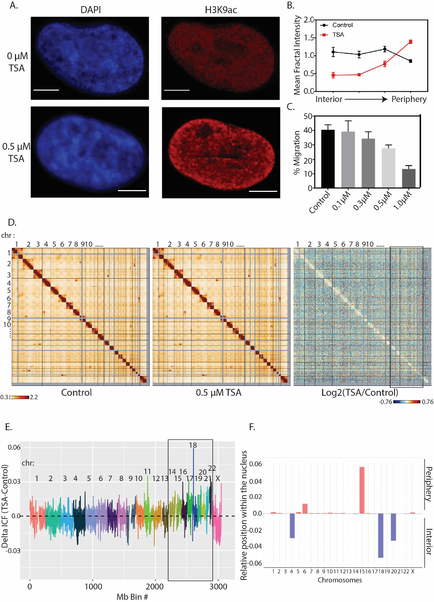

This could indicate that upon treatment with TSA, the smaller chromosomes could be changing their compactness and intermixing with other chromosomes. Additionally, we have used the whole genome HiC contact maps to model radial positioning of the chromosomes based on known radial positioning of chromosomes on an ellipsoid nucleus (Figure 1F). We observe that chromosome 6 and chr 15 have shifted towards the periphery of the nucleus while chr4, 18 and 20 have shifted more toward the interior of the nucleus. Overall these observations suggest that while TSA treatment does not induce any large scale rearrangements in the contact interaction of A375 cells, changes in specific chromosomes indicate altered compactness and intermixing while changing position in the nucleus possibly due to the global decompaction of the chromatin fiber.

Subtle changes in compartment identity observed after treatment with TSA
Since the changes observed in whole genome contact maps were subtle, we next investigated higher resolution contact maps of individual chromosomes binned at 250Kb bins (Figure 2A). We then compute principal component analysis (PCA) to determine compartment identity (A compartment – active, euchromatin and B compartment – inactive, heterochromatin) across each bin throughout the genome (Figure 1A, red - A compartment and blue – B compartment tracks) and investigate if there are any compartment identity switches upon treatment with TSA. Interestingly, the majority of the regions maintain their compartment identity upon TSA treatment and 133 bins change their compartment identity from A to B and 411 bins change their compartment identity from B to A (Figure 2B). However, most of the regions that are switching their compartment identity belong to regions classified as weak compartments (small eigen1 values in each direction) instead of strong compartment switches (Figure 2C). These regions are often correlated with regions of the chromatin that are poised or able to easily switch back and forth between different compartment identity. In fact, when we take a threshold based on compartment strength (PC1 < (-0.01) and PC1 > 0.01), only 4 bins fall under the A to B and 27 bins fall under the B to A compartment identity switch.
It has been previously shown that compartment identity of chromosomal regions is often correlated with their association with the lamina referred to as Lamina Associated Domains (LADs). Regions of the genome that associate with the nuclear lamina strongly correlate with inactive compartment while regions associated with the interior of the nucleus correlative with active compartments. Therefore, we sought to investigate the relationship between the regions that switched compartment identity and the lamin association types. We used a previously established LAD atlas across a cohort of nine different cell types that classify LADs as: cLADs (constitutive LADs; regions associated with the nuclear lamina in all cell types), ciLADs (constitutive inter LADs; regions located in the interior of the nucleus across all cell lines), fLADs and fiLADs (facultative LADs and facultative inter LADs; regions that are sometimes associated with the
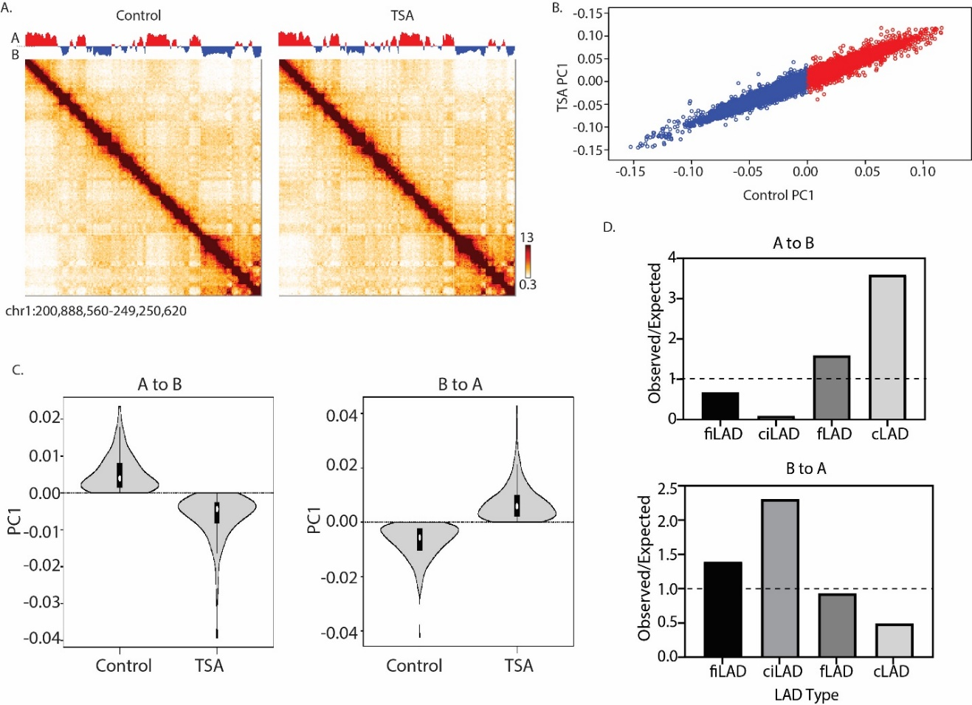
Figure 2. Subtle compartment identity switches observed after treatment with TSA. (A) 250Kb binned Hi-C interaction heatmaps of chr1 (chr1:200,888,560-249,250,620) in Control and TSA treated cells. Red and blue bar graph over the heatmaps represents compartment identity as calculated by PCA (red – A compartment, blue – B compartment). (B) Correlation between A375 Control PC1 and TSA treated PC1. (C) Distribution of PC1 values between Control and TSA in regions that switched their compartment identity from A to B (left panel) and B to A (right panel). (D) Enrichment of different LAD types in regions that switched compartment identity from A to B (top panel) and B to A (bottom panel).

nuclear lamina across the cell types) (Kind et al., 2015, Carolyn de Graaf, 2019). Interestingly, regions of the genome that switch their compartment identity from A to B are over-represented in fLAD (~ 2-fold more than expected) and cLAD (~ 4-fold more than expected) (Figure 2D, top panel). These LAD types represent regions that are often associated with the nuclear lamina and their over-representation could be due to the physical decompaction of the DNA. Moreover, regions of the genome that switched their compartment identify from B to A are overrepresented in fiLADs (~ 1.5-fold more than expected) and ciLADs (~ 2.5-fold more than expected) (Figure 2D, bottom panel). This observation suggests that TSA treatment has a higher effect on regions of the genome that are “poised” and therefore it does not cause major compartment identity shifts.

Increase in long range interactions within and between A compartments observed after TSA treatment
Since most of the bins maintained their compartment identity, we then wondered whether the interaction frequency was affected upon TSA treatment, given its decondensing properties. We used the 250Kb binned matrices and re-ordered the interactions from strongest B to strongest A compartments based on PC1 values (Figure 3A). The most striking feature of these heatmaps is the distinct separation in contacts between A and B compartment and an overall increase in contact frequency within A and within B compartments, separately (Figure 3A, left and middle panel). This pattern of contact frequencies correlates with the notion that compartments of the same identity interact most frequently within themselves then between other compartment types.
Upon TSA treatment, we observe an increase in interaction frequency between strongest A compartments, correlating with the decompaction of the chromatin fiber. In contrary, a decrease in strongest B-B interactions is observed. We then investigated how interaction contact frequency was affected at higher resolution by using matrices binned at 40Kb (Figure 3B). When investigated all contacts within each chromosome, no apparent change in contact frequency with increasing distance was observed (Figure 3B, left panel). However, when the contacts were separated based on compartment identity (A and B), we observe an increase in A contact frequency at longer genomic distances upon TSA treatment (Figure 3B, middle panel). In contrary, B compartment interaction frequency with respect to genomic distance was not affected, again supporting the evidence that TSA mostly affects active or “poised” regions of the genome.
To investigate whether the differences we observe in interaction frequency between different compartments relate to the linear compaction of the DNA after TSA treatment, we measured distal-to-local ratio (DLR) of HiC interaction frequencies. Distal interactions have been defined as all interaction frequencies greater than 3Mb away along the chromosome and local interactions include interactions that take place within 3Mb away (Heinz et al., 2018). This approach infers information about changes in chromosome compaction and loss of local chromatin structure (Heinz et al., 2018, Belaghzal et al., 2019). In agreement with
Figure 3. Interaction Hi-C contact frequency increases within A compartments and is correlated to decompaction of the chromatin fiber. (A) Saddle plots from 250Kb binned Hi-C interaction Z-score matrix (interactions normalized by generic distance decay), reordered by PC1 values derived from A375 Control Hi-C data. Plots are representative of chr17. (B) Scaling plots of chr4 Hi-C interaction contacts using 40Kb binned matrices in A375 Control and TSA treated cells. (C) Distal-to-Local ratio of whole genome contacts within A and B compartment (left panel) and between all types of LADs. Positive deltaDLR (TSA-Control) values indicate a gain in distal interactions (> 3Mb) while negative deltaDLR values indicate a loss in distal and gain in local interactions (< 3Mb) upon treatment with TSA.

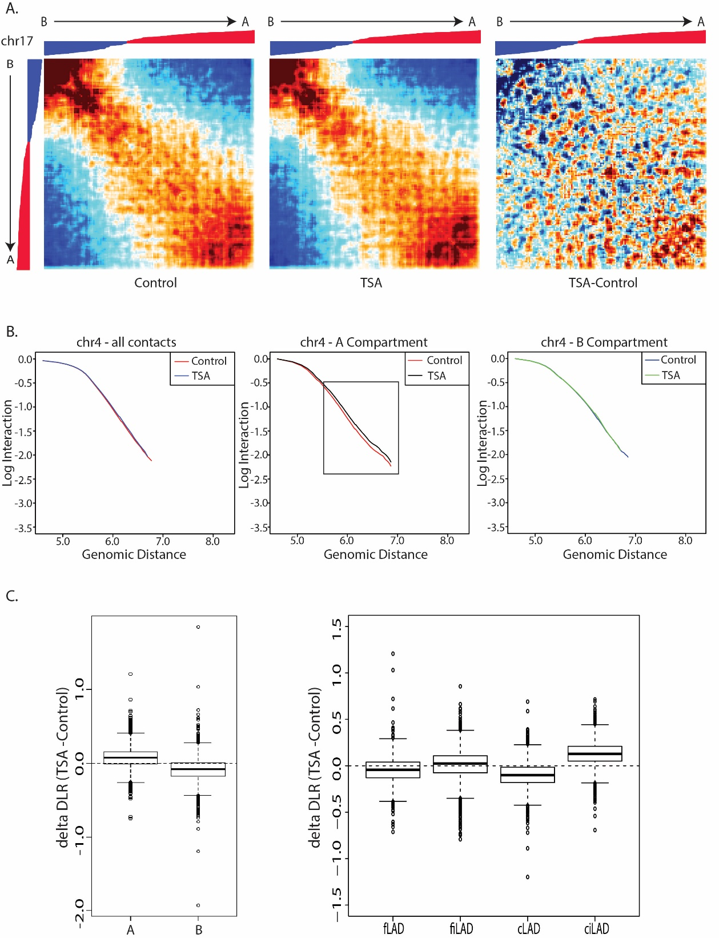

previous results, we observe an increase in distal interactions in A compartment and a decrease in distal interactions in B compartment (Figure 3C, left panel). This could suggest that the chromatin fiber in genomic regions that fall under A compartment is further decompacted and able to make more interactions with distal sites along the same chromosome. On the other hand, B compartment is known for its signature long range interactions due to heterochromatin formation bringing together distal regions in close proximity by contacting the nuclear lamina or phase separation. Therefore, a decrease in distal interactions in B compartment could suggest slight decompaction of these regions.
We further investigated how the compactness of chromosomal regions varied in relation to their association with the nuclear lamina (Figure 3C, right panel) upon TSA treatement. The biggest change we observe in the decrease of distal interactions within cLAD regions and an increase of distal interactions within ciLAD regions. Since ciLADs involve regions that are most often located in the interior of the nucleus and mostly active, its increase in distal interactions suggest a decompaction of the chromatin fiber in these regions, as expected. On the other hands, cLADs are usually regions that contact the nuclear lamina and exhibit condensed chromatin and already distal interactions and therefore the loss of distal interaction could indicate that there is a decompaction that is happening in cLADs upon TSA treatment.

Gene expression changes after TSA treatment reflect TSA gene signature in other cell lines
To investigate whether changes in gene expression resulted after exposure to TSA, we performed RNA-Seq analysis on A375 Control and TSA treated cells. We identified 160 genes that were overexpressed (Log2FC >1, adj p-value < 0.05) and 31 genes were downregulated (Log2FC< -1, adj p-value < 0.05) (Figure 4A). Pathway enrichment analysis revealed enrichment of genes associated with blood vessel endothelial cell proliferation and migration related to VEGF pathways which have been previously shown as targets of TSA treatment (Figure 4B, top panel). Of the downregulated genes, pathway enrichment analysis revealed an overrepresentation of pathways related to methyltransferase activity and chromatin silencing complexes which seems to be in line with the chromatin decondensing function of TSA (Figure 4B, middle panel). Additionally, this gene signature we observed has been previously reported on other cell types treated with TSA such as prostate cancer (PC3), breast cancer (MCF7) and leukemia (HL60) cell lines (Figure 4B, bottom panel).
We then sought to investigate whether genes found within the regions that switch compartment identity, exhibited any changes to their expression values. Interestingly, there was no significant difference in mean expression values of the genes found in regions that switch compartment identity. This observation suggests that rather than larger scale genomic changes, more local scale changes could correlate with changes in gene expression. Therefore, we decided to zoom into individual genes that are part of TSA expression signature in other
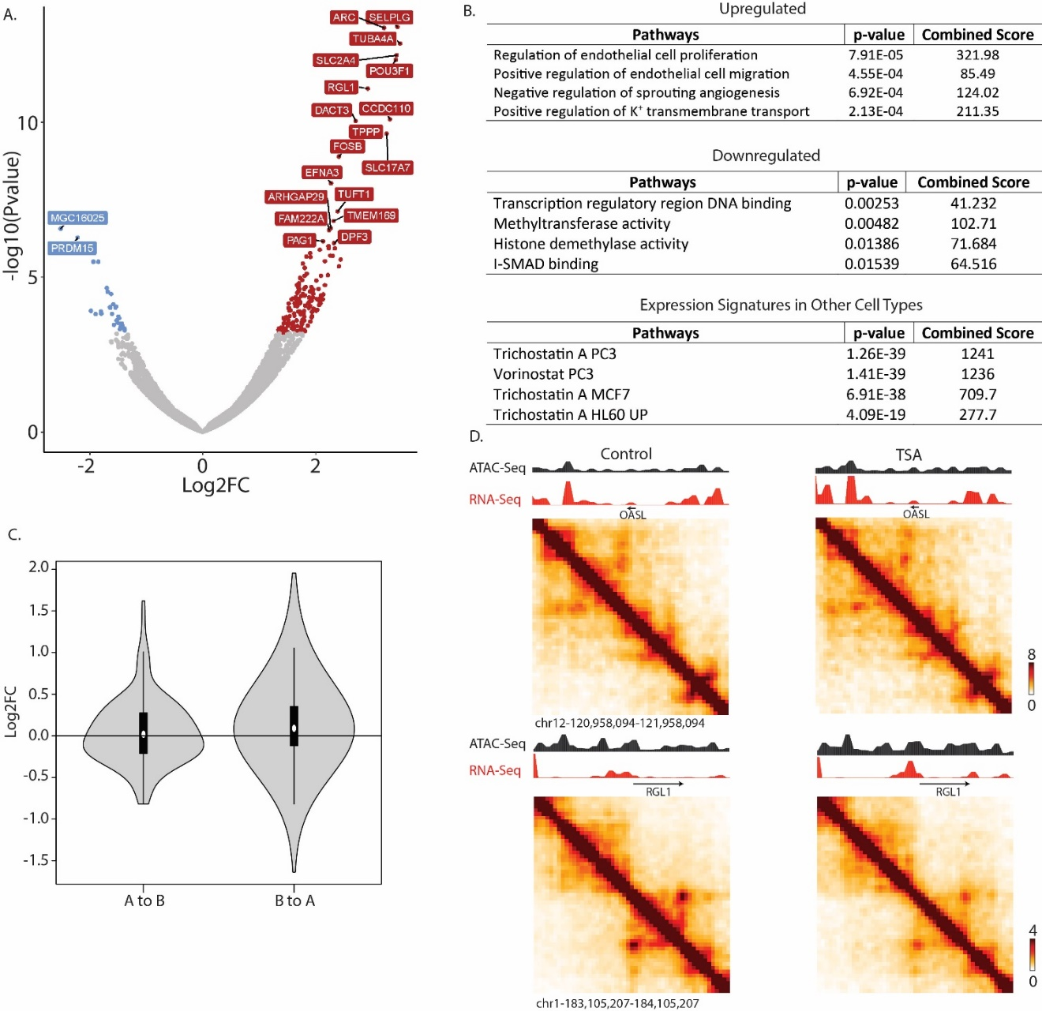

Figure 4. Changes in gene expression relate to TSA signature genes and display alterations of the local structure. (A) Volcano plot representing RNA-Seq genes upon treatment with TSA. Genes colored in red are upregulated (Log2FC >1, adj. p-value < 0.05) while genes colored in blue are downregulated (Log2FC < -1, adj. p-value < 0.05). (B) Gene ontology analysis of upregulated genes (top panel), downregulated genes (middle panel) and expression signature upon TSA treatment (bottom panel). (C) Violin plot representing expression values of genes that were found in regions of the genome that switched compartment identity. (D) 20Kb binned HiC interaction maps smoothed at 40Kb of upregulated genes that fall under TSA signature in other cell types. Tracks over the matrices represent ATAC-Seq (black) and RNA-Seq (red) signal binned at 40Kb.

cell types to investigate whether local structure is affected (Figure 4D). Zooming into OASL gene (Log2FC=2.06) revealed subtle differences in the local structure of the chromatin around the gene. The pre-existing strong interactions that resemble loops, seem to get stronger (Figure 4D, top panels). Additionally, an overall increase in chromatin accessibility is observed (ATAC-Seq track, black). In addition, we zoomed in into RGL1 gene (Log2FC ~ 3.0) which also exhibited difference in the local structure with an overall increase of chromatin accessibility.

Local chromatin structure changes and disruption of chromatin loops upon treatment with TSA
Given our observations about disruption of local chromatin structure around the upregulated genes, we then investigated in more detail the effect of TSA treatment in 3D local structure (Figure 5). We investigated the effect of TSA on chromatin accessibility by using Assay for Transposase-Accessible Chromatin using sequencing (ATAC-Seq). Cells treated with TSA exhibited an increase in local chromatin accessibility (Figure 5A). This observation supports previous microscopy data that TSA overall decondenses the chromatin. We then sought to investigate how this change in accessibility upon TSA treatment affected local 3D structure by investigating TADs. As previously mentioned, TADs have been shown to be important in regulating gene expression since enhancers and promoters have a high probability of interaction when they are found within the same TAD (Lupianez et al., 2015). To visualize the alterations in contacts around TAD boundaries, we plotted the average interaction profile around TAD boundaries (Figure 5B). When we compute the logratio(TSA/Control) we observe an increase across TAD boundaries upon TSA treatment which indicates disruption of the initial structure and an increase in interactions between TADs.
To investigate further the changes in TADs, we quantified TAD activity which represents the mean number of interactions within common TADs between Control and TSA treatment. We were able to identify regions of the genome that showed a disruption in interactions within TADs. We zoomed into two different regions of chr1 that exhibited a decrease in TAD activity (Figure 5C). Upon treatment with TSA, we indeed observe a disruption of the general structure around and within the TADs which also affects the expression of genes located in those regions (Figure 5C, RNASeq track). Despite the overall increase in ATAC-Seq signal and therefore increase in chromatin accessibility, the disruption of the structure around the IGSF21 gene correlates with its downregulation (Figure 5C, top panel). Additionally, disruption of the local structure around PRDM15 gene (which is also one of the few downregulated genes upon TSA treatment) correlated with in decrease in expression (Figure 5C, bottom panel). Interestingly, an increase in overall interactions within the tumor suppressor p73 genomic location, is correlated with its increase in expression and could therefore support previous evidence about the antitumor activity of this drug. The decrease

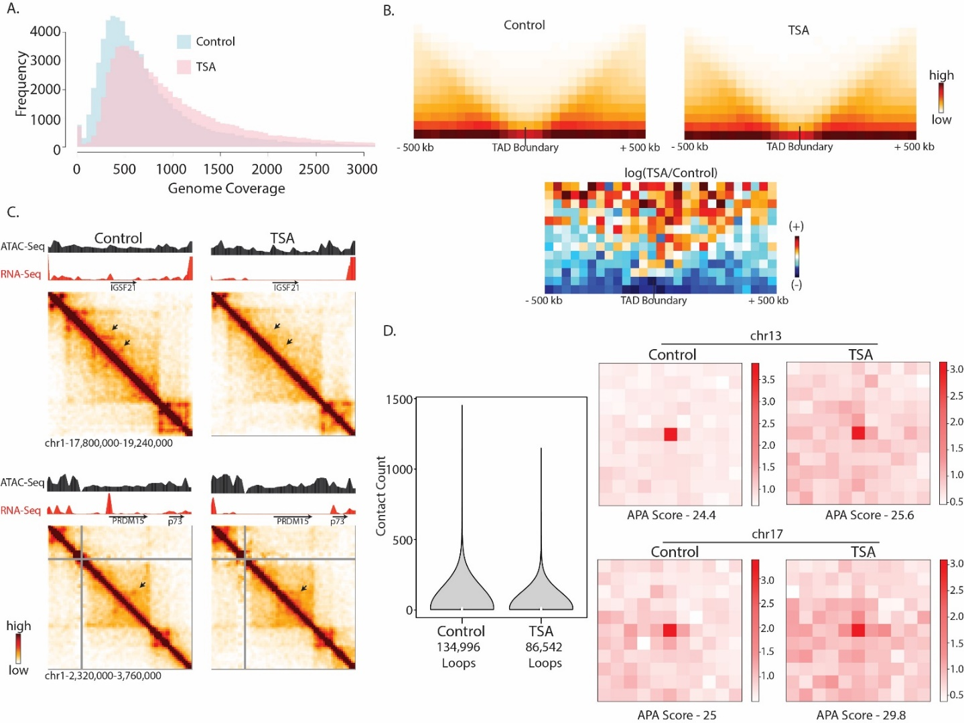
Figure 5. Treatment with TSA increases chromatin accessibility and affects local structure of the genome. (A) Genome coverage plots of ATAC-Seq signals binned at 40Kb bins. (B) Aggregate contact maps at TAD boundaries binned at 40Kb bins. (C) 20Kb binned HiC contact matrices around the regions that exhibited differential TAD activity. Tracks over the heatmap indicate ATAC-Seq (black) and RNA-Seq (red) signal. Matrices and tracks have been smoothed at 40Kb. Pointing arrows indicate loping interactions in Control which are lost upon TSA treatment. (D) Left panel: Violin plot displaying contact counts on looping regions across Control and TSA samples. Right panels: Aggregate heatmaps of loops called in chr13 and chr17.

in expression of the genes is correlated with loss of looping interaction upon TSA treatment (Figure 5C, pointed arrows).
To investigate how looping interactions were affect across the whole genome, we used a loop calling algorithm that detects loops of 100kb in size (Figure 5D). Surprisingly, we observed a decrease in looping interactions upon TSA treatment (86,542 loops for TSA and 134,996 for Control) (Figure 5D, violin plots). We then piled all the looping interactions for each specific chromosome in Control and TSA treated cells (Figure 5D). Treatment with TSA caused an overall increase in background interaction around the loop anchor as observed in chr13 and chr17 (Figure 5D, right panels) which could be due to the decondensation of the chromatin fiber.

Discussion
Increasing evidence on disruption of the epigenetic landscape and its influence in misregulation of cancer related genes, has attracted the development of epigenetic active drugs that are thought to reverse the chromatin state, such as HDAC inhibitors (HDACi). Extensive research of the affect HDACis exhibit on different types of cancers has revealed its chromatin condensation potency and altering of gene expression. However, it has not been clear how the 3D genome organization is affected upon the decondensation of the chromatin by HDACis.
Here, we show that the overall global structure of the genome is maintained, with each chromosome maintaining their own territories and no evidence of any rearrangements. Additionally, we show that compartment identity is maintained with only subtle compartment identity switches of the regions that exhibit weak compartmentalization.
The major affects of TSA mostly occur at local scale where upregulation of genes that are known to be affected upon TSA treatment in other cell types, also show alterations of their local 3D genome structure. The overall decondensation of the chromatin fiber correlated with an increase in accessibility and disruption of chromatin loops. Disruption of loops could be in part due to the pushing forces exerted on the chromatin upon decondensation. However, the importance of this global decondensation and changing of the physical chromatin structure in the efficacy of the drug is not clear. These drugs exhibit low efficacy and increase in non-specific effects which could be in part due to their global effect on the chromatin fiber. It would therefore be important to consider the changes in 3D genome structure during cancer progression in order to develop therapeutics with high efficacy targets. We and others have shown that during cancer progression, large scale genomic rearrangements take place and would therefore be worth to consider how these regions can be targeted in order to deliver better cancer therapeutics.

References

ABBAS, A., HE, X., NIU, J., ZHOU, B., ZHU, G., MA, T., SONG, J., GAO, J., ZHANG, M. Q. & ZENG, J. 2019. Integrating Hi-C and FISH data for modeling of the 3D organization of chromosomes. Nat Commun, 10, 2049.
BALI, P., PRANPAT, M., BRADNER, J., BALASIS, M., FISKUS, W., GUO, F., ROCHA, K., KUMARASWAMY, S., BOYAPALLE, S., ATADJA, P., SETO, E. & BHALLA, K. 2005. Inhibition of histone deacetylase 6 acetylates and disrupts the chaperone function of heat shock protein 90: a novel basis for antileukemia activity of histone deacetylase inhibitors. J Biol Chem, 280, 26729-34.
BAYLIN, S. B. & JONES, P. A. 2011. A decade of exploring the cancer epigenome - biological and translational implications. Nat Rev Cancer, 11, 726-34.
BELAGHZAL, H., BORRMAN, T., STEPHENS, A. D., LAFONTAINE, D. L., VENEV, S. V., WENG, Z., MARKO, J. F. & DEKKER, J. 2019. Compartment-dependent chromatin interaction dynamics revealed by liquid chromatin Hi-C. bioRxiv, 704957.
BERDASCO, M. & ESTELLER, M. 2010. Aberrant epigenetic landscape in cancer: how cellular identity goes awry. Dev Cell, 19, 698-711.
BIGGS, R., LIU, P. Z., STEPHENS, A. D. & MARKO, J. F. 2019. Effects of altering histone posttranslational modifications on mitotic chromosome structure and mechanics. Mol Biol Cell, 30, 820-827.
CAROLYN DE GRAAF, J. K., LUDO PAGIE, DAAN PERIC HUPKES, BAS VAN STEENSEL. 2019. LAD Atlas [Online]. Available: https://osf.io/dk8pm/ [Accessed].
DE RUIJTER, A. J., VAN GENNIP, A. H., CARON, H. N., KEMP, S. & VAN KUILENBURG, A. B. 2003. Histone deacetylases (HDACs): characterization of the classical HDAC family. Biochem J, 370, 737-49.
DEKKER, J., RIPPE, K., DEKKER, M. & KLECKNER, N. 2002. Capturing chromosome conformation. Science, 295, 1306-11.
GASPAR-MAIA, A., ALAJEM, A., MESHORER, E. & RAMALHO-SANTOS, M. 2011. Open chromatin in pluripotency and reprogramming. Nat Rev Mol Cell Biol, 12, 36-47.
GERLITZ, G. & BUSTIN, M. 2010. Efficient cell migration requires global chromatin condensation. J Cell Sci, 123, 2207-17.
GLOZAK, M. A., SENGUPTA, N., ZHANG, X. & SETO, E. 2005. Acetylation and deacetylation of non-histone proteins. Gene, 363, 15-23.
HEINZ, S., TEXARI, L., HAYES, M. G. B., URBANOWSKI, M., CHANG, M. W., GIVARKES, N., RIALDI, A., WHITE, K. M., ALBRECHT, R. A., PACHE, L., MARAZZI, I., GARCIA-SASTRE, A., SHAW, M. L. & BENNER, C. 2018. Transcription Elongation Can Affect Genome 3D Structure. Cell, 174, 1522-1536 e22.
INOUE, K., KOBAYASHI, M., YANO, K., MIURA, M., IZUMI, A., MATAKI, C., DOI, T., HAMAKUBO, T., REID, P. C., HUME, D. A., YOSHIDA, M., AIRD, W. C., KODAMA, T. & MINAMI, T. 2006. Histone deacetylase inhibitor reduces monocyte adhesion to endothelium through the suppression of vascular cell adhesion molecule-1 expression. Arterioscler Thromb Vasc Biol, 26, 2652-9.
KIND, J., PAGIE, L., DE VRIES, S. S., NAHIDIAZAR, L., DEY, S. S., BIENKO, M., ZHAN, Y., LAJOIE, B., DE GRAAF, C. A., AMENDOLA, M., FUDENBERG, G., IMAKAEV, M., MIRNY, L. A., JALINK, K., DEKKER, J., VAN OUDENAARDEN, A. & VAN STEENSEL, B. 2015. Genome-wide maps of nuclear lamina interactions in single human cells. Cell, 163, 134-47.
KRIJGER, P. H. & DE LAAT, W. 2016. Regulation of disease-associated gene expression in the 3D genome. Nat Rev Mol Cell Biol, 17, 771-782.
LARSON, A. G., ELNATAN, D., KEENEN, M. M., TRNKA, M. J., JOHNSTON, J. B., BURLINGAME, A. L., AGARD, D. A., REDDING, S. & NARLIKAR, G. J. 2017. Liquid droplet formation by HP1alpha suggests a role for phase separation in heterochromatin. Nature, 547, 236-240.
LITVAK, D. A., EVERS, B. M., HWANG, K. O., HELLMICH, M. R., KO, T. C. & TOWNSEND, C. M., JR. 1998. Butyrate-induced differentiation of Caco-2 cells is associated with apoptosis and early induction of p21Waf1/Cip1 and p27Kip1. Surgery, 124, 161-9; discussion 169-70.
LUPIANEZ, D. G., KRAFT, K., HEINRICH, V., KRAWITZ, P., BRANCATI, F., KLOPOCKI, E., HORN, D., KAYSERILI, H., OPITZ, J. M., LAXOVA, R., SANTOS-SIMARRO, F., GILBERT-DUSSARDIER, B., WITTLER, L., BORSCHIWER, M., HAAS, S. A., OSTERWALDER, M., FRANKE, M., TIMMERMANN, B., HECHT, J., SPIELMANN, M., VISEL, A. & MUNDLOS, S. 2015. Disruptions of topological chromatin domains cause pathogenic rewiring of gene-enhancer interactions. Cell, 161, 1012-1025.
MA, J., GUO, X., ZHANG, S., LIU, H., LU, J., DONG, Z., LIU, K. & MING, L. 2015. Trichostatin A, a histone deacetylase inhibitor, suppresses proliferation and promotes apoptosis of esophageal squamous cell lines. Mol Med Rep, 11, 4525-31.
MARCHAL, C., SIMA, J. & GILBERT, D. M. 2019. Control of DNA replication timing in the 3D genome. Nat Rev Mol Cell Biol.
MARIADASON, J. M., VELCICH, A., WILSON, A. J., AUGENLICHT, L. H. & GIBSON, P. R. 2001. Resistance to butyrate-induced cell differentiation and apoptosis during spontaneous Caco-2 cell differentiation. Gastroenterology, 120, 889-99.
MARKS, P., RIFKIND, R. A., RICHON, V. M., BRESLOW, R., MILLER, T. & KELLY, W. K. 2001. Histone deacetylases and cancer: causes and therapies. Nat Rev Cancer, 1, 194-202.
MARKS, P. A., RICHON, V. M. & RIFKIND, R. A. 2000. Histone deacetylase inhibitors: inducers of differentiation or apoptosis of transformed cells. J Natl Cancer Inst, 92, 1210-6.
ROWLEY, M. J. & CORCES, V. G. 2018. Organizational principles of 3D genome architecture. Nat Rev Genet, 19, 789-800.
SPIELMANN, M., LUPIANEZ, D. G. & MUNDLOS, S. 2018. Structural variation in the 3D genome. Nat Rev Genet, 19, 453-467.
STROM, A. R., EMELYANOV, A. V., MIR, M., FYODOROV, D. V., DARZACQ, X. & KARPEN, G. H. 2017. Phase separation drives heterochromatin domain formation. Nature, 547, 241-245.
SUN, S., HAN, Y., LIU, J., FANG, Y., TIAN, Y., ZHOU, J., MA, D. & WU, P. 2014. Trichostatin A targets the mitochondrial respiratory chain, increasing mitochondrial reactive oxygen species production to trigger apoptosis in human breast cancer cells. PLoS One, 9, e91610.
TOTH, K. F., KNOCH, T. A., WACHSMUTH, M., FRANK-STOHR, M., STOHR, M., BACHER, C. P., MULLER, G. & RIPPE, K. 2004. Trichostatin A-induced histone acetylation causes decondensation of interphase chromatin. J Cell Sci, 117, 4277-87.
VAN STEENSEL, B. & BELMONT, A. S. 2017. Lamina-Associated Domains: Links with Chromosome Architecture, Heterochromatin, and Gene Repression. Cell, 169, 780-791.
WATSON, J. A., MCKENNA, D. J., MAXWELL, P., DIAMOND, J., ARTHUR, K., MCKELVEY-MARTIN, V. J. & HAMILTON, P. W. 2010. Hyperacetylation in prostate cancer induces cell cycle aberrations, chromatin reorganization and altered gene expression profiles. J Cell Mol Med, 14, 1668-82.
YOSHIDA, M., KIJIMA, M., AKITA, M. & BEPPU, T. 1990. Potent and specific inhibition of mammalian histone deacetylase both in vivo and in vitro by trichostatin A. J Biol Chem, 265, 17174-9.

CONCLUSION
Insert text here.

VITA

Insert text here.

