Novel Insights into The Role of Pyruvate Kinase M2 in Podocyte Homeostasis and Function

A Dissertation Presented for the
Doctor of Philosophy
Degree
The University of Tennessee, Knoxville

Mohammed Alquraishi
May 2021
Acknowledgment
I want to express my sincere appreciation to my major professor and my committee's chair, Dr. Ahmed Bettaieb, for his support, guidance, and constant encouragement throughout this project. Dr. Bettaieb is an expert on a wide range of biological and biochemical techniques, and his contribution to the field is extraordinary. It was a pleasure and an excellent opportunity to join his laboratory and work on research under his supervision. I would also like to thank my knowledgeable committee members Dr. Whelan, Dr. Donohoe, and Dr. Voy, for their suggestions, recommendations, and great thoughts during this degree. In addition, I want to thank my lab mates, Dexter Puckett, Dina Alani, Samah Chahed, and Yi Zhao, for their input and support during the data generation process. I also want to express my sincere gratitude to all people in the nutrition department at the University of Tennessee-Knoxville who provided me with a unique environment that made me feel at home during my stay at UTK.
I also want to thank my family and siblings for their continuous love and care during my whole life, including my time in graduate studies. My father, Ibrahim Alquraishi, always inspires me to achieve my goals and provides me with the wisdom needed during challenging times. My mother, Munirah Aloraini, gave me the strength I needed while I am away from home. Last but not least, I want to thank the love of my life, Munirah Alnuwaysir, for her patience, encouragement, and tremendous effort during our stay in the US. Munirah has been taking great care of me and my little son, Turki, which provided me with plenty of time to focus on my research to advance my career.

Abstract
Background: Renal diseases are major health concerns and among the top ten leading causes of death in the US. A large number of these diseases are characterized by deterioration in glomerular structure and function, leading to reduced filtration capacity and proteinuria. Glomerulus podocytes are epithelial cells that maintain glomerular integrity and act as a defense mechanism against proteinuria. Recent advances in renal research suggested a novel role of glycolysis and its related enzymes, pyruvate kinase M2 (PKM2) in particular, in the progression of renal diseases. However, the precise role of PKM2 in podocyte homeostasis and its contribution to glomerular function under normal and pathological conditions remains to be determined.
Methods: In this project, we evaluated the role of PKM2 in podocyte differentiation and homeostasis, using shRNA-mediated PKM2 knockdown in murine podocytes. Next, we examined the clinical significance of PKM2 deficiency to renal function using the Cre-LoxP technology to generate mice that specifically lack PKM2 in podocytes. Then, lipopolysaccharide (LPS), an endotoxin agent, was used to induce renal injury. We also used various genetic approaches and pharmaceutical compounds to decipher the molecular mechanisms mediating PKM2 action.
Results: The genetic depletion of PKM2 increased podocyte differentiation markers and protected against LPS induced albumin permeability in vitro. These effects were concomitant with enhanced activation of autophagy, AMPK, and mTORC1 but reduced AKT phosphorylation. On the other hand, the prolonged pharmacological inhibition of AKT or activation of AMPK recapitulated the effects of PKM2 deficiency on autophagy induction, podocyte differentiation, and albumin loss. In vivo, the deletion of PKM2 preserved podocyte integrity and protected against LPS induced proteinuria and nephrin loss. Further analysis revealed that PKM2 deficiency was associated with reduced inflammatory cytokines, inflammation, ER stress, and β-catenin level but sustained Wilms’ Tumor 1 (WT1) expression after LPS challenge. Additionally, PKM2 deficiency enhanced podocyte survival and ameliorated LPS-induced podocytes cell death. Mechanistic studies revealed that PKM2 interacts with β-catenin to promote LPS induced podocytes cell death.
Conclusion: Our data elucidate a novel role of PKM2 in podocyte homeostasis and propose PKM2 as a potential therapeutic target to halt renal injury progression.
Table of Contents
Introduction 1
References 5
Chapter I: Literature Review 8
Abstract 10
Abbreviations 11
1.1. Introduction 13
1.1.2 An Era of Discovery in Glycolysis and Pyruvate Kinases 13
1.1.3 PKM2: From Gene to Protein 14
1.1.4 Tissue Distribution of the PK Isoforms 15
1.1.5 PKM2 Enzymatic Function and Regulation 16
1.1.6 PKM2 Post-Transnational Modifications 17
1.2. PKM2 in Health and Disease 19
1.2.1 PKM2 Roles in Cancer Metabolism 20
1.2.2 PKM2 in Inflammation-Associated Diseases 28
1.2.3 Neuropathic Pain 32
1.2.4 PKM2 and Metabolic Disorders 32
1.3. Conclusion and Perspective 36
References 38
Appendix 49
Chapter II: PKM2 Deficiency in Podocyte Enhances Podocyte Differentiation and Alleviates LPS induced Albuminuria 61
Abstract 62
2.1. Introduction 63
2.2. Methods 65
2.3. Results 68
2.4. Discussion 75
References 81
Appendix 86
Chapter III: Podocytes Specific Deletion of PKM2 Ameliorates LPS-induced Podocyte Injury through Beta-Catenin 103
Abstract 104
Abbreviations 105
3.1. Introduction 106
3.2. Materials and Methods 109
3.3. Results 113
3.4. Discussion 121
References 127
Appendix 133
Conclusion, Limitations, and Future Directions 157
References 159
Vita 160

List of Tables
Table 1. Post-translational modifications of PKM2 and their disease-associated physiological relevance. 54
Table 2. List of Antibodies Used in the Reported Experiments. 133
Table 3. List of Primers Used in qRT-PCR Experiments. 136
Table 4. Histology Assessment of Kidneys Injury in Control and PKM2 KO mice. 137

List of Figures
Figure 1. Tissue distribution of PK isoforms and the role of PKM2 in health and disease. 49
Figure 2. Post-translational regulation of PKM2 and its role in redox homeostasis. 50
Figure 3. Direct and indirect regulation of gene expression by PKM2. 52
Figure 4. PKM2 regulation of cancer redox homeostasis. 53
Figure 5. Expression pattern of PKM2 during podocyte differentiation. 86
Figure 6. Characterization of autophagy, AMPK, and mTOR signaling in differentiating podocytes. 87
Figure 7. PKM2 deficiency does not alter podocytes proliferation rate. 89
Figure 8. PKM2 deficiency enhances podocyte differentiation and promotes the induction of autophagy, AMPK, and mTOR signaling. 90
Figure 9. Inhibiting autophagy abolished the beneficial effect of PKM2 deficiency on podocyte differentiation. 93
Figure 10. AMPK inhibition reversed the effect of PKM2 depletion on podocyte differentiation. 96
Figure 11. mTORC1 activity is required for mediating the beneficial effect of PKM2 deficiency on podocyte differentiation. 98
Figure 12. AKT activation impaired podocytes differentiation and abolished the beneficial effect of PKM2 deficiency. 100
Figure 13. PKM2 deficiency protected against LPS induced albumin permeability. 102
Figure 14. LPS increases PKM2 Phosphorylation and Expression Levels in Renal Tissue and Cultured Podocytes. 138
Figure 15. PKM2 Podocyte Deletion Ameliorates LPS Induced Proteinuria and Kidney Injury. 139
Figure 16. Podocyte Specific Deletion of PKM2 Attenuates LPS-Induced Inflammation and Apoptosis in Vivo. 141
Figure 17. PKM2 Deficiency in Cultured E11 Podocytes Ameliorates LPS-Induced Nephrin Loss. 143
Figure 18. PKM2 Deficiency Ameliorates LPS-Induced Inflammation and Apoptosis in Cultured E11 Podocytes. 145
Figure 19. PKM2 Depletion Suppress LPS-Induced-β-Catenin Activation in Kidneys and E11 Cultured Podocytes. 147
Supplementary Figure S1. 151
Supplementary Figure S2. Specificity of PKM2 Deficiency in Podocytes…………………….152
Supplementary Figure S3. PKM2 Podocytes Depletion Ameliorates LPS-Induced ER Stress but Exacerbates Autophagy in Vivo. 153
Supplementary Figure S4. Changes in PKM2 and Nephrin Expression in Response to LPS Treatment in M2R, SCR Cells and Original E11 Cells. 154
Supplementary Figure S5. PKM2 Deficiency Ameliorates ER Stress, but Exacerbates Autophagy in LPS-Treated Podocytes. 155

Introduction
Acute kidney injury (AKI) is characterized by a sudden impairment in kidney function concomitant with reduced glomerular filtration (GF) capacity and the release of proteins in the urine, also known as proteinuria [1]. The causes of AKI are attributed to multiple factors, including metabolic associated factors such as diabetes, obesity, hypertension, and cardiovascular diseases [2]. Additionally, AKI could result from exposure to infectious agents, initiating an abnormal inflammatory response that can be destructive to the renal system [3]. The incidence and risk for AKI are significant, prompting an increasing level of health concern, particularly in hospitalized patients and intensive care units. Notably, AKI can lead to the development of chronic kidney diseases and eventually end-stage renal disease (ESRD), thus raising the risk for mortality [4] and the associated economic burden [5]. Emerging treatment options and strategies targeting AKI focus on attenuating further impairment in GFR and kidney function. However, current approaches to treat or prevent AKI have been ineffective [6].
The underlying basis of AKI is centralized around the nephron structure [7], a functional unit within kidneys that contains the glomerular filtration barriers. Podocytes are epithelial cells required to sustain healthy nephrons, preserve glomerular filtration capacity, and maintain the anatomical unity of the glomerular basement membrane (GBM). These cells are composed of multiple cellular compartments, including the cell body and foot processes. The foot processes embed podocytes into the GBM, while the filtrate passes through slit diaphragms between the projections [8, 9]. Because of their direct exposure to biological waste, foot processes make podocytes susceptible to stressors which may trigger podocytes dedifferentiation [10] and the subsequent cytoskeleton rearrangement, leading to foot processes effacement and protein loss in urine [11, 12]. Furthermore, podocytes can produce cytokines [13] that promote the inflammatory response associated with kidney injuries. Cytokines recruit immune cells to injured kidneys [14], thus increasing the damage to the GBM and exacerbating proteinuria [15, 16]. Additionally, the homeostatic balance disruption due to the loss of proteins in urine can lead to fluid retention in kidneys and other organs [17]. Proteinuria is also associated with an increased incidence of metabolic disorders, including hyperlipidemia [18], hypertension, and the development of cardiovascular diseases [19]. Therefore, strategies to preserve podocytes’ integrity and function are crucial for developing effective therapies.
In addition to this vital function in the excretion of waste products and toxins, a growing body of literature identifies the kidney as a major metabolic organ responsible for sustaining systematic glucose homeostasis through gluconeogenesis and regulation of glucose reabsorption [20]. However, the increase in pro-inflammatory cytokines associated with hyperglycemia could lead to renal damage and proteinuria through modulation of the glycolytic flux [21] [22]. The rise in glycolysis associated with hyperglycemia [22] may result in high production of advanced glycation end products leading to alterations in GBM homeostasis [23]. An increase in glycolysis has been described in ischemia-reperfusion (IR) experimental models [24] and in response to exogenous insult [25]. Notably, RNA-sequencing analysis revealed an increase in the expression of glycolytic enzymes, mainly pyruvate kinase muscle type (PKM) in renal biopsies obtained from AKI patients [26]. PKM is an enzyme catalyzing the final step in glycolysis. However, the precise role of glycolysis and the contribution of its enzymes to podocytes’ survival and homeostasis remain largely unexplored.
The final step of glycolysis, mediated by pyruvate kinases (PK), converts phosphoenolpyruvate (PEP) into pyruvate. PK exists in 4 different isoforms (L, R, M1, and M2) that vary in their enzymatic activity and tissue distribution. The expression pattern of PK isoforms differs amongst organs due in part to variations in metabolic demands [27]. However, some organs, including the kidney, can express multiple isoforms (PKM2, PKM1, and PKL) [28]. Unlike other isoforms, the M2 isoform exhibits critical biological functions in addition to its role in glycolysis. PKM2 acts as a kinase, where it phosphorylates proteins essential to the inflammatory response [29] and cell survival [30]. The expression of PKM2 is significantly elevated under abnormal physiological conditions, such as those observed in cancer [31]. Subsequently, PKM2 can translocate to the nucleus, where it regulates the transcriptional activity or expression of genes associated with diverse signaling cascades and biological processes, including cell proliferation [32] and differentiation [33]. Thus, PKM2 performs other biological functions possibly independent from its classical role in glycolysis. For instance, recent advancement of cancer research has revealed PKM2 as a regulator of major signaling pathways, including, autophagy [34], and the AMP-activated protein kinase (AMPK) [35]. Notably, in podocytes, these pathways play a vital role in maintaining the cellular homeostasis, while the disruption of these signaling may potentiate podocyte dysfunction and dedifferentiation.
It is well established that autophagy is crucial for maintaining cellular homeostasis by recycling excessive materials to generate building blocks and energy [36]. Therefore, autophagy plays an integral role in mammalian development and cell differentiation partially through the remodeling of cellular components to promotes the synthesis of new compartments required for growth and development [37]. Indeed, fully differentiated podocytes sustain a high level of basal autophagy [38], suggesting a possible role in podocyte development and homeostasis [39]. Notably, Notch signaling mediates autophagy induction in podocytes, while inhibiting Notch signaling using DAPT (Notch blocker) impaired differentiation concomitant with a reduction in autophagy. Subsequently, enhancing autophagy alleviated DAPT-induced podocyte dysfunction and nephrin loss [39]. Similarly, within human podocytes, the induction of autophagy ameliorated high glucose induced podocytes injury, nephrin loss, and insulin resistance [40]. Similar results in regards to nephrin expression were recapitulated in aldosterone induced podocytes injury model [41]. Collectively, these studies demonstrate the vital role of autophagy in podocyte development and preserving podocyte differentiation under stressed conditions.
AMPK regulates various molecular mechanisms, including autophagy [42], glucose uptake, and fatty acid oxidation, to sustain energy supply and survival under deprived conditions [42]. Since AMPK coordinates cell metabolism and growth [42], it is reasonable to assume that AMPK could also regulate other aspects of cellular homeostasis, such as differentiation. Indeed, AMPK has been shown to promote intestinal epithelial differentiation and improve the gut barrier function [43]. Moreover, the genetic inhibition of LKB1 reduced the phosphorylation and activity of AMPK and exacerbated the dedifferentiation of renal tubular epithelial cells. Treating epithelial cells with A769662, an AMPK agonist, attenuated the effect of LKB1 deficiency on epithelial cell dedifferentiation, indicating that AMPK might be critical for tubular epithelial cell development [44]. Notably, AMPK is highly expressed in podocytes [45] and the activation of AMPK has been shown to sustain podocytes differentiation proteins in various glomerular disease models. In diabetic nephropathy, high glucose induces the loss of nephrin and podocin expression and exacerbates podocytes dysfunction. The activation of AMPK, using berberine, attenuated high glucose-induced nephrin and podocin loss, leading to improved podocyte function [46]. Similarly, these data were recapitulated by using other AMPK activators [47, 48]. In addition, AMPK contributes to other cellular processes critical for podocyte homeostasis, including oxidative stress [49] and apoptosis [50]. Together, these studies highlighted the crucial role of AMPK in podocyte homeostasis and development.
Based on the above, it is reasonable to hypothesized that PKM2 deficiency in podocytes promotes differentiation and protect against lipopolysaccharide (LPS) induced podocytes dysfunction. We also hypothesize that PKM2 function in podocytes is mediated, at least in part, through the regulation of AMPK and/or autophagy. Thus, the objective for chapter II is to investigate the role of PKM2 on podocyte homeostasis and differentiation in vitro by establishing a stable murine podocyte cell line deficient in PKM2, using shRNA technology. Moreover, we will decipher the mechanism mediating PKM2 action by using several pharmaceutical compounds to activate or inhibit the targeted pathways and precisely identify PKM2 downstream targets.
As mentioned previously, inflammation plays a crucial role in mediating renal injury and proteinuria. Recently, PKM2 has emerged as a master regulator of inflammation through various proposed mechanisms [51]. For example, PKM2 phosphorylates STAT1 and ultimately promotes macrophage activation and cytokines production [52]. Moreover, PKM2 promotes the expression of interleukin 1-beta (IL-1β) and tumor necrosis factor-alpha (TNF- α) in a mechanism mediated by STAT3 phosphorylation [53]. This role of PKM2 in regulating inflammation suggests that PKM2 may serve as a therapeutic target for multiple inflammatory disorders. For instance, the genetic inhibition of PKM2 reduced inflammation and shows protective effects in several inflammatory mediated diseases, including neuropathic pain [54], arthritis [52], atherosclerotic coronary artery disease [55], and sepsis [56]. Interestingly, the downregulation of PKM2 not only improved the outcomes of inflammatory diseases but also prevented organ dysfunction. The genetic inhibition of PKM2 in lung tissue attenuated mechanical ventilator induced lung injury [57, 58]. Similarly, the knockout of PKM2 in proximal tubules reduced injury severity and protected against IR induced renal damage [59]. However, whether the deficiency of PKM2 in podocytes will exert similar beneficial effects in acute renal injury is yet to be identified. Thus, our objective for chapter III is to examine the contribution of PKM2 to the pathophysiology of AKI by generating mice that specifically lack PKM2 in podocytes and challenged with LPS. Moreover, we will investigate the molecular mechanism mediating PKM2 action by using various genetic approaches to identify PKM2 interacting proteins that might be required for its potential function.

References
1. Makris, K. and L. Spanou, Acute Kidney Injury: Definition, Pathophysiology and Clinical Phenotypes. Clin Biochem Rev, 2016. 37(2): p. 85-98.
2. Chawla, L.S., et al., Renal angina: concept and development of pretest probability assessment in acute kidney injury. Crit Care, 2015. 19: p. 93.
3. Vandijck, D.M., et al., Severe infection, sepsis and acute kidney injury. Acta Clin Belg, 2007. 62 Suppl 2: p. 332-6.
4. Doyle, J.F. and L.G. Forni, Acute kidney injury: short-term and long-term effects. Crit Care, 2016. 20(1): p. 188.
5. Rewa, O. and S.M. Bagshaw, Acute kidney injury-epidemiology, outcomes and economics. Nat Rev Nephrol, 2014. 10(4): p. 193-207.
6. Hertzberg, D., et al., Acute kidney injury-an overview of diagnostic methods and clinical management. Clin Kidney J, 2017. 10(3): p. 323-331.
7. Chambers, B.E. and R.A. Wingert, Nephron repair: powered by anaerobic energy metabolism. Ann Transl Med, 2019. 7(Suppl 1): p. S28.
8. Asanuma, K., et al., The role of podocytes in proteinuria. Nephrology (Carlton), 2007. 12 Suppl 3: p. S15-20.
9. Garg, P., A Review of Podocyte Biology. Am J Nephrol, 2018. 47 Suppl 1: p. 3-13.
10. Lv, Z., et al., Podocyte-specific Rac1 deficiency ameliorates podocyte damage and proteinuria in STZ-induced diabetic nephropathy in mice. Cell Death Dis, 2018. 9(3): p. 342.
11. Kawachi, H. and Y. Fukusumi, New insight into podocyte slit diaphragm, a therapeutic target of proteinuria. Clin Exp Nephrol, 2020. 24(3): p. 193-204.
12. May, C.J., M. Saleem, and G.I. Welsh, Podocyte dedifferentiation: a specialized process for a specialized cell. Front Endocrinol (Lausanne), 2014. 5: p. 148.
13. Wright, R.D. and M.W. Beresford, Podocytes contribute, and respond, to the inflammatory environment in lupus nephritis. Am J Physiol Renal Physiol, 2018. 315(6): p. F1683-f1694.
14. Imig, J.D. and M.J. Ryan, Immune and inflammatory role in renal disease. Compr Physiol, 2013. 3(2): p. 957-76.
15. Cattell, V., Macrophages in acute glomerular inflammation. Kidney Int, 1994. 45(4): p. 945-52.
16. Alvarez, V., et al., Overload proteinuria is followed by salt-sensitive hypertension caused by renal infiltration of immune cells. Am J Physiol Renal Physiol, 2002. 283(5): p. F1132-41.
17. Meena, J. and A. Bagga, Current Perspectives in Management of Edema in Nephrotic Syndrome. Indian J Pediatr, 2020.
18. Vogt, L., et al., Lipid management in the proteinuric patient: do not overlook the importance of proteinuria reduction. Nephrol Dial Transplant, 2004. 19(1): p. 5-8.
19. Currie, G. and C. Delles, Proteinuria and its relation to cardiovascular disease. Int J Nephrol Renovasc Dis, 2013. 7: p. 13-24.
20. Triplitt, C.L., Understanding the kidneys' role in blood glucose regulation. Am J Manag Care, 2012. 18(1 Suppl): p. S11-6.
21. Schena, F.P. and L. Gesualdo, Pathogenetic mechanisms of diabetic nephropathy. J Am Soc Nephrol, 2005. 16 Suppl 1: p. S30-3.
22. Zhang, G., M. Darshi, and K. Sharma, The Warburg Effect in Diabetic Kidney Disease. Semin Nephrol, 2018. 38(2): p. 111-120.
23. Toth-Manikowski, S. and M.G. Atta, Diabetic Kidney Disease: Pathophysiology and Therapeutic Targets. J Diabetes Res, 2015. 2015: p. 697010.
24. Lan, R., et al., Mitochondrial Pathology and Glycolytic Shift during Proximal Tubule Atrophy after Ischemic AKI. J Am Soc Nephrol, 2016. 27(11): p. 3356-3367.
25. Ash, S.R. and F.E. Cuppage, Shift toward anaerobic glycolysis in the regenerating rat kidney. Am J Pathol, 1970. 60(3): p. 385-402.
26. Legouis, D., et al., Impaired renal gluconeogenesis is a major determinant of acute kidney injury associated mortality. 2019, bioRxiv.
27. Puckett, D.L., et al., The Role of PKM2 in Metabolic Reprogramming: Insights into the Regulatory Roles of Non-Coding RNAs. Int J Mol Sci, 2021. 22(3).
28. Imamura, K. and T. Tanaka, Multimolecular forms of pyruvate kinase from rat and other mammalian tissues. I. Electrophoretic studies. J Biochem, 1972. 71(6): p. 1043-51.
29. Jiang, Y., et al., PKM2 phosphorylates MLC2 and regulates cytokinesis of tumour cells. Nat Commun, 2014. 5: p. 5566.
30. Yang, W., et al., PKM2 phosphorylates histone H3 and promotes gene transcription and tumorigenesis. Cell, 2012. 150(4): p. 685-96.
31. Yang, W. and Z. Lu, Pyruvate kinase M2 at a glance. J Cell Sci, 2015. 128(9): p. 1655-60.
32. Zhang, Z., et al., PKM2, function and expression and regulation. Cell Biosci, 2019. 9: p. 52.
33. Morfouace, M., et al., Control of glioma cell death and differentiation by PKM2-Oct4 interaction. Cell Death Dis, 2014. 5(1): p. e1036.
34. Wang, C., et al., PKM2 promotes cell migration and inhibits autophagy by mediating PI3K/AKT activation and contributes to the malignant development of gastric cancer. Sci Rep, 2017. 7(1): p. 2886.
35. Li, X., et al., The responsively decreased PKM2 facilitates the survival of pancreatic cancer cells in hypoglucose. Cell Death Dis, 2018. 9(2): p. 133.
36. Mizushima, N. and M. Komatsu, Autophagy: renovation of cells and tissues. Cell, 2011. 147(4): p. 728-41.
37. Mizushima, N. and B. Levine, Autophagy in mammalian development and differentiation. Nat Cell Biol, 2010. 12(9): p. 823-30.
38. Bork, T., et al., Podocytes maintain high basal levels of autophagy independent of mtor signaling. Autophagy, 2020. 16(11): p. 1932-1948.
39. Zhang, C., et al., Autophagy is involved in mouse kidney development and podocyte differentiation regulated by Notch signalling. J Cell Mol Med, 2017. 21(7): p. 1315-1328.
40. Xin, W., et al., Autophagy protects human podocytes from high glucose-induced injury by preventing insulin resistance. Metabolism, 2016. 65(9): p. 1307-15.
41. Yuan, Y., et al., The roles of oxidative stress, endoplasmic reticulum stress, and autophagy in aldosterone/mineralocorticoid receptor-induced podocyte injury. Lab Invest, 2015. 95(12): p. 1374-86.
42. Mihaylova, M.M. and R.J. Shaw, The AMPK signalling pathway coordinates cell growth, autophagy and metabolism. Nat Cell Biol, 2011. 13(9): p. 1016-23.
43. Sun, X., et al., AMPK improves gut epithelial differentiation and barrier function via regulating Cdx2 expression. Cell Death Differ, 2017. 24(5): p. 819-831.
44. Han, S.H., et al., Deletion of Lkb1 in Renal Tubular Epithelial Cells Leads to CKD by Altering Metabolism. J Am Soc Nephrol, 2016. 27(2): p. 439-53.
45. Kume, S., M.C. Thomas, and D. Koya, Nutrient sensing, autophagy, and diabetic nephropathy. Diabetes, 2012. 61(1): p. 23-9.
46. Jin, Y., et al., Berberine enhances the AMPK activation and autophagy and mitigates high glucose-induced apoptosis of mouse podocytes. Eur J Pharmacol, 2017. 794: p. 106-114.
47. Szrejder, M., et al., Metformin reduces TRPC6 expression through AMPK activation and modulates cytoskeleton dynamics in podocytes under diabetic conditions. Biochim Biophys Acta Mol Basis Dis, 2020. 1866(3): p. 165610.
48. Zhai, L., et al., Metformin ameliorates podocyte damage by restoring renal tissue nephrin expression in type 2 diabetic rats. J Diabetes, 2017. 9(5): p. 510-517.
49. Gao, K., et al., 5'-AMP-activated protein kinase attenuates adriamycin-induced oxidative podocyte injury through thioredoxin-mediated suppression of the apoptosis signal-regulating kinase 1-P38 signaling pathway. Mol Pharmacol, 2014. 85(3): p. 460-71.
50. Eid, A.A., et al., AMP-activated protein kinase (AMPK) negatively regulates Nox4-dependent activation of p53 and epithelial cell apoptosis in diabetes. J Biol Chem, 2010. 285(48): p. 37503-12.
51. Alves-Filho, J.C. and E.M. Palsson-McDermott, Pyruvate Kinase M2: A Potential Target for Regulating Inflammation. Front Immunol, 2016. 7: p. 145.
52. Xu, J., et al., Upregulated PKM2 in Macrophages Exacerbates Experimental Arthritis via STAT1 Signaling. J Immunol, 2020.
53. Yang, P., et al., Pyruvate kinase M2 accelerates pro-inflammatory cytokine secretion and cell proliferation induced by lipopolysaccharide in colorectal cancer. Cell Signal, 2015. 27(7): p. 1525-32.
54. Wang, B., et al., PKM2 is involved in neuropathic pain by regulating ERK and STAT3 activation in rat spinal cord. J Headache Pain, 2018. 19(1): p. 7.
55. Kumar, A., et al., Role of pyruvate kinase M2 in oxidized LDL-induced macrophage foam cell formation and inflammation. J Lipid Res, 2020. 61(3): p. 351-364.
56. Xie, M., et al., PKM2-dependent glycolysis promotes NLRP3 and AIM2 inflammasome activation. Nat Commun, 2016. 7: p. 13280.
57. Zhu, R., Y.Q. Lei, and D.C. Zhao, Overexpression of CXCL14 Alleviates Ventilator-Induced Lung Injury through the Downregulation of PKM2-Mediated Cytokine Production. Mediators Inflamm, 2020. 2020: p. 7650978.
58. Hu, K., et al., Caloric Restriction Mimetic 2-Deoxyglucose Alleviated Inflammatory Lung Injury via Suppressing Nuclear Pyruvate Kinase M2-Signal Transducer and Activator of Transcription 3 Pathway. Front Immunol, 2018. 9: p. 426.
59. Zhou, H.L., et al., Metabolic reprogramming by the S-nitroso-CoA reductase system protects against kidney injury. Nature, 2019. 565(7737): p. 96-100.

Chapter I: Literature Review

A version of this chapter has been published in free radical biology and medicine by Mohammed Alquraishi, Dexter Puckett, Dina Alani, Amal Humidat, Victoria Frankel, Dallas Donohoe, Jay Whelan, and Ahmed Bettaieb
Alquraishi, M., et al., Pyruvate kinase M2: A simple molecule with complex functions. Free Radic Biol Med, 2019. 143: p. 176-192.

Abstract
Pyruvate kinase M2 is a critical enzyme that regulates cell metabolism and growth under different physiological conditions. In its metabolic role, pyruvate kinase M2 catalyzes the last glycolytic step which converts phosphoenolpyruvate to pyruvate with the generation of ATP. Beyond this metabolic role in glycolysis, PKM2 regulates gene expression in the nucleus, phosphorylates several essential proteins that regulate major cell signaling pathways, and contribute to the redox homeostasis of cancer cells. The expression of PKM2 has been demonstrated to be significantly elevated in several types of cancer, and the overall inflammatory response. The unusual pattern of PKM2 expression inspired scientists to investigate the unrevealed functions of PKM2 and the therapeutic potential of targeting PKM2 in cancer and other disorders. Therefore, the purpose of this chapter is to discuss the mechanistic and therapeutic potential of targeting PKM2 with the focus on cancer metabolism, redox homeostasis, inflammation, and metabolic disorders. This review highlights and provides insight into the metabolic and non-metabolic functions of PKM2 and its relevant association with health and disease.

Abbreviations
ACL: ATP-citrate lyase; AIF: apoptosis-inducing factor; AIM2: absent in melanoma 2; AKI: acute kidney injuries; AKR1A1: aldo-keto reductase family 1 member A1; ALDOA: aldolase A; AMPK: adenosine monophosphate-activated protein kinase; Apaf-1: apoptotic protease activating factor-1; ATP: adenosine triphosphate; BAD: BCL2-associated agonist of cell death; BAX: BCL2-associated X protein; Bcl2: B-cell lymphoma 2; bFGF: basic fibroblast growth factor; BIM: BCL-2-like protein 11; CAD: coronary artery diseases; CARM: co-activator-associated arginine methyltransferase; Caspase: cysteine-aspartic acid protease; CCI: chronic constriction injury; CD: Crohn's disease; CD31: cluster of differentiation 31; CGNP: cerebellar granule neuron progenitor; COX: cyclooxygenase; DHAP: dihydroxyacetone phosphate; DN: diabetic nephropathy; DSS: dextrin sulfate sodium; EGF: epidermal growth factor; EIF2AK2: eukaryotic translation initiation factor 2 alpha kinase 2; EMT: epithelial-mesenchymal transition; eNOS: endothelial NO synthase; ER stress: endoplasmic reticulum stress; ERK: extracellular signal-regulated protein kinase; ESRD: end-stage renal disease; FADD: Fas associated death domain; FBP: fructose 1,6-bisphosphate; FIH-1: asparaginyl hydroxylase factor inhibiting HIF-1; GF: glomerular filtration; GFR: glomerular filtration rate; GK: glucokinase; GLUT: glucose transporter; H₂O₂: hydrogen peroxide; HDAC: histone deacetylase; HFD: high fat diet; HIF-1α: hypoxia-inducible factor 1-alpha; HK: hexokinase; HMGB: high mobility group box; hnRNPA: nuclear ribonucleoproteins A; IBD: Inflammatory bowel disease; ICAM: intracellular adhesion molecule; IFNγ: Interferon gamma; IGF: Insulin growth factor; IL-1β: interleukin-1 beta; JAK: Janus kinase; LDHA: lactate dehydrogenase A; LMW-PTPs: low molecular weight protein tyrosine phosphatase; LPS: lipopolysaccharides; MAPK: mitogen-activated protein kinase; MDM2: mouse double minute 2; MLC-2: myosin regulatory light chain 2; mTOR: the mammalian target of rapamycin; NAC: N-acetyl-L-cysteine; NADH: nicotinamide adenine dinucleotide; NADPH: nicotinamide adenine dinucleotide phosphate; NF-κB: nuclear factor kappa-light-chain-enhancer of activated B cells; NLRC4: CARD domain-containing protein 4; NLRP: node like receptor; NLS: nuclear localization signal sequence; NO: nitric oxide, OAA: oxaloacetate; NPC: nuclear pore complex; PDK: pyruvate dehydrogenase kinase; PEP: phosphoenolpyruvate; PFK: phosphofructokinase; PHD: pyruvate dehydrogenase; PHDs: prolyl hydroxylase domain-containing proteins; PHGDH: phosphoglycerate dehydrogenase; PI3K: phosphoinositide 3-kinase; PIN1: peptidyl-prolyl cis-trans isomerase NIMA-interacting 1; PK: pyruvate kinase; PKB: protein kinase B; PKC: protein kinase C; PKM: pyruvate kinase M; PSAT1: phosphoserine aminotransferase; PTB: polypyrimidine tract binding protein; PTEN: phosphatase and tensin homolog; PTP: protein-tyrosine phosphatase; RBM4: RNA-binding motif; ROS: reactive oxygen species; SIR: systematic inflammatory responses; SIRT: sirtuins; SOCS3: suppressor of cytokine signaling 3; SOD2: superoxide dismutase; SREBP: sterol regulatory element binding proteins; SRSF3: serine/arginine-rich splicing factor 3; STAT: signal transducer and activator of transcription; TCA: Tricarboxylic acid; TGIF2: TGF-β-induced factor homeobox 2; TLR: toll-like receptor; TNF-α: tumor necrosis factor alpha; UC: ulcerative colitis; VEGF: vascular endothelial growth factor.

1.1. Introduction
Pyruvate kinase (PK) (EC 2.7.1.40) is a prominent regulatory protein involved in glucose catabolism. Mammalian PK has several isoforms that differ in allosteric regulation and tissue expression, which is likely necessary to meet the tissues’ specific energy demands. For instance, the M2 isoform is expressed in highly proliferative cells, including cancer cells, to favor the accumulation of glycolytic metabolites that serve as building blocks for tumor growth. Additionally, PKM2 is directly involved in the metabolic reprogramming (aerobic glycolysis) associated with cancer [1] and the inflammatory response [2]. Unlike other PK isoforms, PKM2 has been reported to modulate gene expression and function as a kinase that phosphorylates proteins involved in cellular growth and survival [3, 4]. A comprehensive understanding of the role of PKM2 in cancer, inflammatory responses, and metabolic disorders may lead to novel therapeutic approaches to alleviate morbidity and mortality related to these conditions. The purpose of this review is to discuss the enzymatic and non-enzymatic functions of PKM2 and highlight the potential contribution of PKM2 to the pathology of human diseases.

1.1.2 An Era of Discovery in Glycolysis and Pyruvate Kinases
Glucose is the predominant energy source for most cells and is partially oxidized through glycolysis. Oxidation of glucose through glycolysis produces two molecules of ATP, two molecules of nicotinamide adenine dinucleotide (NADH), and two molecules of pyruvate. Under normal physiological conditions, pyruvate undergoes two fates, and it is either utilized to produce lactate under anaerobic respiration (when oxygen is not available) or entered the tricarboxylic acid (TCA) cycle in the presence of oxygen to provide cells with more ATP. Glycolysis is an oxygen-independent process and consists of 10 steps, three of which are rate-limiting steps that regulate glycolytic flux. These steps are catalyzed by a group of kinases including phosphofructokinase (PFK), hexokinase (HK) or glucokinase (GK), and PK. Through regulation of the glycolytic flux, cells are able to control the levels of metabolic precursors required for many biosynthetic reactions that occur in various cellular compartments [5, 6].
Glycolysis was the first catabolic pathway to be discovered with the origin of this work dating back to the second half of the 19th century. Interestingly, this early research into this metabolic pathway was financially supported by the alcohol industry due to the significant economic contributions of alcohol fermentation [7]. Early biochemical studies conducted on yeast [8] and muscle [9] identified enzymes and metabolites involved in glycolysis and, in 1940, the complete pathway of glycolysis was revealed for the first time by the Nobel Prize laureates including Otto Fritz Meyerhof for their outstanding accomplishment [7].
Glycolysis is a process that shunts carbohydrates through multiple biochemical reactions to yield energy in the form of ATP and the electron carrier NADH. The rate limiting step for converting phosphoenolpyruvate (PEP) into pyruvate and ATP was first identified in 1934 by Jacob Parnas after conducting an experiment on muscle tissues to inhibit ammonia formation [10]. The history of glycolysis and PK has been extensively reviewed by Barnett [7] and Dayton et al. [11]. However, it is worth noting that although the activity of PK was first described in 1935 by Lehman H, it took approximately ten years for this enzyme to be isolated from muscle [7]. A few years later, multiple isoenzymes of PK were identified by Tanaka et al. [12] in the 1960s. Based on electrophoresis and crystallization procedure, two isoforms of PK were identified. One isoform was isolated from rat liver (type L), while the other was isolated from rat muscle (type M) [12]. In 1968, a third isoenzyme was detected in multiple rat tissues (kidney, spleen, testis, and lung) and was later named PKM2 [13]. However, it was not until 1984, when Josephine Peters confirmed that PKM1 and PKM2 are transcribed by an identical gene [14, 15]. In 1986, Noguchi in collaboration with Tanaka demonstrated the alternative splicing concept of the Pkm gene [16]. Finally, the most significant findings regarding the PK protein is the nuclear localization of the M2 isoform in response to a variety of apoptotic agents (somatostatin and its analogues) [17], as well as the localization of PKM2 into the mitochondria in response to oxidative stress inducers [18]. These findings highlighted novel functions of PKM2 other than its previously identified role in glycolysis.

1.1.3 PKM2: From Gene to Protein
Pyruvate Kinase M gene is located on Chromosome 15 (in humans), Chromosome 7 (in non-human primates) [19], and Chromosome 9 (in mice) [20] which encodes both the M1 and the M2 isoforms [21-23]. The mouse Pkm2 transcript is 82% identical to the human PKM2, while the non-human primate transcript is 99% identical to the human PKM2. The PKM gene is roughly 32 kb, containing 12 exons and 11 introns. Exons 9 and 10 have equal length and account for the variation in the final transcript. The final mRNA product for PKM2 contains exon 10 but excludes exon 9, which is specific to PKM1 [24]. Interestingly, three spliceosomes; the heterogeneous nuclear ribonucleoproteins A1 [25] {Samsam Shariat, 2013 #27}and A2 (hnRNPA1, hnRNPA2), and polypyrimidine tract binding protein (PTB), were found to promote the elimination of exon 9 to favor the production of mature Pkm2 RNA [22, 23, 26]. In addition, a recent study has shown that the RNA-binding motif 4 (RBM4) splicing factor negatively regulates PKM2 expression by suppressing the activity of the splicing regulator PTB [27]. On the other hand, the serine/arginine-rich splicing factor 3 (SRSF3) promotes the addition of exon 10 to the mature PKM2 RNA [22, 28, 29]. The final human mRNAs for both isoforms are 1593 base pairs long, and the variation in their mRNA exist within 155 nucleotide residues from 1142 to 1297 [30].
PK is a tetrameric protein with identical subunits. The single PKM2 monomer is made of 531 amino acids and consists of 4 domains: N (43 aa), A (244 aa), B (102 aa) and C (142 aa). However, PKM1 and PKM2 vary from each other in 22 amino acids within a stretch encoded by exons 9 and 10 [31]. The A domain of PKM2 represents the core of the monomer and responsible for mediating the subunits interaction to form a dimer. The tetramer form of PKM2 consists of 2-units that is assembled through the binding of two dimers’ C-subunits. Both the allosteric fructose 1,6-bisphosphate (FBP) binding pocket [31] and the nuclear localization signal sequence (NLS) [32] are located within the C domain. Moreover, the structure of domain C is responsible for the variation observed between the PKM isoforms in regards to the allosteric regulation by FBP. Interestingly, the activation loop in PKM2 surrounds FBP molecules and closes the allosteric site, while in PKM1 the activation loop is far away from the allosteric site leading to an open conformation of PKM1 allosteric site [31]. However, the active site for PKM2 is located between domains A and B. Domain B regulates the size of the active site by either moving toward or outward of domain A, while the N-terminal domain represents the smallest domain in the PKM2 monomer [31].

1.1.4 Tissue Distribution of the PK Isoforms
The PK family consists of four isoforms encoded by two separate genes. These isoforms are noted as PKL (liver), PKR (erythrocytes), PKM1 (muscle) and PKM2. The PKLR gene encodes both the L and the R isoforms [33], while the M1 and the M2 are encoded by the Pkm gene [16]. At the protein level, a single tissue can express multiple isoforms. For instance, the kidney predominately expresses PKM2, while the PKL and PKM1 isoforms are expressed at significantly lower levels [34]. The PK isoforms can also be tissue-specific, and they differ in their kinetic properties based on the tissues’ metabolic demands [35]. PKR is the only isoform expressed in erythrocytes [36]. PKL, on the other hand, is the dominant isoform expressed in the liver [34], while PKM1 is the dominant isoform in differentiated skeletal muscle, heart, and brain [34, 37]. Unlike all other isoforms, PKM2 is the only detectable type during the embryonic stages and exists in various differentiated adult tissues [34]. Specifically, PKM2 is the dominant form in the kidneys and exists in multiple adult tissues including the lungs, white and brown adipose, intestines, ovaries, testis [34], and pancreatic islets [38], but it is not exclusively limited to these organs (Figure 1). Notably, the expression of PKM2 is more abundant in highly proliferating cells such as stem and tumor cells [34]. Additionally, PKM2 expression changes during development. For instance, PKM2 is expressed in neonatal skeletal muscle, and its expression decreases during muscle development exhibiting a transition from PKM2 to PKM1 in differentiated muscle [39].

1.1.5 PKM2 Enzymatic Function and Regulation
PKM2 exists in four different enzymatic states: an inactive monomer [40], a nearly inactive dimer [40, 41], an inactive T state tetramer, and an active R state tetramer [42]. PKM2 is typically activated by PEP and the upstream glycolytic intermediate FBP or fructose 2,6-bisphosphate (F-2,6-P2). Upon activation, PKM2 catalyzes a critical step in glycolysis by transferring a phosphate group from PEP to ADP, leading to the generation of pyruvate and ATP. During this reaction, PEP and ATP bind to the active site via a mechanism facilitated by the monovalent (K⁺) and divalent (Mg²⁺ or Mn2+) cations [22, 43]. This glycolytic reaction is irreversible under normal conditions and plays a critical role in controlling the glycolytic efflux [44]. The conformational switch between the inactive T-state (low enzymatic activity) and the active R-state (high enzymatic activity) during this glycolytic reaction is noteworthy. Furthermore, in addition to the allosteric regulation, several post-translational modifications were reported to influence and determine the transition between the T and R states of PKM2 through manipulating its intramolecular hydrogen bonds [45]. Unlike PKM2, PKM1 is not regulated by FBP and sustain the R-state conformation [44]. In addition, serine is a specific PKM2 activator that binds to each monomer and promotes the formation of the active tetramer [46]. In contrast, PKM2 is allosterically inhibited by ATP, oxalate, alanine, thyroid hormone (T3), and phenylalanine [42, 47, 48]. However, each of these molecules exhibits distinct mechanisms by which they inhibit PKM2 [42]. For example, T3 blocks the tetramer formation by stabilizing the monomer form, while phenylalanine stabilizes the inactive tetramer T-state [42]. This suggests that the inhibition of PKM2 may be additive with no one inhibitor working through the same mechanism.

1.1.6 PKM2 Post-Transnational Modifications
In addition to the allosteric regulation, PKM2 can be modified by post-translational modifications, which has been extensively reviewed by Prakasam et al. [49]. Major post-translational modifications include oxidation [50], acetylation [51, 52], methylation [53], and phosphorylation [32, 54-56] (Table 1). These post-translational modifications regulate not only PKM2 activity and stability but also its subcellular localization (Figure 2).

1.1.6.1 Redox Regulation of PKM2
Various oxidants have been found to, directly and indirectly, modulate PKM2 functions by post-translational modifications at different amino acid sites through distinct mechanisms. A recent study by Li and colleagues demonstrated an important regulatory role for nitric oxide (NO) in cancer metabolism. Exposure of SKOV3 ovary cancer cells to DETA-NONOate (a commonly used NO donor) for 24 hours showed that low physiologic concentrations of NO promote glycolysis, oxidative defense and cell proliferation. These effects were mediated, in part, by the phosphorylation and translocation of PKM2 to the nucleus in response to the activation of the epidermal growth factor receptor (EGFR) and extracellular signal-regulated protein kinase 2 (ERK2) axis. However, at high NO concentrations, glycolysis and PKM2 translocation were both inhibited, concomitant with increased cell death [57] (Figure 3). In addition, NO has been reported to alter glycolysis by direct inhibition of PKM2 enzymatic activity through S-nitrosylation. In an experimental model of acute kidney injury (AKI), S-nitrosylation of PKM2 at cysteine-423/424 (C-423/424) inhibited the tetramerization of PKM2 and led to the accumulation of glycolytic metabolites [58]. Recently, Siragusa and colleagues reported that active endothelial NO synthase (eNOS) can directly interact with PKM2 leading to the S-nitrosylation and inhibition of PKM2 enzymatic activity, and the subsequent accumulation of reducing equivalents to maintain redox homeostasis in human umbilical vein and mouse pulmonary endothelial cells [59].
Likewise, the induction of oxidative stress in lung cancer cells through exposure to hydrogen peroxide (H₂O₂) or diamide remarkably decreased PKM2 enzymatic activity through oxidation of the sulfhydryl group of cysteine-358 (C-358), which promotes the disassociation of the tetramer form [50]. In addition, oxidative stress induced by H₂O₂ and menadione was demonstrated to increase sirtuin 5 (SIRT5)-mediated desuccinylation of PKM2 at lysine-498 (K-498) and decreases its enzymatic activity [60]. The succinylation of PKM2 at K-498 was reported to alter tumor growth by sensitizing cells to oxidative damage as a result of decreased NADPH levels [60]. In a recent study examining the effects of PKM2 inhibition on human ovarian carcinoma cell survival, the authors demonstrated that shikonin, a liposoluble naphthoquinone isolated from Lithospermum erythrorhizon and a potent inhibitor of PKM2, induced cell death through increased oxidant levels with a concomitant decrease in PKM2 expression. Conversely, treatment with the glutathione precursor and antioxidant, N-acetyl-L-cysteine (NAC), completely abolished the effects of shikonin on PKM2 expression and cell survival [61], emphasizing the role of redox homeostasis in modulating PKM2 activity and functions. Yet, further research is needed to fully understand the mechanisms by which oxidants regulate PKM2 and the subsequent physiological, biochemical, and molecular implications.

1.1.6.2 Regulation of PKM2 by Phosphorylation
Phosphorylation is one of the major post-translational modifications that either activate or deactivate proteins. PKM2 is phosphorylated at different sites in response to various stimuli (Figure 2). Oncogenic growth factors including insulin growth factor-1 (IGF-1) [62], epidermal growth factor (EGF) [32], and basic fibroblast growth factor (bFGF) [54] promote PKM2 phosphorylation in a mechanism mediated by several kinases including protein kinase B (PKB; a.k.a. AKT), ERK1/2, and Janus kinase 2 (JAK2). Additionally, the phosphorylation of PKM2 at different amino acid sites differentially regulate its activity and subcellular location. For example, the phosphorylation of PKM2 at tyrosine-105 (Y-105) inhibits its catalytic activity by altering the tetramer and dimer states that promote the Warburg effect (aerobic glycolysis) [54]. Similarly, the phosphorylation of PKM2 at serine-37 (S-37) and threonine-454 (T-454) induces the Warburg effect by enhancing PKM2 nuclear accumulation [32, 56]. Generally, PKM2 phosphorylation appears to promote tumorigenesis and decrease mitochondrial function [56]. However, low molecular weight protein tyrosine phosphatase (LMW-PTPs)–mediated dephosphorylation of PKM2 was recently shown to promote PKM2 enzymatic activity and inhibits its nuclear translocation. The dephosphorylation of PKM2 has been correlated with reduced growth and invasiveness in melanoma cells [63].

1.1.6.3 Other Post-translational Modifications
Aside from the phosphorylation modification of PKM2, it has been reported that the acetylation of PKM2 at lysine-433 (K-433) enhances PKM2 import to the nucleus [51], while its deacetylation by SIRT6 causes the protein to be exported from the nucleus [64]. This nuclear translocation of PKM2 strengthened the interest in identifying potential non-glycolytic functions of PKM2 as reviewed by Alves-Filho et al. [21]. The export of PKM2 from the nucleus has been suggested to decrease its contribution toward tumorigenesis [64]. Specifically, PKM2 nuclear translocation results in increased cancer cell proliferation and migration. In addition, methylation of PKM2 by co-activator-associated arginine methyltransferase 1 (CARM1) has been reported to be specific to the dimeric form at different arginine sites (R-445/447/455), and does not necessarily alter its enzymatic activity [53]. However, in a recent study, methylation of PKM2 at R445/447 was shown to promote PKM2 tetramerization resulting in an increase in its enzymatic activity [65]. The reasons for the differences between the two findings are not clear; however, it is worth noting that in both studies, the interaction of CARM1 and PKM2 appears to play a critical in the metabolic reprogramming of cancer cells and suggest that targeting PKM2 methylation may have therapeutic value. In addition, PKM2-hydroxylation at proline sites 403 and 408 (P-403/408) by prolyl hydroxylase 3 (PHD3) was shown to promote its interaction with hypoxia-inducible factor 1-alpha (HIF-1α) and the transcription of HIF-1α-dependent genes [66] (Figure 2). Taken together, the fact that several post-translational modifications can regulate PKM2 activity, expression, and/or its subcellular localization underscores the importance of this protein and the significance of studying its potential diverse roles in health and disease.

1.2. PKM2 in Health and Disease
PKM2 exists mainly in the cytosol as a glycolytic enzyme [67]; however, under certain conditions, it can translocate to the nucleus and regulate cell proliferation through altering gene expression. Phosphorylation at S-37 allows PKM2 to bind to the peptidyl-proline isomerase (PIN1) protein, resulting in cis-trans isomerization and the binding of the NLS of PKM2 to importin α5. Once formed, this complex will allow the docking and translocation of PKM2 through the nuclear pore complex (NPC) [32] (Figure 2). The translocation of PKM2 to the nucleus suggests other functions of the enzyme beyond glycolysis [17] (Figure 3). In tumor cells, PKM2 promotes cells survival and proliferation through the phosphorylation of Bub3 and the suppression of cyclin D in order to control the transition between G1 and S phases of the cell cycle [68]. PKM2 has also been reported to regulate HIF-1α activity, leading to an increase in its ability to bind to the hypoxia-responsive elements (HREs) and regulate gene expression [66]. Highlighting the differences between the PKM isoforms and their subcellular localization is essential since the translocation to the nucleus appears to be PKM2 specific. To the best of our knowledge, no prior studies have demonstrated that PKM1 can translocate to the nucleus. In addition to its role in regulating gene expression, the dimeric PKM2 exhibits kinase potential beyond glycolysis, where it also utilizes PEP as a phosphate donor [69, 70]. Recent studies have shown that PKM2 phosphorylates essential proteins involved in cancer pathology and metabolism including histone H3 [4], Bub3 [68], myosin regulatory light chain 2 (MLC-2) [3], signal transducer and activator of transcription 3 (STAT3) [70], and nuclear sterol regulatory element-binding protein 1a (SREB1a) [71].

1.2.1 PKM2 Roles in Cancer Metabolism
PKM2 plays a crucial role in cancer cell metabolism. In both proliferative and tumor cells, the overall demand for energy is higher. Otto Warburg reported an increase in glucose consumption accompanied by high lactate production in cancer cells. This observation was later called aerobic glycolysis (a.k.a. Warburg effect) due to the production of lactate within the availability of oxygen [72]. Despite the lower production of ATP from aerobic glycolysis compared to the net energy generated from oxidative phosphorylation in the mitochondria, cancer cells favor metabolizing glucose through the Warburg effect to yield ATP at a faster rate in response to the increased demand of energy [5]. PKM2 is considered as a significant regulator of the Warburg effect in cancer cells, and its upregulation is mostly correlated with increased glucose utilization [73] and alterations in the redox balance [74]. This shift in metabolism, not only provide cancer cells with ATP, but also favors the production of needed intermediates essential for multiple anabolic pathways. For instance, the glycolytic intermediate, dihydroxyacetone phosphate (DHAP), is used for membrane lipid synthesis [75] to promote the production of membranes required for dividing cells, while additional glycolytic metabolites serve as precursors to advance the generation of cellular building blocks (nucleotides and amino acids) [76, 77]. Because oxidative phosphorylation is suppressed in nearly all cancer types [78], citrate first accumulates in the mitochondria before being extruded into the cytosol, where it is cleaved by ATP-citrate lyase (ACL) into acetyl-CoA and oxaloacetate (OAA). In the cytosol, acetyl-CoA is utilized for histone acetylation and de novo lipogenesis, whereas OAA is converted into pyruvate [79].

1.2.1.1 Modulation of Tumor Redox Homeostasis by PKM2
Most cancer types at early stages exhibit a significant increase in oxidants compared to normal cells. The increase in oxidants such as H₂O₂ induces the generation of free hydroxyl radicals mediated through the Fenton reaction, where free hydroxyl ions can attack and oxidize DNA [80], resulting in DNA damage and mutations that contribute to cancer initiation and progression [80, 81]. Oxidants also contribute to the metabolic reprogramming associated with cancer cells by regulating the expression and stability of HIF-1 [82, 83]. HIF-1 is a well-established regulator of PKM2 expression and a major player in cancer cells homeostasis. HIF-1 is composed of two subunits; an inducible alpha-subunit (HIF-1α) and constitutively expressed β-subunit (HIF-1β). The dimerization of both subunits is essential for HIF-1α transcriptional activity in cancer cells. In addition to its role in promoting the transcription of PKM2, HIF-1α also regulates the transcription of other enzymes involved in anaerobic metabolism, including aldolase A (ALDOA). Luo and colleagues demonstrated that this event occurs in response to the direct interaction between PKM2 and HIF-1α, which enhances the ability of HIF-1 to bind to the hypoxia response elements (HRE) and recruit P300 [66] (Figure 3). In addition, a plethora of other proteins and transcription factors involved in angiogenesis, invasion, metastasis, as well as chemical and radiation resistance have also been reported to be regulated by HIF-1α (reviewed in [84-86]).
Several mechanisms for the role of oxidants level in regulating HIF-1α in cancer cells, under both normoxic and hypoxic conditions, have been proposed. These mechanisms of regulation involve major kinases such as phosphoinositide 3-kinase (PI3K), protein kinase C (PKC), and mitogen-activated protein kinase (MAPK) and signaling pathways including the nuclear factor kappa-light-chain-enhancer of activated B cells (NF-κB) and the PI3K/AKT pathways [82, 87, 88]. The excessive energy requirement of proliferative cells in a developing tumor leads to hypoxia and stabilization of HIF-1α by inhibiting proteins involved in its proteasomal degradation, particularly the von-Hippel-Lindau (VHL)-ubiquitin ligase complexes and the prolyl hydroxylase domain (PHD)-containing proteins (PHDs). However, under normoxic conditions, proteasome-mediated degradation of HIF-1α occurs via the activation of the von-Hippel-Lindau (VHL)-ubiquitin ligase complexes that recognize two hydroxylated proline sites on HIF-1α 402 and 564 (P-402/564) [89]. Hydroxylation of the two proline sites is mediated by PHDs which were shown to be inhibited under hypoxic conditions by oxidation [90] and nitrosylation [91], in response to increased levels of H₂O₂ and NO, respectively. Likewise, stabilization of HIF-1α expression can occur in response to oxidation-mediated inhibition of the asparaginyl hydroxylase factor inhibiting HIF-1 (FIH-1) [92]. Furthermore, Jung and colleagues demonstrated that, under hypoxic conditions, the exposure of human prostate carcinoma cells to oxidants such as H₂O₂ or menadione could lead to the stabilization of HIF-1α through the activation of adenosine monophosphate-activated protein kinase (AMPK). Whereas, inhibition of AMPK abrogates the effects of H₂O₂ or menadione on the expression of HIF-1α [82]. In addition, oxidants can increase the expression of HIF-1α independent of AMPK activation through activating the PI3K/mammalian target of rapamycin (mTOR) signaling pathway [93].
A growing body of literature supports the role of PKM2 in regulating redox homeostasis and the adaptation of cancer cells to stress via multiple mechanisms. PKM2 has been found to play a major role in the survival of cancer cells by shifting the metabolic flux from glycolysis to the pentose phosphate pathway. In response to oxidative stress inducers, H₂O₂ mediates the oxidation of PKM2 at C-358, reduces PK enzymatic activity [50], and shifts the glycolytic metabolites toward the pentose phosphate pathway. The pentose phosphate pathway plays a crucial role in supporting cancer cell survival and proliferation through the production of the reduced form of NADPH, needed by glutathione to prevent excessive oxidants accumulation [94] (Figure 4). Likewise, the increase in H₂O₂ levels enhances SIRT5 and PKM2 interaction leading to the desuccinylation of PKM2 at K-498 residue [60] and the consequent shift of the metabolic flux from glycolysis to the pentose phosphate pathway. On the other hand, enhancing PKM2 enzymatic activity using specific activators such as ML-285 [95] and DASA-10 [50] increases intracellular oxidants accumulation and sensitizes cancer cells to oxidative stress and cell death.
Other potential mechanisms through which PKM2 contributes to the redox balance in cancer cells involve the upregulation of the mouse double minute 2 (MDM2) oncoprotein and the downregulation of the tumor suppressor gene P53. MDM2 is a key player in amino acid metabolism and redox balance, and its expression is upregulated in most cancers [96]. Nuclear translocation of MDM2 in response to a plethora of stimuli leads to the upregulation of genes involved in redox homeostasis, and glycine-serine de novo synthesis [97] (Figure 3). MDM2 nuclear translocation and recruitment to chromatin can be regulated by several kinases, including AKT [98], and PKM2. In addition, MDM2 is also sensitive to cellular redox changes. Treating human non-small cell lung carcinoma cells (H1299) with H₂O₂ or menadione, enhanced MDM2 recruitment to chromatin. Remarkably, the same study also demonstrated that shikonin-mediated inhibition of PKM2, as well as the knockdown of PKM2, increased the levels of chromatin-bound MDM2. These results were further confirmed by site-directed mutagenesis of serine-166 (S-166) and threonine-351 (T-351) on MDM2 to phosphorylation resistant alanine residues (MDM2-S166A/T351A), which abolished the PKM2-MDM2 interaction and increased the recruitment of MDM2 to chromatin. The authors speculated that PKM2 might inhibit MDM2 recruitment to chromatin mediated by the phosphorylation of MDM2 on S-166 and T-351 [97]. These findings, however, contradict previous reports showing that MDM2 phosphorylation at S-166 is essential for its nuclear translocation [98] and its role in regulating the expression of genes involved in serine-glycine metabolism, and redox homeostasis [97] (Figure 3).
MDM2 is also an important E3 ligase of the tumor suppressor P53 [99], recent studies have shown that PKM2 interaction with MDM2 and the subsequent effects on serine biosynthesis and redox homeostasis are independent of P53 [100]. P53 is a transcriptional factor and a tumor suppressor that exhibits pro-apoptotic functions. In many cancer types, P53 is either mutated or deleted. However, in tumors expressing the wild-type, the nuclear translocation of MDM2 leads to P53 cytosolic export and its subsequent degradation [101]. Interestingly, in a recent study, PKM2 was demonstrated to regulate P53 activity in a redox dependent manner. Stabilization of the active tetramer form of PKM2 differentially modulates P53 activity by suppressing P53 transcriptional activity and apoptosis in an oxidized environment state, but enhancing them in a low oxidation state [102]. Taken together, these studies highlight the significant role of PKM2 in maintaining or reestablishing redox homeostasis, growth, and survival of cancer cells.

2.1.2 The Role of PKM2 in Cancer Initiation and Proliferation
The decreased in PKM2 expression has been shown to reduce the glycolytic rate and suppress tumor growth in multiple cancer types [103]. The reintroduction of PKM2, but not PKM1, restored both the rate of glycolysis and tumor growth, which indicates a critical role for PKM2 in the metabolic shift towards aerobic glycolysis. However, this altered metabolic state is mostly mediated by the interaction of PKM2 with two major transcription factors, which include HIF-1α [66, 104], and c-Myc [25]. PKM2 activates HIF-1α to enhance glucose uptake and utilization by increasing the expression of glucose transporters (GLUT1, GLUT3) [66, 104, 105], and HK [105]. The activation of HIF-1α increases the expression of lactate dehydrogenase A (LDHA) [66], and pyruvate dehydrogenase kinase 1 (PDK1) [106]. PDK1 acts as a negative regulator that phosphorylates and deactivates pyruvate dehydrogenase (PDH) [107], which results in a diminishment in the production of acetyl-CoA and TCA cycle activity [106]. Finally, c-Myc has been demonstrated to upregulate spliceosomes that demonstrate preference, through alternative splicing, in the production of PKM2 over PKM1 [108]. Taken together, PKM2 regulates a molecular and biochemical network of factors that promote aerobic glycolysis and cell proliferation [32].
The role of PKM2 in cancer progression, proliferation, and metastasis has been thoroughly studied. Deletion of Pkm2 in a xenograft mouse model of NCI-N87 cells resulted in smaller tumors compared to controls [109]. Similarly, administration of the PKM2 activator TEPP-46 (50 mg/kg/twice a day) to mice in a xenograft model of H1299 cells delayed tumor latency and lead to smaller tumors when compared to control mice that received vehicle [110]. These data are consistent with others that show silencing (RNAi), or reduction (pharmacological inhibition) in PKM2, suppressed the proliferation of a wide range of cancer cells, including colorectal [111] and pancreatic [104] cancer cells. Similarly, directly injecting tumors with recombinant PKM2 protein enhanced cell proliferation as judged by the increased expression of the cellular proliferation marker Ki-67 [112]. On the other hand, deletion of Pkm2 in cerebellar granule neuron progenitor (CGNP) cells increased their proliferation rate [113].
Many reports have highlighted the role of PKM2 in tumor-induced angiogenesis. Deletion of PKM2 impairs angiogenesis in pancreatic cancer [104]. Conversely, PKM2 released in the circulation positively correlated with angiogenesis in a xenograft model of colon cancer cells. Similarly, the intraperitoneal administration of a recombinant PKM2 (rPKM2) promoted tumor angiogenesis through the upregulation of cluster of differentiation 31 (CD31), a marker for the presence of endothelial cells and tumor angiogenesis [112]. In this study, rPKM2 also promoted the migration, cell–cell adhesion, and cell–extracellular matrix (ECM) adhesion of endothelial cells. The mechanism underlying the role of PKM2 in angiogenesis appears to be mediated by the translocation of PKM2 to the nucleus and its interaction with HIF-α resulting in increased vascular endothelial growth factor (VEGF) expression and blood vessel formation [104]. Interestingly, the deletion of PKM2 in tongue squamous cell carcinoma (TSCC) lowered the activity of manganese superoxide dismutase (SOD2), H₂O₂ levels, and attenuated cells migration and invasion. These effects were rescued upon restoring PKM2 expression which caused an increase in H₂O₂ levels and SOD2 activity, along with increased cells proliferation, migration, and invasion [114]. Together, these studies highlight the importance of PKM2 in tumorigenesis through regulation of the redox homeostasis.

1.2.1.3 The Role of PKM2 in Cancer Progression and Metastasis
Metastasis is an important feature of cancer pathology and a major cause of mortality among cancer patients. Metastasis is composed of multiple steps, including the migration and invasion of cancer cells to the surrounding tissues [115]. A growing body of evidence points to the potential contribution of PKM2 in cancer cell migration. Inhibition of PKM2 suppresses cell migration in gastric and colorectal cancer cells [109, 116] through modulation of the PI3K, AKT, and the mTOR pathways [109]. Further support comes from the finding that diminished PKM2 expression is associated with less invasive TSCC compared to more invasive TSCC. Likewise, PKM2 knockdown suppresses TSCC metastasis to the lung [114].
The involvement of PKM2 in metastasis is not only limited to cell migration but also involved in epithelial-mesenchymal transition (EMT). E-cadherin is a major player in EMT, and its downregulation has been shown to promote EMT [117]. Western blot analysis of TSCC cells showed a decrease in E-cadherin and an increase in vimentin (EMT marker) in response to PKM2 overexpression [114]. The suppression of E-cadherin is most likely mediated by the interaction of PKM2 and TGF-β-induced factor homeobox 2 (TGIF2). This interaction facilitates the recruitment of histone deacetylase 3 (HDAC3) to the E-cadherin’s promoter leading to the downregulation of E-cadherin expression [118]. Interestingly, PKM2 expression and its nuclear accumulation increase upon EMT induction, suggesting an influential role of PKM2 in the induction of EMT [119].

2.1.4 The Clinical Significance of Targeting PKM2 in Cancer Therapy
Several studies have shown that PKM2 levels in the circulation is elevated and could be used as a diagnostic indicator for a variety of cancer types [112, 120]. In addition, the overexpression of PKM2 is positively associated with tumor progression due to its role in glycolysis, proliferation [121], and apoptosis [18]. Recent studies highlighted the correlation between PKM2 activity and chemoresistance in cancer [22]. Specifically, pharmaceutical inhibition of PKM2 attenuated cisplatin resistance and decreased tumor growth and metastases in bladder cancer [122]. The correlation between PKM2 expression, tumor progression, apoptosis, and chemoresistance makes PKM2 a promising target for cancer therapy.
Several small molecules have been reported to inhibit PKM2 by targeting the FBP binding site, but these compounds are not specific to PKM2 because other PK isoforms also carry the FBP binding sites [123]. Alternatively, natural compounds such as shikonin display more promising results through selective and specific inhibition of the M2 isoform [124]. A recent study investigated the beneficial effects of shikonin treatment to overcome paclitaxel drug resistant in human ovarian carcinoma cell lines. Co-treatment of shikonin and paclitaxel significantly downregulated PKM2 expression and sensitized ovarian cancer cells to oxidant-induced cell death [61]. Although yet to be confirmed, the pro-apoptotic effects of shikonin could be caused by loss of PKM2 expression, resulting in less oxidant clearance and exacerbated oxidative stress. In addition, shikonin inhibits other proteins with important functions in tumorigenesis such as phosphatase and tensin homolog (PTEN) and protein-tyrosine phosphatase 1B (PTP1B) [125]. Although the exact molecular mechanisms are yet to be determined, PKM2-inhibition by most inhibitors can be partially mitigated by adding FBP. However, studies using vitamins K₃ and K₅ as PKM2 inhibitors have shown efficient PK inhibition even in the presence of FBP [126], suggesting that these molecules inhibit PKM2 in a mechanism that does not involve its allosteric FBP binding site.
Another potential approach to target PKM2 in cancer therapy is by promoting the formation of the active tetrameric form. For example, ML-265 (a compound that activates PKM2 by binding to the dimer-dimer interface of the PKM2 tetramer) showed a significant reduction of the tumor size in a H1299 mouse xenograft model [127]. Likewise, TEPP-46 activates PKM2 through inducing the tetramer formation and increasing the affinity of PKM2 to PEP, thus stabilizing the active form and inhibiting the conversion of the tetramer to the dimer form. This property of TEPP-46 may enhance its therapeutic potential as compared to other PKM2 inhibitors [128]. Lately, a new class of PKM2 activators derived from 4-hydroxy-thiazolidine-2-thione has been discovered, and these molecules display anti-proliferative effects toward several cancer cell lines [129]. However, further experiments are needed to assess the significance of these activators in vivo.
Cancer cells are characterized by a disturbance between the balance of cellular proliferation and apoptosis. In cancer cells, apoptosis or programmed cell death is reduced, partially due to the imbalance between pro and anti-apoptotic proteins responsible for the apoptotic machinery [130]. Therefore, apoptosis is a potential target for cancer treatment. Small molecules that activate or inhibit PKM2 have been reported to increase apoptosis in multiple cancer cell lines [131, 132]. In terms of inducing apoptosis for cancer treatment, apoptosis is triggered by either an intrinsic or an extrinsic pathway. The intrinsic pathway is regulated by the pro-apoptotic B-cell lymphoma 2 (BCL2) family members, such as BAX, BAD, BIM [133], which act on the mitochondrial membrane to dissipate the proton gradient and ultimately promote the release of cytochrome c and the apoptosis-inducing factor (AIF) to the cytosol. Then, cytochrome c binds to the apoptotic protease activating factor-1 (APAF-1) along with dATP and procaspase 9. This step is essential for the cleavage and activation of caspase 9, which cleaves and activates caspase 3 [133]. Additionally, apoptosis can be induced by extracellular ligands, such as Fas ligand (FasL, a.k.a. CD95L). FasL triggers apoptosis through binding to its receptor Fas R (CD95) and subsequently recruits Fas associated death domain (FADD) and procaspase 8, leading to the cleavage and subsequent activation of caspase 8 and its downstream signaling [134].
A growing body of evidence points to the potential therapeutic benefits of targeting PKM2 in cancer. PKM2 has been strongly linked to apoptosis in a variety of tumors and cancer cell lines. The knockdown of PKM2 promotes the apoptotic machinery in human non-small lung [135] and colon cancer cells [111]. Additionally, PKM2 inhibition in human gastric cancer cells induced the cleavage and activation of caspase-3, caspase-8, and caspase-9 and promoted apoptotic cell death [132]. Furthermore, the exposure of U87 or U251 human glioblastoma multiform cells to H₂O₂ induced the translocation of PKM2 to the mitochondria and its interaction with BCL2. PKM2-BCL2 interaction mediates the stabilization of BCL2 through phosphorylation at threonine-69 (T-69) and the subsequent inhibition of apoptosis [18]. Another study has reported a negative association between PKM2 and BIM (pro-apoptotic protein) in primary liver cancer tissues obtained from human patients [136]. The study also showed upregulation of BIM in hepatic cells in response to PKM2 deficiency [136]. Similarly, the depletion of PKM2 upregulates BAX expression (pro-apoptotic protein) in osteosarcoma cell lines [137]. These studies highlight the vital role of PKM2 in promoting the survival of cancer cells. However, the exact molecular and cellular mechanisms mediating the anti-apoptotic functions of PKM2 in cancer cells remain unveiled, and further research is needed.
Recent advances in the use of MicroRNAs (miRNAs) in cancer research have sparked strong interests in targeting PKM2 with miRNAs. MicroRNAs are non-coding small RNAs fragments that play a vital role in regulating protein expression. They act on messenger RNAs to promote their degradation or to inhibit the translation machinery of a wide range of proteins [138]. The increase in PKM2 expression levels associated with multiple cancers has been linked negatively to multiple miRNAs [139-144]. The identifications of miRNAs that suppress the expression of PKM2 could open a new promising era for cancer treatment. For instance, dauricine (an alkaloid compound) has been shown to suppress glycolysis and sensitizes HCC cells to chemotherapy. This beneficial effect of dauricine on HCC is partially mediated by the upregulation of miR-199a, which in turn suppresses the expression of PKM2 [144]. Additionally, the expression of miR-625-5p has been reported to be lower in melanoma tissues compared to control. In melanoma cells, overexpressing miR-625-5p resulted in a significant reduction of PKM2 expression accompanied by lower glycolytic rate and cell proliferation [139]. These findings suggest that targeting PKM2 through its regulatory miRNAs may yield valuable insights into novel and more effective strategies for the treatment of cancer.
Previous research has documented the critical role of PKM2 in cancer progression [70] and treatment [145]. This role of PKM2 in cancer is due, at least in part, to its role in cancer metabolism [1]. However, both cancer and inflammatory disorders share a similar metabolic shift that favors anabolic pathways, which are necessary for cell proliferation and serve as a common theme [146]. The similarities in the metabolic shift between cancer and inflammatory disorders have sparked more interest in characterizing the role of PKM2 in the immune response and certain inflammatory disorders and will be reviewed in the next-coming section.

1.2.2 PKM2 in Inflammation-Associated Diseases
Inflammation is a complex response system that requires the activation of local leukocytes that lead to the recruitment of the surrounding neutrophils and leukocytes [147]. However, the non-resolving or overactive systematic inflammatory responses (SIRs) can lead to serious health issues, such as sepsis and septic shock [148]. These inflammatory responses require a massive amount of energy to meet the immune cells’ demands [149]. Therefore, the metabolic reprogramming (shift from a resting to an active metabolic state) plays a central role in providing immune cells with not only ATP, but also metabolic intermediate molecules needed for the synthesis of pro-inflammatory cytokines [149]. This change in metabolism is similar to that of cancer cells (Warburg effect). Thus, glycolytic enzymes, especially PKM2, play an essential role in this metabolic shift [21].

1.2.2.1 Sepsis
Previous studies have demonstrated that the activation of toll-like receptors (TLRs) in immune cells during sepsis and septic shock mimics cancer cells’ metabolism and promotes the switch from oxidative phosphorylation to glycolysis and accumulation of TCA cycle intermediates, including succinate and fumarate [150-152]. Interestingly, the expression of PKM2 has been demonstrated to increase upon lipopolysaccharides (LPS) treatment in activated macrophages and this was attributed to the accumulation of succinate, suggesting a critical role of PKM2 in mediating the inflammatory response during sepsis [153]. Succinate has both autocrine and paracrine functions, and its accumulation in activated immune cells results in the inhibition of PHDs activity and the consequent stabilization of HIF-1α [154-156]. High levels of succinate were found to promote the production of interleukin-1 beta (IL-1β) [154] through PKM2-mediated activation of HIF-1α [153]. In an experimental model of endotoxemia, inhibition of PKM2 using shikonin resulted in a higher survival rate, reduced serum lactate levels and the release of high mobility group box 1 (HMGB1), a well-established mediator of endotoxin-induced lethality [2]. Likewise, genetic ablation of Pkm2 in myeloid cells protected mice from lethal endotoxemia and polymicrobial sepsis through a decrease in IL-1β production, and the inhibition of NOD-like receptor (NLR) family pyrin domain-containing 3 (NLRP3) [157]. Together with other inflammasome components, including absent in melanoma 2 (AIM2), NLRP1, and NLR family CARD domain-containing protein 4 (NLRC4), the NLRP3 complex plays a critical role in the innate immune system and the overall inflammatory response [158, 159]. NLRP3 is positively associated with an increased incidence of multiple inflammatory diseases [160]. The activation of NLRP3 leads to the maturation of two essential proteins in the innate immune system: caspase-1 and IL-1β [161]. Although the mechanisms underlying the activation of NLRP3 are not entirely understood, in a study by Xie and collaborators, PKM2-dependent glycolysis was reported to promote NLRP3 and AIM2 activation in macrophages during sepsis, a process that depends on lactate production. The authors demonstrate that the increase in lactate production promotes the phosphorylation and activation of the eukaryotic translation initiation factor 2 alpha kinase 2 (EIF2AK2) [157]. Once activated, EIF2AK2 physically binds to several components of the NLRP3 complex leading to the assembly and activation of NLRP3 [162]. Collectively, these studies shed light on a novel role for PKM2 in sepsis and identify it as a potential therapeutic target for inflammatory diseases.

1.2.2.2 Atherosclerosis
The involvement of PKM2 is not limited to sepsis, but it is also involved in the chronic inflammation state seen in atherosclerotic coronary artery diseases (CAD). In patients with atherosclerotic CAD, the elevated levels of cytokines, including IL-6 and IL-1β, induce chronic tissue inflammation, which contributes to the progression of CAD. PKM2 likely increases the production of cytokines through phosphorylating the transcription factor STAT3 [163]. Hyperhomocysteinemia induces atherosclerotic lesion formation in an apolipoprotein E deficient experimental mouse model of CAD. In this model, treatment with shikonin attenuated the hyperhomocysteinemia induced lesion formation, as judged by Oil Red O staining for the aortic roots. More importantly, shikonin treatment decreased the aortic transcription of cytokines [tumor necrosis factor alpha (TNF- α), IL-2, and interferon gamma (IFNγ)], and intracellular adhesion molecule-1 (ICAM-1), vital for lesion formation and development. This beneficial effect of shikonin was attributed to the inhibition of PKM2, which disrupted the metabolic reprogramming required for B cell activation, proliferation, and antibodies production [164]. Recently, inhibition of PKM2 through eNOS-mediated S-nitrosylation, was reported to play a key role in mediating the protective effects of NO against endothelial dysfunction and the development of atherogenesis [59]. Although more in-depth research along these lines is needed, the existing literature points to a novel role for PKM2 in cardiovascular diseases.

1.2.2.3 Inflammatory Bowel Disease
Inflammatory bowel disease (IBD) is a chronic intestinal inflammatory state which includes Crohn's disease (CD) and ulcerative colitis (UC) (thoroughly reviewed in [165, 166]). Leukocyte infiltration, increased oxidants production, and elevated cytokines play a major role in the etiology of IBD [167]. Furthermore, there is emerging evidence highlighting the role of PKM2 in the inflammatory response associated with IBD. According to a study by Almousa et al., the level of PKM2 in the serum of IBD patients was approximately 6-fold higher than healthy controls. However, there were no differences in serum PKM2 between CD and UC patients [168]. Although CD and UC are two different conditions, an exacerbated inflammatory response is common between the two conditions and may explain why PKM2 is elevated in both diseases. In the same study, treating intestinal Caco2 cells with LPS increased the expression of PKM2. Interestingly, this increase in PKM2 levels was suppressed after treating the cells with flaxseed, a rich source of polyunsaturated fatty acids and soluble fibers with anti-inflammatory properties [168]. Further studies are required to define the contribution of PKM2 to IBD with the focus on leukocyte activation, cytokine production, and redox signaling.
Metabolomic and proteomic studies identified succinylation and sirtuins (SIRTs) as important regulators of the inflammatory responses and redox signaling. Interestingly, the activity of PKM2 was also reported to be regulated by succinylation modification [60, 169]. Succinylation acts as a post-translational covalent modifier through the addition of a succinyl group to a lysine residue. This is a diverse process that is often interconnected or substituted for acetylation reactions [170]. SIRT5 is a protein of the deacetylases family exhibiting weak deacetylase activity [171], and its function remains uncertain. Interestingly, SIRT5 has been found to desuccinylase PKM2 at the lysine-311 (K-311) residue, which results in a subsequent decrease in tetramer to dimer transitions. This results in an overall reduction in PKM2 kinase activity, and it also inhibits its nuclear translocation capabilities. Furthermore, this shift in activity through desuccinylation could potentially lead to diverse metabolic alterations regarding PKM2 and its functions. As a result of PKM2 desuccinylation, the expression of IL-1β was lower in LPS-induced macrophages, suggesting an important role of PKM2 post-translational modifications in a model of LPS-induced inflammation. In addition, Sirt5 KO mice are more sensitive to dextrin sulfate sodium (DSS) induced colitis, partially due to the overexpression of IL-1β and the increase in PKM2 dimerization [172]. These studies support the idea that PKM2 may possibly regulate acute inflammatory responses, and the activation of PKM2 may prevent against the onset of ulcerative colitis. Depiction of the significance of the succinylation reactions and how they affect PKM2 activity will be essential for a better understanding of the molecular mechanisms mediating PKM2 roles in immune cells metabolism.

1.2.3 Neuropathic Pain
PKM2 has also been shown to have a potential role in the inflammatory responses associated with neuropathic pain [173]. In nerve injury, pro-inflammatory cytokines contribute significantly to the etiology of neuropathic pain [174]. These pro-inflammatory cytokines mediate the recruitment of leukocytes to the site of nerve injury, which is critical for initiating neuropathic pain [175]. Wang and collaborators studied the involvement of PKM2 in inflammation and neuropathic pain using a chronic constriction injury (CCI) rat experimental model. Interestingly, PKM2 expression in the spinal cord increased significantly in the CCI in comparison to both the naïve and sham rats. Specifically, PKM2 expression increased in neurons, astrocytes, and microglial cells. However, PKM2 deficiency attenuated pain hypersensitivity and decreased TNF-α and IL-1β levels within the spinal cord after CCI [173]. These beneficial effects of PKM2 deficiency suggest that PKM2 plays a role in the pathogenesis of neuropathic pain and its associated diseases and warrant an additional investigation into the site(s) and mechanism(s) of PKM2 actions.
Previous research has linked PKM2 to chronic inflammation under multiple inflammatory-induced research models. However, chronic inflammation is known to contribute significantly to the pathology of several diseases, including metabolic disorders such as diabetes and diabetic nephropathy [176]. Based on the function of PKM2 and its role in inflammation, glycolysis and regulation of genes involved in the pathogenesis of metabolic diseases (HIF-1α, AKT, GLUT, etc...), it is logical to assume that PKM2 also plays a role in the pathology of metabolic disorders.

1.2.4 PKM2 and Metabolic Disorders

1.2.4.1 Insulin Signaling and Regulation
Insulin is an essential hormone that regulates macronutrients metabolism. In cancer cells, it has been elucidated that insulin could favor anabolic pathways and contribute to tumorigenesis by increasing glucose consumption and lactate production. IGF-1, which shares similar activities to insulin but can also be stimulated by insulin, has been positively associated with several cancers [177, 178]. Treating hepatocellular carcinoma (HepG2) cells with insulin significantly increased the expression of PKM2, while the depletion of PKM2 inhibited the effects of insulin on glucose consumption and lactate production [179]. In a different study, insulin stimulation increased the expression of PKM2 mediated through the PI3K/mTOR pathway, which in turn increases the expression of HIF-1α. This upregulation of PKM2 seems to play a crucial role in insulin-induced aerobic glycolysis, as the knockdown of PKM2 partially inhibited glucose uptake and lactate production [180].
On the other hand, HIF-1α has been demonstrated to promote obesity-associated inflammation, inhibits insulin signaling, and promotes angiogenesis in an attempt to lower adipose tissue-hypoxia associated with adipocyte enlargement [181]. The finding that PKM2 could affect HIF-1α expression suggests that PKM2 may regulate the insulin pathway and obesity-associated inflammation [180]. However, further research is needed to better understand the exact metabolic function of PKM2 and its role in insulin signaling under normal physiological conditions. Wang et al. sought to identify the role of PKM2 in beta cells and insulin secretion upon glucose (25 mM) stimulation in a non-human pancreatic cell line (NIT-1) [182]. The main finding of the study demonstrated that PKM2 expression decreased when cells were exposed to high glucose conditions. This decline of PKM2 expression suggested a potential contribution of PKM2 in insulin secretion. The authors subsequently indicated that PKM2 overexpression leads to an increase in beta cell proliferation and a significant reduction in apoptosis. As a result of these cellular changes in response to PKM2 overexpression, the authors observed a significant increase in insulin secretion which is most likely mediated through the Wnt/catenin beta 1 (Wnt/CTNNB1) pathway. This study provided new insight into the role of PKM2 in beta islets and suggested the use of PKM2 as a potential therapeutic target in treating diabetes [182]. Yet, further research on the role of PKM2 on insulin synthesis and overall glucose homeostasis is required.

1.2.4.2 Shikonin Enhances Glucose Tolerance
Obesity is a serious health issue and a risk factor for multiple metabolic disorders such as type 2 diabetes. Type 2 diabetes often results from disruptions in glucose homeostasis, partially due to the development of insulin resistance in major metabolic tissues such as the liver and adipose tissue. In previous studies, we determined the effects of shikonin on glucose tolerance and adiposity in mice fed either regular chow or high-fat diets [183], and we reported a reduction in weight gain and resistance to HFD-induced glucose intolerance in shikonin-treated animals. Furthermore, shikonin treatment attenuated HFD-induced hepatic dyslipidemia, enhanced hepatic insulin signaling in both chow and HFD-fed mice. These data suggest that PKM2 is a key player in glucose homeostasis and adiposity [183]. However, as indicated above, shikonin does not only inhibit PKM2 but also inhibits other signaling molecules such as PTEN and PTP1B [125]. Therefore, future studies utilizing a genetic deletion of PKM2 may further elucidate the role of PKM2 in these metabolic disorders.

1.2.4.3 Hepatic Disorders
Insulin plays a significant role in regulating the metabolic phenotype of the liver, especially as it relates to glucose homeostasis. Depletion of insulin in the liver results in hyperglycemia and altered glucose metabolism [184]. The involvement of PKM2 in liver metabolism was recently investigated by Chen and colleagues who reported a significant increase in PKM2 expression in the liver of insulin-resistant animals. The overexpression of PKM2, in vitro, resulted in higher lipid accumulation in hepatic cancer cells (HepG2) treated with palmitate. However, PKM2 deficiency in these cells enhanced the activation of both AKT and glycogen synthase kinase 3 beta (GSK3β) upon treatment with palmitate and insulin. Mechanistically, these effects appear to be mediated, at least in part, by the activation of STAT3, as the overexpression of PKM2 increased the phosphorylation and subsequent activation of STAT3 [185]. Previous reports have shown that activation of the STAT3 pathway may result in hepatic insulin resistance via the suppressor of cytokine signaling 3 (SOCS3) protein [186, 187].
Aside from its role in hepatic insulin resistance, increased PKM2 expression was also shown to be associated with obesity and steatohepatitis [188]. PKM2 levels were higher in hepatic tissues obtained from non-alcoholic steatohepatitis mice, and this increase in PKM2 expression seems to be specific to Kupffer cells [188]. Moreover, recent studies have identified a novel role of PKM2 in lipid metabolism and cell proliferation of cancer cells through regulating the activity of sterol regulatory element binding proteins 1a (SREBP-1a). SREBPs are a class of transcription factors that tightly regulate lipid synthesis [189]. Zhao and colleagues demonstrated a direct nuclear interaction between PKM2 and SREBP-1a in hepatocellular carcinoma HepG2 cells. This interaction enables PKM2 to phosphorylate SREBP-1 at threonine-59 (T-59) and increases its stability, which in turn enhances lipid synthesis and cell proliferation [71]. These findings point to a possible contribution of PKM2 to the etiology of multiple metabolic disorders and urge the need for further investigations of the roles of PKM2 in tissues and cells other than tumor cells.
Metabolic disorders affecting the liver are characterized by increased insulin resistance and chronic inflammatory state that disrupt the redox balance. Oxidants are well known for their role in mediating and propagating inflammatory responses [190]. In alcoholic and non-alcoholic steatohepatitis, the transition from acute inflammation towards a chronic inflammatory state with a persistent increase in oxidative stress induces severe liver damage that is mediated through HIF-1α [191]. In a recent study, treatment with digoxin, a cardiac glycoside drug with potent effects on chronic heart failure, attenuated hepatic oxidants production in mice injected with LPS or fed HFD. These beneficial effects were mediated, at least in part, through the suppression of PKM2-promoted HIF-1α transactivation [192]. In theory, these findings could potentially provide a rational basis for targeting PKM2 for the treatment of alcoholic and non-alcoholic steatohepatitis and warrant further investigation.

1.2.4.4 PKM2 Role in Renal Diseases
Renal diseases are a worldwide public health problem and reaching epidemic proportions. In the United States, renal diseases are the ninth leading cause of death, accounting for 1.8% of deaths in men and women [193]. Despite the efforts of the federal and states governments to monitor and improve the detection, management, and prevention of renal diseases, emerging evidence indicates that the prevalence of both AKI and chronic kidney diseases (CKD), is still on the rise. Hence, early detection and timely treatment are critical for the treatment of both types of renal diseases. Diabetes, obesity, and high blood pressure are among the main causes of CKD. Approximately 14.8% of US adults are estimated to have CKD. 36% of adults with diabetes and 31.2% of adults with high blood pressure have CKD [194]. Other risk factors for CKD include cardiovascular diseases, obesity, smoking, high cholesterol, lupus, and family history of CKD [195]. CKD causes progressive and irreversible damage to the kidneys’ structure and function [196, 197]. AKI, on the other hand, is more commonly reversible than CKD. AKI is characterized by a sudden episode of kidney failure and impairment in the glomerular filtration (GF) capacity leading to proteinuria and increased serum creatinine levels [198]. Risk factors for AKI include a plethora of stressors, such as sepsis and metabolic associated disorders.
Interestingly, both diabetes and hypertension are the primary risk factors for AKI, suggesting that the molecular mechanisms of both types of renal injuries may share common signal transducers. Indeed, mounting evidence indicates that AKI and CKD are closely intertwined and possibly promote one another as both lead to increased proteinuria and a decline in the glomerular filtration rate (GFR) and nephrotoxicity [199]. Moreover, a growing body of literature provides evidence that PKM2 may serve as a biomarker for nephrotoxicity justifying the increased interest in unveiling the potential role of PKM2 in renal diseases. In a recent study, cisplatin-induced nephrotoxicity in rats led to increased urinary PKM2 levels [200] concomitant with increased lactate excretion and altered levels of amino acids, glucose, and TCA intermediates in the urine [201]. Consistent with these findings, renal tubular HK-2 cells treated with cisplatin, but also other nephrotoxic agents such as cyclosporine A, CdCl2, or HgCl2 exhibited an increase in PKM2 secretion in the conditioned media [202]. These effects were specific to the kidney cells, as neither liver nor breast cancer cells excreted PKM2 in response to cisplatin treatment [202]. Additionally, PKM2 excretion into the media coincided with the appearance of apoptotic markers and was blocked in the presence of Z-VAD-FMK, a pan-caspase and apoptosis inhibitor [202]. Taken together, these studies identify PKM2 as a significant contributor to renal function and possibly a novel marker of nephrotoxicity. This hypothesis is further strengthened by the findings that renal PKM2 activity and expression are significantly altered in patients with diabetic nephropathy (DN). DN is a serious health condition resulting from disturbances in glucose homeostasis. Specifically, DN is the result of hyperglycemia, and it is a classical complication of diabetes [203]. In most severe cases, DN leads to end-stage renal disease (ESRD) and is characterized by nephrotoxicity and alterations in podocyte function [203]. Both PKM2 expression and activity were shown to be lower in DN patients compared to diabetic patients without DN [204]. In addition, PKM2 activity was reduced in cultured podocytes upon glucose exposure. This reduction in PKM2 activity is possibly due to its oxidation at C-358 residue, leading to the inhibition of the tetramer formation. Importantly, specific deletion of PKM2 in podocytes increases albuminuria and induces apoptosis in an STZ-induced diabetes model. Furthermore, while depletion of PKM2 caused mitochondrial dysfunction, its activation by TEPP-46 rescued these effects. Based on these findings, targeting PKM2 may be a novel strategy for preventing or treating renal diseases [204].

1.3. Conclusion and Perspective
Despite the robust evidence for the critical role of PKM2 in cancer, inflammation, and metabolic disorders, most of the studies investigated the potential therapeutic role of PKM2 were conducted in cell and animal models. This raises a question whether the manipulation of PKM2 in humans will lead to beneficial effects similar to what have been observed in animal studies. Additionally, most of the inhibitory compounds used to manipulate PKM2 were not specific to the M2 isoform. Therefore, they may inhibit other PK isoforms that are essential for healthy physiology, which may result in toxicity for untargeted organs. In addition, these compounds are not tissue-specific, which may lead to the inhibition of PKM2 in healthy organs, possibly resulting in undesirable clinical outcomes. Therefore, further studies are required to illustrate the clinical significance of PKM2 activators and inhibitors and their short and long-term health effects.
Acknowledgements
This work was supported by the National Institute of Health (R00DK100736) to A.B. MQ is supported by the Saudi Arabia Cultural Mission.

References
1. Christofk, H.R., et al., The M2 splice isoform of pyruvate kinase is important for cancer metabolism and tumour growth. Nature, 2008. 452(7184): p. 230-3.
2. Yang, L., et al., PKM2 regulates the Warburg effect and promotes HMGB1 release in sepsis. Nat Commun, 2014. 5: p. 4436.
3. Jiang, Y., et al., PKM2 phosphorylates MLC2 and regulates cytokinesis of tumour cells. Nat Commun, 2014. 5: p. 5566.
4. Yang, W., et al., PKM2 phosphorylates histone H3 and promotes gene transcription and tumorigenesis. Cell, 2012. 150(4): p. 685-96.
5. Lunt, S.Y. and M.G. Vander Heiden, Aerobic glycolysis: meeting the metabolic requirements of cell proliferation. Annu Rev Cell Dev Biol, 2011. 27: p. 441-64.
6. Jeremy M Berg, J.L.T., and Lubert Stryer, Biochemistry, 5th edition. 2002: New York: W H Freeman.
7. Barnett, J.A., A history of research on yeasts 5: the fermentation pathway. Yeast, 2003. 20(6): p. 509-43.
8. Suomalainen, H. and E. Arhimo, Hexosediphosphoric Acid in Living Yeast. Science, 1947. 105(2714): p. 17-8.
9. Colowick, S.P. and H.M. Kalckar, The role of myokinase in transphosphorylations I. The enzymatic phosphorylation of hexoses by adenyl pyrophosphate. Journal of Biological Chemistry, 1943. 148(1): p. 117-126.
10. Cori, C.F., Some highlights of the early period of bioenergetics. Mol Cell Biochem, 1974. 5(1-2): p. 47-53.
11. Dayton, T.L., T. Jacks, and M.G. Vander Heiden, PKM2, cancer metabolism, and the road ahead. EMBO Rep, 2016. 17(12): p. 1721-1730.
12. Tanaka, T., et al., Crystallization, characterization and metabolic regulation of two types of pyruvate kinase isolated from rat tissues. J Biochem, 1967. 62(1): p. 71-91.
13. Susor, W.A. and W.J. Rutter, Some distinctive properties of pyruvate kinase purified from rat liver. Biochem Biophys Res Commun, 1968. 30(1): p. 14-20.
14. Peters, J., et al., Polymorphism of kidney pyruvate kinase in the mouse is determined by a gene, Pk-3, on chromosome 9. Biochem Genet, 1981. 19(7-8): p. 757-69.
15. Peters, J. and S.J. Andrews, The Pk-3 gene determines both the heart, M1, and the kidney, M2, pyruvate kinase isozymes in the mouse; and a simple electrophoretic method for separating phosphoglucomutase-3. Biochem Genet, 1984. 22(11-12): p. 1047-63.
16. Noguchi, T., H. Inoue, and T. Tanaka, The M1- and M2-type isozymes of rat pyruvate kinase are produced from the same gene by alternative RNA splicing. J Biol Chem, 1986. 261(29): p. 13807-12.
17. Stetak, A., et al., Nuclear translocation of the tumor marker pyruvate kinase M2 induces programmed cell death. Cancer Res, 2007. 67(4): p. 1602-8.
18. Liang, J., et al., Mitochondrial PKM2 regulates oxidative stress-induced apoptosis by stabilizing Bcl2. Cell Res, 2017. 27(3): p. 329-351.
19. Benson, D.A., et al., GenBank. Nucleic Acids Res, 2017. 45(D1): p. D37-D42.
20. Johnson, F.M., et al., A variation in mouse kidney pyruvate kinase activity determined by a mutant gene on chromosome 9. Genet Res, 1981. 37(2): p. 123-31.
21. Alves-Filho, J.C. and E.M. Palsson-McDermott, Pyruvate Kinase M2: A Potential Target for Regulating Inflammation. Front Immunol, 2016. 7: p. 145.
22. Israelsen, W.J. and M.G. Vander Heiden, Pyruvate kinase: Function, regulation and role in cancer. Semin Cell Dev Biol, 2015. 43: p. 43-51.
23. Yang, W. and Z. Lu, Pyruvate kinase M2 at a glance. J Cell Sci, 2015. 128(9): p. 1655-60.
24. Takenaka, M., et al., Isolation and characterization of the human pyruvate kinase M gene. Eur J Biochem, 1991. 198(1): p. 101-6.
25. Luan, W., et al., PKM2 promotes glucose metabolism and cell growth in gliomas through a mechanism involving a let-7a/c-Myc/hnRNPA1 feedback loop. Oncotarget, 2015. 6(15): p. 13006-18.
26. Clower, C.V., et al., The alternative splicing repressors hnRNP A1/A2 and PTB influence pyruvate kinase isoform expression and cell metabolism. Proc Natl Acad Sci U S A, 2010. 107(5): p. 1894-9.
27. Su, C.H., et al., RBM4 Regulates Neuronal Differentiation of Mesenchymal Stem Cells by Modulating Alternative Splicing of Pyruvate Kinase M. Mol Cell Biol, 2017. 37(3).
28. Wang, Z., et al., Exon-centric regulation of pyruvate kinase M alternative splicing via mutually exclusive exons. J Mol Cell Biol, 2012. 4(2): p. 79-87.
29. Kuranaga, Y., et al., SRSF3, a Splicer of the PKM Gene, Regulates Cell Growth and Maintenance of Cancer-Specific Energy Metabolism in Colon Cancer Cells. Int J Mol Sci, 2018. 19(10).
30. Geer, L.Y., et al., The NCBI BioSystems database. Nucleic Acids Res, 2010. 38(Database issue): p. D492-6.
31. Dombrauckas, J.D., B.D. Santarsiero, and A.D. Mesecar, Structural basis for tumor pyruvate kinase M2 allosteric regulation and catalysis. Biochemistry, 2005. 44(27): p. 9417-29.
32. Yang, W., et al., ERK1/2-dependent phosphorylation and nuclear translocation of PKM2 promotes the Warburg effect. Nat Cell Biol, 2012. 14(12): p. 1295-304.
33. Tani, K., et al., Human liver type pyruvate kinase: cDNA cloning and chromosomal assignment. Biochem Biophys Res Commun, 1987. 143(2): p. 431-8.
34. Imamura, K. and T. Tanaka, Multimolecular forms of pyruvate kinase from rat and other mammalian tissues. I. Electrophoretic studies. J Biochem, 1972. 71(6): p. 1043-51.
35. Cardenas, J.M. and R.D. Dyson, Mammalian pyruvate kinase hybrid isozymes: tissue distribution and physiological significance. J Exp Zool, 1978. 204(3): p. 361-7.
36. Muirhead, H., Isoenzymes of Pyruvate Kinase. Biochemical Society Transactions, 1990. 18: p. 193-196.
37. de Luis, O. and J. del Mazo, Gene expression of mouse M1 and M2 pyruvate kinase isoenzymes correlates with differential poly[A] tract extension of their mRNAs during the development of spermatogenesis. Biochim Biophys Acta, 1998. 1396(3): p. 294-305.
38. MacDonald, M.J. and C.M. Chang, Pancreatic islets contain the M2 isoenzyme of pyruvate kinase. Its phosphorylation has no effect on enzyme activity. Mol Cell Biochem, 1985. 68(2): p. 115-20.
39. Osterman, J., P.J. Fritz, and T. Wuntch, Pyruvate kinase isozymes from rat tissues. Developmental studies. J Biol Chem, 1973. 248(3): p. 1011-8.
40. Wong, N., et al., PKM2 contributes to cancer metabolism. Cancer Lett, 2015. 356(2 Pt A): p. 184-91.
41. Yan, M., et al., Succinyl-5-aminoimidazole-4-carboxamide-1-ribose 5'-Phosphate (SAICAR) Activates Pyruvate Kinase Isoform M2 (PKM2) in Its Dimeric Form. Biochemistry, 2016. 55(33): p. 4731-6.
42. Morgan, H.P., et al., M2 pyruvate kinase provides a mechanism for nutrient sensing and regulation of cell proliferation. Proc Natl Acad Sci U S A, 2013. 110(15): p. 5881-6.
43. Gupta, R.K. and R.M. Oesterling, Dual divalent cation requirement for activation of pyruvate kinase; essential roles of both enzyme- and nucleotide-bound metal ions. Biochemistry, 1976. 15(13): p. 2881-7.
44. Valentini, G., et al., The allosteric regulation of pyruvate kinase. J Biol Chem, 2000. 275(24): p. 18145-52.
45. Wang, P., et al., Structural insight into mechanisms for dynamic regulation of PKM2. Protein Cell, 2015. 6(4): p. 275-287.
46. Chaneton, B., et al., Serine is a natural ligand and allosteric activator of pyruvate kinase M2. Nature, 2012. 491(7424): p. 458-462.
47. Yuan, M., et al., An allostatic mechanism for M2 pyruvate kinase as an amino-acid sensor. Biochem J, 2018. 475(10): p. 1821-1837.
48. Li, Q., X. Qi, and W. Jia, 3,3',5-triiodothyroxine inhibits apoptosis and oxidative stress by the PKM2/PKM1 ratio during oxygen-glucose deprivation/reperfusion AC16 and HCM-a cells: T3 inhibits apoptosis and oxidative stress by PKM2/PKM1 ratio. Biochem Biophys Res Commun, 2016. 475(1): p. 51-6.
49. Prakasam, G., et al., Posttranslational Modifications of Pyruvate Kinase M2: Tweaks that Benefit Cancer. Front Oncol, 2018. 8: p. 22.
50. Anastasiou, D., et al., Inhibition of pyruvate kinase M2 by reactive oxygen species contributes to cellular antioxidant responses. Science, 2011. 334(6060): p. 1278-83.
51. Lv, L., et al., Mitogenic and oncogenic stimulation of K433 acetylation promotes PKM2 protein kinase activity and nuclear localization. Mol Cell, 2013. 52(3): p. 340-52.
52. Lv, L., et al., Acetylation targets the M2 isoform of pyruvate kinase for degradation through chaperone-mediated autophagy and promotes tumor growth. Mol Cell, 2011. 42(6): p. 719-30.
53. Liu, F., et al., PKM2 methylation by CARM1 activates aerobic glycolysis to promote tumorigenesis. Nat Cell Biol, 2017. 19(11): p. 1358-1370.
54. Hitosugi, T., et al., Tyrosine phosphorylation inhibits PKM2 to promote the Warburg effect and tumor growth. Sci Signal, 2009. 2(97): p. ra73.
55. Xu, Q., et al., HSP90 promotes cell glycolysis, proliferation and inhibits apoptosis by regulating PKM2 abundance via Thr-328 phosphorylation in hepatocellular carcinoma. Mol Cancer, 2017. 16(1): p. 178.
56. Yu, Z., et al., PKM2 Thr454 phosphorylation increases its nuclear translocation and promotes xenograft tumor growth in A549 human lung cancer cells. Biochem Biophys Res Commun, 2016. 473(4): p. 953-958.
57. Li, L., et al., iNOS-derived nitric oxide promotes glycolysis by inducing pyruvate kinase M2 nuclear translocation in ovarian cancer. Oncotarget, 2017. 8(20): p. 33047-33063.
58. Zhou, H.L., et al., Metabolic reprogramming by the S-nitroso-CoA reductase system protects against kidney injury. Nature, 2019. 565(7737): p. 96-100.
59. Siragusa, M., et al., Nitric oxide maintains endothelial redox homeostasis through PKM2 inhibition. Embo j, 2019: p. e100938.
60. Xiangyun, Y., et al., Desuccinylation of pyruvate kinase M2 by SIRT5 contributes to antioxidant response and tumor growth. Oncotarget, 2017. 8(4): p. 6984-6993.
61. Wang, Z., et al., Combination of shikonin with paclitaxel overcomes multidrug resistance in human ovarian carcinoma cells in a P-gp-independent manner through enhanced ROS generation. Chin Med, 2019. 14: p. 7.
62. Park, Y.S., et al., AKT-induced PKM2 phosphorylation signals for IGF-1-stimulated cancer cell growth. Oncotarget, 2016. 7(30): p. 48155-48167.
63. Lori, G., et al., LMW-PTP modulates glucose metabolism in cancer cells. Biochim Biophys Acta Gen Subj, 2018. 1862(12): p. 2533-2544.
64. Bhardwaj, A. and S. Das, SIRT6 deacetylates PKM2 to suppress its nuclear localization and oncogenic functions. Proc Natl Acad Sci U S A, 2016. 113(5): p. E538-47.
65. Abeywardana, T., et al., CARM1 suppresses de novo serine synthesis by promoting PKM2 activity. J Biol Chem, 2018. 293(39): p. 15290-15303.
66. Luo, W., et al., Pyruvate kinase M2 is a PHD3-stimulated coactivator for hypoxia-inducible factor 1. Cell, 2011. 145(5): p. 732-44.
67. Chen, Z., et al., TRIM35 Interacts with pyruvate kinase isoform M2 to suppress the Warburg effect and tumorigenicity in hepatocellular carcinoma. Oncogene, 2015. 34(30): p. 3946-56.
68. Jiang, Y., et al., PKM2 regulates chromosome segregation and mitosis progression of tumor cells. Mol Cell, 2014. 53(1): p. 75-87.
69. Ignacak, J. and M.B. Stachurska, The dual activity of pyruvate kinase type M2 from chromatin extracts of neoplastic cells. Comp Biochem Physiol B Biochem Mol Biol, 2003. 134(3): p. 425-33.
70. Gao, X., et al., Pyruvate kinase M2 regulates gene transcription by acting as a protein kinase. Mol Cell, 2012. 45(5): p. 598-609.
71. Zhao, X., et al., Pyruvate kinase M2 interacts with nuclear sterol regulatory element-binding protein 1a and thereby activates lipogenesis and cell proliferation in hepatocellular carcinoma. J Biol Chem, 2018. 293(17): p. 6623-6634.
72. Warburg, O., On the origin of cancer cells. Science, 1956. 123(3191): p. 309-14.
73. Luo, W. and G.L. Semenza, Emerging roles of PKM2 in cell metabolism and cancer progression. Trends Endocrinol Metab, 2012. 23(11): p. 560-6.
74. Gwangwa, M.V., A.M. Joubert, and M.H. Visagie, Crosstalk between the Warburg effect, redox regulation and autophagy induction in tumourigenesis. Cell Mol Biol Lett, 2018. 23: p. 20.
75. Dean, J.M. and I.J. Lodhi, Structural and functional roles of ether lipids. Protein Cell, 2018. 9(2): p. 196-206.
76. Fisher, A.B., et al., Evidence for lipid synthesis by the dihydroxyacetone phosphate pathway in rabbit lung subcellular fractions. J Lab Clin Med, 1976. 87(6): p. 1033-40.
77. Zhang, Y. and J.M. Yang, Altered energy metabolism in cancer: a unique opportunity for therapeutic intervention. Cancer Biol Ther, 2013. 14(2): p. 81-9.
78. Ashton, T.M., et al., Oxidative Phosphorylation as an Emerging Target in Cancer Therapy. Clin Cancer Res, 2018. 24(11): p. 2482-2490.
79. Icard, P., L. Poulain, and H. Lincet, Understanding the central role of citrate in the metabolism of cancer cells. Biochim Biophys Acta, 2012. 1825(1): p. 111-6.
80. Liou, G.Y. and P. Storz, Reactive oxygen species in cancer. Free Radic Res, 2010. 44(5): p. 479-96.
81. Waris, G. and H. Ahsan, Reactive oxygen species: role in the development of cancer and various chronic conditions. J Carcinog, 2006. 5: p. 14.
82. Jung, S.N., et al., Reactive oxygen species stabilize hypoxia-inducible factor-1 alpha protein and stimulate transcriptional activity via AMP-activated protein kinase in DU145 human prostate cancer cells. Carcinogenesis, 2008. 29(4): p. 713-21.
83. Movafagh, S., S. Crook, and K. Vo, Regulation of hypoxia-inducible factor-1a by reactive oxygen species: new developments in an old debate. J Cell Biochem, 2015. 116(5): p. 696-703.
84. Masoud, G.N. and W. Li, HIF-1alpha pathway: role, regulation and intervention for cancer therapy. Acta Pharm Sin B, 2015. 5(5): p. 378-89.
85. Speer, R.E., et al., Hypoxia-inducible factor prolyl hydroxylases as targets for neuroprotection by "antioxidant" metal chelators: From ferroptosis to stroke. Free Radic Biol Med, 2013. 62: p. 26-36.
86. Ziello, J.E., I.S. Jovin, and Y. Huang, Hypoxia-Inducible Factor (HIF)-1 regulatory pathway and its potential for therapeutic intervention in malignancy and ischemia. Yale J Biol Med, 2007. 80(2): p. 51-60.
87. Koshikawa, N., et al., Reactive oxygen species-generating mitochondrial DNA mutation up-regulates hypoxia-inducible factor-1alpha gene transcription via phosphatidylinositol 3-kinase-Akt/protein kinase C/histone deacetylase pathway. J Biol Chem, 2009. 284(48): p. 33185-94.
88. Kasuno, K., et al., Nitric oxide induces hypoxia-inducible factor 1 activation that is dependent on MAPK and phosphatidylinositol 3-kinase signaling. J Biol Chem, 2004. 279(4): p. 2550-8.
89. Chan, D.A., et al., Coordinate regulation of the oxygen-dependent degradation domains of hypoxia-inducible factor 1 alpha. Mol Cell Biol, 2005. 25(15): p. 6415-26.
90. Lee, G., et al., Oxidative Dimerization of PHD2 is Responsible for its Inactivation and Contributes to Metabolic Reprogramming via HIF-1alpha Activation. Sci Rep, 2016. 6: p. 18928.
91. Chowdhury, R., et al., Studies on the reaction of nitric oxide with the hypoxia-inducible factor prolyl hydroxylase domain 2 (EGLN1). J Mol Biol, 2011. 410(2): p. 268-79.
92. Masson, N., et al., The FIH hydroxylase is a cellular peroxide sensor that modulates HIF transcriptional activity. EMBO Rep, 2012. 13(3): p. 251-7.
93. Hwang, J.T., et al., AMP-activated protein kinase activity is required for vanadate-induced hypoxia-inducible factor 1alpha expression in DU145 cells. Carcinogenesis, 2004. 25(12): p. 2497-507.
94. Jin, L. and Y. Zhou, Crucial role of the pentose phosphate pathway in malignant tumors. Oncol Lett, 2019. 17(5): p. 4213-4221.
95. Brimacombe, K.R., et al., ML285 affects reactive oxygen species' inhibition of pyruvate kinase M2, in Probe Reports from the NIH Molecular Libraries Program. 2010, National Center for Biotechnology Information (US): Bethesda (MD).
96. Zhao, Y., H. Yu, and W. Hu, The regulation of MDM2 oncogene and its impact on human cancers. Acta Biochim Biophys Sin (Shanghai), 2014. 46(3): p. 180-9.
97. Riscal, R., et al., Chromatin-Bound MDM2 Regulates Serine Metabolism and Redox Homeostasis Independently of p53. Mol Cell, 2016. 62(6): p. 890-902.
98. Mayo, L.D. and D.B. Donner, A phosphatidylinositol 3-kinase/Akt pathway promotes translocation of Mdm2 from the cytoplasm to the nucleus. Proc Natl Acad Sci U S A, 2001. 98(20): p. 11598-603.
99. Du, W., et al., Suppression of p53 activity by Siva1. Cell Death Differ, 2009. 16(11): p. 1493-504.
100. Arena, G., et al., MDM2 controls gene expression independently of p53 in both normal and cancer cells. Cell Death Differ, 2018. 25(9): p. 1533-1535.
101. Ozaki, T. and A. Nakagawara, Role of p53 in Cell Death and Human Cancers. Cancers (Basel), 2011. 3(1): p. 994-1013.
102. Saleme, B., et al., Tissue-specific regulation of p53 by PKM2 is redox dependent and provides a therapeutic target for anthracycline-induced cardiotoxicity. Sci Transl Med, 2019. 11(478).
103. Tamada, M., M. Suematsu, and H. Saya, Pyruvate kinase M2: multiple faces for conferring benefits on cancer cells. Clin Cancer Res, 2012. 18(20): p. 5554-61.
104. Azoitei, N., et al., PKM2 promotes tumor angiogenesis by regulating HIF-1alpha through NF-kappaB activation. Mol Cancer, 2016. 15: p. 3.
105. Iyer, N.V., et al., Cellular and developmental control of O2 homeostasis by hypoxia-inducible factor 1 alpha. Genes Dev, 1998. 12(2): p. 149-62.
106. Kim, J.W., et al., HIF-1-mediated expression of pyruvate dehydrogenase kinase: a metabolic switch required for cellular adaptation to hypoxia. Cell Metab, 2006. 3(3): p. 177-85.
107. Gogvadze, V., S. Orrenius, and B. Zhivotovsky, Mitochondria in cancer cells: what is so special about them? Trends Cell Biol, 2008. 18(4): p. 165-73.
108. David, C.J., et al., HnRNP proteins controlled by c-Myc deregulate pyruvate kinase mRNA splicing in cancer. Nature, 2010. 463(7279): p. 364-8.
109. Wang, C., et al., PKM2 promotes cell migration and inhibits autophagy by mediating PI3K/AKT activation and contributes to the malignant development of gastric cancer. Sci Rep, 2017. 7(1): p. 2886.
110. Anastasiou, D., et al., Pyruvate kinase M2 activators promote tetramer formation and suppress tumorigenesis. Nat Chem Biol, 2012. 8(10): p. 839-47.
111. Ao, R., et al., Effects of PKM2 Gene Silencing on the Proliferation and Apoptosis of Colorectal Cancer LS-147T and SW620 Cells. Cell Physiol Biochem, 2017. 42(5): p. 1769-1778.
112. Li, L., et al., Pyruvate kinase M2 in blood circulation facilitates tumor growth by promoting angiogenesis. J Biol Chem, 2014. 289(37): p. 25812-21.
113. Tech, K., et al., Pyruvate Kinase Inhibits Proliferation during Postnatal Cerebellar Neurogenesis and Suppresses Medulloblastoma Formation. Cancer Res, 2017. 77(12): p. 3217-3230.
114. Wang, W., et al., Pyruvate kinase M2 deregulation enhances the metastatic potential of tongue squamous cell carcinoma. Oncotarget, 2017. 8(40): p. 68252-68262.
115. Clark, A.G. and D.M. Vignjevic, Modes of cancer cell invasion and the role of the microenvironment. Curr Opin Cell Biol, 2015. 36: p. 13-22.
116. Zhou, C.F., et al., Pyruvate kinase type M2 is upregulated in colorectal cancer and promotes proliferation and migration of colon cancer cells. IUBMB Life, 2012. 64(9): p. 775-82.
117. Kalluri, R. and R.A. Weinberg, The basics of epithelial-mesenchymal transition. J Clin Invest, 2009. 119(6): p. 1420-8.
118. Renart, J., et al., New insights into the role of podoplanin in epithelial-mesenchymal transition. Int Rev Cell Mol Biol, 2015. 317: p. 185-239.
119. Hamabe, A., et al., Role of pyruvate kinase M2 in transcriptional regulation leading to epithelial-mesenchymal transition. Proc Natl Acad Sci U S A, 2014. 111(43): p. 15526-31.
120. Weinberger, R., et al., The pyruvate kinase isoenzyme M2 (Tu M2-PK) as a tumour marker for renal cell carcinoma. Eur J Cancer Care (Engl), 2007. 16(4): p. 333-7.
121. Elbers, J.R., et al., Pyruvate kinase activity and isozyme composition in normal fibrous tissue and fibroblastic proliferations. Cancer, 1991. 67(10): p. 2552-9.
122. Wang, X., F. Zhang, and X.R. Wu, Inhibition of Pyruvate Kinase M2 Markedly Reduces Chemoresistance of Advanced Bladder Cancer to Cisplatin. Sci Rep, 2017. 7: p. 45983.
123. Vander Heiden, M.G., et al., Identification of small molecule inhibitors of pyruvate kinase M2. Biochem Pharmacol, 2010. 79(8): p. 1118-24.
124. Chen, J., et al., Shikonin and its analogs inhibit cancer cell glycolysis by targeting tumor pyruvate kinase-M2. Oncogene, 2011. 30(42): p. 4297-306.
125. Nigorikawa, K., et al., A naphthoquinone derivative, shikonin, has insulin-like actions by inhibiting both phosphatase and tensin homolog deleted on chromosome 10 and tyrosine phosphatases. Mol Pharmacol, 2006. 70(3): p. 1143-9.
126. Chen, J., et al., Vitamin K(3) and K(5) are inhibitors of tumor pyruvate kinase M2. Cancer Lett, 2012. 316(2): p. 204-10.
127. Jiang, J., et al., ML265: A potent PKM2 activator induces tetramerization and reduces tumor formation and size in a mouse xenograft model, in Probe Reports from the NIH Molecular Libraries Program. 2010, National Center for Biotechnology Information (US): Bethesda (MD).
128. Jiang, J.K., et al., Evaluation of thieno[3,2-b]pyrrole[3,2-d]pyridazinones as activators of the tumor cell specific M2 isoform of pyruvate kinase. Bioorg Med Chem Lett, 2010. 20(11): p. 3387-93.
129. Li, R., et al., Discovery and structure-activity relationship of novel 4-hydroxy-thiazolidine-2-thione derivatives as tumor cell specific pyruvate kinase M2 activators. Eur J Med Chem, 2018. 143: p. 48-65.
130. Wong, R.S., Apoptosis in cancer: from pathogenesis to treatment. J Exp Clin Cancer Res, 2011. 30: p. 87.
131. Li, R.Z., et al., Identification of a new pyruvate kinase M2 isoform (PKM2) activator for the treatment of non-small-cell lung cancer (NSCLC). Chem Biol Drug Des, 2018.
132. Hou, Y., et al., Shikonin induces apoptosis in the human gastric cancer cells HGC-27 through mitochondria-mediated pathway. Pharmacogn Mag, 2015. 11(42): p. 250-6.
133. Siddiqui, W.A., A. Ahad, and H. Ahsan, The mystery of BCL2 family: Bcl-2 proteins and apoptosis: an update. Arch Toxicol, 2015. 89(3): p. 289-317.
134. Elmore, S., Apoptosis: a review of programmed cell death. Toxicol Pathol, 2007. 35(4): p. 495-516.
135. Yuan, S., et al., Knockdown of the M2 Isoform of Pyruvate Kinase (PKM2) with shRNA Enhances the Effect of Docetaxel in Human NSCLC Cell Lines In Vitro. Yonsei Med J, 2016. 57(6): p. 1312-23.
136. Hu, W., et al., Pyruvate kinase M2 prevents apoptosis via modulating Bim stability and associates with poor outcome in hepatocellular carcinoma. Oncotarget, 2015. 6(9): p. 6570-83.
137. Yuan, Q., et al., Knockdown of pyruvate kinase type M2 suppresses tumor survival and invasion in osteosarcoma cells both in vitro and in vivo. Exp Cell Res, 2018. 362(1): p. 209-216.
138. Wahid, F., et al., MicroRNAs: synthesis, mechanism, function, and recent clinical trials. Biochim Biophys Acta, 2010. 1803(11): p. 1231-43.
139. Zhang, H., et al., miR-625-5p/PKM2 negatively regulates melanoma glycolysis state. J Cell Biochem, 2019. 120(3): p. 2964-2972.
140. Zheng, X., et al., Ginsenoside 20(S)-Rg3 Prevents PKM2-Targeting miR-324-5p from H19 Sponging to Antagonize the Warburg Effect in Ovarian Cancer Cells. Cell Physiol Biochem, 2018. 51(3): p. 1340-1353.
141. Chen, T., et al., miR-491-5p inhibits osteosarcoma cell proliferation by targeting PKM2. Oncol Lett, 2018. 16(5): p. 6472-6478.
142. Cui, S., et al., LncRNA MAFG-AS1 promotes the progression of colorectal cancer by sponging miR-147b and activation of NDUFA4. Biochem Biophys Res Commun, 2018. 506(1): p. 251-258.
143. Xu, Q., et al., Oviductus ranae protein hydrolysate (ORPH) inhibits the growth, metastasis and glycolysis of HCC by targeting miR-491-5p/PKM2 axis. Biomed Pharmacother, 2018. 107: p. 1692-1704.
144. Li, W., et al., Dauricine upregulates the chemosensitivity of hepatocellular carcinoma cells: Role of repressing glycolysis via miR-199a:HK2/PKM2 modulation. Food Chem Toxicol, 2018. 121: p. 156-165.
145. Prakasam, G., et al., Pyruvate kinase M knockdown-induced signaling via AMP-activated protein kinase promotes mitochondrial biogenesis, autophagy, and cancer cell survival. J Biol Chem, 2017. 292(37): p. 15561-15576.
146. Gaber, T., C. Strehl, and F. Buttgereit, Metabolic regulation of inflammation. Nat Rev Rheumatol, 2017. 13(5): p. 267-279.
147. von Andrian, U.H., et al., Two-step model of leukocyte-endothelial cell interaction in inflammation: distinct roles for LECAM-1 and the leukocyte beta 2 integrins in vivo. Proc Natl Acad Sci U S A, 1991. 88(17): p. 7538-42.
148. Martin, G.S., Sepsis, severe sepsis and septic shock: changes in incidence, pathogens and outcomes. Expert Rev Anti Infect Ther, 2012. 10(6): p. 701-6.
149. Fox, C.J., P.S. Hammerman, and C.B. Thompson, Fuel feeds function: energy metabolism and the T-cell response. Nat Rev Immunol, 2005. 5(11): p. 844-52.
150. Everts, B., et al., TLR-driven early glycolytic reprogramming via the kinases TBK1-IKKvarepsilon supports the anabolic demands of dendritic cell activation. Nat Immunol, 2014. 15(4): p. 323-32.
151. Rodriguez-Prados, J.C., et al., Substrate fate in activated macrophages: a comparison between innate, classic, and alternative activation. J Immunol, 2010. 185(1): p. 605-14.
152. Mills, E.L., et al., Succinate Dehydrogenase Supports Metabolic Repurposing of Mitochondria to Drive Inflammatory Macrophages. Cell, 2016. 167(2): p. 457-470 e13.
153. Palsson-McDermott, E.M., et al., Pyruvate kinase M2 regulates Hif-1alpha activity and IL-1beta induction and is a critical determinant of the warburg effect in LPS-activated macrophages. Cell Metab, 2015. 21(1): p. 65-80.
154. Tannahill, G.M., et al., Succinate is an inflammatory signal that induces IL-1beta through HIF-1alpha. Nature, 2013. 496(7444): p. 238-42.
155. Patil, N.K., et al., Regulation of leukocyte function by citric acid cycle intermediates. J Leukoc Biol, 2019. 106(1): p. 105-117.
156. Selak, M.A., et al., Succinate links TCA cycle dysfunction to oncogenesis by inhibiting HIF-alpha prolyl hydroxylase. Cancer Cell, 2005. 7(1): p. 77-85.
157. Xie, M., et al., PKM2-dependent glycolysis promotes NLRP3 and AIM2 inflammasome activation. Nat Commun, 2016. 7: p. 13280.
158. Hoffman, H.M., et al., Mutation of a new gene encoding a putative pyrin-like protein causes familial cold autoinflammatory syndrome and Muckle-Wells syndrome. Nat Genet, 2001. 29(3): p. 301-5.
159. Segovia, J.A., et al., NLRP3 Is a Critical Regulator of Inflammation and Innate Immune Cell Response during Mycoplasma pneumoniae Infection. Infect Immun, 2018. 86(1).
160. Lee, S., et al., NLRP3 Inflammasome Deficiency Protects against Microbial Sepsis via Increased Lipoxin B4 Synthesis. Am J Respir Crit Care Med, 2017. 196(6): p. 713-726.
161. Agostini, L., et al., NALP3 forms an IL-1beta-processing inflammasome with increased activity in Muckle-Wells autoinflammatory disorder. Immunity, 2004. 20(3): p. 319-25.
162. Lu, B., et al., Novel role of PKR in inflammasome activation and HMGB1 release. Nature, 2012. 488(7413): p. 670-4.
163. Shirai, T., et al., The glycolytic enzyme PKM2 bridges metabolic and inflammatory dysfunction in coronary artery disease. J Exp Med, 2016. 213(3): p. 337-54.
164. Deng, J., et al., Homocysteine Activates B Cells via Regulating PKM2-Dependent Metabolic Reprogramming. J Immunol, 2017. 198(1): p. 170-183.
165. Hanic, M., I. Trbojevic-Akmacic, and G. Lauc, Inflammatory bowel disease - glycomics perspective. Biochim Biophys Acta Gen Subj, 2019.
166. Kim, D.H. and J.H. Cheon, Pathogenesis of Inflammatory Bowel Disease and Recent Advances in Biologic Therapies. Immune Netw, 2017. 17(1): p. 25-40.
167. Biasi, F., et al., Inflammatory bowel disease: mechanisms, redox considerations, and therapeutic targets. Antioxid Redox Signal, 2013. 19(14): p. 1711-47.
168. Almousa, A.A., et al., Elevation of serum pyruvate kinase M2 (PKM2) in IBD and its relationship to IBD indices. Clin Biochem, 2017.
169. Zhang, N., et al., Quantitative Global Proteome and Lysine Succinylome Analyses Reveal the Effects of Energy Metabolism in Renal Cell Carcinoma. Proteomics, 2018. 18(19): p. e1800001.
170. Weinert, B.T., et al., Lysine succinylation is a frequently occurring modification in prokaryotes and eukaryotes and extensively overlaps with acetylation. Cell Rep, 2013. 4(4): p. 842-51.
171. Du, J., et al., Sirt5 is a NAD-dependent protein lysine demalonylase and desuccinylase. Science, 2011. 334(6057): p. 806-9.
172. Wang, F., et al., SIRT5 Desuccinylates and Activates Pyruvate Kinase M2 to Block Macrophage IL-1beta Production and to Prevent DSS-Induced Colitis in Mice. Cell Rep, 2017. 19(11): p. 2331-2344.
173. Wang, B., et al., PKM2 is involved in neuropathic pain by regulating ERK and STAT3 activation in rat spinal cord. J Headache Pain, 2018. 19(1): p. 7.
174. Zhou, L., et al., Levo-corydalmine alleviates vincristine-induced neuropathic pain in mice by inhibiting an NF-kappa B-dependent CXCL1/CXCR2 signaling pathway. Neuropharmacology, 2018. 135: p. 34-47.
175. Kiguchi, N., et al., Pharmacological Regulation of Neuropathic Pain Driven by Inflammatory Macrophages. Int J Mol Sci, 2017. 18(11).
176. Duran-Salgado, M.B. and A.F. Rubio-Guerra, Diabetic nephropathy and inflammation. World J Diabetes, 2014. 5(3): p. 393-8.
177. Boguszewski, C.L. and M. Boguszewski, Growth Hormone's Links to Cancer. Endocr Rev, 2018.
178. Sachdev, D. and D. Yee, Disrupting insulin-like growth factor signaling as a potential cancer therapy. Mol Cancer Ther, 2007. 6(1): p. 1-12.
179. Li, Q., et al., Insulin regulates glucose consumption and lactate production through reactive oxygen species and pyruvate kinase M2. Oxid Med Cell Longev, 2014. 2014: p. 504953.
180. Iqbal, M.A., et al., Insulin enhances metabolic capacities of cancer cells by dual regulation of glycolytic enzyme pyruvate kinase M2. Mol Cancer, 2013. 12: p. 72.
181. Ban, J.J., et al., Regulation of obesity and insulin resistance by hypoxia-inducible factors. Hypoxia (Auckl), 2014. 2: p. 171-183.
182. Wang, S., et al., Pyruvate kinase, muscle isoform 2 promotes proliferation and insulin secretion of pancreatic beta-cells via activating Wnt/CTNNB1 signaling. Int J Clin Exp Pathol, 2015. 8(11): p. 14441-8.
183. Bettaieb, A., et al., Decreased adiposity and enhanced glucose tolerance in shikonin treated mice. Obesity (Silver Spring), 2015. 23(11): p. 2269-77.
184. Rui, L., Energy metabolism in the liver. Compr Physiol, 2014. 4(1): p. 177-97.
185. Chen, L., et al., PKM2 aggravates palmitate-induced insulin resistance in HepG2 cells via STAT3 pathway. Biochem Biophys Res Commun, 2017. 492(1): p. 109-115.
186. Wunderlich, C.M., N. Hovelmeyer, and F.T. Wunderlich, Mechanisms of chronic JAK-STAT3-SOCS3 signaling in obesity. Jakstat, 2013. 2(2): p. e23878.
187. Torisu, T., et al., The dual function of hepatic SOCS3 in insulin resistance in vivo. Genes Cells, 2007. 12(2): p. 143-54.
188. Meoli, L., et al., Nonalcoholic fatty liver disease and gastric bypass surgery regulate serum and hepatic levels of pyruvate kinase isoenzyme M2. Am J Physiol Endocrinol Metab, 2018. 315(4): p. E613-e621.
189. Eberle, D., et al., SREBP transcription factors: master regulators of lipid homeostasis. Biochimie, 2004. 86(11): p. 839-48.
190. Mittal, M., et al., Reactive oxygen species in inflammation and tissue injury. Antioxid Redox Signal, 2014. 20(7): p. 1126-67.
191. Ju, C., S.P. Colgan, and H.K. Eltzschig, Hypoxia-inducible factors as molecular targets for liver diseases. J Mol Med (Berl), 2016. 94(6): p. 613-27.
192. Ouyang, X., et al., Digoxin Suppresses Pyruvate Kinase M2-Promoted HIF-1alpha Transactivation in Steatohepatitis. Cell Metab, 2018. 27(2): p. 339-350.e3.
193. Heron, M., Deaths: Leading Causes for 2016. Natl Vital Stat Rep, 2018. 67(6): p. 1-77.
194. Prevention, C.C.f.D.C.a. Behavioral Risk Factors Surveillance System (BRFSS). Accessed January 31, 2019; Available from: https://www.cdc.gov/brfss/index.html.
195. Glassock, R., P. Delanaye, and M. El Nahas, An Age-Calibrated Classification of Chronic Kidney Disease. JAMA, 2015. 314(6): p. 559-60.
196. Staples, A. and C. Wong, Risk factors for progression of chronic kidney disease. Curr Opin Pediatr, 2010. 22(2): p. 161-9.
197. Eddy, A.A., Progression in chronic kidney disease. Adv Chronic Kidney Dis, 2005. 12(4): p. 353-65.
198. Glodowski, S.D. and G. Wagener, New insights into the mechanisms of acute kidney injury in the intensive care unit. J Clin Anesth, 2015. 27(2): p. 175-80.
199. Hsu, R.K. and C.Y. Hsu, The Role of Acute Kidney Injury in Chronic Kidney Disease. Semin Nephrol, 2016. 36(4): p. 283-92.
200. Cheon, J.H., et al., Pyruvate Kinase M2: A Novel Biomarker for the Early Detection of Acute Kidney Injury. Toxicol Res, 2016. 32(1): p. 47-56.
201. Won, A.J., et al., Discovery of urinary metabolomic biomarkers for early detection of acute kidney injury. Mol Biosyst, 2016. 12(1): p. 133-44.
202. Kim, S.Y., et al., Identification of noninvasive biomarkers for nephrotoxicity using HK-2 human kidney epithelial cells. Toxicol Sci, 2014. 140(2): p. 247-58.
203. Schena, F.P. and L. Gesualdo, Pathogenetic mechanisms of diabetic nephropathy. J Am Soc Nephrol, 2005. 16 Suppl 1: p. S30-3.
204. Qi, W., et al., Pyruvate kinase M2 activation may protect against the progression of diabetic glomerular pathology and mitochondrial dysfunction. Nat Med, 2017. 23(6): p. 753-762.
205. Riscal, R., L. Le Cam, and L.K. Linares, Chromatin-bound MDM2, a new player in metabolism. Mol Cell Oncol, 2016. 3(5): p. e1210560.
206. Yu, Z., et al., Proviral insertion in murine lymphomas 2 (PIM2) oncogene phosphorylates pyruvate kinase M2 (PKM2) and promotes glycolysis in cancer cells. J Biol Chem, 2013. 288(49): p. 35406-16.
207. Bettaieb, A., et al., Protein tyrosine phosphatase 1B regulates pyruvate kinase M2 tyrosine phosphorylation. J Biol Chem, 2013. 288(24): p. 17360-71.
208. An, S., et al., Small ubiquitin-like modifier 1 modification of pyruvate kinase M2 promotes aerobic glycolysis and cell proliferation in A549 human lung cancer cells. Onco Targets Ther, 2018. 11: p. 2097-2109.

Appendix
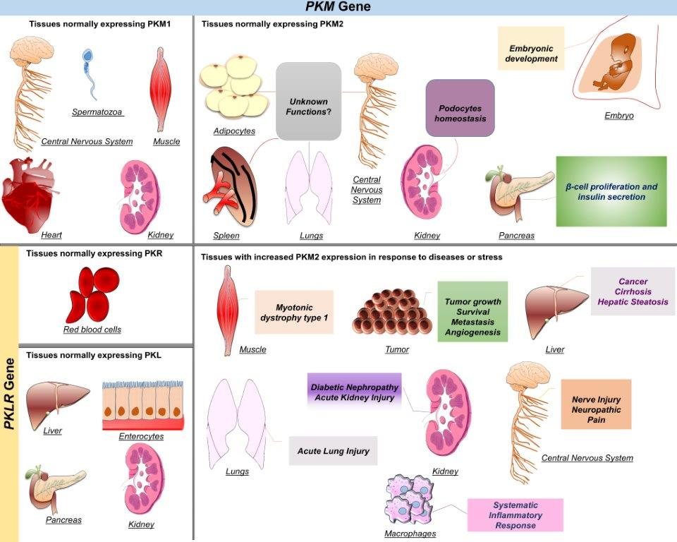
Figure 1. Tissue distribution of PK isoforms and the role of PKM2 in health and disease. Mammalian pyruvate kinase has four isoforms transcribed by two different genes. PKL and PKR are both products of the PKLR gene, while PKM1 and PKM2 are products of the PKM gene. PKL is predominantly expressed in the liver and at lower levels in the pancreas, kidneys, and enterocytes. PKR is expressed in erythrocytes only. PKM1 is known to be expressed in muscle, mature spermatozoa, central nervous system, heart, and kidneys. PKM2 is the predominant isoform expressed during embryogenesis. It is also expressed in proliferative cells, and several healthy differentiated tissues, including pancreatic islets, adipose tissue, brain, kidneys, lungs, and spleen. However, the precise function of PKM2 in these tissues is largely unexplored. In addition, PKM2 is expressed in most tumors and within the liver under abnormal conditions such as cirrhosis, and hepatic steatosis. In activated macrophages, PKM2 expression is upregulated and contributes to sepsis and other inflammatory disorders. In tumors, PKM2 expression enhances aerobic glycolysis that provides cancer cells with growth advantages and has been associated with poor clinical outcomes.
Figure 2. Post-translational regulation of PKM2 and its role in redox homeostasis. PKM2 catalyzes the generation of pyruvate and ATP from phosphoenolpyruvate (PEP) and ADP. PKM2 enzymatic function is partially controlled by upstream glycolytic metabolites. Fructose 1.6-bisphosphate (FBP) is considered as an allosteric activator that interacts with PKM2 to enhance its active configuration, while ATP binds to the allosteric site to inhibit its catalytic activity. Post-translational modifications of PKM2 by oxidation, hydroxylation, S-nitrosylation, acetylation, methylation, succinylation/desuccinylation, or phosphorylation/dephosphorylation regulate its activity and subcellular localization. In addition, exposure to oxidants such as NO and H₂O₂ reduces its enzymatic activity and drive glycolytic metabolites toward the pentose phosphate pathway (PPP) to generate NADPH and reestablish redox homeostasis. EGFR/ERK2-dependent PKM2 phosphorylation or oxidation of the sulfhydryl group of cysteine-358 (C-358) inhibited PKM2, and it was proposed to promote PKM2 nuclear translocation. Additionally, endothelial NO synthase (eNOS) can directly interact with PKM2 leading to its S-nitrosylation at C-358 and inhibition of its enzymatic activity. Likewise, SIRT5 mediates the desuccinylation of PKM2 at lysine (K-498) and the subsequent decrease in its enzymatic activity. In contrast, AKAR1A1 inhibits the S-nitrosylation of PKM2 at cysteines-423/424 (C-423/424). The S-nitrosylation of PKM2 at C-423/424 was reported to inhibit PKM2 enzymatic activity. In addition, several kinases were demonstrated to phosphorylate PKM2 at various sites, and differentially regulate its activity and subcellular location. Oncogenic growth factors such as IGF-1, EGFR, and bFGF promote PKM2 phosphorylation in a mechanism mediated by several kinases including AKT1, ERK1/2, and JAK2. Phosphorylation of PKM2 at tyrosine-105 (Y-105) inhibits its catalytic activity by altering the tetramer and the dimer states that promote aerobic glycolysis. Similarly, the phosphorylation of PKM2 at serine-37 (S-37) and threonine-454 (T-454) induces the Warburg effect by enhancing the nuclear accumulation of PKM2. Likewise, acetylation of PKM2 at lysine-433 (K-433) enhances its nuclear localization, while its de-acetylation by SIRT6 causes PKM2 to be exported from the nucleus. In addition, methylation of PKM2 by CARM1 has been reported to be specific to the dimeric form and occurs at several arginine sites including R-445, 447, and 455. Furthermore, PKM2-hydroxylation at prolines-403/408 (P-403/408) by PHD3 was reported to promote its interaction with HIF-1α and its nuclear translocation.

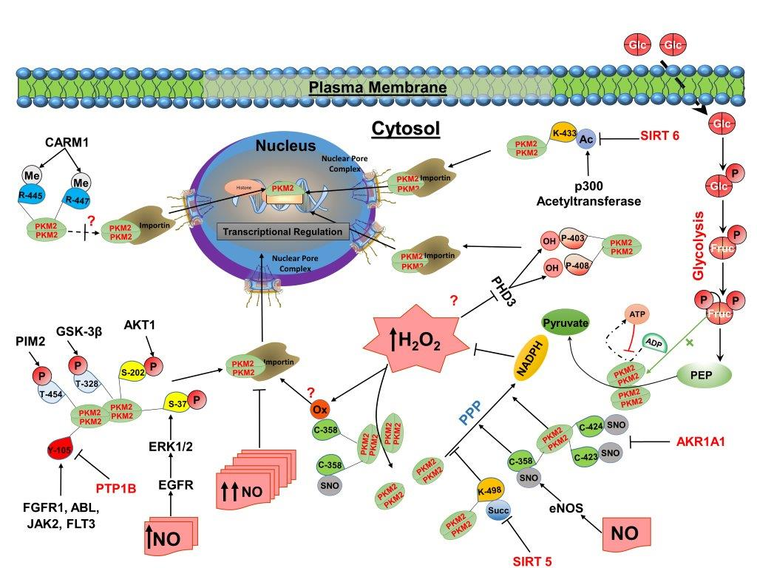
Figure 2. Continued

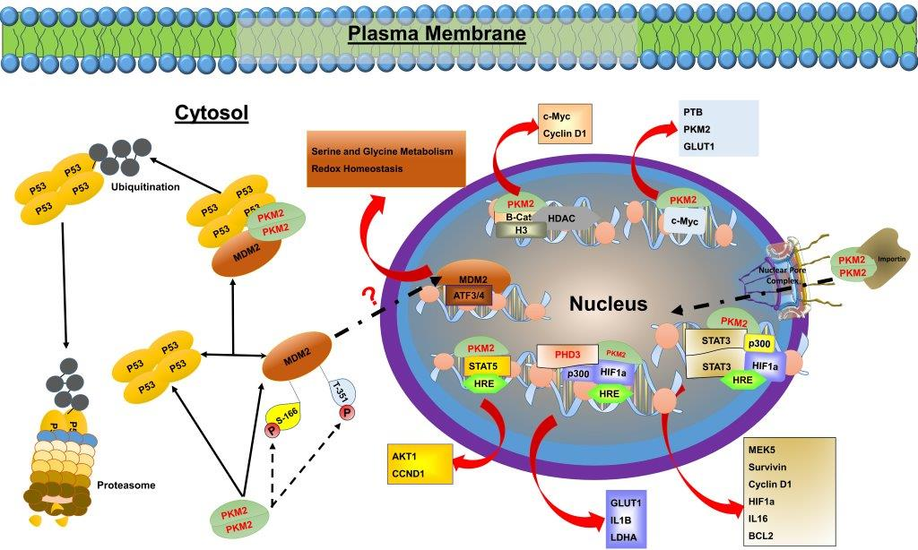
Figure 3. Direct and indirect regulation of gene expression by PKM2. In addition to its enzymatic role, PKM2 exhibits a role in the regulation of gene expression. In its dimeric form, PKM2 can translocate to the nucleus where it interacts with HIF-1a, c-MYC, STAT3, STAT5, β-Catenin, and many others, to regulate the expression of numerous proteins involved in complex biological and biochemical processes. In addition, PKM2 can directly bind to P53 and MDM2, which leads to P53 ubiquitination and degradation. Recent studies have shown that PKM2-MDM2 interaction leads to increased MDM2 phosphorylation at serine-166 (S-166) and threonine-351 (T-351) sites and prevents its recruitment to nuclear chromatin [205]. However, these findings contradict previous reports showing that MDM2 phosphorylation at S-166 is essential for its nuclear translocation [98] and its role in regulating the expression of genes involved in serine-glycine metabolism, and redox homeostasis [97].

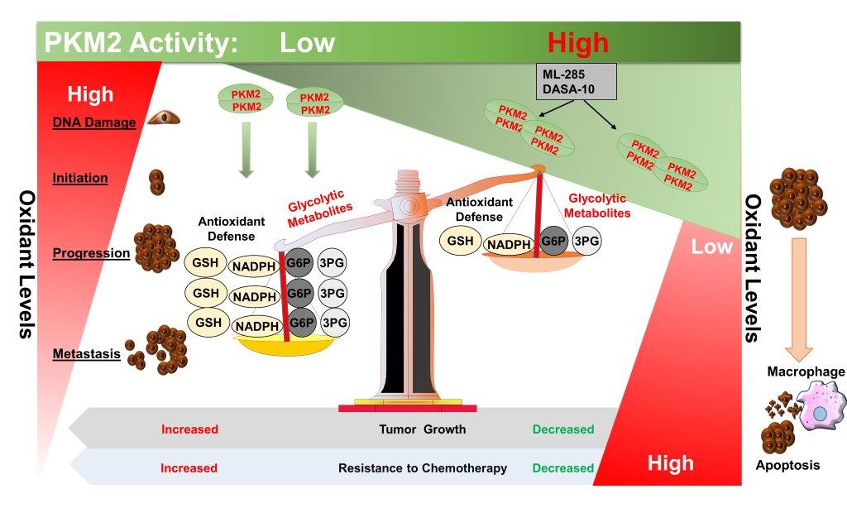
Figure 4. PKM2 regulation of cancer redox homeostasis. At early stages of cancer, increased oxidant levels play a critical role in promoting cancer initiation and development. Once the tumor is formed, cancer cells adapt a mechanism to reduce oxidant levels and to prevent the cells against oxidant-induced cell death. PKM2 enzymatic activity plays an important role in this antioxidant defense. The increase in oxidant levels leads to a decrease in PKM2 enzymatic activity and accumulation of the glycolytic metabolites; glucose-6-phosphate (G6P) and 3-phosphoglycerate (3PG), which serve as precursors for the pentose phosphate and the serine-glycine biosynthetic pathways, respectively. This result in increased production of reduced equivalents such as NADPH, and glutathione (GSH) to amplify the antioxidant defense and promote tumor growth and resistance to chemotherapy. PKM2 activators such as ML-285 and DASA-10 sensitize cancer cells to oxidant-induced cell death, in part, through a decrease in the levels of glycolytic metabolites and the overall antioxidant defense.

Table 1. Post-translational modifications of PKM2 and their disease-associated physiological relevance.
Modification | Specific site | Stimuli | Regulators | Effects | Proposed Function | Reference
Phosphorylation | S-202 | IGF-1 | AKT1 | Promotes nuclear translocation | Nuclear PKM2 interacts with STAT5 to induce cellular proliferation | [62]
Phosphorylation | S-37 | EGF | ERK1/2 | Promotes nuclear translocation | Nuclear PKM2 induces C–Myc expression to upregulate GLUT1, LADH, and PTB expression | [32]
Phosphorylation | T-454 |  | PIM2 | Increases PKM2 protein stability  Reduces PKM2 enzymatic activity | Promotes PKM2 co-activator activity on HIF-1α and β-catenin  Lowers mitochondrial respiration  Promotes cancer cell proliferation | [206]
Phosphorylation | T-328 |  | GSK-3β  HSP90 |  | Increases glycolysis  Lowers the apoptotic rate  Promotes tumor growth | [55]

Table 1. Continued
Modification | Specific site | Stimuli | Regulators | Effects | Proposed Function | Reference
 | Y-105 | bFGF | FGFR1  ABL  JAK2  FLT3 | Inhibits the formation of the active tetramer Decreases PKM2 enzymatic activity | Increases cancer cell proliferation, lactate production, and decreases oxidative phosphorylation | [54]
De-phosphorylation | Y-105 | Insulin | PTP1B | Increases PKM2 enzymatic activity | Contributes to glycemic control | [207]
De-phosphorylation | Y | Morin (LMW-PTP inhibitor) | LMW-PTP | Inhibits PKM2 nuclear translocation  Increases PKM2 enzymatic activity | Reduces glycolysis and enhances oxidative metabolism | [63]

Table 1. Continued
Modification | Specific site | Stimuli | Regulators | Effects | Proposed Function | Reference
SUMOylation | K-336 |  | SUMO1 | Increases PKM2 protein stability | Promotes glycolysis  Promotes PKM2 cofactor functions  Promotes cancer cells proliferation | [208]
Acetylation | K-305 | Trichostatin A (HDAC I & II inhibitor)  Nicotinamide  Glucose | PCAF | Reduces PKM2 enzymatic activity  Promotes PKM2 degradation | Promotes glycolysis  Promotes cellular proliferation and tumorigenesis | [52]
Acetylation | K-433 | Trichostatin A  Nicotinamide | p300 acetyltransferase | Reduces PKM2 enzymatic activity  Promotes PKM2 nuclear translocation | Promotes cell proliferation and tumorigenesis | [51]

Table 1. Continued
Modification | Specific site | Stimuli | Regulators | Effects | Proposed Function | Reference
Deacetylation | K-433 | Starvation | SIRT6 | Increases PKM2 nuclear export  Reduces PKM2 cofactor function | Reduces cancer cell proliferation and invasiveness | [64]
Oxidation | C-358 | Diamide  H₂O₂ | ROS | Promotes the dissociation of the tetramer form to reduce PKM2 enzymatic activity | Lowers ROS production  Enhances tumor growth | [50]
Oxidation | C-358 | Glucose |  | Reduces PKM2 enzymatic activity | Contributes to DN pathogenesis | [204]

Table 1. Continued
Modification | Specific site | Stimuli | Regulators | Effects | Proposed Function | Reference
Hydroxylation | P-403  P-408 |  | PHD3 | Promotes PKM2 nuclear translocation  Promotes HIF-1α transcriptional activity | Promotes the Warburg effect  Increases lactate production | [66]
S-nitrosylation | C-423  C-424 | NO | AKR1A1  (negative regulator) | Inhibits PKM2 tetramer formation | Increases glycolytic metabolites accumulation  Promotes antioxidants defense  Protects against AKI | [58]
S-nitrosylation | C-358 | NO | eNOS | Reduces PKM2 enzymatic activity | Amplifies the antioxidants defense  Delay atherosclerosis development | [59]

Table 1. Continued
Modification | Specific site | Stimuli | Regulators | Effects | Proposed Function | Reference
Methylation | R-445  R-447 | S-Adenosyl-methionine | CARM1  PRMT6 | Promotes PKM2 tetramer formation to increase PKM2 enzymatic activity | Reduces cellular proliferation | [65]
Methylation | R-445  R-447  R-455 | S-Adenosyl-methionine | CARM1 | Has little effect on PKM2 enzymatic activity  Decreases InsP3R1 & InsP3R3 expression | Promotes breast cancer cells proliferation  Reduces mitochondrial respiration | [53]
Succinylation | K-498 | Suramin (SIRT5 inhibitor) | SIRT5 (negative regulator) | Increases PKM2 activity | Reduces NADPH generation  Lowers cellular proliferation and tumor growth | [60]

Table 1. Continued
Modification | Specific site | Stimuli | Regulators | Effects | Proposed Function | Reference
 | K-311 | succinyl-CoA | SIRT5 (negative regulator) | Decreases PKM2 enzymatic activity  Promotes PKM2 nuclear translocation  Promotes PKM2 kinase activity | Promotes pro-inflammatory cytokines  Increases the susceptibility to colitis | [172]

Chapter II: PKM2 Deficiency in Podocyte Enhances Podocyte Differentiation and Alleviates LPS induced Albuminuria

Abstract
Glomerular diseases are major health issues associated with the incidence of end-stage renal diseases. In most glomerular diseases, damage to podocytes presents an early sign of renal diseases that are manifested by proteinuria. Once damaged, podocytes lose their fully differentiated capacity and function, leading to destruction in the glomerular basement membrane. Therefore, preserving podocyte differentiation is crucial for preventing the progression of proteinuria and glomerular injury. Recently, pyruvate kinase M2 (PKM2) has emerged as a potential new player in several renal diseases. However, its role in podocyte differentiation and homeostasis is largely unexplored. Thus, the objective of the current study is to examine the role of PKM2 in podocyte differentiation and homeostasis. To that end, we generated a murine podocyte cell line deficient in PKM2 using the lentivirus shRNA technology and assessed the effects of PKM2 deficiency on key signaling pathways that were demonstrated to regulate podocyte differentiation. We demonstrate that PKM2 deficiency improved podocyte differentiation as evidence by increased expression of nephrin, synaptopodin, and podocin. Additionally, PKM2 depletion resulted in the activation of the mTOR pathway, increased autophagy and autolysosome formation. Mechanistically, the effects of PKM2 deficiency on podocyte differentiation were mediated, at least in part, through the activation of AMPK and inhibition of AKT signaling pathways. Indeed, prolonged pharmacological inhibition of AKT and activation of AMPK recapitulated the effects of PKM2 deficiency on autophagy induction and podocyte differentiation. Notably, PKM2 deficiency attenuated LPS induced albumin permeability, which was reversed upon inhibition of AMPK, mTORC1, and autophagy. Collectively, these data demonstrate a novel role of PKM2 in podocyte differentiation and suggest that PKM2 may serve as a potential therapeutic target to preserve podocyte integrity in various glomerular diseases.

2.1. Introduction
The kidney is well known for maintaining biological homeostasis by performing various physiological functions, including electrolytes balance [1], blood pressure regulation [2], glycemic control [3], and waste filtration [4]. The kidney has intricate anatomical features that enable body fluids to pass through distinct filtration barriers, which selectively allow the secretion of waste in the urine. These filtration barriers are composed of fenestrated endothelium cells, glomerular basement membrane (GBM), and epithelial cells formally termed as “podocytes” [5]. Those epithelial cells contain foot projections extending from their cell body to wrap the glomerular capillaries [6] and adhere podocytes to the GBM [7]. Indeed, podocytes synthesize components required for the structural and physiological function of the GBM [8]. Moreover, podocytes express proteins such as nephrin [9], which connect them to neighboring podocytes to create a 30-40 nm slit diaphragm that provides size and charge selective barrier permitting water and solutes to pass into the urinary ultrafiltrate; while preventing the loss of plasma proteins such as albumin [10]. Therefore, podocytes' homeostasis and dynamics are vital for efficient glomerular filtration and overall kidney function.
Under normal physiological conditions, podocytes exist in terminally differentiated states in order to maintain the integrity of a healthy slit diaphragm [6, 11]. The significance of podocyte differentiation on renal homeostasis and function is evident in a broad spectrum of glomerular diseases. In response to stressors, podocytes tend to dedifferentiate and detach from the GBM, presenting altered glomerular morphology and inefficient filtration [6]. Consequently, the dedifferentiation of podocytes leads to alteration of the podocyte’s cytoskeleton, causing foot projections effacement and proteinuria [11]. Inherited genetic mutations of podocyte differentiation proteins, as observed in focal segmental glomerulosclerosis (FSGS) [12] and minimal change disease (MCD) [13], lead to dysregulated podocyte function and proteinuria. For instance, multiple points and missense mutations of Actinin 4 have been identified. These mutations result in dysregulated Actinin 4 activity that alter its binding affinity to cytoskeleton protein [12]. Similarly, in immune-mediated glomerular diseases, podocytes exhibit a loss of terminally differentiated characteristics as evidence by alteration in podocytes morphology [14], concomitant with reduced levels of differentiation markers such as nephrin and podocin [15]. Because podocytes exist in terminally differentiated states that render them incapable of regeneration [6], maintaining podocytes' differentiation and preservation of cellular homeostasis in response to stressors is a viable therapeutic approach to a wide range of kidney diseases.
Pyruvate kinase M2 (PKM2), an isoform of the pyruvate kinase family, plays a crucial role in controlling cell metabolism by catalyzing the last and rate-limiting step of glycolysis. PKM2 and other PK isoforms (M1, L, and R) mediate phosphoenolpyruvate conversion into pyruvate. Unlike other PK isoforms, the structural configuration of PKM2 is essential for its enzymatic and biological function. The tetrameric PKM2 has been shown to exhibit higher enzymatic activity compared to dimeric PKM2 [16]. However, dimeric PKM2 was shown to translocate to the nucleus where it acts as a coactivator or repressor for a plethora of genes involved in cell growth, survival and metabolism [17, 18]. In addition, dimeric PKM2 acts as a kinase to phosphorylate, and thereby, alter the activity of proteins essential for cell proliferation [19] and differentiation [20]. Thus, PKM2 may perform other biological functions independent from its classic metabolic role.
In podocytes, PKM2 is expressed under normal and abnormal physiological conditions [21]. However, few reports examining the role of PKM2 in podocytes exist. Recently, emerging evidence has linked PKM2 to various glomerular and renal diseases. The deletion of PKM2 in podocytes exacerbated STZ induced diabetic nephropathy [21], while the removal of PKM2 in proximal tubules was protective against ischemic reperfusion (IR) induced acute kidney injury [22]. Moreover, the inhibition of PKM2 in renal tubular cells enhanced podocytes differentiation and ameliorated fibrosis [23]. Nevertheless, PKM2 has been shown to regulate critical processes and protein signaling required for preserving cellular homeostasis and development. For instance, PKM2 was reported to alter the activity of autophagy [24], mTOR signaling [25], and AMPK [26]. Potentially, all of these signalings play a vital role in maintaining podocyte homeostasis and development [27-29]. Therefore, in this study, we investigated the role of PKM2 on podocyte differentiation and homeostasis and highlighted its physiological relevance by using PKM2 knockdown and rescued murine podocyte cell lines. We further examined the potential contribution of PKM2 reduction on preserving podocyte's function after lipopolysaccharides (LPS) challenge.

2.2. Methods
Reagents: Unless otherwise specified, all chemicals used in the study were purchased from Sigma‐Aldrich (St. Louis, MO, USA). However, RPMI164 media, penicillin-streptomycin, FBS, trypsin, and TRIzol reagent were purchased from Invitrogen (Carlsbad, CA, USA), while hygromycin, PMSF, and NaF were obtained from Research Products International Corp. (RPI Corp.; Mount Prospect, IL). The bicinchoninic acid assay kit (BCA) was purchased from Pierce Chemical (Dallas, TX, USA). In Table 2, we summarized the producers, dilutions, and origins of both primary and secondary antibodies. In Table 3, we listed forward and reversed primers used for the quantitative real-time polymerase chain reaction (qRT-PCR) and was obtained from Fisher Scientific (Hampton, NH, USA). Reagents and compounds used to inhibit or activate the indicated pathways were purchased from Millipore-Sigma (Burlington, MA, USA).
Cell Culture and Conditions: The E11 murine podocyte cell line was obtained from Cell Lines Service (Eppelheim, Germany), and PKM2 knockdown was conducted using three distinct hairpins purchased from GeneCopoeia (Inc.; MD, USA). We used the Lentivirus packaging system obtained from GeneCopoeia to generate Lentiviruses in HEK293FT cells (GeneCopoeia), following the manufacturer’s instructions, and then applied to transfect original E11 cells. We selected PKM2 knockdown cells with 200 μg/ml of hygromycin. To eliminate any off-target results, we reconstituted PKM2 deficient cells with particles containing overexpressed human wild-type PKM2 and used 400 µg/ml of Geneticin (G418) to select PKM2 rescued cells for 21 d. All cells were cultured at a 33ºC incubator (10% CO₂) using RPMI164 media containing 10% FBS, 2 mM of Glutamax, and 1 mM of sodium pyruvate. Once the cells reached 100% confluence level, we moved cells to a 37ºC incubator (10% CO₂) and treated them with the indicated compounds or DMSO as vehicle control for two weeks. Media containing freshly prepared compounds or DMSO was changed once every 3 d. All experiments were conducted on cells between passages 3 and 8. Once stated, cells were treated with the indicated concentrations of LPS for the indicated time.
Protein Extraction and Immunoblots: Radioimmunoprecipitation assay (RIPA) buffer containing freshly made proteases and phosphatases inhibitors, 1 mM of PMSF, and 15 mM of NaF, was used to lyse all cells. Cell Lysates were then sonicated twice on ice, 10 seconds each, and centrifuged at 15000g at 4°C for 10 min. The BCA assay kit was used to quantify protein concentration, and 10 μg of proteins were resolved in electrophoresis and transferred to PVDF membranes. Next, we blocked membranes for 1 h at room temperature using 5% BSA blocking buffer (5% BSA dissolved in TBST containing 0.1% tween; pH: 7.4). After blocking, membranes were washed once with TBST for 5 min and incubated for 1 h with the specified primary antibodies at room temperature. Membranes were washed 3 times using TBST, 5 min per cycle, then incubated with the corresponding secondary antibody for another hour at room temperature. After four wash cycles, 15 min per cycle, Luminata™ Western Chemiluminescent HRP substrate was used to visualize protein bands. Proteins band's intensity was quantified using Fluorchem software (Alpha Innotech Corp., CA, USA).
RNA Extraction and Gene Expressions: RNA isolation and extraction were described in detail previously [30]. Briefly, Trizaol reagent was used to extract RNA from cells, then pelleted RNA was dissolved in RNase-free water, following the manufacturer's guidelines. NanoDrop® ND1000 spectrophotometer system (Thermo Fisher Scientific Inc., Piscataway, NJ) was used to quantify RNA, then iScript™ cDNA Synthesis Kit (BioRad, CA, USA) was used on 10 ug of RNA to sunthesize cDNA. Gene expression was conducted using qRT-PCR, SsoAdvanced™ Universal SYBR® Green Supermix (BioRad), and BioRad CFX96™ instrument, as previously described [31]. The relative abundance of mRNA of all genes was determined per the ∆∆CT method using their corresponding primers (Table 3). Gene expression was normalized to the tata-box binding protein (Tbp).
Albumin excretion assay: Albumin was measured using the BCG Albumin Assay Kit obtained from Sigma‐Aldrich (St. Louis, MO). Briefly, cells were treated with LPS (5 μg/ml) using phenol red and serum-free media for 12 h. Then, media was collected and clarified at 15,000 g at 4°C. The protein concentration was measured following the manufacturer's instructions.

Cell cycle analysis: Cell cycle assessment was conducted as described previously [32] with minor alterations. Briefly, an exact number of cells (0.5 X 106) were trypsinized, washed two times with cold PBS, and 70% ethanol overnight at 4°C. Next, cells were washed two times using cold PBS, treated with RNase solution (100 U/ml in PBS), and incubated at 37°C for 15 min prior to staining the cells with propidium iodide (10 μg/ml dissolved in PBS) for 12 h at 4°C. An exact cell number (5000) was determined by the Guava® easyCyte TM Flow Cytometer, and the fluorescence intensity was measured by the InCyte™ and Guava Suite Software package.
Cell proliferation Assay: Sulforhodamine B (Millipore-Sigma) was used to evaluate cell proliferation as described previously [33] with minor changes. In brief, an exact number of cells (0.5 X 106) were seeded using 6 well plates and incubated at 33°C in 10% CO₂. At the indicated time duration, cells were washed two times with cold PBS and fixed by using 17% trichloroacetic acid dissolved in PBS overnight at 4°C. Then, cells were stained for 10 min at room temperature using 0.4% SRB in 1% acetic acid. Running tap water was used to remove excessive SRB stain, and the plates were air-dried for a minimum of 6 h before extracting the SRB using 10 mM Tris buffer (pH 9.0). The amount of intracellular protein was measured by the Synergy™ HTX Multi-Mode microplate reader (BioTek Instruments, Inc. Winooski, VT), and the reading was adjusted using a wavelength of 540 nm. Cells' relative survival rates were quantified through normalizing the absorbance for the indicated condition to the absorbance detected in M2R cells at 12 h post-seeding and presented as a fold change.
Statistical Analyses: Statistical analyses were conducted using JMP data analysis software (SAS Institute Inc., Cary, NC, USA), and an unpaired heteroscedastic two‐tail Student's t test was conducted for two groups comparison, while ANOVA (with post hoc analysis) was conducted for multi-groups comparison. Data are shown as means + standard error of the mean (SEM). The level of significance was set at P ≤ 0.05, while P ≤ 0.01 was set for highly significant data. Single symbol (*) refers to P ≤ 0.05, and double symbols (**) refer to P ≤ 0.01.

2.3. Results
Changes in pyruvate kinase M2 expression in differentiating podocytes. During differentiation, podocytes have been suggested to exhibit increased glycolytic profile under normal physiological conditions [34] and switch from oxidative phosphorylation to glycolysis under abnormal conditions [35]. Therefore, we sought to examine PKM2 and M1 expression in differentiating murine podocytes. Thus, we differentiated E11 podocytes for 15 days and evaluated the expression of PKM2 at several days of differentiation, particularly day 1, day 5, day 10, and day 15. Notably, PKM2 protein level increased significantly during differentiation, concomitant with increased differentiation markers nephrin, podocin, and synaptopodin (Fig. 5A-B). Supportively, these observations have been confirmed at the mRNA levels, where PKM2 expression increased significantly during differentiation (Fig. 5C). However, we did not observe changes in PKM1 expression or protein level during differentiation. These results indicate that PKM2, but not PKM1, might play a role in the process of podocyte differentiation.
Increased PKM2 expression correlates with changes in autophagy and mTOR signaling. Recent studies have proposed autophagy [29] and mTOR signaling [36] to play a potential role in promoting podocyte differentiation. Thus, we investigated the expression pattern of key components involved in each pathway. Notably, the expression of autophagy markers beclin-1, microtubule-associated protein 1A/1B-light chain 3 LC3, and autophagy-related proteins 5 & 7 (ATG5 & 7) increased significantly during differentiation, indicating that autophagy is upregulated and might be involved in podocytes maturation (Fig. 6A). Next, we examined upstream kinases known to regulate the autophagic machinery. Remarkably, the phosphorylation of AMPK at threonine 172, an activation site, increased during differentiation. Moreover, mTORC1 phosphorylation at serine 2448 increased at day 5 and sustained high phosphorylation level at final differentiation stages (Fig. 6B). To further confirm this observation, we immunoblotted for mTORC1 downstream targets. Subsequently, the phosphorylation of P70S6K, E-BP1, and S6 increased significantly, proving that mTORC1 is indeed activated in differentiated podocytes. Collectively, these experiments demonstrate an increase in autophagy, AMPK phosphorylation, and mTORC1 signaling during podocytes maturation, which correlates with changes in PKM2 expression.
PKM2 deficiency enhances podocytes differentiation and promotes the induction of autophagy and mTOR signaling. To evaluate the potential role of PKM2 in differentiating podocytes, we generated a stable podocyte cell line deficient in PKM2 (M2KD) and scramble (SCR) shRNA as control (SCR) by using the lentiviral shRNA technology. However, to eliminate undesired experimental procedure effects or generate inaccurate results, we reconstituted PKM2 knockdown cells with a human shRNA-resistant wild-type PKM2 (M2R). Next, we evaluated the expression of PKM2 by immunoblot and qRT-PCR. As shown in figure 7A, M2KD cells exhibited low PKM2 levels compared to original, scramble, and PKM2 rescued cells (M2R). Importantly, PKM2 expression was maintained low at late differentiation stages. However, the expression of PKM1, the other spliced isoform of the PKM gene, was not affected by PKM2 knockdown. In addition, using an antibody recognizing both PKM isoforms showed a decrease in total PKM1 and 2 levels, further proving the efficiency of PKM2 knockdown. In line with these results, similar data has been recapitulated at the mRNA levels (Fig. 7B). However, the expression pattern and level of PKM2 and nephrin in M2R podocytes were comparable to SCR and E11 original cells. Thereby, we used M2R cells as a control for the remaining experiments. Together, these results show that the generated cell lines are suitable in vitro models for studying the contribution of PKM2 to podocyte differentiation and homeostasis.
A plethora of studies have emerged showing a potential role of PKM2 in regulating the proliferation of various cell types [37, 38]. However, the role of PKM2 in podocyte proliferation is yet to be determined. Therefore, we conducted a proliferation assay using the sulforhodamine B method to examine the proliferation rate in control and M2KD cells. Both cell lines exhibited an increase in cell survival over the course of 12, 36, and 48 hours (Fig. 7C). Furthermore, the cell survival of control and M2KD cells were comparable, indicating that both cell lines proliferated at the same rate. To confirm this observation, we used propidium iodide staining of DNA content to evaluate the cell cycle progression. Apparently, we did not observe any alteration in DNA content of the cell cycle phases between control and PKM2 deficient cells (Fig. 7D). Together, these data show that PKM2 deficiency does not alter podocyte proliferation.
To evaluate the role of PKM2 in podocytes, we differentiated control (M2R) and M2KD cells for 15 d, as described in the method section. Next, we immunoblotted for PKM2 and podocyte differentiation markers at different days of differentiation. Consistent with the previous observation in original podocytes, control cells exhibited increased PKM2 levels throughout the differentiation process (Fig. 8A). However, PKM1 level was slightly decreased in fully differentiated control cells but did not reach statistical significance level. Moreover, in knockdown cells, PKM2 is almost abolished and sustained lower level during differentiation, while PKM1 level was comparable to control cells. Remarkably, the knockdown of PKM2 enhanced podocytes differentiation, as evidence by increased nephrin, podocin, and synaptopodin levels. Similarly, the deficiency of PKM2 increased the expression of Nphs1, Nphs2, and Synapo, which encodes for nephrin, podocin, and synaptopodin, respectively (Fig. 8B). These studies demonstrate that PKM2 deficiency is associated with improved podocytes differentiation capacity.
Recent studies have shown that PKM2 regulates autophagy [24] and mTOR signaling [25], which may play a potential role in promoting podocyte differentiation. Thus, we examined the contribution of PKM2 to podocytes autophagy using immunoblotting and acridine orange staining methods. The acridine orange staining, a green fluorophore trapped in acidic compartments and shift toward red fluorescence in an acidic environment, is a suitable alternative method to evaluate autophagy. The increase in red to green ratio is a sign of elevated acidic compartments volume, thereby indicating increased autophagic flux [39]. However, during differentiation, autophagy is elevated in control cells as evidenced by increased beclin-1, LC3, ATG5, and ATG7, concomitant with increased AMPK phosphorylation (Fig. 8C). Subsequently, the knockdown of PKM2 further increased AMPK phosphorylation and enhanced autophagy compared to controls. Consistent with the immunoblotting data, the acridine orange staining revealed induction of autophagy in M2R podocytes during differentiation, and the depletion of PKM2 further enhanced autophagy in fully differentiated cells (Fig. 8D). Since autophagy is induced in M2KD cells, we speculated that autophagy might be regulated by the mTOR signaling. Therefore, we immunoblotted for key components in the mTOR pathway. Subsequently, the phosphorylation of mTORC1 and its downstream target P70S6K, E-BP1, and S6 were increased during the differentiation of control cells (Fig. 8E). However, the KD cells exhibited a higher phosphorylation level of mTOR signaling than controls, indicating that PKM2 deficiency enhanced mTORC1 activity in differentiating podocytes. Collectively, these studies show that PKM2 deficiency enhances podocytes differentiation, autophagy, AMPK phosphorylation, and mTORC1 activity.
The effects of PKM2 on differentiation are mediated through the regulation of autophagy, mTOR, and AMPK signaling. To decipher the molecular mechanism mediating the beneficial effect of PKM2 depletion and to confirm the role of autophagy, AMPK, and mTOR signaling on podocyte differentiation, we used pharmaceutical compounds to inhibit or activate each pathway. Thus, M2R and M2KD podocytes were treated with freshly prepared compounds on the first day of differentiation. The media was changed once each three days with newly prepared compounds for 15 days, as described in detail in the method section. Since autophagy was suggested to promote podocytes differentiation [29], we hypothesized that the deficiency of PKM2 enhanced podocyte differentiation partially through the upregulation of autophagy. To test this hypothesis, we treated cells with DBeQ and STF-62247, which inhibit and activate autophagy, respectively. Indeed, DBeQ inhibited autophagy in both cell lines, as evidence by a reduction in autophagy markers (Fig. 9A). This observation was further confirmed with the acridine orange staining (Fig. 9B). Subsequently, inhibiting autophagy abolished the effect of PKM2 deficiency on promoting podocyte differentiation and impaired the differentiation of M2R podocytes. Supportively, activating autophagy increased nephrin and podocin levels in M2R controls and notably enhanced their expression in PKM2 deficient cells (Fig. 9C). These studies together indicate that PKM2 deficiency enhanced podocytes differentiation potentially through the upregulation of autophagy.
Protein kinase B or Akt has been long recognized for its role in suppressing autophagy [40]. Recently, PKM2 was shown to regulate the phosphorylation and subsequent activation of AKT [24]. Accordingly, AKT may provide a molecular link between PKM2 and autophagy. Thus, we examined the phosphorylation of AKT at day 1 and day 15 of differentiation. Remarkably, AKT phosphorylation was elevated in undifferentiated control cells and decreased significantly at D15. However, in PKM2 deficient cells, AKT retained low phosphorylation levels throughout the differentiation process. Notably, the decrease in AKT phosphorylation was accompanied by increased autophagy, which further confirms the regulatory effect of AKT on the autophagic machinery. However, it has been shown that autophagy, AKT, AMPK, and mTOR signaling coordinate with each other to sustain cellular homeostasis and growth [41, 42]. Therefore, we aimed to identify the direct target of PKM2 in regulating this axis. Thus, we immunoblotted for AMPK, mTOR, and AKT with or without autophagy inhibitor and activator. Subsequently, manipulating autophagy did not alter any of these signalings, indicating that autophagy is a downstream target of mTOR, AMPK, and AKT.
AMPK has been suggested to play a crucial role in preserving podocyte differentiation in diabetic nephropathy [28]. In this study, we found that PKM2 deficiency leads to increased AMPK phosphorylation. Thus, we examined the potential involvement of AMPK in mediating PKM2 action. Accordingly, we used AMPK inhibitor (BML-275) and activator (AICAR) to manipulate AMPK activity. The level of pAMPK at threonine 172 was used to validate the inhibition or activation of AMPK. Subsequently, AMPK inhibition significantly reduced pAMPK, nephrin and podocin expression in control and M2KD cells, while their level was comparable to day 1 of differentiation (Fig. 10A). Ultimately, the activation of AMPK promoted podocin expression in M2R podocytes, while the expression of nephrin was not significantly changed (Fig. 10B). In PKM2 deficient cells, the activation of AMPK significantly increased nephrin and podocin levels. These studies indicate that AMPK activation is involved in the molecular basis associated with enhanced differentiation status in PKM2 deficient cells. Next, we examined the possible role of AMPK activity on autophagy induction in podocytes. However, AMPK is a well-known positive regulator of autophagy [40]. As anticipated, inhibiting AMPK suppressed autophagy as evidenced by reducing beclin1 and LC3 in both cell lines. Moreover, AMPK inhibition reduced mTORC1 activity but did not alter AKT phosphorylation. Additionally, activating AMPK enhanced autophagy and mTORC1 signaling in both cells but did not change the phosphorylation of AKT. These studies demonstrate that AMPK is an upstream target of mTOR and autophagy but possibly downstream of AKT.
mTORC1 is a protein kinase critical for cell growth and metabolism [43]. In podocytes, maintaining mTORC1 activity might be required for podocyte development [27]. As indicated above, PKM2 deficiency promoted mTORC1 activity, concomitant with increased podocyte differentiation. Thus, we aimed to investigate the role of mTORC1 in mediating this observation. Therefore, we treated control and M2KD cells with rapamycin to inhibit mTORC1 activity. Subsequently, rapamycin treatment reduced TORC1 activity and halted podocytes' differentiation capacity (Fig. 11A). On the other hand, the activation of TORC1 using NV5138 significantly enhanced M2R podocyte differentiation, and the expression of nephrin was comparable to PKM2 deficient cells (Fig. 11B). These experiments demonstrate the role of mTORC1 in mediating PKM2 action on differentiating podocytes. Next, we examined the possible role of mTORC1 on regulating autophagy, AMPK, and AKT. Subsequently, rapamycin treatment halted beclin1 and LC3 levels in both cell lines, and their level was comparable to the early stage of differentiation, indicating that prolonged rapamycin treatment did not lead to autophagy induction. However, mTORC1 inhibition increased the phosphorylation of AMPK in M2R podocytes but not in PKM2 KD cells, while it did not significantly alter AKT phosphorylation level. Moreover, the activation of mTORC1 prompted autophagy in control and M2KD cells, but it did not change the phosphorylation of AMPK or AKT. These experiments revealed that mTORC1 is downstream of AMPK and AKT in differentiating podocytes, while its activity is required for inducing autophagy.
Recently, the genetic and pharmaceutical inhibition of PKM2 has been shown to reduce AKT phosphorylation [24, 44]. In agreement with these findings, the knockdown of PKM2 in podocytes reduced AKT phosphorylation at the first day of differentiation and sustained low AKT phosphorylation level throughout the differentiation process. Conversely, AKT phosphorylation was high in undifferentiated control podocytes but decreased significantly during differentiation. Thus, we speculated that AKT might be involved in the molecular mechanism associated with improved podocyte differentiation in PKM2 KD cells. Therefore, we treated M2KD and control podocytes with the AKT inhibitor LY294002 for 15 days and examined its effect on podocyte differentiation. Subsequently, LY294002 reduced AKT phosphorylation and significantly promoted nephrin and podocin expression in control and PKM2 deficient cells (Fig. 12A). Indeed, the activation of AKT, using SC79, impaired podocyte differentiation as evidence by the significant reduction in nephrin and podocin levels (Fig. 12B). Together, these studies reveal that PKM2 deficiency promoted podocytes differentiation by reducing AKT phosphorylation and activity.
It is well established that AKT negatively regulates AMPK [45] and autophagy [40]. However, whether the reduction in AKT phosphorylation caused by PKM2 deficiency promotes AMPK or autophagy warrant further exploration. Therefore, we immunoblotted for autophagy markers in response to AKT activator or inhibitor. Subsequently, the inhibition of AKT enhanced the expression of beclin1 and LC3 in control and PKM2 deficient cells. Moreover, the activation of AKT significantly reduced autophagy in both cell lines, further confirming the negative regulatory role of AKT on autophagy. Next, we examined the potential role of AKT on AMPK phosphorylation and mTORC1 activity. The inhibition of AKT promoted AMPK and mTORC1 phosphorylation. Supportively, activating AKT abolished the phosphorylation of AMPK and mTORC1 activity in both cell lines. These studies together show that AKT is the direct target of PKM2 and revealed that AKT act as upstream of AMPK, autophagy, and mTOR signaling.
In summary, these experiments show that PKM2 deficiency promoted podocytes differentiation through the concurrent activation of autophagy, AMPK, and mTOR signaling. It also demonstrates that PKM2 primarily targets AKT and thereby regulates the activity of AMPK, mTORC1, and the subsequent induction of autophagy. To this end, these experiments provide an insight into the molecular basis mediating the beneficial effect of PKM2 deficiency on podocyte differentiation.
PKM2 deficiency mitigates LPS induced albumin permeability. Because PKM2 deficiency improved podocyte differentiation, we aimed to examine the significance of this observation on podocyte function. Thus, we treated fully differentiated M2R and M2KD podocytes with lipopolysaccharides (LPS) for 12 h to induce podocyte injury. Next, we measured the albumin excretion level as described in the method section. As expected, LPS significantly induced albumin excretion in controls, while the depletion of PKM2 ameliorated LPS induced albumin leakage (Fig.9). Moreover, we examined the significance of the acute inhibition or activation of autophagy, AMPK, mTORC1, and AKT on podocyte function. Thus, we treated differentiated podocytes with the indicated compounds for 12 h with or without LPS. Consistent with other biochemical findings, the inhibition of autophagy, AMPK, and mTORC1 reversed the beneficial effect of PKM2 deficiency and resulted in massive albumin leakage in control and PKM2 KD podocytes. Supportively, the activation of these pathways ameliorated LPS induced albumin leakage on control cells. However, the transient inhibition of AKT exacerbated LPS induced albumin leakage, while activating AKT shows a protective effect in control podocytes. Collectively, PKM2 deficiency protected against LPS induced albumin leakage, while the inhibition of autophagy, AMPK, or mTORC1 reversed this protective effect.

2.4. Discussion
Glomerular diseases are major health concerns and among the most leading cause of end-stage renal diseases [46] caused in part by altered glomerular matrix and podocytes function [47]. Podocytes, act as a defense line against protein leakage by maintaining the integrity of the glomerular basement membrane (GBM) [48]. In most glomerular diseases, podocytes undergo epithelial to mesenchymal transition (EMT), also called podocyte dedifferentiation [48]. During the process of EMT, podocytes augment mesenchymal-like phenotypes where they alter their morphology [48] and lose the expression of differentiation proteins, including nephrin and podocin [49]. Subsequently, podocytes’ EMT disrupts the glomerular basement membrane leading to protein leakage in urine [48]. Moreover, the mutation of podocytes specific differentiation genes, in most hereditary glomerular diseases, leads to podocyte dysfunction and proteinuria [50]. Therefore, maintaining podocyte differentiation and inhibiting EMT is a potential therapeutic strategy for ameliorating or protecting against the onset of various glomerular diseases.
Recent studies demonstrated that EMT plays an integral role in mediating various renal diseases such as fibrosis [51], diabetic nephropathy [49], and glomerulonephritis [52]. Interestingly, elevated glycolysis has been shown to mediate tubular EMT and exacerbate the progression of tubulointerstitial fibrosis. The inhibition of glycolysis using SGLT2 inhibitors reduced EMT induction in proximal tubules and mitigated STZ induced renal fibrosis [53]. Moreover, elevated glycolysis in proximal tubules promotes lactate production and the subsequent induction of an acidic environment that influences the differentiation status of podocytes in renal interstitial fibrosis model. Indeed, the genetic inhibition of PKM2 in renal tubular cells enhanced podocytes differentiation and ultimately reduced proteinuria [23]. Similarly, the high glycolytic level maintains the self-renewing state of nephron progenitor cells. Indeed, inhibiting glycolysis enhanced mesenchymal to epithelial transition and promoted the differentiation of nephron progenitor cells leading to increase nephrogenesis [54]. However, the main energy metabolic source in podocytes remains controversial [55, 56]. Brinkkoetter and colleagues indicated that podocytes predominantly rely on anaerobic glycolysis, while the lack of oxidative phosphorylation did not cause podocytes dysfunction [55]. In contrast, Yuan et al. demonstrated that fully differentiated podocytes utilize both metabolic machinery and rely mainly on oxidative phosphorylation to produce energy. Supportively, the reduction of both oxidative phosphorylation and glycolysis, mediated by PKM2 knockdown, declined ATP content and eventually reduced nephrin and synaptopodin levels [56]. Nevertheless, the role of glycolytic enzymes and PKM2 in particular in regulating podocytes' EMT and homeostasis remains elusive and warrants further exploration.
In this study, we highlighted the role of PKM2 in podocytes homeostasis and differentiation in vitro. Herein, we demonstrate that PKM2 knockdown did not alter the proliferation rate of podocytes but significantly enhanced the expression of nephrin, podocin, and synaptopodin expression, all of which are key regulators of podocytes function and homeostasis. In addition, PKM2 depletion protected against lipopolysaccharides (LPS) induced albumin leakage, likely due to improved podocytes differentiation. In an attempt to delineate the molecular mechanism by which PKM2 deficiency enhances the differentiation while persevering podocyte’ function, we demonstrate that PKM2 depletion promoted the activity of mTORC1 and the induction of autophagy through an AKT/AMPK-dependent mechanism.
Autophagy is a self-degradation process by which intracellular components are delivered and degraded within the lysosome [57]. The initiation and maturation of autophagy are tightly regulated by the energy sensing-proteins such as mTORC1 [58] and AMPK [59, 60]. Both proteins act on Ulk1, a kinase required for autophagy initiation, to either inhibit or promote its activity by direct phosphorylation of multiple serine sites [60]. Autophagy is a critical process required for maintaining cellular homeostasis by recycling excessive materials to generate building blocks and energy [57]. Therefore, autophagy plays an integral role in mammalian development and cell differentiation partially through the remodeling of cellular components to promotes the synthesis of new compartments required for growth and development [61]. Indeed, fully differentiated podocytes sustain a high level of basal autophagy [62], suggesting a possible role in podocyte development and homeostasis [29]. Notably, Notch signaling mediates autophagy induction in podocytes, while inhibiting Notch signaling using DAPT (Notch blocker) impaired differentiation concomitant with a reduction in autophagy. Subsequently, enhancing autophagy alleviated DAPT induced podocyte dysfunction and nephrin loss [29]. Similarly, within human podocytes, the induction of autophagy ameliorated high glucose induced podocytes injury, nephrin loss, and insulin resistance [63]. Similar results in regards to nephrin expression were recapitulated in aldosterone induced podocytes injury model [64]. Recently, PKM2 has been shown to negatively regulates autophagy, as the knockdown of PKM2 significantly induced the autophagic process in prostate cancer cells [65]. Consistent with these findings, we reported for the first time that PKM2 contributes to podocytes autophagy. Indeed, the reduction of PKM2 enhanced autophagy leading to the improvement in podocytes differentiation and function. Moreover, we show that prolonged inhibition of autophagy impaired podocyte differentiation, while the acute inhibition exacerbated LPS induced albumin permeability. Supportively, the activation of autophagy significantly enhanced podocytes differentiation and functionality and protected podocytes from LPS induced albumin leakage. Our data demonstrated the necessary role of autophagy in podocyte development and revealed PKM2 as a potential regulator of autophagy in podocytes.
Autophagy is a crucial process necessary for organ development and tightly regulated by mTORC1 and AMPK [41, 66]. It is well established that mTORC1 and AMPK antagonize each other to regulate cellular homeostasis and growth [67]. However, it has been reported that mTORC1 and AMPK1 are concurrently activated [68]. Thus, we examined changes in both, AMPK and mTOR signaling in response to PKM2 deficiency throughout the process of podocyte differentiation. We demonstrate that the depletion of PKM2 resulted in the simultaneous activation of mTORC1 and AMPK in podocytes.
AMPK regulates various molecular mechanisms, including autophagy [69], glucose uptake, and fatty acid oxidation, to sustain energy supply and survival under deprived conditions [69]. Since AMPK coordinates cell metabolism and growth [69], it is reasonable to assume that AMPK could also regulate other aspects of cellular homeostasis, such as differentiation. Indeed, AMPK has been shown to promote intestinal epithelial differentiation and improve the gut barrier function [70]. Moreover, the genetic inhibition of LKB1 reduced the phosphorylation and activity of AMPK and exacerbated the dedifferentiation of renal tubular epithelial cells. Treating epithelial cells with A769662, an AMPK agonist, attenuated the effect of LKB1 deficiency on epithelial cell dedifferentiation, indicating that AMPK might be critical for tubular epithelial cell development [71]. Notably, AMPK is highly expressed in podocytes [72]; however, its precise role during differentiation is largely unexplored. Nevertheless, the activation of AMPK has been shown to sustain podocytes differentiation proteins in various glomerular disease models. In diabetic nephropathy, high glucose induces the loss of nephrin and podocin expression and exacerbates podocytes dysfunction. The activation of AMPK, using berberine, attenuated high glucose induced nephrin and podocin loss, leading to improved podocyte function [73]. Similarly, these data were recapitulated by using other AMPK activators [28, 74]. In addition, AMPK contributes to other cellular processes critical for podocyte homeostasis, including oxidative stress [75] and apoptosis [76]. Because AMPK is an energy-sensing protein, it is logical to assume that the activity of AMPK would be altered in response to decreased expression of glycolytic enzymes. Indeed, the downregulation of PKM2 has been shown to increase the phosphorylation of AMPK in pancreatic cancer cells [77]. Consistent with these reports, our data show that the knockdown of PKM2 resulted in significant increases in AMPK phosphorylation at threonine 172. Subsequently, the activation of AMPK is integral for mediating enhanced podocytes differentiation capacity associated with PKM2 reduction. Moreover, and in agreement with others [78], activating AMPK resulted in enhanced podocytes function and retained low albumin leakage in response to LPS. Supportively, AMPK inhibition halted podocyte differentiation and resulted in massive albumin leakage. To our knowledge, this is the first report to demonstrate the integral role of PKM2 and AMPK in differentiating podocytes. This is also the first report to demonstrate that mTORC1 mediates the beneficial effects of PKM2 deficiency and AMPK activation on podocyte differentiation.
In podocytes, mTORC1 is overactivated in diabetic humans and rodents and was suggested to contribute to the pathophysiology of diabetic nephropathy [36]. The inhibition of mTORC1, using rapamycin [79] and sirolimus [80], improved proteinuria and glomerular injury in diabetic nephropathy. However, the complete loss of mTORC1 in podocytes exacerbated proteinuria and glomerulosclerosis while reducing mTORC1 hyperactivity by deleting one raptor allele protected against STZ-induced glomerular injury. Together, these studies indicate that the tight regulation of mTOR activity is vital for podocyte homeostasis [81]. In a more recent study, mTOR has been shown to induce podocyte hypertrophy to compensate for lost podocytes in order to maintain the glomerular integrity [43]. Moreover, mTORC1 induced podocyte hypertrophy was suggested to play a critical role in coping with the increased glomerular surface area during development [36]. Nevertheless, mTORC1 not only regulates podocyte size but also regulates cytoskeleton structure and differentiation proteins. Although the transient inhibition of mTORC1 may exert beneficial effects, the prolonged suppression of mTORC1 by rapamycin significantly reduced nephrin expression [27]. Recently, PKM2 has been shown to activate mTORC1 in cancer cells [25], while its role in non-cancerous cells, including podocytes, remains elusive. Herein, we show that the knockdown of PKM2 promoted the phosphorylation of mTORC1 and its downstream target leading to the subsequent increase in nephrin and synaptopodin expression. Moreover, and in agreement with Vollenbröker et al. findings [27], the prolonged inhibition of mTORC1 using rapamycin impaired podocyte differentiation. However, while rapamycin treatment has shown a beneficial effect against proteinuria in diabetic nephropathy [82], it has been demonstrated to ameliorate proteinuria in membranous nephropathy [83]. In this study, we show that rapamycin treatment aggravated LPS induced albumin permeability. Supportively, the activation of mTORC1 enhanced the beneficial effect of PKM2 deficiency against albumin leakage. In addition, we demonstrated that increasing the activity of mTORC1 prompted podocyte differentiation, possibly due to enhanced autophagy and increased protein synthesis required for maturation. In conclusion, our data show that the beneficial effect of PKM2 knockdown on podocyte homeostasis is due in part to increased mTOR activity.
Protein kinase B, or AKT, is a kinase that performs an integral role in regulating cell growth, proliferation, and survival [84]. In renal diseases, AKT has emerged as a potential therapeutic target for various diseases. Indeed, AKT activation has been shown to promote tubular EMT in several renal fibrotic models [84-86]. However, the activation of AKT was suggested to enhance podocyte survival in response to angiotensin II [87]. Nevertheless, the role of AKT on podocyte development and EMT is largely unexplored. In this study, we found an intriguing phosphorylation pattern of AKT at serine 473, where the phosphorylation of AKT was upregulated in undifferentiated podocytes and decreased significantly in fully differentiated cells. The knockdown of PKM2 suppressed AKT phosphorylation in undifferentiated podocytes and retained low phosphorylation levels during the differentiation process. This observation is in line with Wang et al. findings showing that PKM2 promotes the phosphorylation of AKT in gastric cancer cells [24]. However, the precise mechanism on how PKM2 promotes AKT phosphorylation remains unknown. Nevertheless, in this report, we elucidated the role of AKT on podocytes differentiation. Indeed, the continuous inhibition of AKT prompted podocytes differentiation capacity, while the activation of AKT maintained the undifferentiated status of podocytes. This observation is in agreement with others showing that activation of AKT maintains the undifferentiated phenotypes of embryonic stem cells [88]. However, while the prolonged inhibition of AKT promoted podocytes differentiation, acute AKT inhibition exacerbated LPS induced albumin leakage in differentiated podocytes. Moreover, the prolonged inhibition or activation of AKT altered the activity of AMPK, mTOR and autophagy, while inhibiting these signaling did not change AKT phosphorylation. Therefore, we concluded that reduced AKT activity is the main mediator through which PKM2 deficiency promoted podocytes differentiation.
In this study, we provide evidence that PKM2 deficiency enhanced podocyte differentiation and function. We also highlighted the molecular basis mediating PKM2 deficiency action on podocyte differentiation. We hope that the data presented in this study will enhance our understanding of podocyte biology and lead to an innovative therapeutic approach that preserves podocyte integrity in glomerular diseases.

References
1. Dhondup, T. and Q. Qian, Electrolyte and Acid-Base Disorders in Chronic Kidney Disease and End-Stage Kidney Failure. Blood Purif, 2017. 43(1-3): p. 179-188.
2. Wadei, H.M. and S.C. Textor, The role of the kidney in regulating arterial blood pressure. Nat Rev Nephrol, 2012. 8(10): p. 602-9.
3. Triplitt, C.L., Understanding the kidneys' role in blood glucose regulation. Am J Manag Care, 2012. 18(1 Suppl): p. S11-6.
4. Scott, R.P. and S.E. Quaggin, Review series: The cell biology of renal filtration. J Cell Biol, 2015. 209(2): p. 199-210.
5. Bazzi, C., O. Bakoush, and L. Gesualdo, Proteinuria: from molecular to clinical applications in glomerulonephritis. Int J Nephrol, 2012. 2012: p. 424968.
6. Reiser, J. and M.M. Altintas, Podocytes. F1000Res, 2016. 5.
7. Kriz, W., et al., The podocyte's response to stress: the enigma of foot process effacement. Am J Physiol Renal Physiol, 2013. 304(4): p. F333-47.
8. Kriz, W. and B. Kaissling. CHAPTER 20@ Structural Organization of the Mammalian Kidney. 2008.
9. Ruotsalainen, V., et al., Nephrin is specifically located at the slit diaphragm of glomerular podocytes. Proc Natl Acad Sci U S A, 1999. 96(14): p. 7962-7.
10. Kawachi, H., et al., Role of podocyte slit diaphragm as a filtration barrier. Nephrology (Carlton), 2006. 11(4): p. 274-81.
11. Itoh, M., et al., The structural and functional organization of the podocyte filtration slits is regulated by Tjp1/ZO-1. PLoS One, 2014. 9(9): p. e106621.
12. Feng, D., C. DuMontier, and M.R. Pollak, The role of alpha-actinin-4 in human kidney disease. Cell Biosci, 2015. 5: p. 44.
13. Bertelli, R., et al., Molecular and Cellular Mechanisms for Proteinuria in Minimal Change Disease. Front Med (Lausanne), 2018. 5: p. 170.
14. Herman-Edelstein, M., et al., Dedifferentiation of immortalized human podocytes in response to transforming growth factor-β: a model for diabetic podocytopathy. Diabetes, 2011. 60(6): p. 1779-88.
15. Tan, X., et al., Lipopolysaccharide-induced podocyte injury is mediated by suppression of autophagy. Mol Med Rep, 2016. 14(1): p. 811-8.
16. Alquraishi, M., et al., Pyruvate kinase M2: A simple molecule with complex functions. Free Radic Biol Med, 2019. 143: p. 176-192.
17. Xia, L., et al., A Novel Role for Pyruvate Kinase M2 as a Corepressor for P53 during the DNA Damage Response in Human Tumor Cells. J Biol Chem, 2016. 291(50): p. 26138-26150.
18. Luo, W., et al., Pyruvate kinase M2 is a PHD3-stimulated coactivator for hypoxia-inducible factor 1. Cell, 2011. 145(5): p. 732-44.
19. Jiang, Y., et al., PKM2 phosphorylates MLC2 and regulates cytokinesis of tumour cells. Nat Commun, 2014. 5: p. 5566.
20. Damasceno, L.E.A., et al., PKM2 promotes Th17 cell differentiation and autoimmune inflammation by fine-tuning STAT3 activation. J Exp Med, 2020. 217(10).
21. Qi, W., et al., Pyruvate kinase M2 activation may protect against the progression of diabetic glomerular pathology and mitochondrial dysfunction. Nat Med, 2017. 23(6): p. 753-762.
22. Zhou, H.L., et al., Metabolic reprogramming by the S-nitroso-CoA reductase system protects against kidney injury. Nature, 2019. 565(7737): p. 96-100.
23. Li, M., et al., Elevated aerobic glycolysis in renal tubular epithelial cells influences the proliferation and differentiation of podocytes and promotes renal interstitial fibrosis. Eur Rev Med Pharmacol Sci, 2018. 22(16): p. 5082-5090.
24. Wang, C., et al., PKM2 promotes cell migration and inhibits autophagy by mediating PI3K/AKT activation and contributes to the malignant development of gastric cancer. Sci Rep, 2017. 7(1): p. 2886.
25. He, C.L., et al., Pyruvate Kinase M2 Activates mTORC1 by Phosphorylating AKT1S1. Sci Rep, 2016. 6: p. 21524.
26. Prakasam, G., et al., Pyruvate kinase M knockdown-induced signaling via AMP-activated protein kinase promotes mitochondrial biogenesis, autophagy, and cancer cell survival. J Biol Chem, 2017. 292(37): p. 15561-15576.
27. Vollenbröker, B., et al., mTOR regulates expression of slit diaphragm proteins and cytoskeleton structure in podocytes. Am J Physiol Renal Physiol, 2009. 296(2): p. F418-26.
28. Szrejder, M., et al., Metformin reduces TRPC6 expression through AMPK activation and modulates cytoskeleton dynamics in podocytes under diabetic conditions. Biochim Biophys Acta Mol Basis Dis, 2020. 1866(3): p. 165610.
29. Zhang, C., et al., Autophagy is involved in mouse kidney development and podocyte differentiation regulated by Notch signalling. J Cell Mol Med, 2017. 21(7): p. 1315-1328.
30. Puckett, D., et al., Zyflamend, a unique herbal blend, induces cell death and inhibits adipogenesis through the coordinated regulation of PKA and JNK. Adipocyte, 2020. 9(1): p. 454-471.
31. Bettaieb, A., et al., Effects of soluble epoxide hydrolase deficiency on acute pancreatitis in mice. PLoS One, 2014. 9(11): p. e113019.
32. Cui, Q., et al., P53-mediated cell cycle arrest and apoptosis through a caspase-3- independent, but caspase-9-dependent pathway in oridonin-treated MCF-7 human breast cancer cells. Acta Pharmacol Sin, 2007. 28(7): p. 1057-66.
33. Souslova, T. and D.A. Averill-Bates, Multidrug-resistant hela cells overexpressing MRP1 exhibit sensitivity to cell killing by hyperthermia: interactions with etoposide. Int J Radiat Oncol Biol Phys, 2004. 60(5): p. 1538-51.
34. Ozawa, S., et al., Glycolysis, but not Mitochondria, responsible for intracellular ATP distribution in cortical area of podocytes. Sci Rep, 2015. 5: p. 18575.
35. Imasawa, T., et al., High glucose repatterns human podocyte energy metabolism during differentiation and diabetic nephropathy. Faseb j, 2017. 31(1): p. 294-307.
36. Yao, Y. and K. Inoki, The role of mechanistic target of rapamycin in maintenance of glomerular epithelial cells. Curr Opin Nephrol Hypertens, 2016. 25(1): p. 28-34.
37. Zhang, Z., et al., PKM2, function and expression and regulation. Cell Biosci, 2019. 9: p. 52.
38. Zhao, X., et al., PKM2-dependent glycolysis promotes the proliferation and migration of vascular smooth muscle cells during atherosclerosis. Acta Biochim Biophys Sin (Shanghai), 2020. 52(1): p. 9-17.
39. Thomé, M.P., et al., Ratiometric analysis of Acridine Orange staining in the study of acidic organelles and autophagy. J Cell Sci, 2016. 129(24): p. 4622-4632.
40. Wang, R.C., et al., Akt-mediated regulation of autophagy and tumorigenesis through Beclin 1 phosphorylation. Science, 2012. 338(6109): p. 956-9.
41. Alers, S., et al., Role of AMPK-mTOR-Ulk1/2 in the regulation of autophagy: cross talk, shortcuts, and feedbacks. Mol Cell Biol, 2012. 32(1): p. 2-11.
42. Shaw, R.J., LKB1 and AMP-activated protein kinase control of mTOR signalling and growth. Acta Physiol (Oxf), 2009. 196(1): p. 65-80.
43. Puelles, V.G., et al., mTOR-mediated podocyte hypertrophy regulates glomerular integrity in mice and humans. JCI Insight, 2019. 4(18).
44. Tang, J.C., et al., Efficacy of Shikonin against Esophageal Cancer Cells and its possible mechanisms in vitro and in vivo. J Cancer, 2018. 9(1): p. 32-40.
45. Kovacic, S., et al., Akt activity negatively regulates phosphorylation of AMP-activated protein kinase in the heart. J Biol Chem, 2003. 278(41): p. 39422-7.
46. Woo, K.T., et al., A Global Evolutionary Trend of the Frequency of Primary Glomerulonephritis over the Past Four Decades. Kidney Dis (Basel), 2019. 5(4): p. 247-258.
47. Garg, P., A Review of Podocyte Biology. Am J Nephrol, 2018. 47 Suppl 1: p. 3-13.
48. May, C.J., M. Saleem, and G.I. Welsh, Podocyte dedifferentiation: a specialized process for a specialized cell. Front Endocrinol (Lausanne), 2014. 5: p. 148.
49. Ying, Q. and G. Wu, Molecular mechanisms involved in podocyte EMT and concomitant diabetic kidney diseases: an update. Ren Fail, 2017. 39(1): p. 474-483.
50. Gubler, M.C., Podocyte differentiation and hereditary proteinuria/nephrotic syndromes. J Am Soc Nephrol, 2003. 14 Suppl 1: p. S22-6.
51. Sheng, L. and S. Zhuang, New Insights Into the Role and Mechanism of Partial Epithelial-Mesenchymal Transition in Kidney Fibrosis. Front Physiol, 2020. 11: p. 569322.
52. Bariety, J., et al., Glomerular epithelial-mesenchymal transdifferentiation in pauci-immune crescentic glomerulonephritis. Nephrol Dial Transplant, 2003. 18(9): p. 1777-84.
53. Li, J., et al., Renal protective effects of empagliflozin via inhibition of EMT and aberrant glycolysis in proximal tubules. JCI Insight, 2020. 5(6).
54. Liu, J., et al., Regulation of Nephron Progenitor Cell Self-Renewal by Intermediary Metabolism. J Am Soc Nephrol, 2017. 28(11): p. 3323-3335.
55. Brinkkoetter, P.T., et al., Anaerobic Glycolysis Maintains the Glomerular Filtration Barrier Independent of Mitochondrial Metabolism and Dynamics. Cell Rep, 2019. 27(5): p. 1551-1566.e5.
56. Yuan, Q., et al., Role of pyruvate kinase M2-mediated metabolic reprogramming during podocyte differentiation. Cell Death Dis, 2020. 11(5): p. 355.
57. Mizushima, N. and M. Komatsu, Autophagy: renovation of cells and tissues. Cell, 2011. 147(4): p. 728-41.
58. Dossou, A.S. and A. Basu, The Emerging Roles of mTORC1 in Macromanaging Autophagy. Cancers (Basel), 2019. 11(10).
59. Jang, M., et al., AMPK contributes to autophagosome maturation and lysosomal fusion. Sci Rep, 2018. 8(1): p. 12637.
60. Kim, J., et al., AMPK and mTOR regulate autophagy through direct phosphorylation of Ulk1. Nat Cell Biol, 2011. 13(2): p. 132-41.
61. Mizushima, N. and B. Levine, Autophagy in mammalian development and differentiation. Nat Cell Biol, 2010. 12(9): p. 823-30.
62. Bork, T., et al., Podocytes maintain high basal levels of autophagy independent of mtor signaling. Autophagy, 2020. 16(11): p. 1932-1948.
63. Xin, W., et al., Autophagy protects human podocytes from high glucose-induced injury by preventing insulin resistance. Metabolism, 2016. 65(9): p. 1307-15.
64. Yuan, Y., et al., The roles of oxidative stress, endoplasmic reticulum stress, and autophagy in aldosterone/mineralocorticoid receptor-induced podocyte injury. Lab Invest, 2015. 95(12): p. 1374-86.
65. Dey, P., et al., PKM2 Knockdown Induces Autophagic Cell Death via AKT/mTOR Pathway in Human Prostate Cancer Cells. Cell Physiol Biochem, 2019. 52(6): p. 1535-1552.
66. Allen, E.A. and E.H. Baehrecke, Autophagy in animal development. Cell Death Differ, 2020. 27(3): p. 903-918.
67. Hindupur, S.K., A. González, and M.N. Hall, The opposing actions of target of rapamycin and AMP-activated protein kinase in cell growth control. Cold Spring Harb Perspect Biol, 2015. 7(8): p. a019141.
68. Dalle Pezze, P., et al., A systems study reveals concurrent activation of AMPK and mTOR by amino acids. Nat Commun, 2016. 7: p. 13254.
69. Mihaylova, M.M. and R.J. Shaw, The AMPK signalling pathway coordinates cell growth, autophagy and metabolism. Nat Cell Biol, 2011. 13(9): p. 1016-23.
70. Sun, X., et al., AMPK improves gut epithelial differentiation and barrier function via regulating Cdx2 expression. Cell Death Differ, 2017. 24(5): p. 819-831.
71. Han, S.H., et al., Deletion of Lkb1 in Renal Tubular Epithelial Cells Leads to CKD by Altering Metabolism. J Am Soc Nephrol, 2016. 27(2): p. 439-53.
72. Kume, S., M.C. Thomas, and D. Koya, Nutrient sensing, autophagy, and diabetic nephropathy. Diabetes, 2012. 61(1): p. 23-9.
73. Jin, Y., et al., Berberine enhances the AMPK activation and autophagy and mitigates high glucose-induced apoptosis of mouse podocytes. Eur J Pharmacol, 2017. 794: p. 106-114.
74. Zhai, L., et al., Metformin ameliorates podocyte damage by restoring renal tissue nephrin expression in type 2 diabetic rats. J Diabetes, 2017. 9(5): p. 510-517.
75. Gao, K., et al., 5'-AMP-activated protein kinase attenuates adriamycin-induced oxidative podocyte injury through thioredoxin-mediated suppression of the apoptosis signal-regulating kinase 1-P38 signaling pathway. Mol Pharmacol, 2014. 85(3): p. 460-71.
76. Eid, A.A., et al., AMP-activated protein kinase (AMPK) negatively regulates Nox4-dependent activation of p53 and epithelial cell apoptosis in diabetes. J Biol Chem, 2010. 285(48): p. 37503-12.
77. Li, X., et al., The responsively decreased PKM2 facilitates the survival of pancreatic cancer cells in hypoglucose. Cell Death Dis, 2018. 9(2): p. 133.
78. Sharma, K., et al., Adiponectin regulates albuminuria and podocyte function in mice. J Clin Invest, 2008. 118(5): p. 1645-56.
79. Inoki, K., et al., mTORC1 activation in podocytes is a critical step in the development of diabetic nephropathy in mice. J Clin Invest, 2011. 121(6): p. 2181-96.
80. Lloberas, N., et al., Mammalian target of rapamycin pathway blockade slows progression of diabetic kidney disease in rats. J Am Soc Nephrol, 2006. 17(5): p. 1395-404.
81. Gödel, M., et al., Role of mTOR in podocyte function and diabetic nephropathy in humans and mice. J Clin Invest, 2011. 121(6): p. 2197-209.
82. Yang, Y., et al., Rapamycin prevents early steps of the development of diabetic nephropathy in rats. Am J Nephrol, 2007. 27(5): p. 495-502.
83. Bonegio, R.G., et al., Rapamycin ameliorates proteinuria-associated tubulointerstitial inflammation and fibrosis in experimental membranous nephropathy. J Am Soc Nephrol, 2005. 16(7): p. 2063-72.
84. Lan, A. and J. Du, Potential role of Akt signaling in chronic kidney disease. Nephrol Dial Transplant, 2015. 30(3): p. 385-94.
85. Lee, J.Y., et al., Albumin-induced epithelial-mesenchymal transition and ER stress are regulated through a common ROS-c-Src kinase-mTOR pathway: effect of imatinib mesylate. Am J Physiol Renal Physiol, 2011. 300(5): p. F1214-22.
86. Lee, Y.J. and H.J. Han, Troglitazone ameliorates high glucose-induced EMT and dysfunction of SGLTs through PI3K/Akt, GSK-3β, Snail1, and β-catenin in renal proximal tubule cells. Am J Physiol Renal Physiol, 2010. 298(5): p. F1263-75.
87. Wang, J., et al., Critical roles of PI3K/Akt/NF‑κB survival axis in angiotensin II‑induced podocyte injury. Mol Med Rep, 2019. 20(6): p. 5134-5144.
88. Watanabe, S., et al., Activation of Akt signaling is sufficient to maintain pluripotency in mouse and primate embryonic stem cells. Oncogene, 2006. 25(19): p. 2697-707.

Appendix 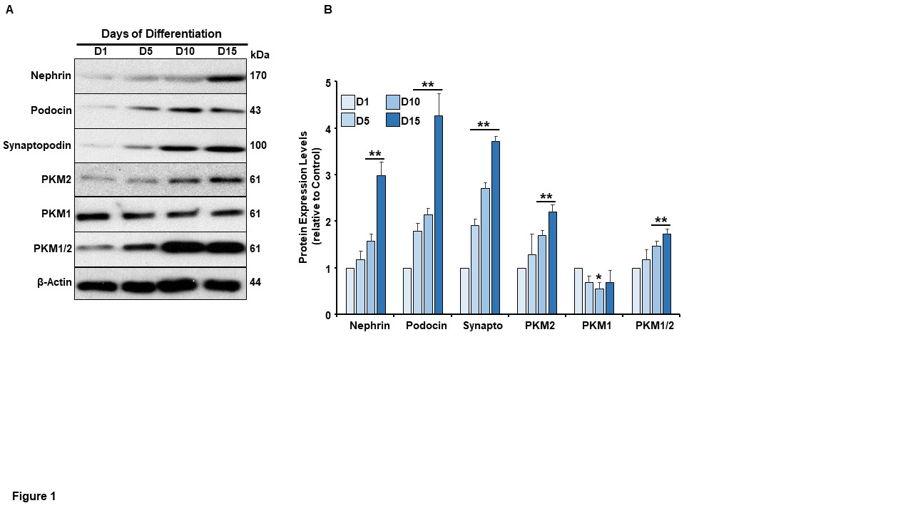
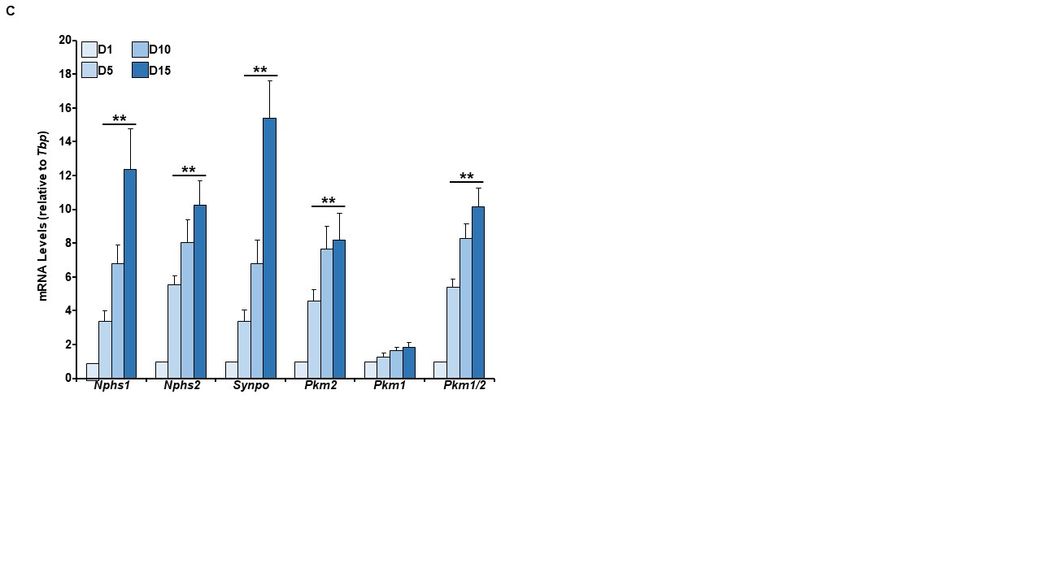
Figure 5. Expression pattern of PKM2 during podocyte differentiation. A) Representative immunoblots of Nephrin, Podocin, Synaptopodin, PKM2, PKM1, PKM1/2, and β-Actin as a loading control in differentiating E11 murine podocytes (days of differentiation; D1, D5, D10, and D15). B) Bar graphs quantification analysis of Nephrin, Podocin, Synaptopodin, PKM2, PKM1, PKM1/2 normalized to β-Actin. C) The mRNA level of Nphs1, Nphs2, Synpo, Pkm2, Pkm1, Pkm1/2 relative to Tbp in differentiating E11 murine podocytes. All experiments were conducted at least three independent times. *p<0.05, **p<0.01 indicate a significant difference between the indicated time point and day 1 (D1) of differentiation.

Figure 6. Characterization of autophagy, AMPK, and mTOR signaling in differentiating podocytes. A) The left panel is representative immunoblots of autophagy markers (beclin1, LC3-I, LC3-II, ATG5, and ATG7), pAMPK^{T172}, AMPK, and β-Actin as a loading control in differentiating E11 murine podocytes (days of differentiation; D1, D5, D10, and D15). The right panel is bar graphs quantification analysis of beclin1, LC3, ATG5, and ATG7 normalized to β-Actin, while pAMPK^{T172} was normalized to total AMPK. B) The left panel is representative immunoblots of pmTOR^{S2448}, mTOR, pP70S6K^{T389}, P70S6K, pE-BP1^{T37/46}, E-BP1, pS6^{S235/236}, S6, and β-Actin as a loading control in differentiating E11 murine podocytes. The right panel is bar graphs quantification analysis of pmTOR^{S2448}, pP70S6K^{T389}, pE-BP1^{T37/46}, and pS6^{S235/236} normalized to their corresponding total proteins. All experiments were conducted at least three independent times. **p<0.01 indicates a significant difference between the indicated time point and day 1 (D1) of differentiation.
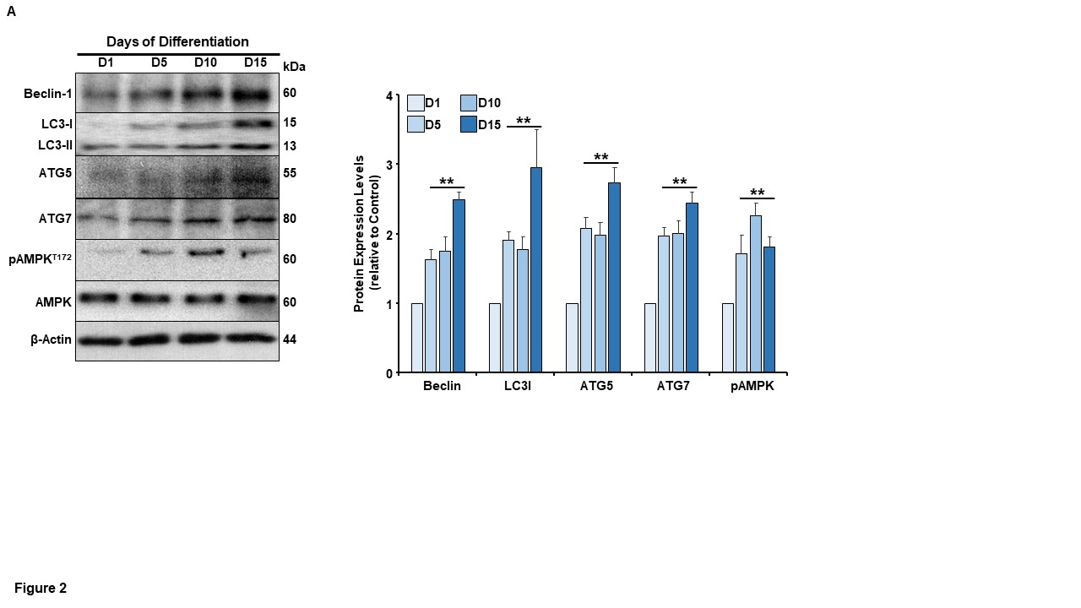
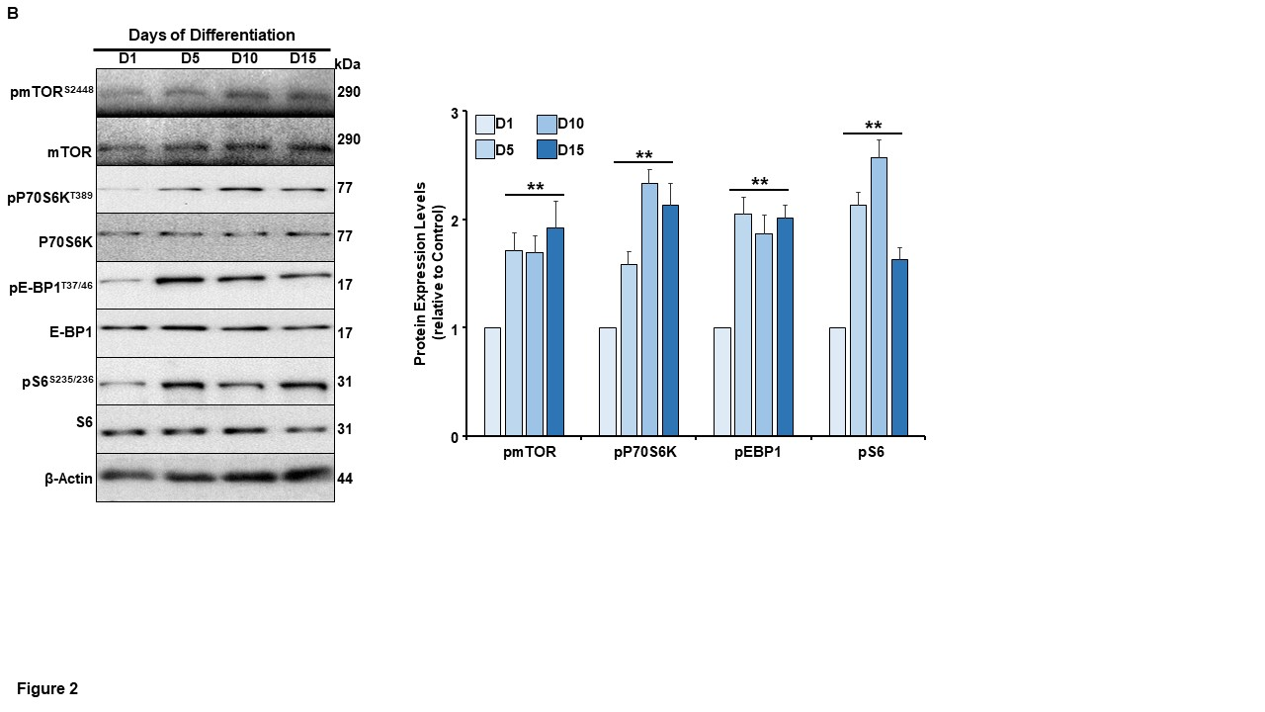
Figure 6. Continued

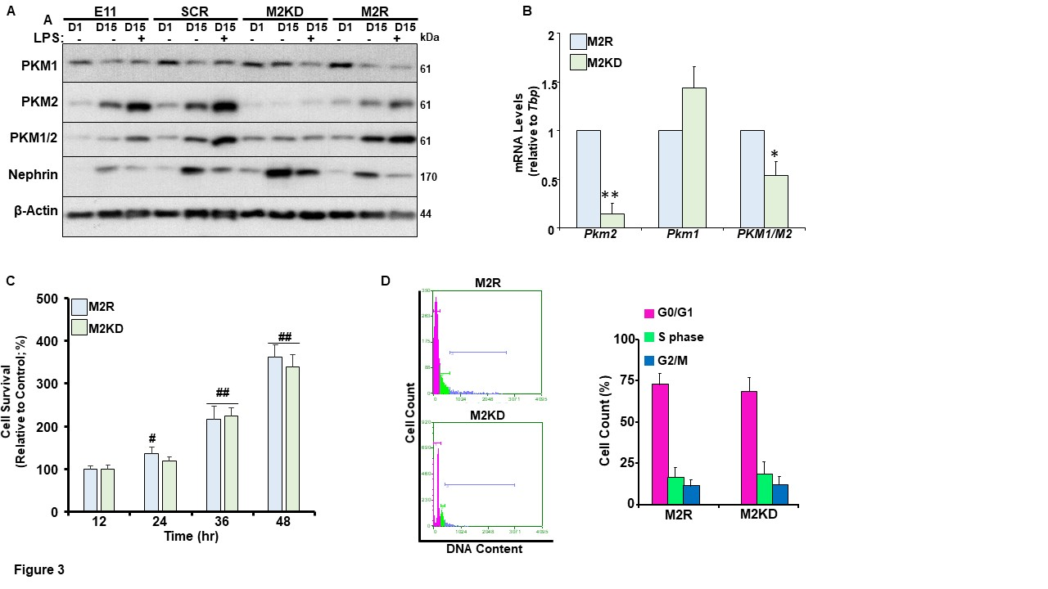
Figure 7. PKM2 deficiency does not alter podocytes proliferation rate. A) Representative immunoblots of PKM2, PKM1, PKM1/2, nephrin, and β-Actin as a loading control at early (day 1; D1) and late stage of differentiation (D15) in E11 murine podocytes transfected with lentivirus particles carrying scramble-shRNA (SCR), shRNA targeting PKM2 (M2KD) or an open reading frame of the human DNA (M2R). Once indicated, differentiated cells were challenged with lipopolysaccharides (LPS) for 24 h. B) The mRNA level of Pkm2, Pkm1, Pkm1/2 relative to Tbp in M2R and M2KD podocytes. C) Effects of PKM2 knockdown on podocyte proliferation rate; proliferating M2R and M2KD cells were stained with SRB over the course of 12, 24, 36, and 48 h. The intensity of the SRB staining is an indication of increased survival rate and proliferation and presented as bar graphs relative to control. D) Cell cycle assessment of DNA content in proliferating control (M2R) and PKM2 knockdown (M2KD) cells. Representative histogram distributions (left panel) and bar graphs (right panel) displaying the percentages of cells captured in each phase of the cell cycle are shown. All experiments were conducted at least three independent times. **p<0.05, **p<0.01 indicate a significant difference between M2KD and M2R. #p<0.05, ##p<0.01 indicate a significant difference between the indicated time point and 12 h.
Figure 8. PKM2 deficiency enhances podocyte differentiation and promotes the induction of autophagy, AMPK, and mTOR signaling. A) The left panel is representative immunoblots of Nephrin, Podocin, Synaptopodin, PKM2, PKM1, PKM1/2, and β-Actin as a loading control in differentiating control (M2R) and PKM2 knockdown (M2KD) podocytes (Days of differentiation, D1, D5, D10, and D15). The right panel is bar graphs quantification analysis of Nephrin, Podocin, Synaptopodin, PKM2, PKM1, PKM1/2 normalized to β-Actin. B) The mRNA level of Nphs1, Nphs2, Synpo, Pkm2, Pkm1, Pkm1/2 relative to Tbp in differentiating M2R and M2KD cells. C) The left panel is representative immunoblots of beclin1, LC3-I, LC3-II, ATG5 and ATG7, pAMPK^{T172}, AMPK, and β-Actin as a loading control in differentiating M2R and M2KD podocytes. The right panel is bar graphs quantification analysis of beclin1, LC3, ATG5, and ATG7 normalized to β-Actin, while pAMPK^{T172} was relative to total AMPK. D) The top panel is representative images displaying acridine orange staining at early (Day 1) and late stage of differentiation (Day 15) in M2R and M2KD podocytes. The bottom panel is bar graphs quantification analysis showing the intensity of acridine orange staining in M2R and M2KD cells. E) The left panel is representative immunoblots of pmTOR^{S2448}, mTOR, pP70S6K^{T389}, P70S6K, pE-BP1^{T37/46}, E-BP1, pS6^{S235/236}, S6 and β-Actin as a loading control in differentiating M2R and M2KD cells. The right panel is bar graphs quantification analysis of pmTOR^{S2448}, pP70S6K^{T389}, pE-BP1^{T37/46}, and pS6^{S235/236} normalized to their corresponding total proteins. All experiments were conducted at least three independent times. **p<0.01 indicates a significant difference between the indicated time point and day 1 of differentiation irrespective of the cell line. #p<0.01 and #p<0.01 indicate a significant difference between M2R and M2KD on the same day of differentiation.

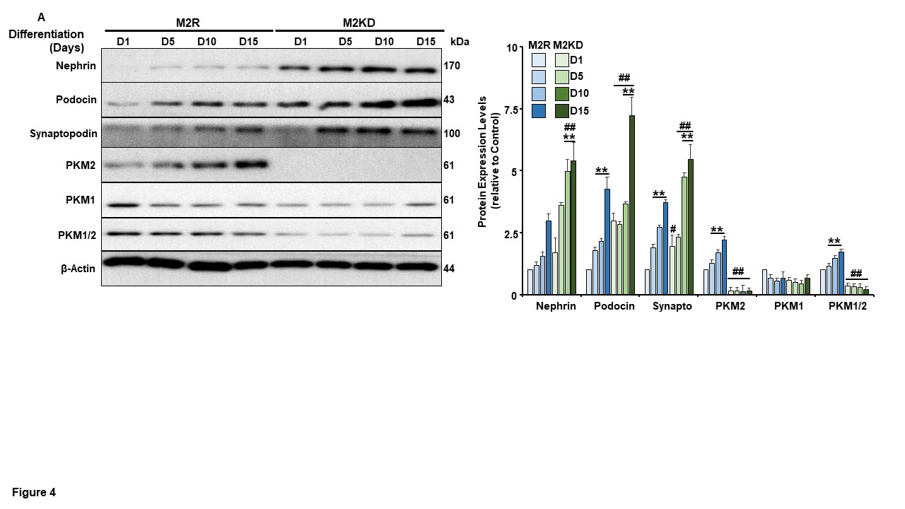
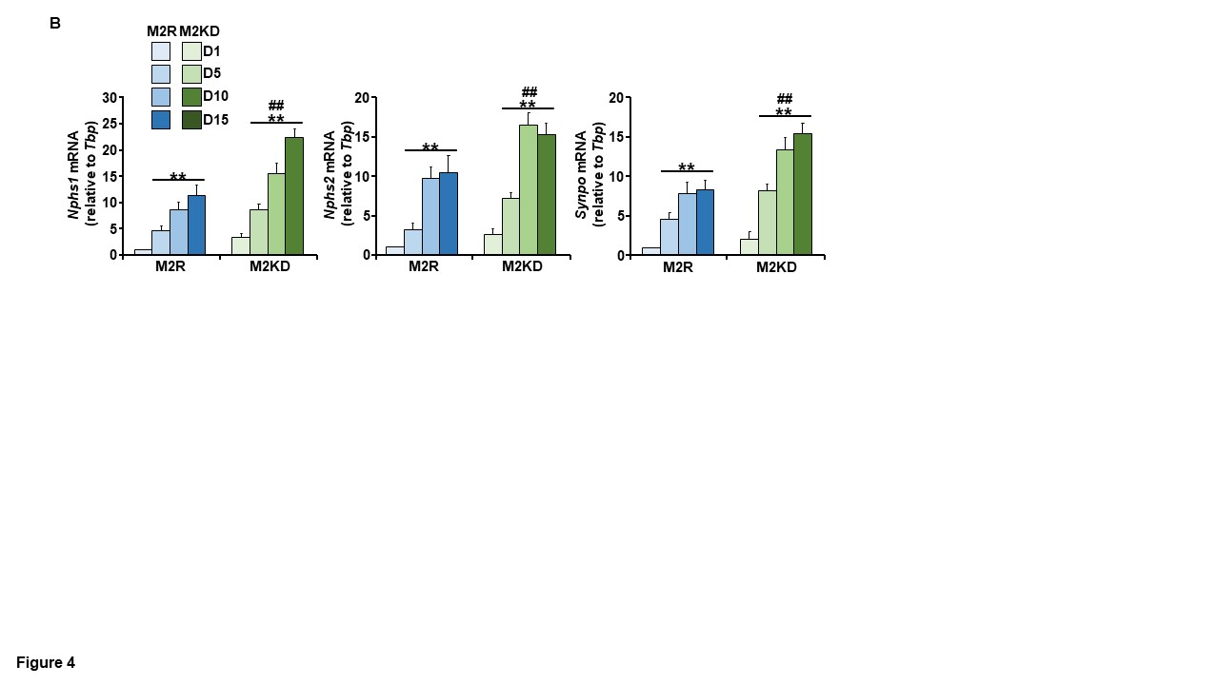
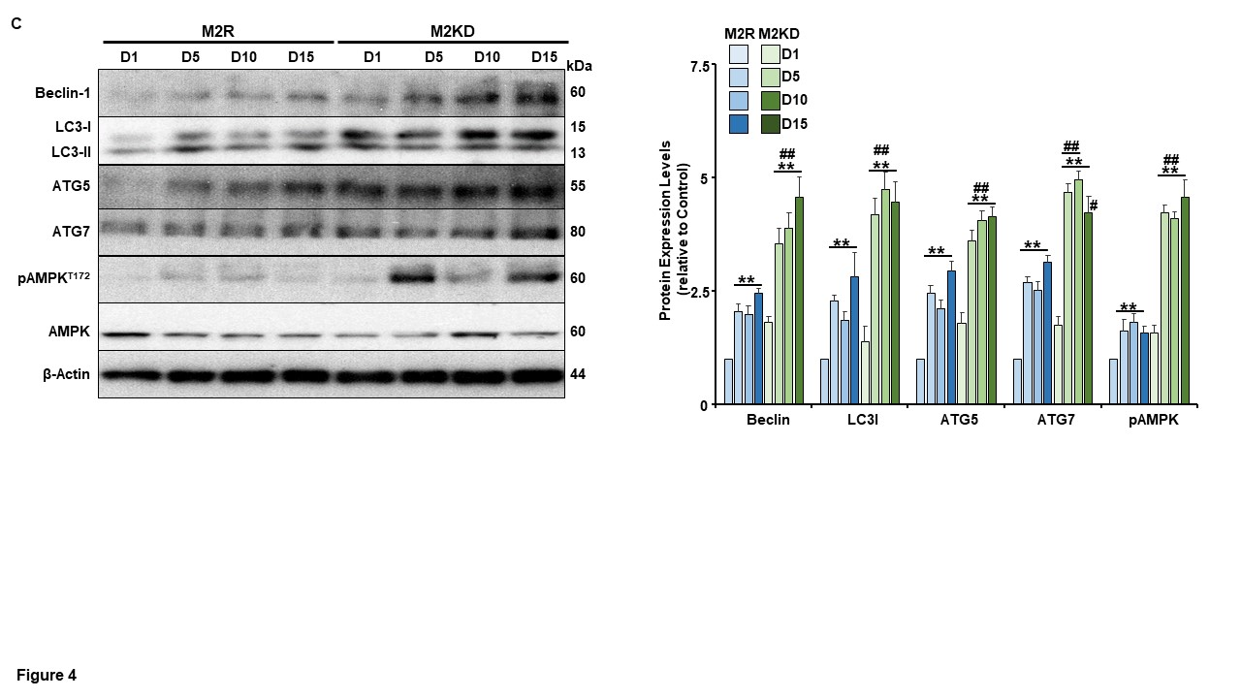
Figure 8. Continued

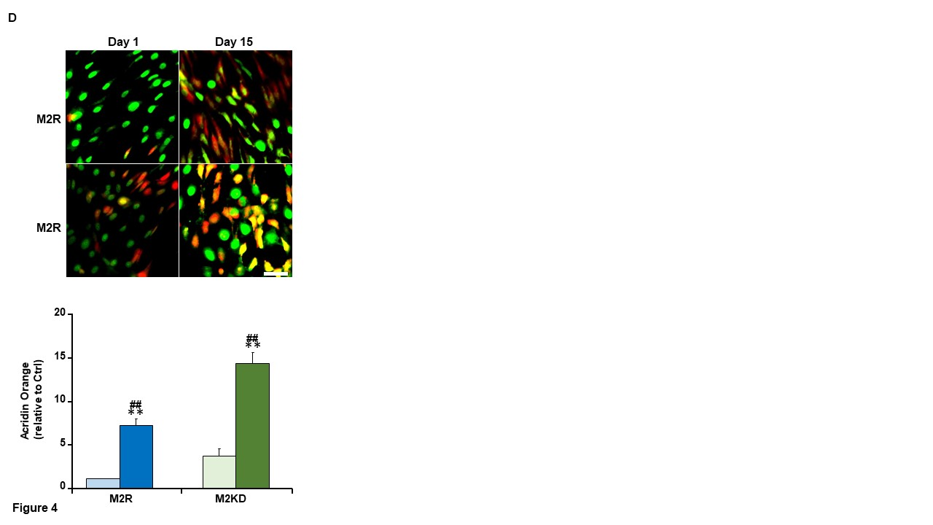
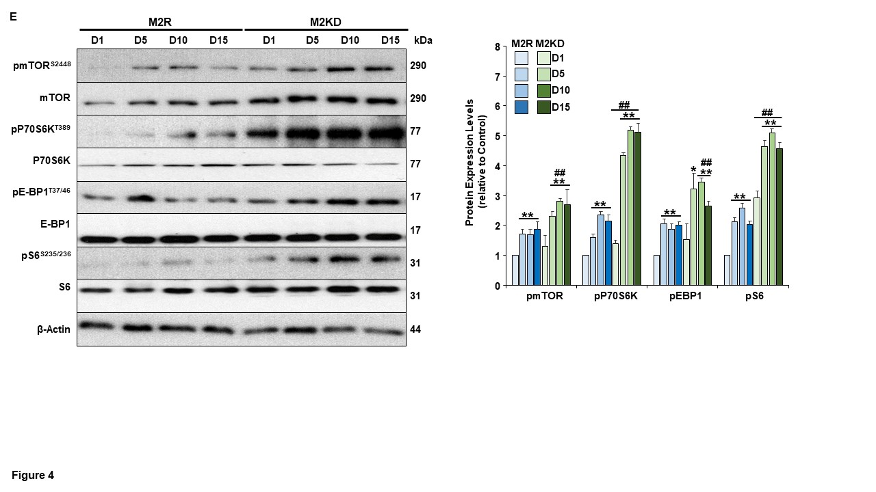
Figure 8. Continued

Figure 9. Inhibiting autophagy abolished the beneficial effect of PKM2 deficiency on podocyte differentiation. A) The left panel is representative immunoblots of podocytes differentiation markers (Nephrin and Podocin), autophagy markers (beclin1, and LC3-II), mTOR signaling (pmTOR^{S2448}, mTOR, pS6^{S235/236} and S6), pAMPK^{T172}, AMPK, pAKT^{S473}, and β-Actin as a loading control at early (Day1; D1) and late stage of differentiation (D15) in control (M2R) and PKM2 knockdown (M2KD) podocytes treated with DMSO or the autophagy inhibitor DBeQ throughout the differentiation process. The right panel is bar graphs quantification analysis of Nephrin, Podocin, beclin1, and LC3 normalized to β-Actin, while pmTOR^{S2448}, pS6^{S235/236}, pAMPK^{T172}, and pAKT^{S473} were normalized to their corresponding total proteins. B) Representative images displaying acridine orange staining at Day 1 and Day 15 of differentiation in M2R and M2KD cells treated with or without the autophagy inhibitor DBeQ during differentiation. C) The left panel is representative immunoblots of Nephrin, Podocin, beclin1, LC3-II, pmTOR^{S2448}, mTOR, pS6^{S235/236}, S6, pAMPK^{T172}, AMPK, pAKT^{S473}, and β-Actin as a loading control at Day 1 and Day 15 of differentiation in M2R and M2KD podocytes treated with either DMSO or autophagy activator (STF-62247) during differentiation. The right panel is bar graphs quantification analysis of Nephrin, Podocin, beclin1, and LC3-I normalized to β-Actin, while pmTOR^{S2448}, pS6^{S235/236}, pAMPK^{T172}, and pAKT^{S473} were relative to their corresponding total proteins. All experiments were conducted at least three independent times. **p<0.01 indicates a significant difference between the indicated time point and day 1 of differentiation irrespective of the cell line. #p<0.01 and #p<0.01 indicate a significant difference between M2R and M2KD on the same day of differentiation. &p<0.05, &&p<0.01 indicates a significant difference between podocytes treated with the indicated inhibitor and non-treated cells on Day 15 of differentiation.

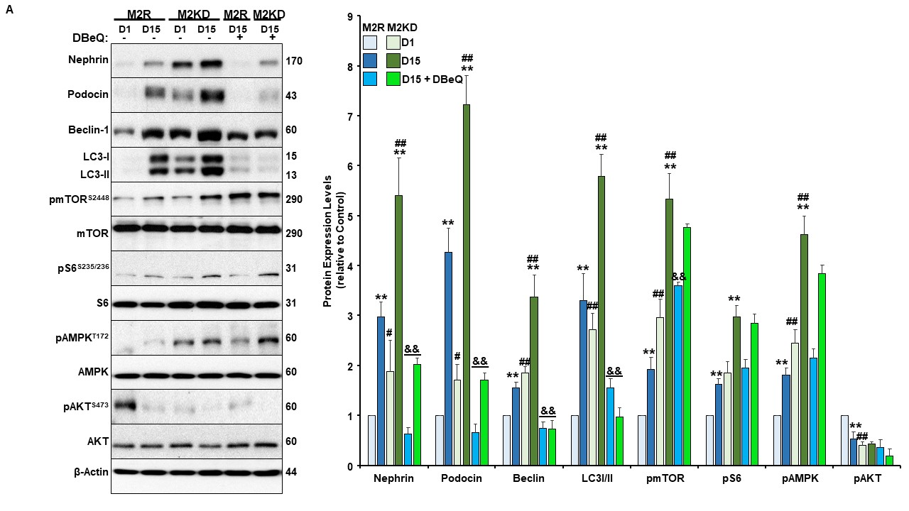
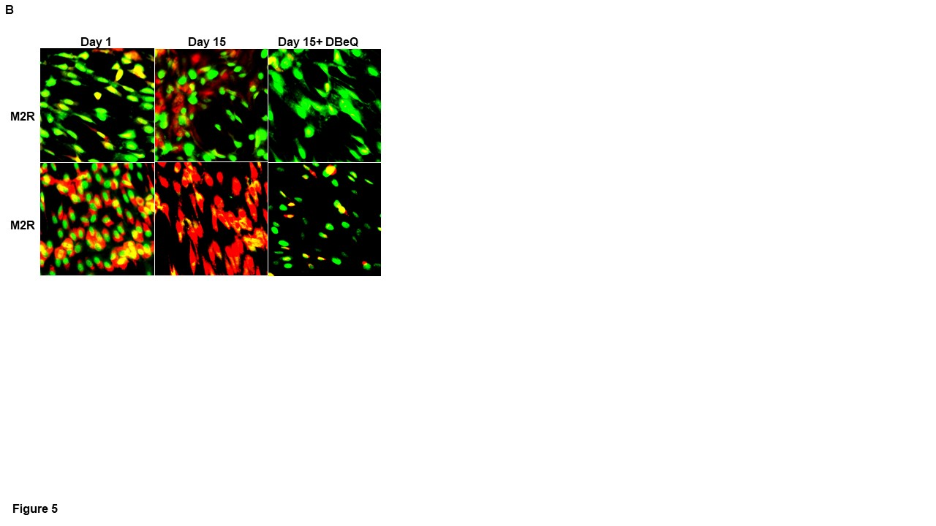 Figure 9. Continued

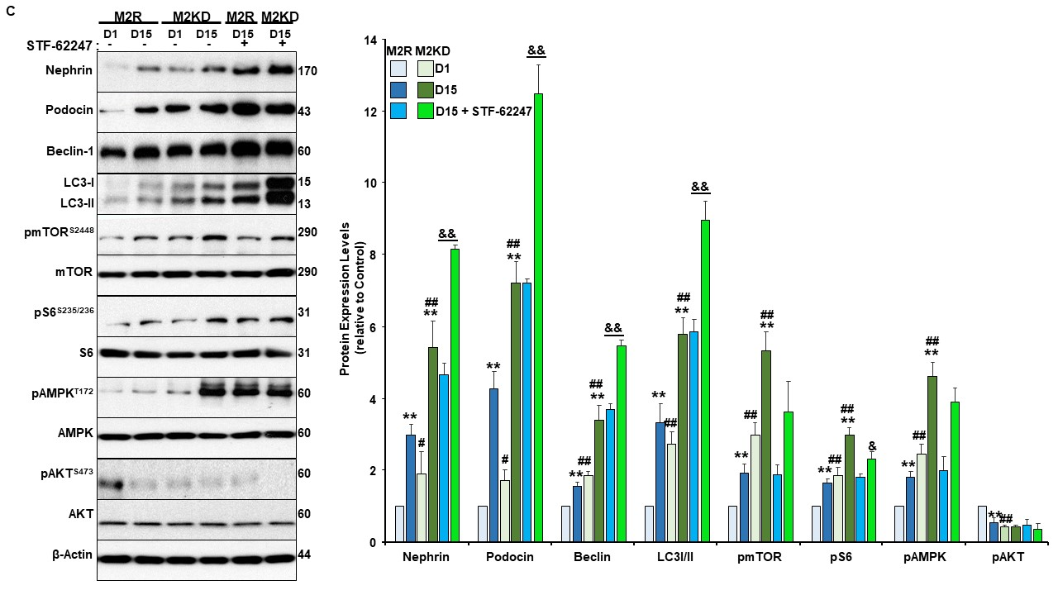
Figure 9. Continued

Figure 10. AMPK inhibition reversed the effect of PKM2 depletion on podocyte differentiation. A) Effect of AMPK inhibition on podocyte differentiation, autophagy, and mTOR signaling. Control (M2R) and PKM2 knockdown (M2KD) cells were treated with DMSO or AMPK inhibitor, BML-275, during the differentiation process. The left panel is representative immunoblots of Nephrin and Podocin, beclin1, and LC3-II, pmTOR^{S2448}, mTOR, pS6^{S235/236} and S6, pAMPK^{T172}, AMPK, pAKT^{S473}, and β-Actin as a loading control at Day 1 and Day 15 of differentiation. The right panel is bar graphs quantification analysis of Nephrin, Podocin, beclin1, and LC3 normalized to β-Actin, while phosphorylated proteins were normalized to their corresponding total proteins. B) Effect of AMPK activation on podocytes differentiation; M2R and M2KD podocytes were treated with DMSO or AICAR during differentiation. The left panel is representative immunoblots of Nephrin and Podocin beclin1, and LC3-II, pmTOR^{S2448}, mTOR, pS6^{S235/236}, pAMPK^{T172}, AMPK, pAKT^{S473}, and β-Actin as a loading control at Day 1 and Day 15 of differentiation. The right panel is bar graphs quantification analysis of Nephrin, Podocin, beclin1 and LC3 normalized to β-Actin, while pmTOR^{S2448}, pS6^{S235/236}, pAMPK^{T172}, and pAKT^{S473} were normalized to their corresponding total proteins. All experiments were conducted at least three independent times. **p<0.01 indicates a significant difference between the indicated time point and day 1 of differentiation irrespective of the cell line. #p<0.01 and #p<0.01 indicate a significant difference between M2R and M2KD on the same day of differentiation. &p<0.05, &&p<0.01 indicates a significant difference between podocytes treated with the indicated inhibitor and non-treated cells on Day 15 of differentiation.

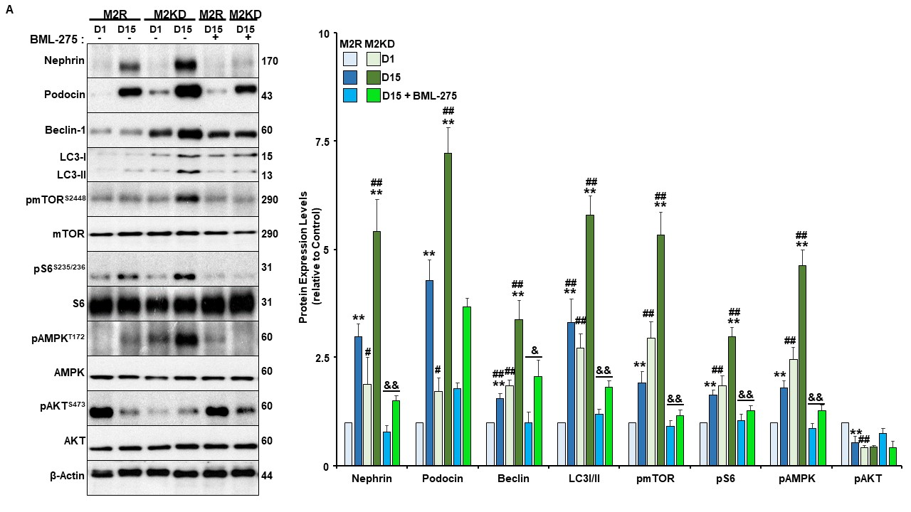
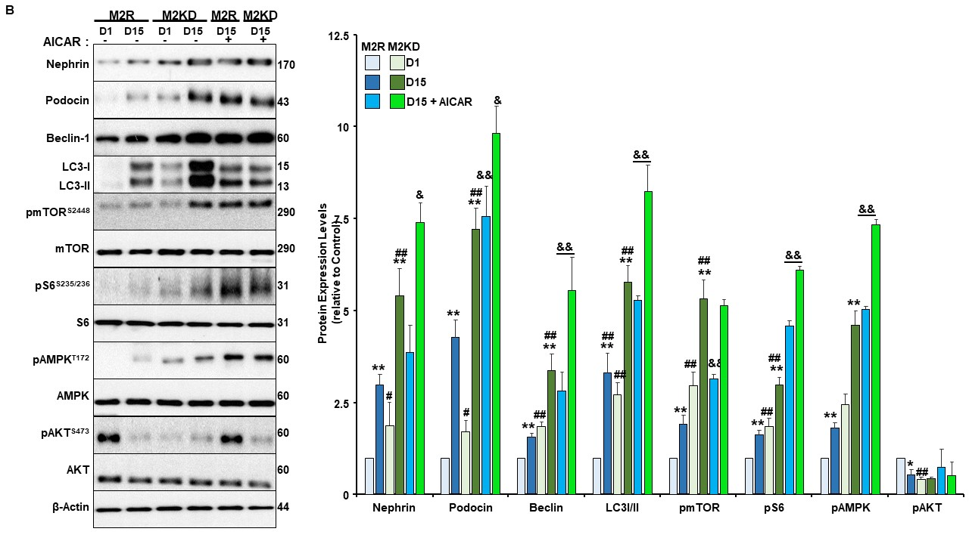
Figure 10. Continued

Figure 11. mTORC1 activity is required for mediating the beneficial effect of PKM2 deficiency on podocyte differentiation. A) Representative immunoblots (left panel) and bar graphs quantification analysis (right panel) of Nephrin, Podocin, beclin1 and LC3-I normalized to β-Actin, while pmTOR^{S2448}, pS6^{S235/236}, pAMPK^{T172}, and pAKT^{S473} were normalized to their corresponding total proteins at early (Day1; D1) and late stage of differentiation (D15) in control (M2R) and PKM2 knockdown (M2KD) podocytes treated with DMSO or rapamycin during the differentiation process. B) Representative immunoblots (left panel) and bar graphs quantification analysis (right panel) of Nephrin, Podocin, beclin1 and LC3 normalized to β-Actin, while pmTOR^{S2448}, pS6^{S235/236}, pAMPK^{T172}, and pAKT^{S473} were normalized to their corresponding total proteins at Day 1 and Day 15 of differentiation in M2R and M2KD cells treated with either DMSO or mTORC1 activator (NV-5138) during differentiation. All experiments were conducted at least three independent times. **p<0.01 indicates a significant difference between the indicated time point and day 1 of differentiation irrespective of the cell line. #p<0.01 and #p<0.01 indicate a significant difference between M2R and M2KD on the same day of differentiation. &p<0.05, &&p<0.01 indicates a significant difference between podocytes treated with the indicated inhibitor and non-treated cells on Day 15 of differentiation.

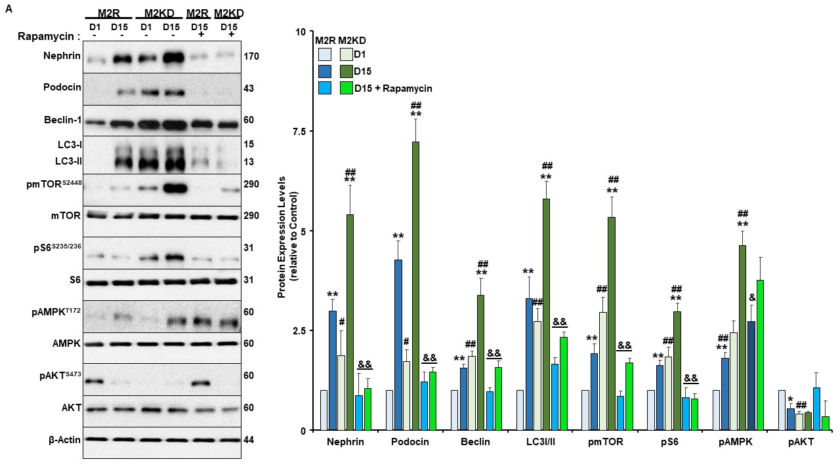
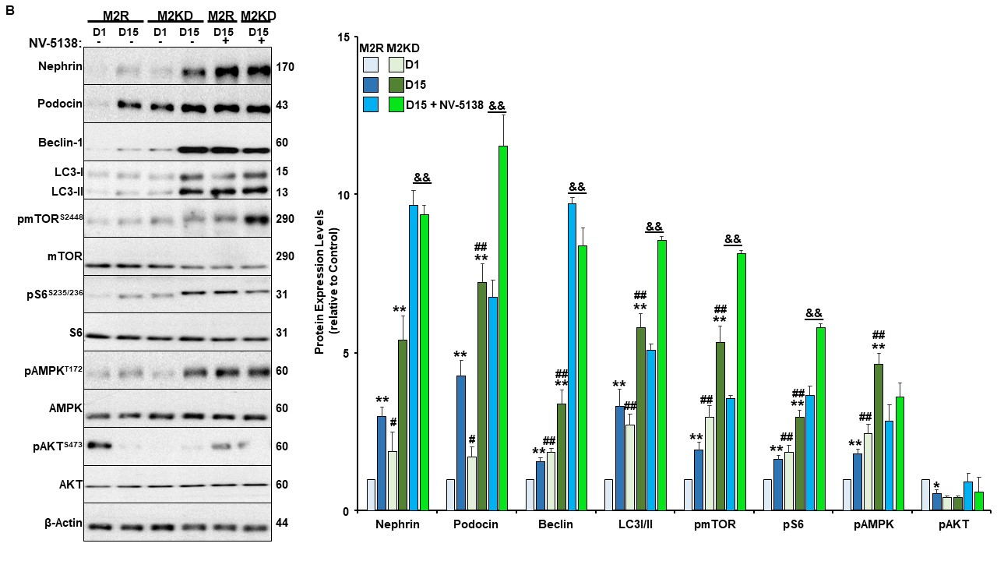
Figure 11. Continued

Figure 12. AKT activation impaired podocytes differentiation and abolished the beneficial effect of PKM2 deficiency. A) Representative immunoblots (left panel) and bar graphs quantification analysis of differentiation (Nephrin and Podocin) and autophagy markers (beclin1 and LC3) normalized to β-Actin, while pmTOR^{S2448}, pS6^{S235/236}, pAMPK^{T172}, and pAKT^{S473} were normalized to their corresponding total proteins at early (Day1; D1) and late stage of differentiation (D15) in control (M2R) and PKM2 knockdown (M2KD) podocytes treated with DMSO or AKT inhibitor (LY-294002) during the differentiation process. B) Representative immunoblots (left panel) and bar graphs quantification analysis of Nephrin, Podocin, beclin1 and LC3 normalized to β-Actin, while pmTOR^{S2448}, pS6^{S235/236}, pAMPK^{T172}, and pAKT^{S473} were normalized to their corresponding total proteins at D1 and D15 of differentiation in M2R and M2KD cells treated with DMSO or AKT activator (SC-79) during differentiation. All experiments were conducted at least three independent times. **p<0.01 indicates a significant difference between the indicated time point and day 1 of differentiation irrespective of the cell line. #p<0.01and #p<0.01 indicates a significant difference between M2R and M2KD on the same day of differentiation. &p<0.05, &&p<0.01 indicates a significant difference between podocytes treated with the indicated inhibitor and non-treated cells on Day 15 of differentiation.

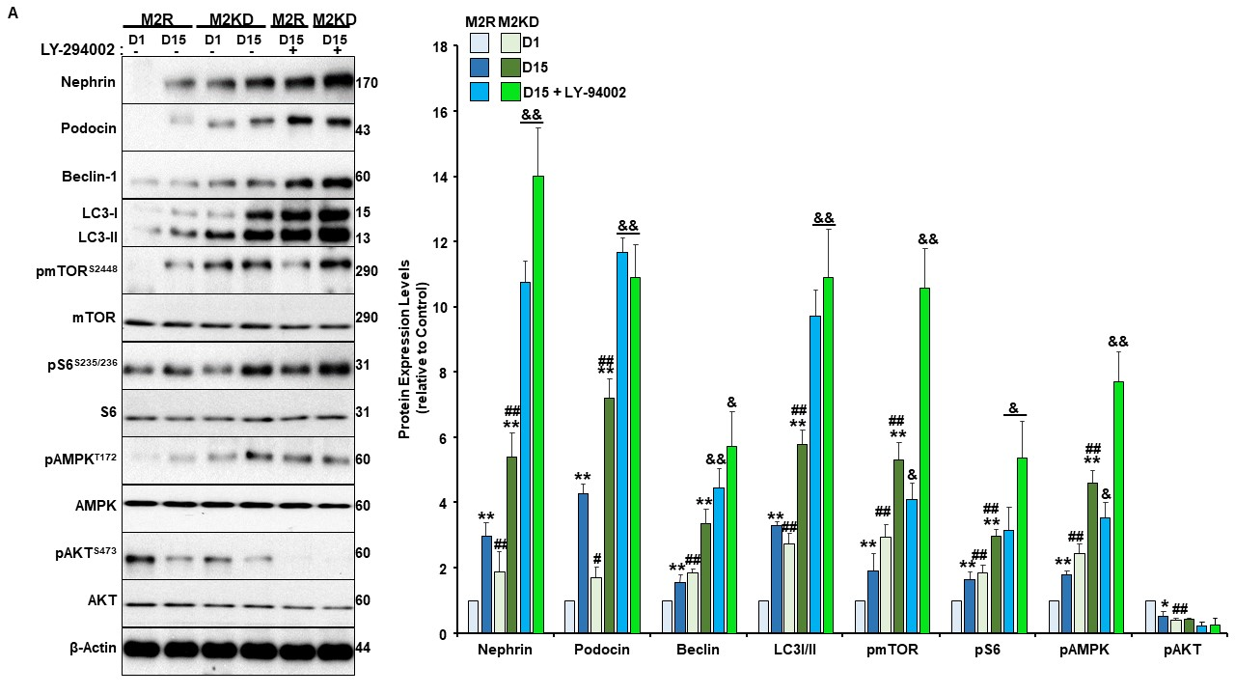
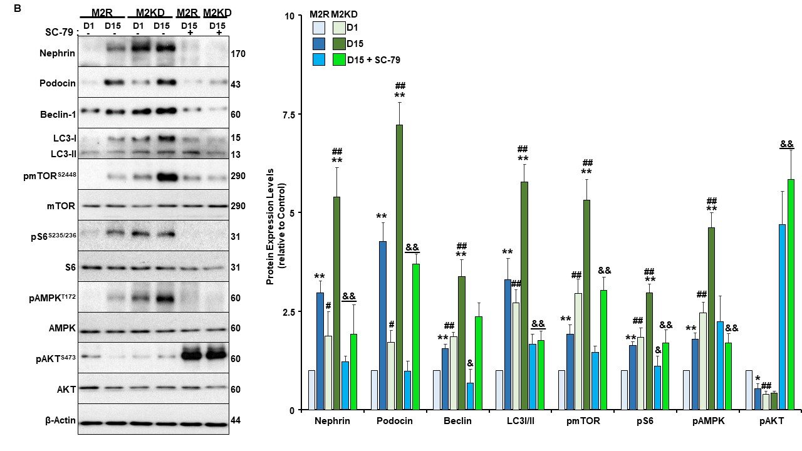
Figure 12. Continued

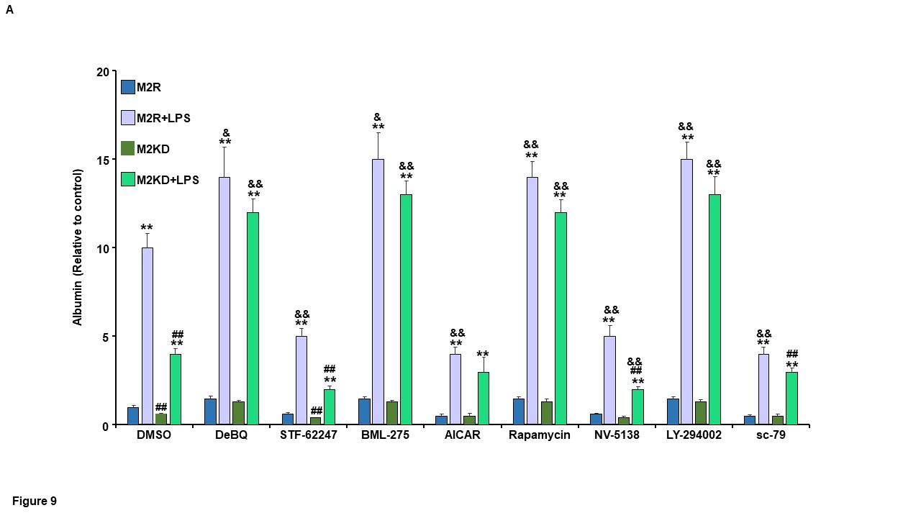
Figure 13. PKM2 deficiency protected against LPS induced albumin permeability. Fully differentiated control (M2R) and PKM2 knockdown (M2KD) podocytes were treated with lipopolysaccharides (LPS) for 12 h in the presence or absence of the indicated compounds. Albumin concentration level was measured as described in the method section. The bar graphs quantification analysis of albumin concentration relative to control is shown. **p<0.01 indicates a significant difference between cells treated with LPS and non-treated cells, irrespective of the cell line. &p<0.05, &&p<0.01 indicates a significant difference between cells co-treated with LPS and the indicated inhibitor/activator and the same cells treated with LPS only.

Chapter III: Podocytes Specific Deletion of PKM2 Ameliorates LPS-induced Podocyte Injury through Beta-Catenin

Abstract
Background: Acute kidney injury (AKI) is associated with a severe decline in kidney function caused by abnormalities within the podocytes' glomerular matrix. Recently, AKI has been linked to alterations in glycolysis and the activity of glycolytic enzymes, including pyruvate kinase M2 (PKM2). However, the contribution of this enzyme to AKI remains largely unexplored.
Methods: Cre-loxP technology was used to examine the effects of PKM2 specific deletion in podocytes on the activation status of key signaling pathways involved in the pathophysiology of AKI by lipopolysaccharides (LPS). In addition, we used lentiviral shRNA to generate murine podocytes deficient in PKM2 and investigated the molecular mechanisms mediating PKM2 actions in vitro.
Results: Specific PKM2 deletion in podocytes ameliorated LPS-induced protein excretion and alleviated LPS-induced alterations in blood urea nitrogen and serum albumin levels. In addition, PKM2 deletion in podocytes alleviated LPS-induced renal injury and protected mice from LPS-induced pro-inflammatory cytokine expression. At the molecular level, PKM2 deficiency in podocytes alleviated LPS-induced inflammation, endoplasmic reticulum stress, and apoptosis, but exacerbated LPS-induced autophagy. In vitro, PKM2 knockdown in murine podocytes suppressed LPS-induced apoptosis. These effects were concomitant with a reduction in LPS-induced activation of β-catenin and the loss of Wilms’ Tumor 1 (WT1) and nephrin. Notably, the overexpression of a constitutively active mutant of β-catenin abolished the protective effect of PKM2 knockdown. Conversely, knockdown cells reconstituted with the phosphotyrosine binding–deficient PKM2 mutant (K433E) recapitulated the effect of PKM2 depletion on LPS-induced apoptosis, β-catenin activation, and reduction in WT1 expression.
Conclusion: Our data demonstrate that PKM2 plays a key role in podocytes injury and suggest that targeting PKM2 in podocytes could serve as a promising therapeutic strategy for AKI.

Keywords: Proteinuria, Pyruvate Kinase M2, Podocyte, β-Catenin, Renal Injury, Apoptosis

Abbreviations
ACR: Albumin to creatinine ratio; AKI: Acute kidney injury; APC: Adenomatous polyposis coli; ATG: Autophagy related protein; ATF6: Activating transcription factor 6; BUN: Blood urea nitrogen; CHOP: C/EBP homologous protein; EIF2α: Eukaryotic translation initiation factor 2 alpha; ER: Endoplasmic reticulum; ESRD: End-stage renal disease; GFR: Glomerular filtration rate; GPR78: G protein-coupled receptor; GSK: Glycogen synthase kinase; HIF 1α: Hypoxia-inducible factor 1-alpha; IL‐1β: Interleukin‐1β; IL‐6: Interleukin‐6; IRE1α: Inositol-requiring transmembrane kinase/endoribonuclease 1α; JNKs: c-Jun N-terminal kinases; LC3: Microtubule-associated protein 1A/1B-light chain 3; LPS: Lipopolysaccharides; MAPK: Mitogen-activated kinases; NF-κB: Nuclear factor kappa-light-chain-enhancer of activated B cells; OXPHOS: Oxidative phosphorylation; PAS: Periodic acid-Schiff; PBS: Phosphate buffered saline; PERK: Protein kinase RNA-like endoplasmic reticulum kinase; PK: Pyruvate kinase; STZ: Streptozotocin; TNFα: Tumor necrosis factor‐α; WT1: Wilms’ tumor 1; XBP1: X-Box binding protein 1

3.1. Introduction
Acute kidney injury (AKI) describes a sudden and severe loss of renal function that can develop over the course of hours or days. Overall, the occurrence of AKI has increased markedly in the US over the past two decades, with approximately 4 million people in the US hospitalized for AKI in 2014 [1]. Although treatment typically restores kidney function, AKI increases the likelihood of subsequently developing proteinuria, a significant risk factor for chronic kidney disease and cardiovascular events [2]. Accordingly, AKI is associated with an increased likelihood of the need for long-term care, lifetime risk of hospitalization, and elevated health care costs [1].
Damage to podocytes is the critical initiating event linked to development of proteinuria during AKI [3]. Podocytes have proven to be crucial in the prevention of proteinuria through their role in preserving the structural integrity of the glomerular filtration membrane. Foot processes of these specialized epithelial cells create the slit diaphragms through which filtrate passes into the proximal tubules [4, 5]. Damage to podocytes compromises the filtration barrier, resulting in protein loss in urine [6]. Podocytes are particularly vulnerable to stressors in the blood due to their anatomical arrangement within the filtration barrier. Pathogens and other stress signals are sensed by podocytes, eliciting release of inflammatory cytokines and recruitment of immune cells into the glomerulus [7, 8]. If unresolved, inflammation can damage the filtration barrier, resulting in chronic proteinuria and increased risk of renal disease.
Sepsis is the leading cause of AKI [8]. Up to one in three septic patients will develop AKI, based on studies of various infectious models. In turn, AKI significantly compromises treatment of sepsis, with mortality rates of septic patients that develop AKI estimated at 70% [9, 10]. Sepsis typically results in reduced blood pressure, which compromises renal function and promotes renal injury due to diminished perfusion. In addition, toll-like receptors that recognize endotoxin lipopolysaccharides (LPS) and other microbial stress signals are distributed through the nephron. Activation of these receptors by pathogens in the renal filtrate elicits local release of inflammatory cytokines, microvascular alterations, and metabolic disruptions that further impede renal function [11].
Emerging studies indicate that LPS rapidly induces aerobic glycolysis in target cells, and that this metabolic shift is necessary for the inflammatory response. Macrophages, dendritic cells, and other immune cells, as well as colorectal cancer cells rapidly switch from mitochondrial-derived production of ATP to aerobic glycolysis when exposed to LPS [12-17]. Inhibiting this Warburg-like metabolic shift suppresses the subsequent release of inflammatory cytokines, demonstrating a causal connection between glycolysis and inflammation during the acute response to LPS. Similar relationships have been described in vivo in an LPS-induced model of lung injury. Injecting mice with 2-deoxyglucose, an inhibitor of glycolysis, prior to administering LPS attenuated infiltration of neutrophils, suppressed expression of inflammatory markers, and limited pathological injury in the lung [18]. Experimental sepsis has also been shown to induce a shift toward aerobic glycolysis in kidney. Administering LPS to mice prompted a significant rise in glycolytic metabolism in the renal cortex that preceded the decline in renal function [19]. The shift in metabolism occurred within three hours of LPS treatment, consistent with rapid induction observed in other cells and tissues. In the kidneys from a murine cecal puncture model of sepsis, metabolome profiling revealed a significant increase in glycolytic metabolites with a corresponding reduction in TCA cycle intermediates [20] Based on these studies, and on findings in other cell types and tissues, Gomez et al. proposed a model in which renal cells undergo metabolic reprogramming as part of an early, pro-inflammatory phase, and that this response is linked to mitochondrial injury that occurs in the kidney during the early stages of sepsis [21].
The glycolytic enzyme pyruvate kinase 2 (PKM2) has emerged as a key enzyme that connects glycolysis to inflammation during sepsis. PKM2 is one of four isoforms (L, R, M1, and M2) of the enzyme pyruvate kinase, which catalyzes the final and rate-limiting step in glycolysis. LPS induces the expression of PKM2 in macrophages and other cell types, and inhibiting this induction through either pharmacological or genetic approaches prevents initiation of the inflammatory cascade [13, 14, 22, 23] . Both genetic deletion of PKM2 in myeloid cells and inhibition using shikonin protect mice from endotoxic shock and septic death, demonstrating a critical role for this enzyme in sepsis [24, 25]. The inflammatory role of PKM2 may include both its classical glycolytic function and non-metabolic actions [26]. Unlike other isoforms, the kinase activity of PKM2 extends beyond glycolysis, including phosphorylation of proteins essential to the inflammatory response [27]. In colorectal cancer cells, for example, phosphorylation of STAT3, rather than phosphoenolpyruvate, by PKM2 mediates the inflammatory response to LPS [16]. PKM2 can also regulate inflammation through transcriptional control of cytokine release. In macrophages, LPS induces the formation of a PKM2 and Hypoxia-inducible factor 1-alpha (HIF 1α) complex, forming a dimer capable of translocating to the nucleus to regulate transcription Tnf-a, IL-1b, and other cytokine genes [28, 29]. Notably, PKM2 is the main pyruvate kinase isoform expressed in podocytes, and an emerging link between metabolism and inflammation during sepsis. Although podocytes are critical in the pathogenesis of AKI, the influence of LPS on podocyte metabolism and the role of PKM2 in sepsis-induced AKI are not known. In the current study, we investigated the role of PKM2 in podocyte homeostasis in response to LPS and highlighted its contribution to sepsis-induced AKI's pathophysiology.

3.2. Materials and Methods
Reagents: Unless indicated otherwise, we obtained most chemicals from Sigma‐Aldrich (St. Louis, MO, USA). RPMI164 medium, penicillin-streptomycin, Fetal Bovine Serum (FBS), and trypsin were all obtained from Invitrogen (Carlsbad, CA, USA). Hygromycin was purchased from Research Products International Corp. (RPI Corp.; Mount Prospect, IL). Primary and secondary antibodies with their dilutions, hosts, and sources are summarized in Table 2. Forward and reverse primers used for quantitative real-time polymerase chain reaction (qRT-PCR) are listed in Table 3 and were purchased from Fisher Scientific (Hampton, NH).
Cell Culture: E11 murine podocyte cells were obtained from Cell Lines Service (Eppelheim, Germany) and cultured at 33ºC in a humidified atmosphere of 10% CO₂. Cells were grown in RPMI164 medium supplemented with 10% fetal bovine serum, Glutamax (2 mM), and sodium pyruvate (1 mM). Differentiation of podocytes was induced as previously described with modification [30]. Briefly, cells were transferred to 37ºC and cultured for an additional period of 15 days. By then, cells exhibit a fully differentiated phenotype as judged by the expression of podocytes markers, namely nephrin and podocin. Cell culture media was replaced every 48 hr, and all experiments were conducted at least three times on cells between passages 3 and 8. PKM2 silencing in E11 cells was achieved using three different hairpins (GeneCopoeia, Inc.; Rockville, MD). Lentivirus packaging system (GeneCopoeia) was used to generate Lentiviruses in HEK293FT cells (GeneCopoeia) following the manufacturer’s guidelines, and then used to infect E11 podocytes. Cells deficient in PKM2 were selected using hygromycin (200 μg/ml). Cells with PKM2 knockdown (KD) were reconstituted using lentivirus particles overexpressing a human wild type PKM2, selected using Geneticin (G418; 400 µg/ml) for three weeks, and used as controls (M2R). When indicated, cells were treated with the specified concentration of LPS (Sigma-Aldrich) for the stated duration.
Mouse studies: All mice strains (pkm2^{fl/fl}, podocin-Cre, and C57Bl/6J) were obtained from the Jackson Laboratory, sustained on a 12 h light-dark cycle, and fed ad libitum a standard lab chow diet (Purina lab chow, # 5001). To generate mice with specific deletion of PKM2 in podocytes, we crossed pkm2^{fl/fl} to mice expressing Cre under the promoter of podocin. Genotyping for the presence of Cre and pkm2 floxed allele was conducted on DNA isolated from tails, using the polymerase chain reaction (PCR). For LPS-induced AKI, we injected 8 to 12 weeks old PKM2 knockout (pkm2^{fl/fl} Pod-cre+) and control (pkm2^{fl/fl}) male mice with a single dose of LPS intraperitoneally (16 mg/kg of body weight dissolved in 0.9% sterile PBS). 22 h after injection, urine samples were collected into 50 ml conical tubes. The urine samples were centrifuged for 1 min at 1,000 g, then stored at -80ºC until further analyses. Mice were sacrificed 2 h after urine collection, and kidneys were harvested and used for biochemical and histological experiments. All mice studies were conducted in accordance with federal regulations upon approval from the Institutional Animal Care and Use Committee at the University of Tennessee, Knoxville.
Metabolic Analysis: Blood samples were collected at the time of sacrifice and evaluated for blood urea nitrogen (BUN) using the Urea Nitrogen Colorimetric Detection Kit from Arbor Assays (Ann Arbor, MI). Additionally, the BCG Albumin and Creatinine Assay Kits (Sigma-Aldrich) was used to measure serum and urine albumins, as well as creatinine levels, respectively, according to the manufacturer's recommendations.
Podocyte isolation and cell culture: We isolated primary podocytes from C57BL6/J, controlled wild-type mice, and from mice lacking PKM2 in podocytes as previously described [31, 32]. Briefly, four kidneys from four different animals were harvested, decapsulated, and minced in Krebs-Henseleit saline (KHS) buffer containing 119 mM NaCl, 4.7 mM KCl, 1.9 mM CaCl2, 1.2 mM KH2PO4, 1.2 mM MgSO4•7H2O, and 25 mM NaHCO3, pH: 7.4. Samples were then centrifuged for 10 min at 500 g, washed twice using the KHS buffer, passed through a 250 μm sieve, and then pelleted them for 10 min at 500 g. Next, samples were digested in a Hanks’Balanced Salt Solution (HBSS) containing collagenase D (0.1%), trypsin (0.25%), and DNase I (0.01%) for 30 min in a 37°C shaking water bath. Then, the digested samples were filtered through a 100 μm sieve placed on the top of a 53 μm sieve. Finally, samples were centrifuged for 5 min at 1500 g in 4°C, and the pelleted podocytes were either flash-frozen in liquid nitrogen or lysed in RIPA buffer for biochemical analyses.
Metabolic flux analyses: Extracellular Acidification Rate (ECAR), a proxy for glycolysis, was measured at 37°C using Seahorse XF24 extracellular analyzer (Seahorse Bioscience, Lexington, MA) as previously described [33]. Fully differentiated E11 cells were seeded at identical numbers and cultured in XF24 plates for 24 hr. 6 h prior to the assay, cells were treated with LPS then transferred to a non-CO2 incubator (37°C) for one additional hour before the Seahorse assay. All Seahorse experiments were performed with identical conditions. Glucose was injected (5 mM final concentration) and changes in ECAR was quantified at baseline. Then, 2-Oligomycin was injected and the ECAR measurement was repeated. Finally, 2-deoxyglucose was injected to block glycolysis. The ECAR was normalized to total protein in each well.
Kidney injury scoring: Freshly harvested kidneys were fixed in 4% paraformaldehyde for 24 h at 4°C, then embedded in paraffin. Prior staining, 4-5 μm thick sections were cut, deparaffinized in xylene, and then stained with Periodic Acid-Schiff reagent (Sigma) according to manufacturer's instructions. Each section was scanned at 400-fold magnification, 10 tubules from 10 different fields in the renal cortex and the outer stripe of the outer medulla were evaluated for tissue injury. Morphological alterations and the magnitude of injury were assessed following an arbitrary scale as previously described [34]. Briefly, a score of 0 indicates a healthy tissue with no major morphological alterations, excluding focal interruptions on the brush border and nuclei projecting into the lumen. A score of 1 indicates large cytoplasmic vacuolization of tubular epithelial cell or focal, individual cell necrosis. A score of 2 was assigned to tissues with a minimum of one necrotic tubular section in which more than 50% of the tubule is identifiable. A score of 3 indicates a minimum of one necrotic tubular section, with less than 50% of the preserved section identifiable (nuclear loss, cytoplasmic fragmentation, epithelial sloughing, obstructive casts). A score of 4 was assigned to section in which the tubular section appears completely necrotic with unspecified derivation. In each of the criterion, the arbitrary scores were calculated and presented as mean of the values attributed to all examined fields.
Immunofluorescence: For immunofluorescence microscopy, freshly harvested Kidney tissues from PBS and LPS-treated WT and PKM2 KO mice were fixed in 10% formalin and embedded in paraffin. 5 μM sections were deparaffinized by three washes in freshly prepared 100% xylene (3 min each) followed by three washes in freshly prepared decreasing concentrations of ethanol (95, 90, 75, and 50%; 3 min each wash). Sections were then stained with anti-PKM2 or anti-nephrin antibodies, and the blue-fluorescent DNA stain; 4', 6-Diamidino-2-Phenylindole, Dihydrochloride (DAPI). Detection was conducted using the proper fluorescein-conjugated secondary antibodies and visualized by the Leica DMI8 inverted fluorescent microscope.
Protein extraction and Immunoblots: Podocytes and kidney samples were lysed in radioimmunoprecipitation assay (RIPA) buffer enriched with freshly prepared solutions of proteases and phosphatases inhibitors (RPI Corp.), PMSF (1 mM), and NaF (15 mM). Next, samples were sonicated twice (10 seconds each) on ice and cleared by 10 min centrifugation at 15,000 g at 4°C. Then, the protein concentration was determined using the bicinchoninic acid assay kit (Pierce Chemical, Dallas, TX, USA). A total of 10 μg of proteins were resolved in electrophoresis then transferred to PVDF membranes. Membranes were blocked with TBST containing 5% BSA and 0.1% tween, pH: 7.4 for 45-60 min at room temperature (RT) before incubation with the indicated primary antibodies (Table 2) for 1 h at RT. After three wash cycles with TBST (5 min each), membranes were incubated with the appropriate secondary antibodies for 1 h at RT. Then washed 4 times (15 min each) with TBST. Luminata™ Western Chemiluminescent HRP Substrate (Millipore Corp., Billerica, MA) was used to visualize proteins, and the band's intensity was quantified using Fluorchem software (Alpha Innotech Corp., San Jose, CA, USA).
RNA isolation and quantitative real-time PCR: mRNA was extracted from kidney and cells using TRIzol reagent (Invitrogen), pelleted in RNase-free water following the manufacturer's instructions, and quantified using NanoDrop® ND1000 spectrophotometer (Thermo Fisher Scientific Inc., Piscataway, NJ). 5 ug of RNA was used for cDNA synthesis using iScript™ cDNA Synthesis Kit (BioRad; Hercules, CA). All genes expression were performed by qRT-PCR using the SsoAdvanced™ Universal SYBR® Green Supermix (BioRad) and BioRad CFX96™ system, as previously described [35]. We evaluated the relative abundance of mRNA of the indicated genes using respective primers (Table 3) via the ∆∆^{CT} method. For each gene, the expression of their corresponding mRNA was normalized to the tata-box binding protein (tbp) as previously described [36].
Statistical Analyses: Statistical analyses were conducted using JMP data analysis software (SAS Institute Inc., Cary, NC, USA), and an unpaired heteroscedastic two‐tail Student's t test was conducted for two groups comparison, while ANOVA (with post hoc analysis) was conducted for multi-groups comparison. Data are shown as means + standard error of the mean (SEM). The level of significance was set at P ≤ 0.05, while P ≤ 0.01 was set for highly significant data. Single symbol (*) refers to P ≤ 0.05, and double symbols (**) refer to P ≤ 0.01.

3.3. Results
Changes in PKM2 Expression and Phosphorylation in Response to LPS Treatment. Recent studies have proposed that podocytes may exhibit a phasic switch from oxidative phosphorylation to aerobic glycolysis similar to Warburg metabolism under non-physiological conditions such as the exposure to high glucose concentrations [37]. Thus, we examined changes in PKM2 expression in total kidneys lysates and primary podocytes isolated from WT mice in response to LPS. Exposure to LPS resulted in a significant increase in renal PKM2 mRNA and protein levels (Fig. 14A). Additionally, and in agreement with previous reports [35, 38], LPS decreased nephrin levels in whole kidney lysates and primary podocytes compared to control (Ctrl) mice injected with PBS. Consistent with these findings, renal and podocyte PKM2 mRNA were significantly higher in LPS-treated mice compared to controls (Supplementary Figure S1A). Moreover, E11 podocytes exposed to LPS exhibited a significant increase in glycolysis compared to control cells (Supplementary Figure S1B-C).
Based on previous reports, the increase in PKM2 phosphorylation at tyrosine-105 and serine-37 is indicative of decreased PKM2 enzymatic activity and enhanced nuclear accumulation [39, 40]. Here, we show that increased PKM2 expression was paralleled with increased phosphorylation at both, tyrosine and serine sites. These results suggest that both, the enzymatic and nuclear functions of PKM2 are altered in response to LPS. Consistent with this observation, PKM2 expression and phosphorylation increased after LPS treatment in primary podocytes isolated from C57Bl6 control mice (Fig. 14B). To examine whether the use of cell-based systems recapitulates our in vivo and ex vivo findings, we examined the expression and phosphorylation of PKM2 in E11 murine podocytes cell line exposed to LPS for different time points (6, 12, 18, and 24 h). Consistent with the in vivo findings, immunoblotting revealed a significant time-dependent induction of PKM2 expression and phosphorylation in response to LPS, paralleled with a reduction in nephrin protein levels (Fig. 14C). These data demonstrate the regulation of PKM2 expression and phosphorylation in response to LPS and suggest that modulation of PKM2 expression and/or activity might be relevant to acute podocyte injury.

Specific Deletion of PKM2 in Podocytes Prevents LPS-induced Alterations in Renal Function. To evaluate the possible contribution of PKM2 to the pathology of AKI, we generated mice lacking the expression of PKM2 in podocytes. Briefly, we crossed homozygous PKM2-floxed mice with podocin-cre transgenic mice, as described in the methods section. The expression of PKM2 was evaluated in total kidney lysates by immunoblotting and qRT-PCR. PKM2 protein levels were slightly lower in PKM2 KO mice compared to their WT control littermates, but the difference was not statistically different. (Fig. 15A). On the other hand, isolated podocytes from PKM2 KO mice exhibited a significant reduction in PKM2 expression at protein and RNA levels (Fig. 15B) with no significant alterations in PKM1 levels (Fig. 15C). In addition, we evaluated the expression of PKM2 in other PKM2 expressing tissues (including pancreas, lungs, and adipose) and found no differences in PKM2 expression in PKM2 KO mice compared to controls (Supplementary Figure S2). In line with these findings, immunostaining of PKM2 in kidney sections of WT and PKM2 KO mice revealed a significant decrease in PKM2 expression in podocytes of the latter group, further confirming PKM2 podocyte-specific deletion (Fig. 15N).
Next, we examined the effects of podocyte-specific deletion of PKM2 on LPS-induced AKI and found that, while the body weight of control mice was significantly reduced 24 h after LPS injection, podocyte PKM2 KO mice exhibited a significant reduction in weight loss compared to controls upon LPS injection (Fig. 15D). In addition, LPS treatment resulted in higher kidney weights and kidney to body weight ratio in WT mice, while PKM2 deficiency attenuated these effects (Fig. 15E-F). Moreover, an assessment of serum and urine albumin levels revealed that exposure to LPS resulted in a significant increase in urinary protein and albumin excretion in control mice paralleled with a reduction in serum albumin concentrations (Fig. 15G-I). On the other hand, mice with a specific deletion of PKM2 in podocytes exhibited a significantly less pronounced alteration in serum and urine albumin levels (Fig. 15G-I). The reduction in serum albumin levels in control mice is consistent with previous reports [35, 41] and suggests a decrease in glomerular filtration capacity and renal function in general. To validate this hypothesis, we examined changes in urine albumin to creatinine ratio (ACR) and blood urea nitrogen (BUN) before and after LPS treatment. We found that LPS caused a significant increase in urinary ACR (Fig. 15J) and BUN (Fig. 15K). These effects were more severe in the control group than podocyte PKM2 KO mice (Fig. 15J-K).
Previous studies have shown that LPS-induced alterations in kidney function are paralleled with increased local and systemic expression of pro-inflammatory cytokines and the overall inflammatory response [42, 43]. Therefore, we sought to examine the effect of PKM2 disruption in podocytes on the expression of pro-inflammatory cytokines. Accordingly, we evaluated mice for the renal levels of interleukin‐1β (Il-1β), interleukin‐6 (Il‐6), and tumor necrosis factor‐α (Tnf-α). Consistent with previous studies [44-46], qRT-PCR analysis of total kidney RNA showed a significant increase in the mRNA levels of Il-1b, Il‐6, and Tnf-a in response to LPS treatment in both genotype. (Fig. 15L). Compared with WT, mRNA levels of Il‐1b, Il‐6, and Tnf-a were significantly lower in podocyte PKM2 KO mice.
AKI is often associated with histological and structural changes in glomeruli characterized by substantial morphological alterations within the tubules. These changes include brush border loss and cytoplasmic vacuolization resulting in tubular cell fragmentation or complete detachment to the lumen and ultimately the formation of obstructive casts [34, 47]. Concomitantly, dilation in tubules is observed due in part to altered intraluminal pressure and cytoskeleton arrangement [48]. Since impeded flow caused by inflammation and obstruction is common in injured tubules, fluids may leak into the denuded basal membrane leading to interstitial edema. Accordingly, we performed a periodic acid-Schiff (PAS) staining to examine the effects of PKM2 deficiency on LPS-induced alterations to the structure of the mesangial matrix and potential modifications of the GBM. Consistent with published studies, LPS-induced significant structural and morphological alterations to the tubules and to the brush border in the control mice as judged by the level of cytoplasmic fragmentation, nuclear loss, epithelial sloughing, and obstructive casts (Fig. 15M and Table 4). In direct support of our previously described biochemical data, PKM2 deficiency in podocytes mitigated the histological alterations caused by LPS and preserved glomerular structure (Fig. 15M).
Nephrin is an essential protein in the slit diaphragm and plays a critical role in maintaining the glomerular filtration barrier. Loss of nephrin in the urine is a hallmark of AKI and podocyte injury in humans and rodents[49]. Thus, to confirm whether PKM2 deletion protects mice against LPS-induced AKI, we examined changes in nephrin levels upon exposure to LPS by immunofluorescence microscopy. Consistent with our previous reports [38] showing that LPS treatment leads to a decrease in nephrin expression in podocytes, both in vivo and in vitro (Fig. 14), a significant reduction in nephrin was observed in kidney sections from LPS treated control mice (Fig. 15N). However, mice with PKM2 deficiency in podocytes retained a significantly higher level of nephrin, confirming the protective effects of PKM2 depletion against LPS-induced histological and biochemical alterations.

PKM2 Podocyte Deficiency Attenuates LPS induced Renal Inflammation, ER Stress, Apoptosis, and Promotes Autophagy In Vivo. Next, we sought to investigate whether PKM2 deficiency mitigates LPS-induced inflammation, mitogen-activated kinases (MAPK), endoplasmic reticulum (ER) stress, autophagy, and apoptosis since these pathways have been identified to play a key role in mediating the pathogenesis of AKI during its early phases. Previous studies have shown that LPS treatment mediates renal injury through activating the systematic inflammatory response [43]. NF‐κB is a major regulator of inflammatory cytokine expression [50] and a mediator of LPS-induced renal injury [51]. Therefore, we examined the expression and phosphorylation of key proteins involved in the transduction of the NF‐κB signaling pathway in response to LPS in control and podocyte PKM2 KO mice. As shown in Figures 16A and Supplementary Figure S3, LPS treatment induced the phosphorylation and activation of NF‐κB, p38, JNK, and ER stress in both genotypes, but this induction was significantly lower in the KO mice. Similarly, apoptotic markers (cleaved caspases 3, 7 and 12, and CHOP) were also lower in podocyte PKM2 KO mice compared to controls (Fig. 16B). Notably, PKM2 deficiency resulted in higher expression of autophagy markers [autophagy-related genes 5 and 7 (Atg5 and Atg7), Beclin-1, and LC3] both basally and in response to LPS (Supplementary Figure S3B). Previous reports have shown that autophagy is critical for podocyte homeostasis, and its disruption has been associated with both acute and chronic renal injuries [52]. It remains unclear why PKM2 deficiency leads to a higher autophagic flux in podocytes; however, previous studies have demonstrated that PKM2 suppresses autophagy in multiple cancer cell lines [53-55]. Nevertheless, PKM2 role in autophagy in non-cancerous cells, including podocytes, remains elusive and warrants further investigation. While our findings demonstrate that PKM2 deficiency attenuates LPS-induced alterations in podocyte homeostasis and apoptotic cell death, they also suggest that PKM2 acts upstream of inflammation and ER stress during podocytes’ response to LPS.
PKM2 Deficiency in Cultured Podocytes Ameliorates LPS induced Inflammation, ER Stress, Apoptosis, and Enhances Autophagy. In an attempt to elucidate the role of PKM2 in podocyte function and to decode the molecular basis of the observed protective outcomes of PKM2 depletion against LPS-induced podocyte injury, we conducted in vitro studies using murine E11 cells. We also used the lentiviral shRNA approach to generate cells with stable PKM2 knockdown (M2KD), and a scramble (SCR) shRNA to generate control cells (SCR). To avoid drawing inaccurate conclusions and any experimental procedure-related off-target effects, PKM2 knockdown cells were reconstituted with a human shRNA-resistant wild type PKM2 (M2R). Since M2R cells exhibited a significant change in PKM2 levels (Fig. 17A) and a reduction in nephrin expression that was comparable to control cells generated using a scramble shRNA (SCR; Supplementary Figure S4), we used M2R cells as control cells in our follow-up experiments on E11 podocytes. All cells were cultured and differentiated into differentiated podocytes as previously described [30]. Immunoblotting analysis shows that E11 cells infected with lentivirus carrying PKM shRNA exhibited a significant reduction in PKM2 levels before (Day 1; D1) and after differentiation (Day 15; D15). On the other hand, M2R cells expressed near endogenous levels of the protein (Fig. 17A). Importantly, immunoblotting for the M1 isoform did not show a significant alteration in the expression of PKM1 in PKM2 knockdown cells (M2KD). In addition, immunoblot with an antibody that binds to both M1 and M2 isoforms showed a significant reduction in total PKM levels, further confirming the knockdown of PKM2 (Fig. 17A). Notably, while PKM2 level increases with differentiation in both, M2R and SCR cells, M2KD cells maintained a significantly lower level of PKM2 throughout the differentiation process (Fig. 17A & Supplementary Figure S4A). Additionally, we observed a slight reduction, albeit not statistically different, in PKM1 expression on Day 15 compared to Day 1 (Fig. 17A) in both E11 and M2R cells, but not in M2KD.
It is well established that podocytes are terminally differentiated cells required for supporting the integrity of the GBM [56]. The magnitude of podocyte injury strongly correlates with proteinuria and kidney damage [52, 57]. Thus, to define the role of PKM2 in podocyte injury, we examined changes in PKM2 expression and phosphorylation in response to LPS treatment for 3, 6, 12, 24, and 36 hr. Western blotting analyses revealed a time-dependent increase in PKM2 expression, concomitant with a reduction in nephrin levels (Fig. 17B). PKM1 levels on the other hand, remained unchanged in both, control (M2R) and M2KD cells exposed to LPS (Fig. 17B & Supplementary Figure S4A). Furthermore, bioenergetic profiles of M2KD and M2R podocytes revealed that upon treatment with LPS, M2R podocytes shifted toward an increase in glycolysis as judged by the increase in ECAR following addition of glucose (Supplementary Figure S4B-C). However, PKM2 KD podocytes failed to show this metabolic shift following LPS treatment. Together, these findings prove the regulation of PKM2 expression and glycolysis in podocytes upon LPS challenge and are in support of our in vivo findings
To decipher the contribution of PKM2 to podocyte injury, we examined whether PKM2 depletion in E11 podocytes would recapitulate the in vivo observations by evaluating the effects of PKM2 deficiency on LPS-induced NF‐κB signaling, ER stress, autophagy, and apoptosis. As shown in Figure 18, LPS induced the phosphorylation of IKKα, IκBα, and NF‐κB p65 in both, control and M2KD cells. However, the level of activation of NF‐κB in M2KD cells was significantly reduced compared to control M2R podocytes (Fig. 18A). Similarly, LPS induced the phosphorylation of JNK in both cell lines, but to a lower extent in the M2KD cells (Fig. 18A). Furthermore, PKM2 deletion in cells ameliorated LPS induced ER stress as judged by the reduced phosphorylation of PERK, IREα, and EIF2α, and the less cleavage of ATF6 (Supplementary Figure S5A). Conversely, and in line with the in vivo findings, the expression of autophagy markers, such as Beclin-1, LC3, ATG5 and 7, was significantly higher, both basally and after LPS stimulation in M2KD cells compared to M2R podocytes (Supplementary Figure S5B). Moreover, PKM2 deficiency alleviated LPS-induced caspase 3 cleavage and activation (Fig. 18B-C).
It is well established that activation of caspase 3 leads to the disruption of the DNA repair machinery and results in chromatin condensation and nuclear fragmentation [58]. Thus, we performed Hoechst staining and examined changes in the number of Hoechst positive cells in response to LPS treatment in both M2R and M2KD podocytes. Exposure to LPS for 24 hr. resulted in a significantly higher chromatin condensation level, which is indicative of apoptotic cell death in both cell lines. However, M2KD podocytes exhibited a reduced number of apoptotic cells compared to M2R cells (Fig. 18D-E). Collectively, these findings are in line with the in vivo protective outcomes of PKM2 depletion against LPS-induced podocyte injury.
Inhibition of Beta-Catenin Mediates the Beneficial Effects of PKM2 Deficiency Against LPS-induced Podocyte Injury. A growing body of evidence implies that Wnt-β catenin is critical for podocyte differentiation and homeostasis [59]. As previously demonstrated, pharmaceutical activation of β-catenin induced proteinuria in mice, while specific deletion of β-catenin in podocytes ameliorated adriamycin-induced proteinuria [60]. Given that nuclear PKM2 has been demonstrated to induce β-catenin transactivation in human cancer cells [61], we sought to explore both the in vivo and in vitro podocyte specific effects of PKM2 deficiency on β-catenin expression and activity. In agreement with previous reports [38], exposure to LPS induced the activation of β-catenin both in mice and in E11 podocytes as judged by the higher total protein levels of β-catenin and the increase in its phosphorylation on tyrosine 333 (Y333; Fig. 19A-B). Previous studies using human glioblastoma cells have shown that c-Src-mediated phosphorylation of β-catenin at Y333 prevents its degradation and promotes its activation and localization to the nucleus in order to regulate the expression of numerous genes including c-Myc [61]. Consistent with these findings, our data show increased c-Myc expression in response to LPS in M2R cells. However, PKM2 deficiency, both in mice and in E11 podocytes, mitigated LPS-induced changes in β-catenin expression and its Y333 phosphorylation and mitigated LPS-induced expression of c-Myc (Fig. 19A-B). It is worth mentioning that phosphorylation of β-catenin on one of the three glycogen synthase kinase-3 (GSK-3) target sites (serine 33 and 37, and threonine 41) has been previously demonstrated to promote the polyubiquitination of β-catenin on lysine 19 and its subsequent proteasomal degradation [62]. Here, we demonstrate a significant decrease in β-catenin S33 phosphorylation in WT mice in response to LPS (Fig. 19A), further confirming the activation of β-catenin in response to LPS. Mice with PKM2 deletion in podocytes, however; retained a higher S33 phosphorylation compared with controls. Similar results were obtained using E11 podocytes (Fig. 19B).
Recent studies have shown that β-catenin antagonizes the function of Wilms’ Tumor 1 (WT1) [63], a critical transcription factor essential for maintaining healthy podocyte integrity [64]. Thus, we sought to examine the effect of PKM2 deletion on WT1 expression. Accordingly, we evaluated its expression in total kidney lysates under PBS or LPS conditions by Western blotting. Exposure to LPS induced a significant loss in WT1 in control mice, concomitant with a significant decrease in nephrin levels (Fig. 19A). Although similar effects were seen in mice lacking PKM2 in podocytes, the extent of WT1 loss was significantly reduced (Fig. 19A). Similarly, LPS induced a time-dependent reduction in WT1 expression in both M2R and M2KD cells, but the reduction was significantly lower in the latter (Fig. 19B). These observations highlight the role of β-catenin in mediating PKM2’s function in podocytes under stress conditions. To further validate this hypothesis, we transfected podocytes with a constitutively active mutant of β-catenin (β-CA), which resulted in a significant reduction in nephrin and WT1 protein levels (Fig. 19C), concomitant with increased cleavage and subsequent activation of caspase 3 (Fig. 19C-D) in M2R cells. Notably, β-catenin overexpression also reversed the beneficial effects of PKM2 deficiency against LPS-induced cell death in cultured podocytes (Fig. 19E-F). Last, since recent studies have shown that the PKM2 lysine 433 residue mediates PKM2 binding to β-catenin upon its phosphorylation on Y333 by c-Src through its lysine 433 residue [65], we sought to investigate the significance of this physical interaction in the context of LPS-induced podocytes injury. Accordingly, we overexpressed a PKM2 mutant lacking the ability to bind to tyrosine-phosphorylated peptides (K433E) [40, 61] in M2KD cells along with the constitutively active mutant of β-catenin. As shown in Figure 19C, the overexpression of PKM2-K433E mutant mirrored PKM2 deficiency and prevented LPS-induced reduction in WT1 levels. However, M2KD cells overexpressing both constitutively active forms of β-catenin and PKM2 (β-CA/K433E) exhibited a significant reduction in WT1 levels, and a significant increase in caspase 3 cleavage, suggesting that the physical interaction between PKM2 and β-catenin is necessary for the detrimental role of both proteins to podocytes homeostasis.

3.4. Discussion
Acute kidney injury is a common consequence of sepsis that is becoming increasingly prevalent both globally and in the US. The glycolytic enzyme PKM2 has emerged as a key player in the metabolic remodeling that occurs during acute exposure to endotoxins and the resultant inflammatory cascade that impairs organ function and underlies sepsis-induced mortality. Inhibition of PKM2 in immune cells and in the lung has been shown to prevent LPS-induced inflammation, tissue damage, and mortality. Additionally, emerging evidence has linked PKM2 in the kidneys to renal function and proteinuric diseases. In a study by Kim and colleagues using an experimental model of cisplatin-induced AKI in rats, PKM2 expression was significantly increased in the renal medulla and cortex after cisplatin treatment [66]. Consistent with these findings, cisplatin treatment of human kidney (HK-2) cells increased anaerobic glycolysis and promoted a metabolic shift from pyruvate to lactate to produce energy [67]. While there have been efforts to characterize the role of PKM2 in renal function, particularly under conditions of hyperglycemia-induced glomerular injury, its contribution to the pathophysiology of AKI remains largely unexplored.
Investigations targeting the metabolic states of renal cells in health and diseases continue to uncover novel functions of this enzyme, PKM2, within the juxtaglomerular apparatus in the renal cortex. Mice with podocyte-specific deletion of PKM2 exhibited enhanced hyperglycemia-induced albuminuria and glomerular injury. Conversely, pharmacological activation of PKM2 using TEPP-46, a PKM2 selective activator that promotes PKM2 tetramerization while blocking its PKM2 nuclear translocation, ameliorated hyperglycemia-induced mitochondrial dysfunction and kidney injury in diabetic Nos3‐/‐ and DBA/2J mice. Furthermore, cultured mouse podocytes treated with TEPP-46 exhibited a significant reduction in mitochondrial dysfunction and cell death caused by prolonged exposure to high glucose concentrations [68]. Pharmacological activators of PKM2 were also shown to protect murine podocytes from accumulation of sorbitol and other cytotoxic glucose metabolites that are induced by chronic hyperglycemia in mouse podocytes [68]. While these studies identify PKM2 as a significant contributor to the pathogenesis of diabetic nephropathy and support the therapeutic potential of pharmacological activators of PKM2 in preventing kidney injury, other studies demonstrated a potential nephroprotective effect of PKM2 pharmacological inhibition. Notably, PKM2 inhibition using shikonin in rat renal tubular epithelial cells alleviated hyperglycemia-induced alterations in mitochondrial membrane potential and resulted in a significant increase in oxidative stress. Additionally, treatment with shikonin reduced the level of apoptosis caused by high glucose levels in these cells through upregulating the antioxidant defense system [69]. These findings are in agreement with other studies demonstrating the nephroprotective effects of PKM2 inhibition against septic acute kidney injury. Indeed, in a study by Kawara and colleagues, the pre-treatment with shikonin protected mice from LPS-induced oxidative stress in the kidneys, reduced the levels of circulating pro-inflammatory cytokines (IL-6 and TNF-α), and prevented kidney injury and alterations in renal function [70]. In another study, shikonin-mediated pharmacological inhibition of PKM2 alleviated LPS-induced endotoxemia and sepsis, and improved survival [24]. Likewise, administration of shikonin decreased LPS-induced secretion and release of the pro-inflammatory mediators TNFα, IL-1β, and high mobility group box 1 (HMGB1). Shikonin also prevented the activation of the NLRP3/caspase-1/IL-1β inflammasome pathway and increased the survival rate of Balb/c mice with LPS-induced lethal endotoxemia and caecal ligation and puncture–induced sepsis [24]. Collectively, these studies suggest that pharmacologic inhibition of PKM2 may provide a new therapeutic approach to treat septic acute kidney injury.
In sepsis-induced AKI, podocytes are a primary target of circulating endotoxin because of their anatomical location in the glomerulus, and structural damage to podocytes can result in sustained proteinuria that links AKI to chronic renal disease. Although PKM2 is the primary pyruvate kinase isoform in mature podocytes, its role in sepsis-induced AKI has not been explored. Based on the aforementioned evidence, we speculated that PKM2 deletion in podocytes might also yield nephroprotective effects and alleviate kidney injury in the contest of LPS-induced endotoxemia and sepsis. Furthermore, because anaerobic respiration is the main source of energy in podocytes [71] under normal physiological conditions, LPS treatment may cause podocytes to undergo a metabolic switch from the anaerobic pathway to aerobic glycolysis, resulting in increased toxicity and cell death. Thereby, PKM2 deletion may prevent this shift and protect podocytes from the harmful effects of LPS. Although these mechanisms are yet to be confirmed in podocytes, prior studies have shown that the induction of aerobic glycolysis in tubular epithelial cells during the course of acute kidney injury caused by ischemic reperfusion was concomitant with increased lactate production, mitochondrial dysfunction and reduced mitochondrial mass, tubular atrophy, and renal fibrosis [72]. Recently, Ran and colleagues provided evidence for the role of the Warburg effect in promoting mitochondrial dysfunction and kidney injury in a mouse model of caecal ligation and puncture–induced AKI and in normal human kidney cells treated with LPS [73]. Furthermore, in a retrospective cohort of critically ill patients with AKI, impaired renal glucose metabolism was suggested to be a key determinant factor of mortality associated with AKI. Supplementation with thiamine, a key factor in aerobic glycolysis, increased lactate clearance and correlated with better health outcomes in humans [74]. Notably, renal PKM2 expression and lactate levels were shown to be upregulated in renal biopsies and urine of patients diagnosed with AKI. As such, PKM2 and its glycolytic function were suggested as novel independent early detection biomarkers for AKI [67, 75] emphasizing the importance of targeting the glycolytic function of PKM2 for the treatment of AKI. This hypothesis is supported by other studies investigating the role of aerobic glycolysis in sepsis-induced organ dysfunction. In these studies, inhibition of glycolysis protected against LPS-induced injury of the lungs [76] and heart [77] and promoted the migration of neutrophils to the infected sites [78]. Nonetheless, we must also acknowledge the potential contribution of the non-glycolytic functions of PKM2 to the pathogenesis of AKI. Indeed, PKM2 can also translocate to the nucleus and modulate expression of signaling pathways, independent of its role as a glycolytic enzyme. This non-glycolytic role of PKM2 was demonstrated to play a role in promoting inflammation and contributes to the etiology of various inflammatory diseases including rheumatoid arthritis [79], inflammatory bowel disease [80], atherosclerotic coronary artery diseases [29], and sepsis [14]. Genetic ablation of PKM2 in myeloid cells exerts a protecting effect against LPS induced endotoxemia in mice, while the pharmaceutical inhibition of PKM2 using shikonin improved mice survival rate [25]. Since AKI is an inflammatory mediated disease that it associated with podocytes injury, it is reasonable to assume that PKM2 in podocytes contributes to sepsis-induced AKI. Thus, we examined the effects of PKM2 deficiency to AKI-associated inflammation in an experimental model of LPS-induced podocyte injury.
In the present study, we report that LPS treatment increased the expression of PKM2 and increased its phosphorylation in podocytes. These effects were concomitant with proteinuria and kidney injury. Notably, podocyte specific PKM2 deletion ameliorated LPS induced proteinuria and preserved serum albumin levels. Furthermore, PKM2 depletion was associated with reduced structural and morphological alterations in response to LPS. These protective effects were concomitant with reduced activation of major pathways that have been demonstrated to mediate the etiology of AKI. Indeed, PKM2 deficiency in podocytes attenuated LPS-induced inflammation, ER stress, and apoptosis in vivo and ex vivo. On the other hand, PKM2 depletion induced autophagy and prevented LPS-induced loss of nephrin, an essential component in the development and maintenance of podocyte slit diaphragm. Mechanistically, the deletion of PKM2 reduced the activation of β-catenin and its downstream target c-Myc but preserved the levels of Wilms' tumor-1 (WT1), a contributing factor to the maintenance of podocyte homeostasis. Collectively, our study demonstrates that PKM2 is a critical player in LPS-induced AKI, and targeting PKM2 might be of therapeutic value to halts the progression of AKI.
The Wnt/β-catenin signaling is a critical pathway required for various cellular processes including proliferation, differentiation, inflammation, ER stress, apoptosis, and autophagy [81, 82]. For example, activation of β-catenin by the Wnt signal has been reported to antagonize the autophagic flux in several cell models, including neuronal and colorectal carcinoma cells [83, 84]. However, in the absence of Wnt ligands, β-catenin is destined for proteasomal degradation through the coordinated action of casein kinase 1 (CK1) and the APC/Axin/GSK-3β-complex. Indeed, Wnt ligands disrupt the APC/Axin/GSK-3β-complex and promote β-catenin stabilization and the subsequent nuclear localization where it exhibits transcriptional activity [85]. Interestingly, β-Catenin cytoplasmic accumulation was shown to promote its proteolytic degradation, concomitant with the induction of autophagy, and suppression of apoptosis in BCR-ABL1⁺ leukemic cells [86]. In addition, β-catenin has been shown to induce ER stress in hepatocytes [87] and endothelial cells [88], and its activation and stabilization were shown to positively correlate with increased apoptosis in several cell lines [89]. The molecular mechanisms mediating β-catenin pro-apoptotic effects are not fully characterized and involve a plethora of signaling pathways, including inflammation, ER stress, and autophagy. Interestingly, recent studies also reported that both inflammation [90] and ER stress [91] could negatively regulate the activity of β-catenin, suggesting a complex interplay amongst these three pathways that warrants additional investigation.
A growing body of literature implicates β-catenin in renal diseases. β-catenin has been shown to promote renal inflammation after uninephrectomy surgery and BSA administration [92], while its inhibition reduces apoptosis in renal mesangial cells [93]. Additionally, the Wnt/β-catenin plays a pivotal role in mediating proteinuric diseases. The expression and activation of β-catenin are increased in multiple proteinuric disease models including DN [94] and LPS induced AKI [38]. Prolonged activation of β-catenin signaling promotes the progression of AKI to CKD and the onset of renal fibrosis [95]. Furthermore, renal biopsy obtained from nephrotic syndrome patients with either small focal lesion or acute tubular necrosis revealed an increase in kidney injury score and Wnt/β-catenin expression in the latter [96]. Moreover, genetic deletion of β-catenin in podocytes was protective against adriamycin-induced renal injury, while the activation of β-catenin mediated by overexpressing Wnt1 exacerbated albuminuria and loss of nephrin [60]. However, transient activation of β-catenin was suggested to promote renal repair after injury, indicating a dual role for β-catenin in kidney diseases [97]. More importantly, siRNA mediated silencing of β-catenin suppressed apoptosis in renal mesangial cells after TNF-α treatment [93]. Likewise, inhibition of Wnt/β-catenin pathway mitigated LPS-induced renal injury and resulted in less structural and functional defects [38]. These studies highlight the importance of targeting the Wnt/β-catenin signaling pathway and its regulators for the treatment of renal diseases and the prevention of podocyte depletion.
In a recent study, PKM2 was reported to regulate the transactivation of β-catenin in response to epidermal growth factor receptor (EGFR) activation [61], and was also suggested to play a critical role in mediating β-catenin nuclear localization in renal cell carcinoma treated with metformin. On the other hand, silencing PKM2 decreased the accumulation of β-catenin in the nucleus [98]. Similarly, inhibiting PKM2 expression repressed β-catenin activity and induced its proteolytic degradation in Hep3B cells [99]. In line with these reports, our study shows that PKM2 depletion protected against the induction of apoptosis in mice and cultured podocytes. We also demonstrate that the beneficial effects of PKM2 deletion against LPS induced apoptosis were mediated, at least in part, through the suppression of β-catenin. LPS treatment induced the phosphorylation of β-catenin at Y333, a site required for PKM2 binding [61]. The disruption of PKM2/β-catenin interaction ameliorated LPS induced apoptosis and recapitulated the beneficial effects of PKM2 depletion against LPS-induced apoptosis in cultured podocytes. Additionally, our study suggests that PKM2 is an upstream regulator of β-catenin and provides novel insights into the molecular contribution of PKM2 in podocytes and its role in regulating β-catenin expression levels and activation in response to LPS. We demonstrate that the increased PKM2 expression in response to LPS was concomitant with increased β-catenin and its Y333 phosphorylation both in vitro and in vivo. Whereas, PKM2 deletion suppressed LPS induced β-catenin and Y333 phosphorylation and promoted β-catenin S33 phosphorylation in total kidney lysates and cultured podocytes. Based on previous studies, the phosphorylation of β-catenin at Y333 promotes the activity and localization of β-catenin to the nucleus [100]. In contrast, S33 phosphorylation reduces β-catenin activity and promotes its ubiquitination [101]. Since β-catenin has been reported to promote the expression of c-Myc [82] while antagonizing the expression and function of WT1 [63], we further confirmed the regulatory effect of PKM2 on β-catenin by examining c-Myc and WT1 expression. In the current study, we show that the reduced expression of β-catenin in PKM2 deficient podocytes was concomitant with reduced c-Myc and elevated WT1 levels. We also demonstrate that stabilizing β-catenin abolishes the effects of PKM2 deletion on c-Myc, WT1, and nephrin expression, as well as caspase 3 activation and the induction of cell death. These data suggest that β-catenin mediates the beneficial effects of PKM2 deficiency on podocytes homeostasis and function, arguing for a novel role of PKM2 in AKI.
In summary, our study depicts a novel mechanism through which PKM2 plays a critical role in the pathophysiology of AKI and demonstrates that targeting PKM2 may be a viable option for the reversal of podocyte damage and the progressive loss of nephrons. Future studies to elucidate the molecular mechanisms mediating PKM2 function in other structural components of the kidney and to address the controversial contributions of PKM2 to other models of podocyte injury will be of benefit to our understanding of the complex functions of this unique enzyme in podocyte homeostasis and renal diseases.
Acknowledgments
This work was supported by the National Institute of Health grants (R00DK100736) to Bettaieb. pLHCX-Flag-mPKM2(K433E) [102] was a gift from Dimitrios Anastasiou (Addgene plasmid # 42514). pCS2 stabilized mutant Beta Catenin-GFP was a gift from Edward De Robertis (Addgene plasmid # 29684) [103].

References
1. Pavkov ME, H.J., Burrows NR Trends in Hospitalizations for Acute Kidney Injury — United States, 2000–2014. MMWR Morbidity and Mortality Weekly Report, 2018. 289-93 DOI: http://dx.doi.org/10.15585/mmwr.mm6710a2external icon.
2. Chawla, L.S. and P.L. Kimmel, Acute kidney injury and chronic kidney disease: an integrated clinical syndrome. Kidney Int, 2012. 82(5): p. 516-24.
3. Greka, A. and P. Mundel, Cell biology and pathology of podocytes. Annu Rev Physiol, 2012. 74: p. 299-323.
4. Asanuma, K., et al., The role of podocytes in proteinuria. Nephrology (Carlton), 2007. 12 Suppl 3: p. S15-20.
5. Garg, P., A Review of Podocyte Biology. Am J Nephrol, 2018. 47 Suppl 1: p. 3-13.
6. Kawachi, H. and Y. Fukusumi, New insight into podocyte slit diaphragm, a therapeutic target of proteinuria. Clin Exp Nephrol, 2020. 24(3): p. 193-204.
7. Wright, R.D. and M.W. Beresford, Podocytes contribute, and respond, to the inflammatory environment in lupus nephritis. Am J Physiol Renal Physiol, 2018. 315(6): p. F1683-f1694.
8. Peerapornratana, S., et al., Acute kidney injury from sepsis: current concepts, epidemiology, pathophysiology, prevention and treatment. Kidney Int, 2019. 96(5): p. 1083-1099.
9. Bagshaw, S.M., et al., Septic acute kidney injury in critically ill patients: clinical characteristics and outcomes. Clin J Am Soc Nephrol, 2007. 2(3): p. 431-9.
10. Waikar, S.S., K.D. Liu, and G.M. Chertow, Diagnosis, epidemiology and outcomes of acute kidney injury. Clin J Am Soc Nephrol, 2008. 3(3): p. 844-61.
11. Gomez, H., et al., A unified theory of sepsis-induced acute kidney injury: inflammation, microcirculatory dysfunction, bioenergetics, and the tubular cell adaptation to injury. Shock, 2014. 41(1): p. 3-11.
12. Corcoran, S.E. and L.A. O'Neill, HIF1alpha and metabolic reprogramming in inflammation. J Clin Invest, 2016. 126(10): p. 3699-3707.
13. Hu, K., et al., Caloric Restriction Mimetic 2-Deoxyglucose Alleviated Inflammatory Lung Injury via Suppressing Nuclear Pyruvate Kinase M2-Signal Transducer and Activator of Transcription 3 Pathway. Front Immunol, 2018. 9: p. 426.
14. Palsson-McDermott, E.M., et al., Pyruvate kinase M2 regulates Hif-1alpha activity and IL-1beta induction and is a critical determinant of the warburg effect in LPS-activated macrophages. Cell Metab, 2015. 21(1): p. 65-80.
15. Wang, F., et al., SIRT5 Desuccinylates and Activates Pyruvate Kinase M2 to Block Macrophage IL-1beta Production and to Prevent DSS-Induced Colitis in Mice. Cell Rep, 2017. 19(11): p. 2331-2344.
16. Yang, P., et al., Pyruvate kinase M2 accelerates pro-inflammatory cytokine secretion and cell proliferation induced by lipopolysaccharide in colorectal cancer. Cell Signal, 2015. 27(7): p. 1525-32.
17. Krawczyk, C.M., et al., Toll-like receptor-induced changes in glycolytic metabolism regulate dendritic cell activation. Blood, 2010. 115(23): p. 4742-9.
18. Zhong, W.J., et al., Inhibition of glycolysis alleviates lipopolysaccharide-induced acute lung injury in a mouse model. J Cell Physiol, 2019. 234(4): p. 4641-4654.
19. Smith, J.A., L.J. Stallons, and R.G. Schnellmann, Renal cortical hexokinase and pentose phosphate pathway activation through the EGFR/Akt signaling pathway in endotoxin-induced acute kidney injury. Am J Physiol Renal Physiol, 2014. 307(4): p. F435-44.
20. Waltz, P., et al., Sepsis results in an altered renal metabolic and osmolyte profile. J Surg Res, 2016. 202(1): p. 8-12.
21. Gomez, H., J.A. Kellum, and C. Ronco, Metabolic reprogramming and tolerance during sepsis-induced AKI. Nat Rev Nephrol, 2017. 13(3): p. 143-151.
22. Zhang, Z., et al., Plumbagin Protects Mice from Lethal Sepsis by Modulating Immunometabolism Upstream of PKM2. Mol Med, 2016. 22: p. 162-172.
23. Palsson-McDermott, E.M., et al., Pyruvate Kinase M2 Is Required for the Expression of the Immune Checkpoint PD-L1 in Immune Cells and Tumors. Front Immunol, 2017. 8: p. 1300.
24. Yang, L., et al., PKM2 regulates the Warburg effect and promotes HMGB1 release in sepsis. Nat Commun, 2014. 5: p. 4436.
25. Xie, M., et al., PKM2-dependent glycolysis promotes NLRP3 and AIM2 inflammasome activation. Nat Commun, 2016. 7: p. 13280.
26. Alquraishi, M., et al., Pyruvate kinase M2: A simple molecule with complex functions. Free Radic Biol Med, 2019. 143: p. 176-192.
27. Jiang, Y., et al., PKM2 phosphorylates MLC2 and regulates cytokinesis of tumour cells. Nat Commun, 2014. 5: p. 5566.
28. Cheng, Y., et al., omega-Alkynyl arachidonic acid promotes anti-inflammatory macrophage M2 polarization against acute myocardial infarction via regulating the cross-talk between PKM2, HIF-1alpha and iNOS. Biochim Biophys Acta Mol Cell Biol Lipids, 2017. 1862(12): p. 1595-1605.
29. Shirai, T., et al., The glycolytic enzyme PKM2 bridges metabolic and inflammatory dysfunction in coronary artery disease. J Exp Med, 2016. 213(3): p. 337-54.
30. Banyai, E., et al., Novel functional changes during podocyte differentiation: increase of oxidative resistance and H-ferritin expression. Oxid Med Cell Longev, 2014. 2014: p. 976394.
31. Bettaieb, A., et al., Podocyte-specific soluble epoxide hydrolase deficiency in mice attenuates acute kidney injury. FEBS J, 2017.
32. Hsu, M.F., et al., Protein tyrosine phosphatase Shp2 deficiency in podocytes attenuates lipopolysaccharide-induced proteinuria. Sci Rep, 2017. 7(1): p. 461.
33. Han, A., et al., Butyrate decreases its own oxidation in colorectal cancer cells through inhibition of histone deacetylases. Oncotarget, 2018. 9(43): p. 27280-27292.
34. Nonclercq, D., et al., Tissue injury and repair in the rat kidney after exposure to cisplatin or carboplatin. Exp Mol Pathol, 1989. 51(2): p. 123-40.
35. Bettaieb, A., et al., Podocyte-specific soluble epoxide hydrolase deficiency in mice attenuates acute kidney injury. FEBS J, 2017. 284(13): p. 1970-1986.
36. Bettaieb, A., et al., Effects of soluble epoxide hydrolase deficiency on acute pancreatitis in mice. PLoS One, 2014. 9(11): p. e113019.
37. Imasawa, T., et al., High glucose repatterns human podocyte energy metabolism during differentiation and diabetic nephropathy. FASEB J, 2017. 31(1): p. 294-307.
38. Senouthai, S., et al., Fractalkine is Involved in Lipopolysaccharide-Induced Podocyte Injury through the Wnt/beta-Catenin Pathway in an Acute Kidney Injury Mouse Model. Inflammation, 2019. 42(4): p. 1287-1300.
39. Yang, W., et al., ERK1/2-dependent phosphorylation and nuclear translocation of PKM2 promotes the Warburg effect. Nat Cell Biol, 2012. 14(12): p. 1295-304.
40. Hitosugi, T., et al., Tyrosine phosphorylation inhibits PKM2 to promote the Warburg effect and tumor growth. Sci Signal, 2009. 2(97): p. ra73.
41. Schreiber, A., et al., Acute endotoxemia in mice induces downregulation of megalin and cubilin in the kidney. Kidney Int, 2012. 82(1): p. 53-9.
42. Schmidt, C., et al., Regulation of renal sodium transporters during severe inflammation. J Am Soc Nephrol, 2007. 18(4): p. 1072-83.
43. Cunningham, P.N., et al., Role of Toll-like receptor 4 in endotoxin-induced acute renal failure. J Immunol, 2004. 172(4): p. 2629-35.
44. Yu, G., et al., Inhibition of inflammation using diacerein markedly improved renal function in endotoxemic acute kidney injured mice. Cell Mol Biol Lett, 2018. 23: p. 38.
45. Lee, S.J., et al., Podocytes express IL-6 and lipocalin 2/ neutrophil gelatinase-associated lipocalin in lipopolysaccharide-induced acute glomerular injury. Nephron Exp Nephrol, 2012. 121(3-4): p. e86-96.
46. Zager, R.A., et al., Ischemic proximal tubular injury primes mice to endotoxin-induced TNF-alpha generation and systemic release. Am J Physiol Renal Physiol, 2005. 289(2): p. F289-97.
47. Solez, K., et al., International standardization of criteria for the histologic diagnosis of renal allograft rejection: the Banff working classification of kidney transplant pathology. Kidney Int, 1993. 44(2): p. 411-22.
48. Pieters, T.T., et al., Histological characteristics of Acute Tubular Injury during Delayed Graft Function predict renal function after renal transplantation. Physiol Rep, 2019. 7(5): p. e14000.
49. Martin, C.E. and N. Jones, Nephrin Signaling in the Podocyte: An Updated View of Signal Regulation at the Slit Diaphragm and Beyond. Front Endocrinol (Lausanne), 2018. 9: p. 302.
50. Song, N., F. Thaiss, and L. Guo, NFkappaB and Kidney Injury. Front Immunol, 2019. 10: p. 815.
51. Sanz, A.B., et al., NF-kappaB in renal inflammation. J Am Soc Nephrol, 2010. 21(8): p. 1254-62.
52. Lin, T.A., V.C. Wu, and C.Y. Wang, Autophagy in Chronic Kidney Diseases. Cells, 2019. 8(1).
53. Zhang, S.Y., et al., Cedrol induces autophagy and apoptotic cell death in A549 non-small cell lung carcinoma cells through the P13K/Akt signaling pathway, the loss of mitochondrial transmembrane potential and the generation of ROS. Int J Mol Med, 2016. 38(1): p. 291-9.
54. Dey, P., et al., PKM2 Knockdown Induces Autophagic Cell Death via AKT/mTOR Pathway in Human Prostate Cancer Cells. Cell Physiol Biochem, 2019. 52(6): p. 1535-1552.
55. Wang, C., et al., PKM2 promotes cell migration and inhibits autophagy by mediating PI3K/AKT activation and contributes to the malignant development of gastric cancer. Sci Rep, 2017. 7(1): p. 2886.
56. Griffin, S.V., et al., Podocyte proliferation and differentiation in glomerular disease: role of cell-cycle regulatory proteins. Nephrol Dial Transplant, 2003. 18 Suppl 6: p. vi8-13.
57. Shankland, S.J., The podocyte's response to injury: role in proteinuria and glomerulosclerosis. Kidney Int, 2006. 69(12): p. 2131-47.
58. Vaughan, A.T., C.J. Betti, and M.J. Villalobos, Surviving apoptosis. Apoptosis, 2002. 7(2): p. 173-7.
59. Dai, H., Q. Liu, and B. Liu, Research Progress on Mechanism of Podocyte Depletion in Diabetic Nephropathy. J Diabetes Res, 2017. 2017: p. 2615286.
60. Dai, C., et al., Wnt/beta-catenin signaling promotes podocyte dysfunction and albuminuria. J Am Soc Nephrol, 2009. 20(9): p. 1997-2008.
61. Yang, W., et al., Nuclear PKM2 regulates beta-catenin transactivation upon EGFR activation. Nature, 2011. 480(7375): p. 118-22.
62. van Andel, H., et al., Aberrant Wnt signaling in multiple myeloma: molecular mechanisms and targeting options. Leukemia, 2019. 33(5): p. 1063-1075.
63. Zhou, L., et al., Mutual antagonism of Wilms' tumor 1 and beta-catenin dictates podocyte health and disease. J Am Soc Nephrol, 2015. 26(3): p. 677-91.
64. Kann, M., et al., Genome-Wide Analysis of Wilms' Tumor 1-Controlled Gene Expression in Podocytes Reveals Key Regulatory Mechanisms. J Am Soc Nephrol, 2015. 26(9): p. 2097-104.
65. Yang, W., et al., Corrigendum: Nuclear PKM2 regulates beta-catenin transactivation upon EGFR activation. Nature, 2017. 550(7674): p. 142.
66. Kim, S.Y., et al., Identification of noninvasive biomarkers for nephrotoxicity using HK-2 human kidney epithelial cells. Toxicol Sci, 2014. 140(2): p. 247-58.
67. Cheon, J.H., et al., Pyruvate Kinase M2: A Novel Biomarker for the Early Detection of Acute Kidney Injury. Toxicol Res, 2016. 32(1): p. 47-56.
68. Qi, W., et al., Pyruvate kinase M2 activation may protect against the progression of diabetic glomerular pathology and mitochondrial dysfunction. Nat Med, 2017. 23(6): p. 753-762.
69. Tong, Y., et al., The protective effect of shikonin on renal tubular epithelial cell injury induced by high glucose. Biomed Pharmacother, 2018. 98: p. 701-708.
70. Madoka Kawara, R.M., Yuko Yamamoto, Go Yoneda, Rika Fujino, Kazuhiko Nishi, Hirofumi Jono and Hideyuki Saito, Nephropreventive Effect of Shikonin on Murine LPS-induced Septic Acute Kidney Injury via Nrf2 Activation with Antioxidative Responses. Journal of Clinical & Experimental Nephrology, 2016. 1(3): p. 19.
71. Brinkkoetter, P.T., et al., Anaerobic Glycolysis Maintains the Glomerular Filtration Barrier Independent of Mitochondrial Metabolism and Dynamics. Cell Rep, 2019. 27(5): p. 1551-1566 e5.
72. Lan, R., et al., Mitochondrial Pathology and Glycolytic Shift during Proximal Tubule Atrophy after Ischemic AKI. J Am Soc Nephrol, 2016. 27(11): p. 3356-3367.
73. Ji, R., et al., The Warburg Effect Promotes Mitochondrial Injury Regulated by Uncoupling Protein-2 in Septic Acute Kidney Injury. Shock, 9000. Publish Ahead of Print.
74. Legouis, D., et al., Altered proximal tubular cell glucose metabolism during acute kidney injury is associated with mortality. Nat Metab, 2020. 2(8): p. 732-743.
75. Won, A.J., et al., Discovery of urinary metabolomic biomarkers for early detection of acute kidney injury. Mol Biosyst, 2016. 12(1): p. 133-44.

76. Gong, Y., et al., Blockage of glycolysis by targeting PFKFB3 alleviates sepsis-related acute lung injury via suppressing inflammation and apoptosis of alveolar epithelial cells. Biochem Biophys Res Commun, 2017. 491(2): p. 522-529.
77. Zheng, Z., et al., Enhanced Glycolytic Metabolism Contributes to Cardiac Dysfunction in Polymicrobial Sepsis. J Infect Dis, 2017. 215(9): p. 1396-1406.
78. Tan, C., et al., Inhibition of Aerobic Glycolysis Promotes Neutrophil to Influx to the Infectious Site Via CXCR2 in Sepsis. Shock, 2020. 53(1): p. 114-123.
79. Xu, D., et al., PKM2: A Potential Regulator of Rheumatoid Arthritis via Glycolytic and Non-Glycolytic Pathways. Front Immunol, 2019. 10: p. 2919.
80. Almousa, A.A., et al., Elevation of serum pyruvate kinase M2 (PKM2) in IBD and its relationship to IBD indices. Clin Biochem, 2017.
81. Pai, S.G., et al., Wnt/beta-catenin pathway: modulating anticancer immune response. J Hematol Oncol, 2017. 10(1): p. 101.
82. Shang, S., F. Hua, and Z.W. Hu, The regulation of beta-catenin activity and function in cancer: therapeutic opportunities. Oncotarget, 2017. 8(20): p. 33972-33989.
83. Shi, Z.Y., et al., Protective effect of autophagy in neural ischemia and hypoxia: Negative regulation of the Wnt/beta-catenin pathway. Int J Mol Med, 2017. 40(6): p. 1699-1708.
84. Petherick, K.J., et al., Autolysosomal beta-catenin degradation regulates Wnt-autophagy-p62 crosstalk. Embo j, 2013. 32(13): p. 1903-16.
85. MacDonald, B.T., K. Tamai, and X. He, Wnt/beta-catenin signaling: components, mechanisms, and diseases. Dev Cell, 2009. 17(1): p. 9-26.
86. Mancini, M., et al., A calpain-cleaved fragment of beta-catenin promotes BCRABL1+ cell survival evoked by autophagy induction in response to imatinib. Cell Signal, 2014. 26(8): p. 1690-7.
87. Lei, Z., et al., Activation of Wnt/beta-catenin pathway causes insulin resistance and increases lipogenesis in HepG2 cells via regulation of endoplasmic reticulum stress. Biochem Biophys Res Commun, 2020.
88. Hua, L., et al., Sphingomyelin Synthase 2 Promotes Endothelial Dysfunction by Inducing Endoplasmic Reticulum Stress. Int J Mol Sci, 2019. 20(12).
89. Kim, K., et al., Overexpression of beta-catenin induces apoptosis independent of its transactivation function with LEF-1 or the involvement of major G1 cell cycle regulators. Mol Biol Cell, 2000. 11(10): p. 3509-23.
90. Ma, B. and M.O. Hottiger, Crosstalk between Wnt/beta-Catenin and NF-kappaB Signaling Pathway during Inflammation. Front Immunol, 2016. 7: p. 378.
91. Costa, R., et al., Impaired Mitochondrial ATP Production Downregulates Wnt Signaling via ER Stress Induction. Cell Rep, 2019. 28(8): p. 1949-1960.e6.
92. Wong, D.W.L., et al., Activated renal tubular Wnt/beta-catenin signaling triggers renal inflammation during overload proteinuria. Kidney Int, 2018. 93(6): p. 1367-1383.
93. Lin, X., et al., Role of the Wnt/beta-catenin signaling pathway in inducing apoptosis and renal fibrosis in 5/6-nephrectomized rats. Mol Med Rep, 2017. 15(6): p. 3575-3582.
94. Zhou, T., et al., Implication of dysregulation of the canonical wingless-type MMTV integration site (WNT) pathway in diabetic nephropathy. Diabetologia, 2012. 55(1): p. 255-66.
95. Tan, R.J., et al., Wnt/beta-catenin signaling and kidney fibrosis. Kidney Int Suppl (2011), 2014. 4(1): p. 84-90.
96. Wang, S.Y., et al., Expression of the Wnt/beta-catenin signal pathway in patients with acute renal injury. Eur Rev Med Pharmacol Sci, 2017. 21(20): p. 4661-4667.
97. Zhou, D., et al., Wnt/beta-catenin signaling in kidney injury and repair: a double-edged sword. Lab Invest, 2016. 96(2): p. 156-67.
98. Liu, M., et al., Activation of AMPK by metformin promotes renal cancer cell proliferation under glucose deprivation through its interaction with PKM2. Int J Biol Sci, 2019. 15(3): p. 617-627.
99. Zheng, Q., et al., Long noncoding RNA MEG3 suppresses liver cancer cells growth through inhibiting beta-catenin by activating PKM2 and inactivating PTEN. Cell Death Dis, 2018. 9(3): p. 253.
100. Zhou, Y., et al., Overexpression of ROD1 inhibits invasion of breast cancer cells by suppressing the translocation of beta-catenin into the nucleus. Oncol Lett, 2018. 16(2): p. 2645-2653.
101. Liu, C., et al., Control of beta-catenin phosphorylation/degradation by a dual-kinase mechanism. Cell, 2002. 108(6): p. 837-47.
102. Anastasiou, D., et al., Inhibition of pyruvate kinase M2 by reactive oxygen species contributes to cellular antioxidant responses. Science, 2011. 334(6060): p. 1278-83.
103. Taelman, V.F., et al., Wnt signaling requires sequestration of glycogen synthase kinase 3 inside multivesicular endosomes. Cell, 2010. 143(7): p. 1136-48.

Appendix
Table 2. List of Antibodies Used in the Reported Experiments.
Antibodies | Source | Catalog Number | MW (kDa) | Host | Dilution
ATG5 | Cell Signaling Technology | 12994 | 55 | Rabbit | 1:1,000
ATG7 | Cell Signaling Technology | 8558 | 78 | Rabbit | 1:1,000
Beclin 1 | Santa Cruz Biotechnology | sc-48381 | 60 | Mouse | 1:1,000
β-catenin | Santa Cruz Biotechnology | sc-7963 | 90 | Mouse | 1:1,000
Phospho-β-catenin ^{S33} | Santa Cruz Biotechnology | sc-57535 | 90 | Mouse | 1:1,000
Phospho-β-catenin ^{SY333} | AbCam | Ab119363 | 90 | Rabbit | 1:1,000
CHOP | Santa Cruz Biotechnology | sc-7351 | 31 | Mouse | 1:5,000
Cleaved Caspase-3 | Cell Signaling Technology | 9662 | 17 | Rabbit | 1:5,000
Cleaved Caspase-12 | AbCam | Ab62484 | 43 | Rabbit | 1:1,000
Cleaved Caspase-7 | Santa Cruz Biotechnology | sc-56063 | 20 | Mouse | 1:1,000
Cleaved ATF6 | Santa Cruz Biotechnology | sc-166659 | 35 | Mouse | 1:1,000
c-Myc | Santa Cruz Biotechnology | Sc-40 | 67 | Mouse | 1:1,000
IKKα | Cell Signaling Technology | 2682 | 87 | Rabbit | 1:1,000

Table 2. Continued
Antibodies | Source | Catalog Number | MW (kDa) | Host | Dilution
IκBα | Cell Signaling Technology | 4814 | 40 | Mouse | 1:1,000
NF-κBp65 | Cell Signaling Technology | 8242 | 65 | Rabbit | 1:1,000
Nephrin | Santa Cruz Biotechnology | sc-376522 | 170 | Mouse | 1:500
WT1 | Santa Cruz Biotechnology | sc-7385 | 52 | Mouse | 1:1,000
EIF2α | Santa Cruz Biotechnology | sc 11386 | 36 | Mouse | 1:1,000
IRE1 | Cell Signaling Technology | 3294 | 115 | Rabbit | 1:1,000
JNK1/2 | Santa Cruz Biotechnology | sc-7345 | 46/54 | Mouse | 1:1,000
LC3-I/II | Bio-Rad | AHP2167 | 13/15 | Rabbit | 1:250
p38 | Santa Cruz Biotechnology | sc-7972 | 42 | Mouse | 1:1,000
PERK | Cell Signaling Technology | 3192 | 140 | Rabbit | 1:1,000
PKM2 | Cell Signaling Technology | 4053 | 61 | Rabbit | 1:5,000
PKM1 | Millipore-Sigma | SAB4200094 | 61 | Rabbit | 1:1,000
PKM1/2 | AbCam | Ab181693 | 61 | Goat | 1:1000
Phospho-EIF2α^{S51} | Santa Cruz Biotechnology | sc 293100 | 38 | Rabbit | 1:1,000

Table 2. Continued
Antibodies | Source | Catalog Number | MW (kDa) | Host | Dilution
Phosphp-IKKα^{S176/180} | Cell Signaling Technology | 2697 | 87 | Rabbit | 1:1000
Phosoho-IκBα^{S32} | Cell Signaling Technology | 2852 | 40 | Rabbit | 1:1000
pNF-κBp65^{S36} | Cell Signaling Technology | 3033 | 65 | Rabbit | 1:1000
Phospho-IRE1^{S724} | Abcam | ab 48187 | 115 | Rabbit | 1:10,000
Phospho-JNK1/2^{T183/Y185} | Santa Cruz Biotechnology | sc-6254 | 46/54 | Mouse | 1:1,000
Phospho-P38^{T180/Y182} | Cell Signaling Technology | 4511 | 43 | Mouse | 1:10,000
Phospho-PKM2^{S37} | ThermoFisher | PA5-37684 | 61 | Rabbit | 1:500
Phospho-PKM2^{Y105} | Cell Signaling Technology | 3827 | 61 | Rabbit | 1:1000
Phospho-PERK^{T980} | Santa Cruz Biotechnology | sc-32577 | 160 | Rabbit | 1:1,000
sXBP1 | Santa Cruz Biotechnology | sc-32136 | 24 | Goat | 1:500
β-actin | Santa Cruz Biotechnology | sc-47778 | 44 | Mouse | 1:20,000

Table 3. List of Primers Used in qRT-PCR Experiments.
Gene | Forward 5’->3’ | Reverse 5'->3'
Pkm  (PKM2 isoform) | GTCTGGAGAAACAGCCAAGG | CGGAGTTCCTCGAATAGCTG
Pkm  (PKM1 isoform) | GTCTGGAGAAACAGCCAAGG | TCTTCAAACAGCAGACGGTG
Il-1β | AGCTTCAGGCAGGCAGTATC | AAGGTCCACGGGAAAGACAC
Il-6 | CCTTGCGTCCTTGTACTGTT | CAGCCTCAGACAGATCTCGCC
Tbp | TTGGCTAGGTTTCTGCGGTC | GCCCTGAGCATAAGGTGGAA
Tnfα | GGCGTGGAGCTGAGAAAC | GGTGTGGGTGAGGAGCACAT

Table 4. Histology Assessment of Kidneys Injury in Control and PKM2 KO mice. We examined the tubules of the cortical and corticomedullary areas using PAS-stained renal sections obtained from LPS treated wild type (Ctrl) and podocyte PKM2 knockout (KO) mice and scored the degree of injury as detailed in the methods section. *p<0.05, **p<0.01 indicate a significant difference between PBS- and LPS-injected mice. &p<0.05, &&p<0.01 indicate a significant difference between Ctrl and KO mice.
 | Cortical Area | Corticomedullary area
Ctrl-LPS | 2.25 ± 0.09 ** | 2.25 ± 0.08 **
KO-LPS | 0.68 ± 0.07**## | 1.38 ± 0.07**##

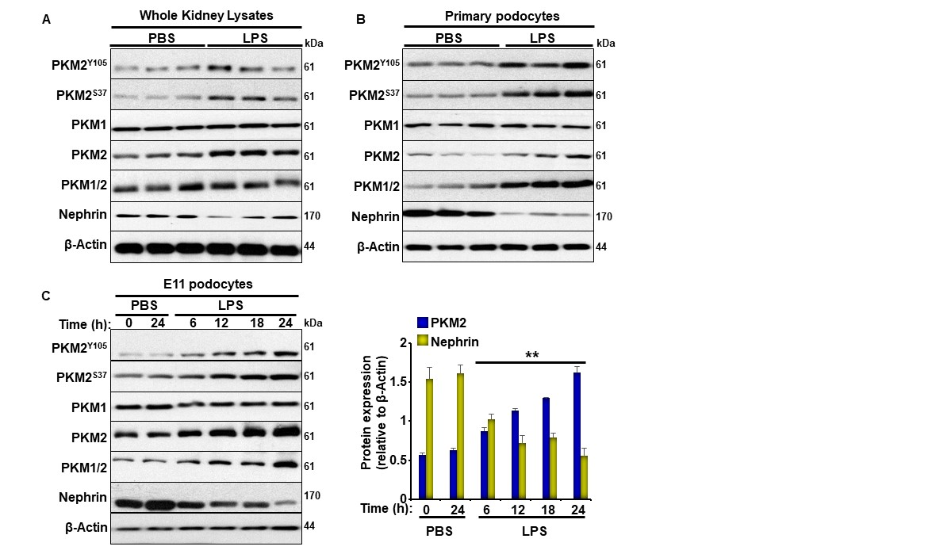

Figure 14. LPS increases PKM2 Phosphorylation and Expression Levels in Renal Tissue and Cultured Podocytes. A) Representative immunoblots of pPKM2^{Y105}, pPKM2^{S37}, PKM2, PKM1, PKM1/2, nephrin, and β-Actin as a loading control in total kidney lysates harvested from C57bl6/J wild type mice 24 h after PBS or LPS injection (n=6/group). B) Representative immunoblots for pPKM2^{Y105}, pPKM2^{S37}, PKM2, PKM1, PKM1/2, nephrin, and β-Actin in primary podocytes isolated from C57bl6/J wild type mice 24 h after PBS or LPS injection (n=12; 4 animals/lane). C) The left panel is representative immunoblots for pPKM2^{Y105}, pPKM2^{S37}, PKM2, PKM1, PKM1/2, nephrin, and β-Actin in cultured murine E11 podocytes in response to PBS or LPS treatment for the indicated duration. The right panel contains bar graphs displaying changes in PKM2 and nephrin levels normalized to β-Actin from three independent experiments. *p<0.05, **p<0.01 indicate a significant difference between cells treated with PBS and non-treated cells.

Figure 15. PKM2 Podocyte Deletion Ameliorates LPS Induced Proteinuria and Kidney Injury. A) The left panel is representative immunoblots of PKM2, PKM1, PKM1/2, and β-Actin in whole kidney lysates from wild type (Ctrl) and podocyte PKM2 knockout mice (KO). The right panel is the mRNA levels of Pkm2 in total kidney lysates of Ctrl and KO mice (n=6 group). B-C) The left panel is representative immunoblots of PKM2, PKM1, PKM1/2, and β-Actin in primary podocytes isolated from Ctrl and KO mice. The right panel is the mRNA level of Pkm2 and Pkm1(C) in primary podocytes (n=12; 4 animals/lane). D) Body weights, (E) Kidney weights, and (F) Kidney to body weight ratio of wild type (Ctrl) and podocyte PKM2 knockout mice (KO) mice, under PBS and LPS treated states. Assessment of (G) total urinary proteins levels, (H) serum albumin levels, (I) urine albumin levels, (J) albumin to creatinine ratios (ACR), and (K) blood urea nitrogen (BUN) levels of Ctrl and KO mice after PBS and LPS injection (n=6-12 per group). (L) mRNA level of Il-1b, Il-6, and Tnfa in whole kidneys of Ctrl and KO mice in response to PBS and LPS (n=6 per group). M) PAS staining of kidney sections in Ctrl and KO mice under PBS and LPS conditions; the arrow is pointing to the expansion of Bowman space in response to LPS treatment. Scale bar = 50 μM. N) Immunofluorescence of Nephrin (green), PKM2 (red), and nuclear DNA using DAPI (blue) in kidney sections obtained from both genotypes injected with PBS or LPS. Scale bar = 50 μM. In A and B, *p<0.05, **p<0.01 indicate a significant difference between Ctrl and KO mice. In D-L, *p<0.05, **p<0.01 indicate a significant difference between PBS- and LPS-injected mice. &p<0.05, &&p<0.01 indicate a significant difference between Ctrl and KO mice.

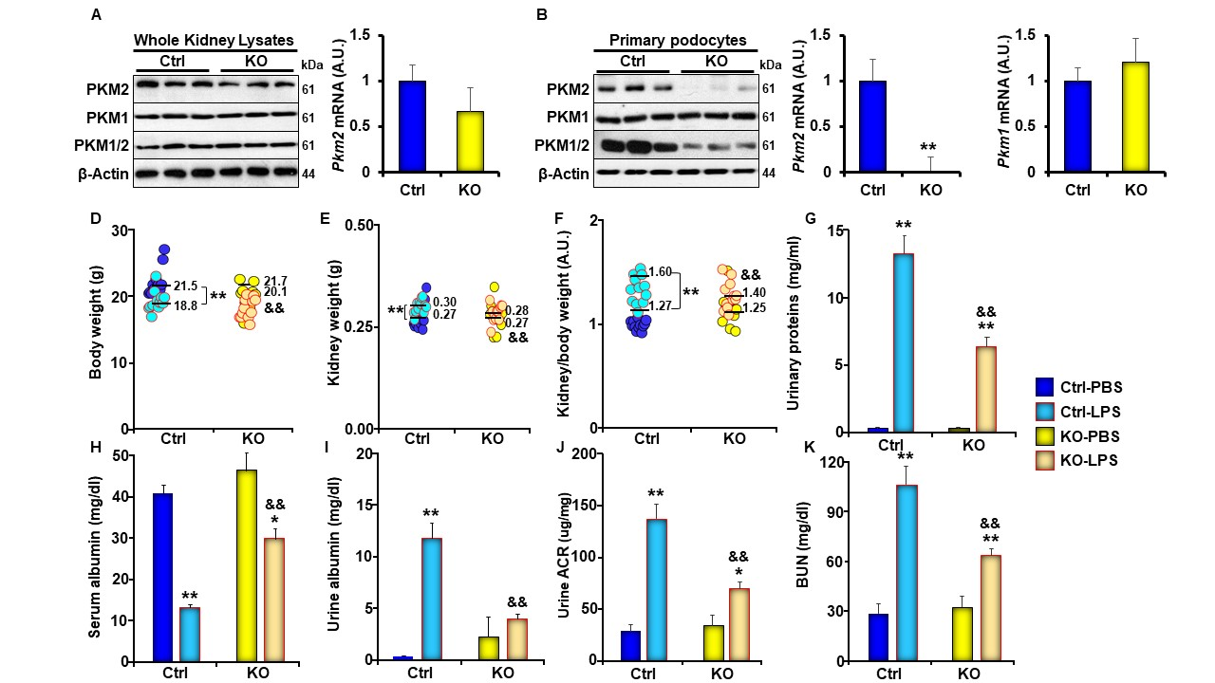
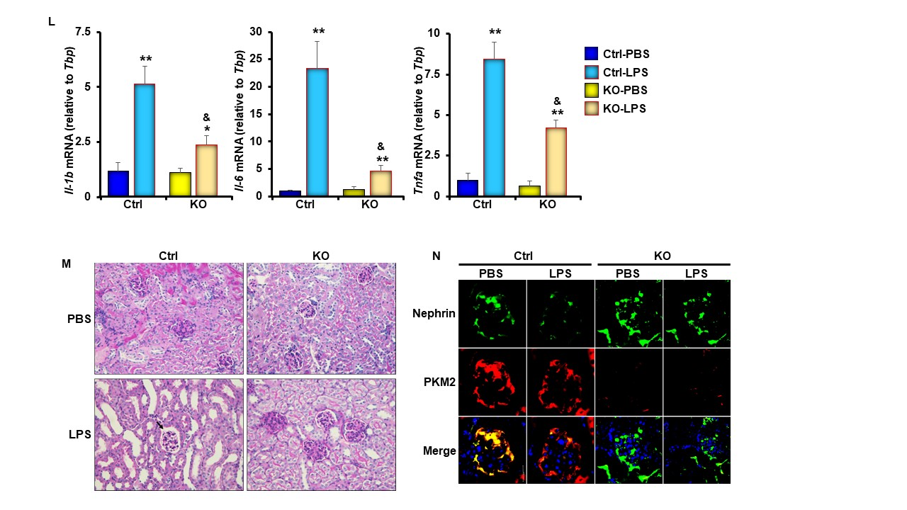
Figure 15. Continued

Figure 16. Podocyte Specific Deletion of PKM2 Attenuates LPS-Induced Inflammation and Apoptosis in Vivo. A) Representative immunoblots (left panel) and bar graph quantitative assessment (right panel) of major signal transduction molecules involved in the NF-κB (pIKKα^{S178/S180}, IKKα, pIκBα^{S32}, IκBα, pNF-κBp65^{S36}, NF-κBp65), MAPK (pJNK1/2^{T183/Y185}, JNK, pP38^{T180/Y182}, P38) signaling pathways, and β-Actin as a loading control in whole kidney lysates of control (Ctrl) and podocyte PKM2 knockout mice (KO) mice harvested 24 h after PBS or LPS injection (n ≥ 6/group). *p<0.05, **p<0.01 indicate a significant difference between PBS- and LPS-injected mice. &p<0.05, &&p<0.01 indicate a significant difference between Ctrl and KO mice. B) Representative immunoblots (left panel) and bar graph quantification (right panel) of apoptotic markers: Caspase 12, 7, and 3, their cleaved forms, and CHOP in whole kidney lysates of control (Ctrl) and podocyte PKM2 knockout mice (KO) mice harvested 24 h after PBS or LPS injection (n ≥ 6/group). *p<0.05, **p<0.01 indicate a significant difference between PBS- and LPS-injected mice. &p<0.05, &&p<0.01 indicate a significant difference between Ctrl and KO mice.

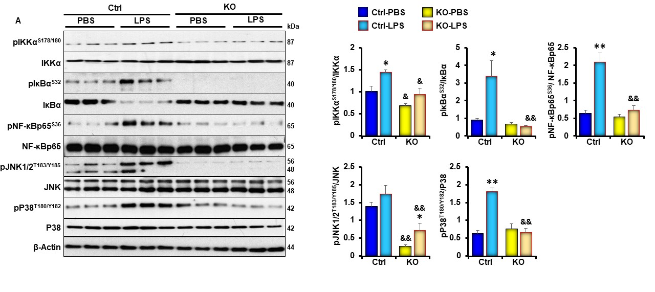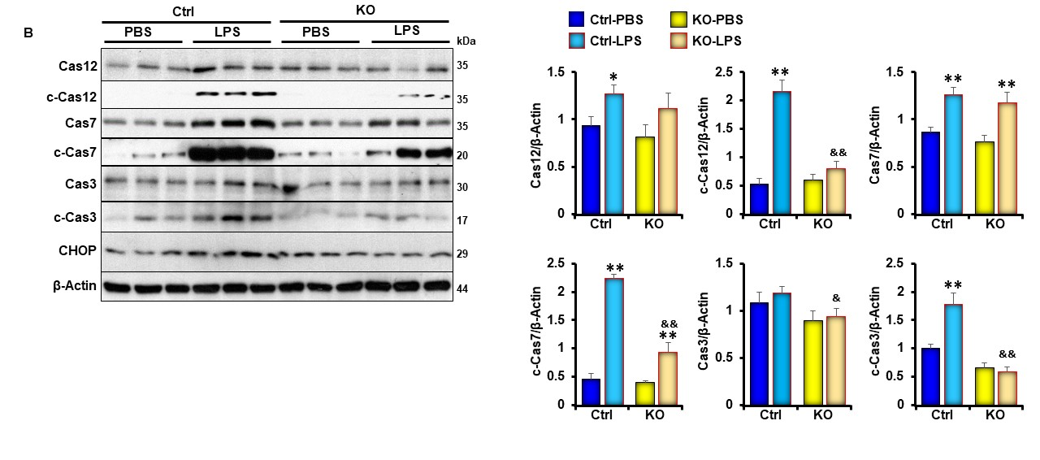
Figure 16. Continued

Figure 17. PKM2 Deficiency in Cultured E11 Podocytes Ameliorates LPS-Induced Nephrin Loss. A) Representative immunoblots (left panel) and bar graph quantitative assessment (right panel) of PKM2, PKM1, PKM1/2, levels in undifferentiated (day 1; D1) and differentiated (D15) E11 murine podocytes infected with lentivirus particles carrying scramble-shRNA (SCR), shRNA targeting PKM2 (M2KD) or an open reading frame of the human DNA (M2R). *p<0.05, **p<0.01 indicate a significant difference between differentiated and undifferentiated cells. #p<0.05, ##p<0.01 indicate a significant difference between the indicated cell and control E11 cells exposed to the same treatment. B) Representative immunoblots (left panel) and bar graph quantitative assessment (right panel) of pPKM2^{Y105}, pPKM2^{S37}, PKM2, PKM1, PKM1/2, and Nephrin, and β-Actin in differentiated M2R and M2KD podocytes treated with LPS for the indicated durations. Data is representative of at least three independent experiments. *p<0.05, **p<0.01 indicate a significant difference between LPS-treated or non-treated cells. &p<0.05, &&p<0.01 indicate a significant difference between M2R and M2KD cells exposed to the same treatment.

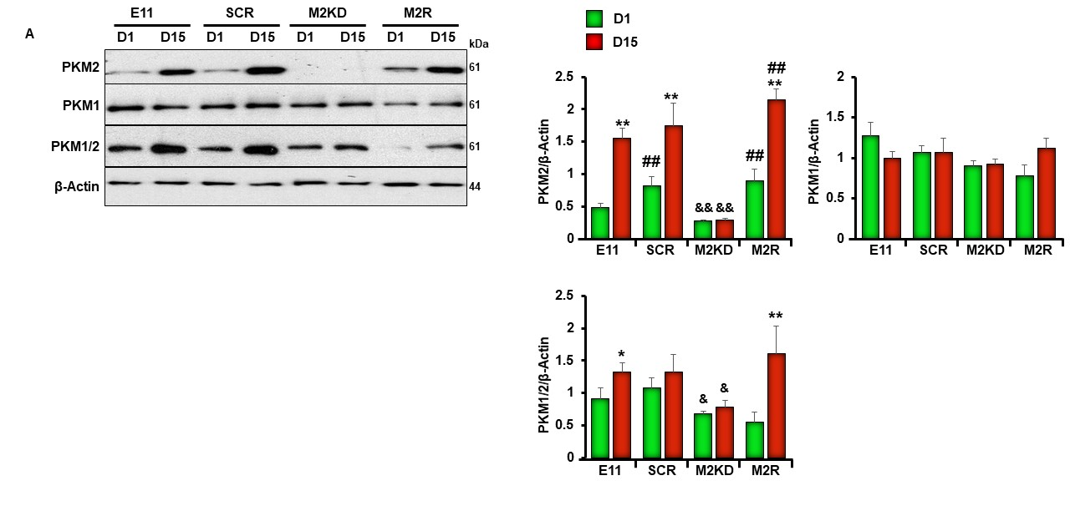
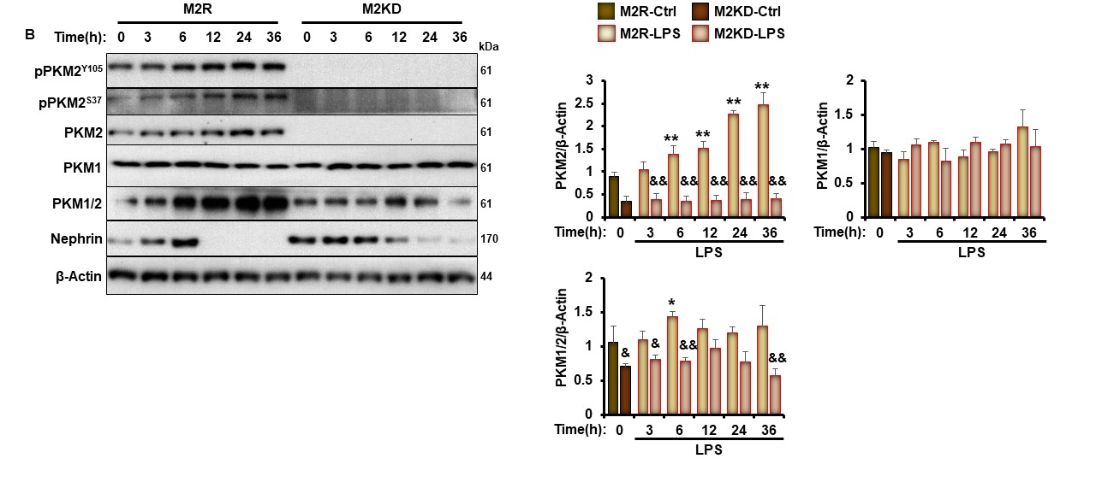
Figure 17. Continued

Figure 18. PKM2 Deficiency Ameliorates LPS-Induced Inflammation and Apoptosis in Cultured E11 Podocytes. A) Representative immunoblots (left panel) and bar graph quantitative assessment (right panel) of pIKKα^{S178/S180}, IKKα, pIκBα^{S32}, IκBα, pNF-κBp65^{S36}, NF-κBp65, pJNK1/2^{T183/Y185}, and JNK in total cell lysates from differentiated M2R and M2KD podocytes treated with LPS for the indicated durations. Data is representative of at least three independent experiments. *p<0.05, **p<0.01 indicate a significant difference between LPS-treated or non-treated cells. &p<0.05, &&p<0.01 indicate a significant difference between M2R and M2KD cells exposed to the same treatment. B) Representative immunoblots (left panel) and bar graph quantitative assessment (right panel) of CHOP, cleaved-caspase 3, and β-Actin in total cell lysates from differentiated M2R and M2KD podocytes treated with LPS for the indicated durations. Data is representative of at least three independent experiments. *p<0.05, **p<0.01 indicate a significant difference between LPS-treated or non-treated cells. &p<0.05, &&p<0.01 indicate a significant difference between M2R and M2KD cells exposed to the same treatment. C) Caspase 3 activity in M2R and M2KD cells treated (LPS) or non-treated (Ctrl) with LPS for 24 hr. **p<0.01 indicate a significant difference between LPS-treated or non-treated cells. &&p<0.01 indicate a significant difference between M2R and M2KD cells exposed to the same treatment. D-E) Representative images (D) and quantification (E) of chromatin condensation in Hoechst-stained M2R and M2KD podocytes treated with LPS for 24 h. Scale bar: 50 μm. Images are representative of at least three independent experiments.

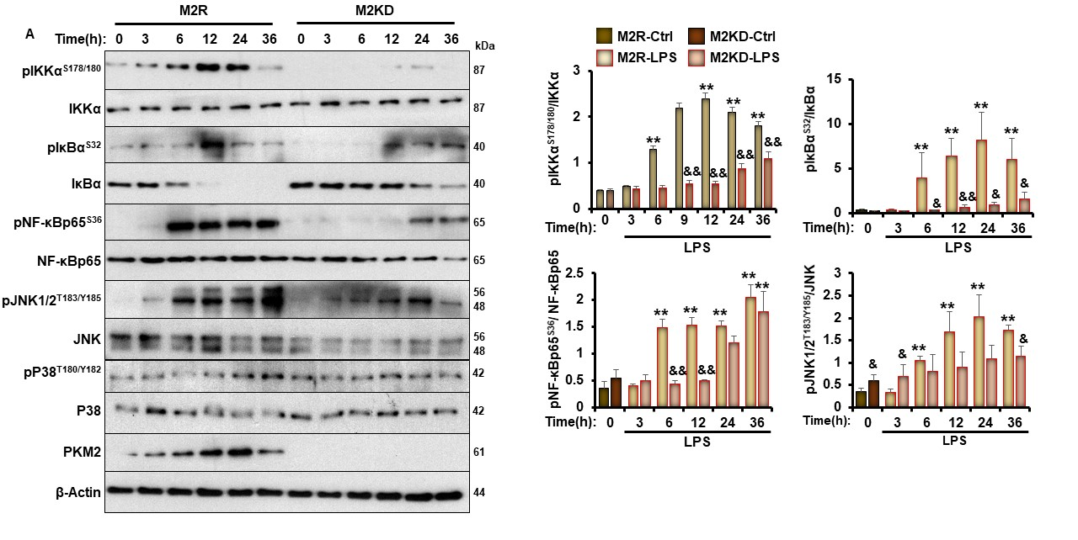
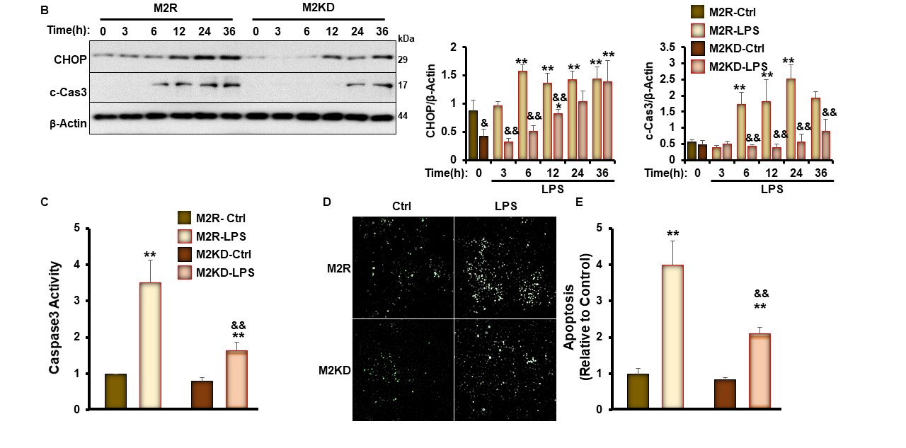
Figure 18. Continued

Figure 19. PKM2 Depletion Suppress LPS-Induced-β-Catenin Activation in Kidneys and E11 Cultured Podocytes. A) Representative immunoblots (left panel) and bar graph quantitative assessment (right panel) of pβ-Catenin^{S33}, pβ-Catenin^{Y333}, β-Catenin and its downstream targets (WT1 and c-Myc), and nephrin in total kidney lysates harvested from WT and KO mice 24 h after PBS or LPS injection (n≥6/group). *p<0.05, **p<0.01 indicate a significant difference between PBS- and LPS-injected mice. &p<0.05, &&p<0.01 indicate a significant difference between Ctrl and KO mice. B) Representative immunoblots (left panel) and bar graph quantitative assessment (right panel) of pβ-Catenin^{Y33}, β-Catenin, WT1, and c-Myc in cell lysates from differentiated M2R and M2KD podocytes treated with LPS for the indicated durations. *p<0.05, **p<0.01 indicate a significant difference between LPS-treated or non-treated cells. &p<0.05, &&p<0.01 indicate a significant difference between M2R and M2KD cells exposed to the same treatment. C) Representative immunoblots (left panel) and bar graph quantitative assessment (right panel) of pβ-Catenin^{Y333}, β-Catenin, GFP, WT1, c-Caspase 3, and PKM2 in total cell lysates from LPS treated or non-treated M2R and M2KD transfected with empty pCS2+ vector (Ctrl), pCS2 plasmid expressing the constitutively active β-catenin mutant (β-CA), or the pLHCX vector expressing the K433E mutant of PKM2. *p<0.05, **p<0.01 indicate a significant difference between LPS-treated or non-treated cells. &p<0.05, &&p<0.01 indicate a significant difference between M2R and M2KD cells exposed to the same treatment. #p<0.05, ##p<0.01 indicate a significant difference between the indicated cell overexpressing the constitutively active mutant of β-catenin (β-CA) or the K433E mutant of PKM2 and M2KD cells exposed to the same treatment. D) Caspase 3 activity in M2R, M2KD cells in total cell lysates from LPS treated or non-treated M2R, M2KD transfected with empty pCS2+ vector (Ctrl), pCS2 plasmid expressing the constitutively active β-catenin mutant (β-CA) plasmids, or the pLHCX vector expressing the K433E mutant of PKM2. Data is representative of at least three independent experiments. *p<0.05, **p<0.01 indicate a significant difference between LPS-treated or non-treated cells. &p<0.05, &&p<0.01 indicate a significant difference between M2R and M2KD cells exposed to the same treatment. #p<0.05, ##p<0.01 indicate a significant difference between the indicated cell overexpressing the constitutively active mutant of β-catenin (β-CA) or the K433E mutant of PKM2 and M2KD cells exposed to the same treatment. E-F) Representative images (E) and quantification (F) of chromatin condensation in Hoechst-stained M2R and M2KD podocytes transfected with empty pCS2+ vector (Ctrl) or a pCS2 plasmid expressing the constitutively active β-catenin mutant (β-CA). Scale bar: 50 μm. Images are representative of at least three independent experiments.

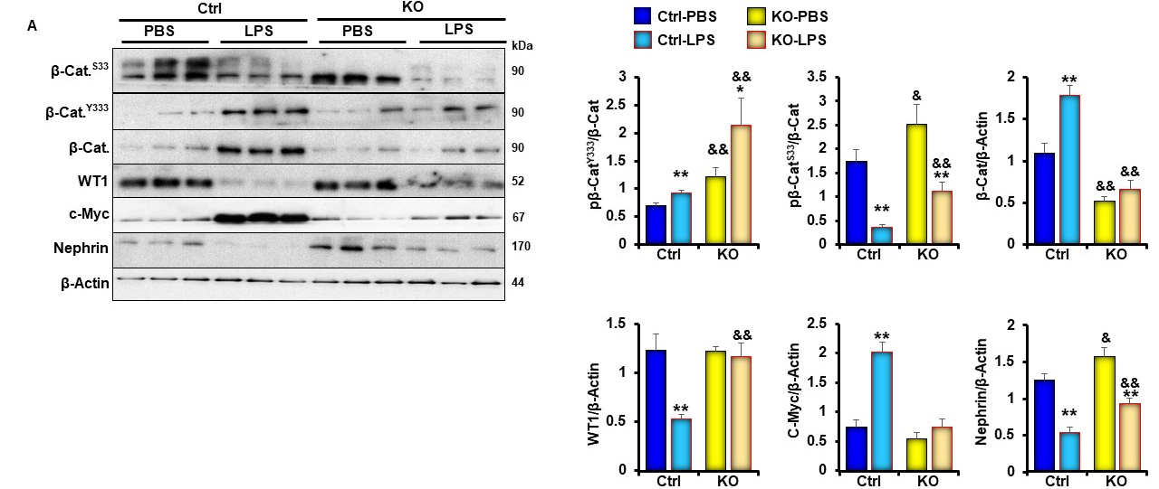
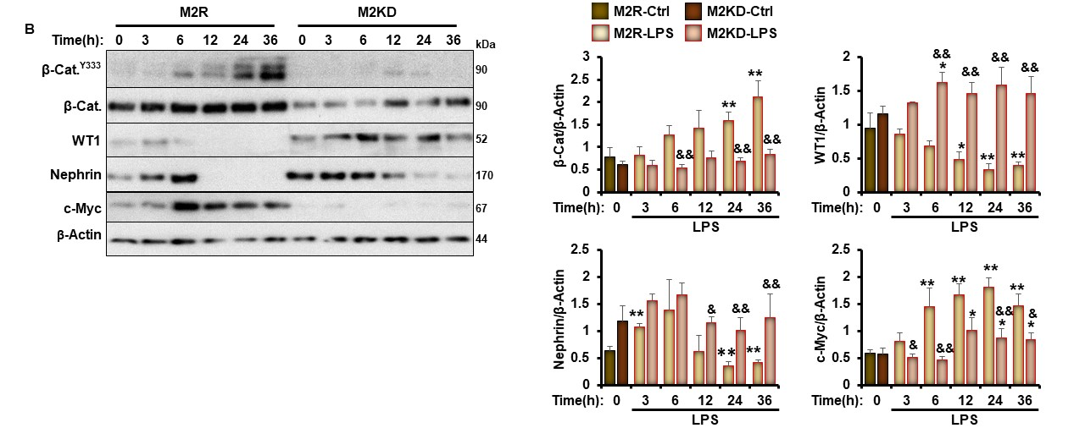
Figure 19. Continued
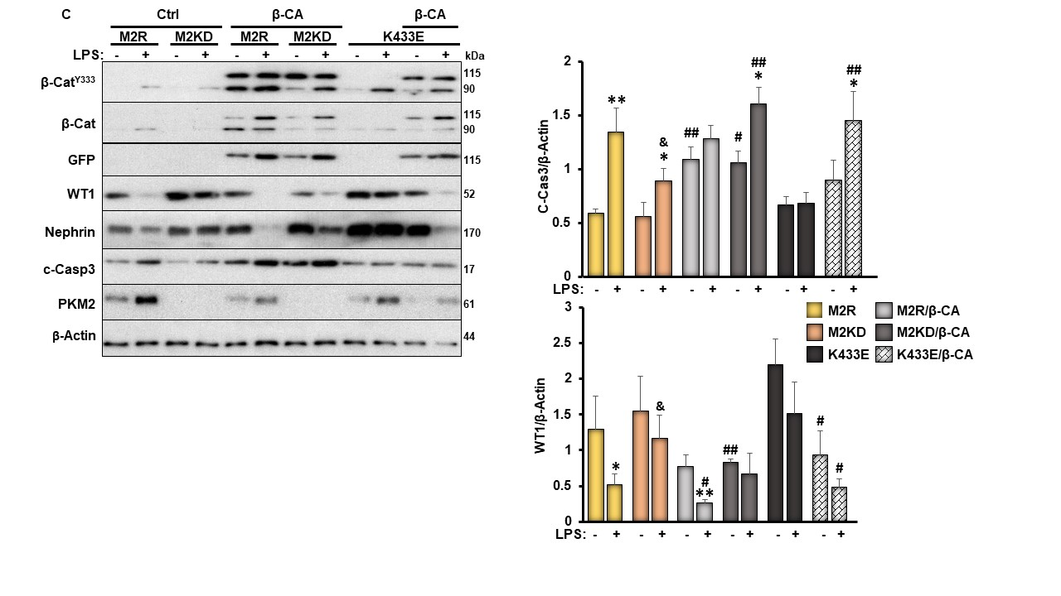
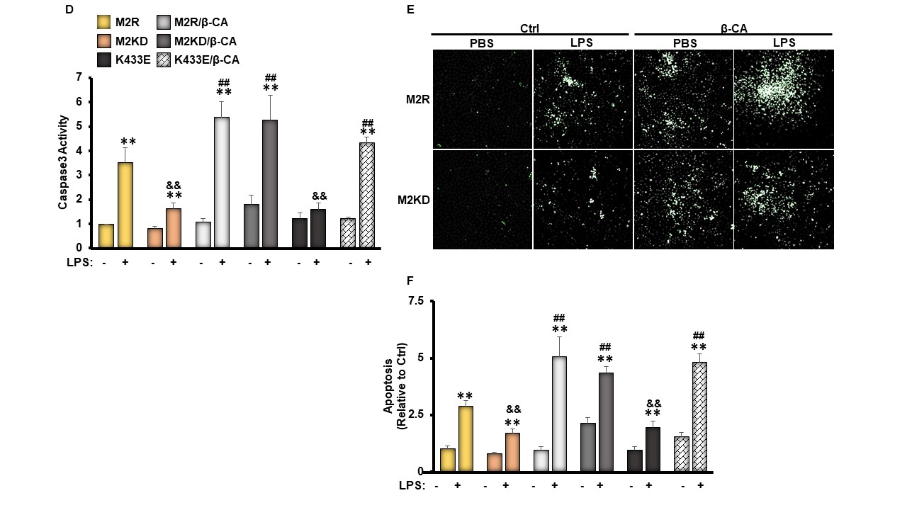
Figure 19. Continued

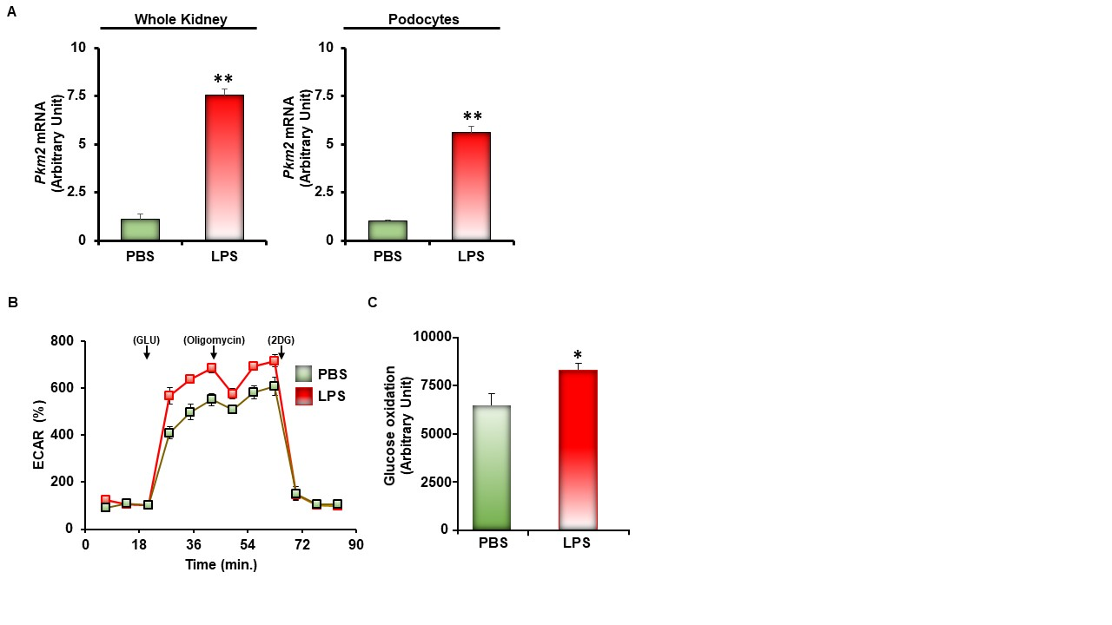
Supplementary Figure S1. A) mRNA levels of Pkm2 in total kidney (n=6/group) and primary podocytes (n=4/group) from C57BL6 mice treated with PBS or LPS for 24 hr. B-C Extracellular acidification (B) and glycolysis rate (C) in differentiated E11 podocytes treated with PBS (Controls) or LPS for 6 hours. In A and C, *p<0.05, **p<0.01 indicate a significant difference between LPS-treated or non-treated mice (A) or E11 podocytes (C).

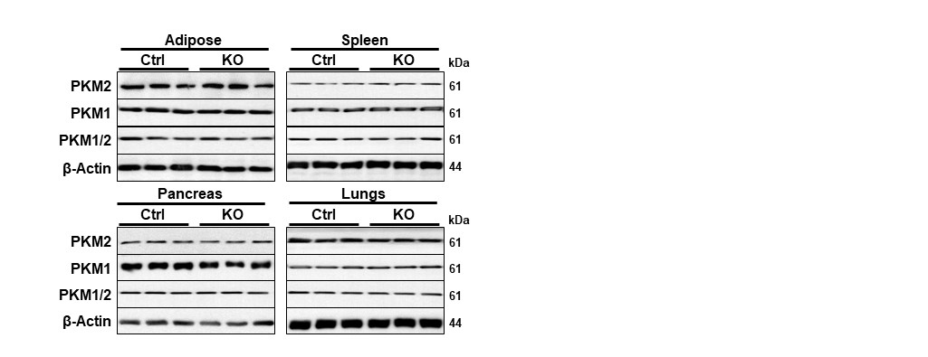Supplementary Figure S2. Specificity of PKM2 Deficiency in Podocytes. Representative immunoblots of PKM2, PKM1, PKM1/2, and β-Actin in adipose, spleen, pancreas, and lungs of WT and KO mice (n = 6 per group).

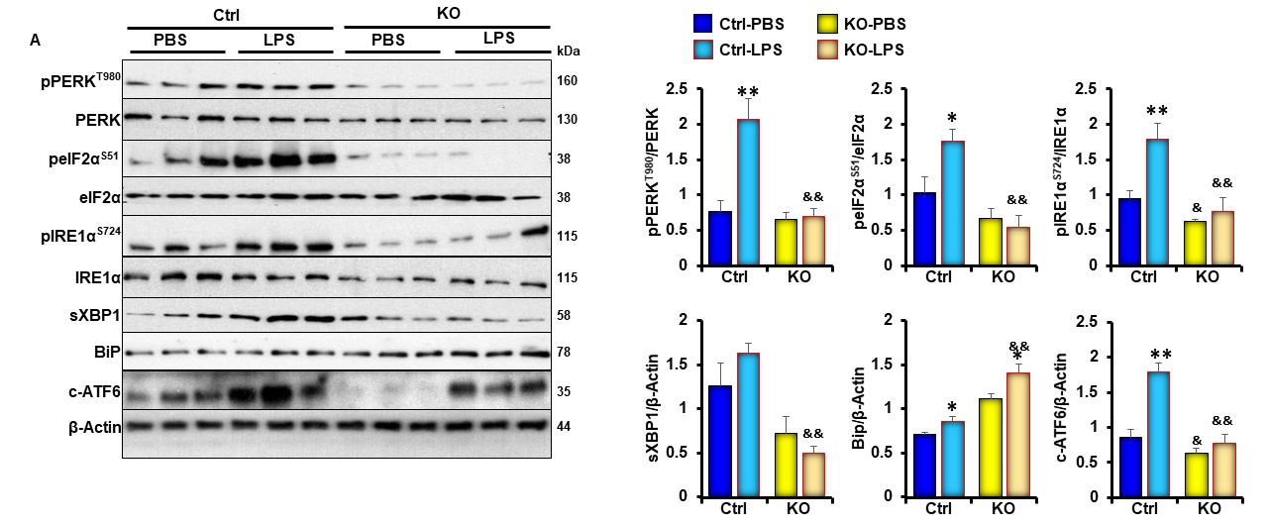
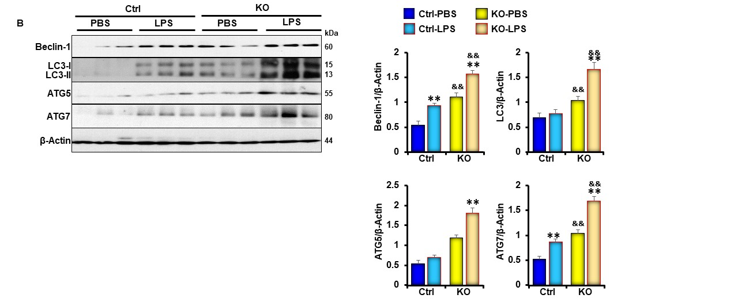
Supplementary Figure S3. PKM2 Podocytes Depletion Ameliorates LPS-Induced ER Stress but Exacerbates Autophagy in Vivo. A-B) Representative immunoblots (left panel) and bar graph quantitative assessment (right panel) of major signal transduction molecules involved in the ER stress (A) or autophagy (B) signaling pathways, and β-Actin as a loading control in whole kidney lysates of control (Ctrl) and podocyte PKM2 knockout mice (KO) mice harvested 24 h after PBS or LPS injection (n ≥ 6/group). *p<0.05, **p<0.01 indicate a significant difference between PBS- and LPS-injected mice. &p<0.05, &&p<0.01 indicate a significant difference between Ctrl and KO mice.

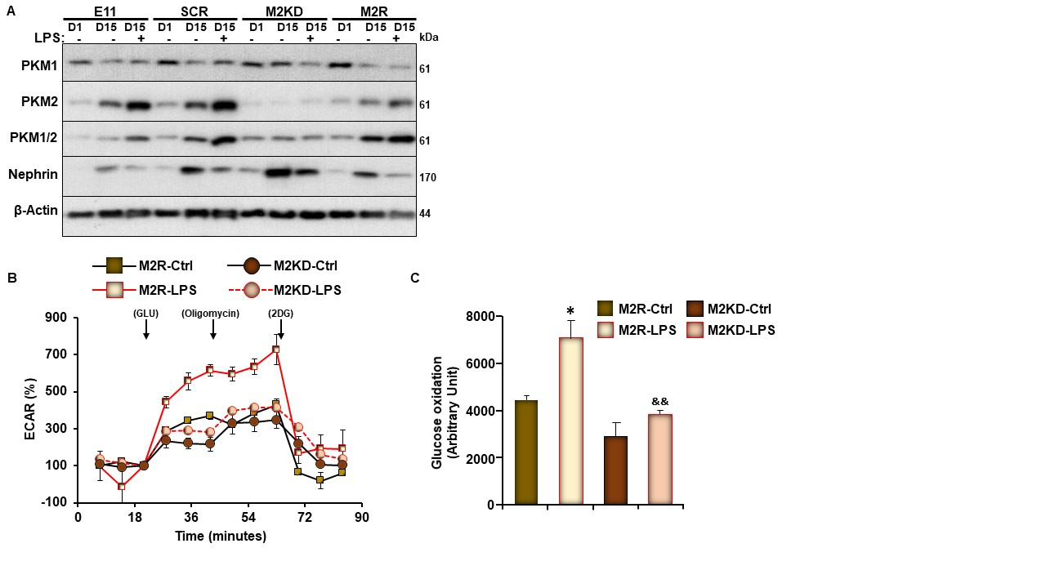
Supplementary Figure S4. Changes in PKM2 and Nephrin Expression in Response to LPS Treatment in M2R, SCR Cells and Original E11 Cells. A) Representative immunoblots (left panel) of PKM2, PKM1, PKM1/2, and nephrin levels in undifferentiated (day 1; D1) and differentiated (D15) E11 murine podocytes infected with lentivirus particles carrying scramble-shRNA (SCR), shRNA targeting PKM2 (M2KD) or an open reading frame of the human DNA (M2R). When indicated, cells were treated with LPS for 24 h. B-C Extracellular acidification (ECAR; B) and glycolysis rate (C) in differentiated M2R and M2KD podocytes treated with LPS for 6 h. *p<0.05 indicates a significant difference between LPS-treated or non-treated cells. &&p<0.01 indicates a significant difference between M2R and M2KD podocytes treated with LPS.

Supplementary Figure S5. PKM2 Deficiency Ameliorates ER Stress, but Exacerbates Autophagy in LPS-Treated Podocytes. Representative immunoblots (left panel) and bar graph quantitative assessment (right panel) of major signal transduction molecules involved in the ER stress (A) or autophagy (B) signaling pathways, and β-Actin as a loading control in total cell lysates from differentiated M2R and M2KD podocytes treated with LPS for the indicated durations. Data is representative of at least three independent experiments. *p<0.05, **p<0.01 indicate a significant difference between LPS-treated or non-treated cells. &p<0.05, &&p<0.01 indicate a significant difference between M2R and M2KD cells exposed to the same treatment.

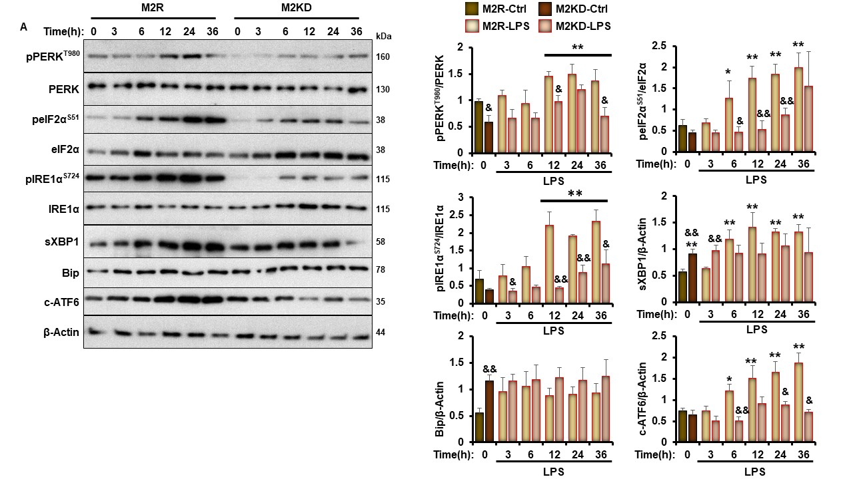
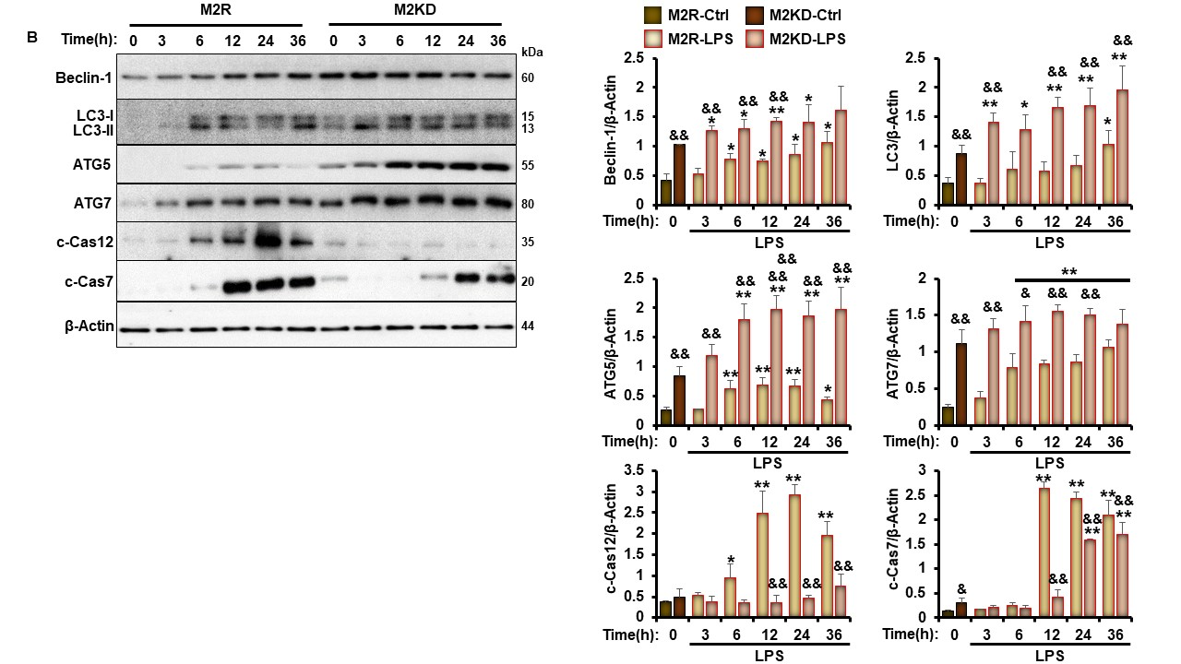
Supplementary Figure S5. Continued

Conclusion, Limitations, and Future Directions
In this dissertation, we highlighted the role of pyruvate kinase M2 (PKM2) on podocyte differentiation and homeostasis and examined its overall contribution to renal injury using lipopolysaccharide (LPS) induced injury model. In chapter II, we provide evidence that the genetic inhibition of PKM2 enhanced podocyte differentiation and functionality in vitro. In addition, we delineated the molecular circuit mediating the beneficial effect of PKM2 deficiency on differentiation. The depletion of PKM2 reduced the phosphorylation of AKT at early stages of differentiation, thereby promoting the activity of AMPK, mTORC1, and autophagy leading to improved differentiation status. Furthermore, we carried out in vivo experiments (chapter III) to examine the significance of PKM2 in podocytes to glomerular function. The specific deletion of PKM2 in podocytes mitigated LPS induced nephrin loss, renal injury, and proteinuria. In addition, PKM2 deficiency in vivo ameliorated the induction of ER stress, inflammation, and apoptosis by LPS while enhancing autophagy. The effect of PKM2 on these signaling was further recapitulated using in vitro experiments. Moreover, we revealed the molecular mechanism mediating PKM2 action on injured podocytes. The interaction of PKM2 and β-catenin appeared to be required for mediating the pathological role of PKM2. Disrupting this interaction protected against LPS induced apoptosis and mimicked the beneficial effect observed in PKM2 deficient podocytes. To that end, the data presented in this project elucidated a novel role of PKM2 in podocytes homeostasis and acute renal injury.
The data presented in this dissertation advanced our understanding regarding the role of PKM2 in podocyte homeostasis and renal injury. However, the dissertation exhibits few limitations that need to be acknowledged. In chapter II, we characterized the expression pattern of PKM2 and PKM1 in differentiating podocytes, but the bioenergetic profile of differentiating podocytes and the effect of PKM2 deficiency on glycolysis was not evaluated. Moreover, while we provided elaborated data on the molecular basis mediating PKM2 deficiency action on podocyte differentiation, the role of mTORC2, which might be regulating mTORC1 or AKT, has not been examined. Finally, we demonstrated the role of PKM2 deficiency on podocytes differentiation using western blotting and qRT-PCR techniques. Still, the electronic microscopy imaging showing the development of podocytes and the effect of PKM2 depletion during differentiation has not been presented. Similarly, in chapter III, we used various biochemical techniques and assays to address the contribution of PKM2 to injured kidneys. However, histological assessment using transmission electron microscopy (TEM) that precisely display the effect of PKM2 on podocytes foot process effacement is lacking. Currently, ongoing studies by my colleagues in the laboratory are investigating the effects of PKM2 deficiency and pharmacological inhibition on the relationship between proteinuria and ultrastructural changes of podocyte foot processes under stress conditions affecting podocyte function and homeostasis.
According to the Center for Disease Control and Prevention, one-fifth of the US population will be older than 65 years in 2030. Eventually, this will lead to increased diagnosis of aging-related diseases, including renal diseases [1]. With aging, the kidneys gradually lose their proper functions and exhibit structural and physiological deteriorations [2]. For instance, the number of podocytes have been shown to decrease with aging under normal physiological conditions [3]. Moreover, the remaining podocytes may exhibit declined function or senescence, thereby promoting the onset of aging-related glomerular diseases and proteinuria [4]. In addition, aging podocytes exhibit decreased nephrin expression under normal physiological conditions [5]. However, further advancement in the field of renal research revealed multiple pathogenic factors that accelerate renal aging. These factors include but are not limited to increased accumulation of reactive oxygen species (ROS), activation of the Wnt signaling, and decreased autophagy [1]. Indeed, the specific deletion of autophagy-related gene 5 (ATG5) has been shown to accelerate podocytes senescence and proteinuria. Moreover, autophagy was suggested as a defense mechanism against podocyte senescence [6]. Similarly, increased phospho-AMPK, which is known for its antioxidant role, has been suggested as a mechanism to ameliorate podocytes senescence [5]. Collectively, these studies show that AMPK and autophagy might be of therapeutic value to maintain podocyte longevity. However, in this dissertation, we observed that PKM2 deficiency was associated with increased autophagy and AMPK phosphorylation but decreased β-catenin level. Furthermore, the depletion of PKM2 promoted podocytes differentiation and protected against LPS induced nephrin loss. Therefore, it is logical to assume that PKM2 may contribute to podocyte senescence and glomerular aging-related diseases through altering the activity of AMPK and autophagy. Thus, it will be of high interest for future studies to investigate the potential role of PKM2 in aging podocytes and its overall contribution to aging-related renal diseases.

References
1. O'Sullivan, E.D., J. Hughes, and D.A. Ferenbach, Renal Aging: Causes and Consequences. J Am Soc Nephrol, 2017. 28(2): p. 407-420.
2. Weinstein, J.R. and S. Anderson, The aging kidney: physiological changes. Adv Chronic Kidney Dis, 2010. 17(4): p. 302-7.
3. Wanner, N., et al., Unraveling the role of podocyte turnover in glomerular aging and injury. J Am Soc Nephrol, 2014. 25(4): p. 707-16.
4. Camici, M., et al., Podocyte dysfunction in aging--related glomerulosclerosis. Front Biosci (Schol Ed), 2011. 3: p. 995-1006.
5. Zhang, L., et al., C/EBPα deficiency in podocytes aggravates podocyte senescence and kidney injury in aging mice. Cell Death Dis, 2019. 10(10): p. 684.
6. Hartleben, B., et al., Autophagy influences glomerular disease susceptibility and maintains podocyte homeostasis in aging mice. J Clin Invest, 2010. 120(4): p. 1084-96.

Vita
Mr. Alquraishi was born and raised in Riyadh capital of Saudi Arabia. In 2008, Mr. Alquraishi received a bachelor's degree of science in Dietetics from King Saud University, Riyadh, Saudi Arabia. Since then, Mr. Alquraishi started his journey in graduate schools. In 2013, Alquraishi earned a Master's degree of Science in Exercise and Nutrition from Lipscomb University, Nashville, TN, USA. In 2016, Alquraishi joined Dr. Bettaeib's laboratory to pursue a doctoral degree in Nutritional Sciences at the University of Tennessee, Knoxville, USA. During his stay in Dr. Bettaieb's laboratory, Mr. Alquraishi was involved in various projects that developed his research and scientific skills. As a result, Alquraishi published four articles as either first, shared, or second author. In addition, Mr. Alquraishi presented multiple projects at different national and international scientific conferences.

