Analyzing Potential Responses to Supply Chain Disruptions
Mackenzie Bond

Abstract

Following the Covid-19 pandemic, supply chain disruptions have been thrust into the spotlight. Despite the recent attention, disruptions have been plaguing supply chains since the Silk Road. Supply chain disruptions can be defined as the trigger event(s), along with their consequences, that disrupt the flow of supply chain and business operations (Bugert and Lasch 2018). Disruptions are an inevitable aspect of managing a supply chain. Because of this, supply chain managers are responsible for enacting a variety of strategies to mitigate the risk and impact of disruptions.
Strategic approaches can be broken into two categories: proactive and reactive. Proactive approaches are implemented as preventative measures by an organization to prevent disruptions or reduce the scale of the disruption. Reactive approaches can be planned before or after a disruption occurs but are implemented and adjusted after the fact to control the impact of the disruption (Rinaldi, et al. 2022). Strategies can typically be used in both proactive and reactive manners.
This research aims to analyze the different potential strategies organizations can implement to combat supply chain disruptions. By understanding what factors trigger different responses and how organizations can respond to disruptions, we can provide insights that will allow managers to adopt the strategies that will be the most effective for their supply chain.

Types of Supply Chain Disruptions

There are multiple different types of supply chain disruptions that can affect operations. The four primary categories of disruptions are natural, man-made, technological, and economic disruptions. Natural disruptions are any events of a natural origin: pandemics and natural disasters like earthquakes, hurricanes, and wildfires. Natural disasters pertaining to atmospheric events tend to physically disrupt the supply chain by damaging infrastructure, materials, and products, whereas natural disasters like pandemics disrupt labor availability and create regulatory disruptions. Man-made disruptions are events like strikes, labor disputes, war, and other forms of geopolitical conflicts. These forms of disruptions can cause operations to shut down and transportation routes to be affected, disrupting downstream customers (BSI America 2024).
Technological disruptions are events like cyber-attacks, system failures, and other technological issues. With our increasing reliance on technology, these disruptions can delay or shut down operations in both manufacturing and corporate supply chain functions. Economic disruptions are events like recessions, market crashes, and trade disputes. These disruptions impact customer behavior, demand, and inventory.
The level of risk associated with a type of disruption can be understood through a supply chain volatility matrix, which classifies each disruption by known and unknown causes. A disruption that is a known known is likely and has foreseeable consequences and recovery actions. A known unknown disruption has a likelihood that is somewhat predictable but has varying consequences. An unknown known disruption is a disruption we are aware of but cannot foresee. Finally, an unknown unknown disruption is a disruption that we are unprepared for in terms of consequences and likelihood of occurrence (Oakden 2019). Before Covid-19, a global pandemic and the resulting shutdowns was an unknown unknown. Included in Appendix A is a matrix categorizing different common disruptions by level of risk, these may vary based on an organization,
All businesses will face any combination of disruption from multiple different categories. Some disruptions, like Covid-19, will affect virtually all businesses, others like cyber-attacks can be isolated incidents that only directly impact one business at a time. Because of this, organizations must have multiple strategies to be reasonably prepared for disruptions.

Strategies to Address Supply Chain Disruptions

The goal of all supply chain disruption strategies is to improve a company’s supply chain resilience. Supply chain resilience is a company's ability to continue operation in the face of internal or external disruptions (Brandon-Jones, et al. 2014). These strategy categories are summarized as exogenous or endogenous and proactive or reactive in Appendices B and C respectively.

Information Sharing and Visibility
Proactive and Reactive Approaches
Information sharing is a necessary tool that enables decision making during a disruption. Information sharing is regarded as the quality and relevance of information that is gathered (Brandon-Jones, et al. 2014). Robust information sharing is the catalyst for greater visibility in a supply chain. Visibility can be defined as the end-to-end view of supply chain operations. Both internal and external information sharing is needed to enable visibility. External visibility of suppliers’ operational activities can improve operational performance and decrease risks (Barratt and Barratt 2010).
Visibility can be used to improve a company’s resilience, proactively helping identify potential risks before they turn into disruptions (Sunmola, et al. 2023). Visibility leads to faster disruption discovery. Discovery time is one of the most important factors in disruption response, allowing for a quicker response that will hopefully reduce the disruption’s impact and prevent larger accrued costs (Messina, et al. 2021). Early identification through information sharing allows companies to have timely responses (Colicchia, et al. 2019). Visibility can also reactively provide insights into why, when, and from where a disruption originates from (Sunmola, et al. 2023).
Limitations
One of the greatest risks of information sharing is information leakage. Potential risks from a security standpoint include viruses, hackers, etc. (Colicchia, et al. 2019) However, modern supply chains increasingly need the information sharing to survive. Operations, transportation, planning, and other facets of the supply chain are interconnected through a network of different systems and infrastructures and are reliant on information sharing (Zuehlke 2010). Companies need to balance the mitigation of risk associated with technological disruptions as compared to other types. Investment in strong IT security can also be pursued to address the risk of data breaches.
Scenario
In March of 2021, the Suez Canal was blocked by a container ship the Ever Given (Trestrail 2023). The Suez Canal is one of the most important shipping routes in the world, and this blockage stopped billions of dollars’ worth of goods. This man-made disruption highlighted a lack of visibility in many companies. Companies did not have access to the real-time data they needed to make necessary business decisions (Upasani, et al. 2024). Products, through multiple levels of suppliers, were physically trapped in the canal. This disruption highlights the need for product visibility and information sharing between suppliers, shippers, and buyers to identify delays. This information is integral for companies to make contingency plans based around these product delays.

Supplier Diversification
Proactive and Reactive Approaches
Multisourcing is the primary method of diversification in a supply chain (Tomlin 2012). This is one of the most straightforward ways to reduce the disruption risks associated with a specific supplier. This method is a proactive approach to handling supplier risks. Diversification in all forms creates a more flexible supply chain and can also stabilize an organization’s supply (Hendricks, et al. 2008). As of April 2021, over 80% of Japanese manufacturers have begun diversifying their suppliers (Nikkei 2021). In a post-Covid environment, it is recommended to avoid overreliance on a small number of suppliers. Geographical diversification adds an extra level of protection against disruption (Lin, et al. 2021).
Alternatively, in response to a disruption, companies can go to an alternative supplier identified previously by a backup plan (Tomlin 2021). Temporary alternative supplier diversification is most useful for products that are not highly specific (Whitney, et al. 2014).
Limitations
However, supplier diversification through multisourcing has its limitations. Firstly, diversification relies on the assumption that both suppliers will not be impacted by the same disruption. When the products are not equitable substitutes in quality, using these materials could cause discrepancies in a company’s own production and processes. Inequitable costs between suppliers and reduced economies of scale can also cause hesitancy to multisource certain products, this is in addition to the investment costs necessary to establish a new supplier (Tomlin 2012). Diversification also complicates a supply chain, discouraging effective information sharing between the company and the manufacturer (Li, et al. 2022).
Scenario
Apple, like most companies, was significantly impacted by Covid-19 and the resulting shutdowns. Prior to the pandemic, China was Apple’s sole manufacturer. The impacts of Covid in China were strict and long lasting, while other countries had reopened manufacturing, many parts of China were still under lockdown (Goh 2022). In 2023, Apple decided to geographically diversify its production. Apple was introducing MacBook production in Vietnam and iPhone production in India (Forbes 2024). This decision creates challenges for Apple as moving to a new country affects labor regulations, government regulations, and property rights. Despite this, this decision was made to protect Apple’s supply chain from similar disruptions to Covid-19. The geographical and geopolitical change is intended to mitigate the potential of an all-out production stoppage. While this might increase the potential of isolated disruptions at a manufacturing facility, this supplier diversification is aimed to strengthen the entire supply chain, with multiple production sources (Forbes 2024).

Continuous Monitoring and Supplier Resilience
Proactive and Reactive Approaches
Supplier resilience is a focus on an individual supplier’s capability to endure disruptions and resume normal operations. Underperforming suppliers are more likely to experience longer and more frequently occurring disruptions. Supplier performance, and therefore resilience, cannot be quantified and tracked without supplier measurement systems. Managers should implement continuous monitoring through performance metrics to understand a supplier’s resilience. These metrics would allow for pre-disruption monitoring to mitigate the risk of a poor-performing supplier, but can also be used to compare pre-disruption, during disruption, and post-disruption impact to improve supplier response (Burkhart and Bode 2024).
Quality audits can be used to monitor a supplier’s operations and catch potential sources of disruption before they occur (Lawson, et al. 2019). Supplier audits can be conducted under voluntary standards, specifically created for that company, or could be based on set industry or government standards (Castka, et al. 2021). These audits are traditionally used to track a supplier’s quality performance, which can also be used to determine their resilience.
Additionally, programs encouraging improved performance of the entire supplier base can make a significant difference in overall supply chain resilience (Burkhart and Bode 2024). One incentive program could be imposing severe external failure penalties. These two strategies should be used in conjunction to improve supplier performance. External penalties provide financial reinforcement to supplier facility audits and supplier facility audits motivate suppliers to demonstrate proper quality control to avoid penalties (Handley and Gray 2013). These programs can be both a proactive deterrent and a reactive penalty for disruption.
Limitations
Improving supplier resilience can be contradictory to supplier diversification. It is recommended to simplify supply chains by decreasing the supplier count and localizing the supply chain (Burkhart and Bode 2024). This causes a challenge for managers to decide between creating resilience through redundant suppliers or creating resilient suppliers through a simplified supply chain and closer supplier relationships.
Scenario
Car manufacturer Ford and tire manufacturer Firestone had a collaborative relationship that had begun in 1906 (Schubert 2011). This relationship was strained when Firestone tires, that had been used on Ford vehicles, were malfunctioning leading to many accidents and fatalities. This caused a supply chain disaster as Firestone and Ford had to recall 6.5 million tires in 2000. Firestone already had the largest tire recall in 1978, when 14.5 million tires were recalled (Schubert 2011). Despite their long-standing relationship and Firestone’s history, Ford did not have the proper quality assurance programs in place with Firestone. This caused a significant disruption as Ford had to publicize the recall, undergo reverse logistics to recall tires, and procure functional replacement tires. Ford was made aware of potential quality issues in 1997, with early warnings coming out of Venezuela and Saudi Arabia. Ford, however, did not take adequate steps to confirm the quality of their tire supply (Pinedo 2000).

Inventory Management
Proactive and Reactive Approaches
Inventory management is the process of balancing the necessary inventory needed to meet demand, while taking storage, stock levels, and many other factors into consideration (Atnafu and Balda 2018). Inventory management models should balance cost savings and customer satisfaction through order fulfillment (Corlu, et al. 2020). Maintaining a higher level of inventory is a more effective and practical approach for companies that experience shorter and more frequent disruptions than companies who experience prolonged and infrequent disruptions. This form of inventory management is known as just-in-case (Ishak 2023). Inventory management models should also be adapted to disruptions with the highest likelihoods. Certain disruptions, like natural disasters, are seasonal and inventory can be planned around these potential disruptions (Atan and Snyder 2011).
Not all inventory management strategies require stockpiles. Companies who want reactive inventory management need tools that allow them to detect potential disruptive events (Tomlin 2012). This allows them to use an adaptive inventory strategy. Additionally, to maintain short-term stockpiles, companies need the infrastructure to store a sudden increase in inventory and procure or manufacture the necessary supplies quickly (Tomlin 2012). Another inventory management strategy that does not involve active inventory adjustments is having an inventory evacuation plan. This method is for the reactive mitigation of disruptions that will directly affect operations at an inventory-holding facility (Corlu, et al. 2020).
Limitations
Inventory stockpiling is ineffective if the disruption will damage or prevent the use of the inventory. This is when inventory evacuation plans are needed, but not always applicable in the case of inner-facility disruptions. Just-in-time (JIT) inventory management has been the new standard, recently challenged by Covid-19. Because of this, there has been some trepidation about the resiliency of JIT and pushback against abandoning JIT. Companies must balance JIT practices with additional buffering mechanisms, considering a just-in-case strategy (Choi, et al. 2023).
Scenario
In 2007 an earthquake in Japan disrupted Riken’s production facilities. Riken was responsible for creating a unique piston ring for multiple car manufacturers, most notably Toyota. When this occurred, Riken was the only supplier of this piston ring and finding an alternative supplier was not a possibility (Whitney, et al. 2014). Production levels did not return to standard operations until 2 weeks after the earthquake. In situations where there is not the possibility of finding alternative sources, inventory management is crucial.
The JIT manufacturing philosophy is famously developed and enacted at Toyota manufacturing facilities (Cambridge 2024). Because of this, Toyota and other car manufacturers kept very low piston inventory on hand. The disruption of the only supplier caused car production to halt entirely (Whitney, et al. 2014). Inventory buffering methods are necessary in these scenarios to prevent production delays or entire stoppages. During Covid-19 there was a global semiconductor chip shortage that lasted into 2023 (Gupta and Chauhan 2023). This shortage heavily affected the automotive industry. Toyota, who had adapted inventory management strategies since 2007, had required its suppliers to stockpile at least two months’ worth of chips (Shirouzu 2021). This contingency plan allowed Toyota to maintain production while other auto manufacturers reduced production.

Technology Adoption
Proactive and Reactive Approaches
Improvement in digital technology is an important step for companies to take. Technology is necessary for proactive disruption detection, and also for disruption mitigation and for returning to normal operations faster (Gottlieb, et al. 2019). Technology adoption enables many of the other potential strategies: information sharing, visibility, and supplier resilience. Tools like blockchain technology, which is an advanced database, create data visibility and enable data sharing that can be used to identify future disruptions (Alkhudary, et al. 2022). They can also be used reactively in response to a disruption to trace products (Kumar, et al. 2021). This can be used to mitigate the impacts of the disruption and to identify the cause of the disruption or weaknesses in the supply chain, therefore enabling improvements.
Additional recommended tools include enterprise resource planning (ERP) systems, Big Data Analytics (BDA), Industry 4.0, and tracking and tracing (T&T) technologies to allow for the collection of data and added resilience (Gottlieb, et al. 2019). This research shows that ERP systems and T&T technologies are the most useful in the pre-disruption phase. These technologies are able to provide real time data, which can decrease time delays in the event of emergency disruptions. ERP systems are also able to create supplier transparency, by allowing visibility when there are quality deficiencies or shortages. Whereas BDA, Industry 4.0 and ERP systems are more useful for recovery during the post-disruption phase (Gottlieb, et al. 2019). In reactive stages, technology can be used to trace back to the origin of the disruption, identifying the causes to allow corrections and to prevent future similar disruptions (Ivanov, et al. 2023).
Limitations
There are significant costs associated with technology adoption. Costs are not limited to the initial investment to procure the system or technology but extended to recurring fees and training costs. This, along with inadequate company organizational structure and talent to properly handle new technology implementations are barriers to technology adoption (Agrawal, et al. 2019). Technology can help prevent disruptions and mitigate the effects; however, it can also create an avenue for technological disruption. Strong cyber-security is needed to protect these systems (Cagliano, et al. 2021). Proper employee training and system maintenance is also needed to ensure that they will not be the source of the disruption. Despite cyber-security risks, some new technologies like blockchain provide greater security and protection (Alkhudary, et al. 2022).
Scenario
One of the largest retailers in the world, Walmart, is subject to almost every type of supply chain disruption due to the expanse of their network and business scope. A core component of their business is being a grocer, and therefore managing food safety is a prominent concern. In 2018, there were large outbreaks of both E. coli and salmonella. These outbreaks are forms of natural disruptions that impact Walmart’s ability to procure and sell certain products (Smith 2018).
To overcome this, Walmart has been working with IBM to implement blockchain technology. Because of Walmart’s large scale, their supply chain involves moving food products, some of which are perishable, across the country and sometimes across borders (Vitasek 2022). Blockchain technology is able to connect the many different systems and technologies that are used within Walmart’s supply chain. This system provides Walmart with greater transparency and traceability when managing their food service supply chain. This allows them to respond to and reactively manage disruptions and trace products through the supply chain and through the supplier (Kumar, et al 2021).

Discussion
Limitations
This paper’s goal is to summarize and categorize empirical and quantitative research regarding supply chain disruption strategies. It is not a comprehensive list of all possible disruptions or disruption strategies. The effects of implementing these strategies are not fully explored, specifically strategies that have been implemented post-Covid. Additionally, not all disruption responses are equally effective for each company. Companies have different needs depending on a multitude of different factors that impact their day-to-day supply chain and operational functions.
Future Research
This research allows for the possibility of further study breaking down recommendations into more categories. Greater insights and recommendations can be made if the research were to focus on a specific factor like industry, company size, long-term goals, supply chain strategy, etc. This would allow recommendations to be catered to companies grouped by characteristics that would affect what disruptions they face and what limitations they face as an organization.
Additional research can also be done regarding the interconnectivity of the responses to supply chain disruptions. Further study could also be conducted regarding how a combination of responses will affect an organization's risk levels. This includes, but is not limited, to understanding if combining multiple strategies creates more risk, if they can be used to help cover the other’s risk, or if incorporating different strategies contradict each other or the organization’s goals.

Conclusion
As supply chains adapt and grow, the disruptions that affect them adapt and grow too. Organizations must be aware of the different types of disruptions they will face: natural, man-made, technological, or economic. They must be aware of each disruption category of risk: known known, known unknown, unknown known, or unknown unknown. These factors are key for managers to understand what disruptions they need to be prepared for.
Managers should be intimately familiar with the level of risk disruptions impose upon their organization. This enables them to strategize and enact the appropriate disruption responses. Information sharing and visibility, supplier diversification, continuous monitoring and supplier resilience, inventory management, and technology adoption are all tactics that can be used to mitigate risks. These strategies are not independent of each other. One strategy is often needed to facilitate and strengthen the other. Through a deeper understanding of these risks and strategies, managers can provide the necessary insights and leadership to create a resilient supply chain.

Appendix A

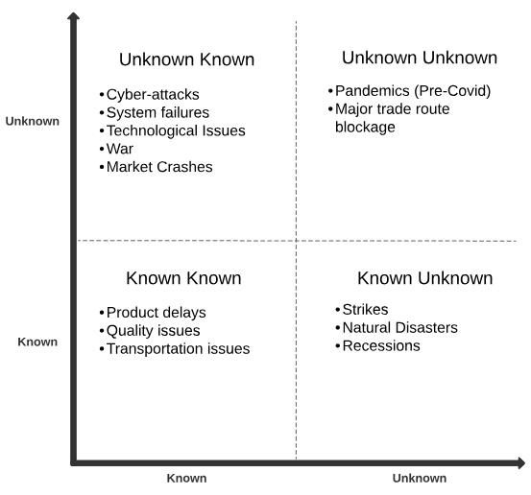

Appendix B
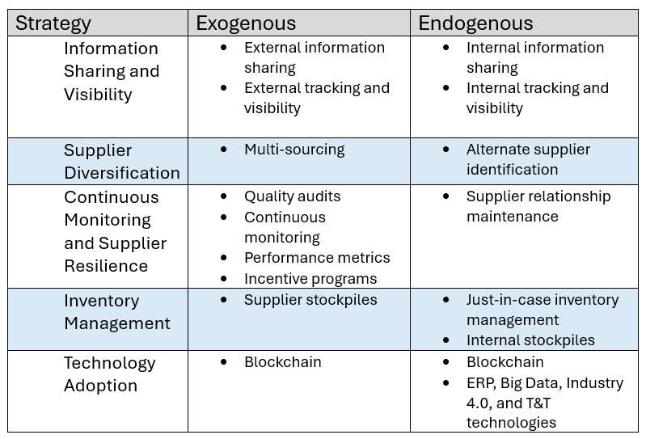

Appendix C
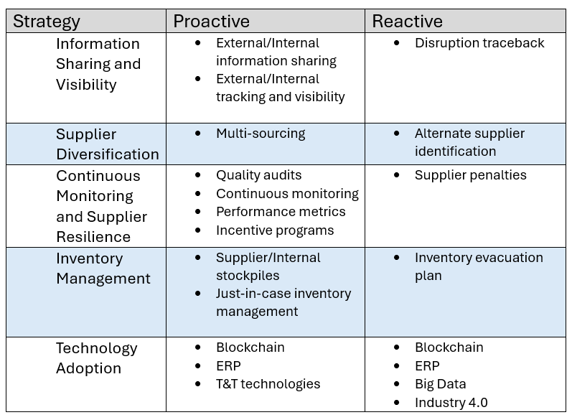

Bibliography
Agrawal, Prakash, et al. “Analysis of barriers in implementation of digital transformation of supply chain using interpretive structural modelling approach.” Journal of Modelling in Management, vol. 15, no. 1, 14 Oct. 2019, pp. 297–317, https://doi.org/10.1108/jm2-03-2019-0066.
Alkhudary, Rami, et al. “Mitigating the risk of specific supply chain disruptions through Blockchain Technology.” Supply Chain Forum: An International Journal, vol. 25, no. 1, 17 June 2022, pp. 1–11, https://doi.org/10.1080/16258312.2022.2090273.
“Apple to Diversify Its Supply Chain by Producing MacBooks in Vietnam.” Forbes, Forbes Magazine, 20 Feb. 2024, www.forbes.com/sites/qai/2023/01/01/apple-to-diversify-its-supply-chain-by-producing-macbooks-in-vietnam/?sh=73d8b7c77d75.
Atan, Zümbül, and Lawrence V. Snyder. “Inventory strategies to manage supply disruptions.” Supply Chain Disruptions, 27 Sept. 2011, pp. 115–139, https://doi.org/10.1007/978-0-85729-778-5_5.
Atnafu, Daniel, and Assefa Balda. “The impact of inventory management practice on firms’ competitiveness and organizational performance: Empirical evidence from Micro and small enterprises in Ethiopia.” Cogent Business &amp; Management, vol. 5, no. 1, 1 Jan. 2018, p. 1503219, https://doi.org/10.1080/23311975.2018.1503219.
Barratt, Mark, and Ruth Barratt. “Exploring internal and external supply chain linkages: Evidence from the field.” Journal of Operations Management, vol. 29, no. 5, 26 Nov. 2010, pp. 514–528, https://doi.org/10.1016/j.jom.2010.11.006.
Brandon‐Jones, Emma, et al. “A contingent resource‐based perspective of Supply Chain Resilience and robustness.” Journal of Supply Chain Management, vol. 50, no. 3, 23 June 2014, pp. 55–73, https://doi.org/10.1111/jscm.12050.
Bugert, Niels, and Rainer Lasch. “Supply chain disruption models: A critical review.” Bundesvereinigung Logistik , vol. 11, no. 5, 2018, pp. 1–35, https://doi.org/10.23773/2018_5.
Burkhart, Davide, and Christoph Bode. “On supplier resilience: How supplier performance, disruption frequency, and disruption duration are interrelated.” Journal of Purchasing and Supply Management, Apr. 2024, p. 100921, https://doi.org/10.1016/j.pursup.2024.100921.
Cagliano, Anna Corinna, et al. “Determinants of digital technology adoption in supply chain. an exploratory analysis.” Supply Chain Forum: An International Journal, vol. 22, no. 2, 14 Feb. 2021, pp. 100–114, https://doi.org/10.1080/16258312.2021.1875789.
Cambridge, University of. Jit Just-in-Time Manufacturing, www.ifm.eng.cam.ac.uk/research/dstools/jit-just-in-time-manufacturing/. Accessed 13 May 2024.
Castka, Pavel, et al. “Supplier audits during COVID-19: A process perspective on their transformation and implications for the future.” The International Journal of Logistics Management, vol. 33, no. 4, 23 Nov. 2021, pp. 1294–1314, https://doi.org/10.1108/ijlm-05-2021-0302.
Choi, Thomas Y., et al. “Just-in-time for supply chains in turbulent times.” SSRN Electronic Journal, 2023, https://doi.org/10.2139/ssrn.4378448.
Colicchia, Claudia, et al. “Information sharing in supply chains: A review of risks and opportunities using the systematic literature network analysis (SLNA).” Supply Chain Management: An International Journal, vol. 24, no. 1, 14 Jan. 2019, pp. 5–21, https://doi.org/10.1108/scm-01-2018-0003.
Goh, Brenda. China Imposes Fresh Lockdown around Major Apple iPhone Plant | Reuters, 2 Nov. 2022, www.reuters.com/world/china/chinese-zone-that-hosts-foxconns-zhengzhou-plant-imposes-fresh-lockdown-2022-11-02/.
Gottlieb, Simone, et al. “Case studies of the digital technology impacts on supply chain disruption Risk Management.” Logistik Im Wandel Der Zeit – Von Der Produktionssteuerung Zu Vernetzten Supply Chains, 2019, pp. 23–52, https://doi.org/10.1007/978-3-658-25412-4_2.
Gunes Corlu, Canan, et al. “Inventory management with Disruption Risk.” 2020 Winter Simulation Conference (WSC), 14 Dec. 2020, https://doi.org/10.1109/wsc48552.2020.9383979.
Gupta, Gaurav, and Kanishka Chauhan. “Understanding the Global Chip Shortage.” BCS, 3 Mar. 2023.
Handley, Sean M., and John V. Gray. “Inter‐Organizational Quality Management: The use of contractual incentives and monitoring mechanisms with outsourced manufacturing.” Production and Operations Management, vol. 22, no. 6, Nov. 2013, pp. 1540–1556, https://doi.org/10.1111/j.1937-5956.2012.01351.x.
Hendricks, Kevin B., et al. “The effect of operational slack, diversification, and vertical relatedness on the stock market reaction to supply chain disruptions.” Journal of Operations Management, vol. 27, no. 3, 11 Sept. 2008, pp. 233–246, https://doi.org/10.1016/j.jom.2008.09.001.
Ishak, Suharti, et al. “The effect of supply chain adaptive strategies during the COVID-19 pandemic on firm performance in Malaysia’s Semiconductor Industries.” Global Journal of Flexible Systems Management, vol. 24, no. 3, 17 July 2023, pp. 439–458, https://doi.org/10.1007/s40171-023-00347-y.
Ivanov, Dmitry, et al. “The impact of digital technology and Industry 4.0 on the ripple effect and supply chain risk analytics.” International Journal of Production Research, vol. 57, no. 3, 28 June 2018, pp. 829–846, https://doi.org/10.1080/00207543.2018.1488086.
Kumar, Pawan, and Minky Sharma. “Adoption of Blockchain technology.” Advances in Marketing, Customer Relationship Management, and E-Services, Jan. 2021, pp. 210–225, https://doi.org/10.4018/978-1-7998-8081-3.ch013.
Lawson, Benn, et al. “Supply chain disruptions: The Influence of Industry and geography on firm Reaction Speed.” International Journal of Operations &amp; Production Management, vol. 39, no. 9/10, 6 Dec. 2019, pp. 1076–1098, https://doi.org/10.1108/ijopm-04-2018-0225.
Li, Guo, et al. “Subsidization or diversification? mitigating supply disruption with manufacturer information sharing.” Omega, vol. 112, Oct. 2022, p. 102670, https://doi.org/10.1016/j.omega.2022.102670.
Lin, Yongjia, et al. “The effects of supply chain diversification during the COVID-19 crisis: Evidence from Chinese manufacturers.” Transportation Research Part E: Logistics and Transportation Review, vol. 155, Nov. 2021, p. 102493, https://doi.org/10.1016/j.tre.2021.102493.
Messina, Dario, et al. “An information management approach for supply chain disruption recovery.” The International Journal of Logistics Management, vol. 31, no. 3, 6 Aug. 2020, pp. 489–519, https://doi.org/10.1108/ijlm-11-2018-0294.
Nikkei. “Over 80% of Japan Inc. Recast Supply Chains as Pandemic Hit: Survey.” Nikkei Asia, Nikkei Asia, 2 Apr. 2021, asia.nikkei.com/Business/Business-trends/Over-80-of-Japan-Inc.-recast-supply-chains-as-pandemic-hit-survey.
Oakden, Roger. “The Matrix of Supply Chain Risks Contains Categories.” Learn About Logistics, 12 Apr. 2019, www.learnaboutlogistics.com/the-matrix-of-supply-chain-risks-contains-categories/.
Pinedo, Michael, et al. The Ford-Firestone Case. NYU Stern, 2000, https://web-static.stern.nyu.edu/om/faculty/zemel/ford_firestone.pdf.
Rinaldi, Marta, et al. “A literature review on quantitative models for Supply Chain Risk Management: Can they be applied to pandemic disruptions?” Computers &amp; Industrial Engineering, vol. 170, Aug. 2022, p. 108329, https://doi.org/10.1016/j.cie.2022.108329.
Shirouzu, Norihiko. “How Toyota Thrives When the Chips Are down | Reuters.” Reuters, 9 Mar. 2021, www.reuters.com/article/idUSKBN2B117X/.
Schubert, Dana. Firestone’s Tire Recall. Auburn, 2011, https://harbert.auburn.edu/binaries/documents/center-for-ethical-organizational-cultures/cases/firestone.pdf.
Smith, Matt. “In Wake of Romaine E. Coli Scare, Walmart Deploys Blockchain to Track Leafy Greens.” Walmart Corporate News and Information, 24 Sept. 2018, corporate.walmart.com/news/2018/09/24/in-wake-of-romaine-e-coli-scare-walmart-deploys-blockchain-to-track-leafy-greens.
Sunmola, Funlade, et al. “Prioritising visibility influencing factors in supply chains for resilience.” Procedia Computer Science, vol. 217, 2023, pp. 1589–1598, https://doi.org/10.1016/j.procs.2022.12.359.
“Supply Chain - Addressing Man-Made Disruptions.” Supply Chain - Addressing Man-Made Disruptions | BSI America, www.bsigroup.com/en-US/our-services/supply-chain-solutions/supply-chain-risks/business-continuity/man-made-disruptions/. Accessed 13 May 2024.
Tomlin, Brian. The Handbook of Integrated Risk Management in Global Supply Chains. Wiley, 2012.
Trestrail, Kathleen. “Lessons from the Suez Canal Cargo Ship Crisis.” Overhaul, 19 May 2023, over-haul.com/the-need-for-increased-visibility-across-global-shippers-a-study-on-the-suez-canal/#:~:text=In%20short%2C%20the%20Suez%20Canal,any%20issues%20on%20their%20end.
Upasani, Manas, et al. “The Ever Given Ship, the Suez Canal, and the Operations Blunder.” ResearchGate, Apr. 2024, https://www.researchgate.net/publication/379726750_The_Ever_Given_Ship_the_Suez_Canal_and_the_Operations_Blunder.
Vitasek, Kate. “How Walmart Canada Uses Blockchain to Solve Supply-Chain Challenges.” Harvard Business Review, 5 Jan. 2022, hbr.org/2022/01/how-walmart-canada-uses-blockchain-to-solve-supply-chain-challenges.
Whitney, Daniel E., et al. “The benefits and constraints of temporary sourcing diversification in supply chain disruption and recovery.” Journal of Purchasing and Supply Management, vol. 20, no. 4, Dec. 2014, pp. 238–250, https://doi.org/10.1016/j.pursup.2014.06.001.
Zuehlke, Detlef. “SmartFactory—towards a factory-of-things.” Annual Reviews in Control, vol. 34, no. 1, Apr. 2010, pp. 129–138, https://doi.org/10.1016/j.arcontrol.2010.02.008.

