Interactions in a warmer world: The relative effects of experimental warming, intraspecific density, and insect herbivory on seedling dynamics

A Thesis Presented for the
Master of Science
Degree
The University of Tennessee, Knoxville

Melissa Ann Burt
August 2013
Copyright © 2013 by Melissa Ann Burt
All rights reserved.

DEDICATION

I dedicate this work to Christopher and Henry for their never-ending support throughout my time as a graduate student at the University of Tennessee.

ACKNOWLEDGEMENTS

First, I would like to thank my advisor, Nathan Sanders, for his insights throughout my time in his lab. I appreciate his role in designing this project and his always-constructive feedback. I have become a better scientist as the result of his guidance. I would also like to thank my committee members: Aimée Classen and Daniel Simberloff. Their feedback along the way has been invaluable. Additionally, I would like to thank Robert Dunn. Although not a member of my committee, Rob was instrumental in the design of this project.
For help in the field I would like to thank E. Boller, L. Bostic, C. Hirsch, J. Markham, K. Stuble, and S. Waring. In the early stages of the project the seedling surveys would have taken months had it not been for these people. In this regard, I would also like to thank Lauren Nichols. I especially appreciate that she was always available to chat about my project and even went out of her way to arrange seedling surveys while I was recovering from having my son. Her insights have been helpful throughout this project.
A big thanks goes to my fellow graduate students in the Sanders lab (Mariano, Lacy, Quentin, and Katie). I could not have asked for a better group of graduate students to work with. Their insights, advice, and support were always there when needed. I am going to miss being part of such a cohesive group.
I would also like to acknowledge my funding sources throughout the last three years. I appreciate the Department of Ecology and Evolutionary Biology for providing a monthly stipend as well as travel funds when needed. The Department of Energy and the National Science Foundation funded the infrastructure in North Carolina. Additionally, GREBE and the University of Tennessee provided me with funds to attend the ESA annual conference.
Last, but definitely not least, I would like to thank my family. The never-ending support of Christopher, Henry, Mom, Dad, Nicole, Fred, Meaghan, and Tara has been critical to my success. My parents and siblings have always been just a call away when I need them. I especially appreciate Christopher’s encouragement along the way. Without him as a partner and a father to our son, being a mom and a graduate student would have been a lot tougher. Finally, I would like to thank my son, Henry. Although he has made my life more hectic at times, he has also brought a great deal of joy.

Abstract

Many effects of a changing climate for organisms, communities, and ecosystems are already apparent. Less studied are the effects of increases in temperature on species interactions. While warming may potentially disrupt interactions among species, species interactions may also mediate individual species responses to ongoing climatic change. In this experiment we manipulated temperature in field-based, open-top chambers for three years to examine the relationship between biotic interactions and climatic warming on the population dynamics of seedlings of Quercus alba. We investigated the effect of warming on rates of insect herbivory on Q. alba seedlings. Additionally, we assessed the relative effects of increasing temperature, insect herbivory, and conspecific density on seedling survival. We found two unexpected results. First, we observed a negative relationship between temperature and levels of insect herbivory during each year of the experiment. Second, higher levels of herbivory were associated with higher rates of survival to the second year of the study. Although we never detected a direct effect of conspecific density on seedling survival, herbivory and conspecific seedling density did interact to influence Q. alba seedling survival early in the experiment. Taken together, our results indicate species responses to climatic warming may be contingent on intra- and interspecific interactions, sometimes in complicated and counter-intuitive ways.

Table of Contents
Chapter 1: Introduction 1
Chapter 2: Materials and Methods 4
Study Location/Warming Experiment 4
Abiotic Conditions in the Open-Top Chambers 5
Study Species 5
Seedling Surveys 6
Statistical Analyses 6
Does the magnitude of herbivory increase with temperature? 6
Is the rate of population growth of Q. alba seedlings following a mast event affected by temperature, herbivory, or conspecific seedling density? 7
Does herbivory interact with temperature or seedling density to affect seedling survival? 8
Chapter 3: Results 9
Does the magnitude of herbivory increase with temperature? 9
Is the rate of population growth of Q. alba seedlings following a mast event affected by temperature, herbivory, or conspecific seedling density? 9
Does herbivory interact with temperature and seedling density to affect seedling survival? 10
Chapter 4: Discussion 11
List of References 17
Appendix 26
Vita 36

List of Tables

Table 1. Results determining if the estimated slope is significantly different than one for linear regressions examining the relationship between achieved temperature treatments and target temperature treatment.. 27
Table 2. Pearson’s correlation coefficients between air temperature treatment and other abiotic variables 28
Table 3. Results of multiple regression models used to determine possible interactive effects between herbivory, conspecific seedling density, and temperature treatment 29

List of Figures

Figure 1. Mean change in temperature in the chambers compared with target treatment temperature 30
Figure 2. Relationship between herbivory (%) and actual air temperature (degrees C above ambient air temperature) in each chamber for all three years of the study 31
Figure 3. Relationship between herbivory (%) and soil moisture 32
Figure 4. Rate of population growth regressed against herbivory, temperature treatment, and conspecific seedling density for each year of the study 33
Figure 5. Logistic regression beta versus temperature treatment (degrees C above ambient conditions) reported for years 2 and 3 of the study 34
Figure 6. Logistic regression beta versus density of seedlings (m⁻²) in each chamber 35

Chapter 1: Introduction

While many studies make it abundantly clear that ongoing climatic warming has affected the phenology (Parmesan and Yohe 2003, Menzel et al. 2006, Parmesan 2006, Amano et al. 2010, Morin et al. 2010), performance (Rossi et al. 2004, Cleland et al. 2012), and distributions (Parmesan and Yohe 2003, Walther 2010, Chen et al. 2011) of species, less appreciated is the fact that climatic change might also alter both intra- and inter-specific interactions (Tylianakis et al. 2008). Predictions related to the effects of ongoing climatic change largely consider the direct effects of climatic on species without taking into account how interactions between species might also affect their responses to climatic change (Davis et al. 1998, Araújo and Rahbek 2006, Buckley et al. 2010). In part, the lack of studies on the interplay between biotic interactions and climatic change arises from the general approaches taken to study the consequences of climatic change. For instance, macroecological approaches that rely on climate envelope models are generally too broad in scale to assess the role of local interactions (Araújo and Rahbek 2006). Conversely, manipulative studies in the field are often too small and too expensive to incorporate a focus on biotic interactions and instead focus on how experimental warming alters ecosystem processes or aggregate measures such as diversity or biomass (e.g., Rustad et al. 2001, Classen et al. 2010, Adair et al. 2011, Hoover et al. 2012). More experiments aimed at determining the effects of climatic warming on species interactions are needed in order to facilitate predictions about the responses of communities and ecosystems to climatic change.
Here, we use field-based, open-top, actively warmed chambers to investigate the interplay between biotic interactions and climatic warming on population dynamics of seedlings of a common eastern temperate deciduous tree, Quercus alba. We take advantage of a fortuitous mast event (i.e., intermittent, synchronized acorn production among many individuals within a region) to examine the combined impacts of conspecific seedling density, herbivory by insects, and experimental warming on seedling survival over three years. Factors limiting seedling establishment are a strong filter on tree recruitment (Clark et al. 1998, Hubbell et al. 1999, Brown and Wu 2005, Matthes and Larson 2006), and an understanding of these factors may provide valuable insights into predicting how future forests will respond to climatic change.
Previous studies have documented the effects of herbivory and conspecific density, both individually and together, on tree seedling survival with mixed results. For example, seedling recruitment may be negatively correlated with conspecific density because of intraspecific competition or because seedling density and the density of their natural enemies (e.g., insect herbivores) are positively correlated (Janzen 1970, Connell 1971). The effects of herbivory on plant survival are mixed, with some studies demonstrating negative effects, some positive effects, while still others show no effects on survival (Karban and Strauss 1993, Maron and Crone 2006). While conspecific density and herbivory can influence the survival of individual seedlings and in turn influence population growth rate, no studies, to our knowledge, have investigated the relative impacts of density and herbivory under experimental warming over multiple years. Doing so is critical because understanding the factors that limit establishment can elucidate the factors that govern population dynamics of forests in the future. For instance, Clark et al. (1998) found that establishment limitation at the seedling stage was one of the strongest factors limiting recruitment in southern Appalachian forests. However, few studies have examined the interplay between biotic interactions and seedling establishment of eastern deciduous trees under climatic warming.
Since January 2010, we have used actively warmed open-top chambers in an eastern temperate forest to address the following inter-related questions:
(1) Does the magnitude of insect herbivory on white oak seedlings increase with warming?
(2) Is the rate of population growth of Q. alba seedlings following a mast event affected by warming, herbivory, or conspecific seedling density?
(3) Does herbivory interact with temperature and seedling density to affect seedling survival?

Chapter 2: Materials and Methods

Study Location/Warming Experiment

We did this study in an array of twelve actively warmed, open-top chambers (OTCs) located in an 80-year-old oak-hickory stand in Duke Forest (near Hillsborough, NC). The site receives approximately 1140 mm of precipitation year⁻¹, and the mean annual temperature is 15.5 °C. The OTCs are octagonal in shape, 5 m in diameter, 1.2 m tall, and constructed around similarly-sized adult Q. alba (mean diameter at breast height ~20cm). Nine of the OTCs are heated between 1.5 and 5.5°C above ambient in half-degree increments (i.e., a regression design; Cottingham et al. 2005), and three serve as ambient controls. We continuously regulate temperature in the chambers with hydronic radiators. In the nine warmed OTCs, air temperature is increased when blown over the radiator and through two concentric rings of 15-cm diameter plastic plena that are located 1.7 and 0.8 m from the chamber walls. Hot air enters the chamber via two rows of 2-cm diameter holes located along the bottom-side of the plena. We continuously measure air temperature (°C) in all OTCs with automated dataloggers (CR1000, Campbell Scientific Inc.). The three ambient control chambers are identical in every way, except that the air is not warmed when it enters the OTC. These actively warmed chambers were turned on in early 2010 and are part of a larger, ongoing study investigating the effects of warming on community and ecosystem dynamics (see Pelini et al. 2011).

Abiotic Conditions in the Open-Top Chambers

At two locations in each chamber, we continuously measured air temperature and soil temperature in the organic and inorganic (mineral) soil (model SQ110; Apogee Instruments Inc., Logan, UT, USA). We also measured the relative humidity (HS-2000V capacitive polymer sensors; Precon, Memphis, TN, USA) and volumetric soil moisture (Model CS616 TDR probes, Campbell Scientific Inc.). We calculated vapor pressure deficit (VPD) as (1-(RH/100))×0.61121× EXP((17.269×T)/(T+237.3) where RH is the mean relative humidity and T is the mean temperature averaged over the growing season (April-September). Observed temperatures in the OTCs matched target temperatures throughout the experiment (Figure 1, Table 1 (all figures are located in the appendix); SMA function of the SMATR package in R version 3.0.0 (Warton et al. 2013)). Unsurprisingly, some of the abiotic factors other than air temperature changed in association with the experimental temperature treatment: humidity significantly decreased with temperature in 2010 and 2011, but not in 2012; vapor pressure deficit was positively correlated with temperature treatment in 2010 and 2011, but not in 2012; soil temperature, both at the organic and inorganic layers, was also positively correlated with air temperature. For each year of the study, soil moisture was never correlated with air temperature (Table 2).

Study Species

Quercus alba (white oak), common in eastern deciduous temperate forests, is the most abundant tree species found at our field site. Its range spans from southwest Maine to northern Florida and west to eastern Texas. Quercus alba reproduces annually with heavier masts occurring every 3-10 years depending on weather conditions and prior reproductive history (Sork et al. 1993, Abrams 2003). Duke Forest was the site of an above-average Q. alba mast event during the fall of 2009 resulting in seedling densities from 41 to 135 seedlings m⁻² within the OTCs.

Seedling Surveys

In June 2010, the year following the mast event, we placed a metal tag with a unique identifier around the base of the stem of each Q. alba seedling within a randomly placed 1-m² plot located within each OTC. We surveyed each plot twice per year between 2010 and 2012 to determine seedling survival, seedling density (number of seedlings m⁻²), and to estimate the amount of herbivory each seedling had sustained across each growing season. During the first survey each year, conducted during the early part of the growing season, we simply noted whether the seedling had survived through the winter. During the second survey, conducted at the end of the growing season, we estimated the accumulated level of foliar herbivory for each seedling. We visually estimated levels of herbivory as the percent leaf area removed by insect herbivores, including skeletonizers, leaf miners, and leaf chewers. The most common herbivores were skeletonizers, such as leaf-tying lepidoptera, and leaf chewers, such as the Asiatic Oak Weevil (Cyrtepistomus castaneus).

Statistical Analyses

Does the magnitude of herbivory increase with temperature?

For each year of the study, we quantified the relationship between warming treatment and herbivory using univariate linear regression models. Herbivory is averaged across all seedlings in the permanently marked 1-m² plot. For all analyses using temperature treatment, we calculated the actual delta temperature as the difference between the mean air temperature in each chamber and the mean ambient air temperature measured over the growing season (April – September). To examine whether other abiotic variables might influence seedling survival, population growth rate of Q. alba, or herbivory, we additionally used univariate linear regression models with soil moisture, relative humidity, and vapor pressure deficit as independent variables in the models. All analyses met the assumptions of linear regression models.

Is the rate of population growth of Q. alba seedlings following a mast event affected by temperature, herbivory, or conspecific seedling density?

We used univariate linear regression models to determine whether the rate of population growth of Q. alba is associated with warming, conspecific seedling density, and herbivory during each year of the study. We did not use multiple regression owing to the low power associated with our small sample size. We calculated the rate of population growth (λ) for 2010 to 2011 and 2011 to 2012 as λ = ln(N_{t}/N_{t-1}), where, N is the number of seedlings alive at year t in a plot, and N_{t-1} is the number of seedlings alive at the end of the previous year in that same plot. For population growth calculated from 2010 to 2011, we used the mean temperature, mean plot level herbivory averaged across the seedlings in the m² plots, and the plot level density of Q. alba seedlings (seedlings m⁻²) measured during 2010. For population growth calculated from 2011 to 2012, we used these same variables measured during 2011. We additionally used univariate regression models to quantify the relationship between λ and soil moisture, relative humidity, and vapor pressure deficit.

Does herbivory interact with temperature or seedling density to affect seedling survival?

For each chamber during each year, we calculated a logistic regression beta coefficient (β), where β indicates the probability that an individual seedling survived from year t to year t+1 given the level of herbivory on that seedling in year t. A positive β indicates that as levels of herbivory increase, so does the probability of surviving from one year to the next, while a negative β indicates that as levels of herbivory increase the probability of surviving decreases. To examine potential interactive effects of herbivory, temperature, and conspecific seedling density on survival, we used multiple regression models. In the models, the dependent variable was the β calculated for each chamber, and the independent variables were mean herbivory (%) and conspecific seedling density. For all of the analyses described, the assumptions of normality were met according to the results of a Shapiro-Wilk Normality Test on model residuals. Given the low number of replicates, we set α=0.10. We used R version 3.0.0 for all statistical analyses (R Development Core Team 2013).

Chapter 3: Results

Does the magnitude of herbivory increase with temperature?

During 2010, mean herbivory (the estimated amount of leaf tissue removed) per seedling in each chamber ranged from 19% to 38%, and there was no relationship between the warming treatment and the magnitude of herbivory (p = 0.18; Figure 2). In 2011, mean herbivory per seedling in each chamber ranged from about 11% to 56% and, in 2012 mean herbivory in each chamber ranged from just over 0% to about 30%. During 2011 and 2012 mean herbivory decreased significantly with increasing temperature (2011: R² = 0.54, p = 0.006; 2012: R² = 0.24, p=0.10; Figure 2). Herbivory decreased by an average of 6% and 3% with each degree of experimental warming for 2011 and 2012, respectively.
Herbivory was not related to relative humidity (p > 0.15 in all cases) or vapor pressure deficit (p > 0.30 in all cases) in any year of the study. Herbivory was not significantly associated with soil moisture in 2010 (p = 0.16; Figure 3); however, there was a positive relationship between herbivory and soil moisture in 2011 (p = 0.10; Figure 3) and 2012 (p = 0.04; Figure 3), even though temperature and soil moisture were not correlated.

Is the rate of population growth of Q. alba seedlings following a mast event affected by temperature, herbivory, or conspecific seedling density?

The rate of population growth of Q. alba seedlings (λ) was positively correlated with mean herbivory (R² = 0.39, p = 0.03; Figure 4), but not seedling density (p = 0.44; Figure 4) or temperature treatment (p = 0.38; Figure 4) from 2010 to 2011, suggesting a potential positive association between herbivory and seedling survival. From 2011 to 2012, the rate of population growth was not correlated with mean herbivory, temperature treatment, or Q. alba seedling density (p > 0.37 in all cases; Figure 4). Soil moisture, relative humidity, and vapor pressure deficit were not correlated with the rate of population growth of Q. alba seedlings in any year (p > 0.25 in all cases).

Does herbivory interact with temperature and seedling density to affect seedling survival?

Conspecific density (p = 0.06), but not temperature (p = 0.32), predicted logistic regression beta coefficients (β) from 2010 to 2011, suggesting that the probability of seedling survival is in part due to an interaction between herbivory and conspecific seedling density such that herbivory on seedlings occurring in dense populations increases mortality (Figures 5 and 6; Table 3). We did not detect a relationship between the logistic regression beta coefficients and temperature (p = 0.21) or conspecific seedling density (p = 0.25; Figures 5 and 6; Table 3) from 2011 to 2012.

Chapter 4: Discussion

Ongoing climatic change can affect the performance and fitness of individuals, the dynamics of populations, the structure of communities and the distribution of species (Parmesan and Yohe 2003, Rossi et al. 2004, Menzel et al. 2006, Parmesan 2006, Amano et al. 2010, Morin et al. 2010, Walther 2010, Chen et al. 2011, Cleland et al. 2012). The effects of climatic change may be mediated by interactions among species, or climatic change may alter the outcomes of interactions among species, though this has been less extensively documented in the literature (e.g., Dury et al. 1998, Stiling et al. 2002, Hamilton et al. 2004, Rossi et al. 2004, Villalpando et al. 2009).
Two somewhat surprising results emerged from this three-year experimental study. First, rates of herbivory on Q. alba seedlings decreased as experimental temperatures increased up to 5.5°C above ambient. Second, higher levels of herbivory were associated with lower rates of seedling mortality going into the second year of the study; that is, across all temperature treatments, seedlings that were attacked more by herbivores had a higher probability of surviving to the next year. Although there was never a direct effect of density on seedling survival in any year of the experiment, herbivory and conspecific seedling density did interact to influence Q. alba seedling survival early in the experiment. However, this effect was only observed during the first year of the experiment when seedling densities were highest. Taken together, our results indicate species responses to climatic warming may be contingent on intra- and interspecific interactions, sometimes in complicated and counter-intuitive ways.
Herbivory can influence plant population dynamics (Crawley 1983, Mulder 1999), and ongoing climatic change is likely to mediate the effects of herbivory on plant populations (Bale et al. 2002). During each year of our study we observed lower amounts of herbivory, or at least a trend toward lower amounts of herbivory, on Q. alba seedlings at higher temperatures (Figure 1). These results diverge with theory (Hillebrand et al. 2009) and previous empirical studies (Coley and Aide 1991, Adams and Zhang 2009, Schemske et al. 2009, Currano et al. 2010, de Sassi and Tylianakis 2012) which have suggested that herbivory and temperature should be positively correlated.
So why should herbivory decrease under experimental warming? A recent study by O’Connor et al. (2011) used consumer prey models to predict the effects of temperature on insect herbivore abundance and found that the abundance of insect herbivores was negatively correlated with temperature. If such a scenario were applicable to our system, then increased temperatures would be associated with a decreasing abundance of herbivores such that the decrease in herbivory observed in our study may arise simply because of a reduction in the abundance of insect herbivores. We did not attempt to sample herbivore populations throughout the experiment because we did not want to alter their potential effects on the seedlings. However, previous work in this system demonstrates that the responses of other insect taxa to warming are often idiosyncratic, with the abundance and activity of some insect taxa responding positively to warming while others respond negatively to warming (Diamond et al. 2012, Stuble et al. 2013). Another possibility is that generalist herbivores switch from feeding on Q. alba to other species as temperatures increase. This would lead to apparent decreases in herbivory on Q. alba though overall levels of herbivory in the entire plant community might increase or not change at all with temperature.
While the negative relationship between herbivory and temperature observed in our study may indicate direct effects of warming on insect herbivores, increased temperature may also indirectly affect herbivores through changes in the phenology or quality of their host plant or by affecting the natural enemies of herbivores. Previous studies suggest differences in the mechanisms underlying the phenologies of plants and insects may lead to asynchronies in insect herbivores and their host plants (Visser and Both 2005). In another active warming experiment at the same site in Duke Forest, plants in warmed treatments exhibited earlier budburst than those at ambient temperatures (Salk 2011). This suggests Q. alba seedlings exposed to warming may have less herbivory because of advanced budburst and thus advanced leaf age. In a study on another oak species, Mopper and Simberloff (1995) found that the oaks that produced leaves earlier in the spring had lower rates of herbivory than those that produced leaves later in the growing season. In addition to host plant phenology, the decline in herbivory with increasing temperature may also be explained by variation in host plant quality under warming. In a study by Dury et al. (1998) on another species of oak, leaf nitrogen concentration decreased and condensed tannins content increased as a result of experimental warming.
Finally, the negative relationship between herbivory and temperature may arise because of the varying responses of different trophic levels to the warming treatments (Tylianakis et al. 2008). For example, in grassland systems Barton and Schmitz (2009) demonstrated that top-down predator effects interact with warming to decrease grasshopper abundance. Additionally, a study on the relative effects of mosquito larvae in a pitcher plant community shows a similar positive relationship between temperature and top-down processes (Hoekman 2010). While this was not quantified in our study, it is possible that warming led to an increase in the top-down predator effects on insect herbivores resulting in lower rates of herbivory in the warmest chambers. Future work in this system could distinguish among this suite of potential mechanisms. Nevertheless, direct interactions between plants and the herbivores are not necessarily straightforward.
Quercus alba recruitment is marked by a high rate of mortality in the transition from the seedling to the sapling stage (Crow 1988, Nowacki et al. 1990, Abrams 2003). While previous work suggests insect herbivory is associated with decreases in oak seedling growth and survival (McPherson 1993, Marquis and Whelan 1994), going into 2011, our study plots with more herbivory had lower rates of seedling mortality. This fact suggests a potential positive association between herbivory on Q. alba and Q. alba seedling dynamics. Together with the negative relationship between herbivory and temperature also observed in our study, these results suggest a potential weakening of an important stage of Q. alba seedling recruitment. On the other hand, this positive association between herbivory and survival may actually be a symptom of water stress. We are potentially observing less herbivory on plants that are water-stressed and, at the same time, plants that are water-stressed die more frequently. Previous studies have shown that water dynamics are an important factor limiting tree seedling survival (McQuilken 1940, Williams & Hobbs 1989, De Steven 1991, Bragg et al. 1993, Inouye et al. 1994). However, in our study it is unclear if Q. alba seedlings are actually water-stressed along the experimental temperature gradient. Although we never detected an effect of soil moisture, relative humidity or vapor pressure deficit on seedling survival, there was a positive relationship between soil moisture and herbivory.
Although we did not observe a direct effect of conspecific seedling density on survival, there was an interaction between herbivory and conspecific seedling density such that herbivory at higher seedling densities was correlated with a lower probability of survival to the second year. Janzen-Connell effects (i.e., patterns of negative density dependence related to natural enemies; Janzen 1970, Connell 1971) are one likely explanation in this and other systems (e.g. Hille Ris Lambers et al. 2002, Martin and Canham 2010, Metz et al. 2010, Comita et al. 2010). Negative-density effects may contribute to the maintenance of species diversity by leading to higher mortality rates in conspecific seedlings.
As tree species respond to climatic change, it will be especially important to understand the various factors contributing to seedling survival during recruitment. While other anthropogenic pressures, such as logging and fire suppression, are already contributing to problems with Q. alba regeneration (Abrams 2003), our results suggest that it will also be important to consider interspecific and intraspecific species interactions at the seedling stage when predicting survival dynamics in the context of climatic warming.
Furthermore, as indicated in our study, the response of a species to climate change may be more complicated than can be predicted from just one factor. In our study we found that the responses of white oak seedlings to our warming manipulation were complex and depended on the impact of warming on herbivory, soil water dynamics, and density dependent effects. Future studies examining the dynamics of species under ongoing climate change should also consider the contingencies prior to making broad sweeping generalizations.

LIST OF References
Abrams, M. D. 2003. Where has all the White Oak gone? BioScience 53: 927-939.
Adair, E. C., P. B. Reich, J. J. Trost, and S. E. Hobbie. 2011. Elevated CO2 stimulates grassland soil respiration by increasing carbon inputs rather than by enhancing soil moisture. Global Change Biology 17: 3546-3563.
Adams, J. M. and Y. Zhang. 2009. Is there more folivory in warmer temperate climates? A latitudinal comparison of insect folivory in eastern North America. Journal of Ecology 97: 933-940.
Amano, T., R. J. Smithers, T. H. Sparks, and W. J. Sutherland. 2010. A 250-year index of first flowering dates and its response to temperature. Proceedings of the Royal Society B: Biological Sciences 277: 2451-2457.
Araújo, M. B. and C. Rahbek. 2006. How does climate change affect biodiversity? Science. 313: 1396-1397.
Bale, J. S. et al. 2002. Herbivory in global climate change research: direct effects of rising temperature on insect herbivores. Global Change Biology 8: 1-16.
Barton, B. T. and O. J. Schmitz 2009. Experimental warming transforms multiple predator effects in a grassland food web. Ecology Letters 12: 1317-1325.
Bragg, W. K., A. K. Knapp, and J. M. Briggs. 1993. Comparative water relations of seedlings and adult Quercus species during gallery forest expansion in tallgrass prairie. Forest Ecology and Management 56: 29-41.
Brown, P. M. and R. Wu. 2005. Climate and disturbance forcing of episodic tree recruitment in a southwestern ponderosa pine landscape. Ecology. 86: 3030-3038.
Buckley, L. B., M. C. Urban, M. J. Angilletta, L. G. Crozier, L. J. Rissler, and M. W. Sears. 2010. Can mechanism inform species distribution models? Ecology Letters 13: 1041-1054.
Chen, I., J. K. Hill, R. Ohlemuller, D. B. Roy, and C. D. Thomas. 2011. Rapid range shifts of species associated with high levels of climate warming. Science 333: 1024-1026.
Clark, J. S., E. Macklin, and L. Wood. 1998. Stages and spatial scales of recruitment limitation in southern Appalachian forests. Ecological Monographs 68: 213-235.
Classen, A. T., R. J. Norby, C. E. Campany, K. E. Sides, and J. F. Weltzin. 2010. Climate change alters seedling emergence and establishment in an old-field ecosystem. PLOS ONE 5: e13476.
Cleland, E. E., J. M. Allen, T. M. Crimmins, J. A. Dunne, S. Pau, S. E. Travers, E. S. Zavaleta, and E. M. Wolkovich. 2012. Phenological tracking enables positive species responses to climate change. Ecology 93: 1765-1771.
Coley, P. D and T. M. Aide. 1991. Comparison of herbivory and plant defenses in temperate and tropical broad-leaved forests. Pages 25-49 in P. W. Price, T. M. Lewinsohn, G. W. Fernandes, and W. W. Benson, editors. Plant-animal interactions: evolutionary ecology in tropical and temperate regions. John Wiley and Sons, Inc., New York City, New York, USA.
Comita, L.S., H. C. Muller-Landau, S. Aquilar, and S. P. Hubbell. 2010. Asymmetric density dependence shapes species abundances in a tropical tree community. Science 329: 330-332.
Connell, J. H. 1971. On the role of natural enemies in preventing competitive exclusion in some marine animals and in rain forest trees. Pages 298-312 in P. J. D. Boer and G. Gradwell, editors. Dynamics of populations. Pudoc, Wageningen, The Netherlands.
Cottingham, K. L., J. T. Lennon, and B. L. Brown. 2005. Knowing when to draw the line: designing more informative ecological experiments. Frontiers in Ecology and the Environment 3: 145-152.
Crawley, M. J. 1983. Herbivory: dynamics of plant-animal interactions. University of California Press, Berkeley, California, USA.
Crow, T. R. 1988. Reproduction mode and mechanism for self-replacement of northern red oak (Quercus rubra): a review. Forest Science 34: 19-40.
Currano, E. D., C. C. Labandeira, and P. Wilf. 2010. Fossil insect folivory tracks paleotemperature for six million years. Ecological Monographs 80: 547-567.
Davis, A. J., J. H. Lawton, B. Shorrocks, and L. S. Jenkinson. 1998. Individualistic species responses invalidate simple physiological models of community dynamics under global environmental change. Journal of Animal Ecology 67: 600-612.
de Sassi, C. and J. M. Tylianakis. 2012. Climate change disproportionately increases herbivore over plant or parasitoid biomass. PLOS ONE 7: e40557.
De Steven, D. 1991. Experiments on mechanisms of tree establishment in old-field succession: seedling survival and growth. Ecology 72: 1076-1088.
Diamond, S. E., L. M. Nichols, N. McCoy, C. Hirsch, S. L. Pelini, N. J. Sanders, A. M. Ellison, N. J. Gotelli, and R. R. Dunn. 2012. A physiological trait-based approach to predicting the responses of species to experimental climate warming. Ecology 93: 2305-2312.
Dury, S. J., J. E. G. Good, C. M. Perrins, A. Buse, and T. Kaye. 1998. The effects of increasing CO₂ and temperature on oak leaf palatability and the implications for herbivorous insects. Global Change Biology 4: 44-61.
Hamilton, J. G., A. R. Zangerl, M. R. Berenbaum, J. Pippen, M. Aldea, E. H. Delucia. 2004. Insect herbivory in an intact forest understory under experimental CO₂ enrichment. Oecologia 138: 566-573.
Hillebrand, H. et al. 2009. Herbivore metabolism and stoichiometry each constrain herbivory at different organizational scales across ecosystems. Ecology Letters 12: 516-527.
Hille Ris Lambers, J., J. S. Clark, and B. Beckage. 2002. Density-dependent mortality and the latitudinal gradient in species diversity. Nature 417: 732-735.
Hoover, S. E. R., J. J. Ladley, A. A. Shchepetkina, M. Tisch, S. P. Gieseg, and J. M. Tylianakis. 2012. Warming, CO₂, and nitrogen deposition interactively affect a plant-pollinator mutualism. Ecology Letters 15: 227-234.
Hubbell, S. P., R. B. Foster, S. T. O’Brien, K. E. Harms, R. Condit, B. Wechsler, S. J. Wright, and S. Loo de Lao. 1999. Light-gap disturbances, recruitment limitation, and tree diversity in a neotropical forest. Science 283: 554-557.
Inouye, R. S., T. D. Allison, and N. C. Johnson. 1994. Old field succession on a Minnesota sand plain: effects of deer and other factors on invasion by trees. Bulletin of the Torrey Botanical Club 121: 266-276.
Janzen, D. H. 1970. Herbivores and the number of tree species in tropical forests. The American Naturalist 104: 501-528.
Karban, R. and S. Y. Strauss. 1993. Effects of herbivores on growth and reproduction of their perennial host, Erigeron glaucus. Ecology 74: 39-46.
Maron, J. L. and E. Crone. 2006. Herbivory: effects on plant abundance, distribution, and population growth. Proceedings of the Royal Society B: Biological Sciences 273: 2575-2584.
Marquis, R. J. and C. J. Whelan. 1994. Insectivorous birds increase growth of white oak through consumption of leaf-chewing insects. Ecology 75: 2007-2014.
Martin, P. H. and C. D. Canham. 2010. Dispersal and recruitment limitation in native versus exotic tree species: life-history strategies and Janzen-Connell effects. Oikos 119: 807-824.
Matthes, U. and D. W. Larson. 2006. Microsite and climatic controls of tree population dynamics: an 18-year study on cliffs. Journal of Ecology 94: 402-414.
McPherson, G. R. 1993. Effects of herbivory and herb interference on oak establishment in a semi-arid temperate savanna. Journal of Vegetation Science 4: 687-692.
McQuilken, W. E. 1940. The natural establishment of pine in abandoned fields in the Piedmont Plateau region. Ecology 21: 135-147.
Menzel, A. et al. 2006. European phenological response to climate change matches the warming pattern. Global Change Biology 12: 1969-1976.
Metz, M. R., W. P. Sousa, and R. Valencia. 2010. Widespread density-dependent seedling mortality promotes species coexistence in a highly diverse Amazonian rain forest. Ecology 91: 3675-3685.
Mopper, S. and D. Simberloff. 1995. Differential herbivory in an oak population: the role of plant phenology and insect performance. Ecology 76: 1233-1241.
Morin, X., J. Roy, L. Sonie, and I. Chuine. 2010. Changes in leaf phenology of three European oak species in response to experimental climate change. New Phytologist 186: 900-910.
Mulder, C. P. H. 1999. Vertebrate herbivores and plants in the Arctic and subarctic: effects on individuals, populations, communities, and ecosystems. Perspectives in Plant Ecology, Evolution and Systematics 2: 29-35.
Nowacki, G. J., M. D. Abrams, and C. G. Lorimer. 1990. Composition, structure, and historical development of northern red oak stands along an edaphic gradient in north-central Wisconsin. Forest Science 36: 276-292.
Parmesan, C. and G. Yohe. 2003. A globally coherent fingerprint of climate change impacts across natural systems. Nature 421: 37-42.
Parmesan, C. 2006. Ecological and evolutionary responses to recent climate change. Annual Review Ecology, Evolution, and Systematics 37: 637-669.
Pelini, S. L., F. P. Bowles, A. M. Ellison, N. J. Gotelli, N. J. Sanders, and R. R. Dunn. 2011. Heating up the forest: open-top chamber warming manipulation of arthropod communities at Harvard and Duke Forests. Methods in Ecology and Evolution 2: 534-540.
O’Connor, M. I., B. Gilbert, and C. J. Brown. 2011. Theoretical predictions for how temperature affects the dynamics of interacting herbivores and plants. The American Naturalist 178: 626-638.
R Development Core Team. 2013. R: A language and environment for statistical computing. R Foundation for Statistical Computing, Vienna, Austria. ISBN 3-900051-07-0, URL http://www.R-project.org/.
Rossi, A. M., P. Stiling, D. C. Moon, M. V. Cattell, and B. G. Drake. 2004. Induced defensive response of myrtle oak to foliar insect herbivory in ambient and elevated CO2. Journal of Chemical Ecology 30: 1143-1152.
Rustad, L. E., J. L. Campbell, G. M. Marion, R. Norby, M. J. Mitchell, A. E. Hartley, J. H. C. Cornelissen, and J. Gurevitch. 2001. A meta-analysis of the response of soil respiration, net nitrogen mineralization, and aboveground plant growth to experimental ecosystem warming. Oecologia 126: 543–562.
Salk, C. F. 2011. Will the timing of temperate deciduous trees’ budburst and leaf senescence keep up with a warming climate? Dissertation, Duke University, Durham, NC, USA.
Schemske, D. W., G. G. Mittelbach, H. V. Cornell, J. M. Sobel, and K. Roy. 2009. Is there a latitudinal gradient in the importance of biotic interactions? Annual Review Ecology, Evolution and Systematics 40: 245-269.
Sork, V. L., J. Bramble, and O. Sexton. 1993. Ecology of mast-fruiting in three species of North American deciduous oaks. Ecology 74: 528-541.
Stiling, P., M. Cattell, D. C. Moon, A. Rossu, B. A. Hungate, G. Hymuss, and B. Drake. 2002. Elevated atmospheric CO₂ lowers herbivore abundance, but increases leaf abscission rates. Global Change Biology 8: 658-667.
Stuble, K. L., S. L. Pelini, S. E. Diamond, D. A. Fowler, R. R. Dunn, and N. J. Sanders. 2013. Foraging by forest ants under experimental climatic warming: a test at two sites. Ecology and Evolution 3: 482-491.
Tylianakis, J. M., R. K. Didham, J. Bascompte, and D. A. Wardle. 2008. Global change and species interactions in terrestrial ecosystems. Ecology Letters 11: 1351-1363.
Villalpando, S. N., R. S. Williams, and R. J. Norby. 2009. Elevated air temperature alters an old field insect community in a multifactor climate change experiment. Global Change Biology 15: 930-942.
Visser, M. E. and C. Both. 2005. Shifts in phenology due to global climate change: the need for a yardstick. Proceedings of the Royal Society B: Biological Sciences 272: 2561-2569.
Walther, G. R. 2010. Community and ecosystem responses to recent climate change. Philosophical Transactions of the Royal Society B: Biological Sciences 365: 2019-2024.
Warton, D. I., A. D. Remko, D. S. Falster, and S. Taskinen. 2012. SMATR 3 – an R package for estimation and interference about allometric lines. Methods in Ecology and Evolution 3: 257-259.
Williams, K. and R. J. Hobbs. 1989. Control of shrub establishment by springtime soil water availability in an annual grassland. Oecologia 81: 62-66.

Appendix
Table 1. Results determining if the estimated slope is significantly different than one for linear regressions examining the relationship between achieved temperature treatments and target temperature treatment. The upper CI and lower CI are upper and lower 95% confidence intervals for the slope estimates

 | Linear Regression |  |  |  |  |  |  | Slope Test
Year | Slope Estimate | R² | p | Upper CI | Lower CI |  |  | p
2010 | 0.98 | 0.94 | 2.61e-07 | 1.17 | 0.82 |  |  | 0.77
2011 | 0.90 | 0.99 | 4.87e-11 | 0.97 | 0.83 |  |  | 0.01
2012 | 0.90 | 0.94 | 2.08e-07 | 1.07 | 0.76 |  |  | 0.20

Table 2. Pearson’s correlation coefficients between air temperature treatment and other abiotic variables. * p < 0.05, ** p < 0.01, *** p < 0.001.

Year | 2010 | 2011 | 2012
Relative Humidity | -0.82** | -0.78** | -0.02
Soil Moisture | -0.16 | -0.24 | -0.16
Vapor Pressure Deficit | 0.67* | 0.66* | -0.15
Organic Soil Temperature | 0.90*** | 0.90*** | 0.77**
Inorganic Soil Temperature | 0.73** | 0.79** | 0.46

Table 3. Results of multiple regression models used to determine possible interactive effects between herbivory, conspecific seedling density, and temperature treatment. In the model, the dependent variable is the logistic regression beta coefficient calculated for each chamber, and the independent variables are conspecific seedling density and temperature treatment. Whole Model: 2010-2011: R² = 0.42, p = 0.09; 2011-2012: R² = 0.22, p = 0.33.

Independent Variable | F | partial r² | p
2010 – 2011  Conspecific Seedling Density  Temperature Treatment | 4.74  1.59 | 0.35  0.15 | 0.06  0.24
2011 – 2012  Conspecific Seedling Density  Temperature Treatment | 1.45  1.86 | 0.14  0.17 | 0.26  0.21

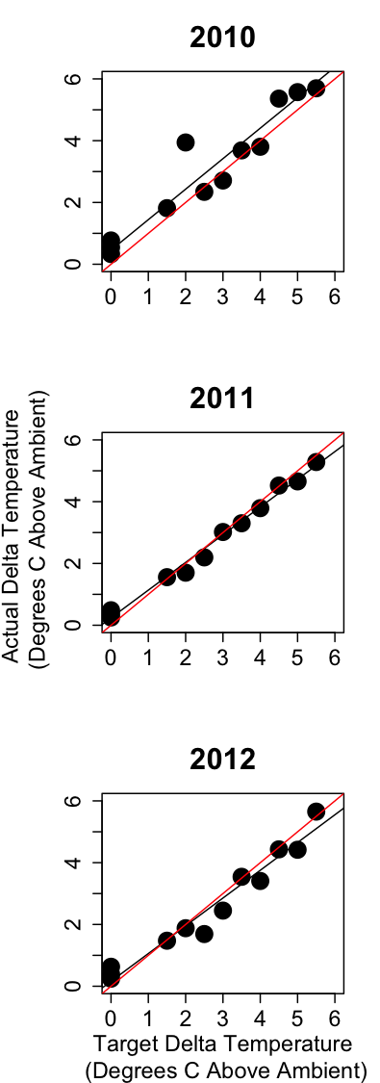
Figure 1. Mean change in temperature in the chambers compared with target treatment temperature. The actual delta temperature has been averaged across the growing season (April – September) for each year of the study. Black lines are the best-fit lines from linear regression models. Red lines represent the target. See Table 1 for slopes of the best-fit lines and p-values showing if they significantly differ from 1.
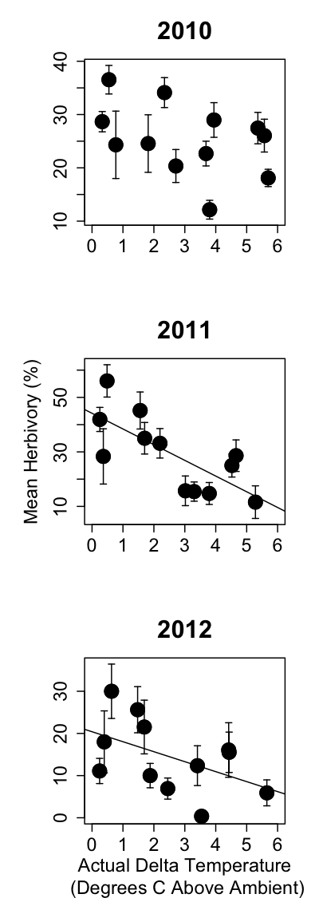

Figure 2. Relationship between herbivory (%) and actual air temperature (degrees C above ambient air temperature) in each chamber for all three years of the study. R² and p-values were calculated with univariate linear regression analyses. A black best-fit line is drawn for significant relationships.
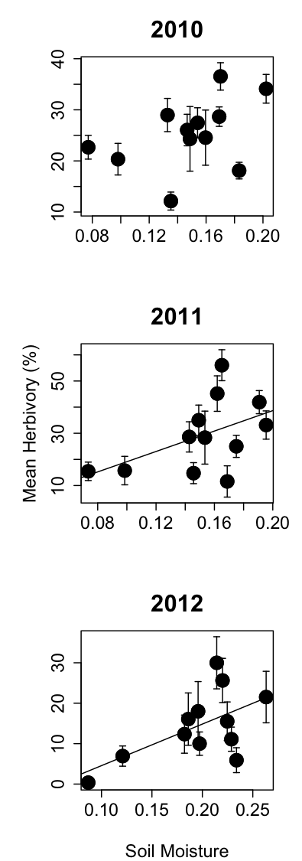

Figure 3. Relationship between herbivory (%) and soil moisture. Herbivory is the plot-level average from each chamber. Soil moisture is an annual mean within each open-top chamber. A black best-fit line is drawn for significant relationships.
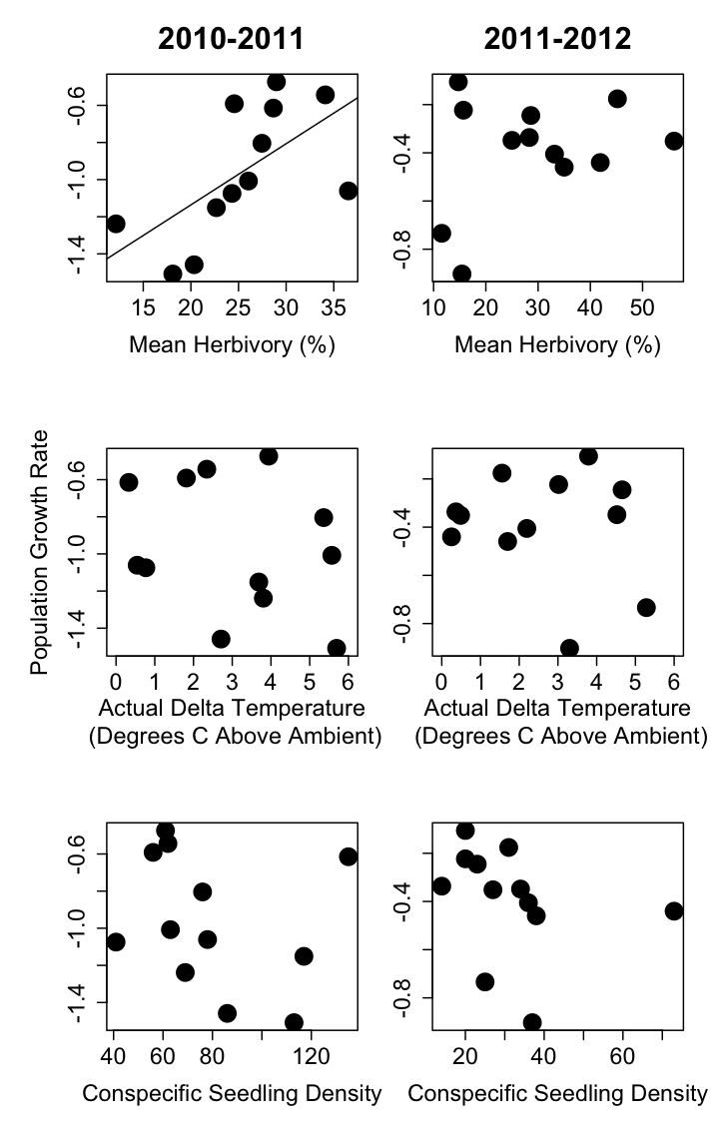

Figure 4. Rate of population growth regressed against herbivory, temperature treatment, and conspecific seedling density for each year of the study.
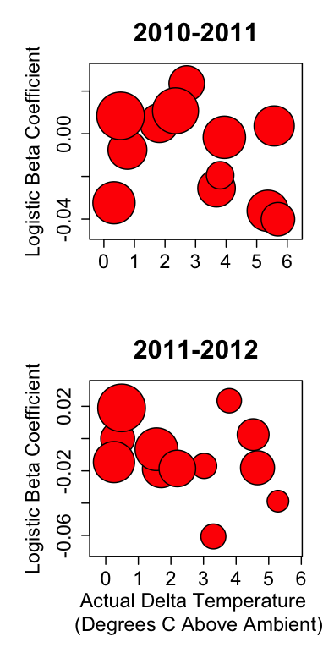

Figure 5. Logistic regression beta versus temperature treatment (degrees C above ambient conditions) reported for years 2 and 3 of the study. Positive beta coefficients indicate a positive effect of herbivory on survival and negative beta coefficients indicate a negative effect of herbivory on survival due to herbivory. The size of each point indicates the plot level mean herbivory.
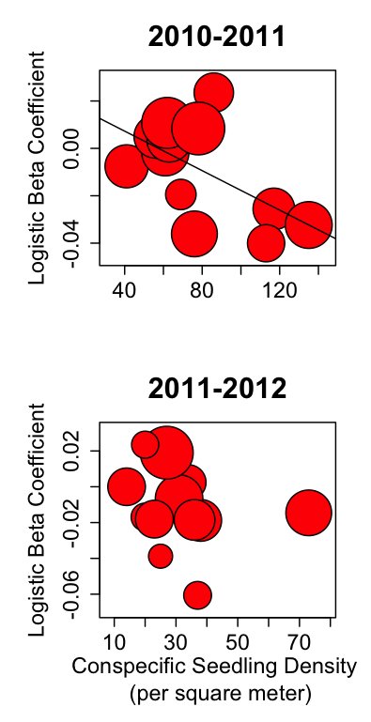
Figure 6. Logistic regression beta versus density of seedlings (m⁻²) in each chamber. Positive beta coefficients indicate a positive effect of herbivory on survival and negative beta coefficients indicate a negative effect of herbivory on survival due to herbivory. The size of each point is related to the amount of herbivory averaged across all seedlings in each plot.

Vita

Melissa Ann Burt was born in Smithtown, NY in 1985 to Fred and Patricia Burt. She received a B.S. in Biology in 2008 from the University of North Carolina at Chapel Hill. Upon completion of her B.S. she worked as a field technician in the Clark lab at Duke University and for the Corridor Project in South Carolina. She began graduate school in the fall of 2010 at the University of Tennessee under the guidance of Dr. Nathan Sanders and will receive her M.S. in Ecology and Evolutionary Biology in August 2013.

