EXAMINING THE EFFECTS OF FAMILY STRESS AND FAMILY STRENGTHS ON THE QUALITY OF MOTHER-CHILD RELATIONSHIPS IN MARRIED AND UNMARRIED BLACK FAMILIES

A Thesis Presented for the
Master of Arts
Degree
The University of Tennessee, Knoxville

Deonte Mitchell Hughes
August 2022
ACKNOWLEDGEMENTS
Writing a thesis is not an easy task. The process is long and tiring, but rewarding and insightful. This thesis would have never been completed without the support from the people around me and I am extremely grateful for the support. First, I would like to thank my advisor, Deadric T. Williams, who helped me sort through my ideas and create this project. While writing this thesis, Deadric always prioritized my growth as a scholar by meeting with me regularly, providing valuable feedback, and being patient throughout the process. Deadric constantly pushed me to challenge myself to learn new skills and techniques by exposing me to new literature and topics to facilitate my growth. I truly appreciate the opportunity to have had Deadric as my advisor, I owe much of my growing confidence as a scholar to his guidance.
I also want to thank the other committee members who helped cultivate this project, Stephanie Bohon and Jeremy Kanter. Both Stephanie and Jeremy have provided me with valuable feedback and suggestions to help guide this thesis. I am thankful for their advice in helping me connect my ideas to my methods, in addition to encouraging me to explore different aspects of my research that I had not considered.
While writing this thesis, I sacrificed a lot of time with family and friends. In particular, I want to acknowledge two people. First, my partner Sherae McRae, for always pushing me to sit at my desk and write even if that meant that there would be less time for us to spend together. Having a supportive partner who understands that I may have to take time away to focus on writing a thesis is helpful and appreciated. The second person I want to acknowledge is my father, not just for his support over the years, but for instilling a work ethic in me that I have used for all of my life. When I was younger, he would always tell me, “To do what you want to do, you ‘gotta do what you have to do.” These are words that I always remember whenever I felt like giving up while completing this project, and words I will always remember as I continue my academic career. I am grateful to my family and friends who constantly checked in on me and encouraged me to complete this thesis. Even on days where I wanted to slow down or stop, they kept urging me to read an article, edit a section, or write something, even if I only wrote one sentence for the day. I truly appreciate all of you, thank you.

ABSTRACT
Mother-child relationships are complex, diverse, and change in response to internal and external factors that affect families and family life. For instance, Black children are more likely to live in households with unmarried parents. Even more, Black families are disproportionately more likely to be in poverty than the general population. Research on Black families tends to center association between family structure and poverty as mechanisms affecting mother-child relationships. There is little research on the role of economic hardship on familial relationships in Black families. Additionally, there is little research on the role of family strengths on familial relationships in Black families. Thus, the purpose of this study is to (1) examine the independent and joint effects of family stress (e.g., poverty and economic hardship) and family strengths (e.g., social support and religious attendance) on mother-child relationships in Black families and (2) examine whether family structure moderates the effects of family stress and family strengths on mother-child relationships in Black families. Using data from the Fragile Families and Child Well-Being Study, I conduct OLS regression to analyze the individual and joint effects of poverty, economic hardship, social support, and religious attendance on mother-child closeness and the time children report spending with their mothers. The results revealed that social support and religious attendance were associated with increased mother-child closeness and more time children report spending with their mothers. Moreover, the results revealed that poverty and economic hardship had no significant impact on mother-child closeness, or the time children spend with their mothers. Additionally, the results revealed that family structure does not moderate the effects of family stress or family strengths on mother-child closeness and the time children spend with their mothers. I conclude that family strengths (e.g., social support and religious attendance) are positively associated with mother-child relationships in Black families, while poverty, economic hardship, and family structure have no effects on mother-child relationships.
Keywords: Black families, Poverty, Economic Hardship, Family Structure, Social Support, Religious Attendance, Mother-Child Relationships

TABLE OF CONTENTS

CHAPTER ONE: INTRODUCTION AND BACKGROUND INFORMATION 1
CHAPTER TWO: LITERATURE REVIEW 4
Theoretical Framework and Conceptual Model 4
Family Stress Model: Linking Poverty and Economic Hardship to Mother-Child Relationships 6
Family Strengths: Linking Social Support and Religious Attendance to Mother-Child Relationships 9
Moderating Effects of Family Structure on Family Stress and Family Strengths 13
CHAPTER THREE: DATA AND METHODS 18
Dependent Variables 18
Independent Variables 19
Moderating Variables 20
Control Variables 20
Analytic Strategy 21
CHAPTER FOUR: RESULTS 22
Descriptive Statistics 22
Correlation Matrix 24
Regression Analyses 24
CHAPTER FIVE: DISCUSSION AND CONCLUSION 34
Limitations and Strengths 39
Conclusion 40
LIST OF REFERENCES 42
VITA 57

LIST OF TABLES
Table 1. Descriptive Statistics 23
Table 2. Correlation Matrix 25
Table 3. Y-Standardized Coefficients for Mother-Child Closeness 26
Table 4. Y-Standardized Coefficients for Children's Time Spent with Mother 27
Table 5. Y-Standardized Coefficients for Interaction Effects on Mother-Child Closeness 29
Table 6. Y-Standardized Coefficients for Interaction Effects on Children's Time Spent with Mom 30

CHAPTER ONE: INTRODUCTION AND BACKGROUND INFORMATION
Positive mother-child relationships are central for cultivating and nourishing healthy family interactions and wellbeing. For example, the quality of the mother-child relationship influences how parents discipline their children, the level of parental involvement, mutual support, and overall parenting quality (Erel & Burman 1995; Finch 2007; Hardie & Seltzer 2016; Haux & Platt 2020; Lareau 2002). Moreover, positive mother-child relationships are associated with higher levels of children’s educational attainment, school readiness (e.g., early literacy, social skills, and oral language), and fewer behavioral problems (Anderson 2015; Anderson 2018; Haux & Platt 2020; Smetana & Rote 2019; Swiss & Le Bourdais 2009). Although these studies inform our understanding of mother-child relationships in valuable ways, there are three notable limitations. First, prior studies include samples that are mostly married, White, two-parent biological families. Second, some studies focus on racial comparisons, which ignores within-race heterogeneity (Haux & Platt 2020; King et al. 2018; Kouros et al. 2014; Scharp & Thomas 2016; Swiss & Le Bourdais 2009; Yuan et al. 2016). Last, previous researchers have not examined the stressors that may pull mother-child relationships apart or the family strengths that may bring mother-child relationships together, especially among Black families.
Thus, the purpose of this thesis is to examine the effects of stressors and strengths among Black mother-child relationships among married and unmarried families. Specifically, I examine the association between economic stressors (e.g., poverty and economic hardship) and family strengths (e.g., social support and religious service attendance) on the quality of Black mother-child relationships. Moreover, I also examine the extent to which these effects vary across family structure (e.g., married vs. unmarried families). Understanding the effects of economic stressors, family strengths, and family structure among Black mothers and children are important for several reasons. First, Black families are more likely to live in poverty compared to other racial groups. In 2019, official poverty rate for Black families was 18.8%, 7.3% for White families, and 15.7% for Hispanic families (Creamer 2020; Semega et al. 2020). In addition, Black families, compared to other racialized groups, are more likely to experience economic hardship. For example, 18% of Black adults with lower income report not being able to meet their basic needs with another 43% of Black adults reporting that their income only meets their basic needs (Edwards 2022). Second, although Black families are more likely to experience economic stress, Black families also experience strengths. For instance, religious service attendance and social support has been shown to be strengths used by Black families to create a social support network through their faith (religious beliefs) and social network from their friends, families, and communities (Brooks & Allen 2016; Hill 2003; Mahoney et al. 2003; Petts 2014).
Last, Black families are overrepresented in nonmarital childbearing (Amato & Maynard 2007). As such, given that unmarried families are more likely to be poor compared to married families (Amato & Maynard 2007; Baker 2015; Cancian & Haskins 2014; Lichter et al. 2003; Waite 1995), the impact of poverty and hardship on the mother-child relationship may be most detrimental for unmarried families. Conversely, given that religious institutions reinforce two-parent families via religious texts (e.g., Bible) (Bartkowski & Ellison 1995; Ellison et al. 2011; Mahoney et al. 2003; Mahoney 2005; Petts 2014), and married couples may be able to tap into a much larger social support network compared to single mothers. As such, the impact of family strengths may be most beneficial for married families.
This study adds to the previous literature on mother-child relationships in several ways. First, this study moves away from the race-comparative approach that often uses White families as a standard by which Black families are compared. Second, the study draws on two disparate perspectives—family stress and family strengths—to understand their relative impact on the quality of mother-child relationships. Last, examining both married and unmarried Black families draws attention to important family heterogeneity by examining the moderating effects of family structure on the impact of family stress (poverty and economic hardship) and family strengths (social support and religious attendance) on the quality of mother-child relationships in Black families. Overall, the goal of the current study is to paint a more holistic picture of Black families.

CHAPTER TWO: LITERATURE REVIEW

Theoretical Framework and Conceptual Model
Figure 1.1 outlines the conceptual model that orients the literature review and guides the statistical analyses. The conceptual model presents specific paths corresponding to the association between the key variables of interest (e.g., poverty, hardship, social support, and religious service attendance) and the moderating variable (e.g., family structure) on mother-child relationship. In Figure 1.1 (Path A), the Family Stress Model guides the association between poverty and economic hardship on mother-child relationships. Proponents of this perspective suggest that economic stress (poverty and economic hardship) negatively impact on mother-child relationships through increased mother-child conflict and disrupted parenting (Conger et al. 2010). Second, for Path B, the family strengths perspective guides the association between social support and religion attendance on mother-child relationships. From this perspective, scholars suggest family strengths (social support and religious attendance) enable families to remain resilient in the face of adversity in tandem with strengthening the family to reduce the negative impact of future stress or stressful events (DeFrain & Asay 2007; DeFrain & Asay 2014; Gabler & Otto 1964).
For Paths C and D, I use the stress-exacerbation hypothesis and the strengths-exacerbation hypotheses to guide the moderating the effects of family structure on family stress and family strengths, respectively. These hypotheses suggests that the negative effects of stress on the mother-child relationship may be larger for unmarried families compared to married families (e.g., stress-exacerbation hypothesis) whereas the positive association between family strengths on the mother-child relationship may be larger for married families compared to unmarried families (strength-exacerbation hypothesis).

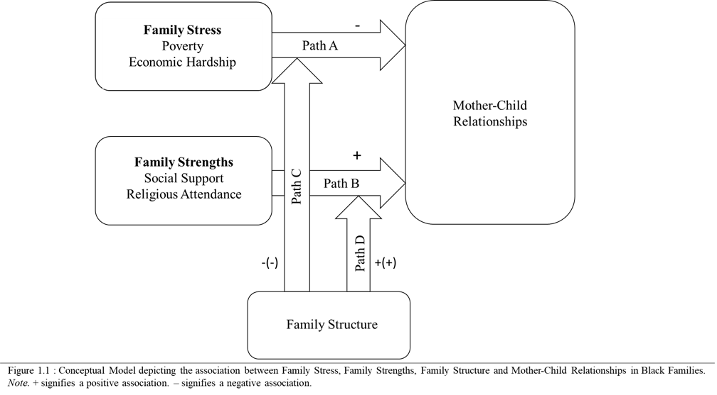

I elaborate on each theoretical perspective and the corresponding literature below.

Family Stress Model: Linking Poverty and Economic Hardship to Mother-Child Relationships
The Family Stress Model (FSM) provides a framework on how economic stressors affects families and their familial relationships. The Family Stress Model was developed to understand the extent to which economic stress links to children’s outcomes through a series of family processes such as parents’ psychological distress, relationship instability, and mother-child relationships (Conger and Elder 1994; Conger et al. 2002; Conger et al. 2010; Masarik & Conger 2017; Scaramella et al. 2008). For the current study, I focus on the direct effects of economic stress on mother-child relationships (Figure 1.1; Path A) by focusing on poverty, economic hardship, and the expected negative association poverty and economic hardship will have on mother-child relationships. Poverty and economic hardship represent two distinct features of economic inequality. For instance, poverty measures the flow of cash resources to households (income and government transfers), measured yearly in the U.S. Census (Iceland 2019). Economic hardship represents (1) unmet material needs such as inadequate food or clothing, (2) the inability to pay bills or meet day-to-day needs, or (3) having to forgo necessary expenses (e.g., health insurance, car insurance, medical expenses) (Conger et al. 2010).
Poverty and economic hardship are especially important for the study of Black family life. For example, in 2019, the official U.S. poverty rate for Blacks was 18.8 percent, 15.7 percent for Latinx, and 7.3 percent for Whites (Semega et al. 2020). Even more, Black families are also more likely to experience economic hardship compared to other racialized groups. Using data collected from 3,769 interviews of families in the U.S. and the District of Columbia, The Pew Research Center found that, on average, Black families were more likely (41%) to experience economic hardship than Latinx families (33%) and White families (25%) (Pew Research Center 2016). Economic hardship is a separate stressor that is only moderately associated with poverty as not all families who experience economic hardship are below the poverty line and not all families below the poverty line experience economic hardship (e.g., rural families) (Iceland & Bauman 2007; Karpman et al. 2018; Rodems & Shaefer 2020). Economic hardship is when the demand on household resources is greater than the available resources (Rodems & Shaefer 2020).
Thus, economic stress may affect mother-child relationships by restricting the ability for families to put financial resources into activities that cultivate positive mother-child relationships. Previous research on the direct effects of poverty on mother-child relationships show that poverty negatively impacts the quality of mother-child relationships in low-income Black families (Anderson 2015; Anderson 2018; Ge and Wang 2019; Hardie & Seltzer 2016; Haux & Platt 2020; Magnus et al. 1999; Malczyk & Lawson 2017; Milteer et al. 2012; Skinner et al. 2021; Wadsworth et al. 2013; Wray 2015). For example, Anderson (2015) conducted a study to examine the relationship between financial stress (e.g., poverty) on mother-child relationships. Anderson (2015) found that significant associations between financial stress and increased mother-child conflict (i.e., lower quality mother-child relationship) among Black families in poverty. Additionally, Black families in poverty do not have the money to create a safe space for children to engage in play outside of school, and also lack the resources to take children to places where play is focused such as amusement parks or safe community centers (Milteer et al. 2012). As a result, parents miss the chance to engage with their children in child-driven play that would otherwise give parents the chance to see the world from their children’s perspective and strengthen the bond between parent and child (Milteer et al. 2012).
There are few studies that examine the direct effect of economic hardship on mother-child relationships. The inability to afford additional expenses leads to strain on parents and families as some expenses must be prioritized in order to stay within their limited budget. As a result, parents may have to forego some of the wants and needs of their children, which may put a strain on the mother-child relationship in Black families. Studies have shown that economic hardship has a negative impact on children’s well-being (Gershoff et al. 2007; Huang et al. 2017; McConnell et al. 2011; McLoyd 1990; Rodems & Shaefer 2020). For instance, if a family is experiencing food hardship, then children are less likely to have healthy food which contributes to decreased child well-being (Rodems & Shaefer 2020). Furthermore, studies on the interaction between economic hardship and the quality of mother-child relationships in Black families have found that the increased strain on Black parents results in infrequent mother-child interaction, negative mother-child interactions, and conflictual mother-child relationships which have profound negative effects on mother-child relationships (Anderson 2015; Anderson et al. 2015; Anderson 2018; McLoyd 1990, Smetana & Rote 2019). Given that both poverty and economic hardship are associated with adverse mother-child relationships, I hypothesize the following:

H1a: Families who live below the poverty line will report lower levels of positive mother-child relationship quality compared to families who live above the poverty line.
H1b: Families with higher levels of economic hardship will report lower levels of positive mother-child relationship quality.

Family Strengths: Linking Social Support and Religious Attendance to Mother-Child Relationships
Alternatively, the Family Strengths perspective provides a theoretical framework emphasizing positive and adaptive strategies to cultivate and maintain positive strong and resilient families. For Black families in particular, Hill (2003) identified five strengths that Black families exhibit: (1) achievement orientation, (2) work orientation, (3) flexible family roles, (4) social support, and (5) religious orientation. For instance, Black families are known to have stronger social support networks through their extended family members, community, and fictive kin compared to White families (Hill 2003). For the current study, due to limitations in the dataset used, I only focus on two strengths: social support and religious service attendance and the expected positive association on mother-child relationships (Figure 1.1; Path B).
First, social support is especially important for Black families. For instance, social support from kin in Black families has been shown to buffer the negative effects of financial stress on various outcomes such as mother’s depressive symptoms, adolescents’ problem behaviors, and the mother-child relationship (Bryant et al. 2010; Johnson 2000; McAdoo 2007; Roehlkepartain & Syvertsen 2014; Taylor et al. 2014; Taylor & Conger 2017; Theron & Theron 2013). For instance, Taylor and colleagues (2014) conducted a study examining the buffering effects of social support on the association between financial pressure and adolescents’ problem behavior. Taylor and colleagues (2014) found that problem behaviors were less apparent for adolescents who received high social support compared to adolescents who received less social support. Additionally, social support for Black families may come from their extended family members, community (e.g., neighbors and church members), and friends. Social support may come in the forms of financial support (e.g., lending money or paying for something), providing services (e.g., transporting children to school, running errands for parents), and emotional support (e.g., talking with family members, gathering for special events or holidays), all of which contribute to strengthening family bonds and alleviating the negative effects of family stress (Hill 2003; Jackson et al. 2014; Lee et al. 2009; Luthar & Ciciolla 2015; McAdoo 2007; McConnell et al. 2011; Taylor et al. 2014).
Additionally, social support may also come from fictive kin in Black families. Fictive kin are individuals who are unrelated by marriage or blood but voluntarily regard each other as family members or relatives (Taylor et al. 2022). Black families are more likely to have fictive kin in their support networks than White families (Nelson 2014; Taylor et al. 2013). Fictive kin in Black families provide similar social support to individuals or families and may be represented by peers, friends, neighbors in the community, extended family members and church-based networks (Alexakos et al. 2011; Brooks & Allen 2016; Nelson 2014; Taylor et al. 2022). Black families receiving social support allows them to worry less about their economic stress because of the help they receive and focus more on cultivating and maintaining positive mother-child relationships within their families. Social support from friends, family, and fictive kin allows parents to parent more effectively, thus allowing for more positive mother-child interaction, and in turn encourages positive mother-child relationships.
Studies have shown that higher reports of social support are associated with positive mother-child relationships in families (Gambin et al. 2020; Lee et al. 2009; McConnell et al. 2011; Riggio 2004; Riggio & Valenzuela 2011). A study done by Riggio (2004) found that among married families and divorced families, the perception of having available social support was positively associated with higher quality mother-child relationships. The findings suggests that children who have higher quality relationships with their parents have access to a broader social support network (Riggio 2004). Furthermore, research has shown that higher levels of social support is important for reducing the negative impact stress has on mother-child relationships (Gambin et al. 2020; McConnell et al. 2011; Riggio & Valenzuela 2011). Overall, social support appears to have a positive relationship with mother-child relationships among families.
Second, religious service attendance is not only germane to Black Americans but also plays an important role in familial relationships. Of all Black adults in the United States, 75% identify as being Christian (Mohamed et al. 2021). Moreover, 47% of Black Americans report attending religious services at least once a week compared to 34% of White Americans, and 39% of Latinx Americans (Pew Research Center 2022). Additionally, Black families who regularly attend religious services are more likely to sanctify (attach spiritual significance to) their mother-child relationships (Mahoney et al. 2003; Mahoney 2005). Furthermore, Black parents and children will sanctify their respective roles within the mother-child relationship and practice their roles to further increase the quality of the mother-child relationship. For instance, religious teachings describe parenting and parenthood as sacred, requires personal sacrifice, and making family life a central priority in life (Bartowski & Ellison 1995; Mahoney 2005; Taylor et al. 2004). Children learn that their role is to honor their parents, respect their elders, and engage in prosocial behavior (Bartowski & Ellison 1995; Mahoney et al. 2003). The reciprocal practice of mothers and children fulfilling their sacred roles in relation to each other seeks to cultivate higher quality mother-child relationships.
In addition, religious service attendance plays an important role in Black family life in many ways. For instance, religion provides Black families with social support through the forming and maintenance of relationships with other Black church members (Taylor et al. 2004). Scholars using Family Strengths perspectives cite common characteristics and actions found in strong families ranging from relationships within the family and parental involvement in child development to religious beliefs and family engagement in shared recreational activities (DeFrain & Asay 2007; DeFrain & Asay 2014; Gabler & Otto 1964; Otto 1962; Theron & Theron 2013).
Religion plays an important role in the lives of Black families because religious involvement played (and continues to play) an important role in mitigating omnipresent racism in the U.S. For instance, during times of extreme adversity such as slavery, Jim Crow, and the Civil Rights Movement, Christianity provided economic, informal social, and spiritual support (Bryant et al. 2010; Hill 2003; Taylor et al. 2004). Black mothers use religion to give spiritual significance and importance to the cultivation and maintenance of positive mother-child relationships in their families. For example, religion describes and gives sacred meaning to parents’ responsibility to foster prosocial behavior (e.g., honesty, trust, respecting authority) and discourage antisocial behavior (e.g., delinquency and drug use) in their children (Bartkowski & Ellison 1995; Mahoney et al. 2003; Mahoney 2005). Additionally, Black families who have higher religious attendance also report receiving more social support from their fellow church members compared to Black families who do not frequently attend religious services (Taylor et al. 2004).
Given the benefits of social support and religious service attendance in family life among Black Americans, I hypothesize the following:

H2a: Families with higher social support levels will report higher levels of positive mother-child relationship quality.
H2b: Families with higher religious service attendance levels will report higher levels of positive mother-child relationship quality.

Moderating Effects of Family Structure on Family Stress and Family Strengths
Heterogeneity in family formations persist for Black Americans. For example, although marriage is declining for all racialized groups, the decline is steeper for Black Americans. Low marriage rates for Black Americans do not mean the absence of family life. Specifically, Black Americans have higher rates of nonmarital childbearing. The racial gap in both marriage and nonmarital childbearing has been persistent over time. Scholars have long argued that family formation heterogeneity among Black families dates to the Reconstruction Era as an adaptive strategy for omnipresent White supremacy and patriarchy (Billingsley 1992; Frankel 1999; Hill 2006). For instance, Black women realized that conforming to the traditional marriage contract pushed onto women provided them with few economic and gender benefits (e.g., protection and economic support) and therefore, Black women resisted marriage (Hill 2006). Due to the restrictions slavery had imposed on Black family life, Black women embraced the idea that love, sexuality, and family were bound to marriage (Hill 2006). Consequently, Black women developed adaptive strategies for family formation including cohabitation, single motherhood, and nonmarital childbearing (Billingsley 1992; Frankel 1999; Hill 2006). The state, however, interpreted the rise in nonmarital childbearing, especially among Black families as a “cause” of higher poverty rates among Black Americans (Baker et al. 2021; Williams & Baker 2021). Recent research shows that unmarried childbearing does not cause poverty; rather, the United States over-penalize unmarried births via welfare reform (Brady et al. 2017; Parolin 2019). Given the long history of family heterogeneity among Black families, the extent to which family stress and family strengths affects positive mother-child relationships may vary across family structure—albeit in divergent ways. I elaborate on the potential association between stress, strengths, and family structure on positive mother-child relationships below.
Stress-Exacerbation Hypothesis: Family Stress, Mother-Child Relationships, and Family Structure
The extent to which family stressors (poverty and economic hardship) is associated with mother-child relationship may be contingent upon the family structure. To understand this potential association, I draw on the stress-exacerbation hypothesis. This hypothesis suggests that the negative effects of poverty and economic hardship on mother-child relationships may be larger for unmarried families than married families (Figure 1.1; Path C). The differential effects between unmarried and married families may reflect differences in economic resources. For example, unmarried families are more likely to experience poverty and economic hardship than married families which in turn reduces their economic resources to meet the wants and needs of their children which may strain the mother-child relationship (Amato & Maynard 2007; Baker 2015; Livingston 2018; Manning 2015; McAdoo 2007; Seccombe 2007). Previous studies on the relationship between family structure and the quality of mother-child relationships has shown that married two-parent households are correlated with higher quality of mother-child relationships (Amato 2010; Booth et al. 2010; Brown 2004; Havermans et al. 2017; King et al. 2018). The potential differences between married and unmarried families in mother-child relationship quality may be due largely to married families having more economic resources, which, in turn, contributes to better housing, education, access to resources, and the ability to use money to invest into their children (Booth et al. 2010; Haux & Platt, King et al. 2018). Based on the previous literature the following hypothesis is offered:

H3: The negative effects of poverty and economic hardship on positive mother-child relationship quality will be stronger for unmarried families compared to married families.
Strength-Exacerbation Hypothesis: Family Strengths, Mother-Child Relationship, and Family Structure
The interplay between family strengths, family structure, and mother-child relationships has largely been ignored. This is especially surprising given the role of social support and religious service attendance for the study on Black families. As such, I present the idea of the strength-exacerbation hypothesis. From this perspective, the positive effects of family strengths on mother-child relationships may be stronger for married families than unmarried families (Figure 1.1; Path D). The general argument is that married families may (1) generate more social support from both mothers’ and fathers’ networks (Booth et al. 2010; King et al. 2018; Riggio 2004; Riggio & Valenzuela 2011) and (2) religion as an institution tends to reify two-parent families as more superior than unmarried families (Ellison et al. 2011; Mahoney 2005; Mahoney et al. 2003; Taylor et al. 2004).
Social support may be more beneficial for mother-child relationships through the reinforcement of positive parenting attitudes for mothers. For instance, Lee and colleagues (2009) found that parents who reported receiving high levels of social support report having better mother-child communication and mother-child interaction which are pivotal to cultivating positive mother-child relationships in families. Social support may also be beneficial for mother-child relationships through a reciprocal interaction. For instance, when children report having higher quality relationships with their parents, they also report having a broader and more satisfying network of social support from extended family members and family friends (Riggio 2004).
Religious attendance may benefit the mother-child relationship through shared religious views and teachings between mothers and children. Mothers and children who attend religious services together may engage with the same religious teachings and sanctify (i.e., give spiritual significance to) their mother-child relationships and feel closer to each other (Mahoney et al. 2003; Petts 2014). Furthermore, attending religious services as a family may help children internalize and recognize their role in the mother-child relationship as having spiritual significance. For instance, children may recognize the spiritual significance of their roles as children from the religious values of their practiced religion (e.g., The Ten Commandments) such as honoring their parents (Mahoney et al. 2003). Altogether, attending religious services as a family will help internalize religious teachings and in turn may increase positive mother-child relationships and reduce the likelihood mother-child conflict.
For religious attendance, Taylor et al. (2004) note that unmarried Black families (single-parent and cohabiting families) may compensate for the lack of a spouse or additional parental figure through frequent religious involvement. Moreover, married Black families tend to report higher religious attendance (Taylor et al. 2004). However, the overall pattern of the effects of family structure on the religious involvement of Black families is not consistent (Taylor et al. 2004). The previous literature suggests that being married or unmarried will moderate the effects of social support and religious attendance on various parents’ and children’s outcomes. Based on the previous literature the following hypothesis is offered:
H4: The positive effects of social support and religious service attendance on mother-child relationship will be stronger for married families compared to unmarried families.

CHAPTER THREE: DATA AND METHODS
To test the hypotheses, data for this study comes from the Fragile Families and Childhood Well-Being Study (FFCWS). The FFCWS is a longitudinal survey based on a stratified multistage sample of 4,898 children born in large US cities between 1998 and 2000. The FFCWS over-sampled children born to unmarried parents however, children born to married parents are still represented in the sample (Reichman et al. 2001). There have been six waves of data collected in the FFCWS with interviews given to mothers and fathers at each wave. Parents were interviewed at Baseline, Year 1, Year 3, Year 5, Year 9, and Year 15. Adolescents were interviewed at Year 15 (wave 6).
In the current study, I use the children’s 15-Year follow up survey. To get the sample of Black families, I use children’s report of their race. Of the initial 4,898 families, there are 1,601 Black families. Of the 1,601 Black families, I dropped another 206 cases (13%) due to missingness on the dependent variable. This yielded a final sample of N=1,395 Black families for analysis.

Dependent Variables
There are two dependent variables for the current study. The first dependent variables reflects two measures to gauge positive mother-child relationships. The first measure, mother-child closeness (alpha = .71) was measured using the following two questions asked to children at Year 15: (1) “How close do you feel to your mom?” with responses on a scale from 1 not very close to 4 extremely close and (2) “How well do you and your mom share ideas or talk about things that really matter?” with responses on a scale from 1 not very well to 4 extremely well. The items were standardized so that higher scores reflect higher levels of mother-child closeness (alpha = .71). The second dependent variable relies on a single-item to gauge mother-child time spent together. Children were asked the following question at Year 15: “In the past month, how often has your mom spent one or more hours a day with you?” with responses on a scale from (1) not at all to (5) every day or nearly every day. Higher scores reflect higher amount of time spent together.

Independent Variables
The key independent variables are separated by family stress and family strengths. To gauge family stress, I rely on poverty and economic hardship. Poverty is measured as household income-to-needs ratios based on official U.S. poverty thresholds from the U.S. Census Bureau, adjusted by family composition and year. A ratio of 1 or less indicated that the family lived in poverty. Thus, poverty is a dichotomous measure that has responses of (0) not poor or (1) poor in Year 15. To measure economic hardship, I rely on the following seven items: (1) “Have you received free food or meals in the past year?” (2) Did you not pay full rent or mortgage in the past year?” (3) “Were you evicted for not paying rent or mortgage in the past year?” (4) “Have you borrowed money from friends or family to help pay bills in the past year?” (5) “Did you move in with other people because of financial problems in the past year?” (6) “Have you stayed in a shelter or place not meant for housing in the past year?” (7) Has someone in the household not seen a doctor or go to the hospital because of cost in the past year?” All responses to the seven measures of economic hardship are (0) no or (1) yes. Due to few hardships after three, I recoded the measure to be measured on a scale from (0) to (4) hardships (alpha= .57). Despite the low reliability score, this measure has been consistently used in previous research (Williams et al. 2015; Williams & Cheadle 2016).
To gauge family strengths, I rely on social support and religious service attendance. Social support (alpha = .79) is measured using six measures asking if the respondent (the parent) the following questions: The six measures include: (1) “Could you count on someone to loan you $200 during the next year?”, (2) “Could you count on someone to provide you a place to live?”, (3) “Could you count on someone to help with emergency childcare?”, (4) “Could you count on someone to co-sign a bank loan for $1,000?”, (5) “Do you have someone who would pay for your child’s activities if you could not afford to?”, and (6) “Do you have a special person you feel close to and can depend on?” The items were combined to create a total score, on a range from 1 to 6. Higher scores reflect higher levels of social support. Religious service attendance is measured using the question, “How often do you attend religious services?” The responses range from 1 being never to 7 being every day. Higher scores reflect higher levels of religious service attendance.

Moderating Variables
To measure family structure, I used mothers’ reports at Year 15 about their marital status with their child(ren)’s biological father. There were 7 response categories: (1) married, (2) romantic cohabitation, (3) romantic, but no visitation, (4) separated, divorced, or widowed, (5) friends, (6) no relationship, and (7) father unknown. Due the similarities between married households and cohabiting households in terms of family structure (Booth et al. 2010; Brown 2004; Brown & Manning 2009) I combined respondents who reported being married or in a romantic cohabitation into one married category. I then recoded all other categories into the unmarried category. Thus, the final family structure categories were (0) unmarried and (1) married.

Control Variables
Given the additional factors that may influence mother-child relationships, I use multiple control variables. Parent’s education was measured using the question, “What is the highest level of education you have completed?” Response categories include (1) less than high school, (2) high school, (3) some college or technical school, and (4) college graduate or more. Parent’s employment status was measured using the question, “Did you do any regular work in the past week?” Responses range from (0) no to (1) yes. Parent’s age was measured through asking parents their current age. Parent’s self-reported health was measured by asking parents, “In general, how is your health?” Responses range from (1) excellent, (2) very good, (3) good, (4) fair, and (5) poor. I recoded the responses to (1) poor, (2) fair, (3) good, (4) very good, and (5) excellent. All control variables were measured at Year 15.

Analytic Strategy
To examine the association between family stress (e.g., poverty and economic hardship), family strength (e.g., social support and religious service attendance), and family structure on mother-child relationships (e.g., closeness and time spent), I employ Ordinary Least Squares (OLS) regression. The analyses are executed separately across the two dependent variables. The analyses are executed across seven analytical models. In Model 1, I examine the association between poverty and economic hardship on positive mother-child relationships, net of control variables. In Model 2, I examine the association between social support and religious attendance on positive mother-child relationships, net of statistical controls. In Model 3, I examine the association between all key independent variables (e.g., poverty, economic hardship, social support, and religious attendance) on positive mother-child relationships among Black families. In Models 4 and 5, I interact family structure with poverty and economic hardship, respectively. In Model 6 and 7, I interact family structure with social support and religious service attendance, respectively.

CHAPTER FOUR: RESULTS

Descriptive Statistics
Table 1 shows the mean values, standard deviations, and mean-difference significance tests of all families in the study. The means comparison significance tests consisted of one-way ANOVA tests for continuous variables (e.g., mother-child closeness, children’s time spent with mother, economic hardship, social support, and religious attendance) and chi-squared tests for dichotomous variables (e.g., poverty and family structure) between groups (e.g., married families and unmarried families). Of the entire sample, 61.29% of all families are living under the federal poverty-line compared to 38.71% of families who are not in poverty. The average economic hardship score for all families is .76. In terms of social support all families report an average score of 4.53. On average, families report that they attend religious services a few times a month (3.78). Most of all families report having some college education (52.19%) with the next largest percentage being high school graduates (18.42%). A majority of all families report being employed (70.39%) compared to those who report being unemployed (29.61%). The average age of all parents was 39.90 years, and all mothers, on average, reported having good health (3.33).
Table 1 also reports the descriptive statistics separately for married (N= 258) and unmarried (N= 1,137) families. There are more married families in poverty (83.72%) than married families out of poverty (16.28%). Moreover, there are more unmarried families in poverty (56.20%) than unmarried families who are not in poverty (43.80%). One-way ANOVA results show, no significant differences emerged between married and unmarried Black families in children’s report of closeness to their mothers (p = .20). One-way ANOVA results show, no significant differences emerged between married and unmarried Black families in children’s report of the time they spend with their mothers (p = .87).
Table 1. Descriptive Statistics
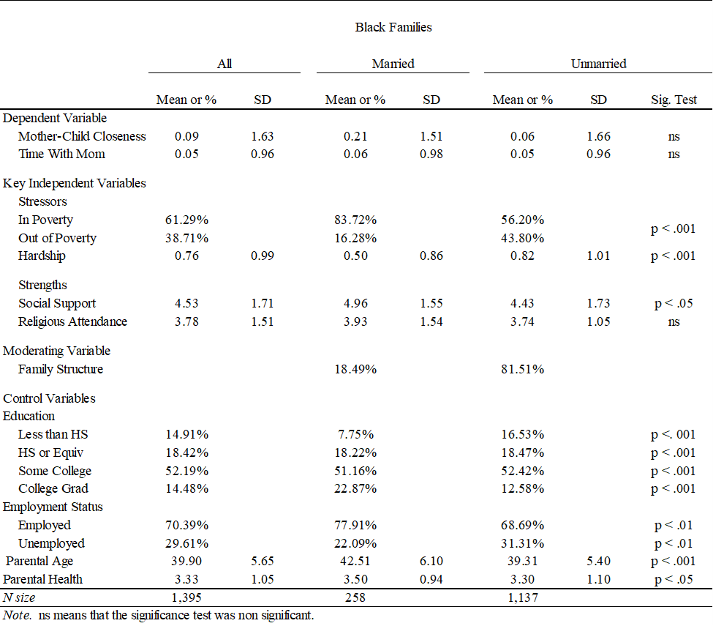

Additionally, married families reported experiencing less economic hardship than unmarried families (p < .001). Married families received more social support (4.97) than unmarried families (4.4; p < .05). There were no significant differences in religious attendance between married and unmarried families (p = .06). Conversely, there are more unmarried families who are out of poverty compared to married families (p < .001).

Correlation Matrix
Table 2 displays the correlations among key independent and dependent variables in the current study. Mother-child closeness was positively correlated with the time children spent with their mothers (r = .39, p < .001). Mother-child closeness was positively associated with social support (r = .10, p < .001) and parental health (r = .10, p < .001). Poverty was negatively associated with all variables except for economic hardship which is positively associated with poverty (r = .19, p < .001). Poverty was not significantly associated with mother-child closeness. Economic hardship was negatively associated with all variables except for poverty, mother-child closeness, and religious attendance. Economic hardship was not significantly associated with mother-child closeness or religious attendance. Social support was positively associated with religious attendance (r = .09, p < .001) and family structure (r = .12, p < .001). Religious attendance was not significantly associated with family structure (r = .05, p = .06).

Regression Analyses
Table 3 and Table 4 show the Y-standardized coefficients and standard errors of the OLS regression models for mother-child closeness and time spent, respectively. I examine whether poverty and economic hardship is associated with lower levels of mother-child closeness (Table 3) and lower levels of children’s time spent with their mothers (Table 4).

Table 2. Correlation Matrix
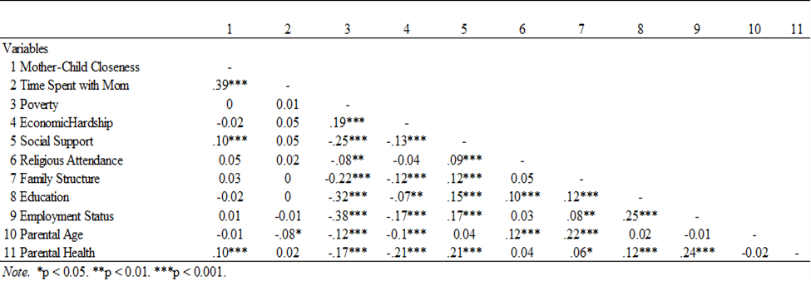
Table 3. Y-Standardized Coefficients for Mother-Child Closeness
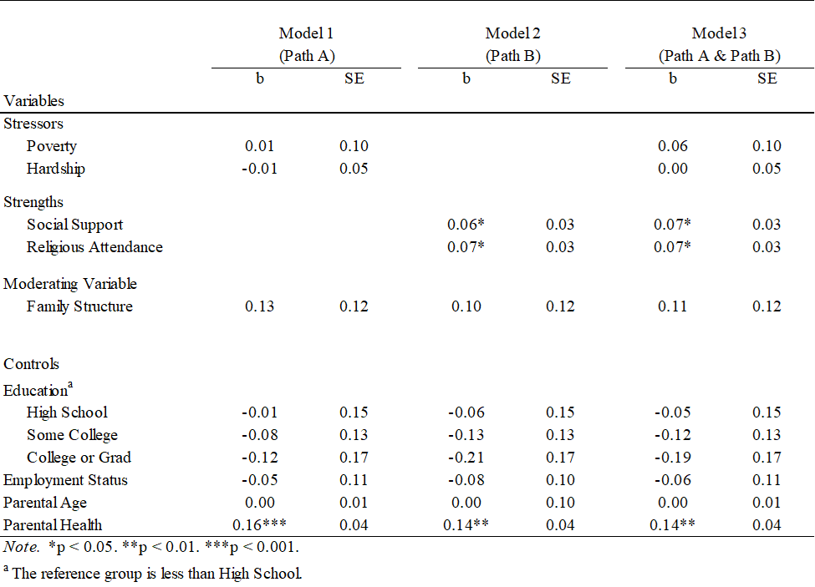

Table 4. Y-Standardized Coefficients for Children's Time Spent with Mother
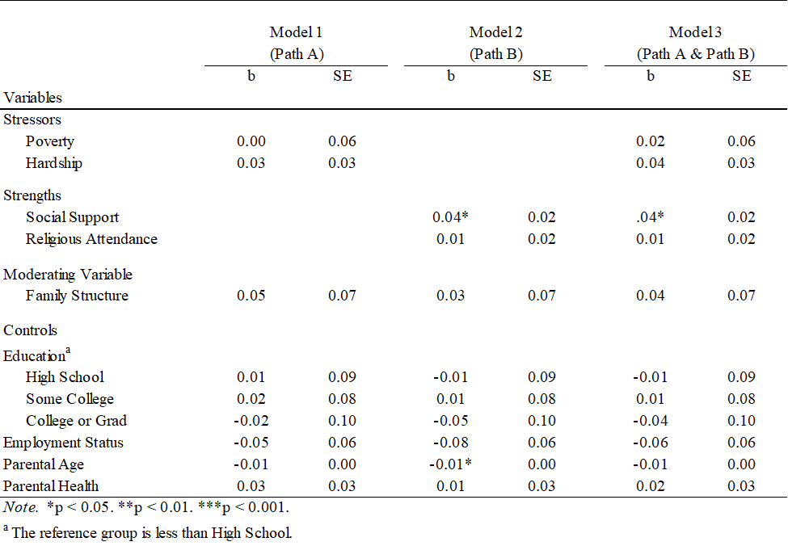
Given that I estimated the models separately across dependent variables, I first present the findings for the association between the family stress variables (e.g., poverty and economic hardship) on closeness and time spent. Second, I present the findings for the association between the family strength variables (e.g., social support and religious service attendance) on mother-child closeness and time spent. Last, I present the results from the interaction effects between family structure and the key independent variables of the study in Table 5 and Table 6.
First, Table 3 (Model 1) shows that no statistically significant differences emerged between poor families and nonpoor families on mother-child closeness (b = .01; p = .92) nor for children’s time spent with their mother (Table 4, Model 1; b = 0.00; p= .99), net of statistical controls. Additionally, economic hardship was not statistically significant for mother-child closeness (Table 3, Model 1; b = -.01; p = .90) nor for time children report spending with their mothers (Table 4, Model 1; b = .03; p = .24), net of statistical controls.
In Tables 3 and 4 (Model 3), I add social support and religious attendance to the analytic models. The association between poverty and economic hardship on mother-child closeness (Table 3, Model 3) and children’s time spent with mothers (Table 4, Model 3) remained statistically non-significant. Thus, the results failed to support the hypotheses that poor families (when compared to nonpoor families) and economic hardship will be associated with lower levels of closeness and time spent (Hypotheses 1a and 1b).
Second, I examine whether the variables associated with family strengths (e.g., social support and religious service attendance) increase mother-child closeness and the time children reported spending with their mothers.

Table 5. Y-Standardized Coefficients for Interaction Effects on Mother-Child Closeness
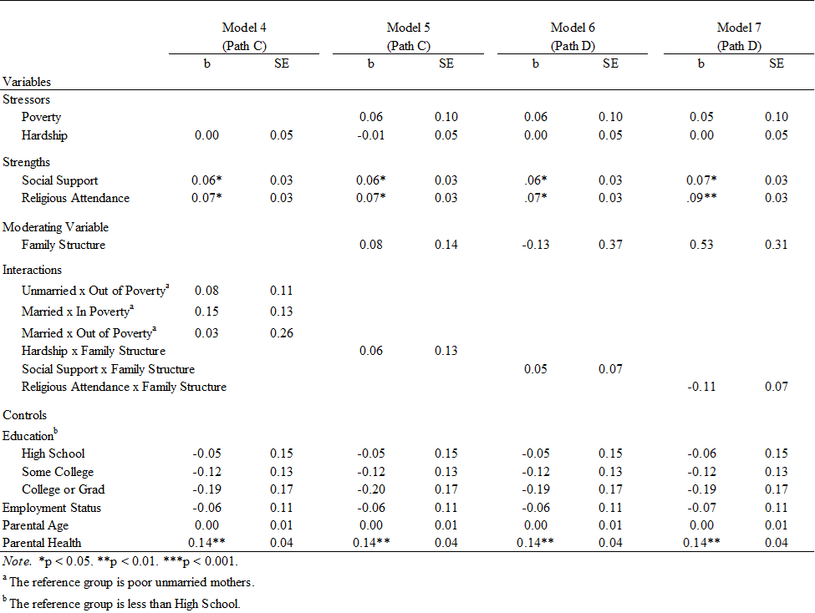
Table 6. Y-Standardized Coefficients for Interaction Effects on Children's Time Spent with Mom
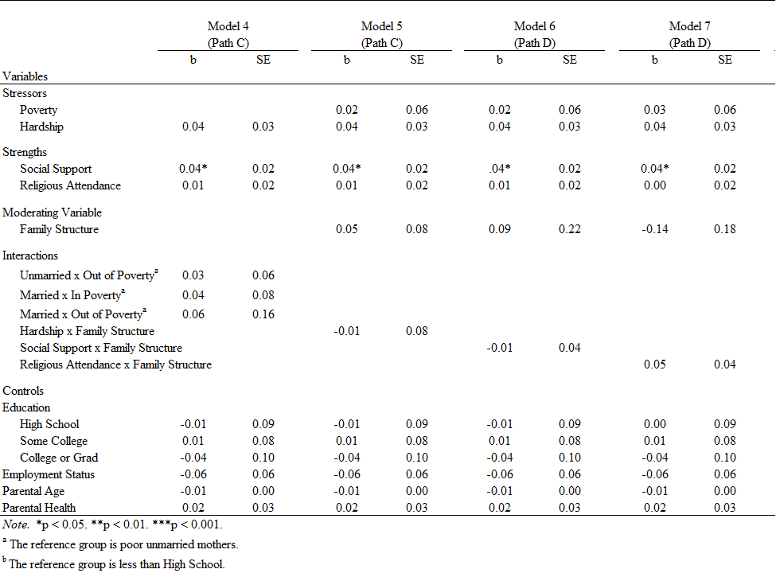
Second, I examine whether the variables associated with family strengths (e.g., social support and religious service attendance) increase mother-child closeness and the time children reported spending with their mothers. In Table 3 (Model 2), the findings show that for every unit increase in social support, mother-child closeness increases by .06 standard deviations (p < 0.05), and for every unit increase in religious attendance, mother-child closeness increases by 0.07 standard deviations (p < 0.05).
In Table 3 (Model 3) I enter poverty and economic hardship into the analytical model. Notably, the association between social support and religious attendance continue to be statistically significant. For every unit increase in social support, mother-child closeness increases by .07 standard deviations (p < .05) and for every unit increase in religious attendance, mother-child closeness increases by .07 standard deviations (p < 0.05).
In Table 4 (Model 2), I examine the association for social support and religious attendance on children’s time spent with their mothers. The results show that the association between social support and children’s time spent with their mothers was statistically significant. For instance, for every unit increase in social support, the average time children report spending with their mothers increases by .04 standard deviations (p < .05). The association between religious attendance and children’s time spent with their mothers was not statistically significant (b = .01; p = .49).
In Table 4 (Model 3), I enter poverty and economic hardship into the analytic model. Notably, the association between social support and children’s time spent with their mothers continues to be statistically significant. Specifically, for every unit increase in social support, the average time children report spending with their mothers increases by .04 standard deviations (p < .05). The association between religious attendance and children’s time spent with their mother is not statistically significant (b = .01; p = .48). Taken together, the results provide strong support for the hypothesis that social support and religious service attendance will lead to higher levels of closeness (Hypotheses 2ab and 2b). The results only provide partial support for children’s time spent with their mother as social support (and not religious service attendance) was statistically significant.
Third, I examine whether family structure moderates the effects of poverty and economic hardship, on mother-child closeness (Table 5) and the time children reported spending with their mothers (Table 6) to test the stress exacerbation hypothesis. In Table 5 (Model 4 and Model 5) I interacted poverty and economic hardship with family structure respectively. The reference group for the interaction between poverty and family structure is poor unmarried mothers for child-mother closeness. The findings show that family structure does not significantly moderate the effects of poverty on mother-child closeness between poor married mothers (Table 5, Model 4; b = .15; p = .25), nonpoor unmarried mothers (Table 5, Model 4; b = .08, p = .47), and nonpoor married mothers (Table 4, Model 4; b = .03, p = .92). In Table 6 (Model 4) I interacted poverty with family structure for the time children report spending with their mothers with poor unmarried mothers as the reference group. Moreover, the findings show that family structure does not significantly moderate the effects of poverty on the time children report spending with their mothers between poor married mothers (Table 6, Model 4; b = .04, p = .57), nonpoor unmarried mothers (Table 6, Model 4; b = .03, p = .69) and nonpoor married mothers (Table 6, Model 4; b = .06, p = .71). Additionally, the findings show that family structure does not moderate the effects of economic hardship on mother-child closeness (Table 5, Model 5; b = .06, p = .62) nor time children report spending with their mothers (Table 6, Model 5; b = -.01, p = .89), net of statistical controls. Thus, the results fail to support the stress exacerbation hypothesis (H3). Last, I examine whether family structure moderates the association between social support and religious service attendance to test the strength exacerbation hypothesis on mother-child closeness and time spent. In Table 6 (Model 6), I examined the interaction between family structure and social support on time children report spending with their mothers. The findings show that family structure does not significantly moderate the effects of social support on mother-child closeness (Table 5, Model 6; b = .05, p = .49) nor for the time children report spending with their mothers (Table 6, Model 6; b = -.01, p = .82). Furthermore, the findings show that family structure does not significantly moderate the effect of religious attendance on mother-child closeness (Table 5, Model 7; b = -.11, p = .14) nor for the time children report spending with their mothers (Table 6, Model 7; b = .05, p = .29). Altogether, these findings do not support the strength exacerbation hypothesis (H4).

CHAPTER FIVE: DISCUSSION AND CONCLUSION
The purpose of the present study was to examine the extent to which family stress (poverty and economic hardship) and family strengths (social support and religious attendance) affect the quality of mother-child relationships in Black families, and whether these associations vary across family structure. Using data from the Fragile Families and Childhood Well-Being Study (FFCWS), the study reveals the extent to which family stress, family strengths, and the moderating effects of family structure affect the quality of mother-child relationships in Black families. The findings reveal that family strengths (e.g., social support and religious attendance) were associated with higher quality mother-child relationships. Overall, I found that family stress (e.g., poverty and economic hardship) was not negatively associated with lower quality mother-child relationships. Results from the current study revealed several new insights that both challenge and advance prior research.
The findings on how family stress (e.g., poverty and economic hardship) affects mother-child relationships in Black families runs contrary to prior research—at least in regard to mother-child closeness and time spent together. For example, previous studies indicate that economic stress (e.g., poverty and economic hardship) negatively impact mother-child relationships through increased mother-child conflict or the inability to provide resources that are associated with positive children’s outcomes (Anderson 2015; Hardie & Seltzer 2016; Haux & Platt 2020; Milteer 2012). The findings from the current study reveal no statistically significant effect of poverty and economic hardship on mother-child closeness, and the average time children spend with their mothers.
Economic circumstances may not affect mother-child relationships in Black families because Black mothers rely on their social support networks (e.g., extended family, fictive kin, friends, and community) to help alleviate some of the financial stress that Black mothers are facing. In turn, Black mothers use adaptive strategies to minimize the impact of poverty and economic hardship on their relationships with their children. Specifically, the promotion and cultivation of positive mother-child relationships has been shown to mediate the negative effects of poverty and economic hardship (Anderson 2018). Black mothers may preemptively focus on maintaining positive mother-child relationships with their children to reduce the impact of poverty and economic hardship on the mother-child relationship.
The findings related to family strengths (e.g., social support and religious attendance) provide support for previous literature on the association between family strengths and the quality of mother-child relationships. Notably, social support and religious service attendance is associated with mother-child closeness and time spent together in different ways. First, when Black mothers receive resources from their social support network (e.g., friends, extended family, and community) and regularly attend religious services, children tend to report higher levels of closeness. The results show that both measures—social support and religious service attendance—are associated with mother-child closeness (children’s reports).
Receiving social support in the forms of financial support (e.g., lending money or paying for something), providing services (e.g., transporting children to school), and emotional support (e.g., talking with family members, gathering for special events or holidays) may allow Black mothers to demonstrate the importance of helping family to their children, thus helping to bring Black mothers and their children together. (Hill 2003; Jackson et al. 2014; Lee et al. 2009; Luthar & Ciciolla 2015; McAdoo 2007; McConnell et al. 2011; Taylor et al. 2014). Additionally, Black mothers who regularly attend religious services with their children are able to strengthen their relationship with their children through sharing religious teachings that emphasize the individual and joint roles of mothers and children in cultivating a positive mother-child relationship through shared religious beliefs (Mahoney et al. 2003; Petts 2014).
Second, the results indicate that when Black mothers receive social support, children report spending more time with their mother. Surprisingly, no significant association emerged between religious service attendance and time spent together. Thus, the social support Black mothers receive are beneficial for the mother-child relationship in terms of both closeness and time spent together. Black mothers who have resources may also spend more time with their children. For instance, low-income Black mothers who receive financial support from their social support networks may worry less about needing to work more to cover all their bills (Hill 2003; Jackson et al. 2014; Taylor et al. 2022). Moreover, Black mothers may also receive social support from extended family members (e.g., grandparents, uncles, and aunts) who may assist with caregiving and household responsibilities (Taylor et al. 1997). The alleviation of financial stress may grant Black mothers the ability to spend more time with their children.
The statistically significant results for mothers’ religious service attendance on children’s reports of closeness and the null results between religious service attendance and children’s reports of time spent together is worth noting. To speculate, on the one hand, religious service attendance may generate, for children, a feeling of closeness to their mother by learning about their mother’s role and their own roles in cultivating the mother-child relationship through religious teachings and shared religious beliefs (Mahoney 2003; Petts 2014). On the other hand, religious service attendance may not necessarily translate into mothers and children spending time together due to a majority of Black adults being Christian, and no teachings in Christianity encourage children and mothers to spend time together. Taken together, the extent to which family strengths affect the mother-child relationship is largely contingent upon the specific quantitative measure.
The findings for family structure’s moderating effects of family stress (e.g., poverty and economic hardship) and family strengths (e.g., social support and religious attendance) on mother-child relationships provide no support for previous literature on the effects of family structure in Black families. Despite previous studies noting that married families have more financial resources than unmarried families (Amato & Maynard 2007; Livingston 2018; Manning 2015; McAdoo 2007; Seccombe 2007), when economic stress is present, family structure will have little impact on how economic stress affects mother-child relationships in Black families. Whether Black families are married or not, poverty and economic hardship do not seem to differ in impact on the interactions and relationships Black mothers have with their children.
The findings for family structure’s moderating effects for family strengths (e.g., social support and religious attendance) show that family structure does not moderate the effects of social support and religious attendance on mother-child closeness and time spent together. The findings do not support the strength exacerbation hypothesis that family structure would strengthen the positive effects of social support and religious attendance on mother-child relationships. A possible explanation for why family structure does not strengthen the impact of social support, is that whether Black mothers are married or not, they continue to have their own social support network. Previous literature notes that children of married families have access to both their mothers’ and their fathers’ social support networks (Booth et al. 2010; King et al. 2018; Riggio 2004; Riggio & Valenzuela 2011).
Having access to more social support networks through marriage does not necessarily mean that Black families will receive more social support compared to unmarried families. For instance, unmarried mothers who have a smaller social support network may receive more satisfying social support for themselves and their families. Previous studies notes that unmarried Black parents may compensate for the lack of a spouse or additional parental figure through frequent religious involvement (Taylor et al. 2004). Thus, family structure may not exacerbate the effects of religious attendance on mother-child relationships because whether or not Black mothers are married, the shared religious teachings and beliefs that Black mothers shared with their children do not change. Therefore, the religious teachings of the roles of a child and mother in a mother-child relationship will not change because of or the lack of a spouse or additional parent.
Additionally, family structure may not moderate the effects of family stress (e.g., poverty and economic hardship) and family strengths (e.g., social support and religious attendance) on mother-child relationships in Black families because Black families must navigate omnipresent racism in their everyday lives, and consequently, Black families have developed strategies to adapt to everyday racism. More specifically, Black families tend to rely on certain strengths like social support or religious attendance as a buffer against racism.
Although the current study focuses on family stress and strengths on mother-child relationship quality, there were some statistical control variables that emerged to have a statistically significant association with mother-child closeness and the time children report spending with their mothers that are worth noting. First, in Table 3, parental health was statistically significant across all models with Model 1 having a slightly higher Y-standardized coefficient. This association remained statistically significant across all models. Moreover, in Table 4 (Model 2), parental age was statistically significant and positively associated with children’s report of spending time with their mothers. Future research should focus on why these associations emerge in mother-child closeness and the time children report spending with their mothers in Black families.

Limitations and Strengths
Although this study contributes to the study of Black families, there are some limitations worth acknowledging to help guide future research. First, this study only focuses on children’s report of their closeness to their mothers and the time they spend with their mothers. Only focusing on children misses the potential similarities and differences on the mother-child relationship from the parents’ perspective (Lussier et al. 2002). Future research should consider including mothers’ report of closeness with their children to call attention to potential similarities and differences between children’s and mothers’ report of the mother-child relationship.
Second, although the Fragile Families and Child Well-Being Study is a longitudinal dataset, the current study only uses cross-sectional data. Using cross-sectional data does not allow for the study to look at potential changes over time in mother-child relationships. Last, the data from the FFCWS focuses on urban families (Reichman et al. 2001). Therefore, the findings of this study cannot be generalized to all families, especially mothers and children living in rural areas. There are well documented disadvantages in family outcomes for rural families (Burton et al. 2013) that are not reflected in this study. As such, future research should examine the ways in which economic stress, social support, and religious attendance affects the mother-child relationship in rural Black families.
Despite the limitations, the current study has several notable strengths. First, this study highlights the heterogeneity of Black families by focusing on married and unmarried Black families. Previous literature on Black families has commonly focused on one family type (unmarried) rather than drawing attention to more diverse family structures among Black families (Amato & Maynard 2007; Cancian & Haskins 2014). Second, this study highlights both family stress and family strengths on mother-child relationships. Previous research tends to focus on family stress and family strengths separately. This current study examines the relative impact of both stress and strengths on mother-child relationships. The third strength of this study is the distinct data used. The FFCWS dataset allows for the study of both family stress (e.g., poverty and economic hardship) and family strengths (e.g., social support and religious attendance) in a single study to examine their individual and relative effects on mother-child relationships in Black families.

Conclusion
Overall, this study contributes to the literature on mother-child relationships in several ways. First, this study moves away from race-comparative approaches that often position White families as the standard by which Black families are compared. Scholars argue that within-race analyses provide more nuance for understanding the heterogeneity in Black families (Williams 2019; Williams and Baker, 2021). Second, the study draws on two disparate perspectives—family stress and family strengths—to understand their relative impact on the quality of mother-child relationships. Previous research has examined family stress and family strengths separately. The current study brings both perspectives in a single study. Lastly, given that Black families are more likely to have a nonmarital birth, I test whether both perspectives intersect with family structure to create disparate outcomes between married and unmarred families. Taken together, this current study paints a more holistic picture of Black families' (mother and children) stress and strengths.

LIST OF REFERENCES

Alexakos, Konstantinos, Jayson K. Jones, and Victor H. Rodriguez. 2011. “Fictive Kinship as It Mediates Learning, Resiliency, Perseverance, and Social Learning of Inner-City High School Students of Color in a College Physics Class.” Cultural Studies of Science Education 6(4):847–70. doi: 10.1007/s11422-011-9317-7.
Amato, Paul R. 2010. “Research on Divorce: Continuing Trends and New Developments.” Journal of Marriage and Family 72(3):650–66. doi: 10.1111/j.1741-3737.2010.00723.x.
Amato, Paul R., and Rebecca A. Maynard. 2007. “Decreasing Nonmarital Births and Strengthening Marriage to Reduce Poverty.” The Future of Children 17(2):117–41. doi: 10.1353/foc.2007.0012.
Anderson, Riana E., Saida B. Hussain, Melvin N. Wilson, Daniel S. Shaw, Thomas J. Dishion, and Joanna Lee Williams. 2015. “Pathways to Pain: Racial Discrimination and Relations Between Parental Functioning and Child Psychosocial Well-Being.” Journal of Black Psychology 41(6):491–512. doi: 10.1177/0095798414548511.
Anderson, Riana Elyse. 2015. “Focusing on Family: Parent–Child Relationships and School Readiness among Economically Impoverished Black Children.” The Journal of Negro Education 84(3):442. doi: 10.7709/jnegroeducation.84.3.0442.
Anderson, Riana Elyse. 2018. “And Still WE Rise: Parent-Child Relationships, Resilience, and School Readiness in Low-Income Urban Black Families.” Journal of Family Psychology 32(1):60–70. doi: 10.1037/fam0000348.
Baker, Regina S. 2015. “The Changing Association Among Marriage, Work, and Child Poverty in the United States, 1974-2010: Marriage, Work, and Child Poverty.” Journal of Marriage and Family 77(5):1166–78. doi: 10.1111/jomf.12216.
Baker, Regina S., David Brady, Zachary Parolin, and Deadric T. Williams. 2021. “The Enduring Significance of Ethno-Racial Inequalities in Poverty in the U.S., 1993–2017.” Population Research and Policy Review. doi: 10.1007/s11113-021-09679-y.
Bartkowski, John P., and Christopher G. Ellison. 1995. “Divergent Models of Childrearing in Popular Manuals: Conservative Protestants vs. the Mainstream Experts.” Sociology of Religion 56(1):21–34. doi: 10.2307/3712036.
Billingsley, Andrew. 1992. Climbing Jacob’s Ladder: The Enduring Legacy of African-American Families. New York: Simon & Schuster.
Booth, Alan, Mindy E. Scott, and Valarie King. 2010. “Father Residence and Adolescent Problem Behavior: Are Youth Always Better Off in Two-Parent Families?” Journal of Family Issues 31(5):585–605. doi: 10.1177/0192513X09351507.
Brady, David, Ryan M. Finnigan, and Sabine Hübgen. 2017. “Rethinking the Risks of Poverty: A Framework for Analyzing Prevalences and Penalties.” American Journal of Sociology 123(3):740–86. doi: 10.1086/693678.
Brooks, Jada E., and Katherine R. Allen. 2016. “The Influence of Fictive Kin Relationships and Religiosity on the Academic Persistence of African American College Students Attending an HBCU.” Journal of Family Issues 37(6):814–32. doi: 10.1177/0192513X14540160.
Brown, Susan L. 2004. “Family Structure and Child Well-Being: The Significance of Parental Cohabitation.” Journal of Marriage and Family 66(2):351–67. doi: 10.1111/j.1741-3737.2004.00025.x.
Brown, Susan L., and Wendy D. Manning. 2009. “Family Boundary Ambiguity and the Measurement of Family Structure: The Significance of Cohabitation.” Demography 46(1):85–101. doi: 10.1353/dem.0.0043.
Bryant, Chalandra M., K. A. S. Wickrama, John Bolland, Barlynda M. Bryant, Carolyn E. Cutrona, and Christine E. Stanik. 2010. “Race Matters, Even in Marriage: Identifying Factors Linked to Marital Outcomes for African Americans.” Journal of Family Theory & Review 2(3):157–74. doi: 10.1111/j.1756-2589.2010.00051.x.
Burton, Linda M., Daniel T. Lichter, Regina S. Baker, and John M. Eason. 2013. “Inequality, Family Processes, and Health in the ‘New’ Rural America.” American Behavioral Scientist 57(8):1128–51. doi: 10.1177/0002764213487348.
Cancian, Maria, and Ron Haskins. 2014. “Changes in Family Composition: Implications for Income, Poverty, and Public Policy.” The ANNALS of the American Academy of Political and Social Science 654(1):31–47. doi: 10.1177/0002716214525322.
Conger, Rand D., Katherine J. Conger, and Monica J. Martin. 2010. “Socioeconomic Status, Family Processes,and Individual Development.” Journal of Marriage and Family 72(3):685–704. doi: 10.1111/j.1741-3737.2010.00725.x.
Conger, Rand D., Lora Ebert Wallace, Yumei Sun, Ronald L. Simons, Vonnie C. McLoyd, and Gene H. Brody. 2002. “Economic Pressure in African American Families: A Replication and Extension of the Family Stress Model.” Developmental Psychology 38(2):179–93. doi: 10.1037/0012-1649.38.2.179.
Conger, Rand, and Glen H. Elder. 1994. Families in Troubled Times: Adapting to Change in Rural America. New York: Ade Gruyter.
Creamer, John. 2020. “Inequalities Persist Despite Decline in Poverty For All Major Race and Hispanic Origin Groups.” Census.Gov. Retrieved November 4, 2021 (https://www.census.gov/library/stories/2020/09/poverty-rates-for-blacks-and-hispanics-reached-historic-lows-in-2019.html).
DeFrain, John, and Sylvia Asay, eds. 2014. “Strong Families Around the World: An Introduction to the Family Strengths Perspective.” Pp. 21–30 in Strong Families Around the World. Routledge.
DeFrain, John, and Sylvia M. Asay. 2007. “Family Strengths and Challenges in the USA.” Marriage & Family Review 41(3–4):281–307. doi: 10.1300/J002v41n03_04.
Edwards, Khadijah. 2022. “Most Black Americans Say They Can Meet Basic Needs Financially, but Many Still Experience Economic Insecurity.” Pew Research Center. Retrieved April 23, 2022 (https://www.pewresearch.org/fact-tank/2022/02/23/most-black-americans-say-they-can-meet-basic-needs-financially-but-many-still-experience-economic-insecurity/).
Ejrnæs, Morten, Jørgen Elm Larsen, and Maja Müller. 2020. “Parents on Low Benefits - Coping with Poverty.” Journal of Poverty 24(7):610–26. doi: 10.1080/10875549.2020.1740376.
Ellison, Christopher G., Andrea K. Henderson, Norval D. Glenn, and Kristine E. Harkrider. 2011. “Sanctification, Stress, and Marital Quality.” Family Relations 60(4):404–20. doi: 10.1111/j.1741-3729.2011.00658.x.
Erel, Osnat, and Bonnie Burman. 1995. “Interrelatedness of Marital Relations and Parent-Child Relations: A Meta-Analytic Review.” Psychological Bulletin 118(1):108–32. doi: 10.1037/0033-2909.118.1.108.
Frankel, Noralee. 1999. Freedom’s Women: Black Women and Families in Civil War Era Mississippi. Bloomington: Indiana University Press.
Gabler, John, and Herbert A. Otto. 1964. “Conceptualization of ‘Family Strengths’ in Family Life and Other Professional Literature.” Journal of Marriage and Family 26(2):221–22. doi: 10.2307/349735.
Gambin, Małgorzata, Małgorzata Woźniak-Prus, Marcin Sękowski, Andrzej Cudo, Ewa Pisula, Eliza Kiepura, Joanna Boruszak-Kiziukiewicz, and Grażyna Kmita. 2020. “Factors Related to Positive Experiences in Parent-Child Relationship during the COVID-19 Lockdown. The Role of Empathy, Emotion Regulation, Parenting Self-Efficacy and Social Support.” Medical Letter on the CDC & FDA.
Ge, Ting, and Lin Wang. 2019. “Multidimensional Child Poverty, Social Relationships and Academic Achievement of Children in Poor Rural Areas of China.” Children and Youth Services Review 103:209–17. doi: 10.1016/j.childyouth.2019.06.007.
Gershoff, Elizabeth T., J. Lawrence Aber, C. Cybele Raver, and Mary Clare Lennon. 2007. “Income Is Not Enough: Incorporating Material Hardship Into Models of Income Associations With Parenting and Child Development.” Child Development 78(1):70–95. doi: 10.1111/j.1467-8624.2007.00986.x.
Hardie, Jessica Halliday, and Judith A. Seltzer. 2016. “Parent-Child Relationships at the Transition to Adulthood: A Comparison of Black, Hispanic, and White Immigrant and Native-Born Youth.” Social Forces 95(1):321–53. doi: 10.1093/sf/sow033.
Haux, Tina, and Lucinda Platt. 2020. “Fathers’ Involvement with Their Children Before and After Separation.” European Journal of Population 37(1):151–77. doi: http://dx.doi.org.proxy.lib.utk.edu:90/10.1007/s10680-020-09563-z.
Havermans, Nele, Sofie Vanassche, and Koen Matthijs. 2017. “Children’s Post-Divorce Living Arrangements and School Engagement: Financial Resources, Parent–Child Relationship, Selectivity and Stress.” Journal of Child and Family Studies 26(12):3425–38. doi: 10.1007/s10826-017-0843-0.
Hill, Robert Bernard. 2003. The Strengths of Black Families. 2nd ed. Lanham, Md: University Press of America.
Hill, Shirley A. 2006. “Marriage among African American Women: A Gender Perspective.” Journal of Comparative Family Studies 37(3):421–40. doi: 10.3138/jcfs.37.3.421.
Huang, J., Y. Kim, and M. Sherraden. 2017. “Material Hardship and Children’s Social-Emotional Development: Testing Mitigating Effects of Child Development Accounts in a Randomized Experiment: Material Hardship and Social-Emotional Development.” Child: Care, Health and Development 43(1):89–96. doi: 10.1111/cch.12385.
Iceland, John. 2019. “Racial and Ethnic Inequality in Poverty and Affluence, 1959–2015.” Population Research and Policy Review 38(5):615–54. doi: 10.1007/s11113-019-09512-7.
Iceland, John, and Kurt J. Bauman. 2007. “Income Poverty and Material Hardship: How Strong Is the Association?” The Journal of Socio-Economics 36(3):376–96. doi: 10.1016/j.socec.2006.12.003.
Iceland, John, Claire Kovach, and John Creamer. 2021. “Poverty and the Incidence of Material Hardship, Revisited.” Social Science Quarterly 102(1):585–617. doi: 10.1111/ssqu.12922.
Jackson, Grace L., David Kennedy, Thomas N. Bradbury, and Benjamin R. Karney. 2014. “A Social Network Comparison of Low-Income Black and White Newlywed Couples.” Journal of Marriage and Family 76(5):967–82. doi: 10.1111/jomf.12137.
Johnson, Colleen L. 2000. “Perspectives on American Kinship in the Later 1990s.” Journal of Marriage and Family 62(3):623–39. doi: 10.1111/j.1741-3737.2000.00623.x.
Karpman, Michael, Stephen Zuckerman, and Dulce Gonzalez. 2017. “Material Hardship among Nonelderly Adults and Their Families in 2017.” 18.
King, Valarie, Lisa M. Boyd, and Brianne Pragg. 2018. “Parent–Adolescent Closeness, Family Belonging, and Adolescent Well-Being Across Family Structures.” Journal of Family Issues 39(7):2007–36. doi: 10.1177/0192513X17739048.
Kouros, Chrystyna D., Lauren M. Papp, Marcie C. Goeke-Morey, and E. Mark Cummings. 2014. “Spillover Between Marital Quality and Parent-Child Relationship Quality: Parental Depressive Symptoms as Moderators.” Journal of Family Psychology 28(3):315–25. doi: 10.1037/a0036804.
Lee, Chih-Yuan S., Jared R. Anderson, Jason L. Horowitz, and Gerald J. August. 2009. “Family Income and Parenting: The Role of Parental Depression and Social Support.” Family Relations 58(4):417–30. doi: 10.1111/j.1741-3729.2009.00563.x.
Lichter, Daniel T., Deborah Roempke Graefe, and J. Brian Brown. 2003. “Is Marriage a Panacea? Union Formation Among Economically Disadvantaged Unwed Mothers.” Social Problems 50(1):60–86. doi: 10.1525/sp.2003.50.1.60.
Livingston, Gretchen. 2018. “The Changing Profile of Unmarried Parents.” Pew Research Center’s Social & Demographic Trends Project. Retrieved April 23, 2022 (https://www.pewresearch.org/social-trends/2018/04/25/the-changing-profile-of-unmarried-parents/).
Lussier, Gretchen, Kirby Deater-Deckard, Judy Dunn, and Lisa Davies. 2002. “Support Across Two Generations: Children’s Closeness to Grandparents Following Parental Divorce and Remarriage.” Journal of Family Psychology 16(3):363–76. doi: 10.1037/0893-3200.16.3.363.
Luthar, Suniya S., and Lucia Ciciolla. 2015. “Who Mothers Mommy? Factors That Contribute to Mothers’ Well-Being.” Developmental Psychology 51(12):1812–23. doi: 10.1037/dev0000051.
Magnus, Keith B., Emory L. Cowen, Peter A. Wyman, Douglas B. Fagen, and William C. Work. 1999. “Parent–Child Relationship Qualities and Child Adjustment in Highly Stressed Urban Black and White Families.” Journal of Community Psychology 27(1):17.
Mahoney, Annette. 2005. “Religion and Conflict in Marital and Parent-Child Relationships.” Journal of Social Issues 61(4):689–706. doi: 10.1111/j.1540-4560.2005.00427.x.
Mahoney, Annette, Kenneth I. Pargament, Aaron Murray-Swank, and Nichole Murray-Swank. 2003. “Religion and the Sanctification of Family Relationships.” Review of Religious Research 44(3):220. doi: 10.2307/3512384.
Malczyk, Benjamin R., and Hal A. Lawson. 2017. “Parental Monitoring, the Parent-Child Relationship and Children’s Academic Engagement in Mother-Headed Single-Parent Families.” Children and Youth Services Review 73:274–82. doi: 10.1016/j.childyouth.2016.12.019.
Manning, Wendy D. 2015. “Cohabitation and Child Wellbeing.” The Future of Children 25(2):51–66. doi: 10.1353/foc.2015.0012.
Masarik, April S., and Rand D. Conger. 2017. “Stress and Child Development: A Review of the Family Stress Model.” Current Opinion in Psychology 13:85–90. doi: 10.1016/j.copsyc.2016.05.008.
McAdoo, Harriette Pipes. 2007. Black Families. 4th ed. Thousand Oaks, Calif: Sage Publications.
McConnell, D., R. Breitkreuz, and A. Savage. 2011. “From Financial Hardship to Child Difficulties: Main and Moderating Effects of Perceived Social Support: Main and Moderating Effects of Perceived Social Support.” Child: Care, Health and Development 37(5):679–91. doi: 10.1111/j.1365-2214.2010.01185.x.
Milteer, R. M., K. R. Ginsburg, COUNCIL ON COMMUNICATIONS AND MEDIA COMMITTEE ON PSYCHOSOCIAL ASPECTS OF CHILD AND FAMILY HEALTH, and D. A. Mulligan. 2012. “The Importance of Play in Promoting Healthy Child Development and Maintaining Strong Parent-Child Bond: Focus on Children in Poverty.” PEDIATRICS 129(1):e204–13. doi: 10.1542/peds.2011-2953.
Mohamed, Besheer, Kiana Cox, Jeff Diamant, and Claire Gecewicz. 2021. “2. Religious Affiliation and Congregations.” Pew Research Center’s Religion & Public Life Project. Retrieved June 25, 2022 (https://www.pewresearch.org/religion/2021/02/16/religious-affiliation-and-congregations/).
Nelson, Margaret K. 2014. “Whither Fictive Kin? Or, What’s in a Name?” Journal of Family Issues 35(2):201–22. doi: 10.1177/0192513X12470621.
Otto, Herbert A. 1962. “What Is a Strong Family?” Marriage and Family Living (Menasha, Wis.) 24(1):77–80. doi: 10.2307/348232.
Parolin, Zachary. 2019. “Temporary Assistance for Needy Families and the Black–White Child Poverty Gap in the United States.” Socio-Economic Review. doi: 10.1093/ser/mwz025.
Petts, Richard J. 2014. “Family, Religious Attendance, and Trajectories of Psychological Well-Being Among Youth.” Journal of Family Psychology 28(6):759–68. doi: 10.1037/a0036892.
Pew Research Center. 2016. “Demographic Trends and Economic Well-Being.” Pew Research Center’s Social & Demographic Trends Project. Retrieved April 23, 2022 (https://www.pewresearch.org/social-trends/2016/06/27/1-demographic-trends-and-economic-well-being/).
Pew Research Center. 2022. “Religious Landscape Study.” Pew Research Center’s Religion & Public Life Project. Retrieved April 23, 2022 (https://www.pewresearch.org/religion/religious-landscape-study/).
Reichman, Nancy E., Julien O. Teitler, Irwin Garfinkel, and Sara S. McLanahan. 2001. “Fragile Families: Sample and Design.” Children and Youth Services Review 23(4–5):303–26. doi: 10.1016/S0190-7409(01)00141-4.
Riggio, Heidi R. 2004. “Parental Marital Conflict and Divorce, Parent-Child Relationships, Social Support, and Relationship Anxiety in Young Adulthood.” Personal Relationships 11(1):99–114. doi: 10.1111/j.1475-6811.2004.00073.x.
Riggio, Heidi R., and Ann Marie Valenzuela. 2011. “Parental Marital Conflict and Divorce, Parent–Child Relationships, and Social Support among Latino-American Young Adults.” Personal Relationships 18(3):392–409. doi: 10.1111/j.1475-6811.2010.01305.x.
Rodems, Richard, and H. Luke Shaefer. 2020. “Many of the Kids Are Not Alright: Material Hardship among Children in the United States.” Children and Youth Services Review 112:104767. doi: 10.1016/j.childyouth.2020.104767.
Roehlkepartain, Eugene C. and Amy K Syvertsen. 2014. “Family Strengths and Resilience: Insights from a National Study.” Reclaiming Children and Youth 23(2):13-.
Scaramella, Laura V., Sara L. Sohr-Preston, Kristin L. Callahan, and Scott P. Mirabile. 2008. “A Test of the Family Stress Model on Toddler-Aged Children’s Adjustment Among Hurricane Katrina Impacted and Nonimpacted Low-Income Families.” Journal of Clinical Child & Adolescent Psychology 37(3):530–41. doi: 10.1080/15374410802148202.
Scharp, Kristina M., and Lindsey J. Thomas. 2016. “Family ‘Bonds’: Making Meaning of Parent–Child Relationships in Estrangement Narratives.” Journal of Family Communication 16(1):32–50. doi: 10.1080/15267431.2015.1111215.
Seccombe, Karen. 2007. Families in Poverty. 1st Ed. New York: Allyn and Bacon.
Semega, Jessica, Melissa Kollar, Emily A. Shrider, and John F. Creamer. 2020. “Income and Poverty in the United States: 2019.” U.S. Census Bureau 88.
Skinner, Olivenne D., Xiaoran Sun, and Susan M. McHale. 2021. “Links between Marital and Parent-Child Relationship in African American Families: A Dyadic Approach.” Journal of Family Psychology. doi: 10.1037/fam0000844.
Smetana, Judith G., and Wendy M. Rote. 2019. “Adolescent-Parent Relationships: Progress, Processes, and Prospects.” Annual Review of Developmental Psychology 1(1):41–68. doi: 10.1146/annurev-devpsych-121318-084903.
Swiss, Liam, and Céline Le Bourdais. 2009. “Father—Child Contact After Separation: The Influence of Living Arrangements.” Journal of Family Issues 30(5):623–52. doi: 10.1177/0192513X08331023.
Taylor, Robert, Linda Chatters, Christina J. Cross, and Dawne Mouzon. 2022. “Fictive Kin Networks among African Americans, Black Caribbeans, and Non-Latino Whites.” Journal of Family Issues 43(1):20–46. doi: 10.1177/0192513X21993188.
Taylor, Robert Joseph, Linda M. Chatters, and Jeffrey S. Levin. 2004. Religion in the Lives of African Americans: Social, Psychological, and Health Perspectives. Thousand Oaks, Calif: SAGE Publications.
Taylor, Robert Joseph, Linda M. Chatters, Amanda Toler Woodward, and Edna Brown. 2013. “Racial and Ethnic Differences in Extended Family, Friendship, Fictive Kin, and Congregational Informal Support Networks.” Family Relations 62(4):609–24. doi: 10.1111/fare.12030.
Taylor, Robert Joseph, James S. Jackson, and Linda M. Chatters. 1997. Family Life in Black America. Thousand Oaks, Calif: Sage Publications.
Taylor, Ronald D., Mia Budescu, Azeb Gebre, and Irma Hodzic. 2014. “Family Financial Pressure and Maternal and Adolescent Socioemotional Adjustment: Moderating Effects of Kin Social Support in Low Income African American Families.” Journal of Child and Family Studies 23(2):242–54. doi: 10.1007/s10826-012-9688-8.
Taylor, Zoe E., and Rand D. Conger. 2017. “Promoting Strengths and Resilience in Single-Mother Families.” Child Development 88(2):350–58. doi: 10.1111/cdev.12741.
Theron, Linda Carol, and Adam Theron. 2013. “Positive Adjustment to Poverty: How Family Communities Encourage Resilience in Traditional African Contexts.” Culture & Psychology 19(3):391–413. doi: 10.1177/1354067X13489318.
Vonnie C McLoyd. 1990. “The Impact of Economic Hardship on Black Families and Children: Psychological Distress, Parenting, and Socioemotional Development.” Child Development 61(2):311–46. doi: 10.1111/j.1467-8624.1990.tb02781.x.
Wadsworth, Martha E., Laura Rindlaub, Eliana Hurwich-Reiss, Shauna Rienks, Hannah Bianco, and Howard J. Markman. 2013. “A Longitudinal Examination of the Adaptation to Poverty-Related Stress Model: Predicting Child and Adolescent Adjustment Over Time.” Journal of Clinical Child & Adolescent Psychology 42(5):713–25. doi: 10.1080/15374416.2012.755926.
Waite, Linda J. 1995. “Does Marriage Matter?” Demography 32(4):483–507. doi: 10.2307/2061670.
Williams, Deadric T., and Regina S. Baker. 2021. “Family Structure, Risks, and Racial Stratification in Poverty.” Social Problems spab018. doi: 10.1093/socpro/spab018.
Williams, Deadric T., and Jacob E. Cheadle. 2016. “Economic Hardship, Parents’ Depression, and Relationship Distress among Couples With Young Children.” Society and Mental Health 6(2):73–89. doi: 10.1177/2156869315616258.
Williams, Deadric T., Jacob E. Cheadle, and Bridget J. Goosby. 2015. “Hard Times and Heart Break: Linking Economic Hardship and Relationship Distress.” Journal of Family Issues 36(7):924–50. doi: 10.1177/0192513X13501666.
Wray, Wendella. 2015. “Parenting in Poverty: Inequity through the Lens of Attachment and Resilience.” 4(2):10.
Yuan, Shu, Dana A. Weiser, and Judith L. Fischer. 2016. “Self-Efficacy, Parent–Child Relationships, and Academic Performance: A Comparison of European American and Asian American College Students.” Social Psychology of Education 19(2):261–80. doi: 10.1007/s11218-015-9330

VITA
Deonté Mitchell Hughes was born in Henrico, Virginia and grew up in Chesterfield, Virginia. After graduating High School, Deonté attended Longwood University where he earned a Bachelor of Arts degree in Sociology. Before graduating with his undergraduate degree, Deonté was encouraged by his undergraduate faculty to pursue a graduate degree. He chose to start his graduate studies at the University of Tennessee, Knoxville to pursue a Master of Arts degree in Sociology with a concentration in Critical Race and Ethnic Studies. His research interests include studying Black families, stress, resilience, policy, race & racism, inequality, and familial relationships. Specifically, Deonté is interested in studying what stressors affect Black families, how Black families respond to those stressors, what resources they use or do not use, and how policies affect those decisions and access to resources. After graduation, Deonté will attend the University of Maryland, College Park to pursue a Doctor of Philosophy degree in Sociology with a concentration in Gender, Work, and Family. He is incredibly grateful for all of the support from his family, friends, partner, and mentors throughout his journey.

