A Study on Early Age Properties of Concrete for Precast and 3D Printing

A Dissertation Presented for the

Doctor of Philosophy

Degree

The University of Tennessee, Knoxville

Debalina Ghosh

December 2022

Copyright © 2022 by Debalina Ghosh
All rights reserved.

DEDICATION

I dedicate my work to
Baba and Ma

ACKNOWLEDGEMENTS
I always thought I will keep the acknowledgment as short as possible because how do I put everyone’s name who helped me to become who I am today, who motivated me, and who supported me professionally and personally? It will be unfair to not mention the names, without whom this Ph.D. journey would not be possible.
The research work was financially supported by the Department of Civil and Environmental Engineering Department, UTK, Center for Material Processing, UTK, and the US-China Clean Energy Research Center for Building Energy Efficiency (CERC BEE) under the Building Technologies Office (BTO) and Additive Manufacturing Office of the US Department of Energy (DOE), under Contract No. DE-AC05-00OR22725. I would like to thank the Precast/Prestressed Concrete Institute, Tindall, Gate Precast, and Metromont for their guidance in my research on precast concrete. I would like to express my gratitude to Bin Tian and Anup Deb from Quikrete for developing the printable mix design and graciously providing the materials used in Chapter IV. The print nozzle used in Chapter IV was additively manufactured in the Manufacturing Demonstration Facility at ORNL.
I am thankful to Google Scholar for letting me stand ‘at the shoulder of giants’. I am indebted to the researchers whose hours and hours of hard work have given us an understanding of materials and technology. Also, women in STEM around the world for inspiring me to continue even when it was easy to quit and choose an alternative way out.
This research would not have been possible without the help of my lab mates, Ammar Al-Hassan, Usama Al Saffar, Nolan Hayes, Mohammed Abdelrahman, and all the undergraduate assistants. Thanks to the fellow graduate students in Room 324, the CEE department faculty, and the staff, who have been nothing but friendly and welcoming over the past 5 years.
I would have been lost if not for the guidance of my academic advisor Dr. John Ma and my research committee, Dr. Yann Le Pape, Dr. Hongyu Nick Zhou, and Dr. Nicholas Wierschem. I also want to thank Paula Bran Anleu, assistant technical professional in Oak Ridge National Lab for helping me complete testing during the Covid restriction.
Finally, thanks to my Ma and Baba for always supporting my decisions and having faith in my decisions, even if that meant going against everyone. I also have to mention my sister's random and funny memes that kept me sane through rough patches. Thanks to my spouse who has been my support since my bachelor’s program. I would have never dreamed of pursuing a higher degree abroad if not for his encouragement.

ABSTRACT
Concrete is the second-most consumed material, leading the global Portland cement production of 4.1 billion tons in 2020 and 5-8% of global Carbon dioxide (CO₂) emission annually. As with any other material and practice, the construction industry is also ever-changing to meet market demand, evolving technology, and resource limitation. In the case of concrete construction, one of the main concerns is the lack of automation. In the last few decades, some new construction methods have risen to address this concern. Some of these economic and successful practices are precast construction, self-compacting concrete (SCC), and 3D printing of concrete(3DPC). Precast concrete and 3DPC have the potential to enhance productivity and to curve the adverse environmental and social effects of conventional construction activities by reducing the required formwork, material waste, operation time, and cost. This study explores the effect of parameters like fiber geometry, binder composition, and workability retention of concrete, on the short-term and long-term performance of high early strength concrete and printed concrete. Understanding the influence of the above-mentioned parameter on the performance of concrete will help develop a safe design of concrete and optimize the construction process with higher efficiency.
In Chapter 1 I review the literature and research gaps on precast concrete and 3d printing of concrete. The productivity of precast and printed concrete is dependent on the early strength gain and workability of concrete. In chapter 2 I studied the effect of fiber types on concrete workability and developed a high early strength fiber-reinforced self-compacting concrete. I examined the hydration process and suggested a chemical parameter for Calcium sulfo aluminate-based composite binders in Chapter 3. Chapter 4 explore the difference in mechanical and fracture performance for printed concrete with varied interlayer time-lapse and cast concrete. In Chapter 5 I discussed the existing fracture models for concrete as well as layer composite materials. Chapter 6 concludes with my findings throughout these chapters and aims to establish the future research this dissertation motivates.

Table of Contents
CHAPTER I: Introduction 1
Introduction 2
Precast Concrete: 4
Optimizing granular structure: 5
Optimizing paste content: 8
3D printed concrete 10
Contributions/Novelty: 12
Summary 14
CHAPTER II Optimization of granular structure and design of a High-Early-Strength Fiber-Reinforced Self-Compacting Concrete 16
Introduction 17
Materials and Mix Design Process 19
Material 19
Target Concrete Properties 20
Design of Concrete Mixtures 20
Mixing Process 33
Test Methods 33
Results and Discussion 35
Fresh Properties 35
Hardened Properties 41
Conclusions 47
CHAPTER III Optimization of Calcium Sulfo Aluminate-based composite binder 48
Introduction 49
Experimental procedure 50
Binders 50
Test Method 51
Results and Discussion 55
Hydration process 55
Thermodynamic modelling 57
Analysis of Experimental XRD patterns 59
Fresh Properties 61
Hardened properties 68
Conclusions 72
CHAPTER IV Effect of Interlayer Time-Lapse and Workability Retention on Printed Concrete Performance 76
Abstract 77
Keywords 77
Introduction 77
Materials and Methodology 79
Material Properties 79
Sample Preparation 81
Test Methods 81
Compression Test 81
Flexural Test 84
Fracture Test 87
Results and Discussion 89
Compressive Strength 89
Flexural Strength 92
Compact Tension (CT) 98
Discussion Summary 100
Conclusions 103
CHAPTER V Analysis of Fracture Along the Interlayer of Additively Manufactured Concrete 105
Introduction 106
Test Method 112
Results and Discussion 113
Conclusions 116
CHAPTER VI Conclusion 118
BIBLIOGRAPHY 124
VITA 143

LIST OF TABLES
Table 1: Chemical composition of the cementitious materials collected from manufacturers. 21
Table 2:Physical and chemical properties of Type III and CSA cements. 23
Table 3: Properties of fiber reinforcements. 26
Table 4: Particle size distribution of concrete mixtures compared to Fuller-Thompson ideal gradation curve 32
Table 5: Composition of concrete mixtures with different fibers. 36
Table 6: Properties and estimated cost of the concrete mixtures. 37
Table 7: Chemical composition of the cementitious materials collected from manufacturers and the phase composition determined by quantitative XRD analysis. 52
Table 8: Physical and chemical properties of PC, CSA cements and GGBF slag. 53
Table 9: Average material performance of composite binders 74

List of Equations
Equation 1: Equivalent diameter of fibers 30
Equation 2: Alite (a) and Belite (b) hydration reaction in pressence of water 55
Equation 3: Hydration reactions of C3A in a. absence of CaSO4 b. Presence of adequate CaSO4, and c. Inadequate presence of CaSO4 56
Equation 4: Hydration of ye'elimites a. monosulfate formation, and b. Ettringite formation 56
Equation 5: Hydration of C3A in presence of Cacite 57
Equation 6: Ye'elimite hydration in presence of calcite 57
Equation 7: Modified M value 61
Equation 8: Quantification of flow table reading 80
Equation 9: Calculation of compressive strength (a), and Interlayer seperation stress (b) 84
Equation 10: Calculation for modulus of rupture 87
Equation 11: Quantification of apparent fracture energy 98
Equation 12: Quantification of fracture toughness using ASTM E 399 99
Equation 13: Normal stress and shear stress in x-y plane for Mode I fracture 110

List of Figures
Figure 1: Research approach for the optimization of High-performance concrete 6
Figure 2: Typical granular structure of fiber reinforced concrete 9
Figure 3:Cumulative particle-size distribution of cementitious materials. 22
Figure 4: Gradation curve of the fine and coarse aggregates. 24
Figure 5:Fiber reinforcements used in the concrete mixtures. (SSF: straight steel fiber, TSF: twisted steel fiber, GF: glass fiber, MGB: glass fiber bars, CF: carbon fiber) 25
Figure 6: Flowchart of steps that were followed to develop the high-early-strength FRSCC. 29
Figure 7: Mixing process for high-early-strength FRSCC. 34
Figure 8: Estimated cost distribution for each concrete mixture per cubic meter. The cost of the admixture is shown at the top of each column and accounts for ≤0.06% of the total cost. 39
Figure 9: Slump flow diameter of concrete mixtures and slump flow classes according to EFNARC (SF1: 550 to 650 mm, SF2: 660 to 750 mm, and SF3: 760 to 850 mm). 42
Figure 10: Effect of fiber aspect ratio and volumetric surface area on slump flow diameter of M1 concrete mixtures. 43
Figure 11: Effect of fiber aspect ratio and volumetric surface area on concrete flow time (T500) for M1 concrete mixtures. 44
Figure 12: Mechanical properties at 6 h: Compressive strength (average of three specimens) and MOR (average of two specimens) of optimized concrete mixtures with different fiber types. 46
Figure 13: XRD patterns and related phases of unhydrated CSA, PC and GGBFS. 58
Figure 14: Thermodynamic modelling of hydration over 1000 hours using CEMGEMS application: (a) 100% CSA (b) T40C30S30 composite (c)T40C35S25 composite (d)T40C40S20 composite 60
Figure 15: (a) XRD pattern of hydrated composite binders and CSA cement at 6 hours (b) XRD pattern of hydrated composite binders, CSA cement, and OPC at 28 days 62
Figure 16: XRD pattern of hydrated composite binders, CSA cement, and PC at 28 days (8-25^{O}) 63
Figure 17: Effect of CSA replacement percentage on flow index of composite binders 64
Figure 18: (a) Effect of M value on the flow index of composite binders (b) Effect of modified M value on the flow index of composite binders 65
Figure 19: (a) Effect of M-value on the setting time of composite binders (b) Effect of modified M value on the setting time of composite binders 66
Figure 20: Effect of C3A and ye’elimite quantity on the setting time of composite binders 67
Figure 21:(a) Effect of M-value on the compressive strength of composite binders (b) Effect of modified M value on the compressive strength of composite binders 69
Figure 22: (a) Effect of C3A+ye’elimite quantity on the compressive strength of composite binders (b) Effect of 4 major phase quantity on the compressive strength of composite binders 70
Figure 23: (a) M value vs Shrinkage of composite binders (b) Effect of modified M value on the shrinkage of composite binders 71
Figure 24: (a) Initial and final setting time of the concrete mix. (b) Workability retention of the concrete mix. 82
Figure 25: Caulk gun and nozzles (2 × 1 in., 1.5 × 0.75 in., and 1 × 0.5 in.) used to fabricate the multilayered printed concrete specimens. 83
Figure 26: Compressive strength tests for parallel-loading, cast, and perpendicular-loading specimens. 85
Figure 27: Center point bending test with parallel-loading, cast, and perpendicular-loading specimens. 86
Figure 28: (a) Dimensions (in inches) for the CT test of printed bilayer specimens. (b) CT test setup. 88
Figure 29. Example of breaking patterns of cast concrete (C1-C2), of a bilayer specimen with perpendicular loading (PR1-PR2), and of a bilayer specimen with parallel loading (PL1-PL4). 90
Figure 30. Plot of load displacement and breaking patterns of cast concrete (C1-C2), of a bilayer specimen with perpendicular loading (PR1-PR2), and a bilayer specimen with parallel loading (PL1-PL4). 91
Figure 31: (a) Compressive strength of cast and printed specimens with different loading directions. (b) The effect of interlayer time-lapse on compressive strength and interlayer separation stress with a parallel loading direction. 93
Figure 32: (a) Comparison of average area fraction of pores in cast and printed concrete. (b) Comparison of average aspect ratio of pore structure in cast and printed concrete. 94
Figure 33. SEM images of the cast and printed concrete displaying concrete matrix and pore structure (darker color). 95
Figure 34: (a) Modulus of rupture of the bilayer specimens with different interlayer time-lapse. (b) Modulus of rupture and the average normalized crack length of bilayer specimens. 96
Figure 35. Crack pattern in cast and printed bending specimens with loading perpendicular to the interlayer. 97
Figure 36: (a) Effect of interlayer time-lapse on the fracture toughness of CT specimens. (b) Effect of interlayer time-lapse on fracture energy of CT specimens. 101
Figure 37: Load vs. CMOD plots from CT tests for cast concrete (a) and bilayer printed concrete specimens (b–e). 102
Figure 38: A typical load-displacement curve of concrete (collected and modified from [136]). 108
Figure 39: Cracking modes (a) mode I (b) mode II, and (c) mode III (collected from [136]). 109
Figure 40: Classification of fracture energy for a Load-CMOD plot. 114
Figure 41: The fracture energy of the cast and printed concrete 115

CHAPTER I: Introduction

Introduction

Concrete can be considered a very old and also modern material. This observation of ambivalence is true for many aspects of concrete. Concrete by definition is ‘an artificial conglomerate of gravel or broken stone with sand and lime or cement’[1]. It is a versatile composite material used in construction, that is initially plastic, workable, and can be molded into the desired shape when mixed with water. Over time cement/ binder paste hardens through an exothermic reaction. One of the earliest binders and building materials was made of burnt lime and hydraulic lime, which can be called a distant predecessor of the current cement composition[2]. The presence of building materials with cementitious properties have been recorded throughout history in different parts of the world, like terrazzo floor of burnt limestone and clay in Anatolia or present-day Turkey (12,000-10,000 BCE), quicklime-based concrete floor in Galilee, Israel (7000 BCE), gypsum based Egyptian cement (4000 BCE), and Greek and Roman use of pozzolan dated back to 500 BCE. Modern Portland cement manufacturing was developed and spread across the world during the 1800s. Currently concrete is the second-most consumed material, leading the global Portland cement production of 4.1 billion tons in 2020[3] and causing 5-8% of global CO₂ emissions annually[4]. As with any other material and practice, the construction industry is also ever-changing to meet market demand, evolving technology, and resource limitation. In the case of concrete construction, one of the main concerns is the lack of automation. In this study, automation is referred to as the use of automated machines or processes in manufacturing or any other process to reduce human intervention[5]. The USGS survey[6] done in 2017 shows that the raw consumption of construction materials is more than three times of any other industry while the labor productivity is significantly lower than the average industry and is on the decline[5, 7]. In the last few decades, some new construction methods have risen to address this concern. Some of these economic and successful practices are precast construction, self-compacting concrete (SCC), and 3D printing of concrete(3DPC). Precast concrete is cast in a controlled facility and transported to the construction site on demand. It improves the automation at the job site by delivering prefabricated assemblies such as walls, beams, floor slabs, and columns. SCC is a highly flowable, non-segregating concrete that can flow through the reinforcement and fill the formwork under only gravitational force. Therefore, SCC reduces the cost of placement by eliminating the need to vibrate the concrete without affecting concrete homogeneity, which shortens production time and increases productivity and efficiency [8-13]. The 3D-printed concrete (3DPC) technique uses an extrusion-based additive manufacturing process that deposits consecutive linear mortar filaments on top of each other to gradually build an object. This process allows flexibility for complex geometry and architectural decisions without relying on expensive formwork. Additive manufacturing can lead to a more sustainable and efficient construction process due to reductions in formwork, material waste, transportation cost, and automated concrete placement [14]. To make construction practice more sustainable despite the upward trend of construction demand, the applicability of alternative construction systems and materials needs to be explored[15]. Precast and 3D printed concrete (3DPC) has the potential to enhance productivity and to curve the adverse environmental and social effects of conventional construction activities by reducing the required formwork, material waste, operation time, and cost [16]. As the complete or partial placement of concrete becomes more automated, the early properties have become even more relevant and crucial for successful application. This study highlights the effect of early-age parameters on precast concrete, rapid-setting cementitious composite binders, and 3D-printed concrete.

Precast Concrete:
PCI defines precast concrete as a prefabricated material, that is manufactured offsite at a production facility, or plant, in a controlled environment, and with a high degree of quality control. This results in a high-strength concrete product, with many inherent benefits[17]. Precast concrete production also has a higher degree of automation compared to any other part of the construction industry and has the scope to increase the degree of automation even further[5]. The introduction of precast concrete started with the use of reinforcement in concrete. Peterson [18] describes the early uses of precast concrete. Structural application of precast concrete helped reduce the probability of collapsing. Existing difficult construction process like marine construction was revamped by reducing cast-in-place construction under water. Other applications like bridges and buildings also integrated precast construction as it reduced the construction time considerably, had better quality control and was cost-effective. Despite of providing speedy construction, higher quality, lower project cost, better sustainability, and enhanced occupational health, precast contributes to very small percentage of overall construction market in USA[19].
Although there are no fixed standards for precast concrete mix design, due to the construction process prefabrication requires some additional properties of concrete. The concrete requires a certain time to gain adequate flexural strength to resist cracking during demolding and transport from the casting bed to storage in a precast plant. Hence, the prefabrication of concrete is limited by the facility and the early strength gain of concrete. The recommended demolding compressive strength can vary from 10 to 17 MPa for different applications [20, 21] with at least a 12- to 24-h waiting period before demolding. Having to wait for 12 h before demolding means that precast plants can only use the casting beds once per day. Therefore, the efficiency of precast concrete can be achieved by improving placement efficiency and increasing strength gain in a shorter time. Placement efficiency can be increased by using self-compacting concrete. Properties like high early strength, and fiber reinforcement can reduce production time and failure during transport. The development of efficient precast concrete can be developed by optimizing two main components of concrete: 1) the granular structure which includes coarse aggregate, and fine aggregate as well as the micro fibers used in fiber reinforced concrete, and 2) the paste content composed of cement, other binders, and water. This study approaches the research objective according to Figure 1.

Optimizing granular structure:
The granular structure can have a significant effect on fresh properties, hardened properties, and the required cementitious material in concrete. It is understood that the high packing density attributes to achieving low porosity, leading to higher strength and durability compared to conventional concrete[22, 23]. So, an optimum design for a concrete mixture will usually incorporate an ‘optimized’ aggregate gradation that minimizes the paste volume and increases the aggregate packing density through careful consideration of the aggregate particle size distribution. A lower material cost, reduced carbon footprint, improved fresh (workability, homogeneity, etc.), and hardened (strength and durability) properties can be achieved through aggregate optimization[24]. When mixtures do not possess sufficient workability due to high void volume or poor granular structure, it is common to increase the cement and water content of the mixture to prevent segregation.
Figure 1: Research approach for the optimization of High-performance concrete

This problem is even more pronounced in high-performance and self-compacting concrete which already require high cement content. Multiple theoretical and experimental methods have been developed for aggregate optimization through packing or particle size distribution for concrete mixtures[25, 26]. Nevertheless, due to the complexities in aggregate packing and irregularities in shape and texture for different types of aggregates (e.g. limestones vs. gravel and naturals sand vs. manufactured sand), there is no standard methodology to account for the contribution of aggregate gradation and packing density on the performance of fresh and hardened concrete. Optimizing granular structure becomes even more difficult when fibers are included. Fibers are incorporated in concrete for numerous reasons like increasing flexural strength, reducing shrinkage, improve durability etc.[10, 27]. Fiber reinforcement improves the mechanical properties of concrete if the fibers distribution in concrete is homogeneous. But the needle like structure of fiber deviate from aggregate structure and creates a higher void volume as shown in Figure 2. Hence it can adversely affect the fresh properties and reduce the effectiveness of fiber reinforcement for hardened properties of concrete[10]. Self-compacting concrete has higher paste content and workability compared to traditional concrete which can provide a better dispersion of the fibers without mechanical vibration[28].
The second chapter of this dissertation investigates the effect of fiber types on concrete workability as well as mechanical strength like compressive strength and flexural strength. A mix design method was suggested and a high early strength fiber reinforced self-compacting concrete was developed that can double the productivity of precast plants. The correlation of fiber properties with concrete workability can be used to estimate the behavior of fiber-reinforced self-compacting concrete (FRSCC) behavior more accurately.

Optimizing paste content:
Paste content generally consists of cement and cement-like binders, that go through an exothermic reaction when in contact with water and provide the matrix for the aggregate granular structure. Thus, the strength, workability, and durability of the concrete depend heavily on the binder composition. Concrete mechanical strength, specifically compressive strength is directly linked with the cement/paste content of the mix[29]. But OPC content is also linked with higher shrinkage and a high carbon footprint. The efficient use of cementitious materials has been neglected due to relatively low prices for ease of planning and production. But as the concern about environmental impact and raw material shortage in the near future increase, the degree of material utilization needs to improve[5]. The use of alternative types of cement with a low carbon footprint and supplementary cementitious materials to completely or partially replace Ordinary Portland cement (OPC) can improve material optimization. But most performance-composition relations used for cement are
Figure 2: Typical granular structure of fiber reinforced concrete

based on the chemical components of OPC. The chemical difference brought by alternative cement and SCM changes the hydration reaction and products thus deviating from the established performance-composition relation. More studies are needed to correlate the chemical composition of specialized binders to the concrete performance to efficiently utilize the binders. Calcium sulfoaluminate (CSA) cement is one of the alternative cementitious binders with a low carbon footprint that provides high strength in a short time [30]. But the use of CSA cement for practical application is difficult due to the very short setting time and incompatibility with common supplementary cementitious materials (SCM) like fly ash[31]. But optimized use of SCM in a CSA-based composite binder might improve the workability of CSA cement as well as the early and long-term mechanical performance of concrete. Using CSA with ordinary Portland cement and SCM depends on a trial and error method due to the lack of accurate parameters to predict concrete performance [32, 33]. The cement hydration process has been elusive due to the difficulty of isolating individual chemical processes due to its complexity and interdependency[34]. This problem becomes increasingly difficult to analyze and predict when more than one binder is involved. But, identifying the governing chemical process based on the gross chemical composition of the binder can be the key to developing less empirical prediction of binder performance. Chapter three explores the hydration behavior of ternary composite binders consisting of Portland cement (Type III), CSA cement, and GGBFS slag based on chemical composition.

3D printed concrete
The manufacturing method of 3D printing started as a stereolithography process[35] in 1986. Later, other processes like powder bed fusion[36], fused deposition modeling [37], and inkjet printing[38] were developed. The 3D printing of concrete was pioneered by Prof. Khoshnevis, who developed contour crafting, a deposition-based manufacturing [39]. Although 3D printing has been widely applied in different industries like prototyping and biomechanical, application in construction is still in its infancy. Despite the advantages like increased automation, less waste, and freedom of design the inclusion of 3D printing in construction has been slow and limited due to high cost, limitation of printing techniques, and differences in material properties[40]. 3D Printing of concrete depends on the early material parameter and printing parameter for the buildability, quality of printing, and concrete performance[41]. To encourage the universal use of printed concrete in construction, the important parameters and performance differences of printed concrete need to be identified and compared with casted concrete. The performance of printed concrete is heavily influenced by the absence of compaction, and the time difference between two consecutive layers as a part of the manufacturing process[42]. The presence of time difference in construction is not a new phenomenon in concrete construction. But unlike cast concrete with cold joint, in 3DPC the bottom layer is usually not hardened before the next layer, and bonding of two layers within the initial setting time is much less studied. In 3DPC it is generally recognized that the interlayer time-lapse should be short enough to allow the layer bonding [43, 44]. Nerella, Hempel [45] mentioned this interlayer bond as ‘Achilles’s heel of 3D printing with concrete structures’ that is still not explored completely. Determining the interlayer bonding strength is important to understand the strength and the weakness of printed concrete. Researchers have investigated compressive strength, flexural strength, and split tensile strength to compare the performance of printed concrete with casted concrete[45-48]. These studies showed interlayer adhesion indeed impacts concrete performance. However, there is no study to test the effect of interlayer time-lapse and workability retention of print material on fracture properties at interlayer joints. Existing studies provide limited data points on the effect of the time gap for the first hour of printing. Also, the lack of information on workability retention of the mixture for the test duration, makes it difficult to compare the material performance. The understanding of fracture properties and interlayer bonding can help researchers perform required optimization and safely estimate the performance of printed concrete. Chapter 4 investigates the effect of these two early age parameters on concrete strength and fracture.
Interlayers are intrinsic to extrusion-based concrete printing. Unlike the cold joints in casted concrete, both involved layers in printed concrete are at the pre-initial setting stage. Thus, printed concrete might show varied strength depending on the interlayer time-lapse and material workability retention. The fracture mechanics of the material explain the cracking behavior and failure that could not be explained using the strength of the material approach. As a material with intrinsic interlayers, the fracture behavior of printed concrete can provide insight into interlayer bonding and failure types. Chapter 5 discusses the existing fracture models for concrete and composite materials. It also further analyzes the fracture data collected in Chapter 4.

Contributions/Novelty:
The contribution of this work to the existing knowledge pool are listed below:
- The study on the granular structure of fiber-reinforced self-compacting concrete (FRSCC) explores the effect of fiber surface area and fiber aspect ratio (length/diameter) on fresh concrete properties (flow time and flow diameter). Incorporating fibers in concrete results in many advantages, but it also causes higher void volume, bleeding, and a tendency to segregation. Effects of segregation and bleeding are more pronounced in SCC materials as it is not manually vibrated. So, it is crucial to identify the fiber parameters that influence the fresh properties of SCC.
- This study also developed a high-early-strength FRSCC mix that will allow the precast concrete industry to double production capacity (i.e., use casting beds twice per day) without expanding facilities.
- Analysis of CSA-based composite binders will reveal the change in hydration behavior based on the change in the chemical composition of the binder. Investigating the key chemical parameter for CSA-based binders can help predict the rate of reaction, and rates of hardening and mechanical performance of binders based on chemical composition. Chapter 3 also evaluates the effect of chemical parameters on the flow diameter, setting time, and compressive strength of the composite binder.
- The fracture behavior of printed concrete can provide insight into interlayer bonding. Wu, Cotrell, and Li [5] showed that the interlayer adjoining two printed columns had different fracture toughness than the concrete filament. However, the current literature does not address the effect of interlayer time-lapse on the fracture properties between two consecutive printed layers. This study suggests a modified compact tension (CT) test, which is suitable for the layer height of printed concrete and is less susceptible to failure during sample preparation.
- Concrete exhibits a dormant phase during early hydration before the hydration process accelerates and workability reduces [18]. As a print material, the workability retention of concrete should impact the effect of time-lapse between two interlayers [19]. Previous work on interlayer bonding is difficult to compare owing to a lack of workability retention data. This work explores the mechanical performance of printed concrete and considers fresh concrete’s properties.

Summary
The literature review in Chapter 1 motivated me to focus on research gaps in the precast and 3d printing of concrete. Prefabrication/precast is one of the existing construction processes that utilize higher automation and productivity compared to traditional onsite construction. But the productivity of precast concrete is limited by the early strength gain and placement of concrete. In chapter 2 I studied the effect of fiber types on concrete workability and developed a high early strength fiber-reinforced self-compacting concrete. Although the rapid setting composite binder used in the study proved advantageous for precast or rapid construction, the hydration process for such binders is not explored. Hence, I examined the hydration process and suggested a chemical parameter for CSA-based composite binders in Chapter 3. 3D printing is another promising construction method that can increase the degree of automation and efficiency of the construction industry. But due to the difference in material properties compared to traditional concrete and the lack of standard guidelines, this process is not universally applied in the USA yet. Chapter 4 explored the difference in mechanical and fracture performance for printed concrete with varied interlayer time-lapse and cast concrete. A better understanding of the difference can help optimize and standardize the print process. The fracture through printed concrete can be considered as a fracture through layer composite material. Thus, the existing knowledge about concrete fracture mechanics might not be adequate to analyze crack propagation through printed concrete interlayers. In Chapter 5 I discussed the existing fracture models for concrete as well as layer composite materials. Chapter 6 concludes with my findings throughout these chapters and aims to establish the future research this dissertation motivates.

CHAPTER II
Optimization of granular structure and design of a High-Early-Strength Fiber-Reinforced Self-Compacting Concrete

A version of this chapter was originally published by Debalina Ghosh, Ammar Abd-Elssamd, John Zhongguo Ma, and Diana Hun:
Ghosh, D., et al., Development of high-early-strength fiber-reinforced self-compacting concrete. Construction and Building Materials, 2021. 266: p. 121051.

Introduction
Precast concrete improves productivity at the jobsite by delivering prefabricated assemblies such as walls, beams, floor slabs, and columns. This enhancement in productivity could be expanded at the precast plant. High-early-strength concrete and self-compacting concrete (SCC) shorten construction time, reduce cost of placement, and enhance durability [8, 9, 49-61]. However, most early-strength concrete mixes are not applicable to precast concrete because they focus on repair applications and thus have very short setting times (3 to 60 min), have low workability [62], require specific curing methods [63], and use expensive repair composite materials [57]. In addition, high early strength mixtures usually have higher shrinkage due to their finer powder content, high cement content, lack of supplementary cementitious materials and low water/binder ratio [52, 64, 65].

SCC is a highly flowable, non-segregating concrete that can flow through the reinforcement and fill the formwork under only gravitational force. Therefore, SCC reduces the cost of placement by eliminating the need to vibrate the concrete without affecting concrete homogeneity, which shortens production time and increases productivity [8-13]. Thus, the use of SCC has been an excellent solution for precast plants as high-quality control can be ensured. However, the properties of SCC highly depend on the component proportions, properties of raw materials, and mixing process [12, 66].

A concrete mix that has high early strength and is self-compacting can potentially double the production rate of precast plants by cutting in half the amount of time needed to reach the required demolding strength and by reducing the amount of labor needed so that the condensed placement time is feasible. The recommended demolding compressive strength can vary from 10 to 17 MPa for different applications [20, 21] with at least a 12- to 24-h waiting period before demolding. Having to wait 12 h before demolding means that precast plants can only use the casting beds once per day. In this study, a compressive and flexural strength of 24 and 3.5 MPa, respectively, at 6 h were considered as safe strength to demold, transport and post tension the concrete. Achieving these mechanical properties at 6 h cuts the amount of time before demolding in half; therefore, the casting beds can be used twice per day. This high-early-strength mix must be self-compacting given the limited amount of placement time available before the initial setting. Such a mix is not readily available, most likely because self-compaction and high-early-strength concrete mixes have contradicting mix design requirements and fresh properties. For example, low water/binder (w/b) ratio, which is a key element to achieve high early strength [51, 67, 68], leads to low workability that hinders self-compaction. Fiber reinforcement is prevalent in high-early-strength concrete to control shrinkage and improve flexural strength and ductility [27]. However, fibers restrict the flowability of concrete [10, 28] and require a longer mixing time that reduces the already short workable time of high-early-strength concrete [69].
This chapter describes a practical mix design process for a high-early-strength FRSCC that was developed based on the granular structure of the concrete and fiber geometry. The goal was to develop concrete mixtures with a minimum slump flow of 635 mm, a compressive and flexural strength of at least 24 MPa and 3.5 MPa, respectively, at 6 h. The mixtures were developed using commercially available materials and following a somewhat typical mixing procedure and air-curing treatment. A price limit of 523 USD/m³ was set to ensure that the precasters and building owners can afford, and hence adopt, the developed concrete mixes.

Materials and Mix Design Process

Material
The four main components in the high-early-strength FRSCC are cementitious materials (i.e., powder content), aggregates, fibers, and admixtures. The powder content included Type III cement, calcium sulfo-aluminate (CSA) cement, and Grade 100 ground-granulated blast-furnace slag (GGBFS). Table 1 presents the comparative chemical compositions of the three cementitious materials. The particle-size distribution of the binders was determined by Coulter principle using isopropanol as a solvent and ammonium thiocyanate as a dispersant. The cumulative particle-size distribution for each of the binders is shown in Figure 3. Physical and mechanical properties of the Type III and CSA cements are provided in Table 2. The coarse aggregate was crushed granite with a maximum aggregate size of 9.5 mm. Natural sand was chosen because of its compatibility with self-compaction over crushed aggregate. The gradations of the coarse and fine aggregates are presented in Figure 4. Figure 5 shows the fibers used in the mixtures: twisted steel fiber (TSF), straight steel fiber (SSF), two lengths of alkali-resistant glass fiber (GF-13 and GF-19), glass fiber bars (MGB), and carbon fiber (CF-12). Table 3 provides relevant properties of the fibers. The equivalent diameter of the fibers was determined according to equation 1.
Polycarboxylate-polymer-based high-range water-reducing admixture (HRWRA; American Society of Testing Materials [ASTM] C-494 Types A and F) was used to reduce the w/b ratio. A hydration-stabilizing admixture (HSA; ASTM C 494/C494M Types B and Types D) was added to retard the setting time without affecting the mechanical strength of the concrete. A stable suspension of synthetically produced crystalline calcium silicate hydrate nanoparticles was added as a strength-enhancing admixture (ASTM C 494/C 494 M Types S) to increase the early strength without reducing the setting time.

Target Concrete Properties
The performance criteria for the fresh and hardened concrete was set based on an ideal high-early-strength FRSCC mixture. The fresh concrete should be homogeneous, and without the presence of bleeding, water sheen, and segregation. The mixture should be self-compacting with a minimum slump flow diameter of 635 mm, flow time lower than or equal to 5 seconds, and initial setting time greater than 30 minutes. The concrete must attain at least 24 MPa compressive strength and 3.5 MPa flexural strength at 6 hours. Concrete mixtures that cost less than 523 USD/m³ were preferred.

Design of Concrete Mixtures
In general, the design process for concrete mixtures changes based on the desired concrete properties. The proportions of raw materials are tailored to deliver consistent concrete properties. Using the standard mix design processes for conventional concrete to design fiber-reinforced SCC
Table 1: Chemical composition of the cementitious materials collected from manufacturers.
Oxide (%) | Type III cement | CSA cement | GGBFS
SiO₂ | 20.4 | 10.5 | 33.8
Al₂O₃ | 4.5 | 25.0 | 13.4
Fe₂O₃ | 3.3 | 2.0 | 0.4
TiO₂ | — | 1.0 | —
CaO | 63.4 | 45.0 | 41.7
MgO | 3.4 | 3.5 | 7.4
SO₃ | 2.7 | 7.5 | 0.8
Total alkali (Na₂O+0.658K₂O) | 0.58 | — | —

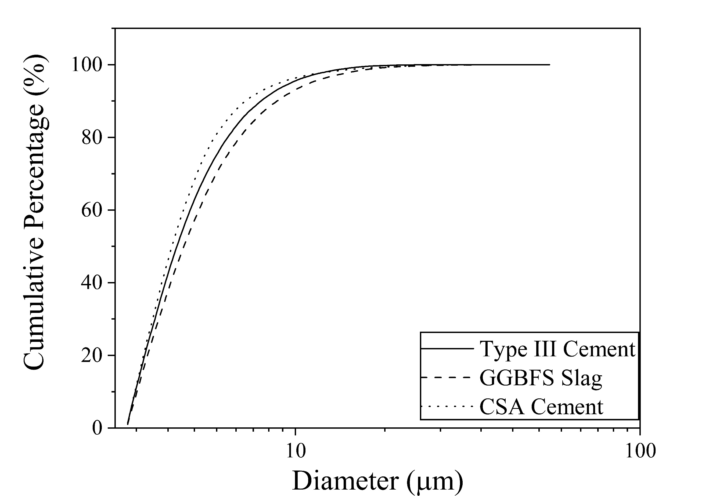
Figure 3:Cumulative particle-size distribution of cementitious materials.

Table 2:Physical and chemical properties of Type III and CSA cements.
Properties | Type III cement | CSA cement
Average fineness (Blaine) (m²/Kg) | 622 | 550
Specific gravity (g/cm³) | 3.15 | 2.75–3.00
Final setting time (min) | 220 | 16 (CSA:OPC = 100:0)  41 (CSA:OPC = 30:70)
Compressive strength at 6 h (MPa) | — | 24.13
Compressive strength at 1 day (MPa) | 24.5 | 55.16

OPC: Ordinary Portland Cement

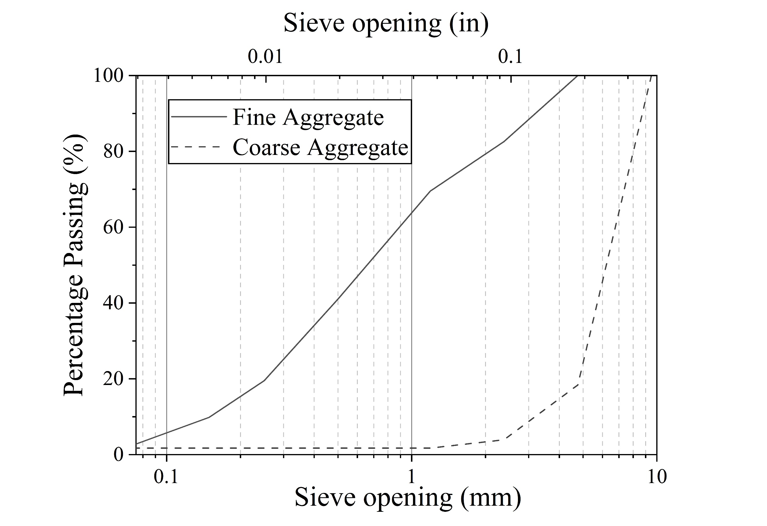
Figure 4: Gradation curve of the fine and coarse aggregates.

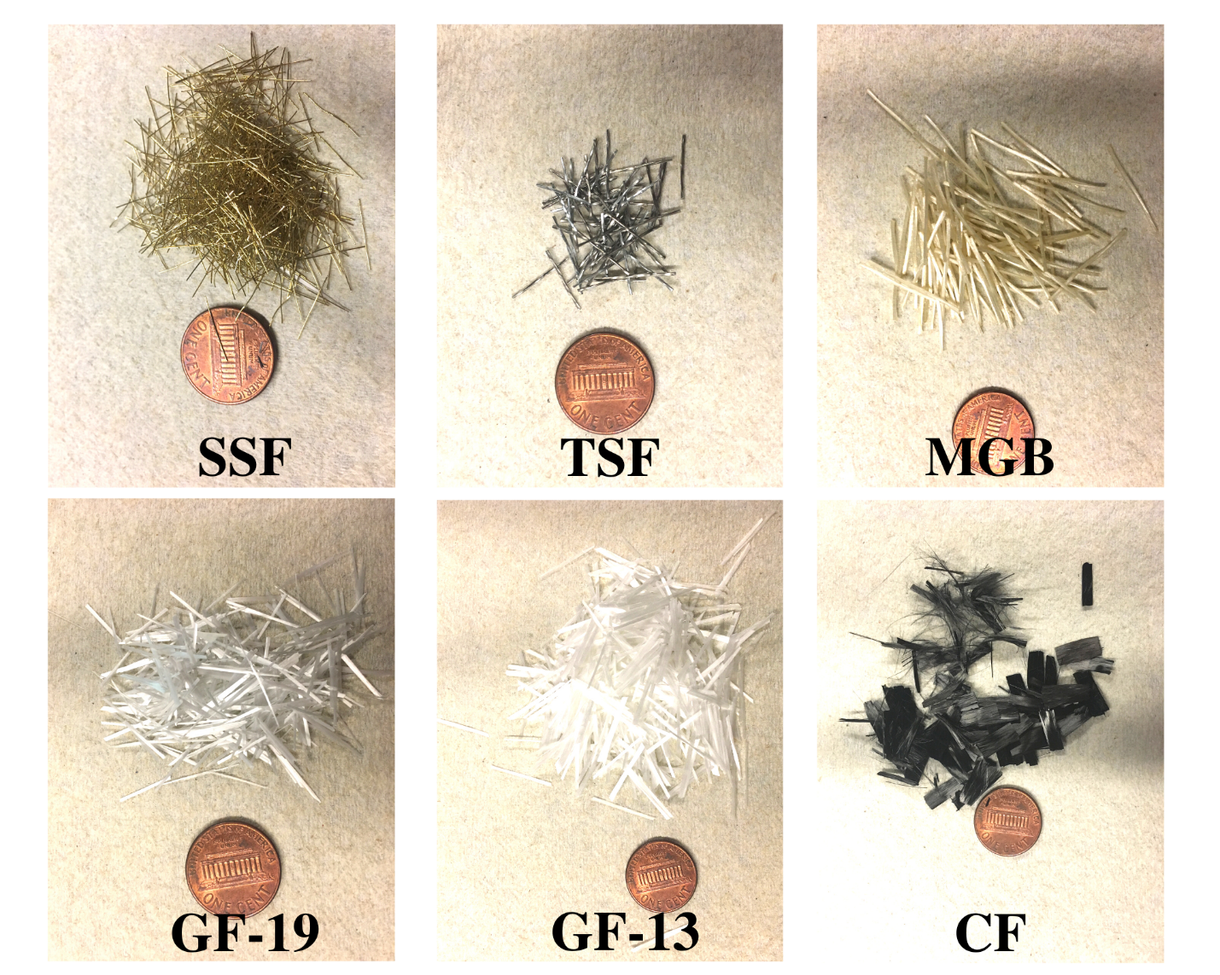
Figure 5:Fiber reinforcements used in the concrete mixtures. (SSF: straight steel fiber, TSF: twisted steel fiber, GF: glass fiber, MGB: glass fiber bars, CF: carbon fiber)

Table 3: Properties of fiber reinforcements.
Properties | Straight steel fiber | Twisted steel fiber | Glass fiber bar | Alkali-resistant glass fiber | Alkali-resistant glass fiber | Carbon fiber
Fiber | SSF | TSF | MGB | GF-19 | GF-13 | CF
Length (mm) | 13.0 | 13.0 | 43.0 | 19.0 | 12.7 | 12.7
Diameter (mm) | 0.20 | 0.50 | 0.70 | 0.18 | 0.18 | 0.072
Density (g/cm³) | 7.17 | 7.85 | 2.00 | 2.80 | 2.80 | 1.81
Profile | Straight | Twisted | Straight | Straight | Straight | Straight
Material | High-carbon steel | Steel | Alkali-resistant glass + thermoset resin | Alkali-resistant glass | Alkali-resistant glass | Carbon fiber¹ + high-temperature thermoplastic resins
Table 3 continued
Properties | Straight steel fiber | Twisted steel fiber | Glass fiber bar | Alkali-resistant glass fiber | Alkali-resistant glass fiber | Carbon fiber
Tensile strength (MPa) | 2,600 | 1,700 | 1,000 | 1,500 | 1,500 | 290
Equivalent diameter² (mm) | 0.82 | 1.78 | 0.80 | 0.29 | 0.29 | 0.07
Aspect ratio | 65 | 26 | 61 | 106 | 71 | 167
Specific surface area³ (mm²/mm³) | 20 | — | 5.8 | 22.3 | 22.4 | 55.7
- Carbon fiber also contained 25% weight fraction of moisture content.
- Equivalent diameters were calculated based on equation 1. An average density of 2.61 g/cm³ was used for the aggregate to determine the equivalent diameter of the fibers.
- The surface area of the fibers was determined assuming a cylindrical shape. The specific surface area of the helical-shaped twisted steel fibers was not calculated using this assumption.

mixtures, including high-early-strength FRSCC, would result in segregation and bleeding due to the large amount of voids in the granular structure and inadequate powder content. Therefore, most SCC design processes use an ideal gradation curve to develop dense granular structures that are cohesive and less prone to segregation [70, 71]. Figure 6 shows the process that was followed to develop the high-early-strength FRSCC. As described in the following paragraphs, seven concrete mixtures (M1) were designed that had the same fiber content but used six different fiber types. Using its performance results, M1 was modified into M2 and M3 to meet the target properties.

The composition of the mixtures can be divided into five constituents: powdered binders, aggregates, fibers, water, and admixtures. The goal of Step 1 was to select binder types and proportions according to the target strength and setting time. Most high-early-strength concrete relies on rapid-hardening cement and supplementary cementitious materials for early strength gain [72-75]. This study uses Type III cement and CSA cement for fast hydration reaction, strength gain and low shrinkage [76-81]. Although CSA cement increases hardening speed because of ettringite formation, it also reduces the cement paste workability and increases the heat of hydration [82]. Therefore, GGBFS was added to increase workability and reduce hydration heat [78, 83, 84]. Higher CSA and slag content and lower Type III cement content decreases the fineness of the binder mixture and water demand [65]; therefore, the w/b ratio could be reduced without decreasing the concrete workability. The binder proportions were optimized based on the effect of individual binders on early strength gain rate, water demand, setting time, and workability. Several trial tests and material properties were used to choose two binder proportions for this study. M1 concrete batches had Type III cement, CSA cement, and GGBFS with a 55:30:15 weight ratio, which was modified in M2 and M3 to 40:35:25 to achieve longer setting time and similar workability at a reduced w/b ratio.
Step 2 determined the total binder content to ensure good flowability and segregation resistance. ACI 237R-18 [85] and the European Federation of National Associations Representing for Concrete (EFNARC [86] suggest 386 to 600 kg/m³ of powder content in SCC. A high binder content was used because fibers make SCC more prone to segregation and bleeding [28]. M1 mixtures had 549 kg/m³ binder content, which was increased to 700 and 800 kg/m³ in M2 and M3, respectively, to maintain similar workability as the fiber content increased.
Step 3 established the fiber content and calculated the equivalent fiber diameter according to fiber geometry. Fibers are generally needle-like structures with high specific surface areas with respect to concrete aggregate. To estimate the effect of fibers in concrete granular skeleton, Ferrara, Park [87] treated fibers as “equivalent spherical particles” with an equivalent diameter ($d_{eq-fibers}$) based on specific surface area equivalence (Eq. 1). The equivalent fiber diameter is used in this study to calculate the gradation curve of the concrete granular structure.

Equation 1: Equivalent diameter of fibers
$$d_{eq-fibers}=\frac{3L_{f}}{1+2\frac{L_{f}}{d_{f}}}\frac{γ_{fiber}}{γ_{aggregate}}$$
Where,
$d_{eq-fibers}$ = equivalent diameter,
L_{f} = effective length of the fiber, based on manufacture
d_{f} = diameter of the fiber,
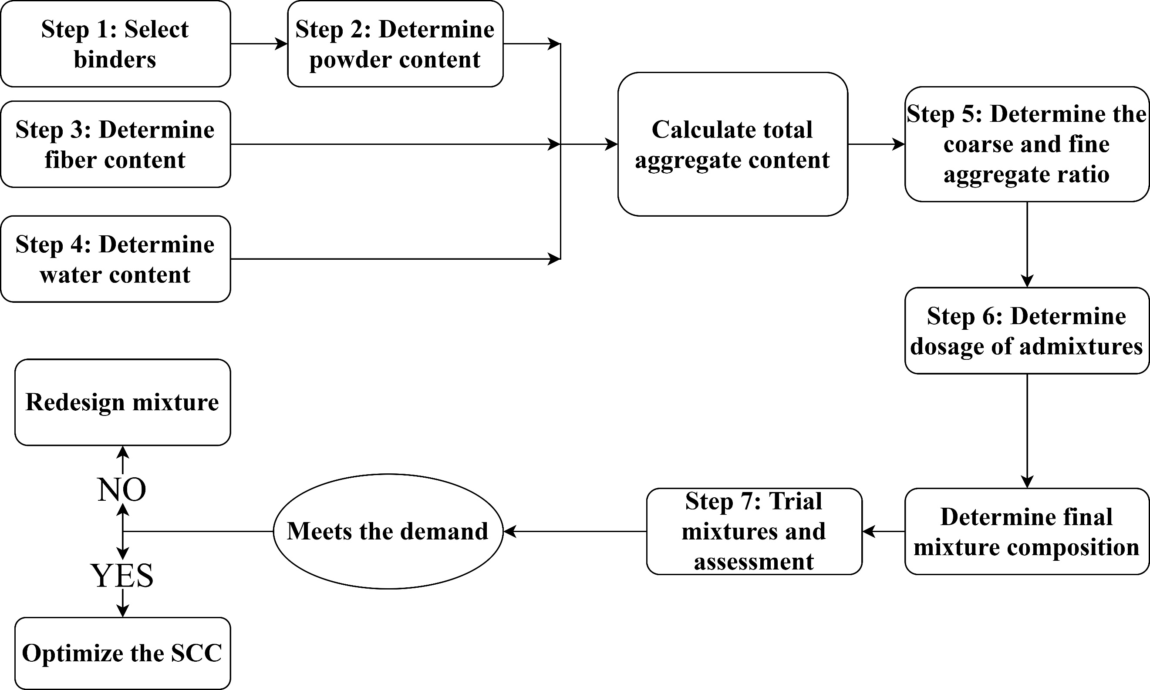
Figure 6: Flowchart of steps that were followed to develop the high-early-strength FRSCC.
$γ_{fiber}$ = specific weight of the fiber, and
$γ_{aggregate}$ = weighted average specific weight of the aggregates.

A low fiber fraction of 0.3 vol % was used in M1 mixes to test the effect of different fibers on concrete workability, compressive strength, and flexural strength. The fiber type that provided the highest compressive and flexural strength was used in M2 and M3 concrete. The fiber content was increased to 0.5 and 1 vol % in M2 and M3, respectively, to increase the flexural strength. Given that fiber reinforcement is one of the most expensive components in the mix, its content was limited to 1 vol % to keep the cost of the high-early-strength FRSCC below 523 USD/m³.

The w/b ratio (wt%) was decided in Step 4. The w/b ratio directly affects the workability and mechanical strength of the concrete. An initial w/b ratio of 0.34 was chosen for the M1 concrete batches based on previous studies on SCC with low w/b ratios [8, 11, 88]. The ratio was modified based on the workability of the concrete and reduced to 0.29 in M2 and 0.30 in M3.

Step 5 determined the volume fraction of the concrete granular structure by subtracting the paste volume from the total concrete volume using the absolute volume method [85]. The paste volume consists of the powder content, water content, and air content. The aggregate proportions and the ratio between coarse and fine aggregates were determined using the least average difference of the granular gradation curve with respect to the Fuller and Thompson gradation curve, which shows the ideal gradation of aggregates required to achieve the least air voids in the granular structure. A granular structure with less air voids requires less paste content to suspend the granular structure
Table 4: Particle size distribution of concrete mixtures compared to Fuller-Thompson ideal gradation curve
Sieve Opening | Percentage Passing (%)
(mm) | Fuller-Thompson Gradation | M1NF | M1  TSF | M1  SSF | M1  MGB | M1  GF13 | M1  GF19 | M1  CF12 | M2  SSF | M3  SSF
9.500 | 100 | 100 | 100 | 100 | 100 | 100 | 100 | 100 | 100 | 100
4.760 | 70.1 | 70.3 | 70.1 | 69.9 | 70.1 | 69.8 | 69.8 | 69.6 | 68.3 | 68.3
2.380 | 50.0 | 62.3 | 62.0 | 61.8 | 62.0 | 61.7 | 61.7 | 61.5 | 60.1 | 60.0
1.190 | 35.4 | 39.4 | 38.9 | 39.3 | 39.4 | 39.2 | 39.2 | 39.0 | 38.3 | 38.7
0.500 | 22.9 | 19.2 | 19.0 | 18.9 | 19.0 | 19.4 | 19.4 | 19.2 | 18.2 | 17.9
0.250 | 16.2 | 10.7 | 10.6 | 10.5 | 10.6 | 10.5 | 10.5 | 10.9 | 10.2 | 10.0
0.149 | 12.5 | 6.3 | 6.2 | 6.2 | 6.2 | 6.2 | 6.2 | 6.5 | 6.0 | 5.9
0.075 | 8.9 | 1.4 | 1.4 | 1.4 | 1.4 | 1.4 | 1.4 | 1.7 | 1.4 | 1.4

and develops a denser concrete matrix with higher mechanical properties and less possibility for segregation[10, 70, 87, 89]. Table 4 presents the gradation of the developed concrete mixtures.

The admixture dosages were determined in Step 6 using the recommendations from the manufacturer. M1 concrete mixtures had 780 ml of HRWRA and 1,625 ml of HSA per 100 kgs of total binder content. The admixtures dosages were increased to 975 ml of HRWRA, 1,787.5 ml HSA and 975 ml of Strength enhancing admixture per 100kgs of binder content for M2 and M3
concrete batches. The water content of the admixtures was considered in the required water content calculation and w/b ratio.

As the final step, the concrete mixtures were evaluated against the target slump flow, compressive strength, and flexural strength. Concrete mixtures were modified according to performance.

Mixing Process
Figure 7 illustrates the mixing process that was followed at a constant temperature of 20±1º C. The fine and coarse aggregates were dry mixed for 45 s, followed by adding one-third of the required water. After 45 s of further mixing, cementitious materials, residue water, and admixtures were added. The batch was mixed for another 1 min and left to rest for 45 s. Fibers were slowly added to the concrete mix after the mixing resumed. After 1 min of remixing, the concrete was poured without vibrating the samples to avoid segregation. Specimens were covered to retain moisture and kept at room temperature for air curing. All the specimens were demolded at 6 h and tested for hardened properties.
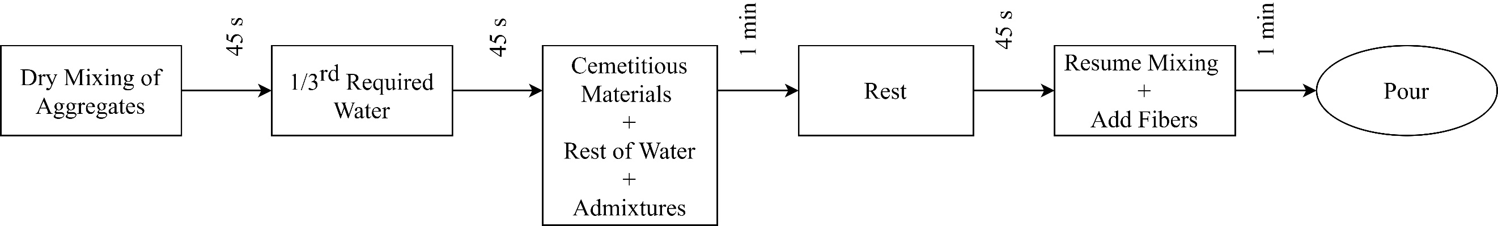
Figure 7: Mixing process for high-early-strength FRSCC.

Test Methods
Fresh properties of the concrete were quantified by slump flow diameter, flow time, and visual stability index (VSI) according to ASTM C1611. The slump flow test for SCC uses a setup similar to the slump test of conventional concrete; that is, it uses the spread of concrete to determine workability instead of the loss in height. The target slump diameter is 635 mm, which can enable concrete to flow through congested reinforcement. The time required for the concrete to reach the diameter of 500 mm (T₅₀₀) indicates the viscosity of the concrete and was recorded as flow time.
A T₅₀₀ of 5 s or less is desirable for SCC. VSI is a visual inspection of the concrete stability that assigns an index of 0 to 3 based on the increased presence of a mortar halo, water sheen, and segregation of aggregates. A homogeneous concrete should have 0 VSI.
Each concrete mixture had three 102 × 203 mm cylinders tested for compressive strength according to ASTM C39 and two 100 × 100 × 406 mm concrete prisms with 300 mm span length were tested for the third-point bending test according to ASTM C1609. The flexural strength of the concrete was quantified by the modulus of rupture (MOR). Concrete specimens were demolded and tested 6 h after casting.

Results and Discussion
The compositions of the developed concrete mixtures are listed in Table 5.
Table 6 presents the average of the experimental results for the slump flow, compressive strength, and third-point bending tests. The table also shows w/b ratios, fiber percentage, total predicted cost, and volumetric ratio of coarse and fine aggregates for each concrete mixture. The cost of
Table 5: Composition of concrete mixtures with different fibers.
Concrete mix | Fiber types | Cement  (Kg/m³) | CSA  (Kg/m³) | Slag  (Kg/m³) | Coarse aggregate  (Kg/m³) | Fine aggregate  (Kg/m³) | Fiber  (Kg/m³) | Water  (Kg/m³) | Admixtures  (ml/100 kg of total binder content)
M1NF | No fiber | 302 | 165 | 82 | 615 | 964 | 0 | 187 | HRWRA=780;  HSA=1,625
M1TSF | TSF | 302 | 165 | 82 | 620 | 964 | 23 | 187 | HRWRA=780;  HSA=1,625
M1SSF | SSF | 302 | 165 | 82 | 623 | 962 | 21 | 187 | HRWRA=780;  HSA=1,625
M1MGB | MGB | 302 | 165 | 82 | 620 | 964 | 6 | 187 | HRWRA=780;  HSA=1,625
M1GF13 | GF-13 | 302 | 165 | 82 | 626 | 959 | 8 | 187 | HRWRA=780;  HSA=1,625
M1GF19 | GF-19 | 302 | 165 | 82 | 626 | 959 | 8 | 187 | HRWRA=780;  HSA=1,625
M1CF12 | CF-12 | 302 | 165 | 82 | 630 | 958 | 4 | 187 | HRWRA=780;  HSA=1,625
M2SSF | SSF | 280 | 245 | 175 | 574 | 809 | 36 | 202 | HRWRA=975;  HSA=1,787.5;  Strength-enhancing admixtures = 975
M3SSF | SSF | 320 | 280 | 200 | 513 | 707 | 72 | 236
Table 6: Properties and estimated cost of the concrete mixtures.
Concrete mix | Water/ binder ratio | Fiber (vol %) | Coarse: fine aggregate ratio | Slump flow |  | Hardened mechanical properties at 6 h |  | Cost²  (USD/m³)
 |  |  |  | Diameter (mm) | Flow time, T₅₀₀  (s) | Average compressive strength  (MPa; std. dev.) | Average MOR (MPa) | Cost²  (USD/m³)
M1NF | 0.34 | 0.00 | 0.57 | 678 | 4 | 22.1 (0.02) | 3.17 | 219
M1TSF | 0.34 | 0.30 | 0.58 | 622 | 6 | 25.0 (0.11) | 3.23 | 372
M1SSF | 0.34 | 0.30 | 0.59 | 691 | 5 | 25.1 (0.01) | 3.25 | 355
M1MGB | 0.34 | 0.30 | 0.58 | 711 | 4 | 22.1 (0.02) | 3.20 | 319
M1GF13 | 0.34 | 0.30 | 0.59 | 531 | 14 | 21.8 (0.20) | 3.11 | 304
M1GF19 | 0.34 | 0.30 | 0.59 | 546 | 12 | 20.7 (0.31) | 2.96 | 304
M1CF12 | 0.34 | 0.30 | 0.60 | 450 | Note 1 | 20.2 (0.28) | 2.83 | 264
M2SSF | 0.29 | 0.50 | 0.64 | 762 | 5 | 40.4 (0.21) | 4.33 | 488
M3SSF | 0.30 | 1.00 | 0.64 | 737 | 4 | 40.6 (0.39) | 4.54 | 753

Table 6 continued
- The slump diameter for M1CF12 was less than 500 mm; hence, T₅₀₀ could not be determined.
- The cost of the mixtures was estimated based on a small survey on average cost of the raw materials among several US precast companies.

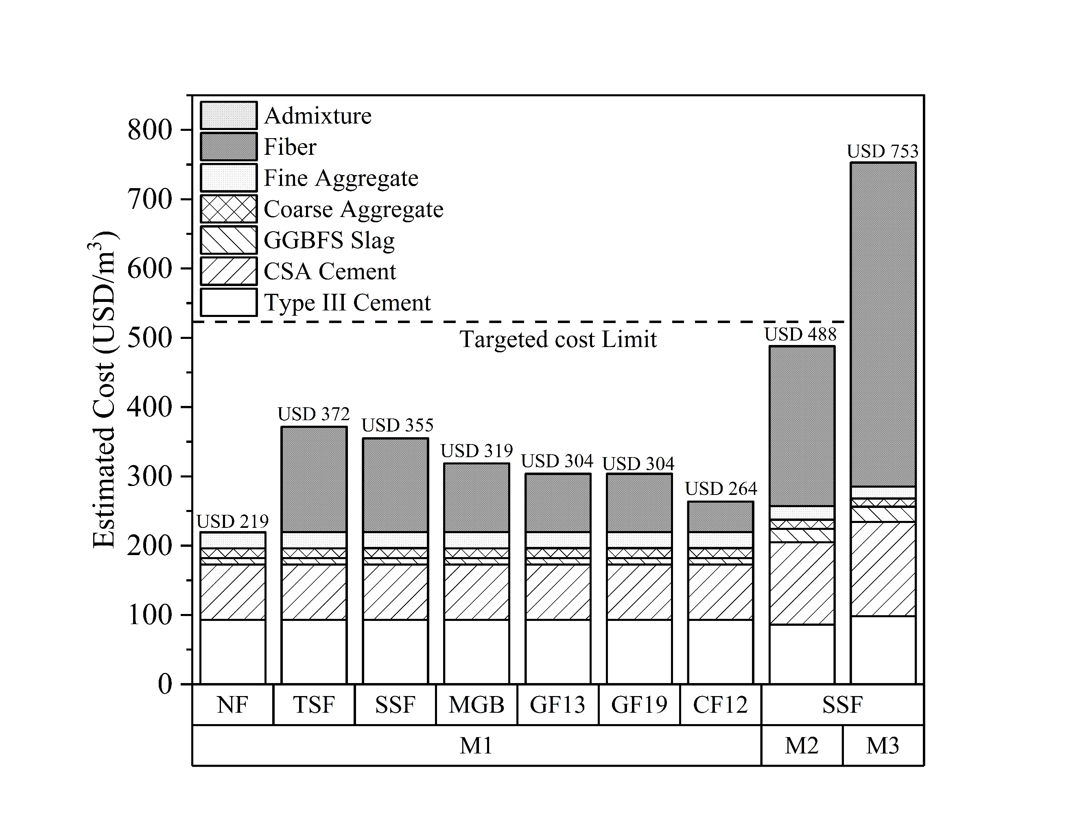
Figure 8: Estimated cost distribution for each concrete mixture per cubic meter. The cost of the admixture is shown at the top of each column and accounts for ≤0.06% of the total cost.

concrete mixtures was estimated from a price assessment survey of raw materials. The cost distribution in Figure 8 shows that despite their small volume fraction, the fibers represented a major share of the total cost. For M2SSF, 0.5 vol % steel fiber represented about 47% of the total estimated price, and for M3SSF, 1 vol % steel fiber accounted for 62% of the total cost of the mix.

Fresh Properties
All the concrete mixtures produced homogeneous and stable slump flow without signs of any bleeding, mortar halo, aggregate segregation, or fiber balling and their initial setting time was
greater than 30 minutes. EFNARC guidelines for SCC classify concrete workability into three categories according to the slump flow diameter and the range of applications: SF1 (550 to 650 mm), SF2 (660 to 750 mm), and SF3 (760 to 850 mm) [59]. Figure 9 indicates the slump flow of the evaluated concrete mixtures. Eight mixes achieved >520 mm slump diameter; therefore, they are self-compacting according to EFNARC and ACI 237 [59]. Five mixes had a slump diameter greater 635 mm and a flow time less or equal than 5 seconds, which are the target values for the present high-early-strength FRSCC. The fresh concrete properties of the M1 mixtures differed significantly with the types of fiber reinforcement despite having the same fiber volume fraction and similar concrete mix design. M1NF, M1SSF, M1MGB, and M3SSF had slump flow between 660 and 750 mm, which is preferred for general applications [59]. Mixtures M1TSF, M1GF13, and M1GF19 had slump flows lower than 640 mm. These three concrete mixtures may need to be vibrated in applications with congested reinforcement because their slump flow was less than 550 mm [85]. M1CF12 is not considered as an SCC because the slump flow diameter was less than 500 mm. The slump diameter of M1 mixtures with glass fibers (GF-13 and GF-19) and carbon fiber (CF-12) were much lower due to reduced workability, likely because of the fiber geometry and higher water absorption of the fiber material.
M2SSF had a slump flow diameter higher than 750 mm; therefore, according to EFNARC, it can be used for vertical applications in congested structures or in complex designs [59, 85].
The effect of the fibers on concrete workability was investigated by plotting slump diameter and flowtime (T₅₀₀) against the aspect ratio (i.e., fiber length/fiber diameter) and volumetric surface area (mm⁻¹) of the fibers. Higher fiber aspect ratio and fiber surface area in the M1 batches, and more specifically in the mixes with glass and carbon fibers, reduced flow diameter and increased flow time, as shown in Figures 10 and 11, respectively. This indicates that higher fiber aspect ratio and surface area increased yield stress and viscosity in fresh concrete that hindered workability. M1GF19 displayed higher flow diameter compared to M1GF13 although GF-19 have higher aspect ratio than GF-13. The higher surface area of GF-13 might have resulted in the lower flow diameter in M1GF13.Previous researchers deduced that increases in fiber aspect ratio and fiber volume fraction reduce slump flow and increase yield stress of concrete by creating a fiber network that prohibits the concrete to flow [28, 69]. Bayasi and Parviz [90] showed that high-fiber surface area and reduced-fiber aspect ratio increases air content. Increased air content in SCC has been associated with a decline in slump flow and workability [91, 92].

Hardened Properties
The compressive and flexural strengths at 6 h of the evaluated mixes are reported in Figure12 and Table 6. The ideal high early-strength FRSCC mixture should fulfill the target fresh concrete properties and achieve a compressive strength higher than 24 MPa and MOR higher than 3.5 MPa in 6 hours. Four concrete mixtures developed higher than 24 MPa compressive strength at 6 h. M1
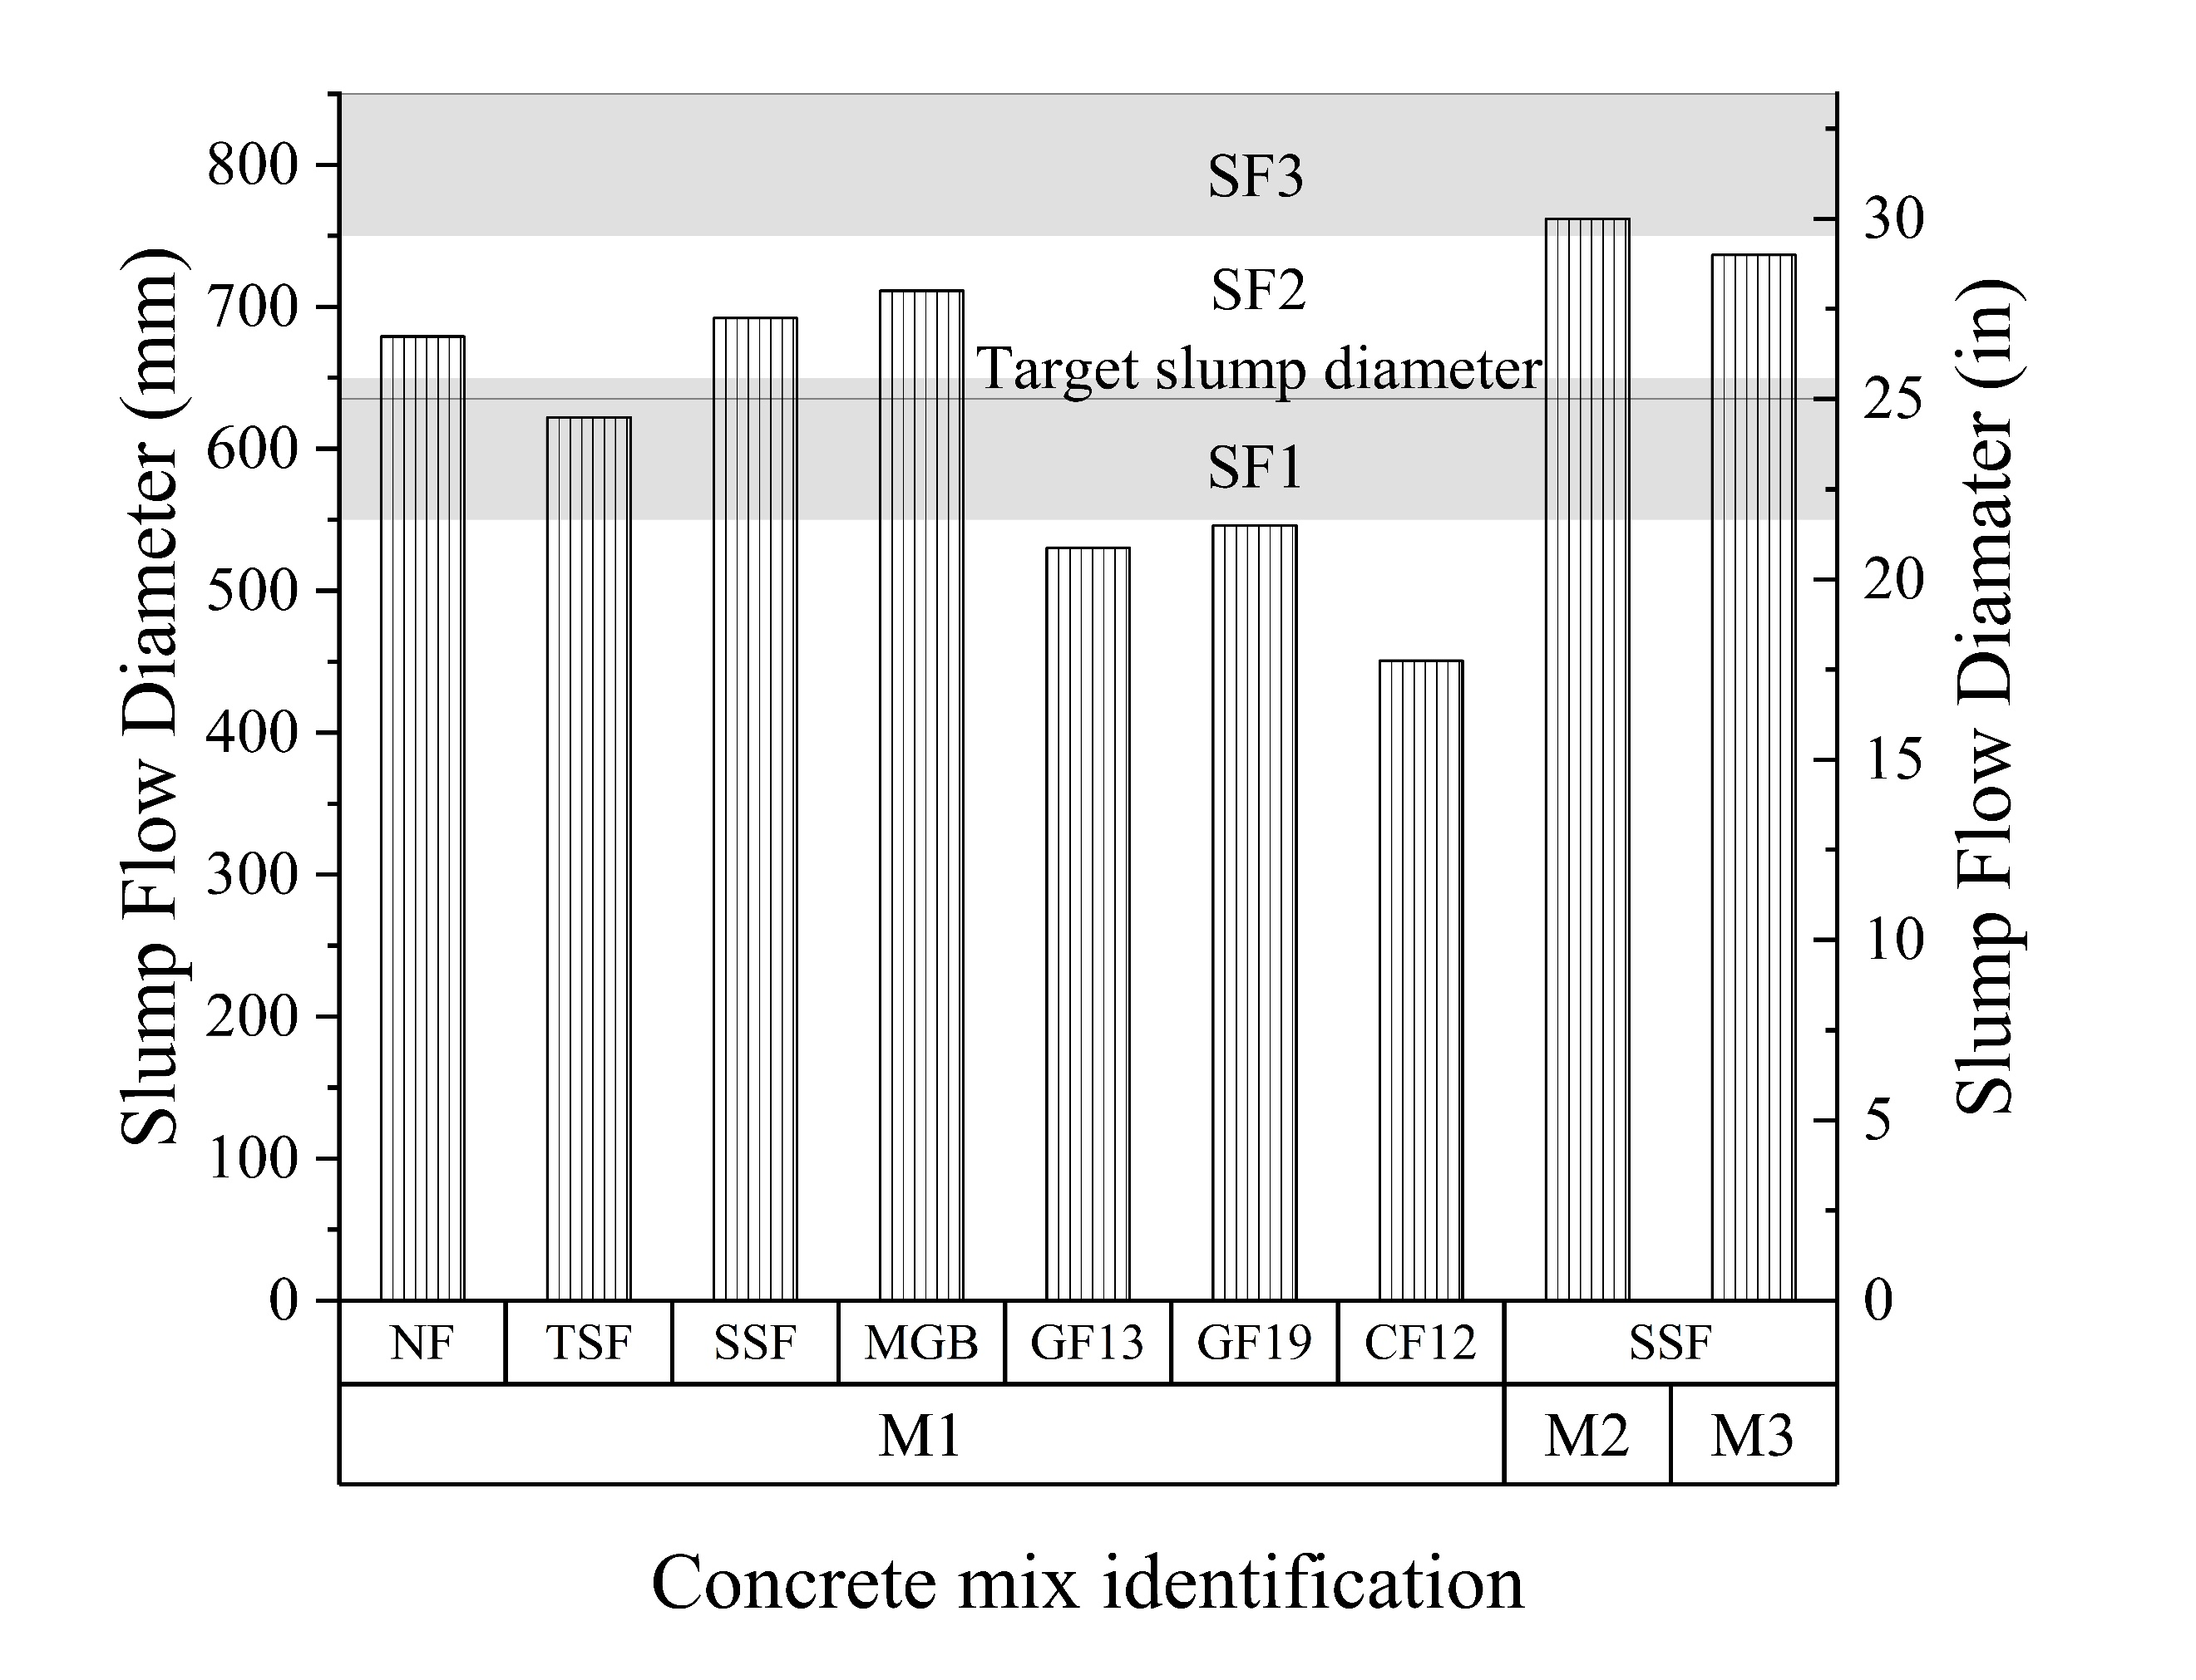
Figure 9: Slump flow diameter of concrete mixtures and slump flow classes according to EFNARC (SF1: 550 to 650 mm, SF2: 660 to 750 mm, and SF3: 760 to 850 mm).

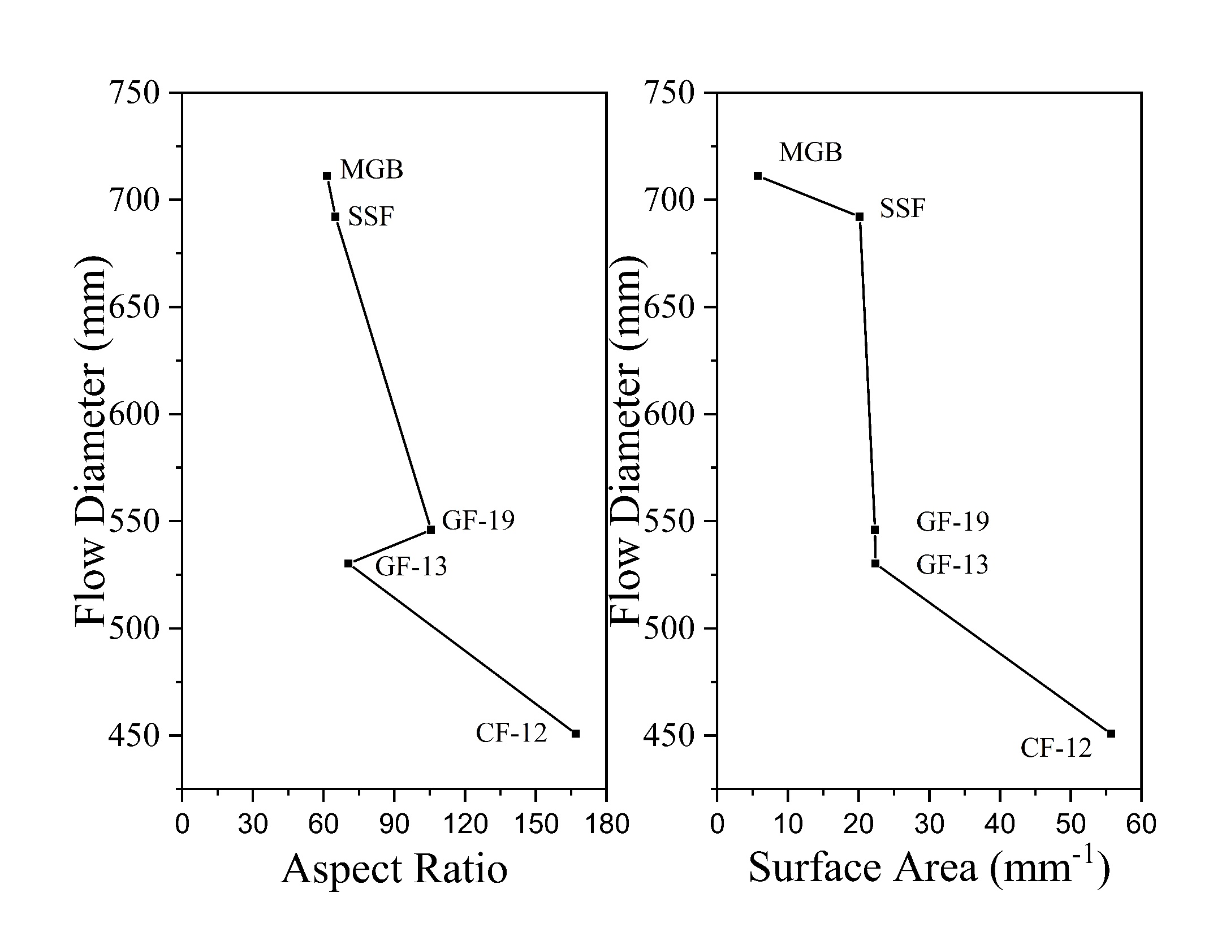
Figure 10: Effect of fiber aspect ratio and volumetric surface area on slump flow diameter of M1 concrete mixtures.

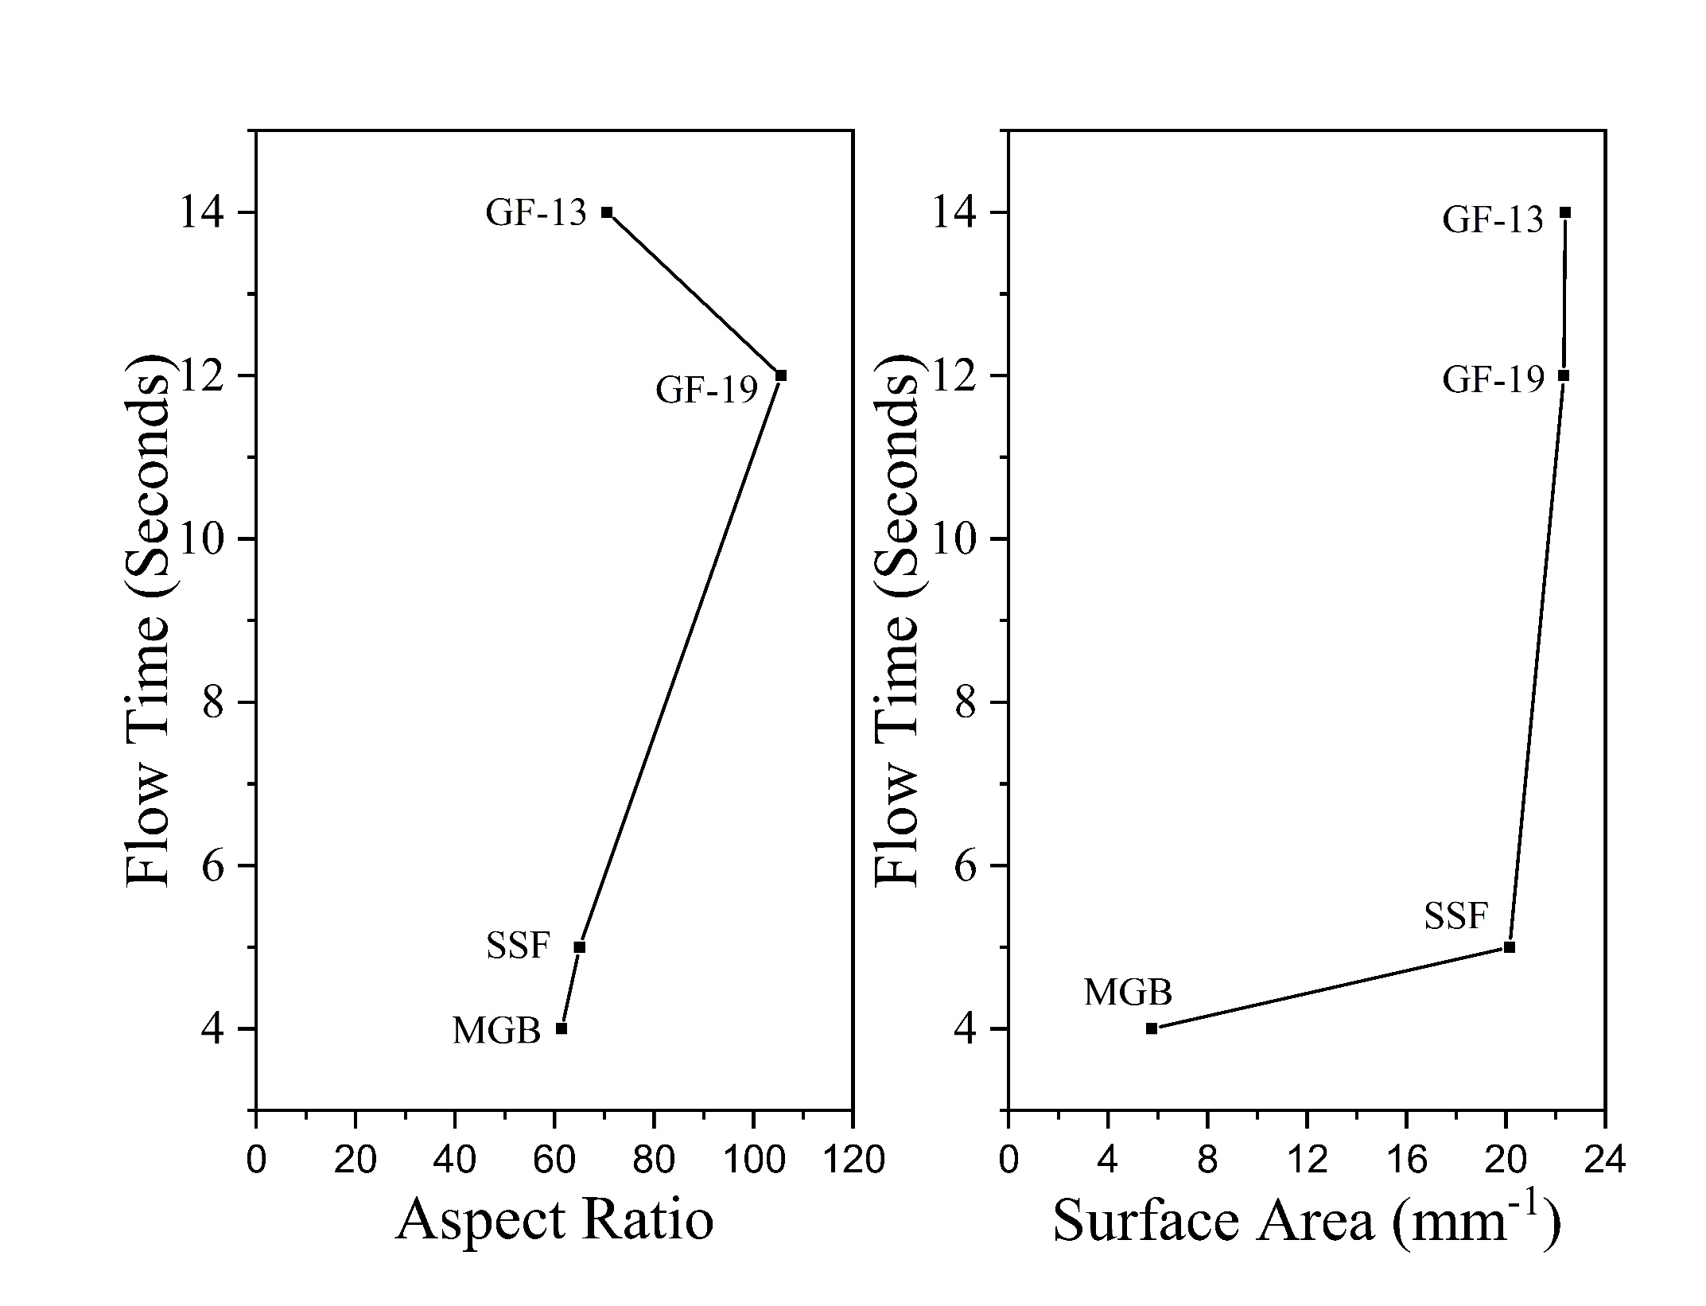
Figure 11: Effect of fiber aspect ratio and volumetric surface area on concrete flow time (T500) for M1 concrete mixtures.

concrete with steel fibers (M1TSF and M1SSF) showed an increase in compressive and flexural strength with respect to the unreinforced concrete specimen (M1NF). Concrete mixtures with alkali-resistant glass fibers and carbon fibers (M1GF13, M1GF19, and M1CF12) showed lower compressive strength and MOR, likely because of concrete defects, induced by reduced workability. The effect of fibers on concrete-hardened properties also depends on the fiber’s stiffness and tensile strength. Most fibers do not have significant effect on the compressive strength of concrete [93-95], but steel fiber loading of up to 0.5 vol % have been shown to increase compressive strength [94]. Unlike compressive strength, concrete flexural strength is directly affected by fiber tensile strength and volume fraction [94]. Fiber reinforcement shows a greater influence on concrete flexural strength at fractions of at least 1 vol % compared with lower volume fractions [92]. The higher MOR of M1TSF, M1SSF, and M1MGB, compared with M1NF, can be attributed to the high tensile strength of steel fibers and glass fiber bars [96].

Although some mixtures from M1 batches achieved the target compressive strength, none of them could achieve the target MOR. Hence, M1 batches were optimized into M2 and M3 concrete mixtures. M2SSF and M3SSF had close to 62% higher compressive strength and 33% and 40% increases in MOR, respectively, compared with M1SSF. M2SSF displayed an average compressive strength of 77.6 MPa and MOR of 7.4 MPa at 28 days under air curing. High CSA content and low w/b ratio in M2 and M3 mixtures developed a denser binder matrix that contributed towards higher compressive and flexural strength. The reduction of the w/b ratio directly relates to the increase in concrete compressive strength [68, 97]. Greater fiber volume fraction compared to M1 batches also attributed to the increase in flexural strength. Although, both
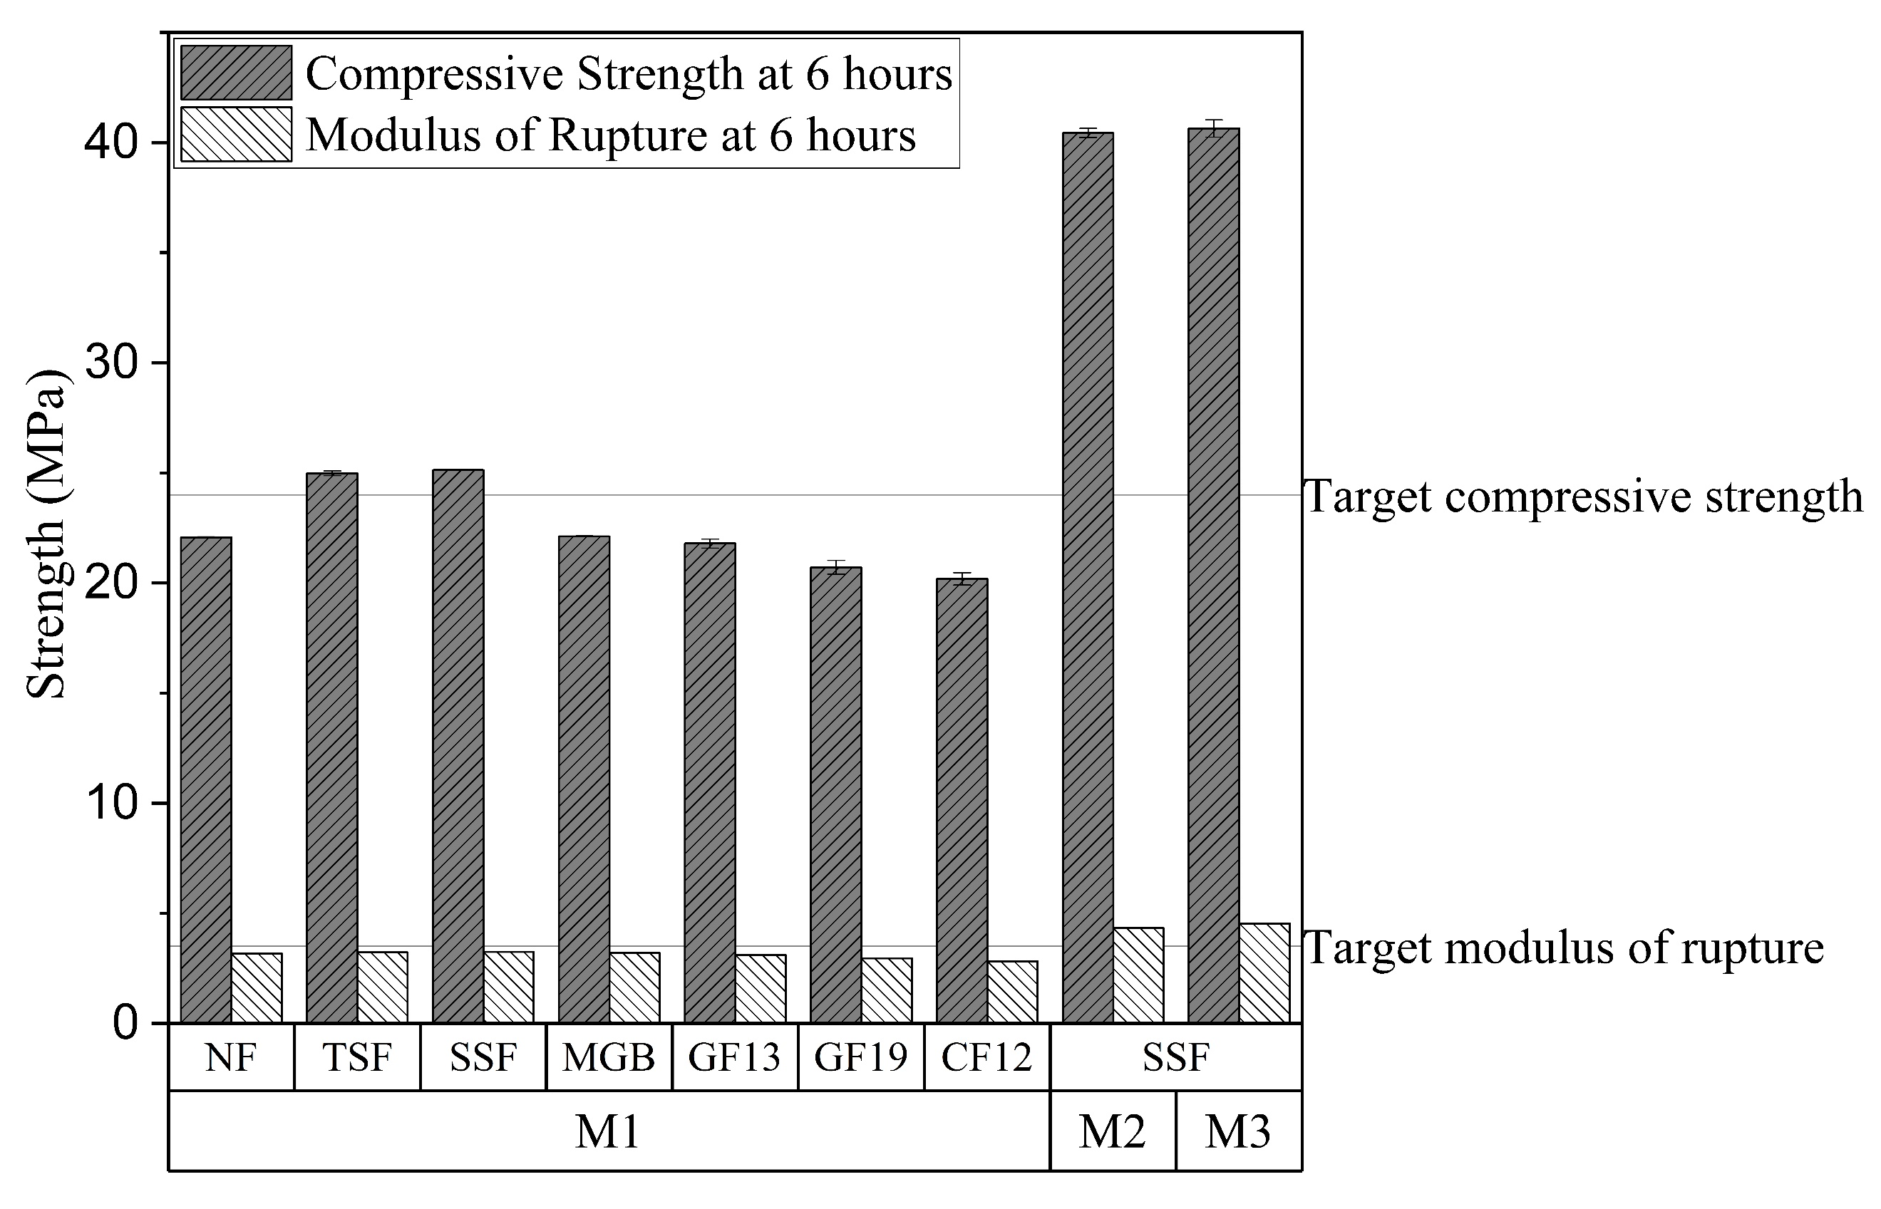
Figure 12: Mechanical properties at 6 h: Compressive strength (average of three specimens) and MOR (average of two specimens) of optimized concrete mixtures with different fiber types.

M2SSF and M3SSF achieved the target performance criteria for the high early-strength FRSCC, the estimated cost of M3SSF exceeded the price limit for this study (523 USD/m³) and it is about 1.5 times more expensive than M2SSF. Hence, M2SSF was selected as an ideal high early-strength FRSCC mixture.

Conclusions
A high-early-strength FRSCC concrete mix was developed that achieved a compressive and flexural strength of 40.4 and 4.33 MPa, respectively, at 6 h with only air curing. The selected FRSCC mixture has a reasonable cost of approximately 488 USD /m³ and follows a practical mix design process that can be easily implemented in precast plants. This concrete mixture maintained its workability for 30 minutes to allow casting and finishing. The developed high-early-strength FRSCC mix will allow the precast concrete industry to double production capacity (i.e., use casting beds twice per day) without expanding facilities. Analysis of concrete batches revealed that strength gain rate and early compressive strength of the concrete matrix highly depend on powder composition and w/b ratio. The differences in Blaine fineness, water demands, and hydration rates among Type III cement, CSA cement, and GGBFS were successfully used to control the concrete’s workability and strength gain. Despite a low fraction of 0.3 vol %, fiber surface area significantly influenced concrete slump flow diameter, flow time, and workability. Shrinkage properties of the high early-strength FRSCC and correlation of the fiber properties with concrete workability will be explored in the future.

CHAPTER III
Optimization of Calcium Sulfo Aluminate-based composite binder

Introduction
Concrete is the second-most consumed material, leading the global Portland cement production of 4.1 billion tons at 2020[3] and 5-8% of global CO2 emission annually[4]. To make construction practice more sustainable despite the upward trend of construction demand, we need to explore the applicability of alternative binders that offer a low-CO2 alternative to Portland cement. Specialized concrete intended for high performance like precast concrete, fiber reinforced concrete, self-compacting concrete, and ultra-high-performance concrete (UHPC) often use high cement content thus contributing towards high CO₂ emission. In recent years alternative types of cement, like Calcium sulfo-aluminate (CSA) cement has shown great prospects as a sustainable substitute to conventional ordinary Portland cement (OPC). But due to the very short setting time, it is difficult to use without any OPC content[31]. Although there has been significant research on the effect of SCM in CSA hydration including calcium carbonate, hydration of CSA does not produce calcium hydroxide (CH) which is essential to initiate the reaction of most supplementary cementitious materials (SCM), thus making most SCMs incompatible with rapid hardening CSA. Unlike other SCMs, ground granulated blast furnace slag (GGBFS) contains active minerals, including gypsum, calcium Hydrate and limestone thus contributing during CSA and PC hydration [31, 32]. Incorporation of slag in CSA composite has been linked with reduced strength as [32] whereas using 50-70% PC with CSA increases the carbon foot print of the binder. The potential of GGBFS in a CSA composite binder is not well explored. The mechanism of hydration for ternary composite binders and CSA composites are less explored. As SCMs and alternative binders are being used more and more in construction, the hydration process and compatibility assessment need to have scientific basis instead of trial and error process. Unfortunately, cement hydration process has been elusive due to difficulty of isolating individual chemical process due to its complexity and interdependency[34]. This problem becomes increasingly difficult to analyze and predict when more than one binder is involved. But, identifying the governing chemical process based on the gross chemical composition of binder can be the key to develop less empirical prediction of binder performance.
The hydration behavior of ternary composite binder consisting Portland cement (Type III), CSA cement and GGBFS slag has been investigated in this article. This study will broaden knowledge in: 1) studying the change in hydration behavior based on change in the chemical composition of binder 2) investigate the key chemical parameter to control the rate of reaction, and rates of hardening and mechanical performance of binders based on chemical composition.3) studying the effect of chemical parameter on the flow diameter, setting time and compressive strength of the composite binder. The understanding of the controlling hydration process can be used to control setting time, the concrete performance during fresh and hardened state, using the composition of the composite binder.

Experimental procedure

Binders
The binder content included Portland cement, calcium sulfo-aluminate (CSA) cement, and Grade 100 ground-granulated blast-furnace slag (GGBFS). Table 7 presents the comparative chemical compositions as well as major phases of the three cementitious materials, as determined by Rietveld analysis of XRD pattern. The main phases present in PC is alite (C3S), belite(C2S), and aluminate(C3A). Ye’elimite(C4AS), anhydrite(CaSO4), and belite(C2S) are the main composition of CSA. GGBFS consists calcite and gypsum along with minerals like akermanite, and gehlanite. Physical and mechanical properties of the PC (Type III), CSA cements, and GGBF slag are provided in Table 8. Composite binders of different binary and ternary ratios were used to investigate effect of slag and PC on CSA based composite cementitious binder. Composite binders are identified as TxCySz, where, x = weight % of PC, y = weight % of CSA cement, and z = weight % of GGBF slag.

Test Method
To investigate the effect of GGBFS in CSA based ternary composite binders, 5 different ratios of CSA-PC composite, 5 different ratios of CSA-GGBFS composite and 19 ratios ternary PC-CSA-GGBFS ternary composite were studied for fresh and hardened properties. Hydration of 3 ternary composite binders, 100% CSA and 100% PC were monitored at 6 hours and 28 days using powdered XRD. Thermodynamic model of CSA and ternary binders were developed using CEMGEMS application to analyze the concrete behavior based on hydration products.

Chemical Composition and Microstructure
The progression of hydration reaction was studied using powder binders, hydrated binders after 6 hour and 28 days using X-ray diffraction with 0.3 w/b ratio. A PANalytical's XPert Pro MPD diffractometer with an X-ray source of Cu Kα radiation (λ = 1.5405 Å) was used to examine the samples in the range of 8° to 55° 2Ɵ with a step size of 0.02°. The X-ray tube voltage and current were fixed at 40 kV and 40 mA, respectively. The measurement of each diffraction pattern last approx. 15 minutes. The evolution of the crystalline phases in the hydrating paste were then analyzed in-situ over time at 6 hours, and 28 days. The obtained XRD patterns were then processed using the X'Pert Highscore Plus (PANalytical) software. Rietveld analysis was done on unhydrated
Table 7: Chemical composition of the cementitious materials collected from manufacturers and the phase composition determined by quantitative XRD analysis.
Oxide (wt%) | Type III cement | CSA cement | GGBFS
SiO₂ | 20.4 | 8.9 | 33.8
Al₂O₃ | 4.5 | 22.4 | 10
Fe₂O₃ | 3.3 | 2.0 | 0.4
TiO₂ | — | 1.0 | —
CaO | 63.4 | 45.0 | 41.7
MgO | 3.4 | 1.5 | 7.4
SO₃ | 2.7 | 16.85 | 2.4
Total alkali (Na₂O+0.658K₂O) | 0.58 | — | —
Phase composition (wt%) | Type III cement | CSA cement | GGBFS
Alite (C3S) | 60 | - | -
Belite (C2S) | 13.3 | 20.6 | -
Aluminate (C3A) | 6.4 | 8.1 | -
Ye’elimite (C4AS) | - | 41.1 | -
Anhydrite (C$\overline{S}$) | - | 30.1
Calcite (C$\overline{C}$) | - | - | 30.4

Table 8: Physical and chemical properties of PC, CSA cements and GGBF slag.
Properties | Type III cement | CSA cement | GGBFS
Average fineness (Blaine) (m²/Kg) | 622 | 550 | 626
Specific gravity (g/cm³) | 3.15 | 2.75–3.00 | 2.85
Final setting time (min) | 220 | 16 (CSA:PC = 100:0)  41 (CSA:PC = 30:70) | -
Compressive strength at 6 h (MPa) | — | 24.13 | -
Compressive strength at 1 day (MPa) | 24.5 | 55.16

CSA, PC and GGBFs and hydrated composite binders to quantify the crystalline hydration products.

Fresh Properties
The setting time and flow table test were used to quantify the fresh properties of binders. Setting time and workability of binder composition controls the available handling time for concrete during construction. Using CSA as a binder instead of 100% Portland cement can bring down that workable time from 5-7 hours to 16 minutes. Thus, it is crucial to correlate the setting time and workability of binder composition to ensure the feasibility of a practical application. The setting time and the workability of the concrete mix were determined according to ASTM C 403 [98] and ASTM C 1437 [99]. The flow table test uses fresh mortar, placed at the middle of the flow table in a conical shape with 4 in. (100 mm) base diameter and the table is dropped 0.5 in. (12.7 mm) 25 times in 15 s. The average percentile increase in concrete diameter after the table drops quantifies the workability of concrete [100].

Hardened Properties
The compression test on 2 × 2” (50.4 × 50.4 mm) mortar cubes were tested according to ASTM C 109 at 6 hours and 28 days from casting, to study the early strength and long-term strength of the composite binders. Drying shrinkage of high-performance concrete is a durability concern as higher binder can contribute to higher shrinkage and crack formation in the concrete structure. ASTM C 157 was followed to quantify the length change of the binder composites up to 32 weeks after casting.

Results and Discussion

Hydration process
Cement hydration involves a collection of coupled chemical processes, each of which occurs at a rate that is determined both by the nature of the process and by the composition of the systems at that point. Powder XRD of PC, CSA and GGBF slag before hydration is shown in figure 13.
Alite or tricalcium silicate (C3S) constitutes 50-70% mass of PC and often controls the setting time and hydration process. Alite (C3S) and belite (C2S) both forms Calcium-silicate-hydrate (C-S-H) and portlandite during hydration as reaction (Eqs. 2a and b) indicates[101].
Equation 2: Alite (a) and Belite (b) hydration reaction in pressence of water
Alite hydration | $$C_{3}S+zH→C_{x}SH_{y}+\left(3-x\right)CH; z=y+3-x$$ | (a)
Belite hydration | $$C_{2}S+zH→C_{x}SH_{y}+\left(2-x\right)CH; z=y+2-x$$ | (b)
Tricalcium aluminate (C3A) is another significant phase that exist in both PC and CSA. C3A can affect hydration kinetics, strength and setting time, specifically in PC hydration. C3A reaction is influenced by quantity of available calcium sulfate in the matrix[102]. In the absence of calcium sulfate C3A react almost instantly with water and produces platelets of aluminate hydrates (Eq. 3a). For this reason, a source of calcium sulfate in form of anhydrite (CaSO₄) or gypsum (CaSO₄·2H₂O) is added to cements to control the reaction of the aluminate phase. Presence of calcium sulfate slows down C3A hydration, allows more time for complete hydration of alite and produces ettringite or Aft (Alumina, Ferric Oxide, Trisulfate) phase (C₃A·3CaSO₄·32H₂O) in PC (Eq. 3b). As calcium sulfate starts to deplete C3A reaction rate increases again and forms monosulfoaluminate or Afm (Alumina, Ferric Oxide, Monosulfate) phase (Eq.3c)[79].
Equation 3: Hydration reactions of C3A in a. absence of CaSO4 b. Presence of adequate CaSO4, and c. Inadequate presence of CaSO4
Absence of CaSO4 | $${2C}_{3}A+21H→C_{4}AH_{13}+C_{2}AH_{8}$$ | (a)
Presence of CaSO4 | $$C_{3}A+3C\overline{S}+32H→C_{6}A\overline{S_{3}}H_{32}$$ | (b)
Inadequate CaSO4 | $$3C_{3}A+3C\overline{S}H_{2}+30H→{3C}_{4}A{\overline{S}H}_{12}$$ | (c)

Ye’elimite (3CaO.3Al₂O₃.CaSO₄) is the main composition of CSA cement. As main crystalline hydration products, ettringite (AFt phase) and monosulfate (AFm phase) are formed together with amorphous aluminum hydroxide (Eq. 4). The molar ratio between calcium sulfate and ye’elimite, known as M-value influences the hydration rate as well as the phases generated during the hydration of CSA cements. At an M-value lower than 1.5 both Eq. 4a and 4b occurs leading rapid setting and early hardening. Above a M-value of 2.5, only the reaction (Eq. 4b) will occur and binder display expansive properties due to the volume of ettringite formation[103-105]. Calcium sulfate also accelerates the hydration of the ye’elimite phase, shortening the dormant period and setting time[103] , which is opposite of the hydration behavior of calcium aluminate phase.
Equation 4: Hydration of ye'elimites a. monosulfate formation, and b. Ettringite formation
Monosulfate formation | $$C_{4}A_{3}\overline{S}+18H→C_{3}A.C\overline{S}.12H+12AH_{3}$$ | (a)
Ettringite formation | $$C_{4}A_{3}\overline{S}+2C\overline{S}H_{2}+34H→C_{3}A.3C\overline{S}.32H+2AH_{3}$$ | (b)
GGBFS slag used in this study is composed of both calcite and gypsum along with other minerals. So, the effect of these two compounds on CSA and PC hydration is important to study. During cement hydration limestone or calcite can actively participate rather than
being an inert filler. Calcite reacts with C3A(Eq. 5) and Afm phase(Eqs. 6b and 6c) to form calcium aluminate carbonates[106].
Equation 5: Hydration of C3A in presence of Cacite
$${2C}_{3}A+C\overline{C}+135H→2C_{4}A{\overline{C}}_{0.5}(OH)H_{11.5}+2C_{3}A.3C\overline{S}.H_{32}+12AH_{3}$$
Ye’elimite and calcite reacts differently based on presence of anhydrite/gypsum and M value of binder. Two moles of anhydrite are needed per mole of ye’elimite are required to form ettringite. After depletion of anhydrite ye’elimite(Eq. 6a) and Afm phase (Eqs. 6b and 6c) reacts with calcite and forms hemi-carbonate and mono-carbonate. At M>2 mono-carbonate and mono-sulfate is not formed[105].
Equation 6: Ye'elimite hydration in presence of calcite
 | $${6C}_{4}A_{3}\overline{S}+C\overline{C}+135H→2C_{4}A{\overline{C}}_{0.5}H_{12}+2C_{3}A.3C\overline{S}.H_{32}+12AH_{3}$$ | (a)
 | $${3C}_{4}A\overline{S}H_{12}+2C\overline{C}+18H→2C_{4}A \overline{C}H_{11}+C_{6}A{\overline{S}}_{3}H_{32}$$ | (b)
 | $${3C}_{4}A\overline{S}H_{12}+C\overline{C}+CH+16H→2C_{4}A{\overline{C}}_{0.5}H_{10.5}+C_{6}A{\overline{S}}_{3}H_{32}$$ | (c)

Thermodynamic modelling
The hydration thermodynamic of CSA and ternary pastes were modelled using the CemGEMS web application [107], along with the CEMDATA18 database [108]. Chemical composition of CSA, PC and GGBFS, determined from XRD quantitative Rietveld analysis were used as input
data. A built in five-parameter logistic (5PL) fit was derived from time resolved quantitative XRD
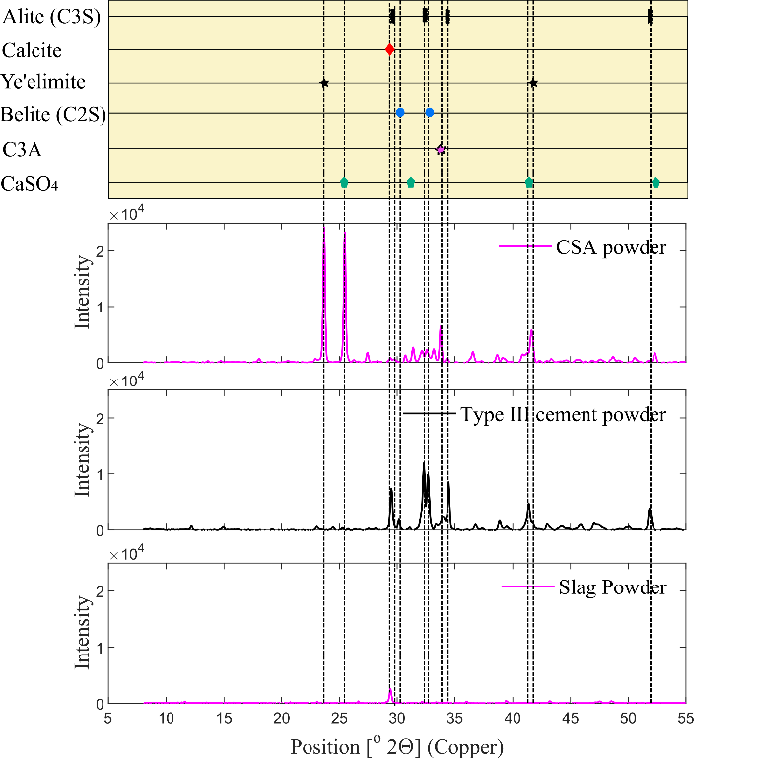
Figure 13: XRD patterns and related phases of unhydrated CSA, PC and GGBFS.

data on how the constituent changes with time during cement hydration[107, 109] The w/b ratio used for the model was 0.75 instead of 0.3 used in the experiment. 0.3 w/b ratio is not enough for the paste to complete hydration.

Analysis of Experimental XRD patterns
XRD pattern of hydrated binders at 6 hours and 28 days, used in this study are displayed in fig 15 and 16. 100% PC binder was only studied at the age of 28 day. These XRD patterns were used to identify the hydration products present in the matrix at 6 hours and 28 days. 100% CSA cement has a M value of 3.3 and the XRD pattern in fig. 15 a and 16 show presence of only ettringite as hydration product at 6 hours, indicating hydration process similar to Eq. 4b. Thermodynamic modelling of 100% CSA also predicts ettringite as main hydrate at 6 hours in Fig. 14 a. XRD pattern at Fig 16 and thermodynamic modelling also show presence of monosulfate(Afm), depletion of C3A and Aluminium hydroxide at 28 days, indicating Eq. 3b, Eq 3c and Eq. 4a. Aluminium hydroxide, C-S-H are hard to detect and quantify using XRD due to respectively micro crystallinity and amorphous structure. Ettringite is present in 6-hour XRD pattern and thermodynamic modelling of ternary binders. Initial hydration of ternary binders up to 6 hours are also controlled by ye’elimite hydration through Eq. 4b. Although the M value for 3 ternary composite ranges between 3.3-4.4, XRD pattern shows presence of Afm phase and mono-carbonate at 28 days. During the hydration of composite binders, the quantity of CaSO₄ in the composite binders influence both ye’elimite and C3A hydration. Hence, M value might not be an accurate prediction parameter for composite binders. Hence, this study suggests a modified M-value can be used to predict and analyze the CSA-based composite behavior (Eq. 7). M_{m} value generalizes the early hydration of composite binders using Eq. 3c and Eq. 4b.
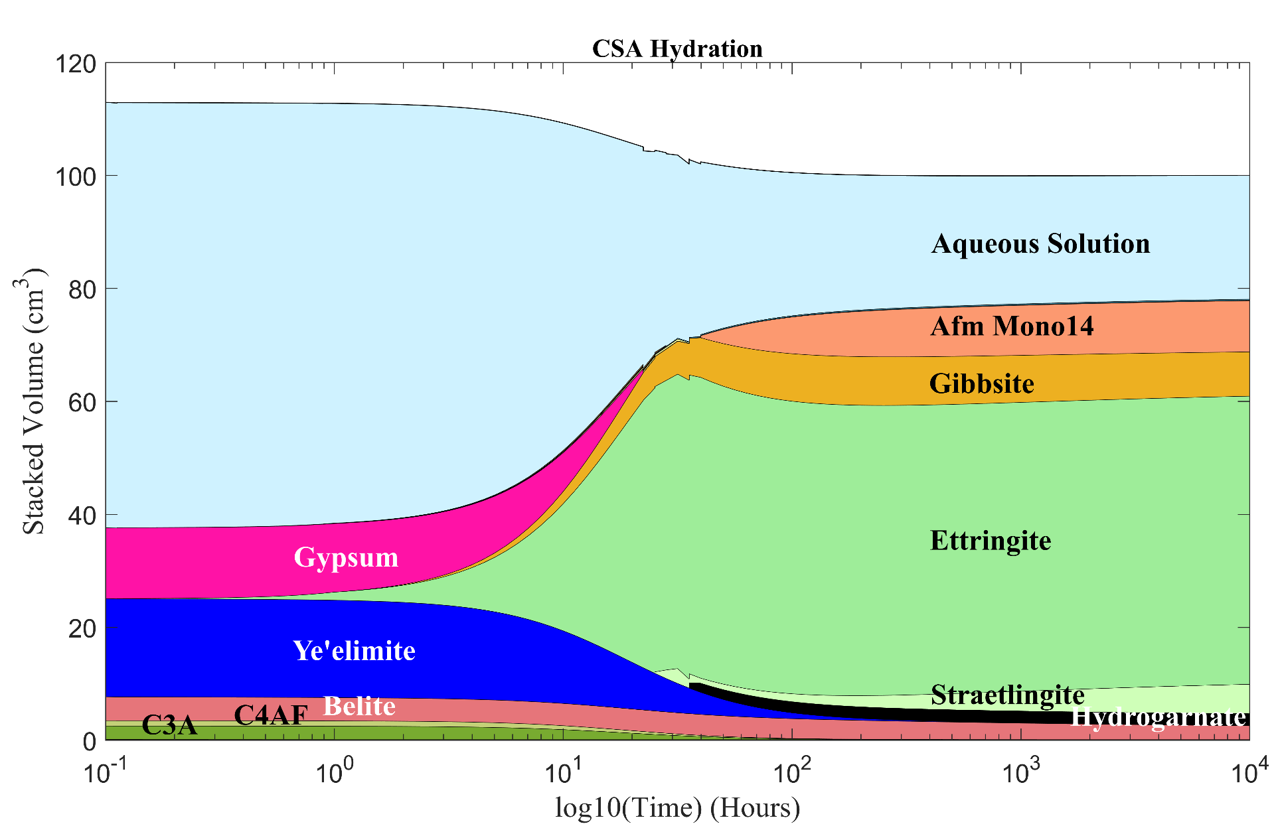 | 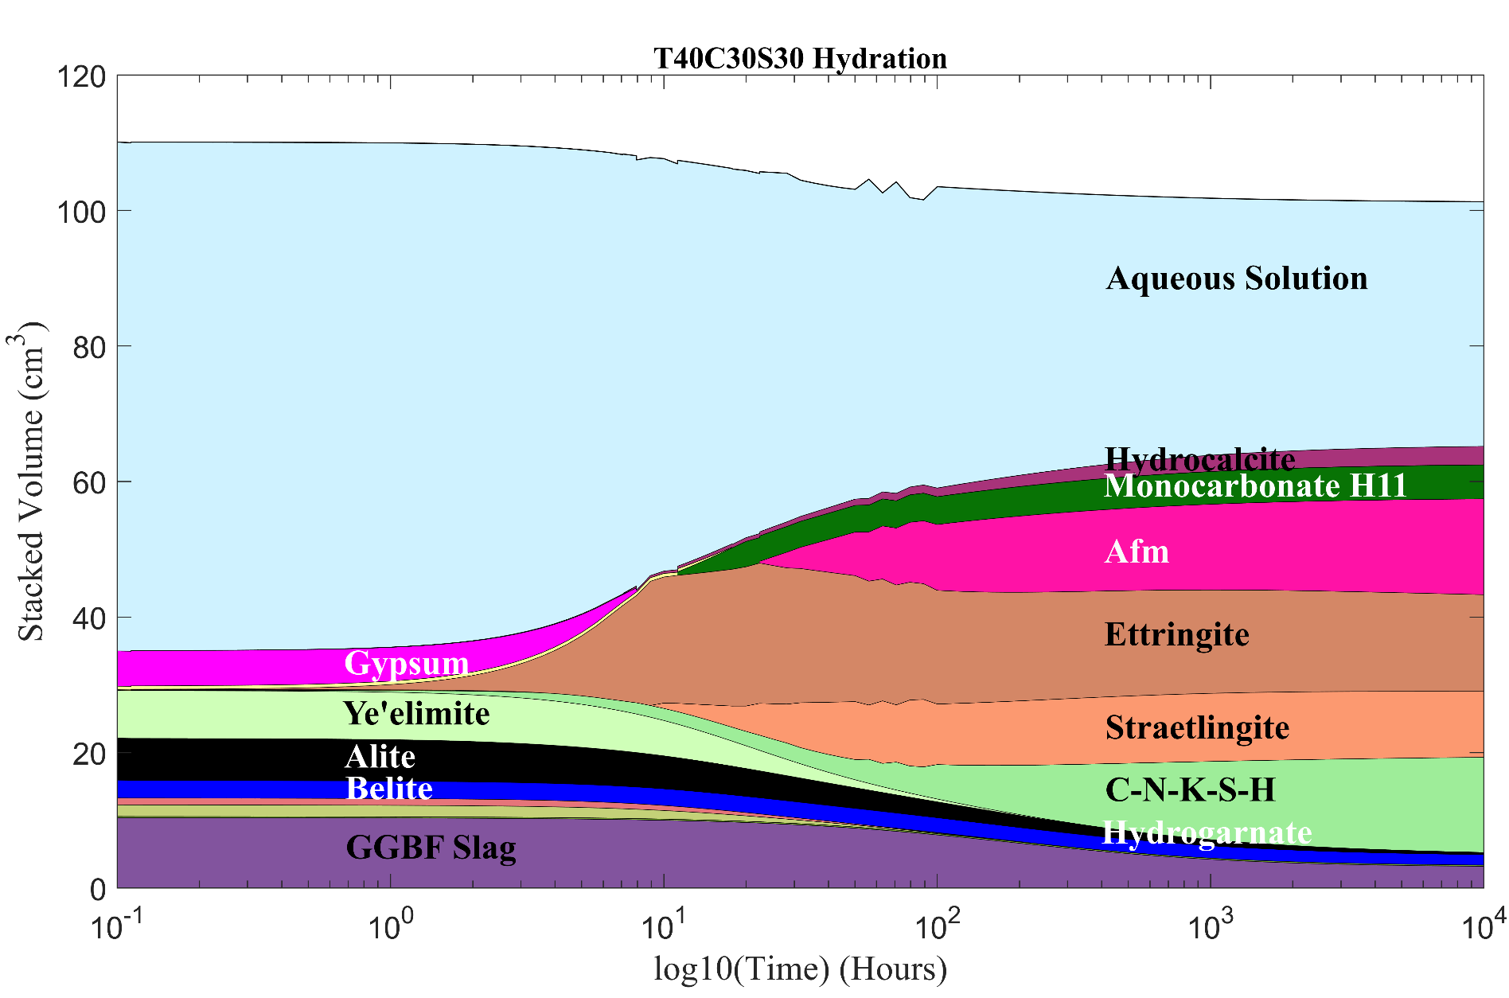
(a) 100% CSA | (b) T40C30S30 composite
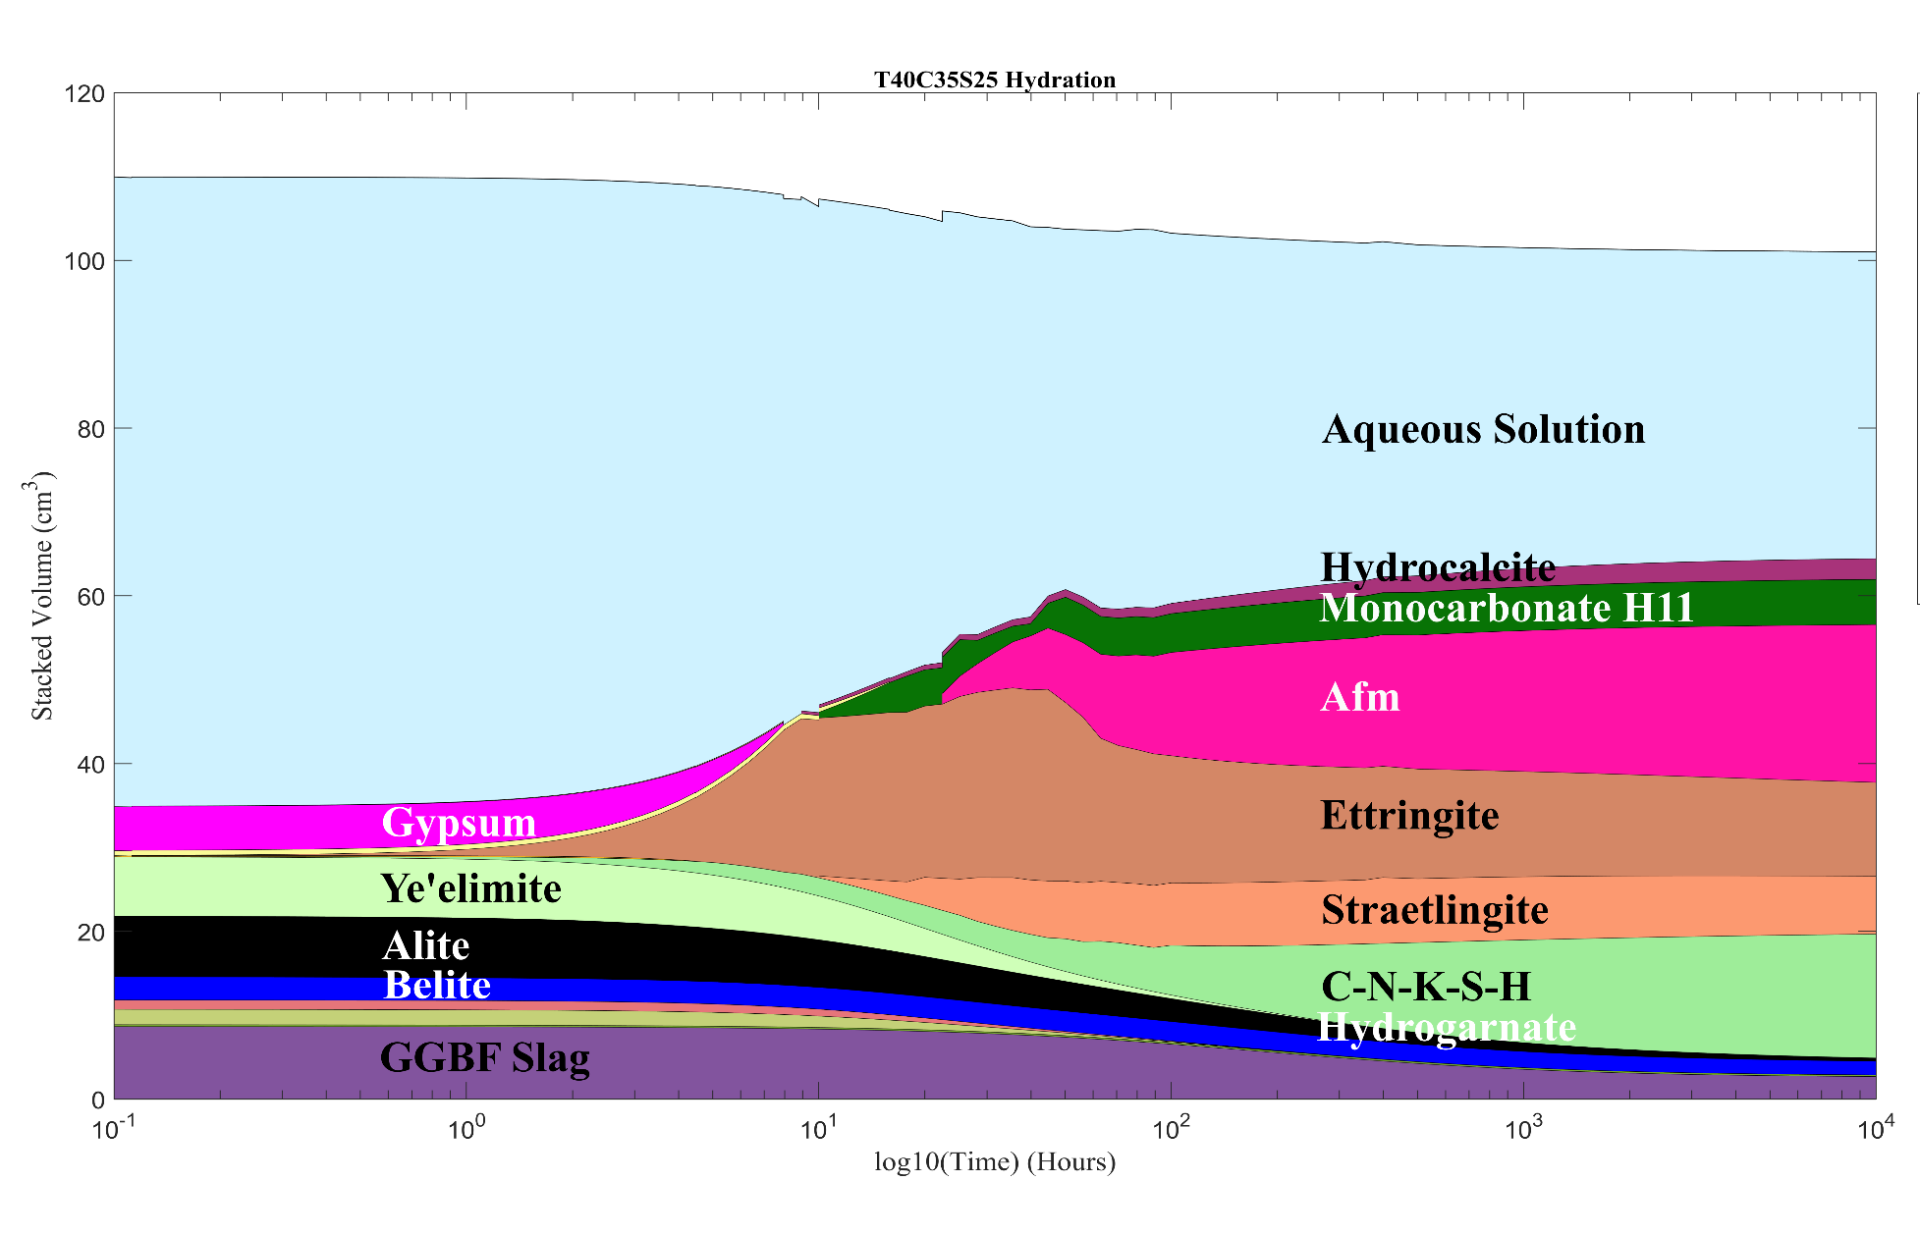 | 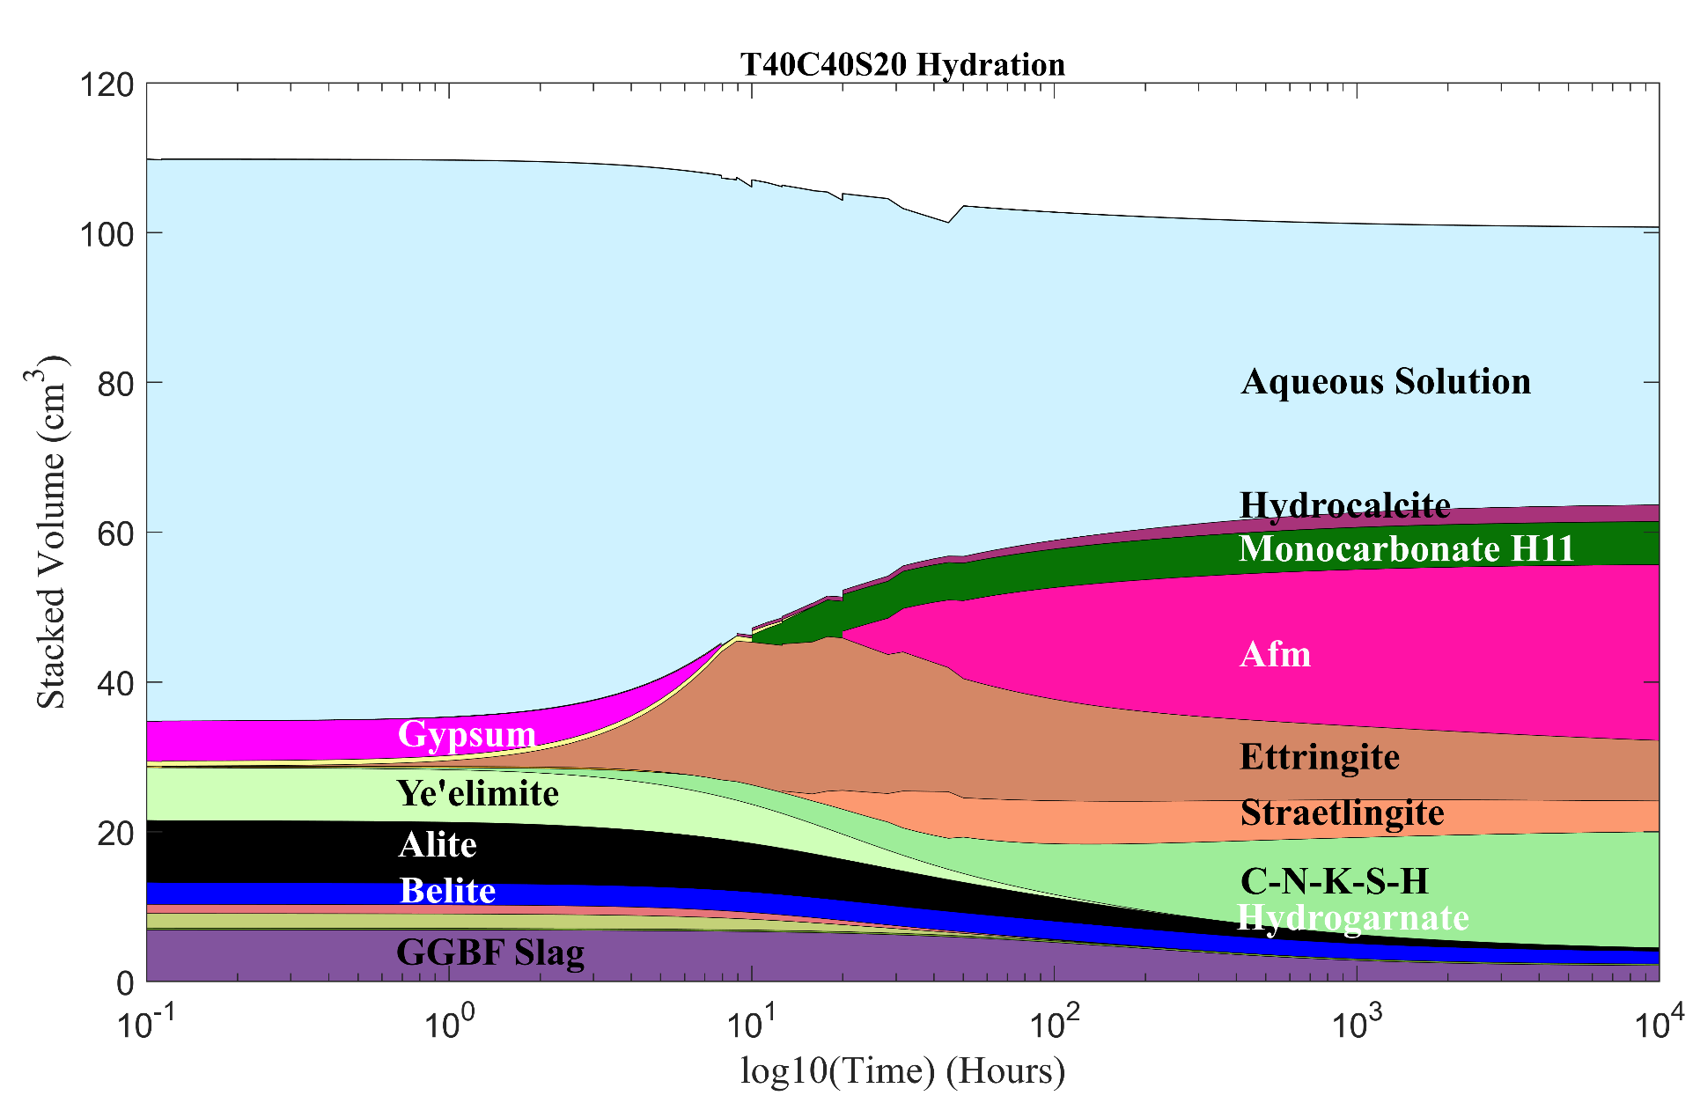
(c)T40C35S25 composite | (d)T40C40S20 composite
Figure 14: Thermodynamic modelling of hydration over 1000 hours using CEMGEMS application: (a) 100% CSA (b) T40C30S30 composite (c)T40C35S25 composite (d)T40C40S20 composite

Equation 7: Modified M value
$$Modified M value \left(Mm\right)=\frac{{CaSO}_{4}(mole)}{C3A\left(mole\right)+2×Ye^{'}elimite(mole)}$$

Fresh Properties

Flow Table Test
The flow indexes of composite binders are plotted against the percentage replacement of CSA in Fig 17. The percentage of CSA does not have much effect on flow index in CSA-PC binary composition does not so much effect on flow index with >20% PC. But both CSA-slag binary and ternary composites are impacted by the composition of the binders. CSA-slag binary composites show increase in flow index and workability compared to 100% CSA. But the ternary composites show low flow index compared to binary composites. Fig 18 a and 18b show that in CSA-slag binary and ternary composites the workability increases with M-value and Mm value. CSA cement has higher water demand compared to PC as ye’elimite needs greater water content during hydration. Also, high CSA percentage leading high quantity of ye’elimite and C3A can shorten the time when binders are plastic. Thus, influencing the workability as early as 5 minutes after water addition. In ternary binder presence of both PC and slag provides a large number of nucleation sites and accelerates the hydration and reducing flow index[110].

Setting Time Test
Fig 19 a and 19 b displays that initial and final setting time of composite binders increases with the higher M value and modified M value. Fig. 20 shows that with high quantity of C3A and ye’elimite in binders, setting time decrease. Hence, these two phases control the early hydration and hardening in CSA-based composites. High amount of CaSO₄ retards the hydration of
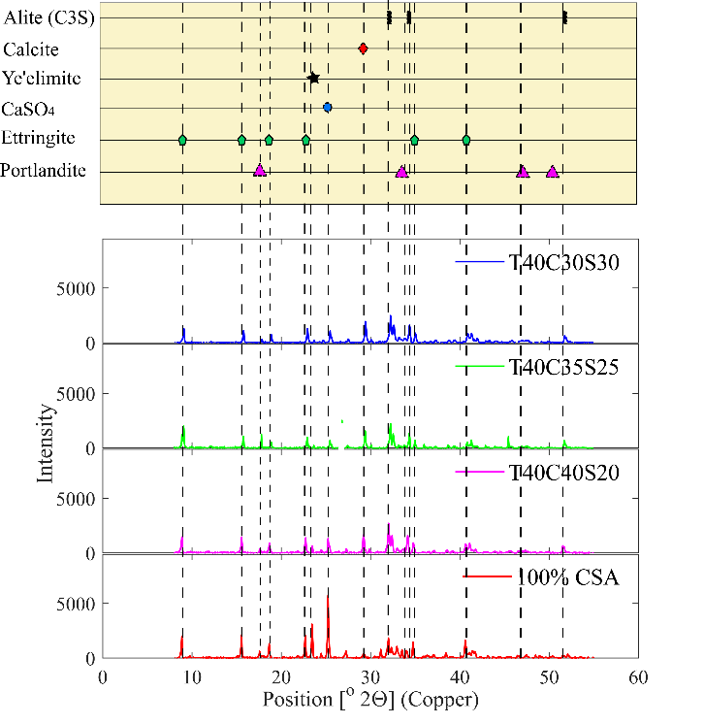 | 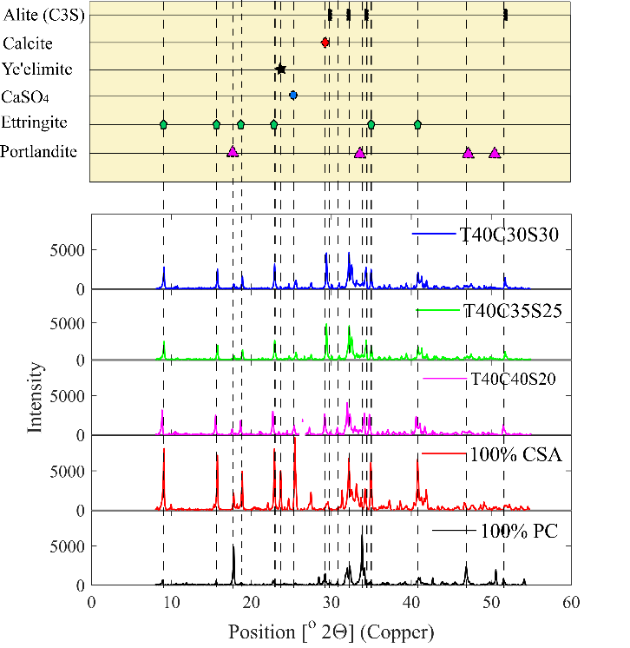
(a) | (b)
Figure 15: (a) XRD pattern of hydrated composite binders and CSA cement at 6 hours (b) XRD pattern of hydrated composite binders, CSA cement, and OPC at 28 days

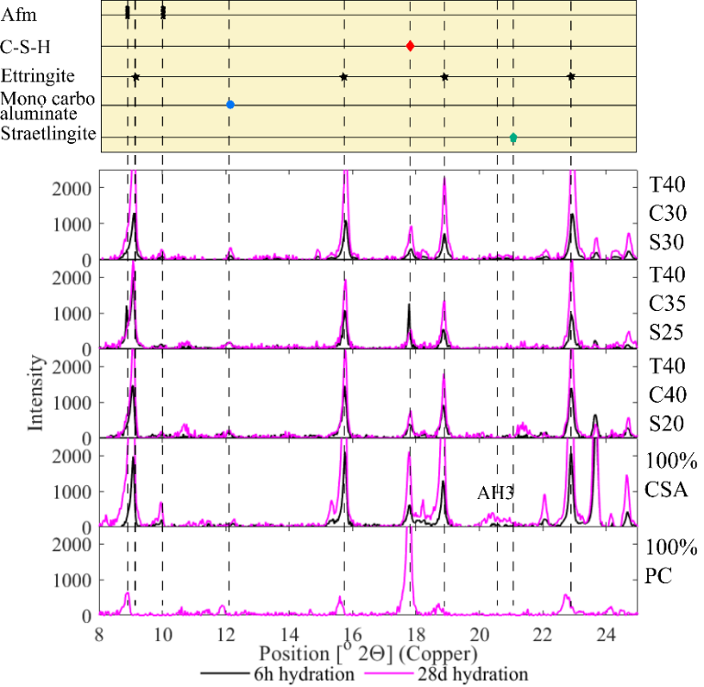
Figure 16: XRD pattern of hydrated composite binders, CSA cement, and PC at 28 days (8-25^{O})

Figure 17: Effect of CSA replacement percentage on flow index of composite binders

(a) | (b)
Figure 18: (a) Effect of M value on the flow index of composite binders (b) Effect of modified M value on the flow index of composite binders

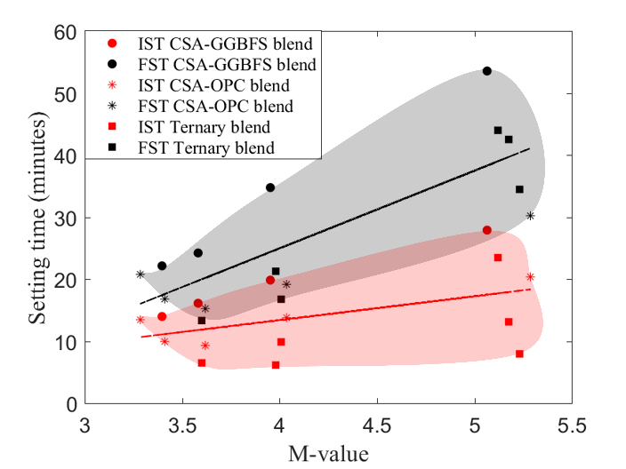
(a) | (b)
Figure 19: (a) Effect of M-value on the setting time of composite binders (b) Effect of modified M value on the setting time of composite binders

Figure 20: Effect of C3A and ye’elimite quantity on the setting time of composite binders

C3A[102] whereas presence of adequate CaSO₄ can accelerate Ye’elimite hydration[103]. Due to opposite effect of CaSO₄ on two controlling reaction further study is required to accurate understand the setting time trend for CSA-PC composite. In CSA-slag composite setting time increases with slag content and modified M value as it reduces both ye’elimite and CaSO4 content.

Hardened properties

Compressive Strength
The 6 hour and 28 days compressive strength was plotted against the M value and the modified M value of composite binders in Fig 21 a and 21 b respectively. Although. 100% CSA yields the highest strength at 6 hours and at 28 days, that can be attributed to largest CSA cement clinker content. As the slag content increases clinker content decreases, that is what contributing.
High slag means less water demand.
Fig 22 a show that the quantity of C3A and Ye’elimite proportionate to the compressive strength at 6 hours. But at 28 days quantity of all 4 major phases (Alite, Belite, C3A and Ye’elimite) are better indicator of the compressive strength.

Shrinkage Test
Fig 23a show that M value of composite binders do not provide any correlation with shrinkage. Expansion in CSA cement pastes has always been attributed to ye’elimite hydration to form ettringite [111]. But presence other phases in composite binder means only ettringite formation from ye’elimite is not the only controlling hydration. But, Fig 23b show that shrinkage in composite binder reduces with high Mm value.

(a) | (b)
Figure 21:(a) Effect of M-value on the compressive strength of composite binders (b) Effect of modified M value on the compressive strength of composite binders

(a) | (b)
Figure 22: (a) Effect of C3A+ye’elimite quantity on the compressive strength of composite binders (b) Effect of 4 major phase quantity on the compressive strength of composite binders

(a) | (b)
Figure 23: (a) M value vs Shrinkage of composite binders (b) Effect of modified M value on the shrinkage of composite binders

Conclusions
This study explored the hydration characteristics and material properties of CSAB cements blended with CC powder of varying fineness, and also investigated the effect of changing the gypsum content for a given CC powder content. The key findings from the conducted experiments are summarized as the following:
- Hydration products found in XRD indicate that early hydration in CSA and CSA-based binders are controlled by the hydration of ye’elimite along with C3A. At later ages e.g. 28 days other phases like C3S and C2S react with the excess water.
- M value i.e. the molar ratio of CaSO₄ and ye’elimite is used to predict and analyze the hydration product of the CSA cement and ye’elimite phase. Thus, the M value can only consider hydration of ye’elimite. But in composite binders, phases other than ye’elimite also participate and influence hydration. Hence, the M value is needed to be modified. Although M value can affect some material performance influenced by early hydration, like setting time and 6-hour compressive strength. But modified M value provides a better correlation, as the modified M value considers hydration of C3A along with ye’elimite. In this study, a modified M value is suggested based on the predicted controlling reactions. Modification of the M value is depended on the binder composition.
- The quantity of CaSO₄ reacts with both C3A and ye’elimite. The increased CaSO₄ content delayed the hydration at early ages, thus flow index, and setting time increase with modified M value. On the other hand, reduced ye’elimite and C3A content lead to a low volume of ettringite generation thus early compressive strength decrease with modified M value.
- The quantity of reacting phases controls the strength gain in CSA and CSA-based composites. At 6 hours Ye’elimite and C3A content influence the compressive strength of the binders. But hydration and compressive strength at 28 days rely on the quantity of other phases like C3S and C2S along with C3A and ye’elimite. Therefore, investigating the controlling hydration reactions are important to understand the performance of the binders.
- The correlation between modified M value and binder performances shows that the understanding of the controlling hydration process can be used to control setting time, and the concrete performance during the fresh and hardened state, using the composition of the binder.
- Although CSA and CSA-based composites can provide high early strength and low shrinkage, the main drawbacks are low setting time and workability. Nevertheless, as shown in this study, using GGBF slag along with PC and CSA cement can provide a middle ground between workability and early strength, thus widening the scope of CSA-based composite usage.

Table 9: Average material performance of composite binders
Identification | Flow Index (%) | Setting time(min) |  | Compressive Strength (psi) |  | Shrinkage (%)
Identification | Flow Index (%) | Initial | Final | 6 hours | 28 days | 28 days | 63 days
T100C0S0 | 18.45 | 282.01 | 382.96 | - | 5662.00 | 0.09 | 0.09
T0C100S0 | 20.75 | 13.51 | 20.84 | 2177.46 | 5773.75 | 0.02 | 0.01
T0C80S20 | 23.70 | 14.04 | 22.21 | - | 2868.75 | 0.05 | 0.04
T0C60S40 | 27.55 | 16.19 | 24.29 | - | 3552.26 | 0.03 | 0.03
T0C40S60 | 28.65 | 19.91 | 34.84 | - | 2620.34 | 0.02 | 0.02
T0C20S80 | 39.07 | 27.98 | 53.64 | - | 850.90 | 0.01 | 0.00
T20C80S0 | 5.87 | 10.00 | 16.85 | - | 3018.06 | 0.04 | 0.03
T40C60S0 | 22.43 | 9.37 | 15.31 | - | 5402.35 | 0.03 | 0.02
T60C40S0 | 22.50 | 13.85 | 19.23 | - | 7380.48 | 0.05 | 0.05
T80C20S0 | 22.90 | 20.43 | 30.29 | - | 4715.37 | 0.12 | 0.12
T40C20S40 | 16.63 | 13.18 | 42.60 | - | 4018.88 | 0.03 | 0.03
T40C30S30 | 16.50 | - | - | 699.72 | 4411.13 | - | -
T35C30S35 | 20.25 | - | - | 540.82 | 2988.27 | - | -
T30C30S40 | 16.75 | - | - | 443.15 | 2638.13 | - | -
T25C30S45 | 22.25 | - | - | 337.91 | 2031.15 | - | -
T40C35S25 | 9.75 | - | - | 1122.17 | 3363.33 | - | -
T35C35S30 | 8.13 | - | - | 821.86 | 3584.02 | - | -
Table 9 continued
Identification | Flow Index (%) | Setting time(min) |  | Compressive Strength (psi) |  | Shrinkage (%)
Identification | Flow Index (%) | Initial | Final | 6 hours |  |  | Initial
T30C35S35 | 13.00 | - | - | 593.74 | 3133.28 | - | -
T25C35S40 | 16.13 | - | - | 529.69 | 2239.80 | - | -
T40C40S20 | 13.00 | 9.94 | 16.82 | 530.64 | 4891.28 | 0.03 | 0.02
T35C40S25 | 12.88 | - | - | 1070.43 | 4359.23 | - | -
T30C40S30 | 14.75 | - | - | 718.08 | 2882.80 | - | -
T25C40S35 | 14.25 | - | - | 654.19 | 2603.29 | - | -
T20C40S40 | 14.13 | 6.21 | 21.34 | 625.91 | 2022.16 | 0.03 | 0.02
T30C45S25 | 9.75 | - | - | 765.85 | 2117.51 | - | -
T25C45S30 | 11.25 | - | - | 664.31 | 2255.58 | - | -
T20C45S35 | 14.50 | - | - | 382.06 | 3289.14 | - | -
T60C20S20 | - | 8.00 | 34.54 | - | 5057 | 0.037801 | 0.03
T20C20S60 | - | 23.53 | 44.08 | - | 3219.04 | 0.025064 | 0.02
T20C60S20 | - | 6.56 | 13.39 | - | - | 0.025064 | 0.02

CHAPTER IV
Effect of Interlayer Time-Lapse and Workability Retention on Printed Concrete Performance

Abstract
The rapid advancement of additive manufacturing technologies for concrete construction requires further understanding of material performance and its relationship with print parameters such as interlayer time-lapse and workability retention during the print. This study addresses the effects of the time delay between consecutive extruded layers on the mechanical performance of printed concrete using a mix designed by Quikrete. A series of specimens were prepared with printing delays of 10, 15, 30, and 60 minutes. This work correlates the change in fracture properties, mechanical performance, and workability retention with the interlayer time-lapse between two consecutive concrete layers. Interlayer time-lapse affects individual properties differently based on the loading direction and test types, but it is consistent in terms of interlayer performance. The understanding of the effect of interlayer time-lapse on the fracture properties between two consecutive printed layers fill the knowledge gaps in printed concrete research. Therefore, this study can help researchers perform required optimization and safely estimate the performance of printed concrete.

Keywords
3D printing; Concrete; Fracture properties; Mechanical properties; Interlayer bonding.

Introduction
The 3D-printed concrete (3DPC) technique uses an extrusion-based additive manufacturing process that deposits consecutive linear mortar filaments on top of each other to gradually build an object. This process allows flexibility for complex geometry and architectural decisions without relying on expensive formwork. Reductions in formwork, material waste, and transportation cost through onsite and automated additive manufacturing can also lead to a more sustainable construction process [14]. This novel 3DPC construction technique is being explored for applications in residential buildings [112, 113], pedestrian bridges [114], wind turbine towers [115], and highly loaded structures [116, 117]. However, 3DPC still lacks the safety standards, guidelines, and evaluation techniques associated with traditional cast concrete [118, 119]. As a distinctively different manufacturing process, 3DPC is incompatible with most existing design and testing standards used for cast concrete. Research has shown that the performance of 3DPC is anisotropic and depends on loading direction[120]. The performance of 3DPC is also heavily influenced by the absence of compaction and the time difference between two consecutive layers during the printing process [42, 46, 121]. The time difference in construction is not a new phenomenon in concrete construction. However, unlike cast cold–joint concrete applications, a 3DPC’s bottom layer is usually not hardened before the placement of the next layer, and the bonding of two layers within the initial concrete setting time is much less studied. In 3DPC, it is generally recognized that the interlayer time-lapse should be short enough to allow for layer bonding. However, the construction rate should also be slow enough for the bottom layer to gain enough strength to support the next layers as they are printed on top [43, 44]. Nerella, Hempel, and Mechtcherine [45] mentioned this interlayer bond as the “Achilles’ heel of 3D printing with concrete structures” that has yet to be explored completely. Determining the interlayer bonding strength is essential to understanding the strength and the weakness of 3DPC. Researchers have also investigated compressive strength, flexural strength, and split-tensile strength to compare the performance of printed concrete with cast concrete [45-47]. These studies showed that interlayer adhesion impacts concrete performance. However, there are specific gaps in the understanding of the material performance:
- The effect of interlayer time-lapse on the fracture properties of concrete interlayers: The fracture behavior of printed concrete can provide insight into interlayer bonding. Wu, Cotrell, and Li [115] showed that the interlayer adjoining two printed columns had different fracture toughness than the concrete filament. However, the current literature does not address the effect of interlayer time-lapse on the fracture properties between two consecutive printed layers. This study suggests a modified compact tension (CT) test, which is suitable for the layer height of printed concrete and is less susceptible to failure during sample preparation.
- The effect of interlayer time-lapse on workability retention: Concrete exhibits a dormant phase during early hydration before the hydration process accelerates and workability reduces [122]. As a print material, the workability retention of concrete should impact the effect of time-lapse between two interlayers [123]. Previous work on interlayer bonding is difficult to compare owing to a lack of workability retention data. This work explores the mechanical performance of printed concrete and considers fresh concrete’s properties.

Materials and Methodology

Material Properties
Concrete prints were fabricated using a dry mortar mix developed by Quikrete with a water:dry-mix ratio of 0.21:1. The dry mix was composed of 25%–35% locally sourced type I/II ordinary portland cement, 70%–50% river sand, and 1%–5% specialty admixtures, including rheology modifier, flow agents, and set controller. The concrete setting time and flow table test were used to quantify the workability retention time. Workability impacts the interlayer bonding and print quality of 3DPC. The setting time and the workability retention of the concrete mix were determined according to ASTM C 403 [98] and ASTM C 1437 [99]. The workability of concrete is directly linked to the printability and print quality of 3DPC [100]. The flow table test uses fresh concrete, placed at the middle of the flow table in a conical shape with 4 in. (100 mm) base diameter and the table is dropped 0.5 in. (12.7 mm) 25 times in 15 s. The average percentile increase in concrete diameter after the table drops quantifies the workability of concrete [100]. In this study, a flow table test was conducted at different time intervals to monitor the loss of workability in the concrete mix over 2 hours after mixing with water. The average diameter of concrete flow was used to determine the flow table reading as a percentage using Equation 8: Quantification of flow table reading Equation 8. Figure 24b shows the changes in the flow table reading with time.
Equation 8: Quantification of flow table reading
$$Flow table reading \left(\%\right)=\frac{\left(Average flow diameter - Base diameter\right) × 100}{Base diameter}$$
According to ASTM C 403, the gradual setting process of concrete is defined by the penetration resistance of the mortar. The 500 psi (3.45 MPa) penetration resistance indicates the initial setting time of the concrete, and the 4,000 psi (27.6 Mpa) penetration resistance indicates the final setting time. Figure 24a shows the gradual increases in resistance of the concrete mix over time in a log-log plot. The initial setting time of the mortar mix was 5 hours and 11 minutes, and the final setting time was 9 hours and 45 minutes. Although concrete does not show any penetration resistance until 100 minutes after initial mixing, the flow readings and workability steadily decrease 30 minutes after the concrete was mixed, which deteriorates the print quality. All concrete used in this study was used within 30 minutes of mixing to maintain consistent print quality in all the printed layers. Therefore, specimens with long interlayer time-lapses were made of layers using multiple identical concrete batches.

Sample Preparation
A surrogate printing method with a modified caulk gun was utilized to print multilayer concrete beams with a specified time-lapse between layers. The standard nozzle of the caulk gun was replaced with the 3D-printed 2 × 1 in. (50.8 × 25.4 mm) rectangular nozzles shown in Figure 25. Interlayer time-lapses of 0, 10, 15, 30, and 60 minutes were chosen to assess the effect of time-lapse on concrete strength and interlayer bonding. Concrete beams had a consistent time-lapse between consecutive layer extrusions. Cast beams with the same mortar mix were used as a reference throughout this study. After 7 days, the beams were cut into smaller specimens for mechanical testing using a wet-cutting tile saw with a 10 in. (254 mm) diameter blade. All beams and specimens were air cured and covered to prevent evaporation from printing until they could be tested.

Test Methods

Compression Test
The beams were cut into 1.67 × 1.67 × 1.67 in. (42.4 × 42.4 × 42.4 mm) specimens for the compressive strength test. Printed specimens consist of two layers and are identified by their interlayer time-lapse. Specimens were capped with 2 × 2 in. (50.8 × 50.8 mm) steel restraining cups and polyurethane pads to ensure uniform load distribution. The load and deflection data were
(a) | (b)
Figure 24: (a) Initial and final setting time of the concrete mix. (b) Workability retention of the concrete mix.

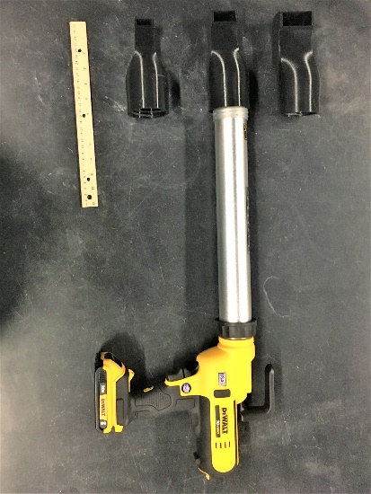
Figure 25: Caulk gun and nozzles (2 × 1 in., 1.5 × 0.75 in., and 1 × 0.5 in.) used to fabricate the multilayered printed concrete specimens.

collected from a universal testing machine with a string extensometer. Owing to the small specimen sizes, the compressive strength was calculated based on the exact dimension of each specimen using Equation 9a.Each sample set of printed concrete was subjected to perpendicular loading and parallel loading, separately, to study the effect of loading direction, as shown in Figure 26. For parallel loading specimens, an additional interlayer separation stress was calculated using
the load during interlayer separation and the approximate surface area of the interlayer, as described in Equation 9b and the study conducted by Wang et al. [124]. No correction factors were used for the compressive strength or interlayer separation stress because the objective of this study is to compare the performance between specimens with the same shape and dimension.
Equation 9: Calculation of compressive strength (a), and Interlayer seperation stress (b)
 | $$Compressive strength=\frac{Peak load}{Surface area}$$ | (a)
 | $$Interlayer seperation stress=\frac{2 × Interlayer separation load}{π × Approximate interlayer surface area}$$ | (b)

Flexural Test
A set of 1.67 × 1.67 × 6 in. (42.4 × 42.4 × 152.4 mm) concrete prisms were fabricated from cast and multilayered specimens for the center–point bending test according to ASTM C 348 [125] to study the effect of loading direction. Printed beams were cut into two different specimen types consisting of three samples in each. One specimen type had the print direction perpendicular to the major axis and parallel to the loading direction. The other specimen had the print direction parallel
to the major axis and perpendicular to the loading direction. Specimen diagrams and setups are
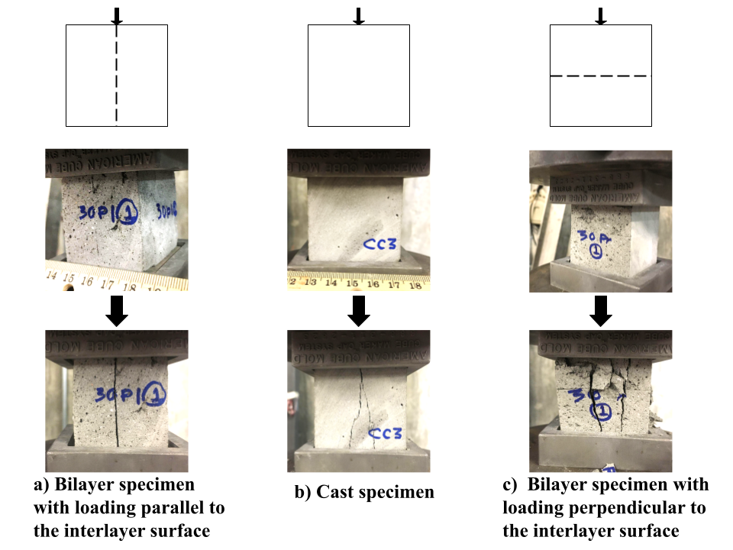
Figure 26: Compressive strength tests for parallel-loading, cast, and perpendicular-loading specimens.
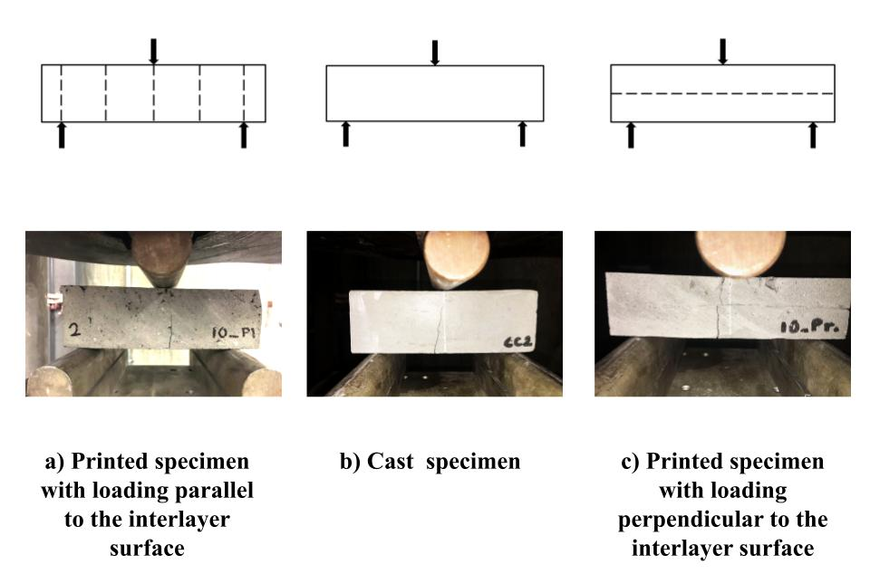
Figure 27: Center point bending test with parallel-loading, cast, and perpendicular-loading specimens.

shown in Figure 27. The modulus of rupture, R, is calculated according to Equation 10.
Equation 10: Calculation for modulus of rupture
$$R=\frac{3PL}{2bd^{2} }$$

Where R is the modulus of rupture in psi or MPa; P is the maximum applied load indicated by the testing machine in lbf or N; L is the span length in inches or mm; b is the average width of the specimen at the fracture in inches or mm; and d is the average depth of the specimen at the fracture in inches or mm.

Fracture Test
Owing to the presence of interlayers, large specimens with multiple layers are prone to internal defects and can fracture during sample preparation. This study used bilayer CT specimens to ensure failure in one interlayer. ASTM E 399 [126] was used as the starting point for this test. The CT test applies tensile force on a notched concrete specimen and measures crack mouth opening displacement (CMOD) to determine the fracture energy and fracture toughness. Figure 28 shows the specimen dimensions and test setup. Bilayer printed concrete specimens were prepared with the interlayer aligned with the notch. The tensile force was applied at a 0.00015 in./second (0.00381 mm/second) loading rate, and a tie-on extensometer was used to measure the CMOD during the test.

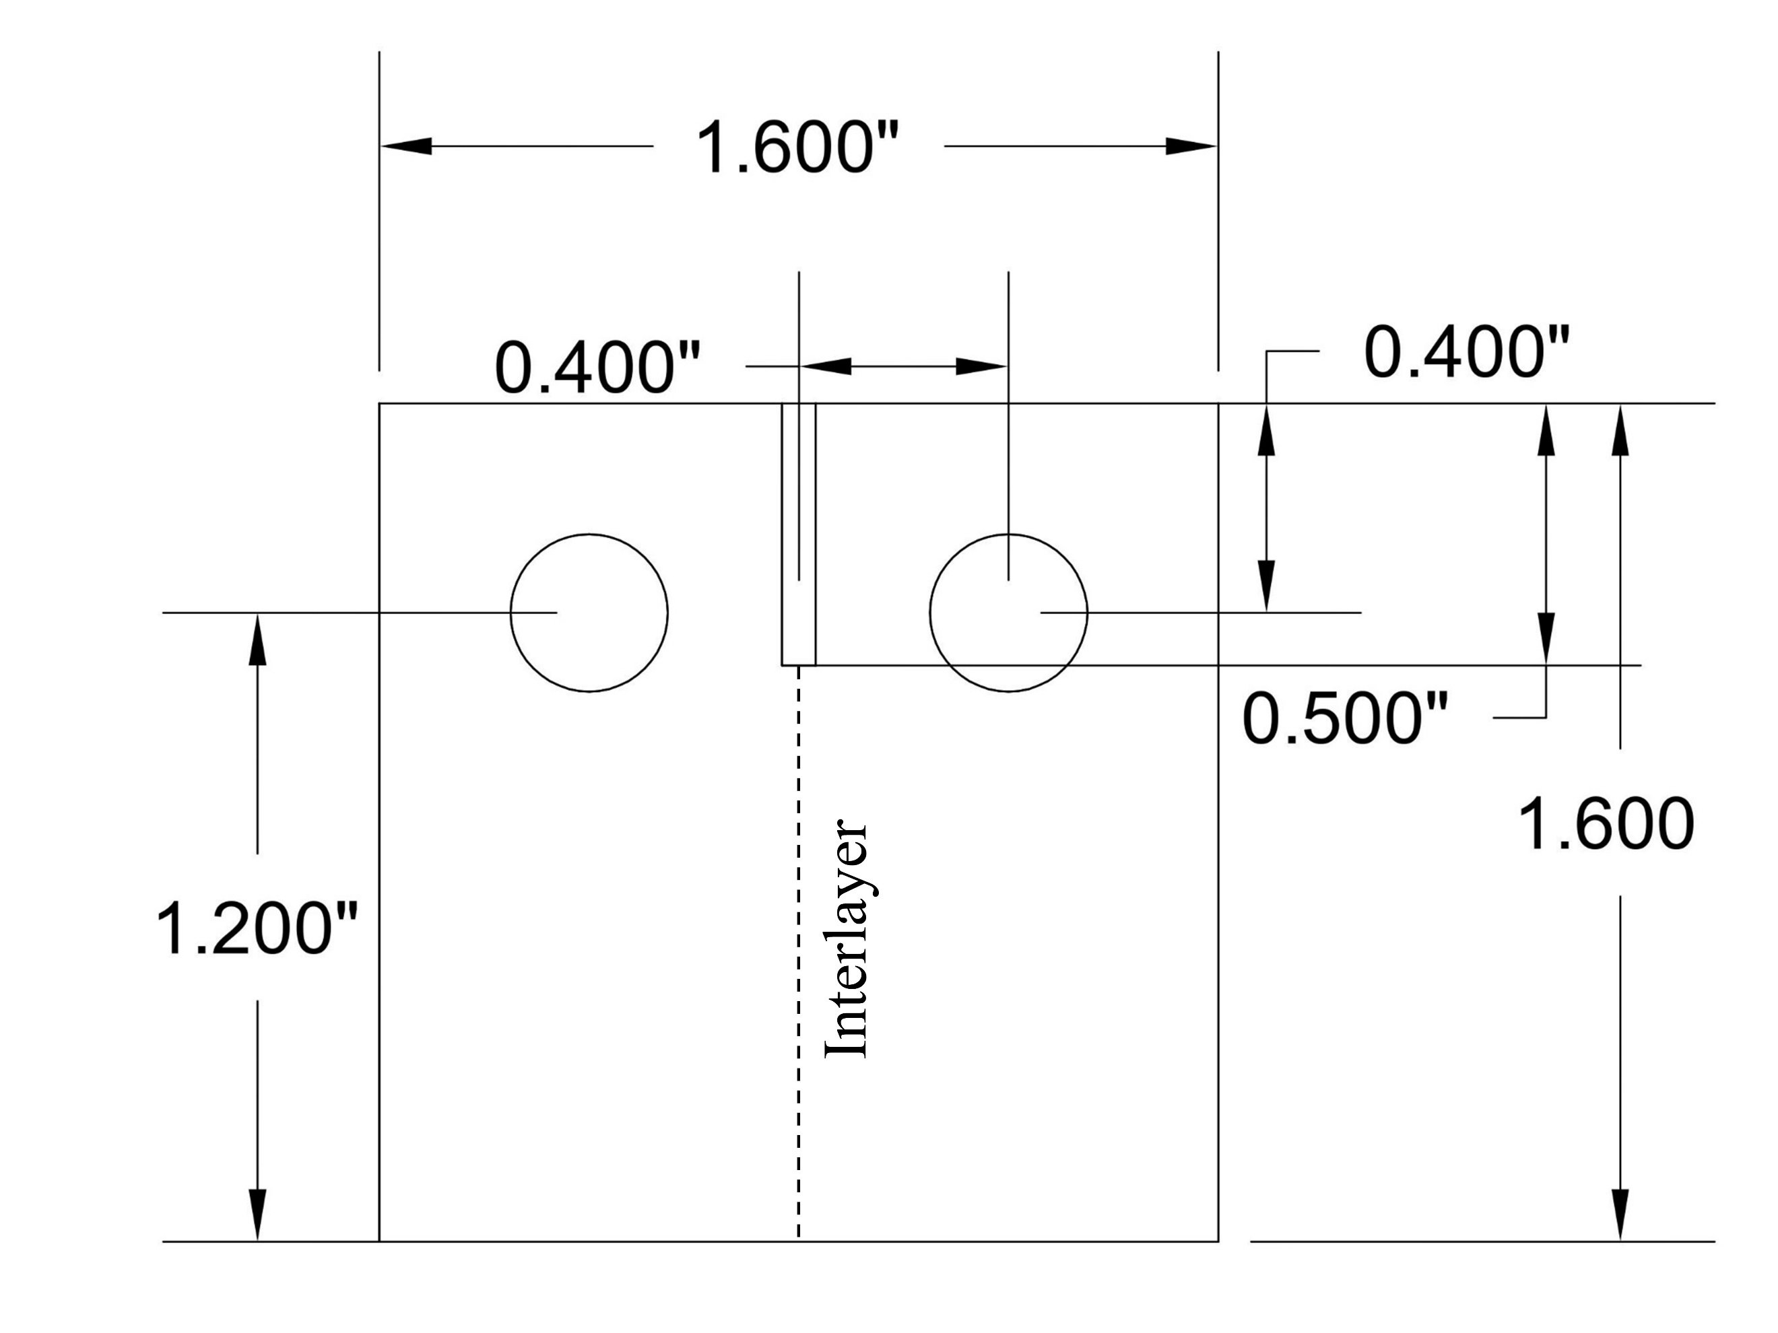 | 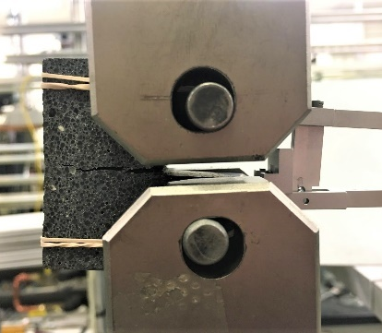
(a) | (b)

Figure 28: (a) Dimensions (in inches) for the CT test of printed bilayer specimens. (b) CT test setup.

Results and Discussion

Compressive Strength
Concrete exhibits different behaviors and breaking patterns for cast specimens, parallel-loading printed specimens, and perpendicular-loading printed specimens. Breaking patterns for each specimen type are presented in Figure 29 and the load-displacement curves of the displayed samples are displayed in Figure 30. Two layers of parallel-loading specimens separated at the interlayer surface at a load lower than peak load. Post-separation, individual layers bear the specimen to failure at a higher load. The stress at the interlayer surface during the interlayer separation, referred to as interlayer separation stress in this document, is calculated using Equation 9b is quantified from the first peak in the load-displacement curve, as shown in Figure 30(PL2).
The interlayer separation stress for the parallel-loading specimens declines after a 15-minute time-lapse, as shown in Figure 31b. The layer separation indirectly reflects the tensile strength of the interlayer and can be compared with the concrete split-tensile test, in which a tensile region is created at the loaded axis, and the specimen splits [127]. In this case, the interlayer zone is aligned with the loaded axis, and a weak bonding between layers with longer interlayer time-lapse encourages crack initiation. Interlayer separation stress declines with longer interlayer time-lapse. But the compressive strength of the specimens is not affected by the interlayer time-lapse because it is reliant on the compressive strength of the material itself. Having the peak stress unaffected by the interlayer time-lapse shows consistency in print quality. Hence, interlayer separation stress is a true indicator of the effect of time-lapse on the interlayer zone’s tensile strength.
Figure 31a shows the average compressive strength of bilayer printed specimens and cast specimens. Printed concrete specimens show lower strength compared to cast concrete. The
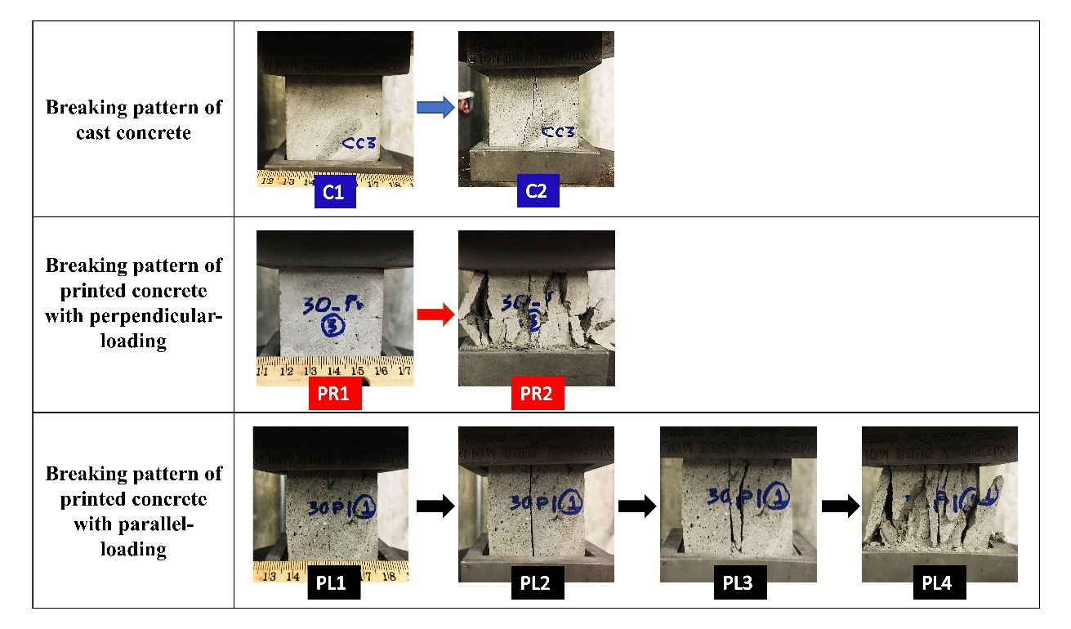
Figure 29. Example of breaking patterns of cast concrete (C1-C2), of a bilayer specimen with perpendicular loading (PR1-PR2), and of a bilayer specimen with parallel loading (PL1-PL4).

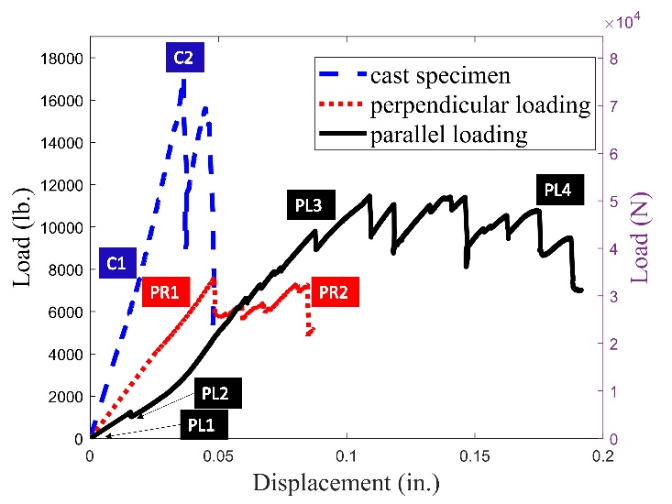
Figure 30. Plot of load displacement and breaking patterns of cast concrete (C1-C2), of a bilayer specimen with perpendicular loading (PR1-PR2), and a bilayer specimen with parallel loading (PL1-PL4).

strength of perpendicular loading specimens decreases further with a longer time-lapse between layers. Scanning electron microscopy (SEM) images of the resin-impregnated cast specimen, the printed specimen with a 10-minute interlayer time-lapse, and the printed specimen with a 30-mininute interlayer time-lapse were studied for the effect of pore volume and orientation on the concrete’s compressive strength. An average of 1 sq-in (6.5 sq-cm) area were captured for each specimen types using SEM-EDX at 40x magnification. The average pore area fraction and average pore aspect ratio were quantified using image intensity thresholding [128]. Figure 32a and 32b show that the pore area and aspect ratio are larger in printed concrete than in cast concrete. Figure 33 shows a few example SEM images of irregular and elongated pore structures in printed concrete compared to cast concrete. Elongated pores and larger pore area in printed concrete generate higher stress concentrations at the corner of the pore structure, which leads to low compressive strength compared to cast concrete [129].

Flexural Strength
The concrete specimens’ average modulus of rupture is presented in Figure 34a. The printed bilayer specimens had higher flexural strength with perpendicular loading compared to cast specimens and printed specimens with parallel loading. Interlayer time-lapse has a different impact on the flexural strength depending on the loading direction. Printed specimens with perpendicular loading show higher flexural strength with longer interlayer time-lapse. The crack pattern of the bending specimens with perpendicular loading is shown in Figure 35; a zigzag pattern is visible in the printed concrete where the crack runs along the interlayer before propagating into the top layer. Other anisotropic concretes, such as alkali–silica reaction affected concrete, showed that tensile
(a) | (b)
Figure 31: (a) Compressive strength of cast and printed specimens with different loading directions. (b) The effect of interlayer time-lapse on compressive strength and interlayer separation stress with a parallel loading direction.

(a) | (b)
Figure 32: (a) Comparison of average area fraction of pores in cast and printed concrete. (b) Comparison of average aspect ratio of pore structure in cast and printed concrete.

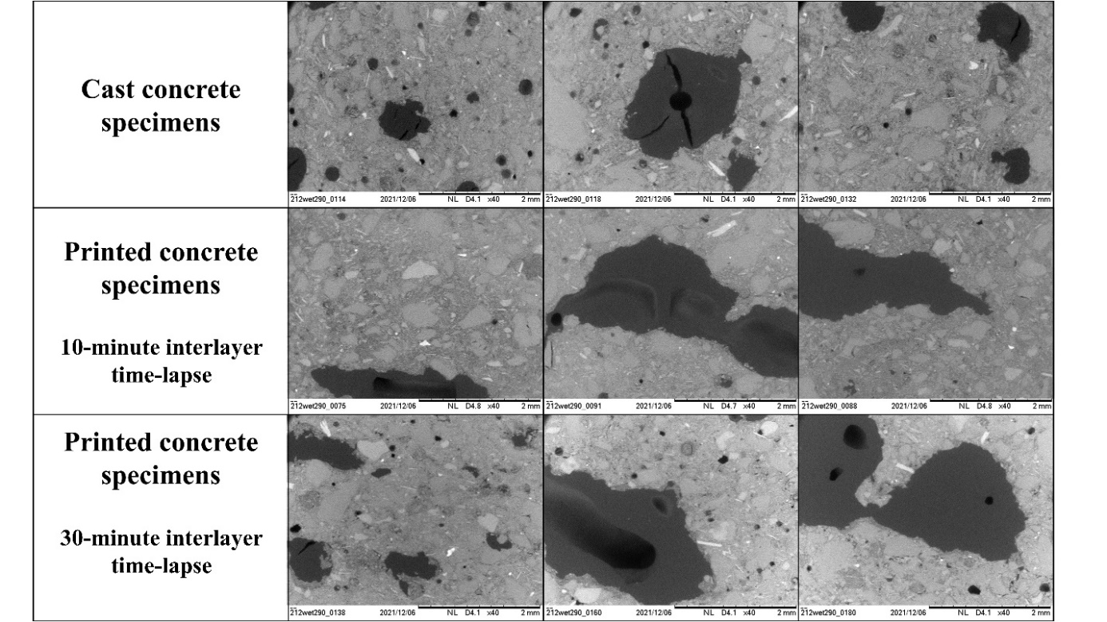
Figure 33. SEM images of the cast and printed concrete displaying concrete matrix and pore structure (darker color).

(a) | (b)

Figure 34: (a) Modulus of rupture of the bilayer specimens with different interlayer time-lapse. (b) Modulus of rupture and the average normalized crack length of bilayer specimens.

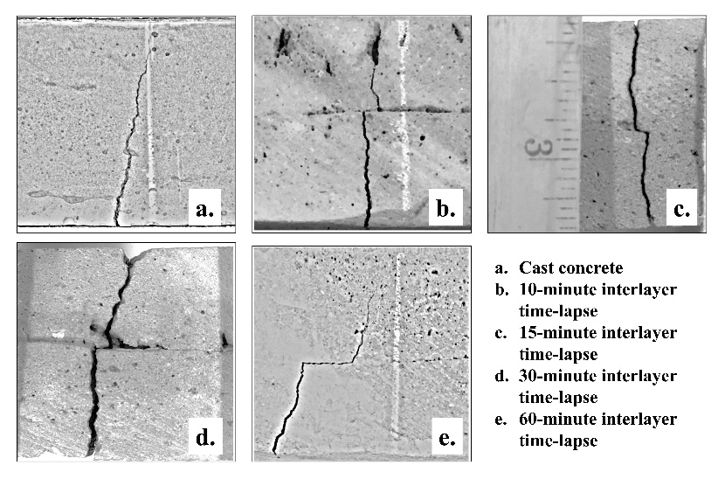
Figure 35. Crack pattern in cast and printed bending specimens with loading perpendicular to the interlayer.

crack propagation is influenced by the preexisting horizontal cracks [130, 131]. Figure 34b shows that the average normalized crack lengths (crack length/depth of specimen) increase with the interlayer time-lapse and modulus of rupture. Hence, the increase in crack length caused by longer interlayer time-lapse increases the ductility of printed concrete without decreasing the strength. Specimens with parallel loading showed a lower flexural strength compared to the specimens with perpendicular loading as well as the cast specimen. When the printed concrete was subjected to bending stress, the interlayer surface acted like a preexisting weak spot for the crack to propagate. This effect lowers the modulus of rupture because the bonding weakens with a longer interlayer time-lapse.

Compact Tension (CT)
Concrete is considered a quasi-brittle material with a fracture process zone with an effective width of about 2–3 times the largest inhomogeneity (or aggregate) size [132]. For a small aggregate diameter and a comparatively large specimen size, various adaptations of linear elastic fracture mechanics that involve fracture energy and fracture toughness can be used to analyze and compare concrete fracture [133]. Figure 36 shows the load vs. CMOD plots and fractured specimens of cast concrete and bilayer printed concrete. Fracture energy is defined as the total work needed to completely break the specimen [134] and was calculated by integrating the area under the load-CMOD curve using the work-of-fracture method (see Equation 11).
Equation 11: Quantification of apparent fracture energy
$$Apparent fracture energy= \frac{A}{b(D - a_{0})}$$
Where A is the area under the complete load-deflection curve, b is the specimen thickness, D is the cross-section dimension, and a₀ is the length of the notch or initial traction-free crack. The fracture toughness provides the required stress for the propagation of the preexisting notch in a predominately linear elastic material [135] and is determined using Equation 12. This study assumes that printed concrete is linearly elastic and has negligible plastic-zone adjustment, and the specimen establishes a sharp crack condition relative to crack size, specimen thickness, and ligament length ahead of the crack.
Equation 12: Quantification of fracture toughness using ASTM E 399
$$K=\frac{P}{B\sqrt{W}}f(\frac{a}{W})$$

where,
$$f\left(\frac{a}{W}\right)=\frac{\left(2+\frac{a}{w}\right)\left[0.886+4.64\frac{a}{W}-13.32{\left(\frac{a}{W}\right)}^{2}+14.72{\left(\frac{a}{W}\right)}^{3}-5.6{\left(\frac{a}{W}\right)}^{4}\right]}{{\left(1-\frac{a}{W}\right)}^{\frac{3}{2}}}$$
P is force, B is the specimen thickness, W is the specimen width measured from the notched edge of the specimen to the opposite edge, and a is the crack size measured from the plane of the centerline of the loading holes. The load-CMOD plots for the cast concrete specimens, the printed specimens with a 5-minute interlayer time-lapse, and the printed specimens with a 10-minute interlayer time-lapse all exhibit a linearly elastic behavior. Compared with the cast concrete specimens, the printed specimens with 30-minute and 60-minute interlayer time-lapses showed more gradual failure at significantly lower peak load and cannot be considered linearly elastic. Thus, the fracture toughness shown in Figure 36a for 30-minute and 60-minute interlayer time-lapses is imprecise. The respective datapoints are provided in Figure 36a for comparison only. The fracture toughness gradually decreases with a longer interlayer time-lapse, as shown in Figure 36a However, Figure 36b shows that the fracture energy for printed concrete is lower than that of the cast concrete specimen and is less affected by the interlayer time-lapse. Fracture energy has a more accurate physical meaning related to the crack energy absorption process compared to fracture toughness. Additionally, further research is needed to accurately calculate fracture toughness when the concrete fracture property varies with interlayer time-lapse. All cracks propagated through the interlayer, but due to the printing process interlayer is not always a straight line thus creating a non-linear crack patch.

Discussion Summary
Varying the interlayer time-lapse of 3DPC affects different mechanical properties of the concrete in different ways, but these experiments show a consistent picture of the material’s performance. The compressive strength of specimens with parallel loading was not affected by interlayer time-lapse. However, the stress during interlayer separation with parallel loading reflects the interlayer split tensile strength. So, the effect of interlayer time-lapse on the separation stress follows a similar trend as fracture toughness in CT specimens and bending strength with parallel loading, as all three properties are dependent on the tensile strength of the concrete interlayer. In the experiments, the separation stress, fracture toughness, and flexural strength decrease with longer interlayer time-lapses. Similarly, the crack propagation through the interlayer in parallel-loaded and perpendicular-loaded bending specimens shows that with longer interlayer time-lapse the
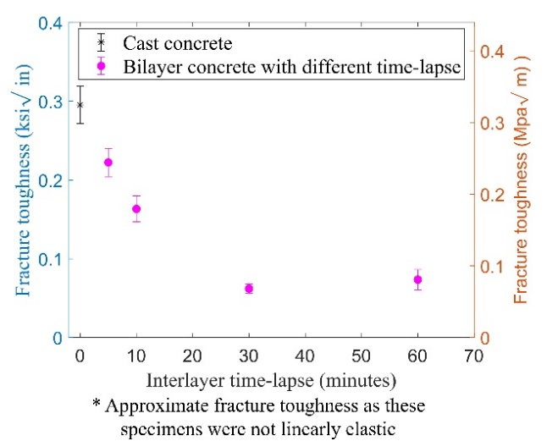
(a) | (b)

Figure 36: (a) Effect of interlayer time-lapse on the fracture toughness of CT specimens. (b) Effect of interlayer time-lapse on fracture energy of CT specimens.

(a) | (b)
(c) | (d)
(e)
Figure 37: Load vs. CMOD plots from CT tests for cast concrete (a) and bilayer printed concrete specimens (b–e).

interlayer becomes an increasingly weaker point through which a crack can propagate. The decrease in the interlayer strength is evident in the 30-minute and 60-minute time-lapse specimens; this decrease aligns with the workability trend. Workability of this specific print material declines after 30 minutes of dormant hydration time. Thus, the concrete mix should be printed during the dormant hydration time to prevent the weakening of the interlayer.
The precision of this study is limited by changes in print speed and print quality that occurred during specimen fabrication. There is no obvious technique to find the interlayer seam during specimen cutting. Hence, the manual alignment of the notch for CT specimens also leaves room for error, which could lead to variations in the crack propagation path and fracture toughness.

Conclusions
This work explored the effect of interlayer time-lapse on the compressive strength, flexural strength, and fracture properties of printed concrete compared with cast concrete. Understanding the differences between the processes and the effects of time-lapse are important for establishing standard testing methods and fabrication guidelines. The findings are summarized below:
- The time span between two consecutive layers plays an important role in printed concrete properties. Interlayer time-lapse affects individual properties differently based on the loading direction and test types, but it is consistent in terms of interlayer performance.
- Printed concrete can have different breaking patterns based on loading direction relative to interlayer orientation. All bilayer printed specimens with parallel loading break at the interlayer during compressive and bending tests. The bending specimens with perpendicular loading show a zigzag crack pattern where the crack length increases with a longer interlayer time-lapse.
- The concrete fracture behavior changes with the interlayer time-lapse. Specimens with a short interlayer time-lapse act like a linearly elastic material similar to cast concrete. However, specimens with a longer interlayer time-lapse display low fracture toughness and more ductile behavior.
- Although the concrete’s mechanical properties exhibit different trends when varying the interlayer time-lapse, the effect on interlayer bonding is consistent. In this study, the bonding strength declines with 30-minute and 60-minute interlayer time-lapses.
- The time-lapse effects are influenced by the properties of the concrete mix. The workability retention of the mix can be used to predict the optimum time span for 3D printing. For 10-minute and 15-minute time-lapses, both layers were still within 30 minutes of the initial concrete mixing and exhibited stronger interlayer bonding. The adverse effects of longer time-lapses on compressive strength and fracture toughness are more prominent in the specimens with 30-minute and 60-minute time-lapses. Hence, the workability retention trend of the print material should be considered to ensure that the interlayer time-lapse is within the dormant hydration period.

CHAPTER V
Analysis of Fracture Along the Interlayer of Additively Manufactured Concrete

Introduction

The mechanical behavior of the structure is strongly influenced by material behavior. Hence fracture mechanics of material is studied to explain the cracking behavior and failure that could not be explained using the strength of the material approach. The fracture mechanics was introduced by Inglis as a stress analysis on an elliptical hole in an infinite linear plastic plate[136]. He modeled the crack-like discontinuity and observed that the crack tip has stress singularity when the minor axis is significantly less than the major axis. The application of fracture mechanics in concrete and cementitious materials started in the 1950s.
Most engineering materials are categorized as brittle, ductile, or quasi-brittle, based on the tensile stress-deformation response. Conventionally concrete was considered linear elastic and brittle in forced-controlled tensile tests in the early 1960s. But as researchers started exploring fracture mechanics of concrete using displacement-controlled tensile tests, it became apparent that concrete is neither perfectly brittle nor perfectly linear elastic [137]. The stress in concrete does not drop suddenly after peak stress like brittle material, but also cannot sustain constant stress after peak stress like ductile material. The stress gradually decreases after the peak stress [138]. A stable and complete stress-strain plot of concrete in direct tension can be using a very stiff tensile test machine. A typical stress-displacement curve of concrete from the direct tensile test is shown in Figure 38. This curve can be divided into three parts. Up to approximately 30% of peak load concrete microcracks and internal voids are negligible. Isolated and randomly distributed microcracks propagate between points A and B. Hence tensile stress is uniform till Point B, which is about 80% of peak load. Past point B microcracks start to localize into a macro crack and tensile stress becomes non-uniform. A stable crack growth happens when the load increases leading to point C. At peak load, localized damage starts to form a fracture zone. Beyond the peak load, tensile strain continues to increase within the fracture, whereas the material outside the fracture zone starts to unload. Concrete shows non-linearity before attaining the peak load.
Past research shows that modified linear elastic fracture mechanics or non-linear fracture mechanics can be useful tools for analyzing concrete fractures. Multiple theories like has proposed and studied for fracture mechanics of concrete. Griffith used an energy-based failure criterion for one of the early explanations of brittle fracture[139]. This theory was later extended to account for the limited plasticity near the crack tip seen in the majority of the engineering materials [140], which suggests that the resistance to crack extension is equal to the sum of the elastic surface energy and the plastic work. Later, based on the existing mathematical procedures[141] a series of linear elastic crack stress fields was developed [142] and it was shown that the stress field near a sharp crack tip shows a fundamental singular variation, i.e., the stress near the crack tip decreases in proportion to the square root of the distance to the crack tip r (r << a, and a is the crack length). In fracture mechanics the cracking mode in a material can be categorized into three modes as displayed in Figure 39: (i) mode I or opening mode, where the predominant stress is normal in the perpendicular direction with crack propagation (σ_{yy}) (ii) mode II or sliding/in-plane shear mode, where the predominant stress is shear in along the crack propagation (τ_{yx}) (iii) mode III or tearing/anti-plane shear mode, where the predominant stress is shear stress is along the perpendicular direction of crack propagation (τ_{yz}). The stress intensity factor defines the amplitude of the crack-tip singularity in a linearly elastic fracture and can be expressed by Equation 13, where the origin of the crack tip is at a distance r and angle θ. Similar equations can be written K_{II} and
Figure 38: A typical load-displacement curve of concrete (collected and modified from [136]).

Figure 39: Cracking modes (a) mode I (b) mode II, and (c) mode III (collected from [136]).

K_{III} for mode II and mode III fracture as well. Linear elastic fracture mechanics (LEFM) applies to the materials in which the nonlinear behavior is confined to a small region near the crack tip.
Equation 13: Normal stress and shear stress in x-y plane for Mode I fracture
 | $$σ_{xx}=\frac{K_{I}}{\sqrt{2πr}}\cos{\frac{θ}{2}(1-\sin{\frac{θ}{2}sin\frac{3θ}{2})}}$$ | (a)
 | $$σ_{yy}=\frac{K_{I}}{\sqrt{2πr}}\cos{\frac{θ}{2}(1+\sin{\frac{θ}{2}sin\frac{3θ}{2})}}$$ | (b)
 | $$τ_{xy}=\frac{K_{I}}{\sqrt{2πr}}\cos{\frac{θ}{2}\sin{\frac{θ}{2}sin\frac{3θ}{2}}}$$ | (c)

Whereas concrete has a relatively large and variable fracture process zone (FPZ) ahead of the macro crack. The size of FPZ in the concrete section is depended on the maximum aggregate size[133, 143]. This FPZ is capable of transferring the closing stress across the crack faces, which decreases as the deformation increases. For smaller size and ligament length, FCZ cannot develop sufficiently, hence ASTM E 399 was used in Chapter 4 to ensure proper specimen size and ligament length which may allow the proper size of FCZ. Researchers have been studying alternative fracture mechanics for concrete and similar material with nonlinear behavior. The nonlinear fracture model uses two main approaches: 1. Using the finite element method, and 2. Modified LEFM.
Popular methods using the first approach are the cohesive crack model (CCM)[144], the fictitious crack model (FCM)[145], and the crack band model (CBM)[146]. Whereas the two-parameter fracture model (TPFM)[147], size-effect model (SEM)[148], effective crack model (ECM), double-K fracture model (DKFM), and double G fracture model (DGFM) are modified LFEM models. To address the nonlinear behavior at the crack tip, the fracture criterion is characterized by two parameters to produce near-size independent quantification of fracture toughness even for relatively large crack tip plasticity:
- Crack tip opening displacement (CTOD) criterion[149], where the crack is stable until it reaches a critical CTOD value
- The J-integral approach, where J integral is the energy release rate of the nonlinear elastic crack body and can be viewed as both energy parameter and stress intensity parameter[144, 150]
Fracture mechanics can be proven important to understanding crack propagation through printed concrete as well. Although there has been some study done in layered concrete[151], fracture mechanics of printed concrete interlayer is not explored. The presence of interlayer is an integral part of deposition-based concrete printing, thus making it an inherently anisotropic material. My previous chapter shows that the layered deposition affects concrete fracture energy and tensile strength. This chapter analyses and discuss the effect of interlayer time lapse on the fracture property of printed concrete based on the test results displayed in the previous chapter.
Wu, Cotrell, and Li [115] showed that the interlayer adjoining two printed columns had different fracture toughness than the concrete filament. Hence, printed concrete has ortho tropic fracture properties, which can influence crack propagation and differentiate it from concrete without a layer. If the interface has low fracture toughness compared to the adjacent solid, the crack propagation might include mixed modes I and II. Unlike isotropic brittle solid, the crack tip in the interface is often not free to evolve in pure mode I stress, due to asymmetry in moduli, potential nonsymmetric loading, and geometry[152]. In a bi-material interface, two types of crack propagation might occur (1) along the interface, and (2) fracture occurs in the more brittle constituent[153]. The crack propagation in the interface is dependent on the fracture energy of the substrate and the interface. If there is a big difference in the fracture energy of the substrate and the interface, it prohibits crack propagation out of the surface. And if the substrate is a low-strength ductile material then the interface can show plastic blunting and the failure often occurs by ductile mechanisms otherwise the crack interacts with the preexisting flaws in brittle material causing substantial mode II loading and extension towards the interface[153]. In the compact tension test mentioned in the previous chapter, where the bilayer concrete sample with a preexisting crack aligned with the interlayer is subjected to tensile force, can have two types of crack propagation. (1) Through the layer interface or (2) through a filament. As the previous study suggests that printed concrete interlayer is more brittle than filament[115], we can expect the crack propagation to follow the interface for a compact tension test on printed concrete with a preexisting notch aligned with the interlayer.

Test Method
Bi-layer concrete samples with 5, 10, 30, and 60 minutes time lapse were printed using a caulk gun and a 2X1-in (50.8 × 25.4 mm) nozzle. The printed samples along with cast concrete samples were further cut into a compact tension sample shown in Figure 28. ASTM E 399 [126] was used as the starting point for this test. The CT test applies tensile force on a notched concrete specimen and measures crack mouth opening displacement (CMOD) to determine the fracture energy and fracture toughness. Bilayer printed concrete specimens were prepared with the interlayer aligned with the notch. The tensile force was applied at a 0.00015 in./second (0.00381 mm/second) loading rate and a tie-on extensometer was used to measure the CMOD during the test.

Results and Discussion
The fracture energy of concrete is defined as the ratio between the total energy, i.e. area under the whole or partial load-CMOD plot, and the area of the concrete fracture. The average fracture energy of the concrete samples is displayed in Figure 41. The fracture energy for quasi-brittle materials has been classified into five categories total fracture energy, pre-peak energy, total softening energy, initial softening, and softening tail as shown in Figure 40. Total fracture energy is the energy needed to completely separate two pieces of the specimen and is calculated as the area under the complete load-CMOD plot. Pre-peak fracture energy is defined as the energy needed to achieve a tensile strength of the material and initiate the crack formation. For quasi-brittle material, a process zone with micro-cracks is created at the crack tip and is enabled to transmit stress. The stress, that is carried by the cracked concrete and the crack opening is described by the softening curve of post-peak behavior[154]. Hence, the shape of this curve is crucial to understanding material properties and maximum crack opening when the crack becomes stress-free. The softening curve has been approximated by researchers are linear, bilinear[155], exponential[156], and power law functions[157].
Total fracture energy decreases from cast concrete to printed concrete. Pre-peak energy and initial softening energy slowly decrease with time-lapse. The pre-peak fracture energy is controlled by the tensile strength of the material and the slope of the material stress-strain diagram, i.e. elastic modulus. The tensile strength and the elastic modulus of the interlayer can be different from the cast material are will be dependent on interlayer bonding[115]. As interlayer bonding is influenced by the fabrication process and interlayer time lapse[151]. Hence the interlayer tensile strength gradually decreases with a longer interlayer time lapse. This trend aligns with the decrease in
Figure 40: Classification of fracture energy for a Load-CMOD plot.

Figure 41: The fracture energy of the cast and printed concrete

flexural strength in parallel loaded bending specimens as discussed on page 92. It solidified the evidence that a longer time gap affects interlayer bonding. The printed concrete with 30- and 60-minutes interlayer time lapse show more nonlinear behavior before peak load compared to cast concrete. The non-linearity also starts at a small load compared to peak load.
The total softening energy can be further divided into the initial softening energy and a softening tail. During initial softening macro-cracks initiate and extend. In this zone, a small crack opening displacement appears ahead of a visible crack tip and reduces the transmitted stresses. The bridging mechanism dominates softening tail where cracks branches and results in an elongated crack opening displacement[151]. Printed concrete displayed small or no softening tail energy. Hence, it can be concluded significantly fewer crack branches to the concrete filament and the failure occurs mostly in the interlayer zone.

Conclusions
The analysis indicates that there is a possibility of a difference in crack propagation mechanism between cast and printed concrete. Fracture through casted concrete or mortar has been studied extensively and the effort to standardize the concrete fracture model continues. But fracture through interlayer in a printed concrete involves additional elements to be considered. The fracture mode and crack propagation can be influenced by the difference in fracture toughness and bonding at the interlayer compared to cast concrete. Previous research on delamination or interface fracture through brittle and quasi-brittle composites can bring a new perspective. Standard test methods such as sandwich tests and double cantilever tests for composite materials can be useful in understanding the fracture through printed concrete. Although this study indicates that the crack propagates mainly through the interface and assumes only mode I fracture, the use of imaging techniques like SEM and DIC in future studies can be used to understand the proper mode of fracture propagation through printed interlayer.

CHAPTER VI
Conclusion
The major concern to the construction industry in the last two decades has been the decreasing productivity of end products, and labor shortages [5, 158]. One approach to address these problems in the construction industry is to move towards industrialization by adopting a higher degree of automation. Similar to any other manufacturing industry, time is crucial in construction. Since automation is considered faster and less prone to error in repetitive tasks, it can increase the efficiency of construction. As one of the largest industries globally, an increase in construction efficiency can influence both developed and developing countries, in terms of investment, employment, and contribution to GDP.
My dissertation focused on the construction methods that can potentially increase the degree of automation in the construction industry. As the process becomes partially or completely automated, the study of early properties of concrete for the such application becomes more important. The placement of concrete is depended on setting time and workability for precast concrete. Similarly for a 3D printed concrete understanding of the relationship between workability retention and print properties like interlayer time gap is essential for good print quality.
Chapter 2 describes a practical mix design process for a high-early-strength FRSCC that was developed based on the granular structure of the concrete and fiber geometry. The goal was to develop concrete mixtures with a minimum slump flow of 635 mm, and compressive and flexural strength of at least 24 MPa and 3.5 MPa, respectively, at 6 h with only air curing to meet the performance criteria fit for precast plants. The mixtures were developed using commercially available materials and following a somewhat typical mixing procedure and air-curing treatment. A price limit of 488 USD/m³ was set to ensure that the precasters and building owners can afford, it and hence adopt the developed concrete mixes. This concrete mixture maintained its workability for 30 minutes to allow casting and finishing. The developed high-early-strength FRSCC mix will allow the precast concrete industry to double production capacity (i.e., use casting beds twice per day) without expanding facilities. Analysis of concrete batches revealed that strength gain rate and early compressive strength of the concrete matrix highly depend on powder composition and w/b ratio. The differences in Blaine fineness, water demands, and hydration rates among Type III cement, CSA cement, and GGBFS were successfully used to control the concrete’s workability and strength gain. Despite a low fraction of 0.3 vol %, fiber surface area significantly influenced concrete slump flow diameter, flow time, and workability. Shrinkage properties of the high early-strength FRSCC and the correlation of the fiber properties with concrete workability will be explored in the future.
Chapter 3 investigate the hydration behavior of ternary composite binder consisting of Portland cement (Type III), CSA cement, and GGBFS slag. The hydration process followed using XRD indicates that ye’elimite along with C3A controls the early hydration in CSA and CSA-based binders. Although at the later ages e.g. 28 days other phases like C3S and C2S react with the excess water. This study suggests a modified chemical parameter (modified M value) to analyze the fresh and hardened properties of composite binders. The modification of the M value is proposed based on the controlling hydration reactions. Changes in binder performance relative to both M value and modified M value are plotted. The correlation between the performance and chemical parameters is analyzed based on the presence of hydration products and existing literature. This study shows that CSA-based composite binders can provide the middle ground between workability and high early strength, both of which are needed for precast and other rapid construction. Thus, widening the scope of CSA and GGBFS-based composite binders with a low carbon footprint.
Chapter 4 explored the effect of interlayer time-lapse on the compressive strength, flexural strength, and fracture properties of printed concrete compared with cast concrete. Understanding the differences between the processes and the effects of time-lapse are important for establishing standard testing methods and fabrication guidelines. The analysis of test results indicates that the period between two consecutive layers plays an important role in printed concrete properties. Interlayer time-lapse affects individual properties differently based on the loading direction and test types, but it is consistent in terms of interlayer performance. In this study, the bonding strength declines with 30-minute and 60-minute interlayer time-lapses, which aligns with the decline in the workability of print material. Hence, the workability retention of the mix can ensure that the optimum time span for 3D printing remains within the dormant hydration period of print material. The concrete fracture behavior also changes with the interlayer time-lapse.
The fracture behavior of printed concrete compared to cast concrete is further discussed in Chapter 5. The analysis indicates that there is a possibility of a difference in crack propagation mechanism between cast and printed concrete. Fracture through casted concrete or mortar has been studied extensively and the effort to standardize the concrete fracture model continues. But fracture through interlayer in a printed concrete involves crack through the interlayer zone between two concrete filaments. The fracture mode and crack propagation can be influenced by the difference in fracture toughness and bonding at the interlayer and adjacent layer compared to cast concrete, where the material can be considered homogeneous without any interlayer. Previous research on delamination or interface fracture through brittle and quasi-brittle composites can bring a new perspective. Standard test methods such as sandwich tests and double cantilever tests for composite materials can be useful in understanding the fracture through printed concrete. Although this study indicates that the crack propagates mainly through the interface and assumes only mode I fracture, the use of imaging techniques like SEM and DIC in future studies can be used to understand the proper mode of fracture propagation through printed interlayer.
In conclusion, this work answers the gaps stated earlier in Chapter 1 and provides direction for research to
- Predict the effect of fiber geometry on the workability of self-compacting concrete. As the fiber reinforcement of concrete becomes increasingly common, understanding the effect of fibers on fresh properties will ensure a higher success rate in the design of new concrete mixtures.
- Utilize the developed concrete mix in a precast system. The concrete can be customized based on the raw material availability and properties using the mix design process suggested in Chapter 2.
- Understand the hydration process of CSA-based composite binder and predict the fresh and mechanical performance of similar composites. This study can also increase the scope of using CSA in precast and rapid construction.
- Optimize the concrete printing process using the fresh properties of print material. This dissertation correlates the workability retention trend and mechanical performance of printed concrete. Understanding the relation between concrete fresh property and construction process parameters, interlayer time-lapse is important to produce good print quality.
- Explore the fracture mechanics of printed concrete compared to cast concrete as well as layered composite materials.

BIBLIOGRAPHY

1. Blezard, R.G., 1 - The History of Calcareous Cements, in Lea's Chemistry of Cement and Concrete (Fourth Edition), P.C. Hewlett, Editor. 1998, Butterworth-Heinemann: Oxford. p. 1-23.
2. Jahren, P.a.S., Tongbo Early concrete history, in History of Concrete. 2018, CO-PUBLISHED WITH CHEMICAL INDUSTRY PRESS. p. 001-056.
3. Survey, U.S.G., Mineral commodity summaries 2021, in Mineral Commodity Summaries. 2021, U.S. Geological Survey: Reston, VA. p. 200.
4. Lippiatt, N., T.-C. Ling, and S.-Y. Pan, Towards carbon-neutral construction materials: Carbonation of cement-based materials and the future perspective. Journal of Building Engineering, 2020. 28: p. 101062.
5. Reichenbach, S. and B. Kromoser, State of practice of automation in precast concrete production. Journal of Building Engineering, 2021. 43: p. 102527.
6. Matos, G.R., Use of raw materials in the United States from 1900 through 2014, in Fact Sheet. 2017: Reston, VA.
7. Bock, T., The future of construction automation: Technological disruption and the upcoming ubiquity of robotics. Automation in Construction, 2015. 59: p. 113-121.
8. Corinaldesi, V. and G. Moriconi, Durable fiber reinforced self-compacting concrete. Cement and Concrete Research, 2004. 34(2): p. 249-254.
9. Domone, P.L., Self-compacting concrete: An analysis of 11 years of case studies. Cement and Concrete Composites, 2006. 28(2): p. 197-208.
10. Grünewald, S. and J.C. Walraven, Parameter-study on the influence of steel fibers and coarse aggregate content on the fresh properties of self-compacting concrete. Cement and Concrete Research, 2001. 31(12): p. 1793-1798.
11. Güneyisi, E., Y.R. Atewi, and M.F. Hasan, Fresh and rheological properties of glass fiber reinforced self-compacting concrete with nanosilica and fly ash blended. Construction and Building Materials, 2019. 211: p. 349-362.
12. Shi, C., et al., A review on mixture design methods for self-compacting concrete. Construction and Building Materials, 2015. 84: p. 387-398.
13. Sugamata, Y.E., Takumi and M. Ouchi. A mix-design method for self-compacting concrete based on mortar flow and funnel tests. in PRO 33: 3rd International RILEM Symposium on Self-Compacting Concrete. 2003. RILEM Publications.
14. Zhang, J., et al., A review of the current progress and application of 3D printed concrete. Composites Part A: Applied Science and Manufacturing, 2019. 125: p. 105533.
15. Matos, P.R.d., R.D. Sakata, and L.R. Prudêncio, Eco-efficient low binder high-performance self-compacting concretes. Construction and Building Materials, 2019. 225: p. 941-955.
16. Shen, L.-y., V.W.-y. Tam, and C.-y. Li, Benefit analysis on replacing in situ concreting with precast slabs for temporary construction works in pursuing sustainable construction practice. Resources, Conservation and Recycling, 2009. 53(3): p. 145-148.
17. Institute, P.P.C. Manufacturing. 2022 8/22/2022 [cited 2022 8/22/2022]; Available from: https://www.pci.org/PCI/Design_Resources/About_Precast/Manufacturing.aspx#:~:text=Precast%20concrete%2C%20by%20definition%2C%20is,Plant%20Tour.
18. Peterson, J.L., History and Development of Precast Concrete in the United States. ACI Journal Proceedings. 50(2).
19. Polat, G., Precast concrete systems in developing vs. industrialized countries. Journal of Civil Engineering and Management, 2010. 16(1): p. 85-94.
20. Won, J.-P., et al., Carbon reduction of precast concrete under the marine environment. Construction and Building Materials, 2015. 74: p. 118-123.
21. Choi, H., et al., Performance Evaluation of Precast Concrete Using Microwave Heating Form. Materials (Basel, Switzerland), 2019. 12(7): p. 1113.
22. Richard, P. and M. Cheyrezy, Composition of reactive powder concretes. Cement and Concrete Research, 1995. 25(7): p. 1501-1511.
23. de Larrard, F. and T. Sedran, Optimization of ultra-high-performance concrete by the use of a packing model. Cement and Concrete Research, 1994. 24(6): p. 997-1009.
24. Wang, X., et al., Optimized design of ultra-high performance concrete (UHPC) with a high wet packing density. Cement and Concrete Research, 2019. 126: p. 105921.
25. Fuller, W.B. and S.E. Thompson, The laws of proportioning concrete. 1907.
26. Shilstone, J.S., Concrete mixture optimization. Concrete International, 1990. 12(6): p. 33-39.
27. Banthia, N. and N. Nandakumar, Crack growth resistance of hybrid fiber reinforced cement composites. Cement and Concrete Composites, 2003. 25(1): p. 3-9.
28. Martinie, L., P. Rossi, and N. Roussel, Rheology of fiber reinforced cementitious materials: classification and prediction. Vol. 40. 2010. 226-234.
29. De Larrard, F., Concrete mixture proportioning: a scientific approach. 1999: CRC Press.
30. Hanein, T., J.-L. Galvez-Martos, and M.N. Bannerman, Carbon footprint of calcium sulfoaluminate clinker production. Journal of Cleaner Production, 2018. 172: p. 2278-2287.
31. Liao, Y., et al., Effect of steel slag on the hydration and strength development of calcium sulfoaluminate cement. Construction and Building Materials, 2020. 265: p. 120301.
32. Yoon, H.N., et al., Hydration of calcium sulfoaluminate cement blended with blast-furnace slag. Construction and Building Materials, 2021. 268: p. 121214.
33. Li, P., et al., Hydration mechanism and early frost resistance of calcium sulfoaluminate cement concrete. Construction and Building Materials, 2020. 239: p. 117862.
34. Bullard, J.W., et al., Mechanisms of cement hydration. Cement and Concrete Research, 2011. 41(12): p. 1208-1223.
35. Hull, C.W., Apparatus for production of three-dimensional objects by stereolithography. United States Patent, Appl., No. 638905, Filed, 1984.
36. Sun, S., M. Brandt, and M. Easton, 2 - Powder bed fusion processes: An overview, in Laser Additive Manufacturing, M. Brandt, Editor. 2017, Woodhead Publishing. p. 55-77.
37. Vyavahare, S., et al., Fused deposition modelling: a review. Rapid Prototyping Journal, 2019.
38. Singh, M., et al., Inkjet printing—process and its applications. Advanced materials, 2010. 22(6): p. 673-685.
39. Khoshnevis, B., Automated construction by contour crafting—related robotics and information technologies. Automation in construction, 2004. 13(1): p. 5-19.
40. Ngo, T.D., et al., Additive manufacturing (3D printing): A review of materials, methods, applications and challenges. Composites Part B: Engineering, 2018. 143: p. 172-196.
41. Wolfs, R.J.M., F.P. Bos, and T.A.M. Salet, Early age mechanical behaviour of 3D printed concrete: Numerical modelling and experimental testing. Cement and Concrete Research, 2018. 106: p. 103-116.
42. Wolfs, R.J.M., F.P. Bos, and T.A.M. Salet, Hardened properties of 3D printed concrete: The influence of process parameters on interlayer adhesion. Cement and Concrete Research, 2019. 119: p. 132-140.
43. Panda, B., et al., The Effect of Material Fresh Properties and Process Parameters on Buildability and Interlayer Adhesion of 3D Printed Concrete. Materials, 2019. 12(13): p. 2149.
44. Timothy, W., et al., Digital Concrete: Opportunities and Challenges. RILEM Technical Letters, 2016. 1(0).
45. Nerella, V.N., S. Hempel, and V. Mechtcherine, Effects of layer-interface properties on mechanical performance of concrete elements produced by extrusion-based 3D-printing. Construction and Building Materials, 2019. 205: p. 586-601.
46. Panda, B., S. Chandra Paul, and M. Jen Tan, Anisotropic mechanical performance of 3D printed fiber reinforced sustainable construction material. Materials Letters, 2017. 209: p. 146-149.
47. Nematollahi, B., et al., Effect of Type of Fiber on Inter-Layer Bond and Flexural Strengths of Extrusion-Based 3D Printed Geopolymer. Materials Science Forum, 2018. 939: p. 155-162.
48. Bos, F., et al., Additive manufacturing of concrete in construction: potentials and challenges of 3D concrete printing. Virtual and Physical Prototyping, 2016. 11(3): p. 209-225.
49. Zhu, D. and L. Zongjin, High-Early-Strength Magnesium Phosphate Cement with Fly Ash. Materials Journal, 2005. 102(6).
50. D. Whiting, M.N., and P.A. Okamoto, Early Strength Gain of Rapid Highway Repairs. Concrete International, 1994. 16(8): p. 28-35.
51. Li, M. and V. Li, High Early Strength Engineered Cementitious Compositesfor Fast Durable Concrete Repair Material Properties. Aci Materials Journal, 2011.
52. Şahmaran, M., et al., High-early-strength ductile cementitious composites with characteristics of low early-age shrinkage for repair of infrastructures. Materials and Structures, 2013. 48(5): p. 1389-1403.
53. Sandor Popovics, N.R. and P. Michael, Rapid Hardening Cements for Repair of Concrete. Materials Journal. 84(1).
54. Shuxin, W. and C.L. Victor, High-Early-Strength Engineered Cementitious Composites. Materials Journal, 2006. 103(2).
55. Soroushian, P. and S. Ravanbakhsh, High-Early-Strength-Concrete: Mix Proportioning with Processed Cellulose Fibers for Durability. MATERIALS JOURNAL 103, 2000. 96(5): p. 593-600.
56. Sukumar, B., K. Nagamani, and R. Srinivasa Raghavan, Evaluation of strength at early ages of self-compacting concrete with high volume fly ash. Construction and Building Materials, 2008. 22(7): p. 1394-1401.
57. Wang, S. and V.C. Li, High-Early-Strength Engineered Cementitious Composites. MATERIALS JOURNAL 103, 2006. 103(2): p. 97-105.
58. Boukendakdji, O., E.-H. Kadri, and S. Kenai, Effects of granulated blast furnace slag and superplasticizer type on the fresh properties and compressive strength of self-compacting concrete. Cement and Concrete Composites, 2012. 34(4): p. 583-590.
59. EFNARC, The European Guidelines for Self-Compacting Concrete Specification, Production and Use. 2005. p. 5.
60. Akcay, B. and M.A. Tasdemir, Mechanical behaviour and fibre dispersion of hybrid steel fibre reinforced self-compacting concrete. Construction and Building Materials, 2012. 28(1): p. 287-293.
61. Siddique, R., Properties of self-compacting concrete containing class F fly ash. Materials & Design, 2011. 32(3): p. 1501-1507.
62. Popovics, S., N. Rajendran, and M. Penko, Rapid hardening cements for repair of concrete. Materials Journal, 1987. 84(1): p. 64-73.
63. Balaguru, P.N. and D. Bhatt, Rapid Hardening Concrete. 2000.
64. Bentz, D.P., M.A. Peltz, and J. Winpigler, Early-age properties of cement-based materials. II: Influence of water-to-cement ratio. Journal of materials in civil engineering, 2009. 21(9): p. 512-517.
65. Bentz, D.P., Blending different fineness cements to engineer the properties of cement-based materials. Magazine of Concrete Research, 2010. 62(5): p. 327-338.
66. Bui, V.K., Y. Akkaya, and S.P. Shah, Rheological model for self-consolidating concrete. Materials Journal, 2002. 99(6): p. 549-559.
67. Kosmatka, S.H. and M.L. Wilson, Design and Control of Concrete Mixtures. Vol. 16. 2016: Portland Cement Association. 544-546.
68. Felekoğlu, B., S. Türkel, and B. Baradan, Effect of water/cement ratio on the fresh and hardened properties of self-compacting concrete. Building and Environment, 2007. 42(4): p. 1795-1802.
69. Ding, Y., et al., The investigation on the workability of fibre cocktail reinforced self-compacting high performance concrete. Construction and Building Materials, 2008. 22(7): p. 1462-1470.
70. Su, N. and B. Miao, A new method for the mix design of medium strength flowing concrete with low cement content. Cement and Concrete Composites, 2003. 25(2): p. 215-222.
71. Su, N., K.-C. Hsu, and H.-W. Chai, A simple mix design method for self-compacting concrete. Cement and concrete research, 2001. 31(12): p. 1799-1807.
72. Li, M. and V. Li, High-Early-Strength Engineered Cementitious Composites for Fast, Durable Concrete Repair-Material Properties. Vol. 108. 2011. 3-12.
73. Knöfel, D. and J.F. Wang, Properties of three newly developed quick cements. Cement and Concrete Research, 1994. 24(5): p. 801-812.
74. Seehra, S.S., S. Gupta, and S. Kumar, Rapid setting magnesium phosphate cement for quick repair of concrete pavements — characterisation and durability aspects. Cement and Concrete Research, 1993. 23(2): p. 254-266.
75. Sprinkel, M., Very-Early-Strength Latex-Modified Concrete Overlay. 1998, Virginia Department of Transportation: Richmond, Va. p. 11.
76. Ferrara, L., High performance fibre reinforced cementitious composites: Six memos for the XXI century societal and economical challenges of civil engineering. Case Studies in Construction Materials, 2019. 10: p. e00219.
77. Chaunsali, P. and P. Mondal, Influence of Calcium Sulfoaluminate (CSA) Cement Content on Expansion and Hydration Behavior of Various Ordinary Portland Cement-CSA Blends. 2015.
78. Yeung, J.S.K., M.C.H. Yam, and Y.L. Wong, 1-Year development trend of concrete compressive strength using Calcium Sulfoaluminate cement blended with OPC, PFA and GGBS. Construction and Building Materials, 2019. 198: p. 527-536.
79. Trauchessec, R., et al., Hydration of ordinary Portland cement and calcium sulfoaluminate cement blends. Cement and Concrete Composites, 2015. 56: p. 106-114.
80. Aranda, M.A.G. and A.G. De la Torre, 18 - Sulfoaluminate cement, in Eco-Efficient Concrete, F. Pacheco-Torgal, et al., Editors. 2013, Woodhead Publishing. p. 488-522.
81. Gartner, E., Industrially interesting approaches to “low-CO2” cements. Cement and Concrete Research, 2004. 34(9): p. 1489-1498.
82. Gastaldi, D., et al., Hydration products in sulfoaluminate cements: Evaluation of amorphous phases by XRD/solid-state NMR. Cement and Concrete Research, 2016. 90: p. 162-173.
83. Péra, J. and J. Ambroise, New applications of calcium sulfoaluminate cement. Cement and Concrete Research, 2004. 34(4): p. 671-676.
84. Kim, Y., et al., Slag waste incorporation in high early strength concrete as cement replacement: Environmental impact and influence on hydration & durability attributes. Journal of Cleaner Production, 2018. 172: p. 3056-3065.
85. Committee, A.C.I., 237R-07: Self-Consolidating Concrete. Technical Documents.
86. EFNARC, The European Guidelines for Self-Compacting Concrete Specification, Production and Use 2005. p. 5.
87. Ferrara, L., Y.-D. Park, and S.P. Shah, A method for mix-design of fiber-reinforced self-compacting concrete. Cement and Concrete Research, 2007. 37(6): p. 957-971.
88. Yehia, S., et al., Mechanical and durability evaluation of fiber-reinforced self-compacting concrete. Construction and Building Materials, 2016. 121: p. 120-133.
89. Brouwers, H.J.H. and H.J. Radix, Self-Compacting Concrete: Theoretical and experimental study. Cement and Concrete Research, 2005. 35(11): p. 2116-2136.
90. Bayasi, M.Z. and S. Parviz, Effect of Steel Fiber Reinforcement on Fresh Mix Properties of Concrete. ACI Materials Journal. 89(4).
91. Kostrzanowska-Siedlarz, A. and J. Gołaszewski, Rheological properties and the air content in fresh concrete for self compacting high performance concrete. Construction and Building Materials, 2015. 94: p. 555-564.
92. Iqbal, S., et al., Mechanical properties of steel fiber reinforced high strength lightweight self-compacting concrete (SHLSCC). Construction and Building Materials, 2015. 98: p. 325-333.
93. Pająk, M. and T. Ponikiewski, Flexural behavior of self-compacting concrete reinforced with different types of steel fibers. Construction and Building Materials, 2013. 47: p. 397-408.
94. Libre, N.A., et al., Mechanical properties of hybrid fiber reinforced lightweight aggregate concrete made with natural pumice. Construction and Building Materials, 2011. 25(5): p. 2458-2464.
95. Ibrahim, H.A. and B.J. Abbas, Influence of Hybrid Fibers on the Fresh and Hardened Properties of Structural Light Weight Self-Compacting Concrete. IOP Conference Series: Materials Science and Engineering, 2019. 518: p. 022022.
96. Afroughsabet, V. and T. Ozbakkaloglu, Mechanical and durability properties of high-strength concrete containing steel and polypropylene fibers. Construction and Building Materials, 2015. 94: p. 73-82.
97. Sandor, P., Analysis of Concrete Strength Versus Water-Cement Ratio Relationship. ACI Materials Journal. 87(5).
98. International, A., Standard Test Method for Time of Setting of Concrete Mixtures by Penetration Resistance. 2016, ASTM International: West Conshohocken, PA.
99. International, A., Standard Test Method for Flow of Hydraulic Cement Mortar, in C1437-20. 2020, ASTM International: West Conshohocken, PA.
100. Papachristoforou, M., V. Mitsopoulos, and M. Stefanidou, Evaluation of workability parameters in 3D printing concrete. Procedia Structural Integrity, 2018. 10: p. 155-162.
101. Choudhary, H.K., et al., Observation of phase transformations in cement during hydration. Construction and Building Materials, 2015. 101: p. 122-129.
102. Shiju, J., S. Jørgen, and C. Özlem, A quantitative study of the C3A hydration. Cement and Concrete Research, 2019. 115: p. 145-159.
103. Winnefeld, F. and S. Barlag, Calorimetric and thermogravimetric study on the influence of calcium sulfate on the hydration of ye’elimite. Journal of Thermal Analysis and Calorimetry, 2010. 101(3): p. 949-957.
104. Marroccoli, M. and A. Telesca, The Influence of Chemical Activators on the Hydration Behavior and Technical Properties of Calcium Sulfoaluminate Cements Blended with Ground Granulated Blast Furnace Slags. Buildings, 2021. 11(7): p. 268.
105. Lukas, H.J.M., et al., Contribution of limestone to the hydration of calcium sulfoaluminate cement. Cement and Concrete Composites, 2015. 62: p. 204-211.
106. Mohamed, A.R., M. Elsalamawy, and M. Ragab, Modeling the influence of limestone addition on cement hydration. Alexandria Engineering Journal, 2015. 54(1): p. 1-5.
107. Kulik, D.A., et al., CemGEMS–an easy-to-use web application for thermodynamic modelling of cementitious materials. RILEM Technical Letters, 2021. 6: p. 36-52.
108. Lothenbach, B., et al., Cemdata18: A chemical thermodynamic database for hydrated Portland cements and alkali-activated materials. Cement and Concrete Research, 2019. 115: p. 472-506.
109. Gottschalk, P.G. and J.R. Dunn, The five-parameter logistic: a characterization and comparison with the four-parameter logistic. Analytical biochemistry, 2005. 343(1): p. 54-65.
110. Moon, G.D., et al., Effects of the fineness of limestone powder and cement on the hydration and strength development of PLC concrete. Construction and Building Materials, 2017. 135: p. 129-136.
111. Hargis, C., et al., Further insights into calcium sulfoaluminate cement expansion. Advances in Cement Research, 2018. 31: p. 160-177.
112. Sakin, M. and Y.C. Kiroglu, 3D Printing of Buildings: Construction of the Sustainable Houses of the Future by BIM. Energy Procedia, 2017. 134: p. 702-711.
113. Hager, I., A. Golonka, and R. Putanowicz, 3D printing of buildings and building components as the future of sustainable construction? Procedia Engineering, 2016. 151: p. 292-299.
114. Salet, T.A.M., et al., Design of a 3D printed concrete bridge by testing. Virtual and Physical Prototyping, 2018. 13(3): p. 222-236.
115. Wu, Y.-C., J. Cotrell, and M. Li. Interlayer Effect on Fracture Behavior of 3D Printing Concrete. 2020. Cham: Springer International Publishing.
116. Le Pape, Y., et al., Development and Characterization of 3D-Printed Cementitious Sytems for Innovative Nuclear Systems. 2020, Oak Ridge National Lab.(ORNL), Oak Ridge, TN (United States).
117. Siddika, A., et al., 3D-printed concrete: applications, performance, and challenges. Journal of Sustainable Cement-Based Materials, 2020. 9(3): p. 127-164.
118. Sh, M.M., et al. Prospects for Using 3D-Printing Technologies in Construction of Buildings in Seismic Areas. in Int. Symp. on Engineer. and Earth Sci. 2018.
119. Babafemi, A.J., et al., A Concise Review on Interlayer Bond Strength in 3D Concrete Printing. Sustainability, 2021. 13(13): p. 7137.
120. Ma, G., et al., Mechanical characterization of 3d printed anisotropic cementitious material by the electromechanical transducer. Smart Materials and Structures, 2018. 27(7): p. 075036.
121. Ding, T., et al., Hardened properties of layered 3D printed concrete with recycled sand. Cement and Concrete Composites, 2020. 113: p. 103724.
122. Ma, G. and L. Wang, A critical review of preparation design and workability measurement of concrete material for largescale 3D printing. Frontiers of Structural and Civil Engineering, 2018. 12(3): p. 382-400.
123. Geng, Z., et al., Layer-interface properties in 3D printed concrete: Dual hierarchical structure and micromechanical characterization. Cement and Concrete Research, 2020. 138: p. 106220.
124. Wang, L., et al., Interlayer reinforcement of 3D printed concrete by the in-process deposition of U-nails. Cement and Concrete Research, 2021. 148: p. 106535.
125. International, A., Standard Test Method for Flexural Strength of Hydraulic-Cement Mortars, in C348-21. 2021, ASTM International: West Conshohocken, PA.
126. International, A., Standard Test Method for Linear-Elastic Plane-Strain Fracture Toughness of Metallic Materials, in E399-20a. 2020, ASTM International: West Conshohocken, PA.
127. Jerome, M.R., Tensile Strength of Concrete. ACI Journal Proceedings, 1984. 81(2).
128. Schindelin, J., et al., Fiji: an open-source platform for biological-image analysis. Nature Methods, 2012. 9(7): p. 676-682.
129. Liu, C., et al., Analysis of the mechanical performance and damage mechanism for 3D printed concrete based on pore structure. Construction and Building Materials, 2022. 314: p. 125572.
130. Hayes, N.W., et al., Effect of alkali-silica reaction on the fracture properties of confined concrete. Construction and Building Materials, 2020. 238: p. 117641.
131. Miki, T. and H. Tsukahara. Crack propagation in ASR damaged concrete detected by image analysis. in Proceedings of 9th International Conference on Fracture Mechanics of Concrete and Concrete Structures. 2016.
132. Hoover, C.G., et al., Comprehensive concrete fracture tests: Description and results. Engineering fracture mechanics, 2013. 114: p. 92-103.
133. Bažant, Z.P., Concrete fracture models: testing and practice. Engineering Fracture Mechanics, 2002. 69(2): p. 165-205.
134. Bažant, Z.P., Analysis of work-of-fracture method for measuring fracture energy of concrete. Journal of Engineering Mechanics, 1996. 122(2): p. 138-144.
135. International, A., E399-20a Standard Test Method for Linear-Elastic Plane-Strain Fracture Toughness of Metallic Materials. 2020, ASTM International: West Conshohocken, PA.
136. Inglis, C.E., Stresses in a plate due to the presence of cracks and sharp corners. Trans Inst Naval Archit, 1913. 55: p. 219-241.
137. Kumar, S. and S.V. Barai, Fracture mechanics of concrete–state-of-the-art review. Concrete Fracture Models and Applications, 2011: p. 9-63.
138. Shah, S.P., S.E. Swartz, and C. Ouyang, Fracture mechanics of concrete: applications of fracture mechanics to concrete, rock and other quasi-brittle materials. 1995: John Wiley & Sons.
139. Griffith, A.A. and G.I. Taylor, VI. The phenomena of rupture and flow in solids. Philosophical Transactions of the Royal Society of London. Series A, Containing Papers of a Mathematical or Physical Character, 1921. 221(582-593): p. 163-198.
140. Orowan, E., Energy criteria of fracture. 1954, Massachusetts Inst of Tech Cambridge Dept of Mechanical Engineering.
141. Westergaard, H.M., Bearing pressures and cracks: Bearing pressures through a slightly waved surface or through a nearly flat part of a cylinder, and related problems of cracks. 1939.
142. Irwin, G.R., Analysis of Stresses and Strains Near the End of a Crack Traversing a Plate. Journal of Applied Mechanics, 1957. 24(3): p. 361-364.
143. Otsuka, K. and H. Date, Fracture process zone in concrete tension specimen. Engineering Fracture Mechanics, 2000. 65(2): p. 111-131.
144. Rice, J.R., Mathematical analysis in the mechanics of fracture. Fracture: an advanced treatise, 1968. 2: p. 191-311.
145. Petersson, P.-E., Crack growth and development of fracture zones in plain concrete and similar materials. 1981, Lund Inst. of Tech.(Sweden). Div. of Building Materials.
146. Bažant, Z.P. and B.H. Oh, Rock fracture via strain-softening finite elements. Journal of engineering mechanics, 1984. 110(7): p. 1015-1035.
147. Jenq, Y. and S.P. Shah, Two parameter fracture model for concrete. Journal of engineering mechanics, 1985. 111(10): p. 1227-1241.
148. Bažant, Z.P. and J. Planas, Fracture and size effect in concrete and other quasibrittle materials. 2019: Routledge.
149. Wells, A.A. Unstable crack propagation in metals: cleavage and fast fracture. in Proceedings of the crack propagation symposium. 1961.
150. Rice, J.R., A path independent integral and the approximate analysis of strain concentration by notches and cracks. 1968.
151. Maier, M. and J. Lees, Interlayer fracture behaviour of functionally layered concrete. Engineering Fracture Mechanics, 2022. 271: p. 108672.
152. Hutchinson, J.W. and Z. Suo, Mixed mode cracking in layered materials. Advances in applied mechanics, 1991. 29: p. 63-191.
153. Evans, A.G., et al., On crack path selection and the interface fracture energy in bimaterial systems. Acta Metallurgica, 1989. 37(12): p. 3249-3254.
154. Mier, J.G.M.v., Concrete fracture: A multiscale approach. Concrete fracture :, 2012: p. 1-333.
155. Ramachandra Murthy, A., et al., Bilinear tension softening diagrams of concrete mixes corresponding to their size-independent specific fracture energy. Construction and Building Materials, 2013. 47: p. 1160-1166.
156. Bazant, Z.P. and P.A. Pfeiffer, Determination of fracture energy from size effect and brittleness number. ACI Materials Journal, 1987. 84(6): p. 463-480.
157. Reinhardt, H.W., Fracture mechanics of an elastic softening material like concrete. HERON, 29 (2), 1984, 1984.
158. Kangari, R. and T. Yoshida, Automation in construction. Robotics and Autonomous Systems, 1990. 6(4): p. 327-335.

VITA

Debalina Ghosh is a PhD student in the Civil and Environmental Engineering Department at the University of Tennessee, Knoxville. She received her BS from Jalpaiguri Government Engineering College in India and MS from Georgia Southern University, Statesboro, GA. She aspires to conduct interdisciplinary research to develop economic and sustainable materials for greener construction. Her research activities include high-performance cementitious materials, additive manufacturing of concrete, self-healing concrete, concrete carbonation, and rapid construction. She is an active member of ACI technical committee 564- 3D printing with cementitious materials and 236 Material Science.

