Regenerative Effects of Patch-Cut Harvests at Natchez Trace State Forest

A Thesis Presented for the
Master of Science
Degree
The University of Tennessee, Knoxville

Joshua K Biggerstaff
May 2021
Acknowledgements
I would like to thank Dr. Wayne Clatterbuck for helping me conceive, plan, and complete this study. I would like to thank Dr. Sheng-I Yang for his help with planning the layout of plots, as well as his help with statistical methods and analysis. Thank you to Dr. Charles Kwit for additional guidance on statistical methods and analysis. I would also like to thank Adam Ziegebein and Molly Aldridge from the Tennessee Division of Forestry for their help providing me with harvest maps and finding my way around Natchez Trace State Forest. Thank you to Ries Troutman for his help with Excel formulas. Lastly, thank you to Canaan Dugger for helping me collect the data for this project.
Abstract
Patch cutting is a harvest method with very little precedent in the Central Hardwoods Region of the United States. It is defined as a small scale clearcut of 2 to 5-acres, and it is generally prescribed in order to lessen the aesthetic impact of harvesting in highly visible areas. This study examines a change in harvesting from clearcutting to patch cutting that occurred at Natchez Trace State Forest, located in west Tennessee, in the 1990s. The objective of the study was to determine the regenerative effects of the patch cuts 25-30 years later. Various patch-cut harvest units that were harvested from 1991-1995 were sampled to determine the species composition of the regenerated areas. The same sampling procedure was followed to obtain information in areas that were clearcut in the 1980s prior to the change in harvest size. The patch-cut areas were hypothesized to have a higher prevalence of shade-tolerant species and less oak species (Quercus) than the clearcut areas. Data were compiled from both types of regenerated stands and compared. The areas that were previously patch cut are dominated by tulip poplar (Liriodendron tulipifera) and have little to no oak species present. Poplar is dominant throughout the sampled patches, even along the edge. The areas that were previously clearcut had a much more diverse species composition, with total oak species being the most prevalent in those areas by both trees per acre and basal area per acre. These results show that patch cutting is not an effective regeneration method for a multi-use public area such as Natchez Trace State Forest. Larger clearcuts done on a rotation to ensure forest stands at each stage of succession is better suited for these areas.

Table of Contents
Chapter 1: Introduction……………………………………………………………………………1
Chapter 2: Literature Review……………………………………………………………………...6
Chapter 3: Research Objectives………………………………………………………………….13
Chapter 4: Methods………………………………………………………………………………14
Chapter 5: Results……………………………………………………………………………......19
Patch Cuts……………………………………………………………………………..…19
Clearcuts…………………………………………………………………………………22
Plot Location……………………………………………………………………………..25
Chapter 6: Discussion……………………………………………………………………………28
Chapter 7: Conclusion ……………………………………………………………………………35
References………………………………………………………………………………………..37
Appendix…………………………………………………………………………………………40
Additional Reading………………………………………………………………………………47
Vita……………………………………………………………………………………………….48

List of Figures
Figure 1: Map of Natchez Trace State Forest……………………………………………………..3
Figure 2: Location of Natchez Trace State Forest in Tennessee………………………………….4
Figure 3: Harvest unit map provided by TDF showing both patch cuts and a clearcut…………16
Figure 4: Example of how plots were arranged in a patch cut…………………………………..17
Figure 5: Harvest unit map provided showing a clearcut………………………………………..18
Figure 6: Total patch cut species composition calculated with trees per acre…………………...20
Figure 7: Diameter distribution of patch cuts……………………………………………………20
Figure 8: Average DBH of notable species in patch cuts………………………………………..21
Figure 9: Total patch cut species composition calculated with basal area per acre……………...21
Figure 10: Total clearcut species composition calculated with trees per acre…………………...23
Figure 11: Diameter distribution of clearcuts……………………………………………………23
Figure 12: Average DBH of notable species in clearcuts………………………………………..24
Figure 13: Total species composition of clearcuts calculated with basal area per acre………….24
Figure 14: Species composition of patch cut edge plots calculated using basal area per acre…..26
Figure 15: Patch cut harvest unit 1………………………………………………………………41
Figure 16: Patch cut harvest unit 2 and clearcut 1……………………………………………….42
Figure 17: Patch cut harvest unit 3………………………………………………………………43
Figure 18: Patch cut harvest unit 4………………………………………………………………44
Figure 19: Clearcut 2…………………………………………………………………………….45
Figure 20: Clearcut 3…………………………………………………………………………….46
Figure 21: Example of how plots were arranged in a clearcut…………………………………..47

Glossary of Terms and Abbreviations
DBH - Diameter at breast height
Basal area - Cross sectional area of tree at DBH
TPA – trees per acre
TDF – Tennessee Division of Forestry
NTSF – Natchez Trace State Forest

Tree Species Common Names
Tulip Poplar/Poplar - Liriodendron tulipifera
Cherry - Prunus serotina
Sweetgum - Liquidambar styraciflua
Maple - Acer spp.
White Oak - Quercus species in the white oak group - section Quercus
Red Oak - Quercus species in the red oak group - section Lobatae
Hickory - Carya spp.
Loblolly – Pinus taeda

Chapter 1: Introduction
Clearcutting is amongst the most controversial words in natural resource fields (Patric 1990). Clearcutting has long been one of the most preferred methods of harvest in timber operations because it is very economical, and the regenerative effects have been well studied. Nevertheless, the public perception of clearcutting is certainly a bad one. Both historical and current events around the world have provided ample reason for people to be against clearcutting. However, using modern forestry practices, clearcutting is a widely accepted and sustainable harvest method that is endorsed by the Society of American Foresters (SAF 2019). Clearcutting provides great economic returns, predictable forest regeneration, and a period of early successional habitat. Despite years of studies and endorsements from many other natural resource groups, the negative perception of clearcutting persists. This perception is largely due to the visual aesthetics of a clearcut harvest, as well as comparisons to unsustainable clearcut harvests being performed in locations such as the Amazon rainforest. Although aesthetics inevitably play a role in managing forest lands, particularly public lands, the emphasis should be placed on management objectives and associated biological principles.
Natural resource management decisions on public lands in the United States are almost always controversial, due to the large number of stakeholders and users that are affected by such decisions. These stakeholders often have very different preferences and values for how public natural resources should be managed because they all use the natural resources in very different fashions. Impassioned user groups can often influence management decisions, even if these forced decisions fail to meet the management objectives of the area. Foresters have tried to find new ways to harvest that accomplish the goals of a clearcut while lessening the visual impact. Patch cutting is one such attempt at compromise. Patch cutting refers to small (2 to 5-acre) clearcut harvests that are distributed across the landscape to provide less damage to the aesthetics of a site (Yamasaki et al. 2014).
One particular instance of the debate over clearcutting took place at Natchez Trace State Forest in the late 1980's. Natchez Trace State Forest (NTSF) is a 36,642-acre area in western Tennessee, approximately 30 miles east of Jackson (Figure 1). Like most state forests, NTSF is a multi-use area, with many stakeholders including, hunters, hikers, campers, birdwatchers, horseback riders, ATV users, and many more. NTSF is also unique in that it completely encircles Natchez Trace State Park, a 10,154-acre state park (Figure 2). NTSF is the largest state forest in Tennessee (TDA-DF 2021). The forest is also bisected by Interstate 40, making the natural resource management at the NTSF highly visible. It was established in 1949 after the land was purchased by the government as a part of the New Deal. The land was greatly diminished and highly eroded due to unsustainable agricultural practices over the preceding 150 years (TDA-DF 2021). In order to stabilize the soil and prevent further erosion, hundreds of acres of loblolly pine were planted. Eventually, the management shifted to what has become the standard for managing many public lands - a rotation where timber is harvested at periodic intervals to ensure there is forest area at each stage of life at any given point. Creating different successional stages throughout a landscape provides a variety of wildlife habitat and helps ensure forest sustainability. Despite the agricultural history of the area, the soils at NTSF are very productive from a forest regeneration standpoint. At the NTSF, the regeneration method of choice is clearcuting, as this is the most feasible and economic method given the terrain and species composition. Today, the forest is approximately 70 percent hardwood and 30 percent pine (TDA-DF 2021).

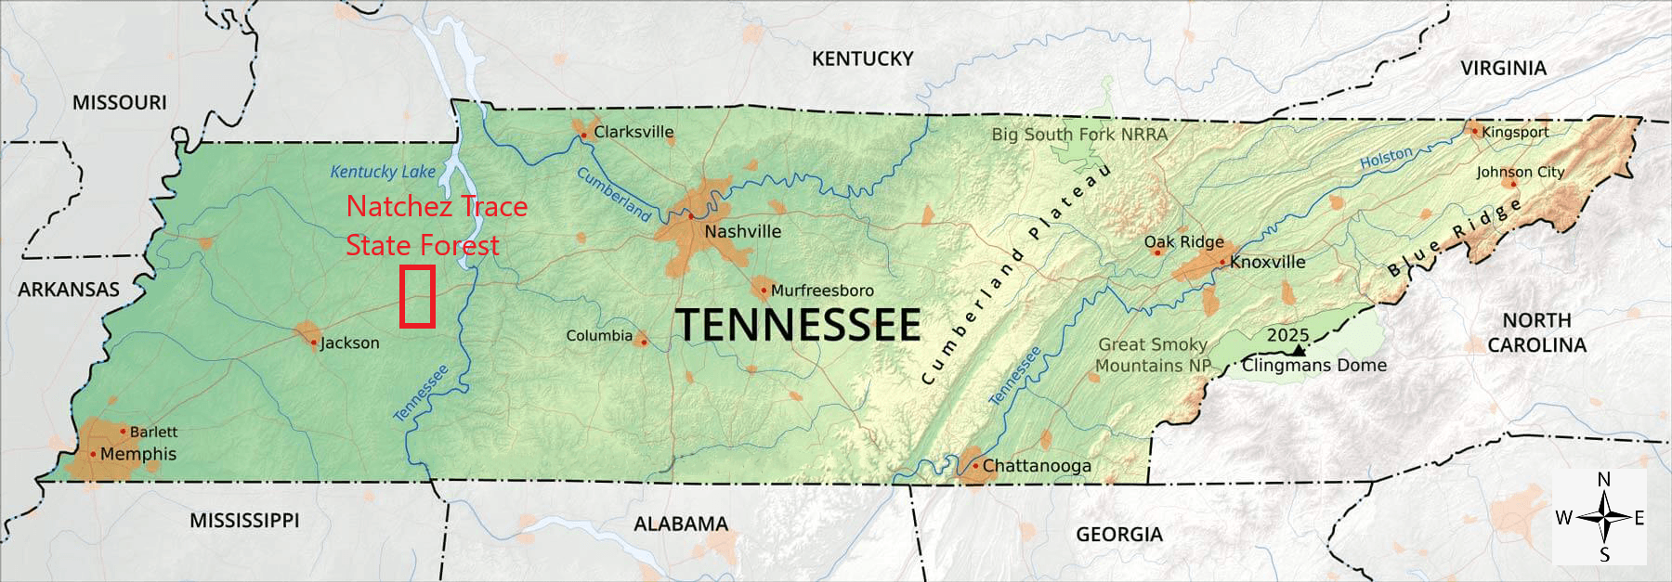
Figure 1: Location of Natchez Trace State Forest in Tennessee
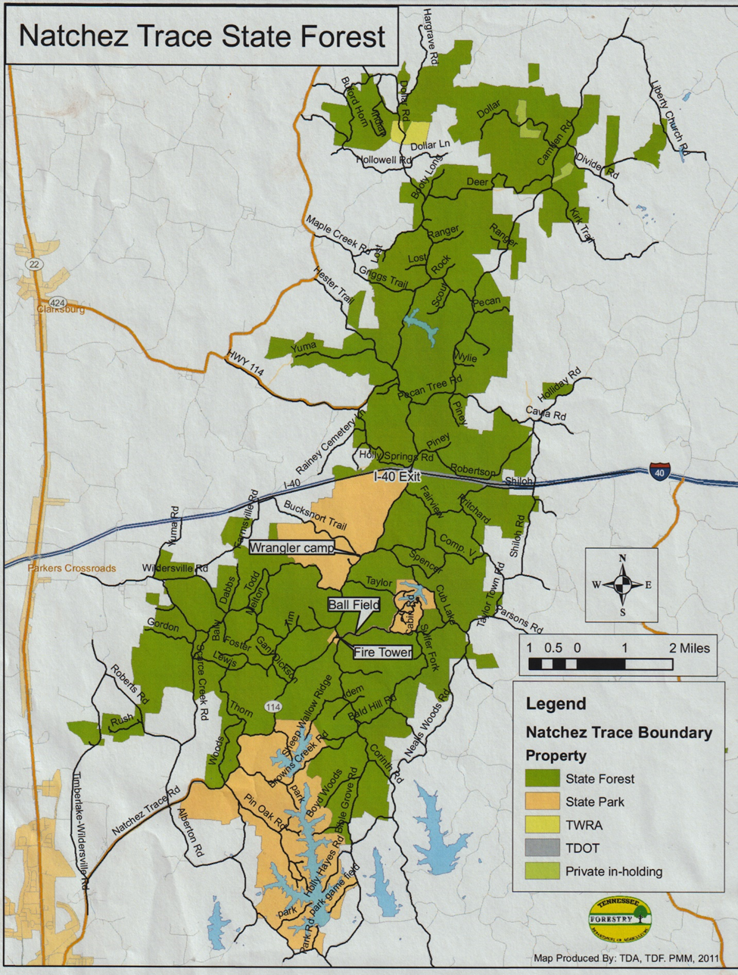
Figure 2: Map of Natchez Trace State Forest

The case study begins in the mid 1980's, when some users of NTSF and a state legislator became critical of the clearcutting practices at NTSF. Enough public support was generated to convince TDF to declare temporarily a "clearcut moratorium" at NTSF. While this declaration was never written into any legislation or policy, an alteration of harvest regime took place at NTSF in the early 1990's. All harvests conducted at NTSF from 1990 until at least 1997 were conducted as patch cuts, which were small clearcuts of only 2 to 5-acres. These patch-cut harvests were inaccurately described as "group selection" in an attempt to make them more palatable to the concerned users. Eventually, public pressure eased and there was a return to the rotational clearcut harvest regime, which is in place today. This study aims to determine what changes in forest composition has taken place as a result of this change in harvest regimes, and to determine the regenerative effects of patch-cut harvesting at Natchez Trace State Forest.
Chapter 2: Literature Review
The "central hardwoods region" includes most of Tennessee, Kentucky, Missouri, Illinois Indiana, Ohio, and parts of West Virginia, Pennsylvania, and Michigan, among others (Fralish 2003). Hardwoods dominate the region outside of commercial pine plantings and some mixed species stands. The central hardwoods region is perhaps best known for its oak-hickory forests, which are of vast economic and ecological importance (Fralish 2003). Much of forest management in the region focuses on oaks and oak regeneration. This focus is inspired by not only the high economic value of oak timber, but also its keystone role in supporting native wildlife populations throughout the region (Keyser et al. 2016).
The size of a harvest area is often defined by the method of regeneration and the light tolerance of regenerating species. On one end of the spectrum is clearcutting, with harvest sizes of 5+ acres to hundreds of acres. Single-tree selection is on the opposite end of the gap size spectrum with a single tree gap size. There are a variety of regeneration methods that fall between the two extremes mentioned above. These include seed-tree cuts, shelterwoods, and group selection. "Patch cutting", the harvest regime that this study is focused on, falls in this intermediate range as well. These regeneration methods developed as replications of natural gap-creating disturbances that have been observed for centuries. Patch cuts are much larger than group selections and simulate disturbances on much smaller areas than larger clearcuts. The same light spectrum used for gap sizes can be used to classify tree species. Larger openings will generally favor fast-growing, shade-intolerant species; whereas, smaller gap sizes will favor shade-tolerant species. However, light is not the only factor affecting regeneration. Site conditions such as soil, moisture, and seed bank also play key roles. Thus, predicting regeneration in a given area is not as simple as checking the list of native species and light tolerances.
Patch cutting, which is also referred to as simply "small clearcuts" or “patch clearcutting”, generally refers to a clearcut harvest of 2 to 5 acres. These 2 to 5-acre patches create small even-aged areas within a larger uneven-aged landscape (Meadows and Stanturf 1997). This harvest regime is often used to lessen the aesthetic impact of harvesting. Patch cutting is not a common harvest regime in the Central Hardwoods Region, and its regenerative effects have not been studied extensively. Similar harvest regimes of interest to this study such as clearcutting and group selection have been more extensively researched in the region (McNabb and Oprean 2021). However, patch cutting is more common in New England (Yamasaki et al. 2014), and most of the literature on the subject is from that region.
The patch-cut harvests at NTSF were initially publicly referred to as group-selection harvests. True group-selection harvests are much smaller than patch cuts. A group-selection harvest creates an opening that is one to two times the size of the surrounding mature trees (Nyland 2007). With group selection, the entire opening is influenced by the adjacent trees on the edge of the opening (LeDoux 1999). Patch cuts are large enough that there is at least some area where the ground receives full sunlight and is not influenced by the adjacent trees (Yamasaki et al. 2014). A study by McNabb and Oprean (2021) showed that group-selection harvests create light conditions suitable for regeneration of shade-tolerant and shade-intermediate species. In their study, poplar was more common in the center of the openings, and shade-tolerants and shade-intermediates were more common around the edge. Given the increased proportion of edge with a gap of this size, it would be expected that those shade tolerant/intermediates would benefit the most from a group-selection harvest. However, for shade-intermediate species like oak, advanced reproduction or cut stumps must be present in order to ensure that they will be present in the new stand (Clatterbuck and Meadows 1993). When a regenerated oak stem reaches 4-6 feet in height it is considered “advanced regeneration” (Schweitzer et al. 2016). Advanced regeneration of oak is an important prerequisite for oak to be a component in a new stand regardless of regeneration method, and there is a great deal of literature on the subject of advanced oak regeneration (Keyser et al. 2016).
Clearcutting is the most easily recognizable forest regeneration method and the most commonly used harvest regime in the Central Hardwoods Region. While harvest size varies depending on a multitude of factors, a harvest is generally considered a clearcut when it is five or more acres and can be as large as the harvest area allows. Ideally, clearcutting removes all trees in the stand, allowing full sunlight to the ground throughout the harvest area, regenerating an even-aged stand. Clearcuts fall into two categories: silvicultural clearcuts, where all stems are removed, and commercial clearcuts, where all merchantable stems are removed (Fox et al. 2007). The exposed soil is quickly overtaken by early successional species. Special care must be taken in areas near streams or highly sloped areas to prevent erosion. Clearcutting is a regeneration method, in forest management it is used to regenerate an even-aged stand. The practice of clearcutting has nothing to do with converting land to a different use, as is seen when land is cleared for economic development or pastureland.
Historically, disturbance events such as large wildfires created conditions similar to those of a clearcut harvest. Wildfires on that scale are rarely ever seen in the Central Hardwoods Region today. Thus, clearcut harvests play an important role in allowing early successional herbaceous plant species to persist. Early successional habitat has decreased throughout the United States for a variety of reasons (Yamasaki et al. 2014), including a reduction in disturbances and even-aged management like clearcutting.
The regenerative effects of clearcutting in the Central Hardwoods Region have been well documented. Tulip poplar is one of the greatest beneficiaries of a clearcut harvest in the Central Hardwoods Region, and a very common species throughout the region where moisture permits. Poplar is the state tree of Indiana, Kentucky, and Tennessee (McPherson 2013). This sun-loving species has wind-dispersed seed that remains viable in the seed bank for up to seven years, and it is a prolific stump sprouter (Beck and Della-Bianca 1981). Poplar grows incredibly quickly on the newly disturbed site. Oak species also regenerate consistently on clearcut sites, provided that there is a nearby seed source, advanced regeneration or an intact root system for sprouting. There are other harvest strategies that target oaks specifically, such as shelterwoods, but on average site, clearcutting will usually regenerate oak to an acceptable level if advanced regeneration and or stump sprouts are present (McGee 1992). New oak seedlings cannot compete with already established reproduction or sprouts (Johnson and Krinard 1976). Shade-tolerant species such as maple grow slowly and colonize an area after a clearcut if their propagules are present. They are still found in areas that have been clearcut, but they are generally relegated to the edges of the harvest area or are quickly overtaken by faster-growing species like poplar (McGee 1992). Maple will persist in the new stand in the midstory and understory. The ability to persist in the understory has made red maple (Acer rubrum) the most common tree in Tennessee (Oswalt et al. 2009).
Aesthetics aside, one of the largest impacts of harvesting is on the soil. All types of harvesting require careful planning and effective use of best management practices to minimize soil disturbances, but the less time spent in an area harvesting, the less potential for soil compaction and erosion (TDA-DF 2003). Every harvest area requires a road and or skid trails to make the harvest area accessible. These factors make clearcutting one of the least invasive harvest regimes from a soil perspective. The stand is only entered once to harvest, and the need for several roads is usually reduced. Patch cuts require a road for every harvest site. Shelterwood harvests require multiple entries into the stand to harvest. Using best management practices, loggers can prevent soil issues from arising due to any type of harvesting, but clearcutting, contrary to popular belief, actually minimizes the possibility of harvest-related soil issues since the stand is only entered once. (McGee 1992). While best management practices have been nearly universally adopted in developed countries like the United States, this is not the case worldwide. Unsustainable clearcut harvests in places like the Amazon rainforest seen on various news outlets have given clearcutting a very negative reputation.
A study conducted in New Hampshire by Yamasaki et al. (2014) observed the regenerative effects of patch cuts in comparison to those of clearcuts and shelterwood cuts. The study observed regeneration at the harvest sites approximately eight years after the cuts took place. The findings showed that all of the patch-cut areas regenerated a significant amount of birch species (Betula spp.). Some of the patches also included significant regeneration of beech and aspen (Populus spp.). The group of species found in New England is significantly different than those in the Central Hardwoods Region. However, birch and aspen play similar roles in the New England system as poplar and sweetgum do in the Central Hardwoods Region. The length of time in the Yamasaki et al. (2014) study differs from this study in that the regeneration was sampled at an age of eight years.
Another objective of Yamasaki et al. (2014) was to determine the impacts of different harvest regimes on breeding bird populations. They mention that early successional habitat is declining across the Eastern United States. This decline is due to a variety of factors, one of which is a reduction of even-aged management. The reduction in even-aged management is a result of less disturbance (highly effective wildfire control) and waning use of clearcutting to initiate early successional habitat. Yamasaki et al. (2014) determined that all three regeneration methods they implemented (clearcut, patch cut, and shelterwood) increased the early successional, brushy species favored by a majority of the breeding bird population. However, the results showed that clearcutting produced a significantly richer breeding bird population, especially 3-6 years post-harvest. Patch cuts can produce similar results, but the smaller scale and greater edge effect limits the amount of early successional habitat available. It can also create habitat fragmentation due to the areas of uncut forest between patches. There were also bird species with range sizes greater than the size of the patch cuts. These bird species were found in the clearcut areas, but not in the patch-cut areas or shelterwoods. The conclusions of their research describe early successional as ephemeral and reiterate that the best management scheme for wildlife that uses this type of habitat is a harvest rotation that always keeps early successional habitat available, a management scheme used on many public lands.
Management decisions on public lands are subject to a great deal of scrutiny. Managing multi-use areas has always proved difficult due to the number of stakeholders with conflicting interests. Recent trends have shown that while the number of traditional natural resource users like hunters and anglers has declined, the number of non-consumptive users has increased (Youn et al. 2017). This change in use requires a shift in perspective when making management decisions. However, this shift is not easily made, as under the current funding system in much of the United States, consumptive natural resource users are the ones who fund management the most (Poudyal et al. 2012). Regardless of use, public participation in natural resource policymaking has been increasing (Youn et al. 2017 and Kakoyannis et al. 2001). In Tennessee, state forests are managed by TDF, and outlined by the state forest management plan, which establishes that TDF is responsible for maintaining a state forest system via multiple use management of renewable and non-renewable resources to suit the needs of the people of Tennessee (TDA-DF 2009). According to the state forest management plan, no state appropriated funding is used in the management (fire, recreation, timber, infrastructure, maintenance) of the state forest system. Thus, the state forest system must be self-sustaining through income generated via timber harvesting. This balancing act of providing multi-use recreation whilst also harvesting timber in a manner that is sustainable both economically and environmentally makes management decisions at Tennessee state forests very complex.

Chapter 3: Research Objectives
The objective of this study is to determine the regenerative effects of the change in harvest regime at NTSF in the 1990’s. This objective will be completed by determining the species composition of the patch-cut areas, as well as the species composition of clearcut areas that were harvested prior to the change. A secondary objective of this study is to determine the effect location has within the harvested area on what species regenerate. This objective will be completed by taking plots at various locations relative to the edge throughout the areas that were harvested. The hypothesis of this study is that the change in harvest method will result in more regeneration of shade-tolerant species that are of lower timber and wildlife value than shade-intolerant pioneer species and intermediate oak species. This study encompasses 25 to 30-year results, which is a period of time not found in the literature.

Chapter 4: Methods
This study was conducted at Natchez Trace State Forest near Wildersville, Tennessee. Data used in the study were collected in June of 2020.
NTSF harvest maps were supplied by the Tennessee Division of Forestry. Using these harvest maps, "patch cuts" were identified and selected to be studied. The maps are on the "harvest unit" scale. Four harvest unit maps located throughout NTSF were selected to ensure an accurate representation of the area. Within each harvest unit, there are many individual patch cuts. Four patch cuts were selected from each harvest unit (Figure 3). Patch cuts were selected with regard to accessibility as 25+ years of growth make finding some patch cuts difficult. Once the patch cuts were selected, six 1/20th acre plots were taken in each one. The plots taken within the patch cuts were also categorized based on their proximity to the edge of the harvest area. Two plots were taken near the edge of the harvest area, two plots near the center, as well as two plots in the intermediate range between the edge and center (Figure 4). Since the cuts sizes and shapes varied drastically, plot selection was subjective, but without pre-conceived bias. This was done to determine if there was a noticeable change in species composition along the gradient of light conditions that would have been seen at the time of harvest. Within each plot, every tree with a DBH of 5 inches or greater was measured and species determined. Diameter was determined using a logger's tape and measured to the nearest inch. This process yielded a total of 96 plots taken in patch-cut areas.
A similar process was used to measure four different large clearcut areas. The clearcut areas were once again selected using maps provided by TDF (Figure 5). Four large clearcut areas from the early to mid-1980's were selected and measured. For each clearcut, nine 1/20th acre plots were taken. Three plots were taken near the edge of the cut, three plots in the intermediate range, and three plots near the center of the cut. As with the patch cuts, all trees with a DBH of 5 or more inches were measured using a logger's tape and species determined. This process yielded a total of 36 plots taken in clearcut areas.
The collected plot data were entered into a Microsoft Excel spreadsheet. Data from the four patch-cut harvest units were compiled into one sheet, and the data from the four clearcut harvest units were also compiled into one sheet. Patch-cut data were also organized separately based on the location of the plots relative to the edge, as was mentioned above. Using these two groupings, as well as the patch-cut sub-groupings, various metrics of species composition, tree growth, and stand stocking were calculated. These metrics were analyzed and compared in order to determine the validity of the study hypothesis, and the state of those forests 25-30 years after harvest. Data were also compiled using JMP to determine the statistical significance of the harvest regime and plot location effects on species composition. In JMP, trees per acre and basal area per acre were calculated for each species. These values were used to run an effect test with treatments of harvest regime and location within a harvest, as well as a blocking factor of harvest site.

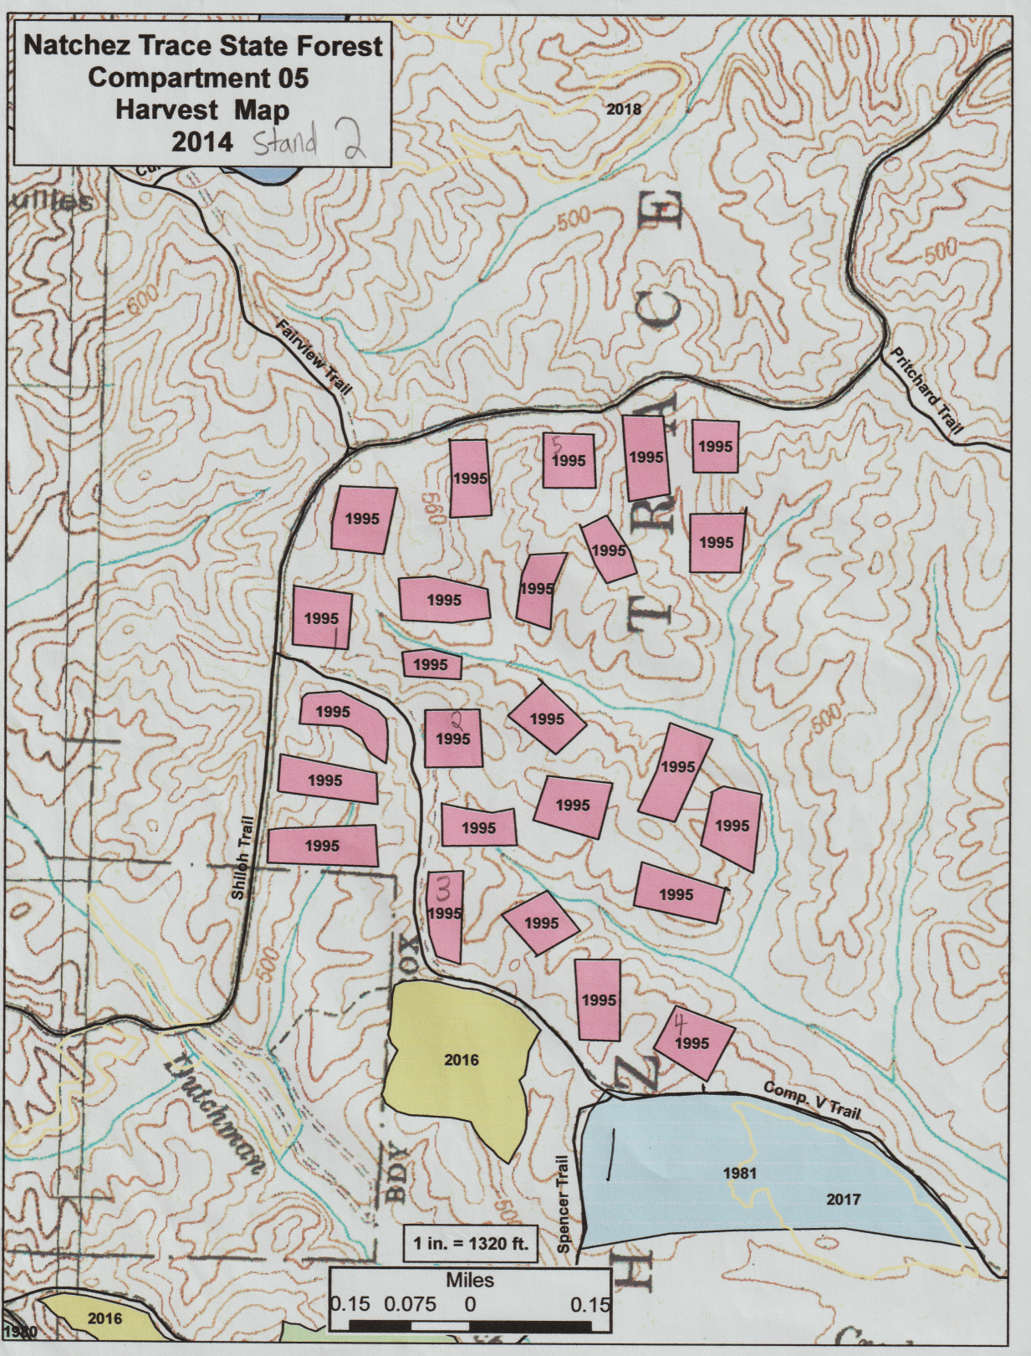
Figure 3: Harvest unit map provided by TDF showing both patch cuts and a clearcut
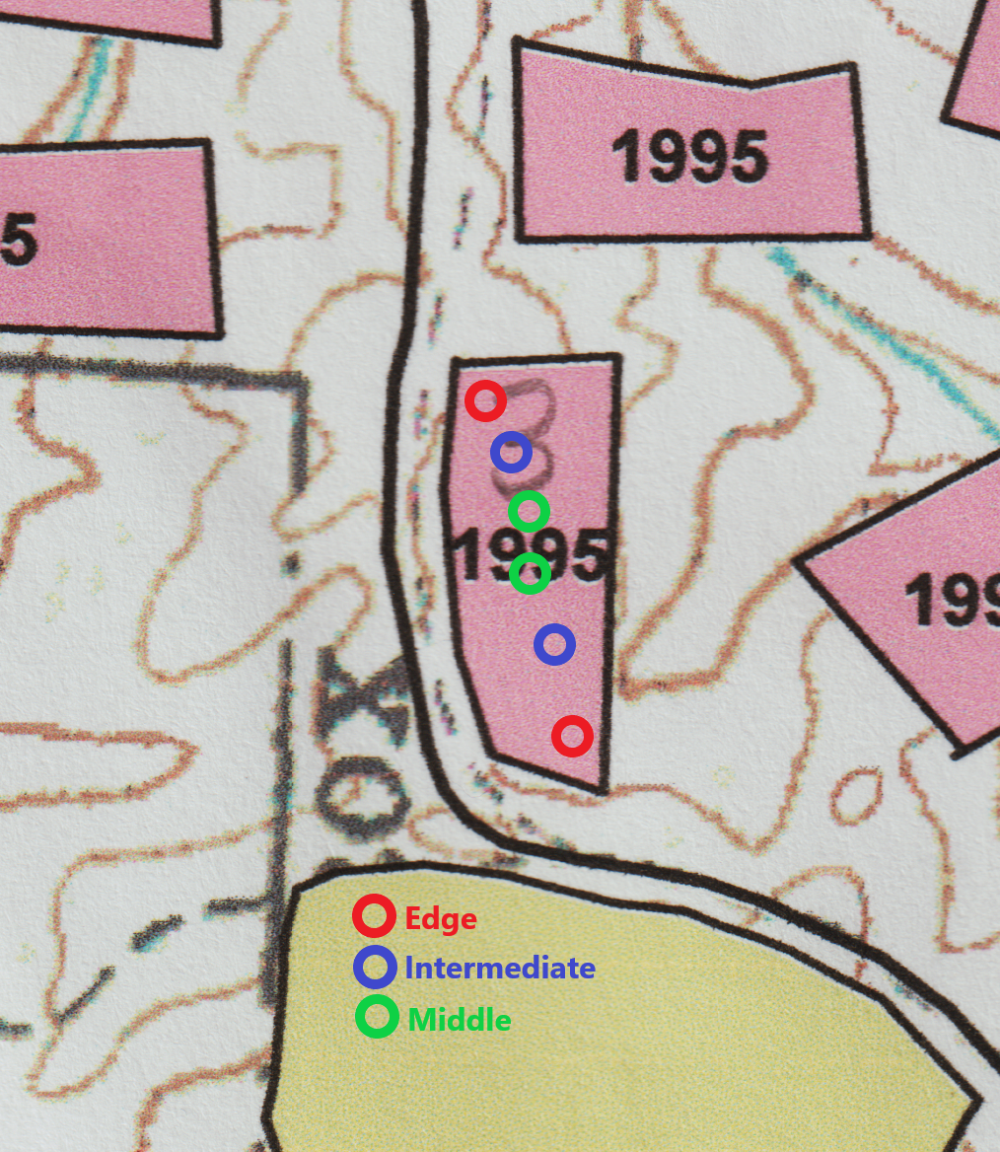
Figure 4: Example of how plots were arranged in a patch cut

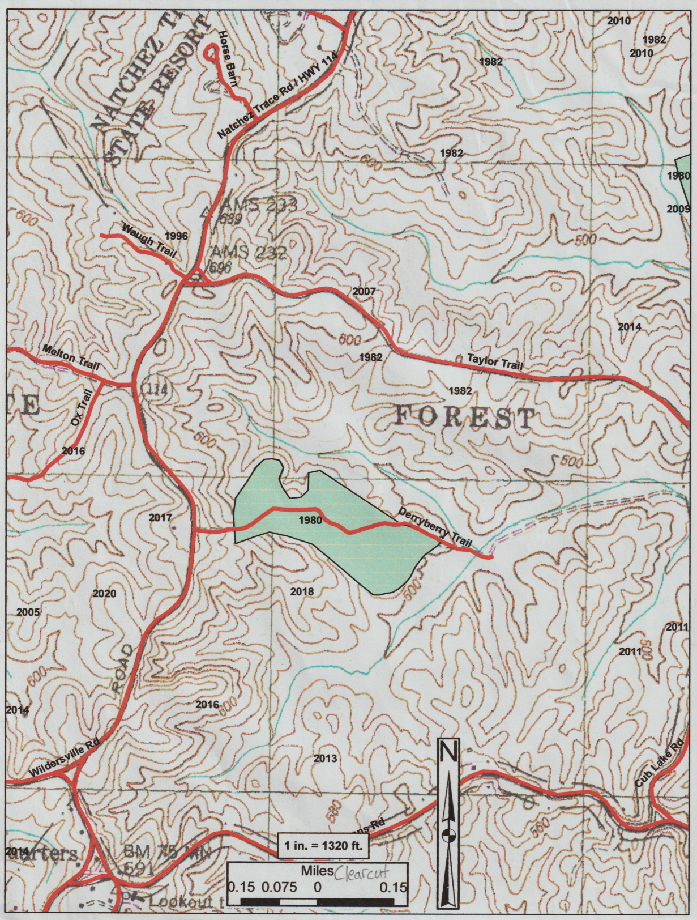
Figure 5: Harvest unit map provided showing a clearcut

Chapter 5: Results
Patch Cuts
The patch cut areas of this study were harvested from 1991-1995. Four patch cut harvest units were selected. For each harvest unit, four patches were selected. Each patch was sampled by taking 6 1/20th acre plots (Figure 4). This process yielded 96 total plots, with 969 total trees sampled. When all patch cuts were compiled, there was an average of 201.7 trees per acre and 65.6 square feet of basal area per acre.
Tulip poplar was by far the most dominant species present, accounting for 44% of the total stems measured (Figure 6) with 88.5 trees per acre. Sweetgum (19%, 39 TPA) and cherry (13%, 27.1 TPA) were the next most commonly observed species in the patch cuts. Red oaks and white oaks combined only made up 3% of the total stems with a combined 6.5 trees per acre. The rest of the trees were maple (6%, 11.5 TPA) or fell into the miscellaneous category (15%, 29.2 TPA).
The diameter distribution follows the reverse-J pattern that is expected of stratified, even-aged stands (Figure 7). Poplar was not only the most plentiful species, but also the largest, with an average DBH of 7.8 inches (Figure 8). Sweetgum was the next ranking species in diameter.
The species composition was also calculated using total basal area of each species (Figure 9). Poplar was even more dominant by this metric, making up 50% of the total basal area with 32.7 square feet of basal area per acre measured in the patch-cut areas. Sweetgum and cherry were still the next two most prevalent species with 11.5 and 6.2 square feet of basal area per acre, respectively. Red and white oaks combined represented only 3% of the total basal area with 2 square feet of basal area per acre.
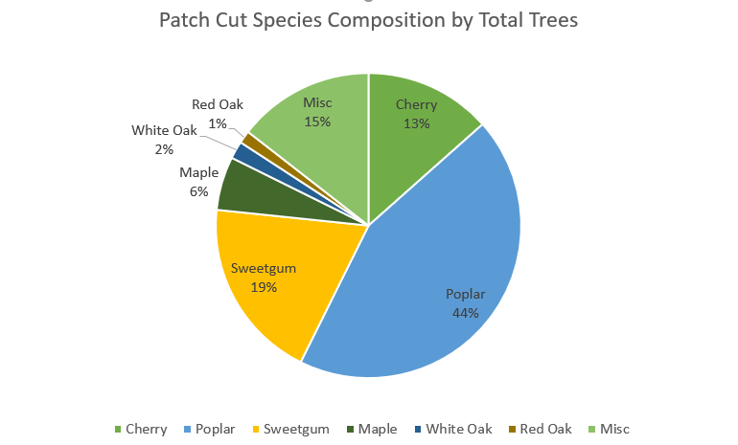
Figure 6: Total patch cut species composition calculated with trees per acre

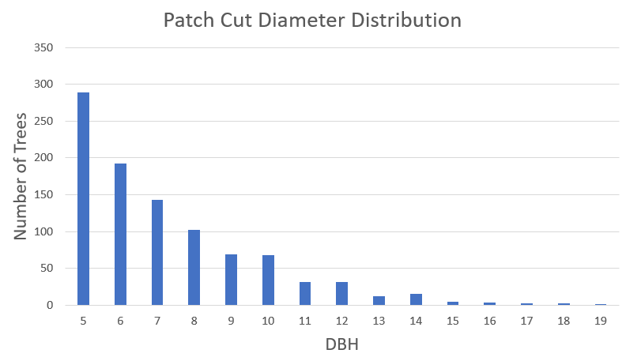
Figure 7: Diameter distribution of patch cuts
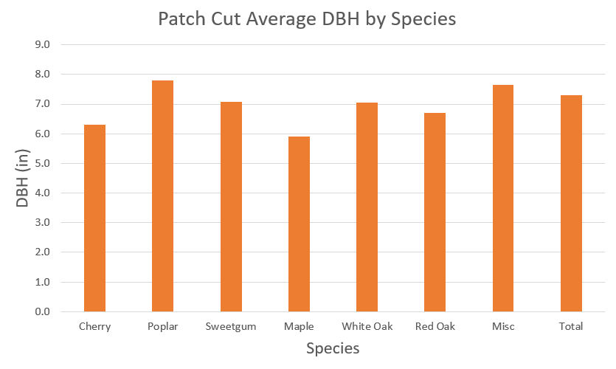
Figure 8: Average DBH of notable species in patch cuts

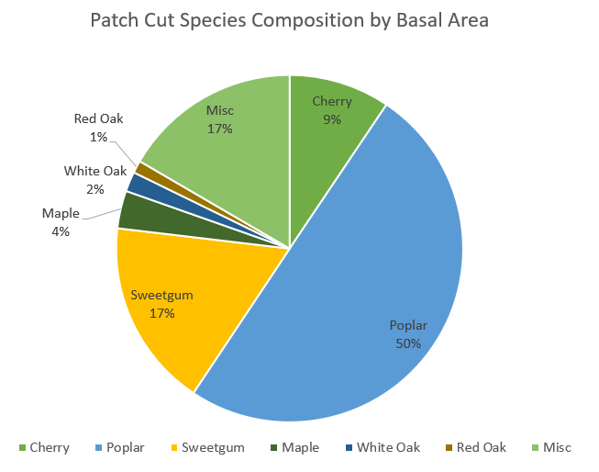
Figure 9: Total patch cut species composition calculated with basal area per acre
Clearcuts
The clearcut areas of this study were harvested in 1979-1981. Four clearcuts were selected. Each clearcut was sampled with 9 1/20th acre plots (3 edge, 3 intermediate, 3 middle) for a total of 36 plots, which contained 311 trees. When compiled, the clearcuts averaged 172.8 trees per acre and 98.9 square feet of basal area per acre.
Poplar was also the most prevalent individual species in these areas, accounting for 21% of the total stems (Figure 10) and 36.1 trees per acre. Red oaks make up 20% of the total stems (33.9 TPA) and white oaks make up 18% (30.6 TPA) in the clearcut areas, making oak the dominant species when combining these two groups. Other species included sweetgum (9%, 16.1 TPA), cherry (7%, 12.8 TPA), and maple (5%, 11.1 TPA). Miscellaneous species (species that account for less than 4% of the total stems) accounted for 19% of the total stems and 32.2 trees per acre.
Diameter distribution once again follows a reverse-J shape (Figure 11), though there is some slight variation. Poplar also had the greatest average DBH with an average of 11 inches (Figure 12). The average diameters of white oak (10 inches) and red oak (9.6 inches) followed poplar.
The species composition of the clearcuts was also calculated using total basal area (Figure 13). Poplar made up the highest proportion of total basal area (27%) with 47.7 square feet per acre. but the oaks remained strong as well with 34.4 square feet of basal area per acre for red oak and 36.2 square feet per acre for white oak. If white oaks and red oaks were combined, these two categories made up a greater proportion of the total basal area (39%) than poplar (27%). Sweetgum accounts for 12.6 square feet of basal area per acre (7% of the total) and cherry accounts for 8.6 square feet per acre (5% of the total).
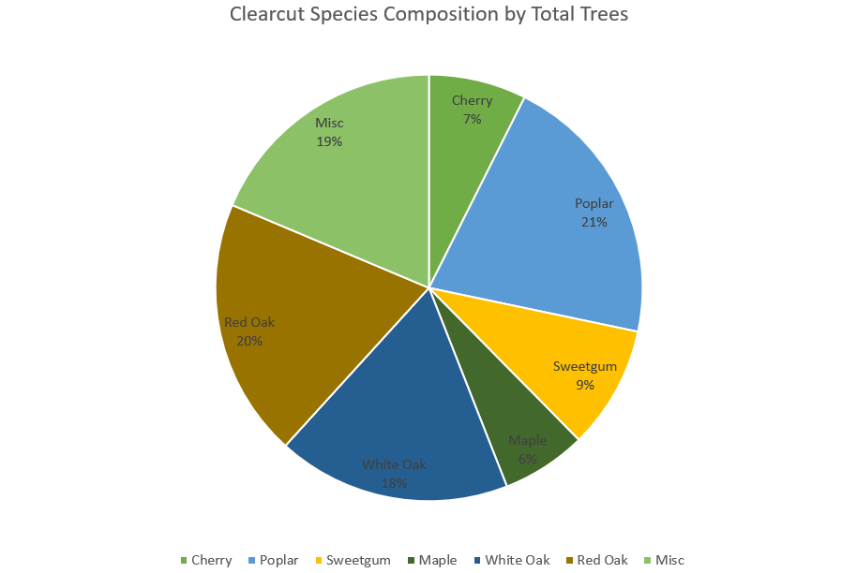
Figure 10: Total clearcut species composition calculated with trees per acre

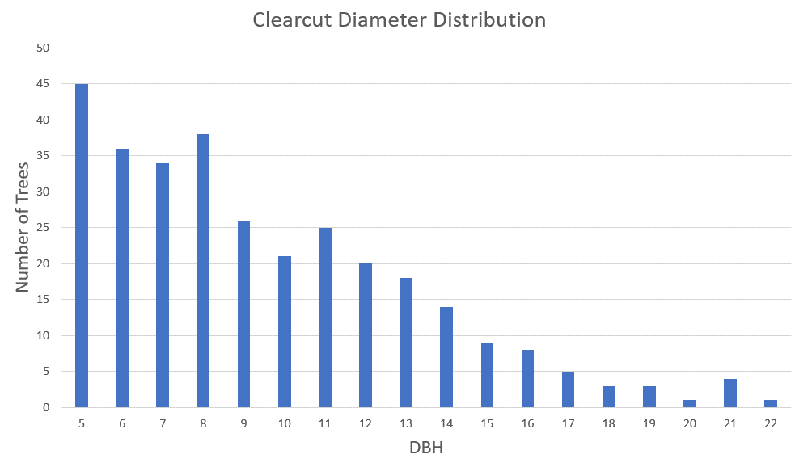
Figure 11: Diameter distribution of clearcuts

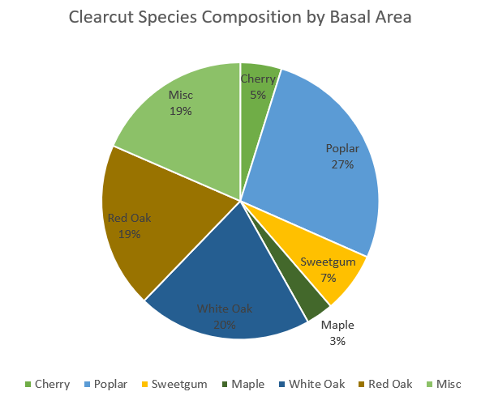
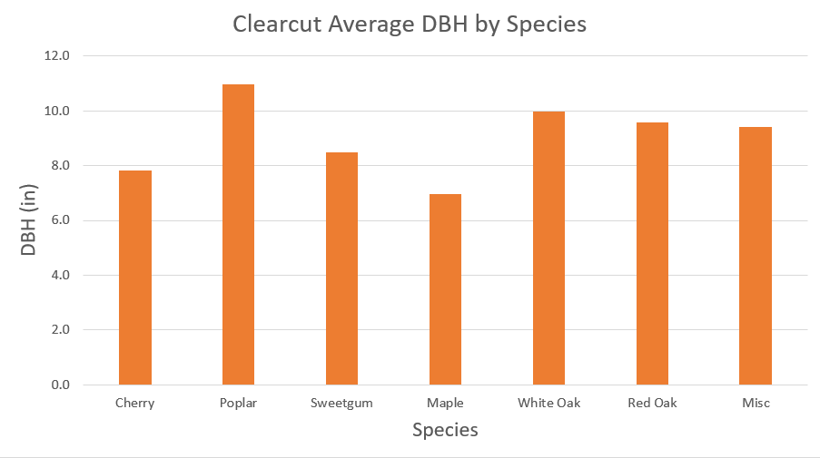
Figure 12: Average DBH of notable species in clearcuts
Figure 13: Total species composition of clearcuts calculated with basal area per acre
Plot Location
The plots taken within the patch cuts were also categorized based on their proximity to the edge of the harvest area. For plots nearest to the edge of the patch, poplar was still the most common tree, accounting for 34% of the total stems in those plots (Figure 14). The species composition varied slightly regarding the position of the plot within a patch (Table 1). The increase in miscellaneous species in the edge plots was primarily due to an increase in loblolly pine in those plots.
Data were also analyzed using JMP Pro 15. An effect test for harvest method, harvest site, and plot location was run for each species of interest. The test was run using the trees per acre by species for each treatment/factor. Harvest regime returned a P-value of < 0.05 for every species of interest except maple (Table 2), indicating a statistically significant relationship between harvest regime and trees per acre for those species. Location returned a P-value of < 0.05 for poplar (Table 2), indicating a statistically significant relationship between poplar trees per acre and location within a cut. Harvest site was statistically non-significant.

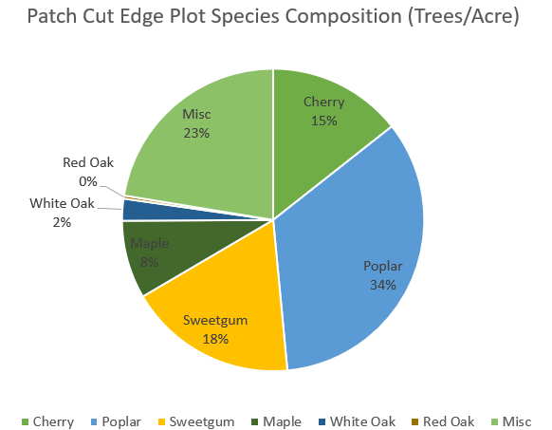
Figure 14: Species composition of patch cut edge plots calculated using basal area per acre

Table 1: Species composition as a percentage of total trees per species for each of the three patch cut plot locations.
Species | Edge | Intermediate | Middle
Cherry | 14.4% | 12.0% | 13.8%
Poplar | 34.1% | 50.8% | 45.6%
Sweetgum | 18.1% | 13.6% | 24.9%
Maple | 8.4% | 7.1% | 3.0%
White Oak | 2.3% | 1.6% | 1.7%
Red Oak | 0.3% | 2.6% | 1.1%
Misc | 22.4% | 12.3% | 9.9%

Table 2: P-values from JMP for harvest regime and location effect tests for species of interest. (Values in red show a significant (P < 0.05) relationship)
Effect | Cherry | Maple | Poplar | Red Oak | Sweetgum | White Oak
Harvest Regime | 0.0333 | 0.9165 | 0.0141 | 0.0226 | 0.0072 | 0.0498
Harvest Site | 0.3844 | 0.3838 | 0.9506 | 0.9494 | 0.2916 | 0.9776
Location | 0.7148 | 0.5576 | 0.0332 | 0.4487 | 0.1058 | 0.6724

Chapter 6: Discussion
Little research has been conducted on patch cuts in the Central Hardwoods Region. This is due in large part to the seldom use of that harvest method in the region. The seldom use of the patch cut can be attributed to a variety of factors such as economic returns and cost of harvesting. More commonly used regeneration methods include clearcutting, which provides the greatest single harvest returns and shelterwood, which creates optimal light conditions to regenerate oaks. Clearcuts also allow for large areas of early successional habitat for 5-10 years, which is excellent habitat for many wildlife species. However, aesthetics play a role in management of public lands, and that will only continue to grow with increased social emphasis on natural resource management. Patch cutting was a solution to this issue of aesthetics faced by the managers of NTSF.
The patch-cut survey results were surprising. While the hypothesis of this study predicted that shade-tolerant species would make up a significantly higher proportion of the species composition in the patch-cut areas when compared to the clearcut areas, this was not the case. Poplar dominated the patch-cut areas, including the edges. Literature from the region regarding group-selection harvests had given the expectation that poplar would be present in the middle/intermediate areas of the patches, but it would not be as common near the edge (McNabb and Oprean 2021). While the surrounding areas were not sampled, the change in species composition from the patch-cut site to the uncut surroundings was stark enough that it could be noticed when walking through the forest trying to find the patch-cut harvest sites.
Poplar was prevalent all the way to the edge of the harvest areas. Shade-tolerant species such as maple were present, but virtually absent from the overstory. Given the domination of poplar on these sites, it was not surprising that cherry and sweetgum were the next most commonly observed species. Sweetgum regenerates with poplar at sites within the stand where it is too moist for poplar (Eyre 1980). Cherry is shade intolerant and is often associated with poplar as a pioneer species, especially at the edge of harvest area (Eyre 1980). The results of this study, however, do not show a difference in cherry prevalence regardless of location within the patch cuts. Regardless of its dominance in relation to other species, the growth of poplar on the patch-cut sites shows that these sites are highly productive. While height measurements were not recorded, the average DBH of poplar after approximately 25 years should translate to a high site index (Beck 1980).
When using basal area to calculate the species composition of the patch-cut areas, poplar made up 50% of the total species composition (Figure 9). This increase over poplar’s percentage of total stems shows that poplar stems are also the largest and take up the most growing space. Maple was the shade-tolerant species expected to be the beneficiary of the patch-cut harvest regime along the edges, but it accounted for 6% of stems (Figure 6) and only 4% of the basal area (Figure 9) in the patch-cut areas. The patch cuts have not regenerated a suitable forest for the management goals of NTSF. While shade-tolerant species have not come to dominate the regenerated openings as was hypothesized, the regenerated openings are dominated by poplar and sweetgum, which do provide a some timber value, but offer very little in the way of providing wildlife habitat when compared to oak-hickory forests. The lower species diversity combined with poor wildlife habitat also makes these stands less aesthetically pleasing.
The edge plots did show an increased proportion of shade-tolerant species when compared to the intermediate and middle plots (Table 1). However, this increase was not as large as expected. The basis for this expectation was the assumed decrease in sunlight on the ground in these edge areas at the time of stand initiation. Literature review also led to the expectation that shade-tolerant and intermediate species would be more common near the edge of a patch-cut harvest. Species composition did not change linearly from edge to intermediate to middle, except for maple (Table 1). This is likely due to the intermediate and middle plots having similar light conditions at stand initiation. Maple being the most shade tolerant of any of the species of interest was likely the only species that was sensitive enough to light conditions to see a step down at each level from edge to middle.
Species composition was expected to change somewhat linearly along the gradient of the three plot locations because of the different light conditions at each location. The species composition was similar to that of the patch cuts as a whole, but the decrease in the prevalence of poplar when compared to the patch cut totals was made up for by a slight increase in cherry and maple stems and a larger increase in the percentage of miscellaneous stems. The increase in miscellaneous stems was largely an increase in loblolly pine stems, which likely established at the time of harvest due to seed sources in the adjacent unharvested area. Loblolly pine was not categorized because it will eventually be outcompeted by hardwoods and is not a targeted species for either of the regeneration methods observed in this study.
Poplar was still by far the most dominant species at the edge (Figure 14). This leads to the assumption that the soils in the area must be productive enough that a fast-growing, shade-intolerant species like poplar can outcompete already established shade-tolerant species to the canopy, despite the diminished light conditions when compared to the center of the patches. Although poplar is classified as a pioneer, highly shade-intolerant species (Beck and Della-Bianca 1981), based on this research, poplar is more adaptable to and aggressive in slightly less amounts of sunlight than originally perceived by the author. As seen in Table 1, the miscellaneous species composition percentage is reduced sharply toward the middle of the patch. Poplar gained a significant portion of the species composition when moving towards the center of the patches, but it was still the most dominant even on the edge. Oak species showed little variation in prevalence regardless of plot location, though there were so few oaks.
The clearcut areas show a very high proportion of oak in the canopy (Figure 10). This was unexpected given how prolific the poplar was on the patch-cut sites, combined with the virtual absence of oak from those sites. While the approximately 10-year age difference between the patch cuts and clearcuts has given the slower-growing oak more time to mature, the near absence of oak in the patch cuts guarantees that it will not be present in those stands if left unmanaged. The 10-year age difference is visible in the diameter distribution and average DBH of the species of interest (Figures 11 and 12). Poplar was the largest species by average DBH found in the clearcut areas, as it was in the patch cuts. This further affirms that the soils at NTSF are very productive for poplar.
When combined across the two groups, oaks are the most dominant species group in the clearcut areas, even overtaking poplar. This was an unexpected result given that the stands had seen little to no management and how dominant poplar was in the patch-cut areas. The oak in these stands was also of high quality, but no data were collected regarding the quality of the trees since the focus of this study was on species composition.
The older age of the clearcut areas was also seen in the diameter distribution (Figure 11). While it still follows the reverse-J pattern expected of stratified even-aged stands, there is more variation than there was with the patch-cut diameter distribution (Figure 7). Poplar was once again the species with the largest average DBH (Figure 12). Oaks were the next greatest species by average DBH not far behind that of poplar. Overall, the species composition of the areas that were clearcut is very diverse when compared to the patch cuts. Comparing Figure 9 and Figure 13 highlights the difference in species diversity between the two harvest regimes. The difference between the clearcut harvests and the uncut surroundings was much harder to distinguish when compared to the stark contrast seen with the patch cuts. The species composition found in the clearcut areas satisfies many of the management objectives at NTSF for a mature forest. This forest composition provides ample recreation opportunities, high timber value, and is aesthetically pleasing.
The near absence of oak in areas that were patch cut despite oak being dominant in areas that were clearcut is perplexing. Overall light conditions are different between the two harvest regimes, but oak being a shade-intermediate species leads to the expectation that it would appear more often than it did in the patch-cut areas given the precedent of the clearcuts which took place at an earlier point in time. While disturbances and mast cycles certainly play an important role in oak regeneration, the areas that were sampled for this study were harvested across multiple years, meaning that any one-year disturbance or mast event would be noticeable when comparing harvest sites.
Selecting harvest sites throughout NTSF also ensured that site conditions were similar. One potential explanation for the difference in oak prevalence is moisture conditions at the sites at stand initiation. The larger openings created by clearcuts allow full sunlight on a significantly larger area than patch cuts. This increased sunlight could reduce the amount of moisture in the soil, making for conditions that allow oak to compete with poplar. The clearcut areas have also had 10-15 more years to grow than the patch-cut areas, giving oak more time to catch up to the faster-growing poplar. However, there is so little oak in the patch-cut areas that there is no path for it to become a dominant species in those areas even with more time to grow.
Another consideration is the state of oak regeneration in the patch-cut areas at the time they were harvested. Pre-harvest regeneration data for the areas that were patch cut at NTSF are not available. As noted in the literature review, new oak seedlings cannot compete with poplar. If there was very little advanced oak regeneration in the patches at the time of harvest and few stumps to sprout from, there was little chance for oak to regenerate in the patch-cut areas (Schweitzer et al. 2016). Thus, when oak regeneration is a management objective, regeneration surveys should be conducted prior to harvest. Given the incredibly small percentage of oak in the patch cuts, it is assumed that there was very little advanced regeneration at the harvest sites. The average DBH of the poplar in the clearcut areas is proportional to the average DBH of the poplar in the patch-cut areas, given the age difference (Figures 8 and 12). Given similar site productivity, the difference in regeneration method played a major role in the regenerative success, or lack thereof, of oak species.
The statistical analysis portion of this study was used to determine if the comparisons made regarding harvest regimes were statistically significant. Statistical analysis showed that there was a significant (P < 0.05) relationship between harvest regime trees per acre for every species of interest other than maple, and the null hypothesis that harvest method did not have an effect on poplar trees per acre can be rejected (Table 2). Poplar was the only species of interest that showed location as a statistically significant treatment (Table 2). The blocking factor of harvest site did not prove to be statistically significant for any species. These findings support the conclusion that harvest regime did have an effect on the species composition of the now-regenerated harvests.
Location of the patches could also play a role in the regeneration that occurred following harvest. There was no information available regarding the criteria used to select individual patch-cut sites. The harvest units where the patch cuts were located were the areas that were to be harvested based on the rotation regardless of the harvest regime at the time. If a lack of advanced regeneration at the patch-cut sites is to blame for the absence of oak in the new stand, then different patches should have been selected to meet the management objectives. Patch cutting is a much more intensive and time-consuming harvest regime, but this increased effort should allow for adjustments like tailoring the patch sites to areas with more advanced oak regeneration. If advanced oak regeneration was not present throughout the harvest unit, alternative management decisions should be made to increase the amount of oak regeneration, or management objectives should be re-evaluated.
The results of this study make a strong case for continued use of the clearcut harvest regime at NTSF. However, the areas that were patch cut are not at a complete loss. Poplar and sweetgum can provide timber value in a normal market. Poplar’s fast rate of growth also means shorter harvest rotations. Nevertheless, the areas that were clearcut are of much greater value to NTSF. The high proportion of oak found in these areas not only provides a great deal of economic value when the areas are harvested again, but also provided excellent wildlife habitat and food supply. Increased wildlife value of an area also increases the recreational value by providing excellent hunting and wildlife watching opportunities. The increased species diversity of the clearcut areas also makes them more resilient to disturbances. Intermediate operations, while costly, can help increase the amount of oak regeneration in the understory of the patch-cut sites.

Chapter 7: Conclusion
The results of this study show that patch cutting is not effective to create the species composition and species diversity needed to meet the needs of a multi-use area like Natchez Trace State Forest in the Central Hardwoods Region. Additional research at other sites throughout the region could help determine how site quality plays a role in the species composition of patch-cut regeneration. The current state of the clearcut areas shows a highly desirable and diverse species composition that meets many of the management objectives at NTSF, while the patch cuts are composed mainly of monotypic poplar. There are a variety of hypothesized reasons for the domination of poplar on the patch-cut sites, but given the success of oak on the clearcut sites and clearcutting being a less intensive harvest regime than patch cutting, clearcutting is the better regeneration method for NTSF.
The results of this study raise a variety of questions that could be answered with further research. To start, there is the question of scale, and how applicable the results of this study are for the Central Hardwoods Region as a whole. This question could be answered with additional study sites at locations that have been patch cut throughout the region. Another interesting measurement that this study did not incorporate is tree quality. Adding additional measures of tree quality could help more specifically determine the economic consequences of the harvest regimes, as well as answer species specific growth questions. The stark difference in the proportion of oak between the two harvest regimes was unexpected. The patch-cut areas were the initial point of interest in this study, and they were sampled much more intensively than the clearcut areas. While efforts were made to ensure that plots were representative of the stands as a whole, additional clearcut sites could help further justify the findings of this study in regards to the oak prevalence in clearcut areas. Further research could also test various explanations for the differences between the two harvest regimes. Light and moisture measurements at the time of stand initiation in both patch cuts and clearcuts could help determine the effects of those site conditions on regeneration. Sampling regeneration before a patch-cut harvest and then conducting a survey 25 years post-harvest like this study could also answer questions regarding the state of advanced regeneration when the NTSF patch cuts occurred.
Poplar was expected to be a component of the regenerated patch cuts as indicated by the literature. However, it was not expected to dominate the regenerated stands all the way up to the edge. Poplar is very adaptable and can prosper on a wide range of sites (Beck 1980). In this study, it flourished even in areas where light conditions were not optimal. Further research as outlined in the preceding paragraph would be required to determine specifically what led to its domination of the sites.
Changes in harvest regimes on public lands are rarely quick and easy processes. Given the number of stakeholders, finding a palatable solution that satisfies all of the stakeholders is very difficult. Social science concerns must be addressed when managing public lands. However, managers of these areas are trained to provide suitable solutions to meet the needs of their forest management plan and to maintain healthy and sustainable forests. One of the objectives of this study was to provide additional guidance for these management decisions.

References
Beck, Donald E. “Yellow-Poplar.” USFS Southern Research Station. United States Forest Service, 1980. https://www.srs.fs.usda.gov/pubs/misc/ag_654/volume_2/liriodendron/tulipifera.htm.
Beck, Donald E, and Lino Della-Bianca, “Yellow-Poplar: Characteristics and Management”. Agriculture Handbook Number 583. 92p. 1981.
Clatterbuck, W. K., and J. S. Meadows. “Regenerating Oaks in the Bottomlands.” In Oak Regeneration: Serious Problems Practical Recommendations, 184–95. Asheville, NC: USFS Southern Research Station, 1993.
Eyre, F. H., ed. Forest Cover Types of the United States and Canada. Washington, D.C.: Society of American Foresters, 1980.
Fox, Thomas R., Carola A. Haas, David W. Smith, David L. Loftis, Shepard M. Zedaker, Robert H. Jones, and A.L. Hammett. “Alternative Silvicultural Practices in Appalachian Forest Ecosystems: Implications for Species Diversity, Ecosystem Resilience, and Commercial Timber Production.” U.S. Forest Service. USDA, 2007. https://www.srs.fs.usda.gov/pubs/29226.
Fralish, James S. “The Central Hardwood Forest: Its Boundaries and Physiographic Provinces”. General Technical Report NC-234. St. Paul, MN: U.S. Dept. of Agriculture, Forest Service, North Central Research Station, 2003.
JMP®, Version 15. SAS Institute Inc., Cary, NC, 1989-2019
Johnson, Paul S., Stephen R. Shifley, and Robert Rogers. The Ecology and Silviculture of Oaks. Wallingford: CABI, 2002.
Johnson, Robert L., and R. M. Krinard. “Hardwood Regeneration After Seed Tree Cutting.” U.S. Forest Service. USDA, January 1, 1976. https://www.fs.usda.gov/treesearch/pubs/43018.
Kakoyannis, Christina, Bruce Shindler, and George Stankey. “Understanding the Social Acceptability of Natural Resource Decisionmaking Processes by Using a Knowledge Base Modeling Approach.” U.S. Forest Service. USDA, October 2001. https://www.fs.usda.gov/treesearch/pubs/2883.
Keyser, Patrick D., Todd Fearer, and Craig A. Harper. Managing Oak Forests in the Eastern United States. Boca Raton, FL: CRC Press, 2016.
LeDoux, Chris B. “An Integrated Approach for Determining the Size of Hardwood Group-Selection Openings.” Forest Products Journal 49, no. 3 (March 1999): 34–37.
McGee, Charles E. “The Regeneration Clearcut: Good, Bad, or Just Ugly?” Forest Farmer 52, no. 1 (October 1992): 6–9.
McNab, W. Henry, and Theodore M. Oprean. “Composition and Structure of Reproduction in Group Selection Openings after 20 Years in a Southern Appalachian Mixed-Hardwood Forest.” Forest Science, February 22, 2021. https://doi.org/10.1093/forsci/fxab001.
McPherson, Alan. State Botanical Symbols. Bloomington, IN: AuthorHouse, 2013.
Meadows, James S., and John A. Stanturf. “Silvicultural Systems for Southern Bottomland Hardwood Forests.” Forest Ecology and Management 90, no. 2-3 (1997): 127–40. https://doi.org/10.1016/s0378-1127(96)03898-4.
Nyland, Ralph D. Silviculture: Concepts and Applications. 2nd ed. Long Grove, IL: Waveland Press, 2007.
Oswalt, Christopher M, Sonja N Oswalt, Tony G Johnson, Consuelo Brandeis, KaDonna C Randolph, and Christopher R King. “Tennessee's Forests, 2009.” U.S. Forest Service. USDA, 2012. https://doi.org/10.2737/SRS-RB-189.
Patric, James H, and Kerry F. Schell. Why Does the Clearcutting Controversy Persist. Washington, D.C.: American Pulpwood Association Inc., 1990.
Poudyal, Neelam C., Gary T. Green, Donald G. Hodges, and J. M. Bowker. “Modeling the Impact of Changes in Land Use and Socio-Cultural Patterns from Urbanization on Recreational Fishing.” Essay. In Urbanization and the Global Environment, 163–80. Hauppauge, NY: Nova Science, 2012.
Schweitzer, Callie Jo, Greg Janzen, and Dan Dey. “Regenerating Oak Stands the ‘Natural’ Way.” Essay. In Managing Oak Forests in the Eastern United States, 75–84. Boca Raton, FL: CRC Press, 2016.
Society of American Foresters. “Clearcutting as a Silvicultural Practice.” April 2019. https://www.eforester.org/Main/Issues_and_Advocacy/Statements/Clearcutting.aspx.
Tennessee Division of Forestry, TN Department of Agriculture. “Natchez Trace State Forest.” January 14, 2021. https://www.tn.gov/agriculture/forests/state-forests/natchez-trace.html.
Tennessee Division of Forestry, Tennessee Department of Agriculture. “Plan 2020: Harvest Plan for Sustainable State Forests.” November 2011. https://www.tn.gov/content/dam/tn/agriculture/documents/forestry/AgForSF2020_Plan.pdf
Tennessee Department of Agriculture, Tennessee Division of Forestry. “Guide to Forestry Best Management Practices in Tennessee.” 2003. https://www.tn.gov/content/dam/tn/agriculture/documents/forestry/AgForBMPs.pdf.
Yamasaki, Mariko, Christine A Costello, and William B Leak. “Effects of Clearcutting, Patch Cutting, and Low-Density Shelterwoods on Breeding Birds and Tree Regeneration in New Hampshire Northern Hardwoods.” U.S. Forest Service. USDA, August 2014. https://www.fs.fed.us/nrs/pubs/rp/rp_nrs26.pdf.
Youn, So-Jung, William W. Taylor, Jim Martin, and John Robertson. “Interactions Between Politics and Natural Resource Organizations.” American Fisheries Society, September 18, 2017. https://fisheries.org/2017/09/interactions-between-politics-and-natural-resource-organizations/.

Appendix
The following pages are the maps that were provided by TDF and used to determine sampling locations. For the maps showing patch cuts, the patches numbered in red are the patches that were sampled for this study.
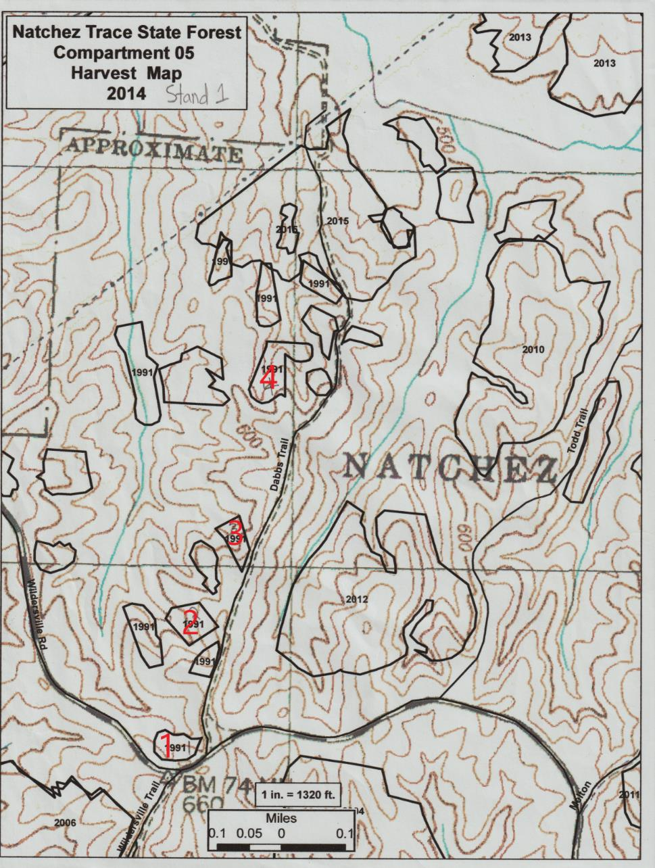
Figure 15: Patch cut harvest unit 1
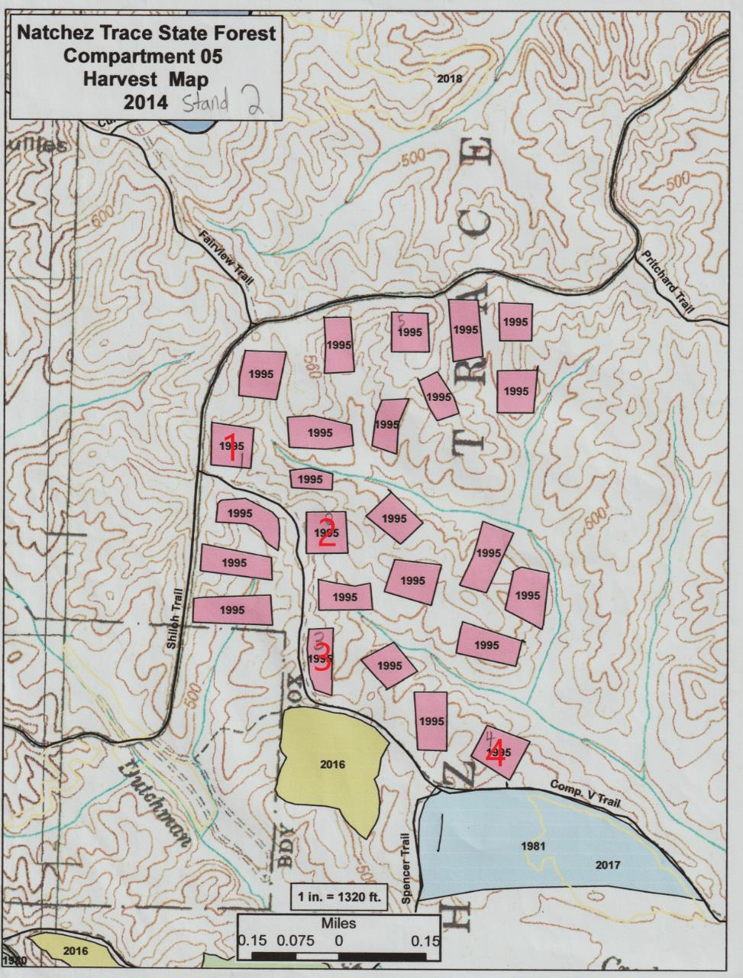
Figure 16: Patch cut harvest unit 2 and clearcut 1
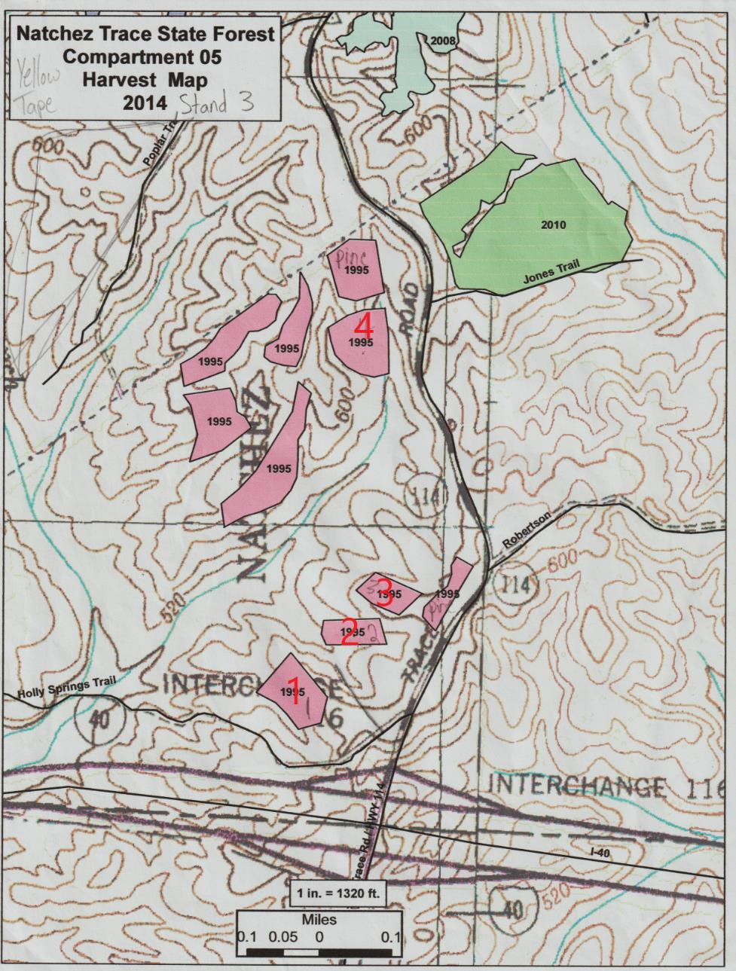
Figure 17: Patch cut harvest unit 3

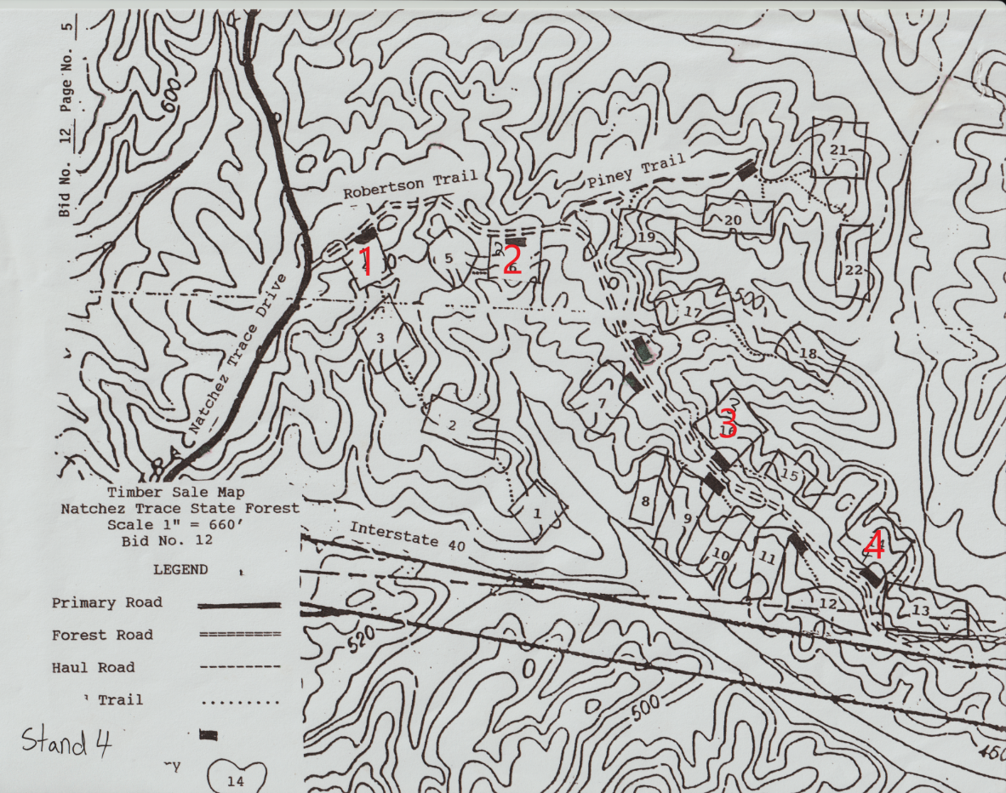
Figure 18: Patch cut harvest unit 4

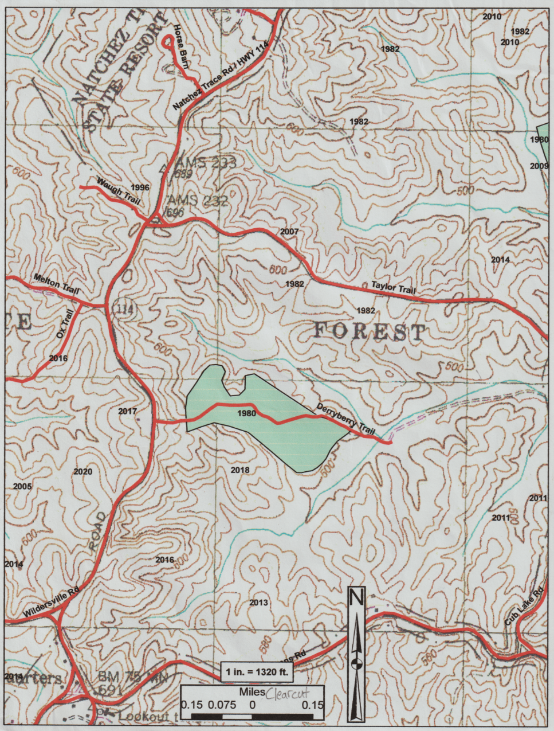
Figure 19: Clearcut 2
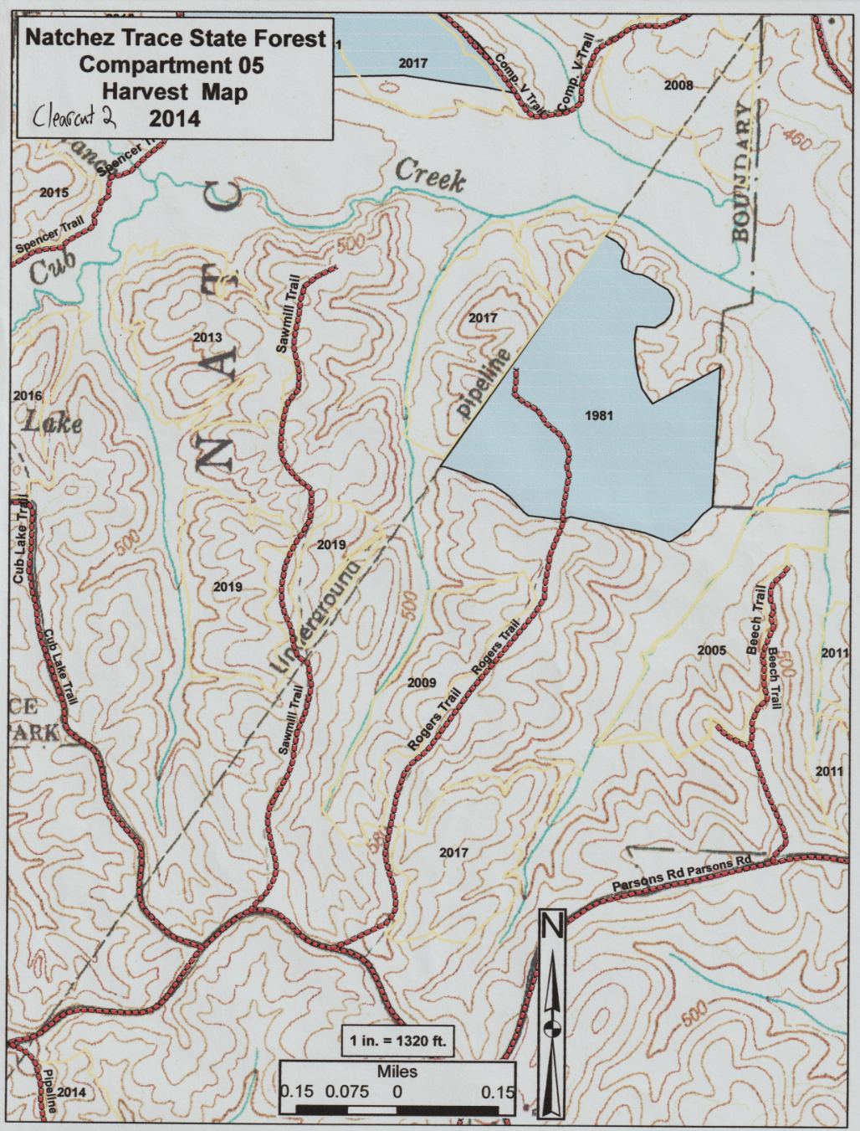
Figure 20: Clearcut 3
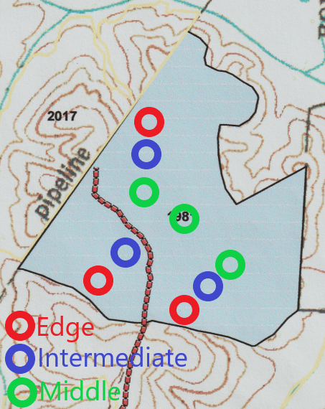
Figure 21: Example of how plots were arranged in a clearcut
Additional Reading
Ashton, Mark S., and Matthew J. Kelty. The Practice of Silviculture: Applied Forest Ecology. 10th ed. Hoboken, NJ: Wiley, 2018.
Clark, F. Bryan, and Richard F. Watt. “Silvicultural Methods for Regenerating Oaks.” U.S. Forest Service. USDA, August 1971. https://www.nrs.fs.fed.us/pubs/4473.
Golden, Michael S. “Reproduction in Group Selection Openings 8 Years After Harvest in a Bottomland Mixed Hardwood Forest.” U.S. Forest Service. USDA, 2002. https://www.srs.fs.usda.gov/pubs/4791.
Grayson, Stephen F., David S. Buckley, Jason G. Henning, Callie J. Schweitzer, Kurt W. Gottschalk, and David L. Loftis. “Understory Light Regimes Following Silvicultural Treatments in Central Hardwood Forests in Kentucky, USA.” Forest Ecology and Management 279 (September 1, 2012): 66–76. https://doi.org/10.1016/j.foreco.2012.05.017.
Kern, Christel C., Rebecca A. Montgomery, Peter B. Reich, and Terry F. Strong. “Harvest-Created Canopy Gaps Increase Species and Functional Trait Diversity of the Forest Ground-Layer Community.” Forest Science 60, no. 2 (2014): 335–44. https://doi.org/10.5849/forsci.13-015.
Kern, Christel C., Julia I. Burton, Patricia Raymond, Anthony W. D'Amato, William S. Keeton, Alejandro A. Royo, Michael B. Walters, Christopher R. Webster, and John L. Willis. “Challenges Facing Gap-Based Silviculture and Possible Solutions for Mesic Northern Forests in North America.” Forestry 90, no. 1 (2016): 4–17. https://doi.org/10.1093/forestry/cpw024.
Loftis, David L. “Upland Oak Regeneration and Management.” U.S. Forest Service. USDA, 2004. https://www.fs.usda.gov/treesearch/pubs/6532.
Rauscher, H. Michael, David L. Loftis, Charles E. McGee, and Christopher V. Worth. “Oak Regeneration: A Knowledge Synthesis.” U.S. Forest Service. USDA, January 1, 1997. https://www.srs.fs.usda.gov/pubs/233.
Shostak, David, Michael S. Golden, and Mark R. Dubois. “Oak Regeneration: Four Years After Three Harvesting Treatments in a North Alabama Upland Hardwood Stand.” U.S. Forest Service. USDA, 2002. https://www.fs.usda.gov/treesearch/pubs/4886.

Vita
Joshua Biggerstaff was born and raised in Knoxville, Tennessee. After high school, he attended the University of Tennessee and received a Bachelor of Science degree in forestry. Upon completing his undergraduate degree, he decided to attend graduate school. He chose to stay at the University of Tennessee and pursue a Master of Science degree in forestry. His research interests include harvest method impacts on tree regeneration. He is incredibly thankful for the support of his family, especially his wife, as he completed graduate school.

