Acculturation’s Effects on Latino Marketing in the United States

A Senior Honors Project
In Partial Fulfillment of
Bachelor of Arts with University Honors
In Spanish and World Business
The University of Tennessee, Knoxville

Jessica Chase Renfro
May 2014

Senior Project Advisor: Edwin Armbrister
Department of Marketing & Supply Chain Management
Abstract
Today, in the United States, there are more and more Latino influences in all aspects of life, especially in the economy. Not only is the Latino population increasing, the buying power of the Latino consumer is also rapidly growing. It is becoming crucial that marketers recognize this attractive opportunity to target the Latino population with their marketing efforts. Through research of various methods used by marketers to target the Latino population in the U.S., analysis reveals both successful methods and mistakes that should be avoided. Also, by examining marketing campaigns aimed toward Latinos by various American companies, the importance of marketing to the Latino consumer is emphasized. Furthermore, through research into various levels of acculturation and integration of Latino populations into the American culture, the importance of market segmentation and the attractive opportunities to target Latino market segments is demonstrated. If marketers thoughtfully consider aspects of Latino culture in marketing strategies and tactics, Latino consumers, who tend to be very brand loyal, will better connect with their company’s products and brands.

Introduction
“Latino” is a very broad term used primarily throughout North America to describe people from Latin America or of Latin American descent. Merriam-Webster officially defines the term as “a person who was born or lives in South America, Central America, or Mexico or a person in the U.S. whose family is originally from South America, Central America, or Mexico.” However, contrary to popular belief, Latino is not a race. Rather Latinos “are African Blacks, they are Asian from almost all Asian countries, they are Caucasian, they are Native Americans, they are mestizos, mulatos, and many other races and origins” (Korzenny and Korzenny 23). The term calls to mind different images and meanings for different people. “Latino” is widely used as a synonym for “Hispanic,” although these two terms are not equal in definition. However, throughout this paper, both terms will be used interchangeably to refer to the target population. Some people have a strong preference for one term over the other, while others use both terms interchangeably, and still others do not like to use either term to self-identify (Soto 1). Many people take pride in their Latino heritage, while others prefer to identify with their country of origin, rather than the larger and broader Latino population. Understanding the term “Latino” proves quite challenging. Similarly, understanding the Latino population is also very difficult due to its diversity.
Homogenization
The distinctiveness of the Latino population requires segmentation and targeted marketing strategies in order for marketers to effectively reach this dynamic market. For example, “marketing, advertising, and communications geared to this cultural group need to take into consideration the information and lifestyle needs of these large numbers of diverse people” (Korzenny and Korzenny 20). Luckily, despite much diversity, the Latino population shares many unifying characteristics that may prove useful to marketers. For example, a common language, history, and certain values are shared among the majority of the Latino population and can be effectively used in companies’ marketing efforts to segment and target this important group. Some common beliefs, values, and attitudes of Latinos are presented in the following chart:
Beliefs | Values and Attitudes
What my friends buy is good for me | Collectivism, the group is more important than the individual
Stay with a brand you know rather than switching around | Loyalty, fear of the unknown, risk avoidance, a risk of reciprocity
Please children by buying them what they want | Being a good mother, giving kids what she did not have growing up, compensating for a past of poverty
Live for today because tomorrow is uncertain | My life is in God’s hands, fatalism, little control over the environment
Having your own business is the best way to work | Value for independence and preserving family lifestyle and cohesiveness
(Korzenny and Korzenny 9).
These shared values, in combination with the Spanish language and heritage, are important common Latino attributes for companies to include when developing marketing strategies toward U.S. Latinos. In addition to shared beliefs and attitudes, many similarities among Latinos’ purchasing behavior have been discovered through extensive research. These include:
- Hispanics are quality and brand conscious. They are willing to pay a premium price for premium quality and are often brand loyal.
- Hispanics prefer buying American-made products, especially those offered by firms that cater to Hispanic needs.
- Hispanic buying preferences are strongly influenced by family and peers.
- Hispanics consider advertising a credible product information source, and U.S. firms spend more than $4 billion annually on advertising to Hispanics.
- Convenience is not an important product attribute to Hispanic homemakers with respect to food preparation or consumption, nor is low caffeine in coffee and soft drinks, low fat in dairy products, and low cholesterol in packaged foods. (Marketing Supply Chain Mgmt 133).
These traits are important to consider when comparing the Hispanic population to the buying habits of other American consumer market segments. Brand loyalty and family influence are especially important characteristics of the Latino population. However, while many Latinos share these similarities to a certain extent, these shared values cannot be oversimplified and generically applied to all Latinos in the United States. While many marketing techniques in the past have exploited these common characteristics, today’s U.S. Hispanic consumer is evolving due to acculturation. Some more useful generalizations to consider include:
- Latinos are a fundamental component to business success, and not a passing niche on the sidelines.
- Rapid Latino population growth will persist, even if immigration is completely halted.
- Latinos have amassed significant buying power, despite perceptions to the contrary.
- Hispanics are the largest immigrant group to exhibit significant culture sustainability and are not disappearing into the American melting pot.
- Technology and media use do not mirror the general market but have distinct patterns due to language, culture, and ownership dynamics.
- Latinos exhibit distinct product consumption patterns and are not buying in ways that are the same as the total market. (Nielsen 1)
These generalizations emphasize the importance of the Latino consumer through their population growth and buying power, while also focusing on their language and cultural sensibilities. These common characteristics are helpful to marketers who want to discover what makes the Hispanic population distinctive from the rest of the U.S. market as well as successful ways to segment and target the Latino market.
Segmentation
Due to the fact that Hispanics in the United States come from many diverse nations across all of Latin America and have developed various levels of acculturation, segmentation proves to be a very useful and important marketing technique. For example,
It is true that the U.S. Hispanic market is complex, and there are specific variables that make it quite desirable to marketers. It is true that some marketers unrealistically have attempted to reach the Hispanic market as a homogenous whole and have failed. It is also true that many smart marketers have specifically targeted segments of the Hispanic market with much success. (Korzenny and Korzenny 21)
Marketing to Hispanics in the United States through homogenization is an overly simplified approach that can only have a limited effect. Campbell Soup Company provides a useful example of avoiding the homogenization trap and successfully implementing the segmentation and targeting approach to marketing to Latinos in the U.S. (Marketing Supply Chain Mgmt 133-134). Campbell sells variations of the Casera line of products targeted to Mexicans in the Southwest and to Puerto Ricans on the East Coast of the United States. This company uses different recipes to create their sauces, soups, and beans based on taste differences in separate geographical and cultural regions of the U.S. (Marketing Supply Chain Mgmt 133-134). This example exhibits Campbell Soup Company’s attentiveness to customers’ tastes and serves as a successful example of target marketing toward the Hispanic population in the United States.
Buying Power
Today, in the United States, there is a significant growth in Latino influences in all aspects of life, and these influences are especially evident in the economy. The buying power of Latinos is steadily increasing along with their population. For example, “between 2000 and 2010 Latino buying power more than doubled,” (Economist) and this growth is only going to continue in the future. According to the Selig Center for Economic Growth, by 2015 the purchasing power of U.S. Hispanics will be 1.5 trillion dollars (Nielsen 2). As a result, Latinos are flexing their buying muscles, and they can afford to be choosy consumers when it comes to brand loyalty. Latino buying power is especially evident in grocery stores across the United States, “where tortillas, taco kits and salsa outperform hamburgers, hot dog buns and ketchup sales” (Llopis: Advertisers Must Pay Attention). These facts reflect the impressive buying power of Latinos in the United States economy and also the need for marketers to recognize this market potential. In fact, “If it were a standalone country, the U.S. Hispanic market buying power would make it one of the top twenty economies in the world” (Nielsen 1). This strong buying power presents a significant opportunity for companies looking to expand their reach and build their brand among U.S. Hispanics. The graph below shows the projected growth in purchasing power of the Hispanic market in the United States in the coming years:
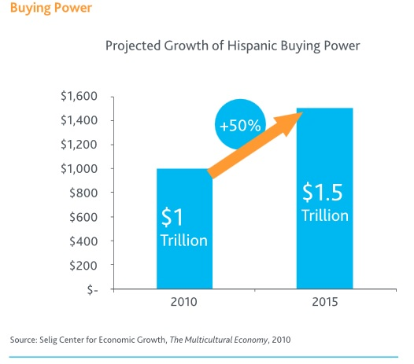
Location and Concentration
While Latinos are spreading out across the United States, there remains a high concentration of this population in certain regions of the country. For example, big cities such as Los Angeles, New York, and Chicago, as well as many cities in Texas, and of course, Miami, all have a significant Hispanic population that is expected to continue to grow in the future as indicated by this chart: 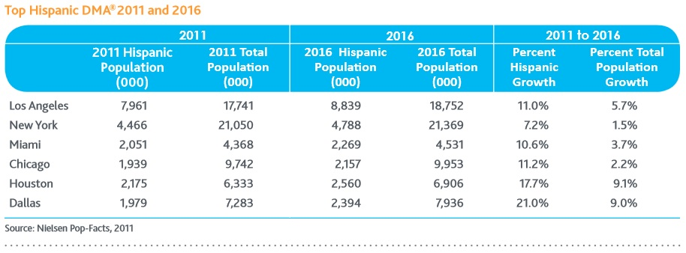
While populations will continue to increase in these traditionally Latino regions, there will also be “dramatic dispersal and new growth in areas where Hispanics were recently unknown” (Nielsen 6). Furthermore, “this growth reflects an amazing and very rapid entrance of the Hispanic population into new settlement areas and illustrates Hispanics’ willingness to settle away from traditional metros” (Soto 8). While the Latino population continues to grow, it will be increasingly dispersed in metropolitan areas and suburbs across the country. Targeting this population can be difficult due to the wide variety of locations; however, Hispanics “have much higher concentrations in Texas (38 percent), California (22 percent), Colorado (21 percent), Nevada (27 percent), and New Mexico (46 percent)” (Nielsen 6). Marketers need to recognize the concentration and disbursement of the U.S. Hispanic population, while always staying mindful of regional and cultural differences.
Population Growth and Distribution
According to the last census in 2010, 16.3% of the United States population is Latino and this percentage is on the rise and will continue to increase in the coming years (Ennis, Ríos-Vargas, and Albert 3). Furthermore, Hispanics are the largest subculture in the U.S with regard to both population and buying power (Marketing Supply Chain Mgmt 133). The Latino population is growing faster than any other, and this growth represents an increase of 43% of the total population (Ennis, Ríos-Vargas, and Albert 3). The distribution of the United States population is shifting and there is an increase in diversity through the growth of the Latino population. The reality is that Latinos are transforming into the mainstream of the future in this country. This graph depicts the large growth in Hispanic population compared with non-Hispanics in the United States over the next few years:
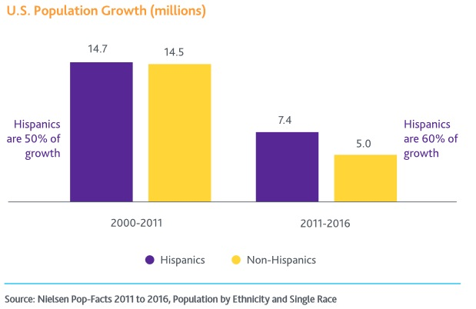
It is important for businesses to consider if they will “be able to ignore what will soon be one-quarter of the entire U.S. population, with younger, larger households?” (Soto 227). Marketers need to be proactive and use this information about typical Latino households to their advantage: they are typically younger, have more children, and live in intergenerational households. The U.S. Hispanic population continues growing dramatically, and the main contributor to this continued growth is surprisingly not immigration but birth rate (Korzenny and Korzenny 181). This growth is especially evident through the fact that “by 2015, 1 in 3 newborns will be Latino” (Llopis: Advertisers Must Pay Attention). Marketers cannot ignore the high population growth of Latinos in the United States. In addition, the majority of U.S. Hispanics “are under the age of 25.” (Marketing Supply Chain Mgmt 133) This growing population of younger people with increasing buying power can have a large impact on the success of U.S. businesses. The chart below illustrates the extreme youth of the Latino population in the U.S. compared to non-Hispanic whites:
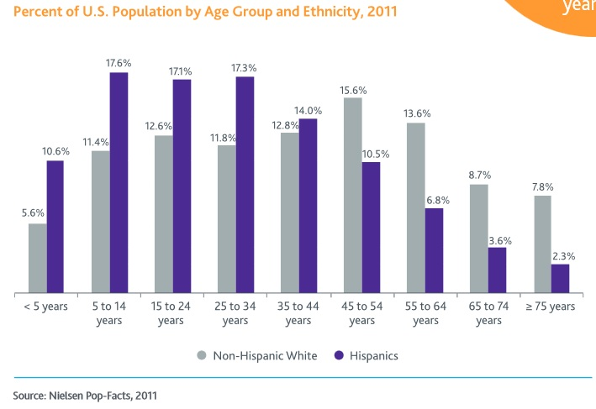
Many marketers realize that the Latino population is continually expanding and has a powerful participation in the United States economy. These impressive facts cause many companies to long for the business of the Hispanic population and to discover new marketing techniques targeted toward Latinos. Because of this, many marketers are turning to various methods of segmentation to reach the Latino consumer. It is evident that, “of late, there is a sense of urgency among many executives to tap into this fast-growing market potential” (Soto ix). Now, more and more marketers understand that “there is a growing necessity for brand marketers to provide culturally relevant content and messaging that specifically targets U.S. Hispanics” (Llopis: Don’t Sell to Me!). These executives recognize, accept, and celebrate the Latino cultures, and they understand that segmenting the Latino population is necessary to target this market. While some of the previously mentioned shared values and homogenization can provide useful information for marketers, it is also important to reflect on differences in level of acculturation to life in the United States based on factors such as language ability and preference.
Acculturation
Merriam-Webster defines acculturation as “cultural modification of an individual, group, or people by adapting to or borrowing traits from another culture.” Hispanics’ various levels of acculturation play an important role in segmenting the population into useful target markets. Furthermore, “Hispanics are the largest immigrant group to exhibit significant sustainability of their culture and are not disappearing into the American melting pot” (Llopis: Don’t Sell to Me!). Many Latinos bring their cultural heritage with them when they immigrate to the United States. However, this culture does not remain unchanged upon arrival, but rather it is combined with many aspects of U.S. culture. Furthermore,
Acculturation is the process of embracing the culture of a host nation while keeping the culture and values of the country of origin, and it has many intricacies since it depends on the personal attitude of the individual, how long they have lived in the host country, as well as the level of interaction at work and within the local community. (Corona and McCabe 67)
Acculturation refers to the amount of integration and changes that a person has undergone in order to adapt to the host culture. Instead of completely assimilating to United States’ culture, many Hispanics also embrace their cultural roots, making this population increasingly bicultural and making their various levels of acculturation important in marketing to this population. For example, “while the good news for marketers is that Hispanics cling to their heritage which makes them approachable as a culture, the challenge is that Latinos are changing their lifestyles as they grapple with what it takes to be successful in the U.S.” (Korzenny and Korzenny 372). Traditional cultures undergo many changes and become integrated with U.S. culture as Hispanics acculturate. It is very important to take precautions and create advertising with much cultural reflection. For example,
If companies want to effectively engage the Latino ethnic group and make them loyal customers, they have to understand the various levels of acculturation, and consider using the adequate message that respects their culture and country of origin, as well as the suitable language (Spanish or English or both) to reach their goal. (Corona and McCabe 67)
In addition to cultural differences, language differences also exist within the Hispanic population of the United States. Many Hispanics are both bicultural and bilingual. For example, recent immigrants with no knowledge of English should be targeted separately from second and third generation U.S. Hispanics who primarily use English and even prefer it to Spanish. Acculturation also incorporates many other factors such as length of time in the U.S. as well as extent of community involvement. However, this paper will primarily focus on acculturation’s effect on language use in marketing.
Language
Contrary to popular belief, successful advertising to Latinos is not only a translation from English to Spanish. For example, “advertisers must look well-beyond the Spanish-language demographic and wake-up to the fact that second and third generation English-speaking U.S. Hispanics – who represent 68% of partially acculturated Hispanics (dual cultural affinity) – is where the growing value of Hispanic purchasing power lies” (Llopis: Advertisers Must Pay Attention). Marketers should be thoughtful of changing Hispanic demographics and their language of choice. Additionally, when advertising to Hispanics began nearly three decades ago, most of the target audience was recent immigrants who spoke only Spanish. However, “today, most Hispanics were born in the United States and only 23% of young ones prefer Spanish to English” (Economist). These facts represent a shift in population distribution of U.S. Latinos and therefore should also represent a shift in advertising to this population. The graph below illustrates the use of Spanish and English among Latino adults in the United States:
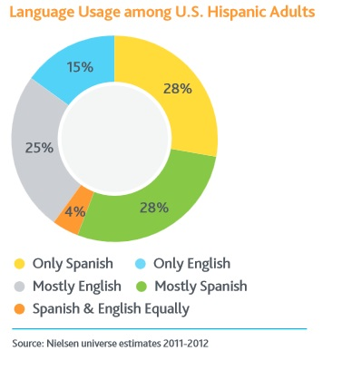
Because of this, the mentality that advertising toward Latinos is only a language translation is too simple and does not reflect the diversity, complexity, and reality of the changing Latino consumer. Additionally, for many Latinos living in the United States, language and culture work together, and “a ‘good’ translation is not a word-for-word transliteration by a credentialed expert, but a cultural adaptation based on common understanding of the meaning of a message by the Hispanic target group” (Korzenny and Korzenny 140). Many marketers are striving to better understand the U.S. Latino population in order to effectively reach this important market.
Many Latinos speak both Spanish and English, while some speak only Spanish or only English. This variation in language use and preference creates difficulties in marketing techniques. Advertising to U.S. Latinos can no longer be a simple translation from English to Spanish. First, with this technique, it is too easy to make unintentional errors in translation. For example, when Volkswagen translated its “Drivers Wanted” slogan into Spanish, it actually indicated “chauffeurs wanted,” which may have caused some confusion and did not clearly express the intent of the advertising campaign. However, Volkswagen quickly adjusted this Spanish language slogan into “‘Agarra calle,’ a slang expression that can be loosely translated as ‘let’s hit the road’” (Marketing Supply Chain Mgmt 134). This example represents the flaws in simple translations and emphasizes the important connection between language and culture.
Second, the translation technique overly simplifies the Latino diversity in the United States. The younger generations of Hispanics in the U.S. may either prefer to speak English or may only be able to speak English, so advertising to this population in Spanish would be unsuccessful. For example, “Immigration of Hispanics to the United States is slowing, and more of the Latino population was either born or raised in the United States, increasing the level of English fluency. More than half of the adult Latino population in the United States, 59 percent, speaks English proficiently” (Vega). The percentage of Latinos speaking English fluently will continue to increase, and bilingual advertising will become more prominent. Despite continued immigration, the Pew Research Center reports that “today, three-fourths of all Hispanics ages 5 and older speak Spanish. However, that share is projected to fall to about two-thirds in 2020” (Lopez and Gonzalez-Barrera). As Latinos are becoming more acculturated, they are learning and adopting the English language. While it is important to many Hispanic parents that their children maintain proficiency in their native tongue, it is frequently necessary to speak English in the United States. The chart below depicts the decrease in Spanish and the increase in English-only among Latino households:
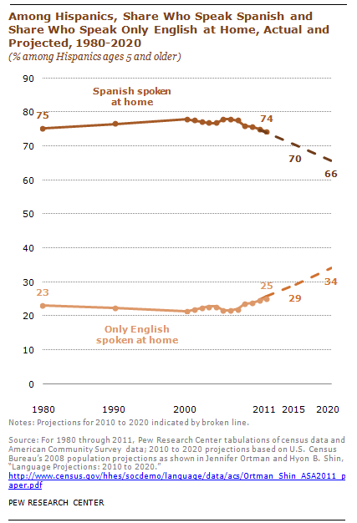
Choosing the language to advertise in can be a complicated but crucial decision for many marketers. Perhaps not choosing is the best choice. Bilingual advertisements are becoming increasingly popular and can successfully reach a large population. Furthermore, incorporating both languages connects Hispanics to their shared language and heritage while also connecting them with the mainstream United States’ language and culture. For example, “many companies, such as those in telecommunications and pharmaceuticals, have recognized this fact and have created bilingual communications that serve all members of the household” (Korzenny and Korzenny 140). For Spanish only or Spanish dominant speakers, a bilingual advertisement communicates the message while also contributing to English language learning. For English only or English dominant speakers, a bilingual advertisement communicates the message while also contributing to Spanish language learning (Korzenny and Korzenny 122). Finally, communicating in both languages connects with a larger Hispanic population with unique benefits that will draw in the target market.
Brand Loyalty
Another important aspect to consider about the typical Latino consumer is brand loyalty. Latinos, even more than other consumers in the United States, feel loyalty and prefer to buy certain brands over others. Because of this, marketers can attract the Latino population through effective branding. In reality, “Hispanics expect and reward brands for their commitment, and notice and appreciate marketing attention with their loyalty” (Korzenny and Korzenny 372). If Hispanics are satisfied and happy with a certain brand purchase, they will become repeat customers. Furthermore, “Hispanic consumers don’t want to be ‘sold to’ – but rather, courted by brands that authentically empower their cultural relevancy and communicate in ways that naturally resonate with Hispanic cultural values” (Llopis: Advertisers Must Pay Attention). Marketers need to build their brand among the Hispanic population in order to have success with this loyal consumer.
Acculturation provides a significant opportunity for marketers to gain the loyalty of new Hispanic consumers. Due to the fact that “acculturating individuals are open to new inputs and influences,” marketers should target this important group early to build brand recognition and brand loyalty (Korzenny and Korzenny 181). It is a competitive advantage to gain the Latino market early on, and it is critical to develop prominent branding and customer service to maintain this brand loyal consumer. Latinos’ acculturation offers a unique opportunity for businesses to connect with this brand loyal consumer. Due to their increasing population and buying power as well as their brand loyalty, many marketers realize are looking for new ways to capitalize on this emerging market.
Stereotype Avoidance
When marketing to U.S. Latinos, it is of upmost importance that advertisements are created with much cultural sensitivity and avoid utilizing preexisting stereotypes to reach this population. A mistake using stereotypes could prove extremely difficult for a company to overcome; therefore, businesses need to market in a way that is effective, not offensive. Both first and second generation Hispanics agree that avoiding stereotypes in advertising is very important to them (Moses). Therefore, it is essential to find employees and consultants that are very informed of the language and culture so as not to perpetuate stereotypes. These employees and consultants can help the business with the cultural conscience and sensibility that is critical to success with the Latino consumer. Advertising to Latinos can be very influential and important to U.S. businesses, but only if it is done in the correct way.
Case Studies: Ford and Target
For example, recently, Ford had an advertisement geared toward the Latino population during the NBA finals between the Miami Heat and the Oklahoma City Thunder. The advertisement was completely in Spanish and was the first time for the companies Ford, ABC, and the NBA (Llenas). Ford executives wanted to see the results of the advertisement to make better decisions about advertising to Latinos in the future. The advertisement shows a Latino family that is speaking very emotionally of the new Ford Escape (Llenas). Although the intention of the advertisement was to be a comic exaggeration, it is too dramatic to have a positive effect on the Latino consumer. This type of advertisement only reflects the way that many Americans already think of Latinos: that they are all very dramatic and emotional like actors in a telenovela. Even more, “unfortunately, many of America’s corporations cling to preconceived stereotypes instead of becoming informed about Hispanic culture and how it shapes the identity of Hispanic consumers and their community at-large” (Llopis: Advertisers Must Pay Attention). The Ford ad does not reflect the reality of Latinos in the United States and only contributes to the stereotypes that already exist toward Latinos. Although the intention is good, because of this, it is not an effective way to have success with the Latino consumer.
While Ford focused on the stereotypes of Latinos with their advertisement, other companies like Target have focused more on the things that unite Latinos with other groups in the United States. Now, Target is trying to create advertising to Latinos in a different and positive way. For example, there is a Target ad that is promoting products for babies with the incorporation of Spanish and Latino families. However, the advertisement is not exclusively geared toward Latinos. It is a subtle incorporation of both English and Spanish, in addition to many American families with different appearances. A spokesperson for Target reflects on new Latino advertising: “as our nation’s population continues to shift, Target will continue to position our brand and merchandise in a way that’s relevant with the new mainstream” (Consumer World). The advertisement for Target does not use stereotypes to call attention nor creates a distinction between Latinos and other groups in the United States. In fact, Target understands that Latinos are the new mainstream and wants to stay ahead of this demographic change. This advertising campaign for Target has managed to both avoid Hispanic stereotypes and connect all levels of acculturated Hispanics through the use of English and Spanish. Because of this, the bilingual advertisement for Target is more effective than the advertisement for Ford and shows the need for cultural sensibility in advertising to Latinos.
Application: Marketing Plan
As presented throughout this paper, segmenting the United States Latino population is crucial in order to target this increasingly large, powerful, diverse, and loyal market. These implications drive real business decisions and can translate into a successful marketing plan. Drawing on the Ford and Target case studies proves to be useful in segmenting and targeting the Latino population through stereotype avoidance and bilingual advertisements. The marketing mix includes product, price, place, and promotion and is the foundation of any successful marketing plan.
Product
Dove, one of Unilever’s popular brands, will be the focus of this marketing plan targeting the U.S. Hispanic population. Dove’s line of products offers something for the whole family, and these unique products should be marketed differently. Furthermore, Latinos enjoy being targeted through marketing efforts and purchasing American-made products (Marketing Supply Chain Mgmt 133). Dove marketers should take this into account and consider prominently labeling products “Made in the U.S.A.” as well as catering their marketing efforts to Latino consumers. The Dove brand is already well-established throughout the American market, but there is still room for growth and expansion into the Hispanic market.
Price
Price is an important factor of the marketing mix. A competitive market price that is both affordable for consumers and profitable for Unilever should be implemented. In order to gain Latino market share, Dove marketers should price their products by keeping in mind that many Latino consumers will pay a premium price for a premium product (Marketing Supply Chain Mgmt 133). Dove’s high quality reputation allows for a slightly higher price that Hispanics are willing to pay.
Place
Marketers for Dove should focus on traditional concentrated Hispanic regions first, in addition to developing an expansion strategy for the rest of the United States as this population disperses. Furthermore, Dove products should be sold in supermarkets and local convenience stores across the country. Dove marketers should strive to make their products as accessible as possible through an intensive distribution strategy. Through effective branding and strategic placement of their line of products, Dove will be well positioned to reach the Hispanic population.
Promotion
Hispanics consider advertisements to be a useful method to discover more about a product, and they also receive much of their buying preferences from family and friends (Marketing Supply Chain Mgmt 133). In addition to segmentation based on gender, the line of Dove products for both men and women of all ages should be marketed to the Latino consumer through segmentation based on generation. Marketers for Dove should target second and third generation Hispanics separately from first generation immigrants to the United States. Promotional efforts will segment the target market with respect to language and ad placement. For instance, for second and third generation Hispanics, the majority of advertisements should be in English with a touch of bilingual. However, for the first generation immigrant population, the majority of advertisements should be in Spanish with a touch of bilingual. Language is a crucial choice that Dove marketers face, and it requires the right combination aimed toward the right generation. While traditional marketing avenues such as print media should be implemented for first generation immigrants, modern marketing techniques such as social media are more applicable to the second and third generations. It is important to connect with the Latino consumer in order to reach the segments through appropriate ad placement in the most appropriate language or combination of languages. Satisfied customers have the potential to become loyal customers and are likely to share their positive experiences with family and friends through word of mouth. Additionally, marketers for Dove should strive to avoid stereotypes, stay fresh and relevant, and recognize the new Latino mainstream. Segmenting and targeting based on generation effectively positions Dove’s product line within the U.S. Latino market.
Conclusion
Extensive investigation into the buying power, location, and population growth of Latinos reveals an important emerging market. While common characteristics of the typical Latino consumer allows for some homogenization, in practice, segmentation proves to be more useful. Acculturation serves as an effective tool for segmenting and targeting the Hispanic population. Bilingual and bicultural marketing can successfully reach diverse Latino households. Drawing on this information, successful marketing plans can be developed that appropriately segment and target Latinos. Savvy marketers have a challenging yet rewarding task ahead: successfully connecting with the dynamic Hispanic market in the United States.

Works Cited
"acculturation." Merriam-Webster.com. Merriam-Webster, 2014. Web. 5 Apr. 2014.
Corona, Ph. D., Ramon, and Mary Beth McCabe, DBA. "Acculturation in Marketing To Latinos In The US." Journal of Business & Economics Research. 9.9 (2011): 67-70. Web. 5 Apr. 2014. <http://journals.cluteonline.com/index.php/JBER/article/view/5637/5718>.
Ennis, Sharon R., Merarys Ríos-Vargas, and Nora G. Albert. United States. Census Bureau. Hispanic Population: 2010. 2011. Web. <http://www.census.gov/prod/cen2010/briefs/c2010br-04.pdf>.
"Half English/Half Spanish TV Commercials Go Mainstream." Consumer World. 1 Jun 2013: n. page. Web. 18 Nov. 2013. <http://consumerworld.wordpress.com/2013/06/01/half-englishhalf-spanish-commercials-go-mainstream/>.
Korzenny, Felipe, and Betty Ann Korzenny. Hispanic Marketing: Connecting with the New Latino Consumer. second ed. Saint Louis, MO: Routledge, 2011. 372. Web. <http://site.ebrary.com.proxy.lib.utk.edu:90/lib/utennk/docDetail.action?docID=10467741>.
"latino." Merriam-Webster.com. Merriam-Webster, 2014. Web. 5 Apr. 2014.
Llenas, Bryan. "Spanish Ad During NBA Finals a First for Broadcast TV." Fox News Latino. 22 Jun 2012: n. page. Web. 18 Nov. 2013. <http://latino.foxnews.com/latino/news/2012/06/22/first-spanish-language-ad-airs-during-nba-finals/>.
Llopis, Glenn. "Advertisers Must Pay Attention to Hispanic Consumers as Rising Trendsetters in 2013." Forbes. 09 Jan 2013: n. page. Web. 16 Nov. 2013. <http://www.forbes.com/sites/glennllopis/2013/01/09/advertisers-must-pay-attention-to-hispanic-consumers-as-rising-trendsetters-in-2013/>.
Llopis, Glenn. "Don't Sell to Me! Hispanics Buy Brands that Empower Their Cultural Relevancy." Forbes. 24 May 2012: n. page. Web. 16 Nov. 2013. <http://www.forbes.com/sites/glennllopis/2012/05/14/dont-sell-to-me-hispanics-buy-brands-that-empower-their-cultural-relevancy/>.
Lopez, Mark Hugo, and Ana Gonzalez-Barrera. "What is the future of Spanish in the United States?." Pew Research Center. (2013): n. page. Web. 5 Apr. 2014. <http://www.pewresearch.org/fact-tank/2013/09/05/what-is-the-future-of-spanish-in-the-united-states/>.
Marketing Supply Chain Mgmt. MKT 300. University of Tennessee - Knoxville: McGraw-Hill, 2013. 133-134. Print.
Moses, Lucia. "Nearly Half of Second-Gen Hispanics Feel Like Ads Don't Target Them Ethnicity influences brand decisions ." AdWeek. 15 May 2013: n. page. Web. 30 Apr. 2014. <http://www.adweek.com/news/advertising-branding/nearly-half-second-gen-hispanics-feel-ads-dont-target-them-149338>.
Soto, Terry. Marketing to Hispanics: A Strategic Approach to Assessing and Planning Your Initiative. Chicago, IL: Dearborn Trade, A Kaplan Professional Company, 2005. vii-ix, 227. Web. <http://site.ebrary.com.proxy.lib.utk.edu:90/lib/utennk/docDetail.action?docID=10118536>.
"State of the Hispanic Consumer: The Hispanic Market Imperative." Nielsen. (2012): 1-17. Web. 5 Apr. 2014. <http://es.nielsen.com/site/documents/State_of_Hispanic_Consumer_Report_4-16-FINAL.pdf>.
"The lust for Latino lucre: How American firms are chasing the elusive Hispanic dollar." Economist. 11 May 2013: n. page. Web. 23 Nov. 2013. <http://www.economist.com/news/business/21577397-how-american-firms-are-chasing-elusive-hispanic-dollar-lust-latino-lucre>.
Vega, Tanzina. "More Latinos Consume News in English, Report Finds." New York Times [New York] 23 July 2013, n. pag. Web. 5 Apr. 2014. <http://www.nytimes.com/2013/07/24/business/media/latinos-in-us-increasingly-rely-on-english-language-news-report-finds.html?_r=0>.

