The Impact of Selective Solvents on the Structure and Function Evolution in Solvent Annealed Organic Photovoltaics

A Thesis Presented for the
Master of Science Degree
The University of Tennessee, Knoxville

Student: Sheng Hu
August 2013

ACKNOWLEDGEMENTS

First and foremost, I would like to gratefully thank to my advisor, Prof. Bamin Khomami and Prof. Mark Dadmun for their guidance and training over the past two years on this project. I really appreciate their contribution of time, ideas and funding to make my Master program more productive. During the time I really learned abundant experimental theory and methods, accumulated important knowledge and experiences in my research field. I also learned how to face up to challenges and solve problems, how to deeply understand the essence of a theory, and how to be more creative during research. In addition, I am also thankful to my reading committees, Prof. Dibyendu Mukherjee; to Prof. Bin Hu for support of power conversion efficiency measurement; to Dr. Joseph E. Spruiell and Dr. Tom Malmgren for assistance with GIWAXS analysis and AFM analysis respectively.
The work was made possible with financial support from the National Science Foundation (CBET-0932666), as well as the support of the Sustainable Energy Education Research Center at the University of Tennessee.
Finally I am most grateful to my co-works, Dr. Huipeng Chen, Yu-che Hsiao, Cameron Lee Scott, and Brad C. Millar, as well as all my dear friends and also family members, for all your support and help.

ABSTRACT
The role of poly(3-hexylthiophene) (P3HT) and [6,6]-phenyl C61-butyric acid methyl ester (PCBM) solubility on the evolution of structure and function in solvent annealed organic photovoltaics is quantitatively investigated. ODCB solvent vapor distribution during the solvent uptake process is simulated on a 3-D profile. Determination of solvent uptake in the P3HT/PCBM mixture shows that the evolution of the morphology during solvent annealing (SVA) takes much longer than the diffusion of the solvent vapor into the sample. The evolution of P3HT crystallinity, as well as the growth of PCBM aggregates, in the solvent annealed thin films is observed by Grazing Incidence Wide Angle X-ray Scattering (GIWAXS) and Atomic Force Microscopy (AFM) respectively. For the solvents that have a finite P3HT solubility, P3HT crystallinity initially increases then decreases with longer SVA time, where P3HT solubility of the annealing solvent plays a significant role in the variation of crystallinity. However, 2-Chlorophonel (2-CP) vapor, which has negligible P3HT solubility but high PCBM solubility, also exhibits an increase in P3HT crystallinity upon solvent annealing a P3HT/PCBM thin film. PCBM aggregates grow continuously with SVA, a process that is modulated by the PCBM solubility in the annealing solvent. Moderate PCBM aggregation correlates to improved power conversion efficiency (PCE) of the solvent annealed thin film. For the samples annealed using solvents that prefer P3HT, PCE benefits from further SVA after P3HT crystallinity peak time, which is ascribed to the additional PCBM aggregation; whereas the PCBM preferred solvents induce excess PCBM phase separation at further SVA times, which limits exciton dissociation hence PCE performance. Also, a flow SVA chamber is designed to realize in-situ light scattering experiments, where preliminary experiments using this apparatus are reported.
TABLE OF CONTENTS
CHAPTER I Introduction 1
Solar cells 1
Mechanism of Organic photovoltaics 2
Organic photovoltaic charge transfer process 2
Power conversion efficiency (PCE) 4
Development of organic solar cell 5
Material innovation 6
Device modification 11
Solvent annealing 13
Goal and structure of this thesis 15
CHAPTER II Diffusivity measurement 16
Introduction of diffusion coefficient calculation: 16
Experimental 17
Results and discussion 18
CHAPTER III The impact of Selective solvent annealing on the structure and Performance of P3HT/PCBM OPV cells 21
Experimental 21
Materials and sample preparation 21
Solvent annealing 21
Characterization 23
Results and discussion 25
Solubility measurement 25
Solvent Uptake in Solvent Vapor Annealing 26
Grazing Incidence Wide Angle X-ray Scattering (GIWAXS) 28
Atomic force microscopy (AFM) 35
Solar cell performance 41
CHAPTER IV Design of flow SVAapparatus forIn-situ light scattering 45
Design of flow SVA Apparatus 45
Initiatory Experiment 46
Results and Analysis: 47
CHAPTER V Conclusion 50
LIST OF REFERENCES 52
VITA 57

LIST OF TABLES
Table 1 Weight percentage increase during SVA 19
Table 2 Diffusivity calculation 20
Table 3 Vapor pressure of solvents used for SVA 23
Table 4 Measured solubility of P3HT and PCBM in solvents used in SVA 26
Table 5 Time for peak P3HT crystallinity, vapor pressure and component solubilities for the examined solvents 32
Table 6 Photovoltaic performance of the Solvent Annealed active layers 44

LIST OF FIGURES
Figure 1 Mechanism of photo-induced charge transport process 2
Figure 2 Innovative electron donor materials 8
Figure 3 Innovative electron acceptor materials 10
Figure 4 Device structures of OPV cells (a) conventional structure; (b) inverted structure; (c) multi-junction structure (Tandem cell) 12
Figure 5 Time dependence of weight percentage increase 19
Figure 6 ODCB vapor distribution in the film during SVA process 20
Figure 7 Schematic of the solvent vapor annealing apparatus: Variation in solvent vapor pressure during annealing is achieved by changing the position of wafer surface with respect to the solvent surface. L/L₀=0.90 is used in our experiment. 22
Figure 8 Solubility measurement via UV-Vis (P3HT in BB) 25
Figure 9 Weight percentage increase of P3HT/PCBM bulk film upon exposure to different solvent vapor 26
Figure 10 Total weight percentage increase during SVA as a function of the product of solvent vapor pressure and total solubility 27
Figure 11 GIWAXS curve of the P3HT/PCBM composite films before and after ODCB SVA 28
Figure 12 Area of the P3HT (100) peak in the various solvent annealed P3HT/PCBM samples: (a) Bromobenzene; (b) ODCB; (c) CB; (d) p-xylene; (e) Toluene; (f) 2-chlorophenol. 31
Figure 13 P3HT crystal size of the P3HT/PCBM sample annealed in various solvents: (a) Bromobenzene; (b) ODCB; (c) CB; (d) p-xylene; (e) Toluene; (f) 2-Chlorophenol; 32
Figure 14 Time of Peak P3HT crystallinity as a function of solvent vapor pressures and P3HT solubility 33
Figure 15 Comparison of the area of (100) peak for solvent annealed P3HT/PCBM and pure P3HT samples. Top left: CB; Top right: TL; Bottom: 2-CP. 34
Figure 16 AFM image of CB and TL annealed thin film. In each column, left: 5μm*5μm phase image; right: 5μm*5μm height image. 36
Figure 17 PCBM aggregation size and RMS roughness during SVA: Left: CB annealed samples; Right: TL annealed samples; Top: PCBM aggregation size; Bottom: RMS roughness 37
Figure 18 Relationship between P3HT crystallinity and RMS roughness. Left: comparison for CB; Right: comparison for TL. 37
Figure 19 AFM image of solvent annealed thin film at time 1 time 2. In each column, left: 5μm*5μm phase image; right: 5μm*5μm height image. 39
Figure 20 AFM results of PCBM aggregate size (left) and RMS roughness (right) of solvent annealed thin film at time 1 and time 2 40
Figure 21 Relationship between PCBM aggregate size, RMS roughness and solubility factor (vapor pressure*solubility*time): (a) PCBM aggregate size and RMS roughness as a function of PCBM solubility at time 1; (b) PCBM aggregate size and RMS roughness as a function of PCBM solubility at time 2; (c) PCBM aggregate size and RMS roughness as a function of P3HT solubility at time 1; (d) PCBM aggregate size and RMS roughness as a function of P3HT solubility at time 2 40
Figure 22 J-V curves of solvent annealed P3HT/PCBM composite films at: (a) time 1; (b) time 2. 43
Figure 23 Relationship between PCE and RMS roughness 44
Figure 24 The schematic diagram illustrating the main components of flow SVA setup for in situ light scattering 46
Figure 25 GIWAX results using flow SVA 47
Figure 26 Off-specular light scattering images of spin coated P3HT/PCBM thin film with different concentration in ODCB (a) 5mg/ml, (b) 10mg/ml, (c) 15mg/ml, (d) 20mg/ml, (e) 25mg/ml, (f) 30mg/ml 48
Figure 27 Off-specular light scattering images of 30 mg/ml film (a) before and (b) after flow SVA for 6 hours 49

CHAPTER I
Introduction

Solar cells
In nature, 1.2 × 10¹⁷ W of solar power shines on the earth’s surface, which is sufficient to satisfy the global power demands if only 0.01 percent of this received solar energy can be converted to electricity¹. Therefore, solar cells have great potential in the energy field by directly converting sunlight to electricity for many applications. The first solar cell was built at Bell labs in 1954². In the following 60 years, electricity has been generated from solar energy from inorganic solar cells, mostly crystalline silicon and inorganic thin film solar cells such as CdTe and CuInGaSe2 (CIGS). It has been demonstrated that high power conversion efficiencies (PCE), up to 25% and 19.4%, can be obtained with these types of solar cells³. However, their high cost due to the limited abundance of the material in earth as well as the photo-corrosion effect of the unique semiconductor energy band gap can dramatically restrict their practical applications⁴. Therefore, organic photovoltaic (OPV) solar cells appears a promising technology to provide clean and renewable energy because they are lightweight, low cost, flexible, and allow for large-area fabrication⁵⁻⁶. These properties mean that it can be widely used in daily use applications such as watches, portable calculators, charges, toys, as well as other devices. Another important merit is that their optical properties and cell performances could be controllably modified by tailoring the chemical composition and molecule structure of the constituent OPV materials. Consequently, the study of OPV materials and devices draw increasing attention in the research field. Nevertheless, organic thin film solar cell is still an immature field, with the maximum efficiency of 9.2% ever reported⁷.

Mechanism of Organic photovoltaics
Figure 1 Mechanism of photo-induced charge transport process

Organic photovoltaic charge transfer process
For single junction solar cell, the main principle of photo-induced charge transfer process follows the four steps as shown in figure 1: 1) Incident photos with energy larger than the electron donor’s band gap is absorbed by the OPV thin film, which promotes a molecule from highest occupied molecular orbital (HOMO) to the lowest unoccupied molecular orbital (LUMO), forming a so called exciton, which consisted of an electron-hole pair. The ratio of generated excitons to incident photons is defined as the absorption efficiency (η_{A}). 2) Organic excitons have a much higher binding energy than thermal energy at room temperature due to the relatively low dielectric permittivity of the polymer. Therefore, an electron acceptor with great electron affinity is needed in order to provide a built-in electrical field, which will provide a path for exciton dissociation and prevent exciton recombination to the ground state. The exciton must diffuse to the donor-acceptor interface within its diffusion length (LD). Based on these processes, the ideal active layer morphology is often described as having a domain size of 20 nm, since the typical exciton LD is around 10 nm. During the process the percentage of the total excitons that finally reach the interface out of the excitons generated in step 1 is defined as the exciton diffusion efficiency (η_{ED}). 3) Due to the built-in electrical field, the electrons in the exciton at a D/A interface transfers from electron donor molecules to the adjacent electron acceptor molecules at a tremendously fast speed (~100 fs), forming a electron polaron in the LUMO of the acceptor molecule; while the holes stay in the HOMO of the donor molecules, result in a hole polaron, the process of which is termed exciton dissociation. 4) The electrons and holes then transport in the acceptor and donor phases the respective electrodes within a short period of time in the scale of nanosecond or microsecond. Meanwhile, an electric field favoring or preventing geminate electron-hole pair dissociation may be present in this step in the BHJ due to a strong Coulomb force⁸⁻⁹. During the above two steps, the percentage of the excitons that go through the charge transfer process defines the charge separation efficiency (η_{CS}) while the percentage of the excitons collected by the electrodes is the charge collection efficiency (η_{CC}).
The external quantum efficiency, 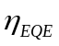, is defined as the ratio of the number of electron collected by the electrodes to the total number of incident photons, which can be calculated by multiplying the above four quantum efficiencies in the photovoltaic charge transfer steps:
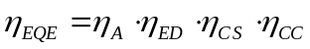⑴
The EQE of a device strongly depends on the wavelength of the incident light, since each photovoltaic material has its unique absorption spectrum, while different absorption location in a solar cell will affect the resulting charge transfer process, i.e., either been collected by the electrodes or undergo exciton recombination.

Power conversion efficiency (PCE)
An important parameter representing solar cell performance is the power conversion efficiency η, indicating the percentage of incident light power that is converted to output electrical power, which can be expressed as:
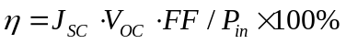⑵
Where J_{SC}, V_{OC}, FF and 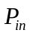 is short-circuit current density, open-circuit voltage, fill factor, and incidence light power, respectively.
The short-circuit current density J_{SC} is determined by the current density when no voltage is applied to the cell system, and can be expressed by integrating the product of the EQE and photon flux density, as shown by the following equation^{10,11}:
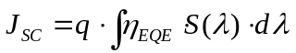⑶
where S(λ) is the photon flux density of the AM 1.5 solar spectrum with units of number of photons per unit area per unit time per unit wavelength. J_{SC} is also considered as the onset of the power conversion process. In ideal devices, the J_{SC} value should be the same as the photocurrent density J_{ph}.
The open-circuit voltage V_{OC}, however, is the maximum potential at zero current density, which is also regarded as the compensation point for both the photocurrent generation and dark current processes. It is stated by some references that V_{OC} is equal to the band gap between the HOMO of donor molecule and the LUMO of the acceptor molecules¹². Therefore, either by reducing the HOMO of the donor or by raising the LUMO of the acceptor increases the V_{OC}, hence improving PCE performance.
The fill factor (FF) is the maximum absolute value of the product of the current density and the voltage divided by the product of J_{SC} and V_{OC}, i.e.,
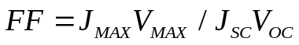⑷
The FF is also an indication of the sharpness of the J-V curve. Currently, FF value is around 60%, thus specific modification methods to improve the FF are desired, as this will also result in a better PCE.

Development of organic solar cell
Organic photovoltaic performance was first discovered in 1959. However, extremely low PCE was found for this cell due to the poor exciton dissociation rate. In 1986, a breakthrough of in OPV cells was demonstrated in Tang’s paper that used small molecular weight materials copper phthalocyanine (CuPc) and 3,4,9,10-perylene tetracarboxylicbenzimidazole (PTCBI); a heterojunction bilayer structure including an electron-donor and an electron-acceptor was adopted, which results in high exciton dissociation efficiency, hence better device performance, which resulted in a PCE of 0.95%¹³. Late in 1990, C₆₀ and its derivatives were blended with conjugated polymers to provide a more efficient photo induced charge transfer process, which take place in the bulk-heterojunction (BHJ) morphology^{14,15}. The archetypal BHJ cell consists of a mixture of regio-regular poly(3-hexylthiophene) (P3HT) and [6,6]-phenyl C₆₁-butyric acid methyl ester (PCBM), which serve as electron donor and acceptor respectively¹⁶⁻¹⁷. The excitation of the π-orbit electron in P3HT gives the photovoltaic effect in the blend¹⁸. The power conversion efficiency (PCE) of this type of solar cell has reached over 5%¹⁸, where the morphology of the active layer plays a crucial role in exciton dissociation and charge transport, and consequently impacts cell performance. A 3-phase model for this kind of BHJ domain has also been proposed, namely, a system that contains a P3HT crystalline phase, a PCBM rich phase and a miscible amorphous phase of P3HT and PCBM. In this morphology, the miscibility and interdiffusion of P3HT and PCBM plays a pivotal role in determining the nanoscale morphology, as shown in our previous work using neutron scattering^{19,20}. Recently, OPV research has focused on many aspects of device improvement, including material innovation, device modification, morphology modification, etc.

Material innovation
Donor material
Figure 2 illustrates some examples of innovative OPV donor materials. The most popular donor material is P3AT series, which has the merit of forming head-to-tail structure as well as inducing high molecular ordering hence higher hole mobility through self–assembly. Hou et al. first developed a series of benzodithiophene (BDT) derivatives as photovoltaic donor material with low band gap²¹, where a PCE of 1.6% was found in cells that contain these materials without further treatment after deposition. Further improvement of PCE to 5.5% is achieved by introducing an alkanedithiol additive into the above system²².
Besides thiophene-based materials, Poly(phenylenevinylene) (PPV) and polycyclic aromatic compound derivatives were also widely investigated as electron donor materials. A PCE of 2.5% was reached for one of the first studied materials, e.g., MEH-PPV²³ and MDMO-PPV²⁴ as shown in Figure 2, where C₆₀ derivatives are usually blended into the system to prevent the generation of singlet oxygen inside, which could destroy the framework of PPV through the oxidation of double bond²⁵. TPD and pentacene are two important examples of small molecule donors, where a planar heterojunction structure²⁶ provides a device with a PCE of 1.6%. Further PCE improvement was also realized by adding rubrene into the device²⁷.
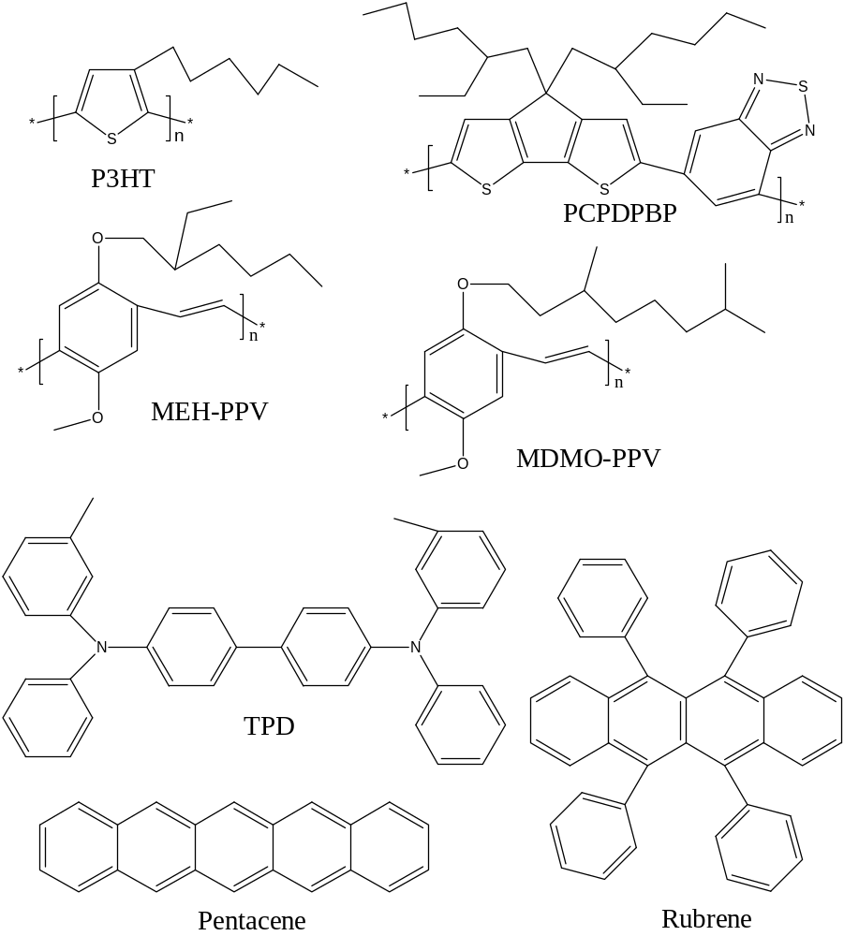
Figure 2 Innovative electron donor materials

Acceptor material
Fullerene (C₆₀), as well as its derivatives, is commonly used in OPV system as an electron acceptor material due to its unique chemical structures. It is widely known that C₆₀ has a spherical conjugated molecule composing of 60 carbon atoms, which endow a small energy gap between singlet and triplet inside the molecule (ΔE_{ST}=0.15 eV), and good spin-orbital coupling. Consequently, the electrons accepted by a C₆₀ singlet transfers to the triplet at a tremendously fast speed, while the opposite process is largely prevented²⁸. C₇₀ is also an excellent electron acceptor material with spherical conjugated molecular structure, which is formed by adding hexagonal ring to the center of C₆₀.
A series of fullerene derivatives have been synthesized recently aiming at adding photosensitivity and more solubility, since both C₆₀ and C₇₀ have very low solubility in the common electron donor materials, which largely limits its application in OPV cells. Zheng et al. synthesized PCBM and PCBB through modifying C₆₀, and used those more soluble fullerene derivatives in an MEH-PPV system OPV cell²⁹. Another derivative, ThCBM, is formed by changing the phenyl functional group to thienyl. The PCE of the corresponding BHJ cell has reached 3.0%³⁰. Moreover, He et al. synthesized two new fullerene derivatives with higher LUMO, i.e., indene-C₆₀ bis-adduct (ICBA) and indene-C₇₀ bis-adduct (IC70BA)^{31,32}. The V_{oc} of above two acceptors are 0.84/0.84V, while the PCE of BHJ OPV solar cells of these acceptors with P3HT have reached 5.44%/5.64% respectively.
Additional organic materials other than C₆₀ derivatives have been synthesized and utilized as acceptors. For instance, by introducing a strong electron-withdrawing group such as CN, thiophene materials such as P3CN4HT and DCV3T³³ can be synthesized that with an increased electron affinity and reduced LUMO level of the acceptor. Similarly, PPV derivative MEH-CN-PPV and polycyclic aromatic compounds PTCDA³⁴ can also be used as electron acceptor, demonstrating good PCE results. Several examples of innovative acceptor materials are shown in figure 3.
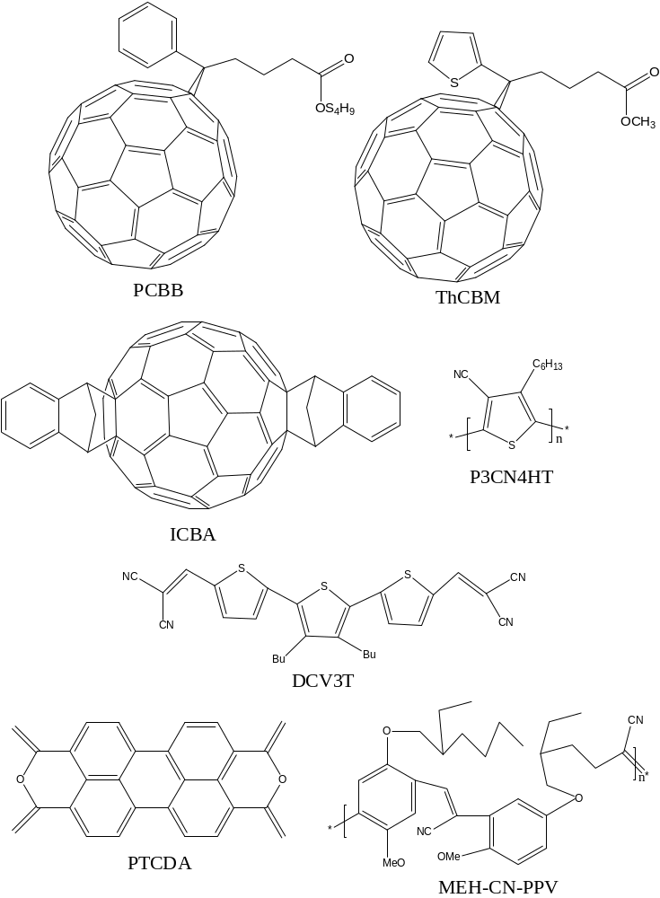
Figure 3 Innovative electron acceptor materials

Device modification
Device structure
Currently, there are three geometries of OPV devices, i.e., conventional structure, inverted device structures and tandem cell with multi-junction structure, as shown in figure 4. The conventional device structure consists of glass/ITO/polyethylene dioxythiophene:polystyrene sulfonate (PEDOT:PSS)/active layer (BHJ)/cathode layer (e.g., Ca, Pt or LiF/Al). For the inverted cell, the structure is deposited in the following order: glass/ITO/metal oxide/active layer/interfacial layer/Ag; here Ag is used at the cathode electrode on the top side, then an interfacial layer with high electron mobility, e.g., zinc oxide (ZnO) nanoparticle is spin coated underneath the Ag layer. Theoretically, an inverted device has a better Jsc than the conventional cells, but V_{oc} and FF are usually lower³⁵. A tandem cell, however, can substantially improve V_{oc} due to the excellent hole/electron collection ability by the inside two layers, i.e., a hole transporting layer (HTL) and an electron transporting layer (ETL), which are used to separate the sub-cells. A PCE of over 10% has been reached by this device geometry.
Figure 4 Device structures of OPV cells (a) conventional structure; (b) inverted structure; (c) multi-junction structure (Tandem cell)

Buffer layer
A Buffer layer is used to modify both anode and cathode electrodes. The purpose for cathode buffer layer is to prevent exciton quenching as well as the damage caused by cathode metal deposition. It is also used to strengthen the built-in field for charge transport. Typical cathode buffer layers include alkaline fluorides such as LiF and NaF³⁶, BCP (bathocuproine)³⁷, transitional metal complex Ru(acac)₃ (Tris(acetylacetonato)ruthenium(III))³⁸. An Alq(tris(8-hydroxy-quinolinato) aluminum)³⁹ buffer layer is usually used for planar heterojunction (PHJ) system. The role of the anode buffer is to enhance anode electrode/active layer interfacial contact as well as to tune active layer morphology and improve anode work function. The most common examples are PEDOT:PSS⁴⁰, Titanium dioxide (TiO2)⁴¹ and gold nanoparticles (GNPs)⁴².

Solvent annealing
Solvent annealing is a widely used processing method in thin films. It provides an opportunity to modify the nano-scale thin film structure, which is usually unachievable by other methods such as thermal annealing.
In BHJ solar cells, excitons dissociate at the interface between donor and acceptor, where the separated holes and electrons must then travel to each electrode respectively. Thus, the ideal morphology of the BHJ active layer has often been depicted as a nanoscale phase separated structure with domains that are less than the exciton diffusion length (around 10-20nm), which creates bi-continuous percolation paths for charge transport^{43,44}. However, in most common fabrication processes, fast solvent evaporation occurs during spin coating, which kinetically blocks the evolution of the structure, initially forming a thin film with minimal crystallization and phase separation of the two components, a morphology that results in poor photovoltaic performance. As a result, a number of groups have adopted thermal annealing (TA) of the sample immediately after spin coating to allow the system to evolve towards equilibrium. This thermal annealing induces in-plane π-π stacking of P3HT chains where charges can easily transport from one grain to another, improving the photovoltaic performance of the active layer⁴³. However, the conjugated polymer may suffer degradation or large-scale phase separation during TA at elevated temperature, detrimentally affecting the photovoltaic cell performance^{44,45}.
As an alternative protocol, solvent vapor annealing (SVA) has been used to impart molecule mobility of the BHJ components, allowing more precise control of P3HT crystallinity⁴⁶. During SVA, the OPV thin films are exposed to a specific solvent vapor environment, where the solvent molecules diffuse into the deposited layer, which often induces a change in the nanoscale morphology. Liu et. al. studied P3HT/C₆₀ blend films exposed to chloroform or 1,2-dichlorobenzene (DCB) solvent vapor. P3HT nanowires rich in C₆₀ were observed instantly after exposure to the two vapors⁴⁷. The solvent annealing effect of carbon disulfide (CS₂) vapor on a poly(3-butylthiophene) (P3BT) spin-coated film was investigated by Lu et. al., using different CS₂ evaporation rates⁴⁸. The results show that slow evaporation rate results in better thin film morphology due to the sufficient time for the morphology to evolve. Later, a combination protocol of post deposition treatment was examined that first applied 1,2-dichlorobenzene (DCB) SVA followed by TA as a second step on P3HT:PCBM films by Zhao et. al. Enhanced optical absorption and hole transport was found following the first SVA step, while more efficient charge separation and charge transport was observed after TA⁴⁹. In addition, Tang et. al. devised a multiple-step SVA, using tetrahydrofuran (THF) and CS₂ as the controlled solvent vapor. PCBM aggregate size increases dramatically upon exposure to the first solvent while it decrease after SVA by CS₂ due to the different PCBM solubility in the two annealing solvents. Meanwhile, P3HT crystallinity improved dramatically during both SVA processes⁵⁰. Similarly, SVA in methylene chloride vapor has been used on a bi-layer OPV system consisting of titanylphthalocyanine (TiOPc) and perylene phenethylimide (PPEI), where the cell performance is largely improved due to the remarkably enhanced optical properties⁴⁵.
Although a series of studies of SVA of OPV thin films have been completed, the thermodynamic driving forces that lead to the morphological changes that occur during these annealing processes are still not understood. During SVA an extra component is introduced into the original films, which means that the morphology modification is strongly affected by the interactions between solvents and polymers. Several parameters such as treatment time, solubility of both polymer and fullerene in the solvent, and solvent vapor pressure, can dramatically impact the structural changes that occur during solvent annealing⁵⁰. As has been reported, solvents with high P3HT solubility may induce excess phase separation, which creates domains that exceed the exciton diffusion length hence limit exciton dissociation^{51,52}. There is therefore a need to more completely understand how those factors that can be readily manipulated impact the morphological evolution in the solvent annealing process of BHJs, to provide guidelines that can be used to optimize the solvent annealing process.

Goal and structure of this thesis
In our experiments, we first measure the diffusivity of three solvents in a P3HT bulk film and simulate the solvent vapor uptake process in a thin OPV BHJ. Then we monitor the effect of SVA on the morphology and OPV performance of P3HT:PCBM active layers, using a series of organic solvents with different component solubility. The solubility of P3HT or PCBM in the examined solvents is measured by UV-Vis. The crystalline structure and the phase separation behavior of the BHJ are examined using Grazing Incidence Wide Angle X-ray Scattering (GIWAXS) and Atomic Force Microscopy (AFM) respectively. In addition, the power conversion efficiency of the resultant active layers are measured to correlate the structure of the resultant P3HT:PCBM film and OPV function. The role of solute solubility on the structural evolution of the P3HT:PCBM mixture during SVA provides a fundamental understanding of the knobs that can be tuned in the development of novel processing techniques to precisely control the structure and performance of organic photovoltaic active layers. Moreover, a flow SVA setup is designed to provide in-situ light scattering measurement, so as to more deeply understand the SVA effect on the thin film morphology change.

CHAPTER II Diffusivity measurement

Introduction of diffusion coefficient calculation:
The diffusion coefficient, also called diffusivity, is a proportional constant between the molar flux due to molecular diffusion and the gradient in the concentration of the species. Fick’s first and second law quantitatively explains this parameter and the diffusion phenomenon, as shown by the following equations:
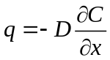⑸
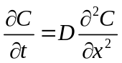⑹
where q is the volume flux, D is diffusivity, C is concentration, and x is distance. The diffusion coefficient plays an important role in the solvent vapor absorption process, and may influence the SVA effect. There are generally two methods for measuring the diffusivity of gas in a solid, i.e., the time lag method and the t^{1/2} method. The first method is applicable in steady state, while the second can be applied to our flat film absorption system.
Based on a model of a flat film placed in a solvent vapor environment, where both surface of the film can absorb vapor, an equation relating total weight percentage increase of the film as a function of time is given by⁵³:
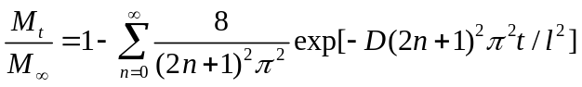⑺
Where M_{t} is the weight increase at time t, M∞ is total weight increase, D is diffusivity, and l is the film thickness. For M_{t}/M∞＜0.6, i.e., at the initial stage of the sorption process, the above equation can be further simplified to:
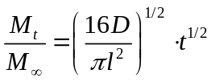⑻

During the solvent uptake process, the film thickness increases due to swelling. Therefore a calibration equation is applied to account for this swelling:
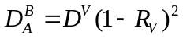⑼
where D^{B}_{A} is the diffusivity under fixed film thickness, D^{V} is the diffusivity with swelling, and R_{v} is the volume fraction of the vapor in the film.
Finally, the distribution of solvent in the layer at time, t, can be deduced by the following equation⁵³:
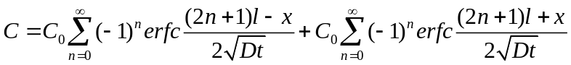⑽

Experimental
All solvents were purchased from Aldrich and used as received. Regioregular P3HT (Mn=37k, PDI-2.0, RR=90-93%) was purchased from Reike Metals Inc. Silicon wafers were used as substrates and were first cleaned in hot piranha (1:3 H₂SO₄:H₂O₂) for 30 min followed by washing in abundant deionized (DI) water and dried using a stream of nitrogen gas. PEDOT:PSS solution was then spin coated on top of the wafer at 1000 rpm for 90s; a 30 mg/ml P3HT solution in ODCB is drop cast on the PEDOT:PSS covered silicon wafer, dried on a hot plate, followed by drop casting another layer. Repeating this procedure about 10 times creates a film that is between 0.2 and 0.5 mm thick, which is then peeled off the wafer by immersion in water. Three bulk film samples were made by this method: sample 1 (14.3mg/0.23mm), sample 2 (23.3mg/0.36mm), sample 3 (29.8mg/0.42mm), which were then placed in the SVA device described in chapter II.

Results and discussion
Table 1 summarizes the time evolution of the percent weight increase of the three bulk films during SVA, and is plotted in Figure 5. According to equation (8), the diffusivity of the vapor into the film can be calculated from the slope of the first five points on each curve. After applying equation (9), the corrected diffusivity is calculated and shown in Table 2. These results show that the average diffusivity of ODCB vapor in P3HT is 1.3×10⁻⁸ cm²/s. According to Equations (7) and (8), the time it will take the solvent vapor to diffuse across a film is proportional to the square of the film thickness, i.e., t~l². The thickness of the bulk film is about 0.3mm, which is 4000 times larger than the spin-coated thin films of OPV active layers (about 70nm). While the saturation time of the thick film is ca. 1500min, the saturation time of the spin-coated films will therefore only be a few hundredths or thousandths of a second.

Table 1 Weight percentage increase during SVA
t (min) | t^{^0.5} | sample1 | sample2 | sample3
0 | 0 | 0 | 0 | 0
20 | 4.47 | 0.33 | 0.22 | 0.18
40 | 6.32 | 0.48 | 0.32 | 0.29
60 | 7.75 | 0.57 | 0.40 | 0.34
120 | 10.95 | 0.76 | 0.54 | 0.49
240 | 15.49 | 0.86 | 0.67 | 0.61
420 | 20.49 | 0.95 | 0.81 | 0.77
780 | 27.93 | 1.00 | 0.95 | 0.90
960 | 30.98 |  | 0.98 | 0.94
1200 | 34.64 |  | 1.00 | 0.98
1800 | 42.43 |  |  | 1.00
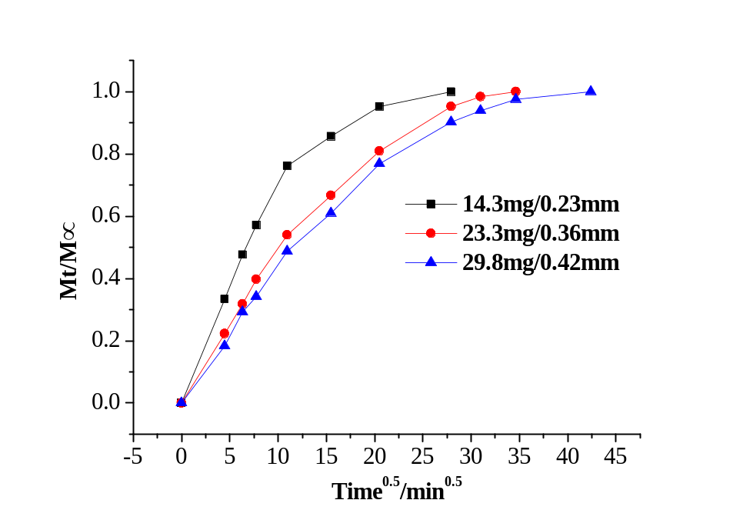
Figure 5 Time dependence of weight percentage increase

Table 2 Diffusivity calculation
 | AC (mm) | SVA (mm) | Rv | D^{A}_{B} (10⁻⁸ cm²/s) | D^{V}(10⁻⁸ cm²/s)
Sample1 | 0.23 | 0.25 | 0.08 | 0.95 | 1.14
sample2 | 0.36 | 0.4 | 0.1 | 1.06 | 1.34
sample3 | 0.42 | 0.47 | 0.11 | 1.12 | 1.44

Finally, by applying equation (10), a 3-D profile of the distribution of the ODCB vapor in the bulk film (Sample 1) at different times during the solvent uptake process is simulated, as shown in figure 6. The vapor pressure of the solvent for this sample is 160 Pa, C=P/RT=0.067mol/m³. Assuming steady state and a linear gradient of the solvent vapor in the column, at height 0.9, C₀=0.067×0.9=0.06 mol/m³, D_{avg}=1.3×10⁻⁸ cm²/s.
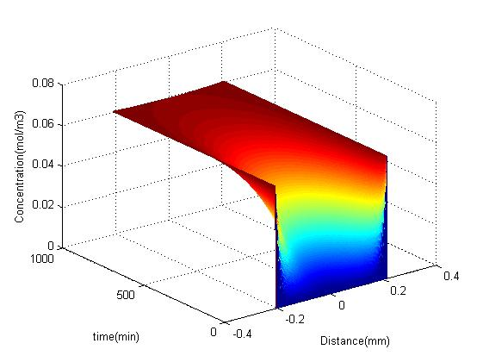
Figure 6 ODCB vapor distribution in the film during SVA process

CHAPTER III
The impact of Selective solvent annealing on the structure and Performance of P3HT/PCBM OPV cells

Experimental

Materials and sample preparation
All solvents were purchased from Aldrich and used as received. Regioregular P3HT (Mn=37k, PDI-2.0, RR=90-93%) and PCBM (99.5%) were purchased from Reike Metals Inc., and Nano-C Inc., respectively.
Silicon wafers were used as substrates and were first cleaned in hot piranha (1:3 H₂SO₄:H₂O₂) for 30 min followed by washing in abundant deionized (DI) water and dried using a stream of nitrogen gas. P3HT:PCBM (1:0.8, w/w) was then dissolved in o-dichlorobenzene (ODCB) to achieve a solution with P3HT and PCBM concentrations of 10 mg/ml and 8mg/ml, respectively. By spin coating the above solution on the treated silicon wafers, thin films with thickness of around 70 nm were obtained, which were characterized by Grazing Incidence Wide Angle X-ray Scattering (GIWAXs) and Atomic Force Microscopy (AFM). To monitor the temporal evolution of the solvent uptake in the film, thicker films (~ 0.5 mm) were formed by drop casting the solution onto a silicon wafer.

Solvent annealing
Six solvents with different P3HT and PCBM solubility (S) and vapor pressure (VP) were used as the solvent in the solvent annealing process; Bromobenzene (BB), 1,2-Dichlorobenzene (ODCB), Chlorobenzene (CB), p-Xylene (XL), Toluene (TL), 2-Chlorophenol (2-CP). A schematic of the solvent annealing apparatus is shown in Figure 7, where the total length of the vapor gradient L₀, i.e., the distance from column opening to solvent surface is 100 cm. The solvent vapor pressure gradient eventually reaches equilibrium after solvent is added into the column.
For all solvent annealing procedures, the P3HT:PCBM mixture is allowed to reside at L/L₀=0.9. In other words, the vapor pressure of the solvent during annealing is 90% of the pure solvent vapor pressure. Table 3 lists the saturated vapor pressure of the six solvents used in this study at 20 °C, as well as the vapor pressure of the solvent at the surface of the annealed sample (surface vapor pressure).
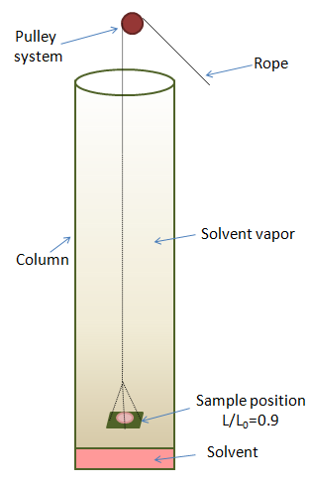
Figure 7 Schematic of the solvent vapor annealing apparatus: Variation in solvent vapor pressure during annealing is achieved by changing the position of wafer surface with respect to the solvent surface. L/L₀=0.90 is used in our experiment.

Table 3 Vapor pressure of solvents used for SVA
Solvent | Height L/L₀ | Vapor pressure 20℃ (mmHg)
Solvent | Height L/L₀ | Saturated VP | Surface VP
BB | 0.9 | 3.3 | 2.97
ODCB | 0.9 | 1.2 | 1.08
CB | 0.9 | 8.8 | 7.92
XL | 0.9 | 9 | 8.10
TL | 0.9 | 22 | 19.8
2-CP | 0.9 | 2.2 | 1.98

Characterization
The solubility of P3HT and PCBM in the solvents of interest was determined via UV-vis spectroscopy using Thermo Scientific Evolution 600 UV-Visible spectrophotometers. In this experiment, the absorbance of solutions with known concentration is monitored at 600 nm. According to the Beer-Lambert Law,
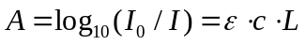⑾
where A is the measured absorbance, I₀ is the intensity of the incident light, I is the transmitted intensity, L is the pathlength (1mm), c is the concentration of the absorbing species, and ε is the extinction coefficient. Plotting the absorbance as a function of known concentration provides a measure of the extinction coefficient, ε. With knowledge of ε, the measured absorbance of a solution with unknown solute concentration provides a method to determine the solute concentration.
The rate of solvent absorption by the thin film during solvent annealing was also monitored. In this experiment, a dry 0.5 mm bulk film is placed in the solvent annealing column at L/L₀=0.9. The increase in mass of the thin film with time is then monitored until the thin film is saturated.
Grazing Incidence Wide Angle X-ray Scattering (GIWAX) was used to monitor the crystallinity of the P3HT in the thin film using a Phillips X’pert-Pro diffractometer in grazing-incidence geometry with 45Kv tube voltage and 40mA tube current. The diffraction was measured using 2theta scanning mode from 2°to 20°. The (100) peak area was analyzed to characterize the amount of crystallinity in the polymer, while Scherrer’s equation is used to calculate the size of the polymer crystals L
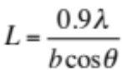⑿
Where b is the full width at half maximum (FWHM) of the (100) peak of the P3HT crystals.
Atomic force microscopy (AFM) in tapping mode using a Veeco MMAFMLN-1898E provides a picture of the surface of the thin film as a function of solvent annealing. The average RMS roughness and aggregation size were quantitatively determined on 5μm*5μm height and phase images, respectively, at multiple spots on the same sample.
To determine device performance, indium tin oxide (ITO) glass was cleaned in an ultrasonic bath using detergent, deionized water, acetone, isopropanol, and chloroform for 10 min. PEDOT:PSS (Baytron P 4083) was then spin cast (film thickness~40 nm) on top of the UV treated ITO glass, then baked in vacuum at 140°C for one hour. The photovoltaic layer was prepared by spin-coating the P3HT:PCBM solution on the above substrate at the same speed and time. This assembly was followed by the thermal deposition of 8nm MoO₃ and 30nm Au under a vacuum of 7×10⁻⁷ Torr at a deposition rate of 0.5 Å/second as the cathode. The current–voltage characteristics of these solar cells were measured utilizing a Keithley 2400 source meter under the photo excitation provided by Thermal Oriel 96000 300-W solar simulator from Newport in a nitrogen-filled environment within one day of electrode deposition.

Results and discussion

Solubility measurement
Figure 8 shows the absorbance of P3HT in bromobenzene as a function of concentration. The solubility limit is also shown by the red line, which is determined by measuring the absorbance of a saturated solution of P3HT in BB that is diluted 100 times, and using the Beer-Lambert Law to determine its concentration. The saturated solution is diluted 100 times, as the absorbance of the saturated solution is too high.
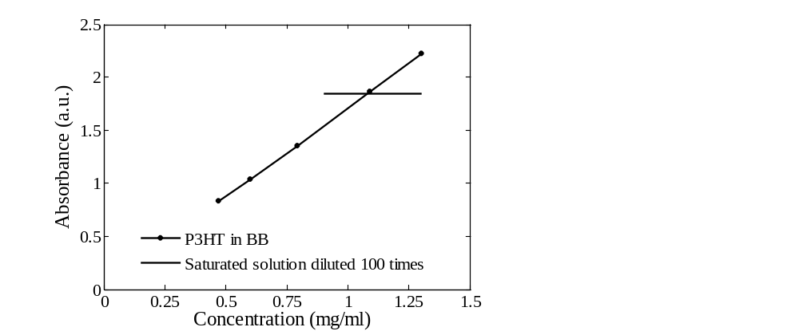
Figure 8 Solubility measurement via UV-Vis (P3HT in BB)

This UV-Vis method is used to determine the solubility of P3HT and PCBM in all six solvents, and presented in Table 4. These results show that BB has the highest P3HT solubility, followed by ODCB, CB, XL, TL, 2-CP; while the PCBM solubility is 2-CP> TL> XL> CB> ODCB> BB.

Table 4 Measured solubility of P3HT and PCBM in solvents used in SVA
Solvent | Measured Solubility (mg/ml)
 | P3HT | PCBM
Bromobenzene | 107.9 | 33.4
ODCB | 37.1 | 35.9
Chlorobenzene | 33.8 | 39.4
p-Xylene | 3.4 | 24.5
Toluene | 1.4 | 16.3
2-Chlorophenol | ＜0.1 | 128.3

Solvent Uptake in Solvent Vapor Annealing
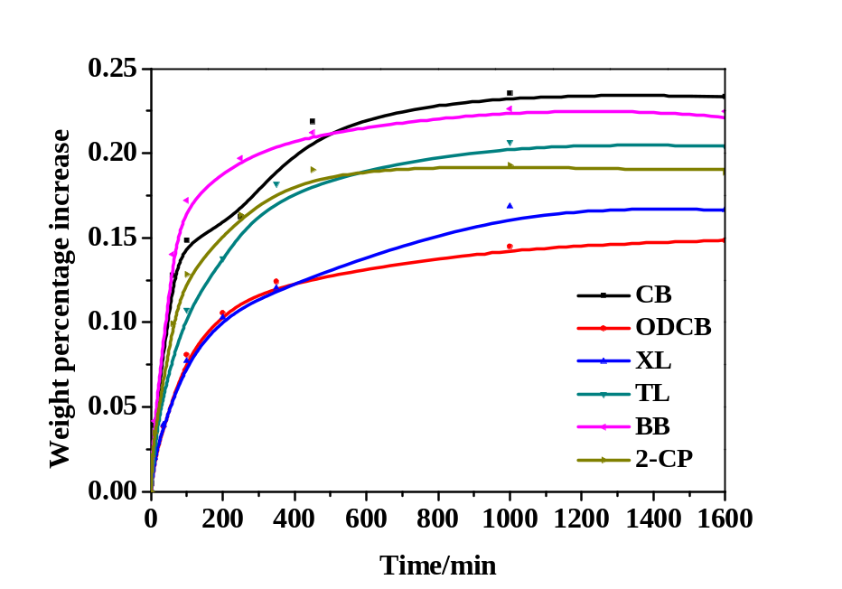
Figure 9 Weight percentage increase of P3HT/PCBM bulk film upon exposure to different solvent vapor

Following the kinetics of the weight increase of P3HT/PCBM bulk film upon exposure to solvent vapor, as shown in Figure 9, shows that initially, the vapor diffuses into the thin film very quickly. However, as the amount of absorbed vapor increases, the evaporation rate increases as well, until finally equilibrium is reached where vapor diffusion into the thin film equals evaporation.
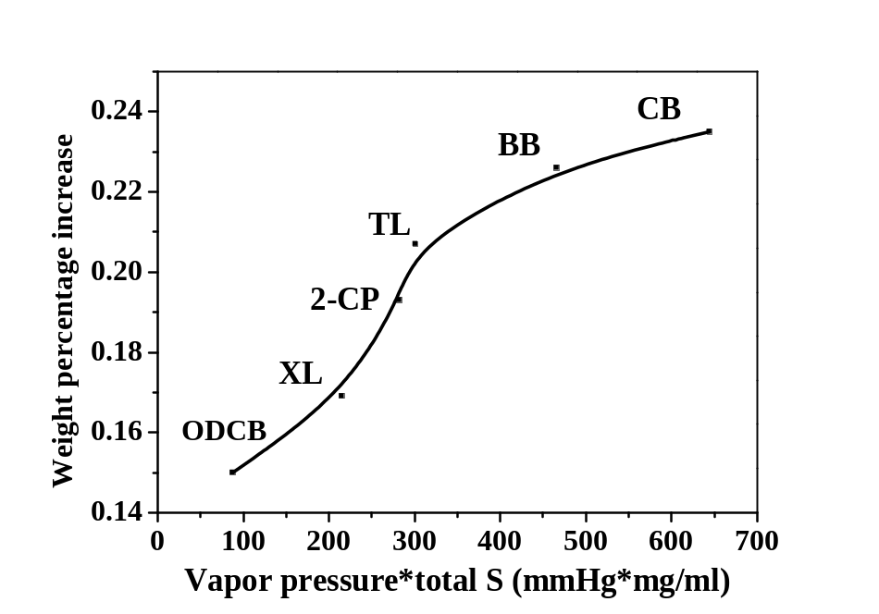
Figure 10 Total weight percentage increase during SVA as a function of the product of solvent vapor pressure and total solubility

Figure 10 quantitatively illustrates that the total weight increase during SVA is in direct proportional to the product of the solvent vapor pressure and the total solubility, where the total solubility is the sum of the solubility limit of P3HT and the solubility limit of PCBM in the given solvent. This result is quite understandable and verifies the measured solubility data.
According to diffusion theory, the time of diffusion across a thin film is proportional to the square of the film thickness, i.e., t~l². The thickness of the bulk film is about 0.1mm, which is 1400 times larger than the spin-coated thin films (about 70nm). While the saturation time of the thick film is ca. 1000min, the saturation time of the spin-coated films is therefore a few hundredths of a second. As will be seen below, the structure of the film evolves over a much longer time scale than this penetration time, indicating that the change of the nanoscale morphology by absorbed solvent vapor is not limited by the diffusion of the solvent into the sample.

Grazing Incidence Wide Angle X-ray Scattering (GIWAXS)
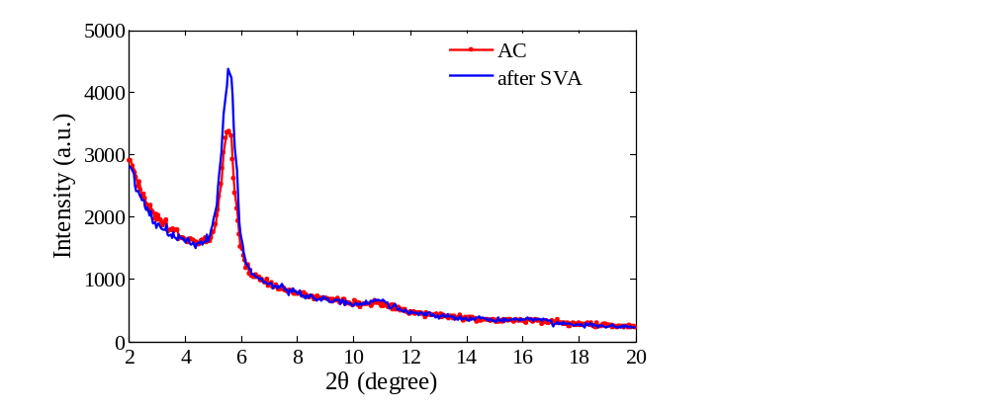
Figure 11 GIWAXS curve of the P3HT/PCBM composite films
before and after ODCB SVA

The GIWAXS scattering curves of the P3HT/PCBM spin-coated film before and after solvent annealing in ODCB vapor are presented in Figure 11. In this Figure, the (100) crystalline peak of a P3HT is found at 2theta= 5.4°. The d-spacing does not change between the as-cast and solvent annealed thin films, whereas the area under the (100) peak and the full width at half maximum (FWHM) of the peak does change. This indicates that the P3HT crystallinity and crystal size (L) transforms during SVA. Figure 12 shows the change in the area of the (100) P3HT peak with solvent annealing time for the solvents studied. All samples exhibit a crystallinity increase at the initial exposure to each solvent vapor, which is attributed to enhanced P3HT mobility imparted by the presence of solvent vapor, which allows P3HT to crystallize. However, for the five solvents with some P3HT solubility (~>1mg/ml; BB, ODCB, CB, XL, and TL), the crystallinity decreases dramatically when exposed to solvent vapor for an extended period of time. At these long exposure times, the crystallinity can be less than that of the as-cast sample. This loss of crystallinity is attributed to the dissolution of the P3HT crystals by the absorbed solvent vapor. However, the crystallinity of P3HT in the sample that is vapor annealed in 2-CP does not show this decrease. 2-CP is a non-solvent for P3HT, indicating that polymer solubility is a crucial parameter that controls the ordering of the polymer during solvent annealing. It is interesting that the P3HT crystallinity does increase at early solvent annealing times in 2-CP, even though it is a non-solvent. This increase is ascribed to the solubility of PCBM in 2-CP and miscibility of PCBM in amorphous P3HT^{54,55}
Figure 13 shows the evolution of P3HT crystal size in each solvent annealed thin film, where the samples that are solvent annealed in the five samples with finite P3HT solubility show a decrease in crystal size at long solvent anneal times, but the crystal size remains relatively constant at long solvent anneal times for the sample that is annealed in 2-CP. This further demonstrates that the dissolution and formation of the P3HT crystals during SVA is mainly influenced by the P3HT solubility in the annealing solvent.
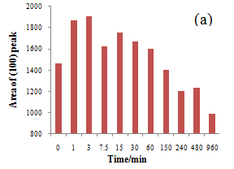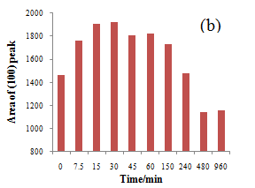
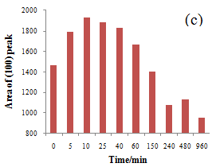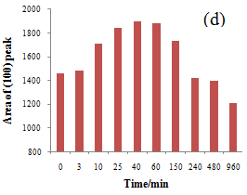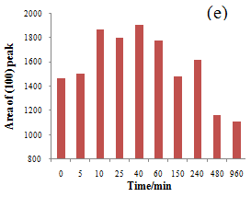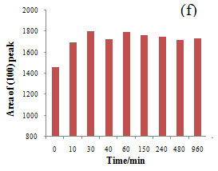
Figure 12 Area of the P3HT (100) peak in the various solvent annealed P3HT/PCBM samples: (a) Bromobenzene; (b) ODCB; (c) CB; (d) p-xylene; (e) Toluene; (f) 2-chlorophenol.

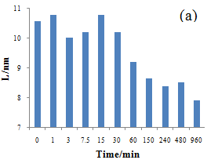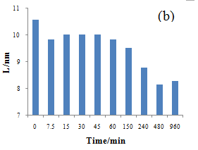
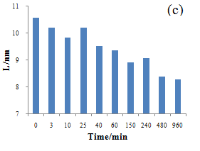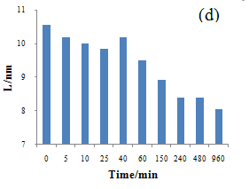
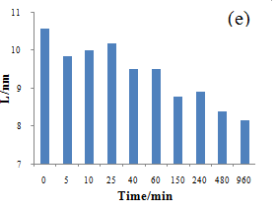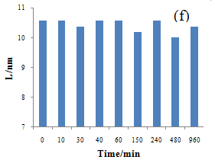
Figure 13 P3HT crystal size of the P3HT/PCBM sample annealed in various solvents: (a) Bromobenzene; (b) ODCB; (c) CB; (d) p-xylene; (e) Toluene; (f) 2-Chlorophenol;

To further understand the role of solvent vapor pressure and the solubility of both P3HT and PCBM in the vapor annealing solvent, the time of maximum P3HT crystallinity is tabulated along with the solvent vapor pressure, P3HT solubilities (P3HT S) and PCBM solubilities (PCBM S) in Table 5. In Figure 14, the time of maximum crystallinity is plotted as a function of the product of the solvent vapor pressure and PCBM S, of the product of the solvent vapor pressure and P3HT S, and of the product of the solvent vapor pressure and the sum of PCBM S and P3HT S. These results show that the time of peak crystallinity is inversely proportional to the product of the solvent vapor pressure and P3HT solubility. This is interpreted to indicate that the higher solvent vapor pressure and P3HT solubility increases the amount and rate of absorbed solvent vapor, more quickly allowing the P3HT chains to assemble into its crystalline form.

Table 5 Time for peak P3HT crystallinity, vapor pressure and component solubilities for the examined solvents
Solvent | P3HT S  (mg/ml) | PCBM S (mg/ml) | VP  (mmHg) | VP*P3HT S  (mmHg*mg/ml) | VP*PCBM S  (mmHg*mg/ml) | VP*total S  (mmHg*mg/ml) | Peak time (min)
BB | 107.9 | 33.4 | 3.3 | 356.1 | 110.2 | 466.3 | 3
ODCB | 37.1 | 35.9 | 1.2 | 44.5 | 43.1 | 87.6 | 30
CB | 33.8 | 39.4 | 8.8 | 297.4 | 346.7 | 644.2 | 10
XL | 3.4 | 20.5 | 9 | 30.6 | 220.5 | 251.1 | 40
TL | 1.4 | 12.3 | 22 | 30.8 | 358.6 | 389.4 | 40
2-CP | ＜0.1 | 128.3 | 2.2 | × | 282.3 | 282.3 | 30

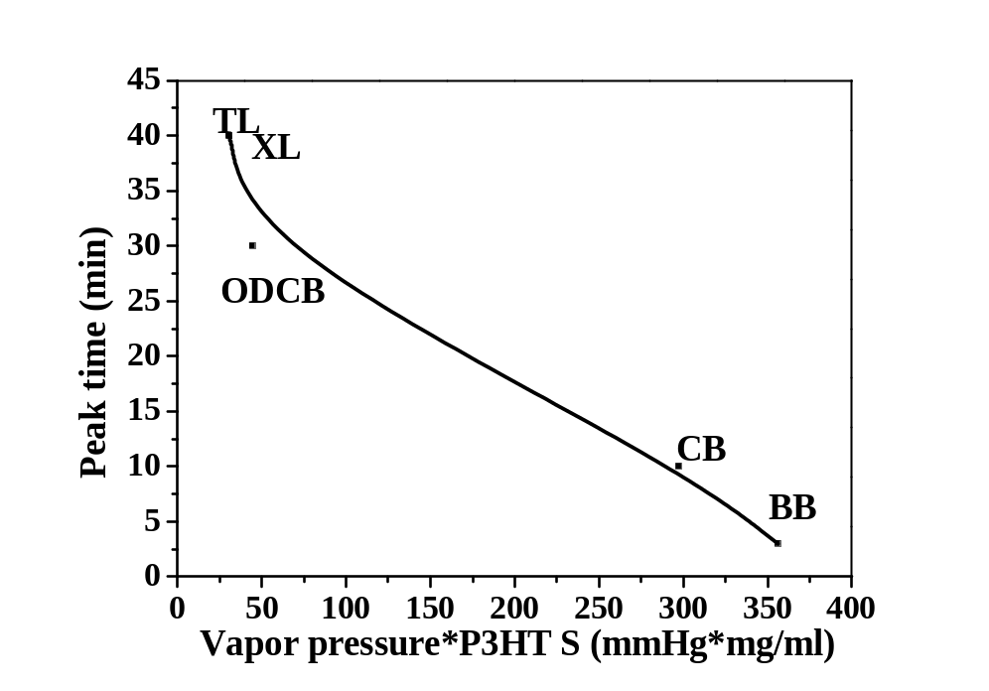
Figure 14 Time of Peak P3HT crystallinity as a function of solvent vapor pressures and P3HT solubility

To further investigate the effect of P3HT or PCBM solubility on the change in crystallinity during SVA, pure P3HT thin films that are formed by spin coating from an ODCB solution (10 mg/ml) were solvent annealed in CB, TL, and 2-CP and characterized. The GIWAXS experiments show that the evolution of P3HT crystallinity is similar in these thin films to the P3HT/PCBM thin films when solvent annealed in CB and TL, as can be observed in Figure 15. However, there is little change in the crystallinity of the P3HT thin film that is annealed in 2-CP vapor, which can be attributed to the insolubility of P3HT in 2-CP. These results also exemplify that the high solubility of PCBM in 2-CP induces P3HT crystallization in the BHJ during SVA.
Utilizing the 3-phase model for P3HT:PCBM mixtures [14,15], the absorbed 2-CP solvent vapor penetrates the miscible amorphous P3HT:PCBM phase, increasing the mobility of PCBM. However, the increased PCBM mobility in the mixed phase will also allow P3HT chain movement, therefore permitting the P3HT to form crystals as well. Moreover, the absorbed 2-CP solvent won’t destroy previously formed P3HT crystals, due to its insolubility. Consequently, the P3HT crystallinity increases in the P3HT/PCBM mixture thin film; but the crystallinity of the P3HT is not altered in the pure P3HT thin film.

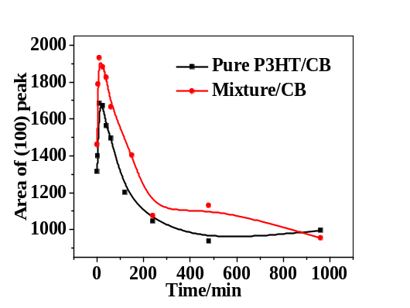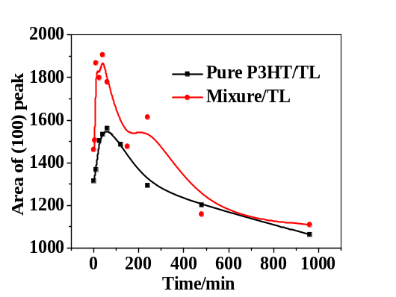
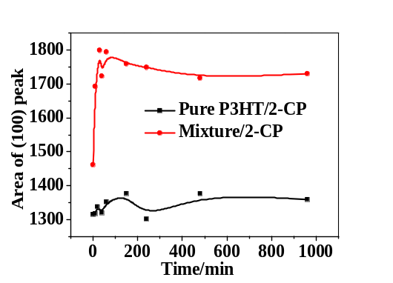
Figure 15 Comparison of the area of (100) peak for solvent annealed P3HT/PCBM and pure P3HT samples. Top left: CB; Top right: TL; Bottom: 2-CP.

Atomic force microscopy (AFM)
AFM investigates the changes in the surface morphology of the OPV active layer as a result of SVA. Figure 16 shows the AFM height and phase contrast images of the P3HT:PCBM thin film during solvent vapor annealing in CB and TL. In these figures, the bright dots in the phase contrast images are ascribed to PCBM domains, as a consequence of the higher modulus of PCBM than P3HT. The average aggregation size of the PCBM domains on the surface as well as the root mean square (RMS) roughness for each annealed film is presented in Figure 17. The phase contrast results indicate that there is a continuous increase of PCBM aggregation on the surface of the P3HT/PCBM composite thin film during both CB and TL SVA. This may be attributed to PCBM phase separation that occurs with increased molecular mobility. The surface morphology of the active layer may exhibit much clearer and larger PCBM aggregation than the inner morphology, due to the high vapor concentration on the surface. The evolution of the RMS roughness, calculated from the 5μm*5μm height images, exhibits a similar increase as the development of PCBM aggregation during CB and TL SVA, whereas it does not follow the crystallinity variation (as is shown in Figure 19). This indicates that the increase of RMS roughness is mainly caused by the formation of PCBM aggregation, but does not closely relate to the P3HT crystallization.

TL annealed thin film
CB annealed thin film
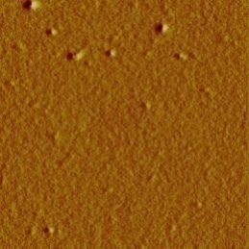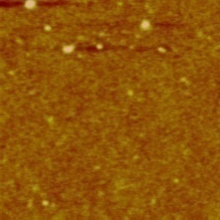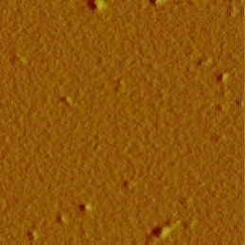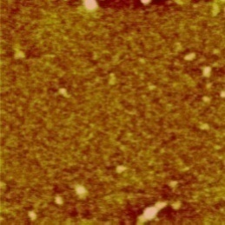
Time
(min)
0
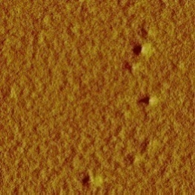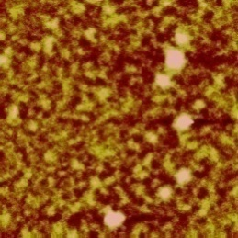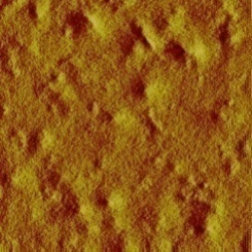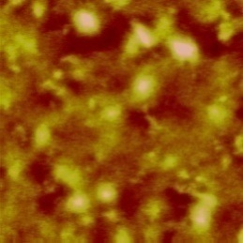
5
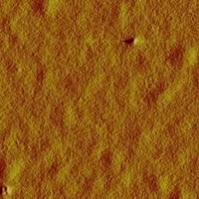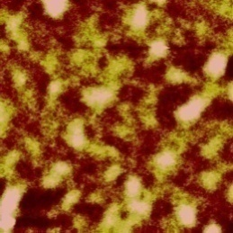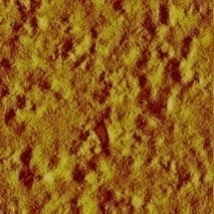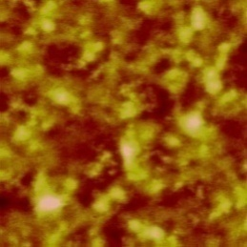
10
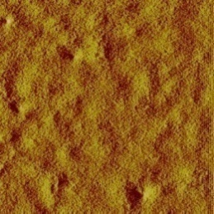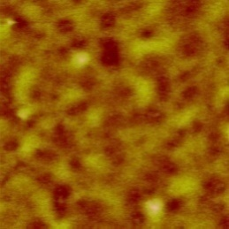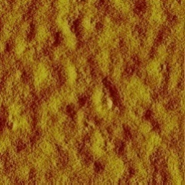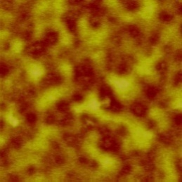
25
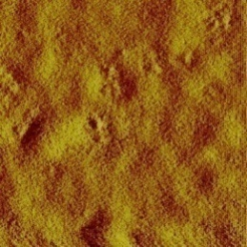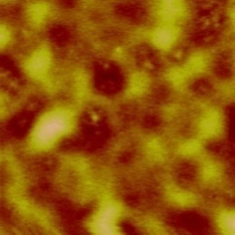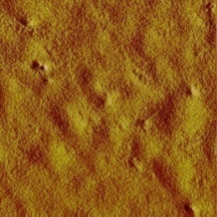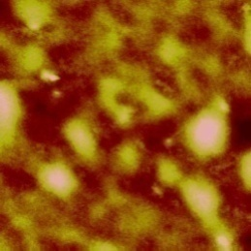
40
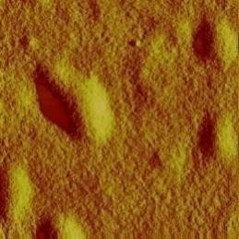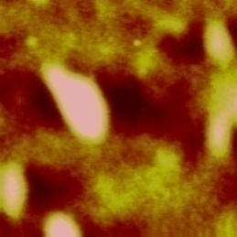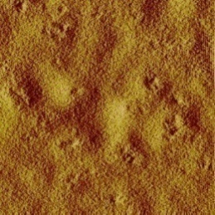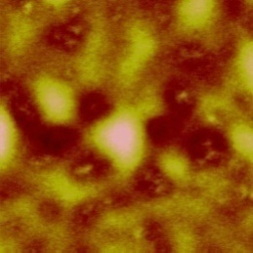
60
Figure 16 AFM image of CB and TL annealed thin film. In each column, left: 5μm*5μm phase image; right: 5μm*5μm height image.

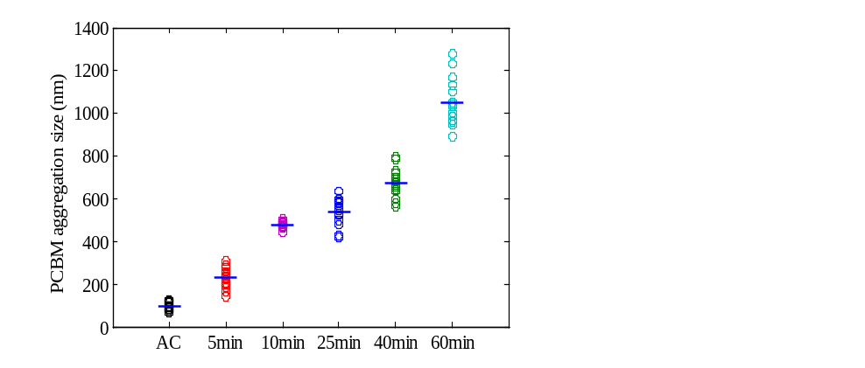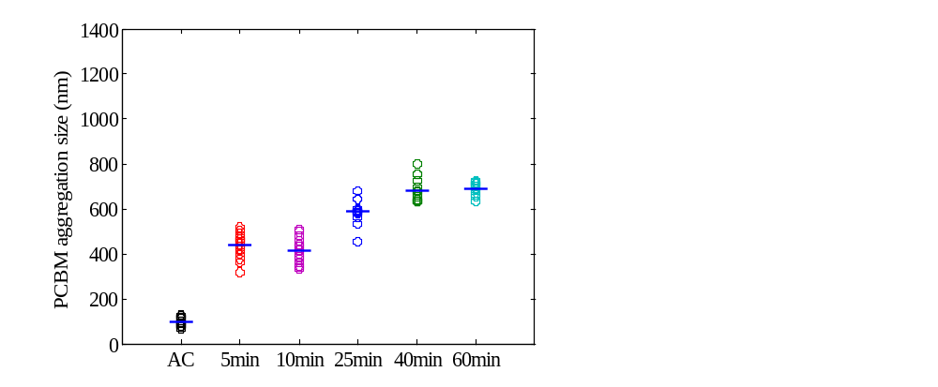
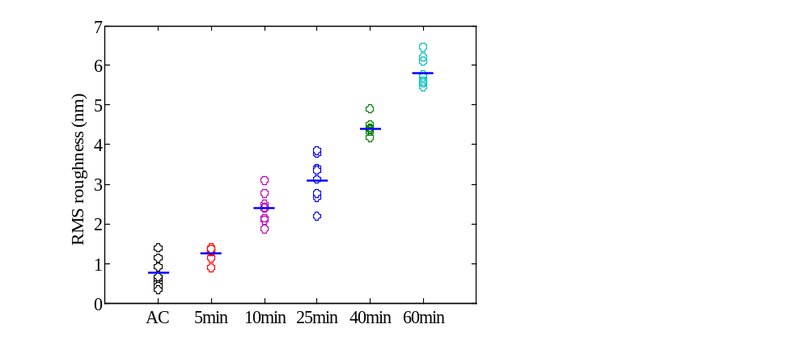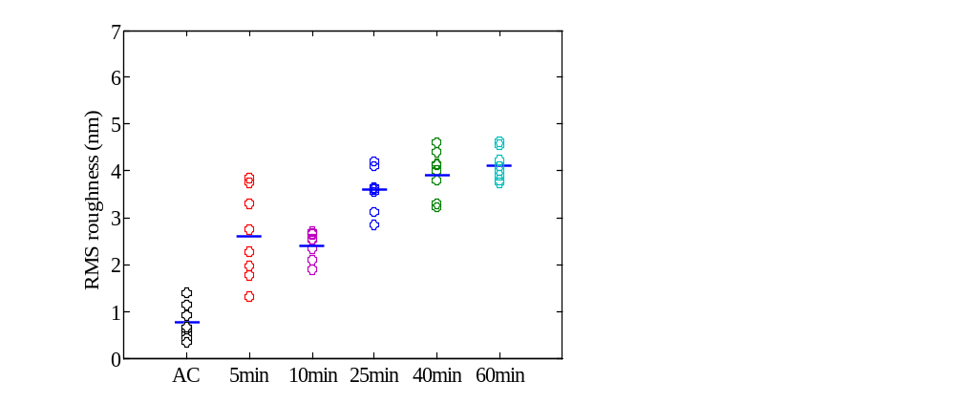
Figure 17 PCBM aggregation size and RMS roughness during SVA: Left: CB annealed samples; Right: TL annealed samples; Top: PCBM aggregation size; Bottom: RMS roughness

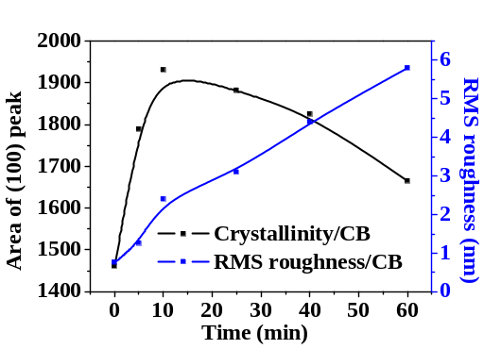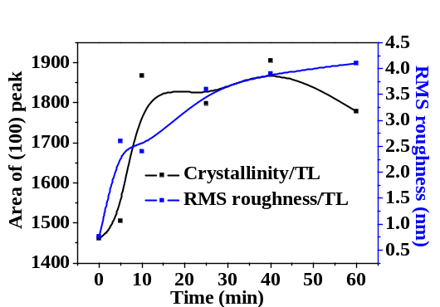
Figure 18 Relationship between P3HT crystallinity and RMS roughness. Left: comparison for CB; Right: comparison for TL.

To compare the evolution of the surface structure for the various solvents, two times were chosen for comparison: time 1, which is the time of peak P3HT crystallinity and time 2, which is approximately twice time 1. The surface morphology of the P3HT:PCBM thin films at time 1 and time 2 are shown in Figure 19, while the average PCBM aggregate size and RMS roughness are plotted in Figure 20. Whereas the P3HT crystallinity initially increases and then decreases with solvent annealing for most solvents, the PCBM aggregate size is always larger at longer times (time 2) than shorter annealing times (Time 1).
In order to better understand the impact of component solubility and solvent vapor pressure on the surface morphology evolution, the PCBM aggregate size and RMS roughness are plotted as a function of the product of component solubility (S) and vapor pressure in Figure 21. These plots clearly show that the PCBM aggregate size and RMS roughness are proportional to the PCBM solubility factor at time 1. This is reasonable, as examining the systems at maximum P3HT crystallinity has moderated the impact of P3HT solubility. Thus the solubility of PCBM in each solvent becomes the most significant factor affecting the surface morphology evolution, as the formation of PCBM aggregates is primarily due to enhanced PCBM molecule mobility endowed by absorbed solvent vapor. Further examination of the data also indicates that the PCBM aggregate size generally correlates to the RMS roughness, indicating that the change in RMS roughness is due to the formation of PCBM aggregates during SVA.

Time 1
Time 2
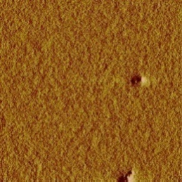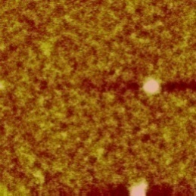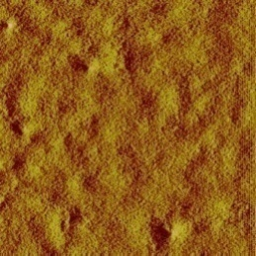
BB
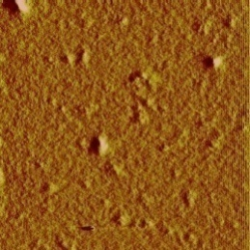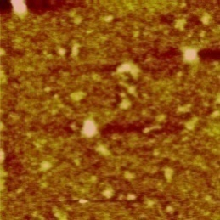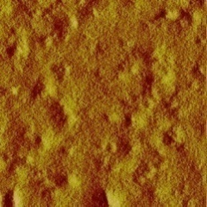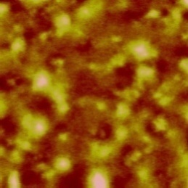
ODCB
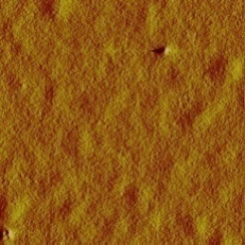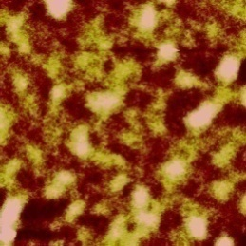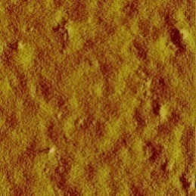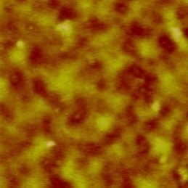
CB
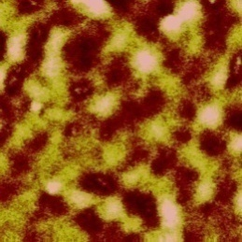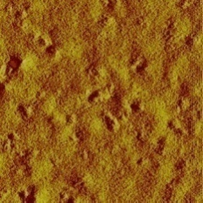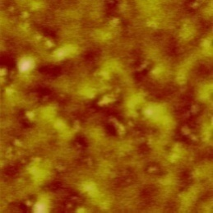
XL
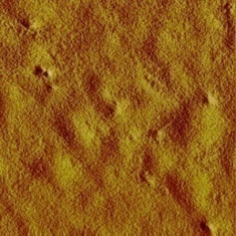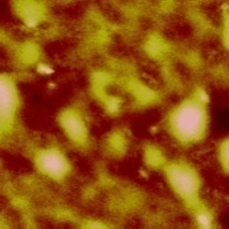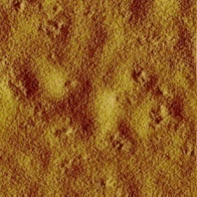
TL
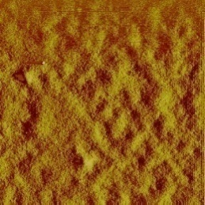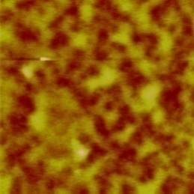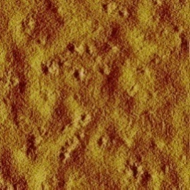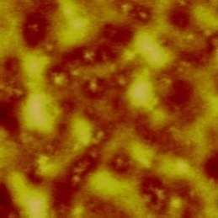
2-CP
Figure 19 AFM image of solvent annealed thin film at time 1 time 2. In each column, left: 5μm*5μm phase image; right: 5μm*5μm height image.
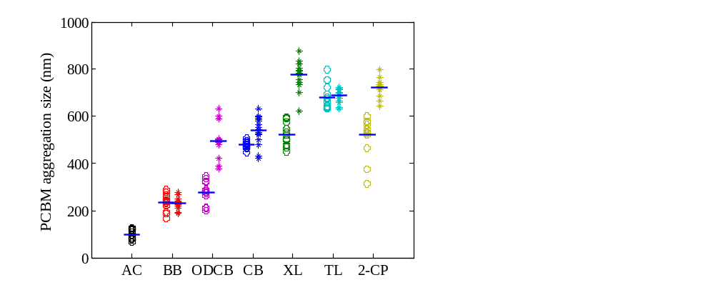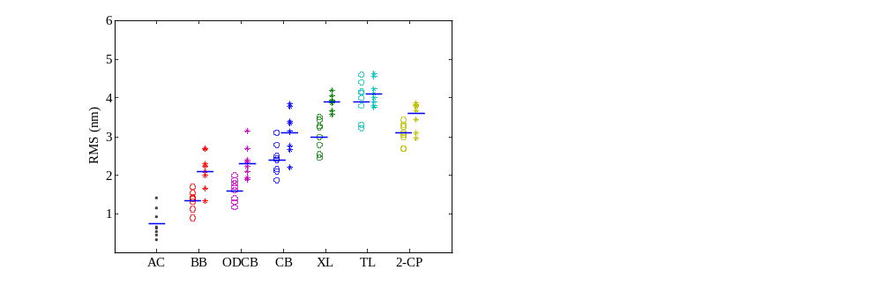
Figure 20 AFM results of PCBM aggregate size (left) and RMS roughness (right) of solvent annealed thin film at time 1 and time 2
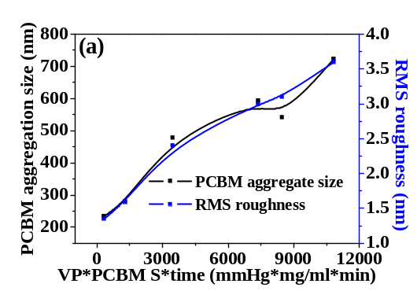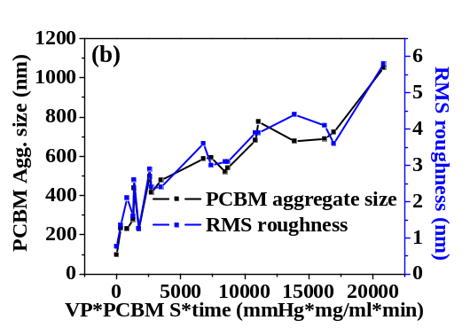
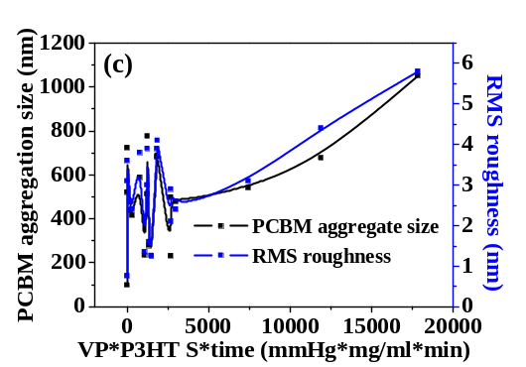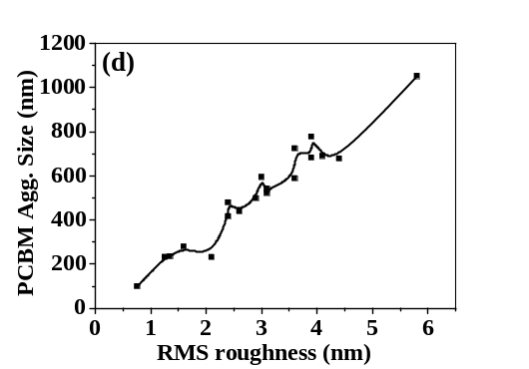
Figure 21 Relationship between PCBM aggregate size, RMS roughness and solubility factor (vapor pressure*solubility*time): (a) PCBM aggregate size and RMS roughness as a function of PCBM solubility at time 1; (b) PCBM aggregate size and RMS roughness as a function of PCBM solubility at time 2; (c) PCBM aggregate size and RMS roughness as a function of P3HT solubility at time 1; (d) PCBM aggregate size and RMS roughness as a function of P3HT solubility at time 2

Solar cell performance
To correlate the morphology changes that occur with SVA to the photovoltaic performance of the OPV active layer, thirteen identical solar cells were fabricated and solvent vapor annealed for the SVA conditions at time1 and time2. The J-V curves for these samples are presented in Figure 22. These results show that J_{sc}improves substantially for all solvent annealed samples, and the overall power conversion efficiency (PCE) increases as well. At time1, where all samples have attained peak P3HT crystallinity, the sample that is annealed in 2-CP exhibits the highest PCE, followed by the samples annealed in TL, XL, CB, ODCB and BB. This variation is primarily a consequence of the differences in PCBM phase segregation.
Previous research has shown that increased P3HT crystallinity improves hole mobility, while PCBM phase separation is conducive to improved electron mobility, both of which are beneficial for improved power conversion efficiency of the OPV active layer [6-8]. The results reported above shows that the increase in P3HT crystallization rate is proportional to P3HT solubility and solvent vapor pressure (Figure 14), while PCBM aggregation is primarily determined by the product of the solubility of PCBM and the solvent vapor pressure (Figure 21). Therefore, the solubility of both components in the vapor annealing solvents controls P3HT crystallization and PCBM aggregation.
For instance, Figure 19 shows that the samples that are vapor annealed in BB, ODCB and CB have relatively small PCBM aggregates at the P3HT crystallinity maximum time, which may be ascribed to the fact that P3HT is more soluble in those three solvents than PCBM. This preference for P3HT results in enhanced P3HT molecular mobility, which results in a faster P3HT crystallization than PCBM aggregation. Therefore, at the peak P3HT crystallinity time, PCBM has not had sufficient time to segregate, limiting electron transport. On the other hand, PCBM has a higher solubility in XL, TL and 2-CP than P3HT, which results in faster PCBM aggregation inducing larger PCBM aggregates at P3HT crystallinity peak time. This provides more opportunities for electron transport to the electrodes.
At longer annealing times, an increased PCE is observed for the samples annealed in BB, ODCB and CB while a similar PCE is observed for the sample that is annealed in XL at time 1 and time 2. The samples that are annealed in TL and 2-CP exhibit a slight decrease in PCE with extended annealing time.
Plotting the OPV active layer PCE as a function of RMS roughness, as shown in Figure 23, shows that the PCE increases with RMS roughness at first then decreases afterwards, indicating that moderate RMS roughness, i.e., moderate PCBM aggregate size, is favorable to the cell performance. This can be ascribed to the fact that excessive PCBM aggregation reduces P3HT/PCBM interfacial area and exciton dissociation, as well as the potential for the formation of isolated PCBM domains that limit charge transport to the electrode. Based on this model, the performance of the samples that are annealed in TL and 2-CP exhibit a decrease in PCE at time 2 because of the overgrowth of PCBM aggregates.

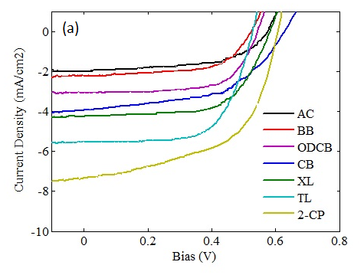
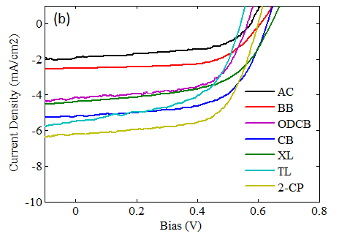
Figure 22 J-V curves of solvent annealed P3HT/PCBM composite films at: (a) time 1; (b) time 2.

Table 6 Photovoltaic performance of the Solvent Annealed active layers
 | Time1  (min) | (100)  peak area | Isc  (mA/cm²) | Voc (V) | FF | PCE | Time2  (min) | (100)  peak area | Isc  (mA/cm²) | Voc (V) | FF | PCE
AC |  | 1420 | 1.92 | 0.58 | 0.58 | 0.65 |  | 1420 | 1.92 | 0.58 | 0.58 | 0.65
BB | 3 | 1909 | 2.25 | 0.52 | 0.61 | 0.71 | 7.5 | 1621 | 2.52 | 0.61 | 0.62 | 0.95
ODCB | 30 | 1920 | 3.10 | 0.54 | 0.66 | 1.11 | 60 | 1822 | 4.16 | 0.57 | 0.63 | 1.49
CB | 10 | 1931 | 3.89 | 0.63 | 0.51 | 1.25 | 25 | 1882 | 5.2 | 0.62 | 0.61 | 1.97
XL | 40 | 1900 | 4.25 | 0.58 | 0.63 | 1.55 | 60 | 1879 | 4.38 | 0.64 | 0.56 | 1.57
TL | 40 | 1905 | 5.49 | 0.53 | 0.65 | 1.89 | 60 | 1778 | 5.48 | 0.54 | 0.55 | 1.63
2-CP | 30 | 1799 | 7.17 | 0.61 | 0.56 | 2.45 | 60 | 1794 | 6.16 | 0.6 | 0.64 | 2.37
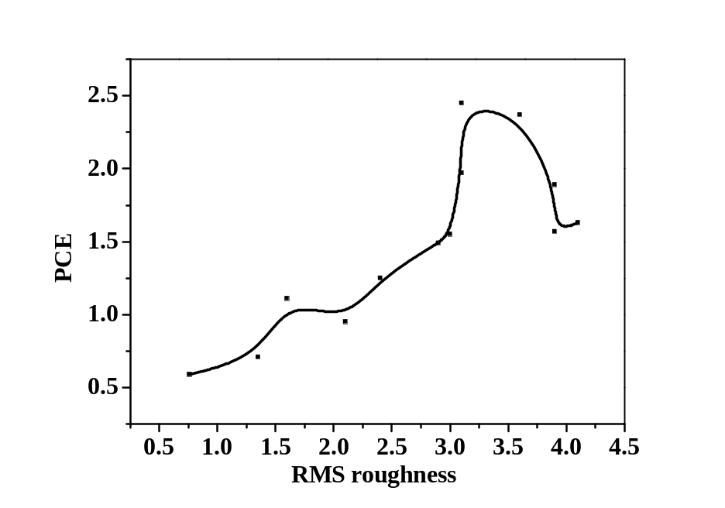
Figure 23 Relationship between PCE and RMS roughness

CHAPTER IV
Design of flow SVAapparatus forIn-situ light scattering

Design of flow SVA Apparatus
A flow SVA apparatus for in-situ light scattering (IS-LS) enables both specular reflection and off-specular reflection measurement of OPV thin film during SVA process. The basic theory of light scattering is that when an electromagnetic wave (i.e., the incidence light) hits a scattering obstacle, the molecule and charge density in the particle will be polarized periodically at the same frequency of the incoming electromagnetic wave, which induce a periodic charge separation within the molecule, forming a dipole moment. This oscillating dipole moment is regarded as an electromagnetic radiation source, which results in redirection of light, i.e., light scattering. In general, the scattering light intensity is strongly dependent on the particle size and morphology, if the particle size is greater than λ/10, the path difference of the scattered light from two points could be large enough to produce a tremendous phase difference so as to induce interference.
In our study, variation of film thickness as well as lateral phase separation of P3HT/PCBM during SVA process could be observed during the light scattering process. This setup mainly comprises two parts: a cone shape metal cover and a solvent container, as shown in Figure24. N₂ was blown into the solvent container to accelerate the solvent evaporation rate, while two mass flow controllers were installed at the inlet and outlet of the container respectively, so as to monitor the solvent evaporation rate by calculating the difference between the outlet and inlet mass flow rate. A large screen made of quartz and a 1cm diameter hole was built on the left and right side of the metal cover respectively, in order to let the laser come through; a round shape paper with 9 diameters was then attached on the quartz screen. Further a charge-coupled-device (CCD) camera and a beam splitter and photodiode detector was installed on left facing the screen, while the laser was installed at the right hand side facing the cover.
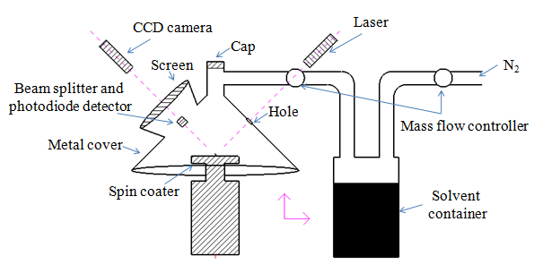Figure 24 The schematic diagram illustrating the main components of flow SVA setup for in situ light scattering

Initiatory Experiment
In our experiment, N₂ was first blown into the metal cover for about 6 hours, so as to let the solvent vapor concentration reaches equilibrium in the cover. A certain amount of P3HT:PCBM (1:0.8, w/w) solution (ODCB) (10 mg/ml) was then deposited onto the silicon substrate mounted on a spin-coater chuck from the top cover using a pipette, at a speed of 1000 rpm for 90 sec. Afterwards, the polymer thin film underwent solvent annealing (Toluene) in the cover, during which time a laser beam with 633nm wavelength was incident on the center of the substrate. The reflected light of the thin film was separated by the beam splitter, where the specular reflection was collected by the photodiode detector, which constructs a profile of thickness as a function of time during SVA; the off-specular reflection was collected by the CCD camera, from which the appearance of ring shape scattering structure is indicative of the development of lateral phase separation of P3HT and PCBM during SVA.

Results and Analysis:

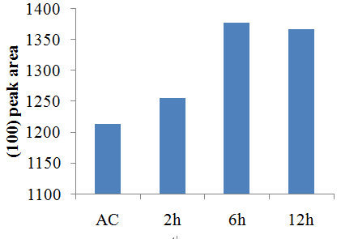
Figure 25 GIWAX results using flow SVA

This flow SVA setup provides a basic model to do the in situ light scattering for the flow SVA process, however, according to the GIWAX results shown in figure 25, the (100) peak area which represents P3HT crystallinity only increases from 1210 to 1370 even SVA for 6 hours; however, our previous research shows that SVA could improve (100) peak area for 600.
Off-specular light scattering of spin coated P3HT/PCBM (1:0.8, w/w) thin film with different concentration in ODCB is measured (P3HT concentration is 5, 10, 15, 20, 25 and 30 mg/ml respectively). More scattering intensity is observed on the off-specular pattern of the spin coated thin film with the increase of solution concentration, and clear ring structure is seen for the 30mg/ml spin coated films, as shown in figure 26. The formation of ring structure could be strongly affected by the thickness of the film as well as P3HT ordering and phase separation. However, not much difference is found in this ring structure after flow SVA for 6 hours as is shown in figure 27.

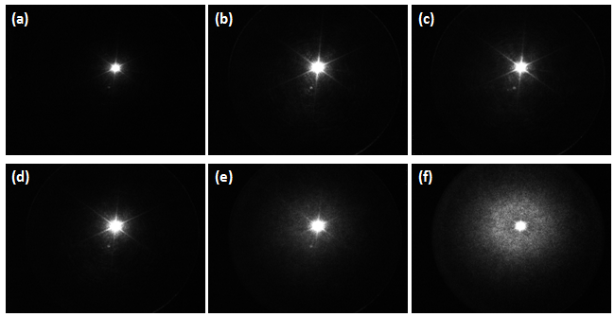
Figure 26 Off-specular light scattering images of spin coated P3HT/PCBM thin film with different concentration in ODCB (a) 5mg/ml, (b) 10mg/ml, (c) 15mg/ml, (d) 20mg/ml, (e) 25mg/ml, (f) 30mg/ml

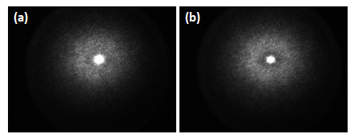
Figure 27 Off-specular light scattering images of 30 mg/ml film (a) before and (b) after flow SVA for 6 hours

The problem is mainly due to inefficiency of vapor pressure, since the pumped air would largely dilute the solvent vapor concentration in the metal cover, also the big space of the metal cover are not favorable for solvent vapor accumulation.
Further modification needs to be done in order to improve the vapor pressure, e.g., control the air flow rate to maximize the vapor accumulation rate in the cover; or heat the solvent using oil bath, so as to accelerate the solvent evaporation rate; also, do some modification to the setup itself, e.g., to make it more sealed, shorten the tube length or decrease the metal cover volume, etc.

CHAPTER V
Conclusion
The solubility of P3HT and PCBM and solvent vapor pressure clearly impacts the development of the morphology of P3HT/PCBM active layers during solvent vapor annealing, which in turn determines the OPV performance of the resultant solar cell. Two distinct phenomena are observed in the morphological progression of the solvent annealed thin films: an evolution of P3HT crystallinity as well as the growth of PCBM aggregates.
For the solvents that have a finite P3HT solubility, SVA initially increases P3HT crystallinity until reaching a limiting value. Solvent vapor annealing beyond this optimum lowers crystallinity presumably by dissolving already formed P3HT crystals. The solubility of P3HT in the vapor annealing solvent is pivotal in determining the variation of P3HT crystallinity with solvent annealing. However, the P3HT/PCBM sample that is solvent annealed in 2-Chlorophonel vapor, which has negligible P3HT solubility also favors P3HT crystallinity enhancement by inducing P3HT mobility in the miscible amorphous phase.
A PCBM-rich phase, formed by PCBM aggregation continuously grows with solvent vapor annealing for all solvents studied, and the rate of this growth is controlled by the PCBM solubility in the annealing solvent. As might be expected, moderate PCBM aggregation, is preferred, as extended phase segregation reduces the interface between P3HT and PCBM, limiting exciton dissociation. Similarly, excess segregation can lead to isolated domains that limit charge transport to the electrodes; both factors will decrease PCE performance.
As the rate of P3HT crystal growth is controlled by the solubility of P3HT in the vapor annealing solvents, and PCBM solubility directs the PCBM aggregation, active layers that are annealed in solvent that prefer P3HT (BB and ODCB in this study) form a P3HT pathway for charge transport before the PCBM domains are sufficient to support efficient electron transport to the electrodes. These samples benefit from further solvent annealing to allow additional PCBM aggregation, but risk the loss of P3HT crystallinity.
P3HT:PCBM thin films that are solvent annealed in solvents that prefer PCBM (XL, TL, and 2-CP in this study) show a decrease in active layer performance with excess solvent annealing, which can be ascribed to phase segregation of the PCBM into larger and potentially inaccessible domains that limits exciton dissociation and charge transport pathways to the electrode.
In order to better monitor the depth and phase transformation of OPV thin film during SVA, a flow SVA setup is designed for the observation of in-situ light scattering, where variation of film thickness as well as lateral phase separation of P3HT/PCBM during SVA process could be observed from specular reflectivity and off-specular reflectivity respectively. Thin film spin coated using 30 mg/ml P3HT/PCBM solution forms ring structure in the off-spacular light scattering pattern. However, due to inefficient vapor pressure, small change is found for this ring structure after flow SVA, while the GIWAX results also show that only a small increase of (100) peak area is found after SVA. Therefore, further modification to the design still needs to be done in order to improve vapor pressure.

LIST OF REFERENCES
1. Markvart, T., Solar Electricity. John Wiley: Chichester, England, 2000.
2. Hegedus, S. S.; Luque, A., Status, Trends, Challenges and the Bright Future of Solar Electricity from Photovoltaics. In Handbook of Photovoltaic Science and Engineering, John Wiley & Sons, Ltd: 2003; pp 1-43.
3. Green, M. A.; Emery, K.; Hishikawa, Y.; Warta, W., Solar cell efficiency tables (version 36). Progress in Photovoltaics: Research and Applications 2010, 18 (5), 346-352.
4. Chung, B. C.; Virshup, G. F.; Hikido, S.; Kaminar, N. R., 27.6% efficiency (1 sun, air mass 1.5) monolithic Al[sub 0.37]Ga[sub 0.63]As/GaAs two-junction cascade solar cell with prismatic cover glass. Applied Physics Letters 1989, 55 (17), 1741-1743.
5. (a) Krebs, F. C., Fabrication and processing of polymer solar cells: A review of printing and coating techniques. Solar Energy Materials and Solar Cells 2009, 93 (4), 394-412; (b) Chen, L.-M.; Hong, Z.; Li, G.; Yang, Y., Recent Progress in Polymer Solar Cells: Manipulation of Polymer:Fullerene Morphology and the Formation of Efficient Inverted Polymer Solar Cells. Advanced Materials 2009, 21 (14-15), 1434-1449.
6. Peet, J.; Senatore, M. L.; Heeger, A. J.; Bazan, G. C., The Role of Processing in the Fabrication and Optimization of Plastic Solar Cells. Advanced Materials 2009, 21 (14-15), 1521-1527.
7. He, Z.; Zhong, C.; Su, S.; Xu, M.; Wu, H.; Cao, Y., Enhanced power-conversion efficiency in polymer solar cells using an inverted device structure. Nat Photon 2012, 6 (9), 591-595.
8. Peumans, P.; Forrest, S. R., Separation of geminate charge-pairs at donor–acceptor interfaces in disordered solids. Chemical Physics Letters 2004, 398 (1–3), 27-31.
9. Liu, A.; Zhao, S.; Rim, S. B.; Wu, J.; Könemann, M.; Erk, P.; Peumans, P., Control of Electric Field Strength and Orientation at the Donor–Acceptor Interface in Organic Solar Cells. Advanced Materials 2008, 20 (5), 1065-1070.
10. Koster, L. J. A.; Mihailetchi, V. D.; Xie, H.; Blom, P. W. M., Origin of the light intensity dependence of the short-circuit current of polymer/fullerene solar cells. Applied Physics Letters 2005, 87 (20), 203502-3.
11. (a) Nelson, J.; Choulis, S. A.; Durrant, J. R., Charge recombination in polymer/fullerene photovoltaic devices. Thin Solid Films 2004, 451–452 (0), 508-514; (b) Schilinsky, P.; Waldauf, C.; Brabec, C. J., Recombination and loss analysis in polythiophene based bulk heterojunction photodetectors. Applied Physics Letters 2002, 81 (20), 3885-3887.
12. Yu, G.; Heeger, A. J., Charge separation and photovoltaic conversion in polymer composites with internal donor/acceptor heterojunctions. Journal of Applied Physics 1995, 78 (7), 4510-4515.
13. Tang, C. W., Two-layer organic photovoltaic cell. Applied Physics Letters 1986, 48 (2), 183-185.
14. Sariciftci, N. S.; Braun, D.; Zhang, C.; Srdanov, V. I.; Heeger, A. J.; Stucky, G.; Wudl, F., Semiconducting polymer-buckminsterfullerene heterojunctions: Diodes, photodiodes, and photovoltaic cells. Applied Physics Letters 1993, 62 (6), 585-587.
15. Lee, K.; Janssen, R. A. J.; Sariciftci, N. S.; Heeger, A. J., Direct evidence of photoinduced electron transfer in conducting-polymer–C_{60} composites by infrared photoexcitation spectroscopy. Physical Review B 1994, 49 (8), 5781-5784.
16. Bavel, S. S. v.; Sourty, E.; With, G. d.; Loos, J., Three-Dimensional Nanoscale Organization of Bulk Heterojunction Polymer Solar Cells. Nano Letters 2008, 9 (2), 507-513.
17. Ma, W.; Yang, C.; Gong, X.; Lee, K.; Heeger, A. J., Thermally Stable, Efficient Polymer Solar Cells with Nanoscale Control of the Interpenetrating Network Morphology. Advanced Functional Materials 2005, 15 (10), 1617-1622.
18. Dennler, G.; Scharber, M. C.; Brabec, C. J., Polymer-Fullerene Bulk-Heterojunction Solar Cells. Advanced Materials 2009, 21 (13), 1323-1338.
19. Yin, W.; Dadmun, M., A New Model for the Morphology of P3HT/PCBM Organic Photovoltaics from Small-Angle Neutron Scattering: Rivers and Streams. ACS Nano 2011, 5 (6), 4756-4768.
20. Chen, H.; Hegde, R.; Browning, J.; Dadmun, M. D., The miscibility and depth profile of PCBM in P3HT: thermodynamic information to improve organic photovoltaics. Physical Chemistry Chemical Physics 2012, 14 (16), 5635-5641.
21. Hou, J.; Park, M.-H.; Zhang, S.; Yao, Y.; Chen, L.-M.; Li, J.-H.; Yang, Y., Bandgap and Molecular Energy Level Control of Conjugated Polymer Photovoltaic Materials Based on Benzo[1,2-b:4,5-b′]dithiophene. Macromolecules 2008, 41 (16), 6012-6018.
22. Lieber, C. M.; Zhang, Z. J., Synthesis of covalent carbon—nitride solids: Alternatives to diamond? Advanced Materials 1994, 6 (6), 497-499.
23. Tan, Z. a.; Yang, C.; Zhou, E.; Wang, X.; Li, Y., Performance improvement of polymer solar cells by using a solution processible titanium chelate as cathode buffer layer. Applied Physics Letters 2007, 91 (2), 023509-3.
24. Shaheen, S. E.; Brabec, C. J.; Sariciftci, N. S.; Padinger, F.; Fromherz, T.; Hummelen, J. C., 2.5% efficient organic plastic solar cells. Applied Physics Letters 2001, 78 (6), 841-843.
25. Pacios, R.; Chatten, A. J.; Kawano, K.; Durrant, J. R.; Bradley, D. D. C.; Nelson, J., Effects of Photo-oxidation on the Performance of Poly[2-methoxy-5-(3′,7′-dimethyloctyloxy)-1,4-phenylene vinylene]:[6,6]-Phenyl C61-Butyric Acid Methyl Ester Solar Cells. Advanced Functional Materials 2006, 16 (16), 2117-2126.
26. Pandey, A. K.; Nunzi, J.-M., Efficient flexible and thermally stable pentacene/C[sub 60] small molecule based organic solar cells. Applied Physics Letters 2006, 89 (21), 213506-3.
27. Pandey, A. K.; Nunzi, J. M., Rubrene/Fullerene Heterostructures with a Half-Gap Electroluminescence Threshold and Large Photovoltage. Advanced Materials 2007, 19 (21), 3613-3617.
28. Sariciftci, N. S.; Smilowitz, L.; Heeger, A. J.; Wudl, F., Photoinduced Electron Transfer from a Conducting Polymer to Buckminsterfullerene. Science 1992, 258 (5087), 1474-1476.
29. Zheng, L.; Zhou, Q.; Deng, X.; Yuan, M.; Yu, G.; Cao, Y., Methanofullerenes Used as Electron Acceptors in Polymer Photovoltaic Devices. The Journal of Physical Chemistry B 2004, 108 (32), 11921-11926.
30. Popescu, L. M.; van 't Hof, P.; Sieval, A. B.; Jonkman, H. T.; Hummelen, J. C., Thienyl analog of 1-(3-methoxycarbonyl)propyl-1-phenyl-[6,6]-methanofullerene for bulk heterojunction photovoltaic devices in combination with polythiophenes. Applied Physics Letters 2006, 89 (21), 213507-3.
31. He, Y.; Chen, H.-Y.; Hou, J.; Li, Y., Indene−C60 Bisadduct: A New Acceptor for High-Performance Polymer Solar Cells. Journal of the American Chemical Society 2010, 132 (4), 1377-1382.
32. He, Y.; Zhao, G.; Peng, B.; Li, Y., High-Yield Synthesis and Electrochemical and Photovoltaic Properties of Indene-C70 Bisadduct. Advanced Functional Materials 2010, 20 (19), 3383-3389.
33. Chochos, C. L.; Economopoulos, S. P.; Deimede, V.; Gregoriou, V. G.; Lloyd, M. T.; Malliaras, G. G.; Kallitsis, J. K., Synthesis of a Soluble n-Type Cyano Substituted Polythiophene Derivative: A Potential Electron Acceptor in Polymeric Solar Cells. The Journal of Physical Chemistry C 2007, 111 (28), 10732-10740.
34. Liu, P.; Li, Q.; Huang, M.; Pan, W.; Deng, W., High open circuit voltage organic photovoltaic cells based on oligothiophene derivatives. Applied Physics Letters 2006, 89 (21), 213501-3.
35. Albrecht, S.; Schäfer, S.; Lange, I.; Yilmaz, S.; Dumsch, I.; Allard, S.; Scherf, U.; Hertwig, A.; Neher, D., Light management in PCPDTBT:PC70BM solar cells: A comparison of standard and inverted device structures. Organic Electronics 2012, 13 (4), 615-622.
36. Ahlswede, E.; Hanisch, J.; Powalla, M., Comparative study of the influence of LiF, NaF, and KF on the performance of polymer bulk heterojunction solar cells. Applied Physics Letters 2007, 90 (16), 163504-3.
37. Vogel, M.; Doka, S.; Breyer, C.; Lux-Steiner, M. C.; Fostiropoulos, K., On the function of a bathocuproine buffer layer in organic photovoltaic cells. Applied Physics Letters 2006, 89 (16), 163501-3.
38. Rand, B. P.; Li, J.; Xue, J.; Holmes, R. J.; Thompson, M. E.; Forrest, S. R., Organic Double-Heterostructure Photovoltaic Cells Employing Thick Tris(acetylacetonato)ruthenium(III) Exciton-Blocking Layers. Advanced Materials 2005, 17 (22), 2714-2718.
39. Song, Q. L.; Li, C. M.; Wang, M. L.; Sun, X. Y.; Hou, X. Y., Role of buffer in organic solar cells using C[sub 60] as an acceptor. Applied Physics Letters 2007, 90 (7), 071109-3.
40. de Jong, M. P.; van Ijzendoorn, L. J.; de Voigt, M. J. A., Stability of the interface between indium-tin-oxide and poly(3,4-ethylenedioxythiophene)/poly(styrenesulfonate) in polymer light-emitting diodes. Applied Physics Letters 2000, 77 (14), 2255-2257.
41. Qiao, Q.; Xie, Y.; McLeskey, J. J. T., Organic/Inorganic Polymer Solar Cells Using a Buffer Layer from All-Water-Solution Processing. The Journal of Physical Chemistry C 2008, 112 (26), 9912-9916.
42. Tong, S. W.; Zhang, C. F.; Jiang, C. Y.; Liu, G.; Ling, Q. D.; Kang, E. T.; Chan, D. S. H.; Zhu, C., Improvement in the hole collection of polymer solar cells by utilizing gold nanoparticle buffer layer. Chemical Physics Letters 2008, 453 (1–3), 73-76.
43. Gadisa, A.; Mammo, W.; Andersson, L. M.; Admassie, S.; Zhang, F.; Andersson, M. R.; Inganäs, O., A New Donor–Acceptor–Donor Polyfluorene Copolymer with Balanced Electron and Hole Mobility. Advanced Functional Materials 2007, 17 (18), 3836-3842.
44. Woo, C. H.; Thompson, B. C.; Kim, B. J.; Toney, M. F.; Fréchet, J. M. J., The Influence of Poly(3-hexylthiophene) Regioregularity on Fullerene-Composite Solar Cell Performance. Journal of the American Chemical Society 2008, 130 (48), 16324-16329.
45. J. C. Conboy; E. J. C. Olson; D. M. Adams; J. Kerimo, A. Z.; Gregg, B. A.; and; Barbara, P. F., J. Phys. Chem. B 1998, 102 (4516).
46. Li, G.; Yao, Y.; Yang, H.; Shrotriya, V.; Yang, G.; Yang, Y., “Solvent Annealing” Effect in Polymer Solar Cells Based on Poly(3-hexylthiophene) and Methanofullerenes. Advanced Functional Materials 2007, 17 (10), 1636-1644.
47. Weili Liu; Ruigang Liu; Wen Wang; Weiwei Li; Wenyong Liu; Kai Zheng; Lin Ma; Ye Tian; Bo, Z.; and; Huang, Y., Tailoring Nanowire Network Morphology and Charge Carrier Mobility of Poly (3-hexylthiophene)/C60 Films. J. Phys. Chem. C 2009, 113 (26), 11385–11389.
48. Lu, G. H.; Li, L. G.; Yang, X. N., Achieving Perpendicular Alignment of Rigid Polythiophene Backbones to the Substrate by Using Solvent-Vapor Treatment. Advanced Materials 2007, 19 (21), 3594-3598.
49. Yun Zhao; Zhiyuan Xie; Yao Qu; Yanhou Geng; and; Wang, L., Solvent-vapor treatment induced performance enhancement of poly(3-hexylthiophene):methanofullerene bulk-heterojunction photovoltaic cells. Appl. Phys. Lett. 2007, 90, 043505.
50. Tang, H.; Lu, G.; Li, L.; Li, J.; Wang, Y.; Yang, X., Precise construction of PCBM aggregates for polymer solar cells via multi-step controlled solvent vapor annealing. Journal of Materials Chemistry 2010, 20 (4), 683-688.
51. Zhao, Y.; Xie, Z.; Qu, Y.; Geng, Y.; Wang, L., Solvent-vapor treatment induced performance enhancement of poly(3-hexylthiophene):methanofullerene bulk-heterojunction photovoltaic cells. Applied Physics Letters 2007, 90 (4), 043504-3.
52. Park, J. H.; Kim, J. S.; Lee, J. H.; Lee, W. H.; Cho, K., Effect of Annealing Solvent Solubility on the Performance of Poly(3-hexylthiophene)/Methanofullerene Solar Cells. The Journal of Physical Chemistry C 2009, 113 (40), 17579-17584.
53. J., C., The Mathematics of Diffusion 2ed. Oxford: 1975.
54. Treat, N. D.; Brady, M. A.; Smith, G.; Toney, M. F.; Kramer, E. J.; Hawker, C. J.; Chabinyc, M. L., Interdiffusion of PCBM and P3HT Reveals Miscibility in a Photovoltaically Active Blend. Advanced Energy Materials 2011, 1 (1), 82-89.
55. Chen, D.; Nakahara, A.; Wei, D.; Nordlund, D.; Russell, T. P., P3HT/PCBM Bulk Heterojunction Organic Photovoltaics: Correlating Efficiency and Morphology. Nano Letters 2010, 11 (2), 561-567.

VITA
Sheng Hu was born in Hangzhou, China, to the parents of Zhizhong Hu and Xinyu Huang. He is the only child in his family. He attended Hangzhou No. 2 High School in 2002. After graduation, he headed west to Sichuan University, China, with the major of Polymer Material Processing Engineering. After getting a Bachelor degree in the summer of 2009, he then worked in the company of Panasonic (Hangzhou) for one year. In 2010 fall, he decided to study in the department of Chemical and Biomolecular Engineering at the University of Tennessee, Knoxville as a graduate student with full assistantship. Sheng Hu graduated with a Master of Science degree in Polymer Engineering in August 2012. He is continuing his P.H.D study now.

