Antibiotic Resistance, a Global Pandemic

University of Tennessee, Knoxville
Deneil Patel
Dr. Gary LeCleir
MICR 495 and UNHO 498

Abstract
Antimicrobial resistance is a serious issue that is making it more difficult for doctors across the globe to treat patients suffering from microbial infections. Antimicrobial resistance refers to when microorganisms alter themselves in ways that make the medications used to cure the infections caused by said microorganisms ineffective. For the purpose of this paper, however, the focus is going to be on antibiotic resistance. Antibiotic resistance is a subset of antimicrobial resistance that allows specifically bacteria to develop the ability to overcome the drugs designed to inhibit and kill the bacteria themselves. Infections caused by antibiotic-resistant bacteria are often difficult or impossible to treat with medicine.
The data and research included in this paper are aimed to better inform the public on the significance of antibiotic resistance. Excluding the obvious medical impact, antibiotic resistance also has a largescale impact on the economy. In addition, the data in this paper is also aimed to better inform the public about actions that contribute towards antibiotic resistance, as well as propose potential alternatives to just antibiotic medicine in terms of dealing with bacterial infections in order to help mitigate the spread of antibiotic resistance. If this could be accomplished, the ability of bacteria to persist and linger despite treatments would potentially dwindle down over time.

Introduction
According to the Centers for Disease Control and Prevention (CDC), antibiotic resistance is one of the world’s most urgent health care problems ¹. This is due to the fact that antibiotic resistance affects not only people at every stage of life, but also various industries such as healthcare, veterinary, and agriculture. In order to better understand just how serious of an issue antibiotic resistance is, it is important to first look at the history of antibiotics. Antibiotics were first discovered in 1928, when the Scottish physician Alexander Fleming discovered a certain mold that inhibited the growth of a Staphylococcal bacterium. He named the active substance from this mold culture “Penicillin”, which would eventually become the first commercialized antibiotic.
Since the discovery of Penicillin, 150 other antibiotics have been discovered ¹. The discovery of antibiotics essentially changed the way that physicians were able to care for patients with bacterial infections. Physicians were able to shift away from diagnosing patients without having any means of healing, to being able to plan out treatments after diagnosis in order to actually save the lives of their patients. However, the emergence of resistance has closely followed the discovery of new antibiotics.
After Penicillin was discovered in 1928, for example, it was approved for public use in 1941. However, a Penicillin-resistant Staphylococcus aureus strain was identified as early as 1942. Strains of Streptococcus pneumoniae were identified as Penicillin-resistant twenty-five years after that in 1967 and strains of Neisseria gonorrhoeae were identified as having Penicillin-resistance in 1976. Methicillin is an antibiotic that was approved for use in 1960 and a Methicillin-resistant strain of Staphylococcus aureus was already identified later that year. Azithromycin, on the other hand, was an antibiotic that did not have a resistant strain identified for over thirty years. Approved for use in 1980, Azithromycin had a resistant strain of Neisseria gonorrhoeae identified in 2011. Even though it has only been roughly eighty years since the first antibiotic was approved for public use, we are already at the point where bacteria are evolving and developing resistance to antibiotics faster than scientists are developing and producing new antibiotics. Table 1 below, provided by the CDC, depicts the previously stated antibiotics and more, as well as the strains of antibiotic-resistant bacteria that followed them ¹.
Table 1: Antibiotics and their Correlating Resistant Bacterial Strains ¹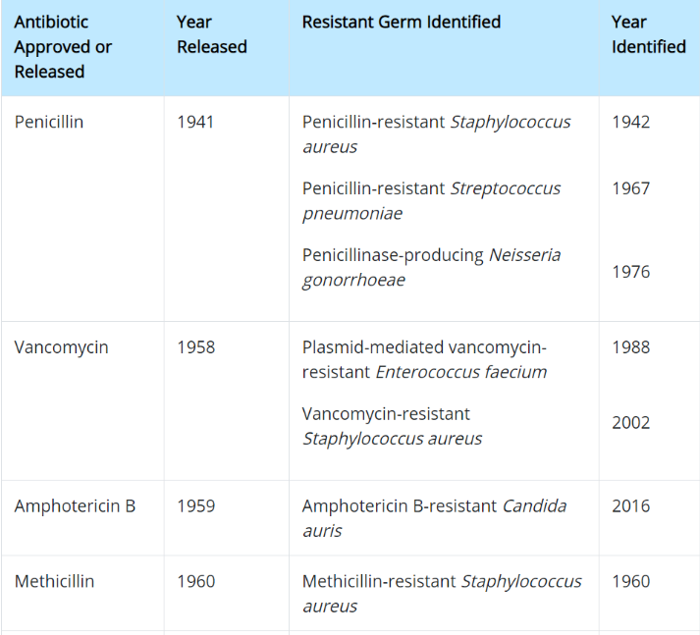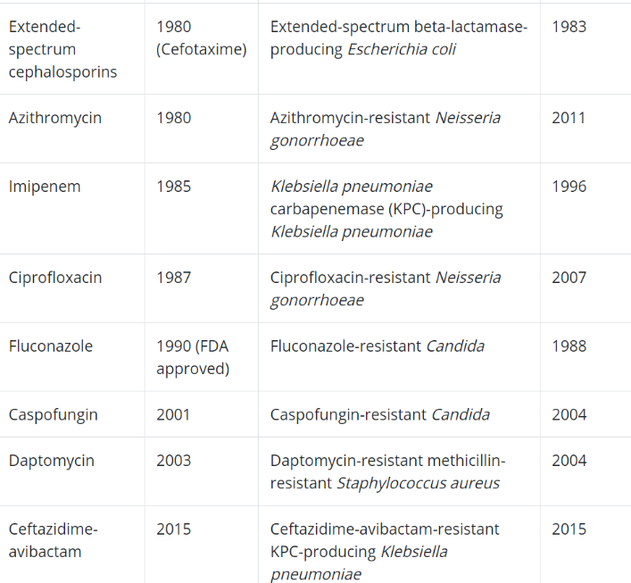
As seen in the table above, Neisseria gonorrhoeae developed resistance to Penicillin in 1976. Neisseria gonorrhoeae is a gram-negative, diplococcus bacterium that causes the well known sexually transmitted disease, gonorrhea. Figure 1 below is based off data collected from the CDC and depicts a timeline that shows how different antibiotics were used to treat gonorrhea and then subsequently outdated due to the development of resistance to said antibiotics ². In Figure 1, Cefixime and Ceftriaxone are two forms of the antibiotic Cephalosporin. Cefixime is an oral form of Cephalosporin, while Ceftriaxone is an injectable form of Cephalosporin. From the 1940s-2012, five different antibiotics were rendered ineffective against Neisseria gonorrhoeae.
Figure 1: Timeline of Gonorrhea Developing Resistance to Various Antibiotics ²
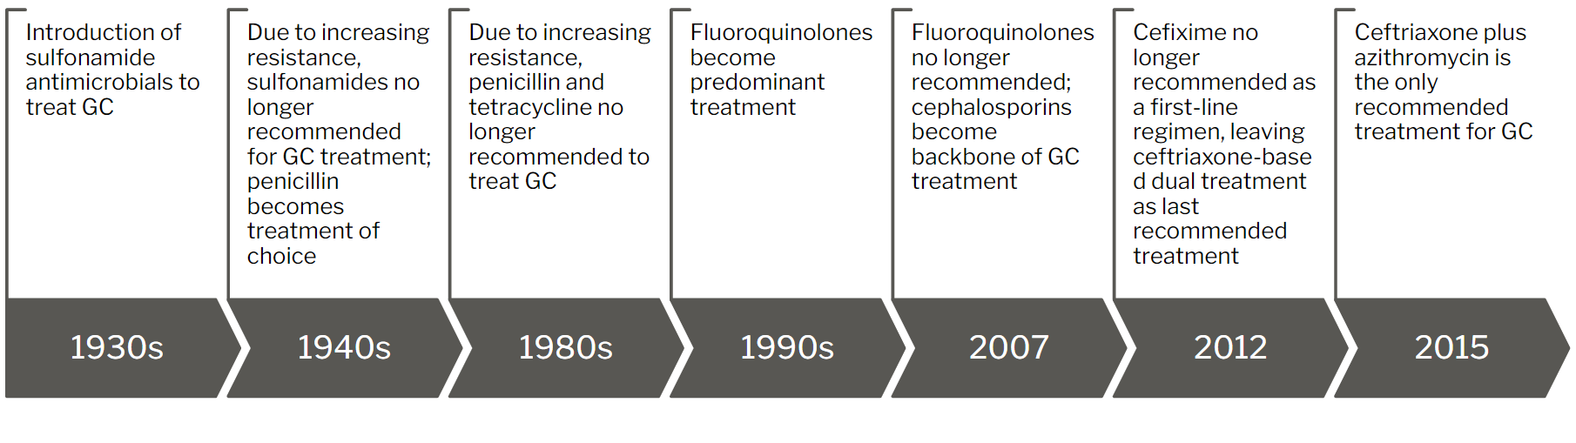
Antibiotic-resistant bacteria such as these cause non-hospital-acquired infections in almost three million people every year, over 35,000 of whom die each year ¹. They are also the cause of nearly two million hospital-acquired infections in the United States every year ³. 99,000 of Americans end up dying from the infections. Antibiotic-resistant infections also cause the American health care system anywhere from $21 billion to $34 billion every single year. In addition, these types of infections cause hospital patients in America to stay an upward of eight million additional days every year.
In the agricultural industry, antibiotics are typically fed to food producing animals at doses lower than those prescribed to treat diseases. This approach increases the feed conversion efficiency, which in turn increases performance in those food producing animals ⁴. This prophylactic antibiotic treatment also contributes to a decrease in subclinical disease in these animals. As seen in the other industries, however, the short generation times of bacteria coupled with their ability to swap genetic material has led to antibiotic resistance developing in many of these animal-infecting bacteria.
One antibiotic, however, that has maintained its efficacy against a particular animal-infecting bacterium is penicillin. Penicillin is just as effective against Streptococcus agalactia despite being used against it for over forty years ⁴. This differs vastly from the human bacteria that penicillin is used against. As seen in Table 1 above, three different bacterial strains had developed resistance against penicillin merely thirty-five years after penicillin had been approved for public use. This scenario of penicillin still being effective against Streptococcus agalactia is in the minority, sadly. Due to an overuse of antibiotics in the agriculture industry, antibiotic resistance has run rampant throughout animals that are processed for food. This is largely due to the ability of antibiotics to be used for growth promotion. Though regarded by the World Health Organization as inappropriate ⁵, medically important antibiotics are used extensively to increase animal growth rates. The resistance that this overuse of antibiotics causes affects not only the animals, but humans as well. The antibiotic resistance bacteria can be passed from the animals to the humans via contaminated food. Even if the bacteria from the animals do not cause disease in humans, they can still pass along their genetic material that codes for resistance to other bacteria in the human body that do cause disease.
Misuse and overuse of antibiotics are major causes of this antibiotic resistance pandemic that is affecting these facets of everyday life. Typical misuse of antibiotics is seen when an individual is prescribed an antibiotic to take for a certain period of time but stops taking it before that time limit is reached because he/she feels better. This creates a phenomenon known as phenotypic persistence ⁶. During phenotypic persistence, the bacterial cells enter a period of inactivity where they are not replicating or expressing their pathogenicity. However, they are not completely killed off by the amount of antibiotic administered by that point. This is because enough of the antibiotic has been taken to inhibit the effects of the bacteria, but not enough has been taken to induce bacterial cell death. So once the stressor, the uptake of antibiotics in this case, is removed, the Persister cells that are still alive begin to replicate again and resume their pathogenic effects. These Persister cells will now be able to survive the effects of the antibiotics that were previously used to inhibit them. This is why when someone does not finish taking their antibiotic completely and the bacterial infection returns, the antibiotic does not work as well as it did before.
As seen in the agriculture industry, antibiotic overuse is another major cause of antibiotic resistance, and this is also commonly seen with humans as well. Strep throat, for example, is a bacterial infection caused by Streptococcus. Most sore throats, however, are caused by viruses. Often times when people have sore throats, however, they will go to their health provider in order to be prescribed an antibiotic. When people take antibiotics while having no need for them, other non-pathogenic bacteria in the body are exposed to the antibiotic. When this happens, the non-pathogenic bacteria are able to develop resistant genes that they are then able to pass to other harmful bacteria when they enter the body.
Studies have been done in which antibiotic use in food animals was decreased and the effect this had on frequency of antibiotic resistance bacteria was measured. In a particular study that was performed in Japan in 2013 ⁵, third-generation cephalosporins were removed from use. Before they were withdrawn, the prevalence of cephalosporin-resistant E. coli was measured to be 16.4%. After the withdrawal, the prevalence of cephalosporin-resistant E. coli was measured to be 4.6%. This study showed similar results as the other studies that were done previously. The data from these studies shows that limiting exposure of animals/humans to antibiotics lowers the prevalence of antibiotic-resistant bacteria in those animals/humans. This relates back to overuse of antibiotics. If the overuse of antibiotics was reduced, then the frequency of antibiotic resistance could be lowered as well.
The misuse and overuse of antibiotics have contributed to the dramatic rise of antibiotic resistance, especially in recent years. Some examples of this rise in resistance can be seen in Figure 2 below ⁷. Figure 2 depicts a graph that shows the increasing prevalence of three different antibiotic-resistant bacterial strains over a twenty-year period from 1981-2001. The three strains depicted are Methicillin-Resistant Staphylococcus Aureus (MRSA), Vancomycin-Resistant Enterococcus (VRE), and Fluoroquinolone-Resistant Pseudomonas Aeruginosa (FQRP). Though it important to note that MRSA is no longer just resistant to methicillin. It is in fact resistant to several of the most common antibiotics in use, including amoxicillin, penicillin, and cephalosporins.
Figure 2: Increase in Antibiotic Resistance ⁷
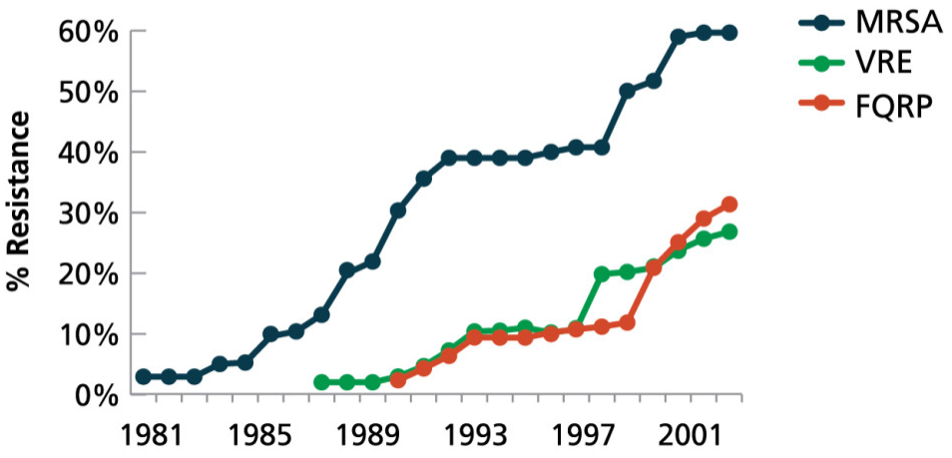

Mechanisms of Antibiotic Resistance
Mechanism 1: Beta-lactamase
Understanding the history and rise of antibiotic resistance is important for working towards reducing the spread of this antibiotic-resistance pandemic. However, understanding the various mechanisms bacteria utilize to develop resistance to antibiotics is important as well. One such mechanism that some bacteria utilize is beta-lactamase. Beta-lactamase enzymes are one of the most common causes of bacterial resistance to beta-lactam antibiotics. Beta-lactam antibiotics, which get their name from a beta-lactam ring present in their structure, are a very common kind of antibiotic that are primarily used to treat infections from gram-negative bacteria. The antibiotics do this by binding to and inhibiting the penicillin-binding proteins in these gram-negative bacteria ⁸. Doing this interferes with the gram-negative bacteria’s ability to synthesize their single peptidoglycan layer cell walls. Some common examples of beta-lactam antibiotics are penicillin, amoxicillin (basically all penicillin derivatives), cephalosporins, monobactams, carbapenems and carbacephems.
Beta-lactamase enzymes covalently bind to the carbonyl group present in a beta-lactam antibiotic. This allows the enzymes to hydrolyze the amide bond in the beta-lactam ring that is present in the structure of said beta-lactam antibiotic. With this beta-lactam ring broken open, the molecule’s antibacterial properties are essentially deactivated ⁹. Figure 3 below depicts a graph that shows the rise of beta-lactamase enzymes in bacteria over a forty-year period from 1970-2010 ¹⁰. As seen in the graph, beginning at around the year 1990, the rate of discovery of unique beta-lactamase enzymes has increased exponentially. This is a serious issue because if bacteria keep expressing more and more beta-lactamase enzymes, soon a lot of the most widely used antibiotics will be rendered useless.
Figure 3: Beta-Lactamase Enzymes Discovered During the Age of Antibiotics ¹⁰
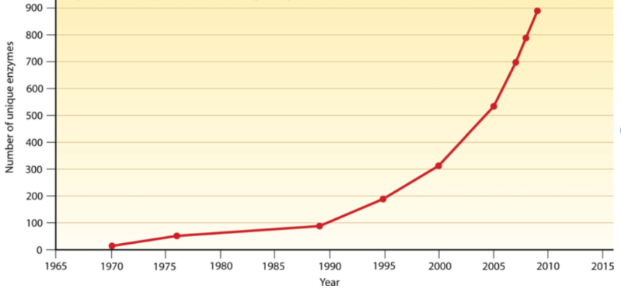
Mechanism 2: Biofilms
Biofilms are another mechanism for antibiotic resistance in bacteria. They are thin, slimy films of bacteria that typically adhere to each other and whatever surface they are on in a moist environment. The films consist of DNA, proteins, and polysaccharides. These films of bacterial cells become embedded in an extracellular matrix that protects the bacteria from harmful external substances such as antibiotics. Biofilms are commonly seen in hospitals, where they grow on medical devices such as catheters, heart valves, and pacemakers. This can cause complications in those devices and are a big reason why antibiotic-resistant hospital acquired infections are such a big issue.
Tables 2 and 3 below from Gong et al. depict data from an article discussing antibiotic resistance and biofilm formation of Salmonella pullorum isolates from eastern China over a forty-eight-year time span from 1962-2010 ¹¹. Table 2 depicts data from the article in which it shows the number of Salmonella Pullorum isolates from their collected samples that are resistant to various antibiotics every few years. Taking a look at the first row, from 1962-1968, there were 2 isolates that were resistant to ampicillin. This then increased to 16, and then 19, and so on. The general trend is that as the years progress, the number of resistant isolates increase across the board for pretty much every antibiotic used. However, it is important to note that this does not always occur. I have highlighted in purple those few instances where this does not occur. The trend with those instances is that after a brief lull, the number of resistant isolates begins increasing again.
Table 2: Antibacterial Resistance of Salmonella pullorum Isolates ¹¹
Antibiotic | 1962 to 1968 (n=32) | 1970 to 1979 (n=82) | 1980 to 1987 (n=75) | 1990 to 1999 (n=56) | 2000 to 2010 (n=92) | Total (n=337)
Ampicillin | 2 | 16 | 19 | 39 | 40 | 116
Carbenicillin | 3 | 6 | 11 | 28 | 38 | 86
Cefamandole | 6 | 27 | 32 | 29 | 63 | 157
Cefotaxime | 0 | 0 | 0 | 0 | 8 | 8
Chloramphenicol | 0 | 0 | 0 | 6 | 8 | 14
Ciprofloxacin | 0 | 0 | 0 | 0 | 15 | 15
Gentamicin | 0 | 0 | 2 | 4 | 12 | 18
Kanamycin | 0 | 0 | 1 | 2 | 10 | 13
Nalidixic acid | 0 | 0 | 0 | 3 | 61 | 64
Nitrofurantoin | 2 | 19 | 24 | 24 | 20 | 89
Spectinomycin | 0 | 4 | 10 | 13 | 18 | 45
Streptomycin | 5 | 26 | 49 | 53 | 75 | 208
Sulfamethoxazole | 10 | 66 | 46 | 25 | 31 | 178
Tetracycline | 6 | 35 | 53 | 49 | 55 | 198
Trimethoprim | 3 | 68 | 70 | 52 | 86 | 279
Trimethoprim/sulfamethoxazole | 0 | 20 | 33 | 35 | 79 | 167

Table 3 below also correlates with the article discussing antibiotic resistance and biofilm formation of Salmonella pullorum isolates from eastern China ¹¹. Table 3 shows the number of Salmonella pullorum isolates collected in each time span along with the number of said isolates that had formed biofilms. So, to clarify, from 1962-1968 they collected 32 isolates, and of those 32 isolates, 16 formed biofilms. The percentage column highlighted in yellow is something that was not included in the original data. I added that column to make it easier to visualize the trend quantified in the data. As you can see, the percentage of isolates that form biofilms have increased over the years. This directly correlates with the increase in antibiotic resistance expressed by the Salmonella pullorum isolates over the same time span as seen in the first table, indicating that increasing biofilm formation has also contributed to increasing antimicrobial resistance.
Table 3: Biofilm Formation of Salmonella pullorum Isolates ¹¹
Years | Number of isolates | Number of biofilm-positive isolates | Percentage
1962 to 1968 | 32 | 16 | 50
1970 to 1979 | 82 | 47 | 57.32
1980 to 1987 | 75 | 46 | 61.33
1990 to 1999 | 56 | 40 | 71.43
2000 to 2010 | 92 | 71 | 77.17
Total | 337 | 220

Mechanism 3: Active Efflux
Another mechanism that bacteria utilize in order to develop resistance to antibiotics is active efflux. Efflux pumps are systems in microorganisms that pump solutes out of the cells. This in turn allows the microorganisms to regulate their internal environment by removing substances that are toxic to the microorganisms ¹². Bacteria can utilize efflux pumps to export the antibiotics out of the cytoplasm and into extracellular media. Efflux Pumps are active transporters that are located in the cytoplasmic membrane. Some pumps are primary active transporters, meaning they use ATP hydrolysis as an energy source. Other pumps are secondary active transporters, which means that the transport is coupled with an electrochemical potential difference. This difference is created by pumping either hydrogen or sodium ions into the cell.
Figure 4 below depicts the general mechanism behind active efflux ¹³. When antibiotics enter the cell, they bind to the inner membrane protein that is a portion of the efflux pump. This then initiates a biochemical cascade which signals the periplasmic membrane protein and the outer membrane protein (which are also parts of the efflux pump), making them open and eject the antibiotics. Keep in mind this is a very generalized way of showing active efflux; there are actually five different families of efflux transporters that work in slightly different ways and for different kinds of bacteria. At the end of the day, however, they achieve the same result. The five families of efflux pump transporters are the major facilitator superfamily, the ATP-binding cassette superfamily (which is the only primary active transporter family), the small multidrug resistance family, the resistance-nodulation-cell division superfamily, and the multi antimicrobial extrusion protein family.
Figure 4: Active Efflux ¹³
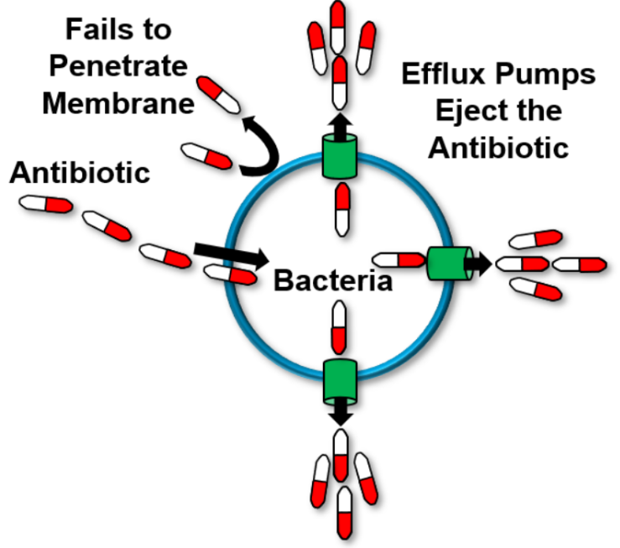

Mechanism 4: Vertical and Horizontal Gene Transfer
As mentioned in the introduction, the misuse and overuse of antibiotics are a major cause of antibiotic resistance. To reiterate, misuse occurs when people stop taking their antibiotics once they start feeling better, even if they still have a few days of treatment left. Since specific antibiotics are prescribed for specific bacterial infections, there are set times for a patient to take said antibiotic to completely eradicate the bacteria causing the infection. When patients do not take the antibiotics for the full length of time, some of the bacteria are able to survive and reproduce. This time however, the parent bacteria adapt to selective pressure from the antibiotics and exhibit antibacterial resistant properties, which they pass on to the offspring. This way, if the same antibiotic is used again, it either will not be as effective or will not be effective at all. This transfer of genetic material from parent to offspring is the mechanism known as Vertical Gene Transfer, which is outlined in part A of Figure 5 below ¹⁴. Vertical Gene Transfer is a major cause of the spreading of antibiotic resistance.
As previously stated, overuse of antibiotics is often seen people are over-prescribed antibiotics for non-bacterial infections. For example, while taking antibiotics for a viral infection will not have an effect on that viral infection, it can be detrimental later in life. If there were non-harmful bacteria present in the body that the antibiotic attacked and some survived, those bacteria could reproduce and make more strains that are resistant to the antibiotic. When a harmful bacteria does eventually enter the body, these non-harmful bacteria could transfer resistance to the harmful bacteria. This transfer of genetic material is the mechanism known as Horizontal Gene Transfer, which is outlined in part B of Figure 5 below ¹⁴. Horizontal Gene Transfer is also a major cause of the spreading of antibiotic resistance.
In layman’s terms, horizontal gene transfer is the movement of genetic material between organisms by means that are not reproduction. As noted in part B of the figure below, there are three primary mechanisms that mediate horizontal gene transfer. Transformation is the uptake of free DNA. Short fragments of naked DNA are taken up by naturally transformable bacteria. Transduction is phage-mediated transfer. The DNA is taken up from one bacterium via a bacteriophage and then inserted into another bacterium. Conjugation is plasmid-mediated transfer. The donor bacterium has a DNA sequence known as the fertility factor that allows the donor bacterium to produce a pilus, which is a tubelike structure. The donor bacterium will contact the recipient bacterium via the pilus and transfer the genetic material, usually in the form of a plasmid.
Figure 5: Vertical and Horizontal Gene Transfer ¹⁴
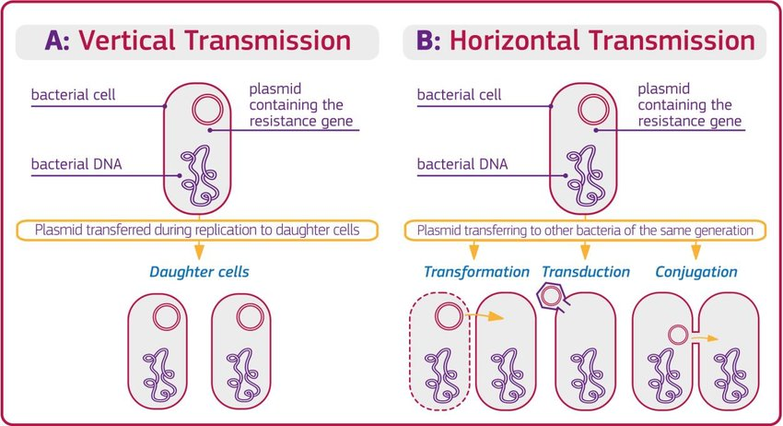

Suggested Plans of Action
General Strategies
Antibiotic resistance is a serious issue that can be lessened with a few safer practices. One simple practice is better hand washing. Since hands are used to touch numerous items and people every day, they make great vectors for spreading antibiotic-resistant bacteria. According to Harvard Medical, washing hands for fifteen seconds removes around 90% of bacteria. An additional fifteen seconds increases this percentage to 99.9% ¹⁵. It is important to note that these numbers are measured in logarithmic reduction. In order to better understand these percentages, take a look at the following hypothetical situation. Say after washing hands for fifteen seconds, the hands of an individual had a bacterial count of 100,000; an additional fifteen seconds would lower that count to 1000. However, it is important to keep in mind not to overdo handwashing. Too much handwashing can lead to dry skin with cuts, which makes a great reservoir for bacteria.
As per the CDC, immunizations and better food preparation are also effective strategies in lowering the spread of antibiotic resistance ¹⁶. Many of the bacterial infections people acquire are through the consumption of foods that are not properly washed or prepared. In addition, using antibiotics as directed is a major strategy in dealing with antibiotic resistance. As described in the mechanisms section above, taking antibiotics for the full length of time greatly reduces the risk of Vertical Gene Transfer. According to the CDC, improving antibiotic prescribing is perhaps the most important course of action needed in reducing the spread of antibiotic resistance ¹⁶. Around half of the antibiotics prescribed for use in humans and in animals are unnecessary. Lowering this number would dramatically reduce the risk of Horizontal and Vertical Gene Transfer.
Beta-lactamase Inhibitors
Since beta-lactam antibiotics comprise approximately 60% of the world’s antibiotic usage, it is important to look at methods to help counter beta-lactamase producing bacteria. One such method is administering beta-lactam antibiotics with beta-lactamase inhibitors. Three such inhibitors that have been in use are clavulanic acid, sulbactam, and tazobactam. These beta-lactamase inhibitors develop irreversible “suicide inhibitors” that are able to inactivate the beta-lactamase forever through secondary chemical reactions in the enzyme active site ¹⁷. These inhibitors, however, are not broad spectrum. They only work on a few beta-lactamase bacteria. In addition, there has been a rise in prevalence of a beta-lactamase known as AmpC in recent years. AmpC beta-lactamases are able to mediate resistance to the beta-lactamase inhibitor-beta-lactam antibiotic combinations that are in use today due to mutations of amino acids in the active site.
Due to this rise of AmpC beta-lactamase mediated resistance, as well as the narrower focus of the current beta-lactamase inhibitors, there is an increasing need for new, synthetic broad-spectrum beta-lactamase inhibitors. In order to successfully prevent beta-lactamase mediated resistance, it is important to use substances that are designed to bind at the active site. The “suicide inhibitors” mentioned above depict one way to accomplish this. Another way to accomplish this task is by creating substrates that can reversibly and/or irreversibly bind the beta-lactamase enzyme with high affinity while forming unfavorable steric interactions as acyl-enzymes ¹⁷. Carbapenems and monobactams have been found to be good examples of this method that form acyl-enzymes and take on catalytically ineffectual conformations, which leads to effective inhibition of AmpC beta-lactamases. However, more experimentation still needs to be done with them in order to make them appropriate for pharmaceutical advancement ¹⁸.

Laser Treatment for Biofilms
Due to the growing pervasiveness of biofilm-related multi-drug resistant bacteria, especially in hospitals, it is especially important to look at non-conventional ways of dealing with biofilms. One common proposition in recent years has been to utilize laser treatments to deal with these multi-drug resistant bacterial biofilms. Kirui et al. analyzes the efficacy of gold nanoparticle-targeted pulsed laser therapy against biofilms from methicillin-resistant Staphylococcus aureus and multi-drug resistant Pseudomonas aeruginosa in vitro ¹⁹. They first tested just the ability of gold nanoparticle-targeted pulsed laser therapy to disperse biofilms. Then they combined gold nanoparticle-targeted pulsed laser therapy with antibiotics to test whether or not the biofilms of the bacteria were more susceptible to the antibiotics.
Gold nanoparticle-targeted pulsed laser therapy first consisted of attaching antibodies to gold nanoparticles to induce site-specific delivery. If this method were to be used in vivo, damage to healthy surrounding tissue would be minimized due to this site-specific delivery. Biofilms were treated with these antibody-conjugated gold nanoparticles and then immediately treated with a nanosecond-pulsed laser irradiation at 532 nanometers. This is all depicted in Figure 6 below. This strategy, when compared to the control, dispersed 96-99% of the biofilms while killing around 90-98% of the biofilm-associated bacteria. While these numbers should be improved upon, they are a very promising start.
This gold nanoparticle-targeted pulsed laser therapy was then used in conjunction with the antibiotics gentamicin and amikacin. These combinations caused a 4-log reduction in biofilm viability for methicillin-resistant Staphylococcus aureus (99.99% reduction) and a 5-log reduction in biofilm viability for multi-drug resistant Pseudomonas aeruginosa (99.999% reduction). The use of gold nanoparticle-targeted laser therapy or antibiotics individually only reduced biofilm viability by approximately 1-log (90%).
Figure 6: Gold Nanoparticle-targeted Pulsed Laser Therapy ¹⁹
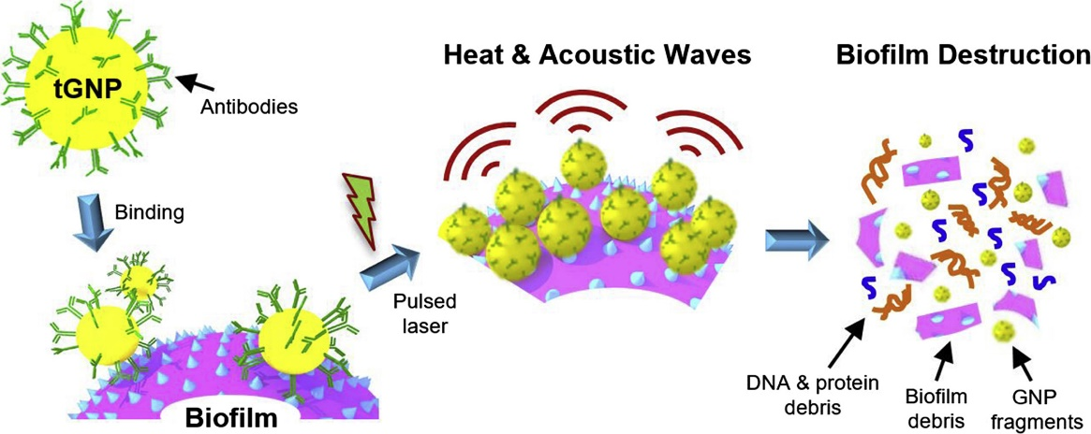

Active Efflux Inhibitors
Due to the fact that active efflux is such an effective mediator of antibiotic resistance, it is important to look at ways to bypass the abilities of efflux pumps. This can be done in a number of ways, including interfering with genetic regulation in order to downregulate the expression of efflux pump genes, reshaping antibiotics so that they are no longer identified as substrates, blocking the actual assembly of working efflux pumps, avoiding substrate binding by blocking the pump, and taking care of the energy mechanism behind powering the pumps ²⁰. A review by Sharma et al. examines these last two methods to inhibit efflux pumps by using chemical units known as efflux pump inhibitors. Efflux pump inhibitors (EPI) have been analyzed for the past several years as a potential means of resurgence for older antibiotics that are no longer effective due to the resistance caused by efflux pumps. It is important to note that in order to be effective and lasting, the EPI molecules can not be antibacterial. This is because an antibacterial would eventually lead to resistant mutants of the target ²⁰.
One mechanism of efflux pump inhibition Sharma et al. looked at was the binding of EPIs to efflux pumps. This binding decreased the ability of efflux pumps to bind to substrate-identified antibiotics and pump them out of the cell ²⁰. The binding of EPI to efflux pump can come in two different types. One is competitive binding, where the EPI competes with the substrate antibiotics for the same binding site. The other is non-competitive binding, where the binding of the EPI to the efflux pump lowers the attraction of the efflux pump towards substrate antibiotics. There are several molecules that have been found that exhibit these kinds of binding to be used as EPIs, however they are still in the experimental stage due to the expression of strong antibacterial properties and a lack of evidence regarding mechanisms of action ²⁰.
Another mechanism of efflux pump inhibition that Sharma et al. reviewed was energy dissipation. Efflux pumps depend on cellular energy, so the dissociation of this energy looks to be a promising mechanism for efflux pump inhibition. The proton gradient and the ATPase that supply energy to efflux pumps have been targeted by various potential EPIs over the years. This seems to be an advantageous approach as the inhibitor does not require contact with the efflux pump, which lowers the chances of resistant mutations (but does not eradicate) ²⁰. Targeting the proton gradient is also a universal proposal for inhibiting efflux pumps as all efflux pumps depend on proton gradients. This paper analyzes a few proposed EPIs that are in the work that target energy dissipation. The most well-known, Carbonyl cyanide-m-chlorophenylhydrazone, is very effective at disrupting proton motive force and making bacterial cells metabolically inactive. However, it has not been approved for pharmaceutical use due to the fact that it exhibits cellular toxicity towards mammalian cells. Synthetic EPI IITR08027 is also a promising EPI that was analyzed that has very low toxicity toward mammalian cells, which is why it currently being evaluated for its preclinical possibility.
Conclusion
Antibiotic resistance is a widespread issue that impacts various aspects of life across the globe. It is becoming a more severe issue each and every day. If no serious actions are taken to help combat this rise of antibiotic-resistant bacteria, scientists propose that the world may soon face an era similar to pre-antibiotic times. Medically, these were darker times when the simplest bacterial infection could kill a person. By understanding the history of and contributions towards the rise of antibiotic resistance, people can move forward and implement safer practices to help decelerate and potentially reverse this rise. While scientists focus on combating the mechanisms of antibiotic resistance in the labs, the public can focus on lowering the misuse and overuse of antibiotics in order to do their share of lowering the spread of antibiotic resistance. Unless a greater focus is placed on these kinds of actions, the global pandemic known as antibiotic resistance may change bacterial infections as we know them, and not in a good way.

Acknowledgements
I would like to thank Dr. Gary LeCleir for not only inspiring the idea for this thesis during his General Microbiology course, but also giving his time to look over and fine tune this thesis to ensure the success of this endeavor. This thesis was also made possible due to the Chancellor’s Honors Program at the University of Tennessee, Knoxville. The belief this program has in the importance of developing critical research skills in student scholars has made numerous projects and theses such as this one possible.

References
[1] “About Antibiotic Resistance.” Centers for Disease Control and Prevention, Centers for Disease Control and Prevention, 13 Mar. 2020, www.cdc.gov/drugresistance/about.html#:~:text=Antibiotic%20resistance%20happens%20when%20germs,killed%20and%20continue%20to%20grow.
[2] “Data on Antibiotic Resistant Gonorrhea, 2016.” Centers for Disease Control and Prevention, Centers for Disease Control and Prevention, 14 July 2016. www.cdc.gov/nchhstp/newsroom/2016/data-on-antibiotic-resistant-gonorrhea.html.
[3] “Facts about Antibiotic Resistance.” IDSA Home, www.idsociety.org/public-health/antimicrobial-resistance/archive-antimicrobial-resistance/facts-about-antibiotic-resistance/#:~:text=Based%20on%20studies%20of%20the,8%20million%20additional%20hospital%20days.
[4] McKellar, Q A. “Antimicrobial Resistance: a Veterinary Perspective. Antimicrobials Are Important for Animal Welfare but Need to Be Used Prudently.” BMJ (Clinical Research Ed.), British Medical Journal, 5 Sept. 1998, www.ncbi.nlm.nih.gov/pmc/articles/PMC1113827/.
[5] Innes, Gabriel K, et al. “External Societal Costs of Antimicrobial Resistance in Humans Attributable to Antimicrobial Use in Livestock.” Annual Review of Public Health, U.S. National Library of Medicine, 2 Apr. 2020, www.ncbi.nlm.nih.gov/pmc/articles/PMC7199423/.
[6] Palma, Ernesto, et al. “Antimicrobial Resistance in Veterinary Medicine: An Overview.” International Journal of Molecular Sciences, MDPI, 11 Mar. 2020, www.ncbi.nlm.nih.gov/pmc/articles/PMC7139321/.
[7] “Dramatic Increase of Antibiotic Resistance between 1981 and 2001.” Silver Book, www.silverbook.org/fact/increase-in-antibiotic-resistance/.
[8] “Beta Lactam Antibiotics.” Beta Lactam Antibiotics - Antimicrobial Resistance Learning Site For Veterinary Students, amrls.cvm.msu.edu/pharmacology/antimicrobials/antibiotics-of-veterinary-importance/beta-lactam-antibiotics.
[9] Tooke, Catherine L, et al. “β-Lactamases and β-Lactamase Inhibitors in the 21st Century.” Journal of Molecular Biology, Elsevier, 23 Aug. 2019, www.ncbi.nlm.nih.gov/pmc/articles/PMC6723624/.
[10] Althubiani, Abdullah. “Figure 1.1 The Rate of Discovery of Beta-Lactamase Enzymes during the...” ResearchGate, 1 Aug. 2018, www.researchgate.net/figure/The-rate-of-discovery-of-Beta-lactamase-enzymes-during-the-age-of-antibiotics-From_fig1_309421397.
[11] Jiansen Gong, Ming Xu, Chunhong Zhu, Jinfeng Miao, Xuexian Liu, Bu Xu, Jinqiu Zhang, Yan Yu & Xuebo Jia (2013) Antimicrobial resistance, presence of integrons and biofilm formation of Salmonella Pullorum isolates from eastern China (1962–2010), Avian Pathology, 42:3, 290-294, DOI: 10.1080/03079457.2013.788129
[12] Soto, Sara M. “Role of Efflux Pumps in the Antibiotic Resistance of Bacteria Embedded in a Biofilm.” Virulence, Landes Bioscience, 1 Apr. 2013, www.ncbi.nlm.nih.gov/pmc/articles/PMC3711980/.
[13] “Our Pipeline.” TAXIS Pharmaceutical, www.taxispharma.com/research-development/our-pipeline/.
[14] Sanseverino, Isabella & Navarro, Anna & Loos, Robert & Marinov, Dimitar & Lettieri, Teresa. (2018). State of the Art on the Contribution of Water to Antimicrobial Resistance. DOI: 10.2760/771124.
[15] Publishing, Harvard Health. “The Handiwork of Good Health.” Harvard Health, www.health.harvard.edu/newsletter_article/The_handiwork_of_good_health#:~:text=In%20studies%2C%20washing%20hands%20with,are%20measured%20in%20logarithmic%20reductions).
[16] “Protect Yourself and Your Family.” Centers for Disease Control and Prevention, Centers for Disease Control and Prevention, 12 Feb. 2020, www.cdc.gov/drugresistance/protecting_yourself_family.html.
[17] Drawz, Sarah M., and Robert A. Bonomo. “Three Decades of β-Lactamase Inhibitors.” Clinical Microbiology Reviews, American Society for Microbiology Journals, 1 Jan. 2010, cmr.asm.org/content/23/1/160.
[18] DM;, Maiti SN;Phillips OA;Micetich RG;Livermore. “Beta-Lactamase Inhibitors: Agents to Overcome Bacterial Resistance.” Current Medicinal Chemistry, U.S. National Library of Medicine.
[19] Kirui, Dickson K., et al. “Targeted Laser Therapy Synergistically Enhances Efficacy of Antibiotics against Multi-Drug Resistant Staphylococcus Aureus and Pseudomonas Aeruginosa Biofilms.” Nanomedicine: Nanotechnology, Biology and Medicine, Elsevier, 22 May 2019, www.sciencedirect.com/science/article/pii/S1549963419301029.
[20] Sharma, Atin, et al. “Efflux Pump Inhibitors for Bacterial Pathogens: From Bench to Bedside.” Indian Journal of Medical Research, vol. 149, no. 2, 2019, p. 129., doi:10.4103/ijmr.ijmr_2079_17.

