Design and Development of the Urban Population Health Observatory to Improve Disease Surveillance and Response

A Dissertation Presented for the
Doctor of Philosophy
Degree
The University of Tennessee, Knoxville

Whitney S. Brakefield
May 2022

Copyright © 2022 by Whitney S. Brakefield
All rights reserved.

ABSTRACT

Chronic and infectious diseases have a profound impact on the quality and length of life of populations that suffer from these conditions. Scientists, physicians, and health officials are seeking innovative approaches to decrease the morbidity and mortality of deadly diseases. Incorporating artificial intelligence and data science techniques across the health science domain could improve disease surveillance, intervention planning, and policymaking. In this dissertation, we describe the design and development of the Urban Population Health Observatory (UPHO), an explainable knowledge-based multimodal big data analytics platform. A common challenge for conducting multimodal big data analytics is integrating multidimensional heterogeneous data sources, which often exist in different levels of granularity. These sources range from individual-level to group-level data, as well as structured and unstructured data sources. The UPHO platform is designed to foster the integration of multimodal big data including social determinants of health, observation of daily living, and population health data consistently across jurisdictions to estimate the incidence and prevalence of different health conditions, as well as related risk factors. Leveraging semantics, the UPHO platform provides contextual knowledge from relevant domains of interest by reusing several ontologies focusing on clinical and public health (diseases, geography, etc.). UPHO encompasses an Explainable Artificial Intelligence (XAI) and Interpretability feature which increases trust and trustworthiness, justifies actions and decisions, improves usability, aids in locating sources of error, and can minimize the chance for human error. Developing a multimodal scalable surveillance system to monitor and detect trends as well as deliver rapid early warnings and recommendations could assist health officials, physicians, and researchers in responding, and mitigating a public health crisis.

TABLE OF CONTENTS

Chapter I Introduction and General Information 1
1.1 Background 3
1.2 Objective 6
1.3 Research Questions 6
1.4 Approach 7
1.5 Contributions 10
Chapter II Literature Review and Related Works 12
2.1 Urban Health Observatory 13
2.2 Addressing the Gaps 15
2.3 Explainability/Interpretability 15
2.4 Interoperability 16
Chapter III UPHO Design & Architecture 18
3.1 Design & Architecture 20
3.2 Data Management 20
3.3 Knowledge and Intelligence 22
3.4 Application Layer 25
Chapter IV UPHO and COVID-19 Surveillance 27
4.1 SDoH and COVID-19 30
4.2 Methods 39
4.3 Results 41
4.4 Dashboard 42
Chapter V UPHO and Obesity Surveillance 46
5.1 Method 48
5.2 Results 52
5.3 Dashboard 53
Chapter VI Evaluation 57
6.1 Performance-Centered Evaluation 59
6.2 User-Centered Evaluation 60
Chapter VII Discussion and Conclusion 63
7.1 UPHO, COVID-19 and Obesity Surveillance 65
7.2 Research Outcome 67
7.3 Major Contributions 68
7.4 Challenges and Limitations 70
7.5 Future Work 71
7.6 Conclusion 72
References 74
Appendix 95
Vita 127

LIST OF TABLES

Table 4.1. Summary Table Representing the Characteristics of Selected Studies. 96
Table 4.2. Components of our SDoH Classification 103
Table 4.3. SDoH Recommendations to address COVID-19 Outcome Disparities 103
Table 4.4. Summary Statistics for Covid-19 and Related Risk Factors in Tennessee, USA Counties. 104
Table 4.5. Intervention Impact 105
Table 5.1. Summary Statistics for Obesity and Related Risk Factors in Memphis, TN Census Tracts. 106
Table 5.2. Spearman’s Rank and VIF Results 107
Table 5.3. Support Vector Regression Machine Results 107

LIST OF FIGURES

Figure 1.1. Five Domains and Variables of the Social Determinants of Health 108
Figure 1.2. Schematic Representation of Four Distinct Modes 108
Figure 1.3. WHO’s Urban Health Observatory Conceptual Framework 109
Figure 1.4. Data Integration 110
Figure 2.1. UHO’s Preliminary Conceptual Framework 111
Figure 3.1. UPHO’s Architecture 112
Figure 3.2. UPHO Analytics Framework 113
Figure 3.3. UPHO Semantic Layer Framework 114
Figure 3.4. A Tabbed View Dashboard Main Features 115
Figure 4.1. Integration Process 116
Figure 4.2. Grouping Analyses Results for COVID-19 and SDoH in Tennessee Counties from
April 28,2020-June 30,2020 117
Figure 4.3. Causal Impact Plot 118
Figure 4.4. UPHO’s Dashboard Display of a Researcher as the User Interested in COVID-19 Disparities and SDoH in Tennessee, USA 119
Figure 4.5. UPHO’s Dashboard Display of a Health Official as the User Interested in the 31-day Intervention Impact in Knox County, TN 120
Figure 4.6. UPHO’s Dashboard Display of a Tennessee Resident Suffering from Multi-Morbidities as the User Interested in the Risk of Traveling to Trousdale County, TN……………….. 121
Figure 5.1. Knowledge Graph 122
Figure 5.2.Grouping Analysis Results 123
Figure 5.3. UPHO’s Dashboard Display of a Physician User Interested in Obesity
Prevalence in Patient’s Neighborhood 124
Figure 5.5. UPHO’s Dashboard Display of a Researcher as the User Interested in Obesity
Prevalence in Memphis, TN 125
Figure 5.6. UPHO’s Dashboard Display of a User Interested in Obesity
Prevalence and SDoH Spatial Distribution in Memphis, TN 126

Chapter I

Introduction and General Information

Disclosure Statement
List All Included Articles, Author's Involved, and Roles
- W. S. Brakefield, N. Ammar, O. A. Olusanya, and A. Shaban-Nejad, “An urban population health observatory system to support Covid-19 Pandemic Preparedness, response, and Management: Design and Development Study,” JMIR Public Health and
Surveillance, vol. 7, no. 6, 2021. https://doi.org/10.2196/28269.
- W. S. Brakefield, N. Ammar and A. Shaban-Nejad, "UPHO: Leveraging an Explainable Multimodal Big Data Analytics Framework for COVID-19 Surveillance and Research," 2021 IEEE International Conference on Big Data (Big Data), 2021, pp. 5854-5858, doi: 10.1109/BigData52589.2021.9671429.
- Whitney S Brakefield, Nariman Ammar, Olufunto Olusanya, Esra Ozdenerol, Fridtjof Thomas, Altha J Stewart, Karen C Johnson, Robert Davis, David L Schwartz, Arash Shaban-Nejad. "Implementing an Urban Public Health Observatory for (Near) Real-Time Surveillance for the COVID-19 Pandemic". Stud Health Technol Inform. 2020 Nov 23;275:22-26. doi: 10.3233/SHTI200687. PMID: 33227733.
- W. S. Brakefield, N. Ammar, and A. Shaban-Nejad, " An Urban Population Health Observatory for Disease Causal Pathway Analysis and Decision Support: The Underlying Explainable AI Model". Submitted to JMIR Public Health and Surveillance (Under Review).

1.1 Background
Chronic and infectious diseases have a profound impact on the quality and length of life of populations that suffer from these conditions. Research scientists and health officials are seeking innovative approaches to decrease the morbidity and mortality of deadly diseases. Incorporating data science techniques across the health science domain could improve decision-making. When making a decision, implementing policies, interventions, or treatments pertaining to population health it is advisable to follow a systematic process [1]. Researchers are continuously finding links between geographical location and health [2-4]. Thus, data such as social determinants of health (SDoH) and observations of daily living (ODL) are critical in guiding local interventions, resource allocation, and decision-making during a health crisis [5-8].
SDoH are defined by the World Health Organization (WHO) as “the conditions of where a person is born, where they grow up, where they live, where they work, and where they age” [9]. The SDoH are comprised of five domains: Economic Stability, Education, Neighborhood and Built Environment, Health and Healthcare Access, and Social and Community Context [10, 11]. Figure 1.1 (All figures and tables are located in appendix) illustrates several SDoH variables that are included in each domain, as follows. The Economic Stability domain encompasses the level an individual or group falls within the hierarchical societal structure, with variables that reflect the impact of socioeconomic conditions. The Education Access and Quality domain consists of variables that influence the process of becoming educated. The Neighborhood and Built Environment consist of variables that relate to the physical environment and have the potential to overlap other domains, making them some of the most flexible domains. The Healthcare Access and Quality domain incorporates variables that reflect access to healthcare and describe how health information is interpreted to make appropriate and informed decisions. The Social and Community Context domain encompasses variables that demonstrate the social setting an individual resides in and their community involvement. These SDoH are impacted by access to power, money, and other resources and are therefore considered to be the major driving force behind health inequities [9]. Our prior works have explored associations between SDoH and several health outcomes [12,13]. Consequently, our findings underpin the importance of incorporating SDoH when implementing intelligent population health solutions. In addition, ODL data captures the patterns and realities of an individual's daily life and various phenomena such as diet, daily movement patterns, etc. [7]. ODL also gives information about the social background of individuals. However, data such as SDoH and ODL are often non-existent at appropriate spatial and temporal resolution or scattered [5-8].
To understand and combat morbidity and mortality of deadly diseases, scientists need to access timely reliable surveillance data and knowledge. Surveillance data often need to be collected and integrated from various multimodal, multidimensional distributed data sources. Multimodality refers to the interplay between different representational modes [14]. Multiple modes of representation combined, communicate things that neither of the modes would convey separately [14]. For instance, our collected data would make better sense when we put them into appropriate contexts. Figure 1.2 is a schematic representation of four distinct modes: number, temperature, and its unit, person, and infection. 107.3 is a numeric representation of temperature in Fahrenheit. The temperature is a measure extracted from the person. The temperature of a person is 107.3 degrees Fahrenheit, which can be interpreted as “the person is having a fever”. Fever is a symptom of infection, thus we can infer that “the person has an infection, which caused by an infectious agent”. If “number” was not a representation of “temperature” it would not convey the same knowledge separately. In other words, since the number reflects a measurement of body temperature now it has a specific meaning.
The concept of multimodality combined with big data analytics, allows us to acquire knowledge and insight necessary for informed decision-making. Contrary to the popular belief that big data is only based on volume, big data also constitute variety and velocity [15]. In big data, advanced analytics techniques are used to operate on big data sets [15]. These techniques are a combination of data mining, statistical analysis, predictive analytics, data visualization, clustering, text mining, artificial intelligence, etc. [15]. In a cohesive approach with multimodality, big data can be used to implement intelligent solutions pertaining to deadly diseases.
World Health Organization (WHO) developed an Urban Health Observatory (UHO) framework, to serve as an institutional mechanism to help synthesize evidence and incorporate it into urban policy-making for health [5]. UHO consists of 3 domains: mission, governance, and knowledge and intelligence (Figure 1.3) [5]. The implementation of the knowledge and intelligence domain will serve the mission and governance domains.
Researchers in the health science field and many other communities are investigating how to bring various multimodal, multidimensional distributed data sources together in real-time to serve as an apparatus for actualizing effective intervention design and implementation to address health disparities, provide awareness to the public, and improve population health decision-making and planning.

1.2 Objective
In the time of the COVID-19 pandemic, the development of an intelligent surveillance platform that embeds SDoH indicators can improve equity in the uneven distribution of quality healthcare services (i.e. testing, vaccination), reduce health disparities, inform health officials on the timing, phasing, and safety for re-openings, and address shortages of medical supplies, devices, and healthcare workers to alleviate the related health and economic crisis [16,17]. In this project, we describe the design and development of the Urban Population Health Observatory (UPHO), an explainable, knowledge-based, multimodal, surveillance platform that integrates multidimensional, heterogenous data including SDoH indicators/risk factors, ODL, and population health data and provides near real-time analysis and dashboarding of ongoing morbidities and mortalities. This surveillance platform offers digital assistance in preparedness, response, and management to COVID-19 and future health crises. We first present our methodology and general architecture of the proposed surveillance system. Subsequently, to display the functionalities of the UPHO surveillance platform, we present a prototype design to demonstrate the features of the system. We provide use case scenarios in the context of COVID-19 for different users. In order to demonstrate the generalizability of our system we also implement a use case scenario in the context of chronic disease (e.g., obesity) surveillance.

1.3 Research Questions
This project aimed to answer the following research questions:
- How can we integrate group-level with individual-level data?
- How can we detect the causality/association between SDoH and health outcomes?
- How to detect hidden dependencies between different risk factors and health?
- How to measure the impact/effectiveness of implemented interventions?
- How to maintain interpretability between different data sources?
- How to cope with lack of data access using semantics logical reasoner?
- How to ensure the protection of private health information?
- How can data-driven insights directly inform policy changes to accommodate different populations and geographic areas?

1.4 Approach
A common challenge for conducting multimodal big data analytics is integrating multidimensional heterogeneous data sources, which often exist in different levels of granularity. These sources range from individual-level to group-level data, as well as structured and unstructured data sources.
We are designing and developing a UPHO platform to foster the integration of multimodal big data consistently across jurisdictions to estimate the incidence and prevalence of different health conditions, as well as related risk factors. Also, leveraging semantics the UPHO platform provides contextual knowledge from relevant domains of interest by reusing several ontologies focusing on clinical and public health (Diseases, Transportation, Food, Geography, etc.). Ontologies “are systematic representations of knowledge that can be used to integrate and analyze large amounts of heterogeneous data allowing classification of knowledge” [18]. When designing and developing a surveillance system to respond and mitigate a public health crisis, there are challenges that should be addressed.
A common challenge for conducting multimodal, big data analytics in clinical and health science settings is the issue of the integration of heterogeneous data sources. These sources range from individual-level to group-level data, as well as structured and unstructured data sources.
- To overcome this obstacle, we leverage semantic technologies for data integration of heterogeneous sources. We address these challenging differences in data sources by the utilization of common ontologies, which explicitly link data through concepts, relations, constraints, and rule axioms.
- When using individual-level data which contains Electronic Medical Records of patients, we integrate the population-level datasets at a specific level of geographical granularity (e.g., zip code, census tract, etc.). Figure 1.4 illustrates this process.
Completion of the data integration process provides system developers with multidimensional datasets to extract knowledge, using data science and engineering techniques such as machine learning (ML), semantics, and Bayesian Inference.
- ML and semantics techniques will detect causality/association and hidden dependencies of risk factors and health outcomes.
- Bayesian approach is incorporated to measure the impact/effectiveness of implemented interventions.
ML approaches, which are also referred to as ‘black-box’ statistics, should be trustworthy, transparent, interpretable, and explainable when making decisions in the clinical or health science setting [19,20]. Explainability and Interpretability are additional functions of UPHO. A system’s explanation constitutes its interpretability [21,22]. Many existing systems are not able to explain their decisions and actions to human users [23]. However, Explainable Artificial Intelligence (XAI) increases the intelligence delivered to the user by providing explanations. Fully interpretable models provide complete transparent explanations [22]. Partial interpretable models only reveal important information (e.g., only variable importance) about the reasoning process [22]. An effective explainable system will take the target user group (e.g., physician, researcher, etc.) into account [22]. Knowledge of the end-user is very important for the delivery of decisions, recommendations, or actions. Providing explanations that are adaptable to the user can decrease errors in interpretation by enhancing the interpretability of outcomes and findings.
To maintain features such as data integration, XAI, and interpretability we need to achieve interoperability.
- We achieve interoperability by utilizing semantics and ontologies.
- This system will breach between multiple systems to overcome the challenge of scattered data sources and to extract data from fast-changing non-structured and structured sources.
There is a common issue of lack of data access across different disciplines.
- To solve this problem, we apply semantic reasoners to extract and supply knowledge despite limited data access. In UPHO, semantic reasoner uses facts derived from existing knowledge along with generic rule axioms defined in the domain ontologies. The rule axioms trigger specific actions under certain conditions.
- Ontologies can supply semantic explainability for causal pathways.
Privacy of health information creates many ethical and functional challenges in developing efficient public health surveillance systems.
- To ensure the protection of privacy, the data is controlled by the developers, but knowledge is accessible to users. This system ensures the ownership of data, but the data doesn’t leave the system.
How can data-driven insights directly inform policy changes to accommodate different populations and areas?
- By utilizing local analysis to account for the detection of possible local variation between health factors and SDoH, location-specific strategies can be identified for certain populations and areas to reduce the burden of diseases as well as increase the effectiveness of preventive interventions.

1.5 Contributions
The concept of UPHO existed prior to our design, however, this concept has not been implemented. Thus, our UPHO surveillance platform provides multiple contributions:
- provides a novel approach and first-of-its-kind insight to inform immediate or long-term health policy response to current and future public health crises;
- enables precision observation and assessment, early detection, and health promotion by disseminating evidence-based, accurate information and facilitating the public’s access to timely health information to improve health literacy levels;
- examines and depicts causal pathways and associations between upstream risk factors and adverse outcomes;
- and provides contextual knowledge by performing semantic inferencing.
Overall, the significance of this proposed research lies in its ability to provide a multifaceted surveillance system design that serves as an apparatus for actualizing effective interventions; addressing concerns in health disparities, providing awareness to the public, and equipping health officials with a surveillance system that will improve population health decision-making and planning.

Chapter II

Literature Review and Related Works

Health surveillance involves the “ongoing systematic collection, analysis, and interpretation of data essential to the planning, implementation, and evaluation of public health practice, closely integrated with the timely dissemination of these data to those who need to know” [24]. The objectives of surveillance activities are to identify, manage, and prevent the emerging and re-emerging of infectious and noncommunicable diseases, evaluate public policy and interventions, prioritize the allocation of resources, detect changes in health practices and examine their effects [25,26]. In the following sections, we will explore current Urban Health Observatories and additional advances in the field of disease surveillance.

2.1 Urban Health Observatory
The concept of Urban Health Observatories was developed to address disparities caused by health determinants in urban areas. Their goal is to “monitor health trends, identify gaps in health information, provide guidance on appropriate methods, assemble data from different sources, and integrate population-based data (e.g., vital statistics, censuses, and social–demographic surveys) and institution-based data from both within and outside the health sector” [5]. WHO conducted a study including gray literature and seven known developed UHOs across the world:
- London Health Observatory (LHO), in London, England (established in 2001)
- Observatório de Saúde Urbana de Belo Horizonte (OSUBH), Belo Horizonte, Brazil (2002)
- Observatorio del Derecho a la Salud (ODSP), Lima, Peru (2002)
- Nairobi Urban Health and Demographic Surveillance System (NUHDSS) associated with the African Population and Health Research Center, Nairobi, Kenya (2002)
- Observatori de la Salut Pública associated with the Agència de Salut Pública de Barcelona (ASPB), Barcelona, Spain (2004)
- Bangladesh Urban Health Network (BUHN): Eminence, Dhaka, Bangladesh (2007)
- Observatorio de Salud Urbana–Guatemala (OSUG), Guatemala City, Guatemala (2008)[5].
WHO's study was conducted to extract characteristic features of an Urban Health Observatory. To conduct their study, a self-administered survey was sent via email to the contact person in each organization to gain a more in-depth understanding of each system. Each organization had its own objective or mission. However, though distinct in origin, these organizations tend to overlap due to similar motivations such as improving the implementation of public policies or special agendas. Through this research effort, WHO suggested a preliminary framework for a typical Urban Health Observatory. As illustrated in Figure 2.1 [5], the preliminary concept of UHO consists of 3 domains: Vision, Governance, and Intelligence. Using prior knowledge from the previous conceptual model, WHO redefined the model in Figure 2.1 and developed a more enhanced version (Figure 1.3).
Over the past few years, researchers have continued to develop health observatories [27-28]. In [27], researchers developed a framework for an academic-based observatory for operational research and training activities aimed to identify and develop data-driven and evidence-based solutions for priority public health needs. In this observatory, developers use analysis approaches such as multilevel modeling to examine the relationship between disease and health determinants within their infrastructure [27]. In [28], researchers developed a Population Health Record (PopHR) surveillance system, which is a semantic web platform used to assist health officials in Canada with decision-making pertaining to population health. The PopHR explicitly links information about a population with evidence about the epidemiology and control of chronic diseases. This platform utilizes ontologies for the integration of multiple heterogeneous data sources. Integrating data across all sources in a health care network would be useful to public health surveillance and provide a complete view of how the overall network is performing [28].

2.2 Addressing the Gaps
There are limited known UPHO designs. Although available designs present infrastructures there are very few, if any, that have implementations or they lack accessible interactive dashboards, except PopHR [28]. However, WHO created a conceptual framework for UHO, and to our knowledge, it has not been implemented. Over the past few years, the architecture of surveillance systems has shown advances. In our system, we aim to implement WHO’s framework and incorporate advances in the Big Data revolution such as interactive dashboard design, explainability, interpretability, and interoperability to improve the quality of urban population health surveillance.

2.3 Explainability/Interpretability
In order to increase the multifaceted nature of health surveillance researchers are exploiting Explainable Artificial Intelligence (XAI). Houssain et al. [29], introduced a B5G framework that utilizes the 5G network's low-latency, high-bandwidth functionality to detect COVID-19 using X-Ray or CT-Scan images, as well as monitor social distancing, mask-wearing, and body temperature during the COVID-19 pandemic. XAI is implemented within the B5G framework and built upon deep learning models (black box). The team of researchers uses gradient-weighted class activation mapping algorithm to build a knowledge graph, which provides an interpretable construction of explanations.
Ammar et al. [30], conducted a study focused on mental health surveillance. In this study, researchers leverage semantics to create an XAI recommendation platform for adverse childhood experiences. Researchers in this study take into consideration the environmental surroundings of the patient when delivering recommendations, with the ability to explain why a certain resource was suggested. This type of feature embedded within a system maximizes the usability of the system. XAI helps with the interpretability of the information and creates flexibility in systems use. For instance, users that are not equipped with domain knowledge could extract “common sense” knowledge from a system that incorporates XAI.

2.4 Interoperability
Chattu et al. [31] applied blockchain technology to enhance real-time data sharing among all the participants, selective privacy, and ensure data safety in health surveillance systems. Also, researchers showed ways that blockchain technology can identify threats of disease spread early, serving as an advantage over previous systems [31]. Researchers have deemed blockchain technology as the answer to greater interoperability. However, this platform or system has limits such as scalability and cost-effectiveness. On the other hand, Brenas et al [32] took a different approach to maintain interoperability between health surveillance systems. The group of researchers presented the design and development of semantic interoperability for malaria surveillance and to support multiple-scale data integration [32].
According to the Center for Disease Control and Prevention (CDC), a surveillance system should encompass simplicity, flexibility, quality data, acceptability, sensitivity, positive predictive value, representativeness, timeliness, and stability [26]. A system can be highly useful if sensitivity is constant over time [33]. Real-time surveillance is a very important feature within a system because it allows control and prevention activities to be initiated earlier [26]. Including predictive value positive prevents unnecessary interventions and wasted resources [33]. Representativeness in surveillance systems gives a holistic view of health-related events and helps depict disparities. Simple, flexible, acceptable, and stable systems will likely be more useful for public health action [26].
Incorporating these current advances into a UPHO can improve the health surveillance of urban populations. Developing a scalable surveillance system to monitor and detect trends as well as deliver rapid early warnings and recommendations could assist health officials, physicians, and researchers in reversing a health crisis. Though researchers have used different approaches to advance the domains of XAI and interoperability, semantics is a powerful technique that can collectively achieve explainability, interpretability, and interoperability, which are components that enhances a systems simplicity, flexibility, quality data, acceptability, sensitivity, positive predictive value, representativeness, timeliness, and stability. We are transforming the UHO domain by designing and developing a multi-faceted, multimodal big data analytics surveillance system.

Chapter III

UPHO Design & Architecture

Disclosure Statement
List All Included Articles, Author's Involved, and Roles
- W. S. Brakefield, N. Ammar, O. A. Olusanya, and A. Shaban-Nejad, “An urban population health observatory system to support Covid-19 Pandemic Preparedness, response, and Management: Design and Development Study,” JMIR Public Health and Surveillance, vol. 7, no. 6, 2021. https://doi.org/10.2196/28269.
- W. S. Brakefield, N. Ammar and A. Shaban-Nejad, "UPHO: Leveraging an Explainable Multimodal Big Data Analytics Framework for COVID-19 Surveillance and Research," 2021 IEEE International Conference on Big Data (Big Data), 2021, pp. 5854-5858, doi: 10.1109/BigData52589.2021.9671429.
- W. S. Brakefield, N. Ammar, and A. Shaban-Nejad, " An Urban Population Health Observatory for Disease Causal Pathway Analysis and Decision Support: The Underlying Explainable AI Model". Submitted to JMIR Public Health and Surveillance (Under Review).

3.1 Design & Architecture
UPHO architecture is composed of three domains and four different layers (Figure 3.1). The data management domain contains the data layer. The knowledge and intelligence domain is comprised of the analytics and semantics layer. The application domain consists of the application layer. Figure 3.1 shows the UPHO architecture domains and layers. In the following section, we provide a detailed description of the UPHO platform design.

3.2 Data Management
The data management domain consists of the data layer, through which we leverage semantic technologies for data integration and interoperability across heterogeneous systems.

3.2.1 Data Layer
UPHO is comprised of two types of data: structured and unstructured. Structured data pairs with relevant metadata that describes its attributes and relationships with other points of data often stored in relational databases. This type of data could be represented as numbers, dates, or strings.
UPHO integrates structured data from several sources such as multidimensional population-level SDoH indicators, clinical data in patients' EMR, and government agencies (e.g., Centers for Disease Control and Prevention (CDC)). On the other hand, unstructured data is not displayed in rows and columns in relational databases, but displayed in images, videos, books, spreadsheets, word documents, websites, emails, and social media platforms.
These sources are discussed in detail below.
Health Data: To obtain health data, we utilized data from the Behavior Risk Factors Surveillance System (BRFSS), which is part of the CDC 500 cities project [34], Humanitarian Data Exchange [35], and Tennessee Department of Health [36]. BRFSS consists of chronic diseases and their behavioral risk factors. These variables are model-based estimates for crude prevalence among adults aged ≥18 years in 2018. We extracted variables pertaining to obesity, lack of physical activity, lack of insurance, and diabetes at the census-tract level. Humanitarian Data Exchange utilizes data compiled by the Johns Hopkins University Center for Systems Science and Engineering. This epidemiological data consists of time-stamped global COVID-19 cases from different countries across the world. Tennessee Department of Health provides epidemiological and surveillance time-stamped, county-level COVID-19 new case data for the state of Tennessee.
UPHO can be incorporated into an EHR interface (e.g., Cerner) and can be used by a physician by providing a patient’s address or a population of patients by providing their zip code. The input then gets geocoded to an appropriate geographic granular. That can then be aligned with the population-level data to get insights about this particular patient.
Population-Level Social Determinants of Health Data: We extracted SDoH variables pertaining to food insecurity, transportation, and socio-economic stability at county, zip code, census tract, and census block group levels. To that end, we utilized the United States Census Bureau 2018 American Community Survey data [37] and the United States Department of Agriculture Research Atlas [38].
Observation of Daily Living (ODL): ODL data is another type of data that we use in UPHO. These valuable datasets can be collected through Internet of Things (IoT)-enabled assets [39], such as smartphones, wearable smartwatches, satellites, GPS and tracking devices, and audio. ODL is used to study various phenomena ranging from discovering movement patterns [40] to digital mass testing for COVID-19 via mobile phone apps [41].
The variety and multimodality of datasets collected by UPHO can improve the precision, efficiency, and flexibility of pandemic assessment. For instance, examining the movement patterns using Safegraph [40] can reveal potential geographical areas of increased exposure during Shelter-in-Place intervention, caused by non-compliant individuals. In addition, the collection of audio through IoT could assist in efforts to identify diseases such as COVID-19 through an individual’s cough, speech, and breath [41]. Incorporating a variety of datasets into UPHO can enhance surveillance efforts.

3.3 Knowledge and Intelligence
The knowledge and intelligence domain consists of two layers: analytics and semantics.
The analytics layer extracts raw data from the data layer and analyzes the data to classify, predict new relations, conduct spatial pattern detection, and calculate new metrics. It also performs feature engineering by deriving new metrics and using them to enrich the original datasets.

3.3.1 Analytics Layer
Steps 1 and 2: Data Processing. Figure 3.2 is a schematic representation of the UPHO Analytic Framework, a four-fold process. Step 1 aligns health data and population-level social determinants of health (and/or ODL). The consolidated dataset constructed in Step 1 is “attribute data” that merged with spatial data in a GIS database in Step 2. These steps pave the way for geospatial intelligence analysis in Steps 3 and 4.
Step 3: Spatial Distribution. In Step 3, we examined spatial distribution to depict patterns. We conduct geospatial distribution analyses of disease patterns, which includes neighborhood-level clusters and hot spots to identify the high-risk groups.
Step 4: Statistical Model Development. In this step, we imported the knowledge from the GIS Database Management System into the analytics engine to perform statistical modeling and causal inference and assess various epidemiological hypotheses.
The analytics layer performs all analyses offline. The results from the analytics layer are stored in a file-based repository that includes different geographic areas at different levels of granularity (e.g. zip code, census tract, census block group), along with their associated SDoH characteristics. It also includes the coefficient estimates between each SDoH and the different health outcomes.

3.3.2 Semantics Layer
A common hurdle that is encountered in the clinical and health science settings is the issue of the integration of heterogeneous data sources. When integrating heterogeneous data sources, we often encounter semantic heterogeneity conflict, which involves semantically equivalent concepts or semantically related/unrelated concepts. We overcome the semantic heterogeneity conflict by applying ontology-based data integration (OBDI) [42]. An ontology provides a vocabulary to represent and communicate knowledge about a domain and a set of relationships, thus describing the semantics of information sources and solving heterogeneity problems by utilizing conceptual mapping [42].
The semantic web extends the Web to a machine-interpretable concept, which establishes data integration and sharing, and interoperability amongst interconnected machines [43]. In order to execute the semantic layer, we used ontologies along with semantic reasoners (i.e., Hermit [44], RacerPro [45], AllegroGraph [46], etc.) and semantic web editors like Protégé [47]. Application ontologies are developed from relevant domains of interest to provide necessary contextual knowledge. In those ontologies, we define concept hierarchies and rule axioms by utilizing the existing domain knowledge, such as the WHO/CDC guidelines, and federal and local sources. We develop those ontologies by reusing several existing domain ontologies. For this dissertation, we adopted concepts from five different ontologies used in our prior work [48-52]: Disease Ontology (DO) [50,51] (e.g., obesity, diabetes), the COPE Ontology [48] that defines SDoH concepts, such as socio-economic issues (e.g., food deserts, income, etc.) as well as behavioral factors (e.g., lack of physical activity, purchasing preference, etc.), Geographical Information System Ontology (GISO) [50, 52] (e.g., zip code, census tract, etc.), Health Indicators Ontology (HIO)[52], and the Adverse Childhood Experiences (ACEs) ontology (ACESO) [49], which defines concepts related to ACEs, Health Outcomes (e.g., mental health, physical health), interventions, and SDoH, including axioms that define issues like lack of transportation (e.g., limited access to a vehicle, limited access to public transit), insufficient food, etc. and how they affect routine follow-up activities (e.g., missing medical appointments).
We start our semantic analysis by using concepts defined in the ontologies along with web services to align concepts to actual data resources to construct a population knowledge graph structure. A Knowledge Graph is a graph structure that abides by an ontology and contains both data and concepts [52]. We then enrich that knowledge graph by using a Semantic Logical Reasoner to perform logical reasoning using facts derived from existing knowledge as well as new knowledge extracted from the analytics layer along with the generic rule axioms defined in the domain ontologies. The rule axioms trigger specific actions under certain conditions. Figure 3.3 shows the stages involved in the UPHO semantics layer.
Also utilizing ontologies enables us to achieve structural and semantic interoperability. UPHO bridges between multiple systems to overcome the challenge of scattered data sources and to extract data from fast-changing non-structured and structured sources. Each of the analytics and semantics layers has an explainability component that can be leveraged in the uppermost health applications layer. XAI and Interpretability are additional functions of UPHO, which increase the intelligence delivered to the user by providing explanations. Thus, enhancing the interpretability of outcomes and findings.

3.4 Application Layer
The UPHO platform can be utilized to implement several applications, some of which we have already developed mobile health (mHealth) apps [53] and digital assistants or recommender systems [54]. In this dissertation, we leverage UPHO for implementing a dashboard for real-time surveillance. By accessing dynamic knowledge discovered through UPHO, the dashboard can provide real-time early warnings that are both content-and context-based. The dashboard queries the repository of generated analysis results and renders the results on a tabbed view. The different tabs on the tabbed view reflect the three different analytics aims that users might be interested in performing (Figure 3.4).

- F1: spatial distribution. The user can use this tab to select the geographic granularity of interest (e.g., county, zip, census tract, block group), navigate through different disease outcomes, and with unlimited access to explore the upstream social determinant risk factors (e.g., crime, poverty, transportation). This tab will allow the user to explore interactive spatial variability maps and interactive time-series graphs.
- F2: the intervention assessment. The user can use this tab to explore the intervention causal impact and temporal trends.
- F3: causal pathway analysis. The user can use this tab to explore the causal pathways between SDoH risk factors, behavioral risk factors, and disease of interest.
We briefly explain the different features provided by this tabbed view and demonstrate some of them through use case scenarios pertaining to two different diseases such as COVID-19 (an infectious disease) and obesity (a chronic condition) in the following sections.

Chapter IV

UPHO and COVID-19 Surveillance

Disclosure Statement
List All Included Articles, Author's Involved, and Roles

- W. S. Brakefield, N. Ammar, O. A. Olusanya, and A. Shaban-Nejad, “An urban population health observatory system to support Covid-19 Pandemic Preparedness, response, and Management: Design and Development Study,” JMIR Public Health and Surveillance, vol. 7, no. 6, 2021. https://doi.org/10.2196/28269.
- W. S. Brakefield, N. Ammar and A. Shaban-Nejad, "UPHO: Leveraging an Explainable Multimodal Big Data Analytics Framework for COVID-19 Surveillance and Research," 2021 IEEE International Conference on Big Data (Big Data), 2021, pp. 5854-5858, doi: 10.1109/BigData52589.2021.9671429.
- W. S. Brakefield, O.A. Olusanya, Brianna White, and A. Shaban-Nejad, " Social Determinants and Indicators of COVID-19 among Marginalized Communities: A Scientific Review and Call to Action for Pandemic Response and Recovery ", Disaster Medicine and Public Health Preparedness, 2022

In December of 2019, a highly transmissible and devastating disease known as the Coronavirus Disease 2019 (COVID-19) originated from Wuhan, China leading to an epidemic of severe acute respiratory illnesses which rapidly spread to other countries across the globe. COVID-19, which is caused by a pathogen known as the severe acute respiratory syndrome coronavirus 2 (SARS-CoV-2), is currently a leading cause of death in many countries and is responsible for more than 259 million cases, and over 5 million mortalities in over 114 countries [55-57]. Although COVID-19 has placed massive socio-psychological, health and economic burdens including deaths of countless lives, susceptibility to the pandemic’s detrimental effects has disproportionally fallen on vulnerable populations with social-economic disadvantages. Several socio-contextual risk factors, e.g., poverty, unemployment, food insecurity, lack of healthcare access, insecure housing, racial segregation, and health insurance, etc., could have considerable negative impacts on the current public health crisis as well as COVID-19 outcomes. Moreover, underlying health inequalities and co-morbid health conditions, e.g., asthma, obesity, diabetes, etc. profoundly increase susceptibility to COVID-19 infections and deaths [58,59].
There is scientific consensus that SDoH indicators e.g., available housing, social distancing, good hygiene, remote employment, food security, health access, etc., can mitigate the prevalence and severity associated with COVID-19 outcomes [60-62] thereby significantly reducing the strain on the overburdened healthcare systems posed by the pandemic. The impacts of COVID-19 are intricate and multi-layered; therefore, more studies are needed to explore the impacts of SDoH on COVID-19 and vice versa. In this section, we will discuss intersecting literature and classify the SDoH indicators to characterize barriers that are specific to the COVID-19 pandemic and demonstrate the features of UPHO by implementing use case scenarios.

4.1 SDoH and COVID-19
In this section, we examined 26 articles to describe five domains that focused on the SDoH detrimental factors exacerbating the rapid spread of COVID-19 cases and deaths. Study characteristics and general information on articles selected for review are shown in Table 4.1. Extracted data describing SDoH characteristics from our literature review findings were categorized into the five domains from the Healthy People 2030’s SDoH taxonomy: (1) Economic Stability, (2) Education, (3) Neighborhood and Built Environment, (4) Health and Healthcare Access, and (5) Social and Community Context (Table 4.2). Overall, COVID-19 positive cases and/or mortality were found to be impacted by SDoH indicators such as race/ethnicity, poverty, median income level, housing density, housing insecurity, healthcare access, occupation, transportation/commuting patterns, education, air quality, food insecurity, old age, etc.

4.1.1 Economic Stability
4.1.1.1 Employment
The U.S. Bureau of Labor Statistics reported that only 19.7% of African Americans were able to work from home in contrast to 29.4% of white employees who worked remotely during the pandemic [63]. Concurrently, minorities were more predisposed to working low-wage positions (e.g., cleaners, grocery workers, delivery truck drivers) in the service industry and essential work settings (e.g., grocery stores, transportation, healthcare facility) and more likely to rely on abbreviated train and bus schedules for transportation, thereby increasing susceptibility to COVID-19 infectivity and death rates [64,65]. Besides, some low-wage workers were denied paid sick leave thus increasing the likelihood of nonadherence to quarantine measures when exposed and/or sick [64]. Moreover, unemployment and residence in a rural county were significantly associated with COVID-19 mortality (unadjusted relative risk (RR) = 1.868, 95% CI = 1.171-2.127) in another study [60].
4.1.1.2 Poverty
Data from the U.S. population census depicted that median income for Black ($41,361) and Hispanic ($51,450) households were among the lowest when compared to other races [66]. Likewise, the most potentially at-risk counties in the U.S. with a greater percentile of the CDC’s Social Vulnerability Index (SVI) had higher incident cases (RR = 1.05, 95% CI= 0.98-1.12) and death rates (RR = 1.08, 95% CI=1.00-1.16) compared to those counties with a lower percentile of SVI [67]. Many American Indian communities lived in multigenerational households that impacted physical distancing and other inequalities measures. Tribal geographic regions also recorded higher percentages of poverty and unemployment, as well as experienced lower levels of educational status and per capita income compared to the national averages [68,69]. Some American Indian communities experienced poor running water, crowded living conditions, and a lack of access to proper healthcare [68,69]. Moreover, the pandemic negatively impacted immigrant and farming populations as Fielding-Miller et al found that COVID-19 mortality risk to be significantly higher for non-urban farmworkers, and those living below the national poverty line (5.79 and 4.41 more deaths per percentage point increase, respectively) [70]. This study also found that the percentage of non-English speaking households in each county significantly influenced the COVID-19 mortality, with a notable increase in the number of reported deaths [70]. In New York City, COVID-19 death rates were 2.0 times higher in poor neighborhoods versus wealthy neighborhoods [71]. Conversely, Texas census tracts with lower income levels experienced a reduced risk of COVID-19 infection incident rate (RR=0.972, 95% CI=0.953-0.993) [72]. Rising unemployment and financial insecurity led to an increase in homelessness, which increased the risk of contracting COVID-19 [73].
4.1.1.3 Education
Some studies found a link between the COVID-19 mortality rate and education. Regions with a high percentage of the population with college or associate degrees were found to have lower COVID-19 morbidity and mortality rates [60,74]. Moreover, Baur et al. found that the risk ratio for COVID-19 incidence was found to be higher in census tracts with a greater percentage of the population with limited English proficiency (RR=1.015, 95% CI=1.003-1.028) [72]. Nonetheless, a higher percentage of no high school education (RR=0.987, 95% CI=0.976-0.998) was protective and associated with a reduced COVID-19 risk with the census tract subgroup aged 19 to 34 years [72].

4.1.2 Neighborhood and Built Environment
4.1.2.1 Transportation and Housing Quality
Bai et al. focused on the commuting behavior of New York residents and found that counties with a high volume of bi-directional commuting patterns were spreading COVID-19 at higher rates than other counties with a low volume of commuting patterns [75]. Counties with high inward commute scores were found to have the highest rates of COVID-19 infection, while counties with high outward commute scores had the lowest rates of infection but were thought to be the primary means of transmission [75]. Another study found that COVID-19 infections were more likely with housing (odds ratio (OR) 1.32; 95% CI=1.16–1.5, p < 0.0001) and transportation insecurities (OR 1.11; 95% CI=1.02–1.23, p = 0.03) [65]. A similar trend found that housing and transportation disparities (adjusted IRR per 10 percentile increase: 1.05, 95% CI=1.04-1.05, p<0.001) predisposed to COVID-19 deaths [76]. Paul et al. reported that for every 5% increase in residential segregation among those who identified as black or white, COVID-19 death rates increased by 3.4% (adjusted RR = 1.034, 95% CI = 1.019-1.050) [60]. Also, the percentage of renters and racial minorities were found to be significantly associated with increased COVID-19 risk (RR=1.014, 95% CI=1.008-1.020 and RR=1.018, 95% CI=1.005-1.032) for people ≥ 65 years, respectively [72]. Moreover, higher rates of COVID-19 positive cases were significantly correlated with areas with greater green space density, public transportation, median distance traveled, carpooling, male percentage, and percentage commuting by walking [77].
4.1.2.2 Air Quality and Environmental Toxins
Health disparities related to air quality and occupational hazards have been found to exist among minority communities for years. For instance, Tessum et al. found that racial-ethnic minorities disproportionally inhaled fine particulate matter (PM_{2.5}) air pollution from agriculture, coal, electric utilities, and residential wood combustion [78]. In this review, one study linked COVID-19 death rates to air pollution and found that any microgram per cubic meter (µg/m³) increases in long-term average PM_{2.5} (particles with a diameter of ≤ 2.5 micrometers) exposure caused an 8% increase in COVID-19 mortality rate [79]. Moreover, Millett et al found that higher PM_{2.5} scores were linked to poor social distancing practices in vulnerable communities. These findings highlight evidence that air quality and environmental toxins have contributed to increased morbidity and mortality [80].
4.1.2.3 Healthy Food Access
Additionally, the intersectionality between food insecurity, racial discrimination, and social class has exacerbated health disparities within marginalized communities. For instance, limited access to healthy foods and green vegetables, residential segregation, and zoning policies that disproportionately increase access to high density fast/junk food establishments were linked to COVID-19 outcomes within these communities [81-83].

4.1.3 Health and Healthcare Access
4.1.3.1 Comorbidity and Mortality
The prevalence of comorbidities in a population is often associated with socio-economic disparities [84]. The SARS-CoV-2 pandemic has disproportionally impacted minority communities. Multiple studies have shown that counties with a higher density of African Americans had a higher percentage of COVID-19 cases and death rates [80,85] and hospitalization rates [86]. Of particular significance, Kim et al. found that areas with higher percentages of African American residents in Chicago were associated with higher SVI and COVID-19 risk factor scores. Areas comprised of <5% African American residents had a lower percentile of SVI ranging from -2.0639 to -0.8391, whereas areas comprised of >75% African American residents had a greater percentile of SVIs ranging from 0.9670 to 2.4588 [85]. Moreover, regions with a greater prevalence of African American residents had significantly higher COVID-19 death rates, with autocorrelation between the percentage of African Americans and COVID mortality being 0.41 while merely –0.33 for the percentage of White residents [85]. As of April 2020, preliminary data indicated that 131 predominantly Black U.S. counties recorded infectivity average rates at 137.5/100 000 and the average death rate of 6.3/100 000. These infectivity and death rates were 3- and 6-fold greater than those reported in White counties. A similar trend was recorded approximately a year later (by March 7, 2021) in another study where death rates were 178/100,000 among African Americans, 172/100,000 among American Indians/Alaska Natives, and 154/100,000 among the Hispanic population [87]. In contrast, COVID-related mortality rates among Whites (124/100,000) and Asians (95/100,000) were slightly lower [87].
Researchers found that underlying health inequalities and co-morbid health conditions increased susceptibility to COVID-19 infection and death [58,59]. For instance, increased COVID-19 mortality rates in urban (RR = 1.862, CI = 1.704-2.035) and rural (RR = 1.962, CI = 1.783- 2.158) areas were linked to 5% increase in frequent mental distress [60]. Also, Yancy [88] elaborated on the higher prevalence of health comorbidities (hypertension, diabetes, obesity, cardiovascular disease, and mental illness) and restricted access to healthcare among African Americans. Likewise, many American Indian and Alaskan Native communities experienced lower life expectancy and suffered higher death rates from comorbidities including liver disease, diabetes mellitus, and pneumonia when compared to other racial groups [68].
4.1.3.2 Access to Healthcare and Health Literacy
The Indian Health Service (IHS), an operating division within the U.S. Department of Health and Human Services, was reported to have inadequate health facilities offering intensive care, thus requiring medical transfers to other locations. In some Navajo communities, the intensive care unit (ICU) facilities were quite far from the residences thus requiring helicopter transportation [89]. Moreover, incomplete documentation of health records resulted in difficulty tracking hospitalization and mortality rates compelling some communities to keep records outside of the electronic health system [90]. Additionally, Native Americans are sometimes miscategorized or labeled as “Others” for race/ethnicity in research studies, thereby causing a lack of representation and complicating efforts to obtain pertinent information to address the health inequalities [90]. Increased COVID-19 morbidity/mortality have also occurred among susceptible elderly individuals who resided in rural areas with limited access to healthcare. Although Telehealth was reported to be relatively available, reliable high-speed internet access remained a major challenge among rural populations. Given the importance of clear communication in healthcare settings, language barriers also deterred accessing health care needs.

4.1.4 Social and Community Context
4.1.4.1 Civic Participation and Discrimination
Although social distancing and the opportunity to work from home decrease exposure risk levels and are established as effective strategies for combating COVID-19, their implementation remains suboptimal among minority groups living in poverty, high-density neighborhoods, and multigenerational households [88,91,92]. Specifically, Heath [93] addressed how social distancing was a daunting task for those unable to secure housing e.g., the homeless because they were compelled to share common spaces with other displaced individuals. These living conditions made it difficult to adhere to social distancing guidelines and maintain hygiene standards, thereby increasing susceptibility to COVID-19 spread [93].
Drivers of health disparities such as structural racial injustices as well as social, historical, and political discriminations have caused communities of color to be disproportionately impacted by the pandemic. This was underscored by initial data from the pandemic which indicated that African Americans and Hispanics experienced substantially higher hospitalization and death rates [64,94]. In addition, prioritization of resources and shortage of beds, and ventilators placed the elderly in an extremely vulnerable situation given the overburdened healthcare setting as they faced double discrimination [72]. Gender imbalances were also exacerbated by the pandemic with women being more likely to give up their paid jobs to take on the responsibility of childcare following school closures [94].

4.1.4.2 Social Support
Some disadvantaged groups e.g., senior citizens and displaced individuals are less likely to access and harness social support systems and other informational resources with respect to transportation, healthcare, and companionship. Due to social distancing measures, some older adults encountered hardship stockpiling food supplies and other necessities [93]. Also, the lack of community capacity and mobilization in deprived areas greatly impacted timely care and support for older patients and their affected families [72].
In addition to identifying SDoH disparities associated with COVID-19 outcomes, this study proposes that SDoH be incorporated into intervention strategies that address pandemic recovery and response (Table 4.3). Investigating communities with public health surveillance and intervention strategies that address policies, health care systems, and society level determinants should be part of the solution process [91]. Moreover, “Moving forward, as the lessons of COVID-19 are considered, SDoH must be included as part of pandemic research priorities, public health goals, and policy implementation [95].” To plan and implement interventions for COVID-19 pandemic recovery and response, it is important to recognize and consider SDoH risk factors and vulnerabilities that may vary among different communities and populations. However, this process will require an in-depth understanding of minority communities to promote health equality for all their individuals. Maslow’s framework model proposed five hierarchies of needs: “physiology”, “safety”, “social”, “esteem”, and “self-actualization” which promote diversity in policy and health decision-making that are in the best interest of communities [96]. Moreover, Jani [97] also recommended a heuristic approach to optimize the expenditure of limited resources and minimize the painful road to recovery following the pandemic. Meneses-Navarro et al. [98] suggested that the government’s implementation of socio-culturally appropriate communication strategies include evidence-based best practices, due to mistrust of the government and healthcare systems among minority communities. They emphasized that inequalities and barriers to healthcare access should be eliminated for ground/air transportation and free health services during the COVID-19 pandemic.
Integrating SDoH indicators into intervention strategies should positively impact policies and decision-making regarding current/future pandemic preparedness and response. To a certain extent, preparedness ensures that “a degree of thought and resources are dedicated to generating the knowledge and materials needed for response to and recovery from actualized disasters [96].” The inclusion of SDoH indicators facilitates a more holistic and systematic approach to mitigating the adverse impact of the ongoing crisis, particularly for the hardest-to-reach and most vulnerable population. Also, importantly, this approach ensures that specific societal needs are met and intervention strategies adequately informed. While clusters of SDoH risk factors may coexist in certain individuals and communities, it is imperative that these are distinctly identified and adequately addressed. Moreover, artificial intelligence, epidemiological analyses/investigations (e.g. ecological regression analyses, etc.), and other innovative disease surveillance methods are essential to rapidly access, understand, and effectively address the emerging big data sets from the ever-evolving COVID-19 health crises.
In the following sections, we demonstrate features of UPHO that measure the effectiveness of implemented interventions or treatment during the pandemic and provide geospatial analysis which detects disparities in Tennessee, USA counties.

4.2 Methods
In this section, we provided three use case scenarios pertaining to COVID-19 to demonstrate the methodology followed in the knowledge and intelligence domain layers as well as the corresponding dashboard design in the application layer.

4.2.1 Clinical Scenarios
To demonstrate features of UPHO in the context of COVID-19 we implement three use case scenarios containing a researcher, a public health official, and a resident as an end-user.
Scenario 1: a researcher is interested in examining the SDoH and COVID-19 to detect disparities within Tennessee counties
Scenario 2: a public health official notices the spike and decline in COVID-19 cases during the shelter-in-place order and would like to assess (e.g., what would have happened if the intervention was not implemented) the overall effectiveness after 31 days of the implemented intervention for future effective policy making and improvement.
Scenario 3: a resident of TN suffers diabetes and obesity and uses information from her parents-in-law's county population health data (e.g., the prevalence of positive cases, infection rates, hospitalization rates, etc.) to decide whether to visit these in-laws for the holiday.

TextBox 4.1: COVID-19 Clinical Scenarios

4.2.2 Grouping Analysis
4.2.2.1 Data Engineering
Determining the correct SDoH variables to use to measure both health disparities and the spread of diseases is a crucial first step in developing an intelligent surveillance system [99]. The variety and multimodality of datasets used in UPHO equip users with a panoramic evaluation of the pandemic. We used the SDoH classification in Table 4.2 extracted from our review as a guideline to collect and analyze the relevant socioeconomic indicators used in UPHO for COVID-19 surveillance. Our health data was extracted from the Tennessee Department of Health [36] from April 28, 2020-June 30,2020 that included daily counts of COVID-19 new cases and the population count. The data were aggregated by county and we calculated the rate per 100,000 people. Next, we extracted SDoH variables from the USDA [38] and U.S. Census [37]. Table 4.4 shows the descriptive statistics of collected indicators used in the grouping analysis. Figure 4.1 shows the integration process. To prepare the dataset for grouping analysis we scaled our variables to have a mean of 0 and a standard deviation of 1[100].
In order to understand the dependent variable and significantly associated SDoH across the region, we used the hierarchical clustering unsupervised machine learning algorithm [101-102] to conduct an exploratory grouping analysis. Ward’s Method was used to minimize the increase in error sum of squares. We used census tract‐level cartographic boundary shape files for 2010 from the US Census Bureau website [103]. These were used for our cartographic displays.

4.2.3 Intervention Assessment Model Development
We used the Bayesian Structured-Time Series model [104] to measure the effectiveness of implemented intervention or treatment. We used COVID-19 county-level new case data from the Tennessee Department of Health [36] and we extracted Sweden’s COVID-19 cases from the Humanitarian Data Exchange [37] to use as a control variable due to lockdown preference. Sweden was used as a covariate because the algorithm assumes that the covariates were not themselves affected by the intervention, as well as a stable relationship throughout the pre- and post-intervention.
To estimate Sweden’s “new case” metric to scale with Tennessee's new case metric data, we subtract Sweden's present-day case count from the previous day case count (total_cases (today) - total_cases (yesterday)). We used data from March 12, 2020-April 24, 2020. We set the pre-intervention period from March 12, 2020-March 24, 2020, and the post-intervention period from March 25, 2020-April 24, 2020.

4.2.4 Spatial Distributions
We used county‐level cartographic boundary shape files [103] to construct our spatial distribution. COVID-19 county-level new case and new test data from the Tennessee Department of Health [36] was used to calculate the positivity rate for the region.

4.3 Results

4.3.1 Grouping Analysis Results
Our grouping analysis divided the study area into three distinct groups across the Tennessee region based on associated population-level characteristic variables (Figure 4.2).
Group 1 spans the largest area of Tennessee (63 counties) and was quantified as being below average in COVID-19 case rate, percentage of Blacks and Hispanic population; above average in the percentage of the population that is White and percentage of population 65 and older; average in percent of population with income below the poverty level, without a high school diploma, for percentage of the population unemployed; and average in percentage of population living in crowded households.
Group 2 was the second largest area in the region and was comprised of 26 counties. This region was average in COVID-19 case rate, percentage of Blacks, and percentage of population living in crowded households; far below average in White population, percent of population with income below the poverty level, percentage of population without a high school diploma, in percent of population 65 and older, and for percentage of the population unemployed. However, far above average in Hispanic population.
Group 3 spans the smallest area of the region (6 counties) and was characterized as being far above average in COVID-19 case Rate, percentage of population that were Black, population with income below the poverty level, and percentage of the population unemployed; average in the Hispanic population, percentage of population living in crowded households, and percentage of population without a high school diploma; However far below average in White population, percent of population 65 and older.

4.3.2 Intervention Assessment
The Bayesian (causal impact) algorithm produces a plot that contains three panels (Figure 4.3). The original panel shows the data and a counterfactual prediction for the post-intervention period, which aligns with intuition that the cases would’ve increased in the absence of our intervention. The pointwise causal effect panel shows the difference between observed data and counterfactual predictions. The cumulative effect panel reflects the summed up pointwise contributions, which shows a decrease of around 267 cases after the intervention period. Table 4.5 shows a quantitative summary of the inference. During the post-intervention period, there were 194 positive COVID-19 cases. However, if the intervention had not been implemented, we would expect around 461 (299.6, 637) cases in Knox County. This effect is -266.9 cases with a 95% interval of (-438, -105.0), which is a 58% decreasing effect. Bayesian one-sided tail probability was p = 0.002, deeming this causal effect statistically significant.

4.4 Dashboard
In this section, we will display the UPHO features by implementing Clinical Scenarios 1, 2, and 3.
First, the user signs into the UPHO platform, which will determine their specific role and establish the proper access permissions. Next, on the dashboard users make selections:
- S1. Select an outcome of interest (e.g. obesity prevalence, cancer, etc.,)
- S2. Select analytics aim ( e.g. spatial distribution, causal pathway analysis, etc.,)
- S3. Select the level of analysis and enter address/location (patient’s address (patient-level), city, county, or state (population-level))
- S4. Select the geographical level of granularity ( e.g. zip code, census tract, etc.,)
- S5. Select SDoH domain-specific risk factors
After making selections the system presents on-demand explanations of risk level calculations based on the selected level of geographic granularity.
Scenario 1: In this scenario, the researcher selects “COVID-19 rates” as the outcome of interest (Figure 4.4; S1). The researcher selects “spatial distribution” (Figure 4.4; S2) as the analytics aim, and “Multi-Variable Clusters” as the sub-aim (Figure 4.4; S2). Next, the researcher enters “Tennessee, USA” as the location (Figure 4.4; S3) and selects “County” as the geographical level of granularity (Figure 4.4; S4). Then the user selects the SDoH of interest (Figure 4.6; S5) and explores the results. Figure 4.4 provides explanations and recommendations for the user (Figure 4.4; A, B, 1a, and 1b). For instance, the user clicks the icon next to "Group 3” in the explanation pane and an explanation is provided that describes the group (Figure 4.4; A, 1a). UPHO also provides the user with recommendations, additional explanations, a description of the analysis process, information and a link to the publicly available data, along with descriptive statistics (Figure 4.4;B,1b).
Scenario 2: In this scenario, the health official selects “COVID-19 Cases” as the outcome of interest (Figure 4.5; S1) and “Intervention Impact” (Figure 4.5; S2) as the analytics aim. Next, the health official enters Knox County, TN as the geographical region of interest (Figure 4.5; S3). In S4, the user enters the “pre and post” dates of the implemented intervention period. Then, the health official selects “Explore” to generate the results. The system provides effect calculations based on Knox County, TN. These results are tailored to the user's interest. The platform gives the health official an explanative overview of the analysis results. The system offers a summary of results, allows the user to explore explanative knowledge and additional information on the model and data (Figure 4.5; II).
Scenario 3: In this scenario, the Tennessee resident selects “COVID-19 Cases” as the outcome of interest (Figure 4.6; S1) and “County” (Figure 4.6; S2) as the geographic level. Next, the resident enters Trousdale County, TN as the geographical region of interest (Figure 4.6; S3). Then, the user selects “Explore” to generate the results. The system provides COVID-19 14-day positivity rate spatial distribution and an interactive time-series graph based on Trousdale County, TN. These results are tailored to the user's interest. The platform gives the user an explanative overview of the analysis results (Figure 4.6; I). The system offers warnings, explanations, and recommendations (Figure 4.6; II). This displays the access level of the general public.

4.4.1 Explanations
Our grouping analysis feature helps examine the disparities within a region. For example, our figure shows ‘Group 3’ is characterized as counties with a high percentage of the black population, with high poverty rates, and these counties have very high COVID-19 rates per 100,000 (Figure 4.4; A, 1a). UPHO supplies descriptive knowledge with high interpretability for the user. Assessing these networks equips the user with the knowledge to develop intelligent solutions to a health crisis with socially disadvantaged populations being considered. The recommendations and extended explanations offer an additional level of explainability (Figure 4.4; B, 1b). Figure 4.5 offers an evaluation of the pandemic allowing the user to assess its effectiveness. The recommendations and explanations in the intervention assessment feature provide transparency of the conducted analysis, thus offering full explainability (Figure 4.5; I, II). The user can hover over icons next to the graph for interpretation of the results (Figure 4.5; I). In Figure 4.6, the general public display of the dashboard provides warnings for areas of interest to the user (Figure 4.6; I). The user can hover over time-series, view explanations and recommendations, as well as provided resources for additional knowledge about COVID-19 (Figure 4.6; I, II).

Chapter V

UPHO and Obesity Surveillance

Disclosure Statement
List All Included Articles, Author's Involved, and Roles

- W. S. Brakefield, N. Ammar, O. A. Olusanya, and A. Shaban-Nejad, “An urban population health observatory system to support Covid-19 Pandemic Preparedness, response, and Management: Design and Development Study,” JMIR Public Health and
Surveillance, vol. 7, no. 6, 2021. https://doi.org/10.2196/28269.
- W. S. Brakefield, N. Ammar and A. Shaban-Nejad, "UPHO: Leveraging an Explainable Multimodal Big Data Analytics Framework for COVID-19 Surveillance and Research," 2021 IEEE International Conference on Big Data (Big Data), 2021, pp. 5854-5858, doi: 10.1109/BigData52589.2021.9671429.
- W. S. Brakefield, O.A. Olusanya, and A. Shaban-Nejad, " A Machine-Learning Approach to Study Association between Neighborhood Factors and Adult Obesity in Shelby County, Tennessee". Submitted to JMIR Public Health and Surveillance (Under Review)
- W. S. Brakefield, N. Ammar, and A. Shaban-Nejad, " An Urban Population Health Observatory for Disease Causal Pathway Analysis and Decision Support: The Underlying Explainable AI Model". Submitted to JMIR Public Health and Surveillance (Under Review).

Obesity is considered a global epidemic that is responsible for about 2.8 million deaths annually and is linked to increased overall mortality [105,106]. Obesity represents an excessive and abnormal accumulation of body fat, which leads to adverse health effects [106]. Subsequently, this imposes a health and financial toll on individuals and society [106]. More than half of the United States are suffering from at least one chronic condition and 27.2% of the U.S. population are living with multimorbidity [107]. These conditions lead to more than 1.7 million deaths per year in America and obesity is found to be associated with the top leading causes of death (e.g., diabetes, heart disease, stroke, cancer, etc.,) in the U.S. [108].
Studies have shown neighborhood factors such as SDoH are significantly contributing to these statistics [109-112]. Implementation of an intelligent health surveillance platform, which incorporates SDoH can improve preparedness, prevention, and management of this obesity epidemic by assisting in the implementation of effective treatment and interventions.

5.1 Method
In the following sections, we present two clinical use case scenarios pertaining to obesity focusing on a physician and a researcher as a user to demonstrate additional features available in the dashboard.

5.1.1 Clinical Scenario
Scenario 4: A physician is seeking an effective intervention for an adult African American patient diagnosed with obesity. The physician focuses on how SDoH in his neighborhood can influence his management plans.

Scenario 5: A researcher is seeking an effective intervention for the adult obese populations in Memphis, TN. The researcher would like to investigate the impact of SDoH on obesity.

TextBox 5.1. Obesity Clinical Scenarios

5.1.2 Machine Learning Model Development
5.1.2.1 Support Vector Regression Machine

We trained a machine learning-based Support Vector Regression Machine (SVR) model [113,114]. We linked CDC 500 Cities population-level obesity and behavior data [34] to the population level social determinants of health [37,38] dataset at the census tract-level in Memphis, TN. We analyzed eight different features. We used Spearman Rank test to assess the positive or negative relationship between each feature. In addition, we used Variance Inflation Factor (VIF) to detect multicollinearity between features. Table 5.1 shows the summary statistics for features considered for this study. We trained our support vector model on the randomly selected 85% training data and tested the model on the remaining 15% of data, and we applied the kernel function [115] to ensure the generalizability of the model. In addition, to avoid overfitting in the model, we implemented five-fold cross-validation on the training dataset. To evaluate the performance of the proposed model, we calculated the Root Mean Square Error (RMSE) [116] and R-square [117].

5.1.3 Grouping Analysis
Similar to Chapter 4, we used the hierarchical clustering unsupervised machine learning algorithm [101,102] to conduct a grouping analysis. We examined the top variables of importance extracted from the machine learning model.

5.1.4 Knowledge Graph Generation
We followed the following steps to generate the knowledge graph from concepts defined in our domain ontologies.
- First, we use concepts, relations, and axioms from domain ontologies to construct a preliminary population knowledge graph. For our scenario, we start by adding a dummy node that represents either a patient or a population (Figure 5.1). We then start connecting that node to concepts like Disease, RiskFactor, Physical Characteristics, etc. Obesity, for instance, is of type Disease (represented by the isA relation in Figure 5.1). IsA reflects a subtype. For instance, SDoH isA RiskFactr, and lackOfTransporation is a subtype of SDoH. These different hierarchies are encoded in the ACESO ontology. Thus, we add a prefix before each type to reflect the namespace where that concept is defined (e.g., DO:Disease reflects that the concept Disease is defined in the Disease Ontology). Relations can also reflect the properties of a node. For example, a patient livesIn 38108, which isA zip code, and that zip code has three census tracts, which are of the type CensusTract defined in the GISO ontology.
- Then we populate the generated graph structure with evidence from the data layer. For instance, our dataset contains a variable that shows the prevalence of Obesity as a percentage metric in specific neighborhoods. We use that information to add edges to our graph that link Obesity (as a Disease) to prevalence (as a Metric).
- We then enrich and refine the initial graph further by performing knowledge engineering using the reasoner (Figure 3.3) and feature engineering using the results from the analytics layer. The reasoner utilizes a set of rule axioms to perform Logical Inference on concepts already existing in the graph. For instance, our COPE ontology encodes epidemiological causal axioms that link SDoH to negative health outcomes. Textbox 5.2 shows how we encode the generic axioms R1-R3. When we combine those generic rule axioms with facts about a specific zip code, we can infer all the risk factors associated with living in that zip code. For instance, knowing the facts F1 can tell us that the population living in that area may be exposed to risk factors that lead to obesity.
- After performing the semantic inference on the initial graph structure, we incorporate new nodes and edges in the graph corresponding to new concepts (e.g., lackOfPhysicalActivity concept from the COPE ontology) or new relations (e.g., isExposedTo). The knowledge graph refinement is an iterative process, so we can repeat step 2 until we reach a stable state of the graph. Once we reach that state, we can populate the graph with more evidence from our engineered data that we pull from the analytics layer. For that purpose, we use the population-level data about SDoH risk factors collected from US Census, CDC, and USDA. For instance, to capture the lack of physical activity we use CDC 500 cities data set. The machine learning analysis performed by the analytics layer provides edges pertaining to prediction (e.g., isPredictorOf, Figure 5.1). Figure 5.1 shows the final knowledge graph, but this graph shows a generic view of all possible assumptions we can make about this patient or population. In order to pull the most important information from this graph, a user can trace a specific pathway based on both logical inference and machine learning results. The red arrows in Figure 5.1 reflect the pathway in our scenario.
Knowledge Base
Generic Rule Axioms
COPE:lackOfPhysicialActivity leadsTo DO:Obesity(R1)
%ObesityPrevalence:Metric isHealthIndicatorFor DO:Obesity (R2)
Obesity:Disease isRiskFactorOf Diabetes:Disease (R3)
Facts
individual:Patient livesIn “00800”:CensusTract (F1)
“00800”:CensusTract has “10”:%PopWLackOfPhysicialActivity (F2)
“00800”:CensusTract has “10”:%UnEmployment (F3)
“00800”:CensusTract has “10”:%UnderPovertyLine (F4)
“00800”:CensusTract has “10”:%ObesityPrevalence (F5)

Feature Engineered through Multivariate analysis
%PopWLackOfPhysicialActivity:Metric isPredictorOf ObesityPrevalence:Metric
[using F2-F5] → (F6)
Logical Reasoning
individual:Patient isExposedTo LackPhysicalActivity:PhysicalCharacteristic
[using F1 and F2] → (F7)
individual:Patient shouldBeScreenedFor Diabetes:Disease
[using R1, R2, R3, F6, F7]

TextBox 5.2. Encoding Axioms as general rules, initial facts, or new facts
from feature engineering and logical inference

5.2 Results

5.2.1 Support Vector Regression Machine Results
Table 5.2 shows the Spearman Rank results and the VIF of the seven features included in this study. Any feature that had a VIF that exceeded 10 was removed. We obtained an RMSE of 0.31 for the training set and 0.28 for the test set. The R-squared for the training set was 0.901 and 0.914 for the testing dataset respectively. The model provides similar results for training and test datasets, thus the proposed model does not over-fit. The SVR feature importance results are shown in Table 5.3, ranging on a scale ‘0-100’, and the greater the score, the most important the feature. We found that the percentage of population below poverty level, percentage of the population lack physical activity, percentage of population without high school diploma, and percentage of population unemployed were the most important variables when predicting obesity prevalence in Memphis, TN. The knowledge extracted from the SVR model allows us to detect the obesity prevalence pathway.

5.2.2 Grouping Analysis Results
Our grouping analysis divided the study area into five distinct groups across the Memphis region based on the top four most important population-level features associated with obesity (Figure 5.3).
Group 1 was the second largest area in the region and was comprised of 49 census tracts. This region is quantified as being far below average in obesity prevalence; far below-average for population with income below the poverty level, unemployment, percentage of population without a high school diploma, and lack of physical activity.
Group 2 was the largest area in the region and was comprised of 54 census tracts. Within this region a large percentage of the population within these census tracts were below the poverty level as well as population that was unemployed; far above average in population that lack physical activity and percentage of population without high school diploma; Group 2 was far above average in obesity prevalence.
Group 3 was the third largest group (34 census tracts). Group 3 was below average in percentage of population unemployed and living below the poverty level; slightly below average for percentage of the population with obesity and lack of physical activity; average for percentage of population without a high school diploma.
Group 4 was the fourth largest area of the region (28 census tracts) and was characterized as being above average for percentage of population that were obese, percentage of population that lack physical activity, percentage of population with income below the poverty level, and percentage of population that is unemployed. Group 4 was below average in the percentage of population without a high school diploma.
Group 5 was the smallest area of the region and comprised of 13 census tracts that consisted of a far above average percentage for unemployed population, obesity, lack of physical activity, and population with income below the poverty level; Group 5 was above average in percentage of population without a high school diploma.

5.3 Dashboard
In this section, we will display the UPHO features by implementing the scenarios 4 and 5.
Scenario 4: In this scenario, the physician selects “obesity prevalence” as the outcome of interest (Figure 5.3; S1) and “causal pathway analysis” (Figure 5.3; S2) as the analytics aim. Next, the physician selects “patient-level” as the level of interest and enters the patient’s address (Figure 5.3; S3). In S4, the physician selects “census tract” as the geographical level of granularity. The system provides risk level calculations based on the city of Memphis, TN, and descriptive statistics based on the census tract of the patient’s address. The physician also has the option to select a particular SDoH of interest in S5, the system will highlight these particular nodes in the graph. Then, the user selects “Explore” to generate the results. The explanation pane presents a knowledge graph. These results are tailored to the user’s interest in patient-level analysis. The platform gives the physician an explanative overview of the analysis results (Figure 5.3;A). The system also allows the user to hover over pathways and nodes to explore explanative knowledge (Figure 5.3; B,C). The system offers a summary of recommendations and knowledge (Figure 5.3;D).
Scenario 5: In scenario 5, the researcher has access to more features. In this particular scenario, the user is also interested in multiple aims: “causal pathway analysis” and “spatial distribution”. First, the researcher explores the “causal pathway analysis” aim in a population-level analysis and enters Memphis, TN as a location of interest at the census tract level (Figure 5.4; S1-S4). The system provides risk level calculations for the city of Memphis, TN. The researcher has access to regression plots (Figure 5.4; Quadrant I), which reflects the selection in S5. In Quadrant II, the system reports the results from the SVR machine model and provides explanations for each feature included in the model (Figure 5.4; Quadrant II). In Quadrant III, the explanation pane presents a knowledge graph. These results are tailored to the user’s interest in population-level analysis (Figure 5.4; Quadrant III). Similar to the physician, the researcher is allowed to hover over pathways and nodes for knowledge (Figure 5.4; Quadrant III; III.a, III.b, III.c), and the system also offers a summary of recommendations and knowledge (Figure 5.4; Quadrant III; III.d).
Next, the researcher explores the “spatial distribution” aim. The researcher selects “obesity prevalence” as the outcome of interest (Figure 5.5; S1), “spatial distribution” (Figure 5.5; S2) as the analytics aim, and “Multi-Variable Clusters” as the sub-aim (Figure 5.5; S2). Next, the researcher enters “Memphis, TN” as the location (Figure 5.5; S3) and selects “census tract” as the geographical level of granularity (Figure 5.5; S4). Then the user selects poverty, lack of physical activity, and unemployment as the SDoH of interest (Figure 5.5; S5). Then the researcher explores the results. Similar to Figures 5.3 and 5.4, Figure 5.5 provides explanations and recommendations for the user (Figure 5.5; A, B, 1a, and 1b).

5.3.1 Explanations
The spatial distribution feature which encompasses multi-variable clustering equips the user with a geospatial visualization of diseases and SDoH. This feature provides insight pertaining to networking neighborhoods and populations. The system provides explainability of the different networks (Figure 5.5; 1a) as well as the unsupervised machine learning approach (Figure 5.5;1b). The causal pathway analysis feature of the dashboard also serves as a tool for researchers and physicians to semantically explain the recommendations that we made about a specific patient or population. The current version of the graph provides two different visual cues:
- Tracing Pathways on the graph: For example, the red arrows in Figure 5.3 show the edges that are part of a causal pathway leading from risk factors to negative health outcomes for this particular patient or zip code or census tract. While this path is specific to the selected patient or population, it can be used as a generic meta-path: Individual livesIn CensusTract → representsA Neighborhood → hasPhysicalCharacteristic → RiskFactorFor Disease. Depending on the level of sophistication desired by the user they can always trace paths on the graph and click on certain nodes or edges to get more insights, including statistically derived evidence or semantically inferred knowledge. They can also track the sources of that knowledge including ontologies used.
- Clicking on a node or edge for analysis results: For instance, the user can hover over a certain edge (e.g., lackOfPhysicalActivity isPredictorOf ObesityPrevalence) (Figure 5.4, Quadrant III.c) to get an explanation that an increase in lackOfPhysical activity in the patient’s census tract leads to a significant increase in obesity prevalence. Similarly, the user can hover over a metric node (e.g., % population below the poverty line) (Figure 5.4, Quadrant III.b) to explain that this patient lives in a neighborhood with about 25% of the population living below the poverty line, compared to the average in his city or the entire county.

Chapter VI

Evaluation

Disclosure Statement
List All Included Articles, Author's Involved, and Roles

- W. S. Brakefield, N. Ammar, and A. Shaban-Nejad, " An Urban Population Health Observatory for Disease Causal Pathway Analysis and Decision Support: The Underlying Explainable AI Model". Submitted to JMIR Public Health and Surveillance (Under Review).

In order to ensure the system operates at peak performance, promotes quality assistance in population health decision-making, and maximizes usability we conduct two forms of evaluation: performance-centered evaluation and user-centered evaluation.

6.1 Performance-Centered Evaluation
To assess the performance of the system we check how the system satisfies functional and non-functional requirements. Functional requirement analysis focuses on the design/architecture of the system such as the interoperability, accuracy, etc., On the other hand, non-functional requirement analysis focuses on the quality of the design/architecture of the system such as usability, reliability, privacy, and adaptability. Semantic reasoners (i.e., Pellet, Fact++, Hermit, RacerPro) provides several task assessments such as classification, consistency checking (checks for contradiction in ontological axioms), satisfiability checking of concepts and ontology and enable query-answering [118]. Semantic reasoners also enable the system to detect redundancy in information and find contradictions and inconsistencies in the knowledge base and allow for inference and reasoning. Thus, our use of semantic reasoners along with querying capability to answer targeted questions as defined in our goal and objectives can evaluate the functional requirements.
The data we extract from the machine learning process is put into appropriate context using XAI. Researchers often consider “explainability” and “interpretability” [119, 120] as two integral components of trustable AI [121]. UPHO uses an XAI-based recommender engine [28] to improve the explainability of its outcomes [122]. Explainability serves the non-functional requirements of a system [123]. Explainability increases trust and trustworthiness, justifies actions and decisions, improves usability, helps in locating sources of error, and can minimize the chance for human error [123].
In user design it is important to understand the individuals or groups that are the target users of the system [124]. Accommodating different types of users with different knowledge, background, language, and/or skills is a valuable feature for a publicly accessible system. In this regard, the design of a user-friendly interface will be a key step to ensure system usability and adaptability. To aid in the functional and non-functional requirement analysis of the flexible user-centered interface, we use the information given at initial sign-up which requires the input of the user’s characteristics (occupation, knowledge breadth, type of usage, skills, preferred language, etc.). The user’s capabilities are determined through direct observation or field expertise, which contributes to the construction and function of the design [124]. In the next section, we will discuss UCD evaluation. UCD evaluation will also assess the non-functional (e.g., usability, reliability, etc.) requirements. UCD evaluation is conducted to increase the accuracy, scalability, and efficiency of our system.

6.2 User-Centered Evaluation
As a UCD, UPHO is based upon an explicit understanding of users, tasks, and environments [125]. UCD is refined by a user-centered evaluation that assesses the user’s experience [125]. After implementing our prototype design, a user-centered evaluation is conducted to detect usability problems that should be solved before the final design of UPHO is fully implemented [126]. To evaluate an interactive system such as UPHO, researchers advise designers to follow a systematic process [126].

6.2.1 Cognitive Walkthrough
For our evaluation method, we utilized a Cognitive Walkthrough (CW) evaluation. CW is a common method used by scientists to evaluate the usability of a system [127]. The process of CW consists of a team that is composed of a junior-level designer, a senior-level designer, and/or a group of designer peers [127]. During this process, the junior-level designer presents the system design including realistic scenarios and tasks to the evaluators for an evaluation with the end-user in consideration while assessing the system [127]. The prerequisite for conducting CW involves [128]: 1) a general description of the user and domain or profession, which infers the user’s relevant domain knowledge; 2) a specific description of realistic tasks to be performed while interacting with the system; and 3) a list of actions required to complete tasks using interface/system being evaluated [128, 129].
After assembling the prerequisites and selecting a group member to transcribe the feedback, in sequential order the examination of each step the user takes is conducted as well as the rationale for the user taking each step or action [128]. The purpose of this approach is for evaluators to assess the likelihood of the user selecting the correct action along the solution path [128]. Researchers suggest criteria for evaluating interactive design scenarios/realistic tasks: 1) evaluators must consider the user’s goal, 2) accessibility of correct control, 3) quality of the match between control label and user’s goal, and 4) the results provided after control is exploited [128,129]. CW is based on the judgment of the evaluators, who pay special attention to how well the system supports exploratory learning [127]. According to Schmidt et al., the feedback that is provided during the evaluation equips the junior designer with the insight of the user experience described below [127]
- first impressions of the interface,
- how easy it is for the user to determine the correct course of action,
- whether the organization of the tools or functions matches the ways that users think of their work,
- how well the application flow matches user expectations,
- whether the terminology used in the application is familiar to users, and
- whether all data needed for a task is present on screen [127].
In addition, we conducted a brief survey to rate the overall perceived UX while evaluators assessed the system. This survey included the question: “How would you rate the overall UCD?”. The feedback was measured on a scale ‘0-3’, where a score of 3 meant ‘excellent UX’, 2 meant ‘great UX’ but nonessential problems exist and are only fixed if time permits, 1 represents ‘good UX’ but low priority problems exist, 0 represents ‘poor UX’.
6.2.1.1 Evaluators and Feedback
Evaluators with expertise in UX design and domain knowledge tend to be more effective in identifying problems in the UX. We recruited 4 evaluators to assess our initial prototype. RT is a computer scientist trained in UX. JP is a physician assistant. TC is an epidemiologist and PW is a resident of the state of Tennessee.
Overall, evaluators rated the UCD: 3, 3, 2, 3 We reviewed the documented feedback of evaluators at the end of the CW and addressed the problems within the UCD.

Chapter VII

Discussion and Conclusion

Disclosure Statement

List All Included Articles, Author's Involved, and Roles

- W. S. Brakefield, N. Ammar, O. A. Olusanya, and A. Shaban-Nejad, “An urban population health observatory system to support Covid-19 Pandemic Preparedness, response, and Management: Design and Development Study,” JMIR Public Health and
Surveillance, vol. 7, no. 6, 2021. https://doi.org/10.2196/28269.
- W. S. Brakefield, N. Ammar and A. Shaban-Nejad, "UPHO: Leveraging an Explainable Multimodal Big Data Analytics Framework for COVID-19 Surveillance and Research," 2021 IEEE International Conference on Big Data (Big Data), 2021, pp. 5854-5858, doi: 10.1109/BigData52589.2021.9671429.
- W. S. Brakefield, N. Ammar, and A. Shaban-Nejad, " An Urban Population Health Observatory for Disease Causal Pathway Analysis and Decision Support: The Underlying Explainable AI Model". Submitted to JMIR Public Health and Surveillance (Under Review).

The significance of UPHO lies in its ability to provide a multifaceted surveillance system design that serves as an apparatus for combating health disparities. The platform provides a reproducible, durable, and scalable model for data-driven, socially informed policymaking for recovery and future readiness for chronic and large-scale pandemic events. UPHO enables precision observation and assessment, early detection, and health promotion [130] by disseminating evidence-based, accurate information and facilitating the public’s access to timely health information to improve health literacy levels. It can also examine and depict causal pathways between upstream SDoH indicators and infectious and chronic disease outcomes.
Similar chronic disease surveillance systems [27, 28, 131-135] have offered approaches to assist in the efforts of mitigating disease prevalence but do not encompass multidimensionality in the systematic approach. For instance, Rotmensch et al., Anantharam and Thirunarayan, Chari et al., Seneviratne et al., and Gyrard et al., do not incorporate SDoH. In [131, 28] researchers did not include XAI as a feature. In [27], there was no implementation of the systematic framework. However, in our system, we implemented WHO’s framework [5] and incorporated advances in the big data revolution such as interactive dashboard design, explainability, interpretability, interoperability, and incorporation of SDoH to improve the quality of disease surveillance.

7.1 UPHO, COVID-19 and Obesity Surveillance
Many factors including SDoH increase the burden of COVID-19 on particular groups of the population. In this dissertation, we proposed the design and development of UPHO, a knowledge-based urban population health observatory that can help to mitigate the disparities of disease burden and to facilitate timely response and better public health planning for equitable distribution of health care resources and services (e.g., COVID-19 testing and vaccination). In this study, we classified the SDoH pertaining to the COVID-19 pandemic into five thematic domains, and these SDoH indicators were integrated with health data within the UPHO platform. UPHO provides an innovative surveillance tool that systematically incorporates group-level SDoH indicators and population health data to facilitate informed decision-making necessary for preparedness, detection, rapid response, and management following disease outbreaks. The platform provides a reproducible, durable, and scalable model for data-driven, socially informed policymaking for recovery and future-readiness for COVID-19 and other large-scale pandemic events.
Depending on the UPHO user’s role (e.g., public health organizations, primary care physicians, etc.) and interests, access can be gained to certain features within the dashboard. For instance, public health officials can visualize graphical representation of analysis results on the dashboard e.g., correlation plots, bar charts, hotspot maps, temporal graphs, and spatial distribution maps. Likewise, physicians may also utilize graphs to summarize and provide context to data from patients’ electronic health records, thereby informing better clinical decision making and improved healthcare efficiency. The application of the dashboard is not limited to only scientific investigators, epidemiologists, and healthcare professionals. Measures of SDoH and diseases from the dashboard can be accessible to both the general public and to government officials to identify neighborhood-level risk factors to inform decisions and policymaking. In addition to the epidemiological surveillance of infectious diseases such as COVID-19, the UPHO may also have utility for monitoring and learning about chronic diseases such as obesity in the urban population.
The obese population is at high risk for developing other non-communicable diseases (NCDs) such as diabetes mellitus, hypertension, heart disease, myocardial infarction, stroke, fatty liver disease, and cancers. UPHO provides an intelligent approach to surveilling obesity to assist in effective treatment implementation by incorporating the environment of an individual and population. The multifaceted design of UPHO addresses SDoH relationship with chronic and infectious diseases, thus providing an intelligent tool for effective decision-making during the pandemic health crisis.

7.2 Research Outcome
The UPHO framework addressed multiple research questions.
- How can we integrate group-level with individual-level data?
- Our utilization of common ontologies explicitly links data through concepts, relations, constraints, and rule axioms. This approach aids in the solution to overcome the issue of semantic heterogeneity.
- How can we detect the causality/association between SDoH and health outcomes? How can we detect hidden dependencies between different risk factors and health?
- We leveraged a combination of semantics and machine learning to detect causal pathways/associations between SDoH and adverse health outcomes as well as hidden dependencies.
- How to measure the impact/effectiveness of implemented interventions?
- Bayesian Inference was used to assess the effectiveness of implemented interventions during the pandemic.
- How to maintain interpretability between different data sources?
- Interoperability is used to maintain features such as data integration, XAI, and interpretability. Semantic technologies and ontologies assist in the achievement of interoperability.
- How to cope with lack of data access using semantics logical reasoner?
- The lack of data is a challenge across many science disciplines; however, we apply logical reasoners to extract and supply knowledge from different sources despite limited data.
- How to ensure the protection of private health information?
- To address the issue of privacy of health information when using UPHO, the data is controlled by the developers, but knowledge is accessible to users.
- How can data-driven insights directly inform policy changes to accommodate different populations and geographic areas?
- The variety and multimodality of datasets used in UPHO equip users with a panoramic evaluation of a health crisis. Using data to assess the environmental factors surrounding a population increase effectiveness of implemented interventions, by assessing the relationship between health and location.

7.3 Major Contributions
We made several contributions in the field of data science and population health surveillance.
- Our platform provides an end-to-end approach to examining the environment one resides in, which incorporates important information for the implementation of effective intervention or treatment.
- UPHO provides the first-of-its-kind insight to inform immediate or long-term health policy response to current and future public health crises.
- UPHO enables precision observation and assessment, early detection, and health promotion by disseminating evidence-based, accurate information and facilitating the public’s access to timely health information to improve health literacy levels.
- Provides contextual knowledge by performing semantic inference
- UPHO implements an intelligent digital health solution that offers the appropriate security and access control mechanisms necessary to achieve protection for the privacy of health data
- By providing a multimodal approach to disease surveillance UPHO has contributed to solutions to major problems such as assessment of intervention effectiveness, data integration, and detection of health disparities.
- Our incorporation of XAI will decrease misinterpretation and misunderstanding of data-driven solutions, which can decrease errors in population health decision-making.
- UPHO could aid in reducing health disparities, achieving health equity, and improving urban population health.
- UPHO offers a panoramic evaluation of health crisis
- Our approach to disease surveillance has developed partnerships with different organizations and health facilities that are aiming to reduce health disparities in the clinical and health science setting as well as neighborhoods.
- We published multiple peer-reviewed articles and have multiple articles under peer review and revision in top venues in the field. Our contribution has gained international attention at prestigious conferences across the field of data science and population health.

7.4 Challenges and Limitations
Albeit this knowledge-based surveillance platform provides intelligent solutions, there is some potential for improvement that will be considered for future research.
- Even though we addressed multiple challenges in our framework, when surveilling a highly transmissible disease such as COVID-19 we encounter data limitations and challenges especially in accessing data at an appropriate level of granularity. Also, the accessibility of high-quality timely data, addresses the issue of under-reporting of cases in different regions that accounts for the early shortage of testing resources.
- UPHO collects population-level data, therefore neighborhood or population assumptions are made for an individual in a clinical setting. For instance, individuals or patients that are being observed that are living in a particular population or neighborhood might not have the same characteristics as the neighborhood or population in which they reside.
- When incorporating and aggregating data such as SDoH in analysis at a specific level of granularity (e.g., county, zip code, etc.) a change in units could alter the findings due to a modifiable areal unit problem.
- Another challenge of the implementation of a web-based platform is the failure to reach digitally divided communities that could benefit from the knowledge-based system. The digital divide decreases the opportunity to fairly distribute information to society.
- Further evaluation should be conducted on general populations with limited technology literacy to assess their interaction with UPHO, in order to enhance usability.
- UPHO faces a challenge with the availability of ontologies. Many ontologies are not fully available to re-use, or the existing ones are not expressive enough required for inferencing, so we need to build more or integrate more.
- When conducting studies that involve individual patients there are ethical, moral, and legal concerns when acquiring the release of patient information such as permission to publish any findings based on the health data
- UPHO must address ethical issues hosting a web-based platform such as the threat to user’s privacy, fair distribution of benefits, and user engagement.
- We could also encounter issues with individuals facing social discrimination based on their environment

7.5 Future Work
Our future work focuses on three main components: 1) data collection 2) continuous evaluation and 3) expansion of accessibility.
The COVID-19 health crisis has revealed the importance of implementing a global systematic approach to data collection. Poor quality data collection exists in clinical as well as community settings that present a challenge to the public health agencies and other organizations responsible for releasing timely accurate health information to the public and policymakers. Without reliable data at appropriate geographical resolution designing and implementing equitable public health interventions, will not succeed. Data collection is vital to the delivery of timely and accurate information. This remains a key element to scaling up preparedness and response to a health crisis. Quality data increases the effectiveness of disease assessment. The implementation of public health policies that increase the standardization of clinical health reporting could increase the completeness of the data, increase the quality of investigations pertaining to disease outbreaks, and increase the use of EMR data. Poor data collection depletes the benefits of an intelligent surveillance system. Therefore, the future may be targeted towards policy pertaining to the standardization of data collection.
The design structure of UPHO can serve as a template for further development. A privacy layer of the system is an area for further exploration. Full implementation of UPHO is underway. Fully implementing the dashboard will provide an opportunity to completely assess the usability, effectiveness, and functionality of the system. For instance, the implemented system will provide a chance to collect a metric to evaluate the impact of UPHO in the public health and clinical settings when making population health related decisions. The enhancement of the system will also require the incorporation of general populations with limited technology literacy to assess their interaction with the system. Continuous evaluation increases the usability, adaptability, and flexibility of the system. In addition, after the production phase of the system, we will focus on the expansion of accessibility. The design of surveillance systems needs to be appropriate for each country as well as correspond to the burden of disease in each country [26], which will require continuous evaluation, continuous expansion, and conformation to standards for global health surveillance.
Expanding UPHO also includes integrating UPHO into other platforms (e.g. PHL [53]) and disease surveillance systems, nationally and globally. Allowing access to important health information could increase health management on a personal and population level. Integrating UPHO into other platforms creates a cohesive approach in reducing health disparities and increasing health awareness as well as personal health management.

7.6 Conclusion
Although health inequalities have persisted throughout the healthcare system for years, the COVID-19 pandemic has exacerbated these disparities and made them more visible. Therefore, incorporating SDoH when implementing policies and interventions could facilitate COVID-19 response and management efforts. UPHO systematically collects health indicators and aligns those indicators with population-level determinants, thereby providing decision support, measures for quality care, individual and population-level health reporting systems, and communication tools. In this dissertation, we leveraged data sciences and semantic technologies and presented a proof-of-concept prototype design for our knowledge-based system, UPHO. The application of UPHO could help reduce health disparities and improve urban population health. UPHO incorporates a feature of interpretable knowledge needed to inform physicians, researchers, and health officials' decision-making process at the community level. Incorporating XAI helps with the interpretability of the information and creates flexibility in systems use. For instance, users that are not equipped with domain knowledge could extract “common sense” knowledge from a system that incorporates XAI [54]. Humans need a clear visualization and understanding of relationships to make informed decisions because the lack of understandability and explainability in the healthcare and public health domains often leads to poor transparency and accountability and ultimately lower quality of care and biased health policies [136]. Thus, incorporating semantics and XAI can improve fairness, accountability, transparency, and trust in healthcare and public health. The design of UPHO provides a multidimensional scalable surveillance system to monitor and detect trends as well as deliver rapid early warnings and recommendations which could assist health officials, physicians, and researchers in reversing a health crisis.

References

[1] R. Sharda, D. Delen, and E. Turban, “Business intelligence and analytics : systems for decision support,” 2020.
[2] Trevor J.B. Dummer, “Health geography: supporting public health policy and planning,” CMAJ, vol. 178, no. 9, pp. 1177–1180, Apr. 2008, doi: 10.1503/CMAJ.071783.
[3] C. M. Padilla, Wahida Kihal-Talantikit, S. Perez, and Severine Deguen, “Use of geographic indicators of healthcare, environment and socioeconomic factors to characterize environmental health disparities,” Environmental Health: A Global Access Science Source, vol. 15, no. 1, pp. 1–11, Jul. 2016, doi: 10.1186/S12940-016-0163-7/TABLES/3.
[4] Sun, Y., Xie, J. & Hu, X. Detecting Spatial Clusters of Coronavirus Infection Across London During the Second Wave. Appl. Spatial Analysis (2021). Doi: https://doi.org/10.1007/s12061-021-09413-3
[5] W. T. Caiaffa et al., “Developing a conceptual framework of urban health observatories toward integrating research and evidence into urban policy for health and health equity,” Journal of urban health : bulletin of the New York Academy of Medicine, vol. 91, no. 1, pp. 1–16, Feb. 2014, doi: 10.1007/S11524-013-9812-0.
[6] D. C. Ompad, S. Galea, W. T. Caiaffa, and D. Vlahov, “Social determinants of the health of urban populations: methodologic considerations,” Journal of urban health : bulletin of the New York Academy of Medicine, vol. 84, no. 3 Suppl, May 2007, doi: 10.1007/S11524-007-9168-4.
[7] Coffman, M. Gedigian, A. Greiner, J. Tucker, and N. Wharton, “UC Berkeley School of Biomedical Informatics 10 observations of daily living.” http://www.rwjf.org/pr/product.jsp?id=51248.
[8] Uba Backonja, K. Kim, G. R. Casper, T. Patton, E. Ramly, and Patricia Flatley Brennan, “Observations of daily living: Putting the ‘Personal’ in personal health records,” NI 2012 : 11th International Congress on Nursing Informatics, June 23-27, 2012, Montreal, Canada., vol. 2012, p. 6, 2012, [Online]. Available: /pmc/articles/PMC3799183/ /pmc/articles/PMC3799183/?report=abstract https://www.ncbi.nlm.nih.gov/pmc/articles/PMC3799183/.
[9] World Health Organisation, “About social determinants of health,” World Health Organization, 2017, doi: /entity/social_determinants/sdh_definition/en/index.html.
[10] Centers for Disease Control and Prevention, “About Social Determinants of Health (SDOH),” www.cdc.gov, Aug. 19, 2020. https://www.cdc.gov/socialdeterminants/about.html.
[11] U.S. Department of Health and Human Services, “Social determinants of health - healthy people 2030,” health.gov, 2020. https://health.gov/healthypeople/objectives-and-data/social-determinants-health.
[12] Eun Kyong Shin, Y. Kwon, and Arash Shaban-Nejad, “Geo-clustered chronic affinity: pathways from socio-economic disadvantages to health disparities,” JAMIA Open, vol. 2, no. 3, pp. 317–322, Oct. 2019, doi: 10.1093/JAMIAOPEN/OOZ029.
[13] Eun Kyong Shin and Arash Shaban-Nejad, “Urban decay and pediatric asthma prevalence in memphis, tennessee: Urban data integration for efficient population health surveillance,” IEEE Access, vol. 6, pp. 46281–46289, Aug. 2018, doi: 10.1109/ACCESS.2018.2866069.
[14] V. Korhonen, “Dialogic literacy : A sociocultural literacy learning approach,” Uniwersytet śląski, pp. 211–226, 2010, doi: 10.2/JQUERY.MIN.JS.
[15] P. Russom and Tdwi Org, “Big Data Analytics Fourth Quarter 2011 TDWI Research Co-sponsored by Big Data Analytics Fourth Quarter 2011 TDWI Best Practice Report Introduction to Big Data Analytics,” 2011.
[16] James Francis Oehmke, C. B. Moss, Lauren Nadya Singh, Theresa Bristol Oehmke, and Lori Ann Post, “Dynamic panel surveillance of COVID-19 transmission in the united states to inform health policy: Observational statistical study,” J Med Internet Res 2020;22(10):e21955 https://www.jmir.org/2020/10/e21955, vol. 22, no. 10, p. e21955, Oct. 2020, doi: 10.2196/21955.
[17] J. Ye, “The role of health technology and informatics in a global public health emergency: Practices and implications from the COVID-19 pandemic,” JMIR Med Inform 2020;8(7):e19866 https://medinform.jmir.org/2020/7/e19866, vol. 8, no. 7, p. e19866, Jul. 2020, doi: 10.2196/19866.
[18] M. A. Haendel, C. G. Chute, and P. N. Robinson, “Classification, ontology, and precision medicine,” New England Journal of Medicine, vol. 379, no. 15, pp. 1452–1462, Oct. 2018, doi: 10.1056/NEJMRA1615014/SUPPL_FILE/NEJMRA1615014_DISCLOSURES.PDF.
[19] P. P. Angelov, E. A. Soares, R. Jiang, N. I. Arnold, and P. M. Atkinson, “Explainable artificial intelligence: an analytical review,” WIREs Data Mining and Knowledge Discovery, vol. 11, no. 5, Jul. 2021, doi: 10.1002/widm.1424.
[20] Richardson and A. Rosenfeld, “A survey of interpretability and explainability in human-agent systems,” in XAI Workshop on Explainable Artificial Intelligence, 2018, pp. 137–143.
[21] Holzinger, C. Biemann, C. S. Pattichis, and D. B. Kell, “What do we need to build explainable AI systems for the medical domain?,” Dec. 2017. https://arxiv.org/abs/1712.09923v1.
[22] Finale Doshi-Velez and B. Kim, “Towards a rigorous science of interpretable machine learning.” Machine Learning. stat, 1050, p.2.
[23] D. Gunning, M. Stefik, J. Choi, T. Miller, S. Stumpf, and G.-Z. Yang, “XAI—Explainable artificial intelligence,” Science Robotics, vol. 4, no. 37, p. eaay7120, Dec. 2019, doi: 10.1126/scirobotics.aay7120.
[24] S. B. Thacker and R. L. Berkelman, “Public health surveillance in the United States,” Epidemiologic reviews, vol. 10, no. 1, pp. 164–190, 1988, doi: 10.1093/OXFORDJOURNALS.EPIREV.A036021.
[25] P. Nsubuga et al., “Public health surveillance: A tool for targeting and monitoring interventions,” Disease Control Priorities in Developing Countries, 2006. https://www.ncbi.nlm.nih.gov/books/NBK11770/.
[26] M.S. Louis, Global health surveillance. MMWR Surveill Summ, 61(Suppl), pp.15-19
[27] Castillo-Salgado, “El desarrollo de un observatorio de salud basado en la academia: El nuevo observatorio de salud pública con énfasis en la salud urbana en la Johns Hopkins Bloomberg school of public health,” Cadernos de saude publica, vol. 31, pp. S286–S293, Jan. 2015, doi: 10.1590/0102-311X00132914.
[28] Arash Shaban-Nejad, M. Lavigne, A. Okhmatovskaia, and D. L. Buckeridge, “PopHR: a knowledge-based platform to support integration, analysis, and visualization of population health data,” Annals of the New York Academy of Sciences, vol. 1387, no. 1, pp. 44–53, Jan. 2017, doi: 10.1111/NYAS.13271.
[29] M. Shamim Hossain, G. Muhammad, and Nadra Guizani, “Explainable AI and mass surveillance system-based healthcare framework to combat COVID-I9 like pandemics,” IEEE Network, vol. 34, no. 4, pp. 126–132, Jul. 2020, doi: 10.1109/MNET.011.2000458.
[30] N. Ammar and Arash Shaban-Nejad, “Explainable artificial intelligence recommendation system by leveraging the semantics of adverse childhood experiences: Proof-of-concept prototype development,” JMIR Med Inform 2020;8(11):e18752 https://medinform.jmir.org/2020/11/e18752, vol. 8, no. 11, p. e18752, Nov. 2020, doi: 10.2196/18752.
[31] Vijay Kumar Chattu, A. Nanda, Soosanna Kumary Chattu, Syed Manzoor Kadri, and A. W. Knight, “The emerging role of blockchain technology applications in routine disease surveillance systems to strengthen global health security,” Big Data and Cognitive Computing 2019, Vol. 3, Page 25, vol. 3, no. 2, p. 25, May 2019, doi: 10.3390/BDCC3020025.
[32] Jon Hael Brenas, Mohammad Sadnan Al-Manir, Christopher J.O. Baker, and Arash Shaban-Nejad, “A malaria analytics framework to support evolution and interoperability of global health surveillance systems,” IEEE Access, vol. 5, pp. 21605–21619, Oct. 2017, doi: 10.1109/ACCESS.2017.2761232.
[33] R. R. German, “Sensitivity and predictive value positive measurements for public health surveillance systems on JSTOR,” Epidemiology, vol. 11, no. 6, pp. 720–727, 2000, [Online]. Available: https://www.jstor.org/stable/3703831.
[34] CDC, “About the PLACES Project,” Centers for Disease Control and Prevention, Oct. 18, 2021. https://www.cdc.gov/places/about (accessed Feb. 06, 2022).
[35] Humanitarian Data Exchange, “Novel Coronavirus (COVID-19) Cases Data - Humanitarian Data Exchange,” data.humdata.org, 2020. https://data.humdata.org/dataset/novel-coronavirus-2019-ncov-cases.
[36] Tennessee Department of Health, “Downloadable Datasets,” Tennessee Department of Health, 2020. https://www.tn.gov/health/cedep/ncov/data/downloadable-datasets.html.
[37] US Census Bureau, “About the Survey,” Census.gov, Sep. 26, 2019. https://www.census.gov/programs-surveys/acs/about.html.
[38] United States Department of Agriculture, “USDA ERS - Data Sources,” www.ers.usda.gov, 2020. https://www.ers.usda.gov/topics/farm-economy/farm-sector-income-finances/data-sources (accessed Feb. 06, 2022).
[39] Md Siddikur Rahman, N. C. Peeri, N. Shrestha, R. Zaki, U. Haque, and H. Ab, “Defending against the Novel Coronavirus (COVID-19) outbreak: How can the Internet of Things (IoT) help to save the world?,” Health Policy and Technology, vol. 9, no. 2, pp. 136–138, Jun. 2020, doi: 10.1016/J.HLPT.2020.04.005.
[40] SafeGraph, “About SafeGraph | SafeGraph Docs,” SafeGraph, 2020. https://docs.safegraph.com/docs/about-safegraph (accessed Feb. 06, 2022).
[41] H. Coppock, L. Jones, I. Kiskin, and B. Schuller, “COVID-19 detection from audio: seven grains of salt,” The Lancet Digital Health, vol. 3, no. 9, pp. e537–e538, Sep. 2021, doi: 10.1016/S2589-7500(21)00141-2.
[42] A. Buccella, A. Cechich, and Nieves Rodríguez Brisaboa, “An ontology approach to data integration,” Journal of Computer Science & Technology, vol. vol. 3, no. 2, 2003, [Online]. Available: http://sedici.unlp.edu.ar/handle/10915/9470.
[43] Altti Ilari Maarala, X. Su, and Jukka Riekki, “Semantic reasoning for context-aware internet of things applications,” IEEE Internet of Things Journal, vol. 4, no. 2, pp. 461–473, Apr. 2017, doi: 10.1109/JIOT.2016.2587060.
[44] Birte Glimm, I. Horrocks, B. Motik, Giorgos Stoilos, and Z. Wang, “HermiT: An OWL 2 reasoner,” Journal of Automated Reasoning 2014 53:3, vol. 53, no. 3, pp. 245–269, May 2014, doi: 10.1007/S10817-014-9305-1.
[45] Volker Haarslev, K. Hidde, Ralf Möller, and M. Wessel, “The RacerPro knowledge representation and reasoning system,” Semantic Web, vol. 3, no. 3, pp. 267–277, Jan. 2012, doi: 10.3233/SW-2011-0032.
[46] AllegroGraph, “AllegroGraph,” Allegrograph.com, 2019. https://allegrograph.com/ (accessed Dec. 01, 2019).
[47] Stanford Center for Biomedical Informatics Research, “protégé,” Stanford.edu, 2019. https://protege.stanford.edu/.
[48] Arash Shaban-Nejad, D. L. Buckeridge, and L. Dubé, “COPE: Childhood obesity prevention [Knowledge] enterprise,” Lecture Notes in Computer Science (including subseries Lecture Notes in Artificial Intelligence and Lecture Notes in Bioinformatics), vol. 6747 LNAI, pp. 225–229, 2011, doi: 10.1007/978-3-642-22218-4_28.
[49] Jon Hael Brenas, Eun Kyong Shin, and Arash Shaban-Nejad, “Adverse childhood experiences ontology for mental health surveillance, research, and evaluation: Advanced knowledge representation and semantic web techniques,” JMIR Ment Health 2019;6(5):e13498 https://mental.jmir.org/2019/5/e13498, vol. 6, no. 5, p. e13498, May 2019, doi: 10.2196/13498.
[50] Lynn Marie Schriml et al., “Disease Ontology: a backbone for disease semantic integration,” Nucleic Acids Research, vol. 40, no. D1, pp. D940–D946, Jan. 2012, doi: 10.1093/NAR/GKR972.
[51] Arash Shaban-Nejad et al., “PHIO: a knowledge base for interpretation and calculation of public health indicators.,” Studies in Health Technology and Informatics, vol. 192, no. 1–2, pp. 1207–1207, Jan. 2013, doi: 10.3233/978-1-61499-289-9-1207.
[52] L. Ehrlinger and Wolfram Wöß, “Towards a definition of knowledge graphs,” in Semantics, 2016, pp. 13–14, [Online]. Available: http://www.semantic-web-journal.net/content/.
[53] N. Ammar, J. E. Bailey, R. L. Davis, and Arash Shaban-Nejad, “Using a personal health Library–Enabled mHealth recommender system for self-management of diabetes among underserved populations: Use case for knowledge graphs and linked data,” JMIR Form Res 2021;5(3):e24738 https://formative.jmir.org/2021/3/e24738, vol. 5, no. 3, p. e24738, Mar. 2021, doi: 10.2196/24738.
[54] N. Ammar and Arash Shaban-Nejad, “Explainable artificial intelligence recommendation system by leveraging the semantics of adverse childhood experiences: Proof-of-concept prototype development,” JMIR Med Inform 2020;8(11):e18752 https://medinform.jmir.org/2020/11/e18752, vol. 8, no. 11, p. e18752, Nov. 2020, doi: 10.2196/18752.
[55] World Health Organization, “WHO COVID-19 Case definition,” www.who.int, 2019. https://www.who.int/publications/i/item/WHO-2019-nCoV-Surveillance_Case_Definition-2020.2.
[56] World Health Organization, “WHO COVID-19 dashboard,” World Health Organization, 2022. https://covid19.who.int/.
[57] Institute of Health Metrics, “IHME | COVID-19 Projections,” Institute for Health Metrics and Evaluation, 2020. https://covid19.healthdata.org/united-states-of-america.
[58] B. Wang, R. Li, Z. Lu, and Y. Huang, “Does comorbidity increase the risk of patients with COVID-19: evidence from meta-analysis,” Aging (Albany NY), vol. 12, no. 7, p. 6049, Apr. 2020, doi: 10.18632/AGING.103000.
[59] M. Smith, “Complications of Coronavirus (COVID-19),” WebMD, 2021. https://www.webmd.com/lung/coronavirus-complications#1.
[60] R. Paul, A. Arif, Kamana Pokhrel, and S. Ghosh, “The association of social determinants of health with COVID-19 mortality in rural and urban counties,” The Journal of Rural Health, vol. 37, no. 2, pp. 278–286, Mar. 2021, doi: 10.1111/JRH.12557.
[61] A. Palacio and L. Tamariz, “Social determinants of health mediate COVID-19 disparities in south florida,” Journal of General Internal Medicine, vol. 36, no. 2, pp. 472–477, Feb. 2021, doi: 10.1007/S11606-020-06341-9/TABLES/3.
[62] E. Cyrus et al., “The impact of COVID-19 on african american communities in the united states,” Health Equity, vol. 4, no. 1, pp. 476–483, Oct. 2020, doi: 10.1089/HEQ.2020.0030/ASSET/IMAGES/LARGE/HEQ.2020.0030_FIGURE2.JPEG.
[63] M. Shah, M. Sachdeva, and R. P. Dodiuk-Gad, “COVID-19 and racial disparities,” Journal of the American Academy of Dermatology, vol. 83, no. 1, p. e35, Jul. 2020, doi: 10.1016/J.JAAD.2020.04.046.
[64] Maritza Vasquez Reyes, “The disproportional impact of COVID-19 on african americans,” Health and Human Rights, vol. 22, no. 2, p. 299, Dec. 2020, [Online]. Available: /pmc/articles/PMC7762908/ https://www.ncbi.nlm.nih.gov/pmc/articles/PMC7762908/.
[65] Y. Rozenfeld et al., “A model of disparities: Risk factors associated with COVID-19 infection,” International Journal for Equity in Health, vol. 19, no. 1, pp. 1–10, Jul. 2020, doi: 10.1186/S12939-020-01242-Z/TABLES/2.
[66] US Census Bureau, “Income and poverty in the united states: 2018,” census.gov, 2018. https://www.census.gov/library/publications/2019/demo/p60-266.html.
[67] B. Neelon, Fedelis Mutiso, N. T. Mueller, J. L. Pearce, and S. E. Benjamin-Neelon, “Spatial and temporal trends in social vulnerability and COVID-19 incidence and death rates in the United States,” PLOS ONE, vol. 16, no. 3, p. e0248702, Mar. 2021, doi: 10.1371/JOURNAL.PONE.0248702.
[68] E. D. Hathaway, “American indian and alaska native people: Social vulnerability and COVID‐19,” The Journal of Rural Health, vol. 37, no. 1, pp. 256–259, Jan. 2021, doi: 10.1111/JRH.12505.
[69] M. Kakol, D. Upson, and A. Sood, “Susceptibility of southwestern american indian tribes to coronavirus disease 2019 (COVID‐19),” The Journal of Rural Health, vol. 37, no. 1, pp. 197–199, Jan. 2021, doi: 10.1111/JRH.12451.
[70] R. K. Fielding-Miller, M. E. Sundaram, and K. Brouwer, “Social determinants of COVID-19 mortality at the county level,” PLOS ONE, vol. 15, no. 10, p. e0240151, Oct. 2020, doi: 10.1371/JOURNAL.PONE.0240151.
[71] Amaia Calderón-Larrañaga, S. Dekhtyar, D. L. Vetrano, T. Bellander, and L. Fratiglioni, “COVID-19: risk accumulation among biologically and socially vulnerable older populations,” Ageing Research Reviews, vol. 63, p. 101149, Nov. 2020, doi: 10.1016/J.ARR.2020.101149.
[72] C. Bauer et al., “Census tract patterns and contextual social determinants of health associated with COVID-19 in a hispanic population from south texas: A spatiotemporal perspective,” JMIR Public Health Surveill 2021;7(8):e29205 https://publichealth.jmir.org/2021/8/e29205, vol. 7, no. 8, p. e29205, Aug. 2021, doi: 10.2196/29205.
[73] C. G. Coughlin, M. Sandel, and A. M. Stewart, “Homelessness, Children, and COVID-19: A Looming Crisis,” Pediatrics, vol. 146, no. 2, Aug. 2020, doi: 10.1542/peds.2020-1408.
[74] D. Ogunyemi et al., “Associations between structural and social determinants of health with COVID infection rates at a safety net hospital,” Cureus, vol. 13, no. 8, Aug. 2021, doi: 10.7759/CUREUS.17397.
[75] S. Bai, J. Jiao, and Y. Chen, “Mapping the intercounty transmission risk of COVID-19 in new york state,” SSRN Electronic Journal, Apr. 2020, doi: 10.2139/SSRN.3582774.
[76] S. J. Islam et al., “Temporal trends in the association of social vulnerability and race/ethnicity with county-level COVID-19 incidence and outcomes in the USA: an ecological analysis,” BMJ Open, vol. 11, no. 7, p. e048086, Jul. 2021, doi: 10.1136/BMJOPEN-2020-048086.
[77] Y. Chen, J. Jiao, S. Bai, and J. Lindquist, “Modeling the spatial factors of COVID-19 in new york city,” SSRN Electronic Journal, May 2020, doi: 10.2139/SSRN.3606719.
[78] C. W. Tessum et al., “Inequity in consumption of goods and services adds to racial-ethnic disparities in air pollution exposure,” Proceedings of the National Academy of Sciences of the United States of America, vol. 116, no. 13, pp. 6001–6006, Mar. 2019, doi: 10.1073/PNAS.1818859116/VIDEO-1.
[79] X. Wu, R. C. Nethery, M. B. Sabath, D. Braun, and F. Dominici, “Air pollution and COVID-19 mortality in the United States: Strengths and limitations of an ecological regression analysis,” Science Advances, vol. 6, no. 45, Nov. 2020, doi: 10.1126/SCIADV.ABD4049/SUPPL_FILE/ABD4049_SM.PDF.
[80] A Millett Gregorio, T Jones Austin, S. Benkeser, and C. Mercer, “Assessing differential impacts of COVID-19 on black communities,” Annals of Epidemiology, vol. 47, pp. 37–44, 2020.
[81] N. Nittle, “People of Color are at Greater Risk of COVID-19. Systemic Racism in the Food System Plays a Role.,” Civil Eats, May 05, 2020. https://civileats.com/2020/05/05/people-of-color-are-at-greater-risk-of-covid-19-systemic-racism-in-the-food-system-plays-a-role/. (accessed Feb. 06, 2022).
[82] K. R. Alleyne, “How covid-19 is a perfect storm for black Americans,” Washington Post, 2020. https://www.washingtonpost.com/opinions/2020/04/26/we-must-address-social-determinants-affecting-black-community-defeat-covid-19/.
[83] S. V. Sharma et al., “Peer reviewed: Social determinants of Health–Related needs during COVID-19 among low-income households with children,” Preventing Chronic Disease, vol. 17, Oct. 2020, doi: 10.5888/PCD17.200322.
[84] Eun Kyong Shin, Y. Kwon, and Arash Shaban-Nejad, “Geo-clustered chronic affinity: pathways from socio-economic disadvantages to health disparities,” JAMIA Open, vol. 2, no. 3, pp. 317–322, Oct. 2019, doi: 10.1093/JAMIAOPEN/OOZ029.
[85] S. J. Kim and W. Bostwick, “Social vulnerability and racial inequality in COVID-19 deaths in chicago,” Health Education and Behavior, vol. 47, no. 4, pp. 509–513, Aug. 2020, doi: 10.1177/1090198120929677.
[86] J. Gold et al., “Characteristics and clinical outcomes of adult patients hospitalized with COVID-19 — Georgia, march 2020,” Morbidity and Mortality Weekly Report, vol. 69, no. 18, p. 545, May 2020, doi: 10.15585/MMWR.MM6918E1.
[87] “The COVID Racial Data Tracker,” The COVID Tracking Project. https://covidtracking.com/race.
[88] C. W. Yancy, “COVID-19 and african americans,” JAMA, vol. 323, no. 19, pp. 1891–1892, May 2020, doi: 10.1001/JAMA.2020.6548.
[89] M. Gutman, A. Yang, T. Shakya, R. Zepeda, “Navajo Community Left To Fight COVID-19 With Limited Resources,” ABC News. https://abcnews.go.com/Health/navajo-community-left-fight-covid-19-limited-resources/story?id=70490722. (accessed May 28, 2020).
[90] R. Nagle, “Native Americans being left out of US coronavirus data and labelled as 'other'. The Guardian,” https://www.theguardian.com/us-news/2020/apr/24/us-native-americans-left-out-coronavirus-data. Published April 24, 2020. (accessed May. 28, 2020).
[91] M Webb Hooper, AM Nápoles, and EJ Pérez-Stable, “COVID-19 and racial/ethnic disparities,” JAMA, vol. 323, no. 24, pp. 2466–2467, 2020.
[92] Cato Laurencin and A. McClinton, “THE COVID-19 PANDEMIC: A call to action to identify and address racial and ethnic disparities,” Journal of Racial and Ethnic Health Disparities, 2020. https://health.uconn.edu/connecticut-convergence-institute/wp-content/uploads/sites/213/2020/04/COVID-19-Pandemic_-A-Call-to-Action.-4.8.2020-1.pdf.
[93] S. Heath, “How the Coronavirus Affects Social Determinants of Health,” PatientEngagementHIT, Mar. 24, 2020. https://patientengagementhit.com/news/how-the-coronavirus-affects-social-determinants-of-health.
[94] H. Green, R. Fernandez, and C. MacPhail, “The social determinants of health and health outcomes among adults during the COVID-19 pandemic: A systematic review,” Public Health Nursing, vol. 38, no. 6, pp. 942–952, Nov. 2021, doi: 10.1111/PHN.12959.
[95] E. M. Abrams and S. J. Szefler, “COVID-19 and the impact of social determinants of health,” The Lancet Respiratory Medicine, vol. 8, no. 7, pp. 659–661, Jul. 2020, doi: 10.1016/S2213-2600(20)30234-4.
[96] B. J. Ryan, D. Coppola, D. V. Canyon, M. Brickhouse, and R. Swienton, “COVID-19 community stabilization and sustainability framework: An integration of the maslow hierarchy of needs and social determinants of health,” Disaster Medicine and Public Health Preparedness, vol. 14, no. 5, pp. 623–629, Oct. 2020, doi: 10.1017/DMP.2020.109.
[97] A. Jani, “Preparing for COVID-19’s aftermath: simple steps to address social determinants of health,” Journal of the Royal Society of Medicine, vol. 113, no. 6, pp. 205–207, Jun. 2020, doi: 10.1177/0141076820921655.
[98] S. Meneses-Navarro, Mariá Graciela Freyermuth-Enciso, Blanca Estela Pelcastre-Villafuerte, R. Campos-Navarro, David Mariano Meléndez-Navarro, and L. Gómez-Flores-Ramos, “The challenges facing indigenous communities in Latin America as they confront the COVID-19 pandemic,” International Journal for Equity in Health 2020 19:1, vol. 19, no. 1, pp. 1–3, May 2020, doi: 10.1186/S12939-020-01178-4.
[99] Arash Shaban-Nejad, M. Lavigne, A. Okhmatovskaia, and D. L. Buckeridge, “PopHR: a knowledge-based platform to support integration, analysis, and visualization of population health data,” Annals of the New York Academy of Sciences, vol. 1387, no. 1, pp. 44–53, Jan. 2017, doi: 10.1111/NYAS.13271.
[100] A. Gelman, “Scaling regression inputs by dividing by two standard deviations,” Statistics in Medicine, vol. 27, no. 15, pp. 2865–2873, Jul. 2008, doi: 10.1002/SIM.3107.
[101] F. Nielsen, “Hierarchical clustering,” Springer, pp. 195–211, 2016, doi: 10.1007/978-3-319-21903-5_8.
[102] R. Gentleman and V. J. Carey, “Unsupervised machine learning,” Bioconductor Case Studies, pp. 137–157, 2008, doi: 10.1007/978-0-387-77240-0_10.
[103] U.S. Census, “TIGER/Line® Shapefiles,” www.census.gov, 2022. https://www.census.gov/cgi-bin/geo/shapefiles/index.php.
[104] K. H. Brodersen, F. Gallusser, J. Koehler, N. Remy, and S. L. Scott, “Inferring causal impact using Bayesian structural time-series models,” https://doi.org/10.1214/14-AOAS788, vol. 9, no. 1, pp. 247–274, Mar. 2015, doi: 10.1214/14-AOAS788.
[105] World Health Organization: WHO, “Obesity,” Who.int, Nov. 06, 2017. https://www.who.int/news-room/facts-in-pictures/detail/6-facts-on-obesity.
[106] M. Abdelaal, le Roux, and N. G. Docherty, “Morbidity and mortality associated with obesity,” Annals of Translational Medicine, vol. 5, no. 7, Apr. 2017, doi: 10.21037/ATM.2017.03.107.
[107] CDC, “Health and Economic Costs of Chronic Disease,” cdc.gov, 2019. https://www.cdc.gov/chronicdisease/about/costs/index.htm.
[108] P. Boersma, L. I. Black, and B. W. Ward, “Prevalence of multiple chronic conditions among US adults, 2018,” Preventing Chronic Disease, vol. 17, Sep. 2020, doi: 10.5888/PCD17.200130.
[109] A. Lee, M. Cardel, and W. T. Donahoo, “Social and environmental factors influencing obesity,” Endotext, Oct. 2019. https://www.ncbi.nlm.nih.gov/books/NBK278977/.
[110] R. Saelee, J. A. Gazmararian, R. Haardörfer, and S. F. Suglia, “Associations between the neighborhood social environment and obesity among adolescents: Do physical activity, screen time, and sleep play a role?,” Health & Place, vol. 64, p. 102380, Jul. 2020, doi: 10.1016/J.HEALTHPLACE.2020.102380.
[111] D. D. Reidpath, C. Burns, J. Garrard, M. Mahoney, and M. Townsend, “An ecological study of the relationship between social and environmental determinants of obesity,” Health & Place, vol. 8, no. 2, pp. 141–145, Jun. 2002, doi: 10.1016/S1353-8292(01)00028-4.
[112] Z. I. Yusuf, Deepa Dongarwar, R. A. Yusuf, M. Bell, T. Harris, and H. M. Salihu, “Social determinants of overweight and obesity among children in the united states,” International journal of MCH and AIDS, vol. 9, no. 1, pp. 22–33, Dec. 2020, doi: 10.21106/IJMA.337.
[113] M. Awad and R. Khanna, “Support vector regression,” Efficient Learning Machines, pp. 67–80, 2015, doi: 10.1007/978-1-4302-5990-9_4.
[114] H. Drucker, C. J. C. Burges, L. Kaufman, A. Smola, and Vladimir Vapoik, “Support vector regression machines,” 1997.
[115] J. Wang, Q. Chen, and Y. Chen, “RBF kernel based support vector machine with universal approximation and its application,” Lecture Notes in Computer Science (including subseries Lecture Notes in Artificial Intelligence and Lecture Notes in Bioinformatics), vol. 3173, pp. 512–517, 2004, doi: 10.1007/978-3-540-28647-9_85.
[116] N. Salkind, “Encyclopedia of research design,” Encyclopedia of Research Design, May 2012, doi: 10.4135/9781412961288.
[117] J. Miles, “R-squared, adjusted r-squared,” Encyclopedia of Statistics in Behavioral Science, Oct. 2005, doi: 10.1002/0470013192.BSA526.
[118] D. Chaudhary, J. Singh, and D. P. Kothari, “Performance evaluation of the semantic web reasoners,” International Journal of Recent Technology and Engineering (, vol. 8, no. 4, 2019, doi: 10.35940/ijrte.D7127.118419.
[119] Pang Wei Koh and P. Liang, “Understanding black-box predictions via influence functions,” in Proceedings of the 34th International Conference on Machine Learning, Jul. 2017, pp. 1885–1894, [Online]. Available: https://proceedings.mlr.press/v70/koh17a.html.
[120] M. Bojarski et al., “Explaining how a deep neural network trained with end-to-end learning steers a car,” Apr. 2017. https://arxiv.org/abs/1704.07911v1.
[121] L. Floridi, “Establishing the rules for building trustworthy AI,” Nature Machine Intelligence 2019 1:6, vol. 1, no. 6, pp. 261–262, May 2019, doi: 10.1038/s42256-019-0055-y.
[122] Arash Shaban-Nejad, M. Michalowski, and D. L. Buckeridge, “Explainability and interpretability: Keys to deep medicine,” Studies in Computational Intelligence, vol. 914, pp. 1–10, 2021, doi: 10.1007/978-3-030-53352-6_1.
[123] M. A. Köhl, K. Baum, M. Langer, D. Oster, Timo Speith, and D. Bohlender, “Explainability as a non-functional requirement,” Proceedings of the IEEE International Conference on Requirements Engineering, vol. 2019-September, pp. 363–368, Sep. 2019, doi: 10.1109/RE.2019.00046.
[124] C. M. Johnson, T. R. Johnson, and J. Zhang, “A user-centered framework for redesigning health care interfaces,” Journal of Biomedical Informatics, vol. 38, no. 1, pp. 75–87, Feb. 2005, doi: 10.1016/J.JBI.2004.11.005.
[125] “User-Centered Design Basics ,” Usability.gov, 2019. https://www.usability.gov/what-and-why/user-centered-design.html.
[126] H. Rex Hartson, T. S. Andre, and R. C. Williges, “Criteria for evaluating usability evaluation methods,” http://dx.doi.org/10.1207/S15327590IJHC150113, vol. 15, no. 1, pp. 145–181, 2010, doi: 10.1207/S15327590IJHC1501_13.
[127] M. Schmidt, Y. Earnshaw, A. A. Tawfik, and I. Jahnke, “Methods of user centered design and evaluation for learning designers,” Learner and User Experience Research, vol. 5, no. 2, pp. 1–129, May 2020, doi: 10.2200/S00418ED1V01Y201205HCI014.
[128] J. Rieman, M. Franzke, and D. Redmiles, “Usability evaluation with the cognitive walkthrough,” Conference on Human Factors in Computing Systems - Proceedings, vol. 2, pp. 387–388, 1995, doi: 10.1145/223355.223735.
[129] T. Mahatody, M. Sagar, and C. Kolski, “State of the art on the cognitive walkthrough method, its variants and evolutions,” http://dx.doi.org/10.1080/10447311003781409, vol. 26, no. 8, pp. 741–785, 2010, doi: 10.1080/10447311003781409.
[130] Arash Shaban-Nejad, M. Michalowski, N. Peek, J. S. Brownstein, and D. L. Buckeridge, “Seven pillars of precision digital health and medicine,” Artificial intelligence in medicine, vol. 103, Mar. 2020, doi: 10.1016/J.ARTMED.2020.101793.
[131] M. Rotmensch, Y. Halpern, Abdulhakim Tlimat, S. Horng, and D. Sontag, “Learning a health knowledge graph from electronic medical records,” Scientific Reports 2017 7:1, vol. 7, no. 1, pp. 1–11, Jul. 2017, doi: 10.1038/s41598-017-05778-z.
[132] A. Sheth, Pramod Anantharam, and Krishnaprasad Thirunarayan, “khealth: Proactive personalized actionable information for better healthcare,” 2014.
[133] S. Chari et al., “Making study populations visible through knowledge graphs,” Lecture Notes in Computer Science (including subseries Lecture Notes in Artificial Intelligence and Lecture Notes in Bioinformatics), vol. 11779 LNCS, pp. 53–68, Oct. 2019, doi: 10.1007/978-3-030-30796-7_4.
[134] O. Seneviratne et al., “Knowledge integration for disease characterization: A breast cancer example,” Lecture Notes in Computer Science (including subseries Lecture Notes in Artificial Intelligence and Lecture Notes in Bioinformatics), vol. 11137 LNCS, pp. 223–238, Oct. 2018, doi: 10.1007/978-3-030-00668-6_14.
[135] A. Gyrard, M. Gaur, Saeedeh Shekarpour, Krishnaprasad Thirunarayan, and A. Sheth, “Personalized health knowledge graph,” Kno.e.sis Publications, Jan. 2018. https://corescholar.libraries.wright.edu/knoesis/1173.
[136] Arash Shaban-Nejad, M. Michalowski, J. Brownstein, and D. Buckeridge, “Guest editorial explainable AI: Towards fairness, accountability, transparency and trust in healthcare,” IEEE Journal of Biomedical and Health Informatics, vol. 25, no. 7, pp. 2374–2375, Jul. 2021, doi: 10.1109/JBHI.2021.3088832.

                - Appendix

Table 4.1 – Summary Table Representing the Characteristics of Selected Studies

First author, year | Purpose | Study/article location | Study type | Analytical method | SDoH Indicators | Author’s conclusion
Paul [60] | Explored the county-level effects of SDoH on COVID-19 mortality rates in rural-urban settings | USA | Retrospective Cohort | Binomial regression, Cluster Analysis, Bayesian Model, | Neighborhood and built environment, race/ethnicity, socioeconomic status, education level, access to healthcare, rurality, walkability, access to transportation, percent unemployed, income inequality ratio, health status, substance abuse rates. | SDoH plays an important role in explaining differential COVID-19 mortality rates and should be considered for resource allocations and policy decisions on operational needs for businesses and schools at county levels.
Palacio [61] | Evaluate self-reported and census-based SDoH as a mediator of health disparities in COVID-19. | USA | Cross-sectional | Ecological analysis | Race and ethnicity, median household income, average household size, education, financial strain, stress, social isolation scale, health literacy, and delays in receiving health care. | Study depicts that in Miami-Dade County, COVID-19 infection is associated with the economic disadvantage and stress reported in a particular geographical area and not with its racial/ethnic distribution.
Cyrus [62] | Examined the impact of the density of African American communities on (COVID-19) prevalence and death rate within the three most populous counties in each U.S. state and territory | USA | Cross-sectional | Ecological analysis | Percentage of county/parish population who identified as African American, poverty level, and median age for the counties/parishes. | There was a direct association between African American density and COVID-19 prevalence. COVID-19 prevalence was found to increase by 5% for every 1% increase in county African American density (p<0.01). Likewise, there was also an association between county African American density and COVID-19 death.

Table 4.1 Continued
Shah et al 2020 [63] | Examined the COVID-19’s epidemiologic evidence and racial disparities in COVID-19 outcomes | Michigan, USA | Editorial | ---- | Densely populated neighborhoods, lower socioeconomic status, closer contact between individuals, less equitable health care access, and lower rates of COVID-19 testing. | Studies are still needed to gain a thorough understanding of the epidemiology of COVID-19. The call to action suggests a higher priority assessment of racial and ethnic disparities as related to COVID-19, which they believe will reduce morbidity and mortality among African Americans.
Vasquez Reyes [64] | Discussed the disproportional impact of COVID-19 on African Americans as related to SDoH | USA | Review | ---- | Race/ethnicity, racism/discrimination, socioeconomic status, residential segregation, housing type and transportation, health status | Conclusion suggests the COVID-19 pandemic has had an unprecedented effect on African American communities and is unmasking higher vulnerabilities among people of color.
Rozenfeld [65] | Examined multiple risk factors including clinical, sociodemographic, and environmental variables associated with COVID-19 infection | USA | Retrospective Cohort | Multivariable Logistic Regression | Health status, race/ethnicity, gender, age, population density, household composition and disability, language barriers, socioeconomic status, substance abuse status, transportation insecurity, relationship status, employment, housing insecurity, and age-stratified communal living | SDoH such as older age, male gender, non-white race, speaking a primary language that is not English, being employed or retired, being married, religious affiliation, having a lower education level, and experiencing financial insecurity were associated with higher risk of COVID-19 infection
Neelon [67] | Examined temporal trends among counties with high and low social vulnerability to quantify disparities in COVID-19 incidence trends | USA | Cross-sectional | Retrospective Longitudinal  Analysis | Social Vulnerability Index (SVI), population size, race/ethnicity, socioeconomic status, gender, daily PCR testing, rurality, health status, household composition and disability | Results suggest that the impact of COVID-19 is not static, rather migrates from less vulnerable populations to more vulnerable populations and back again over time.

Table 4.1 – Continued
Hathaway [68] | Examined the relationship between social vulnerability of American Indian and Alaska Native populations and risk of COVID‐19 infection | USA, American Indian, and Alaska Native People | Review | ---- | Social Vulnerability Index (SVI), household composition and disability, neighborhoods and areas, race/ethnicity, minority status and language, housing type and transportation | Conclusion finds that American Indian and Alaska Native populations are at high risk for COVID‐19 contraction and complications due to numerous SDoH.
Kakol [69] | Explored relationship between COVID-19 inequities and COVID-19 vaccine acceptance in BIPOC populations |  | Review | ---- | Socioeconomic status, education level, crowded living conditions, household air pollution, lack of running water that makes washing hands challenging, access to healthcare, transportation insecurity, and inadequate access to healthy foods | Results demonstrate that identification of populations at high risk, with a number of SDoH for COVID‐19 infection, morbidity, and mortality is important to developing forecasting model analyses of the spread of infection with the help of machine learning and artificial intelligence.
Fielding-Miller et al 2020 [70] | Assessed associations between COVID-19 mortality and social determinants such as work environment, immigration status, and insurance coverage. | USA | Cross-sectional | Linear Regression and Spatial Autoregressive Models | Non-English-speaking households, hired farmworkers, uninsured individuals under the age of 65, and poverty, higher population density, urban counties, rural counties | COVID-19 mortality is significantly associated with SDoH at the county level, with exacerbation in nonurban counties. Individuals who are non-English speaking, farm work, or impoverished may be at heightened risk for COVID-19 mortality
Calderón-Larrañaga [71] | Examined the unproportioned effects of the COVID-19 pandemic on elderly populations |  | Review | ---- | Age, race/ethnicity, socioeconomic status, education level, access to healthcare, employment, neighborhood and built environment, population composition, lifestyle and living conditions | Results suggest that the current COVID-19 pandemic is further amplifying SDoH and inequities already placing pressure on elderly populations

Table 4.1- Continued
Bauer [72] | Examined the notion that SDoH may contribute to the disparities in COVID-19 incidence and mortality among minority and underserved Hispanic populations | South Texas, USA | Granular Spatial Resolution | Bayesian spatiotemporal negative binomial model | Neighborhoods and areas, race/ethnicity, age, minority status, primary language, socioeconomic status, household composition, housing type and transportation, education level, health status | Findings suggest that the risk of COVID-19 infection was statistically significantly higher among highly disadvantaged Hispanic population, who had identified SDoH such as higher percentages of single-parent households, low income, younger population, and limited English-speaking proficiency.
Coughlin [73] | Discussed the relationship between housing and homelessness as related to pediatric health during the COVID-19 pandemic | USA | Review | ---- | Access to housing, housing quality, socioeconomic status, age, race/ethnicity, health status | Conclusion suggests that the COVID-19 pandemic has magnified the vulnerability of housing insecure and homeless families, leading to an increase in morbidity and mortality.
Ogunyemi [74] | Examined the association of Structural and Social Determinants of Health within minority populations with individual risk factors for COVID-19 infection | Arrowhead Regional Medical Center - Colton, California | Retrospective Cohort | Logistic Regression Model | Health status, race/ethnicity, gender, age, population density, household composition and disability, sexual orientation, incarceration, language barriers, socioeconomic status, lack of health insurance, internet access, violent crimes, physical inactivity, education level, access to exercise | Results suggest that socially and economically disadvantaged populations are at an increased risk of developing COVD-19 infections.
Bai et al 2020 [75] | Examined transmission risk of COVID-19 throughout multiple counties in  New York State in early stages of the pandemic | New York State, USA | Retrospective cohort | Network Analysis | Commute type - transmission risk (High commute – inward, High commute – outward, High commute – bidirectional, Low inter-county commute) | The use of generated risk maps can provide extra guidance and aid for local or state governments in the fight against COVID-19. These predictions will continue to help officials distribute enough medical resources to increasing areas of risk.

Table 4.1- Continued
Islam [76] | Examined the temporal association between race/ethic composition of the Social Vulnerability Index (SVI) with COVID-19 incidence/mortality | USA | Ecological Regression | Negative Binomial Mixed Model | Social Vulnerability Index (SVI), neighborhoods and areas, race/ethnicity, minority status and language, socioeconomic status, household composition and disability, housing type and transportation | Results suggest that communities with high social vulnerability  index and high minority populations experienced proportionately worse COVID-19 outcomes when compared to communities with a majority white population.
Chen et al 2020 [77] | Utilized spatial analysis to examine the effects of the COVID-19 pandemic and other similar outbreaks in NYC. | New York City, New York | Retrospective cohort | OLS and Geographical Weighted Regression | Medical density, green space density, mean distance traveled, and commuting (walking, carpooling, and public transit), working from home and race/ethnicity | Policymakers should implement prevention measures and re-opening strategies based on localized unique events and within the context of the pandemic.
Wu et al 2020 [79] | Investigated the impact of long-term PM_{2.5} exposure on COVID-19 mortality rates in US counties. | USA | Cross-sectional | Binomial Mixed Model | Race/ethnicity (black, Hispanic), housing density, education, population density, median household income, median house value, long-term PM_{2.5} exposure | Ecological regression analyses are crucial in understanding rapidly evolving areas of research such as COVID-19.
Millett et al 2020 [80] | Investigated racial disparities in COVID-19 disease, death rates and associated determinants. | USA | Cross-sectional | Bayesian-Hierarchical Model | More likely to be uninsured and unemployed, higher household occupancy per room, diabetes diagnoses, increased cardiovascular/cerebrovascular risk, HIV diagnoses, air quality | Social conditions, structural racism, and other factors significantly increase the risk for COVID-19 infection and death within black communities. Overall, advancing the health and well-being of all Americans relies on the use of big data to affect policy change that makes equity a reality in the US.

Table 4.1- Continued
Sharma [83] | Examined multiple SDoH and their interrelatedness to COVID-19 infection in low-income households with children | USA | Cross-sectional | Thematic analysis, Qualitative and Quantitative | Socioeconomic status, employment status, availability of food, affordability of food, availability or affordability of housing, access to reliable transportation, access to childcare, access to healthcare | Results suggest that the risk of negative health outcomes associated with COVID-19 infection is higher for low-income households with children.
Kim et al 2020 [85] | Examined the effects of social vulnerability and other health risk factors based on the spatial distribution of COVID-19 deaths | Chicago, Illinois | Cross-sectional | Multivariable Linear Regression | African American density, poverty level, the median age in counties/parishes | Areas with a higher percentage of African American citizens were associated with higher levels of SVI and risk factor scores. These areas with higher levels of SVI and risk factor scores had a significantly higher COVID-19 death rate
Gold [86] | Examined the characteristics and clinical outcomes of adult patients hospitalized with COVID-19 in Georgia in March 2020 | Georgia, USA | Cross-sectional | Statistical Analysis, Akaike information criterion approach | Race/ethnicity, health status, access to health insurance | Results found that clinical COVID-19 outcomes of black patients did not differ significantly from those of non-black patients. It is important to note that the study found black patients to be overrepresented in the study population.
Yancy 2020 [88] | Discussed COVID-19 increased mortality and health care disparities.  within African American communities | Chicago, Illinois | Review | ---- | High housing density, high crime rates, and poor access to healthy foods, low socioeconomic status, cardiovascular risk factors | COVID-19 has presented a “moment of ethical reckoning” related to how disparities within minority populations are connected to negative health outcomes. There is a call to action for the U.S. to begin to identify and address disparities to aid in the fight against COVID-19 and other infectious diseases.

Table 4.1- Continued
Hooper et al 2020 [91] | Examined mortalities and economic disruption related to COVID-19 in vulnerable populations. | Maryland, USA | Review | ---- | Racism and discrimination, economic and educational disadvantages, health care access and quality, individual behavior, and biology, occupation, high-density areas, poverty, education | Studies are needed to determine the short-term and long-term effects of COVID-19 on population health and how these are connected to disparities minority populations encounter.
Laurencin et al 2020 [92] | Examined the racial and ethnic distribution of COVID-19 confirmed cases and fatalities in the state of Connecticut. Also sought to explore the myth of Black immunity to the virus. | Connecticut, USA | Review | ----_ | Poverty, limited access to healthcare, high-density neighborhoods and areas, education (graduation rates, degrees, etc.) greater disease burden, higher poverty rates, higher rates of jobs in service industries | COVID-19 may have devastating effects on vulnerable populations. America has a longstanding history of discrimination, creating potential negative public health outcomes as seen in the fight against HIV, influenza, and other infectious diseases. The call for action implores the reader to identify present disparities and address their effect on minority communities against COVID-19.
Green [94] | Examined the relationship between the social determinants of health and COVID-19 infection outcomes | USA | Systematic Review | Network Analysis | Race/ethnicity, gender, socioeconomic status, household composition and disability, housing type and transportation | Results suggest that vulnerable minority populations have been disproportionately impacted by COVID‐19, as related to hospitalizations and mortality rates. Reflection on social and health policies implemented and their relatedness to SDoH are necessary to ensure health inequalities are mitigated moving forward.

Table 4.2: Components of our SDoH Classification
Economic Stability | Neighborhood and Built Environment | Health and Healthcare Access | Social and Community Context
Employment | Housing quality and transportation | Comorbidity and mortality | Discrimination
Poverty | Air quality and environmental toxins | Access to healthcare | Civic participation
Education | Healthy food access | Health literacy | Social support

Table 4.3: SDoH Recommendations to address COVID-19
Outcome Disparities

Recommended Action | Description
Economic instability | Resources for economic assistance, access to social services (i.e. local food banks, loans), training/education on job seeking and skills acquisition
Education and language | Resources for language translation e.g., document translation, telephone interpretation, service in multiple languages; education (i.e. free community college); scholarships; financial aid
Neighborhood and built environment | Health policies and intervention strategies that are focused on addressing barriers in counties with a higher percentile of Social Vulnerability Index, with particular attention to structural inequities e.g. access to healthy foods, housing, healthcare
Health and healthcare access | Health interventions that are adapted within local contexts e.g., culturally adapted mental health services; point-of-care testing and vaccinations within community health centers. Mitigation policies that address racism/discrimination and disruptions to healthcare delivery as well as address barriers to health literacy and telemedicine diffusion.
Social and Community Context | Support services for hard-to-reach groups through community partnerships

Table 4.4: Summary Statistics for COVID-19
and SDoH in Tennessee Counties

Variables | Operationalization | Mean | Std.Dev.
COVID-19 | COVID-19 positive cases per 100,000 | 563 | 1537.77
White | Percentage of population living in the county white | 87.78 | 11.60
Black | Percentage of population living in the county black or African American living in the county | 7.10 | 10.55
Hispanic | Percentage of population living in the county Hispanic | 2.95 | 2.22
Poverty | Percentage of population living below the federal poverty line living in the county | 18.96 | 5.05
Unemployment | Percent of unemployed population living in the county | 6.68 | 1.99
High School Diploma | Percent of population 25 years or older without high school diploma in the county | 0.11 | 0.03
65 or older | Percentage of the population 65 or older | 18.49 | 3.31
Crowding | percentage of population living in crowded households | 1.95 | 0.69

Table 4.5: Intervention Impact
Metric | Average | Cumulative
Actual | 6.3 | 194.0
Prediction (s.d.) | 15 (2.8) | 461 (85.8)
95% CI | [9.6, 20] | [299.0, 632]
Absolute effect (s.d.) | -8.6 (2.8) | -266.9 (85.8)
95% CI | [-14, -3.4] | [-438, -105.0]
Relative effect (s.d.) | -58% (19%) | -58% (19%)
95% CI | [-96%, -23%] | [-96%, -23%]
Posterior tail-area probability p: 0.002

Posterior prob. of a causal effect: 99.8%

Table 5.1: Summary Statistics for Obesity and Related
Risk Factors in Memphis, TN Census Tract

Variables | Operationalization | Mean | Std.Dev.
Obesity | Model-based estimate for crude prevalence of obesity among adults aged ≥18 years, 2018 | 37.50 | 7.84
Low access to supermarket | Count of population without vehicle greater than half mile from a supermarket in the census tract | 1382.2 | 108.37
Black | Percentage of population living in the census tract black or African American living in the census tract | 63.16 | 32.70
Poverty | Percentage of population living below the federal poverty line living in the census tract | 28.65 | 16.28
Unemployment | Percent of unemployed population living in the census tract | 15.73 | 9.31
High School Diploma | Percent of population 25 years or older without high school diploma in the census tract | 10.38 | 6.59
Lack of Physical Activity | Model-based estimate for crude prevalence of lack of physical activity among adults aged ≥18 years, 2018 | 36.16 | 9.80
Crime | Crime rate per thousand people living in the census tract | 350.20 | 126.26
Lack of Insurance Access | Model-based estimate for crude prevalence of lack of insurance among adults aged ≥18 years, 2018 | 20.21 | 6.78

Table 5.2: Spearman’s Rank, VIF, and SVR Results
Features | Spearman’s Rank | VIF
Low access to supermarket | 0.37 | 1.70
Black | 0.77 | 2.80
Poverty | 0.83 | 3.66
Unemployment | 0.73 | 3.02
No High School Diploma | 0.81 | 3.55
Lack of Physical Activity | 0.92 | 8.82
Crime | 0.37 | 1.68

Table 5.3: Support Vector Regression Machine Results

Variable | Feature Importance
Poverty | 80.55
>Half Mile from SM | 3.54
No High School Diploma | 72.83
Lack of Physical Activity | 100.00
Unemployment | 71.80
Crime | 0.00
Black | 67.26

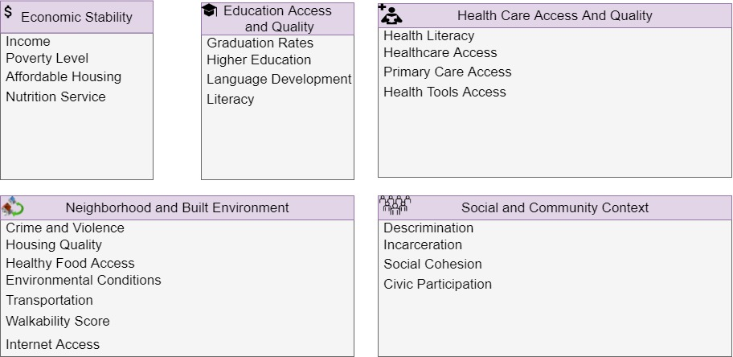
Figure 1.1. Five Domains and Variables of the SDoH

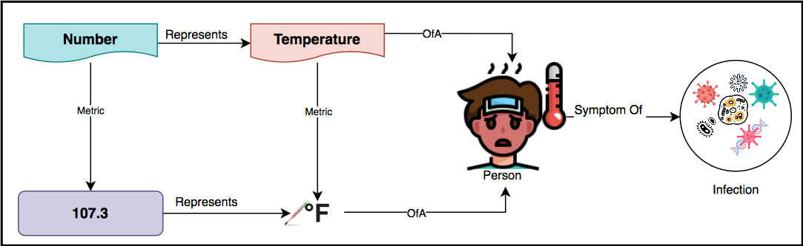
Figure 1.2. Schematic representation of four distinct modes

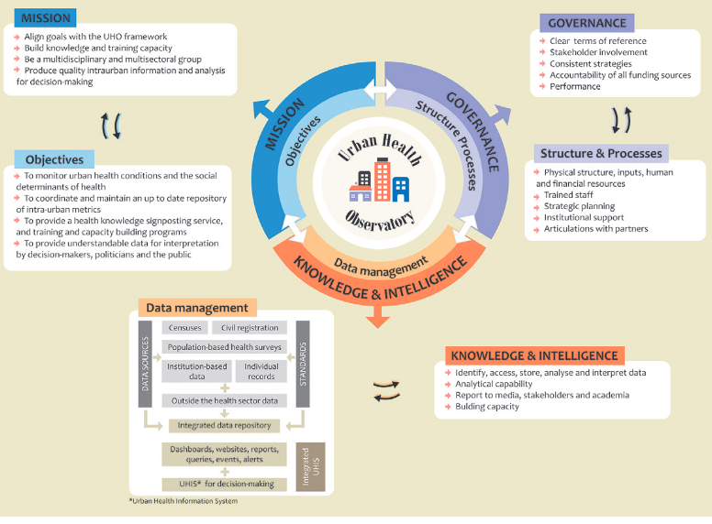
Figure 1.3. WHO’s Urban Health Observatory (UHO) conceptual framework (adapted from [5])

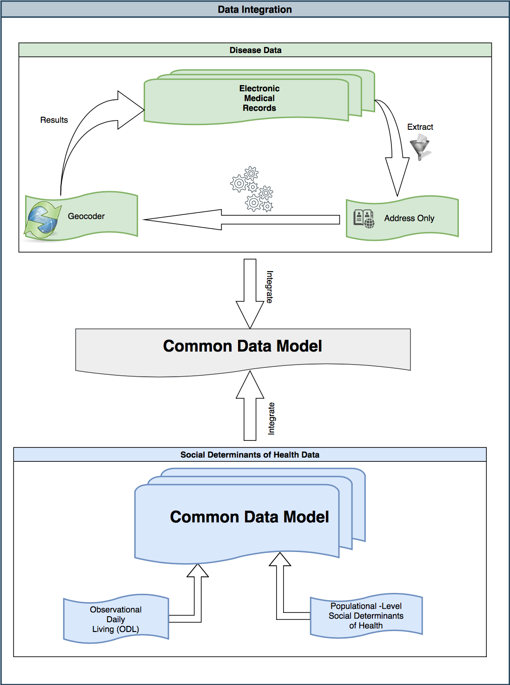
Figure 1.4: Data Integration

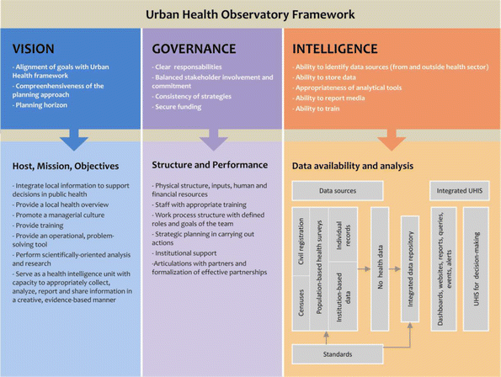
Figure 2.1: UHO’s Preliminary Conceptual Framework (adapted from [5])

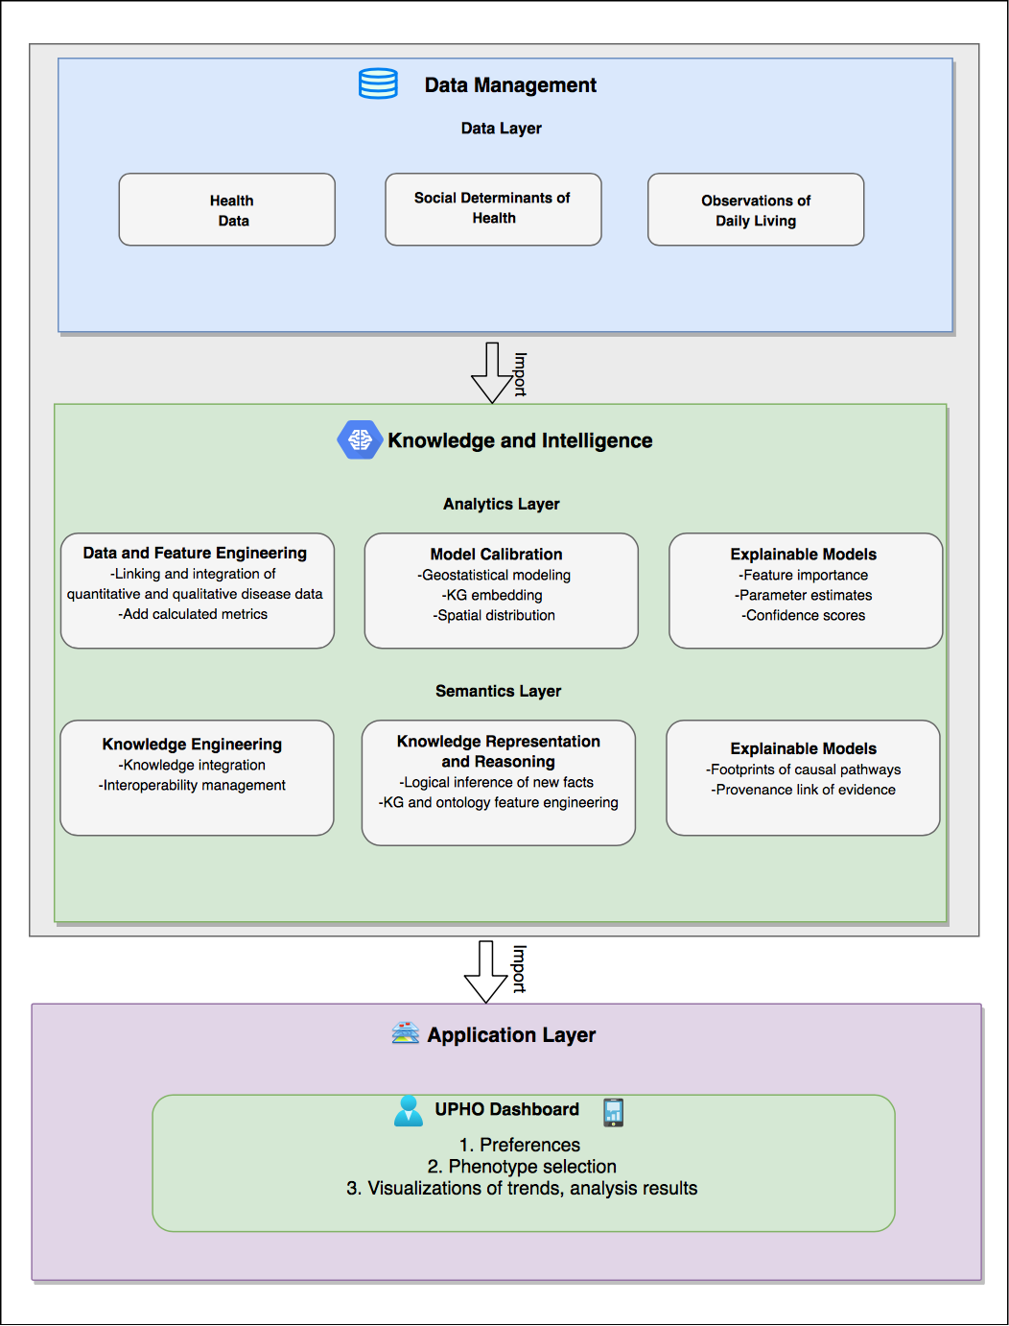

Figure 3.1: UPHO’s Architecture
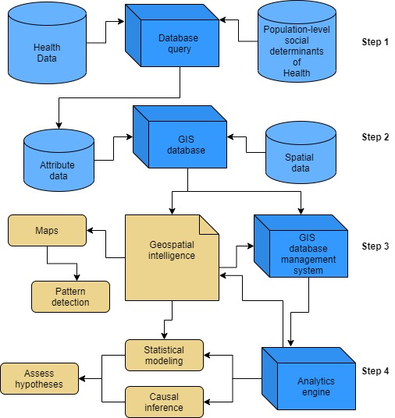
Figure 3.2: UPHO Analytics Framework

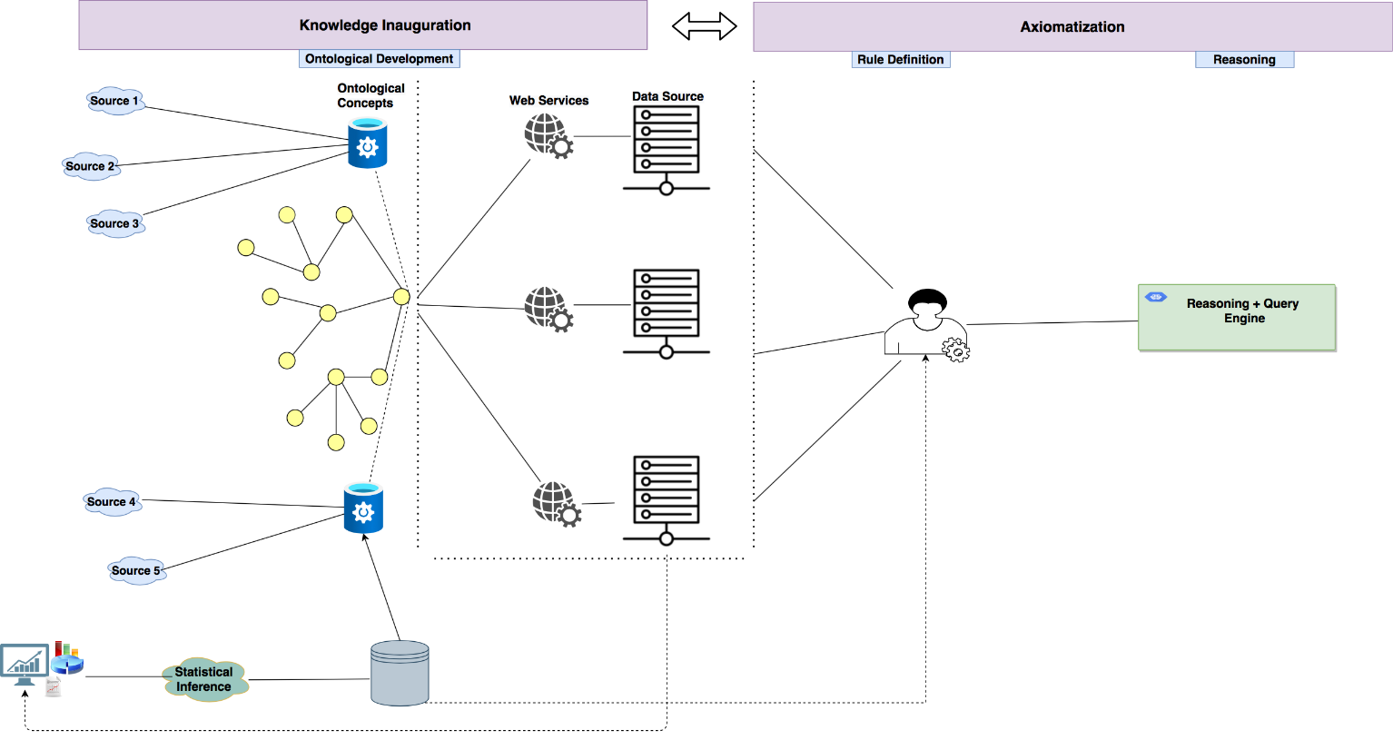

Figure 3.3: UPHO Semantic Layer Framework

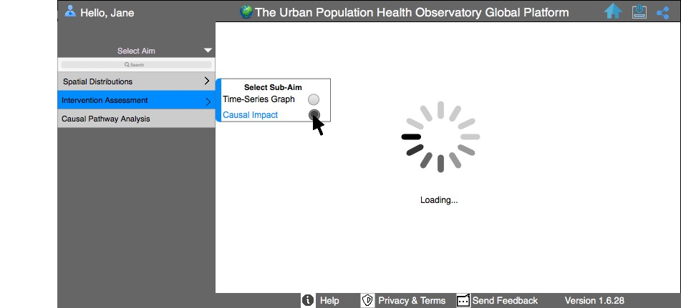
Figure 3.4: A tabbed view of the three main features provided by the dashboard

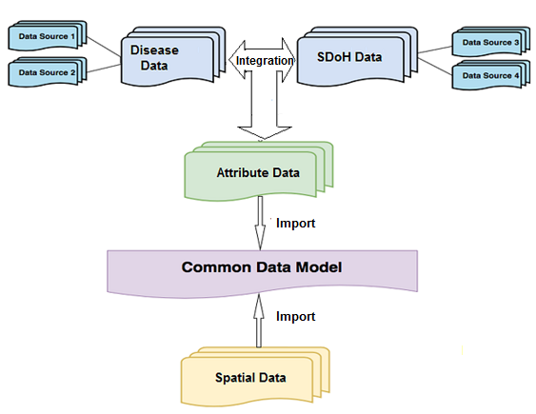
Figure 4.1: Integration Process

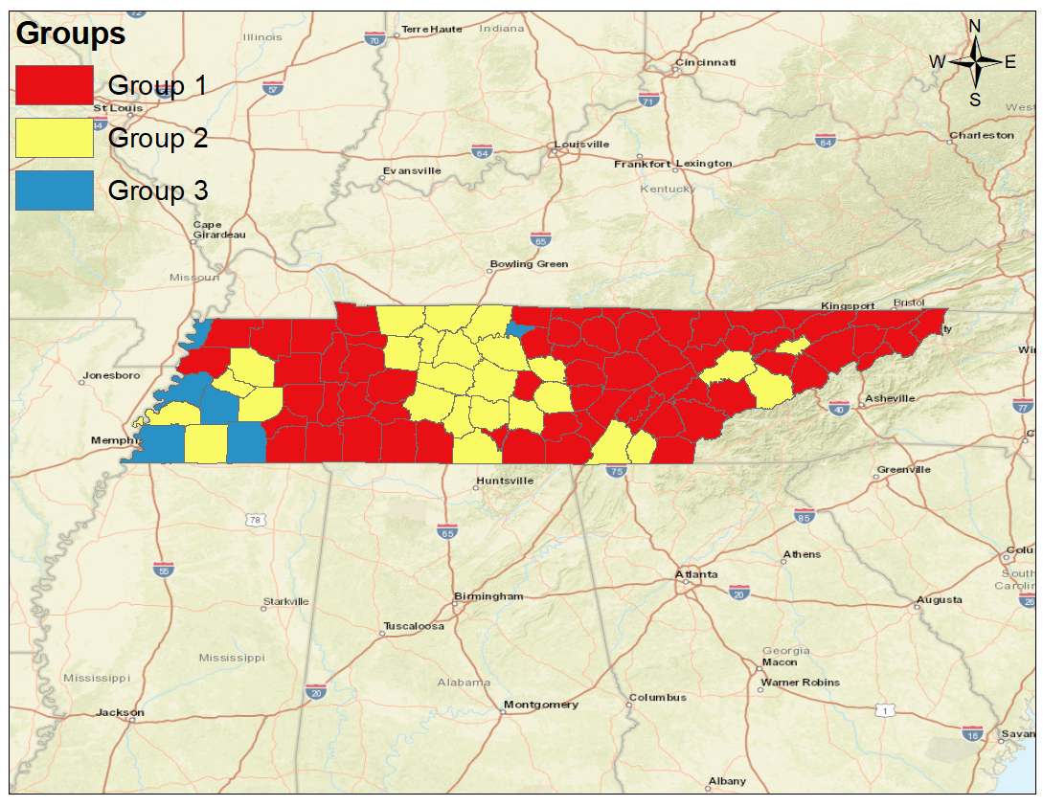

Figure 4.2. Grouping analyses results for COVID-19 and SDoH in Tennessee counties from
April 28,2020-June 30,2020

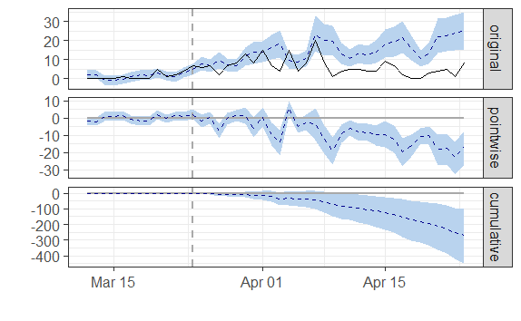
Figure 4.3. Causal Impact Plot

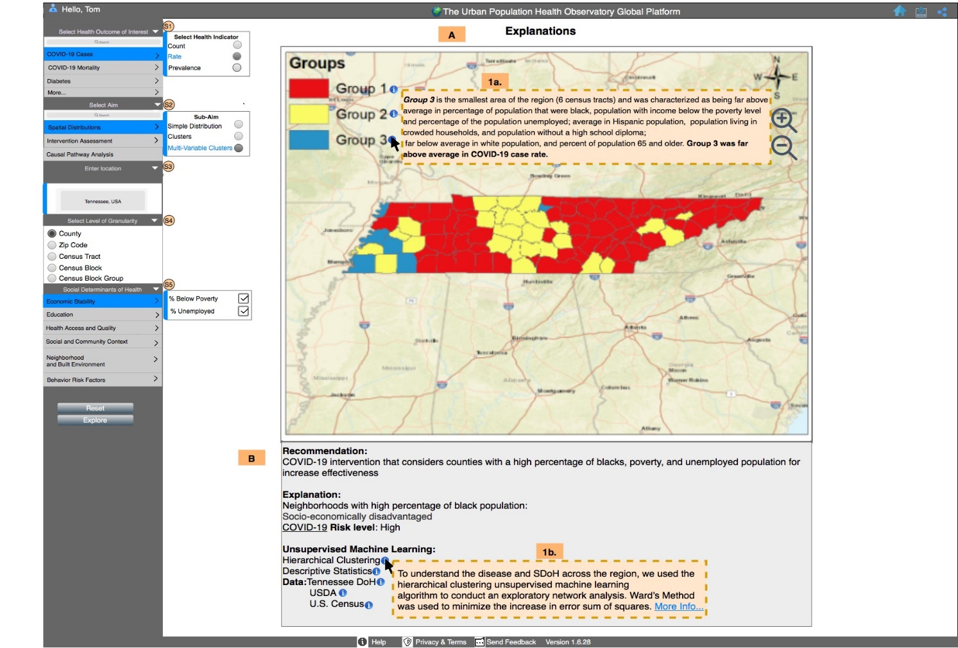
Figure 4.4. UPHO’s dashboard display of a researcher as the user interested in COVID-19 disparities and SDoH in Tennessee, USA

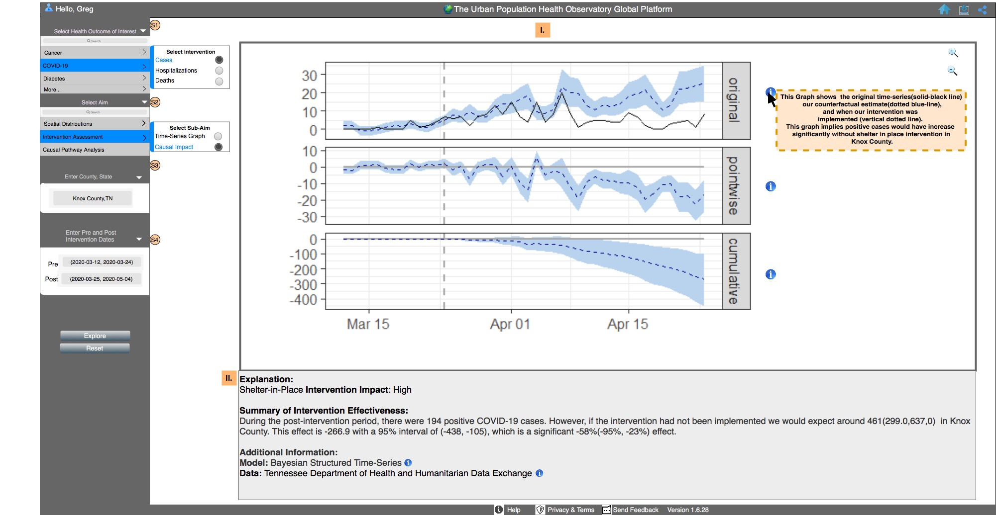
Figure 4.5. UPHO’s dashboard display of a health official as the user interested in the 31-day intervention impact in Knox County, TN

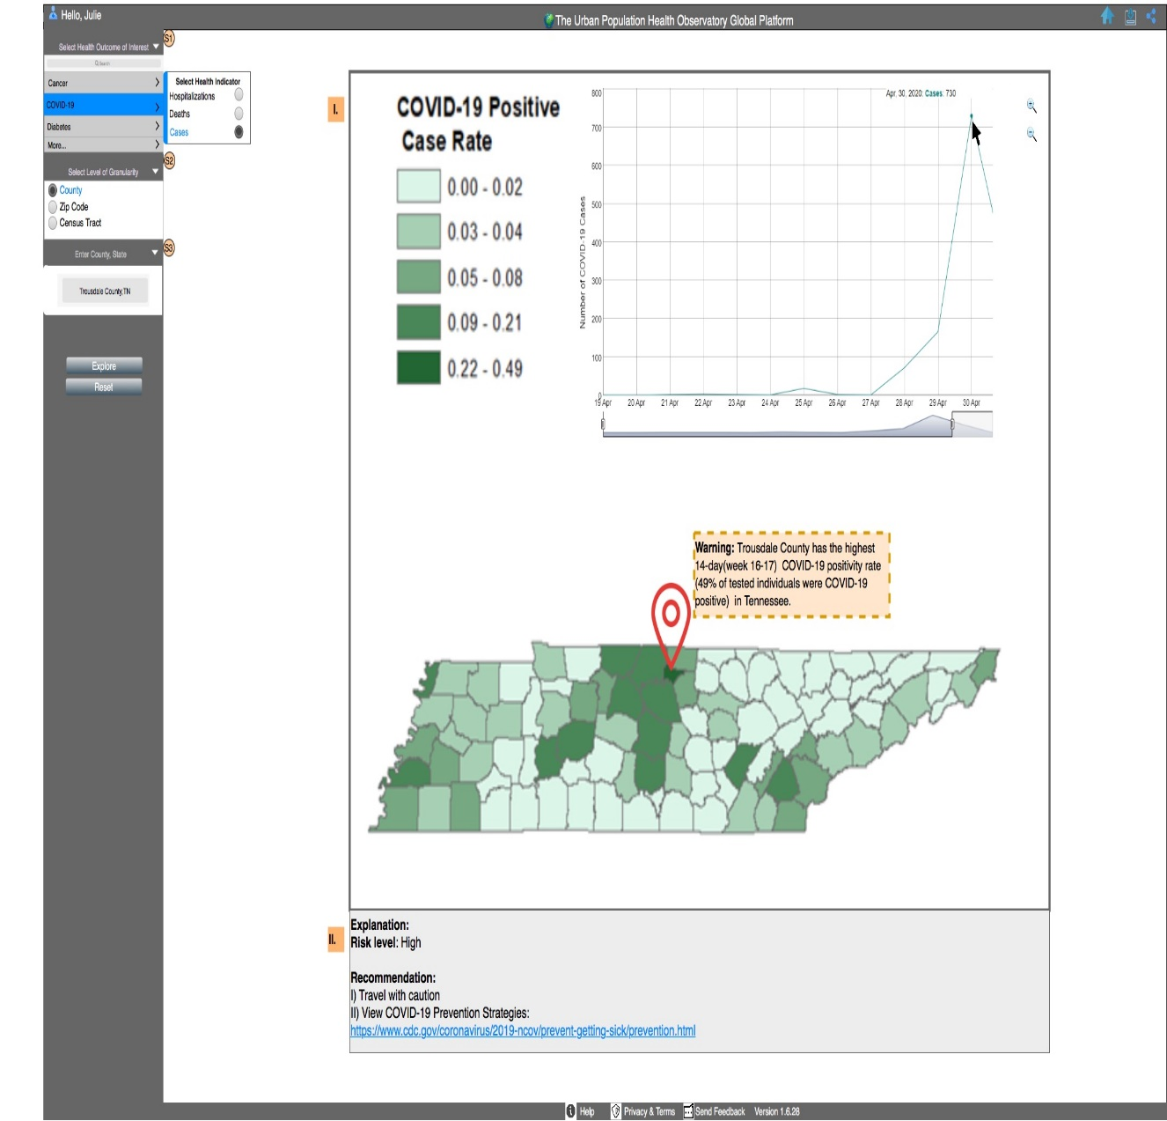
Figure 4.6. UPHO’s dashboard display of a Tennessee resident suffering from multi-comorbidities as the
user interested in the risk of traveling to Trousdale County, TN

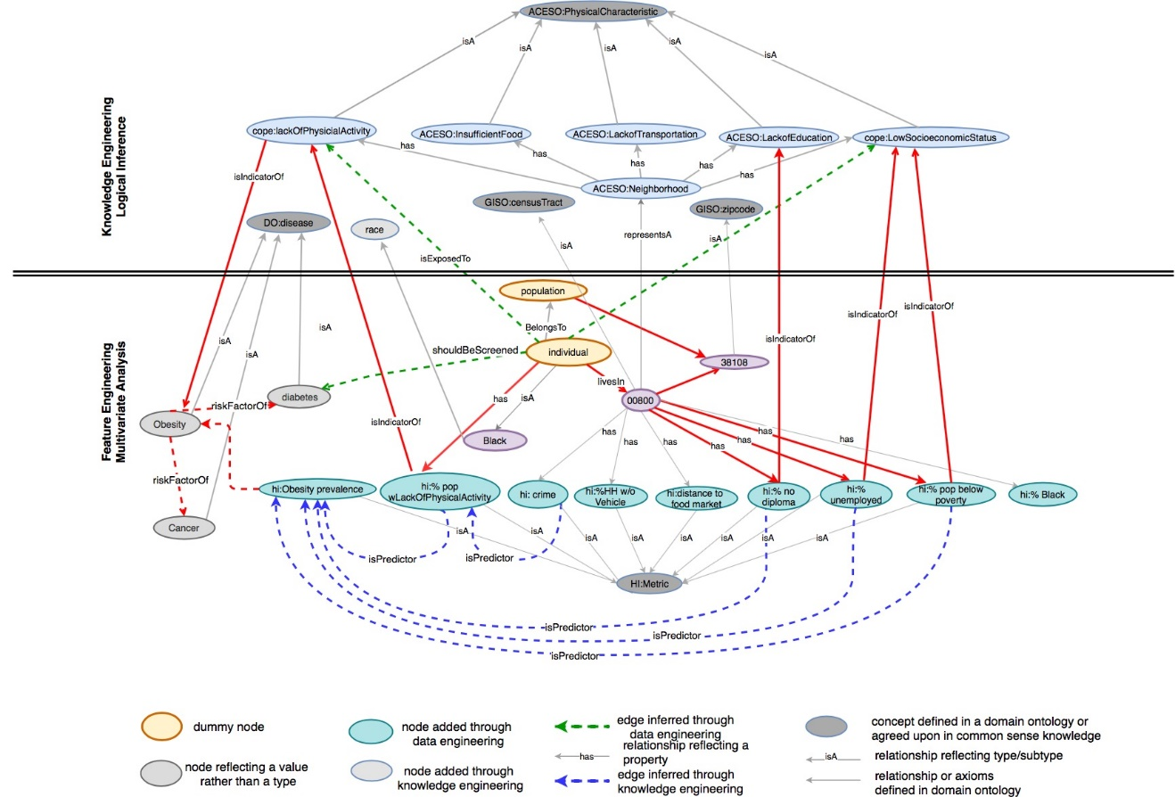
Figure 5.1. Knowledge Graph that links concepts defined in domain ontologies (e.g., GISO: CensusTract) to data resources stored in databases (e.g., % Black population) or those derived from the analytics layer. The upper part of the figure shows the nodes and edges produced through semantic Inference as part of the knowledge engineering phase. The ontologies used include GISO: GIS Ontology, HIO: Health Indicators Ontology, ACESO: Adverse Childhood Experiences Ontology, COPE: Childhood Obesity Prevention Ontology, DO: Disease Ontology. The lower part shows the nodes and edges added through machine learning analysis as part of the feature engineering phase.

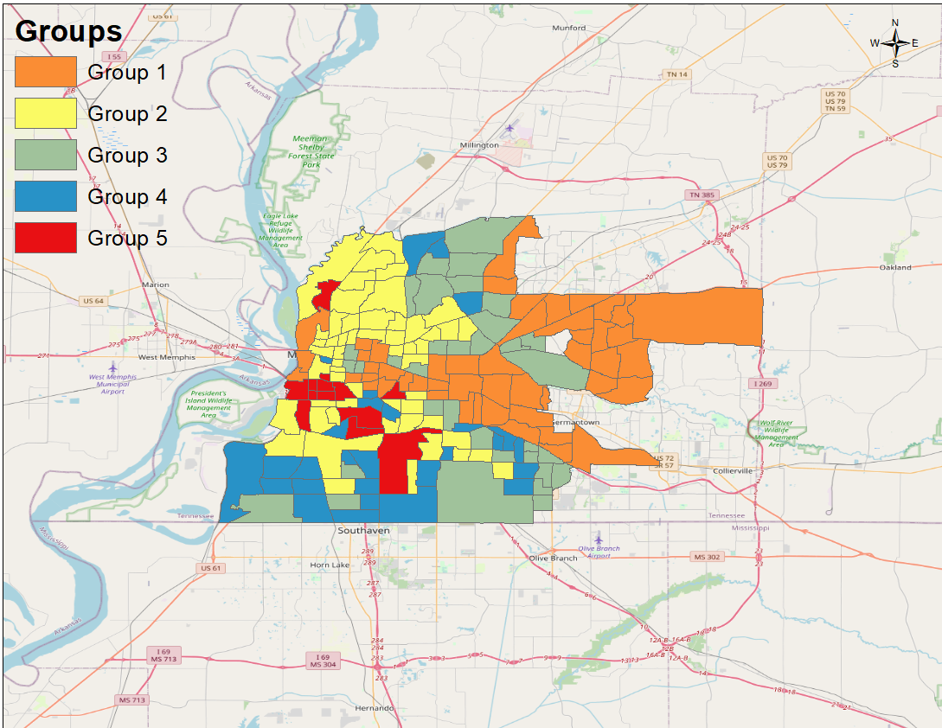

Figure 5.2. Grouping analyses results for obesity and SDoH in Memphis, TN census tracts

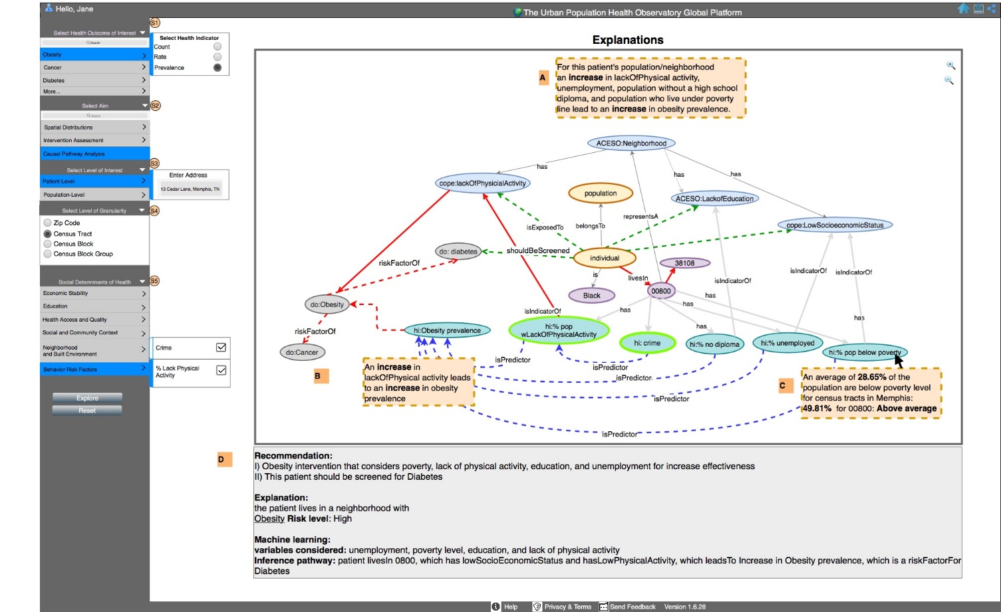

Figure 5.3: UPHO’s dashboard display of a physician user interested in obesity
prevalence in patient’s neighborhood

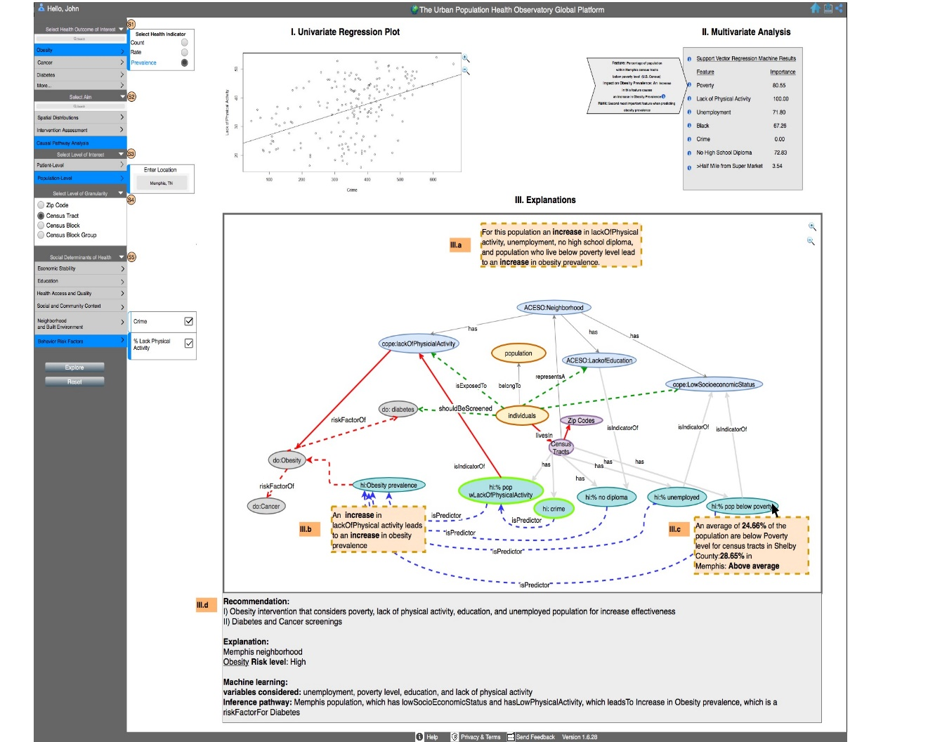Figure 5.4. UPHO’s dashboard display of a researcher as the user interested in obesity
prevalence in Memphis, TN

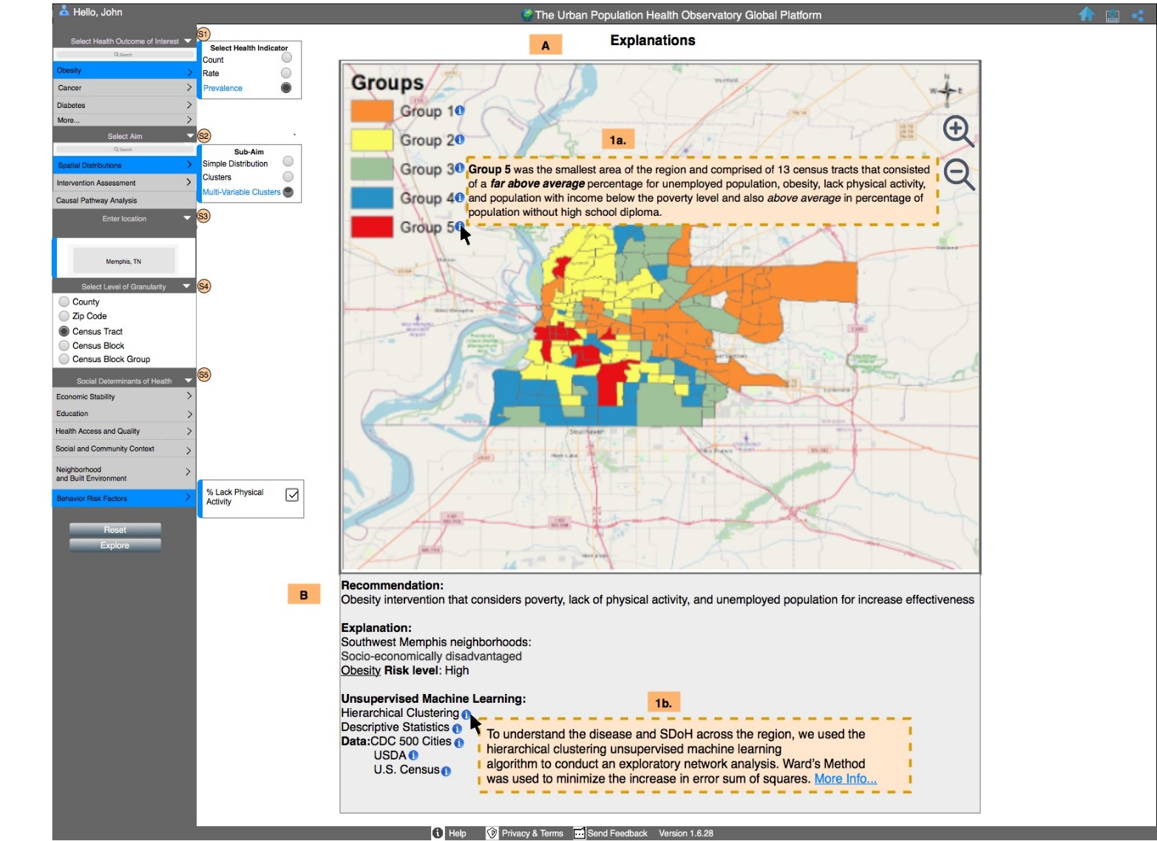

Figure 5.5. UPHO’s dashboard display of a user interested in obesity
prevalence and SDoH spatial distribution in Memphis, TN

                - Vita

Whitney S. Brakefield received the Bachelor of Science and Master of Science in Mathematics at Jackson State University. She is currently a Doctoral Candidate in Data Science and Engineering and Bredesen Center Fellow at The University of Tennessee-Oak Ridge Innovation Institute. Prior to The University of Tennessee, she was a National Science Foundation’s LSAMP Fellow and Department of Transportation Dwight Eisenhower Fellow.

