Insights into planetesimal evolution: Petrological investigations of regolithic howardites and carbonaceous chondrite impact melts

A Dissertation Presented for the

Doctor of Philosophy

Degree

The University of Tennessee, Knoxville

Nicole Gabriel Lunning

August 2015

DEDICATION

To Zack and my family

ACKNOWLEDGEMENTS

I would like to thank Hap McSween for accepting me as a PhD student, and for his guidance, encouragement, and support. Immediately after I decided to pursue my PhD at University of Tennessee with him as my advisor, Hap looked me in the eye and said “You made the right choice.” And I absolutely did. I have left almost every meeting with Hap even more excited about my research than when I entered, and eager to get back to work. Under his supervision, I have become a better petrologist, teacher, and writer.
I would like to thank Tim McCoy and Cari Corrigan for giving me the opportunity to work at the Smithsonian and for taking the time to teach me about meteorites. Thank you, Tim and Cari, for your support when I decided to go back to graduate school and for continuing to mentor me during my PhD.
I am grateful to Josh Emery, Ted Labotka, and Michael Sepaniak for serving on my committee, giving me constructive feedback, and helping me grow professionally. I would like to thank Devon Burr and Larry Taylor for constructive comments and advice on professional presentations. I am grateful to Allan Patchen for sharing his electron microprobe expertise and dry wit. I would like to thank my friends and fellow “Hap students” Arya Udry and Andrew Beck for guidance concerning the road immediately ahead of me, and Chris Wetteland and Tim Hahn for camaraderie and meteorite discussions. Chloe Beddingfield, Ashley Dameron, Sam Peel, Brianne Smith, Mike Lucas, Eric Maclennan, Robert Jacobsen, Richard Cartwright, Latisha Brengman, Sarah Sheffield, Nate Wigton, Cam Hughes, Chanda Drennen, Driss Takir, and many more people—sometimes grad school was rough—having all of you as friends and colleagues has made it a lot more fun! I would also like to thank the rest of the EPS department—particularly Melody, Angie, and Teresa—for support, encouragement, and for generally making the department a warm and welcoming place.
I would like to thank my family for sending love and encouragement from the north. Your support and confidence in me throughout my life has been instrumental to this achievement and to much of my personal happiness. I thank my mom for her unwavering confidence in my intelligence and potential. I thank my dad for encouraging my interest in science and space from an early age. Andy, Nise, Tim, and James: You are among the smartest people I know and growing up with you definitely made me smarter.
Last, but far from least, I would like to thank Zack for being a well of support that even though I draw from it heavily seems never in danger of running dry. Thank you.

ABSTRACT

Asteroidal meteorites are the only available geologic samples from the early part of our solar system’s history. These meteorites contain evidence regarding how the earliest protoplanetary bodies formed and evolved. I use petrological and geochemical techniques to investigate the evolution of these early planetesimals, focusing on two meteorite types: Howardites, which are brecciated samples of a differentiated parent body (thought to be the asteroid 4 Vesta), and CV chondrites, which are primitive chondrites that have not undergone differentiation on their parent body.
Quantitative petrological analysis and characterization of paired regolithic (solar wind-rich) howardites indicate that this large sample of the surface regolith of Vesta is assembled from a range of diverse source materials ( > 18 basaltic and ultramafic lithologies). The abundance of plagioclase in these howardites is depleted relative to unbrecciated source lithologies, which provides evidence that plagioclase is preferentially comminuted by impact gardening on Vesta, as previous studies have suggested it is in lunar regolith. The extent of plagioclase depletion in solar wind-rich howardites may be an indicator of regolith maturity.
The regolithic howardites I studied contain fragments of Mg-rich olivine and pyroxene in low modal abundance ( < 1%); we present geochemical evidence that these mineral fragments are the first recognized mantle samples from Vesta. In general, mantle samples from differentiated meteorite parent bodies are lacking in meteorite collections, which presents an obstacle for understanding the differentiation of these early planetesimals. The geochemical signatures of these Mg-rich olivine and pyroxene fragments suggest that Vesta’s mantle may have only partially melted during its differentiation, rather than forming a whole-mantle magma ocean.
In a regolithic howardite and two CV chondrites, I found impact melt clasts derived from primitive chondrite precursors (CV and CM chondrites). Previously, it had been hypothesized that impact melts might not form from carbonaceous chondrites because their high volatile content might explosively disrupt the formation of a cohesive melt. These clasts provide evidence that impact melts of these precursors can form, that these melts experience some volatile loss, and that they retain some of the redox trends of their precursors.

TABLE OF CONTENTS

INTRODUCTION 1
References 4
CHAPTER I Grosvenor Mountains 95 howardite pairing group: Insights into the surface regolith of asteroid 4 vesta 6
Abstract 7
Introduction 7
Materials and methods 10
Meteorite samples 10
Mineral chemistry and modal assemblages 11
Cosmogenic nuclides 12
Results 12
Textures and shock effects 12
Minerals 13
Polymineralic (lithic) clasts 14
Cosmogenic nuclides 17
Discussion 18
GRO 95 howardite pairing 18
Diversity of source materials 20
Eucrite:diogenite mixing ratio 21
Plagioclase depletion in regolithic howardites 24
Summary and conclusions 26
References 28
Appendix A 37
Extended methods for lithologic modal distribution mapping 38
CHAPTER II Olivine and pyroxene from the mantle of asteroid 4 Vesta 58
Abstract 59
Introduction 59
Samples and Analytical Procedures 60
Meteorite samples 60
Major element and quantitative modal analyses 61
Oxygen isotope analyses 61
Trace element analyses 62
Results 63
Description of Mg-rich olivine and pyroxene 63
Major element analyses 63
Oxygen isotope analyses of olivine 64
Trace element analyses 64
Discussion 65
HED-Vesta parent body provenance 65
Petrogenesis of Mg-rich olivine 66
Mantle of Vesta: Magma ocean or partially melted? 67
Conclusions 69
References 71
Appendix B 75
CHAPTER III CV and CM chondrite impact melts 92
Abstract 93
Introduction 93
Materials and methods 95
Electron Microprobe 95
Raman spectroscopy 95
Oxygen three-isotope analyses 96
Results 96
Host meteorites 96
Impact melt clasts 97
Discussion 100
Melt clast provenances 100
Impact melt clasts: Formation histories and precursors 102
Redox state of impact melt clasts 105
Summary and Conclusions 109
References 111
Appendix C 117
Extended host meteorite descriptions 118
CONCLUSION 135
VITA 136

LIST OF TABLES

Table A1. Groups and subgroups of the howardite, eucrite and diogenite (HED) meteorite clan. Multiple lithologies have previously been described within each subgroup, except the Yamato type-B diogenites. 40
Table A2. Quantitative mineral modes. These percentages are from lithologic distribution maps (Figs. A5-A6). 41
Table A3. Eucritic lithic clasts. The lettered lithologies correspond to those plotted in Figs. A8-A9. 42
Table A4. Diogenite olivine-orthopyroxene lithic clast mineral compositions. 43
Table A5. Concentrations of major elements (in wt%) and of cosmogenic radionuclides, ¹⁰Be, ²⁶Al and ³⁶Cl (in dpm/kg) in bulk samples of GRO howardites. The ²⁶Al concentrations in column 10 are normalized to the main targets elements, Si and Al (assuming Si = 23 wt%). The last column shows ³⁶Cl concentrations normalized to major targets elements, Fe, Mn and Ca, assuming P(³⁶Cl)Ca/P(³⁶Cl)Fe = 8 and P(³⁶Cl)Mn/P(³⁶Cl)Fe = 1.2. 44
Table A6. Modes for regolithic howardites Kapoeta, Bununu and Bholgati. All values in this table are calculated from the volume percent mineral modes and pyroxene composition distributions reported by Fuhrman and Papike (1981). 45
Table A7. Regions of interest and adjustments to standard deviation to tune classification in lithologic distribution maps. 46
Table B1. Electron microprobe analyses of Mg-rich olivine from GRO 95 howardites. 76
Table B2. Electron microprobe analyses of Mg-rich pyroxene from the GRO 95 howardites. 77
Table B3. Unweighted SIMS spot analyses on GRO 95 Mg-rich and Diogenite Olivine Grains. An additional 0.3, 0.15 ‰ were respectively propagated for the respective uncertainties of δ¹⁸O, δ¹⁷O based on standard calibration. All oxygen isotope data and standard deviations are expressed as parts per mil (‰). Continued on next page. 78
Table B3. Continued. Unweighted SIMS spot analyses on GRO 95 Mg-rich and Diogenite Olivine Grains. An additional 0.3, 0.15 ‰ were respectively propagated for the respective uncertainties of δ¹⁸O, δ¹⁷O based on standard calibration. All oxygen isotope data and standard deviations are expressed as parts per mil (‰). 79
Table B4. Average of SIMS spot analyses for each olivine grain. Additional 0.3, 0.15 ‰ uncertainties were propagated for δ¹⁸O, δ¹⁷O respectively from standard calibration. Δ¹⁷O 2σ standard deviation for grains on which multiple analyses were collected. All oxygen isotope data and uncertainties are expressed as parts per mil (‰). 80
Table B5. Ni and Co trace element concentrations for Mg-rich olivine from GRO 95 howardites. 81
Table B6. Extended trace element chemistry of Mg-rich olivine from GRO 95 howardites. LA ICP-MS data. 1σ refers to the error of the analyses calculated by the SILLS program. 1σ is given in terms of the last decimal place, for instance 36.3 ± 1.3 is listed as 36.3 (1.3). Mg# listed in this table were calculated from EMP data (Table B1). 82
Table B7. Ni and Co trace element concentrations for Mg-rich olivine from GRO 95 howardites. 83
Table B8. Trace element chemistry of Mg-rich pyroxene from GRO 95 howardites. 84
Table B9. Mg-rich pyroxene trace element chemistry and errors normalized to CI Chondrites. This table includes the LA ICP-MS data listed in Table B6 normalized to CI chondrite. Element ratio values in italized red were calculated using a detection limit. 85
Table C1. Average bulk composition of melt clasts. 121
Table C2. Mineral percentages for each melt clast. 122
Table C3. Representative olivine analyses from melt clasts. 123
Table C4. Average glass compositions from melt clasts. 124
Table C5. Representative chromite analyses from melt clasts. 125
Table C6. Bulk composition of FeNiS globules in weight percent. 126
Table C7. Representative plagioclase and high Ca-pyroxene analyses from melt clasts. 127
Table C8. Chondrite bulk composition elemental ratios. 128

LIST OF FIGURES

Figure A1. GRO 95 howardite find locations in the Grosvenor Mountains, Antarctica. Map created by John Schutt using USGS air photographs. The eucrite GRO 95533 was found ~8 km away (not within the area of this map) from the GRO 95 howardites. 47
Figure A2. Pyroxene and olivine compositions from paired GRO 95 howardites and GRO 95602. Data for paired GRO 95 howardites (upper diagram) and for GRO 95602 (lower diagram) are similar, but the paired GRO 95 data extend to more extreme values. 48
Figure A3. Plagioclase compositions for the paired GRO 95 howardites and for GRO 95602. 49
Figure A4. Chromite compositions for the paired GRO 95 howardites and for GRO 95602. 50
Figure A5. Quantitative lithologic distribution maps of GRO 95 howardites. The GRO 95602 thin section maps (scale bar above) have somewhat different scale than the GRO 95535 (scale bar lower right). These maps are not color-combination x-ray maps. These maps were constructed using remote sensing techniques on 10 separate element x-ray maps combined with point analyses, described in detail in at the beginning of Appendix A. 51
Figure A6. Quantitative lithologic distribution maps of GRO 95 howardites continued from Figure A5. All thin sections in this figure have the same scale (middle right). These maps are not color-combination x-ray maps. These maps were constructed using remote sensing techniques on 10 separate element x-ray maps combined with point analyses, described in detail in the beginning of Appendix A. 52
Figure A7. Backscattered electron (BSE) images of polymineralic clasts. (a) Subophitic clast with unequilibrated pyroxene in GRO 95535,16, (b) Subophitic clast with unequilibrated pyroxene in GRO 95581,7, (c) Subophitic clast with finely exsolved pyroxene in GRO 95602,13, (d) Granoblastic basaltic eucrite clast in GRO 95535,16, (e) Granoblastic cumulate eucrite clast in GRO 95574,17, (f) Olivine-orthopyroxene diogenite clast in GRO 95574,17. 53
Figure A8. Major and minor element pyroxene compositions of eucritic lithic clasts. Legend at upper right, minor element chemistry plotted on inset ternary diagrams. Boxes enclose lithic clasts with overlapping pyroxene tie lines. Plus signs denote additional minerals identified in each clast using the following abbreviations: plagioclase (Plag), troilite (Tr), silica (Si), ilmenite (Ilm), Fe-rich metal (Fe⁰), olivine (Ol), and chromite (Chr). Additional data on these lithologies is located in Table 2. 54
Figure A9. Pyroxene compositions of eucritic lithic clasts continued from Fig. 8. Legend at upper right of Figure 8, minor element chemistry plotted on inset ternary diagrams. Plus signs denote additional minerals identified in each clast using the following abbreviations: plagioclase (Plag), troilite (Tr), silica (Si), ilmenite (Ilm), Fe-rich metal (Fe⁰), olivine (Ol), and chromite (Chr). Additional data on these lithologies is located in Table 2. 55
Figure A10. Measured ³⁶Cl concentrations in bulk samples of GRO howardites and a eucrite, plotted as a function of the chemical composition, in which Fe + 8Ca represents the relative production from the two main target elements. The four data points in the grey box represent the paired howardites GRO 95534, 95535, 95574 and 95581. The solid line represents the average ³⁶Cl production rates of 22.5 dpm/kg[Fe+8Ca]; the dashed lines represent the 10% uncertainty limits. 56
Figure A11. Comparison of measured ²⁶Al concentrations in bulk samples of the paired GRO 95 howardites with calculated depth profiles in howardites with pre-atmospheric radii of 12-75 cm, as derived from model calculations. For the ²⁶Al production rate calculations we adopted elemental production rates for ordinary chondrites (Leya and Masarik 2009). We assumed the average composition (8.3% Mg, 3.9% Al, 23.6% Si, 4.1% Ca and 12.7% Fe) of the four GRO 95 howardites, even though small variations in the composition of individual samples may change the production rate by 2-3%. The radius and depth scale was adjusted from chondritic values based on an average density of ~3 g/cm² for howardites. 57
Figure B1. Backscatter electron (BSE) images of fragmental Mg-rich olivine and pyroxene grains. a.) Mg-rich olivine fragment (Mg# 90.1) from GRO 95574,17 with LA-ICP-MS pits (32-44 μm laser spots) and SIMS pits (15-μm beam spots) b.) Mg-rich pyroxene fragment (Mg# 90.2) from GRO 95574,17 with LA-ICP-MS pits (24-44 μm laser spots). 86
Figure B2. Fe/Mn ratio versus Mg# of fragmental olivine grains from the GRO 95 howardites. Each green open circle corresponds to an individual olivine fragment; where multiple analyses were collected the symbol corresponds to an average value. Olivines in a carbonaceous chondrite clast in GRO 95535,16 were measured in this study. The representative composition of olivine in CR chondrite clasts in the howardite Kapoeta is calculated from data in Gounelle et al. 2003. Error bars are the propagated analytical error on Mn. The diogenite compositional field is based on published data (Beck et al. 2012; Mittlefehldt et al. 1998). 87
Figure B3. Oxygen three-isotope compositions of Mg-rich olivine. The open circle is the average oxygen isotope composition for 47 Mg-rich olivine spot analyses on 16 grains: the error bars include 2σ standard error and the analytical uncertainty. The bulk HED field includes the eucrite fractionation line and bulk HED analyses, representing Vesta. TFL refers to the terrestrial fractionation line. CCAM refers to the carbonaceous chondrite anhydrous mineral line. Bulk CR and Bulk CM fields refer to bulk analyses of CR chondrites and CM chondrites, respectively. Oxygen three-isotope compositions of other meteorite groups are from Krot et al. 2006 and references therein. 88
Figure B4. Oxygen three-isotope compositions of Mg-rich olivine and diogenite olivine from the GRO 95 howardites. The open circle is the average oxygen isotope composition for 47 Mg-rich olivine spot analyses on 16 grains. The filled gray circle is the average oxygen isotope composition for 34 diogenite olivine spot analyses on 14 grains. The error bars include 2σ standard error and the analytical uncertainty. The EFL is the eucrite fractionation line, which represents the HED meteorites associated with 4 Vesta. The EFL and oxygen isotope fields for other meteorite parent bodies are from data in Greenwood et al. 2012. 89
Figure B5. Oxygen three-isotope compositions of Mg-rich olivine from the GRO 95 howardites compared to achondrites. Δ¹⁷O is defined as δ¹⁷O–0.52 × δ¹⁸O, representing the displacement from the terrestrial fractionation line (TFL). The circle is the average oxygen isotope composition for 47 Mg-rich olivine spot analyses on 16 grains; the error bars include 2σ standard error and the analytical uncertainty. EFL marks the eucrite fractionation line, representing Vesta. The EFL and oxygen isotope fields for other meteorite parent bodies are from data in Greenwood et al. 2012. 90
Figure B6. Trace element patterns of Mg-rich pyroxene fragments from GRO 95 howardites. Closed symbols represent concentrations above 1σ limit of detection (LOD). The source data for this plot are listed in Tables 4 and A.4. Open symbols correspond to elements for which the analyses were below the 1σ LOD, and therefore each open symbol marks a maximum value, the 1σ LOD. When two adjacent data points represent values that are both above the LOD they are connected by a solid line, and dashed lines are used to connect concentrations that were determined based on a LOD. 91
Figure C1. Raman spectrum of a glass with 2 wt. % H₂O with low fluorescence background signal. 129
Figure C2. Raman spectrum of glass from Clast mIM with high fluorescence background signal. 130
Figure C3. Plane polarized light images of impact melt clasts. (a) Clast A in LAR 06317,11. (b) Clast C in LAR 06317,2. (c) Clast mIM in GRO 95574,17. (d) Clast Z in RBT 04143,2. (e) Clast B in LAR 06317,2. 131
Figure C4. Backscatter electron (BSE) images of melt clast textures. All clasts contain zoned equant microphenocrysts of olivine with Mg-rich (black-dark gray) cores and more Fe-rich (lighter) rims. FeNiS globules/grains are white in all of these images. Accessory intergranular zoned chromite (light grays) are visible in images a, b, and c. (a) Clast A in LAR 06317,11; the fragmental contact between this clast and its host meteorite is visible on the right side of this image. (b) Clast B in LAR 06317,2. (c) Clast mIM in GRO 95574,17 in this image 2 SIMS spots are visible. The upper spot is on the core of an olivine grain that texturally grew out of the melt. The lower spot is on Mg-rich olivine relict core, which is dark in BSE. (d) Clast B in LAR 06317,2. (e) Clast Z in RBT 04143,2; several vesicles (black) with sinuously curved edges are visible in this image. 132
Figure C5. Backscatter electron (BSE) images of FeNiS globules or grains in (a) Clast A in LAR 06317,11; white corresponds to the FeNi metal and medium gray is pyrrhotite monosulfide solid solution (MSS). (b) Clast B in LAR 06317,2; white corresponds to the metal and sulfide grains. (c) Same field of view of Clast B in LAR 06317,2; white corresponds to the FeNi metal and medium gray is pyrrhotite MSS. (d) Clast B in LAR 06317,2; white corresponds to the FeNi metal, dark gray is pyrrhotite MSS, and medium-lighter gray is Ni-rich sulfide. (e) Clast B in LAR 06317,2; white corresponds to the FeNi metal, light gray is pyrrhotite MSS, and dark grays are surrounding zoned olivines. (f) Clast Z in RBT 04143,2; white corresponds to the FeNi metal, dark gray is pyrrhotite MSS, and medium-lighter gray in the globule is Fe-oxides that likely formed from terrestrial weathering. (g) Clast mIM in GRO 95574,14; white corresponds to the FeNi metal, dark gray is pyrrhotite MSS, and medium-lighter gray is pentlandite. 133
Figure C6. Oxygen three-isotope plot of olivine in Clast mIM in the regolithic howardite GRO 95574,17. The bulk HED field includes the eucrite fractionation line and bulk HED analyses, representing Vesta. TFL refers to the terrestrial fractionation line. CCAM refers to the carbonaceous chondrite anhydrous mineral line. Bulk CR and Bulk CM fields refer to bulk analyses of CR chondrites and CM chondrites, respectively. Oxygen three-isotope compositions of meteorite groups are from Krot et al. 2006 and references therein. 134

INTRODUCTION

The majority of meteorites that fall to earth come from the asteroid belt (Krot et al. 2006). Asteroidal meteorites include a diverse range of geologic materials. However, they are all samples of the bodies that formed during the earliest portion of our solar system’s history; these bodies are often called planetesimals (Scott and Krot 2006; McCoy et al. 2006). There were likely many more planetesimals that formed out of the solar nebula than are present today in the asteroid belt, because most were scattered out of the asteroid belt or agglomerated onto larger bodies that eventually became the planets (e.g., Morbidelli et al. 2009). A few planetesimals in the asteroid belt may be relatively intact, however, many have been catastrophically fragmented by collisions (Petit et al. 2002). These planetesimals and fragments in our asteroid belt constitute relicts of the early solar system. Meteorites that are samples of asteroids can be used for a wide range of studies that focus on: formation of solids in the early solar nebula, accretion and evolution of planetesimals, and understanding the source materials of the planets. In most cases, meteorites are the only available samples of these bodies for geochemical and petrological studies to complement astronomical and spacecraft-based observations of asteroids.
This work mainly utilizes two types of asteroidal meteorites: howardites and CV chondrites. These two meteorites groups hail from opposite ends of the range of geologic material from the asteroid belt, the former being achondrite and the latter chondrite. The classifications achondrite and chondrite have genetic implications (e.g, Krot et al. 2006). The achondrites originate from bodies that underwent differentiation (a process planets like the Earth underwent but driven by different heat sources): extensive melting and segregation of FeNi-metal into a central core, and melting of silicates to form an ultramafic mantle and mafic crust. These planetesimals contained short-lived radioisotopes, such as ²⁶Al, whose decay provided energy to melt these early bodies. The earlier a planetesimal formed, the higher its concentration of live short-lived radioactive isotopes, and the greater the proportion of melting it likely experienced (McCoy et al. 2006). The planetesimals that experienced near-complete melting accreted early in solar system history, ~1 million years after the first solids condensed out of the solar nebula (e.g., Hans et al. 2013). These planetesimals include the parent body of the howardites, thought to be the asteroid 4 Vesta (evidence for the connection between howardites and Vesta is briefly reviewed in Chapter I).
Howardites are breccias composed of numerous igneous lithologies from their parent body, and sometimes include additional exogenic components. Howardites are analogs for the surface and near-surface materials of Vesta (McSween et al. 2013), commonly called the regolith. The NASA Dawn Spacecraft recently orbited Vesta for a over 14 months between 2011-2012 to map most of Vesta’s surface with several instruments: a framing camera, visible-to-near infrared spectrometer, and a gamma ray and neutron detector (Russell et al. 2013). Petrological and geochemical studies of howardites can provide detail to complement the coarser spatial resolution of the remotely-sensed data sets of these spacecraft instruments.
In contrast, chondrites are generally thought to come from bodies that accreted a few million years later and thus did not contain high enough concentrations of live short-lived radioisotopes (e.g., ²⁶Al) to drive extensive melting and produce igneous rocks (e.g., Grimm and McSween 1989). Although chondrite groups commonly contain evidence that their parent bodies experienced aqueous alteration (if they accreted with ice) and/or thermal metamorphism (if they accreted dry), chondrites did not undergo melting, and thus they are considered more primitive than achondrites. The materials that accreted to form chondrite parent bodies have been less altered, and in chondrites these primitive materials can be directly examined: sediments/grains (e.g., chondrules, calcium-aluminum-rich inclusions, amoeboid olivine aggregates, metal grains) that formed in the solar nebula. CV and CM chondrites are considered to be among the most primitive and relatively oxidized of the chondrite groups (e.g., Scott and Krot 2006).
Even though they formed on very different types of planetesimals, there are some associations between primitive chondrites and howardites. Primitive chondrite materials, including CM chondrite clasts, are frequently found mixed into howardites (e.g., Zolensky et al. 1997; Gounelle et al. 2003). Also, impactor-derived additions of unmelted primitive chondritic material are recognized in the regolith of Vesta in remotely-sensed data sets collected by the Dawn spacecraft (e.g., McCord et al. 2012; De Sanctis et al. 2013; Prettyman et al. 2012). This primitive chondrite material is more volatile-rich than howardites and the other rocks connected to Vesta. The addition of primitive chondrite material may have affected surface processes on Vesta. For instance, the pitted terrains on Vesta may have formed by release of volatiles from primitive chondrite material mixed into the regolith (Denevi et al. 2012).
In this dissertation, I use petrological and geochemical techniques on howardite and CV chondrite samples to answer a range of questions relating to how the surfaces of their parent bodies may have evolved over time and regarding the evolution of Vesta’s mantle during differentiation:
Chapter I: Of what is the surface regolith (soil) of the differentiated asteroid 4 Vesta petrologically composed? What do its petrologic characteristics tell us about surface regolith-forming processes on Vesta? In this chapter, we examine five howardites from a single ice field in Antarctica. Two of these howardites were previously determined to be rich in solar wind implanted gases (Cartwright et al. 2014), which requires that they were directly exposed to solar irradiation for some time. Thus, these meteorites are analogs for the material exposed Vesta’s surface. Based on their petrologic characteristics and cosmogenic nuclide concentrations, four of these howardite stones are shown to be samples from the same 10-15 cm radius meteoroid, which broke apart during atmospheric passage. Combined, they represent one of the largest, and potentially most representative, regolithic howardite samples ever petrologically characterized.
Chapter II: Did Vesta differentiate and form its igneous crust by forming a molten mantle known as a magma ocean? Or did Vesta differentiate and form its igneous crust by partial melting and serial extraction of magma from a mostly solid mantle? Prior to the work described in this chapter, these questions had been examined by modeling but could not be tested with samples, because no olivine-rich mantle samples had been identified from Vesta. In this study, we identify mantle olivine and pyroxene fragments found in howardites based on their major element chemistry, oxygen-three isotope compositions, and trace element chemistry, and use their chemical signatures to consider the structure of the vestan mantle.
Chapter III: How do the surfaces of parent bodies composed of primitive and relatively oxidized chondritic material respond to impacts? If and how do their impact melts degas the volatiles (e.g., H₂O, CO₂, S₂) found in unmelted precursors? Does the redox state (intrinsic oxygen fugacity) of primitive chondrite impact melts change relative to their precursors? In this chapter, we identify the first CV chondrite impact melts based on their texture, bulk chemistry, major and minor element mineral chemistries, and location in unmelted CV chondrite meteorites. We also identify the first recognized CM chondrite impact (located in a howardite) based on its olivine oxygen three-isotope composition, and the similarity of its texture, bulk chemistry, major and minor element mineral chemistries to the CV chondrite impact melts.

References

Cartwright J. A., Ott U., and Mittlefehldt D. W. 2014. The quest for regolithic howardites. Part 2: Surface origins highlighted by noble gases. Geochimica et Cosmochimica Acta 140: 488-508.
Denevi B.W., Blewett D.T., Buczkowski F., Capaccioni F., Capria M.T., De Sanctis M.C., Garry W.B., Gaskell R.W., Le Corre L., Li J.-Y., Marchi S., McCoy T.J., Nathues A., O’Brien D.P., Petro N.E., Pieters C.M., Preusker F., Raymond C.A., Reddy V., Russell C.T., Schenk P., Scully J.E.C., Sunshine J.M., Tosi F., Williams D.A., and Wyrick D. 2012. Pitted terrain on Vesta and implications for presence of volatiles. Science 338: 246-249
De Sanctis M. C., Ammannito E., Capria M. T., Capaccioni F., Combe J.-P., Frigeri A., Longobardo A., Magni G., Marchi S., McCord T. B., Palomba E.,Tosi F., Zambon F., Carraro F., Fonte S., Li Y.-J., McFadden L. A., Mittlefehldt D. W., Pieters C. M., Jaumann R., Stephan K., Raymond C. A., and Russell C. T. 2013. Vesta’s mineralogical composition as revealed by the visible and infrared spectrometer on Dawn. Meteoritics & Planetary Science 48: 2166-2184.
Gounelle M., Zolensky M. E., Liu J-C., Bland P. A., Alard O. 2003. Mineralogy of carbonaceous chondritic microclasts in howardites: Identification of C2 fossil micrometeorites. Geochimica et Cosmochimica Acta 67: 507-527.
Grimm R.E., and McSween H.Y. 1989. Water and the thermal evolution of carbonaceous chondrite parent bodies. Icarus 82: 244-280.
Hans U., Kleine T., Bourdon B. 2013. Rb-Sr chronology of volatile depletion in differentiated protoplanets: BABI, ADOR and ALL revisited. Earth and Planetary Science Letters 374: 204-214.
Krot A.N., Keil K., Scott E.R.D., Goodrich C. A., and Weisberg M. K. 2006. Chapter 1.05 Classification of meteorites. In Meteorites, Comets, and Planets: Treatise on Geochemistry, Volume 1 Editor: A. M. Davis. Amsterdam: Elsevier. pp. 1-52
McCord T. B., Li J.-Y., Combe J.-P., McSween H. Y., Jaumann R., Reddy V., Tosi F., Williams, D.A., Blewett D. T., Turrini D., Palomba E., Pieters C. M., De Sanctis M. C., Ammannito E., Capria M. T., Le Corre L., Longobardo A., Nathues A., Mittlefehldt D. W., Schröder S. E., Hiesinger H., Beck A. W., Capaccioni F., Carsenty U., Keller H. U., Denevi B. W., Sunshine J. M., Raymond C. A., and Russell C. T. 2012. Dark material on Vesta from the infall of carbonaceous volatile-rich material. Nature 491: 83-86.
McCoy, T. J., Mittlefehldt, D. W., Wilson, L. 2006. Asteroid Differentiation In Meteorites and the Early Solar Systems II. Editors: D. S. Lauretta, H.Y. McSween, R. P. Binzel. Tuscon, AZ: University of Arizona Press, Tucson, AZ pp. 733-745
McSween H. Y., Binzel R. P., De Sanctis M. C., Ammannito E., Prettyman T. H., Beck A. W., Reddy V., Le Corre L., Gaffey M. J., McCord T. B., Raymond C. A., Russell C. T., and the Dawn Science Team. 2013. Dawn; the Vesta-HED connection; and the geologic context for eucrite, diogenites, and howardites. Meteoritics & Planetary Science 48: 2090-2104.
Morbidelli A., Bottke W.F., Nesvorný D., and Levison H.F. 2009. Asteroids were born big. Icarus 204: 558-573.
Petit J.-M., Chambers J., Franklin F. and Nagasawa M. 2002. Primordial excitation and depletion of the main belt. In “Asteroids III” Editors: W. F. Bottke, A. Cellino, P. Paolicchi, R. P. Binzel. Tucson AZ: University of Arizona. pp. 711-723
Prettyman T. H., Mittlefehldt D. W., Yamashita N., Lawrence D. J., Beck A. W., Feldman W. C., McCoy T. J., McSween H. Y., Toplis M. J., Titus T. N., Tricarico P., Reedy R. C., Hendricks J. S., Forni O., Le Corre L., Li J-Y., Mizzon H., Reddy V., Raymond C. A., and Russell C. T. 2012. Elemental mapping by Dawn reveals exogenic H in Vesta’s regolith. Science 338: 242-246.
Russell C.T., Raymond C.A., Jaumann R., McSween H.Y., De Sanctis M.C., Nathues A., Prettyman T. H., Ammannito E., Reddy V., Preusker F., O’Brien D.P., Marchi S., Denevi B.W., Buczkowski D.L., Pieters C.M., McCord T.B., Li J.-Y., Mittlefehldt D.W., Combe J.-P., Williams D.A., Hiesinger H. Yingst R.A., Polanskey C.A., and Joy S.P. 2013. Dawn completes its mission at 4 Vesta. Meteoritics & Planetary Science 48: 2076-2089.
Scott E.R.D., and Krot A.N. 2006. Chapter 1.07 Chondrites and their components. In Meteorites, Comets, and Planets: Treatise on Geochemistry, Volume 1 Editor: A. M. Davis. Amsterdam: Elsevier. pp. 1-72.
Zolensky M. E., Weisberg M. K., Buchanan P. C., and Mittlefehldt D.W. 1996. Mineralogy of carbonaceous chondrite clasts in HED achondrites and the Moon. Meteoritics & Planetary Science 31: 518-537.

CHAPTER I
GROSVENOR Mountains 95 howardite pairing group: insights into the surface regolith of asteroid 4 vesta

This chapter is a reformatted version of a paper of the same name submitted to Meteoritics & Planetary Science. This paper has been revised in response to comments from peer reviewers and re-submitted. Its authors are Nicole G. Lunning, Kees C. Welten, Harry Y. McSween Jr., Marc W. Caffee, and Andrew W. Beck. Kees and Marc performed the cosmogenic radionuclide analyses. Nicole conducted the petrologic analyses: petrographic microscopic observations, electron microprobe analyses and x-ray mapping, and quantitative modal lithologic distribution mapping using ENVI software.

Abstract

Regolithic howardites are analogs for the surface materials of asteroid 4 Vesta, recently mapped by the Dawn spacecraft. Rigorously evaluating pairing of howardites recovered in 1995 in the Grosvenor Mountains (GRO 95), Antarctica, enables an examination of a larger, more representative regolith sample. Previous work on two of the howardites studied here concluded that GRO 95602 and GRO 95535 are solar wind-rich surface regolith samples and that they are not paired with each other, leading to uncertainty regarding pairing relationships between the other GRO 95 howardites. Based on petrology, cosmic-ray exposure history, and terrestrial age, four GRO 95 howardites are paired. The paired howardites (GRO 95534, 95535, 95574, 95581) were from a meteoroid with radius of 10-15 cm, a pre-atmospheric size comparable to that of Kapoeta, the largest known regolithic howardite. The paired GRO 95 howardites contain clasts of at least 18 separate HED lithologies, providing evidence they were assembled from diverse source materials. The total eucrite:diogenite mixing ratio (ratio of all eucrite lithologies to all diogenite lithologies) in the paired GRO 95 howardites is ~2:1. Petrographically determined basaltic eucrite:cumulate eucrite ratios in regolithic howardites, studied here and previously, vary more widely than total eucrite:diogenite ratios. Relative to eucritic pyroxene, plagioclase is depleted in these howardites, which provides evidence that plagioclase is preferentially comminuted in the vestan regolith. The extent of plagioclase depletion could be an indicator of regolith maturity.

Introduction

Howardite, eucrite, and diogenite (HED) meteorites likely provide samples of the surface and interior of asteroid 4 Vesta (Wilson and Keil 2012, McSween et al. 2013). Basic petrologic and geochemical features of the groups and subgroups of the HED meteorite clan are outlined in Table A1. In this study, we examine the petrology of five howardites that are analogs for the surface regolith of Vesta to quantify their mineral proportions, examine their source materials, investigate regolith processes, and evaluate which stones may have been part of a single meteorite fall that broke apart during atmospheric transit (i.e., a pairing group).
The HED-Vesta connection is supported by their shared reflectance spectra, observations of Vesta’s dynamical family (the vestoids) extending to the 3:1 resonance that perturbs them into Earth-crossing orbits, and observed near-Earth asteroids with HED-like reflectance spectra (McSween et al. 2013). The Dawn spacecraft collected visible/near-infrared (VNIR) spectra (e.g., De Sanctis et al. 2013), gamma-ray/neutron data (e.g., Prettyman et al. 2012), and framing camera high-resolution images collected in a panchromatic (clear) filter or with one of seven color filters (e.g., Reddy et al. 2012; Thangjam et al. 2013) for the surface of Vesta, as well as gravity science from the telemetry system (Russell et al. 2013). These measurements further support the association between the HED meteorites and Vesta. First, the mass of Vesta’s iron-nickel core constrained from geophysical measurements by Dawn (Russell et al. 2013) is consistent with those predicted by models based on HED compositions (Righter and Drake 1997). Second, exogenic carbonaceous chondrite material has been recognized in the regolith of Vesta (McCord et al. 2012; De Sanctis et al. 2013; Jaumann et al. 2014; Reddy et al. 2012; Prettyman et al. 2012) and is in approximately the same volumetric proportion as observed in average howardites (Buchanan et al. 1993; Prettyman et al. 2012; Zolensky et al. 1996). Finally, nanophase iron from space weathering is rare in howardites (Noble et al. 2011) and VNIR spectra of the vestan surface do not exhibit the “reddening” associated with space weathering on other asteroids (Pieters et al. 2012).
Dawn data reveal that Vesta has a surface overlain by a 1-2 km-thick regolith (Jaumann et al. 2012). The surface regolith and underlying megaregolith exhibit differences in physical characteristics such as varying coherence indicated by resistance to erosion and, at some locations, differences in composition (Denevi et al. 2012; Li et al. 2013). Among known meteorites, howardites are the best meteorite analog for Vesta’s regolith. One possible means for gauging a sample’s former residence on the surface is by the concentration of solar wind gases (Cartwright et al. 2013, 2014; Mittlefehldt et al. 2013). The penetration depth of implanted solar wind ions is < 1 micron, so if a sample has been exposed, even for a short period of time, on the very surface of a regolith, it will have solar wind ions on grain surfaces. The concentration depends on the solar wind flux, which varies with R⁻² (where R is the distance from the sun), and the duration of surface exposure, which will be controlled in part by the impact gardening rate (Lucey et al. 2006; Pepin et al. 2000; Ziegler 2004; Heber et al. 2009). Solar wind-rich howardites are referred to as “regolithic howardites” (e.g., Bischoff et al. 2006; Cartwright et al. 2013, 2014). Howardites classified as regolithic based on solar wind concentrations are inherently composed of surficial materials, and we argue are analogous to the upper portions of Vesta’s 1-2 km-thick regolith (Jaumann et al. 2012).
Even though meteorites provide useful analogs, their small sizes (often a few cm or less) can complicate comparison of their compositions to spacecraft data, which even at their highest resolution cover much broader spatial scales. For instance, the Dawn spacecraft’s VNIR spectrometer (VIR) mapped the surface of Vesta at resolutions of ≥70 m per pixel (De Sanctis et al. 2013). One way to narrow the gap between these disparate spatial scales is to establish a pairing group of meteorites that were part of a single larger meteoroid that broke apart during atmospheric passage; similar meteorites found in proximity to each other potentially represent a pairing group. For uncommon meteorite types, it is easier to argue that these came from the same fall (Benoit et al. 2000). Three kinds of information regarding meteorites’ history—recoverable from petrology, noble gases, and cosmogenic nuclides—can be used to further establish pairing between individual meteorites: 1) parent body history, 2) meteoroid orbital history, and 3) terrestrial history. Cosmogenic radionuclides are especially useful for pairing studies, since they provide information on the meteoroid’s most recent exposure since its ejection from the parent body, and allow the identification of paired fragments even when they were part of a heterogeneous object (e.g., Welten et al. 2006; Beck et al. 2012).
Howardites are breccias composed of clasts of diverse lithologies, which means their petrology can be complex. Many howardite petrographic studies have focused on one or two lithologies with the goal of determining their individual petrogeneses (e.g., Barrat et al. 2012, Delaney et al. 1980, Gounelle et al. 2003, Lunning et al. 2015, Patzer and McSween 2012, Singerling et al. 2013a). Fewer studies have endeavored to systematically characterize howardite petrology (e.g., Labotka and Papike 1980, Buchanan et al. 2000a, Beck et al. 2012, Pun et al. 1998). Howardites are heterogeneous on scales as small as 100 ⎧m and at larger scales, ranging from cm- (e.g., Pun et al. 1998) to possibly m-scales (Beck et al. 2012). This heterogeneity challenges the characterization of individual howardites, because meteorite samples available for study tend to be small, typically cm-scale, and commonly only one chip (typically < 500 mg) or thin section may be analyzed in a given study. The largest howardite specimens Larkman Nunatak (LAR) 12326 and Kapoeta (with recovered masses of 10.4 kg and 11.4 kg, respectively) in meteorite collections are in their greatest dimensions ~25 cm and ~18 cm across, respectively (Caffee and Nishiizumi 2001; Wieler et al. 2000; Satterwhite and Righter 2013). Although larger howarditic meteoroids collide with Earth, these often break up into multiple smaller fragments during atmospheric transit. Paired fragments can then be used to investigate the heterogeneity of the vestan regolith on a larger scale. Only two systematic pairing studies have been previously undertaken for howardites.
The first study investigated numerous HED meteorites found in the Elephant Moraine (EET) icefields, Antarctica (Buchanan et al. 2000a; Buchanan and Mittlefehldt 2003). These authors concluded that the EET meteorites likely represent several meteorite falls: one pairing group of three howardites (EET 87503, EET 87513, and EET 87528), a separate pairing group of four polymict eucrites, and several individual (unpaired) meteorites. Bulk geochemical analyses by Mittlefehldt et al. (2013) further confirm the pairing of EET 87503 and EET 87513 (EET 87528 was not included).
The other study described the PCA 02 pairing group (howardites recovered from the Pecora Escarpment icefields, Antarctica, in 2002) that is largely composed of orthopyroxenitic and harzburgitic diogenite fragments with subordinate basaltic and cumulate eucrite material (Beck et al. 2012). The PCA 02 pairing group includes two meteorites (PCA 02008, 19.1 g and PCA 02017, 2.4 g) that were initially classified as dimict and monomict diogenite breccias (Beck et al. 2012, Beck et al. 2013); however, they could be considered polymict breccias, only with less eucritic material than the other PCA howardites. These two PCA meteorites are close to the borderline between polymict diogenites and howardites (which is arbitrarily set at 10 % eucritic material, Delaney et al. 1983). However, most of the surface regolith of Vesta, as observed by the Dawn spacecraft, resembles more eucrite-rich howardites (De Sanctis et al. 2012; Beck et al. 2015).
In this work, we conduct the first comprehensive pairing group study of howardites from the Grosvenor Mountain icefields, Antarctica. In their initial descriptions, five howardites found during the 1995/96 ANSMET field campaign were proposed to represent a pairing group (Satterwhite and Lindstrom 1996, 1997, 1998). Noble gas analyses of GRO 95535 and 95602 showed that both of these howardites contain solar wind-implanted gases and thus appear to be regolith breccias (Cartwright et al. 2014). However, bulk compositions (Mittlefehldt et al. 2013) and cosmogenic noble gases (Cartwright et al. 2014) indicate that GRO 95535 and 95602 are probably not paired. Since two howardites that looked very similar turned out to be separate falls, the authors of the latter work also questioned whether the other four GRO howardites are paired, although no noble gas data were available to verify this. This work investigates whether the GRO howardites represent one or more “new” regolith samples from the vestan surface.

Materials and Methods

Meteorite samples
The howardites GRO 95534 (17.9 g), GRO 95535 (53.8 g), GRO 95574 (90.6 g), GRO 95581 (49.4 g), and GRO 95602 (51.5 g) were all found within ~4 km or less of each other in the Grosvenor Mountains field area (Fig. A1), Antarctica, and were proposed as a pairing group (Satterwhite and Lindstrom 1996, 1997, 1998). However, the bulk composition of GRO 95602 differs moderately from that of the other four howardites (Mittlefehldt et al. 2013). Additionally, noble gas measurements in GRO 95602 and GRO 95535 show that these two howardites have different concentrations of implanted solar wind gases and different cosmic ray exposure (CRE) ages, leading Cartwright et al. (2014) to conclude that GRO 95602 and GRO 95535 are not paired. However, GRO 95602 and GRO 95535 both have high enough solar wind concentrations to classify them as regolithic howardites (Cartwright et al. 2014). In this study, we will distinguish between GRO 95602 and the proposed GRO 95 howardite pairing group (GRO 95534, GRO 95535, GRO 95574, GRO 95581). Even though no noble gases were measured in GRO 95534, 95574 and 95581, if they are paired by petrology and cosmogenic radionuclides with GRO 95535 (or GRO 95602), they are regolithic howardites.
For completeness, we also included one eucrite in this study because in our initial sample selection we recognized that this eucrite has a similar granoblastic texture to a number of clasts in the GRO 95 howardites (discussed further in results). The eucrite GRO 95533 (613.2 g) was also found in the GRO field area, Antarctica ~8 km away from the five howardites (outside the coverage area of Fig. A1).
The specific thin sections analyzed in this study were: (single thin section per sample) GRO 95533,18; GRO 95534,4; GRO 95574,17; GRO 95581,7; GRO 95581,14; (two thin sections per sample) GRO 95535,11 and ,16; GRO 95581,7 and ,14; GRO 95602,10 and ,13. Chips (~100 mg) of GRO 95533, GRO 95534, GRO 95535, GRO 95574, GRO 95581, and GRO 95602 were allocated for cosmogenic radionuclide analyses.

Mineral chemistry and modal assemblages
Electron microprobe (EMP) analyses were performed with a Cameca SX-100 EMP at the University of Tennessee. Mineral spot analyses were conducted with a 1 µm beam at the following conditions: 15 kV and 30 nA or 20 kV and 100 nA for olivine, chromite and ilmenite, 15 kV and 30 nA for pyroxene, 15 kV and 10 nA for plagioclase and glasses, 15 kV and 20 nA for metal and sulfides. Analyses used the Pouchou and Pichoir (1984) correction model. Natural and synthetic standards were analyzed daily, and ≥ 99 % consistency with standards was maintained. Detection limits were equal to or less than 0.03 wt. % for SiO₂, TiO₂, Al₂O₃, MgO, CaO, P₂O₅, Na₂O, NiO, K₂O and 0.05 wt. % for FeO, MnO, Cr2O3.
Howardite thin sections were mapped on the EMP using wavelength-dispersive spectrometry (WDS). WDS maps of 8 elements were collected using four spectrometers in two consecutive passes: Mg, Si, Fe, Al, Ca, Cr, K (Kα-lines) and Ni (L-line). Energy-dispersive spectrometry (EDS) x-ray maps for S and Ti were collected on each spot (pixel) simultaneously with the first WDS maps pass (Mg, Si, Fe, Al). The EDS system was calibrated using the K-line of Cu prior to mapping.
Quantitative modal mapping was conducted with ENVI 4.2 software, using methods similar to those of Beck et al. (2012). The ten x-ray maps were assembled into a multispectral image cube for each thin section. Regions of interest (ROIs) were defined based on mineral spot analyzes for specific minerals or ranges of mineral chemistries. These ROIs and minimum distance classification were used to map and quantify the modal distributions for each phase (defined by ROIs) in these howardites, which were then assigned to different lithologies. Additional modifications to the quantitative modal mapping method of Beck et al. (2012) are detailed in the online supplementary materials.
Orthopyroxene/pigeonite and olivine mineral compositions that are typical of diogenites, cumulate eucrites, and basaltic eucrites have been established by previous work (Beck and McSween 2010; Warren et al. 1990; Warren et al. 2014; Takeda 1997: Table A1). Major element chemistry of olivine and pyroxene is used in this study to assign these minerals to an HED lithology: diogenite, cumulate eucrite, and basaltic eucrite. However, it is important to note a few caveats with regard to classifying lithologies based on olivine and orthopyroxene major element chemistry. First, cumulate eucrites are technically classified by trace element chemistry or petrographic features indicative of formation by crystal accumulation of pyroxene and plagioclase (e.g., Mittlefehldt and Lindstrom 1993). Within the HED suite, cumulate eucrites contain orthopyroxene/pigeonite that consistently fall within a major element chemistry range (En₄₆₋₆₅: Takeda 1997; Warren et al. 2014). However, some eucritic fragments in these howardites contain zoned pyroxenes with cores that overlap the compositional range of cumulate eucrites (En₄₆₋₆₅) and/or diogenites (>En₆₆) (e.g., Mittlefehldt and Lindstrom 1997; Barrat et al. 2003).
Second, we note that since all the diogenite subgroups are ‘lumped’ together in terms of their mineral compositions, we refer to these as “combined diogenites” or simply “diogenites.” The components classified as “diogenite” in our modal analyses (e.g., Fo₆₁₋₇₉ olivine and >En₆₆ pyroxene) could originate from any of the four diogenite groups: dunitic, harzburgitic/olivine, orthopyroxenitic, or “Yamato type-B” diogenites (Table A1). Three of the diogenite types are defined by their modal percentage of olivine and orthopyroxene (dunitic, harzburgitic/olivine, and orthopyroxenitic). The olivine-rich diogenites range in olivine abundance from ~10-90% and have been called harzburgites (Beck and McSween 2010) or olivine diogenites (Sack et al. 1991). Large intrasample variation in olivine abundance (Beck et al. 2013) challenges further subdivision of this group based on single thin section observations. The Yamato type-B diogenites are distinguished from the other subgroups by their comparatively higher concentrations of incompatible trace elements (Mittlefehldt and Lindstrom 1993); the modal analysis method deployed in this study uses x-ray maps of 10 elements, and it not possible for this method to identify trace element differences between diogenite subgroups. In Yamato type-B diogenites, the orthopyroxene corresponds to—but is not necessarily exclusive to—the lower bound (En₆₅₋₆₇) of the combined diogenite orthopyroxene range (Takeda and Mori 1985; Takeda 1997). All these diogenite types have olivine and/or orthopyroxene compositions that overlap each other with regard to major element chemistry (Beck and McSween 2010; Mittlefehldt et al. 2012; Takeda and Mori 1985).
We also did not split clinopyroxene into subgroups because there is overlap in the clinopyroxene compositions between some Mg-rich basaltic eucrites and in some Fe-rich cumulate eucrites (e.g., Warren et al. 2014). Furthermore, most diogenites contain only minor amounts of clinopyroxene and plagioclase (e.g., Beck and McSween 2010), however, the Yamato type-B diogenites contain exsolved clinopyroxene and minor amounts of plagioclase (Takeda and Mori 1985). Plagioclase was not divided into compositional subunits, because the plagioclases found in basaltic eucrites, cumulate eucrites, and diogenites all have similar compositional ranges (e.g., Mayne et al. 2009; Beck and McSween 2010).

Cosmogenic nuclides
Meteorite chips of 50-100 mg were dissolved in HF-HNO₃ acid spiked with Be and Cl carriers for cosmogenic nuclide analysis. Cl was chemically separated from these initial solutions. Aliquots of these solutions were also analyzed by inductively coupled plasma optical emission spectroscopy (ICP-OES) to determine concentrations of major and minor elements (Mg, Al, K, Ca, Ti, Mn, Fe and Ni) in the dissolved howardite samples. Based on the Al concentrations from major element analyses, Al carriers were added to aliquots of the dissolved rock solutions, from which Be and Al were chemically separated, as described in Welten et al. (2001). From the Be, Al, and Cl separates, ¹⁰Be, ²⁶Al, and ³⁶Cl concentrations were measured by accelerator mass spectrometry (AMS) at Purdue University (Sharma et al. 2000). We normalized the measured ratios of ¹⁰Be/Be, ²⁶Al/Al, and ³⁶Cl/Cl to AMS standards (Sharma et al. 1990; Nishiizumi 2004; Nishiizumi et al. 2007).

Results

Textures and shock effects
All the GRO 95 howardites (regardless of pairing) are composed of single-mineral and lithic (polymineralic) clasts. The lithic clasts are fragments of igneous rocks with granoblastic or subophitic textures, impact melts with microporphyritic, vitrophyric, or clast-laden textures, sulfide-rich clasts, symplectites, and exogenic carbonaceous chondrites.
Most minerals in the four potentially paired howardites (GRO 95534, GRO 95535, GRO 95574, GRO 95581) and in GRO 95602 (not paired) display shock effects. The majority of pyroxene, plagioclase, and olivine grains exhibit undulatory extinction indicative of a minimum S2 shock stage. Consistent with a S2 shock stage, rare grains of plagioclase are partially but not completely transformed to maskelynite (Bischoff and Stöffler 1992; Krot et al. 2006).
Eucrite GRO 95533, previously described by Mayne et al. (2009), has a granoblastic texture similar to granoblastic lithic clasts in all the GRO 95 howardites, regardless of pairing. The majority of pyroxene and plagioclase grains exhibit undulatory extinction, and rare grains of plagioclase are partially but not completely transformed to maskelynite. These shock features are consistent with a minimum S2 shock stage.

Minerals
In this section we focus on the mineral compositions in the potentially paired GRO 95 howardites, and separately present those of GRO 95602. These mineral compositions include analyses of both mineral fragments and lithic clasts. We also present the modal abundance of minerals, and in some cases subdivide mineral modes by composition. In the next section, we describe the texture and mineralogy of individual lithic clasts.
Mineral Chemistry
The ranges in mineral chemistries are similar for the four potentially paired GRO 95 howardites and GRO 95602. Pyroxene compositions extend across En₅₋₉₀Wo₀₋₄₅Fs₈₋₇₆ and olivine varies from Fo₁₅₋₉₂ (Fig. A2). The most Mg-rich olivine (Fo₈₀₋₉₂) and pyroxene (Mg# > 85) mineral fragments found in these howardites are the subject of a prior study, which concluded they are samples of the vestan mantle (Lunning et al. 2015). Plagioclase has a more narrow range in composition, An₇₂₋₉₇Ab₂₄₋₃₀Or₀₋₉ (Fig. A3). Chromite compositions are low-Ti but otherwise do not collectively define a single trend (Fig. A4). Tetrataenite, taenite, kamacite, and Ni-free Fe-metal, troilite, and ilmenite have stoichiometric major element chemistries.
Mineral Quantitative Modal Analysis
The six sections of the four potentially paired GRO 95 howardites (GRO 95534, GRO 95535, GRO 95574, and GRO 95581) have modes of diogenite pyroxene, cumulate eucrite pyroxene, and basaltic eucrite pyroxene within several percentage points of each other (Table A2). Consistent with similar previous studies such as Beck et al. (2012), all thin sections in this study have ~10 % unclassified pixels (Table A2); these unclassified pixels are typically unmasked fractured areas or multiple phase analyses on submicron-scale material (i.e., matrix and impact melt). It is relevant to subsequent discussion to note that unclassified pixels are not preferentially observed in plagioclase, and if anything plagioclase is more thoroughly classified than other phases because it has distinctive “spectral” signature (Si-rich, Ca-rich, and Al-rich, with effectively no Fe or Mg). As detailed in the Online Supplementary Material, we used minimum distance classification, in which phases such as the Ca-rich plagioclase found in HEDs that have distinctive and constrained compositions can be assigned expanded ranges (by tuning of their ROIs standard deviation), since other phases will not be misclassified with them. Section GRO 95581,14 differs a bit more from the other thin sections of the paired GRO 95 howardites; this section is dominated by a ~4 mm diogenite clast composed primarily of orthopyroxene (En₆₆Wo₃) and a ~4 mm cumulate eucrite clast primarily composed of exsolved orthopyroxene-clinopyroxene (En₅₁Wo₂-En₄₂Wo₃₂) and plagioclase (An₉₁) (Fig. A5-6). The GRO 95602 (unpaired) thin sections have lower modes of diogenite pyroxene and higher proportions of basaltic eucrite pyroxene and other eucritic minerals compared to the potentially paired GRO 95 howardites (Table A2).

Polymineralic (lithic) clasts
All the GRO 95 howardites (regardless of pairing) contain fragments representing a diverse range of eucritic and diogenitic lithologies. The eucrite and diogenite clasts contain at least a subset of the textures and mineral assemblages of their precursor rocks (Fig. A7). Based on their textures and pyroxene (and olivine when present) mineral compositions, the polymineralic (lithic) clasts in the proposed GRO 95 howardite pairing group represent at least 18 separable eucrite or diogenite precursor lithologies.
Basaltic eucrite clasts
The polymineralic basaltic eucrite clasts contain pyroxene and plagioclase, and some also contain accessory silica, troilite, ilmenite, Fe-rich olivine, Fe-metal, and/or chromite. They sample the textural range previously described for unbrecciated basaltic eucrites (e.g., Mayne et al. 2009): subophitic to granoblastic (Figs. A7a-d). All clasts with granoblastic textures and some of the clasts with subophitic textures contain exsolved pyroxene (Figs. A7c-d). Some pyroxene exsolution lamellae are very thin, so that 1-μm EMPA define a tie line between the high-Ca and low-Ca pyroxene end members due to beam overlap. In Table A3, previously described eucrite lithologies with pyroxene compositions that fall on the same pyroxene tie-lines are listed. In the subophitic clasts with unequilibrated (zoned with respect to major elements) pyroxene, eucrite lithologies are grouped based on Mg-Fe-Ca trends as listed in Table A3.
Every polymineralic clast (sized from 300 μm-4 mm) may not be large enough to encapsulate all its precursor rocks’ features, so they cannot be diagnostically linked to published eucrite (or diogenite) lithologies. The pyroxene major element trends are the same as the eucrite lithologies listed in Table A3, but other features may differ. For instance, lithologies E and H have subophitic textures (lithology H clasts are pictured in Figs. A7a-b), and their pyroxene major trends resemble the anomalous eucrite NWA 1240 (or its groundmass), which is porphyritic with a variolitic groundmass (Barrat et al. 2003). In this case, the textures of NWA 1240 and lithologies E and H can occur in different portions of the same igneous rock, especially considering the relatively small size of these clasts, so these textural difference do not preclude a common origin. Barrat et al. (2003) concluded that NWA 1240 formed from an impact melt in part based on its whole rock trace element chemistry, information that cannot be reliably obtained from small clasts of unequilibrated rocks. Pyroxenes with major element zoning, particularly those that include Fe-rich metastable pyroxene (lithologies E and H: Table A3 and Figs. A8-9), have experienced little to no metamorphism (e.g., Fuhrman and Papike 1980; Takeda and Graham, 1991, Buchanan et al. 2000b). Notably, the presence of lithology H in the GRO 95 howardite pairing group and lithology E in GRO 95602 provide evidence that neither of these howardites experienced substantial metamorphism after they were assembled.
In the four potentially paired GRO 95 howardites, we recognized clasts that correspond to at least nine separate basaltic eucrite lithologies (lithologies A, D, G, H, I, J, K, L, M in Table A3 and Figs. A8-9) based on their textures and pyroxene chemistry. In GRO 95602, we found at least six basaltic eucrite lithologies (lithologies A, B, C, D, E, F in Table A3 and Figs. A8-9). At least one basaltic eucrite lithology occurs in both GRO 95602 and the GRO 95 pairing group (lithology A in Table A3 and Fig. A8). In practice the lithologies are defined by major element chemistry in this study, however, if lithology A was split according to pyroxene minor elements, the two clasts from the GRO 95 pairing group would not be lumped with those from GRO 95602 (lithology A in Table A3 and Fig. A8).
Cumulate eucrite clasts
We found three polymineralic cumulate eucrite clasts in the proposed GRO 95 howardite pairing group. These contain plagioclase and pyroxene, and the pyroxene typically includes exsolved orthopyroxene-clinopyroxene pairs (e.g., Fig. A7e). Two of these clasts exhibit the same pyroxene composition (lithology O in Table A3 and Fig. A9), which follows the major element pyroxene trend of Moore County (e.g., Harlow et al. 1979), while a third has a separate pyroxene chemistry (lithology N in Table A3 and Fig. A9), which follows the major element pyroxene trend of Nagaria (e.g., Warrant et al. 1990). Thus, at least two separate cumulate eucrite lithologies are sampled by lithic clasts in the GRO 95 howardite pairing group. These cumulate eucrite clasts appear to have originated from coarse-grained rocks; lithology O clasts (sized 0.6-1.6 mm) are composed of only two or three relatively large mineral grains (> 300 μm), which makes recognizing their textures difficult and means their pyroxene minor element chemistry trends may not be representative. Only the ~4 mm cumulate eucrite clast in GRO 95581,14 (lithology N) can be confidently described as granoblastic; this large cumulate eucrite clast also contains accessory chromite and silica. Although both sections of GRO 95602 we examined contain fragments of cumulate eucrite composition pyroxene (Table A2, Fig. A7), we did not find any polymineralic/lithic cumulate eucrite clasts.
Diogenite clasts
A number of diogenite clasts in these howardites are composed of multiple intergrown crystals having the same composition of orthopyroxene, and in some cases also have accessory chromite or troilite. Nine diogenite clasts in the proposed howardite pairing group contain both olivine and orthopyroxene (e.g., Fig. A7f). Using microscopy, we verified that the olivine and pyroxene in each are within the same clast and in contact with each other (i.e., they are not separate fragmental grains coincidently in contact). In the olivine-orthopyroxene clasts, low-Ca pyroxenes (and olivines) are within ±1.5 Mg# of the published lithology listed in Table A4. These olivine-orthopyroxene diogenite clasts in the paired GRO 95 howardites represent at least seven distinct diogenite lithologies (lithologies P, Q, R, S, T, U, V: Table A4). GRO 95602,13 contains one such olivine-orthopyroxene diogenite clast (lithology W: Table A4).
Four of these nine diogenite clasts have similar pyroxene and olivine chemistry: the two clasts of lithology P may sample one precursor diogenite with En₇₄Wo₃Fs₂₃ composition pyroxene and Fo₇₂₋₇₃ olivine, and the two clasts of lithology Q may sample a second precursor diogenite with En₇₄Wo₂Fs₂₄ composition pyroxene and Fo₇₀₋₇₁ olivine (Table A4). Two of the olivine-orthopyroxene diogenite clasts in the paired GRO 95 howardites contain relatively Mg-rich pyroxenes that correspond to some of the most Mg-rich known diogenites (lithologies R and S: Table A4): MET 00425 and Bilanga. However, olivine has not been found in these relatively Mg-rich diogenites (Mittlefehldt et al. 2012; Domanik et al. 2004). Thus, these clasts either correspond to previously undescribed portions of these diogenites or separate lithologies, which at this time have not been found as whole meteorites.
Another notable olivine-orthopyroxene clast contains olivine and pyroxene with compositions that resemble those in the polymict diogenite breccia ALH 85015; however, the olivine (Fo₆₆) and pyroxene (Mg#76 and En₇₅Wo₂) compositionally resemble those from separate diogenite lithologies identified in ALH 85015 (Beck and McSween 2010). The difference in Mg-content between their olivine and pyroxene is not consistent with a single diogenite lithology. In diogenite olivine and pyroxenes that co-crystallized, olivine Fo-composition is equally to or only slightly below the co-existing orthopyroxene’s Mg# (Beck and McSween 2010). The association between the olivine and pyroxene in this clast (lithology T: Table A4) could be explained if they were annealed into a single clast, in an environmental similar to that for ALH 85015, but the polymict diogenite precursor of this clast was subsequently was re-fragmented and mixed into the regolith.
In summary, lithic clasts in the paired GRO 95 howardites sample at least 18 distinguishable lithologies: 9 basaltic eucrites, 2 cumulate eucrites, and 7 diogenites. Lithic clasts in GRO 95602 sample at least 7 lithologies: 6 basaltic eucrites and 1 diogenite. The number of lithologies sampled by lithic clasts in the paired GRO 95 howardites and GRO 95602 represent a minimum number of lithologies included in these howardites, because these divisions are based on major element pyroxene (and sometimes olivine) chemistry. Given that many are composed of only several grains and/or are relatively small as “rock samples” (300 μm-4 mm), it would be imprudent to subdivide them further by pyroxene minor element chemistry, plagioclase chemistry, intraclast mineral modes, or accessory minerals because our data may not be fully representative of their source lithologies. If larger samples were available, it is possible that they could be subdivided into a greater number of lithologies. Thus, we are not subdividing lithologies with major element equilibrated (exsolved) pyroxene into separate thermal metamorphism grades (e.g., Takeda and Graham (1991): metamorphic grade equal to or above Type 2).
The chemistry of monomineralic fragments suggests additional lithologies are present in these howardites, although we cannot reliably distinguish a lithology from only a mineral fragment. Lastly, there are likely additional lithologies in other unexamined portions of both paired GRO 95 howardites and GRO 95602, because many of the lithologies we identified only appear once in the sections examined in this study.
Carbonaceous Chondrite Clasts
GRO 95535,16 contains a carbonaceous chondrite clast > 500-μm across (Fig. A5). Its matrix exhibits a texture when viewed using reflected light microscopy that is consistent with material that has been altered to fine-grained phyllosilicates resembling the matrix of CM chondrites. This clast contains grains of forsteritic olivine (Fo₉₉) with Fe/Mn = 7-17, and a grain of pyroxene that is too heavily fractured for EMP analysis. GRO 95602,13 also contains a carbonaceous chondrite clast ~100-μm across. This clast contains forsteritic olivine (Fo₉₉) grains with Fe/Mn = 2-9, and its matrix has a texture consistent with material that has been altered to fine-grained phyllosilicates.
Small clasts (< 100-μm across) having textures consistent with material that has been altered to fine-grained phyllosilicates occur in both the paired GRO 95 howardites and GRO 95602. These clasts resemble the matrices of the carbonaceous chondrite clasts described above. They do not contain grains of olivine or pyroxene large enough to analyze by EMP.
Carbonaceous chondrite clasts
GRO 95535,16 contains a carbonaceous chondrite clast > 500-μm across (Fig. A5). Its matrix exhibits a texture when viewed using reflected light microscopy that is consistent with material that has been altered to fine-grained phyllosilicates resembling the matrix of CM chondrites. This clast contains grains of forsteritic olivine (Fo₉₉) with Fe/Mn = 7-17, and a grain of pyroxene that is too heavily fractured for EMP analysis. GRO 95602,13 also contains a carbonaceous chondrite clast ~100-μm across. This clast contains forsteritic olivine (Fo₉₉) grains with Fe/Mn = 2-9, and its matrix has a texture consistent with material that has been altered to fine-grained phyllosilicates.
Small clasts (< 100-μm across) having textures consistent with material that has been altered to fine-grained phyllosilicates occur in both the paired GRO 95 howardites and GRO 95602. These clasts resemble the matrices of the carbonaceous chondrite clasts described above. However, they do not contain grains of olivine or pyroxene large enough to analyze by EMP.

Cosmogenic nuclides
The ³⁶Cl concentrations in the five GRO howardites range from 7.5 to 10.8 dpm/kg, while ³⁶Cl in the eucrite GRO 95533 is higher at 13.7 dpm/kg. Since cosmogenic ³⁶Cl in howardites is mainly produced from Ca and Fe, with minor contributions from K, Ti, Cr, and Mn, we normalized the measured ³⁶Cl concentrations to the major target elements, assuming a production rate ratio of P(³⁶Cl)Ca/P(³⁶Cl)Fe = 8 (Table A5). The normalized ³⁶Cl concentrations of GRO 95534, 95535, 95574 and 95581 are identical within experimental error (Fig. A10), yielding an average value of 22.4 ± 0.5 dpm/kg[Fe+8Ca]. This value indicates that the GRO 95 howardite pairing group is a relatively recent fall. Due to the uncertainty of ~10 % in the ³⁶Cl production rate, we can only constrain the terrestrial age to < 50 kyr. The low ³⁶Cl concentration in GRO 95602 yields a significantly older terrestrial age of 205 ± 50 kyr, confirming the findings of Cartwright et al. (2014) that this howardite represents a different fall than the paired GRO 95 howardites. The higher ³⁶Cl concentration in eucrite GRO 95533 is mainly due to higher Ca and Fe concentrations, while the normalized ³⁶Cl concentration in this meteorite corresponds to a terrestrial age of 90 ± 50 kyr, suggesting that it is not paired with the GRO howardites.
Due to the short terrestrial age and the long CRE age, the measured ¹⁰Be and ²⁶Al concentrations in the paired GRO howardites represent saturation levels—at which the production rate equals the decay rate—and can thus directly be compared to theoretical production rates from model calculations (Leya and Masarik 2009). The ¹⁰Be concentrations in GRO 95534, 95535, 95574 and 95581 fall in a narrow range of 20-21 dpm/kg, supporting the hypothesis that these are paired fragments of a single howardite fall, while GRO 95533 and 95602 show significantly lower concentrations (Table A5). The ¹⁰Be values of 20-21 dpm/kg are on the low end of the range of 18-25 dpm/kg for calculated ¹⁰Be production rates in howardites, suggesting a relatively small pre-atmospheric radius of 10-20 cm.
The ²⁶Al concentrations in the four paired GRO howardites range from 54 to 65 dpm/kg, relative to calculated ²⁶Al production rates of 50-110 dpm/kg for howardites with radii of 10-65 cm (Fig. A11). Again, the measured ²⁶Al concentrations are on the low end of the range, suggesting a pre-atmospheric radius of 10-15 cm, corresponding to a mass of 12-42 kg. The slightly higher ¹⁰Be and ²⁶Al concentrations in GRO 95534 and 95535 indicate that these two fragments came from slightly deeper positions within the meteoroid than GRO 95574 and 95581, because the buildup of secondary neutrons with increasing depth leads to higher production rates of ¹⁰Be and ²⁶Al (Leya and Masarik 2009). The cosmogenic radionuclide concentrations in GRO 95534, 95535, 95574 and 95581 indicate that these meteorites are fragments of a relatively small meteoroid (R=10-15 cm) that broke up into multiple fragments during atmospheric transit.

Discussion

GRO 95 howardite pairing
Multiple lines of evidence support the pairing of GRO 95534, GRO 95535, GRO 95574, and GRO 95581. The cosmogenic nuclide results establish that these four howardites experienced a comparable exposure history and have the same terrestrial age. The concentrations of the cosmogenic radionuclides ¹⁰Be (half-life = 1.36 Ma), ²⁶Al (0.705 Ma), and ³⁶Cl (0.301 Ma) in a meteorite are functions of several parameters, including the cosmic-ray exposure (CRE) age of the meteorite, its chemical composition and pre-atmospheric size, depth of the sample within the meteoroid, and the meteorite’s terrestrial age, i.e., the time elapsed since it fell on Earth. Although meteorite fragments that belong to the same fall share the same CRE and terrestrial history, individual fragments may still show variations in the cosmogenic radionuclide concentrations due to differences in shielding depth and chemical composition of the samples. If the meteorites are paired, these variations in radionuclide concentrations should be consistent with expected production rates as a function of shielding and chemical composition, which can be derived from model calculations (Leya and Masarik 2009). Since most HED meteorites have CRE ages > 5 Ma (Welten et al. 1997; Cartwright et al. 2014), they generally contain saturated concentrations of ³⁶Cl, ²⁶Al and ¹⁰Be at the time of fall, so the most significant difference (in terms of radionuclides) is often the terrestrial age. Of the three radionuclides measured, ³⁶Cl is the most sensitive to variations in terrestrial age, and is generally the most useful for pairing studies of Antarctic howardites. The normalized ³⁶Cl concentrations of GRO 95534, 95535, 95574 and 95581 are identical within experimental error (Fig. A10), indicating that these four GRO 95 howardite are paired and that they originate from a relatively recent fall. Due to the uncertainty of ~10% in the ³⁶Cl production rate, we can only constrain the terrestrial age to < 50 kyr.
The lower normalized ³⁶Cl concentrations in the howardite GRO 95602 and the eucrite GRO 95533 suggest that neither of these meteorites is paired with the other GRO 95 howardites. This confirms the findings of Cartwright et al. (2014) that GRO 95602 is not paired with GRO 95535. Even though the errors on the terrestrial ages overlap between the paired GRO 95 howardites and GRO 95533, the concentration of ³⁶Cl compared to target chemistry (Fe+8Ca) in the eucrite GRO 95533 is not within a 10% uncertainty of the production rate from the paired GRO 95 howardites (Fig. A10). The significantly lower ¹⁰Be concentration in GRO 95533 further indicates that it is not paired with the paired GRO 95 howardites.
The slight differences in concentrations of ¹⁰Be and ²⁶Al between GRO 95534 and GRO 95535 compared to GRO 95574 and GRO 95581 (Table A5) are consistent with all four of these meteorites belonging to a meteoroid with a radius 10-15 cm. Its pre-atmospheric size is on par with the minimum size of the largest known regolithic howardite, Kapoeta. Kapoeta was a single-stone fall that weighed ~11.4 kg and was ~18 cm in diameter upon recovery (Caffee and Nishiizumi 2001; Wieler et al. 2000), and is the second largest known howardite. Although the paired GRO 95 howardites (collectively ~211.8 g) do not have a combined mass that approaches Kapoeta’s mass, each pairing group member is from a different location within the pre-atmospheric meteoroid so the pairing group provides a broad sampling of this regolith sample.
The pairing of these four howardites is further supported by the similarity of their mineral modes. In particular, the proportions of basaltic eucrite, cumulate eucrite, and total diogenite pyroxene are typically within several percent of each other (Table A2), with only a couple of exceptions which can be accounted for because individual thin sections cannot be assumed to be perfectly representative of the breccia. We found polymineralic clasts in multiple members of this pairing group that potentially have common provenances (lithologies A, G, H, I, J, O, P: Tables A3-4 and Figs. A8-9), providing further corroboration that these howardites sample the same portion of the vestan regolith.
Our results confirm the exclusion of GRO 95602 (Mittlefehldt et al. 2013; Cartwright et al. 2014), based on bulk geochemistry that differed from those of GRO 95535, GRO 95574, and GRO 95581, and solar wind concentrations differing from that of GRO 95535. GRO 95602’s mineral modes and proportions of basaltic eucrite, cumulate eucrite and total diogenite pyroxene also differ from the GRO 95 howardite pairing group. Both sections of GRO 95602 we analyzed have higher proportions of eucritic material and lower quantities of diogenite pyroxene (Table A2). GRO 95602 has a higher proportion of basaltic eucrite pyroxene while the quantity of cumulate eucrite pyroxene is slightly lower than any section we analyzed in the paired GRO 95 howardites (Table A2). Its older terrestrial age (205±50 ka) indicates GRO 95602 represents a separate meteorite fall from the paired GRO 95 howardites (all < 50 ka). This difference in terrestrial ages is consistent with these two samples having separate ejection histories as determined by Cartwright et al. (2014)’s measurement of ~52 Ma and ~6 Ma cosmic ray exposure ages (CRE) for GRO 95535 (representative the GRO 95 pairing group) and GRO 95602, respectively. Additionally, GRO 95602 shares only one type of polymineralic lithic clast with the paired GRO 95 howardites, which if their pyroxene minor element chemistries are considered are not likely the same lithology (Table A3 and Fig. A8).
The eucrite GRO 95533 has the same mineral chemistry trends (Mayne et al. 2009) as the polymineralic clasts found in both GRO 95602 and the paired GRO 95 howardites (lithology A, Table A3 and Fig. A8). However, the terrestrial age of this eucrite (90±50 ka) and its ¹⁰Be concentration eliminate the possibility that it is paired with either GRO 95602 or the paired GRO 95 howardites. This eucrite and similar clasts in the howardites are main group eucrites that likely represent a lithology broadly mixed into the vestan regolith, rather than indicating a similar regolith source for GRO 95602 and the paired GRO 95 howardites.

Diversity of source materials
As noted previously, the paired GRO 95 howardites contain polymineralic diogenitic and eucritic clasts that correspond to at least 18 distinct lithologies, and individual pyroxene and olivine fragments indicate that an even broader range of lithologies likely contributed material to this howardite pairing group (Fig. A2, A8-9). We identified at least seven lithologies as polymineralic clasts in GRO 95602, and its mineral fragments also indicate it contains material from more lithologies than we identified in polymineralic clasts (Fig. A2, A8-9).
These lithologies represent different geologic environments. Unequilibrated basaltic eucrites formed in surface flows, granoblastic cumulate eucrites formed within the subsurface crust, and diogenites formed as ultramafic cumulates in plutons, and Mg-rich mineral fragments from the vestan mantle, described previously by Lunning et al. (2015). Since GRO 95602 and the GRO 95 pairing group are both regolith samples, the diverse range of lithologies provides evidence that these meteorites are the products of extensive excavation and regolith gardening. They have different proportions of eucrite and diogenite minerals, and there are several distinct lithologic clasts in GRO 95602 (lithologies B, C, D, E, F in Table A3 and Fig. A8) that were not found in the GRO 95 pairing group, and vice versa. The differences between these two samples of the vestan regolith are consistent with observations of regional, mapped differences in the current regolith composition on Vesta (De Sanctis et al. 2012; Prettyman et al. 2013).
The diverse range of precursor materials in these two regolithic howardite samples support the primary hypothesis of Warren et al. (2009) that regolithic howardites are the products of extensive impact mixing and regolith gardening. They do not support Warren et al. (2009)’s secondary hypothesis that this mixing leads to a globally homogenized regolith with a single eucrite:diogenite ratio. The difference in the mineral modes between the paired GRO 95 howardites and GRO 95602 demonstrates that GRO 95602 and the paired GRO 95 howardites are separate spatial and/or temporal surface regolith samples. Thus, we argue the surface regolith of Vesta was either 1) not globally homogenized or 2) was globally homogenized but at various points in Vesta’s history the surface regolith may have evolved toward different eucrite:diogenite ratios prior to and subsequent to the impacts that formed the Veneneia and Rheasilvia impact basins ( e.g., Jaumann et al. 2012; Marchi et al. 2012). The consistency in mineral modes between different thin sections of GRO 95602 and between separate members of the GRO 95 howardite pairing group supports that localized areas of the regolith were well mixed.
Vestan megaregolith up to 1-2 km thick has been interpreted from Dawn Spacecraft data (Jaumann et al. 2012 interpreted by McSween et al. 2013). Megaregolith refers to a subsurface layer of impact fragmented material into which some surface regolith material may have percolated (Cintala et al. 1978; Hartmann 1973; Richardson et al. 2005; Sullivan et al. 1996). Thus, most megaregolithic material would not become enriched in solar wind gases. Howardites measured to be solar wind-poor are plausibly meteorite analogs for Vesta’s megaregolith. Cartwright et al. (2013, 2014) determined that a number of howardites have low concentrations of solar wind implanted gases. They referred to these howardites as “non-regolithic” but did not further interpret their provenance. We suggest that PCA 02066 is a good analog for Vesta’s megaregolith based on its low concentrations of solar wind implanted gases.
Beck et al. (2012) petrologically characterized the paired PCA 02 howardites, to which PCA 02066 belongs. On the thin-section (roughly cm) scale, the PCA 02 megaregolithic howardites have mineral modes that vary widely between pairing group members and between separate thin sections of individual meteorites. In contrast, GRO 95602 and the paired GRO 95 howardites exhibit only minor variations between thin sections of the same meteorite, and between the paired GRO 95 howardites. The broader range in modes in the PCA 02 howardite pairing group thin sections can be partially attributed to the occurrence of relatively large (> 4 mm) diogenite clasts (Beck et al. 2012), which are comparatively rare in the GRO 95 howardites (Fig. A5-6). This greater frequency of large clasts in PCA 02 howardites suggests that they experienced less impact gardening, consistent with a megaregolithic provenance.

Eucrite:diogenite mixing ratio
Using various methods, previous studies have investigated the relative proportions of eucrites and diogenites incorporated into howardites. These studies typically model howardites as two-component mixtures of average eucrite and diogenite compositions from an assembled HED bulk composition data set (e.g., Warren et al. 2009; Mittlefehldt et al. 2013). In some cases, these studies note that two-component mixing models are inherently oversimplifications of howardite petrology (e.g., Mittlefehldt 1979; Warren et al. 2009). Warren et al. (2009) estimated the eucrite:diogenite ratio relative to whole-rock bulk chemistry (particularly Al₂O₃) of 104 HED meteorites that sampled most of the HED clan’s diversity, including four howardites that had been characterized as solar wind-rich by prior work. From these data, they hypothesized that as the vestan regolith matures, it evolves toward a mixing ratio of 2:1 eucrite:diogenite, similar to the material found in the solar wind-rich howardites in their study. Warren et al. (2009) concluded that regolithic howardites with this ratio represent the most mature and potentially ancient regolith. HED breccias with higher proportions of eucrite or diogenite material would either be not regolithic or would be less mature regolith.
The eucrite:diogenite mixing ratio of 2:1 proposed by Warren et al. (2009) as an indicator of mature regolith does occur frequently in regolithic howardites. In Table A2, we calculated the total eucrite:diogenite mixing ratio for the paired GRO 95 howardites and GRO 95602 using our combined diogenite, cumulate eucrite, and basaltic eucrite pyroxene (opx +pig) mineral modes, while assuming that both cumulate eucrite and basaltic eucrite pyroxenes came from precursor rocks with 50 % plagioclase normalized pyroxene + plagioclase (approximate proportions in unbrecciated eucrites: Mayne et al. 2009). We also calculated the total eucrite:diogenite mixing ratio using the volume mineral modes and distribution of pyroxene compositions reported in Fuhrman and Papike (1981) for the howardites Kapoeta, Bununu, and Bholgati which are regolithic, based on their concentrations of implanted solar wind gases (Schultz and Kruse 1989; Warren 1997). Kapoeta, Bununu, and Bholgati were three of the regolithic howardites included in Warren et al (2009)’s study. Four of these five regolithic howardites have total eucrite:diogenite ratios of ~2:1 based on mineral modes (Table A2: results from this study and Table A6: calculated from Fuhrman and Papike 1981). The only exception is GRO 95602, which has a eucrite:diogenite ratio of ~4:1. By Warren et al. (2009)’s conclusions, GRO 95602 is a sample of less mature regolith compared to the other four regolithic howardites. Later in this paper, we will discuss additional work that could investigate other potential indicators of regolith maturity in howardites and on Vesta.
Mittlefehldt et al. (2013) estimated the percent of eucritic material (POEM) in howardites using their bulk Ca and Al abundances, assuming the howardites were two-component mixtures of orthopyroxenitic diogenite and basaltic eucrite. Their study included GRO 95602 and three of the paired GRO howardites (GRO 95535, GRO 95574, GRO 95581). On the most basic level their results agree with ours: GRO 95602 contains a larger proportion of eucritic minerals than the paired GRO 95 howardites. The sum of all eucritic mineral modes (basaltic eucrite + cumulate eucrite) across the GRO 95 pairing group is consistently lower in our results (50.9-55.5 %, Table A2) compared to the POEM values of Mittlefehldt et al. (55-60 %) for the paired GRO 95 howardites they estimated from bulk geochemistry. Our values for total percent eucritic minerals (63.1-64.6 %) in GRO 95602 are also slightly lower than their POEM values (65 %) for the same howardite. In part, our lower values likely reflect the difference in methods. For instance, some Ca and Al in bulk compositions of howardites are hosted in impact melt glasses, which the POEM method assigns to eucrite. Additionally, the POEM calculation assumes howardites are two-component mixtures of average basaltic eucrite and orthopyroxenitic diogenite, but these howardites are not. The diversity of polymineralic clasts in the GRO 95 howardite pairing group indicates that this 10-15 cm radius meteoroid contained > 18 HED lithologies. Part of the difference between our results and that of Mittlefehldt et al. (2013) is that our quantitative modal analyses delineate pyroxene within the compositional ranges of basaltic eucrite, cumulate eucrite, and diogenite lithologies rather than calculating the proportion from a single (average) basaltic eucrite composition and a single (average) orthopyroxenitic diogenite composition. The POEM method was a useful tool for initial interpretation of remote sensing data from the Dawn Spacecraft. However, POEM does not provide the level of detail or accuracy that can be found through quantitative petrologic studies of howardites or recently developed methods for petrological interpretation of data collected by the Dawn spacecraft’s GRaND instrument (e.g., Beck et al. 2015).
The POEM across most of the surface of Vesta has been interpreted from the neutron absorption data collected by Dawn’s GRaND instrument. Prettyman et al. (2013) identified a linear relationship between neutron absorption and howardite POEM; their calibration dataset, which utilized a polymict diogenite, howardites, and a polymict eucrite, ranged from POEM = 10-94 and included GRO 95602 and members of the GRO 95 howardite pairing group. Using this relationship, the majority of Vesta’s surface is composed of material with POEM ≈ 50, but the range of the POEM = 23-82 on Vesta’s surface (Prettyman et al. 2013) is wider than the POEM calculated from geochemistry of regolithic howardites, POEM = 55-76 (Mittlefehldt et al. 2013).
Based on trace element mixing models, Mittlefehldt et al. (2013) argued that cumulate eucrites constitute only a minor component in howardites. In contrast, our data and our re-examination of Fuhrman and Papike’s (1981) data indicate that, at least in regolithic howardites, the cumulate eucrite component is comparable to and sometimes greater than the basaltic eucrite component (Table A2 and A6). Most cumulate eucrites have Ca and Al concentrations that cannot be definitely distinguished from those of basaltic eucrites (e.g., Warren et al. 2009). Although the eucrite:diogenite ratios and/or POEM of regolithic howardites frequently fall within narrow ranges, the proportions of basaltic and cumulate eucrite pyroxene modes do not. The modal proportions of basaltic and cumulate eucrite pyroxenes are ~1:1 in the paired GRO 95 howardites (Table A2). The proportion of basaltic to cumulate eucrite pyroxene is ~ 2:1 in GRO 95602 (Table A2). Using the volume modes and pyroxene composition distributions from Fuhrman and Papike (1981), we also calculated the proportions of basaltic and cumulate eucrite pyroxene in the regolithic howardites they studied (Table A6). Like the paired GRO 95 howardites, Bholgati has roughly equal proportions of basaltic and cumulate eucrite pyroxene. The basaltic to cumulate eucrite proportions in Bununu and Kapoeta are 1:3 and 2:3, respectively (Table A6). Thus, in these five regolithic howardites, the proportions of basaltic and cumulate eucrite material vary more widely (roughly from 3:2 to 1:3) than do their eucrite:diogenite ratios (roughly 2:1 to 4:1). Our results indicate that cumulate eucrites are a larger component in howardites than previously thought.
If variations in the proportion of basaltic and cumulate eucritic material could be recognized on Vesta’s surface using Dawn data, these variations might reveal previously unknown regolith mixing trends. However, maps of the vestan surface from any individual GRaND instrument measurement (high energy gamma rays, thermal neutron absorption, fast neutron counts, Fe abundance) cannot be used to definitively distinguish cumulate eucrites from other HED lithologies (Lawrence et al. 2013, Peplowski et al. 2013, Prettyman et al. 2013, Yamashita et al. 2013). Nonetheless, modeling of these properties using a new database of > 200 HED meteorite compositions indicates that using these four types of data in tandem can distinguish cumulate eucrites from other HED lithologies (Beck et al. 2015). Thus, it may be possible to more closely correlate regolithic howardites with different proportions of basaltic and cumulate eucrite material to Vesta’s surface regolith.

Plagioclase depletion in regolithic howardites
GRO 95602 and the paired GRO 95 howardites contain proportionally less plagioclase relative to eucritic pyroxene than typical unbrecciated eucrites. Plagioclase relative to total plagioclase + eucritic pyroxene in the paired GRO 95 howardites ranges from 35-40 % and in GRO 95602 is 38-39 %. Conversely, plagioclase relative to total plagioclase + pyroxene in unbrecciated eucrites averages 48 % and ranges from 37-61 % (Mayne et al. 2009). Given that these howardites incorporate a diverse range of eucritic lithologies, the average unbrecciated eucrite modes should be more analogous to their eucritic source material than a single eucritic lithology. As mentioned in the results section, this is not a method artifact because if anything plagioclase should be more thoroughly classified (few if any unclassified pixels are plagioclase) than other phases present in the samples. This trend of lower proportions of plagioclase relative to eucritic pyroxene in regolith howardites extends beyond the howardites in this study. Using volume mineral modes and pyroxene composition distributions of 20-2000 μm size fractions in Fuhrman and Papike (1981), we calculated the proportion of plagioclase to total plagioclase + eucritic pyroxene in other regolithic howardites as 32 % (Kapoeta), 35 % (Bununu), and 31 % (Bholgati) (Table A6).
The lower plagioclase portion in regolithic howardites may result from extensive impact gardening. Impact fragmentation experiments using gabbro, a reasonable analog for eucrites, demonstrate that plagioclase is more readily comminuted than pyroxene (Hörz et al. 1984). Thus, over the course of numerous impact events, plagioclase will be disproportionally incorporated into the finer size fractions of the regolith. In the lunar regolith, as soil grain size decreases, there is a corresponding increase in the feldspathic component in soil bulk chemistry (Pieters and Taylor 2003). Additionally, Pieters et al. (2012) proposed that the observed space weathering on Vesta—in which freshly excavated material tends to be brighter or darker than surrounding regolith—may be driven primarily by sedimentary processes. Over time, multiple sedimentary processes active on asteroids may differentially transport finer particle sizes (Colwell et al. 2005; Miyamoto et al. 2007; Osinski et al. 2011; Richardson et al. 2005). If sedimentary processes separate finer and more plagioclase-rich size fractions from coarser fractions, these plagioclase-rich sediments should accumulate in specific locations based on the sediment transport mechanism. If granular sieving (a.k.a. the “brazil nut effect”) is a dominant sedimentary process on Vesta—as it has been argued for asteroid 433 Eros (e.g., McCoy et al. 2001)—there should be lower strata within the vestan regolith-megaregolith column that are enriched in plagioclase-rich fine-grained sediments.
It is possible that the plagioclase depletions between various regolithic howardites could indicate different degrees of surface regolith maturity. The higher range of plagioclase relative to total plagioclase + pyroxene for GRO 95602 (38-39 %) compared to the paired GRO howardites (35-40 %), may indicate that GRO 95602 is the less mature regolith of these two samples. Based on the conclusions of Warren et al. (2009), the ~4:1 total eucrite:diogenite ratio also indicates GRO 95602 is less mature compared to the paired GRO 95 howardites (~2:1 eucrite:diogenite ratio).
The finer size fraction may also be more likely to be melted by impacts. In lunar regolith samples, the proportion of melt (i.e. agglutinates) increases as the soil grain size decreases (Pieters and Taylor 2003). In impact experiments on lunar regolith sieved into separate size fractions, Schaal et al. (1979) found that the finer-grain size fractions experienced complete (whole sample) melting at comparatively lower shock pressure than coarser size fractions, and that all porous (unlithified) samples completely melted at shock pressures lower than crystalline basalts of similar bulk chemistry. Additionally, Bischoff and Stöffler (1992) reported that when present in detrital samples, such as lunar soils, plagioclase typically melted at lower shock pressures than mafic minerals do. By analogy, the finer plagioclase-rich size fractions in the precursor material to regolithic howardites may have been preferentially melted during impact gardening. Singerling et al. (2013a) described impact melt glasses enriched in Ca, Al, and Si compared to bulk HEDs, relative to Mg and Fe content, in howardites. Singerling et al. (2013a) puzzled over the provenance of these glasses, and hypothesized they might have formed by unrepresentative melting of plagioclase by micrometeorite impacts. We suggest an alternative hypothesis: that these Ca, Al, and Si-enriched glasses could have formed by impact melting of plagioclase-rich, fine-grained portions of mature regolith.
Regardless of whether plagioclase comminuted to fine grain sizes is melted by impacts or preferentially transported by asteroidal sedimentary processes, greater plagioclase depletion could be indicative of regolith maturity. This hypothesis could be tested further with additional quantitative petrologic studies, such as measurements of grain size distributions of plagioclase in regolithic howardites compared to plagioclase in eucrites. Dawn’s vestan data might be examined for covariance of plagioclase depletion with terrain age (based on crater counting) to test if plagioclase in linked to regolith maturity. Plagioclase has one spectral feature in the visible-near-infrared spectral range observed by the Dawn’s VIR instrument, but this plagioclase absorption feature is relatively weak compared to those of pyroxene. However, plagioclase abundance is inversely correlated to the depth of pyroxene-related absorption features. Additionally, the finer the grain size of a sample, the less effect plagioclase has on the depth of pyroxene absorption features (Crown and Pieters 1987; Cruikshank et al. 1991).
If plagioclase depletion increases with regolith maturity, in theory the oldest terrains on Vesta may have deeper pyroxene absorption features than other areas with similar regolith compositions. However, band depths can be affected by factors other than pyroxene and plagioclase concentrations: pyroxene grain size and concentration of opaque or carbonaceous chondrite material (De Sanctis et al. 2013). Qualitative band depth evaluations have been recently published regarding the highest crater density areas observed on Vesta, the equatorial cratered highlands (Marchi et al. 2012; De Sanctis et al. 2015). In the Marcia quadrangle Av-8, the ancient cratered highlands (Marchi et al. 2012; Williams et al. 2014) contain two distinct petrologic units, the northern terrain and Vestalia Terra (De Sanctis et al. 2015). De Sanctis et al. (2015) mapped the northern terrain as containing longer wavelength pyroxene band centers (eucritic) and report low-intermediate pyroxene band depths for this area. Some of the shallow pyroxene band depths in the Marcia quadrangle are attributed to carbonaceous chondrite material mixed into the regolith (De Sanctis et al. 2015). Whereas, Vestalia Terra in cratered highlands in the Marcia quadrangle Av-8 (Williams et al. 2014) has shorter wavelength pyroxene band centers (howarditic), deeper pyroxene band depths, and has the lowest concentrations of OH (a proxy for carbonaceous chondrite material) in the quadrangle Av-8 (De Sanctis et al. 2015). Vestalia Terra continues into the Numisia quadrangle Av-9, where a scarp exhibits a cross section of Vestalia Terra exposing the depth of its howardite composition regolith (McCord and Scully 2015). The deeper pyroxene absorption bands in Vestalia Terra noted by De Sanctis et al. (2015) could reflect plagioclase depletion in the ancient regolith of this region. It is possible that band depth may be used to examine plagioclase depletion and regolith maturity in areas with low concentrations of carbonaceous chondrite material using visible to near infrared spectra. For potentially ancient regolith that contains higher abundances of carbonaceous chondrite material, data from the other Dawn Spacecraft instruments may provide additional ways to examine if plagioclase depletion is correlated to regolith age.

Summary and Conclusions

This study provides petrologic characterization of five howardites recovered in the same collection area in Antarctica. GRO 95534, GRO 95535, GRO 95574 and GRO 95581 are paired based on the similarity of mineral compositions and proportions, lithologies that occur in separate stones, their common cosmic-ray exposure history in a 10-15 cm radius meteoroid, and their shared terrestrial age. By these same measures, GRO 95602 is not a member of this pairing group, supporting a prior conclusion based on solar wind gases. Based on their association with GRO 95535, which prior work established contains solar wind-implanted gases, all members of the GRO 95 pairing group are regolithic howardites.
Both the GRO 95 pairing group and GRO 95602 contain material that formed at diverse locations and depths. They contain materials that likely originated from mantle and subsurface crustal lithologies as well as a range of basalts that formed as surface flows. Both also contain less plagioclase proportionally to eucritic pyroxene than expected based on the proportions of plagioclase and pyroxene in unbrecciated eucrites.
In studying GRO 95602, we characterized an additional distinct regolith analog for the surface of Vesta, albeit not as volumetrically representative as the GRO 95 pairing group. Only three regolithic howardites, all individual meteorites, have previously been characterized petrologically. These newly characterized samples (the GRO 95 pairing group and GRO 95602) expand our petrologic understanding of regolithic howardites. New insights include:
- Although it is commonplace to model the vestan regolith as a two-component mixture of basaltic eucrite and orthopyroxenitic diogenite, regolithic howardites contain material from a broader range of HED lithologies, in addition to exogenic carbonaceous chondrite. We distinguished a minimum of 18 HED lithologies as lithic clasts in the GRO 95 howardite pairing group. These 18 lithologies are indicators of the diversity of source material incorporated into these howardites. This diversity can only be directly examined with petrological studies—it is not apparent in bulk geochemical studies.
- Given that the paired GRO 95 howardites include material from > 18 HED lithologies, it is not surprising that the proportions of basaltic eucrite, cumulate eucrite, and diogenite components determined by quantitative petrology differ from those from bulk geochemical data using calculations that assume howardites are two-component mixtures. However, since eucrite and diogenite proportions from both methods follow the same first-order trend, proportions calculated from bulk geochemical data offer a reasonable approach when petrologic studies are not possible, such as initial interpretation remote sensing data collected by spacecraft.
- Based on quantitative petrologic analyses, the regolithic (solar wind-rich based on previous work) howardites discussed in this study Kapoeta, Bununu, Bholgati, and the paired GRO 95 howardites, have total eucrite:diogenite ratios of ~2:1. GRO 95602, with a ratio of ~4:1, may be a less mature regolith sample.
- In the regolithic howardites discussed in this study, the ratio of basaltic eucrite: cumulate eucrite composition pyroxene varies from 2:1 to 1:3. This broad range in the eucritic lithologies may reflect previously unrecognized diversity in regolithic howardites, and potentially on the surface of Vesta.
- Plagioclase is depleted relative to eucritic-composition pyroxene in regolithic howardites. Previous work established that plagioclase is more readily fragmented compared to pyroxene, and thus may over time accumulate in progressively smaller grain size fractions where it may be preferentially transported and/or melted. Greater plagioclase depletion could be correlated to regolith maturity; however, this concept needs to be tested further.

References
Barrat J-A., Jambon A., Bohn M., Blichert-Toft J., Sautter V., Göpel C., Gillet P., Boudouma O., and Keller F. 2003. Petrology and geochemistry of the unbrecciated achondrite Northwest Africa 1240 (NWA 1240): An HED parent body impact melt. Geochimica et Cosmochimica Acta 67: 3959-3970.
Barrat J-A., Yamaguchi A., Jambon A., Bollinger C., and Boudouma O. 2012. Low-Mg rock debris in howardites: evidence for KREEPy lithologies on Vesta? Geochimica et Cosmochimica Acta 99: 193-205.
Beck A. W. and McSween H. Y. 2010. Diogenites as polymict breccias composed of orthopyroxenite and harzburgite. Meteoritics & Planetary Science 45: 850-872.
Beck A. W., Welten K. C., McSween H. Y., Viviano C. E., and Caffee M. W. 2012. Petrologic and textural diversity among the PCA 02 howardite group, one of the largest pieces of the vestan surface. Meteoritics & Planetary Science 47: 947-969.
Beck A. W., McSween H. Y., and Bodnar R. J. 2013. In situ laser ablation ICP-MS analyses of dimict diogenites: Further evidence for harzburgitic and orthopyroxenitic lithologies. Meteoritics and Planetary Science 48:1050-1059.
Beck A. W., Lawrence D. J., Peplowski P. N., Prettyman T. H., McCoy T. J., McSween H. Y., Toplis M. J., and Yamashita, N. 2015. Using HED meteorites to interpret neutron and gamma-ray data from asteroid 4Vesta. Meteoritics & Planetary Science. doi: 10.1111/maps.12467
Benoit P. H., Sears D. W. G., Akridge J. M. C., Bland P. A., Berry F. J., and Pillinger C. T. 2000. The non-trivial problem of meteorite pairing. Meteoritics & Planetary Science 36: 393-417.
Bischoff A. and Stöffler D. 1992. Shock metamorphism as a fundamental process in the evolution of planetary bodies: Information from meteorites. European Journal of Mineralogy 4: 707-755.
Bischoff A., Scott E. R. D., Metzler K., and Goodrich C. A. 2006. Nature and origins of meteoritic breccias. In Meteorites and the Early Solar Systems II. Editors: Lauretta D. S., McSween H.Y., Binzel R. P. University of Arizona Press, Tucson, AZ pp. 679-711.
Buchanan P. C., Zolensky M. E., and Reid A. M. 1993. Carbonaceous chondrite clasts in the howardites Bholghati and EET 87513. Meteoritics 28, 659-669.
Buchanan P. C., Lindstrom D. J., and Mittlefehldt D. W. 2000a. Pairing among the EET87503 group of howardites and polymict eucrites. Workshop on Extraterrestrial Materials from cold and hot deserts, LPI Contribution 97: 21-24.
Buchanan P. C., Lindstrom D. J., Mittlefehldt D. W., Koeberl C., and Reimold W. U. 2000b. The South African polymict eucrite Macibini. Meteoritics & Planetary Science 35: 1321-1331.
Buchanan P. C. and Mittlefehldt D. W. 2003. Lithic components in the paired howardites EET 87503 and EET 87513: Characterization of the regolith of 4 Vesta. Antarctic Meteorite Research 16:128-151.
Caffee M. W. and Nishizumi K. 2001. Exposure history of separated phases from the Kapoeta meteorite. Meteoritics & Planetary Science 36: 429-437.
Cartwright J. A., Ott U., Mittlefehldt D. W., Herrin J. S., Herrmann S., Mertzman S. A., Mertzman K. R., Peng Z. X., and Quinn J. E. 2013. The quest for regolithic howardite. Part 1: Two trends uncovered using noble gases. Geochimica et Cosmochimica Acta 105: 395-421.
Cartwright J. A., Ott U., and Mittlefehldt D. W. 2014. The quest for regolithic howardite. Part 2: Surface origins highlighted by noble gases. Geochimica et Cosmochimica Acta 140: 488-508.
Cintala M. J., Head J. W., and Wilson L. 1978. The nature and effects of impact cratering on small bodies. In Asteroids, Ed. Gehrels, T., Tucson, AZ: University of Arizona Press. pp. 579-600.
Colwell, J. E., Gulbis A.A.S., Horánya, M., Robertson, S. 2005. Dust transport in photoelectron layers and the formation of dust ponds on Eros. Icarus 175: 159-169.
Crown D. A. and Pieters C. M. 1987. Spectral plagioclase and pyroxene mixtures and the interpretation of lunar soil spectra. Icarus 72: 492-506.
Cruikshank D. P., Tholen D. J., Hartmann W. K., Bell J. F., and Brown, R. H. 1991. Three basaltic earth-approaching asteroids and the source of the basaltic meteorites. Icarus 89: 1-13.
Delaney J. S., Nehru C. E., and Prinz M. 1980. Olivine clasts from mesosiderites and howardites: Clues to the nature of achondrite parent bodies. Proceedings of Lunar Planetary Science Conference 11: 1073-1087.
Delaney J. S., Takeda H., Prinz M., Nehru C. E., and Harlow G. E. 1983. The nomenclature of polymict basaltic achondrites. Meteoritics 18: 103-111.
Delaney J. S., Prinz M., and Takeda H. 1984. The polymict eucrites. Journal of Geophysical Research 89: C251-C288.
Denevi B.W., Blewett D.T., Buczkowski F., Capaccioni F., Capria M.T., De Sanctis M.C., Garry W.B., Gaskell R.W., Le Corre L., Li J.-Y., Marchi S., McCoy T.J., Nathues A., O’Brien D.P., Petro N.E., Pieters C.M., Preusker F., Raymond C.A., Reddy V., Russell C.T., Schenk P., Scully J.E.C., Sunshine J.M., Tosi F., and Williams D.A., and Wyrick D. 2012. Pitted terrain on Vesta and implications for presence of volatiles. Science 338: 246-249.
De Sanctis M.C., Ammannito, E., Capria M.T., Tosi F., Capaccioni F., Zambon F., Carraro F., Fonte S., Frigeri A., Jaumann R., Magni G., Marchi S., McCord T.B., McFadden L.A., McSween H.Y., Mittlefehldt D.W., Nathues A., Palomba E., Pieters C.M., Raymond C.A., Russell C.T., Toplis M.J., and Turrini D. 2012. Spectroscopic characterization of mineralogy and its diversity across Vesta. Science 338: 697-700.
De Sanctis M. C., Ammannito E., Capria M. T., Capaccioni F., Combe J.-P., Frigeri A., Longobardo A., Magni G., Marchi S., McCord T. B., Palomba E.,Tosi F., Zambon F., Carraro F., Fonte S., Li Y.-J., McFadden L. A., Mittlefehldt D. W., Pieters C. M., Jaumann R., Stephan K., Raymond C. A., and Russell C. T. 2013. Vesta’s mineralogical composition as revealed by the visible and infrared spectrometer on Dawn. Meteoritics & Planetary Science 48: 2166-2184.
De Sanctis M. C., Combe J.-P., Ammannito A., Frigeri A., Longobardo A., Palomba E., Tosi F., Zambon F., Stephan K., Raymond C. A., and Russell C. T. 2015. Eucritic crust remnants and the effect of in-falling hydrous carbonaceous chondrites characterizing the composition of Vesta’s Marcia region. Icarus doi:10.1016/j.icarus.2015.05.014
Domanik K., Kolar S., Musselwhite D., and Drake M. J. 2004. Accessory silicate mineral assemblages in the Bilanga diogenite: A petrographic study. Meteoritics & Planetary Science 39: 567-579.
Fuhrman M. and Papike J. J. 1981. Howardites and polymict eucrite: Regolith samples from the eucrite parent body. Petrology of Bholgati, Bununu, Kapoeta, and ALHA76005. Proceedings of Lunar Planetary Science Conference 12: 1257-1279.
Harlow G. E., Nehru C. E., Prinz M., Taylor G. J., and Keil K. 1979. Pyroxenes in Serra de Magé: Cooling history in comparison with Moama and Moore County. Earth and Planetary Science Letters 43: 173-181.
Hartmann W. K. 1973. Ancient lunar mega-regolith and subsurface structure. Icarus 18: 634-636.
Heber V. S., Wieler R., Baur H., Olinger C., Friedmann T. A., and Burnett D. S. 2009. Noble gas composition of the solar wind as collected by the Genesis mission. Geochimica et Cosmochimica Acta 73: 7414-7434.
Hörz F., Cintala M. J., See T. H., Cardenas F., and Thompson T. D. 1984. Grain size evolution and fractionation trends in an experimental regolith. Journal of Geophysical Research 89, C183-C196.
Gounelle M., Zolensky M. E., Liu J-C., Bland P. A., Alard O. 2003. Mineralogy of carbonaceous chondritic microclasts in howardites: Identification of C2 fossil micrometeorites. Geochimica et Cosmochimica Acta 67: 507-527.
Jaumann R., Williams, D. A., Buczkowski D. L., Yingst R. A., Preusker F., Hiesinger H., Schmedemann N., Kneissl T., Vincent J. B., Blewett D. T., Buratti B. J., Carsenty U., Denevi B. W., De Sanctis M. C., Garry W. B., Keller H. U., Kersten E., Krohn K., Li J.-Y., Marchi S., Matz K. D., McCord T. B., McSween H. Y., Mest S. C., Mittlefehldt D. W., Mottola S., Nathues A., Neukum G., O’Brien D. P., Pieters C. M., Prettyman T. H., Raymond C. A., Roatsch T., Russell C. T., Schenk P., Schmidt B. E., Scholten F., Stephan K., Skyes M. V., Tricarico P., Wagner R., Zuber M. T., and Sierks H. 2012. Vesta’s shape and morphology. Science 336:687-690.
Jaumann R., Nass A., Otto K., Krohn K., Stephan K., McCord T. B., Williams D. A., Raymond, C. A., Blewett D. T., Hiesinger H., Yingst R. A., De Sanctis M. C., Palomba E., Roatsch T., Matz K.-D., Preusker F., Scholten F., and Russell C. T. 2014. The geological nature of dark material on Vesta and implications for the subsurface structure. Icarus 240: 3-19.
Krot A.N., Keil K., Scott E.R.D., Goodrich C.A., and Weisberg M.K. 2006. Classification of meteorites. In Meteorites, Comets, and Planets Treatise on Geochemistry, Volume 1, 2nd edited by Davis, A.M. Amsterdam, The Netherlands: Elsevier B. V. pp. 1.05-1-1.05-43.
Labotka T. C. and Papike J. J. 1980. Howardites: Samples of the regolith of the eucrite parent-body: Petrology of Frankfort, Pavlovka, Yurtuk, Malvern and ALHA 77302. Proceedings of Lunar Planetary Science Conference 11: 1103-1130.
Lawrence D. J., Peplowski P. N., Prettyman T. H., Feldman W. C., Bazell D., Mittlefehldt D. W., Reedy R. C., and Yamashita N. 2013. Constraints on Vesta’s elemental composition: fast neutron measurements by Dawn’s gamma ray and neutron detector. Meteoritics & Planetary Science 48: 2271-2288.
Leya I. and Masarik J. 2009. Cosmogenic nuclides in stony meteorites revisited. Meteoritics & Planetary Science 44: 1061-1086.
Li Y-J., Mittlefehldt D.W., Pieters C.M, De Sanctis M.C., Schroder S.E., Hiesinger H., Blewett D.T., Russell C.T., Raymond C.A., and Keller H.U. 2012. Investigating the origin of bright materials on Vesta: Synthesis, conclusions, and implications (abstract #2381). 43rd Lunar and Planetary Science Conference.
Lucey P., Korotev R. L., Gillis J. J., Taylor L. A., Lawrence D., Campbell B. A., Elphic R., Feldman B., Hood L. L., Hunten D., Mendello M., Noble S., Papike J. J., Reedy R. C., Lawson S., Prettyman T., Gasnault O., and Maurice S. 2006. Understanding the lunar surface and space-moon interactions. Reviews in Mineralogy and. Geochemistry 60: 83-219.
Lunning N. G., McSween H. Y., Tenner T.J., Kita N. T., and Bodnar R. J. 2015. Olivine and pyroxene from the mantle of asteroid 4 Vesta. Earth and Planetary Science Letters 418: 126-135.
Mayne R. G., McSween H.Y., McCoy T.J., and Gale A. 2009. Petrology of the unbrecciated eucrites. Geochimica et Cosmochimica Acta 73: 794-819.
Marchi S., McSween H. Y., O’Brien D. P., Schenk P., De Sanctis M. C., Gaskell R., Jaumann R., Mottola S., Preusker F., Raymond C. A., Roatsch T., and Russell C. T. 2012. The violent collisional history of asteroid 4 Vesta. Science 336: 690-694.
McCord T. B., Li J.-Y., Combe J.-P., McSween H. Y., Jaumann R., Reddy V., Tosi F., Williams, D.A., Blewett D. T., Turrini D., Palomba E., Pieters C. M., De Sanctis M. C., Ammannito E., Capria M. T., Le Corre L., Longobardo A., Nathues A., Mittlefehldt D. W., Schröder S. E., Hiesinger H., Beck A. W., Capaccioni F., Carsenty U., Keller H. U., Denevi B. W., Sunshine J. M., Raymond C. A., and Russell C. T. 2012. Dark material on Vesta from the infall of carbonaceous volatile-rich material. Nature 491: 83-86.
McCord T. B. and Scully J. E. C. 2015. The composition of Vesta from the Dawn mission. Icarus doi:10.1016/j.icarus.2015.03.022
McCoy T. J., Burbine T. H. McFadden L. A., Starr R. D., Gaffey M. J., Nittler L. R., Evans L. G., Izenberg N., Lucey P. G., Trombka J. I., Bell J. F. III, Clark B. E., Clark P. E., Squyres S. W., Chapman C. R., Boynton W. V., and Veverka J. 2001. The composition of 433 Eros: A mineralogical-chemical synthesis. Meteoritics & Planetary Science 36: 1661-1672.
McSween H. Y., Binzel R. P., De Sanctis M. C., Ammannito E., Prettyman T. H., Beck A. W., Reddy V., Le Corre L., Gaffey M. J., McCord T. B., Raymond C. A., Russell C. T., and the Dawn Science Team. 2013. Dawn; the Vesta-HED connection; and the geologic context for eucrite, diogenites, and howardites. Meteoritics & Planetary Science 48: 2090-2104.
Mittlefehldt D.W. 1979. Petrographic and chemical characterization of igneous lithic clasts from mesosiderites and howardites and comparison with eucrites and diogenites. Geochimica et Cosmochimica Acta 43: 1917-1935.
Mittlefehldt D.W. and Lindstrom M. M. 1993. Geochemistry and petrology of a suite of ten Yamato HED meteorites. Proceedings of the NIPR Symposium on Antarctic Meteorities 6: 268-292.
Mittlefehldt D.W. and Lindstrom M. M. 1997. Magnesian basalt clasts from the EET 92014 and Kapoeta howardites and a discussion of alleged primary magnesian HED basalts. Geochimica et Cosmochimica Acta 61: 453-462.
Mittlefehldt D. W., Beck A. W., Lee C-T. A., McSween H. Y., Buchanan P. C. 2012. Compositional constraints on the genesis of diogenites. Meteoritics & Planetary Science 47: 72-98.
Mittlefehldt D. W., Herrin J. S., Quinn J. E., Mertzman S. A., Cartwright J. A., Mertzman K. R., and Peng Z. A. 2013. Composition and petrology of HED polymict breccias: The regolith of (4) Vesta. Meteoritics & Planetary Science 48: 2105-2134.
Mittlefehldt D.W. 2015. Asteroid (4) Vesta: I. The howardite-eucrite-diogenite (HED) clan of meteorites. Chemie der Erde 75: 155-183.
Miyamoto H., Yano H., Scheeres D. J., Abe S., Barnouin-Jha O., Cheng A. F., Demura H., Gaskell R. W., Hirata N., Ishiguro M., Michikami T., Nakamura A. M., Nakamura R., Saito J., and Sasaki S. 2007. Regolith migration and sorting on asteroid Itokawa. Science 316: 1011-1014.
Nishiizuma, K. 2004. Preparation of ²⁶Al AMS standards. Nuclear Instruments and Methods in Physics Research 223-224: 388-392.
Nishiizumi K., Imamura M., Caffee M. W., Southon J. R., Finkel R. C., and McAninch J. 2007. Absolute calibration of ¹⁰Be AMS standards. Nuclear Instruments and Methods in Physics Research 258: 403-413.
Noble S. K., Keller L. P., and Pieters C. M. 2011. Evidence of space weathering in regolith breccias II: Asteroidal regolith breccias. Meteoritics & Planetary Science 45: 2007-2015.
Osinski G. R., Tornabene L. L., and Grieve R. A. F. 2011. Impact ejecta emplacement on terrestrial planets. Earth and Planetary Science Letters 310: 167-181.
Patzer A. and McSween H. Y. 2012. Ordinary (mesostasis) and not-so-ordinary (symplectites) late-stage assemblages in howardites. Meteoritics & Planetary Science 48: 1475-1490.
Pepin R. O., Palma R. L., and Schlutter D. J. 2000. Noble gases in interplanetary dust particles, I: The excess helium-3 problem and estimates of the relative fluxes of solar wind and solar energetic particles in interplanetary space. Meteoritics & Planetary Science 35: 495-504.
Peplowski P. N., Lawrence D. J., Prettyman T. H., Yamashita N., Bazell D., Feldman W. C., Le Corre L., McCoy T. J., Reddy V., Reedy R. C., Russell C. T., and Toplis M. J. 2013. Compositional variability on the surface of 4 Vesta revealed through GRaND measurements of high-energy gamma rays. Meteoritics & Planetary Science 48: 2252-2270.
Pieters C. M. and Taylor L. A. 2003. Systematic global mixing and melting in lunar soil evolution. Geophysical Research Letters 30: 2048-2042.
Pieters C. M., Ammannito E., Blewett D. T., Denevi B. W., De Sanctis M. C., Gaffey M. J., Le Corre L., Li J.-Y., Marchi S., McCord T. B., McFadden L. A., Mittlefehldt D. W., Nathues A., Palmer E., Reddy V., Raymond C. A., and Russell, C. T. 2012. Distinctive space weathering on Vesta from regolith mixing processes. Nature 491: 79-82.
Pouchou J. L. and Pichoir F. 1984. A new model for quantitative x-ray microanalysis. I.--Application to the analysis of homogeneous samples. La Recherche Aérospatiale 5: 349-367.
Prettyman T. H., Mittlefehldt D. W., Yamashita N., Lawrence D. J., Beck A. W., Feldman W. C., McCoy T. J., McSween H. Y., Toplis M. J., Titus T. N., Tricarico P., Reedy R. C., Hendricks J. S., Forni O., Le Corre L., Li J-Y., Mizzon H., Reddy V., Raymond C. A., and Russell C. T. 2012. Elemental mapping by Dawn reveals exogenic H in Vesta’s regolith. Science 338: 242-246.
Prettyman T. H., Mittlefehldt D. W., Yamashita Beck A. W., Feldman W. C., Hendricks J. S., Lawrence D. J., McCoy T. J., McSween H. Y., Peplowski P. N., Reedy R. C., Toplis M. J., Le Corre L., Mizzon H., Reddy V., Titus T. N., Raymond C. A., and Russell C. T. 2013. Neutron absorption constraints on the composition of 4 Vesta. Meteoritics & Planetary Science 48: 2211-2236.
Pun A. and Papike J.J. 1996. Unequilibrated eucrites and the equilibrated Juvinas eucrite: Pyroxene REE systematics and major, minor, and trace element zoning. American Mineralogist 81: 1438-1451.
Pun A., Keil K., Taylor G. J., and Wieler R. 1998. The Kapoeta howardite: implications for the regolith evolution of the howardite-eucrite-diogenite parent body. Meteoritics & Planetary Science 33: 835-851.
Reddy V., Le Corre L., O’Brien D. P., Nathues A., Cloutis E. A., Durda D. D., Bottke W. F., Bhatt M. U., Nesvorny D., Buczkowski D., Scully J. E. C., Palmer E. M., Sierks H., Mann P. J., Becker K. J., Beck A. W., Mittlefehldt D., Li J-Y., Gaskell R., Russell C. T., Gaffey M. J., McSween H. Y., McCord T. B., Combe J-P., and Blewett D. 2012. Delivery of dark material to Vesta via carbonaceous chondritic impacts. Icarus 221: 544-559.
Richardson J. E., Melosh H. J., Greenberg R. J. and O’Brien D. P. O. 2005. The global effects of impact-induced seismic activity on fractured asteroid surface morphology. Icarus 179: 325-349.
Righter K. and Drake M. J. 1997. A magma ocean on Vesta: core formation and petrogenesis of eucrites and diogenites. Meteoritics & Planetary Science 32: 929-944.
Russell C. T., Raymond C. A., Jaumann R., McSween H. Y., De Sanctis M. C., Nathues A., Prettyman T. H., Ammannito E., Reddy V., Preusker F., O’Brien D. P., Marchi S., Denevi B. W., Buckowski D. L., Pieters C. M., McCord T. B., Li J-Y., Mittlefehldt D. W., Combe J-P., Williams D. A., Hiesinger H., Yingist R. A., Polanskey C. A., and Joy S. P. 2013. Dawn completes its mission at 4 Vesta. Meteoritics & Planetary Science 48: 2076-2089.
Sack R. O., Azeredo W. J., and Lipschutz M. E. 1991. Olivine diogenites: the mantle of the eucrite parent body. Geochimica et Cosmochimica Acta 55: 1111-1120.
Satterwhite C. and Lindstrom M. 1996. Petrographic Descriptions. Antarctic Meteorite Newsletter. 19,2: 10-13.
Satterwhite C. and Lindstrom M. 1997. Petrographic Descriptions. Antarctic Meteorite Newsletter. 20,1: 9-11.
Satterwhite C. and Lindstrom M. 1998. Petrographic Descriptions. Antarctic Meteorite Newsletter. 21,1: 9-11.
Satterwhite C. and Righter R. 2013. Petrographic Descriptions. Antarctic Meteorite Newsletter. 36,2: 13-20.
Schaal R. B., Hörz F., Thompson T. D., and Bauer, J. F. 1979. Shock metamorphism of granulated lunar basalt. Proceedings of Lunar Planetary Science Conference 10: 2547-2571.
Schultz L. and Kruse H. 1989. Helium, neon, and argon in meteorites – A data compilation. Meteoritics 24: 155-172.
Sharma P., Kubik P. W., Fehn U. Gove H. E., Nishiizumi K., and Elmore D. 1990. Development of ³⁶Cl standards for AMS. Nuclear Instruments and Methods in Physics Research B52: 410-415.
Sharma P., Bourgeois M., Elmore D., Granger D., Lipschutz M. E., Ma X., Miller,T., Mueller K., Rickey F., Simms P., and Vogt S. 2000. PRIME lab AMS performance, upgrades and research applications. Nuclear Instruments and Methods in Physics Research 172: 112-123.
Singerling S. A., McSween H. Y., and Taylor L. A. 2013a. Glasses in howardites: Impact melt or pyroclasts? Meteoritics & Planetary Science 48: 715-729.
Singerling S. A., Modi A. L., McFerrin B., Worsham E., McSween H. Y., Rumble D. Tanaka R. and Taylor L. A. 2013b. Two new eucrite breccias from Northwest Africa. Meteoritics & Planetary Science 48: E1-E9.
Sullivan R., Greeley R., Pappalardo R., Asphaug E., Moore J. M., Morrison D., Bleton M. J. S., Carr M., Chapman C. R., Geissler P., Greenberg R., Granahan J., Head J. W., Kirk R., McEwen A., Lee P., Thomas P. C., and Ververka J. 1996. Geology of 243 Ida. Icarus 120: 119-139.
Takeda H., Miyamoto M., Ishii T. and Reid A. M. 1976. Characterization of crust formation on a parent body of achondrites and the moon by pyroxene crystallography and chemistry. Proceedings of the Lunar and Planetary Science Conference 7: 3535-3548.
Takeda H. and Mori H. 1985. The diogenite-eucrite links and the crystallization history of a crust of their parent body. Journal of Geophysical Research 90: C636-C648.
Takeda H. and Graham A. L. 1991. Degree of equilibration of eucritic pyroxenes and thermal metamorphism of the earliest planetary crust. Meteoritics 26: 129-134.
Takeda H., Mori H., and Bogard D. D. 1994. Mineralogy and ³⁹Ar-⁴⁰Ar age of an old pristine basalt: Thermal history of the HED parent body. Earth and Planetary Science Letters 122: 183-194.
Takeda H. 1997. Mineralogical records of early planetary processes on the howardite, eucrite, diogenite parent body with reference to Vesta. Meteoritics & Planetary Science 32: 841-853.
Thangjam G., Reddy V., Le Corre L., Nathues A., Sierks H., Hiesinger H., Li J-Y., Sanchez J. A., Russell C. T., Gaskell R., and Raymond C. 2013. Lithologic mapping of HED terrains on Vesta using Dawn Framing Camera color data. Meteoritics & Planetary Science 48: 2199-2210.
Warren P. H. and Jerde E. A. 1987. Composition and origin of Nuevo Laredo trend eucrites. Geochimica et Cosmochimica Acta 51: 713-725.
Warren P.H., Jerde E. A., Migdisova L. F., Yaroshevsky A. A. 1990. Pomozdino: An anomalous, high-MgO/FeO, yet REE-rich eucrite. Proceedings of Lunar Planetary Science Conference 20: 281-297.
Warren P. H. 1997. Magnesium oxide-iron oxide mass balance constraints and a more detailed model for the relationship between eucrite and diogenites. Meteoritics & Planetary Science 32: 945-963.
Warren P.H., Kallemeyn G.W., Huber H., Ulff-Møller F., and Choe W. 2009. Siderophile and other geochemical constraints on mixing relationship among HED-meteoritic breccias. Geochimica et Cosmochimica Acta 73: 5918-5943.
Warren P. H., Rubin A. E., Isa J., Gessler N., Ahn I., and Choi B-G. 2014. Northwest Africa 5738: Multistage fluid-driven secondary alteration in an extraordinary evolved eucrite. Geochimica et Cosmochimica Acta 141: 199-227.
Weisberg M. K., McCoy T. J. and Krot A. N. 2006. Systematics and evaluation of meteorite classification. In Meteorites and the Early Solar Systems II. Editors: Lauretta D. S., McSween H.Y., Binzel R. P. University of Arizona Press, Tucson, AZ pp. 19-52.
Welten K. C., Lindner L, Van der Borg K., Loeken T., Scherer P., and Schultz L. 1997. Cosmic-ray exposure ages of diogenites and the recent collisional history of the howardite, eucrite and diogenite parent body/bodies. Meteoritics & Planetary Science 32: 891-902.
Welten K. C., Nishiizumi K., Masarik J., Caffee M. W., Jull A. J. T., Klandrud S. E., and Wieler R. 2001. Cosmic-ray exposure history of two Frontier Mountain H-chondrite showers from spallation and neutron-capture products. Meteoritics & Planetary Science 36: 301-317.
Welten K. C., Nishiizumi K., Caffee M. W., Hillegonds D. J., Johnson J. A., Jull A. J. T., Wieler R., and Folco L. 2006. Terrestrial age, pairing and concentration mechanism of Antarctic chondrites from Frontier Mountain, northern Victoria Land. Meteoritics & Planetary Science 41: 1081-1094.
Wieler R., Pedroni A., Leya I. 2000. Cosmogenic neon in mineral separates from Kapoeta: No evidence for an irradiation of its parent body regolith by an early active sun. Meteoritics & Planetary Science 35: 251-257.
Williams D. A., Denevi B. W., Mittlefehldt D. W., Mest S. C., Schenk P. M., Yingst R. A., Buczkowski D. L., Scully J. E. C., Garry W. B., McCord T. B., Combe J-P., Jaumann R., Pieters C. M., Nathues A., Le Corre L., Hoffman M., Reddy V., Schäfer M., Roatsch T., Preusker F., Marchi S., Kneissl T., Schmedemann N., Neukum G., Hiesinger H., De Sanctis, M. C., Ammannito E., Frigeri A., Prettyman T. H., Russell C. T., Raymond C. A. and the Dawn Science Team. 2014. The geology of the Marcia quadrangle of asteroid Vesta: Assessing the effects of large, young craters. Icarus 244: 74-88.
Wilson L. and Keil K. 2012. Volcanic activity on differentiated asteroids: A review and analysis. Chemie der Erde 72: 289-321.
Yamashita N., Prettyman T. H., Mittlefehldt D. W., Toplis M. J., McCoy T. J., Beck A. W., Reedy R. C., Feldman W. C., Lawrence D. J., Peplowski P. N., Forni O., Mizzon H., Raymond C. A., and Russell C. T. 2013. Distribution of iron on Vesta. Meteoritics & Planetary Science 48: 2237-2251.
Ziegler J.F. 2004. SRIM-2003. Nuclear Instruments and Methods in Physics Research Section B: Beam Interactions with Materials and Atoms 219-220: 1027-1036.
Zolensky M. E., Weisberg M. K., Buchanan P. C., and Mittlefehldt D.W. 1996. Mineralogy of carbonaceous chondrite clasts in HED achondrites and the Moon. Meteoritics & Planetary Science 31: 518-537.

Appendix A

Extended methods for lithologic modal distribution mapping

To construct the lithologic maps of howardites, we collected WDS x-ray maps for 8 elements: Mg, Si, Fe, Al, Ca, Cr, K (K-lines) and Ni (L-line); simultaneously we also collected EDS x-ray maps of S and Ti. We used a 1 μm beam set at 20 kV and 30 nA with 50 ms count times for each element and 8 μm between steps. The x-ray maps for individual elements were saved as 16-bit tif files in order to preserve their full dynamic range, which included count ranges as wide as 0 to 1400.
Quantitative modal mapping was conducted with ENVI 4.2 software, using methods similar to those of Beck et al. (2012). The ten x-ray maps were assembled using ENVI into a multispectral image cube for each thin section. Then the image cubes of all sections were placed (non-overlapping) into one multispectral image cube. This enabled us to coincidently use the same regions of interest (ROIs) for all the thin sections.
ROIs were defined based on spot analyzes for specific minerals or ranges of mineral chemistries. These ROIs and minimum distance classification were used to map and quantify the modal distributions for each phase (defined by ROIs) in these howardites, which were then assigned to different lithologies. The distinction between orthopyroxene/pigeonite and olivine of cumulate eucrite, basaltic eucrite, or diogenite composition were based on mineral chemistry in previous work (e.g., Warren et al. 2009, Beck et al. 2012). We classified 17 separate phases in our lithologic distribution maps: clinopyroxene, Fe-rich opx/pigeonite (En_{<33}), basaltic eucrite opx/pigeonite (En₃₃₋₄₅), cumulate eucrite opx/pigeonite (En₄₆₋₆₅), diogenite opx (En_{>66}), Fe-rich olivine (Fo₁₄₋₆₀), diogenite olivine (Fo₆₁₋₈₀), Mg-rich olivine (Fo₈₁₋₉₂), forsteric olivine (Fo₉₉), plagioclase, silica/silica-rich glass, Fe metal/sulfides, chromite, ilmenite, fusion crust, impact melt glasses, and carbonaceous chondrite. We used 24 ROIs to classify these 17 phases. For some phases we used multiple ROIs, which were subsequently summed together. This was useful for delineating between phases with similar compositions such Fe-rich diogenite pyroxene (En₆₆₋₆₈) and Mg-rich cumulate eucrite pyroxene (En₆₃₋₆₅). Impact melt, which is an inherently non-homogenous phase, was broken into three ROIs (plus the fusion crust ROI) so that other materials would not be misclassified as impact melt.
Using EMP spot analyses and the petrography of these thin sections as further “ground truth” calibrations, we assigned different maximum standard deviations values to each ROI (Table A7). ROIs were assigned low maximum standard deviations values, if higher values resulted in other phases being inaccurately included. The fusion crust ROI includes some impact melt, likely because some impact melt formed from localized melting and may resemble the fusion crust composition. Occasionally boundaries between two intergrown phases (e.g., plagioclase and pyroxene) or between fine grains (~μm scale) in the howardite matrix are classified as impact melt, likely because that pixel is actually a multiphase analysis. This may lead to a slight overestimate of the impact melt percentage, but since these spots are rare and seem to be randomly distributed they should not strongly affect the mineral modes and proportions.
We eliminated cracks and background epoxy from our maps by masking areas with low total counts. Some minerals tend to have lower total counts than others, so we multiplied a couple of the element bands to prevent the mask from systematically covering certain minerals (ilmenite, chromite, and occasionally troilite) while masking the greatest quantity of cracks possible. This is partially because the EDS maps had systematically lower counts than the WDS maps, but also because some elements generate few counts (emit fewer x-rays given the same beam conditions) than others. We summed the counts for all elements including multiplication factors on Cr (x2), Ti (x10) and S (x10). Using this weighted sum, we masked all pixels with counts below 750.
We selected standard deviations for each ROI, determined when phases required multiple ROIs, and fixed the count threshold for the mask based on numerous classification trials (> 80). We made adjustments after each iterative trial was inspected and compared to mineral chemistry from our EMP work and mineralogy from our petrographic examination of these thin sections.
In addition to cross checking the lithologic distribution maps with our EMPA collected during the course of the project, as we wrapped up the project we also preformed a ‘closure’ analysis in which we analyzed 25 randomly selected grains in each thin section. The results of these analyses were ≥ 96 % consistent with the phase classification previously mapped. The few grains that did not match the previously mapped lithology were pyroxenes that were ambiguously classified as partially basaltic eucrite-cumulate eucrite grains or cumulate eucrite-diogenite grains. We built additional ROIs to refine the boundaries between these pyroxene composition phases, and then compared the updated maps with pyroxenes having compositions close to the boundaries. There are occasional pixels misclassified within a grain or misclassified pixels that trace fine fractures. These are likely the result of lower intensities of returned x-rays on fractures or other areas without a smooth polish; however, the grains’ overall map colors accurately reflect their compositions. There are also grains of pyroxene and olivine in these sections that have compositional zoning, which appears in the maps as bands or semi-concentric rings.

Table A1. Groups and subgroups of the howardite, eucrite and diogenite (HED) meteorite clan. Multiple lithologies have previously been described within each subgroup, except the Yamato type-B diogenites.
Group | Subgroup | Distinguishing characteristics | Typical low-Ca pyroxene composition
Howardite |  | Breccia of eucrite and diogenite (> 10% of each)
 | Regolithic (surface regolith) | Solar wind-rich | Numerous compositions
 | Non-regolithic (fragmental) | Solar wind-poor | Numerous compositions
Eucrite |  | Basaltic composition
 | Basaltic | Non-cumulate trace element chemistry | One composition within En₃₃₋₄₅
 | Cumulate | Cumulate trace element chemistry and/or mineral modes | One composition within En₄₅₋₆₆
 | Polymict | Breccia containing multiple eucrite lithologies (< 10% diogenite) | Multiple compositions within En₃₃₋₆₆
Diogenite |  | Ultramafic composition (or close to)
 | Orthopyroxenitic | > 90% orthopyroxene | One composition within En₆₆₋₈₅
 | Harzburgitic /Olivine | 90% > olivine > 10% | One composition within En₆₆₋₈₅
 | Dunite | > 90% olivine (Fo₆₁₋₈₀) | One composition within En₆₆₋₈₅
 | Yamato type-B (sometimes called Ferroan or Noritic) | Compared to orthopyroxenitic diogenites: | One composition within En₆₅₋₆₇
 | Yamato type-B (sometimes called Ferroan or Noritic) | • Greater abundances of pigeonite and clinopyroxene (~3:7 ratio of pig+cpx:opx)  • Greater abundance of plagioclase  • Elevated bulk incompatible trace element content | One composition within En₆₅₋₆₇
 | Polymict | Breccia containing multiple diogenite lithologies (< 10% eucrite) | Multiple compositions within En₆₆₋₈₅
*Sources: Weisberg et al. (2006), Bischoff et al. (2006), Delaney et al. (1983), Cartwright et al. (2013, 2014), Beck and McSween (2010), Beck et al. (2013), Sack et al. (1991), Mittlefehldt and Lindstrom (1993), Mittlefehdt et al.(2012), Warren et al. (1990), Warren et al. (2014), Takeda (1997), and Mittlefehldt (2015) inluding their re-interpertation of Delaney et al. (1984)'s data.

Table A2. Quantitative mineral modes. These percentages are from lithologic distribution maps (Figs. A5-A6).

 | GRO 95534,4 | GRO 95535,11 | GRO 95535,16 | GRO 95574,17 | GRO 95581,7 | GRO 95581,14 |  | GRO 95602,10 | GRO 95602,13
Classified pixels (point counts) | 780,113 | 823,358 | 1,695,539 | 969,983 | 816,056 | 666,882 |  | 430,354 | 808,119
Clinopyroxene (Eucritic) | 2.9 | 2.6 | 3.6 | 3.4 | 3.3 | 2.8 |  | 3.4 | 3.7
Fe-rich eucrite px (<En₃₃) | 0.4 | 0.1 | 0.2 | 0.2 | 0.4 | 0.0 |  | 0.7 | 0.4
Basaltic eucrite opx+pig (En₃₃₋₄₅) | 16.1 | 15.5 | 15.1 | 14.1 | 14.0 | 7.1 |  | 22.2 | 21.0
Cumulate eucrite opx+pig (En₄₆₋₆₅) | 12.4 | 14.8 | 13.5 | 14.1 | 12.7 | 23.0 |  | 12.1 | 11.9
Diogenite opx+pig (>En₆₆) | 27.8 | 29.3 | 29.8 | 31.5 | 32.9 | 34.5 |  | 17.2 | 19.0
Olivine (Fo₁₄₋₆₀) | 0.2 | 0.2 | 0.2 | 0.2 | 0.2 | 0.2 |  | 0.1 | 0.2
Olivine (Fo₆₁₋₈₀) | 0.5 | 0.6 | 0.9 | 1.0 | 0.9 | 0.9 |  | 0.3 | 0.5
Olivine (Fo₈₁₋₉₂) | 0.2 | 0.2 | 0.2 | 0.6 | 0.1 | 0.1 |  | 0.1 | 0.1
Olivine (Fo₉₉) | < 0.01 | < 0.01 | < 0.01 | < 0.01 | < 0.01 | < 0.01 |  | < 0.01 | < 0.01
Plagioclase | 21.6 | 18.9 | 20.3 | 18.6 | 18.6 | 17.7 |  | 23.8 | 23.8
Silica | 1.8 | 1.7 | 1.4 | 1.4 | 1.6 | 0.7 |  | 2.2 | 2.2
Troilite & Fe-metals | 0.2 | 0.2 | 0.1 | 0.2 | 0.2 | 0.5 |  | 0.2 | 0.3
Chromite | 0.5 | 0.5 | 0.4 | 0.5 | 0.4 | 0.7 |  | 0.4 | 0.5
Ilmenite | 0.1 | 0.1 | 0.1 | 0.1 | 0.1 | 0.05 |  | 0.1 | 0.1
Fusion crust/melt | 3.5 | 3.2 | 3.3 | 2.9 | 3.5 | 2.3 |  | 2.9 | 3.0
Impact melt glasses | 2.3 | 1.5 | 2.1 | 2.1 | 2.4 | 0.5 |  | 3.3 | 3.3
Carbonaceous chondrite matrix | 0.2 | 0.3 | 0.3 | 0.1 | 0.1 | 0.4 |  | 0.2 | 0.2
Unclassified | 9.3 | 10.4 | 8.6 | 8.8 | 8.5 | 8.5 |  | 11.0 | 10.1
Component proportions
Eucritic % of pyroxene (including cpx) | 53.4 | 52.9 | 52.1 | 50.3 | 48.1 | 48.8 |  | 69.1 | 66.0
Basaltic eucrite (En₃₃₋₄₅) % of opx+pig | 28.5 | 25.9 | 25.9 | 23.7 | 23.5 | 10.9 |  | 43.1 | 40.4
Cumulate eucrite (En₄₆₋₆₅) % of opx+pig | 22.1 | 24.8 | 23.1 | 23.7 | 21.3 | 35.6 |  | 23.6 | 23.0
Diogenite (>En₆₆) % of opx+pig | 49.4 | 49.2 | 51.0 | 52.7 | 55.2 | 53.4 |  | 33.4 | 36.6
Sum of all eucritic mineral modes | 55.5 | 53.8 | 54.3 | 52.2 | 50.9 | 51.6 |  | 64.6 | 63.1
Eucrite minerals/(eucrite+diogenite minerals) | 65.8 | 63.8 | 63.6 | 61.3 | 59.8 | 58.8 |  | 78.4 | 76.0
Eucrite:diogenite ratio (extrapolated from opx+pig projecting eucrites proportionally have 50% plagioclase) | 67:33 | 67:33 | 66:34 | 64:36 | 62:38 | 64:36 |  | 80:20 | 78:22
Plag/(plag+eucrite px) | 40.4 | 36.5 | 38.6 | 36.9 | 37.9 | 35.0 |  | 38.3 | 39.1
Basaltic:cumulate eucrite opx+pig ratio | 56:44 | 51:49 | 53:47 | 50:50 | 52:48 | 23:77* |  | 65:35 | 64:36
POEM Mittlefeldt et al. 2013 | N/A | 55 | 55 | 60 | 55 | 55 |  | 65 | 65
*GRO 95581,14 has a large cumulate eucrite clast and a large diogenite clast

Table A3. Eucritic lithic clasts. The lettered lithologies correspond to those plotted in Figs. A8-A9.

Clasts with Exsolved Pyroxenes |  |  | Representative Pyroxene Analyses |  | Example eucrite lithology with corresponding pyroxene major element chemistry trend
Lithology | Section | Texture | Px1 | Px2
A | GRO 95602,13 | Granoblastic | En₃₆Wo₄Fs₆₀ | En₂₈Wo₄₂Fs₃₀ | GRO 95533 (Mayne et al. 2009)
A | GRO 95602,13 | Granoblastic | En₃₄Wo₁₁Fs₅₅ | En₃₀Wo₃₄Fs₃₆ | GRO 95533 (Mayne et al. 2009)
A | GRO 95535,16 | Granoblastic | En₃₅Wo₂Fs₆₃ | En₂₉Wo₄₂Fs₂₉ | GRO 95533 (Mayne et al. 2009)
A | GRO 95581,7 | Granoblastic | En₃₅Wo₅Fs₆₀ | En₃₀Wo₄₁Fs₂₉ | GRO 95533 (Mayne et al. 2009)
B | GRO 95602,13 | Subophitic | En₃₁Wo₄Fs₆₆ | En₂₈Wo₂₇Fs₄₅ | Nuevo Laredo (Warren and Jerde 1987)
C | GRO 95602,13 | Granoblastic | En₄₂Wo₃Fs₅₅ | En₃₃Wo₄₁Fs₂₆ | Y-791195 (Mittlefehldt and Lindstrom 1993))
D | GRO 95535,16 | Granoblastic | En₃₄Wo₃Fs₆₃ | En₂₉Wo₄₃Fs₂₈ | Haraiya (Takeda et al. 1976); LEW 85305 (Mayne et al. 2009)
E | GRO 95534,4 | Granoblastic | En₃₇Wo₃Fs₆₀ | En₃₆Wo₁₁Fs₅₃ | RKPA 80224; Chervony Kut (Mayne et al. 2009)
E | GRO 95535,16 | Granoblastic | En₃₈Wo₄Fs₅₈ | En₃₀Wo₄₂Fs₂₈ | RKPA 80224; Chervony Kut (Mayne et al. 2009)
I | GRO 95581,7 | Subophitic | En₃₆Wo₃Fs₆₀ | En₃₀Wo₄₂Fs₂₈ | EET 90026; MET 01081 (Mayne et al. 2009)
I | GRO 95581,7 | Subophitic | En₃₆Wo₆Fs₅₈ | En₃₀Wo₄₁Fs₂₉ | EET 90026; MET 01081 (Mayne et al. 2009)
I | GRO 95534,4 | Subophitic | En₃₇Wo₂Fs₆₁ | En₂₉Wo₄₄Fs₂₇ | EET 90026; MET 01081 (Mayne et al. 2009)
J | GRO 95574,17 | Granoblastic | En₃₇Wo₈Fs₅₅ | En₃₆Wo₂₂Fs₄₂ | LEW 88010; ALHA 81001 (Mayne et al. 2009)
J | GRO 95581,7 | Granoblastic | En₃₈Wo₇Fs₅₅ | En₃₅Wo₂₅Fs₄₀ | LEW 88010; ALHA 81001 (Mayne et al. 2009)
K | GRO 95581,7 | Granoblastic | En₃₁Wo₂₁Fs₄₈ | En₂₈Wo₂₉Fs₄₃ | NWA 5734 (Warren et al. 2014)
L | GRO 95574,17 | Subophitic | En₄₁Wo₄Fs₅₅ | En₃₄Wo₃₄Fs₃₂ | LEW 85305 (Mayne et al. 2009)
M | GRO 95534,4 | Granoblastic | En₄₁Wo₈Fs₅₀ | En₃₉Wo₁₉Fs₄₂ | NWA 6105,3 Clast (Singerling et al. 2013b) Some px in Macibini's matrix (Buchanan et al. 2000b)
N | GRO 95581,14 | Granoblastic | En₅₁Wo₂Fs₄₇ | En₄₂Wo₃₂Fs₂₆ | Nagaria (Warren et al. 1990)
O | GRO 95535,16 | N/A | En₄₈Wo₂Fs₅₀ | En₃₇Wo₄₂Fs₂₀ | Moore County (Harlow et al. 1979)
O | GRO 95574,17 | N/A | En₄₉Wo₁Fs₅₀ | En₃₉Wo₄₀Fs₂₁ | Moore County (Harlow et al. 1979)
Clasts with Zoned Pyroxenes
E | GRO 95602,10 | Subophitic | En₆₃Wo₆Fs₃₁ | En₈Wo₁₅Fs₇₈ | Y-75011 (Takeda et al. 1994); NWA 1240 (Barrat et al. 2003)
F | GRO 95602,13 | Subophitic | En₅₇Wo₆Fs₃₆ | En₃₁Wo₂₀Fs₅₀ | Pasamonte Type 2 Mg-Fe-Ca trend of px adjacent to plag (Pun and Papike 1996)
H | GRO 95535,16 | Subophitic | En₄₂Wo₁₈Fs₄₀ | En₈Wo₂₃Fs₆₉ | Groundmass of NWA 1240 (Barrat et al. 2003)
H | GRO 95581,7 | Subophitic | En₅₃Wo₉Fs₃₈ | En₅Wo₂₂Fs₇₄ | Groundmass of NWA 1240 (Barrat et al. 2003)

Table A4. Diogenite olivine-orthopyroxene lithic clast mineral compositions.

Lithology | P |  | P |  | Q |  | Q |  | R |  | S |  | T |  | U |  | V |  | W
 | GRO 95534,4 |  | GRO 95581,7 |  | GRO 95574,17 |  | GRO 95574,17 |  | GRO 95534,4 |  | GRO 95574,17 |  | GRO 95574,17 |  | GRO 95534,4 |  | GRO 95581,7 |  | GRO 95602,13
 | Ol | Px | Ol | Px | Ol | Px | Ol | Px | Ol | Px | Ol | Px | Ol | Px | Ol | Px | Ol | Px | Ol | Px
SiO₂ | 36.7 | 52.5 | 37.1 | 53.0 | 37.3 | 53.3 | 37.1 | 53.4 | 37.6 | 51.8 | 39.2 | 52.6 | 37.2 | 53.8 | 37.2 | 53.2 | 37.9 | 51.0 | 38.2 | 54.0
TiO₂ | 0.04 | 0.11 | b.d. | 0.16 | b.d. | 0.18 | b.d. | 0.09 | b.d. | 0.16 | b.d. | 0.05 | b.d. | 0.08 | b.d. | 0.12 | b.d. | 0.08 | b.d. | 0.07
Al₂O₃ | 0.04 | 1.10 | 0.06 | 1.23 | b.d. | 1.33 | b.d. | 0.70 | 0.03 | 3.22 | b.d. | 0.63 | b.d. | 0.68 | 0.31 | 1.18 | 0.22 | 0.35 | b.d. | 0.78
Cr₂O₃ | 0.06 | 0.69 | b.d. | 0.34 | b.d. | 0.43 | b.d. | 0.46 | 0.13 | 1.14 | 0.05 | 0.66 | b.d. | 0.65 | b.d. | 0.75 | b.d. | 0.18 | b.d. | 0.40
MgO | 36.7 | 27.4 | 37.0 | 27.6 | 36.0 | 26.9 | 35.7 | 27.4 | 41.8 | 28.4 | 44.4 | 33.7 | 34.8 | 27.5 | 36.2 | 27.9 | 37.9 | 30.0 | 39.3 | 28.7
CaO | 0.04 | 1.37 | 0.07 | 1.16 | b.d. | 1.17 | 0.04 | 1.00 | 0.12 | 1.79 | 0.07 | 0.80 | 0.04 | 0.91 | 0.02 | 1.35 | 0.04 | 0.79 | 0.07 | 0.99
MnO | 0.49 | 0.50 | 0.46 | 0.49 | 0.49 | 0.50 | 0.51 | 0.49 | 0.44 | 0.40 | 0.37 | 0.37 | 0.52 | 0.49 | 0.51 | 0.46 | 0.49 | 0.53 | 0.49 | 0.48
FeO | 25.1 | 15.5 | 24.7 | 15.2 | 26.1 | 15.7 | 27.1 | 15.8 | 18.7 | 11.2 | 16.1 | 11.0 | 27.5 | 15.2 | 24.7 | 14.2 | 22.7 | 16.1 | 22.8 | 14.1
Total | 99.1 | 99.2 | 99.4 | 99.2 | 99.9 | 99.5 | 100.4 | 99.4 | 98.8 | 98.2 | 100.2 | 99.9 | 100.1 | 99.3 | 99.1 | 99.1 | 99.4 | 99.1 | 100.9 | 99.6
Mg# | 72.3 | 76.0 | 72.7 | 76.4 | 71.0 | 75.4 | 70.1 | 75.5 | 79.9 | 81.9 | 83.1 | 84.5 | 66.1 | 76.3 | 72.3 | 77.7 | 74.8 | 76.9 | 75.5 | 78.4
En |  | 73.9 |  | 74.7 |  | 73.6 |  | 74.1 |  | 79.0 |  | 83.3 |  | 74.9 |  | 75.7 |  | 75.8 |  | 76.9
Wo |  | 2.7 |  | 2.2 |  | 2.3 |  | 1.9 |  | 3.6 |  | 1.4 |  | 1.8 |  | 2.6 |  | 1.4 |  | 1.9
Fs |  | 23.4 |  | 23.0 |  | 24.0 |  | 24.0 |  | 17.4 |  | 15.3 |  | 23.3 |  | 21.7 |  | 22.7 |  | 21.2
Fe/Mn | 50.9 | 31.6 | 53.1 | 30.9 | 52.6 | 31.9 | 52.3 | 32.2 | 41.2 | 28.4 | 42.4 | 31.4 | 52.5 | 30.9 | 50.0 | 28.9 | 45.4 | 30.1 | 44.7 | 28.4
Diogenite with similar Px ±Ol composition | Mg-rich lithology in EET 83246 (Beck and McSween 2010) |  |  |  | Fe-rich lithology in MET 01084 (Beck and McSween 2010) |  |  |  | *Bilanga (Domanik et al. 2004) |  | *MET 00425 (Mittlefehldt et al. 2012) |  | **ALH 85015 (Beck and McSween 2010) |  | ALHA 77256 (Beck and McSween 2010) |  | Mg-rich lithology in PCA 02008 (Beck and McSween 2010) |  | Mg-rich lithology in LAP 02216 (Beck and McSween 2010)
*Diogenites without olivine. The listed diogenite only contains pyroxene with similar composition to the clast above.
**Although the polymict diogenite ALH 85015 contains olivine and pyroxene with similar compositions, but the olivine were interperted to come from an Fe-rich lithology and the pyroxene of the listed composition were interperted as from a separate more Mg-rich diogenite. The olivine and pyroxene in this clast may be an annealled fragment of two separate diogenite lithologies similar to the overall meteorite ALH 85015.

Table A5. Concentrations of major elements (in wt%) and of cosmogenic radionuclides, ¹⁰Be, ²⁶Al and ³⁶Cl (in dpm/kg) in bulk samples of GRO howardites. The ²⁶Al concentrations in column 10 are normalized to the main targets elements, Si and Al (assuming Si = 23 wt%). The last column shows ³⁶Cl concentrations normalized to major targets elements, Fe, Mn and Ca, assuming P(³⁶Cl)Ca/P(³⁶Cl)Fe = 8 and P(³⁶Cl)Mn/P(³⁶Cl)Fe = 1.2.
GRO | Type | Mg | Al | Ca | Mn | Fe | ¹⁰Be | ²⁶Al | ²⁶Al/ | ³⁶Cl | ³⁶Cl/ | T-terr
 |  |  |  |  |  |  |  |  | (Si+1.8Al) | ³⁶Cl | (Fe+8Ca) | (ka)
95533 | Euc | 4 | 6.9 | 7.3 | 0.48 | 15.3 | 18.4±0.3 | 69.4±1.9 | 195 ± 5 | 13.7±0.3 | 18.3±0.4 | 90±50
95534 | How | 8.8 | 3.7 | 3.7 | 0.37 | 12.4 | 21.1±0.3 | 62.6±2.4 | 212 ± 5 | 9.5±0.3 | 22.2±0.7 | <50
95535 | How | 8.8 | 3.9 | 4 | 0.35 | 12.6 | 21.0±0.4 | 64.6±2.6 | 216 ± 8 | 10.0±0.3 | 22.1±0.8 | <50
95574 | How | 7.3 | 4.2 | 4.4 | 0.38 | 13 | 20.3±0.6 | 58.7±2.3 | 193 ± 8 | 10.8±0.3 | 22.2±0.6 | <50
95581 | How | 8.4 | 3.9 | 4.1 | 0.37 | 13 | 20.2±0.3 | 54.2±3.7 | 180 ±12 | 10.7±0.3 | 23.1±0.6 | <50
95602 | How | 8.1 | 4.1 | 5 | 0.38 | 13.5 | 16.2±0.3 | 56.5±2.2 | 186 ± 7 | 7.5±0.3 | 14.0±0.6 | 205±50

Table A6. Modes for regolithic howardites Kapoeta, Bununu and Bholgati. All values in this table are calculated from the volume percent mineral modes and pyroxene composition distributions reported by Fuhrman and Papike (1981).

 | Kapoeta | Bununu | Bholgati
Basaltic eucrite opx+pig (En_{<45}) | 9.0 | 5.9 | 9.8
Cumulate eucrite opx+pig (En₄₆₋₆₅) | 15.4 | 18.5 | 8.8
Diogenite opx (En₆₆₋₈₅) | 24.4 | 22.0 | 19.1
Plagioclase | 11.6 | 13.3 | 8.4
Ilmenite | 0 | 0 | 0
Silica | 0.1 | 0.1 | 0.1
Chromite | 0.2 | 0.1 | 0.1
Olivine |  |  | 0.1
Metal |  |  | 0.1
Sulfide | 0.2 | 0.1 | 0
Component proportions
Basaltic eucrite (En₃₃₋₄₅) % of opx+pig | 18.4 | 12.7 | 25.9
Cumulate eucrite (En₄₆₋₆₅) % of opx+pig | 31.7 | 39.9 | 23.3
Diogenite (>En₆₆) % of opx+pig | 49.9 | 47.4 | 50.8
Total eucrite:diogenite ratio extrapolated from px | 67:33 | 69:31 | 66:34
Plag/(plag+eucrite px) | 32.2 | 35.3 | 31.2
Basaltic:cumulate eucrite px ratio | 37:63 | 24:76 | 53:47

Table A7. Regions of interest and adjustments to standard deviation to tune classification in lithologic distribution maps.
Region of interest (ROI) | Standard deviation
Clinopyroxene | 14
Fe-rich pigeonite En_{<33} | 5
Basaltic eucrite opx+pigeonite | 13
Basaltic eucrite opx+pigeonite high En | 11
Cumulate eucrite opx+pigeonite low En | 14
Cumulate eucrite opx+pigeonite high En | 5
Diogenite opx low En | 20
Diogenite opx mid En | 13
Diogenite opx high En | 12
Olivine Fo₁₆ | 10
Olivine Fo₄₅ | 10
Olivine Fo₆₁₋₈₀ | 12
Olivine Fo₈₁₋₉₂ | 11
Olivine Fo₉₉ | 6
Plagioclase | 16
Silica | 15
Metal | 22
Troilite | 22
Chromite | 22
Ilmenite | 22
Fusion crust | 4
Impact melt glass 1 | 6
Impact melt glass 2 | 6
Impact melt glass 3 | 4
Carbonaceous chondrite matrix | 7

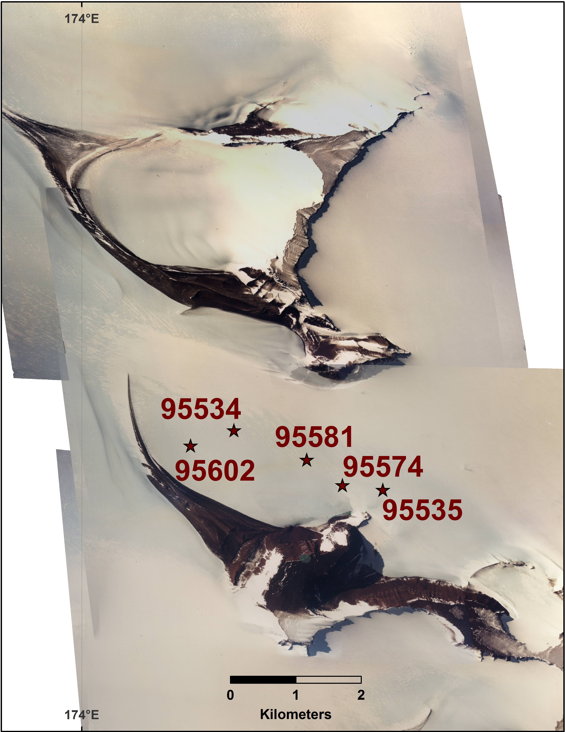
Figure A1. GRO 95 howardite find locations in the Grosvenor Mountains, Antarctica. Map created by John Schutt using USGS air photographs. The eucrite GRO 95533 was found ~8 km away (not within the area of this map) from the GRO 95 howardites.
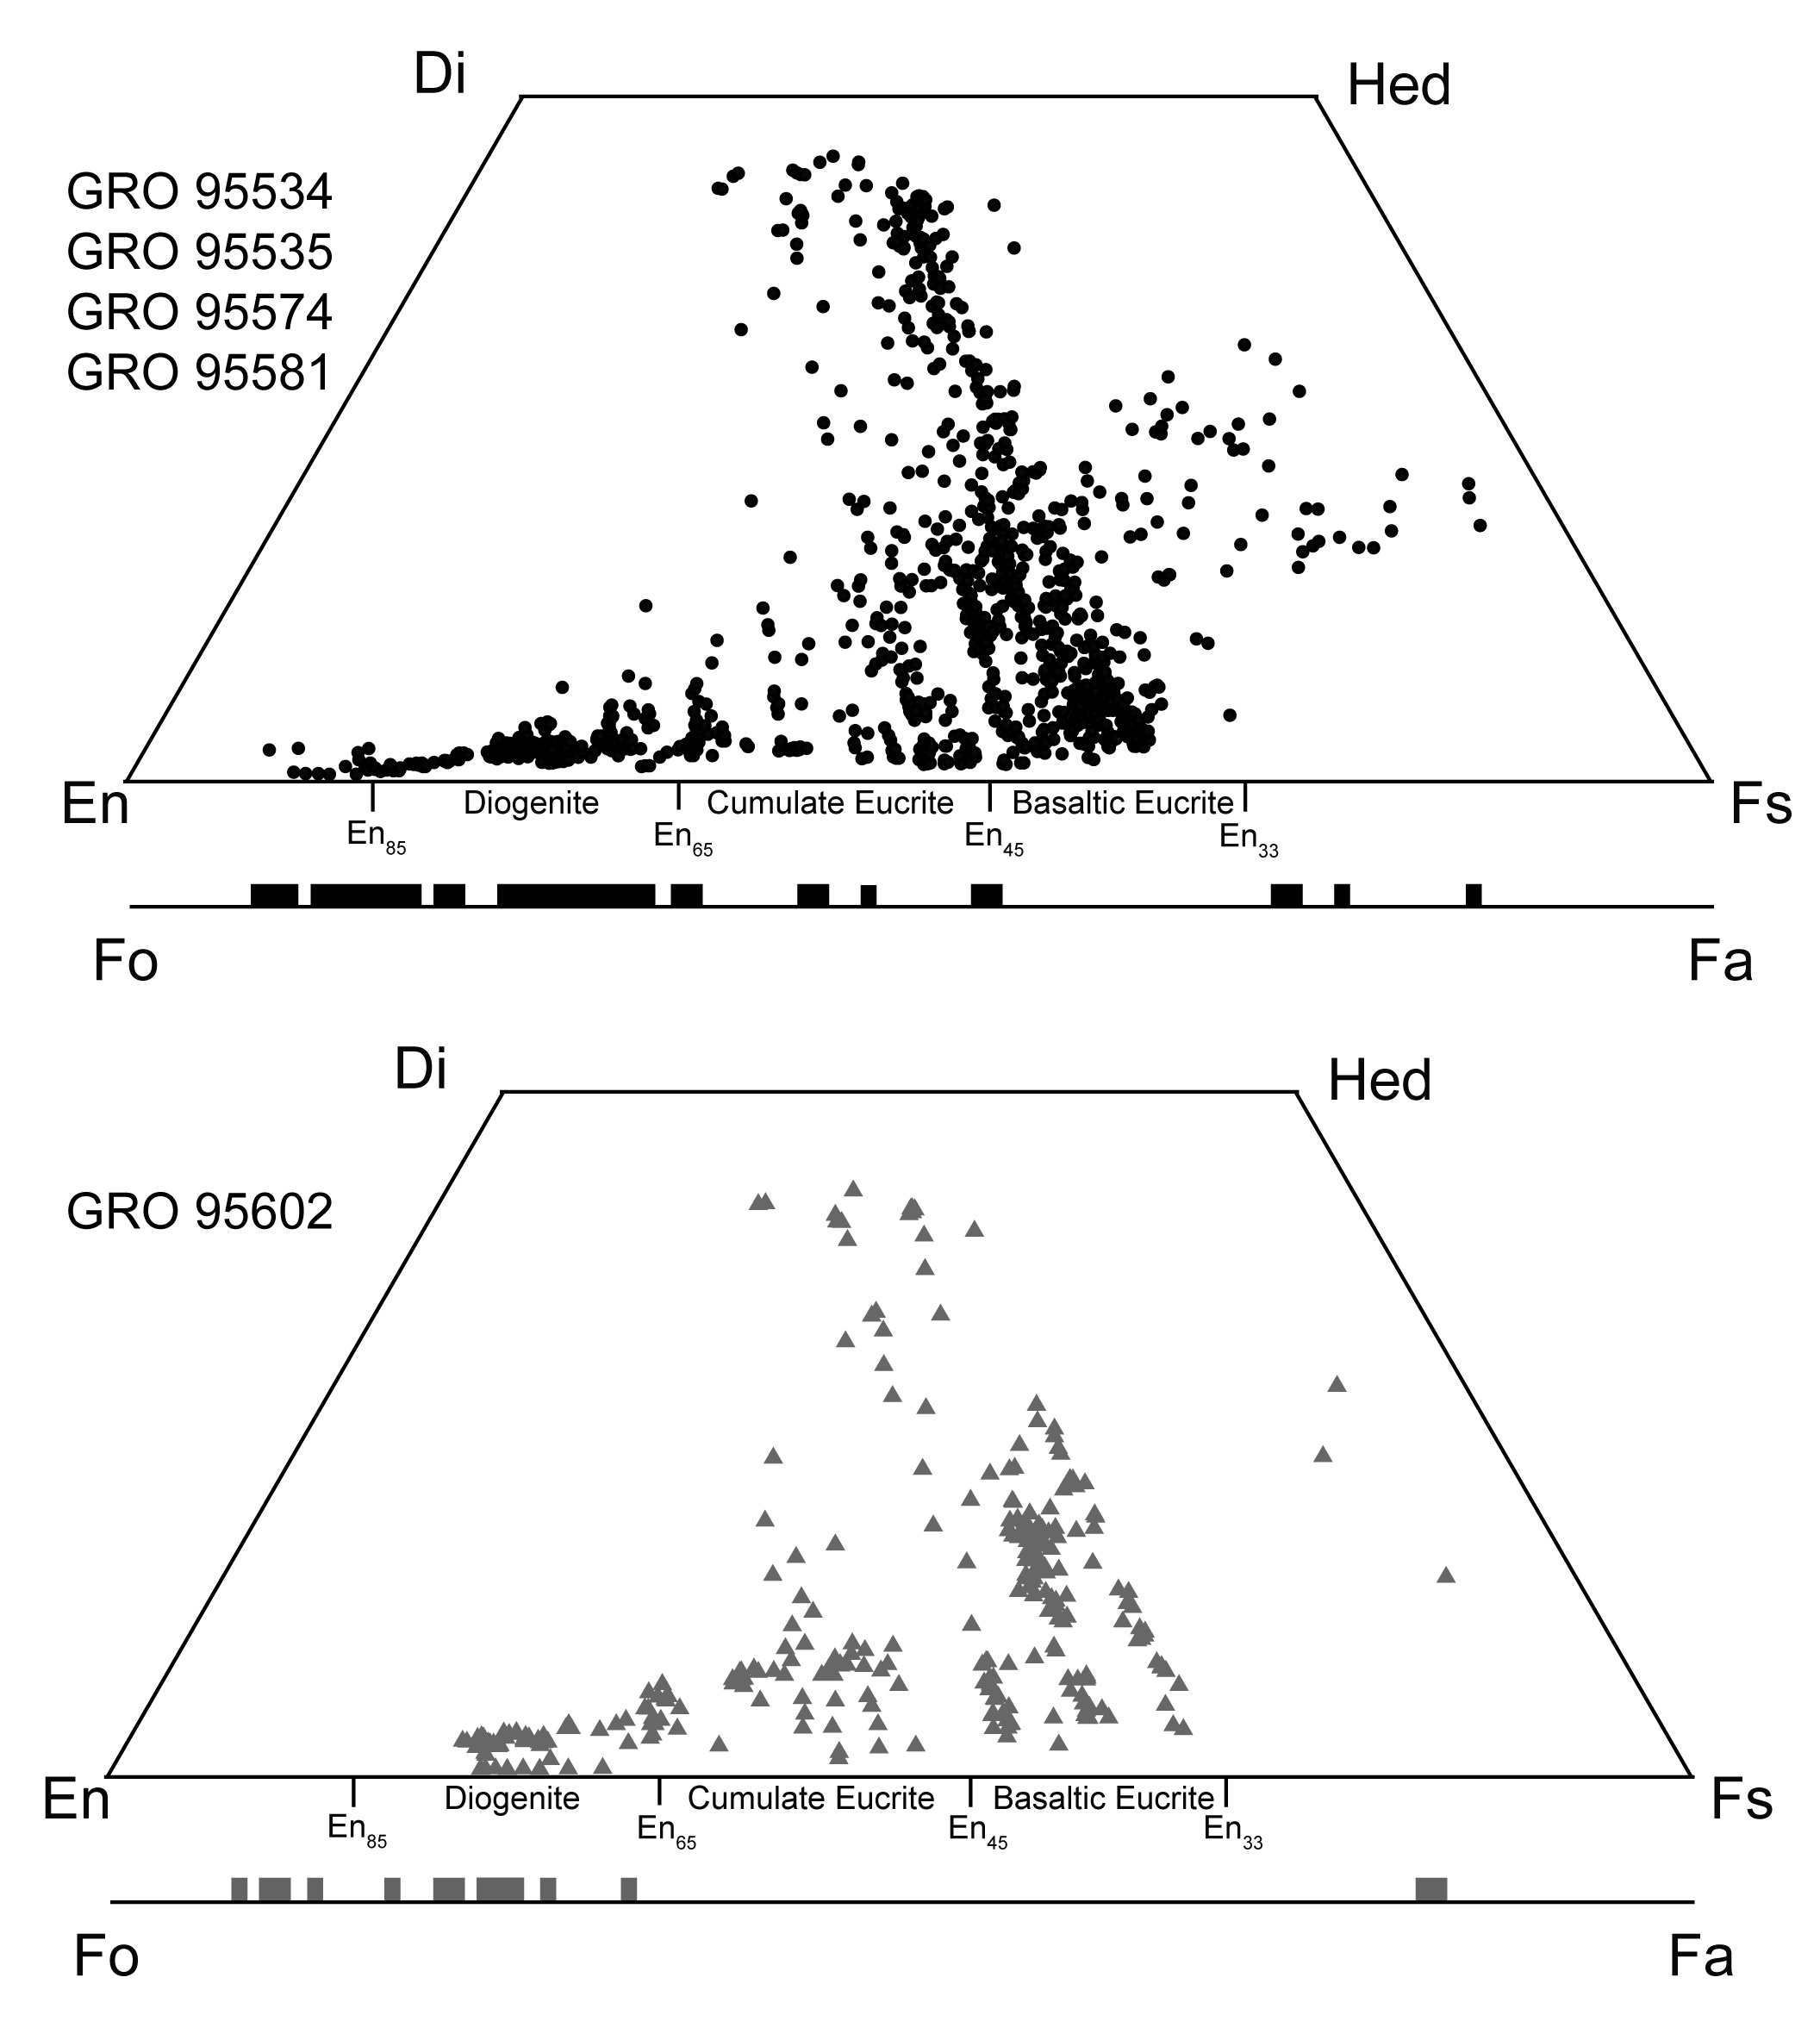
Figure A2. Pyroxene and olivine compositions from paired GRO 95 howardites and GRO 95602. Data for paired GRO 95 howardites (upper diagram) and for GRO 95602 (lower diagram) are similar, but the paired GRO 95 data extend to more extreme values.

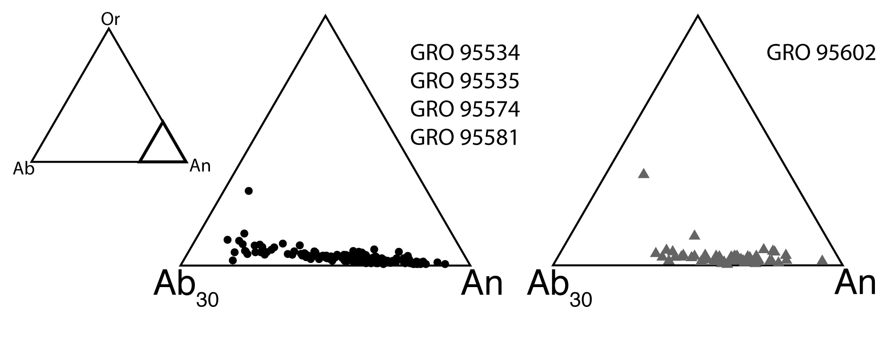
Figure A3. Plagioclase compositions for the paired GRO 95 howardites and for GRO 95602.

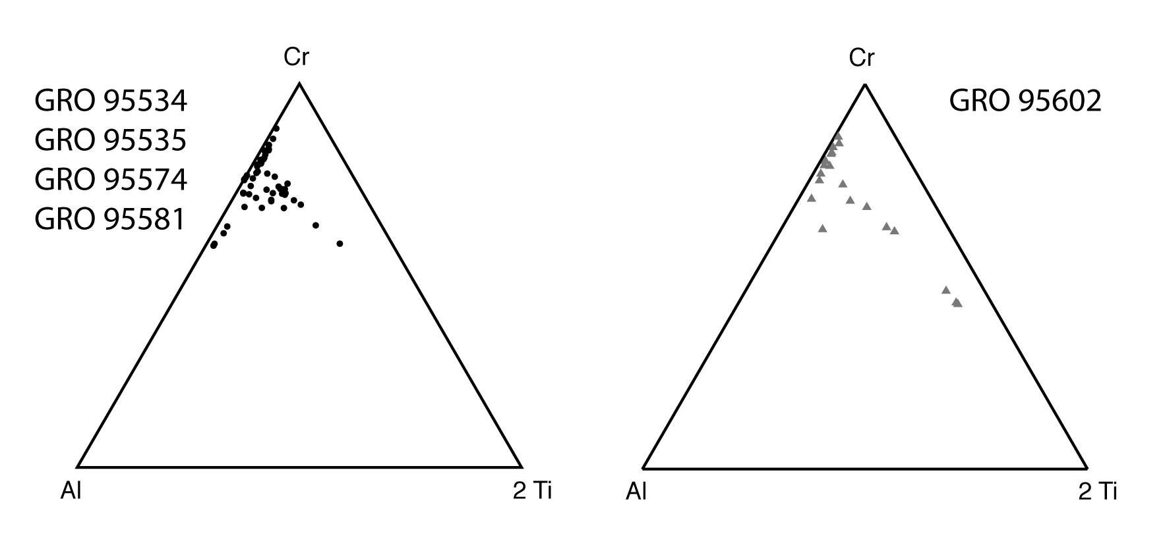
Figure A4. Chromite compositions for the paired GRO 95 howardites and for GRO 95602.

Figure A5. Quantitative lithologic distribution maps of GRO 95 howardites. The GRO 95602 thin section maps (scale bar above) have somewhat different scale than the GRO 95535 (scale bar lower right). These maps are not color-combination x-ray maps. These maps were constructed using remote sensing techniques on 10 separate element x-ray maps combined with point analyses, described in detail in at the beginning of Appendix A.

Figure A6. Quantitative lithologic distribution maps of GRO 95 howardites continued from Figure A5. All thin sections in this figure have the same scale (middle right). These maps are not color-combination x-ray maps. These maps were constructed using remote sensing techniques on 10 separate element x-ray maps combined with point analyses, described in detail in the beginning of Appendix A.

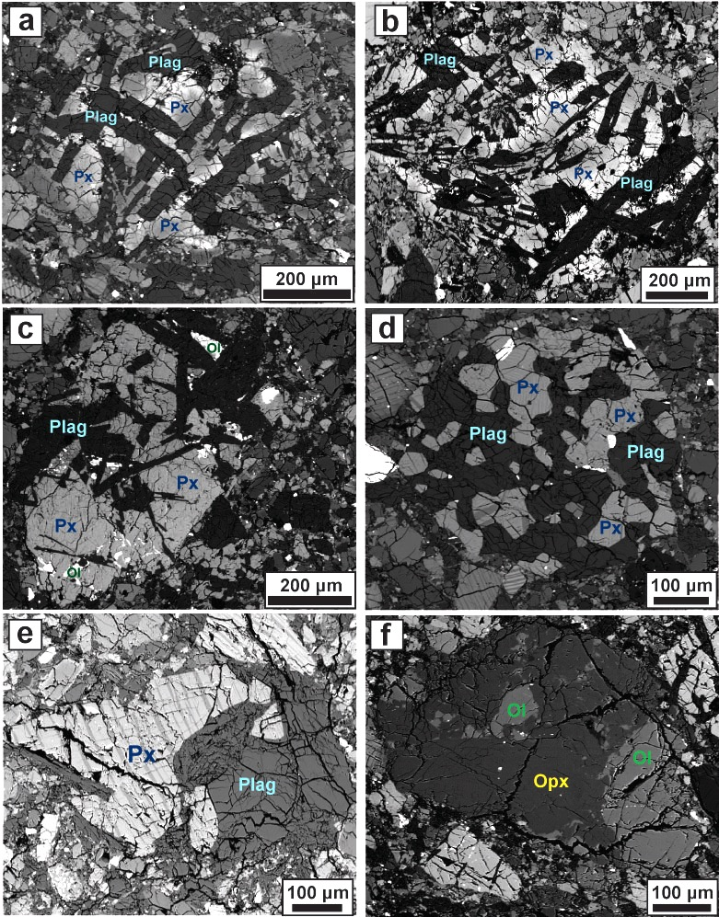
Figure A7. Backscattered electron (BSE) images of polymineralic clasts. (a) Subophitic clast with unequilibrated pyroxene in GRO 95535,16, (b) Subophitic clast with unequilibrated pyroxene in GRO 95581,7, (c) Subophitic clast with finely exsolved pyroxene in GRO 95602,13, (d) Granoblastic basaltic eucrite clast in GRO 95535,16, (e) Granoblastic cumulate eucrite clast in GRO 95574,17, (f) Olivine-orthopyroxene diogenite clast in GRO 95574,17.

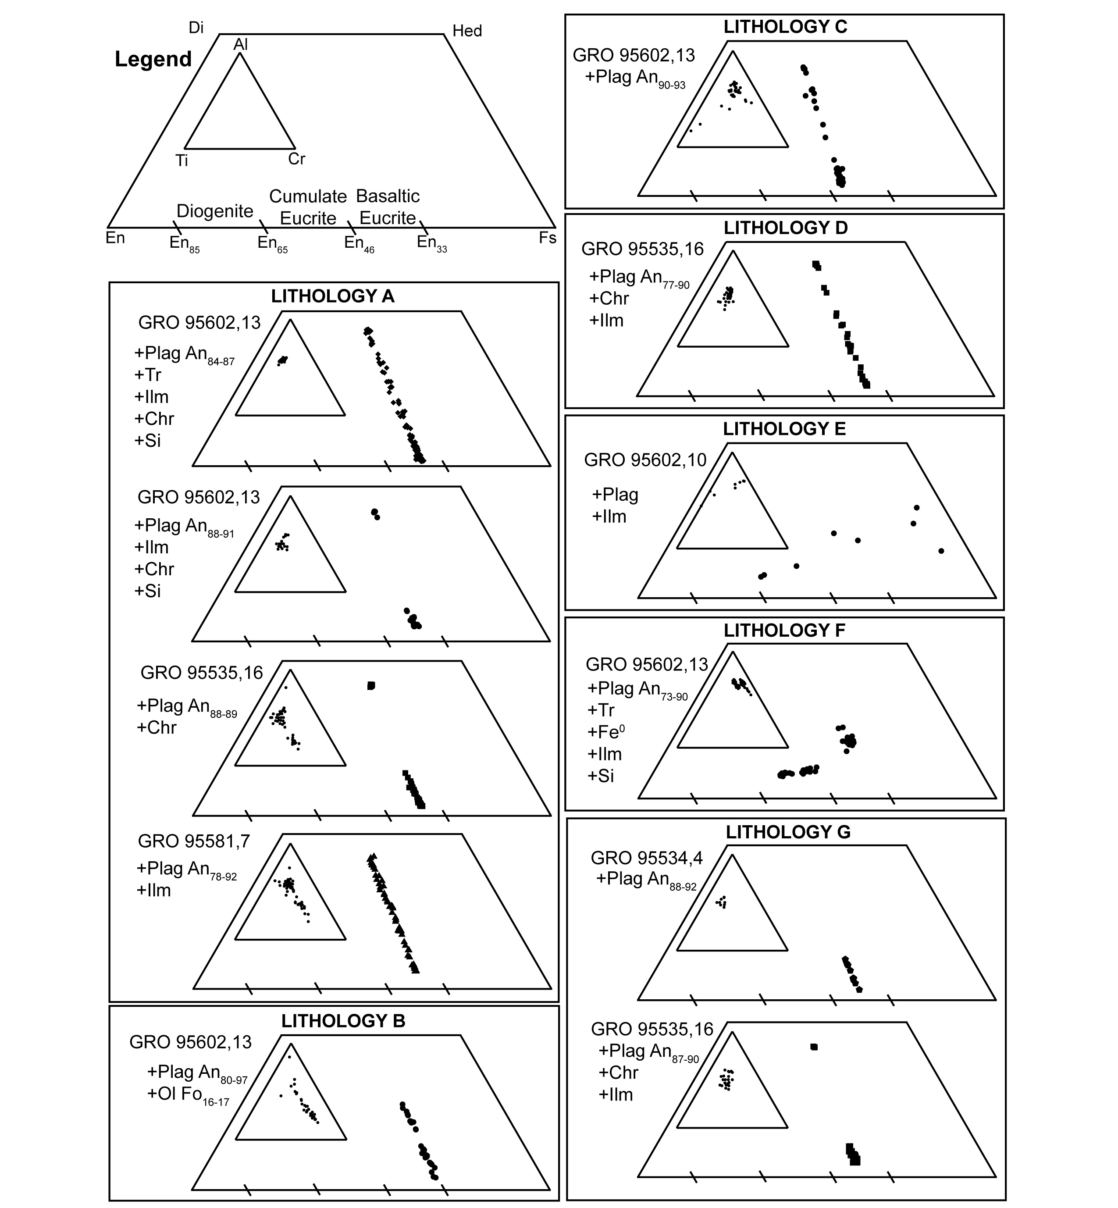
Figure A8. Major and minor element pyroxene compositions of eucritic lithic clasts. Legend at upper right, minor element chemistry plotted on inset ternary diagrams. Boxes enclose lithic clasts with overlapping pyroxene tie lines. Plus signs denote additional minerals identified in each clast using the following abbreviations: plagioclase (Plag), troilite (Tr), silica (Si), ilmenite (Ilm), Fe-rich metal (Fe⁰), olivine (Ol), and chromite (Chr). Additional data on these lithologies is located in Table A3.

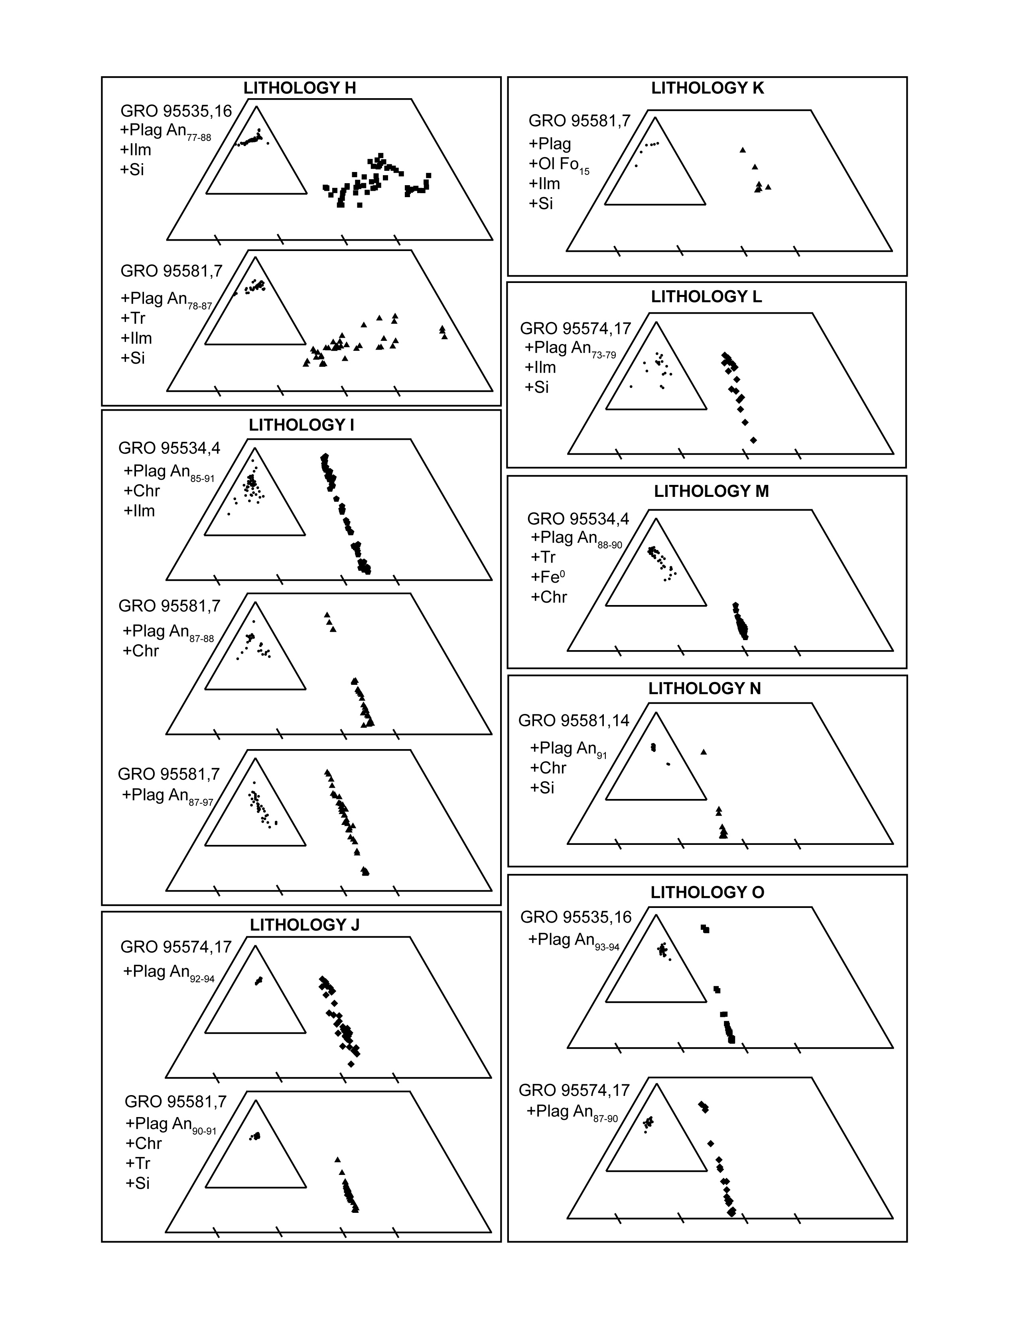Figure A9. Pyroxene compositions of eucritic lithic clasts continued from Fig. 8. Legend at upper right of Figure 8, minor element chemistry plotted on inset ternary diagrams. Plus signs denote additional minerals identified in each clast using the following abbreviations: plagioclase (Plag), troilite (Tr), silica (Si), ilmenite (Ilm), Fe-rich metal (Fe⁰), olivine (Ol), and chromite (Chr). Additional data on these lithologies is located in Table A3.

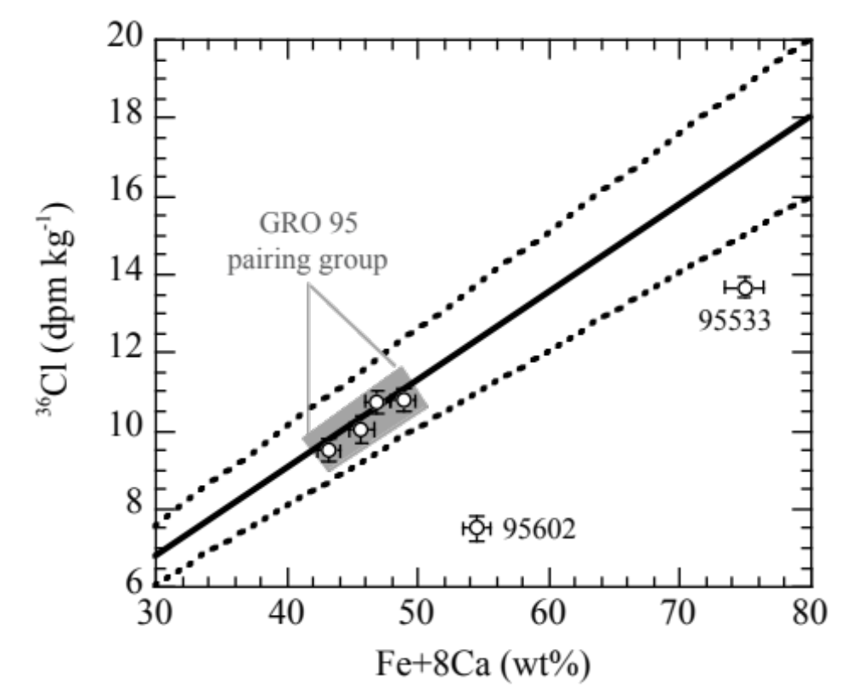
Figure A10. Measured ³⁶Cl concentrations in bulk samples of GRO howardites and a eucrite, plotted as a function of the chemical composition, in which Fe + 8Ca represents the relative production from the two main target elements. The four data points in the grey box represent the paired howardites GRO 95534, 95535, 95574 and 95581. The solid line represents the average ³⁶Cl production rates of 22.5 dpm/kg[Fe+8Ca]; the dashed lines represent the 10% uncertainty limits.

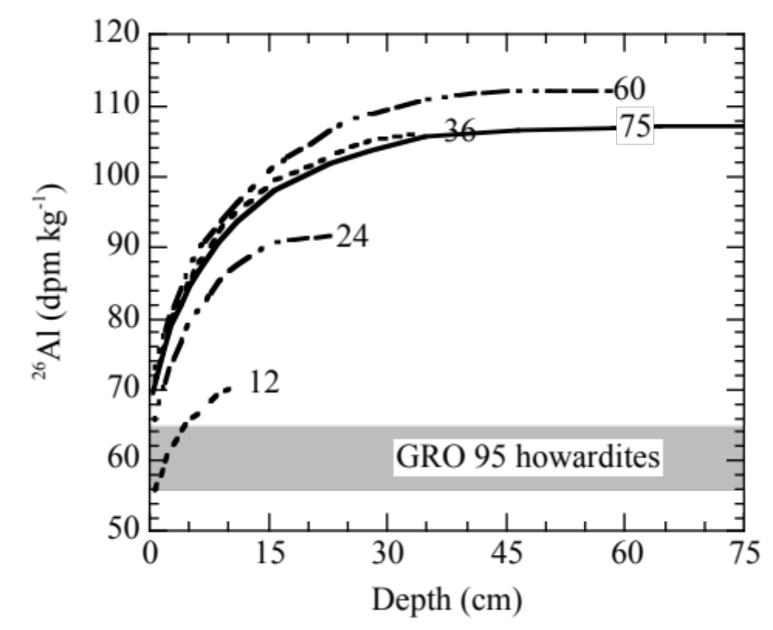
Figure A11. Comparison of measured ²⁶Al concentrations in bulk samples of the paired GRO 95 howardites with calculated depth profiles in howardites with pre-atmospheric radii of 12-75 cm, as derived from model calculations. For the ²⁶Al production rate calculations we adopted elemental production rates for ordinary chondrites (Leya and Masarik 2009). We assumed the average composition (8.3% Mg, 3.9% Al, 23.6% Si, 4.1% Ca and 12.7% Fe) of the four GRO 95 howardites, even though small variations in the composition of individual samples may change the production rate by 2-3%. The radius and depth scale was adjusted from chondritic values based on an average density of ~3 g/cm² for howardites.

CHAPTER II
olivine and pyroxene from the mantle of asteroid 4 vesta

This chapter is a reformatted version of a paper of the same name published in Earth and Planetary Science Letters. Nicole G. Lunning, Harry Y. McSween, Travis J. Tenner, Noriko T. Kita, and Robert J. Bodnar are authors of this paper. Nicole performed all the analyses. SIMS analyses were collected in close collaboration with Travis.

Lunning N. G., McSween H. Y., Tenner T. J., Kita, N. T., Bodnar R. J. 2015. Olivine and pyroxene from the mantle of asteroid 4 Vesta. Earth and Planetary Science Letters 418: 126-135. doi: 10.1016/j.epsl.2015.02043

Abstract

A number of meteorites contain evidence that rocky bodies formed and differentiated early in our solar system’s history, and similar bodies likely contributed material to form the planets. These differentiated rocky bodies are expected to have mantles dominated by Mg-rich olivine, but direct evidence for such mantles beyond our own planet has been elusive. Here, we identify olivine fragments (Mg# = 80-92) in howardite meteorites. These Mg-rich olivine fragments do not correspond to an established lithology in the howardite-eucrite-diogenite (HED) meteorites, which are thought to be from the asteroid 4 Vesta; their occurrence in howardite breccias, combined with diagnostic oxygen three-isotope signatures and minor element chemistry, indicates they are vestan. The major element chemistry of these Mg-rich olivines suggests that they formed as mantle residues, in crustal layered intrusions, or in Mg-rich basalts. The trace element chemistry of these Mg-rich olivines supports an origin as mantle samples, but other formation scenarios could be possible. Interpreted as mantle samples, the range of Mg-rich olivine compositions indicates that Vesta’s structure differs from that predicted by conventional models: Vesta has a chemically heterogeneous mantle that feeds serial magmatism. The range of olivine major element chemistries is consistent with models of an incompletely melted mantle such as in the model proposed by Wilson and Keil (2013) rather than a whole-mantle magma ocean for Vesta. Trace element chemistries of Mg-rich pyroxenes (Mg# = 85-92) provide support that some of these pyroxenes may represent initial fractional crystallization of mantle partial melts.

Introduction

Meteorites can sample separate portions of differentiated asteroidal bodies; for instance, iron meteorites represent cores and basaltic achondrites correspond to crusts. While meteorite collections include samples that originate from up to 150 chemically distinct parent bodies (Burbine et al. 2002), those representing the ultramafic mantles of differentiated asteroids are rare. Most mantle samples should be characterized by Mg-rich olivine, based on redox conditions inferred from crustal meteorite assemblages, and assuming a chondritic bulk composition. The only meteorite examples are pallasites, which may be derived from mantle-core boundaries, and are not tied to any known crustal meteorite groups (Burbine et al. 2002). Mantle lithologies are also rare as collisional fragments in the asteroid belt (Sunshine et al. 2007). The rarity of mantle material, combined with the relative abundance of differentiated samples represented by crustal and core material, has confounded researchers.
One plausible location to search for samples containing mantle material is asteroid 4 Vesta, where the impact that created the Rheasilvia basin excavated to mantle depths of 60-100 km (McSween et al. 2013a; Jutzi et al. 2013). However, olivine has not been detected in this basin, possibly because modest amounts of coarse-grained olivine (≤30 %) are easily masked by orthopyroxene in visible/near-infrared spectra (Beck et al. 2013a). Although olivine-rich areas have been identified elsewhere on Vesta, the related olivine chemistry has not been determined and the related geologic context is not consistent with mantle material (Ammannito et al. 2013). The most abundant samples sourced from a differentiated body are the howardite, eucrite, and diogenite (HED) meteorites. HEDs are interpreted to represent samples of the crust of Vesta and possibly its upper mantle, based on numerous observations (McSween et al. 2013b); furthermore, the orbital distribution of Vesta-like asteroids in the asteroid belt is consistent with their ejection from Vesta during the impact that produced the Rheasilvia basin. Relatively small Vesta-like asteroids routinely cross Earth’s orbital path and become meteorites. The vestan meteorites include a wide range of igneous lithologies, including eucrites (basalts and gabbros), and diogenites (orthopyroxenites, harzburgites). The howardites are brecciated samples of Vesta’s regolith and megaregolith (e.g., Cartwright et al. 2014). Howardites incorporate fragments of eucrites, diogenites, impact-derived materials, exogenic chondritic components, and rare lithologies of undetermined provenance (e.g., Barrat et al. 2012). In this study, we investigate the provenance and petrogenesis of a howardite component of unknown origin: olivine and pyroxene fragments that are more Mg-rich than similar phases occurring in eucrite or diogenite meteorites.

Samples and Analytical Procedures

Meteorite samples
The 4 howardites in this study were all found within a ~4 km area in the Grosvenor Mountains fields area (GRO) in Antarctica. These howardites—GRO 95534, GRO 95535, GRO 95574, GRO 95581—were proposed as a pairing group in their initial descriptions. Their pairing is also supported by similarities in their bulk geochemistry. Based on solar wind concentrations, these paired howardites formed from regolith that was exposed on an asteroid’s surface, rather than from buried megaregolithic material (Cartwright et al. 2014).
The following howardite thin sections were analyzed in this study: GRO 95534,4; GRO 95535,16; GRO 95574,17; and GRO 95581,7. They all contain Mg-rich olivine of unknown provenance, as well as less magnesian olivine grains having compositions typically associated with diogenites (Beck and McSween 2010). To evaluate the consistency of our methods with previous oxygen isotope analyses on HED meteorites using laser fluorination analytical methods, we also analyzed diogenite-composition olivine in the howardites and two diogenites: GRA 98108,16 and LEW 88008,14, which respectively represent meteorites found in the Graves Nunataks (GRA) and Lewis Cliff (LEW) sites in Antarctica.

Major element and quantitative modal analyses
Electron microprobe analyses (EMPA) were performed with a Cameca SX-100 EMP at the University of Tennessee using wavelength-dispersive spectrometry (WDS). The mineral spot analyses were conducted with a 1 µm beam at the following conditions: 15 kV and 30 nA for olivine, and 20 kV and 100 nA for pyroxene. Analyses used PAP corrections. Natural and synthetic standards were analyzed daily, and ≥99% consistency with standards was maintained. The 3σ detection limits for 20 kV and 100 nA EMPA on olivine (Table B1) are as follows or lower (in ppm): Si 136, Mn 80, Fe 123, Mg 179, Al 122, Ca 120, Ti 77, Ni 44, Cr 111. The 3σ detection limits for 15 kV and 30 nA EMPA on pyroxene (Table B2) are as follows or lower (in ppm): Si 202, Na 243, Mn 249, Fe 349, Cr 249, Al 154, Ca 213, Ti 212, Mg 211, K 242. We calculated Mg# = Mg/(Mg+Fe) values from our molar EMPA data.
The 4 howardite thin sections were mapped with WDS for 8 elements: Mg, Si, Fe, Al, Ca, Cr, K (K-lines) and Ni (L-line). EDS (energy-dispersive spectrometry) x-ray maps were collected simultaneously for S and Ti. Using methods similar to those of Beck et al. (2012), we constructed lithologic distribution maps with ENVI 4.2 software to locate olivine and pyroxene grains with Mg-rich compositions. The 10 x-ray maps were assembled into a multispectral image cube for each thin section. Regions of interest (ROIs) were defined based mineral spot analyses for specific minerals or ranges of mineral chemistries. These ROIs and minimum distance classification were used to map the distribution of each phase (defined by ROIs) in these howardites, including those relevant to this study: Mg-rich olivine, diogenite olivine, and Mg-rich orthopyroxene. Grains of interest identified by our lithologic distribution mapping were analyzed by EMP prior to oxygen isotope and/or trace element analysis.

Oxygen isotope analyses
In situ oxygen three-isotope analyses were conducted on a Cameca IMS 1280, a large-radius double-focusing secondary ion mass-spectrometer at the WiscSIMS Laboratory, University of Wisconsin, Madison. Analytical conditions and data reduction are similar to those of Kita et al. (2010) and Tenner et al. (2013). The primary Cs⁺ beam was focused to a 15 µm diameter spot with an intensity of 3 nA. The oxygen isotope data are reported relative to the standard Vienna Mean Ocean Water (VSMOW) using delta notation: δ¹⁷O = [(¹⁷O/¹⁶O)sample/( ¹⁷O/¹⁶O)VSMOW –1]× 1000; δ¹⁸O = [(¹⁸O/¹⁶O)sample/( ¹⁸O/¹⁶O)VSMOW –1]×1000; and Δ¹⁷O is defined as δ¹⁷O–0.52× δ¹⁸O, representing the displacement from the terrestrial fractionation line (TFL).
Matrix effects were evaluated from olivine standards (Fo₆₀, Fo₈₉, and Fo₁₀₀) and instrumental biases of unknowns were corrected as a function of their Fo contents as determined by EMPA. Four bracket analyses on the San Carlos olivine (Fo₈₉) standard were completed before and after sets of 12 unknown analyses. Typical reproducibility (spot-to-spot or 2σ standard deviation; 2SD) of San Carlos olivine standard was ~0.3 ‰ for δ¹⁸O, δ¹⁷O, and Δ¹⁷O. A total of 81 unknown spot analyses were collected on 30 separate olivine grains in the howardite and diogenite thin sections; 14 of the grains were diogenite composition olivine (Mg# = 61-79) and 16 were Mg-rich olivine (Mg# = 80-92). Between 1 and 6 spots were measured per olivine grain. Available flat fracture-free areas large enough to accommodate the 15 μm spot analysis dictated the number of spots per grain. The oxygen three-isotope contents of diogenite composition olivine fragments in the GRO 95 howardites were measured along with the Mg-rich olivine fragments. Most oxygen isotope analyses of HED meteorites have been on bulk rock samples and, to our knowledge, no in situ SIMS analyses of oxygen isotopes in HED minerals have been published. Thus, we analyzed diogenite olivine to independently determine the oxygen three-isotopic composition of slowly cooled HED (vestan) olivine. The average Δ¹⁷O compositions were calculated for Mg-rich olivine (n = 47) and diogenite olivine (n = 34), respectively. The 2σ standard errors of the means of both unknowns and San Carlos olivine standard (n = 40) were propagated into the final uncertainties of the average Δ¹⁷O compositions.

Trace element analyses
In situ trace element analyses were conducted at Virginia Tech using an Agilent 7500ce inductively coupled plasma mass spectrometer (ICP-MS) combined with an Excimer 193 nm ArF GeoLasPro Laser Ablation (LA) system. Laser spot sizes of 16-60 μm were used to analyze single-phase olivine or pyroxene. We analyzed 13 Mg-rich olivine grains and 4 Mg-rich pyroxene grains in the GRO 95 howardites. Between 1 and 5 spots were measured per mineral grain. Available flat fracture-free areas dictated the size and number of spots on each grain. The external standard used was NIST SRM610 reference glass. Every 2 hrs, we measured the NIST standard twice for 60 s to correct for drift. For each of the analyses, approximately 60 s of background signal was collected before the ablation process was initiated. Sample ablation times ranged from 30–50 s using a laser repetition rate of 5 Hz. The samples were ablated in a helium atmosphere. The helium gas carrying the ablated particles was then mixed with the make-up gas (argon) before entering the ICP-MS system. The 3σ analytical precision for the LA-ICP-MS system for the elements analyzed in this study (compared to NIST612) is better than ±5% relative (for V, Co, Cr, Ce, Zn, Ga); between ±5 and 10% (for Ni, Rb, Nb, Sr, Ba, Pr, Eu, Hf, Pb); between ±10 and 20% (for Y, Zr, La, Nd, Sm, Gd, Dy, Er, Yb, Ta, Lu, Th, Tb, Ho, U), and poorer than ±20% (Sc). Analytical precision was determined previously using the NIST standard 610 as the reference, and then USGS standards BCR-2G, BHVO-2G, BIR-1G, NKT-1G and NIST standards NIST612 and NIST614) were analyzed according to established analytical protocols. USGS standards BCR-2G, BHVO-2G and BIR-1G were prepared from natural basalt glasses, and NKT-1G was prepared from a natural nephelinite glass. Details of the analytical results related to these analyses are available at: http://www.geochem.geos.vt.edu/fluids/laicpms/VT_LAICPMS_Accuracy_Precision.pdf.
The LA-ICP-MS detection limits are dependent on several factors, such as the element (isotope) being measured, spot size, and duration of the analysis. Therefore, each analysis and element has a different detection limit. For all of the trace elements listed above, the detection limits obtained during our calibration runs were always less than 1 ppm. Data reduction for all analyses was conducted with both the Analysis Management System (AMS) software (Mutchler et al. 2008) and the SILLS software program (Guillong et al. 2008), both enabling time-resolved signal analysis. We reduced the data with the SILLS software program to calculate the 1σ error and limit of detection. Concentrations calculated by each of these programs were consistent.
Time-resolved signal analysis provides easy recognition of sample heterogeneities during the ablation process, such as when traversing from one phase into a different phase during ablation, or if a solid inclusion is included in the ablated material. These software packages allow the user to select a portion of the ablation signal to process and eliminate signal from multiple phases in order to obtain the composition of only the phase of interest.

Results

Description of Mg-rich olivine and pyroxene
The Mg-rich olivine and Mg-rich pyroxene in this study are all fragmental grains. They are surrounded by diverse range of other fragmental grains or clasts, and the Mg-rich olivines and pyroxenes exhibit no compositional or textural evidence of chemical equilibration with the surrounding material. The fragmental material in these howardites is predominately from HED lithologies, although, exogenic carbonaceous chondrite clasts do occur. There is no apparent spatial correlation between the Mg-rich olivines and/or Mg-rich pyroxenes, which appear to be randomly distributed in the thin sections. The Mg-rich olivine and pyroxene grains are accessory components within the GRO 95 howardites.
The Mg-rich olivines and pyroxenes are irregularly-shaped mineral fragments. The largest Mg-rich olivine grain we found is close to 1 mm in its longest dimension (Figure B1a); the rest of the Mg-rich olivines are between 50-200 μm in their longest dimension. Most of the Mg-rich pyroxene grains also are between 50-200 μm in their longest dimension, but two are larger: a grain in GRO 95574,17 (MgPx1) is close to 400 μm in its longest dimension (Figure B1b) and a grain in GRO 95535,16 (MgPx2) is about 700 μm in its longest dimension.
Both the Mg-rich olivine and pyroxene commonly display undulatory extinction and are crosscut by fractures (Figure B1). In some of the larger grains planar fracturing is evident, but most grains are too small for a pervasive fracture pattern to be observed. A few grains contain small opaque inclusions, but most are inclusion-free. The olivine and pyroxene grains do not appear to be altered or corroded under plane polarized light microscopy. We looked for but did not find any terrestrial weathering byproducts such as calcite or gypsum in our thin sections.

Major element analyses
Each grain we studied is compositionally homogeneous based on multiple EMPA when size and fracturing permitted, and by observations using backscattered electron microscopy. The Mg-rich olivine fragments have Mg# = 80-92 and Fe/Mn = 37-45. Mg-rich pyroxenes have Mg# = 85-92 and Fe/Mn = 23-40 (Figure B2, Tables B1 and B2).

Oxygen isotope analyses of olivine
The weighted average of the oxygen three-isotope analyses of Mg-rich olivine grains (n=16) is δ¹⁸O = 3.49±0.32 ‰ and δ¹⁷O = 1.50±0.17 ‰. The unweighted average of all Mg-rich olivine oxygen isotope spot analyses (n=47) is Δ¹⁷O = -0.295±0.080 ‰. The weighted average of all diogenite olivine grains (n=14) analyzed is δ¹⁸O = 3.25±0.33 ‰ and δ¹⁷O = 1.41±0.31 ‰. The unweighted average of all diogenite olivine spot analyses (n=34) is Δ¹⁷O = -0.259±0.077 ‰.
These diogenite analyses, which were conducted for the purpose of methods testing, demonstrate that in situ SIMS analyses of diogenite olivine yield results (Figures B4 and B5, Tables B3 and B4) consistent with HED whole-rock analyses collected using laser fluorination methods (e.g., Greenwood et al. 2012; Day et al. 2012).

Trace element analyses
The Mg-rich olivines contain 6-52 ppm Ni and 5-26 ppm Co (Table B5). For the relatively incompatible trace elements we analyzed, the Mg-rich olivines are depleted relative to CI chondrites. For instance, in the Mg-rich olivine the Y concentration range is 0.03-0.37 ppm (Table B6) and the CI-normalized Y range is 0.02-0.24. REE in the Mg-rich olivine are depleted relative to CI chondrites and frequently do not have concentrations above analytical detection limits (Table B6), which are all below CI chondrite REE concentrations.
Two of the Mg-rich pyroxene grains analyzed (Mg# = 91.9 and 90.1) have Sr and LREE concentrations that are depleted relative to their HREE concentrations: CI-normalized La/Tm ratios = 0.02-0.04. The Mg# 91.9 and Mg# 90.1 pyroxenes have CI-chondrite normalized Eu/[(Sm+Gd)/2] = Eu/Eu* ratios of 0.1 and 0.2, respectively; these negative Eu anomalies exceed the 1σ errors on Sm, Eu, and Gd. CI-normalized La, Ce, and Pr concentrations of these 2 pyroxenes (Mg# = 91.9 and 90.1) are within 1σ errors of each other, and therefore do not have detectable Ce anomalies: Ce/[(La+Pr)/2] = Ce/Ce* (Figure B6; Tables B7 and B8). The REE patterns of these 2 Mg-rich pyroxenes (Mg# = 91.9 and 90.1) are reliable sources of petrologic processes because they do not have Ce anomalies (Floss and Crozaz 1991), and they exhibit patterns of HREE enrichment relative to LREE that are typical of pyroxene.
In the other two Mg-rich pyroxenes (Mg# = 88.8 and 85.0) analyzed, the pattern of LREE depletion relative to HREE is not evident or is less pronounced (CI-normalized La/Tm ratios ≥ 0.09). These particular pyroxenes appear to have negative Ce anomalies: Mg# = 85.0 pyroxene has a Ce/Ce* = 0.26 and Mg# = 88.8 pyroxene has Ce/Ce* = 0.14; however, the latter anomaly represents the maximum possible anomaly because the La concentration is below 1σ detection limit so we used the La 1σ detection limit to calculate this Ce anomaly (Figure B6; Tables B7 and B8). We chose not to use data from these particular pyroxenes (Mg# = 88.8 and 85.0) to interpret petrologic processes, as they have Ce anomalies consistent with Antarctic weathering (which is not necessarily apparent in major element chemistry but mobilizes REE; Floss and Crozaz 1991). The fact that they do not have the typical pyroxene HREE enrichment relative to LREE is further evidence that their REE may have been mobilized by terrestrial weathering.

Discussion

The Mg-rich olivine fragments are not restricted to the howardites we studied: olivine fragments with Mg#s = 80-92 have been noted in at least 9 other howardites (Delaney et al. 1980; Beck et al. 2012; Desnoyers 1982, Fuhrman and Papike 1981; Ikeda and Takeda 1985; Shearer et al. 2010). Thus, the Mg-rich olivine is likely from a lithology broadly mixed into the vestan regolith.

HED-Vesta parent body provenance
To rigorously establish their vestan provenance, the Mg-rich olivines must be distinguished from olivines found in exogenic chondritic clasts within howardites. The most common exogenic components in howardites are clasts of CM and CR chondrites, and olivine grains in CM and CR chondrites are predominately very Mg-rich with Mg# = 97-100 (e.g., Tenner et al. 2015, Gounelle et al. 2003). A few percent of CM chondrite-like material has been inferred in Vesta’s regolith via remote sensing of spatially correlated H- and OH-bearing dark materials by the DAWN spacecraft (e.g., De Sanctis et al. 2013; Prettyman et al. 2012).
To assess parent body origin, we used Fe/Mn ratios in olivine and pyroxene because they fall within specific ranges for differentiated parent bodies (Papike et al. 2003). The Mg-rich olivines in GRO 95 howardites have Fe/Mn = 37-45 (Figure B2, Table B1) and are consistent with vestan olivine Fe/Mn = 40-60 (Beck et al. 2012), within analytical uncertainty. The Mg-rich pyroxene fragments have Fe/Mn = 23-32 (Table B2) in agreement with the range of Fe/Mn reported for vestan pyroxene (Mittlefehldt et al. 1998), Fe/Mn = 23-40.
To further constrain the parent body provenance, we analyzed oxygen three-isotope compositions of olivine (Goodrich et al. 2010). The average GRO 95 Mg-rich olivine oxygen isotope composition does not overlap those of CR and CM chondrites (Figure B3). However, the average Mg-rich olivine oxygen isotope composition (Figure B3, Table B5) overlaps those of the brachinite, mesosiderite, and HED (vestan) meteorites (Greenwood et al. 2012; Day et al. 2012). The brachinite parent body can be eliminated as the source of Mg-rich olivine because brachinite olivines are more Fe-rich (Mg# = 65-71) and have higher Fe/Mn ratios (>59) (Gardner-Vandy et al. 2013). The mesosiderite parent body can also be eliminated as a source because the Mg-rich olivines analyzed in GRO 95 howardites have about an order of magnitude less Ni (6-52 ppm Ni), when compared to most mesosiderite olivines (88-980 ppm Ni; Kong et al. 2008; Powell 1971). Therefore, the oxygen isotope and elemental chemistry of the Mg-rich olivine fragments are consistent with a vestan origin, and are not consistent with other possible sources.
In addition to major element ratios and oxygen isotope ratios, siderophile elemental abundances in olivine can be used to examine parent body provenance. The concentrations of Ni and Co in GRO 95 Mg-rich olivines (6-52 ppm and 5-26 ppm, respectively; Table B5) overlap abundances estimated for the bulk vestan mantle (4-80 ppm and 7-40 ppm, respectively; Righter and Drake 1997). Since Ni and Co are compatible in olivine, the similarity between their concentrations in the Mg-rich olivine and the estimated bulk composition of an olivine-dominated vestan mantle (Mandler and Elkins-Tanton 2013; Ruzicka et al. 1997) is consistent with an interpretation that the Mg-rich olivine represent fragments of Vesta’s mantle.

Petrogenesis of Mg-rich olivine
The Mg#s of the GRO 95 Mg-rich olivine fragments resemble those expected for the mantles of differentiated rocky bodies, which formed from chondritic composition precursors (e.g., Ruzicka et al. 1997). Olivine with Mg#s overlapping these mantle compositions can sometimes form in Mg-rich basalts or crustal layered intrusions, such as those respectively in Mg-rich basaltic dikes through the Rum ultramafic complex (Kent 1995) and in the lunar Mg-rich suite (Shearer and Papike 2005). These alternative scenarios invoke processes that would produce lithologies that have not been recognized in HED meteorites nor predicted by petrologic models. Regarding Mg-rich basalts, olivine is rare and Fe-rich (e.g., Mg# = 18; Delaney et al. 1983) in basaltic eucrites. Basaltic eucrites are also MgO-poor compared to terrestrial basalts that contain non-xenolithic Mg-rich olivine. Mg-rich olivine-phyric basalts/picrites have bulk rock 14.2-18.7 wt. % MgO (e.g., Kent 1995); whereas, basaltic eucrites have bulk rock 5.5-9.2 wt. % MgO (Kitts and Lodders 1998). Mg-rich olivine phenocrysts in basalts typically exhibit major element zoning, which is not present in the GRO 95 Mg-rich olivines. It is important to note, that in addition to the lack of Mg-rich basaltic HED meteorites, generation of Mg-rich basaltic/picritic melts would require substantially more heterogeneous serial magmatism on Vesta than included in current models (i.e., Mandler and Elkins-Tanton 2013).
Regarding a scenario involving Mg-rich olivines forming as cumulate minerals, the lunar Mg-rich suite is an analogous fractionally-crystallized assemblage of dunites, harzburgites, pyroxenites, spinel troctolites, troctolites, norites, and gabbronorites (Shearer and Papike 2005). The Co concentrations of olivine in the lunar Mg-rich suite (37-160 ppm Co; Table B5) exceed those in the GRO 95 Mg-rich olivine (5-26 ppm Co: Table B5). The lunar Mg-rich suite ultramafic lithologies and spinel troctolites contain Mg-rich olivine (Mg# = 85-90 and Mg# = 90-93 respectively), but the olivines in these lithologies are more Ni-rich (108-291 and 92-107 ppm respectively) than the GRO 95 Mg-rich olivine (6-52 ppm Ni; Table B5). As we later discuss, vestan mantle minerals are expected to be relatively low in compatible siderophile elements such as Ni and Co because they are thought to be in equilibrium with core-forming FeNi metal liquids. The olivines in the lunar Mg-rich suite norites and gabbronorites are more Fe-rich (Mg# = 70-78 and Mg# = 66-77 respectively). However, the olivines in the lunar Mg-rich suite troctolites (Mg# = 80-90 and 28-113 ppm Ni) overlap the Mg- and Ni-content of the GRO 95 Mg-rich olivine. The whole rock chemistries of the lunar Mg-rich suite are enriched in incompatible elements (relative to chondrites), indicative of crustal contamination of their parental melts, but the olivine does not consistently record crustal contamination. For example, in the lunar Mg-rich suite lithologies with olivine Mg# > 80, the Y concentrations vary from 0.07-61 ppm (CI-normalized 0.04-39; Shearer and Papike 2005). For comparison, the GRO 95 Mg-rich olivines have 0.03-0.37 ppm Y (Table B7) and thus do not record crustal contamination.
Given the nature of our olivine samples as fragmental clasts without additional petrologic context, we cannot definitively eliminate the possibility that the GRO 95 Mg-rich olivine originated in crustal layered intrusion or a Mg-rich basalt. However, there is no additional evidence that the GRO 95 Mg-rich olivine formed in a crustal intrusion or basalt. Conversely, the relatively low concentrations of compatible siderophile elements (Ni and Co) provide additional supporting evidence that the Mg-rich GRO 95 olivine formed in the vestan mantle.
The Ni and Co concentrations (6-52 ppm Ni and 5-26 ppm Co) in the Mg-rich olivine are consistent with modeled estimates for the vestan mantle (Righter and Drake 1997) and with formation in an olivine-dominated lithology in chemical equilibrium with FeNi metal. Buseck and Goldstein (1969) cited the Ni concentrations in pallasite olivine (10s of ppm) as evidence that the olivines formed in the deep interior/mantle of their parent body. Although Ni is compatible in olivine, Ni more readily partitions into FeNi metal by factors of a 100-1,000 (e.g., Elhers et al. 1992). If the Mg-rich olivine originates from Vesta’s mantle, it is more likely to have been in equilibrium with metal, either as part of the lower mantle in contact with the core or with metallic liquid that descended through olivine residues to form the core during differentiation. In contrast to the Mg-rich olivine, the ranges of olivine Ni content extend to higher concentrations in diogenites (6.3-277 ppm; Shearer et al. 2010) and mesosiderites (88-980 ppm Ni; Kong et al. 2008; Powell 1971). The moderately higher Ni-concentrations in some diogenite and mesosiderite olivines are consistent with the hypothesized formation of these two lithologies in the upper mantle and/or lower crust away from FeNi metals (Shearer et al. 2010; Powell 1971). Diogenites occasionally contain accessory tetrataenite (ordered FeNi), but olivine is frequently the mineral phase into which Ni would have most readily partitioned. Further, a moderate abundance of Ni in diogenite parental melts may be explained by post-core formation accretion of chondritic material to Vesta (Day et al. 2012).

Mantle of Vesta: Magma ocean or partially melted?
Although other possible origins cannot be completely eliminated, a mantle origin for the GRO 95 Mg-rich olivine fragments is the only petrogenetic scenario supported by multiple lines of evidence: Ni content consistent with equilibrium with FeNi metal and Mg#s that span almost the entire range predicted by whole-mantle magma ocean models for Vesta.
To date, no single vestan mantle model can fully account for the characteristics of Mg-rich olivines and diogenites. For instance, equilibrium crystallization models invoking whole-mantle magma ocean crystallization (e.g., Mandler and Elkins-Tanton, 2013; Righter and Drake 1997) inherently predict narrower ranges in olivine Mg# than those measured here. Alternatively, the model of Ruzicka et al. (1997), which invokes fractional crystallization and crystal settling in a whole-mantle magma ocean, predicts olivines with Mg#s ranging from 80-93, similar to the range among GRO 95 Mg-rich olivine fragments (Mg# = 80-92). However, this fractional crystallization model cannot produce magmas that would lead to formation of the diogenites (McCoy et al. 2006).
As a result of the shortcomings of equilibrium and fractional crystallization whole-mantle magma ocean models, we hypothesize that the vestan mantle experienced incomplete melting, similar to that described by the models of Wilson and Keil (2013) and Neumann et al. (2014) in which differentiation occurs in the absence of a whole-mantle magma ocean. Such partial melting would produce olivine residues with a wide range of Mg-compositions, as observed among GRO 95 Mg-rich olivines. In addition, complementary partial melts could have fractionally crystallized Mg-rich pyroxene (and some olivine) with compositions that may have graded into the well-established range for the diogenites.
Regarding pyroxene, in whole-mantle magma ocean models (e.g., Righter and Drake 1997; Mandler and Elkins-Tanton, 2013; Ruzicka et al. 1997), the most Mg-rich pyroxenes have Mg#s ≤ 84. Such results do not match the GRO Mg-rich pyroxenes, which have Mg# = 85-92. Further, and regardless of whether equilibrium or fractional crystallization dominates, vestan whole-mantle magma ocean models consistently predict that large quantities of Mg-rich olivine will crystallize before progressively lower Mg-content pyroxene and olivine co-crystallize (Righter and Drake 1997; Mandler and Elkins-Tanton 2013; Ruzicka et al. 1997). When Mg-rich olivine and pyroxene do co-crystallize, Mg#s of pyroxene are typically greater than or equal to those of olivine (Beck et al. 2010 and references therein). Thus, based on their Mg#s, we hypothesize that the Mg-rich pyroxene (Mg# = 85-92) could have co-crystallized with at least some Mg-rich olivine. Lending support to this hypothesis is the observation that one of the Mg-rich pyroxene fragments (Mg# = 88.8) includes a small (~5 μm-wide) intergrown grain of Mg-rich olivine (Mg# = 86.9).
Two Mg-rich pyroxene grains, with Mg# 91.9 and Mg# 90.1, indicate that they co-crystallized with plagioclase or in the presence of Al-rich liquids. These two Mg-rich pyroxene grains have Eu and Sr depletions (Figure B6). Further, these Mg-rich pyroxenes have negative Eu anomalies (Eu/Eu* ratios of 0.1 and 0.2:9) that are comparable to those from diogenite pyroxenes that co-exist with plagioclase (Shearer et al. 2005; Beck et al. 2013b). As such, the co-crystallization of these particular GRO 95 pyroxenes with plagioclase or co-existent Al-rich liquids could explain their Sr and Eu depletions. For reference, plagioclase preferentially incorporates both Eu and Sr at an oxygen fugacity expected for vestan magmatic systems (~IW-2: Righter and Drake 1997). In addition, higher Al-contents of co-existing melt would increase negative Eu anomalies in pyroxene (Shearer et al. 2006). Alternatively, basaltic interstitial liquid among cumulate pyroxene could deplete orthopyroxene of Eu by subsolidus reactions, where depletions are positively correlated to the proportion of trapped melt (Barrat et al. 2004); such a process typically involves co-existing plagioclase, but can also include other phases that preferentially partition Eu, such as some phosphates (Shearer et al. 2005; Barrat et al. 2004). We note that pyroxene crystallizing without plagioclase does fractionate Eu slightly more than most other REE, but this partitioning is greater for high-Ca pyroxene (augite) than for the low-Ca Mg-rich pyroxene (orthopyroxene) we analyzed in this study.
If the initial fractional crystallization of mantle partial melts included plagioclase or trapped Al-rich liquid, as suggested by Eu and Sr anomalies in some GRO 95 pyroxenes, the vestan mantle would have incorporated ²⁶Al, thereby retaining some portion of the radiogenic heat source present in the early solar system (McCoy et al. 2006); this would have enabled the mantle to remain partially molten longer than it would have without this additional heat source. However, only very minor quantities of plagioclase or trapped Al-rich liquids in the mantle can be reconciled with (1) the relatively low bulk Al content calculated for Vesta’s silicate fraction from a chondritic precursor (Toplis et al. 2013), and (2) the concept that most Al would have been extracted from the mantle by ascending basaltic magmas (Righter and Drake 1997). For reference, a chondritic composition is the most appropriate estimate of Vesta’s precursor material, especially in light of the calculation of Vesta’s FeNi core mass fraction from geophysical data collected by the Dawn spacecraft (Russell et al. 2013), which falls within the range predicted by models using chondritic bulk compositions (Righter and Drake 1997).
The suggestion that pyroxene co-crystallized with plagioclase or Al-rich liquid, based on pyroxene Eu and Sr anomalies, is consistent with differentiation by incomplete melting, rather than whole-mantle magma ocean models. For smaller planetesimals (diameters ≤100 km), partial melting is the most likely mechanism that drove differentiation, and it has been proposed that even in Vesta-sized bodies (diameter ≈ 500 km) rapid magma ascent could preclude a fully molten mantle (Wilson and Keil 2013). Alternatively, Vesta could have produced a shallow magma ocean, leaving an olivine-rich solid residue in Vesta’s lower mantle (Neumann et al. 2014). Partial melting models, with or without a shallow magma ocean, are easy to reconcile with a broad range of Mg-rich olivine compositions, and are more consistent with Mg-rich pyroxene fractionally crystallizing out of mantle partial melts. Thus, when compared to whole-mantle magma ocean models, partial melting can more reasonably generate magmas that are sufficiently enriched in Al to crystallize Mg-rich pyroxene showing Eu and Sr depletions.

Conclusions

The Mg-rich olivine fragments found in the GRO 95 howardites do not correspond to any established HED lithology. They may be the first recognized mantle olivine from Vesta, the HED parent body. Other petrogenetic scenarios that might account for the Mg#s, such as formation in crustal layered intrusions or in Mg-rich basalts, cannot be unequivocally eliminated. However, the relatively low Ni and Co concentrations (6-52 ppm Ni and 5-26 ppm Co) lend additional support that the GRO 95 Mg-rich olivine formed as mantle residues.
The GRO 95 Mg-rich olivines are not exogenic. They share parent body signatures with other HED meteorites:
- Fe/Mn ratios are consistent with other HED olivines and pyroxenes.
- Oxygen three-isotope composition of Mg-rich olivine overlap compositions for other HED (diogenite) olivine analyzed in this study, as well as bulk rock values in previous studies.
- Major element chemistries and Ni contents definitively distinguish these olivines from the other meteorite parent bodies with oxygen three-isotope ranges that overlap the HEDs.
Beyond their distinctive Mg#s and siderophile element concentrations, interpreted as evidence for a mantle origin, the Mg-rich olivines contain chemical signatures that imply the mantle of Vesta did not form from an equilibrated whole-mantle magma ocean; instead, their signatures are more consistent with a mantle dominated by partial melting and serial magmatism, perhaps producing a shallow magma ocean. Specifically, the wide range in Mg#s of the Mg-rich olivines indicates that the mantle of Vesta contained regions that experienced different degrees of partial melting and were not in chemical communication with each other.
Additionally, two of the Mg-rich pyroxenes (Mg#s 91.9 and 90.1) were likely in contact with an Al-rich liquid, based on depletions in Eu and Sr, which suggest they co-crystallized with plagioclase. Thus, these Mg-rich pyroxenes likely crystallized from mantle partial melts and may correspond to the most primitive end members of the diogenite suite. However, Mg-rich olivine and pyroxene co-exist, and provide evidence that the boundaries may not be sharp between the earliest products of fractional crystallization from mantle partial melts and the residues from which those melts were extracted.

References

Ammannito, E., De Sanctis, M. C., Palomba, E., Longobardo, A., Mittlefehldt, D. W., McSween, H. Y., Marchi, S., Capria, M. T., Capaccioni, E., Frigeri, A., Pieters, C. M., Ruesch, O., Tosi, T., Zambon, F., Carroro, F., Fonte, S., Hiesinger, H., Magni, G., McFadden, L. A., Raymond, C. A., Russell, C. T., Sunshine, J. M. Olivine in an unexpected location on Vesta’s surface. Nature 504, 122-125 (2013).
Barrat, J-A. Determination of parental magmas of HED cumulates: The effects of interstitial melts. Meteorit. Planet. Sci. 39, 1767-1779 (2004).
Barrat, J-A, Yamaguchi, A., Jambon, A., Bollinger, C., Boudouma, O. Low-Mg rock debris in howardites: Evidence for KREEPy lithologies on Vesta? Geochim. Cosmochim. Acta 99, 193-205 (2012).
Beck, A. W., McSween, H. Y. Diogenites as polymict breccias composed of orthopyroxenite and harzburgite. Meteorit. Planet. Sci. 45, 850-872 (2010).
Beck, A. W., Welten, K. C., McSween, H. Y., Viviano, C. E., Caffee, M. W. Petrologic and textural diversity among the PCA 02 howardite group, one of the largest pieces of the vestan surface. Meteorit. Planet. Sci. 47, 947-969 (2012).
Beck, A. W., McCoy, T. J., Sunshine, J. M., Viviano, C. E., Corrigan, C. M., Hiroi, T., Mayne, R. G. Challenges in detecting olivine on the surface of 4 Vesta. Meteorit. Planet. Sci. 48, 2155-2165 (2013a).
Beck, A. W., McSween, H. Y., Bodnar, R. J. In situ laser ablation ICP-MS analyses of dimict diogenites: Further evidence for harzburgitic and orthopyroxenitic lithologies. Meteorit. Planet. Sci. 48, 1050-1059 (2013b).
Burbine, T. H., McCoy, T. J., Miebom, A., Gladman, B., & Keil, K. in Asteroids III, W.F. Bottke, A. Cellino, P. Paolicchi, R.P. Binzel, Eds. (University of Arizona Press, Tucson, AZ, 2002) pp. 653-667
Buseck, P. R., Goldstein, J. I. Olivine compositions and cooling rates of pallasitic meteorites. Geological Society of America Bulletin 80, 2141-2158 (1969).
Cartwright, J. A., Ott, U., Mittlefehldt, D. W. The quest for regolithic howardite. Part 2: Surface origins highlighted by noble gases. Geochimica et Cosmochimica Acta 140: 488-508 (2014).
Day, J. M., Walker, R. J., Qin, L., Rumble, D. Late accretion as a natural consequence of planetary growth. Nature Geoscience 5, 614-617 (2012).
De Sanctis, M. C., Ammannito, E., Capria, M. T., Capaccioni, F., Combe, J.-P., Frigeri, A., Longobardo, A., Magni, G., Marchi, S., McCord, T. B., Palomba, E.,Tosi, F., Zambon, F., Carraro, F., Fonte, S., Li, Y.-J., McFadden, L. A., Mittlefehldt, D. W., Pieters, C. M., Jaumann, R., Stephan, K., Raymond, C. A., Russell, C. T.. Vesta’s mineralogical composition as revealed by the visible and infrared spectrometer on Dawn. Meteorit. Planet. Sci. 48, 2166-2184 (2013).
Delaney, J. S., Nehru C. E., Prinz, M. Olivine clasts from mesosiderites and howardites: Clues to the nature of achondritic parent bodies. Proc. Lunar Planet. Sci. Conf. 11, 1073-1087 (1980).
Desnoyers, C. L’Olivine dans les howardites: origine, et implications pour le corps parent de ces meteorites achondritiques. Geochim. Cosmochim. Acta 46, 667-680 (1982).
Ehlers, K., Grove, T. L., Sisson, T. W., Recca, S. T., Zervas, D. A. The effect of oxygen fugacity on the partitioning of nickel and cobalt between olivine, silicate melt, and metal. Geochim. Cosmochim. Acta 56, 3733-3743 (1992).
Fuhrman, M., Papike, J. J. Howardites and polymict eucrite: Regolith samples from the eucrite parent body. Petrology of Bholgati, Bununu, Kapoeta, and ALHA76005. Proc. Lunar Planet. Sci. Conf. 12, 1257-1279 (1981).
Floss, C., Crozaz, G. Ce anomalies in the LEW85300 eucrite: evidence for REE mobilization during Antarctic weathering. Earth Planet. Sci. Lett. 107, 12-24 (1991).
Gardner-Vandy, K. G., Lauretta, D. S., McCoy, T. J. A petrologic, thermodynamic and experimental study of brachinites: Partial melt residues of an R chondrite-like precursor. Geochim. Cosmochim. Acta 122, 36-57 (2013).
Gounelle, M., Zolensky, M. E., Liu, J-C., Bland, P. A., Alard, O. Mineralogy of carbonaceous chondritic microclasts in howardites: Identification of C2 fossil micrometeorites. Geochim. Cosmochim. Acta 67, 507-527 (2003).
Greenwood, R. C., Franchi, I. A., Gibson, J. M., Benedix, G. K. Oxygen isotope variation in primitive achondrites: The influence of primordial, asteroidal and terrestrial processes. Geochim. Cosmochim. Acta 94, 146-163 (2012).
Guillong, M., Meier, D. L., Allan, M. M., Heinrich, C. A., Yardley, B. W. D. SILLS: A MATLAB-based program for the reduction of laser ablation ICP-MS data of homogeneous materials and inclusions. in Laser-Ablation-ICPMS in the Earth Sciences: Current Practices and Issues, P. Sylvester, Ed. (Mineralogical Association of Canada, Quebec, 2008), Vol. 40, chap. A6
Goodrich, C. A., Kita, N. T., Spicuzza, M. J., Valley, J. W., Zipfel, J., Mikouchi, T., Miyamoto, M. The Northwest Africa 1500 meteorite: Not a ureilite, maybe a brachinite. Meteorit. Planet. Sci. 45, 1906-1928 (2010)
Ikeda, Y., Takeda, H. A model for the origin of basaltic achondrites based on the Yamato 7308 howardite. J. Geophy. Res. Suppl. 90, C649-C663 (1985).
Jutzi, M., Asphang, E., Gillet, P., Barrat, J.-A., Benz, W. The structure of the asteroid 4 Vesta as revealed by models of planet-scale collisions. Nature 494, 207-210 (2013).
Kent, R. W. Magnesian basalts from the Hebrides, Scotland: chemical composition and relationship to the Iceland plume. J. Geol. Soc. London 152, 979-983 (1995)
Kita, N. T., Nagahara, H., Tachibana, S., Tomomura, S., Spicuzza, M. J., Fournelle, J. H., Valley, J. W. High precision SIMS oxygen three isotope study of chondrules in LL3 chondrites: Role of ambient gas during chondrules formation. Geochim. Cosmochim. Acta 74, 6610-6635 (2010).
Kitts, K., Lodders, K. Survey and evaluation of eucrite bulk compositions. Meteorit. Planet. Sci. 33, A197-A213 (1998).
Kong, P., Su, W., Li, X., Spettel, B., Palme, H., Tao, K. Geochemistry and origin of metal, olivine clasts, and matrix in the Dong Ujimquin Qi mesosiderite. Meteorit. Planet. Sci. 43, 451-460 (2008).
Krot, A. N., Keil, K., Scott, E. R. D., Goodrich, C. A., Weisberg, M. K. Classification of Meteorites. In Meteorites, Comets, and Planets (ed. A.M. Davis) Treatise on Geochemistry, 2nd Edition, Volume 1: 1.05-1-1.05-43 (2006).
Mandler, B. E., Elkins-Tanton, L. T. The origin of eucrites, diogenites, and olivine diogenites: magma ocean crystallization and shallow magma chamber processes on Vesta. Meteorit. Planet. Sci. 48, 2333-2349 (2013).
McCoy, T. J., Mittlefehldt, D. W., Wilson, L. in Meteorites and the Early Solar Systems II. D. S. Lauretta, H.Y. McSween, R. P. Binzel, Eds. (University of Arizona Press, Tucson, AZ, 2006) pp. 733-745
McSween, H. Y., Ammannito, E., Reddy, V., Prettyman, T. H., Beck, A. W., De Sanctis, M. C., Nathues, A., Le Corre, L., O’Brien, D. P., Yamashita, N., McCoy, T. J., Mittlefehldt, D. W., Toplis, M. J., Schenk, P., Palomba, E., Turrini, D., Tosi, F., Zambon, F., Longobardo, A., Capaccioni, F., Raymond, C. A., Russell, C. T. Composition of the Rheasiliva basin, a window into Vesta’s interior. J. Geophy. Res. 118, 335-346 (2013a).
McSween, H. Y., Binzel, R. P., De Sanctis, M. C., Ammannito, E., Prettyman, T. H., Beck, A. W., Reddy, R., Le Corre, L., Gaffey, M. J., McCord, T. B., Raymond, C. A., Russell, C. T. Dawn; the Vesta-HED connection; and the geologic context for eucrite, diogenites, and howardites. Meteorit. Planet. Sci. 48, 2090-2104 (2013b).
Mittlefehldt, D.W., McCoy, T. J., Goodrich, C. A., Kracher, A. in Planetary Materials, J.J. Papike, Ed. (Mineralogical Society of America, Washington, DC, 1998), vol. 39, chap. 4
Mutchler S. R., Fedele, L., Bodnar, R. J. in Laser-Ablation-ICPMS in the Earth Sciences: Current Practices and Issues, P. Sylvester, Ed. (Mineralogical Association of Canada, Quebec, 2008), Vol. 40, chap. A5
Neumann, W., Breuer, D., Sophn, T. Differentiation of Vesta: Implications for a shallow magma ocean. Earth Planet. Sci. Lett. 395, 267-280 (2014).
Papike, J. J., Karner, J. M., Shearer, C. K. Determination of planetary basalt parentage: a simple technique using the electron microprobe. Am. Mineral. 88, 469-472 (2003).
Powell, B. N. Petrology and chemistry of mesosiderites—II. Silicate textures and compositions and metal-silicate relationships. Geochim. Cosmochim. Acta 35, 5-34 (1971).
Prettyman, T. H., Mittlefehldt, D. W., Yamashita, N., Lawrence, D. J., Beck, A. W., Feldman, W. C., McCoy, T. J., McSween, H. Y., Toplis, M. J., Titus, T. N., Tricarico, P., Reedy, R. C., Hendricks, J. S., Forni, O., Le Corre, L., Li, J-Y., Mizzon, H., Reddy, V., Raymond, C. A., Russell, C. T. Elemental mapping by Dawn reveals exogenic H in Vesta’s regolith. Science 338, 242-246 (2012).
Righter, K., Drake, M. J. A magma ocean on Vesta: core formation and petrogenesis of eucrites and diogenites. Meteorit. Planet. Sci. 32, 929-944 (1997).
Russell, C. T., Raymond, C. A., Jaumann, R., McSween, H. Y., De Sanctis, M. C., Nathues, A., Prettyman, T. H., Ammannito, E., Reddy, V., Preusker, F., O’Brien, D. P., Marchi, S., Denevi, B. W., Buckowski, D. L., Pieters, C. M., McCord, T. B., Li, J-Y., Mittlefehldt, D. W., Combe, J-P., Williams, D. A., Hiesinger, H., Yingist, R. A., Polanskey, C. A., Joy S. P., Dawn completes its mission at 4 Vesta. Meteorit. Planet. Sci. 48, 2076-2089 (2013).
Ruzicka, A., Snyder, G. A., Taylor, L. A. Vesta as the howardite, eucrite and diogenite parent body: implications for the size of a core and for large-scale differentiation. Meteorit. Planet. Sci. 32, 825-840 (1997).
Shearer, C. K., Papike, J. J. Early crustal building processes on the moon: models for the petrogenesis of the magnesian suite. Geochim. Cosmochim. Acta 69, 3445-3461 (2005).
Shearer, C. K., Papike, J. J., Karner, J. M. Pyroxene europium valence oxybarometer: Effects of pyroxene composition, melt composition and crystallization kinetics. Am. Mineral. 91, 1565-1572 (2006).
Shearer, C. K., Burger, P., Papike, J. J. Petrogenetic relationships between diogenite and olivine diogenites: implications for magmatism on the HED parent body. Geochim. Cosmochim. Acta 74, 4865-4880 (2010).
Sunshine, J. M., Bus, S. J., Corrigan, C. M., McCoy, T. J., Burbine, T. H. Olivine-dominated asteroids and meteorites: distinguishing nebular and igneous histories. Meteorit. Planet. Sci. 42, 155-170 (2007).
Tenner, T. J., Ushikubo, T., Kurahashi, E., Kita, N.T., Nagahara, H. Oxygen isotope systematics of chondrules phenocrysts from the CO3.0 chondrite Yamato 81020: Evidence for two distinct oxygen isotopes reservoirs. Geochim. Cosmochim. Acta 102, 226-245 (2013).
Tenner, T. J., Nakashima, D., Ushikubo, T., Kita, N. T., Weisberg, M. K. Oxgyen isotope ratios of FeO-poor chondrules in CR3 chondrites: Influence of dust enrichment and H2O during chondrule formation. Geochim. Cosmochim. Acta 148, 228-250
Toplis, M. J., Mizzon, H., Monnereau, M., Forni, O., McSween, H. Y., Mittlefehldt, D. W., McCoy, T. J., Prettyman, T. H., De Sanctis, M. C., Raymond, C. A., Russell, C. T. Chondritic models of 4 Vesta: implications for geochemical and geophysical properties. Meteorit. Planet. Sci. 48, 2300-2315 (2013).
Wilson, L., Keil. K. Volcanic activity on differentiated asteroids: A review and analysis. Chemie der Erde 72, 289-321 (2013).

Appendix B

Table B1. Electron microprobe analyses of Mg-rich olivine from GRO 95 howardites.
GRO 95534,4 |  |  |  |  |  |  |  |  |  |  |  | GRO 95535,16
Grain | Ol5 | Ol8 | Ol14 | Ol6 | Ol10 | Ol9 | Ol1 | Ol11 | Ol12 | Ol13 |  | Grain | Ol12 | Ol14 | Ol9 | Ol17
n | 2 | 1 | 1 | 2 | 1 | 1 | 14 | 1 | 1 | 1 |  | n | 2 | 2 | 1 | 1
SiO₂ | 40.7 | 39.9 | 40.1 | 40 | 40.2 | 40 | 38.8 | 39.7 | 39.1 | 38.8 |  | SiO₂ | 40.5 | 40.3 | 40.3 | 39.7
TiO₂ | b.d. | 0.05 | b.d. | b.d. | b.d. | b.d. | b.d. | b.d. | 0.015 | b.d. |  | TiO₂ | b.d. | b.d. | b.d. | 0.016
Al₂O₃ | 0.02 | 0.07 | 0.03 | 0.03 | 0.03 | b.d. | b.d. | b.d. | 0.08 | 0.03 |  | Al₂O₃ | 0.03 | 0.02 | 0.02 | b.d.
Cr₂O₃ | 0.07 | 0.05 | 0.06 | 0.05 | 0.07 | 0.04 | 0.03 | 0.04 | 0.12 | 0.15 |  | Cr₂O₃ | 0.08 | 0.14 | 0.12 | 0.05
MgO | 49.9 | 47.3 | 47.8 | 47.5 | 47.4 | 47.2 | 46.6 | 45.9 | 43 | 42.2 |  | MgO | 50 | 49.1 | 48.6 | 46.1
CaO | 0.09 | 0.07 | 0.04 | 0.05 | 0.08 | 0.07 | 0.05 | 0.09 | 0.12 | 0.12 |  | CaO | 0.06 | 0.07 | 0.07 | 0.05
MnO | 0.19 | 0.27 | 0.29 | 0.29 | 0.29 | 0.29 | 0.3 | 0.33 | 0.4 | 0.42 |  | MnO | 0.21 | 0.23 | 0.28 | 0.34
FeO | 8.7 | 11.5 | 11.7 | 11.9 | 12.1 | 12.5 | 12.7 | 14.1 | 17.3 | 18.4 |  | FeO | 8.8 | 9.7 | 11.5 | 14
NiO | b.d. | b.d. | b.d. | b.d. | b.d. | b.d. | b.d. | b.d. | 0.006 | b.d. |  | NiO | b.d. | 0.008 | b.d. | b.d.
Total | 99.6 | 99.3 | 99.9 | 99.8 | 100.2 | 100.2 | 98.5 | 100.1 | 100.1 | 100.1 |  | Total | 99.7 | 99.5 | 100.9 | 100.2
Mg# | 91.1 | 88 | 88 | 87.7 | 87.5 | 87.1 | 86.7 | 85.3 | 81.6 | 80.3 |  | Mg# | 91 | 90.1 | 88.3 | 85.5
Fe/Mn | 44.6 | 42.1 | 39.9 | 40.9 | 40.8 | 41.9 | 41.5 | 42.6 | 42.8 | 43.5 |  | Fe/Mn | 40.5 | 41.4 | 40.6 | 40.2
GRO 95574,17 |  |  |  |  |  |  |  | GRO 95581,7
Grain | Ol13 | Ol8 | Ol1 | Ol15 | Ol6 | Ol18 |  | Grain | Ol9 | Ol18 | Ol14 | Ol19 | Ol1 | Ol17 | Ol5 | *Ol in MgPx1
n | 2 | 3 | 5 | 3 | 4 | 2 |  | n | 1 | 1 | 1 | 1 | 5 | 1 | 1 | 1
SiO₂ | 40.9 | 40.6 | 40.4 | 39.8 | 39.3 | 39 |  | SiO₂ | 40.6 | 40.1 | 39.9 | 40 | 39.8 | 39.2 | 38.9 | 40.7
TiO₂ | b.d. | b.d. | b.d. | b.d. | b.d. | 0.014 |  | TiO₂ | b.d. | b.d. | b.d. | b.d. | b.d. | b.d. | b.d. | b.d.
Al₂O₃ | 0.04 | 0.03 | 0.02 | 0.03 | 0.03 | 0.03 |  | Al₂O₃ | 0.03 | 0.02 | 0.03 | 0.03 | 0.03 | 0.03 | 0.11 | b.d.
Cr₂O₃ | 0.14 | 0.09 | 0.04 | 0.08 | 0.14 | 0.08 |  | Cr₂O₃ | 0.09 | 0.05 | 0.12 | 0.06 | 0.11 | 0.11 | 0.06 | 0.05
MgO | 49.7 | 49.1 | 49 | 46.4 | 44.8 | 44 |  | MgO | 50.4 | 48.1 | 47.8 | 47.6 | 46.9 | 44.4 | 43.2 | 47.6
CaO | 0.12 | 0.07 | 0.04 | 0.07 | 0.07 | 0.08 |  | CaO | 0.07 | 0.07 | 0.11 | 0.07 | 0.09 | 0.11 | 0.15 | 0.03
MnO | 0.22 | 0.24 | 0.24 | 0.31 | 0.36 | 0.39 |  | MnO | 0.22 | 0.28 | 0.29 | 0.29 | 0.32 | 0.37 | 0.41 | 0.3
FeO | 8.9 | 9.4 | 9.6 | 13.1 | 15.3 | 16.5 |  | FeO | 8.4 | 11.7 | 11.6 | 12 | 12.6 | 16.2 | 17 | 12.8
NiO | b.d. | b.d. | b.d. | b.d. | b.d. | b.d. |  | NiO | b.d. | b.d. | b.d. | b.d. | b.d. | 0.007 | b.d. | n.d.
Total | 100 | 99.5 | 99.4 | 99.8 | 100 | 100.1 |  | Total | 99.8 | 100.2 | 99.9 | 100.1 | 99.8 | 100.5 | 99.8 | 101.4
Mg# | 90.8 | 90.3 | 90.1 | 86.3 | 84 | 82.6 |  | Mg# | 91.5 | 88 | 88 | 87.7 | 86.9 | 83 | 81.9 | 86.9
Fe/Mn | 40 | 39.3 | 39.6 | 41.7 | 42.3 | 42.3 |  | Fe/Mn | 36.9 | 40.8 | 40.2 | 41.3 | 39.1 | 43 | 40.4 | 43.7
*Note: the grain ‘Ol in MgPx1’ in howardite GRO 95581,17 was analyzed with the conditions described for pyroxene.

Table B2. Electron microprobe analyses of Mg-rich pyroxene from the GRO 95 howardites.
GRO 95* | 534,4 | 574,17 | 581,7 | 581,7 | 535,16 | 574,17 | 581,7 | 535,16 | 574,17 | 535,16 | 574,17 | 534,4 | 581,7 | 535,16 | 535,16 | 535,16 | 535,16
Grain | MgPx8 | MgPx1 | MgPx8 | MgPx1 | MgPx5 | MgPx5 | MgPx2 | MgPx8 | MgPx3 | MgPx3 | MgPx2 | MgPx2 | MgPx4 | MgPx6 | MgPx2 | MgPx13 | MgPx1
n | 2 | 4 | 1 | 3 | 3 | 4 | 1 | 1 | 2 | 2 | 2 | 3 | 1 | 1 | 3 | 1 | 1
SiO₂ | 57.3 | 56.3 | 58 | 57.9 | 57.6 | 57.4 | 57.2 | 56.3 | 56.8 | 57 | 56.9 | 56.8 | 56.1 | 56.7 | 56.5 | 56.6 | 56.6
TiO₂ | 0.16 | 0.09 | b.d. | b.d. | 0.04 | b.d. | b.d. | 0.08 | b.d. | 0.04 | b.d. | 0.04 | 0.11 | b.d. | 0.05 | 0.05 | b.d.
Al₂O₃ | 1.13 | 1.6 | 0.29 | 0.13 | 0.18 | 0.11 | 0.5 | 0.91 | 0.37 | 0.45 | 0.26 | 0.42 | 1.02 | 0.31 | 0.49 | 0.59 | 0.41
Cr₂O₃ | 0.66 | 0.91 | 0.46 | 0.29 | 0.26 | 0.16 | 0.65 | 0.85 | 0.54 | 0.72 | 0.44 | 0.81 | 0.62 | 0.63 | 0.71 | 0.56 | 0.54
MgO | 35.1 | 33.7 | 35 | 34.6 | 34.4 | 33.8 | 32.8 | 32.2 | 32.7 | 32.8 | 32.9 | 32.4 | 31.9 | 32.3 | 31.9 | 32.3 | 32.2
CaO | 1.13 | 1.18 | 0.32 | 0.29 | 0.27 | 0.25 | 0.53 | 1.08 | 0.81 | 0.53 | 0.26 | 0.46 | 1.27 | 0.41 | 0.68 | 0.53 | 0.49
MnO | 0.24 | 0.26 | 0.25 | 0.29 | 0.32 | 0.35 | 0.32 | 0.38 | 0.36 | 0.32 | 0.32 | 0.34 | 0.41 | 0.31 | 0.33 | 0.34 | 0.35
FeO | 5.49 | 6.52 | 7.11 | 7.75 | 8.21 | 8.79 | 9 | 9.17 | 9.42 | 9.58 | 9.73 | 9.88 | 9.75 | 10.08 | 10.02 | 10.28 | 10.25
Na₂O | b.d. | b.d. | b.d. | b.d. | b.d. | b.d. | b.d. | b.d. | b.d. | b.d. | b.d. | b.d. | b.d. | b.d. | b.d. | b.d. | b.d.
K₂O | b.d. | b.d. | b.d. | b.d. | b.d. | b.d. | b.d. | b.d. | b.d. | b.d. | b.d. | b.d. | b.d. | b.d. | b.d. | b.d. | b.d.
Total | 101.26 | 100.61 | 101.47 | 101.3 | 101.29 | 100.87 | 101 | 101.01 | 101.05 | 101.39 | 100.89 | 101.24 | 101.18 | 100.8 | 100.7 | 101.23 | 100.89
Mg# | 91.9 | 90.2 | 89.8 | 88.8 | 88.2 | 87.3 | 86.6 | 86.2 | 86.1 | 85.9 | 85.8 | 85.4 | 85.4 | 85.1 | 85 | 84.8 | 84.8
Fe/Mn | 23 | 25.3 | 28.6 | 26 | 25.5 | 25.2 | 28.1 | 23.9 | 25.9 | 29.6 | 30 | 28.8 | 23.5 | 31.7 | 30.3 | 29.7 | 29
En | 90 | 88.2 | 89.2 | 88.4 | 87.8 | 86.9 | 85.8 | 84.5 | 84.8 | 85.1 | 85.3 | 84.7 | 83.3 | 84.4 | 83.9 | 84 | 84
Fs | 7.9 | 9.6 | 10.2 | 11.1 | 11.7 | 12.7 | 13.2 | 13.5 | 13.7 | 14 | 14.2 | 14.5 | 14.3 | 14.8 | 14.8 | 15 | 15
Wo | 2.1 | 2.2 | 0.6 | 0.5 | 0.5 | 0.5 | 1 | 2 | 1.5 | 1 | 0.5 | 0.9 | 2.4 | 0.8 | 1.3 | 1 | 0.9

Table B3. Unweighted SIMS spot analyses on GRO 95 Mg-rich and Diogenite Olivine Grains. An additional 0.3, 0.15 ‰ were respectively propagated for the respective uncertainties of δ¹⁸O, δ¹⁷O based on standard calibration. All oxygen isotope data and standard deviations are expressed as parts per mil (‰). Continued on next page.
Spot | δ¹⁸O | 2SD | δ¹⁷O | 2SD | Δ¹⁷O | 2SD | Mg# | Comment
GRO 95534 OL5_1 | 3.08 | 0.24 | 1.52 | 0.39 | -0.08 | 0.44 | 91 | Mg-rich Olivine
GRO 95534 OL5_2 | 2.95 | 0.24 | 1.27 | 0.39 | -0.26 | 0.44 | 91 | Mg-rich Olivine
GRO 95534 OL5_3 | 3.34 | 0.24 | 1.18 | 0.39 | -0.56 | 0.44 | 91 | Mg-rich Olivine
GRO95574 OL13_1 | 3.63 | 0.31 | 1.72 | 0.37 | -0.16 | 0.43 | 91 | Mg-rich Olivine
GRO95535 OL12_1 | 3.58 | 0.20 | 1.52 | 0.34 | -0.34 | 0.31 | 91 | Mg-rich Olivine
GRO95535 OL12_2 | 3.47 | 0.20 | 1.41 | 0.34 | -0.39 | 0.31 | 91 | Mg-rich Olivine
GRO95535 OL12_3_ | 3.50 | 0.20 | 1.73 | 0.34 | -0.09 | 0.31 | 91 | Mg-rich Olivine
GRO95581 OL9_1 | 3.32 | 0.11 | 1.49 | 0.27 | -0.23 | 0.25 | 91 | Mg-rich Olivine
GRO95581 OL9_2 | 3.34 | 0.11 | 1.87 | 0.27 | 0.13 | 0.25 | 91 | Mg-rich Olivine
GRO95574 OL1_1 | 3.67 | 0.31 | 1.79 | 0.37 | -0.12 | 0.43 | 90 | Mg-rich Olivine
GRO95574 OL1_2 | 3.62 | 0.31 | 1.85 | 0.37 | -0.03 | 0.43 | 90 | Mg-rich Olivine
GRO95574 OL1_3 | 3.60 | 0.31 | 1.97 | 0.37 | 0.10 | 0.43 | 90 | Mg-rich Olivine
GRO95574 OL1_4 | 3.50 | 0.31 | 1.57 | 0.37 | -0.25 | 0.43 | 90 | Mg-rich Olivine
GRO95574 OL1_5 | 3.78 | 0.31 | 1.38 | 0.37 | -0.59 | 0.43 | 90 | Mg-rich Olivine
GRO95574 OL1_6 | 3.68 | 0.31 | 1.37 | 0.37 | -0.54 | 0.43 | 90 | Mg-rich Olivine
GRO95574 OL8_1 | 3.43 | 0.37 | 1.45 | 0.36 | -0.34 | 0.41 | 90 | Mg-rich Olivine
GRO95574 OL8_2 | 3.37 | 0.37 | 1.33 | 0.36 | -0.42 | 0.41 | 90 | Mg-rich Olivine
GRO95574 OL8_3 | 3.43 | 0.37 | 1.57 | 0.36 | -0.21 | 0.41 | 90 | Mg-rich Olivine
GRO95574 OL8_4 | 3.23 | 0.37 | 1.45 | 0.36 | -0.23 | 0.41 | 90 | Mg-rich Olivine
GRO95535 OL14_1 | 3.54 | 0.37 | 1.36 | 0.36 | -0.48 | 0.41 | 90 | Mg-rich Olivine
GRO95535 OL14_2 | 3.63 | 0.37 | 1.48 | 0.36 | -0.40 | 0.41 | 90 | Mg-rich Olivine
GRO95535 OL14_3 | 3.58 | 0.37 | 1.54 | 0.36 | -0.33 | 0.41 | 90 | Mg-rich Olivine
GRO 95534 OL6_1 | 3.32 | 0.37 | 1.09 | 0.45 | -0.64 | 0.41 | 88 | Mg-rich Olivine
GRO 95534 OL14_1 | 4.00 | 0.37 | 1.59 | 0.45 | -0.49 | 0.41 | 88 | Mg-rich Olivine
GRO95535 OL9_1 | 3.54 | 0.20 | 1.61 | 0.34 | -0.23 | 0.31 | 88 | Mg-rich Olivine
GRO95535 OL9_2 | 3.59 | 0.20 | 1.77 | 0.34 | -0.10 | 0.31 | 88 | Mg-rich Olivine
GRO95535 OL9_3 | 3.44 | 0.20 | 1.34 | 0.34 | -0.44 | 0.31 | 88 | Mg-rich Olivine
GRO95581 OL18_1 | 3.23 | 0.11 | 1.26 | 0.27 | -0.42 | 0.25 | 88 | Mg-rich Olivine
GRO95581 OL18_2 | 3.43 | 0.11 | 1.56 | 0.27 | -0.23 | 0.25 | 88 | Mg-rich Olivine
GRO 95534 OL1_1 | 3.72 | 0.37 | 1.93 | 0.45 | 0.00 | 0.41 | 87 | Mg-rich Olivine
GRO 95534 OL1_2 | 3.59 | 0.37 | 1.57 | 0.45 | -0.29 | 0.41 | 87 | Mg-rich Olivine
GRO 95534 OL1_3 | 3.42 | 0.37 | 1.62 | 0.45 | -0.16 | 0.41 | 87 | Mg-rich Olivine
GRO 95534 OL1_4 | 3.50 | 0.37 | 1.40 | 0.45 | -0.42 | 0.41 | 87 | Mg-rich Olivine
GRO 95534 OL1_5 | 3.39 | 0.37 | 1.56 | 0.45 | -0.20 | 0.41 | 87 | Mg-rich Olivine
GRO 95534 OL1_6 | 3.74 | 0.37 | 1.24 | 0.45 | -0.70 | 0.41 | 87 | Mg-rich Olivine
GRO 95534 OL9_1 | 3.41 | 0.24 | 1.49 | 0.39 | -0.28 | 0.44 | 87 | Mg-rich Olivine
GRO 95534 OL9_2 | 3.32 | 0.24 | 1.52 | 0.39 | -0.20 | 0.44 | 87 | Mg-rich Olivine
GRO95581 OL1_1 | 3.34 | 0.30 | 1.64 | 0.23 | -0.10 | 0.26 | 87 | Mg-rich Olivine
GRO95581 OL1_2 | 3.33 | 0.30 | 1.58 | 0.23 | -0.15 | 0.26 | 87 | Mg-rich Olivine
GRO95581 OL1_3 | 3.37 | 0.30 | 1.65 | 0.23 | -0.10 | 0.26 | 87 | Mg-rich Olivine
GRO95581 OL1_4 | 3.35 | 0.30 | 1.51 | 0.23 | -0.23 | 0.26 | 87 | Mg-rich Olivine
GRO95574 OL6_1 | 3.74 | 0.31 | 1.54 | 0.37 | -0.40 | 0.43 | 84 | Mg-rich Olivine
GRO95574 OL6_2 | 3.78 | 0.31 | 1.22 | 0.37 | -0.74 | 0.43 | 84 | Mg-rich Olivine
GRO95574 OL6_3 | 3.73 | 0.31 | 1.66 | 0.37 | -0.29 | 0.43 | 84 | Mg-rich Olivine
GRO95574 OL6_4 | 3.72 | 0.31 | 1.55 | 0.37 | -0.38 | 0.43 | 84 | Mg-rich Olivine
GRO95574 OL18_1 | 3.51 | 0.09 | 1.27 | 0.37 | -0.56 | 0.38 | 83 | Mg-rich Olivine
GRO95574 OL18_2 | 3.39 | 0.09 | 1.49 | 0.37 | -0.27 | 0.38 | 83 | Mg-rich Olivine

Table B3. Continued. Unweighted SIMS spot analyses on GRO 95 Mg-rich and Diogenite Olivine Grains. An additional 0.3, 0.15 ‰ were respectively propagated for the respective uncertainties of δ¹⁸O, δ¹⁷O based on standard calibration. All oxygen isotope data and standard deviations are expressed as parts per mil (‰).
Spot | δ¹⁸O | 2SD | δ¹⁷O | 2SD | Δ¹⁷O | 2SD | Mg# | Comment
GRO 95534 HDIO2_1 | 3.21 | 0.37 | 1.29 | 0.45 | -0.38 | 0.41 | 80 | Diogenite
GRO 95534 HDIO2_2 | 3.29 | 0.37 | 1.29 | 0.45 | -0.42 | 0.41 | 80 | Diogenite
GRO95581 OL10_1 | 3.25 | 0.11 | 1.45 | 0.27 | -0.24 | 0.25 | 79 | Diogenite
GRO95535 OL1_1 | 3.55 | 0.20 | 1.45 | 0.34 | -0.39 | 0.31 | 76 | Diogenite
GRO95535 OL1_2 | 3.85 | 0.20 | 1.53 | 0.34 | -0.47 | 0.31 | 76 | Diogenite
GRO95535 OL1_3 | 3.57 | 0.20 | 1.66 | 0.34 | -0.19 | 0.31 | 76 | Diogenite
GRO95574 OL7_1 | 3.77 | 0.31 | 1.44 | 0.37 | -0.52 | 0.43 | 76 | Diogenite
GRO 95534 OL4_1 | 3.43 | 0.24 | 1.53 | 0.39 | -0.25 | 0.44 | 74 | Diogenite
GRO 95534 OL4_2 | 3.36 | 0.24 | 1.18 | 0.39 | -0.57 | 0.44 | 74 | Diogenite
GRO 95534 OL4_3 | 3.34 | 0.24 | 1.32 | 0.39 | -0.42 | 0.44 | 74 | Diogenite
GRO 95534 OL3_1 | 3.24 | 0.09 | 1.46 | 0.37 | -0.22 | 0.38 | 74 | Diogenite
GRO 95534 OL3_2 | 3.14 | 0.09 | 1.42 | 0.37 | -0.22 | 0.38 | 74 | Diogenite
GRO 95534 OL3_3 | 3.11 | 0.09 | 1.51 | 0.37 | -0.11 | 0.38 | 74 | Diogenite
GRA9808 OL1a1_1 | 3.23 | 0.30 | 1.44 | 0.23 | -0.24 | 0.26 | 72.5 | Diogenite
GRA9808 OL1a1_2 | 3.19 | 0.30 | 1.56 | 0.23 | -0.10 | 0.26 | 72.5 | Diogenite
GRA9808 OL1a2_1 | 3.09 | 0.30 | 1.39 | 0.23 | -0.22 | 0.26 | 72.5 | Diogenite
GRA9808 OL1a2_2 | 3.03 | 0.30 | 1.55 | 0.23 | -0.02 | 0.26 | 72.5 | Diogenite
GRA9808 OL2a3_1 | 3.14 | 0.30 | 1.66 | 0.23 | 0.03 | 0.26 | 72.5 | Diogenite
GRA9808 OL2a4_1 | 3.26 | 0.30 | 1.44 | 0.23 | -0.26 | 0.26 | 72.5 | Diogenite
GRO95574 OlPxClast1_1 | 3.46 | 0.37 | 1.75 | 0.36 | -0.05 | 0.41 | 71 | Diogenite
GRO95574 OlPxClast1_2 | 3.53 | 0.37 | 1.65 | 0.36 | -0.18 | 0.41 | 71 | Diogenite
GRO95574 OlPxClast1_3 | 3.40 | 0.37 | 1.47 | 0.36 | -0.30 | 0.41 | 71 | Diogenite
GRO95535 OL22_1 | 3.26 | 0.20 | 1.48 | 0.34 | -0.22 | 0.31 | 70 | Diogenite
GRO95535 OL22_2 | 3.45 | 0.20 | 1.34 | 0.34 | -0.45 | 0.31 | 70 | Diogenite
GRO95535 OL22_3 | 3.38 | 0.20 | 1.38 | 0.34 | -0.37 | 0.31 | 70 | Diogenite
GRO95581 OL2_1 | 3.13 | 0.11 | 1.54 | 0.27 | -0.09 | 0.25 | 67 | Diogenite
GRO95581 OL2_2 | 3.19 | 0.11 | 1.25 | 0.27 | -0.41 | 0.25 | 67 | Diogenite
GRO95581 OL2_3 | 3.24 | 0.11 | 1.25 | 0.27 | -0.44 | 0.25 | 67 | Diogenite
LEW88008 OL4_1 | 2.99 | 0.11 | 1.19 | 0.27 | -0.37 | 0.25 | 64 | Diogenite
LEW88008 OL5_1 | 3.09 | 0.11 | 1.46 | 0.27 | -0.14 | 0.25 | 64 | Diogenite
LEW88008 Ol1_1 | 3.05 | 0.30 | 1.33 | 0.23 | -0.26 | 0.26 | 62 | Diogenite
LEW88008 Ol1_2 | 2.86 | 0.30 | 1.25 | 0.23 | -0.23 | 0.26 | 62 | Diogenite
LEW88008 OL2_1 | 2.67 | 0.11 | 1.41 | 0.27 | 0.03 | 0.25 | 61 | Diogenite
LEW88008 OL2_2 | 3.07 | 0.11 | 1.48 | 0.27 | -0.12 | 0.25 | 61 | Diogenite
 |  | n |  |  |  |  | Δ¹⁷O | unc
Mg-rich (Mantle) Olivine |  | 47 |  |  |  |  | -0.295 | 0.080
 | 2SD/2SE |  |  |  |  |  | 0.39 | 0.058
Diogenite Olivine |  | 34 |  |  |  |  | -0.259 | 0.077
 | 2SD/2SE |  |  |  |  |  | 0.31 | 0.053

Table B4. Average of SIMS spot analyses for each olivine grain. Additional 0.3, 0.15 ‰ uncertainties were propagated for δ¹⁸O, δ¹⁷O respectively from standard calibration. Δ¹⁷O 2σ standard deviation for grains on which multiple analyses were collected. All oxygen isotope data and uncertainties are expressed as parts per mil (‰).
Olivine Grain | n | δ¹⁸O | unc | δ¹⁷O | unc | Δ¹⁷O | unc | Δ¹⁷O 2SD | Mg#
GRO95534_OL5 | 3 | 3.12 | 0.39 | 1.33 | 0.30 | -0.30 | 0.28 | 0.48 | 91.1
GRO95574_OL13 | 1 | 3.63 | 0.44 | 1.72 | 0.42 | -0.16 | 0.44 |  | 90.8
GRO95535_OL12 | 3 | 3.52 | 0.33 | 1.55 | 0.28 | -0.27 | 0.20 | 0.33 | 91.0
GRO95581_OL9 | 2 | 3.33 | 0.31 | 1.68 | 0.41 | -0.05 | 0.37 | 0.51 | 91.5
GRO95574_OL1 | 6 | 3.64 | 0.34 | 1.66 | 0.29 | -0.24 | 0.22 | 0.51 | 90.1
GRO95574_OL8 | 4 | 3.37 | 0.38 | 1.45 | 0.27 | -0.30 | 0.25 | 0.20 | 90.3
GRO95535_Ol14 | 3 | 3.58 | 0.39 | 1.46 | 0.28 | -0.40 | 0.24 | 0.15 | 90.1
GRO95534_OL6 | 1 | 3.32 | 0.49 | 1.09 | 0.50 | -0.64 | 0.41 |  | 87.7
GRO95534_OL14 | 1 | 4.00 | 0.48 | 1.59 | 0.50 | -0.49 | 0.41 |  | 88.0
GRO95535_OL9 | 3 | 3.52 | 0.33 | 1.57 | 0.31 | -0.26 | 0.21 | 0.35 | 88.3
GRO95581_OL18 | 2 | 3.33 | 0.36 | 1.41 | 0.34 | -0.32 | 0.20 | 0.27 | 88.0
GRO95534_OL1 | 6 | 3.56 | 0.36 | 1.55 | 0.29 | -0.30 | 0.21 | 0.49 | 87.0
GRO95534_OL9 | 2 | 3.36 | 0.36 | 1.51 | 0.34 | -0.24 | 0.32 | 0.11 | 87.1
GRO95581_OL1 | 4 | 3.35 | 0.35 | 1.59 | 0.21 | -0.15 | 0.14 | 0.12 | 86.9
GRO95574_OL6 | 4 | 3.74 | 0.35 | 1.49 | 0.27 | -0.45 | 0.22 | 0.38 | 84.0
GRO95574_OL18 | 2 | 3.45 | 0.33 | 1.38 | 0.33 | -0.42 | 0.29 | 0.40 | 82.6
GRO95534_HDio2 | 2 | 3.25 | 0.42 | 1.29 | 0.39 | -0.40 | 0.29 | 0.06 | 80.0
GRO95581_OL10 | 1 | 3.25 | 0.32 | 1.45 | 0.32 | -0.24 | 0.25 |  | 79.3
GRO95535_OL1 | 3 | 3.66 | 0.37 | 1.55 | 0.28 | -0.35 | 0.19 | 0.29 | 76.1
GRO95574_OL7 | 1 | 3.77 | 0.44 | 1.44 | 0.42 | -0.52 | 0.44 |  | 75.3
GRO95534_OL4 | 3 | 3.38 | 0.34 | 1.35 | 0.30 | -0.41 | 0.26 | 0.32 | 74.3
GRO95534_OL3 | 3 | 3.16 | 0.31 | 1.46 | 0.29 | -0.18 | 0.23 | 0.13 | 66.7
GRA981008_OL | 6 | 3.16 | 0.34 | 1.51 | 0.19 | -0.13 | 0.12 | 0.24 | 72.6
GRO95574_OlPxClast1 | 3 | 3.46 | 0.39 | 1.62 | 0.28 | -0.18 | 0.28 | 0.25 | 71.1
GRO95535_OL22 | 3 | 3.36 | 0.33 | 1.40 | 0.28 | -0.35 | 0.19 | 0.23 | 70.0
GRO95581_OL2 | 3 | 3.19 | 0.31 | 1.35 | 0.26 | -0.31 | 0.23 | 0.39 | 66.7
LEW88008_OL4 | 1 | 2.99 | 0.32 | 1.19 | 0.32 | -0.37 | 0.25 |  | 63.9
LEW88008_OL5 | 1 | 3.09 | 0.32 | 1.46 | 0.32 | -0.14 | 0.25 |  | 64.2
LEW88008_OL1 | 2 | 2.95 | 0.38 | 1.29 | 0.24 | -0.25 | 0.19 | 0.04 | 61.8
LEW88008_OL2 | 2 | 2.87 | 0.51 | 1.44 | 0.26 | -0.05 | 0.18 | 0.21 | 61.1
Weighted Average | n | δ¹⁸O | unc | δ¹⁷O | unc
GRO 95 Mg-rich Olivine | 16 | 3.49 | 0.32 | 1.50 | 0.17
Diogenite Olivine | 14 | 3.25 | 0.33 | 1.41 | 0.31
*Additional 0.3, 0.15 per mil are propagated for d¹⁸, d¹⁷, which are uncertainties of standard calibration
**These data best represent the average of d¹⁸O and d¹⁷O, which may vary from grains to grains

Table B5. Ni and Co trace element concentrations for Mg-rich olivine from GRO 95 howardites.
 | GRO 95534,4 |  |  |  |  |  |  |  | GRO 95535,16
Grain | Ol5 |  | Ol9 |  | Ol1 |  | Ol6 |  | Ol14 |  | Ol9
Mg# | 91.1 |  | 87.1 |  | 86.7 |  | 87.7 |  | 90.1 |  | 88.3
 | µg/g | 1σ | µg/g | 1σ | µg/g | 1σ | µg/g | 1σ | µg/g | 1σ | µg/g | 1σ
Ni | 34.4 | (47) | 10.1 | (38) | 14.1 | (19) | 18 | (5) | 52 | (4) | 30 | (4)
Co | 16.2 | (6) | 12.2 | (6) | 14.2 | (3) | 5.2 | (5) | 26 | (1) | 25 | (1)
 | GRO 95574,17 |  |  |  |  |  |  |  | GRO 95581,7
Grain | Ol8 |  | Ol1 |  | Ol15 |  | Ol6 |  | Ol9 |  | Ol18 |  | Ol1
Mg# | 90.3 |  | 90.1 |  | 86.3 |  | 84 |  | 91.5 |  | 88 |  | 86.9
 | µg/g | 1σ | µg/g | 1σ | µg/g | 1σ | µg/g | 1σ | µg/g | 1σ | µg/g | 1σ | µg/g | 1σ
Ni | 6.3 | (38) | 5.6 | (18) | <8.09 |  | 13 | (2) | 26 | (5) | 24 | (7) | 29.4 | (46)
Co | 8.3 | (9) | 9.1 | (4) | 18 | (2) | 21 | (1) | 18 | (1) | 16 | (1) | 15.5 | (8)

6. Extended trace element chemistry of Mg-rich olivine from GRO 95 howardites. LA ICP-MS data. 1σ refers to the error of the analyses calculated by the SILLS program. 1σ is given in terms of the last decimal place, for instance 36.3 ± 1.3 is listed as 36.3 (1.3). Mg# listed in this table were calculated from EMP data (Table B1).
 | GRO 95534,4 |  | GRO 95534,4 |  | GRO 95534,4 |  | GRO 95534,4 |  | GRO 95535,16 |  | GRO 95535,16 |  | GRO 95574,17 |  | GRO 95574,17 |  | GRO 95574,17 |  | GRO 95574,17 |  | GRO 95581,7 |  | GRO 95581,7 |  | GRO 95581,7
Grain | Ol5 |  | Ol9 |  | Ol1 |  | Ol6 |  | Ol14 |  | Ol9 |  | Ol8 |  | Ol1 |  | Ol15 |  | Ol6 |  | Ol9 |  | Ol18 |  | Ol1
Mg# | 91.1 |  | 87.1 |  | 86.7 |  | 87.7 |  | 90.1 |  | 88.3 |  | 90.3 |  | 90.1 |  | 86.3 |  | 84 |  | 91.5 |  | 88 |  | 86.9
 | µg/g | 1σ | µg/g | 1σ | µg/g | 1σ | µg/g | 1σ | µg/g | 1σ | µg/g | 1σ | µg/g | 1σ | µg/g | 1σ | µg/g | 1σ | µg/g | 1σ | µg/g | 1σ | µg/g | 1σ | µg/g | 1σ
Sc | 36.3 | (13) | 34.3 | (16) | 37.2 | (7) | 39 | (2) | 38 | (1) | 40 | (3) | 49 | (4) | 53 | (2) | 48 | (4) | 52 | (1) | 47 | (2) | 47 | (3) | 49 | (2)
Ti | 14.2 | (14) | 5.2 | (11) | 11.8 | (7) | 68 | (13) | 13 | (1) | 32 | (3) | 20 | (2) | 44 | (2) | 17 | (4) | 47 | (2) | 43 | (3) | 20 | (3) | 44 | (2)
V | 2.13 | (15) | 21.5 | (7) | 22.1 | (3) | 31 | (1) | 43.7 | (9) | 37 | (2) | 31 | (2) | 20 | (1) | 33 | (1) | 34 | (1) | 32 | (1) | 27 | (1) | 31.8 | (7)
Cr | 329 | (5) | 113 | (3) | 177 | (2) | 259 | (7) | 783 | (12) | 727 | (39) | 471 | (22) | 221 | (6) | 424 | (9) | 842 | (12) | 780 | (28) | 303 | (6) | 632 | (11)
Co | 16.2 | (6) | 12.2 | (6) | 14.2 | (3) | 5.2 | (5) | 26 | (1) | 25 | (1) | 8.3 | (9) | 9.1 | (4) | 18 | (2) | 21 | (1) | 18 | (1) | 16 | (1) | 15.5 | (8)
Ni | 34.4 | (47) | 10.1 | (38) | 14.1 | (19) | 18 | (5) | 52 | (4) | 30 | (4) | 6.3 | (38) | 5.6 | (18) | <8.09 |  | 13 | (2) | 26 | (5) | 24 | (7) | 29.4 | (46)
Zn | 1.27 | (68) | 0.79 | (73) | 1.86 | (35) | 1.9 | (8) | 2.2 | (7) | 1.5 | (7) | <0.805 |  | 0.94 | (57) | <1.91 |  | <0.561 |  | 2 | (1) | <0.95177 |  | 0.9 | (11)
Ga | 0.110 | (75) | <0.0582 |  | <0.0256 |  | <0.0546 |  | <0.0670 |  | <0.0564 |  | <0.0846 |  | <0.0364 |  | <0.233 |  | <0.0522 |  | <0.0721 |  | <0.11979 |  | 0.17 | (10)
Sr | 0.029 | (21) | 0.148 | (27) | 0.044 | (12) | 1.8 | (1) | <0.0115 |  | 0.012 | (17) | <0.0201 |  | <0.00772 |  | <0.0480 |  | <0.0113 |  | 0.040 | (32) | 0.022 | (36) | 0.08 | (2)
Y | 0.093 | (27) | 0.212 | (34) | 0.145 | (17) | 0.16 | (4) | 0.12 | (3) | 0.15 | (3) | 0.05 | (3) | 0.031 | (12) | 0.095 | (63) | 0.07 | (2) | 0.168 | (38) | 0.266 | (69) | 0.37 | (5)
Zr | <0.0188 |  | <0.0252 |  | 0.008 | (9) | 0.04 | (4) | 0.041 | (30) | <0.0227 |  | 0.05 | (3) | 0.034 | (22) | 0.080 | (107) | 0.12 | (6) | 0.069 | (35) | <0.047977 |  | 0.13 | (6)
Nb | <0.0223 |  | <0.0270 |  | <0.0109 |  | <0.0307 |  | 0.021 | (29) | <0.0348 |  | <0.0404 |  | <0.0195 |  | <0.0851 |  | <0.0280 |  | 0.044 | (44) | <0.045376 |  | <0.0450
Mo | <0.0570 |  | <0.0602 |  | 0.054 | (45) | 0.08 | (11) | 0.061 | (76) | <0.0726 |  | <0.0784 |  | <0.0262 |  | 0.32 | (22) | <0.0499 |  | 0.14 | (11) | <0.13006 |  | 0.084 | (91)
Ba | <0.00408 |  | 0.012 | (12) | 0.024 | (14) | 0.065 | (16) | 0.0082 | (88) | 0.013 | (7) | 0.023 | (16) | <0.00535 |  | 0.030 | (10) | <0.00429 |  | 0.009 | (12) | 0.042 | (27) | 0.056 | (25)
La | 0.016 | (13) | 0.053 | (22) | 0.024 | (7) | 0.092 | (25) | <0.00940 |  | 0.040 | (14) | <0.0127 |  | 0.0044 | (47) | <0.0264 |  | <0.00605 |  | 0.016 | (7) | 0.029 | (26) | 0.094 | (19)
Ce | 0.139 | (19) | 0.0090 | (90) | <0.00215 |  | 0.105 | (22) | <0.00599 |  | <0.00510 |  | 0.018 | (10) | 0.0054 | (38) | 0.023 | (25) | <0.00628 |  | 0.052 | (11) | 0.032 | (20) | <0.0106
Pr | <0.00398 |  | 0.023 | (11) | 0.0068 | (32) | 0.011 | (9) | <0.00467 |  | 0.0050 | (59) | <0.00459 |  | <0.00247 |  | <0.0151 |  | <0.00321 |  | 0.017 | (10) | 0.010 | (10) | 0.034 | (11)
Nd | <0.0468 |  | <0.0485 |  | 0.056 | (31) | 0.134 | (78) | 0.089 | (65) | <0.0476 |  | <0.0441 |  | 0.038 | (41) | 0.12 | (18) | <0.0503 |  | 0.14 | (9) | <0.093607 |  | 0.15 | (8)
Sm | 0.039 | (35) | 0.019 | (36) | 0.021 | (20) | <0.02523 |  | <0.0255 |  | 0.031 | (34) | 0.08 | (3) | <0.0144 |  | <0.123 |  | <0.0291 |  | 0.067 | (47) | 0.070 | (89) | 0.048 | (19)
Eu | 0.0047 | (60) | 0.0176 | (97) | <0.00278 |  | <0.00693 |  | <0.00607 |  | <0.00575 |  | <0.00520 |  | <0.00344 |  | <0.0170 |  | <0.00625 |  | <0.00706 |  | 0.015 | (16) | <0.00698
Gd | 0.035 | (46) | <0.0263 |  | <0.0150 |  | 0.023 | (34) | 0.046 | (34) | 0.033 | (14) | <0.0344 |  | 0.0178 | (79) | <0.124 |  | <0.0293 |  | <0.0403 |  | <0.043561 |  | 0.12 | (5)
Tb | <0.00378 |  | 0.0061 | (77) | <0.00226 |  | 0.009 | (13) | 0.0051 |  | 0.005 | (7) | <0.00865 |  | <0.00341 |  | <0.0151 |  | <0.00518 |  | 0.011 | (9) | 0.0071 | (111) | 0.011 | (12)
Dy | <0.0207 |  | <0.0243 |  | 0.018 | (17) | 0.025 | (36) | <0.0208 |  | 0.04 | (3) | <0.0239 |  | <0.0210 |  | 0.061 | (74) | <0.0218 |  | <0.0394 |  | <0.051862 |  | 0.066 | (53)
Ho | 0.0049 | (60) | 0.0111 | (48) | 0.0058 | (48) | 0.011 | (7) | <0.00337 |  | 0.010 | (5) | <0.00495 |  | <0.00165 |  | <0.0195 |  | <0.00512 |  | 0.0089 | (91) | 0.011 | (14) | 0.012 | (9)
Er | <0.0122 |  | 0.009 | (14) | <0.00658 |  | 0.007 | (7) | 0.016 | (13) | <0.0118 |  | 0.015 | (19) | 0.0085 | (11) | 0.027 | (15) | <0.0112 |  | 0.045 | (45) | 0.067 | (52) | 0.018 | (23)
Tm | 0.0063 | (75) | 0.0053 | (71) | 0.0075 | (32) | <0.00443 |  | 0.0057 | (52) | <0.00511 |  | 0.010 | (4) | 0.0058 | (18) | <0.0187 |  | <0.00399 |  | 0.018 | (12) | 0.015 | (15) | 0.0069 | (74)
Yb | <0.0120 |  | 0.020 | (32) | <0.00646 |  | 0.07 | (4) | 0.024 | (8) | 0.019 | (18) | <0.0207 |  | <0.00972 |  | <0.0759 |  | 0.042 | (20) | <0.0142 |  | <0.031959 |  | 0.042 | (28)
Pb | 0.162 | (45) | 0.22 | (11) | 0.074 | (21) | 0.34 | (12) | 0.055 | (37) | 0.042 | (41) | 0.12 | (7) | 0.123 | (34) | <0.094 |  | 0.110 | (46) | 0.095 | (61) | 0.20 | (10) | <0.0510

Table B7. Ni and Co trace element concentrations for Mg-rich olivine from GRO 95 howardites.
 | GRO 95534,4 |  |  |  |  |  |  |  | GRO 95535,16
Grain | Ol5 |  | Ol9 |  | Ol1 |  | Ol6 |  | Ol14 |  | Ol9
Mg# | 91.1 |  | 87.1 |  | 86.7 |  | 87.7 |  | 90.1 |  | 88.3
 | µg/g | 1σ | µg/g | 1σ | µg/g | 1σ | µg/g | 1σ | µg/g | 1σ | µg/g | 1σ
Ni | 34.4 | (47) | 10.1 | (38) | 14.1 | (19) | 18 | (5) | 52 | (4) | 30 | (4)
Co | 16.2 | (6) | 12.2 | (6) | 14.2 | (3) | 5.2 | (5) | 26 | (1) | 25 | (1)
 | GRO 95574,17 |  |  |  |  |  |  |  | GRO 95581,7
Grain | Ol8 |  | Ol1 |  | Ol15 |  | Ol6 |  | Ol9 |  | Ol18 |  | Ol1
Mg# | 90.3 |  | 90.1 |  | 86.3 |  | 84 |  | 91.5 |  | 88 |  | 86.9
 | µg/g | 1σ | µg/g | 1σ | µg/g | 1σ | µg/g | 1σ | µg/g | 1σ | µg/g | 1σ | µg/g | 1σ
Ni | 6.3 | (38) | 5.6 | (18) | <8.09 |  | 13 | (2) | 26 | (5) | 24 | (7) | 29.4 | (46)
Co | 8.3 | (9) | 9.1 | (4) | 18 | (2) | 21 | (1) | 18 | (1) | 16 | (1) | 15.5 | (8)
Table B8. Trace element chemistry of Mg-rich pyroxene from GRO 95 howardites.
 | GRO 95534,4 |  | GRO 95535,16 |  | GRO 95574,17 |  | GRO 95581,7
Grain | MgPx8 |  | MgPx2 |  | MgPx1 |  | MgPx1
Mg# | 91.9 |  | 85.0 |  | 90.2 |  | 88.8
 | µg/g | 1σ | µg/g | 1σ | µg/g | 1σ | µg/g | 1σ
Sc | 74 | (3) | 60 | (1) | 77 | (2) | 58 | (2)
Ti | 934 | (35) | 306 | (3) | 436 | (11) | 55 | (2)
V | 142 | (6) | 73 | (1) | 113 | (2) | 37 | (1)
Co | 7.0 | (5) | 13.7 | (2) | 7.7 | (5) | 6.4 | (3)
Ni | 4.8 | (30) | 5.0 | (10) | 3.3 | (14) | 8.4 | (12)
Ga | 0.28 | (8) | 0.090 | (23) | 0.250 | (52) | 0.036 | (28)
Sr | 0.030 | (17) | 0.015 | (6) | 0.110 | (15) | 0.225 | (16)
Y | 3.12 | (17) | 0.224 | (13) | 0.738 | (34) | 0.088 | (11)
Zr | 6.81 | (29) | 0.075 | (15) | 0.377 | (42) | 0.027 | (13)
Nb | 0.158 | (48) | <0.00605 |  | <0.0133 |  | <0.00808
Ba | 0.020 | (6) | <0.00183 |  | 0.0053 | (44) | 0.0099 | (21)
La | 0.018 | (11) | 0.0065 | (41) | 0.0045 | (46) | <0.00266
Ce | 0.068 | (16) | 0.0036 | (23) | 0.0270 | (63) | 0.0014 | (21)
Pr | 0.0142 | (77) | 0.0031 | (16) | 0.0028 | (31) | 0.0035 | (9)
Nd | 0.080 | (68) | 0.023 | (16) | <0.0287 |  | 0.040 | (21)
Sm | 0.097 | (43) | 0.0143 | (85) | 0.039 | (19) | <0.0100
Eu | 0.0061 | (77) | <0.00237 |  | 0.0034 | (38) | 0.0033 | (30)
Gd | 0.243 | (78) | <0.00601 |  | 0.048 | (28) | 0.0181 | (63)
Tb | 0.059 | (14) | 0.0057 | (18) | 0.0086 | (50) | 0.0027 | (20)
Dy | 0.614 | (92) | 0.0408 | (86) | 0.087 | (29) | 0.020 | (11)
Ho | 0.133 | (18) | 0.0069 | (25) | 0.0321 | (51) | 0.0016 | (22)
Er | 0.362 | (48) | 0.0269 | (67) | 0.094 | (18) | 0.0179 | (43)
Tm | 0.048 | (13) | 0.0079 | (20) | 0.0210 | (51) | 0.0023 | (34)
Yb | 0.292 | (46) | 0.069 | (11) | 0.108 | (26) | <0.00483
Lu | 0.054 | (18) | 0.0113 | (50) | 0.024 | (10) | <0.00479
Hf | 0.257 | (37) | 0.0070 | (53) | 0.0110 | (94) | 0.0101 | (43)
Ta | 0.0056 | (85) | <0.000780 |  | <0.00507 |  | <0.00227
W | 0.010 | (17) | 0.0066 | (31) | <0.00718 |  | <0.00756
Pb | 0.116 | (42) | 0.0260 | (92) | 0.059 | (26) | 0.017 | (15)
Th | 0.0159 | (71) | <0.00105 |  | <0.00215 |  | <0.000822
U | 0.0049 | (36) | <0.000462 |  | 0.0032 | (21) | 0.0017 | (13)
Table B9. Mg-rich pyroxene trace element chemistry and errors normalized to CI Chondrites. This table includes the LA ICP-MS data listed in Table B6 normalized to CI chondrite. Element ratio values in italized red were calculated using a detection limit.
 | GRO 95534,4 |  | GRO 95535,16 |  | GRO 95574,17 |  | GRO 95581,7
 | MgPx8 |  | MgPx2 |  | MgPx1 |  | MgPx1
 | Mg# 91.9 | 1σ Error | Mg# 85.0 | 1σ Error | Mg# 90.2 | 1σ Error | Mg# 88.8 | 1σ Error
Sr | 0.0038 | 0.0021 | 0.0019 | 0.0007 | 0.0141 | 0.0019 | 0.0288 | 0.0021
La | 0.0763 | 0.0451 | 0.0279 | 0.0175 | 0.0192 | 0.0197 | <0.0114
Ce | 0.1128 | 0.0260 | 0.0060 | 0.0038 | 0.0448 | 0.0105 | 0.0024 | 0.0035
Pr | 0.0853 | 0.0463 | 0.0185 | 0.0097 | 0.0169 | 0.0186 | 0.0208 | 0.0054
Nd | 0.1770 | 0.1509 | 0.0498 | 0.0355 | <0.0634 |  | 0.0882 | 0.0457
Sm | 0.6585 | 0.2912 | 0.0972 | 0.0577 | 0.2685 | 0.1323 | <0.0683
Eu | 0.1083 | 0.1375 | <0.0424 |  | 0.0606 | 0.0685 | 0.0589 | 0.0529
Gd | 1.2348 | 0.3981 | <0.0306 |  | 0.2418 | 0.1433 | 0.0920 | 0.0319
Tb | 1.6308 | 0.3757 | 0.1563 | 0.0507 | 0.2381 | 0.1366 | 0.0748 | 0.0542
Dy | 2.5315 | 0.3794 | 0.1683 | 0.0354 | 0.3584 | 0.1195 | 0.0841 | 0.0448
Ho | 2.3870 | 0.3232 | 0.1234 | 0.0443 | 0.5774 | 0.0917 | 0.0279 | 0.0397
Er | 2.2812 | 0.3014 | 0.1693 | 0.0420 | 0.5909 | 0.1123 | 0.1124 | 0.0268
Tm | 2.0029 | 0.5246 | 0.3266 | 0.0831 | 0.8683 | 0.2120 | 0.0949 | 0.1390
Yb | 1.7960 | 0.2808 | 0.4272 | 0.0659 | 0.6654 | 0.1571 | <0.0298
Lu | 2.2242 | 0.7593 | 0.4668 | 0.2060 | 0.9709 | 0.4213 | <0.1972
Eu/Eu* | 0.11 |  | 0.66 |  | 0.24 |  | 0.74
La/Tm | 0.04 |  | 0.09 |  | 0.02 |  | 0.12
Ce/Ce* | 1.40 |  | 0.26 |  | 2.48 |  | 0.15

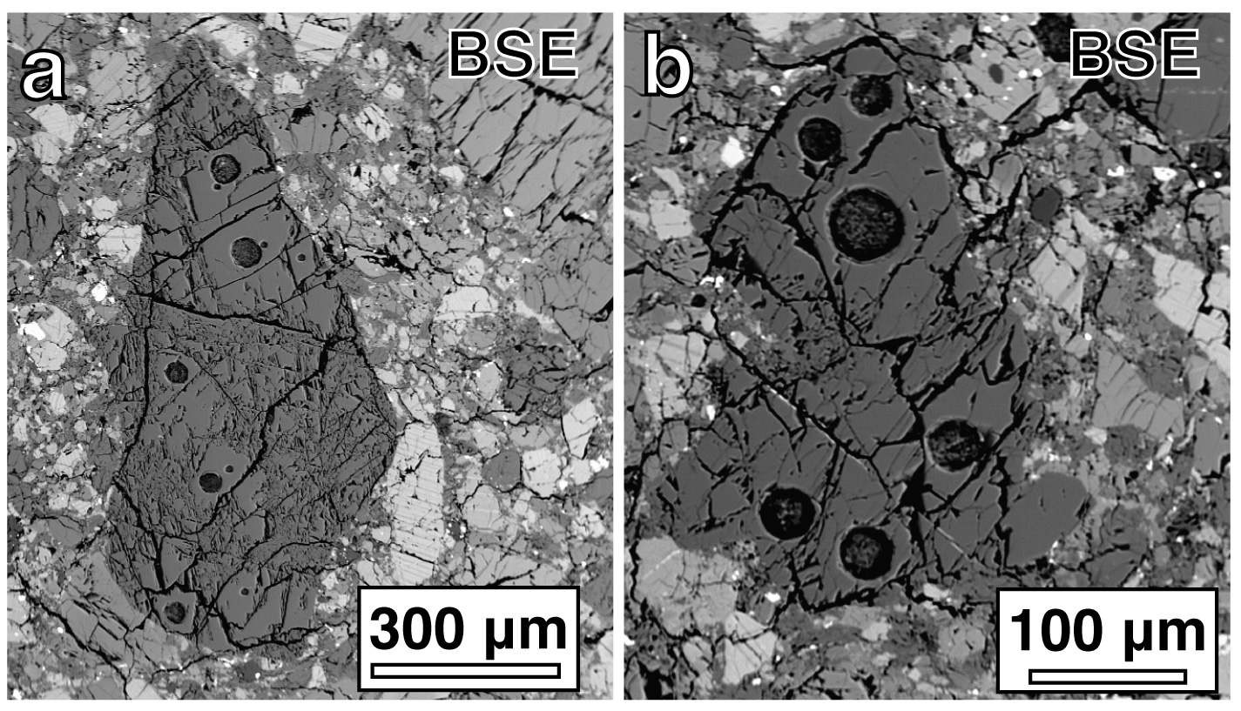
Figure B1. Backscatter electron (BSE) images of fragmental Mg-rich olivine and pyroxene grains. a.) Mg-rich olivine fragment (Mg# 90.1) from GRO 95574,17 with LA-ICP-MS pits (32-44 μm laser spots) and SIMS pits (15-μm beam spots) b.) Mg-rich pyroxene fragment (Mg# 90.2) from GRO 95574,17 with LA-ICP-MS pits (24-44 μm laser spots).

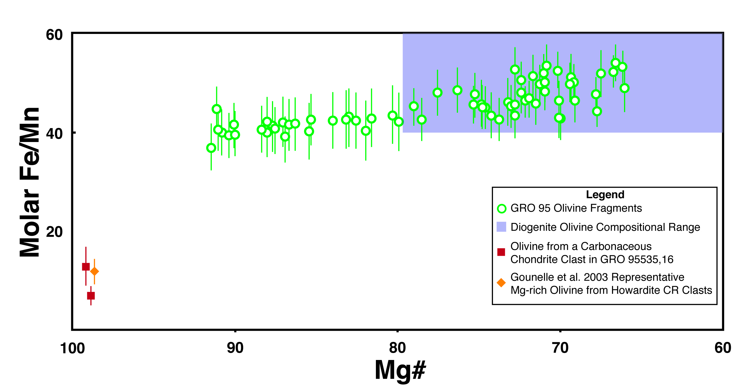
Figure B2. Fe/Mn ratio versus Mg# of fragmental olivine grains from the GRO 95 howardites. Each green open circle corresponds to an individual olivine fragment; where multiple analyses were collected the symbol corresponds to an average value. Olivines in a carbonaceous chondrite clast in GRO 95535,16 were measured in this study. The representative composition of olivine in CR chondrite clasts in the howardite Kapoeta is calculated from data in Gounelle et al. 2003. Error bars are the propagated analytical error on Mn. The diogenite compositional field is based on published data (Beck et al. 2012; Mittlefehldt et al. 1998).

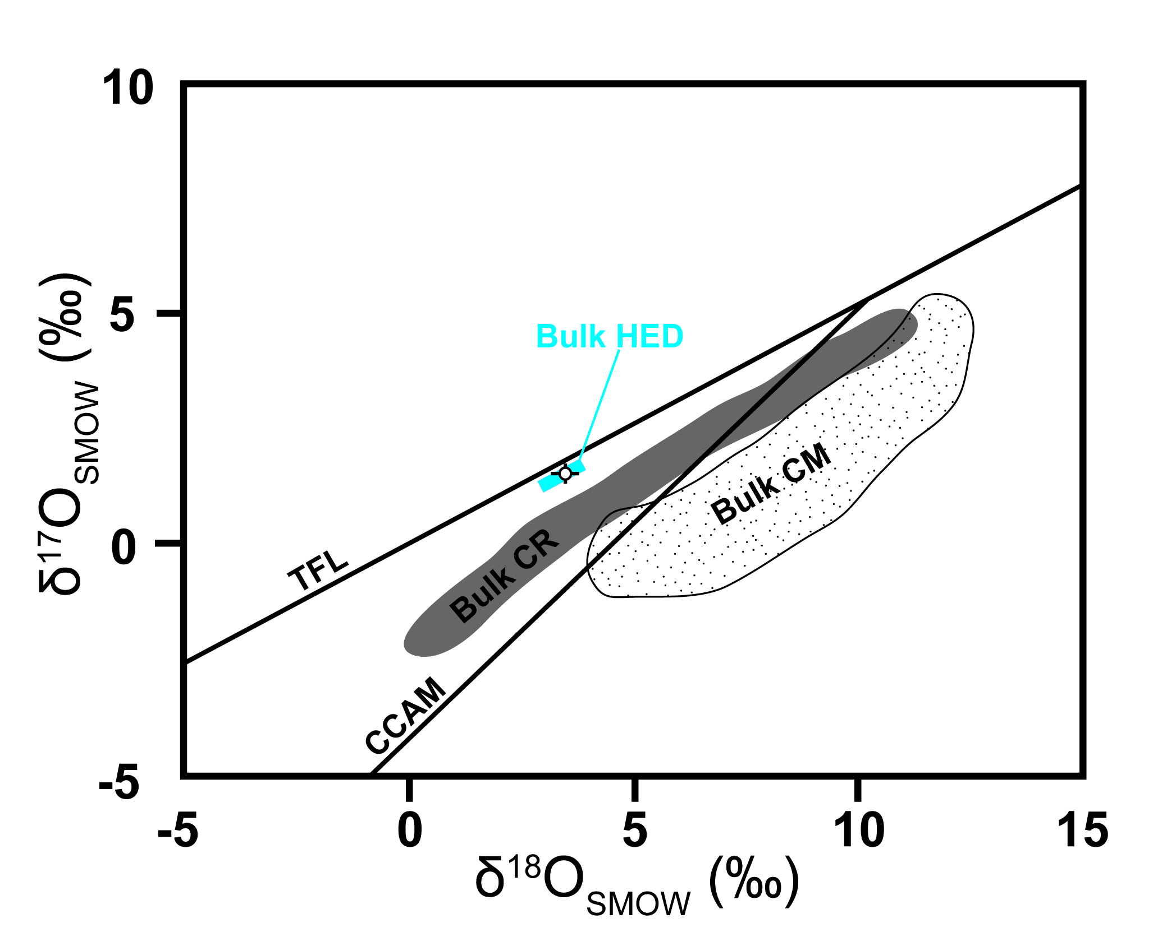
Figure B3. Oxygen three-isotope compositions of Mg-rich olivine. The open circle is the average oxygen isotope composition for 47 Mg-rich olivine spot analyses on 16 grains: the error bars include 2σ standard error and the analytical uncertainty. The bulk HED field includes the eucrite fractionation line and bulk HED analyses, representing Vesta. TFL refers to the terrestrial fractionation line. CCAM refers to the carbonaceous chondrite anhydrous mineral line. Bulk CR and Bulk CM fields refer to bulk analyses of CR chondrites and CM chondrites, respectively. Oxygen three-isotope compositions of other meteorite groups are from Krot et al. 2006 and references therein.

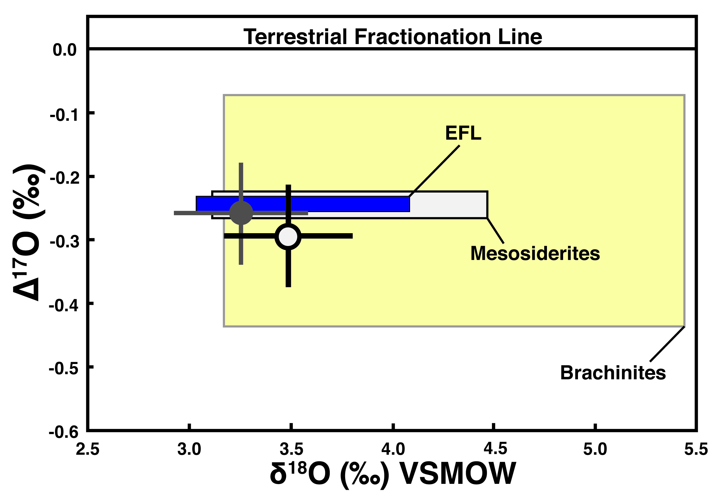
Figure B4. Oxygen three-isotope compositions of Mg-rich olivine and diogenite olivine from the GRO 95 howardites. The open circle is the average oxygen isotope composition for 47 Mg-rich olivine spot analyses on 16 grains. The filled gray circle is the average oxygen isotope composition for 34 diogenite olivine spot analyses on 14 grains. The error bars include 2σ standard error and the analytical uncertainty. The EFL is the eucrite fractionation line, which represents the HED meteorites associated with 4 Vesta. The EFL and oxygen isotope fields for other meteorite parent bodies are from data in Greenwood et al. 2012.

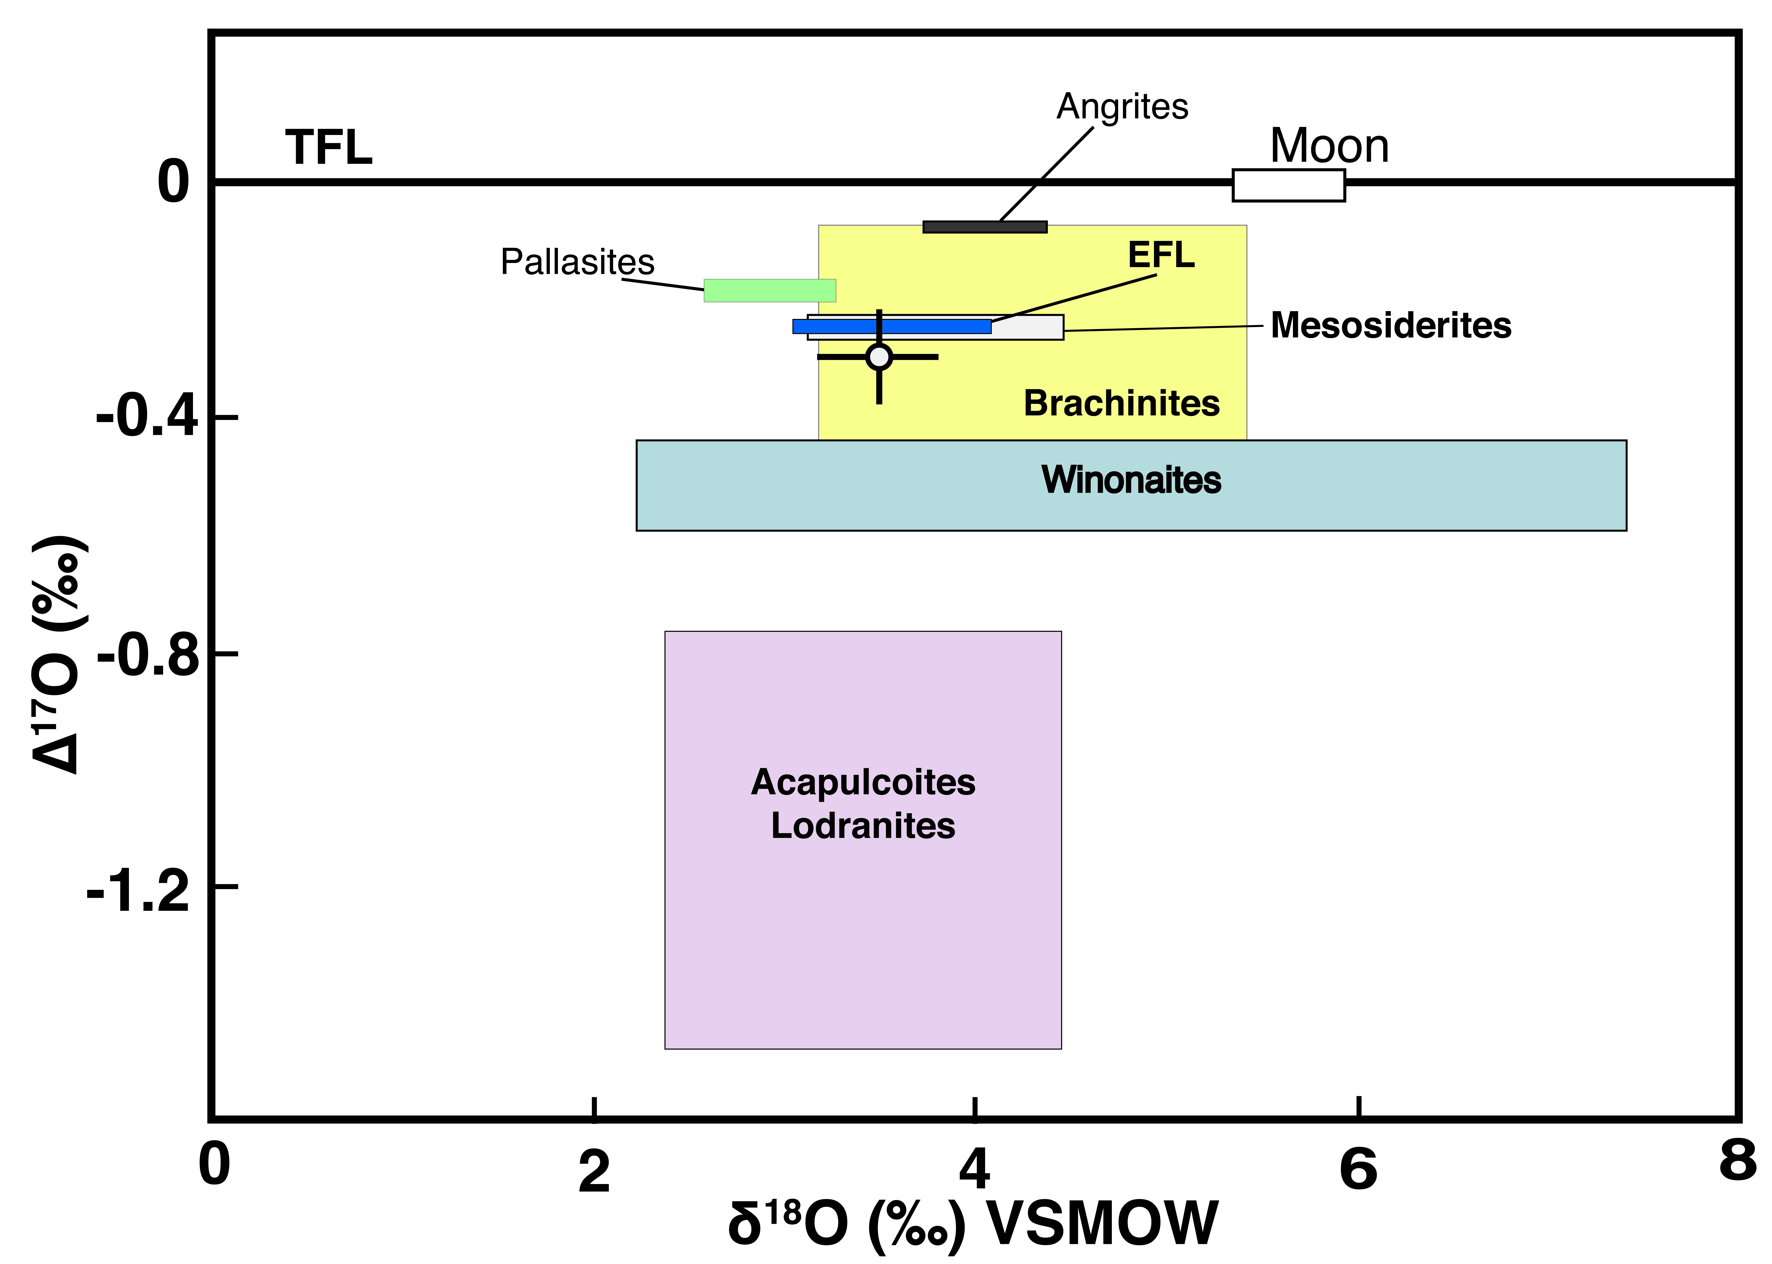
Figure B5. Oxygen three-isotope compositions of Mg-rich olivine from the GRO 95 howardites compared to achondrites. Δ¹⁷O is defined as δ¹⁷O–0.52 × δ¹⁸O, representing the displacement from the terrestrial fractionation line (TFL). The circle is the average oxygen isotope composition for 47 Mg-rich olivine spot analyses on 16 grains; the error bars include 2σ standard error and the analytical uncertainty. EFL marks the eucrite fractionation line, representing Vesta. The EFL and oxygen isotope fields for other meteorite parent bodies are from data in Greenwood et al. 2012.

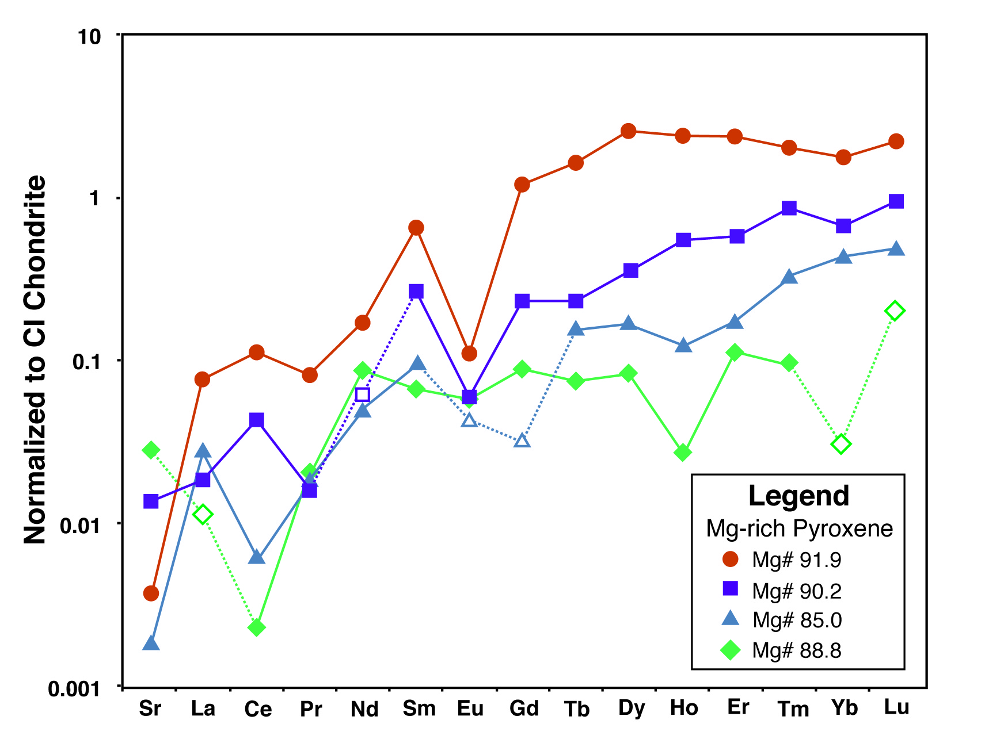
Figure B6. Trace element patterns of Mg-rich pyroxene fragments from GRO 95 howardites. Closed symbols represent concentrations above 1σ limit of detection (LOD). The source data for this plot are listed in Tables 4 and A.4. Open symbols correspond to elements for which the analyses were below the 1σ LOD, and therefore each open symbol marks a maximum value, the 1σ LOD. When two adjacent data points represent values that are both above the LOD they are connected by a solid line, and dashed lines are used to connect concentrations that were determined based on a LOD.

CHAPTER III
CV and CM Chondrite Impact Melts

This chapter is a reformatted version of a manuscript of the same name that will be submitted to Geochimica et Cosmochimica Acta. Nicole G. Lunning, Catherine M. Corrigan, Harry Y. McSween, Jr., Travis J. Tenner, Noriko T. Kita, and Robert J. Bodnar are the authors. Nicole performed all the analyses. SIMS analyses were collected in close collaboration with Travis.

Abstract

Volatile-rich and typically oxidized carbonaceous chondrites potentially respond to impacts differently than other chondritic material. Understanding impact melting of carbonaceous chondrite material has been limited by the dearth of recognized impact melt samples. In this study we identify five carbonaceous chondrite impact melt clasts in three host meteorites: RBT 04143 CV3_{red} chondrite, LAR 06317 CV3_{oxa} chondrite, and GRO 95574 regolithic howardite. The impact melt clasts in these meteorites respectively formed from CV3_{red} chondrite, CV3_{oxa} chondrite, and CM chondrite precursors. We identified these impact melt clasts and interpreted their precursors based on their texture, mineral chemistry, silicate bulk chemistry, and in the case of the CM chondrite impact melt clast, in situ measurement olivine oxygen-three isotope compositions. The impact melts are typically clasts containing subhedral-euhedral olivine microphenocrysts, which sometimes contain relic cores. Based on petrography and Raman Spectroscopy, impact melt clasts from each of the listed precursors contain evidence that they experienced volatile loss: they either contain vesicles or are depleted in H₂O relative to their precursors. Volatile loss may have driven some reduction in the oxygen fugacities of the impact melt clasts. However, the clasts formed from the more oxidized precursors (CV3_{oxa} and CM chondrites) exhibit phase and bulk chemistries consistent with higher intrinsic fugacities compared to the clast that formed from a more reduced precursor (CV3_{red} chondrite). The mineral chemistries and assemblages of the CV and CM chondrite impact melt clasts identified in this study provide a template for recognizing carbonaceous chondrite impact melts in achondrite breccias and on the surfaces of asteroids.

Introduction

The effects of impacts onto carbonaceous chondrite targets are not well understood. This is partially because only a few impact melts have been reported in carbonaceous chondrites. The scarcity of impact melt in most carbonaceous chondrite groups lead Scott et al. (1992) to speculate that the volatile components (e.g., H₂O, CO₂, S₂) in carbonaceous chondrites would respond explosively and prevent the formation of impact melt. CK chondrites were the exception in that at least three CK chondrites contain opaque shock veins (Rubin 1992). CK chondrites are notably different from other carbonaceous chondrite groups in experiencing a greater extent of thermal metamorphism, after which some were exposed to impacts that shock-blackened silicates (Kallemeyn et al. 1991). Additionally, the Leoville CV3_{red} chondrite contains a ~100 μm area of quenched microporphyritic olivine in glass that was initially interpreted as melt generated by an accretionary collision (Caillet et al. 1993); an alternative interpretation is that it is a secondary impact melt (i.e., formed after assembly of CV parent body). In this study, we characterize impact melts of carbonaceous chondrite precursors that prior to impact melting had experienced only low-temperature thermal metamorphism and/or aqueous alteration.
Carbonaceous chondrites are expected to generally respond to impact shocks in a manner similar to that of ordinary chondrites (Scott et al. 1992). The numerous descriptions of ordinary chondrite impact melts (e.g., Bogard et al. 1995; Rubin 1985) are useful references for impact melting of chondritic material. In ordinary chondrites, impact melt clasts typically have bulk compositions close to the material from which they melted (Bogard 2011; Dodd et al. 1982). Only very small degrees of partial melting (producing feldspathic melt pockets) due to impacts have been observed in ordinary chondrites (Dodd and Jarosewich 1982). This is consistent with the shock effects for porous rocks (e.g., chondrites and howardites) laid out by Bischoff and Stöffler (1992): highly localized incipient partial melting is immediately succeeded by complete bulk melting without intermediate partial melting. Processes that occurred after bulk melting can usually explain deviations between impact melt compositions and the bulk compositions of their protoliths. For example, loss of volatiles or separation of immiscible sulfide-metal liquids from the silicate fraction will change the bulk composition in ways that can be anticipated (Bogard et al. 1995; Mittlefehldt and Lindstrom 2001).
Differences between ordinary and carbonaceous chondrites may lead to certain distinct responses to impacts. CV and CM chondrites (on which this study will focus) are notably different from ordinary chondrites in several ways:
(1) All of the ordinary chondrite chemical groups include members that have experienced relatively high-temperature thermal metamorphism. There are no widely accepted CV or CM chondrites that have experienced high-temperature thermal metamorphism (petrologic type > 4). Thus, CV and CM chondrites contain mineral assemblages that are unequilibrated or equilibrated at relatively low temperatures. CM chondrites have experienced aqueous alteration (e.g., Krot et al. 2006).
(2) Compared to ordinary chondrites, CV and CM chondrites have higher intrinsic oxygen fugacities (Rubin et al. 1988) and more frequently contain water (Wasson and Kallemeyn 1988; Jarosewich 1990). Most of the water in carbonaceous chondrites is structurally bound as hydroxyl (OH) groups within phyllosilicates (Brearley and Jones 1998). Carbonaceous chondrites contain between 0-18 wt.% water equivalent hydrogen. CV and CM chondrites respectively contain 0-2.5 wt.% and 6.5-12.5 wt.% water equivalent hydrogen (Baker et al. 2002; Jarosewich 1990; Wasson and Kallemeyn 1988).

Materials and methods

Meteorites containing possible carbonaceous chondrite impact melts were identified using a petrographic microscope. The Meteorite Working Group (MWG) in conjunction with the Smithsonian Institution (for ,2 sections) allocated all meteorite thin sections in this study: LAR 06317,2; LAR 06317,11; RBT 04143,2; and GRO 95574,17. LAR 06317 and RBT 04143 are CV3 chondrites (Satterwhite and Righter 2007, 2008). GRO 95574 is a regolithic howardite (Cartwright et al. 2014; Lunning et al. in review).

Electron Microprobe
Electron microprobe (EMP) analyses were performed with a Cameca SX-100 EMP at the University of Tennessee, Knoxville. This study collected EMP analysis (EMPA) using wavelength-dispersive spectrometry (WDS) on the four thin sections. The mineral spot analyses were conducted with a 1-μm beam at either of the following conditions: 15 kV 30 nA or 20 kV 100 nA. Analyses used PAP corrections. Analyses on natural and synthetic standards were conducted daily, and ≥99% consistency with standards was maintained. Bulk compositions of each melt clast were calculated as the average of EMPA collected in grids/lines across each melt clasts. EMPA were used to determine the chemistry of olivine, glass, plagioclase, high Ca-pyroxene, and most chromite.
Features too small to analyze with EMP required NanoSEM analysis. The work was performed using the FEI Nova NanoSEM 600 field emission scanning electron microscope fitted with a ThermoFisher energy dispersive x-ray (EDS) detector in the Department of Mineral Sciences at the Smithsonian Institution. Maps and spot analyses were collected at 15 kV with currents 2-3 nA. Nanometer-scale data were stored and processed with Noran System Six (NSS) software, which allows for a complete energy spectrum to be stored in each map pixel. Bulk compositions of the whole FeNiS globules and individual minerals were determined by extracting the EDS spectra from areas corresponding to these phases using NSS. To check the major element bulk compositions of entire melt clasts as determined from EMPA, the bulk compositions of Clasts A, C, and mIM were also determined from nanoSEM element maps. EDS spectra were extracted to determine the chemistry of Clast mIM chromites because of their < 5 μm sizes.
We quantitatively determined mineral abundances for each impact melt clast with ENVI 4.2 software and 8-bit grey scale backscatter electron (BSE) images. Regions of interest (ROIs) were defined based on spot analyzes for the phases (e.g., glass and olivine) present. In these ROIs, ranges of pixel values (shades of gray) were assigned to each phase. We excluded cracks and holes within each clast by excluding pixel data values of 0 (black). We excluded the host meteorite when present in our BSE images, by masking the host with black pixels.

Raman spectroscopy
Glasses within the clasts of interest (in situ on thin sections) were analyzed by Raman spectroscopy at the Vibrational Spectroscopy Laboratory at Virginia Tech to test for the presence of water. Spectra were collected using a JY Horiba LabRam HR800 Raman microprobe system with a 514 nm, 5 W argon ion laser and nitrogen-cooled CCD detector. The spectral region of interest corresponding to water in silicate glass ranges from ~3400-3600 cm-1 (Thomas 2000; Severs et al. 2007). Detection limits for water in silicate glass is very much dependent on background signal from the sample. In samples with low background (Figure C1), detection limits as low as 0.2 wt.% H₂O are achievable (Le Losq et al. 2012); if the background intensity is high the detection limits are much higher and vary with background intensity (Severs et al. 2007). The thin sections analyzed were prepared using a highly fluorescent epoxy cement (Supplementary Figure 2); as a result detection limits for our analyses are estimated to be ~2 wt.% H₂O (Figures C1 and C2).

Oxygen three-isotope analyses
In situ oxygen three-isotope analyses were conducted on a Cameca IMS 1280, a large-radius double-focusing secondary ion mass-spectrometer at the WiscSIMS Lab, University of Wisconsin, Madison. Analytical conditions and data reduction are similar to those described previously (Kita et al. 2010; Tenner et al. 2013). The primary Cs⁺ beam was focused to a 15 µm diameter spot with an intensity of 3 nA. Matrix effects were evaluated from olivine standards (Fo₆₀, San Carlos/Fo₈₉, and Fo₁₀₀) and instrumental biases of unknowns were corrected as a function of their Mg# as determined by EMPA. Four bracket analyses on the San Carlos olivine standard were completed before and after sets of 12 unknown analyses; most of the analyses in this session were part of a separate study of Mg-rich olivine in howardites, and the olivines analyzed outside of the clast of interest to this study (Clast mIM) have oxygen three-isotope compositions consistent with HED meteorites (Lunning et al. 2015). Typical reproducibility (spot-to-spot or 2 standard deviation; 2SD) of the San Carlos olivine standard was ~0.3‰ for δ¹⁸O, δ¹⁷O, and Δ¹⁷O. Uncertainties for the San Carlos olivine standard were calculated from the 40 bracket analyses, and were 0.3 ‰ for δ¹⁸O, 0.15 ‰ for δ¹⁷O, and 0.056 ‰ for Δ¹⁷O (propagated 2σ standard error).

Results

Host meteorites
Satterwhite and Righter (2008) and Satterwhite and Righter (2007), respectively, classified LAR 06317 and RBT 04143 as CV3 chondrites. Our petrographic work supports these classifications, and we further determined the subtypes of these two CV3 meteorites and the shock grade of all three host meteorites. RBT 04143 is a reduced CV3.5-3.9 chondrite (CV3_{red}) with a shock grade of S3 and no evidence of brecciation. LAR 06317 is a brecciated oxidized Allende-type CV3.5-3.9 chondrite (CV3_{oxa}) with a shock grade of S3. GRO 95574 is a regolithic howardite (Cartwright et al. 2014; Lunning et al. in revision) with a shock grade of at least S2. The petrographic descriptions associated with these expanded petrologic characterizations are detailed in Appendix C.

Impact melt clasts
We found three impact melt clasts in LAR 06317 in two thin sections. One impact melt clast occurs in RBT 04143 and one non-HED impact melt clast was found in GRO 95574 (Figure C3). The bulk compositions of all the clasts are listed in Table C1, and the petrographic modes (i.e., percentages) of minerals and glass are listed in Table C2.
LAR 06317,11 Clast A
Clast A in LAR 06317,11 is ~250-μm in its longest dimension (Figure C3). It has a microporphyritic texture and is composed of euhedral, compositionally zoned olivine microphenocrysts (~10-50 μm) in a groundmass of translucent pink, optically isotropic glass containing accessory FeNiS globules and chromite. The glass does contain small, semi-spherical voids that are possibly vesicles, but in this clast cannot diagnostically be distinguished from voids that formed by material plucked during polishing. Clast A is a fragmental clast relative to its host meteorite: along the contact between Clast A and the host meteorite, euhedral-subhedral olivines within Clast A are broken (Figure C4).
In Clast A, the olivine microphenocrysts are compositionally zoned with relatively Mg-rich cores grading to more Fe-rich rims. One olivine microphenocryst in this clast contains a relict core (Fo₉₃ with Fe/Mn = 135) marked by an optical discontinuity. Most olivine microphenocrysts in Clast A have cores with ~Fo₈₅ which zone to rims as Fe-rich as Fo₆₃ (Table C3). Olivines in this clast have molar Fe/Mn = 103-150. Glass in Clast A contains on average 14.1 wt. % FeO (Table C4), and has a composition, that by the CIPW norm, would primarily crystallize as plagioclase, diopside, and hypersthene. The chromite is Al-rich or hercynitic chromite (Table C5).
In Clast A, FeNiS globules have circular shapes (two-dimensionally) and are ~10 μm in diameter (Figure C5). These FeNiS globules have bulk compositions with 1.2-3.0 wt.% Ni (Table C6). They contain at least two phases: FeNi-metal and pyrrhotite monosulfide solid solution (MSS). The FeNiS globules by volume are predominantly pyrrhotite MSS (85-90%) while the FeNi-metal is sub-μm-sized and is ~13 wt.% Ni. One of the FeNiS globules in Clast A also contains an additional high-Ni sulfide phase: 18 wt.% Ni, 47 wt.% Fe, and 35 wt.% S.
LAR 06317,2 Clast B
Clast B in LAR 06317,2 is ~3.5 mm in its longest dimension (Figure C3). It has a microporphyritic texture and is composed of compositionally zoned subhedral olivine microphenocrysts (~10-150 μm) in a groundmass of intergranular anisotropic plagioclase and high-calcium pyroxene (Figure C4) with accessory FeNiS globules (Figure C5) and chromite. Clast B contains vesicles with circular cross sections (40-100 μm across), are surrounded by groundmass composed of proportionally smaller crystals (~10-20 μm). Unlike in Clast A, the groundmass crystals in Clast B are generally unbroken along the menisci of the vesicles, and several vesicles are lined with translucent orange-brown glass. Clast B is a fragmental clast relative to its host meteorite: along the contact between Clast B and the host meteorite, mineral grains within Clast B are broken.
The olivine microphenocrysts in Clast B are compositionally zoned from relatively Mg-rich cores to more Fe-rich rims. Most olivine microphenocrysts in Clast B have cores of ~Fo₈₅ that progressively transition to rims as Fe-rich as Fo₅₈ (Table C3); these olivines have molar Fe/Mn = 84-187. Rare olivine microphenocrysts in this clast contain very Mg-rich cores (Fo₉₇₋₉₉ with Fe/Mn = 13-47), which grade into compositions more typical of olivine in this clast. The chromite is Al-rich otherwise known as hercynitic chromite (Table C5). The plagioclase is relatively high-Ca (~An₇₅Ab₂₅) and is notably Fe-rich for plagioclase, with 1.1 wt.% FeO (Table C7). The high-Ca pyroxene in Clast B is relatively high-Al (Table C6: 8-11 wt.% Al2O3), and thus cannot be properly represented on the pyroxene quadrilateral (En-Fs-Wo). This clast contains < 1% quenched mesostasis. The quenched mesostases are < 5-μm areas that vary in composition, but are generally relatively P-rich (1-11 wt.% P measured by quantitative EDS), and consistently contain Fe, Ca, and Si.
FeNiS components in Clast B are intergranular grains along with plagioclase and high-Ca pyroxene (Figure C5). The FeNiS grains range from 1-50 μm in size. Some FeNiS grains are solely composed of a single phase which is usually pyrrhotite MSS; however, at least one grain is FeNi metal (~10 Ni wt.%). Additionally, Clast B contains two-phases of FeNiS grains composed of pyrrhotite MSS-pentlandite or pyrrhotite MSS-FeNi-metal. The pentlandite in the two-phase FeNiS grains has ~20 Ni wt.%, ~43 wt.% Fe, and ~37 wt.% S. The two component FeNiS grains have bulk Ni contents that range from 0.5-5 wt.% Ni (Table C6). These multi-phase FeNiS grains are rare compared to single-phase pyrrhotite MSS grains, while the other two phases occur in the intergranular groundmass, and have irregular shapes.
LAR 06317,2 Clast C
Clast C in LAR 06317,2 is ~1.5-mm in its longest dimension (Figure C3). It has a microporphyritic texture and is composed of compositionally zoned, subhedral-euhedral olivine grains (~10-200 μm) in a mostly glassy groundmass with accessory FeNiS globules and chromite (Figures C4 and C5). The groundmass glass in Clast C is optically isotropic and contains delicate vitrophyric phases (<<1 μm across in narrow direction). Clast C may contain vesicles but their features are not as diagnostic as those in Clast B: it contains voids with smoothly curved, glass-lined edges in cross section. A few isolated regions of the groundmass appear to contain lathes of intergranular plagioclase, but these lathes (1-3 μm across) are too thin for anisotropy to be petrographically assessed. Along the contact between Clast C and its host meteorite, olivine grains within Clast C are broken.
The olivine microphenocrysts in Clast C typically have Mg-rich cores (~Fo₈₅) that zone to olivine compositions as Fe-rich as Fo₅₀, and these olivines have molar Fe/Mn ratios of 83-184. Several olivine microphenocrysts have cores that are more Mg-rich (Fo₉₇₋₉₉ with Fe/Mn = 12-21), which grade into the olivine compositions more typical of this clast. The glass in Clast C has an average composition that is 18.6 wt.% FeO (Table C4) and has a CIPW norm composition that would primarily crystallize plagioclase, nepheline, diopside, and olivine. Clast C’s chromite is Al-rich otherwise known as hercynitic chromite (Table C5). The plagioclase is relatively high-Ca (~An₇₂Ab₂₈) and relatively Fe-rich for plagioclase with 1.6 wt.% FeO (Table C7).
In Clast C, FeNiS globules are irregularly-shaped with smoothly curved edges and are 10-20 μm in size (Figure C5). These FeNiS globules have bulk compositions with 4.6-9.6 wt.% Ni (Table C6). They consistently contain two phases, FeNi-metal and pyrrhotite monosulfide solid solution (MSS), and they sometimes contain a high-Ni sulfide as a third phase. These FeNiS globules by volume are predominantly pyrrhotite MSS (80-94%). The FeNi metal and high-Ni sulfides are typically μm- to sub-μm-scale in size. The high Ni-sulfide occurs as < 1% to 14% of the globule volume—this high-Ni sulfide has a mineral chemistry of 21 wt.% Ni, 52 wt.% Fe, and 27 wt.% S. The FeNi-metal is consistently ~5% of the globule volume, μm-sized, and has a composition of ~43 wt.% Ni.
RBT 04143,2 Clast Z
Clast Z in RBT 04143,2 is ~4 mm in its longest dimension (Figure C3). It has a microporphyritic texture and is composed of compositionally zoned, subhedral-euhedral olivine microphenocrysts (~5-100 μm) and FeNiS globules in a glassy groundmass (Figures C4 and C5). The groundmass glass in Clast Z contains delicate vitrophyric phases (<<1 μm across in their narrowest direction); this glass is translucent with an orange-brown hue. Clast Z contains vesicles, which have smooth curved edges in cross section and in several the menisci along their edges are apparent in plane polarized light when the focal point is raised/lowered. Clast Z’s contact with its host meteorite is slightly diffuse: it co-mingles with the host material. There are no fragmental/broken olivine microphenocrysts along the boundary between Clast Z and its host meteorite.
The olivine microphenocrysts in Clast Z typically have Mg-rich cores (~Fo₈₅) which transition to rims as Fe-rich as Fo₇₁: these olivines have molar Fe/Mn = 62-197. Rare olivine microphenocrysts have more Mg-rich cores (Fo₉₇₋₉₉ with Fe/Mn = 7-32), which grade into the typical olivine compositions in this clast. The glass in Clast Z has an average composition that is 15.91 wt.% FeO (Table C4), and has a CIPW norm composition that would primarily crystallize plagioclase, diopside and hypersthene. Unlike the other melt clasts in this study, we did not find any chromite in Clast Z.
Clast Z contains two large (200-300-μm) FeNiS globules and small, finely disseminated μm-scale FeNiS globules (Figures C4 and C5). The relatively large FeNiS globules have cellular texture with circular grains of metal surrounded by sulfide (Figure C5). The sulfide is consistently the troilite end member (62 wt.% Fe and 38 wt.% S) of the pyrrhotite MSS. Some of the metal grains have been altered to FeNi-oxides that are bright orange-red in plane-polarized light. In the large FeNiS globule with fewer altered metal grains, the globule is 48% troilite and 52% metal by volume. If we added the FeNi-oxides that follow the cellular texture (which likely replaced primary FeNi-metal), the percentage of metal would be even higher. The metal grains are zoned with regard to Ni-content; the metal is predominately ~9 wt.% Ni (kamacite) but along the edges of some metal grains the Ni-content reaches ~27 wt.% (taenite). A cooling rate can be estimated from the minimum distance between metal grains (Scott 1982); the spacing between metal grains in Clast Z’s FeNiS globule is larger than in any of the other melt clasts in this study, indicates that Clast Z FeNiS globule records the slowest cooling rate for the melt clasts in this study: ~16 °C/s using the method of Scott (1982).
GRO 95574,17 Clast mIM
Clast mIM in the howardite GRO 95574,14 is ~1 mm across and is roughly equidimensional in its shape (Figure C3). It contains compositionally zoned olivine microphenocrysts (5-100 μm) in a groundmass of optically isotropic glass with accessory FeNiS globules and sub-μm-scale chromite (Figures C4 and C5). Along the boundary between the clast and its host meteorite, most of the olivine microphenocrysts in Clast mIM are aligned and/or unbroken, and some stretches along its edge are marked by μm-wide sulfide ribbons (opaque in Figure C3). Although most of the olivine grains along the boundary between Clast mIM and its host are unbroken, there are some exceptions.
The olivine microphenocrysts in Clast mIM typically have Mg-rich cores with ~Fo₈₅, which zone to rim olivine compositions as Fe-rich as Fo₇₃: these olivines have molar Fe/Mn = 64-126. A few olivine microphenocrysts have more Mg-rich cores (Fo₉₇₋₉₉) with Fe/Mn = 14-17, grading into the more typical olivine compositions. The oxygen three-isotope signature of a very Mg-rich olivine core (Fo₉₉ with Fe/Mn = 14) is δ18O = -5.7±0.4‰, δ17O = -9.0±0.4‰ and Δ17O = -6.0±0.4‰ (errors are 2σ). Additionally, we measured the oxygen three-isotope signatures of two more typical Mg-rich olivine cores (errors are 2σ): One olivine core (Fo₈₆) has δ18O = 5.5±0.4‰, δ17O = 0.2±0.4‰ and Δ17O = -2.6±0.4‰ and another typical olivine core (Fo₈₆) has δ18O = 6.3±0.4‰, δ17O = 0.2±0.4‰ and Δ17O = -3.1±0.4‰ (Figures C2 and C4).
The glass in Clast mIM has an average composition of 24.7 wt.% FeO , and Raman Spectroscopy show no H₂O above the 2 wt. % dectection limit (Table C4). Clast mIM’s groundmass glass has a composition that, by the CIPW norm, would primarily crystallize plagioclase, diopside and hypersthene. The chromite is too small to be measured by EMP, but quantitative EDS analysis using the NanoSEM shows that this chromite is less Al-rich than the chromite found in the LAR 06317 melt clasts (Table C5).
Clast mIM has one large FeNiS globule (~25 μm) and many finely disseminated, μm -scale FeNiS globules (1-5 μm). The larger FeNiS globule contains three phases: FeNi metal and two sulfide phases (Figure C5). The most volumetrically abundant sulfide (76%) is consistently pyrrhotite MSS. The less volumetrically abundant sulfide (15%) is Ni-rich stoichiometric pentlandite (41 wt.% Fe, 22 wt.% Ni and 37 wt.% S). The FeNi metal grains are μm- to sub-μm-scale in their narrowest dimensions, have skeletal textures, and are ~50 wt.% Ni (tetrataenite).

Discussion

Melt clast provenances
It is necessary to consider multiple possible formation scenarios for the clasts described in this study, and to eliminate those that are not consistent with the chemical and textural features of the clast. There are three potential origins for the melt clasts: 1) chondrules or chondrule fragments, 2) achondritic lithic clasts, 3) impact melts. Clast Z co-mingles with unmelted material from its host meteorite, indicating melting in situ, which is inconsistent with Clast Z potentially being a chondrule, chondrule fragment, or achondritic fragment. Because the other four melt clasts do not exhibit textural evidence for melting in situ, all three possible origins need to be explored for them.
Evidence against origin as chondrules or chondrule fragments
Chondrites commonly contain not only intact chondrules, but also fragments of chondrules that may have broken prior to parent body accretion (Brearley and Jones 1998). Most of the clasts in this study texturally resemble porphyritic olivine (PO) chondrules, which are composed of equant, microporphyritic, Fe-Mg-zoned olivine and chromite in glassy groundmasses. The olivine compositions in clasts described in this study resemble the more Fe-rich Type II PO chondrules (McSween 1977; Hewins 1997). However, the compositions of glass and chromite in these clasts are distinct from those in Type II PO chondrules. Glasses in clasts A, C, Z, and mIM are relatively Fe-rich (plagioclase and pyroxene normative) compared to the glass in Type II chondrules, which is typically feldspathic (Brearley and Jones 1998). Chromites in Clasts A, B, and C extend to more Al-rich compositions than chromites found in Type II chondrules (Johnson and Prinz 1991). Additionally, Clasts B and Z would be large for chondrule fragments (~3.5 mm and 4 mm across, respectively). CV chondrites have the largest chondrules among the chondrite groups, unbroken CV chondrules generally have mean diameters of 1 mm and their chondrule fragments typically are 270-670 μm (Grossman et al. 1988).
Evidence against origin as achondrite fragments
Because LAR 06317 (the host meteorite to Clasts A, B, C) is a brecciated CV3oxa chondrite, we must consider the possibility that these fragmental clasts formed from achondritic precursors. In contrast, Clast mIM is found in a howardite—an HED polymict achondrite breccia—but contains olivines with oxygen three-isotope values that preclude an HED or any fully differentiated precursor (Figure C6). We will discuss the oxygen three-isotope compositions of olivines in Clast mIM in greater detail later.
The achondrites with the olivine chemistry and modes most similar to the five clasts in this study are primitive achondrites, particularly the FeO-rich olivine-rich ungrouped achondrites (e.g., LEW 88763) and brachinites (e.g., Gardner-Vandy et al. 2012). Bulk chemistry cannot be used to distinguish between primitive achondrites and chondritic impact melts: Primitive achondrites have undergone only low degrees of partial melting and thus their bulk compositions are very close to bulk chondritic compositions. However, primitive chondrites typically have comparatively coarse-grained equigranular granoblastic textures and contain minerals that are chemically equilibrated (i.e. not zoned) with respect to their major element chemistry (Mittlefehldt et al. 1998). In contrast, the clasts in this study have undergone near complete melting, with only very Mg-rich relict olivine (Fo₉₇₋₁₀₀) remaining unmelted. After melting, clasts studied here experienced rapid cooling as evidenced by the Mg-Fe zoning in their olivine microphenocrysts, the presence of quenched vitrophyric phases, and cooling rates ≥16 °C/s based the spacing of the cellular metal in their FeNiS globules using the method of Scott (1982).
Evidence supporting Impact Melt Origin
The microporphyritic texture of the five clasts in this study and their mineralogy resemble some impact melt clasts found in ordinary chondrites (e.g., Bogard et al. 1995; Metzler et al. 2011) and one identified in an R chondrite (Bischoff et al. 2006). In contrast to their host meteorites, the four clasts found in the two CV3 chondrites have unequilibrated olivine grains. Although minerals in CV3 chondrites are not equilibrated with each other across the meteorite, individual olivines are homogeneous with regard to major element chemistry (i.e., equilibrated on a grain scale). Additionally, olivines in all five melt clasts do not show the shock features (e.g., undulatory extinction and/or planar fractures) that are observed in their host meteorites. These differences between the melt clasts and their host meteorites indicate the melt clasts have not experienced shock or thermal metamorphism following melt solidification. Thus, the melt clasts were melted after the thermal metamorphism recorded by other components in their hosts and were melted after (or at the same time as) the impacts that shocked the other host components.
Impact melting of porous rocks (including unequilibrated chondrites) typically involves complete bulk melting and thus the bulk silicate chemistry of an impact melt should be the same as (or similar to) its precursor. Elemental ratios enable us to infer the bulk silicate chemistry not affected by impact melting processes (e.g., separation of immiscible FeNiS liquid). All of the melt clasts in this study have bulk silicate compositions that are consistent with carbonaceous chondritic material. The precursor of each clast will be discussed in further detail later.

Impact melt clasts: Formation histories and precursors
In the following subsections, we consider potential precursors for each of the melt clasts using element ratios from the bulk chemistry of each clast. We evaluate silicate bulk chemistry by examining ratios between lithophile elements because they should not be affected by FeNiS immiscibility. Various additional lines of evidence specific to the clast/host meteorite provide context for how each impact melt clast formed.
CV3_{oxa} source and formation of impact melt clasts in LAR 06317
The three melt clasts in LAR 06317 have similar major-element silicate bulk chemistries. Clasts A, B, and C, respectively, have wt.% ratios of Al/Si = 0.126, 0.124, and 0.117; Ca/Si = 0.115, 0.096, and 0.102; Na/Ca = 0.235, 0.240, and 0.252; Mn/Al = 0.073, 0.078, and 0.085. The similarities of these ratios support the interpretation that these clasts formed from the same precursor. Their relatively high Al/Si and Ca/Si ratios, combined with relatively low Na/Ca ratios, are consistent with the bulk chemistry of carbonaceous chondrites (Table C8). The particularly low Mn/Al ratios of these clasts fall within or are below the range for CV chondrites, which have the lowest Mn/Al ratios for any chondrite group. (Table C8). Thus, the bulk chemistries of the clasts are consistent with their forming from a CV chondrite precursor, such as their host meteorite, a CV3oxa chondrite.
The fragmental boundaries of these clasts provide evidence that they were parts of larger impact melts, which were comminuted after they solidified. Of the three fragmental impact melt clasts found in LAR 06317, Clast A appears to have been quenched earliest in its crystallization sequence: its groundmass glass is more abundant (Table C2) and does not contain vitrophyric phases. According to the CIPW norm, the glass in Clast A would crystallize additional olivine (plus diopside and plagioclase). In contrast, Clast B fully crystallized to not only olivine and chromite but also Al- and Ti-rich, high-Ca pyroxene (En₂₀₋₂₉ Wo₅₂₋₅₆) and plagioclase (An₃₆₋₅₉), in place of the intersertal glass found in Clast A and Clast C. The vitrophyric phases in the glass of Clast C and the overall lower fraction of glass in Clast C relative to Clast A indicate that Clast C was quenched at a lower later stage than Clast A (Table C2).
CV_{red} source and formation of Clast Z in RBT 04143
The boundary between Clast Z and its host meteorite RBT 04143 is slightly diffuse and co-mingles with the host material, as mentioned previously. Additionally, there are no fragmental grains along the boundary between Clast Z and the surrounding meteorite. This contact indicates that this clast melted in situ from material of its host meteorite, a CV3_{red} chondrite. Additionally, the bulk chemistry of Clast Z—relatively high Al/Si and Ca/Si ratios combined with relatively low Na/Ca and Mn/Al ratios (Table C1 and Table C8)—is consistent with it forming from a CV chondrite precursor.
CM chondrite source for clast mIM in howardite GRO 95574
A few olivines in Clast mIM have distinct cores that are more Mg-rich (Fo₉₇₋₉₉) than the rest of the olivine (Fo₇₃₋₈₈), which texturally crystallized from the impact melt. The distinct Mg-rich cores have very low Fe/Mn ratios (= 14-17), similar to olivine found in other unmelted carbonaceous chondrite fragments in howardites (Lunning et al. 2015; Gounelle et al. 2003). These relict olivine cores have Fe/Mn ratios much lower than HED olivine Fe/Mn = 40-60 (e.g., Beck et al. 2012), which provided one of the initial indications that this clast was exogenic relative to its host howardite. The rest of the olivines in Clast mIM have relatively high Fe/Mn ratios (64-126), which are similar to the non-relict olivines (Fo₅₀₋₈₅ and Fe/Mn = 60-140) in CV impact melt clasts in this study (Clasts A, B, C, and Z).
The bulk composition of Clast mIM is broadly consistent with its formation from a carbonaceous chondrite precursor: it has high Al/Si = 0.146 and Ca/Si = 0.138 ratios combined with relatively low Na/Ca = 0.259 and Mn/Al = 0.109 ratios. The Al/Si and Ca/Si ratios of Clast mIM are a slightly higher than those found in any chondrite group; however, CV and CM chondrites have among the highest Al/Si and Ca/Si ratios. Its Na/Ca and Al/Mn ratios fall within the ranges of bulk CM and CO chondrites (Table C1 and Table C8).
In situ oxygen three-isotope analyses provide a further test of the provenance of Clast mIM. The relict core has a very primitive O isotopic signature, which falls close to the carbonaceous chondrite anhydrous minerals (CCAM) line. The unequilibrated olivine grains without relict cores have oxygen isotopic compositions that coincide with bulk CM chondrite values. It is not well understood how degassing of O-bearing volatile species related to impact melting of carbonaceous chondrite targets on airless bodies might fractionate oxygen isotopes. If O-bearing volatile species did not degas, we would expect minerals that grew from a CM chondrite impact melt to have bulk CM chondrite oxygen three-isotope signatures.
The contact between Clast mIM and its host meteorite provides textural evidence that this clast formed as a melt splash droplet: 1) Most olivines along the edge of the clast are complete euhedral-subhedral crystals, and only a few olivines are fractured. 2) The boundary of Clast mIM is smooth and does not co-mingle with the clastic matrix of its host meteorite, the regolithic howardite GRO 95574. 3) The roughly equidimensional shape of Clast mIM is consistent with it being a cross section of a spherical droplet. Thus, Clast mIM probably formed in a manner similar to that of impact melt droplets identified from other solar system bodies, such as the lunar crystal-bearing spherules (Ruzicka et al. 2000), the vitrophyre found in the martian regolith breccia NWA 7034 (Udry et al. 2014), and the impact spherules identified on the surface of Mars by the Curiosity rover (Minitti et al. 2013). Clast mIM was likely ejected from a larger impactor, because mm-scale impactors do not melt upon impact. Even on the Moon, mm-size impactors are not expected to melt upon impact into Vesta (e.g., McSween 1976; Zolensky 1997), and impactors collide at higher velocities with the Moon than with 4 Vesta (Strom et al. 2005; Reddy et al. 2012), the likely parent body of howardites (e.g., McSween et al. 2013). At least a few relatively large CR and CM chondrite impactors accreted to 4 Vesta (De Sanctis et al. 2013; McCord et al. 2012; Prettyman et al. 2012; Reddy et al. 2012). Given this context, the bulk Mn/Al ratio of Clast mIM (Table C1 and Table C8) and its olivine oxygen three-isotope values, a CM chondrite precursor is most consistent for the origin of Clast mIM.
Evidence for volatile loss
Impact melt clasts from CV_{red}, CV_{oxa}, and CM chondrite precursors contain evidence for volatile loss. None of the clasts contain glass (when present) with H₂O concentrations above the detection limit of ~2 wt.% using Raman spectroscopy (Table C4) on our samples. Unmelted CM chondrites have H₂O concentrations (water equivalent H) between 6.5-12.5 wt.% H₂O (Baker et al. 2002; Jarosewich 1990; Wasson and Kallemeyn 1988). Consequently, the below-detection H₂O contents of the glass in Clast mIM (CM chondrite impact melt clast) provide evidence that several wt.% of H₂O was lost from this clast before it solidified. Unmelted CV chondrites have H₂O concentrations around or below (0-2.5 wt.% H₂O: Jarosewich 1990; Wasson and Kallemeyn 1988), the detection limit of our Raman measurements.
Clast Z, which formed from a CV_{red} precursor, contains distinct vesicles. Of the clasts that likely formed from a CV_{oxa} precursor, Clast B contains distinct vesicles, and Clasts C and A potentially contain vesicles. Vesicles provide direct evidence that a volatile-bearing melt formed and subsequently degassed, however, in low gravity environment only minuscule amounts (≥ 10s of ppm CO-CO₂ or ≥100s of ppm H₂O for parent body depths ≤ 5 km) of volatiles are required to from vesicles (McCoy et al. 2006). The specific volatile or volatiles that formed the vesicles in the CV chondrite impact melts is unknown, but potentially include H₂O, S₂, and possibly CO-CO₂. We note that CV chondrites do not contain large quantities of bulk C (≤ 0.8 wt.% C: Jarosewich 1990) from which CO-CO₂ species would form.
Ordinary chondrite impact melts provide analogous case studies of impact melting, albeit of more reduced precursor material than the impact melt clasts in this study. Vesicles occur in rare ordinary chondrite impact melts (e.g., Benedix et al. 2008), but most ordinary chondrite impact melts are not vesicular (e.g., Rubin et al. 1983; Bogard et al. 1995; Herd et al. 2013). In the case of the vesicular L chondrite impact melt rock PAT 91501, vesicles are spatially (3-dimensionally) associated with FeNiS globules; thus it is likely that vesicles formed by release of S₂ gas from FeNiS liquids (Benedix et al. 2008).

Redox state of impact melt clasts
Degassing of H₂O and/or CO-CO₂ should reduce the oxygen fugacity of an impact melt relative to its precursor. Unmelted CV chondrites have intrinsic oxygen fugacities ranging from near the iron-wüstite (IW) buffer to less than a log unit below the quartz-magnetite-fayalite (~QMF-1) buffer (Righter and Neff 2007). The reduced CV chondrites should have redox states at the lower end (~IW), while the oxidized CV chondrites should have redox states toward the higher end (≥ QMF-1) of this range. The intrinsic oxygen fugacities of unmelted CM chondrites have not been thermodynamically quantified; however, their mineralogy and higher H₂O content suggest that CM chondrites have higher intrinsic oxygen fugacities than CV chondrites (Rubin et al. 1988).
The most apparent manifestation of intrinsic oxygen and sulfur fugacities in our impact melt clasts is related to the partitioning of Fe between the silicate and FeNiS liquids. Clasts with higher intrinsic oxygen fugacities should have proportionally less Fe° in the FeNiS liquid and more oxidized Fe in the silicate liquid, as FeO and possibly Fe₂O₃.
Evidence regarding redox state from silicates
The FeO_{T} (total iron expressed as FeO) content of the glass in Clast Z and Clast mIM may reflect relative intrinsic oxygen fugacities inherited from their precursors. These two impact melt clasts are respectively interpreted to have formed from CV_{red} and CM chondrites. Their glass compositions may reasonably be compared to each other because they were quenched at similar points in their crystallization, as indicated by their similar proportions of olivine:glass (61:39 and 63:37: Table C2) and zoning trends in their olivines (cores ~Fo₈₅ to rims Fo₇₅₋₇₃: Table C3). The glasses in both clasts are relatively FeO_{T}-rich compared to the feldspathic glass in Type II PO chondrules, but the glass in Clast mIM (CM impact melt) has 24.7 wt.% FeO_{T} while the glass in Clast Z (CV_{red} impact melt) has 15.9 wt.% FeO_{T}. Given that these clasts are petrologically similar otherwise, the more FeO_{T}-rich glass in the CM impact melt may reflect the relatively higher intrinsic oxygen fugacity of its CM chondrite precursor.
The impact melt clasts from the CV_{oxa} were all quenched from a point where a larger proportion of olivine had crystallized, and therefore cannot qualitatively be compared to the CV_{red} and CM-like chondrite impact melt clasts. However, Clast C contains both FeO_{T}-rich plagioclase and glass from which we can estimate oxygen fugacity from a partition coefficient D_{plag}/melt = (FeO_{T} in plagioclase)/(FeO_{T} in melt). Phinney (1992) experimentally determined that FeO_{T} in plagioclase is an oxybarometer because it tracks the proportion of Fe₂O₃ to FeO in the melt, as Fe³⁺ fits more readily into the plagioclase crystal structure. In Clast C, D_{plag}/melt = 0.09 which corresponds to QMF+2 under the conditions of Phinney’s (1992) experiments. QMF+2 is a higher intrinsic oxygen fugacity than is calculated for its unmelted precursor (IW < CV chondrite ≥ QMF-1: Righter and Neff 2007). Phinney’s (1992) experiments were run in equilibrium with basaltic liquids at 1180°C and 1 atm. Clast C formed from a more primitive liquid (Table C1), it crystallized under disequilibrium conditions, and we do not know the pressure and temperature conditions of formation.
Evidence regarding redox state from FeNiS globules
The composition and volumetric abundance of FeNiS liquid will be controlled by the redox state of the impact melt. For instance, in melts with lower oxygen fugacity, a greater percentage of the bulk Fe will partition into the FeNiS liquid rather than into the silicate liquid. Melts in this case will contain larger volumes of FeNiS liquid and compositionally FeNiS liquids will be more Fe-rich (relatively more Ni- and S-poor). Thus, oxygen fugacity should influence the proportion of metal to sulfides in FeNiS globules and their respective Ni-contents. However, redox state interpretations from the FeNiS globules in these melt clasts should be treated with caution for two reasons:
(1) The immiscibility and greater density of FeNiS liquid relative to silicate liquid means that a given 2-dimensional thin section through a clast may not contain a representative proportion of FeNiS globules to silicates.
(2) Different FeS (± Ni, Cu, etc.) globules within a single terrestrial magma body do not consistently have the same composition. For instance, in terrestrial magmas FeS ± NiCu liquids that exsolved and coalesced early can have a distinct composition from smaller globules that exsolved later (Fonesca et al. 2008). Thus, the FeNiS globules in each of our samples may not be perfectly representative of the overall FeNiS immiscible liquid in the clast. With these caveats in mind, we can only make broad interpretations regarding redox state using FeNiS globules.
From our samples, we examine intrinsic oxygen fugacity via speciation of Fe, as a proxy. However, the correspondence of oxygen fugacity to the valence (oxidation state) and speciation of Fe is rooted in phase equilibria (e.g., Herd 2008), as noted earlier, these melt clasts all exhibit textural and chemical evidence for disequilibrium crystallization. Additionally, it is remains an area of active research when and how oxygen fugacity influences the speciation of various volatile elements—such as H, S, C—or in which circumstances the phase equilibria of these elements exert a controlling influence on the oxygen fugacity of a system, and the valence and speciation of Fe (e.g., Canil et al. 1994; Dasgupta and Hirschmann 2010; Sharp et al. 2013).
The mineral phases in the FeNiS globules, along with their chemistries and abundances may also track a relative increase in intrinsic oxygen fugacity from the CV_{red} impact melt to the CV_{oxa} and CM impact melts. The CV_{red} impact melt (Clast Z) has FeNiS globules that are distinct from those in the CV_{oxa} and CM impact melt clasts. The mineralogies and chemistries of the FeNiS globules in the CV_{oxa} and CM impact melt clasts (Clast A, B, C, and mIM) overlap each other. The CV_{red} impact melt contains troilite and FeNi-metal that zones from ~9 to 27 wt.% Ni (stoichiometrically kamacite to taenite). While the CV_{oxa} and CM-like impact melts also contain a pyrrhotite MSS phase, their FeNi-metals are more Ni-rich, with some as high as 50 wt.% Ni (tetrataenite), and some of their globules also contain Ni-rich sulfides, including pentlandite. Additionally, the proportion of metal relative to sulfide is greater in FeNiS globules in CV_{red} impact melt clasts (> 50% metal) than in FeNiS globules in the CV_{oxa} and CM impact melt clasts (≤ 15% metal). The more Ni-rich metal composition and smaller proportion of metal in FeNiS globules in the CV_{oxa} and CM impact melt clasts are consistent with higher intrinsic oxygen fugacities and greater proportions of Fe in their silicate fractions. Conversely, the higher proportion of metal in FeNiS globules in the CV_{red} impact melt clasts and the lower Ni-content of the metal are consistent with a relatively lower intrinsic oxygen fugacity than the CV_{oxa} and CM impact melt clasts. By these qualitative metrics, differences between intrinsic oxygen fugacity between the CV_{oxa} and CM impact melt clasts cannot be recognized, but the CV_{red} impact melt clast has a recognizably lower intrinsic oxygen fugacity. The similarity in redox state between CV_{oxa} and CM impact melt clasts may be on account of relatively less reduction between the CV_{oxa} impact melt clasts and their precursor. Degassing of several wt. % H₂O from the CM impact melt clast may have reduced the intrinsic oxygen fugacity close to that of CV_{oxa} chondrites.
The intrinsic oxygen fugacity differences between the CV_{red} impact melt clast (Clast Z) and the CV_{oxa} and CM impact melt clasts may also be reflected in the bulk chemistry of FeNiS globules (Table C6). In particular, the FeNiS globule in Clast Z has lower S-concentration (18 wt.% S), which is consistent with its higher metal content relative to sulfides. The FeNiS globules in the CV_{oxa} and CM impact melt clasts all have ~35 wt.% S (Table C6). These differences in bulk S-content by themselves could be explained by sulfur fugacity differences alone. However, given the evidence indicating differences in oxygen fugacity outlined previously in this section, the difference in FeNiS globule bulk S-content in the CV_{red} impact melt clast compared to the CV_{oxa} and CM impact melt clasts are most parsimoniously explained either solely by different oxygen fugacities or by a combination of different oxygen and sulfur fugacities.
Relevance for identification of chondrite impact melts in achondrite breccias
The CV and CM impact melt clasts in this study may be useful archetypes for identifying additional primitive chondrite impact melt clasts in both carbonaceous chondrite and achondrite breccias. It is possible that similar primitive chondrite impact melts may occur not only in howardites but also in lunar and martian regolith samples. Prior to in situ oxygen isotopic analysis, anomalous Fe/Mn ratios may be useful for flagging potential primitive chondrite impact melts in achondrite breccias. The molar Fe/Mn ratios of olivines in Clast mIM initially distinguished this clast from other olivine in its host (GRO 95574 and its pairs: Lunning et al. 2015). In Clast mIM, the Mg-rich relict cores have lower Fe/Mn ratios (= 14-17) than HED olivine (= 40-60: Beck et al. 2012). The olivines that texturally grew out of the melt in Clast mIM have Fe/Mn ratios (Fe/Mn = 64-126), higher than ratios in HED olivine. The other impact melt clasts in this study exhibit similar trends with regard to olivine Fe/Mn ratios: collectively all the CV chondrite impact melt clasts have low Fe/Mn ratios (Fe/Mn = 7-32) in potentially relict olivine cores (Fo₉₇₋₉₉) and comparatively high Fe/Mn ratios (Fe/Mn = 62-197) in the olivine (≥ Fo₈₈) that texturally grew out of the impact melt. Mg-rich olivines (Fo₉₇₋₁₀₀) in unmelted CM and CR chondrite clasts in howardites have similar Fo-content and low molar Fe/Mn ratios (Fe/Mn = 7-17: Lunning et al. 2015, Gounelle et al. 2003) compared to the potentially relict olivine cores in the impact melts in this study. As mentioned previously, the very Mg-rich relict cores are consistent with these clasts forming from melts of primitive chondrites, because the μm- and larger-sized olivine in primitive chondrites (CI, CM, CV, CO, CR chondrites) is predominately Fo₉₇₋₁₀₀ (e.g., Tenner et al. 2015; Wood 1967).
Potential for observation of impact melt on CM chondrite-like asteroids
The mineral assemblages in the impact melt clasts in this study are distinctly different from their precursors. Such changes in mineralogy could potentially be observed with visible/infrared spectroscopy via remote sensing to identify impact melt-rich regions on the surfaces of asteroids, particularly on the surfaces of CM chondrite-like asteroids. Unmelted CM chondrites have spectra dominated by absorption features related to their phyllosilicates (Cloutis et al. 2011; Beck et al. 2014a; Takir et al. 2013). In contrast, the CM impact melt clast in this study is composed primarily of olivine and glass. The spectra of glasses are relatively featureless, although glass can alter a spectrum’s continuum (Cloutis et al. 1990). Thus absorption features related to olivine would dominate spectra of CM impact melts. Specifically, olivine has a broad absorption feature which typically extends ~0.9 to 1.25 μm (e.g., Cloutis et al. 2011) and an absorption feature at ~11.3 μm (Beck et al. 2014a). Laboratory spectra of CM chondrites typically do not have the ~0.9 to 1.25 μm absorption feature of olivine (Cloutis et al. 2014). Occasionally CM chondrites have a weak ~11.3 μm absorption feature but in this spectral range CM chondrites have a more prominent ~9.9 μm feature associated with phyllosilicates (Beck et al. 2014a; McAdams et al. 2015). These hydrated minerals are also apparent in other spectral ranges: OH and H₂O related absorption features at ~3 μm (e.g., Takir et al. 2013), which sometimes have a corresponding ~0.7 μm absorption feature. However, the ~0.7 μm absorption feature is sometimes absent in the spectra of CM chondrites with abundant phyllosilicates (McAdams et al. 2015).
Using ground-based observations in which a spectrum is emitted from the visible hemisphere/area, we posit that a CM chondrite-like asteroid with abundant impact melt on it surface would have a spectrum with both phyllosilicate-related absorption features but stronger olivine absorption features than typically observed in the spectra of unmelted CM chondrite material. However, it is reasonable to expect that impact melt on CM chondrite-like asteroids may not necessarily constitute a large enough area to contribute absorption features to a spectrum observed from Earth. Resolving impact melt from unmelted CM chondrite material may require higher resolution mapping of CM chondrite-like asteroids by spacecraft.
Two spacecraft missions, NASA’s Osiris-Rex and JAXA’s Hayabusa 2, will map and return samples from asteroids for which CM chondrites are appropriate meteorite analogs. The target of Osiris-Rex is the potentially hazardous near-Earth asteroid (101955) Bennu, which has spectra most similar to CM and CI chondrites but without any observed absorption features related to hydrated phases such as phyllosilicates (Clark et al. 2011; Lauretta et al. 2015; Binzel et al. 2015). Asteroid (162173) 1999 JU3—the target of Hayabusa 2—is also spectrally similar to certain CM and CI chondrites (Vilas 2008; Moskovitz et al. 2013). A ~0.7 μm absorption feature has been observed in spectra from Hayabusa 2’s target, albeit not consistently (Vilas 2008; Lazzaro et al. 2013). Moskovitz et al. (2013) proposed that the ~0.7 μm absorption feature may not be consistently observable if either 1) this asteroid has a heterogeneous surface composition or 2) the asteroid’s orbital proximity to the sun influences the manifestation of the ~0.7 μm absorption feature. Subsequent work looked for but did not find any orbital elements correlated to the presence of ~0.7 μm absorption feature on carbonaceous chondrite-like asteroids (Fornasier et al. 2014). If asteroid (162173) 1999 JU3 has a compositionally heterogeneous surface, that could suggest a complex collisional history and increase the chance that it might have olivine-rich impact melt—similar to those described in this study—on its surface.
Although Vesta is a differentiated asteroid, as mentioned previously, it contains exogenic carbonaceous chondrite material mixed into its surface regolith (McCord et al. 2012; De Sanctis et al. 2013; Jaumann et al. 2014; Reddy et al. 2012; Prettyman et al. 2012). Olivine-rich lithologies have been identified in geologically unexpected locations on Vesta (e.g., Ammannito et al 2013; Le Corre et al. 2015). Conference presentations that incorporated preliminary versions of the results on Clast mIM in the howardite GRO 95574 presented in full in this study (Beck et al. 2014b; Lunning et al. 2014), have been discussed as one possible explanation for olivine-rich areas on Vesta (Nathues et al. 2014; Thangjam et al. 2014; Poulet et al. 2015).

Summary and Conclusions

It was previously suggested that impact melts from CM and CV chondrites did not exist, because of the lack of recognized samples and because the explosivity of melts produced by melting of volatile-rich precursors might prevent consolidated melt from forming. We identify and describe CV and CM chondrite impact melt clasts, each of which has a slightly different petrogenesis. These five impact melt clasts formed from three separate carbonaceous chondrite precursors based on their silicate bulk chemistry and individual petrology:
- A clast formed from a CV3_{red} chondrite precursor (Clast Z in RBT 04143) melted in situ based on it texture, and has bulk silicate chemistry consistent with a CV chondrite.
- Three clasts formed from CV3_{oxa} chondrite precursor material (Clasts A, B, C in LAR 06317) and experienced different degrees of crystallization prior to final solidification. The fragmented olivine crystals along the clast boundaries of all three clasts indicates were brecciated after they solidified. Their bulk silicate chemistries are consistent with CV chondrites, and thus their CV3_{oxa} chondrite host is probably representative of their precursor.
- One clast interpreted to have formed from a CM chondrite precursor (Clast mIM in howardite GRO 95574) solidified as a melt splash droplet from a larger impactor and after solidification was incorporated into the regolith of asteroid Vesta. The oxygen three-isotope and Fe/Mn values of its olivine distinguish this clast from howardite-eucrite-diogenite materials. The oxygen three-isotope signatures of relict olivine and of olivines that grew from the melt provide evidence that this clast formed from a primitive chondrite, most likely a CM chondrite.
There is evidence for degassing in all three types of carbonaceous chondrite impact melts in this study. Impact melt clasts that formed from both CV3_{red} chondrite and CV3_{oxa} chondrite precursors contain vesicles. The impact melt that formed from a CM chondrite precursor has H₂O-content below our Raman spectroscopy detection limits, which indicates it lost a few to several weight percent H₂O relative to its precursor. Depending on which species degassed, volatile loss may reduce the intrinsic oxygen fugacity. If impact-related reduction occurred, it did not alter the relative redox state trend of the melt clasts compared to their precursors. Compared to the clast that formed from a more reduced precursor (CV3_{red} chondrite), the clasts that formed from the more oxidized precursors (CV3_{oxa} and CM chondrites) exhibit signatures of higher intrinsic fugacities in their silicate and FeNiS fractions.
The petrologic features of the clasts may be used to identify impact melt of CV and CM chondrites in additional meteorites and via remote sensing of asteroids:
- The CV and CM chondrite impact melt clasts identified in this study provide a methodology for recognizing similar impact melts in achondrite breccias: anomalously high or low mineral Fe/Mn ratios, anomalously high olivine abundances, and diagnostically distinct oxygen three-isotope signatures.
- Large quantities of impact melts similar to the clasts in this study may be observable by remote sensing on CM chondrite-like asteroids; the olivine-dominated mineral assemblage of the CM chondrite impact melt in this study might be distinguishable with visible to infrared spectroscopy from its phyllosilicate-dominated precursor.

References

Ammannito, E., De Sanctis, M. C., Palomba, E., Longobardo, A., Mittlefehldt, D. W., McSween, H. Y., Marchi, S., Capria, M. T., Capaccioni, E., Frigeri, A., Pieters, C. M., Ruesch, O., Tosi, T., Zambon, F., Carroro, F., Fonte, S., Hiesinger, H., Magni, G., McFadden, L. A., Raymond, C. A., Russell, C. T., Sunshine, J. M. (2013) Olivine in an unexpected location on Vesta’s surface. Nature 504, 122-125.
Baker L., Franchi I. A., Wright I.P., and Pillinger C. T. The oxygen isotopic composition of water from Tagish Lake: Its relationship to low-temperature phases and to other carbonaceous chondrites. Meteoritics & Planetary Science 43, 977-985.
Beck A. W., Welten K. C., McSween H. Y., Viviano C. E., and Caffee M. W. (2012) Petrologic and textural diversity among the PCA 02 howardite group, one of the largest pieces of the vestan surface. Meteoritics & Planetary Science 47, 947-969.
Beck A. W., Lunning N. G., De Sanctis M. C., Hiroi T., Plescia J., Viviano-Beck C. E., Udry A., Corrigan C. M., McCoy T. J. (2014a) A meteorite analog for olivine-rich terrain in unexpected locations on Vesta. Lunar Planet. Sci. XLV. Lunar Planet. Inst., Houston. #2499 (abstr.).
Beck P., Garenne A., Quirico E., Bonal L., Montes-Hernadez G., Moynier F. and Schmitt B. (2014b). Transmission infrared spectra (2-25 microns) of carbonaceous chondrites (CI, CM, CV-CK, CR, C2 ungrouped): mineralogy, water, and asteroidal processes. Icarus 229, 263-277.
Benedix G. K., Ketcham R.A., Wilson L., McCoy T.J., Bogard D.D., Garrison D.H., Herzog G. F., Xue S., Klein J., and Middleton R. (2008) The formation and chronology of the PAT 91501 impact-melt L chondrite with vesicle-metal-sulfide assemblages. Geochimica et Cosmochimica Acta. 72, 2417-2428.
Bischoff A. and Stöffler D. (1992) Shock metamorphism as a fundamental process in the evolution of planetary bodies: Information from meteorites. European Journal of Mineralogy 4, 707-755.
Bischoff A., Scott E.R.D., Metzler K., and Goodrich C.A. (2006) Nature and origin of meteorite breccias. In Meteorite and the early solar system II (eds. D.S. Lauretta and H.Y. McSween, Jr.) University of Arizona Press, Tucson AZ. pp. 670-712.
Bogard D.D., Garrison D.H., Norman M., Scott E.R.D. and Keil K. (1995) 39Ar-40Ar age and petrology of Chico: Large-scale impact-melting on the L chondrite parent body. Geochimica et Cosmochimica Acta 59, 1383-1399.
Bogard D.D. (2011) K-Ar ages of meteorites: Clues to parent-body thermal histories. Chemie der Erde 71, 207-226.
Brearley A.J. and Jones R.H. (1998) Chondritic meteorites. In Reviews in Mineralogy Volume 36 Planetary Materials (ed. J. J. Papike). Mineralogical Society of America, Washington DC. pp. 3-1-3-398.
Caille, C., MacPherson, G.J. and Zinner, E.K. (1993) Petrologic and Al-Mg isotopic clues to the accretion of two refractory inclusions onto the Leoville parent body: One was hot, the other wasn’t. Geochimica et Cosmochimica Acta 57, 4725-4743.
Canil D., O’Neill H. St. C., Pearson D. G., Rudnick R. L., McDonough W. F., and Carswell D. A. (1994) Ferric iron in peridotites and mantle oxidation states. Earth and Planetary Science Letters 123, 205-220.
Cartwright J. A., Ott U., and Mittlefehldt D. W. (2014). The quest for regolithic howardites. Part 2: Surface origins highlighted by noble gases. Geochimica et Cosmochimica Acta 140, 488-508.
Cloutis E.A., Gaffey M. J., Smith D.G.W. and Lambert R. S-J. (1990). Reflectance spectra of glass-bearing mafic silicate mixture and spectral deconvolution procedures. Icarus 86, 383-401.
Cloutis E.A., Hudon P., Hiroi T., Gaffey M.J., Mann P. (2011) Spectral reflectance properties of carbonaceous chondrites: 2. CM chondrites. Icarus 216, 309-346.
Dasgupta R. and Hirschmann M. M. (2010) The deep carbon cycle and melting in Earth’s interior. Earth and Planetary Science Letters 298, 1-13
De Sanctis M. C., Ammannito E., Capria M. T., Capaccioni F., Combe J.-P., Frigeri A., Longobardo A., Magni G., Marchi S., McCord T. B., Palomba E., Tosi F., Zambon F., Carraro F., Fonte S., Li Y.-J., McFadden L. A., Mittlefehldt D. W., Pieters C. M., Jaumann R., Stephan K., Raymond C. A. and Russell C. T. (2013) Vesta’s mineralogical composition as revealed by the visible and infrared spectrometer on Dawn. Meteoritics & Planetary Science 48, 2166-2184.
Dodd R.T., Jarosewich E. and Hill B. (1982) Petrogenesis of complex veins in the Chantonnay (L6f) chondrite. Earth and Planetary Science Letters. 59, 364-374.
Dodd R.T. and Jarosewich E. (1982) The compositions of incipient shock melts in L6 chondrites. Earth and Planetary Science Letters. 59, 355-363.
Herd C.D.K. (2008) Basalts as probes of planetary interior redox state. Reviews in Mineralogy & Geochemistry 68, 527-553.
Herd C.D.K., Friedrich J.M., Greenwood R.C. and Franchi I.A. (2013) An igneous-textured clast in the Peace River meteorite: insights into accretion and metamorphism of asteroids in the early solar system. Canadian Journal of Earth Sciences 50, 14-25.
Fonseca R.O.C., Campbell I.H., O’Neill H.S-C., and Fitzgerald J.D. (2008) Oxygen solubility and speciation in sulphide-rich mattes. Geochimica et Cosmochimica Acta 72, 2619-2635.
Gardner-Vandy K.G., Lauretta D.S., Greenwood R.C., McCoy T.J., Killgore M. and Franchi I. A. (2012) The Tafassasset primitive achondrite: Insights into initial stages of planetary differentiation. Geochimica et Cosmochimica Acta 85, 142-159.
Gounelle M., Zolensky M. E., Liu J-C., Bland P. A., and Alard O. (2003) Mineralogy of carbonaceous chondritic microclasts in howardites: Identification of C2 fossil micrometeorites. Geochimica et Cosmochimica Acta 67, 507-527.
Grossman J. N., Rubin A. E., Nagahara H., and King E. A. (1988) Properties of Chondrules. In Meteorites and the early solar system. Eds. Kerridge, J. F., Matthews, M. S. Tuscon, AZ: University of Arizona Press. pp. 488-511.
Hewins R. H. (1997) Chondrules. Annual Review of Earth and Planetary Sciences. 25, 61-83
Jarosewich E. (1990) Chemical analyses of meteorites: A compilation of stony and iron meteorite analyses. Meteoritics 25, 323-337.
Johnson C.A. and Prinz M. (1991) Chromite and olivine in type II chondrules in carbonaceous and ordinary chondrites: Implications for thermal histories and group differences. Geochimica et Cosmochimica Acta. 55, 893-904.
Kallemeyn. G.W., Rubin A.E., Wasson J.T. (1991) The compositional classification of chondrites: V. the Karoonda (CK) group of carbonaceous chondrites. Geochimica et Cosmochimica Acta 55, 881-892.
Kallemeyn. G.W., Rubin A.E., Wasson J.T. (1994) The compositional classification of chondrites: VI. The CR carbonaceous chondrite group. Geochimica et Cosmochimica Acta 58, 2873-2888.
Kita N. T., Nagahara H., Tachibana S., Tomomura S., Spicuzza M. J., Fournelle J. H., and Valley, J. W. (2010) High precision SIMS oxygen three isotope study of chondrules in LL3 chondrites: Role of ambient gas during chondrules formation. Geochimica et Cosmochimica Acta 74, 6610-6635.
Krot A.N., Keil K., Scott E.R.D., Goodrich C. A., and Weisberg M. K. (2006) Chapter 1.05 Classification of meteorites. In “ Meteorites, Comets, and Planets: Treatise on Geochemistry, Volume 1” Editor: A. M. Davis. Amsterdam: Elsevier. pp. 1-52.
Le Corre L, Reddy V., Sanchez J. A., Dunn T., Cloutis E. A., Izawa M. R. M., Mann P., and Nathues A. (2015) Exploring exogenic sources for the olivine on asteroid (4) Vesta. Icarus http://dx.doi.org/10.1016/j.icarus.2015.01.018
Le Losq C., Neuville D. R., Moretti R., and Roux J. (2012) Determination of water content in silicate glasses using Raman spectrometry: Implications for the study of explosive volcanism. American Mineralogist 97, 779-790.
Lunning N. G., Corrigan C. M., McSween H. Y., Tenner T. J., Kita N. (2014) CM chondrite impact melt clast identified in a regolithic howardite. Meteorit. Planet. Sci. 49 Annu. Met. Soc. Meeting 77th #5193 (abstr.).
Lunning N.G., McSween H.Y., Tenner T.J., Kita N.K., Bodnar R.J. (2015) Olivine and pyroxene from the mantle of asteroid 4 Vesta. Earth and Planetary Science Letters 418, 126-135.
Lunning N. G., Welten K. C., McSween H.Y., Caffee M. W., Beck A. W. (in review). Grosvenor Mountains 95 howardite pairing group: Insights into the surface regolith of asteroid 4 Vesta. Meteoritics & Planetary Science
McCord T. B., Li L-Y., Combe J-P., McSween H. Y., Jaumann R., Reddy V., Tosi F., Williams D. A., Blewett D.T., Turrini D., Palomba E., Pieters C. M., De Sanctis M. C., Ammannito E., Capria M. T., Le Corre L., Longobardo A., Nathues A., Mittlefehldt D. W., Schröder S. E., Hiesinger H., Beck A. W., Capaccioni F., Carsenty U., Keller H. U., Denevi D. W., Sunshine J. M., Raymond C. A. and Russell C. T. (2012) Dark material on Vesta from the infall of carbonaceous volatile-rich material. Nature 491, 83-86.
McCoy T. J., Ketcham R. A., Wilson L., Benedix G. K., Wadhwa M., Davis A. M. (2006) Formation of vesicles in asteroidal basaltic meteorites. Earth and Planetary Science Letters 246, 102-108.
McSween H.Y. (1976) A new type of chondritic meteorite found in lunar soil. Earth and Planetary Science Letters. 31, 193.
McSween H.Y. (1977) Chemical and petrographic constraints on origin of chondrules and inclusion in carbonaceous chondrites. Geochimica et Cosmochimica Acta. 41, 1843-1860
McSween H. Y., Binzel R. P., De Sanctis M. C., Ammannito E., Prettyman T. H., Beck A. W., Reddy V., Le Corre L., Gaffey M. J., McCord T. B., Raymond C. A., Russell C. T., and the Dawn Science Team. (2013) Dawn; the Vesta-HED connection; and the geologic context for eucrite, diogenites, and howardites. Meteoritics & Planetary Science 48, 2090-2104.
Metzler K., Bischoff A., Greenwood R.C., Palme H. Gallissen M., Hopp J. Franchi I.A. and Trieloff M. (2011) The L3-6 chondritic regolith breccia Northwest African (NWA) 869 (I) Petrology, chemistry, oxygen isotope, and Ar-Ar age determinations. Meteoritics & Planetary Science 46, 652-680.
Minitti M. E., Kah L. C., Yingst R. A., Edgett K. S., Anderson R. C., Beegle L. W., Carsten J. L., Deen R. G., Goetz W., Hardgove C., Harker D. E., Herkenhoff K. E., Hurowitz J. A., Jandura L., Kennedy M. R., Kocurek G., Krezoski G. M., Kuhn S. R., Limonadi D., Lipkaman L., Madsen M. B., Olson T. S., Robinson M. L., Rowland S. K., Rubin D. M., Seybold C., Schieber J., Schmidt M., Sumner D. Y., Tompkins V. V., Van Beek J. K., and Van Beek T. (2013) MAHLI at the Rocknest sand shadow: science and science-enabling activities. Journal of Geophysical Research: Planets 118, 2338-2360.
Mittlefehldt D.W., McCoy T. J., Goodrich C. A., Kracher A. (1998). Non-chondritic meteorites from asteroidal bodies. In Reviews in Mineralogy Volume 36 Planetary Materials (ed. J. J. Papike). Mineralogical Society of America, Washington DC. pp.4-01-4-170.
Mittlefehldt D.W. and Lindstrom M.M. (2001) Petrology and geochemistry of Patuxent Range 91501, a clast-poor impact-melt from the L-chondrite parent body and Lewis Cliff 88663, an L7 chondrite. Meteoritics & Planetary Science. 36, 439-457.
Nathues A., Hoffmann M., Schäfer M., Thanjam G., Le Corre L., Reddy V., Christensen U., Mengel K., Sierks H., Vincent J-B., Cloutis E. A., Russell C. T., Schäfer T., Gutierrez-Marques P., Hall I., Ripken J., and Büttner I. (2014) Exogenic olivine on Vesta from Dawn framing camera color data. Icarus http://dx.doi.org/10.1016/j.icarus.2014.09.045
Phinney W.C. (1992) Partition coefficients for iron between plagioclase and basalt as a function of oxygen fugacity: Implications for Archean and lunar anorthosites. Geochimica et Cosmochimica Acta 56: 1885-1895.
Poulet F., Ruesch O., Langevin Y., and Hiesinger H. (2015) Modal mineralogy of the surface of Vesta: Evidence for ubiquitous olivine and identification of meteorite analogues. Icarus 253, 364-377.
Prettyman T. H., Mittlefehldt, D.W., Yamashita, N., Lawrence, D.J., Beck, A.W., Feldman, W.C., McCoy, T.M., McSween, H.Y., Toplis, M.J., Titus, T.N., Tricarico, P., Reedy, R.C., Hendricks, J.S., Forni, O., Le Corre, L., Li, Jian-Yang, Mizzon, H., Reddy, V., Raymond, C.A. and Russell, C.T. 2012. Elemental Mapping by Dawn Reveals Exogenic H in Vesta’s Regolith. Science 338, 242-246.
Reddy V., Le Corre L., O’Brien D. P., Nathues A., Cloutis E. A., Durda D. D., Bottke W. F., Bhatt, M. U., Nesvorny, D., Buczkowski, D., Scully, J. E. C., Palmer, E. M., Sierks, H., Mann P. J., Becker K. J., Beck A. W., Mittlefehldt D., Li J-Y., Gaskell R., Russell C. T., Gaffey M. J., McSween H. Y., McCord T. B., Combe J-P., and Blewett D. (2012) Delivery of dark material to Vesta via carbonaceous chondritic impacts. Icarus 221, 544-559.
Righter K. and Neff K. E. (2007) Temperature and oxygen fugacity constraints on CK and R chondrites and implications for water and oxidation in the early solar system. Polar Science 1, 25-44.
Rubin A.E., Rehfeldt A., Peterson E., Keil K. and Jarosewich E. (1983) Fragmental breccias and the collisional evolution of ordinary chondrite parent bodies. Meteoritics 18, 179-196.
Rubin A. E. (1985) Impact melt products of chondritic material. Reviews of Geophysics 23, 277-300.
Rubin A. E., Fegley B. and Brett R. (1988) Oxidation state in chondrites. In Meteorites and the early solar system. Eds. Kerridge, J. F., Matthews, M. S. Tuscon, AZ: The University of Arizona Press. pp. 488-511.
Rubin A.E. (1992) A shock-metamorphic model for silicate darkening and compositionally variable plagioclase in CK and ordinary chondrites. Geochimica et Cosmochimica Acta 56, 1705-1714.
Ruzicka A., Snyder G.A. and Taylor L.A. (2000) Crystal-bearing lunar spherules: impact melting of the Moon’s crust and implications for the origin of meteoritic chondrules. Meteoritics & Planetary Science 35, 173-192.
Satterwhite C. and Righter K. (2007) Petrographic Descriptions. Antarctic Meteorite Newsletter. 30,2, 18-30.
Satterwhite C. and Righter K. (2008) Petrographic Descriptions. Antarctic Meteorite Newsletter. 31,1, 24.
Scott E.R.D. (1982) Origin of rapidly solidified metal-troilite grains in chondrites and iron meteorites. Geochimica et Cosmochimica Acta 46, 813-823.
Scott E.R.D., Keil K., and Stöffler D. (1992) Shock metamorphism of carbonaceous chondrites. Geochimica et Cosmochimica Acta 56, 4281-4293.
Severs M.J., Azbej T., Thomas J.B., Mandeville C.W. and Bodnar R.J. (2007) Experimental determination of H2O loss from melt inclusions during laboratory heating: evidence from raman spectroscopy. Chemical Geology 237, 258-371.
Sharp Z. D., McCubbin F. M., Shearer C. K. (2013) A hydrogen-based oxidation mechanism relevant to planetary formation. Earth and Planetary Science Letter 380, 88-97
Strom R. G., Malhotra R., Ito T., Yoshida F. and Kring D.A. (2005) The origin of planetary impactors in the inner solar system. Science 309, 1847-1850.
Takir D., Emery J. P., McSween H. Y., Hibbitts C. A., Clark R. N., Pearson N. and Wang A. (2013) Nature and degree of aqueous alteration in CM and CI carbonaceous chondrites. Meteoritics & Planetary Science 48, 1618-1637.
Tenner T. J., Ushikubo T., Kurahashi E., Kita N.T. and Nagahara H. (2013) Oxygen isotope systematics of chondrules phenocrysts from the CO3.0 chondrite Yamato 81020: Evidence for two distinct oxygen isotopes reservoirs. Geochimica et Cosmochimica Acta 102, 226-245.
Tenner T. J., Nakashima D., Ushikubo T., Kita N. T., Weisberg M. K. (2015) Oxygen isotope ratios of FeO-poor chondrules in CR3 chondrites: Influence of dust enrichment and H2O during chondrule formation. Geochimica et Cosmochimica Acta 148, 228-250.
Thangjam G., Nathues A., Mengel K., Hoffmann M., Schäfer M., Reddy V., Cloutis E. A., Christensen M., Sierks H., Le Corre L., Vincent J-B., Russell C. T. (2014) Olivine-rich exposures at Bellicia and Arruntia craters on (4) Vesta from Dawn FC. Meteoritics & Planetary Science 49, 1831-1850.
Thomas R. (2000) Determination of water contents of granite melt inclusions by confocal laser Raman microprobe spectroscopy. American Mineralogist 85, 868-872.
Udry A., Lunning N.G., McSween H. Y. and Bodnar R. J. (2014) Petrogenesis of a vitrophyre in the martian meteorite breccia NWA 7034. Geochimica et Cosmochimica Acta 141, 281-293.
Wasson J.T. and Kallemeyn G.W. (1988) Compositions of chondrites. Philosophical Transactions of the Royal Society of London 325, 535-544.
Wood J.A. (1967) Olivine and pyroxene compositions in Type II carbonaceous chondrites. Geochimica et Cosmochimica Acta 31, 2095-2108.
Zolensky M.E. (1997) Structural water in the Bench Crater chondrite returned from the Moon. Meteoritics & Planetary Science 32, 15-18.

Appendix C

Extended host meteorite descriptions
LAR 06317
Our petrographic examination of LAR 06317 is consistent with the CV3 classification by Satterwhite and Righter (2008) in that LAR 06317 is composed of olivine, pyroxene, pentlandite, troilite, and refractory inclusions in a fine-grained matrix. There are rare accessory (<<1%) grains of iron-nickel metal in chondrules. Individual olivines and pyroxenes appear compositionally homogenous with back scatter electron (BSE) imaging indicating they are are unzoned with respect to their major element chemistry. This meteorite has large chondrules, up to 2 mm in diameter. The chondrules are predominately porphyritic, but there is one complete barred-olivine chondrule and fragments of radial and barred chondrules. It also contains a relatively high modal abundance of refractory inclusions ~5% calcium-aluminum-rich inclusions (CAIs) and several percent amoeboid olivine aggregates (AOAs). These components are in a black fine-grained relatively unaltered matrix with fragmental olivine and pyroxene grains.
The features that petrographically place LAR 06317 in the CV chondrite group are its large chondrules and relatively high abundance of refractory inclusions (CAIs & AOAs). The roughly equal proportion of matrix and chondrules in this meteorite is consistent with CV classification. Almost all CV meteorites are petrologic type 3, and LAR 06317 is not an exception, based on its sharply defined chondrules and relatively unaltered clastic matrix. It has a petrologic type between 3.5-3.9 based on metamorphic alternation within the chondrules. Specifically, the porphyritic chondrules (in our sections all porphyritic chondrites are Type I) have a granular texture and little to no intra-chondrule mesostasis glasses (Brearley and Jones 1998).
In the opaque mineral assemblage, the predominance of troilite and pentlandite (rather than FeNi metal) indicates that LAR 06317 is an oxidized CV. The unaltered texture of the matrix supports that this meteorite as an Allende-type oxidized CV3 (CV3oxA) (Scott and Krot 2006). LAR 06317 is a breccia based on the fragmental clasts: melt clasts on which this study will focus and a fragmental breccia clast (a breccia within a breccia) in section LAR 06317,2. The majority of olivines and pyroxenes have planar fractures and undulatory extinction. These features correspond to a minimum shock grade of S3, according to the shock classification scheme of Stöffler et al. (1991), which was developed for ordinary chondrites and can reasonably be applied to carbonaceous chondrites (Scott et al. 1992). This shock grade corresponds to shock pressures of up to 15-20 GPa (Krot et al. 2006).
To summarize, LAR 06317 is a brecciated oxidized Allende-type CV chondrite with a shock grade of S3.
RBT 04143
Our petrographic examination RBT 04143 is also consistent with the CV3 classification by Satterwhite and Righter (2007). RBT 04143 is composed of olivine, pyroxene, FeNi metal, troilite, and refractory inclusions in a fine-grained matrix. Our section of this meteorite has large chondrules (≤2 mm in diameter). The chondrules are predominately porphyritic, but there are several barred-olivine chondrules, a cryptocrystalline chondrule, and numerous fragments of these chondrules. It also contains a relatively high modal abundance of refractory inclusions: ~5% CAIs and several amoeboid olivine aggregates (AOAs). Individual olivine and pyroxene grains are unzoned: they appear compositionally homogeneous in BSE. These components are in a black, fine-grained, relatively unaltered matrix. Petrographically, this meteorite is a CV chondrite based on its large chondrules and relatively high abundance of refractory inclusions. The roughly equal proportion of matrix to chondrules in this meteorite is consistent with a CV chondrite classification.
RBT 04143 is petrologic type 3 based on its sharply defined chondrules and relatively unaltered-clastic matrix. Its porphyritic chondrules have granular textures that provide evidence of metamorphic alternation (chondrule mesostasis is altered as indicate by the absence of fresh glass) corresponding to a petrologic type between 3.5-3.9 (Brearley and Jones 1998). The opaque mineral assemblage in RBT 04143’s matrix is predominantly troilite and FeNi (rather than pentlandite), which indicates it is a reduced CV or a CV3red chondrite (Scott and Krot 2006). There is no evidence of brecciation in the section of RBT 04143 that we examined.
Regarding shock, the majority of olivines and pyroxenes have planar fractures and undulatory extinction. These features correspond to a minimum shock grade of S3 (Stöffler et al. 1991; Scott et al. 1992). This shock grade corresponds to shock pressures of up to 15-20 GPa (Krot et al. 2006).
To summarize, RBT 04143 is a reduced CV3.5-3.9 chondrite (CV3red) with a shock grade of S3 and no evidence of brecciation.
GRO 95574
GRO 95574 is a regolithic howardite. GRO 95574 is composed of single-mineral and lithic (polymineralic) clasts of varying sizes; its matrix is composed of small (μm-scale) fragmental clasts (not impact melt). GRO 95574 is designated as a regolithic howardite because it is paired with GRO 95535 (Lunning et al. in revision), and its pair has high concentrations of solar wind-implanted gases (Cartwright et al. 2014). The lithic clasts are fragments of igneous rocks with granoblastic or subophitic textures, impact melts with microporphyritic, vitrophyric, or clast-laden textures, sulfide-rich clasts, symplectites, and exogenic carbonaceous chondrites. Most minerals in this howardite display shock effects. The majority of pyroxene, plagioclase, and olivine grains in this meteorite exhibit undulatory extinction indicative of a minimum S2 shock stage. Consistent with a S2 shock stage, rare grains of plagioclase are partially but not completely transformed to maskelynite (Bischoff and Stöffler 1992; Krot et al. 2006). The petrology of GRO 95574 overall has been described in greater detail elsewhere (Lunning et al. in revision).

References in Appendix C not included in Chapter III

Scott E.R.D and Krot A.N. (2006) Chapter 1.07 Chondrites and their components. In “Meteorites, Comets, and Planets: Treatise on Geochemistry, Volume 1” Editor: A. M. Davis. Amsterdam: Elsevier. pp. 1-72
Stöffler, D., Keil, K., and Scott, E. R. D. (1991) Shock metamorphism of ordinary chondrites. Geochimica et Cosmochimica Acta. 55: 3845-3867

Table C1. Average bulk composition of melt clasts.
 | LAR 06317,11 | LAR 06317,2 | LAR 06317,2 | RBT 04143,2 | GRO 95574,17
 | Clast A | Clast B | Clast C | Clast Z | mIM Clast
n | 116 | 192 | 213 | 149 | 229
P₂O₅ | 0.28 | 0.88 | 0.24 | 0.15 | 0.27
SiO₂ | 39.6 | 37.7 | 37.7 | 43.4 | 43.7
SO₂ | 0.18 | 0.15 | 0.24 | 0.33 | 0.59
TiO₂ | 0.17 | 0.10 | 0.15 | 0.21 | 0.22
Al₂O₃ | 3.77 | 3.54 | 3.33 | 5.40 | 4.84
Cr₂O₃ | 0.27 | 0.45 | 0.57 | 0.59 | 0.55
MgO | 28.6 | 28.7 | 29.2 | 29.7 | 21.3
CaO | 3.05 | 2.42 | 2.55 | 3.76 | 4.02
MnO | 0.19 | 0.19 | 0.19 | 0.22 | 0.36
FeO | 23.5 | 26.2 | 25.9 | 15.8 | 23.4
Na₂O | 0.58 | 0.48 | 0.53 | 0.65 | 0.85
K₂O | 0.05 | 0.04 | 0.04 | 0.05 | 0.07
Total | 100.3 | 100.3 | 100.5 | 100.3 | 99.9
wt. % ratios
Mg/Si | 1.090 | 1.147 | 1.167 | 1.031 | 0.734
Al/Si | 0.126 | 0.124 | 0.117 | 0.165 | 0.146
Ca/Si | 0.115 | 0.096 | 0.102 | 0.130 | 0.138
Ca/Al | 0.915 | 0.776 | 0.869 | 0.789 | 0.941
Na/Ca | 0.235 | 0.240 | 0.252 | 0.212 | 0.259
Mn/Al | 0.073 | 0.078 | 0.085 | 0.059 | 0.109
Table C2. Mineral percentages for each melt clast.
 | LAR 06317,11 | LAR 06317,2 | LAR 06317,2 | RBT 04143,2 | GRO 95574,17
 | Clast A | Clast B | Clast C | Clast Z | mIM Clast
Olivine | 72 | 87 | 76 | 60 | 62
Glass | 27 |  | 20 | 38 | 37
Chromite | 0.8 | 2.0 | 2.2
FeNiS globules | 0.5 | 1.4 | 1.9 | 1.7 | 1.1
Plagioclase |  | 6.7
High-Ca pyroxene |  | 2.6
Silicate Re-normalized Modes
Olivine | 73 | 90 | 80 | 61 | 63
Glass | 27 |  | 20 | 39 | 37
Plagioclase |  | 7
High-Ca pyroxene |  | 3

Table C3. Representative olivine analyses from melt clasts.
 | LAR 06317,11 |  |  | LAR 06317,2 |  |  | LAR 06317,2 |  |  | RBT 04143,2 |  |  | GRO 95574,17
 | Clast A |  |  | Clast B |  |  | Clast C |  |  | Clast Z |  |  | Clast mIM
 | Relict Core* | Core | Rim | Relict Core | Core | Rim | Relict Core | Core | Rim | Relict Core | Core | Rim | Relict Core | Core | Rim
P₂O₅ | b.d. | 0.05 | 0.04 | b.d. | 0.17 | 0.04 | b.d. | 0.06 | 0.04 | b.d. | 0.05 | 0.03 | 0.03 | 0.17 | 0.15
SiO₂ | 41.6 | 39.4 | 36.1 | 41.8 | 38.5 | 35.4 | 41.7 | 39.1 | 34.5 | 42.5 | 39.8 | 37.3 | 42.0 | 39.6 | 37.7
TiO₂ | 0.04 | 0.02 | b.d. | 0.11 | b.d. | 0.02 | 0.06 | 0.02 | b.d. | 0.03 | b.d. | 0.02 | 0.01 | b.d. | 0.03
Al₂O₃ | 0.04 | 0.06 | 0.07 | 0.11 | 0.15 | 0.08 | 0.11 | 0.09 | 0.07 | 0.03 | 0.07 | 0.89 | 0.07 | 0.06 | 0.08
Cr₂O₃ | 0.05 | 0.28 | 0.22 | 0.25 | 0.32 | 0.22 | 0.30 | 0.29 | 0.10 | 0.51 | 0.41 | 1.01 | 0.54 | 0.34 | 0.52
MgO | 51.5 | 43.7 | 30.1 | 54.3 | 44.4 | 27.5 | 55.8 | 44.8 | 24.0 | 56.0 | 46.2 | 38.0 | 54.6 | 45.7 | 37.4
CaO | 0.35 | 0.16 | 0.24 | 0.34 | 0.23 | 0.48 | 0.32 | 0.20 | 0.69 | 0.23 | 0.28 | 0.32 | 0.21 | 0.17 | 0.22
MnO | 0.06 | 0.13 | 0.23 | 0.19 | 0.14 | 0.27 | 0.08 | 0.11 | 0.30 | 0.14 | 0.14 | 0.21 | 0.19 | 0.18 | 0.31
FeO | 6.68 | 16.1 | 32.2 | 2.57 | 15.8 | 35.2 | 1.30 | 15.6 | 40.6 | 1.07 | 12.9 | 21.8 | 2.90 | 14.4 | 24.2
NiO | 0.03 | 0.07 | 0.12 | b.d. | 0.04 | 0.04 | b.d. | 0.11 | 0.02 | b.d. | 0.21 | 0.11 | 0.02 | 0.08 | 0.08
Total | 100.3 | 99.9 | 99.3 | 99.7 | 99.8 | 99.2 | 99.6 | 100.4 | 100.4 | 100.5 | 100.2 | 99.7 | 100.5 | 100.7 | 100.7
P | b.d. | 0.001 | 0.001 | b.d. | 0.004 | 0.001 | b.d. | 0.001 | 0.001 | b.d. | 0.001 | 0.001 | 0.001 | 0.003 | 0.003
Si | 1.001 | 0.995 | 0.996 | 0.995 | 0.976 | 0.995 | 0.989 | 0.983 | 0.985 | 0.998 | 0.991 | 0.977 | 0.993 | 0.987 | 0.985
Ti | 0.001 | b.d. | b.d. | 0.002 | b.d. | 0.0 | 0.001 | 0 | b.d. | 0.001 | b.d. | 0 | 0 | b.d. | 0
Al | 0.001 | 0.002 | 0.002 | 0.003 | 0.004 | 0.003 | 0.003 | 0.003 | 0.002 | 0.001 | 0.002 | 0.027 | 0.002 | 0.002 | 0.002
Cr | 0.001 | 0.006 | 0.005 | 0.005 | 0.006 | 0.005 | 0.006 | 0.006 | 0.002 | 0.009 | 0.008 | 0.021 | 0.01 | 0.007 | 0.011
Mg | 1.849 | 1.646 | 1.237 | 1.93 | 1.676 | 1.149 | 1.972 | 1.68 | 1.023 | 1.958 | 1.716 | 1.48 | 1.928 | 1.694 | 1.458
Ca | 0.009 | 0.004 | 0.007 | 0.009 | 0.006 | 0.014 | 0.008 | 0.005 | 0.021 | 0.006 | 0.007 | 0.009 | 0.005 | 0.005 | 0.006
Mn | 0.001 | 0.003 | 0.005 | 0.004 | 0.003 | 0.006 | 0.002 | 0.002 | 0.007 | 0.003 | 0.003 | 0.005 | 0.004 | 0.004 | 0.007
Fe | 0.135 | 0.34 | 0.742 | 0.051 | 0.335 | 0.826 | 0.026 | 0.328 | 0.969 | 0.021 | 0.269 | 0.476 | 0.057 | 0.301 | 0.529
Ni | 0 | 0.002 | 0.003 | 0 | 0.001 | 0.001 | 0 | 0.002 | 0 | 0 | 0.004 | 0.002 | 0 | 0.002 | 0.002
Total | 2.998 | 2.999 | 2.999 | 2.999 | 3.013 | 3.000 | 3.006 | 3.011 | 3.011 | 2.996 | 3.002 | 2.998 | 3 | 3.004 | 3.003
Fo | 93.2 | 82.9 | 62.5 | 97.4 | 83.3 | 58.2 | 98.7 | 83.7 | 51.4 | 98.9 | 86.4 | 75.7 | 97.1 | 84.9 | 73.4
Fe/Mn | 135 | 113 | 148 | 13 | 111.7 | 138 | 13 | 164 | 138.4 | 7 | 89.7 | 95.2 | 14 | 75 | 75.6
*Relict core in Clast A is defined by an optical discontinuity

Table C4. Average glass compositions from melt clasts.
 | LAR 06317,11 |  | LAR 06317,2 |  | RBT 04143,2 |  | GRO 95574,17
 | Clast A |  | Clast C |  | Clast Z |  | mIM Clast
n | 14 |  | 15 |  | 10 |  | 9
 | Average | 1σ S.D. | Average | 1σ S.D. | Average | 1σ S.D. | Average | 1σ S.D.
P₂O₅ | 1.05 | 0.07 | 1.24 | 0.05 | 0.29 | 0.08 | 0.49 | 0.03
SiO₂ | 48.0 | 0.3 | 42.0 | 0.3 | 49.9 | 3.5 | 49.4 | 0.8
SO₂ | 0.36 | 0.11 | 0.69 | 0.10 | 0.43 | 0.26 | 0.85 | 0.13
TiO₂ | 0.79 | 0.03 | 0.82 | 0.05 | 0.50 | 0.14 | 0.42 | 0.05
Al₂O₃ | 16.5 | 0.4 | 16.7 | 0.5 | 12.0 | 3.1 | 9.4 | 0.5
Cr₂O₃ | 0.08 | 0.01 | 0.03 | 0.02 | 0.43 | 0.15 | 0.23 | 0.05
MgO | 1.56 | 0.08 | 1.46 | 0.30 | 8.90 | 7.87 | 4.22 | 0.87
CaO | 14.1 | 0.1 | 15.0 | 0.8 | 9.2 | 2.8 | 7.7 | 0.5
MnO | 0.16 | 0.02 | 0.16 | 0.02 | 0.27 | 0.03 | 0.44 | 0.02
FeO | 14.1 | 0.5 | 18.6 | 1.4 | 15.9 | 3.1 | 24.7 | 0.9
Na₂O | 2.47 | 0.08 | 3.00 | 0.43 | 1.49 | 0.23 | 1.77 | 0.13
K₂O | 0.17 | 0.02 | 0.20 | 0.03 | 0.11 | 0.41 | 0.14 | 0.04
Total | 99.4 | 0.3 | 99.5 | 0.6 | 99.4 | 1.1 | 99.8 | 0.4
P | 0.13 | 0.01 | 0.16 | 0.01 | 0.04 | 0.01 | 0.06 | 0.00
Si | 7.15 | 0.03 | 6.54 | 0.02 | 7.39 | 0.41 | 7.58 | 0.07
S | 0.05 | 0.02 | 0.10 | 0.01 | 0.06 | 0.04 | 0.12 | 0.02
Ti | 0.09 | 0.00 | 0.10 | 0.01 | 0.06 | 0.01 | 0.05 | 0.01
Al | 2.89 | 0.05 | 3.06 | 0.08 | 2.09 | 0.52 | 1.70 | 0.08
Cr | 0.01 | 0.00 | 0.00 | 0.00 | 0.05 | 0.02 | 0.03 | 0.01
Mg | 0.35 | 0.02 | 0.34 | 0.07 | 1.98 | 1.77 | 0.97 | 0.21
Ca | 2.25 | 0.02 | 2.51 | 0.13 | 1.45 | 0.43 | 1.26 | 0.07
Mn | 0.02 | 0.00 | 0.02 | 0.00 | 0.03 | 0.00 | 0.06 | 0.00
Fe | 1.76 | 0.07 | 2.42 | 0.19 | 1.98 | 0.42 | 3.17 | 0.14
Na | 0.71 | 0.02 | 0.91 | 0.12 | 0.43 | 0.11 | 0.53 | 0.04
K | 0.03 | 0.00 | 0.04 | 0.01 | 0.02 | 0.01 | 0.03 | 0.01
Total | 15.44 | 0.04 | 16.21 | 0.07 | 15.57 | 0.64 | 15.56 | 0.09
H₂O | b.d. |  | b.d. |  | b.d. |  | b.d.
Table C5. Representative chromite analyses from melt clasts.
 | LAR 06317,11 | LAR 06317,2 | LAR 06317,2 | GRO 95574,17
 | Clast A | Clast B | Clast C | mIM Clast
 | EMPA | EMPA | EMPA (core) | EDS
SiO₂ | 0.31 | 0.33 | 0.27 | n.d.
TiO₂ | 1.14 | 0.99 | 0.67 | 1.37
Al₂O₃ | 22.7 | 20.1 | 23.9 | 8.48
V₂O₃ | 0.85 | 0.47 | 0.52 | 1.21
Cr₂O₃ | 38.2 | 41.1 | 38.5 | 53.1
MgO | 6.24 | 7.82 | 8.82 | 6.15
CaO | 0.08 | 0.07 | 0.12 | n.d.
MnO | 0.18 | 0.11 | 0.14 | n.d.
FeO | 29.4 | 28.6 | 27.0 | 29.9
Total | 99.12 | 99.57 | 99.87 | 100

Table C6. Bulk composition of FeNiS globules in weight percent.
 | LAR 06317,11 |  |  | LAR 06317,2 |  |  | LAR 06317,2 |  |  | RBT 04143,2 | GRO 95574,17
 | Clast A |  |  | Clast B |  |  | Clast C |  |  | ClastZ | Clast mIM
 | Globule1 | Globule2 | Globule3 | Globule1 | Globule2 | Globule3 | Globule1 | Globule2 | Globule3 | Globule1 | Globule1
S | 35.4 | 35.2 | 33.9 | 38.4 | 38.0 | 36.7 | 34.7 | 34.8 | 32.6 | 18.2 | 33.8
Fe | 63.3 | 63.6 | 63.0 | 56.4 | 61.6 | 60.6 | 59.1 | 60.6 | 58.8 | 74.7 | 56.4
Ni | 1.2 | 1.2 | 3.1 | 5.2 | 0.4 | 2.7 | 6.2 | 4.6 | 8.7 | 7.0 | 9.8

Table C7. Representative plagioclase and high Ca-pyroxene analyses from melt clasts.
Plagioclase |  |  |  |  | High-Ca Pyroxene
 | LAR 06317,2 |  | LAR 06317,2 |  |  | LAR 06317,2
 | Clast B |  | Clast C |  |  | Clast B
SiO₂ | 49.14 |  | 49.00 |  | SiO₂ | 44.41 | 45.57
Al₂O₃ | 31.57 |  | 30.51 |  | TiO₂ | 3.01 | 2.03
MgO | 0.10 |  | 0.21 |  | Al₂O₃ | 11.04 | 7.83
CaO | 15.19 |  | 14.52 |  | Cr₂O₃ | 0.77 | 0.86
FeO | 1.09 |  | 1.65 |  | MgO | 7.54 | 7.64
Na₂O | 2.75 |  | 3.09 |  | CaO | 22.12 | 22.85
K₂O | 0.05 |  | 0.09 |  | MnO | 0.11 | 0.09
Total | 99.90 |  | 99.08 |  | FeO | 10.89 | 12.33
 |  |  |  |  | Na₂O | 0.52 | 0.56
Si | 2.258 |  | 2.276 |  | K₂O | 0.00 | 0.00
Al | 1.709 |  | 1.67 |  | Total | 100.42 | 99.76
Mg | 0.007 |  | 0.015
Ca | 0.748 |  | 0.723
Fe | 0.042 |  | 0.064
Na | 0.245 |  | 0.279
K | 0.003 |  | 0.006
Total | 5.012 |  | 5.031
An | 75.1 |  | 71.7
Ab | 24.6 |  | 27.7

Table C8. Chondrite bulk composition elemental ratios.
wt. % ratio | CV | CM | CO | CR | CI | LL | L | H
Mg/Si | 0.92-1.09 | 0.881-1.058 | 0.912-1.23 | n/a | 0.924-1.22 | 0.810-1.11 | 0.805-1.13 | 0.810-1.20
Al/Si | 0.112-0.130 | 0.092-0.143 | 0.090-0.124 | n/a | 0.082-0.099 | 0.063-0.080 | 0.053-0.085 | 0.063-0.092
Ca/Si | 0.114-0.121 | 0.065-0.104 | 0.065-0.096 | 0.064-0.486 | 0.088-0.090 | 0.064-0.083 | 0.062-0.086 | 0.062-0.083
Na/Ca | 0.116-0.245 | 0.150-0.461 | 0.079-0.423 | n/a | 0.533-0.683 | 0.238-0.710 | 0.317-0.757 | 0.262-0.729
Mn/Al | 0.081-0.088 | 0.102-0.194 | 0.095-0.124 | 0.998-2.10 | 0.181-0.221 | 0.184-0.276 | 0.163-0.300 | 0.167-0.308
Sources: Jarosewich 1990, Wasson and Kallemeyn 1989, Kallemeyn et al. 1994 (no Si reported for CR chondrites)

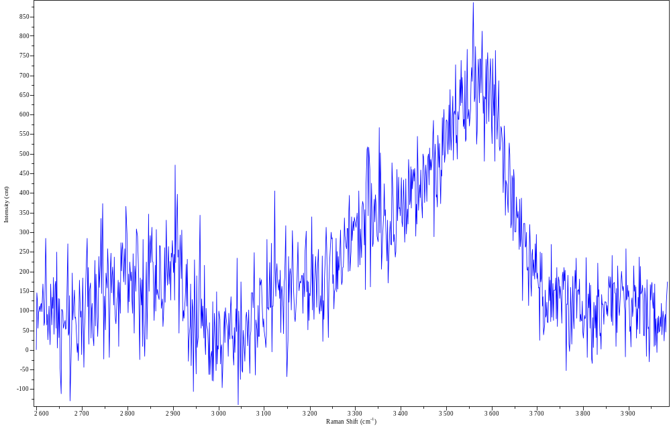
Figure C1. Raman spectrum of a glass with 2 wt. % H₂O with low fluorescence background signal.

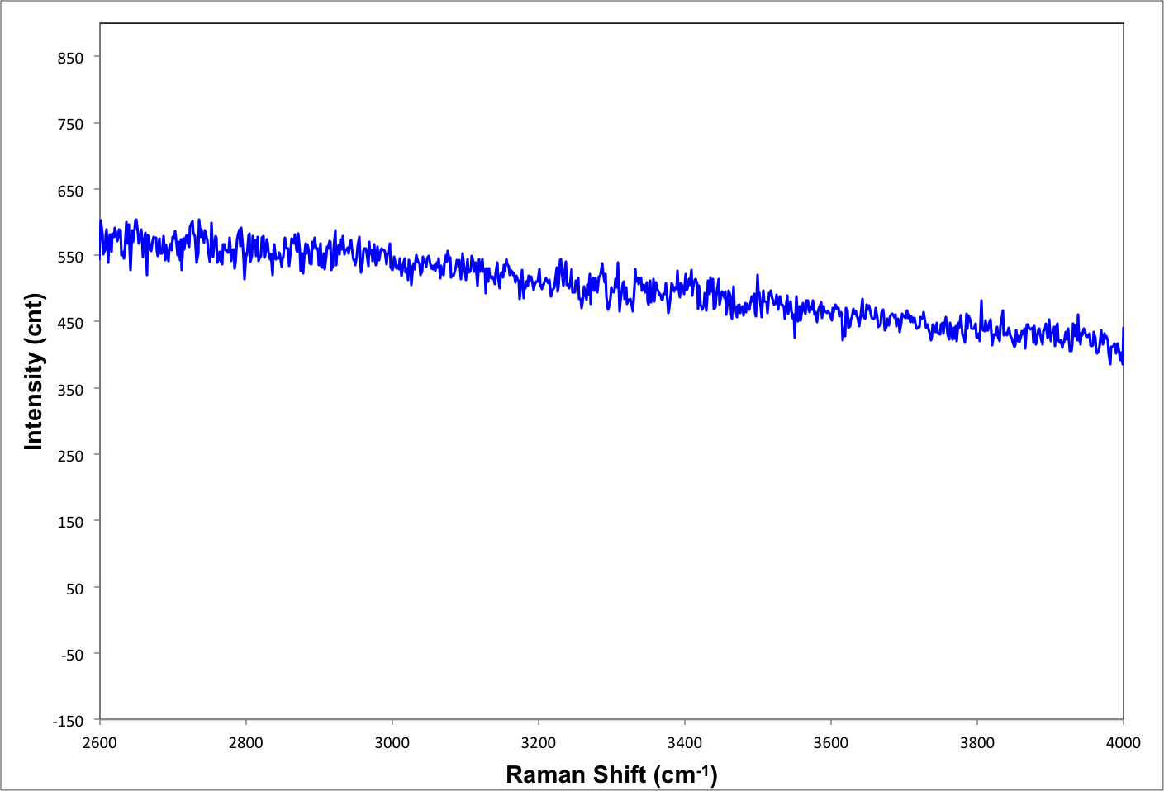
Figure C2. Raman spectrum of glass from Clast mIM with high fluorescence background signal.

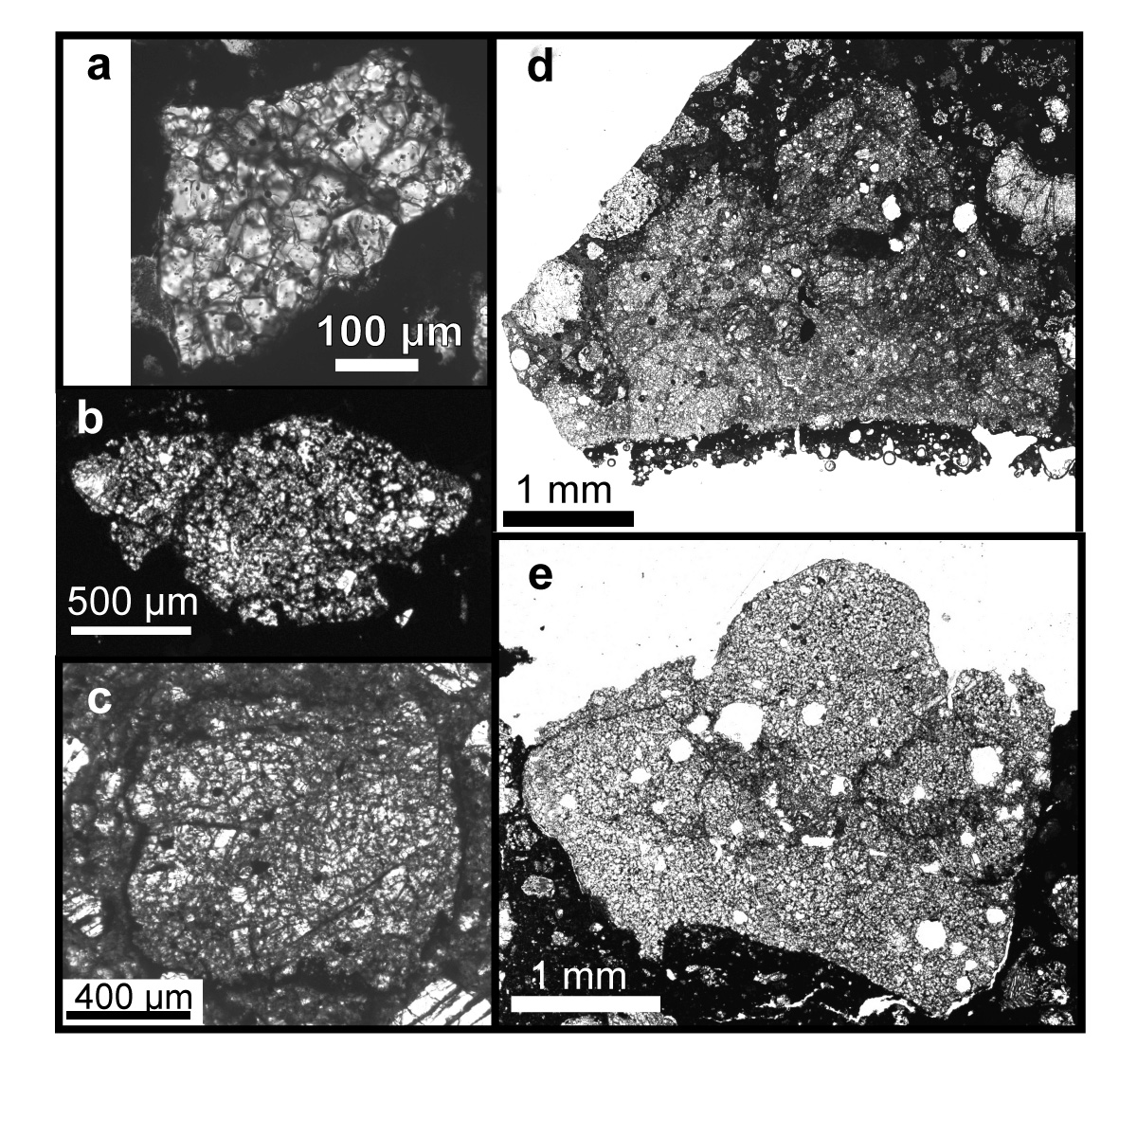
Figure C3. Plane polarized light images of impact melt clasts. (a) Clast A in LAR 06317,11. (b) Clast C in LAR 06317,2. (c) Clast mIM in GRO 95574,17. (d) Clast Z in RBT 04143,2. (e) Clast B in LAR 06317,2.

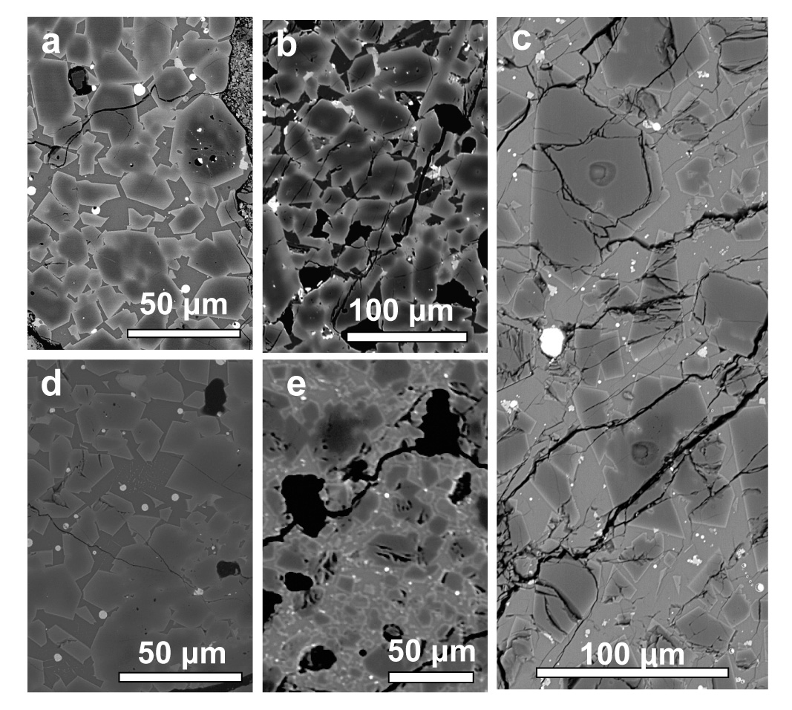
Figure C4. Backscatter electron (BSE) images of melt clast textures. All clasts contain zoned equant microphenocrysts of olivine with Mg-rich (black-dark gray) cores and more Fe-rich (lighter) rims. FeNiS globules/grains are white in all of these images. Accessory intergranular zoned chromite (light grays) are visible in images a, b, and c. (a) Clast A in LAR 06317,11; the fragmental contact between this clast and its host meteorite is visible on the right side of this image. (b) Clast B in LAR 06317,2. (c) Clast mIM in GRO 95574,17 in this image 2 SIMS spots are visible. The upper spot is on the core of an olivine grain that texturally grew out of the melt. The lower spot is on Mg-rich olivine relict core, which is dark in BSE. (d) Clast B in LAR 06317,2. (e) Clast Z in RBT 04143,2; several vesicles (black) with sinuously curved edges are visible in this image.

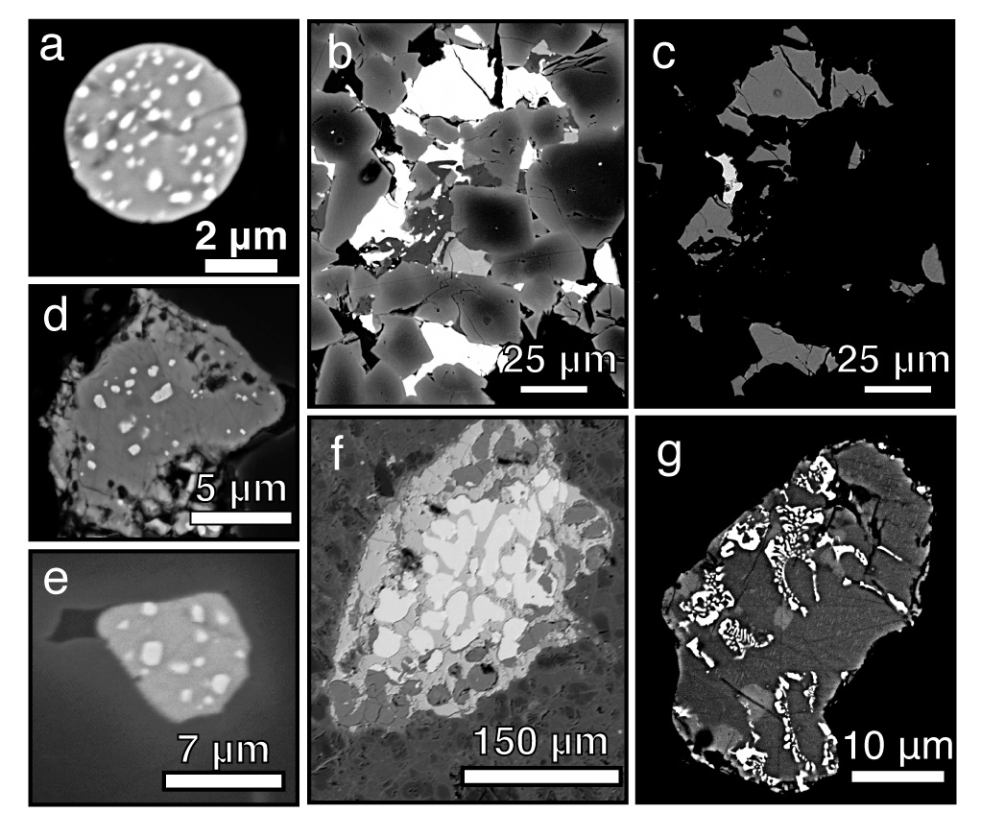
Figure C5. Backscatter electron (BSE) images of FeNiS globules or grains in (a) Clast A in LAR 06317,11; white corresponds to the FeNi metal and medium gray is pyrrhotite monosulfide solid solution (MSS). (b) Clast B in LAR 06317,2; white corresponds to the metal and sulfide grains. (c) Same field of view of Clast B in LAR 06317,2; white corresponds to the FeNi metal and medium gray is pyrrhotite MSS. (d) Clast B in LAR 06317,2; white corresponds to the FeNi metal, dark gray is pyrrhotite MSS, and medium-lighter gray is Ni-rich sulfide. (e) Clast B in LAR 06317,2; white corresponds to the FeNi metal, light gray is pyrrhotite MSS, and dark grays are surrounding zoned olivines. (f) Clast Z in RBT 04143,2; white corresponds to the FeNi metal, dark gray is pyrrhotite MSS, and medium-lighter gray in the globule is Fe-oxides that likely formed from terrestrial weathering. (g) Clast mIM in GRO 95574,14; white corresponds to the FeNi metal, dark gray is pyrrhotite MSS, and medium-lighter gray is pentlandite.

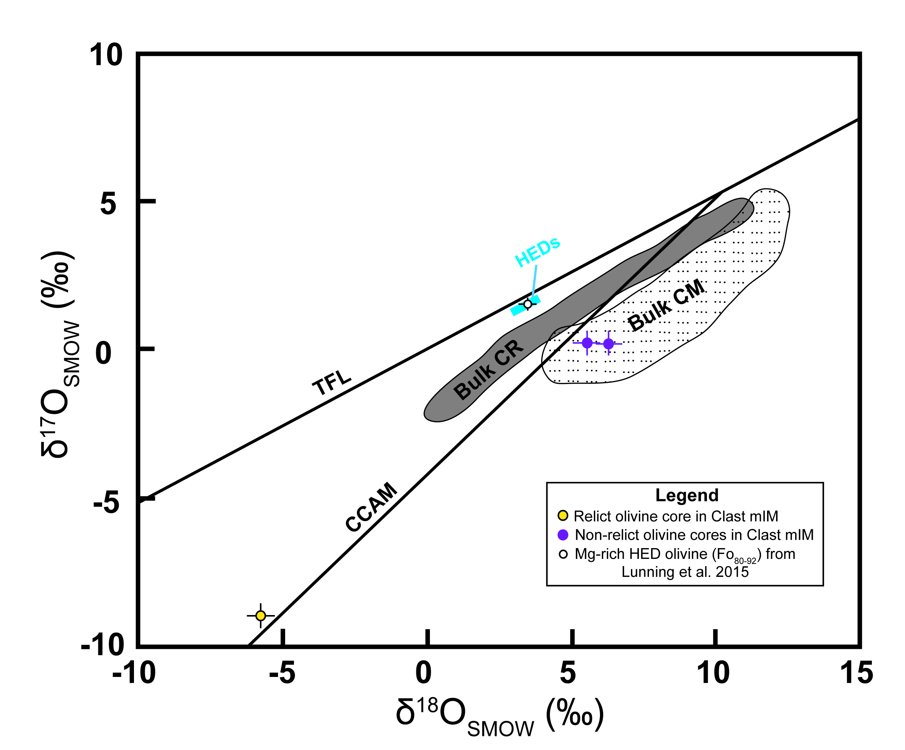
Figure C6. Oxygen three-isotope plot of olivine in Clast mIM in the regolithic howardite GRO 95574,17. The bulk HED field includes the eucrite fractionation line and bulk HED analyses, representing Vesta. TFL refers to the terrestrial fractionation line. CCAM refers to the carbonaceous chondrite anhydrous mineral line. Bulk CR and Bulk CM fields refer to bulk analyses of CR chondrites and CM chondrites, respectively. Oxygen three-isotope compositions of meteorite groups are from Krot et al. 2006 and references therein.

Conclusion

Asteroidal meteorites, including those studied in my dissertation, are geologic samples from the early solar system. In my dissertation research, I used petrological and geochemical techniques of asteroidal meteorite samples to investigate how the earliest protoplanetary bodies formed and evolved. I focused on howardites, which are brecciated samples of a differentiated parent body (thought to be the asteroid 4 Vesta), and CV chondrites, which are primitive chondrites that have not undergone differentiation on their parent body.
By investigating petrology and pairing of regolithic (solar wind-rich) howardites found in the Grosvenor Mountains in Antarctica, I found that mature surface regolith of asteroid 4 Vesta may be depleted in plagioclase. I established that four of these meteorites are a pairing group: portions of one larger pre-atmospheric transit meteoroid. These analogs for the surface regolith of Vesta provide evidence that the vestan surface regolith is assembled from a range of diverse source materials ( > 18 basaltic and ultramafic lithologies). Additionally, the abundance of plagioclase in these howardites is depleted relative to unbrecciated plagioclase-bearing source lithologies. These depletion of plagioclase may be explained by the fact that plagioclase is preferentially comminuted by impact gardening. The extent of plagioclase depletion in solar wind-rich howardites may be an indicator of regolith maturity.
The howardites I studied contain low modal abundances of fragments of Mg-rich olivine and pyroxene. I suggested based on geochemical evidence that these mineral fragments are the first recognized mantle samples from Vesta. These mineral fragments contain chemical signatures more consistent with formation in a partial melted mantle rather than a whole-mantle magma ocean. Identification and examination of mantle samples, even as fragments in regolithic breccia, is important because mantle material from differentiated meteorite parent bodies are lacking in meteorite collections. Additionally, the REE signatures of the Mg-rich pyroxene fragments contribute data regarding the way in which Vesta differentiated. These REE signatures suggest there was small amounts of trapped Al-rich melts in Vesta’s mantle, which is more consistent with differentiation by partially melting, rather than differentiation facilitated by a whole-mantle magma ocean.
I identified and studied impact melt clasts derived from primitive chondrite precursors (CV and CM chondrites), in a regolithic howardite and two CV chondrites. My work demonstrates that impact melts can form from CV and CM chondrites. Prior to my work, it had been posited that impact melts might not form from these meteorites because their volatile chemical components might explosively disrupt the formation of melt. Additionally, I found the impact melts that form these precursors experienced some volatile loss, but they retain the general redox state trends of their precursors.

VITA

Nicole Gabriel Lunning was born September 22, 1982 in Minneapolis, Minnesota, USA, where she grew up with her four siblings and attended Minneapolis Public Schools. Nicole’s interest in geology was first sparked by her high school AP biology teacher, Mr. Jim Doty, who organized a number of geology-biology camping field trips. These trips exposed Nicole to a smorgasbord of Minnesota geology ranging from the Sioux quartzite in western Minnesota, Morton gneiss in southern Minnesota, pillow basalts and rhyolite palisades along the north shore of Lake Superior, and numerous glacially derived landforms throughout the state.
For college, Nicole attended the University of Chicago where she concentrated in geophysical sciences, which included geology. Through endowed field courses, the University of Chicago Department of Geophysical Sciences gave Nicole the opportunity to expand her geologic experience beyond the Midwestern U.S. on field courses to Italy, Mexico, the Bahamas, California, and Montana. The University of Chicago challenged Nicole intellectually and laid the groundwork for her career in academia. For her Master’s Degree in Geology, Nicole attended the University of California, Davis. During her Master’s research on Holocene peat deposits, Nicole developed research and project planning skills that have helped her thrive in subsequent endeavors.
After her Master’s degree, she was hired on a three-month contract as support staff in the Division of Meteorites at the Smithsonian Institution, where she discovered a passion for meteorite petrology and ultimately worked for two years. To feed and further this passion for meteorite petrology, Nicole embarked on a PhD at the University of Tennessee, Knoxville in 2012 under the direction of Hap McSween. While at the University of Tennessee, she taught planetary geology and physical geology to students from all disciplines, and taught mineralogy and petrology to geology majors. Nicole has presented her PhD research at international conferences. Upon completion of her dissertation, Nicole has been awarded a Smithsonian-Peter Buck Postdoctoral Fellowship to conduct petrologic melting experiments to examine differentiation of oxidized parent bodies.

