GIVEN TO THIS LAND:
MAPPING SETTLER COLONIALISM IN KITUWAH, 1682-1810

A Dissertation Presented for the
Doctor of Philosophy
Degree
The University of Tennessee, Knoxville

Casey L. Price
May 2025

DEDICATION
For Dr. Price
ACKNOWLEDGEMENTS
My favorite part of constructing this dissertation project has been learning from the people who helped me bring it to fruition. Christopher Magra took me under his wing and provided me with steady guidance from the day I stepped onto campus through the completion of this project. I look forward to many years of receiving his wisdom. Brooke Bauer joined my committee weeks after taking a position at UTK. She immediately influenced my project and my approach to historical scholarship. Kristen Block has been a powerful ally in my scholastic journey. UTK faculty members Derek Alderman, Nikki Eggers, Ernie Freeberg, and Tore Olsson have all profoundly influenced my scholarship. Thank all of you for everything you have done for me.
I could not have completed this project without the support of generous institutions that funded my research. I would like to thank the National Endowment for the Humanities and the Newberry Library, The Filson Historical Society, The William Clements Library, The John Carter Brown Library, The Library Company of Philadelphia, and the Pennsylvania Historical Society. I would also like to thank the North Caroliniana Society, the American Philosophical Society, the Omohundro Institute, FEEGI, the UTK Center for the Study of War and Society, the University of Tennessee Denbo Humanities Center, and the UTK College of Arts and Sciences.
Several archivists, curators, and librarians went above and beyond to help me in my research. Thank you to Jim Akerman, Mary Pedley, Mark Armstrong, Valerie Andrews, Kimberly Nusco, Bertie Mandelblatt, and Patrick Lewis. All of you made my time at your archives an enriching experience that forwarded my project and made my time productive and enjoyable. Thank you.
A special thank you to my friends and colleagues at the University of Tennessee. Stacie Beach, Kyle Vratarich, Camron Murray, Jeff Saba, and Morgan Hardy. Thank you all for the enlightening discussions and encouragement along the way. Thank you to Alyssa Culp for your encouragement and direction and for taking the time to share your witty and professional expertise. More than anyone, Kaitlin Simpson gave me a steady and encouraging voice that helped me grow as a scholar. You are awesome, and I am glad to call you my friend.
My family was gracious enough to survive without me for several extended fellowships. Thank you to my kids for being kids. Taking you to dance and basketball was often a welcome reprieve from my laptop. To my wife, Dr. Jamie Price, thank you for letting me take a decade to pursue my dream. But the one that started it all was the original Dr. Price, my mother. Thank you for your unwavering support. We did it.
ABSTRACT
Seventeenth- and eighteenth-century maps of the Cherokee homelands in the Southern Appalachian Mountains spanning present-day Western North Carolina, Eastern Tennessee, Northwest South Carolina, and Northwestern Georgia documented and facilitated European settler colonialism’s accretion in the region. I argue that from the 1750s until the early nineteenth century, ecological destruction resulting from the invasion of settler populations from British colonies and eventually the U.S., who established plantation-style agriculture, drove changes in the Cherokee’s agricultural practices, social connections, and cultural identity directly tied to an incremental land loss of nearly all of their vital spaces. The deracination of Cherokees from their agriscapes and cultural anchors proved significantly more transformative than more overt forms of European conquest in the Cherokee homelands.
My project helps define settler colonialism by demonstrating it is a collective substantiation of land tenure by individual colonizers entrenching on Indigenous lands. My dissertation uses maps as primary source material to detail the entrenchment of European settler colonialism in the Cherokee homelands during the eighteenth century. Early modern European maps were meant for European audiences, but they were more than European productions. Diverse groups of people contributed to colonial cartography. Indigenous communities provided Euro-American informants with geographic knowledge regarding regional hydrography and topography. European mapmakers repurposed Indigenous geographic knowledge of the land to market land speculators’ claims. Indigenous nomenclature for areas with good fishing waters and rich hunting grounds became Baroque royal fantasies, such as Jamestown and Charleston, to attract European buyers. Maps empowered land brokers and enticed settlers to occupy interior territories permanently. Collectively, these groups’ activities would diminish the land’s viability for Cherokee agrarian practices. Maps demonstrate that Cherokees developed multiple strategies for combating colonial entrenchment. As a series of larger-scale maps of the Keowee frontier region reveal, Cherokee women became a source for preserving Cherokee land tenure amongst the destructive environment of colonial agriculture. Cherokees employed their hand-drawn 1785 [Cherokee Map of their Territory] to assert their territorial sovereignty. However, by the final decades of the eighteenth century, every territorial facet of the Cherokee homelands became an untenable amalgamation. Maps from the early nineteenth century that confidently display solidified state boundaries and neat integration of Cherokee towns into the Euro-American landscape belie the enduring battle within.

Table of Contents
PROLOGUE 1
INTRODUCTION 4
CHAPTER ONE: INDIGENOUS SPATIAL EPISTEMOLOGIES SHAPE EARLY AMERICA AND THE ATLANTIC WORLD 24
Show Me the Money: Early Spanish and French Maps of the Native Southeast 30
What Your Land Might Provide Us: Mapping Indigenous Coalescent Responses onto English and French Colonial Aspirations 45
The British are Coming: Mapping British Colonialism in the Native South 69
Conclusion 77
CHAPTER 2: ᎠᏇᏅᎡᎢ Ꭶ ᎠᎾᎴᏂᏍᎬ AQUENVSVI GA YANALENISGV (HOME SINCE THE BEGINNING) THE ᏣᎳᎩ (CHEROKEE) HOMELANDS TO 1755 79
Deep and Diverse Connections 82
Emergent Stories 83
Migration Stories 85
Mapping Cherokee Coalescence 87
Tied to the ᎦᏙᎯ ᏄᏍᏗᏓᏅ gadohi nusdidanv (landscape) 102
Mapping ᏣᎳᎩ Cultural Connections 109
Conclusion 118
CHAPTER 3: ROOTED IN THE LAND: CHEROKEE AGRISCAPES 119
Cherokee Domestic Agricultural Spaces 123
Cherokee Commercial Agricultural Spaces 136
Cherokee Agricultural Spaces’ Susceptibility to Colonial Entrenchment 149
Conclusion 156
CHAPTER 4: COMMODIFYING CHEROKEE GEOGRAPHY 158
Mapping Cherokee Geopolitics 164
Mapping Collective Entrenchment on the Keowee Frontier 183
Mapping Colonial Entrenchment on the Long Island Frontier 188
Conclusion 205
CHAPTER 5: SUBSTANTIATING AND COMBATING ENTRENCHMENT 206
Investing in Entrenchment 211
Self-Substantiation of Sovereignty 224
It’s A Woman’s World: Cherokee Strategies to Retain Land 229
Conclusion 242
CHAPTER 6: RIVAL SOUTHERN GEOGRAPHIES 248
Entrenching on the Margin 251
Conducting Cartographic Diplomacy 255
The Business of Settler Colonialism 270
Contesting Boundaries 287
Conclusion 301
CONCLUSION 304
Settler Colonialism’s Modern Memorial Landscape: Substantiation and Resilience 310
BIBLIOGRAPHY 320
Primary Sources 320
Secondary Sources 325
VITA 358
LIST OF FIGURES
Figure 1 ᎩᏚᏩ giduwa (Kituwah), Cherokee Homelands 2
Figure 2 Daniel Smith, A Map of the Tennessee Government, 1795, https://teva.contentdm.oclc.org/digital/collection/p15138coll23/id/73/ 5
Figure 3 A Map of the British Empire in America with the French and Spanish Settlements adjacent thereto. by Henry Popple. C. Lempriere inv. & del. B Baron Sculp. To the Queen’s Most Excellent Majesty This Map is most humbly Inscribed by Your Majesty’s most Dutiful, most Obedient, and most Humble Servant Henry Popple. London Engrav’d by Willm. Henry Toms & R.W. Seale, 1733. 13
Figure 4 Dressée sur les relations et mémoires du pere Hannepin et de Mrs. de La Salle, Tonti, Laotan, Ioustel,... Creator Fer, Nicolas de, 1646-1720. Publisher Chez Benard Isle du Palais, 1718. https://collections.newberry.org/asset-management/2KXJ8ZSSE0YVE 14
Figure 5 [Daniel Smith Land Survey on the Cumberland River in Davidson County, dated December 19, 1792] 18
Figure 6: Jolliet, L. & Marquette, J. (1673) Map of the New Discovery Made by the Jesuit Fathers in and Continued by Father Jacques Marquette, from the Same Group, Accompanied by a Few Frenchmen in the Year 1673, Named “Manitounie.”[Place of Publication Not Identified: Publisher Not Identified] [Map] Retrieved from the Library of Congress. https://www.loc.gov/item/2021668635 26
Figure 7 Guillaum Le Testu (1555), Cosmographie universelle, selon les navigateurs tant anciens que modernes / par Guillaume Le Testu, pillotte en la mer du Ponent, de la ville francoyse de Grâce p.118, Service historique de la Défense, D.1.Z14, Bibliothèque nationale de France, https://gallica.bnf.fr/ark:/12148/btv1b8447838j/f110.item# 31
Figure 8 The “De Soto Map” Santa Cruz, Alonso De, and Archivo General De Indias. Mapa del Golfo y costa de la Nueva España: desde el Río de Panuco hasta el cabo de Santa Elena. [? 1572] Map. https://www.loc.gov/item/2003623374 33
Figure 9 Upper right: “Ortelius-Chiaves Map” La Florida. Auctore Hieron Chiaves. In Theatre de l'univers, contenant les cartes de tout le monde [1598], Ortelius, Abraham, following p. 9. https://jcb.lunaimaging.com/luna/servlet/s/8735g5 37
Figure 10 Gabriel Tatton and Benjamin Wright. Nova et rece terraum et regnorum Californae, nouae Hispaiae Mexicanae et Peruviae.[S.l 1600] Map. https://www.loc.gov/item/99446134/. 39
Figure 11 Jacques Le Moyne De Morgues, Floridae Americae provinciae recens & exactissima descriptio auctorè Iacobo le Moyne cui cognomen de Morgues, qui Laudōnierum, altera Gallorum in eam prouinciam nauigatione comitat est, atque adhibitis aliquot militibus ob pericula, regionis illius interiora & maritima diligentissimè lustrauit, & exactissimè dimensus est, obseruata etiam singulorum fluminum inter se distantia, ut ipsemet redux Carolo .IX. Galliarum regi, demonstrauit. [S.l.: s.n, 1591] Map. https://www.loc.gov/item/2003623393/. 41
Figure 12 The Mercator-Hondius Map, Jodocus Hondius, Lionel Pincus and Princess Firyal Map Division, The New York Public Library. “Virginiae item et Floridae Americae provinciarum, nova descriptio.” New York Public Library Digital, https://digitalcollections.nypl.org/items/510d47da-ef5f-a3d9-e040-e00a18064a99 . 44
Figure 13 “Lederer’s Map,” (1672), In The discoveries of John Lederer: in three several marches from Virginia to the west of Carolina, and other parts of the continent: begun in March 1669, and ended in September 1670. Together with a general map of the whole territory which he traversed, Beinecke Rare Book and Manuscript Library, Yale, https://collections.library.yale.edu/catalog/2000250 46
Figure 14 “The Ogilby-Moxon Map, (1672), John Ogilby and James Moxon, A New Description of Carolina by the order of the Lords Proprietors, Digital Collections, University of North Carolina at Chapel Hill, https://dc.lib.unc.edu/cdm/ref/collection/ncmaps/id/498 50
Figure 15 Joel Gascoyne, A new map of the country of Carolina with its rivers, harbors, plantations and other accomodations don from the latest surveighs and best information by order of the Lords Proprietors, John Carter Brown Library https://jcb.lunaimaging.com/luna/servlet/s/80m9q5 53
Figure 16 Inset on Gascoyne’s map showing the erasure of “Wadwad Malow” 56
Figure 17 Marquette Map Inset 60
Figure 18 L'Isle, G. D. & Simonneau, C. (1703) Carte du Mexique et de la Floride des Terres Angloises et des Isles Antilles: du cours et des environs de la Riviere de Mississipi sic, dressée sur ungrand nombre de memoires principalemt. sur ceux de M.rs d'Iberville et le Sueur. Paris: Chez l'auteur sur le Quai de l'Horloge. [Map] Retrieved from the Library of Congress, https://www.loc.gov/item/99446135/. 62
Figure 19 L'Isle, Guillaume de, 1675-1726. “Carte des environs du Mississippi.” 1701. https://dlg.usg.edu/record/guan_hmap_hmap1701d4#item 66
Figure 20 L'Isle, Guillaume De. Carte de la Louisiane et du cours du Mississipi i.e. Mississippi: dressée sur un grand nombre de mémoires entrautres sur ceux de Mr. le Maire. Paris: Chez l'auteur le Sr. Delisle sur le quay de l'horloge avec privilege du roy, 1718. Map. https://www.loc.gov/item/2001624908/ 67
Figure 21 “Nairne Map” in the upper left: Crisp, Edw, Thomas Nairne, John Harris, Maurice Mathews, and John Love. A compleat description of the province of Carolina in 3 parts: 1st, the improved part from the surveys of Maurice Mathews & Mr. John Love: 2ly, the west part by Capt. Tho. Nairn: 3ly, a chart of the coast from Virginia to Cape Florida. [London: Edw. Crisp, ?, 1711] Map. https://www.loc.gov/item/2004626926/. 71
Figure 22 “The Barnwell-Hammerton Map”, Hammerton, William, -1732, Map of the southeastern part of North America., 1721., Yale Center for British Art, Gift of the Acorn Foundation, Inc., Alexander O. Vietor, Yale BA 1936, President, in honor of Paul Mellon. https://collections.britishart.yale.edu/catalog/orbis:9600894 73
Figure 23 Mitchell, John, Thomas Kitchin, and Andrew Millar. A map of the British and French dominions in North America, with the roads, distances, limits, and extent of the settlements, humbly inscribed to the Right Honourable the Earl of Halifax, and the other Right Honourable the Lords Commissioners for Trade & Plantations. [London; Sold by And: Millar, 1755] Map. https://www.loc.gov/item/74693173/. 76
Figure 24 Inset: Jolliet, L. & Marquette, J. (1673) Map of the New Discovery Made by the Jesuit Fathers in and Continued by Father Jacques Marquette, from the Same Group, Accompanied by a Few Frenchmen in the Year 1673, Named “Manitounie .”[Place of Publication Not Identified: Publisher Not Identified] [Map] Retrieved from the Library of Congress. https://www.loc.gov/item/2021668635 89
Figure 25 Inset: Franquelin, Jean Baptiste Louis, [S.l, 1896-1901], Carte de la Louisiane ou des voyages du Sr. De La Salle, from the original, 1684, Harvard University Library. http://hdl.loc.gov/loc.gmd/g3300.ct000656 90
Figure 26 Inset: L'Isle, Guillaume d, 1701: Carte des environs du Missisipi par G. de L'Isle Geogr. Donné par Mr. d'Iberville en 1701. 96
Figure 27 L'Isle, Guillaume de, 1702: Carte du Canada et du Mississipi. 97
Figure 28 L'Isle, Guillaume de, 1718 Carte de la Louisiane et du cours du Mississipi 99
Figure 29 Inset: The Barnwell-Hammerton Map, Hammerton, William, -1732, Map of the southeastern part of North America., 1721., Yale Center for British Art, Gift of the Acorn Foundation, Inc., Alexander O. Vietor, Yale BA 1936, President, in honor of Paul Mellon. https://collections.britishart.yale.edu/catalog/orbis:9600894 101
Figure 30 Inset from Barnwell-Hammerton Map 113
Figure 31 “George Haige Map,” 1752, Fac, Newberry Library, Kings Collection, Sheet 5, British Library. 116
Figure 32 George Hurbert, 1730 Hunter, George, -1755. George Hunter's map of the Cherokee country and the path thereto in 1730. 1917. Retrieved from the Digital Public Library of America, http://digital.tcl.sc.edu/cdm/ref/collection/sclmaps/id/2294 117
Figure 33 Gascoyne, Joel, A new map of the country of Carolina. Inset. 1682. Library of Congress Geography and Map Division Washington, D.C. https://lccn.loc.gov/99446166. 124
Figure 34 Cherokee domestic agricultural spaces. Recreation of Cherokee town surrounded by agriscapes, small fields near the town with larger fields and pastures in the distance, ChatGTP. 126
Figure 35 Soil Map Sikora, F.J., and Moore, K.P. (2014) Soil Test Methods from the Southeastern United States. 130
Figure 36 A recreation of Cherokee commercial agriscapes with fields for multiple cultigens, designed spaces for deer herds, and fires for clearing other pastures. Note the strawberry fields on the left with the road running through them, ChatGPT. 139
Figure 37 Crisp, Edw., 1711, A compleat description of the province of Carolina in 3 parts: 1st, the improved part from the surveys of Maurice Mathews & Mr. John Love: 2ly, the west part by Capt. Tho. Nairn: 3ly, a chart of the coast from Virginia to Cape Florida, Library of Congress Geography and Map Division Washington, D.C. http://hdl.loc.gov/loc.gmd/g3870.ct001123 144
Figure 38 Contrast of Spaces on Crisp's Map, 1711, with plantation land on the left and hunting land on the right. 145
Figure 39 Contrasts on the 1721 Barnwell-Hammerton Map with Cherokee lands on the left and Piedmont areas on the right. 147
Figure 40 Timberland on the Barnwell-Hammerton Map replaced by Fertile Country on the Mitchell Map 148
Figure 41 Contrasts on Mouzon's Map 1775 with Cherokee towns on the left and South Carolina plantation on the right. 150
Figure 42 Mouzon Map Inset, 1775, showing the Cherokee-South Carolina Border. The white line is a fold in the map. 151
Figure 43 Example of an area adjacent to direct entrenchment undergoing ecological transformation. The tract is above the "Indian Boundary" line surrounding the Reedy River. Although topographically similar to other regions on the map, the area contains no textual references to mountains or the numerous swirl marks indicating rough terrain in the surrounding areas above and to the right. On [Mr. Wilkinsons plat of ye Cherekee country], ca. 1770s. https://quod.lib.umich.edu/w/wcl1ic/x-1832/wcl001923 154
Figure 44 Joshua Fry and Peter Jefferson, A map of the most inhabited part of Virginia containing the whole province of Maryland with part of Pensilvania, New Jersey and North Carolina, 1755. https://www.loc.gov/resource/g3880.ct000370/ 160
Figure 45 Jefferson-Fry Map insert. The toponyms “Cow Pasture” and “Tobacco Row” highlight agricultural opportunities while “Bordens” and “Irish Track” advertise successful entrenchment and beckon additional colonizers from a specific group. 161
Figure 46 “[Map of the area between Fort Loudon, Tennessee, and Kaskaskia, Illinois].”. https://quod.lib.umich.edu/w/wcl1ic/x-5529/wcl005606. In the digital collection William L. Clements Library Image Bank. William L. Clements Library, University of Michigan Library Digital Collections. 167
Figure 47 William De Brahm, The Plan and Profile of Fort Loudoun, 1757 172
Figure 48 Stuart, John, Grant, James, Amherst, Jeffery Amherst, Baron, and Royal United Services Institute for Defence and Security Studies. SKETCH OF THE CHEROKEE COUNTRY And March of the Troops Under the Command of Luet. Col. Grant to the Middle & Back Settlements, 1761. Map. Place of production not identified: John Stuart, 1760. Norman B. Leventhal Map & Education Center. https://collections.leventhalmap.org/search/commonwealth:hx11z2278 176
Figure 49 John Stuart, Map of the Cherokee Country 1761 178
Figure 50 John Stuart, Map of the Southern Indian District, 1764, Clements Library, Ann Arbor, MI 182
Figure 51 John Pickens, Boundary Line Between the Province of South Carolina and the Cherokee Indian Country, 1766. 189
Figure 52 Mitchell Map, inset, 1755 193
Figure 53 Robert de Vaugondy, Partie de l'Amerique Septentrionale, inset,1755 194
Figure 54 Lewis Evans, A general map of the middle British colonies, inset, 1755 195
Figure 55 De Brahm, A Map of the Southern Indian District, inset, 1766. 197
Figure 56 [Thomas Hutchins Map], ca.1766, Pennsylvania Historical Society 198
Figure 57 [The lands purchased at Fort Stanwix, and those which remain to be purchased of the Cherokees in order to secure peace] 1768. https://images.nationalarchives.gov.uk/asset/65546/ 200
Figure 58 John Donelson, [Plan of the Boundary Line Between the Colony of Virginia and the Cherokee Indians hunting grounds], 1771. 203
Figure 59 George Mercer, [Ohio Company Map], 1752 204
Figure 60 Romans, Bernard, A general map of the southern British colonies in America, London, Printed for R. Sayer and J. Bennett, map, chart, and print sellers, 1776. https://www.loc.gov/resource/g3870.ar139600/ 207
Figure 61[A Map to show the effect of the restriction of settlement placed upon Vandalia by order in council, August 14, 1772: Drawn June 1773], John Stuart, 1773. 212
Figure 62 The Petition of the Sundry Inhabitants of the Counties of Washington and Montgomery, 1774 214
Figure 63 John Stuart and Joseph Pursell, A Map of the Southern Indian District, 1775 216
Figure 64 A general map of the new settlement called Transilvania, 1776, https://exploreuk.uky.edu/catalog/xt751c1tgg78 218
Figure 65 Watauga Deed to James Robertson, 1775 221
Figure 66 [Daniel Smith Map], 1774, a note indicates Dr. Thomas Walker’s agent, Robert Doack’s knowledge of the area to the south. 222
Figure 67 James Cook, A Map of the Province of South Carolina, 1773. 230
Figure 68 [Mr. Wilkinson's Plat of ye Cherokee country]. https://quod.lib.umich.edu/w/wcl1ic/x-1832/wcl001923 233
Figure 69 Patrick Colhoun, [Map of lands on the Saluda River], 1770 234
Figure 70 [Part of the modern counties of Oconee, Pickens, Anderson, and Greenville], ca1777, https://quod.lib.umich.edu/w/wcl1ic/x-8317/wcl008386 238
Figure 71 [A Map of the Lands Ceded by the Cherokee Indians to the State of South Carolina], ca 1777 239
Figure 72 [A Map of the Lands Ceded by the Cherokee Indians to the State of South Carolina], ca 1777, inset. The map’s legend indicates that the three marks represent an “Indian Settlement.” 240
Figure 73 Thomas Hutchins, A new map of the western parts of Virginia, Pennsylvania, Maryland, and North Carolina, 1778 https://www.loc.gov/resource/g3707o.ar078901/ 243
Figure 74 Joseph Purcell A New Map of the Southern District of North America, 1781. 245
Figure 75 William McMurray, The United States, according to the definitive treaty of peace signed at Paris, Septr. 3d. 1783 ... by Wm. McMurray, late asst. geogr. to the US, 1784. https://jcb.lunaimaging.com/luna/servlet/s/8505pn 256
Figure 76 [Cherokee Map], 1785 in The American State Papers Vol. II, p.40 261
Figure 77 Barnwell-Hammerton Map Inset, 1721 with “a large branch of the Missicipi” along the Tennessee River. 262
Figure 78 [Hunter Map] inset, 1730 263
Figure 79 [Kitchin Map], inset, 1760 264
Figure 80 A decolonized rendition of the 1785 Cherokee map drawn at the Hopewell Conference 266
Figure 81 Joseph Purcell, Map of the States of Virginia, North Carolina, South Carolina, and Georgia, 1788, published by Jedidiah Morse, in The American Geography,1789 274
Figure 82 [Innes Map] 1791, Newberry 277
Figure 83 William Fadden, The United States of North America with the British Territories and those of Spain, 1793 280
Figure 84 Thomas Kitchin, A New Map of North America, with the West India Islands, 1794 281
Figure 85 John Russell, Map of the six southern states (Maryland, Virginia, Kentucky, North Carolina, South Carolina, Georgia) plus the Tennessee Government, 1795. 282
Figure 86 Daniel Smith, Map of the Tennassee Government, published in Cary's American Atlas, 1795 284
Figure 87 Table from A Short Description of the State of Tennessee, 1795 286
Figure 88 Abraham Swagerty Survey, 1793 291
Figure 89 Blount County Survey, 1807 UTK Special Collections 294
Figure 90 Plan of Knoxville, UTK Special Collections, 1791 297
Figure 91 Tennessee. Lewis, Samuel, Drawn by S. Lewis. Engraved by Lawson. (Published by John Conrad & Co., Philadelphia. 1804) in A new and elegant general atlas, comprising all the new discoveries, to the present time, Aaron Arrowsmith. https://www.davidrumsey.com/luna/servlet/s/en6lgb 299
Figure 92 C.C. Royce, Map of the former Territorial Limits of the Cherokee Nation, 1884 303
Figure 93 Noquisiyi Mound, picture by author. 311
Figure 94 Article in the Goldsboro Daily Argus, Goldsboro, North Carolina, Sep 17, 1909 313
Figure 95 Undated photo of Jesse Duncan Memorial, Tennessee State Library and Archives 314
Figure 96 Jesse Duncan historical road marker at the intersection of Hwy 36 and Boone’s Creek Road, Johnson City, TN. 315
Figure 97 A damaged Duncan Memorial at the terminal roundabout. Note that the house is being constructed on the actual gravesites. Photograph by author. 317
Figure 98 Entrance facade at Duncan’s Retreat community, Johnson City, TN, photograph by author. 318

PROLOGUE
I remember a feeling of exuberant anticipation on my way to visit ᎩᏚᏩ giduwa (Kituwah) for the first time. Figure 1 Throughout conducting research for this project I had seen the Cherokee’s mother town depicted on dozens of seventeenth- and eighteenth-century maps housed in prominent archives far from the majestic valley I drove toward on that hot summer day. On the drive, I pictured my experience unfolding somewhat like visiting a pilgrimage destination or holy landmark where overseers attend to the world’s most iconic cultural treasures. Would there be security? Interactive displays? Throngs of non-Native visitors and Cherokees marveling together at this sacred landscape? Would I have to pay for parking? When my GPS told me I had arrived, I looked left and peered down what looked like someone’s driveway, which crossed an old railroad track and led past an empty field across from a half-torn-down aircraft hangar. That moment reminded me that writing a historical project involving settler colonialism requires a fair amount of present tense to capture the modern iteration of an ongoing process that began nearly three hundred years ago.
The valley surrounding ᎩᏚᏩ giduwa (Kituwah) is gorgeous. I parked and walked around alone until I got to an old wooden fence that partially surrounds Kituwah’s mound. I took in the sights, sounds, and smells with reverence. As a non-Native scholar, I felt a sense of gratitude for being allowed to stand at such hallowed ground and anger at the prolonged desecration that had needlessly transpired. Although the mound once formed the centerpiece of a bustling town at the center of the Cherokee cultural world, colonizers’ plows have rendered the mound nearly imperceptible today. What a tragic way to visually confirm the physical manifestation of what

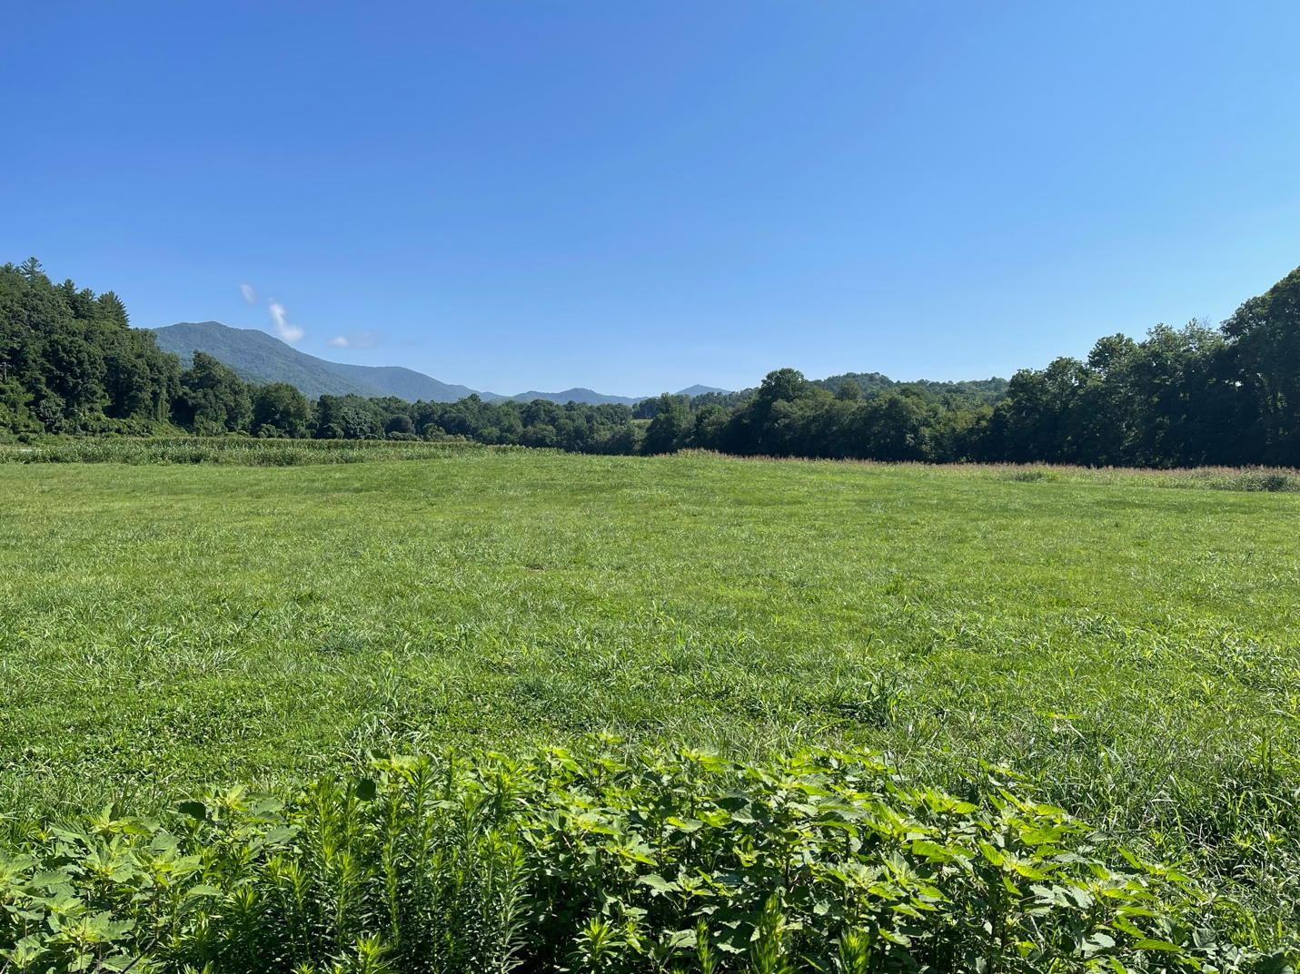
Figure 1 ᎩᏚᏩ giduwa (Kituwah), Cherokee Homelands

the archives revealed regarding the entrenchment of colonizers in the Cherokee homelands during the eighteenth century.
Make no mistake, many Cherokees still live in their original homelands. The Cherokee landscape enmeshed in the mountains and valleys remains a luminescent mosaic of cultural vibrancy, inexorably tied to the land for those willing and able to observe. The story of colonial entrenchment in the Cherokee homelands could be considered a biting declension narrative. However, to understand fully the work this study attempts to accomplish, the reader must realize that the story of Cherokees living in their homelands remains far from concluded. The Eastern Band of Cherokee Indians is thriving in a variety of ways. Current events regarding the interactions of Cherokees with entrenched colonial structures will comprise the material for future chapters to be written by future scholars. It is up to us how the story unfolds.

INTRODUCTION
In 1795, Daniel Smith produced the cartographic epitome of settler colonialism. Figure 2 Smith’s map represents a culmination of his pursuit of personal gain through substantiating his and his business colleagues’ land holdings on Indigenous lands. Smith and his influential buddies James Robertson and John Donelson entrenched near present-day Nashville, Tennessee, between 1779 and 1784, years before agreements with Cherokees would give any validation to usurping Cherokee territory. This was not their first trip. Smith and Donaldson had drawn maps from excursions in the early 1770s when they “discovered” areas they could claim. Smith participated in surveying the state military land grant reservation in the Cumberland Valley around areas of prior colonization in 1783 before moving his family to his 3,140-acre plantation the following year. Smith’s pattern of claiming land, establishing a plantation through enslaved labor, and then substantiating his tenure through marketing the area to other potential colonizers exemplifies the process of settler colonialism in the Cherokee homelands.
Like many other land speculators, Smith espoused several state apparatuses for personal gain. Smith represented the state of Virginia in extending the Virginia-North Carolina boundary in 1779 when he marked the border three miles south of North Carolina’s contingency, which included the notorious land speculator and North Carolina judge, Richard Henderson. Both men had economic and political interests that influenced their opinions of the border’s location. His fellow land speculators appointed Smith the commanding general of the Mero District Militia in 1788. In 1789 Smith wrote to the Spanish governor in New Orleans regarding talks to secure the area from Creek and Cherokee resistance. In 1790, George Washington appointed Smith the secretary of the Territory of the United States South of the River Ohio with authority to act
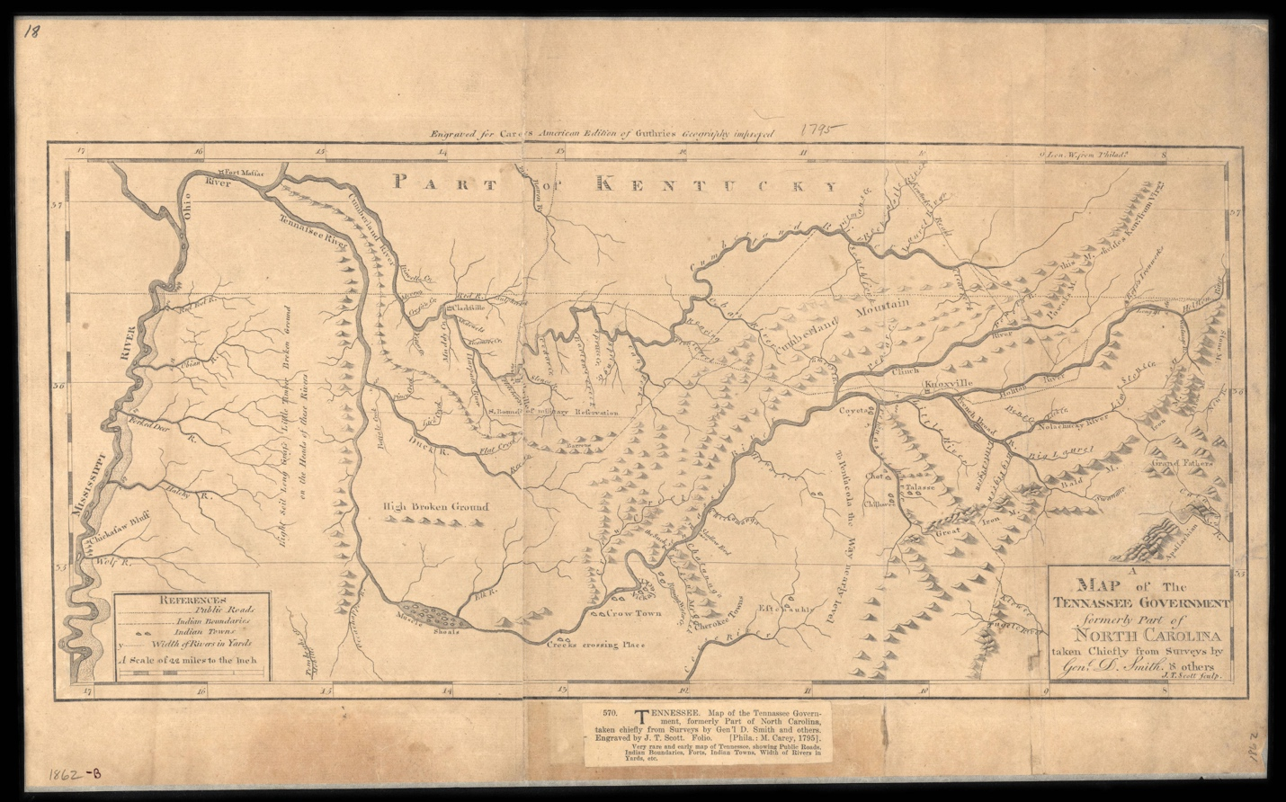
Figure 2 Daniel Smith, A Map of the Tennessee Government, 1795, https://teva.contentdm.oclc.org/digital/collection/p15138coll23/id/73/

for his friend and fellow land speculator William Blount as governor in Blount’s absence.
Once the two decided that inventing their own state seemed like the best course of action for substantiating their massive land claims, Smith and Blount included Smith’s map with A Short Description of the State of Tennessee published in Philadelphia by Mathew Carey meant to market colonization of the area. The map, with its fictitious rivers connecting vast alluvial areas to the trade markets of the Mississippi River, advertised land in the region as a valuable commodity. Following settler colonialism’s predominant element of substantiation of land tenure, Smith intended the map’s implied state boundaries and reduced Native presence to sell his new state’s stability as much as the land within its boundaries.
Settler colonial theory has developed several key tenants since its primary inception. Scholars have argued that colonists’ desire for “access to territory” over the extraction of resources and Indigenous labor forms a prominent element of settler colonialism that distinguishes it from other forms of colonialism. According to Patrick Wolfe, “territoriality is settler colonialism’s specific, irreducible element.” His mantra argues that settler colonialism forms a “structure” that employs a “logic of elimination” toward Indigenous people. Much of the scholarship regarding settler colonial theory focuses on how the logic of elimination functions and when and to whom the theory proves applicable. While nearly all scholars recognize settler colonialism as a historical phenomenon, many scholars argue over its usefulness as a theoretical tool. Refining settler colonialism’s basic tenets and presuppositions improves its scholarly capacity.
I argue that individual colonists’ collective substantiation of disputed land tenure defines settler colonialism. Settler colonialism was, and is, an abstract assertion that requires constant maintenance. Wolfe’s “logic of elimination” forms only one element in a colonizer’s multifaceted and evolving contestation against Indigenous peoples and other colonial competitors. The individualistic genesis of collective substantiation reveals settler colonialism’s foundational force, the market. And not just any market, but a specific market that makes locating settler colonialism geographically and temporally possible. Abstract commodification of land rights drives settler colonialism. Settler colonialism proves “relatively impervious to regime change” because governments only serve to buttress or weigh on the market value of land through perceived stability.
Scholarship regarding settler colonialism operates under the assumption that it is always associated with a polity, leading to a conflation between imperial or national studies and settler colonialism. However, this assumption flattens our understanding of settler colonialism’s economic and individualistic underpinnings. Entrenching individuals or collective groups of colonists did espouse imperial and national projects but only as an endorsement for their substantiation of land tenure. In the Cherokee homelands, individual colonists chose polities that reified their substantiation of land tenure and discarded them for another or formed their own when they became a hindrance. In settler colonialism’s structure, polities and empires remain fundamentally corollary to the substantiation of land tenure. Government authority represented a potentially powerful tool in the colonist’s kit but also a possible obstacle. Viewing settler colonialism as an individually derived constant assertion that is fundamentally divorced from national and imperial narratives removes the tendency to view its “structure” as fait accompli, allowing for the ongoing Indigenous resistance in combating substantiation of land tenure to retain its primacy in settler colonial studies.
All settler colonialism studies are concerned with governance and territoriality. Scholars have intently debated what separates settler colonialism from colonial studies in general. Most Early Americas scholars have situated their debates in identifying the differences between extensive imperial colonization projects by the French, British, and Spanish empires. Conflating imperial policy with determining settler colonialism’s applicability has led to a heavily Anglo-centric view of its place in North America.
However, imperial modes of colonization do not define settler colonialism; economic forces do. At times when colonizing empires viewed supporting trade endeavors and plantations in North America as a financial opportunity, corporate sponsorship of colonizers drove imperial links to resource-extraction-focused colonialization. In these cases, individuals needed no further justification for occupying a space because only imperial-level competition drove land claims. The “first Christian discoverer” of the region, the Crown, had given it an individual proprietor, and there was plenty of mineral wealth, land for commercial crops, or Indigenous trade partners to support the colonial endeavors. When competition for land intensified, requiring individuals to obtain and maintain access to the means of agricultural production regardless of imperial policies, a market for land developed in some areas within the ambit of European colonization. There is a reason it is difficult to find more than small pockets of settler colonialism in North America before the mid-18th century.
The moment the value of selling access to land outside of areas of previous colonization outstripped the value of what that region’s land could produce, settler colonialism was born. Settler colonialism does not depend on sovereignty, governance, or imperial territory acquisition. It was dependent on individuals collectively securing long-term access to land. This economic necessity sparks settler colonialism’s foundation: the substantiation of land tenure required to commodify land. The land market operated outside of state building projects. State-building projects in areas of colonial entrenchment functioned as an implement for individuals’ collective substantiation of land tenure.
The treaties in the last half of the eighteenth century between Cherokees and colonizers demonstrate how individual colonists’ collective substantiation of land tenure functioned outside imperial, national, and state projects. Scholars have interpreted the nuances of treaties between Cherokees and other Indigenous peoples differently. Early commentators viewed treaties as “opening Indian lands,” resulting in mass immigration of Euro-American colonizers. Many late twentieth-century scholars saw Indigenous-European treaties as an extreme power imbalance with Indigenous peoples compelled by violence or tricked into accepting detrimental terms that led to land cessions. More recently, scholarship has emphasized Indigenous agency by exploring Indigenous understandings and motives for participating in treaty conferences. However, nearly all the scholarship operates under two assumptions regarding treaty conferences: the colonists represented a polity, and the treaties resulted in colonists acquiring Indigenous land. Viewing settler colonialism as market-driven individual colonists’ collective substantiation of land tenure helps us better understand the nature of Indigenous-colonizer treaty conferences.
Every treaty between Cherokees and colonists in the second half of the eighteenth century represented an attempt at codification for individual groups of colonists’ previous physical or metaphorical entrenchment outside of official political sanction. In each case, Cherokees “ceded” land that colonists had already created provisional land deeds for and entrenched upon or adjacent to, commodifying the land for individual trade and ecologically transforming it, rendering the land outlined in the treaty useless for Cherokee farming. Colonial military invasions in 1760, 1761, and 1777 under the auspices of representing a colony, empire, or nation never resulted in a “conquest” of Cherokee territory. The treaties following these conflicts drew borders around areas already under colonial entrenchment.
Cherokees recognized treaties as tools of individual colonizers, ostensibly wielding government authority to forward their interests. The commissioners, promoting personal interests under the auspices of representing governments, had provisional land titles at stake in all cases. These elite colonizers sanctioned the land provisions in the treaties, or at times disputed them, for personal, economic, and political gain. At each treaty conference, Cherokees consistently requested to appeal to an overarching political authority they felt was responsible for restraining the entrenchment of individual groups of colonizers. Cherokees knew the clandestine mechanics of settler colonialism two hundred and fifty years before scholars began to study them as a field of inquiry. It makes sense that we look to them to understand better how settler colonialism works and how to combat it.
Scholars have identified the suppression of Indigenous agency as a primary critique of settler colonial theory. Jean M. O’Brien argues settler colonialism theory “offers us fewer explicit angles on the historicism of Indigenous resistance and survival.” J. Këhaulani Kauanui furthers that “indigeneity itself is enduring—that the operative logic of settler colonialism may be to “eliminate the native,” but that “indigenous peoples exist, resist, and persist,” to the degree that any study using settler colonial theory must also recognize that “settler colonialism is a structure that endures indigeneity, as it holds out against it.” In short, any narrative regarding colonial entrenchment must stay centered on the conflicting modes of invasion and resistance between Indigenous people and colonizers. Considering colonizers wrote and selectively archived nearly all of the written primary source material, including Cherokee perspectives, focusing on Cherokee land retention strategies requires implementing Indigenous Studies methodologies to interrogate colonial records in decolonized ways.
This study uses maps as the primary conduit for understanding settler colonialism’s entrenchment and the Cherokee’s strategies for retaining their homelands. Historians have spent the last forty years studying the ways in which maps and mapmakers facilitated the formation and maintenance of European Empires in the Atlantic World. Figure 3, Figure 4 The broad
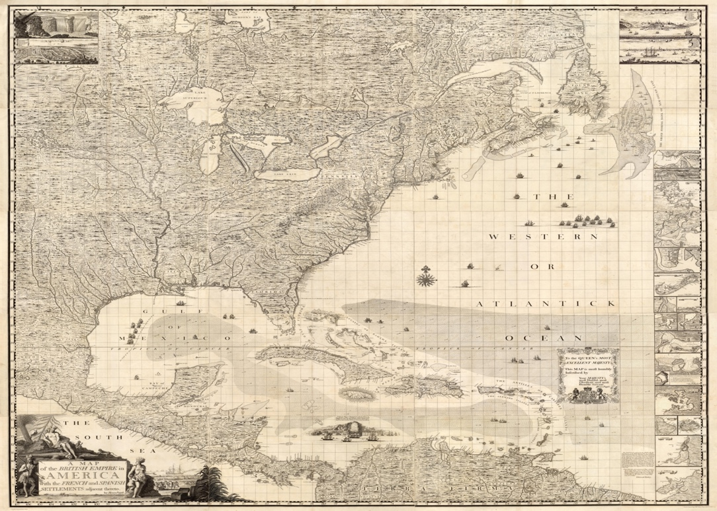
Figure 3 A Map of the British Empire in America with the French and Spanish Settlements adjacent thereto. by Henry Popple. C. Lempriere inv. & del. B Baron Sculp. To the Queen’s Most Excellent Majesty This Map is most humbly Inscribed by Your Majesty’s most Dutiful, most Obedient, and most Humble Servant Henry Popple. London Engrav’d by Willm. Henry Toms & R.W. Seale, 1733.

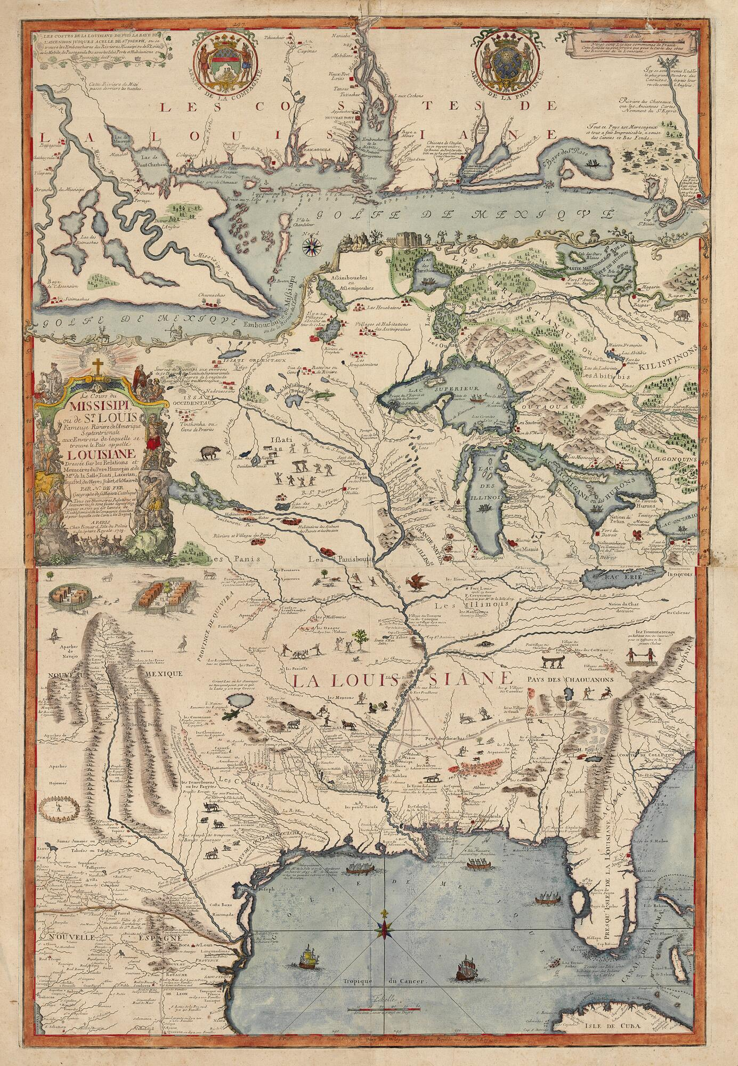
Figure 4 Dressée sur les relations et mémoires du pere Hannepin et de Mrs. de La Salle, Tonti, Laotan, Ioustel,... Creator Fer, Nicolas de, 1646-1720. Publisher Chez Benard Isle du Palais, 1718. https://collections.newberry.org/asset-management/2KXJ8ZSSE0YVE

imperial implications of maps have become an incontrovertible assumption in early American map studies. Historians have pointed to the realized impacts of surveys, maps, and geographical knowledge in imperial expansion. Administrators’ efforts to map America proved “profoundly empirical, as concerned about revealing the distinctive qualities of places as it was in creating generalized schemas.” According to this body of scholarship, mapping territory became a vital component for preempting and solidifying imperial expansion. However, early American maps reveal much more than imperial aspirations.
I argue that early American European maps represent Indigenous spatial epistemologies embedded within a cartographic rendering of a specific colonial moment. Scholars have traditionally separated Indigenous mapping into a separate category of study from European-
authored maps. Some scholars have hinted at Indigenous sources for European maps but have rarely investigated European maps as a form of Indigenous mapping. Obvert references in the colonial archives to Cherokee sources for geographical information on European-drawn maps remain scant but significant. Examining some elements of early American maps as fully Indigenous allows for broadening a decolonized lens to identify Cherokee geographic epistemologies and geopolitical worldviews on many more European-authored maps during the seventeenth and eighteenth centuries.
Early American maps’ colonial overlays represent the colonial moment in which mapmakers fashioned them. Maps drawn during the sixteenth century, when European empires sought wealth through mineral resources, imagined the Cherokee homelands as rich with gold and silver. As trade with the Southeast’s Indigenous peoples, including for enslaved Natives, became the focus of European empires, cartographers transformed Indigenous information regarding the Native South’s incredibly diverse and shifting Indigenous geopolitical landscape into fictional centralized polities with imagined limitless trade potential. In the mid-eighteenth century, mapmakers populated vast areas with indications of alluvial land ripe for entrenchment. By the late eighteenth century, maps promised land that appeared fit for agricultural development, connected to broad trade markets, and safely contained within secure colonized boundaries. More significantly, the maps representing commodifiable colonial spaces also caused colonizers to pursue entrenchment actively.
Maps that imagined colonial economic aspirations fostered colonial projects. Maps that had staked bold territorial claims of dominion and drew fictive boundaries evolved into tools for advertising entrenchment to colonizers and simultaneously providing evidence for substantiation of their land tenure. I use maps as primary source material to demonstrate the colonial substantiation of, and Cherokee strategies to combat, settler colonialism as it developed over the eighteenth century.
Maps now show, and during the last half of the eighteenth century, facilitated, the shift from imperial colonization projects to individual economically driven settler colonialism in the Southeast. In the seventeenth century, colonial investors, granted land by monarchs, included maps depicting utopian geography with treatises regarding the economic potential of the Southeast for emboldened clients. These maps often made brazen, if imagined, claims of dominion that depicted Indigenous land as foreign and divorced from colonizable space.
However, maps associated with settler colonialism commodified Indigenous land. By the mid-eighteenth century, land speculators had shrugged off government oversight and created maps in combination with their prospective land titles to sell land to colonizers for low to no capital investment profits. Figure 5 They espoused any government entity that would improve the market value of their prospective titles, even ones they invented themselves for that purpose. Land speculators turned political authorities used maps to convince colonizers to entrench on Indigenous lands with the promise that occupation could soon develop into a government-backed collective substantiation of their land tenure. Many maps that colonizers wielded contained Cherokee source material.

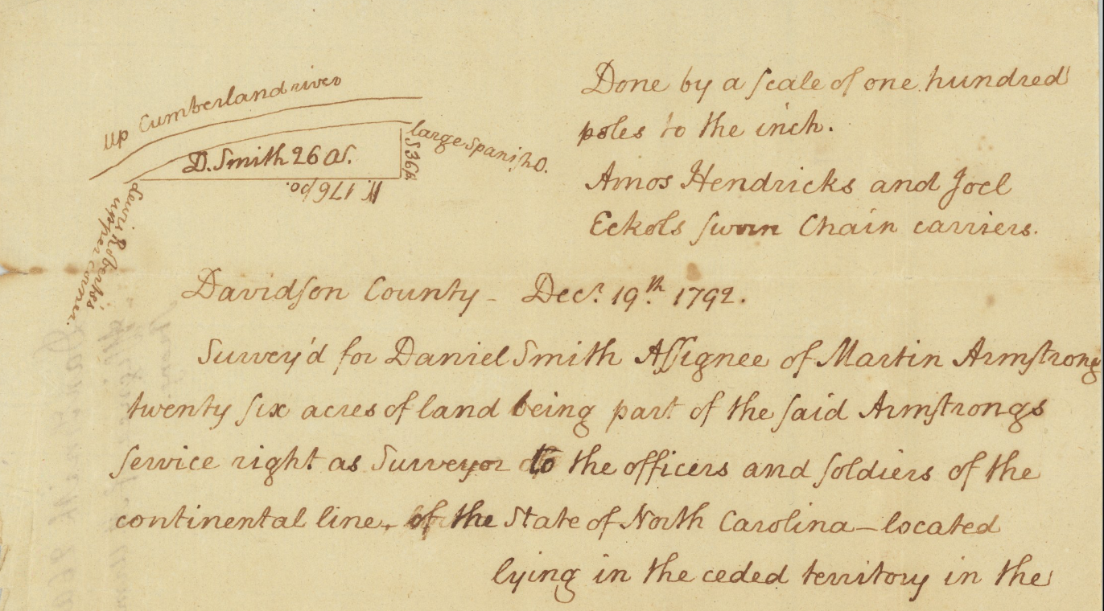
Figure 5 [Daniel Smith Land Survey on the Cumberland River in Davidson County, dated December 19, 1792]

Maps reveal the Cherokee’s cultural ties to their homelands and their strategies to retain them. Colonial records obscure the history of people with a rich oral tradition. However, Cherokee-sourced information on European-authored maps acts as a visual record of Cherokee spatial epistemologies, geopolitical awareness, and cultural ties to their homelands. Colonizers heavily redacted the one surviving map a group of Cherokees drew at the 1785 Hopewell Conference. A decolonized rendering reflects many features from earlier maps drawn from Cherokee sources. Piecing the cartographic clues together allows for exploring how the Cherokees conceived of their territory, traveled, traded, and attempted to combine natural barriers with European-style imaginary lines of demarcation as blockades against the ecological destruction brought on by entrenching colonizers. Maps provide an avenue for further exploring the Cherokee strategies for combating settler colonialism.
Eighteenth-century “Ani′-Kĭtu′hwagĭ” (the people from Kituwah, “Cherokee”) society was a product of the land in which it emerged. Like the intermontane valleys in which they run, rivers connected Cherokee towns and town clusters, both physically and culturally. Cultural centers such as ᎩᏚᏩ giduwa (Kituwah) anchored Cherokee society to the landscape and unified Cherokees across the high mountain ridges. The blend of remoteness and connectivity fostered the Cherokee’s matrilineal, matrilocal clan-based society. Cherokee women and men worked together to construct a homeland where agricultural knowledge and practices intertwined with the essence of Cherokee culture and religion.
Cherokee matriarchs established residential centers in the alluvial valleys. Over centuries, Cherokee farmers transformed the surrounding areas into sustainable agriscapes that allowed Cherokee communities to permanently reside in the region as they chose. Cherokees constructed fields for a wide array of cultigens. They burned prescribed fires and manipulated native plants to create pastures that housed deer herds for their primary protein source. Rivers and roads connected the fields and pastures with Cherokee towns, allowing for efficient harvesting and transport. The labor required to construct and maintain vast agricultural areas helped to form unique gender roles in Cherokee society. The land that ᎤᏁᏝᏅᎯ (unetlanvhi, “the provider”) had apportioned for the Cherokees represented an indispensable Cherokee community member.
This study demonstrates that an accretion of colonial entrenchment driven by shifts in Atlantic World colonial markets drove the deracination of Cherokees from an essential amount of their land. Groups of colonizers used intentional ecological destruction to transform Cherokee agriscapes, altering the landscape and, consequently, Cherokee society. Beginning in the 1750s, the development of competition for access to land in British North America caused a broad socio-economic range of North American colonizers to perceive that the prospect of monetizing Cherokee land as an abstract commodity had outstripped the potential immediate profitability of the resources land might produce through trade with the Cherokees or eventual emplacement of plantation style agrarian commerce. The colonial market’s transformation in the Native Southeast from imperial-driven commercial arbitrage to individual competition for power centered on land acquisition ignited the process of colonial entrenchment and engulfed Cherokees in a battle to retain their homelands.
This study follows the development of settler colonialism in the Cherokee homelands. Chapter One: “Indigenous Spatial Epistemologies Shape Early America and the Atlantic World,” uses maps to place the Southeastern region of North America within the global context of early modern contested colonial spaces. Colonists collected geographic information regarding the Southeast from Indigenous peoples. Spanish, French, and English mapmakers repurposed Indigenous information to imagine the region within contemporary colonial aspirations focused on imperial resource extraction and commerce. Early Southeast maps provide evidence of imperial colonization projects and the Indigenous geopolitical landscape responding to colonization.
Chapter Two: “ᎠᏇᏅᎡᎢ Ꭶ ᎠᎾᎴᏂᏍᎬ aquenvsvi ga yanalenisgv (Home Since the Beginning) The ᏣᎳᎩ (Cherokee) Homelands to 1755,” explores the relationship between Cherokee society and their homelands. The Cherokee’s matrilineal, matrilocal, clan-based society developed within the valley and mountains of the homelands. I use Cherokee oral tradition, archeological evidence, and maps to reconstruct the Cherokee landscape that anchored Cherokee society to their homelands and proved vital to their cultural unification.
Chapter Three: “Rooted in the Land: Cherokee Agriscapes,” redefines Cherokee agricultural spaces. Oral tradition and written documents demonstrate that the Cherokee practiced sedentary and sustainable agriculture. The fields and pastures Cherokees created and maintained over generations defined gender roles and mixed with religious and cultural elements of Cherokee society. These spaces proved crucial for sustaining the Cherokee’s matrilineal, matrilocal, clan-based social structure and unifying Cherokee culture.
Chapter 4: “Commodifying Cherokee Geography,” shows the disparate ways colonists appropriated Cherokee geographic knowledge to construct maps in the Seven Years’ War era. High-level British administrators mapped the Cherokee homelands as foreign territory emphasizing military and commerce. However, aspiring North American colonists transformed maps of the region to promote the commodification of Cherokee land. As colonists arrived, enticed by the promise of unoccupied fertile land, Cherokees combated colonial entrenchment by appealing to government administrators they believed were accountable for stemming the tide of preemptive entrenchment on their lands.
Chapter 5: “Substantiating and Combating Entrenchment,” demonstrates the modes of entrenchment colonizers employed and how Cherokees adapted traditional strategies to retain their land before and during the American Revolution. Land speculators acted outside of official British and U.S. federal policy to market Cherokee lands to groups of colonizers with the promise of future substantiation of their land rights. Local colonial leaders formed militias that invaded Cherokee homelands bent on destroying Cherokee agricultural spaces to pave the way for entrenchment. Cherokees appealed to British and federal administrators to stem the tide of invading colonizers as the American Revolution further weakened practical political authority in the region. Cherokee women also fought to retain their traditional land rights and social status. A series of maps shows how Cherokee women adapted customary land rights to maintain their lands.
Chapter 6: “Rival Southern Geographies” shows that in the final decades of the eighteenth century, every facet of the Cherokee homelands became an untenable amalgamation of groups competing for space. Maps lay bare the contested landscape. Cherokees and government officials used maps to assert territorial sovereignty. Land speculators serving as government administrators weaponized maps as marketing tools to promote their investments, eventually turning imagined states into realities. Maps from the early nineteenth century that confidently display solidified state boundaries and neat integration of Cherokee towns into the Euro-American landscape belie the enduring battle within. Land speculators vied for supremacy while minions of colonial invaders arrived with promises of social and financial ascension. The arrival of enslavers brought thousands of enslaved Africans whose labor transformed the enslavers' speculative investment in Cherokee agricultural spaces into entrenched plantations. Because of the erosion of their geographical-social anchor, the Cherokees debated strategies for cultural survival outside of their traditional integration or expulsion formula for dealing with foreigners arriving in their territory.

CHAPTER ONE: INDIGENOUS SPATIAL EPISTEMOLOGIES SHAPE EARLY AMERICA AND THE ATLANTIC WORLD
A group of Cherokees spied a curious band of men meandering down the river. As the rough-hued canoes drifted near the site where the Cherokees reposed, a darkly clad individual gesturing with an object in his hand shouted a phrase none of the Cherokees within earshot understood. Glancing at one another in alarm, one Cherokee clutched his musket as he called to the men on the craft to come closer. The Cherokees must have found the arrival of the band of riverine wonderers quite puzzling along the western edge of their territory. While these men seemed to resemble the people whom the Cherokees had bartered with a few weeks ago in a village named Charles Towne along the shore of the dikalvgvi amequohi (Atlantic Ocean), these men did not speak the same tongue. However, the exuberant man, still waving the object in the air, donned a robe not unlike the ones the Cherokees had seen worn by a few men in Charles Towne. The robed men in that town consistently gave Cherokee visitors gifts and insisted they come to buildings with two logs tied together to form a cross on the top. Perhaps, the Cherokee occasioned, these men also had items to share.
The Cherokee had discovered the French. Jacques Marquette, a Jesuit missionary accompanying a French expedition attempting to acquire knowledge of the Mississippi River’s course and environs, noted the encounter in his journal in June 1673. The chance interaction provided French officials with details regarding the expanse of Cherokee commerce and geographical knowledge of the Native South’s interior. Marquette noted that the Cherokees had European-made goods, such as glass bottles, knives, gunpowder, and liquor, which they purchased from Europeans along the East Coast. Not as remarkable to Marquette, the Cherokees consisted of men and women who brought bear oil and peaches along with hoes, suggesting that Cherokees made frequent and protracted trips to the western reaches of the Tanisi River (Tennessee River). Unlike the disoriented French, whose maps would soon cobble together a cartographic vision of the region couched as geographic discoveries made on a novel voyage into terra incognita, for the Cherokees, this was a routine outing.
The Cherokees provided the young leader of the French party, Louis Jolliet, with a description of the location of their homelands, which Marquette and others attempted to map. Figure 6 The Cherokees informed the French that their homelands lie several days travel up the “ȣabȣquigȣ” River (Tanisi River) at their mother town of Kituwah. Through a hand-drawn sketch or some other locational medium, the polyglot Cherokee group detailed their homelands and described the “Kaskinȣba” (Kaskinampo) territory further downriver, the nearby “ȣabanghiharea” communities, and the “Matahale” who lived on the other side of the mountains adjacent to their homes.
Cherokees and other Indigenous groups in the Southeast shared geographic information from which European colonizers came to know and understand the region’s waterways and terrain. Although Jolliet lost his notes regarding the voyage in a canoe accident near Montreal, the Cherokee geographic relations from this seemingly innocuous interaction found their way onto printed maps throughout Europe. During the sixteenth, seventeenth, and eighteenth centuries, the most renowned European cartographers produced maps representing the apogee of
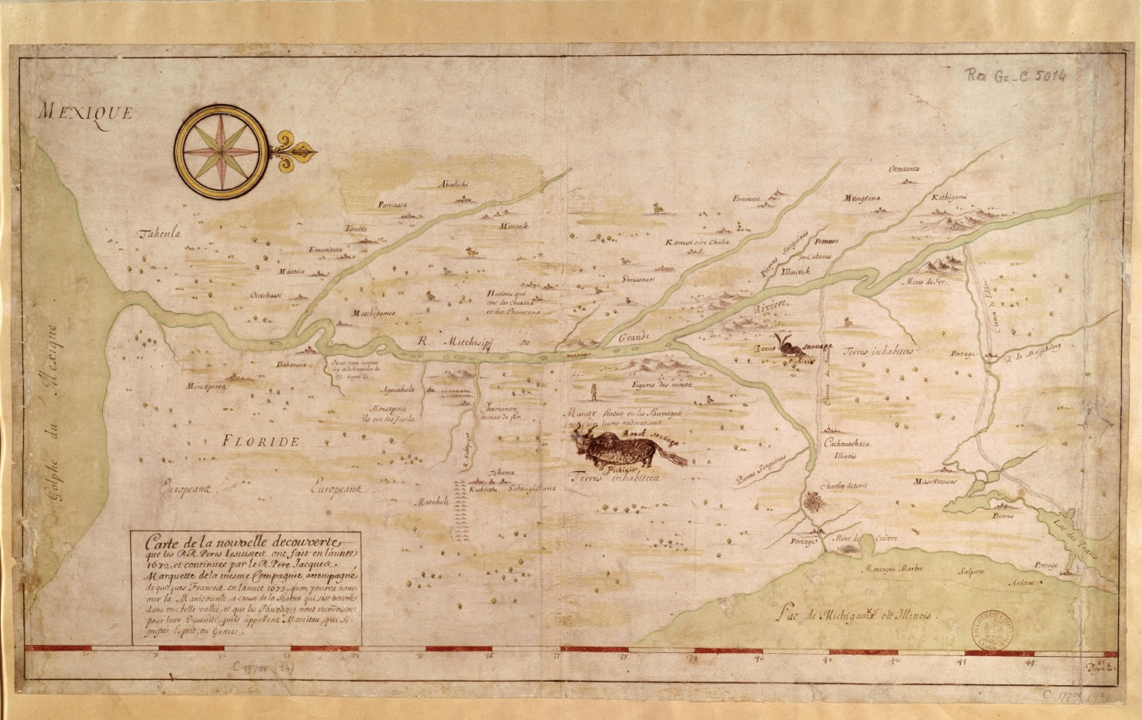
Figure 6: Jolliet, L. & Marquette, J. (1673) Map of the New Discovery Made by the Jesuit Fathers in and Continued by Father Jacques Marquette, from the Same Group, Accompanied by a Few Frenchmen in the Year 1673, Named “Manitounie.”[Place of Publication Not Identified: Publisher Not Identified] [Map] Retrieved from the Library of Congress. https://www.loc.gov/item/2021668635

early modern European cartography based on similar interpretations of Indigenous spatial epistemologies. For European imperial administrators interested in colonial endeavors in North America, the interior of the Southeast came into relief through appropriated Indigenous understandings of the land and its peoples’ territorial sovereignties.
This chapter demonstrates that Indigenous spatial epistemologies on European maps informed how colonizers imagined the region as colonization projects developed. Indigenous knowledge provides unexplored evidence of Indigenous perspectives and geopolitical maneuvering throughout the process of colonization in the Native South. Colonial maps show that Indigenous groups’ territorial contests vis-à-vis other Indigenous rivals proved at least as pressing for them as struggles with European colonists. Southeastern colonial maps serve as archival conduits into Indigenous spatial realities and a lens through which to view contemporary Indigenous spatial understandings. While scholars have deftly shown how European empires cartographically encompassed Indigenous territory as part of a scheme to justify and represent colonial expansion, few scholars have acknowledged the Indigenous geopolitical contests and claims embedded in European-authored maps.
The chapter follows the changes in colonial aspirations and Indigenous realities through early modern maps. Spanish and French mapmakers in the sixteenth century depicted imperial colonizing projects centered around extracting mineral wealth onto an active Indigenous region’s geopolitical contests. In the seventeenth century, French cartographers mapped the effects of Indigenous movement and coalescence onto their aspirations of a trade empire in North America. British maps of the late seventeenth and early eighteenth centuries fabricated a utopian colonial space consisting of potential trade with centralized Indigenous polities and areas ideal for European-style plantation agricultural endeavors onto a region occupied by many Indigenous peoples responding to the effects of imperial colonization. Examples of the changing Indigenous geopolitical landscape embedded in developing colonial aspirations on the maps demonstrate the significant differences between imperial colonization focused on accumulating resources and the abstract commodification of Indigenous land that inaugurated settler colonial projects in the mid-eighteenth century.
Early American maps form a palimpsest of phenomenological Indigenous and Cartesian European modes of mapping. Barbra Mundy’s work on the Relaciones Geográficas demonstrates the existence of distinct modes of Indigenous mapping that historians of cartography have traditionally studied as incongruent with European cartography. However, early American maps challenge the traditional categorization of Indigenous mapping as a separate and parochial mode of mapping from a universally applicable science of European cartography. The melding of the two modes onto a sheet of paper, or velum, inaugurated a composite map genre that requires examination of the disentangled modes and amalgamated images in conjunction. Examining Indigenous spatial epistemologies as a distinctive mode of mapping embedded in European maps better captures the lived experiences of Indigenous people who maintained intimate ways of knowing the lands and waterways in North America that both shaped and contested European colonial understandings of those lands and waterways.
Indigenous spatial epistemologies involve multiple ways of knowing Native lands and waterways. These epistemologies defied Cartesian mathematical principles that defined early modern European cartography. Cherokee spatial epistemologies incorporated cosmological, astrological, and temporal elements throughout the colonial era. Cartographic histories of seventeenth and eighteenth-century North America have predominantly overlooked these Indigenous epistemologies. According to traditional scholarship, European maps were “born of scientific calculations,” the product of “compasses, protractors, and surveying chains.” The “empirical nature” of European maps “rendered them authoritative documents that imparted a perception of power and control over the environment.” In map scholar Louis De Vorsey’s essay on the role of Indigenous peoples in mapping the Southeast, he argues that post-contact Amerindian cartographic techniques might “reflect an adoption of European cartographic conventions and expanded European spatial information” while Indigenous Americans only contributed to the “information-gathering and information-processing functions of Euro-American map production.” Matthew Edney’s pathbreaking scholarship has paved the way for a processual analysis of early European cartography. Understanding cartography in terms of a lengthy process helps us situate the Cherokees and other Indigenous peoples’ holistic way of knowing the land alongside the Western cartographic tradition.

Show Me the Money: Early Spanish and French Maps of the Native Southeast
European maps initially incorporated the Southeast into existing premodern geographical debates long before acquiring knowledge of the region from the people who had mapped the area for millennia. Early maps of the Americas, such as Juan Vespucci’s 1526 [untitled world map] and Giovanni da Verrazano’s 1529 [detail from untitled world map], used portolan style ninety-degree details of points of interest along the coastline. These and other early Spanish maps’ information informed the Spanish padrón general, the Spanish Empire’s secretive official world map. While the coasts contain numerous toponyms, the maps leave the Southeast’s interior absent of detail but mark the space as within the Spanish Empire using ensigns. Figure 7 European empires continued to cartographically claim the Southeast region, known as La Floride, for the first half of the sixteenth century with little regard for the region’s Indigenous occupants’ sovereignty. When Spanish conquistadors turned their gaze to the interior Southeast in 1539, their encounters with numerous tribes would begin to shape the European conception of the region.
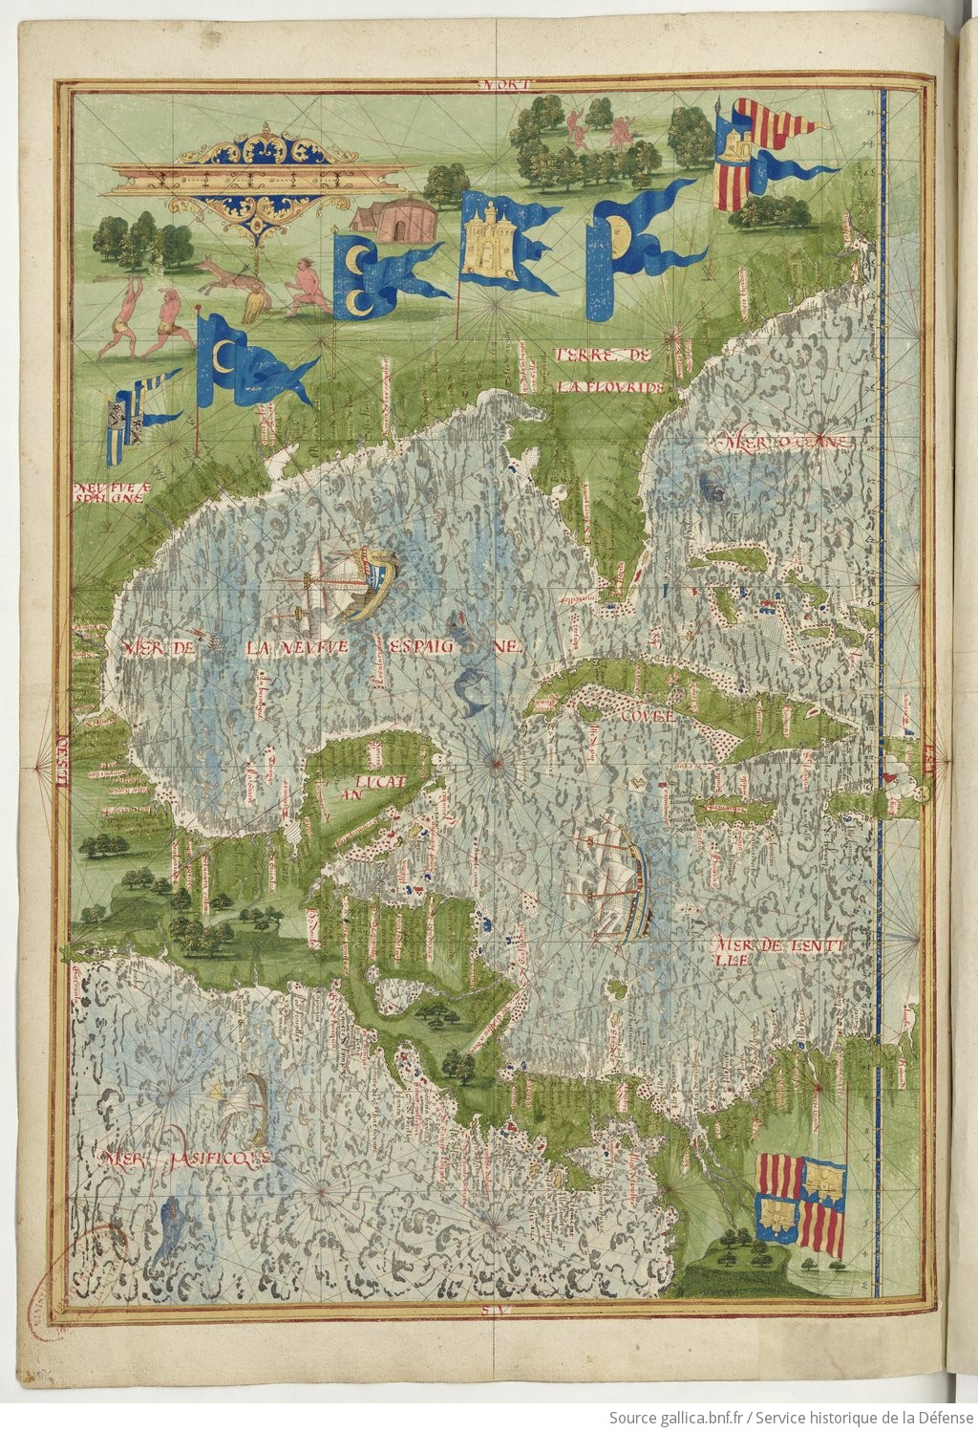
Figure 7 Guillaum Le Testu (1555), Cosmographie universelle, selon les navigateurs tant anciens que modernes / par Guillaume Le Testu, pillotte en la mer du Ponent, de la ville francoyse de Grâce p.118, Service historique de la Défense, D.1.Z14, Bibliothèque nationale de France, https://gallica.bnf.fr/ark:/12148/btv1b8447838j/f110.item#

The “De Soto Map” (1544) and the “Ortelius-Chiaves Map” (1584) represent archetypical examples of European mapmakers’ initial Southeastern interior geographic nomenclature. Based primarily on recollections from De Soto’s disastrous crusade of 1539-1543, the geographic information contained on these maps became the dominant European conception of the Southeast for the remainder of the sixteenth century. These maps reveal crucial information regarding the dynamic Indigenous spatial epistemologies of the sixteenth-century Native Southeast and the ways in which Europeans fixed Native understandings of the region into existing premodern ideas regarding territoriality. Despite what appears to be a grossly inaccurate topographical rendition of the Southeast’s geography, maps containing the De Soto Maps’ nomenclature nonetheless hint at the comprehensive nature of Indigenous groups’ geographical knowledge of the region and their grasp of a complex geopolitical landscape. The De Soto Map has Indigenous roots. Figure 8 However, its Indigenous content lies under several layers of obscurity. Charles Hudson attributes the authorship of this anonymous map to one of the few survivors of De Soto’s rampage, perhaps Moscoso. Hudson calls the De Soto
Map a “memory map,” suggesting the author drew the map sometime after returning to Spain. The time and space between the author’s observation and drawing of the map presents the first level of complexity regarding interpreting the map. The second challenge is what to make of what map scholars have called its “geographical misconceptions,” citing the east-westorientation of the Appalachian Mountains and atypical river systems. In Louis de Vorsey’s assessment, major rivers appear anastomosed -flowing into one another, rather than dendritic- smaller streams
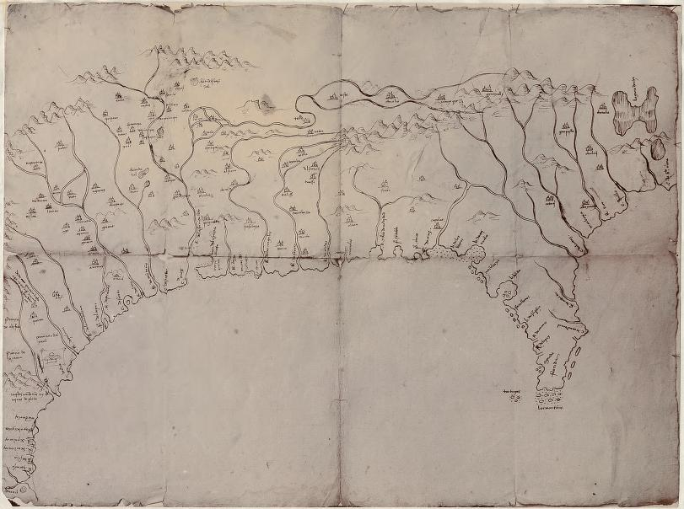
Figure 8 The “De Soto Map” Santa Cruz, Alonso De, and Archivo General De Indias. Mapa del Golfo y costa de la Nueva España: desde el Río de Panuco hasta el cabo de Santa Elena. [? 1572] Map. https://www.loc.gov/item/2003623374

joining to become larger streams- due to the map’s author’s misinterpretation of Indigenous information. According to De Vorsey, Indigenous peoples in the Southeast equated rivers and portages along a route as indistinguishable on geographical renderings, resulting in the map’s unusual riverine systems.
Just as the De Soto group encountered many distinct language groups, ethnic groups, and cultures, De Soto and his men would have encountered disparate geographical conceptions. The De Soto Map represents the author’s recalled rendering of the entire Southeast despite only observing a tiny fraction of the territory. The De Soto expedition relied on lexically challenging interrogations of captive Indigenous people from different areas and traversed Indigenous thoroughfares across plains, over mountains, and along rivers. The expedition’s extant journals also recorded what many separate Natives told them regarding regions the Spaniards had never observed. The only person who contributed to the map’s content who remained utterly disoriented while traversing the Southeast was the author. Perhaps a decolonized lens would improve De Vorsey’s interpretation.
The De Soto Map’s practical accuracies represent some of the map’s Indigenous information. As captives led the Spaniards from what is now western Florida across southeastern Georgia and the Carolina Piedmont, they would have indeed encountered four significant rivers that the natives indicated had headwaters in the highlands and terminated in the ocean, as the map correctly shows. The map’s author placed Chitala (Joara) within the foothills of mountains and near the headwaters of a river that drains into the Atlantic. The Berry Site, the archeological remains of Joara, is located near present-day Morgantown, North Carolina, near the headwaters of the Catawba River in the foothills of the Appalachians. As De Soto’s group headed across the Appalachian Highlands in what is now East Tennessee, they encountered other Indigenous groups who might have informed them of the western flowing rivers that connected to what is now named the Mississippi River, which they regularly traversed. Although De Soto’s band turned south toward Coosa in modern Northern Georgia, the map shows knowledge that the rivers in Eastern Tennessee flowed into an extensive river system far to the west. Perhaps the communities that De Soto encountered did not perceive the utility of riverine travel much differently than their European counterparts, as De Vorsey assessed. Instead, the map’s anomalies reveal descriptive and practical Southeastern Indigenous spatial epistemologies near the end of the Mississippian period.
For many Southeastern Indigenous groups, rivers represented living parts of their territory. The De Soto Map hints at the vital relationship between Indigenous peoples and rivers. The Indigenous geographers must have described rivers to the Spanish in terms of territorial access, travel distances, and proximity to others, which accounts for riverine anomalies and varying scales. The map shows a major river draining into the Gulf of Mexico and the Atlantic Ocean. Indigenous captives must have informed the Spanish that the people’s territory near the split in the rivers encompassed what is now the Flint and Ocmulgee Rivers, explaining this “unnatural” depiction. The Indigenous communities spanning the Appalachian Mountains must have told the Spanish that their rivers provided them access to the Mississippi and Atlantic watersheds. The area just north of the mountains shows details regarding the placement of settlements in relation to rivers in what would become East Tennessee. The distance to the confluence of the Tanisi (Tennessee), Ohio, and Mississippi Rivers appears off-scale, indicating short travel times downstream. Many of the map’s peculiar features provide evidence of the spatial epistemologies that early sixteenth-century Southeastern people described to the Spanish.
The “Ortelius-Chiaves Map” simplified the landscape but maintained an Indigenously informed structure. Figure 9 As with the De Soto Map, iconography representing Indigenous groups as European-style kingdoms introduces layers of colonial understandings and aspirations regarding settlement patterns in the Southeast. The author’s placement of settlements within a backdrop of mountains and watersheds represented a geographic reality and also hinted at the territoriality of the Native Southeast. The Indigenous chaperones deftly directed the Spanish away from their homelands and into foreign territory where news of the Spaniards’ imminent arrival had already come. The path that De Soto’s marauders took outlines the geopolitical contours of the Southeast that become discernible on the map for modern scholars. Access to rivers and settlement groupings indicate how the Indigenous people the Spanish encountered understood territoriality and connectivity.
Spanish mapmakers understood the area known as La Florida through an early-modern conception of empire. Notions of vassalage, feudalism, and Christian kingdoms made incorporating distant spaces into the Spanish Empire possible through written testaments of loyalty and tribute documented by De Soto and Juan Pardo. The Ortelius-Chiaves Map
cartographically molded the region to fit into New Spain. The map, found in Ortelius’ widely viewed Theatrum Orbis Terrarum, places Ortelius-Chiaves’ La Florida as one of three maps visible on facing pages. The atlas’s author depicted La Florida as a physical extension of Spanish South and Central America, reassuring the viewer of the imperial connectivity. The maps’ position in the atlas suggests that if Spanish expeditions had extracted mineral wealth in South
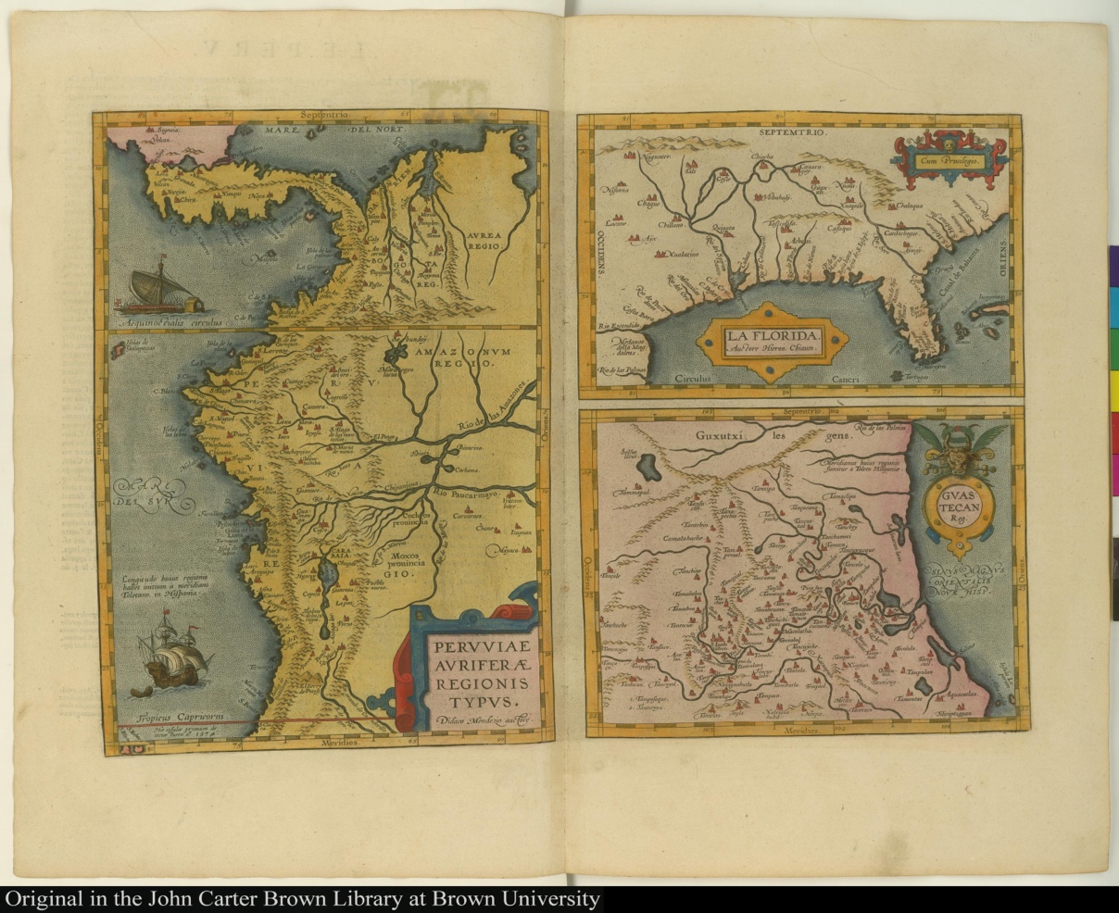
Figure 9 Upper right: “Ortelius-Chiaves Map” La Florida. Auctore Hieron Chiaves. In Theatre de l'univers, contenant les cartes de tout le monde [1598], Ortelius, Abraham, following p. 9. https://jcb.lunaimaging.com/luna/servlet/s/8735g5

and Central America, the Southeast must also contain undiscovered riches within the Spanish ambit.
The European townscape iconography mirrors other Spanish maps of South and Central America, further visually incorporating the Southeast into an imagined Spanish Empire. The Southeast appears as a seamless extension of New Spain despite the fruitless incursions of would-be Spanish conquistadors in the sixteenth century. These colonial overlays to the Indigenous geographic information permeated European perceptions of the region for decades. As the title suggests, Englishman Gabriel Tatton’s Nova et rece Terraum et regorum Californiæ, nouæ Hispaniæ, Mexicanæ, et Peruviæ incorporated the region into the Spanish empire. Figure 10
Many maps printed outside Spain reused the De Soto Map-based geographic nomenclature while extracting the region from New Spain and placing it in a contested North American colonial context. Jode’s 1593 map shows the Southeast as the periphery of a French and English colonial space, cutting off Central America and denoting French and English settlements. Wytflie’s 1597 Florida et Apalche replicated the Orteliou-Chiaves map but situated the region within a broader North American context rather than making geographic and geopolitical connections to the Spanish Empire in Central America as the Theatrum Orbis Terrarum Atlas made clear. Remnants of the De Soto toponyms would remain on the second iteration of Southeastern nomenclature.
Jacques Le Moyne’s Floridae Americae Provinciae reimagined the Southeast cartographically as outside the Spanish Empire but retained much of the early-modern conceptions regarding mineral resource extractive colonization. Figure 11 The details on the Le Moyne map informed the European conception of the region for nearly a century. Jacques Le
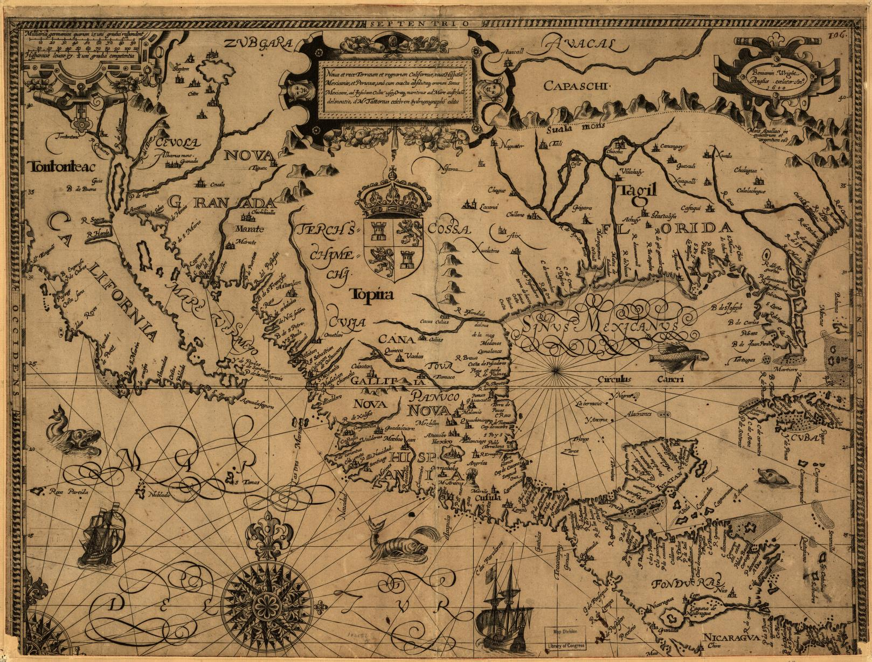
Figure 10 Gabriel Tatton and Benjamin Wright. Nova et rece terraum et regnorum Californae, nouae Hispaiae Mexicanae et Peruviae.[S.l 1600] Map. https://www.loc.gov/item/99446134/.

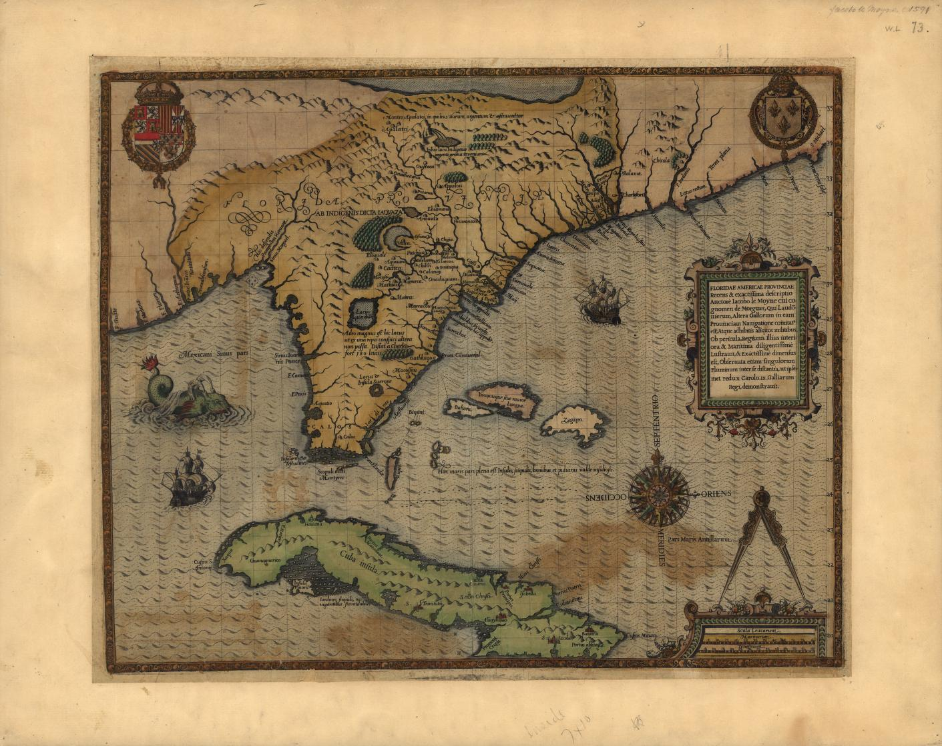
Figure 11 Jacques Le Moyne De Morgues, Floridae Americae provinciae recens & exactissima descriptio auctorè Iacobo le Moyne cui cognomen de Morgues, qui Laudōnierum, altera Gallorum in eam prouinciam nauigatione comitat est, atque adhibitis aliquot militibus ob pericula, regionis illius interiora & maritima diligentissimè lustrauit, & exactissimè dimensus est, obseruata etiam singulorum fluminum inter se distantia, ut ipsemet redux Carolo .IX. Galliarum regi, demonstrauit. [S.l.: s.n, 1591] Map. https://www.loc.gov/item/2003623393/.

Moyne accompanied the René Goulaine de Laudonnière flotilla to the North American shore near modern Jacksonville, Florida in 1564 and spent almost a year in the area near the coast. Le Moyne drew the map sometime between 1586 and 1588 after surviving the failed attempt led by Jean Ribault and Laudonnière to establish a French colony at Fort Caroline near the St. Johns River. Theodore de Bry then engraved and published the map in 1591 using Le Moyne’s posthumously obtained papers containing a manuscript map and other drawings.
As with many assessments of early maps of the Southeast, the scholarship regarding the map’s geographic information sources remains thoroughly Eurocentric. R.A. Skelton lists ten possible sources for De Bry’s published map, all stemming from textual or cartographic material regarding the colonization effort in the 1560s. Skelton assumes “some of the striking details of delineation” and the map’s “wealth of inland features and names, not located on any textual source” demonstrate that most of the map “must have had a graphic record from experience as its basis.” Contrasting De Bry’s map that covers a large portion of the Southeast, the “Parreus Map,
the only other extant cartographic record from these colonial expeditions, is limited to a few miles in and along the coast and provides an example of a map produced via observation.
Indigenous spatial epistemologies gleaned by French colonizers formed the basis for De Bry’s printed version of Le Moyne’s manuscript map. The toponyms that populate the map resulted from the tiny French contingent becoming pawns in a regional power contest between Indigenous groups. One day, while eating a meal of fish and bread, a man from Molona informed the French that his people were allied with nine other communities located along what is now the Saint Johns River: Cadecha, Chilili, Eclauou, Euacappe, Calanay, Onachaquara, Omittaqua, Acquera, Moquoso. The man explained that these groups aligned against the over forty communities subject to the dreaded headman, Olata Ouae Outina. Curious to discover Outina’s material resources, Laudonnière permitted the “verbose” young La Roche-Ferrière to barter with Outina. La Roche-Ferrière sent word that Outina’s group desired French assistance in defeating Potanou, Onathequa, and Oustaca. According to Outina, these rivals, located at the foothills of the Appalachian Mountains, blocked his access to the numerous people in the “Apalatci” who possessed great riches of gold and silver. Unable to resist the temptation of mineral wealth, the French became embroiled in the regional struggle. Laudonnière’s self-serving alliance resulted in an axe buried in La Roche-Ferrière’s skull and near starvation for the rest of the French colonists when Outina’s enemies arrived with Spanish reinforcements.
Le Moyne mapped out an Indigenous understanding of territoriality in the region that De Bry’s printed map embedded into the European cartographic lexicon for one hundred and fifty years. The geographical scope of Le Moyne’s map far exceeded his observations. Le Moyne drew from Indigenous people who understood the region in terms of ethnic and linguistic groups’ relationships to each other as the basis for the region’s topography. Terms such as “day’s journey” and “beyond” our or their land created Le Moyne’s spatiality. Men such as Outina spoke of distant riches to tempt the French into aiding them in defeating rivals. Le Moyne’s mountains and waterfalls that abounded with shimmering gold and silver cartographically represented Outina’s political whit that exploited past and shaped future European colonial imaginations regarding the Southeast. For modern historians, Le Moyon’s map provides clues to the often violent process of coalescence occurring in the sixteenth century as colonization put pressure on coastal groups.
The Mercator-Hondius map further entrenched Indigenous spatial epistemologies into the Southeast’s European cartography. Figure 12 Mercator’s renowned status and the inclusion of Virginae Item et Floridae Americae Provinciarum nova Descriptio in Mercator’s Atlas, beginning with the 1606 edition published by Jodocus Hondius, ensured the Indigenous geopolitical landscape recorded in the 1560s became the dominate European perception of the Southeast. Map scholars lament Mercator’s placement of the large inland lake to the north near the Appalachian Mountains, creating “geographical misconceptions of the region which lasted for nearly a century.” Colored versions of the map neatly border the Indigenous confederations described in narratives from the failed French colony. Mercator’s map also separated the Southeast into three distinct regions: Spanish Florida to the south, English Virginia to the north and east, with the Indigenous confederations occupying the middle. Prominent French cartographers like Nicolas Sanson, Nicolas de Fer, and Johannes de Laët incorporated the Mercator-Hondius geographic nomenclature into continental-scale maps of North America.
English and Dutch cartographers likewise adopted Mercator’s depiction of the Southeast that would shape European imperial perceptions until Indigenous groups’ understanding of territoriality in the Southeastern interior would again mold new iterations of European
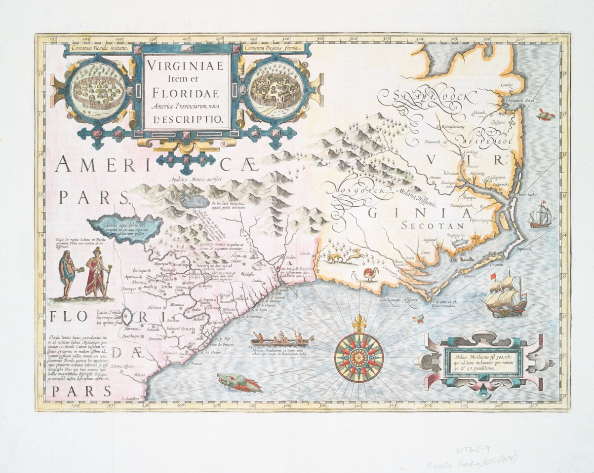
Figure 12 The Mercator-Hondius Map, Jodocus Hondius, Lionel Pincus and Princess Firyal Map Division, The New York Public Library. “Virginiae item et Floridae Americae provinciarum, nova descriptio.” New York Public Library Digital, https://digitalcollections.nypl.org/items/510d47da-ef5f-a3d9-e040-e00a18064a99 .

century. Initiated by European armed Iroquoian raids, displaced groups such as the Erie became cartography.

What Your Land Might Provide Us: Mapping Indigenous Coalescent Responses onto English and French Colonial Aspirations
German John Lederer’s 1670 adventure into the interior of what would become Virginia and Carolina introduced developing Southeastern Indigenous spatial epistemologies onto a new era of European colonial cartography. The position of the Indigenous settlements demonstrates Indigenous groups’ understanding of how their location in relation to mountains and rivers protected their ability to preserve or grow their culture as slave raiding and colonial incursion enveloped the region. First published in London, The Discoveries of John Lederer, In three several Marches from Virginia, To the West of Carolina, And other parts of the Continent included a map with geographic nomenclature that English and other European mapmakers rapidly incorporated. Figure 13 Lederer’s connections with prominent individuals such as Governor William Berkely of Virginia and Governor John Winthrop of Connecticut lent contemporary credibility to both Lederer’s narrative and map. However, map scholars have excoriated Lederer’s account as fraught with geographic “misconceptions” and wantonly “fictitious,” and some scholars question if he even made the journey.” Lederer’s map was as much of a product of a disoriented individual as it was of someone ignorant to ongoing social upheaval throughout the region.

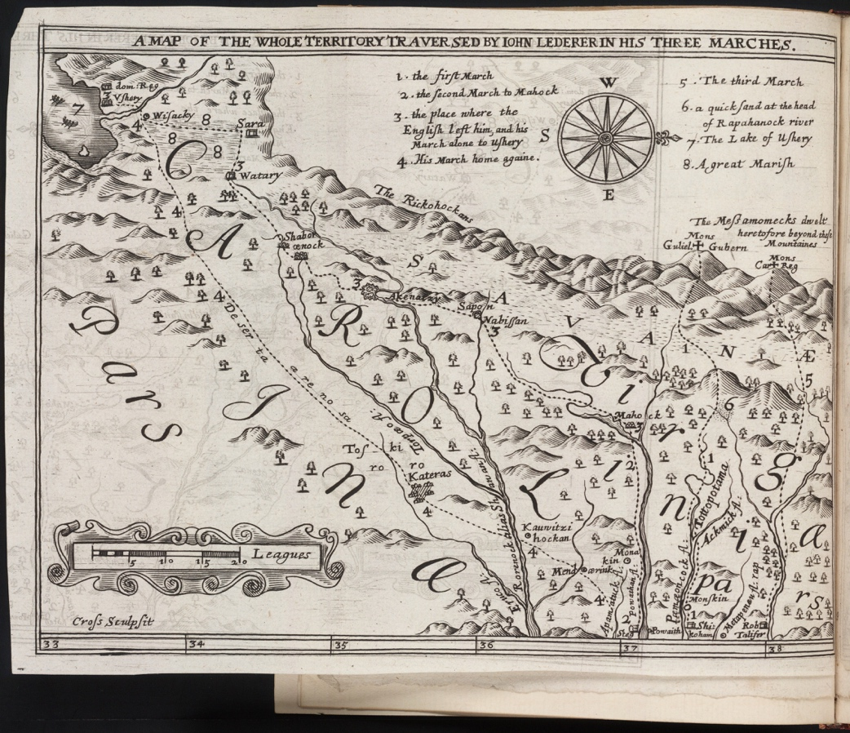
Figure 13 “Lederer’s Map,” (1672), In The discoveries of John Lederer: in three several marches from Virginia to the west of Carolina, and other parts of the continent: begun in March 1669, and ended in September 1670. Together with a general map of the whole territory which he traversed, Beinecke Rare Book and Manuscript Library, Yale, https://collections.library.yale.edu/catalog/2000250

Lederer unwittingly mapped Indigenous displacement and coalescence in the Southeast. Indigenous slave raiding had reached a fevered pitch in the region during the mid-seventeenth
itinerate slaving societies. The society comprised of Eries and other groups became known as the Westos when they migrated into the Southeast near the James River in 1656. The heavily armed
Westos enslaved Yamasees, Cofitachequians, and Catawba-speaking people throughout the interior Piedmont and parts of Spanish Florida. Lederer’s map denotes the “Richahecrians,” a general term Virginians used to refer to enslaving groups and perhaps the Westos specifically. The spatiality of Indigenous coalescence caused by the effects of slave raiding Richahecrians underpin Lederer’s depiction of the region, which would inform European perceptions regarding the Southeast.
The tidy dotted line on the map indicating Lederer’s route belies the two distinct manners in which Lederer pursued his course. When guided “by the Indians instructions,” Lederer’s “easie journeys” led him along established routes to settlements where he witnessed the effects of displacement resulting from European incursion and militaristic groups of Indigenous enslavers. When Lederer chose to ignore the paths Indigenous people drew to guide him, he wandered across difficult and sparsely inhabited terrain in the Piedmont region, which he labeled “marshes” or “deserts.” These divergent modes of travel reveal the spatiality of coalescence in the region. Areas under pressure from encroaching Europeans and slave raids became depopulated as Indigenous groups reformed in other areas that they selected to provide adequate cultural space. The region’s Indigenous inhabitants viewed the natural topography of the Southeast as providing access to, or a barrier against, other Indigenous groups, as they had done for centuries.
Lederer’s preconception of encountering hierarchical Indigenous polities, stemming from his knowledge of earlier Spanish accounts, mingles on his map with the realities of the enslaving and coalescing societies he experienced. When Lederer arrived at the island town of Akenatzy, he found the center of Occaneechi power “naturally fortified.” Lederer erroneously viewed the multi-cultural Occaneechis, whom historian Robbie Ethridge described as one of the earliest “militaristic slaving societies,” as a longstanding hierarchical chiefdom, meeting his presuppositions set by earlier Spanish and French regional maps which depicted centralized Indigenous polities. The Occaneechis selected a location that provided them access to both interior Indigenous communities for slave raiding and English colonists on the coast as an outlet for their enslaved victims.
As Lederer proceeded southwest along the Carolina Piedmont, he encountered small groups rather than the large settlements that Spanish excursions encountered a century before. When he arrived at Iswą (Ushery) on the lower Catawba River Valley, he recorded the most populous region he had yet seen. Iswą and the surrounding area had become a refuge for Catawba-speaking peoples as slave raids had all but eliminated centers of power like Cofitachequi. Archeological evidence supports Lederer’s observation regarding how Indigenous societies in the region had reconfigured settlement patterns during the seventeenth century. However, Lederer remained ignorant of the social upheavals in the region and viewed the coalescing societies as advantageously placed potential trading partners, even petitioning for a trading license upon his return. Sharing Lederer’s ambitions, European cartographers would immediately reconfigure the nomenclature on Lederer’s map to create a new colonial vision for the region, which appeared teeming with consolidated and amicable Indigenous trade partners.
The “Ogilby-Moxon Map” animated a transitioning English colonial vision of the Southeast. Figure 14 John Ogilby first published the map in his 1671 edition of America in London, opposite a promotional account of Carolina written by John Locke to attract prospective colonists. Referred to as The First Lords Proprietors’ Map, Ogilby’s widely viewed map became archetypical for a new form of colonial propaganda that increasingly emphasized the region’s agricultural and trade potential over mineral resources. Having founded the Carolina colony and established Charles Towne by 1670, the Lords Proprietors’ vision for the region entailed neatly placed rural communities near a central port producing copious amounts of agricultural products for export to England. The Ogilby-Moxon Map incorporated elements from the Mercator-Hondius and Lederer nomenclatures but reorientated and combined them with coastal features to produce a cartographic rendering of the Lords Proprietors’ colonial scheme.

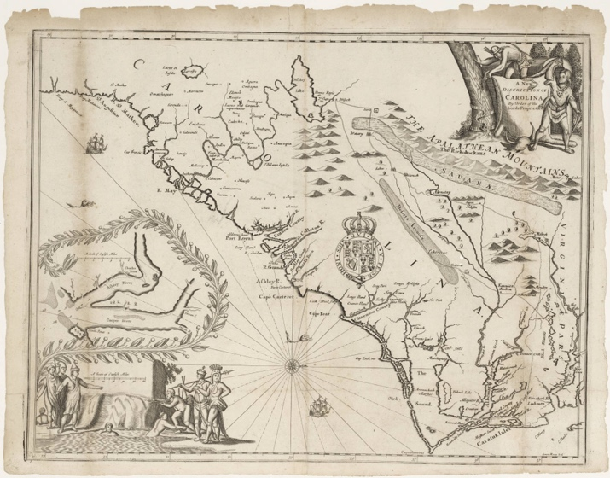
Figure 14 “The Ogilby-Moxon Map, (1672), John Ogilby and James Moxon, A New Description of Carolina by the order of the Lords Proprietors, Digital Collections, University of North Carolina at Chapel Hill, https://dc.lib.unc.edu/cdm/ref/collection/ncmaps/id/498

The Ogilby-Moxon Map foregrounds established coastal English settlement. The map employed a westward-facing orientation simulating the landscape’s orientation to England, a common feature of English maps of North America in the seventieth century. Along the coast, English toponyms separate coastal plains into counties, and a cartouche displaying the English Crown’s coat of arms firmly establishes the unoccupied adjacent land as English possessions. An inset at the left shows Charles Towne in its original position along the west bank of Ashley River, renamed for Lord Ashley, one of the original proprietors of the Carolina Colony. Other European settlements, St. Augustine in the south and Jamestown in the north, helped frame the coastal region as Christianized. The map secludes Indigenous toponyms from the surrounding coastal plains, reflecting actual events and changing English imperial aspirations.
The map incorporates previously depicted Indigenous territories in familiar but repurposed ways. The Indigenous polities first depicted on Le Moyne’s map, including Utina, form a southern buffer zone against Spanish Florida. Le Moyne’s inland lake, which Hondius moved north on Mercator’s map, no longer contains waterfalls of gold. Instead, the lake has been renamed Ashley Lake and appears at the intersection of the Le Moyne and Lederer geographic nomenclatures. The Ogilby-Moxon Map incorporates the Lederer material as an extension of Le Moyne’s Indigenous buffer zone. Rather than a barrier to rumored mineral wealth in the mountains to the west, Lederer’s network of Indigenous settlements served as potential trade partners and a bulwark against the distant Rickohockans. I argue that the colonial vision underpinning the intended buffer zone accounts for the extreme enlargement and elongation of Lederer’s purported savanna and desert on the map, which scholars have denounced as absurd.
The reframing of the Indigenous space on the map reflected changing conditions in the colony and developing English engagement with modes of imperial expansion. By the time the proprietors commissioned the map in the early 1670s, colonial officials had turned their attention to land improvement as both a vector for agricultural wealth and a mode of establishing sovereignty against other European rivals. Near total erasure of “settlement Indians” near Charles Towne on the map indicates their diminished role in the minds of colonial officials. Local and imperial colonial administrators commented that small coastal Indigenous groups such as the Cusabo had passed from indispensable allies to nearly extinct annoyances. As interior groups such as the Cherokees, Westoes, and Yamasees contacted English settlers hoping for trade and military partners, colonial attention shifted from envisioning Indigenous groups as communities integrated into the colony’s space to foreign polities seen as friend or foe in a broader colonial contest. Having integrated Indigenous geographical knowledge and geopolitical contests that spanned over a century, the Ogilby-Moxson Map represented the nescient development and cartographic implementation of commerce-based colonialism in the Southeast.
Joel Gascoyne’s A New Map of the Country of Carolina presented a more refined and alternative rendition of cartographic colonialism in the Southeast. Figure 15 Gascoyne’s map appeared tacked onto a four-leaved promotional tract, A True Description of Carolina, published in London in 1682. Map scholars have extolled Gascoyne’s map as the “most accurate” printed map of the region until “well into the eighteenth century.” The changes from the Ogilby-Moxon
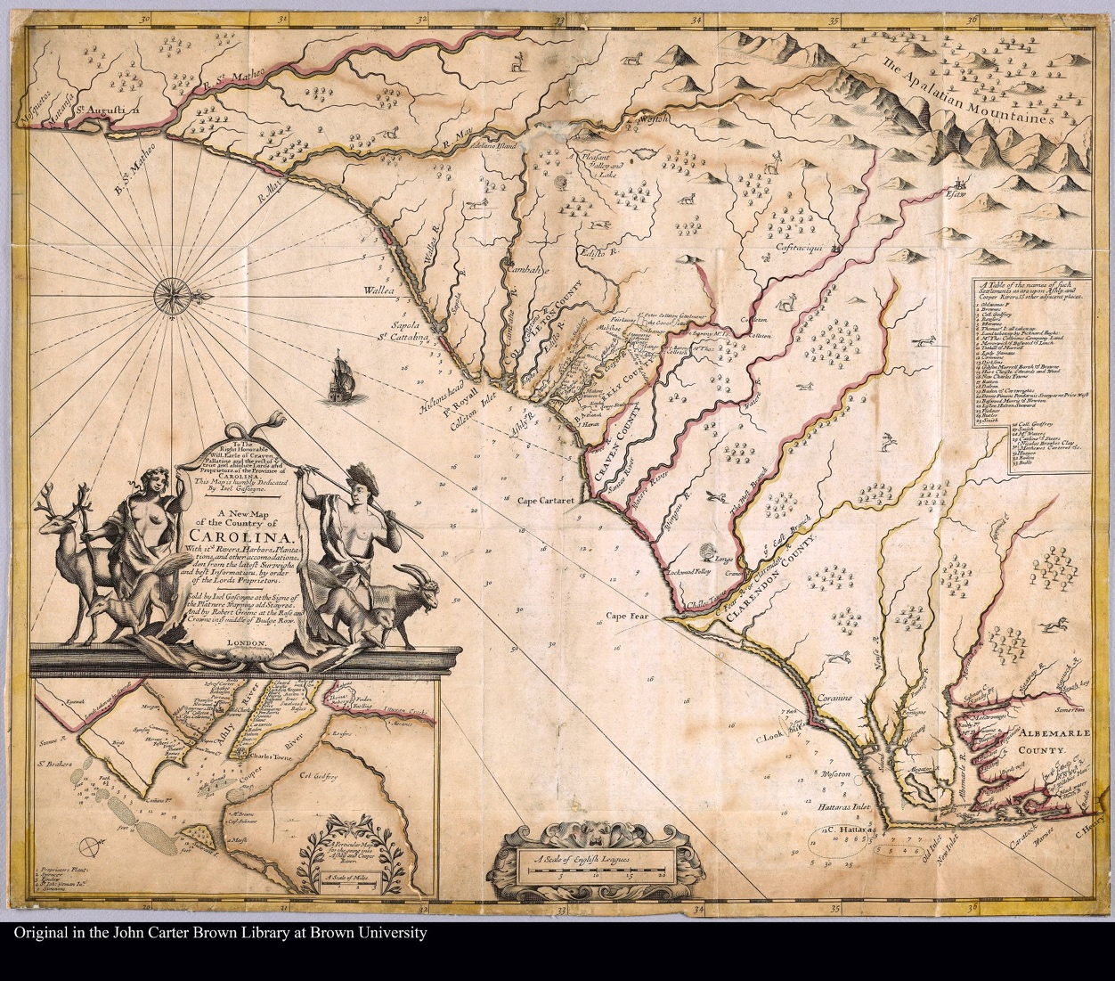
Figure 15 Joel Gascoyne, A new map of the country of Carolina with its rivers, harbors, plantations and other accomodations don from the latest surveighs and best information by order of the Lords Proprietors, John Carter Brown Library https://jcb.lunaimaging.com/luna/servlet/s/80m9q5

to the interior include an erasure of Le Moyne and Lederer’s geographic nomenclature in favor of a drastic reduction in Indigenous toponyms and rows of “innocuous and non-committal” rivers running from deep within the interior to the coast. Gascoyne’s map indicates the owners and locations of dozens of plantations along the Ashley and Cooper Rivers near Charles Towne. Cartographic historians have attributed these new features to new information provided by what Louis De Vorsey deemed the “excellent work” of the general surveyor Maurice Mathews and excursions into the interior by Henry Woodward in the 1670s. However, as a magnified inspection of Gascoyne’s map reveals, the mapmaker quite literally attempted to erase the realities of developing Indigenous spatial epistemologies and colonial geopolitics from his office in London.
The mapmaker intentionally made choices to display and promote the Proprietors’ vision for the colony’s economic growth and administrative stability. Soon after the establishment of Charles Towne in 1670, colonial officials lamented the discovery of the limited access to the interior that the Ashley River provided. Before rice cultivation became prevalent following the turn of the eighteenth century, the dream of English-style plantations lining rivers with navigable access to the interior formed the foundation of expected colonial economic growth. The map’s rows of rivers extending well into the interior fulfill the expectation that further settlement might occur according to this design.
Gascoyne asserted the Proprietors’ claims of land ownership by privileging white settlers’ presence and understanding of the land while erasing Native polities from the map. The mapmaker simplified Indigenous elements and strategically placed them on the periphery of coastal iconography that listed and outlined individual plantations along coastal rivers. The map reduced the Indigenous networks of the Ogilby-Moxon Map to just five Indigenous settlements and significantly erased or anglicized Indigenous placenames. Lord Ashley, who once rebuked Carolina Governor Joseph West for using the Indigenous name “Kyawah” instead of the newly renamed Ashley River, demanded anglicized placenames on the map.
The placename on the map for Ashley’s personal signatory originally read “Earle Shaftesbury Signory called Wadwad Malow.” Figure 16 Only one copy of the Gascoyne’s map
exists with this placename. All other known copies have evidence of Wadwad Malow being physically erased, with only the outline of the name slightly visible. This effacement would suggest Lord Ashley demanded a post-print edit to remove any association between his property and its Indigenous provenance.
The map asserts the Proprietors desired monopoly on trade with peripheral Indigenous polities. When Henry Woodward made treks inland to Confitachequi in 1670 and Hickauhaugau, the center of Westo power, along the Savana River in 1674, he documented limited and conflated geographic information regarding his routes. He recorded encountering several “petty Cassekas” along the journey to Confitachqui. While in Hickauhaugau, the Westos informed him of the location of the “Cowatoe and Chorakae” that lay “eight daies journey” along the branches of the Savannah River to the west-northwest. Woodward also encountered two “Savana Indians” who described their location as “twenty days journey West Southwardly” from the Westo town. A
wealth of geographic knowledge that the mapmaker ignores or cartographically reconfigures to establish the Proprietors’ authority to trade with particular groups.
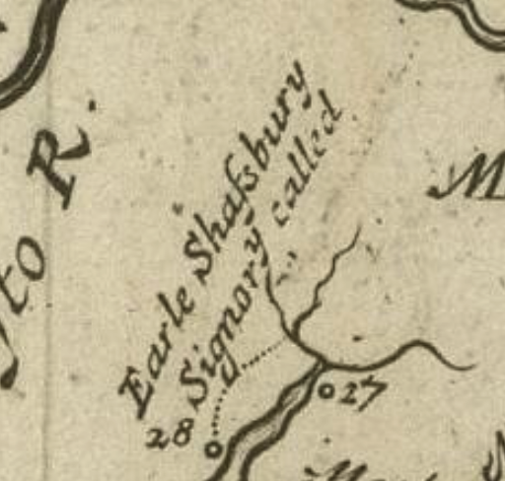
Figure 16 Inset on Gascoyne’s map showing the erasure of “Wadwad Malow”

Events in the region tell a different story. After Woodward’s trade deals with representatives from Confitachequi and the Westos on behalf of the Proprietors, enraged local planter elites plotted to break the Proprietor’s grip on trade monopolies with Westos and Piedmont Indian groups. Unbeknownst to the colonial officials, chiefly authority had moved north sometime before Woodward’s visit to Confitachequi. By the time Gascoyne published the map in 1682, Westo enslavers had caused the dispersal of the remaining residents of Confitachequi among ancestral Creeks and other settlements. Planters who had relocated from Barbados to Charles Towne, known as the Goose Creek Men, and other prominent Carolina traders financed a war between the Savannas and Westos that resulted in the nearly complete annihilation of the Westos in 1682. Despite the two groups’ dispersal among other tribes, the mapmaker uses prominent cityscape iconography to locate imagined Confitachequi and Westos seats of power along major rivers with access to the interior.
The tension between the Ogilby-Moxon Map and Gascoyne’s map personified competing English colonial visions of transitioning Indigenous spatial epistemologies into a colonial landscape. The Ogilby-Moxon Map’s geographical nomenclature represented the Lords Proprietors’ initial colonial schema inserted into a landscape inherited from earlier colonial dreams predicated on encountering interior lands populated by hierarchical Indigenous chiefdoms. English mapmakers received little new information regarding the Southeast’s interior during the intervening years between the printing of the maps. Instead, the map reflected the Proprietors’ desire to project authority despite recalcitrant colonial planter elites’ increasing autonomy. The two maps represented and reinforced debates regarding the colony’s future direction. The popularity and many reprints of Ogilby’s Atlas ensured that the Ogilby-Moxon rendition of the English Southeast gained a far greater audience than Gascoyne’s. In the coming years, local planters would wrestle power away from the Lords Proprietors, and English maps’ changing cartography would once again reflect new colonial contexts placed upon coalescing Indigenous communities’ spatial epistemologies.
Indigenous peoples’ encounters with Louis Jolliet and Jacques Marquette’s 1673 along the Mississippi River initiated French colonial cartography’s gaze toward the Southeast from its western edge. A journal of Marquette and Jolliet’s voyage, “Decouverte de Quelques pays et Nations de L’Amerique Septentrionale,” published in Recueil De Voyages de Mr Thevenot in 1681, includes many instances of Marquette encountering Indigenous groups along the route where he solicited information. (See Figure 1) Jolliet and Marquette’s observations account for an inconsequential portion of their renderings of the region on maps they fashioned of a vast area of North America. Indigenous residents described the areas surrounding the river, providing information regarding distances and the locations of foreign Indigenous communities upstream from the many rivers within the Mississippi watershed. When Marquette encountered the Cherokees along the Mississippi River’s bank, they provided him with Cherokee spatial epistemologies regarding the Southeast that would inform French conceptions of topography and potential allies and rivals in the Southeast for over half a century.
Marquette’s map shows the location of many Indigenous communities that the French expedition never observed firsthand. Rivers to the west form a pattern of successive Indigenous communities lining tributaries of the Mississippi River. This pattern matched episodes in Marquette’s journal when the expedition encountered Indigenous groups that resided adjacent to the Mississippi River near the mouth of a tributary and apprised the French of other communities they interacted with further upstream.
The Cherokee had traveled some distance from their homelands. The map’s placement of the area the Cherokee described to the French manifested the iconography of four distinct groups situated in relationship to rivers and mountains along with their spatial relationship to their neighbors, the Kaskinȣba” (Kaskinampo), the “ȣabanghiharea,” the “Taharea,” and the “Matahale.” Figure 17 However, the Cherokee language contains no bilabial stops, making the P and B sounds unlikely to come from a Cherokee speaker. Instead, these consonant clusters are common in the Koasati language. Jean Baptiste Louis Franquelin, the leading cartographer in Québec, fashioned the map Carte de l’Amerique Septentrionnale (1688) using sources from the same encounter between Cherokees and the Marquette and Jolliet expedition. The settlements at the eastern end of the Tanisi River (Tennessee River), Tchalak, Tamghi, and Cattoughi (Kituwah) on Franquelin’s map match Cherokee sounds and suffixes.
The multilingual placenames suggest that the group of Cherokees contained disparate linguistic groups or polyglots. The Indigenous group’s use of two non-related languages provides an essential clue in the process and timing of coalescent Indigenous groups in the region. Within one encounter, the Cherokees must have described themselves as an individual group living in defined settlement clusters among groups using Koasati and Tslagi languages. The Cherokee’s description suggests a pluralistic society identifying as a cohesive group at some level.

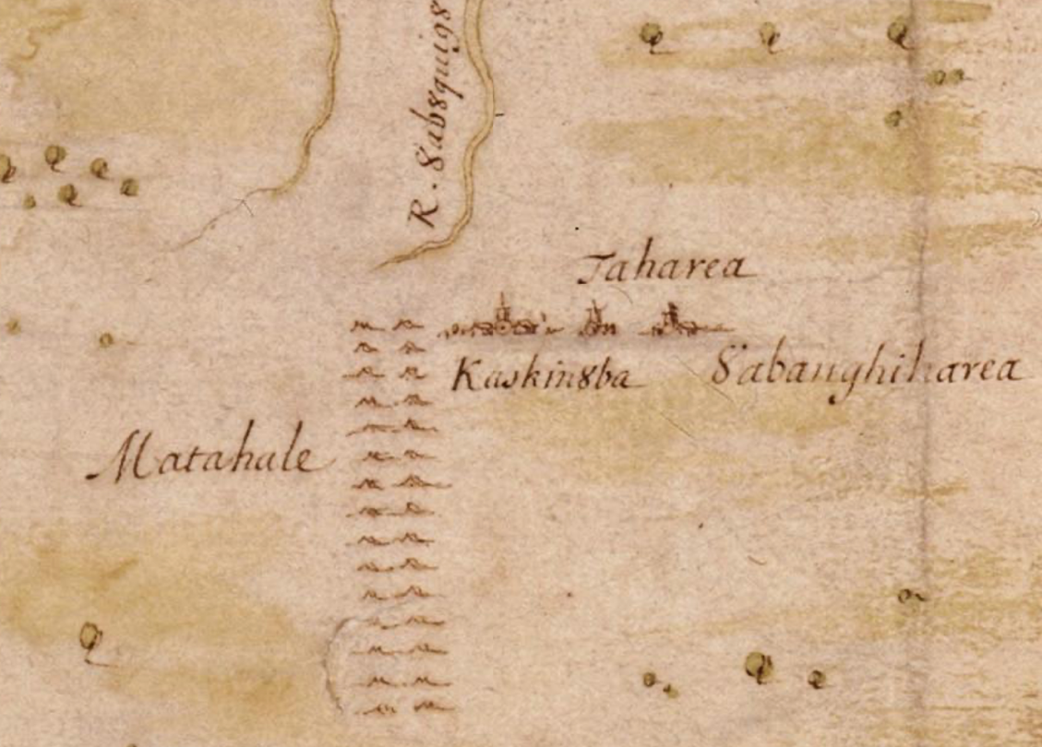
Figure 17 Marquette Map Inset

The geographic nomenclature from the Cherokees quickly reached the highest levels of the French empire via Jean Baptiste Louis Franquelin’s cartography. Franquelin drew information from voyageurs like Marquette and Jolliet, who had cobbled together Indigenous information to form the cartographic vision of North America that King Louis IV contemplated in 1683. Franquelin’s map remained in manuscript form, prohibiting an extensive audience. Cumming’s definitive work on early maps of the Southeast omits Franquelin’s work. However, France’s most prolific cartographers, Claude and Guillaume Delisle’s printed maps, would introduce the Cherokee’s information given to Marquette in 1673 regarding Southeastern geography to a broader European audience.
The Delisles incorporated Indigenous spatial epistemologies given to French, Spanish, and English informants into their maps. As a géographe de cabinet, a mapmaker compiling information from his office in Paris, Delisle’s maps comprised a compendium of sources that drew from various Indigenous sources across North America via European relations. Delisle lists travel journals and reports written by Europeans. However, these documents’ information derived primarily from Indigenous informants. For example, Delisle made significant changes to the Southeast geography on his maps of North America after obtaining a document prepared by Charles Levasseur stemming from an expedition to the Gulf Coast in 1700.
Delisle’s 1703 map Carte du Meixque et de la Floride des Terres Angloises et des Les Isles Antilles du Cours et des Environs de la riviere Mississipi represented a compilation of all the cartographic sources available to the mapmaker at the turn of the eighteenth century. Figure 18 Delisle’s Southeast depiction incorporated elements that harken as far back as the De Soto and Le Moyne maps. Delisle left a record of his sources for his 1703 printed map, providing a
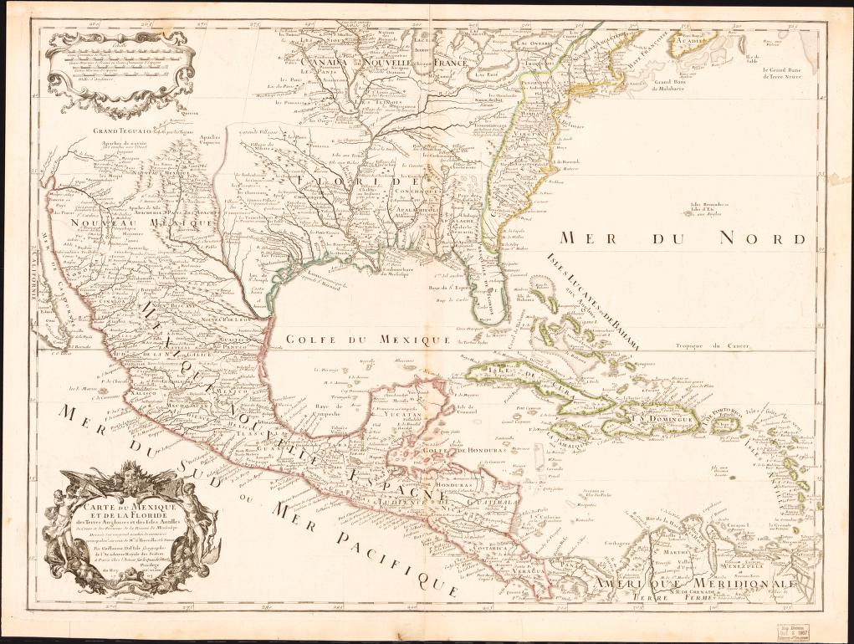
Figure 18 L'Isle, G. D. & Simonneau, C. (1703) Carte du Mexique et de la Floride des Terres Angloises et des Isles Antilles: du cours et des environs de la Riviere de Mississipi sic, dressée sur ungrand nombre de memoires principalemt. sur ceux de M.rs d'Iberville et le Sueur. Paris: Chez l'auteur sur le Quai de l'Horloge. [Map] Retrieved from the Library of Congress, https://www.loc.gov/item/99446135/.

rare opportunity to examine how the image of the Southeast, which French and other European empires embraced, came into focus. As with earlier maps, the Indigenous roots of Delisle’s representation lie dormant under layers of colonial and archival muck. Scholarship regarding Delisle’s geographic information points to his unparalleled access to sources of European “exploration.”
Indigenous knowledge underpinned each of Delisle’s graphic and textual sources. Delisle drew from French translations of Garcilaso de la Vega and the Gentleman of Elvas’ narratives of the 1534 De Soto expedition for sections between the Atlantic coast and Mississippi. As with the original De Soto Map, Indigenous people provided the framework for the geographical information contained in these sources. Delisle sketched maps that preceded the printed version, including parts of Florida and the Carolinas, which he based on French publications regarding Ribaud and Laudonieres’ 1560s accounts. The information on the Ohio and Tennessee Valley area comes from Franquelin’s cartography based on Jolliet and Marquette’s voyages. Accounts by La Salle, d’Iberville, and de Tonty’s interactions among the “Chactas and Chicachas informed areas around the Mississippi.” For the Atlantic coastal areas, Delisle drew from Carte Nouvelle de V Amerique Angloise . . . Dresse sur les Relations les Plus Nouvelles Par le Sieur S, a Amsterdam, Chez Pierre Mortier Libraire, which included the Lederer nomenclature in the east and Marquette’s nomenclature in the west. Delisle’s printed map interspersed elements of the Lederer-based map with information from a French version of the 1685 “Thorton-Morden-Lea Map,” which Delisle acknowledged in a note, draws heavily from Gascoyne’s Map.
The resulting image of the Southeast combined generations of Indigenous geographical information and social upheavals overlayed with contemporary colonial contexts. The map contains multi-layered sectionalities of independently sourced geographic nomenclature overlayed with chimerical colonial demarcations. Delisle separated the map into four colonial zones: Canada Novelle France in the North, Nouveau Mexique in the west, English possessions along the Atlantic coast, and Floride extending from the spine of the Appalachian Mountains in the east to the Rio Grande in the west from the Gulf of Mexico to a northern terminus meandering through the Ohio Valley extending west beyond the Mississippi. The lines forming the borders of these colonial partitions are colored on most extant copies of the map.
Contained within each section are distinct cartographic nomenclatures stemming from various Indigenous sources. Within “Caroline” and “Virginie,” the hubs of militant enslaving Indigenous communities recorded by Lederer still form a network between the deserted savanna of the foothills and the desert of the piedmont. Cofitachequi remains an Indigenous kingdom within close proximity to Charles Towne. The feared Rickarians (Westoes), named Chaouenons on Delisle’s map, are found beyond the mountains and along a river near Charles Town. The Indigenous settlement of Carlos in southern Florida and the inland lake at the foot of the “Mount Apalates” from Le Moyne’s Indigenous contacts still have their place on the map. As told to French voyageurs sailing along the coast, Indigenous communities populated rivers flowing from the highlands into the Gulf of Mexico. To the north of the highlands, the river systems flowing into the Mississippi contain the Indigenous settlements that the Cherokee described to Marquette some forty years before. Delisle’s vision of the Southeast, which significantly influenced European cartography and informed colonial administrators, at once represented centuries of Indigenous geopolitical upheaval while shaping a new vision of a contested European colonial sphere.
Delisle’s maps of North America developed along with colonial contests. The differences between Delisle’s 1701 manuscript map, Carte des environs du Mississippi, his printed version in 1703, and the 1718 version, Carte de la Louisiane et du cours du Mississipi, cartographically identify geopolitical developments in the Southeast. Figure 19, Figure 20 The scope of the 1701 and 1703 maps includes Spanish colonial zones as a prominent part of the maps. However, after the Wars of Spanish Succession and the Treaties of Utrecht, the 1718 map shifted its focus to French claims in North America aux-face-de British. The 1701 manuscript details an overland trade route between the English along the coast with the “Chicachas,” trade that French and British officials coveted exclusive access to by the turn of the eighteenth century. Delisle omitted this burgeoning trade route in the 1703 map and replaced it with an outline of DeSoto’s route on the 1718 map, diminishing British presence in the region.
The 1718 version, Carte de la Louisiane et du cours du Mississipi, gained rapid notoriety outside France. Scholarship regarding Delisle’s 1718 creation has emphasized the map as France’s initial cartographic salvo against Spanish and British imperial aspirations in North America. As Geographer to the King of France, Delisle’s maps reflected the official policies of the French Empire. However, the emphasis on France’s expanded territorial claims on the map has resulted in little recognition of the map’s most salient feature, Indigenous geopolitical shifts throughout the Southeast. Significant changes in Indigenous nomenclature occurred on the 1718
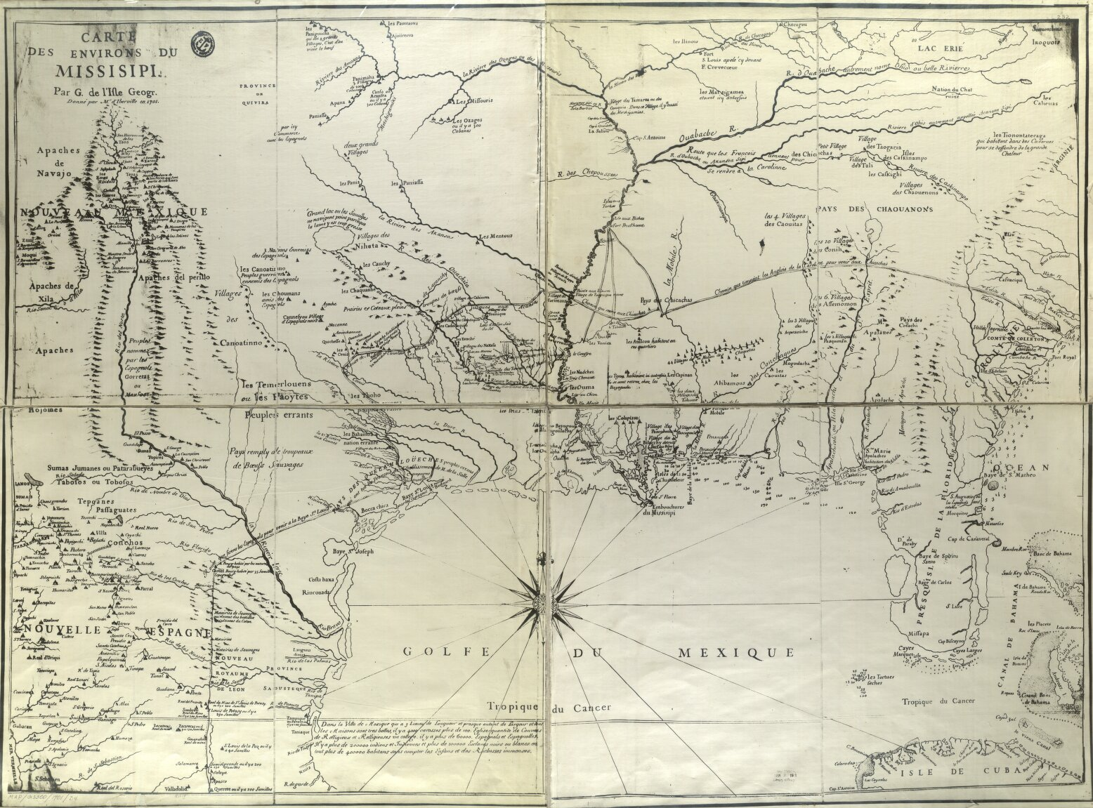
Figure 19 L'Isle, Guillaume de, 1675-1726. “Carte des environs du Mississippi.” 1701. https://dlg.usg.edu/record/guan_hmap_hmap1701d4#item

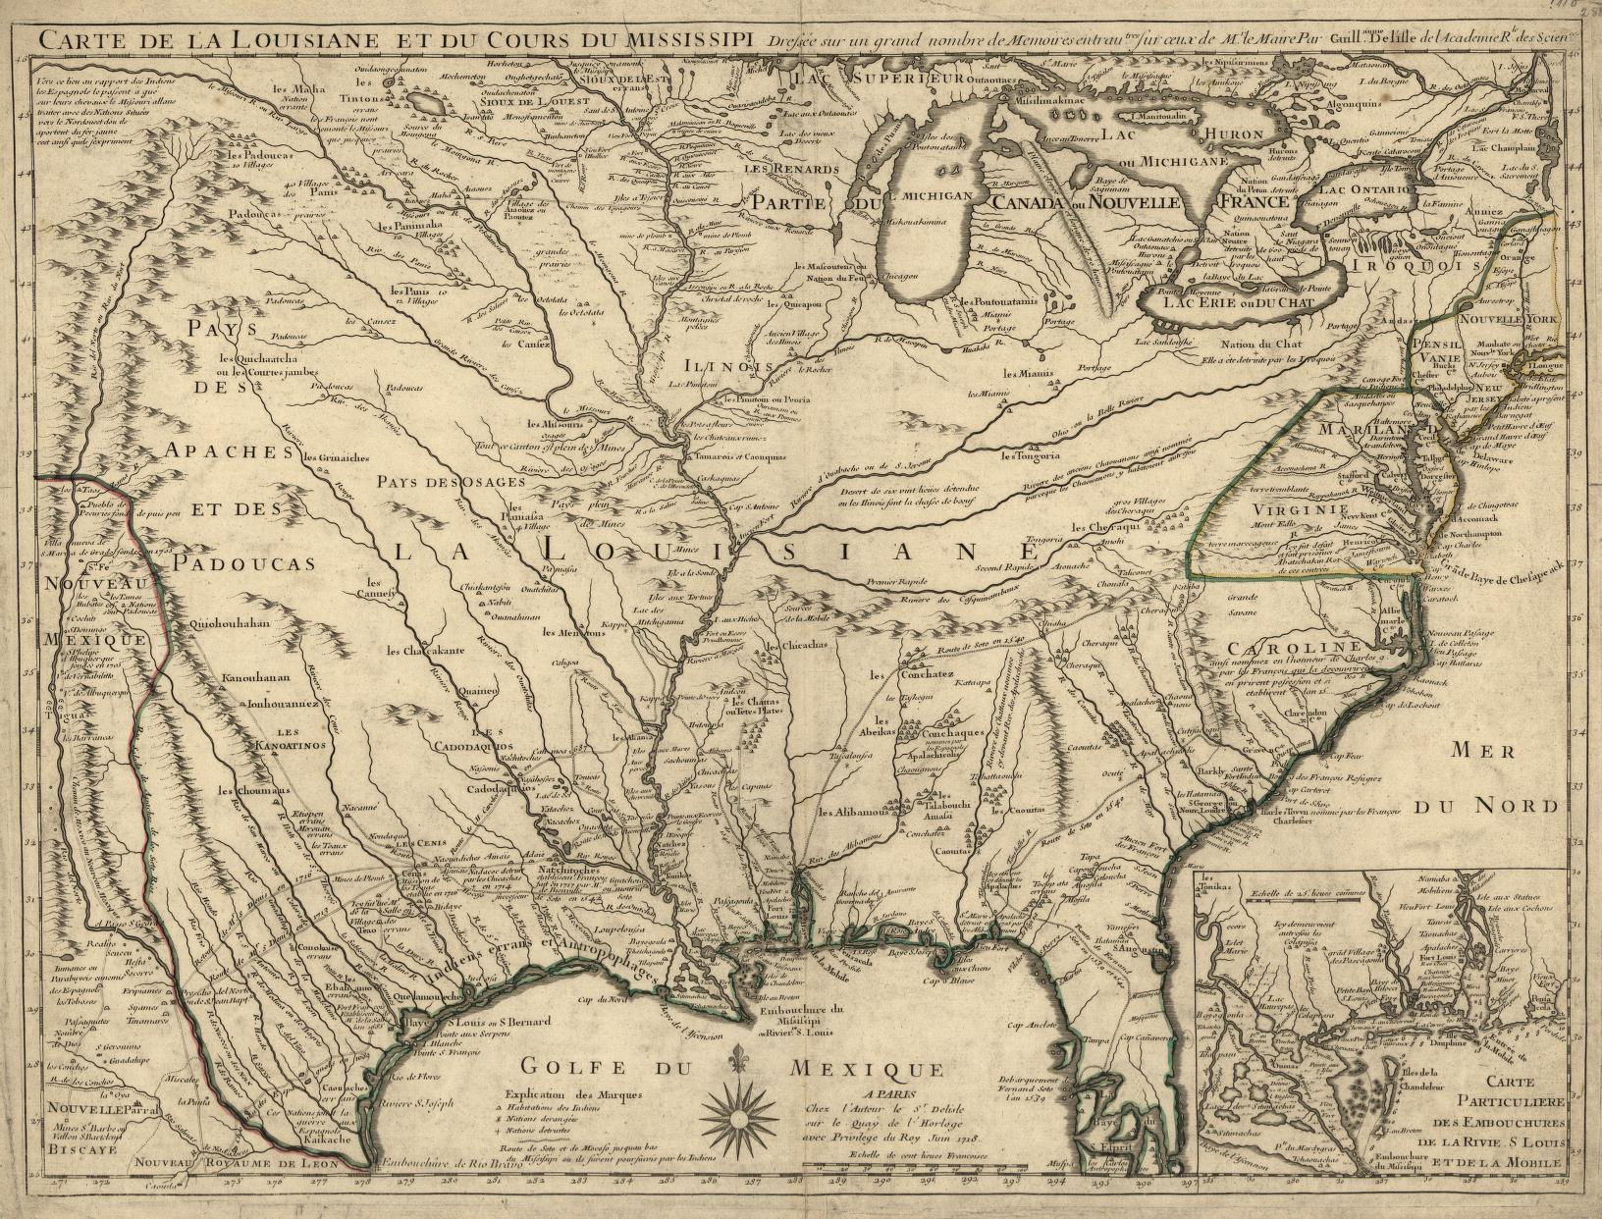
Figure 20 L'Isle, Guillaume De. Carte de la Louisiane et du cours du Mississipi i.e. Mississippi: dressée sur un grand nombre de mémoires entrautres sur ceux de Mr. le Maire. Paris: Chez l'auteur le Sr. Delisle sur le quay de l'horloge avec privilege du roy, 1718. Map. https://www.loc.gov/item/2001624908/

map as Indigenous groups coalesced and took on new identities within the Native Southeast and new roles within European colonial strategies.
The Indigenous nomenclature of the Mississippi Valley and areas west of the Savanna River reflect the information given to Claude Delisle regarding M. de Sauvole’s interactions in the Mobile Bay area with an Alabaman Muklasa man living among the Mobilians in 1700. The journal prepared by Charles Lavasseur and edited by Claude contains the names of thirty-six distinct Indigenous groups throughout the Southeast as far away as the Cherokee. Recorded through a Choctaw interpreter, the Alabaman Muklasa man laid out the geography of the Native South for Sauvole according to his spatial understandings. The man informed Levasseur of the positions of thirty-six distinct Indigenous groups located along rivers throughout the Southeast.
The unnamed Alabaman Muklasa man and other Mobilians’ description of the region reveal their understanding of the landscape. The Mobilians indicated that the Alabama River ran into Carolina, expressing their understanding of territorial boundaries encompassing access to watersheds. Levasseur also found that several communities had settled around Iagame minco (high ground), suggesting that coalescing societies still valued traditional locations of power. Decades of colonial impacts, disease, slave raids, and displacement manifest as relocated groups that sought shelter in clusters along Southeastern rivers. Delisle struggled to label the new groups within solid political entities required by his colonial perspective.
Delisle initially adopted the nomenclature from Franquelin referencing the Cherokee and neighboring groups but made a significant typographical and fundamental change on his maps after obtaining the Alabaman Muklasaman’s information. The nomenclature stimming from Franquelin’s maps represented the group of Cherokees referring to themselves and describing their neighbors’ locations in the 1673 encounter with the Jolliet and Marquette. Delisle had changed the toponyms to “Les Cheriqui” on his 1718 map. “Cherokee” is not a word in the Cherokee’s Tsalagi language, suggesting this change signified the Alabaman Muklasaman’s or so other groups’ understanding of linguistics as a significant cultural identifier that could be placed in a specific location.
Delisle incorporated the Indigenously sourced information into France’s imperial vision of territorial claims that simplified the Indigenous groups according to colonial contexts. By the early eighteenth century, potential profits through trade had replaced mineral wealth as France’s primary colonial focus. Delisle’s cartography organized coalescing Indigenous groups that the Cherokee and Alabaman Muklasaman’s descriptions viewed as culturally distinct into legible polities and placed them within France’s ambit of territorial sovereignty. British officials took notice of French imperial claims that relegated the British presence to the Atlantic coast, isolated from Indigenous trade networks. British decried the map as cartographically “making encroachments on the King’s territories.” The competing visions of incorporating Indigenous coalescence throughout the Southeast into disparate imperial schema produced distinct cartographic nomenclatures between British and French maps.

The British are Coming: Mapping British Colonialism in the Native South
Late seventeenth and early eighteenth-century British maps of the Southeast also hinged on rationalizing Indigenous spatial epistemologies that contoured a developing vision of a British colonial space. Before the Yamasees War, British officials focused on encouraging coastal areas of settlement that produced agricultural resources and facilitated trade with Indigenous groups that ultimately profited the metropole. After the war, which geopolitically transformed portions of the Southeast, British colonial officials perceived Indigenous groups as military and economic allies or enemies in their attempts to solidify territorial acquisitions through demographic ascendancy. The first generation of British maps that depicted the Southeast from a north orientation followed and facilitated the expansion of British commerce-based colonial endeavors.
Thomas Nairne’s 1708 map represented the British colonial lens before the Yamasee War. Figure 21 Fitting with Britain’s pre-war colonial schema, the map appeared as an inset of Crisp’s 1711 printed map that devoted most of the map to a much larger scale depiction of the plantations around the Charles Town area. Nairne fashioned the map following his expedition west from Fort Augusta to the Mississippi River in search of potential Indigenous trading partners. Nairne encountered several coalescing Indigenous communities described by the Alibamon man to M. de Sauvole a few years earlier. Nairne’s cartographic vision of the Southeast came from information he gathered as he ventured west. Along with taking measurements of latitude and estimating longitude based on dead reckoning, Nairne solicited topographical and geopolitical information from the Indigenous communities he encountered. The information these groups provided shaped Nairne’s map into a combination of British and Indigenous renderings of space.
Indigenous understandings of geography informed the river systems’ depictions on the map. Historians of cartography have long lamented the persistence of an east-to-west orientation of the Appalachian Mountains into the eighteenth century on colonial Southeast maps. However, reevaluating Nairne’s map using Indigenous spatial epistemologies reveals a rational and accurate depiction of the Southeast on the map. As Nairne proceeded west, he inquired from
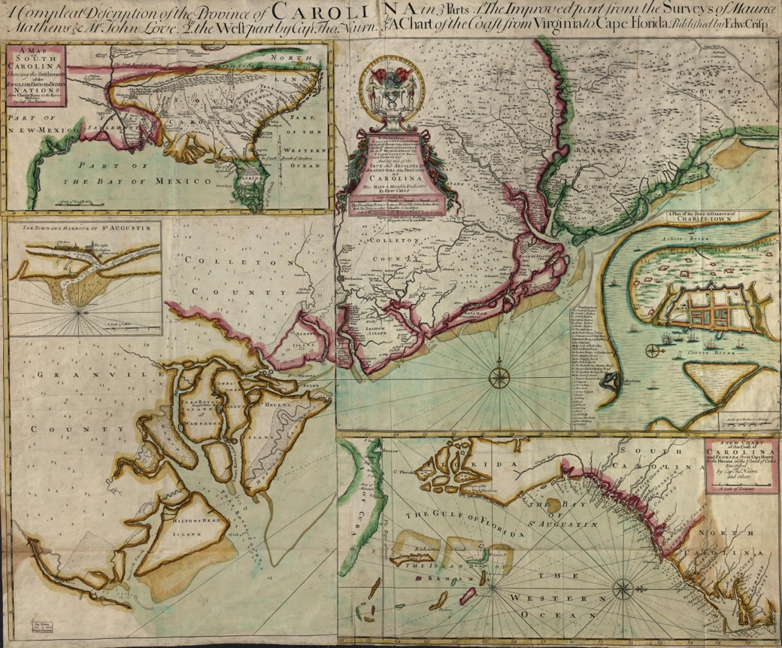
Figure 21 “Nairne Map” in the upper left: Crisp, Edw, Thomas Nairne, John Harris, Maurice Mathews, and John Love. A compleat description of the province of Carolina in 3 parts: 1st, the improved part from the surveys of Maurice Mathews & Mr. John Love: 2ly, the west part by Capt. Tho. Nairn: 3ly, a chart of the coast from Virginia to Cape Florida. [London: Edw. Crisp, ?, 1711] Map. https://www.loc.gov/item/2004626926/.

Indigenous peoples regarding what could be found up and down the rivers from the communities he visited settled along the rivers’ banks.
His Indigenous sources correctly told him that the Savana, Chattahoochee, and Coosa Rivers initiate in the Appalachian highlands. They also informed Nairne that the Oconee, Flint, and western rivers from the Mobile area do not. Indigenous residents continued to tell Nairne that the rivers he crossed began in the mountains to the north as Nairne proceeded due west. Nairne, ignorant of the exact orientation of the rivers with headwaters in the Appalachian Highlands, assumed that the mountains must also proceed west. Indigenous informants also informed Nairne of their neighbors’ territorial location throughout the Southeast. The result of Nairne combining the Indigenous information within his European framework is a map that does not conform to European standards of accuracy but proves highly useful within its Indigenous geographical perspective. Although the map depicts Indigenous communities’ territoriality and their riverine connections as the Indigenous peoples of the Southeast understood them, Nairne places Indigenous communities within a British colonial context by enumerating each community’s population as an indication of their potential commerce and connecting the interior Southeast to British Virginia and Carolina with overland trade paths. The socio-political upheavals caused by the Yamasee War would transform how the British approached their imperial project in the Southeast.
The 1721 “Barnwell-Hammerton Map” represented the new post-Yamasee War British imperial vision for the Southeast. Figure 22 Considered a “mother map of the first degree” by modern historians of cartography, the Barnwell-Hammerton Map became the basis for Southeastern maps until after the American Revolution. The Barnwell-Hammerton Map,
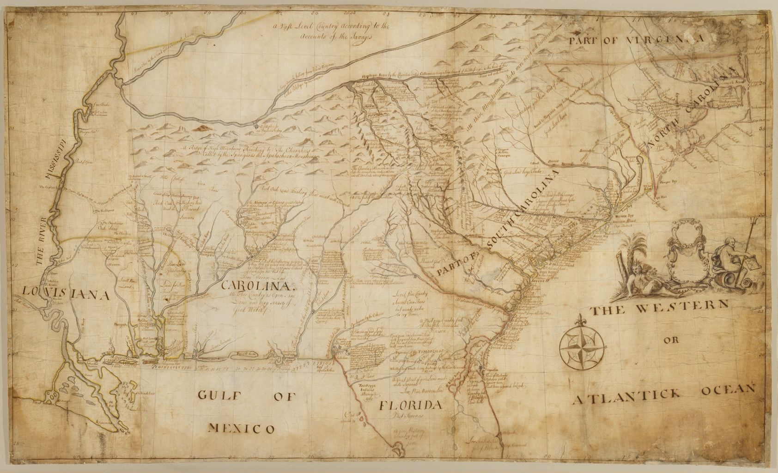
Figure 22 “The Barnwell-Hammerton Map”, Hammerton, William, -1732, Map of the southeastern part of North America., 1721., Yale Center for British Art, Gift of the Acorn Foundation, Inc., Alexander O. Vietor, Yale BA 1936, President, in honor of Paul Mellon. https://collections.britishart.yale.edu/catalog/orbis:9600894

housed at the Yale Center for British Art, is one of two contemporary manuscript maps based on information gathered by Colonel John Barnwell. The British Public Archives houses a similar map, known as the “Barnwell Map.” These maps contain information provided by Indigenous people throughout the Southeast. Like Delisle and Nairne’s maps of the pre-war Southeast, Barnwell’s map depicts Indigenous spatial epistemologies of the Southeast as newly displaced Indigenous communities experienced the ripple effects of the Yamasee and Tuscarora Wars in the 1710s. As with the other maps, Barnwell placed the Indigenously sourced information within the contemporary colonial context of British imperial expansion.
The map’s riverine orientations reflected newly relocated Indigenous communities’ continued autonomy within settlement clusters. For example, the map shows nine individual Indigenous groups, including Yuchis and Westos, clustered along the Chattahoochee River. The adjacent text states these communities removed to this location in 1716 and “are at peace with us” but still “suffer the French” to trade with them as well as us.” The text groups the autonomous communities as one military unit “in all about 1,000 men” whom the author describes as “the most military Indians in the dept.” The map displays the tension between the Indigenous communities’ desire to retain their cultural identity and the British impulse to combine neighboring groups into a single category.
Established Indigenous groups reified territorial claims on the map according to their understandings. The Cherokee sources placed the headwaters of several coastal rivers, including the Savana River, within their territory. These headwaters intersected with the headwaters of the rivers running north and west into the Tennessee River watershed. The Cherokee’s definitive sense of territory manifests on the map as an exaggerated area of rivers’ confluence among the Appalachian Highlands. Having won the Yamasee War for the British in 1715 and becoming increasingly more involved in the deer-skin trade to Charles Towne, the map displays the Cherokee as a powerful force within the Southeast. The text on the map uses numbers from the Varnod Census in 1721 to estimate the Cherokee population and separates the Cherokee settlements into geographic regions that had little to do with Cherokee social and political structures.
Text sprinkled across the maps regarding the landscape’s agricultural potential hints at the emerging British imperial vision of territorial sovereignty through increased colonial occupation. The map described areas as “rich oak and hickory land” containing mast for free-range husbandry. Other regions contain “good level land” with “large timber” and unused hunting grounds abounding with “deer, bear, and buffalo.” The map advertises some regions as unpopulated, stating, “all this country is open.” As British officials assessed how best to control the Southeast, they increasingly envisioned a region where Indigenous groups represented problematic internal barriers rather than potential foreign allies. The Barnwell-Hammerton Map played an active role in British colonial expansion. As tensions grew between European powers, the Barnwell-Hammerton Map’s Indigenous geopolitical realities increasingly became subsumed into British imperial aspirations.
John Mitchell’s 1755 A map of the British and French dominions in North America represented the culmination of Indigenously sourced cartography placed within a colonial context. Figure 23 Considered the most important map of North America by historians, the Mitchell Map is renowned for its bold territorial claims and essential role in cartographically codifying British North America. Before commissioners used Mitchell’s map to draw the borders of the newly independent United States at the Treaty of Paris in 1783, British officials used the
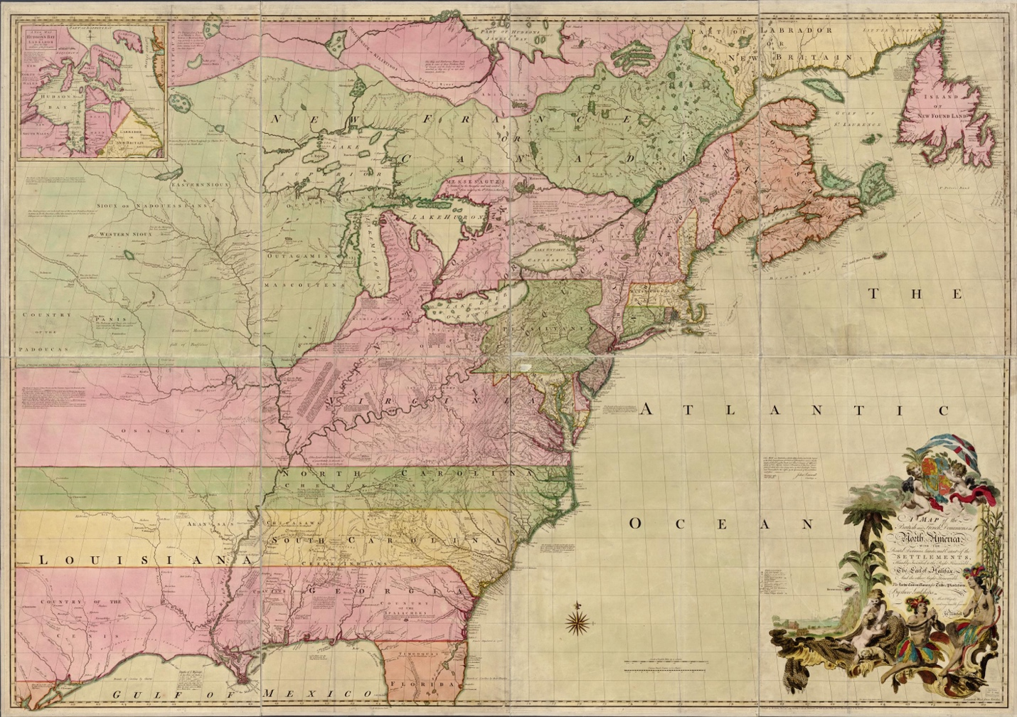
Figure 23 Mitchell, John, Thomas Kitchin, and Andrew Millar. A map of the British and French dominions in North America, with the roads, distances, limits, and extent of the settlements, humbly inscribed to the Right Honourable the Earl of Halifax, and the other Right Honourable the Lords Commissioners for Trade & Plantations. [London; Sold by And: Millar, 1755] Map. https://www.loc.gov/item/74693173/.

map to envision a British North America controlled and occupied by British subjects. The Southeast loomed as a potential lynchpin for territorial control within the continental colonial vision. Mitchell’s map incorporated a near-exact replica of the Barnwell-Hammerton Map’s geographic nomenclature for the Southeast. As British, French, and Spanish administrators poured over the map, preparing for a global conflict, they would have observed the Southeast as Indigenous groups understood the region in 1721 under a multivalent colonial façade rife with textual and visual indicators of imperial imaginations.

Conclusion
Indigenous spatial epistemologies on European maps show how Indigenous groups in the Southeast responded as they absorbed the European Atlantic World into their region. The six identifiable nomenclatures on European maps of the Southeast provide a glimpse of Indigenous communities responding to upheaval as colonial incursion took different forms over the sixteenth, seventeenth, and early eighteenth centuries. The maps record a complex and fluid Indigenous space, demonstrating how individual Indigenous groups contested territories, enslaved rivals, and coalesced for survival. European mapmakers placed these internal geopolitical developments into a contemporary colonial framework that reflected contemporary imperial imaginations and ambitions.
Early Southeastern maps demonstrate Indigenous people’s influence on the development of European cartography. Using journals filled with information from diverse Indigenous sources, European mapmakers bent lines and distorted scales to fit unfamiliar geographical conceptions into Cartesian-style maps. Indigenous forms of distance, direction, and territoriality informed how European mapmakers positioned rivers and delineated boundaries. The science of cartography progressed within drafting offices in European capitals only as fast as Europeans came to understand the information they received from Indigenous peoples who occupied the space depicted on the maps.
As European incursion increased, Indigenous information on Southeastern maps became increasingly suppressed. British and French colonial projects turned mineral resource extractive colonialism into trade and agriculturally based colonialism during the sixteenth, seventeenth and early eighteenth centuries, culminating in the Seven Years’ War. Early eighteenth-century maps reflect the transition of imperial goals from resource extraction to increased territorial occupation. Colonial era maps facilitated this transition by promoting the region’s envisioned agricultural potential and ostensive subjugation to European monarchs. These promotional maps enticed colonial investors, excited individual settlers, and prompted colonial officials to wage war over claims the maps brought into relief. Soon, individual land speculators would transform maps drawn from Cherokee informants into weapons far more effective than rifles.

CHAPTER 2: ᎠᏇᏅᎡᎢ Ꭶ ᎠᎾᎴᏂᏍᎬ AQUENVSVI GA YANALENISGV (HOME SINCE THE BEGINNING) THE ᏣᎳᎩ (CHEROKEE) HOMELANDS TO 1755
Soapstone boulders in the Appalachian Highlands might display the oldest maps of the ᏣᎳᎩ (Cherokee) homelands. One such rock, Tsulʻkălû′ (Judaculla’s) Rock, has a multivalent cultural significance. According to some Cherokees, the rock contains markings made by the giant Judaculla. A ᏣᎳᎩ story recounts how Judaculla lived in the region as a land steward for millennia before teaching the newly arrived ᏣᎳᎩ how to take care of the region’s environmental resources to ensure the Cherokee’s survival. According to some Cherokees, Judaculla means to “lean against” in the Tsalagi language of the ᏣᎳᎩ, a name the Cherokee gave the giant because the pupils in his eyes leaned to the side. As the story goes, before departing westward, Judaculla drew a map on the rock that showed the Cherokees where they could find all the resources throughout the region that they would ever need. With that, Judaculla left the Cherokees to live in balance with their environment for eternity. That is one version.
While hiking one clear autumn day in the ᏣᎳᎩ homelands with Doyi, a Cherokee scholar, the story of Judaculla arose. Most of us in the group, comprised of a few younger Cherokees and two non-Native scholars, knew the story well and waited anxiously to hear what insights Doyi had to lend to the story. He simply chuckled and informed the group that “ju-da-cull-a” did not mean just “lean against.” Elders had told him it meant to lean over and “pee on.” The Cherokees in the group laughed heartily while we non-Natives tittered as we pondered what meaning in his story must have gone over our heads. Perhaps one thread in the story of Judaculla’s Rock had a more jovial esoteric significance.
Tsulʻkălû′ (Judaculla’s) Rock quite literally demonstrates the extricable relationship between Cherokee culture and the landscape in which it formed. The poignancy of the multiple versions of the rock’s significance lies in its representation of the plurality of a collective Cherokee identity that is as dynamic as ever. As with all Cherokee history, a consensus version of events rarely exists. Instead, each rendition comprises an interwoven thread in a communal historical tapestry. That tapestry is woven into the landscape of the Southern Appalachian Highlands. The ᏣᎳᎩ homelands shaped Cherokee society as much as Cherokees shaped their ᎦᏙᎯ ᏄᏍᏗᏓᏅ gadohi nusdidanv (landscape).
Understanding the Cherokee’s symbiotic relationship with their homelands provides insight into why settler colonialism’s demographic infiltration proved so existentially threatening to eighteenth-century Cherokee society. Reconstructing the ᏣᎳᎩ built environment of the seventeenth and early eighteenth centuries, before settler colonialism’s structure enveloped the region, provides an opportunity to examine the relationship between ᏣᎳᎩ culture and their homelands.
The pre-colonial-entrenchment Cherokee ᎦᏙᎯ ᏄᏍᏗᏓᏅ gadohi nusdidanv (landscape) existed as human-environment relationships that fostered and developed from the Cherokee’s societal structure. Cherokees coalesced by incorporating other Indigenous groups into their society while maintaining a cultural continuity connected with ᏣᎳᎩ “center places,” which are both physical and spiritual. These cultural anchors included townhouses, rivers, places of long-established human occupation, sacred sites, and residences of non-human kin. These “center places” moored Cherokee identity onto a multidimensional landscape within their homelands.
ᏣᎳᎩ social structure relied on an essential relationship with their homelands’ physical and spiritual elements to maintain viability. Cherokees recognized themselves as belonging in a reciprocal relationship with their ᎦᏙᎯ ᏄᏍᏗᏓᏅ gadohi nusdidanv (landscape). Cherokee religion was rooted in the landscape by sacred narratives encompassing numerous specific geographical places within their homelands. The unique spatial relationships between ᏣᎳᎩ settlements, riverine connections, cosmography, and agricultural practices represented the physical manifestation of a dynamic but persistent Cherokee culture. The Cherokee built environment allowed for the autonomy of households, clans, communities, and settlement clusters to all function as a consolidated and distinctive ᎠᏂᏴᏫᏯ aniyvwiya (“us”).
This chapter examines the Cherokee’s relationship with their ᎦᏙᎯ ᏄᏍᏗᏓᏅ gadohi nusdidanv (landscape). The examination prioritizes ᏣᎳᎩ oral tradition and ᏣᎳᎩ epistemologies on maps as the sources most capable of providing a decolonized assessment of ᏣᎳᎩ emplacement in the Appalachian Highlands in the century before European entrenchment transformed the landscape. Although the maps in this chapter are European sources, the information contained on them is Indigenous and provides a ᏣᎳᎩ perspective. I use archeological, linguistic, and written sources to reveal physical manifestations of ᏣᎳᎩ sources regarding their existential relationship with their homelands.

Deep and Diverse Connections
According to various sources, the Cherokees have either lived in the Appalachian Highlands since time immemorial, migrated to the area many centuries ago, have direct connections with ancestral forbearers that had lived in the area for millennia, or developed as a distinct people sometime after the mid-sixteenth century. It is possible that each assessment is equally valid and congruent and fits neatly into a pluralistic Cherokee society that has always consisted of autonomous elements that constitute a whole. The Cherokee refer to themselves as the “ᎠᏂᏴᏫᏯ aniyvwiya (“us”) and the “Ani′-Kĭtu′hwagĭ” (the people from Kituwah), suggesting both deep roots and a shared environment. Cherokee oral traditions contain both migration and emergent narratives. Linguistic studies of Tsalagi suggest Cherokee migration and exogenous incorporation, while archeological studies suggest elements of long-term continuity and cultural integration. The Cherokee’s cultural-physical relationships with their homelands in the decades before European invasion display evidence of endemic lifeways and constant incorporation of new cultural elements over a protracted period.
ᏣᎳᎩ oral traditions of emergence and migration each hold historical significance. The stories hint at a collective identity that contains elements of sustained occupation, relocation, and integration of other cultures. Linguistic, archeological, and cartographic evidence support ᏣᎳᎩ oral traditions. As with many oral tradition studies, exact dates and locations matter far less than the collective memories the stories evoke to fashion a cultural connection to a physical environment. The Cherokee’s origins lie within these stories.
The body of archeological studies of the Appalachian Highlands supports a multilinear Cherokee cultural development. The region’s archeological sites abound in Woodland and Mississippian Era cultures’ materials and earthworks, evidencing sustained occupation in the area for at least three thousand years. Archeologists have debated the relationship between modern Cherokee peoples and the region’s ancient and more recent cultural artifacts.

Emergent Stories
According to some ᏣᎳᎩ ᎦᎸᏉᏗ galvquodi (beloved) narratives, the Ani′-Kĭtu′hwagĭ have lived in the Appalachian Highlands since time immemorial. Near the beginning of time, the giant sulĭ′ (Great Buzzard) flew over the earth. When he reached the ᏣᎳᎩ homelands, he became fatigued, and his wings beat against the ground, creating the mountains and valleys of the Southern Appalachian Highlands. Soon after, the first two Cherokees, Selu and her husband Kana′tĭ lived on Tsuwa’tel’da (Pilot Knob) with their sons. Selu mysteriously and effortlessly produced corn and beans while Kana′tĭ harvested animals such as deer to provide food. The couple’s mischievous sons murdered Selu and ruined Kana′tĭ’s method of harvesting animals before following their father to the east. The story leaves exact timelines and many locations undefined but makes clear that Cherokee society is deeply rooted in the Appalachian Highland’s agricultural resources and gendered agrarian practices that the Cherokee have relied on to harvest these resources since the beginning of Cherokee history.
Many archeological studies have pointed to some form of an in situ model for Cherokee development in the region. Archaeologists Bennie Keel and Roy Dickens Jr. forwarded arguments that drew direct ties between Woodland period material culture, such as pottery, and modern Cherokees in the Appalachian Highlands. According to their reports, “hallmarks” of Cherokee material culture first appeared in the Woodland period and continued through the nineteenth century. Keel and Dickens’s initial studies explained the Cherokee’s eighteenth-century egalitarian culture as resulting from a “cultural decline” following a period of “sociopolitical complexity” during the Mississippian era. Dickens later amended his argument to distance the development of Cherokee culture from earlier groups’ occupation, identifying Cherokee culture as a distinctive adaptation to the environment of the Appalachian Highlands and integration of large groups of Indigenous peoples, resulting from widespread population displacements of the sixteenth century. In 1989, Gerald Schroedl also forwarded an in situ model for Cherokee development, arguing that Overhill Cherokees emerged as a politically reorganized society resulting from a “dramatic collapse and reorganization of hierarchically organized chiefdoms” that prevailed in the region during the previous centuries.

Migration Stories
Other stories hint at an ancient Cherokee migration. According to ethnographer James Mooney’s 1900 publication, Myths of the Cherokee, most Cherokee migration stories had been forgotten by his time, but early nineteenth-century historian John Haywood had preserved fragments. One “vestige” of a migration story told amongst the Cherokee recounted the tribe migrating from the west into the Ohio Valley, then to the Shenandoah Valley of Virginia, and finally into the Appalachian Highlands.
The ᏣᎳᎩ narrative of migration from the west into the Ohio Valley, then to the Shenandoah Valley of Virginia, and finally into the Appalachian Highlands bears out in linguistic evidence. Linguistic studies suggest a multilinear genesis for the Cherokee people. Glottochronological studies have indicated that the Cherokee’s Tsalagi (Southern Iroquoian) language diverged from Northern Iroquoian from 3,500 to 3,800 years ago in one estimation and 2,700 years ago in a more recent analysis. Researchers have also employed an Automated Similarity Judgment Program that estimated the language clades split at a much earlier date of 4,855 years ago. A 2017 study considered geographical and lexical separation, estimating Southern Iroquoian speakers diverged from Northern Iroquoian speakers in what is now west-central New York “4,624 years ago ± 1,341 years (3965-1283 BCE). The study concluded that the geographical area of ancestral Iroquoian speakers before the initial divergence is unknown. However, subsequent clade splits coincide with significant events observable in the archeological record, such as the emergence of corn cultivation in eastern North America.
Each study attributes Tsalagi’s lexical dissimilarities with Northern Iroquoian languages to prolonged separation, exposure to non-related languages, and internal innovations. As Patricia Galloway accurately observed, linguistics fails to define ethnic distinctions but serves as a “strong promoter of community solidarity.” In the case of the Cherokee, Tsalagi’s uniqueness and thoroughly developed regional dialects reflect the incorporation of several cultural traditions and groups under a single cultural umbrella corresponding to a multivalent Cherokee identity.
Following Cherokee oral traditions, the most recent archeological summations of Cherokee cultural development recognize both long-term occupation and rapid, more recent ethnogenesis through coalescence. Christopher Rodning’s study of the Coweeta Creek site concluded that while eighteenth-century Cherokees have ties to much earlier Appalachian Highland communities, a distinct modern Cherokee identity emerged as a direct result of demographic changes brought on by the European invasion of North America. Rodning’s examination of eighteenth-century Cherokee townhouses also forwarded a blend of post-European contact adaptations to more deeply rooted architectural traditions.
Jon Marcoux’s examination of the Tuckaleechee town sites in the Tuckaleechee Cove of East Tennessee led him to agree with Rodning that aspects of “Cherokee ethnogenesis took place largely in response to European colonial pressure during the late seventeenth and early eighteenth centuries.” Marcoux found adjacent households containing three distinct pottery traditions with disparate antecedents, concluding that late seventeenth and early eighteenth Cherokee societies became increasingly diverse due to coalescent groups, displaying evidence of sustained local cultural traditions and incorporation of exogenous practices. Marcoux’s perspective intuitively allows for a community-based, diverse conception of Cherokee culture over a monolithic Cherokee identity that has traditionally served as a litmus test for determining what material artifacts scholars could define as authentically “Cherokee.” Investigating the process of coalescence helps better understand who represented ᎠᏂᏴᏫᏯ aniyvwiya (“us”) and where they lived by the mid-eighteenth century.

Mapping Cherokee Coalescence
In 1826 ᏣᎳᎩ Charles Hicks recounted a story in a letter to the Principal Chief of the Cherokee Nation, John Ross, outlining historical movements of the ᏣᎳᎩ. He stated that at some time in the not-so-distant past, Cherokees had moved into areas near the mouth of the Hiwassee River. According to the oral tradition that Hicks wrote in his letter, Cherokees had moved in the immediate proximity of two other Native communities. Hicks wrote that the “Uchees became their nearest neighbors who settled on the south side of the [Hiwassee River]” and the “Creeks made their settlement at Sawtee” above the mouth of ᎤᎴᏖᏩ “oo-le-te-wauh” [Ooltewah Creek] alongside Cherokees and Uchees. Cartographic and archeological evidence complements ᏣᎳᎩ oral tradition. The narrative states there was “no account of any hostile nature,” noting the three communities lived peacefully together for over a century.
Two sixteenth-century French maps indicate three diverse groups residing together in the Cherokee homelands near the mouth of a river in the 1670s. Figure 24, Figure 25 Contemporary French mapmakers customarily used ethnonyms to indicate the location of linguistic groups, suggesting that the toponyms on the maps placed three culturally distinct groups in immediate proximity. Marquette’s Carte da la nouvelle decouverte locates three communities at the terminus of a river in the Appalachian Mountains. Anthropologist John R. Swanton suggested the toponym “Taharea” represents a Yuchi community. He identified “Kaskinȣba” as a Koasati community and ȣabanghiharea as the Algonquian term for “easterners.” Koasati speak a Muskogean dialect similar to Creek as identified in the later Cherokee narrative. ȣabanghiharea may have been the term Marquette recorded on the advice of one of his

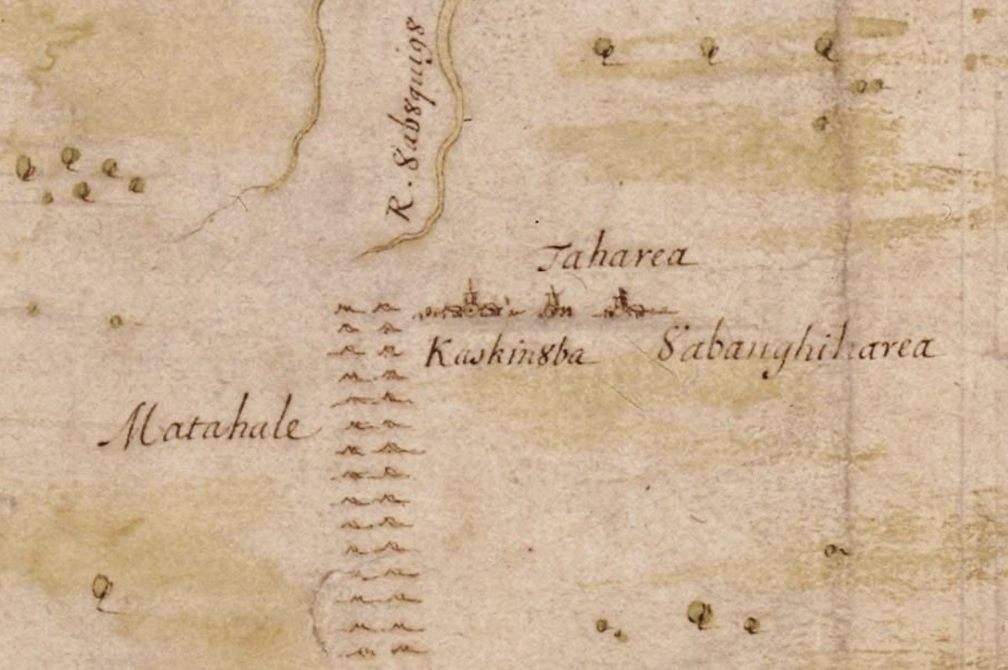
Figure 24 Inset: Jolliet, L. & Marquette, J. (1673) Map of the New Discovery Made by the Jesuit Fathers in and Continued by Father Jacques Marquette, from the Same Group, Accompanied by a Few Frenchmen in the Year 1673, Named “Manitounie .”[Place of Publication Not Identified: Publisher Not Identified] [Map] Retrieved from the Library of Congress. https://www.loc.gov/item/2021668635

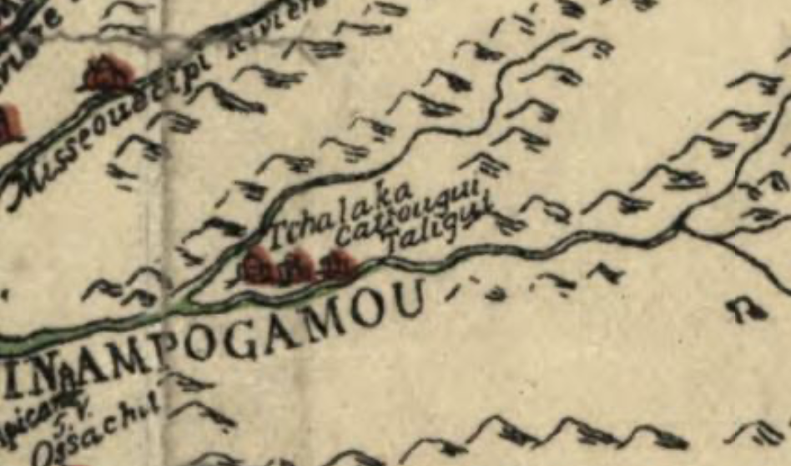
Figure 25 Inset: Franquelin, Jean Baptiste Louis, [S.l, 1896-1901], Carte de la Louisiane ou des voyages du Sr. De La Salle, from the original, 1684, Harvard University Library. http://hdl.loc.gov/loc.gmd/g3300.ct000656

Algonquian speaking guides. “Easterners” would indicate the relatively recent arrival of a group from the east, the Cherokees.
Jean Baptiste Franquelin’s Carte da la Louisiane notes three toponyms in the same location, including “cattougui,” the “people from Kituwah,” the Cherokee’s mother town.
“Taligui,” which Swanton identifies as Tǎlikwǎ (Great Tellico). Tǎlikwǎ, although it became a Cherokee town by the eighteenth century, had long been occupied. Archeological evidence shows over 10,000 years of mixed occupation at Tǎlikwǎ. Swanton suggests “Tchalaka” is a Gallicized form of the word “Cherokee.” Linguistic clues suggest Franquelin’s nomenclature came from Cherokee members of the group.
The toponyms provide insight into the process of Cherokee coalescence. Both sets of nomenclature likely stemmed from the chance meeting in 1673 on the Mississippi River between the French wonderers and a group of Native people from the area around the confluence of the Hiwassee and Tennessee Rivers described in Cherokee oral history. Curiously, the Cherokee language contains no bilabial stop prohibiting a monoglot Cherokee speaker from providing the names “Kaskinȣba” and ȣabanghiharea on Marquette’s map derived from his personal notes. His recording of “ȣabanghiharea” (easterners) suggests non-Cherokees provided information regarding their neighbors to Algonquian-speaking members of Marquette’s party, which he recorded and mapped.
ᏣᎳᎩ speakers provided nomenclature that represented locations of towns rather than linguistic groups’ ethnonyms on Marqutte’s map. Cherokees would have described themselves as originating from “cattougui” (Kĭtu′hwagĭ). The addition of the suffix “ui,” or spelled Ᏹ (yi) in Cherokee, signifies a Cherokee speaker identifying a placename. Cherokees identified Tǎlikwǎ (Great Tellico) as a settlement, but the term does not distinguish a particular group. Swanton’s assumption that “Tchalaka” is an ethnonym representing Cherokee is likely incorrect. No dialect of the Cherokee language has a hard “ch” sound, and the French pronunciation of “Tcha” sounds more like the Cherokee “Ꮳ” (tsah), making the toponym inconsistent with the Cherokee language and with Cherokee’s identifying town locations rather than ethnonyms. “Tchalaka” could represent an early example of the Cherokee practice of renaming Muskogean-speaking people’s towns. The Native group that provided the geographic information for the maps must have consisted of multilingual speakers living and traveling together.
More poignantly, the Native group contained men and women that the French described as appearing ethnically distinct. The French accorded the men in the group as bearing “the same markings (tattoos) as Iroquois.” Marquette recorded that the “women dressed and style(d) their hair like the Hurons.” Although these are colonial generalizations that do not reveal any specifics, it is clear that the French noticed cultural differences in the men's and women’s appearances.
Eastern Indigenous peoples routinely brought women, particularly captive or non-member women, as burdeners and laborers to support a group traveling for food, trade, or raids. If men and women from different communities traveled together as a regular practice among the Cherokees, Yuchis, and Koasati groups, then the practice would have driven coalescence. The children of the more recently arrived Cherokee women would all receive Cherokee clan membership, and female children would eventually become heads of Cherokee households, swelling the Cherokee population and establishing Cherokee-style matrilineal land rights among the communities. If Cherokee women began to integrate into the Yuchi and Koasati communities, as the example of the information on the French maps indicates, a modified but culturally consistent Cherokee society would have become hegemonic in the area within a few generations. The archeological and written records demonstrate the result of these interactions.
A study published in 1946 evaluated materials on Hiwassee Island in the East Tennessee region. The study found burial practices and pottery styles that the researchers deemed inconsistent with eighteenth-century Cherokee practices. The authors argued that the burials represented “vestiges of local Muskogean speaking Mississippian community.” Established Dallas Phase pottery assemblages began to be replaced with “typical Cherokee-stamped pottery in the 17th century, leading the researchers to conclude that the Cherokees “invaded” the Appalachian Highlands in the seventeenth and eighteenth centuries, displacing Mississippian groups throughout the region. However, Cherokee oral history, French cartographic sources, and more recent archeological interpretations show that the Cherokees did not “invade” the region. Cherokees lived alongside and coalesced with Yuchi and Koasati peoples throughout several generations in the seventeenth and early eighteenth centuries. It was not until 1714 that the colonial pressures of the slave trade caused Cherokee expulsionists to “cut off” the Yuchi communities.
Cherokee archeologists have demonstrated that other regions of the Cherokee homelands show similar patterns of generational coalescence. They argue that valleys along the Middle Nolichucky River had a “core (non-Cherokee) population that likely persisted in one area from the time of the early Spanish explorations (1540s-1560s) to the late seventeenth century” Late Dallas (Muskogean) ceramic wares “alter significantly toward the Overhill (Cherokee) tradition” in the late seventeenth and early eighteenth centuries at “Cane Notch, Runion, and Plum Grove” sites in the region. Along with diverse and transitioning material culture, archeologists also found a rise in population that “meets the criteria for emergent coalescing societies,” such as emergent large towns and villages with diverse material culture and large-scale participation in wider trade networks.” According to these scholars, “Native towns on the Upper Holston and/or Lower Nolichucky River may have folded into the Middle Nolichucky settlements during the mid-to-late sixteenth century” and similarly to the Hiwassee Island towns had taken on “an emergent regional Overhill identity by the late sixteenth and early seventeenth centuries.” Maps display the process of coalescence.
Turn of the Eighteenth French cartography shows the coalescence of distinguishable Native communities within an expanding Cherokee homeland. Prominent French mapmaker Claude Delisle compared information given to Marquette and Jolliet with information from a group of rouge French traders who traveled from the Mississippi River to Charles Town via the Tennessee River and across the Cherokee homelands in 1700. Delisle synthesized this nomenclature with other sources from Indigenous people through French voyagers in the following years. From 1700 to 1718, developments in Cherokee coalescence drove Delisle’s evolving conceptions of the Cherokee homeland’s social and physical geography displayed on his maps. Figure 26, Figure 27
Delisle’s depiction of the Cherokee homelands rapidly changed in the early eighteenth century. His 1701 map borrows information directly from Marquette and Franquelin’s maps. On his 1703 printed map, Carte du Mexique et de la Floride des Terres Angloises et des Isles Antilles, Delisle lists “Taogaria” (Tsisduyi) “Tali” (Cherokee), “Caskinampo” (Koasati), and “Les Caskighi” (Tuskegee) in the Cherokee homelands, suggesting the voyagers passing through the region found the communities labeled on Marquette and Franquelin’s 1670s maps had remained somewhat culturally distinct. A 1702 manuscript map also adds the “Nation des Tarachis,” indicating the communities along the Nolichucky River had become recognizably Cherokee, in line with archeological interpretations. While Delisle’s exact placement provides nothing more than his best estimation, the names demonstrate that the French informants found an ethnically and linguistically diverse population living in close approximation within the Appalachian Highlands. As the omission of the “Nation des Tarachis” on the 1703 printed map demonstrates, Delisle’s assessment of the available sources left him wrestling with the region’s communities’ broader cultural affiliations.

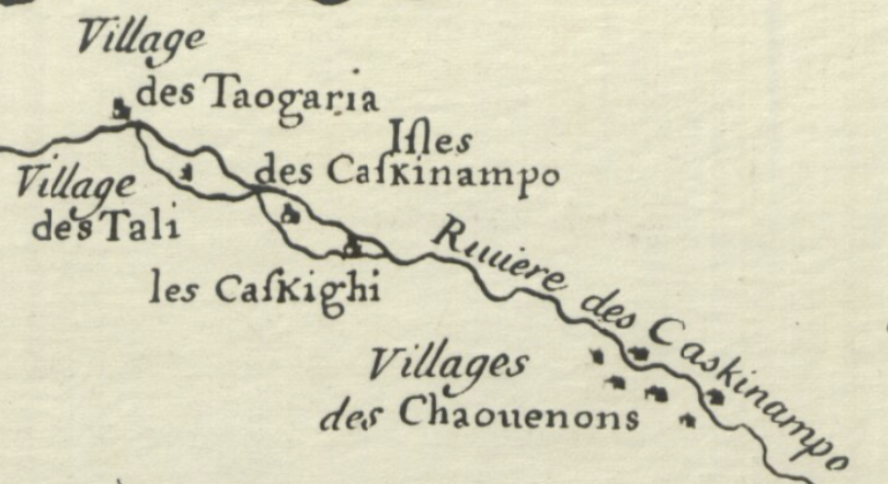
Figure 26 Inset: L'Isle, Guillaume d, 1701: Carte des environs du Missisipi par G. de L'Isle Geogr. Donné par Mr. d'Iberville en 1701.

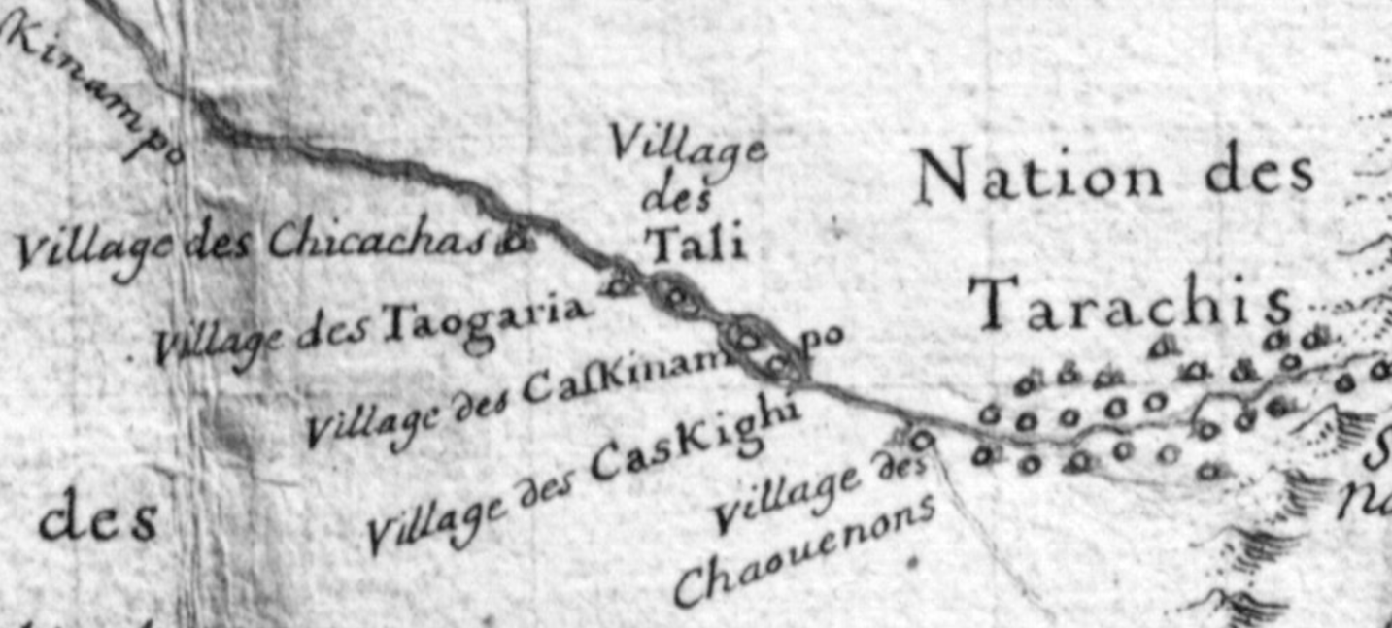
Figure 27 L'Isle, Guillaume de, 1702: Carte du Canada et du Mississipi.

Delisle’s updated 1718 Carte de la Louisiane et du cours du Mississipi introduces a variation of his understanding of the region’s complex cultural ties. Delisle labels several areas, one east and south of the Appalachian Mountains and one further upstream along a prospective river, as “Cheraqui.” These semi-regional labels for multiple towns demonstrate that Delisle
understood these areas, through his Native informants, to be exclusively occupied by separate groups of Cherokees. The regional label “les Cheraqui” indicates Delisle recognized the regional groups as belonging to a broader ethnonym. However, in the region northeast of the mountains, Delisle used what he may have thought were ethnonyms but are Cherokee terms describing the relationship between some of ᏣᎳᎩ communities and the land. Figure 28
As the Cherokee culture became hegemonic in these areas, they described their emplacement in terms of the landscape. Cherokees must have told a French informant that they lived at “Aiouache” (Hiwassee), “Amohi” (amuyeli), and “Talicouet” (Tǎlikwǎ or Tellico). However, the Cherokees’ description that resulted in Delisle’s toponyms belies a simple town-location relationship. “Aiouache,” (Hiwassee) in Cherokee, Ayphwa’si, translates to the French, prairie, or in English, meadow, “Amohi” (amuyeli), to the French, île or îlot, or in English, “land surrounded by water.” “Tongoria” remains, perhaps as a cartographic relic or indicative of a remaining group of Yuchi.
In Cherokee’s active grammar structure, the toponyms likely described a community’s relationship with the landscape rather than a specific physical location. Placenames associated with towns, such as Talicouet (Tǎlikwǎ or Tellico) and Dugilu’yi (Tugaloo), appeared in several locations because of the descriptive manner of the Cherokee language. For example, Dugilu’yi (Tugaloo) translates to English as “a place at the forks of a stream” and Tikwali’tsi as “a peaceful

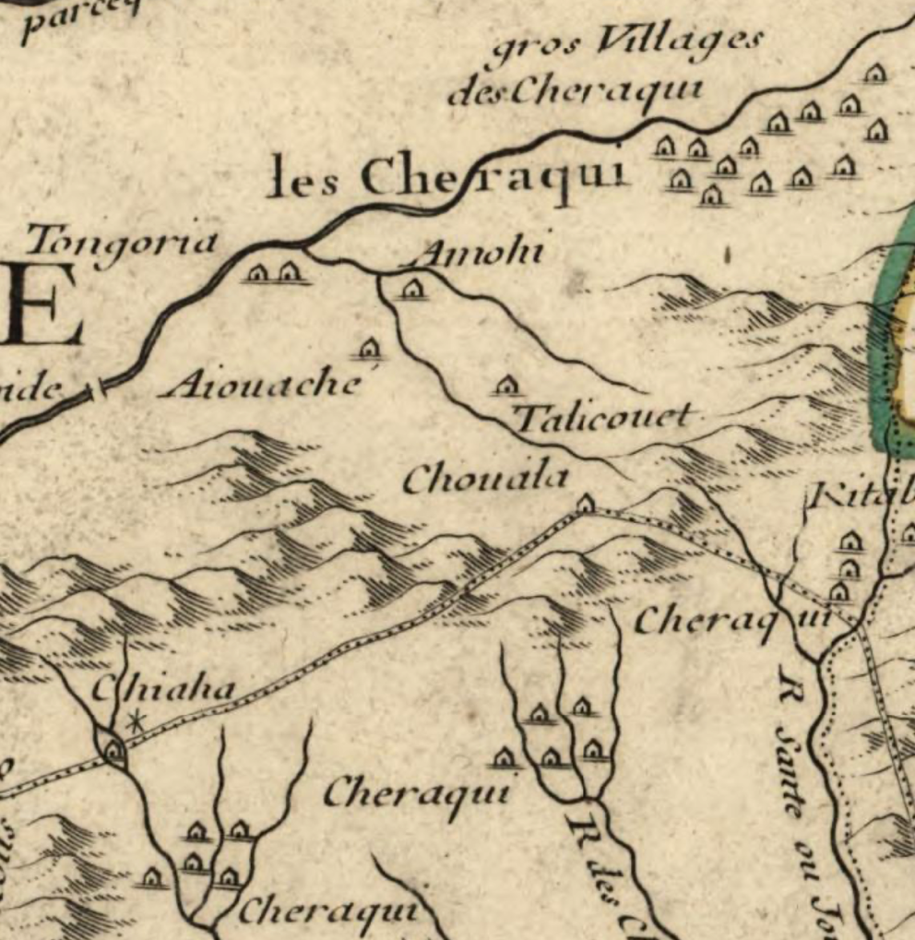
Figure 28 L'Isle, Guillaume de, 1718 Carte de la Louisiane et du cours du Mississipi

valley.” In these cases, the placenames on the maps represented a community associated with a particular type of landscape.
The 1721 Barnwell-Hammerton Map displays the development of Cherokee coalescence in the region as the onset of colonial pressures disrupted the region’s Native communities after many generations had integrated mostly amicably. Figure 29 The “Hogohegee River” references
the recent presence of Yuchi communities, as does the “Euphasee River” moniker. These rivers soon adopted anglicized Cherokee placenames on maps, the Tennessee and the Hiwassee Rivers. The Cherokee term, “Amohi” (amuyeli), remains near the forks of the rivers, but the adjacent “Tongoria” now appears as “Chestou,” an anglicized version of the Cherokee placename Tsistu’yǐ, “Frog Town.” The toponym reflects the linguistic diversity of Cherokee toponyms on later British maps and the amalgamated material cultures found in adjacent towns in the archeological record that had become recognizably Cherokee by the early eighteenth century. The map labels the settlements further upstream indicated on Delisle’s map as “deserted” which matches archeologist’s findings. The nomenclature on Barrnwell’s map cartographically connects the diversity and spatiality of the Cherokee's interconnected community-centered social structure embedded in a larger cultural sphere that British officials traveling inside Cherokee territory would later confront. Cherokee coalescence occurred as a generational cultural accretion tied to the landscape. Unlike many Southeastern Indigenous groups, whom colonial pressures deracinated by the early eighteenth century, Cherokee culture expanded into adjacent regions
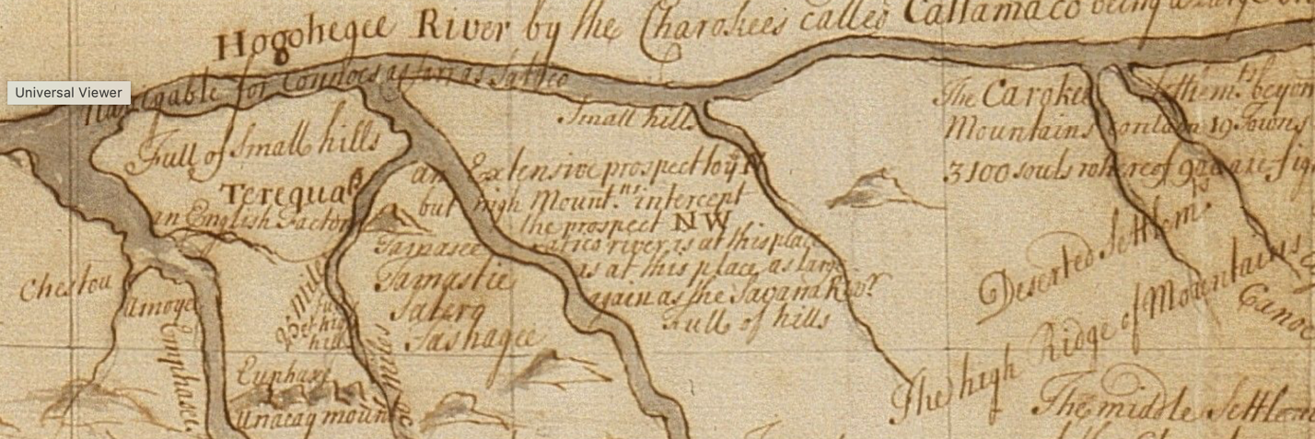
Figure 29 Inset: The Barnwell-Hammerton Map, Hammerton, William, -1732, Map of the southeastern part of North America., 1721., Yale Center for British Art, Gift of the Acorn Foundation, Inc., Alexander O. Vietor, Yale BA 1936, President, in honor of Paul Mellon. https://collections.britishart.yale.edu/catalog/orbis:9600894

occupied by other Indigenous communities by emplacing the Cherokee landscape that tied their matrilineal social structure to the land. The Muskogean etymology for eighteenth-century Cherokee towns in the East Tennessee region of the maps supports a form of acculturation during the previous generations in these localities. However, by the time Barnwell drew his map in 1721, the culturally distinct communities that described their geography to the French in 1673 had become part of the ᎦᏙᎯ ᏄᏍᏗᏓᏅ gadohi nusdidanv (landscape).

Tied to the ᎦᏙᎯ ᏄᏍᏗᏓᏅ gadohi nusdidanv (landscape)
The Cherokee’s relationship with the Appalachian Highlands forms the most salient commonality to ᏣᎳᎩ origin stories. Cherokees believe their homelands are the center of the world. By the time Europeans began to invade surrounding territories in the eighteenth century, the Cherokees had developed a society that adapted to and relied upon the Appalachian Highland’s environment. Jean O’Brien found that for Indigenous peoples in New England, “the connection to homeland as the place where kin and community are sustained remained at the center of their identity despite the transformation of many of the traits that are usually interrogated as the building-blocks of identity, such as language, religion, political organization, and economic systems.” Despite coalescence and colonial pressures, the Cherokee’s unique relationship with their ᎦᏙᎯ ᏄᏍᏗᏓᏅ gadohi nusdidanv (landscape) sustained their society.
ᏣᎳᎩ emplacement since ᎢᎸᎯᏳ ilvhiyu (long ago) anchored some broad cultural aspects of Cherokee society. Council fires burning at townhouses on mounds such as ᎩᏚᏩ giduwa (Kituwah) or Noquisiyi (Nikwasi), sacred sites like Kuwahi where the White Bear lives, and markers like Tsulʻkălû′ (Judaculla’s) Rock represented deep-rooted Cherokee cultural emplacement within their ᎦᏙᎯ ᏄᏍᏗᏓᏅ gadohi nusdidanv (landscape). At the same time, adaptation to the constant incorporation of peoples and traditions over many centuries accounts for much of the linguistic and political diversity across the Cherokee homelands. The spatiality of Cherokee society provides clues for what elements might define pre-colonial-entrenchment Cherokee culture. Perhaps asking what elements constituted Cherokee culture has much to do with where they emplaced.
Cherokees recognized a multivalent system of physical and cultural boundaries and connections within their territory. The Cherokee’s collective territory contained recognized regional boundaries that produced linguistic diversity and sectional coalitions. Within each region, Cherokees formed interrelated town clusters comprised of three or more autonomous settlements that relied on the proximity of the other towns for safety and agricultural management. Within each community, matriarchs of individual families served as heads of households that functioned within a clan system that linked Cherokee society across towns and town clusters. The balance of distance and proximity formed a crucial element in Cherokee society.
Culturally significant towns anchored the Cherokee’s regional town cluster superstructure to the world above, below, and around them. Cherokees consistently placed townhouses, the physical manifestation of a town’s social identity, upon earthen mounds at sites of enduring occupation that often stretched over a millennium or more. Noquisiyi (The Place of the Stars) fixed a town cluster that included Watauga and Cowee. Here, Cherokees practiced astronomy, connecting them to the world above and informing them of the timing of natural cycles. ᎩᏚᏩ giduwa (Kituwah), the Cherokee mother town, hosted a sacred fire that Cherokees would use to reignite council fires throughout the Cherokee homelands.
The pre-colonial-entrenchment council house, built upon the remints of many previous council houses at the ᎩᏚᏩ giduwa (Kituwah) mound, stretched sixty feet in diameter, large enough to sit up to eight hundred people. The building’s size suggests sites of sustained occupation served as gathering places where Cherokees exercised and preserved a collective Cherokee culture. “Mother” towns such as Tugallo, Noquisiyi, and ᎩᏚᏩ giduwa (Kituwah) situated town clusters within the broader Cherokee cultural landscape. Archeological studies have provided substantial evidence for Cherokee towns’ spatiality and cultural significance. However, scholars possess little understanding regarding the spaces between and surrounding the pre-colonial-entrenchment era townships. The Cherokees used most of their territory for agricultural methods that colonizers overlooked or purposely misrepresented.
Cherokees understood their towns as a community of interwoven kinship networks physically embedded in a broader geographic and cultural landscape. Town clusters existed with varied forms of physical separation but with a strategic travel-time proximity. While often clustered along a river within hearing distance of the next town, two town council houses could sit adjacent, representing the political autonomy of each town’s citizens regardless of sharing a physical space. Cherokees most often identified with a single community representing a localized social entity. Despite the physical, political, and social boundaries that divided the Cherokee territory into regional and local anarchic communities, kinship networks, and riverine highways ensured Cherokee culture remained galvanizing throughout the Cherokee homelands.
Regional territories within a culturally connected ᎦᏙᎯ ᏄᏍᏗᏓᏅ gadohi nusdidanv (landscape) fluctuated with the movement of people but remained distinctive identity markers within Cherokee society. Community members recognized regional groups’ territorial sovereignty physically and, when convenient, politically. During George Chicken’s second visit in 1724, he encountered some of the regional and town divisions, which he poorly understood. Many of Chicken’s expectations for the Cherokee’s geopolitical organization arose from his first venture into the Cherokee homelands in 1717 and his colonial epistemology. Because Cherokees often held joint councils at mother towns within their town cluster, Chicken presumed the Cherokees to have regional political factions, the “Upper People” and the “Lower People,” whom he reckoned the rugged terrain of the Appalachian Highlands had rendered semi-independent. Chicken also erroneously assumed that a political hierarchy existed, including headmen from each town and a king of his two hypothetical regions. Chicken’s colonial assumptions proved unfounded, resulting in his diplomatic ineffectiveness and frustration. John Herbert and Alexander Cuming also shouldered colonized presuppositions regarding Cherokee political organization during their forays into Cherokee territory in 1728 and 1730. The regional distinctions the British officials recognized derived from long-standing matrilineal household occupation within regional town clusters that produced linguistic variations by the eighteenth century. However, the cultural connectivity of the Cherokee cosmography and clan-based kinship remained outside the colonized view of societal structure.
Cherokees understood regional town clusters to have social distinctions with bounded physical territories. When George Chicken spoke to men at the townhouse in “Keehowe” regarding the “Upper people’s” defensive measures taken against the Creeks, one of the men acknowledged Chicken and stated that the “Upper people might take their own method as they would theirs.” Town cluster regions possessed well-recognized territorial limits. During the conference at the Long Island between members of “Overhill” communities and white officials, the proposed boundary between settlers and the Cherokees would take “a southeast course into the mountains which divide the hunting grounds of the middle settlements from those of the Overhill Cherokees.” The Cherokees in attendance recognized the territorial separation of their regional agricultural areas as having a clearly defined boundary between both colonizers and other Cherokee groups.
Pre-colonial-entrenchment era journals written before 1755 can provide insight into the geography of the Cherokee’s regional and local social networks. Chicken and Herbert quickly realized the necessity of traveling to various regions of the Cherokee homelands to communicate with localized delegations. The Cherokees met with the British representatives in groups where they prioritized individual town distinctions but collectively represented town clusters distinguished by the three major Cherokee language dialects. Chicken and Herbert reported meeting with Cherokees from “Toogelo, Chagey, Etsotoe, Noyouwee, Echy, and Toxsuah,” a town cluster both British officers referred to as the “Toogelo parts.” This group likely represented Elati dialect-speaking Cherokees. Both officers attended meetings near “Nequisey,” which predominantly represented Kithuwa dialect-speaking towns. Chicken and Herbert traveled to “Tunissee” (Chota) to meet with Otali-speaking Cherokees who represented towns on both sides of the central mountain ridges that separate modern Tennessee and North Carolina. Although the meetings occurred within regional contexts, the linguistically similar town clusters formed affiliated social spheres anchored to the collective ᎦᏙᎯ ᏄᏍᏗᏓᏅ gadohi nusdidanv (landscape) by the culturally unifying “center places” of mother towns. However, the linguistically distinct town clusters did not represent European-style cohesive political entities.
Individual towns served dual roles as fundamental units in the social and spatial fabric of the Cherokee homelands. Cherokees understood towns as cohesive communities of matrilineal households and clan-based kinship rather than solely an occupied physical site. As political entities, towns functioned autonomously. Much to Chicken and Herbert’s consternation, the Cherokee “headmen” who met with the officers could not indicate policy without first consulting women and men from their individual towns. The men who met with the British envoys consistently declined to respond to the officers until after consulting with town members. Cherokees only responded when they conducted the meetings within town council houses, linking community decision-making to sacred places.
Within each town, individuals could collaborate or act on their own accord. When British administrators tried to incite the Cherokees into collective military action against the Creeks in 1715 and 1725, they experienced the practicalities of Cherokee town-based political organization and Cherokee military strategies that befuddled the British officers. Chicken recommended conscripting a percentage of men from each town, while Herbert encouraged individual towns to send every able warrior against the Creeks. The Cherokees dismissed the possibility of British-style collective action, with one Cherokee becoming irritated at Chicken’s insistence, stating “that the people would go to work as they pleased and go to Warr [sic] when they pleased.” Individual towns did organize assaults in small parties aimed at stealthy incursions into Creek communities. The Cherokee towns formed groups and collaborated with other towns to resist Creek incursions. However, the Cherokee men and women decided on a course of action within traditional town- and town-cluster-based communal organizations.
Cherokees located towns based on regional social interdependence and a relationship to a broader cultural landscape. On a local level, the matriarchal heads of Cherokee households placed towns along rivers for religious and practical reasons at calculated intervals that provided rapid communication and joint agricultural management. A study regarding the spatiality of pre-colonial-entrenchment Cherokee towns found that seventy-five percent of all Cherokee towns in 1721 lay less than nine miles from the nearest one to three neighboring towns. According to the study, Cherokees had a proclivity to locate towns in clusters that provided short travel distances, indicating “that the neighborhood of Cherokee towns was much tighter and more selective in terms of membership than the vaguely defined Overhill, Middle, or Valley” regional distinctions traditionally used in scholarship. Placement along rivers allowed rapid travel between neighboring towns, other regions, and points far outside Cherokee territory. Where Cherokees placed interdependent town clusters relied on a broader cultural landscape of “center places” and intraregional riverine connections.

Mapping ᏣᎳᎩ Cultural Connections
The dynamic nature of the pre-colonial-entrenchment Cherokee territory comes into relief on contemporary maps. The Cherokee sourced maps reveal the Cherokee homelands as coalescent in some areas, linguistically diverse, and domestically fragmented yet socially interconnected, and firmly culturally emplaced in the ᏣᎳᎩ ᎦᏙᎯ ᏄᏍᏗᏓᏅ gadohi nusdidanv (landscape). European maps from the pre-colonial-entrenchment era display information the mapmakers overwhelmingly acquired from Cherokees or as conducted guests within the Cherokee homelands. Anglicized toponyms contain locational and cultural information and reflect the diversity of a coalesced Cherokee society. The Cherokee’s understanding of their collective territory becomes distinct on smaller-scale maps. The routes and details on larger-scale maps resulting from on-the-ground British presence within the Cherokee homelands reveal the spaces inside their territory that Cherokees allowed the British to interact with and those they kept hidden. The changes and similarities in the maps reflect the dynamism and spatiality of cultural emplacement of the pre-colonial-entrenchment Cherokee society.
The 1721 Barnwell-Hammerton Map provides a multivalent rendering of the pre-colonial-entrenchment Cherokee homelands from a Cherokee perspective. (See Figure 22 p. 73) John Barnwell, a British colonial military officer appointed as a surveyor for the Carolinians, only observed a fraction of the region displayed on the map. Barnwell gained notoriety and scorn from colonial administrators for rarely leaving his office on the coast in Wilmington. Instead, he accumulated most of his geographic information from Indigenous sources, perhaps from white traders or the Natives themselves. By 1721, few Europeans had visited the Cherokee homelands, and no European had attempted to make systematic observations specifically to produce mappable geographic information. Barnwell laid out the area of the map that depicts the Cherokee homelands entirely from Cherokee descriptions of their territory, potentially from information received by a detachment of South Carolinian militia during a 1715 excursion up the Savanah River to the outskirts of the Cherokee homelands.
The map shows how prominently Cherokees viewed their rivers as integral to their territory’s social and geographical fabric. Rivers formed the physical and cultural superstructure that linked town clusters’ social networks. The Tennessee River retains its multilingual heritage on the map, labeled Hogohegee referencing Muskogean speakers’ designation and “Callamaco” referring to the Cherokees’ name for the river. This river on the northern edge of the map’s detailed area runs into the confluence of the Ohio River near the Mississippi River far to the west, but the map states that the eastern terminus remained “not well known.” The Cherokees knew the western reaches of the river well but seldom went the opposite direction upstream past the Long Island (near modern-day Kingsport, TN) via water, resulting in the map’s incomplete information. The prominence and description of this river on the map demonstrates its long-standing importance for generations of multilingual groups of Cherokees’ travel and commerce around the confluence of the Ohio and Mississippi Rivers.
The conspicuous Northwest to Southeast orientation of the rivers flowing through the Cherokee homelands shows how Cherokees understood their collective territory’s organization and connectivity. On the map, two main rivers drop from the “Hogohegee-Callamaco” River. Cherokee communities’ names line the two rivers and their tributaries. To the south, the Savana River’s forks make a pronounced northward turn, showing the upper branches mingling with the southern branches of the two main rivers from the north. Cherokee town names adorn the upper branches of the Savana River, creating an unbroken landscape of Cherokee settlements that extends from the “Hogohegee-Callamaco” River to the forks of the Savana River. The rivers’ prominent depiction reflects how the Cherokee recounted their territory as orientated around and connected by these river systems. Figure 30
Most parts of the map distinguish between physical settlements and ethnic groups. Along the Apalachicola River, the mapmakers separated adjacent ethnic groups such as the “Westoes,”
“Tuskagees,” “Sanvanoes,” and “Cowestos.” They designated their location with a circle and cross symbol, indicating the groups’ perceived affiliation with Catholic Spanish missions. The accompanying text also differentiates each group as separate tribes. However, the map recognizes the “Abicaws” or “Coffaws” and the “Halbamas” as distinct groups with established towns. The mapmaker marked the towns with European-styled architectural iconography to represent each town’s specific location within the ambit of the named group. Further west, the map designates a region, “Chactaws,” but provides plain square iconography for each Choctaw town. Further west still, along the Mississippi, the “Yawsaw” (Yazoo) and “Chacchumas” (Chakchiuma) received a single symbol like those of fixed towns to the east, indicating a distinct group with only one settlement.
The Barnwell-Hammerton Map represents Cherokee town toponyms as communities of people rather than specific locations. The Cherokee territory is devoid of town iconography. Instead, the mapmaker provided three sets of text describing the “Cherokee Settlements on this side the mountains,” the “middle settlements,” and “settlements beyond the mountains.” Each text provided the number of towns and an estimate of population and military capacity categorized as “souls” and “fighting men.” The difference between the mapmaker’s representation of the Cherokees and other groups likely stems from his information’s source.
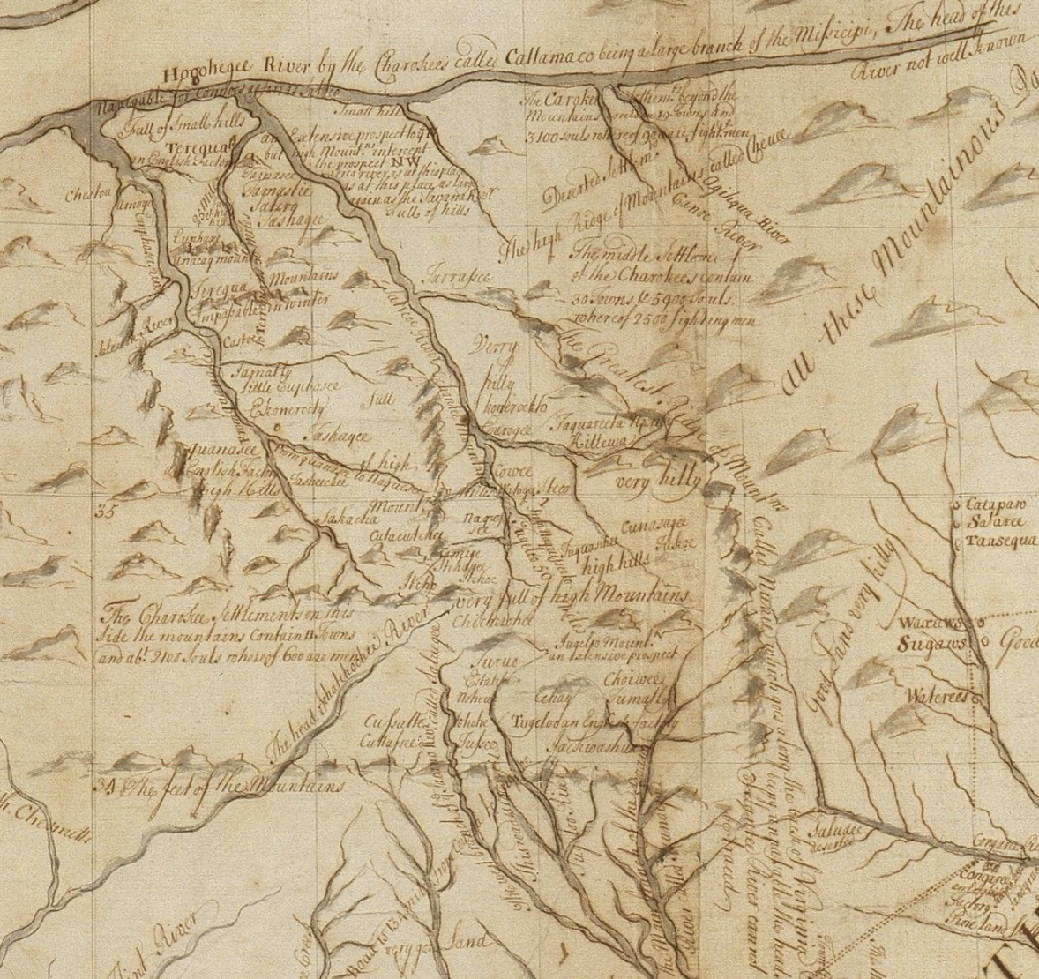
Figure 30 Inset from Barnwell-Hammerton Map

Parts of the map containing iconography representing towns and forts draw from Barnwell’s and other British officials’ travel journals resulting in a more thoroughly Europeanized rendering of a region’s geopolitical spatiality.
Barnwell drew the eastern portions of the map from his travel into the interior during the Tuscarora War in 1712. He traced his route on the map, placing what he considered distinct tribes that he encountered and recruited along the way, such as the “Waxaws,” “Waterees,” and “Catapaw.” He assigns each tribe a simple circle icon, affixing their position on the map. Within the territory of the “Tesquero Indians,” Barnwell locates individual towns with square icons. In this way, Barnwell differentiates between particular ethnic groups he considered strategically insignificant and those that, in his estimation, demanded British attention. This pattern mirrors the iconography along the mapped routes of Thomas Nairne and Pryce Hughes, two British officials who traveled west from the colonies to gain intelligence of the region’s potential for commerce.
Although Barnwell, Nairne, and Hughes’s maps list the Cherokees as the most populous Indigenous group, Barnwell did not use the same iconographic pattern in the Cherokee homelands. Bereft of a similar travel narrative or personal reconnaissance into the Cherokee homelands, Barnwell mapped the Cherokee homelands and northern sections of the map by interpreting information from Cherokees. The lack of iconography likely represented Barnwell’s uncertainty regarding categorizing Cherokee towns. If Cherokees had described their towns as part of a kinship community embedded within a broader cultural ᎦᏙᎯ ᏄᏍᏗᏓᏅ gadohi nusdidanv (landscape) as they had decades before to the French along the Mississippi River, Barnwell’s simple categories for cartographically representing such an unfamiliar system would have lied outside his intellectual framework to map.
Routes of British officials on pre-colonial-entrenchment maps of the Cherokee homelands indicate what spaces Cherokees understood as places for foreign interaction. Cherokees led British officials strategically through their territory during the pre-entrenchment era. The route, outlined similarly on George Hunter’s 1730 map and George Haige’s 1751 map, took European delegations to settlement clusters in each region where Cherokees could rapidly disseminate intelligence. Figure 31, Figure 32 Cherokees directing British officials to specific mother towns to fulfill necessary ceremonies for foreign delegations demonstrates the cultural significance of the route. The routes also kept most of the Cherokee sacred spaces out of Europeans’ gaze.
Hunter’s map clearly delineates between areas he observed and secondary information from Cherokees. Hunter recorded each stream and distance as he ascended the “Sante” River. However, once inside the Cherokee homelands, the map scale and detail changes, representing his estimations. Haige’s map, edited by Hunter, denotes towns along his route but leaves other spaces blank. The Cherokee’s designation of spaces unavailable to foreigners, evident on these maps, became problematic for British invaders during genocidal colonial expeditions in 1760 and 1776. When colonists wandered through the rugged terrain, they often stumbled upon unknown towns, surprising both themselves and unprepared Cherokee residents, leading to the enslavement of the town’s women and children.

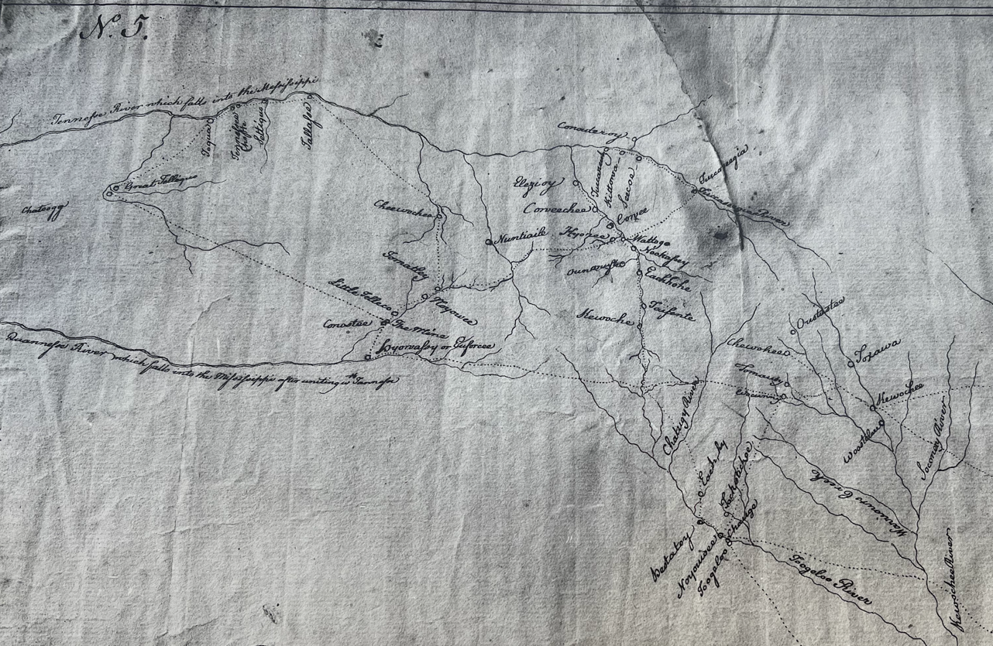
Figure 31 “George Haige Map,” 1752, Fac, Newberry Library, Kings Collection, Sheet 5, British Library.

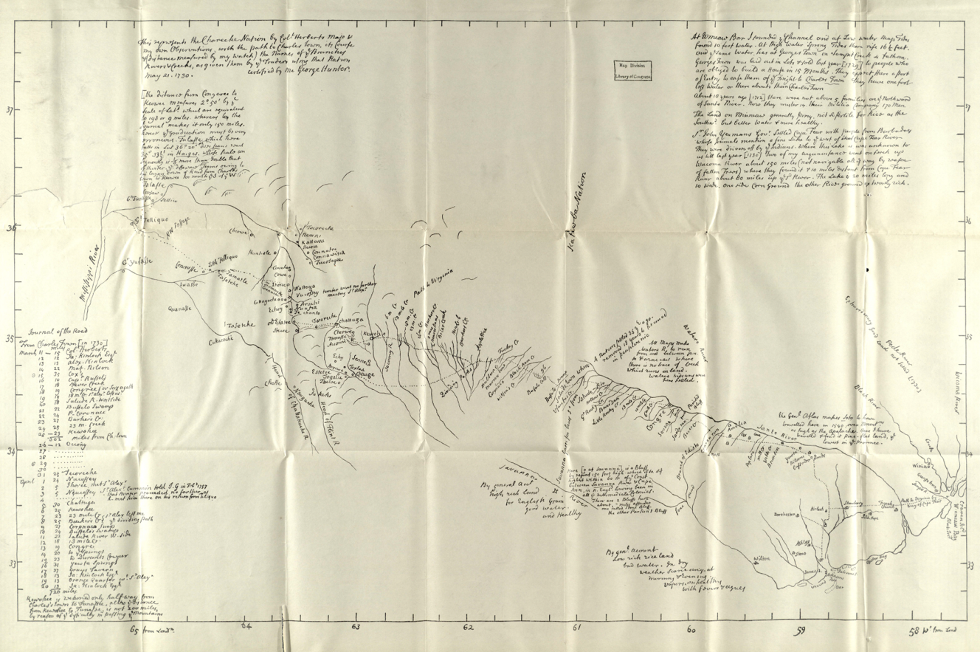
Figure 32 George Hurbert, 1730 Hunter, George, -1755. George Hunter's map of the Cherokee country and the path thereto in 1730. 1917. Retrieved from the Digital Public Library of America, http://digital.tcl.sc.edu/cdm/ref/collection/sclmaps/id/2294

Conclusion
Perhaps one morning in the pre-colonial-entrenchment era, a Cherokee woman set out from her town to tend to her ani’dlogesi (strawberry field) through spaces unidentified on any European map. She would have passed many familiar places as she moved along the Tsiksitsi (Tuckasegee) River, which seemed to flow slowly like a crawling terrapin that day. She might have passed by Gisehun’yi (where the woman lives) and thought of her grandmother. Perhaps she moved a bit quicker past Ukte’na-tsuganun’yi (the place where the giant snake got fastened) and waved when she saw her people fishing at Uniga’yata’ti’yi (the fish trap) like they almost
always did this time of day. Along with her knowledge of the broader places and people the river connected her to, these connotative placenames animated her world. When filled with Cherokee mnemonic toponyms, spaces left blank by European colonizers would have spoken to the symbiotic relationship Cherokees had fostered with their land over centuries of refining their own identities.
Pre-colonial-entrenchment Cherokee society relied on the spatiality of their ᎦᏙᎯ ᏄᏍᏗᏓᏅ gadohi nusdidanv (landscape) in the Appalachian Highlands, which allowed for cultural foundations anchored in the landscape to tie independent communities and town clusters together. Although the spatiality of the Cherokees had allowed for the incorporation of many other Native groups over the centuries, colonizers would soon arrive, seeking to eliminate Cherokee society via genocidal deracination.

CHAPTER 3: ROOTED IN THE LAND: CHEROKEE AGRISCAPES
Near the beginning of time, the first Cherokee woman and man named Selu and Kana′tĭ developed Cherokee farming and husbandry strategies. Selu produced limitless corn and beans from her knowledge. However, when her mischievous sons witnessed her power to provide endless yields, the boys decided to murder Selu. Knowing her fate, Selu instructed the boys on implementing her knowledge of sustainable agriculture. She told the boys to turn large tracts of land near their houses into agricultural spaces and constantly tend to the crops, even at night. The boys ignored her advice. They only turned small patches of land into agrarian spaces and did not maintain them vigilantly as Selu had instructed. Consequently, Cherokees had to rely on small, isolated fields that only produced corn twice a year instead of limitless quantities of food that Selu knew how to grow.
Whenever Kana′tĭ went into the forest, he always brought home a load of meat, a fat buck or doe, or some turkeys; he never failed. Kanatĭ’s effectiveness stemmed from keeping all the region's animals in a cave with a rock at the entrance. When Kana′tĭ desired meat, he would roll the rock from the cave's entrance, and an animal would dash out. Kana′tĭ would quickly finish the vulnerable animal and replace the rock, securing all the other animals inside. One day, an inquisitive Wild Boy, a recalcitrant little rascal, secretly followed Kana′tĭ to the cave. After Kana′tĭ returned home, Wild Boy opened the cave and watched delightfully as all the animals ran out into the wild. When Kana′tĭ discovered Wild Boy's mischief, Kana′tĭ lamented and told Wild Boy that now all of the animals had scattered into the forest, and he would have to hunt throughout the woods for them and perhaps return emptyhanded.
A Cherokee origin story contains the Selu and Kana′tĭ narrative, which Cherokees retold countless times. Cataloguers of the story, such as ethnographer James Mooney, viewed Selu’s connection to agricultural production as “mythic” and labeled Kana′tĭ “the Lucky Hunter.” However, Selu’s connection to Cherokee agricultural practices remained a salient part of Cherokee culture, and there seems to be no reference to hunting as being lucky in the Cherokee story. Instead, Cherokees associated Selu and Kana′tĭ with being environmentally responsible by sustainably sourcing plants and animals used for nourishment and medicine.
The story’s plot metaphorically represents actual Cherokee pre-colonial entrenchment practices that had little to do with the wandering and chance associated with the terms “hunting” and “gathering” in much of Western scholarship. Cherokee management of agricultural spaces produced a cornucopia of reliable and sustainable plant and animal food sources. Cherokees constructed pastures for their deer herds, fields for various crops, and orchards for fruits and nuts. Although substantial changes in the Appalachian Highland’s environment have occurred since the pre-colonial-entrenchment era, Cherokee oral traditions, archaeobotanical, zooarchaeological, and contemporary written sources provide evidence of the agricultural landscape that settler colonialism sought to transform rhetorically and physically.
Traditional scholarship regarding Native Eastern Woodland agriculture, including studies of Cherokee agriculture, has concluded that Cherokees practiced swidden farming and gathering native plants alongside far-ranging hunting and fishing. Because of the types of labor traditionally associated with swidden agriculture and hunting, these studies have stated that Cherokee women dominated farming activities while Cherokee men primarily participated in hunting activities. Theda Purdue has argued that Cherokee men dominated the mid-eighteenth-century deerskin trade, increasing their political and social influence over women. However, Native scholars have recently challenged conventional assumptions regarding Indigenous agricultural practices and the types of labor their methods involved.
Rereading sources using Jane Mt. Pleasant’s “New Paradigm,” this chapter reconstructs and redefines Cherokee agricultural practices and spaces. Mt. Pleasant argues that “indigenous cropping systems in North America were predominantly permanent and intensive, rather than fallow-based shifting cultivation.” Mt. Pleasant's framework demonstrates that Indigenous peoples in eastern North America practiced intensive, permeant, and sustainable agricultural methods. Cherokee oral tradition, archeological evidence and contemporary written records support Mt. Pleasant’s paradigm applying to Cherokee agriculture.
This chapter reenvisions pre-colonial entrenchment Cherokee agricultural spaces and their connection to the Cherokee’s gendered social structure. Cherokees practiced intensive, permanent agriculture. Cherokees not only grew crops in clearings near towns that colonizers recognized, such as corn, but they genetically engineered, cultivated, and harvested many other food sources colonizers considered “wild,” such as nuts and strawberries in expertly crafted fields colonizers overlooked. Cherokees practiced a system of free-range husbandry that included establishing and managing habitats that augmented deer herds and provided for efficient and sustainable harvesting. Constructing domestic and commercial agriscapes allowed Cherokees to reside in locations they chose for as long as they wished.
Cherokees’ matrilineal social structure heavily relied on agricultural spaces for food production, medicine, and commercial products that defined gender roles and matriarchal land rights. Many scholars have emphasized Cherokee women’s prominent role in agricultural food production as a source for their significant social and political influence. Purdue admitted that “theoretically the sexual division of labor was very ridged, but in reality, men and women often willingly helped one another.” Examining Cherokee agriscapes as intentionally constructed by both men and women for enduring, sustainable harvesting of plants and animals helps us better understand the vital relationship between pre-colonial-entrenchment Cherokee society and their land. And why the transformation of these spaces proved so existentially threatening.
This chapter demonstrates that women and men participated equally in agriculture and husbandry through the construction and maintenance of Cherokee agriscapes. The engineered fields, orchards, and woodland plantations secured not only Cherokee sustenance and commerce but also social balance. Rather than the colonial emphasis on Cherokee men’s prominent role in commerce, the loss of communally owned and maintained Cherokee agricultural spaces to the destruction of colonial agriculture would upset long-standing Cherokee gender roles that maintained their society.

Cherokee Domestic Agricultural Spaces
In 1775, from high atop a ridge deep inside Cherokee homelands, English botanist William Bartram observed a “vast expanse of green meadows and strawberry fields” with “flocks of turkies strolling about them” and “herds of deer prancing in the meads.” To Bartram, this seemed like a primitive landscape to be studied according to his familiar taxa. Like other Europeans who encountered the Cherokee homelands in the eighteenth century, Bartram observed the Cherokee homelands from a Western perspective. He made sharp distinctions between familiar British agricultural spaces and methods and Cherokee practices. Blinded by a colonial gaze, he failed to notice the vast array of Cherokee agricultural activity that shaped the landscape.
From the beginning of North American colonization, Europeans created superficial distinctions between European and Indigenous agricultural methods.Joel Gasconyne’s map shows individual colonizer’s plantations while he places the map's Indigenous communities among “wild game” with no such illusions to agricultural development. Figure 33 Colonizers weaponized agricultural differentiations to argue for justification of land disposition. While Europeans categorized wondering and sometimes feral cattle and swine as husbandry and extolled plowed wheat fields as improved farmland, colonizers relegated similar Indigenous practices to haphazard hunting and gathering. These superficial distinctions had direct
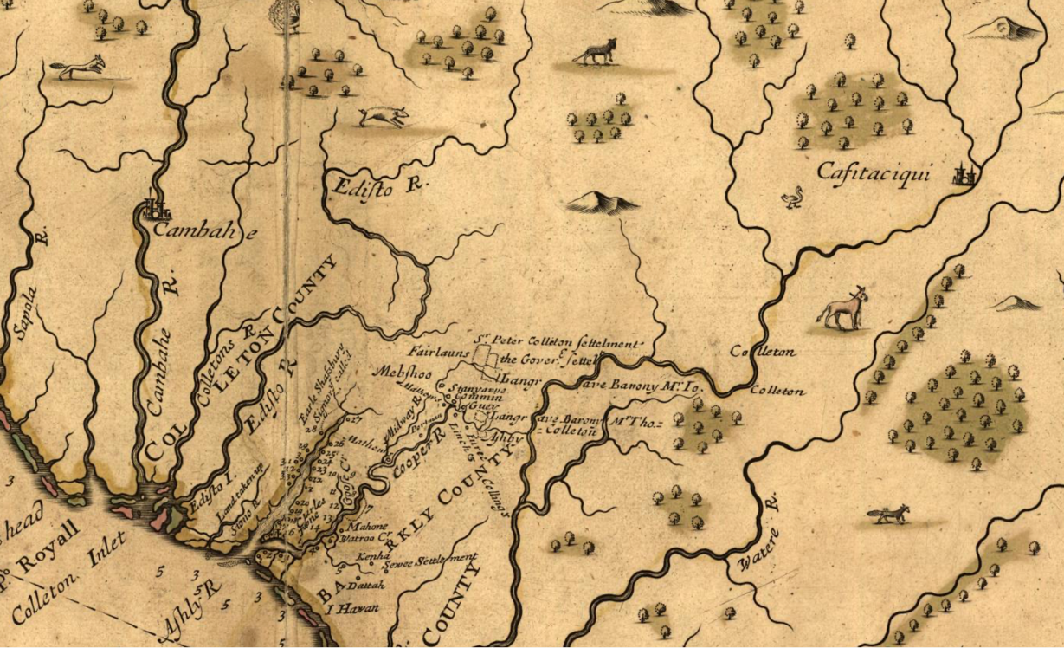
Figure 33 Gascoyne, Joel, A new map of the country of Carolina. Inset. 1682. Library of Congress Geography and Map Division Washington, D.C. https://lccn.loc.gov/99446166.

implications for deracinating the Cherokee and other groups of Indigenous peoples from their land and remain entrenched suppositions in academic research. Cherokee agricultural spaces can be better understood by examining archeological, archival, and oral history sources through a decolonized lens that discards superficial categorizations and recognizes the breadth of Cherokee agriculture.
Bartram perceived a distinction between farming and gathering rooted in European agricultural conventions. He understood a spatial aspect to his distinctions. In Bartram’s estimation, planters neatly delineated farms or gardens and placed them adjacent to a dwelling whereas gathering occurred in a somewhat removed and uncultivated space. Bartram wrote that while in “Whatoga: Riding through this large town, all before me and on every side appeared little plantations of young Corn, Beans, &c. divided from each other by narrow strips or borders of grass, which marked the bounds of each one's property.” Comparing these individual plots to miniature plantations, the Cherokees’ gardens seemed recognizable to Bartram as farming. He viewed the plots as private property, neatly delineated, near housing, and growing cultigens he deemed acceptable for the purpose. However, when Bartram noticed “a vast expanse of green meadows and strawberry fields,” he determined the Cherokees were “gathering the rich fragrant fruit” in wilderness spaces.Figure 34
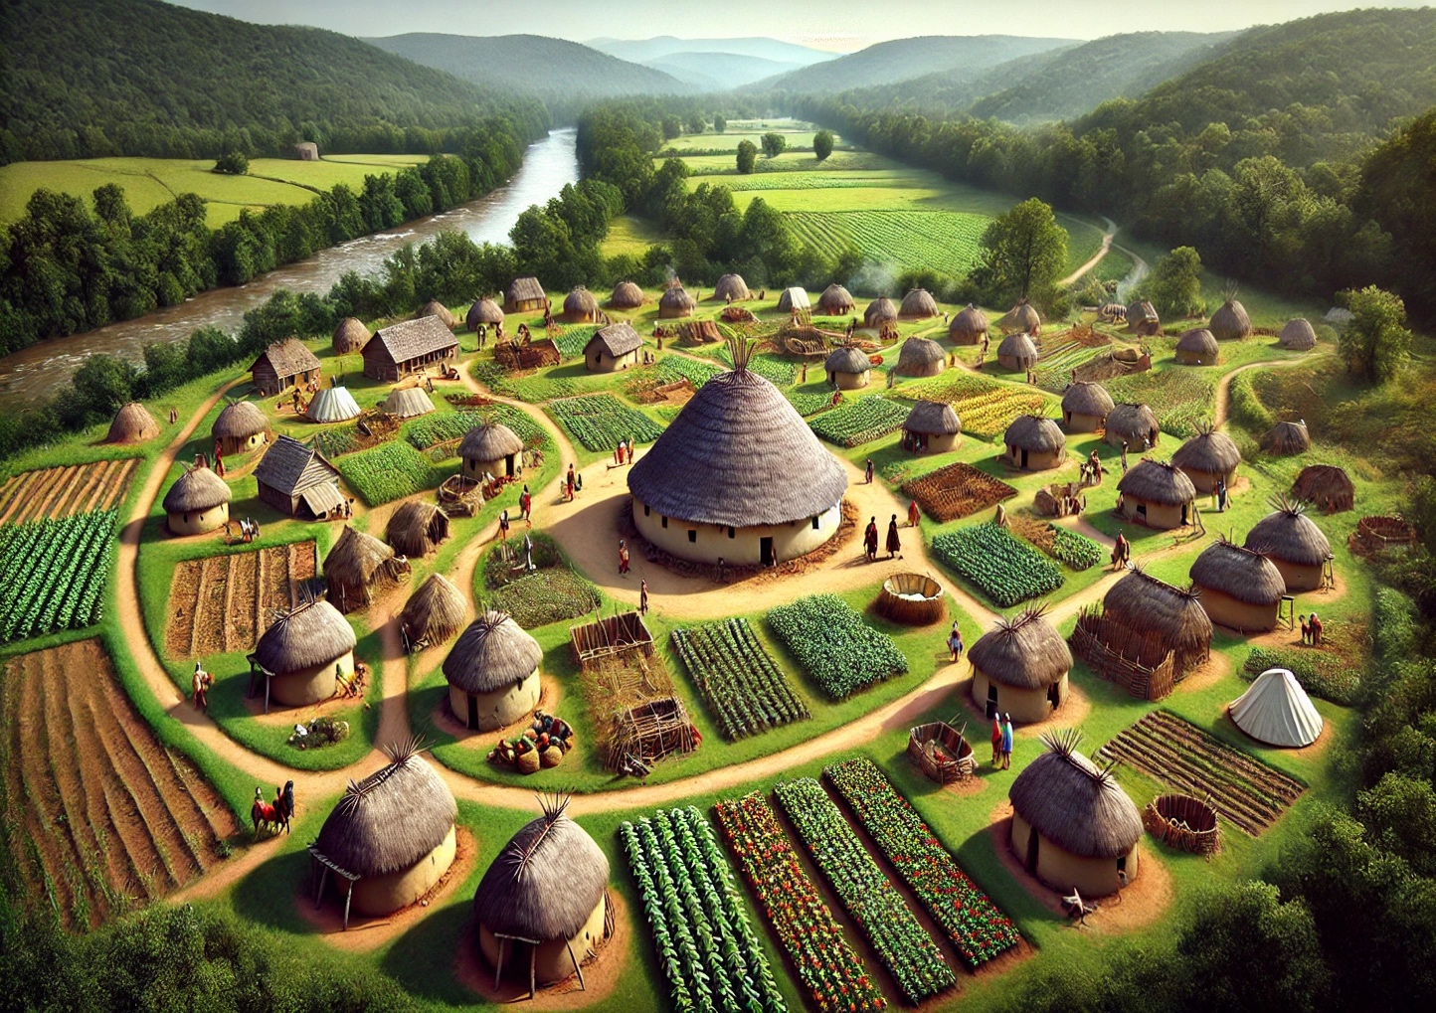
Figure 34 Cherokee domestic agricultural spaces. Recreation of Cherokee town surrounded by agriscapes, small fields near the town with larger fields and pastures in the distance, ChatGTP.

in the eighteenth century. In Wayne Lee's assessment of “Native Americas’ “Demographic Space,” he states that “Indians modified their landscape as farmers, hunters, and gatherers.” As with most scholarship regarding Eastern Woodland people’s agriculture, Lee follows environmental historians in distinguishing between maize cultivation as “farming” and other cultigens, such as strawberries, as “gathering” in his analysis of Native domestic spaces.
Bartram’s misperception of Cherokee fields and activities outside maize cultivation as “gathering” has helped colonize modern scholarship. After “bounding over the hills into Elysian fields,” Bartram discovered Cherokee women “gathering” baskets of strawberries. Bartram noted this “sylvan scene of primitive innocence” as enchanting. According to Bartram, these women had happened upon the strawberries and were enjoying nature’s bounty with alacrity. However, as the archaeobotanical evidence from this era shows, fruit represented a staple of the Cherokee diet and increased consumption from 1700 to 1780, while corn and bean consumption vacillated.
Bartram had witnessed Cherokee farming in communal fields that required generational agricultural knowledge to produce. An established road connected the fields to a nearby town. The strawberries grew in abundance and with such plumpness that Bartram observed the younger women “wantonly chasing their companions, tantalizing them, staining their lips and cheeks with the rich fruit.” The group of women that Bartram found consisted of “elder matrons” who had gathered groups of young women around them after the harvest. The strawberries located in these cultivated spaces were far from “wild.” They represented a vital connection between Cherokee society, substance, and land.
Cherokee oral tradition equated strawberries to conceptions of stability, land tenure, and home. Long ago, one of the first Cherokee men’s wives became angry with him and left and headed east. She passed several other types of fruit, and it was only when she came upon a large patch of strawberries that she stopped. As she picked and ate them, she thought of her home and could not go on. She gathered a bunch and headed back. Then, she found her husband and went home to stay. This story suggests that Cherokee communities recognized strawberry fields as foundational to their homeland’s agricultural and social landscape. Walking up a path from her house, a pre-invasion Cherokee woman would have smelled the sweet fragrances of her fields, reminding her she was home. The harvesting of Strawberries represented only one example of colonial misconceptions regarding Cherokee farming. The Cherokees had engineered the fields to support a reliable and abundant harvest.
Riding a few miles outside the Cherokee town of Kulsage, Bartram described the “fragrant strawberry fields” surrounded by thick Calycanthean groves. Fragaria virginiana strawberry plants that Bartram described are perineal plants that spread in open sunny areas via stolons and rhizomes and suppress invasive weeds but do not tend to colonize unopen areas. The plants can produce prodigious amounts of fruit in May and June. Calycanthean plants produce strongly fragrant flowers in May that continue to bloom until early July and mimic a strawberry aroma, while the dark green leaves and bark release a clove scent. The dense shrub emanates a strong fragrance, rendering it nearly “deer-proof,” an effective olfactory fence.
When Bartram saw the Cherokee women harvesting strawberries, he noted Magnolia, Azalea, mock oranges, Calycanthean, yellow jasmine, and wisteria frutescens outlining the field of strawberries. Yellow jasmine and wisteria are fast-growing climbing vines that provide deer resistance. Azalea and mock oranges grow bulky shrubs that control erosion in sloped areas. This conglomeration of plants would give a perimeter to the strawberry field that would attract pollinators, resist deer, and control erosion in undulating areas within the river valleys. While these plant and shrubbery combinations could undoubtedly exist in an undisturbed environment, the multiple examples of combinations of strawberry fields surrounded by herbivore-resistant plants at the end of a road near Cherokee towns suggest a level of cultivation that goes beyond prescribed burning or semi-domestication.
Cherokee agricultural spaces included the most sustainable maize production of its time. Large portions of the Cherokee homelands consist of regularly flooded alluvial inceptisols soils providing excellent natural conditions for perennial corn yields. Figure 35 Cherokees augmented the soil’s natural nutrients by incorporating “the three sisters” into their practices.
Scholars who have examined Native and Cherokee agriculture have, by and large, retained Bartram’s colonized categorizations. Studies of Cherokee dietary patterns make categorizations of farm and forage cultigens and categorize deer differently than pigs and cattle The combination of corn, which extracts nitrogen from the soil, beans that create space
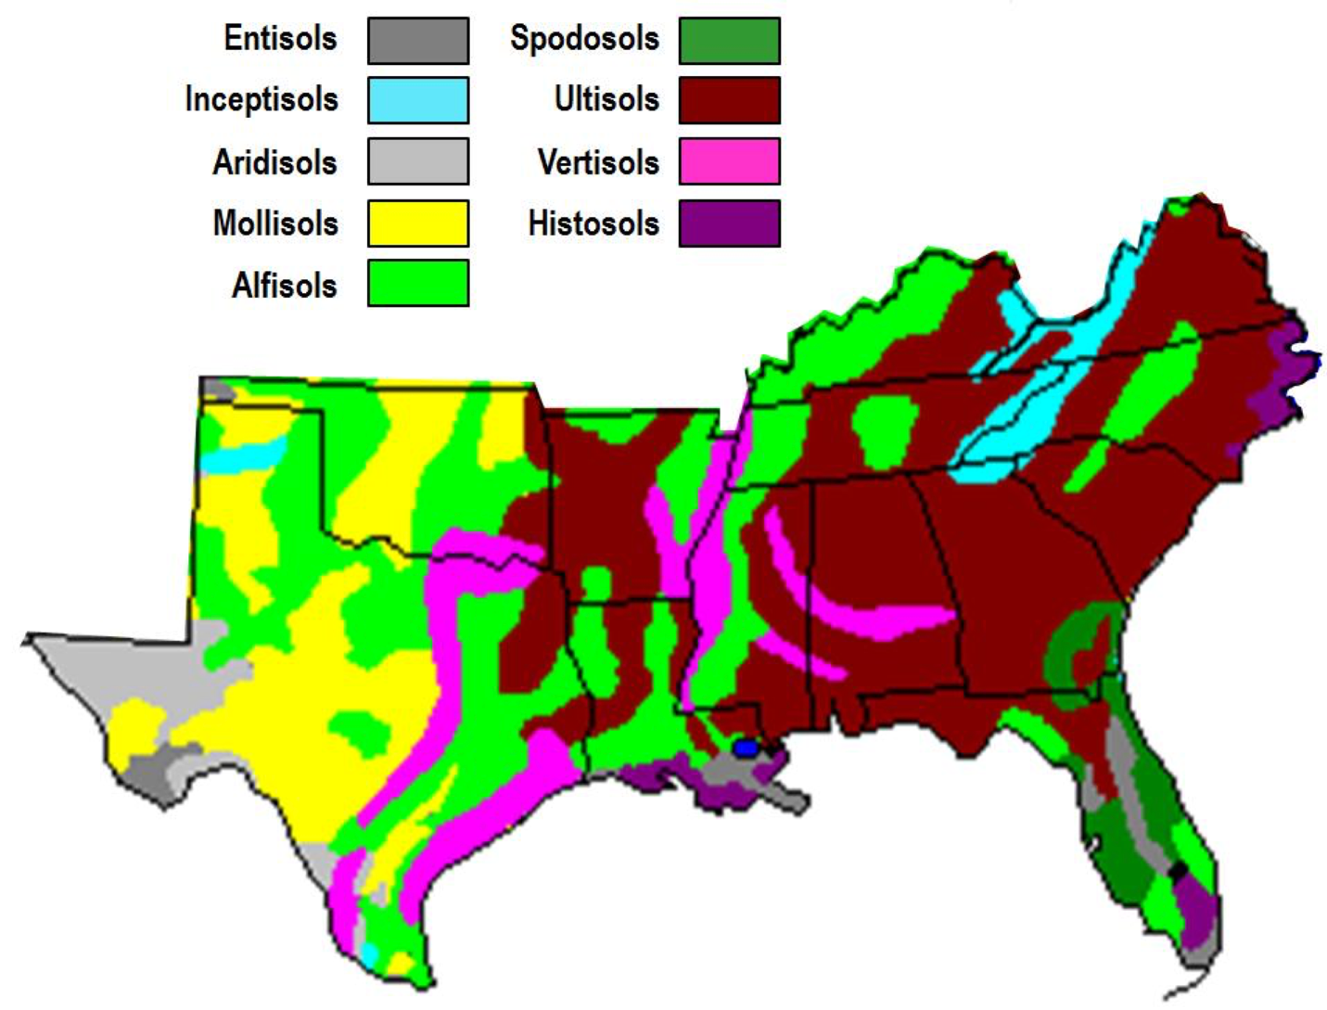
Figure 35 Soil Map Sikora, F.J., and Moore, K.P. (2014) Soil Test Methods from the Southeastern United States.
https://aesl.ces.uga.edu/sera6/?PUB/MethodsManualFinalSERA6.pdf

underground for Rhizobium bacteria that supply nitrogen, and squash that helps reduce weeds and retain water in the surrounding soils, made farming the same fields for generations possible.
Cherokees supplemented the sustainability of these crops by not using intrusive planting methods such as plowing the fields. They would create a small hole for the seeds using a toe or stick, which allowed for a significant amount of soil nutrient retention over plowing. Cherokee corn fields mirrored the practices they implemented to secure their strawberry fields from unwanted hungry deer “by timing planting to coincide with the ripening of wild fruit near the margins of their (corn) fields” to distract crows. For centuries, Cherokees genetically altered the corn to produce more plentiful and nutritionally significant yields. Maize production and the fields where they cultivated the crops became culturally significant spaces that eighteenth-century Cherokees connected to their emergence in their homelands.
Tsalagi does not share a cognate for “corn” or “beans” with any other Iroquoian language. The Cherokee word for corn, “Selu,” alludes to the Cherokee’s tradition that the development of corn agriculture coincided with the emergence of Cherokees as a unique people. The Cherokee’s inclusion of corn and bean cultivation along with harvesting local fauna in oral tradition suggests that adapting these practices to the environment of the Appalachian Highlands represented a vital component of Cherokee culture. The association of the word and figure of Selu also indicates that Cherokee women’s fixed emplacement over many generations played a primary role in the connection between the development of Cherokee culture and corn production. Cherokees’ sedentary agricultural practices led to the development of manicured agricultural spaces near their towns, including orchards.
Cherokees established fruit and nut orchards. Written records show Cherokees had cultivated and consumed peaches by the mid-seventeenth century. When British travelers came to the Cherokee homelands in the eighteenth century, orchards had become a visible marker of an established town. In 1762, Henry Timberlake determined the fields of “plumbs, cherries, and berries of several kinds” remained uncultivated but took notice of the orchards of peaches and pears just outside of Chota that grew “only by culture.” Bartram noted the “Peach and Plumb orchards” near recently abandoned Cherokee towns in the aftermath of U.S. militia invasions in 1776. The placement of the orchards near Cherokee mounds suggests the orchards had become a recent addition to the sedentary agricultural landscape surrounding Cherokee towns and town clusters. While these and other colonizers recognized orchards as cultivated land, they regarded the Cherokee nut groves as wild.
Cherokees deftly cultivated groves of nut-bearing trees. British trader James Adair described the area around Cherokee towns as “full of hiccory-nuts, acorns, chesnuts, and the like.” Bartram mentioned a plethora of hickory and walnut trees adjoining areas near Cherokee and Creek towns. Bartram categorized the trees as “natives of the forest” but recognized the groves “thrive better, and are more fruitful, in cultivated plantations.” Nut trees fruit in unison with nearby trees in groves. Cherokee farmers understood the intermittent nature of nut harvesting and developed storage methods that provided high-calorie nutrition year-round.
Cherokee nut cultivation, harvesting, and processing methods tied Cherokee communities to the land. Men and women cleared spaces for groves of nut-producing trees. Women harvested the nuts, and community women came together to process the plentiful harvests. Cherokee women turned the nuts into soups and oils and used the seeds from walnuts to form dyes used in generation-connecting basket making. Each process proved labor intensive: girdling the trees for clearing, prescribed burns, cultivating the saplings, harvesting the nuts, and processing them. The groves would have represented a pillar of sustainable and fixed agricultural spaces that helped tie a Cherokee community to the land.
Archeological evidence shows that Cherokees practiced long-term, region-wide agricultural strategies. Brett Riggs’s insightful work at Watauga has demonstrated that Cherokees practiced astronomy for centuries. Cherokees understood and tracked the astronomical seasons down to the hour. These observations would have allowed them to plan for a wide range of cyclical agricultural activities. Cherokee placenames such as Kuwa'hi (mulberry place), Duni'skwa lgun'I (forked antler), Noquisiyi (the place of the stars), and many others demonstrate the Cherokee’s profound sense of place within a terrestrial and cosmological world deeply connected to engineered agriculture. Carefully cultivated agricultural spaces formed a hallmark of Cherokee territoriality that colonizers overlooked or dismissed, and scholarship continues to underappreciate.
Cherokees maintained sustainable and abundant food sources through intensive management of agricultural spaces. The Cherokee’s pre-colonial entrenchment agricultural methods defied colonial categorizations in the eighteenth century, rendering them unrecognized by contemporary observers and many modern scholars. Colonizers like William Bartram, James Adair, and members of genocidal militia companies like William Dells recognized agricultural spaces within the Cherokee homelands according to their European definitions. For these men, rows of corn identified fields. They associated species like cows and pigs with husbandry and domestication. When North Carolina militia man William Dells took part in a 1776 expedition into the Cherokee homelands, he recorded in his journal, “160 acres of corn” at “Wartago,” another “160 acres of corn and some Horse and Cow Creatures” at Cowee, all of which he described as the “plantations belonging to the Enemy.” The militiamen perceived the corn fields as the Cherokee’s primary source of agriculture, which his company destroyed with alacrity. Fortunately for the Cherokees, colonizers failed to recognize the Cherokee’s other agricultural spaces.
Military expeditions by British and American forces often overlooked Cherokee agriculture, which lay outside their colonial perspective, and the Cherokees took advantage. When Col. James Grant invaded southern Cherokee territory in 1761, he became frustrated at not finding Cherokees to engage in military combat. According to accounts, his expedition burned 15 towns and 15,000 acres of corn and beans. Crops that Grant viewed as purposely cultivated for consumption. At the peace negotiations a few months later, Oconostota stated that South Carolinians might call Col. Grant a great warrior, but the Cherokee call him the “corn puller.” Instead of a devastating effect from Grant’s crop destruction, the Cherokees experienced a population boom in the 1760s.
Gabrielle Purcell’s work on Cherokee adoption of non-native cultigens has shown a massive increase in the consumption of sweet potatoes by Cherokees beginning in 1761, probably gotten from Virginians. These difficult-to-spot tubers can grow 40 feet long and produce highly nutritious roots that can last hidden in the ground for months. Cherokees wholesale adoption of sweet potatoes following the “Corn Puller’s” 1761 attack on vegetation demonstrates Cherokees’ familiarity with using land to grow crops that did not fit the western trop for farmland. Of the four simultaneous military expeditions that invaded Cherokee territory again in 1776, all four recorded burning corn fields again; however, none mentioned pulling up sweet potatoes.
The perceived differences in Cherokee agricultural practices recorded by eighteenth-century Europeans continue to inform the ways in which scholarship explores Cherokee understandings of gender. Many studies regarding the history of Cherokee agriculture hold that “farming among the Cherokees was largely women’s work” while the men hunted and helped in certain aspects of farming. Tom Hatley’s study of women’s role in Cherokee agriculture acknowledges areas such as the ones described by Bartram as “agriscapes” but stops short of calling them fields which he reserves for corn or mixed cultivation such as the three sisters (corn, beans, and squash.) Alongside fields of strawberries, Bartram identified persimmon, honey locust, Chickasaw plum, red mulberry, shellbark hickory, and black walnut growing and thriving better in cultivated plantations. Hatley classifies harvesting of these resources as gathering. Considering the large areas surrounding Cherokee towns that seem intentionally designed and manipulated to develop and protect a wide variety of food sources, including strawberries and deer, as farmland and pastures, land that men and women worked year-round to maintain, would refocus our understanding of gendered spaces in pre-invasion Cherokee society.
The colonized categories of Cherokee agriculture also inform how scholars examine the Cherokee’s understanding of territorial sovereignty. Some eighteenth-century colonizers argued that “hunting grounds” did not constitute a viable land ownership. In contrast, others recognized Indigenous claims as they sought to create boundaries that would keep settlement within the ambit of imperial and national control. Colonizers agreed that “hunting grounds” represented a category outside Western modes of public or private land ownership that they legally codified to ensure power and profit. However, for Cherokees, “hunting grounds” meant many acres of manicured pastures designed to produce reliable animal harvests, which took generations of knowledge and labor to develop fully.

Cherokee Commercial Agricultural Spaces
Awi Usdi (Little Deer) directs all of the deer around to fruitful pastures in the Cherokee homelands. He watches the herds to ensure that the Cherokees responsibly harvest the deer. Cherokees seldom see Awi Usdi (Little Deer) because he is small, often invisible, and albino. Awi Usdi (Little Deer) appears when Cherokees slaughter a deer to ensure the farmer understands the ecological responsibility needed to ensure the future meat supply. Only a Cherokee farmer who has mastered the art of sustainable slaughtering can see Awi Usdi (Little Deer) and have a chance to obtain his power to attract herds of deer by possessing a piece of his antler. In this and many other ways, Cherokees connect their religious beliefs to practical applications of sustainable and reliable animal husbandry techniques capable of producing substance and commerce after the arrival of Europeans. Colonizers failed to recognize the breath of the Cherokee’s husbandry practices regarding the production of deer products.
Euro-Americans made a colonized distinction between hunting and animal husbandry. According to colonizers, hunting contained the element of chance that husbandry overcame. Ideally, animal husbandry took place on an identifiable piece of land, preferably an enclosed pasture. However, many colonizers in coastal areas such as the Chesapeake Bay area practiced free-range husbandry and would spend weeks searching for wondering cattle, often to avoid community responsibilities. Colonizers only deemed certain species, such as chickens, hogs, and cattle, acceptable for husbandry, while other food source animals, such as deer and turkey, were considered “wild.” For Cherokees, their herds consisted of white-tailed deer whom Kana′tĭ had mastered long ago.
Livestock management had been a Cherokee practice for centuries. Cherokees chose deer as a preferred source of protein for hundreds of years. Research has shown that despite the scope of the deerskin trade and the introduction of non-native domestic animals, Cherokees continued to consume deer, and their diet did not include a substantial amount of non-native animals until after the 1790s. Rather than vast tracts of “hunting grounds” labeled on European maps, Cherokees required only a fraction of the available territory to harvest large amounts of deer and other animals.
Cherokees did not locate their settlements due to environmental constraints. Studies suggest that the availability of “lower-elevation and lower-slope sites” along rivers did not play a significant role in Cherokee’s town placement. Studies also concluded that Cherokees only used around five percent of the “suitable architectural and agricultural areas, defined as land near streams” with “low slop” adjacent to their towns to quickly satisfy their needs for agricultural land for crops and resources such as wood for fuel. However, the study concluded that given the demand for deer meat and skins, Cherokees must have ranged significantly further to sustain deer populations. Scholars have demonstrated that despite a massive augmentation in the number of deer the Cherokees killed resulting from the deerskin trade with coastal colonists, Cherokees maintained venison as a significant source of protein throughout the eighteenth century. The Cherokee’s incorporation of European markets lead to the expansion of Cherokee agriculture for commerce. Figure 36
The European written records allude to Cherokees managing their animal food sources. In 1725, Col. George Chicken recorded arriving at Keeowee to find the men “out of town at their plantations.” What did these men’s plantations consist of? Both Timberlake and Bartram recorded an abundance of grape vines in proximity to Cherokee towns. Bartram records that the grape vines were growing over the shrubs and low trees around hills that were “barren and

Figure 36 A recreation of Cherokee commercial agriscapes with fields for multiple cultigens, designed spaces for deer herds, and fires for clearing other pastures. Note the strawberry fields on the left with the road running through them, ChatGPT.

grassy” where few large trees grew. When Bartram took refuge for the night in an “Indian hunting cabin” he turned his horse out to the “sweet meadows adjoining.” He observed Heracleum maximum (cow parsnip), an invasive and dominating weed that deer love to eat in the meadows and the surrounding hills, which he wrote were filled with “many hundreds of acres of strawberries.” A deer’s mountain paradise.
In 1749, Dr. Thomas Walker found animals, including buffalo, to be plentiful as he neared Cherokee fields at the “Fork between the Holstons and the North River,” where he saw “five Indian Houses built with logs” with a nearby community cooking spot containing an “abundance of Bones, some whole Pots and pans some broken.” However, as he traveled north away from Cherokee territory, he reported several times that “Game” seemed “very scarce.” Archeological and historical research in other regions has shown that Indigenous groups often employed techniques for increasing deer populations and for slaughtering many deer at once.
Gregory Waselkov’s research suggested that prescribed burns to augment deer populations and fire drive techniques used by Cherokees were not hunting but rather “harvesting” techniques.
The fields Bartram described in the Cherokee homelands would suggest careful cultivation of fields intended to attract and increase deer populations. These agricultural spaces created an environment that held deer in place, increased fecundity, and made slaughtering deer far from a lucky accident. Bartram noted the use of Indian Olive. He stated, “The Indians, when they go in pursuit of deer, carry this fruit with them, supposing that it has the power of charming or drawing the creature to them.” Bartram referred to the Nestronia umbellule plant, which seldom produces fruit without human intervention for pollination. Possession and use of this fruit would suggest that Cherokees purposely manipulated the plants to produce fruit to which deer likely had more than a supernatural attraction.
Cherokees quickly responded to changing market conditions that placed a high demand on deer skins. By the first decade of the eighteenth century, Charlestown exported 50,000 deerskins. In the 1730s, this number reached 255,000, according to some estimates. In 1751, the Cherokee alone provided 59,259 deer hides. Yet European visitors consistently recorded the abundance of deer in the Cherokee homelands. Henry Timberlake remarked on the “amazing quantity of buffaloes, bears, and deer” in 1761. Bartram encountered green turfy knolls embellished with parterres of flowers and strawberry beds, turkeys, and herds of deer near Cherokee towns in 1776. Cherokees maintained curated agricultural spaces capable of sustainable harvest levels, far exceeding natural deer density levels to produce astounding surpluses of deer skins and maintain regular levels of deer meat consumption.
Scholars consider Cherokee animal husbandry the exclusive domain of men. However, just as Cherokee men participated in the construction of fields and orchards where women primarily harvested the crops, women participated in developing and maintaining pastures and fields designed to produce reliable, abundant deer harvests. French wonderers reported a group from the Cherokee homelands consisted of women and men who “had guns, axes, and some hoes and some knives,” tools of the trade for constructing pastures, harvesting deer, preserving the meat, and preparing the hides. Theda Purdue argues that few Cherokee women traveled with men on hunting trips. However, if Cherokees predominantly harvested deer in nearby areas, women would have played a role in maintaining the pastures even if they did not participate in the deer harvest.
Cherokees commented that settler encroachment made areas not of “any use to them as a hunting ground.” The Cherokees stated in 1771 that the area around Keowee was “entirely wore out.” In many instances, colonial and state officials became baffled and frustrated when settlers chose to move directly to boundaries set with Indigenous communities, leaving miles of land closer to previous settlements unoccupied. Settlers likely preferred areas that Cherokees and others had previously used as pasture and farmland. Shortly after European entrenchment approached, Cherokees along the Keowee Frontier with South Carolina reported they found the 1754-1755 “hunt” so challenging that they planned summer excursions. The following year, the Cherokee harvest produced such abundant qualities of deer skins that they outstripped the supply of European goods to barter for. Cherokees likely spent the previous summer preparing new pastures farther from the ecological destruction of European entrenchment.
Early European maps of the Cherokee homelands show the stability of Cherokee agriculture and the progression of colonial perceptions of the land. The earliest British maps of the region sustained the colonized view of separating “settled” colonized areas and “wilderness” Indigenous landscapes. Maps informed by Cherokees depicted the area from a broad perspective based on Cherokee understandings of the landscape. However, reading these maps as tools of colonialism allows for an examination of how the evolving colonial markets changed the perception of Cherokee agricultural spaces. Maps of the late sixteenth century and early seventeenth century imagined the Cherokee homelands only as a foreign wilderness where Native hunters could supply “wild” animal products for untold profits. Maps of the mid-eighteenth century began to fill in “wild” spaces with colonized imaginations of land that contained commodifiable natural resources that fit the contemporary market. Maps followed and set the market that increasingly envisioned Cherokee agricultural spaces less as the sites for obtaining products for profit and more as the product itself.
Edward Crisp’s 1711 map displays the early seventeenth-century English convention of the separation of plantation vis-à-vis “wilderness.” Figure 37 Thomas Nairn’s inset shows the Cherokee as a significant collection of randomly placed settlements traversing the prominent ridges of the Appalachian Mountains. Nairn used forest iconography for much of the area
surrounding the Cherokee settlements, denoting uncleared and, therefore, “wild” land. This cartographic description starkly contrasts the area near the Piedmont and coast, which the map
showed in detail in Crisp's section of the map of the area surrounding Charles Town. As with earlier maps of the region, the mapmaker labels individual English plantations, indicating expanses along rivers that colonists plowed over for agricultural production. Land labeled “hunting grounds,” even along the coast, received iconography distinguishing it from colonized agriculture. Figure 38
The 1721 Barnwell-Hammerton Map continues the tradition of separating Cherokee land from colonized agricultural spaces but begins to fill in liminal spaces with indications of potential agrarian development. The landscape retains much of the Cherokee character within the Cherokee homelands, including descriptions of riverine connections and valley towns. Textual
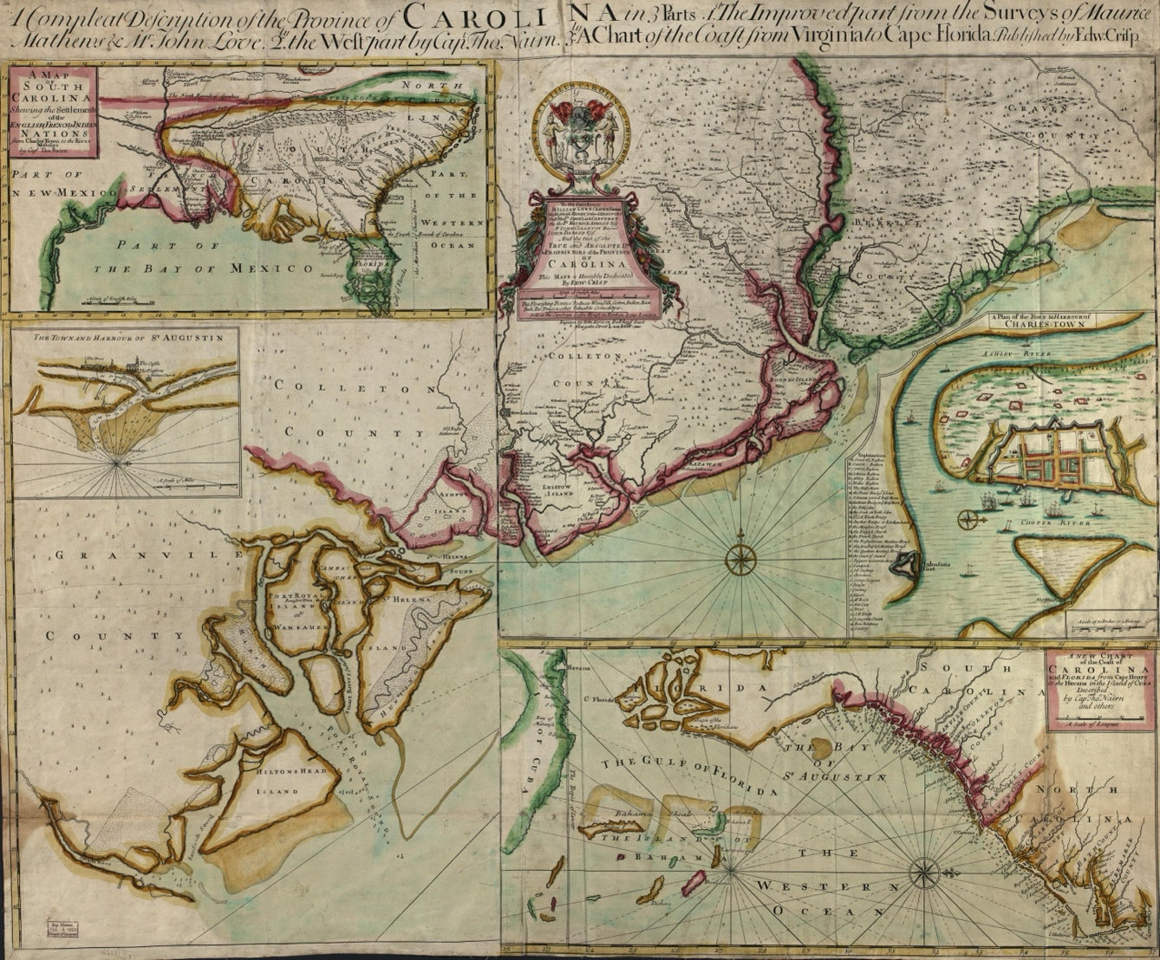
Figure 37 Crisp, Edw., 1711, A compleat description of the province of Carolina in 3 parts: 1st, the improved part from the surveys of Maurice Mathews & Mr. John Love: 2ly, the west part by Capt. Tho. Nairn: 3ly, a chart of the coast from Virginia to Cape Florida, Library of Congress Geography and Map Division Washington, D.C. http://hdl.loc.gov/loc.gmd/g3870.ct001123

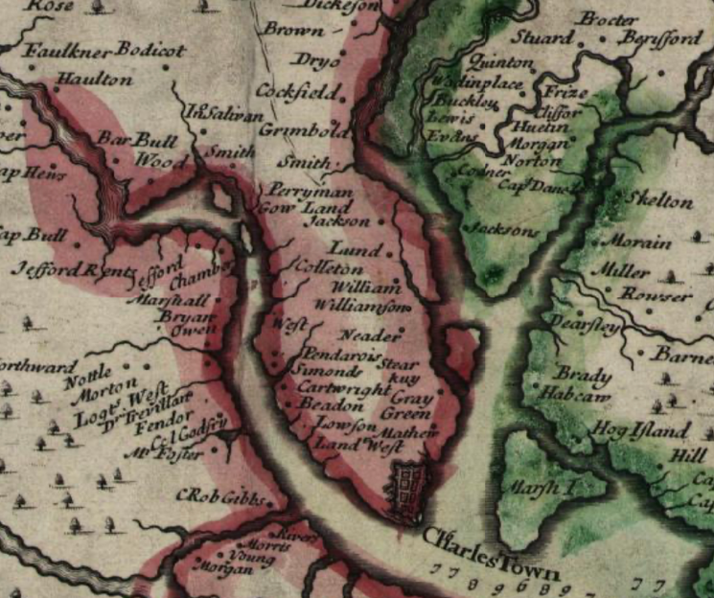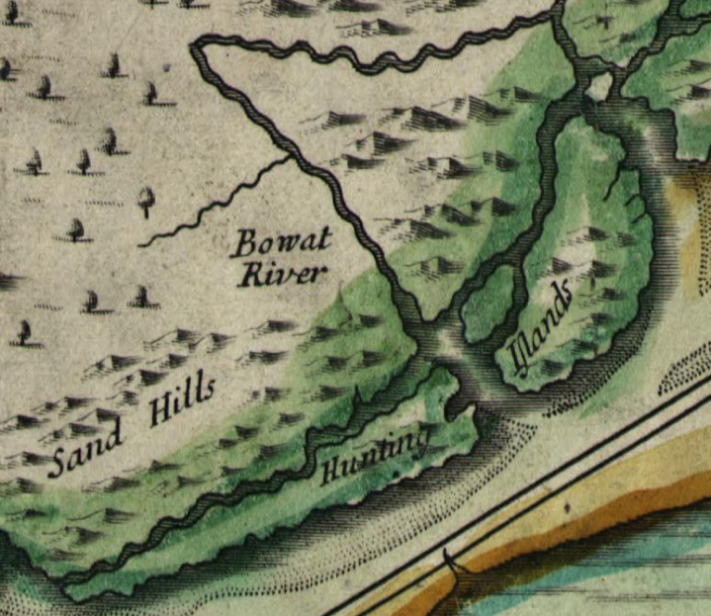
Figure 38 Contrast of Spaces on Crisp's Map, 1711, with plantation land on the left and hunting land on the right.

descriptions of “very high hills” and “full of high mountains” accompany familiar mountain iconography representing non-agrarian spaces. Figure 39 Vast tracts of land contain descriptions that hint at natural resource potential. The mapmaker imagined expanses filled with “rich oak and hickory” stands, “large timber” fields “void” of less marketable pine. Figure 40 Other locations contained mineral resources “full of marble” or “expansive prospects,” potentially of gold or silver. The map overtly demonstrates the reconfiguring of colonial agendas following the Yamasees War in 1715, which expressed British colonial aspirations of expanding the colonies for collective defense and profit through resource extraction.
John Mitchell's 1755 map explicitly demonstrated the agricultural nature of conflicting imperial claims. Scholars have extensively examined the map for its bold territorial claims in contrast to French claims on maps in the years leading up to the Seven Years’ War. Mitchell
borrowed nearly all of the Southeast’s geographic information from the Barnwell-Hammerton Map. However, key changes in the textual nomenclature hint at the changes in the colonial market of commodities, which drove many of the newfound British territorial assertions that the map cartographically claims. Rather than the natural resources Barnwell’s map imagined dispersed on the edges of Native lands, Mitchell envisions rights to the land itself as the commodity. Mitchell replaced timberland with “fine Fertile Country” now void of Cherokees as well as pines. The map labels areas surrounding the Cherokee homelands that mapmakers recently imagined as mountain vistas as “well settl’d.” As the market progressed toward real estate as the primary commodity in Cherokee territory, British mapmakers sharpened their view of Cherokee land as recognizable colonial agricultural spaces.
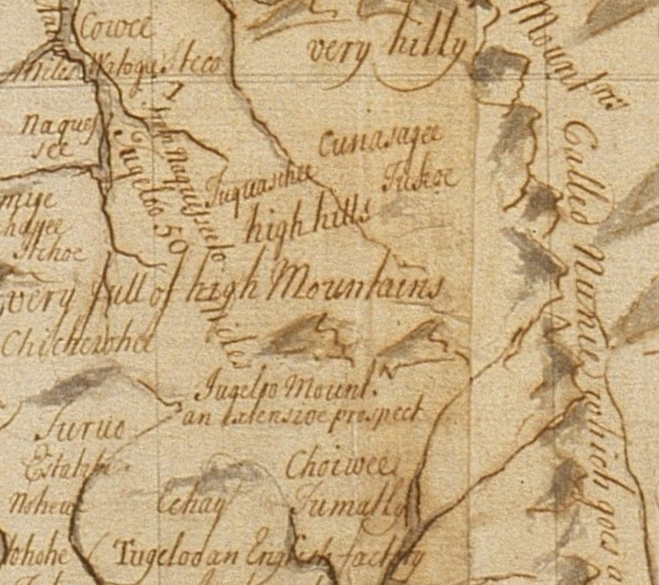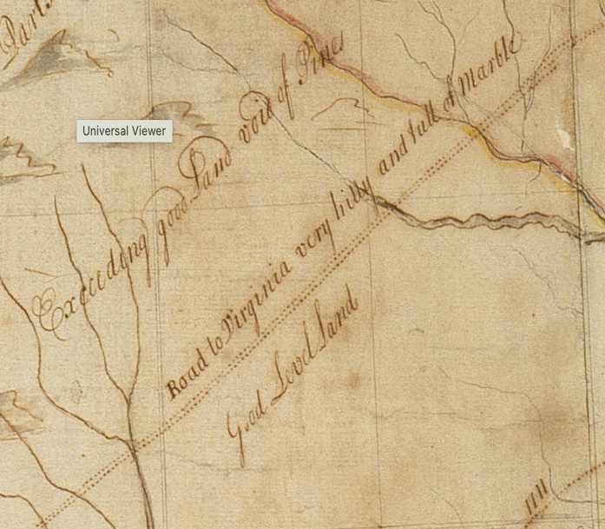
Figure 39 Contrasts on the 1721 Barnwell-Hammerton Map with Cherokee lands on the left and Piedmont areas on the right.

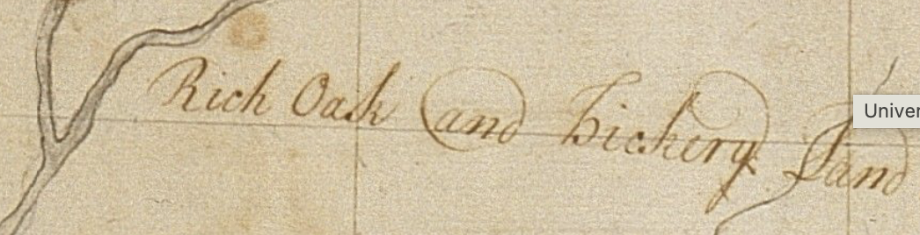
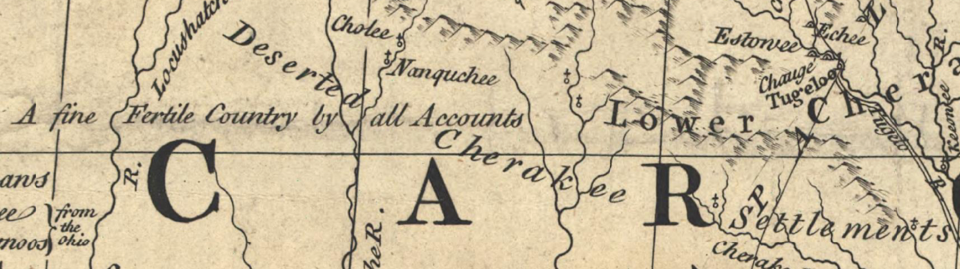
Figure 40 Timberland on the Barnwell-Hammerton Map replaced by Fertile Country on the Mitchell Map

By late-mid-century, British mapmakers did not consider Cherokee settlements comprising wilderness “hunting grounds” or recognizable agriscapes. Henry Mouzon depicted colonial settlements as fundamentally linked to plantation agriculture, a distinction Cherokee towns lacked on his widely circulated map. Figure 41 His iconography for colonial settlements consisted of minor regularly placed marks representing individual plantations with the owner’s adjacent moniker. However, Mouzon drew Cherokee towns as a cluster of tightly packed markings indicating individual dwellings with an anglicized Cherokee toponym representing the entire community. The evolution of the agricultural spaces on European maps comes to fruition with the example of Mouzon’s map. The river valleys on the Cherokee side of the boundary line on Mouzon’s map mirror those on the South Carolina side, only lacking the individual colonial plantations lining them. Figure 42

Cherokee Agricultural Spaces’ Susceptibility to Colonial Entrenchment
Cherokees had maintained and, at times, expanded their domestic and agricultural spaces for centuries. The Cherokee’s universal belief in sustainable agriculture and a natural balance that included environmental responsibility and gender-specific roles in creating and maintaining their fields and pastures had ensured their agriscapes endured ecological challenges. Their methods of conducting war against Native rivals and coalescing with nearby Native communities fostered an enduring territoriality that made sustained, fixed agriculture possible. Cherokee agriculture that implemented cultivation through methods like shallow planting and cultivation of non-crop plants to create advantageous deer habitats and productive and secure fields allowed Cherokees to remain anchored in their homelands over a long duration. These same two elements, sustainable agriculture and non-conquest military methods that had made fixed territoriality possible, made Cherokee lands vulnerable to colonial entrenchment.
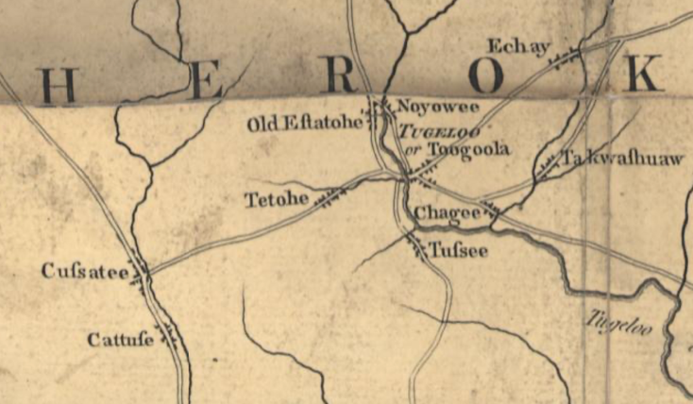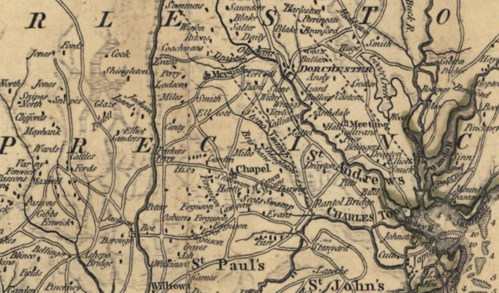
Figure 41 Contrasts on Mouzon's Map 1775 with Cherokee towns on the left and South Carolina plantation on the right.

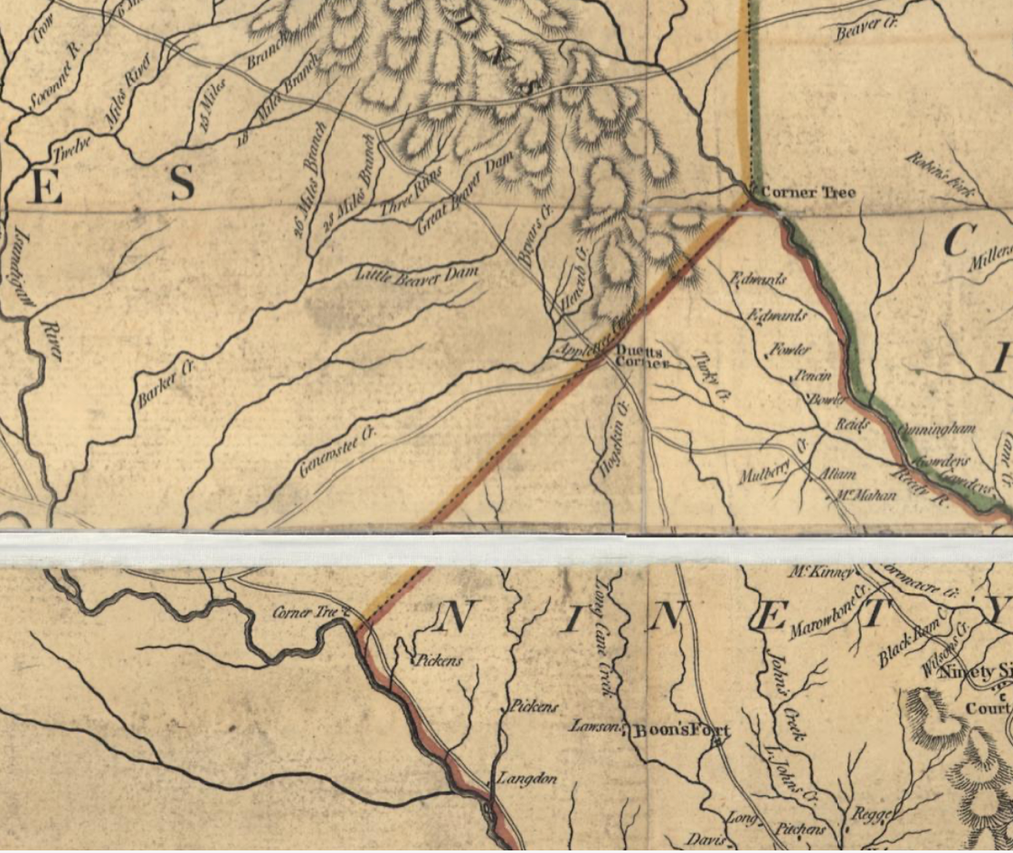
Figure 42 Mouzon Map Inset, 1775, showing the Cherokee-South Carolina Border. The white line is a fold in the map.

Invasive colonial agriculture destroyed Cherokee pastures and fields. Colonial invaders destroyed Cherokee fields that consisted of a mixture of crops and supporting plants and replaced them with non-sustainable agriculture. As Mt. Pleasant explains, European-style plow-based agriculture exhausted the soils of their nitrogen content much quicker than Cherokee methods. Also, European-style agriculture did not implement cultivating native supporting plants to enrich the soil or ward off scavengers.
European-plantation style agriculture transformed adjacent Cherokee agricultural spaces. With the arrival of European-style agriculture came hogs and cattle that decimated the non-crop plants that supported Cherokee agriculture. Within a short time of arriving on a cleared Cherokee field, groups of colonizers unleashed cattle and hogs to feast on the Cherokee’s cultivated supporting plants that augmented deer herds and protected crop fields. Soon, the invasive species transformed entire habitats that Cherokees had constructed to sustain their framing and husbandry practices.
Cherokee agricultural spaces provided an enticing advantage for would-be colonizers. Upon arrival, entrenchers would have found roads to nutrient-rich cleared fields, plentiful deer herds and other protein sources, and riverine landscapes for mills. When land-speculating colonizers sought land to advertise, they sought out these manicured spaces that often appear on large-scale maps as “Indian Old Fields” in areas where direct facilitation of entrenchment took place. But, because entrenchment destroyed whole agriculturally based habitats, areas adjacent to ongoing entrenchment quickly became ecologically transformed. These areas appear on much smaller scale maps, identifiable through the clearance of iconography representing traditionally non-agricultural space such as dry, montane, or undulating regions. Figure 43
Cherokee military tactics exposed their domestic and commercial agricultural spaces to entrenchment. Eighteenth-century Cherokees did not associate military action with territorial conquest. George Chicken and other British military officials found Cherokee towns unfortified despite an ongoing dispute with Creeks. Wayne Lee describes the Cherokees as conducting warfare within his “the cutting-off way framework.” The cutting-off way consisted of small but lethal attacks between groups of Native peoples that used stealth as a strategy for advantage. These attacks aimed to kill or capture smaller groups of rivals in and around their hometowns. The results could be a reciprocal number of casualties on each side. The result of constant and effective attacks could result in the abandonment of more exposed towns by one of the Native groups, which was the case with several Cherokee towns during the conflict with the Creeks. However, Cherokee military strategies did not include territorial conquest or defense.
Cherokee military strategies proved effective for surviving large-scale colonial military invasions. Cherokees used traditional tactics to combat large forces of colonists who invaded the Cherokee’s territory in 1760, 1761, and 1776. Cherokees avoided direct conflict and targeted the colonist’s supply chains to have them vacate Cherokee territory. Cherokees rapidly reoccupied towns where soldiers had burned structures and destroyed crops they recognized, such as corn fields. The Cherokees avoided heavy casualties, and the soldiers left without upsetting the vast majority of the Cherokee’s agriscape habitats, making rapid repopulation of the towns possible. However, when the Creeks implemented decades of the “cutting-off way” of warfare, Cherokees abandoned exposed towns. Cherokees in the area could not safely maintain their agriscapes
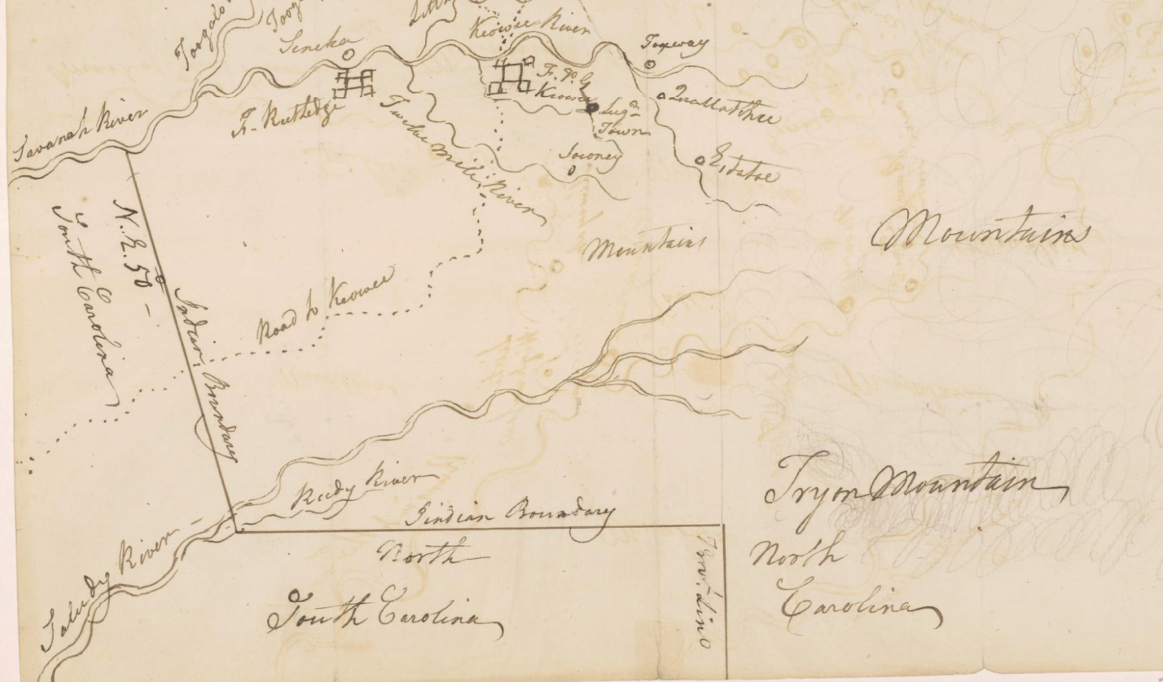
Figure 43 Example of an area adjacent to direct entrenchment undergoing ecological transformation. The tract is above the "Indian Boundary" line surrounding the Reedy River. Although topographically similar to other regions on the map, the area contains no textual references to mountains or the numerous swirl marks indicating rough terrain in the surrounding areas above and to the right. On [Mr. Wilkinsons plat of ye Cherekee country], ca. 1770s. https://quod.lib.umich.edu/w/wcl1ic/x-1832/wcl001923

outside of the safety of their towns. Sustained pressure that rendered maintaining agriscapes impossible resulted in the Cherokee’s pastures and fields in the region becoming less productive, resulting in abandonment.
Cherokee military excursions had limited personnel and sustainability capacities. The political autonomy of Cherokee towns and clans prevented large-scale mustering of combatants. Lee argues that the Cherokees and other Indigenous groups traveled in small groups for camouflage. The element of surprise determined the progression and outcome of the expedition. Once an invading group had been discovered, they quickly retreated. Expecting a quick ambush and escape, the groups survived off food and supplies they found en route rather than carrying large stores from their home bases. The lack of mass groups of warriors who directly confronted the enemy in their towns and the lack of supplies for sustained occupation resulted in little, if any, territorial acquisition through military conquest. These limitations also made mustering the equivalent of a standing army that could patrol an area against colonial entrenchment for protracted periods untenable.
Cherokees lacked the military framework to safeguard against entrenchment. Cherokees could and did discover and violently expel colonial trespassers. However, they faced a complicated set of choices when expelling small groups of entrenchers. Using “the cutting-off way,” Cherokees could root out small groups of clandestine colonists, but they realized this might spark an interruption in trade or an invasion from an official colonial government. The need to locate and dislodge entrenchers became a pressing issue that required urgency. Once colonists invaded an area in and around Cherokee agriscapes, they immediately began a process of ecological transformation that only took a short time to dismember generations of Cherokees’ labor.
Cherokees also fought an indirect battle against penetrating ecological destruction. Cherokees removed groups of settlers from within their territory, but without the military conventions to conquer and hold territory adjacent to their agriscapes, Cherokees could not prevent the destruction of field and pasture habitats by cattle and other invasive species that colonists intentionally left to roam. The colonists, who consistently entrenched near the limits of Cherokee territory, effectively decimated Cherokee agricultural spaces exogenously.

Conclusion
Over centuries, Cherokees constructed an environmentally sustainable and territorially fixed system of agriscapes. Cherokees tied their cultural origins to the landscape and based gender roles around the construction, maintenance, and harvesting of their agricultural spaces. Cherokee agriculture was far more sophisticated and reliable than the conceptions of hunting and gathering. Cherokee agriscapes consisted of field and pasture systems supported by surrounding habitats to augment and protect crops and herds. The Cherokee’s agricultural systems consisted of domestic and commercial spaces capable of producing food and trade goods in copious but sustainable amounts. Cherokee society and territoriality relied on constructing and maintaining their agricultural spaces. Cherokees would adapt military strategies to preserve their agriscapes against colonial military invasions. However, Cherokee agriscapes proved vulnerable to the ecological destruction brought by groups of colonial entrenchers. When the colonial market shifted from seeking Indigenous trade goods to commodifying Indigenous real estate in the 1750s, the Cherokees unwillingly found their agriscapes suddenly made them one of the wealthiest communities in the Americas.

CHAPTER 4: COMMODIFYING CHEROKEE GEOGRAPHY
As the middle of the eighteenth century approached, many Cherokees considered inviting European colonial administrators into their territory beneficial. A controlled presence of European trading centers gave Cherokees access to crucial European goods, such as guns and ammunition, that they needed to compete with their “many Enemies.” Convenient European trade centers also provided Cherokee women with items such as woven fabric and sexual partners. British and French forts and trading posts became centers of political and cultural interaction within the Cherokee homelands. For strategic purposes, Cherokees shared their geographic knowledge at these colonial outposts.
Maps of the Cherokee homelands during the 1750s drawn by colonial officials like British Indian Agent John Stuart exemplify Cherokee understandings of the geopolitical turmoil that pressed them on every frontier. Stuart’s maps reflect Cherokee descriptions of their homelands and the adjacent threats. Cherokees’ concern for foreign raiding parties and launching their own expeditions was nothing new. They considered conflicts with Creeks, Shawnee, Haudenosaunee, and other Indigenous groups as equally or perhaps more consequential than relations with French or British colonists. Cherokees influenced some European cartographic depictions of the region based on their spatial understandings and political maneuvering. However, in the hands of land-speculating British colonists, the maps of the Cherokee homelands became weapons in an internal conflict between imperial designs to prevent settlement outside of the metropole’s economic control and a swelling on-the-ground determination to invade Cherokee lands by aspiring North American British colonists.
The 1755 Jefferson-Fry Map resulted from individual land speculators cartographically commodifying Indigenous territory. Figure 44 In a 1751 report, Joshua Fry wrote that after reading Virginia colonist John Peter Sally’s journal from his party’s 1742 excursion into Indian territory, he concluded that “the country between our Settlements and the Missisippi is uninhabited, or at most has only some inconsiderable Indian villages,” a convenient narrative that Dr. Thomas Walker’s report from his 1749 jaunt supposedly confirmed. Unsurprisingly, the map’s authors, Fry, Jefferson, and one of its primary sources, Dr. Walker, had received provisional land grants as part of the Loyal Land Company for over one million acres of the “uninhabited” land. The proprietors altered the landscape on a published map as part of their scheme to obtain legal titles and market the region to immigrant colonizers. They omitted competitors such as the Ohio Land Company and added features such as alluvial valleys and toponyms emphasizing the successful entrenchment that had already occurred for the enterprising progenitors of the endeavor.Figure 45
Map historians have written extensively regarding maps as weapons of colonization. According to scholars, colonial maps represented imperial aspirations. In many examples, such as the 1762 First Lord’s Proprietors Map or John Mitchell’s 1755 map, broad imperial projects
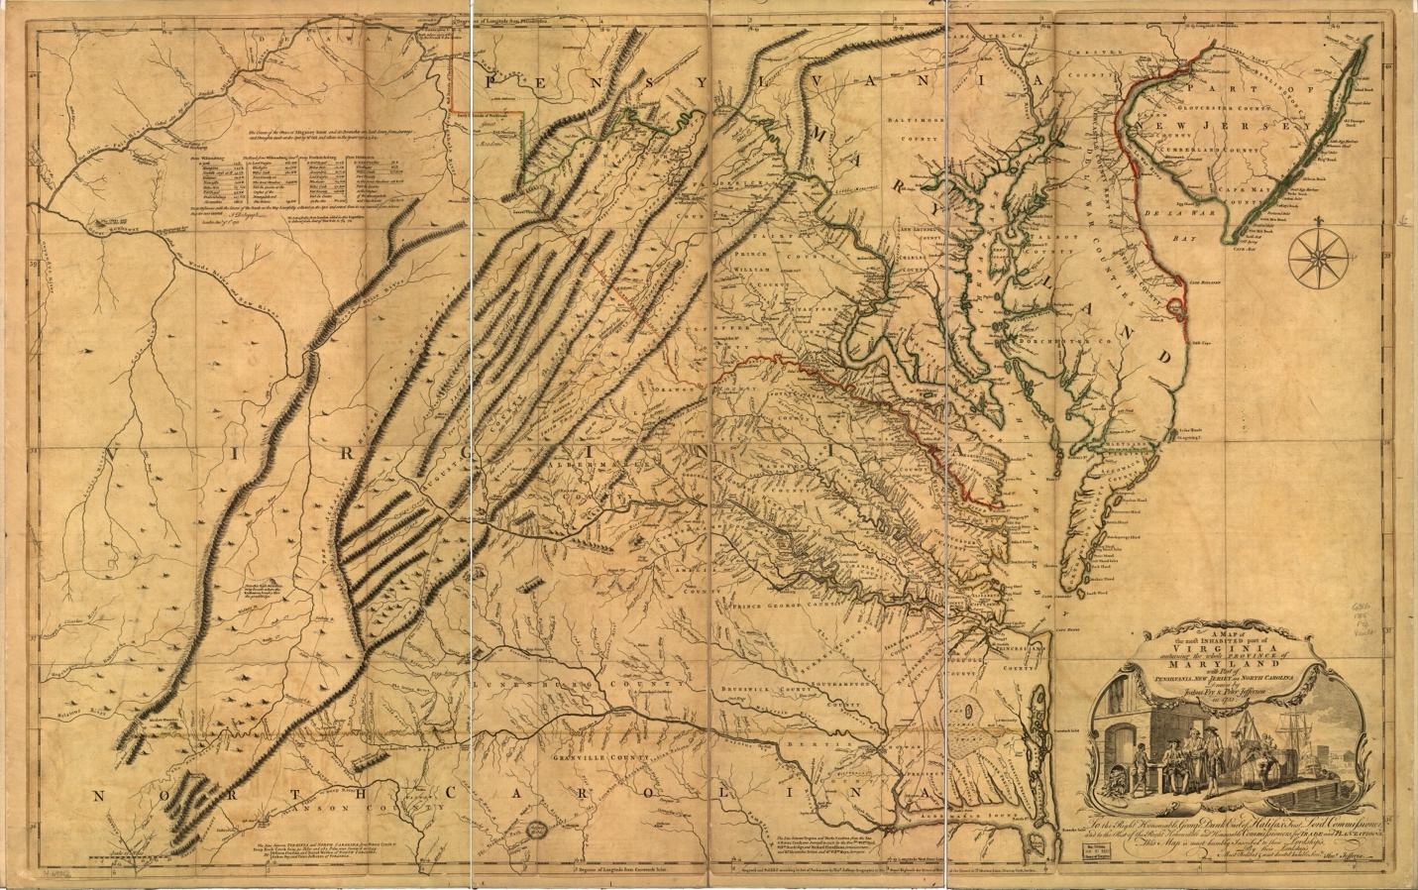
Figure 44 Joshua Fry and Peter Jefferson, A map of the most inhabited part of Virginia containing the whole province of Maryland with part of Pensilvania, New Jersey and North Carolina, 1755. https://www.loc.gov/resource/g3880.ct000370/

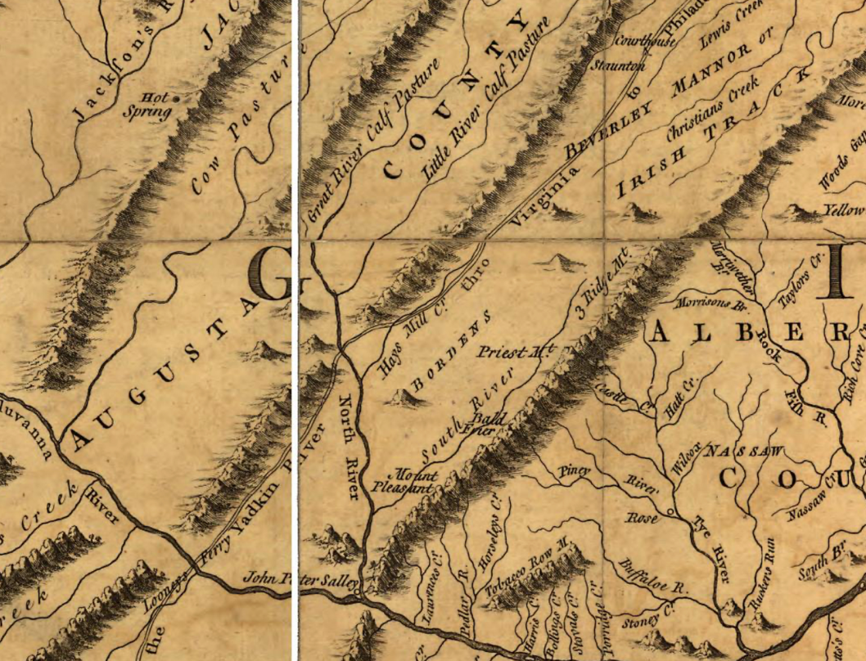
Figure 45 Jefferson-Fry Map insert. The toponyms “Cow Pasture” and “Tobacco Row” highlight agricultural opportunities while “Bordens” and “Irish Track” advertise successful entrenchment and beckon additional colonizers from a specific group.

drove the way mapmakers represented territory. British Mapmakers often erased or subjugated Indigenous groups on maps and drew colonial lines through Indigenous lands that made bold territorial claims. Scholars have argued that these maps represented cartographic salvos in a colonial contest over territorial conquest in North America.
I argue that colonial maps of the Cherokee homelands deviated into two separate genres during the 1750s. Some maps, like Mitchell’s, forwarded imperial projects while others represented the aspirations of individual colonizers, divorced and often in conflict with official Crown policies. While both subsets represented colonial projects, the individual and commodifying nature of land speculators’ maps marked the beginning of settler colonialism in the region. Maps drawn by colonists who espoused the Crown’s official policies regarding Cherokee territorial sovereignty depicted the region as a foreign land where geographic knowledge informed trade relations and military strategies between the Cherokees and the British Empire. John Stuart’s maps relied heavily on Cherokee sources and provide material for investigating contemporary Cherokee geographic epistemologies and their diplomatic maneuvering. On the other hand, maps drawn by land speculators warped Cherokee information and ignored official colonial policy to produce maps that commodified Indigenous land for personal gain. The divergence of the fundamental elements underpinning the maps’ colonial schema in this era helps define the differences between traditional colonialism and settler colonialism.
In the nearly two decades between the onset of the Seven Years’ War and the beginnings of rebellion in the British colonies, maps of the region underwent a profound transition. This transition did not entail drastic changes in topographic accuracy but rather in the ways in which British colonial factions consumed and wielded the maps originally based on Cherokee and other Indigenous people’s information. Imperial colonial administrators used maps to delineate areas reserved for Indigenous “nations” from areas of British settlement. Meanwhile, colonial elites in Virginia, the Carolinas, and Georgia began envisioning the Cherokee homelands as a region ripe for territorial monetization. Maps from the 1750s and 1760s display and facilitated the cartographic transition of the Cherokee homelands into an abstract colonial commodity.
Colonizers intentionally targeted Cherokee agricultural areas. Immigrant colonizers looking for land knew these areas likely contained no European occupants. Tidewater land speculators coveted vast tracts of land with no rival British claimants. Using two distinct mythologies, the colonists appropriated knowledge of the land to entrench themselves in these areas. Along the Cherokees’ southern frontier near Keowee, groups of South Carolina colonists acted in concert to identify Cherokee commercial agricultural spaces that individual families could occupy. Collectively, these groups’ activities would diminish the value of the land for Cherokee agricultural practices, providing an avenue for colonial officials to approve the colonists’ petitions for land titles under South Carolina law. On the Cherokee’s Long Island frontier with Virginia, well-connected land speculators ex post facto invented land titles for large groups of colonizers that they had actively solicited to entrench on Cherokee and other Indigenous people’s commercial agricultural property.
This chapter outlines the commodification of Cherokee territory by exploring the divergent trajectory of colonial maps. First, this chapter uses a decolonized lens to examine maps drawn by British colonial officials in Cherokee territory to reveal Cherokee geopolitical strategies and realities on the eve of the Seven Year’s War. These Cherokee-sourced maps provide material for analyzing mid-eighteenth-century Cherokee spatial epistemologies that drew from their cosmography and cultural ties to their homelands. Next, the chapter demonstrates how individual colonizers employed two methods of colonial entrenchment. It details how small groups of colonists operated in conjunction to ecologically devastate Cherokee agricultural spaces and then appeal to colonial governments to codify their occupation. Other groups of influential colonists formed land companies to profit from advertising entrenchment on their vast hypothetical tracts of land. In response, Cherokees marked borders and demanded the highest levels of imperial administration help stave off clandestine colonial entrenchment.

Mapping Cherokee Geopolitics
By the mid-1750s, the Cherokees sought to secure their European goods supply chains. A group of Cherokees wrote South Carolina Governor James Glen, thanking him for ammunition and requesting “the same Quantity more” to “have enough to withstand our Enemy.” Decades of unreliable and unscrupulous individual British traders residing within the Cherokee’s territory had led to many town clusters requesting high-level colonial officials provide formal trade centers near their communities to “always have a place to go to for a Supply of Necessaries.” For disparate reasons, the Cherokee’s requests fit neatly with British officials’ plans for fortifying the Cherokee’s territory to secure the region against what they viewed as a looming French threat to British territorial claims. Many of the Cherokee town clusters had participated in an organized schema to procure a steady stream of British goods from British colonials, particularly South Carolina. The colonial record is rife with Cherokee emissaries in urban centers and forwarded petitions requesting supplies, demanding fair prices, and pleading for access to credit at trade centers within Cherokee territory.
The Cherokees got their wish. As a result of the construction and garrison of Fort Prince George adjacent to Keowee in 1753 and Fort Loudoun near its’ti (Chota) in 1756, two prolific British mapmakers spent time among the Cherokee homelands. Newly appointed Governor of South Carolina, William Lyttelton, tasked William De Brahm, a renowned British surveyor, cartographer, and engineer, with designing a fort near its’ti (Chota). John Stuart, who became the Indian Agent for the British Southern District, came to Fort Loudon as a 35-year-old captain in 1756. These two men would produce the most influential British geographical information on the Southeast and Cherokee homelands during the middle of the eighteenth century. Much of the information on their maps came from Cherokee and other Indigenous groups’ knowledge of the land. Stuart admitted that he fashioned his maps from “such intelligence as I have been able to procure.” These maps reveal a Cherokee perspective of the global geopolitical firestorm embroiling the region resulting from mounting colonial pressures.
John Stuart’s 1757 “[Map of the area between Fort Loudon, Tennessee, and Kaskaskia, Illinois]” reveals Cherokee geopolitical machinations at the onset of the Seven Years’ War. Figure 46 Having consulted among themselves between town clusters, the Cherokees launched a multi-pronged diplomatic strategy designed to secure European military supplies for their defense and attacks vis-à-vis Shawnee and other Indigenous groups. One group of Cherokees traveled to Fort Toulouse and New Orleans in 1756 to fain French allegiance in exchange for goods, while another Cherokee envoy headed toward the confluence of the Ohio and Tennessee Rivers in early 1757 as part of a raid against “French Indians” to convince British officials to furnish them with military firearms and ammunition. Upon returning to Fort Loudon, Attakullakulla provided John Stuart with the information found on the map including a recently built French fort as part of the Cherokee’s plot to encourage British aid. The Cherokees told Stuart they “looked to us for assistance to drive away the French.” Stuart immediately fashioned the map and sent it with a dispatch requesting aid to the Governor of the South Carolina colony, William Lyttelton.
Stuart’s map cartographically depicts Cherokee diplomacy toward British colonizers. The towns approximate to Fort Loudon represented the only section of the map Stuart observed. Here, Stuart used a relatively uniform scale. However, outside of his direct observation, the map’s scale and riverine topography make drastic deviations. Some of these topographical
anomalies arise from Cherokees’ intentional manipulations. Just outside of Cherokee territory, Stuart severely truncated the section of what is now the Tennessee River from its confluence with the Hiawassee River to the confluences of the Ohio and Mississippi Rivers. The Cherokee
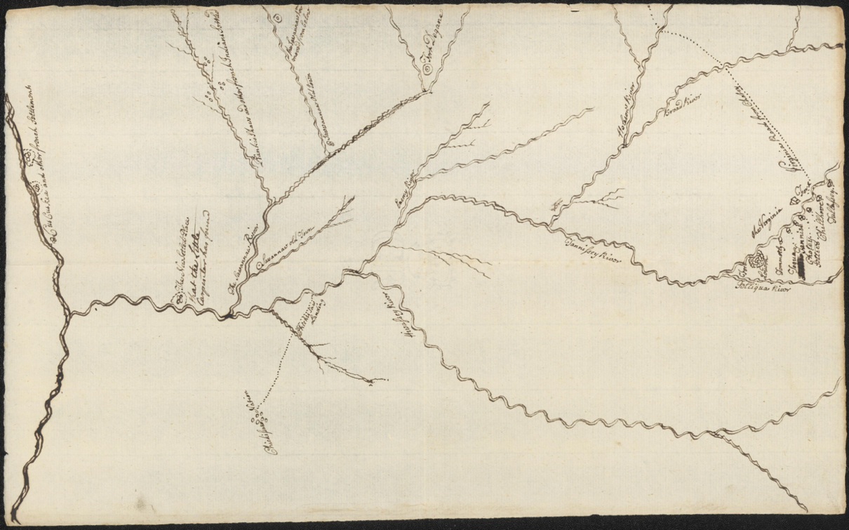
Figure 46 “[Map of the area between Fort Loudon, Tennessee, and Kaskaskia, Illinois].”. https://quod.lib.umich.edu/w/wcl1ic/x-5529/wcl005606. In the digital collection William L. Clements Library Image Bank. William L. Clements Library, University of Michigan Library Digital Collections.

councilors must have informed Stuart that the French lay but a few days’ travel from their homelands, resulting in Stuart’s abrupt change in scale. To Lyttelton’s eyes, the newly constructed French fort appeared alarmingly near Fort Loudon, and Cherokee communities eager to barter for European goods just as the Cherokees intended.
The prominence of the “Virginia Fort” on the map represented the Cherokee’s recognition of Virginia and South Carolina as politically distinct and antagonistic colonies. During the 1750s, the Cherokees maneuvered to have competing trading centers at their fingertips from both colonies. Cherokees had become dissatisfied with autonomous British traders’ intermittent supplies and unscrupulous practices. For the Cherokees, British forts represented a centralized economic center with more administrative stability and, they hoped, accountability.
The map shows the “Virginia Fort” on the opposite riverbank from the Cherokee towns and South Carolina’s Fort Loudon. When Virginia Major Andrew Lewis arrived in the area in July 1756, Cherokees insisted the Virginians build a separate “Fort at Chotte [sic]” apart from the “Spot for the Carolina People,” which the Cherokees had already “laid off.” Lewis complied after some Cherokees pledged to provide four hundred warriors to aid Virginia’s war efforts. Only ten Cherokee warriors accompanied Lewis back to Virginia causing him to speculate that the Cherokees had only wanted the fort to further secure European supplies rather than become military allies. Although the Virginian’s slow-witted realization of the Cherokee’s intentions resulted in the “Virginia Fort” remaining ungarrisoned, the Cherokee’s insistence on its inclusion on the map ensured the empty fort remained an effective bargaining chip with South Carolina’s colonial officials.
The map’s varying scales and fluvial orientations also reflect Cherokee geographic epistemologies. For the area surrounding Fort Loudon, Stuart used a relatively conventional scale denoting Cherokee towns along the Little Tennessee River without regard to varying distances between them. Again, outside of this area, the map’s scale and riverine topography change dramatically. These topographical anomalies reflect Cherokee conceptions of distance, directional orientation, cosmology, and intentional manipulations. Instead of the circuitous route the Tennessee River takes from East Tennessee to its confluence with the Ohio River, the map depicts a direct route.
Eighteenth-century Cherokees relied on landmarks and celestial orientation for navigation and often measured distance via transit time. The map’s nearly direct east-west course likely resulted from the Cherokees' description of their route and destination’s location in relation to the sun’s path. The short stretch of distance along the Ohio River from the confluence of the Tennessee River to its termination at the Mississippi River appears much longer on the map than in reality. Although Stuart notes in his letter to Lyttelton that Cherokees found the “new French Settlement” only “a mile and a half below the fork” of the Mississippi and Ohio Rivers, the approximately five-mile stretch of the river appears longer than the nearly five-hundred-mile stretch of the Tennessee River from the Ohio to the Hiawassee. The Cherokee had a long history of travel to this locality, and their detailed descriptions of the area and ostensible insistence on the troubling incursion of the French must have led Stuart to enlarge the region. The rivers inside the Cherokee homelands, now the Tennessee, Little Tennessee, and Hiawassee Rivers, appear elongated, exaggerating the size of the Cherokee homelands. Perhaps the Cherokee describing one or more of these rivers as Ganvhidv Asgaya (The Long Man), whose head is in the mountains and feet in the oceans, led Stuart to depict these rivers in such a fashion.
Stuart’s map contains rich Cherokee descriptions of the region’s Indigenous geopolitical makeup. The map notes a Cherokee trading path with Virginia and a meeting spot with Chickasaws, both rival trading partners with South Carolina. The Cherokees termed the Ohio River the “Sawannaw River,” denoting the presence of Shawnee groups upstream. They referenced two former Shawnee settlements labeled “Sawannaw old Towns” on the map and locations further north where Shawnees had removed, thus asserting Cherokee dominance of the region. The map includes the positions of “Pinkashaw,” “Cus Cus Kea” (Kaskaskias), and other Indigenous communities along the Mississippi and Wabash Rivers with whom the Cherokees had constant interactions for centuries.
The “Enemy River” on the map represents an inadequate translation. On another of Stuart’s maps and a De Brahm map derived from Cherokee information, the river’s name is the “Anagusge,” the Cherokee word for Creek or Muskogean-speaking group. Stuart’s use of the term “enemy” reveals that the Cherokee were not on friendly terms or had once been in conflict with a Muskogean-speaking group settled along the river. The Cherokee informants blended their inter-Indigenous conflicts and alliances with efforts to gain British supplies in their rendering of the landscape. The map’s seemingly erroneous scales and ethnonyms are the result. The information Stuart received from the Cherokees formed the geographical framework for many of Stuart’s future maps.
William De Brahm arrived at the Cherokee settlements on the Tanasi River (Little Tennessee River) in 1756, tasked with overseeing the construction of a fort. Cherokees informed De Brahm that they had selected a site for the British to situate the fort. The Cherokees had prepared a plot adjacent to the Little Tennessee River with a road directly linking the neighboring towns to the site. De Brahm deemed the site unfit for a defensive structure as a high ridge just to the north looked down on the site. The conflicting determinations for an ideal site elucidate the disparate ways the British and the Cherokees viewed the purpose of a “fort.” De Brahm’s large-scale maps of Fort Loudon and the surrounding area demonstrate how high-level British officials and Cherokees perceived the territorial sovereignty of the region and the status of British presence there as foreign and imperiled.
De Brahm produced three renderings of Fort Loudon and the surrounding area. He drew the earliest, The Plan and Profile of Fort Loudoun, in 1757 and two similar maps in 1773 as part of his Report on the General Survey that he produced for King George III. Figure 47 The maps demonstrate De Brahm’s intentions to construct a fort that would effectively provide protection against a French attack via land and secure the river against French gunboats. De Brahm based his plans on defending against European military strategies that employed cannon and firearms. He paid little heed to designing the fort to withstand a Cherokee attack, declaring that the thorns on surrounding locust trees “renders the Fort impregnable, at least to Indians, who always engage naked.” De Brahm’s design called for a bastion-style fort built on a commanding position along the river, which mirrored other British forts in port cities around the globe. The Cherokees cared

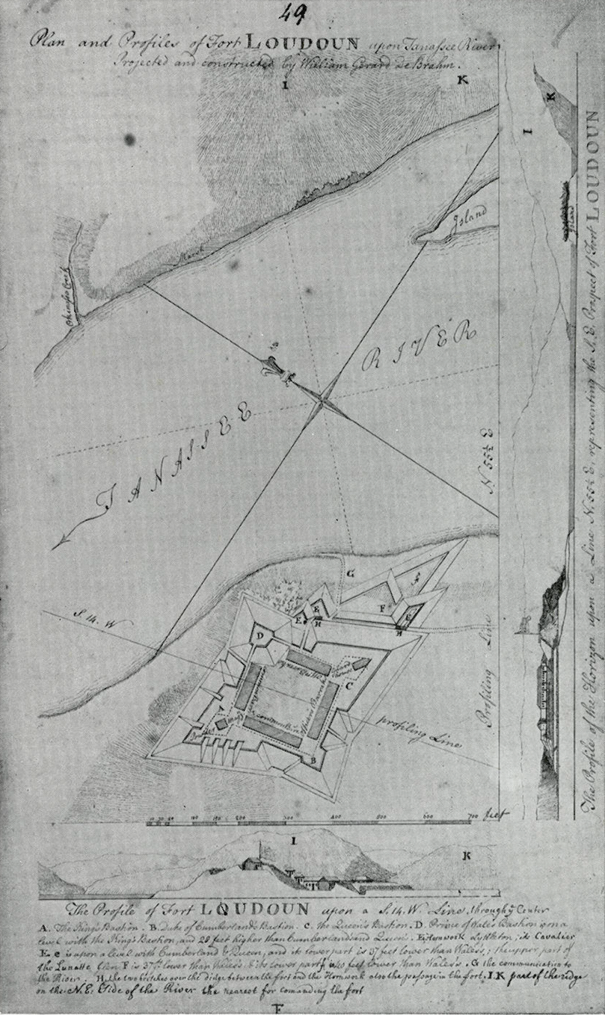
Figure 47 William De Brahm, The Plan and Profile of Fort Loudoun, 1757

little for De Brahm’s main military objective for the fort. They anticipated other uses for the British presence that appear on De Brahm’s maps.
The Cherokees benefited from the convenient location and amenities at Fort Loudon. The Plan and Profile of Fort Loudoun shows two paths to the nearby Cherokee town of Tomaley and a path leading from the fort to the river’s forks and beyond. The plan shows a “landing place for the Indians.” These access points reflect the Cherokee’s frequent interactions with the British in the fort. The map shows “Indian barracks” that would have served to temporarily house Cherokee who frequented the station. Captain Raymond Demere remarked soon after the fort’s construction, “It is a Pleasure to me to see the Indians coming to us both by Land and Water with Eatables &c. to sell to the People which they do in such Numbers that this Place already beings to have the Appearance of a Market.” The Cherokees exploited the coupling of British goods and political authority at the fort.
Cherokees also wanted access to military supplies and services. De Brahm’s map indicated the “Smith Shop.” Early in the fort’s construction, many Cherokees complained bitterly about the British focusing on completing defensive ramparts rather than constructing buildings devoted to fulfilling their firearm supplies and maintenance needs. In October 1756, Connecorte (Old Hop) remarked to Demere that “if he had seen any Women amongst us, he would have immagined [sic] that Dallying with them had employed us, but as he saw none he knows not what we have been doing.” Connecorte implored Demere to “make a wooden Fort immediately, and then go on with your Works.” By August 1757, the fort’s new commander, Paul Demere, reported that he had a blacksmith, gunner, and butcher. Cherokees immediately took advantage of the British marketplace, prompting Demere to write to Lyttelton, “It is impossible for me to describe how tormented I am Every Day with the Indians. Some bring their Guns to be mended & it must be done because the Carpenter told them it should be So, and you promised him; Some brings[sic] Hatchets to be mended other Padlocks to have keys made to them; others want Salt, others sometimes Meat, & great many other things.” A contemporary map by Henry Timberlake shows a town labeled “Toskegee” had developed nearly adjacent to the fort, demonstrating that Cherokees gravitated towards the location while it served their needs.
De Brahm’s maps of Fort Loudon’s surroundings reveal Cherokee and British imperial administration’s perceptions of territoriality at the moment of Fort Loudon’s construction and throughout the early 1760s. Both parties recognized the British as a foreign presence in Cherokee territory. De Brahm’s 1773 Plan of the Environs in the Neck of Tennessee and Talequo Rivers shows 700 acres of the “King’s Land,” which De Brahm claimed “the Indians had obliged themselves to cede to the King forever.” De Brahm’s statement indicates that the Cherokees provided an enclave to the British, which both parties recognized as outside British territory. While it remains unclear if the Cherokees understood the land surrounding the fort’s status in the same way as De Brahm’s assertions, what is clear is that they incorporated the British foreigners much the way they had integrated other groups seeking to occupy space within their territory. The Cherokees selected a spot they knew was both self-sustaining for the newcomers and convenient for Cherokees to travel to and interact with the British but with enough space to maintain cultural integrity in the surrounding town clusters. De Brahm’s map displays the spatiality that the Cherokees likely employed to integrate groups of Muskogean speakers and others in the previous century. In 1760, Cherokees understood the physical limits of their territorial sovereignty, and British imperial officials recognized Cherokee lands as a foreign space.
Imperial maps produced following the British attempts at Cherokee genocide in 1760 and 1761 retained the concept of the Cherokee homelands as independently sovereign territory. Despite the lack of widespread direct military conflict during the two British incursions, South Carolina colonists drew maps to document and celebrate a military victory. The 1761 map, SKETCH OF THE CHEROKEE COUNTRY And March of the Troops Under the Command of Luet. Col. Grant to the Middle & Back Settlements traces Grant’s path through the southern part of the Cherokee homelands, noting the dates and locations of Grant’s encampments. Figure 48 The general riverine orientations and penmanship seem similar to a contemporary map by John Stuart. However, the lack of mountain topography outside Grant’s direct path highlights the map’s purpose of visualizing the campaign. The map only notes locations of Cherokee “attacks,” omitting any elusion to the colonists’ razing of Cherokee towns and crops.
Colonists fashioned the 1762 elegantly decorated “Powder Horn Map” carved into a cow’s horn as a commemorative trophy for an officer in Grant’s expedition. The map-like drawings on the horn lend an artistic narrative to the more cartographic renderings on the SKETCH OF THE CHEROKEE COUNTRY map. Both maps use a processional formula for the army’s route, depicting each Cherokee town along the way. The Cherokees appear hidden in the forest as they ambush the colonists along the road through the Cherokee homelands. Although the maps portray different rallying points for the expedition, the “Powder Horn Map” at Charles Town and the SKETCH OF THE CHEROKEE COUNTRY at Fort Prince George, both hint at a
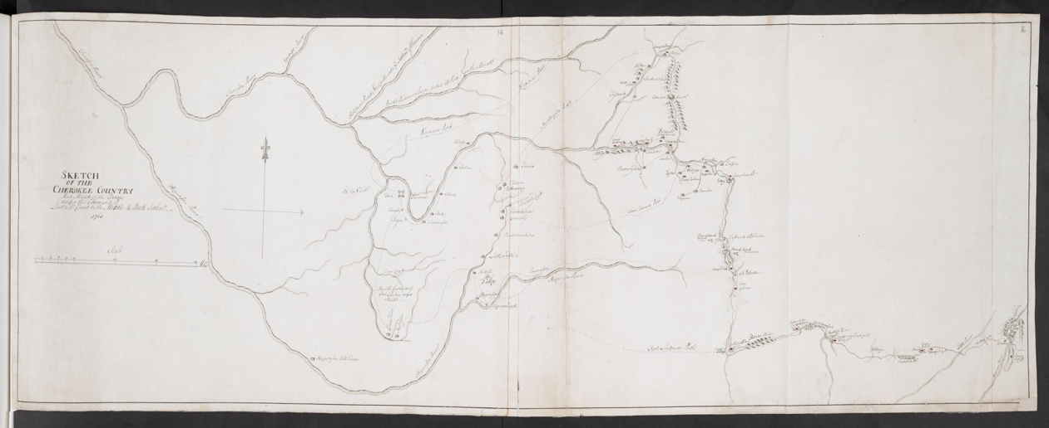
Figure 48 Stuart, John, Grant, James, Amherst, Jeffery Amherst, Baron, and Royal United Services Institute for Defence and Security Studies. SKETCH OF THE CHEROKEE COUNTRY And March of the Troops Under the Command of Luet. Col. Grant to the Middle & Back Settlements, 1761. Map. Place of production not identified: John Stuart, 1760. Norman B. Leventhal Map & Education Center. https://collections.leventhalmap.org/search/commonwealth:hx11z2278

recognition of a clear delineation between the colony and Cherokee territory. The “Powder Horn Map’s” cartouche reads “A New Map of Carolina and Likewise a Plan of Ye Cherokee Nation,” expressing an obvert textual indication of the Cherokee territory’s political sovereignty.
Meanwhile, the SKETCH OF THE CHEROKEE COUNTRY’s depiction of the Cherokee Homelands shows Fort Prince George as the easternmost point on the map, a location commonly referenced as a frontier of Cherokee settlements by South Carolina colonists. According to these maps, British imperial officials regarded the punitive campaigns as excursions outside British territory. However, the 1761 “Treaty of Peace and Friendship” signed between South Carolina officials and a group of Cherokee representatives reveals the spatial ambiguity created by already emplaced colonial intruders.
Stuart’s 1761 “Map of the Cherokee Country” reflects a palimpsest of Cherokee knowledge and Stuart’s rendering of British imperial policy. Figure 49 The Cherokees and Stuart envisioned the Cherokee homelands as a culturally cohesive space apart from British sovereignty. Stuart had traversed only a tiny fraction of the territory. He required Attakullakulla’s assistance to find his freedom and his way back to Virginia after the Cherokees expelled the colonists at Fort Loudon in 1760. Stuart drew from the Cherokee descriptions Attakullakulla provided, closely replicating the orientation of rivers and the exaggerated size of the Cherokee homelands he had used on his 1756 manuscript map. He notes landmarks important to the Cherokees along the Tennessee River, such as the Chickasaw landing and the location of rapids. Stuart also used earlier maps by British officers such as George Hunter and George Haig to illustrate the intermontane Cherokee homelands. However, these earlier maps also predominantly contained Cherokee information. British colonizers would have been ignorant of some information, like the connotative aspects of Cherokee toponyms. For example,
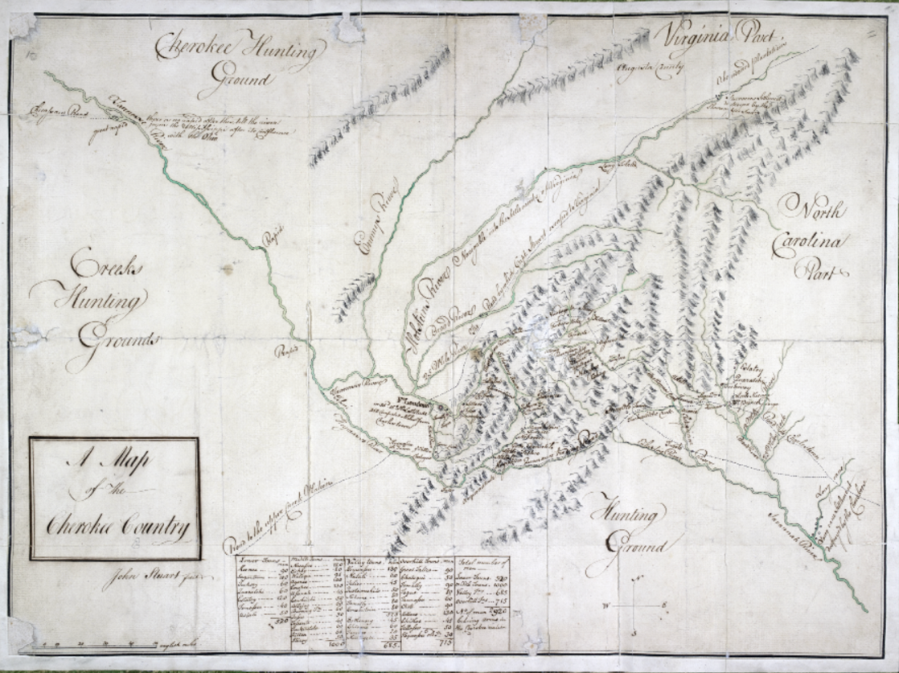
Figure 49 John Stuart, Map of the Cherokee Country 1761

Noquisiyi, (the place of the stars) where Cherokees had tracked the movement of the cosmos for centuries. Or Allajoy, a beautiful meadow, which describes a community of people associated with this type of landscape rather than a specific location. Other locations, such as the Long Island, receive a prominent place on Stuart’s map, indicating their significance to the Cherokees at that moment.
Stuart’s map visually renders broad Cherokee understandings of their social connections. Stuart eschews labeling the town clusters under the colonial monikers of Upper, Lower, and Middle settlements, reflecting Cherokee understandings of their social structure. Cherokees identified with a community and a clan within a broader Cherokee culture and would not have used the colonial designations for a regional identity. The Cherokee’s society existed in geographically fragmented towns and town clusters. Still, it remained physically interconnected through rivers and culturally anchored to the land by cultural centers such as ᎩᏚᏩ giduwa (Kituwah), the birthplace of the Cherokee people. Cherokee spatial epistemologies inform the map’s blend of daunting mountain ridge iconography with intermingling rivers traversing the region.
Stuart included elements on the map intended to depict the Cherokee homelands as outside of colonial control and to discourage intrusion. The top of the map, which is north-oriented, clearly separates “Virginia’s Augusta County” from “Cherokee Hunting Ground” to the west. Along the map’s right edge, Stuart separated North Carolina from the Cherokee Homelands and hunting grounds to the south of Cherokee settlements by annotations, massive mountain ridges, and the Savanna River. Stuart places warnings to squatters by indicating the location of “abandoned plantations” and Staeutner’s settlement, which he states was “destroyed by the Shawnne Indians” just northwest of the Long Island. He included settlements on the Long Cane at the bottom-right of the map, which he notes were “destroyed by the Cherokees.” The vast tracks of land Stuart labeled “hunting grounds” followed official British imperial policy that these spaces belonged to the Indigenous claimant because they contained commodities such as deer that Cherokees and Creeks obtained to sustain commerce.
Cherokees valued land they used to produce commodities but did not consider lands outside of their cultivated agricultural spaces as vital to their prosperity and cultural integrity. At the August conference held in 1763, Attakullakulla framed Cherokee commercial animal pastures in a way that fit into the British imperial lexicon of legitimate land ownership. He informed the British officials that Cherokee land past the Long Island “toward Virginia” must not be invaded nearer to Cherokee settlements closer than the people already entrenched “southward of New River” because harvesting animals for hides was their primary industry. Along the Cherokee’s southern frontier, the encroachment of colonizers had crowded Cherokee agricultural spaces, prompting Attakullakulla to demand the white people beyond the Long Canes “proceeded no further.” Sallouih of Estatowih repeated this sentiment, stating the “white people settled at or near Long-Canes” could stay, but “none more” may entrench “nearer the Cherokees.” Despite the British imperial support for Cherokee territorial stability, individual colonial invaders continued their entrenchment.
The Cherokees distinguished between areas of intensive cultivation near settlements, which provided space for culturally relevant lifeways, and the expansive regions they managed for commercial enterprise. John Stuart’s intimate knowledge of the Cherokee society and his dogmatic commitment to British imperial policy led him to label these distinct areas on his maps. In his mind, both types of land use legitimized Cherokee territorial claims according to British law. Stuart’s 1764 manuscript map drawn after the 1763 Conference at Augusta with several Southeastern Indigenous groups included both settlements and “hunting grounds” within bounded territories with which he intended to persuade British officials that the Southeast west of the Proclamation Line was filled with Indian nations that possessed a spatiality much like familiar European states. Figure 50
Stuart’s map from the mid-1760s provided the British with the most comprehensive picture of the Southeast’s interior to date. Cherokee and other Indigenous peoples’ knowledge formed images revealed to British colonizers through his maps, both at high levels of administration and eventually in colonial urban centers in America. Stuart intended his delineation of Cherokee territory as a contiguous polity that included intermontane towns and vast hunting grounds to reify the Crown’s recent Proclamation of 1763 and cause the British Board of Trade to reimagine the Cherokees as a bounded nation. Stuart’s use of Cherokee geographical knowledge would belie his purpose. Stuart’s Cherokee-based depictions would transform land south of the Ohio River into a colonial bullseye in the hands of emboldened groups of colonizers and land speculators.

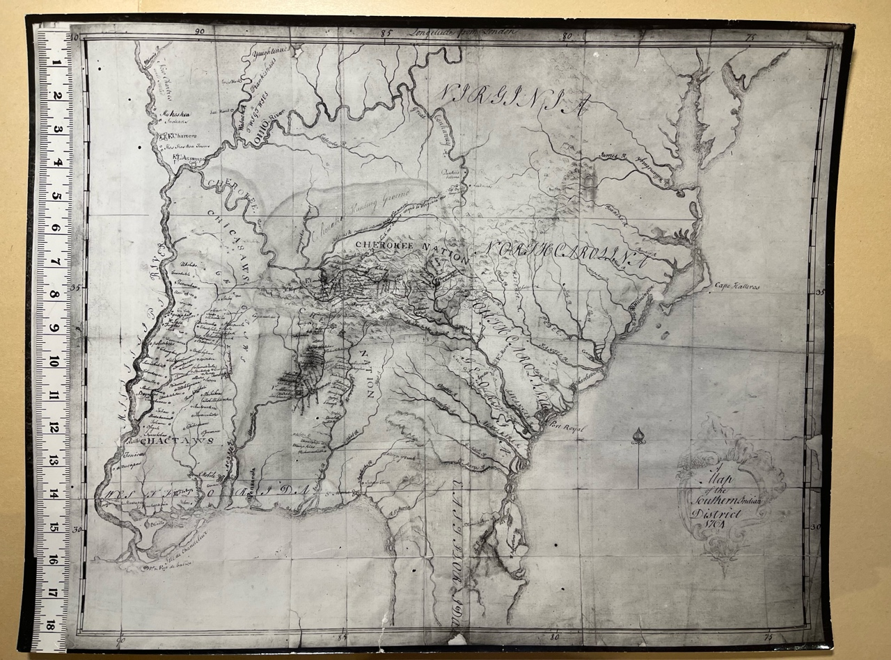
Figure 50 John Stuart, Map of the Southern Indian District, 1764, Clements Library, Ann Arbor, MI

Mapping Collective Entrenchment on the Keowee Frontier
Cherokees remained well-equipped to deal with military raids and groups of foreigners residing within their territory. The Cherokee responses to the British erecting forts adjacent to
mother towns in the 1750s and genocidal British military excursions in 1760 and 1761 seem surprisingly subdued. However, they had successfully survived attacks and incorporated or expelled foreign groups for centuries. The existential threat to Cherokees during this era manifested in the growing perception among aspiring British colonists that Cherokee land had become tenable and exchangeable through proven clandestine methods. A threat in which maps, underpinned by Cherokee geographic information, played a prominent role.
A foreign group arriving to stay without intending to integrate into Cherokee society represented an unfamiliar menace, especially when substantiating land claims by individual colonizers required an erasure of Cherokee land tenure patterns via physical or abstract means. By the time some Cherokees advocated that encroaching white colonizers intended “to destroy them from being a people,” the most dangerous invaders, enslavers scheming to profit from provisional land titles and their minions of indignant squatters, had already created a settler-colonial foothold within Cherokee territory. Maps and surveys, not treaties or guns, would serve as the catalyst that ushered in a massive wave of Anglo-European invasion into the Cherokee homelands in the following decades.
Article five of the South Carolina “Treaty of Peace and Friendship” represents the territorial obscurity symptomatic of colonial invasion. The agreement states, “to prevent…disturbances between Cherokees and the white people on the back settlements, no Cherokee Indian shall come down into this province further than forty miles this side of Keowee.” Although De Vorsy called this boundary “far from clearly defined,” it provides insight into where colonial invasion had already occurred and how Cherokees felt regarding the cultural and agricultural zones surrounding their settlements. The Cherokees were willing to risk ending peace negotiations over a boundary some twenty miles closer to Keowee that the South Carolina assembly demanded. The Cherokees must have considered whatever lay between these two proposed boundaries to be vital agricultural or fishing areas or sacred space. Forming an “unofficial” forty-mile demarcation point in 1761 provides an example of how colonial invasion took place within these locally well-recognized contested spaces cloaked from imperial oversight. Official land deeds in colonial records obscure the process because entrenchment occurred through a clandestine but established method.
Acting as a gang, colonizers reconstituted the landscape physically and metaphorically. Colonizers occupied areas they identified as Cherokee lands, intent on physically transforming agricultural spaces. Conspirators operating under this surreptitious system helped new arrivals identify Cherokee land that others had not already begun to alter on which to lay a claim. They petitioned colonial administrators for land grants in contiguous groups, employing anglicized names for landmarks to create the guise of an already Europeanized space. Destroying Cherokee agricultural spaces rendered the area useless to Cherokee farmers. Representing the area as colonized helped persuade urban colonial administrators to annex tracts of land officially. Colonizers began the transformation of the area around Long-Canes in the 1740s, resulting in the forty-mile informal but well-understood demarcation in 1761. The 1746 petitions of colonialists John Turk, Thomas Turk, and Michael Taylor elucidate the beginning of this process.
The Turk and Taylors “had already pitched upon” land near Ninety-Six with their families when they collectively petitioned the South Carolina General Assembly to receive 1,100 acres in three adjacent plots along the trading path between Cherokee settlements and Charles Town in what is now North-Western South Carolina. They identified the land as ostensibly vacant because of the presence of “our Indian hunting camp” containing “a few houses.” They argued that “some small acknowledgement” would cause the Cherokees to “readily give up and relinquish” their right to the land. The petitioners were correct. Extensive colonization by these petitioners and a host of other colonizers had rendered the land useless for Cherokee farming methods before they formally agreed to cede the territory. The petition reveals the extent of the unlicensed but implicitly sanctioned invasion. When the Turks and Taylor first arrived, “inhabitants dwelling thereabouts” directed them to Cherokee lands, which had not already been claimed by colonists, indicating previous settlement in the neighboring localities.
The toponyms described in the petition also map out colonial incursion prior to official land cessions. The placename “Coronraka Creek,” where the petitioners desired to gain official land titles, might be of Indigenous origin, demonstrating the Turk and Taylors likely represented the first colonists to entrench that area. However, Thomas Turk had settled near (J?)ame Creek. John Turk petitioned for land in the same area near “Wilson’s Creek,” a location “that was known by the name of Johhny Cook’s place,” indicating several previous European occupations. The scheme worked. Governor Glen of South Carolina formally purchased the land the colonizers had already pervaded on February 12, 1747, in an agreement with local Cherokees. This transaction did not hasten the area’s settlement, as previous scholars have indicated. Instead, the purchase codified the process of occupational invasion which promoted the process’s replication in adjacent areas of the Cherokee homelands.
By 1756, colonizers had penetrated Cherokee land much closer to Cherokee settlements. James Beamer reported to Governor Glen that the Cherokees “complain heavily” of “White People’s coming so far up in their Hunting Grounds.” He wrote to Glen that “Families settled too far up” all the way “above the Devidens on a river called the Rockey River” along the “Tuglo Road.” The colonizers’ entrenchment achieved the desired effect. Cherokees stated that “they have settled so near that the deer have become so scarce.” The agreement to adopt a boundary at 40 Mile Creek occurred on December 17, 1761, between Cherokees and then Governor Bull, who had first-hand knowledge of the area surrounding the proposed border. The agreement must have reflected what the two parties knew well, that the practical boundary between the Cherokee homelands and the entrenched colonists currently lay at that point. Little more than a year later, the South Carolina Gazette reported that during 1762, over one thousand families had settled the area around the Long-Cane, and the South Carolina Assembly ordered the “considerable sum” of £2,058 to cover the six-months pay for militia defending the area. This was no settler exodus of biblical proportions to a newly acquired Canaan but rather a flood of applications for land warrants from colonists who had previously “pitched” upon the land. Regional maps of the area show where the occupational invasion took place and demonstrate the development of a schism between official imperial policy and the hordes of colonizers.
In 1764, Sallouih once again complained to the South Carolina governor that “Englishmen have begun to settle not 12 to 15 miles” from Cherokee towns. Complaints poured into Fort Prince George of colonizers attempting to destroy the Cherokees’ herds. With vital Cherokee agricultural spaces that surrounded Keowee under imminent threat, the Cherokees pressed for a physically demarcated boundary that South Carolina officials would enforce against the gangs of colonial invaders. By 1765, the South Carolina Assembly had allowed £500 to mark a boundary. Soon after, Cherokees wrote to the South Carolina Assembly through an interpreter that local colonists had told them “that the boundary line was Broadies Plantation” but that “Captain Stuart” had told them at Augusta that “Swearingham across to Templeton on the road should be our bounds” several miles to the south. The letter continued, “We might claim below that but white people were (already) settled.” The Cherokees informed the Assembly that “We know the white people are very troublesome to you for land,” and if the boundary “is not soon run out,” the colonizers would claim more land via preemptive entrenchment.
More than thirty Cherokees arrived at Dewise’s Corner in April 1766 to physically establish a boundary between their agricultural spaces and colonized space. Many Cherokees remained dissatisfied that the practical boundary between the two spaces had crept closer to their settlements since the conference at Augusta in 1763. At a meeting a few months earlier, Ostenaco (Judd’s Friend) laid out the frustrations on many Cherokees’ minds and what they expected to result from demarcating a European-style line. Ostenaco told British commissioners that he and other Cherokees had to give up the additional land because Lieutenant Governor Bull and the King had disregarded the entrenchment and hoped they would be more mindful of enforcing policies prohibiting illicit settlement in the future. He went on to say the Cherokees wanted the boundary marked with North Carolina and Virginia as well, hinting at the Cherokee’s recognition that British North American colonies often acted in defiance of official imperial policies.
Ostenaco then told the British representatives to inform the King that they wanted him to provide security against further encroachment. He said to remind the King that the land they had to give up recently had the Cherokee’s cultivated fields, managed tree canopies, and streams that sustained their herds of deer. But now, he said, colonizers had let their cattle loose to feed on the grass and chopped down the trees to use for firewood, rendering the area useless for herding deer. He hoped the colonial administrators understood that Cherokees needed these agricultural spaces to sustain trade with British colonies. Ostenaco turned to his fellow frustrated Cherokees. He told them there was little they could do now to regain any land, and they would just have to resolve to move on from the matter. “Go ahead and build permanent houses on the land near the boundary, and don’t cause any disturbances or make any undocumented transactions with the colonists that they can turn on us to gain more land,” he implored.
Months later, when the Cherokees showed up to blaze trees along the line, they indignantly went out of their way to make the boundary line “very clear and strong.” As Pickens’s original map of the line and other maps in the following years demonstrate, the Cherokees left no doubt of the extent of their agricultural areas. Figure 51 With such an obvious visual and epistemological delineation to the colonizers, they would need to develop a new method for pursuing entrenchment deeper into Cherokee domestic spaces along the Keowee frontier.

Mapping Colonial Entrenchment on the Long Island Frontier
The colonial invasion along the Cherokee’s Long Island frontier followed a pattern of large-scale land speculation schemes that solicited waves of illicit entrenchment. Unlike the
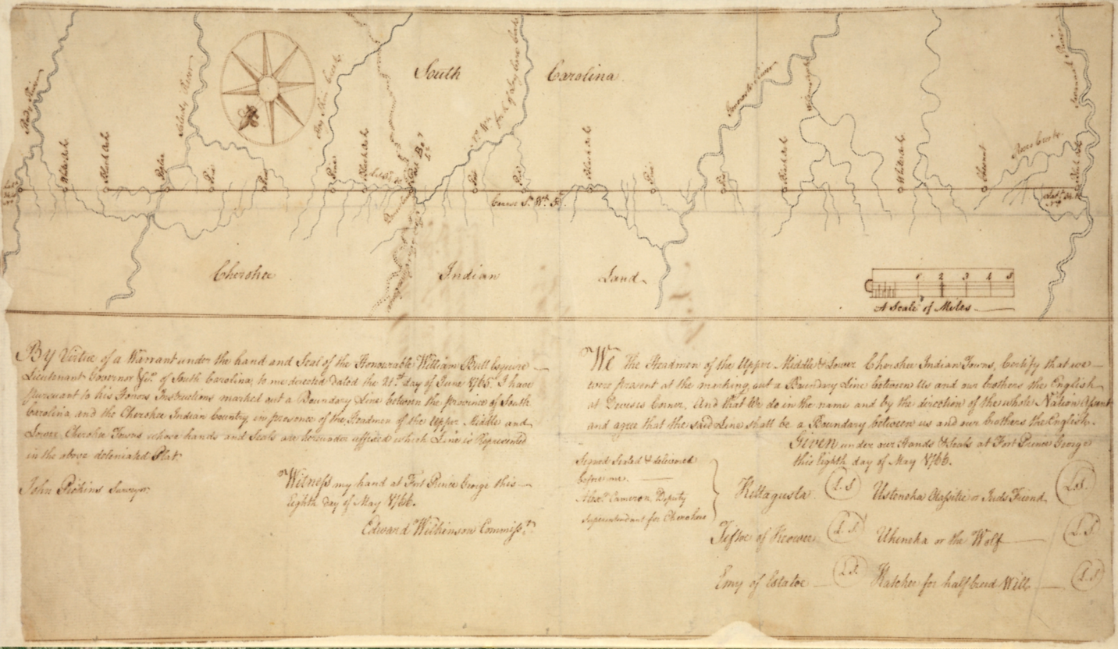
Figure 51 John Pickens, Boundary Line Between the Province of South Carolina and the Cherokee Indian Country, 1766.

Keowee frontier, where gangs of colonizers sought to physically alter Cherokee land tenure to ensure documented legal support from the South Carolina Colony, Virginia-based land speculators primitively fabricated legal claims in hopes of encouraging colonizers to modify the land physically within promoted spaces. Lack of knowledge regarding marketable land was vital to foiling land speculators’ plots in the 1740s and 1750s. Stuart’s 1760s maps breathed new life into land-speculation schemes when they indicated expansive areas of engineered Cherokee hunting grounds west of the New River. Armed with the promise of easily procured farmland, speculators went to work selling Cherokee commercial agricultural land. Waves of colonial invasions empowered the very colonial officials profiting from mass entrenchment to alter treaty boundaries with the Cherokees to encompass their minions of colonizers that had already begun to transform the landscape physically.
On July 12, 1748, Dr. Thomas Walker and a cabal of influential Virginia colonial administrators representing the Loyal Land Company of Virginia received an 800,000-acre land grant “beginning on the bounds of this colony and North Carolina and running westward and to the north.” Now, they had to find it. Two other members of the Loyal Land Company of Virginia, Peter Jefferson and Jousha Fry, marked the boundary between the Virginia and North Carolina colonies in 1749, effectively establishing the beginning point of the grant. Lands in the valleys on the western side of the New River sold well in the 1750s, likely because people had already occupied the area. Owners of the Loyal Company advertised for £3 an acre, including fees. Colonists took up the offer, and by 1754, the Company had recorded deeds for “about two hundred families, already settled upon the lands.”
Walker led an expedition on behalf of the Company in 1749-1750 to find out the topography of the land his company had figuratively obtained beyond areas of previous entrenchment. Walker’s report disappointed the company’s stakeholders. He recorded finding only ridge after ridge of cold peaks, few passes, and challenging to traverse rivers. Based on Walker’s reports, Joshua Fry wrote that the land “a great way beyond our settlements are mountains.” Still, he optimistically noted that “there are fruitful Vallies [sic] and much also of the high land is exceedingly rich.” “John Mitchell incorporated Walker’s report of the region on his famous map in 1755. This nomenclature appeared on maps that east-coast colonial administrators and the public would have frequently referenced, damping hopes of a profitable marketing campaign for land in the region.
Attempts at selling land further west of the New River and south of the Ohio River continued to languish in the 1750s. A long note on the back of a map made for the Ohio Land Company in 1753 lamented that clients had let their grants expire without occupying the tracts because “they did not like the land.” The frustrated colonizers arrived to find that the grants “would not afford them 1000 Acres of arable Ground in the whole Complement they were to have.” Potential colonizers retained a general apathy regarding the region’s potential because of the perception that the topography would prevent easy conversion to sustainable European-style commercial agriculture. Walker and Christopher Gist had traveled into the area specifically to lend credence to land speculation companies’ marketing narratives. However, the maps that resulted from their reports curtailed mass colonial entrenchment.
In the early 1760s, the geography of the Cherokee homelands and the regions to the north and west remained obscure to British officials. Henry Timberlake, a Lieutenant in the Virginia militia who visited Cherokee towns along the Little Tennessee River in 1762, drew a widely viewed map of Cherokee territory along the Little Tennessee River. However, Timberlake had to wait for Cherokees to escort him back to Virginia as Timberlake admitted he was “for the space of 140 miles, ignorant of every step of the way.” Although regional British maps from the 1730s and 1750s gave some indications to colonial observers of the general outlay of Cherokee settlements, British officials still lacked adequate knowledge of the region to comprehend much more than the location of a few roads and the general area of Cherokee settlements. British maps represented the vast region of what would become North-East Tennessee, Kentucky, and West Virginia as an expanse of unrelenting mountain ridges incapable of supporting European-style agriculture. Figure 52, Figure 53, Figure 54 Cherokee knowledge of where their intensive agricultural and commercial resource areas lie and where stretches of unmanaged land could be found remained outside colonizers’ marketing arsenal.
Sometime between 1764 and 1768, land-speculating Virginia officials came to a profound realization regarding the geography of what they considered the western parts of the Virginia colony. Despite decades of advertising, they simply could not hawk mountains to potential colonizers. So, they got rid of them. Virginia officials like Walker, who corresponded with John Stuart, likely ran across his 1764 map. A similar version of Stuart’s map, probably drawn by William De Brahm in 1766, further simplified the region. Figure 55 More importantly for Walker and his constituents, like Stuart’s map, De Brahm’s map indicated the massive area of
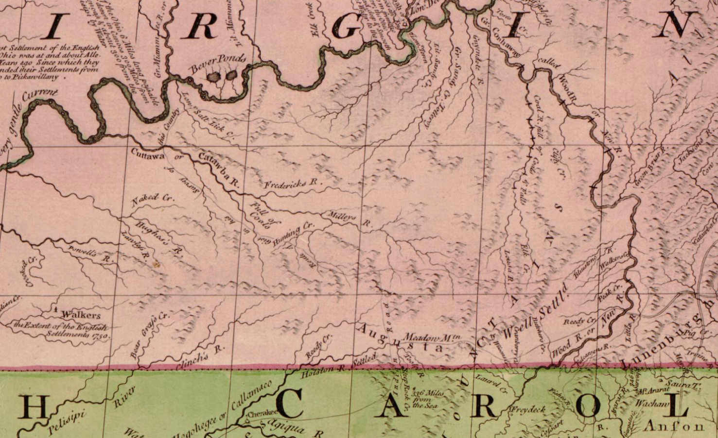
Figure 52 Mitchell Map, inset, 1755

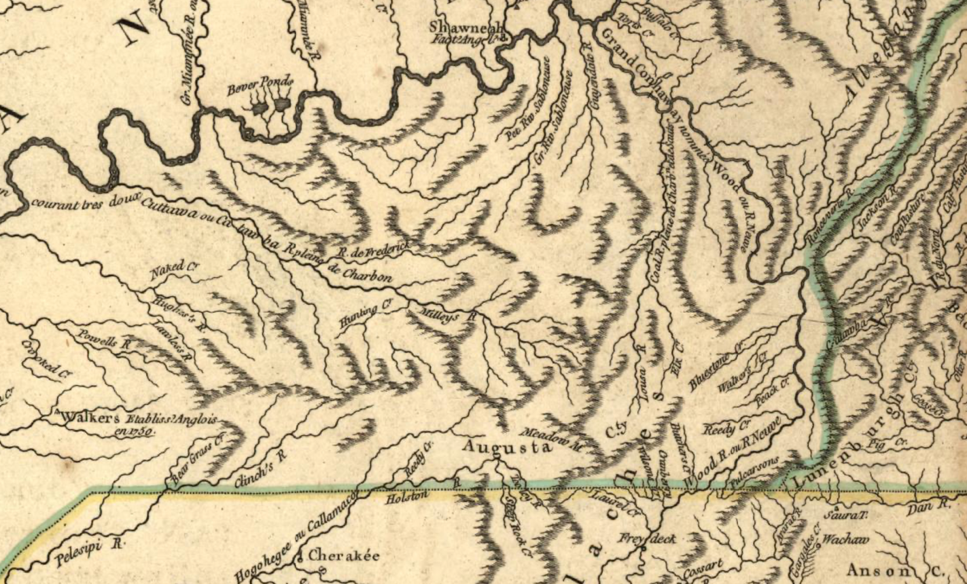
Figure 53 Robert de Vaugondy, Partie de l'Amerique Septentrionale, inset,1755

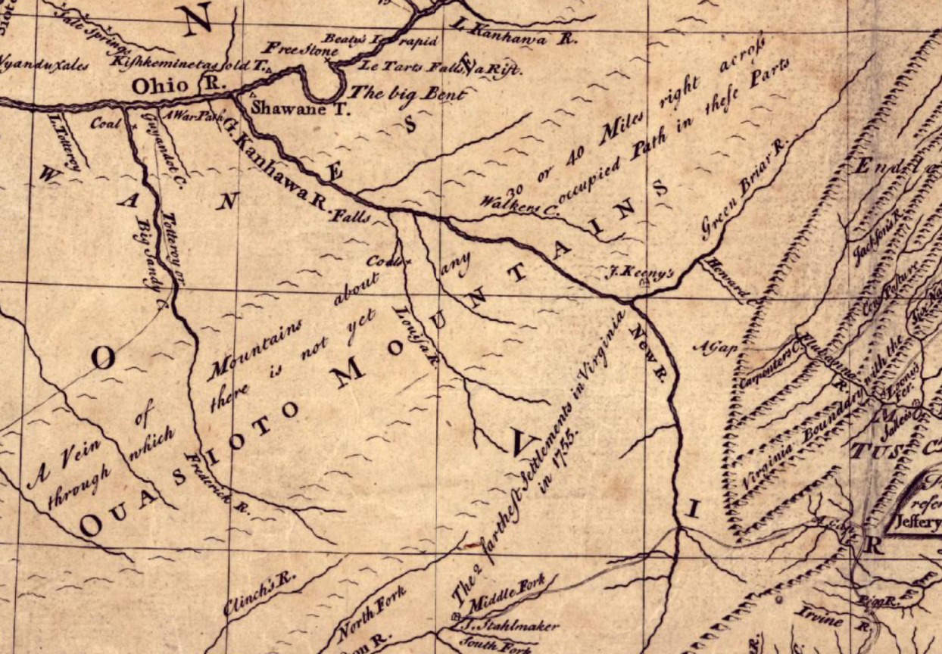
Figure 54 Lewis Evans, A general map of the middle British colonies, inset, 1755

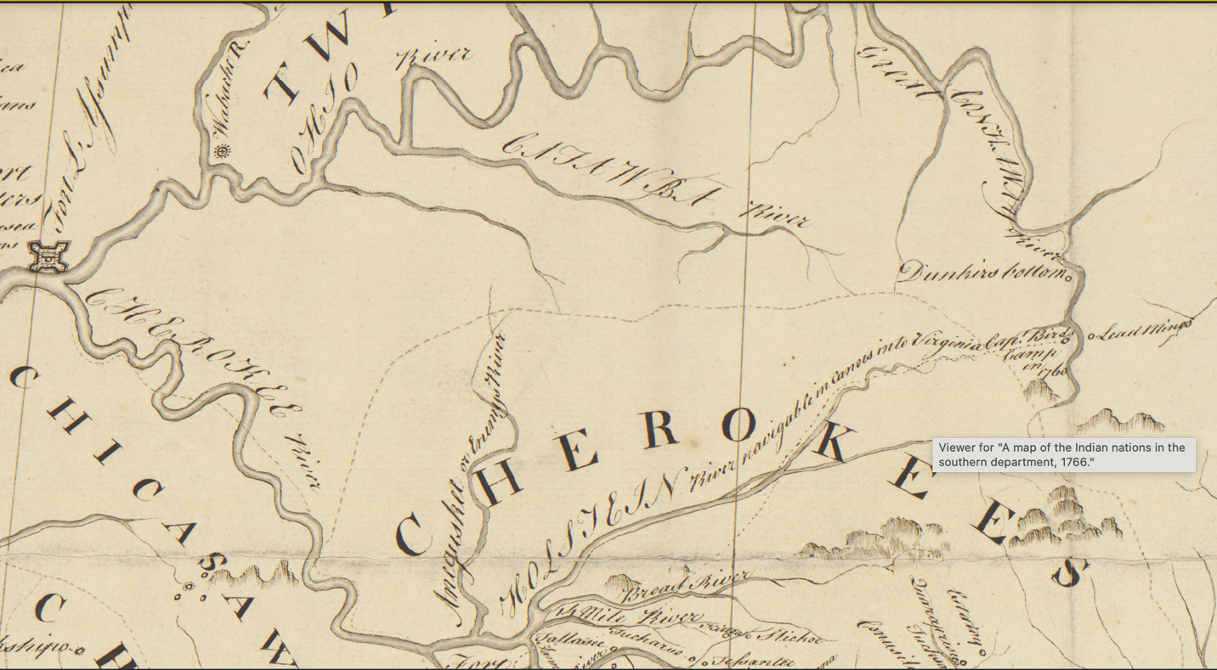
Figure 55 De Brahm, A Map of the Southern Indian District, inset, 1766.

land just to the west of the Kanawah River (New River) contained no mountains. De Brahm commented in his report that “should this Country once come into the Hands of Europeans, they may with Propriety call it American Canaan; for it will fully answer their Industry.” His participation in the colonial moment of cartographically preparing the region for European entrenchment stemmed from his opinion that Cherokee agricultural methods did not match his expectations for proper land usage.
British engineer Thomas Hutchins probed the area along the Holston and Tennessee Rivers in the mid-1760s. He produced a manuscript map that followed a formulaic approach to recording the river system’s navigational properties and the surrounding land’s resources. Figure 56 Hutchins’s hand-drawn map included notes that described “vast bodies of rich low lands on the river.” He noted gentle currents and deep waters ideal for shipping timber from the “large walnut, cherry, poplar, and hickory” trees he found along the river. He downplayed Cherokee presence, only mentioning “a Cherokee village called Chota about 10 miles up the Tennessee (River).” He observed “several families” of colonizers “settled 60 miles up Chinch River,” proving that speculators’ promotion of the region had already produced pockets of entrenchment. Hutchins’s map, later incorporated into his printed regional maps, marked another transition in the colonization of Cherokee territory. His map and notes indicate that he and other North American British colonial officials no longer understood the Cherokee homelands as foreign territory. The region was open for sale.
By 1766, the land speculators’ new marketing approach was in full swing. That year Thomas Walker advertised that “all persons who had contracted for any of the company’s land
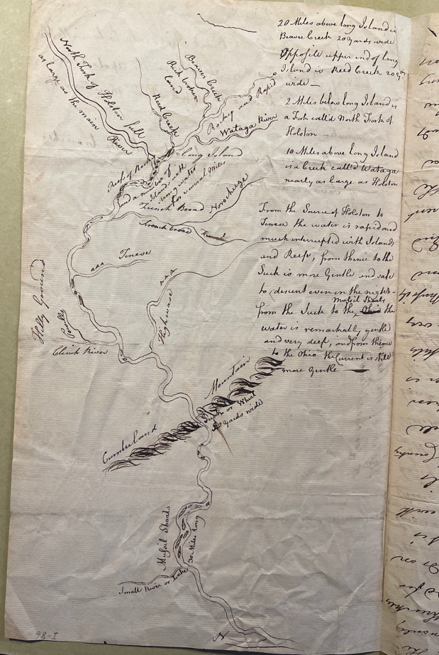
Figure 56 [Thomas Hutchins Map], ca.1766, Pennsylvania Historical Society

and were driven off their settlements during the recent war, to return and claim the same or it would be sold to others.” Cherokee concern grew as colonizers entrenched closer to their
commercial resource lands to their north and their domestic agricultural spaces in valleys near the Long Island. They looked to John Stuart and British imperial authority to establish a boundary that might limit colonizers’ access to their territory. Cherokee appeals set off a string of events that outline how colonial entrenchment occurred in the region beginning in the mid-1760s. The physical entrenchment of thousands of colonizers resulted in the Treaties of Hard Labor and Fort Stanwix in 1768 and the Treaty of Lochaber in 1770.
The 1768 “[Map of the lands purchased at Fort Stanwix, and those which remain to be purchased of the Cherokees in order to secure peace]” provides a depiction of the landscape that Virginia land speculators’ efforts had produced. Lord Botetourt, the Virginia Colony’s Governor, sent the map to officials in London to help justify the acquisition of the lands stipulated in the Treaty of Fort Stanwix. Figure 57 Along with presenting the façade of “a new space for colonization” to the Crown, his map shows the extent to which land speculators had cartographically transformed the region and mapped the resulting European entrenchment. The mapmaker limited the mountain iconography to the eastern parts of the territory and depicted long ridges running southwest to northeast that contain water-rich valleys traversing each ridge. The map provided notations for three sections: “lands given to traders for losses in 1763, Lands granted and partly settled, and lands to be purchased from Cherokees.” These sections of the map
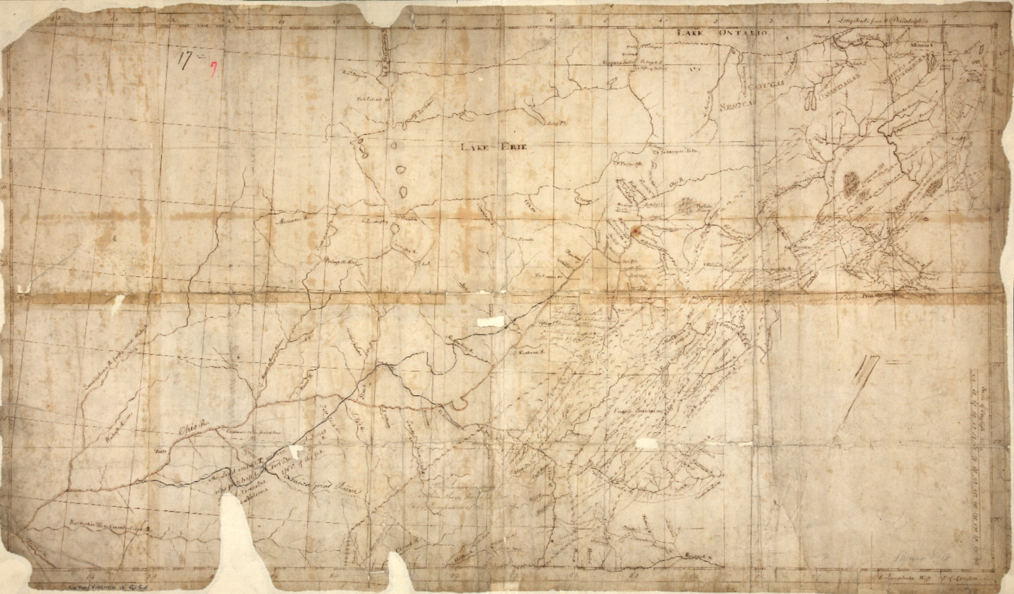
Figure 57 [The lands purchased at Fort Stanwix, and those which remain to be purchased of the Cherokees in order to secure peace] 1768. https://images.nationalarchives.gov.uk/asset/65546/

indicate areas where entrenchment had already occurred. A cartographic sleight of hand in renaming the “Lousia Great River, moving it significantly westward, and reorienting it in a more east-to-west direction suggests the land speculators’ areas of active marketing.
The Cherokees must have considered much of the territory that colonizers had entrenched in order to secure the Treaties of Hard Labor and Fort Stanwix as outside of their curated areas of commercial agriculture and culturally vital spaces. Two years later, at the Conference at Lochaber, the Cherokees made clear to colonizers where the limits of their agricultural and cultural areas lay. Oconostoa and other Cherokees demanded a boundary be made six miles upstream from the Long Island along the Holston River in what is now extreme Northeastern Tennessee. Cherokees had refused a Virginian’s request to locate a trade center at the Long Island in 1766. Cherokees considered the Long Island a cultural anchor to their territory. An approximately six-mile buffer zone would not represent Cherokee understandings of distance and territoriality. However, the distance that colonizers recorded does suggest that Cherokees valued the area around the Long Island at that measure for some reason.
In 1771, Attakullakulla led British commissioner John Donelson on the expedition to physically mark the boundary line set forth by the Treaty of Lochaber. The deviations Attakullakulla made from the Lochaber agreement indicate the realized boundary between the Cherokee and colonial landscapes at that moment. He first followed the South Holston River “as it meanders.” Colonizers had already entrenched on the river, causing Attakullakulla to exclude the area initially agreed upon, diplomatically stating that he had “given away some land by the river side as my brothers were settled on it and I pitted them.” He then led the party north, keeping some distance from the Long Island. Next, Attakullakulla led the party northwest to what Virginia Land speculators had renamed the Louisa River. This deviation from the original line that would have gone due north to the mouth of the Kanawha River on the Ohio River encompassed millions of acres. Attakullakulla and Donelson must have witnessed that physical entrenchment had begun in this area and would be useless for Cherokee commercial agriculture.
John Donelson produced a map of the boundary he and Attakullakulla had blazed that summer. Figure 58 He presented the map to Governor Dunmore of Virginia as part of an appeal to gain the Crown’s official sanction for the massive lands he had included in Virginian’s territory in addition to the Lochaber agreement. Scholars of Donelson’s map have attributed the map’s wild inaccuracies to “the lack of accurate geographical knowledge about the transmontane country.” De Vorsey points out the misnaming and misplacement of the “Louisa River” on the map. However, Donelson's map contains some noticeable similarities compared to the Ohio Company’s 1752 map and the Fort Stanwix Map of 1768. Figure 59 The mountain ridges are located in the east and run in a similar direction. The river named Louisa on the Stanwix and Donelson maps share a similar orientation on the three maps. As Cummings points out, Donelson was not a professional surveyor or cartographer. Donelson’s map is part of the region’s colonial cartographic transition. Scholarship should analyze the map for its effectiveness as a sales tool rather than critique the merit of its topographical depiction. Donelson’s map followed the model of a colonial sales brochure that Walker and others had refined for decades.

Conclusion
The area that Stuart helped map in 1757 had undergone a profound transition. The Cherokees depicted their geopolitical landscape as full of inter-Indigenous conflict and foreign European intrigue. Stuart attempted to interpret the physical landscape as they described it
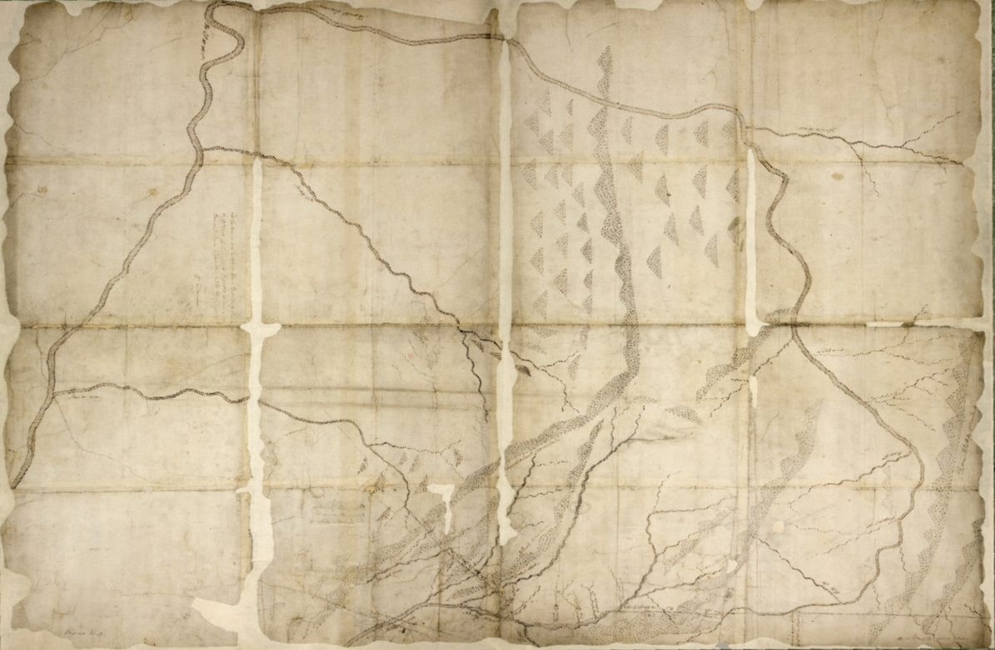
Figure 58 John Donelson, [Plan of the Boundary Line Between the Colony of Virginia and the Cherokee Indians hunting grounds], 1771.
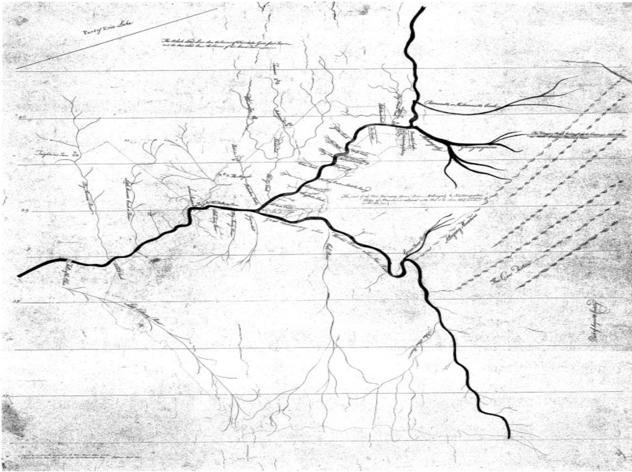
Figure 59 George Mercer, [Ohio Company Map], 1752

according to their epistemology. Gangs of colonizers and land speculators would transform the Cherokee landscape into a colonial episteme. Invaders sought out Cherokee commercial agricultural spaces and desired knowledge of transitional spaces they could physically entrench. Land speculators captured Cherokee descriptions of their territory and cartographically transformed them to fit their marketing campaign. By the time British administrators unfurled Donelson’s map in 1771, colonizers had established an effective method of cartographically transitioning Cherokee commercial agricultural spaces into spaces marketable for European-style land tenure. The next step would be to devise a methodology for appropriating Cherokee areas of intensive cultivation and settlement.

CHAPTER 5: SUBSTANTIATING AND COMBATING ENTRENCHMENT
By the early 1770s, the Cherokees had witnessed and contemplated how to best combat the processes of Anglo-American entrenchment. Until then, entrenchment had only occurred on the periphery of Cherokee lands containing cultural anchors and agricultural spaces vital to Cherokee society. As a result, the 1760s saw prosperity and population increase in the Cherokee homelands. Cherokee efforts to delineate boundaries between areas of previous entrenchment and their essential fields, towns, and cultural anchor sites had temporarily arrested colonists’ efforts to appropriate these spaces, at least in the minds of imperial officials.
Maps of the Cherokee homelands from the 1770s and 1780s demonstrate a multivalent power struggle over territoriality. Sayer and J. Bennett’s 1776 map captures the moment when British colonists became internally embroiled in a multilateral and often overlapping conflict between individual groups of migrant colonizers, aspiring elites, established North American-based colonial administrators, and officials representing the Crown’s and eventually the U.S. federal government’s policies. Figure 60 The map shows North Carolina’s western border open, leaving doubt as to the authoritative colonial regime claiming the Cherokee homelands. However, the “Wattogee” colonial settlement surrounded by recently anglicized names for local rivers such as “Clinch’s” and “Holston” in what would become Eastern Tennessee attest to the ongoing entrenchment of colonizers on Cherokee land regardless of any authoritative colonial government administration. Regional and continental maps depicting definitive boundaries supported by imperial policy contrast sharply with local maps. Late-eighteenth-century cartography reveals the ways in which Cherokees and multiple groups of colonizers contested territorial sovereignty.
.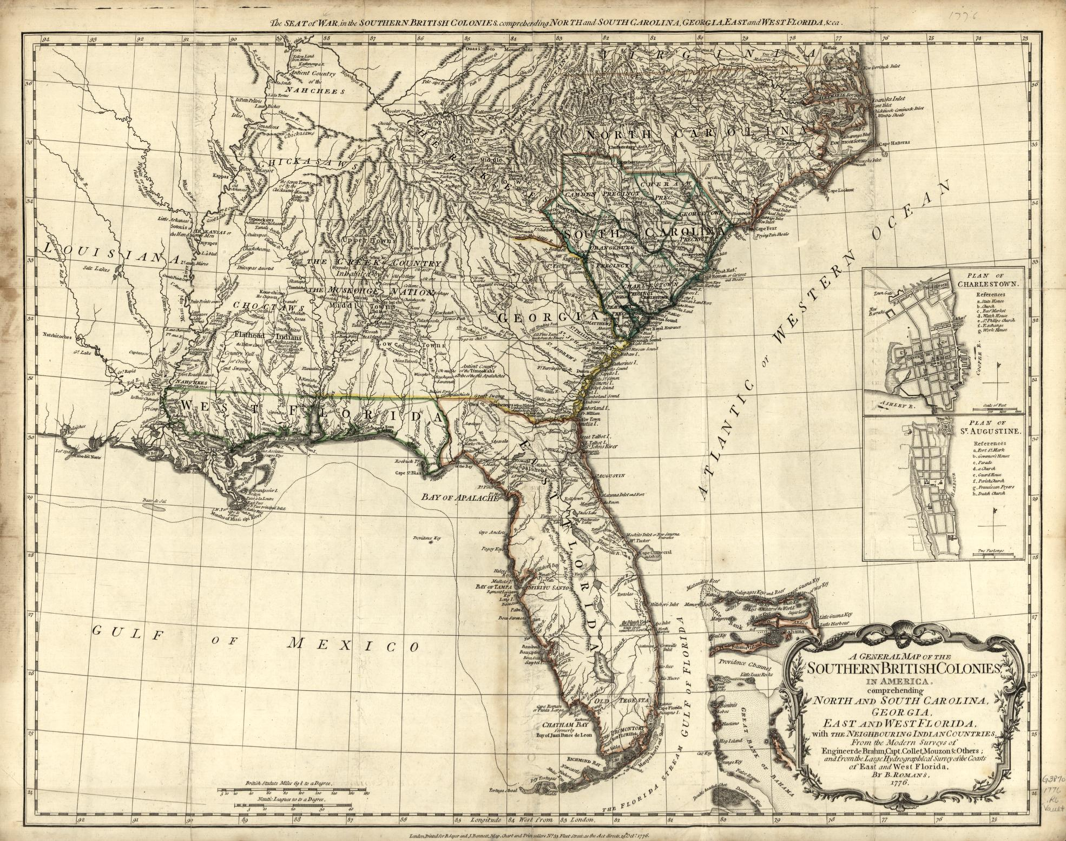
Figure 60 Romans, Bernard, A general map of the southern British colonies in America, London, Printed for R. Sayer and J. Bennett, map, chart, and print sellers, 1776. https://www.loc.gov/resource/g3870.ar139600/

The Revolutionary War brought few fundamental changes to the Cherokee’s strategies for preserving their territory and even fewer to the on-the-ground processes of colonial entrenchment. As had been the case in 1760, colonial authority mustered militias in support of trespassing colonists who had ignored imperial policies. North American-based elites with direct interests in land speculations led the vigilante militias of colonists that arrived in the Cherokee homelands in 1776 under the guise of a military force representing rebellious American interests. Groups of men already entrenched near or in Cherokee territory formed the body of soldiers who sought genocide as a means of personal enrichment in landholdings. In practice, the accretion of entrenchment progressed through the same methods as before. What did change for the Cherokees and British colonists was the source of imagined political authority that legitimized invasion post hoc.
With the disappearance of the British Crown’s perceived authority to lend force to “official” land deeds under Western modes of property possession, land speculators no longer had to rely on the Crown’s approval to undergird the land market as the region’s authoritative political entity. They could conjure a legitimization for land claims out of thin air. Richard Henderson took advantage of the impending power vacuum to establish an autonomous community in 1775. Men like Sevier, William Blount, and Daniel Smith would perfect the process of inventing a political authority to legitimize territorial invasion for personal prestige. In the minds of these enslavers, the accumulation of land and unfree labor formed the foundation of state authority. From the 1770s until the turn of the nineteenth century, land spectators turned government officials would appeal to any political entity they felt beneficial in achieving their personal pursuits of power and wealth, including themselves.
Cherokees consistently appealed to the highest colonial authorities to exert control over the groups of invaders infiltrating their fields and destroying their herds’ habitats. In 1779, Col. Evan Shelby, representing U.S. military interests, and that of local colonists entrenched on Cherokee land, invaded Cherokee towns,“killing a dozen, burning 11 Towns, 20,000 bushels of Corn.” Thomas Jefferson responded to the news delightfully, saying, “I hope these two blows coming together and the depriving them of their head will in some measure effect the quiet of our frontiers this summer.” In response, Cherokees met with colonial officials at Fort Partick Henry on their Long Island Frontier “to treat for peace with the united States.” Years later, in 1784, Cherokees still believed that appealing to British officials could protect their lands from entrenchment. Corn Tassel wrote British colonial governor Alexander Martin, “In your last talk to me, you promised to have your people taken off our grounds, but it is not yet done. When one goes off two comes in his place. We are in a great deal of trouble about it.” Despite invading armies, Cherokees had identified their existential threat, individual groups of autarchic colonizers they called “Virginians.”
Contemporary maps show that Cherokees clung to traditional land tenure patterns and social structures to preserve their culture and sovereignty. While some scholars have argued that Cherokees adapted to Western modes of mapping, politics, and agriculture, maps and the documents that contextualize their creation reveal a different account. As they had since they first discovered Europeans, Cherokees drew maps that Europeans not only recognized; indeed, Europeans copied and integrated them into their own maps that informed their imaginations and policies. Cherokees walked alongside colonial officials to mark boundaries they acknowledged, hoping that colonial invaders would be forced to do the same. Cherokees worked to maintain their cultivated agricultural spaces and cultural anchors to the landscape, which supported their matrilineal, matrilocal society. They also found ways to transfer land threatened by entrenchment by adapting traditional methods to manipulate British law. They continued to appeal to established political entities to help them defend their land, which they rightly perceived as vital in protecting their social structure and cultural identity. The Cherokees cared as much or more about territorial sovereignty than the colonizers, who readily changed flags to substantiate their own land claims.
This chapter first demonstrates how land speculators marketed vast tracts of land to individual colonizers. The speculators acted outside of official British imperial policy to entice groups of colonists to entrench on Cherokee lands with the promise of future substantiation of their land rights. Cherokees appealed to colonial administrators to hold the invading colonizers accountable to little avail as the American Revolution further weakened practical political authority in the region. The chapter explains how aspiring colonial elites took the matter of substantiating entrenchment into their own hands. Men interested in gaining political traction used the power vacuum created by the Revolution to commit violence against Cherokees, growing their political clout along with their fortunes. Cherokees found ways to preserve their land and society. The story of the Cherokee woman known in the colonized archives as Molly elucidates the ways in which Cherokees adapted traditional practices to retain their land rights in the face of unrelenting colonial entrenchment.

Investing in Entrenchment
In 1773, as Cherokees living near its’ti (Chota) gathered to discuss the latest incoming British correspondence, they must have recognized the complexity of combatting colonial entrenchment. Oconostota, Nanye’hi, and other Cherokees had seen individual groups of colonizers employ the same methods of entrenchment along the Long Island Frontier as those on their Keowee frontier. The “white people had paid no attention” to the conferences determining boundaries. They had destroyed Cherokee deer herds and “settled the land a great way” into Cherokee territory, resulting in the Cherokees altering the border when they marked it in 1771. The Cherokees knew that these groups of colonizers arrived knowing where the best land lay and that they could employ tried-and-true methods of entrenchment under a clandestine, organized direction. Aside from negotiating in person and physically marking boundaries, the Cherokee engaged in conflicts between North American-based land speculators and British imperial officials through correspondence.
Cherokees looked over a map included in a letter from John Stuart representing his efforts to stem the tide of land companies’ petitions to gain the Crown’s approval for appropriating Cherokee territory. Figure 61 Stuart had gained the Crown’s support for limiting the extent of a province named Vandalia south of the Ohio River that land speculators had marketed to investors in East Coast and London markets. Cherokees must have recognized
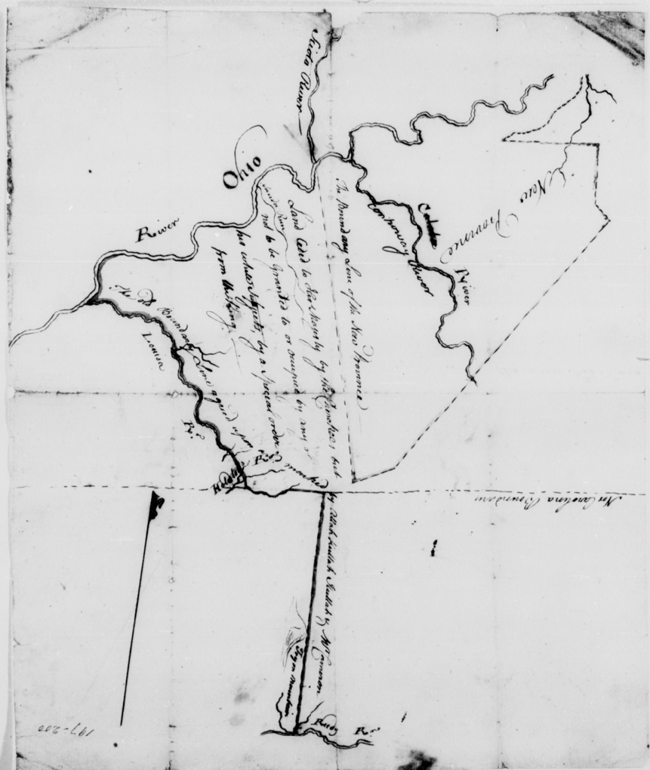
Figure 61[A Map to show the effect of the restriction of settlement placed upon Vandalia by order in council, August 14, 1772: Drawn June 1773], John Stuart, 1773.

that the men organizing the land-speculating schemes provided the groups of colonists showing up on Cherokee territory with prospectus maps and promises that environmental transformation would eventually ensure the colonists recognized property rights by some authoritative polity that they could, in turn, commodify.
Land speculation schemes became increasingly complicated and extralegal as individual groups of colonizers vied for British-backed property rights against the claims of large-scale land companies. Dr. Thomas Walker had opened a land office “at William Ingles on the New River” in 1769 in hopes of attracting enough colonists to legitimize the Loyal Land Company’s pursuit of British land grants south of the Ohio River. Much to the dismay of the investors, the over fifty petitioners to the Virginia colonial assembly in 1774 argued that their individual land claims should supersede the Loyal Land Company’s grant “having possession and paid for surveying” as well as protecting “our settlements against our Savage Enemies.” Figure 62 Each party recapitulated familiar legal arguments of preemption and property rights recognizing British colonial administrators as the source for adjudicating the dispute.
Two nearly identical maps produced by John Stuart and Joseph Pursell in 1775 provide a final look at the Cherokee homelands before the theoretical overarching authority of the British empire to substantiate land claims evaporated along the Long Island and Keowee Frontiers. Stuart’s role as the Superintendent of Indian Affairs for the Southern District of North America began in 1762, and his well-known mapmaking skills led him to be tasked by George the III’s advisors to provide them with a reliable general map of the region.
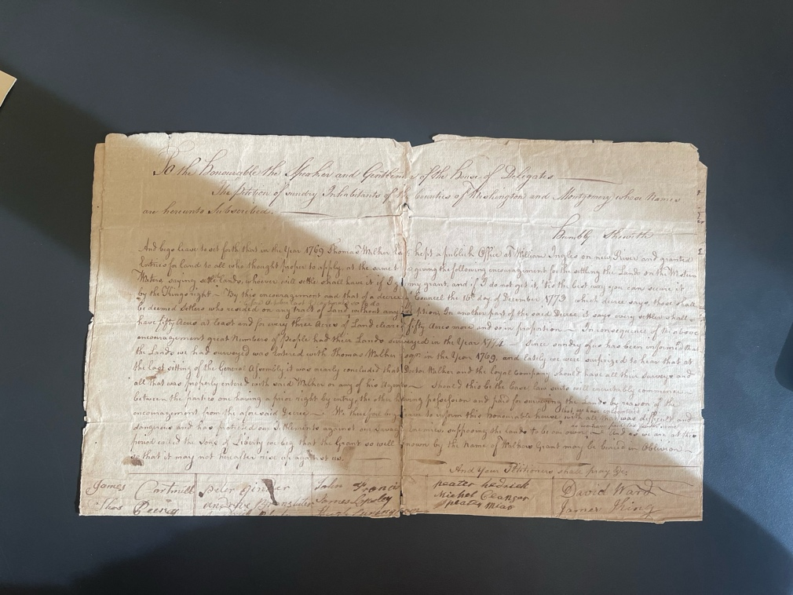
Figure 62 The Petition of the Sundry Inhabitants of the Counties of Washington and Montgomery, 1774

The 1775 Stuart-Purcell map, now housed at the Newberry Library, fulfilled the Crown’s request. Figure 63 Stuart’s dogmatic support of the Crown’s imperial policies led him to lend prominence to boundaries, particularly to the 1763 Proclamation Line adjacent to the Carolinas and surrounding the “new government” along the Ohio River. Along with locations of predominantly fantastical boundaries, Stuart attempted to delineate each section of the map’s sovereign status in relation to the British Crown, a post-Seven Year’s War colonial fantasy indeed. However, beneath the veneer of colonial assertions, a familiar picture emerges. The same Cherokee-derived riverine orientations, connotative toponyms, and hints of inter-Indigenous geopolitical strife emerge that had been present on British maps of the region since the 1721 Barnwell-Hammerton map.
Despite Stuart’s best political and cartographic efforts, the Cherokees knew by this time that land speculators and their minions of “Virginians” had developed methods of entrenchment that the British empire could not confine. Looking at Stuart’s 1775 map, Cherokees would have recognized the map’s imperially sponsored boundaries as incongruent with the realities of ongoing colonial entrenchment. As the petition against the Loyalty Land Company demonstrated, entrenchment had already occurred beyond Stuart’s asserted borders. Through Stuart and other diplomatic channels, the Cherokees had worked to use the implied power of the British empire to keep colonizers at bay with some success. The evolution and effects of the “Transylvania Purchase” demonstrate how the disappearance of the option for Cherokees to appeal to a capable higher authority to combat entrenchment for the final decades of the 18th century significantly reshaped how land speculators pursued implementing their tested methods of occupational invasion.
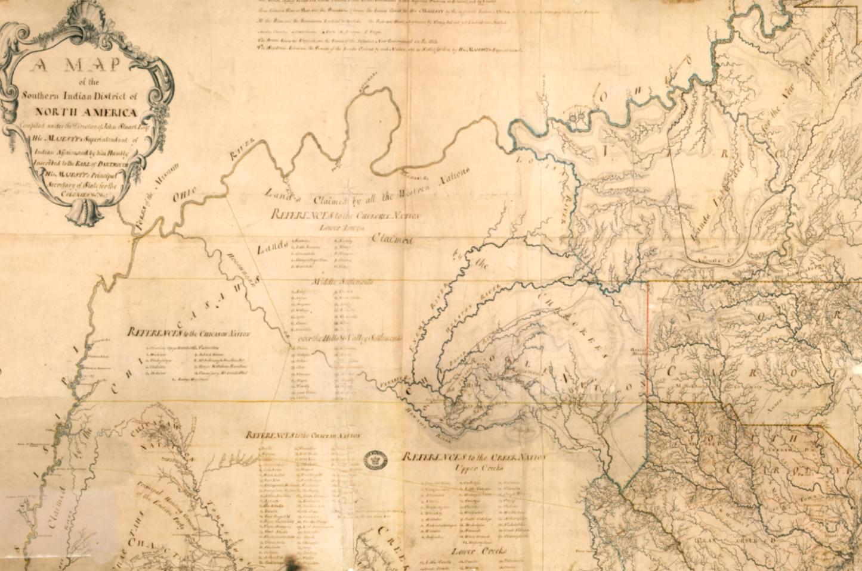
Figure 63 John Stuart and Joseph Pursell, A Map of the Southern Indian District, 1775

For the Cherokees, the conference at Sycamore Shoals began familiarly. In March 1775, over 1,200 Cherokees arrived on their Long Island Frontier, where colonizers had entrenched over the past decade, to witness and discuss a land transaction that had been in the works for over a year. Richard Henderson, a colonial judge in North Carolina, had gathered a group of investors seeking to establish an avenue for British-sanctioned land titles in an area west of Vandalia. A generation of Cherokees had witnessed similar conferences of land speculators hoping to obtain from them a British legal path to tracts of land outside of the Cherokee’s curated agricultural spaces. Henderson, friends and colleagues with the would-be proprietors of the Vandalia Colony and other land speculators hawking organized land investments would have been familiar with similar projects’ legal and practical successes and failures. As significant wear in the Transilvania map’s folds indicates, Henderson and his partners had a map produced that they unfurled as part of their many sales pitches to colonial administrators and potential buyers. Figure 64
Henderson came seeking an avenue in British colonial law for obtaining a massive tract of land that lay beyond the Cherokee’s cultivated agricultural spaces. He had formed a syndicate of nine investors for a land company he called Transylvania that was to begin at Vandalia’s western boundary along the Louisa River and contain all the land westward along the Ohio River. Tsiyu Gansini (Dragging Canoe) had temporarily halted the conference when the Cherokees realized what land Henderson hoped to delineate in the agreement. After some deliberation, the Cherokees must have recognized the territory as outside of their commercial
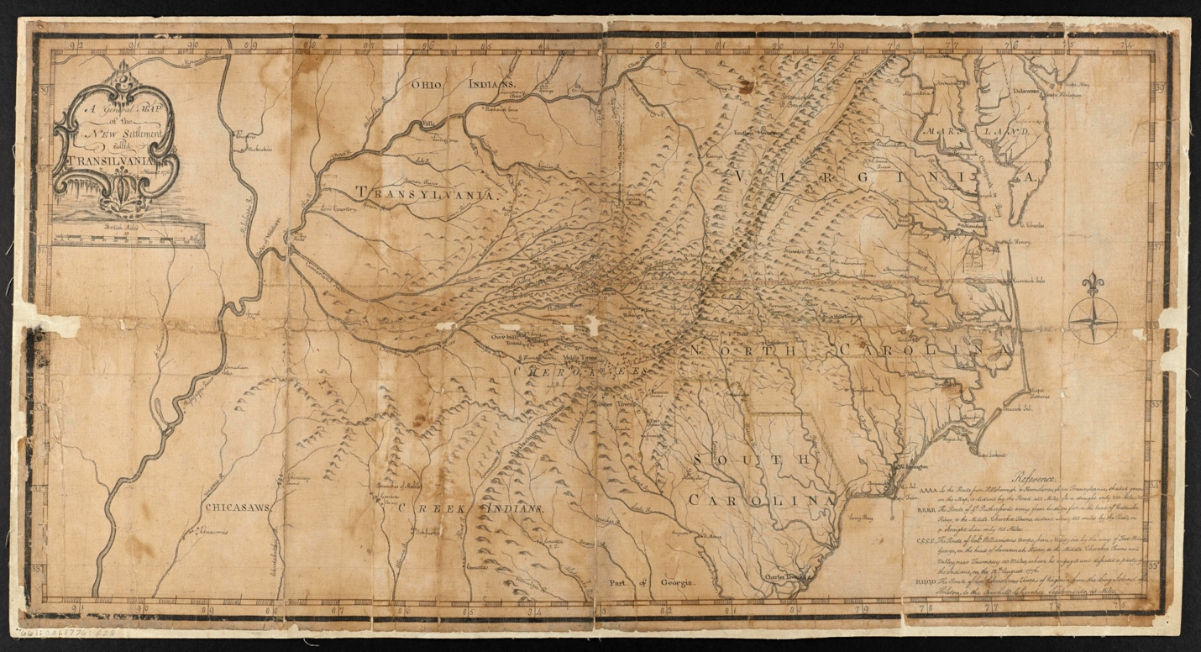
Figure 64 A general map of the new settlement called Transilvania, 1776, https://exploreuk.uky.edu/catalog/xt751c1tgg78

pastures and seemed satisfied to receive supplies in exchange for a region where “Tawas, Kickapoos, Piankasees, and Kuskuskoes” cast a “dark cloud.” For the Cherokees, Henderson’s scheme represented another in a line of colonizers they recognized as acting outside official British policy, which John Stuart regularly transmitted to the Cherokee communities.
Stuart recognized how the land speculator’s schemes worked to destroy Cherokee deer herds and take advantage of altering the areas on the periphery of Cherokee commercial agricultural spaces. Stuart wrote that entrenchment “has rendered what the Indians reserved to themselves on this side the ridge of mountains of very little use to them, the deer having left those lands, frightened by numberless white hunters and the settlements so near them. This the Cherokees are sensible of and therefore are easily induced to complement away great tracts” of land. The Cherokees had been wise to receive supplies in exchange for land schemes outside their territory, hoping that entrenchment would occur far from their cultivated agricultural spaces. However, Henderson’s investors predicated their support on his ability to secure property rights for an unspecified width of land through Cherokee territory to contain a road from Hillsboro in North Carolina to the Transylvania land claim, clearly outlined on the “Transilvania” map.
Henderson’s “path deed” request sent Cherokees back to council. John Reid, a Virginian involved in the scheme, reported that he witnessed Cherokees privately mapping “out sundry Water Courses which he took to be the main branch of Holsteins River seeing the Great Island laid down and the north Fork with sundry others which the Deponent does not recollect, and thinks they were the branches of Holstein.” The Cherokees must have been discussing what land Henderson wanted and how it would affect land surrounding where entrenchment had already occurred.
A combination of negotiating two disparate types of colonial entrenchment at the exact moment marked a significant difference between the summit at Sycamore Shoals and other previous conferences, such as Hard Labor and Augusta. In addition to Henderson and his partners who desired remote land, groups of local colonists who had entrenched beyond the official boundary within vital Cherokee commercial agricultural spaces joined Henderson at the conference, intending to gain a similar path to legal possession of land under some form of British law. These men, including John Sevier, James Robertson, and John Carter, represented an existential threat to Cherokee society. Like the individual groups of colonizers who had helped one another entrench on Cherokee territory in South Carolina, leading colonial governments to support their endeavors, the “Wataugans” employed a scorched earth method of localized entrenchment. Figure 65 However, resembling Henderson’s grander schemes, some of these men envisioned masses of colonial invaders entrenching on land they could sell them, inventing a property-based political oligarchy. Figure 66
In March 1775, Cherokees at the Sycamore Shoals conference disagreed on how to deal with organized entrenchment on their vital spaces. However, they remained culturally unified when they employed centuries-old debates regarding the integration or expulsion of non-Cherokee groups. Nearly all the Cherokees seemed in step with placating Henderson’s request
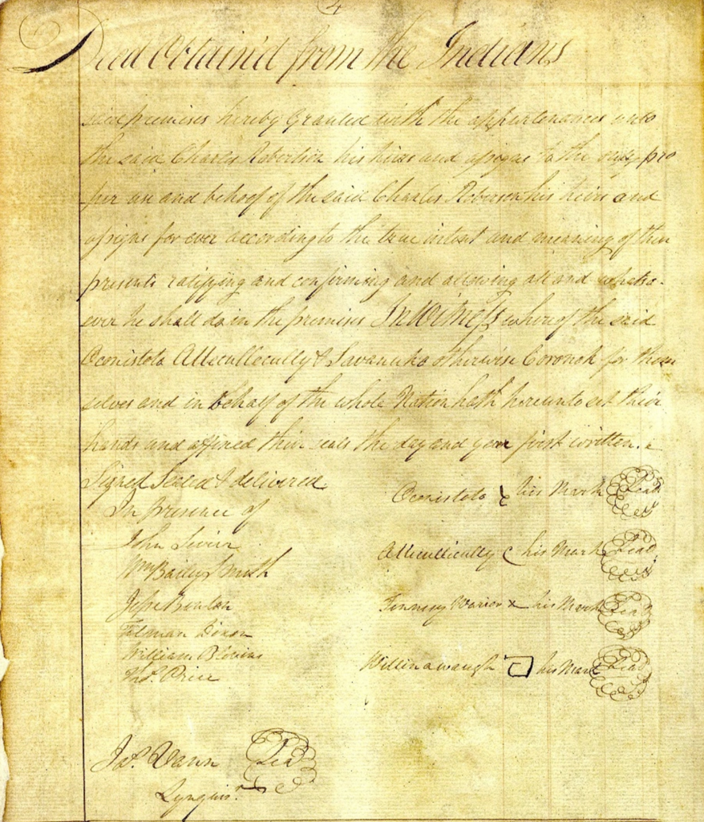
Figure 65 Watauga Deed to James Robertson, 1775

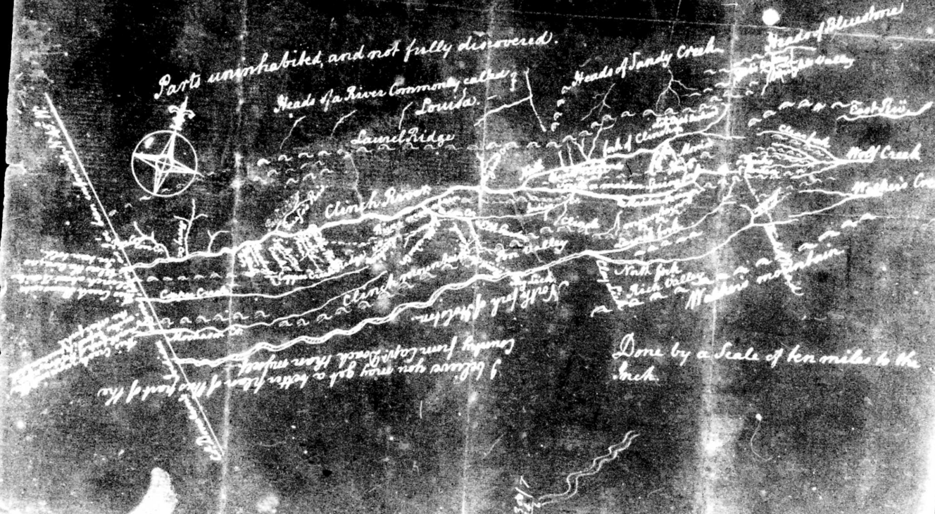
Figure 66 [Daniel Smith Map], 1774, a note indicates Dr. Thomas Walker’s agent, Robert Doack’s knowledge of the area to the south.

for a signed document regarding Cherokee territory outside of their commercial pastures and fields. Tension between Cherokees arose when local colonial leaders combined with Henderson to demand entrenched space adjacent to Cherokee agricultural spaces without an intersecting river to protect their fields and herds from colonial ecological damage. The Cherokees consistently sought rivers as boundaries to act as physical barriers against the accretion of colonial entrenchment. Some Cherokees, represented by Oconastota, Atakulllakulla, and Nanye’hi, felt that appealing to the Crown against illicit entrenchment was the best method for maintaining enough cultural and agricultural space for Cherokee society to remain intact. When men such as Sevier began entrenching past the river boundary set in 1771, Cherokees, represented in the archives by Atakulllakulla, “leased” the land to colonists for eight years, perhaps hoping that Cherokees could integrate the colonizers into Cherokee society. The Watauga Deed to James Robertson represented the Cherokee’s acknowledgment that entrenchment in the area had already transformed the landscape beyond their control to integrate its residents into Cherokee society.
Other Cherokees recognized that the colonizers at the conference acted as separate entities from British authority and felt expulsion was the best option for stemming the tide of colonial entrenchment. For expulsionist Cherokees such as Tsiyu Gansini (Dragging Canoe), who entertained and participated in Henderson’s scheme for foreign land, the prospect of incentivizing entrenchment on vital Cherokee lands proved anathema. The communities that comprised the Chickamauga Cherokee’s physical removal away from colonizers suggest they believed proximity to colonists eroded their ability to maintain Cherokee culture. These groups of Cherokees would soon employ traditional tactics, including calculated violence, to expel the trespassing colonists.

Self-Substantiation of Sovereignty
The American War for Independence provided colonists entrenched on Cherokee lands an opportunity to self-substantiate their property rights. Initially, this meant appealing to established governments for military assistance. “Wataugans” wrote to Virginia’s assembly requesting annexation and that they be “taken under protection” in early 1776. Concomitantly, they sent a petition to North Carolina’s assembly requesting “that you may annex us into your Province.” Meanwhile, they continued to pursue land acquisition of Cherokee lands through localized violence.
Those with a vested interest in maintaining their entrenchment and expanding their landholdings organized themselves into raiding expeditions against Cherokee communities that acted with or without government sanction. Col. William Christian, a Virginia militia officer, wrote to Col. Preston, “You seem to signify that you don’t think yourself warrantable in ordering out the Militia” against the Cherokees and Shawnees “unless we are actually invaded, that may be so, but I think you could safely encourage men to rise and go out without expressly ordering them to do so.” With entrenchment in mind, Christian added, “Perhaps our going might pave the way and encourage others to follow.” Preston and other rebellious American officials withheld support for entrenchment beyond their sphere of personal interest to prevent Cherokees from coordinating attacks with British troops. Christian wrote in June 1776, “Is it not some pity that the poor savages should be ruined by the intrigues of our own nation?” Cherokees cared much less for the foreigner’s “intrigue” than they did for combating the ongoing entrenchment along their Long Island Frontier.
Growing anticipation and a Cherokee attempt to expel “Virginians” along the Long Island Frontier in July 1776 provided colonists with an opportunity for a genocidal invasion of the Cherokee homelands. Local residents filled the ranks of militia that launched a three-pronged attack in October 1776. Like the invasions of 1760 and 1761, the militias’ time spent destroying recognizable Cherokee agricultural spaces and homes exceeded direct armed conflict drastically. William Dells, a militia man in Rutherford’s South Carolina force, reported only one engagement with Cherokees. He recorded eleven Americans killed, one by friendly fire crossing a stream, and nine Cherokees killed with nineteen wounded Americans. William Christian reported no engagements and only one casualty as he razed Overhill towns. The Cherokee spaces that militia altered and the reports they brought back of the landscape proved far more disruptive than their firearms.
The territorial repercussions of the 1776 invasion had a devastating effect on Cherokee society. Colonists retreated from the Cherokee homelands following the invasions in the 1760s under a British imperial system that recognized a system of international diplomacy. The old system allowed Cherokees to rebuild and flourish within their traditional geographically linked social structure. The lack of perceived British imperial authority in the aftermath of the 1776 invasion allowed local elites to base the substantiation of entrenchment on economic rather than legal precedent. The local perception of men like Sevier as “big men” who slaughtered Cherokees, galvanized groups of colonizers to tie their hopes of substantiating their own entrenchment with leaders like Sevier. Provincial elites’ ability to self-legitimize their land claims accelerated entrenchment, causing Cherokees to abandon regions with managed agricultural spaces and cultural anchors.
The Treaty of Dewitt’s Corner and the Treaty of Long Island in 1777 linked scorched earth invasion with economically legitimizing entrenchment. Cherokees recognized the schism between the commissioners who presided over the conferences and imperial authority, which they now linked to distant seats of state governments, and the figure of George Washington during the negotiations. The pro-integration contingent of Cherokees complained bitterly regarding the colonial entrenchment of their agricultural and cultural spaces. The Raven stated that he “did not know when the first colonists entrenched on these waters” but that “ever since the colonists have been among us we have been more and more afflicted, and they have been causing trouble for several years.” Old Tassel said that he was “grieved by Col Williamson’s request to have a considerable part of” Cherokee territory and hoped that the governors of Virginia and North Carolina would not sanction the entrenchment that had destroyed their agricultural spaces and restricted their cultural space “because of the encroachments on their land.”
When pressed by commissioners regarding their consent to the “Watauga Deed,” the Cherokee contingent argued that they had not expelled the “bodies of people” trespassing “upon our commercial agricultural spaces” because the colonists had initially “given them guns” to have use of the land but had subsequently destroyed the deer herds and habitats through implementing European style agriculture to the extent that the Cherokees had no choice but to let them use the land.
As usual, the commissioners proposed an official boundary between the individual states and the Cherokees, excluding areas of previous entrenchment from Cherokee territory. The proposed line cut off the cultural anchor space of the Long Island, which the Cherokees protested. After days of negotiations, the Cherokees provisionally agreed to the proposed border on the condition that George Washington or the governors of Virginia and North Carolina adjudicate the location of a permanent boundary that the Raven “wished to be a wall to the skies that no man would be permitted to pass it.” The commissioners and the colonizers on Cherokee lands ignored the Cherokee’s desire for an appellate decision. In the minds of the commissioners and colonists entrenched in the areas the treaty incorporated, there existed no need or avenue to escalate the matter.
Militiamen who participated in the 1776 invasions returned with reports of the Cherokee’s engineered agricultural spaces rip for entrenchment. Early nineteenth-century historian J.G.M. Ramsey described the proliferation of reports regarding the Cherokee’s territory by colonists following the invasion:
“The volunteers who composed the command of Christian were, many of them, from the more interior counties of North Carolina and Virginia. In their marches they had seen and noticed the fertile vallies, the rich uplands, the sparkling fountains, the pellucid streams, the extensive grazing and hunting grounds, and had felt the genial influences of the climate of the best part of East Tennessee. Each soldier, upon his return home, gave a glowing account of the adaptation of the country to all the purposes of agriculture. The story was repeated from one to another, till upon the Roanoke and the Yadkin the people spoke familiarly of the Holston, the Nollichucky, the French Broad, Little River and the Tennessee. Particular places were selected, springs designated and points chosen as centres for future settlements. A flood of emigration followed to strengthen, build up and enlarge the little community already planted across the mountain.”

As William Dells traveled through the mountains near Noquisiyi, he reported “a most Delightfull prospect As Ever Your Eyes Beheld” with “Pleasant” valleys among “Impregnable” mountains. The reports fomented a sense of urgency in ordinary colonists seeking to gain landholdings. Aspiring elites such as William Henderson, John Sevier, Henry Massengill, Daniel Smith, and others felt empowered by the precedent set by the Treaty of Long Island in 1777. They learned that in the absence of a hegemonic political structure, organizing a militia of ready-made buyers under the guise of a state authority allowed them to violently pave the way for manufacturing commodifiable property rights.
Over the following years, Sevier and other local elites launched a series of semi-vigilante excursions into Cherokee territory intended to employ a scorched earth method of encouraging entrenchment. For example, in 1780, Sevier rounded up 170 local men and headed for Cherokee towns. Although he was supposed to wait for Col. Arthur Campbell marching a force from Virginia, Sevier and his gang confronted some Cherokees at Boyd’s Creek before joining with Campbell’s force to raze “Chota Town” and several other towns “along the Tennessee river, among them being Tellico and Hiwasse.” The militia reported that upon their return, “they found settlers erecting cabins in the wake of the army as far in the Indian country as the French Broad River.” During his raids, Sevier had “applied the method of destruction of provisions and towns which made it impossible for” Cherokees to “remain in the vicinity” of their towns.

It’s A Woman’s World: Cherokee Strategies to Retain Land
Maps bring Cherokee women out of the historical shadows. Despite the façade of a firmly established border on Cook’s 1773 A Map of the Province of South Carolina between the South Carolina Colony and “Cherokee Land,” the space between Long Canes and Keowee remained in danger of complete colonial entrenchment. Figure 67 As a series of larger-scale maps of the Keowee frontier region reveal, Cherokee women became a source for preserving Cherokee land tenure amongst the destructive environment of colonial agriculture. The example of Molly, whose Cherokee name remains in the historical shadows, demonstrates Cherokee women’s crucial role in preserving Cherokee culture’s inextricable tie to the landscape. As the Cherokee and British worlds collided on the Cherokee Keowee frontier, Molly showed cultural resilience in sustaining her family structure and her family’s property.
Molly’s brilliant strategy to stymie colonial entrenchment by circumventing colonial property laws using Cherokee matrilineal property rights created a significant kerfuffle for British colonial administrators and in the historical interpretation of the scheme. The all-male actors in the colonial archives obscure the women in Molly’s family’s motivation regarding the land transaction. Some scholars have interpreted the incident and the similar transaction
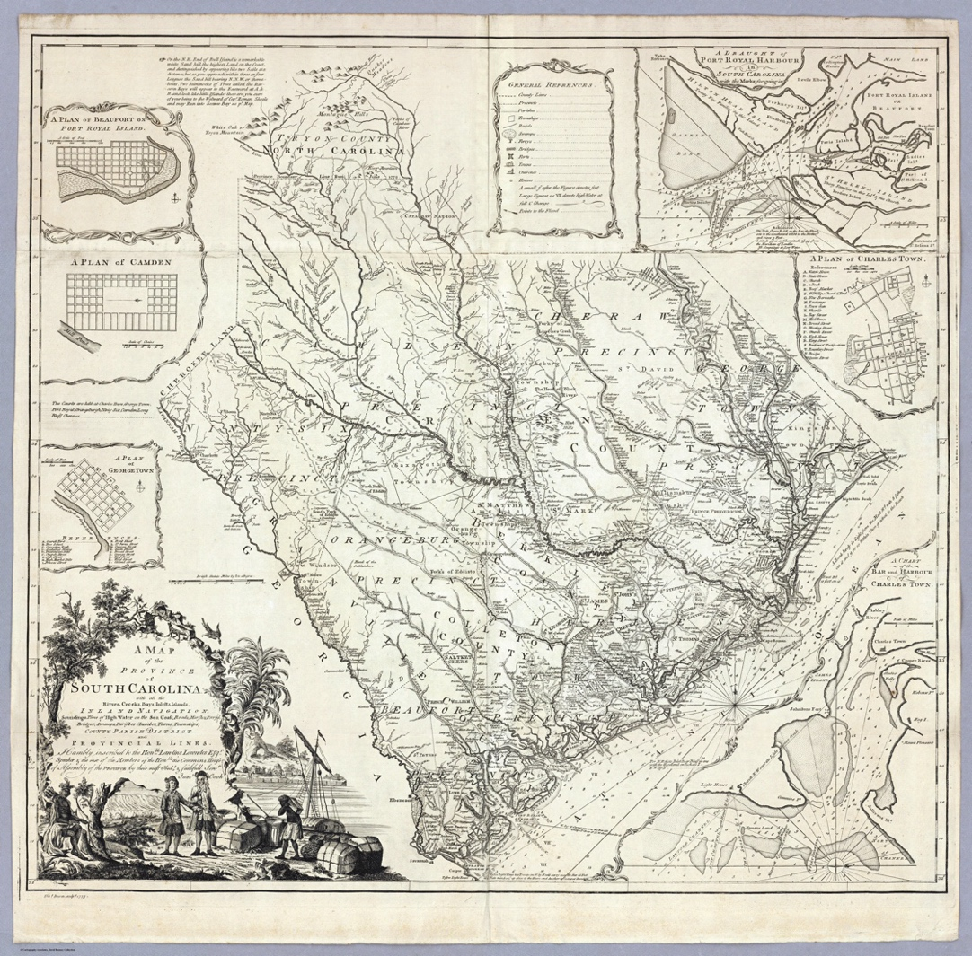
Figure 67 James Cook, A Map of the Province of South Carolina, 1773.

involving Richard Pearis as a scandalous incident that embodied the conflicts over territory between local elites and higher-level British officials. More recent scholars have explained the incident as male Cherokee leaders attempt to link “lines of kinship and lines of property to secure Cherokee rights and relations.” Nevertheless, the maps and related documentation must be examined from Molly’s perspective. After all, as a Cherokee woman, it was her orchard lands, not any man’s. And her son George, as he is known in the colonial records, was her male child who possessed no claim to her land. According to Cherokees, Alexander Cameron, a British Indian agent and George’s biological father, was not the child’s blood relative, nor was Molly’s father, Saluy. Her land could only pass through her to her daughters. However, as Molly knew, according to colonial law, her son would receive her land. Molly intentionally employed her Cherokee property rights and experience navigating the male-dominated British colonial system to have the land essentially deeded to herself in both worlds. Molly’s efforts map out Cherokee strategies to retain their homelands.
Molly must have perceived the urgency of developing a strategy for retaining her family’s land which she, her grandmother, and her mother must have tolled on to develop Cherokee-style agriculture. Her family’s cultivated area lay along the Saluda River just north of the border marked by Cherokees and Pickens in April 1766. According to British policy and Cook’s map, her land was safely inside Cherokee territory. However, her property fell beneath the unofficial line suggested at forty miles south of Keowee in 1761, indicating colonizers had likely entrenched on land surrounding her family’s holdings. As a letter from Oconostota made clear, colonial fences, clearing of forests, and bovine livestock had rendered her fields useless for herding, “the deer being mostly killed off if it.” But, as a woman, Molly might have had another option: Junaluska apple trees. Because colonial livestock could not readily destroy the trees, she could continue to use her family’s orchards for commerce and consumption.
Molly and perhaps her mother and grandmother must have made their intentions to hold onto their orchards known in Cherokee counsels regarding selling a tract of land to a trader named Mr. Wilkinson in the months before Cherokees met with British officials to ratify the marked border at the conference at Hard Labor in October 1768. According to Alexander Cameron, then serving as a commissary of the British Superintendent of Indian Affairs in the Southern District, John Stuart, a Cherokee named Saluy (Saloue), “the Young Warrior,” approached the commanding officer at Fort Prince George in February 1768 to inform him that he intended to grant a parcel of land lying within Cherokee territory to his grandson via British law as part of the land exchange with Wilkinson. The grandson Saluy mentioned was Molly’s son and Alexander Cameron’s biological offspring named George. The Cherokee’s plan included titling the land deed in Alexander’s name in South Carolina “in conjunction with the boy.”
Other women participated in the Cherokee strategy to retain more of their land in the area under colonial pressure. The Cherokees offered an estimated 158,000 acres to Mr. Wilkinson along the 1768 border with North Carolina in exchange for payments of trade debts. Figure 68 Colhoun’s map shows Wilkinson’s requested land at the top of the map. Figure 69 The two square plots represent Molly’s family’s land and another Cherokee woman’s property who had a child with Richard Pearis. The women requested their land be reserved in the transaction and deeded to their sons. The Cherokee decision was likely part of a plan to sell land that had already been rendered unfit for herding and planting by nearby entrenchment or already suffered
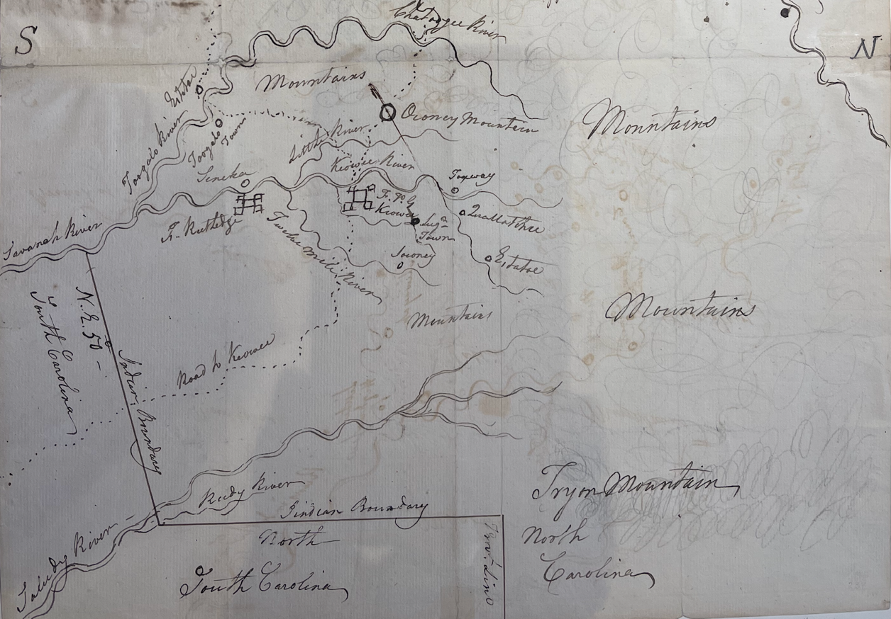
Figure 68 [Mr. Wilkinson's Plat of ye Cherokee country]. https://quod.lib.umich.edu/w/wcl1ic/x-1832/wcl001923

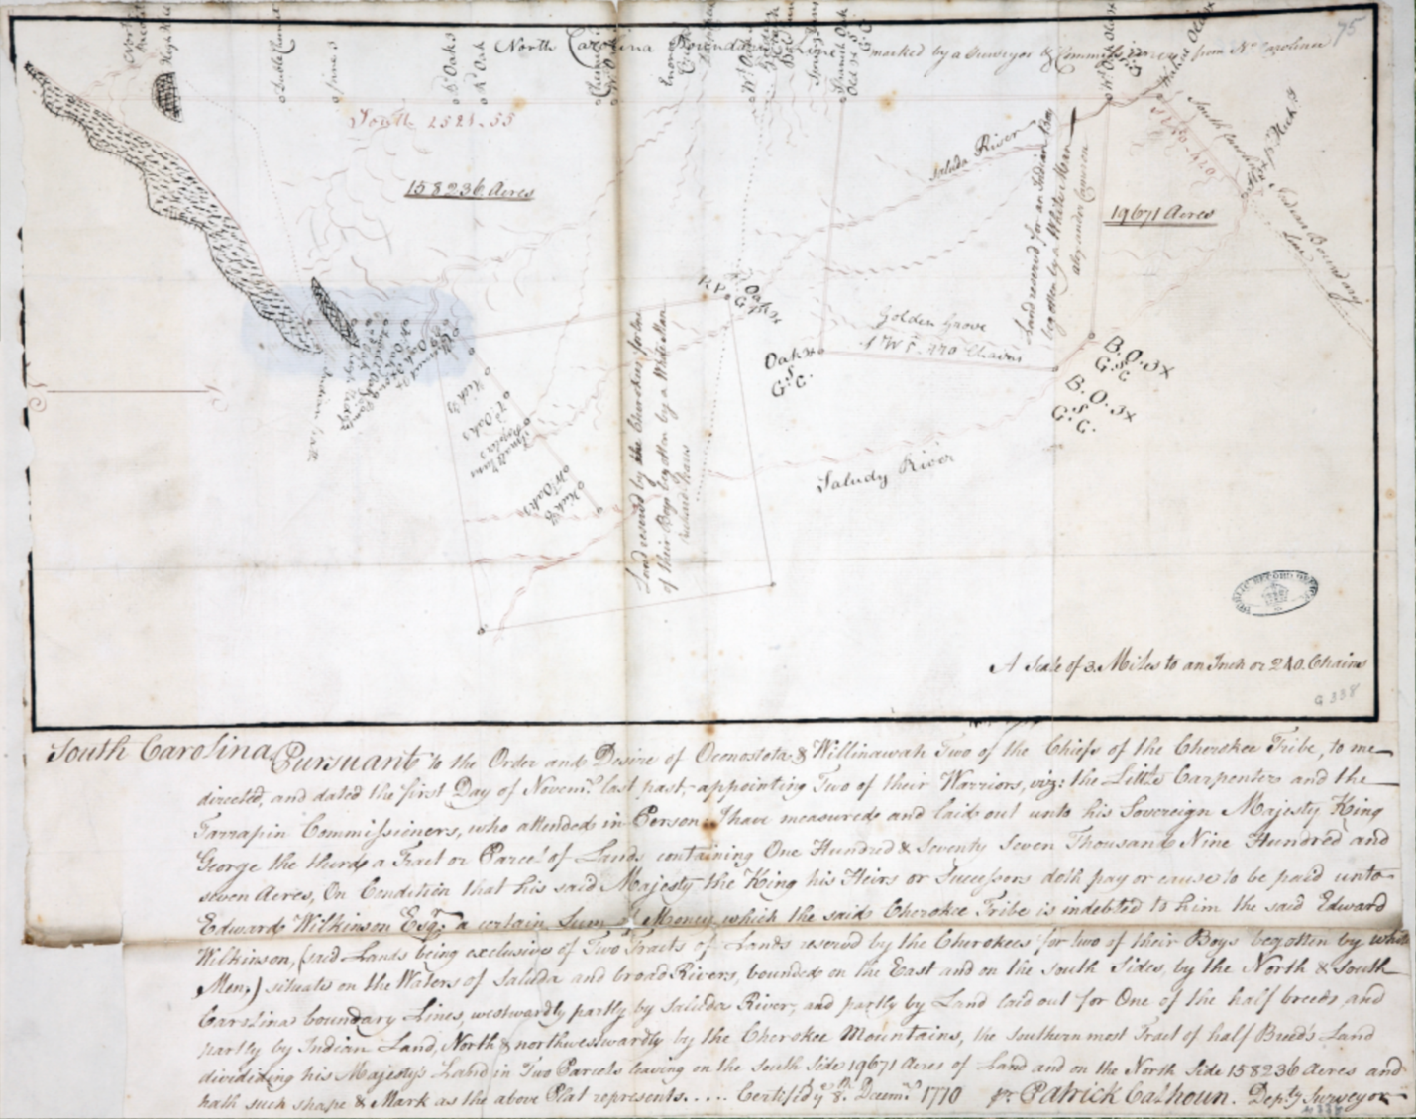
Figure 69 Patrick Colhoun, [Map of lands on the Saluda River], 1770

“encroachments” by “settlements unwarranted by govt. beyond the established lines.” The women must have seen their land as still viable and demanded to retain their right to over 19,000 acres. Oconostota revealed the plan to John Stuart at the Hard Labor Conference in October 1768.
John Stuart’s correspondence elucidates the complexity of the transaction. Stuart, always a proponent of the Crown’s policies protecting Cherokee sovereignty, had a multifaceted reaction. At the Hard Labor conference, he publicly “reprehended Mr. Cameron for entering into any Negotiation of such a nature so incompatible” with his position as a British official representing the Cherokees. More privately, Stuart worked to absolve Cameron of the matter at the imperial level. He forwarded a well-crafted letter from Cameron to the Earl of Hillsborough in which Cameron stated that the Cherokees offered him the land through his son “as a token of their friendship” but that he had dutifully told them “He could not accept of any land” and was more than well compensated “by the King, their father” for his services. Stuart must have trusted Cameron to respect the wishes of the Cherokee women regarding their land. However, Stuart did not have the same faith in the other parties involved.
In 1770, Saluy (Saloue), the male mouthpiece for his biological daughters, defended the transaction. In a letter, he told Virginia’s governor that “as the land is our own,” the Cherokees could convey it as they saw fit. He and other Cherokee men stated that Pearis “had many years been known to them both as a trader and warrior” and that they “were desirous of settling him, his son, and Jacob Hite, his friend, on some of their land as a reward.” Other Cherokees not directly interested in the matter may have suspected that Pearis would not remain faithful to the Cherokee women’s requests. Although Oconostota supported the principal transaction to Mr. Wilkinson, like Stuart, he maintained an option to appeal to imperial authority to override the actions of local colonists. When Oconostota commented on the transaction in an official message to the South Carolina Assembly, he coyly asked British officials, “Who is Paris to think he could acquire land not granted by the King?”
Stuart also suspected Richard Pearis and his partner Jacob Hite had nefarious intentions when they agreed to become the legal surrogate for the Cherokee women who wished to retain their land. Stuart accused Pearis and Hite of “fraudulently” obtaining a deed by writing letters “pretending” to be authored by Stuart to the governor of Virginia. He took legal action in a local court against Pearis’s involvement in the transaction in 1773 after learning that Pearis and Hite had begun selling tracts of the land in markets in “Northern Colonies.” Stuart’s efforts to block Pearis and Hite’s deeds proved successful in a British court at Ninety-Six. However, Stuart obtained approval from the Crown for Mr. Wilkinson’s purchase that included Cameron and Pearis’s son’s reserved land by claiming that it met the same precedent as recently approved sales of land by the Creeks and Cherokees in Georgia for the liquidation of debts to British traders. The Cherokee women witnessed prior ecological destruction near their lands and knew physical colonial entrenchment in the region would result in a Cherokee land cession in the near future.
Molly and the other Cherokee women faced a direct challenge to their land rights following an American militia invasion of the area in 1776. In the 1777 “Definitive Treaty of Peace,” South Carolina and Georgia officials felt the need to insist that their armies “repeatedly defeated” Cherokee forces and “victoriously penetrated” the “Lower Towns and Middle Settlements and Vallies,” resulting in “the rights incidental to conquest” granting colonists who had entrenched in the region an excuse to remain under South Carolina law. The “[Part of the modern counties of Oconee, Pickens, Anderson, and Greenville]” manuscript map shows the area just after Cherokees “ceded” the land in the agreement. Figure 70 The map notes the “late Cherokee Boundary line” and the extended North Carolina boundary. Within the recently entrenched space, the map demonstrates Cherokee presence with Cherokee settlements shown along the Keowee River around Fort Prince George and Fort Rutledge. The map also indicates the two parcels of land, “Golden Grove or Cameron’s Land” and “Rich’d Parris Land,” for which the Cherokee women had worked to obtain South Carolina title, still intact despite the Cherokee land cession following the peace accord. Although the mapmaker drew from official South Carolina records to record the parcel’s male owners, another contemporary map shows the realization of the Cherokee women’s efforts.
A pen and ink manuscript map of the region shows that the Cherokee women’s plan to retain their property had borne fruit. Figure 71 The mapmaker labeled the area where Pearis’s deed existed as Selooqua, indicating that Saluy’s (Saloue) biological daughter’s family still occupied the space. Below her land, the map shows an area called Golden Grove, where Cameron’s deed lay. Within that space, the map indicates an “Indian Settlement” named “Golden Grove.” This was Molly’s family’s household. Figure 72 Despite having to navigate British property law using surrogate male acquaintances, Molly’s Cherokee right to her land remained
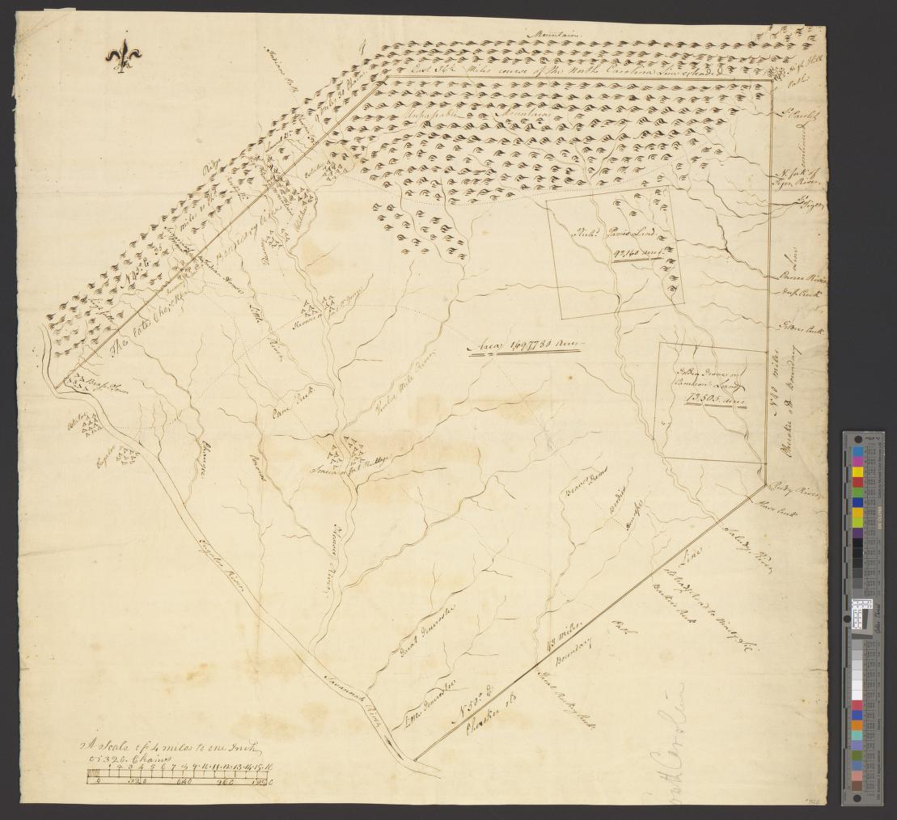
Figure 70 [Part of the modern counties of Oconee, Pickens, Anderson, and Greenville], ca1777, https://quod.lib.umich.edu/w/wcl1ic/x-8317/wcl008386

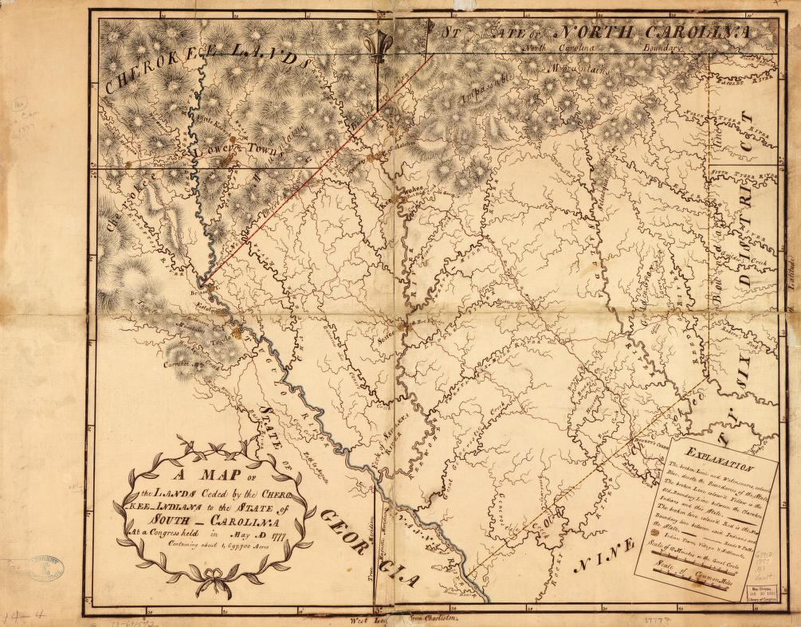
Figure 71 [A Map of the Lands Ceded by the Cherokee Indians to the State of South Carolina], ca 1777

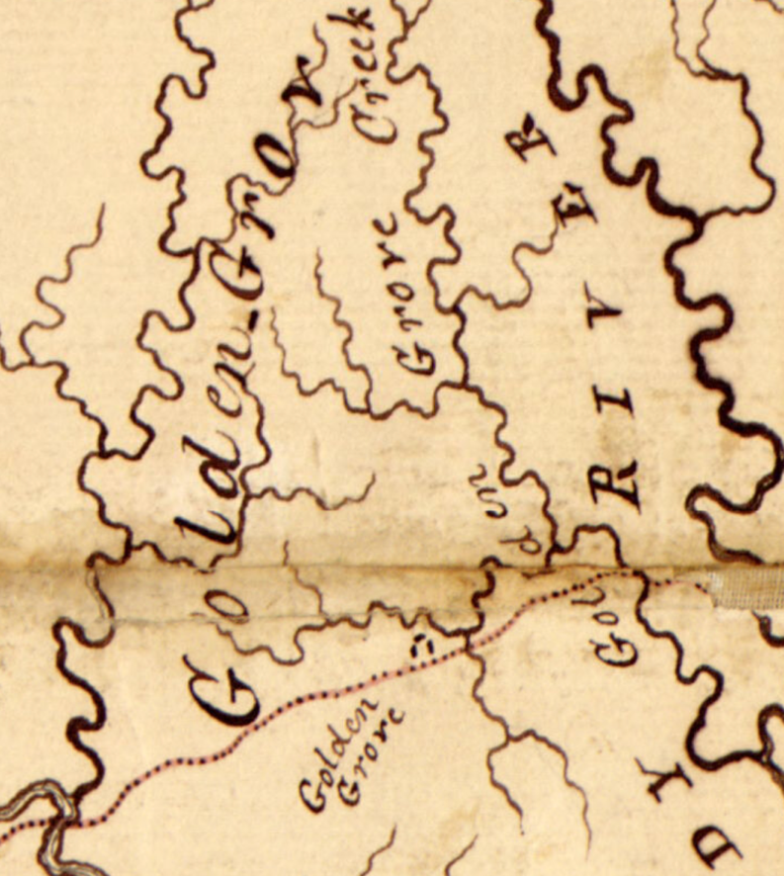
Figure 72 [A Map of the Lands Ceded by the Cherokee Indians to the State of South Carolina], ca 1777, inset. The map’s legend indicates that the three marks represent an “Indian Settlement.”

intact nearly a decade after the women in her family enacted a plan to thwart colonial occupation via its own institutions.
The map reveals a great deal regarding Molly. She and the other women in the family likely maintained orchards for commerce. The abundance of Oak trees, along with the Reedy River and Cane Creek on the maps, suggest Molly’s mother and grandmother had plenty of materials to teach Molly how to make baskets for their apples on warm days outside their house. The property’s placement along a creek and trade route suggests she often sold her produce to Cherokees and colonists. Her willingness to maintain her property within a space that colonists had increasingly surrounded demonstrates her ability to successfully navigate both Cherokee and British worlds, something she desired for her children when she sent them to school in London with hopes of them returning to live on her land. Like Nanye’hi and Atakulllakulla, Molly’s partnership with Camron both romantically and economically places her firmly within the group of Cherokees that supported the integration of colonists into Cherokee society as the best way to respond to entrenchment within their territory.
The existence of Molly’s landholding speaks to her status and that of Cherokee women in Cherokee society during the 1770s. Although colonial records emphasize the role of men such as Saluy, Oconostota, and Alexander Cameron as increasingly influential colonial interlopers, the map demonstrates that Molly’s traditional gender role as the purveyor of resources resulted in her retaining her land using Cherokee matrilineal property rights. Despite being engulfed in colonial entrenchment, as long as Moll’s family remained anchored to the land, the traditional matrilineal, matrilocal, clan-based social structure remained intact, strong evidence for Cherokees that supported peaceful integration of foreign groups for centuries.

Conclusion
Thomas Hutchins’s 1778 map displays a cartographic rendering of the impact of the colonial sentiment following the grand land-speculation schemes and localized entrenchment of the early 1770s. Figure 73 Hutchins’s map reflects an idealized view of the region as systematically becoming colonized under British direction. Hutchins outlines Indiana (Vandalia) but ignores the controversial Henderson-led Transylvania colony. Instead, he labels the region as Virginia and notes the Crown paid the Six Nations for a vast area in 1768. Although Hutchins draws a theoretical boundary between Virginia and North Carolina, the mapmaker labels the line “the southern bounds of Virginia.” He restricts North Carolina to the east of the Appalachian Mountains, leaving the Cherokee homelands in doubt. Within the ambiguity of the Cherokee homelands, the map displays the effects and promises of entrenchment.
Hutchins places the Long Island and the Holston River branches in Virginia, as many colonists entrenched there claimed. Henderson’s land surrounding the road through Cherokee territory is clearly shown as “a most important path.” Mirroring the maps of the land companies, Hutchins drew long ridges “covered in good soil and
timber,” interspersed with inviting valleys that “are rich and remarkably well watered.” The Cherokee (Tennessee) River is shown as navigable for over 900 miles through the Holston into Virginia, foreshadowing the possibility of moving people
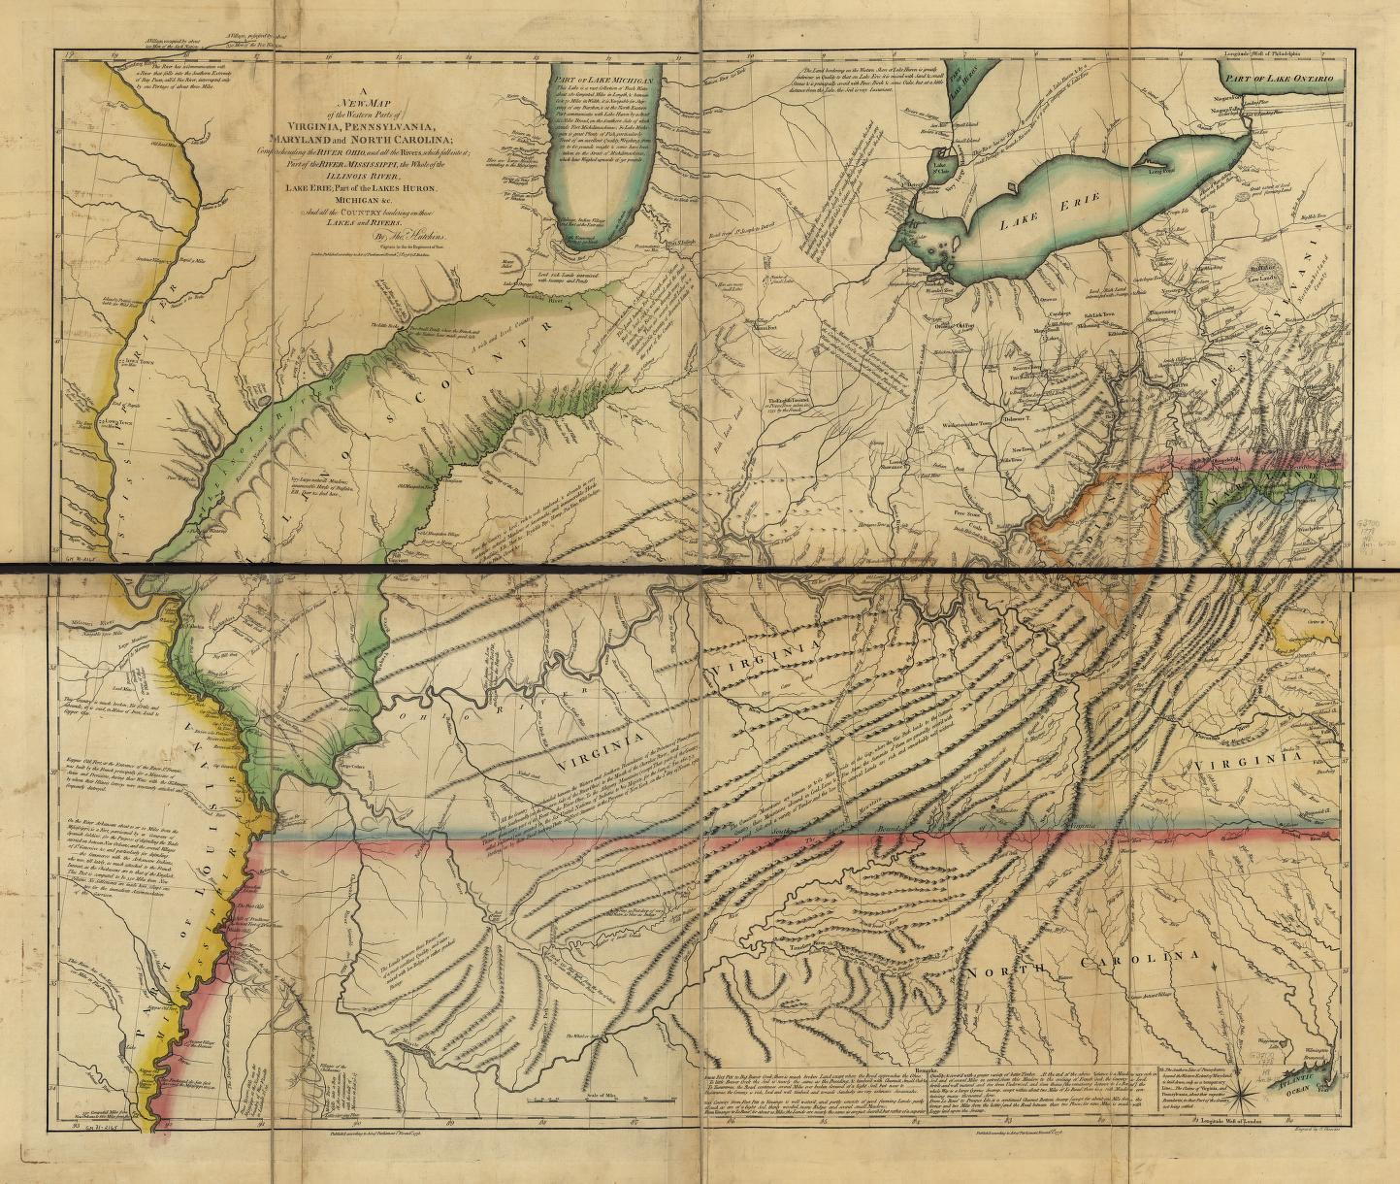
Figure 73 Thomas Hutchins, A new map of the western parts of Virginia, Pennsylvania, Maryland, and North Carolina, 1778 https://www.loc.gov/resource/g3707o.ar078901/

and materials. Hutchins chose to remove any overtly demarcated boundaries between Cherokee territory and British territory. The map relegates the Cherokees to a single town of “Chota” and “a number of Indian Villages” deep in the mountains. Hutchins’s colonial fantasy starkly contrasts Purcell’s updated 1781 map and the realities of the intensifying multifaceted contestation of the region.
Purcell’s A New Map of the Southern District of North America provides a sharp view of the territorial chaos caused by the erosion of perceived British authority in the Cherokee homelands. Figure 74 The map maintains the official boundary between British and Cherokee territories. The line runs from its agreed-upon position from the Savana River past Molly’s land and due north until making a westward turn at the point where Attakullakulla led the boundary marking party along the South Holston to just north of the Long Island and then on to the Kentucky River (formally the Louisa River). However, the effects of entrenchment belie the borderline’s imagined order. Purcell shows Molly’s Golden Grove and Saluy’s (Saloue) plot across the line at the Keowee frontier, where Cherokees had recently rebuilt the towns of Keowee and Seneca after the South Carolina militia razed them in 1776. Along the Long Island frontier, the map shows the entrenchment of the “Watoga,” Cumberland, and Powel’s Valley Settlements within Cherokee territory.
The map outlines the effects of land-speculation companies, but unlike Hutchins’s map, it withholds the environmental promise of future entrenchment. The mountainous topography of
the Cherokee homelands appears relentless, and the Tennessee River system seems much less inviting to commerce than on Hutchins’s map. However, to the north and west, the map outlines Indiana (Vandalia) and shows the Kentucky and Cumberland settlements, demonstrating the
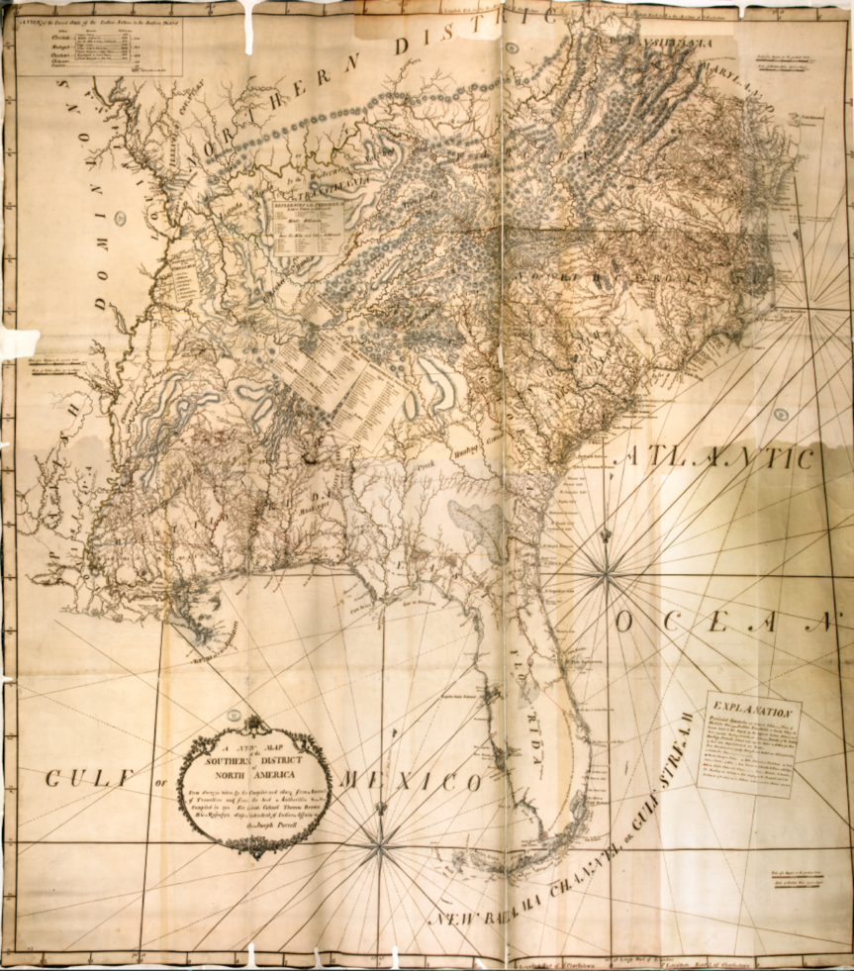
Figure 74 Joseph Purcell A New Map of the Southern District of North America, 1781.

efficacy of the land company’s economic endeavors. West of the Kentucky River, Purcell overlaps the monikers “Lands Claimed by the Western Nations” with “Transilvania” and adds a fainter “and disputed by the Cherokees.” Purcell marks the southern border of the area according to Henderson’s purchase but placed a “Cherokee Hunting Grounds” toponym that bisects the boundary. Adding to the confusion, he put a cartouche listing Cherokee town names in the area. A broad view of the map shows territorial contestation at an imperial level, but the map’s Cherokee toponyms embody the process the Cherokee’s integrate or expel response to foreign entrenchment.
The map displays anchored Cherokees separated from diasporic Cherokees. Purcell copies the locations of forty-five anchored Cherokee towns from his 1775 map regardless of whether he knew that Cherokee communities had reoccupied the sites after the 1776 invasions. His 1781 map shows three new diasporic Cherokee towns. He places the “Shukamagga Village” along the Tennessee River near the mouth of the “Hiwasee River” and the “Lt Quotokouec[]ito Villige” nearby on the “Hiwasee River.” He also locates a “Cherokee Village Settled in 1776” near the Muscle Shoals on the Tennessee River but does not list these towns in his index of Cherokee towns. Purcell’s categorization of these settlements provides insight into the effects of colonial dismemberment of the geographical infrastructure that maintained Cherokee society for centuries.
A combination of Cherokee resilience and the lack of practical Anglo-American political authority would leave the region in utter disarray. Through localized and organized entrenchment, territorial erosion had led Cherokees to begin splintering into yet another period of diasporic and anchored territoriality. The authority of the British empire had vaporized, and the nascent American federal government and state governments existed only in the form of self-serving officials such as John Sevier. As maps of the region show, borders between national, state, land-company, and Cherokee territories overlapped with contested and undefined boundaries, all overlaying topographical and imagined political domains the mapmaking colonizer wished to emphasize.

CHAPTER 6: RIVAL SOUTHERN GEOGRAPHIES
On the morning of February 13, 1779, Virginia Gov. Patrick Henry wrote to Col. William Fleming that he had commanded Col. Evan Shelby to destroy “the Chickamogga Indians who are directly in the way to Mississippi & obstruct all of our affairs on that [the Tennessee] River.” Henry was one of many land speculators that embodied the confluence of territory, power, and politics. The same year, William Henderson, who had clandestinely sought to obtain rights to millions of acres of land south of the Ohio River, represented North Carolina when he met with rival speculators. Dr. Thomas Walker and Daniel Smith, representing Virginia, joined Henderson’s group to mark an extension of the states’ boundary deep into what Henderson had referenced as “Indian Country” in a letter to fellow land speculator, North Carolina governor Richard Caswell. Unsurprisingly, the two adversarial groups disagreed regarding the placement of the boundary, resulting in each blazing a separate line some three miles apart, leaving a contested liminal space that remained in doubt until 1903.
Col. Evan Shelby, who had entrenched in Cherokee territory in 1770 within the contested three-mile area, sought to obtain land warrants from North Carolina and Virginia, but due to the confusion regarding what political entity had jurisdiction, Shelby’s heirs did not receive a deed to the land from Virginia until 1795. Shelby may not have had any official land titles but he knew how to ensure he would. He brought along “immense herds of cattle” and several enslaved Africans to alter the landscape. British officials recognized the land that the rebellious Americans had used enslaved labor to transform into plantations as Cherokee territory under British imperial sovereignty. Shelby viewed British authority as an obstacle to his accumulation of land rights. Within a few years, Shelby joined John Sevier, who would soon enter into a land-speculation investment with Richard Caswell in the Muscle Shoals area of the Tennessee River, and hundreds of colonizers entrenched along the Cherokee's Long Island frontier in combating the British Empire at the Battle of Kings Mountain in 1780.
This chapter demonstrates that an economic market centered on land commodification and the potential profits of enslaved labor espoused convenient political entities to drive entrenchment through the end of the eighteenth century. The conclusion of the American War for Independence in 1783 and Tennessee's statehood in 1796 did not significantly alter settler colonialism’s modes of entrenchment in the Cherokee homelands. It was business as usual for land speculators. Scholars have pointed to changes in theoretical territorial jurisdiction as a catalyst for increased settlement. Others have argued that colonists residing along an empire’s periphery employed pluralistic, self-serving legal notions of territorial sovereignty to bolster their efforts at expanding their territorial footprint. The problem with understanding the mechanics of settler colonial entrenchment lies with the presupposition that some, plural or hegemonic, government-backed legal system, influenced, justified, or authorized colonial invasion of Indigenous lands. Within the late-eighteenth-century Cherokee homelands, this was not the case. Elite colonists sought substantiation for entrenchment from any political authority they thought best enhanced the market value of their land. Cherokees, as they had for decades, searched for a colonial authority that they could hold accountable for the relentless entrenchment of colonizers on their land.
Selling the idea of foreign entrenchment to groups of would-be colonizers depended on the perception of the level of administrative capacity to secure their investments. Governments became interchangeable pieces in backing the commodification of land, agriculture, and black bodies in the regions beyond substantive Euro-American administrative capacity. Land speculators like William Blount and John Sevier envisioned government entities as profit avenues. They espoused any provisional or established government they perceived heightened the marketability of their ventures or enriched the value of their commodities within Indigenous territories. When polities such as Britain, North Carolina, or the nascent U.S. balked at supporting their investments, they simply invented governments to drive the land market. The cabal of men who sought power through profit in the Cherokee homelands exchanged government titles and loyalties many times. However, they participated in an enduring collusive oligopoly that drove settler colonialism in the Cherokee homelands during the late 18th century.
Meanwhile, the Cherokees had physically and strategically separated into groups to pursue retaining their social structures and core homelands through methods of incorporation or expulsion of foreigners. Identifying enemies was straightforward for the expulsionists who fought colonists trespassing in their homelands. But for the Cherokees who espoused incorporation, it must have been impossible to ascertain who to treat with. As maps of the Cherokee homelands during the end decades of the eighteenth century show, every piece of land and every waterway had multiple claimants encompassing a dizzying array of cultural, social, and political elements.
Rival Southern Geographies examines a multisided territorial contest in the Cherokee homelands from the end of the revolution to the early removal period of the early nineteenth century. Newly minted U.S. administrators met with Cherokees at the Hopewell conference in 1785 to establish physical boundaries and define diplomatic relationships between Cherokees and the U.S. However, internal debates within both groups would render the conference null. Cherokee explutionists would not capitulate to land cessions, and rouge colonial officials like William Blount remained unsatiated by the restraints of federal policy. This chapter shows that the Cherokees maintained cultural unity while perusing traditional strategies for coping with foreign peoples who arrived on their land. Local colonial elites swapped political allegiances to fit their economic and political fortunes that remained based on marketing land to growing numbers of enslaving plantation owners. Maps from the era show that beneath the colonial facade of a progressively stronger U.S. and state jurisdiction, individual colonizers, enslaved Africans, and groups of Cherokees vided for space in the rapidly transforming Cherokee homelands.

Entrenching on the Margin
On September 25, 1782, at its’ti (Chota), translators recorded a message from the Cherokees to the governors of rebelling North Carolina and Virginia. The Cherokees complained that “Your People from Nolichuckey are daily pushing us out of our lands. We have no place to herd deer. Your People have built houses within one day’s walk of our towns.” They requested that North Carolina and Virginia not allow their citizens to take land British officials had reserved for them. The Cherokee argued that colonial officials should halt the entrenchment of their cultural and agricultural spaces because “We are the first people that ever lived on this land—it is ours.” After a five-year delay, Cherokees wondered why officials had still neglected “to have the line run between us” agreed upon at the 1777 Treaty of Long Island. They requested the governors "send to Colonel [John] Sevier, who is a good man, to have all of your People moved off our lands.” Considering Sevier’s genocidal raids against Cherokee communities in 1780 and just weeks before, this seems like a bizarre request. However, the letter speaks to the complexity of the diplomatic work within the Cherokee homelands during the early 1780s.
Many integrationist Cherokees determined to maintain their homelands by diplomatic means searched for an authority to plead their case. Sevier, who had passed through its’ti (Chota) on the way to wreak havoc on Chickamauga Cherokee towns further upstream along the Tennessee River, seemed to possess the authority the Cherokee integration strategists desired to enforce agreements they had made with colonial entities in recent years. However, these Cherokees may not have realized the degree to which land speculators’ schemes had influenced the region’s future territorial sovereignty. Governor Alex Martin also appealed to John Sevier regarding the Cherokee’s “repeated complaints respecting the daily intrusion of our people on their Lands beyond the French Broad,” asking him to “warn these intruders off the Lands reserved for the Indians" by the so-called “Land Grab Act” passed just months before. Due to Sevier’s involvement in land speculation schemes in the area, he ignored the governor’s charge. Men like Sevier and North Carolina statesman William Blount’s personal aspirations would create a difficult-to-decipher gap between theoretical and practical governance in the region. The integrationist Cherokees had good reason to be conflicted over who might hold colonizers accountable for entrenching on their lands. Dragging Canoe and the expulsionist Cherokees determined to hold the trespassing colonizers accountable themselves.
The 1783 so-called “Land Grab Act” represented another, part post hoc, part conjectural scheme, conducted by aspiring elites. Much the same as Dr. Walker, Richard Henderson, and many other land speculators turned government officials before him, William Blount and many others staked their fortunes in expectant documents, which their potential monetization relied on an uncertain jurisdictional future. Along with other investors, Blount secured provisional titles to hundreds of thousands of acres where the practical ability to enforce private ownership through government administration was still a distant dream. However, knowing large areas of Cherokee agricultural spaces had been rendered useless by Sevier’s and other’s raids, land speculators sold the idea of settling on Cherokee lands to colonizers.
Land speculators sought tenuous documentation asserting land ownership, hoping to legitimize them rapidly enough to encourage entrenchment on their claims. Arthur Campbell wrote that the “steps taken” by North Carolina officials “to dispose of the Cherokee and Chickasas hunting grounds…held out an advantageous speculation.” He reported that during the fall and winter of 1783, “numerous parties of men were excited” to “range through the heart of Indian Country to locate lands.” Land speculators recorded provisional warrants for the lands at John Armstrong’s Land Office from October 1783 to May 1784, hundreds of miles away in Hillsboro, North Carolina. Others like Blount never traveled to the area but obtained documentation affording him vast land holdings. With the land warrants still conditional, speculators used the “Land Grab Act” to open credit lines, hoping to one day cash in on the flood of implicitly encouraged entrenchment in Cherokee territory. The speculators cared little for the current jurisdiction of the lands they claimed. Campbell complained that “at about the same time, measures were urged on by private individuals to profit themselves a district on the Tennessee (River) south of the North Carolina border.”
Land speculators knew that projecting internal stability and external access to broader markets made it possible to turn their schemes into profitable ventures. In some areas, speculation could rely on extending established state structures. Along the Keowee Frontier, South Carolina had proven its willingness to collectively enforce entrenchment with military action, creating a positive environment for land and labor commodification. Enslavers like Henry Laurence, who entrenched on Cherokee lands, encouraged other neighboring plantation owners to support the development of schools and churches in the area to make his investment “more secure.” In this region, colonists readily adopted Georgia, South Carolina, or North Carolina administration to increase the value of their investments in land commodities and enslaved labor. Other more ambitious land speculators saw the lack of established government along the Cherokee’s Long Island and Hiawassee Frontiers as both an economic obstacle and prospect.
Seeing little results from appealing to local or state officials to enforce territorial agreements, over nine hundred integrationist Cherokees headed for a conference with U.S. commissioners at Hopewell, South Carolina, in December of 1785, hoping for diplomatic clarity that would lead to territorial solidification under the ageists of a single hegemonic Euromerican political entity. The conference would send Cherokees and land speculators in new directions to achieve their territorial goals.

Conducting Cartographic Diplomacy
On November 22, 1785, the opening day of discussions at the Conference of Hopewell, U.S. commissioners unfurled William McMurray’s map for the Cherokees to examine. Figure 75 The relatively sizeable 26x38-inch map presented the Cherokees with an unfamiliar and disorienting world. The commissioners noted that some Cherokees had traveled extensively, having “visited the Six Nations, up the Wabash and down the Miami (Rivers) to lake Erie,” some going to “fort Pitt, the Natchez, Pensacola, St. Augustine, Savannah, Charleston, and Williamsburg.” Despite the Cherokees having acute geographical knowledge of the eastern half of North America, the commissioners commented that they explained only “with great pains, the limits of the United States” to the indignant Cherokees. McMurray’s map utterly erased the Cherokee’s longstanding vision of their homelands.
The inset presents a hollow United States encompassing nearly all the land east of the Mississippi River. The commissioners intended the vacant image to visually demonstrate their assertion that “Congress is now the sovereign of all our country, which we now point out to you on the map.” The area engulfed and expunged the Cherokees and all other Indigenous groups,
leaving the Cherokees questioning what had happened to their sovereign homelands. What about the many friend and foe communities of Creeks, Chickasaws, invading colonists, and all the other people they knew lived within the map’s barren space? The commissioners stated that the
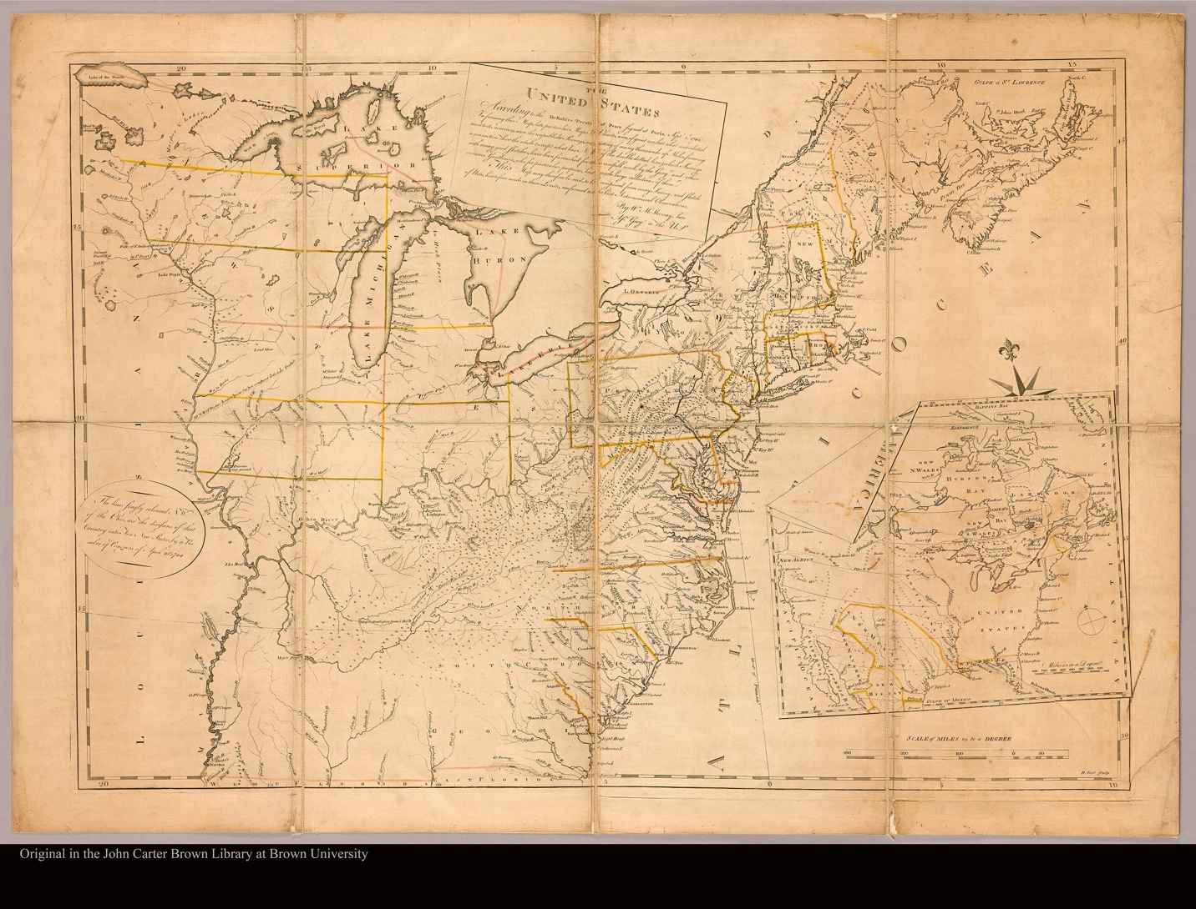
Figure 75 William McMurray, The United States, according to the definitive treaty of peace signed at Paris, Septr. 3d. 1783 ... by Wm. McMurray, late asst. geogr. to the US, 1784. https://jcb.lunaimaging.com/luna/servlet/s/8505pn

United States “wants none of your lands.” However, the Cherokees must have wondered why the map neglected to outline the boundaries between them and the United States they had already agreed upon.
McMurray’s map reoriented the riverine connections within the Cherokee homelands. Unlike the Barnwell-Hammerton and John Stuart’s maps, which relied on Cherokee geographic epistemologies, a colonial vision for commerce informed McMurray’s map. Instead of the northwest to southeast river systems that intermingled within the Cherokee's montane homelands, which appeared on Cherokee-derived maps, McMurray’s map separated the rivers draining into the Mississippi River from the rivers that with an unbroken ridge labeled the “Allegany Mts” and situated the rivers in a distinctive east-west orientation.
McMurray's ambivalence regarding colonial boundaries south of the Ohio River reflected the contemporary debate among colonizers regarding competing and undeveloped visions for the region's territorial future. The map delineated Congress’s 1784 suggested plan for governing the Northwest Territory by subdividing the region into neatly arranged potential new jurisdictional areas. However, the land south of the Ohio River contained no such partitioning, leaving the area in territorial ambiguity. The mapmaker discontinued the boundaries of Virginia, North and South Carolina, and Georgia short of the Appalachian Mountains but failed to enclose them. He extended their monikers an indeterminate distance past the stunted boundaries, suggesting incertitude as to where the western borders might lie. McMurray’s map depicted the region as theoretically under the ageist of U.S. jurisdiction yet practically devoid of a hegemonic administrative presence. At the end of the first day, the U.S. commissioners asked the Cherokees “to reflect on what we have told you,” regarding what the commissioners asserted was a shift in the region's territorial sovereignty. The Cherokees understood U.S. assertions of sovereignty as adopting the responsibility to control colonizers in the areas outlined on McMurray’s map, not as a territorial or personal jurisdictional claim over Cherokees or the Cherokee homelands, adding to their confusion.
The Cherokees delighted in the colonizers’ determination that a single political entity oversaw all Euro-Americans in the region but asserted their own territorial sovereignty within that space. The “Tassel of Chota” (Onitositah) told the U.S. contingent that they were “very much pleased” with what the commissioners had asserted the day before regarding external sovereignty but that “The Provider had granted Cherokees the right to own the land they were on when he had placed us there.” He explained, “Cherokees had always lived here, and whites had only recently arrived.” He told commissioners, “Cherokees had fought to retain our own territory in the American Revolutionary War, the land we are on now,” implying they never allied with the British in a Western sense. Instead, they acted toward their self-preservation against invading colonizers.
The integrationist Cherokees at the conference distinguished between the white commissioners who represented a foreign political entity that assisted Cherokees in controlling the pace of integrating individual Euro-Americans into Cherokee society and invaders entrenched on their land. Onitositah stated, “I am an Ani-Yvwiya who grew up in Cherokee territory where we have integrated many whites into our culture on our lands.” But, he warned, “the white people have entrenched on our land, on every side.”
Cherokees viewed the U.S. jurisdiction over Euro-Americans as non-territorially encompassing the Cherokee’s sovereign land, just as they had British authority. The Cherokees made a detailed argument against the continuity of the U.S.’s territorial sovereignty that the commissioners asserted with the lack of a Cherokee-U.S. border on McMurray’s map. Tassel referenced the 1777 Long Island Treaty and the agreed-upon boundaries with North Carolinians and Virginians. He described the boundary lines and went on to complain that “the people of North Carolina and Virginia have gone over” the lines and had blazed survey lines for individual plots across “land on the bank of the river near the town where I live and down the fork of the Tennessee and Holston.” For the Cherokees, maintaining a physical space apart from colonial entrenchment was an existential cultural necessity.
Nan-ye-hi articulated the Cherokee’s expectations that “Congress” would protect Cherokee territorial sovereignty. She found the end of the Revolutionary War “most pleasing” because now Cherokees could identify what authoritative body oversaw Euro-American trespassers. She hoped that “under the protection of Congress” against further entrenchment, she and other Cherokee mothers could “bear children who will grow up and become Cherokees.” Nan-ye-hi spoke on behalf of all the clan members of her community who expected Congress to provide lasting order and effective boundaries so they would “have no more disturbance” from colonists. The Cherokee arguments for their territorial sovereignty led the commissioners to request the Cherokees provide a map showing the extent of their homelands with the boundaries as they understood them.
After four consultation days, the Cherokees produced a map of their homelands and surrounding regions. Figure 76 Unfortunately the redactions on the extant map obscure the Cherokee’s argument for territorial autonomy. The sketch of the Cherokee’s original map published in the American State Papers appears as a colonized version with many erroneous notations based on a longstanding misunderstanding of the river systems on regional maps of the Cherokee homelands by Euro-American mapmakers. When George Herbert updated information from the 1721 Barnwell-Hammerton Map and John Herbert’s lost map from the mid-1720s, Hunter reoriented the map 90 degrees, and his notations cut off the “a large branch of” precursor to “the Mississippi” along the river representing what is now the Tennessee River. Figure 77 Thomas Kitchen perpetuated the error in 1760 with his widely viewed printed map. Figure 78, Figure 79 This erroneous format may have served as a model for a later colonial redactor attempting to fit the image into a colonial agenda. It is unlikely the Cherokees would have used their borrowed pencil and paper in the field to annotate their map with intricate British-style
budlings or have drawn solid or dotted lines to indicate a territorial boundary, suggesting an editor added these later.
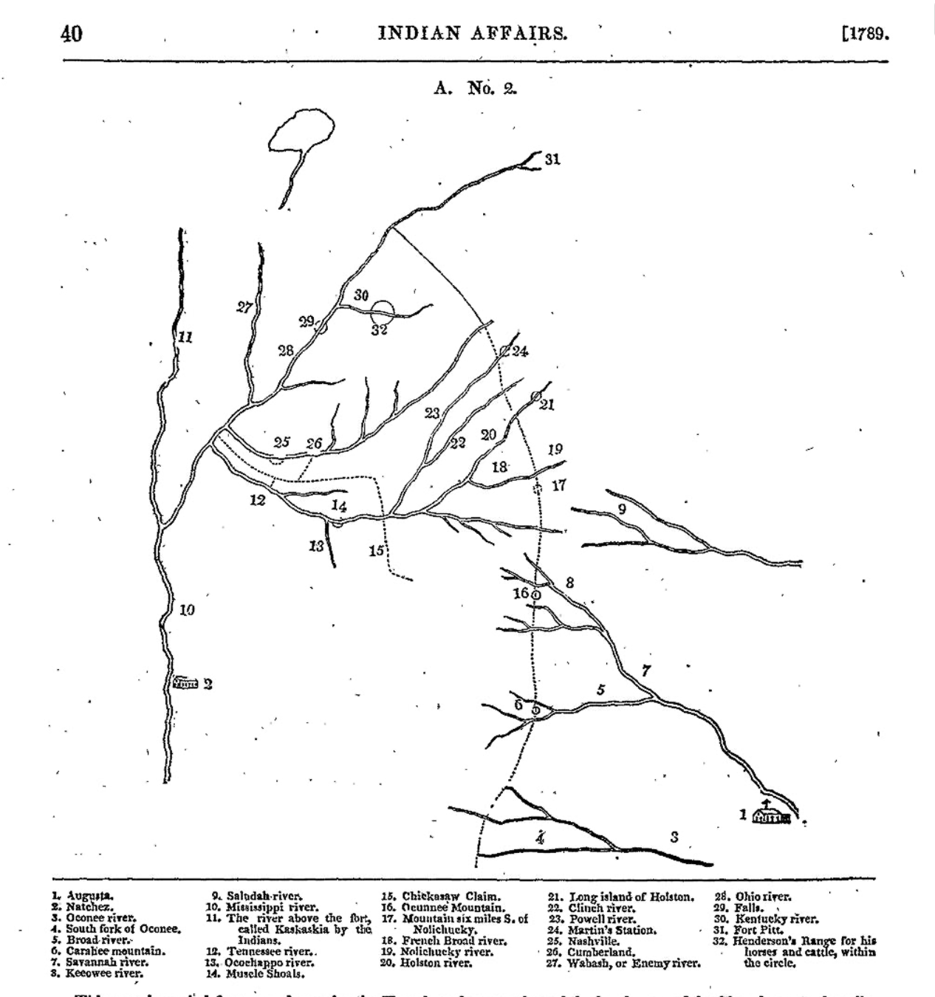
Figure 76 [Cherokee Map], 1785 in The American State Papers Vol. II, p.40

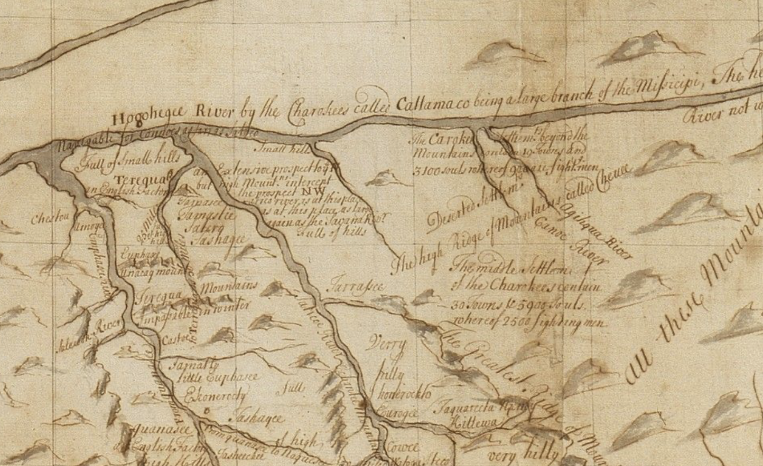
Figure 77 Barnwell-Hammerton Map Inset, 1721 with “a large branch of the Missicipi” along the Tennessee River.

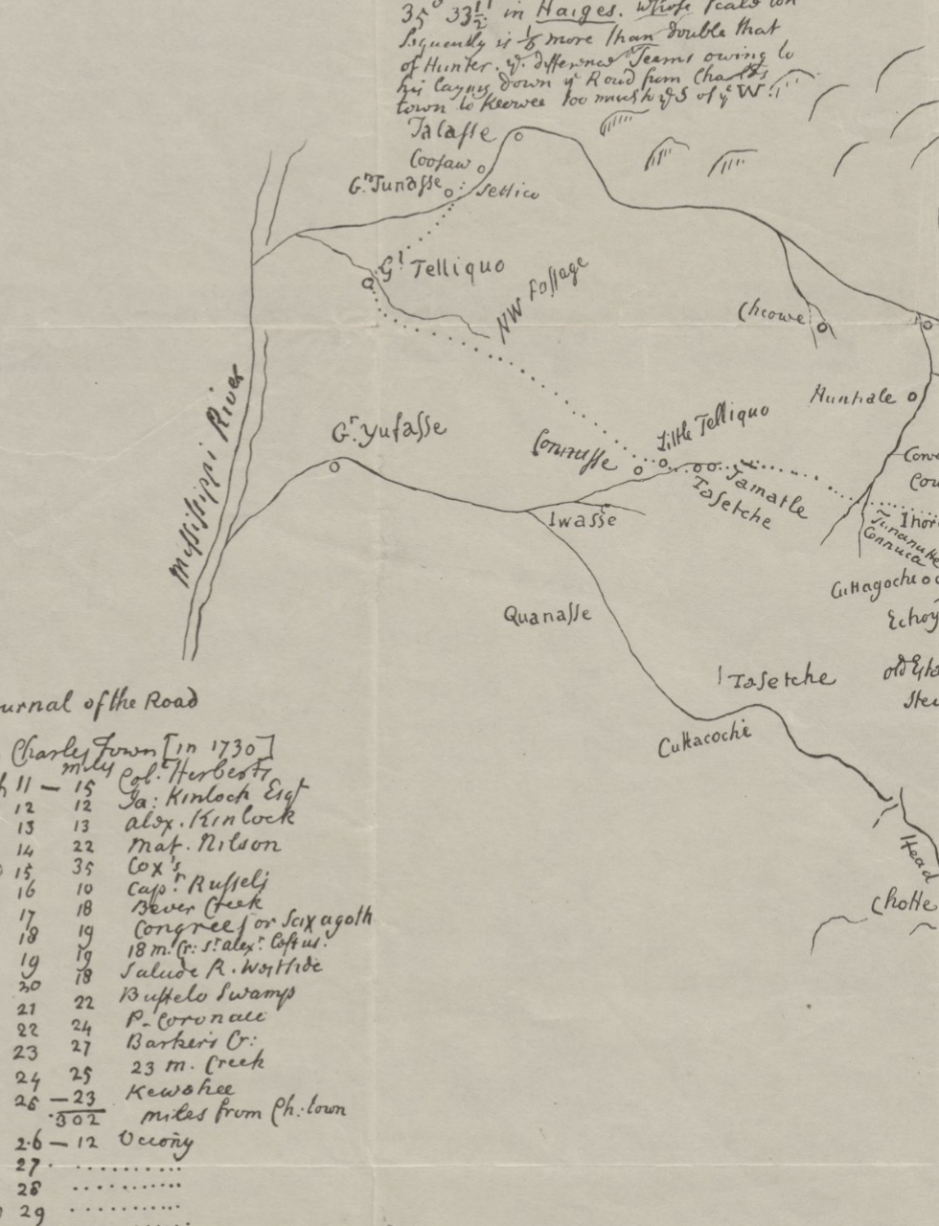
Figure 78 [Hunter Map] inset, 1730

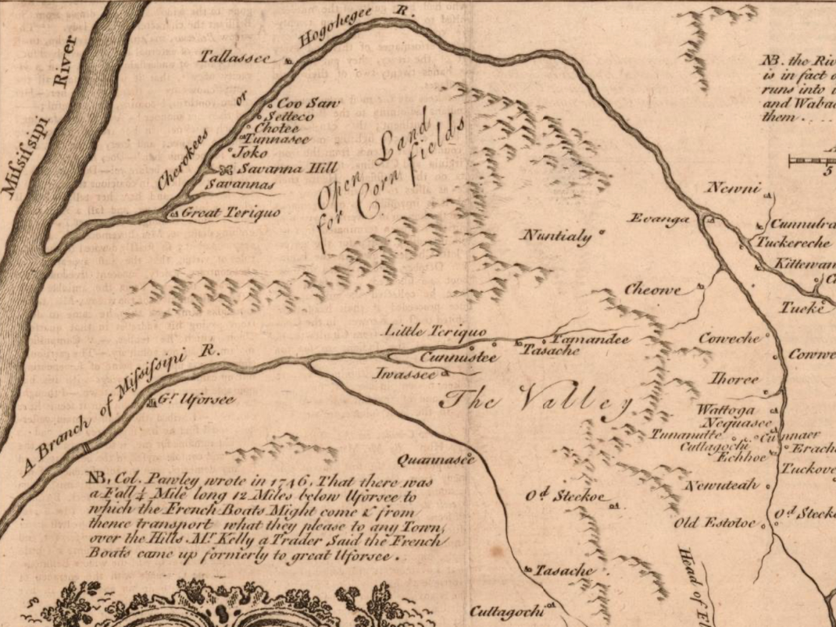
Figure 79 [Kitchin Map], inset, 1760

A decolonized version of the map reveals the Cherokees’ understandings of their homeland’s territoriality at that moment. Figure 80 The map demonstrates that Cherokees understood boundaries as a matrix of visual and physical cues that did not appear as Western perceptions of lines. Cherokees physically determined the extent of a territory based on rivers,
mountains, and cultural sites. They considered rivers adjacent to their territory as natural boundaries that delimited a group's territory. For rivers that ran away, they determined the location of the bounds of territory based on access to the river’s navigable watershed. The Cherokees used natural markers such as conspicuous mountain peaks as a visual cue for the territorial markers. If a Cherokee could see a boundary peak, they would know that a different territory was on the other side. The editor noted locations assigned 6,16,17,21,24, and 31, corresponding to the map’s key on the printed version. These were likely the editor’s attempt to label indeterminate Cherokee notations on the original map that, in truth, indicated visual cues that worked in conjunction with the river systems in forming what Cherokees understood and colonizers translated into a “line” that the editor sketched out on the map through a Western lens. Including the Long Island as an enclave of Cherokee territory demonstrates the Cherokee's recognition that cultural significance could determine land’s territoriality outside of occupation and agricultural use.
The map’s creation reveals recognized internal territorial divisions between groups of Cherokees. Onitositah described the boundary between the land his town clusters claimed and “whites” but also stated his claim ended with “the border with the middle settlements.” When Onitositah finished, Unsuocanail stated “I and my people will extend their line.” The location of the boundary between the groups remains unclear. Still, the wording in the 1777 Long Island
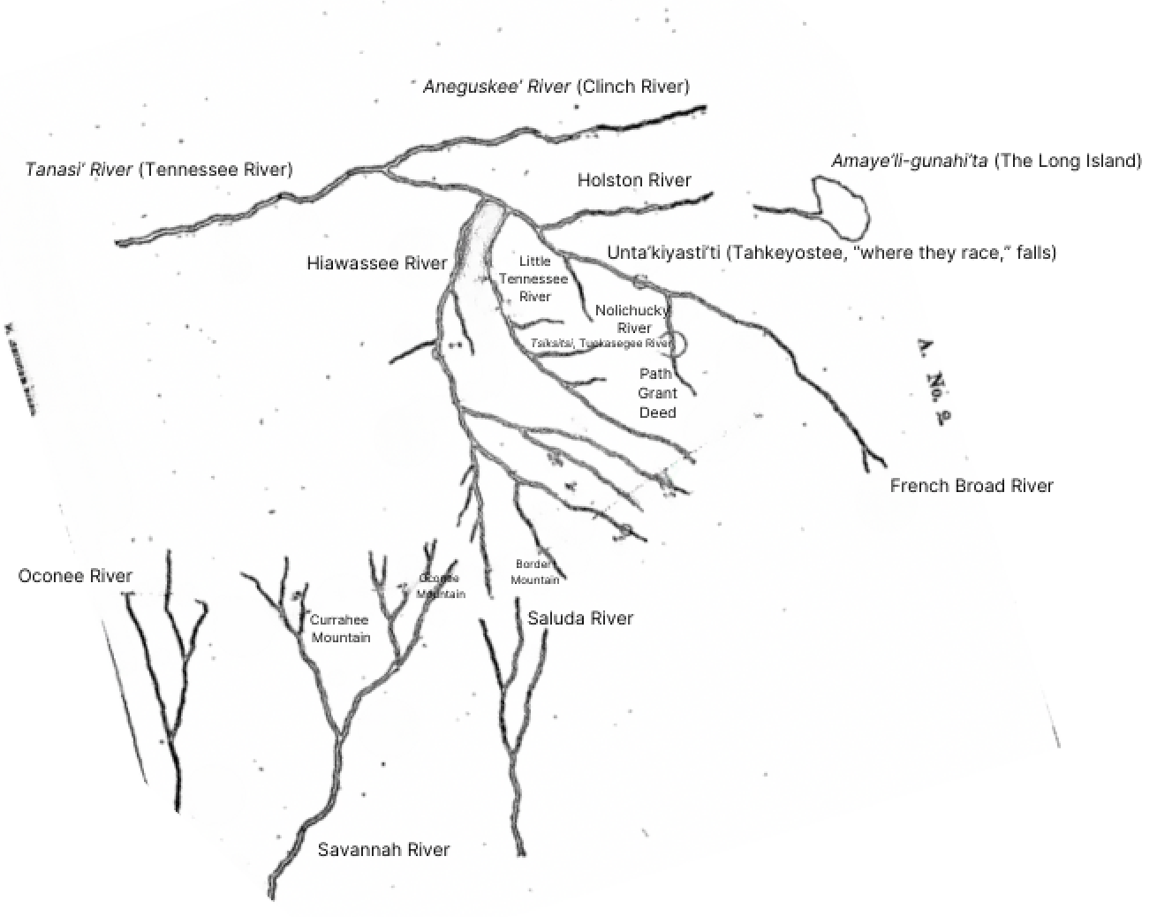
Figure 80 A decolonized rendition of the 1785 Cherokee map drawn at the Hopewell Conference

Treaty and a change to a dotted line in the editor’s marking suggests the boundary lay somewhere south on the Nolichucky River. A glaring omission of rivers and mountains representing boundaries in the southwestern part of the Cherokee homelands reveals the distinction present Cherokees made for the absent Chickamauga expulsionists, many of whom had declined to attend the conference.
The map demonstrates that contemporary Cherokees understood and mapped territorial sovereignty in much the same way as Western mapmakers, with some crucial distinctions. Scholarship has taken a myopic view regarding Indigenous mapping in the Southeast, claiming earlier Indigenous maps drawn by Catawba and Chickasaws represent a monolithic Native South Indigenous mapping tradition that Indigenous peoples later adapted to conform to Western cartographic standards. However, the Cherokee map displayed precisely located borders and zones of control, which Onitositah stated he used to reconcile Cherokee understandings of cartographically depicting territoriality with the commissioner's McMurray Map.
Because Cherokees did not draw borders as lines the same way as Western cartographers did not mean they did not see them on their map. Nor did it mean Cherokee mapmakers did not quickly come to understand the implicit assertions the lack of boundaries on the McMurray Map made. The Cherokee’s inability to immediately decipher McMurray’s map, coupled with the necessity of Onitositah reconciling the two maps only after a great deal of consultation, suggests the Cherokees had a unique longstanding mapping tradition. However, because the two mapping traditions contained many of the same fundamental territorial understandings, the Cherokees produced a map that effectively countered the McMurray Map’s intentional ambiguity. A significant difference between the Cherokee map and the two other extant Indigenous Southeastern maps may be that the Cherokees mapped their own territory, eliminating the need to explain intra-Indigenous geopolitics cartographically to Europeans.
The Cherokees produced the map expressly to ameliorate the lack of divisions between their territory and others on the McMurray Map and reify the commissioner’s proposed responsibility to oversee colonizers within Cherokee territory. Cherokees verbally outlined their territory using their map in conjunction with the McMurray Map. They immediately pointed out locations where colonial entrenchment had occurred near modern-day Nashville and the “three thousand souls” at the fork of the Holston and French Broad Rivers just east of what is now Knoxville, Tennessee. The Cherokee’s request that the commissioners ensure the removal of the colonists from their territory brought to light the multivalent contestation of the Cherokee homelands.
The U.S. commissioners were keenly aware of their inability to enforce their jurisdictional assertions. The officials insisted the Cherokees “make provisions, if practical, for the people settled at Nashville and for other such bodies of people, if numerous, as may be within what you have pointed out as your claim.” When the Cherokees demanded that “Congress” remove colonizers entrenched at the confluence of the Holston and French Broad Rivers, the commissioners taunted the Cherokees, quipping the “King of Great Britain ought to have removed them for you” while the Cherokees remained under his “protection.” The Americans insisted they could not “stipulate to do anything positively about them.” Disgusted, Old Tassel chided, “Are Congress, who conquered the King of Great Britain, unable to remove these people?” This exchange reveals what the Cherokees knew well: despite the commissioners’ cartographic assertions that they represented a body that now held sway over non-Cherokees in their homelands, the Euro-Americans entrenching in Cherokee territory acted semi-independently and often with implicit sanction from men with state and local-level political influence.
The maps used at the Hopewell conference present an internally and externally contested space. The U.S. officials asserted territorial sovereignty over the region but recognized Cherokees as possessing a yet-to-be-determined autonomy within that space. Both the Cherokees and the commissioners recognized colonizers entrenched on Cherokee lands as acting outside of explicit U.S. support, but both admitted an inability or unwillingness to remove Euro-American settlements. The lack of engaged participation from expulsionist Chickamauga Cherokees in person and on the maps reveals the deep divide in Cherokee anti-colonial strategies. The McMurray Map’s indeterminate extension of state toponyms into Cherokee lands hints at more layers of contention regarding the territorial status of Georgia, North Carolina, South Carolina, and Virginia. Much like the entrenched colonists, for some agents at the conference, their interest in the territorial status of the Cherokee’s homelands stemmed from personal economic aspirations.

The Business of Settler Colonialism
William Blount protested the Hopewell Conference’s premise and potential outcome, ostensibly representing North Carolina’s land claims. Blount arrived at Hopewell with a written declaration from the North Carolina General Assembly asserting North Carolina’s claim to Cherokee lands in much of what is now Tennessee in one hand and provisional North Carolina-backed grants to hundreds of thousands of acres of that land in his pocket. After North Carolina had rescinded its cession of its “western lands” to federal jurisdiction in 1784, Blount had argued for the legitimacy of his “Land Grab” land grants under North Carolina’s jurisdiction. However, John Sevier and a handful of ruling-class men living on Cherokee lands on the Long Island Frontier became unsatisfied with North Carolina’s ineffectual ability to appropriate Cherokee lands and decided to invent their own state to back their investments in land and enslaved labor. For aspiring elites like Blount and Sevier, the debate regarding the territorial sovereignty of the Cherokee homelands centered around personal economic gain. Undeterminable political hegemony became a byproduct of the region’s land and enslaved labor markets.
David Campbell wrote to his brother, Arthur Campbell, on December 27, 1784, from “The State of Franklin” to describe the recent meeting of landed elites to form an autonomous state government. He informed his brother that the convention had declared this country a separate and independent state, and they intended “to court the Guardianship of Congress.” “Attempting the utter extirpation of the Indians” lay heavy on the minds of many at the convention, though Campbell wrote he was “decidedly against the measure,” it being “totally impractical” and “evidently unjust.” However, Campbell boasted that he had purchased “Nineteen hundred acres of land on the French Broad six miles above the mouth,” which he considered “a great addition to my fortune.” He had purchased the land for “three hundred pounds” on credit “to be paid in three years.” The letter does not specify what political entity legitimized his purchase, but his support of an independent state and zero upfront investment purchase of Cherokee lands suggests it was yet to be determined.
It did not take long for the Campbell brothers and other elite landholders to convince other prominent men that inventing a local state government held the most promise for legitimizing their investments. John Sevier, who initially considered strengthening North Carolina’s influence in the area as his best option for solidifying his claim to 84,000 acres of provisional land titles, signed on as governor of the State of Franklin in March 1785. At the same meeting, the local gentry crafted a letter complaining the North Carolina assembly had “detained a Certain quantity of Goods which was promised to satisfy the Indians for the lands we possess” as a reason the men formed the new government. Sevier stated that North Carolina’s “Land Grab” act had allowed entrenchment on “all the lands on The North side of the Tenesee [sic] as far Up as the mouth of Holeston [sic] River,” which included “several Indian Towns, and the greater part of all the Corn plantations Belonging to Chuckamauga [sic],” causing Cherokees to “commit hostilities” Sevier knew that Cherokees’ violent acts against colonial intruders made contested land challenging to market. He worked quickly to provide an air of stability that he and his fellow land investors felt North Carolina failed to deliver.
In June 1785, Sevier invited a small group of Cherokee men to collect goods for lands already entrenched by colonizers. At the “Treaty of Dumplin Creek,” Sevier gained a document which he could show his clients that Cherokees had abandoned “all the lands lying and being on the South side of Holeson [sic] and French Broad Rivers, as far South as the ridge that divide the Waters of Little River from the Waters of Tenesee [sic].” Sevier stated, “the lands on the South of Broad River, where some few people are settled, I cannot Believe the Indians Care any thing about, And have expressed themselves to me in That light. For they Have no Hunting in that quarter and Consequently Care Little about those lands.” The State of Franklin soon opened a land office to issue land grants for colonizers in the area. Cherokees had complained to colonial officials for years regarding the entrenchment in this area, but Sevier knew that the Cherokees could only appeal for their removal, to no avail. However, Sevier realized that making the Cherokee lands marketable which contained agricultural spaces they forcefully defended against entrenchment would be a difficult task.
Sevier employed scorched earth genocide to expand entrenchment into Cherokee agricultural spaces. In 1786, Sevier mustered 160 local militia to raze Cherokee towns and crops along the Hiawassee River. In 1788, Sevier led another expedition to destroy Cherokee towns on the Little Tennessee River. When several surviving Cherokee leaders who still supported incorporating whites as the best survival strategy appealed to the U.S. federal officials for protection, Sevier had Abraham and Corn Tassel, two well-known integrationists, murdered. Sevier rallied the would-be colonists by telling the hoard that “as the Cherokees had refused to sell their lands, they had no recourse but to take it with the sword, killing the warriors and capturing their women and children, destroying their provisions and compelling them to give up their lands.” For Sevier and his constituents, clearing a path to profit through entrenchment began with clearing the land of potential obstacles, including people, before pursuing the legitimization of invasion through governmental backing.
Purcell’s map, published by Jedidiah Morse in The American Geography in 1789, demonstrates the Cherokee homelands in a moment of multivalent overlapping territoriality. Figure 81 Morse had received geographical information regarding the area from Arthur Campbell, a supporter of the State of Franklin, which he incorporated into the map. The map displays confident boundaries between North Carolina and Virginia to the north and South Carolina and Georgia to the south. However, “Lines limiting the territory claimed by each Indian Nation” often traverse the state borders, and he placed state toponyms that override Indigenous spaces. Cherokee territory has a southern and western boundary but no line indicating the eastern and northern limits. The map separates diasporic Chickamaugas from anchored Cherokees, whose towns lay underneath a “New State of Franklin” moniker with indeterminable limits. The map’s territorial uncertainty is a product of geographical information from a conglomeration of men who contested their investments by backing political entities they believed best served the marketability of their ventures. Purcell’s map represents a moment of market uncertainty.
William Blount’s 1790 appointment as governor of the Territory South of the Ohio would cause a significant market shift.
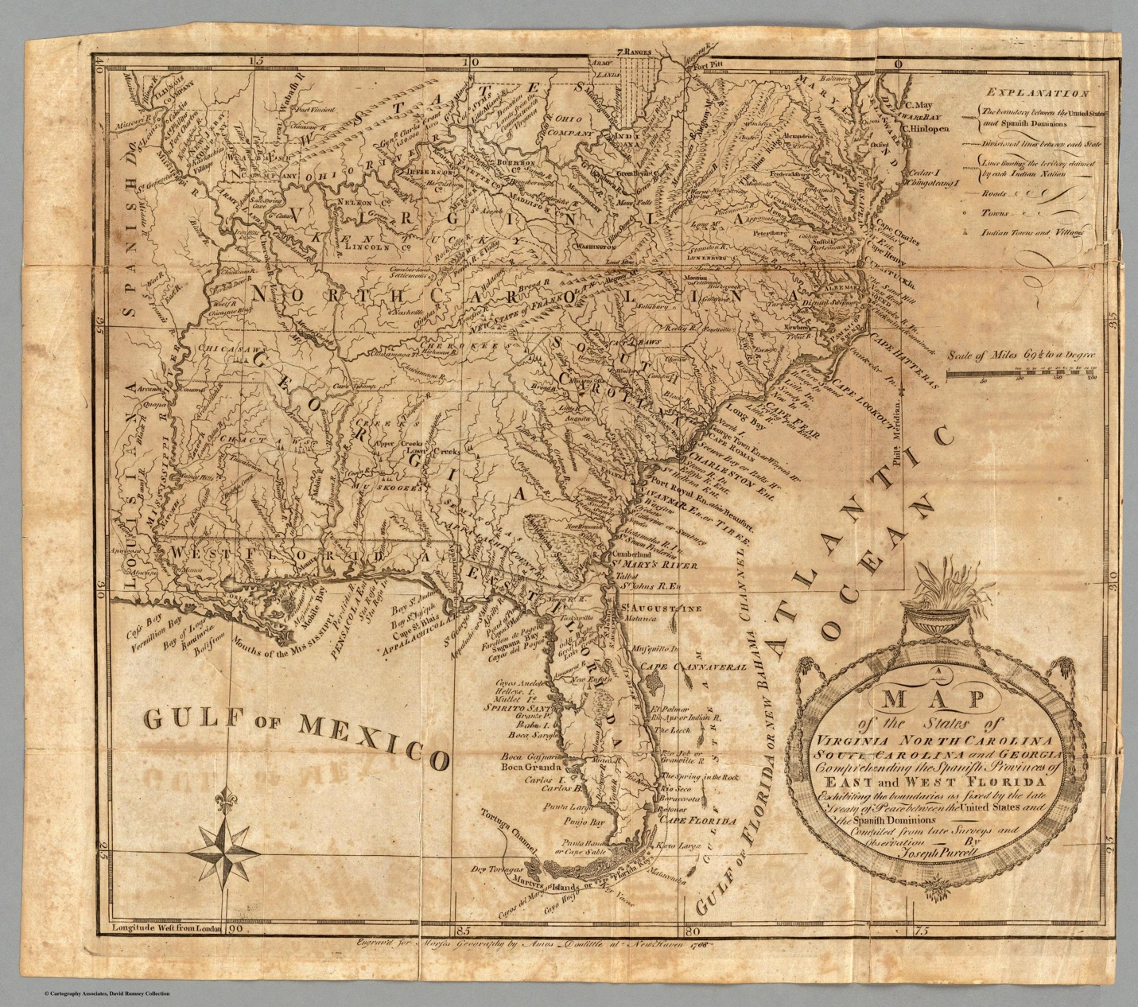
Figure 81 Joseph Purcell, Map of the States of Virginia, North Carolina, South Carolina, and Georgia, 1788, published by Jedidiah Morse, in The American Geography,1789

Land speculators perceived a valuable marketing opportunity when the U.S. organized the Southwest Territory. After lobbying from fellow land investors, George Washington appointed Blount the first governor in June 1790. Blount, who had opposed U.S. sovereignty over his claims at Hopewell, quickly reversed loyalties, determining that his appointment “was of great Importance to our Western Speculations.” Blount, Sevier, Daniel Smith, and many others plotted to expand their landholdings by preemptive entrenchment, which they would market as sponsored by the U.S. federal government. Because Blount now represented an authority that Cherokees mistakenly believed existed to forbid entrenchment, they gathered to conduct a congress with Blount and other U.S. officials in 1791.
On June 26, 1791, Cherokees approached U.S. commissioners at the conference ground near modern-day Knoxville, Tennessee, performing the Eagle-Tail Dance. The dance indicated that Cherokees expected to treat with a powerful ally. However, the U.S. commissioners, William Blount, James Robertson, Isacc Shelby, and David Campbell, represented a who’s-who of land speculators with provisional holdings in Cherokee territory. With little pomp, Blount got straight to the point. He demanded that the Cherokees abandon their boundary with the U.S. outlined at the conference at Hopewell. Shocked and suspicious, Cherokees initially rebuffed Blount’s advances, stating they “did not arrive to speak about land.” However, Blount possessed a powerful negotiation tool: prior successful entrenchment. He reminded Cherokees that “a great deal of your hunting grounds have been injured by the game being destroyed— hence they are no longer of great use to you.” Sevier and other’s scorched earth excursions and the legions of colonizers entrenched in Cherokee agricultural spaces had already physically appropriated the land surrounding towns on their Long Island frontier. Now, Blount wanted to profit from their efforts by marketing the area with prices reflecting the backing of an established government. Figure 82
The Cherokee’s speeches indicate they suspected a divide between Blount and U.S. federal policy. The Cherokees consistently evoked “the Beloved man in New York,” hoping that the commissioners were “sent by our protector” but admitted that after Blount’s attempt at more land, they became “much disappointed.” Blount tried to assure the Cherokees that he represented “the illustrious General Washington,” who could not uphold the agreements made at Hopewell because he was “chosen years after the Hopewell Treaty.”
However, the Cherokees appealed to Washington and “Congress” by making speeches they knew would be written down by the commissioners and delivered to other federal officials. Hanging Maw spoke past Blount through the written words, stating that “you have been appointed by George Washington to do this business.” Appealing to an absent Washington, Hanging Maw insisted that “God has apportioned this land for the Cherokees” and “this land was first ordered to us not whites [by the British King],” but “when they came, they shortly began to encroach on our land.” Referencing Blount’s actions at the conference, Hanging Maw told Washington, “The first time you came and offered us some small goods for our land— you have taken us by surprise this way with few goods.” Speaking directly to Washington through the record, Hanging Maw warned “Twas a long time before it became known to George Washington
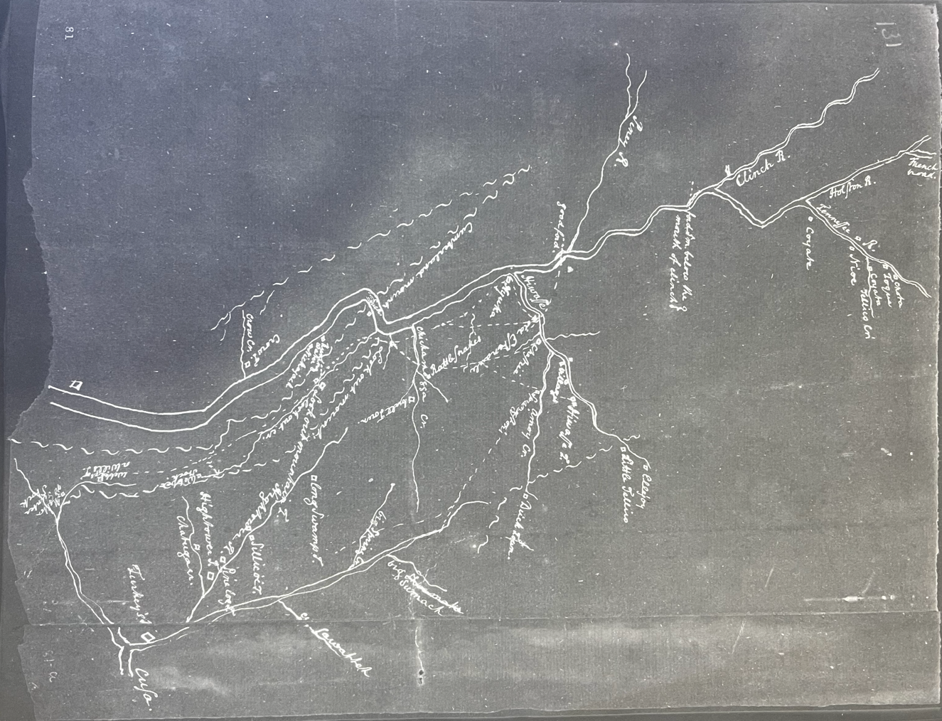
Figure 82 [Innes Map] 1791, Newberry

how we have been imposed on.” The Cherokees saw through Blount’s ruse and would continue to appeal to U.S. officials at the capitol to address the actions of local colonizers.
Blount flaunted his authority as a U.S. administrator but remained aloof in enacting federal policy that interfered with entrenchment. When Secretary Henry Knox wrote to Blount in April 1794 responding to a planned attack of Cherokee towns, Knox wrote that President Washington “does not conceive himself authorized to direct any such measure” as Congress “did not think it proper to authorize any such offensive measure.” Blount allowed militia led by James Ore to destroy Cherokee towns, Nickajack and Running Water, in September, enslaving nineteen Cherokee women and children. Blount reported to Knox that he had authorized Ore to protect the Mero District, but he assured Knox that “no order of mine sanctioned” the offensive attack.
Blount issued official proclamations but undermined them to placate colonizers. Under the federal government’s direction, Blount issued an official proclamation on January 8, 1795, commanding settlers in Powell’s Valley on Cherokee lands to remove to Virginia. When the residents stayed, Blount wrote to Lt. Thomas Mitchell to remove them and sent word to Knox that he had commanded their removal. Blount informed Mitchell that “it has rendered it my duty, disagreeable as it may be to me and them, to issue an order for their removal by military force,” instructing Mitchell to “remove the settlers, their families and effect and stock” and then burn their houses and “destroy their corn.” The menacing order Knox received seemed harsh and authoritative. However, Blount’s instructions to Mitchell regarding how to go about the removal effectively defanged the order.
Blount instructed Mitchell to assemble local militia from Hawkins County, the neighbors of the offending settlers. Then, “in execution” of the removal, “use no more force as necessary” to “prevent the effusion of human blood.” Blount wrote Mitchell that if the settlers “manifest a determination of resistance with firearms” to wait “seventy-two hours” before informing him and “not injure them” while waiting on “an Express with my further orders.” Blount then wrote to Knox informing him that the settlers would not leave peacefully and awaited further instructions. Meanwhile, the militia, comprised of the resilient settlers’ acquaintances, simply went home.
Maps of the region underwent a profound topographical and geopolitical simplification from 1790 to 1795. William Faden’s 1793 map, The United States of North America with the British Territories and those of Spain, printed in London, shows a blend of geographical and geopolitical sources within a British-inspired lens. Figure 83, Figure 84, Figure 85 The 1763 Proclamation Line and Hard Labor Line separated Southern states from “Granted” Indian territory. The maps located twelve Cherokee towns in their traditional European-inspired “Upper,” “Middle,” and “Lower” town groupings along rivers surrounded by mountain iconography, demonstrating the map’s British influence. The map also outlined large tracts labeled “Reserved for North Carolina,” and "Virginia Troops,” and “Franklinia, New State of Franklin,” bordering the sweeping Cherokee toponym, demonstrating the mapmaker pulled from various sources regarding the region’s geopolitical status. Similarly, Kitchin’s 1794 map shows a mixed source base with a broad temporal range. Kitchin truncated the westward boundaries of the states and located numerous Cherokee towns, many of which colonizers had physically
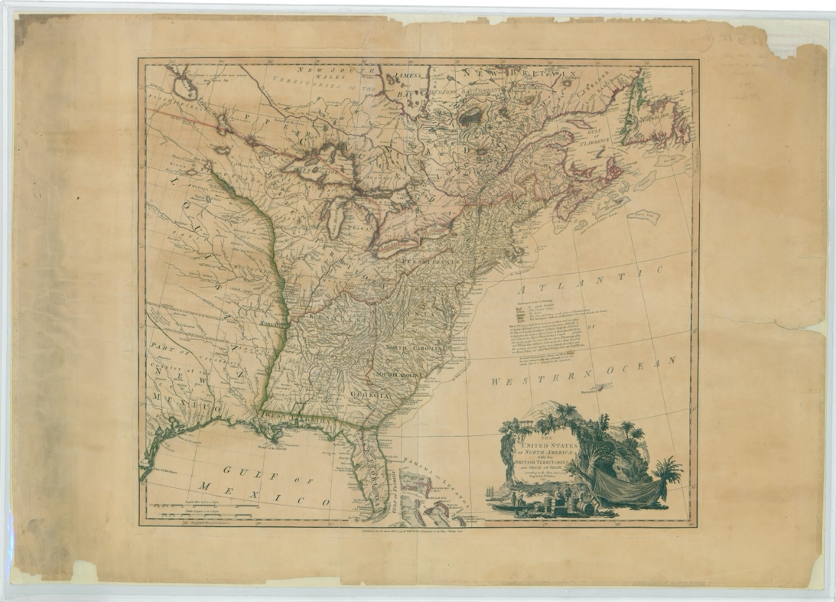
Figure 83 William Fadden, The United States of North America with the British Territories and those of Spain, 1793

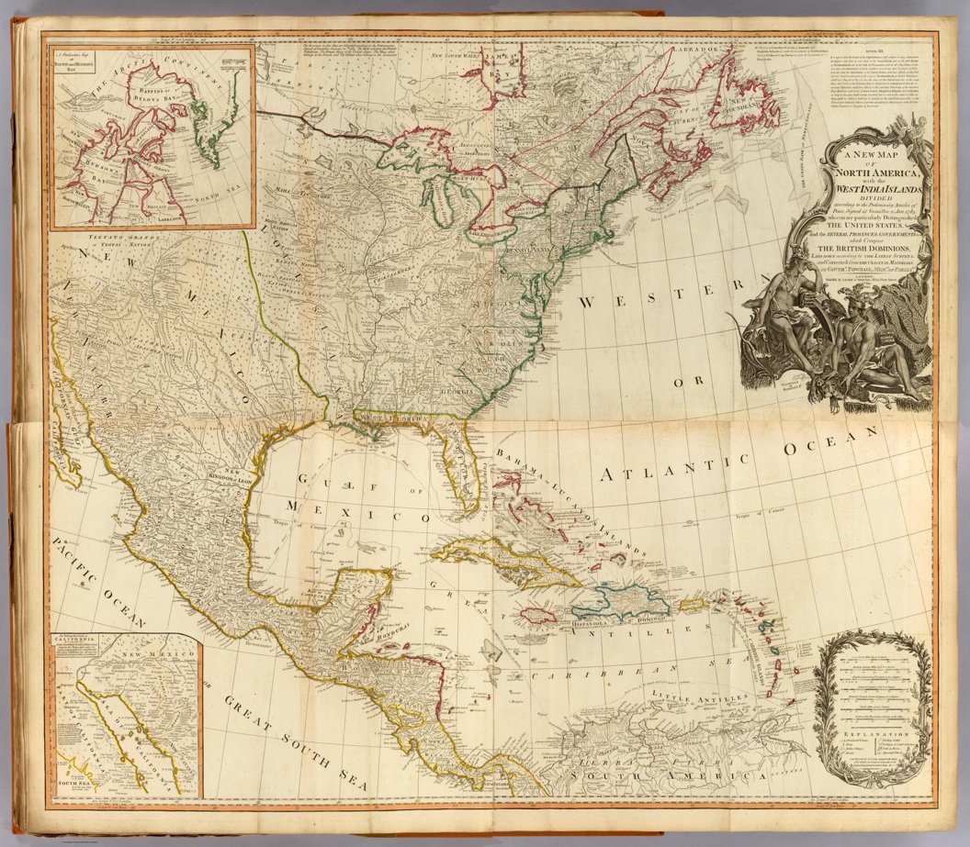
Figure 84 Thomas Kitchin, A New Map of North America, with the West India Islands, 1794

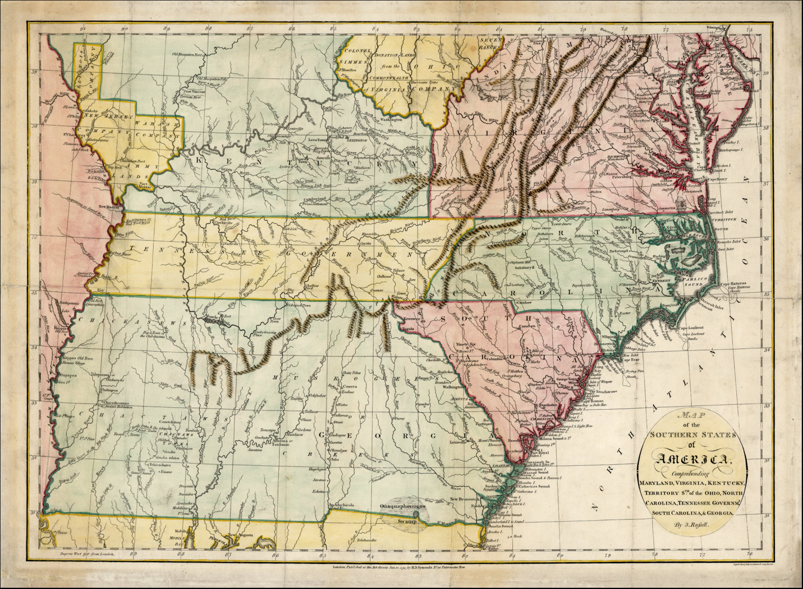
Figure 85 John Russell, Map of the six southern states (Maryland, Virginia, Kentucky, North Carolina, South Carolina, Georgia) plus the Tennessee Government, 1795.

destroyed decades prior. He labeled the Tennessee River “Hogohegee,” indicating the river systems and Appalachian Mountain’s depiction borrows heavily from John Mitchell’s 1755 and Barnwell’s 1721 maps.
Russell’s Map shows glaring changes that indicate a new and distinct source. On Russell’s map, North Carolina has a western boundary with the “Tennessee government,” which had yet to be formally established. The map shows twelve Cherokee towns but does not label any area as Cherokee territory more broadly. Kentucky exemplifies a newly established state with many towns and zero Native presence. Knoxville, Nashville, and a few other Anglo-American towns populate the Tennessee region, promising a potential replication of Kentucky’s prosperity. As with many land company maps of the 1750s and 1760s, the mountain ranges are reduced, and river systems populate expansive valleys. The map highlights the Muscle Shoals area, which features a fort. The geographical information for Russell’s map comes from a cartographic marketing ploy launched by William Blount and Daniel Smith to sell a state into existence.
Blount and others recognized the limits the federal government placed on their plans for profit. Blount and his fellow investors believed an explosion in land prices relied on securing access to trade on the Mississippi River. Blount and Smith produced a map to accompany a publication titled A Short Description of the State of Tennessee, lately called the Territory of the United States South of the River Ohio, touting the region’s potential commerce that Mathew Cary published in 1796 at his Philadelphia press. Figure 86 The map possesses distinct features that
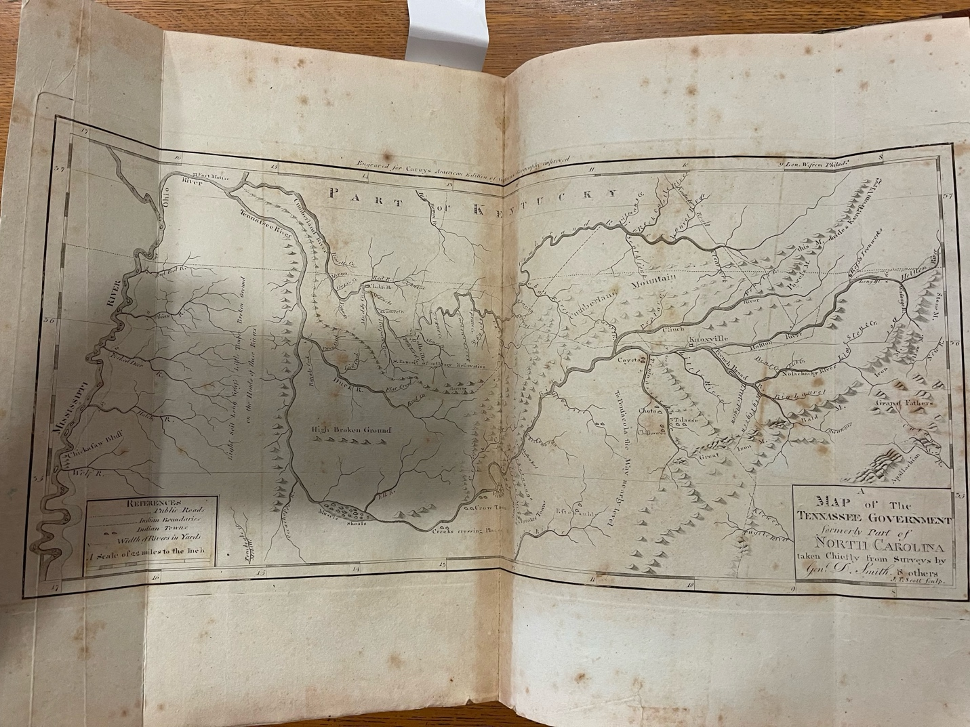
Figure 86 Daniel Smith, Map of the Tennassee [sic] Government, published in Cary's American Atlas, 1795

mirror the publication’s sales pitch. The mountain ranges appear minimal, and river systems run into every valley. All parts of the region enjoy access to the Mississippi through navigable waterways, including the five fictitious rivers that run into the Mississippi on the map’s western side, where the Description promises yearly flooded alluvial land “hardly equaled in value by any known land, except Egypt.” Cherokee presence is reduced but not eliminated, reflecting the description that settlers would only encounter “small tribes of friendly Indians.” Paths traverse Cherokee territory connecting eastern and middle Tennessee settlements, representing an area that appears well-connected to outside markets.
Implied state borders pronounce assertions of the soon-to-be state of Tennessee's “right of soil.” A prominent federal border separates Cherokee towns from American settlements that follows the 1791 Holston Conference agreement. However, lines of latitude imply the state’s
future boundaries that belie a national border with the Cherokees. A dotted line along the 36.30 latitude line, conforming to Carolina's original 1663 English charter, forms a provisional northern border for Tennessee, and the 35th forms the southern. The map shows the controversial Powell’s Valley region within American territory. Alongside the publication, the map acted as a visual aid for would-be clients to envision a plantation paradise within a newly formed and self-governed state bereft of federal land restrictions and Indian territory.
A Short Description of the State of Tennessee provides a detailed description of land speculators’ vision for the region. Figure 87 In a genre that would have been familiar to prospective colonists living in England during the seventeenth century, the book provides a
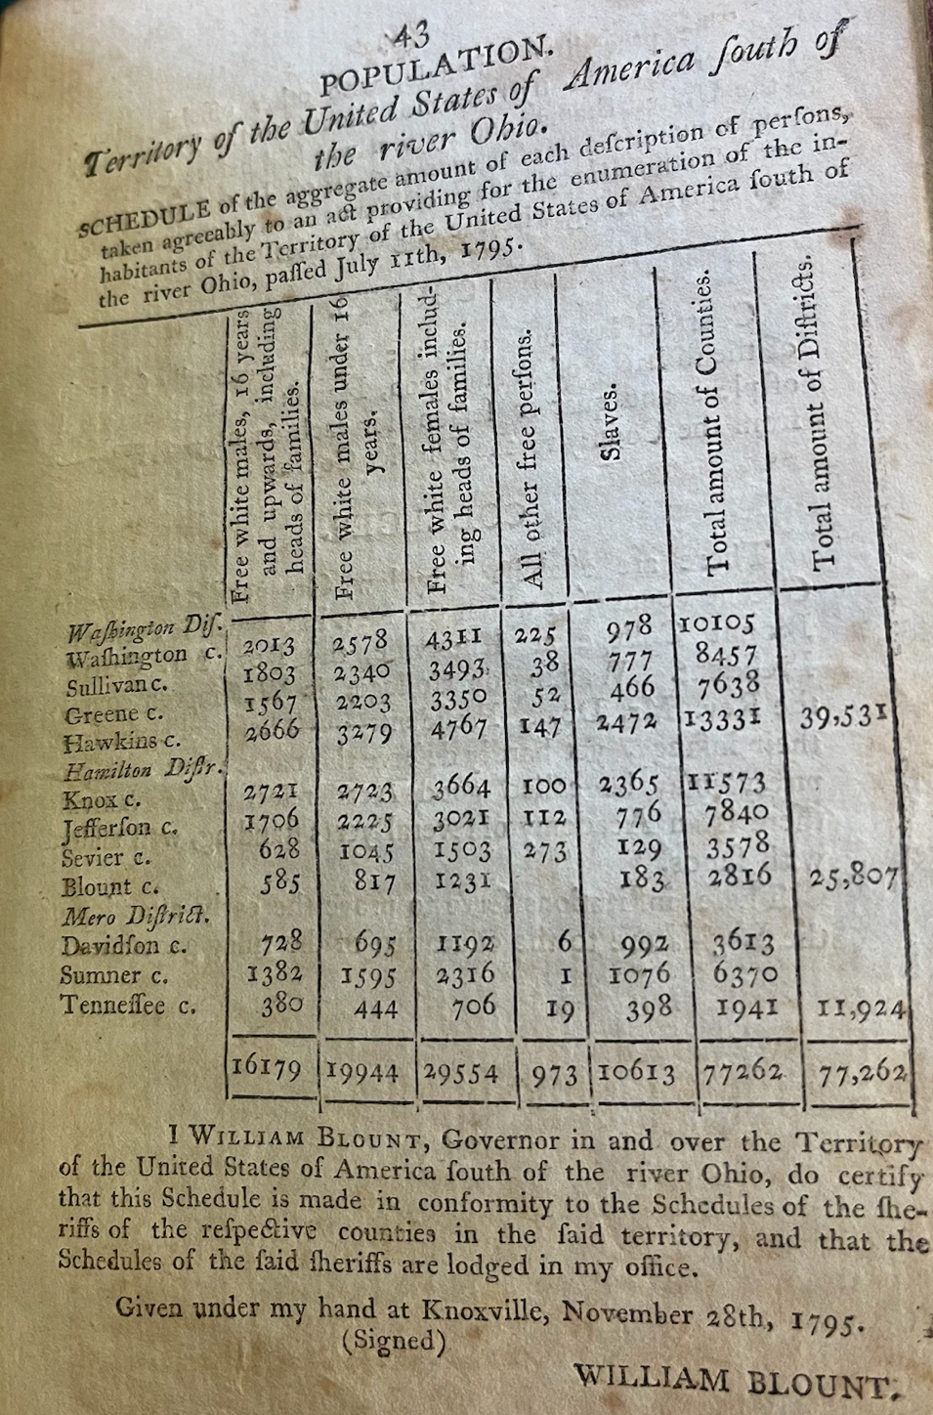
Figure 87 Table from A Short Description of the State of Tennessee, 1795

utopian account of the region’s natural resources, established commerce, and potential prosperity. The book tells the reader that the land is “generally fertile” and “a farmer never suffers by the want of rain.” According to the author, a host of crops, including tobacco and cotton, "have already been planted," and “they all thrive in great perfection.” A Short Description touts the land as much cheaper than coastal prosperity and notes that the “United States will not permit [Indigenous ] lands to be settled without the consent of the Indians but…natural progress, in a short time, will render a considerable part of the country…useless to the Indians and necessary to the Whites.” The book contains a chart listing the established counties and their demographics, highlighting the number of enslaved laborers and a large discrepancy in the proportion of women to men to bolster the region’s perception of a stable and growing plantation society.

Contesting Boundaries
Blount, Sevier, and other elite landholders invented the state of Tennessee to rid themselves of the economic constraints the U.S. federal government posed. A check on the marketability of land federally recognized as Cherokee territory marked one prominent restriction. This included prior entrenchment on Cherokee lands and prospective entrenchment into Cherokee, Creek, and Chickasaw territories. Many colonists already entrenched on Cherokee land possessed provisional land titles based on North Carolina land grants that violated federal law. Their tenuous federal-level legal situation meant little to Tennessee’s new leadership. Tennessee constitutional delegates wrote a section to “enable the Citizens South of French Broad and Holston between the Rivers Tennessee and Big Pigeon to obtain titles upon their claims of occupancy and preemption,” which provided colonizers a path to legal title in the new state but remained in defiance of federal law which supported Cherokee claims.
The preemption provision in Tennessee's constitution was symptomatic of land speculators turned state officials’ shift in marketing strategies. When the federal government formed the Southwest Territory, landholders viewed the auspice of federal authority as an avenue for expanding their landholdings, gaining access to broader markets, and selling the perception of stability. When the federal government began to pose more of a hindrance than a stimulant for land sales, land speculators formed a new entity to back their investments. For Tennessee leaders, a federal boundary represented an economic barricade. However, for the Cherokees, the erosion of their territory at the doorstep of their towns was an existential threat to their society. While politicians threw legal salvos at one another in capitol halls, the Cherokees could see the colonizers’ cabins going up in their fields.
Federal agents and Cherokees fought to impose a federally recognized border ostensibly between the U.S. and the Cherokees. The real battle was to mark an adequate border between Cherokee land and ongoing entrenchment sanctioned by local elites. As Tennessee’s first governor Sevier expressed, land speculators argued that Cherokee territory lay “within our [Tennessee's] territorial limits.” The Cherokee once again turned to George Washington and the authority of the federal government to combat Sevier’s assertion. In April 1797, the U.S. representative Benjamin Hawkins finally arrived to mark the national boundary negotiated at the 1791 Holston Conference, providing colonists ample time for colonial entrenchment to ecologically transform Cherokee agricultural spaces beyond the prospective border.
Blount and other officials had slyly endorsed the protracted delay to encourage further entrenchment. Hawkins arrived at the Cherokee town of Tuskegee to meet with a large group of Cherokees regarding marking the border and constructing forts to curtail entrenchment. A group of “gentlemen of our neighborhood” interrupted the conference, demanding to “attend the conference on the part of the citizens.” The group of local militia requested to treat with the Cherokees “face to face” to obtain a new land cession that would place the “citizen’s” settlements outside of Cherokee territory. Hawkins told the men that he was there to fulfill “the solemn guarantee of the government” by marking the original Treaty of Holston line and would not allow the men to be present while the commissioners blazed the line.
Cherokees made it clear that they expected the federal government to uphold its promises. They also reminded Hawkins of the U.S.’s recent failure to do so. The Cherokees told Hawkins that they felt Blount had deprived them of more land than they expected at the Holston Conference and asked that Hawkins report the deception to George Washington. They informed the U.S. commissioners that they knew of “Zachariah Cox and his followers” who were “about to settle the best of Tennessee.” They asked that Hawkins enjoin the “President to fulfill his promises and protect the little land we have left.” The Cherokees recognized land speculators and their minions as the actual combatants against them in the contest over retaining their homelands.
Entrenchment set the practical borders of the Cherokee homelands. Local resident Lt. Col. Thomas Butler issued a proclamation regarding whites on Cherokee land couched as officially sanctioned by the federal government. The proclamation formed only one part of a written campaign by Tennessee administrators to reassure potential colonizers that their efforts at entrenchment on Cherokee lands would eventually prove profitable. Butler’s proclamation clarified the land disputes at stake and the intentions of local leaders to support the offending settlers claims in the near future. It states that “all persons having intruded upon the Cherokee lands should be removed.” It goes on to say that “your titles will neither be prejudiced nor impaired by your removal but will be made available…whenever the Indian right to the soil shall be extinguished.” The proclamation “reflecting the nature of” the settler's “rights” allowed for those “on Cherokee lands that have crops growing” to stay until October 25, over sixteen weeks from the date of the proclamation. Federal troops did return and remove some settlers in the area. However, the Cherokees accepted payment to cede the lands a year later at the Treaty of Tellico, demonstrating the effectiveness of colonial entrenchment through the ecological destruction allowed by the intentional delay in removal.
Survey maps by Abraham Swagerty detail the mechanics of entrenchment in the Cherokee homelands during the 1790s. Figure 88 A series of manuscript maps delimit 4,201,240 acres in the “Territory South of Ohio” on Cherokee Lands dated January 21 to January 29, 1795, suggesting the field surveying had been accomplished in the previous years. Each map comes with a detailed description of acreage amounts and a certification by Swagerty that “the land contained in the above plot is vacant and unappropriated and free from any location.” One map describes a 1,866,240-acre tract containing “Richland Creek, Scale Creek, Sequachey River” and an “Old Indian Path” in what would now be Hamilton, Marion, and Sequatchie
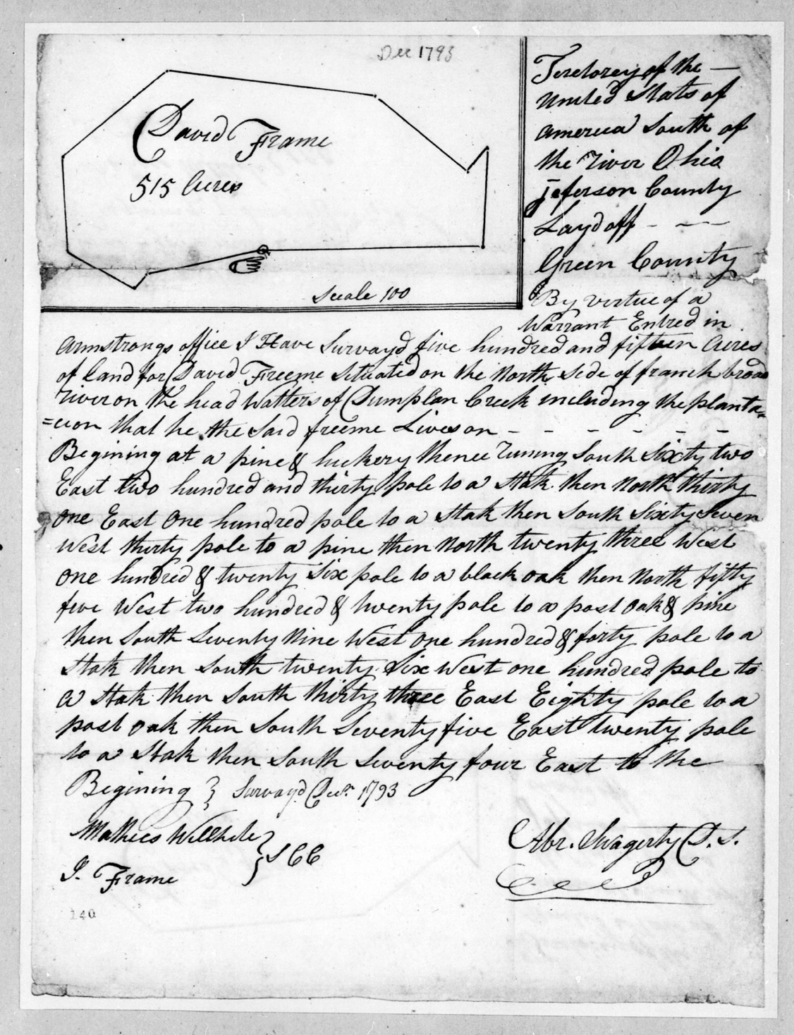
Figure 88 Abraham Swagerty Survey, 1793

Counties near Chattanooga, Tennessee, deep in Cherokee lands. The other five maps follow the same descriptive pattern and include a 585,000 tract “on the road from Knoxville to Nashville through which run Crab Orchard Creek,” near modern Crossville, Tennessee, also on Cherokee Lands. Swagerty provided his maps to his land-speculating collaborators at the conclusion of these scouting missions.
Land speculators marketed the surveyed Cherokee land to prospective colonizers who would occupy the “vacant” land. Then, sometimes years later, the colonizers would obtain a deed that shows up in the archives long after the destruction of Cherokee agricultural spaces rendered the land nearly irrecoverable for Cherokee ranchers and farmers. For example, John Hesse immigrated from Switzerland to Cherokee lands just beyond Hawkins’s line in the years before Cherokees and Hawkins marked the border. Hesse’s plantations lie near a spring on the property of what is now the Blackberry Farm Resort. A well-used flint rock quarry, a stone marker for a Cherokee road, and a stone-carved medicine wheel still found on the property suggest Hesse’s “vacant” land was likely conveniently cleared for him by Cherokees for deer herds and located along a well-established road. A stroll to the east side of the property reveals trees still displaying the remnants of hatchet marks and carvings in the shape of an owl that Cherokees left while blazing the line in 1797. Hesse, whose euphonious creek runs through the property, also built a mill in the area. He appears in the Blount County records as a resident after the official annexation of the valley after the 1798 Treaty of Tellico.
Hesse and the thousands of other colonizers did not build plantations and mills on Cherokee land themselves. They brought thousands of enslaved Africans. The maps and surveys tell us where Africans labored and how they circulated. Figure 89 Blount’s 1795 estimation of the enslaved population is likely grossly inadequate, as many enslavers resided inside undocumented Cherokee lands or on lands officially deeded to land speculators. The pattern of colonizers using enslaved labor to convert Cherokee commercial agricultural spaces into Euro-American plantations began with the earliest entrenchment in the Cherokee homelands and continued into the nineteenth century.
Henry Massengill entrenched on Cherokee lands in the early 1770s near what is now Piney Flats, Tennessee. Although Washington County Tax lists from 1779 list 32 enslavers owning only 102 enslaved, Massengill purported to own 151 with his son’s neighboring father-in-law, William Cobb. The pair enslaved so many “souls” that in 1777, they, meaning the enslaved, constructed a house of worship with “a section of benches on the back side so these slaves could come out and be refreshed body and soul.” Enslaved Africans on these types of plantations would have worked to transform the well-watered, cleared, and connected Cherokee agricultural spaces into fields resembling plantations further east. They did not live isolated but would have carved out the types of elbow room that other African communities did in different parts of the South. For those who could, self-emancipation within the Cherokee homelands was a frequent option early on.

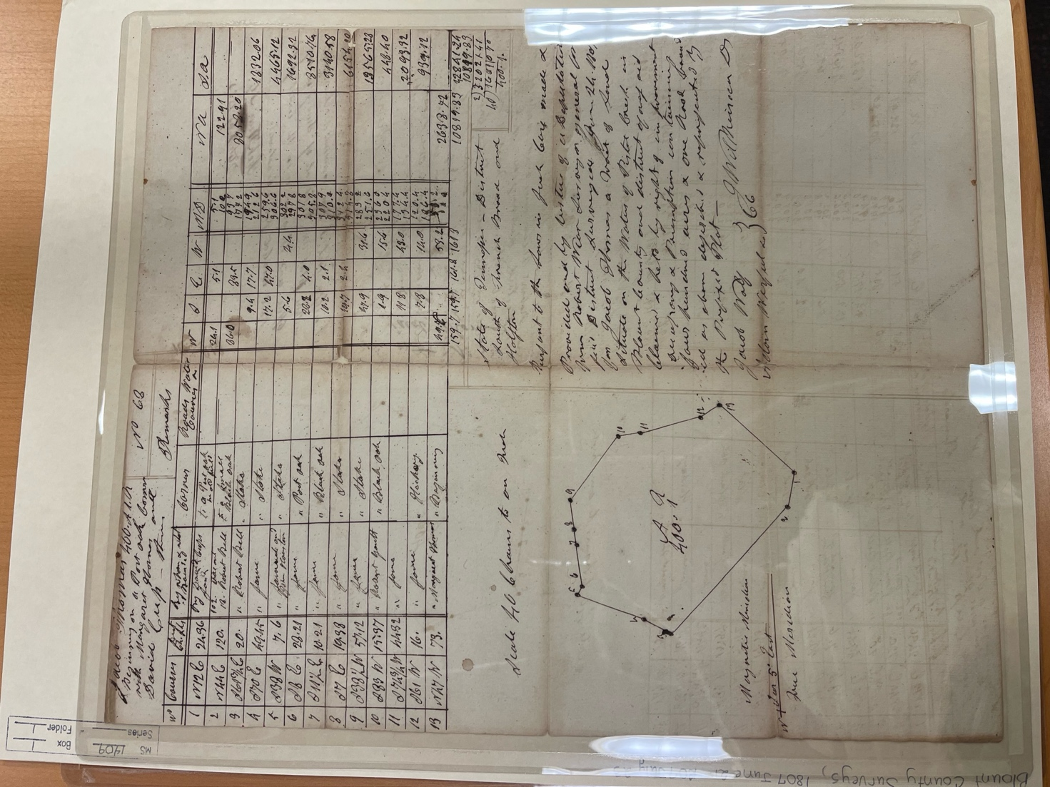
Figure 89 Blount County Survey, 1807 UTK Special Collections

Interlopers helped enslaved people escape to Cherokee territory on a riverine underground railroad. In 1777, an enslaved man self-emancipated from his enslaver’s plantation along the Holston River. According to a report, he “inquired the way to the [Cherokee] Nation,” and “some Villains” had “conveyed him down the Holston [River] to the settlement on the Ohio [River]” via “people who carry with them all they can, either black or white servants.” In 1788 Micager Crews, Alea Frasier, Elisha Hoskins, and William Kanady attempted to help “Two Negroes fellows & a wench” escape west towards Cherokee Territory. They were caught. Cherokees had long harbored enslaved Africans and integrated them into their society. However, as more integrationist Cherokees began to produce European crops for commerce, they began enslaving Africans, making self-emancipation for the enslaved into Cherokee territory less likely.
Enslaved Africans carved out vast swaths of connections with fellow African acquaintances as they frequently circulated among colonists. By the mid-1780s, enslaved labor was transforming the agricultural and economic landscape of the Long Island Frontier. Enslavers lent out enslaved labor, causing Africans to travel the area frequently. U.S. officials readily participated in the practice of lending out enslaved labor. In November 1796, Silas Dinsmore, the U.S. agent to the Cherokees, paid local enslaver David Henley “three shillings or half a dollar a day” for three days labor of Antonio and Proupapa in helping to construct the Tellico Blockhouse, noting it as “public service.” With the enslaved labor clearing fields and constructing buildings, the hundreds of surveys recorded in the area provide a map of when and where enslaved Africans lived, traveled, and socialized along the Long Island Frontier.
Enslaved people lived and tolled in urban areas that replaced Cherokee towns. The “Plan of Knoxville” shows plots reserved for several well-known enslavers. Figure 90 Enslaved laborers would have constructed and lived in the #36 plot of Charles McClung, who ran ads in the Knoxville Gazette for recouping self-emancipated Africans. The map labeled plots 18 and 15 for the notorious enslaver and land speculator William Blount. Perhaps designers reserved plot #15 for a number of the 26 Africans Blount enslaved. The map provides a spatial framework for envisioning how Jack, Blount's personal slave, would have navigated the city streets and who he would have seen and interacted with.
In the first years of the nineteenth century, Cherokees held a series of councils to debate their course of action. Colonial entrenchment had destroyed a sufficient amount of their agriscapes and displaced them from enough cultural anchors to alter Cherokee society. The debates, often interpreted as regional factionalism, centered around new iterations of traditional strategies. Many Cherokees still favored integration. However, with the ecological destruction brought by colonizers, the conventional Cherokee strategy of integrating foreign peoples into Cherokee society had transformed into some Cherokees arguing for their acculturation into colonial structures to remain in their homelands. Cherokees also realized expulsion no longer served as a tenable option. Instead, the Cherokees would have to enter diaspora to maintain their traditional
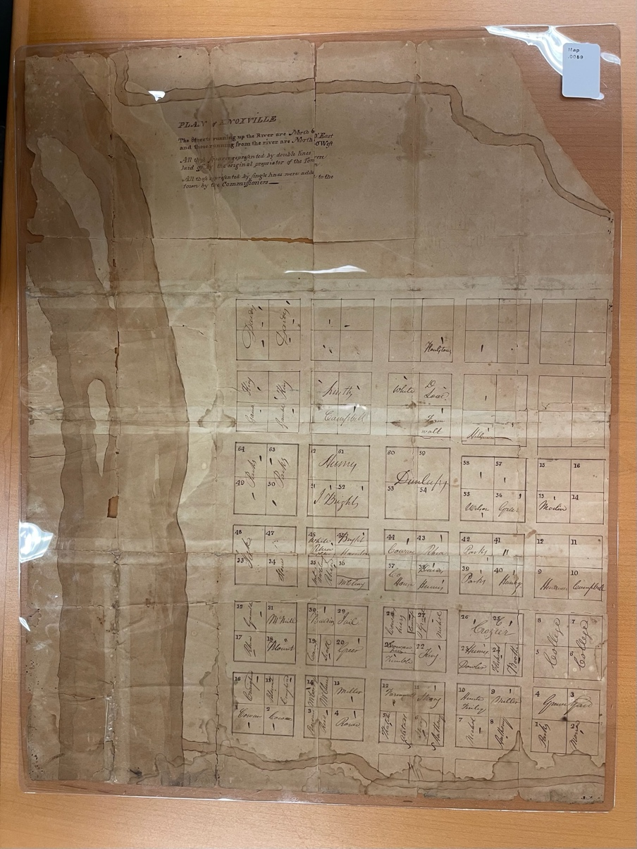
Figure 90 Plan of Knoxville, UTK Special Collections, 1791
watered soil, and the flatlands of the western part of Tennessee still contained fictitious rivers feeding into the Mississippi River, which the mapmaker meant to evoke access to trade as society.
Lewis’s 1804 map of Tennessee demonstrates that colonial entrenchment progressed much as it had for fifty years. Figure 91 The map’s valleys contained the promise of well-
much as alluvial flood plains. The mapmaker neatly bounded colonial spaces showing colonized settlements within established counties, a cartographic substantiation of land tenure. However, the map placed Cherokee and Choctaw lands in ambiguity. The map shows the borders between the Cherokees and the U.S. but plainly establishes them as superseded by state boundaries and,
by default, not divorced from U.S. territory. As groups of individual colonists entrenched in the areas around remaining Cherokee agriscapes, land speculators employed now tried-and-true methods of commodifying Cherokee lands.
The toponym for the non-bounded “Cherokee Country” runs through a large tract labeled the “Tennessee Company” containing the Mussel Shoals along the Tennessee River. Vigorous colonial competition for this area had existed for decades, resulting in repeated attempts by land speculators to gain substantiation for their provisional titles by attracting colonizers to entrench there. Michael Harrison, the proprietor of the Tennessee Company, provocatively advertised the area’s “rich lands” and “big spring.” By 1808, he had convinced 2545 colonists to entrench in the area. A twentieth-century scholar fondly wrote of the colonizers that “they intended to buy land of the government whenever the sales began, and while they waited, they proceeded to put
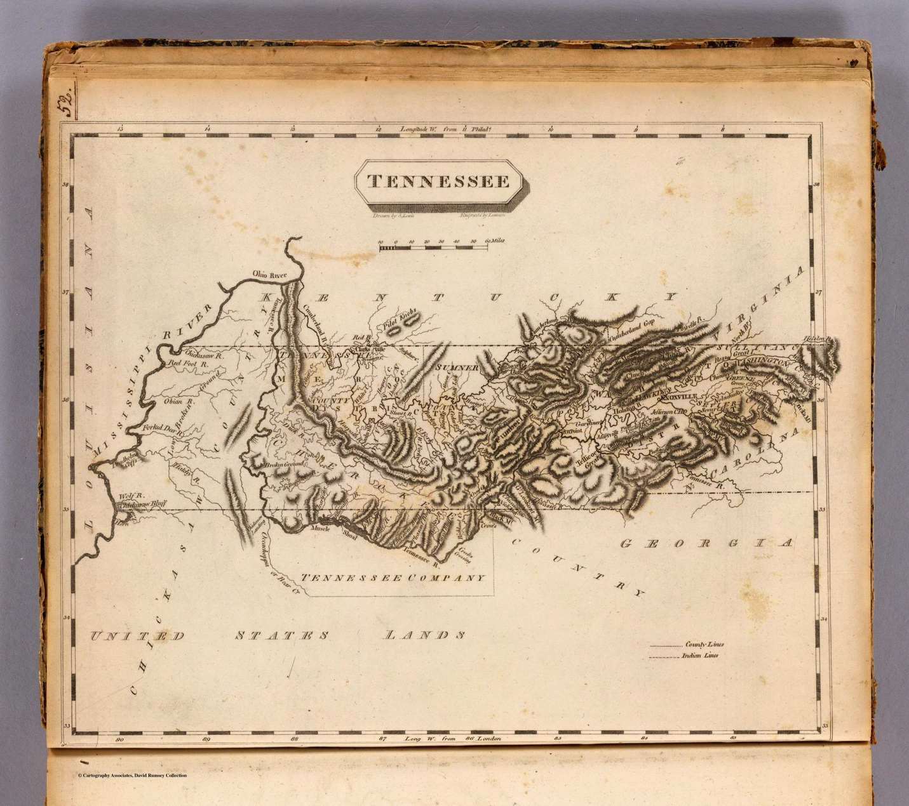
Figure 91 Tennessee. Lewis, Samuel, Drawn by S. Lewis. Engraved by Lawson. (Published by John Conrad & Co., Philadelphia. 1804) in A new and elegant general atlas, comprising all the new discoveries, to the present time, Aaron Arrowsmith. https://www.davidrumsey.com/luna/servlet/s/en6lgb

out their crops—chiefly corn—and erect their houses. This done they built themselves a mill and… constructed a distillery.” The author comments that the colonizers “were evidently of the poorer classes, since there were only 344 slaves among them.” This group represented the quintessential demographic for colonizers competing for access to land that land speculators catered to. Even Doublehead, a Cherokee who had pushed for assimilation, had accumulated substantial personal landholdings and enslaved Africans, including a woman named Pebe with her four children and three boys named Jack, Joe, and Austin. Doublehead had a large plantation reserved for himself in the region in 1806 as part of a Cherokee land “cession” to the U.S. government caused by previous entrenchment’s ecological transformation. Given the new iteration of the Cherokee’s long-standing tradition of integration, Doublehead’s actions were not surprising.
Cherokees stayed consistent in collectively appealing to a government authority they felt was responsible for restraining local colonizers. Groups of Cherokees, some representing acculturation in the homelands and others representing traditionalism through diaspora, made regular trips to Washington D.C. to appeal to President Thomas Jefferson regarding safeguarding their land rights wherever that might be. A letter from Cherokees who wished to remain in their homelands stated they desired to “hold to our country as far as the present boundary line between us, the Cherokees, and the whites.” They told Jefferson that they would follow his advice “to learn your ways.” Meanwhile, another delegation wrote to Jefferson that a contingency of Cherokee “is determined to move over the [Sic]Massippa if they like the country when they explore it.” Jefferson wrote back to the Cherokees who wished to remain that they should “make a law for giving to each head of a family a separate parcel of land which when he has built upon it and improved it shall belong to him and his decedents forever.” The dismantling of Cherokee women’s traditional monopoly on land rights represented a substantiation of colonial land tenure that sought to erode aspects of Cherokee society directly tied to their homelands. Throughout the first decade of the nineteenth century, Cherokees continued to adapt strategies to combat settler colonialism in its ever-evolving forms, a battle they continue to fight.

Conclusion
Many disparate groups sought to carve out space in the Cherokee homelands during the final decade of the eighteenth century. Integrationist Cherokees such as Na-ye-hi had children with colonizers, enslaved several Africans, and owned land via Cherokee and colonial conventions. Expulsionist Cherokees such as DoubleHead adopted some facets of European-style commercial agriculture but attempted to remain physically isolated from Anglo-Americans.
Men representing U.S. interests in the region fought a documentary war with land speculators regarding jurisdictional rights. Land speculators who had first assumed federal authority under the Southwest Territory and then invented the State of Tennessee to circumvent the least convenient aspects of federal policy used the perception of increased political authority to promote their personal economic interests. Meanwhile, thousands of colonizers enticed by the land speculators’ advertisements entrenched on Cherokee lands using enslaved labor to transform the landscape. Enslaved Africans drove the processes of settler colonialism by physically altering Cherokee agricultural spaces, all while constructing a society of their own.
Royce’s map gives an erroneous visual narrative of a linear temporal cession of Cherokee land. Figure 92 According to Royce’s map, each treaty resulted in the Cherokees giving up land, which instantaneously, theoretically and practically, became British or U.S. territory, leading to Euro-American settlement in that area. As contemporary maps and related documentation demonstrate, Royce’s narrative is shallow and completely backward. Treaties containing Cherokee land cessions resulted from the prior actions of Euro-American entrenchment. The entrenchment process had to geopolitically affiliate and physically transform the landscape before land cession articles in treaties added another layer of reinforcing an area’s market stability.
The on-the-ground contested spaces in which these groups interacted determined the actual boundaries that later became represented as “official” on documents and maps. The movement of boundaries over time shows where a contested space had become engulfed in an active Euro-American land market. Maps’ shifting political boundaries indicated which government entity the participants in the land market currently had confidence in. The overlapping territories on contemporary maps were a symptom of the yet-to-be-determined contests that were less about political territorial sovereignty and more a reflection of the colonists’ perception of the physical and geopolitical nature of a region’s landscape that determined its marketability.
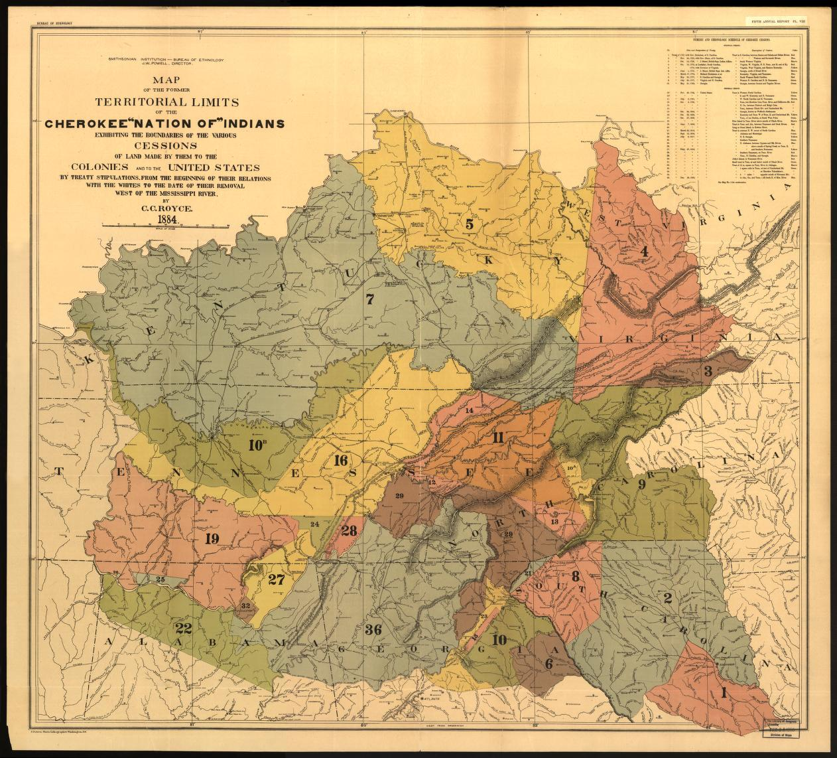
Figure 92 C.C. Royce, Map of the former Territorial Limits of the Cherokee Nation, 1884

CONCLUSION
Maps allowed an exploration of developing colonial aspirations and Indigenous spatial epistemologies in the early American Southeast. They showed changes in the Native Southeast’s Indigenous geopolitical environment as the effects of colonial endeavors influenced interactions between Indigenous groups. The maps demonstrated shifts in the economic nature of European imperial colonial endeavors from seeking mineral riches in the sixteenth century to focusing on establishing Indigenous trade markets and expanding agricultural production in the seventeenth and early eighteenth centuries. Along with representing the changes brought on by colonial intrusion, maps facilitated the expanse and economic aspirations of colonial projects.
A decolonized examination of the maps revealed the Indigenous sources that informed the European mapmakers. Early American European maps were meant for European audiences, but they were more than European productions. Diverse groups of people contributed to colonial cartography. Indigenous communities provided Euro-American informants with geographic knowledge regarding regional hydrography and topography. European cartographers appropriated Indigenous geographic knowledge to produce maps that reimagined the landscape. European mapmakers repurposed Indigenous geographic understanding of the land to market territory for the economic opportunities of the specific colonial moment. Native nomenclature for areas with good fishing waters and rich hunting grounds became Baroque royal fantasies, such as Jamestown and Charleston, to attract European buyers. Early European maps of the Southeast empowered land brokers and enticed colonizers to occupy interior territories permanently. However, as the maps demonstrated, these imperial-driven colonization projects sought the resources the land could produce rather than the land as an abstract commodity. Exploring the ways in which the landscape shaped Cherokee society’s structure helped understand why the colonial transition to commodifying access to Cherokee land would prove existentially threatening.
Cherokee society formed inextricably within the ᎦᏙᎯ ᏄᏍᏗᏓᏅ gadohi nusdidanv (landscape) that shaped it. Cherokee oral tradition pointed to an essential connection between the emergence of Cherokee culture and the land in which it formed. Linguistic and archeological evidence complemented the pluralistic but deeply rooted Cherokee oral traditions. The ᎦᏙᎯ ᏄᏍᏗᏓᏅ gadohi nusdidanv (landscape) contoured the spatial aspects of the Cherokee’s matrilineal, matrilocal, clan-based society. A society that maps showed coalesced with other Indigenous groups during the sixteenth century.
Sixteenth-century French maps drawn from information given by Indigenous people residing in the Cherokee homelands provided clues to the processes of coalescence in the Native Southeast. The maps showed disparate linguistic groups living adjacent to one another. Cherokee oral tradition corroborated the information on the maps, as did archeological evidence. The triangulation of the evidence and demonstration of changes to material culture and representation on maps showed coalescence happened rapidly over a few generations through demographic ascendency driven by Cherokee women. Understanding how Cherokees absorbed foreign groups helped make connections to strategies Cherokees would adapt to combat colonial entrenchment. When groups of individual colonizers arrived to appropriate Cherokee land, they found the cleared fields and pastures of the Cherokee’s agricultural landscape ideal for rapid entrenchment.
An analysis of Cherokee agriscapes showed that the Cherokees practiced agricultural methods far from the colonized terms of hunters and gatherers. Cherokees had constructed elaborate systems of fields and pastures that sustainably produced abundant harvests of diverse cultigens and augmented deer herds. Cherokee oral tradition spoke to the relationship between Cherokee religion, culture, and the agriscapes they fashioned over the generations. Oral tradition regarding agricultural knowledge matched archeological evidence of sustained occupation, demonstrating the sustainability of Cherokee agriculture and reifying Cherokee’s connection to the landscape.
The array of agriculture required Cherokee men and women’s participation in constructing and maintaining the fields, pastures, and groves. This insight lends nuance to the way we understand Cherokee gender roles through agricultural practices. Men and women held disparate roles in the harvesting and slaughtering of food products, but their activities relied on mutual labor. The labor invested to establish and sustain Cherokee agriscapes made them particularly valuable. When colonizers began entrenching on and near Cherokee land, the ecological destruction of European-style agriculture rendered the land unviable for Cherokee farmers without mustering a significant amount of labor to restore them.
Beginning in the 1740s, Cherokees invited British colonial officials to construct forts deep in their homelands. Cherokees perceived the forts as centers of commerce rather than military outposts. The invitations demonstrated that Cherokees viewed high level colonial authority as responsible for regulating trade with individual colonists, still their most involved interactions with colonizers. The maps showed that Cherokees interacted with British colonists on separate planes. They recognized that individual colonizers often acted apart from official colonial authority. An invitation to build forts next to their towns represented an adaptation to the Cherokee’s traditional strategy for integrating foreign peoples into their society. They recognized the need to combat individual colonists’ schemes at a moment when the colonists sought material goods. Groups of individual colonists began seeking access to Cherokee lands rather than the material goods the land could produce.
As colonists turned from participating in commerce involving agricultural products and began vying for access to land, they turned their gaze to susceptible Cherokee agriscapes. Maps showed that colonizers employed two methods of entrenchment in the 1750s. Along the Cherokee’s Keowee Frontier, collective groups of colonists occupied fields on or near Cherokee lands, weaponizing ecological destruction to reduce the Cherokee’s motivation to retain the land for agriculture. The local colonists would then appeal to colonial officials to validate their entrenchment. They leveraged their substantiation of land tenure on official colonial recognition through land titles that would make the land they entrenched on fungible. Documenting the mechanics of colonial entrenchment demonstrated how individual colonizers’ intentional ecological destruction drove settler colonialism.
Large-scale land speculation ventures drove entrenchment on the Cherokee’s Long Island Frontier. Influential colonists formed land companies that marketed to groups of clients through maps. After failed attempts to promote the land effectively in the 1750s, mapmakers transformed Cherokee geographic knowledge on maps drawn by John Stuart and others to reimagine the land as ideal for plantation agriculture. They removed mountains and rerouted rivers to provide an idealist image for would-be colonizers. The speculators enticed eager groups of colonists to entrench on Cherokee lands. The land companies’ proprietors worked to obtain colonial land titles to satisfy entrenchers’ substantiation of land tenure and to increase the marketability of other provisional land holdings. The men often served as government administrators themselves, working against official British imperial policy for personal gain. Their actions demonstrate that the developing land market functioned without government sanction but depended on the perception of authoritative support for entrenchment to drive it. The process of market-driven entrenchment showed the individualistic and economic nature of settler colonialism.
Cherokees adapted several strategies to combat entrenchment. Individually, some Cherokee women fought to retain their land rights by appropriating colonial law. Molly asserted her matrilineal Cherokee right to her orchards while using her son with a white man’s status to ensure her family retained her land rights despite the surrounding ecological destruction that led to Cherokees “ceding” her land to South Carolina. Molly’s actions demonstrated an adaptation of Cherokees integrating foreigners into their society. Her retention of her matrilineal family’s land helped us understand studies of settler colonialism’s assertions as incomplete without an examination of the Indigenous strategies to counter colonial substantiation of land tenure.
Collectively, Cherokees continued to appeal to the highest level of colonial authority to combat entrenchment. Cherokees witnessed colonial officials like Richard Henderson and the members of the Watauga Association act as individuals or collectively to usurp imperial authority to gain access to Cherokee land and to market entrenchment. Cherokees countered by employing traditional strategies of integration and expulsion. Although the Cherokees disagreed on the best course of action, they remained unified in combating entrenchment. Some Cherokees led by Dragging Canoe chose to implement “cutting-off” methods of violence against trespassing colonists. Others like Oconastota, Atakulllakulla, and Nanye’hi appealed to the highest level of colonial authorities, British and later U.S. officials, to hold them accountable for colonial invasion. The Cherokee strategies demonstrated the cultural continuity of Cherokee society through the upheavals of the late eighteenth century. The methods of entrenchment remained the same despite the American Revolution, which showed that setter colonialisms’ assertions did not depend on an imperial project; instead, they could weaponize a regime change to augment the land market.
Land speculators and individual colonists sought substantiation of land tenure by espousing any government entity that would back their land claims. Men like William Blount and John Sevier switched political allegiances several times, including forming an independent government to validate land titles and augment the value of potential land investments. Sevier and other militia commanders employed scorched earth tactics to eradicate Cherokee towns. However, unlike previous military invasions, individual groups of colonists followed in the wake of the military invasions, quickly entrenching on Cherokee territory. Cherokees appealed to U.S. commissioners and federal officials to uphold their responsibility to protect them from colonists bent on gaining access to their lands. The maps of the era show how colonizers weaponized them to advertise for further occupation and substantiate prior entrenchment. Colonizers employed cartographic assertions of firm state and national boundaries that superseded treaty provisions to reify land investments. The maps demonstrated that state-building processes are a settler colonial tool that individual groups of colonists espoused for settler colonialism’s defining characteristic, substantiation of land tenure.
The map the Cherokees drew at the Hopewell Conference in 1785 remains crucial primary source material. The map demonstrated the Cherokee’s traditional view of their territory remained intact. The river orientations and the visualization of natural barriers, as recognized physical territorial boundaries, provide clues to the Cherokee’s worldview. The decolonized depiction of the map provided context for examining other European-authored maps sourced from Cherokees in a decolonized fashion. The legacy of colonized archives has resulted in the modern memorialization of colonizers as patriotic progenitors of national and state-building projects. This project’s demonstration of settler colonialism as individually derived and economically driven creates new paths for interrogating settler colonialism’s core assertions.

Settler Colonialism’s Modern Memorial Landscape: Substantiation and Resilience
Settler colonialism’s substantiations intentionally produce complacent ignorance for modern colonizers. Beyond the rhetoric during the initial period of intrusive colonization, settler colonialism’s ideological justifications for land tenure require tangible maintenance over time. Perpetuating a settler-colonial assertion includes building a hegemonic memoryscape that reinforces the idea that colonial entrenchers were heroic and autochthonous. Surrounded by European-style place names, monuments to “heroic pioneer settlers,” and documented “initial” settlement that extends deep into authoritative western archives, current residents in the Cherokee homelands remain mainly oblivious to Cherokee land dispossession and slavery’s horrific violence that marked the period of initial colonial entrenchment in the area. The monuments to “pioneers” and the neglect of Cherokee sites create a spatial narrative that reifies settler colonialism’s assertions. The colonial memorial landscape in the Cherokee homelands is the product of nearly two-hundred-fifty years of settler-colonial memory work, and they have proven devastatingly efficacious.
Concrete parking lots surround the mound at Noquisiyi. Figure 93 However, they are not for visitors to the site that has remained a Cherokee cultural anchor to their homelands for centuries. Like ᎩᏚᏩ giduwa (Kituwah), Noquisiyi and many other Cherokee sites and memorials dwell in intentional obscurity. Even the stories of ostensive altruism that “saved” the sites, like the penny fundraiser conducted by children in Franklin, NC, to raise $1,500 for the
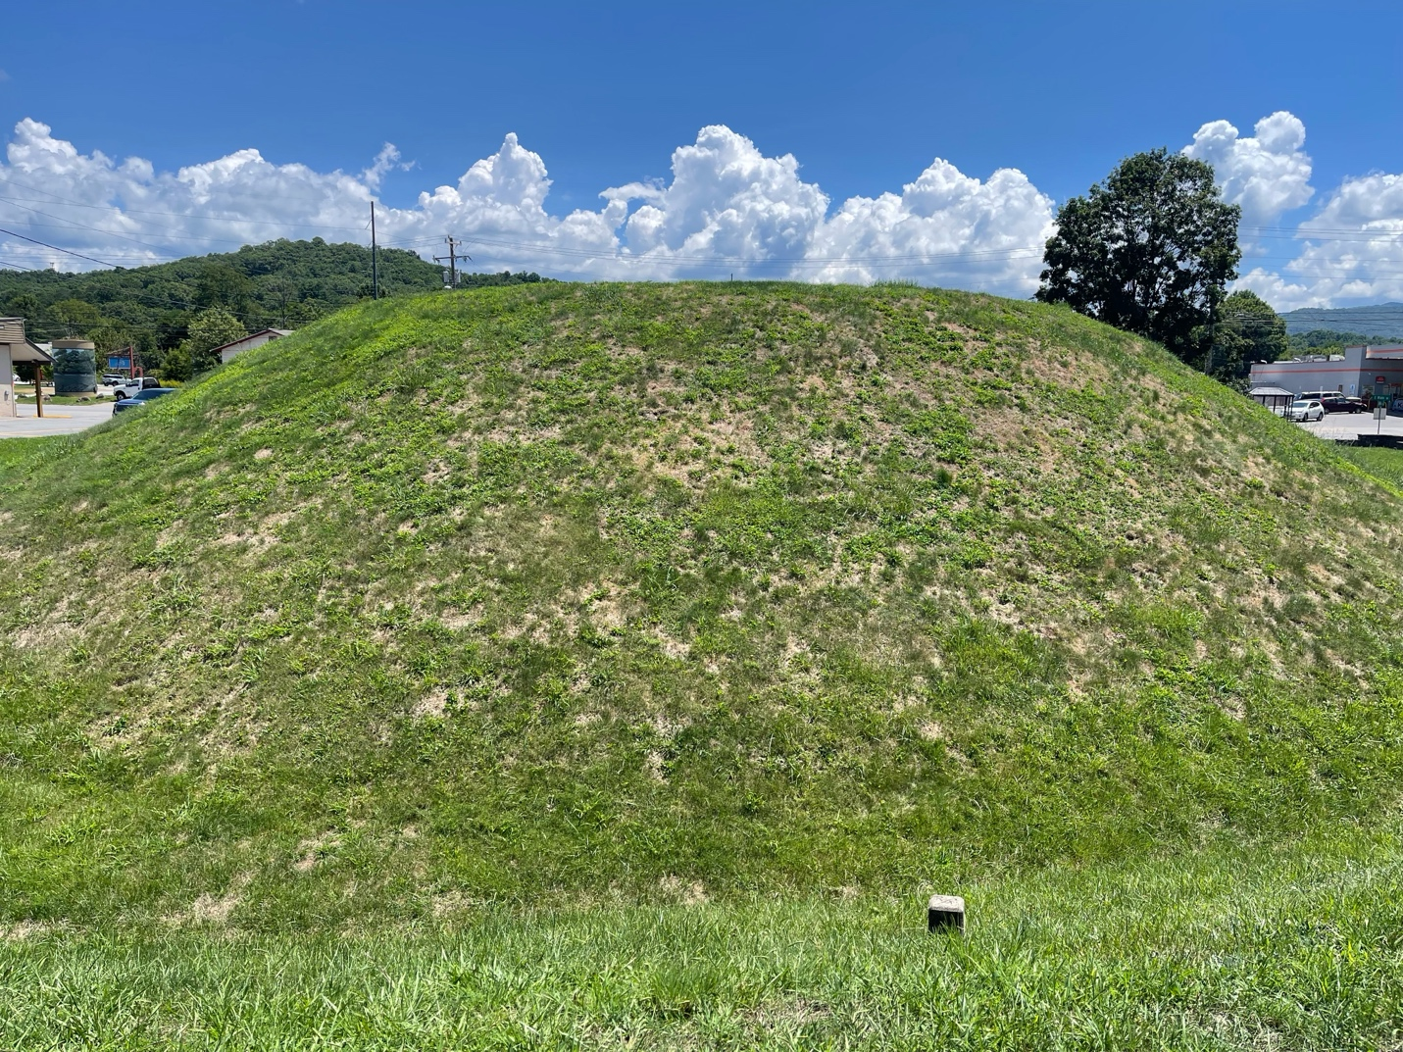
Figure 93 Noquisiyi Mound, picture by author.

Noquisiyi Mound’s preservation, smack of colonial assertions of land tenure. Settler colonial’s perpetual substantiation of land tenure can only allow Cherokee sites to exist if they remain divorced from a relationship between the Cherokee’s land tenure and the region’s history. The colonized narrative of the mound states that unnamed Mississippian peoples built it, government-backed military troops conquered it, and Franklin’s children saved it. In this colonial narrative, not only do Cherokee land claims disappear, but the Cherokee’s social framework that the site anchored to the landscape becomes unimaginable and incompatible. However, the colonial memorial landscape presents a different perspective regarding colonial entrenchment.
The Jesse Duncan Memorial’s history has been nearly as obscure as Duncan the man. Proposed in 1904 to enough fanfare to warrant newspaper coverage in North Carolina, the memorial spent most of its first one-hundred-fourteen years tucked away on forested private property. Figure 94, Figure 95 The memorial’s secluded location did not prevent the Tennessee State Historical Commission from erecting a historic highway marker on a prominent thoroughfare in an area referred to locally in East Tennessee as “Boone’s Creek,” a nod to the colonial narrative that Daniel Boone spearheaded the area’s initial “settlement.” Figure 96
As the differences in the 1909 newspaper article and the road marker indicate, the historical depiction of Duncan’s death had changed significantly during the twentieth century. The newspaper article conceded that tradition had it that Indians fired upon Duncan’s expedition for trespassing into Cherokee territory. The more recent historical marker recounts Duncan, a helpless pioneer, being mercilessly slain and scalped “in this area” as opposed to “Indian territory.” The changes in the narrative represent the memory work of the symbolic annihilation

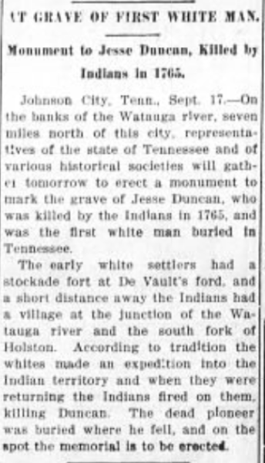
Figure 94 Article in the Goldsboro Daily Argus, Goldsboro, North Carolina, Sep 17, 1909

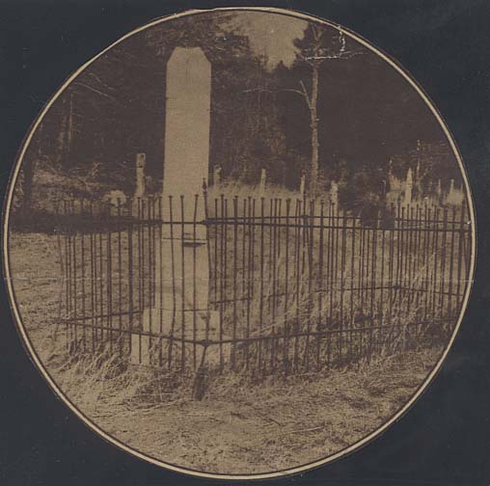
Figure 95 Undated photo of Jesse Duncan Memorial, Tennessee State Library and Archives

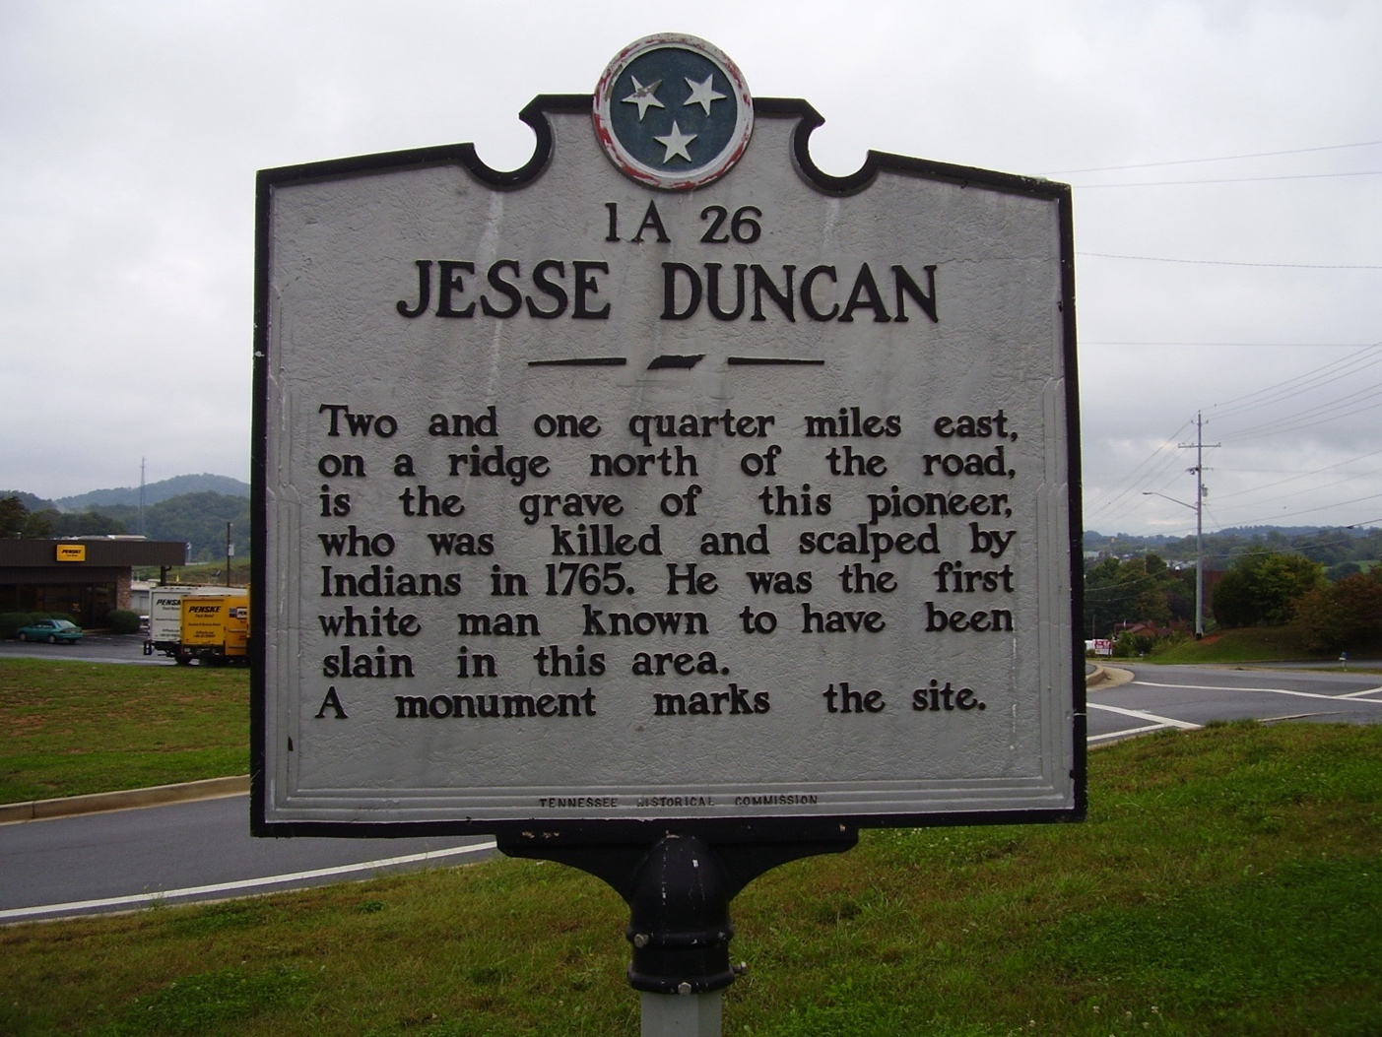
Figure 96 Jesse Duncan historical road marker at the intersection of Hwy 36 and Boone’s Creek Road, Johnson City, TN.

of Cherokee occupancy from the region’s history and the mythologizing of colonizers as martyred “settler pioneers.”
Duncan’s legacy took a dramatic turn in 2018 when Rogers Development decided to center the Duncan memorial in a neighborhood development site on the extreme north side of Johnson City, Tennessee. Figure 97 The community is an extension of an affluent subdivision, boasting its own elementary school and exclusive neighborhood amenities. Rather than reserve a prime cul-de-sac lot for Duncan and his wife Elizabeth Dodge Duncan’s gravesite, Rodgers Development placed the memorials in the center of the neighborhood’s terminal roundabout. Rodgers Development sardonically named the subdivision “Duncan’s Retreat,” further entangling the community with the historical significance of Jesse Duncan’s mythologized pioneer legacy. Figure 98
The developer positioned the gravesite as a prominent reminder to all who pass by, including the neighborhood’s children on their bikes, of Duncan’s martyrdom. As geographers Derek Alderman et al. have demonstrated, “The geographic arrangement, design, and location of memorials and monuments can significantly influence the power they are (not) perceived to have, as well as the kinds of messages they communicate about the past.” By relocating the memorial into a position of drastically increased visibility, the memorial’s message has gained a more active place within Upper East Tennessee’s broader memoryscape. Naming the community “Duncan’s Retreat” provides a measure of reassurance to the community that the first white settlers’ sacrifices brought the comfort and stability they now enjoy to an otherwise “untamed” and “savage” land. Duncan’s memorials represent one of many examples of the Cherokee homeland’s colonial memoryscape that is part of a substantiation of land tenure. Understanding

Figure 97 A damaged Duncan Memorial at the terminal roundabout. Note that the house is being constructed on the actual gravesites. Photograph by author.


Figure 98 Entrance facade at Duncan’s Retreat community, Johnson City, TN, photograph by author.

settler colonialism as an individually derived assertion creates an avenue for its collective refutation.

BIBLIOGRAPHY

Primary Sources

Archival Sources
Archives at the Museum of the Cherokee Indian, Cherokee, NC.
Clements Library, Ann Arbor:
William Lytton Papers
Filson Historical Society:
Author Campbell Papers, Virginia Land Papers, Folder 21, Filson Historical Society, Louisville, KY.
William Dells, Journal, 1776, in the Arthur Campbell Papers, Filson Historical Society, Louisville KY.
Henry Massengill Monument, Winged Deer Park, Piney Flats TN, from the Memoirs of Henry Massengill.
Historical Society of Pennsylvania:
Indian Petitions to the President Thomas Jefferson, Historical Society of Pennsylvania, Philadelphia.
Library Company of Philadelphia
Thomas Hutchins Papers Box 1, Folder 11, Historical Society of Pennsylvania, Philadelphia.
John Carter Brown Library:
Newberry Library:
John Howard Payne Papers, 1826, Ayers Collection, Box 7, folder 1, Newberry Library, Chicago.
William Blount Papers, Ayer Collection MS 74, Box 1, Folder 11, Newberry Library, Chicago
SCIA: see McDowell, William L., Jr. (Editor) 1970 Documents Relating to Indian Affairs, Colonial Records of South Carolina, Series 2: The Indian Books, Volume 3. University of South Carolina Press, Columbia, South Carolina.
University of Tennessee Special Collections
Draper Papers, Draper Manuscripts, Wisconsin Historical Society, Madison, Wisconsin, microfilm at University of Tennessee Special Collections Reading room, Hoskins Library, Knoxville, TN

Online Sources
American State Papers Vol. II Indian Affairs, https://lccn.loc.gov/97080286
Belt, Dr. Tom “Judaculla Rock~Giant & Legend by Cherokee Scholar Tom Belt.” YouTube, July 10, 2021. https://www.youtube.com/watch?v=N28Tc50Qi6c.
https://blountmansion.org/enslaved-persons/
Colonies General C.O., Public Record Office, London. Accessed through Colonial America Database, https://www-colonialamerica-amdigital-co-uk.utk.idm.oclc.org
Colonial and Sate Records of North Carolina, Documenting the American South. University Library, The University of North Carolina at Chapel Hill, 2007. http://docsouth.unc.edu/csr/index.php/document/csr01-0061.
Chicken, George, 1685-1727. “George Chicken Journal” Lowcountry Digital Library, South Carolina Historical Society, 1715-1716, https://lcdl.library.cofc.edu/institution/south-carolina-historical-society/
Evans Early American Imprint Collection, https://www.readex.com/products/early-american-imprints-series-i-evans-1639-1800
Founders Online, National Archives, https://founders.archives.gov
Gallica https://gallica.bnf.fr/accueil/fr/html/accueil-fr
Monroe County Historical Papers and Other Material, A&M 2537. Margaret B. Ballard, Compiler. West Virginia and Regional History Center, https://archives.lib.wvu.edu/repositories/2/resources/5369
Native American South Carolina Digital Archive, The University of South Carolina Lancaster Native American Studies Center, https://digital.tcl.sc.edu/digital/collection/nasca
Tennessee Constitution, 1796, 39, http://tsla.tnsosfiles.com/digital/teva/transcripts/33633.pdf.

Published Primary Sources
Adair, James. The History of the American Indians; Particularly Those Nations Adjoining to the Missisippi [Sic], East and West Florida, Georgia, South and North Carolina, and Virginia: Containing an Account of Their Origin, Language, Manners, ... With a New Map of the Country Referred to in the History. By James Adair. London: printed by Edward and Charles Dilly, 1775.
De Brahm, John Gerard William, and Louis de Vorsey. De Brahm’s Report of the General Survey in the Southern District of North America. Edited and with an Introduction by Louis de Vorsey. Columbia: University of South Carolina Press, 1971.
Grant, James. “Journal of Lieutenant-Colonel James Grant, Commanding an Expedition against the Cherokee Indians, June-July 1761.” The Florida Historical Society Quarterly 12, no. 1 (1933): 25–36.
Hawkins, Benjamin, and H. Thomas Foster. 2003. The Collected Works of Benjamin Hawkins, 1796-1810. Tuscaloosa: University of Alabama Press.
Johnston, J. S. (1898). First explorations of Kentucky: Doctor Thomas Walker’s journal of an exploration of Kentucky in 1750, being the first record of a white man’s visit to the interior of that territory, now first published entire, with notes and biographical sketch; also Colonel Christopher Gist’s journal of a tour through Ohio and Kentucky in 1751, with notes and sketch. J. P. Morton and company.
Journal of Colonel John Herbert, commissioner Indian affairs for the province of South Carolina, October 17, 1727, to March 1927/8; edited by A. S. Salley.
Laudonnière, René Goulaine de., Martin. Basanier, and John Holles Newcastle. L’histoire notable de la Floride situee es Indes Occidentales, contenant les trois voyages faits en icelle par certains capitaines & pilotes françois,. A Paris: chez Guillaume Auuray, ruë sainct Iean Beauuais, au Bellerophon couronné, 1586.
Lederer, John, and William Talbot. The discoveries of John Lederer, in three several marches from Virginia to the west of Carolina, and other parts of the continent: begun in March, and ended in September, 1670, together with a general map of the whole territory which he traversed. [Charleston, S.C., Walker, Evans & Cogswell Co, 1891] Pdf. https://www.loc.gov/item/rc01002786/.
McDowell, William L, South Carolina. Archives Department., and South Carolina. Archives Department. Journals of the Commissioners of the Indian Trade, September 20, 1710-August 29, 1718. Columbia: South Carolina Archives Dept., 1955.
Mid-America; an Historical Review. Chicago: Loyola University [Institute of Jesuit History], Vol. 25, 1943.
Mitchell, John, and Arthur Young. 1775. American Husbandry: Containing an Account of the Soil, Climate, Production and Agriculture, of the British Colonies in North America and in the West-Indies ... London: Printed for J. Bew.
Norona, Delf. “Joshua Fry’s Report on the Back Settlements of Virginia (May 8, 1751).” The Virginia Magazine of History and Biography 56, no. 1 (1948): 22–41, http://www.jstor.org/stable/4245517.
Ogilby, John, and Arnoldus Montanus. 1670. America: Being an Accurate Description of the Nevv World: Containing the Original of the Inhabitants, by John Ogilby Esq; Master of His Majesties Revels in the Kingdom of Ireland. London: printed by Tho. Johnson for the author, and are to be had at this House in White. Fryers.
Saunders, Colonial Records of North Carolina
Shaftesbury papers and Other Records Relating to Carolina (1897; repr., Charleston, S.C.: Tempus, 2000.
Smith, Daniel. A Short Description of the State of Tennessee: Lately Called the Territory of the United States, South of the River Ohio: To Accompany and Explain a Map of That Country. Philadelphia: Printed for Mathew Carey by Lang and Ustick, 1796.
Smith, Genl Daniel, Robert Hays, Saml Johnston, I. Glasgow, Andrew Jackson, Christopher Greenup, John Reid, et al. “Papers of Gen. Daniel Smith.” The American Historical Magazine 6, no. 3 (1901): 213–35;
Thévenot, Melchisédec, Jacques Marquette, Saedor Iacovvits Boicoof, and Jan Swammerdam. 1687. Recueil de Voyages de Mr Thevenot. Paris: Chez T. Moette, John Carter Brown Library, Providence, RI.
Varnod to Humphreys, Dorchester, South Carolina, January 13, 1723, Society for the Propagation of the Gospel in Foreign Parts Manuscripts, MSS, B4, No 132; Lingberg, Frank J. “The Indian Frontier in South Carolina as Seen by the S.P.G. Missionary.” The Journal of Southern History 5, no. 4 (1939): 479–500.
Walker, Thomas. 1898. “Doctor Thomas Walker’s Journal of an Exploration of Kentucky in 1750, Being the First Record of a White Man’s Visit to the Interior of That Territory, Now First Published Entire, with Notes and Biographical Sketch.” Edited by J. Stoddard Johnston. First Explorations of Kentucky, Vice-President of the Filson Club. [Filson Club Publications, No. 13.] (Louisville: The Filson Club. 1898).
Whitaker, Arthur P. “Letters of James Robertson and Daniel Smith.” The Mississippi Valley Historical Review 12, no. 3 (1925): 409–12.
William L. McDowell, Documents Relating to Indian Affairs, 1754-1765, 1970,

Secondary Sources
Abernethy, Thomas Perkins. From Frontier to Plantation in Tennessee; a Study in Frontier Democracy. Chapel Hill: University of North Carolina Press, 1932.
Abernethy, Thomas Perkins. The South in the New Nation, 1789-1819. Baton Rouge: Louisiana State University Press, 1961.
Ablavsky, Gregory. Federal Ground: Governing Property and Violence in the First U.S. Territories. New York: Oxford University Press, 2019.
Akerman, James R, Robert W Karrow, Field Museum of Natural History., and Newberry Library. Maps: Finding Our Place in the World. Chicago: University of Chicago Press, 2007.
Akers, Donna L. “Decolonizing the Master Narrative: Treaties and Other American Myths.” Wicazo Sa Review 29, no. 1 (2014): 58–76. https://doi.org/10.5749/wicazosareview.29.1.0058.
Alden, John Richard. John Stuart and the Southern Colonial Frontier: A Study of Indian Relations, War, Trade, and Land Problems in the Southern Wilderness, 1754-1775. New York: Gordian Press, 1966.
Alderman, Derek H, and Jordan P Brasher. “Memorials and Monuments.” International Encyclopedia of Human Geography, 2nd Edition 9 (2020): 39–47.
Allen, Ben, and Dennis T. Lawson. “The Wataugans and the ‘Dangerous Example.’” Tennessee Historical Quarterly 26, no. 2 (1967): 137–47.
Allen, Christian David, and Kandace D. Hollenbach. “Coalesced Cherokee Communities in the Eighteenth Century: A Spatial and Elemental Analyses of the Ceramic Assemblage at Mialoquo (40MR3), an Overhill Cherokee Town in Monroe County, Tennessee.” The University of Tennessee, Knoxville, 2019.
Anderson, Chad. “Rediscovering Native North America: Settlements, Maps, and Empires in the Eastern Woodlands.” Early American Studies 14, no. 3 (2016): 478–505. https://www.jstor.org/stable/earlamerstud.14.3.478.
Anderson, Virginia DeJohn. Creatures of Empire: How Domestic Animals Transformed Early America. New York: Oxford University Press, 2010.
Armitage, David. “John Locke, Carolina, and the ‘Two Treatises of Government.’” Political Theory 32, no. 5 (2004): 602–27.
Arneil, Barbara. John Locke and America: The Defense of English Colonialism. Oxford: Clarendon Press, 1996.
Asaka, I. (2024). The endurance and expanse of settler colonial history. Settler Colonial Studies, 14(4), 465–469. https://doi.org/10.1080/2201473X.2024.2371485
Atalay, Sonya. Community-Based Archaeology: Research with, by, and for Indigenous and Local Communities. 1st ed. Berkeley: University of California Press, 2012.
Banivanua-Mar, Tracey, and Penelope Edmonds. 2010. Making Settler Colonial Space: Perspectives on Race, Place and Identity. Houndmills, Basingstoke, Hampshire: Palgrave Macmillan.
Banner, Stuart. How the Indians Lost Their Land: Law and Power on the Frontier. Cambridge, M.A.: Harvard University Press, 2005.
Barksdale, Kevin T. The Lost State of Franklin: America’s First Secession. 1st ed. University Press of Kentucky, 2009.
Barr, Juliana, and Edward Countryman, eds. Contested Spaces of Early America. University of Pennsylvania Press, 2014.
Basso, Keith. Wisdom Sits in Places: Landscape and Language Among the Western Apache. Albuquerque: University of New Mexico Press, 1996.
Bauer, Brooke M. Becoming Catawba: Catawba Indian Women and Nation-Building, 1540-1840. Tuscaloosa, Alabama: University of Alabama Press, 2023
Bauer, B., & Ellis, E. (2023). Indigenous, Native American, or American Indian? The Limitations of Broad Terms. Journal of the Early Republic 43(1), 61-74.
Baumflek, M., T. Cabe, J. Schelhas, and M. Dunlavey. “Managing forests for culturally significant plants in traditional Cherokee homelands: emerging platforms.” International Forestry Review 24, no. 3 (September 1, 2022): 298–314.
Beck, Robin A. “From Joara to Chiaha: Spanish Exploration of the Appalachian Summit Area, 1540-1568.” Southeastern Archaeology 16, no. 2 (1997): 162–69.
Beck, Robin, and Charles M Hudson. Chiefdoms, Collapse, and Coalescence in the Early American South. New York: Cambridge University Press, 2013.
Beck, Robin A., Lee Ann Newsom, Christopher B. Rodning, and David G. Moore. “Spaces of Entanglement: Labor and Construction Practice at Fort San Juan de Joara.” Historical Archaeology 51, no. 2 (2017): 167–93.
Belich, James. Replenishing the Earth: The Settler Revolution and the Rise of the Anglo-World, 1783-1939. Oxford: Oxford Univ. Press, 2011.
Belmessous, Saliha. 2015. Empire by Treaty Negotiating European Expansion, 1600-1900. New York: Oxford University Press.
Benton, Lauren A. A Search for Sovereignty: Law and Geography in European Empires, 1400--1900. Cambridge: Cambridge University Press, 2010.
Berkhofer, Robert F. “Jefferson, the Ordinance of 1784, and the Origins of the American Territorial System.” The William and Mary Quarterly 29, no. 2 (1972): 231–62.
Billington, Ray A. “The Fort Stanwix Treaty of 1768.” New York History 25, no. 2 (1944): 182–94. http://www.jstor.org/stable/23147791.
Blaakman, Michael A. Speculation Nation: Land Mania in the Revolutionary American Republic. Philadelphia: University of Pennsylvania Press, 2023.
Booker, Karen M., Charles M. Hudson, and Robert L. Rankin. “Place Name Identification and Multilingualism in the Sixteenth-Century Southeast.” Ethnohistory 39, no. 4 (1992), 399-451.
Borsk, Michael. “Conveyance to Kin: Property, Preemption, and Indigenous Nations in North America, 1763–1822.” The William and Mary Quarterly 80, no. 1 (2023): 87–124.
Boudreaux, Edmond A, Jay K Johnson, and Maureen Meyers. “Contact, Colonialism, and Native Communities in the Southeastern United States: University Press of Florida, 2020.
Boulware, Tyler. Deconstructing the Cherokee Nation: Town, Region, and Nation among Eighteenth-Century Cherokees. Gainesville: University Press of Florida, 2011.
Brooks, Lisa “Awikhiganwôgan ta pildowi ôjmowôgan: Mapping a New History,” Joint Forum on Materials and Methods in Native American and Indigenous Studies, William and Mary Quarterly 75:2, April 2018.
Brown, John P. Old Frontiers; the Story of the Cherokee Indians from Earliest Times to the Date of Their Removal to the West, 1838, by John P. Brown. Tennessee: Southern Publishers, inc., 1938.
Brown, Richard H.and Paul E. Cohen. Revolution: Mapping the Road to American Independence 1755 to 1783. New York: W.W. Norton & Company, 2015.
Brückner, Martin. The Geographic Revolution in Early America: Maps, Literacy, and National Identity. Chapel Hill: University of North Carolina Press, 2006.
Brückner, Martin, ed. Early American Cartographies. Chapel Hill, North Carolina: Published for the Omohundro Institute of Early American History and Culture, Williamsburg, Virginia, by the University of North Carolina Press, 2011.
Burns, Inez E., Daughters of the American Revolution Mary Blount Chapter (Blount County, Tenn), and Tennessee State Historical Commission. History of Blount County, Tennessee; from War Trail to Landing Strip, 1795-1955. Nashville: Benson Print. Co., 1957.
Burton, Antoinette. “Beyond the Big Tent: Recontextualizing Settler Colonial Studies.” Settler Colonial Studies 14, no. 4 (2024): 460–64. https://doi.org/10.1080/2201473X.2024.2371481.
Bushnell, Amy Turner and Greene, Jack P. “Peripheries, Centers, and the Construction of Early American Empires,” in Negotiated Empires: Centers and Peripheries in the Americas, 1500-1820, eds. Christine Daniels and Michael Kennedy, New York: Routledge, 2002.
Byrd, Jodi A. The Transit of Empire: Indigenous Critiques of Colonialism. University of Minnesota Press, 2011.
Calloway, Colin G. New Worlds for All. Indians, Europeans, and the Remaking of Early America Calloway, Calloway. Baltimore: Johns Hopkins University Press, 2013.
Calloway, Colin G. (Colin Gordon). Pen and Ink Witchcraft: Treaties and Treaty Making in American Indian History. New York, NY: Oxford University Press, 2013.
Campbell, William J. Speculators in Empire: Iroquoia and the 1768 Treaty of Fort Stanwix. Norman: University of Oklahoma Press, 2012.
Camp, Stephanie M. H. Closer to Freedom: Enslaved Women and Everyday Resistance in the Plantation South. Chapel Hill: University of North Carolina Press, 2004.
Canny, Nicholas P., and Alaine M. Low. The Origins of Empire: British Overseas Enterprise to the Close of the Seventeenth Century. Oxford: Oxford University Press, 2001.
Casey, Edward S. Getting Back into Place: Toward a Renewed Understanding of the Place-World. Bloomington: Indiana University Press, 1993.
Carter, Paul. The Road to Botany Bay an Exploration of Landscape and History. 1st University of Minnesota Press ed. Minneapolis: University of Minnesota Press, 2010.
Chambers, Ian. 2010. “The Movement of Great Tellico: The Role of Town and Clan in Cherokee Spatial Understanding.” Native South. 3, no. 1: 89-102.
Chambers, Ian. “A Cherokee Origin for the ‘Catawba’ Deerskin Map (c.1721).” Imago Mundi (Lympne) 65, no. 2 (2013): 207–16.
Chapman, Jefferson. Tellico Archaeology: 12,000 Years of Native American History. Norris, Tenn: Tennessee Valley Authority, 1985.
Chang, David A. The World and All the Things upon It: Native Hawaiian Geographies of Exploration. Minneapolis: University of Minnesota Press, 2016.
Cobb, Charles R. The Archaeology of Southeastern Native American Landscapes of the Colonial Era. Gainesville: University Press of Florida, 2019.
Cohen, Paul E., and David Rumsey. Mapping the West: America’s Westward Movement 1524-1890. New York: Rizzoli. 2002.
Cook, Robert A, and T. Douglas Price. “Maize, Mounds, and the Movement of People: Isotope Analysis of a Mississippian/Fort Ancient Region.” Journal of Archaeological Science 61 (2015): 112–28. https://doi.org/10.1016/j.jas.2015.03.022.
Corcoran, Paul. “John Locke on Native Right, Colonial Possession, and the Concept of Vacuum Domicilium.” The European Legacy, toward New Paradigms 23, no. 3 (2018): 225–50. https://doi.org/10.1080/10848770.2017.1416766.
Cotterill, R. S. “The National Land System in the South: 1803-1812.” The Mississippi Valley Historical Review 16, no. 4 (1930): 495–506.
Crane, Verner W. “The Tennessee River as the Road to Carolina: The Beginnings of Exploration and Trade.” Mississippi Valley Historical Review 3, no. 1 (1916): 3–18.
Cronon, William. Changes in the Land: Indians, Colonists, and the Ecology of New England. New York: Hill and Wang, 1983.
Cotterill, R. S. “The National Land System in the South: 1803-1812.” The Mississippi Valley Historical Review 16, no. 4 (1930): 495–506. https://doi.org/10.2307/1896541.
Cumfer, Cynthia. Separate Peoples, One Land: The Minds of Cherokees, Blacks, and Whites on the Tennessee Frontier. 1st ed. Chapel Hill: University of North Carolina Press, 2007.
Cumming, W. P. “The Parreus Map 1562 of French Florida.” Imago Mundi. Vol. 17, 1963. pp. 27-40
Cumming, William Patterson, and Louis De Vorsey. The Southeast in Early Maps. 3rd ed. / rev. and enl. By Louis De Vorsey, Jr. Chapel Hill: University of North Carolina Press, 1998.
Cutler, H. G. (Harry Gardner). History of South Carolina. Edited by Yates Snowden. Chicago, New York: The Lewis pub. co., 1920.
Delcourt, Paul A, and Hazel R Delcourt. Prehistoric Native Americans and Ecological Change: Human Ecosystems in Eastern North America since the Pleistocene. Cambridge, UK; Cambridge University Press, 2004.
De Vorsey, Louis. The Indian Boundary in the Southern Colonies, 1763-1775. Chapel Hill: University of North Carolina Press, 1966.
De Vorsey, Louis. “William Gerard De Brahm: Eccentric Genius of Southeastern Geography.” Southeastern Geographer 10, no. 1 (1970): 21–29.
De Vorsey, Louis. “Silent Witnesses: Native American Maps.” The Georgia Review 46, no. 4 (1992): 709–26.
De Vorsey, Louis “Native American maps and world views in the Age of Encounter,” The Map Collector 58 (1992): 24-29.
De Vorsey, Louis “The Importance of Native American Maps in the Discovery and Exploration of North America,” Terrae Incognitae 42 (2010): 5-17.
Dickens Jr., Roy S. Cherokee Prehistory: The Pisgah Phase in the Appalachian Summit. University of Tennessee Press, Knoxville, 1979.
Dickens Jr., Roy S. “An Evolutionary-Ecological Interpretation of Cherokee Cultural Development,” in The Conference on Cherokee Prehistory, ed. David G. Moore (Swannanoa, N.C., 1986), 81–94.
Donahue, Brian. The Great Meadow: Farmers and the Land in Colonial Concord. New Haven, Conn: Yale University Press, 2007.
Dowd, Gregory Evans. A Spirited Resistance: The North American Indian Struggle for Unity, 1745-1815. Baltimore, Md: Johns Hopkins University Press, 1993.
Duncan, Barbara R, Brett H Riggs, Museum of the Cherokee Indian., Blue Ridge Heritage Initiative. Cherokee Heritage Trails Guidebook. Chapel Hill: Published in Association with the Museum of the Cherokee Indian by the University of North Carolina Press, 2003.
Durham, Walter T. Daniel Smith: Frontier Statesman. Gallatin, Tenn: Sumner County Library Board, 1976.
DuVal, Kathleen. The Native Ground: Indians and Colonists in the Heart of the Continent. Philadelphia, 2006.
Edelson, S. Max. Plantation Enterprise in Colonial South Carolina. Cambridge, Mass: Harvard University Press, 2006.
Edelson, S. Max. The New Map of Empire: How Britain Imagined America Before Independence. Cambridge: Harvard University Press, 2017.
Edelson, S. Max. “Searching for Cofitachequi: How English Colonizers Mapped the Native Southeast before 1700.” Société d'études anglo-américaines des XVIIe et XVIIIe siècles, 17 - 18 78 (2021). https://doi.org/10.4000/1718.7383.
Edney, Matthew H. Mapping an Empire: The Geographical Construction of British India, 1765-1843. Chicago: University of Chicago Press, 1997.
Edney, Matthew H. “John Mitchell’s Map of North America (1755): A Study of the Use and Publication of Official Maps in Eighteenth-Century Britain.” Imago Mundi (Lympne) 60, no. 1 (2008): 63–85. https://doi.org/10.1080/03085690701669327.
Edney, Matthew H. Cartography: The Ideal and Its History. Chicago: The University of Chicago Press, 2019.
Edney Matthew H Mary Sponberg Pedley Mary Sponberg Pedley and Mi Stauber. The History of Cartography Volume 4: Cartography in the European Enlightenment. Chicago: University of Chicago Press. 2020.
Elliott, John Huxtable. Empires of the Atlantic World: Britain and Spain in America: 1492-1830. New Haven: Yale University Press, 2006.
Erbig, Jeffrey Alan. Where Caciques and Mapmakers Met: Border Making in Eighteenth-Century South America. Chapel Hill: The University of North Carolina Press, 2020.
Ethridge, Robbie Franklyn, and Eric E. Bowne. The Historical Turn in Southeastern Archaeology. Gainesville: University of Florida Press, 2021.
Ethridge, Robbie Franklyn, and Sheri Marie Shuck-Hall. Mapping the Mississippian Shatter Zone: The Colonial Indian Slave Trade and Regional Instability in the American South. Lincoln: University of Nebraska Press, 2009.
Faragher, John Mack,“Settler Colonial Studies and the North American Frontier,” Settler Colonial Studies 4:2 (2014): 181– 91.
Finger, John R. Tennessee Frontiers: Three Regions in Transition. Bloomington: Indiana University Press, 2001.
Furstenberg, François. “The Significance of the Trans-Appalachian Frontier in Atlantic History.” The American Historical Review 113, no. 3 (2008): 647–77. https://doi.org/10.1086/ahr.113.3.647.
Glassburn, Ashley. “Settler Standpoints.” The William and Mary Quarterly 76, no. 3 (2019): 399–406. https://doi.org/10.5309/willmaryquar.76.3.0399.
Gallay, Alan. Indian Slavery in Colonial America. Lincoln: University of Nebraska Press, 2009.
Galloway, Patricia Kay. Choctaw Genesis, 1500-1700. Lincoln: University of Nebraska Press, 1995.
Gragson, Ted L, and Paul V Bolstad. “A Local Analysis of Early-Eighteenth-Century Cherokee Settlement.” Social Science History 31, no. 3 (2007): 435–68. https://doi.org/10.1215/01455532-2007-005.
Greer, Allan. “Commons and Enclosure in the Colonization of North America.” The American Historical Review 117, no. 2 (2012): 365–86. https://doi.org/10.1086/ahr.117.2.365.
Greer, Allan. “Settler Colonialism and Empire in Early America.” The William and Mary Quarterly 76, no. 3 (2019): 383–90. https://doi.org/10.5309/willmaryquar.76.3.0383.
Greer, Allan. Property and Dispossession: Natives, Empires and Land in Early Modern North America. Cambridge, United Kingdom; Cambridge University Press, 2018.
Hally, David J. “The Territorial Size of Mississippian Chiefdoms,” in Archaeology of Eastern North America: Papers in Honor of Stephen Williams, edited by J.B. Stoltman, pp. 143-168. Mississippi Department of Archives and History, Jackson, 1993.
Hämäläinen, Pekka, and S. Truett. “On Borderlands.” The Journal of American History (Bloomington, Ind.) 98, no. 2 (2011): 338–361.
Hämäläinen, Pekka. The Comanche Empire. New Haven, Conn., 2008.
Harris, Cole. “How Did Colonialism Dispossess? Comments from an Edge of Empire.” Annals of the Association of American Geographers 94, no. 1 (2004): 165–82. http://www.jstor.org/stable/3694073.
Harris, Cole. Making Native Space: Colonialism, Resistance and Reserves in British Columbia. Vancouver: UBC Press, 2007.
Hatley, M. Thomas. The Dividing Paths: Cherokees and South Carolinians through the Era of Revolution. New York: Oxford University Press, 1995.
Hatley, Tom. “Cherokee Women Farmers Hold Their Ground.” In Powhatan’s Mantle: Indians in the Colonial Southeast, Revised and Expanded Edition, edited by Gregory A. Waselkov, Peter H. Wood, and Tom Hatley, 305–36. University of Nebraska Press, 2006. https://doi.org/10.2307/j.ctt1djmhnk.
Hawkinson, Clara, “Exploring our Past and the Cove-With Horses!,” The Blackberry Magazine, June 1, 2016, https://theblackberrymagazine.com/stories/exploring-our-past-and-the-cove-with-horses.
Haywood, John. The Civil and Political History of the State of Tennessee, from Its Earliest Settlement up to the Year 1796, Including the Boundaries of the State. Knoxville, Tenn: Printed for the author by Heiskell & Brown, 1823.
Haywood, John. The Natural and Aboriginal History of Tennessee, up to the First Settlements Therein by the White People in the Year 1768. Including Archaeological, Geological, and Historical Annotations Bringing the Ancient Account into Focus with Present Day Knowledge, and an Introductory Sketch of the Author, John Haywood. Jackson, Tenn: McCowat-Mercer Press, 1959.
Head, David, and Timothy C. Hemmis, eds. 2023. A Republic of Scoundrels: The Schemers, Intriguers & Adventurers Who Created a New American Nation. First Pegasus Books cloth edition. New York: Pegasus Books.
Henderson, Archibald. Dr. Thomas Walker and the Loyal Company of Virginia. American Antiquarian Society. Worcester, Mass.:1931.
Herrmann, Brigitta Benzing and Bernd eds., Exploitation and Overexploitation in Societies Past and Present. Piscataway, N.J., 2003.
Hirt, Irène. “Mapping Dreams/Dreaming Maps: Bridging Indigenous and Western Geographical Knowledge.” Cartographica 47, no. 2 (June 2012): 105–120.
Hixson, Walter L. American Settler Colonialism A History. Basingstoke: Palgrave Macmillan, 2013.
Hoffman, Ronald, and Peter J. Albert. Launching the “Extended Republic:” The Federalist Era. Charlottesville: Published for the United States Capitol Historical Society by the University Press of Virginia, 1996.
Hofstra, Warren R. The Planting of New Virginia: Settlement and Landscape in the Shenandoah Valley. Baltimore: The Johns Hopkins University Press, 2004.
Hoxie, F. E. (2008). Retrieving the Red Continent: Settler Colonialism and the History of American Indians in the US. Ethnic and Racial Studies, 31(6), 1153–1167. https://doi.org/10.1080/01419870701791294
Hornsby, Stephen J., and Hope Stege. Surveyors of Empire: Samuel Holland, J.W.F. Des Barres, and the Making of the Atlantic Neptune. Montréal: McGill-Queen's University Press, 2011.
Hudson, Angela Pulley. Creek Paths and Federal Roads: Indians, Settlers, and Slaves and the Making of the American South. Chapel Hill: University of North Carolina Press, 2010.
Hudson, Charles M, and Paul E Hoffman. The Juan Pardo Expeditions: Exploration of the Carolinas and Tennessee, 1566-1568. Washington: Smithsonian Institution Press, 1990.
Hudson, Charles M, and Carmen Chaves Tesser. The Forgotten Centuries: Indians and Europeans in the American South, 1521-1704. Athens; University of Georgia Press, 1994.
Hudson, Charles M. Knights of Spain, Warriors of the Sun: Hernando De Soto and the South’s Ancient Chiefdoms. Athens: University of Georgia Press, 1997.
Hudson, Charles M. The Transformation of the Southeastern Indians, 1540-1760. Jackson: University Press of Mississippi, 2002.
Hudson, Charles M, Thomas J. (Thomas John) Pluckhahn, and Robbie Franklyn Ethridge. Light on the Path: The Anthropology and History of the Southeastern Indians. Tuscaloosa: University of Alabama Press, 2006.
Hulton, Paul. The Work of Jacques Le Moyne De Morgues: Huguenot Artist in France, Florida, and England, London, 1977.
Inman, Natalie. “‘A Dark and Bloody Ground’ American Indian Responses to Expansion during the American Revolution.” Tennessee Historical Quarterly 70, no. 4 (2011): 258–75.
Inman, Natalie Rishay. Brothers and Friends: Kinship in Early America. Athens, Georgia: The University of Georgia Press, 2017.
Jackson, Jason Baird. Yuchi Indian Histories before the Removal Era. Lincoln: University of Nebraska Press, 2012.
Jackson, Jason Baird, and Mary S. Linn. Yuchi Folklore Cultural Expression in a Southeastern Native American Community. Norman: University of Oklahoma Press, 2013.
Johnson, Rashauna. Slavery's Metropolis: Unfree Labor in New Orleans During the Age of Revolutions. Cambridge: Cambridge University Press, 2018.
Juricek, John T. Endgame for Empire: British-Creek Relations in Georgia and Vicinity, 1763-1776. Gainesville: University Press of Florida, 2015.
Kauanui, J. Kehaulani. “‘A Structure, Not an Event’: Settler Colonialism and Enduring Indigeneity.” Lateral (Island Lake) 5, no. 1 (2016). https://doi.org/10.25158/L5.1.7.
Kauanui, J. K. (2020). False dilemmas and settler colonial studies: response to Lorenzo Veracini: ‘Is Settler Colonial Studies Even Useful?’ Postcolonial Studies, 24(2), 290–296. https://doi.org/10.1080/13688790.2020.1857023.
Keel, Bennie C. Cherokee Archaeology: A Study of the Appalachian Summit. University of Tennessee Press, Knoxville, 1976.
Kelton, Paul. “The British and Indian War: Cherokee Power and the Fate of Empire in North America.” The William and Mary Quarterly 69, no. 4 (2012): 763–92. https://doi.org/10.5309/willmaryquar.69.4.0763.
Kelton, Paul. Cherokee Medicine, Colonial Germs: An Indigenous Nation’s Fight Against Smallpox, 1518-1824. 1st ed. University of Oklahoma Press, 2015.
Kimball, Geoffrey D., Bel Abbey, and Indiana University, Bloomington American Indian Studies Research Institute. Koasati Dictionary. Lincoln: University of Nebraska Press, 1994.
King, Duane H. The Cherokee Indian Nation: A Troubled History. Knoxville: University of Tennessee Press, 1979.
Knight, Vernon J., and Sherée L. Adams. “A Voyage to the Mobile and Tomeh in 1700, with Notes on the Interior of Alabama.” Ethnohistory 28, no. 2 (1981): 179–94.
Knobloch, Frieda. The Culture of Wilderness: Agriculture as Colonization in the American West. The University of North Carolina Press, 2000.
Konishi, Shino. “First Nations Scholars, Settler Colonial Studies, and Indigenous History.” Australian Historical Studies 50, no. 3 (2019): 285–304.
Koot, Christian J. A Biography of a Map in Motion: Augustine Herrman's Chesapeake. (New York: New York University Press, 2018.
Krawec, Patty. Becoming Kin: An Indigenous Call to Unforgetting the Past and reimagining Our Future, Broadleaf Books Minneapolis, 2022.
Kulikoff, Allan, and ProQuest. From British Peasants to Colonial American Farmers. Chapel Hill, NC: University of North Carolina Press, 2000.
Kupperman, Karen Ordahl. Indians and English: Facing off in Early America. Ithaca, N.Y: Cornell University Press, 2000.
La Vere, David. The Tuscarora War: Indians, Settlers, and the Fight for the Carolina Colonies. First edition. Chapel Hill: The University of North Carolina Press, 2013.
La Vere, David, and JSTOR. Erasure & Tuscarora Resilience in Colonial North Carolina. First edition. Syracuse, New York: Syracuse University Press, 2024.
Lee, Jacob F. Masters of the Middle Waters: Indian Nations and Colonial Ambitions along the Mississippi. Cambridge, Massachusetts: The Belknap Press of Harvard University Press, 2019.
Lee, Wayne E. The Cutting-Off Way: Indigenous Warfare in Eastern North America 1500-1800, The University of North Carolina Press: Chapel Hill, 2023.
LeMaster, Michelle. Brothers Born of One Mother: British-Native American Relations in the Colonial Southeast. Charlottesville: University of Virginia Press, 2012.
Lewis, G.M. Cartographic Encounters: Perspectives on Native American Mapmaking and Map Use. University of Chicago Press, Chicago. 1998.
Lewis, Thomas M. N. (Thomas McDowell Nelson), Madeline D. Kneberg Lewis, and Charles H Nash. Hiwassee Island, an Archaeological Account of Four Tennessee Indian Peoples. Knoxville, Tenn: University of Tennessee Press, 1946.
Lewis, Thomas M. N., Madeline D. Kneberg, and Lynne P. Sullivan, The Prehistory of the Chickamauga Basin. University of Tennessee Press, Knoxville, 1995.
Lloyd, Dana. Land is Kin: Sovereignty, Religious Freedom, and Indigenous Sacred Sites, University of Kansas Press, 2024.
Loftin, John D, and Benjamin E Frey. People of Kituwah: The Old Ways of the Eastern Cherokees. Oakland, California: University of California Press, 2024.
Lu, S. X. (2024). Defining settler colonialism: thinking with categories and concepts. Settler Colonial Studies, 14(4), 457–459. https://doi.org/10.1080/2201473X.2024.2371477
Lucchesi, Annita Hetoevėhotohke’e. “Indians Don't Make Maps”: Indigenous Cartographic Traditions and Innovations American Indian Culture and Research Journal (2018) 42 (3): 11–26.
Lucchesi, Annita Hetoevėhotohke’e. “Spatial Data and (De)Colonization: Incorporating Indigenous Data Sovereignty Principles into Cartographic Research.” Cartographica 55, no. 3 (2020): 163–69. https://doi.org/10.3138/CART-2019-0022.
Maddison, Sarah. 2011. Unsettling the Settler State: Creativity and Resistance in Indigenous Settler-State Governance. Leichhardt: Federation Press.
Mancke, Elizabeth, and Carole Shammas. The Creation of the British Atlantic World. Baltimore: Johns Hopkins University Press, 2005.
Main, Gloria L. Peoples of a Spacious Land: Families and Cultures in Colonial New England. Cambridge, Mass: Harvard University Press, 2004.
Marcoux, Jon Bernard. “Cherokee Households and Communities in the English Contact Period, A.D. 1670–1740.” ProQuest Dissertations & Theses, 2008.
Marcoux, Jon Bernard. Pox, Empire, Shackles, and Hides: The Townsend Site, 1670-1715. Tuscaloosa: University of Alabama Press, 2010.
Martin, Michael S. “Settlement, Cultural Memory, and Sacred Sites: The Function of Placenames within the Cherokee Wonder Stories.” Studies in American Indian Literatures 31, no. 3-4 (2019): 36-57.
McCafferty, Michael. Native American Place Names of Indiana. Urbana: University of Illinois Press, 2008.
McCarter, Dwight, and Joe Kelley. Meigs Line: Rangers Rediscover a Two-Century-Old Disputed Boundary between the US And Cherokee Nation. Asheville, N.C.: Grateful Steps, 2009.
McCormick, Richard P. “The ‘Ordinance’ of 1784?” The William and Mary Quarterly 50, no. 1 (1993): 112–22.
McCusker, John J., and Russell R. Menard. The Economy of British America, 1607-1789. University of North Carolina Press, 1991. http://www.jstor.org/stable/10.5149/9781469600000_mccusker.
McGrath, John. “A Massacre Revised: Matanzas, 1565.” Proceedings of the Meeting of the French Colonial Historical Society 21 (1997): 15–29. http://www.jstor.org/stable/42953207.
McLoughlin, William G. “Thomas Jefferson and the Beginning of Cherokee Nationalism, 1806 to 1809.” The William and Mary Quarterly 32, no. 4 (1975): 548–80. https://doi.org/10.2307/1919554.
Mellon, Knox. “Christian Priber’s Cherokee ‘Kingdom of Paradise.’” The Georgia Historical Quarterly 57, no. 3 (1973): 319–31.
Merritt, Jane T, and Omohundro Institute of Early American History & Culture. At the Crossroads: Indians and Empires on a Mid-Atlantic Frontier, 1700-1763. Chapel Hill: University of North Carolina Press, 2003.
Mitchell, John, and Arthur Young. 1775. American Husbandry: Containing an Account of the Soil, Climate, Production and Agriculture, of the British Colonies in North America and in the West-Indies ... London: Printed for J. Bew.
Moon, A. Mary. Sketches of the Shelby, McDowell, Deaderick, Anderson families. Chattanooga, 1933.
Mooney, James. “The Cherokee River Cult.” The Journal of American Folklore 13, no. 48 (1900): 1–10. https://doi.org/10.2307/533728.
Mooney, James. 1902. "Myths of the Cherokee." in Nineteenth annual report of the Bureau of American Ethnology, 1897-1898, 3–548. Bureau of American Ethnology.
Moore, Palmyra Arzaga, “A Geophysical Survey of the Kituhwa Mound (31Sw2) and the Surrounding Area (31Sw1), Swain County, North Carolina.” Master's Thesis, University of Tennessee, 2009.
Moose, Ray. Commentary: “Revelations from Selu,” Cherokee One Feather, May 13, 2024, https://theonefeather.com/2024/05/13/commentary-revelations-from-selu/
Mt.Pleasant, Jane. “A New Paradigm for Pre-Columbian Agriculture in North America.” Early American Studies 13, no. 2 (2015): 374–412. http://www.jstor.org/stable/24474894.
Mundy, Barbara E. The Mapping of New Spain: Indigenous Cartography and the Maps of the Relaciones Geograficas. Chicago: University of Chicago Press, 1996.
Nichols, David Andrew. Red Gentlemen & White Savages: Indians, Federalists, and the Search for Order on the American Frontier. Charlottesville: University of Virginia Press, 2008.
Nichols, John L. “Alexander Cameron, British Agent among the Cherokee, 1764-1781.” The South Carolina Historical Magazine 97, no. 2 (1996): 94–114.
Norona, Delf. “Joshua Fry’s Report on the Back Settlements of Virginia (May 8, 1751).” The Virginia Magazine of History and Biography 56, no. 1 (1948): 22–41. http://www.jstor.org/stable/4245517.
O’Brien, Jean M. “Tracing Settler Colonialism’s Eliminatory Logic in ‘Traces of History.’” American Quarterly 69, no. 2 (2017): 249–55. http://www.jstor.org/stable/26360844.
O’Brien, Jean M. Dispossession by Degrees: Indian Land and Identity in Natick, Massachusetts, 1650-1790. Cambridge; Cambridge University Press, 1997.
O’Brien, Jean M. Firsting and Lasting: Writing Indians out of Existence in New England. Minneapolis: University of Minnesota Press, 2010.
Oliphant, John. Peace and War on the Anglo-Cherokee Frontier, 1756-63. Houndmills, Basingstoke, Hampshire: Palgrave, 2001.
Ostler, Jeffrey, and Nancy Shoemaker. “Settler Colonialism in Early American History: Introduction.” The William and Mary Quarterly 76, no. 3 (2019): 361–68. https://doi.org/10.5309/willmaryquar.76.3.0361.
Ostler, Jeffrey. “Locating Settler Colonialism in Early American History.” The William and Mary Quarterly 76, no. 3 (2019): 443–50. https://doi.org/10.5309/willmaryquar.76.3.0443.
Padrón, Ricardo. The Indies of the Setting Sun: How Early Modern Spain Mapped the Far East as the Transpacific West. Chicago: University of Chicago Press, 2020.
Padrón, Ricardo. The Spacious Word: Cartography, Literature, and Empire in Early Modern Spain. Chicago: University of Chicago Press, 2004.
Palmer, Mark, and Cadey Korson. “Decolonizing World Heritage Maps Using Indigenous Toponyms, Stories, and Interpretive Attributes.” Cartographica 55, no. 3 (2020): 183–192.
Parmenter, Jon. The Edge of the Woods: Iroquoia, 1534-1701. East Lansing: Michigan State University Press, 2010.
Paulett, Robert, An Empire of Small Places: Mapping the Southeastern Anglo-Indian Trade, 1732-1795, Athens: University of Georgia Press, 2012.
Pearce, Margaret Wickens. “Framing the Days: Place and Narrative in Cartography” Cartography and Geographic Information Science 35, no. 1(2008): 17-32.
Pearce, Margaret Wickens. “The Last Piece Is You.” Cartographic Journal 51, no. 2 (2014): 107–22. https://doi.org/10.1179/1743277414Y.0000000078.
Pedley, Mary “Map Wars: The Role of Maps in the Nova Scotia/Acadia Boundary Disputes of 1750.” Imago Mundi (Lympne) 50, no. 1 (1998): 96–104. https://doi.org/10.1080/03085699808592881.
Perdue, Theda. “Traditionalism in the Cherokee Nation: Resistance to the Constitution of 1827.” The Georgia Historical Quarterly 66, no. 2 (1982): 159–70. http://www.jstor.org/stable/40580890.
Perdue, Theda and Michael D. Green. The Columbia Guide to American Indians in the Southeast, New York: Columbia University Press, 2001.
Perdue, Theda. Cherokee Women: Gender and Culture Change, 1700-1835. Lincoln: University of Nebraska Press, 1998.
Perdue, Theda. The Cherokee. Norman: University of Oklahoma Press, 1991.
Pesantubbee. Michelene E. “Nancy Ward: American Patriot or Cherokee Nationalist?” American Indian Quarterly 38, no. 2 (2014): 177–206. https://doi.org/10.5250/amerindiquar.38.2.0177.
Palmer, Mark, and Cadey Korson. “Decolonizing World Heritage Maps Using Indigenous Toponyms, Stories, and Interpretive Attributes.” Cartographica 55, no. 3 (2020): 183–192.
Pearce, Margaret Wickens. “Framing the Days: Place and Narrative in Cartography.” Cartography and Geographic Information Science 35, no. 1 (2008): 17–32. https://doi.org/10.1559/152304008783475661.
Pluckhahn, Thomas J, Robbie Ethridge, Adam King, Jerald T Milanich, and Marvin T Smith. Light on the Path: The Anthropology and History of the Southeastern Indians. The University of Alabama Press, 2006.
Porter L. Fortune, Jr. History Symposium, Marvin T. Smith, Robbie Franklyn Ethridge, and Charles M. Hudson. The Transformation of the Southeastern Indians, 1540-1760. Jackson: University Press of Mississippi, 2002.
Prado, Fabrício, Viviana L. Grieco, and Alex Borucki, eds. The Rio de La Plata from Colony to Nations Commerce, Society, and Politics. 1st ed. Cham: Springer International Publishing: Imprint: Palgrave Macmillan 2021.
Pratt, Mary Louise. Imperial Eyes: Travel Writing and Transculturation. London: Routledge, 1992.
Prior, Charles. “Beyond Settler Colonialism: State Sovereignty in Early America.” Journal of Early American History 9, no. 2–3 (2019): 93–117. https://doi.org/10.1163/18770703-00902013.
Prior, Charles W. A. Settlers in Indian Country: Sovereignty and Indigenous Power in Early America. of Elements in Comparative Political Theory. Cambridge: Cambridge University Press, 2020.
Pritchard, Margaret Beck, and Henry G. (Henry Garland) Taliaferro. Degrees of Latitude: Mapping Colonial America. Williamsburg, Va: Colonial Williamsburg Foundation, in association with Harry N. Abrams, 2002.
Pruitt, Albert Bruce, Tennessee Land Entries: John Armstrong’s Office, Part 1, Land Entries. Albert Bruce Pruitt: n.p, 1995.
Purcell, Gabrielle C. “An Analysis of Cherokee Foodways During European Colonization.” ProQuest Dissertations Publishing, 2022.
Ramsey, J. G. M. (James Gettys McGready), and East Tennessee Historical Society. The Annals of Tennessee to the End of the Eighteenth Century; Comprising Its Settlement, as the Watauga Association, from 1769 to 1777; a Part of North-Carolina, from 1777 to 1784; the State of Franklin, from 1784 to 1788; a Part of North-Carolina, from 1788 to 1790; the Territory of the U. States, South of the Ohio, from 1790 to 1796; the State of Tennessee, from 1796 to 1800. Knoxville: reprinted for the East Tennessee Historical Society, 1967.
Ray, Kristofer. “Land Speculation, Popular Democracy, and Political Transformation on the Tennessee Frontier, 1780-1800.” Tennessee Historical Quarterly 61, no. 3 (2002): 161–81.
Ray, Kristofer, “Cherokees and Franco-British Confrontation in the Tennessee Corridor, 1730-1760,” Native South 7 (2014): 35-67.
Ray, Kristofer. Before the Volunteer State New Thoughts on Early Tennessee, 1540-1800. Knoxville: University of Tennessee Press, 2015.
Ray, Kristofer, “Leadership, Loyalty, and Sovereignty in the Revolutionary American Southwest: The State of Franklin as a Test Case,” The North Carolina Historical Review, 92:2, 2015.
Ray, Kristofer. “Interpreting Native Trans-Appalachia, 1670-1770: or, How I Stopped Worrying and Learned to Read Fanni Mingo’s Map.” Société d'études anglo-américaines des XVIIe et XVIIIe siècles, 78 (2021).
Ray, Kristofer. Cherokee Power: Imperial and Indigenous Geopolitics in the Trans-Appalachian West, 1670-1774. Norman: University of Oklahoma Press, 2023.
Reed, Julie L. “Thinking Multidimensionally: Cherokee Boundaries Above, Below, and Beyond.” Transactions of the American Philosophical Society 110, no. 4 (2021): 57–70. http://www.jstor.org/stable/45388538.
Reed, Marcelina. 1993. Seven Clans of the Cherokee Society. 1st ed. Cherokee, N.C.: Cherokee Publications.
Renfrew, Colin, April M. S. McMahon, R. L. Trask, and McDonald Institute for Archaeological Research. 2000. Time Depth in Historical Linguistics. Cambridge: McDonald Institute for Archaeological Research.
Reynolds, William R. The Cherokee Struggle to Maintain Identity in the 17th and 18th Centuries. Jefferson, N.C: McFarland & Company, Inc., Publishers, 2015.
Rice, James D. Nature & History in the Potomac Country: From Hunter-Gatherers to the Age of Jefferson. Baltimore: Johns Hopkins University Press, 2009.
Richter, Daniel K. Facing East from Indian Country: A Native History of Early America. Cambridge, Mass., 2001.
Rodning, Christopher B. “The Cherokee Town at Coweeta Creek.” Unpublished Ph.D. dissertation, Department of Anthropology, University of North Carolina, Chapel Hill.
Rodning, Christopher B. “The Townhouse at Coweeta Creek.” Southeastern Archaeology 21, no. 1 (2002): 10–20.
Rodning, Christopher B. “Domestic Houses at Coweeta Creek.” Southeastern Archaeology 28, no. 1 (2009): 1–26.
Rodning, Christopher B. “Mounds, Myths, and Cherokee Townhouses in Southwestern North Carolina.” American Antiquity74, no. 4 (2009): 627–63.
Rodning, Christopher B. “Architectural Symbolism and Cherokee Townhouses.” Southeastern Archaeology 29, no. 1 (2010): 59–79.
Rodning, Christopher B. “Cherokee Townhouses: Architectural Adaptation to European Contact in the Southern Appalachians.” North American Archaeologist 32, no. 2 (2011): 131–90. https://doi.org/10.2190/NA.32.2.b.
Rodning, Christopher Bernard. Center Places and Cherokee Towns: Archaeological Perspectives on Native American Architecture and Landscape in the Southern Appalachians. Tuscaloosa, AL: The University of Alabama Press, 2015.
Romney, Susanah Shaw. “Settler Colonial Prehistories in Seventeenth-Century North America.” The William and Mary Quarterly 76, no. 3 (2019): 375–82. https://doi.org/10.5309/willmaryquar.76.3.0375.
Rose-Redwood, Reuben, Natchee Blu Barnd, Annita Hetoevėhotohke’e Lucchesi, Sharon Dias, and Wil Patrick. 2020. "Decolonizing the Map: Recentering Indigenous Mappings." Cartographica: 55, no. 3: 151-162.
Rull, Ana Pulido. Mapping Indigenous Land: Native Land Grants in Colonial New Spain. Norman: University of Oklahoma Press, 2020.
Rushforth, Brett, and Omohundro Institute of Early American History & Culture. Bonds of Alliance: Indigenous and Atlantic Slaveries in New France. Chapel Hill: University of North Carolina Press, 2012.
Saler, Bethel. The Settlers' Empire: Colonialism and State Formation in America's Old Northwest. University of Pennsylvania Press, 2015.
Saunt, Claudio. A New Order of Things: Property, Power, and the Transformation of the Creek Indians, 1733-1816. Cambridge, U.K.: Cambridge University Press, 2003.
Saunt, Claudio. Unworthy Republic: The Dispossession of Native Americans and the Road to Indian Territory. New York: Norton. 2021.
Scarry, Margaret and John F. Scarry, “Native American ‘Garden Agriculture’ in Southeastern North America,” World Archaeology 37 (2005): 259-74.
Schayegh, C. (2024). Settler Colonial Studies: A Historical Analysis. Settler Colonial Studies, 14(4), 470–497. https://doi.org/10.1080/2201473X.2024.2371490.
Schillaci, Michael A., Craig Kopris, Søren Wichmann, and Genevieve Dewar. “Linguistic Clues to Iroquoian Prehistory.” Journal of Anthropological Research 73, no. 3 (2017): 448–85. https://www.jstor.org/stable/26548732.
Scott, James C. Two Cheers for Anarchism: Six Easy Pieces on Autonomy, Dignity, and Meaningful Work and Play. Princeton University Press, 2012.
Seeley, Samantha. Race, Removal, and the Right to Remain: Migration and the Making of the United States. Chapel Hill: University of North Carolina Press: 2021.
Sevier, James. “A Memoir of John Sevier.” The American Historical Magazine 6, no. 1 (1901): 40–45.
Sheidley, Nathaniel J. 1999. “Unruly Men: Indians, Settlers, and the Ethos of Frontier Patriarchy in the Upper Tennessee Watershed, 1763-1815.” Dissertation, Princeton University, Princeton, NJ, 1999.
Shoemaker, Nancy. “Settler Colonialism: Universal Theory or English Heritage?” The William and Mary Quarterly 76, no. 3 (2019): 369–74. https://doi.org/10.5309/willmaryquar.76.3.0369.
Sikora, F.J. and Moore, K.P. (2014) Soil Test Methods from the Southeastern United States. https://aesl.ces.uga.edu/sera6/?PUB/MethodsManualFinalSERA6.pdf
Smith, Genl Danl, Robert Hays, Saml Johnston, I Glasgow, Andrew Jackson, Christopher Greenup, John Reid, et al. “Papers of Gen. Daniel Smith.” The American Historical Magazine 6, no. 3 (1901): 213–35. http://www.jstor.org/stable/42657533.
Smith, Katy Simpson. “‘I Look on You... As My Children’: Persistence and Change in Cherokee Motherhood, 1750—1835.” The North Carolina Historical Review 87, no. 4 (2010): 403–30. http://www.jstor.org/stable/23523708.
Smith, Linda Tuhiwai. Decolonizing Methodologies: Research and Indigenous Peoples. Third ed. London: Bloomsbury Academic, 2022.
Smith, Marvin T. Robbie Ethridge and Charles Hudson ed. The Transformation of Southeastern Indians: 1540-1760. Jackson: University of Mississippi Press, 2002.
Smithers, Gregory D. The Cherokee Diaspora: An Indigenous History of Migration, Resettlement, and Identity. Yale University Press, 2015.
Smithers, Gregory D. “‘Our Hands and Hearts Are Joined Together’: Friendship, Colonialism, and the Cherokee People in Early America.” Journal of Social History 50, no. 4 (2017): 609–29. https://doi.org/10.1093/jsh/shw066.
Steere, Benjamin A. “Revisiting Platform Mounds and Townhouses in the Cherokee Heartland: A Collaborative Approach.” Southeastern Archaeology 34, no. 3 (2015): 196–219.
Steere, Benjamin A. “The Nikwasi Mound: Archaeology, Preservation, and Politics in the Eastern Cherokee Heartland.” Native South (Lincoln, NE) 15, no. 1 (2022): 60–77. https://doi.org/10.1353/nso.2022.a918253.
Strasser, Ulrike. Missionary Men in the Early Modern World: German Jesuits and Pacific Journeys. Amsterdam: Amsterdam University Press, 2020.
Streets-Salter, Heather, and Trevor R. Getz. Empires and Colonies in the Modern World: A Global Perspective. New York: Oxford University Press, 2016.
Stremlau, Rose. Sustaining the Cherokee Family: Kinship and the Allotment of an Indigenous Nation. Chapel Hill: University of North Carolina Press, 2011.
Summers, L.P. History of Southwest Virginia, 1746-1786. J.L. Hill Richmond, VA, 1903.
Swanton, John R. “The Kaskinampo Indians and Their Neighbors.” American Anthropologist 32, no. 3 (1930): 405–18. https://doi.org/10.1525/aa.1930.32.3.02a00010.
Taylor, Alan. The Divided Ground Indians, Settlers and the Northern Borderland of the American Revolution. New York: Vintage Books, 2006.
Taylor, Jessica. Plain Paths and Dividing Lines: Navigating Native Land and Water in the Seventeenth-Century Chesapeake. Charlottesville: University of Virginia Press, 2023.
Teuton, Christopher B., Hastings Shade, Loretta Shade, Larry Shade, and MaryBeth Timothy. Anitsalagi Elohi Anehi: Cherokee Earth Dwellers: Stories and Teachings of the Natural World. Seattle: University of Washington Press, 2023.
Teves, Stephanie Nohelani, Andrea Smith, and Michelle H. Raheja. Native Studies Keywords, edited by Stephanie Nohelani Teves, Andrea Smith and Michelle H. Raheja. 1st ed. Tucson: The University of Arizona Press, 2015.
The Power of Maps and the Politics of Borders, ed. The American Philosophical Society, APS Press, Philadelphia, 2021.
Thomas, Cyrus, “Was John Lederer in Either of the Carolinas?” American Anthropologist (1903), pp. 724– 727.
Tortora, Daniel J. Carolina in Crisis: Cherokees, Colonists, and Slaves in the American Southeast, 1756-1763. Chapel Hill: University of North Carolina Press, 2015.
Townsend, Russell, Kathryn Sampeck, Ethan Watrall, and Johi D. Griffin. “Digital Archaeology and the Living Cherokee Landscape.” International Journal of Historical Archaeology 24, no. 4 (2020): 969–88. https://www.jstor.org/stable/48737271.
Trouillot, Michel-Rolph. Silencing the Past: Power and the Production of History. Boston, Mass: Beacon Press, 1995.
Turnbull, David. Masons, Tricksters and Cartographers: Makers of Knowledge and Space. Amsterdam: Harwood Academic, 2000.
Usner, Daniel H, and Institute of Early American History and Culture. Indians, Settlers & Slaves in a Frontier Exchange Economy: The Lower Mississippi Valley before 1783. Chapel Hill: Published for the Institute of Early American History and Culture, Williamsburg, Virginia, by the University of North Carolina Press, 1992.
VanDerwarker, Amber M., and Kandace R. Detwiler. “Gendered Practice in Cherokee Foodways: A Spatial Analysis of Plant Remains from the Coweeta Creek Site.” Southeastern Archaeology 21, no. 1 (2002): 21–28. http://www.jstor.org/stable/40713484.
VanDerwarker, Amber M., Jon B. Marcoux, and Kandace D. Hollenbach. “Farming and Foraging at the Crossroads: The Consequences of Cherokee and European Interaction Through the Late Eighteenth Century.” American Antiquity 78, no. 1 (2013): 68–88. http://www.jstor.org/stable/23486385.
Veracini, Lorenzo. Settler Colonialism: A Theoretical Overview. New York: Palgrave Macmillan, 2010.
Veracini, Lorenzo,“Settler Colonialism’: Career of a Concept,” Journal of Imperial and Commonwealth History 41:2 (June 2013): 313– 33.
Walker, Melissa A. The Battles of Kings Mountain and Cowpens: The American Revolution in the Southern Backcountry. London: Routledge, 2012.
Wallace, Jessica L. “More than ‘Strangers to Each Other’s Persons & Manners’: Overhill Cherokees and Fort Loudoun.” Native South (Lincoln, NE), vol. 13, no. 1, 2020, 120–57.
Walter, Maggie and Kid Andersen. Indigenous Statistics: A Quantitative Research Methodology. 1;1st; ed. Walnut Creek, CA: Left Coast Press, 2013.
Waselkov, Gregory A, Peter H Wood, and M. Thomas Hatley. Powhatan’s Mantle: Indians in the Colonial Southeast. Rev. and Expanded ed. Lincoln: University of Nebraska Press, 2006.
Waselkov, Gregory. “Indian Maps of the Colonial Southeast.” In Powhatan’s Mantle: Indians in the Colonial Southeast, revised and expanded edition, edited by Gregory A. Waselkov, Peter H. Wood, and Tom Hatley, pp. 435-502. University of Nebraska Press, Lincoln. 2006.
Waselkov, Gregory A. “Rediscovering Antoine-Philippe d’Orléans, Duc de Montpensier’s View of the Cherokee Town of Tokouo.” Tennessee Historical Quarterly 76, no. 2 (2017): 132–59.
Wellford, Harry W. “Dr. Thomas Walker, His Uncelebrated Impact on Early Tennessee.” Tennessee Historical Quarterly 34, no. 2 (1975): 130–44.
Weaver, John C. The Great Land Rush and the Making of the Modern World, 1650-1900. Montreal: McGill-Queen's University Press, 2009.
Wellford, Harry W. “Dr. Thomas Walker, His Uncelebrated Impact on Early Tennessee.” Tennessee Historical Quarterly 34, no. 2 (1975): 130–44. http://www.jstor.org/stable/42623514.
Whitaker, Arthur P. “Letters of James Robertson and Daniel Smith.” The Mississippi Valley Historical Review 12, no. 3 (1925): 409–12. https://doi.org/10.2307/1889570.
Whitaker, A. P. “The Muscle Shoals Speculation, 1783-1789.” The Mississippi Valley Historical Review 13, no. 3 (1926): 365–86. https://doi.org/10.2307/1893112.
White, Luise. Speaking with Vampires: Rumor and History in Colonial Africa. Berkeley, Calif: University of California Press, 2000.
White, Richard. The Middle Ground: Indians, Empires, and Republics in the Great Lakes Region, 1650-1815. Cambridge: Cambridge University Press, 1991.
Whyte, Thomas R. “Proto–Iroquoian Divergence in the Late Archaic–Early Woodland Period Transition of the Appalachian Highlands.” Southeastern Archaeology, 26 (2007):134–144.
Wigginton, Caroline. “A Storied Place: Jonathan Carver’s Travel Narrative and the Indigenous Map of the Upper Mississippi River Valley.” American Literature 92, no. 1 (2020): 1–31. https://doi.org/10.1215/00029831-8056576.
Williams, Samuel C. “Henderson and Company’s Purchase within the Limits of Tennessee.” Tennessee Historical Magazine 5, no. 1 (1919): 8. http://www.jstor.org/stable/42637407.
Wise, Michael D. “The Ties of Historical Geography and Critical Indigenous Studies.” Historical Geography 46, no. 1 (2018): 239–84. https://doi.org/10.1353/hgo.2018.0033.
Witgen, Michael. “A Nation of Settlers: The Early American Republic and the Colonization of the Northwest Territory,” WMQ 76 no. 3 (July 2019): 391-398.
Wolfe, Patrick. “Nation and miscegeNation: discursive continuity in the post-Mabo era,” Social Analysis, Vol 36, 1994, pp 93–152.
Wolfe, Patrick. “Settler Colonialism and the Elimination of the Native.” Journal of Genocide Research 8, no. 4 (2006): 387–409. https://doi.org/10.1080/14623520601056240.
Wolfe, Patrick. Settler Colonialism and the Transformation of Anthropology: The Politics and Poetics of an Ethnographic Event. London: Cassell, 1999.
Wood, Ellen Meiksins. 1999. The Origin of Capitalism. New York: Monthly Review Press.
Woodward, David, and G. Malcolm Lewis, eds. Cartography in the Traditional African, American, Arctic, Australian, and Pacific Societies. Vol. 2.3 of The History of Cartography. Chicago: University of Chicago Press, 1998.

VITA
Casey Price is a historian of Vast Early America. Casey’s work focuses on the history of cartography and the Native South, specifically the Cherokee. Casey’s dissertation project, “Given to This Land: Mapping Settler Colonialism in Kituwah: 1682-1810,” examines the relationship between cartography and settler colonialism in the Cherokee homelands. The dissertation focuses on maps and mapmakers to shine new light on the processes of settler colonialism in the Southeast region of North America. Alongside violence, mapping territory became a vital component for preempting and solidifying imperial expansion. He takes a bottom-up approach to early American cartographic history by emphasizing Cherokee and African participation in surveying, boundary formation, and mapmaking. Casey’s dissertation demonstrates that changes in cultural identity, agricultural practices, and social connections occurring through incremental changes in land tenure proved significantly more transformative than military violence in the Cherokee homelands. As part of his project, Casey will work with native Cherokee speakers to construct digital maps of the eighteenth-century Cherokee homelands using toponyms from contemporary maps and Cherokee oral traditions regarding the landscape.
His current research project has been supported by the National Endowment for the Humanities’ Summer Institute at the Newberry Library; 2023-2024 fellowships from The Omohundro Institute, The John Carter Brown Library, The Clements Library, The Filson Historical Society, The Native American Rights Fellowship from The Library Company of Philadelphia and the Pennsylvania Historical Society, The Phillips Fund for Native American Research from the American Philosophical Society, The North Caroliniana Society’s Archie K. Davis Fellowship, FEEGI, and The UTK Center for the Study of War and Society. Casey is a recipient of a year-long 2023-2024 Dissertation Completion Fellowship from the UTK Humanities Center.

Genl Daniel Smith, Robert Hays, Saml Johnston, I. Glasgow, Andrew Jackson, Christopher Greenup, John Reid, et al. “Papers of Gen. Daniel Smith.” The American Historical Magazine 6, no. 3 (1901): 213–35; Whitaker, Arthur P. “Letters of James Robertson and Daniel Smith.” The Mississippi Valley Historical Review 12, no. 3 (1925): 409–12; Durham, Walter T. Daniel Smith: Frontier Statesman. Gallatin, Tenn: Sumner County Library Board, 1976.
For theoretical overviews and studies implementing settler colonialism theory see Patrick Wolfe, Settler Colonialism and the Transformation of Anthropology: The Politics and Poetics of an Ethnographic Event (New York: Cassell, 1999); Patrick Wolfe, “Settler Colonialism and the Elimination of the Native,” Journal of Genocide Research 8:4 (December 2006): 387– 409; Hoxie, F. E. (2008). Retrieving the Red Continent: Settler Colonialism and the History of American Indians in the US. Ethnic and Racial Studies, 31(6), 1153–1167; Lorenzo Veracini, Settler Colonialism: A Theoretical Overview (New York: Palgrave Macmillan, 2010); Jean M. O’Brien, Firsting and Lasting: Writing Indians out of Existence in New England. Minneapolis: University of Minnesota Press, 2010; Jodi A. Byrd, The Transit of Empire: Indigenous Critiques of Colonialism (University of Minnesota Press, 2011); Hornsby, Stephen J., and Hope Stege. Surveyors of Empire: Samuel Holland, J.W.F. Des Barres, and the Making of the Atlantic Neptune. Montréal: McGill-Queen's University Press, 2011; Walter L. Hixson, American Settler Colonialism: A History (New York: Palgrave Macmillan, 2013); ; Lorenzo Veracini, “‘Settler Colonialism’: Career of a Concept,” Journal of Imperial and Commonwealth History 41:2 (June 2013): 313– 33 John Mack Faragher, “Settler Colonial Studies and the North American Frontier,” Settler Colonial Studies 4:2 (2014): 181– 91; ; Kauanui, J. Kehaulani. “‘A Structure, Not an Event’: Settler Colonialism and Enduring Indigeneity.” Lateral (Island Lake) 5, no. 1 (2016); “Forum: Settler Colonialism in Early American History,” The William and Mary Quarterly 76:3 (July 2019): 361– 450; Saunt, Claudio. Unworthy Republic: The Dispossession of Native Americans and the Road to Indian Territory. New York: Norton. 2021; Samantha Seely, Race, Removal, and the Right to Remain: Migration and the Making of the United States. Chapel Hill: University of North Carolina Press: 2021.Schayegh, C. (2024). Settler colonial studies: a historical analysis. Settler Colonial Studies, 14(4), 470–497; Lu, S. X. (2024). Defining settler colonialism: thinking with categories and concepts. Settler Colonial Studies, 14(4), 457–459; Burton, A. (2024). Beyond the big tent: recontextualizing settler colonial studies. Settler Colonial Studies, 14(4), 460–464.
Wolfe, “Settler Colonialism and the Elimination of the Native,” 388.
Wolfe, “Settler Colonialism and the Elimination of the Native,” 387.
Hoxie states that “Settler colonialism is a term that scholars often cite but rarely define” in Hoxie, F. E. (2008). Retrieving the Red Continent, 1153. Colonists employed many tools for their collective substantiation of land tenure including but not limited to physically transforming the land, building defensive structures, committing genocide against Native peoples, forming associations and governments, recording land titles under various government entities, renaming the landscape, making cartographic assertions, fighting among themselves, and espousing multiple government authorities.
Patrick Wolfe, (2006). “Settler Colonialism and the Elimination of the Native.”402.
For example, Allen Greer argues that settler colonial theory does not apply to French North American colonial projects. Greer, Allan. “Settler Colonialism and Empire in Early America.” The William and Mary Quarterly 76, no. 3 (2019): 383–90; Kauanui, J. K. (2020). False dilemmas and settler colonial studies: response to Lorenzo Veracini: ‘Is Settler Colonial Studies Even Useful?’ Postcolonial Studies, 24(2), 290–296.
Paul Corcoran, “John Locke on Native Right, Colonial Possession, and the Concept of Vacuum Domicilium.” The European Legacy, toward New Paradigms 23, no. 3 (2018): 225–50.
Scholars have commented on the escalation of competition for land through imperial measures and economic factors, see Kulikoff, Allan, and ProQuest. From British Peasants to Colonial American Farmers. Chapel Hill, NC: University of North Carolina Press, 2000, 126; Blaakman, Michael A. Speculation Nation: Land Mania in the Revolutionary American Republic. Philadelphia: University of Pennsylvania Press, 2023, 25.
Dorothy V. Jones, License for Empire: Colonialism by Treaty in Early America (University of Chicago Press, 1982); Colin Calloway, Pen and Ink Witchcraft: Treaties and Treaty Making in American Indian History (New York, NY: Oxford, 2013), chs. 1–2; Daniel Richter, ‘“To Clear the King and Indians Title”: Seventeenth-Century Origins of American Land Cession Treaties’, in Empire by Treaty: Negotiating European Expansion, ed. Saliha Belmessous (Oxford, 2015), pp.45–77.
Cherokees understood treaties with Europeans as a binding agreement moving forward rather than the Eurocentric view that a conflict had been concluded. For information on Cherokee understandings of treaties see Kristofer, Ray, Cherokee Power, 55,71.
Treaties such as the November 24th 1755 Treaty of Purchase, the May 20th 1777 Definitive Treaty of Peace Between South Carolina and Georgia, The July 20th 1777 Avery’s Treaty, and the 1791 Treaty of the Holston “ceded” land already under intrenchment rather than claim Cherokee territory where military expeditions razed Cherokee towns. The May 20th 1777 Definitive Treaty of Peace Between South Carolina and Georgia claimed conquest for holding onto a previously constructed colonial fort and the Treaty of the Holston redrew the boundary from the 1785 Treaty of Hopewell between the U.S. and the Cherokees to include areas already full of colonists. https://digital.tcl.sc.edu/digital/collection/nasca/id/1207; https://www.govinfo.gov/content/pkg/STATUTE-7/pdf/STATUTE-7-Pg39.pdf#page=1.
Prior, Charles W. A. Settlers in Indian Country: Sovereignty and Indigenous Power in Early America. Cambridge, United Kingdom; Cambridge University Press, 2020., 36.
Subtle critiques of agency in Wolfe are Carey, ‘Hope’, 35; Jean O’Brien, ‘Tracing Settler Colonialism’s Eliminatory Logic in Traces of History’, American Quarterly 69, no. 2 (2017): 249–55. Landmark studies like Tracey Banivanua Mar and Penelope Edmonds, ed., Making Settler Colonial Space (London, 2010) and like Sarah Maddison and Morgan Brigg, ed., Unsettling the Settler State (Alexandria, 2011), included chapters on Indigenous actors’ agency. For studies of Indigenous social practices and places paralleling settler colonial structures, see Shino Konishi, ‘First Nations Scholars, Settler Colonial Studies, and Indigenous History’, Australian Historical Studies 50, no. 3 (2019): 285–304; Schayegh, C. (2024). Settler Colonial Studies: A Historical Analysis. Settler Colonial Studies, 14(4), 470–497; Prior, Charles. “Beyond Settler Colonialism: State Sovereignty in Early America.” Journal of Early American History 9, no. 2–3 (2019): 93–117. https://doi.org/10.1163/18770703-00902013.
O’Brien, ‘Tracing Settler Colonialism’s Eliminatory Logic; 251.
Kauanui, J. Kehaulani. “‘A Structure, Not an Event’: Settler Colonialism and Enduring Indigeneity.” Lateral (Island Lake) 5, no. 1 (2016), 1.
For Indigenous Studies methodologies see Sonya Atalay, Community-Based Archaeology: Research with, by, and for Indigenous and Local Communities. 1st ed. Berkeley: University of California Press, 2012; Maggie Walter and Kid Andersen. Indigenous Statistics: A Quantitative Research Methodology. 1;1st; ed. Walnut Creek, CA: Left Coast Press, 2013; Stephanie Nohelani Teves, Andrea Smith, and Michelle H. Raheja. Native Studies Keywords, edited by Stephanie Nohelani Teves, Andrea Smith and Michelle H. Raheja. 1st ed. Tucson: The University of Arizona Press, 2015; Linda Tuhiwai Smith. Decolonizing Methodologies: Research and Indigenous Peoples. Third ed. London: Bloomsbury Academic, 2022.
See Martin Brückner, The Geographic Revolution in Early America: Maps, Literacy, and National Identity (Chapel Hill: University of North Carolina Press, 2006); Margaret Beck Pritchard, and Henry G. Taliaferro. Degrees of Latitude: Mapping Colonial America (Williamsburg, VA: Colonial Williamsburg Foundation, in association with H.N. Abrams, 2002); Paul E. Cohen Mapping the West: America's Westward Movement 1524-1890 (New York: Rizzoli, 2002); Richard H. Brown and Paul E. Cohen. Revolution: Mapping the Road to American Independence 1755 to 1783 (New York: W.W. Norton & Company, 2015); Susan Schulten, “Mapping American History,” in James R. Akerman, and Robert W. Karrow. Maps: Finding Our Place in the World (Chicago: University of Chicago Press, 2007), 165; Jess Edwards, “John Locke, Carolina, and the Politics of Restoration Geography,” in Martin Brückner, Early American Cartographies (Chapel Hill, NC: University of North Carolina Press, 2012), 93-115; Bethel Saler, The Settlers’ Empire: Colonialism and State Formation in America's Old Northwest (University of Pennsylvania Press, 2015) 2; Stephen J. Hornsby. Surveyors of Empire: Samuel Holland, J.W.F. Des Barres, and the Making of the Atlantic Neptune (Montréal: McGill-Queen's University Press, 2011); S. Max Edelson, The New Map of Empire: How Britain Imagined America Before Independence (Cambridge: Harvard University Press, 2017); Allan Greer, Property and Dispossession: Natives, Empires and Land in Early Modern North America (Cambridge: Cambridge University Press, 2019); Claudio Saunt, Unworthy Republic: The Dispossession of Native Americans and the Road to Indian Territory (New York, Norton, 2021).
Edleson, The New Map of Empire,11.
For studies of Indigenous mapping see Louis De Vorsey, “Native American maps and world views in the Age of Encounter,” The Map Collector 58 (1992): 24-29; David J. Hally, “The Territorial Size of Mississippian Chiefdoms,” in Archaeology of Eastern North America: Papers in Honor of Stephen Williams, edited by J.B. Stoltman, pp. 143-168. Mississippi Department of Archives and History, Jackson, 1993; Keith Basso. Wisdom Sits in Places: Landscape and Language Among the Western Apache. Albuquerque: University of New Mexico Press, 1996; G.M. Lewis, Cartographic Encounters: Perspectives on Native American Mapmaking and Map Use. University of Chicago Press, Chicago. 1998; Greg Waselkov, “Indian Maps of the Colonial Southeast.” In Powhatan’s Mantle: Indians in the Colonial Southeast, revised and expanded edition, edited by Gregory A. Waselkov, Peter H. Wood, and Tom Hatley, pp. 435-502. University of Nebraska Press, Lincoln. 2006; Margaret Wickens Pearce “Framing the Days: Place and Narrative in Cartography.” Cartography and Geographic Information Science 35, no. 1 (2008): 17–32; Louis De Vorsey, “The Importance of Native American Maps in the Discovery and Exploration of North America,” Terrae Incognitae 42 (2010): 5-17; Hirt, Irène. “Mapping Dreams/Dreaming Maps: Bridging Indigenous and Western Geographical Knowledge.” Cartographica 47, no. 2 (June 2012): 105–120; Margaret Wickens Pearce, “The Last Piece Is You.” Cartographic Journal 51, no. 2 (2014): 107–22; Chang, David A. The World and All the Things upon It: Native Hawaiian Geographies of Exploration. Minneapolis: University of Minnesota Press, 2016; Waselkov, Gregory A. “Rediscovering Antoine-Philippe d’Orléans, Duc de Montpensier’s View of the Cherokee Town of Tokouo.” Tennessee Historical Quarterly 76, no. 2 (2017): 132–59; Lisa Brooks, “Awikhiganwôgan ta pildowi ôjmowôgan: Mapping a New History,” Joint Forum on Materials and Methods in Native American and Indigenous Studies, William and Mary Quarterly 75:2, April 2018; Annita Hetoevėhotohke'e Lucchesi, “Indians Don't Make Maps”: Indigenous Cartographic Traditions and Innovations American Indian Culture and Research Journal (2018) 42 (3): 11–26; Martin, Michael S. “Settlement, Cultural Memory, and Sacred Sites: The Function of Place-Names within the Cherokee Wonder Stories.” Studies in American Indian Literatures 31, no. 3-4 (2019): 36-57; Annita Hetoevėhotohke’e. Lucchesi, “Spatial Data and (De)Colonization: Incorporating Indigenous Data Sovereignty Principles into Cartographic Research.” Cartographica 55, no. 3 (2020): 163–69; Wigginton, Caroline. “A Storied Place: Jonathan Carver’s Travel Narrative and the Indigenous Map of the Upper Mississippi River Valley.” American Literature 92, no. 1 (2020): 1–31; Christopher B. Rodning and Lynne P. Sullivan, “An Archaeology of Native American Placemaking in the Southern Appalachians,” in The Historical Turn in Southeastern Archaeology, edited by Robbie Ethridge and Eric E. Bowne, pp. 101-121, 2020; Ana Pulido Rull. Mapping Indigenous Land: Native Land Grants in Colonial New Spain. Norman: University of Oklahoma Press, 2020; Palmer, Mark, and Cadey Korson. “Decolonizing World Heritage Maps Using Indigenous Toponyms, Stories, and Interpretive Attributes.” Cartographica 55, no. 3 (2020): 183–192.
For an example see Ogilby, John, and Arnoldus Montanus. 1670. America: Being an Accurate Description of the Nevv World: Containing the Original of the Inhabitants, by John Ogilby Esq; Master of His Majesties Revels in the Kingdom of Ireland. London: printed by Tho. Johnson for the author, and are to be had at this House in White. Fryers. http://gateway.proquest.com/openurl?ctx_ver=Z39.88-2003&res_id=xri:eebo&rft_val_fmt=&rft_id=xri:eebo:image:206631, which came with the Ogilby-Moxon Map called “The First Lords Proprietors’ Map,” Cumming, William Patterson, and Louis De Vorsey. The Southeast in Early Maps. 3rd ed. / rev. and enl. By Louis De Vorsey, Jr. Chapel Hill: University of North Carolina Press, 1998, 163.
Trouillot, Michel-Rolph. Silencing the Past: Power and the Production of History. Boston, Mass: Beacon Press, 1995.
For Cherokee studies during the colonial era see Duane H. King, ed. (1979). The Cherokee Indian Nation: A Troubled History. Knoxville: University of Tennessee Press. Theda Perdue, The Cherokee. Norman: University of Oklahoma Press, 1991; Thomas M. Hatley, The Dividing Paths: Cherokees and South Carolinians through the Era of Revolution. New York: Oxford University Press, 1995; John Oliphant, Peace and War on the Anglo-Cherokee Frontier, 1756-63. Houndmills, Basingstoke, Hampshire: Palgrave, 2001; Jon Bernard Marcoux. Pox, Empire, Shackles, and Hides: The Townsend Site, 1670-1715. Tuscaloosa: University of Alabama Press, 2010; Cynthia Cumfer, Separate Peoples, One Land: The Minds of Cherokees, Blacks, and Whites on the Tennessee Frontier. 1st ed. Chapel Hill: University of North Carolina Press, 2007.Tyler Boulware, Deconstructing the Cherokee Nation: Town, Region, and Nation among Eighteenth-Century Cherokees. Gainesville: University Press of Florida, 2011; Rodning, Christopher B. “Cherokee Townhouses: Architectural Adaptation to European Contact in the Southern Appalachians.” North American Archaeologist 32, no. 2 (2011): 131–90; Kelton, Paul. “The British and Indian War: Cherokee Power and the Fate of Empire in North America.” The William and Mary Quarterly 69, no. 4 (2012): 763–92. https://doi.org/10.5309/willmaryquar.69.4.0763; Kristofer Ray, “Cherokees and Franco-British Confrontation in the Tennessee Corridor, 1730-1760,” Native South 7 (2014): 35-67. See also Kristofer Ray, “Cherokees, Empire, and the Tennessee Corridor in the British Imagination, 1670-1730” in Before the Volunteer State: New Thoughts on Early Tennessee, 1540-1800, ed. Kristofer Ray, (Knoxville, TN, 2014), 35-63; Rodning, Christopher Bernard. Center Places and Cherokee Towns: Archaeological Perspectives on Native American Architecture and Landscape in the Southern Appalachians. Tuscaloosa, AL: The University of Alabama Press, 2015; Kelton, Paul. Cherokee Medicine, Colonial Germs: An Indigenous Nation’s Fight Against Smallpox, 1518-1824. 1st ed. University of Oklahoma Press, 2015; Ethridge, Robbie Franklyn, and Eric E. Bowne. The Historical Turn in Southeastern Archaeology. Gainesville: University of Florida Press, 2021; Kristofer Ray, Cherokee Power: Imperial and Indigenous Geopolitics in the Trans-Appalachian West, 1670-1774. Norman: University of Oklahoma Press, 2023; Loftin, John D, and Benjamin E Frey. People of Kituwah: The Old Ways of the Eastern Cherokees. Oakland, California: University of California Press, 2024.
For studies of Cherokee women and connections to land see Perdue, Theda Perdue, Cherokee Women: Gender and Culture Change, 1700-1835. Lincoln: University of Nebraska Press, 1998; Tom Hatley, “Cherokee Women Farmers Hold Their Ground.” In Powhatan’s Mantle: Indians in the Colonial Southeast, Revised and Expanded Edition, edited by Gregory A. Waselkov, Peter H. Wood, and Tom Hatley, 305–36. University of Nebraska Press, 2006; Ted L. Gragson, and Paul V Bolstad. “A Local Analysis of Early-Eighteenth-Century Cherokee Settlement.” Social Science History 31, no. 3 (2007): 435–68; Michelene E. Pesantubbee. “Nancy Ward: American Patriot or Cherokee Nationalist?” American Indian Quarterly 38, no. 2 (2014): 177–206; Julie L. Reed, “Thinking Multidimensionally: Cherokee Boundaries Above, Below, and Beyond.” Transactions of the American Philosophical Society 110, no. 4 (2021): 57–70 ; Christopher B. Teuton, Hastings Shade, Loretta Shade, Larry Shade, and MaryBeth Timothy. Anitsalagi Elohi Anehi: Cherokee Earth Dwellers: Stories and Teachings of the Natural World. Seattle: University of Washington Press, 2023.
A brief narrative of the encounter recorded by Jacques Marquette was printed in “Decouverte de Quelques pays et Nations de L'Amerique Septentrionale,” in Recueil De Voyages de Mr Thevenot, p. 34-35.
ȣ is a typographical ligature of the Greek ou. The toponyms on the maps represent French phonetic renderings of the Indigenous languages. See: Brett Rushforth, and Omohundro Institute of Early American History & Culture. Bonds of Alliance: Indigenous and Atlantic Slaveries in New France. Chapel Hill: University of North Carolina Press, 2012, 4; Michael McCafferty. 2008. Native American Place Names of Indiana. Urbana: University of Illinois Press, 24-26; For studies of Cherokee multilingualism see: Booker, Karen M., Charles M. Hudson, and Robert L. Rankin. “Place Name Identification and Multilingualism in the Sixteenth-Century Southeast.” Ethnohistory 39, no. 4 (1992): 441.
For a comprehensive online database of early Southeastern maps see: https://rla.unc.edu/emas/index.html
Louis De Vorsey, “American Indians and the Early Mapping of the Southeast,” in Cumming, William Patterson, and Louis. De Vorsey. The Southeast in Early Maps. 3rd ed. / rev. and enl. By Louis De Vorsey, Jr. Chapel Hill: University of North Carolina Press, 1998, 66-98; “G. Malcolm Lewis, “Maps, Mapmaking, and Map use by Native North Americans,” in Woodward, David, and G. Malcolm Lewis, eds. Cartography in the Traditional African, American, Arctic, Australian, and Pacific Societies. Vol. 2.3 of The History of Cartography. Chicago: University of Chicago Press, 1998, 54-182; Gavin Hollis, “The Wrong Side of the Map,” in Martin Brückner, Early American Cartographies (Chapel Hill, NC: University of North Carolina Press, 2011), 146.Greg Waselkov, “Indian Maps of the Colonial Southeast.” In Powhatan’s Mantle: Indians in the Colonial Southeast, revised and expanded edition, edited by Gregory A. Waselkov, Peter H. Wood, and Tom Hatley, pp. 435-502. University of Nebraska Press, Lincoln. 2006.
Carter, Paul. The Road to Botany Bay an Exploration of Landscape and History. 1st University of Minnesota Press ed. Minneapolis: University of Minnesota Press, 2010; Edney, Matthew H. Mapping an Empire: The Geographical Construction of British India, 1765-1843. Chicago: University of Chicago Press, 1997; Susan Schulten, “Mapping American History,” in James R. Akerman, and Robert W. Karrow. Maps: Finding Our Place in the World (Chicago: University of Chicago Press, 2007); Cohen, Paul E. Mapping the West: America's Westward Movement 1524-1890 (New York: Rizzoli, 2002); Martin Brückner, Early American Cartographies (Chapel Hill, NC: University of North Carolina Press, 2012); Margaret Beck Pritchard, and Henry G. Taliaferro. Degrees of Latitude: Mapping Colonial America (Williamsburg, VA: Colonial Williamsburg Foundation, in association with H.N. Abrams, 2002); Bethel Saler, The Settlers' Empire: Colonialism and State Formation in America's Old Northwest (University of Pennsylvania Press, 2015) 2; Stephen J. Hornsby, and Hope Stege. Surveyors of Empire: Samuel Holland, J.W.F. Des Barres, and the Making of the Atlantic Neptune (Montréal: McGill-Queen's University Press, 2011); Michael Witgen, “A Nation of Settlers: The Early American Republic and the Colonization of the Northwest Territory,” WMQ 76 no. 3 (July 2019): 391-398; S. Max Edelson, The New Map of Empire: How Britain Imagined America Before Independence (Cambridge: Harvard University Press, 2017).
Indigenous elements on European authored maps tend to stem from lived experience such as the length of a river corresponding to travel time vs European mapmakers who attempted to fit described distances into a mathematical model.
Barbara E. Mundy, The Mapping of New Spain: Indigenous Cartography and the Maps of the Relaciones Geográficas (Chicago: University of Chicago Press, 1996).
“Indigenous epistemologies” is a term I use to encompass the Southeast’s many diverse tribes’ unique knowledge set against colonial mapmaking. For proper use of the term Indigenous see: Bauer, B., & Ellis, E. (2023). Indigenous, Native American, or American Indian? The Limitations of Broad Terms. Journal of the Early Republic 43(1), 61-74.
Julie L. Reed, “Thinking Multidimensionally: Cherokee Boundaries Above, Below, and Beyond.” Transactions of the American Philosophical Society 110, no. 4 (2021): 57–70.
Júnia Ferreira Furtado and Neil Safier, “Indigenous Peoples and European Cartography,” in Edney Matthew H Mary Sponberg Pedley Mary Sponberg Pedley and Mi Stauber. 2020. The History of Cartography Volume 4: Cartography in the European Enlightenment. Chicago: University of Chicago Press, 663-671.
Margaret Beck Pritchard, and Henry G. Taliaferro. Degrees of Latitude: Mapping Colonial America (Williamsburg, VA: Colonial Williamsburg Foundation, in association with H.N. Abrams, 2002), 1.
De Vorsey, “American Indians and Early Mapping, 66.
Matthew H. Edney, Cartography: The Ideal and Its History (Chicago: University of Chicago Press, 2020), 26-50.
For information on the Vespucci map see Cumming, De Vorsey, L. The Southeast in early maps, p.106-107 map 02, plate 2, and the Verrazano map Cumming, De Vorsey, L. The Southeast in early maps, p.107, map 3, plate 3.
The colloquial names for the maps come from Cumming and De Vorsey. The Southeast in Early Maps, 108-109, 116-117.
Luis de Moscoso Alvarado was a fellow conquistador in Peru with De Soto and an assistant commander on the expedition into the Native South.
De Vorsey, Louis. “Silent Witnesses: Native American Maps.” The Georgia Review 46, no. 4 (1992): 715.
Cumming and De Vorsey. The Southeast in Early Maps, 109.
Beck, Robin A., Lee Ann Newsom, Christopher B. Rodning, and David G. Moore. “Spaces of Entanglement: Labor and Construction Practice at Fort San Juan de Joara.” Historical Archaeology 51, no. 2 (2017): 167–93.
For information on Juan Pardo see Charles M. Hudson and Paul E Hoffman. The Juan Pardo Expeditions: Exploration of the Carolinas and Tennessee, 1566-1568. Washington: Smithsonian Institution Press, 1990.
Cumming and De Vorsey. The Southeast in Early Maps, 126.
According to Beck and Taliaferro “Cartographic historians agree that either Le Moyne or de Bry had access to earlier Spanish map, which would account for the presence of topography unknown to the French in the early 1560s. That more than one source was used is evident in differences between both compass orientation and the variation in scale of latitude between Spanish and French territories.” These arguments never considered Indigenous sources accounting for the anomalies. Pritchard, Margaret Beck., and Henry G. (Henry Garland) Taliaferro. Degrees of Latitude: Mapping Colonial America. Williamsburg, Va: Colonial Williamsburg Foundation, in association with Harry N. Abrams, 2002, p.62-65.
Cumming, W. P. “The Parreus Map 1562 of French Florida.” Imago Mundi. Vol. 17, 1963. pp. 27-40; Paul Hulton, The Work of Jacques Le Moyne De Morgues: Huguenot Artist in France, Florida, and England, (London, 1977, Vol.1, Chapter IV, p. 49; McGrath, John. “A Massacre Revised: Matanzas, 1565.” Proceedings of the Meeting of the French Colonial Historical Society 21 (1997): 15–29.
Laudonnière, René Goulaine de., Martin. Basanier, and John Holles Newcastle. L’histoire notable de la Floride situee es Indes Occidentales, contenant les trois voyages faits en icelle par certains capitaines & pilotes françois,. A Paris: chez Guillaume Auuray, ruë sainct Iean Beauuais, au Bellerophon couronné, 1586, 49.
Hulton, The Work of Jacques Le Moyne, Vol. I, 128.
Edelson, S. Max. “Searching for Cofitachequi: How English Colonizers Mapped the Native Southeast before 1700.” Société d'études anglo-américaines des XVIIe et XVIIIe siècles, 17 - 18 78 (2021). 22. https://doi.org/10.4000/1718.7383.
Cumming and De Vorsey. The Southeast in Early Maps, 133.
Lederer, John, and William Talbot. The discoveries of John Lederer, in three several marches from Virginia to the west of Carolina, and other parts of the continent: begun in March, and ended in September, 1670, together with a general map of the whole territory which he traversed. [Charleston, S.C., Walker, Evans & Cogswell Co, 1891] Pdf. https://www.loc.gov/item/rc01002786/.
Cumming and De Vorsey. The Southeast in Early Maps, 15-17; Cyrus Thomas, “Was John Lederer in Either of the Carolinas?” American Anthropologist (1903), pp. 724– 727.
Maureen Meyers. “From Refugees to Slave Traders: The Transformation of the Westo Indians.” In Mapping the Mississippian Shatter Zone, United States: UNP, Nebraska Paperback, 2009, 81–103.
Lederer, John., and William Talbot. The Discoveries of John Lederer in Three Several Marches from Virginia to the West of Carolina and Other Parts of the Continent Begun in March,1669 and Ended in September, 1670: Together with a General Map of the Whole Territory Which He Traversed. London: Printed by J.C. for Samuel Heyrick ..., 1672, 13. For information on the effects of Westo slave raiding see Eric E. Bowne, Robbie Ethridge, and Sheri M. Shuck-Hall. “Caryinge Awaye Their Corne and Children: The Effects of Westo Slave Raids on the Indians of the Lower South.” In Mapping the Mississippian Shatter Zone, 104-114. UNP - Nebraska Paperback, 2009.
Lederer, The Discoveries, 13; Robbie Ethridge, “Creating the Shatter Zone: The Indian Slave Traders and the Collapse of the Southeastern Chiefdoms,” in 2006. Light on the Path: The Anthropology and History of the Southeastern Indians. Tuscaloosa: University of Alabama Press, 210.
Lederer, The Discoveries, 17.
Bauer, Brooke M. Becoming Catawba: Catawba Indian Women and Nation-Building, 1540-1840. Tuscaloosa, Alabama: University of Alabama Press, 2023, 55.
Robin A Beck Jr., “Catawba Coalescence and the Shattering of the Carolina Piedmont,” 1540-1675, In Mapping the Mississippian Shatter Zone, 81–. United States: UNP - Nebraska Paperback, 2009, 133.
Lederer, The Discoveries, 27; Cumming and De Vorsey. The Southeast in Early Maps, 15; Archives of Maryland V (1887), 84-85.
S. Max Edelson, Plantation Enterprise in Colonial South Carolina. Cambridge, Mass: Harvard University Press, 2006, 36-37.
The Lake’s namesake was Anthony Ashley Cooper, 1st Earl of Shaftesbury, one of the original eight Lord’s Proprietors of the Carolina Colony in 1663.
Cumming and De Vorsey. The Southeast in Early Maps, 17.
Edelson, Plantation Enterprise, 31-33.
Cumming and De Vorsey. The Southeast in Early Maps, 174.
Cumming and De Vorsey. The Southeast in Early Maps, 174-175.
Edelson, Plantation Enterprise, 17-33.
Lord Ashley to Joseph West, 1 November 1670, in The Shaftesbury papers and Other Records Relating to Carolina (1897; repr., Charleston, S.C.: Tempus, 2000), 209-210.
The meaning of Wadwad Malow may be lost.
“Petty Cassekas,” small Indigenous communities containing leaders with limited athority.
H. G. Cutler (Harry Gardner). History of South Carolina. Edited by Yates Snowden. Chicago, New York: The Lewis pub. co., 1920, 85.
Maureen Meyers. “From Refugees to Slave Traders: The Transformation of the Westo Indians,” in Mapping the Mississippian Shatter Zone, United States: UNP, Nebraska Paperback, 2009, 81–103.
“Decouverte de Quelques pays et Nations,” 38.
Booker, Karen M., Charles M. Hudson, and Robert L. Rankin. “Place Name Identification and Multilingualism in the Sixteenth-Century Southeast.” Ethnohistory 39, no. 4 (1992): 399–451.
Edney, Matthew H., and Mary Sponberg Pedley, eds. Cartography in the European Enlightenment. Vol. 4 of The History of Cartography. Chicago: University of Chicago Press, 2019, 416.
John Senex’s widely seen 1710 map, North America, plagiarized Delisle’s 1703 print.
Mid-America; an Historical Review. Chicago: Loyola University [Institute of Jesuit History], Vol. 25, 1943, 280-281.
Mid-America; an Historical Review. Chicago: Loyola University [Institute of Jesuit History], Vol. 25, No. 4, 1943, 282.
Mid-America; an Historical Review. Chicago: Loyola University [Institute of Jesuit History], Vol. 25, 1943, 291.
Mid-America; an Historical Review. Chicago: Loyola University [Institute of Jesuit History], Vol. 25, 1943, 295.
Robert Paulett, An Empire of Small Places: Mapping the Southeastern Anglo-Indian Trade, 1732-1795, Athens: University of Georgia Press, 2012.
Mary, Pedley, “Map Wars: The Role of Maps in the Nova Scotia/Acadia Boundary Disputes of 1750.” Imago Mundi (Lympne) 50, no. 1 (1998): 96–104. https://doi.org/10.1080/03085699808592881.S. Max Edelson, The New Map of Empire: How Britain Imagined America Before Independence (Cambridge: Harvard University Press, 2017, 20; Cumming and De Vorsey. The Southeast in Early Maps, 21.
Knight, Vernon J., and Sherée L. Adams. “A Voyage to the Mobile and Tomeh in 1700, with Notes on the Interior of Alabama.” Ethnohistory 28, no. 2 (1981): 179–94.
White, Richard. The Middle Ground: Indians, Empires, and Republics in the Great Lakes Region, 1650-1815. Cambridge; Cambridge University Press, 1991.
Cumming and De Vorsey. The Southeast in Early Maps, 21.
Cumming and De Vorsey. The Southeast in Early Maps, 182.
Cumming and De Vorsey. The Southeast in Early Maps, 35.
Gragson, Ted L., and Paul V. Bolstad. “A Local Analysis of Early-Eighteenth-Century Cherokee Settlement.” Social Science History 31, no. 3 (2007): 435–68.
Edelson, The New Map of Empire, 20-23.
Dr. Tom Belt, “Judaculla Rock~Giant & Legend by Cherokee Scholar Tom Belt.” YouTube, July 10, 2021. https://www.youtube.com/watch?v=N28Tc50Qi6c.
Doyi, Black Rock Knob, NC, November 19, 2023.
For a review of landscape studies see Cobb, Charles R. The Archaeology of Southeastern Native American Landscapes of the Colonial Era. Gainesville: University Press of Florida, 2019, 3.
Loftin, John D, and Benjamin E Frey. People of Kituwah: The Old Ways of the Eastern Cherokees. Oakland, California: University of California Press, 2024, 15, 114.
Loftin, John D, and Benjamin E Frey. People of Kituwah, 15; Rodning, Christopher Bernard. Center Places and Cherokee Towns: Archaeological Perspectives on Native American Architecture and Landscape in the Southern Appalachians. Tuscaloosa, AL: The University of Alabama Press, 2015.
For Cherokee and other Indigenous peoples’ relationships with land see O’Brien, Jean M. Dispossession by Degrees: Indian Land and Identity in Natick, Massachusetts, 1650-1790. Cambridge; Cambridge University Press, 1997; Krawec, Patty. Becoming Kin: An Indigenous Call to Unforgetting the Past and reimagining Our Future, Broadleaf Books Minneapolis, 2022; Lloyd, Dana. Land is Kin: Sovereignty, Religious Freedom, and Indigenous Sacred Sites, University of Kansas Press, 2024; Loftin, John D, and Benjamin E Frey. People of Kituwah.
I define emplacement as an individual’s or group’s inextricable metaphysical and physical connection to a geographic space. For academic theories see Casey, Edward S. Getting Back into Place: Toward a Renewed Understanding of the Place-World. Bloomington: Indiana University Press, 1993. For Indigenous views of emplacement see Krawec, Patty. Becoming Kin, 26-27; Lloyd, Dana. Land is Kin, 17, 33.
Cherokee origin stories are numerous, see James Mooney, Myths of the Cherokee. Washington: Government Printing Office, 1900 for summations of archeological and linguistic interpretations of Cherokee origins see notes below on each topic.
John D, and Benjamin E Frey. People of Kituwah, 4.
For information on linguistic studies regarding North American languages see Schillaci, Michael A., Craig Kopris, Søren Wichmann, and Genevieve Dewar. “Linguistic Clues to Iroquoian Prehistory.” Journal of anthropological research 73, no. 3 (2017): 448–485. For a recent summation of Cherokee archeology see Marcoux, Jon Bernard. Pox, Empire, Shackles, and Hides: The Townsend Site, 1670-1715. Tuscaloosa: University of Alabama Press, 2010, 5-13; Cobb, Charles R. The Archaeology of Southeastern Native American Landscapes of the Colonial Era. Gainesville: University Press of Florida, 2019; see also Roy S. Dickens Jr., “An Evolutionary-Ecological Interpretation of Cherokee Cultural Development,” in The Conference on Cherokee Prehistory, ed. David G. Moore (Swannanoa, N.C., 1986), 81–94.
For a study of collective memory and oral tradition see; White, Luise. Speaking with Vampires: Rumor and History in Colonial Africa. Berkeley, Calif: University of California Press, 2000.
For syntheses see: Rodning, Christopher B. The Cherokee Town at Coweeta Creek. Unpublished Ph.D. dissertation, Department of Anthropology, University of North Carolina, Chapel Hill; Marcoux, Jon Bernard. Pox, Empire, Shackles, and Hides: The Townsend Site, 1670-1715. Tuscaloosa: University of Alabama Press, 2010, 5-13.
John D, and Benjamin E Frey. People of Kituwah, 3-16.
Mooney, Myths of the Cherokee, 239.
Scholars define an in situ model as a dynamic but persistent culture developing over a protracted period of time in an established location. Marcoux, Jon Bernard. Pox, Empire, Shackles, and Hides: The Townsend Site, 1670-1715. Tuscaloosa: University of Alabama Press, 2010, 5-13.
The Woodland Period: 1000-3200 years before the present followed by the Mississippian Era which lasted until roughly 1600A.D.
Robbie Ethridge’s Shatter Zone framework is useful for understanding the colonial pressures present during the early contact era. Ethridge, Robbie Franklyn, and Sheri Marie Shuck-Hall. Mapping the Mississippian Shatter Zone: The Colonial Indian Slave Trade and Regional Instability in the American South. Lincoln: University of Nebraska Press, 2009. For the archeological studies see Keel, Bennie C. Cherokee Archaeology: A Study of the Appalachian Summit. University of Tennessee Press, Knoxville, 1976; Roy S. Dickens Jr., Cherokee Prehistory: The Pisgah Phase in the Appalachian Summit. University of Tennessee Press, Knoxville, 1979; Roy S. Dickens Jr. The Origins and Development of Cherokee Culture. In The Cherokee Indian Nation: A Troubled History, edited by D. H. King, pp. 3–32. University of Tennessee Press, Knoxville; Roy S. Dickens Jr. An Evolutionary-Ecological Interpretation of Cherokee Cultural Development. In The Conference on Cherokee Prehistory, compiled by D. G. Moore, pp. 81–94. Warren Wilson College, Swannanoa, North Carolina; Marcoux, Jon Bernard. Pox, Empire, Shackles, and Hides: The Townsend Site, 1670-1715. Tuscaloosa: University of Alabama Press, 2010, 8; Beck, Robin, and Charles M Hudson. Chiefdoms, Collapse, and Coalescence in the Early American South. New York: Cambridge University Press, 2013.
Marcoux, Jon Bernard. “Cherokee Households and Communities in the English Contact Period, A.D. 1670–1740.” ProQuest Dissertations & Theses, 2008, 101.
Mooney, James. Myths of the Cherokee. Washington: Government Printing Office, 1900. John Haywood was an early nineteenth-century Tennessee chronicler. https://tennesseeencyclopedia.net/entries/john-haywood/
Mooney, Myths of the Cherokee, 21.
Glottochronology is the use of statistical data to determine the approximate dates of languages’ divergence from their common sources. See: Renfrew, Colin, April M. S. McMahon, R. L. Trask, and McDonald Institute for Archaeological Research. 2000. Time Depth in Historical Linguistics. Cambridge: McDonald Institute for Archaeological Research.
An Automated Similarity Judgment Program is a computational method of comparing a list of 40-item word lists from multiple languages to determine the temporal rage of divergence from common sources, https://asjp.clld.org; Schillaci, Michael A., Craig Kopris, Søren Wichmann, and Genevieve Dewar. “Linguistic Clues to Iroquoian Prehistory.” Journal of anthropological research 73, no. 3 (2017): 448–485.
Schillaci, Kopris, Wichmann, and Dewar. “Linguistic Clues,” 479; Whyte, Thomas R. “Proto–Iroquoian Divergence in the Late Archaic–Early Woodland Period Transition of the Appalachian Highlands.” Southeastern Archaeology 26 (2007):134–144.
Galloway, Patricia Kay. Choctaw Genesis, 1500-1700. Lincoln: University of Nebraska Press, 1995, 25.
For studies of coalescence see Ethridge, Robbie Franklyn, and Sheri Marie Shuck-Hall. Mapping the Mississippian Shatter Zone: The Colonial Indian Slave Trade and Regional Instability in the American South. Lincoln: University of Nebraska Press, 2009; Beck, Robin, and Charles M Hudson. Chiefdoms, Collapse, and Coalescence in the Early American South. New York: Cambridge University Press, 2013; Boudreaux, Edmond A, Jay K Johnson, and Maureen Meyers. “Contact, Colonialism, and Native Communities in the Southeastern United States: University Press of Florida, 2020.
Rodning, Christopher B. “The Townhouse at Coweeta Creek.” Southeastern Archaeology 21, no. 1 (2002): 10–20; Rodning, Christopher B. “Domestic Houses at Coweeta Creek.” Southeastern Archaeology 28, no. 1 (2009): 1–26.
Marcoux, Pox, Empire, Shackles, and Hides, 106.
Lewis, Thomas M. N. (Thomas McDowell Nelson), Madeline D. Kneberg Lewis, and Charles H Nash. Hiwassee Island, an Archaeological Account of Four Tennessee Indian Peoples. Knoxville, Tenn: University of Tennessee Press, 1946, 11. The narrative is located in the John Howard Payne Papers, Letter #2 Charles R. Hicks to John Ross, 1826, Ayers Collection, Box 7, folder 1, Newberry Library, Chicago.
Swanton, John R. “The Kaskinampo Indians and Their Neighbors.” American Anthropologist 32, no. 3 (1930): 414; Erbig, Jeffrey A. 2021. “Between Ethnonyms and Toponyms: Cartography and Native Pasts in the Eastern Rio de La Plata.” In Prado, Fabrício, Viviana L. Grieco, and Alex Borucki, eds, The Rio de La Plata from Colony to Nations: Commerce, Society, and Politics, 9–30.2.
Kimball, Geoffrey D., Bel Abbey, and Indiana University, Bloomington American Indian Studies Research Institute. Koasati Dictionary. Lincoln: University of Nebraska Press, 1994.
Jefferson Chapman, Tellico Archaeology: 12,000 Years of Native American History. Report of Investigations ,1. Knoxville, TN: Department of Anthropology, University of Tennessee. 1985.
Swanton, John R. “The Kaskinampo Indians and Their Neighbors.” American Anthropologist 32, no. 3 (1930): 405–18.
Duncan, Barbara R, Brett H Riggs, Museum of the Cherokee Indian., Blue Ridge Heritage Initiative., Museum of the Cherokee Indian., and Blue Ridge Heritage Initiative. Cherokee Heritage Trails Guidebook. Chapel Hill: Published in Association with the Museum of the Cherokee Indian by the University of North Carolina Press, 2003, 80.
Booker, Karen M., Charles M. Hudson, and Robert L. Rankin. “Place Name Identification and Multilingualism in the Sixteenth-Century Southeast.” Ethnohistory 39, no. 4 (1992): 425.
“Decouverte de Quelques pays et Nations de L'Amerique Septentrionale,” in Recueil De Voyages de Mr Thevenot, p. 34-35.
Lee, Wayne E. The Cutting-Off Way: Indigenous Warfare in Eastern North America 1500-1800, The University of North Carolina Press: Chapel Hill, 2023, 69-70.
Lewis, Thomas M. N., and Madeline D. Kneberg 1946 Hiwassee Island: An Archaeological Account of Four Tennessee Indian Peoples. University of Tennessee Press, Knoxville, 15; Lewis, Thomas M. N., Madeline D. Kneberg, and Lynne P. Sullivan, 1995, The Prehistory of the Chickamauga Basin. University of Tennessee Press, Knoxville.
McDowell, William L, South Carolina. Archives Department., and South Carolina. Archives Department. Journals of the Commissioners of the Indian Trade, September 20, 1710-August 29, 1718. Columbia: South Carolina Archives Dept., 1955, 53,55.
Nathan K. Shreve, Jay D. Franklin, Eileen G. Ernenwein, Maureen A. Hays, Ilaria Patania, Jay K Johnson, Maureen Meyers, and Edmond A Boudreaux. “An Arc of Interaction, a Flow of People, and Emergent Identity: Early Contact Period Archaeology and Early European Interactions in the Middle Nolichucky Valley of Upper East Tennessee.” In Contact, Colonialism, and Native Communities in the Southeastern United States, 1st ed., 140-. United States: University of Florida Press, 2020. 153-155.
Crane, Verner W. “The Tennessee River as the Road to Carolina: The Beginnings of Exploration and Trade.” The Mississippi Valley Historical Review 3, no. 1 (1916): 3–18.
For the use of cartographic sources for exploring Native South ethnogenesis see Galloway, Patricia Kay. Choctaw Genesis, 1500-1700. Lincoln: University of Nebraska Press, 1995, 233-258.
Swanton, John R. “The Kaskinampo Indians and Their Neighbors.” American Anthropologist 32, no. 3 (1930): 408-09.
Shreve, Franklin, Ernenwein, Hays, Patania, Johnson, Meyers, Boudreaux. “An Arc of Interaction, a Flow of People,” 155; Marcoux, Pox, Empire, Shackles, and Hides, 106.
Shreve, Franklin, Ernenwein, Hays, Patania, Johnson, Meyers, Boudreaux. “An Arc of Interaction, a Flow of People,” 140.
Cobb describes this accretion as “The larger cultural landscape is thus a network of places defined relationally and contextually, as deterritorialized communities reproduce themselves by drawing on various scales and types of relationships.” Cobb, Charles R. The Archaeology of Southeastern Native American Landscapes of the Colonial Era. Gainesville: University Press of Florida, 2019, 35.
Booker, Karen M., Charles M. Hudson, and Robert L. Rankin. “Place Name Identification and Multilingualism in the Sixteenth-Century Southeast.” Ethnohistory 39, no. 4 (1992): 426.
Perdue, Theda, and Theda Perdue. The Cherokees. Philadelphia: Chelsea House, 2005, 13; John D Loftin, and Benjamin E Frey. People of Kituwah, 13-14.
O’Brien, Jean M. Dispossession by Degrees: Indian Land and Identity in Natick, Massachusetts, 1650-1790. Cambridge; Cambridge University Press, 1997, 10.
Beck, Robin, and Charles M Hudson. Chiefdoms, Collapse, and Coalescence in the Early American South. New York: Cambridge University Press, 2013, 238, 242.
John D Loftin, and Benjamin E Frey. People of Kituwah, 28.
Reed, Julie L. “Thinking Multidimensionally: Cherokee Boundaries Above, Below, and Beyond.” Transactions of the American Philosophical Society 110, no. 4 (2021): 60; John D Loftin, and Benjamin E Frey. People of Kituwah, 28.
Rodning, Christopher B. “Architectural Symbolism and Cherokee Townhouses.” Southeastern Archaeology 29, no. 1 (2010): 63; Steere, Benjamin A. “Revisiting Platform Mounds and Townhouses in the Cherokee Heartland: A Collaborative Approach.” Southeastern Archaeology 34, no. 3 (2015): 196–219; Cobb, Charles R. The Archaeology of Southeastern Native American Landscapes of the Colonial Era. Gainesville: University Press of Florida, 2019, 48.
Jane Eastman, Brett Riggs, “Archeoastronomy in Southwestern North Carolina,” presentation, Cherokee Archeological Symposium, September 15-16, 2022, Cherokee, NC.
Moore, Palmyra Arzaga, “A Geophysical Survey of the Kituhwa Mound (31Sw2) and the Surrounding Area (31Sw1), Swain County, North Carolina.” Master's Thesis, University of Tennessee, 2009.
Rodning, Christopher Bernard. Center Places and Cherokee Towns: Archaeological Perspectives on Native American Architecture and Landscape in the Southern Appalachians. Tuscaloosa, AL: The University of Alabama Press, 2015.
Beck, Robin, and Charles M Hudson. Chiefdoms, Collapse, and Coalescence in the Early American South. New York: Cambridge University Press, 2013, 33-34; John D Loftin, and Benjamin E Frey. People of Kituwah, 27-49.
Lee, Wayne E. The Cutting-Off Way: Indigenous Warfare in Eastern North America 1500-1800, The University of North Carolina Press: Chapel Hill, 2023, 41.
We have an example of this at Chatuge and Great Tellico, Rodning, Christopher B. “Cherokee Townhouses: Architectural Adaptation to European Contact in the Southern Appalachians.” North American Archaeologist 32, no. 2 (2011): 131–90,135.
I am using the term anarchic as defined by James C. Scott as “mutuality, or cooperation without hierarchy or state rule,” expressing a society’s “confidence in spontaneous cooperation and reciprocity.” Scott, James C. Two Cheers for Anarchism: Six Easy Pieces on Autonomy, Dignity, and Meaningful Work and Play. Princeton University Press, 2012, xii.
An example lies in the 1777 Treaty of the Holston when Cherokees recognized the border with the U.S. as extending to “the mountains which divide the hunting grounds of the middle settlements from those of the Overhill Cherokees,” Avery's Treaty/Treaty of Holston in Haywood, John. The Civil and Political History of the State of Tennessee from its Earliest Settlement up to the year 1796, Knoxville: Heiskell and Brown, 1823. 501-504.
Chicken, George, 1685-1727. “George Chicken Journal” Lowcountry Digital Library, South Carolina Historical Society, 1715-1716.
Journal of Col. George Chicken in Mereness, Newton Dennison, National Society of the Colonial Dames of America., and National Society of the Colonial Dames of America. Travels in the American Colonies, Ed. under the Auspices of the National Society of the Colonial Dames of America. New York: The Macmillan company, 1916, 104-108.
Allen, Christian David, and Kandace D. Hollenbach. “Coalesced Cherokee Communities in the Eighteenth Century: A Spatial and Elemental Analyses of the Ceramic Assemblage at Mialoquo (40MR3), an Overhill Cherokee Town in Monroe County, Tennessee.” The University of Tennessee, Knoxville, 2019, 35.
Journal of Col. George Chicken in Mereness, Newton Dennison, 104-108.
“Treaty of the Holston,” in Haywood, John. The Civil and Political History of the State of Tennessee from its Earliest Settlement up to the year 1796, Knoxville: Heiskell and Brown, 1823. 501-504.
Journal of Col. George Chicken in Mereness, Newton Dennison, 151; Journal of Colonel John Herbert, commissioner Indian affairs for the province of South Carolina, October 17, 1727, to March 1927/8; edited by A. S. Salley, 27.
King, Duane H. The Cherokee Indian Nation: A Troubled History. Knoxville: University of Tennessee Press, 1979, ix; John D Loftin, and Benjamin E Frey. People of Kituwah, 108; Lee, Wayne E. The Cutting-Off Way, 144.
Travels in the American colonies,126.; Journal of Colonel John Herbert, 13.
John D Loftin, and Benjamin E Frey. People of Kituwah, 27-49.
Rodning, Christopher B. “Mounds, Myths, and Cherokee Townhouses in Southwestern North Carolina.” American Antiquity 74, no. 4 (2009): 627–63.
Journal of Colonel John Herbert, 27.
Lee, Wayne E. The Cutting-Off Way, 149-150.
Quote in, Travels in the American colonies, 153-154; For Cherokee military strategies see Lee, Wayne E. The Cutting-Off Way, 94-95.
For information on the Cherokee practice of “going to water” see Loftin, John D, and Benjamin E Frey. People of Kituwah, 36.
Gragson, Ted L., and Paul V. Bolstad. “A Local Analysis of Early-Eighteenth-Century Cherokee Settlement.” Social science history 31, no. 3 (2007): 454.
Some scholars point to Mr. Francis Varnod’s 1721 census, known as the “Varnod Census” as a key source for the Barnwell-Hammerton Map’s information. However, there is no evidence that Varnod traveled to the Cherokee Homelands. He collected his information from other sources. It is also important to note that he referred to the Cherokees as being separated into the ten lost tribes of Israel and having a “guttural language that contained Hebrew and Phoenician words.” Cumming, William Patterson, and Louis De Vorsey. The Southeast in Early Maps, 218; Varnod to Humphreys, Dorchester, South Carolina, January 13, 1723, Society for the Propagation of the Gospel in Foreign Parts Manuscripts, MSS, B4, No 132; Lingberg, Frank J. “The Indian Frontier in South Carolina as Seen by the S.P.G. Missionary.” The Journal of Southern History 5, no. 4 (1939): 479–500, 495.
[Indian Wars] map, London. Public Record Office. C.O. 700, Carolina No.4., reproduced in Hulbert, A.B. Crown Collection. Series III, Plates 17,1.
Charles R. Cobb, The Archaeology of Southeastern Native American Landscapes of the Colonial Era. Gainesville: University Press of Florida, 2019, 57; James Adair, The History of the American Indians, 226.
Stremlau, Rose. Sustaining the Cherokee Family: Kinship and the Allotment of an Indigenous Nation. Chapel Hill: University of North Carolina Press, 2011, 23.
Wayne E. Lee, The Cutting-Off Way, 126-140.
Examples of Cherokees leading British officers though a specific route with written documentation are Col. George Chicken in 1715 and 1725, Col. George Herbert in 1727, and George Haige in 1746.
For an example see, Tuesday, September 25th, William Dells, Journal, 1776, in the Arthur Campbell Papers, Filson Historical Society, Louisville KY.
The Selu and Kana′tĭ story and interpretations can be found in many studies of the Cherokees see Mooney, James, Myths of the Cherokee, 242 quote on p. 243; Theda Perdue, Cherokee Women, 13-15; Loftin, John D, and Benjamin E Frey. People of Kituwah, 23.
Hatley, Tom. “Cherokee Women Farmers Hold Their Ground.” In Powhatan’s Mantle: Indians in the Colonial Southeast, Revised and Expanded Edition, edited by Gregory A. Waselkov, Peter H. Wood, and Tom Hatley, 305–36. University of Nebraska Press, 2006, 307; Ray Moose, “Commentary: Revelations from Selu,” Cherokee One Feather, May 13, 2024, https://theonefeather.com/2024/05/13/commentary-revelations-from-selu/
Anderson, Virginia DeJohn. Creatures of Empire: How Domestic Animals Transformed Early America. New York: Oxford University Press, 2004.
Paul A. Delcourt and Hazel R. Delcourt, Prehistoric Native Americans and Ecological Change: Human Ecosystems in Eastern North America since the Pleistocene, (New York: Cambridge University Press, 2004), 129; William Woods, “Soils and Sustainability in the Prehistoric New World,” in Brigitta Benzing and Bernd Herrmann, eds., Exploitation and Overexploitation in Societies Past and Present (Piscataway, N.J., 2003), 145-48; C. Margaret Scarry and John F. Scarry, “Native American ‘Garden Agriculture’ in Southeastern North America,” World Archaeology 37 (2005): 259-74.
Perdue, Cherokee Women, 18-40; Loftin, John D, and Benjamin E Frey, People of Kituwah, 18-26.
Perdue, Cherokee Women, 78.
Mt.Pleasant, Jane. “A New Paradigm for Pre-Columbian Agriculture in North America.” Early American Studies 13, no. 2 (2015): 374–412.
Mt.Pleasant. “A New Paradigm,” 381-382.
Perdue, Cherokee Women, 18-40; Loftin, John D, and Benjamin E Frey. People of Kituwah, 18-26.
Perdue, Cherokee Women, 18.
Tom Hatley defines an agriscape as “landscapes shaped for subsistence, in which field-based farming was only one element. The agriscape was much more than a handful of crops; it was also a system of cultivation cross-bedded into a broader ecosystem—a designed landscape, Hatley, Tom. “Cherokee Women Farmers Hold Their Ground,” 311.
Bartram, William, Printer James & Johnson, and Jay I. Kislak Collection. Travels through North & South Carolina, Georgia, east & west Florida, the Cherokee country, the extensive territories of the Muscogulges or Creek Confederacy, and the country of the Chactaws: containing an account of the soil and natural productions of those regions, together with observations on the manners of the Indians: embellished with copper-plates. Philadelphia: Printed by James & Johnson (1791), 356.
Rice, James D. Nature & History in the Potomac Country: From Hunter-Gatherers to the Age of Jefferson. Baltimore: Johns Hopkins University Press, 2009.
O’Brien, Jean M. Dispossession by Degrees, 20-22.
William Cronon, Changes in the Land: Indians, Colonists, and the Ecology of New England, Hill and Wang, New York, 1984, 67-81; Greer, Allan. “Commons and Enclosure in the Colonization of North America.” The American Historical Review 117, no. 2 (2012): 365–86.
Gragson, Ted L., and Paul V. Bolstad. “A Local Analysis of Early-Eighteenth-Century Cherokee Settlement.” Social science history 31, no. 3 (2007): 456; VanDerwarker, Amber M., Jon B. Marcoux, and Kandace D. Hollenbach. “Farming and Foraging at the Crossroads: The Consequences of Cherokee and European Interaction Through the Late Eighteenth Century.” American antiquity 78, no. 1 (2013): 68–88.
Bartram, William. Travels through North & South Carolina, 350.
Bartram, William. Travels through North & South Carolina, 356-357.
VanDerwarker, Amber M., and Kandace R. Detwiler. “Gendered Practice in Cherokee Foodways: A Spatial Analysis of Plant Remains from the Coweeta Creek Site.” Southeastern Archaeology 21, no. 1 (2002): 21–28. VanDerwarker, Amber M., Jon B. Marcoux, and Kandace D. Hollenbach. “Farming and Foraging at the Crossroads: The Consequences of Cherokee and European Interaction Through the Late Eighteenth Century.” American Antiquity 78, no. 1 (2013): 68–88.
Lee, Wayne E. The Cutting-Off Way, 11. Lee cites classic environmental histories that hold the same assumptions, Cronon, William. Changes in the Land: Indians, Colonists, and the Ecology of New England. 1st ed. New York: Hill and Wang, 1983; Rice, James D. Nature & History in the Potomac Country: From Hunter-Gatherers to the Age of Jefferson. Baltimore: Johns Hopkins University Press, 2009.
Bartram, William. Travels, 365-358.
VanDerwarker, Amber M., Jon B. Marcoux, and Kandace D. Hollenbach. “Farming and Foraging at the Crossroads: The Consequences of Cherokee and European Interaction Through the Late Eighteenth Century.” American antiquity 78, no. 1 (2013), 82.
William Bartram, Travels, 357.
James Mooney, Myths, 259-260; Kimmerer, Robin Wall, Monique Gray Smith, and Robin Wall Kimmerer, Braiding Sweetgrass, 22-32
Bartram, William. Travels, 331.
Mt.Pleasant, Jane. “A New Paradigm for Pre-Columbian Agriculture in North America.” Early American Studies 13, no. 2 (2015): 395.
The “three sisters” consist of corn, beans, and squash that create a nitrogen balance in the soil. Kimmerer, Robin Wall, Monique Gray Smith, and Robin Wall Kimmerer, Braiding Sweetgrass, 128-140.
Perdue, Cherokee Women, 18-40; Loftin, John D, and Benjamin E Frey. People of Kituwah, 18-26.
Mt.Pleasant, Jane. “A New Paradigm,” 399.
Perdue, Cherokee Women, 18; Mt.Pleasant, Jane. “A New Paradigm,” 398-400.
Hatley, Tom. “Cherokee Women Farmers Hold Their Ground,” 312.
Hatley, Tom. “Cherokee Women Farmers Hold Their Ground,” 309.
Loftin, John D, and Benjamin E Frey. People of Kituwah, 24.
Schillaci, Michael A., Craig Kopris, Søren Wichmann, and Genevieve Dewar. “Linguistic Clues to Iroquoian Prehistory.” Journal of anthropological research 73, no. 3 (2017): 466, 477.
“Decouverte de Quelques pays et Nations de L'Amerique Septentrionale,” in Recueil De Voyages de Mr Thevenot, p. 34-35.
Hatley, Tom. “Cherokee Women Farmers Hold Their Ground,” 316.
Timberlake, Memoirs, 44.
Bartram, William. Travels, 334.
Adair, James. The History of the American Indians, 116.
Bartram, Travels, 38.
Kimmerer, Robin Wall, Monique Gray Smith, and Robin Wall Kimmerer. Braiding Sweetgrass,14-15; VanDerwarker, Amber M., Jon B. Marcoux, and Kandace D. Hollenbach. “Farming and Foraging,” 80.
VanDerwarker, Amber M., Jon B. Marcoux, and Kandace D. Hollenbach. “Farming and Foraging,” 80; Hatley, Tom. “Cherokee Women Farmers Hold Their Ground,” 309-310. VanDerwarker, Amber M., and Kandace R. Detwiler. “Gendered Practice in Cherokee Foodways,” 27.
Smith, Katy Simpson. “‘I Look on You... As My Children’: Persistence and Change in Cherokee Motherhood, 1750—1835.” The North Carolina Historical Review 87, no. 4 (2010).
Dells, William, Journal, 1776, in the Arthur Campbell Papers, Filson Historical Society, Louisville KY.
Grant, James. “Journal of Lieutenant-Colonel James Grant, Commanding an Expedition against the Cherokee Indians, June-July 1761.” The Florida Historical Society Quarterly 12, no. 1 (1933): 25–36.
Purcell, Gabrielle C. “An Analysis of Cherokee Foodways During European Colonization.” ProQuest Dissertations Publishing, 2022.
Hatley Tom. 1995. The Dividing Paths: Cherokees and South Carolinians through the Era of Revolution. New York: Oxford University Press., 8; Hatley, Tom. “Cherokee Women Farmers Hold Their Ground.”
Mooney, James, Myths of the Cherokee, 263-264; Perdue, Cherokee Women, 18; Loftin, John D, and Benjamin E Frey. People of Kituwah, 20-21.
Anderson, Creatures of Empire, 114-117.
Anderson, Virginia DeJohn. Creatures of Empire: How Domestic Animals Transformed Early America. New York: Oxford University Press, 2004.
VanDerwarker, Amber M., Jon B. Marcoux, and Kandace D. Hollenbach. “Farming and Foraging at the Crossroads: The Consequences of Cherokee and European Interaction Through the Late Eighteenth Century.” American antiquity 78, no. 1 (2013): 80; Loftin, John D, and Benjamin E Frey. People of Kituwah, 20.
Gragson, Ted L., and Paul V. Bolstad. “A Local Analysis of Early-Eighteenth-Century Cherokee Settlement.” Social science history 31, no. 3 (2007): 567; VanDerwarker, Amber M., Jon B. Marcoux, and Kandace D. Hollenbach. “Farming and Foraging at the Crossroads: The Consequences of Cherokee and European Interaction Through the Late Eighteenth Century.” American antiquity 78, no. 1 (2013): 68–88.
Gragson, Ted L, and Paul V Bolstad, “A Local Analysis of Early-Eighteenth-Century Cherokee Settlement,” 451.
Gragson, Ted L., and Paul V. Bolstad. “A Local Analysis of Early-Eighteenth-Century Cherokee Settlement,” 467.
Journal of Colonel George Chicken's Mission from Charleston, S.C., to the Cherokees, 1726 in Mereness, Newton Dennison, 101. my emphasis.
Bartram, William. Travels through North & South Carolina, 342-344.
March 31st,1749, Walker, Thomas. 1898. “Doctor Thomas Walker’s Journal of an Exploration of Kentucky in 1750, Being the First Record of a White Man’s Visit to the Interior of That Territory, Now First Published Entire, with Notes and Biographical Sketch.” Edited by J. Stoddard Johnston. First Explorations of Kentucky, Vice-President of the Filson Club. [Filson Club Publications, No. 13.] (Louisville: The Filson Club. 1898).
May 24th, 1749, Thomas Walker, Journal.
Waselkov, Gregory A. “Evolution of Deer Hunting in the Eastern Woodlands.” Midcontinental Journal of Archaeology3, no. 1 (1978): 15–34. http://www.jstor.org/stable/20707815; Lee. The Cutting-Off Way, 52.
Bartram, William. Travels through North & South Carolina, 41.
Gragson, Ted L., and Paul V. Bolstad. “A Local Analysis of Early-Eighteenth-Century Cherokee Settlement.” Social science history 31, no. 3 (2007): 567; Cobb, Charles R. The Archaeology of Southeastern Native American Landscapes of the Colonial Era. Gainesville: University Press of Florida, 2019, 161.
The memoirs of Lieut. Henry Timberlake. London: Printed for the author, 1765. With new annotations, 11.
Bartram, William. Travels through North & South Carolina, 346.
Perdue, Cherokee Women, 17; Loftin, John D, and Benjamin E Frey. People of Kituwah, 23.
“Decouverte de Quelques pays et Nations de L'Amerique Septentrionale,” in Recueil De Voyages de Mr Thevenot, p. 34-35.
Perdue, Cherokee Women, 17.
Oconostota to John Stuart, July 29, 1769, C.O. 5; Juricek, John T. Endgame for Empire: British-Creek Relations in Georgia and Vicinity, 1763-1776. Gainesville: University Press of Florida, 2015, 147-185.
Perdue, Cherokee Women, 70-71.
Edney, Matthew H. “John Mitchell’s Map of North America (1755): A Study of the Use and Publication of Official Maps in Eighteenth-Century Britain.” Imago Mundi (Lympne) 60, no. 1 (2008): 63–85; Anderson, Chad. “Rediscovering Native North America: Settlements, Maps, and Empires in the Eastern Woodlands.” Early American Studies 14, no. 3 (2016): 478–505; Edelson, S. Max. The New Map of Empire, 20.
Tom Hatley. “Cherokee Women Farmers Hold Their Ground,” 310.
Lee, The Cutting-Off Way, 29-33.
Lee, The Cutting-Off Way, 26; Journal of Colonel George Chicken's Mission from Charleston, S.C., to the Cherokees, 1726 in Mereness, Newton Dennison, and National Society of The Colonial Dames of America. Travels in the American colonies. New York, The Macmillan Company, 1916, 110.
Lee, The Cutting-Off Way, 96.
Lee, The Cutting-Off Way, 45-62, 84-85, 94-95.
Mitchell, John, and Arthur Young. 1775. American Husbandry: Containing an Account of the Soil, Climate, Production and Agriculture, of the British Colonies in North America and in the West-Indies ... London: Printed for J. Bew, 335-340.
Old Hopp to Captain Raymond Demere, Oct. 3, 1756, in William L. McDowell, Documents Relating to Indian Affairs, 1754-1765, 1970, 223.
For British forts as centers of cultural exchange see: Wallace, Jessica L. “More than ‘Strangers to Each Other’s Persons & Manners’: Overhill Cherokees and Fort Loudoun.” Native South (Lincoln, NE), vol. 13, no. 1, 2020, 120–57.
For information on the Cherokees’ geopolitical situation in the 1750s see: Boulware, T. (2011). Deconstructing the Cherokee Nation, 1-110; Ray, K. (2023). Cherokee Power,83-102.
For a discussion of British Imperial designs after the Seven Years War see Edelson, A New Map of Empire.
John Peter Sally’s journal quoted in Norona, Delf. “Joshua Fry’s Report on the Back Settlements of Virginia (May 8, 1751).” The Virginia Magazine of History and Biography 56, no. 1 (1948): 22–41; 35; For information on Dr. Thomas Walker see Wellford, Harry W. “Dr. Thomas Walker, His Uncelebrated Impact on Early Tennessee.” Tennessee Historical Quarterly 34, no. 2 (1975): 130–44.
James Patton had received a similar land grant of Indigenous territory of 120,000 acres prompting Dr. Walker’s 1748 scouting trip later that year. Wellford, Harry W. “Dr. Thomas Walker, His Uncelebrated Impact on Early Tennessee.” Tennessee Historical Quarterly 34, no. 2 (1975): 130–44.
Edney, Matthew H. “John Mitchell’s Map of North America (1755): A Study of the Use and Publication of Official Maps in Eighteenth-Century Britain.” Imago Mundi (Lympne) 60, no. 1 (2008): 63–85.
Susan Schulten, “Mapping American History,” in James R. Akerman, and Robert W. Karrow. Maps: Finding Our Place in the World (Chicago: University of Chicago Press, 2007); Cohen, Paul E. Mapping the West: America's Westward Movement 1524-1890 (New York: Rizzoli, 2002); Martin Brückner, Early American Cartographies (Chapel Hill, NC: University of North Carolina Press, 2012); Margaret Beck Pritchard, and Henry G. Taliaferro. Degrees of Latitude: Mapping Colonial America (Williamsburg, VA: Colonial Williamsburg Foundation, in association with H.N. Abrams, 2002); Bethel Saler, The Settlers' Empire: Colonialism and State Formation in America's Old Northwest (University of Pennsylvania Press, 2015) 2; Stephen J. Hornsby, and Hope Stege. Surveyors of Empire: Samuel Holland, J.W.F. Des Barres, and the Making of the Atlantic Neptune (Montréal: McGill-Queen's University Press, 2011); Michael Witgen, “A Nation of Settlers: The Early American Republic and the Colonization of the Northwest Territory,” WMQ 76 no. 3 (July 2019): 391-398; S. Max Edelson, The New Map of Empire: How Britain Imagined America Before Independence (Cambridge: Harvard University Press, 2017).
Cherokee Head Men to Governor Glen, September 21, 1754, Documents Relating to Indian Affairs, 1754-1765, 1970, 7.
“Old Hopp to Captain Raymond Demere, Oct. 3, 1756, in William L. McDowell, Documents Relating to Indian Affairs, 1754-1765, 1970, 224; British Public Record Office, Vol 7, 127; Cherokees had requested South Carolina authorities construct a fort for trade regulation beginning in 1747; see De Vorsey, Louis. 1966. The Indian Boundary in the Southern Colonies, 1763-1775. Chapel Hill: University of North Carolina Press, 118.
For examples see: Letters from written from fort Loudoun by John Stuart and Demere in the William Lytton Papers, Clements Library, Ann Arbor; and McDowell, Documents Relating to Indian Affairs, 1754-1765.
For information on De Brahm see: De Vorsey, Louis. “William Gerard De Brahm: Eccentric Genius of Southeastern Geography.” Southeastern Geographer 10, no. 1 (1970): 21–29; Edney, Matthew H., Mary Sponberg Pedley, Robert W. Karrow, Dennis Reinhartz, and Sarah Tyacke, eds. 2020. Cartography in the European Enlightenment. Chicago: The University of Chicago Press, 331-332; For Information on Stuart see: Alden, John Richard. 1966. John Stuart and the Southern Colonial Frontier: A Study of Indian Relations, War, Trade, and Land Problems in the Southern Wilderness, 1754-1775. New York: Gordian Press.
Colonies General C.O. 323-17 p. 438, Public Record Office, London.
Stuart to Governor Lyttelton, July 11, 1757, in William Lytton Papers Series 1, Box 1, Clements Library, Ann Arbor; For more on the Cherokee delegation’s congresses with French administrators see Ray, Cherokee Power, 92-94. For information on the Cherokee’s dealings with the French see Ray, Cherokee Power, 92-102.
For more on political conflicts between British colonies see, Ray, Cherokee Power, 83-103.
Major Lewis to Raymond Demere, July 7, 1756, in William L. McDowell, Documents Relating to Indian Affairs, 1754-1765, 1970, 138.
Alden, John Richard. John Stuart and the Southern Colonial Frontier: A Study of Indian Relations, War, Trade, and Land Problems in the Southern Wilderness, 1754-1775. Gordian Press, 1966, 59.
Stuart to Governor Lyttelton, July 11, 1757.
William De Brahm served as a surveyor and engineer for the British colonies. De Brahm, John Gerard William, and Louis de Vorsey. 1971. De Brahm’s Report of the General Survey in the Southern District of North America. Edited and with an Introduction by Louis de Vorsey. Columbia: University of South Carolina Press, 99-114.
For De Brahm’s description of the placement and intentions of the fort see De Brahm’s Report, 99-103, quote on p. 102.
R. Demere to Lyttelton, October 13, 1756, SCIA:218.
Talk of Old Hopp to Demere, Stuart and Wall, October 26, 1756, SCIA:236.
P. Demere to Lyttelton, October 11, 1757, Lyttelton Papers Box1.
De Brahm’s Report, 100.
For information on the details of the conflicts see Chapter 6 in: Boulware, Deconstructing the Cherokee Nation, p 110-129.
Cumming, & De Vorsey, The Southeast in early maps, 288.
For interpretations of Stuart’s 1761 map and his attitude toward the Cherokee within imperial policy see Aldean, John Stuart, 156-176; Edelson, A New Map of Empire, p.71 (online); Cummings & De Vorsey, The Southeast in Early Maps, p.286.
Edelson, A New Map of Empire, p.73.
I took the liberty to decolonize this translation. The journal’s text reads: Attakullakulla: “The lands towards Virginia, must not be settled nearer the Cherokees than the southward of New-River; hunting is their trade, and they have no other way of getting a living.” And Sallouih: ‘the white people settled at or near Long-Canes he desires not to remove, but none more to settle nearer the Cherokees." Journal of the congress of the four southern governors, and the superintendent of that district, with the Five Nations of Indians, at Augusta, 1763." In the digital collection Evans Early American Imprint Collection. https://name.umdl.umich.edu/N07603.0001.001. University of Michigan Library Digital Collections. Accessed August 11, 2024, 32.
Edelson, A New Map of Empire, p.74.
For a discussion of Stuart’s 1764 map in the context of the post-Seven Years War context see Edelson, A New Map of Empire, p.74.
“Stuart’s Account,” Aug. 25, 1776, in Saunders, Colonial Records of North Carolina, V.10: 764.
A Treaty of Peace and Friendship finally concluded and ratified 1761, Native American South Carolina Digital Archive, The University of South Carolina Lancaster Native American Studies Center, https://digital.tcl.sc.edu/digital/collection/nasca/id/1177, (Accessed Aug. 19, 2024.)
De Vorsey, The Indian Boundary, 118.
C. O. 5-455, p. 3,5, my italics.
C. O. 5-455, p. 3,5, De Vorsey, The Indian Boundary, 115, my emphasis.
James Beamer to Governor Glen, Cherrockees [sic] February 11, 1756, Documents Relating to Indian Affairs, 1754-1765, p. 94.
De Vorsey, The Indian Boundary, 124.
De Vorsey, The Indian Boundary, 125-126.
C.O. 5-66 p.412.
Ostenaco’s “talk,” in Copy of a talk from the Headmen and Warriors of the Cherokee Nation dated Ft. Prince George October 20, 1765 is translated in C.O. 5-66 p.416-419. I have given a decolonized summary of his recorded statements.
C.O. 5-66 p. 398.
Edelson, A New Map of Empire, p.78.
Augusta County Records, Staunton, VA, Record Book 1834, p. 380ff, in Archibald Henderson, Dr. Thomas Walker and the Loyal Company of Virginia, American Antiquarian Society Worcester, Mass.:1931, 88.
Henderson, Dr. Thomas Walker, 93.
Dr. Thomas Walker's Journal, undated, Box: 62. Margaret B. Ballard, Compiler, Monroe County Historical Papers and Other Material, A&M 2537. West Virginia and Regional History Center.
Norona, Delf. “Joshua Fry’s Report on the Back Settlements of Virginia (May 8, 1751).” The Virginia Magazine of History and Biography 56, no. 1 (1948): 22–41.
Walker's Journal; Johnston, J. S. (1898). First explorations of Kentucky: Doctor Thomas Walker’s journal of an exploration of Kentucky in 1750, being the first record of a white man’s visit to the interior of that territory, now first published entire, with notes and biographical sketch; also Colonel Christopher Gist’s journal of a tour through Ohio and Kentucky in 1751, with notes and sketch. J. P. Morton and company, p. 101-166.
Timberlake, Memoirs, p.45.
For a discussion of the 1766 map’s authorship see Cummings, De Vorsey, The Southeast in Early Maps, p.297.
De Brahm’s Report, 105.
Thomas Hutchins Papers Box 1, Folder 11, Historical Society of Pennsylvania, Philadelphia.
Walker was referencing the Loyal Land Company of Virginia. L.P. Summers, History of Southwest Virginia, 1746-1786, J.L. Hill Richmond, VA, 1903, p. 83.
For scholarship on this related series of documents see, Billington, Ray A. “The Fort Stanwix Treaty of 1768.” New York History 25, no. 2 (1944): 182–94; Campbell, William J. 2012. Speculators in Empire: Iroquoia and the 1768 Treaty of Fort Stanwix. Norman: University of Oklahoma Press; Ray, Cherokee Power, 122-125, Boulware, Deconstructing the Cherokee Nation, 130-151, De Vorsey, Indian Boundary, 60-92; Edelson, A New Map of Empire, p.76-80.
Edelson, A New Map of Empire, p.79
Extract of a letter from Ensign George Price, 3 Jun 1766, C.O. 5-66 p. 394
C.O. 5-1350, p. 27.
De Vorsey, The Indian Boundary, 86.
Cumming, De Vorsey, L. The Southeast in early maps, p. 313.
“From Thomas Jefferson to George Washington, 19 June 1779,” Founders Online, National Archives, https://founders.archives.gov/documents/Jefferson/01-03-02-0005. [Original source: The Papers of Thomas Jefferson, vol. 3, 18 June 1779 – 30 September 1780, ed. Julian P. Boyd. Princeton: Princeton University Press, 1951, pp. 6–7.]
“Evan Shelby to Patrick Henry, 4 June 1779,” Founders Online, National Archives, https://founders.archives.gov/documents/Jefferson/01-02-02-0116. [Original source: The Papers of Thomas Jefferson, vol. 2, 1777 – 18 June 1779, ed. Julian P. Boyd. Princeton: Princeton University Press, 1950, pp. 285–286.]
“A Talk Delivered By The Old Tassel To Col. Joseph Martin For His Excellency Alexander Martin, Esquire, Gov. Ernor of North Carolina, For Himself And Whole Nation The 10th October, 1784,” Colonial and Sate Records of North Carolina, Volume 17, p 175-176.
Kelley, Lucas, “Clear Boundaries or Shared Territory: Chickasaw and Cherokee Resistance to American Colonization, 1785-1816” in The Power of Maps and the Politics of Borders, ed. The American Philosophical Society, APS Press, Philadelphia, 2021, p 93-116.
Oconostota to John Stuart, July 29, 1769, C.O. 5
Blaakman, Michael A. Speculation Nation: Land Mania in the Revolutionary American Republic. University of Pennsylvania Press, 2023, 44-57.
The Petition of the Sundry Inhabitants of the Counties of Washington and Montgomery, Author Campbell Papers, Virginia Land Papers, Folder 21, Filson Historical Society, Louisville, KY.
For examples of preemption legal arguments see Taylor, A. The Divided Ground: Indians, Settlers, and the Northern Borderland of the American Revolution (New York, 2006), 404; Ford, Lisa. (2010). Settler Sovereignty: Jurisdiction and Indigenous People in America and Australia, 1788-1836. Harvard University Press, 180-181.
Edelson, A New Map of Empire, 81.
Williams, Samuel C. “Henderson and Company’s Purchase within the Limits of Tennessee.” Tennessee Historical Magazine 5, no. 1 (1919): 8; Depositions concerning Claims to Lands under Purchases from the Indians, [April 1777–October 1778],” Founders Online, National Archives, https://founders.archives.gov/documents/Jefferson/01-02-02-0033-0003. [Original source: The Papers of Thomas Jefferson, vol. 2, 1777 – 18 June 1779, ed. Julian P. Boyd. Princeton: Princeton University Press, 1950, pp. 68–111.]
“II. Thomas Price, quoting “Dragon Canoe” (Tsiyu Gansini, Dragging Canoe) Depositions concerning Claims to Lands under Purchases from the Indians, [April 1777–October 1778],” Founders Online, National Archives, https://founders.archives.gov/documents/Jefferson/01-02-02-0033-0003. [Original source: The Papers of Thomas Jefferson, vol. 2, 1777 – 18 June 1779, ed. Julian P. Boyd. Princeton: Princeton University Press, 1950, pp. 68–111.]
Stuart to Hillsborough, April 27, 1771, CRNC, 553-54.
John Reid, Depositions concerning Claims to Lands under Purchases from the Indians, [April 1777–October 1778],” Founders Online, National Archives, https://founders.archives.gov/documents/Jefferson/01-02-02-0033-0003. [Original source: The Papers of Thomas Jefferson, vol. 2, 1777 – 18 June 1779, ed. Julian P. Boyd. Princeton: Princeton University Press, 1950, pp. 68–111.]
For more on the men leading the Watauga Association see Allen, Ben, and Dennis T. Lawson. “The Wataugans and the ‘Dangerous Example.’” Tennessee Historical Quarterly 26, no. 2 (1967): 137–47.
Depositions concerning Claims to Lands under Purchases from the Indians, [April 1777–October 1778],” Founders Online, National Archives, https://founders.archives.gov/documents/Jefferson/01-02-02-0033-0003. [Original source: The Papers of Thomas Jefferson, vol. 2, 1777 – 18 June 1779, ed. Julian P. Boyd. Princeton: Princeton University Press, 1950, pp. 68–111.]
De Vorsey, The Indian Boundary, 79-83.
Inman, Natalie. “‘A Dark and Bloody Ground’ American Indian Responses to Expansion during the American Revolution.” Tennessee Historical Quarterly 70, no. 4 (2011): 264.
Brown, J. P. (1938). Old frontiers; the story of the Cherokee Indians from earliest times to the date of their removal to the West, 1838, by John P. Brown. Southern Publishers, inc., 1938, 131.
For more on the Chickamaugas, Dowd, G. E. (1992). A spirited Resistance: The North American Indian struggle for unity, 1745-1815. Johns Hopkins University Press cp. 2; Boulware, Deconstructing the Cherokee Nation, 153, 163-163; Inman, A dark and Bloody ground, 262-264.
William Christianson to, June 8, 1776, Draper MSS 4, QQ 49.
Ramsey, James Gettys McGready. The annals of Tennessee to the end of the eighteenth century: comprising its settlement, as the Watauga association, from 1769 to 1777 : a part of North-Carolina, from 1777 to 1784 : the state of Franklin, from 1784-1788 : a part of North-Carolina, from 1788-1790 : the territory of the U. States, south of the Ohio, from 1790 to 1796 : the state of Tennessee, from 1796 to 1800. J. Russell, 1853, 137.
William Christian to William Preston, June 22, 1774, Draper Papers, MSS. 3 QQ 42.
William Christian to William Preston, June 8, 1776, Draper Papers, MSS. 4 QQ 49.
I agree with Kristopher Ray that the Cherokees only looked after their best interest, Ray, Cherokee Power, 9-14.
William Dells Journal, Arthur Campbell Papers, Folder 27, Filson Historical Society, Louisville, KY.
See the Orderly Book of William Christian Expedition, 1776, photocopy at the Filson Historical Society.
Quoted in Ramsey, J. G. M. The annals of Tennessee to the end of the eighteenth century: comprising its settlement, as the Watauga association, from 1769to 1777: a part of North-Carolina, from 1777 to 1784. Philadelphia, Lippincott, Grambo & co, 1853, 507.
Ibid, the original translation used the term “hunting grounds” which I replaced with commercial agricultural spaces.
Ibid, 510.
Ramsey, The annals of Tennessee, 170.
Ramsey, The annals of Tennessee, 26-27, 36.
A grateful nod to Theda Perdue’s opening line in her seminal monograph, Cherokee Women. Perdue, T. (1998). Cherokee women: gender and culture change, 1700-1835. University of Nebraska Press, 3.
De Vorsey, Indian Boundary, 134-135.
Borsk, M. (2023). Conveyance to Kin: Property, Preemption, and Indigenous Nations in North America, 1763–1822. The William and Mary Quarterly, 80(1), 102.
Oconostota to John Stuart, November 7, 1772, C.O. 5/74, 43-44.
Alexander Cameron to John Stuart, January 23, 1771, C.O. 5/74 p. 215.
John Stuart to the Earl of Dartmouth, January 4, 1773, C.O. 5/228 105-106, NAUK.
John Stuart to the Earl of Dartmouth, January 8, 1773, C.O. 5/228 110, NAUK.
John Stuart to the Earl of Hillsborough April 27, 1771, C.O. 5/73, 215, NAUK.
I use the English term convey as a substitute for the translator’s “dispose.” “At a Council held at the Palace,” Aug. 17, 1770, C.O. 5/1349, 30, NAUK.
“Abstract of a Letter from John Watts, Indian Interpreter with the Cherokee Nation, 17 May 1770 to John Stuart,” C.O. 5/71 Part 2, 34, NAUK.
John Stuart to the Earl of Hillsborough April 27, 1771, C.O. 5/73, 215, NAUK.
De Vorsey, The Indian Boundary, 134-135. Ninety-Six was a British settlement eponymously named for its distance from the Cherokee’s Keowee frontier.
“Letter concerning Mr. Wilkinson’s petition for land,” April 10, 1773, C.O. 5/74, 59, NAUK.
The Definitive Treaty of Peace Between South Carolina and Georgia on the one part, and the Cherokee Nation on the other; concluded at Dewit's Corner in South Carolina the 20th of May, in the Year of our Lord 1777; and in the 2d Year of the Independence of America, The University of South Carolina Lancaster, Native American Studies Archive.
Jame Adair commented on the beauty and value of Cherokee baskets in South Carolina in his 1775 publication. Perhaps Molly’s family’s desire to live on lands with these raw materials indicates his colonial view that Cherokees no longer could survive without British goods is hubristic. Adair, J. (1775). The history of the American Indians, 424.
Nichols, John L. “Alexander Cameron, British Agent among the Cherokee, 1764-1781.” The South Carolina Historical Magazine 97, no. 2 (1996): 100.
For more on Indigenous groups wielding traditional and Western law in land disputes see Kelley, Lucas P. “Clear Boundaries or Shared Territory: Chickasaw and Cherokee Resistance to American Colonization, 1785-1816.” Transactions of the American Philosophical Society 110, no. 4 (2021): 93–116.
Bartram, Travels, 329-330.
Gov. Patrick Henry to Col. William Fleming, February 13th, 1779, Draper Papers, Frontier Wars U Vol. 2, Microfilm, UTK.
Richard Henderson to Caswell, June 19, 1779, NC Colonial and State Records Vol. 14, p. 122.
Shelby had purchased the rights to the land from John Buchanan who had no patten to the land but had purchased the rights from a John Tayloe Jr. who had the land surveyed in 1745 demonstrating how long land speculators had exchanged the land before any official treaties with the Cherokees occurred, Washington Co, VA deed book No. 2, p 223, Washington County Courthouse, Abingdon, VA.
Mary A.Moon, Sketches of the Shelby, McDowell, Deaderick, Anderson families, Chattanooga, 1933.
Sevier, James. “A Memoir of John Sevier.” The American Historical Magazine 6, no. 1 (1901): 40–45; Walker, Melissa A. The Battles of Kings Mountain and Cowpens: The American Revolution in the Southern Backcountry. London: Routledge, 2012.
Bethel Saler, The Settlers' Empire: Colonialism and State Formation in America's Old Northwest, University of Pennsylvania Press, 2015.
Lisa Ford, Settler Sovereignty: Jurisdiction and Indigenous People in America and Australia 1788-1836, Harvard University Press, 2010, 20; Kristofer Ray, “Leadership, Loyalty, and Sovereignty in the Revolutionary American Southwest: The State of Franklin as a Test Case,” The North Carolina Historical Review, 92:2, 2015.
Many scholars have tied Lockean ideas specifically to British imperial expansion. See Armitage, David. “John Locke, Carolina, and the ‘Two Treatises of Government.’” Political Theory 32, no. 5 (2004): 602–27; Arneil, Barbara. John Locke and America: The Defense of English Colonialism. Oxford: Clarendon Press, 1996.
“A Talk to Colonel Joseph Martin by the Chief ‘Old Tassel’ in Chota,” September 25, 1782, Colonial and State Records of North Carolina Vol. 16 p 415-416. I replaced “hunt” with herd.
Governor Martin to Colonel John Sevier, February 11th, 1784, North Carolina State Records Vol p 14-15.
Driver, Sevier, 65-66.
Ray, Kristofer. “Land Speculation, Popular Democracy, and Political Transformation on the Tennessee Frontier, 1780-1800.” Tennessee Historical Quarterly 61, no. 3 (2002): 161–81, 163.
Letter From Arthur Campbell, November 18, 1784, Arthur Campbell Papers, Filson Historical Society, Folder, 5.
Abernethy, From Frontier to Plantation, 53. Also A.B. Pruitt, Tennessee Land Entries: John Armstrong’s Office, Part 1, Land Entries (Albert Bruce Pruitt: n.p, 1995), iii-iv.
Christopher P. Magra, Blount’s Bunko: The Southwest Territory 1790-1796, in Head, David, and Timothy C. Hemmis, eds. 2023. A Republic of Scoundrels: The Schemers, Intriguers & Adventurers Who Created a New American Nation. First Pegasus Books cloth edition. New York: Pegasus Books, 38.
Letter From Arthur Campbell, November 18, 1784, Arthur Campbell Papers, Filson Historical Society, Folder, 5.
Hatley, Dividing Paths, 171.
Ibid.
Report of the Commissioners regarding the Treaty at Hopewell, November 22 1785, American State Papers Vol. II Indian Affairs, p 41. A note by the commissioners identifies the McMurray Map.
Ibid.
Ibid.
For more on the plan put forth by a congressional committee chaired by Thomas Jefferson see Berkhofer, Robert F. “Jefferson, the Ordinance of 1784, and the Origins of the American Territorial System.” The William and Mary Quarterly 29, no. 2 (1972): 231–62; McCormick, Richard P. “The ‘Ordinance’ of 1784?” The William and Mary Quarterly 50, no. 1 (1993): 112–22.
A decolonized translation, American State Papers, Indian Affairs, Vol. II, 41. The translation states, “Now, I shall give you my own talk. I am made of this earth, on which the great man above placed me, to possess it; and what I am about to tell you, I have had in my mind for many years. This land we are now on, is the land we were fighting for, during the late contest and the great man made it for us to subsist upon. You must know the red people are the aborigines of this land, and that it is but a few years since the white people found it out. I am of the first stock, as the commissioners know, and a native of this land; and the white people are now living on it as our friends. From the beginning of the first friendship between the white and red people, beads were given as an emblem thereof: and these are the beads I give to the commissioners of the United States, as a confirmation of our friendship, and as a proof of my opinion of what you yesterday told us.”
Ray, Cherokee Power, Chapter 5, 103-127.
My decolonized translation, American State Papers, Indian Affairs, Vol. II, 41. The translator used “God” and “aboriginal” which I have substituted with “The Provider” and “Ani-Yvwiya” referencing Tassel’s self-distinction as a genetically linked and clan-affiliated Cherokee in opposition to non-clan affiliated whites on Cherokee land.
American State Papers, Indian Affairs, Vol. II, 40.
American State Papers, Indian Affairs, Vol. II, 41.
Many scholars attribute the map’s authorship signally to Onitositah. However, a group of Cherokees requested materials to draw the map. It is probable that many Cherokees participated in fashioning the map, including women as they did at the Conference at Sycamore Shoals in 1775, see page 196.
American State Papers, Indian Affairs, Vol. II, 40.
American State Papers, Indian Affairs, Vol. II, 43-44.
Louis De Vorsey, “American Indians and the Early Mapping of the Southeast,” in Cumming, William Patterson, and Louis. De Vorsey. The Southeast in Early Maps, 66-98; “G. Malcolm Lewis, “Maps, Mapmaking, and Map use by Native North Americans,” in Woodward, David, and G. Malcolm Lewis, eds. Cartography in the Traditional African, American, Arctic, Australian, and Pacific Societies. Vol. 2.3 of The History of Cartography, 54-182; Gavin Hollis, “The Wrong Side of the Map,” in Martin Brückner, Early American cartographies (Chapel Hill, NC: University of North Carolina Press, 2011), 146.Greg Waselkov, “Indian Maps of the Colonial Southeast.” In Powhatan’s Mantle: Indians in the Colonial Southeast,” revised and expanded edition, edited by Gregory A. Waselkov, Peter H. Wood, and Tom Hatley, pp. 435-502.
American State Papers, Indian Affairs, Vol. II, 43-44; Chambers, Ian. “A Cherokee Origin for the ‘Catawba’ Deerskin Map (c.1721).” Imago Mundi (Lympne) 65, no. 2 (2013): 207–16; Ray, Kristofer. “Interpreting Native Trans-Appalachia, 1670-1770: or, How I Stopped Worrying and Learned to Read Fanni Mingo’s Map.” Société d'études anglo-américaines des XVIIe et XVIIIe siècles 78 (2021).
American State Papers, Indian Affairs, Vol. II, 43-44.
American State Papers, Indian Affairs, Vol. II, 43.
Magra, “Blount’s Bunko,” 38.
Barksdale, Kevin T. 2009. The Lost State of Franklin: America’s First Secession. Paperback ed. Lexington: University Press of Kentucky, 51-55.
David Campbell to Arthur Campbell, December 27, 1784, Arthur Campbell Papers, Filson Historical Society.
Barksdale, Kevin T. The Lost State of Franklin: America’s First Secession. 1st ed. University Press of Kentucky, 2009, 51, 61.
Letter form the Franklin [state] General Assembly to Alexandar Martin, March 22, 1785, NCSR, Vol 22, p. 639.
John Sevier to Alexander Martin March 22, 1785, NCSR, Vol 22, p 641.
Treaty between Franklin [state] and the Cherokee Nation, June 10, 1785, NCSR, Vol 22, p 650.
John Sevier to Alexander Martin March 22, 1785, NCSR, Vol 22, p 641.
Barksdale, The Lost State, 130.
A Talk to Colonel Joseph Martin by the Chief ‘Old Tassel’ in Chota,” September 25, 1782, Colonial and State Records of North Carolina Vol. 16 p 415-416.; American State Papers, Indian Affairs, Vol. II, 40; American State Papers, Indian Affairs, Vol. II, 41.
American State Papers, Indian Affairs, Vol. II, 48; Driver, John Sevier, 29-33.
Deposition of Anthony Forman, Jan. 26, 1789, SRNC, XXII, 1007, in Driver, John Sevier, 29.
Letter from Jedidiah Morse to Arthur Campbell August 27, 1793, Arthur Campbell Papers, Filson Historical Society.
Magra, Blount’s Bunko, 39; “William Blount to John Gray Blount, June 6, 1790, John Gray Blount Papers.”
Magra, 40.
For more on the Egal-Tail Dance and its possible interpretations see Henry Timberlake Memoirs and John D. Loftin and Benjamin E Frey. People of Kituwah, 71-73.
Daniel Smith Journal Draper Papers, MSS 15u28.
Daniel Smith Journal Draper Papers, MSS 15u32.
Magra, Blount’s Bunko, 41.
Daniel Smith Journal Draper Papers, MSS 15u28.
Daniel Smith Journal Draper Papers, MSS 15u31,36.
Daniel Smith Journal Draper Papers, MSS 15u15.
American State Papers, Vol. 4, Indian Affairs, 1:633–34
American State Papers, Vol. 4, Indian Affairs, 1:633.
William Blount to Lt. Thomas Mitchell, June 11, 1795, Ayer Collection MS 74, Box 1, Folder 11, Newberry Library, Chicago.
Blount went as far as plotting to begin a war between Spain and Britian to achieve his financial goals. See Andrew R. L. Cayton, “When Shall we Cease to Have Judases?” The Blount Conspiracy and the Limits of the Extened Republic.” in Hoffman, Ronald, and Peter J. Albert. Launching the “Extended Republic”: The Federalist Era. Charlottesville: Published for the United States Capitol Historical Society by the University Press of Virginia, 1996, 156-188.
Daniel Smith, A Short Description of the State of Tennessee: Lately Called the Territory of the United States, South of the River Ohio: To Accompany and Explain a Map of That Country. Philadelphia: Printed for Mathew Carey by Lang and Ustick, 1796.p.28.
Smith, A Short Description, 37.
Ablavsky, Federal Ground, 203-204.
Smith, A Short Description, 30.
A Short Description, 38.
Ablavsky, Gregory. Federal Ground: Governing Property and Violence in the First US Territories. New York: Oxford University Press, 2019, 201.
Ablavsky, Federal Ground, 205
Tennessee Constitution, 1796, 39, http://tsla.tnsosfiles.com/digital/teva/transcripts/33633.pdf .
Ablavsky, Federal Ground, 205 note 13.
Hawkins, Benjamin, and H. Thomas Foster. 2003. The Collected Works of Benjamin Hawkins, 1796-1810. Tuscaloosa: University of Alabama Press, 164.
Hawkins, Benjamin, and H. Thomas Foster. 2003. The Collected Works of Benjamin Hawkins, 1796-1810. Tuscaloosa: University of Alabama Press, 163-164. The Cherokees’ reference to Zachariah Cox regarded Cox, Blount and Sevier’s land company that sought investments around the Muscle Shoals area along the Tennessee River. Ablavsky, Federal Ground, 205; Whitaker, A. P. “The Muscle Shoals Speculation, 1783-1789.” The Mississippi Valley Historical Review 13, no. 3 (1926): 365–86.
One of the authors of a circulated diatribe proclaiming that federal action to remove settlers would be an “act of violent oppression” was William Blount. Ablavsky, Federal Ground, 215, 216.
Abraham Swagerty was heavily involved in land speculation and was a prominent surveyor in the Glasgow Land Frauds,
The information for the maps is provided by an advertisement for a public auction held at The Anderson Galleries in 1922 for the estate sell of Dr. Frank P. O’Brian. The advertisement book is at the Newberry Library. The maps must be in private hands.
Burns, Inez E., Daughters of the American Revolution Mary Blount Chapter (Blount County, Tenn), and Tennessee State Historical Commission. History of Blount County, Tennessee; from War Trail to Landing Strip, 1795-1955. Nashville: Benson Print. Co.1957; McCarter, Dwight, and Joe Kelley. 2009. Meigs Line: Rangers Rediscover a Two-Century-Old Disputed Boundary between the US And Cherokee Nation. Asheville, N.C.: Grateful Steps, 28-29; Carla Hawkinson, “Exploring our Past and the Cove-With Horses!,” The Blackberry Magazine, June 1, 2016, https://theblackberrymagazine.com/stories/exploring-our-past-and-the-cove-with-horses.
Barksdale, Lost State, 26.
Henry Massengill Monument, Winged Deer Park, Piney Flats TN, from the Memoirs of Henry Massengill.
For the seminal study on African communities in the Plantation South see Camp, Stephanie M. H. 2004. Closer to Freedom: Enslaved Women and Everyday Resistance in the Plantation South. Chapel Hill: The University of North Carolina Press.
Draper Papers, MSS Vol.1, 6.
[Legal document] 1788 Nov. 17, Washington District, North Carolina [Warrant for man accused of stealing slaves], UTK Special Collections, SC283, Hodges Library, UTK.
For an example of British officials demanding Cherokee return enslaved individuals and the Cherokees reluctancy to do so see the Timberlake Memoirs.
Cumfer, Cynthia. Separate Peoples, One Land: The Minds of Cherokees, Blacks, and Whites on the Tennessee Frontier. 1st ed. Chapel Hill: University of North Carolina Press, 2007,121.
Barksdale, Lost State, 26.
Silas Dinsmore to Lt. L Grimes Ayer Collection MS 241, Box 1, Folder 1, Newberry Library, Chicago.
Cumfer. Separate Peoples, 126-132.
https://blountmansion.org/enslaved-persons/
McLoughlin, William G. “Thomas Jefferson and the Beginning of Cherokee Nationalism, 1806 to 1809.” The William and Mary Quarterly 32, no. 4 (1975): 548–80.
Turn of the century scholarship Perdue, Theda. “Traditionalism in the Cherokee Nation: Resistance to the Constitution of 1827.” The Georgia Historical Quarterly 66, no. 2 (1982): 159–70; Gregory D. Smithers, The Cherokee Diaspora: An Indigenous History of Migration, Resettlement, and Identity. Yale University Press, 2015, chapters 1 and 2.
For land speculation companies around the Muscle Shoals area see Whitaker, A. P. “The Muscle Shoals Speculation, 1783-1789.” The Mississippi Valley Historical Review 13, no. 3 (1926): 365–86; Kevin Barksdale, Lost State of Franklin, 83-90; Thomas Perkins Abernethy, The South in the New Nation, 1789-1819 (Baton Rouge: Louisiana State University Press, 1961), 74; Samual Watson, “James Wilkinson: Schemer, Scoundrel, Soldier, Spy… Success?” in Head, David, and Timothy C. Hemmis, eds. 2023. A Republic of Scoundrels, 68,70.
Cotterill, R. S. “The National Land System in the South: 1803-1812.” The Mississippi Valley Historical Review 16, no. 4 (1930): 495–506, 501.
Doublehead’s ledger, March 1808, p. 8, Archives at the Museum of the Cherokee Indian, Cherokee, NC.
Letter from Cherokees to Thomas Jefferson, December 28th, 1808, Parker Papers, Box 21/1, Indian Petitions to the President Thomas Jefferson, Historical Society of Pennsylvania, Philadelphia.
Letter Thomas Jefferson to the Chiefmen, deputies of the Cherokees Upper Towns, January 9th, 1809, Parker Papers, Box 21/1, Indian Petitions to the President Thomas Jefferson, Historical Society of Pennsylvania, Philadelphia, my emphasis in italics.
For an explanation of memory-work see, Alderman, Derek H, Jordan P Brasher, and Owen J Dwyer. “Memorials and Monuments.” In Encyclopedia of Human Geography, Second Edition., 39–47. Elsevier Ltd, 2020.
Steere, Benjamin A. “The Nikwasi Mound: Archaeology, Preservation, and Politics in the Eastern Cherokee Heartland.” Native South (Lincoln, NE) 15, no. 1 (2022): 60–77.
https://www.bpr.org/news/2019-03-29/debunking-the-origins-of-the-ancient-nikwasi-mound; Steere, “The Nikwasi Mound,” 64.
Derek H, Alderman and Jordan P Brasher. “Memorials and Monuments,” 40.

