Interconnecting Feed Efficiency with Molecular Mechanisms of Muscle Growth

A Thesis Presented for the

Master of Science

Degree

The University of Tennessee, Knoxville

Sophia Maria Ascolese

August 2024

Copyright © by Sophia Maria Ascolese.
All rights reserved.

ACKNOWLEDGEMENTS

Thank you to my family who have supported me throughout my academic career. Without them, I would not have had the opportunity to pursue my professional and academic goals. Thank you to all my friends who have encouraged me, even those who live so far away have supported me the entire way.

Thank you to my fellow graduate students who were always there for me and provided help during my project. I would like to especially thank my lab mates Maddie and Lindsey, who have provided me with so much support.

Thank you to my committee members, Dr. Beever and Dr. Rowan, who have provided guidance throughout my project. A special thank you to my mentors, Dr. Myer and Dr. Voy, without them, I would not be where I am today. They have given me so many opportunities throughout my academic career that I will be forever grateful for.
ABSTRACT

In beef cattle production, the skeletal muscle is the primary product. Animals with greater efficiency use fewer resources to produce muscle. However, there are very few studies about the relationship between the molecular pathways in muscle and animal efficiency. The objective of the study was to determine relationships between animal efficiency at the molecular level and how those genes regulate growth in the skeletal muscle of beef cattle. Our hypothesis was there are increased number of genes involved in muscle growth in association with greater ADG or increased feed efficiency. One-hundred Angus steers were enrolled in 70d feed efficiency trials using the Vytelle GrowSafe 8000 individual feed intake monitoring system. Around 500µg of muscle tissue were collected via needle biopsy during the last 30 days of the feed efficiency trial. RNA was extracted from ~50mg/sample using a modified TRIzol method. Libraries were constructed using SMART Seq v4 3’ DE Kit and were sequenced using a Novaseq 6000. Reads were mapped to the bos taurus genome (ARS-UCD 2.0) using STAR RNA-seq aligner. For all ADG and feed efficiency analyses, animals were ranked according to ADG or feed efficiency and grouped by the greatest to least 20th percentile; greater or less ADG, respectively. DESeq2 in R (version 3.5) was used to examine the differential expression with an LRT test for the analysis of the linear model. A total of 4,162 and 55 genes were identified as differentially expressed (fdr p-value < 0.05) respectively for the grouped and linear models. Gene sets were functionally annotated using clusterProfiler package in R (version 3.14) and found expression at higher levels in greater ADG steers were significantly enriched (fdr p-value < 0.01) in BP Gene Ontology (GO) and KEGG functions relating to ribosomal biogenesis and mitochondrial function, which has been associated with muscle growth. Genes that were expressed at higher levels in less ADG steers were significantly enriched in GO terms and KEGG pathways relating to lysosome degradation and which have been associated with muscle atrophy. In conclusion, these results support that animals with greater ADG expressed more genes associated with muscle growth and energy metabolism.

TABLE OF CONTENTS
CHAPTER 1 LITERATURE REVIEW 1
ABSTRACT 2
MEASURING FEED EFFICIENCY 3
HERITABILITY OF FEED EFFICIENCY 4
FEED EFFICIENCY AND THE RUMEN MICROBIOME 4
MUSCLE GROWTH AND DEVELOPMENT 6
GROWTH FACTOR SIGNAL HORMONE IGF1 8
FEED EFFICIENCY AND MUSCLE GROWTH 8
CONCLUSIONS 10
CHAPTER II INTERCONNECTING FEED EFFICIENCY WITH MOLECULAR MECHANISMS OF MUSCLE GROWTH 11
ABSTRACT 12
INTRODUCTION 13
MATERIALS AND METHODS 14
ANIMALS AND EXPERIMENTAL DESIGN 14
TISSUE COLLECTION 14
RNA EXTRACTION AND LIBRARY PREPARATION 16
RNA SEQUENCING AND MAPPING READS 16
GAIN AND FEED EFFICIENCY DESIGN 17
DIFFERENTIAL GENE EXPRESSION ANALYSIS 17
PATHWAY ANALYSIS 17
RESULTS 18
ANIMAL PERFORMANCE 18
GENE IDENTIFICATION AND DIFFERENTIAL EXPRESSION 18
ENRICHMENT AND PATHWAY ANALYSIS 18
LINEAR MODEL 27
PATHWAY ANALYSIS LINEAR MODEL 37
DISCUSSION 37
GROUPED MODEL 37
GENE SET ENRICHMENT 39
LINEAR MODEL 40
CONCLUSION 41
REFERENCES 42
VITA 48

LIST OF TABLES
TABLE 2.1 NUTRIENT COMPOSITION OF DIETS FED TO GROWING BEEF STEERS1 14
TABLE 2.2 T-TEST RESULTS PERFORMED FOR RESIDUAL FEED INTAKE (RFI), AVERAGE DAILY GAIN (ADG), AND FEED TO GAIN RATIO (F:G) BETWEEN TWO FEED EFFICIENCY TRIALS IN GROWING BEEF STEERS 19
TABLE 2.3 OVER-REPRESENTED KEGG PATHWAYS, GENE RATIO, AND P-VALUE IN STEERS WITH GREATER AVERAGE DAILY GAIN (ADG) 31
TABLE 2.4 KEGG OVER-REPRESENTED KEGG PATHWAYS, GENE RATIO, AND P-VALUE IN STEERS WITH LOWER AVERAGE DAILY GAIN (ADG) 34
TABLE 2.5 BIOLOGICAL PROCESSES (BP GOTERM) PATHWAYS FOR SIGNIFICANT DIFFERENTIALLY EXPRESSED GENES (DEGS) IN THE LINEAR MODEL IN STEERS WITH DIVERGENT AVERAGE DAILY GAIN (ADG) 38

LIST OF FIGURES
Figure 1.1 Heritability of residual feed intake (RFI) and dry matter intake across environmental gradients. 5
Figure 1.2 Carbohydrate activity (CAZy) relationship to cattle with high or low feed efficiency groups. 7
Figure 1.3 Insulin-like growth factor 1 (IGF-1) Pathway 9
Figure 2.1 Scatterplot of the relationship between steer’s residual feed intake (RFI) and average daily gain (ADG) 20
Figure 2.2 Scatterplot of the relationship between steer’s feed to gain ratio (F:G) and average daily gain (ADG) 21
Figure 2.3 Principle component analysis (PCA) for high and low average daily gain (ADG) percentile groups in growing beef steers 22
Figure 2.4 Principle component analysis (PCA) for high and low feed to gain ratio (F:G) percentile groups in growing beef steers 23
Figure 2.5 Principle component analysis (PCA) for high and low residual feed intake (RFI) percentile groups in growing beef steers 24
Figure 2.6 Heatmap cluster analysis of differential gene expression for average daily gain (ADG) in beef steers 25
Figure 2.7 Volcano Plot demonstrating overview of differentially expressed genes identified in steers with divergent average daily gain (ADG). 26
Figure 2.8 GO terms enriched in genes expressed at higher levels in steers with greater average daily gain (ADG) 28
Figure 2.9 ShinyGO network of enriched biological processes (BP GOTerms) pathways in significant up-regulated genes in steers with greater average daily gain (ADG) 29
Figure 2.10 Biological processes (BP GOTerms) ribosome STRING protein-protein interaction of significant genes in steers with greater average daily gain (ADG) 30
Figure 2.11 Barplot of enriched KEGG Pathways in significant up-regulated genes in steers with greater average daily gain (ADG) 32
Figure 2.12 GO terms enriched in genes expressed at lower levels in steers with greater average daily gain (ADG) 33
Figure 2.13 Barplot of enriched KEGG Pathways in significant down-regulated genes in steers with greater average daily gain (ADG) 35
Figure 2.14 Heatmap of linear model for growing beef steers with divergent average daily gain (ADG) 36

CHAPTER 1
Literature Review

Abstract
Feed efficiency is a way scientists and producers are improving beef production while maintaining food quantity and decreasing environmental impact. Residual feed intake (RFI) is a common measurement of feed efficiency, which takes the animals expected feed intake and compares it to that of its actual feed intake. An animal that is more feed efficient uses less feed and energy to produce muscle, the main economic product. Although moderately heritable, RFI is a complex trait that is dependent based on animal trial and independent of growth. Previous studies have conducted trials to determine the relationship between feed efficiency and tissue metabolism, such as the liver and skeletal muscle. It was found that there were genes that regulate energy expenditure in these tissues in animals with greater efficiency, but sample size was too small to lead to any conclusion. Due to the complexity of RFI, other traits are taken into account when breeding, such as feed to gain ratio (F:G) and average daily gain (ADG). Genetic selection is an important tool in the livestock industry to improve production traits, such as feed efficiency. Although it has been shown to be heritable, there is little understanding of the genes that control these processes. Muscle growth and development is responsible for energy utilization, and is primarily affected by genetics. By understanding the genes regulating muscle growth and development, producers can use genomic selection and implement strategies for breeding animals with greater feed efficiency

Introduction
Beef and buffalo rank third for most meat consumed globally, and production has increased from 50 million tonnes of beef per year in 1961 to over 350 million tonnes per year today. (Hannah Ritchie, Pablo Rosado and Max Roser 2019). Although meat is an important source of protein, livestock has notoriously had a bad reputation for its impacts on the environment, such as greenhouse gas emissions and land usage (González et al., 2020). While carbon footprint is increasing, land availability is decreasing, and the population expected to double within the next twenty years, new strategies and research techniques have been implemented to improve food production for the increasing population, while also meeting the needs economically and environmentally (Scialabba et al., 2013).

Although a popular protein source for humans, beef has the highest cost of production per unit of product in comparison to poultry, pork, or dairy (Kenny et al., 2018). A major reason why beef is an expensive product is due to the cost of feed. Feed is the largest cost item for animal productions, and the cost of grain and land has since increased 40-60% in America in the past few years, and is expected to continue rising dramatically (Lawrence et al., 2008). The amount of feed needed to adequately supply each animal is exponentially greater in beef cattle than other livestock species (Nielsen et al., 2013). A way to improve these feed costs in the production system would be to focus on phenotypic traits relating to feed digesting and utilization (Crews, 2005). An improvement in the efficiency of the animal can benefit the producer by decreasing the amount of feed purchased, as well as land utilized.

Feed efficiency is the ability for the animal to convert energy into pounds of gain, while accounting for other factors that may affect the animals energy usage, such as environment or diet (Khanal et al., 2023). Feed efficiency is an important factor when it comes to sustainability and economic value of beef production. An animal that is more feed efficient uses less resources to produce muscle, which is the main economic and consumer product in beef operations (McKenna et al., 2021).

Methane is a major contributor to greenhouse gas emissions, as it is a byproduct of the fermentation of carbohydrates that occur naturally in the rumen microbiome (Hardan et al., 2022). It has been shown in recent studies that cattle with greater feed efficiency have the potential to have a decreased methane excretion during the fermentation process (Manzanilla-Pech CIV, 2022) (Hegarty et al., 2007). Increasing feed efficiency has also been shown to benefit and improve profit for other production systems, such as dairy cattle operations due to utilization of feed and nutrient composition for lactation (Beever & Doyle, 2007).

Major advances have previously been made in studying feed efficiency as a phenotype in genetic analysis (Pryce et al., 2014). Previous research has been done and has shown strong evidence that there are genes associated with divergence in feed efficiency and traits associated with growth rate in cattle, such as metabolic processes (Herd & Arthur, 2009). Further research and evidence are still needed to determine what drives the genetic variation responsible for feed efficiency and the potential for the individual animals environmental to have an impact as well (Crowley et al., 2010) (Jiang et al., 2024).

Measuring Feed Efficiency
Feed efficiency is a common phenotype being studied to improve genetic selection in cattle production, and new methods are still being improved upon today (Archer et al., 1999). Feed efficiency has previously been calculated through the feed conversion ratio (FCR), which is the ratio of weight gain per day and daily dry matter intake (Yi et al., 2018). Although FCR has been a popular method to determine efficiency, it is highly correlated with growth, so using FCR as a phenotype cannot guarantee a more efficient animal (Carstens & Tedeschi, 2006). In recent years, RFI has become increasingly popular due to its ability to be unbiased and independent of body size, or production traits (Carstens & Tedeschi, 2006). Residual feed intake (RFI) is the difference in an animal's expected feed intake and its actual feed intake (Hu et al., 2023). It is based on a multiple regression model based on sources of variation due to growth or activity taken from dry matter intake (DMI) and average daily gain (ADG) (Kenny et al., 2018) (Savietto et al., 2014). Due to the fact feed efficiency does not solely depend on the feed intake of the animal, but also biological mechanisms and basic metabolic processes that play a role in energy expenditure, it is important to evaluate other sources of biological individuality (Koch et al., 1963) (Williams et al., 2011). According to the Beef improvement Federation, feed efficiency can accurately be measured over a minimum of a 42- day long testing period with a 21- day acclimation period (Wiki, 2022).

The effects of feed intake are greatly varied due to differences in energy usage between each animal, for example, if that animal is lactating (Allen, 2014). Understanding energy metabolism and its impact on tissue growth is critical in understanding feed utilization of cattle (Moe, 1981). Energy in the animal, which is created from the oxidation of feed, is required for biological processes required for homeostasis (Patience et al., 2015). A review by Nielsen (2013), indicated that feed, when consumed, is used for maintenance, production, or it comes out as waste. Feed efficiency is an extremely complex phenotype; therefore, it is essential to take into consideration the age, body weight, genetics, and environmental impact of the animal if it is to be studied and improved. An example in his review explained that the differences in intake between a growing calf and a reproducing cow is vastly different due to individual digestion, activity, or age, but measuring feed intake is still important because there is little information gained from body weight alone.

Heritability of Feed Efficiency
Genetic selection has become an important tool in the beef industry since the invention of artificial insemination (AI). Historically, maximizing phenotypic traits in livestock has been done through the evaluation of offspring performance (García-Ruiz et al., 2016). Today, scientists have developed ways to map the genome to analyze production traits. Through the understanding of genetics, scientists and producers are able to breed animals for certain traits, for example, breed, fat deposition, or size. More importantly, genetically selecting animals for greater feed efficiency has become increasingly popular, due to the potential to increase utilization of land and feed usage while also increasing farmer profitability (Silva Neto et al., 2023). Although the ability to breed animals based on a feed efficiency phenotype has been shown to be possible, the understanding of the genetics that control the biology in these processes is poorly understood by scientists (Tempelman & Lu, 2020). Since feed efficiency is multiplex, it takes into consideration environmental interaction as well as genetic, and cattle have been bred to accommodate traits associated with feed efficiency, such as end weight, dry matter intake (DMI), or average daily gain (ADG) (Khanal et al., 2023). Previous research by Salleh et al. has shown that dairy cattle with greater feed efficiency express genes associated with immunological function and lipid metabolism, both of which involved in the regulation of homeostasis (Salleh et al., 2018). Although this research explored differentially expressed genes of the liver, this may give insight to how feed efficiency impacts other biological systems and organs, such as the muscle. To look at individual feed efficiency for cattle, long trials are typically recommended where each animal’s intake is observed. Due to the expense of these trials, understanding and breeding this phenotype is becoming popular amongst producers. In another study, Neto, 2023 depicted the relationship between phenotypic gradient and environmental gradient for both DMI and RFI, as shown in Figure 1.1. Overall, heritability estimates for DMI and RFI showed evidence of moderate heritability and interaction between genetics and environment (Silva Neto et al., 2023).

Feed Efficiency and the Rumen Microbiome
Ruminants have evolved to have a unique digestive system which allows them to consume

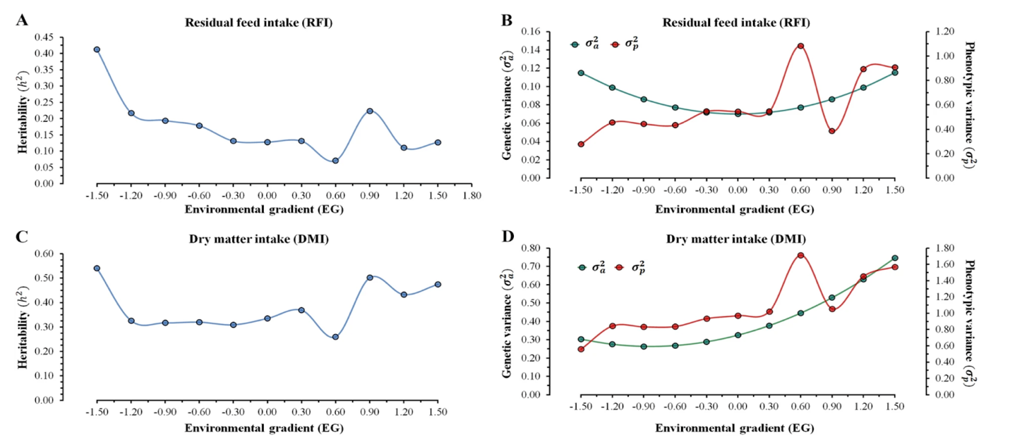

Figure 1.1 Heritability of residual feed intake (RFI) and dry matter intake across environmental gradients.
x-axis = environmental gradient (EG)
y-axis = heritability (h²)
food deemed inedible for humans. This is due to their compartmentalized stomachs and the bacteria, fungi, protozoa, and methanogens that assist in breaking down feed (Hackmann & Firkins, 2015). During this fermentation process, volatile fatty acids (VFAs) are broken down to supply the animal sufficient energy and protein needs (Hackmann & Firkins, 2015). This digestion process is affected by multiple factors, including breed or diet, and has an impact on methane emissions, as previously referenced in a study. Since the rumen microbiome has such an effect on the ruminant's ability to use and store energy, there have been multiple studies, specifically in dairy cattle, which provide evidence that the composition of the rumen gut microbiomes and its microorganisms are heavily associated with varying levels of RFI (Tapio et al., 2023). In a study by Tapio (2023), 87 Nordic red dairy cattle in the late lactation stage were ranked based on feed efficiency traits. Rumen microbial composition was then sequenced to determine correlation between microbial networks and feed efficiency rank. It was found that cows with a more efficient rumen exhibited a higher abundance of glycoside hydrolases, which are enzymes that break down sugar, as well as more bacterial motility and sensing. Animals ranked with lower efficiency expressed glycosyltransferase and metabolic pathway activity. Taken from the study, Figure 1.2 depicts the differences of carbohydrate activity enzymes (CAZy) between both high (H) and low (L) groups. This figure concludes that the animals with higher efficiency inhibited more enzymes to process polysaccharides, while lower efficiency animals exhibited enzymes which degrade carbohydrates. This research can suggest that animals with divergent efficiency contained a more diverse microbiome geared toward a more efficient function (Tapio et al., 2023).

Muscle Growth and Development
Skeletal muscle is a heterogeneous tissue and an organ in the muscular system (Mohammadabadi et al., 2021). Muscle mass is what regulates resting energy expenditure, which is the energy required to regulate homeostasis. This energy is typically sourced from carbohydrates, fat, or protein, and in this process, oxygen is used and carbon dioxide is released. Muscle growth and development is primarily affected by genetics, but other factors such as diet and lifestyle can also play a crucial role (Westerterp, 2000).

The primary development of muscle fibers begins at early embryonic development. Although after embryonic development there are no more new muscle fibers created, they can regenerate through hypertrophy (Wicks et al., 2019). Nutrition plays a main role in the development of muscle tissue. Poor nutrition correlates with lower production of muscle fibers and adipocytes, which forms intramuscular fat (Westerterp, 2000).

Myogenesis is the main process of muscle tissue formation which has three stages that begins at embryonic development (Mohammadabadi et al., 2021). During myogenesis, myoblasts fuse to form muscle fibers. These myoblasts can either proliferate into more fibers if enough growth factors are present, or they can differentiate into myotubes. The
first stage then begins and this is where specific genes become expressed. The second stage

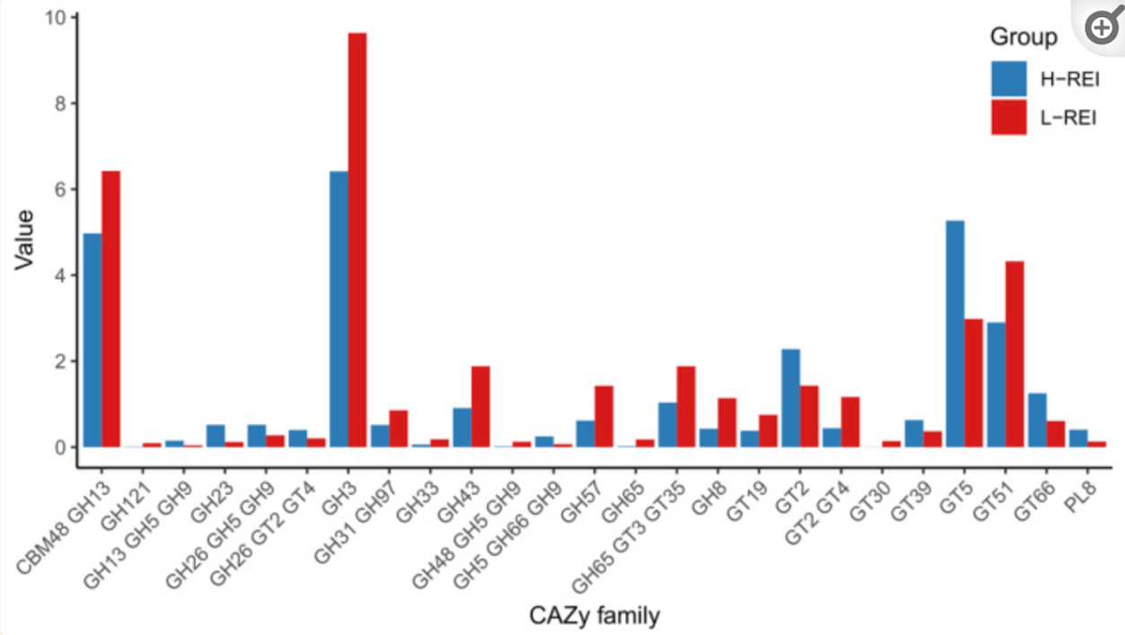
Figure 1.2 Carbohydrate activity (CAZy) relationship to cattle with high or low feed efficiency groups.

is where the myoblasts are aligned with one another. The third and final stage is where cell fusion takes place. During the later stages of myogenesis, satellite cells can multiply, which is an important trait for livestock used for meat. The amount of satellite cells present can increase muscle hypertrophy. If in that animal's life it sustains an injury, satellite cells will regenerate muscle cells and fibers (Mohammadabadi et al., 2021). Some key transcriptome factors that play a role in myogenesis are MRFs and PAX3 and PAX7. MRFs activate genes for cell proliferation while PAX3 regulates them and PAX7 keeps them dormant while also activating myoblast formation (Mohammadabadi et al., 2021). These genes regulating muscle growth and development play a key role in research for determining genetic variation between species, breed, and phenotype (Sheet et al., 2024) (Mohammadabadi et al., 2021)..

Growth Factor Signal Hormone IGF1
The neuroendocrine system plays an important role in regulating metabolic activity, such as growth, in mammalian species. It is composed of growth hormones, which are located in the hypothalamus, and regulate growth signals in the body (Al-Samerria & Radovick, 2021). Insulin-like growth factor 1 (IGF1) is a growth hormone found in almost every tissue in the body and is named for its similarity to the structure of insulin as well as its ability to bind to the insulin receptor (Laron, 2001). Although controlled by growth hormones and prevalent in tissues such as skeletal muscle, IGF1 is released mainly by liver hepatocytes and transferred to tissues (Al-Samerria & Radovick, 2021). This growth factor has been shown to regulate cellular growth and improve protein synthesis as well as muscle degradation and regeneration (Yoshida & Delafontaine, 2020). Figure 1.3, taken from a study by Ahmed 2023, summarizes the mechanism of action of IGF1 and its role in skeletal muscle. Studies have shown the importance of the IGF1 gene after concluding the main causes of Laron Syndrome (LS), previously known as Laron dwarfism, is due to mutations in the IGF1 gene. A review by Laron (2001) summarized a study on patients with LS throughout gestation and into adulthood. These patients each had a mutation in the IGF1 gene which caused, even at birth, growth deterioration to muscle, skeletal system, brain, and heart. Studies done by knocking out the IGF1 gene in mice caused a size reduction of about half, as well as death due to the impaired development of the diaphragm. This experimental data proves the function of IGF1 gene and its role in skeletal and muscle growth and development (Laron, 2001). A study by Montelli (2020) gathered approximately one hundred lambs and fed them over a period of 56 days to determine their efficiency and the relationship between leptin and the IGF1 gene. After the trial, lambs were separated into classes based on RFI and residual feed intake and gain (RIG). It was found that animals with greater efficiency (Low RFI & High RIG) expressed a higher concentration of leptin and IGF1 (Montelli et al., 2021).

Feed Efficiency and Muscle Growth
The muscle is the primary economic product in beef cattle production. By understanding the mechanisms of action behind muscle growth and development as well as the factors

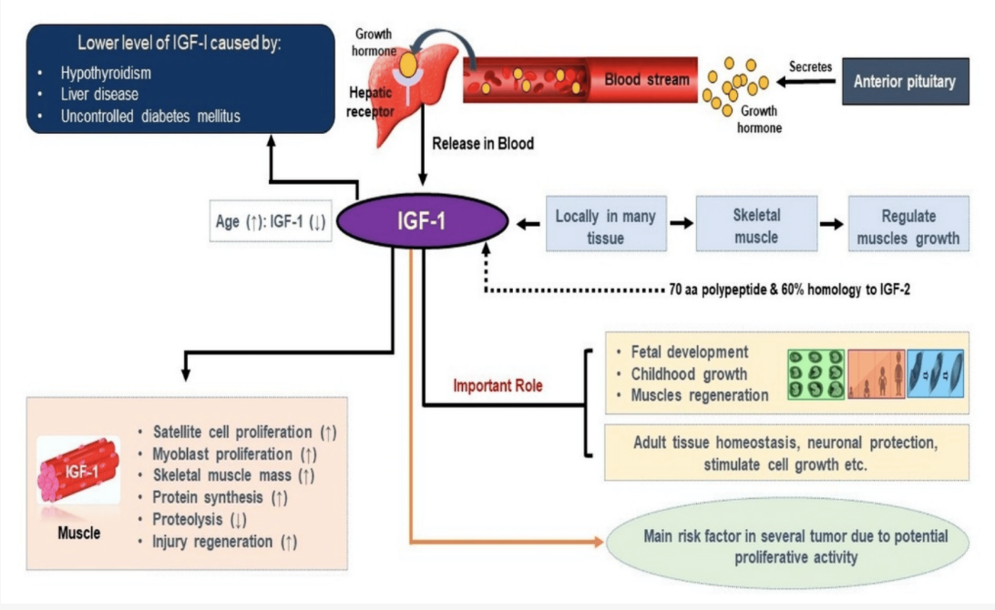

Figure 1.3 Insulin-like growth factor 1 (IGF-1) Pathway

that drive it, producers can select animals for better production (McKenna et al., 2021). As previously mentioned, feed efficiency is an important factor due the environmental and economic benefits of an animal effectively growing. A study by McKenna (2021) took muscle biopsy samples of heifers and bulls to look at differential expressed genes (DEGS) relating to muscle growth. Although a small number of DEG’s were discovered in heifers divergent for RFI, all the genes found were part of the electron transport chain, which is important for energy metabolism. This study concluded that their findings indicated RFI is directly related to gene expression regulating muscle growth and energy metabolism, further research is needed to solidify the evidence (McKenna et al., 2021).

Conclusions
With the population expected to increase exponentially in the next ten years, animal production is crucial in providing a sustainable amount of protein needs to the population. With further research, beef production can take a turn for the better with efficiency. By understanding the mechanics of muscle growth and development in bovine, as well as the genes regulating it, beef animals can be bred to be more efficient in the future. This change not only benefits the population by meeting the needs for food production, but beef can be more economical for the producer and sustainable for the environment.

CHAPTER II
Interconnecting feed efficiency with molecular mechanisms of muscle growth

Abstract

In beef cattle production, the skeletal muscle is the primary product. Animals with greater efficiency use fewer resources to produce muscle. However, there are very few studies about the relationship between the molecular pathways in muscle and animal efficiency. The objective of the study was to determine relationships between animal efficiency at the molecular level and how those genes regulate growth in the skeletal muscle of beef cattle. Our hypothesis was there are increased number of genes involved in muscle growth in association with greater ADG or increased feed efficiency. One-hundred Angus steers were enrolled in 70d feed efficiency trials using the Vytelle GrowSafe 8000 individual feed intake monitoring system. Around 500µg of muscle tissue were collected via needle biopsy during the last 30 days of the feed efficiency trial. RNA was extracted from ~50mg/sample using a modified TRIzol method. Libraries were constructed using SMART Seq v4 3’ DE Kit and were sequenced using a Novaseq 6000. Reads were mapped to the bos taurus genome (ARS-UCD 2.0) using STAR RNA-seq aligner. For all ADG and feed efficiency analyses, animals were ranked according to ADG or feed efficiency and grouped by the greatest to least 20th percentile; greater or less ADG, respectively. DESeq2 in R (version 3.5) was used to examine the differential expression with an LRT test for the analysis of the linear model. A total of 4,162 and 55 genes were identified as differentially expressed (fdr p-value < 0.05) respectively for the grouped and linear models. Gene sets were functionally annotated using clusterProfiler package in R (version 3.14) and found expression at higher levels in greater ADG steers were significantly enriched (fdr p-value < 0.01) in BP Gene Ontology (GO) and KEGG functions relating to ribosomal biogenesis and mitochondrial function, which has been associated with muscle growth. Genes that were expressed at higher levels in less ADG steers were significantly enriched in GO terms and KEGG pathways relating to lysosome degradation and which have been associated with muscle atrophy. In conclusion, these results support that animals with greater ADG expressed more genes associated with muscle growth and energy metabolism.

Introduction

Feed efficiency is an important factor in beef cattle operations due to its heavy influence on economic development and environmental sustainability. Feed efficiency is the ability for the animal to turn feed and energy into weight gain (Khanal et al., 2023). An animal that is more feed efficient uses less resources to gain muscle, the main economic product. Skeletal muscle accounts for over 50% of the animal’s body weight, making it an important metabolic tissue (McKenna et al., 2021). Providing feed to production cattle is a major input cost, so producers are selecting animals that have a lower feed intake with consistent gain. Although beef production has the lowest efficiency of all animal protein sources, in terms of feed input to product output, cattle have an advantage over other livestock species due to the ability to convert inedible forages into protein for human consumption (Terry et al., 2020).

Residual feed intake (RFI) is a common method to measure cattle’s feed efficiency (Nielsen et al., 2013). RFI is the difference in an animal's actual feed intake and its expected feed intake based on production factors such as average daily gain (ADG), dry matter intake (DMI), and weight throughout a trial period (Arthur & Herd, 2008; Koch et al., 1963). An animal that is more feed efficient will have a lower RFI value than a less efficient animal. RFI is complex trait that is controlled and influenced by genetic and environmental factors. Some of these factors that influence cattle efficiency include the rumen microbiome’s volatile fatty acids as a marker of energy utilization (Suzuki et al., 2023). Diet is also important, not only due to the contents of the feed but how diet affects digestibility and muscle gain. Muscle is responsible for 40% of a growing cattle’s body weight. (Listrat et al., 2016) Previous research has shown that skeletal muscle influences whole body energy expenditure and expresses receptors for short chain fatty acids and bile acids in other species as well (Koch et al., 1963).

Genomic selection is a practice using genetic markers to predict breeding, which has become increasingly popular in the livestock industry in order to produce more efficient animals (Meuwissen et al., 2001). Single nucleotide polymorphisms (SNP) are responsible for the variation in traits and are used as molecular markers for phenotypes in livestock (Dadi et al., 2012) (Kaushik et al., 2019). Genome wide association studies (GWAS) identify these SNPs and the correlation between production traits, such as RFI and ADG. (DePristo et al., 2011). Typically, GWAS focuses on identifying SNPS at a larger scale and with a larger population size. Next generation sequencing (NGS), specifically RNA-sequencing, is widely used for differential expression (DE) analysis. (Chen et al., 2016; Costa-Silva et al., 2017). DE uses gene expression data to identify differences within production traits, such as differences between greater and lower gain, control and treatment groups, and sex. DE uses gene expression data to identify differences within production traits, such as differences between greater and lower gain and greater or lesser feed efficiency. Indeed, research has demonstrated transcriptomics is a sensitive tool to detect changes in differential gene expression in multiple tissues in cattle differing in RFI, such as hepatic tissue, skeletal muscle, and intestines (Ibragimov et al., 2022) (McKenna et al., 2021) (Izadnia et al., 2019)
RFI is a complex trait that is moderately heritable, with recent estimates ranging from 0.08 to 0.49 (Seabury et al., 2017) (Basarab et al., 2013; Manzanilla-Pech CIV, 2022). However, the pathways that control this trait have limited research, especially in cattle. A previous study was conducted to determine the transcriptome profiles between heifers and bulls with divergent RFI in the hepatic tissue and skeletal muscle. Although no variation between sex, there were few differentially expressed genes (DEGs) between 10 animals that potentially provide insight into the possibility of the genes controlling feed efficiency (McKenna et al., 2021). By understanding the genes that are associated with feed efficiency and gain, major advances can be made to breed animals with feed efficiency traits.

The objective of this study is to determine the relationships between animal efficiency and gain at the molecular level in the skeletal muscle. The hypothesis of this study was that there will be an increased number of genes regulating muscle growth and energy metabolism in beef steers with greater gain.

Materials and Methods

Animals and experimental design
This experiment was conducted as part of an ongoing USDA project which investigated genetic variation and its interactions with the rumen microbiome on the influence of feed efficiency utilizing 8 feed efficiency trials and 350 animals (USDA-NIFA-Agriculture and Food Research Initiative grant no.2020-67015-30832). This study utilized a total of 100 Angus beef steers enrolled in two separate 70-day feed efficiency trials using the Vytelle Growsafe System (Vytelle, Calgary Canada). Steers were fed mixed cool-season grass pasture ad libitum for two weeks and then stepped up to the test ration 14 days prior to the start of the beginning of the trial. During the trial, steers were fed a 12% complete beef feed diet for growing beef cattle (Table 2.1). The system displayed a feed bunk which continuously monitored the weight of the feed in the bunk so an accurate measurement of each individual animal’s feed intake could be recorded throughout the trial. Weights of each steer were taken at the beginning of the trial (d -1, 0), twice mid-trial (d 35, 36), and twice at the end of the trial (d 69, 70).

Tissue Collection
Skeletal muscle biopsies were taken in the last 30 days of each trial. Steers were weighed and one at a time restrained in a squeeze chute for the remainder of the procedure. The area over the left side longissimus dorsi muscle from the first lumbar vertebra region was shaved down, and the site was washed thoroughly with iodine solution (povidone-iodine, solution 10%) and 70% isopropyl alcohol (Swan, St. Louis, MO). Approximately 5-10 mL of lidocaine hydrochloride (VET one, 2%) was administered subcutaneously and intramuscularly and effectiveness was monitored over the course of 10 minutes to assure lack of response to the tissue during the procedure. A 1-cm incision was made through the epidermis using a sterile scalpel. Approximately 500-mg of muscle tissue was extracted
Table 2.1 Nutrient composition of diets fed to growing beef steers

 | Grain Mix | Sorghum/Sudan | TMR-Bunk Mix
Crude Protein (%DM)² | 16.78 | 9.99 | 14.72
AD-ICP (%CP)³ | 14.90 | 7.61 | 10.67
ADF (%DM)⁴ | 21.29 | 42.40 | 29.90
aNDF(%DM)⁵ | 36.01 | 62.95 | 43.86
aNDFom (%DM)⁶ | 35.19 | 61.68 | 42.54
Lignin (&NDFom)⁷ | 9.95 | 6.08 | 10.41
Ash (%DM)⁸ | 6.27 | 7.29 | 6.04
Fat (EE) (%DM)⁹ | 3.35 | 2.95 | 3.05
¹ Contents of dry matter percentage per diet type fed during the two trials
² Amount of protein based on its nitrogen content expressed as a percentage of dry matter, CP = N x 6.25
³ Acid detergent insoluble crude protein (AD-ICP) expressed as a percentage of crude protein (CP)
⁴ Amount of fiber measured using a rinse of acid detergent
⁵ Amount of fiber measured using a rinse of amylase and sodium sulfite in neutral detergent
⁶ Adjusted aNDF for ash content
⁷ Amount of woody fiber using sulfuric acid
⁸ Amount of ash measured in dry matter (DM)
⁹ Amount of fat measured using ether extraction

through the wing of the ilium between the axis and transverse process of the lumbar vertebrae using a Zamar Cortex Bone Marrow Biopsy Needle (Zamar, 0.7Gx100mm, Orsera, Croatia). The center portion of the probe needle was removed after insertion and replaced with a 10cc syringe to suction the small incisions to the muscle. The syringe was removed from the probe tool and the tissue was punched out into a petri dish and washed with diethyl pyrocarbonate (DEPC)- treated RNase-free phosphate-buffered saline solution (PBS) (1x, pH 7.2). Pressure was applied to the wound with sterile gauze to prohibit bleeding and surgical glue or sutures was applied. Steers were treated with fluxin transdermal solution (3mL/100lbs, MERCK Banamine Transdermal Pour-on for beef and dairy cattle, Rahway, NJ, USA) and incisions were covered with wound spray (Dr. Naylor Blu-Kote Aerosol Livestock Wound Spray, Otsego County NY, USA) and steers were monitored in stalls for recovery. Samples were separated and placed into two 2-mL cryovial tubes and stored in liquid nitrogen for further analysis.

RNA Extraction and Library Preparation
RNA was isolated from muscle tissue for 3’ RNA Sequencing using a modified TRIzol protocol as follows. 50-mg of frozen muscle tissue was homogenized in 1-mL of TRIzol Reagent (Ambion RNA, Carlsbad, CA, USA). Sample was incubated at room temperature for 5 minutes to permit the complete dissociation of nucleoproteins and then centrifuged for another 5 minutes to remove cell debris. Around 200-µL of chloroform was added to the supernatant, sample was vortexed and incubated again at room temperature for 2-3 minutes, then centrifuged for 5 minutes at 14,000xg at 10° which resulted in the separation of three phases. The RNA-containing clear upper aqueous phase was transferred to a new tube and a second extraction was performed by adding 500-µL of acid-phenol chloroform. 500-µL of 70% isopropyl alcohol was added to the sample and was incubated on ice for 5-10 minutes. After centrifugation for at 10°, 10 minutes at 14,000x g, the resulting white nucleic acid pellet was resuspended in 70% ethanol. The remaining ethanol was decanted and the RNA pellet was dried at room temperature. Once dried, the RNA pellet was dissolved in 50-µL of RNase-free water (Zymo, San Diego, CA).

RNA was purified using ZYMO Clean and Concentrator protocol (Zymo, San Diego, CA) following large RNAs (>200nt) clean up-protocol on step 4. High quality of RNA integrity number (RIN) of 7.8-10 and concentration of ≥10 ng/µL was verified using Agilent 4200 Tapestation (Agilent Technologies, Santa Clara, CA), and cDNA libraries were constructed from isolated RNA using the SMART Seq v4 3’ DE Kit (Takara Bio, Mountain View, CA).

RNA Sequencing and Mapping Reads
3’ RNA Sequencing was performed using the sequencer Illumina NovaSeq 6000 (Illumina, San Diego, CA, USA) at The University of Tennessee Genomics Core (The University of Tennessee, Knoxville, TN, USA). Only the forward reads were used for analysis, and FastQC (Andrews, S. 2010) was used to perform quality checks on raw sequencing reads. FastP (Shifu Chen, 2023) was then used to trim, filter, and remove low quality base pair reads. The reads were then mapped to bos taurus genome (ARS-UCD_2.0) using STAR RNA-Seq aligner (Alexander Dobin, 2019). Counts were, again, examined using MultiQC (Phillip Ewels, et. Al, 2016) to generate summary reports of reads based on the genome sequence.

Gain and Feed Efficiency Design
Feed efficiency traits were calculated and identified for each steer per trial. Average daily gain (ADG) is defined as the animals average weight gain throughout the trial, residual feed intake (RFI) is the difference between an animals expected feed intake and its actual feed intake, while feed to gain ratio (F:G) is the amount of feed consumed on a dry matter basis (Herd & Arthur, 2009; Koch et al., 1963). ADG values were adjusted to accommodate the variation between the trials. Adjustment was conducted by taking the difference in the mean ADG per trial and subtracting that value from each steer’s value in Trial 2. F:G was also adjusted by dividing dry matter intake (DMI) by the new ADG value. RFI was not adjusted due to the lack of trial-dependent variation. Animals were then ranked within the phenotypic group and grouped by 20th percentile; the first and fifth groups were designated as “Low “and “High”, respectively (n=32). Twenty steers were removed from the trial for periods of reduced intake, affected weight, poor ADG, or poor finish, and received no feed efficiency data.

Differential Gene Expression Analysis
R package ‘DESeq2’ of Bioconductor (Love MI, Huber W, Anders S 2014) was used to perform a negative binomial generalized linear model. Raw count matrix and column data from trials were used to construct a DESeqDataSet and data was pre-filtered to remove genes with counts ≤10. A factor level was set to label “High” as upregulated genes and “Low” as downregulated genes. Logarithmic fold change (LFC) was used in the model to shrink the results based on gene rank and remove those with low differential expression with type “apeglm” (Zhu, A., Ibrahim, J.G., Love, M.I. 2018). Therefore, differences in expression and statistically significant DEGs were identified between the “Low” and “High” percentile group (fdr p-value <0.05). Principal component analysis (PCA) was performed for exploratory results with the normalized counts in DESeq2 to visualize the clusters between and within the two groups.

Genes that exhibited a continuous relationship to trait were identified using the likelihood-ratio test (LRT) by testing the goodness of fit between two models with a reduced factor of ~1 for ADG and F:G, and ~TRIAL for RFI. False discovery rate (FDR) was controlled using the method of Benjamini-Hochberg, with statistical significance based on fdr p-value ≤0.05.

Pathway Analysis
Functional annotation of differentially expressed genes was analyzed based on enrichment in GO terms (Biological Process) and KEGG pathway membership using clusterProfiler (T. Wu, 2021) package from R & RStudio. Annotations and pathway membership were based on corresponding genes in the human genome (org.Hs.eg.db; Carlson M, 2023), which was downloaded from Bioconductor package. The Database for Annotation, Visualization and Integrated Discovery (DAVID; david.ncifcrf.gov; B.T. Sherman, 2022) and ShinyGO (http://bioinformatics.sdstate.edu/go/; Ge SX, Jung D, Yao R, 2020) were also used for supplementary functional annotation.

Results

Animal Performance
Average daily gain (ADG) differed significantly between trials, with an average of 3.11 ± 0.66 kg/d in Trial 1 and 4.78 ± 0.51 kg/d in Trial 2 (P = <2.2e-16). Both residual feed intake (RFI) and feed to gain ratio (F:G) values were not different between the two trials with 6.28 ± 1.2 and 6.21 ± 0.62 for F:G (P = <2.2e-16 ) and 0.135±1.21 and 0.078±1.71for RFI (P = 0.086) , respectively. T-test results are present in Table 2.2 for the relationship between ADG, RFI, and F:G in the two trials.

Weight and age also varied between trials, as Trial 1 steers weighed an average of 413.92 ± 27.56 kg and around 7 months of age while steers in Trial 2 weighed an average of 484.2 ± 37.21 kg and were around 14 months of age.

Figures 2.1 and 2.2 illustrate a scatterplot of the relationships between ADG to RFI and F:G. Overall, the majority of animals had a greater ADG with RFI and F:G, concluding the animals in this study were more efficient overall.

Gene Identification and Differential Expression
Animals were ranked independently for ADG, RFI and F:G and based on 20th percentiles. Those in the first (High) and fifth (Low) percentile groups were used to represent animals that diverged for each phenotype. The exploratory visualization using PCA indicates separation between greater and less ADG groups, with slight overlap (Figure 2.3). In contrast to ADG, no apparent differences in gene expression were observed between groups based on divergence of RFI or F:G, shown in Figures 2.4 and 2.5.

Differential expression analysis was implemented for ADG based on exploratory results. Extensive differences in gene expression were identified between these two groups, with a total of 4,156 DEGs (fdr p-value ≤ 0.05; Figure 2.6). Of these, 2,150 were expressed at higher levels in animals with High ADG, while 2,006 were more abundantly expressed in the Low ADG group. The top 20 DEGs identified by lowest p-value are represented in the heatmap in Figure 2.7.

Enrichment and Pathway Analysis
These sets of DEGs were functionally annotated based on GO terms (Biological Process) and KEGG Pathway membership. The set of 2,150 genes expressed at higher levels on animals with higher ADG were significantly enriched in 118 GO terms (fdr P-value < 0.05). Enriched functions include annotations related to mitochondrial metabolism,

Table 2.2 t-test results performed for residual feed intake (RFI), average daily gain (ADG), and feed to gain ratio (F:G) between two feed efficiency trials in growing beef steers

TRAITS | Trial 1 | Trail 2 | P-value
RFI¹ | 0.135±1.21 | 0.078±1.71 | 0.8658
ADG² | 3.113±0.669 | 4.78±0.516 | <2.2e-16
F:G³ | 6.28±1.20 | 6.21±0.622 | 0.79
¹residual feed intake (RFI) mean ± sd
²average daily gain (ADG) mean ± sd
³feed to gain ratio (F:G) mean ± sd

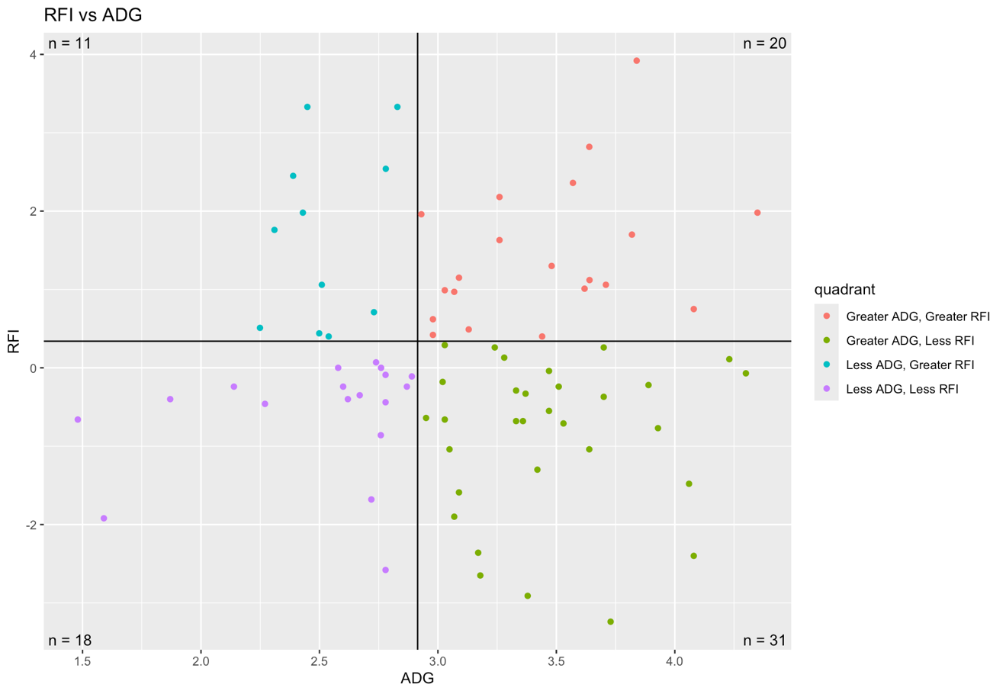

Figure 2.1 Scatterplot of the relationship between steer’s residual feed intake (RFI) and average daily gain (ADG)
X-axis = Average daily gain (ADG) (kg/d)
Y-axis = Residual feed intake (RFI)

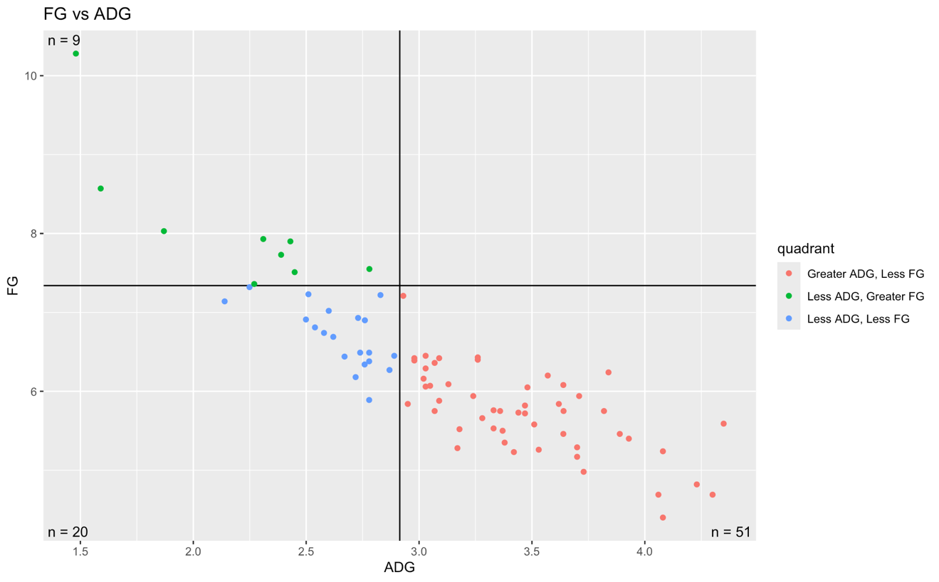
Figure 2.2 Scatterplot of the relationship between steer’s feed to gain ratio (F:G) and average daily gain (ADG)
X-axis = Average daily gain (ADG) (kg/d)
Y-axis = Feed to gain ratio (F:G)

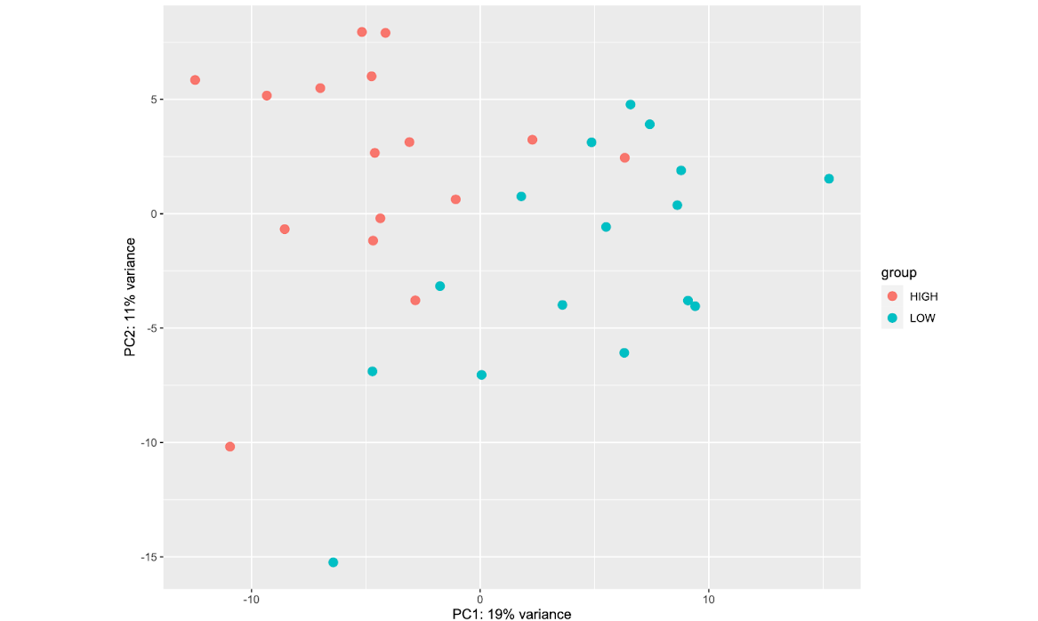
Figure 2.3 Principle component analysis (PCA) for high and low average daily gain (ADG) percentile groups in growing beef steers
The PCA scatter plot expressing the similarities and clusters between high and low groups of the data, labeled in blue and red. The X and Y axis represent the percentage of variation between the two principle components.

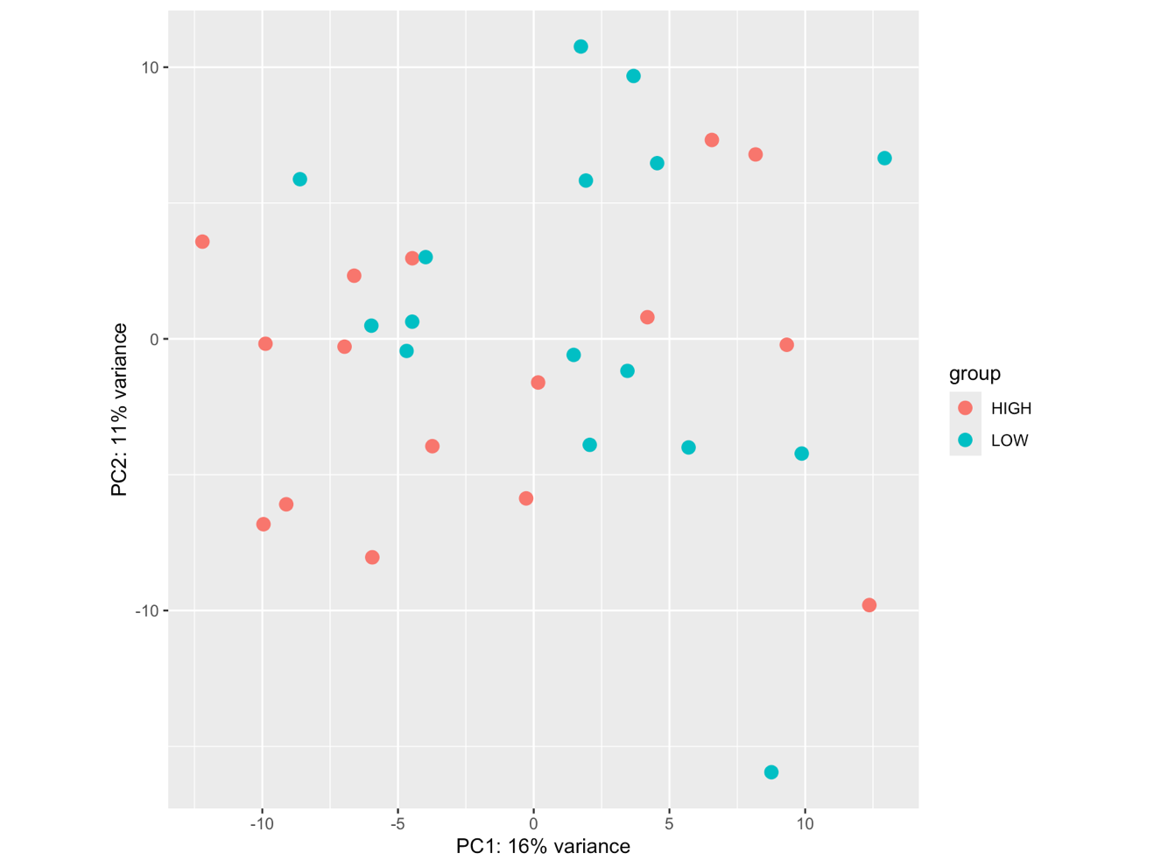

Figure 2.4 Principle component analysis (PCA) for high and low feed to gain ratio (F:G) percentile groups in growing beef steers
The PCA scatter plot expressing the similarities and clusters between high and low groups of the data, labeled in blue and red. The X and Y axis represent the percentage of variation between the two principle components.
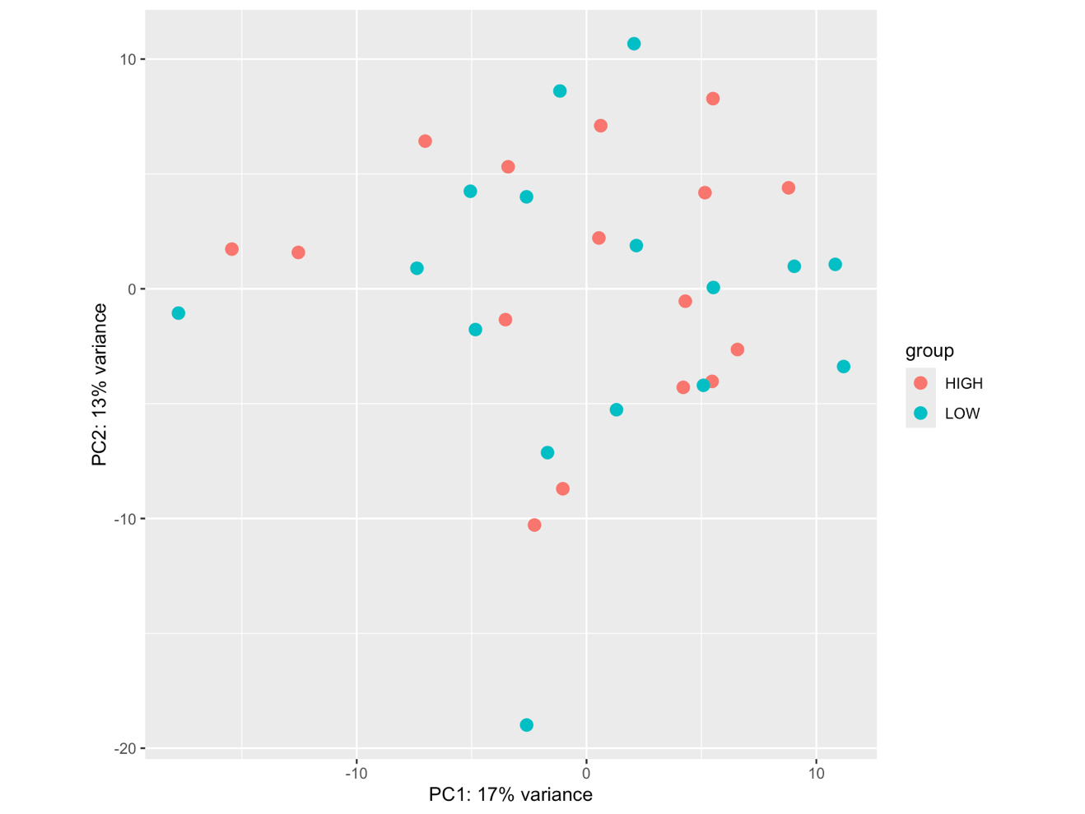

Figure 2.5 Principle component analysis (PCA) for high and low residual feed intake (RFI) percentile groups in growing beef steers
The PCA scatter plot expressing the similarities and clusters between high and low groups of the data, labeled in blue and red. The X and Y axis represent the percentage of variation between the two principle components.

Greater ADG
Less ADG

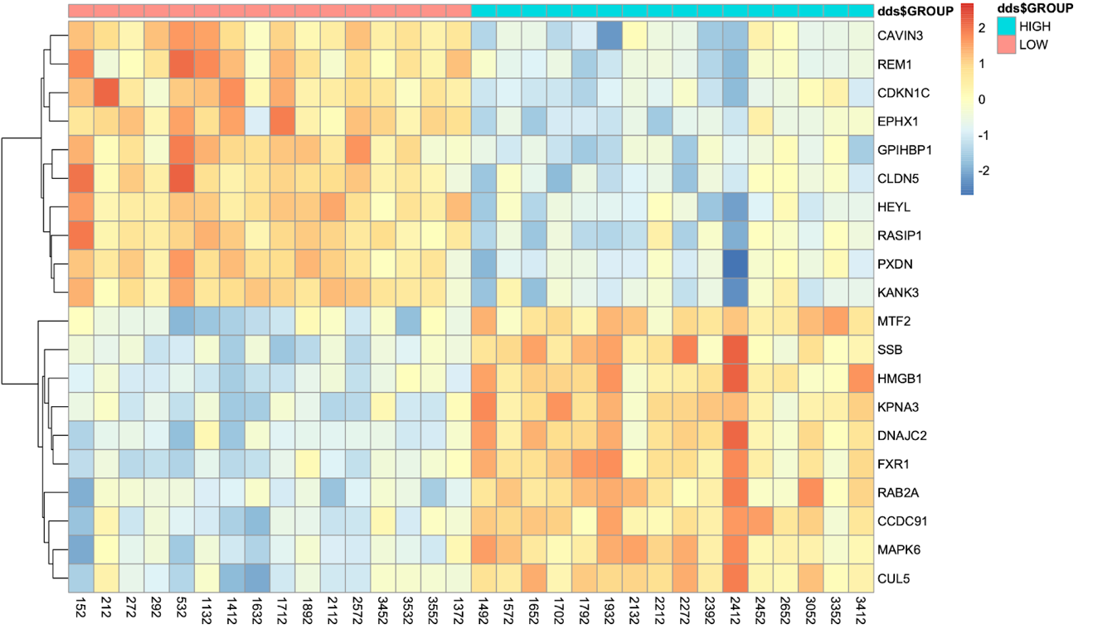

Figure 2.6 Heatmap cluster analysis of differential gene expression for average daily gain (ADG) in beef steers
Heatmap showing the gene expression data of the top 20 DEGS (adjusted p-value <0.05) of the 4,162 identified by DESeq2 for ADG grouped model, arranged by lowest padj value. X-axis represents the individual steer number while the Y-axis represents the annotation of the official gene symbol. The blue to red color scale indicates relative gene expression. The panels at the top represent ADG group.

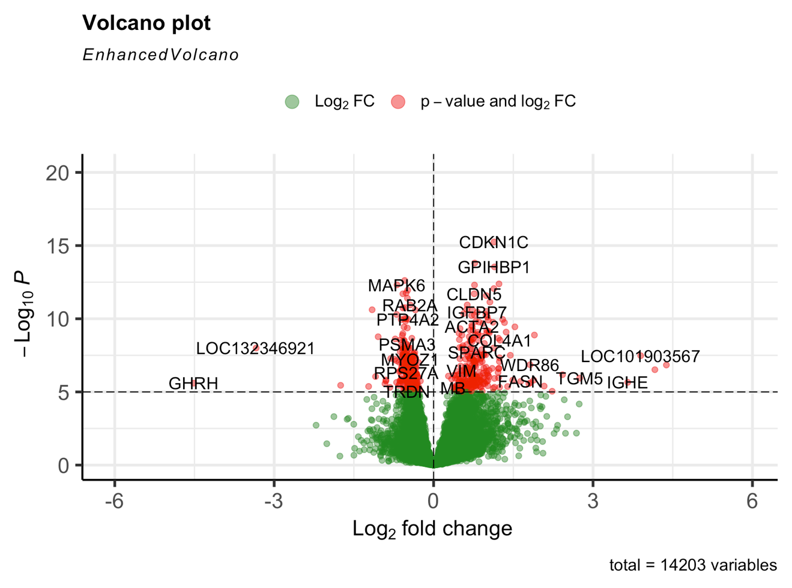

Figure 2.7 Volcano Plot demonstrating overview of differentially expressed genes identified in steers with divergent average daily gain (ADG).
Volcano plot of differentially expressed genes in steer muscle tissue for the grouped percentile model of average daily gain (ADG) (FDR<0.05). The x-axis represents the log2fold change for each gene while the y0axis represents the -Log10 p-value for each gene; green represents 2-fold change; blue represents significant genes; red indicates both.

translation, ribosome biogenesis, and protein synthesis (Figure 2.8). Many of the enriched GO terms are interrelated and represent a network of functions that is highly relevant to muscle growth and gain (Figure 2.9). KEGG pathway analysis yielded similar biological functions associated with higher ADG. Over-representation KEGG pathway analysis for the 2,150 differentially expressed genes in animals with greater ADG revealed 25 enrichment pathways related to ribosome (hsa03010), proteasome (hsa03050), oxidative phosphorylation (hsa00190), thermogenesis (hsa04714), and mitophagy (hsa04137) pathways (Table 2.3) (Figure 2.10). There was also a strong interaction between ribosomal proteins and mitochondrial ribosomal protein (MRPL24), also shown in Figure 2.9. Ribosomal proteins showed to have the strongest and most reoccurring relationships between all protein interactions out of the DEGs most expressed in animals with greater ADG. Gene set interaction in the network analysis showed ribosome biogenesis and ribonucleoprotein biogenesis enriched with translation, peptide metabolism, peptide biosynthetic process, cellular macromolecule process and mitochondrial gene expression (Figure 2.11). Over-representation analysis identifies the most significant pathways in a subset of the data, in this case by separating genes that were over-expressed or under-expressed.

There were gene set interactions that occurred between thermogenesis, proteasome, and oxidative phosphorylation, while ribosome was more significantly enriched of all gene sets (Figure 2.11). Based on enrichment analysis for most represented pathways in animals with greater ADG in skeletal muscle, ribosome and mitochondrial activity as well as pathways involved in energy metabolism were most significant.

A similar number (2,006) of genes were expressed at higher levels in animals with lower ADG. This set of genes was significantly enriched in 325 GO annotations, including functions related to angiogenesis, endothelial development, and actin filament organization (P-value = <0.05) (Figure 2.12). Over-representation KEGG pathway analysis identified enrichment in 8 pathways relating to leukocyte, fatty acid metabolism, AMP-activated protein kinase, valine, leucine, and isoleucine degradation, and lysosome (P-value = <0.05) (Table 2.4) (Figure 2.13).

Linear Model
A linear model was applied to the entire dataset to further identify genes with expression levels that vary in association with quantitative average daily gain (ADG). The differential gene expression analysis identified a total of 55 genes that exhibit a continuous relationship
to ADG (fdr p-value ≤ 0.05). Of these, 24 genes expressed a positive association in animals with greater ADG, and 31 of those genes had a negative association in animals with greater ADG. A heat map of the top 20 DEGs by lowest p-value was generation to visualize separation along the continuous scale (Figure 2.14). Overall, there was slight separation that occurred between animals with greater or less ADG, as shown how it changes along the continuous scale.

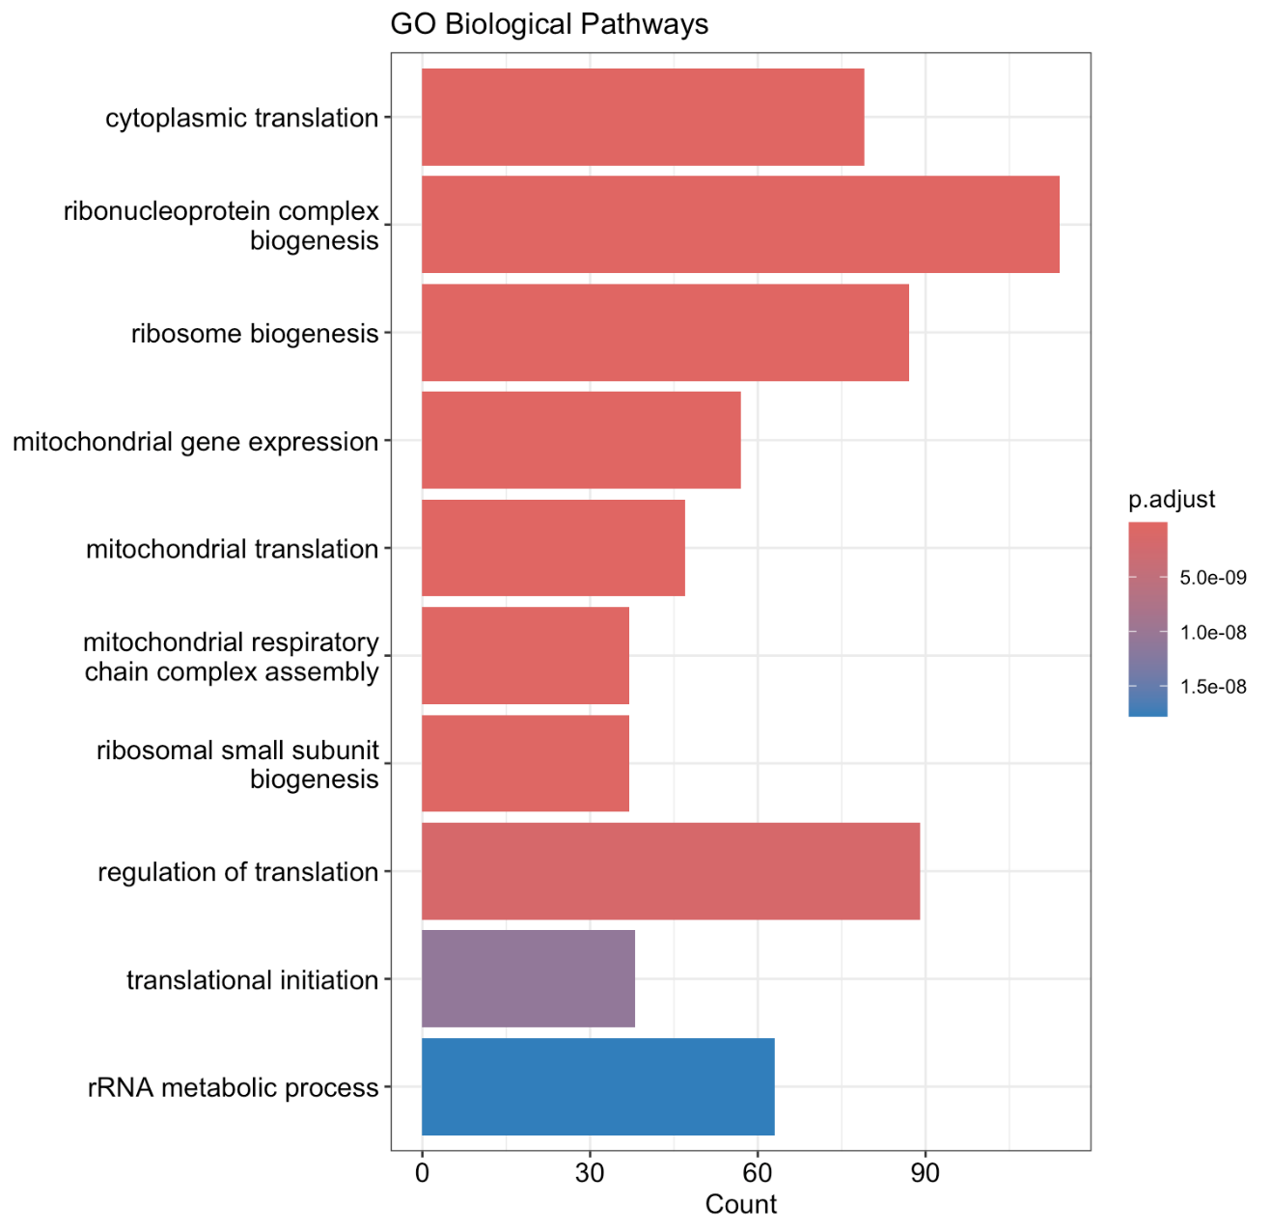

Figure 2.8 GO terms enriched in genes expressed at higher levels in steers with greater average daily gain (ADG)
ClusterProfiler generated barplot represents over-represented GO Biological Process annotations (BP GOTerms) in steers with greater average daily gain (ADG) of the 2,150 genes expressed at higher levels. The red to blue scale indicates significance based on padj value. The x-axis represents the number of gene counts per pathway.

Figure 2.9 ShinyGO network of enriched biological processes (BP GOTerms) pathways in significant up-regulated genes in steers with greater average daily gain (ADG)
The ShinyGO network represents complex associations of enriched GOTerm pathways between genes and gene sets of the 2,150 genes expressed at higher levels in steers with greater ADG. Pathways are connected if they share 20% or more genes, with larger nodes represented larger gene sets and thicker edges representing more overlapped genes. Darker color represents gene set enrichment significance.

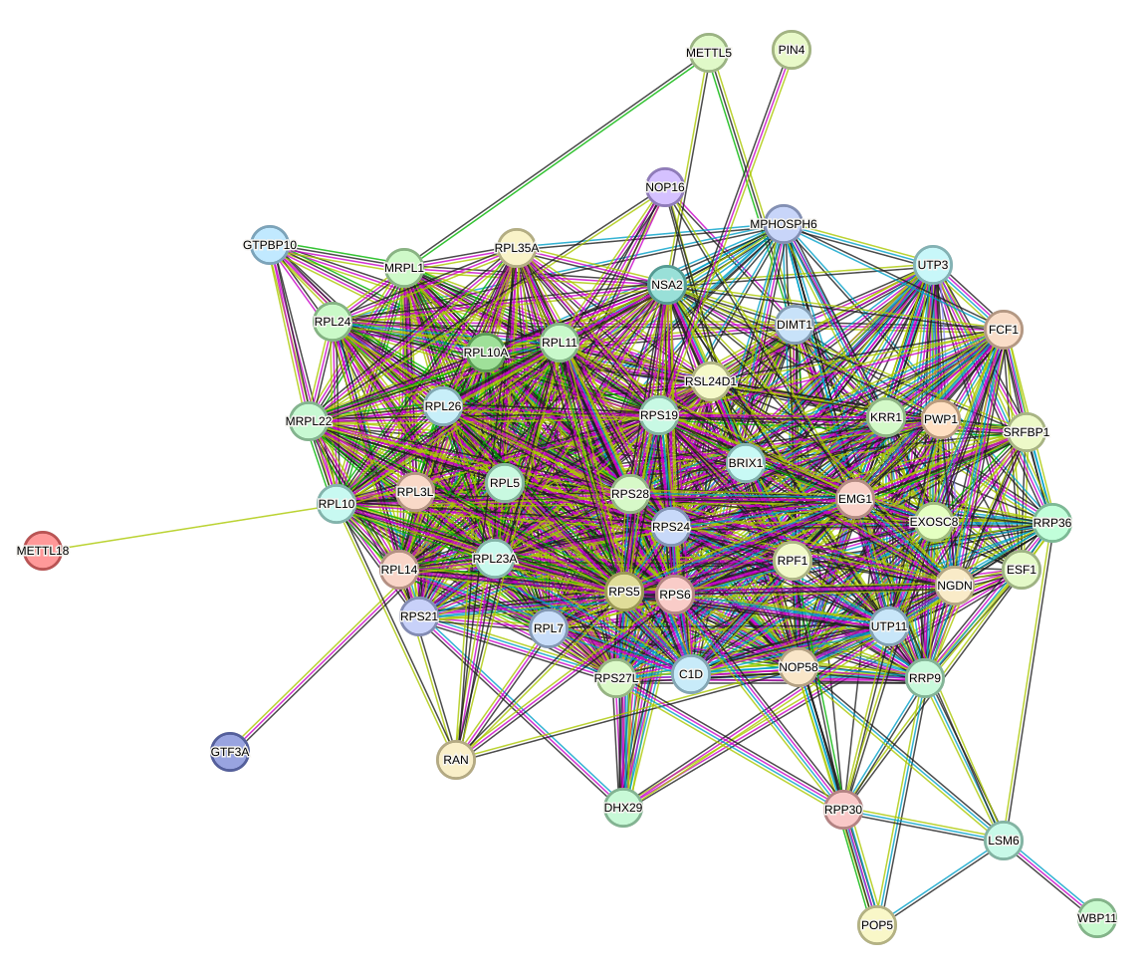
Figure 2.10 Biological processes (BP GOTerms) ribosome STRING protein-protein interaction of significant genes in steers with greater average daily gain (ADG)
STRING BP GOTerms of the 54 genes associated with ribosome biogenesis expressed at higher levels in steers with greater ADG. Results show a functional protein-protein interaction based on lowest p-value and relationship between the most significant protein levels.

Table 2.3 Over-represented KEGG pathways, gene ratio, and p-value in steers with greater average daily gain (ADG)
KEGG Pathway | Gene count¹ | P-Value
hsa03010  Ribosome | 77 | 1.44e-39
HSA03050  Proteasome | 23 | 9.44e14
hSA00190  Oxidative phosphorylation | 35 | 3.32e-10
HSA04714  Thermogenesis | 47 | 3.52e-09
HSA04137  Mitophagy | 27 | 3.28e-08
¹ number of genes represented of the 718 over-represented genes total

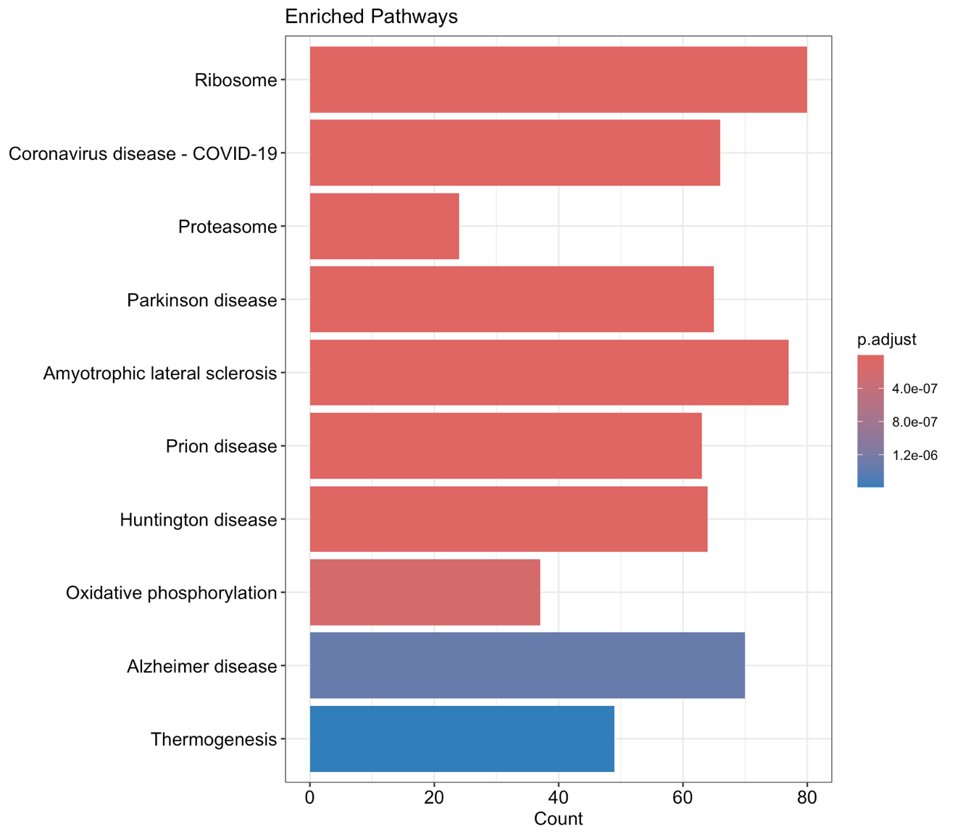
Figure 2.11 Barplot of enriched KEGG Pathways in significant up-regulated genes in steers with greater average daily gain (ADG)
Clusterprofiler generated barplot represents over-represented KEGG Pathway annotations in steers with greater average daily gain (ADG) of the 2,150 genes expressed at higher levels. The red to blue scale indicates significance based on padj value. The x-axis represents the number of gene counts per pathway.

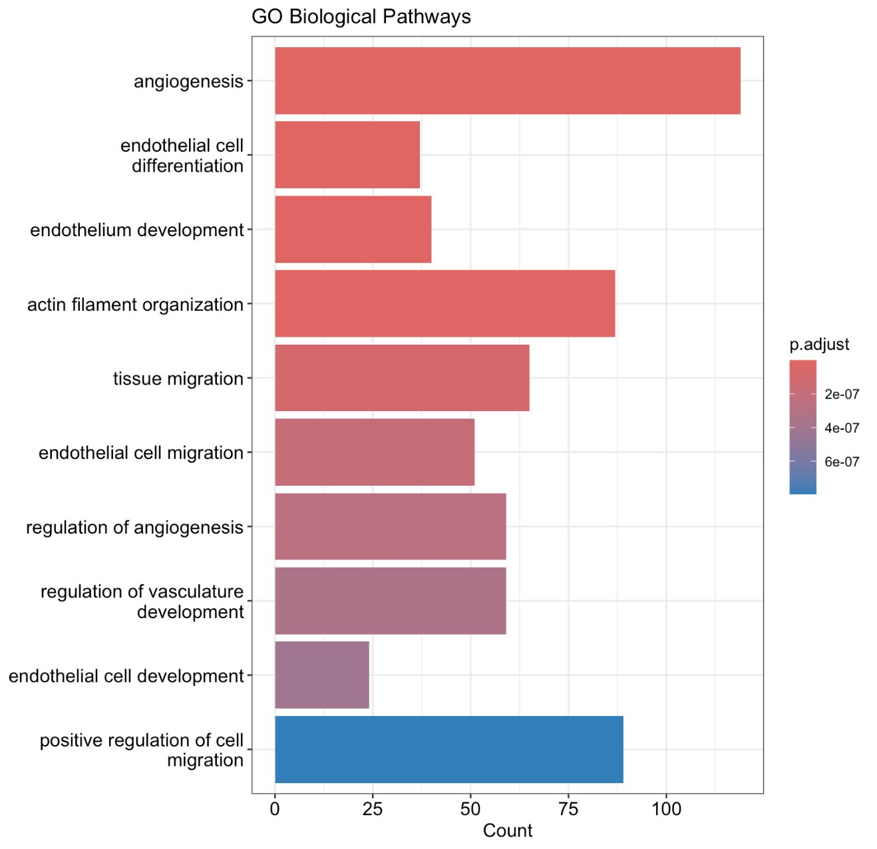

Figure 2.12 GO terms enriched in genes expressed at lower levels in steers with greater average daily gain (ADG)
Clusterprofiler generated barplot represents enriched GO Biological Process annotations (BP GOTerms) of pathways in steers with greater average daily gain (ADG) of the 2,006 genes expressed at lower levels. The red to blue scale indicates significance based on padj value. The x-axis represents the number of gene counts per pathway.

Table 2.4 KEGG Over-represented KEGG pathways, gene ratio, and p-value in steers with lower average daily gain (ADG)

KEGG Pathway | Gene Ratio¹ | P-value
HSA04670  Leukocyte | 24 | 8.65e-05
HSA01212  Fatty acid metabolism | 16 | 8.29e05
HSA04152  Amp-activated protein kinase | 26 | 0.0001
HSA00280  Valine, leucine, and isoleucine degradation | 14 | 0.0001
HSA04142  Lysosome | 28 | 0.0001
¹ number of genes represented of the 718 over-represented genes total

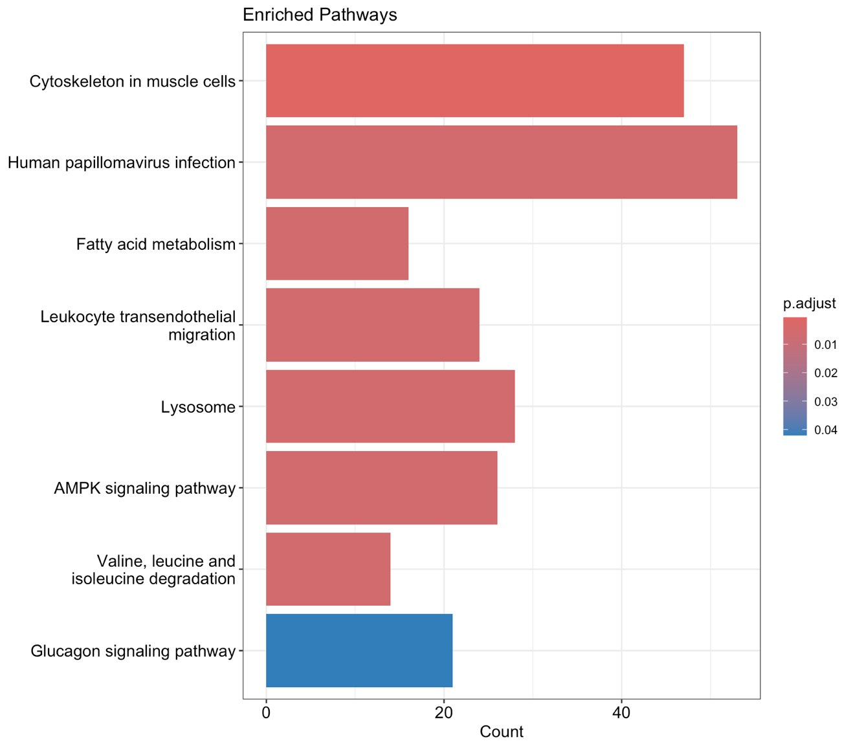

Figure 2.13 Barplot of enriched KEGG Pathways in significant down-regulated genes in steers with greater average daily gain (ADG)
Clusterprofiler generated barplot represents enriched KEGG pathways in steers with greater average daily gain (ADG) of the 2,006 genes expressed at lower levels. The red to blue scale indicates significance based on padj value. The x-axis represents the number of gene counts per pathway.

Greater ADG
Less ADG

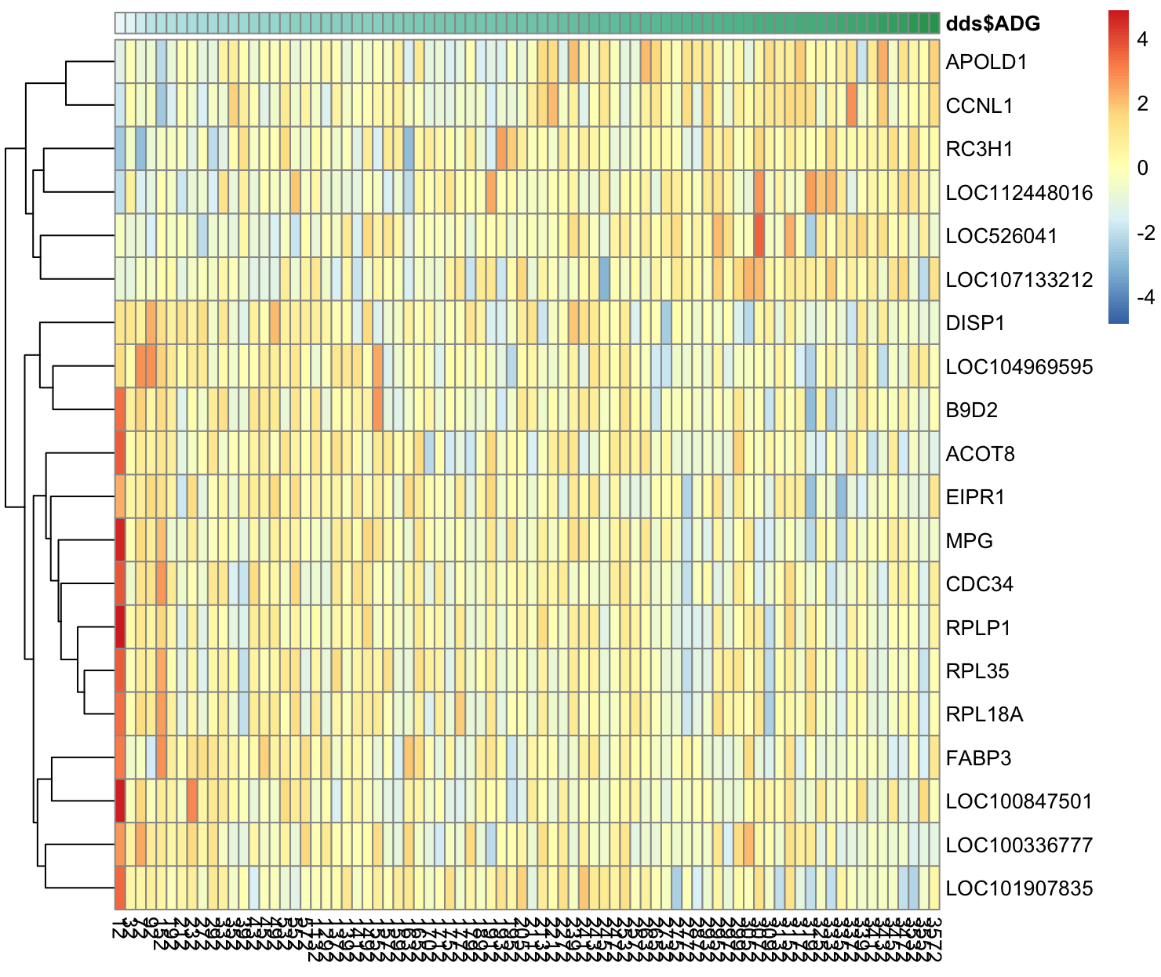
Figure 2.14 Heatmap of linear model for growing beef steers with divergent average daily gain (ADG)
Heatmap representing the gene expression data of the top 20 DEGS (adjusted p-value <0.05) of the 55 identified by DESeq2 for ADG linear model, arranged by lowest padj value. X-axis represents the individual steer number while the Y-axis represents the annotation of the official gene symbol. The blue to red color scale indicates an increase or decrease in gene expression. The green scale across the top represents the scale of each animal's ADG rank.

Pathway Analysis Linear Model
Over-representation analysis was also performed on the linear model and found 10 significant pathways enriched in mitochondrial proton-transporting ATP synthase complex assembly (GO:0033615), regulation of long-chain fatty acid import into cell (GO:0140212), T-helper 17 type immune response (GO:0072538), and cytoplasmic translation (GO:0002181) in the continuous model of steers with divergent ADG (Table 2.5). There were 2 significant over-represented pathways along the continuous scale, which included pathways enriched in ribosome activity. Of these, the pathways that were enriched were significantly correlated to the ones enriched within the grouped percentile model, for example, GO pathways relating to mitochondrial signaling, and KEGG pathways relating to ribosomal biogenesis.

Discussion

Improving feed efficiency is essential in beef cattle production. An animal that is more feed efficient is able to gain muscle while eating less (McKenna et al., 2021). Growth and development are primarily affected by genetics, diet, or environment, and examining key genes regulating its functions is crucial (Koch et al., 1963). Muscle proliferation incorporates energy expenditure, and one way to determine at how efficient these animals are at using this energy is by studying phenotypes such as RFI, ADG, and F:G (Fernandez et al., 2020) (Cantalapiedra-Hijar et al., 2018). By understanding which genes are expressed in animals with greater efficiency, opens the potentials for producers to select for more efficient animals. This study allowed for a deeper understanding of the mechanisms that control these genes to provide producers strategies to implement breeding into production.

Grouped model
Mean ADG was statistically different between the two feed efficiency trials, likely due to the variation in age and weight between the two trials. Due to the adjustment of ADG value, it can be assumed that this variation was no longer due to age or weight. In this study, significant DEGs were identified in steers with greater and lower ADG. Similarly, a study with hanwoo cattle, identified significant DEGs in the dorsi muscle in cattle with divergent ADG (Sheet et al., 2024). The results of the hanwoo cattle are consistent to this study, having a smaller sample size and less genes identified.

RFI is the animals expected feed intake when compared to its actual feed intake. The complexity of the RFI phenotype and its independence to growth and body size could explain why no DEG’s were identified (Crews, 2005). Another study also investigated the
differential expression of RFI in muscle tissue using 5 of the highest RFI cattle and 5 of the lowest. The results were similar, where no DEGs were identified in the skeletal muscle of greater and lower RFI steers (McKenna et al., 2021). RFI, although moderately heritable, is a difficult phenotype to compare across studies (Reyer et al., 2015). Measurement of RFI
can depend on test period, age of the animals in the study, or breed. Further, RFI is inconsistent due to it being dependent on weight and intake, and not necessarily gain and Table 2.5 Pathways for significant differentially expressed genes (DEGs) in the linear model in steers with divergent average daily gain (ADG)

Pathways | Fdr
GO:0033615 Mitochondrial proton-transporting atp synthase complex assembly | 2.2e-02
GO:0140212 Reg. of long-chain fatty acid import into cell | 2.1e-02
GO:0072538 T-helper 17 type immune response | 2.1e-02
GO:0002181 Cytoplasmic translation | 8.0e-03
hsa03010 Ribosome | 4.38e-16

Biological pathway (BP) results showing DEGs in the linear model for steers with greater ADG. FDR p-value <0.01

energy metabolism (Lines, 2016). Cattle with lower RFI may be seen as more efficient, but may not be gaining sufficient muscle. Therefore, identification of differential expression across studies is inconsistent. This study did not find significant DEGs in muscle tissue for animals with varying RFI or F:G, both likely due to the complexity of the traits.

Gene Set Enrichment
Ribosomal activity was the major over-represented pathway identified for gene set enrichment analysis in up-regulated genes in animals with High ADG in both KEGG and GO Biological Pathways. Specifically, there were 87 over-enriched significant genes (p-value <0.01) identified in animals with High ADG in the KEGG pathway, such as ribosomal protein L10a (RPL10A) and ribosomal protein S15a, which play a role in ribosomal biogenesis. The ribosome is responsible for protein synthesis in the cell and plays a vital role in cell proliferation and division (Jiao et al., 2023). Ribosomal biosynthesis occurs when rRNA are synthesized, which creates more ribosomes. Therefore, an increase in muscle mass is due to an increase in protein synthesis, causing muscle fiber hypotrophy (Figueiredo & McCarthy, 2019). A recent study with rats found that muscle protein synthesis and ribosomal abundance was elevated after resistance exercise, which was consistent with results for ribosomal biosynthesis in humans (West et al., 2019). Ultimately, ribosomal activity can be activated with muscle contraction and exercise. Therefore, animals with higher average daily gain expressing genes in skeletal muscle associated with ribosomal pathways can demonstrate an increase in muscle contraction and muscle gain.

Skeletal muscle, which is over 50% of body weight, accounts for 30% of resting energy expenditure. Previous studies have shown that mitochondrial functions, in relation to energy metabolism, were over-expressed in tissues with high energy demands (Dorji et al., 2020). The mitochondria create ATP by utilizing energy in food consumed. Due to this production of intracellular ATP, the mitochondria play an important role in oxidative phosphorylation (Brand et al., 2013) (Leduc-Gaudet et al., 2021). It has been shown in previous study that a disruption in genes regulating mitochondrial pathway function increases reactive oxygen species (ROS) and cause muscle atrophy (Romanello & Sandri, 2015). Mitochondrial gene expression, translation, respiratory chain complex assembly, and ATP synthesis were identified in cattle with greater ADG. Since skeletal muscle growth and development requires high energy demand, activation of mitochondrial activity can conclude animals expressing these genes have increased and rapid muscle proliferation (Oliveira & Hood, 2019). Mitophagy is a process that removes damaged mitochondrial, which regulates mitochondrial quality and quality (Chatzinikita et al., 2023). Studies show that in older damaged skeletal muscle, mitophagy is diminished compared to newer stronger skeletal muscle where mitophagy is abundant, which is consistent with the results of this study where mitophagy and mitochondrial function is present.

Inflammation in the muscle can occur with infection or damage to the tissue. When muscle is inflamed, leukocytes accumulate to repair the muscle tissue (Muller, 2002). A study found an increase in leukocytes and immune response in the skeletal muscle of swine with lower efficiency. An increase in immune response is likely due to nutrient deprivation and energy usage in lower efficiency animals (Gondret et al., 2017). In this study, we found an increase expression of leukocyte trans-endothelial migration in steers with lower gain. Although more research is still needed in this pathway specifically for cattle, producers may take into consideration the inflammatory impact of diet, which can cause cattle to have lower muscle gain.

Linear model
A linear model of this study was also conducted to view the regression between the traits. Linear models of quantifiable traits can lead to a better understanding on how the dependent variable is predicted and lead to more accurate results. There is limited research using feed efficiency as a continuous factor, therefore, the results of the linear model can used as supporting evidence for the grouped percentile model. There were 55 DEGs in the linear model compared to the 4,162 in the grouped percentile model, likely due to the lack of statistical power when taking samples out of groups. However, the pathway findings of the linear model were consistent with those of the grouped model, with greater ADG animals expressing major pathways involved in energy expenditure and lower ADG with inflammation. However, more research is needed in linear modeling for differential expression and feed efficiency traits in cattle.

CONCLUSION

The human population is growing globally, therefore, farmers and researchers are identifying ways to improve beef production while also meeting the needs sustainability and economically. Feed efficiency phenotypes including ADG, RFI, and F:G are all important factors in beef operations due to the ability to monitor the animals gain to feed intake. Muscle is the main economic product in beef cattle operations, however, there is limited work on how the genetics of muscle growth and development are regulated in cattle with varying levels of energy and feed efficiency.

This study investigated the differentially expressed genes in muscle tissue in Angus beef steers with varying RFI, ADG, and F:G. Between two different models analyzed in DESeq2, there were over 4,000 DEGs that were identified with a p-value of <0.01 between high and low groups of ADG. There were 55 DEGs identified in ADG in the linear model using individual ADG values. There were no DEG’s identified in high and low groups of RFI or F:G in either model. These results can assist in research to improve efficiency and muscle growth while meeting the needs of food production and sustainability for the growing population.

REFERENCES

Al-Samerria, S., & Radovick, S. (2021). The Role of Insulin-like Growth Factor-1 (IGF-1) in the Control of Neuroendocrine Regulation of Growth. Cells, 10(10). https://doi.org/10.3390/cells10102664
Allen, M. S. (2014). Drives and limits to feed intake in ruminants. Animal Production Science, 54(10), 1513-1524. https://doi.org/https://doi.org/10.1071/AN14478
Archer, J. A., Richardson, E. C., Herd, R. M., & Arthur, P. F. (1999). Potential for selection to improve efficiency of feed use in beef cattle: a review. Australian Journal of Agricultural Research, 50(2), 147-162. https://doi.org/https://doi.org/10.1071/A98075
Arthur, J., & Herd, R. (2008). Residual Feed intake in beef cattle. Revista Brasileira De Zootecnia-brazilian Journal of Animal Science - REV BRAS ZOOTECN, 37. https://doi.org/10.1590/S1516-35982008001300031
Basarab, J. A., Beauchemin, K. A., Baron, V. S., Ominski, K. H., Guan, L. L., Miller, S. P., & Crowley, J. J. (2013). Reducing GHG emissions through genetic improvement for feed efficiency: effects on economically important traits and enteric methane production. Animal, 7 Suppl 2(Suppl 2), 303-315. https://doi.org/10.1017/s1751731113000888
Beever, D. E., & Doyle, P. T. (2007). Feed conversion efficiency as a key determinant of dairy herd performance: a review. Australian Journal of Experimental Agriculture, 47(6), 645-657. https://doi.org/https://doi.org/10.1071/EA06048
Brand, M. D., Orr, A. L., Perevoshchikova, I. V., & Quinlan, C. L. (2013). The role of mitochondrial function and cellular bioenergetics in ageing and disease. Br J Dermatol, 169 Suppl 2(0 2), 1-8. https://doi.org/10.1111/bjd.12208
Cantalapiedra-Hijar, G., Abo-Ismail, M., Carstens, G. E., Guan, L. L., Hegarty, R., Kenny, D. A., McGee, M., Plastow, G., Relling, A., & Ortigues-Marty, I. (2018). Review: Biological determinants of between-animal variation in feed efficiency of growing beef cattle. Animal, 12, s321-s335. https://doi.org/https://doi.org/10.1017/S1751731118001489
Carstens, G. E., & Tedeschi, L. O. (2006). Defining feed efficiency in beef cattle. Proceedings of Beef Improvement Federation 38th Annual Research Symposium and Annual Meeting, Choctaw, Mississippi,
Chatzinikita, E., Maridaki, M., Palikaras, K., Koutsilieris, M., & Philippou, A. (2023). The Role of Mitophagy in Skeletal Muscle Damage and Regeneration. Cells, 12(5). https://doi.org/10.3390/cells12050716
Chen, Y., Lun, A. T., & Smyth, G. K. (2016). From reads to genes to pathways: differential expression analysis of RNA-Seq experiments using Rsubread and the edgeR quasi-likelihood pipeline. F1000Res, 5, 1438. https://doi.org/10.12688/f1000research.8987.2
Costa-Silva, J., Domingues, D., & Lopes, F. M. (2017). RNA-Seq differential expression analysis: An extended review and a software tool. PLOS ONE, 12(12), e0190152. https://doi.org/10.1371/journal.pone.0190152
Crews, D. H. D. (2005). Genetics of efficient feed utilization and national cattle evaluation: a review. Genetics and molecular research : GMR, 4(2), 152-165. Retrieved 2005/06//, from http://europepmc.org/abstract/MED/16110437
Crowley, J. J., McGee, M., Kenny, D. A., Crews, D. H., Jr., Evans, R. D., & Berry, D. P. (2010). Phenotypic and genetic parameters for different measures of feed efficiency in different breeds of Irish performance-tested beef bulls. J Anim Sci, 88(3), 885-894. https://doi.org/10.2527/jas.2009-1852
Dadi, H., Kim, J. J., Yoon, D., & Kim, K. S. (2012). Evaluation of Single Nucleotide Polymorphisms (SNPs) Genotyped by the Illumina Bovine SNP50K in Cattle Focusing on Hanwoo Breed. Asian-Australas J Anim Sci, 25(1), 28-32. https://doi.org/10.5713/ajas.2011.11232
DePristo, M. A., Banks, E., Poplin, R., Garimella, K. V., Maguire, J. R., Hartl, C., Philippakis, A. A., del Angel, G., Rivas, M. A., Hanna, M., McKenna, A., Fennell, T. J., Kernytsky, A. M., Sivachenko, A. Y., Cibulskis, K., Gabriel, S. B., Altshuler, D., & Daly, M. J. (2011). A framework for variation discovery and genotyping using next-generation DNA sequencing data. Nature Genetics, 43(5), 491-498. https://doi.org/10.1038/ng.806
Dorji, J., Vander Jagt, C. J., Garner, J. B., Marett, L. C., Mason, B. A., Reich, C. M., Xiang, R., Clark, E. L., Cocks, B. G., Chamberlain, A. J., MacLeod, I. M., & Daetwyler, H. D. (2020). Expression of mitochondrial protein genes encoded by nuclear and mitochondrial genomes correlate with energy metabolism in dairy cattle. BMC Genomics, 21(1), 720. https://doi.org/10.1186/s12864-020-07018-7
Fernandez, E. E., Oltjen, J. W., & Sainz, R. D. (2020). Mitochondrial abundance and function in muscle from beef steers with divergent residual feed intakes. Animal, 14(3), 560-565. https://doi.org/https://doi.org/10.1017/S1751731119002209
Figueiredo, V. C., & McCarthy, J. J. (2019). Regulation of Ribosome Biogenesis in Skeletal Muscle Hypertrophy. Physiology (Bethesda), 34(1), 30-42. https://doi.org/10.1152/physiol.00034.2018
García-Ruiz, A., Cole, J. B., VanRaden, P. M., Wiggans, G. R., Ruiz-López, F. J., & Van Tassell, C. P. (2016). Changes in genetic selection differentials and generation intervals in US Holstein dairy cattle as a result of genomic selection. Proceedings of the National Academy of Sciences, 113(28), E3995-E4004. https://doi.org/doi:10.1073/pnas.1519061113
Gondret, F., Vincent, A., Houée-Bigot, M., Siegel, A., Lagarrigue, S., Causeur, D., Gilbert, H., & Louveau, I. (2017). A transcriptome multi-tissue analysis identifies biological pathways and genes associated with variations in feed efficiency of growing pigs. BMC Genomics, 18(1), 244. https://doi.org/10.1186/s12864-017-3639-0
González, N., Marquès, M., Nadal, M., & Domingo, J. L. (2020). Meat consumption: Which are the current global risks? A review of recent (2010-2020) evidences. Food Res Int, 137, 109341. https://doi.org/10.1016/j.foodres.2020.109341
Hackmann, T. J., & Firkins, J. L. (2015). Maximizing efficiency of rumen microbial protein production. Front Microbiol, 6, 465. https://doi.org/10.3389/fmicb.2015.00465
Hardan, A., Garnsworthy, P. C., & Bell, M. J. (2022). Detection of Methane Eructation Peaks in Dairy Cows at a Robotic Milking Station Using Signal Processing. Animals, 12(1), 26. https://www.mdpi.com/2076-2615/12/1/26
Hegarty, R. S., Goopy, J. P., Herd, R. M., & McCorkell, B. (2007). Cattle selected for lower residual feed intake have reduced daily methane production1,2. Journal of Animal Science, 85(6), 1479-1486. https://doi.org/10.2527/jas.2006-236
Herd, R. M., & Arthur, P. F. (2009). Physiological basis for residual feed intake. J Anim Sci, 87(14 Suppl), E64-71. https://doi.org/10.2527/jas.2008-1345
Hu, Z., Boschiero, C., Li, C. J., Connor, E. E., Baldwin, R. L. t., & Liu, G. E. (2023). Unraveling the Genetic Basis of Feed Efficiency in Cattle through Integrated DNA Methylation and CattleGTEx Analysis. Genes (Basel), 14(12). https://doi.org/10.3390/genes14122121
Ibragimov, E., Pedersen, A. Ø., Xiao, L., Cirera, S., Fredholm, M., & Karlskov-Mortensen, P. (2022). Analysis of merged transcriptomic and genomic datasets to identify genes and pathways underlying residual feed intake in growing pigs. Scientific Reports, 12(1), 21946. https://doi.org/10.1038/s41598-022-26496-1
Izadnia, H. R., Tahmoorespur, M., Bakhtiarizadeh, M. R., Nassiri, M., & Esmaeilkhanien, S. (2019). Gene expression profile analysis of residual feed intake for Isfahan native chickens using RNA-SEQ data. Italian Journal of Animal Science, 18(1), 246-260. https://doi.org/10.1080/1828051X.2018.1507625
Jiang, W., Mooney, M. H., & Shirali, M. (2024). Unveiling the Genetic Landscape of Feed Efficiency in Holstein Dairy Cows: Insights into Heritability, Genetic Markers, and Pathways via Meta-Analysis. J Anim Sci, 102. https://doi.org/10.1093/jas/skae040
Jiao, L., Liu, Y., Yu, X.-Y., Pan, X., Zhang, Y., Tu, J., Song, Y.-H., & Li, Y. (2023). Ribosome biogenesis in disease: new players and therapeutic targets. Signal Transduction and Targeted Therapy, 8(1), 15. https://doi.org/10.1038/s41392-022-01285-4
Kaushik, S., Kaushik, S., & Sharma, D. (2019). Functional Genomics. In S. Ranganathan, M. Gribskov, K. Nakai, & C. Schönbach (Eds.), Encyclopedia of Bioinformatics and Computational Biology (pp. 118-133). Academic Press. https://doi.org/https://doi.org/10.1016/B978-0-12-809633-8.20222-7
Kenny, D. A., Fitzsimons, C., Waters, S. M., & McGee, M. (2018). Invited review: Improving feed efficiency of beef cattle – the current state of the art and future challenges. Animal, 12(9), 1815-1826. https://doi.org/https://doi.org/10.1017/S1751731118000976
Khanal, P., Johnson, J., Gouveia, G., Ross, P., & Deeb, N. (2023). Genomic evaluation of feed efficiency in US Holstein heifers. Journal of Dairy Science, 106(10), 6986-6994. https://doi.org/https://doi.org/10.3168/jds.2023-23258
Koch, R. M., Swiger, L. A., Chambers, D., & Gregory, K. E. (1963). Efficiency of Feed Use in Beef Cattle. Journal of Animal Science, 22(2), 486-494. https://doi.org/10.2527/jas1963.222486x
Laron, Z. (2001). Insulin-like growth factor 1 (IGF-1): a growth hormone. Mol Pathol, 54(5), 311-316. https://doi.org/10.1136/mp.54.5.311
Lawrence, J., Mintert, J., Anderson, J., & Anderson, D. (2008). Feed Grains and Livestock: Impacts on Meat Supplies and Prices. Iowa State University, Department of Economics, Staff General Research Papers, 23.
Leduc-Gaudet, J.-P., Hussain, S. N. A., Barreiro, E., & Gouspillou, G. (2021). Mitochondrial Dynamics and Mitophagy in Skeletal Muscle Health and Aging. International Journal of Molecular Sciences, 22(15), 8179. https://www.mdpi.com/1422-0067/22/15/8179
Lines, D. S. (2016). Consequences of selection for residual feed intake in beef cattle [Abstract].
Listrat, A., Lebret, B., Louveau, I., Astruc, T., Bonnet, M., Lefaucheur, L., Picard, B., & Bugeon, J. (2016). How Muscle Structure and Composition Influence Meat and Flesh Quality. The Scientific World Journal, 2016(1), 3182746. https://doi.org/https://doi.org/10.1155/2016/3182746
Manzanilla-Pech CIV, S. R., Difford GF, Løvendahl P, Lassen J. (2022). Selecting for Feed Efficient Cows Will Help to Reduce Methane Gas Emissions. .
McKenna, C., Keogh, K., Porter, R. K., Waters, S. M., Cormican, P., & Kenny, D. A. (2021). An examination of skeletal muscle and hepatic tissue transcriptomes from beef cattle divergent for residual feed intake. Scientific Reports, 11(1), 8942. https://doi.org/10.1038/s41598-021-87842-3
Meuwissen, T. H., Hayes, B. J., & Goddard, M. E. (2001). Prediction of total genetic value using genome-wide dense marker maps. Genetics, 157(4), 1819-1829. https://doi.org/10.1093/genetics/157.4.1819
Moe, P. W. (1981). Energy Metabolism of Dairy Cattle. Journal of Dairy Science, 64(6), 1120-1139. https://doi.org/https://doi.org/10.3168/jds.S0022-0302(81)82692-6
Mohammadabadi, M., Bordbar, F., Jensen, J., Du, M., & Guo, W. (2021). Key Genes Regulating Skeletal Muscle Development and Growth in Farm Animals. Animals (Basel), 11(3). https://doi.org/10.3390/ani11030835
Montelli, N., Alvarenga, T., Almeida, A. K., Alvarenga, F. A. P., Furusho-Garcia, I. F., Greenwood, P. L., & Pereira, I. G. (2021). Associations of feed efficiency with circulating IGF-1 and leptin, carcass traits and meat quality of lambs. Meat Sci, 173, 108379. https://doi.org/10.1016/j.meatsci.2020.108379
Muller, W. A. (2002). Leukocyte-Endothelial Cell Interactions in the Inflammatory Response. Laboratory Investigation, 82(5), 521-534. https://doi.org/10.1038/labinvest.3780446
Nielsen, M. K., MacNeil, M. D., Dekkers, J. C. M., Crews, D. H., Rathje, T. A., Enns, R. M., & Weaber, R. L. (2013). Review: Life-cycle, total-industry genetic improvement of feed efficiency in beef cattle: Blueprint for the Beef Improvement Federation11The development of this commentary was supported by the Beef Improvement Federation. The Professional Animal Scientist, 29(6), 559-565. https://doi.org/https://doi.org/10.15232/S1080-7446(15)30285-0
Oliveira, A. N., & Hood, D. A. (2019). Exercise is mitochondrial medicine for muscle. Sports Medicine and Health Science, 1(1), 11-18. https://doi.org/https://doi.org/10.1016/j.smhs.2019.08.008
Patience, J. F., Rossoni-Serão, M. C., & Gutiérrez, N. A. (2015). A review of feed efficiency in swine: biology and application. Journal of Animal Science and Biotechnology, 6(1), 33. https://doi.org/10.1186/s40104-015-0031-2
Pryce, J. E., Wales, W. J., de Haas, Y., Veerkamp, R. F., & Hayes, B. J. (2014). Genomic selection for feed efficiency in dairy cattle. Animal, 8(1), 1-10. https://doi.org/10.1017/s1751731113001687
Reyer, H., Hawken, R., Murani, E., Ponsuksili, S., & Wimmers, K. (2015). The genetics of feed conversion efficiency traits in a commercial broiler line. Sci Rep, 5, 16387. https://doi.org/10.1038/srep16387
Romanello, V., & Sandri, M. (2015). Mitochondrial Quality Control and Muscle Mass Maintenance. Front Physiol, 6, 422. https://doi.org/10.3389/fphys.2015.00422
Salleh, S. M., Mazzoni, G., Løvendahl, P., & Kadarmideen, H. N. (2018). Gene co-expression networks from RNA sequencing of dairy cattle identifies genes and pathways affecting feed efficiency. BMC Bioinformatics, 19(1), 513. https://doi.org/10.1186/s12859-018-2553-z
Savietto, D., Berry, D. P., & Friggens, N. C. (2014). Towards an improved estimation of the biological components of residual feed intake in growing cattle1. Journal of Animal Science, 92(2), 467-476. https://doi.org/10.2527/jas.2013-6894
Scialabba, N., Jan, O., Tostivint, C., Turbé, A., O’Connor, C., Lavelle, P., Flammini, A., Hoogeveen, J., Iweins, M., Tubiello, F., Peiser, L., & Batello, C. (2013). Food Wastage Footprint: Impacts on Natural Resources. Summary Report.
Seabury, C. M., Oldeschulte, D. L., Saatchi, M., Beever, J. E., Decker, J. E., Halley, Y. A., Bhattarai, E. K., Molaei, M., Freetly, H. C., Hansen, S. L., Yampara-Iquise, H., Johnson, K. A., Kerley, M. S., Kim, J., Loy, D. D., Marques, E., Neibergs, H. L., Schnabel, R. D., Shike, D. W., . . . Taylor, J. F. (2017). Genome-wide association study for feed efficiency and growth traits in U.S. beef cattle. BMC Genomics, 18(1), 386. https://doi.org/10.1186/s12864-017-3754-y
Sheet, S., Jang, S. S., Kim, J. H., Park, W., & Kim, D. (2024). A transcriptomic analysis of skeletal muscle tissues reveals promising candidate genes and pathways accountable for different daily weight gain in Hanwoo cattle. Scientific Reports, 14(1), 315. https://doi.org/10.1038/s41598-023-51037-9
Silva Neto, J. B., Mota, L. F. M., Amorim, S. T., Peripolli, E., Brito, L. F., Magnabosco, C. U., & Baldi, F. (2023). Genotype-by-environment interactions for feed efficiency traits in Nellore cattle based on bi-trait reaction norm models. Genetics Selection Evolution, 55(1), 93. https://doi.org/10.1186/s12711-023-00867-2
Suzuki, T., Murakami, H., Uchiyama, J., Sato, R., Takemura-Uchiyama, I., Ogata, M., Sogawa, K., Ishida, H., Atipairin, A., Matsushita, O., & Nagai, M. (2023). Exploratory study of volatile fatty acids and the rumen-and-gut microbiota of dairy cows in a single farm, with respect to subclinical infection with bovine leukemia virus. Annals of Microbiology, 73(1), 31. https://doi.org/10.1186/s13213-023-01737-4
Tapio, M., Fischer, D., Mäntysaari, P., & Tapio, I. (2023). Rumen Microbiota Predicts Feed Efficiency of Primiparous Nordic Red Dairy Cows. Microorganisms, 11(5). https://doi.org/10.3390/microorganisms11051116
Tempelman, R. J., & Lu, Y. (2020). Symposium review: Genetic relationships between different measures of feed efficiency and the implications for dairy cattle selection indexes. Journal of Dairy Science, 103(6), 5327-5345. https://doi.org/https://doi.org/10.3168/jds.2019-17781
Terry, S., Basarab, J., Guan, L., & McAllister, T. (2020). Invited Review: Strategies to improve the efficiency of beef cattle production. Canadian Journal of Animal Science, 101. https://doi.org/10.1139/CJAS-2020-0022
West, D. W. D., Marcotte, G. R., Chason, C. M., Juo, N., Baehr, L. M., Bodine, S. C., & Baar, K. (2019). Normal Ribosomal Biogenesis but Shortened Protein Synthetic Response to Acute Eccentric Resistance Exercise in Old Skeletal Muscle [Original Research]. Frontiers in Physiology, 9. https://doi.org/10.3389/fphys.2018.01915
Westerterp, K. R. (2000). Control of Energy Expenditure in Humans. In K. R. Feingold, B. Anawalt, M. R. Blackman, A. Boyce, G. Chrousos, E. Corpas, W. W. de Herder, K. Dhatariya, K. Dungan, J. Hofland, S. Kalra, G. Kaltsas, N. Kapoor, C. Koch, P. Kopp, M. Korbonits, C. S. Kovacs, W. Kuohung, B. Laferrere, M. Levy, E. A. McGee, R. McLachlan, M. New, J. Purnell, R. Sahay, A. S. Shah, F. Singer, M. A. Sperling, C. A. Stratakis, D. L. Trence, & D. P. Wilson (Eds.), Endotext. https://www.ncbi.nlm.nih.gov/pubmed/25905198
Wicks, J., Beline, M., Gomez, J. F. M., Luzardo, S., Silva, S. L., & Gerrard, D. (2019). Muscle Energy Metabolism, Growth, and Meat Quality in Beef Cattle. Agriculture, 9(9), 195. https://www.mdpi.com/2077-0472/9/9/195
Wiki, B. G. (2022). Feed Efficiency — BIF Guidelines WIki. "\url{http://guidelines.beefimprovement.org/index.php?title=Feed_Efficiency&oldid=2606}",
Williams, Y. J., Pryce, J. E., Grainger, C., Wales, W. J., Linden, N., Porker, M., & Hayes, B. J. (2011). Variation in residual feed intake in Holstein-Friesian dairy heifers in southern Australia. J Dairy Sci, 94(9), 4715-4725. https://doi.org/10.3168/jds.2010-4015
Yi, Z., Li, X., Luo, W., Xu, Z., Ji, C., Zhang, Y., Nie, Q., Zhang, D., & Zhang, X. (2018). Feed conversion ratio, residual feed intake and cholecystokinin type A receptor gene polymorphisms are associated with feed intake and average daily gain in a Chinese local chicken population. Journal of Animal Science and Biotechnology, 9(1), 50. https://doi.org/10.1186/s40104-018-0261-1
Yoshida, T., & Delafontaine, P. (2020). Mechanisms of IGF-1-Mediated Regulation of Skeletal Muscle Hypertrophy and Atrophy. Cells, 9(9). https://doi.org/10.3390/cells9091970

VITA

Sophia Maria Ascolese was born in Boston, Massachusetts on December 20th, 1999. She attended Arlington Catholic High School in Arlington, MA and graduated in May of 2018. She then went to the University of Tennessee, Knoxville and received her bachelor’s degree in Animal Science with a minor in Plant Sciences in May of 2022. She then went on to pursue a Master of Science under Dr. Phillip Myer and Dr. Brynn Voy that same year.

