Chancellor’s Honors Program and Nursing Honors Program Senior Thesis Project
Parental Responses to Outcomes of Developmental Screening Among Children: A Pilot Study
Ashley Manus
Faculty Mentor: Dr. Deb Chyka

Purpose
To examine parental response to developmental screening outcomes that may suggest a deficit in their child’s progress.
Abstract
Using age-appropriate developmental screening tools in young children may be the initial step in the identification of socialization, language, and/or motor skill delays when evaluations are conducted. Early detection of these delays, with subsequent early interventions, are critical to foster/promote proper growth and development. Elective evaluation is contingent upon the willingness and desire of parents to seek evidence regarding atypical screening results. Current literature does not address parental responses or emotions experienced after receiving notification that developmental concerns about their child have been identified. Trepidation may cause some parental hesitation about pursuing further evaluation for their child thereby delaying definitive diagnosis and early intervention efforts. Future research may provide evidence to guide discussions between parents and healthcare providers toward improving follow-up evaluation rates that could lead to earlier diagnosis and treatment.
Background of the Project
This project aimed to highlight the importance of understanding and accepting the parent’s emotional response to atypical screening results in hopes of improving communication between health care providers and parents. This can be a fearful time for parents; however, it is important for the healthcare provider to educate the parents about the potential impact of a developmental delay, the necessity of further evaluation and the need for early intervention.
Research Question
What is the emotional response of a parent to a potential developmental concern as suggested by an atypical developmental screening result?
Design of Study
This research study was completed using a qualitative-descriptive design of study. A semi-structured interview was arranged with two participants. The interviews focused on the parent’s emotions in regards to their child’s screening results. The interview was recorded on a recording device and then transcribed. The transcript was analyzed using qualitative content analysis. Common themes were extracted from the participant’s responses to help clarify the common responses of parents receiving the concern. Similarities and differences were noted between the two participant’s responses.
Sample
This study focused on the parents of children who received two suspect results from a developmental screening tool. The project sample consisted of 2 primary caregivers of children who were screened/rescreened and received two suspect results. Both children of the parents currently attend Cokesbury Childcare Center and are part of a low-risk population. The children of the parents were required to be between the ages of 0-6 years old to qualify for testing using the Denver II Developmental Screening Tool. The primary caregivers had to be above the age of 18 for legal purposes. The title of the primary caregiver was not used as criteria for inclusion or exclusion.
Definitions
Developmental delay: an occurrence where a child meets age-appropriate milestones at a
delayed time, yet in a sequential order (Voigt, 2011)
Developmental milestone: an activity that a child should be able to perform once he/she
reaches a certain age, as defined by developmental standards; based on societal and cultural expectations of a child at a specific age i.e. kicking a ball, stacking blocks on top of each other, pointing to a bird, etc. (Jenni, Chaouch, Caflisch, & Rousson, 2013)
Evaluation: a medical process that serves to identify a developmental diagnosis, explore
the origin of the diagnosis, and encourage early interventional services (Voigt, 2011)
Trepidation: a nervous or powerless feeling of uncertainty that has the potential to cause
hesitation related to fear (“Trepidation,” 2014)
Brief Review of the Literature
By definition, developmental delays occur when a child meets age-appropriate milestones in sequential order but over a delayed timeframe (Voigt, 2011). Developmental deficits include, but are not limited to, language, psychosocial, and fine and gross motor skill delays (Frankenburg et al., 1992). These skills are important for engaging in activities of daily living and in developing and learning behaviors necessary for self-sufficiency. Approximately 12% to 16% of children in the United States (U. S.) have a developmental delay (Hunter & Lynch, 2013; Mackrides & Ryherd, 2011, Voigt, 2011). Identifying early life delays is a problem that could realistically be improved by using developmental screening tools. Unaddressed developmental delays can affect a child forward into adulthood and therefore is an important healthcare issue that should not be overlooked. Chiu and DiMarco (2010) state that only one-third of childhood developmental or behavioral delays are identified before kindergarten age (Kerstjens et al., 2009). This inefficiency calls for increased use of developmental screening tools for the recognition of deficits well before a child attempts kindergarten. Because child development is an interconnected and multifaceted process involving fine and gross motor, language, cognitive, and adaptive behavioral development, it is important to accurately test all of domains so as to effectively identify possible developmental deficits (Kerstjens et al., 2009).
Parenthood is portrayed to be a generally rewarding time in couples’ lives; however, when a medical concern arises about their child, a mixture of emotions often occurs (Fallowfield & Jenkins, 2014). One study analyzed maternal and paternal reactions to their child’s developmental delay, concluding that both parents were “unresolved” with the idea that their child had been diagnosed with a developmental concern, but that the rate of resolution was similar between the two parents (Barak-Levy & Atzaba-Poria, 2013). In a similar study, it was found that mothers expressed more emotional responses to the diagnosis whereas the fathers processed the information more cognitively with less outward emotion (Barak-Levy & Atzaba-Poria, 2013). In their study, Barak-Levy and Atzaba-Poria defined acceptance and resolution of the diagnosis as “…the process in which parents build a presentation, incorporating the pre- and post-diagnostic internal self-representation of the self and the ‘real’ child, as opposed to the ‘fantasy’ child they dreamt of ” (p. 2040). For the parent, the reality of having to comprehend that their child has a possible health concern may seem unrealistic at first, even creating a sense of shock (Fallowfield & Jenkins, 2014). The parent’s individual coping style determines the next step they may take toward addressing the developmental concern. The healthcare provider (HCP) bears the responsibility for providing guidance to confused and emotional parents during this unpredictable time (Rebow & McPhee, 1999). Many parents may not understand the importance of the findings or potential consequences for their child testing results are ignored. By acknowledging parental grief in response to receiving the diagnosis and using a concerned approach, a knowledgeable HCP can assist by providing professional advice, guidance, and recommendations regarding how they may begin to address their child’s situation. When the HCP recognizes whether a parent is resolved or unresolved, they are better able to provide appropriate assistance and guidance (Barak-Levy & Atzaba-Poria, 2013).
Several research studies have explored parental reactions to receiving or hearing a definitive medical diagnosis about their child; feelings such as denial, shock, anger, and sadness were commonly identified among parents (Fallowfield & Jenkins, 2014; Rabow & McPhee, 1999; Russ et al., 2004; Waxler, Cherniske, Dieter, Herd, & Pober, 2012). Waxler et al. found that parents receiving a diagnosis of a disorder with an explanation by the HCP, 34% felt they had had a negative experience and 25% had mixed feelings about their experience. It is critical that parents feel comfortable about both the diagnosis and their ability to access resources once they depart from the facility after receiving the diagnosis. The high rate of negative or mixed parental feelings about their experiences indicates this is an area of care that needs improvement. Receipt of diagnosis can be a highly sensitive period during which parents may feel confused and require adequate time and space to process the information (Little & Bolick, 2014). Empathy and a sense of caring by the HCP is essential for parents to help with their acceptance and understanding about their child’s condition (Fallowfield & Jenkins, 2014; Waxler et al., 2012). The HCP should remain aware that this event will likely leave a lifelong impression on the parent (Fallowfield & Jenkins, 2014; Little & Bolick, 2014; Waxler et al., 2012).
Focus on the relationship between parental feelings (such as trepidation or validation) and how these internal emotions influence their action or inaction was not found in the course of the literature review. Exploring and gaining understanding about the relationship between these two elements will help healthcare professionals and childcare providers to be more cognizant about these influences and therefore promote enhanced advocacy on behalf of children requiring developmental interventions. Parents make the ultimate decision; it is therefore critical that healthcare providers guide and advise them in a manner that is simultaneously empathetic and informative (Waxler et al., 2012). By gaining a better understanding of such parental perceptions, healthcare providers can more knowledgeably and effectively present diagnostic results to them in an informative yet supportive manner (Fallowfield & Jenkins, 2014). Acknowledging the parental perceptions about a possible developmental delay and educating them about the importance of early intervention has the potential to prevent continuation or extension of the delay. If parents are able to overcome their trepidation, the interventional process could ideally put the child back on track developmentally. The concept map encompasses the current state of knowledge while also setting the stage for future research.
The literature review conducted identified that further research need to be conducted to gain a broader foundation of the reactions of parents during the sensitive time of receiving a developmental delay diagnosis about their child. During this period, it is important to determine whether the parents will elect to pursue further evaluation and / or treatment for their child. If the parents seem to be disinterested or uncertain about seeking further care, the HCP should be prepared to address their issue. The literature reviewed reported maternal and paternal reaction differences but did not explore the parents’ decision-making about their plan of action after receiving the diagnostic information about their child. This critical step should be the subject of future research. Understanding parental rationale can help HCPs guide and support other parents in similar situations toward accepting additional evaluations for their child. This will allow children with identified developmental delays begin early intervention processes and potentially halt or reverse their delay. All involved parties must have a unified focus on the child’s health and development.
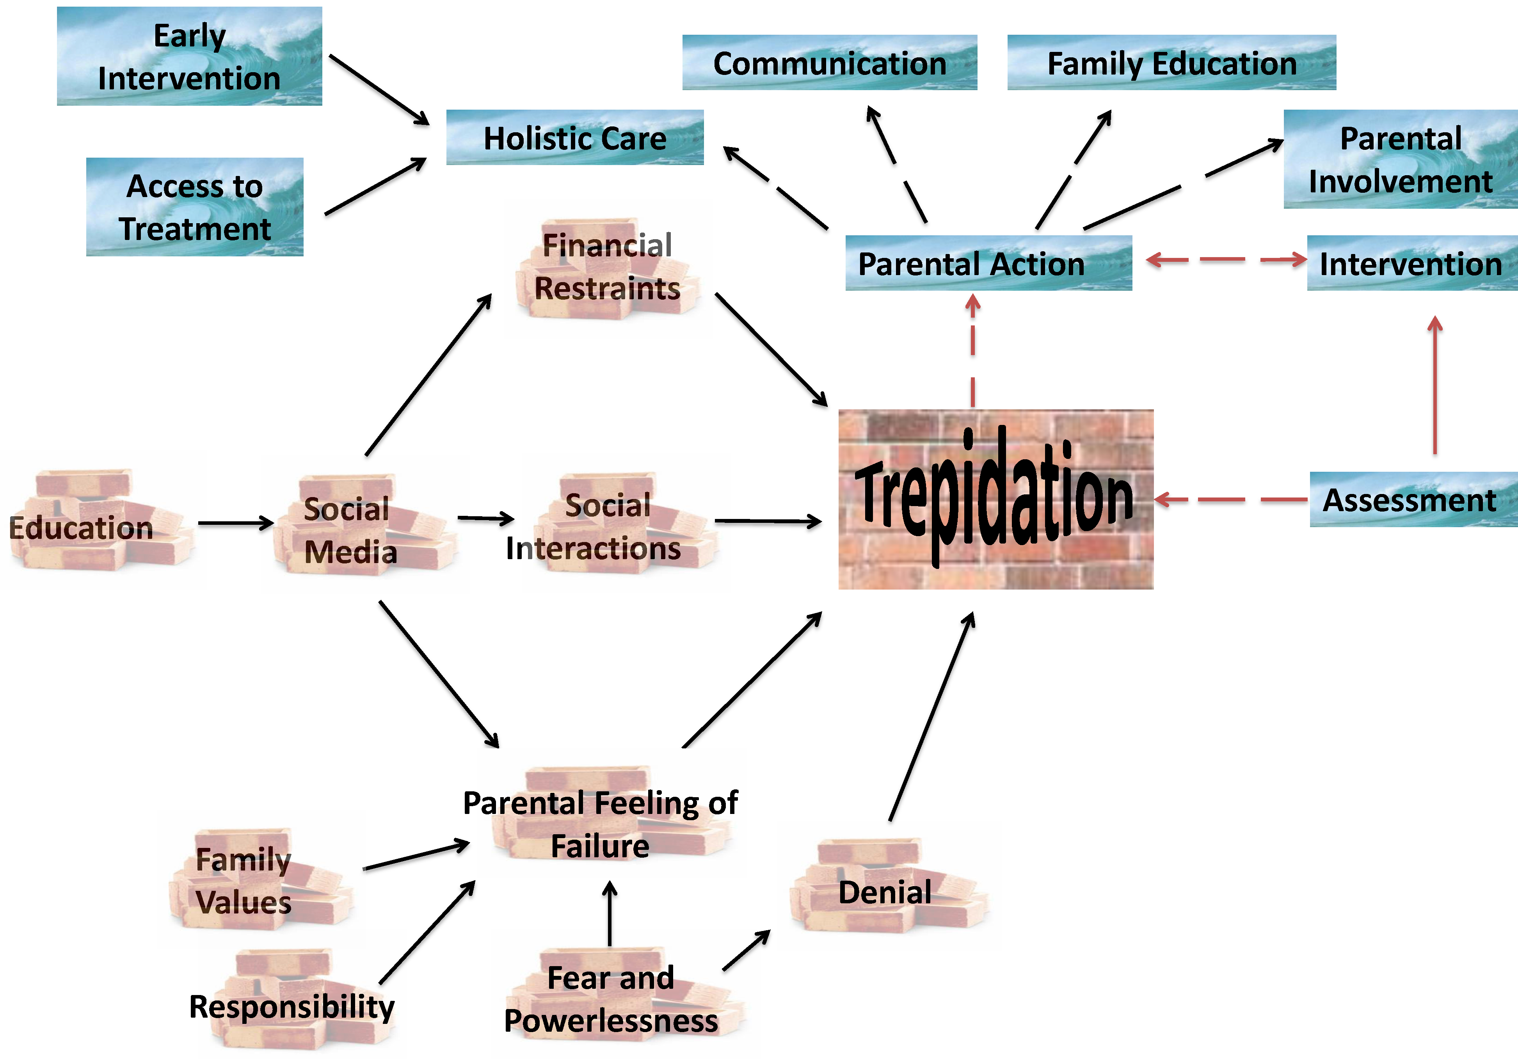

Results
The results collected and analyzed for this research study were unforeseen by the PI. As identified by the concept map, it was hypothesized that trepidation would be the definition used to describe the overall feelings of the parents when receiving notification of a developmental concern. However, the main theme that was found between both of the participating caregivers was validation. The first participant stated “hearing it out loud, I already kind of knew,” followed by “the truth hurts.” She had been concerned about her child’s development because she had compared her child to the peers in the classroom. However, the participant explained that the day she was notified was an emotional day. After being notified, she was referred to a local program and attended a meeting where she was placed into a room with specialists in a panel-like situation. She reports that she felt very overwhelmed and confused with everything the specialists were saying about the developmental concern as well as the plan of action for her child. She thought to herself, “Am I signing her [her child] away?” She explains that confusion was the strongest emotion she felt those first few weeks. She did not have any previous exposure to developmental delays and had never been exposed to child growth and development in an educational setting prior to this setting. This provided for a very overwhelming experience for this particular participant.
The second participant felt similarly about feeling a sense of validation after being notified of her child’s developmental concern. She explained that it was a relief to hear that her child had a developmental concern because she had recognized a concern and initiated a conversation with her child’s teacher and pediatrician for advice. Unlike the first participant, she had taken growth and developmental classes throughout college and currently works closely with school-aged children. She explained that her knowledge regarding developmental delays made it scarier for her as a mother. She already knew that it was highly probable that her child would have some type of delay secondary to prematurity and having congenital abnormalities; however, she stated that it was “gut-wrenching to think there is a deficit.” She reported that she had a typical motherly response and began to feel anxious about receiving care for her child. When the participant told her mother-in-law, she stated that the mother-in-law panicked and went into denial about there being a problem.
Overall, both of the participants felt a sense of relief and validation when being told about their child’s developmental concern. Each mentioned that they had recognized signs of a deficit prior to being told by a healthcare provider. Both had a friendly response to developmental screening tools and understood that the purpose was to identify a deficit if one was present. Both trusted their pediatricians and commended the way that they handled the situation of confirming the developmental concern. While the first participant felt a sense of confusion, the second felt more anxious. A lot of their emotions stemmed from the idea that insurance would not provide assistance in helping their children get the adequate amount of interventional services necessary. The first participant explained that speech therapy cost $1,800 and when they received the bill, they began to look for other options. Although the primary HCP signed off for insurance to help cover some of the costs, the family still struggled with finding care that was affordable for their child. The problem the second participant faced was the child was on the margin for receiving care covered by insurance. Although the child presented with a developmental concern, insurance did not provide coverage. This placed the mother in a difficult situation because she recognized the importance of early interventional services. She began to take it upon herself to talk to her friends that were occupational therapists and physical therapists to ask for activities that she could use to help her child. Fortunately, she had the connections to help her, however, she is still in the process of trying to find formal and professional care that will be covered by insurance.
Discussion
The results provided by the two participants are invaluable to healthcare professionals. The emotions experienced by parents in this sensitive situation are critical to understanding the best approach when disclosing a developmental concern to parents. The first participant felt confusion. If their was a preliminary meeting to explain the meaning and impact of a developmental delay prior to the meeting about the plan of care, the participant could have been more informed and involved in planning her child’s care. Instead, she was concerned about trying to accept the underlying fact that her child had a developmental concern. This detracted from her involvement in her child’s care. Healthcare providers should present information with the knowledge that most parents may feel overwhelmed in this atmosphere and situation. If the time was taken to explain to the caregiver about the basics of the situation and allowed time to comprehend the results, the caregiver could have been more at ease.
HCPs can, also, improve their empathy by preceding the conversation with reassuring words. Allowing time for the caregiver to comprehend the news is important. These thoughts can cloud their concentration when the HCP is explaining options of care. The ultimate goal of the HCP is to stress the importance of interventional services and options and provide further treatment for the child. If the parent is distracted while the HCP is explaining this to the parents, then some children may not receive the care necessary for proper growth and development. It is crucial that parents have the option of taking a few minutes to compose their thoughts and clear their mind so that they can concentrate on how to intervene with the concern. Preceding the conversation by stating it is okay to ask for permission to step out of the room for a few minutes can be valuable for the parent. Although the time constraints of the medical field are palpably present, it is important to be aware of the emotions associated with this situation. While perceptions were identified throughout this research study, there are limitations that could be clarified for future research.
Limitations
Many limitations surfaced throughout the span of this research project. The data used to recruit parents’ participation was collected at Cokesbury Childcare Center. The population of children screened using the Denver II Developmental Screening Tool was considered to be a low-risk sample of children. This provided the PI with a challenge because there were not as many potential participants for the study because there were only a few children who had two sequential suspect screening results. If this project could have been completed in a high-risk population, ideally there would have been the opportunity for more participants. Furthermore, the exclusion criteria needed to be more specific for this research study. Because of the great community and support provided at Cokesbury Childcare Center, both of the parents that shared their emotional experiences had already been informed that their child had a developmental concern. The PI was originally hoping to hear the initial reaction of the parent to the developmental concern, however both participants were asked to recall their original reaction to the notification. Further research in this area of health care should be completed to further understand the initial reaction of a parent. Ultimately, this will provide the HCP with the immediate response of parents instead of a delayed response that could have evolved. Exploring the immediate response will allow HCP to address the initial fears in the most professional and compassionate way possible.

References
Barak-Levy, Y., & Atzaba-Poria, N. (2013). Paternal versus maternal coping styles with child diagnosis of developmental delay. Research in Developmental Disabilities, 34(6), 2040-2046.
Chiu, S. H., & DiMarco, M. A. (2010). A pilot study comparing two developmental screening tools for use with homeless children. Journal of Pediatric Health Care, 24(2), 73-80. doi: 10.1016/j.pedhc.2009.01.003
Fallowfield L., Jenkins V. 2004. Communicating sad, bad, and difficult news
in medicine. Lancet 363:312–319.
Frankenburg, W. K., Dodds, J., Archer, P., Bresnick, B., Maschka, P., Edelman, N., & Shapiro, H. (1992). Denver II Training Manual (2nd ed.). Denver, CO: Denver Developmental Materials.
Hunter, L. R., & Lynch, B. A. (2013). Impact of implementing mental health screening by mail with a primary care management model. Journal of Primary Care and Community Health, 5(1), 9-13. doi: 10.1177/2150131913484340.
Kerstjens, J. M., Bos, A. F., ten Vergert, E. M., de Meer, G., Butcher, P. R., & Reijneveld, S. A. (2009). Support for the global feasibility of the Ages and Stages Questionnaire as developmental screener. Early Human Development, 85(7), 443-447. doi: 10.1016/j.earlhumdev.2009.03.001
Little, J., Bolick, B. (2014). Preparing Prelicensure and Graduate Nursing Students to
Systematically Communicate Bad News to Patients and Families. Journal Nursing Education, 53(1) 52-55. doi: 10.3928/01484834-20131218-02
Mackrides, P. S., & Ryherd, S. J. (2011). Screening for developmental delay. American Family Physician, 84(5), 544-549.
Rabow, M., & McPhee, S. (1999). Beyond breaking bad news: How to help patients who suffer. West Journal of Medicine, 171(4), 260–263.
Russ, S., Kuo, A., Poulakis, Z., Barker, M., Rickards, F., Saunder, K., … Oberklaid, F. (2004). Qualitative analysis of parents' experience with early detection of hearing loss. Archives of Disease in Children, 89(4), 353–358.
Voigt, R. G., Macias, M. M., & Myers, S.M. (Eds.). (2011). Developmental and behavioral pediatrics. Elk Grove Village, IL: American Academy of Pediatrics.
Waxler, J. L., Cherniske, E. M., Dieter, K., Herd, P., & Pober, B. R. (2013). Hearing from parents: The impact of receiving the diagnosis of Williams syndrome in their child. American Journal of Medical Genetics, 161a(3), 534-541. doi: 10.1002/ajmg.a.35789

