TOTAL PHYSICAL RESPONSE STORYTELLING WITH UNDERGRADUATE FOREIGN LANGUAGE LEARNERS: EXPLORING VOCABULARY GROWTH

A Thesis Presented for the
Master of Arts
Degree
The University of Tennessee, Knoxville

Eva Jones
December 2022
ACKNOWLEDGEMENTS
Thank you to Dr. Issa for taking on this project with me and helping me every step of the way. Additionally, thank you to Dr. Bowden and Dr. Frimu for being my second readers and adding so much to this project. I would also like to thank the Spanish department at the University of the South: Sewanee, without whom I would not be here. Lastly, thank you to my parents, who have always instilled in me the drive to learn more and to shoot for the stars.

ABSTRACT

This thesis analyzes the effectiveness of two pedagogical techniques used in foreign language teaching on vocabulary growth in a university setting: Total Physical Response Storytelling (TPRS) and a more traditional approach that does not involve storytelling. Over two sessions taking place a week apart, participants were separated into either the Control group or the Experimental group. Each group learned the same list of vocabulary words in the treatment session. While the Control group learned the target vocabulary through a traditional method, the Experimental group learned the vocabulary through a story. In the introduction, TPRS’s origins are reviewed as well as its basic principles. Communicative Language Teaching (CLT) and another pedagogical approach known as Presentation, Practice, and Production (PPP) and its relation to this study are also explained. In the literature review, pertinent studies related to this thesis are presented which will highlight the relevance of the present study. In the Methods chapter, participants and materials are presented to demonstrate the exact manner in which everything occurred in the study. In the Procedures chapter, the data collection sessions are described in detail for both the Control and Experimental group. Next, the data are presented, and findings are explained which will show that although the Control group did make higher gains than the Experimental group according to the data, both groups made impressive gains, which does support positively answering our research questions regarding the effectiveness of TPRS as a teaching method in a foreign language classroom in a university setting. Lastly, limitations and conclusions for the study are presented.

Table of Contents

CHAPTER ONE: INTRODUCTION 5
CHAPTER TWO: LITERATURE REVIEW 13
CHAPTER THREE: METHODS AND MATERIALS 19
CHAPTER FOUR: RESULTS 25
CHAPTER FIVE: DISCUSSION 28
CHAPTER SIX: CONCLUSION AND RECOMMENDATION 32
REFERENCES 34
APPENDICES 35
VITA 40

CHAPTER ONE: Introduction

Learning an additional language is a complex process that places myriad demands on learners of any age, but is arguably more difficult for adult learners, resulting in more variable outcomes. Research with adult foreign language learners has shown that instruction has a positive effect on foreign language development (Norris and Ortega, 2000). In the research disciplines of Second Language Acquisition and World Language Education, methods for and approaches to foreign language pedagogy abound. Interestingly, there is a divide between approaches for primary and secondary school language learners and university-level learners. One approach that has taken foreign language teaching in primary and secondary school contexts by storm is Total Physical Response Storytelling (TPRS) (TPRS; Ray, 1990). This pedagogical approach, first introduced in the 90s by Blaine Ray, is grounded in the use of the target language (i.e., the language being learned) via storytelling that requires the constant participation and attention of all learners in the classroom. Instructors may rely on photos or bodily movements to make the target language comprehensible to learners while asking short comprehension questions and inviting learners to co-construct the story along with the instructor. Very little to no translation into the native language of the learners is used in this approach, and the majority of the lesson is taught in the target language. While the effects of TPRS have been extensively researched and compared to traditional instructional practices with younger children and high school-aged language learners in the primary and secondary school context, relatively little research has examined the effects of TPRS with beginner language learners in the university context.
Many university language instructors have already transitioned from former traditional language approaches such as Presentation, Practice and Production (PPP) to Communicative Language Teaching (CLT). Communicative Language Teaching emphasizes interaction with the language (e.g., speaking with a partner, listening and responding to partner or instructor) as the means for studying and learning a new language. This is in contrast to former language learning teaching approaches that stressed memorization as a key concept for learning and mastering a new language. CLT and TPRS overlap in many of their standards for language teaching. For example, CLT emphasizes communication either between the instructor and the students or student to student in pairs or groups in order to develop understanding of and produce the target language (TL). In the same manner, TPRS imposes a constant stream of interaction between the instructor and students throughout the class time. The ultimate goal of CLT is to be able to understand and communicate in the target language (TL), which clearly aligns with the key goals of TPRS as a communicative approach. Through the use of stories, hand gestures, and pictures, along with short comprehension questions from the instructor throughout the class, learners are able to demonstrate understanding of the language as well as communicate in the target language. Since many university language instructors have already made the transition to CLT with success in the last couple of decades, adding TPRS as an additional pedagogical tool would be a natural stepping-stone without abandoning the communicative approach. While the goal of this study is not to compare CLT to TPRS, it may show that TPRS could be a useful pedagogical tool to use in classrooms at the university level.
Although high-school and university contexts differ in numerous ways, one important factor is the number of instructional hours per week. As opposed to high school learners who may receive up to five hours of instruction hours per week, a learner in a beginner foreign language classroom in a university setting will usually only receive up to three hours per week of exposure to the target language and practice in the classroom. By using TPRS in a beginner foreign language classroom, instructors can maximize the time that they are given with their learners, allowing for exposure to more rich, comprehensible examples in the target language. Additionally, given the large class size of most beginner foreign language classes in a university setting, the use of TPRS may ensure better engagement with material throughout the class time through the constant use of short comprehension questions and the need for full class participation at every step of the TPRS lesson.
Given that TPRS has been shown to be successful with high school learners and even younger learners, additional research examining the effects of this method with learners of a slightly older age group, enrolled in a qualitatively different type of language program, such as those in the university context, is needed to more fully understand the impact that this method has on foreign language learning. This research aims to examine the effectiveness of TPRS on one dimension of linguistic knowledge: vocabulary development. Examining the effects of TPRS with university students can help deepen our understanding of best practices in teaching foreign languages to adult learners and ultimately contribute to the linguistic community’s knowledge about the processes that underlie language acquisition in adults.
Vocabulary growth is oftentimes an overlooked feature of linguistic knowledge in early SLA in classrooms. Many instructors tend to focus on growing their students’ grammar knowledge and think of vocabulary as secondary. Because grammar is equally as important as vocabulary, learners should not be subject to only memorization and mere exposure through class activities as a form of learning second language vocabulary. Many instructors of second languages use mnemonic devices, games, songs, etc. as tricks for learners to remember grammar tools. However, when it comes to vocabulary, many instructors tell students to memorize lists for tests or recommend that they use flashcards. This method may work for some learners; however, memorization alone will not work for some learners and is not always an effective long-term solution for actually retaining the knowledge of the vocabulary (Raximovna, 2020). Lack of long-term retention of the target language is a problem linguists, professors, and teachers alike have been working diligently to address.
In recent years, helpful strategies for making vocabulary growth in a second language classroom more productive have emerged. CLT is one such approach, even though its main focus is not solely on vocabulary growth. CLT focuses on effective communication, meaning and usage of vocabulary and grammar, and the implementation of authentic resources and real-world examples of grammar and vocabulary. In this way, under CLT, learners are not merely given vocabulary lists to memorize. When CLT is implemented properly, learners practice and reinforce vocabulary usage through authentic resources. Authentic resources for vocabulary can be highly beneficial as a form of SLA and vocabulary growth and development because they provide the learner with real-life scenarios where the target language is used. For example, an instructor might use a commercial or advertisement in the target language to teach or highlight certain grammar skills or vocabulary for a certain unit so that learners might watch or read them in order to see vocabulary or grammar concepts in context. These types of examples in class can also serve as a reminder to learners that there is a world of people who speak different languages than the learner’s own native language. CLT has been and is used as a successful pedagogical strategy in millions of second language classrooms across the United States and the world (Lightbown & Spada, 1990). As a teaching strategy, TPRS naturally builds off of the basic principles for vocabulary growth as stipulated in CLT and gives learners something (i.e., an engaging story) with which to associate target vocabulary in order to remember it better.
In order to understand TPRS, one must also know its beginnings as Total Physical Response (TPR) as first introduced by James Asher in the mid-1960s. “The inspiration for TPR came from watching the process of first language acquisition in young children. Asher observed that early communication with babies and toddlers often took the form of a verbal utterance by the parent followed by a physical response from the child” (Lichtman, 2018 p. 7). An example of this in a foreign language classroom setting could be the instructor saying, “Class, stand up!” while also standing up and expecting the students to follow. While TPR is quite effective for learning commands (e.g., verb forms that instructors or learners can physically act out) or concrete vocabulary (e.g.; nouns that have high imageability, or that can be easily represented with realia), it is not always as effective for more abstract vocabulary and grammar concepts (e.g., verbs and nouns that have low imageability or that cannot be physically acted out). This issue was the inspiration for Blaine Ray to create TPRS, which uses the same principles of Asher’s TPR with the addition of storytelling. Ray wanted to be able to teach his Spanish students more abstract vocabulary and grammar while also retaining the benefits of TPR. Originally, Ray called this method TPR Storytelling and in 1990, published his level 1 Spanish curriculum entitled Look, I Can Talk! This publication was quickly followed by a book explaining the method entitled Fluency through TPR Storytelling: Achieving real language acquisition in school (1998). Over time, the acronym and method known as TPRS (Total Physical Response Storytelling) has also become known as Teaching Proficiency through Reading and Storytelling.
The first central component of TPRS as a teaching method is that it follows the idea that learners have the same abilities as children learning their first language. When learning their first language, children are not directly taught grammatical rules or words, but instead naturally acquire the language by hearing and repeating words and phrases multiple times. Second, there is a strong emphasis in TPRS on developing listening skills and comprehension before language production. This could be compared to the time in a child’s life when they hear language all around them but haven’t begun to speak yet. Third, all linguistic forms are connected with an action, picture, or gestures (e.g., pretending to drive a car when talking about a character in the story driving). Lastly, and most importantly, learners should be provided with constant Comprehensible Input (CI). First introduced by Stephen Krashen, CI is rooted in the idea of only giving learners language input that they can understand at their current language level. An example of this in TPRS could be using shorter, concrete sentences in the place of longer sentences with the addition of gestures or actions to help learners understand the input (Rapstine, 2003).
TPRS can be adapted to fit a grammar or vocabulary lesson and can include as many or as few target vocabulary or grammar structures as one wants. Every lesson can be different in terms of theme or topic and can include differing amounts of talking time by the instructor or learners. Some instructors use TPRS readers (i.e., already published materials) and others choose to create their own story. Additionally, lessons can be as long or as short as one wants or is feasible for learners. Because some can be longer, many instructors implement “brain breaks” to give students a rest from focusing on the story. These “brain breaks” could be anything from standing up and doing some stretches to playing “Simon Says.” These all could be reasons for TPRS’s rising popularity, given that it can be used in numerous ways and is amenable to each instructor’s teaching style. During the story, learners are expected to be attentive, taking in all the input and responding to the cues and questions asked by the instructor. The questions asked by the instructor during the story are short comprehension questions that can normally be answered in few words and are answered by the class as a group. At the conclusion of the story, instructors can choose what they want learners to do for a final activity to reflect on or use the information presented to them in the story. Some may choose to present learners with short comprehension questions about the story. Others may choose to have learners attempt to retell the story or portion of the story to a partner.
In the following sections, I will review three studies that target the effects of TPRS on vocabulary and grammar in different learner populations in order to show the positive results that are being obtained through the use of TPRS in classrooms. These three studies were conducted in the last fifteen years in a variety of age groups with positive results, showing that TPRS can be an effective tool in classrooms to maintain vocabulary and grammar growth.

CHAPTER TWO: Literature Review

Study 1

In a recent study, Kara (2019), examined the effects of TPRS on the vocabulary acquisition of nineteen four-year-old English L2 learners in Turkey over the course of seven weeks. This study included 28 unique and unfamiliar vocabulary items identified in children’s story books. Each book contained at least two to three items of the target vocabulary. Additional to the story, the researcher used flashcards, props, and videos depicting the target vocabulary which were used at different stages to facilitate comprehension as well as to keep the young learners’ interest and motivation high. The learners were assessed via a pretest-posttest design before and after the seven weeks of the study. Additionally, participants completed multiple tests over the course of a seven-week period assessing productive and receptive vocabulary knowledge. The productive portion of the pre-test and post-test consisted of the researcher displaying a picture depicting a target word and asking the learner to name it aloud. For the receptive tests, learners were shown three pictures, however only one of them was on the target vocabulary list, while the other two pictures served as distractors. The researcher asked for the learner to point to the picture that showed a certain vocabulary word. An example of this exercise might be that the target word is “book,” and the learner is shown pictures of a car, a cat and a book. Learners received stickers for correct answers during the testing. Each student was tested 15 times throughout the seven-week period that data was being collected, at the beginning and end of each week of testing as well as an additional post-test that covered all of the material covered throughout the study.
The findings showed a short-term and a long-term effect of TPRS on the L2 vocabulary acquisition of the learners. The immediate post-tests following the each week’s treatment showed significantly higher scores as compared to each weeks’ pre-tests. This suggests a positive short-term effect on L2 receptive and productive knowledge of the vocabulary. The results also presented a long-term effect of the TPRS treatment on receptive knowledge as the mean scores of delayed post-tests remained the same as the immediate post-tests or increased. However, there did prove to be a slight decrease in the mean scores on the delayed post-tests for productive knowledge. Despite this, the most difficult word on the list – lettuce – was still produced 63% of the time by the participants on the delayed post-tests. Overall, the researcher concluded that TPRS is indeed an effective manner for increasing vocabulary acquisition in young learners. Additionally, Kara concluded that the implementation of TPRS clearly had a stronger effect on receptive than productive learning of vocabulary.

Study 2
In another relevant study by Watson (2009), TPRS was compared to another traditional method in a secondary school language classroom with participation from 73 high-school students. The traditional class was focused on conscious learning “with a great deal of the instructional time dedicated to helping students understand grammatical concepts through explanations in English” (Watson, 2009, p. 21). Additionally, the traditional class used student-to-student question answer exercises, interviews, and games to identify and review vocabulary. Both the TPRS and traditional class had reading assignments outside of class. The traditional class read Pobre Ana by Blaine Ray, an easy read TPRS book while the TPRS group read both Pobre Ana and Patricia va a California by Blaine Ray as class readers. Of the 73 participants, twenty-three were enrolled in the traditionally taught class, and fifty were enrolled in two sections of a TPRS class. All three classes were taught by the same instructor.
The testing for this study included a final examination and an oral examination at the end of the semester. The final examination consisted of a listening section that included a true or false answer section based on the audio, a vocabulary and grammar section that included fill in the blank sentences, and a reading section where students were to read sentences and decide if the sentences were probable or improbable and additionally read two passages and answer comprehension questions. The oral assessment was the same as the measure used district wide. Regarding the administration of the oral examination, the author says, “Students were asked to randomly choose a card with an English word and explain it in two minutes in the target language” (Watson, 2009, p. 22). Lastly, students estimated the amount of homework they received nightly in their Spanish classes on a questionnaire that followed the final examination.
The results of the study showed that the TPRS group performed nearly identically to each other on both the final examination and the oral exam. In comparison to the traditional class and both TPRS classes, the TPRS students outperformed the traditional class, scoring one standard deviation higher in combined scores. The only obvious reason noted by the author for these results was the treatment. Interestingly, a larger percentage of students in the traditional class spoke Spanish outside the classroom (15% in the traditional class vs. 4% in the TPRS classes), thus suggesting that TPRS superiority is actually even larger than what was reported in the results.
Study 3
De Costa (2015)’s study examined the progress of twenty university students enrolled in a French immersion class. Taking place in a French immersion classroom at a public university, the Experimental group was given TPRS treatment and the Control group was given a teaching method that “does not incorporate a story context within the lesson” (De Costa, 2015, p. 4). Participants were randomly assigned to either the Experimental group or Control group. All participants received the same pre-test in order to assess their pre-existing language abilities in writing, listening, and speaking in French. This same pre-test was used as a post-test to determine any changes in their abilities. The study took place over a five-day period. The materials for this study included a vocabulary list of 44 words.
A series of 2-tailed t-tests were conducted in order to compare the scores of the TPRS group and the traditional methods group. Although the results did not reveal a significant difference between groups, a descriptive difference between the two groups was evident. In fact, the Experimental group improved 13% compared to the Control group in the vocabulary measure. De Costa attributes this improvement to the repetition of the vocabulary words throughout the study. De Costa estimated that the vocabulary words were repeated upwards of at least 50 times by herself and the learners. The researcher attributes the gain in grammar scores by the Control group (0.76% to 86.15%) to the more explicit explanations of the grammar rules and how to conjugate verbs, whereas the TPRS group received less explicit explanations (De Costa, 2015). De Costa states, “These results demonstrated that combining these two methods could be useful for teaching new language to college level students” (De Costa, 2015, p. 47). Regarding the benefits of TPRS, De Costa says in her work, “It engaged all students in the classroom…and because of daily interaction, the teacher could verify the progress of each student in terms of vocabulary, culture, listening, and comprehension” (De Costa, 2015, p. 47). This research study did not prove to be significant in support of either method meaning that neither method is superior to the other. However, these results do show that TPRS can be a beneficial tool in several aspects of language learning alongside another method of teaching. In discussing limitations, De Costa stated that she would have done this study for a full semester, if she had the time (De Costa, 2015, p. 49).

Overall
In looking at the importance of these three aforementioned studies in comparison to the present study, they are pivotal in showing the effectiveness of TPRS in classrooms of learners of all ages. Kara (2019)’s study conducted with four-year-old language learners suggests that there are both short-term and long-term effects of TPRS for both comprehension and production of vocabulary. In additional work with a slightly older group of learners, Watson (2009)’s study showed that learners can make gains over the course of a semester, highlighting that prolonged exposure to TPRS is also beneficial. While De Costa’s five-day study of TPRS in comparison to a traditional method did not prove to have significant overall results in favor of either method, the results did show that the TPRS group did have increased gains over the Control group in the vocabulary measures on post-testing. These results are relevant to the present study that focuses on vocabulary growth in a university language class. Taken together, the previous studies suggest that the present study’s hypothesis stating that the TPRS group will outperform the Control group could have validity.

CHAPTER THREE: Methods and materials
Hypothesis and Research Questions
The research questions that guide this project are:
RQ1a: What are the effects of TPRS on the identification of vocabulary words as compared to a more traditional instructional approach?
RQ1b: What are the effects of TPRS on the production of vocabulary words as compared to traditional instruction?
Motivation for the present study is rooted in the need for more research with TPRS with undergraduate learners. Based on previous research, which has primarily been conducted with younger learners, we hypothesize that TPRS will have positive effects on both dimensions of vocabulary knowledge development outlined in our research questions. If our hypothesis is indeed correct, studies such as this one could provide evidence for the use of TPRS as a beneficial tool for foreign language pedagogy at the university level in addition to communicative language practices being used in foreign language classrooms at this level.

Methods

Participants
The participants for this study consist of 18 Spanish students enrolled in elementary Spanish classes at the University of Tennessee, Knoxville. Participants were recruited by email through their professors. Only those who agreed to participate and signed the necessary consent forms took part in this research study. In total 14 female students and 4 male students participated in this study. The L1 of all participants was English and all participants reported on average one year of classroom exposure to Spanish. Participants were randomly divided into two groups – Experimental and Control. Ten participants were assigned to the Experimental group and eight participants were assigned to the Control group.
All required IRB protocols were followed for recruitment of participants, consent and data storage throughout this study.

Materials and Procedures

Identical pre-test and post-test measures were used for both the Experimental and the Control groups to assess their existing language abilities and document any changes in the participants’ language abilities after the intervention (described below). These measures consisted of two parts. The first assessed the participants’ comprehension of vocabulary before and after completion of the study. This comprehension task was a Google form where participants were instructed to choose the English definition of a word in Spanish. For this measure, participants were given three options to choose from for each of the sixteen target vocabulary words (see Appendix A, C). For the second measure, we assessed the participants’ ability to produce the target words by showing a picture of a vocabulary word from our list. The participants then had to write the word in Spanish that represented the photo (see Appendix B). For example, when viewing a picture of a tree, the participant was expected to write “el árbol.” Lastly, the same list of sixteen target vocabulary words was used for both the Experimental and Control group (see Appendix C).
Procedures

Experimental Group

Participants in the Experimental group were taught the target vocabulary using TPRS. The participants were put into small groups of 3-5 for each session and the location of the study was a classroom setting. Once the participants arrived at the location of the study at the University of Tennessee, Knoxville’s campus for the first session, they were given a hard copy of the informed consent. Participants were given time to read over the informed consent and sign it. Then, participants completed both the comprehension and the production pre-tests.
After pre-testing was complete, the participants listened to the TPRS story that was written and told by the researcher. The title of the short story was “Harry Styles va a las vacaciones” (Harry Styles goes on vacation). Throughout the story, a PowerPoint with pictures was used to illustrate the story. For example, at a point in the story when the protagonist was visiting a beach, the PowerPoint contained a picture of the protagonist, and a beach to illustrate the scene. Before beginning the story, the researcher informed the participants that they were expected to: a) remain engaged, b) repeat words when prompted, and c) answer questions aloud as a group when prompted. Aligning with TPRS models as highlighted above, the researcher told the story very slowly, including repetition from the researcher so that the participants were able to hear correct pronunciation of the target vocabulary. The participants were able to practice their own pronunciation when prompted to repeat target vocabulary or answer questions. An example of this practice in context is shown in the following script:

Researcher: “Clase, en el cuento, hay un chico. El chico se llama Harry Styles. Clase, ¿Quién es el chico?” (Translation: “Class, in this story there is a boy. The boy’s name is Harry Styles. Class, who is the boy?”)

Participants: “¡Harry Styles!”

Researcher: “Clase, ¡Harry Styles va a la playa! Clase, ¿adónde va Harry Styles?” (Translation: Class, Harry Styles goes to the beach! Class, where does Harry Styles go?)

Participants: “¡La playa!” (Translation: the beach!”)

By telling the story and asking questions to the participants, it not only ensures that they are engaged, but it allows them to be active in the story by repeating target vocabulary up to 8 times throughout the story. The researcher is also animated and acting out many parts of the story that may be difficult to understand and to keep participants engaged. This included smiling and making a thumbs up when Harry Styles is happy at the end or pretending to trip when Harry Styles trips on a tree root in the story. The telling of the entire story took up to 15 minutes.

After the completion of the story, the research handed each student a blank sheet of paper. The researcher then called out up to 5 of the target vocabulary words from the story. The participants were expected to draw the target vocabulary words as they heard them on the blank sheet of paper. For example, the researcher said, “la flor (flower)” and the participants drew a flower. Total treatment for the Experimental group took around twenty minutes.

After the completion of the story and the drawing activity, participants then completed the immediate post-tests which are identical to the comprehension and production pre-tests given before the treatment.

Approximately one week later, participants returned to take the delayed post-tests which are, again, identical to the pre- and post-tests completed during the first session. Participants also completed a language background questionnaire in order to obtain a better idea of their language learning background and experience with their L1 and L2 and any other languages they might know.
Control Group

Similar to the experimental group, upon arrival at the study location, participants read through and signed the informed consent before taking the comprehension and production pre-tests. The participants, again, were put into small groups of 3-5 for each session and the location of the study was a classroom setting. Participants were then given a list of the target vocabulary in both Spanish and English. This is a similar list to one you would see in any language textbook (See Appendix C). The researcher gave participants a few minutes to look over and study the words, as if studying for a vocabulary test. Next, the researcher had the participants repeat each of the vocabulary words after the researcher read them aloud. The researcher then asked the students to put it away while they completed a matching activity that included all of the target vocabulary (See Appendix D). After reviewing the answers to this activity as a group, participants were provided with a fill in the blank activity that allowed them to use the words in context (see Appendix E). Participants were allowed to bring out their bilingual list for this activity, to preserve authenticity of a classroom activity where students often have their books out while completing activities. After the researcher went over the answers to the fill in the blank activity with the participants, the participants were then given additional time to study the words after the group reviewed the answers to the fill in the blank activity, which provided participants with vocabulary in context. The activities chosen for the Control group were mean to replicate those in a textbook. Total treatment for the Control group took around twenty minutes.

After the completion of the Control group tasks, participants completed the immediate comprehension and production post-tests, which were identical to the pre-tests used in this research study.

Approximately one week later, the groups returned to complete the delayed post-tests, which were the same given as pre and post-tests the week prior. Participants also completed a language background questionnaire during this session, which was identical to the one given to the Experimental group.

CHAPTER FOUR: Results
This study aimed to examine the effects of TPRS on the identification and production of vocabulary for university aged foreign language students. The results of this study were first examined by determining the overall means and standard deviations for each group from at the Pre-test and Post-test and then on the Delayed Post-test on both the Production and Comprehension dimensions of their vocabulary knowledge (see Tables 1 and 2). As seen in Tables 1 and 2, both groups make large gains, however the Control group did make more gains than the Experimental group in both Comprehension and Production overall. Additionally, Table 2 shows that while the Control group improved the most overall in the Production category, they seem to plateau between the immediate and delayed post-tests (.86 and .89 between the post-test and delayed post-test, respectively). In comparison, the Experimental group made larger gains between the immediate Post-test and the Delayed Post-test on the Production tests (from .63 to .75; see Table 2).
In order to examine whether changes over time and between groups were statistically significant we conducted a repeated measures ANOVA. A repeated measures ANOVA was performed to compare the effect of Group (Control or Experimental) versus Time (Pre, Post, or Delayed Post-Test). For the comprehension tasks, there was a significant main effect for Time (F(2) = 11.053, p <.001), indicating that both groups made significant gains over time. However, there was no statistically significant interaction between Time and Group between (F(2) = 2.456, p = .102). Indicating that performance was similar in each group across the three points in time.
For the production task, there was a statistically significant main effect for Time (F(2) = 120.335, p < .001), indicating that both groups made significant gains over time. Additionally, there was a significant Time by Group interaction (F(2) = 3.632, p = .038), and as revealed by a post-hoc pairwise comparison, the Control group outperforms the Experimental group on the immediate post-test (p = .002). Interestingly, a post-hoc paired-sample t-test revealed that the Experimental group showed significant gains from the Post-test to the Delayed Post-test (t(9) = -2.767, p =.022), whereas the Control group did not show a significant increase (t(7) = -1.526, p = 1.71).

Table 1

Comprehension Scores

 | Pre-test |  | Post-test |  | Delayed Post-test
 | M | SD | M | SD | M | SD
Control | .66 | .09 | .99 | .02 | .98 | .05
Experimental | .68 | .09 | .93 | .06 | .89 | .09

Table 2

Production Scores

 | Pre-test |  | Post-test |  | Delayed Post-test
 | M | SD | M | SD | M | SD
Control | .31 | .13 | .86 | .11 | .89 | .12
Experimental | .28 | .23 | .63 | .15 | .75 | .19

CHAPTER FIVE: Discussion
In summary of the results, it is clear that while both groups made impressive gains from pre-test to delayed post-test, the Control group outperformed the Experimental group in all results. This is contrary to our initial hypothesis that the Experimental group would outperform the Control group. For the comprehension scores, the Control and Experimental group begin at essentially the same place as far as mean scores and continue to stay the same after the immediate post-test. Continuing on to the delayed post-test, the mean scores between the two groups grow farther apart with the Control group having almost no difference in between the immediate post-test and the delayed post-test and the Experimental group dropping off in the same measures. Taking a closer look at the production scores, it is interesting to note that the Control group seems to plateau after the immediate post-test into the delayed post-test whereas the Experimental group improved notably from the immediate post-test to the delayed post-test.
In thinking about the reasons why we might have received the results we received it is important to remember that this study was done over the course of two sessions. Ideally, this study would be done over the course of several sessions, however time did not allow for that. This could be one reason that led the Control group to outperform the Experimental group overall, since TPRS is a teaching method that is best implemented slowly over time. As far as why the Experimental group grew more from the Post-test to Delayed Post-test, it could be theorized that the TPRS story resonated with the students more than the lesson received by the Control group due to its stark difference from a traditional language class. It is also plausible that the students in the Experimental group are more studious than those in the Control group and continued to study those vocabulary terms after the first session. Since the Time by Group Production ANOVA tests were proven to be significant for the Experimental group, this means that the two groups performed differently from the immediate post-test to the delayed post-test. However, the Control group still overall made the largest gains from pre-test to delayed post-test.
In relation to the previously mentioned research on TPRS, there are myriad observations that could be made. First, for Kara (2019)’s study conducted with four-year-old English learners in Turkey, the key differences are first that the participants of this particular study were much younger than the participants of the present study at hand. Secondly, Kara (2019)’s study was conducted over the course of seven weeks, while the present study was conducted in two sessions a week apart. Additionally, Kara (2019)’s study included a longer list of words. Kara concluded that TPRS showed positive short-term effects on receptive and productive knowledge and positive long-term effects on receptive knowledge. The present study did not test for long-term effects as Kara (2019)’s study did, however, we did find similar results that suggest that the Experimental group experienced short-term effects from pre-test to post-test and then a week later to the delayed post-test.
Watson (2009)’s study conducted with 73 secondary school students over the course of a full semester has many similarities to the present study; however, presents many differences as well. While their study does include an older group of students as participants, Watson (2009)’s study was conducted over the course of a full semester, while the present study only took place over two sessions a week apart. Watson (2009)’s study also presented differing results than the ones of the present study, showing the TPRS group outperforming the traditional class by one standard deviation. The results of Watson (2009)’s study are an example of why it could be beneficial to examine TPRS under longitudinal conditions.
In reviewing De Costa (2015)’s study in relation to the present study, the two have many key principles in common. Both studies research the effects of TPRS on university level students and are performed in a relatively short amount of time. In De Costa (2015)’s study, De Costa saw a great increase of the TPRS group over the Control group, whereas the Control group outperformed the TPRS group in the grammar category. De Costa attributes the Control group’s success to having received more explicit instruction on the target grammar structures. This same reason could be the reason the present study’s Control group outperformed the Experimental group due to having received an explicit bilingual list of the target vocabulary words.
While our initial hypothesis that the Experimental group would outperform the Control group was not met, we did answer both research questions regarding the effectiveness of TPRS as a tool to enhance identification and production of vocabulary words. Both groups made substantial gains from the pre-test to the delayed post-test, which speaks to the effectiveness of both teaching methods. This supports our claim that TPRS can be an effective tool for vocabulary growth in the foreign language classroom, particularly in a classroom that uses CLT.
As pertaining to the Control group, the results highlight what was assumed, that the traditional method used in this study is very effective for comprehension and production tasks. While the Control group did outperform the Experimental group in total gains from Pre-test to delayed post-test, it is interesting to note that the Control group plateaued in scores from the immediate post-test to the delayed post-test in the production task while the Experimental group continued to improve from the immediate post-test to the delayed post-test. For the Control group, this could mean a variety of things. As can be seen in Table 2, the Control group did not decrease from immediate to delayed post-test, so it can only be claimed that the Experimental group had larger gains according to this study from the immediate to delayed post-test. It could mean that the students in the Control group are not as studious as those in the Experimental group. As to why the Control group outperformed the Experimental group, while both groups spent around twenty minutes total in treatment, it is possible that the Control group receiving more explicit information was more beneficial than the Experimental group receiving mostly implicit information.

CHAPTER SIX: Conclusion and recommendations
In conclusion, I believe that through the data of this study, it was shown that TPRS could be an effective tool for vocabulary growth in a university foreign language classroom setting even though our initial hypothesis was not met. Both groups made significant gains from pretest to delayed post-test, which does not discount either teaching method. However, it does demonstrate the effectiveness of TPRS in the identification and production of vocabulary content. While it is still unclear why the Experimental group continued to improve from the post-test to delayed post-test, this is a promising statistic that they continued to improve even more than the Control group between those two tests.
Clear limitations of this study are time and the number of participants. Potentially, if we had had more time or a larger number of participants, the results of this study could have been more definitive between groups. Another limitation of this study is that it was just implemented with one instructor. It could be better to look at results from multiple instructors implementing a teaching method before deciding whether or not it is effective. Every instructor teaches in a different manner, even within TPRS, as there are numerous ways to implement it and so, its effectiveness may vary depending on the instructor and audience. Additionally, the subject matter could be considered a limitation. Both groups learned nature vocabulary, which may have or not have been interesting to all participants and in turn affected their scores on the tests. A key part of success in language learning is motivation, as highlighted by Gardner (1988)’s theory on motivation in SLA. Two key parts noted by Gardner within motivation are desire and positive affect. When learning a second language, learners do have a desire to meet a goal and then secondly need to enjoy the act of learning that new language. Having said this, it is possible that some learners simply did not get enjoyment out of either the content of the lessons or did not get enjoyment learning through a new method like TPRS.
Regarding recommendations for future research on TPRS in a university setting, I believe this study could be repeated however over a longer period of time, particularly in a regular classroom setting over several weeks with more participants in each group. This study could also be done with a focus on grammar in order to get a fuller picture of the overall effects of TPRS on language learning. This could give further insight into the effectiveness of TPRS overall in foreign language studies.
The present study provides pedagogical implications for educators of a foreign language in a university setting. First and foremost, it does show that TPRS can be an effective tool in university classrooms in terms of vocabulary acquisition. Even though our initial hypothesis was not correct, the data does not show that TPRS is a completely ineffective tool for vocabulary acquisition. Secondly, it does leave room for further research to be performed in terms of grammar, culture, and longitudinal vocabulary studies. This could provide educators with the opportunity to do their own research and experimentation with TPRS as a teaching method with their own students. Lastly, the present study could provide inspiration to other instructors to explore methods that go beyond conventional textbook material. Every student is different and the use of a variety of methods of teaching can potentially allow instructors to connect more deeply with learners and more effectively teach them.

References
De Costa, R. M. (2016). Traditional Methods versus TPRS: Effects on Introductory French Students at a Medium Sized Public University in the Midwestern United States (thesis). Proquest LLC , Ann Arbor.

Gardner, R. (1988). Attitudes and Motivation. Annual Review of Applied Linguistics, 9, 135-148. doi:10.1017/S0267190500000854

Kara, K. (2019). Effects of TPRS on Very Young Learner's Vocabulary Acquisition. Advances in Language and Literary Studies, 10(1).
Lichtman, K. (2018). Teaching Proficiency Through Reading and Storytelling: An Input-Based Approach to Second Language Instruction. Routledge.
Lightbown, P. M., and Spada, N. “Focus-on-Form and Corrective Feedback in Communicative Language Teaching.” Studies in second language acquisition 12.4 (1990): 429–448. Web.

Norris, J. M., & Ortega, L. (2000). Effectiveness of L2 instruction: A research synthesis and quantitative meta-analysis. Language Learning, 50(3), 417–528. https://doi.org/10.1111/0023-8333.00136

Rapstine, A. H. (2003). Total Physical Response Storytelling (TPRS): A Practical and Theoretical Overview and Evaluation Within the Framework of the National Standards (thesis). ProQuest LLC, Ann Arbor.
Raximovna, B. M. (2020). Vocabulary Retention in Cognitive Theory. Journal of Critical Reviews, 7(02). https://doi.org/10.31838/jcr.07.02.78
Ray, B., & Asher, J. J. (1990). Look, I Can Talk!: Teacher's guidebook. Sky Oaks Productions.
Ray, B., & Seely, C. (1998). Fluency through TPR Storytelling: Achieving Real Language Acquisition in School. Blaine Ray Workshops/Command Performance Language Institute.
Watson, B. (2009). A Comparison of TPRS and Traditional Foreign Language Instruction at the High School Level. Retrieved 2022.

Appendices

Appendix A
Comprehension test


Appendix B
pictures used for production test
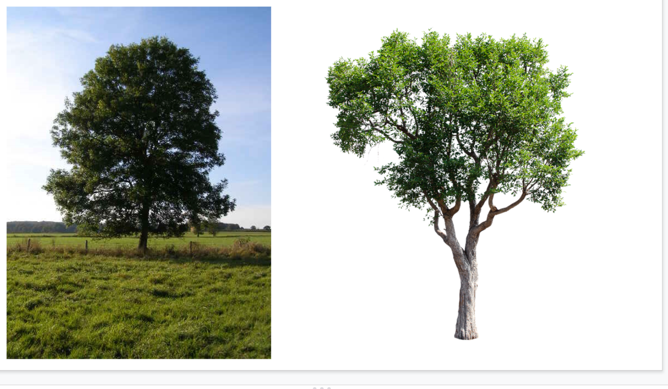

Appendix C
bilingual list for control group and list of target vocabulary words
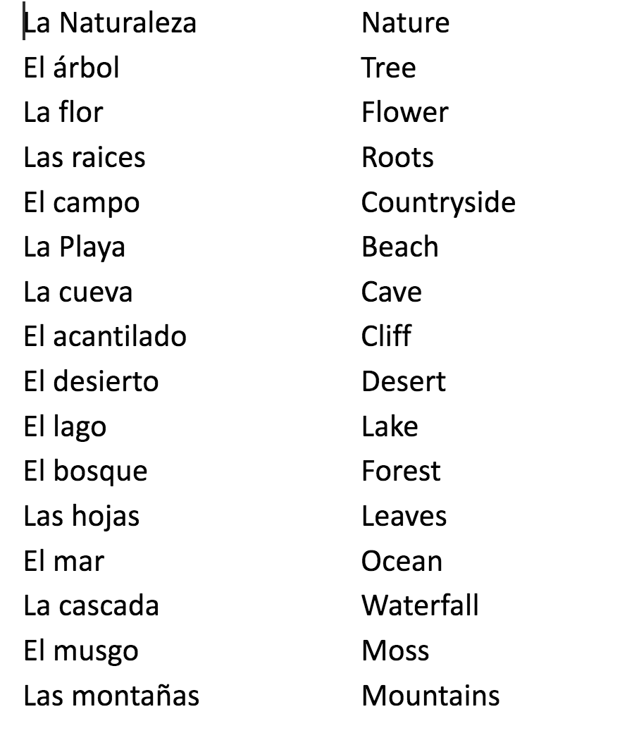

appendix d
matching activity for control group
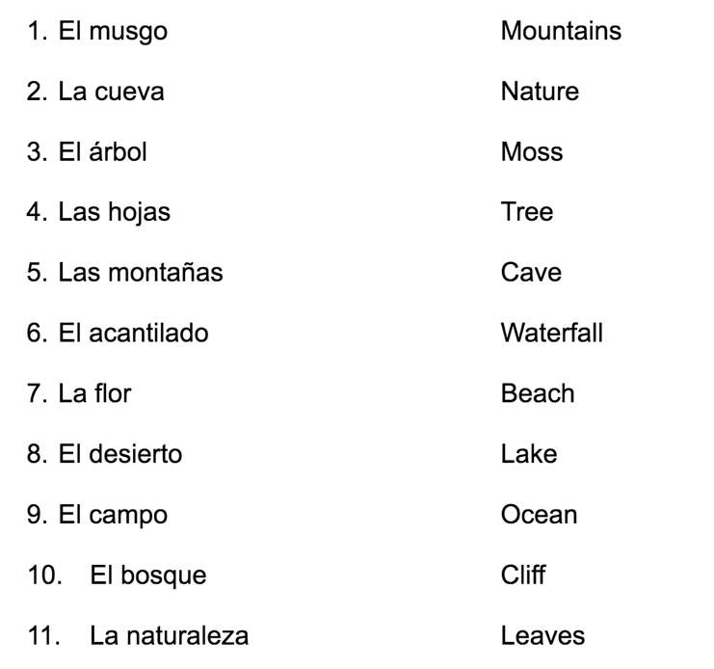

appendix e
fill in the blank activity for control group
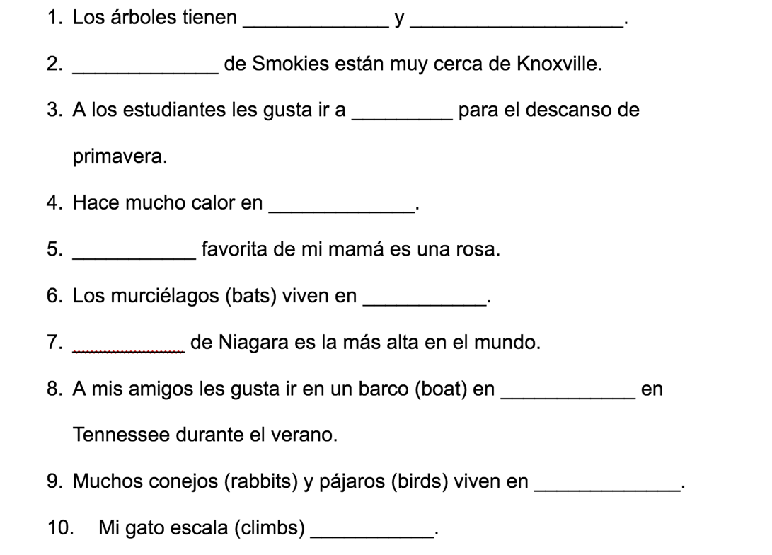

Vita
Eva Jones was born in Nashville, TN to her parents Phillip and Angela. She graduated with her undergraduate degree from the University of the South in Sewanee, Tennessee in Spanish. She wrote this thesis in completion of her MA Spanish degree at the University of Tennessee, Knoxville. She is planning to continue her education for her PhD in Spanish literature with a concentration in Applied Linguistics at the University of Tennessee, Knoxville.

