A Watershed Prioritization Model for Community-Centered Riparian Forest Restoration in Tennessee

A Thesis Presented for the
Master of Science
Degree
The University of Tennessee, Knoxville

Madison S. Johnson
August 2023

Copyright © 2023 by Madison S. Johnson.
All rights reserved.

ACKNOWLEDGEMENTS

I would like to thank my committee members for providing guidance during this process, and especially Dr. Andrea Ludwig and Dr. Sharon Jean-Philippe for their constant encouragement and dedication to myself and all their students. Thank you to the Tennessee Division of Forestry for their championship of the CRRP, and for all that they do to protect Tennessee’s forests.
This work also wouldn’t be possible without the undergraduate researchers and volunteers who braved poison ivy, thorns, extreme heat, and wet socks in the name of science.
Lastly, I would like to thank my family and friends who supported me through all of it.
ABSTRACT

Riparian forests are unique ecosystems that act as transitional areas between land and water that are a vital part of a healthy and functional stream ecosystem. Due to the rapidly changing landscape, riparian forests are increasingly threatened by urban development, agriculture, and invasive species, which contributes to a trend of degrading water quality in Tennessee. To address declining riparian forest quality in the face of land-use changes, the purpose of this study was to develop a simple watershed prioritization model that identifies areas that are highly susceptible to poor water quality, and where riparian plantings would be most beneficial. This study consisted of a spatial analysis assessing connections between 3 land-cover types (Forest Cover, Impervious Cover, and Open Area) within HUC-12 watersheds and associated Tennessee Macroinvertebrate Index (TMI) scores, and a field analysis connecting land and riparian cover variables to resulting stream temperatures. The spatial analysis indicated that all three land-cover types were found to have a significant predictive relationship with TMI score outcomes, with greater predictive ability achieved when combining land-cover types into a single “score”. Assessment of stream temperatures in connection with adjacent riparian vegetation and upstream land-cover factors support the importance of forests in maintaining lower temperatures, as well as the contribution of urban development to higher temperatures with broader ranges. The results of the analysis and further review of literature informed the development of a watershed priority model that emphasizes the importance of targeting HUC-12 watersheds with higher levels of impervious surface and low forest cover for riparian restoration efforts. This model could be a helpful tool for the communication of water quality and urban forestry initiatives to public audiences.

TABLE OF CONTENTS

Chapter I: Introduction and General Information 1
Introduction 2
Riparian Forests and the Riparian Zone 3
Prioritizing Riparian Forests in the Face of Urbanization 4
Watershed Land Cover as an Indicator of Water Quality 6
Adequate Riparian Buffer Widths for Maintaining Ecosystem Services 8
Stream Temperature in Relation to Riparian Vegetation 10
Benthic Macroinvertebrates as a Measure of Water Quality: State of Tennessee 11
Removing Barriers to Promote Community Involvement in Riparian Restoration 12
Statement of Problem 13
Chapter II: Materials and Methods 16
Spatial Analysis of Tennessee BMI Data and Watershed Characteristics 17
Statistical Analysis of TMI Scores and Watershed Land-Cover 19
Field Measurements of Riparian Vegetation and Stream Temperature: Methods
Overview 19
Channel Characteristics 20
Vegetation Sample 20
Stream and Riparian Canopy Shade Using a Densiometer 21
Stream Temperature 21
Upstream Land-Cover 22
Statistical Analysis of Field Measurements 22
Chapter III: Results and Discussion 25
Spatial Analysis of Watershed Land-Cover Statistics Results 26
Stream Temperature, Riparian Vegetation, and Upstream
Land-Cover General Linear Regression 32
Means Separation of Canopy and Development Groups 38
Discussion of Spatial Analysis 40
Discussion of Stream Temperature Analysis Results 44
Chapter IV: Conclusions and Recommendations 48
Final Proposed Watershed Prioritization Model 49
Closing Statements 54
References 55
Appendix 63
Vita 64

LIST OF TABLES

Table 3.1. Results of logistic regression between individual watershed landcover types and TMI score outcomes 28
Table 3.2 Results of logistic regression between watershed land-cover calculations and TMI score outcomes 28
Table 3.3 Descriptive statistics of independent variables for field measurement
analysis 35
Table 3.4 Descriptive statistics of dependent temperature variables for analysis of field
measurements 35
Table 3.5 Descriptive statistics for mean separation analysis groups 40
Table 4.1 Descriptions of priority scores and their associated ranges of impervious and forest cover 55

LIST OF FIGURES

Figure 3.1 a Predicted Probabilities of FC 29
Figure 3.1 b Predicted Probabilities of OA 29
Figure 3.1 c Predicted Probabilities of IC 29
Figure 3.2 a Predicted Probabilities of OAIC 30
Figure 3.2 a Predicted Probabilities of FCIC 30
Figure 3.2 Water Quality Prediction Scores for Forest Cover and Impervious Cover
(FCIC) in HUC-12 Watersheds in Tennessee (Madison Johnson, 2023) 31
Figure 3.3 Water Quality Prediction Scores for Open Area and Impervious Cover
(OAIC) in HUC-12 watersheds in Tennessee (Madison Johnson, 2023) 32
Figure 3.4 a Upstream Developed % Vs. High Temp 34
Figure 3.4 b Upstream Developed % Vs. Avg Temp 34
Figure 3.4c Upstream Developed % Vs. Water/Ambient Range 34
Figure 3.4 d Upstream Developed % Vs. Range Temp 34
Figure 3.5 a Upstream Forest Cover % Vs. High Temp 35
Figure 3.5 b Upstream Forest Cover % Vs. Avg Temp 35
Figure 3.5 c Upstream Forest Cover % Vs. Water/Ambient Range 35
Figure 3.5 d Upstream Forest Cover % Vs. Range Temp 35
Figure 3.6 a Riparian Canopy% Vs. High Temp 38
Figure 3.6 b Riparian Canopy% Vs. Avg Temp 38
Figure 3.6 c Riparian Canopy% Vs. Water/Ambient Range 38
Figure 3.6 d Riparian Canopy% Vs. Range Temp 38
Figure 3.7 a Group Means for Avg Temp 41
Figure 3.7 b Group Means for High Temp 41
Figure 3.7 c Group Means for Water/Ambient Range 41
Figure 3.7 d Group Means for Range Temp 41
Figure 4.1 Reformed Impervious Cover Model (Schueler 2009) 53
Figure 4.2 Map of Final Watershed Prioritization Model 55
Chapter I

Introduction
Riparian forests are woodland areas that grow along waterways, such as streams, rivers, and lakes (Svejcar, 1997). These unique forests provide essential ecosystem services to their adjacent waterways and surrounding communities. Ecosystem services are benefits that humans derive from ecosystem functions (Daily, 1997). Services provided by riparian forests include erosion prevention and sediment control, nutrient pollution absorption, and providing habitat and supporting aquatic and terrestrial biodiversity (Riis et al, 2020; Tolkkinen et al, 2020). Aside from the physical benefits of riparian forests for the quality of the adjacent waterway, preserving functional and biodiverse riparian forests, especially in urban areas, can provide highly valuable social benefits such as recreational opportunities, and improved physical and psychological well-being (Guida-Johnson & Zuleta, 2017; Opdahl, 2021; Zhao & Parves, 2016).
In the past several decades, millions of acres of forests and other natural ecosystems have been cleared and altered for agriculture and urban development, reducing their capacity to continue providing their full ecosystem services (Lawler 2014; Sweeney 2004). This loss of diverse native forested and vegetated land along streams and within a watershed leads to a subsequent loss of biodiversity essential for the health and functioning of aquatic habitats, as well as increased nutrient, sediment, and contaminant levels (Broadmeadow 2004; Gonzales et al 2017; Thompson & Parkinson 2011; Tong & Chen 2002). In addition, riparian areas are heavily affected by invasive plant species, which outcompete native vegetation and reduce the overall biodiversity and integrity of the ecosystem (Hammer & Gunn 2021; Lapin 2015). The need for waterway protection efforts in relation to preserving and enhancing natural riparian forests has become increasingly realized as landscapes have changed and negative effects on water quality are increasingly documented.
Riparian Forests and the Riparian Zone
According to Merriam-Webster, the word “riparian” simply means something dwelling in or pertaining to a river- bank and is derived from the Latin root ‘ripa’, meaning bank or shore (riparian, 2023). Therefore, and as previously mentioned, a riparian forest is simply one that grows along a waterway. This is similar but distinct from a riparian zone, which is a pronounced land feature that acts as a transitional area between fully terrestrial and fully aquatic areas. Riparian zones experience both standing water and extremely moist soils during some parts of the year, but can also experience pronounced levels of drought. The size and extent of the riparian zone varies depending on the size of the waterway, and local geology and hydrology. Vegetation within riparian zones is unique because of its adaptation for both aquatic and terrestrial conditions (Svejcar, 1997). Similarly, a riparian buffer specifically refers to a strip of vegetation along a waterway that protects, or “buffers” the waterway against inflow from the watershed. A riparian buffer can be a completely natural occurrence, but the term is often used in reference to man-made vegetative strips of various compositions used to provide conservation benefits (United States Department of Agriculture, 2012). Forests are an important vegetation composition type within the riparian zone that work in tandem with waterways to maintain ideal aquatic conditions. However, forests are not the only type of vegetation that grows within riparian zones. Depending on the area’s geology and climate, other types of vegetation such as prairies or shrubland, provide the same benefits to their adjacent waterway, and are specially adapted for their local conditions. Riparian vegetation will be used to simply refer to plant communities that grow within the riparian zone, either naturally occurring or as part of a human-managed area.

Prioritizing Riparian Forests in the Face of Urbanization
Riparian forest systems and their relationship with adjacent waterways have been extensively researched and well-documented. Riparian forests are an integral part of a functional stream ecosystem and play a significant role in supporting a wide range of aquatic life (Gonzales et al, 2015; Guida-Johnson & Zuleta, 2017; Riis et al, 2020). The root systems of forests are essential in erosion control and bank stabilization, and nutrient uptake. Riparian forests contribute important organic matter that serves as a food and habitat source for benthic macroinvertebrates and other aquatic and terrestrial organisms (Broadmeadow & Nisbet, 2004) They also provide habitat regulation, such as lowering temperatures by reducing sun exposure, and maintaining ideal conditions for a variety of aquatic organisms (Tolkkinen et al, 2020).
Riparian areas are increasingly threatened by alterations of stream-side land. According to the Boyd Center for Business and Economic Research’s report on population predictions, Tennessee’s population is targeted to reach 7.89 million by 2040, with almost 70% of the population predicted to reside in urban areas (Tennessee State Data Center, 2022). In the coming decades, as cities prepare for this population increase and developed urban areas expand rapidly, many natural resource professionals are emphasizing the importance of prioritizing riparian areas in urban development plans, and of restoration & protection initiatives to safeguard water quality for future generations (Atkinson & Lake, 2020; Orsi et al, 2011; Thompson & Parkinson, 2011). Many plans include the protection and restoration of riparian areas because they can help reduce the severity of Urban Stream Syndrome. Urban Stream Syndrome describes the consistent degradation of waterways draining urban land, which display flashier hydrographs and increased severity and frequency of flooding, increased sediment and nutrient loads, reduced biodiversity, and altered channel morphology and stability (Paul & Meyer, 2001; Walsh, 2005). Urban Stream Syndrome arises primarily through the alteration of water flow, reduction of natural channel morphology and habitat, and increasing exposure to contaminants through stormwater (Walsh, 2005). Prioritizing healthy and functional riparian forests will be an important part of improving and maintaining urban stream quality and value to surrounding communities as city planners, government entities, and natural resource professionals prepare for growing developed areas (Bernhardt & Palmer, 2007; Guida-Johnson & Zuleta, 2017; Paul & Meyer, 2001).
The phenomenon of degraded urban streams is also described by the Impervious Cover Model (ICM). The ICM was developed in 1998 by the Center for Watershed Protection to quantify the negative effects of impervious surfaces, and to provide a simple tool for resource managers to determine locations of poor water quality by sub-watershed (Schuler 2004). The assumption of the model is that as sub-watershed (HUC-12) imperviousness increases, water quality generally decreases. Impervious cover (IC), determined by aerial photography and Landsat Imagery, has been an important variable in countless studies assessing and predicting water quality and stream degradation (Brabec et al, 2002; Capiella & Brown, 2001; Schuler, 2004; Shuster et al, 2005). In a 2009 review of over 250 research studies testing the assumptions of the ICM, the model was found to be largely supported in literature. It was reformulated to have broader ranges to reflect the imperfection of using solely IC as a predictor for water quality. While the updated model is still imperfect, and has reduced predictive ability in larger (>50 square kilometers) sub-watersheds and in those with low percentages of IC, it is an important factor that can be helpful in determining stream degradation and water quality trends. Schuler’s (2009) review and additional researchers suggest using other data in conjunction with the ICM for improved accuracy in prediction (Shuster et al, 2005).
Watershed Land Cover as an Indicator Water Quality
While impervious surfaces have been shown to be particularly deleterious, they are not the only land-cover variable that can be explanatory of water quality trends. Other land-cover types, such as forest cover and agriculture when analyzed within an entire catchment, have been cited as being helpful water quality indicators when used in combination with IC. Forests both within and outside the riparian zone have been found to potentially be important for water quality preservation within sub-watersheds (Morse et al, 2018; Richards et al, 1996; Wickham et al, 2000). One literature review found that specifically for maintaining optimal water quality, a HUC-12 forest cover percentage of 60-90% is ideal (Morse, 2018). Other sources, while not identifying an ideal watershed forest cover percentage, frequently cite the importance of forested watersheds in erosion prevention, nutrient absorption, flood control, and maintenance of habitat and biodiversity (De Mello, 2018; Ernst, 2004; Kreye, 2014; Pearce, 2001). Opposing the benefits of forests and other naturally occurring vegetation are the negative effects of agriculture and suburban sprawl on water quality. Agricultural watersheds are frequently noted to be susceptible to non-point source pollutants such as nutrient contamination, higher levels of sedimentation and bank erosion, and reduced biodiversity (Lintern, 2020; Moore, 2005). Residential expansion of suburban areas, which combine impervious surfaces with highly managed vegetated strips like mowed lawns, also have measurable negative impacts on local water quality due to their reliance on synthetic fertilizers and herbicides, and low biodiversity (Johnson, 2001). One study estimates that the area of cultivated lawns is three times larger than that of cultivated crops in the United States (Milesi, 2005). Another study found that even at low levels of imperviousness, suburban streams exhibited significantly elevated levels of nutrient contamination (Cunningham, 2009). Considering various land-cover types in water quality predication aside from impervious surface will allow for more accuracy for watersheds that do not work well with the ICM. Identifying land-cover trends that contribute to stream degradation, and prioritizing functional riparian forests to mitigate these negative impacts will be an important part of improving urban stream quality and value to surrounding communities as city planners, government entities, and natural resource professionals plan for rapidly expanding developed areas (Bernhardt & Palmer, 2007; Guida-Johnson & Zuleta, 2017; Paul & Meyer, 2001).
In response to the pattern of degradation of waterways across the country, there has been an exponential increase in river and riparian restoration projects in the United States since 1990. And yet, water quality has largely failed to improve, and in most regions has continued to degrade, indicating that these restoration initiatives are failing to meet their goals of improved stream habitat (Bernhardt et al, 2005; Gonzalez et al, 2015; Langendoen, 2009). Due to the rapid declines in water quality in many areas, and to the overwhelming number of streams with reduced or disturbed riparian canopy cover, there has been an increasing interest among natural resource professionals and government agencies to develop decision-making tools that will identify locations of highest need for restoration or resource protection (Atkinson & Lake, 2020 Guida-Johnson & Zuleta, 2017). Though agricultural watersheds contribute massive amounts of nutrient contamination to waterways and have reduced biodiversity, many sources strongly express the need to prioritize urbanized watersheds in both riparian planting initiatives and preservation efforts. This rationale cites the significant impact that impervious surfaces and channelization has on the stability and resilience of aquatic ecosystems (Atkinson & Lake, 2020; Matteo, Rhandir & Bloniarz, 2006; Tu at al, 2007).
Adequate Riparian Buffer Widths for Maintaining Ecosystem Services
Riparian zones are uniquely valuable due to their ability to buffer waterways from many anthropogenic sources of pollution and degradation, but determining specifications for constructed or protected riparian areas to achieve maximum benefits for their waterways can be highly complex, especially in urbanized watersheds (Dosskey, 2010; Moore, 2005; Mutinova, 2020; Stone et al, 2005). The extent to which an existent or restored riparian forest of adequate width and composition is able to effectively mitigate negative impacts from upstream and within the watershed is not well-understood, and depends on the extent and proximity of land alteration upstream, and subsurface geology and hydrology (Gonzalez et al, 2015; Kupilas, 2021; Stanfield & Kilgour, 2013; Walsh, 2005). Surface runoff from urban areas through stormwater infrastructure is one of the main drivers of increased nutrient and contaminant levels and frequency of flooding (Baruch, 2018; Roy, 2010). Runoff in heavily urbanized areas and over impervious surfaces is often circumvented through underground pipes and enters streams directly, as opposed to flowing through and under riparian zones. In addition, impervious surfaces radically alter the natural channel morphology. These factors reduce the efficacy of a functional riparian forest to remove contaminants and protect biological integrity of the waterway (Brabec, Schulte & Richards, 2002). Aside from this, when stormwater is successfully intercepted by adequate riparian vegetation, the ability of this vegetation to absorb nutrient pollution and filter sediments from surface runoff is heavily dependent on a variety of factors, such as slope, groundwater chemistry and hydrology (Mayer, 2007; Parkyn 2004,). Because of this, a riparian buffer of “adequate” width and composition may still fail to fully protect its adjoining waterway from all sources of degradation in highly urbanized areas. In addition, there is a wide range of varying information pertaining to size and composition requirements in order for these areas to fully provide their ecosystem services, and protect from negative impacts of runoff from agricultural and urban land-use (Lowrance, 1997). When determining guidelines for riparian forest management for the Southeast Region, the U.S.D.A. Forest Service described riparian management as a “contentious issue, and one of the most difficult challenges in the planning process” (Holcomb, 2005). State municipalities have been required to set standards indicating the importance of riparian buffer width to support water quality and biodiversity. However, the “ideal” width of a riparian forest from the bank of a stream is heavily debated, and depends on a variety of factors, such as the size and characteristics of the receiving waterway and surrounding area.
The ideal width of a riparian buffer also depends on what ecosystem services the planner wishes to preserve. Narrower buffers prove effective in sediment and erosion control and stream shading, while wider buffers provide increased nutrient pollution absorption abilities, provide more diverse biomass to aquatic ecosystems, and increased terrestrial habitat (Sweeney, 2014; Wenger, 1999). One meta-analysis of the effectiveness of riparian buffers in reducing nitrogen loads found that while wider forested buffers (>50 meter) more consistently removed more nitrogen from surface-flow, in general the width of the buffer alone cannot be a determinant of effectiveness of nitrogen removal (Mayer, 2007). Another study found that vegetation composition of native trees of varying age classes, shrubs, and herbaceous layers is an essential factor in supporting stream quality, by more effectively reducing channel erosion and contributing more organic matter to streams (Dosskey, 2010). Another case study found that the length and connectivity of the buffer is more important to consider for water quality, finding that a 15-meter buffer width was adequate, providing that the buffer was at least 500 meters long (Brumberg, 2007). However, generally riparian buffer widths of greater than 30 meters are considered most effective in maintaining stream habitat and water quality (Parkyn, 2004; Sweeney, 2014; Wenger, 1999). However, according to a 2004 review of riparian buffer guidelines across the United States and Canada, average forested buffer widths around a variety of water body types only range from 15-29 meters, with the Southeast region having the narrowest buffer widths (Lee, 2004). In response to the general trend of degrading water quality across the state, and due to Tennessee’s rapid urban development, there is a strong need for more research clarifying the role of riparian buffers of varying widths and vegetation compositions in preserving stream habitat, and how land-use affects a buffer’s ability to provide these essential services.
Stream Temperature in Relation to Riparian Vegetation
Stream temperature is a water quality parameter that is a strong predictor for the overall habitability of the waterway for a variety of organisms (Bogan & Stefan, 2003; Eaton & Scheller, 1996). According to the U.S. Environmental Protection Agency (2016), higher stream temperatures have a direct effect on water chemistry, including lower dissolved oxygen levels, and increased nutrient levels which can be harmful to aquatic life. Stream temperature is a complex variable and is affected by a variety of factors such as stream order level, source of water, and local climate (US EPA, 2016). Land alteration for the purposes of agriculture, urban development, and timber harvesting and construction has an established effect on stream temperature as well (Beschta & Taylor, 1988; Bowler et al, 2012; Somers 2013, Studinski et al, 2012). Due to their reduced riparian forest cover and generally higher sediment loads, agricultural streams tend to have higher temperatures and more reduced biodiversity (Macedo et al, 2013; Piggot et al, 2012; Stone et al, 2005). Impervious surfaces and urban development have been found to be connected to stream temperature as well, as urban heat islands contribute to increased summer baseflow water temperatures in urban streams (Dugdale, 2018; Paul & Mayer, 2001; Somers et al, 2013; Wenger, 2009). Wooded riparian areas shading waterways can be an important defense against heightened stream temperatures (Bowler et al, 2012). However, the extent to which shading from riparian vegetation can mitigate the negative effects of low canopy cover and high impervious surfaces within a watershed is relatively unknown due to the complex nature of freshwater systems. According to reviews of the ICM, the relative ability of riparian areas to provide benefits to their adjacent waterways decreases as watershed imperviousness increases (Brabec et al, 2002; Schueler, 2009).
Benthic Macroinvertebrates as a Measure of Water Quality: State of Tennessee
Benthic Macroinvertebrates (BMI) are a group of small aquatic organisms that lack vertebrae, and are large enough to be seen with the naked eye. They are often used in biological monitoring efforts pertaining to water quality due to their ease of sampling and analysis. They are ideal organisms for biological monitoring due to their presence in even the most deteriorated streams, and their vast range of tolerance levels for pollution levels that can be highly representative of the habitat quality at a particular stream location. Many state municipalities and federal agencies rely on BMI data as an indicator of water quality in their official biannual water quality reports and use this data to inform conservation strategies (U.S. Environmental Protection Agency, 2020; Tennessee Department of Environment & Conservation Division of Water Resources, 2021). The Tennessee Department of Environment and Conservation (TDEC) has an established protocol for collecting, assessing, and analyzing BMI data to develop water quality status reports for waterways across the state. State municipalities often determine the status of waterways by combining different BMI metrics into a single “Macroinvertebrate Index” score to comprehensively describe an individual stream’s level of degradation (Tennessee Department of Environment & Conservation Division of Water Resources, 2021). In the 2009 review of the ICM, it was determined that benthic macroinvertebrate data conformed to the ICM better than any other stream indicator (Schueler, 2009). Many other studies have documented macroinvertebrate communities’ sensitivity to human disturbance on aquatic habitats (Maloney, Mungala & Mitchell, 2011, Schiff & Benoit, 2007). Stone et al (2005) found macroinvertebrate communities drastically change when sampled from streams where forest or shrub land was converted to urban land, as opposed to agricultural land converted to shrubland. The author cites the reasoning for this occurrence as the fact that agricultural streams already face significant degradation as a result of agricultural practices (Stone et al, 2005). BMI data presents an ideal water quality indicator for this analysis, due to their established connection with stream characteristics and to their ability to be compared over diverse ecoregions.
Removing Barriers to Promote Community Involvement in Riparian Restoration
As part of the River Restoration Synthesis Survey, a 2005 review of over 37,000 river restoration programs found that above all else, involvement from the local community was the most significant indicator of long-term success for these projects (Bernhardt et al, 2005). Other similar reviews informing restoration tactics frequently note the importance of bolstering public outreach and education efforts as a part of a multidisciplinary approach to effective stream restoration (Gonzales et al, 2017; Guida-Johnson & Zuleta, 2017; Junker et al, 2006). This factor has become increasingly important due to the rising fragmentation of stream-side property. According to a 2022 report, the United States has converted 11 million acres of agricultural land to urban and residential development in the last 20 years (Hunter et al, 2022). This drastically proliferates the number of land-owners involved in maintaining stream-side vegetation, which presents difficulties to initiatives that are dependent on community support. One qualitative study identifying land-owner perceptions highlighted some challenges in recruiting participants of riparian buffer establishment initiatives. The study found that though individuals were cognizant of the cumulative effects of their actions downstream, and expressed a strong sense community obligation to mitigate negative impacts, they ultimately were reluctant to alter the ordered landscapes to which they had become accustomed (Dutcher et al 2004). Making information more visual, accessible, and understandable to involve broad and diverse community audience is an important part of addressing and social barriers to involvement of growing numbers of participants in restoration projects (Ambrose, Fitch & Bateman, 2006; Junker et al, 2006; Rosenberg & Margerum, 2008). The model used to identify high-priority watersheds for riparian restoration must also be able to be effectively communicated to audiences with diverse backgrounds and help foster a sense of identification with one’s watershed and waterways.
Statement of Problem
Drastic changes in Tennessee’s landscape have had significant impacts on water quality. According to the 2022 305b report from the Tennessee Department of Environment and Conservation, almost 60% of assessed waterways in Tennessee did not meet adequate state water quality standards as delineated by the Federal Water Pollution Control Act (Tennessee Department of Environment and Conservation Division of Water Resources, 2022). Nationally, there is an issue of declining water quality, which is further exacerbated by a lack of awareness among the general public, and limited funding for practical outreach efforts pertaining to water quality and forestry issues (Gonzales et al, 2017). In addition, traditional riparian restoration initiatives are often not well-suited for residential land-owner involvement, as they often involve strict maintenance standards and financial barriers (Armstrong et al, 2013). Effective riparian restoration efforts must focus not only on identifying areas of highest need to improve physical water quality, but also must ensure that the importance of riparian forests becomes known and accepted among the public. Traditional models for riparian planting initiatives lack methods for practical implementation and widespread adoption, and should be adapted to address social and communicative barriers that inhibit long-term success.
The Community Riparian Restoration Program (CRRP) for Tennessee is an initiative funded by the Tennessee Department of Agriculture - Division of Forestry in partnership with the University of Tennessee’s School of Natural Resources, Departments of Biosystems Engineering and Soil Science, Agricultural Leadership, Education & Communication, and Civil Engineering. The CRRP seeks to drive community involvement in riparian restoration through applied research. In response to degrading water quality across the state, and Tennessee’s rapid urban development, the CRRP seeks to investigate the role of riparian buffers and vegetation compositions in preserving stream habitat, and land-use effects on buffers ability to provide these essential ecosystem services. This study addressed the research question, “How can watersheds be prioritized for restoration and outreach efforts in terms of susceptibility to poor water quality, and potential to benefit from riparian plantings?”. A data-driven watershed prioritization model for the State of Tennessee was developed. Further, to encourage effective communication of this model to a diverse audience, the study also addressed the question, “How can the model be simplified and visualized in a way that can be used as a communication tool for the stakeholders?”. The result of this study is a model that uses minimal variables and categorized groups of watersheds, which allows for communication, usability, and application for a variety of audiences.

Chapter II

Materials and Methods

Spatial Analysis of Tennessee BMI Data and Watershed Characteristics

The Tennessee Macroinvertebrate dataset was acquired from the Tennessee Department of Environment and Conservation Division of Water Resources (TDEC). This dataset contained over 9,400 data points between 1994 and 2022 in streams across the state of Tennessee. The metric used to quantify water quality was the Tennessee Macroinvertebrate Index score (TMI) (Tennessee Department of Environment and Conservation Division of Water Resources, 2022). TMI scores range from 0-42, with 0 indicating poorest water and habitat quality, and 42 indicating the highest quality streams. Scores over 30 indicate fully supporting streams and meet state water quality standards. TMI scores are ideal for an analysis comparing scores over a large study area because they are calculated using other macroinvertebrate metrics then standardized to reflect the diverse ecoregions of Tennessee (Tennessee Department of Environment and Conservation Division of Water Resources, 2021). Other datasets used in this analysis included the Forest Cover layer from the 2016 NLCD, and Land Cover and Impervious Cover datasets from the 2019 National Landcover Database, and streams and watershed shapefiles from the National Hydrography Dataset (Dewitz &amp; U.S. Geological Survey, 2019; U.S. Geological Survey, 2019).
Forest Cover values were gathered from the National Landcover Database’s (NLCD) Forest Cover layer (2016), which shows 30 x 30-meter raster cells assigned a numerical value from 0-100 indicating the percentage of canopy cover in that area. Impervious Cover values were similar, gathered from the NLCD’s Impervious Cover layer (2019), with values in raster cells of the same size indicating percentages of impervious surfaces. Forest Cover (FC) and Impervious Cover (IC) percentages for individual HUC12 watersheds were calculated using the Zonal Statistics as Table tool. Open Area (OA) percentages were gathered from the general NLCD (2019), which separates 30 x 30-meter raster cells into one of twenty land-cover classifications. OA values were calculated with the Zonal Histogram tool, calculating the total raster cells for agricultural land use, and low intensity and open developed space, and dividing by the total number of raster cells within the watershed. Agricultural land use included pasture/hay, and
cultivated crops. Open and low intensity developed land includes areas with less than 50% of the total area, and most commonly indicates single-family housing units and recreational areas or managed utility easements (Dewitz &amp; U.S. Geological Survey, 2021).Percentages for FC, IC, and OA were all calculated as percentages excluding the area in the watershed determined to be “Open Water”, symbolizing lakes and large rivers, to exclude areas that do not contribute flow to waterways.
Individual TMI scores were assessed in comparison with their HUC-12 watershed’s IC, FC, and OA percentages to identify subsequent water quality trends. The dataset was first assessed to exclude outliers to only analyze statistically consistent scores. Outliers were identified using ArcGIS Pro’s Optimized Hotspot and Outlier Analysis, a total of 7,086 datapoints remained for further study. Because TMI scores have a set range of whole numbers that indicate increasing quality from 0 moving upward to 42, this is considered discrete interval data. To better analyze this data in relation to land-cover percentages, TMI scores were converted into a binary numerical form, with 0 indicating scores under 30 (failing to meet water quality standards), and 1 indicating scores over 30 (passing water quality standards). Each individual data point (n=7,086) had a binary TMI score value, with its associated watershed’s FC, IC, and OA percentages to be compared.
Statistical Analysis of TMI Scores and Watershed Land-Cover
To assess the probability of a particular stream receiving a passing (1) or failing (0) TMI score in relation to its surrounding HUC12 watersheds’ FC, IC, and OA percentages, a logistic regression was performed on each land-cover type separately to determine how each land-cover type contributes to this probability. The three percentages were analyzed together to assess the associated weighted effect on the subsequent score. Using these results and weighted effects, a new “Priority Score” field was calculated to develop a more accurate combination of land-cover types to determine the probability of streams receiving a passing score.
Field Measurements of Riparian Vegetation and Stream Temperature: Methods Overview
To identify stream sites, 300 random points were generated in ArcGIS Pro along streams (U.S. Geological Survey, 2019) in 10 East Tennessee counties: Bradley, Cumberland, Greene, Hamilton, Jefferson, Knox, Loudon, Roane, Sullivan, Washington. Points that appeared to be inaccessible for research purposes, such as those in dense forest or with unidentifiable water sources were excluded. These counties were identified by the Tennessee Division of Forestry in the 2020 Forest Action Plan as locations of interest for riparian forest health (Tennessee Division of Forestry, 2020).
Landowners of private properties were contacted via letter to request permission to access their property, and county or city governments were contacted for public properties. Forty-five sites received adequate permissions for entry. Eleven sites were public, and thirty-four were private. Sampling was completed from late August through early October 2022. While each site was visited, only forty-one sites were fully sampled for vegetation because of hazardous conditions or accessibility issues.
Channel Characteristics

At each site, 3 transects were set up along the stream approximately 10 meters apart, named upstream, middle, and downstream. Along each of these transects, channel width, wetted width, and bank slope of both sides were measured and recorded. Channel width is the length in feet from the top of one bank to the top of the other bank. Wetted width is measured as the distance between the two points where water is touching each side of the channel. Bank slope was measured by measuring the vertical and horizontal distance from the top of the bank to the top of the water’s surface. Some channel measurements were unable to be recorded due to potentially hazardous conditions, such as steep banks or high flow.
Vegetation Sample

Vegetation data was collected using an adapted Line-Point-Intercept method adapted from the U.S.D.A Forest Service’s National Riparian Core Sampling Protocol (Merrit et al 2017). Each transect was 30 feet in length starting at the top of the stream bank, with 10 points per transect spaced every 3 feet, with a total of 30 points per site. Vegetation was sorted into one of the following categories, using the app “Picture This” to identify plant species:
AF = Annual forb (also includes biennials)
PF= Perennial forb
AG = Annual graminoid
PG = Perennial graminoid
SH = Shrub
TR = Tree

In addition, if the vegetation was considered invasive in Tennessee, this was indicated with a ‘-I’. If the vegetation was visibly mowed below knee height, this was indicated with a “-M”. This resulted in 20 possible categories for vegetation to be recorded. Some sites, due to difficult terrain or other accessibility concerns, were unable to be fully sampled. Teams recorded as much vegetation as possible. At sites where water was too deep, or conditions presented a hazard to data collectors, only vegetation data was collected.
In order to quantify vegetation survey data into variables to be used in analysis, the total number of points where vegetation was recorded was calculated. Percentages of mowed (Mowed_%), invasive (Invasive_%), and non-tree (Non-Tree_%) points compared to the total were calculated for each site.
Stream and Riparian Canopy Shade Using a Densiometer:

Using a spherical densiometer at 3 equidistant points along the wetted width of each stream transect, the stream shade was measured and averaged for each site. Densiometer values were also recorded at each vegetation collection point and averaged for each site. This method allows quantification of shading from trees and other vegetation over the stream itself, and was adapted from a procedure used by the United States Fish & Wildlife Service, and the State of Washington’s Department of Ecology (Werner 2019).
Stream Temperature

Using 3 Onset HOBO temperature and light recording pendants, stream temperatures for 32 sites were recorded through the month of October. Temperature collectors were placed in streams that had enough water to fully submerge the pendant, in no more than 12 inches of pooled depth, as close to the center of the stream as the depth would permit. Temperatures in degrees Celsius were collected every 5 minutes over a period of at least 48 hours. Ambient high and low temperatures for the location were recorded for each collection duration.
Upstream Land-Cover:
Coordinate points for stream sites were loaded into ArcGIS Pro, and upstream networks for each point were traced using the TIGERLine streams shapefile. A 60-meter buffer was created for each upstream network using the buffer analysis tool. Land Cover raster data was added from the U.S.G.S. National Landcover Database (2019) and Tree Canopy percentages were derived from the Tree Canopy layer from USGS (2016). Using the Zonal Histogram and Zonal Statistics as Table tools, percentages for pertinent land cover types and tree canopy percentages within 60-meter upstream buffer networks for each temperature point were calculated. Upstream land cover types included “natural area” (Upstream Natural_%), which included forests, wetlands, shrub/scrub, and herbaceous land cover. Upstream developed (Upstream Developed_%) land included raster cells classified as high and medium intensity developed land. The other land cover type that was assessed was “open area” (Upstream Open_%) which included agriculture (hay/pasture and cultivated crops) and low intensity and open developed space. Upstream tree canopy cover, using the Forest Cover layer, (Upstream FC_%) was calculated within the buffer zone as well.
Statistical Analysis of Field Measurements
To assess individual variables to identify where significant relationships exist, a linear regression between upstream land use variables (Upstream Developed_%, Upstream Natural_%, Upstream Open_%, Upstream FC_%) and site vegetation measurements (Riparian Canopy_%, Stream Canopy_%, Nontree_%, Mowed _%) as explanatory variables, and water temperature measurements (Average temperature, high temperature, temperature range, and water/ambient temperature range).
‘Upstream Area’ indicates the size of the stream and was calculated using the 60-meter buffer on the upstream shapefile on ArcGIS Pro. ‘Collection Order’ was a number assigned to each site indicating the order in which the temperatures were collected, with the first site being 1, the second being 2, and so on. These values were used as covariates in the regression because streams widely varied in size and order. Smaller streams tend to have broader temperature ranges (Moore and Miner, 1997) and a covariate will allow the analysis to account for these naturally occurring differences, and for better comparison between sites. In addition, the temperature collection order was used as a covariate because temperatures from early to late October ranged widely, and there was some leaf loss for some of the later sites that would affect the levels of shade for the stream.
To assess the relative ability of riparian canopy to mitigate the temperature effects from urban heat islands, a means separation procedure was completed between groups of sites that signify their level of development relative to their level of riparian canopy. Data points were separated into four groups reflecting each site's relative urban area upstream (Upstream Developed_%) and riparian canopy (Riparian Canopy_%) at the site location. The four groups are as follows:
- High Development/High Canopy (HDHC): 6 sites
- High Canopy/ Low Development (HCLD): 12 sites
- Low Canopy/ High Development (LCHD): 5 sites
- Low Canopy/ Low Development (LCLD): 9 sites
A site was considered “High Development” if the percentage of upstream development was over the calculated state-wide average of approximately 5%, and “Low Development” if the value was under that average. A site was considered “High Canopy” if the riparian canopy was over the calculated site-wide average of 68%, and “Low Canopy” if the value was below average. A means separation procedure was performed between groups reflecting their relationship to each water temperature variable. The purpose of the analysis was to evaluate the ability of riparian forest cover to assuage the temperature effects from impervious surfaces upstream.
To further assess the relationship between riparian canopy and urban sites, and its effect on water temperature variables, two multiple linear regressions were performed with Riparian Canopy_% and Upstream Developed_%, and Upstream FC_% and Upstream Developed_% explanatory variables, between each water temperature measurement with the same covariates as previously mentioned.
All analysis was completed on SAS 9.4 (SAS Institute Inc., 2013).

Chapter III

Results and Discussion

Spatial Analysis of Watershed Land-Cover Statistics Results

The spatial analysis of TMI scores in comparison to land-cover percentages, shown in Table 4.1, showed that all three variables had a significant relationship to the probability of a stream receiving a passing or failing TMI score (p < 0.0001). Impervious cover had the most significant negative relationship for this probability, with its parameter estimate being over 3 times that of forest cover or open area. In other words, a higher percentage of impervious cover within a watershed indicates a higher probability of a stream within that watershed will be to receive a failing TMI score. However, forest cover and open area also had significant predictive ability for TMI score outcomes. Forest cover had a positive relationship to TMI score, suggesting watersheds with higher forest cover generally have higher likelihood of receiving passing scores. Open Area had a negative relationship, indicating that more areas of highly managed vegetation is generally connected to poorer water quality. The predictive ability of each variable is indicated by the “Area Under Curve” (AUC) value. Impervious Cover had the highest AUC value of 0.7667, and forest cover and open area had slightly lower AUC values of 0.7624 and 0.7634 respectively. Predicted probabilities of a passing TMI (1) score for each landcover type with 95% confidence limits are indicated in Figure 3.1.
To assess if land-cover variables are more accurate in predicting TMI score outcomes when used together, an additional round of logistic regressions was performed with combined land-cover types using the estimates of the initial results to develop “priority score” equations. However, it was found that Open Area and Forest Cover were very highly correlated (Rho = 0.97). This stipulates that these two variables should not be used together in a single model. Therefore, this resulted in two separate “priority score” equations that combined IC with FC and OA separately. The equations were as follows:
OAIC= Open Percent + (Impervious Cover*3.55)
FCIC= Forest Cover - (Impervious Cover * 3.43)
The equations are ascertained from the individual effect estimates and reflect the negative relationship of impervious cover and open area, and the positive relationship of forest cover to TMI score results. The results of these logistic regressions are shown in Table 3.1.
The analysis of impervious cover with open area (OAIC) and forest cover (FCIC) separately were both statistically significant in determining a passing TMI score (p < 0.0001). OAIC had an effect estimate of -0.0386, and FCIC had an effect estimate of .0412. Predicted probabilities compared with watersheds’ OAIC and FCIC calculations with 95% confidence limits are shown in Figure 3.2. Both new variables exhibited increased predictive ability as indicated by the Area Under the Curve value, which increased to 0.8141 for OAIC, and 0.8138 for FCIC, indicated in Table 3.2. OAIC had a marginally higher AUC value, which suggests the using Open Area with Impervious Cover achieved more accuracy in prediction. Resulting maps showing each HUC-12 watershed’s calculated FCIC and OAIC values are shown in Figures 3.3 and 3.4.

Table 3.1. Results of logistic regression between individual watershed landcover types and TMI score outcomes.
Land Cover Type | Estimate | Pr > Chisq | Point Estimate | Area Under Curve
Impervious Cover (IC) | -.1952 | <.0001 | .823 | .7667
Forest Cover (FC) | .0525 | <.0001 | 1.054 | .7624
Open Area (OA) | -.0489 | <.0001 | .952 | .7634

Table 3.2. Results of logistic regression between watershed land-cover calculations and TMI score outcomes.
Priority Score | Estimate | Pr > Chisq | Point Estimate | Area Under Curve
OAIC | -.0386 | <.0001 | .962 | .8141
FCIC | .0412 | <.0001 | 1.042 | .8138

(a) (b)

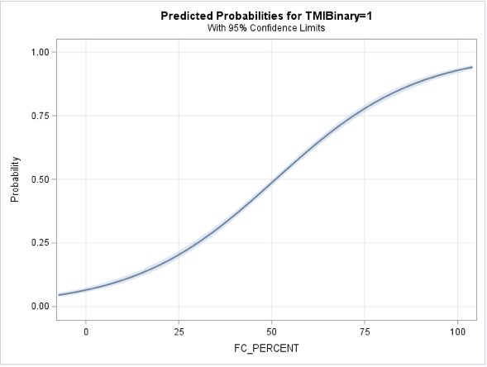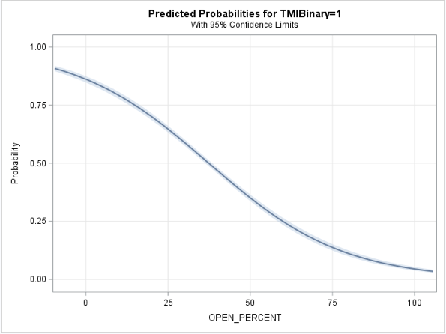
(c)

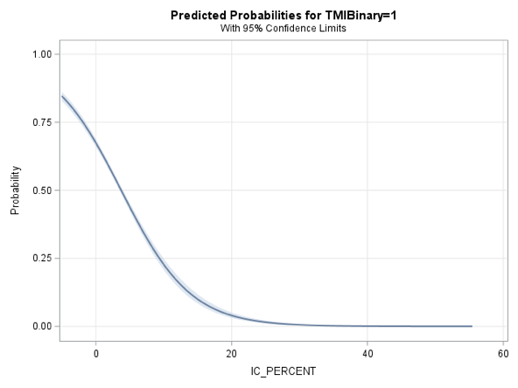

Fig 3.1 Predicted Probabilities of forest cover (FC – a) open area (OA – b), impervious cover (IC – c) for Tennessee Macroinvertebrate Index score outcomes.

(a) (b)

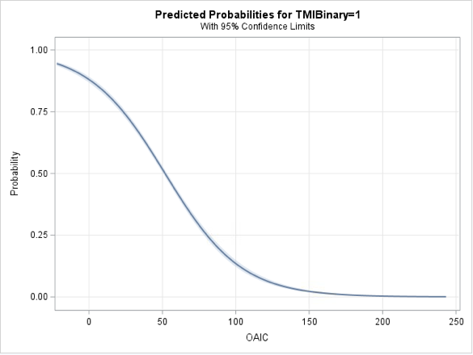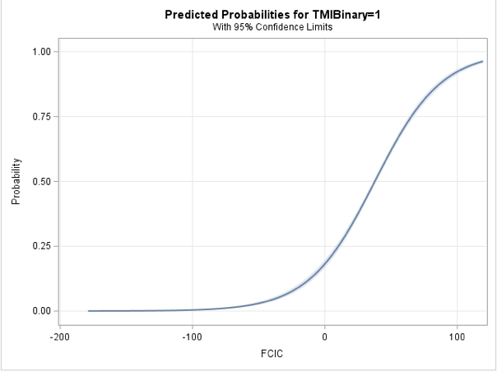
Fig 3.2 Predicted probabilities for calculated water quality prediction scores for forest cover and impervious cover (FCIC-a) and open area and impervious cover (OAIC-b) on Tennessee Macroinvertebrate Index score outcomes.

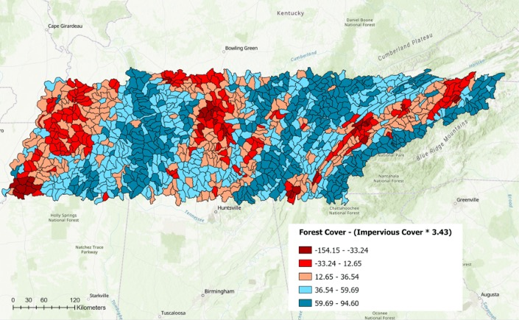

Fig 3.3 Water Quality Prediction Scores for Forest Cover and Impervious Cover (FCIC) in HUC-12 Watersheds in Tennessee (Madison Johnson, 2023).

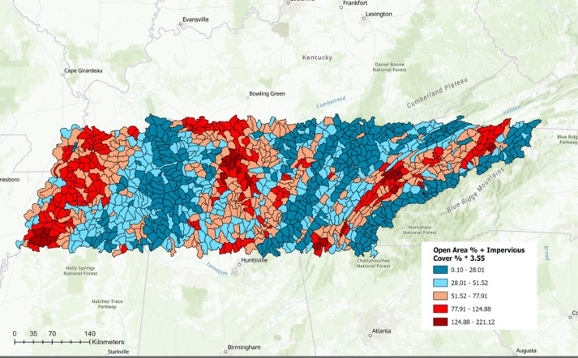

Fig 3.4 Water Quality Prediction Scores for Open Area and Impervious Cover (OAIC) in HUC-12 watersheds in Tennessee (Madison Johnson, 2023).

Stream Temperature, Riparian Vegetation, and Upstream Land-Cover General Linear Regression

Descriptive statistics for all variables are shown in Tables 3.3 and 3.4. Table 3.3 shows statistics for the dependent variables related to the presence of riparian vegetation immediately at the site, and to percentages of land-cover types upstream from the site within a 60-meter buffer zone. Note that Upstream Developed_%, Upstream Natural_%, and Upstream Open_% all range from 0 to 1, as opposed to being raw percentages. All other variables are raw percentages ranging from 0 to 100. Table 3.4 shows descriptive statistics of the response water temperature variables of interest.
The percentage of developed land upstream (Upstream Developed_%), shown in Figure 3.5 showed a significant positive relationship to the highest water temperature (p < 0.001), water/ambient range, and average temp (p < 0.01). Upstream Developed_% did not have a significant relationship with the temperature range.
The percentage of forest canopy upstream (Upstream FC_%), shown in Figure 3.6, showed a significant relationship between the high water temperature for each site (p < 0.05), and the water/ambient range (p < 0.05). Upstream FC_% did not have a statistically significant relationship with water temperature range or average water temperature.
The riparian canopy percent (Riparian Canopy_%) , shown in Figure 3.7 collected at the temperature locations showed a significant negative relationship to the highest water temperatures and average water temperatures (p < 0.05). Riparian Canopy_% did not have a statistically significant relationship with temperature range or water/ambient range.
In the multiple regression model with Upstream Developed_% and Riparian Canopy_%, the only water temperature variable found to have a significant relationship with both Upstream Developed_% (p < 0.01) and Riparian Canopy_% (p < 0.05) variables was the average water temperature (p < 0.0001). Upstream Developed_% was again found to have a significant positive relationship with water/ ambient range (p < 0.05), and maximum water temperature (p < 0.01). There were no significant relationships with the temperature range in this model.
In the multiple regression with Upstream Developed_% and Upstream FC_%, the model showed a significant relationship with water/ambient range (p < 0.01), and individually had a significant relationship with Upstream Developed_% (p < 0.05) and a non-significant relationship with upstream forest cover. The model between the two independent variables and average water temperature was significant (p < 0.0001), but Upstream Forest_% was not statistically significant, while developed percent was statistically significant (p < 0.01). The model predicting water temperature range was not statistically significant. The model for high water temperature was statistically significant (p < 0.0001), but Upstream Developed_% was the only variable with a significant relationship (p < 0.01).
Each of the rest of the upstream land cover (Upstream Natural_%, Upstream_Open%) and vegetation survey variables (Mowed_%, NonTree_%, Stream Canopy_%) showed non-significant relationships with the four water temperature variables (p > 0.05).

Means Separation of Canopy and Development Groups
Descriptive statistics for the groups of high and low developed, and high and low canopy sites are shown in Table 3.5. The means separation procedure between the high and low canopy and developed/canopy groups of sites (HCHD,HCLD,LCHD,LCLD), showed a significant difference between the mean average water temperature of the Low Canopy/High

Table 3.3 Descriptive statistics of independent variables for field measurement analysis.
Variable | Mean | Std Dev | Std Error | Median | Min | Max | Range
Upstream FC_% | 33.2652302 | 17.5510906 | 3.1026238 | 30.4561160 | 7.8336634 | 73.8201439 | 65.9864805
Upstream Open_% | .6112461 | .2283810 | 0.0403724 | .06527722 | .1086956 | 1.0000 | .8913044
Upstream Natural_% | .2467053 | .1955329 | .0345657 | .2051207 | 0 | .833333 | .83333333
Upstream Developed_% | .0782306 | .1280536 | .0226369 | .0174445 | 0 | .4550264 | .4550264
Stream Canopy_ % | 74.1913501 | 26.4272017 | 4.7464655 | 87.6355556 | .5155556 | 97.8044444 | 97.2888889
Riparian Canopy_% | 63.9044167 | 35.3293623 | 6.2454015 | 79.4946667 | 0 | 99.3066667 | 99.3066667
NonTree_% | 59.4562500 | 23.7380399 | 4.1963323 | 59.8200000 | 7.1000000 | 100.00000 | 92.900000
Mowed_% | 28.2275000 | 31.4080329 | 5.5522083 | 16.1900000 | 0 | 88.64000 | 88.640000

Table 3.4 Descriptive Statistics of dependent temperature variables for analysis of field
measurements.

Variable (ºC) | Mean | Std Dev | Std Error | Median | Min | Max | Range
High Temp | 16.8693750 | 3.5136820 | .6211371 | 16.5350000 | 10.550000 | 31.2700000 | 20.720000
Range Temp | 5.3709375 | 2.9342146 | .5187708 | 4.8850000 | 1.970000 | 17.8400000 | 15.870000
Water/Ambient Range | .03173438 | .1716698 | .03033471 | .2895000 | .1190000 | 1.0040000 | .8850000
Average Temp | 13.9218669 | 2.5544539 | .4515679 | 13.6887247 | 9.5800000 | 21.8084316 | 12.2284316

a) b)

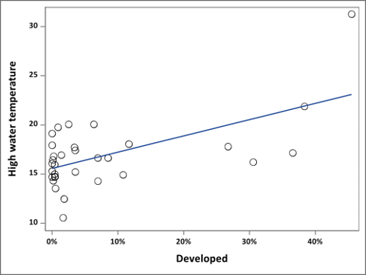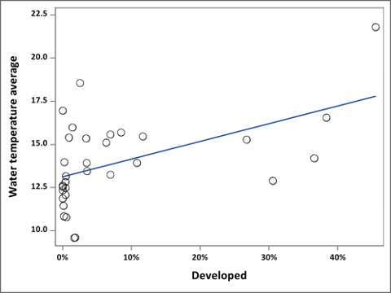
c) d)

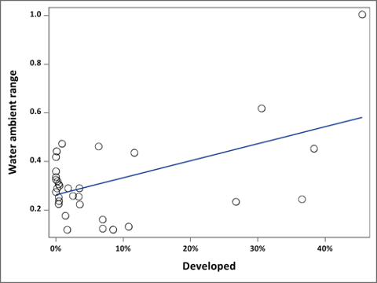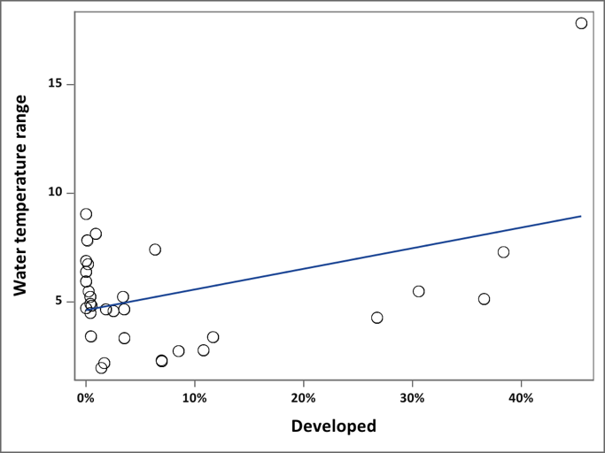
Fig 3.5 Linear regression showing the relationship between Upstream Developed_% and High Water Temperature (a), Average Water Temperature (b), Water/Ambient Range (c), and Water Temperature Range (d) in Degrees Celsius.

a) b)

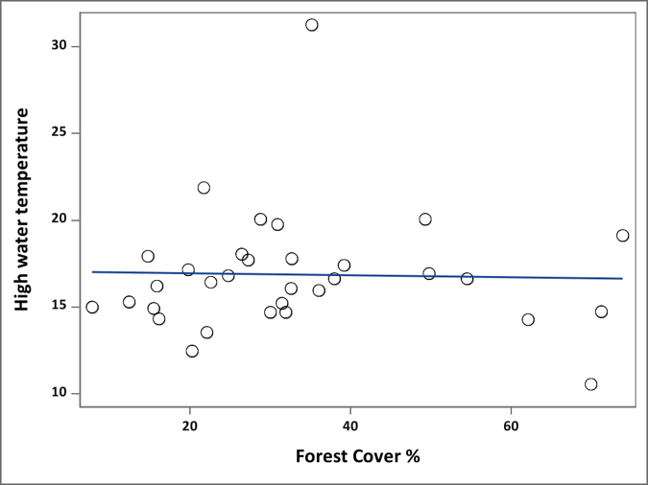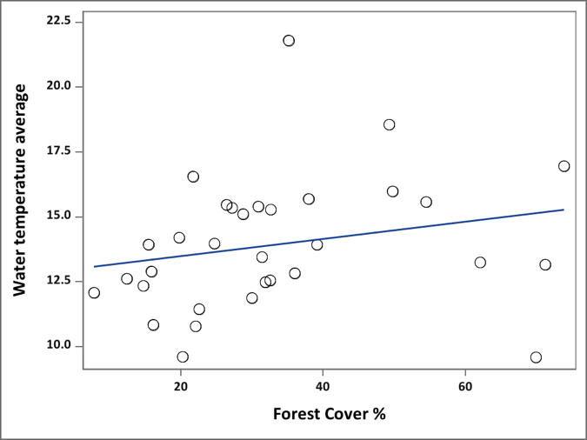
c) d)

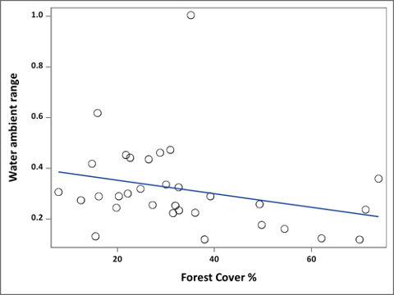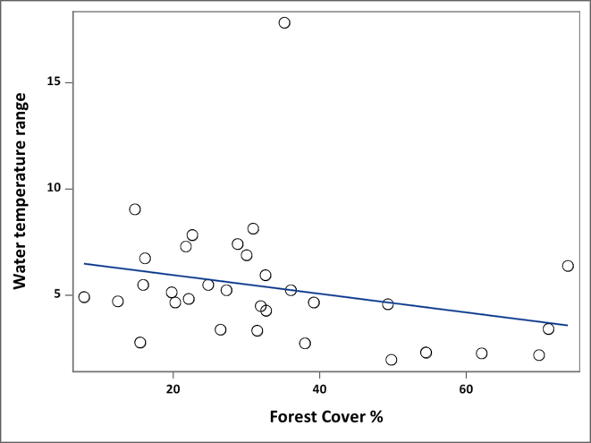
Fig 3.6 Linear regression showing the relationship between Upstream Forest_% and High Water Temperature (a), Average Water Temperature (b), Water/Ambient Range (c), and Water Temperature Range (d) in Degrees Celsius.

a) b)

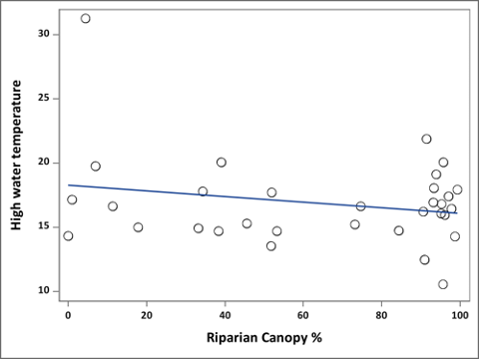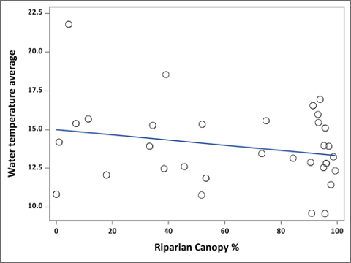

c) d)

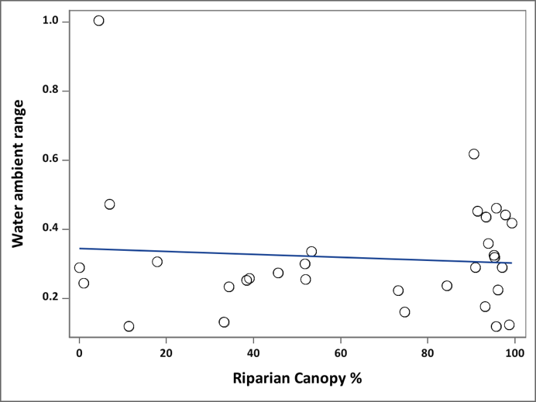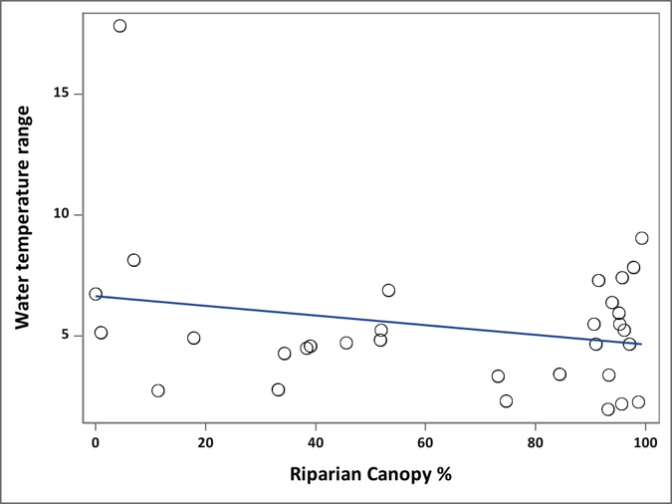

Fig 3.7 Linear regression showing relationship between Riparian Canopy_% and High Water Temperature (a), Average Water Temperature (b), Water/Ambient Range (c), and Water Temperature Range (d) in Degrees Celsius.

Development group compared to the three other groups, as seen in Figure 3.7. Comparisons of means of range, water/ambient range, and high temperatures showed no significant differences between the four groups.
Discussion of Spatial Analysis
The spatial analysis of land-cover percentages in relation to benthic macroinvertebrate scores provides a general overview of water quality trends across the state of Tennessee. The analysis clearly demonstrates how detrimental impervious surfaces are on waterways across the state, which is supported by reviews of the Impervious Cover Model. The results also indicate that ‘Open Area’, or highly managed vegetative areas like agricultural lands and low intensity development are clearly harmful, but less so than impervious surfaces. In addition, the positive effects of established forest cover within watersheds were significant as well, suggesting the importance of preserving mature and connected forest systems, especially in urban watersheds. These results are well supported by theories of land-cover and its effects on watershed health and will be increasingly important to consider as the state experiences unprecedented urban growth. Land-cover trends in Tennessee and the U.S. have been declining in agricultural land, and increasing in urban developed and residential land (Hunter et al, 2022; Thurman et al 2011). Used in partnership with stormwater management plans and sustainable urban development,
riparian forests will be an essential part of mitigating these effects of urbanization on fragile stream habitats, through bank stabilization and preservation of aquatic resources. This tool will be helpful in further identifying individual stream sites for restoration initiatives that, because of their location in an urbanized watershed with low forest cover, are likely more susceptible to poor water quality. It is a tool that also has applicability for a wide variety of purposes depending
Table 3.5 Descriptive statistics for mean separation analysis groups.
Group | N | Variable (ºC) | Mean | Std Error | Median | Range | Minimum | Maximum
HCHD | 6 | Water_Temp_High  Water_Temp_Range  Water_Ambient_Range  Water_Temp_Avg | 17.85667  4.6983  0.3755  14.8068 | 1.1271  0.9672  0.0785  0.5858 | 17.3500  4.4400  0.4445  15.2880 | 7.6000  5.1500  0.4940  3.6625 | 14.2800  2.2700  0.1240  12.8960 | 21.8800  7.4200  0.6180  16.5585
HCLD | 12 | Water_Temp_High  Water_Temp_Range  Water_Ambient_Range  Water_Temp_Avg | 15.8083  5.02167  0.2853  12.9822 | 0.6801  0.6164  0.0275  0.6335 | 16.2550  4.9550  0.2900  12.9931 | 8.5800  7.0800  0.3230  7.3792 | 10.5500  1.9700  0.1190  9.5800 | 19.1300  9.0500  0.4420  16.9592
LCHD | 5 | Water_Temp_High  Water_Temp_Range  Water_Ambient_Range  Water_Temp_Avg | 19.5600  6.5620  0.3468  16.1823 | 2.9660  2.8564  0.1662  1.4440 | 17.1600  4.2900  0.2340  15.2790 | 16.3400  15.1000  0.8840  7.8753 | 14.9300  2.7400  0.1200  13.9332 | 31.2700  17.8400  1.0040  21.8084
LCLD | 9 | Water_Temp_High  Water_Temp_Range  Water_Ambient_Range  Water_Temp_Avg | 16.1311  5.6233  0.3049  13.3290 | 0.80930  0.4354  0.0229  0.8605 | 15.0100  4.9300  0.2890  12.4834 | 6.5200  3.6500  0.2200  7.7816 | 13.5500  4.5000  0.2530  10.7751 | 20.0700  8.1500  0.4730  18.5567

a) b)
c) d)
Fig 3.7 Means separation of High and Low Development and Canopy sites (HCHD, HCLD, LCHD, LCLD) for Average Water Temperature (a), Water Temperature Range (b), High Water Temperature, and Water/ Ambient Range in Degrees Celsius.

on the goals of the user, including natural resource conservation and informing future urban development and urban forestry plans aimed at conserving stream quality.
Though this analysis was useful in determining the applicability of land-cover theories to watersheds in Tennessee, some improvements in methodology and application specifications should be accounted for in future research and in its implementation. One challenge with this model was the high level of multicollinearity between Open Area and Forest Cover. The two variables had almost equal and opposite effects on the outcome of the TMI scores. Open Area had a significant negative effect on TMI scores, while forest cover percent had a nearly equal positive effect. This indicated that the model might be improved by removing one of these variables. In a comparison between logistic regression models using impervious cover and either Open Area or Forest Cover as explanatory variables, Open Area was found to result in a very slightly higher AUC value (0.8141) compared to that of Forest Cover (0.8138), which suggests that using the percentage of Open Area in a watershed may be a slightly better predictor of water quality when used in conjunction with impervious cover.
However, because the effects of these two variables are so similar, it is difficult to determine from this analysis which variable has more of a causal relationship on water quality. Impervious cover has well-documented detrimental effects on stream quality, especially in smaller, highly urbanized watersheds (Schuler 2009). However, the cumulative effects of both watershed forest cover and open space are much less established in literature, and therefore have wider acceptable ranges in terms of prioritizing water quality. One review determined that to maintain optimal water quality, watersheds with 60-90% forest cover are generally ideal (Morse 2018). This range of positive effect has a much broader range than that of the negative effects of impervious cover, which is often observed at levels as low as 5% cover. Additionally, of the land-cover data from within Tennessee’s HUC-12 watersheds that were used in the analysis, the area that does not encompass forest/ woody wetlands, agriculture, and developed areas make up only 3% of land within the area assessed. While natural vegetated areas such as herbaceous or shrubland provide similar benefits for water quality depending on the surrounding geology and climate, for the case of this analysis their prevalence is minimal, so their effects were not specifically factored into the outcome of TMI scores. These categories include Barren, Herbaceous, Shrub/Scrub, and Emergent Herbaceous Wetland. Open Area could potentially be a slightly more accurate predictive variable because it signifies spaces that are absent of any natural vegetation, whereas forest cover only signifies areas of mature forest or tree cover. The results could indicate that Open Area is not necessarily a better predictor for water quality, but simply signifies areas that are absent of mature forests and other natural vegetation that are essential to water quality, therefore accounting for their nearly equal but opposite effects on TMI score outcomes. Further studies on these effects should focus on parsing out the different effects and relationships between various types of vegetative cover and quality of streams within watersheds.
In addition, the use of forest cover as a predictive variable for water quality may be well-suited for some regions in Tennessee, like East and Middle Tennessee, where deciduous forests are more dominant in the landscape. West Tennessee is markedly distinct, and is generally more dominated by plains and prairies. According to an updated impervious cover model developed by Schueler 2009, utilizing land cover as a predictor for water quality tends to improve in accuracy when utilized with watersheds of the same physiographic region. Further analysis might account for the physiographic regions of Tennessee into separate models to gain further insight into the effects of watershed land-cover on macroinvertebrate index scores to see, at the very least, if the prioritization variables should be adjusted for West Tennessee.
Other general improvements that could be made are related to the land-cover data quality and applicability to the TMI scores. The most recent forest cover dataset available is from 2016, while the impervious cover layer was collected in 2019. This might create some discrepancies between land cover percentages between the two different years that may reduce accuracy to the current state of watershed land-cover. In addition, it may be beneficial to remove data points before a certain time-period to improve their suitability to land-cover data in 2019 and 2016. Some data points were collected as early as 1994. While the locations of major cities and most rural areas have remained generally the same, their level and expansion of urbanization has shifted dramatically. Landsat imagery collected almost 2 decades later might have limited applicability to earlier TMI scores, especially for smaller watersheds that have gained significant imperviousness in the last 20 years. Alternatively, the analysis could be performed with land-cover data from an earlier year, more central to the median collection date of the macroinvertebrate data. These improvements are contingent on current data availability, which is limited for such large spatial analyses. Other further research efforts to clarify relationships between land-covers and TMI scores might also focus on macroinvertebrate sampling to determine if more recent samples still support the findings of this spatial analysis.
Discussion of Stream Temperature Analysis Results
In general, the results of the spatial analysis of TMI scores and field measurements are well-supported by previous studies on urban stream dynamics and indicate the extremely detrimental impacts that impervious cover and urban development has on stream quality. These results also suggest that mature riparian forests, mature forests within the watershed, and urban forests all play an essential role in assuaging these negative impacts.
The general linear regression analyses of the field measurements also indicate the importance of mature, established forests in maintaining lower stream temperatures, which helps support a diverse array of aquatic life. Riparian Canopy_% was measured with a spherical densiometer, and reflects the prevalence of mature trees and shrubs within 30 feet of the bank. This variable differs from other field measurements such as “Non-Tree_%” and “Mowed_%” in that it most likely better reflects the establishment of diverse forests as opposed to other highly managed vegetation types. For example, Non-Tree_% was hypothesized to have a significant connection with higher stream temperatures. However, a healthy riparian site with an even mix of trees, shrubs, and herbaceous plants would score very similarly for this variable as a mowed bank with several trees planted in the vicinity. This calculation is not necessarily an accurate representation of the quality of a riparian forest, as there is other vegetation aside from trees that are capable of shading and supporting aquatic life.
In addition, the pervasiveness of invasive plants like Amur Honeysuckle and Chinese Privet presents a confounding effect on water temperatures that cannot be separated from the shading effects of native trees and shrubs. In general, the assumption of this experiment is that lower temperatures and smaller ranges as a result of higher canopy cover and vegetative shading are generally beneficial to aquatic life. However, invasive shrubs and trees often contribute more shade to streams than native vegetation in some locations. Invasive plants, while likely providing some benefits in terms of erosion control and stream shading, are extremely harmful overall due to their competition with native species which significantly alters the resilience of both the terrestrial and aquatic habitat (Hammer & Gunn, 2021; Lapin, 2015). Further research should focus on the distribution of invasive plants in riparian areas, and should examine other water quality indicators in conjunction with the dominance of invasives in an area.
Another challenge was presented as a result of site selection methods. When selecting sites, it was difficult to discern perennial streams from intermittent or ephemeral streams. The experiment began with 45 sites, but some streams did not have water at the time of sampling, and were unable to accommodate a temperature logger due to lack of flow or other accessibility issues. In addition, because the stream sites were selected randomly, there was significant variation in the size, depth, and flow of streams. Some streams were perennial with well over a foot in depth in some areas, while others were smaller with nearly stagnant flow. The size of a stream is often correlated to its temperature, with deeper, faster moving streams having less temperature variation (Moore & Miner, 1997). In the analysis, the results were controlled for their size by calculating the area of its upstream network and using the variable as a covariate. However, a repetition of this experiment would ensure either all streams selected met certain similar criteria for channel width, order, and depth. Alternatively, the experiment could be repeated with equal and adequate numbers of streams of different sizes.
Another potential limitation of this experiment is that vegetation sampling was only able to be completed on one side of the stream site due to private land accessibility limitations. If further research is conducted, it would be beneficial to select sites where sampling can be completed on both sides of the stream to acquire more robust data explaining the establishment of the riparian forest. This would take more planning upfront, as streams often serve as boundaries between two parcels, and the waterway itself is not under private ownership. In most cases, sampling on both sides of the bank would require permission form both landowners, which could present some difficulty.
The accuracy and applicability of vegetation sampling could further be improved by using wider transects. The 30-foot transect length was utilized because this is often a minimum buffer width utilized by stormwater departments for water quality purposes, but many studies show that 30-foot buffer widths are not nearly enough to achieve the full water quality benefits that riparian forests are able to provide. Buffers of shorter widths are beneficial for reducing bank erosion and capturing sediment, but are often not adequate to achieve effective pollution absorption or to support aquatic and terrestrial wildlife. In some cases, forest widths of up to 200 feet are suggested to achieve this full range of ecosystem services (Parkyn, 2004).
In addition, analysis of upstream land-cover variables prior to field data collection would be helpful to determine if there is an equal variation of upstream developed percentages among different sites. Because upstream land-covers were calculated after site visits, the groups for mean separation analysis each had different numbers of sites, which might affect the validity of the results. A repetition of this experiment would be more accurate and yield more informational results if sites were identified with specific upstream land-cover values already calculated and separated into predetermined study groups to allow for more standardization of results.
For stream temperature collection, a repetition of the experiment would be improved by completing the temperature measurements in the summer so there is less variation between day and night-time temperatures. During the collection period, ambient temperatures ranged from up to 80 degrees Fahrenheit during the day, to sometimes 40 degrees Fahrenheit at night. Because of the drastic change in ambient temperature during the fall, the variable “temperature collection order” needed to be added to the dataset and used as a covariate. Most water temperature studies refer to summer temperatures, but data-collection efforts were restricted by conditions unable to be changed.
This experiment was helpful in discerning some general relationships between the level of riparian canopy cover and quality, land-cover, and resulting water temperatures. The experiment also aided in determining some effective methods of assessing riparian forest quality. These results have provided helpful information in determining improvements and establishing directions of future research efforts. In combination with the results from the spatial analysis of TMI scores, the results of the experiment help support the use of the percent of impervious cover and forest cover as predictive variables in the watershed prioritization model.

Chapter IV

Conclusions and Recommendations

Final Watershed Prioritization Model for Tennessee

Though water quality is an important factor in determining where restoration efforts should be focused, other factors need to be included in the final prioritization model as well. A 2014 review of river restoration practices and assessment of future directions found that watershed scale pollutant reduction and riparian zone restoration indicated the most promise for successful outcomes (Palmer et al, 2014). Identifying watersheds that, based on their land-cover, are highly susceptible to non-point source pollutants and channel alteration, and used in conjunction with urban forestry and sustainable development plans, could help ensure that future restoration efforts will be effective. Both impervious cover/urban development and forest cover within HUC-12 watersheds were shown in both analyses to have significant relationships and effective predictive ability for determining general water quality trends. The results of this analysis support the use of impervious cover and forest cover within a watershed as prioritization factors.
However, according to a 2009 review and reassessment of the Impervious Cover Model (ICM), it is highly suggested that as watershed imperviousness increases, the ability of forested riparian areas to benefit waterways decreases. According to the reformed ICM, indicated by the graph in Figure 4.1, as watershed imperviousness passes 25%, the waterways become generally non-supporting, which often indicates that it will be difficult or nearly impossible for riparian plantings to achieve significant benefits for the waterway. This is well-supported by this analysis where around 25% imperviousness exhibits a significant drop in the probability of receiving a passing TMI score. In addition, the average impervious percentage is about 4.875, and according to the ICM, watersheds transition to being “sensitive” to impairment at 5% imperviousness.
These results and review of literature suggest that a range of 5-25% imperviousness in watersheds tend to be more susceptible to poor water quality, but also have the greatest opportunity to benefit from revegetation and restoration of the riparian zone.
In terms of forest cover, there are much fewer peer-reviewed sources assessing watershed forest covers for maintaining water quality. However, American Forests and the U.S. Forest Service have determined that forested states like Tennessee should strive to achieve at least 40% urban canopy cover to achieve and maintain the ecosystem services provided by trees (Nowak, 2018). In urbanized watersheds, forests and trees play an essential role in mitigating negative effects on water quality from urban development by intercepting stormwater runoff and removing pollutants, providing water storage, and reducing sedimentation and erosion (Bernhardt & Palmer, 2007; Dosskey, 2010). In addition, the results of the spatial analysis indicate that a forest cover percentage above 70% indicates over a 75% likelihood that streams within that watershed will receive a passing TMI score. This is supported by a 2019 review that found that a forest cover percent of 60-90% in watersheds was ideal for maintaining water quality. Using this information, the 40% and 70% benchmarks will be used to prioritize watersheds for restoration.
Combining the results from the spatial analysis and field measurements, and review of current literature, the final watershed priority model is shown below. Watersheds are grouped into 1 of 5 categories based on their impervious and forest cover percentages with benchmarks

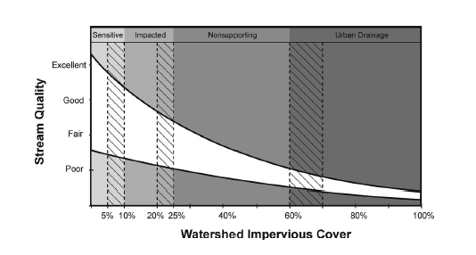
Fig 4.1 Reformed Impervious Cover Model (Schueler 2009).

separating groups based on factors discussed in the previous paragraph. Categories are separated and described in Table 4.1, and the resulting map is shown in Figure 4.2.

Closing Statements
The results of the spatial analysis and assessment of stream temperatures are in support of the documented relationship between impervious surfaces and water quality and suggest the importance of forests within riparian zones and in sub-watersheds as a whole for preserving optimal stream habitat. These analyses also provide further substantiation for urban forestry expansion efforts across the state, indicating that trees and other natural vegetation will be an important component in attenuating the harmful ecological impacts of urban and suburban development.
This final prioritization model and its resulting map will be a tool for the Community Riparian Restoration Program to narrow down and identify specific stream locations across the state that will benefit most from restoration practices and tree plantings within their riparian zones, and to foster connection with communities in high-priority watersheds. The simplicity of this model, by only utilizing two explanatory factors, will be an important aspect as it is used to communicate the importance of riparian and all forests to those outside the academic environment. The prioritization model is well-supported by a range of sources that increasingly indicate the importance of restoration and reforestation along waterways in urbanized watersheds and considers canopy cover as a water quality protection resource. Future applications of the model will involve selecting stream sites within priority 4 and 5 watersheds that are candidates for future initiatives and community projects.
Table 4.1 Descriptions of priority scores and their associated ranges of impervious and forest cover.
Priority Rating | Impervious Cover Range | Forest Cover Range
5 (highest priority) | 5-25% | <40%
4 | 5-25% | >40%
3 | <5% or >25% | <40%
2 | <5% or >25% | >40%
1(lowest priority) | - | >70%

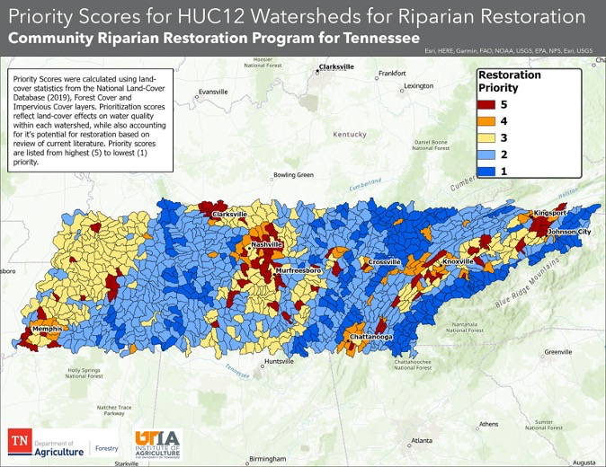
Figure 4.2 Map of Final Watershed Prioritization Model (Madison Johnson, 2023).

References

Ambrose, N. E., Fitch, L., & Bateman, N. G. (2006). Evaluating characteristics of community riparian awareness program interactions. Water science and technology, 53(10), 193-199.

Atkinson, & Lake, M. C. (2020). Prioritizing riparian corridors for ecosystem restoration in urbanizing watersheds. PeerJ (San Francisco, CA), 2020(2), e8174–e8174. https://doi.org/10.7717/peerj.8174

Baruch, E. M., Voss, K. A., Blaszczak, J. R., Delesantro, J., Urban, D. L., & Bernhardt, E. S. (2018). Not all pavements lead to streams: variation in impervious surface connectivity affects urban stream ecosystems. Freshwater Science, 37(3), 673-684.

Bernhardt, Palmer, M. A., Allan, J. D., Alexander, G., Barnas, K., Brooks, S., Carr, J., Clayton, S., Dahm, C., Follstad-Shah, J., Galat, D., Gloss, S., Goodwin, P., Hart, D., Hassett, B., Jenkinson, R., Katz, S., Kondolf, G. M., Lake, P. S., … Sudduth, E. (2005). Synthesizing U.S. River Restoration Efforts. Science (American Association for the Advancement of Science), 308(5722), 636–637. https://doi.org/10.1126/science.1109769

Beschta, R.L, and R.L Taylor. “Stream Temperature Increases and Land Use in a Forested Oregon Watershed.” Journal of the American Water Resources Association 24.1 (1988): 19–25. Web.

Bogan, T., Mohseni, O., & Stefan, H. G. (2003). Stream temperature‐equilibrium temperature relationship. Water Resources Research, 39(9).

Bowler, Diana E et al. “What Are the Effects of Wooded Riparian Zones on Stream Temperature?” Environmental evidence 1.1 (2012): 3–3. Web.

Brabec, E., Schulte, S., & Richards, P. L. (2002). Impervious surfaces and water quality: a review of current literature and its implications for watershed planning. Journal of planning literature, 16(4), 499-514.

Broadmeadow, & Nisbet, T. R. (2004). The effects of riparian forest management on the freshwater environment: A literature review of best management practice. Hydrology and Earth System Sciences, 8(3), 286–305. https://doi.org/10.5194/hess-8-286-2004

Brumberg, H., Beirne, C., Broadbent, E. N., Zambrano, A. M. A., Zambrano, S. L. A., Gil, C. A. Q., ... & Whitworth, A. (2021). Riparian buffer length is more influential than width on river water quality: A case study in southern Costa Rica. Journal of environmental management, 286, 112132.

Cappiella, K., & Brown, K. (2001). Impervious cover and land use in the Chesapeake Bay watershed. Watershed Protection Techniques, 3(4), 0_1.
Cunningham, M. A., O'Reilly, C. M., Menking, K. M., Gillikin, D. P., Smith, K. C., Foley, C. M., ... & Batur, P. (2009). The suburban stream syndrome: evaluating land use and stream impairments in the suburbs. Physical Geography, 30(3), 269-284.

Daily, G. C. (1997). Introduction: what are ecosystem services. Nature’s services: Societal dependence on natural ecosystems, 1(1).

de Mello, K., Valente, R. A., Randhir, T. O., dos Santos, A. C. A., & Vettorazzi, C. A. (2018). Effects of land use and land cover on water quality of low-order streams in Southeastern Brazil: Watershed versus riparian zone. Catena, 167, 130-138.
Dewitz, J., and U.S. Geological Survey, 2021, National Land Cover Database (NLCD) 2019 Products (ver. 2.0, June 2021): U.S. Geological Survey data release,doi:10.5066/P9KZCM54
Dosskey, M. G., Vidon, P., Gurwick, N. P., Allan, C. J., Duval, T. P., & Lowrance, R. (2010). The role of riparian vegetation in protecting and improving chemical water quality in streams 1. JAWRA Journal of the American Water Resources Association, 46(2), 261-277.

Dugdale, Malcolm, I. A., Kantola, K., & Hannah, D. M. (2018). Stream temperature under contrasting riparian forest cover: Understanding thermal dynamics and heat exchange processes. The Science of the Total Environment, 610-611, 1375–1389. https://doi.org/10.1016/j.scitotenv.2017.08.198

Dutcher, D. D., Finley, J. C., Luloff, A. E., & Johnson, J. (2004). Landowner perceptions of protecting and establishing riparian forests: A qualitative analysis. Society and natural resources, 17(4), 319-332.

Eaton, J. G., & Scheller, R. M. (1996). Effects of climate warming on fish thermal habitat in streams of the United States. Limnology and oceanography, 41(5), 1109-1115.

Ernst, C., Gullick, R., & Nixon, K. (2004). Conserving forests to protect water. Opflow, 30(5), 1-7.

González, Eduardo et al. “Restoration of Riparian Vegetation: A Global Review of Implementation and Evaluation Approaches in the International, Peer-Reviewed Literature.” Journal of environmental management 158 (2015): 85–94. Web.

González, Felipe-Lucia, M. R., Bourgeois, B., Boz, B., Nilsson, C., Palmer, G., & Sher, A. A. (2017). Integrative conservation of riparian zones. Biological Conservation, 211, 20–29. https://doi.org/10.1016/j.biocon.2016.10.035

Guida-Johnson, Bárbara, and Gustavo A. Zuleta. “Riparian Rehabilitation Planning in an Urban–rural Gradient: Integrating Social Needs and Ecological Conditions.” Ambio46.5 (2017): 578–587. Web.
Hammer, & Gunn, J. S. (2021). Planting native trees to restore riparian forests increases biotic resistance to nonnative plant invasions. Invasive Plant Science and Management, 14(2), 126–133. https://doi.org/10.1017/inp.2021.11

Hicks, A. L., & Larson, J. S. (1997, June). The Impact of Urban Stormwater Runoff on Freshwater Wetlands and the Role of Aquatic Invertebrate Bioassessment. In Effects of watershed development and management on aquatic ecosystems (pp. 386-401). ASCE.

Holcomb, J. (2005). Developing riparian guidelines on Forest Service land in the southern Appalachians. Georgia Institute of Technology.
Hunter, M., A. Sorensen, T. Nogeire-McRae, S. Beck,
S. Shutts, R. Murphy. 2022. Farms Under Threat 2040: Choosing an Abundant Future. Washington, D.C.: American Farmland Trust.
Johnson, M. P. (2001). Environmental impacts of urban sprawl: a survey of the literature and proposed research agenda. Environment and planning A, 33(4), 717-735.
Junker, Buchecker, M., & Muller-Boker, U. (2007). Objectives of public participation: Which actors should be involved in the decision making for river restorations? Water Resources Research, 43(10), W10438–n/a. https://doi.org/10.1029/2006WR005584

Kreye, M. M., Adams, D. C., & Escobedo, F. J. (2014). The value of forest conservation for water quality protection. Forests, 5(5), 862-884.

Kupilas, B., Burdon, F. J., Thaulow, J., Håll, J., Mutinova, P. T., Forio, M. A. E., ... & Friberg, N. (2021). Forested riparian zones provide important habitat for fish in urban streams. Water, 13(6), 877.

Langendoen, Richard Lowrance, R., & Simon, A. (2009). Assessing the impact of riparian processes on streambank stability. Ecohydrology, 2(3), 360–369. https://doi.org/10.1002/eco.78

Lapin, Bernhardt, K.-G., Lichtenwöhrer, P., & Roithmayr, S. (2015). Are Invasive Plant Species Disturbing Plant Diversity of Restored Riparian Areas? Gesunde Pflanzen, 67(2), 75–82. https://doi.org/10.1007/s10343-015-0338-0

Lawler, Lewis, D. J., Nelson, E., Plantinga, A. J., Polasky, S., Withey, J. C., Helmers, D. P., Martinuzzi, S., Pennington, D., & Radeloff, V. C. (2014). Projected land-use change impacts on ecosystem services in the United States. Proceedings of the National Academy of Sciences - PNAS, 111(20), 7492–7497. https://doi.org/10.1073/pnas.1405557111

Lee, P., Smyth, C., & Boutin, S. (2004). Quantitative review of riparian buffer width guidelines from Canada and the United States. Journal of Environmental Management, 70(2), 165-180.
Lintern, A., McPhillips, L., Winfrey, B., Duncan, J., & Grady, C. (2020). Best management practices for diffuse nutrient pollution: wicked problems across urban and agricultural watersheds. Environmental Science & Technology, 54(15), 9159-9174.

Lowrance, R., Altier, L. S., Newbold, J. D., Schnabel, R. R., Groffman, P. M., Denver, J. M., ... & Robinson, J. L. (1997). Water quality functions of riparian forest buffers in Chesapeake Bay watersheds. Environmental management.

Macedo, Marcia N. et al. “Land-Use-Driven Stream Warming in Southeastern Amazonia.” Philosophical Transactions of the Royal Society B: Biological Sciences 368.1619 (2013): 20120153–20120153. Web.

Maloney, K. O., Munguia, P., & Mitchell, R. M. (2011). Anthropogenic disturbance and landscape patterns affect diversity patterns of aquatic benthic macroinvertebrates. Journal of the North American Benthological Society, 30(1), 284-295.

Matteo, M., Randhir, T., & Bloniarz, D. (2006). Watershed-scale impacts of forest buffers on water quality and runoff in urbanizing environment. Journal of water resources planning and management, 132(3), 144-152.

Mayer, P. M., Reynolds Jr, S. K., McCutchen, M. D., & Canfield, T. J. (2007). Meta‐analysis of nitrogen removal in riparian buffers. Journal of environmental quality, 36(4), 1172-1180.

Meyer, J. L., Paul, M. J., & Taulbee, W. K. (2005). Stream ecosystem function in urbanizing landscapes. Journal of the North American Benthological Society, 24(3), 602-612.
Merritt, David M.; Manning, Mary E.; Hough-Snee, Nate, eds. 2017. The National Riparian Core Protocol: A riparian vegetation monitoring protocol for wadeable streams of the conterminous United States. Gen. Tech. Rep. RMRS-GTR-367. Fort Collins, CO: U.S. Department of Agriculture, Forest Service, Rocky Mountain Research Station. 37 p.
Milesi, C., Elvidge, C. D., Dietz, J. B., Tuttle, B. T., Nemani, R. R., & Running, S. W. (2005). A strategy for mapping and modeling the ecological effects of US lawns. J. Turfgrass Manage, 1(1), 83-97.
Moore, A.A, and M.A Palmer. “Invertebrate Biodiversity in Agricultural and Urban Headwater Streams: Implications for Conservation and Management.” Ecological applications 15.4 (2005): 1169–1177. Web.

Moore, J. A., & Miner, J. R. (1997). Stream temperatures: some basic considerations.

Morse, Joshua, Jessica Nicole Welch, Abigail Weinberg, and Peter Szabo. "Literature review: forest cover & water quality–implications for land conservation." Open Space Institute: June 24 (2018): 2018.

Mutinova, P. T., Kahlert, M., Kupilas, B., McKie, B. G., Friberg, N., & Burdon, F. J. (2020). Benthic diatom communities in urban streams and the role of riparian buffers. Water, 12(10), 2799.

Nowak, D. J., & Greenfield, E. J. (2018). US urban forest statistics, values, and projections. Journal of Forestry, 116(2), 164-177.

Opdahl, Ellie, Kathryn Demps, and Julie A. Heath. “Decreased Cortisol Among Hikers Who Preferentially Visit and Value Biodiverse Riparian Zones.” Scientific reports 11.1 (2021): 848–848. Web.

Orsi, F., Geneletti, D., & Newton, A. C. (2011). Towards a common set of criteria and indicators to identify forest restoration priorities: An expert panel-based approach. Ecological indicators, 11(2), 337-347.

Palmer, Hondula, K. L., & Koch, B. J. (2014). Ecological Restoration of Streams and Rivers: Shifting Strategies and Shifting Goals. Annual Review of Ecology, Evolution, and Systematics, 45(1), 247–269. https://doi.org/10.1146/annurev-ecolsys-120213-091935

Parkyn, S. (2004). Review of riparian buffer zone effectiveness(Vol. 2005). Wellington, New Zealand: Ministry of Agriculture and Forestry.

Paul, Michael J, and Judy L Meyer. “STREAMS IN THE URBAN LANDSCAPE.” Annual review of ecology and systematics 32.1 (2001): 333–365. Web.

Piggott, Jeremy J et al. “Multiple Stressors in Agricultural Streams: a Mesocosm Study of Interactions Among Raised Water Temperature, Sediment Addition and Nutrient Enrichment.” PloS one 7.11 (2012): e49873–e49873. Web.

Richards, C., Johnson, L. B., & Host, G. E. (1996). Landscape-scale influences on stream habitats and biota. Canadian Journal of Fisheries and aquatic sciences, 53(S1), 295-311.

Riis, Kelly-Quinn, M., Aguiar, F. C., Manolaki, P., Bruno, D., Bejarano, M. D., Clerici, N., Fernandes, M. R., Franco, J. C., Pettit, N., Portela, A. P., Tammeorg, O., Tammeorg, P., Rodríguez-González, P. M., & Dufour, S. (2020). Global Overview of Ecosystem Services Provided by Riparian Vegetation. Bioscience, 70(6), 501–514. https://doi.org/10.1093/biosci/biaa041

“Riparian.” Merriam-Webster.com Dictionary, Merriam-Webster, https://www.merriam-webster.com/dictionary/riparian. Accessed 25 May. 2023.

Robbins, P., Polderman, A., & Birkenholtz, T. (2001). Lawns and toxins: An ecology of the city. Cities, 18(6), 369-380.

Rosenberg, S., & Margerum, R. D. (2008). Landowner motivations for watershed restoration: lessons from five watersheds. Journal of Environmental Planning and Management, 51(4), 477-496.

Roy, A. H., Paul, M. J., & Wenger, S. J. (2010). Urban stream ecology. Urban ecosystem ecology, 55, 341-352.
SAS Institute Inc 2013. SAS/ACCESS® 9.4 Interface to ADABAS: Reference.Cary, NC: SAS Institute Inc.

Schiff, R., & Benoit, G. (2007). Effects of impervious cover at multiple spatial scales on coastal watershed streams 1. JAWRA Journal of the American Water Resources Association, 43(3), 712-730.

Schueler, T. R. (2004). An integrated framework to restore small urban watersheds (Vol. 1). Center for Watershed Protection.

Schueler, T. R., Fraley-McNeal, L., & Cappiella, K. (2009). Is impervious cover still important? Review of recent research. Journal of Hydrologic Engineering, 14(4), 309-315.

Shuster, Bonta, J., Thurston, H., Warnemuende, E., & Smith, D. R. (2005). Impacts of impervious surface on watershed hydrology: A review. Urban Water Journal, 2(4), 263–275. https://doi.org/10.1080/15730620500386529

Somers, Kayleigh A. et al. “Streams in the Urban Heat Island: Spatial and Temporal Variability in Temperature.” Freshwater science 32.1 (2013): 309–326. Web.

Stanfield, L. W., and B. W. Kilgour. “HOW PROXIMITY OF LAND USE AFFECTS STREAM FISH AND HABITAT: HOW PROXIMITY OF LAND USE AFFECTS STREAMS.” River research and applications 29.7 (2013): 891–905. Web.

Stone, M. L., Whiles, M. R., Webber, J. A., Williard, K. W., & Reeve, J. D. (2005). Macroinvertebrate communities in agriculturally impacted southern Illinois streams: patterns with riparian vegetation, water quality, and in‐stream habitat quality. Journal of Environmental Quality, 34(3), 907-917.

Studinski, Jered M. et al. “The Effects of Riparian Forest Disturbance on Stream Temperature, Sedimentation, and Morphology.” Hydrobiologia 686.1 (2012): 107–117. Web.

Svejcar, T. (1997). Riparian zones. 1. What are they and how do they work?. Rangelands Archives, 19(4), 4-7.

Sweeney, Bott, T. L., Jackson, J. K., Kaplan, L. A., Newbold, J. D., Standley, L. J., Hession, W. C., Horwitz, R. J., & Wolman, M. G. (2004). Riparian Deforestation, Stream Narrowing, and Loss of Stream Ecosystem Services. Proceedings of the National Academy of Sciences - PNAS, 101(39), 14132–14137. https://doi.org/10.1073/pnas.0405895101

SWEENEY, Bernard W, and J. Denis NEWBOLD. “STREAMSIDE FOREST BUFFER WIDTH NEEDED TO PROTECT STREAM WATER QUALITY, HABITAT, AND ORGANISMS: A LITERATURE REVIEW : Riparian Ecosystems IV: Advancing Science, Economics, and Policy.” Journal of the American Water Resources Association. Vol. 50. Middleburg, VA: American Water Resources Association, 2014. 560–584. Print.
Tennessee Department of Environment and Conservation Division of Water Resources. (2022, July 13). Tennessee 305(b) Water Quality Report 2022. ArcGIS StoryMaps. Retrieved March 8, 2023, from https://storymaps.arcgis.com/stories/5d4aa1dae4754b98a6cd9baf01d1477d
Tennessee Department of Environmental and Conservation Division of Water Resources. (2022, June 29). Semi-Quantitative Single Habitat (SQSH) and Tennessee Macroinvertebrate Index Samples. Tennessee Department of Environment and Conservation Division of Water Resources. The data that support the findings of this study are available from the corresponding author upon reasonable request.
Tennessee Department of Environment and Conservation Division of Water Resources (2021, December 28). Quality System Standard Operating Procedure for Macroinvertebrate Stream Surveys. https://www.tn.gov/content/dam/tn/environment/water/policy-and-guidance/DWR-PAS-P-01-Quality_System_SOP_for_Macroinvertebrate_Stream_Surveys-122821.pdf
Tennessee Division of Forestry. (2020). Tennessee Forest Action Plan: 2020-2030. Tennessee Department of Agriculture. https://www.tn.gov/agriculture/forests/ protection/ag-forests-action-plan.html

Thompson, & Parkinson, S. (2011). Assessing the local effects of riparian restoration on urban streams. New Zealand Journal of Marine and Freshwater Research, 45(4), 625–636. https://doi.org/10.1080/00288330.2011.569988

Thurman, L., Terry B., Gibson T., & Green H. (2011). Land-Use and Planning in Tennessee: A TACIR Staff Report. The Tennessee Advisory Commission on Intergovernmental Relations.

Tolkkinen, Heino, J., Ahonen, S. H. K., Lehosmaa, K., & Mykrä, H. (2020). Streams and riparian forests depend on each other: A review with a special focus on microbes. Forest Ecology and Management, 462, 117962–. https://doi.org/10.1016/j.foreco.2020.117962

Tong, & Chen, W. (2002). Modeling the relationship between land use and surface water quality. Journal of Environmental Management, 66(4), 377–393. https://doi.org/10.1006/jema.2002.0593

Tu, J., Xia, Z. G., Clarke, K. C., & Frei, A. (2007). Impact of urban sprawl on water quality in eastern Massachusetts, USA. Environmental Management, 40, 183-200.

Turunen, J., Elbrecht, V., Steinke, D., & Aroviita, J. (2021). Riparian forests can mitigate warming and ecological degradation of agricultural headwater streams. Freshwater Biology, 66(4), 785-798.
United States Environmental Protection Agency. (2016). Stream Temperature- Climate Change Indicators in the United States. In U.S.G.S. National Water Information System.
U.S. Environmental Protection Agency. 2020. National Aquatic Resource Surveys.
https://www.epa.gov/national-aquatic-resource-surveys. Accessed May 2023.
United States Department of Agriculture. (2012). Working Trees Info: What is a Riparain Forest Buffer? U.S.D.A. National AgroForestry Center.
U.S. Geological Survey, 2019, National Hydrography Dataset (ver. USGS National Hydrography Dataset Best Resolution Watershed Boundaries (NHD) for Hydrologic Unit (HU) 12 - 2001 (published 20191002)), accessed August 4, 2022 at URL https://www.usgs.gov/national-hydrography/access-national-hydrography-products
U.S. Geological Survey, 2019, National Hydrography Dataset (ver. USGS National Hydrography Dataset Best Resolution (NHD) for Streams and Waterbodies - 2001 (published 20191002)), accessed August 4, 2022 at URL https://www.usgs.gov/national-hydrography/access-national-hydrography-products
Walsh, C. J., Roy, A. H., Feminella, J. W., Cottingham, P. D., Groffman, P. M., & Morgan, R. P. (2005). The urban stream syndrome: current knowledge and the search for a cure. Journal of the North American Benthological Society, 24(3), 706-723.
Wenger, S. (1999). A review of the scientific literature on riparian buffer width, extent and vegetation.
Wenger, Roy, A. H., Jackson, C. R., Bernhardt, E. S., Carter, T. L., Filoso, S., Gibson, C. A., Hession, W. C., Kaushal, S. S., Martí, E., Meyer, J. L., Palmer, M. A., Paul, M. J., Purcell, A. H., Ramírez, A., Rosemond, A. D., Schofield, K. A., Sudduth, E. B., & Walsh, C. J. (2009). Twenty-six key research questions in urban stream ecology: an assessment of the state of the science. Journal of the North American Benthological Society, 28(4), 1080–1098. https://doi.org/10.1899/08-186.1
Werner, L. 2019. Standard Operating Procedure EAP064, Version 1.1: Determining Canopy Closure using a Concave Spherical Densiometer, Model C for the Type N Experimental Buffer Treatment Study in Incompetent Lithologies. Publication No. 19-03-221. Washington State Department of Ecology, Olympia.
Wickham, James D., et al. "LAND COVER AS A FRAMEWORK FOR ASSESSING RISK OF WATER POLLUTION 1." JAWRA Journal of the American Water Resources Association 36.6 (2000): 1417-1422.
Appendix

Raw data: Stream temperature and Land-Cover values for Field Sites

DATAPOINT | Upstream Area | CHANNEL_WIDTH_AVG | Forest Cover Percent | Upstream OpenSpace | Upstream Natural | Upstream Developed | STREAM_CANOPY_PERCENT | RIPARIAN_CANOPY_PERCENT | NONTREE_PERCENT | MOWED_PERCENT
ADAMS CREEK-ADAMS | 98100 | 10.26666667 | 32.57798165 | 0.629629612 | 0.3703703582 | 0 | 96.41777778 | 95.14666667 | 71.76 | 0
BYRDCREEK_BYRDS | 7678800 | 43.76666667 | 69.88607595 | 0.1586707234 | 0.5664638281 | 0.01673297398 | 74 | 95.632 | 26.44 | 1.15
CANORES_NEWMANSVILLE | 1232100 | 22.2 | 22.10299489 | 0.7306569219 | 0.2153284699 | 0.005109488964 | 80.12444444 | 51.744 | 74.5 | 62.7
CARSONCREEK-CARSON | 2439900 | 29.26666667 | 16.15492438 | 0.8205697536 | 0.1564927846 | 0.001849796507 | 49.04 | 0 | 100 | 73.2
CHEROKEE_LITTLECHEROKEE | 933300 | 17.86666667 | 36.02700096 | 0.5799614787 | 0.3092485666 | 0.003853564616 | 95.37777778 | 96.08266667 | 30 | 0
CHESTNUTHILL_DADDYS | 27969300 | 88.1 | 71.17517778 | 0.1341894269 | 0.5406791568 | 0.004438507371 | 34.01777778 | 84.33066667 | 33.3 | 0
DALLASHOLLOW_DALLASLAKETRIB | 462600 | 21.23333333 | 49.28015564 | 0.5719844103 | 0.3579766452 | 0.02529182844 | 97.80444444 | 39.02133333 | 63.3 | 53.3
DISCOVERY_POE | 680400 | 16.7 | 35.1494709 | 0.190476194 | 0.3544973433 | 0.4550264478 | 47.42222222 | 4.421333333 | 7.1 | 0
FORT-HENRY_SOUTHFORKHOLSTON | 5059800 | 45 | 20.28121665 | 0.783018887 | 0.1703453213 | 0.01815592684 | 60.82666667 | 90.91733333 | 83.61 | 24.59
FOUNDERPARK_BRUSH | 639000 | 15.9 | 19.8 | 0.5330520272 | 0.08016877621 | 0.3656821251 | 0.515555556 | 0.973333333 | 77.78 | 77.78
HINESVILLE-HINESTRIB | 139500 | 13.63333333 | 30.01290323 | 0.6948052049 | 0.2727272809 | 0 | 95.95555556 | 53.26933333 | 86.76 | 86.76
HOTCHKISS-HOTCHKISS | 402300 | 11.96666667 | 30.89932886 | 0.6681614518 | 0.2600896955 | 0.008968610317 | 93.76 | 6.952 | 92.11 | 0
HUGHCOX-SINKING | 454500 | 12.43333333 | 7.833663366 | 0.9405940771 | 0.02970297076 | 0.003960396163 | 36.27555556 | 17.856 | 88.64 | 88.64
IJAMS_TOLL | 255600 | 40.86666667 | 39.15492958 | 0.7097902298 | 0.1713286787 | 0.03496503457 | 92.25777778 | 97.01866667 | 47.73 | 11.36
INDUSTRIAL_LITTLEOBEDTRIB | 130500 | 17.76666667 | 15.88275862 | 0.694444418 | 0 | 0.3055555522 | 76.54222222 | 90.57066667 | 55.43 | 3.26
INSKIP_SECOND | 265500 | 12.43333333 | 21.73898305 | 0.6164383292 | 0 | 0.383561641 | 90.87111111 | 91.40266667 | 57.14 | 0
KENNYTOWN_LICK | 25505100 | 55 | 31.9089241 | 0.6341517568 | 0.322458148 | 0.004128879867 | 85.20888889 | 38.36266667 | 62.5 | 35.71
KIMBERLIN_SIXMILE | 257400 | 28.73333333 | 28.76923077 | 0.7394366264 | 0.1514084488 | 0.06338027865 | 87.63555556 | 95.70133333 | 45.87 | 14.68
MARSHALL_BEAVER | 3368700 | 28 | 31.44162437 | 0.7004016042 | 0.194912985 | 0.03534136713 | 92.83555556 | 73.168 | 71.01 | 71.01
MEADOW_CLOUD | 371700 | 23.13333333 | 24.76029056 | 0.8140096664 | 0.1014492735 | 0.002415458905 | 94.84444444 | 95.28533333 | 45.92 | 30.61
OLD PATTON-CARDIFF | 541800 | 32.03333333 | 62.05481728 | 0.2902155817 | 0.6152570248 | 0.06965173781 | 95.49333333 | 98.68266667 | 28.6 | 0
OOTLEWAH_HURRICANE | 701100 | 31.5 | 54.45057766 | 0.4087403715 | 0.3920308352 | 0.06940873712 | 88.67555556 | 74.65866667 | 67 | 5
REX_MOORE | 877500 | 24.56666667 | 22.60512821 | 0.6879505515 | 0.1884655058 | 0.001029866165 | 94.45333333 | 97.78133333 | 47.5 | 0
ROOTYBRANCH_UNNAMED | 375300 | 20.16666667 | 14.76258993 | 0.8886198401 | 0.04600484297 | 0 | 92.95111111 | 99.30666667 | 37.5 | 17.7
RT34_LITTLELIMESTONE | 701100 | 12.63333333 | 15.478819 | 0.8406169415 | 0.03984575719 | 0.1079691499 | 71.68888889 | 33.16266667 | 92.7 | 31.3
SAWYER_UNNAMED | 125100 | 12.33333333 | 73.82014388 | 0.1086956486 | 0.8333333135 | 0 | 93.87555556 | 93.864 | 40.6 | 5
SPRING-SWEETWATER | 10215000 | 17.53333333 | 27.23947137 | 0.6632922292 | 0.2308098525 | 0.03389084339 | 38.64 | 51.91733333 | 38.7 | 0
SWICEGOOD_BAGWELL | 22500 | 12.86666667 | 12.44 | 1 | 0 | 0 | 24.58074074 | 45.58933333 | 87 | 33.7
TYSON_THIRD | 2157300 | 33.76666667 | 32.66583229 | 0.624530673 | 0.1013767198 | 0.2674176097 | 43.72444444 | 34.32266667 | 79.3 | 69
VILLA_CANDIES | 19846800 | 41.06666667 | 49.74564665 | 0.4618317187 | 0.3946627975 | 0.01406916603 | 81.51111111 | 93.136 | 35 | 0
WAMPLER_TOWN | 1809000 | 37.1 | 26.43482587 | 0.6422521472 | 0.1758844107 | 0.1165919304 | 92.60444444 | 93.30933333 | 48.39 | 27.42
WEMORY-UNNAMED | 11708100 | NA | 37.95187947 | 0.5986869335 | 0.2512505352 | 0.08493122458 | NA | 11.35466667 | 79.41 | 79.41

                - Vita
Madison Johnson is originally from Cincinnati, Ohio, and completed her Bachelor of Science in Environmental Biology at the University of Dayton in 2020. She completed a year of service through AmeriCorps in Nashville through 2020 and 2021, and began her Master of Science in Forestry degree at the University of Tennessee, Knoxville in August 2021.

