MAXIMIZING LIGNIN YIELD USING
EXPERIMENTAL DESIGN
ANALYZING THE IMPACT OF SOLVENT COMPOSITION AND FEEDSTOCK PARTICLE SIZE ON THE ORGANOSOLV PROCESS IN THE PRESENCE OF FEEDSTOCK CONTAMINATION

A Thesis Presented for the
Master of Science
Degree
The University of Tennessee, Knoxville

BSc. Hagen Maraun
August 2013

DEDICATION

to my wife and kids

ACKNOWLEDGEMENTS

Of all the people who have supported me during this last year, I am most indebted to both my Co-major Professors Dr. Joseph J. Bozell and Dr. Timothy M. Young and my two Committee members Dr. Darren Baker and Dr. Alexander Petutschnigg who have provided extensive support during my studies here at UT and who have spared no effort to make this stay a wonderful experience. I would further like to express my gratitude towards Dr. Keith Belli, Professor and Head of the Department of Forestry, Wildlife and Fisheries as well as Dr. Timothy G. Rials, Professor and Director of the Center for Renewable Carbon and to Dr. Adam Taylor for the good times and the superb cookouts. Great thanks go to Mr. Anton Astner and Mr. Andreas Attwenger for their assistance with conducting experiments on the organosolv fractionation reactor at the Center for Renewable Carbon in Knoxville. Furthermore, I would like to thank Dr. Omid Hosseinaei for his continued support and friendship. My thanks go to Mr. Mark Alexander for sharing his knowledge on switchgrass and for supplying the weeds used in this study. A very big “Thank You” goes to Ms. Amanda Silk Curde for her help on all the paperwork, Mr. Chris Helton, Dr. Nicolas André and Ms. Ann Ryan for their support, great laughs and friendship. I would like to thank my soon to be wife and my great kids for their constant support, encouragement and understanding during my studies here at UT. A big “Thank You” goes to my mother in law for her ongoing support, love and encouragement. I also want to thank my dad, his wife, my brothers and my sister for their love and support.
ABSTRACT
The depletion of fossil feedstock and the unfavorable environmental effects accompanying by its exploitation are the driving forces in the process of transitioning to renewable feedstock as the primary resource. Similar to petrorefineries, a new modern biorefinery would use biomass to produce a variety of different chemical products and transportation fuels. Lignin, a potential low-cost, high volume output process stream derived from lignocellulosic biomass is currently being researched to better support the economics of the future biorefinery. In this study, experimental design was used to determine the optimal level for each process factor in an organosolv fractionation process that targets maximum attainable lignin yield, even in the presence of feedstock contaminants. The process factors studied were two different fractionation times (56, 90 min), two different fractionation temperatures (140°C, 160°C), three mixed feedstock loadings containing mixtures of switchgrass (Panicum virgatum) and tulip poplar (Liriodendron tulipifera) in three different weight ratios ([10/90], [50/50], [90/10]), three different poplar chip sizes (coarse, medium, fine), three different solvent compositions containing different ratios of the fractionation solvents methyl isobutylketone (MIBK), ethanol (EtOH) and water (H₂O) ([07/30/63], [16/34/50], [62/27/11]), and three different acid concentrations (0.025, 0.05, 0.1 M). Based on the results found it is predicted that, even in the presence of switchgrass contaminants an estimated mean lignin yield of ~ 90 wt % is attainable if the levels of the organosolv process are set to a fractionation time of 90 minutes at a fractionation temperature of 160°C, use of a feedstock mixture containing 10% switchgrass and 90% medium poplar particles, and the use of the 16/34/50 solvent mixture with an added acid concentration of 0.1 M. The practical implications of these results on biorefinery operation will also be discussed.
TABLE OF CONTENTS
CHAPTER I - INTRODUCTION 1
Research Hypothesis 6
Objectives 7
Thesis Organization 8
CHAPTER II - LITERATURE REVIEW 9
Biorefinery Concept 9
Different Biorefinery Types 10
The Lignocellulosic Feedstock Biorefinery (LCF) 11
Lignin Utilization 12
Suitable Biomass for Biorefineries 13
Physical Pretreatment of Biomass 14
Structure of Lignocellulosic Biomass 15
Principles of Pretreatment 20
Pretreatment Technologies for the Biorefinery 22
Summary of Pretreatment Methods 26
Experimental Design 28
Taguchi Robust Product Design (TRPD) 28
CHAPTER III – MATERIALS AND METHODS 36
Feedstock I - Switchgrass (Panicum virgatum) 37
Feedstock II - Tulip Poplar (Liriodendron tulipifera) 38
Particle Size of Feedstock II 39
Switchgrass Contaminating Weeds 39
Mixed Feedstocks 42
Organosolv Fractionation Process 44
Solvent Composition 50
Taguchi Robust Product Design (TRPD) 51
CHAPTER IV – RESULTS AND DISCUSSION 66
Klason Lignin Analysis 67
Taguchi Robust Product Design Experimental Results 72
Lignin Yield Distribution 74
Impact of Run Time on Lignin Yield 78
Impact of Run Temperature on Lignin Yield 79
Impact of the Feedstock Ratio on Lignin Yield 80
Impact of Poplar Particle Size on Lignin Yield 81
Impact of Acid Concentration on Lignin Yield 82
Impact of Solvent Composition on Lignin Yield 83
Maximizing Lignin Yield 84
Validation of the Prediction Profiler using Monte Carlo Simulation 86
Impact of Run Time based on Simulation 86
Impact of Run Temperature based on Simulation 87
Impact of Feedstock Ratio based on Simulation 89
Impact of Poplar Particle Size based on Simulation 90
Impact of Acid Concentration based on Simulation 92
Impact of Solvent Composition based on Simulation 94
Impact of Solvent Composition on the Organosolv Fractionation Process 95
Impact of Solvent Composition on Lignin Purity 96
Impact of High MIBK Solvent on the Cellulose Yield 98
Impact of High MIBK Solvents on the Lignin Recovery Process 100
Impact of Low MIBK Solvents on the Lignin Recovery Process 102
CHAPTER V – CONCLUSION & RECOMENDATIONS 104
Impact of Solvent Composition on the Organosolv Fractionation Process 105
Impact of Poplar Particle Size on the Organosolv Fractionation Process 107
Future Research 108
LIST OF REFERENCES 109
VITA 120

LIST OF TABLES

Table 1: Effects that different pretreatment methods have on the chemical composition and chemical/physical structure of lignocellulosic biomass (Mosier et al., 2005). 29
Table 2: Broadleaf plant and grass species found in the weed fraction of a switchgrass plantation for bioenergy production. 41
Table 3: Mixed feedstock ratio for TRPD experiments. 42
Table 4: Mixed feedstock ratio for TRPD experiments with weeds. 43
Table 5: Lignin content of mixed feedstock loadings. 43
Table 6: Organosolv fractionation solvent composition (Bozell et al., 2011a). 51
Table 7: Signal factors for the inner array. 52
Table 8: Taguchi robust product design matrix. 65
Table 9: Klason lignin purity results presented in percent. 68
Table 10: Percentage of maximum attainable lignin achieved for runs containing pure feedstocks. 70
Table 11: Percentage of maximum attainable lignin achieved for runs containing contaminated feedstocks. 71
Table 12: Lignin yields and S/N ratios for pure feedstocks and the weed contaminated feedstocks. 73
Table 13: Model comparison for pure feedstock runs. 75
Table 14: Model comparisons for contaminated feedstock runs. 76
Table 15: Lignin yield distribution between the aqeous and solvent phase when using the +2 solvent mixtures. 102

LIST OF FIGURES

Figure 1: Organosolv fractionation process (Bozell et al., 2011a). 4
Figure 2: Potential products of the LCF biorefinery (Kamm and Kamm, 2004). 12
Figure 3: Illustration of lignocellulosic biomass composition and structure (Menon and Rao, 2012). 16
Figure 4: Cellulose structural formula (Stuart and El-Halwagi, 2013). 17
Figure 5: Hemicellulose structural formula (Stuart and El-Halwagi, 2013). 18
Figure 6: Monomeric components of the lignin structure (Sannigrahi et al., 2010). 19
Figure 7: Schematic goal of pretreatment on lignocellulosic biomass (Hsu et al., 1980). 21
Figure 8: Parameter diagram (Phadke, 2010). 30
Figure 9: Traditional loss funktion or step funktion (Albright and Roth, 1994). 31
Figure 10: Quality loss function (Phadke, 2010) 32
Figure 11: (a) Transmission of variation, (b) The Taguchi robust design (Taylor, 1998). 34
Figure 12: Switchgrass (Panicum virgatum). 37
Figure 13: Tulip poplar (Liriodendron tulipifera) pulp grade chips. 38
Figure 14: Reactor flow diagram and layout. 45
Figure 15: Organosolv fractionation reactor at the CRC, University of Tennessee. 46
Figure 16: Cellulose washing in a Büchner funnel (Bozell et al., 2011a) 47
Figure 17: Phase separation between organic (upper) and aqueous (lower) phase. 48
Figure 18: Ternary phase diagram of organic solvent (Bozell et al., 2011a). 50
Figure 19: Parameter diagram for the organosolv fractionation process. 52
Figure 20 (a) and (b): Histograms and boxplots for lignin yield by (a) mixed feedstock and (b) contaminated feedstock. 74
Figure 21: Normal probability plot of lignin yield for (a) pure feedstock and (b) for contaminated feedstock. 75
Figure 22: One-Way ANOVA for mean lignin yield between pure and contaminated feedstock expressed in percent. 77
Figure 23: One-Way ANOVA for mean lignin yield by run time expressed in percent. 78
Figure 24: One-Way ANOVA for mean lignin yield by process temperature expressed in percent. 79
Figure 25: One-Way ANOVA for mean lignin yield by feedstock expressed in percent. 80
Figure 26: One-Way ANOVA for lignin yield by poplar particle size in expressed in percent. 81
Figure 27: One-Way ANOVA for lignin yield by acid concentration presented in percent. 82
Figure 28: One-Way ANOVA for mean lignin yield by solvent composition expressed in percent. 83
Figure 29: Prediction profiler suggesting optimal levels for each factor to maximize the mean yield of lignin. 85
Figure 30: One-Way ANOVA for simulated mean lignin yield by run time presented in percent. 87
Figure 31: One-Way ANOVA for simulated mean lignin yield by run time presented in percent. 88
Figure 32: One-Way ANOVA for simulated mean lignin yield by feedstock ratio presented in percent. 89
Figure 33: One-Way ANOVA simulated mean lignin yield by feedstock particle size presented in percent. 91
Figure 34: One-Way ANOVA for simulated mean lignin yield by acid concentration presented in percent. 93
Figure 35: One-Way ANOVA for mean lignin yield by solvent composition. 94
Figure 36: Collection vessel containing black liquor from a -2 solvent run. 96
Figure 37: Box plot for mean lignin purity by solvent composition expressed as a percent. 98
Figure 38: Box plot of the mean cellulose yield by solvent composition in percent of total Feedstock. 99
Figure 39: Phase separaton during the lignin recovery process. 101

CHAPTER I - INTRODUCTION

The exploitation of cheaply available fossil feedstock such as petroleum, natural gas and coal was strongly researched and developed during the 20th century. These fossil feedstocks form the base of a great variety of petroleum derivatives such as fuel, chemicals, pharmaceuticals, synthetic fibers, plastics, pesticides, fertilizers, lubricants, waxes etc. to accommodate the increasing demands of the growing world population (Bender, 2000; Demirbas, 2006). However, the burning of fossil fuels increases greenhouse gas (GHG) emissions substantially and thus, contributes to environmental issues namely pollution, climate change, acid rain and the deterioration of human health (Tan et al., 2008). These unfavorable effects on our environment, as well as the depletion of fossil feedstock, have been realized by society as becoming the driving force in the quest to provide an affordable and environmentally-friendly supply of renewable energy and resources (Mabee et al., 2005; Tan et al., 2008).

Renewable energy sources such as wind, solar and geothermal provide a long-term and reliable electric or geothermal energy supply for the future, but around 40% of total energy consumption requires the availability of liquid fuels (Butler, 2006). This fact makes fuel from biomass the most promising alternative to fossil fuels because this biological feedstock is the only carbon based source of renewable energy. It contains substantial amounts of sugars, starch or cellulose that can be converted into biofuel (Butler, 2006; Malca and Freire, 2006).

Bioethanol, an alcohol derived from biomass, is considered to be a good alternative to fossil fuel because the combustion of bioethanol is cleaner, and the carbon dioxide (CO₂) released during this process is equivalent to the CO₂ taken up by the plant during growth (Mabee et al., 2005). Therefore, when using bioethanol the emissions resulting from fossil fuels are avoided and allowed to remain underground (Mabee et al., 2005). With almost 50 billion liters produced annually, most current biofuel supplies are considered “first generation” and come in the form of bioethanol that is typically produced from food crops (sugarcane, corn, wheat) and fruit (Naik et al., 2010). Furthermore, the growing fear among the population that the use of food crops or fruit for the production of biofuel will drive up the prices for essential foods and other consumer products has forced producers to search for other types of biofuel feedstock (Tan et al., 2008).

Lignocellulosic feedstocks (agricultural & forest residue, grass, aquatic biomass, etc.), often referred to as “plant biomass”, are non-edible, widely available and lower cost alternatives to first generation feedstocks. Such feedstocks do not require intensive agriculture as sugar cane and corn do giving them the potential to offer new innovative biofuels of the “second generation” (Simpson-Holley et al., 2007). The US Environmental Protection Agency also conducted a life cycle analysis investigating the GHG impact of lignocellulosic ethanol production. This analysis found that lignocellulosic ethanol generated 91% less GHG than fossil transportation fuels, outperforming corn ethanol with only 22% less GHG emissions than fossil fuels, further highlighting the potential of lignocellulosic biomass (Fargione et al., 2008; Panichelli and Gnansounou, 2008).

However, crude oil is not only the primary source of energy for the transport sector (IEA, 2007) it is also the primary source for the production of the majority of chemical products and plastics used worldwide (Nossin, 2009) This renders the dependency on fossil feedstock even stronger, since almost 4% of oil is worldwide used to produce the majority of chemicals and plastics (Nossin, 2009).

Currently, most biorefineries are mainly focused on the production of ethanol. However, biorefineries that have a focal point only on the production of ethanol or similar fuels will have limited opportunities for profitability (Bozell et al., 2011a). Therefore, a new generation of integrated biorefineries will follow a model of the petrochemical industry by integrating the production of low value fuel with high value chemicals derived from primary components of lignocellulosic biomass. Lignin currently considered a byproduct in the production of cellulosic ethanol makes up a considerable part of lignocellulosic biomass (up to 25 wt %) and is an example of a potential future low cost, high-volume product derived from biomass. The complex chemical structure of lignin offers unique routes to produce fine and bulk chemicals for products ranging from building materials to pharmaceutical applications (Lange et al., 2013). Future biorefineries will produce massive amounts of lignin, and thus unleashing the possibilities of lignin will be fundamental if the lignin stream is to economically support the health of a modern biorefinery (Holladay et al., 2007).

In order to achieve this, processes are needed that separate the biomass into its individual process streams. More selectivity (the complete separation of cellulose, hemicellulose and lignin) will increase the cost, but will also improve the ability to integrate high value chemicals and provide a value stream that is able to compensate for the increased selectivity (Bozell et al., 2011a).

Work at the University of Tennessee Center for Renewable Carbon (CRC) has identified organosolv fractionation (the treatment of biomass with organic solvents) as a promising technology for the separation of biomass into process streams that can be used for the production of high value chemicals. Organosolv fractionation meets the requirements that are needed for a new integrated biorefinery concept (Bozell et al., 2011a). In the organosolv process (Figure 1), biomass is treated with a ternary solvent mixture in a closed, heated and pressurized reactor. The hemicellulose and lignin are dissolved into a liquid fraction called “black liquor”, leaving behind the cellulose as the solid fraction, affording an overall fractionation of biomass into its primary individual components.

Figure 1: Organosolv fractionation process (Bozell et al., 2011a).

In particular, this work has focused on using the lignin isolated from an organosolv process as a feedstock for chemical production, and optimizing the organosolv process to give the highest possible yield of this component.

However, the development and validation of new methods and technologies (research) often require a lot of time and money to achieve the optimal system or condition. The most common statistical approach to optimization is factorial design, i.e., measuring the response by testing each independent variable (factor) at every possible level. Unfortunately, full factorial designs, even though the most informative, are very expensive and time consuming. Therefore, this study was initiated to address the organosolv fractionation process at the CRC with the goal to further improve the process using the Taguchi Robust Product Design (TRPD) methodology, an engineering method developed by Genichi Taguchi (Taguchi, 1988). The TRPD engineering method applies the concept of fractional factorials to distribute the variables in a balanced manner thus, greatly reducing the number of runs in an experiment (Ballantyne et al., 2008). TRPD methodology is an approach to achieve consistent performance by making a product or a process insensitive to the influence induced by uncontrollable factors (Phadke, 1989). The end result is a process design that has minimum sensitivity to variations in uncontrollable factors.

The goal of this study is to determine if lignin yield from the organosolv fractionation process can be maximized for mixed feedstocks in the presence of feedstock contamination. To test this hypothesis, Taguchi methods are used in a laboratory setting, focusing on identifying conditions able to give the maximum lignin yield relative to the process input or design parameters in the presence of external noise factors that are associated with the organosolv fractionation process. The large scale utilization of biomass in the integrated biorefinery requires a consistent and stable supply of sustainable feedstocks from a variety of sources. Therefore, this study was conducted using different mixtures of switchgrass (Panicum virgatum) and tulip poplar (Liriodendron tulipifera) as the TRPD input factors. A hammermill was used to further reduce the particle size of the tulip poplar pulp grade chips into three different particle sizes to study a statement made in a recent study on the organosolv fractionation of mixed feedstocks (Astner, 2012). Astner proposes further size reduction of the wood chips thus increasing the surface area of the biomass, making the biomass more accessible to the dissolving solvents hence leading to a possible higher lignin yield. Other process factors such as fractionation time, fractionation temperature, solvent composition and acid concentration are controllable process factors that are investigated to further optimize the organosolv fractionation process to achieve increased selectivity (the total separation of biomass into its main components) and hence reduce fractionation costs. Switchgrass contaminating weeds were introduced into the TRPD as a noise factor to analyze the impact of feedstock contamination on the yield of lignin.

Research Hypothesis

Based on the knowledge from previous studies on organosolv fractionation, the intended outcome of this research will be the ability to predict lignin yields as a function of feedstock type, feedstock particle size, feedstock ratio, process temperature, solvent composition, acid concentration and runtime, in the presence of feedstock weed contamination. Our hypothesis is that formal experimental design in a controlled laboratory setting can accurately estimate lignin yields from organosolv fractionation.

Objectives
The following objectives were evaluated to test the research hypothesis.

- Design an experiment to determine if maximum lignin yield is attainable
- Determine which design parameters affect the organosolv fractionation process – Run time, run temperature, mixed feedstock, feedstock particle size, solvent composition and acid concentration are all variables affecting the organosolv process. Each of these parameters can have one or more levels (e.g. temperature – high, medium, low)
- Create the TRPD design- Fractions of the full factorial statistical design are used in TRPD. This reduces the number of experimental runs saving time and money. In this study, JMP ^{10.0} statistical software was used to assist in the TRPD design
- Compare lignin yield with and without feedstock contaminants (weeds)
- Observe the effects of solvent composition on the lignin yield, the fractionation process and the separation method
- Observe the effects of feedstock particle size on the yield of lignin
- Validate the results by Monte Carlo simulation
- Propose recommendations for future directions on organosolv fractionation research

Thesis Organization

Covered in Chapter 2 is the literature review on the integrated biorefinery concept, the importance of lignin and the role it plays as an added value co-product in the concept of a new integrated biorefinery, lignocellulosic biomass and its conversion to bioethanol and other chemicals. Taguchi Robust Product Design is also defined in this chapter. Materials and methods used during this study are elucidated in Chapter 3 followed by the results, the discussion and findings in Chapter 4. Conclusions are given in Chapter 5 with propositions and directions for further research.

CHAPTER II - LITERATURE REVIEW

This chapter is a literature review that firstly explains the concept of the emerging integrated biorefinery and secondly elucidates the utilization of isolated lignin as a potential source of value-added co-products in the biorefinery process followed by an explanation of the structure of lignocellulosic biomass, principles of pretreatment, promising pretreatment technologies for biorefineries, and their advantages and disadvantages in regard to the concept of a new integrated biorefinery. Additionally, this chapter addresses the use of Taguchi Robust Product Design, an engineering method that greatly reduces the number of necessary experimental runs when designing robust products or technologies. The solvent composition used in the organosolv fractionation process at the CRC is further discussed in this chapter and annotates the reason for further research.

Biorefinery Concept

Dematerialization, or the use of fewer resources per person, has been a natural part of the human technological progress (Clark and Deswarte, 2008). Efficient technologies, legislation and other pressures have pushed society and the processing industry to reduce its material use and recycle waste material (Clark and Deswarte, 2008). In order to achieve sustainable development and switch consumption of current raw material and energy (fossil fuels) to resources that are renewable on a shorter timescale, a more radical approach to the problem is necessary. This process is called transmaterialization, or the replacement of current raw materials and energy. The integrated biorefinery concept is an approach to achieve transmaterialization. Transmaterialization in terms of organic chemicals must mean a shift from currently used fossil feedstock (petroleum) with a cycle time of more than 10⁷ years to plant feedstock with a cycle time of less than 10³ years (Clark and Deswarte, 2008). In contrast to fossil feedstocks, wind, solar, geothermal energy and biomass are all renewable sources of energy, but only biomass has the potential to produce chemicals and carbon based liquid fuels (Butler, 2006).

The future biorefinery will be similar to today’s petrorefineries (National Renewable Energy Laboratory, http://www.nrel.gov/biomass/biorefinery.html) meaning that similar to oil based refineries, biorefineries will produce a variety of different chemical products and transportation fuels derived from biomass. There will be two groups of products, the low-value, high-volume products such as transportation fuels (bioethanol, biodiesel), and high value, lower volume materials such as commodity chemicals, chemical intermediates or specialty chemicals (Clark and Deswarte, 2008).

Different Biorefinery Types

There are three different biorefinery types that are characterized in the literature (Kamm and Kamm, 2004):

- The Phase I biorefinery: This biorefinery model uses a single feedstock processed in a single major process and yields one major product.
- The Phase II biorefinery: This biorefinery model uses a single feedstock processed in multiple processes and yields a variety of major products.
- The Phase III biorefinery: This biorefinery model uses multiple feedstocks, multiple processes and yields multiple major products.

The Lignocellulosic Feedstock Biorefinery (LCF)

The Lignocellulosic Feedstock Biorefinery (LFC) is an example of a future large Phase III biorefinery, and the model targeted by this research effort. The Phase III biorefinery is the most advanced and developed type of biorefinery. The ability to change feedstock and process technologies to produce numerous products, depending on society’s requirements, provides the Phase III biorefinery with a higher flexibility when adapting to market demands. Lignocellulosic raw materials such as wood, straw, energy crops, corn stover, etc., are multiple feedstocks that enter the biorefinery. Through a collection of processes these raw materials will be fractionated and converted into an array of energy and chemical products (Clark and Deswarte, 2008). In this new integrated biorefinery model, more selectivity (the complete separation of cellulose, hemicellulose and lignin) will increase the cost, but will also improve the ability to integrate high value chemicals and provide a value stream that is able to compensate the cost of increasing selectivity during the initial biomass fractionation (Bozell et al., 2011a). Illustrated in Figure 2 are the potential products of a Phase III LCF.

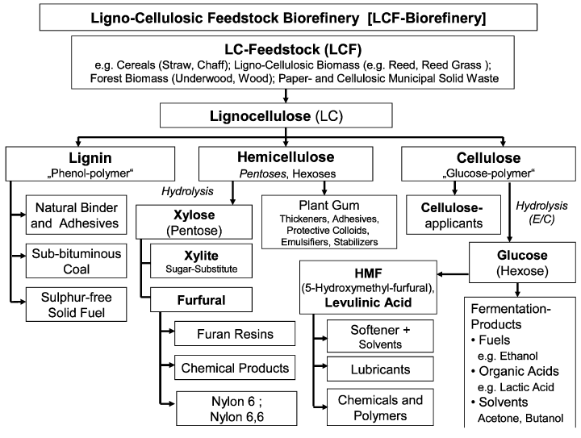
Figure 2: Potential products of the LCF biorefinery (Kamm and Kamm, 2004).

Lignin Utilization

The research in this program focuses on isolating lignin from biomass as one source of chemicals and fuels in a Phase III LCF. Future biorefineries will produce massive amounts of lignin. Unleashing the possibilities of lignin will be fundamental if the lignin stream is to economically support the health of a modern biorefinery (Holladay et al., 2007). According to the work of Holladay et al., on value added chemicals from lignin, the applications of lignin can be characterized into near-term, medium-term and long-term opportunities. The core subject of their report is to identify research and development breakthroughs needed to make the use of lignin more attractive and thus support the overall economics of the biorefinery (Holladay et al., 2007). The near-term uses ascertained for lignin are process heat, power and steam with further uses assumed within three to five years of ongoing development (Holladay et al., 2007). Medium-term uses of lignin which take advantage of lignin’s polymer and polyelectrolyte properties can, if appropriate chemical and catalytic processes are developed, expand lignin’s commercial applications into higher valued macro monomer and polymer application, such as carbon fiber, polymer fillers, resins, adhesives and binders (Holladay et al., 2007). Aromatic chemicals derived from lignin represent the most challenging uses for lignin in terms of realization and thus are categorized as the viable but long-term opportunities for lignin (Holladay et al., 2007).

Suitable Biomass for Biorefineries

Feedstock availability can be affected by climate and weather conditions, location, socioeconomic issues and government policies. Biorefineries must have a dependable supply of biomass throughout their entire lifespan which can be 10-30 years or even longer if they are to be a reasonable alternative to petrochemical refineries (Stephen et al., 2010). Since the driving force for the establishment of biorefineries is sustainability, the feedstock supply should reconcile these parameters (Thorsell et al., 2004). Furthermore, the feedstock should be of consistent quality, particle size and moisture content. In the current biofuel production scenario, problems with high moisture content and physical densities of the biomass impact the collection, handling, transport, storage and processing making it uneconomical (BRaD Board, 2010).

In consideration of these aspects two different lignocellulosic feedstocks, namely switchgrass (Panicum virgatum), tulip poplar (Liriodendron tulipifera), and an assortment of common switchgrass contaminating weeds were chosen to be included in this study. Chapter 3 includes a detailed description of both the feedstock and the contaminating weeds.

Physical Pretreatment of Biomass

Depending on the feedstock or pretreatment process, a feedstock size reduction prior to the pretreatment process might be necessary (Wyman et al., 2005). Woody biomass is abundant, widely available and can be sustainably produced in the US, making it an attractive feedstock for the biorefinery operation (Oak Ridge National Laboratory, 2005). However, wood is physically large and structurally tough with a natural resistance to microbial or chemical deconstruction (Zhu and Pan, 2010). Thus, a physical pretreatment (e.g. size reduction through mechanical means) is necessary to enhance accessibility of surface area to enzymes, for example, in the production of ethanol, or to enable a more effective fractionation or separation into individual process streams for chemical production (Zhu et al., 2010a; Zhu et al., 2009; Zhu et al., 2010c). Currently, size reduction of wood is possible during harvesting, where logs are reduced to the size of standard wood chips (10-50mm in two dimensions and 5-15mm in the third dimension) (Zhu and Pan, 2010; Zhu et al., 2009). Wood size reduction is energy intensive; the energy consumption for the production of wood chips is close to 50 kWh or 0.18 GJ/ton of wood (Zhu, 2011).

In an initial study at the CRC examining the fractionation of mixed switchgrass and poplar feedstocks, the size (pulp grade chips) and density of the tulip poplar feedstock was suggested as significant. The poplar used had a much greater impact than the switchgrass in hindering the penetration of solvents during the organosolv fractionation process, thus resulting in a lower lignin yield (Astner, 2012). As a result, it was proposed that the reduction of particle size would increase solvent accessibility and lignin yield (Astner, 2012). Accordingly, to further investigate the effects of particle size on the organosolv fractionation process and the yield of lignin, this study includes three different tulip poplar particle sizes, which are explained in further detail in Chapter 3.

Structure of Lignocellulosic Biomass

Examples for lignocellulosic biomass are forestry and agricultural residues, woods, and grasses. Lignocellulosic biomass is very attractive for the production of fuel and chemicals since it is the most abundant natural sustainable resource on earth (Balat et al., 2008). The US Department of Energy Biomass Program estimated that in 2009 the total annual available biomass in the US was around 1.4 million dry tonnes (US Department of Energy, 2009). Lignocellulosic biomass is mainly composed of 40-50% (by weight) cellulose, 25-30% hemicellulose and 15-20% lignin (US Department of Energy, 2009). Figure 3 shows the composition and structure of lignocellulosic biomass as found in nature for these feedstocks.
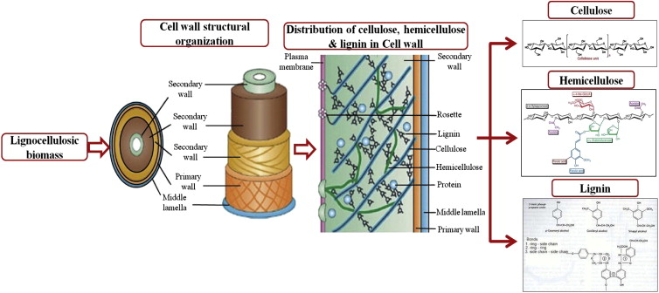
Figure 3: Illustration of lignocellulosic biomass composition and structure (Menon and Rao, 2012).

The lignocellulosic or plant cell wall can be divided into the primary wall (PW) and secondary wall (SW) (Pandey, 2009). The SW can again be subdivided into three layers called SW1, SW2, and SW3, where SW2 accommodates the biggest portion of the cellulose and thus, is often the thickest layer in the cell wall (Pandey, 2009). At a molecular level, cellulose is composed of long chains of glucose monomers giving it a linear structure. These matrixes will appear in very compacted crystalline regions forming “crystalline cellulose” and in regions that are less-ordered and non-crystalline. The crystalline cellulose ridged and compact structure is highly recalcitrant to enzymes (Menon and Rao, 2012) The prevalent hydrogen bonding among molecules result in a crystalline and enduring matrix structure (Ebringerova et al., 2005). Cellulose is the most widespread organic polymer in nature and accounts for approximately 40-50% of the plants composition. Shown in Figure 4 is the long linear polymeric chain of glucose units, the main component in the cellular walls of plants.

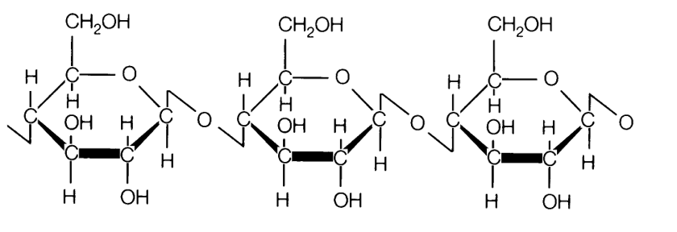
Figure 4: Cellulose structural formula (Stuart and El-Halwagi, 2013).

Surrounding the cell is the middle lamella, which binds adjacent cells and is made up almost entirely of lignin (Pandey, 2009). Magnification would reveal that the cellulose chains are tightly packed into elongated microfibrils that are stabilized by hydrogen bonds. Hemicellulose, an amorphous polymer, and lignin then attach and cover these fibrils forming the cellulose-hemicellulose-lignin matrix known as bundles or macrofibrils (Menon and Rao, 2012). Hemicellulose (Figure 5) is composed of heteropolymers containing hexoses (_{D}-glucose, _{D}-galactose, _{D}-mannose), pentoses (_{D}-xylose, _{L}-arabinose) contain sugar acids like _{D}-glucuronic, _{D}-galacturonic and methylgalacturonic acids giving it an amorphous and flexible structure (McMillan, 1994; Saha, 2003) and it accounts for approximately 25-30% of the plant’s composition. To fully hydrolyze hemicellulose into free monomers requires a variety of enzymes due to the many different sugars found in hemicellulose (Aspinall et al., 1982).

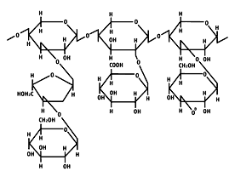
Figure 5: Hemicellulose structural formula (Stuart and El-Halwagi, 2013).

Lignin

Lignin, meaning wood in Latin, is an irregular polyphenolic natural amorphous polymer synthesized by dehydrogenative polymerization of phenylpropanoid units with the purpose of giving plants their structural integrity. Lignin accounts for 15-20% of the plant’s composition. Depicted in Figure 6 are the phenylpropanoid units coniferyl alcohol, sinapyl alcohol and coumaryl alcohol, which correspond to guaiacyl (G), syringyl (S) and p-hydroxyphenyl (H) structures found in lignin, respectively (Sannigrahi et al., 2010). Lignin is not only the most abundant aromatic polymer in the plant cell wall it is also the most complex (Ralph et al., 2004). The biological role of lignin is the strengthening of the cell wall by embedding the crystalline cellulose elementary fibrils (Ralph et al., 2004). But the biosynthesis of lignin can also be induced under biotic and abiotic stress conditions like wounding, pathogen infection, metabolic stress, and perturbations in cell wall structure (Cano-Delgado et al., 2003). Furthermore, lignin protects the plant cell wall polysaccharides from microbial degradation, providing a natural decay resistance that becomes an inhibiting factor to the conversion of plant biomass to biofuel and pulp (Mansfield, 2009; Sticklen, 2008; Weng et al., 2008).

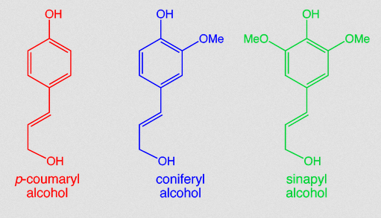

Figure 6: Monomeric components of the lignin structure (Sannigrahi et al., 2010).

Principles of Pretreatment

To convert lignocellulosic biomass into biofuels and chemicals requires a pretreatment technology to enhance the enzymatic accessibility to cellulose and simultaneously fractionate the biomass into its main components (cellulose, hemicellulose and lignin) to ease their subsequent conversion to both fuels and high value co-products in high yield and high purity (Sims et al., 2010; US Departement of Energy, 2013).

The production of bioethanol from non-grain feedstock, especially lignocellulosic biomass, has become a matter of interest in many countries mainly because lignocellulosic biomass is the most abundant organic material in nature (Claassen et al., 1999) and the only alternative source of carbon that can be converted to liquid fuels. However, the recalcitrance of lignocellulosic biomass to enzyme hydrolysis makes pretreatment a necessary process to increase the enzymatic digestibility (Himmel, 2007). Hydrolysis without preceding pretreatment typically yields < 20% of sugars whereas yields following a pretreatment frequently surpass 90% (Hamelinck et al., 2005). The enzymatic hydrolysis of cellulose and hemicellulose to fermentable sugars is appealing, since near theoretical yields of fermentable sugars are possible which is a key to the economic success of lignocellulosic ethanol production (Lynd, 1996). Depicted in Figure 7 is the effect of the pretreatment process on lignocellulosic biomass. In this process, the cell wall physical barriers including the cellulose crystallinity and the linkage to lignin are disrupted.

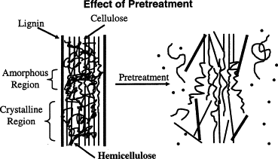
Figure 7: Schematic goal of pretreatment on lignocellulosic biomass (Hsu et al., 1980).

Currently, most conversion technologies are mainly focused on the production of ethanol, not integrating the chemical by-products that are created during the conversion of biomass to bioethanol. A new generation of integrated biorefineries will follow a model of the petrochemical industry by integrating the production of low value fuel with high value chemicals each derived from primary components of lignocellulosic biomass.

The choice of pretreatment influences the cost of not only steps prior to pretreatment like feedstock size reduction, but also operations further downstream such as enzymatic hydrolysis rates, enzyme loadings and many more process variables (Wyman et al., 2005).

Pretreatment Technologies for the Biorefinery

Among the many methods developed for pretreating lignocellulosic biomass, a few are seen as being promising in the context of the future biorefinery. These methods include steam explosion, ammonia fiber expansion (AFEX), dilute acid pretreatment, alkali pretreatment technology, and lime pretreatment (Mosier et al., 2005; Wyman et al., 2005; Yang and Wyman, 2008), as well as organosolv pretreatment.

Steam Explosion

During this treatment method, lignocellulosic material is rapidly heated with high-pressure saturated steam followed by a sudden release of pressure, causing the material to undergo an explosive decompression (Varga et al., 2004). This mixture of steam and biomass is then held for a certain period before an abrupt release of pressure, the “steam explosion”, finalizes the treatment (Avellar and Glasser, 1998; Brownell et al., 1986; Glasser and Wright, 1998). This rapid “explosion” not only terminates the reaction by reducing the temperature considerably, but also opens the particulate structure of the biomass. Even though this process disrupts the structure of the biomass, only weak improvements in enzymatic digestibility were observed (Brownell et al., 1986). Overall, the dominant change to lignocellulosic biomass during steam explosion is the removal of hemicellulose.

Ammonia Fiber Expansion (AFEX)

AFEX is a physico-chemical pretreatment process where lignocellulosic biomass is treated with liquid ammonia at a high pressure and temperature for a specific period of time before the pressure is suddenly reduced, resulting in a similar reaction as the steam explosion process (Zheng et al., 2009). Typically, there is a ratio of 1-2kg ammonia per kilogram of dry biomass at a residence time of 30 minutes and a temperature of 90°C before the pressure is suddenly reduced. AFEX pretreatment causes decrystallization of cellulose, and notably, depolymerization of hemicellulose and breaking of the lignin carbohydrate complex (Gollapalli et al., 2002). Ammonia from the AFEX process must be recycled to lower costs and preserve the environment (Holtzapple et al., 1992). However, the expenditure for the ammonia as well as the cost for the recovery process drive up the relative expense of an AFEX pretreatment (Holtzapple et al., 1992). Even though the AFEX treatment was found to be effective on some feedstocks, it is not a very effective technology for lignocellulosic biomass with higher lignin content such as hardwoods or nut shells (Taherzadeh and Karimi, 2008).

Dilute Acid Pretreatment

Diluted acid pretreatment breaks down the recalcitrant structure of lignocellulosic biomass. Currently, sulfuric acid (H₂SO₄) is the most frequently used acid when pretreating different feedstocks such as switchgrass (Digman et al., 2010; Li et al., 2010), corn stover (Du et al., 2010; Xu et al., 2009), spruce and poplar (Kumar and Wyman, 2009; Shuai et al., 2010; Wyman et al., 2009). Acid pretreatment has been traditionally used to remove the hemicellulose from the lignocellulosic biomass (Zhang et al., 2007). Other acids, such as hydrochloric acid, phosphoric acid and nitric acid have been tested (Himmel et al., 1997; Marzialetti et al., 2008; Zhang et al., 2007). Dilute acid pretreatment is usually performed by adding 0.2 - 2.5% w/w acid to the biomass and stirring it at temperatures between 130 - 201°C. The hydrolysis of the sugars can take between minutes and hours, depending on the pretreatment conditions. Overall acid pretreatment is known for its ability to remove hemicellulose effectively. Combining with an alkali pretreatment to remove of lignin leads to relatively pure cellulose and significantly improves the enzymatic hydrolysis thereof (Xiang et al., 2003).

Alkaline Pretreatment Technology

Alkaline pretreatment is performed using bases, such as sodium, potassium, calcium, or ammonium hydroxide to pretreat lignocellulosic biomass. These alkalis degrade the ester and glycosidic side chains altering the structure of lignin, partially dissolving hemicellulose and swelling and decrystallizing the cellulose (Cheng et al., 2010; Ibrahim et al., 2011; McIntosh and Vancov, 2010; Sills and Gossett, 2011). Disrupting the lignin structure enhances the accessibility of enzymes to both the cellulose and hemicellulose (Soto et al., 1994; Zhao et al., 2008; Zhu et al., 2010b).

Lime Pretreatment

Lime pretreatment, another alkali pretreatment, is generally less severe than other pretreatment methods and can also be performed at ambient temperature with longer pretreatment times than at higher temperatures. During this process the biomass is drenched in alkali solution and mixed for a period of time at a specific temperature before a neutralizing step is carried out to remove lignin and other enzymatic hydrolysis inhibitors such as salts, phenolic acids, furfural and aldehydes (Sun et al., 1995).
Organosolv Pretreatment

The organosolv fractionation that forms the basis of this investigation is a pretreatment process that offers the selective and effective fractionation of high lignocellulosic biomass. Literature reviews on pretreatment processes only introduce the organosolv pretreatment process neglecting the fact that even though organosolv pretreatment at present is more expensive than other leading pretreatment processes, it affords separate cellulose, hemicellulose and lignin fractions. When these fractions are utilized as starting materials for integrated chemical and fuel production, organosolv pretreatment becomes a promising method for biorefinery development (Zhao et al., 2009). Organosolv processes first attracted interest in the 1970’s within the pulp and paper industry because conventional pulping processes, such as kraft and sulfite, had deficiencies concerning water and air pollution (Zhao et al., 2009).

Organosolv pretreatment can be conducted at a temperature range between 100-250°C using a variety of organic or aqueous organic solvent systems, and with or without extra catalysts (Muurinen, 2000). Multiple solvents have been successfully used in organosolv pretreatment ranging from solvents with low boiling points (methanol, ethanol), alcohols with higher boiling points (ethylene glycol, glycerol, tetrahydrofurfuryl alcohol) and organic compounds of different classes (e.g. dimethylsulfoxide, ethers, ketones and phenols) (Thring et al., 1990). Mineral acids (hydrochloric acid, sulfuric acid, and phosphoric acid) are catalysts that are added to the organic solvent in order to increase the rate of delignification and the retrieval of higher yields of xylose (Sun and Cheng, 2002). For alcohol based pretreatment, both methanol and ethanol are preferred options due to the lower cost and ease of recovery for reuse since organic solvents are often expensive and thus should be recovered to the furthest extent. The main advantage of organosolv process is the selective and effective fractionation for high lignin containing biomass (Agbor et al., 2011). The lignin that is recovered from the organosolv fractionation process is not comparable to so-called “lignins” that are presently produced by the pulp and paper industry. It is far superior making it commercially favorable for a wide range of applications (Lora et al., 1989).

Summary of Pretreatment Methods

A summary of the different promising technologies used for the pretreatment of lignocellulosic biomass and their distinct characteristics is given in Table 1. Chemical and physical factors of the lignocellulosic biomass, such as cellulose crystallinity, accessible surface area, protection by lignin, and cellulose covering by hemicellulose all contribute to the resistance of biomass to enzymatic hydrolysis (Mosier et al., 2005). The pretreatment technologies given in Table 1 all affect at least two of these chemical and physical factors (Mosier et al., 2005), but the ultimate goal of the pretreatment technology is the efficient fractionation of lignocellulosic biomass into numerous product streams that include value added compounds in concentrations that make purification, utilization and recovery economically achievable (Mosier et al., 2005).

Table 1: Effects that different pretreatment methods have on the chemical composition and chemical/physical structure of lignocellulosic biomass (Mosier et al., 2005).
Pretreatment method | Increases accessible surface area | Decrystalizes cellulose | Removes hemicellulose | Removes lignin | Alters lignin structure
Uncatalyzes steam explosion | ++ | - | ++ | - | +
Liquid hot water | ++ | ND | ++ | - | +
pH controlled hot water | ++ | ND | ++ | - | ND
Flow-through liquid hot water | ++ | ND | ++ | + | +
Dilute acid | ++ | - | ++ | - | ++
AFEX | ++ | ++ | ++ | ++ | ++
Lime | ++ | ND | ++ | ++ | ++
Major Effect: | ++
Minor effect: | +
ND: | not determined

Experimental Design

The goal of this study is to determine if lignin yield from the organosolv fractionation process can be maximized for mixed feedstocks in the presence of feedstock contamination. To test this, Taguchi methods are used in a laboratory setting, focusing on identifying conditions able to give the maximum lignin yield relative to the process input or design parameters in the presence of external noise factors that are associated with the organosolv fractionation process.

The development and validation of new methods and technologies often require a lot of time and money to achieve the optimization of the product or system. When using statistical methods, the most common approach to optimization of the response is the factorial method where each variable is tested at every level of the other variable (Ballantyne et al., 2008). The Taguchi Robust Product Design (TRPD) method is an engineering approach that applies the concept of fractional factorials and orthogonal arrays, and uses a signal-to-noise ratio as the response metric. Levels are distributed in a balanced manner to test the main effects only. This reduces the number of experimental runs which reduces the cost of experimentation (Ballantyne et al., 2008).

Taguchi Robust Product Design (TRPD)

TRPD methodology is an approach to achieve consistent performance by making a “robust” product or a process that is insensitive to the influence of uncontrollable “noise” factors. In other words, the goal is to reduce variation without actually reducing or removing the cause of uncontrollable variation since these are difficult to control or too expensive to control (Phadke, 1989). A primary goal of this study is the use of Taguchi methods to design an organosolv fractionation process that operates consistently and optimally over a variety of conditions. To determine which design is the best requires not only the use of engineering experiments, which exposes the organosolv fractionation process to distinct levels of design parameters, but also a thorough understanding of the process.

According to Phadke’s interpretation of Taguchi, a robust design is an “engineering methodology for improving productivity during research and development so that high-quality products can be produced quickly and at low cost” (Phadke, 1989). The idea behind a robust design is to minimize the effects of variation, without eliminating the causes since they are either too difficult or too expensive to control, thus improving the quality of a product. The end result is a process design that has minimum sensitivity to variations in uncontrollable factors.The TRPD strategy uses five primary tools (Phadke, 2010):

- Parameter Diagram

The Parameter Diagram (p-diagram) shown in Figure 8 is a must for every development project and is used to classify the variables related to the product or process. These are the “inner array” or signal factors that can easily be controlled and manipulated, i.e. temperature, acid concentration, feedstock weight. The “outer array” or noise factors i.e. human operators, ambient humidity, ambient temperature, contamination in raw material, are factors that influence the process but are either too difficult or too expensive to control the “signal factors” or input to the process and the “response” or output of the same (Phadke, 2010).

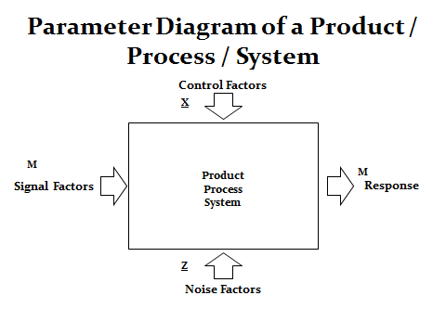
Figure 8: Parameter diagram (Phadke, 2010).

- Quality Measurement

The “Quality Measurement”, or the Taguchi Loss Function, is used to measure the financial loss to society resulting from poor quality (Taguchi’s definition of quality) (Ross, 1996). Quality losses occur when a product becomes unacceptable because it deviates beyond the set specification limits (Pi and Low, 2005). The step function (Figure 9) is the traditional way in which manufacturers consider whether a product is “good” or “bad”, ensuring only that performance falls within the upper and lower specification. Taguchi however, penalizes the deviation from the specified target value as a quadratic curve, denouncing the deviation as a contributing factor to the deterioration of the product’s performance, thus resulting in a loss to the customer (Phadke, 1989).

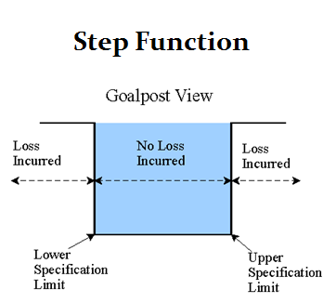
Figure 9: Traditional loss funktion or step funktion (Albright and Roth, 1994).

Taguchi defines quality as “the loss impaired by any product to society after being shipped to the customer, other than any loss caused by its intrinsic function” (Ross, 1996). When translating Taguchi’s definition of “quality” into measurable engineering terms, it translates into consistency of performance, meaning consistency in performance is vital regardless of whether it is a process or a product, how it is measured or where it is applied (Roy, 2010). This consistency can be attained when performance is close to the target with minimal variation, e. g., at the bottom of the parabolic curve in Figure 10 (Roy, 2010).
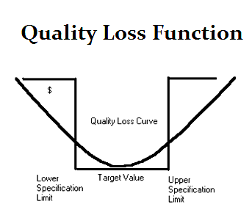
Figure 10: Quality loss function (Phadke, 2010)

- Signal to Noise (S/N) Ratio

The signal to noise (S/N) ratio is derived from the quality loss function and is used to decide which of the values, or levels of the control factors are best in design phase of a process (Phadke, 2010). There are three standard signal-to-noise (S/N) ratios given in equations [1], [2], [3], (Phadke, 1989; Taguchi et al., 1987):

- Nominal is best (for reducing variability around a target)

$${{SN}_{Target}=10 log}_{10}\left(\frac{\overline{Y}}{s^{2}}\right)$$ | [1]
- Larger the better (for making the system response as large as possible)

$${{SN}_{Larger}=-10 log}_{10}\left(\frac{1}{n}\sum_{i=l}^{n}{\frac{1}{y_{i}^{2}}}\right)$$ | [2]
- Smaller the better (for making the system response as small as possible)

$${{SN}_{Smaller}=-10 log}_{10}\left(\frac{1}{n}\sum_{i=l}^{n}{y_{i}^{2}}\right)$$ | [3]

The signal-to-noise ratio will produce operational target values that make the output or response less sensitive (more robust) to the variation caused by the inputs. Figure 11 (a) depicts the variation introduced by the input being transmitted to the output. Producing along the S/N function as illustrated in Figure 11 (b) shows that the introduced variation from the input is greatly reduced leading to a robust design.

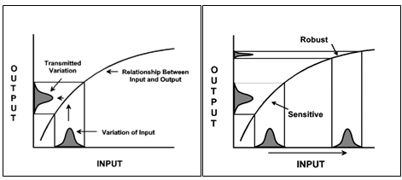
Figure 11: (a) Transmission of variation, (b) The Taguchi robust design (Taylor, 1998).

- Orthogonal Arrays

The orthogonal array, also called the “full orthogonal array”, takes fractions of the full factorial design of experiments, meaning that each level of each parameter is tested at least once (Cimbala, 2009). This greatly reduces the number of experiments which saves time and money.

The following five tools help achieve a robust product design which is minimally influenced by variation of controllable and uncontrollable factors. Thus this improves the quality of the organosolv fractionation process. Using this process, TRPD for optimizing lignin yield in our biomass fractionation process carried out the following steps (Fraley et al., 2006):

- Definition of the process objective – The objective of this study was to maximize the lignin yield and to research the effects that feedstock particle size and solvent composition have on both the lignin yield and the organosolv fractionation process itself.

- Determine which design parameters affect the organosolv fractionation process – Run time, run temperature, mixed feedstock, feedstock particle size, solvent composition and acid concentration are all variables affecting the organosolv process. Each of these parameters can have one or more levels (e.g. temperature – high, medium, low).

- Create the TRPD design- Fractions of the full factorial statistical design are used in TRPD. This reduces the number of experimental runs saving time and money. In this study JMP ^{10.0} statistical software was used to assist in the TRPD design.

- Conduct the experiment - A total of 36 runs were conducted on the organosolv fractionation reactor. This includes 18 experiments with two replicates across the noise factor of weed/no weed feedstock.

CHAPTER III – MATERIALS AND METHODS

This chapter addresses the materials and methods used in this study. A detailed description of the different feedstocks and the feedstock contaminants is presented. A description of the organosolv fractionation reactor situated at the CRC is also given. A thorough annotation to the fractionation procedure is followed by a description of the recovery processes for the different product streams. This chapter also explains how the TRPD was applied to the organosolv fractionation process in this study.

Feedstock I - Switchgrass (Panicum virgatum)

Alamo switchgrass, a warm season perennial grass harvested in East Tennessee, was used for this study. A 1 inch (25.4 mm) knife mill was used to reduce the switchgrass particle size to an average length of 1 - 2 inches (25.4 – 50.8 mm) (Figure 12). The average switchgrass moisture content was determined to be 8.6% by using the Darr method (Wagenführ, 2008). This method simply uses the difference in weight before and after drying the biomass in an oven at 105°C for 12 hours to determine the moisture content. A compositional analysis of switchgrass was published in a preliminary study (Bozell et al., 2011b) and was performed according to protocol NREL/TP-510-4268, to determine a lignin content of 22.94 wt % of the dry biomass.

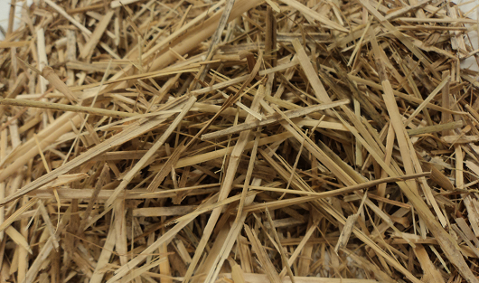
Figure 12: Switchgrass (Panicum virgatum).

Feedstock II - Tulip Poplar (Liriodendron tulipifera)

The tulip poplar pulp grade chips used in this study with an average dimension of one square inch were purchased from Oak Ridge Hardwoods, Oak Ridge, Tennessee (Figure 13). The wood chips were air dried and a moisture content of 8.6% was determined using the Darr method (Wagenführ, 2008). A compositional analysis was performed according to protocol NREL/TP-510-4268 to determine a lignin content of 22.70 wt % of the dry biomass.

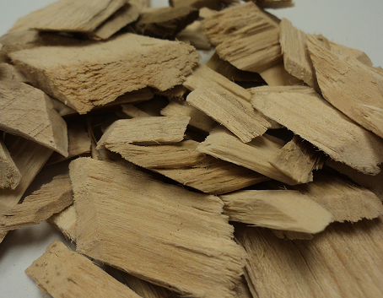
Figure 13: Tulip poplar (Liriodendron tulipifera) pulp grade chips.

Particle Size of Feedstock II

To further investigate the effect of particle size on the yield of lignin this study includes three different tulip poplar particle sizes. The poplar chips were fragmented in a hammermill model 3B from Jay Bee Manufacturing Inc. Texas, U.S. (http://www.jaybeehammermills.com/).

After initial size reduction the poplar particles were screened with a RO-TAP Sieve Shaker from the company W.S. Tyler Industrial Group, Ohio, U.S., (http://www.wstyler.com/html/industrial_group.html) into three different size groups.

- Coarse (pulp grade chips – no size reduction)
- Medium (all particles from mesh size 4 to pulp grade chips)
- Small (all particles from mesh size 8 to mesh size 4)

After size reduction and screening the different poplar chip sizes were stored in closed containers.

Switchgrass Contaminating Weeds

Weeds were included into this study to serve as a noise factor in the TRPD. Weed samples were collected in September, 2012 from Blount County, TN at a local switchgrass farm. The switchgrass cultivar, “Alamo”, was established in spring of 2010 using a direct drill with no-till planting methods. Switchgrass was managed as a standard bioenergy crop with annual winter harvest. Randomly assigned plots measuring 10 m² were established within the existing switchgrass fields. All above ground biomass was collected and plants were categorically separated into switchgrass, grassy weed and broad leaf weed fractions. A total of 15 broadleaf plant species, 2 woody shrubs and 4 grass species were found in the weed fractions as listed in Table 2. All the samples collected were dried at 40±5 °C using an ISI dry kiln (Lexington, NC, USA). The resulting dried plant materials were chopped into approximately 2 inch (5 cm) sizes. The weed samples were evaluated by pyrolysis GC/MS and were found to have an average lignin content of roughly 8 wt%.

Table 2: Broadleaf plant and grass species found in the weed fraction of a switchgrass plantation for bioenergy production.
ID | Common Name | Genus | Species | Family
1 | Yarrow | Achillea | millefolium | Asteraceae
2 | Redroot Pigweed | Amaranthus | retroflexus | Amaranthaceae
3 | Horsenettle | Solanum | carolinense | Solanaceae
4 | Autumn olive | Elaeagnus | umbellata | Elaeagnaceae
5 | Horseweed | Conyza | canadensis | Asteraceae
6 | White clover | Trifolium | repens | Fabaceae
7 | Tree of Heaven | Ailanthus | altissima | Simaroubaceae
8 | Polk weed | Phytolacca | americana | Phytolaccaceae
9 | Blackberry | Rubus | Argutus | Rosaceae
10 | Wood sorrel | Oxalis | stricta | Oxalidaceae
11 | Giant Ragweed | Ambrosia | trifida | Asteraceae
12 | Common fleabane | Erigeron | philadelphicus | Asteraceae
13 | Buckhorn plantain | Plantago | lanceolata | Plantaginaceae
14 | Broadleaf plantain | Plantago | major | Plantaginaceae
15 | Johnson grass | Sorghum | halepense | Poaceae
16 | Knotroot foxtail | Setaria | parviflora | Poaceae
17 | Large crabgrass | Digitaria | sanguinalis | Poaceae
18 | Low panicgrass | Panicum | species | Poaceae
19 | Dallisgrass | Paspalum | dilatatum | Poaceae
20 | Oldfield Cinquefoil | Ponentilla | simplex | Rosaceae
21 | Curly Dock | Rumex | crispus | Polygonaceae

Mixed Feedstocks

The organosolv fractionations for the TRPD were performed with three different switchgrass/tulip polar ratios that were based on a constant mass of 400 g. The perforated Teflon basket used in these experiments can hold a maximum of approximately 400 g of switchgrass and about 800 g in tulip poplar chips. Displayed in Table 3 is the feedstock ratio used for the TRPD experiments. Prior to every run, the basket was filled according to the mixed feedstock ratio provided by the TRPD.

Table 3: Mixed feedstock ratio for TRPD experiments.
Ratio in [%] of Total Feedstock | Constant mass 400 [g]
Switchgrass / Tulip Poplar | Switchgrass | Tulip Poplar
[10/90] | 40 | 360
[50/50] | 200 | 200
[90/10] | 360 | 40

The switchgrass contaminating weeds were chosen as the noise factor that were incorporated into the TRPD matrix and added to the feedstock loadings. After the initial runs were performed, all replicate runs contained weeds according to the experimental design. The mixed feedstock loadings for the TRPD with added weeds are listed in Table 4.

Table 4: Mixed feedstock ratio for TRPD experiments with weeds.
Ratio in [%] of Feedstock | Constant mass 400 [g]
Switchgrass / Weeds / Poplar | Switchgrass | Weeds | Tulip Poplar
[7/3/90] | 28 | 12 | 360
[35/15/50] | 140 | 60 | 200
[63/27/10] | 252 | 108 | 40

The compositional analysis results of the switchgrass and the tulip poplar were used to calculate the lignin content of the different feedstock ratios used in this study to provide the maximum possible attainable lignin yield of each feedstock ratio as can be seen in Table 5. The maximum attainable lignin yield for each individual feedstock composition is the sum of the lignin content determined by compositional analysis for each feedstock. Because diverse feedstocks have different lignin contents, mixing them in different ratios will affect the maximum attainable lignin calculated.

Table 5: Lignin content of mixed feedstock loadings.
Feedstock | Switchgrass | Poplar | Maximum
Ratio SG/Poplar | Lignin | Lignin | attainable Lignin
[%] | Content [g] | Content [g] | [g]
[10/90] | 8.39 | 74.69 | 83.08
[50/50] | 41.93 | 41.50 | 83.43
[90/10] | 75.48 | 8.30 | 83.78

Organosolv Fractionation Process

All the experiments conducted to maximize the yield of lignin using mixed feedstock and different solvent compositions were performed using the organosolv fractionation process as previously described (Bozell et al., 2011a; Bozell et al., 2011b). Briefly, 400 g of mixed feedstock is loaded into a perforated Teflon basket before the basket is inserted into a Hastelloy C276 flowthrough pressure reactor. After closing, the reactor is placed under vacuum for 20 minutes allowing excess air to be removed for a better penetration of the feedstock by the organic solvent. After 20 minutes, the pull of the vacuum is used to fill the reactor with ternary solvent mixture containing MIBK, EtOH and water in the presence of sulfuric acid catalyst. Once the reactor is filled, heaters bring the reactor to the specified fractionation temperature. When the fractionation temperature is reached, additional solvent is pumped through the flowthrough reactor into a collection vessel for a set time period (56 min, 90 min), at a sufficient rate to generate approximately 3.5 - 4.5 liters of black liquor. After completion, the solvent remaining in the reactor is carefully drained into the collection vessel. The reactor is allowed to cool before the remaining solid fraction of the biomass is recovered. Displayed in Figure 14 is the reactor layout and flow diagram. All system operations are monitored and controlled using Labview 8.6 software in combination with Omega thermocouples, analog to digital converters and pressure transducers.

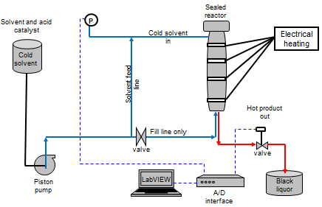
Figure 14: Reactor flow diagram and layout.

Figure 15 is the organosolv fractionation reactor located at the UT CRC. Also displayed are the perforated Teflon baskets used for loading the feedstock and the monitor showing the Labview interface used to monitor and control the fractionation process.

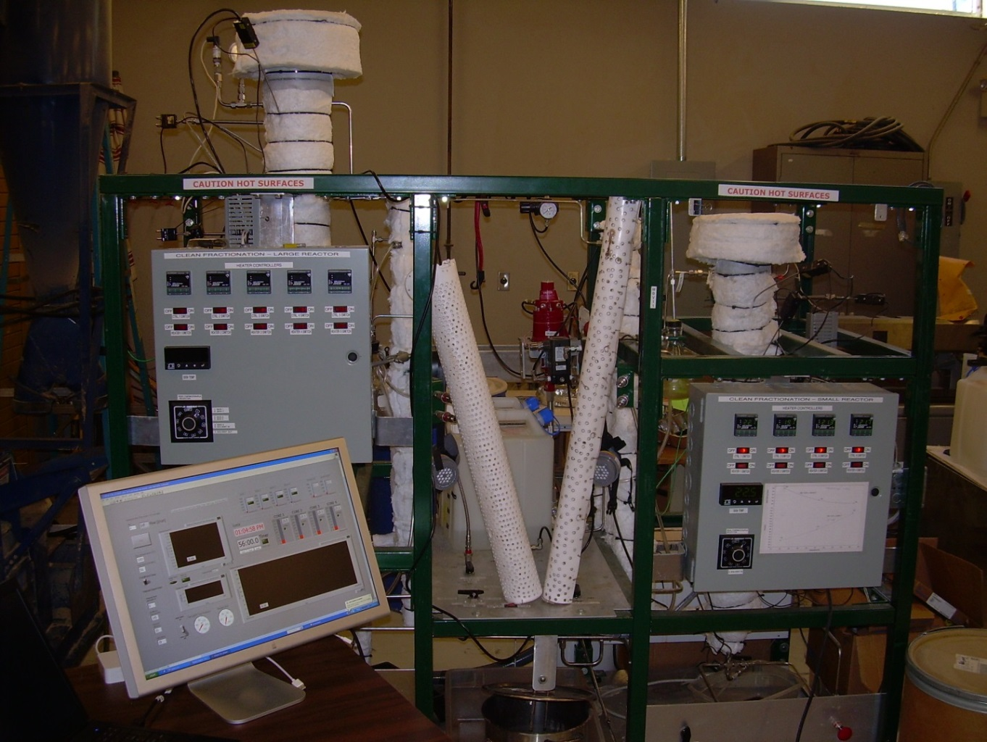

Figure 15: Organosolv fractionation reactor at the CRC, University of Tennessee.

After the organosolv fractionation process is over and the reactor has been allowed to cool, the reactor is opened and the perforated Teflon basket containing the residual cellulose (solid fraction) is emptied into a bucket which is filled with three liters of deionized water. The cellulose is left to soak in the deionized water overnight to remove residual solvent. After soaking overnight the cellulose is fiberized in a typical household blender before it is washed over a polypropylene filter cloth inlayed to a Büchner funnel using a water aspirator (Figure 16). The fiberized cellulose is then continually washed with deionized water for a two hour period until a clear filtrate is observed. After washing, excess water is removed by covering the Büchner funnel with a rubber dam and vacuum pressing the cellulose for approximately one hour. Finally, the cellulose cake is bagged, labeled and stored in the freezer for further analysis.

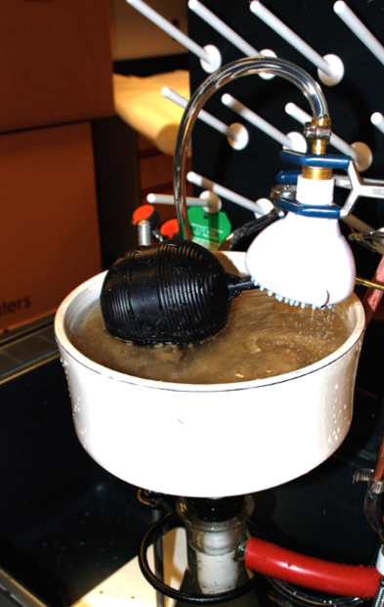
Figure 16: Cellulose washing in a Büchner funnel (Bozell et al., 2011a)

In parallel, the black liquor containing the dissolved lignin and hemicellulose is separated. The volume of the warm black liquor is measured and poured into a separatory funnel, and solid NaCl (15 g for every 100ml of deionized water contained in the initial solvent mixture) is added and the separatory funnel is vigorously shaken until the NaCl is fully dissolved. The black liquor is then allowed to rest for 30 minutes and a gradual phase separation between the aqueous and organic phases can be observed as depicted in Figure 17.

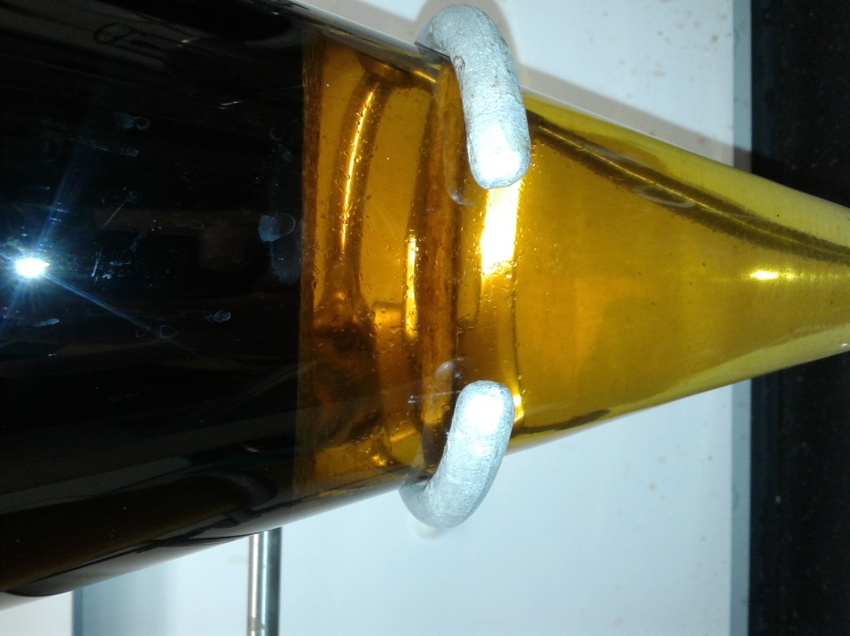
Figure 17: Phase separation between organic (upper) and aqueous (lower) phase.

After the initial separation, the aqueous phase which rests at the bottom of the separatory funnel is drained and set aside. The organic phase is washed twice by adding 30% v/v deionized water to remove residual sugars and EtOH from the darker organic phase. After the phase separation is completed, lignin is isolated from the organic phase by solvent removal through a rotary evaporator and a water bath temperature of 50°C. Following the evaporation of solvents, the remaining lignin is washed with diethyl ether in order to remove impurities before decanting the ether and drying the lignin under vacuum. Depending on impurities and the appearance of the lignin powder, the ether washing step is repeated as necessary. The aqueous fraction collected during the phase separation process is processed on a large 20 liter rotary evaporator to remove the more volatile EtOH and MIBK leaving behind mostly saltwater and lignin. To isolate the lignin, the aqueous phase is filtered through a fast flow paper filter in a Büchner funnel. The filter paper with the remaining lignin is then dried overnight using vacuum before it is weighed and stored. A 500 ml sample is taken from the leftover aqueous phase and stored in a freezer for further analysis.

In this study the TRPD uses the combined lignin masses of both the aqueous and the organic phase. The total lignin yield for every organosolv fractionation run performed is calculated as follows:

$$Lignin yield [\%]=\frac{Lignin after pretreatment [g]}{Klason lignin of Biomass [g]}×100$$ | $$[1]$$

The moisture content of the lignin recovered from both, the aqueous and the organic phase are measured after 24 hours at 105°C (NREL/TP-510-4268). The Klason lignin analysis for acid soluble lignin and acid insoluble lignin are performed using protocol NREL/TP-510-4268 (Sluiter et al., 2012).

Solvent Composition

One of the proposed goals of this study was to research the effects of the solvent composition on the yield of lignin, the lignin recovery process and the organosolv fractionation process itself. Therefore, three solvent mixtures containing methyl isobutyl ketone (MIBK), ethanol (EtOH) and water (H₂O) were prepared based on the ternary phase diagram displayed in Figure 18. MIBK, EtOH (190 proof) and sulfuric acid (used as a catalyst) were purchased at Thermo Fisher Scientific Inc., NJ. The phase transition line shown in Figure 18 was determined by preparing different compositions of EtOH/H₂O mixtures and incrementally adding MIBK until a phase separation occurred at room temperature to afford a family of solvent compositions shown in Figure 18. Preliminary studies focused entirely on the -1 solvent mixture for the organosolv fractionation process (Bozell et al., 2011a).

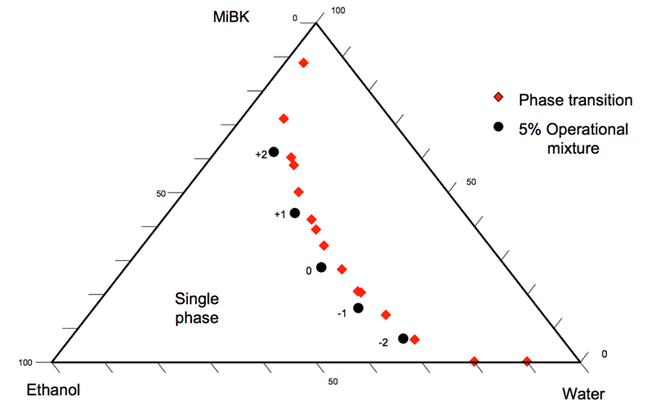
Figure 18: Ternary phase diagram of organic solvent (Bozell et al., 2011a).

Three different solvent compositions were investigated and compared in this study. These were the standard -1 solvent mixture used in the organosolv fractionation process at the CRC, the solvent mixture with the highest MIBK level, (+2 solvent mixture) and the solvent with the lowest MIBK level, the -2 solvent mixture as listed in Table 6.

Table 6: Organosolv fractionation solvent composition (Bozell et al., 2011a).
Solvent Designation |  | MIBK (%) | EtOH (%) | H2O (%)
+2 |  | 62 | 27 | 11
+1 |  | 44 | 32 | 24
0 |  | 28 | 35 | 37
-1 |  | 16 | 34 | 50
-2 |  | 7 | 30 | 63

Taguchi Robust Product Design (TRPD)

The “p-diagram” for the organosolv fractionation process is given in Figure 19. There were up to three different inputs and one output in this system. The mixed feedstock, also called signal factor, is the input of the organosolv fractionation system. During the process there were two different influences on the mixed feedstock input, the signal factors (controllable by the operator) and the noise factors (uncontrollable or very expensive to control), which in this study were the added switchgrass contaminating weeds. The response or output of the organosolv fractionation is the yield of lignin. The main purpose of this study is to maximize the yield of lignin in the organosolv fractionation process using the TRPD methodology.
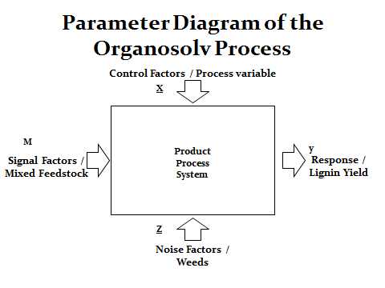
Figure 19: Parameter diagram for the organosolv fractionation process.
The control factors used in this TRPD are listed in Table 7.
Table 7: Signal factors for the inner array.
 | Factor: | Levels
 |  | 1 | 2 | 3
1 | Run Time | 56 min | 90 min | -
2 | Run Temperature | 140°C | 160°C | -
3 | Poplar Particle Size | coarse | medium | small
4 | Solvent Composition | +2 mixture | -1 mixture | -2 mixture
5 | Feedstock Ratio | [10/90] | [50/50] | [90/10]
6 | Acid Concentration | 0.025 | 0.05 | 0.1

The noise factor (Outer Array) introduced into the TRPD was:

- Switchgrass contaminating weeds

To simulate a switchgrass harvest heavily contaminated with natural weeds, 30% of the switchgrass fraction of the 400 g mixed feedstock basket was substituted with mixed weeds during all replicate runs.

The run matrix in Table 8 lists the minimum number of experiments that are necessary to achieve the set goals of this study using all the control factors mentioned before. Weeds were only induced during the replication of the 18 initial runs.

Table 8: Taguchi robust product design matrix.
Run # | Run time [min] | Run temperature [°C] | Particle size | Solvent composition | Feedstock ratio | Acid concentration [M] | Pattern
1 | 56 | 160 | Coarse | -1 solvent | 10/90 | 0.025 | −++0−−
2 | 90 | 160 | Medium | -1 solvent | 50/50 | 0.025 | ++000−
3 | 56 | 160 | Fine | -1 solvent | 50/50 | 0.05 | −+−000
4 | 56 | 140 | Medium | -1 solvent | 90/10 | 0.05 | −−00+0
5 | 90 | 160 | Fine | -1 solvent | 10/90 | 0.1 | ++−0−+
6 | 90 | 140 | Coarse | -1 solvent | 90/10 | 0.1 | +−+0++
7 | 90 | 140 | Fine | +2 solvent | 50/50 | 0.025 | +−−+0−
8 | 90 | 160 | Medium | +2 solvent | 90/10 | 0.025 | ++0++−
9 | 90 | 160 | Coarse | +2 solvent | 10/90 | 0.05 | ++++−0
10 | 56 | 160 | Fine | +2 solvent | 90/10 | 0.05 | −+−++0
11 | 56 | 160 | Medium | +2 solvent | 10/90 | 0.1 | −+0+−+
12 | 56 | 140 | Coarse | +2 solvent | 50/50 | 0.1 | −−++0+
13 | 56 | 140 | Fine | -2 solvent | 10/90 | 0.025 | −−−−−−
14 | 56 | 160 | Coarse | -2 solvent | 90/10 | 0.025 | −++−+−
15 | 90 | 140 | Medium | -2 solvent | 10/90 | 0.05 | +−0−−0
16 | 90 | 160 | Coarse | -2 solvent | 50/50 | 0.05 | +++−00
17 | 56 | 160 | Medium | -2 solvent | 50/50 | 0.1 | −+0−0+
18 | 90 | 160 | Fine | -2 solvent | 90/10 | 0.1 | ++−−++

CHAPTER IV – RESULTS AND DISCUSSION
The first part of this chapter is presentation of the results found by the Klason lignin analysis. This method, used to determine the degree of purity of the lignin recovered from the organosolv fractionation process, forms the base for the interpretation of the TRPD results and the thus also forms the base for the predictions made in this study.

The second part of this chapter is the presentation of the TRPD results. The ANOVA was used to detect statistical differences between contaminated and pure feedstock runs. Furthermore, the ANOVA was used to detect statistical differences between the different levels of each process factor (e.g. factor being temperature and levels being 140°C and 160°C) to determine if the ANOVA supports the levels found by the highest S/N ration provided by the TRPD.

The third part of this chapter is the presentation of a prediction for maximum attainable lignin that is based on the findings of this study. Here the prediction profiler, a statistical tool provided by JMP ^{10.00} statistical software, predicts the optimal settings of all the levels for every factor of the organosolv fractionation to maximize the lignin yield. To validate the prediction, ANOVA was used to analyze a Monte Carlo simulation of 648 runs based on the results of the TRPD.

An important part of this study was to evaluate how different solvent compositions impact the lignin yield and the organosolv fractionation process. Since all the processes and procedures around the fractionation of biomass at the CRC are fine tuned to the use of the standard -1 solvent, the use of different solvent compositions resulted in interesting findings and observations that make up the last part of this chapter.

Klason Lignin Analysis
After the lignin recovery process described in Chapter 3, a Klason lignin analysis for acid soluble lignin (ASL) and acid insoluble lignin (AIL) was performed using protocol NREL/TP-510-4268 to determine the purity of the recovered lignin. The results confirm that the organosolv fractionation process provides a lignin fraction of high purity with very little cross contamination.

Table 9: Klason lignin purity results presented in percent.
Run # | Klason purity ASL+AIL in [%] | Run # | Klason purity ASL+AIL in [%]
1 | 90.03 | 19 | 79.66
2 | 88.33 | 20 | 90.18
3 | 84.02 | 21 | 92.80
4 | 93.75 | 22 | 93.69
5 | 92.59 | 23 | 91.69
6 | 80.82 | 24 | 85.13
7 | 90.76 | 25 | 92.37
8 | 92.80 | 26 | 93.50
9 | 92.67 | 27 | 82.67
10 | 95.13 | 28 | 94.84
11 | 97.26 | 29 | 93.82
12 | 96.18 | 30 | 94.36
13 | 87.32 | 31 | 87.65
14 | 79.16 | 32 | 68.80
15 | 79.60 | 33 | 79.74
16 | 85.41 | 34 | 70.29
17 | 91.57 | 35 | 81.31
18 | 89.58 | 36 | 86.71

The results concluded that the mean lignin purity in this study was 90.10 %.
The mean maximum attainable lignin yield was 85.67 wt %. Together these results confirm that the organosolv fractionation process is a highly capable process that provides a stream of high lignin yields in a pure form.

The percentage of maximum attainable lignin yield used in the TRPD is based on the maximum attainable lignin available in 400 g of pure feedstock loadings as given in Table 5, in Chapter 3. To determine how much lignin was obtained from biomass during organosolv fractionation, the values of “impure” lignin (containing minimal impurities as shown in Table 9 were multiplied by the degree of purity determined by the Klason lignin analysis to determine the weight of the “pure” lignin. The pure lignin attained and the maximum possible attainable lignin content of the feedstock was then used to calculate the percentage of the maximum attainable lignin recovered in the process.

The percentage of maximum attainable lignin for the runs conducted with pure feedstock are listed in Table 10, while the percentage of maximum attainable lignin for the runs conducted with contaminated feedstock are listed in
Table 11.

Table 10: Percentage of maximum attainable lignin achieved for runs containing pure feedstocks.
Run # | Feedstock Ratio (SG/poplar) 400 [g] | Impure Lignin  yield [g] | Pure Lignin Yield [g] | Feedstock Lignin Content [g] | Percentage of Maximum attainable yield [%]
1 | [10/90] | 73.91 | 66.86 | 83.08 | 80.48
2 | [50/50] | 68.6 | 62.32 | 83.43 | 74.70
3 | [50/50] | 76.94 | 72.14 | 83.43 | 86.47
4 | [90/10] | 64.81 | 55.85 | 83.78 | 66.66
5 | [10/90] | 68.34 | 64.44 | 83.08 | 77.56
6 | [90/10] | 67.5 | 59.1 | 83.78 | 70.54
7 | [50/50] | 52.33 | 47.5 | 83.43 | 56.93
8 | [90/10] | 62.62 | 58.11 | 83.78 | 69.36
9 | [10/90] | 72.26 | 68.89 | 83.08 | 82.92
10 | [90/10] | 55.07 | 52.39 | 83.78 | 62.53
11 | [10/90] | 70.46 | 73.62 | 83.08 | 88.61
12 | [50/50] | 50.5 | 52.39 | 83.43 | 62.80
13 | [10/90] | 74.72 | 65.6 | 83.08 | 78.96
14 | [90/10] | 40.17 | 32.23 | 83.78 | 38.47
15 | [10/90] | 71.34 | 54.56 | 83.08 | 65.67
16 | [50/50] | 77.54 | 66.23 | 83.43 | 79.38
17 | [50/50] | 64.23 | 58.82 | 83.43 | 70.50
18 | [90/10] | 74.27 | 66.53 | 83.78 | 79.41

Table 11: Percentage of maximum attainable lignin achieved for runs containing contaminated feedstocks.
Run # | Feedstock | Impure | Pure | Feedstock | Percentage of
 | Ratio (SG/poplar) | Lignin | Lignin | Lignin | Maximum
 | 400 [g] | Yield [g] | Yield [g] | Content [g] | attainable yield [%]
19 | [10/90] | 72.46 | 67.15 | 83.08 | 80.83
20 | [50/50] | 70.66 | 65.96 | 83.43 | 79.06
21 | [50/50] | 71.95 | 67.41 | 83.43 | 80.80
22 | [90/10] | 60.08 | 50.88 | 83.78 | 60.73
23 | [10/90] | 78.14 | 74.05 | 83.08 | 89.13
24 | [90/10] | 63.06 | 55.92 | 83.78 | 66.75
25 | [50/50] | 69.44 | 64.15 | 83.43 | 76.89
26 | [90/10] | 65.02 | 62.58 | 83.78 | 74.70
27 | [10/90] | 77.3 | 63.9 | 83.08 | 76.91
28 | [90/10] | 64.73 | 61.39 | 83.78 | 73.28
29 | [10/90] | 73.26 | 68.74 | 83.08 | 82.74
30 | [50/50] | 51.74 | 48.82 | 83.43 | 58.52
31 | [10/90] | 58.15 | 51.38 | 83.08 | 61.84
32 | [90/10] | 81.13 | 55.78 | 83.78 | 66.58
33 | [10/90] | 89.52 | 73.78 | 83.08 | 88.81
34 | [50/50] | 110.11 | 71.02 | 83.43 | 85.13
35 | [50/50] | 90.22 | 72.46 | 83.43 | 86.85
36 | [90/10] | 77.28 | 67.28 | 83.78 | 80.31

Taguchi Robust Product Design Experimental Results

A total of 36 runs (18 experiments plus replicates) were conducted to determine if the TRPD method could identify process factors needed to maximize lignin yield using mixed feedstock in the presence of up to 27 % feedstock contaminants (i.e., uncontrollable noise).

The maximum lignin yield is defined as the largest signal-to-noise (S/N) ratio (recall equation [3], Chapter 3). The highest S/N ratio was run # 11 with a S/N ratio of 38.64 (Table 12). The maximum S/N ratio was attained at a runtime of 56 minutes, run temperature of 160°C, feedstock mixture containing 10% switchgrass and 90% medium sized poplar chips, +2 solvent and an acid concentration of 0.1 M. The highest S/N ratio also corresponded to the highest mean lignin yield of 85.67 wt %.

In addition to the S/N ratio the ANOVA an objective statistically based decision making tool, can be used to detect differences in the average performance between groups of items tested (Lindman, 1992). Significant factors can be used to set optimal conditions for the process. Insignificant factors are set at economic levels or at levels required by the manufacturer or industry (Rama Rao and Padmanabhan, 2012).

Run # | Run Time | Temperature [°C] | Feedstock Particle Size | Solvent Composition Ratio | Feedstock Ratio | Acid Concentration | TRPD Pattern | Pure Feedstock Lignin yield in [%] | Contaminated Feedstock Lignin yield in [%] | Mean | S/N Ratio
1 | 56 | 160 | Coarse | -1 solvent | 10/90 | 0.025 | −++0−− | 80.48 | 80.83 | 80.65 | 38.13
2 | 90 | 160 | Medium | -1 solvent | 50/50 | 0.025 | ++000− | 74.7 | 79.06 | 76.88 | 37.71
3 | 56 | 160 | Fine | -1 solvent | 50/50 | 0.05 | −+−000 | 86.47 | 80.8 | 83.63 | 38.43
4 | 56 | 140 | Medium | -1 solvent | 90/10 | 0.05 | −−00+0 | 66.66 | 60.73 | 63.69 | 36.05
5 | 90 | 160 | Fine | -1 solvent | 10/90 | 0.1 | ++−0−+ | 77.56 | 89.13 | 83.34 | 38.35
6 | 90 | 140 | Coarse | -1 solvent | 90/10 | 0.1 | +−+0++ | 70.54 | 66.75 | 68.64 | 36.72
7 | 90 | 140 | Fine | +2 solvent | 50/50 | 0.025 | +−−+0− | 56.93 | 76.89 | 66.91 | 36.22
8 | 90 | 160 | Medium | +2 solvent | 90/10 | 0.025 | ++0++− | 69.36 | 74.69 | 72.02 | 37.13
9 | 90 | 160 | Coarse | +2 solvent | 10/90 | 0.05 | ++++−0 | 82.92 | 76.91 | 79.91 | 38.03
10 | 56 | 160 | Fine | +2 solvent | 90/10 | 0.05 | −+−++0 | 62.53 | 73.27 | 67.9 | 36.56
11 | 56 | 160 | Medium | +2 solvent | 10/90 | 0.1 | −+0+−+ | 88.61 | 82.74 | 85.67 | 38.64
12 | 56 | 140 | Coarse | +2 solvent | 50/50 | 0.1 | −−++0+ | 62.8 | 58.52 | 60.66 | 35.64
13 | 56 | 140 | Fine | -2 solvent | 10/90 | 0.025 | −−−−−− | 78.96 | 61.84 | 70.40 | 36.76
14 | 56 | 160 | Coarse | -2 solvent | 90/10 | 0.025 | −++−+− | 38.47 | 66.58 | 52.52 | 33.46
15 | 90 | 140 | Medium | -2 solvent | 10/90 | 0.05 | +−0−−0 | 65.67 | 88.81 | 77.24 | 37.46
16 | 90 | 160 | Coarse | -2 solvent | 50/50 | 0.05 | +++−00 | 79.38 | 85.13 | 82.25 | 38.29
17 | 56 | 160 | Medium | -2 solvent | 50/50 | 0.1 | −+0−0+ | 70.5 | 86.85 | 78.67 | 37.78
18 | 90 | 160 | Fine | -2 solvent | 90/10 | 0.1 | ++−−++ | 79.41 | 80.3 | 79.855 | 38.05
Table 12: Lignin yields and S/N ratios for pure feedstocks and the weed contaminated feedstocks.

Lignin Yield Distribution

A statistical analysis of the lignin distributions indicated that the data were normally distributed (Figure 20). The histogram for lignin yield in pure and contaminated feedstock runs reveals approximate normality of both distributions with a slight skewness to the left. Figure 20 (a) includes an outlier identified as being Run # 14 with a lignin yield of 38.47 wt%.

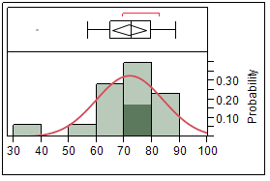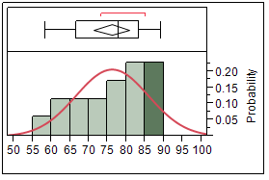
(a) (b)

Figure 20 (a) and (b): Histograms and boxplots for lignin yield by (a) mixed feedstock and (b) contaminated feedstock.

The normal probability plots indicate that the underlying data are approximately normal. The goodness of fit (Figure 20) was tested with the Shapiro Wilk W Test and confirmed the normality assumption for both datasets, with a W = 0.910598 (p-value = 0.0881) for the lignin yield distribution for mixed feedstock and a W = 0.960980 (p-value = 0.6207) for the lignin yield for mixed feedstock with added weeds, showing no statistical evidence that suggests a departure from normality.
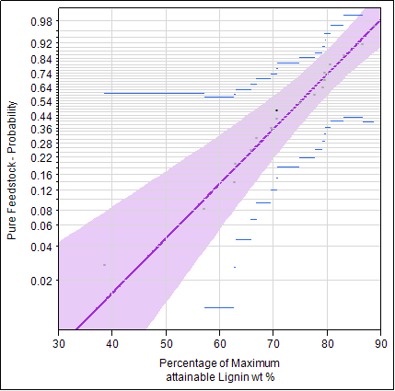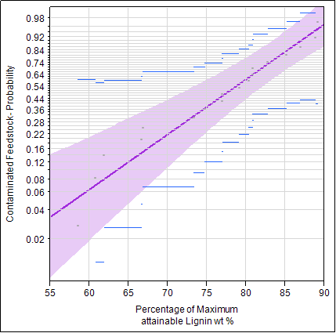
- (b)
Figure 21: Normal probability plot of lignin yield for (a) pure feedstock and (b) for contaminated feedstock.
Table 13: Model comparison for pure feedstock runs.
 | Distribution | AICc | -2Loglikelihood | BIC
1 | SEV | 141.0424 | 136.2424 | 142.02315
2 | Weibull | 141.91621 | 137.11621 | 142.89696
3 | Logistic | 143.63831 | 138.83831 | 144.61905
4 | Generalized Gamma | 143.84269 | 136.1284 | 144.79952
5 | Log Generalized Gamma | 143.9112 | 136.19691 | 144.86802
6 | Normal | 144.52271 | 139.72271 | 145.50345
7 | DS Weibull | 144.8305 | 137.11621 | 145.78733
8 | Loglogistic | 146.16905 | 141.36905 | 147.14979
9 | DS Loglogistic | 149.08333 | 141.36905 | 150.04016
10 | Lognormal | 149.09529 | 144.29529 | 150.07604
11 | DS Lognormal | 152.00958 | 144.29529 | 152.96641
12 | LEV | 152.64665 | 147.84665 | 153.62739
13 | Frechet | 160.05123 | 155.25123 | 161.03197
14 | DS Frechet | 162.96551 | 155.25123 | 163.92234
15 | Exponential | 192.0973 | 189.8473 | 192.73768

Table 14: Model comparisons for contaminated feedstock runs.
 | Distribution | AICc | -2Loglikelihood | BIC
1 | SEV | 134.8623 | 130.0623 | 135.8431
2 | Weibull | 134.91 | 130.11 | 135.8908
3 | Normal | 136.4438 | 131.6438 | 137.4245
4 | Generalized Gamma | 137.1269 | 129.4126 | 138.0837
5 | Logistic | 137.6015 | 132.8015 | 138.5823
6 | Lognormal | 137.6263 | 132.8263 | 138.607
7 | Log Generalized Gamma | 137.7315 | 130.0172 | 138.6883
8 | DS Weibull | 137.8243 | 130.11 | 138.7811
9 | Loglogistic | 138.5824 | 133.7824 | 139.5632
10 | LEV | 140.1832 | 135.3832 | 141.164
11 | DS Lognormal | 140.5406 | 132.8263 | 141.4974
12 | DS Loglogistic | 141.4967 | 133.7824 | 142.4536
13 | DS Frechet | 145.0844 | 137.3701 | 146.0412
14 | Exponential | 194.2045 | 191.9545 | 194.8449
15 | Frechet | 1418.4831 | 1413.6831 | 1419.4638

A One-Way ANOVA (Figure 22) was conducted to detect any statistical differences in lignin yield between the runs with and without weed contaminants. There is no significant statistical difference in terms of lignin yield between the pure and contaminated feedstock (p-value = 0.8783). The pure feedstock runs provide a mean lignin yield of 71.77 wt %, while the contaminated feedstock runs provide a higher mean lignin yield of 76.10 wt %. These results show that the runs containing weeds provided a slightly higher lignin yield than the pure feedstock runs. To deliver a possible explanation the reader needs to understand that the weeds are plant material and thus consist of cellulose, hemicellulose and lignin. The lower lignin content of the weeds also means that the weeds have less structural integrity. The lower structural integrity might in this case lead to an easier removal of lignin during fractionation, thus leading to slightly higher lignin yields. It was also observed that handling the dry and brittle weeds over time led to a significant decrease in particle size. A smaller particle size offers more accessible surface area for the dissolving solvents during the fractionation process, thus again resulting in a possible higher lignin yield. In this study the impact of particle size in terms of lignin yield was examined and the results showed that smaller particle size led to slight but insignificantly higher lignin yields. This result, could support the explanation given here. However, these results raise questions that require more research or additional replicates of this study to further support the findings.

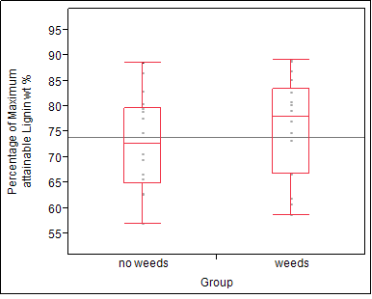
Figure 22: One-Way ANOVA for mean lignin yield between pure and contaminated feedstock expressed in percent.

Impact of Run Time on Lignin Yield

A One-Way ANOVA (Figure 23) was conducted to detect any statistical differences (α = 0.05) in the mean lignin yield as function of fractionation time. The analysis indicated a difference not only in mean lignin yield but also in the dispersion around the means for the two different runtimes. The Levene’s test for unequal variances concluded that the variances were not equal for mean lignin yield by run time (p-value=0.0419). Due to unequal variances, a Wilcoxon signed-rank test (Wilcoxon, 1945) was performed, concluding that there was no significant difference between the two run times in terms of mean lignin yield (p-value=0,3506). With a maximum mean lignin yield of 76.34 wt % the run time of 90 minutes provided a slightly higher mean lignin yield than the 56 minute run with a mean lignin yield of 71.53 wt %. These results do not support the level setting for run time found by the highest S/N ratio in the TRPD.

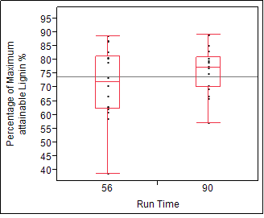
Figure 23: One-Way ANOVA for mean lignin yield by run time expressed in percent.

Impact of Run Temperature on Lignin Yield

A One-Way ANOVA (Figure 24) was conducted to detect any statistical differences (α = 0.05) in the mean lignin yield as function of run temperature. The analysis concludes that there is a significant difference (p-value=0.0179) between the two temperatures regarding lignin yield. Runs conducted at the higher temperature (160°C) achieved a significant higher mean lignin yield of 76.94 wt %, while the lower temperature (140°C) achieved a mean lignin yield of 67.92 wt %. These results support the level setting for run temperature found by the highest S/N ratio in the TRPD.

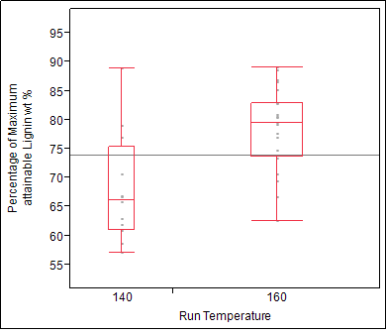
Figure 24: One-Way ANOVA for mean lignin yield by process temperature expressed in percent.

Impact of the Feedstock Ratio on Lignin Yield

A one-way ANOVA (Figure 25) was conducted to detect any statistical differences (α = 0.05) in the mean lignin yields as a result of different feedstock ratios. There is no significant difference (p-value = 0.2841) between the feedstock mixtures [10/90] and [50/50]) and the feedstock mixtures [50/50] and [10/90] (p-value = 0.3199). There is, however, a statistical difference between the feedstock mixtures [10/90] and [90/10] (p-value = 0.0058). The feedstock ratio containing the highest amount of poplar ([90/10]) performed best in terms of lignin yield with a mean lignin yield of 79.53 wt%. Runs conducted with the feedstock mixture [50/50] provided a mean lignin yield of 77.74 wt%. The highest S/N ratio and thus the highest mean lignin yield of the TRPD was achieved with a feedstock ratio of 10% switchgrass and 90 % poplar.

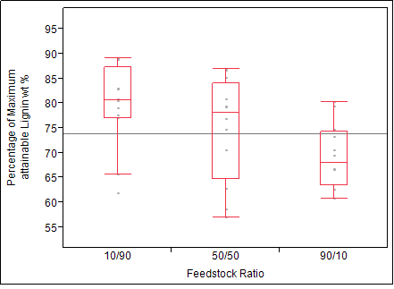
Figure 25: One-Way ANOVA for mean lignin yield by feedstock expressed in percent.

Impact of Poplar Particle Size on Lignin Yield

A one-way ANOVA (Figure 26) was conducted to detect any statistical differences (α =0.05) in the mean lignin yields as a result of the poplar chip size. There was no significant difference found between the different wood chip sizes in terms of lignin yield, but the medium size of poplar particles outperformed the two other wood chip sizes with a mean lignin yield of 75.69 wt % followed by the fine wood chip size with a mean lignin yield of 75.34 wt %. The use of a standard industrial wood chip size resulted in a mean lignin yield of 70.77 wt %. The highest mean lignin yield in the TRPD was found using a medium poplar particle size. These results thus support the level settings found by the highest S/N ratio since medium poplar particle size provided the highest mean lignin yield of 75.69 wt %.

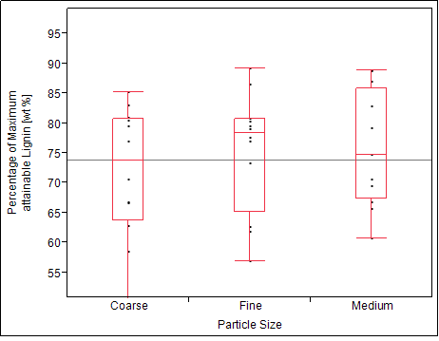
Figure 26: One-Way ANOVA for lignin yield by poplar particle size in expressed in percent.

Impact of Acid Concentration on Lignin Yield

A one-way ANOVA (Figure 27) was conducted to detect any statistical differences (α=0.05) in the mean lignin yield as a result of using different acid concentrations. In this study, no statistical differences in regards to lignin yield could be found between the high acid (0.01 M) and medium acid (0.05 M) (p-value = 0.9345), as well as between medium acid (0.05 M) and low acid (0.025) (p-value = 0.1966), and between high acid (0.1 M) and low acid (0.025 M) (p-value = 0.1706). The high acid concentration achieves a slightly higher mean lignin yield (76.77 wt %) than the medium (0.5 M) acid concentration (74.28 wt %). The solvent mixtures containing a low acid concentration (0.025 M) achieve a mean lignin yield of 69.18 wt%. These results further support the results from the S/N ration found in the TRPD. The highest mean lignin yield was recovered using 0.1 M acid concentration.

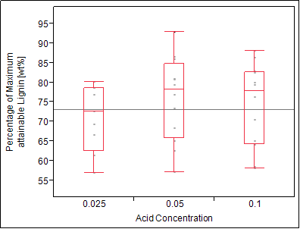
Figure 27: One-Way ANOVA for lignin yield by acid concentration presented in percent.

Impact of Solvent Composition on Lignin Yield

A one-way ANOVA (Figure 28) was conducted to detect any statistical differences (α = 0.05) in the mean lignin yield as a result of using different solvent compositions. There was no statistical difference found in the mean lignin yield between -1 solvent and +2 solvent (p-value = 0.3919), as well as between the -1 solvent and the -2 solvent (p-value = 0.5655), and between the -2 solvent and the +2 solvent composition (p-value = 0.7759). The mean lignin yield of the -1 solvent with 76.14 wt % was higher than the mean lignin yield of the -2 solvent with 73.49 wt %. The use of +2 solvent provided the lowest overall mean lignin yield of 70.92 wt %, but the highest S/N ratio in the TRPD was achieved using a +2 solvent mixture.

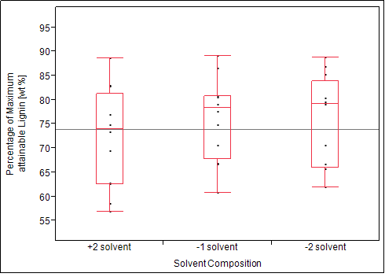
Figure 28: One-Way ANOVA for mean lignin yield by solvent composition expressed in percent.

Maximizing Lignin Yield

The prediction profiler offered by JMP Pro 10.0 statistical software offers a feature to maximize desirability, meaning that the prediction profiler uses the data of the underlying study and expands both the lignin yield and the S/N ratio to other orthogonal arrays, which were not analyzed in the underlying TRPD study.

The outcome of the prediction profiler states that, even if every second batch of feedstock was evenly contaminated with lignin containing weeds of either 3, 15 or 27% of total feedstock, a mean maximum lignin yield of 91.11 wt % will be attained if the levels of the different organosolv process factors were set at a runtime of 90 minutes, a run temperature of 160°C, a feedstock mixture of 10% switchgrass and 90% medium poplar particles, and using the -1 solvent mixture with an added acid concentration of 0.1 M as can be seen in the prediction profiler depicted in Figure 29.

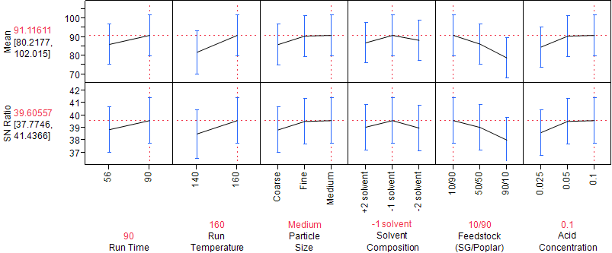

Figure 29: Prediction profiler suggesting optimal levels for each factor to maximize the mean yield of lignin.

Validation of the Prediction Profiler using Monte Carlo Simulation
JMP Pro ^{10.0} statistical software offers a prediction profiler, a feature that expands the lignin yield and S/N ratio prediction to other orthogonal arrays not analyzed in this TRPD. The simulator equally chooses different levels of every factor and simulates 648 runs, while adding random noise, which is calculated by the software based on the results found, to both the mean lignin yield and the S/N ratio. The noise induced to the mean lies within a standard deviation of 6.034541, while the noise induced to the S/N ratio lies within a standard deviation of 1.0138394. The noise induced simply simulates varying yields of lignin based on the given study.

Impact of Run Time based on Simulation

A One-Way ANOVA (Figure 30) was conducted on 648 simulated runs to detect any statistical differences (α = 0.05) in the mean lignin yield as function of fractionation time. The analysis resulted in a significant difference between the run time of 56 minutes and a run time of 90 minutes (p-value < 0.001). In the simulation the lower run time achieves a mean lignin yield of 71.30 wt %, while the higher runtime achieves a mean lignin yield of 76.69 wt %. The simulation shows that over a large number of experiments significant differences between the two different run times in terms of mean maximum lignin yield become visible. According to these results a 90 minute run will provide a 5.39 wt % higher mean lignin yield, thus explaining why the prediction profiler chooses the higher run time. In order to maximize lignin yield the practical implication would be to operate at a higher runtime. In contrary, a lower runtime would lower the cost, reduce the cycle time and thus might increase throughput. These results are supported through previous research done by Astner (Astner, 2012) on lignin yield maximization of lignocellulosic biomass using the organosolv fractionation process. In his research Astner (Astner, 2012) found that higher runtimes led to a higher lignin yield.

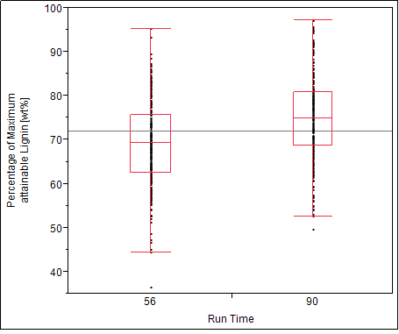
Figure 30: One-Way ANOVA for simulated mean lignin yield by run time presented in percent.

Impact of Run Temperature based on Simulation

A One-Way ANOVA (Figure 31) was conducted on 648 simulated runs to detect any statistical differences (α = 0.05) in the mean lignin yield as function of fractionation temperature. The analysis resulted in a significant difference between the run temperature of 140°C and a run temperature of 160 °C (p-value = 0.001). In the simulation the lower temperature achieves a mean lignin yield of 67.55 wt %, while the higher run temperature achieves a mean lignin yield of 77.32 wt%. The simulation supports the findings of the study. Therefore the higher run temperature should be favored in terms of lignin yield. Similar to the discussion on run time as a process factor in the TRPD, a higher run temperature is directly linked to higher energy consumption and thus higher costs. The financial gain from a nearly 10 wt % higher mean lignin yield must exceed or at least compensate the higher operation cost. These results are supported by previous research done by Pan et al. (2006) on the organosolv fractionation on hybrid poplar. Pan et al. (2006) and Brudericki et al (2012) found that lignin recovery was increased with the use of higher fractionation temperatures.

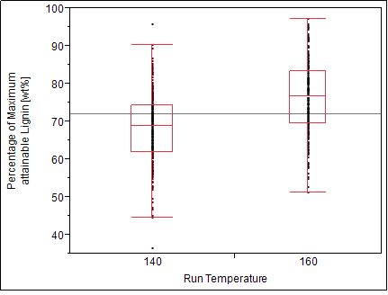
Figure 31: One-Way ANOVA for simulated mean lignin yield by run time presented in percent.

Impact of Feedstock Ratio based on Simulation

A One-Way ANOVA (Figure 32) was conducted on 648 simulated runs to detect any statistical differences (α = 0.05) in the mean lignin yield as function of feedstock ratio chosen. The analysis resulted in a highly significant difference between all the different feedstock ratios (p-value < 0.001). In the simulation, the feedstock ratio containing high amounts of poplar ([10/90]) achieves a mean lignin yield of 78.90 wt %, the feedstock ratio containing equal parts of switchgrass and poplar ([50/50]) achieves a mean lignin yield of 72.20 wt % followed by the feedstock ratio containing mainly switchgrass ([10/90]), which achieves a mean lignin yield of 67.42 wt %. These results further support the findings of the prediction profiler.

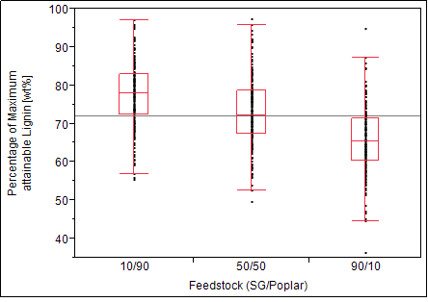
Figure 32: One-Way ANOVA for simulated mean lignin yield by feedstock ratio presented in percent.
The compositional analysis of the switchgrass and the tulip poplar used for this study determined a lignin content of 22.94 % for switchgrass and 22.70 % for poplar. Thus, that all three feedstock loadings, independent from the ratio they were mixed in, had a similar lignin content. One possible answer is the impact of the switchgrass contaminating weeds. This would contradict the results from the ANOVA conducted on the lignin distribution between pure and contaminated runs, but the results from above clearly show that the mean lignin yield declines as the degree of contamination increases. Another explanation would be that lignin is more easily removed from the poplar fraction than it is from the switchgrass. Another possible answer is the impact of particle size. About one third of the runs was conducted using medium and fine polar chips (pulp grade chips – mesh size 8, mesh size 4 – mesh size 8), which have the same size or are significantly smaller than the average switchgrass particle size. This would then again lead to more accessible surface area for the dissolving solvents, thus possibly explaining an easier and more efficient removal of lignin.

Impact of Poplar Particle Size based on Simulation

A preliminary study conducted by Astner (Astner 2012) found that fractionations performed on batches that had high proportions of switchgrass (90%) relative to tulip poplar (10%) in the feedstock mixture resulted in a higher lignin yield. Astner (Astner, 2012) believes that the size (pulp grade chips) and density of the tulip polar feedstock more so than switchgrass is hindering the penetration of solvents during the organosolv fractionation process, thus resulting in a lower lignin yield. As a result, Astner (Astner, 2012) proposes the reduction of particle size to increase solvent accessibility and lignin yield (Astner, 2012). To further investigate the effect of particle size on the yield of lignin this study included three different tulip poplar particle sizes as described in Chapter 3. A One-Way ANOVA (Figure 33) was conducted on 648 simulated runs to detect any statistical differences (α = 0.05) in the mean lignin yield as function of feedstock ratio chosen. The analysis resulted in a highly significant difference between the medium and a large particle size, as well as between the fine and large particle size (p-value < 0.001). The test also indicated that there is no statistical difference in the mean lignin yield between the medium and fine particle size (p-value = 0.9012). The highest mean lignin yield of 76.28 wt% is achieved by the fine poplar particle size followed by the medium particle size with a mean lignin yield of 75.82 wt % and the coarse or standard wood chip size with a mean lignin yield of 71.133 wt %.

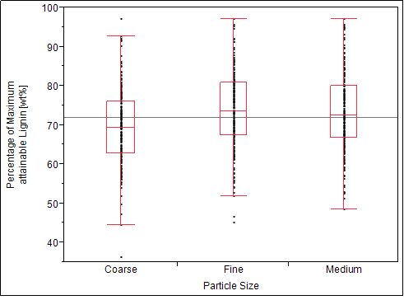
Figure 33: One-Way ANOVA simulated mean lignin yield by feedstock particle size presented in percent.
The findings from the simulated runs would support Astner’s (Asntner, 2012) suggestion that the size (pulp grade chips) and density of the tulip polar feedstock more so than switchgrass are hindering the penetration of solvents during the organosolv fractionation process, thus resulting in a lower lignin yield. Again, the gain of 4.57 wt% in mean lignin yield should exceed or at least compensate the higher cost for the wood particle size reduction. Size reduction is energy intensive and the energy consumption for the production of wood chips is close to 50 kWh or 0.18 GJ per ton of wood (Zhu, 2011). Currently, size reduction of wood is possible during harvesting, where logs are reduced to the size of standard wood chips (10-50mm in two dimensions and 5-15mm in the third dimension) (Zhu and Pan, 2010; Zhu et al., 2009). A further size reduction of the wood chips would increase the overall cost, since more equipment and more energy would be necessary.

Impact of Acid Concentration based on Simulation

A One-Way ANOVA (Figure 34) was conducted on 648 simulated runs to detect any statistical differences (α = 0.05) in the mean lignin yield as function of the acid concentration. The analysis between groups resulted in a highly significant difference between the 0.025 M and 0.05 M acid concentration as well as between the 0.025 and the 0.1 M acid concentration (p-value < 0.001). Adding acid catalysts is known to increase the rate of delignification (Sun and Cheng, 2002), which supports the findings of the simulation. However, the test conducted on the simulated runs could not find a significant difference between the 0.05 M and the 0.1 M acid concentration (p-value = 0.1998). The 0.1 M acid concentration achieves a mean lignin yield of 77.01 wt %, which is slightly higher than the mean lignin yield achieved by the medium acid concentration with 75.84 wt%. The 0.025 M acid concentration achieves a significantly lower mean lignin yield of 68.51 wt %. When maximizing desirability in terms of mean lignin yield, the profiler suggests the use of 0.1 M acid concentration, since it achieved the highest mean lignin yield. In this case, the suggestion made by the profiler should be questioned, since there is no significant difference in terms of mean lignin yield between the medium and high acid concentration. A high acid concentration can directly be linked to higher cost and an accelerated deterioration of equipment. These results lead to the conclusion that higher mean lignin yield will not be significantly increased by choosing higher acid levels. This is supported by the research conducted by Astner (Astner, 2012), who achieved a maximum lignin of 82. wt % using an acid level of 0.05 M.

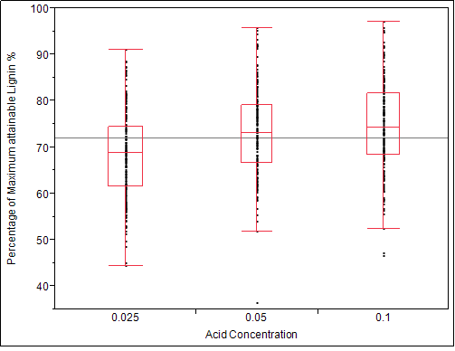
Figure 34: One-Way ANOVA for simulated mean lignin yield by acid concentration presented in percent.

Impact of Solvent Composition based on Simulation

A One-Way ANOVA (Figure 35) was conducted on 648 simulated runs to detect any statistical differences (α = 0.05) in the mean lignin yield as function of solvent composition chosen. The analysis states that there is a significant statistical difference between the -1 solvent mixture and the +2 solvent (p-value <.001),as well as between the -2 solvent and +2 solvent (p-value = 0.0285), and between the -1 solvent mixture and the -2 solvent (p-value = 0.0334) The -1 solvent achieves the highest mean lignin yield of 76.09 wt % followed by the -2 solvent with a mean lignin yield of 73.97 wt %. The +2 solvent achieves a mean lignin yield of 71.79 wt %. The practical implication of these results would imply the use of a solvent containing lower amounts of MIBK, since the cost of solvents is a large contributor to the overall cost of organosolv fractionation.

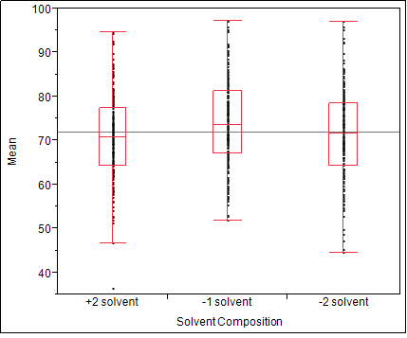
Figure 35: One-Way ANOVA for mean lignin yield by solvent composition.
However, the solvent composition had minor and major effects on the organosolv fractionation process, the purity of the recovered lignin, the cellulose recovered and the on the lignin recovery process.

Impact of Solvent Composition on the Organosolv Fractionation Process

Using +2 solvent was found to have a positive effect on the fractionation process itself. Especially high temperature runs (160°C), normally known to cause pressure fluctuations and steam bursts at the reactor outlet, were found to run more smoothly. Pressure fluctuations during high temperature runs were no more than ± 2 psi. The equilibrium pressure was observed to level off at around 152 psi. However, the corrosivity of this +2 solvent was apparently quite high, as visible degradation to the metal tubing of the reactor and other metal parts was observed. The corrosion resistant Hastelloy reactor itself showed no visible signs of wear resulting from the use +2 solvents. The black liquor recovered from runs conducted with +2 solvents was homogeneous and very dark in color.

Using -2 solvents had only a minor effect on the organosolv fractionation process itself. It was observed that high temperature runs (160°C) conducted with -2 solvents led to an overall increase of pressure fluctuations and increased number of steam bursts at the reactor outlet, which can presumably be ascribed to the high water content of the -2 solvent. The black liquor recovered from runs conducted with -2 solvent was slightly translucent, contained chunks and lumps of lignin with heavier particles that settled to the bottom of the collection vessel and had a sand like appearance (Figure 36).

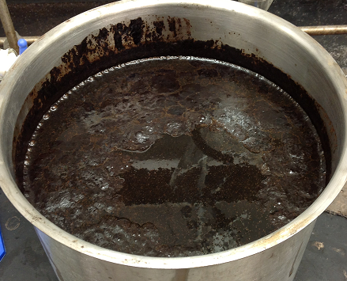
Figure 36: Collection vessel containing black liquor from a -2 solvent run.

Impact of Solvent Composition on Lignin Purity

Of the six process factors; run time, run, temperature, feedstock composition, feedstock particle size, solvent composition and acid concentration, only the solvent composition had a statistical significant impact on the lignin purity. A one-way ANOVA (Figure 37) was conducted to detect any statistical differences (α = 0.05) in the mean lignin purity as a result of using different solvent compositions. The Levene’s test concluded that the three different solvent groups had unequal variances. A nonparametric comparison between each pair of solvent mixtures was done using the Wilcoxon method (Wilcoxon, 1945). There was a significant difference in lignin purity between the +2 solvent and the -1 solvent (p-value=0.0102), as well as between the -1 solvent and the -2 solvent mixture (p-value=0.0194), and the +2 solvent and the -2 solvent (p-value 0.0194). The highest mean lignin purity of 93.03 wt% achieved using the +2 solvent is significantly higher than the mean lignin purity of 88.56 wt % achieved by the use of the -1 solvent mixture, and the -2 solvent mixture which achieved a mean lignin purity of 82.26 wt %. The +2 solvent composition not only provided the highest lignin purity with a mean purity but it also had the least amount of variation with all lignin purities lying above 90% except for an outlier that occurred during Run # 27 (lignin purity of 82.67%). Even though the -1 solvent contains only 16% MIBK compared to the 62% MIBK in the +2 solvent, the mean lignin purity of the -1 solvent was not considerably lower. In terms of lignin purity, these results propose a solvent composition towards a higher MIBK content for more robustness in the organosolv process and for higher lignin purity.

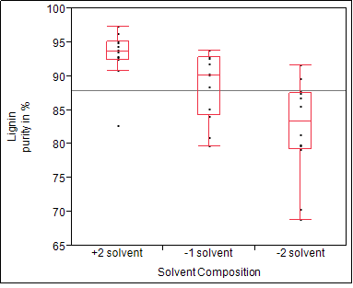
Figure 37: Box plot for mean lignin purity by solvent composition expressed as a percent.

Impact of High MIBK Solvent on the Cellulose Yield

Although the focus of this work was on lignin yield, the high severity of the solvent mixture containing high amounts of MIBK had a significant effect on the cellulose yield. A one–way ANOVA (Figure 38) was conducted to detect any statistical differences (α = 0.05) in the mean cellulose yield as a result of the solvent composition used in the organosolv process. There is a significant difference in the mean cellulose yield between runs conducted with +2 solvent and runs conducted with -1 and -2 solvents (p-value < .0001). The -2 solvent provided a mean cellulose yield of 36 wt %, while the -1 solvent provided a mean cellulose yield of 34.05 wt % followed by the +2 solvent that only provided a significant lower mean cellulose yield of 17.33 wt%.

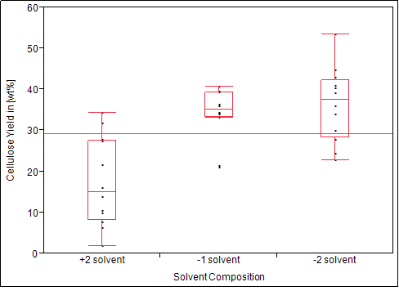
Figure 38: Box plot of the mean cellulose yield by solvent composition in percent of total Feedstock.

It seems that increasing amounts of MIBK in the solvent composition results in a higher dissolution of cellulose. The statistics show that in this study the +2 solvent in average dissolved 16.72 wt % more biomass into the liquid fraction of the organosolv process than the -1 solvent used. The resulting cellulose that was not dissolved was brittle and very dark in color. This implies that the cellulose in the feedstock is undergoing more depolymerization during the fractionation process which could be an important observation for the production of biobased chemicals and fuels from carbohydrates. A more enriched sugar stream could also benefit the production of fermentation EtOH, for example through a streamlined simultaneous fractionation and hydrolysis.

Impact of High MIBK Solvents on the Lignin Recovery Process

The lignin recovery was conducted according to the standard recovery process when using the “-1 solvent”. For every 100ml of water contained in the starting solvent mixture, 15 g of salt were added. The first observation during application of this process to +2 solvent mixtures was that the salt would hardly dissolve in the black liquor resulting only in the formation of a small aqueous phase at the bottom of the separatory funnel. Only the incremental addition of deionized water and additional shaking of the separatory funnel caused the salt to dissolve and resulted in an unusually fast and clear separation of the organic and the aqueous phase. The incremental addition of deionized water was continued until the formation of lumps or chunks of lignin indicated that most of the ethanol had been removed from the organic phase. Depicted in Figure 39 is a separatory funnel used for the lignin recovery process, showing both the upper dark organic layer as well as the lower very clear aqueous layer.

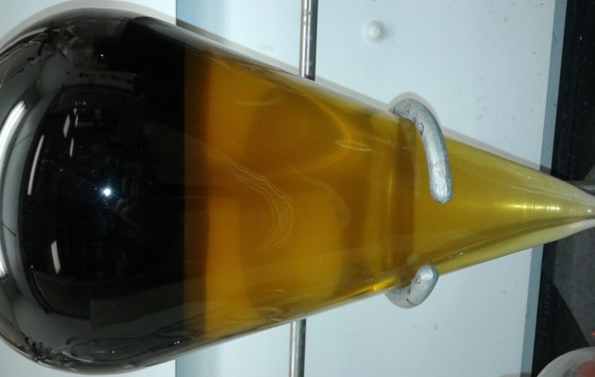
Figure 39: Phase separaton during the lignin recovery process.

Due to the use of high MIBK solvent mixtures, the organic fraction was considerably larger compared to runs conducted with the standard -1 solvent. This larger organic phase formed a thick crude oil like liquid that required the repeated use of diethyl ether to wash and removed impurities until a lignin powder was observed. The lignin yield distribution as listed in Table 15 shows that the largest fraction of the lignin contained in the black liquor remained in the organic phase. This finding implies that increased amounts of MIBK result in a more clean and efficient separation and thus could further streamline the lignin recovery process.

Table 15: Lignin yield distribution between the aqeous and solvent phase when using the +2 solvent mixtures.
High MIBK Runs | Aqueous Lignin [g] | Organic Lignin [g]
1 | 0.86 | 41.49
2 | 1.25 | 61.37
3 | 1.76 | 70.5
4 | 0.93 | 54.14
5 | 2.23 | 73.46
6 | 3.97 | 50.5
7 | 2.4 | 67.04
8 | 1.73 | 63.29
9 | 3.37 | 73.93
10 | 1.9 | 62.83
11 | 2.76 | 73.93
12 | 0.6 | 51.14

Impact of Low MIBK Solvents on the Lignin Recovery Process

The lignin recovery was conducted according to the standard recovery process when using the “-1 mixture”. For every 100ml of water contained in the starting solvent mixture, 15 g of salt were added. Due to the large water fraction in the low MIBK solvent, increased amounts of salt were used. The use of low MIBK solvents resulted in the formation of a very small organic phase. The ability of MIBK to keep the lignin in solution was limited since only 7% of the solvent was MIBK. This caused most of the lignin to stay in the aqueous phase, resulting in a very dark aqueous phase making it hard to distinguish between organic and aqueous phase.

CHAPTER V – CONCLUSION & RECOMENDATIONS

Formal experimental design in a controlled laboratory setting was used to conduct a study that would result in the ability to predict lignin yields, as being a function of feedstock type, feedstock particle size, feedstock ratio, process temperature, solvent composition, acid concentration and runtime, even in the presence of feedstock contamination.

The L 18 TRPD was used to determine the optimal level for each process factor of the organosolv fractionation process. These process factors studied were two different run times (56, 90 min), two different run temperatures (140°C, 160°C), mixed feedstock loadings containing mixtures of switchgrass (Panicum virgatum) and tulip poplar (Liriodendron tulipifera) in three different ratios ([10/90], [50/50], [90/10]), three different poplar chip sizes (coarse, medium, fine), three different solvent compositions containing MIBK, EtOH and H₂O ([07/30/63], [16/34/50], [62/27/11]), and three different acid concentrations (0.025, 0.05, 0.1 M).

The highest mean lignin yield of 85.675 wt % and thus the highest S/N ratio of 38.64 determined the optimal level settings for the organosolv fractionation process factors to attaining a mean maximum lignin yield of 85.67 wt % in this study. These optimal level settings were a runtime of 56 minutes, a run temperature of 160°C, a feedstock mixture containing 10% switchgrass and 90% medium sized poplar chips, a high MIBK solvent and an acid concentration of 0.1 M.

The prediction profiler within JMP Pro ^{10.0} statistical software offers a feature to maximize desirability, meaning that the prediction profiler uses the data of the underlying study and expands both the lignin yield and the S/N ratio to other orthogonal arrays which were not analyzed in the underlying TRPD study. As a result it offers a new comprehensive optimum for the organosolv process to further maximize the yield of lignin. The results state that, even if every second batch of feedstock was evenly contaminated with lignin containing weeds of either 3, 15 or 27% of total feedstock, a mean maximum lignin yield of 91.11 wt % will be attained if the levels of the different process factors of the organosolv fractionation process were set at a runtime of 90 minutes, a run temperature of 160°C, a feedstock mixture of 10% switchgrass and 90% medium poplar particles, and using the -1 solvent mixture with an added acid concentration of 0.1 M.

A Klason lignin analysis was conducted determine the purity and of the extracted lignin. The results concluded that the mean lignin purity in this study was 90.10 %.
The mean maximum attainable lignin yield was 85.67 wt %. Together these results confirm that the organosolv fractionation process is a highly capable process that provides a stream of high lignin yields in a pure form.

Impact of Solvent Composition on the Organosolv Fractionation Process

Ongoing research, changing feedstock, mixed feedstock experiments and the lack of information on the effects of different solvent composition on lignin yield and the organosolv fractionation process were reasons to include these different solvent compositions into this study.

The different solvent compositions had a minor effect on the reactor operation itself. The solvent that contained less water and more MIBK (+2 solvent) seemed to operate more smoothly at high operation temperatures, while runs conducted with the solvent containing more water and less MIBK (-2 solvent) were observed to generate more pressure fluctuations and steam bursts.

The use of the +2 solvent had a significant effect on the purity of lignin. Lignin recovered from +2 solvent runs resulted in a mean lignin purity of 93.03 %. The individual properties of the solvent compositions had a significant impact on the lignin recovery process. Runs conducted with higher amounts of MIBK in the solvent lead to a faster and cleaner separation leaving the main fraction of lignin in the organic phase. In contrast, the -2 solvents lead to a very small organic fraction surrendering most of the lignin to the very dark aqueous phase. The phase separation conducted on -2 solvent runs was also much slower, taking up to 20 minutes and more compared to the +2 solvent runs that fully separated in less than 3 minutes. In both cases the standard procedure of adding 15 g of NaCl for every 100ml of anticipated water in the black liquor to initiate separation, had to be altered. Runs conducted with -2 solvents required considerably more salt, due to the high water content, while +2 solvent runs required considerable additional amounts of deionized water to fully dissolve the added salt and separate into two fractions.

Although cellulose yield was not a central issue in this study, it was observed that the solvent containing high amounts of MIBK had a significant effect on the yield of cellulose and thus on the cellulose. During this study it was observed that the +2 solvent on average dissolved 16% more biomass than the standard -1 solvent used in the organosolv fractionation process at the CRC.

The +2 solvent containing high amounts of MIBK also led to the dissolution of cellulose. In average the +2 solvent dissolved 16% more biomass than the -1 solvent used in the organosolv fractionation process at the CRC.

Impact of Poplar Particle Size on the Organosolv Fractionation Process

There were no significant differences found in the mean lignin yield between the three different poplar particle sizes studied. However, a simulation conducted by the JMP ^{10.00} prediction profiler that is based on the underlying study suggested that poplar particle size could significantly impact the lignin yield. An explanation for this might be that small poplar particle sizes provide a larger amount of surface area and thus increase accessibility to the solvents.

Future Research

The future biorefinery will be similar to today’s petrochemical refineries, meaning that biorefineries will produce a variety of different chemical products and transportation fuels. Multiple lignocellulosic feedstocks such as wood, straw, energy crops, corn stover, etc. would enter the biorefinery, and through a collection of processes these raw materials will be fractionated and converted into an array of energy, fuels and chemical products. The organosolv fractionation process bears the potential to fractionate these feedstocks selectively into clean process streams. The underlying study showed that the organosolv process not only successfully fractionates lignocellulosic biomass, but also delivers high yields of pure lignin. In pursuit of maximum lignin yield, test runs need to be conducted to verify the predictions made in the underlying study.

The results of this study propose the further investigation of the solvent composition currently used in the organosolv fractionation process at the CRC. The solvent composition had a highly significant effect on the purity of lignin.

The different solvent compositions also affected the lignin recovery process. The alteration of the solvent composition holds the potential to greatly improve the separation and further streamline this process.

LIST OF REFERENCES

Agbor, V.B., Cicek, N., Sparling, R., Berlin, A., Levin, D.B. 2011. Biomass pretreatment: Fundamentals toward application. Biotechnol Adv, 29(6), 675-685.

Albright, T.L., Roth, H.P. 1994. Managing quality through the quality loss function. J. Cost Manag., 20-37.

Aspinall, G.O., Fanous, H.K., Sen, A.K. 1982. Structural chemistry of some cell-wall polysaccharides from non-cereal sources of dietary fiber. Abstr Pap Am Chem S, 183(Mar), 38-Agfd.

Astner, A.F. 2012. Lignin Yield Maximation of Lignocellulosic Biomass by Taguchi Robust Product Design using Organosolv Fractionation, University of Tennessee, Knoxville, pp. 1 electronic text (137 pages).

Avellar, B.K., Glasser, W.G. 1998. Steam-assisted biomass fractionation. I. Process considerations and economic evaluation. Biomass Bioenerg, 14(3), 205-218.

Balat, M., Balat, H., Oz, C. 2008. Progress in bioethanol processing. Prog Energ Combust, 34(5), 551-573.

Ballantyne, K.N., van Oorschot, R.A., Mitchell, R.J. 2008. Reduce optimisation time and effort: Taguchi experimental design methods. Forensic Science International: Genetics Supplement Series, 1(1), 7-8.

Bender, M.H. 2000. Potential conservation of biomass in the production of synthetic organics. Resourc. Conserv. Recycl., 30(1), 49-58.

Bozell, J.J., Black, S.K., Myers, M., Cahill, D., Miller, W.P., Park, S. 2011a. Solvent fractionation of renewable woody feedstocks: Organosolv generation of biorefinery process streams for the production of biobased chemicals. Biomass Bioenerg, 35(10), 4197-4208.

Bozell, J.J., O'Lenick, C.J., Warwick, S. 2011b. Biomass Fractionation for the Biorefinery: Heteronuclear Multiple Quantum Coherence-Nuclear Magnetic Resonance Investigation of Lignin Isolated from Solvent Fractionation of Switchgrass. J Agr Food Chem, 59(17), 9232-9242.

BRaD Board. 2010. Biofuel Feedstock Logistics: Recommendations for Research and Commercialization.

Brownell, H.H., Yu, E.K.C., Saddler, J.N. 1986. Steam-Explosion Pretreatment of Wood - Effect of Chip Size, Acid, Moisture-Content and Pressure-Drop. Biotechnol Bioeng, 28(6), 792-801.

Butler, R. 2006. High oil prices fuel bioenergy push, Vol. 2013.

Cano-Delgado, A., Penfield, S., Smith, C., Catley, M., Bevan, M. 2003. Reduced cellulose synthesis invokes lignification and defense responses in Arabidopsis thaliana. Plant J, 34(3), 351-362.

Cheng, Y.S., Zheng, Y., Yu, C.W., Dooley, T.M., Jenkins, B.M., VanderGheynst, J.S. 2010. Evaluation of high solids alkaline pretreatment of rice straw. Appl Biochem Biotech, 162(6), 1768-1784.

Cimbala, J.M. 2009. Taguchi Orthogonal Arrays

Claassen, P.A.M., van Lier, J.B., Contreras, A.M.L., van Niel, E.W.J., Sijtsma, L., Stams, A.J.M., de Vries, S.S., Weusthuis, R.A. 1999. Utilisation of biomass for the supply of energy carriers. Appl Microbiol Biot, 52(6), 741-755.

Clark, J.H., Deswarte, F.E.I. 2008. Introduction to chemicals from biomass. Wiley, Chichester, U.K.

Demirbas, M.F. 2006. Current technologies for biomass conversion into chemicals and fuels. Energ Source Part A, 28(13), 1181-1188.

Digman, M.F., Shinners, K.J., Casler, M.D., Dien, B.S., Hatfield, R.D., Jung, H.J.G., Muck, R.E., Weimer, P.J. 2010. Optimizing on-farm pretreatment of perennial grasses for fuel ethanol production. Bioresource Technol, 101(14), 5305-5314.

Du, B.W., Sharma, L.N., Becker, C., Chen, S.F., Mowery, R.A., van Walsum, G.P., Chambliss, C.K. 2010. Effect of varying feedstock-pretreatment chemistry combinations on the formation and accumulation of potentially inhibitory degradation products in biomass hydrolysates. Biotechnol Bioeng, 107(3), 430-440.

Ebringerova, A., Hromadkova, Z., Heinze, T. 2005. Hemicellulose. Adv Polym Sci, 186, 1-67.

Fargione, J., Hill, J., Tilman, D., Polasky, S., Hawthorne, P. 2008. Land clearing and the biofuel carbon debt. Science, 319(5867), 1235-1238.

Fraley, S., Oom, M., Terrien, B., Zalewski, J. 2006. Design of experiments via taguchi methods: orthogonal arrays. University of Michigan Chemical Engineering Process Dynamics and Controls Open Textbook. .

Glasser, W.G., Wright, R.S. 1998. Steam-assisted biomass fractionation. II. Fractionation behavior of various biomass resources. Biomass Bioenerg, 14(3), 219-235.

Gollapalli, L.E., Dale, B.E., Rivers, D.M. 2002. Predicting digestibility of ammonia fiber explosion (AFEX)-treated rice straw. Appl Biochem Biotech, 98, 23-35.

Hamelinck, C.N., van Hooijdonk, G., Faaij, A.P.C. 2005. Ethanol from lignocellulosic biomass: techno-economic performance in short-, middle- and long-term. Biomass Bioenerg, 28(4), 384-410.

Himmel, M.E. 2007. Biomass recalcitrance: engineering plants and enzymes for biofuels production (vol 315, pg 804, 2007). Science, 316(5827), 982-982.

Himmel, M.E., Adney, W.S., Baker, J.O., Elander, R., McMillan, J.D., Nieves, R.A., Sheehan, J.J., Thomas, S.R., Vinzant, T.B., Zhang, M. 1997. Advanced bioethanol production technologies: A perspective. Fuels and Chemicals from Biomass, 666, 2-45.

Holladay, J., White, J., Bozell, J., Johnson, D. 2007. Top Value-Added Chemicals from Biomass - Volume II—Results of Screening for Potential Candidates from Biorefinery Lignin .

Holtzapple, M.T., Lundeen, J.E., Sturgis, R., Lewis, J.E., Dale, B.E. 1992. Pretreatment of lignocellulosic municipal solid-waste by Ammonia fiber explosion (Afex). Appl Biochem Biotech, 34-5, 5-21.

Hsu, T.A., Ladisch, M.R., Tsao, G.T. 1980. Alcohol from cellulose. Chemtech, 10(5), 315-319.

Ibrahim, M.M., El-Zawawy, W.K., Abdel-Fattah, Y.R., Soliman, N.A., Agblevor, F.A. 2011. Comparison of alkaline pulping with steam explosion for glucose production from rice straw. Carbohyd Polym, 83(2), 720-726.

IEA. 2007. World energy outlook, International Energy Agency. Paris.

Kamm, B., Kamm, M. 2004. Principles of biorefineries. Appl Microbiol Biot, 64(2), 137-145.

Kumar, R., Wyman, C.E. 2009. Access of cellulase to cellulose and lignin for poplar solids produced by leading pretreatment technologies. Biotechnol Progr, 25(3), 807-819.

Lange, H., Decina, S., Crestini, C. 2013. Oxidative upgrade of lignin – Recent routes reviewed. Eur Polym J, 49(6), 1151-1173.

Li, C.L., Knierim, B., Manisseri, C., Arora, R., Scheller, H.V., Auer, M., Vogel, K.P., Simmons, B.A., Singh, S. 2010. Comparison of dilute acid and ionic liquid pretreatment of switchgrass: Biomass recalcitrance, delignification and enzymatic saccharification. Bioresource Technol, 101(13), 4900-4906.

Lindman, H.R. 1992. Analysis of variance in experimental design. Springer-Verlag, New York.

Lora, J.H., Wu, C.F., Pye, E.K., Balatinecz, J.J. 1989. Characteristics and potential applications of lignin produced by an organosolv pulping process. Acs Symposium Series, 397, 312-323.

Lynd, L.R. 1996. Overview and evaluation of fuel ethanol from cellulosic biomass: Technology, economics, the environment, and policy. Annu Rev Energ Env, 21, 403-465.

Mabee, W.E., Gregg, D.J., Saddler, J.N. 2005. Assessing the emerging biorefinery sector in Canada. Appl Biochem Biotech, 121, 765-778.

Malca, J., Freire, F. 2006. Renewability and life-cycle energy efficiency of bioethanol and bio-ethyl tertiary butyl ether (bioETBE): Assessing the implications of allocation. Energy, 31(15), 3362-3380.

Mansfield, S.D. 2009. Solutions for dissolution-engineering cell walls for deconstruction. Current Opinion in Biotechnology, 20(3), 286-294.

Marzialetti, T., Olarte, M.B.V., Sievers, C., Hoskins, T.J.C., Agrawal, P.K., Jones, C.W. 2008. Dilute acid hydrolysis of Loblolly pine: A comprehensive approach. Ind Eng Chem Res, 47(19), 7131-7140.

McIntosh, S., Vancov, T. 2010. Enhanced enzyme saccharification of Sorghum bicolor straw using dilute alkali pretreatment. Bioresource Technol, 101(17), 6718-6727.

McMillan, J.D. 1994. Pretreatment of lignocellulosic biomass. Enzymatic Conversion of Biomass for Fuels Production, 566, 292-324.

Menon, V., Rao, M. 2012. Trends in bioconversion of lignocellulose: Biofuels, platform chemicals &amp; biorefinery concept. Prog Energ Combust, 38(4), 522-550.

Mosier, N., Wyman, C., Dale, B., Elander, R., Lee, Y.Y., Holtzapple, M., Ladisch, M. 2005. Features of promising technologies for pretreatment of lignocellulosic biomass. Bioresource Technol, 96(6), 673-686.

Muurinen, E. 2000. Organosolv pulping - a review and distillation study related to peroxyacid pulping.

Naik, S.N., Goud, V.V., Rout, P.K., Dalai, A.K. 2010. Production of first and second generation biofuels: A comprehensive review. Renew Sust Energ Rev, 14(2), 578-597.

Nossin, P.M.M. 2009. White biotechnology: replacing black gold? in: Fifth international confrence on renewable resources and biorefineries. Ghent, Belgium.

Oak Ridge National Laboratory. 2005. Biomass as Feedstock for a Bioenergy and Bioproducts Industry: The Technical Feasibility of a Billion-Ton Annual Supply.

Pandey, A. 2009. Handbook of plant-based biofuels. CRC Press, Boca Raton.

Panichelli, L., Gnansounou, E. 2008. Estimating greenhouse gas emissions from indirect land-use change in biofuels production: concepts and exploratory analysis for soybean-based biodiesel. J Sci Ind Res India, 67(11), 1017-1030.

Phadke, M.S. 2010. Introduction To Robust Design (Taguchi Method).

Phadke, M.S. 1989. Quality engineering using robust design. Prentice Hall, Englewood Cliffs, N.J.

Pi, W.-N., Low, C. 2005. Supplier evaluation and selection using Taguchi loss functions. Int J Adv Manuf Technol, 26(1-2), 155-160.

Ralph, J., Bunzel, M., Marita, J., Hatfield, R., Lu, F., Kim, H., Schatz, P., Grabber, J., Steinhart, H. 2004. Peroxidase-dependent cross-linking reactions of p-hydroxycinnamates in plant cell walls. Phytochem. Rev., 3(1-2), 79-96.

Rama Rao, S., Padmanabhan, G. 2012. Application of Taguchi methods and ANOVA in optimization of process parameters for metal removal rate in electrochemical machining of Al/5%SiCcomposites. Int. J. Eng. Res. and Appl. (IJERA) 2(3), 192-197.

Ross, P.J. 1996. Taguchi techniques for quality engineering : loss function, orthogonal experiments, parameter and tolerance design. 2nd ed. McGraw-Hill, New York.

Roy, R.K. 2010. A primer on the Taguchi method. 2nd ed. Society of Manufacturing Engineers, Dearborn, Mich.

Saha, B.C. 2003. Hemicellulose bioconversion. J Ind Microbiol Biot, 30(5), 279-291.

Sannigrahi, P., Pu, Y.Q., Ragauskas, A. 2010. Cellulosic biorefineries-unleashing lignin opportunities. Curr Opin Env Sust, 2(5-6), 383-393.

Shuai, L., Yang, Q., Zhu, J.Y., Lu, F.C., Weimer, P.J., Ralph, J., Pan, X.J. 2010. Comparative study of SPORL and dilute-acid pretreatments of spruce for cellulosic ethanol production. Bioresource Technol, 101(9), 3106-3114.

Sills, D.L., Gossett, J.M. 2011. Assessment of commercial hemicellulases for saccharification of alkaline pretreated perennial biomass. Bioresource Technol, 102(2), 1389-1398.

Simpson-Holley, M., Higson, A., Evans, G. 2007. Bring on the biorefinery. Tce-the Chem Eng(795), 46-49.

Sims, R.E.H., Mabee, W., Saddler, J.N., Taylor, M. 2010. An overview of second generation biofuel technologies. Bioresource Technol, 101(6), 1570-1580.

Sluiter, A., Hames, B., Ruiz, R., Scarlata, C., Sluiter, J., Templeton, D., Crocker, D. 2012. Determination of Structural Carbohydrates and Lignin in Biomass. NREL.

Soto, M.L., Dominguez, H., Nunez, M.J., Lema, J.M. 1994. Enzymatic saccharification of alkali-treated sunflower hulls. Bioresource Technol, 49(1), 53-59.

Stephen, J.D., Sokhansanj, S., Bi, X., Sowlati, T., Kloeck, T., Townley-Smith, L., Stumborg, M.A. 2010. The impact of agricultural residue yield range on the delivered cost to a biorefinery in the Peace River region of Alberta, Canada. Biosyst Eng, 105(3), 298-305.

Sticklen, M.B. 2008. Plant genetic engineering for biofuel production: towards affordable cellulosic ethanol (Retracted article. See vol 11, pg 308, 2010). Nature Reviews Genetics, 9(6), 433-443.

Stuart, P.R., El-Halwagi, M.M. 2013. Integrated biorefineries : design, analysis, and optimization. CRC Press, Boca Raton, FL.

Sun, R.C., Lawther, J.M., Banks, W.B. 1995. Influence of Alkaline Pretreatments on the Cell-Wall Components of Wheat-Straw. Ind Crop Prod, 4(2), 127-145.

Sun, Y., Cheng, J.Y. 2002. Hydrolysis of lignocellulosic materials for ethanol production: a review. Bioresource Technol, 83(1), 1-11.

Taguchi, G. 1988. Introduction to Quality Engineering: Designing Quality Into Products and Processes. Am. Supplier Inst.

Taguchi, G., Konishi, S., Konishi, S., Institute, A.S. 1987. Taguchi Methods Orthogonal Arrays and Linear Graphs: Tools for Quality Engineering. American Supplier Institute.

Taherzadeh, M.J., Karimi, K. 2008. Pretreatment of lignocellulosic wastes to improve ethanol and biogas production: A review. Int J Mol Sci, 9(9), 1621-1651.

Tan, K.T., Lee, K.T., Mohamed, A.R. 2008. Role of energy policy in renewable energy accomplishment: The case of second-generation bioethanol. Energ Policy, 36(9), 3360-3365.

Taylor, W. 1998. Methods and Tools for process validation, Taylor Enterprises, Inc.

Thorsell, S., Epplin, F.M., Huhnke, R.L., Taliaferro, C.M. 2004. Economics of a coordinated biorefinery feedstock harvest system: lignocellulosic biomass harvest cost. Biomass Bioenerg, 27(4), 327-337.

Thring, R.W., Chornet, E., Overend, R.P. 1990. Recovery of a solvolytic lignin - effects of spent liquor acid volume ratio, acid concentration and temperature. Biomass, 23(4), 289-305.

US Departement of Energy. 2013. Replacing the whole barrel to reduce dependecy on oil.

US Department of Energy. 2009. U.S. Department of Energy Biomass Program.

Varga, E., Reczey, K., Zacchi, G. 2004. Optimization of steam pretreatment of corn stover to enhance enzymatic digestibility. Appl Biochem Biotech, 113, 509-523.

Wagenführ, A. 2008. Taschenbuch der Holztechnick. Hanser, München.

Weng, J.K., Li, X., Bonawitz, N.D., Chapple, C. 2008. Emerging strategies of lignin engineering and degradation for cellulosic biofuel production. Current Opinion in Biotechnology, 19(2), 166-172.

Wilcoxon, F. 1945. Individual comparisons by ranking methods. Biometrics Bulletin, 1(6), 80-83.

Wyman, C.E., Dale, B.E., Elander, R.T., Holtzapple, M., Ladisch, M.R., Lee, Y.Y. 2005. Coordinated development of leading biomass pretreatment technologies. Bioresource Technol, 96(18), 1959-1966.

Wyman, C.E., Dale, B.E., Elander, R.T., Holtzapple, M., Ladisch, M.R., Lee, Y.Y., Mitchinson, C., Saddler, J.N. 2009. Comparative sugar recovery and fermentation data following pretreatment of poplar wood by leading technologies. Biotechnol Progr, 25(2), 333-339.

Xiang, Q., Kim, J.S., Lee, Y.Y. 2003. A comprehensive kinetic model for dilute-acid hydrolysis of cellulose. Appl Biochem Biotech, 105, 337-352.

Xu, J., Thomsen, M.H., Thomsen, A.B. 2009. Pretreatment on corn stover with low concentration of formic acid. J Microbiol Biotechn, 19(8), 845-850.

Yang, B., Wyman, C.E. 2008. Pretreatment: the key to unlocking low-cost cellulosic ethanol. Biofuel Bioprod Bior, 2(1), 26-40.

Zhang, Y.H.P., Ding, S.Y., Mielenz, J.R., Cui, J.B., Elander, R.T., Laser, M., Himmel, M.E., McMillan, J.R., Lynd, L.R. 2007. Fractionating recalcitrant lignocellulose at modest reaction conditions. Biotechnol Bioeng, 97(2), 214-223.

Zhao, X.B., Cheng, K.K., Liu, D.H. 2009. Organosolv pretreatment of lignocellulosic biomass for enzymatic hydrolysis. Appl Microbiol Biot, 82(5), 815-827.

Zhao, Y.L., Wang, Y., Zhu, J.Y., Ragauskas, A., Deng, Y.L. 2008. Enhanced enzymatic hydrolysis of spruce by alkaline pretreatment at low temperature. Biotechnol Bioeng, 99(6), 1320-1328.

Zheng, Y., Pan, Z., Zhang, R. 2009. Overview of biomass pretreatment for cellulosic ethanol production. Int J Agric & Biol Eng.

Zhu, J.Y. 2011. Physical Pretreatment - Woody Biomass Size Reduction - for Forest Biorefinery. Sustainable Production of Fuels, Chemicals, and Fibers from Forest Biomass, 1067, 89-107.

Zhu, J.Y., Pan, X.J. 2010. Woody biomass pretreatment for cellulosic ethanol production: Technology and energy consumption evaluation. Bioresource Technol, 101(13), 4992-5002.

Zhu, J.Y., Pan, X.J., Zalesny, R.S. 2010a. Pretreatment of woody biomass for biofuel production: energy efficiency, technologies, and recalcitrance. Appl Microbiol Biot, 87(3), 847-857.

Zhu, J.Y., Wan, C.X., Li, Y.B. 2010b. Enhanced solid-state anaerobic digestion of corn stover by alkaline pretreatment. Bioresource Technol, 101(19), 7523-7528.

Zhu, J.Y., Wang, G.S., Pan, X.J., Gleisner, R. 2009. Specific surface to evaluate the efficiencies of milling and pretreatment of wood for enzymatic saccharification. Chem Eng Sci, 64(3), 474-485.

Zhu, W., Zhu, J.Y., Gleisner, R., Pan, X.J. 2010c. On energy consumption for size-reduction and yields from subsequent enzymatic saccharification of pretreated lodgepole pine. Bioresource Technol, 101(8), 2782-2792.

VITA

Hagen Maraun was born and raised near Windhoek the capital of Namibia, in Southern Africa before emigrating to the Republic of Germany in the Year 2001. Presently, he is a student at the University of Tennessee in Knoxville, TN, where he pursues a dual master’s degree in Forestry. In the year 2006 through evening classes he graduated and obtained his higher education entrance qualification before he started his bachelor program in Forest Products Technology and Timer Construction at the Salzburg University of Applied Sciences. After successfully completing his Bachelor’s in the Year 2011 he subsequently entered the Salzburg University of Applied Sciences master program studying Forest Products Technology and Management.

Hagen joined the dual master’s degree program in the fall of 2012 and has since been stationed at the Center for Renewable Carbon under the co-advisory of Prof. Dr. Joseph J. Bozell and Prof. Dr. Timothy M. Young, working on his current research, the optimization of the organosolv fractionation process, an important process step in the modern conversion of biomass to energy and chemicals.

He looks forward to graduating from the University of Tennessee with a Master of Science degree in “Wood Science Technology and Biomaterials” in December 2013.

