Cross-Linguistic Phonosemantics

Chair: Dr. Jessica Grieser
Committee Member: Dr. Mary McAlpin

Honors Senior Thesis for a Bachelor of Arts in
IDP Linguistics &
MFLL French and Francophone Studies
The University of Tennessee, Knoxville

Raleigh Anne Butler
May 2017
ABSTRACT

Phonosemantics is the idea that sounds have inherent meanings. A small, but growing branch of linguistics, phonosemantics lies at the opposite end of the spectrum from Swiss linguist Ferdinand de Saussure's Theory of Signs. This theory states that a word and the object to which it refers are arbitrarily related. This, de Saussure explained, is why languages have such variety in words referencing the same object. The work of de Saussure has informed much of linguistics research; however, recent studies in phonosemantics -- particularly the work of Damián Blasi at Universität Zurich and his collaborators -- have begun to challenge the "arbitrariness of signs."
My proposed research project explores phonosemantics inter-linguistically (i.e. across English, French, Vietnamese, etc.) in order to investigate human perceptions of sounds. While there are some phonosemantic studies that examine multiple languages, and some that examine perceptions of sounds, no study does both. The purpose of my research is to investigate whether phonemes/sounds have inherent meanings, how various phonemes are connoted, and how phonemic perceptions do or do not vary based on the language (English, French, Vietnamese, etc.) and the individuals' native tongue. Analysis of results would allow for new insights about the human perceptions of sounds across languages.

TABLE OF CONTENTS
- Literature Review…………………………………………………………………….10
  - Background / Current State of Research……………………………..10
  - Other Researchers’ Hypothesized Phone Connotations………..12
  - Other Researchers’ Conclusions on Cross-Linguistic
Agreement…………………………………………………………………………14
  - This Study………………………………………………………………………….15
- Methodology…………………………………………………………………………….16
  - Variables………………………..………………………..………………………...16
  - Study Procedures…….………………………..……………………………….16
  - Study Population………………………..………………………..…………….17
  - Examination of Phonological Systems…………………………………20
  - Pilot Study………………………..………………………..………………………22
- Results……………………………………………………………………………………...27
  - Ranking Questions.……………….………………………..…………………..27
  - Open-Ended Comments………………..………………………..…………..33
- Discussion………………………………………………………………………………..34
  - Ranking Analysis………………………………………………………………..34
    - Indo-European………………………………………………………..34
    - Non Indo-European…………………………………………………35
    - IE / NIE: Comparison……………………………………………….36
  - Comment Analysis……………………………………………………………...36
    - Indo-European………………………………………………………...36
    - Non Indo-European…………………………………………………37
- Conclusions………………………………………………………………………………38
  - Conclusions……………………………………………………………………….38
  - Limitations.………………………..………………………..…………………….39
  - Future Research………………………..………………………..……………...40
- References………………………………………………………………………………..41
- Appendix………………………………………………………………………………….44

LIST OF FIGURES

Chapter 1: Literature Review
1.1: Bouba / Kiki………………………………………………………………………….................14
Chapter 2: Methodology
2.1: Structure of Question.………………………..………………………..…………………….17
2.2: Indo-European: Native Languages.………………………..…………………………...18
2.3: Indo-European: Genders……………………………………………………………………18
2.4: Indo-European: Ages…….………………………..………………………..………………..18
2.5: Non Indo-European: Native Languages………………………..…………………….19
2.6: Non Indo-European: Genders………………………..………………………..………….19
2.7: Non Indo-European: Age….………………………..………………………..……………..20
2.8: Indo European v. Non: Phone Comparison………………………..………………..21
2.9: Phoneme Perceptions: Indo & Non Indo-European………………………..……24
2.10: Indo-European v Non Indo-European: Phoneme Perceptions…………....24
2.11: Invented Word Ratings: Indo & Non Indo-European…………………………25
Chapter 3: Results
3.1: Averaged (R&I) Phone Perceptions: IE v NIE….………………………..…………27
3.2: (table form of 3.1) ………………………..………………………..…………………………28
3.3: IE Phone Perception: Real v Invented………………………..……………………….28
3.4: (table form of 3.5) ………………………..………………………..…………………………29
3.5: NIE Phone Perception: Real v Invented………………………..…………………….30
3.6: (table form of 3.7) ………………………..………………………..…………………………31
3.7: IE avg - NIE avg: Phone Perception………………………..………………………..…31
3.8: (table form of 3.9) ………………………..………………………..…………………………32
3.9: Phone Ranking: IE ………………………..………………………..…………………………32
3.10: Phone Rankin: NIE………………………..………………………..……………………….32
3.11: (table form of 3.9 & 3.10) ………………………..……………..……………………….33
Appendix
1: Survey………………………..………………………..………………………..……………………44
2: Indo-European comments………………………..………………………..………………..50
3: Non Indo-European comments………………………..………………………..…………51

Introduction
Phonosemantics is the idea that sounds have inherent meanings. however, recent studies in phonosemantics—particularly the work of Damián Blasi at Universität Zurich and his international collaborators (Søren Wichmann, Harald Hammarström, Peter F. Stadler, and Morten H. Christiansen)—have begun to challenge this notion of the "arbitrariness of signs" (Blasi et. al, 2016). Their research suggests sounds indeed have inherent meanings across languages, worldwide.
Phonosemantics is, quite simply, the combination of phonology and semantics. According to the OED, phonology is: a branch of linguistics examines speech sounds, intra or cross-linguistically. Meanwhile, semantics is the study of signs; that is, the relationship between object and meaning, and the study of this relationship. Continuing with these ideas, phonosemantics is the idea that sounds have inherent meanings. That is, the possibility that phones have predetermined associations and meanings. This differs from lexical meaning in that lexical meanings have a 1:1 correspondence with outside meanings (and are clearly defined). Inherent meanings are (if they exist) not clearly defined, and the sound-idea correspondence would be much more general/abstract. If this possibility is indeed true, it would contradict Saussure’s theory of arbitrariness. This difference creates controversy between phonosemanticians and those who follow Saussure’s school of thought.
A small, but growing branch of linguistics, phonosemantics lies at the opposite end of the spectrum from Swiss linguist Ferdinand de Saussure's foundational Theory of Signs. This theory states that a word and the object to which it refers are arbitrarily related. This, de Saussure explained, is why languages have such variety in words referencing the same object. The work of de Saussure has informed much of linguistics research for more than a century. The theory consists of three main terms - the “sign,” the “signifier,” and the “signified.” The sign is the relationship between the signifier and the signified, or the relationship between word and object/idea. The signifier is the word itself, or how you refer to a specific object. The signified is the object/idea. For instance, in the sign of a tree, tree (‘the tall plant with a trunk and leaves’) would be the signifier - the word that points to the concept. Meanwhile, the tree itself is the signified. De Saussure argued that the relationship between signifier and signified is arbitrary, leading to language differences. For example, the English word for tree is /tri/ while in French it is /aʀbʀ/ and in German it is /baʊ̯m/. De Saussure argued that there is nothing inherently “tree”-y about a tree that leads to it having that name.
Recently, other linguists (most notably Blasi et al.) have begun to argue otherwise. While not true for 100% of words, there is frequently a phonological crossover of words inter-linguistically. For example, linguists such as Ohala (1984) have argued that the sound /i/ (ee), a close-vowel, inherently means “small.” One can see it used in English tiny, French petit, German kleine, even Japanese chiisai. By contrast, the more open vowels tend to be associated with large size. For example English large, French grand, German groß, and Japanese ookii.
Recently, Blasi et al. conducted research on this precise topic. First, they began with a type of Swadesh word list (list of words most key to language). Then, they made phonological comparisons of the composition of these words across 4,000+ languages. Their results show that there are indeed trends of phonemes usage for these words, even across boundaries of language families.
Other researchers have conducted somewhat similar research. For example, Klink (2000) conducted a study examining which phones participants thought were most descriptive of an object; for example, he asked about phone association with knives to see if any phones were pre-associated to sound “sharp.” There results did indicate there to be an inherent bias/meaning association with regards to phone, however the study only consisted of English speakers.
It is this gap that I am intending to fill with my research study. While linguists have studied phone associations, and linguists have studied inter-linguistic phonosemantics, no study yet has done both. By combining the two, I apply a bit more of a humanistic approach to Blasi’s study in order to see how the speakers themselves perceive language (instead of analyzing an existing system). Indeed, it is the speakers who keep language alive.
My research project explores phonosemantics cross-linguistically (i.e. across English, French, Vietnamese, and more) in order to investigate human perceptions of sounds. While there are some phonosemantic studies that examine multiple languages, and some that examine participants' opinions of sounds, no study does both. The purpose of my research is to investigate whether the phonemic/idea relationship exists, how various phonemes/sounds are connoted (i.e. more positively or more negatively), and if there is inter-linguistic correlation. Presenting participants with a variety of sounds, the participants will rank the sounds according to positivity/negativity as well as personal associations.
If similar results are found on a larger scale, it would provide additional evidence towards rejecting de Saussure's Theory of Signs and enrich researchers' understanding of phonosemantics.
This thesis is laid out as follows:
In chapter 1, I will present my pilot study on this topic.
In chapter 2, I will go more in depth into other researchers’ findings. In addition to de Saussure and Blasi, many researchers (especially recently) have begun to explore this growing field, and I will shed some light on phonosemantic discoveries most linked to my study. And motivate the purpose of this study
In chapter 3 I discuss the pilot study I conducted and its applications to the current study.
In chapter 4 I discuss the methodology and data collection process.
In chapter 5 I discuss the data that was collected and its overall applications to the field.
In the next chapter, I will discuss a review of the relevant literature and research in the field.

CHAPTER ONE

LITERATURE REVIEW

BACKGROUND / CURRENT STATE OF RESEARCH
Phonosemantics is a small but growing field within the linguistics domain. Combining phonology and semantics, phonosemantics (or sound-symbolism) examines the possible inherent meanings of phones/sounds. It directly contradicts de Saussure’s “Theory of Signs,” or the theory that objects and the related phones are arbitrarily related. While phonosemantics has been researched before, it has only been researched either cross-linguistically or with a large sample size; this study aims to combine both.
In September 2016, Blasi, Wichman, Hammarström, Stadler, and Christiansen (2016) authored a paper on phonosemantics. This landmark study, conducted by an international research team led by Blasi at the Universität Zürich, examined the core words of language and made phonemic comparisons from an inter-linguistic perspective -- that is, across languages. The scale of the study is noteworthy; Blasi et al. (2016) researched 4,298 of the world's 6,000+ languages, making their findings all the more impactful and generating considerable buzz in academic and media outlets. To make their comparisons, Blasi et al. (2016) made a list of 100 basic vocabulary words (similar to the Swadesh list (1952) and compared the phonemic composition of these words in each language. This study has allowed Blasi and his co-authors to conclude that phones are generally associated with certain words and ideas regardless of language, helping legitimize the field of phonosemantics.
By examining phonemic commonalities worldwide, Blasi et al. (2016) were able to conclude that some phones (individual sounds that make up words) are indeed traditionally associated with specific ideas, no matter the language or language family. For instance, they discovered that breasts was associated with the bilabial /m/, perhaps echoing “the mouth configuration of suckling babies or...the sounds feeding babies produce” (Blasi, 2016).
Ivan Fónagy (1995, 1999) conducted similar research to Blasi’s, but his studies examined only 3 languages total, so it was rather limited in scope. The scope of evidence in Blasi et al.’s study is groundbreaking and works towards overturning Swiss linguist Ferdinand de Saussure's theory of "arbitrariness of sign" (1916). This theory essentially states that a word and the object to which it refers are arbitrarily related. This, de Saussure stated, is why languages have such variety in words to reference the same object. Therefore, the findings of Blasi et al. (2016) -- that there is a correlation of phones inter-linguistically -- represent a refutation of de Saussure’s theory and a potentially significant shift in the field of linguistics.
Additionally, there is a bit of current research in the marketing area of linguistics which capitalizes on phonosemantic research, particularly through the use of "potent" sounds to optimize customers' opinions of the brand. For instance, in Vanden Bergh et al. (1984) comment in agreement that brand names that begin with hard consonants such as Kodak and Pepsi are more easily recognized. Furthermore, in Yorkston and Menon (2004) state that when people encounter a brand, they automatically infer attributes based on the name itself. For instance, in Klink’s study, his participants generally associated the voiceless stops /p/, /t/, and /k/ as sharper than the voiced stops /b/, /d/, and /g/ (Klink, 2000). Indeed, as discussed in another study, participants chose which of two words (differing by one vowel) would best represent an idea/object (Klink, 2000). From this, one can infer that there are inherent perceptions towards phones which are associated with various concepts. However, since the participants were undergraduates from a single U.S. university, it leaves one wondering how similar research would play out across multiple languages. This study inspired me to rate sounds according to “pleasantness” or overall positive qualities.
While some studies have examined participants’ perspectives of phones, no study has done this inter-linguistically. A study such as this would extend Klink's research and fortify Blasi et al.’s refutation of de Saussure’s Theory of Signs.
OTHER RESEARCHERS’ HYPOTHESIZED PHONE CONNOTATIONS
The findings of previous researchers have been more or less consistent regarding the connotations of phones (even cross-linguistically). Phones perceived as “bright” vs. those perceived as “dark” are remarkably similar across languages.
In terms of the ‘bright’ vowels, the phones [e], [ɛ], [a], and [æ] are all front vowels, opposite of the ‘dark’ vowels in terms of position. Furthermore, as Boulton states, “Generally speaking, a predominance of vowels in any verse tends to suggest something slow, peaceful, pleasant” (Boulton, 1982). Among the more positively-connoted phones are the vowel sounds [e], [ɛ], [a] (chosen by speakers of West African languages (Ewe, Twi, Gā, Guang, Nupe, and Temne) and [e], [ɛ], and [æ] (chosen by Danish subjects) (Fischer-Jørgensen 1978). The Danish subjects considered the phone [i] to be “the brightest of all vowels” (Fischer-Jørgensen, 1978).
The consonant sounds [f], [l], [m], [n], [ŋ], [v], and [w] are, similarly, associated with more fluid, softer sounds (Klink 2000). In referring to the poems of the Hungarian romantic poet Sándor Petöfi, Fónagy states that there is a “significantly higher frequency of phones considered ‘soft’ and ‘sweet’, l, m, n, i in the six tender poems” (Fónagy, 2001). The phones [m], [n], [ŋ], and [l] are also considered to be among the softer phones; Boulton states that [l] “suggests liquids in motion…” while the others “symbolize various effects of humming, singing, music, and occasionally sinister” (Boulton, 1982). Even Fónagy points out that the phones /l/ and /m/ “are consistently associated with sweet taste” (Fónagy, “Form Miming Meaning” 23). The phones [f], [v], and [w], though they sound less like humming, are nevertheless soft; Boulton states that they “suggest wind, wings as well as light and easy movement (Boulton, 1982).
Among the more negatively-connotated phones are the consonants [k], [t], and [r], as well as the vowels [u], [o], and [ɔ] (Fónagy, “Languages within Language” 34; 404-406; Fischer-Jørgensen 81; 83). The phone [i] demonstrates a bit of discrepancy; unlike the Danish subjects, the speakers of the West African languages viewed the phone [i] as ‘dark’ (Fischer-Jørgensen, 1978).
The dominance of [k], [t], and [r], according to Fónagy, are dominant phones in the more ‘aggressive poems’ of the Hungarian romantic poet Sándor Petöfi (Fónagy, 2001). Furthermore, according to Fónagy “Tense articulation of angry speech is imitated by an unusually high number of hard (tense) consonants: t, k, r” (Fónagy, 2001). According to Boulton, the phone [k] especially can reflect harshness and violence (Boulton, 1982).
OTHER RESEARCHERS’ CONCLUSIONS ON CROSS-LINGUISTIC AGREEMENT
These perceptions of sounds and positive/negative connotation seem to be relatively universal. As Fischer-Jørgensen points out, the agreement between West African words and Danish participants demonstrates that these associations do not depend on specific languages (Fischer-Jørgensen, 1978).
The kiki/bouba effect (see figure below) also demonstrates this universality of sound perception and association. The research studied if there was a trend in participants associating the sounds /bubɑ/ and /kiki/ with either of the shapes. Indeed, it was found that the majority of participants associated /bubɑ/ with the rounder shape and /kiki/ with the sharper shape (Köhler; Pitcher, Mesoudi, and McElligott 1). This seems to suggest that some sounds do have symbolism.
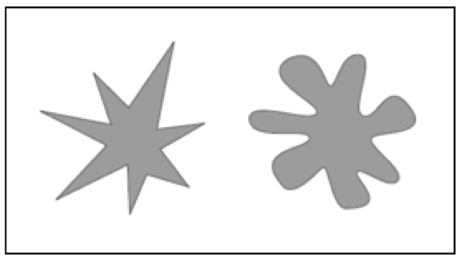
Figure 1.1: Bouba/Kiki effect
Despite the Bouba/Kiki effect, Taylor and Taylor’s research has shown that, while phonetic symbolism occurs but in not universal (Taylor et. al, 1962). Therefore, the writer’s/director’s intention of a language’s perception may not be what is actually “felt” by some international markets.
These studies tie in to my research extremely well. They each explore phones and their inherent connotations / associations. My study furthers these findings by exploring the field in a cross-linguistic manner.
Thusly, the true perception of phones can be effectively compared. For while sound systems are similar within language families (e.g. Romance languages), they differ vastly across families.
THIS STUDY
So far, studies have examined the perception of phones (inherent meaning of sounds intra-linguistically) and they have conducted cross-linguistic research (not necessarily with regards to phonosemantics). However, no study as of yet has studied both - if they have, it has been very narrow in scope (usually just 3 languages). With my research, I aim to study the perception of phones in a cross-linguistic manner with as many languages as possible, allowing for a greater understanding of connotation/association world-wide. In the next chapter, I go on to discuss the methodology used in conducting my study.

CHAPTER TWO

METHODOLOGY
Variables
In my studies (pilot and recent), I examined the relationship between individual phones and the cross-linguistic connotations thereof. The variables I tested included a wide variety of phones that are not as common cross-linguistically. I chose the less-common phones because, if participants have similar connotations to sounds regardless of its presence in their native language, this truly speaks to the inherent qualities of sounds. The phones I tested are /ə/, /u/, /a/, /i/, /d/, /ð/, /ʃ/, /θ/, /l/. The phones used in the distractor questions are /t/, /m/, /p/, and /k/. After examining a list of cross-language phoneme frequency, I noted that these were the most frequent (Maddieson, 1984). I aimed to test associations of phonemes which were not necessarily present in all languages. I hypothesized that (despite the differences in frequency between the distractor phones and the tested phones) the phones in the survey would show similar associations regardless of native language. I will also inquire as to the participants’ political affiliations. Past research (Oliver, Wood, Bass, 2015) shows that there is a connection between political affiliation and preferred phones. My studies explore this on a cross-linguistic level.
Study Procedures
In order to carry out this research, I created a questionnaire and administered it to each participant. The questionnaire consisted of a variety of alliterative phrases. Each question/phrase specified the phone sound in question, and participants rated their perception of the phone on a 1-5 Likert scale. At the beginning of the quiz, I explained exactly what I am researching, so there was no deception used. I administered the survey online using the tool “SurveyMonkey.” The survey was completed at the participants’ own pace and took approximately 20 minutes per person. Question responses were saved individually as participants proceeded through the survey. If at any time a participant decided that they did not wish to continue, they could simply close the browser window and their survey would be discarded.
The online survey consisted of 30 items. Each item asked the participant to rate the pleasantness of words on a 1-5 scale, with 1 being the least positive, and 5 being the most positive. Some of the words were real words in real languages, while others were artificial words. The participants were also asked a few short demographic questions about age, gender, native language, and political affiliation.
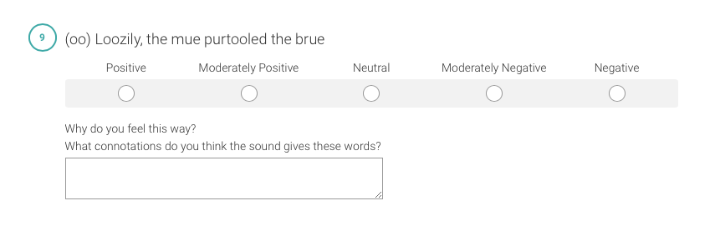Fig. 2.1: structure of question
Study Population
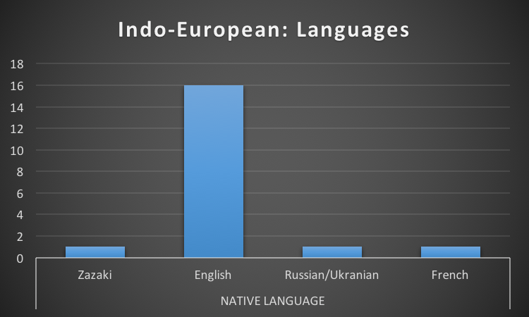
Figure 2.2
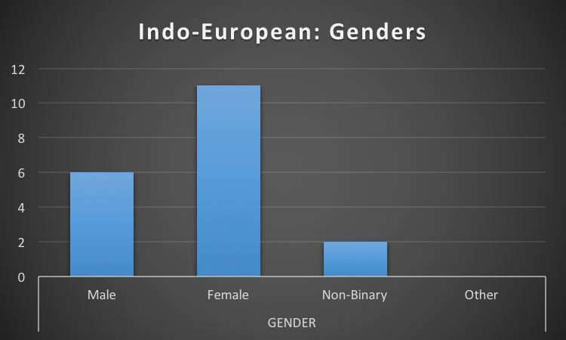
Figure 2.3
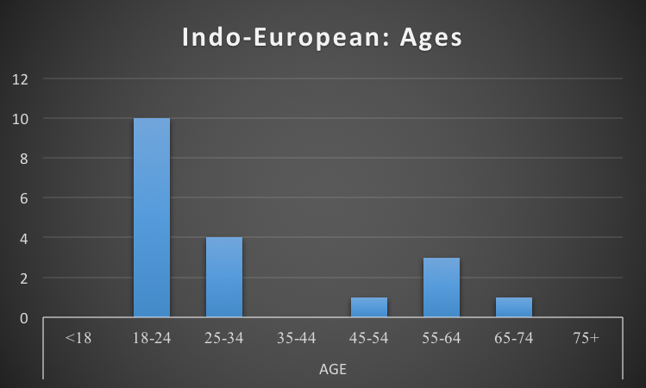
Figure 2.4
The study included 19 Indo-European native language speakers and 6 Non Indo-European language speakers. Within the IE group, the Native Languages included 1 Zazaki, 16 English, 1 Russian/Ukranian, and 1 French. The Genders included 6 male, 11 female, 2 non-binary, and 0 other. The ages included 0 of <18, 10 of 18-24, 4 of 25-34, 0 of 35-44, 1 of 45-54, 3 of 55-64, 1 of 65-74, and 0 of 75+.
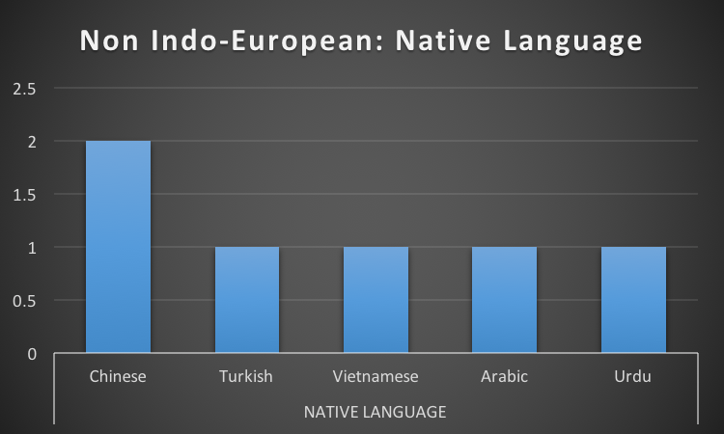
Figure 2.5
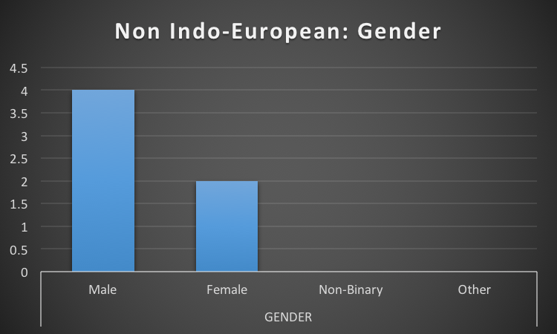
Figure 2.6
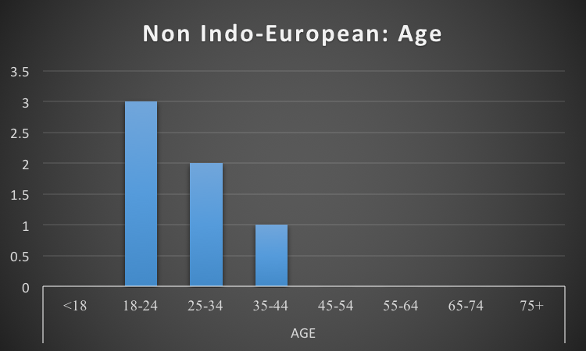
Figure 2.7
Within the NIE group, the Native Languages included 2 Chinese, 1 Turkish, 1 Vietnamese, 1 Arabic, and 1 Urdu. The Genders included 2 male, 2 female, 0 non-binary, and 0 other. The ages included 0 of <18, 3 of 18-24, 2 of 25-34, 1 of 35-44, 0 of 45-54, 0 of 55-64, 0 of 65-74, and 0 of 75+.
My population included native speakers of as wide a variety of languages as possible. There were no exclusion factors barring that the participant must have a native language. Dividing them into Indo-European and Non Indo-European groups on the basis of their native language, I aimed to have an approximately equal number of participants in each group. By gathering a wide variety of languages, I aimed to prevent linguistic similarities from acting as confounding variables. This did not end up being the case, as the study ended with 19 Indo-European native language speakers and 6 Non Indo-European native language speakers.
Examination of Phonological Systems
Also within this section, I will briefly discuss the differences between example phonological systems from the Indo-European and Non Indo-European language families.
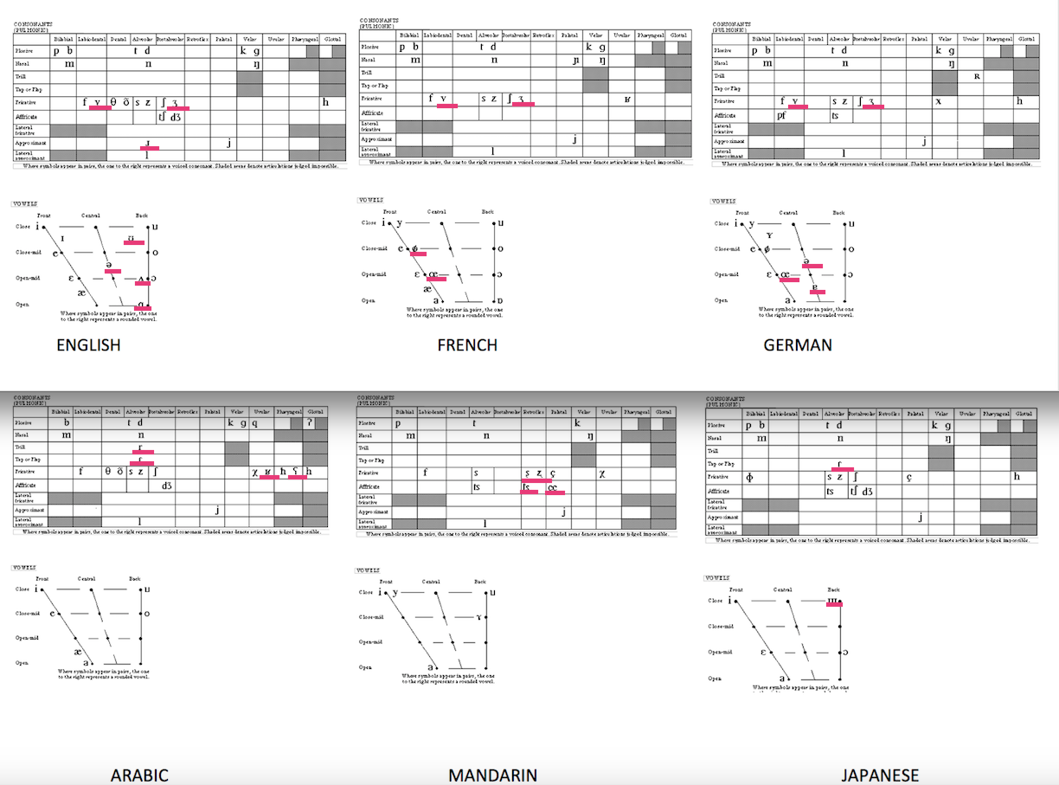

Figure 1.2: Indo European v. Non: Phone Comparison
To preface my research and discussion thereof, a table has been included comparing/contrasting various languages. The top row is Indo-European languages; the bottom row is Non Indo-European languages. According to the languages chosen - there are various patterns to note.
I-E languages have many more vowels than N-I-E languages. Arabic has 6 while Mandarin and Japanese have 5. By contrast, English and French use 12, while German uses 13. In some N-I-E languages, this is made up for by tonality, or altering the pitch of words.
I-E languages also use voiced fricatives that are lacking in the N-I-E languages - /v/ and /ʒ/ (labiodental and postalveolar). However, Arabic similarly employs fricatives that are lacking in I-E languages, specifically /χ/, /ħ/, and /ʕ/ (voiceless uvular, voiceless pharyngeal, and voiced pharyngeal). Considering the uvular, pharyngeal, and glottal columns, the N-I-E languages use many more phonemes than do I-E languages. Among the I-E languages considered, /ʁ/, /ʀ/, and /h/ are employed. The N-I-E languages, by contrast, use /q/, /χ/, /ʁ/, /ħ/, /ʕ/, /ʔ/, and /h/.
The N-I-E languages (especially Mandarin) use vastly more palatals and retroflexes than do the I-E languages, which use only /j/. The N-I-E languages compared employ /ʂ/, /ʐ/, /t͡s/, /ɕ/, and /j/.
In sum, N-I-E languages (according to the ones studied) generally employ far more phonemes with the place of articulation further back in the mouth than I-E languages do (the right 6 columns of the phoneme chart, excepting velars). This would include retroflexes, palatals, uvulars, pharyngeals, and glottals. The rest of the phoneme chart has little variation. Vowels by contrast, show higher levels of linguistic variation as N-I-E languages have far fewer vowels than do I-E languages.
Next, I will describe the results of a pilot study using these methods conducted in 2016, a year before the present research.
PILOT STUDY
In 2016, I conducted a pilot study of this research. My methodology was the same. A questionnaire was written (distributed online on SurveyMonkey) and administered it to each participant. The questionnaire consisted of a variety of alliterative phrases. Each question/phrase specified the phoneme sound in question, and participants rated their perception of the phoneme on a 1-5 Likert scale. At the beginning of the quiz, I explained exactly what I am researching, so the participants know exactly what is being researched. There was no deception used. As in my current study, I used a mix of sentence types - half with real English words, and half with invented words (generated by a computer program).
There were 26 participants total, with a wide variety of native languages. The traditional manner of dividing languages is into the two large groups of Indo-European and non Indo-European. In a study of larger scope, it would be more informative to make divisions along each language family (Indo-European as well as Altaic, Afro-Asiatic, etc.). However, given the small scope of this study, a singular division between Indo-European and Non was most practical.
The native languages in my study were, likewise, divided thusly. The native languages in the Indo-European family were English, German, Norwegian, Armenian, French, and Spanish, with 21 participants. The native languages in the Non Indo-European family were Vietnamese, Telugu, Mongolian, Turkish, Gujarati, Korean, Turkish, and Arabic, with 8 participants. 4 participants were represented in both categories, as they had been raised bilingually.
I hypothesized that the participants would find similar connotations as to the meanings of sounds regardless of their native language. Despite differences in language, the majority of the population did indeed have similar perceptions of the phones tested. Charts of my findings are below:

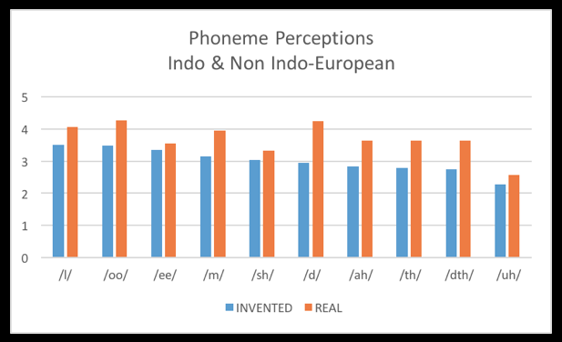
Fig. 2.8: Phoneme perceptions: Indo & Non Indo-European
This chart divides the population into the real v. invented phrases that were studied, graphing them according to specific phoneme. The invented/real graphs are distinctly related, all graphed within 1.5 points of each other.
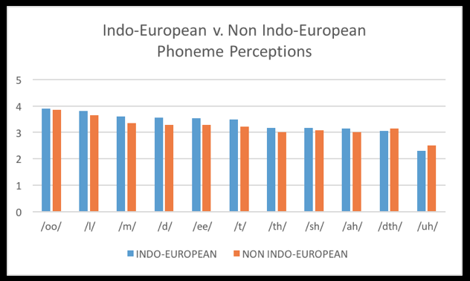
Fig. 2.9: Indo-European v. Non Indo-European Phoneme Perceptions
This chart divides the population into the two languages family of Indo-European and non. The two sections of the chart (the IE blue bars v the NIE red bars) are incredibly closely related, with the sections of the graphs within .5 points of the other.
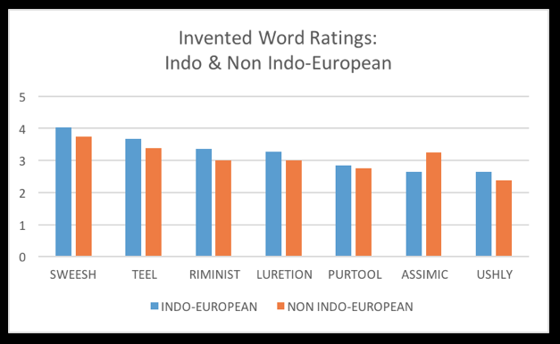
Fig. 2.10: Invented Word Ratings: Indo & Non Indo-European
This chart examines exclusively the invented words studied in question 31, divided into the language families Indo-European and Non Indo-European. The two sections of the chart are closely related, with the sections of the graphs within 1 point of each other.
I concluded that the phonemes tested are viewed approximately equally in both IE and Non IE languages. Positively-rated phones were /u/, /l/, and /m/ (Liquids, Nasals, Close vowels). Negatively-rated phones were /a/, /ð/, and /ə/ (Fricatives, Open vowels). Phones with somewhat mixed opinions were /d/, /θ/, /i/, and /ʃ/. Participant comments for positively-viewed phonemes were: /u/ : ”seems fluid”; /m/ : “calming”, “warm, comforting”; /l/ : “flowing”, “soft and smooth”. Comments regarding negatively-viewed phonemes were: /a/ : “serious, important”, ”formal”, “pompous or aloof”; /ð/: “complex and uncomfortable”, “important”; /ə/ : “strained”, ”closed”, “slow, heavy”.
By conducting this study, I was able to see some preliminary results, and I was eager to carry it out with a larger sample size. In my recent study, I incorporated the use of distractor questions with the phones /t/, /m/, /p/, and /k/. The phones I was truly testing were the vowels (from high to low) /i/, /u/, /ə/, and /a/, and the consonants (in increasing order of sonority) /d/, /θ/, /ʃ/, /ð/, and /l/. I changed the IPA notation on the survey (for the participants’ sake) to /t/, /m/, /p/, /k/, /i/, /ah/, /uh/, /oo/, /d/, /dth/, /sh/, /th/, and /l/. By incorporating distractor questions, I examine phones that are most common across languages, working to ensure there that phone frequency within a language is not a source of bias. This pilot study showed that there are indeed cross-linguistic associations with phones.
After conducting the pilot study, I was able to refine the survey for my recent study. The changes included incorporation of distractor questions using the phones /t/, /m/, /p/, as well as introducing new test phones to compensate.
In the next chapter, I introduce the results from the most recent study.

CHAPTER THREE

RESULTS
To analyze my results, I first split my population into the groups of Indo-European and Non Indo-European. These are two key language “families” and a common way of analyzing linguistic differences. Since the languages therein have different origins, the vocabulary roots, phones, etc. will be entirely different.

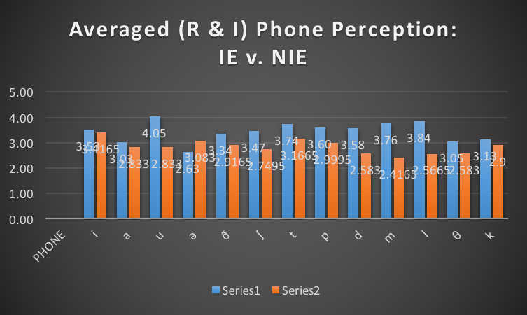
Fig. 3.1

Phone | IE Avgs | NIE Avgs
i | 3.53 | 3.4165
a | 3.03 | 2.833
u | 4.05 | 2.833
ə | 2.63 | 3.083
ð | 3.34 | 2.9165
ʃ | 3.47 | 2.7495
d | 3.58 | 2.583
l | 3.84 | 2.5665
θ | 3.05 | 2.583
Fig 3.2
In Figures 3.1 & 3.2, the charts show a comparison of Indo-European and Non Indo-European Phoneme Perception. In this chart, the average phone perception of the Real and Invented phone uses have been further averaged together. Hereafter, “invented phone” will simply refer to phones being used in Invented phrases; “Real phone” will refer to phones being used in Real phrases of real English words. This chart aims to create a more holistic look at phone perception between the groups of IE and NIE.
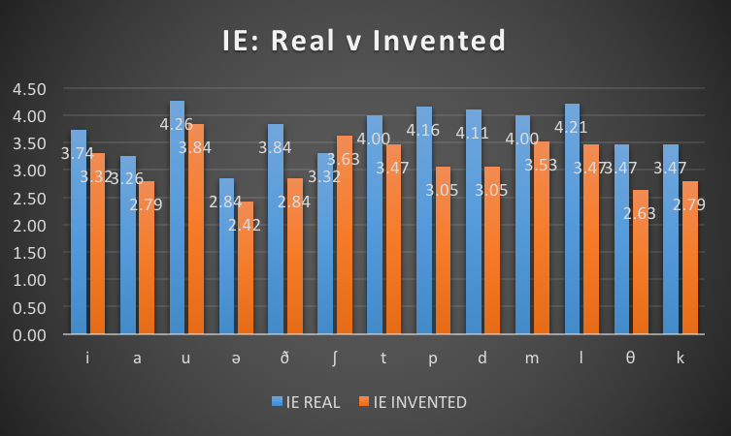
Fig. 3.3

PHONE | REAL | INVENTED
i | 3.74 | 3.32
a | 3.26 | 2.79
u | 4.26 | 3.84
ə | 2.84 | 2.42
ð | 3.84 | 2.84
ʃ | 3.32 | 3.63
d | 4.11 | 3.05
l | 4.21 | 3.47
θ | 3.47 | 2.63
Fig 3.4
Figures 3.1 & 3.2 demonstrate opinions of the IE native language speakers, split into the categories of “real phones” and “invented phones.” There is little variation between the two categories of Real and Invented.

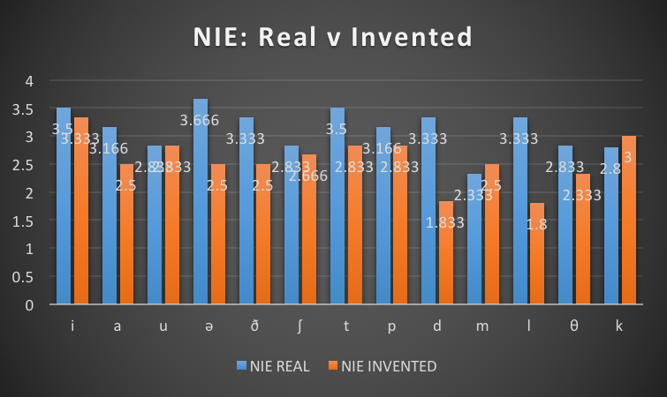
Fig. 3.5
PHONE | REAL | INVENTED
i | 3.5 | 3.333
a | 3.166 | 2.5
u | 2.833 | 2.833
ə | 3.666 | 2.5
ð | 3.333 | 2.5
ʃ | 2.833 | 2.666
d | 3.333 | 1.833
l | 3.333 | 1.8
θ | 2.833 | 2.333
Fig 3.6
Figures 4.1 & 4.2 complement the one above - it examines the same facet of Real v. Invented, yet from the NIE perspective. There is little variation between the two categories of Real and Invented.

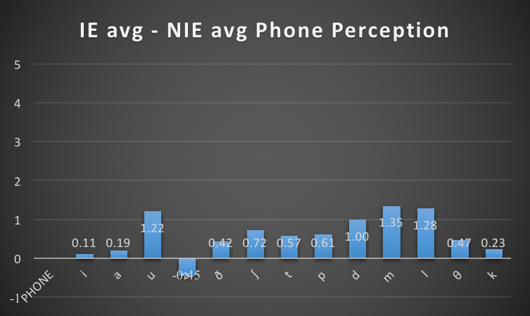
Fig. 3.7
Phone | IE Avg-NIE Avg
i | 0.11
a | 0.19
u | 1.22
ə | -0.45
ð | 0.42
ʃ | 0.72
d | 1.00
l | 1.28
θ | 0.47
Fig. 3.8
Figures 5.1 & 5.2 examine the differences in the averages of IE and NIE phone perception. To find these results, the average rating of Real and Invented were averaged to create a more holistic, singular perspective. Then, the averages of the NIE were subtracted from the averages of the IE averages in order to find the difference. The differences in phone perception across the two groups was in fact relatively small. On a rating of 1-5 (not 0-4), the largest difference was 1.35. One bar falls below the X-axis due to that particular IE-NIE value having a negative difference.
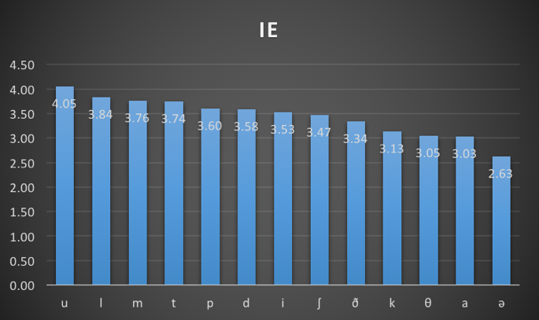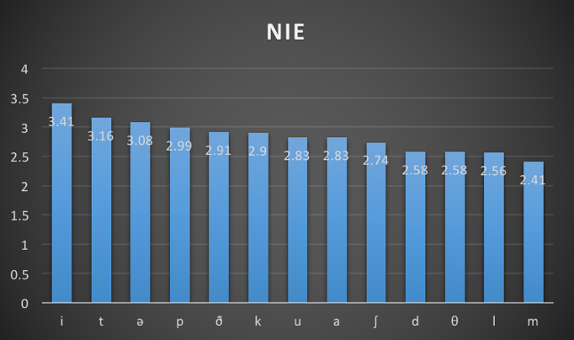
Fig. 3.9 Fig. 3.10

PHONE | IE | PHONE2 | NIE
u | 4.04 | i | 3.41
l | 3.84 | ə | 3.08
d | 3.58 | ð | 2.91
i | 3.53 | u | 2.83
ʃ | 3.47 | a | 2.83
ð | 3.34 | ʃ | 2.75
θ | 3.05 | d | 2.58
a | 3.03 | θ | 2.58
ə | 2.63 | l | 2.57

Fig 11
Figures 6.1 & 6.2 show the ranking (positive → negative) of IE and NIE languages. The X-axis has two parts in a sense, showing the corresponding IE phone on the left and corresponding NIE phone on the right (in order to show both rankings on the same chart.
Open-Ended Comments
The second section of my survey consisted of open-ended comment boxes corresponding to each question. Since phonosemantics is based largely on personal association to sounds, an additional, open-ended insight into the participants’ thoughts aided in uncovering specific associations (and, sometimes, reasoning behind these associations). To analyze the comments, I took it as organic data and tabulated the frequency of the most common descriptor words. These words/word frequencies provide insight into the associations/connotations of each tested phone. The tabulation tables appear in the appendix (item 2).
In the next chapter, I discuss the results in more detail, limitations on the study, and possible future research.

CHAPTER FOUR

DISCUSSION

Results from my study show that the two groups were in remarkable agreement about the connotation of phones. Since I divided the data into two groups (Indo-European and Non), I will begin by discussing each group independently before comparing/contrasting them.
Multiple Choice / Ranking
Indo-European
I will begin first with the IE group. In examining Figure 3.11 (see below), we see a ranking of their phone preferences (u, l, d, i, ʃ, ð, θ, a, ə).
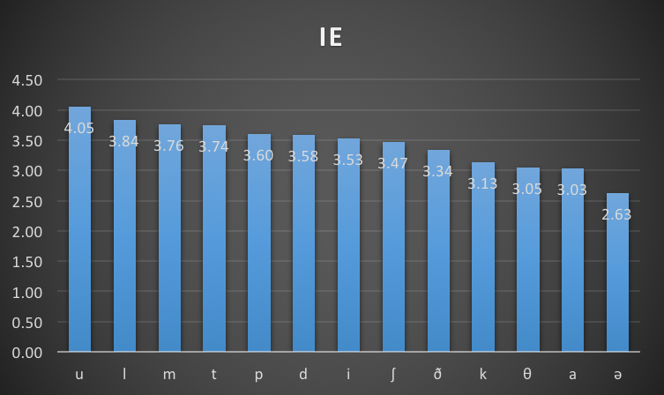
First, let us consider the vowels. That is - u, i, a, ə. The close vowels (oo and ee) (ranked 4.04 and 3.84, respectively) fall at the far left side of the axis, as they are ranked most positively. The more open vowels (ah and uh) fall at the far right side of the axis (ranked 3.03 and 2.62 respectively). As for why this is the case, that is a question for a different study (perhaps it is biologically based, though it is not yet known). However, we can analyze patterns in the data we have. For instance:
/i/ is a close-front tense vowel;
/u/ is a close-back tense vowel;
/a/ is an open-front tense vowel; and
/ə/ is a mid-central lax vowel.
Therefore, it seems that IE native language speakers prefer close vowels over all other attributes. Furthermore, they seem to prefer tense vowels over lax vowels, as /uh/ is notably ranked last.
Next let us consider the consonants. That is - l, d, ʃ, ð, θ. Within the IE language group, the liquid consonant /l/ was ranked most highly (3.84). The plosive consonant /d/ came second (3.58), followed by /ʃ/, /ð/, then /θ/ (3.47, 3.34, 3.05).
Non Indo-European
Now, I will discuss the NIE group. In Figure 3.12 (see below), we see a ranking of their phone preferences (i, ə, ð, u, a, ʃ, d, θ, l).
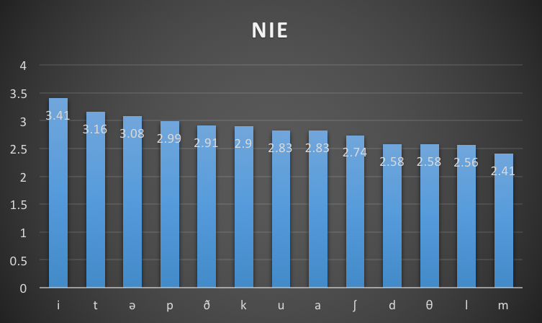
First, let us consider the vowels. That is - i, ə, u, a. The patterns in the NIE are not as clear-cut as they were in the IE dataset. However, one could map the order of preference as traveling across the top (and mid) of mouth, ending in an open-back vowel as least preferable. Furthermore, all vowels were rated relatively high, falling on the left-to-mid areas of the chart.
Next, let us consider the consonants. That is - ð, ʃ, d, θ, l. Within the NIE group, the /l/ consonant was ranked most lowly. The stop /d/ fell third from last, with fricatives scattered throughout the chart.
Indo-European / Non: Comparison
I will now compare the data of the two groups. Broadly speaking, it seems that the groups share a preference for close vowels. However, the NIE group rank all vowels relatively high, seeming to prefer them to consonants.
The groups had opposite opinions on the liquid consonant /l/, with IE ranking it quite highly, and NIE ranking it relatively lowly.
Neither group seemed to have strong preferences towards fricatives - both groups show them scattered in the middle of the chart.
Comment Analysis
In this next section, I will analyze and discuss the open-ended comment section that was included in my survey.
Indo-European
Again, I will start with IE and will begin by considering the vowels. The positive ranking of /oo/, was reflected in the comments as well. It was described 6 times as a whimsical/happy/fun/silly sound. One commenter even described it as “better than everything else.” /ee/’s positive ranking was also reflected in the comments. Similarly, it was described 7 times as fun/whimsical/happy/silly/light-hearted. One commenter observed that pronouncing it “feels like smiling.” The /ah/ and /uh/ sounds, lower-ranked, were explained in the comments. /ah/ was disliked for its proximity to guttural vowels (“not quite guttural”); it is probably the back position of articulation that makes it also seem “proper,” “strict,” and “serious.” /uh/ was disliked for its similarity to filler sounds like uh or um. Commenters described it as sounding “not knowing,” “confused,” and “unsure.”
Next, I will discuss the consonants. /l/, the most highly ranked consonant by IE native language speakers, did very well. Three commenters described it with musical adjectives (singing, lilting, lyrical), also commenting that it sounded “soft” and “soothing.” IE speakers seemed to prefer plosives such as /d/ for their precision (precise, sure, solid, crisp). By contrast, they dispreferred fricatives for the same reason, repeatedly describing them as evocative of a lisp.
Non Indo-European
Now, I will discuss the perspective of NIE. Due to a small sample size, the number of comments in the NIE group is rather limited. However, I will compare the comments to the rankings and see which comments seem to fit the population as a whole.
Regarding vowels, /ee/ was twice described as “happy,” while /oo/ was twice described as “negative.” This makes sense, because in the ranking, /ee/ is ranked much higher than /oo/.
Regarding consonants, /l/ was twice described in a negative light (bad, creepy). The two highest ranked consonants, /ð/ and /ʃ/ were described using the words joy and protection, respectively.

CHAPTER FIVE

CONCLUSIONS
Conclusions
So, how do these findings address the preliminary research questions? I sought out to find if phone associations remained constant cross-linguistically. Indeed, upon examining the data as broader classes of phones, patterns begins to emerge. Both groups rank close-vowels quite highly. Fricatives emerged as a neutral sound (both in the comments and in the numbers), falling in the middle of the scale for both groups. Yet, these results are troubled by a few differences. For instance, IE speakers viewed the /l/ phone as one of the most positive, while for NIE it was among the most negative. Furthermore, whereas IE speakers only preferred close-vowels, NIE speakers ranked all tested vowels quite highly.
At this point, it is interesting to re-examine the phone chart from Figure 1.2. One notices, for instance, that fricatives (neutrally-rated in both groups) are common in both language families. Furthermore, close-vowels are common to the example languages in the comparison chart. By contrast, one notes that all IE languages have several vowels - around 12 each. Yet, the NIE languages have much fewer - around 5 each. Perhaps it is this difference in vowel frequency that contributes to the difference in close-vowel perception. The lateral approximate /l/ appears in almost all languages, so possible reasoning for the inconsistancy here cannot be found in the chart. However, one may note that the phone /l/ is used many NIE words of negation (such as Arabic /la/); the source of the discrepancy for /l/ may lie there.
Due to these patterns, I can neither reject nor altogether fail to reject the null hypothesis. By conducting further research, I hope to strengthen my findings and fortify this refutation. Indeed, with a larger sample size, clearer results would begin to emerge.

Limitations
While this study has shed some light on the subject of cross-linguistic phonosemantics, it is not large enough in scope to provide sufficient evidence for or against. Limitations of the study included small sample size, time constraints, voluntary response, and mixing of lexical meanings with inherent phone meanings.
The primary constraint on the study was time. I was able to collect data for only one week in order to have time to tabulate/analyze my results. The time constraint, in turn, limited sample size. It is probable that with more time, I could have gathered more participants. I ended up with a sample size of 25 (19 Indo-European; 6 Non). The small quantity prevents me from drawing more generalized claims about language perception as a whole. While I had several English speakers, I was very lacking in terms of other IE and NIE native language speakers. This lack of participants creates easily biased results.
The voluntary-response style of the survey also limited the study. If participants had been recruited differently, and/or obliged to take/finish the survey, it is likely the sample size would have been larger.
Another limitation was the crossing of lexical meaning with the inherent phone meanings I was attempting to study. I attempted to account for this ahead of time by including both Real and Invented phrases. Yet, participants were affected by both - Real phrases led them to focus on lexical meaning, while Invented phrases bothered them due to “gibberish.” It is possible that this caused affected the participants’ rankings.

Future Research
Further research is needed in order to determine if cross-linguistic phonosemantics truly exists. Subsequent projects could continue with studies similar to this one, yet with larger sample sizes. The survey could be augmented to include phones from language systems other than English. Furthermore, if cross-linguistic phonosemantics does exist, future studies could examine why this is the case; i.e. is it grounded in biology (for example, Blasi’s finding that /m/ possibly reflects the sound of babies suckling) or something else?

REFERENCES
Blasi, Damián E.; Wichmann, Søren; Hammarström, Harald; Stadler, Peter F.; Christiansen, Morten H. (2016). "Sound-meaning association biases evidenced across thousands of languages." PNAS.
Boulton, Marjorie. (1982). The Anatomy of Poetry. 46-52.
Brown, Roger W., Abraham H. Black, and Arnold E. Horowitz. (2017). “Phonetic Symbolism in Natural Languages” Harvard University.
Fischer-Jørgensen, Eli. (1978). "On The Universal Character of Phonetic Symbolism with Special Reference to Vowels." Studia Linguistica 32.1-2: 80-90.
Fónagy, Ivan. (2001). Languages Within Language: an Evolutive Approach. 33-41.
Fónagy, Ivan. (1999). "Why Iconicity?" Form Miming Meaning: Iconicity in Language and Literature. 3-36.
Jayarava. (2008). "Visible Mantra." Phonosemantics.
Kelley, Sharon. (2010). "Playing God: World-Making Words." English Literary File: University of South Carolina Upstate. 2: 16-22.
Klink, R.R. (2000). “Creating Brand Names with Meaning : The Use of Sound Symbolism.” Marketing Letters.
Köhler, Wolfgang. (1929). Gestalt Psychology. H. Liveright.
Ohala, J. “An ethological perspective of common cross-language utilization of F₀ of voice.” Phonetica.
Maddieson, Ian, Kristin Precoda. (1984). UCLA Phonological Segment Inventory Database.
Miall, David S. (2001). "Sounds of Contrast: An Empirical Approach to Phonemic Iconicity." Poetics. 29.1: 55-70.
“Proto-Indo-European Phonology” (2017). Dnghu.
Saussure, Ferdinand de. (1916). "Nature of the Linguistics Sign", in: Charles Bally & Albert Sechehaye (Ed.), Cours de linguistique générale, McGraw Hill Education. 66-70.
"Sound Symbolism." (2014). Oxford English Dictionary.
Stockwell, Peter. (2006). "Invented Language in Literature." in Encyclopedia of Language & Linguistics. Ed. Keith Brown. 2nd ed. Vol. 6. Oxford: Elsevier. 3-10.
Swadesh, Morris. (1952). "Lexicostatistic dating of prehistoric ethnic contacts." Proceedings American Philosophical Society.
Taylor, Insup Kim, and Maurice M. Taylor. "Phonetic Symbolism in Four Unrelated Languages." Canadian Journal of Psychology/Revue Canadienne De Psychologie 16.4 (1962): 344-56.
Ufot, Bassey Garvey. (2013). "Phonology and Stylistics: A Phonaesthetic Study of Gray’s ‘Elegy Written in a Country Churchyard’." English Linguistics Research 2.2.
Vanden Bergh, Bruce G; Collins, Janay; Schultz, Myrna; Adler, Keith. (1984). "Sound Advice on Brand Names." Journalism Quarterly.
Whissell, Cynthia. (1999). "Phonosymbolism and the Emotional Nature of Sounds: Evidence of the Preferential Use of Particular Phonemes in Texts of Differing Emotional Tone." Perceptual and Motor Skills. 89.1: 19-48.
Yorkston, Eric; Menon, Geeta. (2004). "A Sound Idea: Phonetic Effects of Brand Names."
Journal of Consumer Research.

APPENDIX

1. Survey
1. What is your native language? (If you learned 2+ simultaneously, please list all)
2. What is your gender?
Male Female Non-Binary Other
3. What is your age?
<18 18 to 24 25 to 34 35 to 44 45 to 54 55 to 64 65 to 74 75 +
4. (ee) Freezy breeze made these three trees freeze
Positive Moderately Positive Other (please specify) Neutral Moderately Negative Negative
Why do you feel this way? What connotations do you think the sound gives these words?
5. (ah) The father saw that the stars were small
Positive Moderately Positive Other (please specify) Neutral Moderately Negative Negative
Why do you feel this way? What connotations do you think the sound gives these words?
- (uh) The etumer unsmoon was ushly upostic
Positive Moderately Positive Other (please specify) Neutral Moderately Negative Negative
Why do you feel this way? What connotations do you think the sound gives these words?
7. (oo) The blue balloon flew to the zoo Positive Moderately Positive
Positive Moderately Positive Other (please specify) Neutral Moderately Negative Negative
Why do you feel this way? What connotations do you think the sound gives these words?
8. (ah) Armalted, the lahmpete of ahzdids angahned assimically
Positive Moderately Positive Other (please specify) Neutral Moderately Negative Negative
Why do you feel this way? What connotations do you think the sound gives these words?
9. (oo) Loozily, the mue purtooled the brue Positive Moderately Positive
Positive Moderately Positive Other (please specify) Neutral Moderately Negative Negative
Why do you feel this way? What connotations do you think the sound gives these words?
10. (uh) An unnamed update on the money
Positive Moderately Positive Other (please specify) Neutral Moderately Negative Negative
Why do you feel this way? What connotations do you think the sound gives these words?
11. (ee) The teely sweesh of splateens were elioid
Positive Moderately Positive Other (please specify) Neutral Moderately Negative Negative
Why do you feel this way? What connotations do you think the sound gives these words?
12. (t) The tola stropated the teel with tription
Positive Moderately Positive Other (please specify) Neutral Moderately Negative Negative
Why do you feel this way? What connotations do you think the sound gives these words?
13. (d) The discid reddom is devidly redicular
Positive Moderately Positive Other (please specify) Neutral Moderately Negative Negative
Why do you feel this way? What connotations do you think the sound gives these words?
14. (dth) Hither and thither together with the feather
Positive Moderately Positive Other (please specify) Neutral Moderately Negative Negative
Why do you feel this way? What connotations do you think the sound gives these words?
15. (sh) Shut the shutter before it makes you shudder
Positive Moderately Positive Other (please specify) Neutral Moderately Negative Negative
Why do you feel this way? What connotations do you think the sound gives these words?
16. (p) unperal perin gave a porrive pable
Positive Moderately Positive Other (please specify) Neutral Moderately Negative Negative
Why do you feel this way? What connotations do you think the sound gives these words?
17. (t) What a tale their turbulency tells
Positive Moderately Positive Other (please specify) Neutral Moderately Negative Negative
Why do you feel this way? What connotations do you think the sound gives these words?
18. (th) Finith the parth and the thamil
Positive Moderately Positive Other (please specify) Neutral Moderately Negative Negative
Why do you feel this way? What connotations do you think the sound gives these words?
19. (dth) The synothe and dethem were amithed to fethen
Positive Moderately Positive Other (please specify) Neutral Moderately Negative Negative
Why do you feel this way? What connotations do you think the sound gives these words?
20. (sh) Infrush the sweesh of shillimer
Positive Moderately Positive Other (please specify) Neutral Moderately Negative Negative
Why do you feel this way? What connotations do you think the sound gives these words?
21. (p) Pandas and peacocks played at the park
Positive Moderately Positive Other (please specify) Neutral Moderately Negative Negative
Why do you feel this way? What connotations do you think the sound gives these words?
22. (d) The droplets dance daintily in the darkness
Positive Moderately Positive Other (please specify) Neutral Moderately Negative Negative
Why do you feel this way? What connotations do you think the sound gives these words?
23. (k) The krous karized by the keeth
Positive Moderately Positive Other (please specify) Neutral Moderately Negative Negative
Why do you feel this way? What connotations do you think the sound gives these words?
24. (m) The murmuring of innumerable mice
Positive Moderately Positive Other (please specify) Neutral Moderately Negative Negative
Why do you feel this way? What connotations do you think the sound gives these words?
25. (l) Lightly, leaves blew across the floor
Positive Moderately Positive Other (please specify) Neutral Moderately Negative Negative
Why do you feel this way? What connotations do you think the sound gives these words?
26. (th) Through thousands of threads of thoughts
Positive Moderately Positive Other (please specify) Neutral Moderately Negative Negative
Why do you feel this way? What connotations do you think the sound gives these words?
27. (k) The kangaroos kicked the keyboard
Positive Moderately Positive Other (please specify) Neutral Moderately Negative Negative
Why do you feel this way? What connotations do you think the sound gives these words?
28. (m) The motym by the morac was riministic
Positive Moderately Positive Other (please specify) Neutral Moderately Negative Negative
Why do you feel this way? What connotations do you think the sound gives these words?
29. (l) The loophy luretion was alize and teely
Positive Moderately Positive Other (please specify) Neutral Moderately Negative Negative
Why do you feel this way? What connotations do you think the sound gives these words?
30. Please rank the words below from best to worst (according to sound, not definition)
6 (Best)
5
4
3
2
1 (Worst)
Negative
Illicit Mellifluous Chunk Pulchritude Ethereal Pulp
31. How positive/negative do you view the following words? (according to sound, not definition)
Positive
Moderately positive
Neutral
Moderately negative
Negative
Sweesh Riminist Assimic Ushly Purtool Teel Synth Part Luretion

32. How would you describe your political affiliation?
33. Choose the term that best describes your views
Socialism Liberalism Center Conservatism Libertarianism Authoritarianism Don't know
34. Do you prefer Individualism or Populism?
Individualism Populism Don't know

2. Indo-European Comment Tabulation
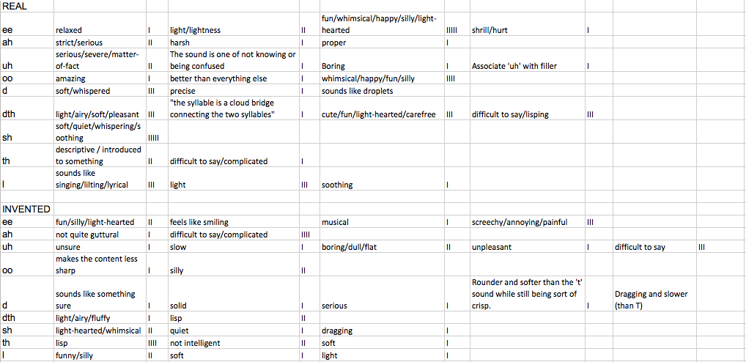

3. Non Indo-European Comment Tabulation
