A novel transmembrane ligand inhibits T cell receptor activation

A Dissertation Presented for the
Doctor of Philosophy
Degree
The University of Tennessee, Knoxville

Yujie Ye
December 2022

Copyright © 2022 by Yujie Ye
All rights reserved.

DEDICATION

This work is dedicated to the memory of Dr. Elizabeth Howell, one of my previous Ph.D. committee members, and people who suffer from cancer, inflammatory and autoimmune diseases each year globally.

ACKNOWLEDGEMENTS

To my family members, for their years of love, support, and always patience with me

To my Ph.D. advisor, Dr. Francisco N. Barrera, for his guidance and visions. I enjoy discussing science with him, especially biophysics.

To my committee, Drs. Rachel P. McCord, Dan M. Roberts, and Michael D. Best, for their helpful feedbacks on my projects.

To Dr. Art Weiss (UCSF) for generous advice and kindly gifting some key experimental materials.

To my current lab mates, Jennifer Schuster, Boomer Russell, Alyssa Ward, Ryan Schuck, and Jordan Pyron, for their advice and companionship. I enjoy having lunch with you.

To my previous lab mates, Drs. Justin Westfield, Vanessa Nguyen, Katherine Stefanski, Haden Scott, and Daiane Alves, for their advice and companionship. I enjoy having lunch, coffee, and celebrations with you.

To Drs. Barry D. Bruce (UTK), Matthew Call (WEHI), Peiqing Sun (WFBC), and Barry Rouse (UTK), for their useful advice for my research.

To collaborators, Shumpei and Dr. Jay T. Groves (UC-Berkeley), for their beautiful data and interesting scientific discussions.

To Dr. Ed Wright (UTK), Jaydeep Kolape (AMIC, UTK), Dr. Trevor Hancock (Sparer lab, UTK), and Dr. Sarah Kauffman (Goodrich-Blair lab, UTK) for their helpful technical support.

To BCMB department, University of Tennessee, for providing friendly and supportive environments.

To NIH funding agencies, for continuing funding Barrera lab, so that my research project can finish.

Thank you

ABSTRACT
T lymphocytes (T cells) play essential roles in the adaptive immune system. Each mature T cell expresses one type of functional T cell receptor (TCR). The TCR recognizes antigens bound to the major histocompatibility complex (MHC) in antigen presenting cells. The resulting stimulation signal crosses the transmembrane domain of TCR and initiates downstream signaling cascades. The human immune system relies on TCRs to recognize a variety of pathogens. Normally, TCR can distinguish the self-antigens from pathogenic antigens. However, dysfunction or aberrant expression of TCRs causes different inflammatory and autoimmune diseases, which afflict millions of people annually (Chapter I). Current treatments for TCR dysfunction diseases lack efficacy and often have side effects due to lack of target specificity. Intriguingly, an acidic (low pH) extracellular microenvironment has been found in multiple TCR-associated diseases. Drugs that specifically target tissue acidity are expected to cause fewer side effects. Francisco Barrera and colleagues successfully developed pH-responsive membrane peptides using a rational design approach. This approach introduces pH-responsive residues to the designed peptide, causing an alternation of peptide polarity. As a result, the designed peptide becomes α-helix and inserts into the membranes only at acidic pH (Chapter II). We used this approach to design a pH-responsive peptide based on the transmembrane domain of human TCR, termed PITCR. Our aim was to use this peptide to inhibit TCR activation that causes disease. In agreement with our hypothesis, PITCR interacts with TCR and reduces TCR activation. PITCR allosterically interrupts the receptor changes leading to TCR activation (Chapter III). In addition to the potential therapeutic value, the transmembrane peptide PITCR can also be applied to investigate the transmembrane interaction and dynamics that occur upon TCR activation (Chapter IV).

TABLE OF CONTENTS

CHAPTER I. INTRODUCTION 1
1.1 T cells in the adaptive immune system 2
1.2 T cell receptor 3
1.3 T cell receptor activation 12
1.4 T cell receptor proximal signaling pathways 17
1.5 T cell receptor distal signaling pathways 23
1.6 Dysregulation of T cell receptor signaling in diseases 26
CHAPTER II. PH-RESPONSIVE PEPTIDES 28
2.1 pH-responsive amino acids 29
2.2 pH-responsive amino acids applications 30
2.3 GALA peptide and its variant, KALA 32
2.4 pHLIP and variants 33
2.5 ATRAM and variants 41
2.6 TYPE7 (TYPE-C2) and variants 47
2.7 Other pH-responsive peptides 56
CHAPTER III. ALLOSTERIC INHIBITION OF THE T CELL RECEPTOR BY A DESIGNED MEMBRANE LIGAND 63
Abstract 65
Introduction 66
Results 68
PITCR decreases phosphorylation of the ζ chain upon TCR activation. 68
Phosphorylation of TCR proximal signaling molecules is downregulated by PITCR. 70
PITCR reduces intracellular calcium response. 70
Inhibition of TCR engagement with antigen presenting cells. 74
PITCR interacts with the TCR 74
PITCR weakens the interaction of the ζ subunit with the rest of the complex after TCR activation. 81
Discussion 82
Materials and Methods 89
CHAPTER IV. CONCLUSION 108
4.1 Conclusions and discussions 109
REFERENCES 115
APPENDICES 132
APPENDIX I 133
APPENDIX II 143
APPENDIX III 146
APPENDIX IV 149
VITA 153

LIST OF Tables

Table 1. K_{D} values between anti-CD3 (OKT3 and UCHT1) and TCR-CD3 18
Table 2. Sequences of GALA peptide and KALA peptide. 34
Table 3. Blue shifts (λ_{max}) of GALA peptide in three different cations ⁸². 35
Table 4. Sequences of pHLIP and its variants 40
Table 5. Sequences of ATRAM and its variants 46
Table 6. Sequences of partial EphA2 and TYPE families 57
Table 7. Sequences of melittin peptide and its variants 58
Table 8. Antibodies 99

LIST OF Figures

Figure 1. The gradual loss of multi-potency and commitment to T cell lineage. 4
Figure 2. αβ-T cell receptor. 6
Figure 3. TCR activation by pMHC. 7
Figure 4. Cartoons of four TCR activation models. 14
Figure 5. An overview of the human TCR proximal and distal signal pathways upon TCR activation by APC. 21
Figure 6. The simple cartoon of the human Calcium-NFAT signal pathway upon 22
Figure 7. Cartoon of three distinct states of pHLIP. 38
Figure 8. Membrane entry and exit of pHLIP. 39
Figure 9. Cartoon of pHLIP delivery of cargo to acidic diseased tissue surface. 42
Figure 10. Cartoon of pHLIP delivery of cargo to the intracellular region. 43
Figure 11. Eph receptors interact with their relevant ligands. 48
Figure 12. Cartoon of human EphA2 receptor structure. 50
Figure 13. Cartoon of human EphA2 receptor structure. 51
Figure 14. Helical Wheel diagrams of pHLIP, GALA, MelP5, MelP5_Δ4, and MelP5_Δ6. 62
Figure 15. PITCR reduces phosphorylation of the ζ chain in response to OKT3. 69
Figure 16. PITCR reduces phosphorylation of TCR proximal signaling proteins after activation. 71
Figure 17. PITCR reduces the TCR intracellular calcium response. 73
Figure 18. PITCR reduces CD69 expression after T cell activation by APC. 75
Figure 19. PITCR colocalizes with TCR. 77
Figure 20. Colocalization of PITCR and the TCR-pMHC complex in primary murine 79
Figure 21. PITCR interacts with TCR. Jurkat cells were treated with PITCR-680. 80
Figure 22. PITCR weakens the interaction of the ζ chain with the rest of the complex after TCR activation. 83
Figure 23. Cartoon model of PITCR interaction with TCR. 85
Figure 24. Higher levels of Na+ lead to different FI changes of NBD conjugated to the Ct of pHLIP in state II. 143
Figure 25. Determination of the partition coefficient (Kp) for pHLIP binding to POPC. 144
Figure 26. Different peptides’ Kp values in different environments. 146
Figure 27. ATRAM2 Kp values. 147
Figure 28. Ligand and lipid compositions decide EphA2 signaling. 151

Chapter I. Introduction

1.1 T cells in the adaptive immune system
The immune system helps us defend ourselves from harmful microorganisms and serious diseases. It is composed of innate immune response and adaptive immune response. The innate immune response in humans is present from birth, such as skin and the respiratory tract, while the adaptive immune system is more advanced compared with the innate immune system since it can apply memory functions to kill pathogens when reinfection occurs. The adaptive immune system contains two main immune cells, B cells (B lymphocytes) and T cells (T lymphocytes). B cells secrete antibodies that bind to pathogens, whereas T cells are able to kill virus-infected cells directly or help other immune cells to eliminate pathogens to defend the body ¹.
Once activated functionally, naïve T cells can act as effector T cells. Effector T cells can be divided into three main classes, cytotoxic T cells (Tc), helper T cells (Th), and regulatory T cells (Treg). Effector cytotoxic T cells can directly kill infected host cells secreting perforins and granzymes. Helper T cells are able to activate B cells to make antibody, macrophages to destroy the pathogens they harbor, dendritic cells to activate T cells, and cytotoxic T cells to become effector T cells to kill pathogen-infected host cells. Regulatory T cells inhibit other types of immune cells via secreting cytokines, such as IL10 and TGF-beta ².

1.2 T cell receptor
What does enable T cells to execute biological functions? The answer is the T cell receptor (TCR). TCR was discovered by James P. Allison in 1982 ³. In 1984, Mark M. Davis ⁴ and Tak Wah Mak ⁵ cloned cDNA encoding mouse and human TCR, respectively. These milestones facilitate the progress of basic immune system study and immune-associated therapeutics.
In humans, the dominant type of TCR is α and β – TCR. In addition, three other types of TCR exist. They are the γδ-TCR, the mucosal associated invariant T cells – TCR (MAIT-TCR), and the nature-killer T cells – TCR (NKT-TCR). The amount of human γδ-TCRs is found within 5% and most of them are located in the gut mucosa. The MAIT-TCR can recognize the bacterially derived vitamin B presented by the MHC I-like protein (MR1). In Type 1 and Type 2 NKT cells, these NKT-TCR recognize lipids and glycolipids presented by CD1d instead of peptide bound to major histocompatibility complexes (pMHCs) ⁶. Interestingly, the TCR on these NKT cells can recognize glycolipids originated from Mycobacterium, a bacterium causing tuberculosis ⁷. Where do different types of TCR in the human body come from? The selection of differentiation happens in thymus during early T cell developments ⁸ (Figure 1). DN2 (double negative 2) is a key stage for the decision of T cell fates (Figure 1). Once passing through DN3a (double negative 3a) stage, α and β – T cells cannot change back to γ and δ – T cells. This is an irreversible step ^{8, 9}. Since the dominant type of TCR is the α and β – TCR (referred herein as αβTCR) and our research project mainly
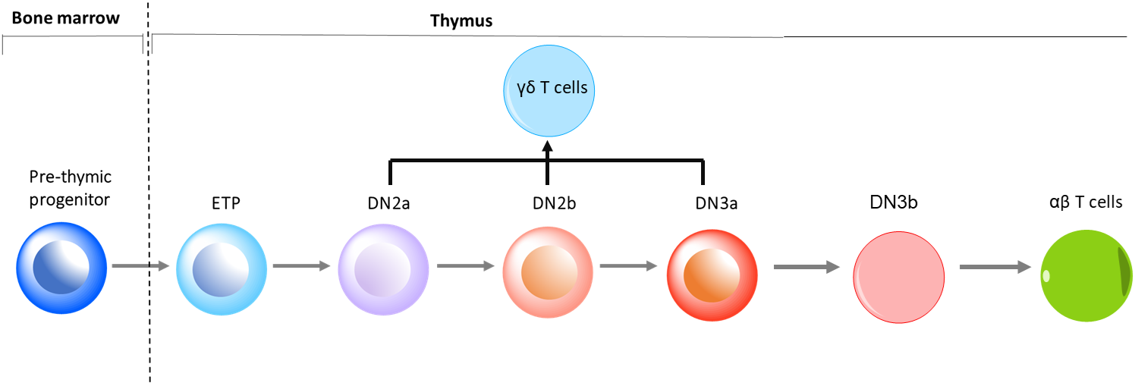

Figure 1. The gradual loss of multi-potency and commitment to T cell lineage.
The diagram depicts the early development of αβ T cells and γδ T cells. The procedure is from pre-thymic progenitor in the bone marrow to an entry into the thymus. ETP: early thymic progenitor; DN: double negative.

focuses on αβTCR, the rest of introduction will discuss the αβTCR (referred herein as TCR from now on except specific mentions). The TCR is an eight subunits receptor complex on the T cell surface. The dominant stoichiometry of TCR is composed of a TCRαβ heterodimer, two CD3ɛγ and CD3ɛδ heterodimers, and a CD3ζζ homodimer (Figure 2) ¹⁰. TCRα and TCRβ form a disulfide bond. TCRαβ is noncovalently coupled with the CD3 complex ¹⁰. Extracellular domain of CD3εδ is located underneath TCRα and extracellular domain of CD3εγ is underneath TCRβ ^{10, 11}. Extracellular domains (ECDs) of TCRαβ recognize different ligands including pMHC (antigenic peptide bound to major histocompatibility complex) processed by APCs (antigen presenting cells) (Figure 3). The CD3 complex is a signaling activation module that relies on TCR to receive a variety of signals. TCR is a type I membrane protein and not an auto-phosphorylated receptor. Upon receiving the stimulus, the TCR relies on immunoreceptor tyrosine-based activation motifs (ITAMs) ¹² in the intracellular domains of CD3 complex to recruit other kinase and adaptors to initiate TCR activation ¹³.
The structure of TCRα and TCRβ are similar, composed of large extracellular domains, transmembrane domains (TMDs), and short intracellular domains (ICDs). The extracellular domain of TCRα and TCRβ is composed of a variable domain and a constant domain. They are both immunoglobulin (Ig) - like polypeptides. The variable domain of TCRα contains three CDRs (complementary determining regions) but the variable domains of TCRβ contains

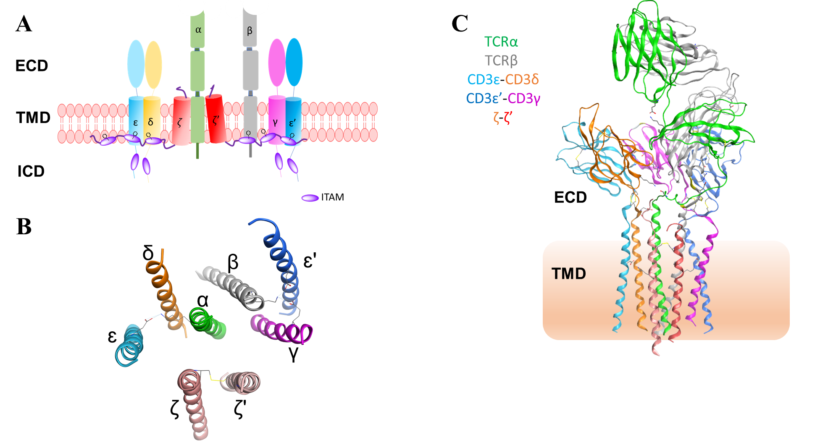

Figure 2. αβ-T cell receptor.
(A) Cartoon of αβ-T cell receptor. ECD: extracellular domain; TMD: transmembrane domain; ICD: intracellular domain. ITAM: immunoreceptor tyrosine-based activation motif. CD3ζ has three ITAMs. CD3ɛ, CD3γ, and CD3δ each has one ITAM. The sequence of ITAMs comprises of YxxL/I(x)₆₋₁₂YxxL/I. X demotes non-conserved amino acids. Residues in the ITAM in the cartoon are tyrosine. (B) Extracellular view of the transmembrane in the Cryogenic electron microscopy (cryo-EM) αβTCR (PDB: 6JXR). (C) Cryo-EM structure of αβTCR (PDB: 6JXR). It is composed of extracellular domains and transmembrane domains of αβTCR. The gradient rectangle denotes the plasma membrane.

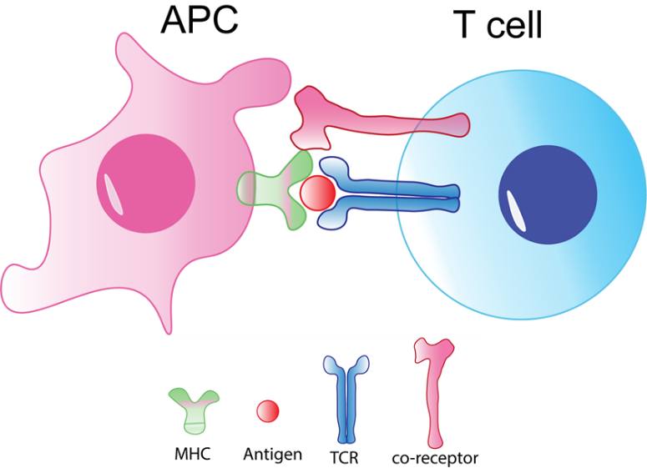
Figure 3. TCR activation by pMHC.
A cartoon illustrates that TCR recognizes the antigen bond to MHC processed by APC.

four CDRs. CDRs are hypervariable. Another important difference between the two chains is that VDJ (variable, diversity, and joining) recombination happens only in TCRβ, instead, TCRα is formed by VJ (variable and joining) recombination. V(D)J recombination leads to TCR diversity. In human peripheral blood samples, 10⁴ varieties of TCRβs can be found ¹⁴. In theory, 10¹⁵ combinations of TCRαβ exist overall ¹⁵ ¹⁶. TCRβ is an interesting subunit. Not only the variable Ig-like domain of TCRβ is special, but also the constant region has the mutually exclusive expression, TRBC1 and TRBC2, on the malignant T cells. This characteristic is beneficial to develop targeting therapy and an antibody, jovi1, has been identified to only recognize TRBC1 ¹⁷. Nanodomains could be a regulator for TCR oligomerization. Sphingomyelin and cholesterol are two main components for nanodomains (also known as lipid rafts) ¹⁸. Cholesterol binds to the transmembrane domain of TCRβ ¹⁹ and recruits sphingomyelin to assist TCR dimer formation before TCR activation ²⁰. The amount of cholesterol binding to TCRβ is decreased in active T cells ¹⁹. So, the dynamic movement of cholesterol is associated with TCR activation. In addition, downregulated sphingomyelin production has been shown to impair TCR signaling in active T cells. In aggregate, an increase in either cholesterol or sphingomyelin interaction with TCRβ could inhibit T cell activation. A core peptide has been developed based on the TMD of TCRα that showed strong inhibition of interleukin-2 (IL-2) expression in T cells and alleviated the inflammation symptoms of arthritis in a rat model ²¹.
In the assembly of the human CD3 complex, CD3ɛ noncovalently interacts with CD3γ and CD3δ, resulting in the formation of two heterodimers. The homodimer of CD3ζζ is formed by a disulfide bond in the TMD ²² and ζζ are last assembled to the TCR-CD3 complex in the Golgi ²³. Electrostatical interactions hold TCRαβ with the CD3 complex on the plasma membrane. Two negatively charged residues, aspartic acids, in the TMD of CD3ζζ ionically interact with a positively charged residue, arginine, in the TMD of TCR. Aspartic acids, in the TMDs of CD3ɛ and CD3δ, together interact with another positively charged residue, lysine, in the TMD of TCRα. Additionally, aspartic acid, in the TMD of CD3ɛ and another negatively charged residue, glutamic acid, in the TMD of CD3γ, interact with lysine, in the TMD of TCRβ ^{10, 24}. Such asymmetric electrostatic interactions in their transmembrane helices enable to TCR complex to gain flexibility to change its conformation in response to different stimulations in the cellular membrane. An imbalance of charged residues discovered in the organization of TCR complex indicates that lipids in the transmembrane helices should be the structural elements to participate into the complex interaction since some types of lipids have charges. Also, a variety of lipids alter fluidity. This characteristic also gives the space to enable conformational changes of the protein. Another possibility could be one negatively charged residue that is embedded into the lipid, enlarging the interaction radius. This results in the positively charged residue can only feel one negatively charged residue.
The transmembrane domains of TCR play critical roles in the signal transductions, resulting in an influence on the cell growth, proliferation, and survival. The cryo-EM of TCR has unraveled extracellular domain and transmembrane domain of this complex. This lovely structure is a milestone for this intricate membrane protein and is beneficial for the therapeutical design based on TCR. However, limitations of sample preparations and this technology still cannot be avoided. First, the samples were prepared using a crosslinker to acquire stable structure. Second, cryo-EM catches snapshots instead of recording the dynamics of structure movement. Third, the data obtained from cryoEM did not include the force since that is a transient delivery from pMHC-APC to TCR. Fourth, the sequences of human TCRβ applied in this cryoEM analysis are M1-specific T cell receptor beta chain (T cell receptor beta constant 2, UniProt: A0A5B9). Other types of TCRβ constant region also exist, such as T cell receptor beta constant 1 (UniProt: P01850). Fifth, the TCR complex was purified in a detergent (digitonin), which broke the native lipid environment around the protein. Sixth, this TCR complex was purified from a transformed cell line, HEK293F cells instead of a T cell line. We do not know whether the different expression systems would affect TCR structures or not. Taken together, TCR is an intricate and interesting receptor. It gives us challenges and opportunities at the same time.
The intracellular domain of TCR is missing in the cryoEM structure, but multiple studies of ICD of TCR have been performed and many progresses have been made. Tyrosine in the ITAMs of CD3ɛ have been proved to interact with the membrane using NMR (PBD: 2K4F) ¹². Basic residues in the intracellular domains of ζζ homodimer ²⁵ and of CD3ɛ ¹² have also been showed to interact with plasma membrane using fluorescence resonance energy transfer (FRET). The results of molecular dynamic simulation showed that phosphatidylinositol 4, 5 – biphosphate (PIP2) and phosphatidylinositol 3,4,5-triphosphate (PIP3) strongly interacted with basic residue-rich stretches (BRS) of CD3ε and CD3ζ ²⁶. Moreover, the activation of T cells induced conformational change, resulting in the release of the cytoplasmic tails from the plasma membrane ²⁷. The resulting downstream signaling cascade enables calcium influx ^{28, 29, 30}. Calcium ions interact with acidic phospholipids to change the local charge environment ^{31, 32} , resulting in the amplification from the proximal signaling to the distal signaling ³³. Phosphatidylserine (PS) was redistributed after T cell activation ³⁴. Moreover, the juxtamembrane domains of ζζ homodimer have been experimentally reported to switch from a divaricated conformation to a parallel status in response to TCR engagement using FRET, interaction-dependent probe incorporation mediated by enzymes (ID-PRIME) and erythropoietin receptor (EPOR) activity ³⁵. Even though we did not observe this kind of conformational switch in the cryoEM structure of the homodimer ζζ, the possible reason could be a difference between the assembly of whole TCR complex and a single homodimer ζζ peptides or technical limitations of cryoEM. We do not know yet currently.
Taken together, these breakthrough discoveries enabled scientists to propose a model where the plasma membrane can control intracellular domain phosphorylation.

1.3 T cell receptor activation
T cells can be activated by one to ten pMHC ligands ³⁶ ³⁷, with seconds to minutes response time ³⁸, and very low error rate ³⁹. Once the TCR receives signals, these characteristics allow T cells to have enough time to respond and initiate a successful activation ⁴⁰ and many TCR activation models have been proposed ⁴¹. Here, we introduce the four that are most popular currently. These popular models include allosteric alternation, segregation, clustering, and mechanosensing (Figure 4).
The allosteric model (Figure 4 - B) shows that once extracellular domain of TCR receives the signal, the transmembrane domains are altered, resulting in a release of intracellular domain of TCR from the plasma membrane. This model can be experimentally detected using cryoEM, FRET detection either at the single molecular level or at the bulky level, immunoprecipitation in the detergent, NMR spectroscopy, or crystallography.
The segregation model (Figure 4 - A) exhibits that the exclusion of receptor CD45 (phosphatase) occurs at the immunological synapse in response to TCR activation. So, the kinase Lck can be recruited to initiate the CD3 phosphorylation. The segregation model can be studied using super resolution imaging or FRET.
The clustering model (Figure 4 - C) refers to the enrichment of TCR oligomerization in response to TCR activation, which can be studied by counting gold particles under an electron microscope (EM).
The mechanosensing model (Figure 4 - D) is widely studied in the single molecular level. This model can be experimentally investigated using a single molecular FRET, a biomembrane force probe (BFP) to detect pulling and pushing or a micropipette to detect shear force in presence of TCR engagement. Currently, researchers provide a new theory that T cell activation is cross-reactivity instead of clonal selection theory. The cross-reactivity theory points out that TCR can be reacted with more than one specific pMHC. But compared with the specific ligand (full agonist), other mutated reacted pMHC ligands (partial agonist and weak agonist) show less activation effects ⁴². The cross-reactivity of T cells enables the immune system to kill pathogens more easily since TCR can react with more than one antigen ligand. pMHC1 recognizes TCR on CD8⁺ T cells, and pMHC2 interacts with TCR on CD4⁺ T cells, which described everywhere ¹³. MHC I closed-end binding groove causes long peptides (8-14 amino acids) to kink (‘bulge’ phenomena), but MHC II open-end binding groove
enables longer peptides to interact with ⁴³.

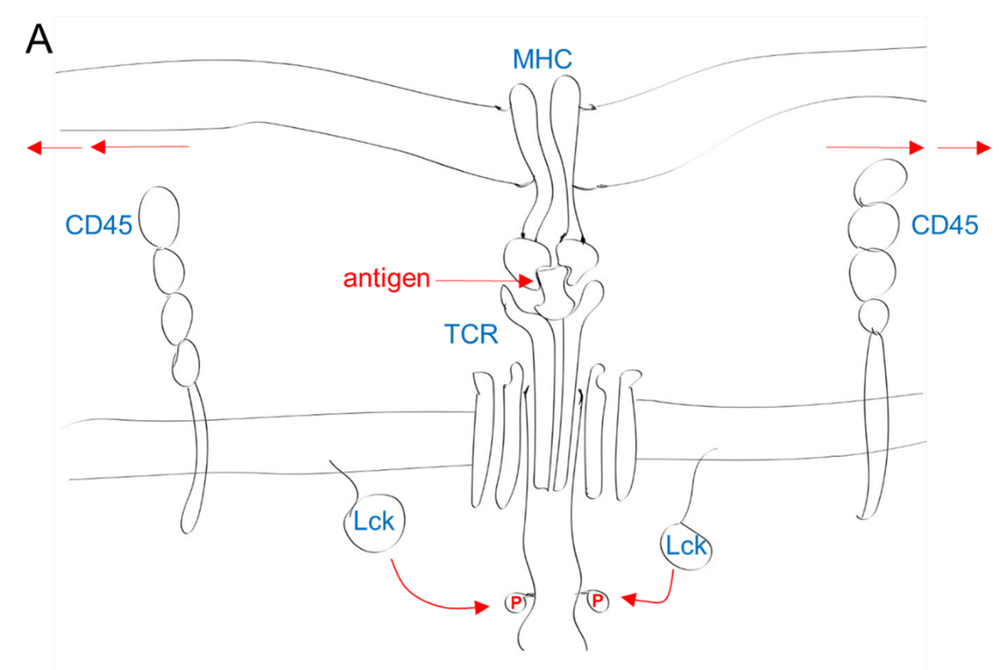
Segregation Model
Allosteric activation Model
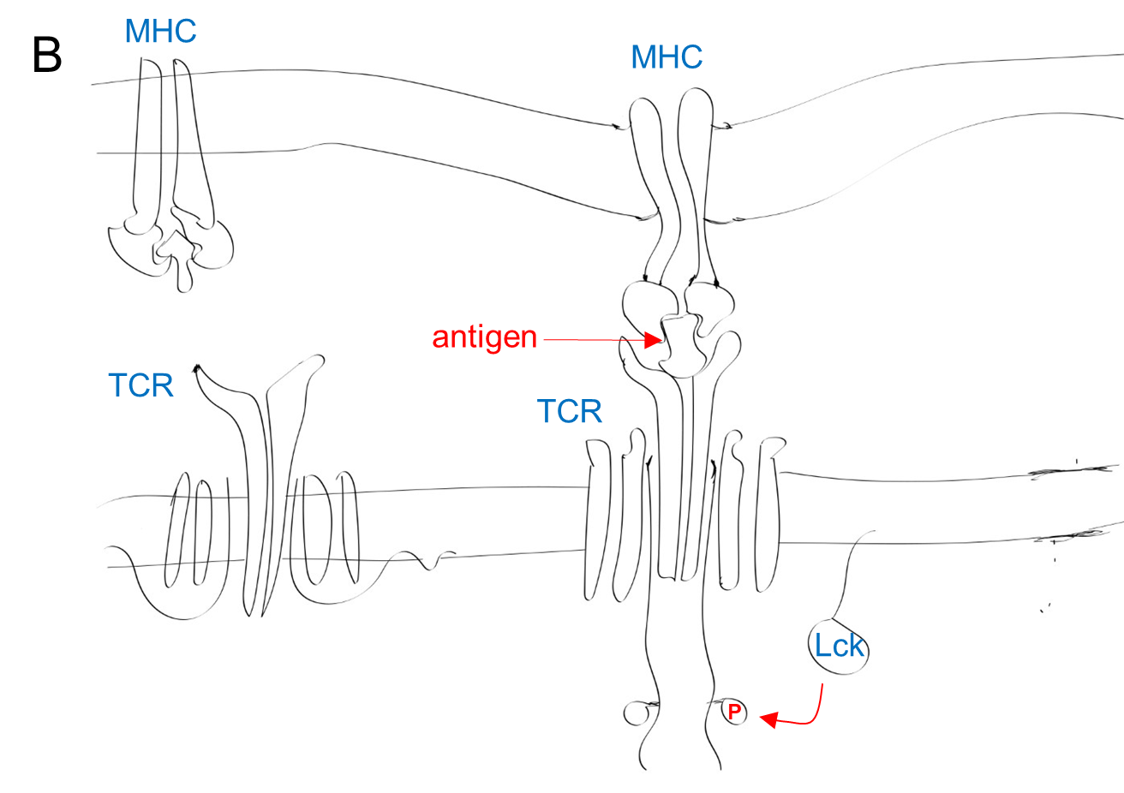
Figure 4. Cartoons of four TCR activation models.
All these activations are stimulated by pMHC. (A) Segregation Model; (B) Allosteric activation model; (C) Clustering Model; (D) Mechanosening Model.

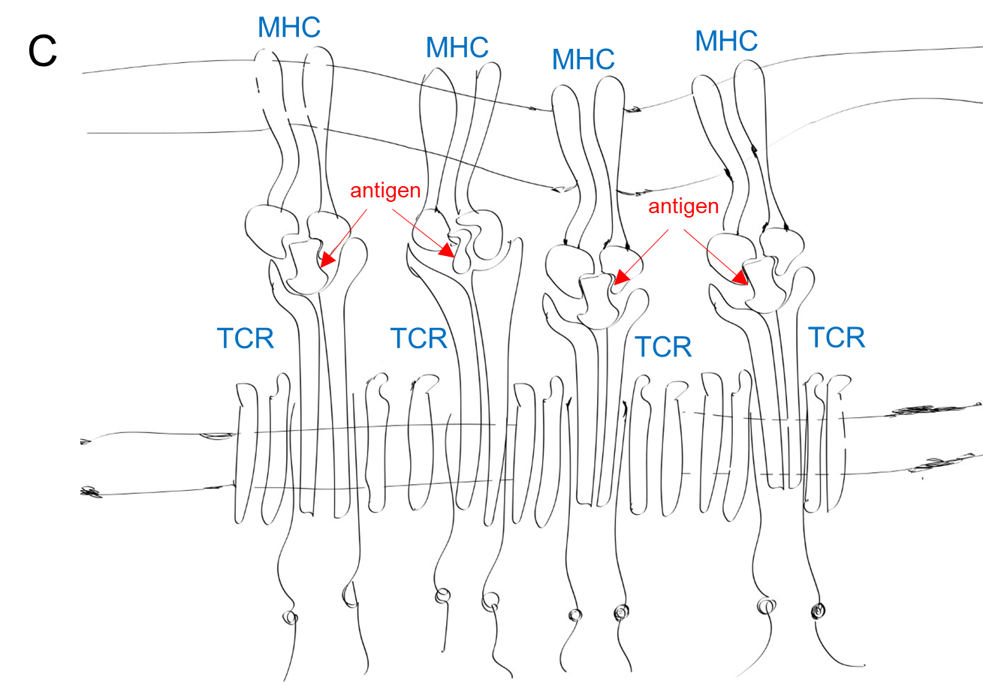
Clustering Model
Mechanosensing Model
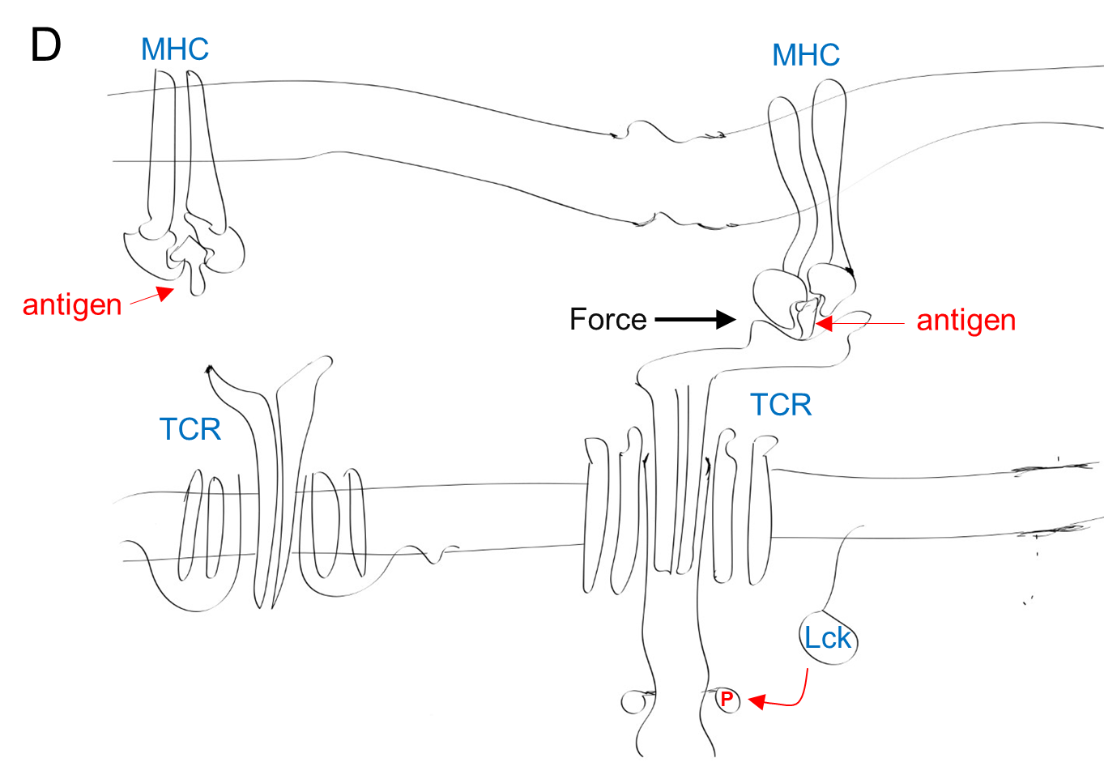

Figure 4. Continued.

In the study of TCR signaling, the human Jurkat T cell leukemic line is widely used. Two different clones of anti-CD3 antibodies, UCHT1 and OKT3, are often applied to activate TCR. Crystal structures of human CD3ε/γ bound to OKT3 Fab (2.1 Å) ⁴⁴ and human CD3ε/δ bound to UCHT1 Fab (1.9 Å) ⁴⁵ have been solved. Comparing between these two crystal structures, overlapping is revealed, and differences are found. OKT3 Fab buries 1,220 Å² and interacts with residues ε35, ε47, ε49 and ε80-86. UCHT1 interacts with all residues that OKT3 Fab does, plus ε44, ε45, ε48, ε56, and ε78. The binding site intrudes deeply into the groove between the F-G loop and C’ strand, further close to the side of CD3ε as described ⁴⁵.
When the K_{D} was measured for UCHT1 and OKT3 antibodies using biolayer interferometry, the results showed that UCHT1 had much lower K_{D} compared with OKT3 no matter in native TCR-CD3 or glutaraldehyde cross-linked TCR-CD3 (Table 1), indicating that UCHT1 binds much more tightly to the TCR-CD3 complex than OKT3. These results are consistent with the results from crystallography, where UCHT1 binds much deeper compared with OKT3. Even though the binding strength of UCHT1 is stronger compared with that of OKT3; however, the immunosuppressant OKT3, the first monoclonal antibody approved by the Food and Drug Administration (FDA), has already been applied to transplant surgery to increase immune tolerance. Even though the first generation of OKT3 has retracted from market, more advanced versions of hOKT3-related and other anti-CD3 monoclonal antibody are tested in the clinical trials ^{46, 47}. Therefore, the binding strength of anti-CD3 may not be the key component to contribute to biomedical applications.
Besides the anti-CD3 antibody, another antibody, anti-TCRβ (Jovi1) can activate a specific TCR, TRBC1 instead of TRBC2. Interestingly, the key causing the Jovi1 recognition difference is two amino acids at the position 4 and position 5, Asn₄Lys₅ (C1 epitope) in TRBC1 and Lys₅Asn₄ (C2 epitope) in TRBC2. From the 3D structure described in this article ¹⁷, it exhibits that the exposed residue is Lys in TRBC1. This suggests that exposed positively charged residue plus Lysine conformation is essential for Jovi1 recognition. This specific recognition avoids killing all T cells since a portion of normal T cells express TRBC2, which is beneficial to maintain immunity in the procedure of immunotherapy.

1.4 T cell receptor proximal signaling pathways
When a TCR is activated by its relevant pMHC or other stimulators such as antibodies, TCR signaling begins (Figure 5). After TCR activation, kinases are recruited to the intracellular domains of CD3 ¹³. Lymphocyte-specific protein tyrosine kinase (Lck) is a non-receptor tyrosine Src family kinase. N-terminal sites of Lck can be myristoylated and reversibly palmitoylated. Lck has at least three stages in the cytoplasmic region regulated by CD45 (phosphatase) ⁴⁸ and C-terminal Src kinase (CSK): (1) the open and activated state (Y394 phosphorylated and Y505 dephosphorylated); (2) the open and inactivated or
Table 1. K_{D} values between anti-CD3 (OKT3 and UCHT1) and TCR-CD3
Sample name | K_{D} value
TCR-CD3 / OKT3 | 0.35 nM
Crosslinked TCR-CD3 / OKT3 | 0.39 nM
CD3εγ / OKT3 | 3.27 nM
TCR-CD3 / UCHT1 | < 1 pM
Crosslinked TCR-CD3 / UCHT1 | < 1 pM
Values were measured as described ¹⁰.

‘primed’ state (Y394 dephosphorylated state and Y505 phosphorylated); (3) the closed and inactivated state (both Y394 and Y505 phosphorylated state). Coupled with CD4/CD8 coreceptor via its N-terminal di-cysteine motif in the zinc clasp – like structure ⁴⁹, Lck is recruited to the TCR and initiates the phosphorylation of ITAM regions of ζ chain ⁵⁰. Fyn, another Src family kinase, participates in the TCR activation as well. But Lck seems to take most responsibilities of regulating initial events of TCR activations ⁴⁹. Another type I transmembrane protein, lymphocyte-activation gene 3 (LAG-3), can inhibit TCR activation. When LAG-3 is in the vicinity of co-receptors (CD4/CD8), glutamic acid (E)-rich C-terminal region of LAG-3 reduces the pH of microenvironment, leading to a dissociation of Lck from co-receptors. Since E-rich region of LAG-3 can bind to Zn²⁺ competitively and this cation is required for Lck interaction with the co-receptor, it can also result in the Lck dissociation ^{51, 52}. Besides, another protein, Nck is recruited to proline rich sequence (PRS) of CD3ε by its SH3 domain in response to TCR activation ⁵³.
Before TCR engagement, ζ chain-associated protein kinase 70 (Zap70) is autoinhibited in the cytoplasmic region. Phosphorylated ITAM regions of ζ chain recruits Zap70 via its tandem SH2 domains (C-SH2 and N-SH2). Lck phosphorylates Y315 and Y319 in the interdomain B of Zap70, destabilizing the autoinhibitory conformation. Next, Lck phosphorylates Y493 in the kinase domain of Zap70 to fully activate Zap70 kinase ⁵⁴. The deletion of Zap70-SH2 lipid binding domain results in the impairment of TCR signaling ⁵⁵.
Once activated, Zap70 is able to recruit and phosphorylate the linker for activation of T cells (LAT). During this process, Lck is as a scaffold protein. The SH3 domain of Lck interacts with the PIPRSP motif of LAT ⁵⁴. This suggests that Lck may participate in the LAT phosphorylation. Phospho-Y132 of LAT recruits phospholipase γ1 (PLCγ1). Phospho-Y171, Y191, and Y226 of LAT act as the docking sites for growth factor receptor-bound protein 2 (Grb2) and Grb2-related adaptor protein (Gads). These binding interactions result in the recruitment of Son of sevenless (SOS) and SH2 domain-containing leukocyte protein of 76 kDa (SLP76). Since SOS is a guanine nucleotide exchange factor, activated SOS can amplify the Ras signal pathway. Ras is associated with the mitogen-activated protein kinase (MAPK) kinase – Activator protein 1 (AP1, c-Jun and c-Fos heterodimer) transcriptional regulation. SLP76 is phosphorylated by Zap70 and forms a signalosome with LAT-Grb2-Gads. SLP76 also recruits Interleukin-2-inducible T cell kinase (ITK) (through ITK SH3 domain). ITK binds to PIP3 by its PH domain as well. Activated ITK can phosphorylate PLCγ1 ⁴⁸. PLCγ1 participates in the regulation of calcium – calcineurin – nuclear factor of activated T cells (NFAT) pathway ³⁶ ³³ (Figure 6).
In T cell activation, the TCR also works together with CD28 co-receptor to activate phosphoinositide 3-kinase (PI3K). PI3K can phosphorylate PIP2 to produce PIP3. PIP3 can recruit ITK to the plasma membrane, stimulating the PLCγ1 downstream signaling as previous described. Another canonical pathway, PI3K-AKT is also found in T cells. The pleckstrin homology (PH) domain of AKT

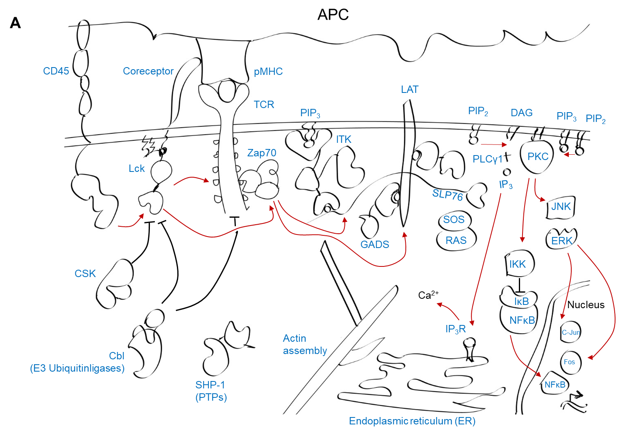
Figure 5. An overview of the human TCR proximal and distal signal pathways upon TCR activation by APC.

Red arrows denote positive regulation (activation). The black inhibition arrow symbols denote negative regulation (inhibition). The figure is not to scale. This figure is drawn using Adobe Illustrator (ipad version) by YY.

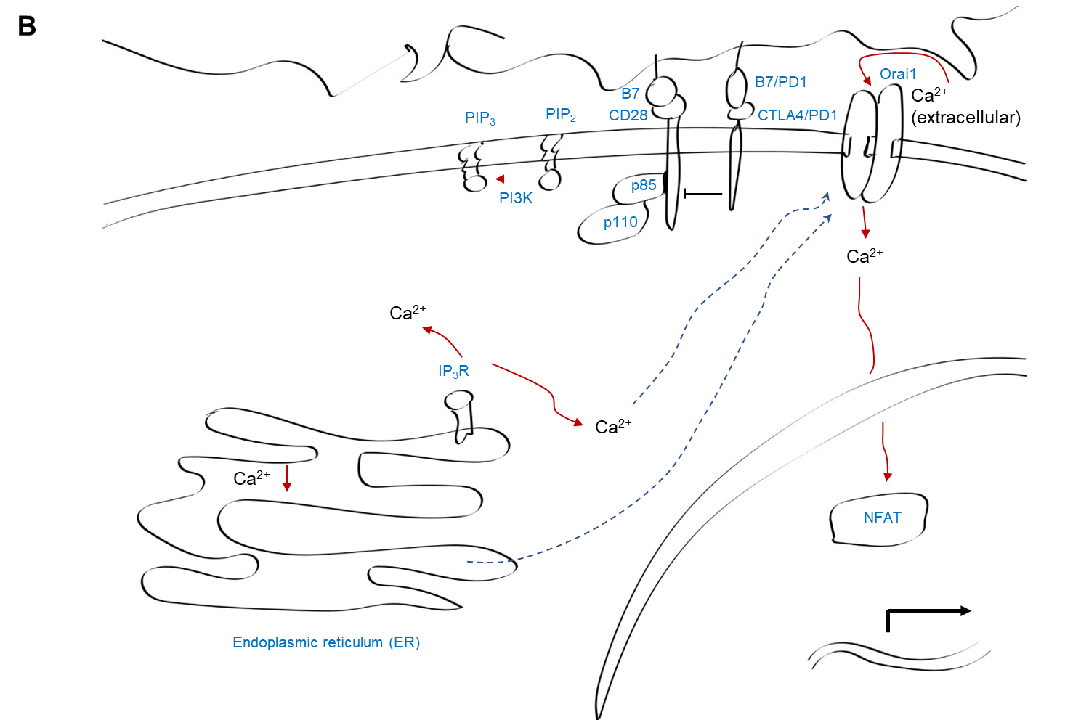

Figure 6. The simple cartoon of the human Calcium-NFAT signal pathway upon
TCR activation by APC.

Red arrows denote positive regulation (activation). The black inhibition arrow symbols denote negative regulation (inhibition). The dash blue arrow symbols denote calcium sensors. The decrease calcium concentration in the ER can be detected by cells. As a result, the extracellular calcium is transported by Orai1 receptor. The figure is not to scale. This figure is drawn using Adobe Illustrator (ipad version) by YY.

binds to PIP3 and PIP2 directly, leading to a translocation of AKT to the plasma membrane. The phosphoinositide-dependent kinase-1 (PDK1) also binds to PIP2 and PIP3 by the PH domain. PDK1 phosphorylates threonine 308 of AKT to partially activate AKT. Further, mTORC2 protein kinase phosphorylates serine 473, resulting in the full activation of AKT ⁵⁶.
In aggregate, an extracellular stimulus activates TCR, producing proximal signaling network. These proximal signal molecules bring and amplify diverse downstream cascade modulations. These modulations work together simultaneously, and activate/suppress transcriptional factors in the nucleus, resulting in a culmination of T cell activation. These procedures regulate T cell proliferation and differentiation by rearrangement of cellular cytoskeleton and metabolism.

1.5 T cell receptor distal signaling pathways
Once TCR is engaged with its relevant pMHC, the initial activation starts. Multiple proximal phosphorylation event cascades occur in response to TCR activation. PLCγ1 is a hub that connects proximal and distal signaling pathway. Phosphorylated PLCγ1 can hydrolyze PIP2, producing inositol 1,4,5 – trisphosphate (IP₃) and diacylglycerol (DAG). IP₃ is a secondary messenger. IP₃ diffuses in the cytoplasmic region and binds to the IP₃ Receptor (IP₃R) on the surface of the endoplasmic reticulum (ER), causing the calcium release from the ER (300 µM – 1mM Calcium). The ER release peak is around 500 nM and drops into the baseline 100 nM in around 100 second ²⁹. The decrease of calcium from ER lumen is sensed by the EF-hands of stromal interaction molecules 1 and 2 (STIM1 and STIM2), resulting in the conformation change of STIMs and then a signal delivery to ORAI proteins on the plasma membrane. These induce the store-operated calcium entry (SOCE) from extracellular space (1-2 mM calcium) ^{28, 30}. Augmented calcium concentration activates calcineurin, a protein phosphatase. Calcineurin dephosphorylates NFAT, resulting in the translocation of NFAT to the nucleus.
DAG stays in the plasma membrane and acts as an activator for the Ras guanyl nucleotide-releasing protein RasGRP and protein kinase C (PKC). RasGRP participates in the Ras - Raf - MEK - Erk signal, finally activating c-Jun and c-Fos. Activated c-Jun and c-Fos can form a complex with activated NFAT in the nucleus ¹³. This transcriptional complex can facilitate the secretion of interleukin 2 (IL2), increasing the growth of T cells. If the activated NFAT stays alone, it can activate diacylglycerol kinase α (DGK α). DGK α can phosphorylate DAG to produce phosphatidic acid (PA), so that the reduction of DAG brings a diminished signal of Ras-Raf-MEK-Erk. This pathway can also activate mTORC2, which phosphorylates AKT-Ser473. Phosphorylation of AKT-Ser473 is associated with Th1 differentiation. Therefore, the decrease of DAG also interrupts Th1 differentiation by reducing AKT-Ser473 phosphorylation. Activated Erk can phosphorylate Lck as well, regulating the initiation of TCR activation, conversely.
PKCθ plays a major role in TCR activation. PKCθ is associated with the CBM complex - Iκβ kinase (IKK) - NF-κB (p50 and p65) canonical signaling pathway. The CBM complex is composed of the caspase recruitment domain – containing membrane – associated guanylate kinase protein - 1 (CARMA1), B cell lymphoma / leukemia 10 (BCL10), and mucosa - associated lymphoid tissue translocation protein - 1 (MALT1) ⁵⁷. Activated PKCθ initiates the phosphorylation of CARMA1, resulting in oligomerization of CARMA1 and interaction with BCL10 ⁵⁸. After that, MALT1 binds to BCL10, forming a complex. This complex recruits a tumor necrosis factor receptor-associated factor 6 (TRAF6), an E3 ubiquitin ligase, so that it enables IKK to evade from being polyubiquitination and degradation. To this end, IKK can phosphate Iκβ, which can be regarded as an inhibitor binding to NF-κB. This leads to a release of NF-κB from Iκβ, translocating into nucleus and executing biological functions¹³, such as promoting the differentiation of Th1 and Th17 cells ⁵⁹.
In addition to the distal pathways discussed above, an epigenetic regulator, canonical BRG1/BRM-associated factor (cBAF), Myc and transcriptional factors, hypoxia inducible factor 1α (HIF-1α), also execute biological functions in response to TCR activation. CD8⁺ T cells can differentiate into effector CD8⁺ T cells and memory precursor CD8⁺ T cells upon TCR engagement. In response to combinational stimulations of anti-CD3/CD28 antibodies plus intercellular adhesion molecule 1 (ICAM1) in vitro, CD8⁺ T cells with high expression of Myc and cBAF preferentially differentiate into effector CD8⁺ T cells; but CD8⁺ T cells with low expression of Myc and cBAF exhibits memory precursor CD8⁺ T cells properties in their first division ⁶⁰. Upon TCR activation, HIF-1α participates into a transition to glycolysis, resulting in a regulation of T cell proliferation and executing effector functions ⁶¹. Deletion of HIF-1α in CD8⁺ T cells reduces T cell infiltrating into tumor cells and killing tumor cells ⁶² .

1.6 Dysregulation of T cell receptor signaling in diseases
Inadequacy of TCR signaling causes deficiency of immune responses, while aberrant activation of TCR signaling leads to inflammatory and autoimmune diseases. Abnormal expression or mutations of kinase, phosphatase, adaptor protein molecules in TCR activation signaling cause associated symptoms, disorders, and diseases.
The dysfunction of CD45 participates in autoimmune diseases and immuno-deficiency. Severe combined immunodeficiency (SCID) occurs in the absence of CD45 expression ⁶³; however, multiple sclerosis (MS) displays CD45 polymorphisms ⁶⁴. Reduced levels of CD3 ζ have been observed in rheumatoid arthritis (RA) and systemic lupus erythematosus (SLE) ⁶⁵. Mutations of CD3 ε, δ, and ζ have been found to generate SCID ⁶⁶. Defective expression of Lck causes immunodeficiency ⁶⁷. Deletion of Zap70 in double positive T cells (CD4⁺ and CD8⁺) does not allow T cells to pass through selection, resulting in the deficiencies of CD4⁺ T cells and CD8⁺ T cells ⁶⁸. Mutations of Zap70 causes inflammatory bowel diseases, diffuse large B cell lymphoma, inflammatory enterocolitis, toxic cholangitic hepatitis, autoimmune hemolytic anemia, silent brain infarct, eosinophilia, as reviewed ⁶⁹. Aberrant activations of LAT, CARD11, and PLCγ1 have been observed in Sezary syndrome, an aggressive form of a type of blood cancer termed cutaneous T cell lymphoma ⁷⁰.
In the distal signaling molecules, aberrant expressions of RASGRP1 and RAS in T cells have been reported in SLE patients ⁷¹. This indicates that the RAS pathway is associated with the generation of SLE.

Chapter II. pH-responsive peptides

2.1 pH-responsive amino acids
Seven amino acids contain ionizable groups in a pH range of 1 – 14. They are aspartic acid (Asp, D), glutamic acid (Glu, E), tyrosine (Tyr, Y), cysteine (Cys, C), histidine (His, H), lysine (Lys, K), and arginine (Arg, R). When the pH is below the pKa of their ionizable side chains, His, Lys and Arg are positively charged but Asp, Glu, Tyr, and Cys are uncharged. When the pH is above the pKa of their ionizable groups, His, Lys, and Arg are uncharged but Asp, Glu, Tyr, and Cys are negatively charged. However, the pKa values of these ionizable groups in a protein could be different based on the positions of residues in the protein structure. The thiol (-SH) of Cys, the hydroxyl group (-OH) of Tyr, and the imidazole of His are often buried inside the protein at physiological pH because they are uncharged. Conversely, the guanidinium of Arg, the amino group of Lys, and the carboxylate groups of Asp and Glu are exposed since they are charged at pH 7.4 ⁷². The long and flexible side chain of Lys allows the hydrocarbon part of the side chain to enter deeply into the hydrophobic acyl chain of the membrane and the charged part of the side chain stretches to the polar head of the membrane. This phenomenon is termed “snorkeling” ⁷³. Based on the side chain pKa value of Arg (12.48), it should be a strong cation theoretically. But the side chain guanidinium in water is a weakly hydrated cation, resulting in the especially buried of Arg in water ⁷⁴. This is probably because of charge delocalization. This buried Arg is important to maintain the stability of protein because a positively charged side chain can form a hydrogen bond with the side chains of other residues ⁷⁵.
Replacing hydrophobic residues with negatively charged residues increases the solubility of a typical protein with over 100 residues at pH 7.4 ⁷⁶. In the protein RNase Sa (21.99 kDa, PDB: 1RSN), the solubility of the T76D variant (43 mg/ml) is twelve-fold higher than T76W (3.6 mg/ml). Conversely, mutating Thr to His, Lys, or Arg decreases the solubility of this protein ⁷⁷. This similar phenomenon is also found in the short peptides including pHLIP (pH-low insertion peptide) ⁷⁸, ATRAM (acidity-triggered rational membrane) peptide and its variants ^{79, 80, 81}, GALA ^{82, 83}, TYPE7 ⁸⁴, PITCR ⁸⁵, and PET1 (Peptide inhibitor of EGFR-1, unpublished data). However, KALA, a variant of GALA containing positively charged Lys (K) residues, is an exception because KALA is buffer-soluble at pH 7.4. In summary, ionic interaction promotes solubility of a protein.

2.2 pH-responsive amino acids applications
Currently, targeted therapy has been regarded as a promising tool in treating diseases compared to traditional chemotherapy, radiation therapy, and surgery. An ideal target is only found in the diseased cells. However, the non-specific targeting is a big hurdle in this therapy. The targets, such as protein receptors, are aberrantly expressed in diseased cells but expressed in healthy cells. Thus, the antibodies (monoclonal antibodies) or small chemical molecules (small-molecule drugs) can kill the diseased cells but also damage healthy cells, leading to the injuries of other organs and the interruption of normal metabolic systems. Besides, protein receptors can be activated by the canonical pathway and the non-canonical pathway ^{84, 86, 87}, because of different cancer types. These also increase difficulties of therapeutics and lead to the relapse. Therefore, it is urgent to develop a more selective way that can target only diseased cells/tissues. Cell surface acidity ⁸⁸ in different diseases, such as cancer, ischemia, stroke, inflammation, and autoimmune diseases, results from their metabolism ^{89, 90}. The metabolism, here, refers to partially anaerobic (the Pasteur effect) and aerobic glycolysis (the Warburg effect, preferential an increase rate of glucose consumption and production of lactate in tumors) ⁸⁹. The surface pH of highly metastatic cancer cells is 6.7-6.8. Furthermore, in the tumor tissue, the surface pH can reduce to 6.1- 6.4 in the more aggressive cancer cells ⁸⁸. Therefore, acidic pH at the cellular surface can be regarded as a promising target/indicator to distinguish diseased cells and healthy cells. In addition, the acidic surface level of cancer cells can be used in combination with pathological examination results to understand the progression of the disease.
Since acidic pH on the diseased cell medium is a therapeutic target, the discovery of pHLIP (pH low insertion peptide) ⁹¹ as a delivery system has facilitated the development of pH-responsive peptides in biomedical research and applications ⁹². In the acidic environment, the negatively charged residues Glu and Asp can be protonated, resulting in alternations of peptide conformation and pKa in presence of lipid hydrophobic environment. These alternations facilitate adsorption of the peptide to the plasma membrane. The hydrophobic interaction is coupled with a release of energy ⁹³.
Introducing the pH-responsive residues to the therapeutic peptide/protein design ⁸¹, the product (peptide/protein) can function as either a delivery system which can be conjugated with an imaging dye ⁹⁴ or a pharmaceutical compound ⁹⁵ or function as both a delivery system and a biologically active molecule (inhibitor or activator) ⁸⁴ ⁸⁵.

2.3 GALA peptide and its variant, KALA
GALA is a designed pH-responsive ⁸³ and cell penetrating ⁹⁶ peptide. It contains thirty amino acids (Table 2, top). It has Glu-Ala-Leu-Ala (EALA) repeated units, a histidine, and a tryptophan. The histidine residue and tryptophan residue are used as spectroscopic indicators ⁸³. GALA was a jazzier acronym and used to name a peptide ⁸². This was the first successful case for designing a pH-responsive peptide. The knowledge of GALA peptide design principle can be applied to design other pH-responsive peptides.
GALA is aqueous soluble. The helical content of the peptide increases as the pH decreases ⁸³. The alternation of secondary structure of GALA is reversible between pH 5.0 (α-helix) and pH 7.4 (random coil) ⁸³. The influences of divalent cations on the GALA have also been studied using Trp as a fluorescent probe with an emission wavelength peak between 300 nm and 400 nm. In presence of calcium or magnesium or zinc cation at physiological pH, the emission spectrum of GALA tryptophan fluorescence shifts toward lower wavelengths (blue shift). The aim for designing this peptide was to build a simple model, and to investigate how viral fusion peptides enter membranes. The application goal for this peptide and its variants is to deliver oligonucleotide (ODN) and DNA ⁸³.
GALA causes membrane leakage at acidic pH. This can be explained by using a mathematical model. The mathematical model proposes that GALA α-helix monomers are oligomerized and form a transmembrane pore. The GALA oligomerization is composed of 8-12 monomers. The GALA peptide favors maintaining the surface parallel state in presence of a cis unsaturation on both chains (such as DOPC) and a relatively small head group (such as DOPE), while the trans-bilayer insertion of GALA peptide decreases in presence of DOPC and DOPE vesicles. Instead, GALA peptide favors inserting cross lipid bilayer in presence of POPC vesicles. However, GALA peptide cannot bind to DNA or ODN directly because of negative charge repulsion ⁸³.
Positively charged Lysine residues were introduced to enable the peptide to maintain the pH-responsive feature, termed KALA (Table 2, bottom). It is not unexpected that alkaline pH increases α-helical content of KALA peptide since the introduction of Lys alters the pKa of the peptide ⁹⁷. KALA is a cationic peptide, and as a result, the negatively charged backbones of nucleic acids can interact with KALA peptide ⁹⁸. Therefore, KALA can be used to deliver nucleic acids into cells without adding other molecules (condensing reagents).

2.4 pHLIP and variants
pHLIP (pH-low insertion peptide) is a paradigm of the basic research
Table 2. Sequences of GALA peptide and KALA peptide.
Introducing residues are highlighted in red.
Peptide  Name | Sequence | Molecular Weight (Daltons)
GALA | WEAALAEALAEALAEHLAEALAEALEALAA | 3032.4
KALA | WEAKLAKALAKALAKHLAKALAKALKACEA | 3131.86

Table 3. Blue shifts (λ_{max}) of GALA peptide in three different cations ⁸².
Cation name | λ_{max} (nm)
Calcium | From 360 to 353
Magnesium | From 360 to 353
Zinc | From 360 to 344

transformation to biomedical and clinical applications. pHLIP was first discovered by Professor Donald Engelman (Yale University) ⁹¹ and developed together with the colleagues from Yale University, University of Tennessee (Barrera lab), University of Rhode Island, the Memorial Sloan Kettering Cancer Center, and other groups all over the world. The pHLIP (Table 4, middle) was discovered from the C-helix of the membrane protein bacteriorhodopsin (bR) in haloarchaea, termed BR-C (Table 4, top) at the beginning. bR has seven transmembrane helices, and only one out of seven helices are poorly hydrophobic and cannot form α-helical secondary structure in presence of lipid vesicles. BR-C is instead water soluble. When presented with lipid bilayers, BR-C shows an unstructured conformation at neutral pH but switches to α-helical secondary structure at acidic pH. BR-C has 36 amino acids. Six out of thirty-six are negatively charged residues, two glutamic acids and four aspartic acids. These six residues can be protonated when the pH drops, in consistent with pH-responsive behavior. This protonation results in the transformation of peptide to a less polar status, leading to insert into lipid bilayer. Two tryptophan residues serve as fluorescent probes, which can be used to study the change of peptide conformation in response to differences in environmental conditions ⁹¹.
BR-C peptide was renamed as pHLIP. In the initial study of pHLIP, the published results show three different states. pHLIP shows random coils mostly in the phosphate solution (State I) and lipid bilayer (State II) at the physiological pH. Reducing pH promotes pHLIP to gain more helicities, resulting in a C-terminus transmembrane insertion (State III) (Figure 7). These two transitions can proceed spontaneously since both values of Gibbs free-energy change are negative (Figure 7). Interesting, this procedure is reversible. When acidic pH is increased, the exit of pHLIP exhibits (Figure 8). But adding negatively charged lipid (POPS) postpones the exit of pHLIP because of a raised pK value of the peptide ⁹⁹. The predominant conformations of pHLIP at acidic pH and physiological pH in presence of lipid bilayer are still α-helix and random coils, respectively. But all kinds of secondary structures of pHLIP exit at each pH. The thermodynamic ensembles of pHLIP associated with lipid membrane is an intricate and dynamic process, especially when it comes to the intermediates of pHLIP ¹⁰⁰. The pKa value of pHLIP in presence of lipid bilayer is ~6.0 ⁹¹. The membrane composition, different ionic components, and concentrations (such as
a pH gradient on cell surface ⁸⁸) and N/C-terminal conjugated compounds all impact the pK_{a} values of pHLIP. pHLIP, as a promising targeted delivery tool, has been studied in different kinds of acidic diseased tissues. pHLIP can be used for targeting extracellular delivery of cargo molecules such as imaging agents (¹⁸F-NO2A, a PET agent) ¹⁰¹, immune-triggered molecules (antigen), and metabolic associated molecules (carbohydrates) (Figure 9) and targeting intracellular delivery of cargo molecules such as peptide nucleic acid (PNA) cargo (Figure 10). Compared to traditional delivery system (~500 Da drug-like molecules), pHLIP can deliver over ~6 kDa PNA cargo within tumor ¹⁰². In another imaging

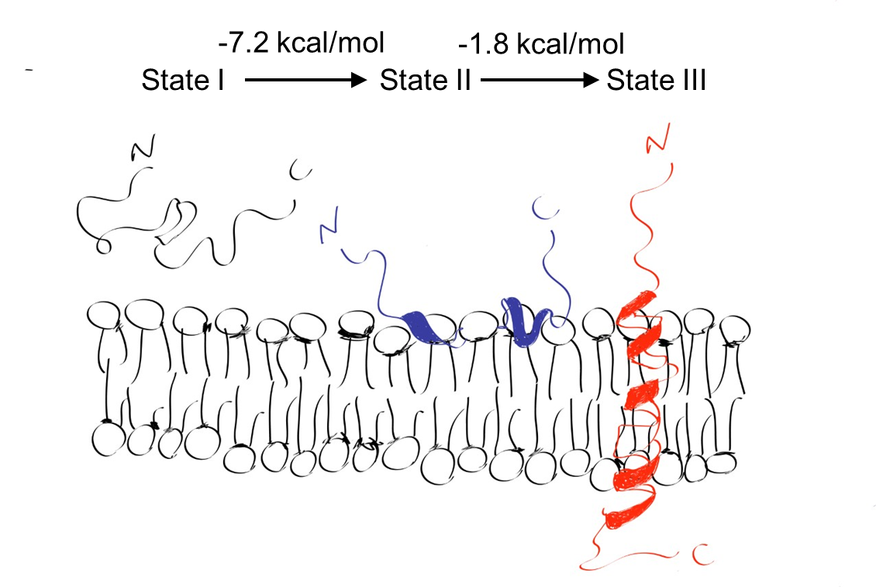
Figure 7. Cartoon of three distinct states of pHLIP.
State I: pHLIP is random coil (black) in the aqueous solution at pH 7.4. State II: pHLIP is mostly unstructured in presence of lipid bilayer at pH 7.4. In addition, pHLIP stays at the outer leaflet (blue). State III: decreasing pH (~ pH 6.0) facilitates the pHLIP to insert its C-terminus across lipid bilayer. As a result, an α-helix transmembrane conformation (red) is formed. Since both Gibbs free-energy values are negative, the transitions proceed simultaneously in response to the environmental pH change. The figure is not to scale. This figure is drawn using Adobe Illustrator (ipad version) by YY.

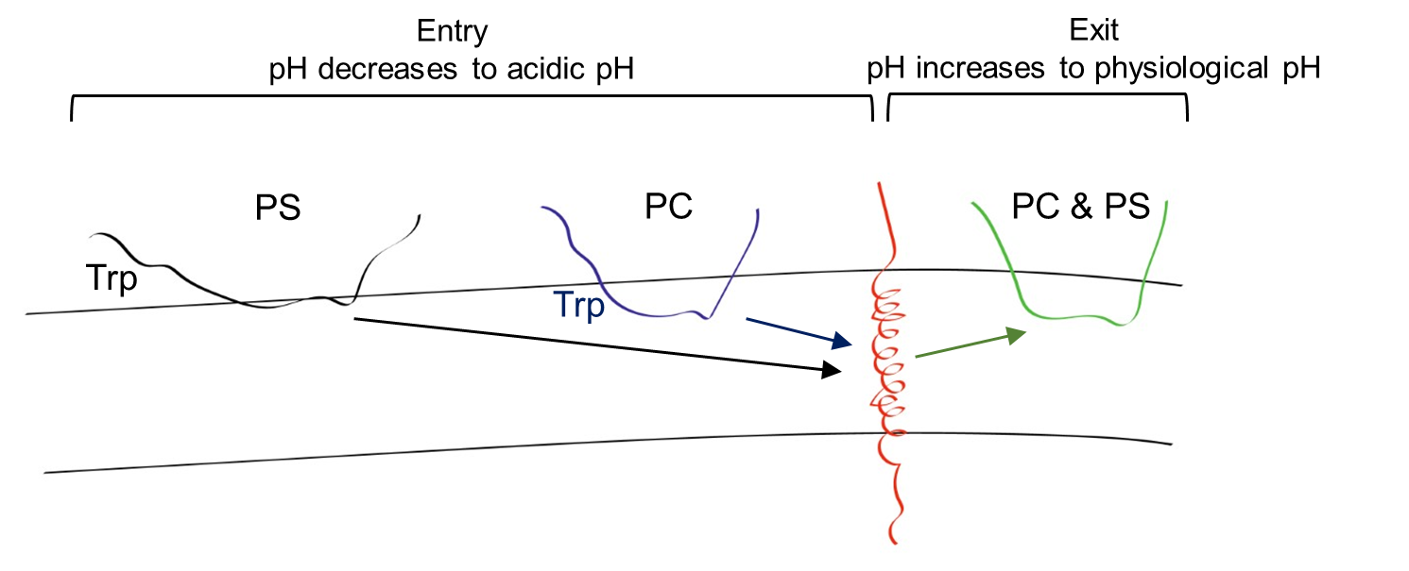
Figure 8. Membrane entry and exit of pHLIP.

The position of tryptophan is the average position of the two tryptophan residues. Black: pHLIP is in presence of 10%PS90%PC lipid bilayers. Blue: pHLIP is in presence of POPC lipid bilayers. Red: pHLIP forms α-helical secondary structure in the membrane bilayers in response to the pH reduction (pH = ~6.0 finally). Green: pHLIP reversible becomes the random coil secondary structure upon pH increase. The switch from random coil to α-helix is called “Entry”. The reversible alternation from α-helix to the random coil is termed “Exit”.

Table 4. Sequences of pHLIP and its variants
Acidic residues are highlighted in red and Trp residues are highlighted in green. The transmembrane domain is underlined.
Peptide Name | Sequences
BR-C  (pHLIP) | NH2-GGEQNPIYWARYADWLFTTPLLLLDLALLVDADEGT-COOH

application, indocyanine green (ICG) is linked to pHLIP, termed ICG-pHLIP. ICG-pHLIP was given as an intravenous injection to identify primary tumor margins and metastasis of tumor in the vicinity, resulting in an improvement of surgical accuracy ¹⁰³ ¹⁰⁴ since the fluorescent intensity is enhanced largely once ICG-pHLIP interacts with lipid bilayers ¹⁰⁵. In addition, compared with the stability of ICG alone for minutes, ICG-pHLIP can maintain in blood circulation for 1-2 hours ⁸⁹. It will be a good application for the angiography. protein targeting, such as specificity to diseased tissues. Moreover, pHLIP can target multiple tumors/ cancers since one of the common features of the microenvironment of tumor tissues/cancers is acidic. The pHLIP’s cargo can be a range of molecular weights and polarity. pHLIP can deliver cargo across the plasma membrane into cells which is a major obstacle for drug delivery ¹⁰². Moreover, pHLIP’s cargo delivery allows escape from endosomes ⁸⁹.

2.5 ATRAM and variants
pHLIP is a golden child for acidic diseased tissue delivery. But pHLIP has its disadvantages. pHLIP starts to aggregate at 7 µM, and the pK_{a} of pHLIP in presence of POPC is ~6.0. The pH within tumor tissue is identified different levels of acidosis. Different levels of metastatic cancers exhibit a range of pH (6.0 – 6.5) ¹⁰⁶. Therefore, a peptide that owns soluble in aqueous environment and strongly

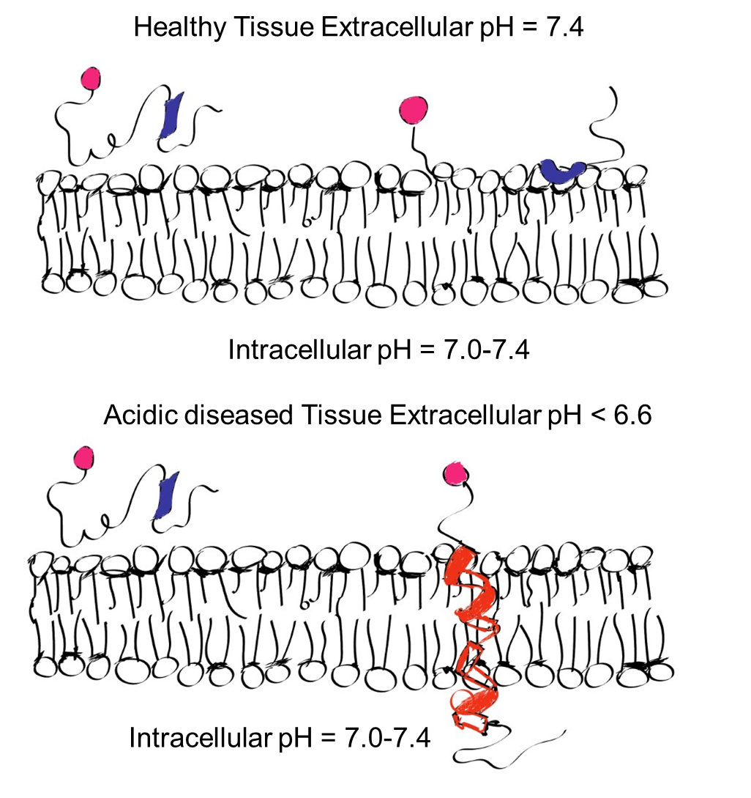
Figure 9. Cartoon of pHLIP delivery of cargo to acidic diseased tissue surface.
Upper: at pH 7.4, the pHLIP N-terminus labeled cargo does not insert into the plasma membrane. It is a reversible procedure at the physiological pH. Bottom: at acidic pH (pH < 6.6), pHLIP-cargo inserts into the membrane bilayer, and then forms a transmembrane helix. This is a stable procedure. This feature can be used to target the acidic positions. Thus, it can be used to image and deliver specific molecule for direct treatment or stimulation. The figure is not to scale. This figure is drawn using Adobe Illustrator (ipad version) by YY.

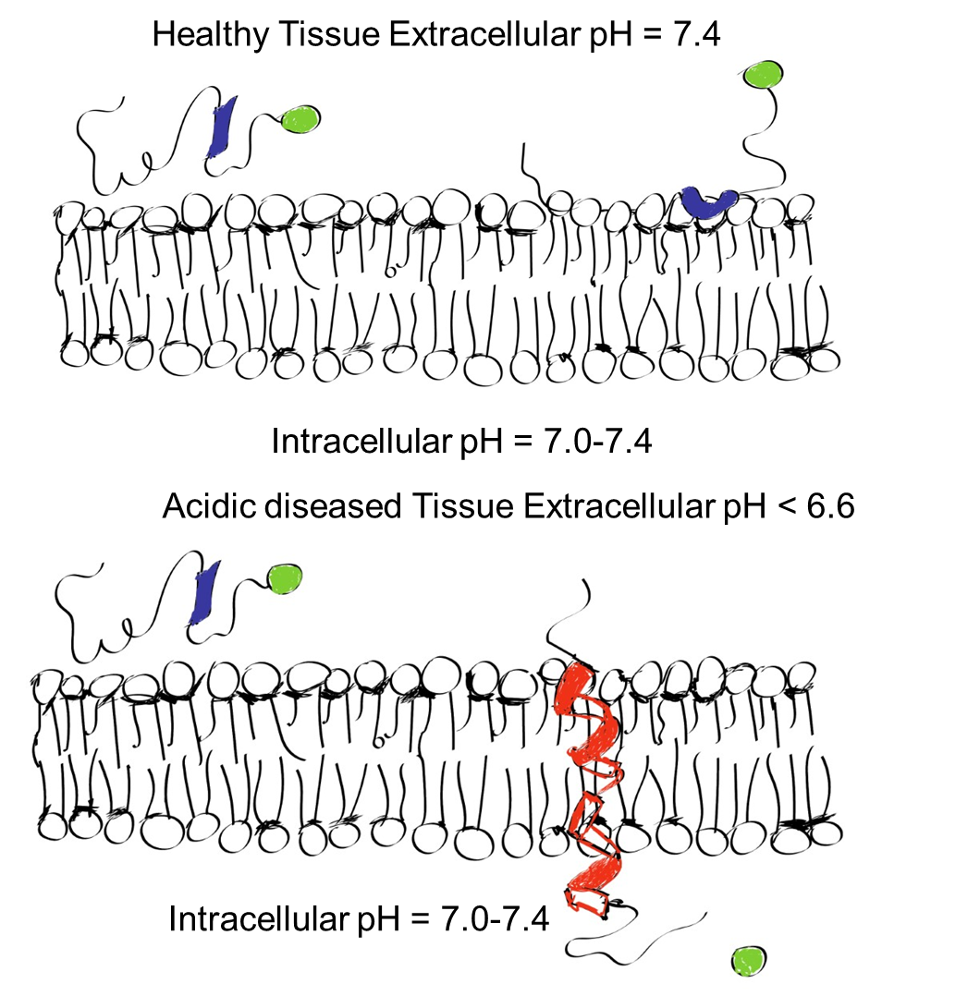
Figure 10. Cartoon of pHLIP delivery of cargo to the intracellular region.

Upper: at pH 7.4, the pHLIP C-terminus labeled cargo does not insert into the plasma membrane. It is a reversible procedure at the physiological pH. Bottom: at acidic pH (pH < 6.6), pHLIP-cargo inserts into the membrane bilayer, and then forms a transmembrane helix. This is a stable procedure. This feature can be used to target the acidic positions. Thus, it can be used to deliver drug or other small molecule treatments into the intracellular region. Once arrived in the cytoplasm, the drug or the treatments can be cleaved and released. The figure is not to scale. This figure is drawn using Adobe Illustrator (ipad version) by YY.

In summary, pHLIP has several advantages compared to traditional targeted therapies. Acidic targeting can overcome side effects of molecular
stable in the lipid bilayer is needed. Except for being stable in opposite hydrophilicities, higher pK_{a} is also required since it can improve the pH range of targeted delivery system. Francisco Barrera’s group (University of Tennessee, Knoxville) applied a rational design approach to create a new pH-responsive peptide, termed ATRAM (acidity-triggered membrane) (Table 5). The ATRAM peptide contains pH-responsive glutamic acids (E), which have higher pK_{a} of side chain compared with aspartic acid (D) ⁸¹. This design assists to raise the pK_{a} of the ATRAM peptide in presence of lipid bilayer. Besides, introduction of glycine residues contributes to the formation of α-helix across the membrane bilayer (compactness) even though glycine residue alone does not contribute to the signal in the circular dichroism detection. A Trp residue is added as a fluorescent probe to study the peptide conformation/folding. To ensure the insertion of the peptide to the membrane bilayer, the peptide hydrophobicity is an important factor. So, leucine (Leu) and alanine (Ala) residues are used. Compared to other hydrophobic residues, Leu and Ala residues do not have too large and bulky side chains, which may interrupt the helical formation in presence of lipid bilayer.
In the biophysical examination of ATRAM peptide, the solubility is higher compared to pHLIP. ATRAM peptide can be dissolved easily at 200 µM. ATRAM peptide exhibited three predominant states similarly to pHLIP, random coil in the aqueous solution and lipid bilayer at physiological pH but switch to α-helix when the pH drops. Comparing with intermediate states of dynamic insertion into lipid bilayer (determined by stopped- flow fluorescence), ATRAM shows two intermediates ⁸⁰ but pHLIP shows three ¹⁰⁰. In the pH titration experiment, ATRAM membrane insertion pK detected by Trp fluorescence is 6.51 ± 0.09 in presence of POPC lipid bilayer. This meets the wish of the design. Similar to pHLIP, ATRAM displays a unidirectional insertion, C-terminus, as well ⁷⁹. In addition, a blue shift of spectrum further proves that ATRAM is folded in a hydrophobic lipid environment. ATRAM forms oligomers in presence of membrane bilayer, resulting in leakage ⁸⁰.
Renal clearance and drug-protein degradation are two major concerns in the design of targeted therapeutics. Interestingly. ATRAM interacts with human serum albumin to escape clearance and degradation ⁸⁰. ATRAM can remain in blood circulation for 4 hours in an intravenous injection which is much longer compared with pHLIP (1-2 hours). This characteristic enables ATRAM can be conjugated to different dyes, as a promising imaging tool in tumor surgery.
Furthermore, ATRAM has been applied to target nanoparticles (NPs) encapsulated chemotherapeutic drug (DOX-triphenylphosphine) to treat cancer and the ATRAM-BSA-PLGA NPs are regarded as a promising drug delivery system in cancer therapeutics ^{89, 95, 107}
In order to further understand the ATRAM peptide, the Barrera group mutated residues of ATRAM peptide at the N-terminus, producing ATRAM2, K2-ATRAM, and Y-ATRAM (Table 5). All of them are pH-responsive peptides that exhibit membrane insertion at acidic pH. Since phosphatidylserine (PS) occurs at higher percentage in the outer leaflet of cancer cells, the influences of PS on
Table 5. Sequences of ATRAM and its variants
Acidic residues are highlighted in red, basic residues are highlighted in blue, tyrosine residue is highlighted in green and Trp residues are underlined.
Peptide Name | Sequences
ATRAM | GLAGLAGLLGLEGLLGLPLGLLEGLWLGLELEGN
K2-ATRAM | GKAGKAGLLGLEGLLGLPLGLLEGLWLGLELEGN
Y-ATRAM | GYAGLAGLLGLEGLLGLPLGLLEGLWLGLELEGN

ATRAM, K2-ATRAM and Y-ATRAM membrane insertion have been studied ⁸⁰. PS alters ATRAM, K2-ATRAM, and Y-ATRAM membrane insertion by changing the pK_{FI} of those peptides. This can improve acidic tissue targeting, especially on the local surface of different types of cancer cells or tumor tissues. Modification
of the N-terminus can affect peptide insertion, which can be applied to design other transmembrane peptides.

2.6 TYPE7 (TYPE-C2) and variants
Eph receptors are the largest subfamily of receptor protein tyrosine kinases (RTKs). The name of Eph originates from its expression in an erythropoietin-producing human hepatocellular carcinoma cell line ¹⁰⁸. Eph receptors drive/control multiple cellular processes, including cell growth, proliferation, differentiation, morphology, and migration ¹⁰⁹. The ligand of Eph receptor is ephrin (pronounced eff-rins). The ephrin is named from Eph family receptor interacting protein), or from ɛφορο (ephoro). The ɛφορο (ephoro) is a Greek word and means a controller. The ligands have two structural types, ephrin A and ephrin B. The ephrin A is a membrane-anchored protein that uses a glycosylphosphatidylinositol (GPI) linkage. (Figure 11A). The ephrin B is a transmembrane protein (Figure 11B). Both Eph and ephrin are membrane proteins. Eph (receptor) on a cell recognizes ephrin (ligand) at another cell. This recognition mediates biological signaling on both cells (receptor and ligand) ¹⁰⁸ .
So far, fourteen human Eph receptors have been discovered. Eph receptors can be divided into two groups. These two groups are defined by their ligands.
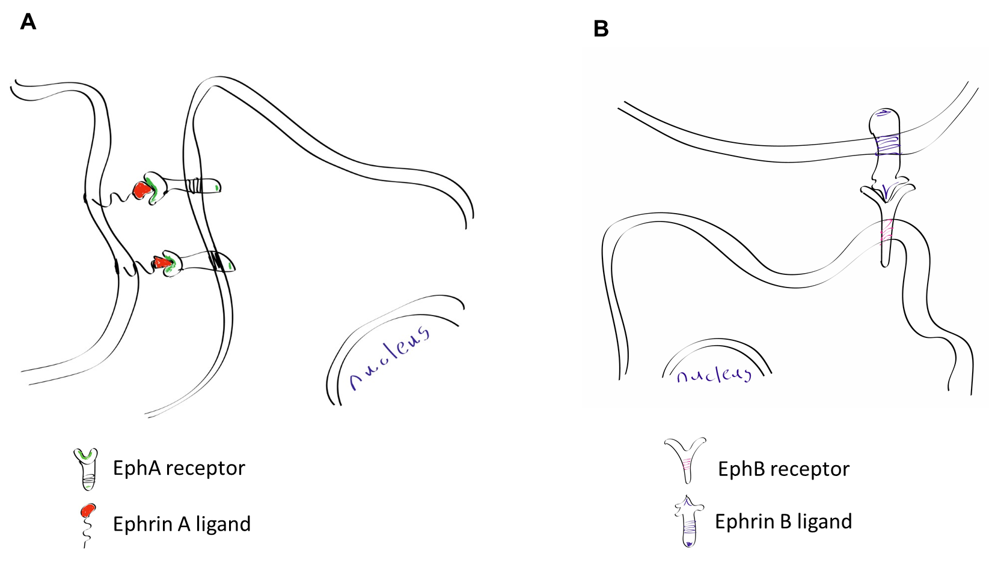
(A) An EphA receptor recognizes ephrin A ligand at the surface of another cell. Ephrin A is a GPI membrane-anchored protein. (B) An EphB receptor recognizes ephrin B transmembrane protein located at another cell. The figure is not to scale. This figure is drawn using Adobe Illustrator (ipad version) by YY.

Figure 11. Eph receptors interact with their relevant ligands.

The Eph receptor that binds to ephrin A, termed EphA. The EphA family contains nine out of fourteen Eph receptors. Similarly, the Eph receptor that binds to ephrin B, termed EphB. The EphB receptors consist of five members ¹⁰⁸.
Currently, EphA2 protein is one of the most widely tested Eph receptors in cancer studies ^{110, 111}. EphA2 is composed of extracellular, transmembrane, and intracellular domains. The extracellular domain of EphA2 is composed of a ligand binding domain (LBD), a cysteine-rich domain (CRD) or an EGF-like domain, and two fibronectin type III repeats (FN1 and FN2). A single-pass transmembrane helix is followed by an intracellular domain, which contains a juxtamembrane domain (JMD), a tyrosine kinase domain (TKD), a sterile α motif (SAM), and a postsynaptic density protein (PDZ) binding motif ¹¹² (Figure 12).
Interestingly, EphA2 is a double-edged sword. EphA2 can be either a protumorigenic protein (ligand-independent activation) or a tumor suppressor (ligand-dependent activation) ¹¹³ ⁸⁶ (Figure 13). When the protein EphA2 is anti-tumorigenic, it can be activated at multiple phosphorylation sites, including Y588 (JMD), Y594 (JMD), and Y772 (TKD, in the kinase loop) ¹¹⁴ ¹¹⁵. When the EphA2 is protumorigenic, S897 is phosphorylated ¹¹⁶ ¹¹⁷.

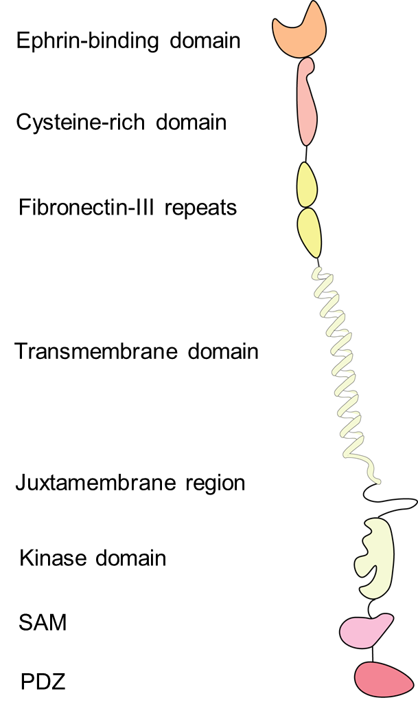
Figure 12. Cartoon of human EphA2 receptor structure.

This cartoon is composed of extracellular, transmembrane, and intracellular domains of the EphA2 receptor. The extracelluar domain contains ephrin-binding domain, cysteine-rich domain, and fibronectin-III repeats (I and II). The transmembrane domain is the α-helical structure. The intracellular domain contains juxtamembrane domain, kinase domain, SAM and PDZ domain binding motif. This figure is drawn using Adobe Illustrator (Windows version) by YY. The figure is not to scale.

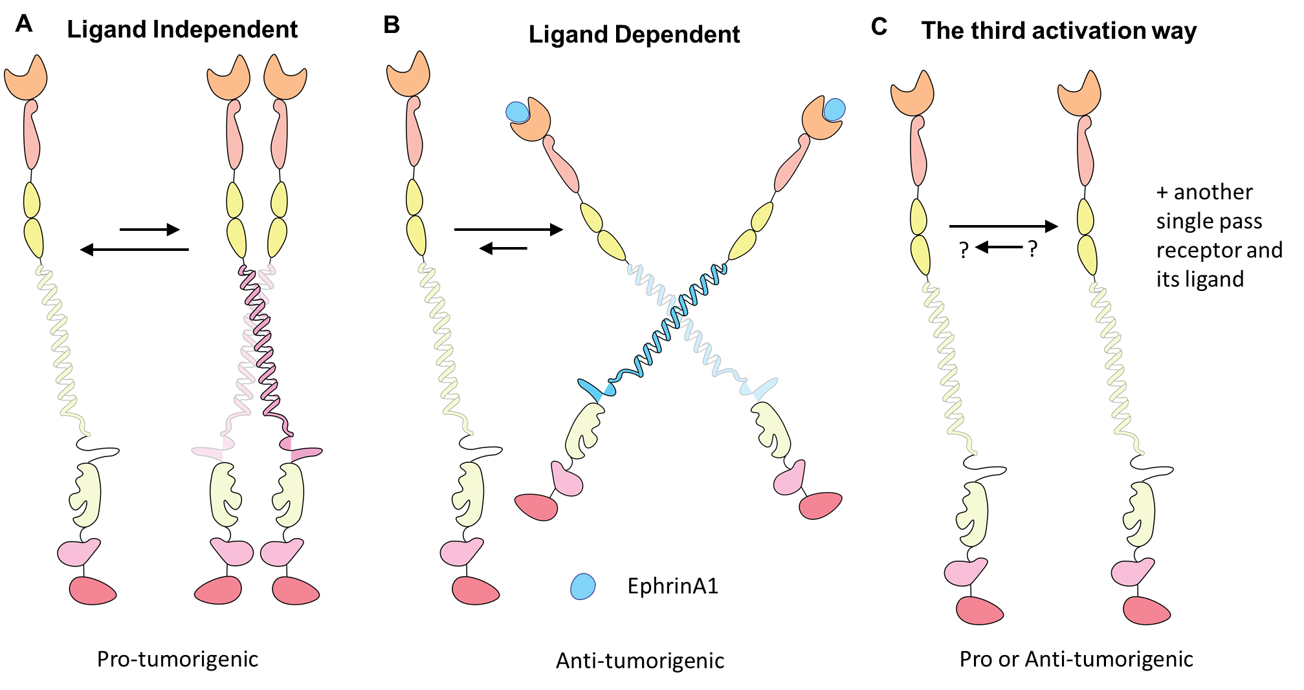
(A) The ligand independent dimerization of EphA2 promotes tumor formation by phosphorylating S897 in the linker between the kinase domain and SAM (not shown). (B) The ligand dependent activation of EphA2 inhibits the tumor formation by phosphorylating Y588 and Y594 in the juxtamembrane domain and Y772 in the kinase region (not shown). (C) The EphA2 interacts with another single-pass receptor, causing the heterodimer formation. The activation is stimulated by another receptor’s ligand. The downstream effect (pro or anti-tumorgenic) is decided by which receptor is to dimerize. The figure is not to scale. This figure is drawn using Adobe Illustrator (Windows version) by YY.
Figure 13. Cartoon of human EphA2 receptor structure.

Consistent with the double-edged sword effect of EphA2, dimerization of EphA2 has also been found to promote or reduce migration in different types of cancers in vitro and metastasis in vivo ¹¹⁷. The dimerization referred here is either homodimer of EphA2 or heterodimer of EphA2 with another receptor. Compared with multiple subunits receptors such as TCR and G-protein coupled receptor (GPCR), the single-pass transmembrane domain of EphA2 receptor is relatively simple. But this characteristic enables the EhpA2 receptor to gain more plasticity, such as having more opportunities to dimerize with another receptor. The EphA2 receptor has the third activation way, which is engaged with another receptor ligand. The EphA2 has been reported to form a heterodimer with ROBO (Roundabout guidance receptor) and then be stimulated by SLIT2 (Slit Guidance Ligand 2, the ligand for ROBO), resulting in slowing down cell proliferation through a robust reduction of S897 phosphorylation in EphA2 ¹¹³. This is the first time that proposes that EphA2 receptor has the third activation way as a concept.
Even though research on EphA2 has been conducted for more than 30 years and varies of milestone discoveries have been made; however, the activation of EphA2 receptor is still not totally understood, especially the response of the transmembrane domain upon different kinds of activations. The reason for it could be the hydrophobicity of TMD, resulting in the TMD solubility problem. To overcome this hurdle, Francisco Barrera and colleagues developed a new tool, termed TYPE7 (transmembrane tyrosine kinase peptide for Eph, also known as TYPE-C2) ⁸⁴ ⁸⁷ (Table 6). The design strategy is based on the transmembrane domain of EphA2, followed by applying a rational design approach. This approach has been successfully tested in designing a synthetic pH-responsive peptide, ATRAM ⁸¹. Introduced glutamic acid residues can enhance peptide solubility at physiological pH and can be protonated in presence of acidity. This protonation enhances the peptide hydrophobicity and transform the peptide into amphitropic status, promoting peptide to insert into lipid bilayer as a TM helix (membrane insertion state). In addition, the positions of glutamic acid residues in TYPE7 are away from the EphA2 homodimer interface. TYPE7 is highly soluble in aqueous solution at a neutral pH. TYPE7 is unfolded in aqueous solution and in presence of lipid bilayer at neutral pH, but switches to α-helix when the pH drops. After addition of EphA2 TM, TYPE7 peptide shows an increase of pH midpoint (pH₅₀) from 6.18 to 6.85 compared with TYPE7 in the lipid bilayer only. This change promotes TYPE7 to target acidic diseased tissues, such as malignant tumors. To overcome hydrophobic mismatch, TYPE7 forms a transmembrane helical tilt in the presence of the synthetic lipid POPC bilayer. The TYPE7 tilted phenomena disappears in the longer acyl chain 22:1 PC bilayer.
To study two different activation conformation mechanisms using biophysical methods, a new method has been created using hydrophobic matching to study two different activation conformations since these two conformations exhibit different transmembrane (TM) crossing angles, being displayed in the 14:1 PC (thin, anti-oncogenic) and 22:1 PC (thick, pro-oncogenic) bilayers, separately. Francisco Barrera and colleagues creatively applied a new copolymer, SMALP (styrene maleic acid lipid particles) to dissolve EphA2-TM-JM. Then, the single molecule photobleaching method was used to investigate dimer and oligomer formations of EphA2-TM-juxtamembrane (JM) in the presence of lipids nanodiscs. Interestingly, dimerization and oligomerization of EphA2-TM-JM were increased only in 22:1 PC by phosphatidylinositol-4,5-biphosphate (PIP2), indicating that negatively charged PIP2 has its specific interaction with JM of EphA2 to facilitate dimer formations. To investigate whether it is general electrostatic interaction between negatively charged lipid molecules and positively charged residues in the JM domain increased EphA2 TM-JM dimers, the authors used the most abundant anionic lipid in the human cells, PS, to perform EphA2 TM-JM single molecule TIRF photobleaching experiments in 22:1 PC. However, PS does not drive dimer formation, indicating that PIP2 could be a potential trigger to reduce oncogenic signaling since the monomeric EphA2 facilitates ligand-independent oncogenic signaling ⁸⁶.
TYPE7 interacts with EphA2 receptor in different types of cancer cells. TYPE7 colocalized with EphA2 receptor in the human malignant melanoma A375 cells. Moreover, TYPE7 co-immunoprecipitated with endogenous EphA2 in the human non-small cell lung cancer (NSCLC) H358 cells.
In the canonical ephrinA1 activation EphA2 pathway, Y588 and Y594 in the JMS are phosphorylated, resulting in a release of autoinhibition. After that, Y772 in the loop of the kinase activation domain can be phosphorylated to regulate downstream AKT signaling. Both phosphorylation levels of S473 and T308 of AKT are dampened as a result ¹¹⁶. The phosphorylation of Y772 in EphA2 and AKT are crucial for an inhibition of transendothelial migration ¹¹⁴. TYPE7 reduces cancer cell migration through partially activating canonical pathway of EphA2. TYPE7 only enhances Y772 phosphorylation, while ephrinA1 that uses to upregulates three phosphorylation sites. Similar to ephrinA1, TYPE7 also attenuates downstream AKT phosphorylation at T308 and S473. Here, TYPE7 shows an inhibition of AKT signaling in the absence of EphA2 Y588 and Y594 phosphorylation. In addition, we do not know how TYPE7 can promote the phosphorylation of Y772 in the absence of two phosphorylation sites located in JMS of EpA2 in the A375 cells. Therefore, another mechanism should exist to explain the EphA2 release from the autoinhibition status without phosphorylation of the JMS. EphA2 forms large oligomers in response to the ephrinA1 stimulation. In contrast, small oligomers of EphA2 are formed in the presence of TYPE7. The size of EphA2 oligomers may be used to explain the differences of phosphorylation status, but additional detailed experiments are needed. To further study the mechanism that TYPE7 uses to activate EphA2, Barrera group mutated residues in the TYPE7 and developed five TYPE variants ⁸⁷ (Table 6). All the five TYPE variants interact with membranes and show pH-responsive features as TYPE7 in the presence of lipid bilayers. But only one out of five TYPE variants, TYPE-C1 (Table 6), exhibits a reduction of cell migration as TYPE7 (TYPE-C2). Therefore, peptide-EphA2 TM binding pattern that uses to
reduce cell migration is allowed to have some flexibilities or minor modifications. Since it is challenging to obtain a high-resolution structure of human membrane protein presented in the plasma membrane, coarse grained (CG) molecular dynamics (MD) simulation was applied here. The CG-MD results show glycine zipper motif dimerization in the EphA2-TYPE7 (C2) system, consistent with the BiFC (bimolecular fluorescence complementation) results that the mutations of glycine residues in the helical interface 1 broke the human EphA2 homodimer formation.

2.7 Other pH-responsive peptides
The honeybee (Apis melifera) venom lytic peptide, melittin, (Table 7) is a pore-forming toxin. This is one type of natural toxin. The melittin peptides form small and transient pores in the lipid bilayer ^{118, 119, 120}. To elongate the pore existing time, William C. Wimley and his colleagues applied an orthogonal two-step high-throughput screening as described ¹²¹, and selected fourteen variants of melittin. One out of fourteen candidates were further identified to cause the most robust leakage in lipid vesicles and transmembrane insertion. It was termed Mel-P5. This peptide can self-assemble into transmembrane α-helical pores at low peptide concentrations in contrast to the melittin peptides, which predominantly form membrane surface-bound α-helices. Only a small portion of natural melittin peptides can span the membrane and form α-helical pores at high peptide-lipid ratio ¹²¹. To further investigate the pore-forming mechanism of this novel selected Mel-P5 peptide, William C. Wimley, Kalina Hristova, and their colleagues
Table 6. Sequences of partial EphA2 and TYPE families
Acidic residues are highlighted in red, basic residues are highlighted in blue, and Trp residue is underlined.
Peptide Name | Sequences
EphA2 | …₅₂₃EFQTLSPEGSGNLAVIGGVAVGVVLLLVLAGVGFFIHRRRK  QRA₅₆₆…
TMJM563-EphA2 | GSGNLAVIGGVAVGVVLLLVLAGVGFFIHRRRKCWN
TYPE-C1 | EFQTLSPEGSGNLAVIGGVAVGVVELLVLAGEGFFIEEEEE
TYPE-C2 (TYPE7) | EFQTLSPEGSGNLAVIGGVAVGVVLELVLAGVEFFIEEEEE
TYPE-C3 | EFQTLSPEGSGNLAVIGGVAVGVVLLEVLAGVGFFIHEEEE
TYPE-N1 | EFQTLSPEGSGNEAVIEGVAVGVELLLVLAGVGFFIEEEEE
TYPE-N2 | EFQTLSPEGSGNLEVIGEVAVGVVLELVLAGVGFFIEEEEE
TYPE-N3 | EFQTLSPEGSGNLAEIGGEAVGEVLLLVLAGVGFFIEEEEE

Table 7. Sequences of melittin peptide and its variants
Acidic residues are highlighted in red, basic residues are highlighted in blue, and Trp residue is underlined.
Peptide Name | Sequences
Melittin | GIGAVLKVLTTGLPALISWIKRKRQQ
MelP5 | GIGAVLKVLATGLPALISWIKAAQQL
MelP5_Δ4 | GIGAVLKELADGLPALIDWIEAAQQL
MelP5_Δ6 | GIGAVLEELADDLPALIDWIEAAQQL
pHD108 | GIGEVLHELAEGLPELQDWIHAAQQL

examined the secondary structure, pore formation, and bilayer resistance response of the Mel-P5 peptide ¹²². Mel-P5 shows 20% α-helix compared with the melittin peptide in the presence of POPC-Cholesterol bilayers ¹²², which is consistent with previous results that Mel-P5 gains more helical propensity than the melittin peptide in POPC and POPC-POPG vesicles ¹²¹. In addition, the bilayer electric resistance of Mel-P5 does not show recovery compared with melittin after the initial state. This result is consistent with the Mel-P5 transmembrane α-helix feature ¹²¹. The most interesting discovery regarding the Mel-P5 is that low concentrations of this peptide can form macromolecular size pores ¹²². This macromolecular poration feature is totally new and interesting since the melittin peptide and two other classic pore-forming peptides, GALA and alamethicin, can only form small equilibrium pores in the synthetic lipid bilayers ^{121, 122}. Moreover, the membrane conductance increase induced by the Mel-P5 peptide is much higher compared with melittin, GALA, and alamethicin ¹²². Taken together, Mel-P5 is identified as a new class of membrane poration peptide, which can be applied to the delivery of macromolecules into the cytoplasm.
Currently, pH is a promising target in therapeutics for inflammatory diseases and malignant tumors. Two pH-responsive peptides have been well studied, pHLIP and GALA. However, none of them can form macromolecular size pores in the lipid bilayer. William C. Wimley, Kalina Hristova, and their colleagues sought to solve this problem. pHLIP and GALA are two successfully pH-responsive paradigms. They learned the rational design approach from the sequences of pHLIP and GALA by using helical wheel diagrams (Figure 14). They found that polar residues were closely together and mostly located at one side of the helical wheel. Then, they introduced the aspartic acid and glutamic acid residues into the Mel-P5 peptide, resulting in the development of two pH-dependent peptides, termed MelP5_Δ4 and MelP5_Δ6. However, these two peptides lose the ability to cause the macromolecule release from the lipid bilayer ¹¹⁸. Therefore, high-throughput approaches are needed to make up for the deficiency of pure rational design.
To approach the goal of having a pH-responsive peptide that uses to deliver macromolecular compounds across the plasma membrane, they built an iterative peptide library and performed an orthogonal high-throughput screen method ¹²³. The design of the library is based on the polar/non-polar divisions from the helical wheel and space-filing of the Mel-P5 peptide. The library contains 18,432 peptide candidates. Then, they sought to look for candidates that can cause macromolecule pores at the acidic pH but little permeabilization at neutral pH in synthetic lipid bilayer. Based on their two aims, they performed two different leakage experiments. The first one is the small molecule leakage assay (ANTS/DPX assay). ANTS is a small dye, which can be quenched by DPX inside the lipid vesicle. Thus, once the peptide breaks the membrane bilayer at pH 7.0, the ANTS and DPX are released outside. And the ANTS fluorescence is recovered. The second one is the macromolecular leakage assay based on the principle of FRET (Förster resonance energy transfer). In this experiment, the macromolecule Dextran-40 (40 kDa) is labeled with TAMRA fluorescent dye and biotin, termed TBD (TAMRA-biotin-dextran). The TBD acts as an acceptor. The donor streptavidin is conjugated with AlexaFluor-488 fluorophore (streptavidin-488). TBD is encapsulated into the lipid vesicles. Upon macromolecule pore-forming, the TBD enters outside. Then, the TBD binds to free streptavidin-488, resulting in the occurrence of FRET. Since no relevant fluorescence overlap between ANTS (ex/em 350/519 nm) and AlexaFluor-488 (ex/em 488/505 nm), they can be read in the same sample well at the same time. This is a great advantage to help reduce the workload on the high-throughput screen. Another advantage of this selection is choosing dextran-40 as the macromolecule. The dextran-40 is the only dextran format that uses in anticoagulation therapy. It indicates that dextran-40 is not toxic. Moreover, 70% dextran-40 can be excreted in urine within 24 hours of intravenous infusion. The rest of dextran-40 can be cleared in several days. The selected peptide can be applied to accelerate the excretion of dextran-40 metabolism. Finally, they successfully identified one peptide, named pHD108, which is pH-responsive and cause macromolecule leakage in the lipid bilayer at a low peptide concentration. This is a milestone synthetic peptide case because it is a combination of rational design and the high-throughput screen method. But except for the canonical theories including membrane partitioning, electrostatic repulsion, and α-helical insertion, the molecular mechanism of non-working peptides in the library cannot be explained clearly so far.

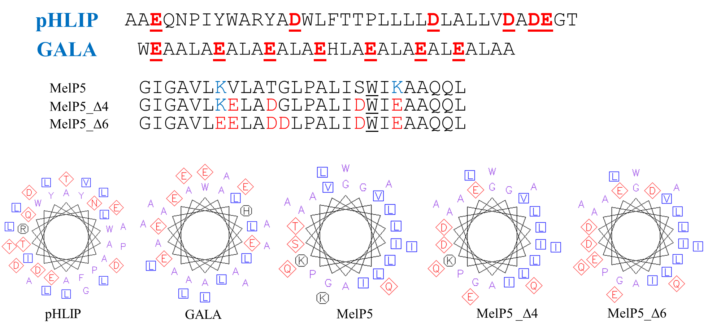
Figure 14. Helical Wheel diagrams of pHLIP, GALA, MelP5, MelP5_Δ4, and MelP5_Δ6.

Upper: At neutral pH, red residues in the sequences are negatively charged and blue residues in the sequences are positively charged. Bottom: At neutral pH, red residues in the helical wheel diagrams denote polar residues and blue residues are hydrophobic. The helical wheel diagrams were produced using pepwheel website: https://www.bioinformatics.nl/cgi-bin/emboss/pepwheel.

Chapter III. Allosteric Inhibition of the T Cell Receptor by a Designed Membrane Ligand

A version of this chapter was originally published by Yujie Ye, Shumpei Morita, Kiera B. Wilhelm, Jay T. Groves, Francisco N. Barrera:
bioRxiv preprint doi: https://doi.org/10.1101/2022.08.19.503518
Yujie Ye: Conceptualization; Data curation; Formal analysis; Supervision; Funding acquisition; Investigation; Methodology; Writing - original draft; Writing
- review and editing. Shumpei Morita: Conceptualization; Data curation; Investigation; Methodology; Writing - original draft; Writing - review and editing.
Kiera Wilhelm: Supervision; Investigation; Writing - original draft; Writing - review and editing. Jay Groves: Conceptualization; Formal analysis; Supervision; Funding acquisition; Investigation; Writing - original draft; Writing - review and editing. Francisco Barrera: Conceptualization; Formal analysis; Supervision; Funding acquisition; Investigation; Writing - original draft; Writing - review and editing. This manuscript was submitted to elife journal and is under review currently.

Abstract
The T cell receptor (TCR) is a complex molecular machine that directs the activation of T cells, allowing the immune system to fight pathogens and cancer cells. Despite decades of investigation, the molecular mechanism of TCR activation is still controversial. One of the leading activation hypotheses is the allosteric model. This model posits that binding of pMHC at the extracellular domain triggers a dynamic change in the transmembrane (TM) domain of the TCR subunits, which leads to signaling at the cytoplasmic side. We sought to test this hypothesis by creating a TM ligand for TCR. Previously we described a method to create a soluble peptide capable of inserting into membranes and bind to the TM domain of the receptor tyrosine kinase EphA2 (Alves et al., eLife 2018). Here we show that the approach is generalizable to complex membrane receptors, by designing a membrane ligand for TCR. We observed that the designed peptide caused a reduction of Lck phosphorylation of TCR at the CD3 ζ subunit. As a result, in the presence of this Peptide Inhibitor of TCR (PITCR), the proximal signaling cascade downstream of TCR activation was significantly dampened in T cells. Co-localization and co-immunoprecipitation results in DIBMA native nanodiscs confirmed that PITCR was able to bind to the TCR. We propose that PITCR binds into a crevice present between the TM helices of the CD3 ζ and CD3ɛ(δ) subunits. Our results additionally indicate that PITCR disrupts the allosteric changes in the compactness of the TM bundle that occur upon TCR activation, lending support to the allosteric TCR activation model. The TCR inhibition achieved by PITCR might be useful to treat inflammatory and autoimmune diseases and to prevent organ transplant rejection, as in these conditions aberrant activation of TCR contributes to disease.

Introduction
T cells are central players in the adaptive immune response. Different types of T cells recognize the presence of pathogenic organisms and cancer cells and orchestrate diverse immune activities intended to kill the damaging cells ^{40, 48}. The T cell receptor (TCR) is a protein complex present at the membrane of T cells that allows to detect the presence of foreign molecules. The TCR engages with antigen-presenting cells (APC), where peptide fragments are displayed at the major histocompatibility complex (pMHC) ⁵⁰. Recognition of pMHC by the TCR triggers an intricate signaling cascade that activates the T cell response ^{13, 27}. In αβ T cells, pMHC binding occurs at the TCRαβ subunits. The TCR complex additionally contains four types of CD3 subunits: ɛ, γ, δ and ζ, forming the TCR-CD3 complex (referred herein as TCR). The dominant stoichiometry of TCR is composed of TCR α β - CD3 ɛ γ - CD3 ɛ δ - CD3 ζ ζ ^{10, 24, 41}. The CD3 subunits relay the information of the pMHC binding event across the membrane, initiating TCR proximal signaling. TCR downstream signaling cascade starts by phosphorylation of ITAMs (immunoreceptor tyrosine-based activation motifs) present in all CD3 subunits, particularly at ζ, which leads to a transient increase in calcium levels in the cytoplasm ^{54, 69}.
Despite decades of effort, there is not yet a clear understanding of how TCR is activated after recognition of pMHC ⁴¹. A number of different activation modes have been proposed, namely the aggregation/clustering model, the segregation model, the mechanosensing model, and the allosteric model. In this latter functional hypothesis, the signal resulting from binding of pMHC to the extracellular region of the TCRαβ is dynamically transmitted across the transmembrane (TM) region into the ITAMs. While there is growing evidence supporting the allosteric model, as reviewed in ¹²⁴ , the molecular mechanism of the allosteric triggering of TCR-CD3 is not clear. Recent reports provide a plausible mechanistic framework on how allosteric changes affect the TM helical bundle: TCR activation involves a quaternary relaxation of the TM helical bundle, whereby in the active state there is a loosening in the interaction between the TM helices of the TCRβ and CD3ζ ^{26, 125}.
Here, we have used rational design to develop a peptide (PITCR) to target the TM region of TCR. PITCR comprises the TM domain of the ζ subunit ²² modified by the addition of acidic residues to convert it to a conditional TM sequence. The PITCR peptide is used to test the allosteric relaxation model, as its binding to the TM region of TCR can be reasonably expected to alter the conformation and/or dynamics/packing of the helical bundle. We observed that PITCR robustly inhibited the activation of the TCR. The results obtained in this work support the allosteric relaxation activation model and provide new mechanistic insights into TCR activation.

Results

PITCR decreases phosphorylation of the ζ chain upon TCR activation.
We recently reported an approach to transform the isolated TM domains of human receptors into peptides that function as conditional TM sequences: they are highly soluble in water, while they have the ability to insert into the membrane in the TM orientation that allows the peptide to interact laterally with their natural binding partners ⁸⁴. We applied this protocol to the CD3ζ TM, to generate the PITCR peptide. Biophysical experiments in synthetic lipid vesicles showed that the design for PITCR was successful, as it was soluble in aqueous solution and able to insert into membranes (Figure 15 - Figure supplementary 1).
The TCR at the surface of human Jurkat T cells is activated upon binding of the monoclonal antibody (mAb) OKT3, which has been widely applied to study T cell signaling ^{42, 54}. TCR activation is initiated by phosphorylation of tyrosine residues at the ITAMs of the ζ chain by Lck (lymphocyte-specific protein tyrosine kinase) (Figure 15A) ⁴⁸. To investigate whether PITCR affects TCR activation, we treated Jurkat cells with PITCR before stimulation with OKT3. The immunoblot results revealed that PITCR reduced phosphorylation of the ζ chain at residues Y142 and Y83 after TCR activation (Figure 15 B-C and Figure 15 - Figure supplementary 2). These results suggest that PITCR binding reduces activation of the TCR.

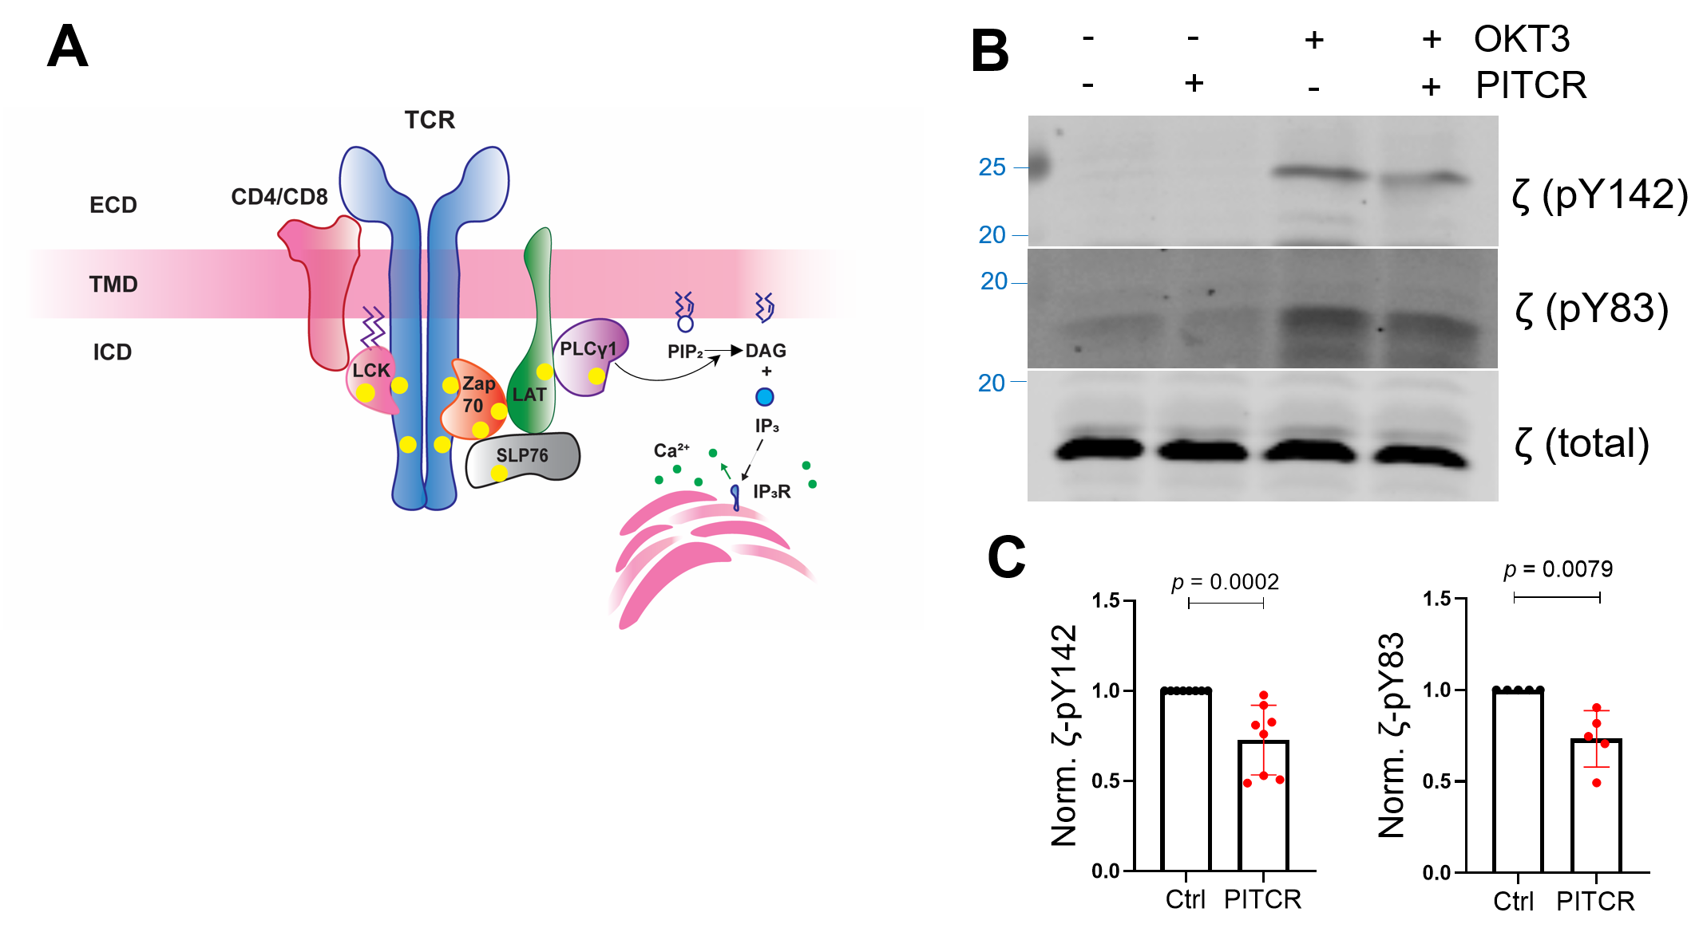
Figure 15. PITCR reduces phosphorylation of the ζ chain in response to OKT3.

(A) Cartoon that illustrates TCR proximal downstream signaling. The plasma membrane is shown as a horizontal bar, and phosphorylation sites are shown as yellow dots. ECD: extracellular domain; TMD: transmembrane domain; ICD: intracellular domain of TCR. (B) Jurkat cells were treated with PITCR, followed by stimulation with OKT3. Lysates were analyzed by immunoblot to detect TCR phosphorylation of ζ (pY142 and pY83). Total ζ levels were assessed and no change was observed. Data are representative at least five independent experiments. (C) Quantification of phosphorylation at both tyrosine residues in the presence of OKT3, normalized to data in the absence of PITCR (based on data from Figure 15-Figure supplementary 2). Error bars are the SD. p values were calculated using a two-tailed Mann-Whitney test.

Phosphorylation of TCR proximal signaling molecules is downregulated by PITCR.
Since PITCR inhibited TCR phosphorylation after activation, we sought to explore the effect of PITCR on TCR downstream signaling. TCR activation induces the recruitment of Zap70 (ζ chain – associated protein kinase 70) to the phosphorylated TCR, where it is itself phosphorylated by Lck (Figure 15A). The
activated Zap70 then phosphorylates LAT (linker for activation of T cells) and SLP76 (SH2 domain containing leukocyte protein of 76 kDa), and as a result PLCγ1 (phospholipase C-γ1) is recruited and phosphorylated ^{13, 54, 126}. In agreement with the hypothesis that PITCR inhibits TCR activation, in the presence of peptide we observed a statistically significant decrease in the phosphorylation of Zap70, LAT, SLP76 and PLCγ1 (Figure 16 and Figure 16 - Figure supplementary 1). However, PITCR did not affect phosphorylation of Lck (Figure 16 - Figure supplementary 2). Since basal phosphorylation of Zap70, LAT, SLP76 and PLCγ1 was observed in the absence of OKT3 (Figure 16A), we could determine that the effect of PITCR is specific to stimulation of the TCR. Our data therefore indicate that PITCR causes a robust inhibition of the proximal signaling cascade triggered by TCR activation.

PITCR reduces intracellular calcium response.
After TCR activation, the active PLCγ1 hydrolyzes phosphatidyl inositol 4,5-bisphosphate (PIP₂) to generate inositol trisphosphate (IP₃) and
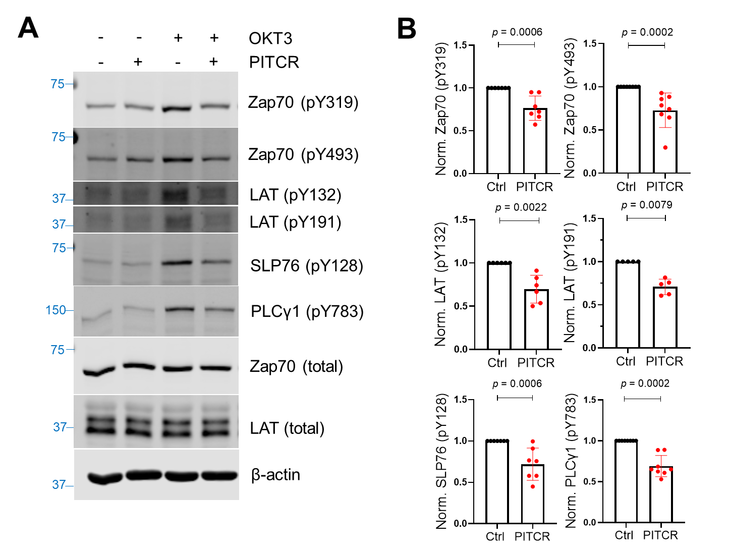
Figure 16. PITCR reduces phosphorylation of TCR proximal signaling proteins after activation.
(A) Immunoblot analysis of lysates to detect phosphorylation of Zap70 (pY319 and pY493), LAT (pY132 and pY191), SLP76 (pY128), and PLCγ1 (pY783). Total protein levels of Zap70, LAT and the housekeeping protein β-actin were assessed, revealing no changes. Data are representative of at least five independent experiments. (B) Quantification of phosphorylation in the presence of OKT3, normalized to data in the absence of PITCR (based on data from Figure 2-Figure supplementary 1). Error bars are the SD. p values were calculated using a two-tailed Mann-Whitney test.

diacylglycerol (DAG). Free IP₃ diffuses across the cytoplasm and binds to the IP3 receptor at the endoplasmic reticulum (ER), causing the release of calcium from ER storage (Figure 15A) ^{13, 28, 29}. Based on our previous results, we reasoned that PITCR should inhibit the cytoplasmic calcium influx that follows TCR activation. We tested this idea with a kinetic analysis of intracellular calcium release using the calcium indicator Indo-1 ⁵⁴.
Consistent with our expectation, we observed that the calcium response after OKT3 stimulation was attenuated in the PITCR treatment group compared with control conditions (Figure 17 A and D, Figure 17 - Figure supplementary 1). We used as a negative control pHLIP ^{100, 127}, a different conditional TM peptide that is not expected to interact with membrane proteins ⁸⁴. The dynamic calcium curve of pHLIP-treated group was within the error of the control curve (Figure 17 B and D). To further test specificity of PITCR, we performed a mutation (replacing Gly41 for a Pro) in PITCR that is expected to form a helical kink and disrupt the TM helix. Control biophysical experiments indicated that the G41P mutation did not prevent the peptide to act as a conditional TM (Figure 15 - Figure supplementary 1). We observed that PITCRG41P was unable to inhibit the calcium influx in response to OKT3 treatment (Figure 17C and D). These data indicate that PITCR specifically impaired the calcium response that occurs in Jurkat cells after TCR activation, in agreement with the observed decrease in phosphorylation of PLCγ1 (Figure 16A and B).

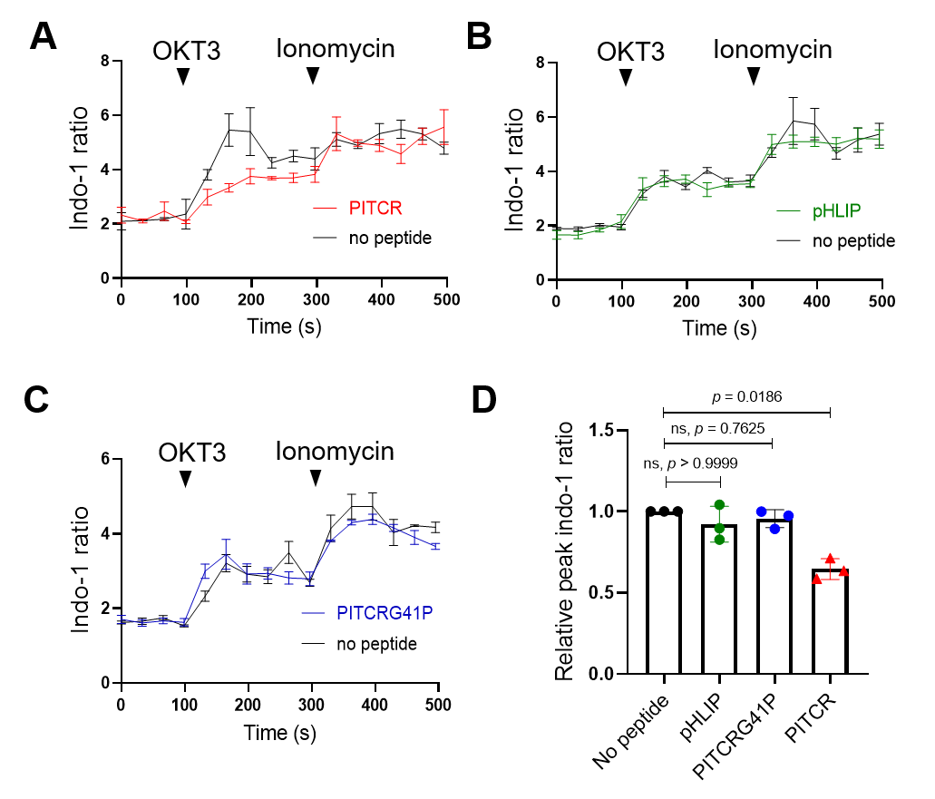
Figure 17. PITCR reduces the TCR intracellular calcium response.
Jurkat cells were stained with the fluorescent dye indo-1 AM, followed by treatment with PITCR (A), pHLIP as a negative control (B), or the variant PITCRG41P (C) and stimulated with OKT3. Ionomycin was applied as a positive calcium control. The indo-1 ratio was calculated from fluorescence at 405 nm (calcium-bound) divided by 475 nm (calcium-free). Data are representative of three independent experiments. Each independent experiment includes at least four technical replicates. Error bars are the SEM. (D) Quantification of the maximum Indo-1 increase after OKT3 activation, normalized to no peptide treatment. Error bars are the SD. p values were calculated from a Kruskal-Wallis test with Dunn’s multiple comparisons test.

Inhibition of TCR engagement with antigen presenting cells.
While the OKT3 mAb efficiently stimulates TCR signaling, we sought to test the effect of TCR in a more physiologically relevant TCR activation, consisting of T cell stimulation by binding to pMHC in antigen presenting cells (APCs) ⁵⁴. Similar to human primary cytotoxic CD8⁺ T cells, OT1⁺-TCR CD8⁺ Jurkat T cells (J.OT1.CD8) can recognize the ovalbumin (OVA) peptide presented by H-2K^{b}-MHC I on T2 APC cells (T2K^{b}) (Figure 18 A and B). TCR engagement results in increased levels of CD69, a T cell activation marker ^{42, 54, 128}. We treated J.OT1.CD8 cells with PITCR followed by incubation with T2K^{b} cells pre-treated with a range of OVA concentrations and measured the CD69 expression using flow cytometry (Figure 18 C and D). As expected, in the presence of high OVA concentrations we observed CD69 upregulation (Figure 18 C). Our data showed that PITCR caused a significant reduction of CD69 levels (Figure 18 C and D). To further examine the specificity of PITCR, we again used pHLIP as a negative control, and we observed that pHLIP did not elicit significant changes. Our data therefore indicate that PITCR specifically impaired CD69 upregulation in J.OT1.CD8 cells in response to OVA stimulation. These results show that PITCR also achieves robust inhibition when TCR is activated by binding pMHC to APC.

PITCR interacts with the TCR
Our results clearly show that PITCR inhibits TCR activation. We sought

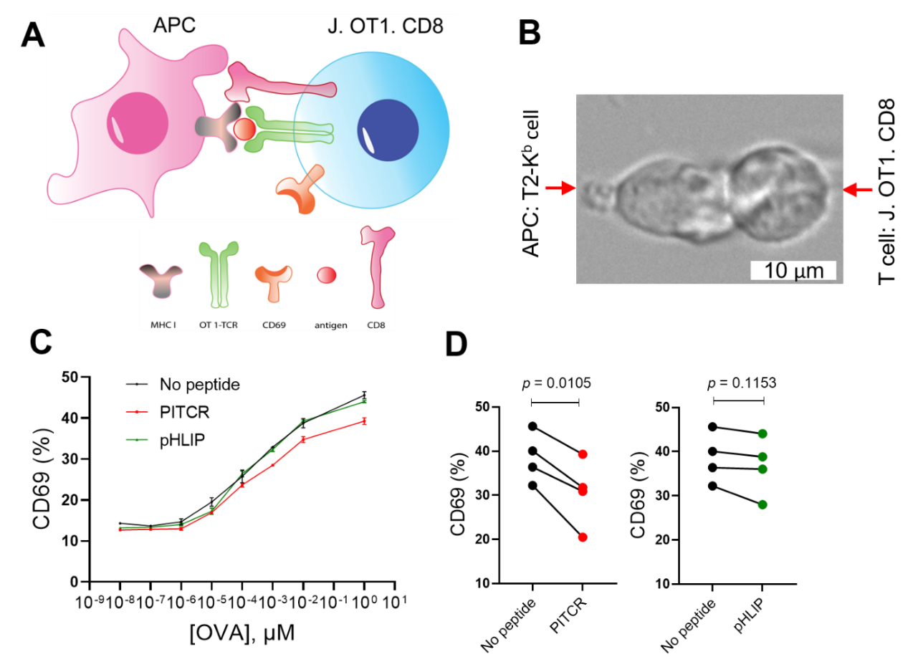
(A) Cartoon showing T cell interaction with APC. (B) A live cell microscopy image that depicts engineered Jurkat-OT1⁺ TCR-CD8⁺ T cells interacting with T2K^{b} APC pre-incubated with the peptide antigen OVA. (C) Jurkat-OT1⁺ TCR-CD8⁺ T cells were treated with PITCR or pHLIP (as a negative control), and then incubated with T2K^{b} cells at different concentrations of OVA, followed by CD69 flow cytometry analysis. The upregulation of CD69 is representative of four independent experiments. Each independent experiment includes two technical replicates. Error bars are the SD. (D) Quantification of CD69-positive cells at [OVA] = 1 μM for PITCR (red) and negative control pHLIP (green). Each dot pair represents one independent experiment. p values were calculated from two-tailed paired t-test.
Figure 18. PITCR reduces CD69 expression after T cell activation by APC.

next to determine if this was a specific effect that resulted from a direct interaction between the peptide and TCR. First, we performed co-localization experiments in Jurkat cells. To this end, we fluorescently labeled PITCR with dylight680 (PITCR680). We employed super-resolution confocal microscopy with lightning deconvolution to investigate PITCR680 co-localization with TCR, as detected with an anti-CD3 ɛ antibody. We observed that PITCR680 localized to some areas of the Jurkat cells, corresponding to the plasma membrane and intracellular organelles, probably endosomes (Figure 19 A). In these two regions we observed co-localization between PITCR680 (magenta) and TCR (CD3 ɛ, green) (Figure 19 A). To better assess co-localization, we plotted graphic profile curves on regions of interest (ROI), which revealed clear overlap in some areas. To quantify the degree of co-localization, we calculated the Mander’s M1 coefficient, which showed a value of ~0.8 (Figure 19 D). This result reveals that around 80% of PITCR680 signal overlaps with the TCR. We also observed robust co-localization using the Pearson correlation coefficient (r = ~0.4) (Figure 19 – Figure supplementary 2) ¹²⁹. To further explore whether TCR activation influences co-localization, we stimulated PITCR680-treated Jurkat cells with OKT3. We observed similar results, suggesting that PITCR is able to bind to TCR before it is activated by OKT3. We investigated if co-localization of PITCR and TCR also occurred in primary T cells. We performed surface-selective imaging by total internal reflection microscopy in primary murine CD4⁺ T cells expressing
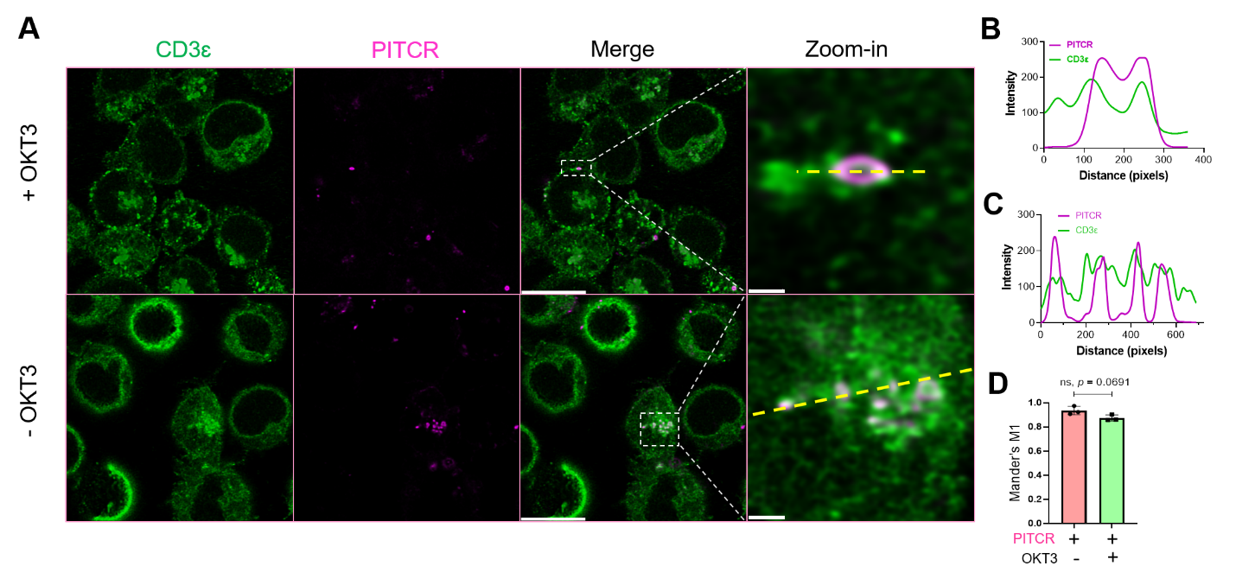
Figure 19. PITCR colocalizes with TCR.
(A) PITCR680 and CD3ɛ co-localization was studied in the presence and absence of activation with OKT3. Scale bars = 10 µm. Representative areas with co-localization at the plasma membrane (top) and cytoplasm (bottom) were zoomed-in, where scale bars are 0.5 µm and 1 µm, respectively. Confocal images are representative of three independent experiments. (B) and (C) show graphic profile curves plotted across the zoom-in ROI (dotted yellow lines) in + OKT3 and – OKT3, respectively. Magenta lines denote PITCR, and green lines denote CD3ɛ. Overlap indicates colocalization. (D) Quantification of co-localization by Mander’s coefficient (M1), corresponding to the fraction of PITCR that overlaps with CD3ɛ. Error bars indicate SD. p value was calculated from two tailed unpaired t-test.

AND TCR. Immune synapse formation was imaged ^{130, 131, 132, 133}, as T cells were stimulated by contact with supported bilayers functionalized with agonist pMHC
(MCC peptide labeled with Atto647N) and the adhesion molecule ICAM-1 ³⁶ ¹³⁴. TCR-pMHC complexes were selectively distinguished from free pMHC using an elongated image exposure time strategy ^{36, 135, 136}. We observed the c-SMAC (central supramolecular activation cluster) structure at the core of the immune synapse (Figure 20), as previously reported ^{133, 137}. PITCR conjugated to AZDye 555 (PITCR555) could be detected in intracellular structures (SI Movie),
consistent with confocal microscopy results. Additionally, a distinct population plasma-membrane-bound peptide could be also observed (Figure 20). In these cases, PITCR exhibited c-SMAC localization together with TCR-pMHC complexes (SI Movie). Although the image resolution was insufficient to definitively confirm molecular binding between PITCR and TCR-pMHC complex, their co-localization is suggestive of interaction. In aggregate, the co-localization
experiments support binding of PITCR to TCR in Jurkat and primary T cells. We sought to determine if the observed co-localization indeed resulted from binding between PITCR and TCR. We developed an assay to maintain the TCR complex of Jurkat cells in a native lipid environment, consisting of using the polymer diisobutylene maleic acid (DIBMA) to form native nanodiscs. On these
band of molecular weight (~5 kDa) similar to that of PITCR680 (4.8 kDa) (Figure 21). To further explore whether TCR activation would affect binding of PITCR680

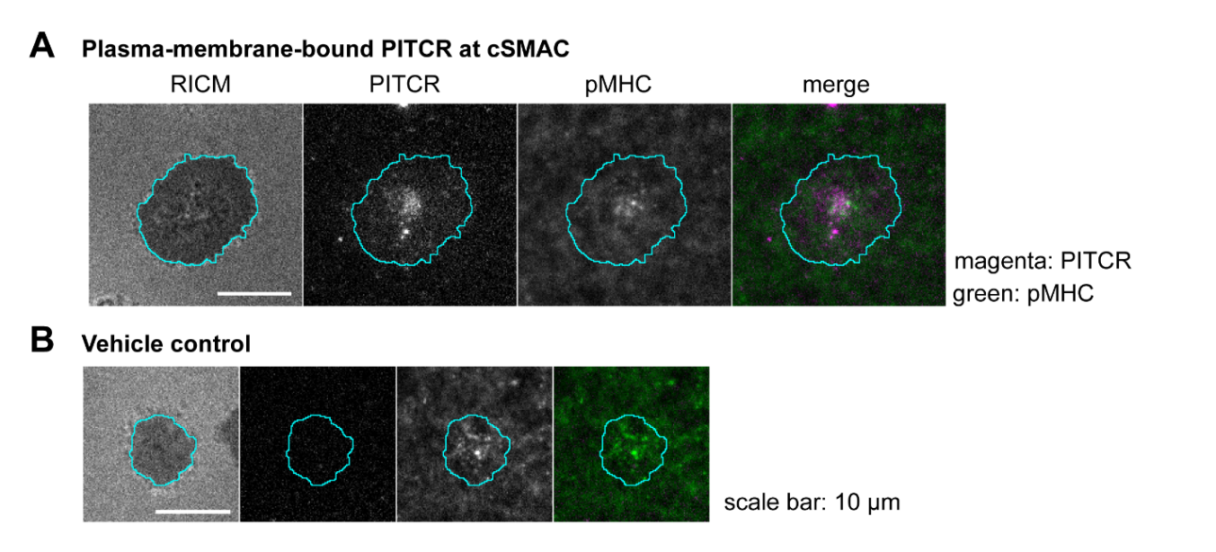
(A) Images of plasma-membrane-localized PITCR555 and TCR-pMHC complex in a representative T cell adhering to supported lipid bilayer functionalized with pMHC (19-23 molecules/µm², 9% labeled with Atto-647N) and ICAM-1 (~20 molecules/µm²). TCR-pMHC complex was selectively visualized with a long exposure time (500 ms). PITCR exhibited localization at c-SMAC together with the TCR-pMHC complex. (B) Vehicle control showed no signal at the PITCR channel.

Figure 20. Colocalization of PITCR and the TCR-pMHC complex in primary murine
CD4⁺ T cells

5
10
PITCR680
OKT3
-
-
+
-
-
+
+
-
-
+
-
-
+
+
+
+
Anti-CD3 ε -IP
IgG -IP
20
CD3 ɛ
37
TCR β
15
CD3 ζ
Co-IP samples
CD3 ζ
15
20
CD3 ɛ
TCR β
37
37
β-actin
Whole lysates
PITCR680
Figure 21. PITCR interacts with TCR. Jurkat cells were treated with PITCR-680.

TCR nanodiscs were immunoprecipitated with the mAb UCHT1, or with IgG as a negative control. Fluorescent detection of PITCR-680 after Co-IP or run in the gel directly as a positive control (side panel). Below are shown immunoblot analysis of Co-IP samples and whole lysates to probe CD3 ɛ, TCR β and CD3 ζ. β-actin was a loading control. Data are representative of at least three independent experiments.

to the complex, we applied OKT3 as previously described. We observed the ~5 kDa fluorescent band as well. These results indicate that PITCR680 interacts
with the TCR irrespective of activation by OKT3, in agreement with the co-localization results in Jurkat cells (Figure 18).

PITCR weakens the interaction of the ζ subunit with the rest of the complex after TCR activation.
We next sought to understand the mechanism by which PITCR partially inhibits TCR activation. It has been recently proposed that TCR activation involves a change in robustness of the TM helical bundle. This allosteric change can be detected by immunoprecipitation after solubilization in DDM, as a loose complex is less resistant to this detergent ^{26, 125}. We optimized this assay for our experimental conditions and investigated the interaction between the ζ chain and rest of the TCR complex. We first examined the immunoprecipitated levels of CD3 ɛ, CD3 ζ and TCR β in the presence of DDM to evaluate the specificity and efficacy of the use of the anti-CD3 ɛ antibody for our immunoprecipitatation assay. We observed the targeted bands in the immunoblot results for anti-CD3 ɛ-IP, and no bands in the negative control IgG-IP (Figure 22A). These results suggest that our protocol successfully IPs the TCR complex. Once we validated our method, we tested the effect of OKT3 stimulation and PITCR treatment. We observed that OKT3 increased the levels of CD3ζ when compared to both TCRβ2 and CD3ɛ (ζ / β2 and ζ / ɛ) (Figure 22). These results suggested a more robust ζζ interaction with the rest of complex in response to OKT3 stimulation. Based on this result, we reasoned that PITCR could act by reversing the changes in quaternary robustness that occur in the membrane region upon TCR activation. In agreement with our hypothesis, we observed that the ζ / β2 ratio was decreased when cells were incubated with PITCR and OKT3. However, ζ / ɛ did not change (Figure 22). Taken together, these results suggested that PITCR disrupts the allosteric changes in TM quaternary robustness that occur upon TCR activation.

Discussion
For this study we developed a novel conditional transmembrane peptide to target the T cell receptor. The design of PITCR involved strategically introducing glutamic acid residues into the transmembrane sequence of the human CD3 ζ chain, as previously described for TYPE7, a rationally designed TM ligand for the EphA2 receptor ⁸⁴. We additionally introduced small and polar residues (Figure 15-Figure supplementary 1 A). PITCR selectively inserted into synthetic lipid vesicles at acidic pH (Figure 15-Figure supplementary 1). However, we observed that TCR activation in Jurkat cells was severely disrupted by acidic pH (data not shown). We therefore performed experiments at physiological pH, where we observed that PITCR efficiently targeted cells (Figure 18 and Figure 19). This observation is not unexpected. The acidity-responsive TYPE7 also targeted cellular membranes at neutral pH because the presence in the membrane of its target receptor shifts the pH-responsiveness to cause membrane insertion at pH 7.4. We suggest that a similar situation might occur for TCR. However, we
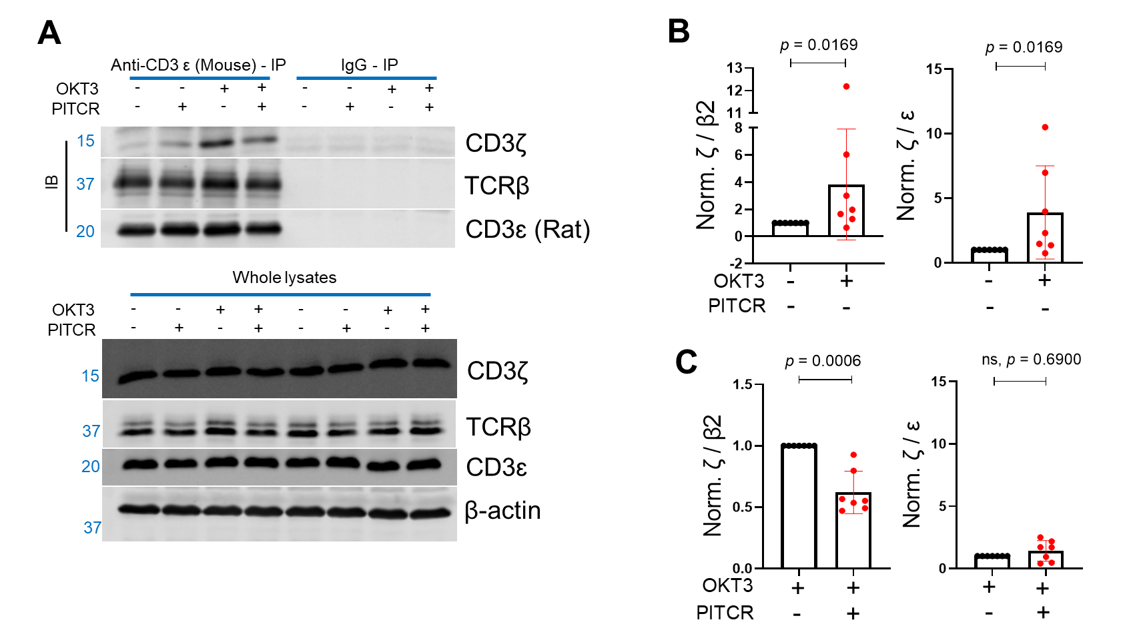
Figure 22. PITCR weakens the interaction of the ζ chain with the rest of the complex after TCR activation.
(A) Immunoblot analysis of immunoprecipitated samples and whole lysate samples solubilized with DDM. Data are representative of at least three independent experiments. (B) Quantification of ζ / β2 and ζ / ɛ after OKT3 stimulation. (C) ζ / β2 and ζ / ɛ in PITCR-treated OKT3 samples, normalized to OKT3 stimulation. The β2 subunit was studied since it is the most abundant β subunit at the plasma membrane. Error bars are SD. p values were calculated from a two-tailed Mann-Whitney test.

speculate that PITCR will more effectively inhibit T cells that reside and survive in acidic environments. The solubility of PITCR is a useful property to facilitate delivery to tissues. Furthermore, the pH-responsiveness of PITCR could potentially be used for targeted therapies in pathologies that are characterized by acidic extracellular environments, including inflammatory ¹³⁸ and autoimmune diseases ¹³⁹, and solid tumors ⁹². PITCR could also be used to overcome a critical limitation of allogeneic CAR T therapy, since TCR inhibition is required to prevent graft-versus-host disease resulting from side effects of this therapy. The use of PITCR would additionally overcome the risk resulting from genetic manipulation (i.e., viral transfection) of allogeneic T cells before injection into patients ¹⁴⁰.
PITCR caused robust inhibition throughout the signaling cascade that is triggered when TCR is activated, from phosphorylation of the ζ chain to calcium influx. Upon TCR ligation, immunoblot analysis showed that PITCR inhibited phosphorylation at multiple sites in Zap70, LAT, SLP76 and PLCγ1 (Figure 16), but not of Lck (Figure 16-Figure supplementary 2). The observed specific inhibition of TCR-downstream signaling suggests that PITCR is unlikely to inhibit/activate a broad range of kinases or phosphatases. Rather, PITCR is likely to specifically inhibit TCR triggering, while maintaining Lck association with coreceptors and its phosphorylation ^{51, 141}.
What is the molecular mechanism of PITCR inhibition of TCR? A recent molecular dynamics simulation study of TCR ²⁶ offers clues on a possible binding site for PITCR. The model reveals a hydrophobic gap between the TM domain of the ζ and ɛ (δ) subunits that can accommodate PITCR (Figure 23). Interestingly, the cryo-EM structure of TCR reveals a binding interface between the TM of ζ and ɛ (δ) ¹⁰. PITCR maintains all the residues that form the helical face of ζ that interacts with ɛ (δ). Therefore, we propose that PITCR binds into the membrane gap between ζ and ɛ (δ), where it establishes native interactions with the ɛ (δ) subunit. We found that when we replaced glycine at position 41 with proline, the peptide no longer inhibited calcium influx (Figure 17). We speculate that proline induced a local helical kink in PITCR that prevented binding to the TM gap, or a productive interaction between PITCR and the ɛ (δ) subunit of TCR. The results of the immunoprecipitation experiments in the presence of DDM (Figure 22) showed that upon TCR activation with OKT3, ζζ strengthened its association with the β subunit. We observed that PITCR caused the opposite effect. This result shows that PITCR acts by reversing the allosteric changes in TM compactness induced by OKT3 activation. However, there was an interesting difference in the interaction with the ɛ subunit, which increased with OKT3 activation but was not altered by PITCR. This observation suggests that not all the TM interactions are equally important with regards to contributing to TCR activation. Our results additionally suggest that the interface between the ζ and β subunits is a target for pharmacological inhibition of the TCR.
We based the DDM immunoprecipitation assay on a previous report ¹²⁵, but our protocol contains significant differences. We performed the immunoprecipitation
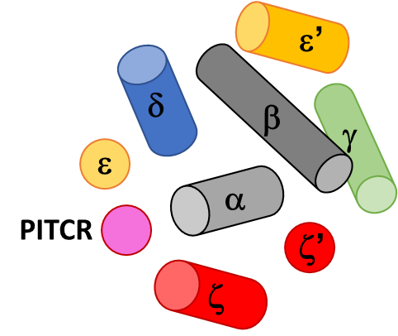
Schematic view looking from the extracellular side of the TM bundle of TCR, with PITCR is shown in magenta. TM helices are shown as cylinders or circles. The disulfide bond between the z subunits is not shown for clarity.

Figure 23. Cartoon model of PITCR interaction with TCR.

for the native receptor, while the previous protocol involved IP of an HA-tagged TCR, which was also activated by different means to ours. Probably as a result of these differences, our DDM immunoprecipitation result showed an opposite effect into how TCR activation affected the association of TCRαβ with ζζ ^{125, 142}. Nevertheless, the two experimental lines of evidence still agree in showing changes in the quaternary stability of the TCR upon activation, and support that this effect could be an important element of the allosteric activation of the TCR. Overall, our data indicate that binding of PITCR to the transmembrane region of TCR results in opposite allosteric changes to those that occur upon TCR activation, and we propose this effect reduces signal transduction into the intracellular region.
Even though the activation of TCR is an intricate process ^{10, 41, 143, 144}, significant progress has been made to understand the conformational changes it entails. For example, in response to TCR engagement, the juxtamembrane domains of the ζζ homodimer have been experimentally reported to switch from a divaricated to a parallel conformation ³⁵. TCR activation additionally involves a conformational change of the ITAMs of CD3ɛ that releases the interaction of basic residues in the intracellular domain of CD3 ζ ²⁵ and ɛ ¹² giving access to Lck for phosphorylation. We suggest a plausible mechanism where PITCR insertion into the gap between ζζ homodimer and the rest of TCR-CD3 complex may additionally hinder the activating conformational change in ζζ. This hypothesis might further explain the observed decrease of ζ / β2 in the PITCR-treated Jurkat cells upon TCR activation.
The human adaptive immune system contains numerous types of T cells. T cells present a broad repertoire of TCR ¹⁶. For example, in human peripheral blood samples, 10⁴ varieties of TCRβs can be found ¹⁴, while more than 10¹⁵ combinations of TCRαβ are could theoretically be formed ¹⁶ ¹⁴⁵ ¹⁵. The TCR repertoire plays a critical role in the adaptive immune response, but it also brings challenges to achieve immunosuppression to treat inflammatory and autoimmune diseases. Our data show that PITCR interacts with different types of TCRs: it inhibited TCR signaling in Jurkat-WT (Figure 15, Figure 16, and Figure 17), and colocalized with the cSMAC structure formed by AND-TCR in primary CD4⁺ T cells (Figure 20). Furthermore, PITCR reduced CD69 upregulation in OT1-TCR Jurkat cells (Figure 18). These results suggest that PITCR may possess the ability to interact with a broad range of TCR types. We hypothesized that this would be possible because the PITCR design is based on targeting the TM region of the TCR, a sequence that is largely conserved.
Taken together, our data show that rational design of a membrane ligand inhibits TCR activation. PITCR has potential clinical value to treat autoimmune and inflammatory diseases or to avoid transplant rejection. The strategy used to design PITCR can be applied to develop targeted ligands for other receptors causative of disease.

Materials and Methods
Cell lines
Human male leukemic Jurkat T cells (Clone E6-1, TIB-152) were obtained from the American Type Culture Collection (Manassas, United States). Jurkat.OT1-TCRα-GFP-TCRβ.hCD8⁺ (J.OT1.hCD8) cells and T2-K^{b} cells were kindly provided by Arthur Weiss (UCSF). Cell lines were maintained in RPMI 1640 (Gibco 11875119) supplemented with 10 % fetal bovine serum (Gibco 10437028), 1 % L-Glutamine (Gibco 25030081) and 1 % penicillin & streptomycin (Gibco 15140122) in a 37 °C & 5 % CO₂ humid tissue culture incubator (Panasonic Healthcare, Wood Dale, United States). The identity of Jurkat cells was authenticated using ATCC services. Mycoplasma contamination was ruled out by PCR (Abcam 289834).
Peptide synthesis
Peptides were synthesized by Thermo Fisher Scientific (Waltham, United States) and were confirmed by matrix-assisted laser desorption ionization-time-of-flight (MALDI-TOF) mass spectrometry and reverse phase high performance liquid chromatography (HPLC). Purities of the peptides are over 95 %. PITCR sequence: DPKLSYLLDGILFGYGVELTALFLEVGFSESAD.
Intracellular calcium assay
Jurkat wild-type (WT) cells were washed twice with PBS and then stained with the calcium sensor dye Indo-1 AM (Invitrogen I1223), at 37 °C and 5 % CO₂ for 30 mins as described ^{42, 54}. The final concentration of Indo-1 AM was 1 µM. Stained Jurkat cells were washed twice with PBS and then were transferred to a 96 well flat bottom black plate. PITCR was added and incubated at 37 °C and 5 % CO₂ for 20 mins. Next, the plate was transferred to a prewarmed (37 °C) and 5 % CO₂ Cytation V plate reader (BioTeK, Winooski, United States) and incubated for another 10 mins. The final concentration of PITCR in the each well was 10 µM. The baseline for each well was recorded for the first 100 seconds, followed by auto-injection of anti-CD3 (OKT3 clone, Tonbo-70-0037). The final concentration of anti-CD3 was 1 µM. Ionomycin (Invitrogen I24222) was used as a positive control to prove that Jurkat cells respond to calcium influx. The fluorescent signal collected from Jurkat-WT cells without staining was subtracted from the signal collected from Indo-1 AM stained cells since Jurkat-WT cells have auto-fluorescent signals.
SDS-PAGE Immunoblot analysis of proximal signal molecules of TCR-CD3, ζ-Y83 and ζ-Y142
Jurkat-WT cells were washed twice with PBS and treated with PITCR at 37 °C and 5 % CO₂ for 30 mins, followed by stimulation with anti-CD3 antibody (OKT3 clone) for 5 mins. The final cell density was 5 x 10⁶ cells/ml and the final concentration of PITCR was 10 µM. The final concentration of anti-CD3 was 1 µM. Cells were lysed in 1 % NP-40 lysis buffer (50 mM Tris-Cl pH 7.4, 150 mM sodium chloride, 2 mM PMSF, 5 mM EDTA, 0.25 % sodium deoxycholate with proteinase inhibitors (Thermo Scientific A32955) and phosphatase inhibitors (Sigma-Aldrich P0044) for 30 minutes on ice, followed by centrifugation of 16.2 x 10³ g, 30 mins, 4 °C. Supernatants were collected and detergent-compatible protein assay (Bio-Rad5000112) was performed to quantify the protein concentration of each sample. Equal amounts of protein samples were run in 10 %, 12 % or 15 % SDS-PAGE gels and transferred to 0.45 µm nitro cellulose membranes. Membranes were blocked with 3 % bovine serum albumin (BSA) dissolved in TBS, followed by overnight incubation with primary antibodies at 4 °C. IRDye 800CW or IRDye 680LT secondary antibodies were used to incubate the blots at the 2nd day, followed by detection with an Odyssey Infrared Scanner (Li-Cor Biosciences, Lincoln, United States). All primary antibodies were diluted in 5 % BSA dissolved in 0.1 % TBST except specific mentions and all secondary antibodies were diluted in 5 % non-fat milk dissolved in 0.1 % TBST unless mentioned otherwise.
Co-localization assay and analysis
All steps were performed at room temperature (RT), unless noted otherwise. Jurkat-WT cells were washed once with PBS, resuspended in RMPI1640 phenol-red free media, and treated with dylight680 labeled PITCR (PITCR680) at 37 °C and 5 % CO₂ for 15 mins, followed by stimulation in presence or absence of anti-CD3 (OKT3 clone) for 5 mins. The final concentration of anti-CD3 was 1 µM. The final cell density was 5 x 10⁶ cells/ml and the final concentration of PITCR680 was 10 µM. PITCR680 treated cells were washed twice with cold PBS and resuspended in cold RPMI1640 phenol-red free media. 100 μL of cells were transferred to each chamber of μ-Slide 8 Well ibiTreat (ibidi80826) and rested for 10 mins. Next, RPMI1640 phenol-red free media was removed gently. 150 μL cold fixing buffer (1.998 % - formaldehyde and 0.2 % - glutaraldehyde in filtered PBS) was added and incubated for 10 mins. Fixed PITCR680 treated Jurkat cells were washed twice with cold DPBS/Modified (HycloneSH30264.01). 150 μL permeabilization buffer (0.1 % Triton X100 in PBS) was incubated with the sample for another 15 mins. Each chamber was washed with blocking buffer (5 % goat serum in 0.01 % PBST) twice. The sample was blocked 1 hr, followed by washing once with antibody dilution buffer (1 % BSA in 0.01 % PBST). The samples were incubated with 1:200 diluted anti-CD3ɛ (UCHT1 clone, sc-1179) primary antibody in the wet box at4 °C, overnight. On the 2nd day, each chamber was washed twice with cold DPBS/Modified (HycloneSH30264.01). 1:200 diluted secondary antibody (Invitrogen A32723) was incubated with samples in a foil covered wet box for 1 hr, followed by washing twice with cold DPBS/Modified (HycloneSH30264.01). 1:1000 diluted DAPI (Thermo Scientific 62248) was stained with samples for 2 mins, followed by washing once with cold DPBS/Modified. The samples were mounted with Vectashield (H-1000), followed by sealing the chambers with parafilm until imaging.
Samples were imaged using a Leica SP8 White Light Laser Confocal Microscope (Leica, Wetzlar, Germany) equipped with a 63X oil immersion objective, zoom 5 through LAS X software. Z-stack scanning was applied, followed by a lightning deconvolution analysis. Each image was chosen from one time point at each Z-stack section. Graphic profile curves of the Region of Interest in Zoom-in images were analyzed using Image J RGB Profile Plot Plugin. The Mander’s M1 and Pearson’s r coefficients were calculated using Image J Just Another Colocalization Plugin (JACoP).
CD69 activation flow cytometry assay
2x10⁶ cells/ml T2-K^{b} cells were washed twice with PBS and treated with a series of diluted ovalbumin (OVA) derived peptide (SIINFEKL) at 37 °C and 5 % CO₂ for 1 hr. 5 x 10⁶ cells/ml J.OT1.hCD8⁺ cells were washed twice with PBS and treated with PITCR at 37 °C and 5 % CO₂ for 30 mins. PITCR-treated J.OT1.hCD8⁺ cells were added to OVA-treated T2-K^{b} cells and the ratio of these two cells was 1:1. Final concentration of PITCR was 10 µM. The incubation time was 3 hrs. Next, anti-CD69 - Allophycocyanin (Biolegend 310910) and Isotype - Allophycocyanin (Biolegend 400122) were applied to stain the cells, respectively followed by LSRII Flow Cytometer (BD Bioscience, Franklin Lakes, United States) analysis. Data was quantified using FlowJo_v10.8.0 software.
Co-Immunoprecipitation of TCR-CD3 complex and immunoblot analysis
Jurkat-WT T cells were washed twice with PBS and treated with Dylight680 labeled PITCR at 37 °C and 5 % CO₂ for 30 mins, followed by stimulation with 1 µM anti-CD3 antibody (OKT3 clone). Cells were lysed in 2.5 % Diisobutylene Maleic Acid (DIBMA, AnatraceBMA101) lysis buffer (20 mM Tris-Cl pH 8.0, 137 mM NaCl, 2 mM EDTA, 1 mM PMSF, 5 mM iodoacetamide, 1 mM NaF, proteinase inhibitors (Promega G6521) and phosphatase inhibitors (Sigma-Aldrich P0044 and P5726) at warm room (37 °C) for 2 hrs followed by rotating at least 12 hrs in the cold room (4 °C). Lysates were ultracentrifuged 10,000 g, 4 °C, 45 mins to get rid of debris, and the supernatants were collected and ultracentrifuged again 10,000 g, 4 °C, 1hr. The protein concentrations were quantified using a detergent compatible protein assay. 40 µl whole lysates were saved to detect the TCR-CD3 complex. 1 % BSA blocked protein G agarose (Thermo Scientific 20398) and anti-CD3ɛ (UCHT1 clone, sc-1179) were added to the rest of lysates. Samples were gently rotated at cold room (4 °C) for 16 hrs. Samples were centrifuged 5,000 g, 4 °C, 3mins, followed by washing twice with cold wash buffer (20 mM Tris-Cl pH 8.0, 137 mM NaCl, 2 mM EDTA, 1 mM PMSF, 5 mM iodoacetamide, 1 mM NaF) and rinsing once with cold wash buffer. SDS sample buffer was applied to elute the captured protein followed by incubation at 95 °C for 5 mins.
Equal amount of whole lysate samples and captured protein samples were loaded in 15 % SDS-PAGE glycine gels and transferred to 0.45 µm or 0.2 µm nitro cellulose membranes. 3 % BSA was used to block the membranes, followed by incubation with primary antibodies: anti-TCRβ, anti-CD3ɛ and anti-CD3ζ (6B10.2 clone) overnight at 4 °C. In the whole lysates’ group, the housekeeping protein β-actin was also probed. PITCR was directly detected using channel 700 nm of an Odyssey Infrared Scanner (Li-Cor Biosciences, Lincoln, United States). The 2nd day, same approaches were performed as described in SDS-PAGE Immunoblot analysis of proximal signal molecules of TCR-CD3, ζ-Y83 and ζ-Y142.
Liposome preparation
1-palmitoyl-2-oleolyl-glycero-3-phosphocholine (POPC) and 1-palmitoyl-2-oleoyl-sn-glycero-3-phospho-L-serine (POPS) were purchased from Avanti Polar Lipids, Alabaster, AL. POPC and POPS were dissolved in cold chloroform and stocks prepared at 32.89 mM. POPS and POPC were mixed in a round-bottom test tube, dried together under a stream of argon gas, and placed in a vacuum overnight. The dried lipid film was rehydrated in 10 mM sodium phosphate buffer (pH 7.4), followed by extrusion with a Mini-Extruder (Avanti Polar Lipids, Alabaster, AL) through a 0.1 µm Nuclepore Track-Etch membrane (Whatman, Maidstone, United Kingdom). The final large unilamellar vesicles (LUVs) stock concentration was 4 mM. LUVs contain 10% POPS and 90% POPC.
Circular dichroism (CD)
CD experiments were performed as described previously ⁸¹ . Briefly, the secondary structure of PITCR in aqueous solution (10 mM sodium phosphate, pH 7.4) and liposomes (10 % POPS and 90 % POPC LUVs at pH 5.0 and pH 7.4, respectively) was determined in a Jasco J-815 spectropolarimeter at RT. The Circular Dichroism (CD) spectra were measured from 195 nm to 260 nm in a 2 mm path length quartz cuvette. The peptide to lipid molar ratio was 1: 200 and the final concentration of the peptide was 5 µM. To obtain the desired pH, the experimental samples were adjusted by adding either 100 mM sodium phosphate (pH 7.4) or 100 mM sodium acetate (pH 4.0). The appropriate liposome or buffer backgrounds were subtracted. Molar ellipticity was calculated with the following equation: $\left[θ\right]= θ/{\left[10lc\left(N-1\right)\right]}$, where $θ$ is the measured ellipticity in millidegree, $l$ is the cell path length, $c$ is the protein concentration and $N$ is the number of amino acids (N= 33).
pK _{CD} determination assay
The apparent pK _{CD} is defined as a pH midpoint, where half of the peptide changes its secondary structure in presence of liposomes ¹⁰⁰. The liposome preparation (10 % POPS and 90% POPC LUVs) was followed as described in liposome preparation. To reach a series of different desired pH values, the experimental samples were adjusted with either 100 mM sodium phosphate or 100 mM sodium acetate. The final pH was measured by a 2.5-mm bulb pH electrode (Microelectrodes, Bedford, NH) after recording CD spectrum. The CD spectra were recorded from 220 nm to 262 nm. The appropriate liposome blanks were subtracted. The ellipticity values at 222 nm were subtracted from that at 262 nm. The subtracted ellipticity were plotted for a range of pH values. The pK _{CD} was fitted in the following equation: $Signal=\frac{\left[{(F}_{a}+S_{a}×pH)+( F_{b}+S_{b}{×pH)×10}^{\left[m×\left(pH-pK\right)\right]}\right]}{\left[1+{10}^{\left[m×\left(pH-pK\right)\right]}\right]}$,
where $F_{a}$ is the acidic baseline, $F_{b}$ is the basic baseline, m is the slope of the transition, and pK is the midpoint of the curve.

Peptide conjugation
Cysteine was added to the N-terminal of PITCR, termed NEC-PITCR (sequence: ECDPKLSYLLDGILFGYGVELTALFLEVGFSESAD). NEC-PITCR was labeled with dylight680 maleimide (Thermo Scientific-46618) and AZDye 555 maleimide (Fluoroprobes-1168-1). Both dyes labeled peptides were purified using reverse phase HPLC purification to remove unconjugated dye. The molecular weight was confirmed by MALDI-TOF. After that, samples were aliquoted, lyophilized and stored at -80 °C.
MALDI-TOF mass spectrometry
PITCR associated peptides were dissolved in 1 mM sodium phosphate buffer (pH 7.4, filtered). The matrix α-Cyano-4-hydroxycinamic acid (TCI C1768), was dissolved in 75 % HPLC-level acetonitrile coupled with 0.1 % TFA and sonicated 15 minutes, RT. The dissolved samples were mixed with the dissolved matrix. After that, the mixed matrix samples were loaded onto the MSP target plate (Bruker, Billerica, United States) drop by drop and dried using filtered air. The Bruker Microflex MALDI-TOF mass spectrometer (Bruker, Billerica, United States) was calibrated with ProteoMass MALDI-MS calibration standards (Sigma-Aldrich I6279-5X1VL, I6154-5X1VL, C8857-5X1VL and P2613-5X1VL). All PITCR associated peptides were measured in a negative mode. The pHLIP was measured in a positive mode. Data were analyzed using FlexAnalysis software (Bruker, Billerica, United States) and graphs were plotted using Origin 9.1 (research lab) software.
HPLC
All peptides were dissolved in 1 mM sodium phosphate buffer (pH 7.4, filtered). Dissolved peptides were injected into an Agilent 1200 series HPLC system (Agilent Technologies, Santa Clara, United States). A semi-preparative Agilent Zorbax 300 SB-C18 column (P.N. 880995-202) was used to purify the PITCR associated peptides. A stable-bond analytical Agilent Zorbax 300 SB-C18 column (P.N. 880995-902) was used to identify the purity of each peptide. The running procedure used a gradient (solvent A: 0.05% TFA HPLC-level water plus solvent B: 0.05% TFA HPLC-level acetonitrile) from 5% B to 100% B. PITCR associated peptides were eluted around 80% B.
Immunoprecipitation and immunoblot analysis
Jurkat-WT T cells were washed twice with PBS and treated with PITCR at 37 °C and 5 % CO₂ for 30 mins, followed by stimulation with 1 µM anti-CD3 antibody (OKT3 clone). Cells were lysed in cold 0.5% Dodecyl-β-D-maltopyranoside (DDM, VWR-97063-172) lysis buffer (20 mM Tris-Cl pH 8.0, 10 mM NaF, 166.67 mM NaCl, 20 mM iodoacetamide, Benzonase endonuclease 50 U/ml (Sigma-1016970001), proteinase inhibitors (Thermo Scientific A32955) and phosphatase inhibitors (Sigma-Aldrich P0044 and P5726)) for 30 minutes on ice, followed by centrifugation of 16.2 x 10³ g, 15 mins, 4 °C. Supernatants were collected and detergent compatible protein assay was performed to quantify the protein concentration of each sample. 30-50 µl whole lysates were saved to detect the TCR complex. Protein G agarose and anti-CD3ɛ (UCHT1 clone) were used as described in the methodology of co-IP of TCR. Samples were continuously rotated at 4 °C for 4 hrs. Other steps follow the methodology of co-IP of TCR, except the wash buffer (20 mM Tris-Cl pH 8.0, 10 mM NaF, 166.67 mM NaCl, 20 mM iodoacetamide, Benzonase endonuclease 50 U/ml, Sigma-1016970001) and the elution condition (70 °C for 10 mins). Immunoblot analysis were performed as described in the methodology of co-IP of TCR.

Table 8. Antibodies
Antibodies | Sources | Catalogue # | Dilutions
Zap70 (pY319) | Cell Signaling Technology | 2717 | 1:1000 (WB)
Zap70 (pY493) | Cell Signaling Technology | 2704 | 1:1000 (WB)
Zap70 (total) | Cell Signaling Technology | 3165 | 1:1000 (WB)
LAT (pY191) | Cell Signaling Technology | 3584 (discontinued) | 1:1000 (WB)
LAT (pY132) | Abcam | ab4476 | 1:2000 (WB)
LAT total | Cell Signaling Technology | 45533 | 1:1000 (WB)
Lck (pY394) | R & D systems | 755103 | 1:2000 (WB)
Lck (pY505) | Cell Signaling Technology | 2751 | 1:1000 (WB)
Lck (total) | Cell Signaling Technology | 2984 | 1:1000 (WB)
β-actin | Abcam | ab6276 | 1:5000 (WB)
CD3 ɛ (OKT3) | Tonbo biosciences | 70-0037 | 1:50 (stimulation)
CD3 ɛ (UCHT1) | Santa Cruz biotechnology | sc-1179 | 1: 200 (IF), IP (see methodology)
CD3 ɛ (CD3-12) | Cell Signaling Technology | 4443 | 1:1000 (WB)
ζ (6B10.2) | Santa Cruz biotechnology | sc-1239 | 1:500 (WB)
ζ (pY142) | BD Biosciences | 558402 | 1:1000 (WB)
ζ (pY83) | Abcam | ab68236 | 1:1000 (WB)
TCR β | Cell Signaling Technology | 77046 | 1:2000 (WB)
SLP76 (pY128) | BD Biosciences | 558367 | 1:2000 (WB)
PLCγ1 (pY783) | Cell Signaling Technology | 2821 | 1:1000 (WB)
IgG | Cell Signaling Technology | 5415 | IP (see methodology)
CD69-APC (FN50) | Biolegend | 50-166-584 | 1:100 (Flowcytometry)
IgG-APC | Biolegend | 50-168-838 | Flowcytometry
Goat anti-Mouse IgG (H+L) Highly Cross-Adsorbed Secondary Antibody, Alexa Fluor™ Plus 488 | ThermoFisher Scientific  (Invitrogen) | A32723 | 1: 200 (IF)
IRDye® 800CW Goat anti-Rabbit IgG Secondary Antibody | LI-COR Bioscience | 926-32211 | 1:5000 (WB)
IRDye® 800CW Goat anti-Mouse IgG Secondary Antibody | LI-COR Bioscience | 926-32210 | 1:5000 (WB)
IRDye® 800CW Goat anti-Rat IgG Secondary Antibody | LI-COR Bioscience | 925-32219 | 1:5000 (WB)

TIRF imaging of AND-TCR T cells
AND-TCR T cells were incubated with PITCR-AZDye555 by mixing 50 µL of 100 µM solution in 10 mM sodium phosphate buffer pH 7.4 with 450 µL of 2.5 M cells/mL T cells in RVC medium with IL-2 (final concentration of 10 µM PITCR-AZDye555, 2.2 M cells/mL, 37 °C, 30 min), rinsed by imaging buffer, then applied to the imaging chamber with SLB functionalized with ICAM-1 (~20 molecules/µm2) and pMHC (19-23 molecules/µm2, MCC peptide 9.1% labeled with Atto647N) at 37 °C. The real-time images of just-adhering cells with RICM, TIRF at 561 nm excitation (50 ms exposure), and TIRF at 640 nm excitation (500 ms exposure) channels were recorded at the average frame rate of 1 frame per 4 seconds. After 15-30 min, the snapshots of the cells forming immune synapses were recorded with the same three channels. The experiment was performed with 5 cells (real-time) and about 50-100 cells (snapshots) from 1 mouse. The cells with dominant plasma-membrane-bound PITCR signal could be found only in snapshot measurements due to low population. The vehicle control was performed by treating the cells with phosphate buffer instead of PITCR-AZDye555 solution using the cells from the same mouse.
Reagents
T cell culture medium: DMEM (Gibco, Thermo Fisher) with 10% FBS, 1 mM sodium pyruvate, 2 mM L-glutamine, 1x Corning nonessential amino acids (Fisher Scientific), 1x Corning MEM vitamin solution (Fisher Scientific), 0.67 mM L-arginine, 0.27 mM L-asparagine, 14 µM folic acid, 1x Corning Penicillin/Streptomycin (100 IU, 0.1 mg/mL respectively) (Fisher Scientific), 50 µM β-mercaptoethanol.
Imaging buffer for TIRF experiment: 20 mM HEPES, 137 mM NaCl, 5 mM KCl, 1 mM MgCl₂, 1.8 mM CaCl₂, 0.1% w/v D-glucose, 0.1% w/v BSA, pH 7.4.
AND-TCR T cell culture
Primary AND-TCR T cells were prepared and cultured basically as previously described ¹⁴⁶.T cells from the lymph nodes and spleens were harvested from (B10.Cg-Tg(TcrAND)53Hed/J) × (B10.BR-H2k2 H2-T18a/SgSnJ) hybrid mice (Jackson Laboratory) and kept in T cell culture medium (day 1). The cells were activated by 2 µM MCC peptide at day 1, then cultured with IL-2 after day 2. Cells were used at day 5 or 6 for imaging. All animal work was performed with prior approval by Lawrence Berkeley National Laboratory Animal Welfare and Research Committee under the approved protocol 17702.
pMHC and ICAM-1 preparation
ICAM-1 extracellular domain with His10 tag and MHC class II I-Ek with two His6 tags were expressed and purified as previously described ¹⁴⁷.
Peptides for pMHC were prepared and loaded to MHC molecule as previously described ¹³⁵ MCC peptide (ANERADLIAYLKQATK) and MCC-GGSC (ANERADLIAYLKQATKGGSC) were synthesized on campus (D. King, Howard Hughes Medical Institute Mass Spectrometry Laboratory at University of California, Berkeley) or commercially (Elim Biopharmaceuticals, Hayward, CA). MCC-GGSC was labeled with Atto647N-maleimide (ATTO-TEC), purified by C18 column reversed phase HPLC, and identified by MALDI-TOF mass spectrometry.
Excess amount of MCC and MCC-GGSC-Atto647N were separately loaded on MHC molecules in loading buffer (PBS acidified with citric acid to pH 4.5, 1% BSA) over night at 37°C. Then mixed at a 10:1 molar ratio to achieve 9.1% labeling efficiency. The mixture was diluted-concentrated with TBS and 10 kDa MWCO filters (Spin-X UF, Corning) for two times to remove excess peptides, then used for bilayer functionalization.
Supported lipid bilayer preparation
Small unilamellar vesicles with 98 mol% 1,2-dioleoyl-sn-glycero-3-phosphocholine (DOPC, Avanti Polar Lipids) and 2 mol% 1,2-dioleoyl-sn-glycero-3-[(N-(5-amino-1-carboxypentyl)iminodiacetic acid)succinyl] nickel salt (DGS-NTA, Avanti Polar Lipids) was prepared by sonicating 0.5 mg/mL lipid suspension in water followed by centrifugation (21,000 g, 20 min, 4°C). Then, supported lipid bilayer (SLB) was prepared upon 25 mm #1.5 glass coverslip set into Attofluor cell chamber (Invitrogen, Thermo Fisher). Coverslips were cleaned by sonication in 1:1 water:2-propanol then etched with piranha solution (1:3 mixture of 30% H₂O₂ and sulfuric acid), rinsed by water and set into clean chambers. SLB was formed by adding 1:1 mixture of SUV solution and TBS into chambers and incubating for more than 30 min. SLB was rinsed by TBS then incubated with 10 mM NiCl₂ in TBS for 5 min. Chambers were then incubated in imaging buffer for more than 30 min for blocking defects by BSA, then used for functionalization. ICAM-1 (~10 nM) and pMHC (concentration adjusted by determined densities) were added to chambers and incubated for 30 min, then rinsed by imaging buffer. The ICAM-1 density is estimated to be ~20 molecule/µm² based on a previously reported estimate ³⁶. pMHC labeled by Atto647N was imaged by TIRF to determine the molecular density. The density was determined by extrapolating the calibration curve of density-intensity relationship from lower densities where the molecular density can be directly determined by single molecule localization (below 0.5 molecules/µm²) using TrackMate ¹⁴⁸.
TIRF microscopy and image processing
TIRF microscopy was performed on a motorized inverted microscope (Nikon Eclipse Ti-E; Technical Instruments, Burlingame, CA) with Lumen Dynamics X‐Cite® 120LED Fluorescence Illumination System (Excelitas Technologies, Waltham, MA, USA) and a motorized stage (MS-2000; Applied Scientific Instrumentation, Eugene, OR). A laser launch with 561-, and 640-nm diode lasers (Coherent OBIS, Santa Clara, CA) was aligned into a custom-built fiber launch (Solamere Technology Group Inc., Salt Lake City, UT). For TIRF imaging, laser excitation was illuminated through a four bands beam splitter (ZT405/488/561/640rpc) to the objective lens (NA 1.49, 100×, oil immersion, Apochromat TIRF, Nikon), then filtered through an emission filter (ET600/50M or ET700/75M). For RICM, LED excitation was illuminated through D546/10x excitation filter and 50/50 beam splitter. Emission was captured on an EM-CCD (iXon Ultra 897; Andor Inc., South Windsor, CT). All optical filters were purchased from Chroma Technology Corp. (Bellows Falls, VT). The sample and objective lens were kept at 37 °C with temperature controller system (CU-109, Live Cell Instrument, Republic of Korea). The equipment was controlled using the software MicroManager ¹⁴⁹ Laser power and exposure time was set to 2 mW, 50 ms for 561 nm excitation and 1 mW, 500 ms for 640 nm excitation. The pixel size was 0.16 µm square and the field of view was 81.92 µm square (512×512 pixels).
Cell footprint was determined from RICM images with the following procedures. RICM image was gaussian-blurred (sigma: 2 pixels), manually background-subtracted, and converted to absolute values pixel-wise. The obtained intensity images were segmented by semi-automatic way: the inner region and the encompassing region of the cell of interest were manually selected. Image was thresholded by the intensity in the inner region multiplied by an arbitrary factor of 0.5. The obtained segment was filtered within the encompassing region, then cleaned by binary opening (kernel: 3×3 pixels square). The regions smaller than 200 pixels were deleted and the remaining regions (multiple regions were allowed to exist if any) were used as the cell footprint.
The background signal was measured using the chamber containing only imaging buffer and subtracted from TIRF images. The inhomogeneity of the TIRF illumination were corrected using the images from the solution of rhodamine B (561 nm excitation, from Sigma Aldrich) and 3,3’-diethylthiadicarbocyanine iodide (640 nm excitation, from Sigma Aldrich).
Statistical analysis
All statistical analyses of experiments were performed using GraphPad Prism 9.4.0. P values are provided as exact values. 95% confidence level was used to determine statistically significance in all experiments and ns stands for not significant. All statistical correspond to biological replicates only and all n values reflect biological replicates. Detailed statistical analyses were illustrated in each result.
Acknowledgements
This work was supported by grant R35GM140846 (to F.N.B.), and by a Faculty-Graduate student award to YYJ (University of Tennessee). We thank Art Weiss (UCSF) for generous advice to YYJ and for providing J.OT1.CD8 and T2Kb cells, and to L. Teyton (Scripps Research) and M. Davis (Stanford University) for providing the MHC and ICAM-1 bacmids. We also appreciate the advice provided to YYJ by Barry Bruce (University of Tennessee), Matthew Call (Walter and Eliza Hall Institute of Medical Research), and Peiqing Sun (Wake Forest Baptist Medical Center). We are also thankful for the technical advice of Tim Sparer and Trevor Hancock (University of Tennessee), Jaydeep Kolape (AMIC, University of Tennessee) and Ed Wright (BRF, University of Tennessee). We appreciate the members of the Barrera lab Jen Schuster, Jordan Pyron and Boomer Russell for insights on the manuscript.
Competing Interests
The authors declare that not competing or non-competing interest exist.

Chapter IV. Conclusion

4.1 Conclusions and discussions
In Chapter I, we introduced the T cells which are critical components in the human adaptive immune system. Then, we described the TCR structure, activation, and downstream signaling, because TCR is a switch to initiate the T cell responses. The T cell responses regulate T cell survival, proliferation, differentiation, and the human immune responses.
In Chapter II, we have summarized the most popular and well-studied pH-responsive peptides to date. They include GALA, pHLIP, ATRAM, TYPE, melittin, and their variants. Within this chapter, we have also introduced pH-responsive residues, some of which are widely applied in the design of pH-responsive peptides. This approach lays the foundation for the creation of PITCR in Chapter III, another pH-responsive peptide targeting the TCR.
In Chapter III, we developed a novel pH-responsive transmembrane peptide, termed PITCR. Compared to the previous design of the TYPE7 peptide, targeting the TM of human EphA2 ⁸⁴, we not only introduced the polar residues but also a small residue to the transmembrane sequence of the human CD3ζ. This result indicates that small residues can be applied to the design of transmembrane peptides. In addition to the design approach, the activation patterns between EphA2 (Figure 9) and the TCR-CD3 (Figure 3) are surprisingly similar. They are both at cell-cell contacts in the canonical activations. The human TCR-CD3 is engaged with pMHC presented by the APC, whereas the human EphA2 receptor is activated by ephrinA1 through the GPI linkage with the plasma membrane at another cell. Even though the TCR-CD3 is not an auto-phosphorylated kinase receptor the way EphA2 does; however, the ten ITAMs located in the intracellular domain of the TCR-CD3 execute similar functions. The ITAMs have multiple tyrosine residues, which are phosphorylated by Lck kinase upon TCR-CD3 activation. The phosphorylated ITAMs can recruit the kinase protein, Zap70, resulting in the activation of the proximal downstream signaling pathway ⁵⁰ ¹³ ¹²⁶ ¹⁴¹. Moreover, compared to the EphA2 receptor plasticity resulting in different types of activation as previously described, TCR-CD3 full activation also requires the recruitment of different co-receptors and the LAT signalosome. In addition, both the TCR-CD3 and the EphA2 have similar well-characterized soluble ligand activation model systems in vitro. Anti-CD3 (OKT3 or UCHT1) and ephrinA1-Fc are widely used to study the biological functions of the TCR and the EphA2 receptor, respectively. Therefore, using so many similarities between the TCR and the EphA2, PITCR is successfully designed and investigated.
In the biophysical results, PITCR exhibits random coil structure present in aqueous solution and in a synthetic lipid bilayer at physiological pH. When the pH drops to an acidic pH, PITCR switches to an α-helical secondary structure in the lipid bilayer. The pK_{CD} of the PITCR in the presence of the membrane bilayer is 5.8. This is a good feature that can potentially be used in targeting acidic tissues such as malignant tumors since the tumor microenvironment is in a pH range of 6.0-6.5.
Consistent with the biophysical results, PITCR interacts with TCR on the surface of the human Jurkat T cells, and the primary mouse CD4⁺ T cells. Despite the colocalization and co-IP experiments being done at a physiological pH, we speculate that cellular surface acidity ¹⁰³ ⁸⁹ may exist in human Jurkat T cells. The reason for this speculation is that the Jurkat (Clone E6-1) T cells were isolated from the peripheral blood of an acute T cell leukemia patient ¹⁵⁰, but further examinations are needed. On the other side, the fluorophore-labeled pMCC-MHC colocalized with PITCR555 at the cSMAC in primary mouse T cells. The dSMAC (distal-SMAC), the pSMACs (peripheral-SMAC), the secretory domain, and the cSMAC compose of immunological synapses (ISs), which resemble a bullseye-like structure. The IS formation indicates T cell activation, which has been frequently reported in an optical ideal surface system. This system is composed of the ICAM-1 and the pMHC, which are linked to the planar lipid bilayers or supported lipid bilayers ¹⁵¹ ^{36, 152}. TCR activation signaling can occur in the pSMAC and cSMAC. Upon high antigen densities activation, pSMAC has strong tyrosine phosphorylation but TCR degradation is fast in cSMAC. Conversely, in response to rare/low antigen densities, tyrosine phosphorylation events of TCR are sustained in cSMAC, which is coupled with a slow degradation rate of TCR ¹⁵³. Thus, the stimulation strength and dwell time are two key components in deciding T cell signaling. More interestingly, cSMAC has been found as a self-adjustable regulator in response to different strengths of stimulations: decreasing strong signaling but enhancing weak effects ¹⁵³. Therefore, except for the CD3 sequences’ differences between humans and mice discussed in chapter III, this self-adjustable regulator feature of cSMAC may also explain why PITCR does not break the cSMAC formation in primary mice T cells since PITCR reduces TCR activation in human Jurkat T cells. Simplified, the reduction of TCR activation caused by PITCR may recover by the cSMAC since the pMCC-MHC supported lipid bilayers system applied here is a rare antigen stimulation T cell activation as described ³⁶.
Moreover, we observed endocytosis in colocalization experiments in Jurkat T cells and primary mice CD4⁺ T cells. In addition to the brief explanations in Chapter III, we speculate that this may result from the degradation of TCR. That is, the PITCR interacts with TCR first. Then, the TCR is endocytosed either in the active or inactive state. PITCR is endocytosed together with TCR at the same time. Consistent with our speculation, Jurkat T cells’ two-color colocalization results show that the partial and full colocalization between PITCR and TCR is observed on the surface and in the cytoplasmic domain of Jurkat T cells. The partial colocalization that we observed inside the cells may come from the different degradation rates between PITCR and TCR. The results of pMCC-MHC that use to activate primary mice CD4⁺ T cells on the supported lipid bilayer system also indicate PITCR endocytosis. We cannot speculate whether some PITCR endocytosis is with TCR since the antigen is labeled rather than TCR in this experiment. But the result that PITCR colocalized with the cSMAC is solid. These analyses and speculations further support our conclusions that PITCR interacts with TCR.
After identifying the interaction between PITCR and TCR, we were interested in examining PITCR biological functions. We observed that PITCR reduced intracellular calcium signals in human Jurkat T cells. This reduction is by downregulating phosphorylation of PLCγ1 signaling in the TCR proximal activation. However, PITCR did not reduce Lck phosphorylation, which is consistent with the design hypothesis that PITCR interacts with TCR-CD3 to execute biological functions. To further understand how PITCR interacts with the TCR-CD3 complex, we performed an immunoprecipitation experiment in DDM as described ¹⁵⁴ but with an addition of the modifications. Upon OKT3 stimulation, the reductions of ζ / β2 and ζ / ɛ were observed. However, after PITCR treatment, the ζ / β2 ratio was increased but no change with ζ / ɛ. These results are also consistent with the PITCR-design hypothesis, which is an interaction with the TCR-CD3 complex. Expect the speculation that PITCR interacts with ɛ (δ) discussed in chapter III, PITCR may form a dimer with ζ (ɛδ). The reason is that PITCR also maintains all critical residues that use to form a homodimer, resulting in an allosteric interruption of the CD3ζ tails released from the plasma membrane upon TCR activation.
Furthermore, the PITCRG41P mutant rescues the attenuation of intracellular calcium influx, indicating that the PITCR directly interacts with the TCR-CD3. Otherwise, this rescued effect should not happen. In addition to the speculation of the proline kink effect on the PITCRG41P in Chapter III, we also speculate that the introduced proline enhances the peptide rigidity since the side chain of proline contains an alpha-carbon connected to a nitrogen atom resulting in the formation of a pyrrolidine loop. We speculate that the increased rigidity of the peptide variant makes it hard to interact with the TCR-CD3 complex.

References

1. Alberts, B. Molecular biology of the cell, Sixth edition. edn. Garland Science, Taylor and Francis Group: New York, NY, 2015.

2. Oh, D.Y. & Fong, L. Cytotoxic CD4(+) T cells in cancer: Expanding the immune effector toolbox. Immunity 54, 2701-2711 (2021).

3. Allison, J.P., McIntyre, B.W. & Bloch, D. Tumor-specific antigen of murine T-lymphoma defined with monoclonal antibody. J Immunol 129, 2293-2300 (1982).

4. Hedrick, S.M., Cohen, D.I., Nielsen, E.A. & Davis, M.M. Isolation of cDNA clones encoding T cell-specific membrane-associated proteins. Nature 308, 149-153 (1984).

5. Yanagi, Y. et al. A human T cell-specific cDNA clone encodes a protein having extensive homology to immunoglobulin chains. Nature 308, 145-149 (1984).

6. Mallevaey, T. et al. Invariant and noninvariant natural killer T cells exert opposite regulatory functions on the immune response during murine schistosomiasis. Infect Immun 75, 2171-2180 (2007).

7. Fischer, K. et al. Mycobacterial phosphatidylinositol mannoside is a natural antigen for CD1d-restricted T cells. Proc Natl Acad Sci U S A 101, 10685-10690 (2004).

8. Yui, M.A. & Rothenberg, E.V. Developmental gene networks: a triathlon on the course to T cell identity. Nat Rev Immunol 14, 529-545 (2014).

9. Zhang, J.A., Mortazavi, A., Williams, B.A., Wold, B.J. & Rothenberg, E.V. Dynamic transformations of genome-wide epigenetic marking and transcriptional control establish T cell identity. Cell 149, 467-482 (2012).

10. Dong et al. Structural basis of assembly of the human T cell receptor-CD3 complex. Nature 573, 546-552 (2019).

11. Birnbaum, M.E. et al. Molecular architecture of the alphabeta T cell receptor-CD3 complex. Proc Natl Acad Sci U S A 111, 17576-17581 (2014).

12. Xu, C. et al. Regulation of T cell receptor activation by dynamic membrane binding of the CD3epsilon cytoplasmic tyrosine-based motif. Cell 135, 702-713 (2008).

13. Courtney, A.H., Lo, W.L. & Weiss, A. TCR Signaling: Mechanisms of Initiation and Propagation. Trends Biochem Sci 43, 108-123 (2018).

14. Kidman, J. et al. Characteristics of TCR Repertoire Associated With Successful Immune Checkpoint Therapy Responses. Front Immunol 11, 587014 (2020).

15. Freeman, J.D., Warren, R.L., Webb, J.R., Nelson, B.H. & Holt, R.A. Profiling the T-cell receptor beta-chain repertoire by massively parallel sequencing. Genome Res 19, 1817-1824 (2009).

16. Davis, M.M. & Bjorkman, P.J. T-cell antigen receptor genes and T-cell recognition. Nature 334, 395-402 (1988).

17. Maciocia, P.M. et al. Targeting the T cell receptor beta-chain constant region for immunotherapy of T cell malignancies. Nat Med 23, 1416-1423 (2017).

18. Abe, M. & Kobayashi, T. Dynamics of sphingomyelin- and cholesterol-enriched lipid domains during cytokinesis. Methods Cell Biol 137, 15-24 (2017).

19. Swamy, M. et al. A Cholesterol-Based Allostery Model of T Cell Receptor Phosphorylation. Immunity 44, 1091-1101 (2016).

20. Molnar, E. et al. Cholesterol and sphingomyelin drive ligand-independent T-cell antigen receptor nanoclustering. J Biol Chem 287, 42664-42674 (2012).

21. Manolios, N. et al. T-cell antigen receptor transmembrane peptides modulate T-cell function and T cell-mediated disease. Nat Med 3, 84-88 (1997).

22. Call, M.E. et al. The structure of the zetazeta transmembrane dimer reveals features essential for its assembly with the T cell receptor. Cell 127, 355-368 (2006).

23. Alcover, A., Alarcon, B. & Di Bartolo, V. Cell Biology of T Cell Receptor Expression and Regulation. Annu Rev Immunol 36, 103-125 (2018).

24. Call, M.E., Pyrdol, J., Wiedmann, M. & Wucherpfennig, K.W. The organizing principle in the formation of the T cell receptor-CD3 complex. Cell 111, 967-979 (2002).

25. Zhang, H., Cordoba, S.P., Dushek, O. & van der Merwe, P.A. Basic residues in the T-cell receptor zeta cytoplasmic domain mediate membrane association and modulate signaling. Proc Natl Acad Sci U S A 108, 19323-19328 (2011).

26. Prakaash, D., Cook, G.P., Acuto, O. & Kalli, A.C. Multi-scale simulations of the T cell receptor reveal its lipid interactions, dynamics and the arrangement of its cytoplasmic region. PLoS Comput Biol 17, e1009232 (2021).

27. Kuhns, M.S. & Davis, M.M. The safety on the TCR trigger. Cell 135, 594-596 (2008).

28. Trebak, M. & Kinet, J.P. Calcium signalling in T cells. Nat Rev Immunol 19, 154-169 (2019).

29. Lewis, R.S. Calcium Signaling Mechanisms in T Lymphocytes. Annual Review of Immunology 19, 497-521 (2001).

30. Feske, S. Calcium signalling in lymphocyte activation and disease. Nat Rev Immunol 7, 690-702 (2007).

31. Shi, X. et al. Ca2+ regulates T-cell receptor activation by modulating the charge property of lipids. Nature 493, 111-115 (2013).

32. Gagnon, E., Schubert, D.A., Gordo, S., Chu, H.H. & Wucherpfennig, K.W. Local changes in lipid environment of TCR microclusters regulate membrane binding by the CD3epsilon cytoplasmic domain. J Exp Med 209, 2423-2439 (2012).

33. Brownlie, R.J. & Zamoyska, R. T cell receptor signalling networks: branched, diversified and bounded. Nat Rev Immunol 13, 257-269 (2013).

34. Gagnon, E. et al. Response multilayered control of T cell receptor phosphorylation. Cell 142, 669-671 (2010).

35. Lee, M.S. et al. A Mechanical Switch Couples T Cell Receptor Triggering to the Cytoplasmic Juxtamembrane Regions of CD3zetazeta. Immunity 43, 227-239 (2015).

36. Lin, J.J.Y. et al. Mapping the stochastic sequence of individual ligand-receptor binding events to cellular activation: T cells act on the rare events. Sci Signal 12 (2019).

37. Brameshuber, M. et al. Monomeric TCRs drive T cell antigen recognition. Nat Immunol 19, 487-496 (2018).

38. McKeithan, T.W. Kinetic proofreading in T-cell receptor signal transduction. Proc Natl Acad Sci U S A 92, 5042-5046 (1995).

39. Dustin, M.L. Stop and go traffic to tune T cell responses. Immunity 21, 305-314 (2004).

40. Ganti, R.S. et al. How the T cell signaling network processes information to discriminate between self and agonist ligands. Proc Natl Acad Sci U S A 117, 26020-26030 (2020).

41. Mariuzza, R.A., Agnihotri, P. & Orban, J. The structural basis of T-cell receptor (TCR) activation: An enduring enigma. J Biol Chem 295, 914-925 (2020).

42. Lo, W.L. et al. Slow phosphorylation of a tyrosine residue in LAT optimizes T cell ligand discrimination. Nat Immunol 20, 1481-1493 (2019).

43. Wieczorek, M. et al. Major Histocompatibility Complex (MHC) Class I and MHC Class II Proteins: Conformational Plasticity in Antigen Presentation. Front Immunol 8, 292 (2017).

44. Kjer-Nielsen, L. et al. Crystal structure of the human T cell receptor CD3 epsilon gamma heterodimer complexed to the therapeutic mAb OKT3. Proc Natl Acad Sci U S A 101, 7675-7680 (2004).

45. Arnett, K.L., Harrison, S.C. & Wiley, D.C. Crystal structure of a human CD3-epsilon/delta dimer in complex with a UCHT1 single-chain antibody fragment. Proc Natl Acad Sci U S A 101, 16268-16273 (2004).

46. Herold, K.C. et al. An Anti-CD3 Antibody, Teplizumab, in Relatives at Risk for Type 1 Diabetes. N Engl J Med 381, 603-613 (2019).

47. Keymeulen, B. et al. Insulin needs after CD3-antibody therapy in new-onset type 1 diabetes. N Engl J Med 352, 2598-2608 (2005).

48. Courtney, A.H. et al. A Phosphosite within the SH2 Domain of Lck Regulates Its Activation by CD45. Mol Cell 67, 498-511 e496 (2017).

49. Palacios, E.H. & Weiss, A. Function of the Src-family kinases, Lck and Fyn, in T-cell development and activation. Oncogene 23, 7990-8000 (2004).

50. Chakraborty, A.K. & Weiss, A. Insights into the initiation of TCR signaling. Nat Immunol 15, 798-807 (2014).

51. Guy, C. et al. LAG3 associates with TCR-CD3 complexes and suppresses signaling by driving co-receptor-Lck dissociation. Nat Immunol 23, 757-767 (2022).

52. Hivroz, C. LAG3 disrupts the TCR signal by local acidification. Nat Immunol 23, 649-651 (2022).

53. Gil, D., Schamel, W.W., Montoya, M., Sanchez-Madrid, F. & Alarcon, B. Recruitment of Nck by CD3 epsilon reveals a ligand-induced conformational change essential for T cell receptor signaling and synapse formation. Cell 109, 901-912 (2002).

54. Lo, W.L. et al. Lck promotes Zap70-dependent LAT phosphorylation by bridging Zap70 to LAT. Nat Immunol 19, 733-741 (2018).

55. Park, M.J. et al. SH2 Domains Serve as Lipid-Binding Modules for pTyr-Signaling Proteins. Mol Cell 62, 7-20 (2016).

56. Liu, P. et al. PtdIns(3,4,5)P3-Dependent Activation of the mTORC2 Kinase Complex. Cancer Discov 5, 1194-1209 (2015).

57. Lu, H.Y. et al. The CBM-opathies-A Rapidly Expanding Spectrum of Human Inborn Errors of Immunity Caused by Mutations in the CARD11-BCL10-MALT1 Complex. Front Immunol 9, 2078 (2018).

58. Weil, R. & Israel, A. Deciphering the pathway from the TCR to NF-kappaB. Cell Death Differ 13, 826-833 (2006).

59. Sun, S.C. The non-canonical NF-kappaB pathway in immunity and inflammation. Nat Rev Immunol 17, 545-558 (2017).

60. Guo, A. et al. cBAF complex components and MYC cooperate early in CD8(+) T cell fate. Nature 607, 135-141 (2022).

61. Pearce, E.L., Poffenberger, M.C., Chang, C.H. & Jones, R.G. Fueling immunity: insights into metabolism and lymphocyte function. Science 342, 1242454 (2013).

62. Palazon, A. et al. An HIF-1alpha/VEGF-A Axis in Cytotoxic T Cells Regulates Tumor Progression. Cancer Cell 32, 669-683 e665 (2017).

63. Kung, C. et al. Mutations in the tyrosine phosphatase CD45 gene in a child with severe combined immunodeficiency disease. Nat Med 6, 343-345 (2000).

64. Wilkinson, B., Downey, J.S. & Rudd, C.E. T-cell signalling and immune system disorders. Expert Rev Mol Med 7, 1-29 (2005).

65. Moulton, V.R. & Tsokos, G.C. T cell signaling abnormalities contribute to aberrant immune cell function and autoimmunity. J Clin Invest 125, 2220-2227 (2015).

66. Fischer, A. Severe combined immunodeficiencies (SCID). Clin Exp Immunol 122, 143-149 (2000).

67. Sawabe, T. et al. Defect of lck in a patient with common variable immunodeficiency. Int J Mol Med 7, 609-614 (2001).

68. Shah, K., Al-Haidari, A., Sun, J. & Kazi, J.U. T cell receptor (TCR) signaling in health and disease. Signal Transduct Target Ther 6, 412 (2021).

69. Au-Yeung, B.B., Shah, N.H., Shen, L. & Weiss, A. ZAP-70 in Signaling, Biology, and Disease. Annu Rev Immunol 36, 127-156 (2018).

70. Wang, L. et al. Genomic profiling of Sezary syndrome identifies alterations of key T cell signaling and differentiation genes. Nat Genet 47, 1426-1434 (2015).

71. Mor, A., Philips, M.R. & Pillinger, M.H. The role of Ras signaling in lupus T lymphocytes: biology and pathogenesis. Clin Immunol 125, 215-223 (2007).

72. Nicol, F., Nir, S. & Szoka, F.C., Jr. Orientation of the pore-forming peptide GALA in POPC vesicles determined by a BODIPY-avidin/biotin binding assay. Biophys J 76, 2121-2141 (1999).

73. Strandberg, E. & Killian, J.A. Snorkeling of lysine side chains in transmembrane helices: how easy can it get? FEBS Lett 544, 69-73 (2003).

74. Hebert, M.J. & Russell, D.H. Hydration of Guanidinium Ions: An Experimental Search for Like-Charged Ion Pairs. J Phys Chem Lett 10, 1349-1354 (2019).

75. Harms, M.J., Schlessman, J.L., Sue, G.R. & Garcia-Moreno, B. Arginine residues at internal positions in a protein are always charged. Proc Natl Acad Sci U S A 108, 18954-18959 (2011).

76. Apostolopoulos, V. et al. A Global Review on Short Peptides: Frontiers and Perspectives. Molecules 26 (2021).

77. Trevino, S.R., Scholtz, J.M. & Pace, C.N. Amino acid contribution to protein solubility: Asp, Glu, and Ser contribute more favorably than the other hydrophilic amino acids in RNase Sa. J Mol Biol 366, 449-460 (2007).

78. Deacon, J.C., Engelman, D.M. & Barrera, F.N. Targeting acidity in diseased tissues: mechanism and applications of the membrane-inserting peptide, pHLIP. Arch Biochem Biophys 565, 40-48 (2015).

79. Nguyen, V.P. et al. Mechanistic insights into the pH-dependent membrane peptide ATRAM. J Control Release 298, 142-153 (2019).

80. Nguyen, V.P., Dixson, A.C. & Barrera, F.N. The Effect of Phosphatidylserine on a pH-Responsive Peptide Is Defined by Its Noninserting End. Biophys J 117, 659-667 (2019).

81. Nguyen, V.P., Alves, D.S., Scott, H.L., Davis, F.L. & Barrera, F.N. A Novel Soluble Peptide with pH-Responsive Membrane Insertion. Biochemistry 54, 6567-6575 (2015).

82. Li, W., Nicol, F. & Szoka, F.C., Jr. GALA: a designed synthetic pH-responsive amphipathic peptide with applications in drug and gene delivery. Adv Drug Deliv Rev 56, 967-985 (2004).

83. Subbarao, N.K., Parente, R.A., Szoka, F.C., Jr., Nadasdi, L. & Pongracz, K. pH-dependent bilayer destabilization by an amphipathic peptide. Biochemistry 26, 2964-2972 (1987).

84. Alves, D.S. et al. A novel pH-dependent membrane peptide that binds to EphA2 and inhibits cell migration. Elife 7 (2018).

85. Ye, Y., Morita, S., Wilhelm, K.B., Groves, J.T. & Barrera, F.N. Allosteric Inhibition of the T Cell Receptor by a Designed Membrane Ligand. bioRxiv, 2022.2008.2019.503518 (2022).

86. Stefanski, K.M., Russell, C.M., Westerfield, J.M., Lamichhane, R. & Barrera, F.N. PIP2 promotes conformation-specific dimerization of the EphA2 membrane region. J Biol Chem 296, 100149 (2021).

87. Westerfield, J.M. et al. Conformational Clamping by a Membrane Ligand Activates the EphA2 Receptor. J Mol Biol 433, 167144 (2021).

88. Anderson, M., Moshnikova, A., Engelman, D.M., Reshetnyak, Y.K. & Andreev, O.A. Probe for the measurement of cell surface pH in vivo and ex vivo. Proc Natl Acad Sci U S A 113, 8177-8181 (2016).

89. Reshetnyak, Y.K., Moshnikova, A., Andreev, O.A. & Engelman, D.M. Targeting Acidic Diseased Tissues by pH-Triggered Membrane-Associated Peptide Folding. Front Bioeng Biotechnol 8, 335 (2020).

90. Swietach, P. What is pH regulation, and why do cancer cells need it? Cancer Metastasis Rev 38, 5-15 (2019).

91. Hunt, J.F., Rath, P., Rothschild, K.J. & Engelman, D.M. Spontaneous, pH-dependent membrane insertion of a transbilayer alpha-helix. Biochemistry 36, 15177-15192 (1997).

92. Cheng, C.J. et al. MicroRNA silencing for cancer therapy targeted to the tumour microenvironment. Nature 518, 107-110 (2015).

93. Reshetnyak, Y.K., Andreev, O.A., Segala, M., Markin, V.S. & Engelman, D.M. Energetics of peptide (pHLIP) binding to and folding across a lipid bilayer membrane. Proc Natl Acad Sci U S A 105, 15340-15345 (2008).

94. Bauer, D. et al. PET Imaging of Acidic Tumor Environment With (89)Zr-labeled pHLIP Probes. Front Oncol 12, 882541 (2022).

95. Palanikumar, L. et al. pH-responsive high stability polymeric nanoparticles for targeted delivery of anticancer therapeutics. Commun Biol 3, 95 (2020).

96. Bohmova, E. et al. Cell-penetrating peptides: a useful tool for the delivery of various cargoes into cells. Physiol Res 67, S267-S279 (2018).

97. Lee, H., Jeong, J.H. & Park, T.G. A new gene delivery formulation of polyethylenimine/DNA complexes coated with PEG conjugated fusogenic peptide. J Control Release 76, 183-192 (2001).

98. Wyman, T.B. et al. Design, synthesis, and characterization of a cationic peptide that binds to nucleic acids and permeabilizes bilayers. Biochemistry 36, 3008-3017 (1997).

99. Scott, H.L. et al. The negative charge of the membrane has opposite effects on the membrane entry and exit of pH-low insertion peptide. Biochemistry 54, 1709-1712 (2015).

100. Scott, H.L., Westerfield, J.M. & Barrera, F.N. Determination of the Membrane Translocation pK of the pH-Low Insertion Peptide. Biophys J 113, 869-879 (2017).

101. Demoin, D.W. et al. PET Imaging of Extracellular pH in Tumors with (64)Cu- and (18)F-Labeled pHLIP Peptides: A Structure-Activity Optimization Study. Bioconjug Chem 27, 2014-2023 (2016).

102. Svoronos, A.A. et al. Tumor-Targeted, Cytoplasmic Delivery of Large, Polar Molecules Using a pH-Low Insertion Peptide. Mol Pharm 17, 461-471 (2020).

103. Golijanin, J. et al. Targeted imaging of urothelium carcinoma in human bladders by an ICG pHLIP peptide ex vivo. Proc Natl Acad Sci U S A 113, 11829-11834 (2016).

104. Brito, J. et al. Ex-vivo Imaging of Upper Tract Urothelial Carcinoma Using Novel pH Low Insertion Peptide (Variant 3), a Molecular Imaging Probe. Urology 139, 134-140 (2020).

105. Roberts, S. et al. Acid specific dark quencher QC1 pHLIP for multi-spectral optoacoustic diagnoses of breast cancer. Sci Rep 9, 8550 (2019).

106. Gatenby, R.A. & Gillies, R.J. Why do cancers have high aerobic glycolysis? Nat Rev Cancer 4, 891-899 (2004).

107. Doroudian, M., Azhdari, M.H., Goodarzi, N., O'Sullivan, D. & Donnelly, S.C. Smart Nanotherapeutics and Lung Cancer. Pharmaceutics 13 (2021).

108. Unified nomenclature for Eph family receptors and their ligands, the ephrins. Eph Nomenclature Committee. Cell 90, 403-404 (1997).

109. Shi, X. & Wang, B. Caught in the "Akt": Cross-talk between EphA2 and EGFR through the Akt-PIKfyve axis maintains cellular sensitivity to EGF. Sci Signal 11 (2018).

110. Miyazaki, T., Kato, H., Fukuchi, M., Nakajima, M. & Kuwano, H. EphA2 overexpression correlates with poor prognosis in esophageal squamous cell carcinoma. Int J Cancer 103, 657-663 (2003).

111. Saito, T. et al. Expression of EphA2 and E-cadherin in colorectal cancer: correlation with cancer metastasis. Oncol Rep 11, 605-611 (2004).

112. Wykosky, J. & Debinski, W. The EphA2 receptor and ephrinA1 ligand in solid tumors: function and therapeutic targeting. Mol Cancer Res 6, 1795-1806 (2008).

113. Srivastava, S. et al. Activation of EPHA2-ROBO1 Heterodimer by SLIT2 Attenuates Non-canonical Signaling and Proliferation in Squamous Cell Carcinomas. iScience 23, 101692 (2020).

114. Locard-Paulet, M. et al. Phosphoproteomic analysis of interacting tumor and endothelial cells identifies regulatory mechanisms of transendothelial migration. Sci Signal 9, ra15 (2016).

115. Fang, W.B., Brantley-Sieders, D.M., Hwang, Y., Ham, A.J. & Chen, J. Identification and functional analysis of phosphorylated tyrosine residues within EphA2 receptor tyrosine kinase. J Biol Chem 283, 16017-16026 (2008).

116. Miao, H. et al. EphA2 mediates ligand-dependent inhibition and ligand-independent promotion of cell migration and invasion via a reciprocal regulatory loop with Akt. Cancer Cell 16, 9-20 (2009).

117. Wilson, K., Shiuan, E. & Brantley-Sieders, D.M. Oncogenic functions and therapeutic targeting of EphA2 in cancer. Oncogene 40, 2483-2495 (2021).

118. Wiedman, G., Wimley, W.C. & Hristova, K. Testing the limits of rational design by engineering pH sensitivity into membrane-active peptides. Biochim Biophys Acta 1848, 951-957 (2015).

119. Wiedman, G., Herman, K., Searson, P., Wimley, W.C. & Hristova, K. The electrical response of bilayers to the bee venom toxin melittin: evidence for transient bilayer permeabilization. Biochim Biophys Acta 1828, 1357-1364 (2013).

120. Shai, Y. Mode of action of membrane active antimicrobial peptides. Biopolymers 66, 236-248 (2002).

121. Krauson, A.J., He, J. & Wimley, W.C. Gain-of-function analogues of the pore-forming peptide melittin selected by orthogonal high-throughput screening. J Am Chem Soc 134, 12732-12741 (2012).

122. Wiedman, G. et al. Highly efficient macromolecule-sized poration of lipid bilayers by a synthetically evolved peptide. J Am Chem Soc 136, 4724-4731 (2014).

123. Wiedman, G., Kim, S.Y., Zapata-Mercado, E., Wimley, W.C. & Hristova, K. pH-Triggered, Macromolecule-Sized Poration of Lipid Bilayers by Synthetically Evolved Peptides. J Am Chem Soc 139, 937-945 (2017).

124. Schamel, W.W., Alarcon, B. & Minguet, S. The TCR is an allosterically regulated macromolecular machinery changing its conformation while working. Immunol Rev 291, 8-25 (2019).

125. Lanz, A.L. et al. Allosteric activation of T cell antigen receptor signaling by quaternary structure relaxation. Cell Rep 36, 109531 (2021).

126. Lo, W.L. & Weiss, A. Adapting T Cell Receptor Ligand Discrimination Capability via LAT. Front Immunol 12, 673196 (2021).

127. Scott, H.L., Heberle, F.A., Katsaras, J. & Barrera, F.N. Phosphatidylserine Asymmetry Promotes the Membrane Insertion of a Transmembrane Helix. Biophys J 116, 1495-1506 (2019).

128. Wolpert, E.Z. et al. Generation of CD8+ T cells specific for transporter associated with antigen processing deficient cells. Proc Natl Acad Sci U S A 94, 11496-11501 (1997).

129. Costes, S.V. et al. Automatic and quantitative measurement of protein-protein colocalization in live cells. Biophys J 86, 3993-4003 (2004).

130. Biswas, K.H. & Groves, J.T. Hybrid Live Cell-Supported Membrane Interfaces for Signaling Studies. Annu Rev Biophys 48, 537-562 (2019).

131. Yu, Y., Fay, N.C., Smoligovets, A.A., Wu, H.J. & Groves, J.T. Myosin IIA modulates T cell receptor transport and CasL phosphorylation during early immunological synapse formation. PLoS One 7, e30704 (2012).

132. Mossman, K.D., Campi, G., Groves, J.T. & Dustin, M.L. Altered TCR signaling from geometrically repatterned immunological synapses. Science 310, 1191-1193 (2005).

133. Grakoui, A. et al. The immunological synapse: a molecular machine controlling T cell activation. Science 285, 221-227 (1999).

134. McAffee, D.B. et al. Discrete LAT condensates encode antigen information from single pMHC:TCR binding events. bioRxiv, 2021.2012.2016.472676 (2021).

135. O'Donoghue, G.P., Pielak, R.M., Smoligovets, A.A., Lin, J.J. & Groves, J.T. Direct single molecule measurement of TCR triggering by agonist pMHC in living primary T cells. Elife 2, e00778 (2013).

136. Pielak, R.M. et al. Early T cell receptor signals globally modulate ligand:receptor affinities during antigen discrimination. Proc Natl Acad Sci U S A 114, 12190-12195 (2017).

137. Bromley, S.K. et al. The immunological synapse. Annu Rev Immunol 19, 375-396 (2001).

138. Andreev, O.A. et al. Mechanism and uses of a membrane peptide that targets tumors and other acidic tissues in vivo. Proc Natl Acad Sci U S A 104, 7893-7898 (2007).

139. Marunaka, Y. Roles of interstitial fluid pH in diabetes mellitus: Glycolysis and mitochondrial function. World J Diabetes 6, 125-135 (2015).

140. Michaux, A. et al. Clinical Grade Manufacture of CYAD-101, a NKG2D-based, First in Class, Non-Gene-edited Allogeneic CAR T-Cell Therapy. J Immunother 45, 150-161 (2022).

141. Ashouri, J.F., Lo, W.L., Nguyen, T.T.T., Shen, L. & Weiss, A. TZAP70, too little, too much can lead to autoimmunity. Immunol Rev 307, 145-160 (2022).

142. Brazin, K.N. et al. The T Cell Antigen Receptor alpha Transmembrane Domain Coordinates Triggering through Regulation of Bilayer Immersion and CD3 Subunit Associations. Immunity 49, 829-841 e826 (2018).

143. Reinherz, E.L. The structure of a T-cell mechanosensor. Nature 573, 502-504 (2019).

144. Chai, J. Atomic-resolution view of complete TCR-CD3 revealed. Protein Cell 11, 158-160 (2020).

145. Wong, J. et al. Adaptation of TCR repertoires to self-peptides in regulatory and nonregulatory CD4+ T cells. J Immunol 178, 7032-7041 (2007).

146. Smith, A.W., Smoligovets, A.A. & Groves, J.T. Patterned two-photon photoactivation illuminates spatial reorganization in live cells. J Phys Chem A 115, 3867-3875 (2011).

147. Nye, J.A. & Groves, J.T. Kinetic control of histidine-tagged protein surface density on supported lipid bilayers. Langmuir 24, 4145-4149 (2008).

148. Tinevez, J.Y. et al. TrackMate: An open and extensible platform for single-particle tracking. Methods 115, 80-90 (2017).

149. Edelstein, A., Amodaj, N., Hoover, K., Vale, R. & Stuurman, N. Computer control of microscopes using microManager. Curr Protoc Mol Biol Chapter 14, Unit14 20 (2010).

150. Abraham, R.T. & Weiss, A. Jurkat T cells and development of the T-cell receptor signalling paradigm. Nat Rev Immunol 4, 301-308 (2004).

151. James, J.R. & Vale, R.D. Biophysical mechanism of T-cell receptor triggering in a reconstituted system. Nature 487, 64-69 (2012).

152. Choudhuri, K. et al. Polarized release of T-cell-receptor-enriched microvesicles at the immunological synapse. Nature 507, 118-123 (2014).

153. Valitutti, S. Immunological synapse: center of attention again. Immunity 29, 384-386 (2008).

154. Lanz, A.L. et al. Allosteric activation of T cell antigen receptor signaling by quaternary structure relaxation. Cell Rep 36, 109375 (2021).

155. Park, J.E., Son, A.I. & Zhou, R. Roles of EphA2 in Development and Disease. Genes (Basel) 4, 334-357 (2013).

156. Tandon, M., Vemula, S.V. & Mittal, S.K. Emerging strategies for EphA2 receptor targeting for cancer therapeutics. Expert Opin Ther Targets 15, 31-51 (2011).

157. Barquilla, A. et al. Protein kinase A can block EphA2 receptor-mediated cell repulsion by increasing EphA2 S897 phosphorylation. Mol Biol Cell 27, 2757-2770 (2016).

158. Zhou, Y. et al. Crucial roles of RSK in cell motility by catalysing serine phosphorylation of EphA2. Nat Commun 6, 7679 (2015).

159. Lemmon, M.A. & Schlessinger, J. Cell signaling by receptor tyrosine kinases. Cell 141, 1117-1134 (2010).

160. Bocharov, E.V. et al. Left-handed dimer of EphA2 transmembrane domain: Helix packing diversity among receptor tyrosine kinases. Biophys J 98, 881-889 (2010).

161. Sharonov, G.V. et al. Point mutations in dimerization motifs of the transmembrane domain stabilize active or inactive state of the EphA2 receptor tyrosine kinase. J Biol Chem 289, 14955-14964 (2014).

162. Singh, D.R. et al. EphA2 Receptor Unliganded Dimers Suppress EphA2 Pro-tumorigenic Signaling. J Biol Chem 290, 27271-27279 (2015).

AppendiCES

AppendiX I
A version of this chapter was originally published by Yujie Ye, Shumpei Morita, Kiera B. Wilhelm, Jay T. Groves, Francisco N. Barrera:
bioRxiv preprint doi: https://doi.org/10.1101/2022.08.19.503518
Yujie Ye: Conceptualization; Data curation; Formal analysis; Supervision; Funding acquisition; Investigation; Methodology; Writing - original draft; Writing
- review and editing. Shumpei Morita: Conceptualization; Data curation; Investigation; Methodology; Writing - original draft; Writing - review and editing.
Kiera Wilhelm: Supervision; Investigation; Writing - original draft; Writing - review and editing. Jay Groves: Conceptualization; Formal analysis; Supervision; Funding acquisition; Investigation; Writing - original draft; Writing - review and editing. Francisco Barrera: Conceptualization; Formal analysis; Supervision; Funding acquisition; Investigation; Writing - original draft; Writing - review and editing. This manuscript was submitted to elife journal and is under review currently.

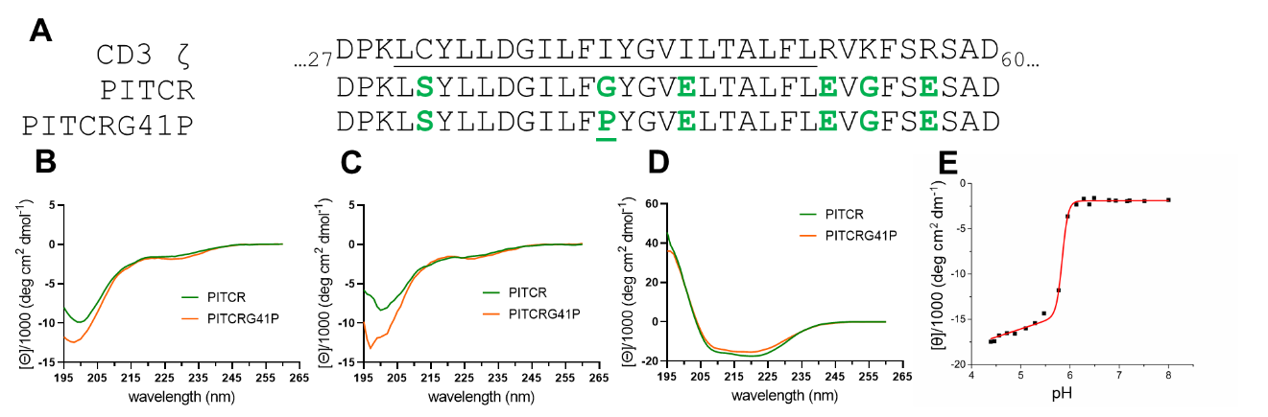
Figure 15 - Figure supplementary 1. (A) Top, the partial amino acid sequence from human CD3ζ comprising a small segment of the extracellular domain, the transmembrane domain (underlined) and a small portion of intracellular domain. Middle, the amino acid sequence of PITCR peptide. Bottom, the amino acid sequence of PITCRG41P. Introduced residues are highlighted in green. Residue numbers are labeled in human CD3ζ sequence. Circular dichroism spectra for PITCR and PITCRG41P in different conditions: 10 mM sodium phosphate buffer at pH 7.4 (B), and in the presence of vesicles of 16:0-18:1 POPS/POPC (1/9) at pH 7.4 (C) and at pH 5.0 (D). Each spectrum is the mean of three independent experiments. (E) Representative circular dichroism pH titration curve of PITCR in the presence of 16:0-18:1 POPS/POPC (1/9) liposomes. Data are calculated by the difference of molar ellipticity ([θ]) between 222 nm and 260 nm. Data are representative of two independent experiments. pK _{CD} is 5.87 ± 0.03 (mean ± S.D.).

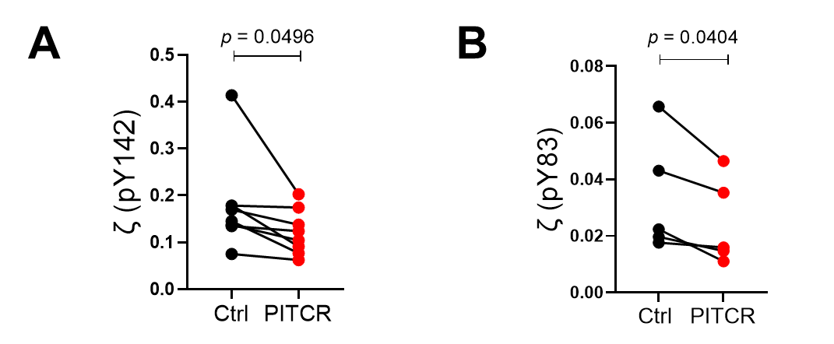

Figure 15 - Figure supplementary 2. Quantification of phosphorylation of ζ (pY142) (A) and ζ (pY83) (B) after OKT3 stimulation. Band intensities were normalized to ζ (total). Each dot pair represents one independent experiment. p values were calculated using a two-tailed paired t-test.

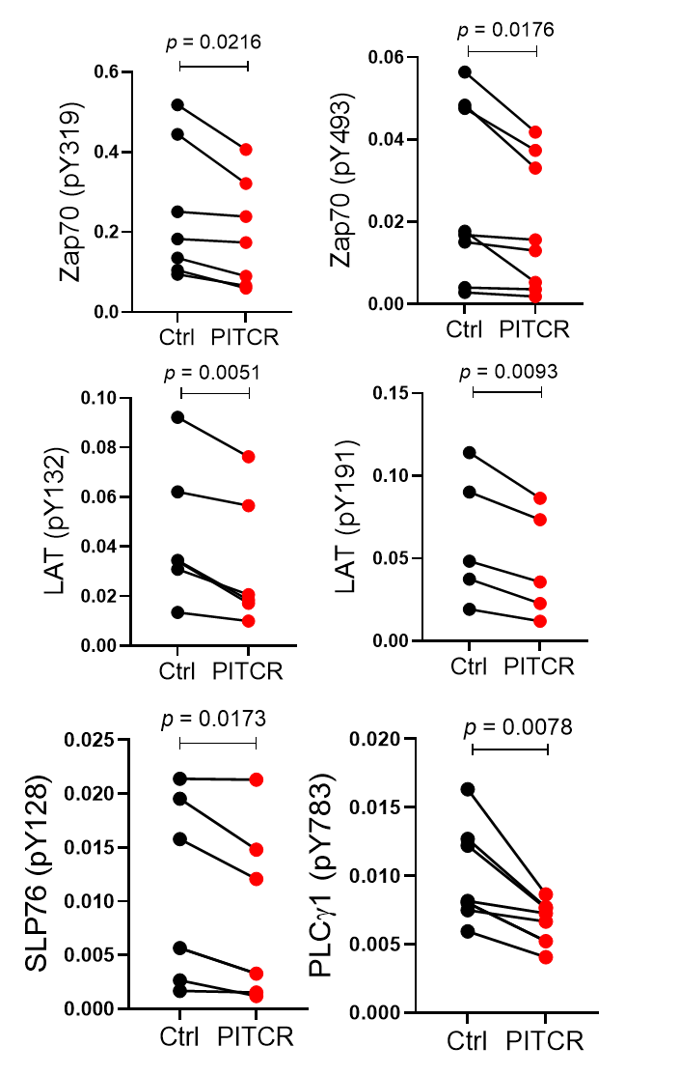
Figure 16 - Figure supplementary 1. Quantification of Zap70 (pY319), Zap70 (pY493), LAT (pY132), LAT (pY191), SLP76 (pY128), and PLCγ1 (pY783) in response to OKT3 stimulation. Zap70 (pY319) and Zap 70 (pY493) were normalized with Zap70 (total). LAT (pY132) and LAT (pY191) were normalized with LAT (total). SLP76 (pY128) and PLCγ1 (pY783) were normalized with β-actin. Each dot pair represents one independent experiment. All p values except PLCγ1 (pY783) were calculated using a two-tailed paired t test. p value for PLCγ1 (pY783) was calculated using a two-tailed Wilcoxon matched-pairs signed-rank test because the p value for the F test to compare variance was 0.0494.

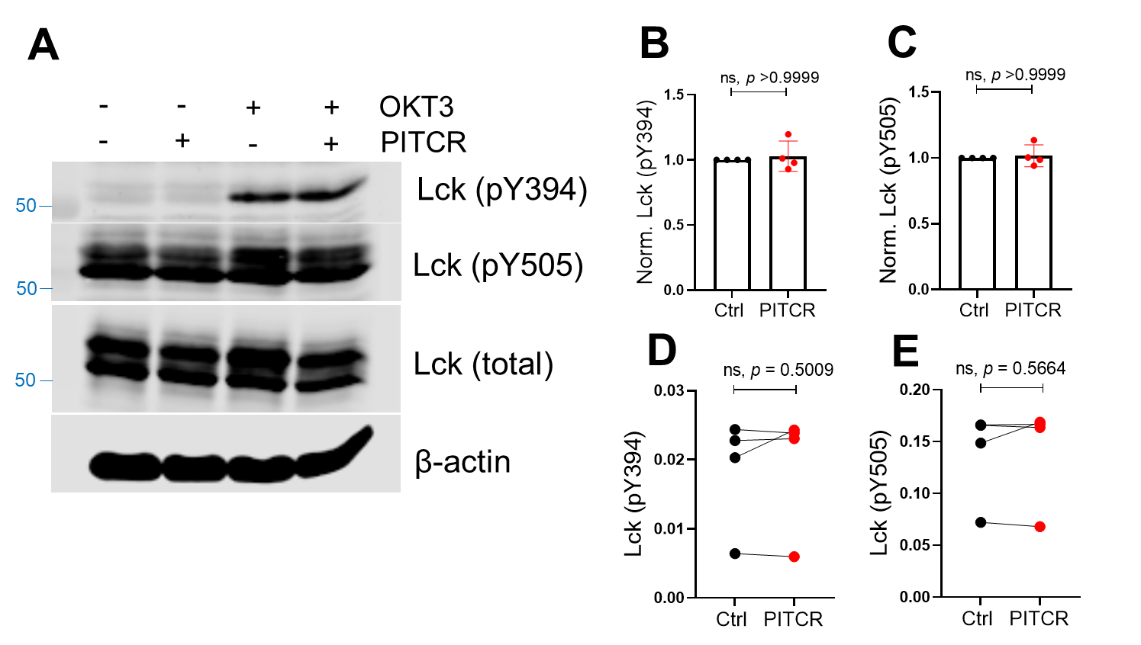
Figure 16 - Figure supplementary 2. PITCR does not reduce the phosphorylation of Lck after OKT3 activation. (A) Immunoblot analysis of Lck (pY394 and pY505), Lck (total), and the housekeeping protein β-actin. Data are representative of four independent experiments. (B) and (C) show normalized quantifications of phosphorylation of tyrosine at the positions of 394 and 505 of Lck after TCR activation. Data in the presence of PITCR was normalized to data in the absence of PITCR in response to OKT3 activation. Error bars are the SD. p values were calculated using a two-tailed Mann-Whitney test. (D) and (E) show quantification of phosphorylation of Lck at pY394 and pY505 after the OKT3 stimulation. Band intensities were normalized to Lck (total). Each dot pair represents one independent experiment. p value was calculated using a two-tailed paired t-test.

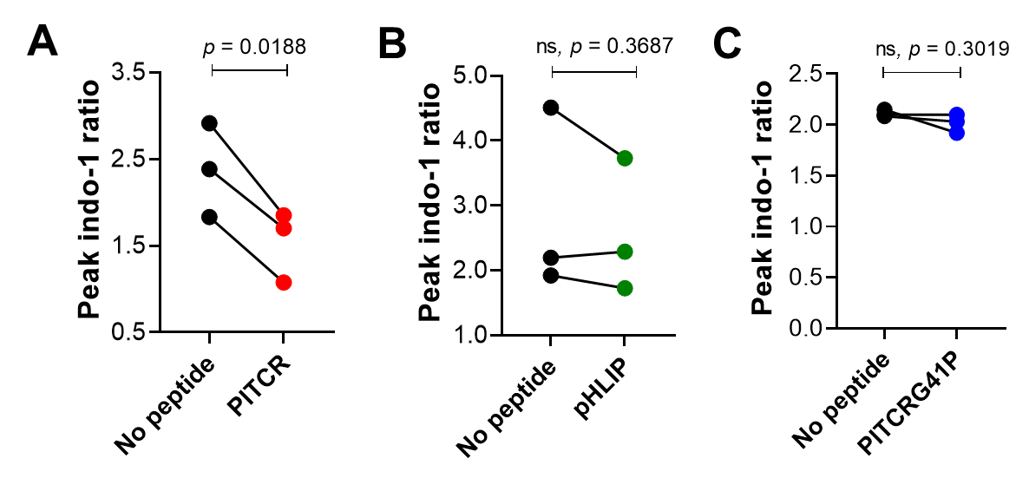

Figure 17 - Figure supplementary 1. PITCR reduces intracellular calcium responses for PITCR (A), but not for pHLIP (B) or PITCRG41P (C). Quantification of the magnitude of Indo-1 ratio between OKT3 peak and baseline. Each dot pair represents one independent experiment. Each independent experiment (n= 3) includes at least four technical replicates. p values were calculated using a two-tailed paired Student’s t test.

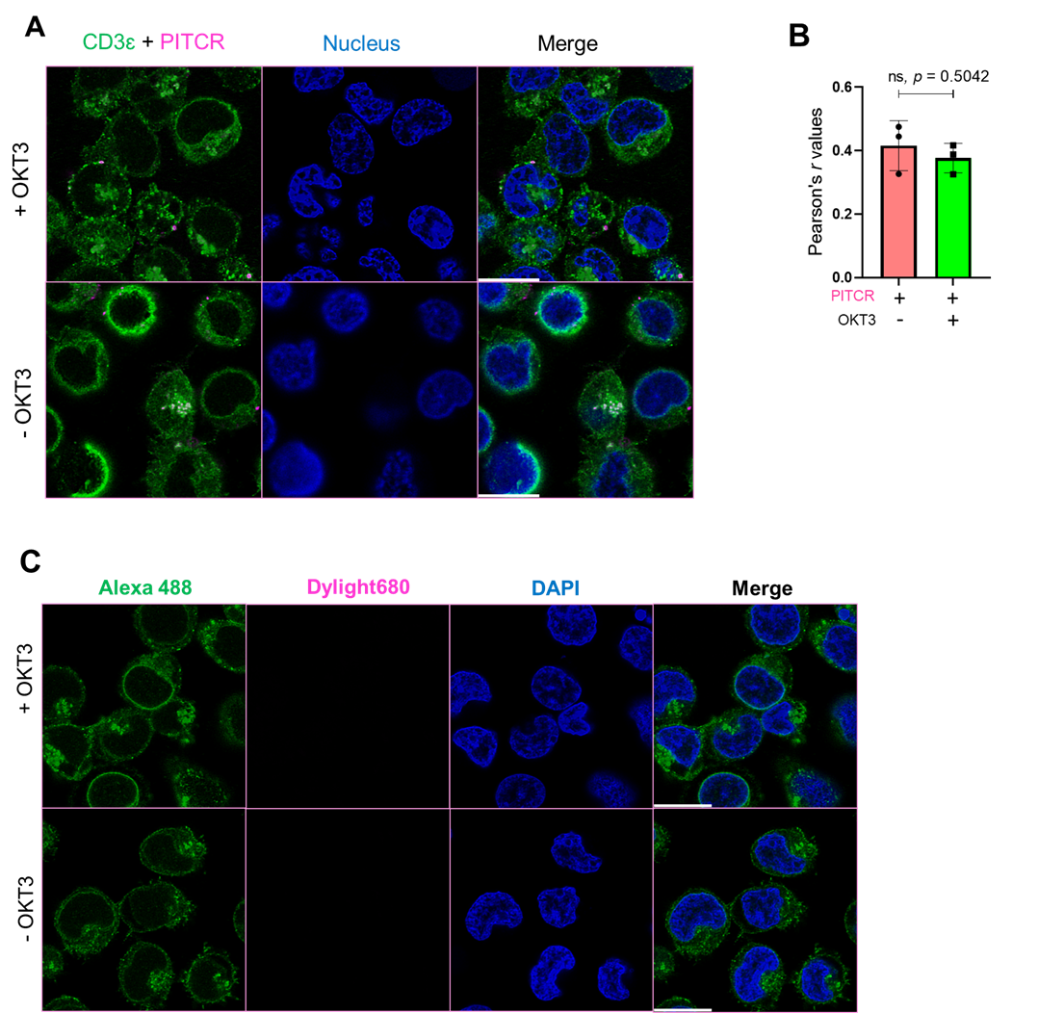
Figure 18 - Figure supplementary 1. PITCR colocalizes with TCR. (A) PITCR and CD3ɛ co-localization images and nuclear staining (DAPI) are shown. Confocal images are representative of three independent experiments. Scale bars = 10 mm. (B) Quantification of PITCR and CD3ɛ co-localization calculating Pearson’s r value. Each dot of panel B denotes mean from one independent experiment. Each independent experiment contains 19 – 21 technical replicates. Error bars indicate SD. p value was calculated using a two tailed unpaired t-test. (C) Jurkat cells were treated with control followed by an anti-CD3ɛ immunofluorescent staining. Confocal images are representative of three independent experiments. Scale bars = 10 mm.

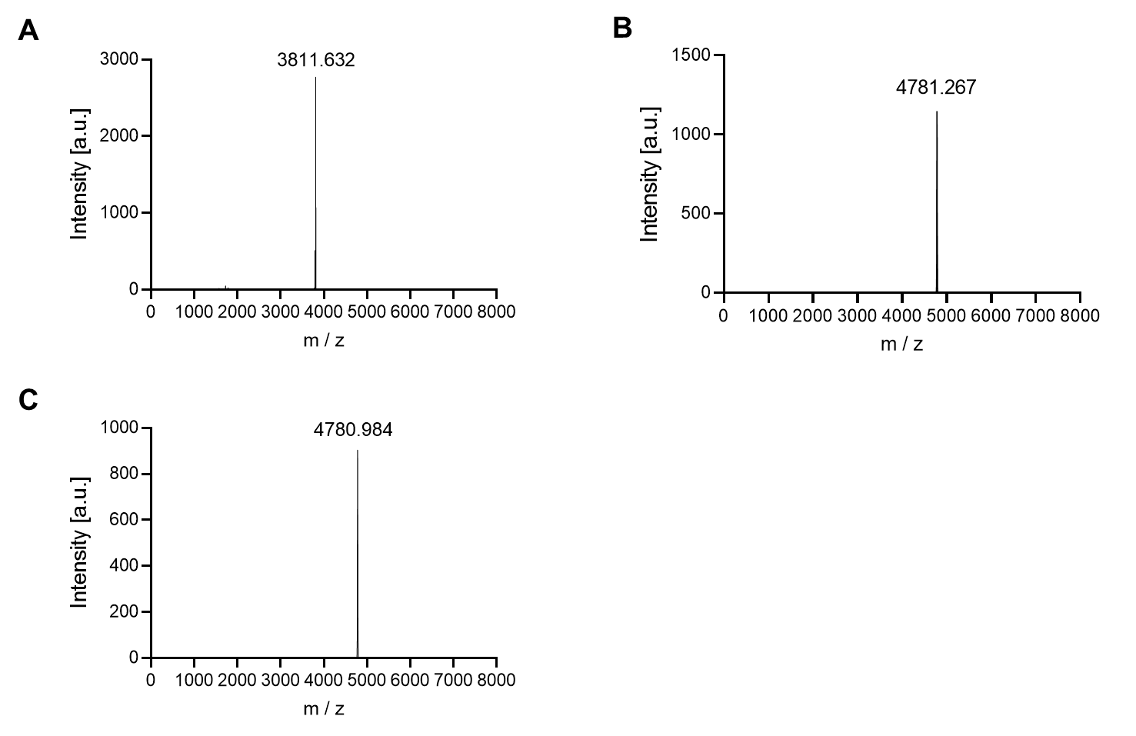
Figure 18 - Figure supplementary 2. MALDI-TOF spectra of NEC-PITCR (A), PITCR conjugated with dylight680 (B), and PITCR conjugated with AZ555 (C). The theoretical MW of NEC-PITCR is 3812.31. The MW of dylight 680 and AZ555are 972 Da and 969.12 Da, respectively.

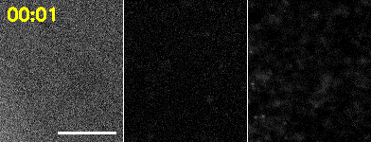
SI Movie: Real-time imaging of PITCR and pMHC in a T cell adhering to supported bilayer. Left: RICM, center: PITCR555, right: pMHC. Cell footprint is shown as cyan line. Scale bar: 10 µm.

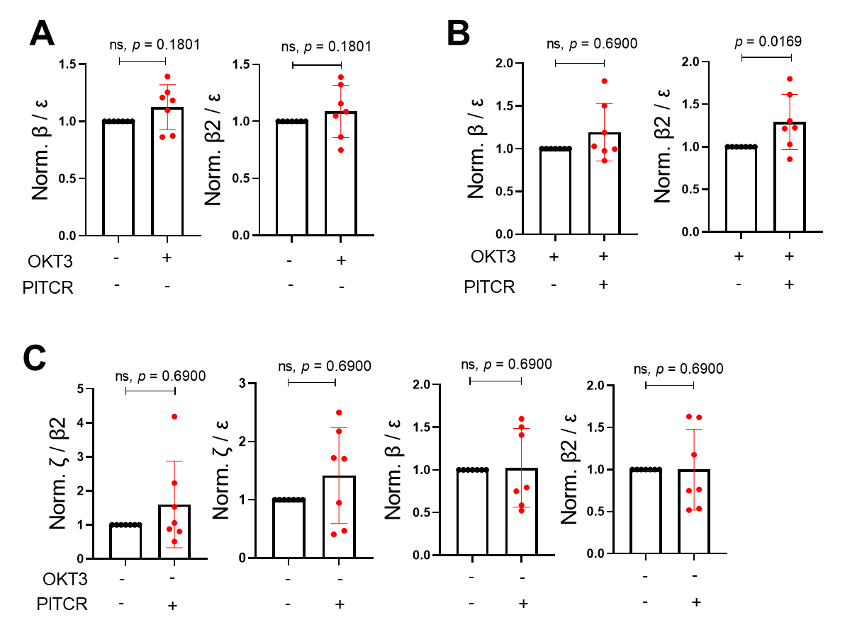

Figure 22 - Figure supplementary 1. Quantification of DDM immunoprecipitation results for the following conditions: (A) OKT3 stimulation, (B) OKT3 stimulation in the presence or absence of PITCR, and (C) PITCR incubation without stimulation. Error bars are SD. p values were calculated with a two-tailed Mann-Whitney test.

AppendiX II
This appendix II was published by Justin Westerfield, Chitrak Gupta, Haden L. Scott, Yujie Ye, Alayna Cameron, Blake Mertz, and Francisco N. Barrera:
Ions Modulate Key Interactions between pHLIP and Lipid Membranes. Biophysical Journal, 117, 920–929, September 3, 2019.

B.M. and F.N.B. designed the research. J.W., C.G., H.L.S., Y.Y., and A.C. carried out all the experiments and simulations. J.W., C.G., H.L.S., Y.Y.,
A.C., B.M., and F.N.B. analyzed the data and wrote the article.

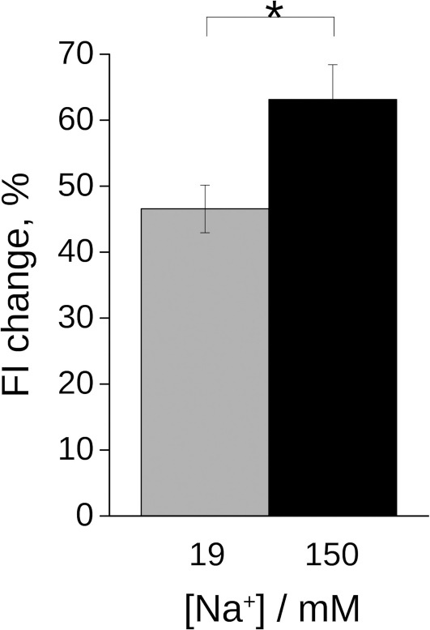
Figure 24. Higher levels of Na+ lead to different FI changes of NBD conjugated to the Ct of pHLIP in state II.
Quantification of changes in FI are shown as percentage changes. Experiments were performed in conditions in which similar lipid binding saturation was achieved (0.7 mM POPC, see Fig. 22). Mean and SD are shown. n = 7. Statistical analysis was performed with a two-tailed Student’s t-test; *p < 0.05.

Binding of pHLIP-NBD to POPC vesicles was measured monitoring changes in NBD fluorescence intensity (540 nm). Experiments were repeated in the presence of 19.3 mM Na⁺ (A) and 150 mM Na⁺ (B). Averages and fitting errors are shown for data normalized to initial intensity. Kp values were 1.5 ± 0.4 x 10⁵ and 1.7 ± 0.5 x 10⁵, respectively. n=7.

Figure 25. Determination of the partition coefficient (Kp) for pHLIP binding to POPC.

AppendiX III
The figure XX in the appendix III was published by Vanessa P. Nguyen, Loganathan Palanikumar, Stephen J. Kennelc, Daiane S. Alves, Yujie Ye, Jonathan S. Wall, Mazin Magzoub, Francisco N. Barrera:
Mechanistic insights into the pH-dependent membrane peptide ATRAM.
Journal of Controlled Release, Volume 298, 28 March 2019, Pages 142-153.

The ATRAM 2 in the figure XXX in the appendix II was unpublished data from Yujie Ye.

Kapp varies as a function of ATRAM concentration at both acidic (red) and physiological pH (blue), which was also observed with pHLIP at physiological pH (black). Mean values are shown ± S.D. (n = 4). ATRAM data was contributed from Vanessa P. Nguyen and pHLIP data was contributed from Yujie Ye.

Figure 26. Different peptides’ Kp values in different environments.

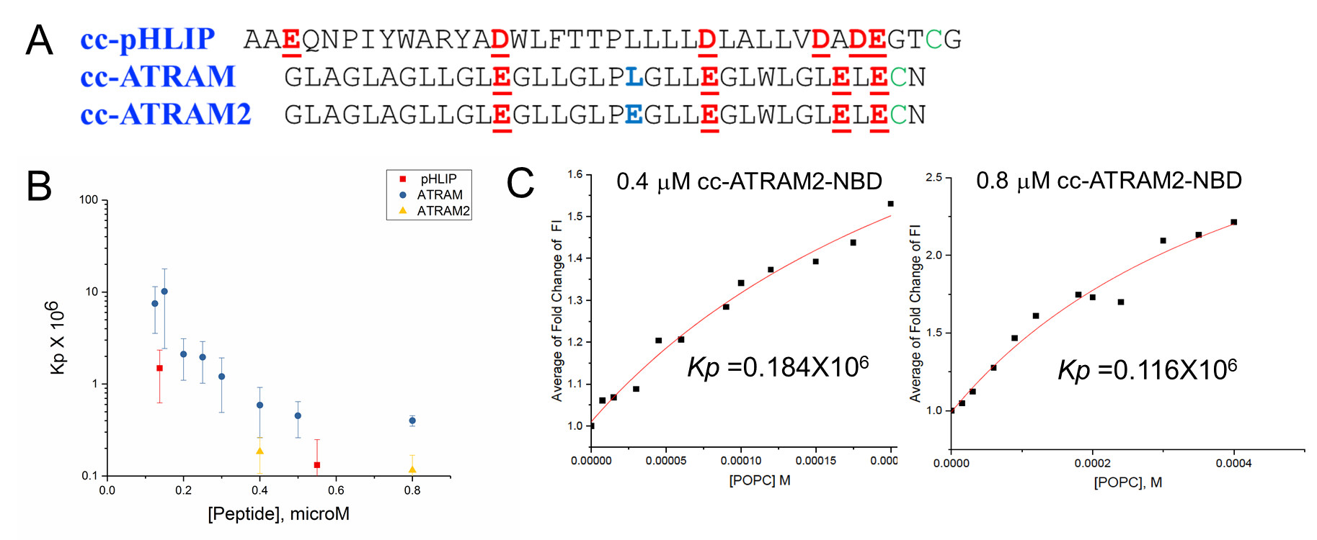
Figure 27. ATRAM2 Kp values.
(A) Peptide sequence comparisons between pHLIP (top), ATRAM (middle), and ATRAM2 (bottom). Acidic residues are highlighted and underlined in red. Cysteine residues at the C-terminal were colored in green and were used to conjugate dyes. The blue Leu (L in ATRAM) and Glu (E in ATRAM2) denote introduced residues. (B) Kp varies as a function of pHLIP (red), ATRAM (blue), and ATRAM2 (yellow) at physiological pH. Mean values are shown ± S.D.. (C) Determination of the partition coefficient (Kp) for ATRAM2 binding to POPC. Binding of ATRAM2-NBD to POPC vesicles were measured monitoring changes in NBD fluorescence intensity. Averages and fitting errors are shown for data normalized to initial intensity. Kp values were 0.184 X 10⁶ (left) and 0.116 X 10⁶ (right), respectively.

AppendiX IV
This appendix IV was published by Alyssa E. Ward, Yujie Ye, Jennifer A. Schuster, Shushu Wei and Francisco N. Barrera: Single-molecule fluorescence vistas of how lipids regulate membrane proteins. Biochemical Society Transactions, 4 August 2021.

PIP2 promotes specific dimerization of receptor tyrosine kinases to stabilize the active conformation.
The receptor tyrosine kinase (RTK) EphA2 is overexpressed in multiple cancers, including breast, prostate, and pancreatic subtypes ^{155, 156}. Loss of EphA2 ligands, like ephrinA1, is often associated with EphA2 overexpression,
which can lead to poor cancer prognosis and high rates of metastasis. Therefore, EphA2 is a relevant target candidate for cancer therapeutics. Two different activation mechanisms have been identified for this receptor. EphA2 follows the canonical RTK activation mode, whereby binding of ephrinA ligands promotes
receptor dimerization which activates the intracellular kinase domain. In addition to this ligand-dependent activation mechanism, EphA2 can be activated in the absence of ligand through phosphorylation by intracellular kinases ^{116, 157, 158}. This ligand-independent activation triggers an oncogenic signal, while the ligand-dependent activation results in the opposite effect (Figure 25A).
The single TM domain of EphA2 participates in receptor dimerization, and the nearby juxtamembrane (JM) segment modulates the activity of the downstream kinase domain ¹⁵⁹. The TM region is believed to dimerize using different conformations in the two activation modes, with different transmembrane crossing angles (Figure 25A and 25B) ^{160, 161}. We have recently used hydrophobic matching to stabilize these two alternate conformations with a peptide that contains the TM domain and a portion of the JM segment (known as TMJM EphA2) ⁸⁴. We observed that thin bilayers, consisting of the lipid 14: 1-PC, stabilize the ligand-dependent conformation while in thicker bilayers (22 : 1-PC) a lower crossing angle is observed, in agreement with the ligand-independent (oncogenic) conformation ⁸⁶. Experiments of TMJM EphA2 using lipid vesicles were complemented with SM photobleaching studies. This approach quantified dimer formation in the two alternative conformations. For these studies, TMJM EphA2 was incorporated into lipid nanodiscs formed using the copolymer styrene maleic acid (SMA) to form SMA lipid particles (SMALPs). The SM results indicate that the peptide is in a monomer–dimer equilibrium in both bilayers (Figure 25C). Interestingly, dimerization was promoted by 3% PIP2, but only in the oncogenic conformation stabilized in 22 : 1 PC bilayers. In contrast, 10% phosphatidylserine (PS), the negatively charged lipid that is most abundant in human cells, caused no significant impact on dimerization ⁸⁶. These results suggest that PIP2 specifically modulates the activity of EphA2, probably by electrostatic attraction with basic residues in the JM segment. Stabilization of the dimer by PIP2
might prevent oncogenic signaling by EphA2, as the monomer is the pro-oncogenic EphA2 species ¹⁶².

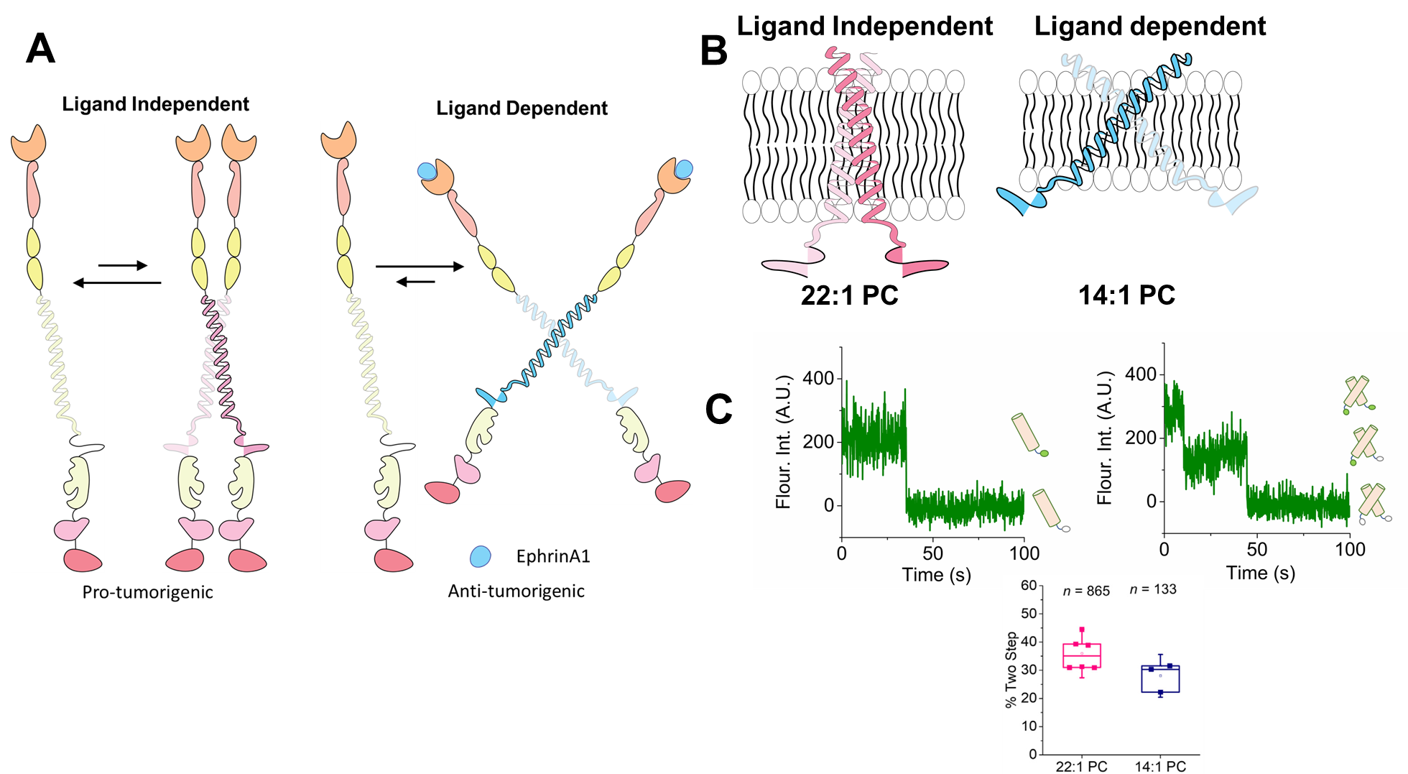
Figure 28. Ligand and lipid compositions decide EphA2 signaling.
(A) Cartoon of two main EphA2 activation mechanisms in cancer. (B) Transmembrane domain crossing angles of EphA2 in thin (14:1 PC) and thick (22:1 PC) bilayers. (C) Single molecule photobleaching of fluorescently conjugated TMJM EphA2 in SMALPs. Quantification of TMD monomers (left) and dimers (right) indicate a monomer-dimer equilibrium (right). Adapted from ⁸⁶ with permission.

Vita
Yujie Ye was born in Fuzhou, Fujian province in China. After high school, she went to the Tianjin University of Science and Technology, Tianjin, China, and obtained a Bachelor of Engineering degree in 2012. After that, she went to Nankai University in Tianjin, China and received a Master of Science degree in 2015. She enrolled in the Biochemistry, Cellular and Molecular Biology at the University of Tennessee in 2016. She defended her PhD dissertation on the October 13th, 2022.

