Consumer Preferences for Environmentally Friendly Disposable Dinnerware Alternatives

A Thesis Presented for the

Master of Science

Degree

The University of Tennessee, Knoxville

Mackenzie Belen Gill

August 2020

Copyright © 2020 by Mackenzie Belen Gill.
All rights reserved.

DEDICATION

I would like to dedicate this thesis to my loving husband, Ethan Kitchens. Thank you for letting me take over your desk. I also dedicate this thesis to my wonderful family, without whose support I would not be where I am today.

ACKNOWLEDGEMENTS

First and foremost, I would like to thank Dr. Jensen for her continuous guidance and advice throughout this investigation. Thank you for being such an amazing and inspiring mentor during this extremely formative time in my life. I also want to thank my committee members, Dr. English, Dr. Thompson, and Dr. Upendram, for their helpful suggestions and directing questions that contributed so much to the research process. I owe much thanks to Dr. Lambert at Oklahoma State University for his input on the economic modeling of these investigations.
I owe much thanks to the faculty and staff in the Department of Agricultural and Resource Economics at UT. Your hard work has facilitated a wonderful learning environment from which students can embark on important and fulfilling careers. Lastly, I want to thank my cohort for providing an invaluable support system during this endeavor. I truly could not have finished this project without the laughs during our daily lunch breaks at Mable’s.

ABSTRACT

In the context of growing concern surrounding the environmental impact of single-use paper and plastic waste, demand for alternatives to conventional disposables has recently increased. This study investigates factors driving consumer preferences for ecofriendly attributes in disposable dinnerware. The study subsequently measures willingness to pay for such an alternative; specifically, dinnerware molded from wheat straw. Data was collected from an online survey of 206 Tennessee consumers aged 18 and older who consider themselves to be the primary household food shopper.
The first part of this investigation uses a Multiple Indicator Multiple Causes (MIMIC) model to estimate the effects of demographics, expenditures, and attitudes on propensity to prefer ecofriendly attributes in disposable dinnerware. The eight disposable dinnerware attributes examined include: compostable, recyclable, uses no trees, contains no plastic, USDA certified bio-based, made from an agricultural crop byproduct, made from cellulose from dedicated crops, and/or made from organically sourced cellulose. The ‘no plastic’ and ‘recyclable’ attributes were found to have the broadest appeal among consumers, while the ‘no trees’ and ‘USDA certified bio-based’ attributes had a narrower appeal and were most valued by consumers with the strongest propensities to prefer ecofriendly attributes.
The second part of this investigation measured consumer willingness to pay for disposable dinnerware molded from wheat straw, which is a byproduct of the wheat industry. A choice set was used in the survey data to elicit consumer purchasing decisions, and compared a 25-count package of wheat straw bowls to a 25-count package of conventional paper bowls. Overall, consumers were found to be willing to pay a premium of $1.33 for the wheat straw bowls. The target market estimated to most likely select the bowls molded from wheat straw is: consumers who spend more on disposable dinnerware, have previously purchased alternative fiber products, and feel a responsibility to address greenhouse gas emissions and climate change.
These findings provide the industry for disposable dinnerware with marketing information that may encourage them to increase offerings of dinnerware with attributes perceived to be ecofriendly. Additionally, manufacturers may use production materials that would have been otherwise burned or disposed of in a landfill.

TABLE OF CONTENTS

INTRODUCTION 1
Trends in Societal Awareness of Disposable Dinnerware 1
Consumer Substitution Towards Eco-Friendly Alternatives 2
PART I: CONSUMERS PREFERENCES FOR PERCEIVED ECO-FRIENDLY ATTRIBUTES IN DISPOSABLE DINNERWARE 4
Abstract 5
Chapter 1: Introduction and Objectives 6
Trends in Disposable Dinnerware Consumption 7
Trends in the Industry for Biobased Disposables 8
Potential Impacts 9
Objectives 11
Chapter 2: Review of Literature 12
Studies of Consumer Preferences for Products with Ecofriendly Attributes 13
The MIMIC Model 21
Chapter 3: Methods and Procedures 24
Data Collection and Variable Creation 25
The MIMIC Model 27
The Logit Model 30
Chapter 4: Results 32
Quantitative valuation of dinnerware attribute importance 33
MIMIC Model 36
Logit Model 42
Chapter 5: Conclusions 45
Chapter 6: Appendix A 50
PART II: CONSUMER WILLINGNESS TO PAY FOR DISPOSABLE BOWLS MOLDED FROM WHEAT STRAW 59
Abstract 60
Chapter 1: Introduction and Objectives 61
Introduction 62
Objectives 65
Chapter 2: Review of Literature 66
Consumer Willingness to Pay for Eco-Friendly Alternatives 67
Hypothetical Contingent Valuation 71
Chapter 3: Methods and Procedures 72
Data Collection 73
Economic Modeling of Consumer Willingness to Pay 75
Chapter 4: Results 80
Indices for Environmental Opinion Variables 81
Logit Model 82
Willingness to Pay 84
Responses of Participants Who Did Not Choose the Wheat Straw Bowls 84
Means Comparisons of Attribute Importance Ratings 85
Chapter 5: Conclusions 87
Implications 89
Chapter 6: Appendix B 92
CONCLUSIONS 100
REFERENCES 103
APPENDIX C 112
Survey Instrument 113
VITA 130

LIST OF TABLES

Table 1.1 Compiled Variables’ Impact in Previous Research 50
Table 1.2 Variable names, definitions, and means included in the MIMIC model with 2017 Tennessee Census Means for comparison. 51
Table 1.3 MIMIC Model Estimates of Preferences for Eco-Friendly Attributes in Disposable Dinnerware 53
Table 1.4 Marginal Effects of the Causal Variables on the Probability of Eco-Friendly Attributes Being Classified as Important 54
Table 1.5 Estimated Logit Model of Probability of Choosing an Above Average Number of Eco-Friendly Attributes in Disposable Dinnerware and Marginal Effectsª 55
Table 2.1 Variable Names, Definitions, and Means for the Logit Model Estimating Probability of Choosing Wheat Straw Molded Dinnerware Bowls 92
Table 2.2 Logit Results: Probability of Choosing Wheat Straw Molded Dinnerware Bowls 93
Table 2.3 Importance of Disposable Dinnerware Attributes across Respondents Who Chose and Did Not Choose the Wheat Straw Bowls 94

LIST OF FIGURES

Figure 1.1 Trends in MSW Generation, Recycling, and Composting from 1960 to 2015* 56
Figure 1.2 Relationship of Variables in the MIMIC Model 56
Figure 1.3 Percentages of respondents that rated an attribute as important to purchasing decision 57
Figure 1.4 Probability of Perceived Eco-Friendly Attribute Importance across levels of ENVIR 58
Figure 2.1 Map of TN Counties and Regions 95
Figure 2.2 Greenhouse Gas Emissions Yielded from 1 Hectare of Harvested Wheat* 96
Figure 2.3 Creation of Molded Wheat Straw Products from Wheat Straw Cellulose* 97
Figure 2.4 Estimated WTP for Wheat Straw Bowls 98
Figure 2.5 Importance of Disposable Dinnerware Attributes among Respondents Who Chose and Did Not Choose the Wheat Straw Bowls 99

INTRODUCTION

Trends in Societal Awareness of Disposable Dinnerware

Recently, consumers have become increasingly aware of the impact that high levels of plastic waste, especially single-use plastic waste, has on the environment. A social movement encouraging consumers to be mindful of their plastic consumption has led to higher demand for products that have attributes such as being biodegradable, being byproducts of existing production, and not containing plastic (Mishra et al. 2017). Evidence of this social movement can be seen by recent changes in government legislation. In the last year, many municipalities have announced intentions to ban single-use plastics. In October 2018, the European Union announced its goal of banning single-use plastics by 2021, and Canada announced it would join this effort in July 2019. In the United States, Seattle banned the use of plastic straws and utensils in bars and restaurants in July 2018. In January 2019, Washington D.C. took this a step further and announced that businesses would be fined if they continue to offer plastic straws. Regarding food packaging, municipalities that placed bans on polystyrene or foam food packaging in the last year include San Diego (Jan. 2019), Maryland (May 2019), and Maine (May 2019). These bans are the result of increased societal concern about the impact of plastic pollution and excessive amounts of landfilled waste on the people and ecosystems of the globe (Parker 2019).

Consumer Substitution Towards Eco-Friendly Alternatives

Studies illustrate a positive correlation between consumers’ valuation of eco-friendly product attributes and their education about sustainability issues (Klaiman, Ortega, and Garnache 2016). Therefore, in the context of increasing societal concern about environmental issues, consumers will likely place higher value on eco-friendly product attributes and may substitute towards biobased alternatives. One such alternative is disposable dinnerware molded from wheat straw. This bio-based alternative yields a product with marketable attributes such as: sturdiness, durability, using byproduct material from existing wheat production, compostability, and that it is produced without the use of trees. Certain environmentally minded consumer segments may be willing to pay a premium for dinnerware molded from wheat straw. Determination of consumer preferences, demographics, and expenditure patterns which impact willingness to pay for this type of product will help develop the market for bio-based alternatives to single-use disposables.
In an effort to convey these findings, this report will be organized into two parts. Part I will assess consumer preferences for a variety of eco-friendly attributes that are frequently seen in alternatives to conventional disposables. Part II will calculate consumer willingness to pay for disposable bowls molded from wheat straw and will investigate associated impactful factors. Appendix C will contain the survey instrument used in both parts of the report.

PART I: CONSUMERS PREFERENCES FOR PERCEIVED ECO-FRIENDLY ATTRIBUTES IN DISPOSABLE DINNERWARE

Mackenzie Gill is the main author of this article. The study used was conducted under the direction and supervision of Dr. Kimberly Jensen, with input by Dr. Sreedhar Upendram, Dr. Burt English, Dr. Dayton Lambert, Dr. Sam Jackson, and Dr. Jada Thompson. The study used a dataset that was obtained through an online survey conducted by the aforementioned faculty in August 2018.

Abstract

In the United States, paper and plastic disposable dinnerware are landfilled at rates of 40 and 80 percent, respectively. However, consumer concerns have been growing regarding the potential environmental impact of single-use containers, particularly those made of plastic. This study measures consumer preferences for eight attributes in single-use disposable dinnerware: compostable, recyclable, uses no trees, contains no plastic, certified bio-based, made from agricultural crop byproduct cellulose, cellulose from dedicated crops, and/or from organically sourced cellulose. Survey data from 206 Tennessee consumers, who were aged 18 years or older and were primary household food shoppers, were used in this study. To estimate the effects of consumer demographics, expenditures, and attitudes on propensity to prefer eco-friendly attributes in disposable dinnerware, a Multiple Indicator Multiple Causes (MIMIC) model is used. Findings show attributes with the broadest appeal among consumers are ‘no plastic’ and ‘recyclable’. However, the ‘no trees’ and ‘USDA certified bio-based’ attributes appeal to a narrower consumer segment, those with strongest preferences for eco-friendly attributes. A market profile of those most likely to prefer the eco-friendly attributes include male, older, urban residence, higher household income, greater self-perceived environmental knowledge, stronger beliefs that science and technology can provide environmental solutions, and greater belief in consequences of the survey results.

Chapter 1: Introduction and Objectives

Trends in Disposable Dinnerware Consumption

The total amount of municipal solid waste (MSW) generated yearly in the United States (US) has increased almost every year since 1960, with the exception of recession years 2008 to 2010. Figure 1.1 illustrates the trends in MSW generation from 1960 to 2015 (US EPA 2018). In 2015, a total of 262.4 million tons of MSW was generated in the US, which is equal to 4.48 pounds per person, per day. Of this total amount, paper and paperboard made up the largest category of MSW at 25.9 percent, and plastic made up 13.1 percent of MSW generated (US EPA 2018). Studies indicate that plastics’ increasing percentage of MSW from 2010 to 2015 is a result of a global trend towards single-use plastic containers (which make up the largest type of plastic waste) as a substitute for reusable containers (Geyer et al. 2017).
Of the total MSW generated in 2015, 67.8 million tons were recycled and 23.4 million tons were composted. Mixed paper or glass containers and packaging made up one of the most recycled or composted categories, while plastic containers were not recycled as often as other types of packaging (US EPA 2018). One example of single-use paper and plastic waste is disposable dinnerware such as paper or plastic plates and cups. Nationwide, paper plates and cups represented 1,360,000 tons of MSW in 2015 (US EPA 2018), with about 40 percent landfilled. Of the 1,050,000 tons of MSW generated from plastic plates and cups, 80 percent was landfilled in 2015 (US EPA 2018).
Recently, consumers have become more aware of and concerned about the potential impacts of single-use disposable containers (Barnes et al. 2011; Yue et al. 2010). Previous literature shows that environmental concern influences consumers’ purchase decision regarding products with eco-friendly attributes (Koenig-Lewis et al. 2014). Consumers could potentially impact the trend toward landfilling of single-use disposables by adapting or changing product purchase decisions and post-use behaviors. For example, consumers could shift their purchases away from single-use plastic dinnerware. They could also recycle disposable dinnerware they use and, in some cases, compost it. Furthermore, they could select dinnerware with certain product attributes that reflect an eco-friendlier manufacturing process, for example, those that use sustainably sourced cellulose fiber or uses industry wastes as sources of cellulosic fibers.

Trends in the Industry for Biobased Disposables

In response to consumer concerns about the number of single-use disposables landfilled, some alternative product markets are emerging. One alternative to conventional plastics is bio-plastics. Bio-plastic is made from renewable raw materials, for example starch made from potatoes, and may be either biodegradable or non-biodegradable (Barker and Safford 2009; Endres and Siebert-Raths 2011; Scherer, Emberger-Klein, and Menrad 2018). Another example of these types of eco-friendly substitutes is disposable dinnerware molded from an agricultural byproduct, such as bagasse cellulose from sugarcane or wheat straw cellulose from wheat grain production.
In other cases, cellulose is being derived from fast growing plants, such as bamboo, that are grown for making alternative biobased fiber products from cellulose-like disposable dinnerware. Some manufacturers have taken the additional step of having their products become USDA Certified Biobased (USDA Bio-Preferred Program 2019). The USDA defines biobased products as “….derived from plants and other renewable agricultural, marine, and forestry materials. These products provide an alternative to conventional petroleum derived products and include a diverse range of offerings such as lubricants, detergents, inks, fertilizers, and bioplastics” (USDA Bio-Preferred Program 2019). The USDA Certified Biobased label indicates that a given product has been verified to be bio-based by a third-party tester. The label is a voluntary initiative that companies may seek out as a part of their marketing efforts. However, while this labeling is available, the market for these products is still emerging. Currently there are 46 manufacturers of disposable dinnerware that participate in the USDA Certified Biobased labeling program (USDA Biopreferred Program 2020).

Potential Impacts

The market for environmentally labeled disposable dinnerware is emerging and few studies have examined attributes that may influence consumer purchases of these products. Further investigation is needed to determine factors that drive consumers to prefer eco-friendly attributes in single-use disposable dinnerware products. This study will use a sample of Tennessee consumers who are 18 years or older and are primary food shoppers to investigate factors influencing preferences for eco-friendly attributes in disposable dinnerware. To relate probability of preferring eight attributes that could be labeled on disposable dinnerware to consumers’ environmental attitudes, expenditure patterns, and demographics, a Multiple Indicator Multiple Causation (MIMIC) model is estimated. The results can be used to identify potential disposable dinnerware attributes that hold the widest and narrowest appeal to consumers. The results can also be used in building market segment profiles of those most likely to prefer these perceived eco-friendly attributes. This product preference and market segment information could be used in product development and subsequent target marketing of new products to consumers mostly likely to substitute towards disposable dinnerware with such attributes. Developing a market for environmentally friendly disposable dinnerware could increase consumers’ options for alternatives to conventional paper or plastic disposable dinnerware.

Objectives
The overall goal of this study is to provide the emerging market for eco-friendly disposable dinnerware with information about consumers’ preferences for perceived eco-friendly attributes and information about market profiles for consumers most likely to prefer these attributes in disposable dinnerware. The disposable dinnerware attributes investigated are: made from cellulose from an agricultural byproduct, made from cellulose from a dedicated agricultural crop, USDA Certified Biobased, no plastic used, no trees used, compostable, produced from organic cellulose, and recyclable. The effects of demographics, expenditure patterns, and environmental attitudes on propensity to prefer these attributes is measured. Specifically, the objectives of this study are to:
- estimate consumers’ preferences for environmentally friendly attributes in disposable dinnerware,
- determine probabilities of preferring these attributes,
- determine the influence of demographics, disposable dinnerware expenditure patterns, and environmental attitudes on these attribute preferences, and
- build market profiles of consumers most likely to prefer these attributes.

Chapter 2: Review of Literature

This literature review will be comprised of two primary sections. First, findings from studies related to consumer preferences for ecofriendly attributes in disposables and product alternatives, such as bioplastics or biobased products, will be discussed. While studies related directly to disposable dinnerware alternatives are lacking, the discussed products are relevant in that they are disposable or are substitutes for plastic (bioplastics). The Multiple Indicators Multiple Causation (MIMIC) modeling system is used in this study to estimate the effects of consumer demographics and attitudes on preferences for ecofriendly attributes in disposable dinnerware. Therefore, secondly, examples of empirical applications of this model are discussed.

Studies of Consumer Preferences for Products with Ecofriendly Attributes

While studies determining factors which drive consumers to demand disposable dinnerware products with multiple eco-friendly attributes are lacking, several studies have examined the importance of ecofriendly attributes (Aday and Yener 2014; Barnes et al. 2011; Casadesus-Masanell et al. 2009; Herbes et al. 2018; Jerzyk 2016; Khachatryan et al. 2014; Koutsimanis et al. 2012; Kurka and Menrad 2009; Saphores and Nixon 2014; Sijtsema et al. 2016; Yue et al. 2010) and factors that drive consumers to purchase bioplastics and other single-use disposable substitutes (Arboretti and Bordignon 2016; Barnes et al. 2011; Casadesus-Masanell et al. 2009; Herbes et al. 2018; Kainz 2016; Klaiman, Ortega, and Garnache 2016; Klein et al. 2019; Kurka and Menrad 2009; Martinho et al. 2015; Yue et al. 2010). While they do not directly address consumer preferences for disposable dinnerware, the results from these studies do examine similar products and will likely be helpful in developing hypotheses about consumer preferences for ecofriendly attributes in disposable dinnerware. A summary of findings from past research is presented in Table 1.0. Results from past studies, hypotheses about potentially important attributes, and the effects of consumer demographics and attitudes on preferences for ecofriendly attributes in disposable dinnerware are discussed below.
Importance of Attributes
Findings from previous studies indicate that when evaluating eco-friendly attributes, the majority of consumers in Germany, France, and the United States (US) are concerned with “end of life” attributes, or what will happen after the disposal of a product (Herbes, Beuthner, and Ramme 2018). Specifically, US respondents have been found to place the highest value on packaging that was recyclable. Consumers placed less importance on attributes associated with the manufacturing process, such as the packaging being made from renewable materials or the amount of resources required for other events in the packaging’s production chain (like transport and retail use). These results suggest that in the US, marketing efforts focused on recyclability, rather than renewable origins of disposables would be most effective (Herbes, Beuthner, and Ramme 2018). Other studies further emphasize the importance of recyclability and compostability attributes in alternative food containers to US consumers. Results from a survey of Hawaiian consumers indicated that 97 percent of respondents stated that they would recycle or compost the container if given the choice (Barnes et al. 2011). In a separate study, 61 percent of respondents reported that they recycled their food packaging (Aday and Yener 2014). The relatively high percentage reported by the survey of Hawaiian consumers may be influenced by the fact that Hawaii is dealing with limited landfill space and experiences the impacts of marine plastic pollution firsthand. Younger consumers’ preferences also emphasize the importance of recyclability to the decision to purchase a product with eco-friendly attributes. A study which measured preferences for environmental labels on packaging found that student consumers aged 17 to 30 identified recyclability as one of the two most important labels in regards to the purchase decision (Jerzyk 2016). An online survey examining US consumers’ recycling behavior found that attitudes and perceived barriers to recycling were associated with recycling rates, while relatively few demographic variables were statistically significant (Saphores and Nixon 2014). Previous studies point to the recyclability attribute of disposables as one that is highly important to US consumers.
Previous studies indicate that more environmentally sensitive consumers highly value compostable/ biodegradable products, as evidenced by their willingness to pay a premium for such products. Data from an auction experiment found that US consumers were willing to pay premiums for biodegradable pots made from wheat starch (Yue et al. 2010). Furthermore, a conjoint study using mixed ordered probit model found that consumers were willing to pay a premium of $0.227 for a plant container that was compostable (Khachatryan et al. 2014). More research on consumer preferences for compostability of food containers is needed to understand the importance of this attribute on the purchase decision.
A product with many of the discussed attributes will inherently not contain plastic. For example, a product that is compostable, USDA biobased, or made from cellulose from an agricultural crop or byproduct will not contain plastic. Thus, it is difficult to discern consumers’ preferences for the ‘no plastic’ attribute from these other attributes. However, a few studies have investigated attitudes influencing certain consumers’ demand for a product that does not contain plastic. In a study of Turkish consumers, Aday and Yener (2014) showed that young consumers preferred glass packaging over plastic due to its low perceived toxicity and human health risk. It is reasonable to conclude that many consumers similarly perceive plastic food containers to be potentially harmful to human health, as it is common to see this notion discussed in the media (Harvard Women’s Health Watch 2019). Additionally, the encompassing nature of this attribute may be such that it appeals to consumers with a wide variety of concerns. While studies investigating consumer perception of the ‘no plastic’ attribute are lacking, some consumers may assign great importance to this attribute.
Despite the current use of the ‘no trees’ or ‘tree free’ label, there is no previous literature on consumer valuation of this specific attribute. More research is needed to understand the efficacy of this label in the market for disposable dinnerware before a conclusion about consumers’ preferences can be made.
Overall, consumers have associated the bio-based label with positive environmental impacts, but some studies have found that a subset of consumers are skeptical of the label. While studies quantifying consumers’ importance ratings of the USDA Certified Biobased label are limited, several studies have investigated consumers’ perceptions of the ‘biobased’ label. Results from a conjoint analysis found that while US consumers were more likely to select a biobased fresh produce container over a petroleum based container, no disposal preference (i.e. recyclable, compostable, or landfill) was found to be significant. Additionally, 45.5 percent of respondents in this study were unable to identify sources of biobased materials (Koutsimanis et al. 2012). Results from a series of survey interviews found that European consumers listed their top reasons for purchasing bioplastics in order as: to be more ecofriendly, to conserve resources for future generations, for health reasons, to strengthen the regional economy, to get it for a lower price, to set an example for others, and to ease one’s conscience (Kurka and Menrad 2009). On the other hand, a study which surveyed consumers in the Czech Republic, Denmark, Germany, Italy, and the Netherlands found that consumers were uncertain about the meaning and credibility of the bio-based label. Respondents questioned whether the product was to be completely constructed from plant-based materials or from a mixture with environmentally unfriendly materials. The results of the study suggest that a subset of environmentally concerned consumers is skeptical and might perceive a company using the ‘biobased’ label as opportunistic of increasing trends towards consumer preferences for more sustainable production (Sijtsema et al. 2016). These findings point to a lack of understanding of the ‘biobased’ term in many consumers. This suggests there is potential for a biobased certification label which guarantees that a product is made from renewable plant-based materials to increase consumer satisfaction.
While studies investigating consumer preferences for the use of organic cellulose as material in disposable dinnerware alternatives is sparse, there is some evidence to suggest that some consumers highly value the use of organic cellulose in alternative products that are not consumed. For example, one study used a negative binomial regression to estimate that Patagonia consumers were willingness to pay a $6.58 premium for garments made from organically grown cotton despite no discernable difference to the garment grown from conventional cotton (Casadesus-Masanell 2009). This suggests that certain segments of consumers may be concerned about the environmental impact of pesticides enough to pay a substantial premium for products sourced from organic cellulose.
Previous studies indicate that consumers may be more likely to select an alternative food container made from a dedicated crop or crop byproduct when they believe their purchase decision will help the local economy. Results from a conjoint choice experiment involving Hawaiian consumers found that 66.5 percent of respondents preferred a sugarcane food container to other plastic alternatives or to the conventional polystyrene packaging. Sugarcane is a major commodity produced in Hawaii, and a substitution towards alternative packaging made from sugarcane byproducts may support the local economy. Authors hypothesized that this may have motivated respondents’ selections (Barnes et al. 2011). Thus, using a dedicated crop or byproduct materials that are recognized in the community may be of interest to consumers.
Additionally, results from an experimental auction found that consumer willingness to pay increased as the amount of crop byproduct material used to construct a biodegradable plant container increased (Yue et al. 2010). Respondents were willing to pay a premium of $0.16 for a container comprised of 1-49 percent of waste (byproduct) materials and $0.23 for a container comprised of 50-100 percent of waste materials over a base product with 0 percent waste material. This suggests that certain environmentally minded consumers highly value plastic alternatives being made from crop byproduct material, and this attribute is thus likely important to the purchase decision.

Effects of Demographics
Results from prior research suggest that being female positively influences interest in environmentally friendly substitutes for single-use disposables and/or environmentally friendly packaging (Casadesus-Masanell et al. 2009; Kainz 2016; Martinho et al. 2015; Yue et al. 2010). Hence in this study, we hypothesize that female gender (Female) will have a positive effect on preferences for ecofriendly attributes in disposable dinnerware. Findings from previous research about the effects of age on single-use disposables or environmentally friendly packaging are mixed. Some studies indicate that older consumers (Age) will be more interested in eco-friendly substitutes (Kainz 2016), while other research suggests that younger consumers better represent the target market for these types of products (Aday and Yener 2014 ; Arboretti and Bordignon 2016; Jerzyk 2016; Martinho et al. 2015; Yue et al. 2010). Therefore, while it is hypothesized age (Age) will influence preference for ecofriendly attributes in disposable dinnerware, the direction of its influence cannot be hypothesized a priori.
Regarding regional influence, a study by Casadesus-Masanell et al. (2009) suggested that living in a rural area or small town negatively impacted interest in eco-friendly substitutes. Hence, in this study it is hypothesized that living in a more rural area (Rural/Small Town) will have a negative influence on preferences for ecofriendly attributes in disposable dinnerware.
Prior research also suggests that having children increased the likelihood of substitution towards eco-friendly disposables (Kainz 2016; Yue et al. 2010). Therefore, in this study it is hypothesized that having children in the household (Children) will positively influence preferences for ecofriendly disposable dinnerware attributes. Some studies found that consumers who were more educated were more likely to be interested in eco-friendly substitutes (Arboretti and Bordignon 2016; Yue et al. 2010), while the study by Casadesus-Masanell et al. (2009) suggested the opposite. Because findings have been mixed, the direction of influence of being a college graduate (College Graduate) is not hypothesized a priori.
Household income also had mixed implications in the literature, with a positive correlation with consumer preferences for ecofriendly attributes in products found by some studies (Casadesus-Masanell et al. 2009; Yue et al. 2010) and negative correlation found by other studies (Kainz 2016). Therefore, the sign on household income (Household Income) is not hypothesized a priori.
Previous experience with the product was found to positively impact likelihood of purchasing an eco-friendly substitute (Casadesus-Masanell et al. 2009; Klein et al. 2019). Therefore, prior purchases of alternative fiber products (Previously Purchased) are hypothesized to have positive influence on preferences for ecofriendly attributes in disposable dinnerware.
Overall, consumers who were more concerned with environmental issues were more likely to substitute towards products with ecofriendly attributes and/or packaging (Barnes et al. 2011; Herbes et al. 2018; Kainz 2016; Klaiman, Ortega, and Garnache 2016; Klein et al. 2019; Kurka and Menrad 2009; Martinho et al. 2015). In this study, it is hypothesized that greater concern about the environment (ENVIR) will have a positive influence on consumer preferences for ecofriendly attributes in disposable dinnerware. A compilation of previous literature’s findings regarding the impact of explanatory variables on consumer preferences is illustrated in Table 1.0.

The MIMIC Model

A Multiple Indicator Multiple Causation Model (MIMIC) will be used to indicate which environmental attributes are most influential in the disposable dinnerware purchase decision. The MIMIC model allows simultaneous predictive modeling of each explanatory variable with respect to a logistic framework (Skrondel and Rabe-Hesketh 2004). With this method, a common underlying factor, such as preferences for ecofriendly attributes, can be accounted for in the model. To this end, structural equations are used to define the underlying latent variable and measurement equations reveal the relationship between the latent variable and the indicator variables.
While separate logit models could have estimated the impact of structural variables on attribute importance ratings, the influence of a common unobservable variable would have been left out of the findings. Additionally, an ordered logit model could be used to estimate the impact of structural variables on attribute preferences, but this would also eschew the possibility of observing importance ratings across varying levels of the latent underlying factor. This underlying factor, such as preferences for ecofriendly attributes in disposable dinnerware, may be important in fully understanding the findings’ implications for the associated market.
The MIMIC model is often used in the study of human behavior, as there are often common unobservable factors to human actions. For example, one such study modeled the impact of structural variables, such as gender, on symptoms of dementia, with the underlying latent variable being psychosis level (Proitsi et al. 2011). One more closely related application of the MIMIC model investigated changing consumer preferences for fresh produce. In this study, the latent variable was created to be a function of health information known by the respondent, a convenience indicator (“percentage of working wife”), and the presence of young children in the household. This was done based on the assumptions that consumers’ preferences for fresh produce will change as they become more educated on health issues and nutrition, as their valuation of convenience changes, and as the structure of their family changes (Acharya and Molina 2014). After creating the latent variable index for consumer preferences, a linearized almost ideal demand system (LAIDS) that included the preference index and other observed explanatory variables (such as price and expenditure patterns) was estimated for both fruit and vegetables. Since the difference between observed and predicted values are not directly observable for the latent variable index, this procedure minimized the difference between the sample’s observed covariance and the predicted covariance (Acharya and Molina 2014).
The first study to use a MIMIC model to understand consumer food preferences investigated changing demand for beef. Gao, Wailes, and Cramer (1997) observed the impact of structural variables, such as household demographics, on the underlying variable beef preferences, as indicated by the residuals of a household’s demand function for beef. Importantly, the investigation revealed that the changing demographic composition of the population was significantly impacting consumer preferences and demand for beef. Structural variables including residence, region, race, proportion of away-from-home food expenditures, and female household head employment status were found to significantly influence consumer preferences for beef attributes (Gao, Wailes, and Cramer 1997). Clearly, the MIMIC model can make important contributions in modeling and understanding dynamic consumer preferences.

Chapter 3: Methods and Procedures

Data Collection and Variable Creation

Data was obtained through an online Qualtrics consumer survey. The survey was pre-tested on individuals before the final survey was developed. Based on the pre-test comments the survey was revised. All University of Tennessee Institutional Review Board protocols were followed. The approval number is UTK-IRB-18-04627-XM. The survey was carried out in August of 2018 and distributed to 218 Tennessee respondents, aged 18 or older. Of these 218 respondents, 205 answered all questions needed for the statistical analysis.
The survey instrument (See Appendix at end of report) included several sections. These included information on wheat straw and its uses, a contingent valuation (CV) question regarding wheat straw bowls, follow-up questions for respondents who did not choose the wheat straw bowls during the CV, Likert-scale questions regarding the importance of disposable dinnerware attributes, questions regarding disposable dinnerware expenditures, attitudes towards the environment, and demographics.
The data used in the analysis section of this report was collected from survey questions regarding consumers’ ratings of importance of several attributes in disposable dinnerware (See Appendix C, Question 16). Consumers’ valuation of disposable dinnerware attributes was assessed by asking respondents to rate importance of these attributes on a 1 to 5 scale, with 1 representing “Not Important” and 5 representing “Extremely Important”. For modeling purposes, these importance ratings were converted to dummy variables (the italicized names following each description). If the respondent somewhat or strongly agreed that a disposable dinnerware attribute was important, and hence gave an importance rating of 3, 4, or 5, the variable would take on a value of 1, and 0 otherwise. In this analysis we focused on the potentially eco-friendly oriented attributes: made from cellulose from an agricultural crop byproduct (Crop Byproduct), made from cellulose from a dedicated agricultural crop (Dedicated Crop), USDA Certified Biobased (USDA Cert. Biobased), no plastic used (No Plastic), no trees used (No Trees), compostable (Compostable), produced from organic cellulose (Organic Cellulose), and recyclable (Recyclable).
Because many respondents might be unfamiliar with the product being USDA Certified Biobased, prior to this question an information screen was provided. The information screen is shown in Question 15 of Appendix C.
Questions were asked regarding respondent demographics including gender (Female), urbanization of residence (Rural/Small Town), education (College Graduate), and 2017 before tax household income (Household Income). Female, College Graduate, and Rural/Small town were dummy variables, while Household Income was converted to dollars from mid-points of the categorical question asked (See Appendix C, Question 31). Respondents were also asked to report their annual disposable dinnerware expenditures. Again, this was converted to dollars using the mid-points of the categorical variable (See Appendix, Q17). The dollar expenditures were then calculated as a percent of income (Disp. Expend. Pct. Inc.).
Self-perceived environmental knowledge, their attitudes toward the environment, and belief in consequences of their survey responses were also used in developing variables for the analysis. Questions 19-20 of the survey (See Appendix C) were used to develop an environmental knowledge dummy variable, Envir. Knowledgeable=1 if agree (somewhat or strongly) they have enough knowledge to make informed decisions on environmental issues, 0 otherwise. Consumers’ environmental attitudes were assessed by asking respondents to rate how much they agreed with a series of environmentally positive statements on a 1 to 5 scale, with 1 representing strong disagreement and 5 representing strong agreeance. These included: a) We have a responsibility to future generations to protect the environment (Future Generations), b) One's personal actions significantly affect the environment (Personal Actions), c) Science and technology will come up with ways to solve environmental damage and pollution (Science/ Technology), and d) Responses to this survey could cause disposable dinnerware manufacturers to offer more alternative fiber products that don't use trees (Consequences).
Economic Modeling

The MIMIC Model

In this study, we examine the effects of multiple potential causes (demographic variables, expenditures, and opinion variables) on indicators (disposable dinnerware attributes) of the latent variable, consumer propensity to prefer ecofriendly attributes in disposable dinnerware (ENVIR). A multiple indicator multiple causation (MIMIC) model is used to estimate these relationships. MIMIC models are comprised of two types of equations: structural and measurement equations. The structural equation specifies the relationship between ENVIR and the causal variables, which include the demographic, expenditure, and attitudinal variables. Within the MIMIC model, the structural equation is estimated as a regression. The second type of equation, measures the relationship between the indicator variables (the attributes) and the latent variable (ENVIR). Figure 1.4 illustrates the linkages between the indicator and the causal variables used in the MIMIC model.
Equation 1.1a represents the structural equation and reflects the relationship between the latent variable, ENVIR for the i^{th} individual and the causal variables.
ENVIR_{i} = $γ_{1}X_{i1}+…γ_{n}X_{in}+ς_{i}$, (1.1a)
where $γ_{1}…γ_{n}$ represents parameters on the structural variables to be estimated, $X_{i1}…$ $X_{in}$ represents the n structural variables, and $ς_{i}$ represents the random error term. Substituting in the causal variables in Table 1.2, the equation becomes,
ENVIR_{i} = $γ_{1}{Female}_{i}+…γ_{11}{Consequences}_{i}+ς_{i}$, (1.1b)
The MIMIC model then measures the impact of the latent variable index on the propensity of the indicator variables to occur or be true (Richards and Jeffrey 2000). This measurement, where the probability is equal to ‘1’ if the attribute is rated as important, is described by the following measurement equations:
${Pr⁡[Attribute}_{i1}=1]=Ϝ{(a_{1}+ λ}_{1}{ENVIR}_{i} + ε_{i1})$ (1.2a)
…
Pr [${Attribute}_{ih}=1]={Ϝ(a_{h}+ λ}_{h}{ENVIR}_{i} + ε_{ih})$ (1.2h)
where ${{Attribute}_{i1}…Attribute}_{ih}$ represent the indicator variables of the latent variable for a given level h, $a_{1}… a_{h}$ represent constants, $λ$₁$…λ$_{h} represent estimated parameters on the ENVIR_{i} variable, and $ε_{i1}… ε_{ih}$ represent the random error terms. The$Ϝ$represents the logistic distribution function, where $Ϝ=\frac{e^{α+λENVIR}}{(1+e^{α+λENVIR}) }$ . It is important to note that the linking equations in this MIMIC model reflect the relationship of the underlying latent variable as a component of the structural variables and influencer of the indicator variables. For smaller sample sizes, a logistic distribution is best suited for the linking equations, and this type of model reflects relationships that would be left unexplained if instead a multivariate probit or logit model was used.
In this model, the indicator variables will be the eight dinnerware attributes. Thus, the propensity of classifying each attribute as important to the purchasing decision at varying levels eco-friendly disposable dinnerware attribute preference (ENVIR) will be measured. Substituting these attributes names into Equation 1.2a…1.2h provides the following equations.
Pr[Crop Byproduct_{i} = 1] = $Ϝ$ (α₁ + λ₁ENVIR_{i} + ε_{i1}) (1.3a)
Pr[Dedicated Crop_{i} =1] = $Ϝ$ (α₂ + λ₂ENVIR_{i} + ε_{i2}) (1.3b)
Pr[USDA Certified Biobased_{i}=1] = $Ϝ$ (α₃ + λ₃ ENVIR_{i} + ε_{i3}) (1.3c)
Pr[No Trees_{i}=1] = $Ϝ$(α₄ + λ₄ ENVIR_{i} + ε_{i4}) (1.3d)
Pr[Recyclable_{i}=1] = $Ϝ$(α₅ + λ₅ ENVIR_{i} + ε_{i5}) (1.3e)
Pr[Compostable_{i}=1] = $Ϝ$ (α₆ + λ₆ ENVIR_{i} + ε_{i6}) (1.3f)
Pr[Organic Cellulose_{i}=1] = $Ϝ$ (α₇ + λ₇ ENVIR_{i} + ε_{i7}) (1.3g)
Pr[No Plastic_{i}=1] = $Ϝ$ (α₈ + λ₈ ENVIR_{i} + ε_{i8}). (1.3h)
All error terms are assumed to be independent, to have identical distribution of random variables, and to have a constant variance (Lambert, Paudel, and Larson 2015).
To determine the impact of a one-unit change in a structural variable on the probability of an individual classifying a given attribute as important, the marginal effects are calculated. Equation 1.4 illustrates the reduced form equations calculating the marginal effect of the n^{th} structural variable on the probability of the i^{th} individual selecting the j^{th} attribute as important to his or her purchasing decision.
ME_{i} = $\frac{∂\operatorname{Pr}\left({Attribute}_{j}=1\right)}{∂x_{in }}= \frac{γ_{n }∙λ_{j}∙exp\left(a_{j}+ λ_{j}^{ENVIR} \left(γ_{1} A{ge}_{i} + …γ_{11} C{onseq}_{i}\right)\right)}{{\left(1+\exp\left(a_{j}+ λ_{j}^{ENVIR} \left(γ_{1} A{ge}_{i} + …γ_{11} C{onseq}_{i}\right)\right)\right)}^{2}}$ (1.4)
where λ_{j} is the parameter from the logit equation for the associated j^{th} attribute, $γ_{n }$is the estimated coefficient on the n^{th} causal variable in the regression equation. Using the calculated ME_{i}, a mean marginal effect is then calculated to determine the impact of a one unit change in a structural variable on the average probability of respondents classifying a given attribute as important to the purchasing decision. The Delta Method is used to calculate the standard errors around the mean marginal effects (Greene 2018).

The Logit Model

To measure the intensity of importance of the ecofriendly attributes to consumers, the average number of attributes rated as important was calculated. The average number of attributes preferred was 4.58. A dummy variable, INTENSITY, was then created to reflect whether the respondent rated greater than the average number of attributes as important. If the respondent selects greater than the average number of indicators, the variable (INTENSITY) takes on a value of ‘1’ and ‘0’ otherwise. The variable (INTENSITY) thus takes on a value of ‘1’ if an individual selects 5 or greater attributes as important to his or her purchasing decision, and ‘0’ otherwise.
To measure the effect of causal variables, such as demographics and expenditures, on whether the i^{th} individual prefers greater than average number of attributes, a logit model is used. Assuming the logistic distribution, F, the probability of a person choosing 5 or greater attributes, can be expressed as:
$\operatorname{Pr}{({INTENSITY}_{i}=1)}= Ϝ (β_{0}+β_{1}∙{AGE}_{i}+…+β_{11}∙{CONSEQ}_{i}$) (1.5)
The marginal effects are again calculated to find the impact of a one unit change in the n^{th} causal variable on probability of the i^{th} person believing 5 or greater attributes as important. Equation 1.6 provides the formula for the marginal effect.
ME_{i}$=\frac{∂\operatorname{Pr}\left({INTENSITY}_{i}=1\right)}{∂x_{in }}=β_{n }∙\frac{exp(γ_{1} A{ge}_{i} + …γ_{11} C{onseq}_{i})}{{\left(1+ exp⁡(γ_{1} A{ge}_{i} + …γ_{11} C{onseq}_{i})\right)}^{2}}$ (1.6)

Chapter 4: Results

Table 1.2 compares the means of the respondents’ demographics to medians of Tennessee residents’ demographics reported by the Census Bureau (US Department of Commerce 2019). The average age of the Qualtrics survey respondents was 43.2 years, while the median age of Tennessee resident is 38.6 years. The average age of respondents was thus similar to the median age of residents in Tennessee. The average household income in the sample was $52,330, which is similar to the 2017 median household income in Tennessee, which was $51,340. The sample had a slightly higher percentage of respondents who were college graduates, at 30.58 percent, compared to the 27.3 percent of Tennessee residents aged 25 and older who were college graduates.
The largest demographic disparity between the survey respondents and Tennessee residents was in regard to gender. 77.2 percent of survey respondents were female, while 52.18 percent of Tennessee residents are female (US Department of Commerce 2019). Survey respondents were initially screened to ensure that they considered themselves to be a primary household food shopper, which may explain the comparatively higher percentage of female respondents in the sample. This implication is drawn from consumer purchasing data research, which found that primary household food shoppers in the US are more likely to be female (Food Marketing Institute 2015). Still, it should be noted that the sample’s proportion of female respondents is substantially larger than the proportion represented by Tennessee’s population, as reported by Census results.

Quantitative valuation of dinnerware attribute importance
Figure 1.3 shows the percentage of respondents that found each attribute to be important in disposable dinnerware. The attributes Recyclable and No Plastic were most frequently rated as important, with over 67 percent of respondents indicating that these attributes were important attributes in disposable dinnerware. This finding is aligned with results from the literature, as US consumers have been commonly found to highly value the recyclability attribute (Herbes, Beuthner, and Ramme 2018; Barnes et al. 2011, Aday and Yener 2014; Jerzyk 2016; Saphores and Nixon 2014). Additionally, the No Plastic attribute has been previously found to be valued by consumers who perceive plastic food containers to pose a health risk (Aday and Yener 2014). As relatively few studies have investigated consumer valuation of this label, it is noteworthy that it was so commonly rated as important in this study.
The next attribute most frequently cited as important was Compostable at 58.7 percent of respondents. This finding is aligned with previous research, as several studies have found certain segments of US consumers to highly value this attribute as evidenced by their willingness to pay premiums for compostable products (Yue et al. 2010; Khachatryan et al. 2014).
The attributes Crop Byproduct and Dedicated Crop were the next most commonly selected as important, where both were rated as important by about 56% of the respondents. This result suggests respondents do not view these latter two attributes as substantially different in importance. In other words, whether the materials used to produce the dinnerware were made from byproducts of existing agricultural production or from a crop dedicated for production of bio-based dinnerware were equally rated as important to respondents. This finding could potentially reflect a need for more consumer education about environmental impacts from the use of crop byproducts versus dedicated crops for their cellulose. Future research may include life cycle analysis for these products, which could be provided to respondents in information screens.
In addition to the previously discussed attributes, a majority of respondents indicated that the dinnerware being made from organic cellulose (Organic Cellulose) was important, at 54.4 percent. Prior research on consumer valuation of this attribute in regards to food containers is sparse, but this finding is aligned with research that found a certain environmentally minded segment of consumers to value the use of organic cellulosic fibers in clothing (Casadesus-Masanell 2009).
At 52.9 percent, a majority of respondents felt it was important that the bio-based dinnerware was certified under the USDA Bio-based Certification program (USDA Certified Biobased). Findings in previous literature have found some consumers highly biobased products (Koutsimanis et al. 2012; Kurka and Menrad 2009), while others have been found to be skeptical of the label (Sijtsema et al. 2016). Thus, the finding that this attribute was less commonly rated as important compared to the other attributes is not altogether surprising.
Notably, the only attribute which was not found to be important by a majority of respondents was the No Trees attribute at 43.7 percent selection. This finding has several potential interpretations. This may, in part, be a result of the enthusiasm surrounding plastic reduction movements that is currently taking place. Previous literature shows “societal nudging” to be influential in consumers’ purchase decisions that are perceived as environmentally friendly or not (Loschelder et al. 2019). In other words, current campaigns against single-use disposables may be more positively impacting consumers’ importance valuations of end-of-life attributes compared to attributes related to the materials required for production. Furthermore, manufacturers may be able to use a mixture of cellulose derived from trees and from agricultural crops without losing consumer demand if the end product is recyclable, contains no plastic, compostable, and offered at a competitive price point. The finding could also suggest that consumers have gained confidence in sustainability of trees being produced or harvested for their cellulose. While this is beyond the scope of this study, it likely merits additional research.
When the attributes were summed to obtain a measure of the intensity of preferences for the attributes, on average, the respondents found 4.57 of the 8 attributes to be important in disposable dinnerware. This suggests that between 4 and 5 attributes are important, on average, to the respondents’ purchase decision.

MIMIC Model
The estimated MIMIC model is presented in Table 1.3. The log likelihood ratio (LLR) test which tests the full estimated model against an intercept only model, showed that that the full model performed significantly better than the intercept only model at the 99% confidence level with 12 degrees of freedom (df). The fourth column of Table 1.3 displays the percent of observations that each logit measurement equation in the MIMIC model correctly classifies. These percentages provide a generalized measure of model fit in that they indicate how well the latent variable, ENVIR, predicts whether consumers view each of the 8 attributes (indicator variables) as important. The lowest percent was for No Trees at 78.64 percent and the highest percent was for Recyclable at 84.95 percent.
The second and third columns of Table 1.3 present the estimated coefficients for each of the 8 measurement logit equations. The intercept terms are λ_{0j} and the estimated coefficients on the latent variable ENVIR are λ_{ENVIRj.}. Notably, the estimated coefficients in each of the 8 measurement equations are statistically significant at the 99% confidence level. This result suggests the 8 attributes are good indicators of consumer propensity to prefer ecofriendly attributes (ENVIR) in disposable dinnerware. This is presented in the second and third columns in Table 1.3. Throughout the table, asterisks are used to reflect the significance level of estimated coefficients, with three asterisks (***) representing the 99 percent confidence level, two asterisks (**) representing the 95 percent confidence level, and one asterisk (*) representing the 90 percent confidence level.
In order to rule out correlation among the structural variables, a multicollinearity test was conducted. If correlation among structural variables exists, standard errors may be inflated. Multicollinearity levels are indicated by variance inflation factors (VIF), which indicate inflated standard errors when greater than 10 (Kutner et al. 2004). The mean VIF was found to be 1.28, which implies multicollinearity in the model was not prominent enough to necessitate a correction.
Structural variables which were found to have a significant influence on the underlying latent variable ENVIR included: Female, Age, Rural/Small Town, Children, Household Income, Envir. Knowl., Science/Tech, and Consequences. Female gender of respondent and being located in a more rural area both had negative influences on ENVIR. Older age, presence of children in the household, and greater household income each had positive effects on ENVIR.
Being female and located in a rural area or small town were found to have negative influences on ENVIR. The result for female gender contrasts prior research findings of positive effects of female gender on preferences for sustainable packaging (Casadesus-Masanell et al. 2009; Kainz 2016; Martinho et al. 2015; Orset, Barret, and Lemaire 2017; Yue et al. 2010). This contradictory variable impact is hypothesized to be a reflection of selection bias. The limited number of male respondents in the sample may be skewed towards a market segment with a higher propensity to prefer ecofriendly attributes.
On the other hand, findings by Casadesus-Masanell et al. (2009) regarding negative influence of rural residence on preferences for eco-friendly attributes in packaging is similar to the results in this study for disposable dinnerware.
The results from this study showed positive effects of Age, Children, and Household Income on ENVIR. The positive effects of age are similar to findings by Kainz (2016), but dissimilar to those from other research by (Arboretti and Bordignon, 2016; Martinho et al. 2015; Orset, Barret, and Lemaire 2017; Yue et al. 2010). The finding of positive effects on ENVIR from having children in the household is similar to prior research findings for sustainable packaging (Kainz 2016; Yue et al. 2010). While this study found positive influence of household income on ENVIR, the findings from prior research regarding the effects of income have been mixed (Casadesus-Masanell et al. 2009; Yue et al. 2010; Kainz 2016).
With regards to opinion variables, being self-described as environmentally knowledgeable (Envir. Knowl.) has a positive effect. Other opinion variables with a positive influence include being in greater agreement with the statements that science and technology (Science/Technology) will come up with ways to solve environmental damage and pollution, and that responses to the survey could cause disposable dinnerware manufacturers to offer more alternative fiber products (Consequences). The results regarding the positive influence of environmental attitudes are similar to previous findings from the literature (Klein et al. 2019; Loschelder et al. 2019; Kainz 2016).
The findings did not imply a significant relationship between the percent of income spent on disposable dinnerware and probability of selecting the attributes as important. Thus, consumers with higher expenditures on disposable dinnerware as a percentage of income have about the same propensity to prefer eco-friendly attributes as those with a relatively low percentage of their income spent on these products. Unlike previous studies (Arboretti and Bordignon 2016; Yue et al. 2010), the results do not reflect a significant influence of education level on the probability of classifying the attributes as important.
In order to measure the marginal effects (ME) of the causal variables on the probability of selecting each of the attributes, the estimates from Table 1.3, Equation 1.4, and the individual data for the respondents are used. Table 1.4 displays the estimated marginal effects of the causal variables on probability of selecting each of the 8 attributes. These marginal effects illustrate the impact of a one unit change in a given structural variable on the probability of classifying one of the perceived eco-friendly attributes as important in disposable dinnerware. As indicated in the table, the asterisks next to each calculated marginal effect indicate their statistical significance level (compared with a value of zero). The largest marginal effects of each structural variable were observed on the Compostable attribute, while the smallest effects are seen on the No Plastic and USDA Certified Biobased attributes.
Further examination of the magnitudes of the marginal effects reveal that females are about 10.1-12.1 percent less likely than males to select the attributes. Respondents residing in rural/small town areas are about 7.6 to 8.5 percent less likely to select the attributes than more urban respondents.
However, the marginal effect on Children suggests that households with children under 18 are about 13.0 to 15.4 percent more likely to choose the attributes. The impact of Children ranged from a 13.0 percent increase in probability of selecting No Plastic and USDA Cert. Biobased attributes to a 15.4 percent increase in probability of selecting the Compostable attribute. For each additional $1,000 of household income, the probabilities of selecting the attributes increases by 0.1 percent. Thus, for example, an increase in household income of $10,000 would increase the probabilities of selecting the attributes by about 1 percent.
Those who considered themselves environmentally knowledgeable are about 9.6 percent (No Plastic and USDA Cert. Biobased) to 11.5 percent (Compostable) more likely to select the attributes as important. Regarding the Likert-scaled opinion variables (1=strongly disagree to 5=strongly agree), the marginal effects for a one level increase in agreement are measured. For every one level increase in agreement that science and technology will come up with ways to solve environmental damage and pollution (Science/Technology), the probability of selecting the attributes increased by a range of 5.0 to 5.9 percent. Hence, compared with a person who strongly disagrees with the ability of science and technology to solve environmental problems, a person who strongly agrees is 20 to 23.6 percent more likely to choose the attributes as important. The ME for beliefs in consequences of the survey suggests that for every one level increase in agreement that the respondent’s survey answers could cause disposable dinnerware manufacturer to offer more alternative fiber products that do not use trees (Consequences), the probability of attribute importance selection increases by a range of 8.6 to 10.2 percent.
The results from Table 1.3, the range of predicted values for ENVIR, and Equations 1.3a-1.3h are used to calculate the probabilities of choosing each of the attributes across varying levels of ENVIR. Figure 1.4 illustrates the influence of respondent propensity to prefer ecofriendly attributes (ENVIR) on the probabilities of choosing the 8 disposable dinnerware attributes. The curves that increase more steeply as ENVIR increases reflect attributes that have a wider appeal, as these attributes are valued among those with lower levels of preferences for environmental attributes (ENVIR). Notably, the probabilities of No Plastic and Recyclable being chosen emerge at relatively low levels of ENVIR. This suggests relatively wide appeal of these attributes among consumers. At moderate levels of ENVIR (2.92-3.32) around 60 to 70 percent perceive these attributes to be important to the purchase decision. The attribute Compostable emerges rapidly among consumers with moderate levels of ENVIR, as evidenced by its curve crossing over several other attribute curves at the mid-range of ENVIR levels. The probability curve for No Trees increases the most slowly as ENVIR increases. Hence, this attribute may be popular only among those with relatively high preferences for eco-friendly attributes. At mid-levels of ENVIR (2.92-3.32), only 20-40 percent are likely to perceive this attribute as important.

Logit Model
The logit model estimating probability of the respondent selecting an above average number (INTENSITY) of eco-friendly attributes as important to their disposable dinnerware purchase decision is shown in Table 1.5. For reference of the estimation method, see Equation 1.5. The results of the log likelihood ratio (LLR) test of the full estimated model against an intercept only model implies the full model is significant overall. The pseudo-R² is 0.16 and the model was found to correctly classify 71 percent of the observations. The estimated parameters indicating direction and significance of the causal variables’ influence can be found in column 2 of Table 1.5. Female gender and being located in a rural area or small town both have negative effects on probability of selecting greater than five (rounded average) attributes as important. Older age and presence of children in the household both have positive effects on this probability. In addition, self-described environmental knowledge and belief in consequences of the survey both have positive effects. The estimated marginal effects (ME), which indicate magnitude of each causal variable’s influence on the probability of selecting five or greater attributes (INTENSITY), are shown in column 3. The ME are calculated using Equation 1.6, the estimates from Table 1.4, and the data for each individual. Additionally, the mean ME are calculated across the individual MEs. The standard errors are calculated using the Delta Method (Greene 2018).
Female gender and residing in a more rural area impacted the probability of selecting five or greater attributes by 15.8 percent and 15.7 percent respectively. For every year of age, the probability increases by 0.4 percent. Presence of children in the household increases the probability by 14.4 percent. Being self-described as environmentally knowledgeable increases the probability by 13.2 percent, while belief in survey consequences on industry offerings increases the probability by 13.6 percent.
From these findings, the target market segment most likely to have more intense preferences for perceived eco-friendly attributes are older males residing in urban areas who have children in the household. Additionally, these individuals perceive themselves to be knowledgeable enough to make environmentally responsible purchasing decisions, and believe that this research will have positive consequences in regards to the number of disposable dinnerware offerings available to consumers.
Before deriving conclusions from these results, it is important to note that this study has several limitations. First, the survey sample was limited to Tennessee consumers aged 18 or older who considered themselves to be the primary shopper in the household. A wider region should be surveyed before implications can be attributed on a national scale. Additionally, females more heavily responded to the study compared to the percent of females in the population. With this sample containing 77.1 percent of female respondents, additional research should draw the sample according to gender demographics of the population. This should be kept in mind as findings are examined, as the results may be over representative of female shoppers. Third, additional research should likely include other dinnerware attributes, such as sturdiness, absorption, and other functionality characteristics. Furthermore, the study did not include price effects. The following investigation of this manuscript will integrate prices along with the attributes using contingent valuation to find a measure of willingness to pay for a specific alternative disposable dinnerware product.

Chapter 5: Conclusions
Understanding how different consumer segments perceive the importance of eco-friendly attributes in disposable dinnerware is highly relevant to the development of the associated market. With this information, manufacturers may introduce more disposable dinnerware alternatives. Thus, shoppers would have more opportunities to purchase disposable dinnerware that is recyclable, compostable, made from organic cellulose, or cellulose from tree-alternative fibers. With paper plates and cups being landfilled at rates of 40 percent in the US, and plasticware at 80 percent, wider adoption of market-based alternatives could help reduce some of these landfilling rates.
The Recyclable and No Plastic attributes were found to be most commonly preferred, with over 67 percent of respondents selecting these attributes as important to their disposable dinnerware purchase decision. The Compostable attribute was third most preferred, with 58.7 percent of respondents selecting. This was followed by the Crop Byproduct and Dedicated Crop attributes, both selected by 56 percent of respondents, then Organic Cellulose at 54.4 percent and USDA Certified Biobased at 52.9 percent selection. Lastly, the No Trees attribute was selected as important by a minority of the respondents, at 43.7 percent selection. These responses reflect the potential for Recyclable and No Plastic labels to be valuable to marketing efforts, while the No Trees label may not be successful in generating consumer interest in the product.
Consumers may be concerned with end-of-life attributes, or in other words, the environmental impact of a product’s decomposition. Examples of end-of-attributes include the product being recyclable, compostable, or USDA Certified Bio-based. Other consumers are most concerned with attributes related to the materials used to make the product. These types of attributes include the product being made from organic cellulose, not containing tree fiber, or being sourced from crop byproducts. This study aimed to provide information about which attributes are most important to consumers’ disposable dinnerware purchase decisions across varying levels of their propensity to prefer ecofriendly attributes (ENVIR). Additionally, this study sought to determine the market profile of consumers most likely to classify these attributes as important in the disposable dinnerware purchasing decision.
Findings from this study have several implications for the disposable dinnerware market. First, attributes most widely preferred by consumers, including at relatively low levels of ENVIR, included products being recyclable and also containing no plastic. Despite the ‘No Trees’ label already being used in the marketplace, this attribute had the narrowest appeal (preferred at higher levels of ENVIR) and was selected as important by less than half of respondents. One hypothesized conclusion from this finding is that it reflects current environmental concern focusing on the end-of-life impact of single use disposables. Previous research shows that societal nudging substantially impacts consumer behavior and attitudes towards environmental concerns (Loschelder et al. 2019). Notably, consumers did not seem to differentiate between materials made from crop byproducts and dedicated crops, as importance ratings for these attributes were approximately equal. This suggests that disposables derived from cellulose from crop byproducts such as wheat straw or bagasse may be about equally acceptable as disposables derived from cellulose from crops produced specifically for their cellulose. Perhaps educating consumers on the benefits of using materials from crop byproducts that may otherwise be burned or landfilled would help differentiate these two sources of cellulose.
Relatedly, findings from this study provide insight about market segments most likely to place greater importance on the attributes. Being male, residing in an urban area, having children in the household, having higher income, and being more environmentally concerned were found to indicate a greater probability of classifying the dinnerware attributes as important to the purchasing decision. With the exception of gender, these results align with those from prior literature on consumer preferences for eco-friendly alternatives to single-use disposables. In several studies, female gender has been found to positively influence preferences for ecofriendly packaging and/or disposable substitutes. This exception may be attributed to sample bias, as the percentage of females in this sample was substantially larger than the proportion observed in the population. The male respondents in the sample may have preferences skewed towards a higher propensity to prefer the ecofriendly attributes than is true of the US population. In any case, this result merits further investigation of the gender impact.
Other notable results regarding respondents’ attitudes are important in developing a full understanding of the target market segment. Respondents who self-identified as having enough knowledge to make informed decisions on environmental issues were found to be more likely to select the dinnerware attributes. In addition, those with greater confidence that science and technology would come up with ways to solve environmental problems were also more likely to select the dinnerware attributes as important. Consumer confidence in the ability of the industry to adapt is likely reflective of the positive effect of belief in consequentiality of the survey results. In other words, consumers who believe their responses are likely to be used in product development by an adaptable industry are more likely to select the perceived eco-friendly attributes as important.
While this investigation reflects preferences for a state-level region, future research is needed on a national scale to fully measure the consumer preferences for eco-friendly attributes in disposable dinnerware. Also, future research ought to incorporate more in-depth information on environmental impact of the attributes, such as Life Cycle Analysis, to more fully quantify potential environmental impacts of attributes. Measuring the relative willingness to pay for these attributes is beyond the scope of this study. However, additional research could incorporate multiple attributes into choice sets through a conjoint or best-worst analysis.

Chapter 6: Appendix A

Table 1.1 Compiled Variables’ Impact in Previous Research
Study | Product and Study Group | Age | Gender (F=1) | Education | Income | Envir.  Attitudes | Other
Barnes et al. (2011) | Non-Plastic Food Containers in Honolulu, HI | Varied across classes | n/a | Varied across classes | n/a | n/a | Microwaveable (+) Water Resistant (+) Locally Produced (+/-)
Casadesus-Masanell et al. (2009) | Organic Cotton Patagonia flannel shirts, Patagonia customers in 1994-1997 | n/a | + | - | + | n/a | Rural (-) Prev. Purch. (+) Ad space in catalog (+)
Kainz (2016) | Biopolymer toothbrush and sunglasses, randomly assigned experimental auction participants | + | + | n/a | - | + | Children (+) Prev. Heard of Biopolymers (+)
Kurka and Menrad (2009) | Biobased shampoo/soap and bioplastic orange juice bottle, EU consumers in 6 countries | n/a | n/a | n/a | n/a | + | Health Attitudes (+)
Martinho et al. (2015) | Sustainable packaging, Portugal | - | + | n/a | n/a | + | Others' Opinions (+) Green Product Attitudes (+)
Yue et al. (2010) | Floral plant containers, US consumers in 2 states | - | + | + | + | + | Household Size (+) Carbon Footprint high (-) Lg. % Recycled material in product (+)

Table 1.2 Variable names, definitions, and means included in the MIMIC model with 2017 Tennessee Census Means for comparison.
Variable Name | Definition | Mean (N=206) | 2017 Census Mean*
Structural Variables
Demographics
Female | 1 if respondent is female, 0 otherwise | 0.77 | 0.51
Age | Age of respondent in years | 43.18 | 38.60
Rural or Small Town | 1 if respondent resides in a rural area or small town, 0 otherwise | 0.56 | 0.33
Children | 1 if respondent has children in household, 0 otherwise | 0.45 | 0.23
College Graduate | 1 if respondent is a college graduate, 0 otherwise | 0.31 | 0.27
Household Income | 2017 pre-tax household income in thousands of dollars | 52.33 | 51.34
Expenditures and Attitudes
Disp. Expend. Pct. of Income | Percent of household income spent on disposable dinnerware | 0.31
Envir. Knowledgeable | 1 if respondent identifies as having enough knowledge to make informed decisions on environmental issues, 0 otherwise | 0.38
Future Generations | We have a responsibility to future generations to protect the environment, 1 if strongly disagree, …, 5 if strongly agree. | 4.34
Personal Actions | One's personal actions significantly affect the environment, 1 if strongly disagree, …, 5 if strongly agree. | 3.57
Table 1.2 Continued
Science/ Technology | Science and technology will come up with ways to solve environmental damage and pollution, 1 if strongly disagree, …, 5 if strongly agree. | 3.53
Consequences | Responses to this survey could cause disposable dinnerware manufacturers to offer more alternative fiber products that don't use trees, 1 if strongly disagree, …, 5 if strongly agree. | 3.84
Latent Variable
ENVIR | Unobserved latent variable reflecting level of respondent's propensity to prefer eco-friendly attributes in disposable dinnerware | 3.42
Indicator Variables
Crop Byproduct | Made from cellulose from the byproduct of an agricultural crop, 1 if important, 0 otherwise. | 0.57
Dedicated Crop | Made from cellulose from a dedicated agricultural crop, 1 if important, 0 otherwise. | 0.56
USDA Certified Biobased | Certified under the USDA Biopreferred program, 1 if important, 0 otherwise. | 0.53
No Trees | No tree cellulose was used in production, 1 if important, 0 otherwise. | 0.44
Recyclable | Disposable dinnerware is recyclable, 1 if important, 0 otherwise. | 0.68
Compostable | Disposable dinnerware is compostable, 1 if important, 0 otherwise. . | 0.59
Produced Using Organic Cellulose | Disposable dinnerware is made from cellulose produced organically, 1 if important, 0 otherwise. | 0.54
No Plastic | Disposable dinnerware does not contain any plastic, 1 if important, 0 otherwise. | 0.68
*Source: 2013-2017 American Community Survey, US Census Bureau

Table 1.3 MIMIC Model Estimates of Preferences for Eco-Friendly Attributes in Disposable Dinnerware
Indicator Variables | Estimated Coefficients |  |  |  | Pct. Correctly Classified |  | Estimated Coefficients  𝛾_{n}
Indicator Variables | Intercept  λ_{0j} |  | ENVIR  λ_{ENVIRj} |  | Pct. Correctly Classified | Structural Variables
No Trees | -5.631 | *** | 1.486 | *** | 78.64 | Female | -0.444 | **
No Plastic | -5.116 | *** | 1.814 | *** | 83.69 | Age | 0.017 | ***
Crop Byproduct | -5.590 | *** | 1.719 | *** | 77.18 | Rural/Small Town | -0.334 | *
Dedicated Crop | -6.301 | *** | 1.920 | *** | 81.07 | Children | 0.568 | ***
Organic Cellulose | -5.874 | *** | 1.753 | *** | 80.10 | College Graduate | 0.192
USDA Cert. Biobased | -4.826 | *** | 1.421 | *** | 81.73 | Household Income | 0.004 | *
Compostable | -8.472 | *** | 2.633 | *** | 88.83 | Disp. Expend. Pct. Inc. | 0.126
Recyclable | -5.672 | *** | 1.993 | *** | 84.95 | Envir. Knowl. | 0.423 | **
 |  |  |  |  |  | Personal Actions | -0.074
 |  |  |  |  |  | Science/Tech | 0.218 | **
 |  |  |  |  |  | Future Generations | 0.150
 |  |  |  |  |  | Consequences | 0.375 | ***
Log likelihood = -842.30
N=206
Likelihood ratio test against intercept only, χ² (12df)= 72.81***
*** indicates significant at α=0.01, ** indicates significant at α=0.05, and * indicates significant at α=0.10.

Table 1.4 Marginal Effects of the Causal Variables on the Probability of Eco-Friendly Attributes Being Classified as Important
 | No Trees |  | No Plastic |  | Crop Byproduct |  | Dedicated Crop |  | Organic Cellulose |  | USDA Cert. Biobased |  | Compostable |  | Recyclable
Female | -0.102 | ** | -0.101 | ** | -0.108 | ** | -0.113 | ** | -0.110 | ** | -0.101 | ** | -0.121 | ** | -0.105 | **
Age | 0.004 | *** | 0.004 | *** | 0.004 | *** | 0.004 | *** | 0.004 | *** | 0.004 | ** | 0.005 | *** | 0.004 | ***
Rural/Small Town | -0.077 | * | -0.076 | * | -0.081 | * | -0.085 | * | -0.083 | * | -0.076 | * | -0.091 | * | -0.079 | *
Children | 0.131 | *** | 0.130 | *** | 0.139 | *** | 0.144 | *** | 0.141 | *** | 0.130 | *** | 0.154 | *** | 0.134 | ***
College Graduate | 0.044 |  | 0.044 |  | 0.047 |  | 0.049 |  | 0.048 |  | 0.044 |  | 0.052 |  | 0.045
Household Income | 0.001 | * | 0.001 | * | 0.001 | * | 0.001 | * | 0.001 | * | 0.001 | * | 0.001 | * | 0.001 | *
Disp. Expend. Pct Inc. | 2.896 |  | 2.866 |  | 3.063 |  | 3.188 |  | 3.112 |  | 2.869 |  | 3.415 |  | 2.959
Envir. Knowledgeable | 0.097 | ** | 0.096 | ** | 0.103 | ** | 0.107 | ** | 0.105 | ** | 0.096 | ** | 0.115 | ** | 0.100 | **
Personal Actions | -0.017 |  | -0.017 |  | -0.018 |  | -0.019 |  | -0.018 |  | -0.017 |  | -0.020 |  | -0.017
Science/Tech | 0.050 | ** | 0.050 | ** | 0.053 | ** | 0.055 | ** | 0.054 | ** | 0.050 | ** | 0.059 | ** | 0.051 | **
Future Generations | 0.035 |  | 0.034 |  | 0.037 |  | 0.038 |  | 0.037 |  | 0.034 |  | 0.041 |  | 0.035
Consequences | 0.086 | *** | 0.086 | *** | 0.091 | *** | 0.095 | *** | 0.093 | *** | 0.086 | *** | 0.102 | *** | 0.088 | ***
N=206
*** indicates significant at α=0.01, ** indicates significant at α=0.05, and * indicates significant at α=0.10.

Table 1.5 Estimated Logit Model of Probability of Choosing an Above Average Number of Eco-Friendly Attributes in Disposable Dinnerware and Marginal Effectsª
 |  |  | Probability of Choosing Five or Greater Eco-Friendly Attributes (Intensity=1)
Variables |  |  |  |  |  | Estimated Coefficients |  | Marginal Effects
Intercept |  |  |  |  |  | -3.488 | *** | -----
Female |  |  |  |  |  | -0.793 | * | -0.158 |  | *
Age |  |  |  |  |  | 0.021 | * | 0.004 |  | *
Rural/Small Town |  |  |  |  |  | -0.787 | ** | -0.157 |  | **
Children |  |  |  |  |  | 0.724 | ** | 0.144 |  | **
College Graduate |  |  |  |  |  | 0.191 |  | 0.038
Household Income |  |  |  |  |  | 0.004 |  | 0.001
Disp. Expend. Pct of Income |  |  |  |  |  | -4.680 |  | -0.934
Envir. Knowledgeable |  |  |  |  |  | 0.659 | * | 0.132 |  | **
Personal Actions |  |  |  |  |  | -0.240 |  | -0.048
Science/Tech |  |  |  |  |  | 0.078 |  | 0.016
Future Generations |  |  |  |  |  | 0.214 |  | 0.043
Consequences |  |  |  |  |  | 0.683 | *** | 0.136 |  | ***
Log likelihood =-120.075 |  |  |  |  | Pseudo R²=0.1562
LLR Test Against Intercept Only Chi²(12df)=44.47*** N= 206 |  |  |  |  | Percent Correctly Classified= 71.36%
ª *** indicates significant at α=0.01, ** indicates significant at α=0.05, and * indicates significant at α=0.10.

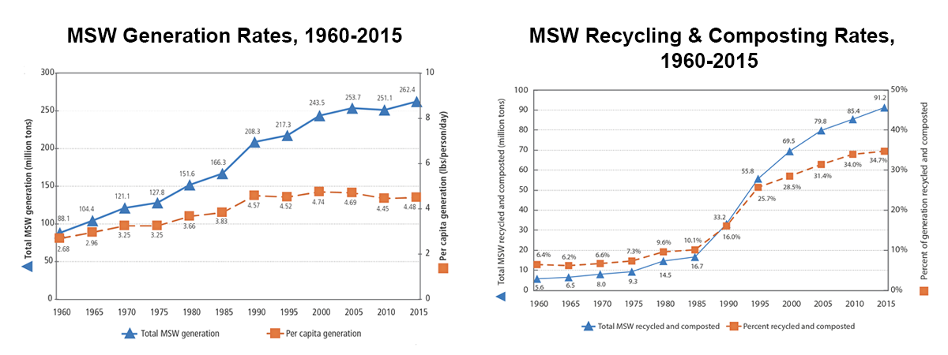
Figure 1.1 Trends in MSW Generation, Recycling, and Composting from 1960 to 2015*
*Source: US EPA 2018

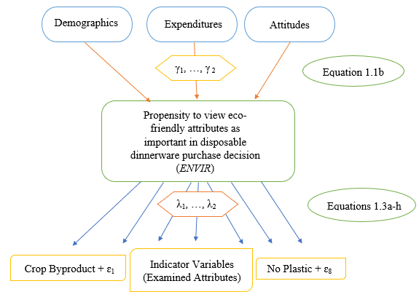
Figure 1.2 Relationship of Variables in the MIMIC Model

Figure 1.3 Percentages of respondents that rated an attribute as important to purchasing decision

Figure 1.4 Probability of Perceived Eco-Friendly Attribute Importance across levels of ENVIR

PART II: CONSUMER WILLINGNESS TO PAY FOR DISPOSABLE BOWLS MOLDED FROM WHEAT STRAW

Mackenzie Gill is the main author of this article. The study used was conducted under the direction and supervision of Dr. Kimberly Jensen, with input by Dr. Sreedhar Upendram, Dr. Burt English, Dr. Jada Thompson, Dr. Dayton Lambert, and Dr. Sam Jackson. The study used a dataset that was obtained through an online survey conducted by the aforementioned faculty in August 2018.

Abstract

Wheat straw cellulose is a byproduct of the wheat industry, and can be used as material for bio-based alternatives to conventional paper and plastic disposables. One such example is disposable dinnerware molded from wheat straw. This study uses contingent valuation method in the form of a choice set survey to measure consumer willingness to pay for wheat straw dinnerware bowls. Tennessee consumers aged 18 or older who consider themselves to be the primary shopper in their household were surveyed. Respondents were found to be willing to pay a premium of $1.33 for a 25-count package of disposable dinnerware molded from wheat straw compared to a 25-count package of conventional paper bowls. The market segment identified as most likely to purchase this product is: Consumers who spend more on disposable dinnerware, are familiar with alternative fiber products, and feel a responsibility to address environmental issues like greenhouse gas emissions and climate change. Attributes including recyclability, no plastic, being USDA Certified Bio-based, and compostability were found to be more highly valued by consumers compared to the product not being made from tree cellulose.

Chapter 1: Introduction and Objectives

Introduction
One emerging bio-based alternative to conventional disposable dinnerware products is dinnerware molded from wheat straw cellulose. Wheat straw is what is left after the wheat kernel is used to make common wheat industry products like flour or cereal. Products molded from wheat straw may thus be labeled as constructed from ‘Crop Byproduct’ materials, which is one of the perceived eco-friendly attributes analyzed in Part I of this report. Molding dinnerware from wheat straw makes use of resources that are otherwise left in the field to be burned, reincorporated into the soil, or sometimes used as animal bedding (USDA ERS 1997). Burning of wheat straw yields substantial emissions of greenhouse gases such as particulate matter, carbon monoxide, and methane. One study on the environmental impact of backfire and headfire burning of wheat straw in the Mexicali Valley found that one tonne of burned wheat straw yielded 138.3 kg of greenhouse gas emissions (Montero et al. 2018). The burning process described by this study is illustrated in Figure 2.2. The fibrous parts of wheat straw and other high-fiber plants are called lignin, cellulose, and hemicellulose. Figure 2.3 portrays the process by which these high fiber components are often used in bio-based industries to create new products, such as plastic-alternatives or biofuels. With a wheat industry in the United States that produced 1.92 billion bushels in the 2019-2020 harvest year, an increase from 1.74 billion bushels in 2017-2018, there is great potential for a substantial supply of cellulose to an emerging wheat straw market (USDA ERS 2020).
The investigation of consumer willingness to pay for bio-based alternatives to conventional paper and plastic disposable dinnerware will be helpful in the development of the market for disposable dinnerware molded from biobased materials. The findings may be most pertinent to businesses interested in either entering the market or in diversifying their offerings to consumers. Kumar and Rahman (2015) reviewed literature on factors instigating changes in production or manufacturing by suppliers and found that two major factors exist which motivate firms to adopt sustainability practices. According to the authors, most suppliers adopt eco-friendly practices as a result of motivational pressure from external agencies, government, and stakeholders. Additionally, many firms are drawn to sustainable products and practices as a part of their marketing campaigns and efforts to remain competitive (Kumar and Rahman 2015). A relevant example of these two motivating factors is the USDA Bio-preferred Program described in Chapter 1 of Part I of this thesis. Through this program, the United States government places external pressure by incentivizing suppliers to participate in this pro-environmental program. The government does this by committing to purchase a certain percentage of bio-based material annually. This voluntary USDA labeling program then contributes to marketing campaigns by certifying that a product is made up of 25% bio-based material, making it easier for both federal purchasers and the average consumer to recognize (USDA Bio-preferred Program 2019). Disposable dinnerware molded from wheat straw could qualify as being USDA certified bio-based, which may provide external incentive to manufacturers to offer the product.
Additionally, consumer awareness of the cumulative impact plastic has on the environment may positively drive their willingness to pay for plastic alternatives (Yue et. al. 2010). Bio-based disposables offer a reliable alternative to plastics that may satisfy environmentally-minded consumers. Dinnerware molded from wheat straw is generally durable and sturdy, compostable, uses no trees, and is a byproduct of existing production. Thus, environmentally concerned consumers are likely willing to pay a premium for such a product, which may inspire the development of a wheat straw-based disposables industry and market. However, the industry for alternative disposable products is still emerging and there have been few investigations into consumers’ preferences for environmentally friendly attributes and willingness to pay for bio-based disposables.

Objectives

The wider objective of this study is to provide marketing information, including product pricing and potential target market segments, to the developing market for disposable dinnerware molded from wheat straw. With this information, manufacturers may be more inclined to enter the market, which may in turn lead to increased disposable dinnerware options for consumers. To this end, this study seeks specifically to:
- estimate a premium for disposable bowls molded from wheat straw,
- determine consumer preferences which drive willingness to pay for this premium,
- determine which attributes are most impactful in driving consumer willingness to pay, and to
- determine how consumers’ demographics, budgets, and attitudes about the environment influence their willingness to pay for wheat straw bowls.

Chapter 2: Review of Literature

Consumer Willingness to Pay for Eco-Friendly Alternatives

While few investigations have investigated consumer willingness to pay (WTP) for disposable dinnerware molded from wheat straw, other studies have examined consumer preferences for alternatives to conventional paper and plastic disposables. For example, Kainz (2016) examined how educating consumers about the biobased attribute in plastic alternatives (non-biodegradable biopolymers) influenced their willingness to pay for biobased sunglasses and toothbrushes. Data was collected through an online survey and a series of experimental auctions, and willingness to pay was estimated with a Tobit censored regression model. The author found that textual information about biopolymers, climate, and durability of the product given to the consumer did positively influence their willingness to pay, but that adding a label to the biopolymer during the auction experiment was most influential (Kainz 2016).
The use of a conjoint choice experiment to model consumer preferences and WTP for eco-friendly alternatives is exemplified by several studies. Barnes et al. (2011) studied Hawaiian consumer preferences and WTP for non-plastic food containers using a conjoint choice experiment. A survey was administered and latent class analysis was used to separate responses into four classes based on stated preferences for attributes of the non-plastic food container. All classes were found to prefer lower prices and water-resistant food containers, but certain classes more highly valued the containers being microwavable and/or locally produced. Barnes et al. (2011) found that respondents in class four most highly valued the attribute ‘locally produced’, and were willing to pay a premium of $0.37 for the product to have such an attribute. Authors hypothesized that this class represented those who understood the local economic impacts of using sugarcane (an important crop in the Hawaiian economy) to produce food containers.
Additionally, Yue et al. (2010) examined consumer preferences for biodegradable plant containers. Using a combination of a hypothetical conjoint analysis and a sealed-bid auction with real products, investigators evaluated premiums that consumers would be willing to pay for containers made from biobased materials including: wheat starch, rice hulls, straw, coir, peat, and other materials. Using a random individual effect two-limit tobit model to classify their survey data, Yue et al. (2010) found that consumers were willing to pay 19.5 cents more for wheat starch containers compared to recyclable plastic containers. This suggests that containers constructed from biobased materials, specifically from the wheat crop, appeal to consumers. While authors examined the effects of demographics on WTP premiums, the only demographic found to have a significant impact was that female participants were willing to pay more for the biodegradable pots when compared with conventional plastic pots (Yue et al. 2010).
Klaiman, Ortega, and Ganache (2016) used discrete choice experiments to derive consumer WTP for recyclable packaging made from a variety of materials. Consumers were found to be WTP the highest premium for recyclable packaging made from plastic, followed by aluminum and glass. An educational video was found to influence consumers’ ordinal preferences for the packaging material, and increased WTP for recyclability overall. Education and positive environmental attitudes were found to be strongly associated with consumers’ valuation of eco-friendly purchases. One market segment found to have high WTP was consumers who stated that they recycled in an effort to save water. Other socio-demographic factors were not found to be highly associated with recycling preferences (Klaiman, Ortega, and Ganache, 2016).
Kurka and Menrad (2009) conducted a survey on European consumers’ attitudes towards and WTP for several bio-based products, including orange juice packaged in a bio-based container and labeled as bio-based. Investigators carried out discrete-choice experiments based on a rational choice model, and thus assumed that consumers were utility maximizers who were able to determine their own utility from their choices. Authors used a logit model to classify their data and subsequently calculated WTP. Consumers who indicated highest WTP for bio-based soap had greater awareness of ecological issues, sustainability, and personal health. Consumers ranked their top hypothetical reasons for purchasing bioplastics in order as: to be more ecofriendly, to conserve resources for future generations, for health reasons, to strengthen the regional economy, to get it for a low price, to set an example for others, and to ease ones conscience (Kurka and Menrad 2009). In this study, environmental attitudes impacted whether the consumer chose to purchase the product with bio-based components.
Royne et al. (2011) surveyed consumers with “at least a minimal interest in environmentalism” in an effort to derive WTP based on concern for a variety of environmental issues. A general linear model found a negative association of age and WTP for a hypothetical eco-friendly product. Unsurprisingly, a relatively high concern for waste also predicted increased WTP.
While the results from each of these studies provide useful insights into consumer preferences for environmentally friendly containers and packaging, none directly examined consumer willingness to pay for bio-based or potentially ecofriendly alternatives to conventional products. Some results from prior research (Yue et al 2010; Martinho et al. 2015) suggest that age will likely have a negative influence on WTP, while other studies suggest age will have a positive influence (Kainz 2016). Findings from prior research also suggest that being female will have a positive influence on willingness to pay (Casadesus-Masanell et al. 2009; Kainz 2016; Martinho et al. 2015; Yue et al. 2010). Previous research suggests that residing in an urban area will have a negative influence on WTP (Casadesus-Masanell et al. 2009). Having children and/or household size was previously found to positively impact WTP (Kainz 2016; Yue et al. 2010). Some studies found education to positively impact WTP (Martinho et al. 2015; Yue et al., 2010), while others found education to have a negative impact (Casadesus-Masanell et al. 2009). Similarly, some studies found household income to positively impact WTP (Casadesus-Masanell et al. 2009; Yue et al. 2010), while others observed a negative impact (Kurka and Menrad 2009; Kainz 2016). Having previous knowledge of the product was found to positively impact WTP (Kainz 2016), as well as the consumer having previously purchased the product type (Casadesus-Masanell et al. 2009). Overall, having positive environmental attitudes and positive attitudes toward sustainable products increased WTP (Barnes et al. 2011; Herbes et al. 2018; Kainz 2016; Klaiman, Ortega, and Garnache 2016; Klein et al. 2019; Kurka and Menrad 2009; Martinho et al. 2015). These findings provide a conceptual starting point for possible factors to be included in a WTP analysis of biodegradable wheatstraw bowls.

Hypothetical Contingent Valuation

Previous studies have highlighted the advantages and disadvantages of using hypothetical contingent valuation to illicit consumer preferences and willingness to pay (Yue et al. 2010, Lusk et al. 2004; Cummings and Taylor 1999). Some advantages identified include: its virtual nature does not require the product to be developed (Lusk et al. 2004); respondents may be more likely to reveal accurate spending behaviors compared to an auction setting where preferences may be influenced by temporal factors (Lusk et al. 2004); the choice set method of listing prices associated with varying attributes is reminiscent of the common shopping experience (Lusk et al. 2004); responses can be elicited from large sample sizes at a relatively low cost (Lusk et al. 2004). Disadvantages to the hypothetical contingent valuation method include: responses may be biased by the lack of real monetary exchange (Cummings and Taylor 1999); the lack of a real shopping environment implies that respondents are unable to offer feedback of a real shopping experience (Yue et al. 2010); willingness to pay values must be indirectly calculated from stated values and utility estimation (Lusk et al. 2004). These advantages and disadvantages will be considered when creating survey information screens and deriving conclusions from the study’s findings.

Chapter 3: Methods and Procedures

Data Collection

Data was obtained through an online Qualtrics consumer survey in August 2018. The survey sample consisted of 218 Tennessee residents aged 18 or older. The survey instrument contained several sections, including information about wheat straw and its uses, a contingent valuation exercise for molded wheat straw disposable dinnerware bowls, questions about why they did not select the wheat straw product, descriptions of other potential disposable dinnerware attributes, disposable dinnerware expenditures and shopping patterns, environmental attitudes, and demographic questions about the respondents. A copy of the survey instrument can be found in Appendix C at the end of this report.
Prior to the contingent choice exercise, the respondents were provided information screens. One of these screens provided information about wheat straw and its potential uses. Questions 3-5 in Appendix C show the screens that informed consumers about wheat straw and its uses. A common criticism of the CV method is that due to its hypothetical nature, respondents have no disincentive to select a more expensive product as they are not truly spending money. Thus, they may tend to select a product they would not truly purchase. To help diminish this issue, known as yea-saying, (Blamey, Bennett, and Morrison 1999), respondents were reminded to answer as realistically as possible considering their budget (Cummings and Taylor 1999). This information screen is shown in Question 6 of Appendix C.
Following these information screens, the choice set measuring willingness to pay for a molded wheat straw disposable dinnerware bowl was introduced. In this question, the respondent could choose between two 25 count packages of conventional paper or molded wheat straw disposable dinnerware bowls (or neither). To elicit respondent willingness to pay, the question was presented as a referendum style contingent valuation choice (Haveman and Weimer 2001). The price of the conventional bowls was held at $2.25, while the price of the wheat straw bowls was divided into five equal price groups ($2.25, $3.25, $4.25, $5.25, and $6.25). The sample was equally divided across the five price levels for the wheat straw bowls, so each respondent only saw one price for the wheat straw bowls. The survey choice set is shown in Questions 7-14 of Appendix C.
Respondents who did not select the wheat straw bowls or selected wheat straw bowls at the base price ($2.25) were asked if they were willing to pay any amount more for the wheat straw bowls. If the respondent was not willing to pay anymore or chose neither, they were asked to identify the reasons.
To obtain respondent views on environmental issues, they were asked their level of agreement (1=strongly disagree, …, 5=strongly agree Likert scale) with several positive environmental statements (Appendix C, Question 19-20). They were also asked about expenditure patterns and their demographics, including gender, age, income, and education level. Questions 17, 21-31 in Appendix C show these sections of the survey as they were presented to the respondent.

Economic Modeling of Consumer Willingness to Pay

The economic framework for the choice set in the survey, random utility theory, is used, where the consumer will choose the option that provides the greatest utility (McFadden 1974). Park and Loomis (1992) recommended the Hanemann utility difference approach for estimating average willingness to pay from CV survey data. Hanemann (1984) expressed the dichotomous choice as a consumer indirect utility function. Let U_{i} be equal to the i^{th} consumer’s indirect utility derived from choosing the conventional paper bowls or wheat straw bowls. It is postulated that the i^{th} consumer will choose the alternative that provides them with the greatest utility. Indirect utility is postulated to be influenced by the consumer’s demographics and attitudes, which make up X_{i}, income represented by Y_{i}, price of the wheat straw bowls represented by P_{iWSB}, and the error term ε_{i}. Let the consumer’s indirect utility function then be:
U_{i} =V(WSB_{i}, P_{iWSB,,} Y_{i,} X_{i})+ε_{i ,} where WSB_{i}=0,1 (2.1)
The probability that the i^{th} respondent will select the wheat straw bowls at P_{iWSB}, is then the probability that utility level from respondents’ selecting wheat straw bowls is greater than or equal to the utility derived from selecting the conventional bowls. Let the variable WSB_{i} reflect choice of the wheat straw bowls, where WSB_{i} =1 if the respondent chooses the wheat straw bowls and WSB_{i} =0 if they choose the conventional bowls. Then the probability of choosing the wheat straw bowls can be expressed as:

Pr [${WSB}_{i}=1]$=Pr [V(1, Y_{i,} -P_{iWSB}, X_{i})- (2.2)
V(0, Y_{i,}, X_{i}) ≥ ε₀ -ε₁].

If the logistic probability distribution, Λ, is assumed, then probability of the i^{th} consumer choosing the wheat straw bowls is
Pr [${WSB}_{i}=1]$ =$Λ\left(X_{i}, Y_{i}{, P}_{iWSB}\right)$ (2.3)
This probability can be estimated as a logit model, such that
Pr [${WSB}_{i}=1]$ =$Λ\left(α+{βX}_{i}{+{β_{Y}Y}_{i}+β}_{PWSB}P_{iWSB}\right)$ (2.4)
where $α$ represents a constant, $β$ represents a parameter vector on the $X_{i}$ explanatory variables, ${β_{Y}}_{i}$ is parameter on income, and $β_{PWSB}$ represents a parameter on the price explanatory variable (Greene 2018). The variable names and definitions to be used in the logit model are shown in Table 2.1.
The estimated coefficients from a logit model can be interpreted for sign and significance. However, their magnitudes cannot be interpreted directly. Hence, marginal effects must be calculated. The marginal effect of a given k^{th} explanatory variable, $X_{ki}$, reflects the impact of a one unit change of the k^{th} explanatory variable on the probability of the i^{th} respondent choosing the wheat straw bowls. The marginal effect can be calculated as:
$\frac{∂Pr [{WSB}_{i}=1] }{∂X_{ki}}$ = 𝜆$β_{k}$ (2.5)
where $β_{k}$ represent the parameter of variable $X_{ki}$ and λ is the logistic density function (Greene 2018). The logistics density function is calculated as $λ= \frac{e^{\left(α+{βX}_{i}{+{β_{Y}Y}_{i}+β}_{PWSB}P_{iWSB}\right)}}{{( e^{\left(α+{βX}_{i}{+{β_{Y}Y}_{i}+β}_{PWSB}P_{iWSB}\right)})}^{2} }$, where e represents the exponential function.
Overall marginal effects for the explanatory variables are then found by taking the mean of each respondent’s marginal effect value. The standard errors around the marginal effects are calculated using the Delta method (Greene 2018).
Consumers’ willingness to pay for the wheat straw bowls was derived using the following equation with the previously defined variables:
${\hat{WTP}}_{WSB,i}$ = - $(\left(α+{βX}_{i}+{β_{Y}Y}_{i}\right))/β_{PWSB}$ (2.6)
Mean willingness to pay is calculated using each variable’s marginal effect on willingness to pay, and the standard errors associated with each calculation. The Krinsky and Robb method with 5,000 replications is used (Krinsky and Robb 1986). Also, with $β_{k}$ representing the parameter on $X_{i}$ explanatory variables and $β_{pWSB}$ representing the parameter on price, the mean effect of the k^{th} variable on estimated willingness to pay will be found with the following equation:
$\frac{{\hat{∂WTP}}_{WSB, i}}{∂X_{i}}$ = - $\frac{β_{k}}{β_{pWSB}}$ (2.7)
Expected Results
The results from this analysis are anticipated to provide a measure of consumers’ willingness to pay a premium for the molded wheat straw bowls. Additionally, the market segment most likely to purchase these wheat straw bowls will be identified. The results from the logit model will convey how consumers’ expenditure patterns, demographics, and environmental attitudes influence their stated willingness to pay. The associated marginal effects will describe the magnitude of this influence as well. Finally, the wheat straw bowls’ least and most important attributes will be identified using means comparisons of the consumers who selected the wheat straw bowls compared to the consumers who did not select the bowls.
The impact of explanatory variables to be included in the logit model estimating the probability of a respondent choosing the wheat straw bowls are as follows. Following the law of demand, the price of the wheat straw bowls (Price) will have a negative impact on purchase decision (Nicholson and Snyder 2012). Age is expected to negatively influence probability of selection (Yue et al. 2010; Martinho et al. 2015). Being female (Female) is expected to have a positive influence (Casadesus-Masanell et al. 2009; Kainz 2016.; Martinho et al. 2015; Yue et al. 2010). Residing in an urban area (Urban) will have a negative impact (Casadesus-Masanell et al. 2009). Income will likely have a positive impact on selection and willingness to pay (Casadesus-Masanell et al. 2009; Yue et al. 2010). Furthermore, residing in middle Tennessee (Middle) will likely have a positive influence, as average household incomes are slightly higher in this region compared to the average household income for the state of Tennessee (US Department of Commerce 2019). Having children under 18 in the household (Children) is expected to positively influence selection (Kainz 2016; Yue et al. 2010). Having at least a college degree (College) is expected to positively influence selection of the perceived eco-friendly alternative (Casadesus-Masanell et al. 2009). While few studies have investigated the impact of annual expenditures on disposable dinnerware (Ann. Expend. Disp. Dinn.), this variable is expected to positively impact purchase decision. This reasoning behind this assumption is that the more one spends on disposable dinnerware, the more likely it is that this respondent will be willing to pay a premium for a product with perceived eco-friendly attributes. If a respondent has previously heard of wheat straw (Heard of), he or she is expected to be more likely to select the wheat straw bowls (Kainz 2016). If the respondent has previously purchased alternative fiber products (Purch. Alt. Fiber Prod.), this will similarly have a positive impact on selection (Casadesus-Masanell et al. 2009). Thus, it follows logically that if a respondent has both heard of wheat straw and previously purchased alternative fiber products (Heard of* Purch. Alt. Fiber Prod.), this will also positively influence selection decision. If a respondent has a higher than average agreeance with the positive environmental statements in the environmental concern index (Environ. Concern Index), this individual will be more likely to select the wheat straw bowls (Barnes et al. 2011, Herbes et al. 2018, Kainz 2016, Klaiman, Ortega, and Garnache 2016, Klein et al. 2019, Kurka and Menrad 2009, Martinho et al. 2015). Similarly, if an individual has a higher than average agreeance with the statements expressing the need to address greenhouse gas emissions and climate change (GHG/Clim. Chng. Concern Index), this individual will be more likely to select the wheat straw bowls (Barnes et al. 2011, Herbes et al. 2018, Kainz 2016, Klaiman, Ortega, and Garnache 2016, Klein et al. 2019, Kurka and Menrad 2009, Martinho et al. 2015).

Chapter 4: Results

Indices for Environmental Opinion Variables
From a covariance matrix of survey participants’ Likert ratings of positive environmental statements (1= strongly disagree, …, 5= strongly agree), certain opinions were found to be highly correlated. Two groups of these opinion statements became evident as interrelated. First, the following statements related to environmental concern were highly correlated:
- Protecting the world’s forests is critical to the environment,
- We have a responsibility to future generations to protect the environment,
- Responses to this survey could cause dinnerware manufacturers to offer more alternative products that don’t use trees, and
- Consumers can impact the environment with their product choices.
Cronbach’s alpha was used to measure whether these Likert opinion variables could be reliably represented with a single summative index. Cronbach’s alpha enables assessment of the reliability of using summative rating scale composed of the Likert variables to represent that variable list (Cronbach 1951). If the reliability score, α, is at least 0.80 then the summative rating scale is considered to be a reliable representation of the variables in the list. Using Cronbach’s alpha coefficient as a scale reliability metric, a summative index was created from these variables after the α was found to be equal to 0.8665. Hence, an average rating of these Likert variables was used in the model. This index variable was called Environ. Concern Index.
Secondly, the following opinion statements were also found to be highly
correlated:
- There is urgent need to take measures to prevent climate change, and
- There is urgent need to reduce greenhouse gas emissions.
In this case, Cronbach’s α was found to be equal to 0.7903. Thus, a second summative index was created from these variables and named GHG/Climate Change Concern Index. These two indices were then included as explanatory variables in the logit model estimating probability of choosing disposable dinnerware bowls made from wheat straw cellulose.

Logit Model

Results for the logit model estimating probability of choosing the wheat straw bowls can be found in Table 2.2 (N=173). The log likelihood ratio test with 14 degrees of freedom yielded a value of 87.25 and was significant, implying that the model was a good fit for the data. The model correctly classified 78.03 percent of the observations. Variables with significant influences on selection of the wheat straw bowls included Price (-), College (-), Household Income in Thousands (-), Ann Expend Disp Dinnerware (+), Heard of Wheat Straw (+), Heard of Wheat Straw*Purchased Alternative Fiber Products (+), and GHG/Climate Change Concern Index (+).
These associations are congruent with previous findings in the literature. As previously discussed, some studies found education positively impacts willingness to pay for bio-based or eco-friendly alternatives (Martinho et al. 2015; Yue et al. 2010), while other studies have found negative impacts (Casadesus-Masanell et al. 2009). Similarly, findings regarding the effects of income have also been mixed as both positive (Casadesus-Masanell et al. 2009; Yue et al. 2010), and negative (Kurka and Menrad 2009; Kainz 2016). The positive effects of having prior knowledge about wheat straw and having previously purchased alternative fiber products align with prior research findings (Kainz 2016; Casadesus-Masanell et al. 2009). The finding regarding the positive effect of being concerned about greenhouse gas emissions and climate change on willingness to pay for environmentally friendly alternatives is similar to those from other studies (Kainz 2016.; Kurka and Menrad 2009; Martinho et al. 2015). Overall, relatively few sociodemographic variables were significant within the logit model, which is also consistent with previous literature findings (Kurka and Menrad 2009; Klaiman et al. 2016).
The marginal effects of the explanatory variables, as evident in the third column of Table 2.2, illustrate the impacts of a one unit change in a given variable on the probability of selecting the wheat straw bowls. Notably, a $1 increase in price implies a decreased probability of being willing to purchase the wheat straw bowls by 16.33 percent. Having a college education (College) decreases the probability by 13.82 percent. While a $1,000 increase in household income (Household Income Thous.) decreased the probability of choosing the wheat straw bowls by 0.16 percent, a $1 increase in expenditures on disposable dinnerware (Ann Expend Disp. Dinnerware) increased the probability by 0.07 percent. If the respondent had heard of wheat straw (Heard of Wheat Straw), this increased the probability of choosing the wheat straw bowls by 15.62 percent. Furthermore, if the respondent had both heard of wheat straw and purchased an alternative fiber product in the past (Heard of Wheat Straw*Purch Alt Fiber Prod), this increased the probability by 33.15 percent. Attributing a greater than average importance of reducing greenhouse gases and climate change (GHG/Clim Chng Concern Index) increased probability by 6.42 percent.

Willingness to Pay
The effects of each of the variables on willingness to pay (WTP) are shown in the fourth column of Table 2.2. Bolded values had significant confidence intervals, excluding zero at the 95% confidence level. If the respondent had at least attended college (College), this decreased his or her WTP by nearly $0.85. An increase in annual expenditures on disposable dinnerware (Ann Expend Disp Dinnerware) of $1 increased the WTP by $0.004, or in other words, a $10 per year increase would increase WTP by $0.04. If the respondent had heard of wheat straw (Heard of Wheat Straw) this increased WTP by nearly $0.96. Furthermore, if greenhouse gas and climate change reduction (GHG/Clim Chng Concern Index) were of greater than average importance to him or her, this increased WTP by $0.39.
The mean WTP was estimated to be $3.58, a premium of $1.33 over the base price of $2.25. The 95% confidence interval with a lower bound of $3.14 and an upper bound of $3.94 was calculated using the Krinsky Robb method at 5,000 replications. A histogram of the WTP values is shown in Figure 2.4 (Krinsky and Robb 1986).

Responses of Participants Who Did Not Choose the Wheat Straw Bowls
The respondents who either did not choose the wheat straw bowls, or chose the wheat straw bowls at the base price of $2.25, were asked if they would pay any amount more for the wheat straw bowls. Among this group, 33.83 percent revealed they would pay some amount more. Additionally, 60.90 percent supported development of wheat straw disposable dinnerware, but would not pay any more, and only 5.26 percent did not support development of wheat straw disposable dinnerware. Among those who said they would not pay any additional amount, the most commonly cited reason was that they could not afford to do so. The second most cited reason was that they did not purchase disposable dinnerware bowls often enough to pay attention to the materials from which they are made.

Means Comparisons of Attribute Importance Ratings
As can be seen in Table 2.3, overall, respondents who chose the wheat straw bowls felt the potentially eco-friendly disposable dinnerware attributes were more important than those who did not select the wheat straw bowls. However, statistical difference in the mean ratings at the 95% confidence level across the groups was found only for the ‘Compostable’ attribute of disposable dinnerware. In this case, the group who selected the wheat straw bowls felt this attribute was of greater importance (3.14 average) than the group who did not select the wheat straw bowls (2.80 average).
In addition to comparing the means across the two groups, mean ratings were compared within each group. In Table 2.3, the same letter beside two means indicates that these two means were not statistically different from each other at the 95% confidence level. For those who did not select the wheat straw bowls, the mean importance ratings of attributes in disposable dinnerware were not significantly different from each other except for the ‘No Trees’ attribute. This attribute was rated significantly lower than the product being US made, recyclable, made from cellulose that is organically produced, made from cellulose from a dedicated energy crop or a byproduct of crops, and not being made from plastic. For those who did select the wheat straw bowls, products being recyclable, not containing plastic, USDA certified bio-based, and compostable were rated significantly higher in importance than the product containing no cellulose from tree fibers. The relative importance of each potential attribute is shown in bar charts for the two groups in Figure 2.5.

Chapter 5: Conclusions

Findings from this investigation suggest that Tennessee consumers would pay $3.58 for a 25-count package of bowls molded from wheat straw cellulose and characterized by attributes often perceived as environmentally friendly. This revealed willingness to pay is a premium of $1.33 compared to the price of $2.25 for a 25-count package of conventional dinnerware molded from tree cellulose. The market segment estimated by the logit model as most likely to select the wheat straw bowls were those who spend more on disposable dinnerware, have previously heard of wheat straw, have previously purchased alternative fiber products, and are relatively more concerned about reducing greenhouse gas emissions. Thus, consumers who spend more on disposable dinnerware, but feel more responsibility to address environmental issues may be target markets.
The finding that consumers who have prior familiarity with wheat straw or other alternative fibers are more likely to choose the wheat straw bowls implies that educating consumers about bio-based fibers and their attributes could be helpful in marketing these products. Additionally, this finding may suggest that loyal customers of “alternative fiber” products may represent an additional component of the market segment.
Regarding means comparisons of importance ratings among the groups, for those who selected the wheat straw bowls, the product being recyclable, not containing plastic, being USDA Certified Bio-based, and being compostable were rated significantly higher in importance than the product containing no cellulose from tree fibers. Adding these attributes could bring additional premiums among the target market segment.

The results suggest that among both those who chose the wheat straw bowls and did not choose them, the least valued attribute was that the product contains no cellulose fibers from trees. In other words, “tree free” labeling may be of little value in building premiums. This may also imply that consumers believe cellulose from trees can be sustainably sourced. On the other hand, this may be partly a reflection of societal nudging behaviors that are focused on decreasing the use of single use disposables due to their end-of-life environmental impacts. Additional research would be needed to further investigate these motivations before a conclusion can be drawn.
The means ratings comparisons also reflected that respondents view cellulose from agricultural crops similarly whether it comes from a dedicated crop or a crop byproduct. This may suggest that consumers are about equally receptive to planting of dedicated crops as sources of cellulose for disposable products as they are to cellulose sourced as a crop byproduct. Additionally, providing information about the efficiency of using byproducts of existing crop production may be helpful in marketing such products to environmentally minded consumers. For example, future research might present information about Life Cycle Analysis for both types of cellulose in disposable dinnerware.

Implications

Findings from this investigation suggest that overall, consumers are willing to pay a premium for disposable bowls molded from wheat straw fiber compared to conventional paper disposable bowls. Results suggest that the target market for this product may be consumers who spend more on disposable dinnerware but are still more concerned about the environment. Providing this evidence of a potential market to disposable dinnerware manufacturers may help facilitate the development of an industry for alternative disposable dinnerware products that are constructed from bio-based material such as wheat straw.
The development of this industry would yield several positive economic and environmental consequences. First, consumers would see increased disposable dinnerware purchase options. Environmentally minded consumers may feel more satisfied with their purchasing decision when selecting a product with perceived eco-friendly attributes. Additionally, the wheat straw used to mold these dinnerware bowls is most often otherwise burned or disposed of in a landfill (crop byproduct). Making use of this material could decrease the greenhouse gas that is emitted from burning wheat straw. However, capturing the relative GHG emissions associated with use of different cellulose sources was beyond the scope of this study. Further research on the environmental impact of the supply chain involved with the sale of these bowls is needed before an overarching claim can be made about the positive environmental impact of producing disposable dinnerware molded from wheat straw.
This study had several limitations which may impact the conclusions that can be drawn from the findings. First, the study was limited in the geographic region reflected by the sample. Further research may expand this study’s sample region, as this sample was limited to consumers in Tennessee. Research conducted across a broader geographical region may better reflect United States consumers’ willingness to pay for this type of product. Also, a broader region may allow for a larger sample size to be surveyed, which would be more representative of the US population and less disposed to to skewedness of results. Specifically, the gender composition of this study’s sample was somewhat skewed, as females were overrepresented compared to Tennessee’s population. Further research may avoid using the “primary shopper in household” classification to filter respondents.
Future studies may incorporate factors driving consumers to purchase disposable dinnerware. As mentioned, the findings that consumers with lower income and education were more likely to select the wheat straw bowls suggest that indirect influences on expenditures may be present. For example, grouping respondents according to convenience, time constraints, or other factors may provide deeper insight to this study’s findings. Additionally, further investigation may include in-store experiments, market data, or auctions in an effort to eliminate the potential for bias associated with respondents’ stated preferences related to a hypothetical environment.

Chapter 6: Appendix B

Table 2.1 Variable Names, Definitions, and Means for the Logit Model Estimating Probability of Choosing Wheat Straw Molded Dinnerware Bowls
Variable Name | Variable Definition | Means  (N=173) | Census Means*
ChooseWheat | 1 if chose 25 count package of wheat straw molded bowls, 0 otherwise | 0.41 | n/a
Price | Price of 25 count package of disposable dinnerware bowls, $2.25, $3.25, $4.25, $5.25, $6.25 | 4.21 | n/a
Age | Age in years | 43.35 | 38.70
Female | 1 if Female, 0 otherwise | 0.77 | 0.51
Urban | 1 if resides in urban area, 0 otherwise | 0.20 | 0.66
Middle | 1 if resides in Middle Tennessee, 0 otherwise | 0.31 | 0.40
Children | 1 if have children under 18 in household, 0 otherwise | 0.45 | 0.45
College | 1 if attended college or graduated from college, 0 otherwise | 0.68 | 0.68
Household Income Thous. | 2017 Household Income (Pre-Tax) in Thousands of Dollars | 52.42 | 52.42
Ann. Expend. Disp. Dinnerware | Annual expenditures on disposable dinnerware in dollars | 95.39 | 95.39
Heard of Wheat Straw | 1 if have heard of wheat straw before, 0 otherwise | 0.57 | n/a
Purch. Alt. Fiber Prod. | 1 if have purchased alternative fiber products before, 0 otherwise | 0.18 | 0.18
Heard of Wheat Straw*Purch. Alt. Fiber Prod. | 1 if have heard of wheat straw and purchased alternative fiber products before, 0 otherwise | 0.14 | n/a
Environ. Concern Index | Index from Cronbach’s alpha on environmental concern Likert variables (1=strongly disagree, …, 5=strongly agree) | 4.20 | n/a
GHG/Clim. Chng. Concern Index | Index from Cronbach’s alpha on GHG/climate change concern Likert variables (1=strongly disagree, …, 5=strongly agree) | 3.70 | n/a
*Source: US Department of Commerce, Bureau of the Census (2019).

Table 2.2 Logit Results: Probability of Choosing Wheat Straw Molded Dinnerware Bowls
Variable |  | Est. Coeff. ª |  | ME on Pr WheatStraw=1 |  |  |  |  | Est. Effect on WTP^{b}
Intercept |  | 1.271
Price |  | -1.189 | *** |  | -0.163 | ***
Age |  | 0.007 |  |  | 0.001 |  |  | $0.006
Female |  | 0.310 |  |  | 0.043 |  |  | $0.260
Urban |  | -0.163 |  |  | -0.022 |  |  | -$0.137
Middle |  | 0.033 |  |  | 0.005 |  |  | $0.028
Children |  | -0.151 |  |  | -0.021 |  |  | -$0.127
College |  | -1.006 | ** |  | -0.138 | ** |  | -$0.846
Household Income Thous. |  | -0.011 | * |  | -0.002 | * |  | -$0.009
Ann. Expend. Disp. Dinnerware |  | 0.005 | ** |  | 0.001 | *** |  | $0.004
Heard of Wheat Straw |  | 1.138 | ** |  | 0.156 | ** |  | $0.957
Purch. Alt. Fiber Prod. |  | -1.303 |  |  | -0.179 |  |  | -$1.100
Heard of Wheat Straw*Purch Alt. Fiber Prod. |  | 2.413 | * |  | 0.331 | * |  | $2.030
Environ. Concern Index |  | 0.202 |  |  | 0.028 |  |  | $0.170
GHG/Clim. Chng. Concern Index |  | 0.467 | ** |  | 0.064 | *** |  | $0.393
LLR Test (14 df) |  | 87.25 | *** |  | Pseudo R² 0.3725
Pct. Correctly Classified= 78.03% | N=173
Est. WTP $3.58 Mean $3.14 LCL $3.94 UCL
ª *** significant at α=0.01, ** significant at α=0.05, * significant at α=0.10.
^{b} Estimated effects on WTP that are significantly different from zero at the 95% confidence level are bolded.

Table 2.3 Importance of Disposable Dinnerware Attributes across Respondents Who Chose and Did Not Choose the Wheat Straw Bowls
Attribute | Mean Rating of Importance  (1=Not At All, …, 5= Extremely)^{a,b}
Attribute | Did Not Choose Wheat Straw Bowls  (N=102) | Chose Wheat Straw Bowls  (N=71)
No Trees | 2.58 b | 2.89 b
USDA Certified Biobased | 2.82 ab | 3.15 a
U.S. Made | 3.04 a | 3.08 ab
Recyclable | 3.04 a | 3.22 a
Compostable | 2.80 ab | 3.14 a | **
Cellulose from Dedicated Ag Crop | 2.99 a | 3.10 ab
Cellulose from Byproduct of a Crop | 2.94 a | 3.00 ab
No Plastic | 2.94 a | - a
Cellulose Organically Produced | 3.00 a | 2.97ab
ª ** indicates significant difference in means across the two groups at 95% confidence level.
^{b} Within each group, means followed by the same letter indicate no significant difference between the means at the 95% confidence level.

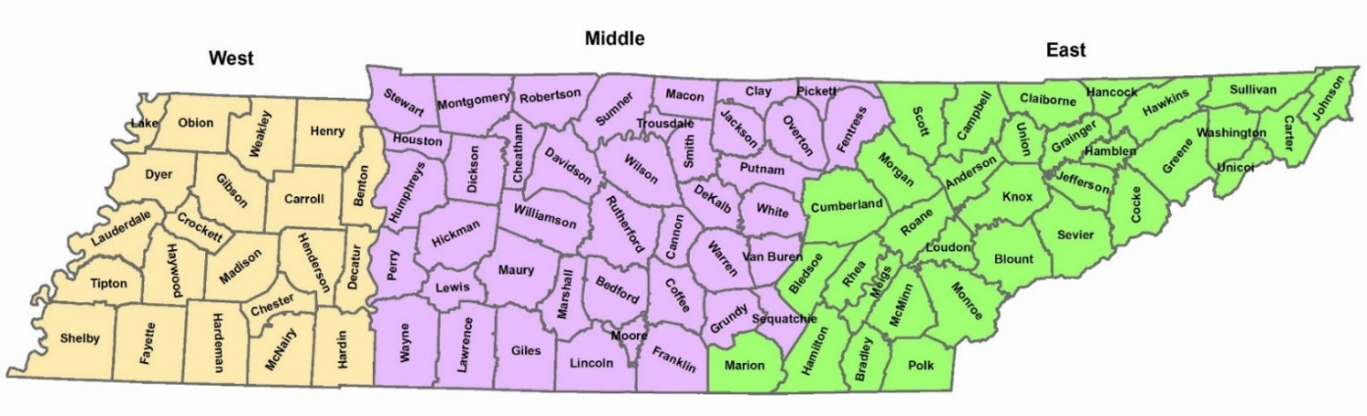
Figure 2.1 Map of TN Counties and Regions
*Source: Dr. Sreedhar Upendram, University of Tennessee Department of Agricultural and Resource Economics

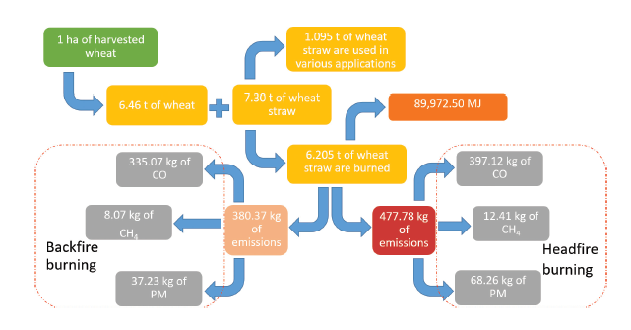
Figure 2.2 Greenhouse Gas Emissions Yielded from 1 Hectare of Harvested Wheat*
*Source: Montero et al. 2018

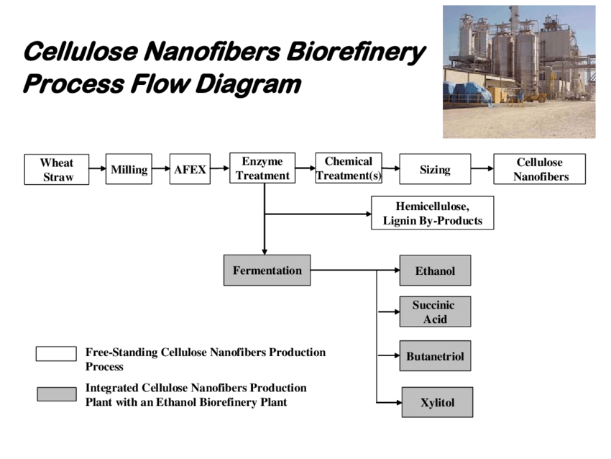
Figure 2.3 Creation of Molded Wheat Straw Products from Wheat Straw Cellulose*
*Source: Leistritz et al. 2006
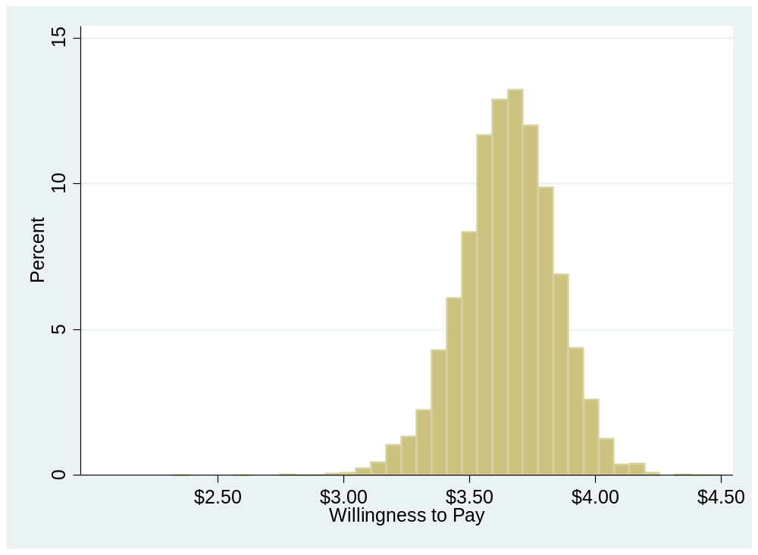
Figure 2.4 Estimated WTP for Wheat Straw Bowls

** = No significant difference among means at the 95% confidence level.
= No significant difference among means at the 95% confidence level.
Figure 2.5 Importance of Disposable Dinnerware Attributes among Respondents Who Chose and Did Not Choose the Wheat Straw Bowls

CONCLUSIONS

The amount of municipal solid waste per capita in the United States has grown consistently since 2010 (EPA 2018). Certain consumer segments have exhibited growing interest in purchasing alternatives to conventional paper and plastic disposable products. Such alternatives often have ecofriendly attributes such as being compostable, recyclable, not containing plastic, or being byproducts of existing production (Mishra, et al. 2017). Within this context, this investigation had two overarching objectives. First, to develop an understanding of consumer preferences for perceived ecofriendly attributes in disposable dinnerware. Second, to provide a measure of consumers’ willingness to pay for a specific alternative disposable dinnerware product exemplifying such attributes.
For both parts of this investigation, data was collected from an online Qualtrics survey. Tennessee consumers aged 18 and older who identified as being the primary shopper in his or her household were polled. For reference, the appendix at the end of this report contains the survey instrument. The sample was similar to the Tennessee population in most aspects, except that the sample contained a larger proportion of females, at 77.2 percent, compared to the 52.18 percent of females in the population (US Department of Commerce 2019).
The first part of this study investigated the former objective, and thus determined the market segment of consumers most likely to classify certain perceived ecofriendly attributes as important to their disposable dinnerware purchasing decision. Importance ratings were measured across varying levels of respondents’ propensity to prefer ecofriendly attributes in disposable dinnerware. The measured attributes included: ‘crop byproduct’, ‘dedicated crop’, ‘USDA certified biobased’, ‘no trees’, ‘recyclable’, ‘compostable’, ‘produced using organic cellulose’, and ‘no plastic’. Table 1.2 defines these attributes. From the survey data, a Multiple Indicator Multiple Causes (MIMIC) model was used to estimate the effects of demographics, expenditures, and attitudes on propensity to prefer these attributes. While the ‘no plastic’ and ‘recyclable’ attributes were found to have the broadest appeal among consumers, the ‘no trees’ and ‘USDA certified bio-based’ attributes were found to appeal to a narrower consumer segment with the strongest preferences for eco-friendly attributes. Structural variables found to be associated with higher preferences for these attributes in disposable dinnerware included respondents’ gender, age, residential location, household income, household composition, and attitudes related to environmental concern.
The second part of this study investigated the latter objective, and thus measured respondents’ willingness to pay for disposable dinnerware molded from wheat straw, which is a byproduct of the wheat industry. A logit model used survey data to measure willingness to pay and estimate a target market for the wheat straw bowls. Findings suggest that consumers are willing to pay an average premium of $1.33 for a 25-count package of wheat straw bowls compared to a 25-count package of conventional paper bowls. Consumers who spend more on disposable dinnerware, have previously purchased alternative fiber products, and are more concerned about addressing greenhouse gas emissions and climate change were found to be most likely to select the wheat straw bowls over the conventional paper bowls.
There are several limitations of this investigation that ought to be considered when deriving implications from these findings. First, only state-level preferences were measured. Further research may expand this study’s sample region to more accurately portray consumers’ preferences nationwide. Furthermore, the gender composition of this study’s sample was somewhat skewed, as females were overrepresented compared to the population in Tennessee. Further research may avoid using the “primary shopper in household” classification to filter respondents, as it is suspected to have caused the disparity between the sample and population composition. Importantly, the nature of the contingent valuation method in the survey is such that respondents reveal stated preferences in reference to a hypothetical situation. This inherently inserts bias in the responses, despite efforts to remind respondents of their budgets and prompts to keep responses as realistic as possible. Future investigation may include in-store experiments or auctions in an effort to diminish this bias.
Other future studies may incorporate factors driving varying disposable dinnerware expenditure patterns among consumers. The findings that respondents with lower income and less education were more likely to select the wheat straw bowls suggest that indirect influences on expenditures may be present. Incorporating convenience, time constraints, or other factors may provide deeper insight to this study’s findings. Finally, further research may include quantification of the environmental impact of the attributes, such as Life Cycle Analysis. With this information, disposable dinnerware manufacturers may be more willing to adopt products made from alternative fibers, thus providing consumers with dinnerware options that are perceived to be both convenient and ecofriendly.

REFERENCES

Acharya, R. and I. Molina. 2004. “Testing for a Change in Consumer Tastes for Fresh Fruits and Vegetables: A Structural Latent Variable Approach.” Paper presented at AAEA annual meeting, Denver, CO, 1-4 August.
Aday, M.S., and U. Yener. 2014. “Understanding the Buying Behaviour of Young Consumers Regarding Packaging Attributes and Labels: Consumer Behaviours in Turkey.” International Journal of Consumer Studies. 38 (4): 385–93.
Arboretti, R., and P. Bordignon. 2016. “Consumer Preferences in Food Packaging: CUB Models and Conjoint Analysis.” Fabio Verneau and Professor Christopher J., ed. British Food Journal. 118 (3): 527–40.
Barker, M., and R. Safford. 2009. Industrial Uses for Crops: Markets for Bioplastics. Home Grown Cereals Authority: Research & Development project report.
Barnes, M., C. Chan-Halbrendt, Q. Zhang, and N. Abejon. 2011. “Consumer Preference and Willingness to Pay for Non-Plastic Food Containers in Honolulu, USA.” Journal of Environmental Protection. 2 (9): 1264–73.
BBC, “Starbucks to Ban Plastics Straws in All Stores by 2020.” BBC News, 9 July 2018, www.bbc.com/news/world-us-canada-44774762.
Blamey, R., Bennett, J, Morrison, M., 1999. “Yea-saying in contingent valuation surveys.” Land Economics. 75(1): 126-141.
Casadesus-Masanell, R., M. Crooke, F. Reinhardt, and V. Vasishth. 2009. “Households’ Willingness to Pay for ‘Green’ Goods: Evidence from Patagonia’s Introduction of Organic Cotton Sportswear.” Journal of Economics & Management Strategy. 18 (1): 203–33.
Cronbach, L.J. 1951. “Coefficient alpha and the internal structure of tests.” Psychometrika. 16: 297-334.
Cummings, R., Taylor, L., 1999. “Unbiased value estimates for environmental goods: a cheap talk design for the contingent valuation method.” American Economic Review. 89 (3): 649-665.
Davis, G., and J.H. Song. 2006. “Biodegradable Packaging Based on Raw Materials from Crops and Their Impact on Waste Management.” Industrial Crops and Products. 23 (2): 147–61.
Gao, X.M., E.J. Wailes, and G.L. Cramer. 1997. “A Microeconometric Analysis of Consumer Taste Determination and Taste Change for Beef.” American Journal of Agricultural Economics. 79: 573-582.
Greene, W.H. 2018. Econometric Analysis, 8th Ed. Boston: Pearson
Geyer, R., J.R. Jambeck, and K.L. Law. 2017. “Production, use, and fate of all plastics ever made.” Science Advances 3 (7): e1700782.
Hanemann, W. 1994. “Contingent Valuation and Economics.” Working Paper Series, UC Berkeley Department of Agricultural and Resource Economics. 697 (March): 1-36.
Hanemann, W. M. 1984. “Welfare Evaluations in Contingent Valuation Experiments with Discrete Responses.” American Journal of Agricultural Economics. 66: 332-341.
Harvard Women’s Health Watch. 2019. “Is plastic a threat to your health?” Harvard Health Publishing. December. https://www.health.harvard.edu/staying-healthy/is-plastic-a-threat-to-your-health Last Accessed: May 26, 2020.
Haveman, R.H. and D.L. Weimer. 2001. “Cost-Benefit Analysis”. International Encyclopedia of the Social & Behavioral Sciences. 2845-2851.
Herbes, C., C. Beuthner, and I. Ramme. 2018. “Consumer Attitudes towards Biobased Packaging – A Cross-Cultural Comparative Study.” Journal of Cleaner Production. 194 (September): 203–18.
Jensen, K., et. al. 2019. “Consumers’ Willingness to Pay for Disposable Dinnerware Molded from Wheat Straw. University of Tennessee, Department of Agricultural Economics. Manuscript presented at WAEA 2019 conference.
Jerzyk, E. 2016. “Design and Communication of Ecological Content on Sustainable Packaging in Young Consumers’ Opinions.” Journal of Food Products Marketing. 22 (6): 707–16.
Kainz, U. W. 2016. “Consumers’ Willingness to Pay for Durable Biobased Plastic Products: Findings from an Experimental Auction,” Technical University of Munich (2016): 1-143.
Khachatryan, H., B. Campbell, C. Hall, B. Behe, C. Yue, and J. Dennis. 2014. “The Effects of Individual Environmental Concerns on Willingness to Pay for Sustainable Plant Attributes.” HortScience. 49(1):69–75.
Klaiman, K., D.L. Ortega, and C. Garnache. 2016. “Consumer preferences and demand for packaging material and recyclability.” Resources, Conservation and Recycling. 115:1–8.
Klein, F., A. Emberger-Klein, K. Menrad, W. Möhring, and J.M. Blesin. 2019. “Influencing Factors for the Purchase Intention of Consumers Choosing Bioplastic Products in Germany.” Sustainable Production and Consumption. 19 (July): 33–43.
Koenig-Lewis, N., A. Palmer, J. Dermody, A. Urbye. 2014. “Consumers’ evaluations of ecological packaging- Rational and emotional approaches.” Journal of Environmental Psychology. 37: 94-105.
Koutsimanis, G., K. Getter, B. Behe, J. Harte, and E. Almenar. 2012. “Influences of packaging attributes on consumer purchase decisions for fresh produce.” Appetite. 59 (2): 270–280.
Krinsky, I., and A. L. Robb. 1986. “On Approximating the Statistical Properties of Elasticities.” The Review of Economics and Statistics. 68 (4): 715–19.
Kumar, D., and Z. Rahman. 2015. “Sustainability adoption through buyer supplier relationship across supply chain: A literature review and conceptual framework.” International Strategic Management Review. 3 (1–2): 110–127.
Kurka, S., and K. Menrad. 2009. “Biorefineries and Biobased Products from the Consumers’ Point of View.” 13th ICABR International Conference on Agricultural Biotechnology, Italy, (June) 1-33.
Lambert, D.,K. Paudel, J. Larson. 2015. “Bundled adoption of precision agriculture technologies by cotton producers.” Journal of Agricultural and Applied Economics. 40 (2): 325-345.
Leistritz, F.L., D.M. Senechal, M.D. Stowers, W.F. McDonald, C.M. Saffron, and N.M. Hodur. 2006. “Preliminary Feasibility Analysis for an Integrated Biomaterials and Ethanol Biorefinery Using Wheat Straw Feedstock.” Agribusiness and Applied Economics Report, North Dakota State University. 590: 1-49.
Loschelder, D. D., H. Siepelmeyer, D. Fischer, and J. A. Rubel. 2019. “Dynamic Norms Drive Sustainable Consumption: Norm-Based Nudging Helps Café Customers to Avoid Disposable to-Go-Cups.” Journal of Economic Psychology. https://doi.org/10.1016/j.joep.2019.02.002
Lusk, J.L., T. Feldkamp, and T.C. Schroeder. 2004. “Experimental Auction Procedure: Impact on Valuation of Quality Differentiated Goods.” American Journal of Agricultural Economics. 86, 2: 389-405.
Martinho, G., A. Pires, G. Portela, and M. Fonseca. 2015. “Factors Affecting Consumers’ Choices Concerning Sustainable Packaging during Product Purchase and Recycling.” Resources, Conservation and Recycling. 103: 58–68.
McFadden, D. 1974. Conditional Logit Analysis of Qualitative Choice Behavior. P. Zarembka, ed. Frontiers in Econometrics. New York: Academic Press, pp. 105–142.
Mishra, P., T. Jain, and M. Motiani. 2017. “Have Green, Pay More: An Empirical Investigation of Consumer’s Attitude Towards Green Packaging in an Emerging Economy.” Sarkar R., Shaw A., eds. Essays on Sustainability and Management. India Studies in Business and Economics. Springer, Singapore.
Montero, G., M.A. Coronado, C. García, H.E. Campbell, D.G. Montes, R. Torres, L. Pérez, J.A. León, and J.R. Ayala. 2018. “Wheat Straw Open Burning: Emissions and Impact on Climate Change.” In S. Fahad, A. Basir, and M. Adnan, eds. Global Wheat Production. InTech.
Nicholson, W., and Snyder, C. 2012. Microeconomic Theory: Basic Principles and Extensions (11 ed.). Mason, OH: South-Western. pp. 27, 154.
Orset, C., N. Barret, and A. Lemaire. 2017. “How Consumers of Plastic Water Bottles Are Responding to Environmental Policies?” Waste Management. 61 (March): 13–27.
Park, T., and J. Loomis. 1992. “Comparing Models for Contingent Valuation Surveys: Statistical Efficiency and the Precision of Benefit Estimates.” Northeastern Journal of Agricultural and Resource Economics. 21 (2):170–176.
Parker, L. 2019. “Canada aims to ban single-use plastics by 2021.” National Geographic Society, June 11. https://www.nationalgeographic.com/environment/2019/06/canada-single-use-plastics-ban-2021/
Proitsi, P., G. Hamilton, M Tsolaki, M. Lupton, M. Daniilidou, P. Hollingworth, N. Archer, C. Foy, F. Stylios, B. McGuinness, S. Todd, B. Lawlor, M. Gill, C. Brayne, D.C. Rubinsztein, M. Owen, J. Williams, D. Craig, P. Passmore, S. Lovestone and J.F. Powell. 2011. “A Multiple Indicators Multiple Causes (MIMIC) model of Behavioural and Psychological Symptoms in Dementia (BPSD).” Neurobiology of Aging. 32: 434-442.
Richards, T.J., and S.R. Jeffrey. 2000. “Efficiency and Economic Performance: An Application of the MIMIC Model.” Journal of Agricultural and Resource Economics. 25: 1 (July) 232-251.
Royne, M.B., M. Levy, and J. Martinez. 2011. “The Public Health Implications of Consumers’ Environmental Concern and Their Willingness to Pay for an Eco-Friendly Product.” Journal of Consumer Affairs. 45 (2): 329–343.
Saphores, J.D.M., and H. Nixon. 2014. “How effective are current household recycling policies? Results from a national survey of US households.” Resources Conservation and Recycling. 92: 1–10.
Scherer, C., A. Emberger-Klein, and K. Menrad. 2018. “Segmentation of interested and less interested consumers in sports equipment made of bio-based plastic.” Sustainable Production and Consumption. 14: 53–65.
Sijtsema, S. J., M. C. Onwezen, M. J. Reinders, H. Dagevos, A. Partanen, and M. Meeusen. 2016. “Consumer Perception of Bio-Based Products—An Exploratory Study in 5 European Countries.” NJAS - Wageningen Journal of Life Sciences. 77 (June): 61–69.
US Department of Agriculture Bio-preferred Program. 2020. Bio-Preferred Catalog. Retrieved from: https://www.biopreferred.gov/BioPreferred/faces/catalog/Catalog.xhtml. Last Accessed May 24, 2020.
US Department of Agriculture (USDA) Economic Research Service (ERS). 2020. “Wheat Data- Recent.” USDA Economic Research Service. November, https://www.ers.usda.gov/data-products/wheat-data.aspx
US Department of Agriculture (USDA) Economic Research Service (ERS). 1997. “Natural Fibers: Straw and Kenaf Make Inroads in Building Materials and Paper.” USDA Economic Research Service. July. www.ers.usda.gov/webdocs/publications/37354/32787_ius7e_002.pdf?v=41471
US Department of Commerce, Bureau of the Census. 2019. United States Population Census. Washington D.C. Retrieved from: https://data.census.gov/cedsci/. Last Accessed May 31, 2019.
US Environmental Protection Agency (EPA). 2018. Facts and figures about materials, waste, and recycling. Nondurable goods: product-specific data. Washington D.C. Retrieved from: https://www.epa.gov/facts-and-figures-about-materials-waste-and-recycling/nondurable-goods-product-specific-data#PaperandPaperboardProducts. Last accessed May 6, 2019.
Van der Harst, Eugenie, and J. Potting. 2013. “A critical comparison of ten disposable cup LCAs”. Environmental Impact Assessment Review. 43: 86-96.
Yue, C., C. R. Hall, B.K. Behe, B. L. Campbell, R. G. Lopez, and J. H. Dennis. 2010. “Investigating Consumer Preference for Biodegradable Containers,” Journal of Environmental Horticulture. 28 (4): 239–243.
Yue, et. al. 2010. “Are Consumers Willing to Pay More for Biodegradable Containers Than for Plastic Ones? Evidence from Hypothetical Conjoint Analysis and Nonhypothetical Experimental Auctions.” Journal of Agricultural and Applied Economics, 42 (4): 757-772.

APPENDIX C

Survey Instrument
Wheat Straw Paper Products
Question 1
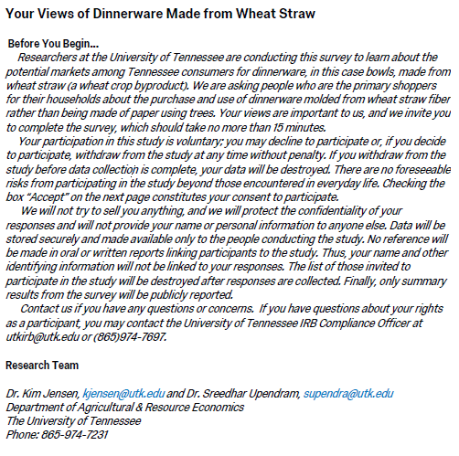
Question 2
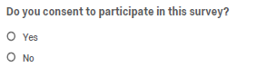
Question 3
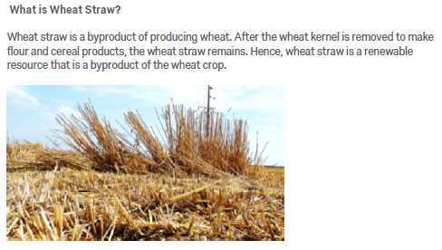
Question 4
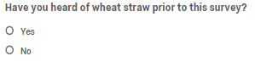

Question 5
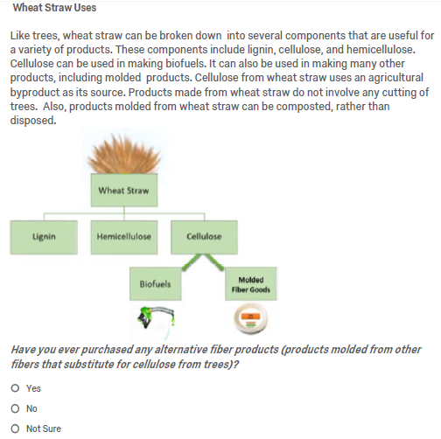

Question 6
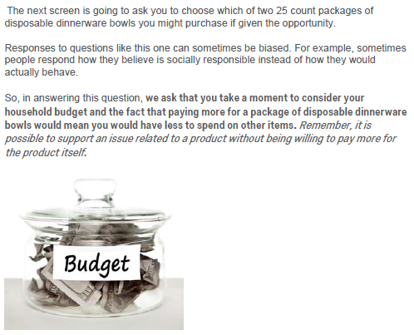

Question 7
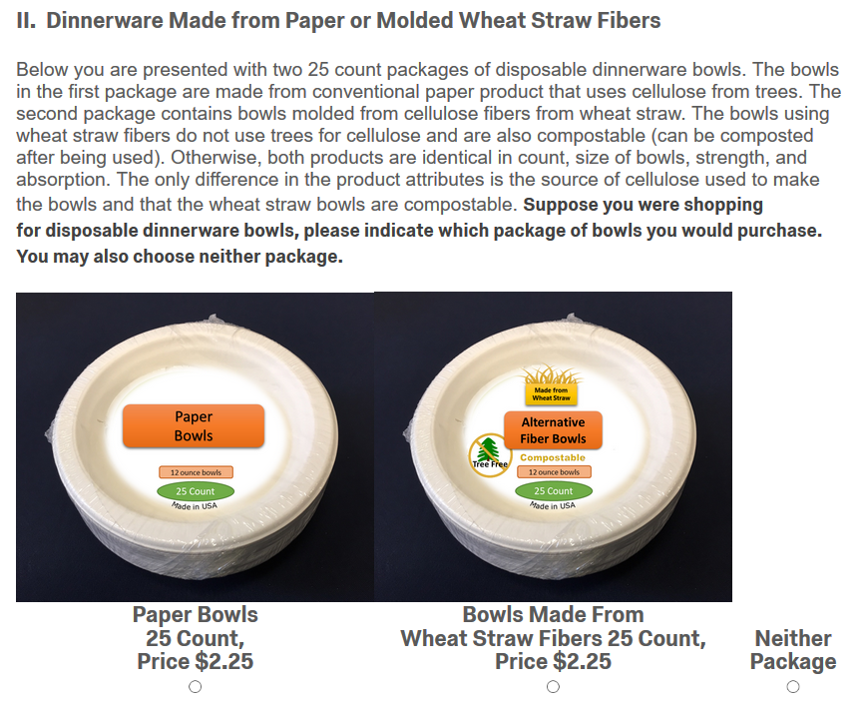

Question 8
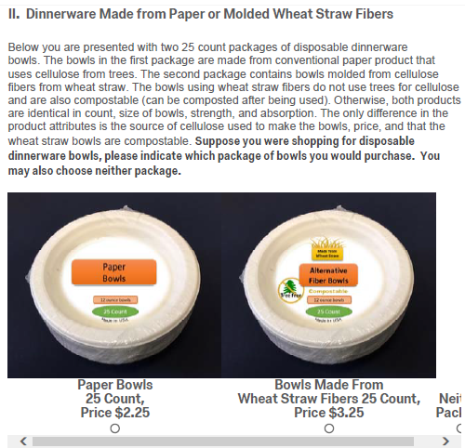

Question 9
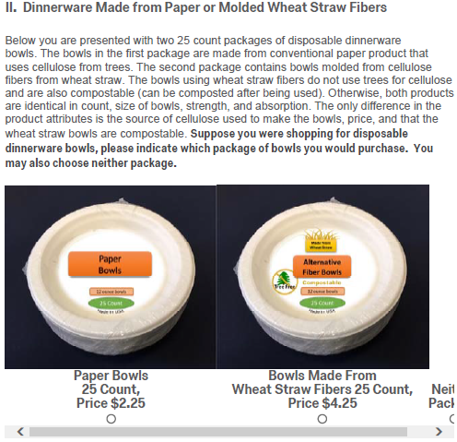

Question 10
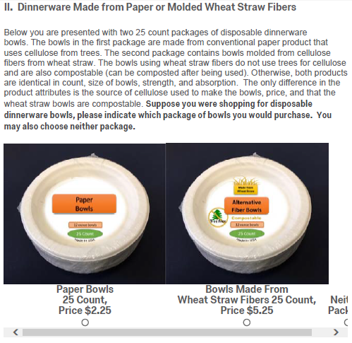

Question 11
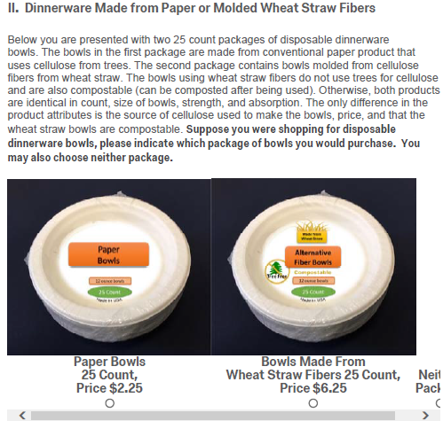
Question 12
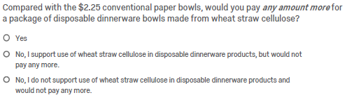

Question 13
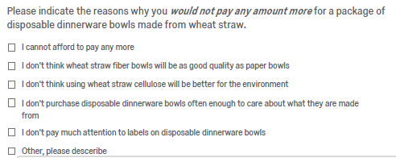
Question 14
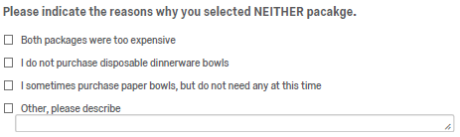

Question 15
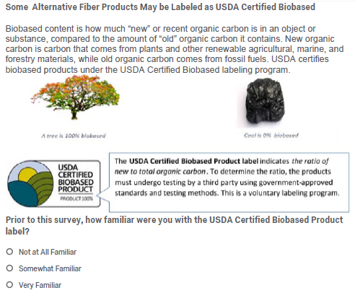

Question 16
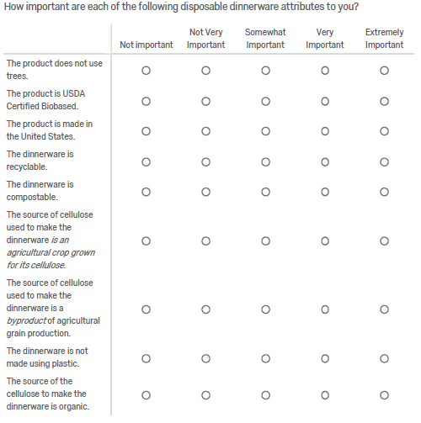
Question 17
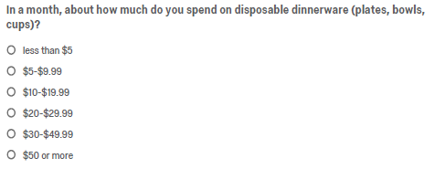

Question 18
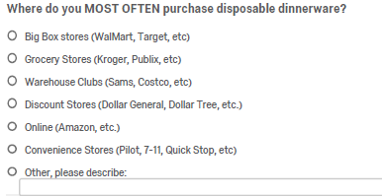
Question 19
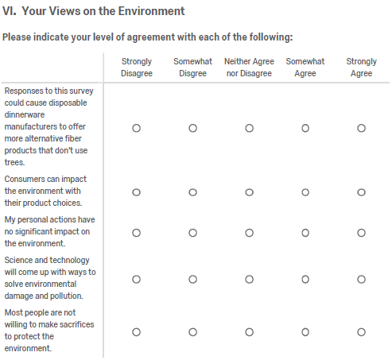

Question 20
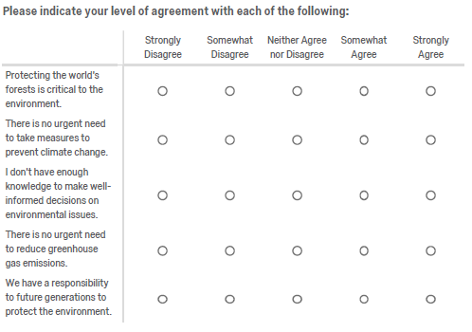
Question 21

Question 22
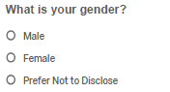

Question 23
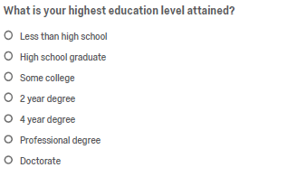
Question 24
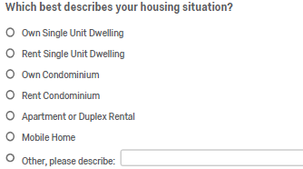
Question 25
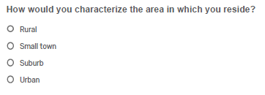
Question 26
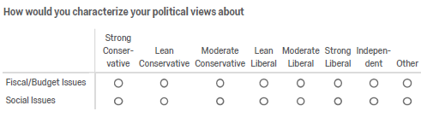

Question 27

Question 28
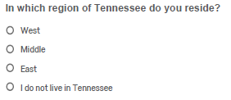
Question 29
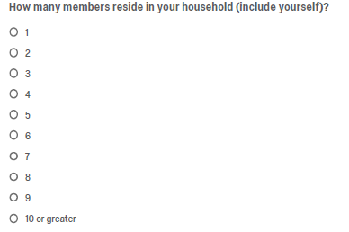
Question 30
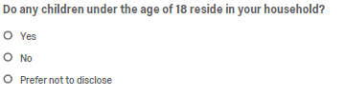

Question 31
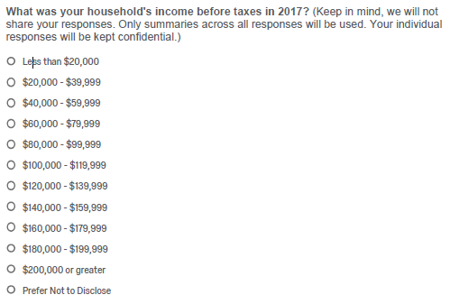

VITA

Mackenzie Belen Bluth Gill was born in Quito, Ecuador and was raised in Knoxville, Tennessee. She graduated from the University of Tennessee with a Bachelor of Science in Animal Science and a minor in Food and Agricultural Business in 2018. She continued her graduate education at UT, completing her Master of Science in Agricultural and Resource Economics with a minor in Statistics in August 2020. She will be starting a doctoral program in Agricultural and Resource Economics at Colorado State University in the fall of 2020.

This research was partly funded by the US Federal Aviation Administration (FAA) Office of Environment and Energy as a part of ASCENT Project 1 under FAA Award Number: 13-C-AJFEUTENN-Amd 5. Additional funding was provided by the USDA through Hatch Project TN000484. Any opinions, findings, conclusions or recommendations expressed in this material are those of the author and do not necessarily reflect the views of the FAA or other ASCENT sponsor organizations.
Life Cycle Analysis is a scientific method used to understand the environmental impact of a product in its entirety. Assessment includes every stage of the life cycle of a product, from the materials used for construction to the disposal process (van der Harst and Potting 2013).
While conjoint analysis is often used to assess different product attributes and their effects on willingness to pay for attributes of products, this study was limited to around 200 observations. Due to the research budget and size of the data set, contingent valuation was used.

