Power System Electromagnetic Transient Simulation Using a Semi-Analytical Approach

A Dissertation Presented for the
Doctor of Philosophy
Degree
The University of Tennessee, Knoxville

Min Xiong
May 2024

Copyright © 2023 by Min Xiong
All rights reserved.

ACKNOWLEDGEMENTS

I would like to thank my advisor Dr. Kai Sun for his consistent guidance for this dissertation and his support for exploring new research areas during my Ph.D. study at the University of Tennessee, Knoxville. I also want to thank him for his guidance in being a better researcher through numerous meetings and discussions. Appreciation is also extended to members of my Ph.D. committee, Dr. Fangxing Li, Dr. Xiaopeng Zhao, and Dr. Bin Wang, for their valuable discussions and suggestions.
Special thanks to Dr. Xiaopeng Zhao for his support in the research of cardiac dynamics that greatly broadened my research area, and to Dr. Bin Wang for his continuous discussions and valuable insights on power system dynamics and electromagnetic transient simulations.
I appreciate the helpful discussions with graduate students in Dr. Kai Sun’s group, Dr. Xin Xu, Dr. Yang Liu, Dr. Tianwei Xia, Zhenping Guo, Kaiyang Huang, Mahsa Sajjadi, Mohammed Khamees, and postdoctoral researcher Dr. Xiaowen Su.
I want to thank Dr. Feng Qiu, Dr. Rui Yao, and Dr. Jianzhe Liu from the Argonne National Laboratory for their helpful discussions on power system simulations.
Sincere appreciation to Dr. Andy Hoke, Dr. Jin Tan, Dr. Shuan Dong, and Dr. Rodrigo Henriquez-Auba at the National Renewable Energy Laboratory (NREL) for their helpful discussions and guidance on power system modeling and simulation, and to Dr. Jonathan Maack and Deepthi Vaidhynathan for their help with simulation leveraging parallel computing on high-performance computers during my internship at NREL.
I also want to thank my friends Dr. Hongyu Li, Dr. Changsheng Chen, Dr. Xiaofei Wang, Dr. Buxin She, Min Lin, Haoyuan Sun, Jingzhi Liu, Jinning Wang, Junjie Yin, Yu Liu, and Wen Wang for their help with my life in the USA. Huge thanks to my friends Bryan Dove and Carol Dove for the invitation to their family dinners and for helping me improve my English. Deep thanks to my wife and groupmate Zhenping Guo for her support and companionship during my Ph.D. study.
Finally, thanks to my parents and family for their encouragement and support in my decision to pursue my Ph.D. degree in the USA.
This work was supported in part by the ERC Program of the National Science Foundation and U.S. Department of Energy (DOE) under grant EEC-1041877, in part by the Advanced Grid Modeling program of the DOE’s Office of Electricity under grant DE-OE0000875, and in part by the DOE’s Office of Energy Efficiency and Renewable Energy (EERE) under the Solar Energy Technologies Office Award Number 38457.
ABSTRACT

This dissertation investigates efficient power system electromagnetic transient (EMT) simulations using a semi-analytical approach.
First, based on state-space equations of system EMT models, a semi-analytical solution (SAS) is acquired using the Differential Transformation Method (DTM). The DTM can efficiently derive the SAS of any linear or nonlinear system as a power series in time in a recursive manner using well-developed transformation rules. A high-order SAS allows a large time step to speed up the simulation while maintaining the same level of accuracy. Also, a variable time step approach is proposed to further improve its efficiency. Case studies on multiple systems demonstrate that the proposed approach has better performance compared to traditional numerical approaches.
Second, to effectively handle switches caused by limit violations during simulations, a binary search-enhanced quadratic-interpolation algorithm is proposed to precisely locate the transition moment and correct the simulation using the SAS. Case studies on a full EMT model of the IEEE 39-bus system are conducted to show the high accuracy of the proposed detection approach.
Third, while the network is solved by a nodal equation instead of a state-space equation, the SAS is explored on synchronous generators and controllers. An interface between the two different numerical approaches is developed based on the extrapolation of terminal voltages. At the same accuracy, the SAS can still improve the simulation efficiency using a larger time step.

Fourth, the parallel SAS-based EMT simulation using a nodal equation for the network is studied and tested. The network solution is parallelized through reformulating the network conductance matrix into a bordered block diagonal (BBD) form. The SAS-represented synchronous generators are naturally decoupled and parallelized. Case studies on a synthetic 10024-bus system demonstrate the high performance of the parallel simulation.
Fifth, a high-order nodal approach for the network equation based on diagonally implicit Runge-Kutta methods is proposed and interfaced with the SAS of generator and controller equations. Case studies on a four-bus system show that the proposed approach has higher efficiency compared with the traditional approach.
Keywords: Electromagnetic transient simulation; power system dynamics; semi-analytical solution; differential transformation method; inverter-based resource; nodal formulation; state-space formulation; parallel computing; diagonally implicit Runge-Kutta.

TABLE of contents
CHAPTER ONE INTRODUCTION AND BACKGROUND INFORMATION 1
1.1 Background and motivation 1
1.2 Formulation of electromagnetic transient (EMT) simulation 3
1.2.1 State-space method 3
1.2.2 Nodal formulation method 4
1.3 Semi-analytical approaches 10
1.3.1 Homotopy-Analysis Method 10
1.3.2 Adomian Decomposition Method 13
1.3.3 Differential Transformation Method 14
1.4 Contribution of this paper 15
CHAPTER TWO STATE-SPACE EMT SIMULATION USING A SEMI-ANALYTICAL APPROACH 18
2.1 Introduction of the Differential Transformation Method 19
2.2 Formulation of state-space EMT network equations 22
2.3 Differential Transformation of state-space EMT models 24
2.4 Simulation strategy using a variable time step approach 33
2.5 Dense output mechanism 35
2.6 Case study 36
2.6.1 Case study on the Kundur’s two-area system 36
2.6.2 Case study on a modified IEEE 39-bus system 40
2.6.3 Case study on the IEEE 39-bus system 45
2.6.4 Case study on a synthetic 390-bus system 54
2.7 Conclusion 56
CHAPTER THREE SWITCH DETECTION BASED ON THE SEMI-ANALYTICAL SOLUTION 57
3.1 Switch detection using linear interpolation 58
3.2 Binary search-enhanced quadratic interpolation 58
3.3 Computational cost analysis 63
3.3 Case study 65
3.4 Verification of computational cost analysis 65
3.5 Conclusion 68
CHAPTER FOUR SAS-BASED EMT SIMULATION USING THE NODAL EQUATION FOR THE NETWORK 69
4.1 Simulation strategy 69
4.2 Deriving SAS using dynamic bus voltages 73
4.3 Case study 75
4.4 Conclusion 78
CHAPTER FIVE PARALLEL SAS-BASED EMT SIMULATION 82
5.1 Parallel simulation strategy 83
5.1.1 Parallel network solution using the bordered block diagonal technique 83
5.1.2 Parallel update of generator states and network historical currents 88
5.2 Case study 88
5.3 Conclusion 93
CHAPTER SIX SAS AND HIGH-ORDER NODAL FORMULATION-BASED EMT SIMULATION 96
6.1 High order diagonally implicit Runge-Kutta methods 96
6.2 High order nodal approach 99
6.3 Case study with ideal current sources 104
6.4 Case study with synchronous generators 115
6.5 Conclusion 123
CHAPTER SEVEN CONCLUSIONS AND FUTURE WORKTURE WORK 124
REFERENCES 125
VITA 140

LIST OF TABLES
Table 1.1 Companion circuit parameters of common branches 9
Table 2.1 Transformation rules for common functions 21
Table 2.2 Time steps and time costs of fixed time step DT using different orders 39
Table 2.3 Comparing times steps and time costs of different numerical methods 41
Table 2.4 Comparing time steps and costs of different methods on the 46
Table 2.5 Comparison of performance on the IEEE 39-Bus system 51
Table 2.6 Comparison of Performance on a 390-Bus System 55
Table 4.1 Error analysis of generator currents and network voltages under an open loop simulation strategy 72
Table 5.1 Comparison of time costs on the 179-Bus WECC system for a 1-second simulation using a 50-μs Time Step 89
Table 6.1 Maximum simulation error of different numerical methods using a 1 μs time step 107
Table 6.2 Maximum simulation error of different numerical methods using time steps of 50 μs and 100 μs 108
Table 6.3 Maximum time steps of different numerical methods under the same maximum error tolerances 111
Table 6.4 Number of stages of different numerical methods 112
Table 6.5 Efficiency of different numerical methods under the same maximum error tolerances 113
Table 6.6 Maximum time steps of different numerical methods under the same average error tolerances 116
Table 6.7 Efficiency of different numerical methods under the same average error tolerances 117
Table 6.8 Maximum simulation errors of different numerical methods using time steps of 50 μs and 100 μs on the four-bus system with synchronous generators 120
Table 6.9 Maximum time steps of different numerical methods under the same error tolerances on the four-bus system with synchronous generators 121
Table 6.10 Efficiency of different numerical methods under the same error tolerances on the 4-bus system with synchronous generators 122

LIST OF FIGURES
Figure 1.1 An R-L-C circuit with an ideal voltage source 5
Figure 1.2 A serial resistor-inductor branch 7
Figure 1.3 The companion circuit of a series resistor-inductor branch 7
Figure 2.1 PI section of the lumped transmission line model 23
Figure 2.2 Constant R-L model of an inductive load 23
Figure 2.3 Constant C model of a fix shunt 23
Figure 2.4 Control diagram of the TGOV1 governor model 29
Figure 2.5 Control diagram of the SEXS excitation model 29
Figure 2.6 Diagram of a grid-following IBR model 32
Figure 2.7 Flow chart of the multistage simulation strategy using the SAS approach 34
Figure 2.8 Illustration of dense output under large time step simulations 37
Figure 2.9 The Kundur’s two-area system 37
Figure 2.10 Relative rotor angle of generators 37
Figure 2.11 Frequency deviation of generators 38
Figure 2.12 Three-phase terminal current of generator #2 38
Figure 2.13 Three-phase voltage at bus #7 38
Figure 2.14 One-line diagram of the modified IEEE 39-bus system 41
Figure 2.15 Case 1 simulation results on the modified 39-bus system: Tripping the load at Bus 4 43
Figure 2.16 Case 2 simulation results on the modified 39-bus system: Grounding Bus 16 for 10 cycles 43
Figure 2.17 Case 3 simulation results on the modified 39-bus system: Tripping generator at Bus 34 44
Figure 2.18 Performance of the SAS with different orders on the modified 39-bus system 44
Figure 2.19 Comparison of time step and absolute error in case 2 on the modified IEEE 39-bus system 47
Figure 2.20 Phase C voltage at Bus 16 in case 2 on the modified IEEE 39-bus system 47
Figure 2.21 Phase C current of branch 16-22 in case 2 on the modified IEEE 39-bus system 47
Figure 2.22 Simulation results of generator rotor speed 49
Figure 2.23 Simulation results of generator terminal voltage 49
Figure 2.24 Simulation results of generator electrical power 49
Figure 2.25 Simulation results of three-phase voltage at Bus 10 50
Figure 2.26 Simulation results of three-phase current on branch 10-11 50
Figure 2.27 Performance of the SAS with different orders on the IEEE 39-bus system after code compilation 50
Figure 2.28 Phase-C voltages of Bus 10 from PSCAD 53
Figure 2.29 Errors of phase-C voltages at Bus 10 from PSCAD 53
Figure 2.30 Phase-C voltage at Bus 10 simulated by the SAS 53
Figure 2.31 Phase-A voltage at grounded Bus simulated by PSCAD 55
Figure 2.32 Phase-A voltage at grounded Bus simulated by the SAS approach 55
Figure 3.1 An example of linear interpolation in simulations 59
Figure 3.2 Flow chart of the SAS-based switch detection algorithm 61
Figure 3.3 Illustration of the binary search algorithm for switch detection 62
Figure 3.4 Simulation results of i_{qref} of IBR2 66
Figure 3.5 Simulation results of E_{fd} of synchronous generator #4 66
Figure 4.1 Steady state open loop simulation strategy by assuming 72
Figure 4.2 Open loop steady state simulation results based on SAS on the two-area system 72
Figure 4.3 Simulation strategy based on SAS 74
Figure 4.4 Interface between the network and an SAS represented synchronous generator 74
Figure 4.5 SAS-based EMT simulation using a nodal equation for the network 76
Figure 4.6 Simulation results provided by the conventional approach using a 5 μs time step 77
Figure 4.7 Simulation results provided by the SAS-based approach using a 150 μs time step 79
Figure 4.8 Bus voltage magnitude error of the SAS-based simulation using a 150 μs time step 80
Figure 4.9 Electrical power error of the SAS-based simulation using a 150 μs time step 80
Figure 5.1 Graph representation of the WECC 179-bus system 85
Figure 5.2 Parallel EMT simulation strategy 87
Figure 5.3 A synthetic, large-scale, 10024-bus system created by connecting 7×8 replications of the 179-bus WECC system 91
Figure 5.4 Speedup performance when leveraging HPC parallelization relative to a serial simulation on the synthetic 10024-bus system 91
Figure 5.5 Time cost for a 1-second simulation using a 50 μs time step on the synthetic 10024-bus system 92
Figure 5.6 Simulation speedup leveraging both SAS and HPC parallelization using a 150 μs time step 94
Figure 6.1 A series resistor-inductor circuit 100
Figure 6.2 A four-bus system 105
Figure 6.3 Phase A Voltage at Bus 2 105
Figure 6.4 Phase B Voltage at Bus 3 105
Figure 6.5 Phase C Current of Branch 2-3 105
Figure 6.6 Maximum error of the 5th-order DIRK method using a 100 μs time step 109
Figure 6.7 Efficiency of different numerical methods under the same maximum error tolerances 114
Figure 6.8 Efficiency of different numerical methods under the same average error tolerances 118

Introduction and Background Information

1.1 Background and motivation
As a powerful tool for power system dynamic and stability analysis, numerical power system simulations include electromechanical transient simulations and electromagnetic transient (EMT) simulations. The former is based on phasor models defined by assuming a synchronous system frequency, in which only positive-sequence states are modeled and computed, and time steps around milliseconds are adopted to focus simulations on the mechanical dynamics of rotating machines. In contrast, the latter, EMT simulations, compute three-phase instantaneous voltage and current values varying at their actual frequencies, taking into account fast dynamics caused by the interactions between electrical fields of capacitors and magnetic fields of inductors. This results in a more detailed analysis of phenomena such as harmonics, overvoltage, short-circuit current, and other fast dynamics over a wide frequency range. However, EMT simulations suffer from high computational costs due to the tiny time steps of e.g., microseconds for accuracy and also the high dimension of a three-phase system model [1]-[3].
To accelerate EMT simulations, mainstream techniques include hybrid phasor-EMT simulation and parallel computing [4]-[14]. Reference [5] proposed a hybrid simulation protocol to reduce the computational burden, in which only parts of the system requiring detailed dynamic information are simulated using an EMT model, and the rest is studied by phasor domain simulation. This approach has been further investigated by [6]-[9] to validate its feasibility. As a widely applied technology in computing areas, parallel computing has also been adopted to boost EMT simulations [10]-[14]. In addition, a state-space nodal method was proposed in [15]. By dividing a system into multiple sub-groups, the system state-space equation can be updated more efficiently, from which the discrete nodal formulation can be derived directly through discretizing the state-space equation using the trapezoidal-rule method. Also, the state-space nodal method enables flexible and simultaneous interfacing of subsystems respectively in the nodal and state-space representations.
Some other approaches for EMT simulation acceleration focus on enlarging the time step, to reduce the number of simulation steps. Related approaches include DQ0 transformation, frequency shift, and dynamic phasor methods. Because the balanced fundamental frequency instantaneous variables are transformed to DC components under the DQ0 transformation, the dynamics can be simulated more efficiently. However, both the DQ0 transformation and frequency shift methods are inefficient in unbalanced conditions, or in the presence of high-order harmonics. The dynamic phasor method approximates the original waveform using K time-varying Fourier series. Still, it requires careful selection of K to reflect the correct system behaviors accurately, and the number of variables and equations will increase with K and decrease the efficiency [16]-[19].
In recent years, semi-analytical solutions (SAS) have been derived from the mathematical model of a power system to speed up electromechanical transient simulations. Each SAS is an analytical approximate solution for a nonlinear system’s ordinary differential equations or differential-algebraic equations and can be derived by mathematical methods such as the Adomian Decomposition method, Holomorphic Embedding method, Differential Transformation (DT) method, and Homotopy Analysis method [20]-[26]. Among these methods, the DT method provides a highly accurate approximation of a true solution by an ultra-high-order SAS in the form of a power series of time. The computation of the SAS coefficients is conducted efficiently in a recursive manner. Besides power system simulations, the DT has proven to be successful in many other fields [27]-[29].
Existing SAS methods for power systems have focused on phasor models for electromechanical transient simulations. For the first time, this work investigated EMT simulation using an SAS approach.

1.2 Formulation of electromagnetic transient (EMT) simulation
To simulate EMT dynamics of the network, two main approaches can be used to formulate the network equation: the state-space method and the nodal formulation method, and the latter is also known as the companion circuit method.

1.2.1 State-space method

In EMT simulations, the network can be described by linearly independent first-order differential equations, as described below [30][31].
(1-1)
where x is the network state variables vector, which mainly includes capacitor voltages and inductor currents; u is the system input vector; A is the system matrix and B is the input matrix.
Consider the R-L-C circuit shown in Figure 1.1 as an example. The capacitor voltage v and inductor current i are state variables, the voltage source v_{s} is the input. Then, the system can be described as:
(1-2)
The state-space method is rather powerful for control components, and it is flexible for choosing different numerical methods to solve the equations with even a variable time step. The EMT simulator Simscape Electrical (formerly SimPowerSystems and SimElectronics) was developed by the state-space method. The main challenge or disadvantage is that the state variables and the block matrices differ under system switching operations, and the automatic formulation of the state-space equations is time-consuming for large-scale systems. Related discussions on this topic can be found in [32]-[33].
After the formulation of state-space equations of the system, different numerical methods can be applied to obtain the solutions. Therefore, a variable time-step approach can be adopted to accelerate the process with small time steps for fast dynamics intervals and large time steps for slow dynamics intervals while ensuring high accuracy [23][24], and the simulation time cost can be reduced if the state-space equations can be solved in a more efficient way.

1.2.2 Nodal formulation method
Another widely used approach for simulating the network generally represented by R-L-C circuits is the nodal formulation method [34]. Usually, the trapezoidal-rule method

Figure 1.1 An R-L-C circuit with an ideal voltage source

with a fixed time step is applied to discretize the differential equations to get the nodal equation, as illustrated in the detailed process below.
As given in Figure 1.2 and equations (1-3)-(1-4), the differential equation of a series resistor-inductor branch is discretized by the trapezoidal-rule method which is numerically A-stable [34]. Subsequently, as shown in (1-5)-(1-6) and Figure 1.3, the original circuit depicted in Figure 1.2 can be represented by an equivalent resistor and a historical data-determined current source.
(1-3)
Applying the trapezoidal rule to (1-3) yields:
(1-4)
which can be reformulated as:
(1-5)
where,
(1-6)
Thus, the resistor-inductor branch in Figure 1.2 can be converted into a companion circuit shown in Figure 1.3.
The same strategy can be applied to capacitors and any circuits consisting of R-L-

Figure 1.2 A serial resistor-inductor branch

Figure 1.3 The companion circuit of a series resistor-inductor branch

C components. Moreover, to mitigate undesired fictitious numerical oscillations, artificial resistors Rp≈40L/(3Δt) and Rs≈3Δt/(40C) can be added in parallel/series with L/C, respectively [35].
The coefficients corresponding to companion circuits of various types of network circuits are summarized in Table 1.1. Following this process to replace all the R-L-C circuits in the network with their corresponding companion circuits or equivalent circuits, the final network becomes a network consisting of equivalent resistors and current sources. Then, it is straightforward to formulate the system network equation with the Kirchhoff's current law as a real-valued nodal equation:
(1-7)
where, G is the network conductance matrix composed of all equivalent resistors, v(t) is the three-phase instantaneous nodal voltage vector, i(t) is the three-phase instantaneous current injection vector, and i_{hist}(t-Δt) is the historical current vector of companion circuits [34][36].
So, starting from the initial state at t=t₀, when a fixed time step Δt is chosen, the network G matrix is straightforward to formulate and remains unchanged unless the system topology is changed under faults, then the nodal voltages at each time step can be solved from the linear network nodal equation using sparse matrix methods.
To notice, because the time step Δt is embedded in the network G matrix, a fixed time step could help to provide a constant G matrix. Although theoretically, variable time step or multiple time steps algorithms can be employed, this requires a significant structural
change of the existing EMT programs and a well-designed method to determine the time

Table 1.1 Companion circuit parameters of common branches
Branch Type | R_{eq} | a | b
L |  | 1
C |  | −1
R-L
R||L |  | 1
R-C
R||C |  | −1
R-(L|| R_{p})

step. Thus, usually, a fixed time step is used in the nodal formulation [34].
Compared to the state-space equation, the nodal equation is formulated more efficiently on large-scale systems, and thus it is widely employed in commercial EMT simulation tools such as PSCAD, EMTP-RV, and RTDS. The disadvantage is that the time step of the nodal equation should be small enough to ensure accuracy, and usually, a fixed time step is used to keep the G matrix constant; thus, variable time step methods are typically not used to accelerate the simulation [37]. Also, the nodal equation cannot provide eigenvalues of the system matrix A, and this can be easily obtained with the state-space equation. The eigenvalues could provide important system information such as stability margin, time constants, and oscillation modes [15][31][38]-[43].

1.3 Semi-analytical approaches

1.3.1 Homotopy-Analysis Method
The Homotopy Analysis Method (HAM) was first proposed by Shijun Liao in 1992 [44] and then improved over the next twenty years [45]. The HAM, which originates from the concept of homotopy in topology, is a powerful tool to solve differential equations, especially initial value problems and boundary value problems with strong nonlinearity, such as the nonlinear boundary-layer flow and pendulum problems. Like the definition of homotopy, which means a continuous transformation or deformation from one continuous function to another, the main idea of the HAM is using the solutions of simple linear equations to approximate that of a nonlinear differential equation based on the Taylor series. In addition, the convergence of the approximation can be accelerated by an auxiliary convergence control parameter [45].
In differential geometry, the homotopy is defined as below:
Two continuous curves are homotopic if there exists a continuous map:
(1-8)
such that:
(1-9)
where,
(1-10)
This continuous map, H(s,t), is a continuous family of curves and a homotopy parametrized by p∈[0,1] that deforms the curve c₀ into the curve c₁ [46][47].
Drawing from the above homotopy in differential geometry, a homotopy can be built to deform a linear differential equation into a nonlinear differential equation, and then the solution of the nonlinear equation can be deformed by the solution of the linear equation as well. This is the essence of the HAM.
The general process of the HAM follows the steps below.
1) For a nonlinear differential function f[x(t)]=0, which needs to be solved, a homotopy equation is constructed:
(1-11)
where q is a homotopy parameter belonging to [0,1], x₀ is the initial value of x at t=0, ξ is a linear differentiation operation such as a first-order or a second-order derivative, and h is
a real-valued convergence control parameter.
Equation (1-11) shows that when q=0, the equation becomes:
(1-12)
which yields the solution of the linear differential equation below.
(1-13)
When q=1, the equation (1-11) becomes:
(1-14)
which is the original nonlinear differential equation to be solved.
Thus, equation (1-11) is a homotopy for a linear differential equation and a nonlinear differential equation f[x(t)]=0.
2) Differentiate both sides of equation (1-11) for m times with respect to q, and then divide both sides by the factorial of m, it becomes:
(1-15)
where,
, (1-16)
3) Substitute the truncated approximate equation below into equation (1-15).
(1-17)
Because the solution of x in the homotopy equation changes with q, implying that x is a function of q, the solution based on the Taylor series can be formulated as:
(1-18)
An approximation can be obtained as in (1-17).
4) Solve the linear differential equations of (1-15) recursively starting from m=0 to m=k to get x_{m}.
5) Finally, the solution of the nonlinear differential equation f[x(t)]=0 can be approximated by:
(1-19)
Besides its ability to solve first-order nonlinear differential equations, the HAM is also capable of solving high-order differential equations. An approximate frequency-amplitude expression was obtained by the HAM based on the second-order swing equation in [26]. More details about applications of the HAM on frequency calculations in high-order nonlinear differential equations can be found in [45]. Another advantage of the HAM is its flexibility in choosing a suitable base function, such as polynomial functions, sinusoidal functions, and exponential functions, for approximations.

1.3.2 Adomian Decomposition Method
The Adomian Decomposition Method (ADM) is also a powerful tool for solving differential equations based on the Taylor series. However, unlike the Taylor series, ADM has a greater capability to preserve the nonlinearity of the system.
Because it has been demonstrated that the ADM is equivalent to the HAM when the convergence control parameter of the HAM is set to -1 [21][25][48][49], the process for calculating the Adomian Decomposition series is not detailed here but can be found in [49] and [50].
Similar to the HAM, using 3 approximate terms proves accurate enough for the ADM to speed up power system electromechanical simulations with either a fixed or variable time step. While these methods enhance simulation speeds, the primary drawback of the HAM and DTM is that the derivation of approximate terms requires a lot of work, especially when strong nonlinear functions are involved.

1.3.3 Differential Transformation Method
The Differential Transformation Method (DTM) is a powerful nonlinear differential equation solver that has been successfully applied to various nonlinear dynamic systems, as well as power system transient simulations [22][51].
Compared to traditional low-order explicit numerical methods such as the Euler method and the 4th-order Runge-Kutta (RK4) method, the SAS using the DTM offers higher-order approximations to achieve a bigger convergence region and allows a larger time step while maintaining the same level of simulation accuracy.
Considering a continuous function x(t), the k^{th} order differential transform (DT) of x(t) is defined as:
(1-20)
Also, from the Taylor series, we have:
(1-21)
where T_{x} is the convergence region; x[k] indicates coefficients of the SAS series; k is the order of series terms; and N is the highest order of SAS terms.
Based on the DT introduced above, replace all variables in equations by their Taylor series composed of DT and equal the like terms of (t-t₀)^{k} in the equation. Then, linear equations of different order DTs can be established easily. Finally, solving and plugging different-order DTs back into the Taylor series gives us an approximate solution.
As will be illustrated in later chapters, the major advantage of the DTM is that, with well-developed transformation rules, it is very straightforward to obtain high-order approximate solutions without complex mathematical derivations.

1.4 Contribution of this paper
To achieve higher EMT simulation speed by enlarging the time step, this dissertation proposed an efficient simulation strategy based on an SAS approach using the DTM. The main contributions of this dissertation are summarized as follows.
1) Based on the state-space equations of EMT models, the SAS of regular components including R-L-C represented circuits and loads, the voltage-behind-reactance synchronous generator model, inverter-based resources, and other controllers in EMT simulation are derived using the DTM. Then, a multi-stage SAS-based EMT simulation strategy is proposed. With larger time steps enabled, the simulation efficiency can be greatly improved compared to traditional numerical methods.
2) To further improve the performance, a variable time step SAS approach based on truncation error is proposed. Although the simulation time step should be within a certain range to capture the details and ensure convergence during fast dynamics periods, bigger time steps can be used to accelerate the simulation when the fast dynamics diminish, and this can be automatically achieved by the proposed variable time step approach. Meanwhile, with the derived SAS terms, high resolution can be easily maintained by reconstructing detailed fast EMT dynamics through an efficient dense output mechanism.
3) A binary search-enhanced quadratic interpolation approach is proposed to accurately locate the moment when power system controllers or other components hit their limits using derived SAS expressions. Accurately locating limit-hitting moments or status-switching moments is important to ensure the precision and correctness of simulation results, and this problem has not been adequately addressed by previous work related to SAS-based power system studies. Also, because the time steps are enlarged by the SAS approach, traditional simple linear interpolation used in EMT simulation is inaccurate in such cases. With the derived high-order approximate SAS expressions, it is efficient to calculate values of state variables at any moment within one time step. Thereby, binary search could quickly locate the earliest switching moment in a smaller time interval less than a predefined value, e.g., 10-20 μs, and then the quadratic interpolation can be applied to accurately locate the switching moment. After this process, the time step is adjusted to match the identified switching time instant, and thus the accuracy and correctness can be improved.
4) For large-scale systems, the nodal formulation is generally more efficient for the network. While keeping the network solved by the nodal method, the SAS approach is applied to synchronous generators and their controllers to facilitate accurate and efficient simulation of these components using a larger time step.
5) Based on the natural independence of involved SAS calculations for each synchronous generator and controls, and the bordered block diagonal (BBD) form of the network conductance matrix, the EMT simulation is parallelized and tested on a high-performance computer for simulation speedup.
6) Traditionally the network is discretized by low-order numerical methods, such as the backward Euler method, the trapezoidal rule method, or the 2-stage semi-implicit Runge-Kutta method. Based on high-order singly diagonally implicit Runge-Kutta methods, a high-order nodal approach is proposed and tested on a four-bus system with ideal current sources or synchronous generators.

State-space EMT Simulation Using a Semi-Analytical Approach

As is commonly known, power system dynamic simulation is an initial value problem in general. For a simple linear system such as a constant R-L-C circuit with pre-defined current or voltage sources, the closed-form analytical solution can be easily obtained, and thus system states at any time instants can be readily calculated without time-domain simulations. However, for a dynamic system with strong nonlinearity such as power systems, such a closed-form solution theoretically does not exist. Thus, a good compromise is to find an approximate solution that is accurate for a certain time step or time window. As a kind of method providing approximate solutions, the semi-analytical method could recursively derive high-order solutions, and thus allows larger time steps for simulations under the same level of accuracy, compared to traditional low-order numerical methods.
Targeting to improve the simulation efficiency of state-space EMT simulations via an SAS approach using differential transformation, this chapter first introduces the differential transformation method, EMT models of typical power system components, and the formulation of state-space EMT equations. Then, the differential transformations of EMT model equations are derived in detail using well-defined transformation rules. Finally, the performance is tested on the Kundur’s two-area system using a fixed time step and also on the IEEE 39-bus system using a variable time step.

2.1 Introduction of the Differential Transformation Method
An EMT simulation needs to solve an initial value problem for the power system model. The N-th order SAS for the initial value problem (2-1) takes the form (2-2) [24][51]:
(2-1)
(2-2)
where Tx is the convergence region; x[0] is the initial value of x; x[k] indicates the coefficients of the SAS series; k is the order of series terms; and N is the highest order of SAS terms.
Compared to traditional low-order numerical methods such as the Euler method and the 4th-order Runge-Kutta (RK4) method, the SAS provides a high-order approximation. Thus, under the same accuracy level, SAS has a bigger convergence region which allows for a larger time step to speed up simulation.
The k^{th}-order DT of a smooth function g(t) at t=t₀ is defined in [27] as:
(2-3)
Thus, from (2-1)-(2-3), a differential equation (2-4) involving smooth functions f(t), g(t), and h(t) is transformed into (2-5) about f[k], g[k], and h[k] (k=0, 1, …, N), which are their DTs of the k^{th} order [27]-[28]:
(2-4)
(2-5)
By calculating DTs in such a recursive manner, the SAS of any order for (2-1) can be derived in the form of (2-2).
Some transformation rules for common linear and nonlinear functions are given in Table 2.1 [27]-[29], which facilitate efficient, recursive derivation of a high-order SAS.
In EMT simulations, the Park transformation shown in (2-6) and its inverse transformation are required to interface the variables of a generator in the DQ0 frame with the three-phase network variables in the abc frame. The DT rule of Proposition 2.1 is introduced to deal with matrix multiplication, based on rules in Table 2.1.
(2-6)
Proposition 2.1: For any three smooth matrix functions F(t), G(t), and H(t) given in (2-7) that satisfy F(t)=G(t)H(t) for t≥0, the rule in (2-8) holds for DTs of their matrix elements.
(2-7)

Table 2.1 Transformation rules for common functions
Original function | Differential Transformation
#1
#2
#3
#4
#5
#6
#7

(2-8)
where f_{ij}(t), g_{ij}(t), and h_{ij}(t) are the i-th row j-th column elements, N₀, N₁, and N₂ are positive
integers on matrix dimensions, and [k], [m], and [k-m] indicate the orders of DTs.
Note here that, although the DT of functions cos(θ +2ℼ/3), cos(θ -2ℼ/3), sin(θ -2ℼ/3), sin(θ +2ℼ/3) are not directly given in Table 2.1, by using cos(θ +2ℼ/3)=cos(θ )cos(2ℼ/3)-sin(θ )sin(2ℼ/3), the DT can be easily derived using rule #2 and rule #6. The same process can be used for cos(θ -2ℼ/3), sin(θ -2ℼ/3), and sin(θ +2ℼ/3).

2.2 Formulation of state-space EMT network equations
In this work, the PI section represented lumped transmission line model is used, as shown in Figure 2.1 [52][53]. The constant impedance (R-L) and constant capacitor models are used for loads and shunts, as shown in Figures 2.2 and 2.3.
Based on the above network models, the differential equations for bus voltages and branch currents are given below.
(1) Current of a line branch:
(2-9)
(2) Current of an inductive load:
(2-10)
(3) Bus voltage:
(2-11)

Figure 2.1 PI section of the lumped transmission line model

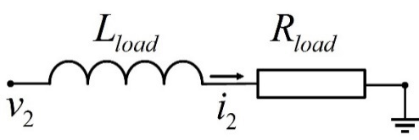
Figure 2.2 Constant R-L model of an inductive load

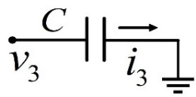
Figure 2.3 Constant C model of a fix shunt

where, C_{node} is the total capacitor connecting a bus node, including the shunt capacitor and line capacitor; v_{node} is the bus voltage; i_{capacitor} is the total current passing through the capacitors on this bus. Based on Kirchhoff’s current law, i_{capacitor} can be expressed as the negative sum of all branch currents that injected into this bus.
Note that currents and voltages are all vectors of three-phase values, and R, L, and C parameters are 3×3 matrices.
Because the synchronous generators are usually connected to the network through transformers, the synchronous generator stator inductor current and transformer inductor current are not independent. For such circuits, only one current equation is considered [36].

2.3 Differential Transformation of state-space EMT models
This section presents state-space EMT models of power system components along with the corresponding SAS derived by DT.
(1) Synchronous Generator.
The widely used voltage-behind-reactance (VBR) model from [54] is applied for EMT simulation purposes. As an EMT model of synchronous generator, the VBR model has better numerical efficiency and accuracy compared to the d-q frame model and the phase-domain model. Also, because the stator circuit in the VBR model is directly interfaced with the rest of the network, the numerical stability is improved. The equations of the VBR model can be briefly summarized as follows. Equations (2-12)-(2-14) give the VBR model of a round rotor generator, comprising the swing equation (2-12), the rotor flux equation (2-13), and the stator phase current equation which can directly interface with

the network through current injection (2-14):
(2-12)
(2-13)
(2-14)
In (2-12), δ, Δω_{r}, H, D, p_{m}, and p_{e} are the rotor angle, rotor speed deviation, inertial constant, damping coefficient, mechanical power, and electrical power, respectively, and ω₀ is the nominal frequency of the system. In (2-13), λ_{fd}, λ_{1d}, λ_{1q}, and λ_{2q} are flux linkages of the field winding, d-axis damper winding, q-axis first damper winding, q-axis second damper winding, respectively; r_{fd}, r_{1d}, r_{1q}, and r_{2q} are resistances of the four windings; L_{fdl}, L_{1dl}, L_{1ql}, and L_{2ql} are leakage inductance of the four windings; e_{fd} is the field winding voltage. In (2-14), i_{abc} and v_{abc} are three-phase generator terminal current and voltage that interface with the grid, and R_{s} is the constant stator resistance matrix. The subtransient inductance matrix $L_{abc}^{''}$ in (2-14) is:
(2-15)
where,
(2-16)
and here, L_{ls} and L₀ are leakage inductance and zero sequence inductance, respectively, and “//” means the parallel connection of inductances.
The d-q axes subtransient voltages in (2-14) are given by:
(2-17)
(2-18)
The d-q axes flux linkages λ_{ad} and λ_{aq} are:
(2-19)
In the Park transformation (2-6), θ satisfies:
(2-20)
The electrical power depends on the number of poles n_{p}:
(2-21)
Because this VBR model can be formulated as a state-space equation, the SAS of the synchronous generator can be efficiently derived using the differential transformation method. Applying the rules in Table 2.1 to (2-12)-(2-21) yields the corresponding DT equations, which are illustrated in (2-22)-(2-26) below for representative variables including δ, Δω_{r}, λ_{fd}, i_{abc}, $v_{q}^{''}$, and p_{e}.
(2-22)
(2-23)
(2-24)
where, $v_{abc}^{''}[k]$ in (2-24) can be derived from applying Proposition 2.1 to $v_{abc}^{''}=P_{park}^{-1}v_{0dq}^{''}$.
(2-25)
(2-26)
where, i_{d}[n] and i_{q}[n] in (2-25) are obtained by applying the Proposition 2.1 to i_{0dq}=P_{park} i_{abc}.
(2) TGOV1 governor model.
Also consider the models of the exciter, turbine, and governor of a synchronous generator [55]. Without loss of generality, the TGOV1 turbine-governor model in [56] is adopted in this paper as described in Figure 2.4 and (2-27).
(2-27)
where p₁ and p₂ are intermediate state variables; p_{ref} is the reference power, and others are control parameters. The corresponding DT is given as (2-28). In addition, due to the limits, if the initial value p₁[0]≥P_{max} and dp₁/dt≥0, or if p₁[0]≤P_{min} and dp₁/dt≤0, then p₁[k+1]=0.
(2-28)
(3) SEXS exciter model.
The SEXS exciter model in [57] is adopted in this paper as described in Figure 2.5 and (2-29):

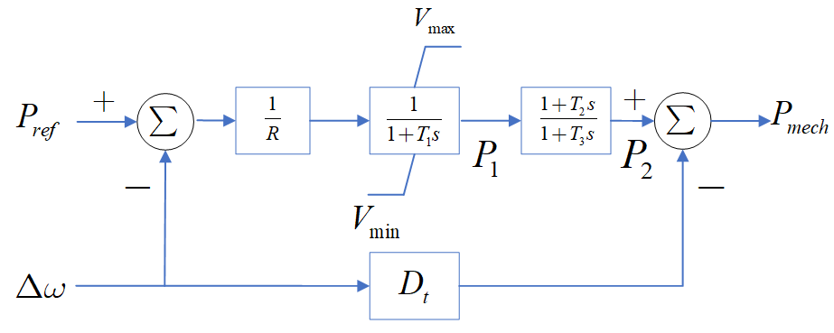
Figure 2.4 Control diagram of the TGOV1 governor model

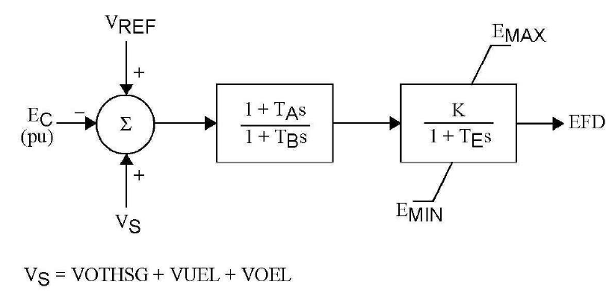
Figure 2.5 Control diagram of the SEXS excitation model

(2-29)
where v_{ref} is the voltage regulator reference; E_{fd}=e_{fd}L_{ad}/R_{fd}; v₁ is an intermediate variable; v_{t} is terminal voltage; K_{E}, T_{E}, T_{A}, and T_{B} are the exciter control parameters. Its DT is given as (2-30). In addition, if E_{fd}[0]≥E_{max} and dE_{fd}/dt≥0, or if E_{fd}[0]≤E_{min} and dE_{fd}/dt≤0, then E_{fd}[k+1]=0.
(2-30)
(4) Network Components.
Transmission lines are modeled as PI sections in this work [53]. Other network components such as transformers, constant impedance loads, and fixed shunts are modeled by R-L-C circuits. Such circuits can be roughly divided into series resistor-inductor circuits and grounding capacitor circuits, as shown in Figures 2.1-2.3, with original differential equations listed in (2-31)-(2-33).
(2-31)
(2-32)
(2-33)
The corresponding DTs are respectively given by (2-34)-(2-36):
(2-34)
(2-35)
(2-36)
Note that currents and voltages are all vectors of three-phase values, and R, L, and C parameters are 3×3 matrices.
(5) Inverter-based resource.
A grid-following inverter-based resource (IBR) model in Figure 2.6 is considered in this work, which comprises an outer-loop current regulator, an inner-loop power regulator, a frequency droop controller, and a voltage droop controller. The dynamics of its PWM are disregarded in the system-level EMT simulation and analysis. A Phase-Locked Loop (PLL) is used to track the terminal bus voltage angle. The IBR interfaces with the network by coordinate transformation [58]-[66]. In Figure 2.6, the subscript ‘ref’ denotes the reference value, and ‘0’ signifies the steady-state value.
The mathematical equations of the model primarily consist of basic linear operations which are fully covered by Table 2.1 and thus are not presented in detail here.
Additionally, the Proportional-Integral (PI) controller and corresponding DT are:

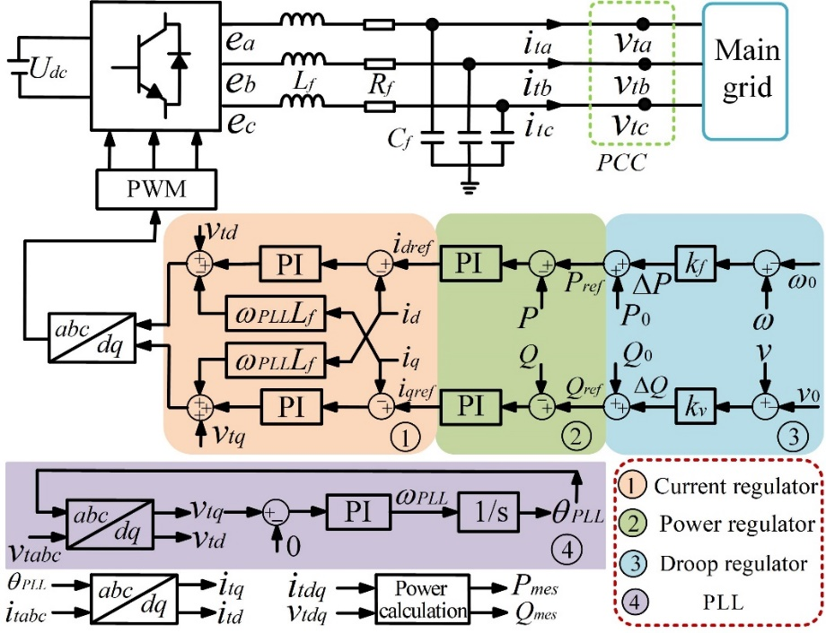
Figure 2.6 Diagram of a grid-following IBR model

(2-37)
(2-38)
where k_{i} and k_{p} are proportional and integral control parameters, respectively; x_{in} is the input; x_{s} is the output of the integral controller; x_{out} is the output of the PI controller.

2.4 Simulation strategy using a variable time step approach

Because the SAS is not an exact solution, its error can be tolerated only within limited time steps. The initial value problem to be solved for simulation can evaluate an SAS by a multistage strategy as depicted in Figure 2.7 over consecutive time steps that make the desired simulation period. At the end of each time step, the end values of state variables are used as the initial values for the next step to evaluate the SAS of the problem, which can be derived ahead of time or together with the simulation.
The simulation can be conducted at a fixed or variable time step. To improve the convergence and efficiency of simulation using an SAS over larger time steps, a variable-time-step strategy is proposed and incorporated as follows.
Suppose the state-space EMT model of the system network to be in the form of [30][31]:
(2-39)
where x is the network state vector; u is the input vector; A is the state matrix; and B is the input matrix. Substitute the SAS for x and calculate the absolute imbalance in per unit:

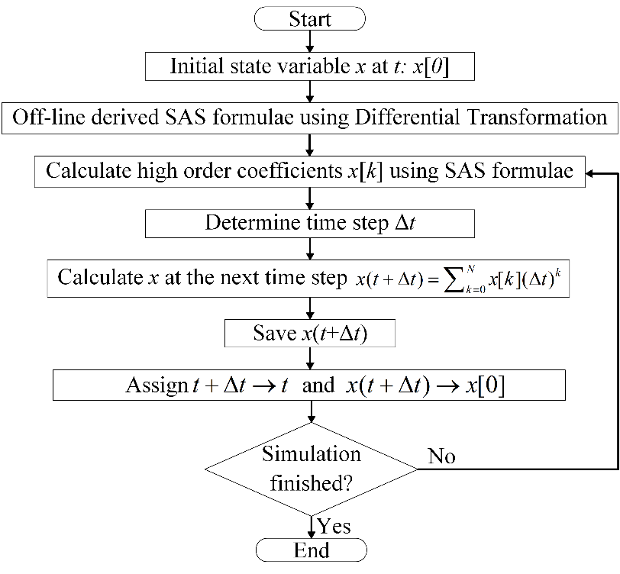
Figure 2.7 Flow chart of the multistage simulation strategy using the SAS approach

(2-40)
where,
(2-41)
Substituting (2-41) into (2-40) yields:
(2-42)
The imbalance E(Δt) can serve as an indicator for determining the termination of the present time interval and the initiation of the subsequent one. Thus, a variable time step is enabled, allowing for a tradeoff between increasing time steps and sufficient accuracy [23]-[24]. In practice, the variable length of each time step is determined by a predetermined imbalance threshold ε_{E}, typically around 1×10⁻² per unit for EMT simulation.
(2-43)

2.5 Dense output mechanism
Because the SAS utilizes high-order approximations to enlarge the time steps, some detailed fast dynamics such as overvoltage and over-current may be missed. Thus, obtaining dense output is significant in such cases.
As shown in (2-2) and (2-41), with derived SAS coefficients, the SAS expression is a function of time. Thus, the value of state variables at the next time step can be calculated by substituting the time step Δt. Furthermore, it is flexible to calculate values at
multiple instants of t_{i} within the time step Δt, as illustrated in (2-44) and Figure 2.8.
(2-44)

2.6 Case study

2.6.1 Case study on the Kundur’s two-area system
First, the performance of the DT method-based EMT simulation is tested on the Kundur’s two-area system with four synchronous generators, as shown in Figure 2.9 [67].
In the simulation, the system is in a steady state at first, and at t=1 s, bus #7 is grounded for 5 cycles. The fault is then cleared without tripping any lines [68]-[70]. In this test, the benchmark simulation results are given by the 4th-order Runge-Kutta method using a tiny time step of 1 μs.
After that, the 2-second post fault simulation results provided by the 20th-order DT method using a time step of 100 μs are compared with the benchmark results, as shown in Figures 2.10-2.13.
Figures 2.10-2.13 show that results given by the DT method accurately match the benchmark results. Also, convergence and accuracy can be ensured when the time step is not too large.
Then, under different error tolerances, the computational efficiency of the fixed time step DT method, using different orders, for a 2-second post-fault simulation is presented in Table 2.2. In addition, the computational cost of the 30th-order DT is compared with that of the RK4 method, Modified Euler method (ME), and trapezoidal rule method under different error tolerances. Here, the error tolerances are provided by the maximum

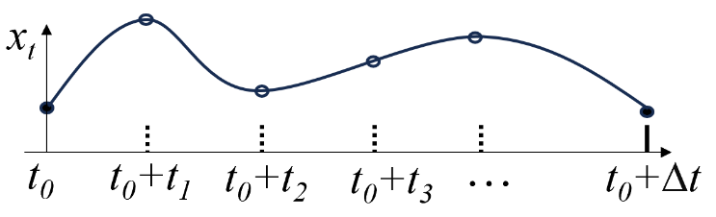
Figure 2.8 Illustration of dense output under large time step simulations

Figure 2.9 The Kundur’s two-area system

Figure 2.10 Relative rotor angle of generators

Figure 2.11 Frequency deviation of generators

Figure 2.12 Three-phase terminal current of generator #2
Figure 2.13 Three-phase voltage at bus #7

Table 2.2 Time steps and time costs of fixed time step DT using different orders
Error  (p.u.) | DT  (10th-order) |  | DT  (20th-order) |  | DT  (30th-order) |  | DT  (40th-order)
Error  (p.u.) | Time step  (μs) | Time cost  (s) | Time step  (μs) | Time cost  (s) | Time step  (μs) | Time cost  (s) | Time step  (μs) | Time cost  (s)
10⁻² | 72 | 81 | 200 | 58 | 330 | 53 | 412 | 58
10⁻³ | 58 | 100 | 180 | 64 | 306 | 57 | 382 | 62
10⁻⁴ | 46 | 1162 | 158 | 73 | 284 | 62 | 365 | 68

absolute error of all state variables over the simulation time interval compared with the benchmark results. The performance comparison is presented in Table 2.3.
From Table 2.2, as the order of DT increases, the time step keeps increasing, and the computational cost first decreases and then increases. This validates that high-order DT can enlarge the time step, but when the order becomes excessively high, the burden of computing high-order terms would decrease the overall computational efficiency [71].
From Table 2.3, the time step of the 30th-order DT method is much bigger than that of the ME and RK4 methods, thus the simulation time cost of the DT method is much smaller especially when the simulation desires a smaller error tolerance. Specifically, the computational speed of 30th-order DT is at least 4 times faster than other methods when the error tolerance is 10⁻³, and at least 8.8 times or more faster when the error tolerance is 10⁻⁴. Thus, the simulation results validate the high computational efficiency and accuracy of the proposed SAS-based approach.

2.6.2 Case study on a modified IEEE 39-bus system
Second, to evaluate the efficacy and validity of the proposed approach in scenarios involving IBRs, the EMT model of a modified IEEE 39-bus system in Figure 2.14 is employed [72]. The synchronous generators connected to buses #32, #35, #37, and #39 are replaced by four grid-following IBRs, as modeled in Figure 2.6. The evaluation process entails two stages: (1) testing the SAS approach with different orders using variable time steps, and (2) comparing the SAS approach to traditional numerical methods.
Three typical cases including load tripping, bus grounding, and generator tripping are considered:

Table 2.3 Comparing times steps and time costs of different numerical methods
on the Kundur’s two-area system
Error  (p.u.) | ME |  | RK 4 |  | DT  (30th order) |  | Trapezoidal rule
Error  (p.u.) | Time step  (μs) | Time cost  (s) | Time step  (μs) | Time cost  (s) | Time step  (μs) | Time cost  (s) | Time step  (μs) | Time cost  (s)
10⁻² | 1.0 | 1045 | 10 | 200 | 330 | 53 | 35 | 92
10⁻³ | 0.5 | 2100 | 5 | 360 | 306 | 57 | 29 | 230
10⁻⁴ | 0.5 | 4215 | 3 | 550 | 284 | 62 | 25 | 600

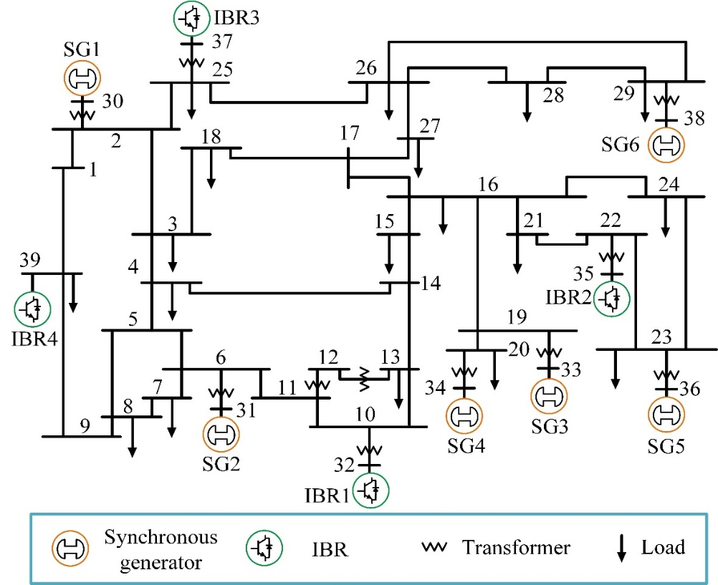
Figure 2.14 One-line diagram of the modified IEEE 39-bus system

(1) In case 1, the load at bus #4 is tripped permanently.
(2) In case 2, a three-phase grounding fault is added at bus #16 and then cleared after 10 cycles without losing any component.
(3) In case 3, the synchronous generator at bus #36 is tripped permanently.
The simulation results of several state variables, including rotor speed deviation of synchronous generators, active power of IBRs, three-phase currents and voltages close to the fault locations, are shown in Figure 2.15-2.17.
Then, the tests are conducted in the following two aspects:
(1) Test of SAS with different orders.
The performance of the variable time step SAS method with different orders is evaluated using three test cases presented above. The computation performed in one step increases with the order of SAS. Meanwhile, a higher-order DT allows for longer time steps, thereby reducing the total number of simulation steps. Therefore, there exists an optimal order that offers the best performance.
Using different SAS orders, the average time steps and time costs of SAS for post-fault simulation lasting for 2 seconds are summarized in Figure 2.18, for the three cases introduced above. The benchmark results are provided by the 4th-order Runge-Kutta method using a 1 μs time step. The simulation tests are carried out on a desktop computer equipped with an Intel Core i7-6700 3.4 GHz CPU and 16GB RAM, using MATLAB. To ensure accuracy, the errors of bus voltages are kept below 0.01 in per-unit value.
The results presented in Figure 2.18 demonstrate that as the order of SAS increases, the time step grows, and the total time cost initially decreases before rising due to increased

Figure 2.15 Case 1 simulation results on the modified 39-bus system: Tripping the load at Bus 4
Figure 2.16 Case 2 simulation results on the modified 39-bus system: Grounding Bus 16 for 10 cycles

Figure 2.17 Case 3 simulation results on the modified 39-bus system: Tripping generator at Bus 34

Figure 2.18 Performance of the SAS with different orders on the modified 39-bus system

computation load per step. The optimal order appears to be around 30.
(2) Comparison of SAS with traditional numerical methods.
In Table 2.4, the performance of the 30th-order SAS is then compared to state-of-the-art traditional numerical solvers, including the Numerical Differentiation Formulas (NDF) method, the Runge-Kutta method, and the trapezoidal rule method, which are provided by the MATLAB solvers ode15s, ode45, and ode23t, respectively. Also, the auxiliary ‘odeset’ function in MATLAB, with a carefully adjusted absolute error tolerance around 1×10⁻⁵, is used to generate results with per unit bus voltage errors less than 0.01 per-unit.
The MATLAB solvers mentioned above all adopt variable time steps, the average time step of each method is calculated for comparison. As demonstrated in Table 2.4, the 30th-order SAS offers a significant advantage in terms of time efficiency, thanks to its capacity to leverage large time steps enabled by high-order approximations.
The comparison between the varying time steps and absolute errors in bus voltages for case 2 is presented in Figure 2.19. As shown in Figure 2.19(a), the variable time step 30th-order SAS can gradually increase the time step to a considerable value. Meanwhile, Figure 2.19(b) demonstrates the good accuracy and convergence performance of the SAS.
Additionally, waveforms of two state variables are illustrated below in Figure 2.20-2.21 to highlight the accurate match between the results of the 30th-order SAS and the benchmark.

2.6.3 Case study on the IEEE 39-bus system
To evaluate efficacy and validity of the proposed approaches against commercial

Table 2.4 Comparing time steps and costs of different methods on the
modified IEEE 39-bus system
Case | NDF  (ode15s) |  | Runge-Kutta  (ode45) |  | SAS  (30th-order) |  | Trapezoidal rule  (ode23t)
Case | Time step  (μs) | Time cost  (s) | Time step  (μs) | Time cost  (s) | Time step  (μs) | Time cost  (s) | Time step  (μs) | Time cost  (s)
Case 1 | 15.8 | 136 | 10.5 | 85 | 427 | 56 | 36.3 | 118
Case 2 | 16.2 | 133 | 10.3 | 86 | 438 | 54 | 35.6 | 121
Case 3 | 16.1 | 134 | 10.7 | 83 | 449 | 52 | 35.9 | 120

Figure 2.19 Comparison of time step and absolute error in case 2 on the modified IEEE 39-bus system
Figure 2.20 Phase C voltage at Bus 16 in case 2 on the modified IEEE 39-bus system

Figure 2.21 Phase C current of branch 16-22 in case 2 on the modified IEEE 39-bus system

tools, the SAS-based simulation approach implemented in MATLAB is benchmarked with the commercial tool PSCAD on the original IEEE 39-bus system with only synchronous generators [72]. Consider the following contingency: the system starts from its steady state at t=0 s, and then experiences a three-phase grounding fault on Bus #10 at t=1 s, lasting for 0.2 seconds without losing any network component. The results from the proposed approach using MATLAB and from the PSCAD are compared in Figures 2.22-2.26, which match well. A slight mismatch between the two results is observed, which is acceptable and may be caused by unknown implementation details with PSCAD.
It should be noted that MATLAB is an interpreted rather than a compiled environment, having hidden overheads. To accelerate the simulation speed, the MATLAB code is converted into MEX files and compiled to achieve higher efficiency [73].
The results presented in Figure 2.27 demonstrate that the optimal order is also around 30, with approximately a time cost of 2.75 s for a 1-s simulation on the 39-bus system.
Then, PSCAD simulations are conducted for the three cases: Case 1 disconnects the load at bus 4 at t=1 s; Case 2 adds a three-phase grounding fault to bus 10 at t=1 s lasting for 0.2 seconds; Case 3 disconnects the generator at bus 36. The average time costs for 1-s simulations, along with the maximum and average errors in three-phase voltages at different time steps, are summarized in Table 2.5. The simulation results using a 1 μs time step are designated as the benchmark. Remarkably, all three cases have nearly identical time costs using the same time step. The maximum error is the maximum three-phase voltage absolute error of all 39 buses, and the average error is the average of all voltage

Figure 2.22 Simulation results of generator rotor speed

Figure 2.23 Simulation results of generator terminal voltage

Figure 2.24 Simulation results of generator electrical power

Figure 2.25 Simulation results of three-phase voltage at Bus 10

Figure 2.26 Simulation results of three-phase current on branch 10-11

Figure 2.27 Performance of the SAS with different orders on the IEEE 39-bus system after code compilation

Table 2.5 Comparison of performance on the IEEE 39-Bus system
Approach | PSCAD |  |  |  | SAS (20th-order) | SAS (30th-order)
Time step (μs) | 5 | 50 | 75 | 100 | 297 | 467
Time cost (s) | 56.2 | 5.62 | 3.75 | 2.81 | 4.16 | 2.71
Maximum error (pu) | 1.10 | 5.52 | 6.11 | 5.95 | 8.9×10⁻³ | 7.7×10⁻³
Maximum percentage error (%) | 110 | 552 | 611 | 595 | 0.89 | 0.77
Average error (×10⁻³ pu) | 0.15 | 1.73 | 2.80 | 4.11 | 0.037 | 0.032

errors [74]-[76] related to the benchmark during t=0 to 2 s.
Figures 2.28-2.29 respectively illustrate the simulated phase-C voltage at Bus 10 and its error for Case 2 using different time steps. From Figure 2.29, the PSCAD results converge to the benchmark results shortly, but obvious errors exist for fast dynamics following a disturbance with times steps >50 μs. This is because he nodal approach in PSCAD, based on the trapezoidal rule method [37], is of a low order and offers less accuracy.
As presented in Table 2.5 and Figures 2.28-2.30, the instantaneous values are simulated and used for error analysis. Therefore, calculating the maximum percentage error directly from the instantaneous values is not feasible, as the true value could be zero, resulting in an infinitely large percentage error. So, for illustrating percentage error, the per unit values of those voltages, which typically approach 1 under steady state, are used as the base, as shown in:
(2-45)
It's important to note that although large errors in the results provided by PSCAD can be observed immediately following a disturbance, these are primarily due to phase shifting. As observed in Figures 2.28-2.29, PSCAD can still simulate the trend of the waveform correctly.
In comparison, the results provided by the SAS-based approach are presented in Figure 2.30. Utilizing a high-order approximation, the SAS approach can provide accurate results for fast dynamics under large time steps, and detailed high-resolution dynamics can be reconstructed through dense output.

Figure 2.28 Phase-C voltages of Bus 10 from PSCAD

Figure 2.29 Errors of phase-C voltages at Bus 10 from PSCAD

Figure 2.30 Phase-C voltage at Bus 10 simulated by the SAS

To compare simulation using the SAS approach with a 467-μs time step, PSCAD performs faster when its time step increases to over 100 μs. However, PSCAD has much bigger errors than the SAS approach. Even if PSCAD uses a 5-μs time step, its average and
maximum errors are respectively 4.7 and 142.9 times of those with the SAS approach using the 467-μs time step. In such a case, the time cost of PSCAD is 20.7 times that of the SAS approach. Thus, when both high accuracy and speed of simulation are desired, the SAS approach is superior.

2.6.4 Case study on a synthetic 390-bus system
To test the time performance of the SAS-based EMT simulation approach on a large system, a synthetic 390-bus system is constructed by interconnecting 10 replications of the
39-bus system [57], in which generators are replaced by ideal current sources.
Subsequently, by simulating a grounding fault at t=1 s lasting for 0.2 s, the performance of the SAS-based simulation is compared with that of the nodal formulation approach [37] utilized in PSCAD. The results are presented in Table 2.6, where the time costs are for a 1-second simulation. Simulation results of the phase-A voltage at the grounding Bus are shown in Figures 2.31-2.32.
From the results presented in Table 2.6 and Figures 2.31-2.32, the modal approach in PSCAD has higher efficiency than the state-space SAS approach when adopting a time step approximately >22 μs, which is much smaller than the corresponding time step approximately 100 μs on the 39-bus system. This is aligned with the existing conclusion that the nodal approach has outstanding efficiency on large systems [3].
Nevertheless, similar to the observations on the 39-bus system, the nodal approach

Table 2.6 Comparison of Performance on a 390-Bus System
Approach | PSCAD |  |  |  | SAS
Time step (μs) | 5 | 50 | 75 | 100 | 534
Time cost (s) | 425 | 42.5 | 28.3 | 21.5 | 98
Maximum error (pu) | 0.22 | 2.58 | 3.36 | 3.85 | 7×10⁻⁴
Average error (×10⁻³ pu) | 0.41 | 2.61 | 2.91 | 3.3 | 0.0012

Figure 2.31 Phase-A voltage at grounded Bus simulated by PSCAD

Figure 2.32 Phase-A voltage at grounded Bus simulated by the SAS approach

failed to accurately capture some fast dynamics right after a disturbance, under a time step larger than 5 μs. In contrast, the SAS-based approach could still provide high-precision results with better efficiency.

2.7 Conclusion
This chapter presents an SAS-based EMT simulation approach to enlarge the time step and reduce computational cost using conventional state-space representation. A variable time step strategy is incorporated into the multistage simulation strategy to further enhance its robustness and efficiency. Also, the proposed dense output mechanism is used to provide detailed high-precision dynamics under large time steps.
Case studies on the Kundur’s two-area system with synchronous generators, on a modified IEEE 39-bus system with synchronous generators and IBRs, on the IEEE 39-bus system with synchronous generators, and on a synthetic 390-bus system with ideal current sources validate the high efficiency of proposed approach under a high accuracy requirement.
In addition, when sacrificing the accuracy of detailed dynamics such as overvoltage which happens right after a disturbance, the nodal formulation can be more efficient than the proposed SAS-based approach. Conversely, the SAS-based approach has better efficiency for providing high-precision results.

Switch Detection Based on the Semi-Analytical Solution

In EMT simulations, the time instants when limits are reached are typically of interest and importance to ensure the correctness of results. The timings of such switches are unknown ahead of the simulation. In commercial software like PSCAD, if a switch occurs during a small time step, its timing is estimated via linear interpolation, based on values at the previous and present steps, followed by a re-computation for the present step, starting from the switching moment [77][78]. However, when a significantly increased time step is used by an SAS, linear interpolation may yield inaccurate results, and this problem has not been addressed by previous work related to SAS-based power system studies.
With the derived high-order approximate SAS expressions, it is efficient to calculate values of state variables at any moment within one time step. Therefore, a binary search can quickly locate the earliest switching moment within a smaller time interval less than a predefined value, e.g., 10-20 μs, and then the quadratic interpolation can be applied to accurately locate the earliest switching moment. After this process, the time step is varied to the switching time instant to correct the simulation, thus the accuracy and correctness can be improved.
In addition to the proposed detection algorithm, which locates moments of switches with errors less than 1-2 μs, another straightforward way to tackle limit violations is to simulate with a time step of 1 μs using a low-order SAS. In the following, the computational cost of the switch detection algorithm is compared to that of the simulation using fixed tiny time steps of 1 μs.

3.1 Switch detection using linear interpolation
Traditionally, when a typical 50 μs time step is used for EMT simulations, the currents and voltages can be assumed to vary linearly, and thus linear interpolation is used to estimate the time instants when limits are reached.
As illustrated in Figure 3.1 [78], the current i_{L} is constrained to be bigger than 0. The original simulation tells that i_{L}(Δt) is less than 0, as shown in the dashed black line. Then, to correct the simulation, the moment when the limit is reached, i.e., δt, is estimated using linear interpolation, as given in equation (3-1).
(3-1)
After that, the state variable values at δt are recalculated, and then the simulation continues to move from δt to δt+Δt when a variable time approach is used. If a fixed time step is used, usually a multi-stage linear interpolation is used to estimate the state variable values first at δt and then at Δt, and then the simulation will continue to move from Δt to 2Δt if no limit violation or switching is detected.

3.2 Binary search-enhanced quadratic interpolation
When the SAS approach is used to enlarge the time step up to 300-500 μs, as presented in Chapter 2, the state variables cannot be assumed to vary linearly anymore, and thus linear interpolation is not suitable for switch detection in this case.
To address this problem, a switch detection algorithm utilizing SAS coefficients is

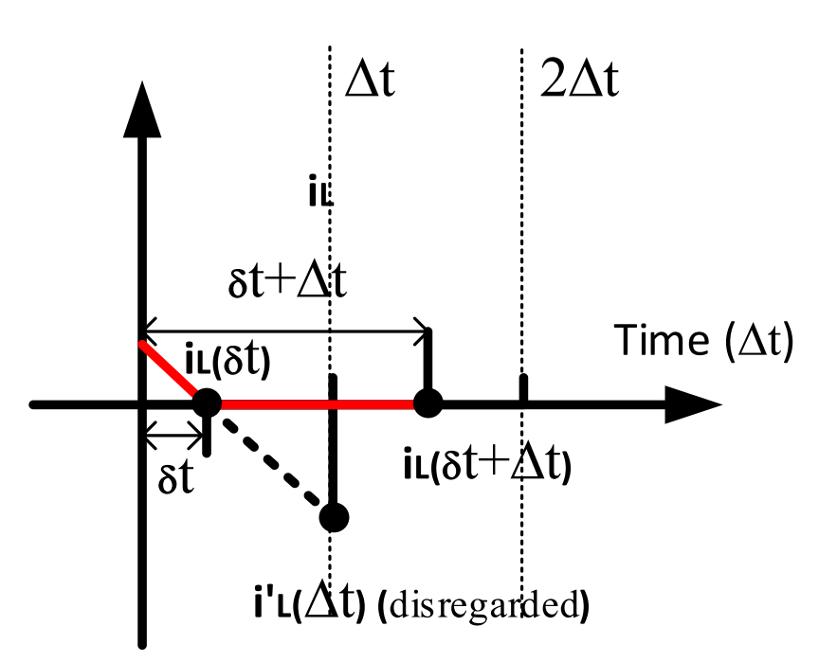
Figure 3.1 An example of linear interpolation in simulations [78]

proposed as depicted in Figure 3.2. Thanks to high-order SAS coefficients, state variable values at any time during a time step can be calculated efficiently following equation (2-2)
with negligible arithmetic operations.
Moreover, to avoid an exhaustive and time-consuming process of checking every tiny time step at 1 μs time step or less, the earliest small time interval ε_{t}, e.g., 10-20 μs or smaller, in which a switch occurs is identified by a binary search approach as illustrated by steps in the blue area of Figure 3.2 when upper limits are reached. To deal with lower limits, the algorithm requires only a swap in the updates of a and b. Then, as indicated by steps in the purple area, as a and b are close enough, quadratic interpolation is used to accurately detect the earliest switch moment where the current time step is finished.
After the detection, a variable time step is chosen to simulate the system dynamics at the switch moment. Then, the simulation continues for the next time step in the same manner until finishing the simulation, as shown in Figure 2.7.
An example is given below to illustrate the process of this approach. As shown in Figure 3.3, four state variables x₁, x₂, x₃, and x₄ are considered here with their upper limits marked as dashed lines.
As shown in Figure 3.3(a), the simulation starts from t=a, and all four state variables will violate their upper limits the next time when t=a+Δt. Then, as shown in Figure 3.3(b), the state variable values at the middle point are calculated using SAS coefficients, and it can be observed that some state variables still violate their upper limits. Thus, as shown in Figure 3.3(c), the value of b is updated to b=(a+b)/2; and the state variable values at the new middle point are checked for limits violation. Because no limits are violated, the value

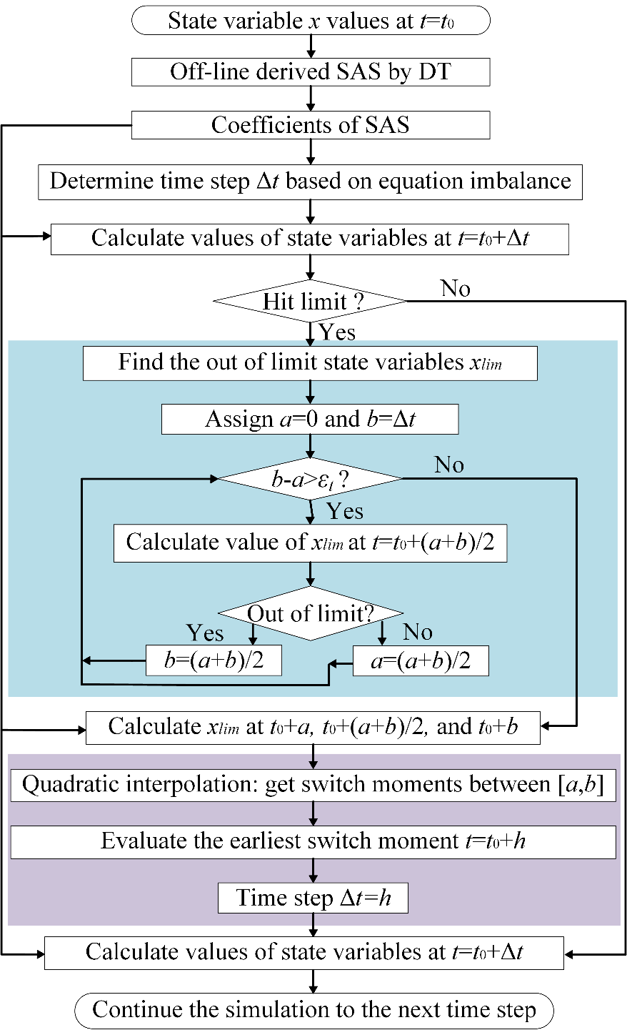
Figure 3.2 Flow chart of the SAS-based switch detection algorithm

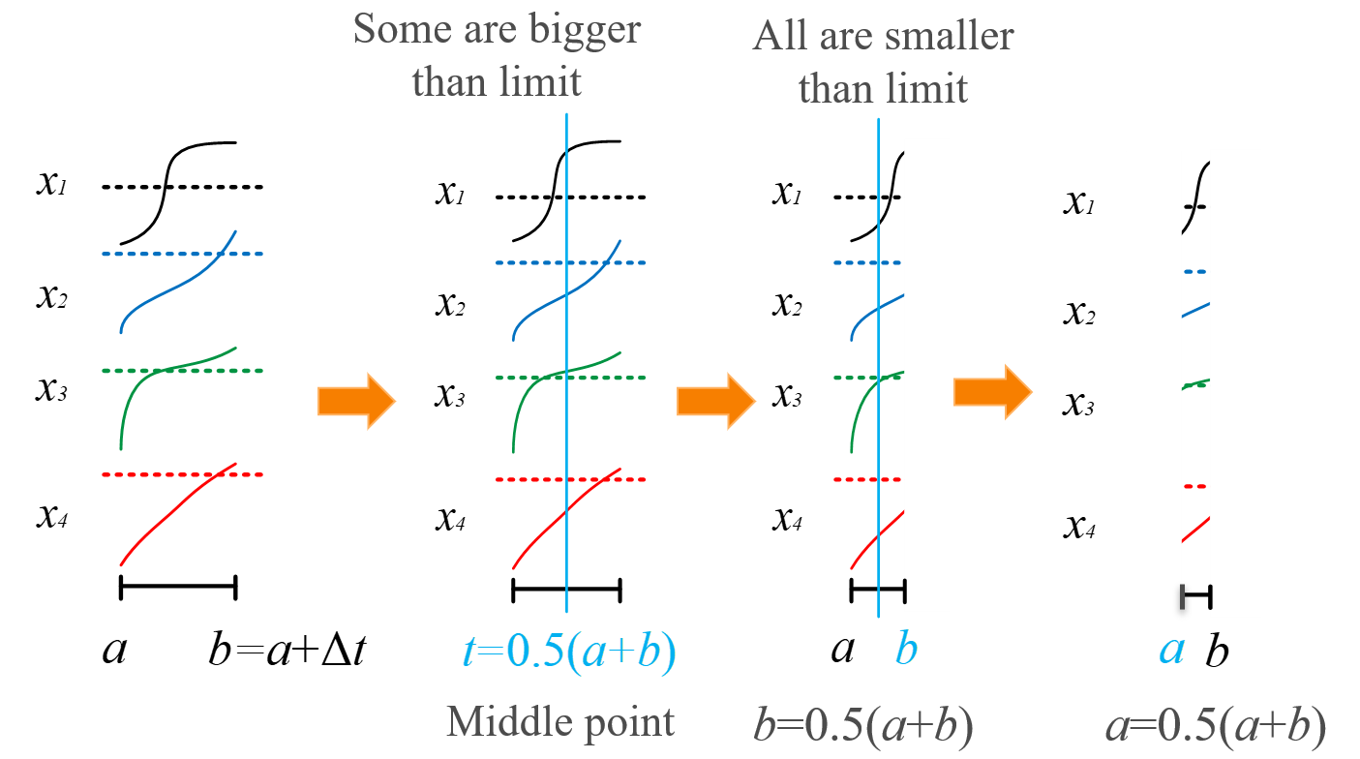
(a) (b) (c) (d)

Figure 3.3 Illustration of the binary search algorithm for switch detection

of a is updated to a=(a+b)/2, as shown in Figure 3.3(d).
This binary search process will locate the earliest time interval during which at least
one limit is violated, and this process is continued until the difference between a and b is less or equal to a pre-defined threshold ε_{t}, which can be set around 10-20 μs to ensure accuracy for future quadratic interpolation.
Finally, as shown in Figure 3.3(d), suppose only x₁ and x₃ will violate their limits during the earliest time interval [a,b], quadratic interpolation is then applied on both x₁ and x₃ to locate the exact time instants when their limits are hit. Supposing x₁ and x₃ hit their limits at t=t₁ and t=t₃ respectively, the time step is adjusted to Δt=min(t₁, t₃).
Because variable time step is easy to implement with the SAS approach, no further estimation is required, compared to fixed time step simulation [77]. Then, the simulation continues to the next time step.

3.3 Computational cost analysis
Besides the proposed detection algorithm which can locate moments of switches with errors less than 1-2 μs, another straightforward way to tackle limit violations is to simulate with a time step of 1 μs using a low-order SAS. In the following, the computational cost of the switch detection algorithm is compared to that of the simulation using equal tiny time steps of 1 μs. Suppose that the system has N_{net} network state variables and N_{gen} generators (including synchronous generators and IBRs), and the order of the SAS is N_{SAS}. The overall computational cost stems mainly from multiplications of matrices with vectors, as well as the multiplication of vectors with vectors. Supposing the number of operations is m∙n for multiplying an m×n matrix with a n×1 vector, and n for multiplying two n×1 vectors. The number of multiplication operations is then counted to estimate the computational cost of the SAS for each time step, as given below:
(3-2)
where k₁=3 for three AC phases, k₂≈12 and k₃≈115 are determined through a process of counting operations. The first term in the equation results from linear functions of the three-phase network and its interface with generators, the second term primarily arises from convolution operations for nonlinear functions, and the third term relates to equations of generators.
Then, suppose N_{hit} limits are hit during a single large time step T_{steph} (μs) enabled by a high-order SAS. In such a scenario, the computational cost of a high-order SAS will be multiplied by N_{hit}, because it must revisit the moments when the limits were reached.
Finally, the computational cost ratio of a high-order SAS to a low-order SAS using a 1 μs time step which does not need backtracking is:
(3-3)
where Cost_{SASh} and Cost_{SASl} are respectively computational costs of the high-order and low-order SAS approaches per step given by (3-2). Therefore, when CostRatio<1, the high-order SAS approach incorporating switch detection will be more efficient than the low-order SAS that utilizes a 1 μs time step. This determines an upper bound for N_{hit} on a T_{steph} time window. Subsequently, case studies are performed in the next section to determine and affirm the upper bound of N_{hit}, which ensures the efficiency of the proposed switch detection algorithm.

3.3 Case study
To verify the correctness of the proposed switch detection algorithm, a case study
is conducted on the modified IEEE 39-bus system shown in Figure 2.14 in Chapter 2, which has 6 synchronous generators and 4 grid following IBRs.
In this case study, limits are enabled on E_{fd} of exciters, p₁ of governors, and i_{dref} and i_{qref} of the IBRs. Simulation of Case 2 is repeated to assess the proposed switch detection algorithm. Recall that in this case a three-phase grounding fault is added at bus 16 and then cleared after 10 cycles.
In this scenario, the E_{fd} of synchronous generator #4 that is connected to Bus 34 reaches its upper limit, and i_{qref} of IBR2 that connected to Bus 35 reaches its lower limit. The simulation results provided by the 30th-order SAS with and without the proposed switch detection algorithm are compared against the benchmark results, as shown in Figures 3.4-3.5.
As can be observed, without detection, the state switch moments are missed. Although the values of variables exceeding their limits are forced to be the limits, the resulting trajectory becomes inaccurate and may compromise the accuracy of SAS in subsequent calculations. In contrast, the proposed detection algorithm could accurately locate such moments and reset the simulation to those time instants with errors less than 1 μs, leading to a close match with the benchmark results.

3.4 Verification of computational cost analysis
According to the case studies above, the switch detection algorithm can accurately locate the switch time instants with errors of less than 1 μs. Thus, another way to achieve

Figure 3.4 Simulation results of i_{qref} of IBR2

Figure 3.5 Simulation results of E_{fd} of synchronous generator #4

the same level of accuracy is to simulate by checking every 1 μs. Also, the 30th-order SAS conservatively allows a large time step around T_{steph}=350 μs, and the 3rd-order SAS provides accurate results with a time step of 1 μs.
In Section 3.2, the computational costs of the high-order SAS with switch detection and the low-order SAS using tiny time steps, which both can handle the limit violation accurately, are compared by computational cost estimation. In this part, results from additional case studies are presented to verify the estimation.
Case studies are conducted to simulate a 2-second duration using the 30th-order SAS approach with T_{steph}=350 μs and the 3rd-order SAS approach with 1 μs. The respective time costs are around 68 s and 2326 s, respectively, without compiling the code. To ensure CostRatio<1, it can be estimated that N_{hit}<2326/68=34.2.
Alternatively, considering the 10-generator 39-bus system, the upper bounds for N_{hit} on one large step of T_{steph}=350 μs are determined by (3-2)-(3-3) via substituting system information and setting CostRatio<1. The resulting upper bound is 33.9, closely aligning with the estimation from the additional case studies mentioned above.
Furthermore, even if the number of generators increases from 10 to 50, the upper bound for N_{hit} will only decrease from 33.9 to 31.2. This minor decrease is primarily due to the fact that the computational cost is mainly attributed to the network equations which have a high dimension. Hence, this verifies the the computational cost estimation.
Therefore, as a general rule, as long as no more than approximately 34 limits are exceeded in every large time step of around 350 μs, which is commonly the case, the proposed switch detection algorithm is more efficient than checking every tiny time step.

3.5 Conclusion
In this chapter, an SAS-based switch detection algorithm is proposed to accurately locate the time instants when limits are violated. This makes the algorithm flexible and adaptable, enabling it to accurately simulate system state switches caused by limit violations during large time steps.
Also, the computational cost of the proposed algorithm is compared to that of simulations using a time step of 1 μs. Although both approaches can accurately locate the switch time instants, the proposed algorithm generally has higher efficiency when less than 31 to 34 limits are violated during a single time step around 350 μs.
Case studies on a modified IEEE 39-bus system with IBRs validated the accuracy and high efficiency of the proposed approach.

SAS-based EMT Simulation Using the Nodal Equation for the Network

In Chapter 2 and Chapter 3, the SAS approach is applied to the EMT state-space equation to speed up the simulations. As another major kind of EMT formulation method, the nodal method is more suitable for large networks due to its high efficiency in dealing with frequent network topology changes.
In this chapter, while the network is solved by the nodal voltage equation using a fixed time step, the SAS approach is explored on the synchronous generators and related controllers. Specifically, a hybrid strategy is proposed to employ the SAS in EMT simulations by applying a DT-based method to solve the state-space differential equations of components such as synchronous generators and controls, and then interface the SAS solution with the network solution solved from the network nodal voltage equation.

4.1 Simulation strategy
In the nodal formulation-based EMT simulation, the first-order ODEs of network components, including resistors, inductors, and capacitors, are discretized by the trapezoidal rule method to form the grid nodal voltage equation. Other components, including synchronous generators, exciters, governors, turbines, and stabilizers, are represented by state-space equations.
Based on this precondition, the SAS is used to derive high-order time series approximations of the state-space variables using the DT method, and hopefully, the simulation time step can be enlarged at the same error limit compared to the traditional low-order numerical methods and accelerate the simulation.
However, when the network and generators are solved with different numerical methods, a big challenge is to interface them together.
To investigate the interface, an open loop test for steady state simulation is conducted on the Kundur’s two-area system with only synchronous generators. By assuming the generator terminal voltages v_{d} and v_{q} to be constant under steady state, the current outputs of synchronous generators are calculated by a high-order SAS using generator equations given in (2-12)-(2-29).
With the assumption that generator terminal voltages v_{d} and v_{q} are constant, we can get the SAS coefficients of v_{d} and v_{q}:
(4-1)
(4-2)
Based on that, first, we can get high-order SAS of the three-phase terminal voltages:
(4-3)
where, (i,1), (i,n), and (n,1) are matrix indices; [k], [m], and [k-m] indicate the orders of DTs. In addition, when i=1, 2, and 3, v_{abc(i,1)} represents v_{a}, v_{b}, and v_{c}, respectively.
With the SAS of v_{abc}, the SAS of a three-phase terminal current can be calculated in a recursive manner following the equations below:
(4-4)
Also, other related derivations and calculations are the same as presented in (2-22)-(2-30) in Chapter 2. Here, only three-phase balanced faults are considered, and states at the ‘0’ axis are equal to 0.
Under the assumption that generator terminal voltages v_{d} and v_{q} are constant, the steady state simulation can be conducted in an open loop way. As shown in Figure 4.1, the current outputs of synchronous generators are calculated by high-order SAS using generator equations. Then, the current injection from generators is used to solve the nodal-based network voltages. In this way, the simulation is done in an open loop way, i.e., the solved network voltages are not used to update generator state variables.
The open loop simulation strategy is tested on the Kundur’s two-area system, which has four synchronous generators, for steady state simulation. The steady state simulation lasting for 0.25 seconds gives very good results, as shown in Figure 4.2.
Also, under different time steps, the errors of both generator currents and network voltages are analyzed using the benchmark obtained with a time step of 10 μs. The results are shown in Table 4.1.
From the results above, it can be observed that the SAS approach could provide accurate generator current outputs under large time steps. Errors in voltages provided by the network solution would increase with the time step, but the errors are small and acceptable.
The preliminary test above shows that the SAS-based approach could work. However, it is a rather strong assumption to make the generator terminal voltages v_{d} and v_{q}
constant, and steady state simulation is much simpler compared with dynamic simulation.
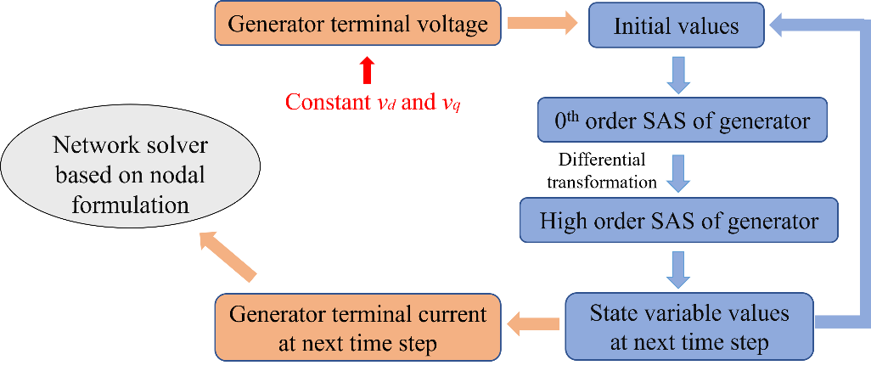
Figure 4.1 Steady state open loop simulation strategy by assuming
constant synchronous generator terminal voltages

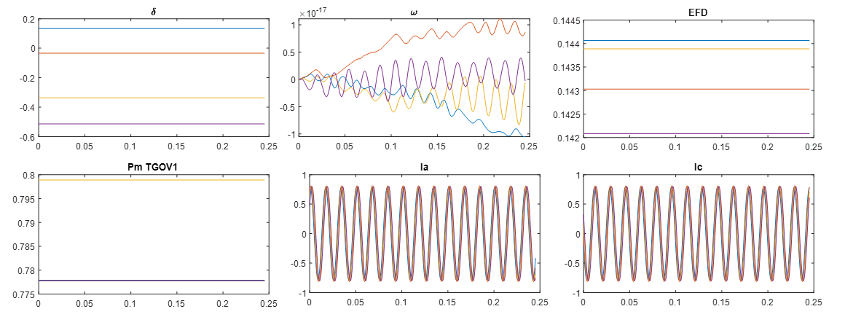
Figure 4.2 Open loop steady state simulation results based on SAS on the two-area system

Table 4.1 Error analysis of generator currents and network voltages under an open loop simulation strategy
Error | 100 μs | 300 μs | 500 μs | 700 μs
Current | 5.07×10⁻¹³ | 5.04×10⁻¹³ | 5.0×10⁻¹³ | 4.94×10⁻¹³
Voltage | 0.35% | 0.55% | 0.83% | 1.11%

The dynamic simulation should be a closed-loop simulation, as shown in Figure 4.3. As illustrated, the synchronous generator is solved using the SAS approach as shown in the blue boxes. The SAS approach calculates currents of synchronous generators that are injected into the network. Then, the solved network nodal voltages could provide terminal voltages of synchronous generators, which are then used to calculate the generator's state variable values for the next time step.
Subsequently, the synchronous generator's terminal is transformed from a Thevenin equivalent circuit to a Norton equivalent circuit, which provides current injection from the generator to the network. Also, the generator terminal equivalent resistor is merged into the network conductance matrix, as shown in Figure 4.4.

4.2 Deriving SAS using dynamic bus voltages
As pointed out in Section 4.1, the SAS of generator terminal bus voltage should be updated each time after solving the network solution. In a conventional synchronous generator, the SAS of terminal bus voltage is derived using state-space equations of the whole system along with the initial solution; however, the state-space equation of the network is unavailable when a nodal equation is employed. To tackle this challenge, the terminal bus voltages are not assumed to be constant but are instead treated as time-dependent functions that update with the simulation process [24].
Assuming the SAS of any generator terminal bus voltage is a time series function:
(4-5)

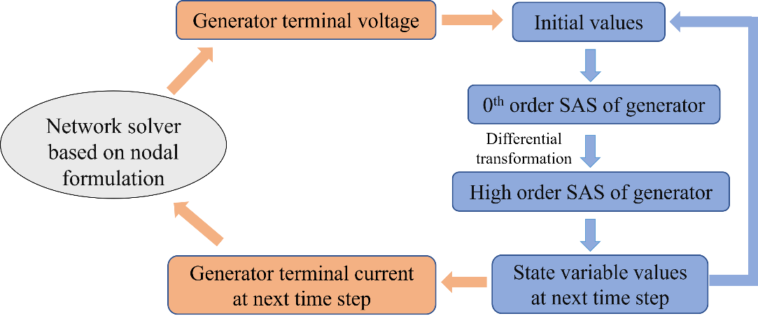
Figure 4.3 Simulation strategy based on SAS

Figure 4.4 Interface between the network and an SAS represented synchronous generator

where v_{m} and v_{a} are voltage magnitude and angle in the d-q frame.
Then, we have:
(4-6)
The SAS coefficients of v_{m[k]} and v_{a[k]} are obtained by solving several linear least squares error problems using samples from previous time steps.
For example, with n+1 samples at n+1 time steps:
(4-7)
It is a linear least squares error problem to fit the data set with the time series function shown in (4-6). Such an optimization problem can be easily solved by utilizing the polynomial fitting functions.
After obtaining v_{d,k} and v_{q,k} for k=1, 2, 3, …, n. The SAS of other state variables of the synchronous generators can be derived by following equations (2-12)-(2-29).
Then, the SAS of the synchronous generators and controls is interfaced with the network solution, as shown in Figure 4.5.

4.3 Case study
A case study is conducted on the Kundur’s two-area system, which is shown in Figure 2.9. Before t=1 s, the system is in a steady state, and the synchronous generator connecting to Bus #4 is tripped at t=1 s permanently. The simulation lasts for 10 s, and the results provided by the conventional simulation method [34] using a time step of 5 μs are shown in Figure 4.6.

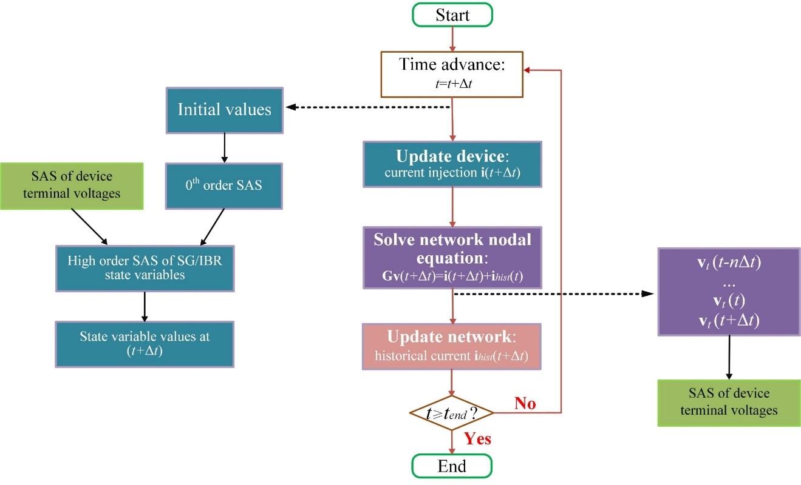
Figure 4.5 SAS-based EMT simulation using a nodal equation for the network

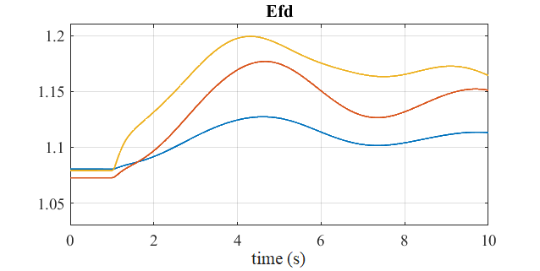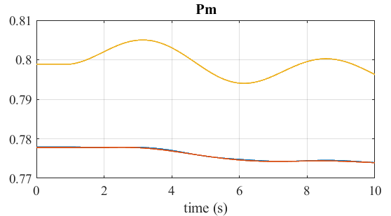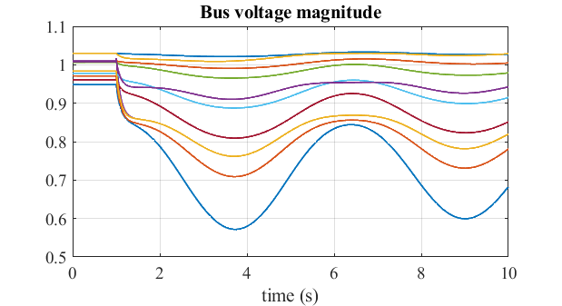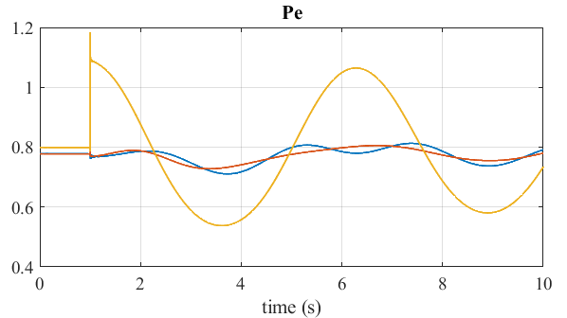
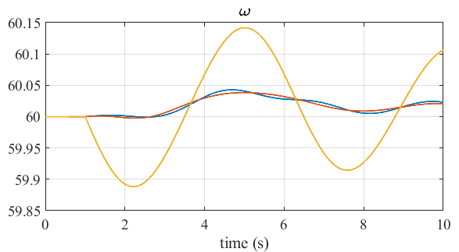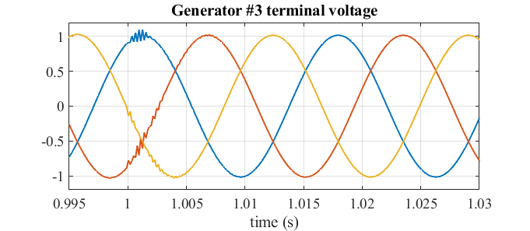
Figure 4.6 Simulation results provided by the conventional approach using a 5 μs time step

The simulation results provided by the 3rd-order SAS using a 150 μs time step are shown in Figure 4.7.
As can be observed from Figure 4.6 and Figure 4.7, the results provided by the SAS approach are aligned with those of the conventional approach in terms of the dynamics.
The errors of states including bus voltage magnitude and electrical power are shown in Figures 4.8-4.9. As can be observed, the per unit errors are less than 0.005, which is small enough to show the high accuracy of the proposed approach.
By enabling a larger time step of 150 μs, the SAS approach could provide roughly 2 times speedup compared to the traditional approach using 50 μs, and this speedup could be further improved through investigation of even larger time steps.
Meanwhile, because the test platform, ParaEMT, now supports mainly tripping of generator and step change of control references for disturbance simulations [13][14], fast dynamics induced by line or bus faults in the network, such as bus grounding faults, are still under development and validation, and thus the performance of the SAS-based approach considering more disturbances will be tested in the future.
In addition, whether the network equation can be solved with a larger time step, such as 150 μs, requires further investigations. Although the nodal approach is very stable even under large time steps, a larger time step for the network solution will definitely bring larger errors for fast network dynamics, such as over-voltage and over-current.

4.4 Conclusion
As a method that has dominated EMT simulation for nearly half a century, the nodal formulation approach is more efficient than the state-space approach on large systems.

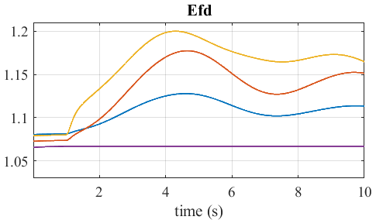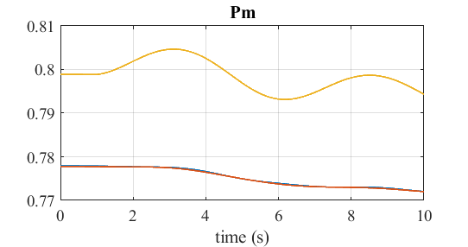
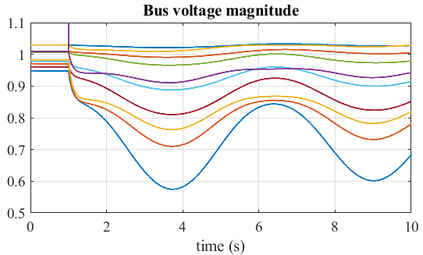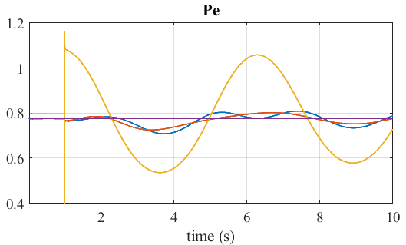
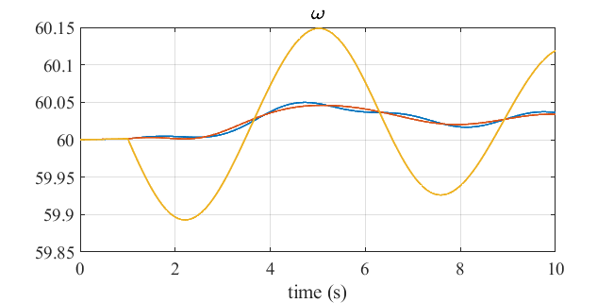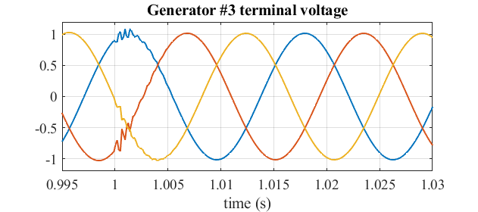
Figure 4.7 Simulation results provided by the SAS-based approach using a 150 μs time step

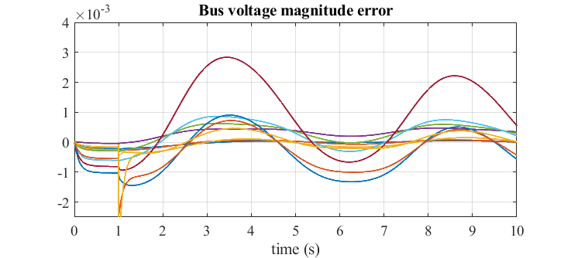
Figure 4.8 Bus voltage magnitude error of the SAS-based simulation using a 150 μs time step

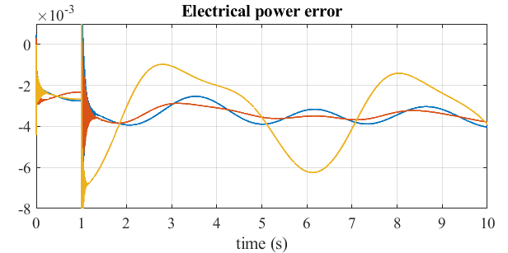
Figure 4.9 Electrical power error of the SAS-based simulation using a 150 μs time step

This chapter proposed a simulation approach using the SAS to solve the synchronous generators and related controls, such as exciters and governors, with a larger time step, while the network is solved by the nodal voltage equation using a fixed time step. An interface between the SAS solution of the synchronous generators and the network nodal solution is designed. Numerical tests show that the SAS could provide accurate results under both steady state and disturbances using a larger time step to improve the efficiency.

Parallel SAS-Based EMT simulation
In this chapter, the nodal formulation based EMT simulation is parallelized using the bordered block diagonal (BBD) proposed in [79] and accelerated by leveraging high-performance computers.
As multicore processors have become commonplace, considerable effort has been directed toward parallel computations for EMT simulations of large power grids [80]. Traditionally, the parallelization of EMT simulations relied on exploiting the natural decoupling between subnetworks that arises from the traveling wave propagation delay across long-distance distributed parameter transmission lines and cables in a manual way; however, the performance of this approach is constrained by the number, location, and length of transmission lines, and it becomes infeasible when the delay is too small [80]-[83]. An alternative, which does not rely on the time delay of lines, is to automatically reformulate the network conductance matrix into a BBD form, which is not fully decoupled but is still amenable to parallelization [79].
As an advanced and promising technique for handling computationally intensive power systems studies, such as contingency analysis, reliability analysis, state estimation, and transient stability simulation, high-performance computing (HPC) can leverage rich computing resources, and thus multiple subtasks can be simultaneously processed with superior efficiency [84][85]. Leveraging HPC clusters at the Pacific Northwest National Laboratory and the National Renewable Energy Laboratory (NREL), transmission and distribution phasor-domain co-simulations of large systems were performed and presented in [86] and [87], respectively.
Thus, to improve the efficiency of EMT simulations, parallel simulation leveraging HPC is tested in this chapter. Also, the simulation speedup performance of the SAS-based simulation proposed in Chapter 4 is tested.

5.1 Parallel simulation strategy
It is widely recognized that a significant amount of time cost, typically up to 80%–97% for large systems, in EMT simulations is consumed by solving the network nodal equation [88]-[90]. Traditionally, the LU decomposition of the sparse G matrix has been used to solve the network nodal voltage vector, v, through forward and backward substitutions; however, such a sequential approach is not easily parallelizable, leading to a bottleneck that limits the speed of EMT simulations. To tackle this challenge and to speed up EMT simulations, the BBD form and the block matrix LU decomposition of the G matrix for the network solution are utilized [79].
In the meanwhile, the updates of generator current injections and control state variables are naturally decoupled and thus can be parallelized effortlessly. Also, the update of network historical currents is naturally decoupled for different circuits and can also be easily parallelized.

5.1.1 Parallel network solution using the bordered block diagonal technique
To efficiently parallelize the network solution, a graph representation of the network is automatically obtained and partitioned into multiple subregions using the METIS software package. Subsequently, each partition is internally reordered using a nested dissection to reduce the number of nonzero elements during the future LU factorization [79].
Taking the WECC 179-bus system as an example, as illustrated in Figure 5.1, a graph representation of the original network is shown on the left, and its BBD form with four partitions is shown on the right.
The partitioning process ultimately transforms the network conductance matrix into the BBD form, with n=m+1:
(5-1)
To solve the network nodal equation during the time domain simulation, the block matrix LU decomposition is conducted before the time-loop simulation, as illustrated in (5-2):
(5-2)
Then, the original network nodal equation in (1-7) becomes:
(5-3)
To solve (5-3), the first step is to solve the following equation by forward substitution:
(5-4)

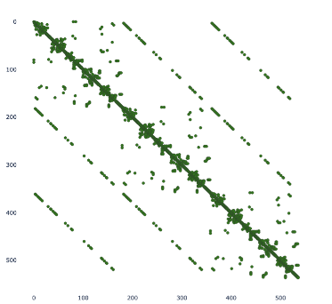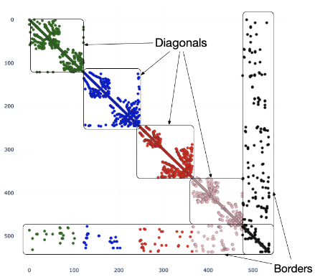
(a) Original representation (b) BBD representation
Figure 5.1 Graph representation of the WECC 179-bus system

where:
(5-5)
Thus, the process of solving (5-4) can be parallelized as:
(5-6)
And in series with:
(5-7)
The second step is to solve the following equation by backward substitution:
(5-8)
which relies on solving v_{n} first by:
(5-9)
Finally, the following equations are parallelized to solve v_{i}:
(5-10)
As shown in Figure 5.2, calculating y_{n} necessitates the synchronization of [y₁, y₂, …, y_{m}] from parallel threads, and v_{n} needs to be synchronized to threads for the parallel calculation of [v₁, v₂, …, v_{m}]; therefore, such junctures are designated as synchronization points. Further, if the LU decomposition is parallelized, the calculation of L_{nn} and U_{nn} is also a synchronization point [79].
Notice that the device update shown in the up-left corner can be conducted using the Euler method or using the SAS approach, and the one with SAS is depicted.

Figure 5.2 Parallel EMT simulation strategy

5.1.2 Parallel update of generator states and network historical currents
Although the same network parallelization approach [79] is used, parallelism can be leveraged beyond the network solution to further improve computational efficiency.
Updating the generator current injection and related control state variables, which can be calculated by the Euler method or the SAS, is naturally decoupled for different devices. This step can be easily parallelized, as shown in the upper green box in Figure 5.2.
Also, historical current updates represent critical steps in EMT simulations, and they exhibit natural independence across most components. As a result, these steps can also be effortlessly parallelized to accelerate simulations, as indicated by the lower dashed green boxes in Figure 5.2.

5.2 Case study
First, the performance of parallel simulation without SAS is tested on the 179-bus WECC system, and the performance is shown in Table 5.1.
As can be observed, the parallel simulation does not show obvious speedup on this 179-bus system, mainly because the utilized BBD technique cannot fully decouple the network, and the system size is not sufficiently large. Thus, the required synchronization process undermines the merit of parallelization, and the advantages of the BBD technique are not exploited in this case.
Nevertheless, the BBD technique is fully automatic and does not require any manual process for parallelization, and it may have great potential for acceleration on large-scale systems with thousands of buses or more.
Based on the above observation, to investigate the performance of the BBD-based

Table 5.1 Comparison of time costs on the 179-Bus WECC system for a 1-second simulation using a 50-μs Time Step
Tool | Series simulation | Parallel simulation
ParaEMT | 22 s | 21 s

parallel simulation on handling large-scale system simulations, the efficiency is studied on a synthetic, large-scale, 10,024-bus system created by interlinking 7×8 replications of the WECC 179-bus system as a large array through newly added transmission lines between neighboring replications [90], as shown in Figure 5.3.
The Eagle supercomputer at NREL is set as the HPC platform for the simulation tests. As a cluster comprising 2618 compute nodes connected by a high-speed, 100-Gb/s EDR InfiniBand network, Eagle is configured to run computationally intensive and parallel computing jobs on the Linux operating system [91].
To comprehensively investigate the performance of ParaEMT parallel simulations, a series of case studies was conducted with varying numbers of network partitions and HPC Message Passing Interface (MPI) ranks [92]. The simulation speedup results are summarized in Figures 5.4 and 5.5.
As shown in Figure 5.4, when the simulation is performed with only 1 MPI rank, no speedup is achieved because the simulation is conducted in a serial manner without parallelization, regardless of the number of partitions. As more MPI ranks are used for the parallel simulations, the simulation speedup generally increases before saturating. Specifically, with the number of HPC MPI ranks and network BBD partitions both varying from 1 to 84, the simulation achieves a peak speedup of approximately 15-18 times when 40-60 network partitions and 60-80 MPI ranks are used, with a corresponding minimum time cost of 90-110 seconds for a 1-second simulation using a 50-μs time step, as shown in Figure 5.5. In comparison, the series simulation costs nearly 1800 seconds for a 1-second simulation, significantly longer than the parallel simulation time cost.

Figure 5.3 A synthetic, large-scale, 10024-bus system created by connecting 7×8 replications of the 179-bus WECC system

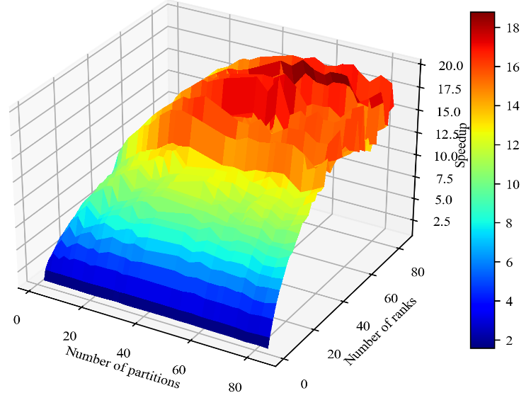
Figure 5.4 Speedup performance when leveraging HPC parallelization relative to a serial simulation on the synthetic 10024-bus system

Figure 5.5 Time cost for a 1-second simulation using a 50 μs time step on the synthetic 10024-bus system

To notice, because the synthetic 10024-bus system is created through weak connections of multiple 179-bus systems, the BBD technique may easily decouple the large system and achieve overly optimistic performance. For a real system that has the same size but more complicated interconnections, the speedup factor may be less than the 15-18 times achieved on the synthetic system.
In addition, the above case studies are all conducted with the conventional approach, which employed the Euler method to solve generator and control states. As presented in Chapter 4, an advantage of SAS is that it provides accurate results using larger time steps with acceptable errors on a two-area system, and its performance and error analysis on large-scale systems remain to be tested in future work. Here, without evaluating the simulation error, the SAS is applied to generators, and a 150 μs time step is used for the simulation for a conceptual study. With both the number of network partitions and the number of HPC MPI ranks varying from 1 to 80, maximum speedup of up to approximately 40-45 is achieved in the parallel SAS-based simulation using a 150 μs time step, as shown in Figure 5.6.
Given the vast amount of data involved in such a large-scale system, considerable effort is required to fully investigate simulation errors of the SAS-based approach on a large system and test its performance with different SAS orders with different time steps. Future work will be devoted to this.

5.3 Conclusion
In this chapter, the BBD technique based parallel EMT simulation proposed in [79] is implemented to parallelize the network solution, which is based on nodal formulation.

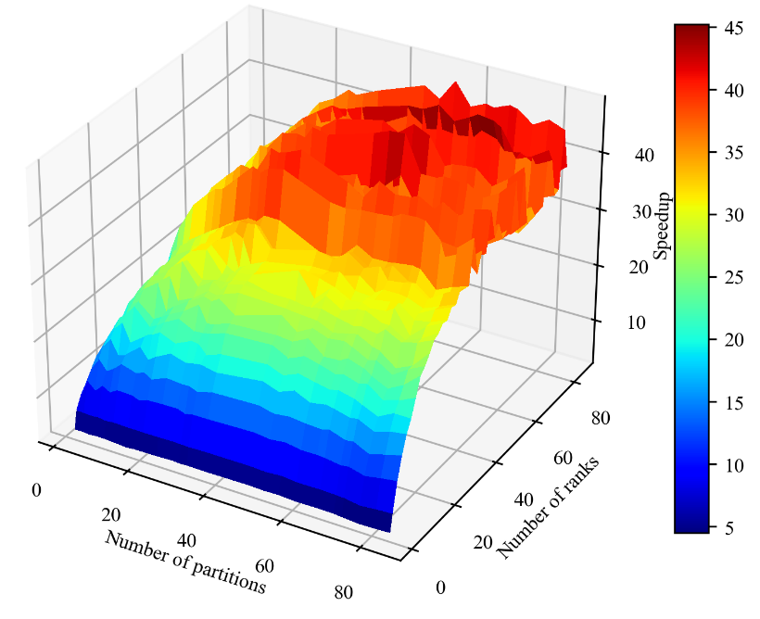
Figure 5.6 Simulation speedup leveraging both SAS and HPC parallelization using a 150 μs time step

Besides, parallelization of other naturally decoupled tasks including update of generator current injection, update of generator states, update of control states, and update of network historical currents is also implemented. Leveraging HPC, which has rich computing resources, the parallel simulation was tested on a synthetic 10,024-bus system. Case study results show that the SAS-based parallel simulation using a 150 μs time step achieves a speedup of approximately 40-45 times.

SAS and High-Order Nodal Formulation-Based EMT Simulation
In this chapter, a high-order nodal formulation approach for the network is proposed based on high-order diagonally implicit Runge-Kutta methods, and the SAS approach is implemented on synchronous generators and interfaced with the network, to explore larger simulation time steps.

6.1 High order diagonally implicit Runge-Kutta methods
As is known, EMT simulation is a stiff problem, and usually numerical A-stable or even L-stable approaches such as the trapezoidal rule method and backward Euler method are used to discretize differential equations of network components [93]-[95].
Although high-order multi-step approaches such as the Gear’s method given in (6-2)-(6-3) are able to solve some stiff problems generally described in (6-1), they require a more complex initialization process to generate history data at previous time steps to start the process, and it is not easy to maintain stability for EMT simulations when the order is higher than two [3][96].
(6-1)
(6-2)
where the coefficients a₁, a₂, …, a_{n}, and b are obtained by solving:
(6-3)
In addition, it is widely recognized that multi-step approaches with an order higher than two cannot be A-stable. Thus, such an approach is usually not considered for EMT nodal formulation.
As a kind of single-step approach, the solution of the Runge-Kutta method has the form in (6-4) for an initial value problem in (6-1):
(6-4)
Equation (6-4) can also be written as:
(6-5)
where y_{i} is the value of y at t+c_{i}Δt, y_{n} is the value of y at t, y_{n+1} is the value of y at t+Δt, and the coefficients are provided by a pre-designed real-valued Butcher tableau in (6-6) [94].
(6-6)
When all a_{ij} where j≥i equal to 0, it becomes the explicit Runge-Kutta method which is not numerically A-stable and cannot ensure stability if applied to EMT simulations. Otherwise, the Runge-Kutta method is implicit and can be A-stable with well-designed parameters, but usually requires iterative approaches such as the Newton-Raphson approach to simultaneously obtain values of k_{i} or y_{i}, which are coupled with each other. This will greatly increase the computation burden.
Nevertheless, when all a_{ij} with j>i equal to 0, which means the corresponding Butcher tableau has a form in (6-7). Such a kind of Runge-Kutta method is diagonally implicit and can be A-stable or L-stable. Compared with fully implicit Runge-Kutta methods, the advantage of diagonally implicit Runge-Kutta (DIRK) is that the values of y_{i} can be solved sequentially, rather than simultaneously.
(6-7)
Specifically, applying (6-5) and (6-7) to (6-1) gives:
(6-8)
As can be seen, the values of y₁, y₂, …, y_{s}, and y_{n+1} can be solved sequentially through these equations, instead of simultaneously. This makes computation easier and more efficient.

6.2 High order nodal approach
To develop a high-order nodal approach using the DIRK method, first take a series R-L circuit shown in Figure 6.1 as an example. Its differential equation is given in (6-9).
(6-9)
Applying the DIRK method detailed in (6-8) to (6-9) yields:
(6-10)
Thus, multistage nodal equations are formulated as:
(6-11)

Figure 6.1 A series resistor-inductor circuit

Moreover, the following two requirements would further simplify the process:
(1) When c_{s}=1 and b_{i}=a_{si}, the last two equations of the DIRK method are identical, as shown in (6-12).
(6-12)
Thus, the last equation can be eliminated, and the first s equations with i=1, 2, …, s are adequate and kept, as shown in (6-13). Also, because c_{s}=1, the last equation calculates state values exactly at the next time step.
(6-13)
With the above requirement, when the DIRK method is applied to the R-L circuit equation, we have:
(6-14)
(2) Furthermore, when a₁₁=a₂₂=…=a_{ss}, the DIRK method becomes the singly diagonal implicit Runge-Kutta method. Then, the companion circuits for calculation of all s stages, which includes s-1 intermediate stages and 1 final stage, have the same equivalent resistance.
(6-15)
This feature could make the network conductance G matrix of each stage equal, and thus greatly simplify the simulation process.
(3) Several DIRK methods with different orders could meet the above two requirements, and some examples are given below with their Butcher tableaus [97]. Specifically, like the SAS approach presented in Chapter 2, the accuracy of DIRK methods will increase with the order, but usually more intermediate points need to be calculated. So, there is a trade-off between accuracy and computation burden.
A two-stage 2nd-order DIRK method is given in (6-16).
(6-16)
A three-stage 3rd-order DIRK method is given in (6-17).
(6-17)
A five-stage 4th-order DIRK method is given in (6-18).
(6-18)
A five-stage 5th-order DIRK method is given in (6-19). Here, although the original stage number is six, the first stage calculates the initial values and can be ignored. Thus, it can be regarded as a five-stage method.
(6-19)
As can be seen from (6-18) and (6-19), (6-19) is superior to (6-18) because both are five-stage methods and have the same computational cost, but (6-19) has higher order, i.e., higher accuracy, than (6-18).
DIRK methods with even higher orders are not presented here and remain to be investigated in future work.
Although only one example with an R-L circuit is given in (6-11), the same process can be easily extended to equations of other circuits. For example, the differential equation of a capacitor C is given in (6-20), and the corresponding solution provided by the DIRK method is given in (6-21).
(6-20)
(6-21)

6.3 Case study with ideal current sources
To test the performance of the high-order nodal approach based on the DIRK methods, a four-bus system shown in Figure 6.2 is built. This system has three transmission lines represented by PI sections, two ideal current sources, and two loads represented by constant R-L circuits.
First, both the state-space and nodal approaches are implemented to simulate the system. Considering a three-phase grounding fault happens at t=0.5 s on Bus 2 and is then cleared at t=0.6 s without losing any network component, the results provided by the state-space approach are compared with those of the nodal approach, which is based on the trapezoidal rule method. The results using a 1-μs time step are shown in Figures 6.3-6.5.
Figure 6.2 A four-bus system
Figure 6.3 Phase A Voltage at Bus 2
Figure 6.4 Phase B Voltage at Bus 3
Figure 6.5 Phase C Current of Branch 2-3
As can be observed, the results provided by the state-space approach and the nodal approach-based on the trapezoidal rule method can accurately match with each other. This proves the correct implementation of the nodal approach.
Second, the accuracy of DIRK methods is tested using a small time step of 1 μs, and the errors are given in Table 6.1. Here only errors of the instantaneous voltages at all buses are considered because voltages have a per unit value close to 1 and errors of currents can also be reflected in voltages. Table 6.1 shows that all DIRK methods are correctly implemented, as they are all very accurate when a small time step is used.
Third, the simulation errors of the nodal approach using different numerical methods, including the trapezoidal rule method and DIRK methods with an order from 2 to 5, are summarized in Table 6.2. Here, the benchmark is provided by the nodal approach using the trapezoidal rule method with a time step of 1 μs, and instantaneous voltage errors under time steps of 50 μs and 100 μs are presented.
As shown in Table 6.2, when all methods use the same time step, the 2nd-order DIRK method has a close error with the trapezoidal rule method. With the increase of the order from 2 to 5, the accuracy of the DIRK method becomes higher and higher, across all intervals, including steady-state, during-fault, and post-fault periods.
For illustration, the maximum error of the 5th-order DIRK method is shown in Figure 6.6. Large errors appear right after disturbances because a low-order method cannot perfectly capture fast dynamics with a fixed time step that is not small enough. After that, the results gradually converge to the true results and the error becomes much smaller. This is the case for all other tested numerical approaches, but the error levels may be different.

Table 6.1 Maximum simulation error of different numerical methods using a 1 μs time step
Numerical methods  with a 1 μs time step | Maximum error of the instantaneous voltage
Trapezoidal rule | 6.5×10⁻⁵
2nd-order DIRK | 6.4×10⁻⁵
3rd-order DIRK | 2.4×10⁻⁶
4th-order DIRK | 8.5×10⁻⁷
5th-order DIRK | 4.5×10⁻¹⁰

Table 6.2 Maximum simulation error of different numerical methods using time steps of 50 μs and 100 μs
Numerical methods |  | Maximum error of instantaneous voltages
 |  | Time step: 50 μs | Time step: 100 μs
Trapezoidal rule | Steady state | 1.77×10⁻⁵ | 7.05×10⁻⁵
Trapezoidal rule | During fault | 0.325 | 0.911
Trapezoidal rule | Post fault | 0.334 | 0.736
2nd-order DIRK | Steady state | 2.5×10⁻⁵ | 1.0×10⁻⁴
2nd-order DIRK | During fault | 0.16 | 0.54
2nd-order DIRK | Post fault | 0.17 | 0.49
3rd-order DIRK | Steady state | 4.0×10⁻⁶ | 2.72×10⁻⁵
3rd-order DIRK | During fault | 0.033 | 0.189
3rd-order DIRK | Post fault | 0.04 | 0.19
4th-order DIRK | Steady state | 6.0×10⁻⁹ | 1.37×10⁻⁷
4th-order DIRK | During fault | 4.1×10⁻⁴ | 0.0065
4th-order DIRK | Post fault | 6.16×10⁻⁴ | 0.0095
5th-order DIRK | Steady state | 6.9×10⁻¹¹ | 2.6×10⁻⁹
5th-order DIRK | During fault | 8.6×10⁻⁵ | 0.00258
5th-order DIRK | Post fault | 1.5×10⁻⁴ | 0.0045

Figure 6.6 Maximum error of the 5th-order DIRK method using a 100 μs time step

The tests above show that a higher-order DIRK method could provide more accurate results, but their efficiency has not yet been thoroughly tested. To do this, using the error of the trapezoidal rule method as a reference, and then under the same accuracy level defined by the error reference, the maximum allowable time steps for the DIRK methods are evaluated, as shown in Table 6.3.
As can be seen from Table 6.3, the time steps under the same accuracy level or error tolerance can be gradually enlarged with the increase of order. Because the majority of the time cost comes from solving the nodal equation, we can simply assume that the computational costs for each stage are the same for different approaches. Also, the number of stages of different methods is summarized in Table 6.4.
Then, we can roughly estimate the computational efficiency by dividing the time steps by the number of stages, as shown in (6-22), which represents the allowable time step for each stage, and a larger number indicates a higher efficiency.
(6-22)
Based on (6-22) and the results presented in Table 6.3, the efficiency of different numerical methods is presented in Table 6.5 and Figure 6.7, where the average efficiency for pre fault, during fault, and post fault periods are used for efficiency presentation in Figure 6.7.
As can be observed, the 2nd-order DIRK method is less efficient than the trapezoidal rule method. The 3rd-order and 4th-order DIRK methods have roughly the same efficiency as the trapezoidal rule method, and the 5th-order DIRK method is more efficient than the trapezoidal rule method and is also the most efficient one.

Table 6.3 Maximum time steps of different numerical methods under the same maximum error tolerances
Numerical methods |  | Maximum time steps under the same error tolerances
 |  | Tolerance 1:  Steady state: 1.77×10⁻⁵  During fault: 0.325  Post fault: 0.334 | Tolerance 2:  Steady state: 7.05×10⁻⁵  During fault: 0.911  Post fault: 0.736
Trapezoidal rule | Steady state | 50 μs | 100 μs
Trapezoidal rule | During fault | 50 μs | 100 μs
Trapezoidal rule | Post fault | 50 μs | 100 μs
2nd-order DIRK | Steady state | 35 μs | 90 μs
2nd-order DIRK | During fault | 75 μs | 175 μs
2nd-order DIRK | Post fault | 75 μs | 150 μs
3rd-order DIRK | Steady state | 80 μs | 150 μs
3rd-order DIRK | During fault | 130 μs | 500 μs
3rd-order DIRK | Post fault | 130 μs | 500 μs
4th-order DIRK | Steady state | 300 μs | 450 μs
4th-order DIRK | During fault | 250 μs | 600 μs
4th-order DIRK | Post fault | 250 μs | 600 μs
5th-order DIRK | Steady state | 550 μs | 800 μs
5th-order DIRK | During fault | 350 μs | 800 μs
5th-order DIRK | Post fault | 350 μs | 800 μs

Table 6.4 Number of stages of different numerical methods
Numerical methods | Number of stages
Trapezoidal rule | 1
2nd-order DIRK  (defined by equation 6-16) | 2
3rd-order DIRK  (defined by equation 6-17) | 3
4th-order DIRK  (defined by equation 6-18) | 5
5th-order DIRK  (defined by equation 6-19) | 5

Table 6.5 Efficiency of different numerical methods under the same maximum error tolerances
Numerical methods |  | Efficiency under the same maximum error tolerances
 |  | Tolerance 1:  Steady state: 1.77×10⁻⁵  During fault: 0.325  Post fault: 0.334 | Tolerance 2:  Steady state: 7.05×10⁻⁵  During fault: 0.911  Post fault: 0.736
Trapezoidal rule | Steady state | 1 | 1
Trapezoidal rule | During fault | 1 | 1
Trapezoidal rule | Post fault | 1 | 1
2nd-order DIRK | Steady state | 0.35 | 0.45
2nd-order DIRK | During fault | 0.75 | 0.875
2nd-order DIRK | Post fault | 0.75 | 0.75
3rd-order DIRK | Steady state | 0.53 | 0.5
3rd-order DIRK | During fault | 0.87 | 1.67
3rd-order DIRK | Post fault | 0.87 | 1.67
4th-order DIRK | Steady state | 1.2 | 0.9
4th-order DIRK | During fault | 1.0 | 1.2
4th-order DIRK | Post fault | 1.0 | 1.2
5th-order DIRK | Steady state | 2.2 | 1.6
5th-order DIRK | During fault | 1.4 | 1.6
5th-order DIRK | Post fault | 1.4 | 1.6

Figure 6.7 Efficiency of different numerical methods under the same maximum error tolerances

As previously discussed, although the 5th-order DIRK method in (6-19) has six stages, the first stage, which calculates the values at the starting point, can be ignored. Therefore, it is always superior to the 4th-order DIRK method in (6-18). The case study results also validated this.
Except for the maximum error, the average error can also be used to estimate the performance of different approaches. In the same way, the average error of the trapezoidal rule method is set as the average error tolerance, and the performance of DIRK methods with different orders is tested, as shown in Table 6.6. Notice, as discussed, the 5th-order DIRK method is always superior to the 4th-order, here only the 2nd-order, 3rd-order, and 5th-order DIRK methods are tested. Besides, the average efficiency is analyzed in Table 6.7 and plotted in Figure 6.8. From the results, we can still get the same results that the 5th-order has the best performance and is superior to the trapezoidal rule method for circuit simulations in this case.

6.4 Case study with synchronous generators
The case studies in Section 6.3 used ideal current sources as power sources, which means that the current inputs of the whole system at any time instants are known. In real power systems, the current injections usually come from synchronous generators. Thus, the case studies in this section replace the ideal current sources with synchronous generators and continue the tests.
The same synchronous generator described Section 2.3 (2-12)-(2-21) is used, and interfaced with the network using the Thevenin equivalent circuit presented in Section 4.2.

Table 6.6 Maximum time steps of different numerical methods under the same average error tolerances
Numerical methods |  | Maximum time steps under the same average error tolerances
 |  | Tolerance 1:  Steady state: 1.23×10⁻⁵  During fault: 0.025  Post fault: 0.02 | Tolerance 2:  Steady state: 4.95×10⁻⁵  During fault: 0.039  Post fault: 0.033
Trapezoidal rule | Steady state | 50 μs | 100 μs
Trapezoidal rule | During fault | 50 μs | 100 μs
Trapezoidal rule | Post fault | 50 μs | 100 μs
2nd-order DIRK | Steady state | 50 μs | 90 μs
2nd-order DIRK | During fault | 80 μs | 200 μs
2nd-order DIRK | Post fault | 80 μs | 200 μs
3rd-order DIRK | Steady state | 200 μs | 300 μs
3rd-order DIRK | During fault | 200 μs | 450 μs
3rd-order DIRK | Post fault | 200 μs | 450 μs
5th-order DIRK | Steady state | 600 μs | 750 μs
5th-order DIRK | During fault | 400 μs | 1000 μs
5th-order DIRK | Post fault | 400 μs | 1000 μs

Table 6.7 Efficiency of different numerical methods under the same average error tolerances
Numerical methods |  | Efficiency under the same average error tolerances
 |  | Tolerance 1:  Steady state: 1.77×10⁻⁵  During fault: 0.325  Post fault: 0.334 | Tolerance 2:  Steady state: 7.05×10⁻⁵  During fault: 0.911  Post fault: 0.736
Trapezoidal rule | Steady state | 1 | 1
Trapezoidal rule | During fault | 1 | 1
Trapezoidal rule | Post fault | 1 | 1
2nd-order DIRK | Steady state | 0.5 | 0.45
2nd-order DIRK | During fault | 0.8 | 1.0
2nd-order DIRK | Post fault | 0.8 | 1.0
3rd-order DIRK | Steady state | 1.33 | 1.0
3rd-order DIRK | During fault | 1.33 | 21.5
3rd-order DIRK | Post fault | 1.33 | 1.5
5th-order DIRK | Steady state | 2.4 | 1.5
5th-order DIRK | During fault | 1.6 | 2.0
5th-order DIRK | Post fault | 1.6 | 2.0

Figure 6.8 Efficiency of different numerical methods under the same average error tolerances

Notice that when a high-order DIRK method is used for the network nodal formulation, state values at several intermediate points need to be calculated, as presented in (6-14) and (6-21). Hence, the current injections from generators at those intermediate points should also be provided. To do this, the SAS is applied to the generator model, and as the simulation progresses, SAS values are updated using:
(6-23)
The calculation of generator SAS coefficients is the same as the process presented in equation (2-22)-(2-26). Thus, finally, the SAS-represented synchronous generator is interfaced with the DIRK discretized network equation through current injections.
Through multiple studies, the order of the SAS does not affect the accuracy much, and thus a 3rd-order SAS is used for synchronous generators. Also, case studies in Section 6.3 show that the 5th-order DIRK method has better performance than DIRK methods with an order from 2 to 4, thus the network is solved by the 5th-order DIRK method here.
The performance of using SAS for solving the generator equation and 5th-order DIRK methods for solving the network equation is shown in Tables 6.8-6.10. As shown in Table 6.8, using the same time step, the errors are bigger than those on the four-bus system with ideal current sources, mainly because of stronger nonlinearity of generators.

Table 6.8 Maximum simulation errors of different numerical methods using time steps of 50 μs and 100 μs on the four-bus system with synchronous generators
Numerical methods |  | Maximum errors of the instantaneous voltage
 |  | Time step: 50 μs | Time step: 100 μs
Trapezoidal rule | Steady state | 5.2×10⁻⁶ | 2.1×10⁻⁵
Trapezoidal rule | During fault | 0.49 | 0.57
Trapezoidal rule | Post fault | 2.34 | 3.21
SAS with 5th-order DIRK | Steady state | 1.6×10⁻⁶ | 1.1×10⁻⁵
SAS with 5th-order DIRK | During fault | 0.004 | 0.047
SAS with 5th-order DIRK | Post fault | 0.047 | 0.36

Table 6.9 Maximum time steps of different numerical methods under the same error tolerances on the four-bus system with synchronous generators
Numerical methods |  | Maximum time step under the same error tolerance
 |  | Tolerance 1:  Steady state: 1.77×10⁻⁵  During fault: 0.325  Post fault: 0.334 | Tolerance 2:  Steady state: 7.05×10⁻⁵  During fault: 0.911  Post fault: 0.736
Trapezoidal rule | Steady state | 50 μs | 100 μs
Trapezoidal rule | During fault | 50 μs | 100 μs
Trapezoidal rule | Post fault | 50 μs | 100 μs
SAS with 5th-order DIRK | Steady state | 350 μs | 750 μs
SAS with 5th-order DIRK | During fault | 400 μs | 650 μs
SAS with 5th-order DIRK | Post fault | 400 μs | 700 μs

Table 6.10 Efficiency of different numerical methods under the same error tolerances on the 4-bus system with synchronous generators
Numerical methods |  | Efficiency under the same maximum error tolerance
 |  | Tolerance 1:  Steady state: 1.77×10⁻⁵  During fault: 0.325  Post fault: 0.334 | Tolerance 2:  Steady state: 7.05×10⁻⁵  During fault: 0.911  Post fault: 0.736
Trapezoidal rule | Steady state | 1 | 1
Trapezoidal rule | During fault | 1 | 1
Trapezoidal rule | Post fault | 1 | 1
2nd-order DIRK | Steady state | 1.4 | 1.5
2nd-order DIRK | During fault | 1.6 | 1.3
2nd-order DIRK | Post fault | 1.6 | 1.4

As shown in Table 6.8-6.10, with the high-order nodal formulation method to solve the network equation, and the SAS to solve the generator state-space equation, the simulation efficiency is improved compared to the traditional approach based on the trapezoidal rule method.

6.5 Conclusion
The trapezoidal rule-based nodal approach is efficient for large-scale system EMT simulation, but its accuracy level is not high. To explore a high-order network solver that can improve efficiency, a high-order nodal approach based on the DIRK methods is proposed and tested. Case studies show that a high-order nodal approach base on the 5th-order DIRK method is more efficient than the trapezoidal rule method under the same accuracy level.
Additionally, the proposed high-order nodal approach can be easily applied to large networks. The formulation of the network G matrix is straightforward and similar to that of the trapezoidal rule method, and the G matrix remains constant during the whole simulation under a fixed time step. Although updating historical currents will include more terms with an increase of order, it can be easily automated without adding many arithmetic operations.
Besides, to implement high-order solutions on both the network and generator side, the SAS solved generator is interfaced with a high-order nodal approach solved network. Case studies also demonstrate the high performance of the SAS and high-order nodal approach-based simulation strategy.

Conclusions and Future Work

This dissertation proposed an SAS-based EMT simulation approach to enlarge the time step and reduce computational cost using a conventional state-space representation. A variable time step strategy is incorporated into the multistage simulation strategy to further enhance its robustness and efficiency. Also, a switch detection algorithm is proposed to accurately locate the time instants when limits are violated, making it flexible and adaptable to accurately simulate state switches caused by limit violations. Case studies on multiple systems validated the accuracy and high efficiency of proposed approaches.
When the nodal formulation instead of the state-space formulation is used for the network, the SAS can still be utilized on the synchronous generator side to improve the efficiency. Also, leveraging parallel computing, the simulation can be greatly speeded up on large-scale systems.
A high-order nodal approach is proposed using the high-order DIRK method to solve the network equation. Through interfacing with the SAS that solves the generator equation, the efficiency is improved.
Meanwhile, when the proposed SAS approach is applied to a system or component with stronger stiffness such as detailed power electronics with a high switching frequency, the simulation time step of the proposed SAS-based approach may be constrained to a small value, which could undermine its potential benefits. Such issues will be explored in our future work.

References
- J. Shu, W. Xue, W. Zheng, “A parallel transient stability simulation for power systems,” IEEE Trans. Power Syst., vol. 20, no. 4, pp. 1709–1717, Nov. 2005.
- V. Jalili-Marandi, V. Dinavahi, K. Strunz, J. A. Martinez, A. Ramirez, “Interfacing techniques for transient stability and electromagnetic transient programs,” IEEE Trans. Power Del., vol. 24, no. 4, pp. 2385–2395, Oct. 2009.
- J. Mahseredjian, V. Dinavahi, J. A. Martinez, “Simulation tools for electromagnetic transients in power systems: overview and challenges,” IEEE Trans. Power Del., vol. 24, no.3, pp. 1657–1669, Jul. 2009.
- A. Sharma, S. C. Srivastava, S. Chakrabarti, “Testing and validation of power system dynamic state estimators using real time digital simulator (RTDS),” IEEE Trans. Power Syst., vol. 31, no. 3, pp. 2338–2347, May 2016.
- M. D. Heffernan, K. S. Turner, J. Arrillaga, C. P. Arnold, “Computation of A.C.-D.C. system disturbances: Part I, II, and III,” IEEE Trans. Power App. Syst., vol. PAS–100, no. 11, pp. 4341–4363, Nov. 1981.
- J. Reeve, R. Adapa, “A new approach to dynamic analysis of AC networks incorporating detailed modeling of DC systems. I. Principles and implementation,” IEEE Trans. Power Del., vol. 3, no. 4, pp. 2005–2011, Oct. 1988.
- K. Mudunkotuwa, S. Filizadeh, U. Annakkage, “Development of a hybrid simulator by interfacing dynamic phasors with electromagnetic transient simulation,” IET Gener., Transmiss. Distrib., vol. 11, no. 12, pp. 2991–3001, Aug. 2017.
- Q. Huang, V. Vittal, “Advanced EMT and phasor-domain hybrid simulation with simulation mode switching capability for transmission and distribution systems,” IEEE Trans. Power Syst., vol. 33, no. 6, pp. 6298–6308, Nov. 2018.
- D. Shu et al., “A novel interfacing technique for distributed hybrid simulations combining EMT and transient stability models,” IEEE Trans. Power Del., vol. 33, no. 1, pp. 130–140, Mar. 2018.
- Z. Zhou, V. Dinavahi, “Parallel massive-thread electromagnetic transient simulation on GPU,” IEEE Trans. Power Del., vol. 29, no. 3, pp. 1045–1053, Jun. 2014.
- T. Cheng, T. Duan, V. Dinavahi, “Parallel-in-time object-oriented electromagnetic transient simulation of power systems,” IEEE Open Access J. Power Energy, vol. 7, pp. 296–306, Jul. 2010.
- Z. Zhou, V. Dinavahi, “Fine-grained network decomposition for massively parallel electromagnetic transient simulation of large power systems,” IEEE Power Energy Technol. Syst. J., vol. 4, no. 3, pp. 51–64, Dec. 2017.
- M. Xiong, B. Wang, D. Vaidhynathan, et al., “An open-source parallel EMT simulation framework,” preprint. Golden, CO: National Renewable Energy Laboratory,” NREL/CP-5D00-87164. Sep. 2023.
- M. Xiong, B. Wang, D. Vaidhynathan, et al., “ParaEMT: An open source, parallelizable, and HPC-compatible EMT simulator for large-scale IBR-rich power grids,” IEEE Trans. Power Del., Dec. 2023.
- C. Dufour, J. Mahseredjian, J. Bélanger, “A combined state-space nodal method for the simulation of power system transients,” IEEE Trans. Power Del., vol. 26, no. 2, pp.928–935, Apr. 2011.
- F. Gao, K. Strunz, “Frequency-adaptive power system modeling for multi-scale simulation of transients,” IEEE Trans. Power Syst., vol. 24, no. 2, pp. 561–571, May 2009.
- P. Zhang, J. R. Marti, H. Dommel, “Shifted-frequency analysis for EMTP simulation of power system dynamics,” IEEE Trans. Circuits Syst. I, Reg. Papers, vol. 57, no. 9, pp. 2564–2574, Sep. 2010.
- S. Almer, U. Jonsson, “Dynamic phasor analysis of periodic systems,” IEEE Trans. Autom. Control, vol. 54, no. 8, pp. 2007–2012, Aug. 2009.
- T. H. Demiray, “Simulation of power system dynamics using dynamic phasor models,” Ph.D. dissertation, Dept. Inf. Technol. Elect. Eng., Swiss Fed. Inst. Technol., Zurich, Zurich, Switzerland, 2008.
- R. Yao, F. Qiu, K. Sun, “Contingency analysis based on partitioned and parallel holomorphic embedding,” IEEE Trans. Power Syst., vol. 37, no. 1, pp. 565–575, Jan. 2022.
- B. Park, K. Sun, A. Dimitrovski, Y. Liu, S. Simunovic, “Examination of semi-analytical solution methods in the coarse operator of parareal algorithm for power system simulation,” IEEE Trans. Power Syst., vol. 36, no. 6, pp. 5068–5080, Nov. 2021.
- Y. Liu, K. Sun, “Solving power system differential algebraic equations using differential transformation,” IEEE Trans. Power Syst., vol. 35, no. 3, pp. 2289–2299, May. 2019.
- R. Yao, Y. Liu, K. Sun, F. Qiu, J. Wang, “Efficient and robust dynamic simulation of power systems with holomorphic embedding,” IEEE Trans. Power Syst., vol. 35, no. 2, pp. 938–949, Mar. 2020.
- B. Wang, N. Duan, K. Sun, “A time-power series based semi-analytical approach for power system simulation,” IEEE Trans. Power Syst., vol. 34, no. 2, pp. 841–851, Mar. 2019.
- N. Duan, K. Sun, “Power system simulation using the multistage Adomian decomposition method,” IEEE Trans. Power Syst., vol. 32, no. 1, pp. 430–441, Jan. 2017.
- M. Xiong, X. Xu, K. Sun, B. Wang, “Approximation of the frequency-amplitude curve using the homotopy analysis method,” in IEEE Power & Energy Society General Meeting, Washington, DC, 2021, pp. 1–5.
- I. H. A. Hassan, “Different applications for the differential transformation in the differential equations,” Appl. Math. Comput., vol. 129, no. 2-3, pp. 183–201, Jul. 2002.
- F. Ayaz, “Applications of differential transform method to differential-algebraic equations,” Appl. Math. Comput., vol. 152, no. 3, pp: 649–657, May 2004.
- M. Idrees, F. Mabood, A. Ali, G. Zaman, “Exact solution for a class of stiff systems by differential transform Method,” Appl. Math., vol. 4, no. 3, pp: 440–444, May 2013.
- A. Sinkar, H. Zhao, B. Qu, A. M. Gole, “A comparative study of electromagnetic transient simulations using companion circuits, and descriptor state-space equations,” Electr. Power Syst. Res., vol. 198, pp: 107360, Sep. 2021.
- H. Zhao, S. Fan, A. Gole, “Equivalency of state space models and EMT companion circuit models,” in Proc. Int. Conf. Power Syst. Transients, 2019, pp. 1–5.
- S. Natarajan, “A systematic method for obtaining state equations using MNA,” IEE Proceedings G-Circuits, Devices and Systems, vol. 138, no. 3, pp: 341–346. Jun. 1991.
- A. R. Sana, J. Mahseredjian, X. Dai-Do, H. W. Dommel, “Treatment of discontinuities in time-domain simulation of switched networks,” Mathematics and Computers in Simulations, vol. 38, pp. 377–387, Aug. 1995.
- H. W. Dommel, “EMTP theory book,” Portland, OR: Bonneville Power Admin., Aug. 1986.
- F. Alvarado, “Eliminating numerical oscillations in trapezoidal integration,” EMTP Newsletter, vol. 2, no. 3, pp. 20–32, Feb. 1982.
- N. Watson, J. Arrillaga, “Power systems electromagnetic transients simulation,” Stevenage, U.K.: IET, 2003.
- H. W. Dommel, “Digital computer solution of electromagnetic transients in single-and multiphase networks,” IEEE Trans. Power Apparatus and Systems, vol. PAS-88, no. 4, pp. 388–399, Apr. 1969.
- M. Sajjadi, T. Xia, M. Xiong, et al., “Estimation of participation factors using the synchrosqueezed wavelet transform,” in IEEE PES General Meeting, Orlando, FL, Jul. 2023. pp. 1–5.
- M Sajjadi, K Huang, K Sun, “Participation factor-based adaptive model reduction for fast power system simulation,” in IEEE PES General Meeting, Denver, CO, Jul. 2023. pp. 1–5.
- X. Wang et al., “Tri-level scheduling model considering residential demand flexibility of aggregated HVACs and EVs under distribution LMP,” IEEE Trans. Smart Grid, vol. 12, no. 5, pp. 3990–4002, Sep. 2021.
- B. She, Y. Dong, Y. Liu, “Time delay of wide area damping control in urban power grid: Model-based analysis and data-driven compensation,” Front. Energy Res., p. 526, Apr. 2022.
- M. Sajjadi, S. Hossein, M. Shahrzad, “Dynamic model validation for large-scale networks using the dominant time intervals,” In IEEE Texas Power and Energy Conference, College Station, TX, USA, 2020, pp. 1–6.
- M. Sajjadi, H. Seifi, “A new approach for parameter estimation of power system equipment models,” in International Power System Conference (PSC), Dec. 2019, pp. 530–535.
- S. Liao, “A second-order approximate analytical solution of a simple pendulum by the process analysis method,” J. of Applied Mechanics, vol. 59, no. 4, pp.970–975, Dec. 1992.
- S. Liao, “Homotopy analysis method in nonlinear differential equations,” Beijing: Higher Education Press, 2012.
- A. Hatcher, “Algebraic topology,” Cambridge: Cambridge University Press. 2002.
- M. D. Carmo, “Differential Forms and Applications,” Springer Science & Business Media, 1998.
- K. Sun, “Power system simulation using semi-analytical methods,” Wiley-IEEE Press, 2023.
- N. Duan, K. Sun, “Stochastic power system simulation using the adomian decomposition method,” unpublished paper, 2017. [Online]. Available: https://arxiv.org/abs/1710.02415
- G. Gurrala, D. L. Dinesha, A. Dimitrovski, P. Sreekanth, S. Simunovic, M. Starke, “Large multi-machine power system simulations using multi-stage Adomian decomposition,” IEEE Trans. Power Syst., vol. 32, no. 5, pp. 3594–3606, Sept. 2017.
- Y. Liu, K. Sun, R. Yao, B. Wang, “Power system time domain simulation using a differential transformation method,” IEEE Trans. Power Syst., vol. 34, no. 5, pp. 3739–3748, Sept. 2019.
- Z. Hu, M. Xiong, H. Shang, A. Deng, “Anti-interference measurement methods of the coupled transmission-line capacitance parameters based on the harmonic components,” IEEE Trans. Power Del., vol. 31, no. 6, pp. 2464–2472, Dec. 2016.
- Z. Hu, M. Xiong, C. Li, P. Tang, “New approach for precisely measuring the zero-sequence parameters of long-distance double-circuit transmission lines,” IEEE Trans. Power Del., vol. 31, no .4, pp. 1627–1635, Aug. 2016.
- L. Wang, J. Jatskevich, “A voltage-behind-reactance synchronous machine model for the EMTP-type solution,” IEEE Trans. Power Syst., vol. 21, no. 4, pp. 1539–1549, Nov. 2006.
- Z. Guo, K. Sun, X. Su, S. Simunovic, “A review on simulation models of cascading failures in power systems,” iEnergy, vol. 2, no. 1, pp. 284-296, Dec. 2023.
- G. Kou, P. Markham, S. Hadley, T. King, Y. Liu, “Impact of governor deadband on frequency response of the U.S. eastern interconnection,” IEEE Trans. Smart Grid, vol. 7, no. 3, pp. 1368–1377, May 2016.
- S. Maslennikov, B. Wang, “Creation of simulated test cases for the oscillation source location contest,” National Renewable Energy Lab. (NREL), Golden, CO, Tech. Rep. NREL/CP-6A40-81394, Mar. 2022.
- B. She, F. Li, H. Cui, J. Zhang, R. Bo, “Fusion of microgrid control with model-free reinforcement learning: review and insight,” IEEE Trans. Smart Grid, vol. 14, no. 4, pp. 3232–3245, Jul. 2023,
- A. A. van der Meer, M. Gibescu, M. A. M. M. van der Meijden, W. L. Kling, J. A. Ferreira, “Advanced hybrid transient stability and EMT simulation for VSC-HVDC systems,” IEEE Trans. Power Del., vol. 30, no. 3, pp. 1057–1066, Jun. 2015.
- K. Huang, K. Sun, “A review on applications of holomorphic embedding methods,” iEnergy, Early Access, Dec. 2023.
- J. Rocabert, A. Luna, F. Blaabjerg, P. Rodriguez, “Control of power converters in AC microgrids,” IEEE Trans. Power Electron., vol. 27, no. 11, pp. 4734–4749, Nov. 2012.
- B. She, F. Li, H. Cui, et al., “Inverter PQ control with trajectory tracking capability for microgrids based on physics-informed reinforcement learning,” IEEE Trans. Smart Grid, vol. 15, no. 1, pp. 99–112, Jan. 2024.
- B. She, F. Li, H. Cui, et al., “Decentralized and coordinated Vf control for islanded microgrids considering DER inadequacy and demand control,” IEEE Trans. Energy Convers., vol. 38, no. 3, pp. 1868–1880, Sept. 2023.
- V. A. Lacerda, E. P. Araujo, M. Cheah-Mañe, O. Gomis-Bellmunt, “Phasor modeling approaches and simulation guidelines of voltage-source converters in grid-integration studies,” IEEE Access, vol. 10, pp. 51826– 51838, May 2022.
- B. She, F. Li, H. Cui, et al., “Virtual inertia scheduling (VIS) for real-time economic dispatch of IBRs-penetrated power systems,” IEEE Trans. Sustain. Energy, 2023.
- B. She, J. Liu, F. Qiu, et al., “Systematic controller design for inverter-based microgrids with certified large-signal stability and domain of attraction,” IEEE Trans. Smart Grid, 2023.
- Prabha Kundur, “Power system stability and control,” The EPRI Power System Engineering Series, 1994, McGraw-Hill.
- M. Sajjadi, H. Seifi, H. Delkhosh, “A new approach for system-wide power system frequency model validation via measurement data,” Engineering Reports, vol. 4, no. 1, Jan. 2022.
- X. Su, Z. Guo, K. Sun, “A quasi-dynamic energy function method for out-of-step prediction under line outages,” IEEE PES General Meeting, Denver, CO, July 17-21, 2022, pp. 1–5.
- Z. Guo, K. Sun, B. Park, S. Simunovic, W. Kang, “A directed acyclic graph neural network for AC optimal power flow,” IEEE PES General Meeting, Orlando, FL, July 16-20, 2023, pp. 1–5.
- M. Xiong, R. Yao, Y. Liu, K. Sun, F. Qiu, “Semi-analytical electromagnetic transient simulation using differential transformation,” SPIES, Bejing, Dec. 2022, pp. 481–486.
- New England IEEE 39-Bus System. Accessed: Aug. 18, 2022. [Online]. Available: https://electricgrids.engr.tamu.edu/electric-grid-test-cases/newengland-ieee-39-bus-system
- Build MEX function or engine application. Accessed: Jun. 2023. [Online]. Available: https://www.mathworks.com/help/matlab/ref/mex.html
- X. Wang, F. Li, Q. Zhang, Q. Shi, and J. Wang, “Profit-oriented BESS siting and sizing in deregulated distribution systems,” IEEE Trans. Smart Grid, vol. 14, no. 2, pp. 1528–1540, Mar. 2023.
- X. Wang, F. Li, L. Bai, X. Fang, “DLMP of competitive markets in active distribution networks: Models, solutions, applications, and visions,” Proceedings of the IEEE, pp. 1–19, 2022.
- X. Wang, F. Li, J. Zhao, et al., “Tri-level hybrid interval-stochastic optimal scheduling for flexible residential loads under GAN-assisted multiple uncertainties,” Int. J. Elect. Power Energy Syst, vol. 146, p. 108672, 2023.
- P. Kuffel, K. Kent, G. Irwin, “The implementation and effectiveness of linear interpolation within digital simulation,” Int. J. Elect. Power Energy Syst., vol. 19, no. 4, pp. 221–227, May 1997.
- H. Zhao, S. Fan, A. M. Gole, “Stability evaluation of interpolation, extrapolation, and numerical oscillation damping methods applied in EMT simulation of power networks with switching transients,” IEEE Trans. Power Del., vol. 36, no. 4, pp. 2046–2055, Aug. 2021.
- S. Fan, H. Ding, A. Kariyamasam, A. M. Gole, “Parallel electro-magnetic transients simulation with shared memory architecture computers”, IEEE Trans. Power Del., vol. 33, no. 1, pp. 239–247, Jun. 2018.
- B. Bruned, P. Rault, S. Dennetière, I. M. Martins, “Use of efficient task allocation algorithm for parallel real-time EMT simulation,” Electric Power Syst. Res., p. 189, Dec. 2020.
- B. Bruned, S. Dennetière, J. Michel, M. Schudel, J. Mahseredjian, N. Bracikowski, “Compensation method for parallel real-time EMT studies,” Electric Power Syst. Res., p. 198, Apr. 2021.
- A. Abusalaha, O. Saadb, J. Mahseredjiana, U. Karaagacc, L. Gerin-Lajoieb, I. Kocara, “CPU based parallel computation of electro-magnetic transients for large power grids,” Electric Power Syst. Res., vol. 162, pp. 57–63, May 2018.
- D. M. Falcao, E. Kaszkurewicz, H. L. S. Almeida, “Application of parallel processing techniques to the simulation of power system electromagnetic transients,” IEEE Trans. Power Syst., vol. 8, no. 1, pp. 90–96, Feb. 1993.
- R. C. Green, L. Wang, M. Alam, “Applications and trends of high performance computing for electric power systems: Focusing on smart grid,” IEEE Trans. Smart Grid, vol. 4, no. 2, pp. 922–931, Jun. 2013.
- J. Zhang, L. Razik, S. H. Jakobsen, S. D’Arco, A. Benigni, “An open-source many-scenario approach for power system dynamic simulation on HPC clusters,” Electronics, vol. 10, no. 11, p. 1330, Jan. 2021,
- Y. Liu, R. Huang, W. Du, A. Singhal, Z. Huang, “High-performance transmission and distribution co-simulation with 10,000+ inverter-based resources,” in IEEE Industry Applications Society Annual Meeting (IAS), 2022, pp. 1–5.
- W. Wang, X. Fang, H. Cui, et al., “Transmission and distribution dynamic co-simulation framework for distributed energy resource frequency response,” IEEE Trans. Smart Grid, vol. 13, no. 1, pp. 482–495, Jan. 2022
- L. Gérin-Lajoie, J. Mahseredjian, “Simulation of an extra-large network in EMTP: From electromagnetic to electromechanical transients,” Int. Conf. Power Syst. Transients, Kyoto, Japan, Jun. 2009.
- Y. Chen, Y. Song, S. Huang, Z. Yu, W. Wei, “GPU-based techniques of parallel electromagnetic transient simulation for large-scale distribution network,” Autom. Electric Power Syst., vol. 41, no. 19, pp. 82–88. Oct. 2017.
- L. Zhang, B. Wang, X. Zheng, W. Shi, P. R. Kumar, L. Xie, “A hierarchical low-rank approximation based network solver for EMT simulation,” IEEE Trans. Power Del., vol. 36, no. 1, pp. 280–288, Feb. 2021.
- Eagle computing system. Accessed: Aug. 8, 2023. [Online]. Available: https://www.nrel.gov/hpc/eagle-system.html
- F. Nielsen, “Introduction to HPC with MPI for Data Science,” Springer, 2016.
- T. Noda, K. Takenaka, T. Inoue, “Numerical integration by the 2-stage diagonally implicit Runge-Kutta method for electromagnetic transient simulations,” IEEE Trans. Power Del., vol. 24, no. 1, pp. 390–399, Jan. 2009.
- P. Maffezzoni, L. Codecasa, D. R. D’Amore, “Time-domain simulation of nonlinear circuits through implicit Runge–Kutta methods,” IEEE Trans. Circuits Syst. I, Reg. Papers, vol. 54, no. 2, pp. 391–400, Feb. 2007.
- K. Huang, K. Sun, “A study on energy preservability of Runge-Kutta methods in power system simulation,” IEEE PES General Meeting, Denver, CO, July 17–21, 2022, pp. 1–5.
- M. L. Crow, “Computational methods for electric power systems,” CRC press, 2002.
- C. A. Kennedy, M. H. Carpenter, “Diagonally implicit Runge-Kutta methods for ordinary differential equations. A review,” NASA STI Program, NASA/TM-2016-219173, Mar. 2016.

Publications during Ph.D. Study
Journal Papers
[J1] Min Xiong, Kai Sun, Xiaowen Su, Elena G. Tolkacheva, Xiaopeng Zhao, “Dynamics study of constant DI and constant TR control for cardiac alternans based on a two-dimensional cellular automata model,” Nonlinear Dynamics. 2022.
[J2] Min Xiong, Bin Wang, Deepthi Vaidhynathan, Jonathan Maack, Matthew Reynolds, Andy Hoke, Kai Sun, Jin Tan, “An open source, parallelizable, and HPC-compatible EMT simulator for large-scale IBR-rich power grids,” IEEE Trans. Power Del., Dec. 2023.
[J3] Min Xiong, Bin Wang, Deepthi Vaidhynathan, Jonathan Maack, Matthew Reynolds, Andy Hoke, Kai Sun, Deepak Ramasubramanian, Vishal Verma, Jin Tan, “An open-source parallel EMT simulation framework,” Electrical Power System Research (Under review).
[J4] Min Xiong, Kaiyang Huang, Yang Liu, Rui Yao, Kai Sun, Feng Qiu, “A semi-analytical approach for electromagnetic transient simulation,” (to be submitted).
Conference papers
[C1] Danny Gallenberger, Min Xiong, Tony Z. Zhuang, Kai Sun, Elena G. Tolkacheva, Xiaopeng Zhao, “A cellular automata model for dynamics and control of cardiac arrhythmias,” ASME Dynamic Systems and Control Conference, 2020.
[C2] Min Xiong, Xin Xu, Kai Sun, Bin Wang, “Approximation of the frequency-amplitude curve using the homotopy analysis method,” IEEE PES General Meeting, Washington, DC, 2021, pp. 1–5.
[C3] Min Xiong, Rui Yao, Yang Liu, Kai Sun, Feng Qiu, “Semi-analytical electromagnetic transient simulation using differential transformation,” SPIES, Bejing, Dec. 2022, pp. 481–486.
[C4] Kaiyang Huang, Min Xiong, Yang Liu, Kai Sun, Feng Qiu, “A heterogeneous multiscale method for power system simulation considering electromagnetic transients,” IEEE PES General Meeting, Denver, CO, Jul. 2023. pp. 1–5.
[C5] Mahsa Sajjadi, Tianwei Xia, Min Xiong, Kai Sun, Andy Hoke, Jin Tan, Bin Wang, “Estimation of participation factors using the synchrosqueezed wavelet transform,” IEEE PES General Meeting, FL, Jul. 2023. pp. 1–5.

Vita
Min Xiong received the B.S. degree and M.S. degree in electrical engineering from Wuhan University, China, in 2013 and 2016, respectively. He was an engineer at the State Grid Hubei Power Supply Company from 2016 to 2019. He is currently pursuing the Ph.D. degree at the Department of Electrical Engineering and Computer Science, University of Tennessee, Knoxville, USA, and is also a graduate researcher with National Renewable Energy Laboratory, Golden, CO, USA. His research interests include electrical parameter measurement, power system simulation, transient stability analysis, relay protection, and integration of renewable resources.

