AIRFIELD PAVEMENT MANAGEMENT AND POLICY

A Dissertation Presented for the
Doctor of Philosophy
Degree
The University of Tennessee, Knoxville

Christopher Lee Starr
May 2025
Copyright © 2025 by Christopher Lee Starr
All rights reserved.

ACKNOWLEDGEMENTS
I began this PhD journey from a conversation with my grandfather in 2019. He believed it would be an incredible accomplishment within my reach and that I would be the first in my family to earn such a degree. At the time, I didn’t think much of it, but I enrolled with the hope of surprising him when I graduated. He passed away in 2020 and my grandmother in 2022. The only other objective that I had was to finish so that I could say, “I did it, Papa and Mepat. Thank you for always looking out for me.”
My Korean grandmother also passed away in 2020. She always supported me in her own way, smiling with pride even when we couldn't communicate verbally due to language barriers. She endured a difficult life after the Korean War with the loss of her husband and two children. I will always admire her strength and devotion to family.
To my beautiful wife – thank you for always supporting my ambitious goals. After my third degree, she didn’t flinch when I said I wanted a PhD. She always supported me to help me achieve to benefit our family. I have also developed a love for learning through this process. God continues to bless me beyond measure and remind me how much I still have to grow.
To my 7 children – thank you for loving me and inspiring me to be a better Christian, father, and husband. Everything I do is for God and my family. To my parents – thank you for always being there, especially in helping with the kids’ sports and activities.
To Dr. Andrew Yu: Thank you for never giving up on me and encouraging me through the busiest times.
To Dr. Zefeng Lyu: Thank you for your mentorship, your late-night coding help, and your friendship. I’m proud of the person you’ve become.

ABSTRACT
General aviation (GA) airports are one of many critical infrastructures to a community. The community may use the airport for business purposes by transporting people and/or goods, helicopter lifesaving flight operations to and from hospitals or act as a reliever airport for commercial flight services. The airport may also be used for regional mobility connecting communities or the starting point to train future aviators that will be pilots for commercial aviation or military service. It is asserted here that the effectiveness of the general aviation airports to their communities is relative to how well the airport is maintained. To create an acceptable state-of-good repair or maintenance expectations concerning the airport’s assets, a comprehensive maintenance plan in addition to a capital plan is required. The 1st chapter showcases the importance of this research as industry places high importance on Pavement Condition Index (PCI) and how it has been misunderstood for pavement replacement rather than a comprehensive program that includes both maintenance and capital projects to maximize asset life. The 2nd chapter dives in several relevant literature survey’s that was utilized to have a further understanding where the gaps in existing research are, what hasn’t been accomplished and what still needs to be further researched. Chapter 3 focuses on creating the problem definition that focuses away from just a PCI being a number and focusing more on the pavement distresses while Chapter 4 dives into a solution approach using a heuristic model while also discussing the methodology. Chapter 5 presents the results of while Chapter 6 discusses the business insights. Chapter 7 is the conclusion of what was the best method and other consideration.

TABLE OF CONTENTS
CHAPTER 1 INTRODUCTION 1
CHAPTER 2 LITERATURE REVIEW 8
Creation of a Pavement Management Program and their Dataset 8
Examples of surface treatments 14
Utilizing PCI to create maintenance work 16
Utilizing of data models and algorithms to optimize treatments and work 18
Literature Gap Analysis 20
CHAPTER 3 PROBLEM DEFINITION 27
Overall Distresses in the State 27
Types of distresses in pavement 27
Types of maintenance for pavements 31
Benefit and misunderstanding of the existing PCI method and software 31
Transitioning to a different PCI method 34
Maintenance Objective 43
CHAPTER 4 SOLUTION APPROACH AND METHODOLOGY 47
Pavement Condition Database 49
Treatment Flow Chart and Policies 52
Historical Maintenance Data and Resource Availability 58
Heuristic method 59
Maintenance Optimization Model 64
Maintenance Work Plan and Schedule 70
CHAPTER 5 RESULTS 72
Computation Setup 72
Results for the two methodologies 72
Comparisons 73
Implementation 83
Improvements to research with PCI Modeling 83
CHAPTER 6 BUSINESS INSIGHTS 89
CHAPTER 7 CONCLUSION 94
LIST OF REFERENCES 96
APPENDIX 101
Treatment Flow Chart and Policies for Heuristic Model 101
Evaluation Function 112
Gurobi Commercial Solver 115
Heuristic solver 122
VITA 126

LIST OF TABLES
Table 1. TH01SA-001 Rehabilitation versus Maintenance 25
Table 2. Maintenance database 35
Table 3. PAVER data export 50
Table 4. Cost factors and resource availability 51
Table 5. Example of possible distresses 54
Table 6. Example of distresses and maintenance treatment without local policy 55
Table 7. Global policies 57
Table 8. Notations for solver 65
Table 9. Revised notations for solver 69

LIST OF FIGURES
Figure 1. Map of Tennessee airports and classification of airports 2
Figure 2. Pavement Condition Index (PCI) and repair types 2
Figure 3. Asset pavement treatment options (Past) 3
Figure 4. Asset pavement treatment options (Present and Future) 3
Figure 5. Example of pavement treatment options 5
Figure 6. PCI scale 21
Figure 7. Savannah-Hardin County (SNH) airport pavement information 21
Figure 8. SNH airport pavement section TH01SA-001 PCI 22
Figure 9. TH01SA-001 maintenance recommendation 22
Figure 10. TH01SA-001 pavement photo L&T Cracking 23
Figure 11. TH01SA-001 pavement photo Alligator Cracking 23
Figure 12. SNH TH01SA-001 distress data 25
Figure 13. PAVER maintenance list 26
Figure 14. Airfield identification 29
Figure 15. Distress database 29
Figure 16. Pavement distress examples 30
Figure 17. Maintenance and Rehabilitation activity based on the PCI ranges 33
Figure 18. Simplified and ASTM PCI rating in the APMS of NASA Ames center 33
Figure 19. Crack Seal application 36
Figure 20. Seal Coat (P-623) application post 1 month 36
Figure 21. Seal Coat (P-608) application post 1 month 37
Figure 22. Seal Coat (P-623) application coring photo 37
Figure 23. TN IDEA for MKL pavement section CTJK-004 distress data 40
Figure 24. MKL CTJK-004 before and after maintenance repairs 42
Figure 25. MKL CTJK-004 before and after maintenance repairs 42
Figure 26. FAA/Army Corps’s inspection guide 44
Figure 27. ASTM D5340-23 distress chart 44
Figure 28. Methodology of airfield Pavement Management and policy 48
Figure 29. Example treatment flow chart 53
Figure 30. Reelfoot Lake airport pavement sections. 62
Figure 31. Reelfoot Lake asphalt distress 63
Figure 32. Map of Millington airport maintenance work 71
Figure 33. Gantt Chart for TDOT 2024 calendar year maintenance work 71
Figure 34. Gurobi versus Heuristic 74
Figure 35. Gurobi versus Alternative Heuristic 74
Figure 36. Gurobi versus Smart Heuristic 76
Figure 37. Comparison of Gurobi actions versus Smart Heuristic actions 78
Figure 38. Comparison of original versus modified Heuristic 80
Figure 39. Comparison of original versus Gurobi by percentages 80
Figure 40. Comparison of modified Heuristic versus Gurobi by percentages 80
Figure 41. Comparison of original and modified versus Gurobi by percentages 82
Figure 42. Example of modeling quartic regression 85
Figure 43. Example of asphalt quartic regression equations of distresses 87
Figure 44. Example of asphalt quartic regression equations correction values 87
Figure 45. TDOT’s roadway concept of Pavement Preservation 90
Figure 46. Example list of maintenance prioritized by Heuristic solver 92
Figure 47. Example of PCI associated to capital and maintenance program 93

CHAPTER 1
INTRODUCTION
Tennessee Department of Transportation Aeronautics Division (TAD) has an annual general aviation budget of approximately $24 million State and $24 million non-primary entitlement federal before any additional discretionary funding is given. Funding can increase or decrease due to additional allocations given by the state general fund as well as federal funding discretionary budget allocations. In Figure 1, TAD oversees 77 public-use airports, but mainly on a monthly basis, when the Primary Airports and Privately-Owned Public-Use Airports are subtracted due to requiring less oversight due to circumstances, 69 public-use airports are the main focus concerning system performance and asset management. With the cost of construction continuing to increase every year and budgets not increasing quickly enough to match it, future dollars have less buying potential. In addition to existing assets in need of maintenance, additional assets like hangars are sought after for revenue generation for the airport as they can charge a rental fee. According to TAD (2023), to maintain their system at a PCI of 73 (reference Figure 2), $30.5 million was needed while $41.5 million would be needed for a 75, which is TAD’s true target goal for the system performance. This is not plausible with a $48 million budget. Since the Pavement Management Program (PMP) evaluates at a system level and uses PCI as a target threshold, the system and PCI by design is very conservative in the PCI reductions due to distresses and recommendation of work. TAD goal has been applying in recent past the “Maintenance” aspect shown in Figure 3 and in the present plus possibly future, Figure 4, at the appropriate time with the appropriate budget to extend the asphalt life by achieving system goals while maintaining minimum values for individual sections.
Tennessee, like the other states, uses the PAVER software that was developed by the United
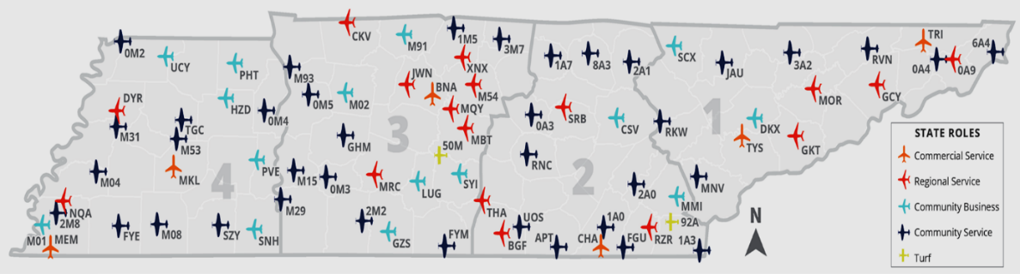
Figure 1. Map of Tennessee airports and classification of airports

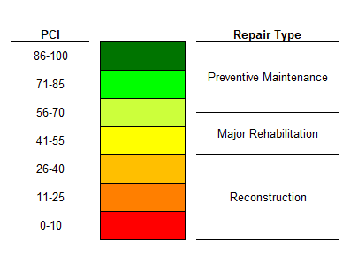
Figure 2. Pavement Condition Index (PCI) and repair types
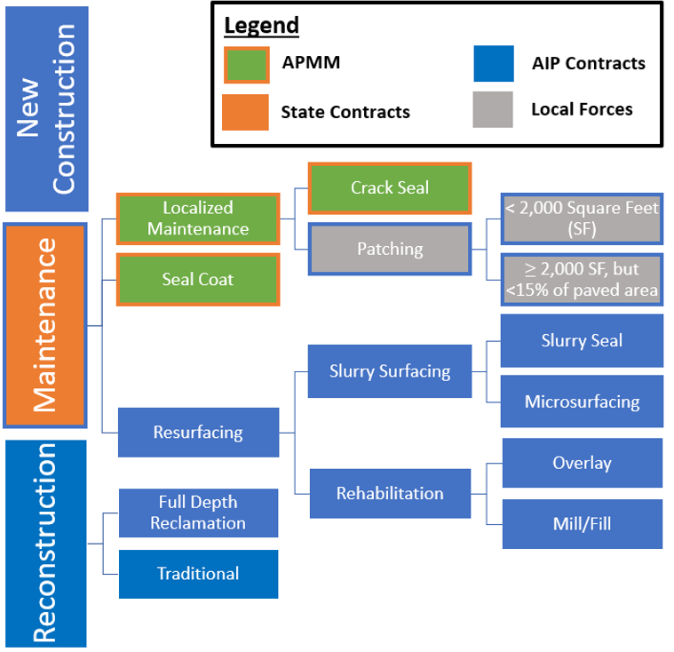
Figure 3. Asset pavement treatment options (Past)

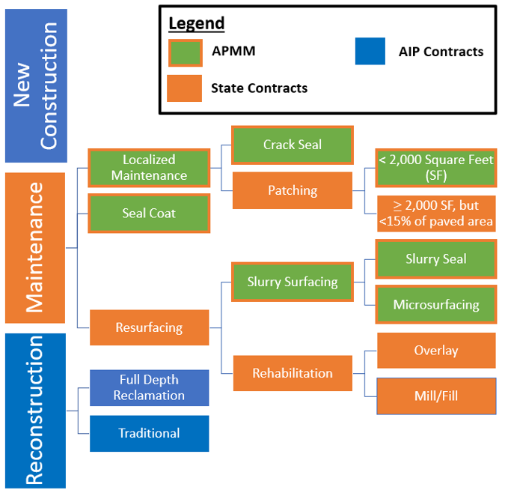
Figure 4. Asset pavement treatment options (Present and Future)
States’ Army Corps of Engineers and the American Society for Testing Materials’ (ASTM) Pavement Condition Index (PCI) method as the primary metric to specify condition of the airfield pavement by an Integer and condition label of “Good”, “Fair”, “Poor” and “Failed”. Other research has taken it further to specify when treatments are applied based on the integer and condition label.
Talking to industry experts and from the literature reviews, PCI is a sound methodology to understand system-wide performance and future budgetary needs, but not on a project-level performance and needs as other metrics and constraints are needed to formulate a better plan. For example, Tennessee’s pubic-use general aviation airports are currently set to the industry standard of PCI equal or less than 65 for runways to be considered for rehabilitation of the pavement by removing and replacing a layer of asphalt or overlaying a layer of asphalt. At 40 or less, the pavement would then be possibly ready for reconstruction, which would mean all layers of asphalt are removed and replaced including base stone being reconstructed and replaced with new asphalt. This can be very misleading as PCI number plus distresses could mean that all is needed is patching and crack-filling (shown in Figure 5), which can significantly increase the PCI to an acceptable number, whereas the PCI number by itself would indicate something ten times more expensive like rehabilitation or reconstruction if followed blindly. A related analogy is that PCI is just a thermometer. If the temperature is warm, it is just a means of knowing that something is going on that needs a treatment. It may be a minor illness like a common cold versus meningitis, which have significantly different treatment plans.
Project-level maintenance selection and execution is a major gap that the industry is trying to better understand to properly execute routine and proactive maintenance. Unfortunately, many of the industry either attempted to implement the system-wide data at a project-level or uses a

Figure 5. Example of pavement treatment options

separate system to try and create a list of projects that still isn’t optimized per airport. It is very time consuming and an impractical solution due to impractical budget requests.
To correct the problem, this research is focused on project-level planning and scheduling of work to be completed by the use of treatment flow charts and two possible automative worklist generation with one (1) being a heuristic solution and the second (2) being a Guobi commercial solver with a mathematical model developed in this research to implement and identify the best solution approach. The current approach is manually attempting to address maintenance distresses as PAVER assumes a deterioration factor that assumes crack repair and other maintenance is being conducted. The main issue is knowing where to conduct said maintenance, when and with what budget. If executed poorly, the airfield could look like a quilted patterned rug for the airport as it will have a dozen of different treatments being requested based on severity levels of “Low”, “Medium” and “High” at low quantities, which will make for higher line-item prices and more mobilization cost to bring in different materials and equipment. The desired approach at the airports will select related treatments at each airport based on proportions of severity via treatment flow charts to select one treatment for that distress to reduce the amount of types of treatments and increasing the quantities that would maximize the number of airports selected for work to conduct while optimizing the budget via unit cost and contractor available time at the airport.
In Chapter 2, we will be reviewing several literatures that include background information of the industry on how PCI plus distresses selects the applicable treatment. This is limited as it is only a single treatment for a single distress. We will take a basic look at PCI. We will then look at the highway side of the Tennessee Department of Transportation (TDOT) pavement program and later, the current pavement management program for airports that TDOT is currently utilizing as required by the Federal Aviation Administration (FAA). We will also review several studies completed by researchers on ideas and related topics. In Chapter 3, we will discuss what hasn’t been completed yet as part of the Gap Analysis. In Chapter 4, we will define the problem and in Chapter 5, we will discuss the data input, the decision tree as part of the data preprocessing stage plus other variables and mathematical model that was used as a basis for the heuristic and Gurobi approaches. We will briefly discuss the objectives in detail. That will lead us into Chapter 6 where we will analyze both solutions and develop goals to improve the heuristic solver. We will then talk about the next steps on the solution that leads to the conclusion in Chapter 7.
Overall, this dissertation contributes a different approach to routine and proactive maintenance planning and scheduling for multiple airports being managed as most states are either funding or actively assigning work to be completed at General Aviation airports. The end result is a printable list of work to be conducted that would allow the user to request bids from contractors through a work-order based contracting method to execute work that would be achievable both by budget and time availability of the contractor.

CHAPTER 2
LITERATURE REVIEW

Creation of a Pavement Management Program and their Dataset
ASTM D5340-23 (2023) establishes the appropriate method to calculate the pavement condition index associated to distresses found in a sampling that are then extrapolated to the entire pavement area. The user starts with dividing the pavement section into sample units then select the confidence level and then select the sample units to be inspected. There are statistical derivations to ensure that the correct sample size is selected for this process. As part of the inspection process, each randomly selected area is inspected. The branch, section number and type are recorded as well as a sketch is performed. Distresses observed are measured and recorded. The process is then repeated for each sample unit. There are a total of 13 possible distresses for asphalt, while for concrete pavements, there are 15. After the inspection is completed, the data is then compiled into PAVER, computing software developed by the United State Army Corps for pavement condition evaluations, to compute the Pavement Condition Index or PCI. An inspection report is then generated and the deduct value is given for each distress. From there, a total deduct value is created that ensure the pavement is not being reduced due to several distresses present compounding the results as that is not intended. The final adjusted value is the PCI of the entire section of the pavement. From there, it is a weighted average to find the entire branch then airfield itself. There are many advantages to conducting PCI. There are a couple of limitations though.
Advantage:
- It is objective in evaluating condition as it standardizes the methodology of collection.
- It is repeatable to obtain similar scores.
- No special equipment is needed.
- Inexpensive compared to alternatives.
Disadvantage:
- Only visible distresses are measured.
- Simplified graphs can be misleading if not understood.
Reviewing the United States Department of Transportation (USDOT) Airport Pavement Management Program (PMP), 2014 advisory circular (AC) discusses the cost-effective decisions about pavement maintenance and rehabilitation (M&R). The document talks about the usefulness in PMP’s assisting airports in finding optimum strategies for “maintaining pavements in a safe serviceable condition over a given period for the least cost”. USDOT further specifies that federally obligated airport must perform detailed inspection of the airfield pavements at least once a year. When PCI is conducted, ASTM D5340 must be adhered to. The document continues to specify that historically, airports focused on immediate need rather than long-term planning or documented M&R methods. Without that, alternative strategies were not taken into consideration, which led to inefficient use of funding. With any treatment, there is a life-cycle cost that can be compared to validate the most appropriate treatment to be selected. The document also goes over budgeting and the appropriate use of planning associates to future major cost. It concludes with using prediction and other analysis tools to evaluate the choices made to ensure that consistent decisions are being made throughout the organization to prevent staff or management turnover from affecting the long-term strategies. The main importance of an Airport Pavement Management Program (PMP) is the ability to understand deterioration over time to create the asset’s lifecycle to better understand when appropriate treatments are necessary. This then allows for funding strategies to determine budgetary needs of the system. The user would then have an understanding of how many years a pavement stays in “good” condition versus the other conditions. Normally when pavement reaches “Fair”, it has less time before reaching “Poor”, “Very Poor”, “Serious” and then “Failed”. Rehabilitation strategies start with “Fair” condition pavements. Design criteria of pavements are also a critical topic as overloaded or under designed pavements will fail earlier than anticipated. With a successful PMP and M&R techniques being utilized, the asset should see a steady decline ensuring that the pavement has many more useful years plus prevent the need of lengthy closures to the airport due to the need of reconstruction. The components of a PMP include a database for work history, pavement inventory, pavement structure, M&R history that includes cost, pavement condition data, traffic data, system capabilities, predicting current and future pavement condition, determining optimum M&R plans for a given budget, determining budget requirements to meet management objectives and facilitating the formulation and prioritization of M&R projects. In a Pavement Management Program, the pavement network, pavement branch and pavement section are defined. Network-level and Project-level management are then executed and validated with reporting tools. USDOT then recommends PMP’s like PAVER that was developed by the United States Army Construction Engineering Research Laboratory sponsored by the FAA. FAA PAVEAIR is an online version using the original concepts of what PAVER provides. The document concludes that if the system can contain pavement Inventory, inspection Schedule, record keeping, and information retrieval then that will satisfy as a PMP.
Reviewing an article titled “Airport Pavement Maintenance Decision-Making System with Condition Cases Optimization” by Roh, Seunghyun, et al. introduced the idea of using Condition Case Optimization as a means of optimizing maintenance strategies by associating the budget constraints stratifying the budgets between different scenarios, but also ensuring that the approaches are practical as well. A case study was also concluded as part of the article. The article had proposed an airport pavement management system architecture that took Pavement condition, Pavement structure, traffic data and asset work history to determine if the pavement sections are in need of being filtered out then run a performance curve to figure when work needs to be conducted constraint to a budget. While this is still similar to the Army Corps PAVER software approach as it is utilizing curves to determine life expectancies based on routine maintenance being conducted, the deviation is the application of including pavement serviceability level and decision-making process that includes the ability of deciphering maintenance projects versus capital projects. This is great for determining system level funding needs.
The Transportation Research Board sponsored a report numbered ACRP Report 138 (National Academics of Science, Engineering, and Medicine, 2015) that addresses preventative maintenance at a general aviation airport. In the report, it talks about preventative maintenance being given low to no priority when creating budgets. The report also talks about the importance of a maintenance program to extend the life of the asset. It also talks about the economic impact of Georgia general aviation airports by supporting 10,000 jobs, $354 million in payroll and $1.2 billion in state economic impact from a 2011 report. The report also illustrates that one runway can cost from $20 million to $100 million to build. It also shows the different asset groups on the airport in addition to airside pavements. It goes on to illustrate that few airports have a comprehensive preventative maintenance program that includes a regular assessment. Maintenance is derived as Operational, Reactive, Preventative and Predictive. Operational is maintenance due to external condition like snow/ice removal or adjustment of equipment due to wind. Reactive is maintenance associated to use it till it breaks. This is considered poor customer service as the asset could be damaged beyond repair when the user desires to fly. Preventive is maintenance that is scheduled, and the purpose is to mitigate the degradation of the system or component. Predictive is maintenance that utilizes testing and monitoring to predict when the asst will fail. The paper then specifies that airport preventative maintenance is important to apply treatments early in the deterioration curve to extend the asset life and minimize cost to rehabilitate or reconstruct till after the asset life is achieved.
The National Academies of Sciences, Engineering and Medicine (2011) created guidelines to help provide agencies direction on utilizing preservation treatments for high-volume roadways. The document adds yet more definitions to what was established by National Academics of Science, Engineering and Medicine (2015) in a previous publication. “Pavement Preservation” is defined as a network-level strategy of enhancing performance of pavements. “Preventative Maintenance” is considered treatments applied to the pavement to preserve the system and prevent early deterioration. “Minor Rehabilitation” is considered non-structural enhancements like a thin asphalt overlay or mill and thin overlay as a surface correction. “Routine Maintenance” is planned work to maintain and preserve the system like “Crack Filling and Sealing plus drainage maintenance”. “Corrective Maintenance” is a response to address issues relative to safe, efficient operations like pothole patching and concrete slab replacements. “Major Rehabilitation” is structural enhancements that improves load-carrying capacity and extends the service life. “Reconstruction” is replacement of all existing pavement and restarts the lifecycle.
Reviewing the Tennessee Department of Transportation’s (TDOT) Pavement Resurfacing Program Standard Operating Guidelines (2018) showcases TDOT’s methodology of maintaining the roadways of Tennessee. TDOT uses a Pavement Management System (PMS) with data entered from scanning the roadways. The metric chosen to evaluate the roadway’s performance is called Pavement Quality Index (PQI) that encompasses 70% of Pavement Distress Index (PDI) and 30% of the Pavement Smoothness Index (PSI). Within PMS, construction history is also entered to ensure that treatments, rehabilitation, or reconstruction recommendations would overlap with the pavement cross-sections. To optimize the roadways, TDOT uses lane-mile-years. Each treatment will give a certain number of years of life extension and the amount of lane miles it covers will yield the lane-mile-years. When developing a resurfacing list, teams are created statewide that evaluate the reports from the pavement system and budgets. Pavement age and a draft of possible locations are given to the team to evaluate. Field visits are conducted to evaluate project worthiness. During the field trip, visual inspections are conducted to confirm whether maintenance is an option or additional measures like pavement treatments, rehabilitation or reconstruction is needed. Once all the districts complete their assessments, a list is then created with the leaders of those teams and the region to combine into a regional list then sent to headquarters to create a single list statewide. The State Pavement Engineer then evaluates the results and enters them into the Program/Project/Resource Management System (PPRM). This will include project dates for turn-in and construction bidding including project completion. The next step is the development of Plans, Specification and Estimates (PS&E) forms. During field site visits, roadways are then measured, and identification of any ancillary assets are taken into consideration.
The types of treatments that could be selected are the following:
- Crack Sealing
- Fog Sealing
- Joint Stabilization
- Slurry Seal
- Microsurfacing
- Srub Seal
- Chip Seal
- Cape Seal
- Thin Overlay
- Chip Seal with Thin Overlay
- Open-Graded Friction Course
- Hot In-Place Recycling
For minor and major rehabilitation, spot or full Mill and Overlay at different thicknesses would be the appropriate treatment. After everything is completed, work history is updated and then the entire process is repeated to maintain the system.
Regardless of approach taken for optimizing pavement treatments and repairs, according to Susan Tighe and Margaret Covalt (2008), Airport Pavement Management Systems (APMS) require commitments from all levels of management in order for the system to function properly, but also obtain regular updates plus training from staff. Without this, the system will become stale thus become a misleading plan.

Examples of surface treatments
As an example of a seal coat treatment, P-608 (ASI, 2019) is an emulsified asphalt seal coat designed as a preventative maintenance to preserve asphalt pavement in fair or better condition as defined by the Pavement Condition Index score. It is also suitable for weathered surfaces in low to moderate severity. For new pavements, P-608 can also be utilized as a construction seal coat to help provide immediate protection to the new pavement from the environmental elements. If a previous coal application was placed on the asphalt, the document specifies that it is generally not recommended for this product to be applied. P-608 has been deemed by the Federal Aviation Administration to be applied to all airfield pavements without restrictions. A caution given is using a sand aggregate in addition to the emulsion to ensure friction numbers are maintained on runways and taxiways until the pavement’s natural friction return from the initial wearing. The cost of the emulsion and aggregate is considered minimal in comparison to asphalt and crack repair that would be required if a seal coat isn’t applied. The greatest cost savings are dependent on the pavement’s condition at the time of application thus the pavement with the least distresses will benefit the most from a seal coat treatment. Glisonite creates the very high nitrogen element that makes the treatment resistant to UV rays, water and oxidation. The rest of the document goes over the installation process.
As an example of another seal coat treatment, Polymer-Modified Masterseal (PMM) Ultra Pavement Sealer (2023) or P-623 (PMM Ultra) is an emulsified asphalt sealer blended with polymers and special surfactants for flexibility, durability, and adhesion. It’s use case is for protecting pavement surfaces. It is applied by squeegee or spray equipment with sand aggregate mixed. P-623 is applied with two coats while a third coat would be used for heavily trafficked area. After final coat, 24 hours is needed to then open to traffic.
Cape seals according to Joslin, Kimberly, et al. (2019) are defined as a chip seal with microsurface or slurry seal placed on top. In this report, a literature review was conducted to evaluate the treatment. Cape seals last from 3 years to 9 years based on site condition. 5 to 7 years are the typical timeline that was observed. In South Africa, cape seals are lasting 10 years and able to take heavy turning traffic as well as sustain cold temperatures without raveling. Early cracking is found in the cape seal and it is assumed that the prolonged cold weather is what
creates it.
The advantages are as follows:
- Seals existing pavements to prevent air and moisture from entering the cracks
- Prevents raveling
- Provides a skid-resistant driving surface
- Provides a smooth, durable surface treatment
- Prevents loss of chips when bonded to slurry
- Prevents abrasion and erosion
- Is appropriate for city use
- Has higher benefit-cost ratio for microsurfacing cape seals in comparison to slurry seal cape seals
- Resist raveling in colder weather and can handle turning traffic
The Disadvantages are as follows:
- Slurry seal Cape seals cannot be applied in cold weather
- Lower benefit-cost ratio for slurry seal cape seals in comparison to microsurfacing cape seals
- More construction time because it requires a PME chip seal to cure before slurry or micro is applied as a wearing surface
- Higher cost than the other treatments

Utilizing PCI to create maintenance work
According to Boyapati, Bharath and R. Prasanna Kumar (2015), their goal in their research was to create a prioritization of maintenance based on the PCI of the pavement to rationalize which pavement group received treatment first. Their methodology was formulated into: Study area characteristics and identification of study sections, Visual inspection on selected locations, Collection of Data, Identification of distress and its severity level, Assigning acceptability levels and weightages, Determination of PCI, Determination of priorities for maintenance. Marquez a Crespo, et al. took it a step further and created a framework to help classify decision making by a series of models to help management make decisions on when to execute decision making for maintenance. According to Peshkin, David G., et. al (2004), Preventative Maintenance is a systematic process of applying a series of preventative maintenance treatments over the life of the pavement to maintain a good condition, extend pavement life and minimize life-cycle cost. The purpose of the paper was to determine the best timing to apply the treatments to flexible and rigid pavements. The categorized all the different treatments associated to climate, traffic, conditions that were being addressed and potential issues/restrictions. Creating a relationship between age and condition, there were able to analyze the proper timing of each treatment group and made those recommendations. Outside of PAVER, other Mathematical models to determine pavement deterioration have also been attempted as represented as a non-linear method by Weihua Gu, et. al (2011).
Another interesting idea according to Wang, Hao, et al. (2019) in their Airfield Pavement Management Framework using a Multi-Objective Decision Making Process is the idea where they refined the Maintenance and Reconstruction decision-making, improving pavement life estimations and deploying pavement maintenance strategies. They brought in the idea of a Structural Condition Index (SCI) and Foreign Object Damage (FOD) index in addition to the traditional Pavement Condition Index (PCI). The results were that there was a high correlation between PCI and FOD, which makes sense as FOD normally is due to surface condition issues, which is what PCI determines. The paper also determined that PCI has a tendency to increase pavement life expectations versus FOD and SCI. Lastly, it was determined that using all three is the best for determining Maintenance and Reconstruction decision-making as using only one gives gaps to others. Similar to this, another idea according to Karballaeezadeh, Nader, et al (2020) was using surface deflections with PCI to inspect pavements, which would be a hybrid approach to SCI and PCI. To make this possible, several field equipment would be utilized to determine the pavement deflections present.

Utilizing of data models and algorithms to optimize treatments and work
Another methodology was using sensors to collect pavement data and then applying data analytics to optimize the predicative modeling to determine when the best treatments should be applied (Sirvio, Konsta M., 2015). The model was able to project the deterioration curve of the pavement asset to specify when treatments should be applied.
For roadway systems, Pavement Management Systems (PMS) are commonly used. The next idea was utilizing machine learning algorithms to evaluate PCI and prediction models using multiple linear regression, artificial neural networks and fuzzy logic models for flexible pavement sections. Eight pavement distresses were modeled. The end result was that the artificial neural networks yield the best results on correlating surface pavement distress and PCI. Another example of using artificial neural networks (ANN) for predicting pavement condition index was conducted using data from Nablus City in Palastine as the objective goal was to remove manholes as a principle of reducing the PCI score (Issa, Amjad, et al. 2021).
An important idea was the utilization of an integer programming approach to determine the optimal solution to aircraft maintenance planning and scheduling to create a more efficient and effective process (Chung, Nick and George Ho, 2010). Three groupings were proposed that consist of initial maintenance demand schedule, maintenance pairing and maintenance group assignments. The end results were that they were able to use excel solver to create a scheduling system based on staffing availability.
An interesting idea was using a statistical outliers analysis to help clean data errors by grouping the data into similar pavement families such as pavement type, pavement use, and pavement rank from functional classification first then use a straight-line regression to analyze the residuals (Nunez, Maria M and Mohamed Y Shahin, 1986).
Mohamadhossein Noruzoliaee and Bo Zou (2018) took the approach of modeling the Maintenance and Rehabilitation program associated to the network deterioration levels that are measured rather than PAVER’s standard approach to pavement preservation and applied into a stochastic duration model for prediction. The goal was to minimize cost over time by minimizing the deterioration levels. To take this a step further, Seyed Amirhossein and Omar Smadi (2021) created prediction models and then verified the sensitivity of their model by utilizing Iowa’s Department of Transportation’s pavement treatment decision trees to determine the accuracy of their cost of maintenance to maintain the network. For optimization, Khaled A. Abaza et. al (2024) utilize a Markovian model that utilized a generalized nonlinear objective function associated to randomly selecting similar pavement distresses found in pavement sections that was constraint associated to a budget while another approach to compare was worst-first selection within the same condition state. The goal was to be able to predict pavement deterioration associated to pavement improvement from maintenance and rehabilitation methods. Adding additional constraints to a similar optimization method integrated user cost like travel time and fuel consumption by Leilei Chen, et. al. (2021).
Lastly, another interesting thought by Peyman Babashamsi et. al. (2022) was showing the importance of pavement maintenance from a life cycle cost perspective on how delaying
maintenance overall reduces the value of the pavement asset itself over time. In the first year, delaying in maintenance increases the life cycle cost by 16%. The author noted that up to 50% could be achieved by continuing to postpone maintenance.

Literature Gap Analysis
Reviewing the literature in Chapter 2 illustrated a gap on how industry uses Pavement Condition Index (PCI) at a network-level and tries to implement at a project-level. As stated beforehand, PCI is just an objective visual inspection at the surface level that is to determine if action is needed or not in terms of maintenance or monitoring. If the PCI rapidly decreases over time, then further preliminary engineering is needed to validate if major rehabilitation is needed including reconstruction of that pavement section. As shown in Figure 6, a low PCI is assumed to be reconstruction. When misunderstood by taking a low PCI number and assuming that it needs to be reconstructed rather than reviewing the distresses and amount of distresses led this area to be assumed as a cost that is up to 10 times than what needs to be spent if the section is repairable. As an example, using Tennessee IDEA (2023), in Figure 7, we reviewed this section of the airport and the PCI’s in Figure 8 indicates that the section is in need of reconstruction from a PCI of 36 and illustrated in Figure 9. This can also create an incorrect budget request to the governmental legislator as the approach would be a “worse-first” approach to pavement management. The analogy is like buying a new car, never changing the oil and wondering why the engine needs to be replaced sooner than expected. The reality is that with proper maintenance, the vehicle will last for many years thus enable the ability to purchase a 2nd if needed.
Reviewing Figure 10 and Figure 11 showcases the photo of the pavement distresses noted in the field that would be in a typical PCI report. Looking then at the distresses in the report
Figure 6. PCI scale

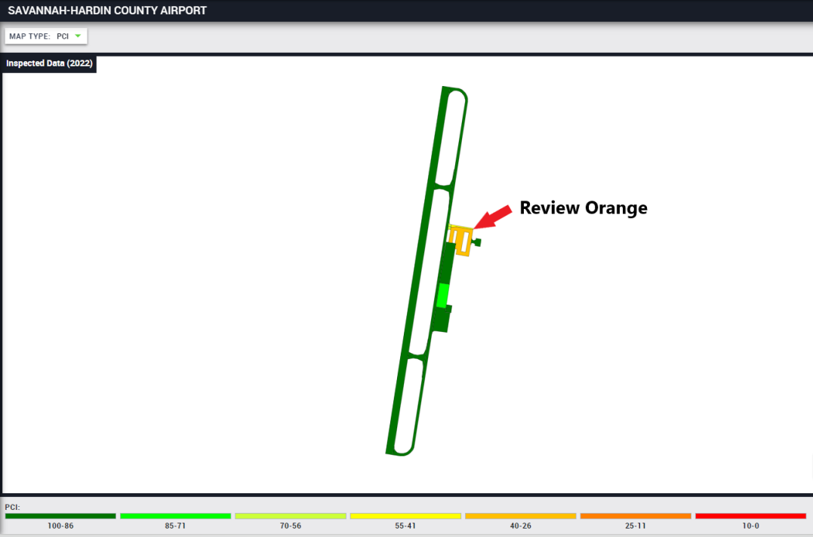
Figure 7. Savannah-Hardin County (SNH) airport pavement information
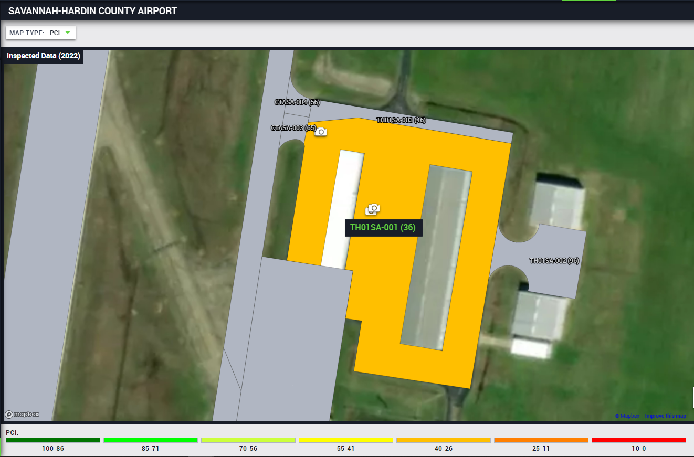
Figure 8. SNH airport pavement section TH01SA-001 PCI

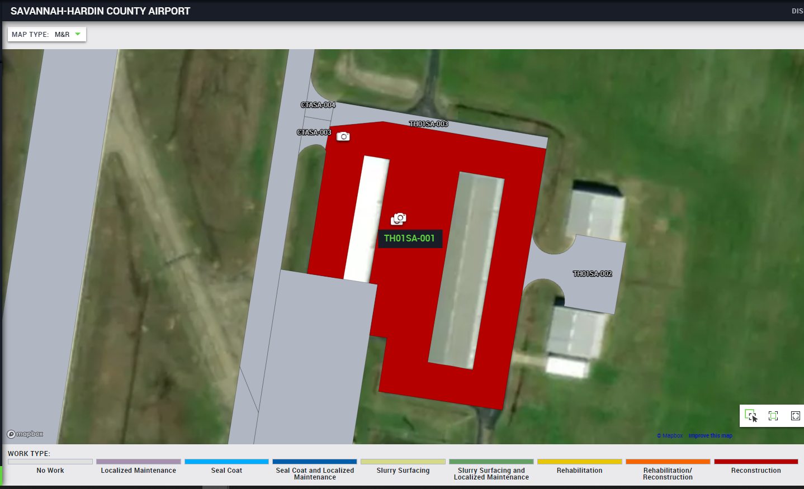
Figure 9. TH01SA-001 maintenance recommendation
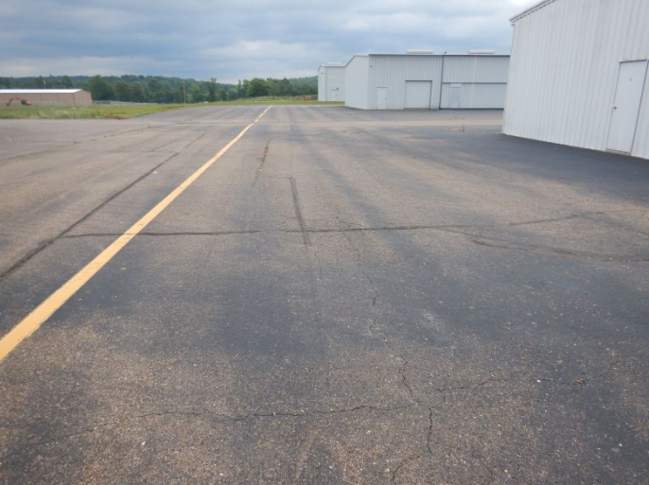
Figure 10. TH01SA-001 pavement photo L&T Cracking

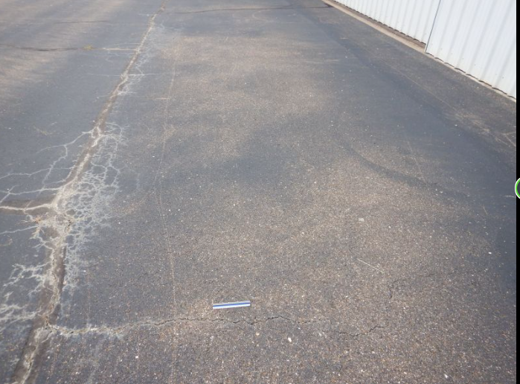
Figure 11. TH01SA-001 pavement photo Alligator Cracking

summarized in Figure 12 indicate that patching of the alligator cracking, crack repair of the longitudinal and transverse cracking and a slurry surfacing to correct the raveling at medium severity would correct all the deficiencies that would remove the need of reconstruction. This idea is summarized in Table 1 showcasing that by conducting maintenance of patching, crack repair and microsurfacing can yield a higher cost/benefit ratio associated to the amount of area x 1 point of PCI increase per dollar versus a traditional reconstruction. With maintenance, the condition improves from poor to fair condition and spending a 1/10 of the cost. The PAVER application can derive work from distresses as show in Figure 12 as that is what derived the data in Figure 13, but the problem is not having local policies to help group the treatments at a single airport to help with optimizing the repair options. For example, if a small section of the airport is a seal coat while the majority is a slurry surfacing, for contracting unit cost and mobilization, it is better to have the entire sections at the airport to be slurry surfacing or one treatment. The other issue is lack of optimization based on airport classification and then optimize based on quantities at each airport within that classification. Taking it a further step is ensuring other policies and contraints are taken into consideration to ensure the final results is a list of work to be accomplished for the the year while obtaining acceptible unit cost and contractor production due to the values being optimized. The other gap that is not solved in this research is understanding what maintenance can be accomplished by the workforce to optimize the PCI recovered at the airport at a project-level basis by recalculating the PCI value. If this is also completed, then a system level target can be set to optimize the PCI associated to the budget.

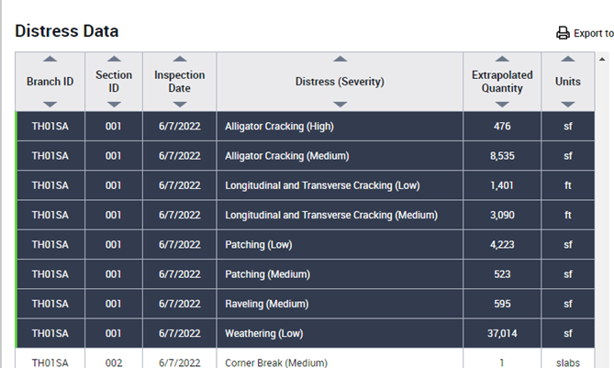
Figure 12. SNH TH01SA-001 distress data

Table 1. TH01SA-001 Rehabilitation versus Maintenance
Pavement Type | 2022 PCI | Area (sf) | Unit Cost ($/SF) | Treatment | New PCI | Square Foot PCI point increase per dollar
Asphalt | 36 | 68,722 | 14.75 | Mill/Fill/Remarking | 100 | 4.3
Asphalt | 36 | 68,722 | 1.41 | Patching/Crack Sealing/Microsurface/Remarking | 69 | 23.3

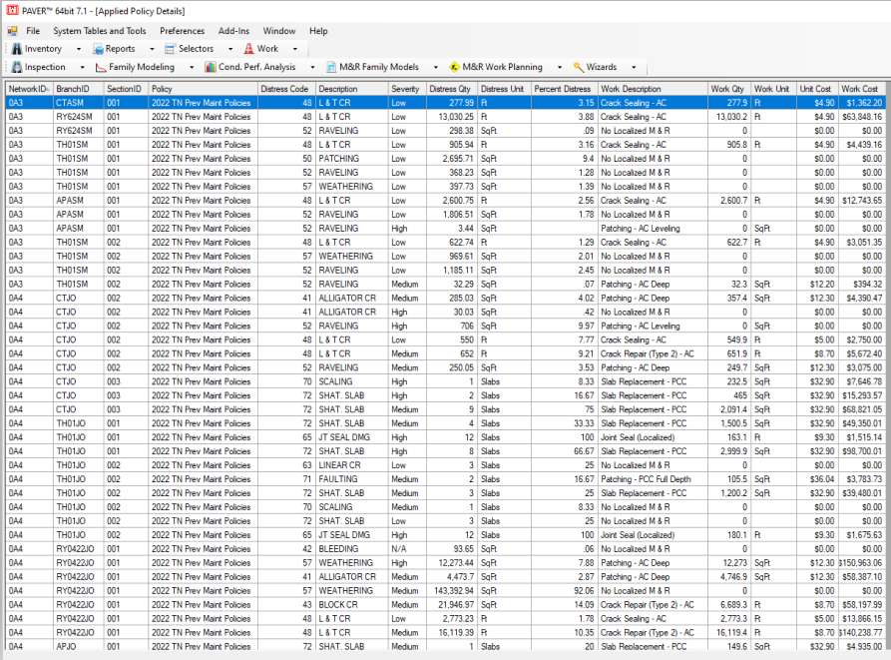
Figure 13. PAVER maintenance list

CHAPTER 3
PROBLEM DEFINITION

Overall Distresses in the State
The Tennessee Department of Transportation (TDOT) Aeronautics Division (TAD) recently released their Pavement Management Program (PMP) update (TAD 2023). In the report, it shows that TAD has 72 public use airports (excluded 5 airports) that associates with 78.7 million square feet of pavement and the area-weighted age as of 2022 is 21 years. This is a significant number as pavement especially asphalt useful life is 30 years and this does not reset unless rehabilitation via replacement is conducted. As a system, the Pavement Condition Index (PCI) was rated at a 73. Running What-If scenarios in the commercial application specify that maintaining the PCI of 73 at a system level will cost $30.5 million annually in rehabilitation and reconstruction while increasing to a PCI of 75 would cost $41.5 million annually. To complete all the maintenance and rehabilitation needs of the system would cost $80.8 million per year for 5 years. In the pavement inventory, it showed at 43% are runways, 24% are Taxiways, 23% are Apron/Helipad and 10% are T-Hangar. A table was then attached showing localized preventive maintenance plan of patching and crack sealing.

Types of distresses in pavement
From Tennessee IDEA (2023), General Aviation airport account for 78.7 million Sq.FT. of pavement area with the following percentages accounting for the different use types:
- Runways: 43%
- Taxiways: 24%
- Apron/Helipad: 23%
- Hangar Pavement: 10%
The different use types are illustrated in Figure 14. Applying the proper airfield pavement treatment due to distresses present has been previously researched by the Transportation Research Board through ACRP Project 09-11 by Freeman, Thomas J, et al. (2016). The purpose of the study was to use the airport classification, climate zone, and distresses present in the pavement to determine the treatment to solve or slow the deterioration. The treatments were set up as “recommended” and “acceptable”. The user is able to add several sections together to create options on a plausible solution to a singular location. The limitations were if you had multiple different distresses on different pavement sections, since the treatment is singular, the results is a quilted looking pavement. While this may be fine if the amount of treatment needed is 50/50 and the amount is large enough to warrant, the main issue is that if the quantities are low, a higher mobilization cost is being paid. It would be better to use a singular product to minimize the number of times you have to mobilize different equipment for practicality purposes. It also changes the treatment based on criteria like Airport Classification as the weight of the aircraft would change with it. The user is able to also add a cost basis and calculate the overall cost and benefit of the project. Reviewing TAD 2023’s statewide report, distresses were extracted from the PAVER application as the consultant who compiled the report using the application followed ACRP Project 09-11 recommendations as plausible defects as shown as an example in Figure 15 and examples of some of the distresses in Figure 16. The consultant followed the appropriate ASTM requirements on how the PCI was calculated in terms of the distresses that were present in the pavement. They had also collected data from the 2019 cycle as well, which means they now possess several consecutive years’ worth of comprehensive information that can be used to begin systematically correlating the deduction values of pavement condition PCI assumptions over time within the PAVER database.
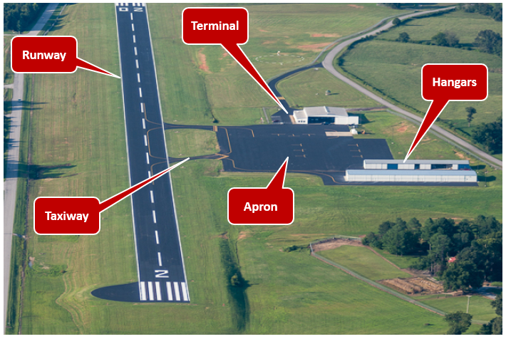
Figure 14. Airfield identification

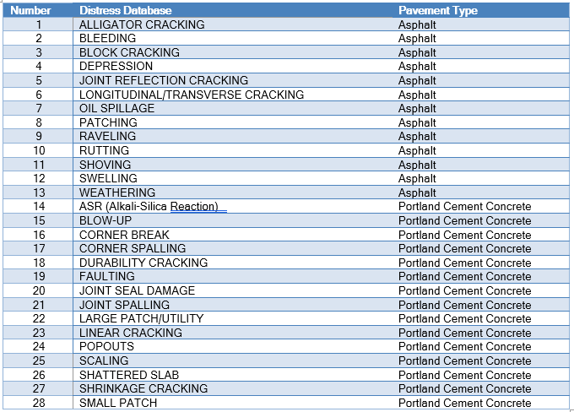
Figure 15. Distress database
Figure 16. Pavement distress examples

Types of maintenance for pavements
Insights from previously conducted research by the Transportation Research Board, American Society for Testing Materials (ASTM) for Pavement Condition Index (PCI) and data from Tennessee’s general aviation Airfield Pavement Management Software (APMS) called PAVER were used. To create the PCI, inspections are conducted then the data is uploaded into an Airfield Pavement Management Software (APMS) called PAVER that helps to create branches then sections and deterioration curve modeling. As more data is fed into the system, the deterioration curve modeling improves. Between new construction to reconstruction is the maintenance phase of an asset’s life. To have a robust maintenance program to slow the aging process, maintenance treatment recommendations are needed at the right time associated to an available budget. A deeper dive into ASTM D5340-23 was necessary to discover the pros and cons of the existing PCI methodology and if a new methodology could be defined to recover pavement life at a discount rate.

Benefit and misunderstanding of the existing PCI method and software
From my practical experience, the current Pavement Condition Index (PCI) method is an excellent way to evaluate smaller areas. If on a limited budget, it is a great solution as it gives insights on action steps whether it is to do nothing, conduct maintenance or reconstruct. The PCI method also creates budget ideas pending on the PCI score you are trying to maintain. Using Grade Point Average (GPA) in grade school that you are desiring is an excellent analogy. The higher the number; the greater the effort to an extent where diminishing returns starts. For this case, the higher the number; the higher the cost. Applying cost factors to each opportunity or option will enable a budget that the user would be able to request. Once the budget is approved, the user would enable the program then to reassess to ensure those targets are being achieved in a specified cycle. For airports, the FAA requires every 3 years to be re-evaluated. For this, PCI method has the ability within applications like PAVER to create trends to understand predictions so tracking long term goals are possible. This also aids in formulating both short- and long-term budgets.
There is a downside to the use of the PCI method to also be considerate of. Industry has inaccurately associated that a low PCI number means that replacement is necessary when the reality is that low Pavement Condition Index means that a triggering event has occurred whether it be maintenance, rehabilitation or watch and time for reconstruction of the asset. A small area of a larger pavement section with a pavement structure distress like a pothole can create a low PCI number for the entire pavement section. The repair should be a patch, whereas, going by industry charts, it would show that replacement of the entire section by “Reconstruction” should be the method utilized. As an example, think of a driveway. If a car size damage was present in the pavement, patching would be the most cost-effective solution. If the pavement is asphalt, seal-coating the rest could also make the pavement blend in color. If looking blindly at a PCI number, it would suggest that replacing the entire driveway was more appropriate. Two charts below as shown by Zou, Bo, and Hossein Noruzoliaee showcase this as a typical understanding where low PCI is misunderstood as replacement being needed as shown in Figure 17, but shown well in Figure 18 as action is needed for lower PCI that could include maintenance based on quantities and types of distresses present. Following this methodology does not work anymore due to the cost of materials for asphalt. According to the National Highway Construction Cost Index (NHCCI), in January 2005, the cost index of was 1.25. By quarter 2, trying to split the sharp increase in half between 2021 and 2024, of 2022, the cost index was 2.53. The change in 17 years was a difference of 2.02 or 202% increase. In 2005, the Tennessee Transportation
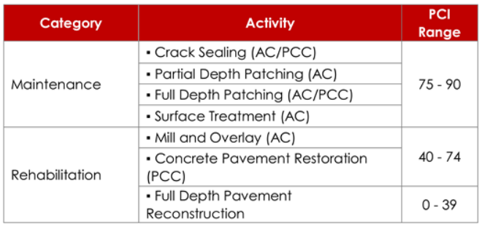
Figure 17. Maintenance and Rehabilitation activity based on the PCI ranges

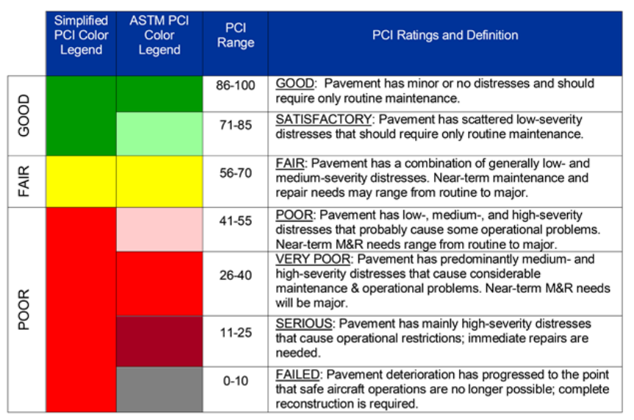
Figure 18. Simplified and ASTM PCI rating in the APMS of NASA Ames center

Budget was $1,858.6 million while in 2022, it was $3,188.5 million or 72% increase. The assumption here is very simplistic; Maintaining or constructing the same way in 2005 should not be the same plan in 2022. More innovation or asset management principals are needed.

Transitioning to a different PCI method
To make this probable, a list of recommended projects with constraints of what can be achievable by a contractor from historic completion rates are needed as an output for maintenance and reconstruction to take place.
Table 2 list possible maintenance treatment associates to the different pavement types that are then illustrated in Figures 19, 20, and 21 as photos of a couple of distresses shown previously in Figure 16. These are typical surface distresses found in pavements on airfields that if not addressed, water will continue to travel into the pavement and eventually under the pavement. If temperature freezes and thaws, then that swelling and shrinkage would expand that crack into a larger pavement issue introducing a possible structural failure.
As part of a larger analysis that TDOT was involved with, a coring shown as Figure 22 was removed to verify visually and from a lab how the seal coat as a surface treatment is impacting or not impacting the pavement itself for longevity.
The major issue is that distresses are needed to be considered when evaluating low Pavement Condition Index (PCI) scores and the issue could be a localized failure that needs to be addressed in order to correct that score for the pavement section. If the distress is severe enough, that pavement section could be bringing the entire airport overall score down. From running several tests within the PAVER application, 10% area that has several alligator cracking can have a 40-point decrease. Add a couple of other minor surface related issues and now the pavement appears to need to be rehabilitated by the PCI number.
Table 2. Maintenance database
Maintenance | Pavement Type
AC Patch | Asphalt
Crack Seal (Type 1) | Asphalt
Crack Seal (Type 2) | Asphalt
Crack Seal (Type 3) | Asphalt
Microsurface | Asphalt
Slurry Seal | Asphalt
Cape Seal | Asphalt
Monitor | Asphalt
Seal Coat | Asphalt
Crack/Joint Seal | Portland Cement Concrete
Grinding/Grooving | Portland Cement Concrete
Monitor | Portland Cement Concrete
PCC Patching (Full) | Portland Cement Concrete
PCC Patching (Partial) | Portland Cement Concrete
Replacement (Statewide Contract - Smaller Area) | Asphalt
Replacement (Invitation to Bid - Larger Area) | Asphalt

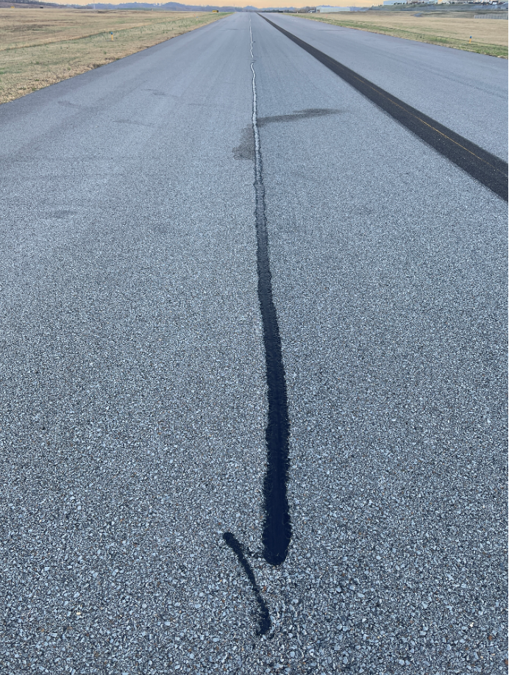
Figure 19. Crack Seal application

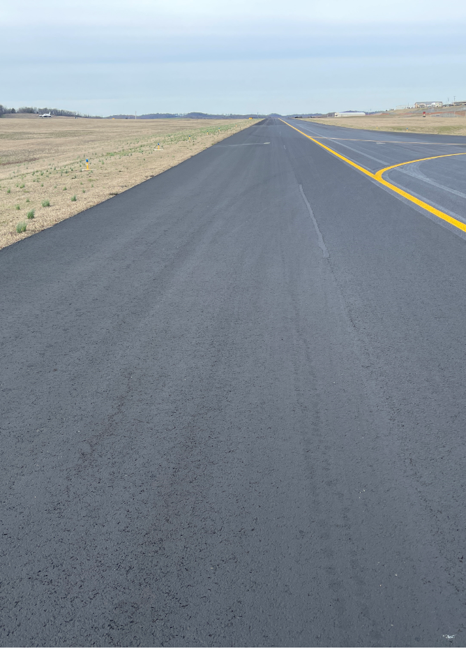
Figure 20. Seal Coat (P-623) application post 1 month
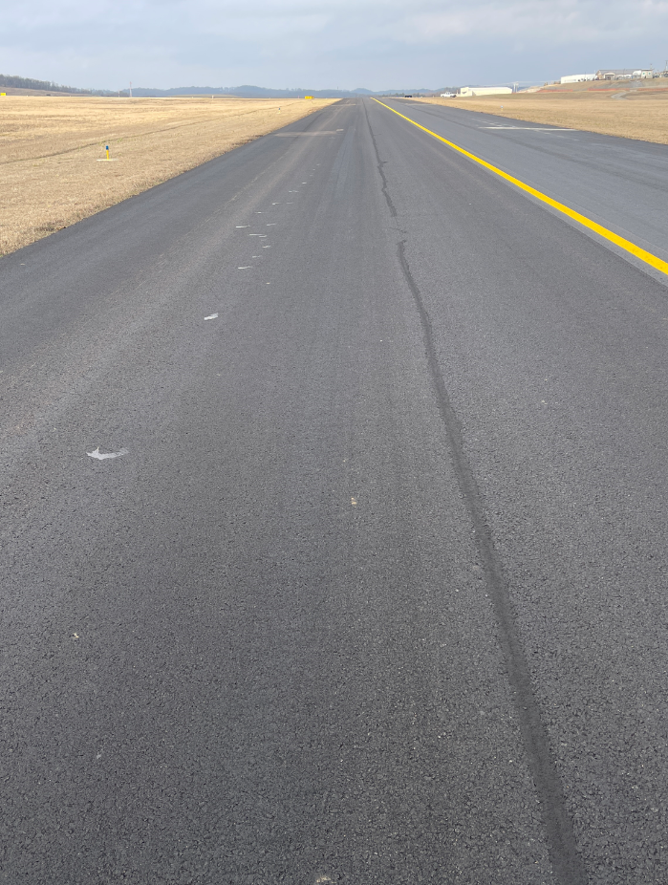
Figure 21. Seal Coat (P-608) application post 1 month

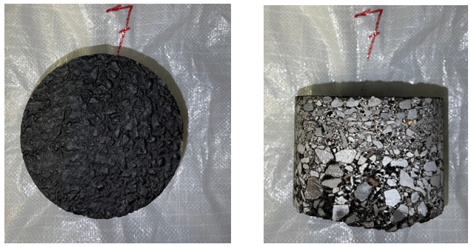
Figure 22. Seal Coat (P-623) application coring photo
After initial review of the PCI scoring to better understand how the deductions are working plus the review of the ASTM D5340-23, it was discovered that industry was simplifying the score to determine overall treatment assuming that only the high scores could be preventative maintenance or maintenance in general while the lower scores needed more drastic work like replacement of the entire pavement section. This excluded the ability to do what industry considers as heavy maintenance or the ability to spot patch issues. Reviewing pavement distresses in the TDOT PCI 2022 study revealed that heavy discounts per ASTM D5340-23 and how the inspection is associated according to FAA’s Asphalt Surface Airfields Distress Manual are given to issues like alligator cracking and raveling of the surface where the rock material also known as aggregate is starting to come loose. If high enough severity, the entire PCI score for the section would be very low. For example, if you had 10,000 square feet of pavement with 1,000 square feet of high severity of alligator cracking, the PCI score of the section would be a 38. If you are able to repair that, the severity changes to low as that is the ASTM D5340-23 standard and changes to patching. The new PCI score then changes to 84. That is a jump of 46 points!
To further test this theory out, TDOT issued a work order to a consultant firm to conduct the PCI investigation of before work was conducted to after the work was conducted. Results are uploaded in the TN Idea website. For MKL airport or known now as Jackson Regional Airport, the entire airport had a PCI score of 52, while excluding the runway due to being under construction. The expected cost to replace as industry would assume for any pavement under 60 PCI would cost $13.2 million and if attempting to replace anything under 70 PCI, the cost jumps to $23.6 million showcasing that it isn’t long till more monies are going to be requested for replacement if following industry standard. The assumption of price was using previous construction years data that set the rate to $12 per square feet. Utilizing maintenance techniques like crack repair, seal coating and Microsurfacing to treat cracks and raveling ranging from low to high severity was able to change the PCI of the airfield from 52 to 71. Again, the runway was excluded as it is being reconstructed. The cost for the maintenance was $1.9 million or approximately $1.80 per square feet. This is about 15% of the cost overall. To break this even deeper, a section of pavement named CTJK-004 at MKL was evaluated to see what an equivalent area of correction would look like associated to a 1-point PCI increase per dollar. TDOT Director John Paul Saalwaechter formulated this idea thus we will call it the Saalwaechter Equivalence. For this section, the PCI was rated at 29 with high raveling and other distresses noted in Figure 23. Again, repairing any of the distresses will just put the severity state or the condition state to a possible improved number while replacement through rehabilitation or reconstruction creates the ability for the asset pavement section to return to 100.
Patching was low severity due to a previous patch thus no patching was conducted. If conducting a replacement of the pavement, the replacement cost was estimated at $331,000 by using the same $12 per square feet replacement cost. The new PCI would be a 100 since it is a rehabilitation by the ASTM D5340-23 rules. The change of PCI would be 71 thus the amount of area that can be impacted associated to 1 point PCI increase per dollar can be calculated. The equations used for this calculation are presented below and are referred to as the Saalwaechter Equivalence and the Saalwaechter Equivalence (SE):
$$Saalwaechter Equivalence=\frac{(pavement section area*△PCI)}{cost in dollars}$$
$$Saalwaechter Equivalence (SE)=\frac{(28,555 sqft*71 PCI)}{\$331,000}=6.1 sqft-\frac{1PCI}{\$}or 6.1 SE$$
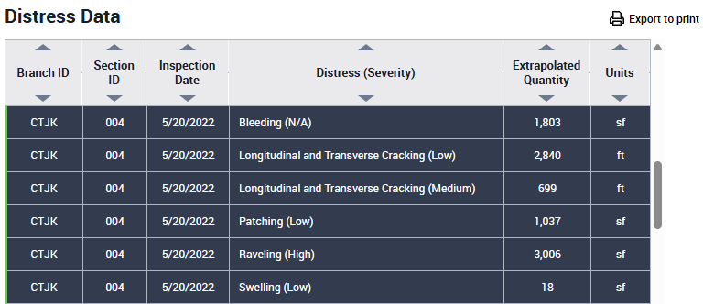
Figure 23. TN IDEA for MKL pavement section CTJK-004 distress data

$$Saalwaechter Equivalence (SE)=\frac{\left(28,555 sqft*45 PCI\right)}{\$30,000}=42.8 sqft-\frac{1PCI}{\$}or 42.8 SE$$
So, rehabilitation yields a 6.1 SE whereas maintenance yields a 42.8 SE. That is a multiplier of 7 from maintenance alone in terms of area of coverage to improve the pavement’s condition. This test yielded a thought of being able to apply the same principals across other airports and effectively change the way system level performance is being considered. Photos of the repairs are shown in Figure 24 where on the left side is prior to any work and photos on the right are after work was completed. The PCI condition is shown on top of the photo that was determined by TDOT’s consultant to verify a before and after comparison. Furthermore, the inspection was conducted in person as required by ASTM. The airport comparison is shown in Figure 25.
The main purpose was showing on the left side using the traditional approach of worst-first methodology where replacement of the worst asset is prioritized using generalized cost that TDOT has been seeing on airport projects while on the right side illustrates what the results were when maintenance was executed for the airport. Note that regular maintenance would have to occur so for example, crack repair must be reconsidered every 3 years to effectively fill any new displacement that has developed. For example, if a one-inch crack is fixed with being routed and filled in with crack seal, that same crack after 3 years may be ¼ inch thus would have to be heated and refilled. This becomes another idea to consider, which is a life-cycle cost analysis for maintenance versus construction. The beauty of maintenance from TDOT’s experience is that after initial maintenance is conducted, subsequent maintenance is less intrusive, which makes it more manageable by being lesser quantities and more predictable.
With this concept, TDOT is making an investment into maintenance by allocation of funds and
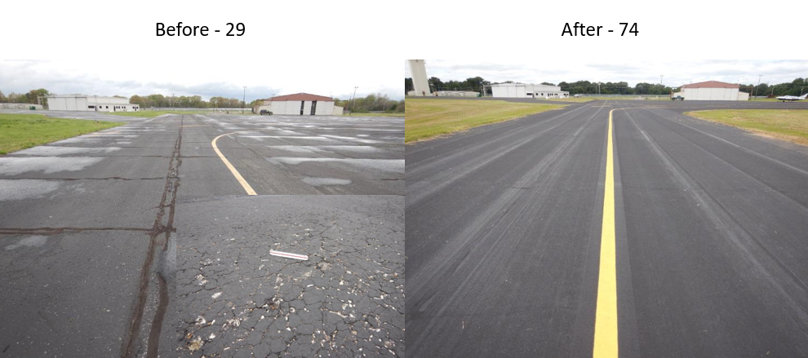
Figure 24. MKL CTJK-004 before and after maintenance repairs

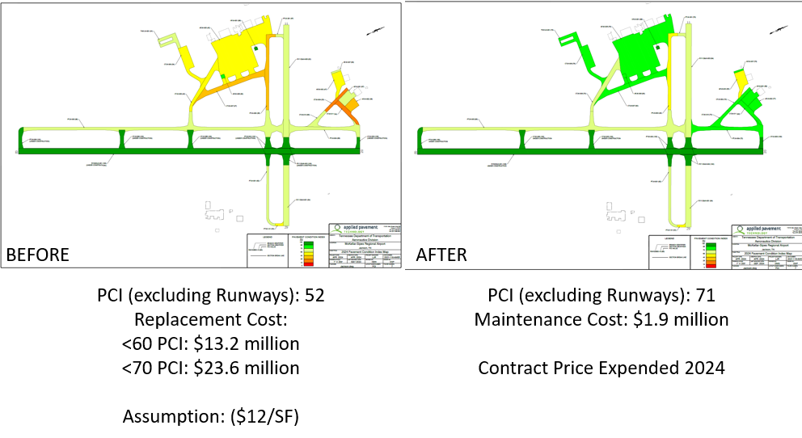
Figure 25. MKL CTJK-004 before and after maintenance repairs
securing a work-order based contracting as discussed later in Chapter 6. From the FAA/Army Corps’s inspection guide shown in Figure 26 and the ASTM D5340-23 shown in Figure 27, the idea is that a low PCI is only a triggering mechanism that something may need to occur. By using both PCI and distresses, this will create the work plan for the airport associated to an asset management plan for that airport in the split between maintenance projects and capital project’s needs. The overall PCI statewide report then doesn’t mean how much pavement needs to be replaced; it becomes a gauge to say how well are triggering events being managed by both maintenance and capital project processes so that they have to function together in order to have a complete program. This leads us to the maintenance objective.

Maintenance Objective
As discussed in previous chapters, the number of airports is constraint to 69 airports. The budget available for maintenance is between $4 million to $8 million annually and there is a contracting company that works for TAD. The PCI scores from the TAD Pavement Management Program was set to 75 as a target goal of the system by reviewing data history. Using maintenance history of 4 years would help to outline what work was possible to accomplish in a given calendar year to help with the inputs of the model.
The main benefit from a global maintenance program is the ability to control the airfield pavement deterioration rate by being able to apply the right treatment at the right time. This allows for further prevention of a need of an unsustainable budget needed for continuous replacement or rehabilitation of existing assets.
The secondary benefit from a global maintenance program would be obtaining bulk discount on those line items plus maintain control of keeping contractor(s) busy within the state for longer stretches thus able to accomplish all the airports in a more predictable timeframe.
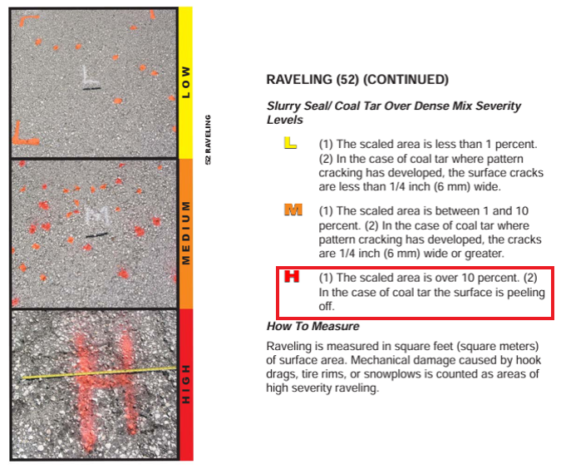
Figure 26. FAA/Army Corps’s inspection guide

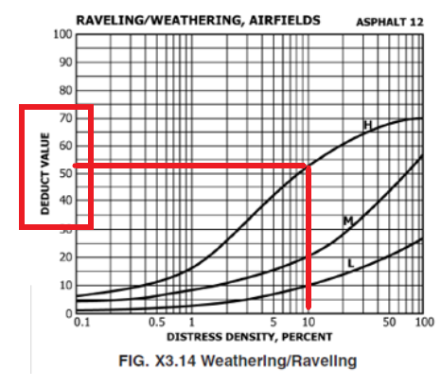
Figure 27. ASTM D5340-23 distress chart
Some policies will be introduced associated to limit the number of different treatments at a single airport due to mobilization cost and downtime from switching material types. Some treatments will require multiple sources of contracting to be performed like a construction letting and different maintenance contracts thus having a list to operate from allows flexibility to plan out an entire year to ensure separate contracting can occur in parallel processes and not in a series as a critical path methodology. The Airfield Pavement and Marking Maintenance (APMM) contract consist of crack routing/sealing, seal coating, slurry surfacing (slurry seal or microsurfacing), minor patching (< 2,500 Square Feet) and remarking. The model would make several passes to find the most favorable solution. Since each airport is unique and the possible work at the airport is determined by its parts as type of issue and severity then determine specific treatment versus a universal higher-level treatment due to how typically it is accomplished, the best outcome will be derived. As an example, it is like repainting one-third of one wall in a room versus repainting the entire wall in a new different color as the other three are being repainted as well. It would make fiscal sense and possible material availability pending on the paint order to include it since a portion needs repainting. This is the same concept as if the airfield had a small portion of a treatment, but on the same airfield had an upgraded treatment due to a need, then upgrading the small portion would be feasible so that the contractor could use the same material and not have to deal with down time while swapping materials. Typically, these low quantities would garner higher prices in my experience while larger quantities garner lower prices due to bulk volume discounting.
In a deeper dive in Chapter 4, we associate the distresses and maintenance treatments into a decision tree that preprocesses the data with local policies. We then apply global policies. This sets up the idea of being able to have a system wide impact by being able to address pavement maintenance at each airport and prioritize by what can be repaired versus what cannot be repaired as the types of repairs needed are not applicable or the pavement is already in a state of reconstruction thus have been excluded from the list.

CHAPTER 4
SOLUTION APPROACH AND METHODOLOGY
As shown in Figure 28, the first data input is derived from the PAVER application that holds the location, distress, severity and quantities. The second data input is historical cost and resource availability associated to maintenance treatments. The third data input is derived on treatment flow chart associated to the present distress and severity in the pavement itself plus the treatment policies that govern the local and global goals. Local policy then can change the maintenance treatment based on certain parameters associated with that distress in a pavement section. The global policy associates all the pavement section distresses and matches the maintenance treatment totals for each airport. For each airport, the heuristic model is then executed based on the “greedy approach” where the data is then manipulated to apply holistically the treatment that would be proportional to an acceptable quantity for a contractor to perform. If not enough treatment quantities are present, the maintenance treatment would be upgraded to match the other section with similar distresses. The results are associated with an exported excel file showing work, location and quantities of work needing to be conducted.
That exported excel file that is considered to be our data results of the first methodology, which was the heuristic. The “greedy approach” of the heuristic is defined by the first objective by ensuring that airport classification is maintained from the greatest to least importance and then maximizing the budget and prioritizing technically significant work for greater impact to each airport classification grouping. Available budget and time are then displayed with the output file showing what airports where selected and organized from top to bottom on work that should be executed first. The second methodology utilizes the commercial solver: Gurobi with inputs associated to the mathematical model and constraints being input into the solver. The goal is to
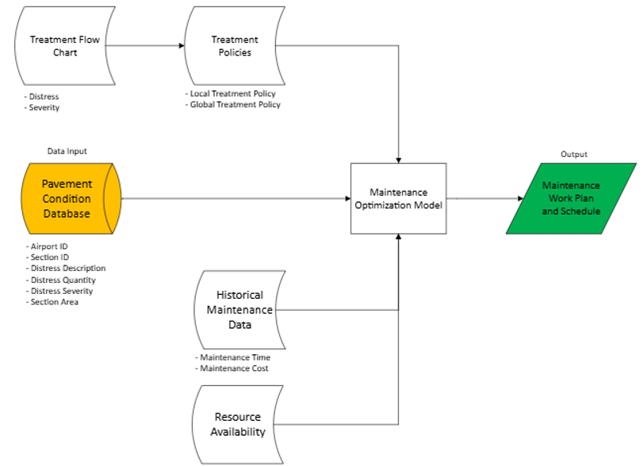
Figure 28. Methodology of airfield Pavement Management and policy

maximize the total number of airports with distress while respecting the airport classifications and other constraints. Since Gurobi typically tries to equate the results across all options, it was curious on what the initial results could be then modify the mathematical model until the heuristic operated like the commercial solver, which we will go into detail later. A comparison is then conducted to continue to modify the heuristic to determine when it does act more like a traditional commercial solver. Future improvements are then given as for now, having the amount and where work conducted balanced at all airports is the intentions, but instead of one year, pushing to three years is another future goal with a targeted PCI objective as well as budget.

Pavement Condition Database
The data input consists of an excel export from the PAVER application (example shown in Table 3) that contains all the condition data and other relevant information like airport identifier, pavement section area, distress present, distress quantity, distress severity, pavement section number and many more data points that were collected in the field. TASP role is the Tennessee Aviation System Plan role and it is based on the types of aircraft and operations at the airport. Something that was not taken into consideration is the types of treatment associated to the types of aircraft utilizing the airport. Since commercial services except for a non-primary one was taken out of the data set, the weights of aircrafts do not play a role in this evaluation. The cost factor is the budget that is being exercised and also the unit cost for the maintenance type shown in Table 4. Resource availability also shown in Table 4 are set amounts using historical values of what was accomplishable daily for each maintenance type at the State over the last 4 years’ worth of data that was reviewed to create a baseline that could be associated. Later in Chapter 4.4, we will dive deeper in the meeting of accomplish units per day and how they were derived.
Table 3. PAVER data export
ID | Network | Branch | Distress | Quantity
0A3 | Smithville | Apron |  | 0.00
0A3 | Smithville | Apron | RAVELING | 3.41
0A3 | Smithville | Apron | RAVELING | 1806.55
0A3 | Smithville | Apron | LONGITUDINAL/TRANSVERSE | 2600.75
0A3 | Smithville | T-hangar 01 | RAVELING | 32.32
0A3 | Smithville | T-hangar 01 | LONGITUDINAL/TRANSVERSE | 622.72
0A3 | Smithville | T-hangar 01 | WEATHERING | 969.64
0A3 | Smithville | T-hangar 01 | RAVELING | 1185.12
0A3 | Smithville | T-hangar 01 | RAVELING | 368.27
0A3 | Smithville | T-hangar 01 | WEATHERING | 397.73
0A3 | Smithville | T-hangar 01 | LONGITUDINAL/TRANSVERSE | 905.95
0A3 | Smithville | T-hangar 01 | PATCHING | 2695.76
0A3 | Smithville | Runway 6-24 | RAVELING | 298.40
0A3 | Smithville | Runway 6-24 | LONGITUDINAL/TRANSVERSE | 13030.25
0A3 | Smithville | Connecting Taxiway | LONGITUDINAL/TRANSVERSE | 278.00
0A4 | Johnson | Apron | LINEAR CRACKING | 1.00
0A4 | Johnson | Apron | SHATTERED SLAB | 1.00
0A4 | Johnson | Apron | SHATTERED SLAB | 3.00
0A4 | Johnson | Apron | ALLIGATOR CRACKING | 743.63

Table 4. Cost factors and resource availability
Maintenance | Pavement Type | Units | Average Unit Cost ($/Unit)
AC Patch | Asphalt | SqFT | 3.53
Crack Seal (Type 1) | Asphalt | FT | 1.2
Crack Seal (Type 2) | Asphalt | FT | 2.36
Crack Seal (Type 3) | Asphalt | FT | 37.24
Microsurface | Asphalt | SqFT | 0.56
Slurry Seal | Asphalt | SqFT | 0.42
Cape Seal | Asphalt | SqFT | 0.79
Monitor | Asphalt | Each | 0
Seal Coat | Asphalt | SqFT | 0.13
Crack/Joint Seal | Concrete | FT | 9.36
Grinding/Grooving | Concrete | SqFT | 0.53
Monitor | Concrete | Each | 0
PCC Patching (Full) | Concrete | SqFT | 64.63
PCC Patching (Partial) | Concrete | SqFT | 14.55
Replacement (Statewide Contract - Smaller Area) | Asphalt | SqFT | 6.50
Replacement (Invitation to Bid - Larger Area) | Asphalt | SqFT | 14.75

Treatment Flow Chart and Policies
The treatment flow chart shown in Figure 29 was first developed to utilize the distresses present in the Pavement Condition Index (PCI) inspection results for each pavement section that gives what types of distresses were present in the inspection and the severity to categorize the type of treatment that would be received. There are also allotments where if the quantity of distresses were either low or high, it could select a different treatment option. The flow chart would then influence how the heuristic and commercial solver would initially assign the treatments for each distress that then the global policy would then be enacted given certain circumstances. For each, for one pavement section, say that the pavement has medium severity weathering. The treatment would be slurry seal if the amount of distress is greater than 10% of the section area. For the airport, the global policy would be looking at all the section areas and if Microsurfacing is also present at the airport and the slurry surfacing is not greater than 30% of the entire airport’s section surface areas, the slurry surfacing would be changed over to Microsurfacing due to making the selection of materials easier to handle plus the cost being relatively similar due to having a higher markup for lesser quantities and having to truck the material to the airport. The result was then logged in the excel output file.
The treatment flow chart was derived from 28 possible distresses. Examples are shown below in Table 5 with associated treatments in Table 6 as a sample to create an approach that could be repeatable that would assign treatments to all pavement sections of each airport associated to their distresses present. Bear in mind this also includes non-maintenance items like replacement as it is a way to determine if that pavement sections maintenance needs to be deferred due to replacement being imminent. This followed the standard FAA and ASTM methods of treatments as it has been a standard for many decades.
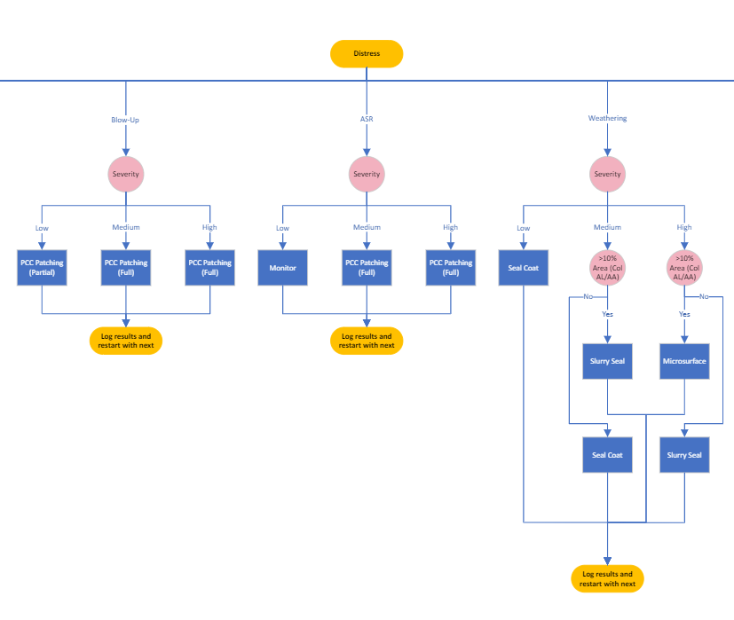
Figure 29. Example treatment flow chart
Table 5. Example of possible distresses
Database Distress | Pavement Type
ALLIGATOR CRACKING | Asphalt
BLEEDING | Asphalt
BLOCK CRACKING | Asphalt
DEPRESSION | Asphalt
JOINT REFLECTION CRACKING | Asphalt
LONGITUDINAL/TRANSVERSE CRACKING | Asphalt
OIL SPILLAGE | Asphalt
PATCHING | Asphalt
RAVELING | Asphalt
RUTTING | Asphalt
SHOVING | Asphalt
SWELLING | Asphalt
WEATHERING | Asphalt
ASR | Concrete
BLOW-UP | Concrete
CORNER BREAK | Concrete
CORNER SPALLING | Concrete
DURABILITY CRACKING | Concrete
FAULTING | Concrete
JOINT SEAL DAMAGE | Concrete
JOINT SPALLING | Concrete
Table 6. Example of distresses and maintenance treatment without local policy
Database Distress | Severity | Maintenance
ALLIGATOR CRACKING | Low | AC Patch
ALLIGATOR CRACKING | Medium | AC Patch
ALLIGATOR CRACKING | High | AC Patch
BLEEDING | N/A | Monitor
BLOCK CRACKING | Low | Crack Seal (Type 1)
BLOCK CRACKING | Medium | Crack Seal (Type 2)
BLOCK CRACKING | High | Crack Seal (Type 3)
DEPRESSION | Medium | AC Patch
DEPRESSION | Low | AC Patch
DEPRESSION | High | AC Patch
JOINT REFLECTION CRACKING | Low | Crack Seal (Type 1)
JOINT REFLECTION CRACKING | Medium | Crack Seal (Type 2)
JOINT REFLECTION CRACKING | High | Crack Seal (Type 3)
LONGITUDINAL/TRANSVERSE CRACKING | Low | Crack Seal (Type 1)
LONGITUDINAL/TRANSVERSE CRACKING | Medium | Crack Seal (Type 2)
LONGITUDINAL/TRANSVERSE CRACKING | High | Crack Seal (Type 3)
OIL SPILLAGE | N/A | AC Patch
PATCHING | Low | Monitor
PATCHING | Medium | AC Patch
PATCHING | High | AC Patch
RAVELING | Low | Seal Coat
Since this is all surface based distresses, only asphalt and concrete were selected rather than using a composite where there could be asphalt over concrete or vice versa. The intentions were to create a relationship to create based on the type of surface and the type of distress to then associate to a typical type of treatment based on the severity of distress that was present in the pavement. Global Policies shown in Table 7 are also established during the initial step for each airport to help ensure that the treatments made economical reasoning associated to what is being requested and held as a constraint in both solvers that are discussed in the next section. The goal was that if there was not a large quantity needed of a higher cost treatment, utilize the lower cost treatment that the rest of the other pavement sections are receiving at that airport for economies of scale. If there were a larger quantity of higher cost treatments being utilized, then upgrade the other pavement sections to a higher quantity treatment as well to further benefit from economies of scale. For example, if the need is two boxes of cereal of the first being a name brand and the other being a store brand, then purchasing the two boxes makes sense. If nine boxes of the name brand is needed and one box of generic, then it may make more sense to purchase 10 of the name brand from a discount bulk purchasing store due to economies of scale. With this, the intentions were to simplify the number of different similar treatments that would be prescribed to make the operations more “real-world” to make the output file more realistic. This would also indirectly minimize the delays at the airport from reopening due to not needing to continuously switch materials out or having to haul different materials to the airport to then be applied. This would also reduce the possibility of having a quilt looking appearance at the airport if the material change color at different rates as that would also affect the way that the airport is able to advertise itself to the public. It could also have a different appearance from the air from a pilot’s perspective as in different weather and lighting conditions can make a grey asphalt pavement very difficult to point out.
Table 7. Global policies
Priority | Instructions
Change "Seal Coat" or "Slurry Seal" to "Microsurface" | If "Block Cracking", "Joint Reflective Cracking" and/or "Logitudinal/Transverse Cracking" = "Crack Seal (Type 2)" and "Seal Coat", "Slurry Seal" or "Microsurface" is also recommended in the same section, change to "Microsurface".
Change "Microsurface" to "Cape Seal" | If "Block Cracking", "Joint Reflective Cracking" and/or "Logitudinal/Transverse Cracking" = "Crack Seal (Type 3)" and "Seal Coat", "Slurry Seal" or "Microsurface" is also recommended in the same section, change to "Cape Seal".
Change "Slurry Seal" to "Microsurface" | If "Microsurface" and "Slurry Seal" are on the same airport and "Slurry Seal" is <30% of surface area, change "Slurry Seal" to "Microsurfacing".
Change "Microsurface" to "Slurry Seal" | If "Microsurface" and "Slurry Seal" are on the same airport and "Microsurface" is <10% of surface area and less than 20,000 SqFT, change "Microsurface" to "Slurry".
Airport Classification | (1) Commercial Service, (2) Regional Service, (3) Community Business and (4) Community Service
Quantities | Higher Total Cost at one airport first: Single large quantities first (AL) or multiple smaller quantities to be corrected at the airport (Crack Seal plus Seal Coat/Slurry Seal/Microsurface/Cape Seal)

Historical Maintenance Data and Resource Availability
One of the major constraints is what a maintenance crew can accomplish. What this means is the amount of work that can be conducted by the crew to a certain unit of measure. For example, a crew of 3, which would be team 1, could accomplish 16,000 ft of crack repair in one day. Pending on the amount of cracking and the type of cracking present would specify the number of days needed. A total cost would also be estimated. TDOT is currently working on an average unit prices database for TDOT Aeronautics that would enable the ability to update unit cost dynamically associated to quantity. Pavement type is incredibly important as asphalt crack repair for example leads to the ability for a seal coat or another surface type treatment. This is why team 1 is the patching plus crack repair crew while team 2 is one type of surface treatment while the last team is only the seal coat application. The cost and area are major factors to ensure there is enough value to use team 2, 3 or both at any one airport. Concrete is more straightforward as it is one team, number 4, that does the concrete repairs as it isn’t prepping for another item thus not part of the critical path. Please note that painting pavement markings is not considered due to being yet another crew that is specialized in that specific area. The last two are replacement criteria where if triggered, would specify crew 5 or 6. For now, this is largely ignored, but helps to stratify the replacement gain for PCI thus can help to garner the amount of capital projects are necessary with maintenance in order to maintain a system maximum PCI of 75, but also minimum of 70. Using the TDOT Pavement Management Standard Operating Procedure garnered the Pavement Life Extension (Years) for a starting point.
In order to not showcase true accomplishments per day from our current contractor, rough estimations were utilized from previous contracts to showcase as examples. The accomplishments are associated to different teams or crews that would accomplish the tasks plus average unit cost per unit itself and the unit of measure. All of this was also associated to the pavement type and the type of maintenance being executed associated to the distress. For monitoring, those were set to 0 for the team and unit cost.
This is actually one of the most important aspects for PCI system improvement. If not enough resources are available, then additional crews are needed or possibly additional contractors. Sequencing is incredibly important as outlined before thus for another future improvement would be the idea of adding subscripts to each team to identify alternative crews that could be utilized to help where there are traffic flow issues via critical path points. Another interesting idea would be a nodal network idea in terms of distance as after a group of airports are selected, they would need to be realigned from West Tennessee to East Tennessee as normally West Tennessee warms up sooner plus having the crews move sequentially throughout the state.

Heuristic method
For the heuristic, the main goal was to reorganize all the preprocessed data to associate a level of importance for each airport classification and then group the cost of each classification to ensure that the contractor remained active and yielded the best unit pricing due to available work at each airport. The pseudo-code for the heuristic is below:
Sorting distresses according to heuristic rules was the first process.
- Step 1: Read preprocessed file
- Step 2: If in the exclude column has a “1” for that pavement section, data is excluded. The goal is that this ensures that rows marked for exclusion can be sorted to appear at the end of the dataset.
- Step 3: If distress data does not exist like a not-a-number in the distress column for the pavement section, label condition for that section as “Good”.
- Step 4: Define airport classification by “Commercial Service”, “Regional Service”, “Community Business”, “Community Service” with the first being the highest importance to the lowest at the end. Note that this is in lieu of having operational numbers to ensure equitable repairs to maintain safe operations at every airport.
- Step 5: Sort values by using the following order: Step 2, Step 3, Step 4 and then largest cost of airport and largest cost of distress by ascending the order. Note that this is also achieved by using an ascending parameter.
After this sorting was completed, the next step was associating the distresses being repaired by the remaining budget and remaining days.
- Step 1: Read the global constraints from the excel file
  - Consist of Total budget and remaining days
    - Note: Total budget is a key column to draw down as well as remaining days as the goal is to get them to “0”. This also assumes that each issue is only listed once and not duplicated for the airport. This isn’t needed as the export from PAVER does not duplicate datasets since it has its own QA/QC processes.
- Step 2: Counting the number of airports that are repaired
  - Note: The goal is to understand how many are accomplished within set budgets to help as a reality check.
- Step 3: Initialize remaining budget and teams’ days columns being added
  - Note: This is a new column needed to ensure we can then associate to compare to remaining time and budget to subtract from each airport as we work towards zero time being available and zero budget.
- Step 4: Calculate the remaining budget and days for each team iteratively
- Step 5: Subtract cost from remaining budget
- Step 6: Verify enough budget and days to repair the distresses
Steps 4 through 6 then runs an iterative sprint to move the budget and time to zero or as close as. The end goal is a script associated with the heuristic model is the ability to take an entire list that is outputted by a Blackbox system called PAVER as an excel data is able to be extracted from the system. It is then associate with the system level and project level objectives and constraints that enables the ability to obtain a list to associate with maintenance and capital projects to better implement a rough draft of projects to review versus having to manually comb through 69 airports.
The current process is too taxing as reviewing 69 airports for all their pavement sections and all the possible distresses to then map out a maintenance plan for the year makes it almost a full-time job itself. For example, taking a simple airport like Reelfoot Lake has 4 different pavement sections as shown in Figure 30. This would be considered a typical rural airport in the state that is part of the public-use and publicly owned system thus the pavements are subject to the pavement maintenance and marking program by the state in the effort to extend the pavement life. For one of the simplest airports in the state of Tennessee, it has 22 noted distresses and quantities shown in Figure 31. For a system number, TDOT Aeronautics has approximately 993 airfield pavement sections from their TN IDEA system when accounting for all airports categorized as public-use that is not considered a primary airport like a commercial airport namely Nashville International Airport, Memphis International Airport, McGee Tyson Airport, Tri-Cities Airport, and Chattanooga Airport as they have their own maintenance forces due to the size of their staff to take care of their pavement issues.
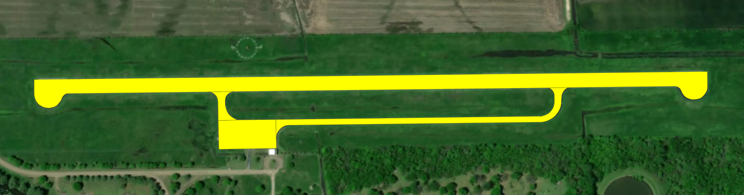
Figure 30. Reelfoot Lake airport pavement sections.

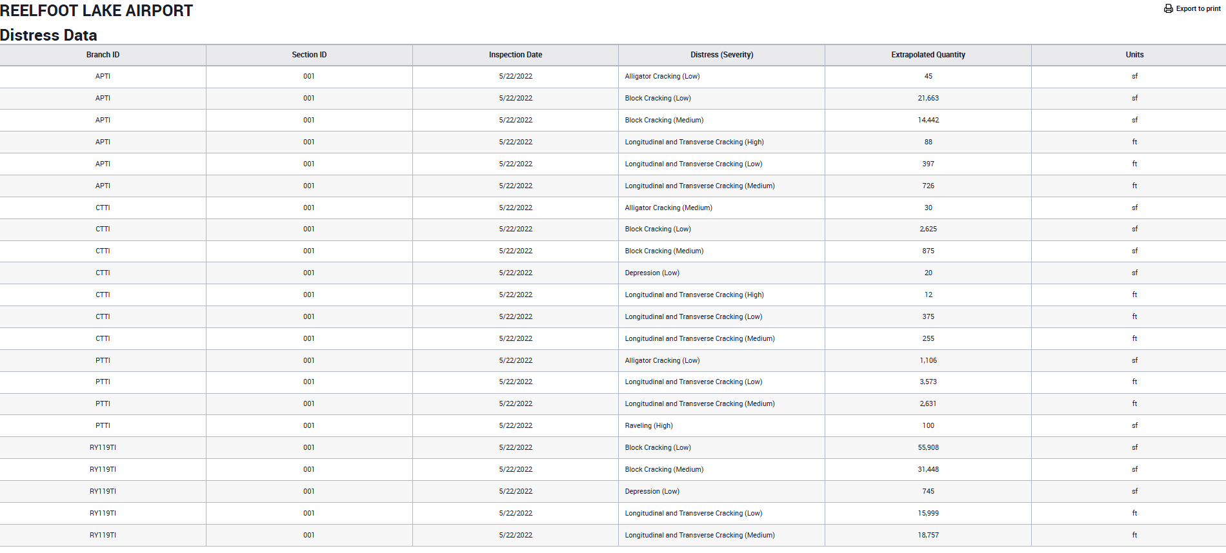
Figure 31. Reelfoot Lake asphalt distress

With the remaining airports where it made sense to have a statewide maintenance program to help Tennessee’s public-use airport system, to divide and prioritize work is nearly impossible without reviewing each airport manually then selecting manually and prioritize linearly. This has been problematic as each year is considered a new year on it’s own making data management and asset management virtually impossible due to having to manually review all records and account for conditional change of the asset from the previous inspection.
A better solution is the need of evaluating a multi-layer approach through a heuristic model that would allow prioritization and scoring associated to many additional criteria to be implemented at the same time to create a plan that can be adapted every year as new issues arise. This allows the ability to then focus on how this can impact the 10-year plan for the airport as known as their Airport Layout Plan or ALP and the 20-year system level plan, which outlines goals and objectives that the system is trying to accomplish to allow for economic growth to prosper at every community in the state plus support the next commercial airliner pilots as they all start out as general aviation pilots whether through college or flying on their own gaining the initial private pilot’s license as they work their way up to obtain all their certificate.

Maintenance Optimization Model
This section discusses the notation associated with Table 8 in detail and describes the mathematical model that created the heuristic programming model for optimizing airfield pavement repairs across all public-use airports available in the State of Tennessee while balancing cost, time, priority and feasibility that is executed.
As part of the iterative approach later described, the original objective function of the model had to be adapted as the goal was to create an effective model that could mimic the same output as a commercial solver as this would ensure that the model is functioning reasonably as a solution
Table 8. Notations for solver
$$x_{i}^{d}$$ | Decision variable where $i$ represents the distress and $d$ the type of decision.
$$y_{a}^{d}$$ | The total days required to address all distresses in the airport $a$ with decision $d$.
$$z_{a}$$ | This variable indicates whether all distresses in airport $a$ will be addressed.
$$A$$ | All public-Use and Publicly Owned Airports in the State of Tennessee
$$A_{i}$$ | The subset of airports where $i$ represents the category of the airport. Specifically, $A_{1}$, $A_{2}$, $A_{3}$, and $A_{4}$ correspond to “Commercial Service,” “Regional Service,” “Community Business,” and “Community Service,” respectively.
$$I$$ | The set of distresses present in the airport pavement sections.
$$D$$ | The set of decisions.
$$U$$ | An exclusion set comprised of distresses that must be omitted from consideration.
$$S_{a}$$ | The set of distresses in the airport $a$.
$$c^{d}$$ | It denotes the unit cost for each decision type $d$.
$$m^{d}$$ | It represents the accomplishment amount per day for each decision $d$.
$$q_{i}$$ | This is the quantity of distress $i$.
$$p_{i}^{d}$$ | This parameter indicates the acceptable decision for a distress.
$$B$$ | It is the total allocated budget for the project.
$$\overline{B}$$ | This parameter sets a threshold for the maximum allowable remaining budget.
$$T$$ | It represents the total days available to work on projects.
$$\overline{T}$$ | This parameter sets a threshold for the maximum allowable remaining days.
$$N_{a}$$ | The number of distresses in the airport $a$.
$$N$$ | The total number of airports.

that would not require a constant subscription while also being consistent to one. This also required the need of having to review the constraints to figure out what was or was not functioning correctly. Initially, a “greedy approach” was taken to determine if this would be a good approach for the heuristic model. This is the common approach that has been taken manually thus the desire was to replicate that process initially to see how it would compare to a commercial solver. It is then noted in the next few pages alternatives that were developed to then compare if improvement were realized or not in the heuristic model.
As specified beforehand, Pavement Condition Index (PCI) inspection is conducted every 3-years as required by the Federal Aviation Administration (FAA) thus the goal would be to generate a list of work annually for the year of every year. Ideally, as discussed in the improvement section would be the ability to create a work list for 3-years and a way to determine which pavement sections are selected sooner could be based on the amount of Pavement Condition Index is recovered if it is recalculated utilizing regression modeling of the different deterioration curves. By having that, a new PCI number could be derived as any pavement that is repaired goes from the medium or high severity to low severity thus it won’t be a score of 100 unless if the pavement is fully replaced instead like a rehabilitation or reconstruction. This could be manageable as stated in the earlier section as maintenance can be 1/10th the cost of replacing thus can be very strategic with capital funds being utilized for pavement replacement across the state. This will be a future enhancement of the model as the first goal is to discover the reasonability.
The Mathematical Model is as follows:
Maximize: ${(N}^{3}\sum_{a∈A_{1}}{z_{a}}+N^{2}\sum_{a∈A_{2}}{z_{a}}+N^{1}\sum_{a∈A_{3}}{z_{a}}+\sum_{a∈A_{4}}{z_{a}})$
$$\sum_{i∈I}{\sum_{d∈D}{c^{d}q_{i}}x_{i}^{d}}≤B⋅⋅⋅⋅⋅⋅⋅⋅⋅⋅⋅⋅⋅⋅⋅⋅⋅⋅⋅⋅⋅⋅⋅(1)$$
$$y_{a}^{d}≥\sum_{i∈S_{a}}{\frac{q_{i}}{m_{d}}x_{i}^{d}}, ∀a∈A,d∈D ⋅⋅⋅⋅⋅(2)$$
$$\sum_{a∈A}{\sum_{d∈D}{y_{a}^{d}} }≤T ⋅⋅⋅⋅⋅⋅⋅⋅⋅⋅⋅⋅⋅⋅⋅⋅⋅⋅⋅⋅⋅⋅⋅⋅⋅⋅⋅⋅⋅(3)$$
$$\sum_{d∈D}{x_{i}^{d}}≤1 ∀i∈I⋅⋅⋅⋅⋅⋅⋅⋅⋅⋅⋅⋅⋅⋅⋅⋅⋅⋅⋅⋅⋅⋅⋅⋅⋅⋅⋅⋅\left(4\right)$$
$$(1-p_{i}^{d})x_{i}^{d}≤0 ∀i∈I,d∈D⋅⋅⋅⋅⋅⋅⋅⋅⋅⋅(5)$$
$$B-\sum_{i∈I}{\sum_{d∈D}{c^{d}x_{i}^{d}}}≤\overline{B} ⋅⋅⋅⋅⋅⋅⋅⋅⋅⋅⋅⋅⋅⋅⋅⋅⋅⋅⋅⋅(6)$$
$$T-\sum_{a∈A}{\sum_{d∈D}{y_{a}^{d}}}≤\overline{T} ⋅⋅⋅⋅⋅⋅⋅⋅⋅⋅⋅⋅⋅⋅⋅⋅⋅⋅⋅⋅⋅⋅⋅(7)$$
$$z_{a}\left(N_{a}-\sum_{i∈s_{a}}{\sum_{d∈D}{x_{i}^{d}}}\right)≤0 ∀a∈A⋅⋅(8)$$
$$\sum_{d∈D}{x_{i}^{d}}≤0, ∀i∈U⋅⋅⋅⋅⋅⋅⋅⋅⋅⋅⋅⋅⋅⋅⋅⋅⋅⋅⋅⋅⋅⋅⋅⋅⋅⋅(9)$$
$$x_{i}^{d}∈\left\{0, 1\right\} ∀i∈I,d∈D⋅⋅⋅⋅⋅⋅⋅⋅⋅⋅⋅⋅⋅⋅⋅⋅⋅(10)$$
$$y_{a}^{d}∈Z ∀a∈A,d∈D⋅⋅⋅⋅⋅⋅⋅⋅⋅⋅⋅⋅⋅⋅⋅⋅⋅⋅⋅⋅\left(11\right)$$
$$z_{a}∈\left\{0, 1\right\} ∀a∈A⋅⋅⋅⋅⋅⋅⋅⋅⋅⋅⋅⋅⋅⋅⋅⋅⋅⋅⋅⋅⋅⋅⋅⋅⋅⋅(12)$$
The objective function is designed to maximize the total number of airports, A, repaired, by their different categories. It is also designed to add a penalty or reward based on improvements in Pavement Condition Index for each of the different categories. Constraint (1) ensures adherence to the total cost of repairs in each time period designated as year to of which does not exceed the budget limit. Constraints (2) ensures that the number of workdays associated to each decision made d at airport a is calculated as such to ensure days required will be at least the amount of work divided by what can be accomplished. Constraint (3) is specifically limiting the contracting days needed to repair all distresses in airport $i$ under decision $d$ associated to the number of available days for the year. Constraint (4) ensures that only one decision is made for each distress. Constraint (5) defines the possible decision range for each distress, with parameters $b_{i}^{d}$ being determined by both local and global policies during the pre-processing stage. Constraints (6) and (7) ensures the remaining budget and contracting days do not exceed set thresholds. While these could be treated as soft constraints integrated into the objective function, doing so would necessitate balancing factors for multiple objectives; hence, we have retained them as hard constraints, as depicted in constraints (6) and (7). Constraint (8) limits the maximum Pavement Condition Index (PCI) for the airport system weighted average after the end of the 3rd year to be less than or equal to 75. Constraint (9) checks whether all distresses in airport $i$ are addressed, setting $z_{i}$ to 0 if any distress remains uncompleted. Constraint (10) ensures that all distresses within the exclusion set must be omitted from consideration. Constraints (11), (12), and (13) stipulate that decision variables $x_{ijkl}^{d}$ and $z_{i}$ must be binary, while $y_{i}^{d}$ should be an integer.
Again, the end result is a model that selects which distress to repair, what repair decision is necessary, which airport is selected to be fully repaired while staying within time and budget limits, feasibility and exclusions being applied and finally a system-wide performance cap.
This then pushed the need of testing out a more balanced approach as shown in Table 9 to then validate which result would create a model like that of a commercial solver. The meaning of most notations remains the same, e.g., $A_{i}$ in the new model is the same as in the previous one.
Revision to the previous Mathematical Model is as follows:
Maximize: $\sum_{i∈I}{\sum_{d∈D}{(\frac{w_{a\left(i\right)}}{1+c_{d }∙ q_{i}+\frac{q_{i}}{m_{d}}})}}+x_{i,d}$
Changes reflected above associate after running iterations and associating to make the heuristic act like a commercial solver.
Table 9. Revised notations for solver
$$x_{i}^{d}$$ | Decision variable where $i$ represents the distress and $d$ the type of decision.
$$y_{a}^{d}$$ | The total days required to address all distresses in the airport $a$ with decision $d$.
$$z_{a}$$ | This variable indicates whether all distresses in airport $a$ will be addressed.
$$A$$ | All public-Use and Publicly Owned Airports in the State of Tennessee
$$A_{i}$$ | The subset of airports where $i$ represents the category of the airport.
$$I$$ | The set of distresses present in the airport pavement sections.
$$D$$ | The set of decisions.
$$U$$ | An exclusion set comprised of distresses that must be omitted from consideration.
$$S_{a}$$ | The set of distresses in the airport $a$.
$$c^{d}$$ | It denotes the unit cost for each decision type $d$.
$$m^{d}$$ | It represents the accomplishment amount per day for each decision $d$.
$$q_{i}$$ | This is the quantity of distress $i$.
$$p_{i}^{d}$$ | This parameter indicates the acceptable decision for a distress.
$$B$$ | It is the total allocated budget for the project.
$$\overline{B}$$ | This parameter sets a threshold for the maximum allowable remaining budget.
$$T$$ | It represents the total days available to work on projects.
$$\overline{T}$$ | This parameter sets a threshold for the maximum allowable remaining days.
$$N_{a}$$ | The number of distresses in the airport $a$.
$$N$$ | The total number of airports.
$$w_{a}$$ | Role-based priority weight for airport a ( $A_{1}={80}^{4}; A_{2}={80}^{3}; A_{3}={80}^{2}; A_{4}={80}^{1} )$

Maintenance Work Plan and Schedule
Again, the end result is a model that selects which distress to repair, what repair decision is necessary, which airport is selected to be fully repaired while staying within time and budget limits, feasibility and exclusions being applied and finally a system-wide performance cap. This is absolutely critical as a rough draft that then the team can conduct a reality check to verify the work that needs to be conducted over the next three years. The beauty is that the TDOT Aeronautics Planning and Environmental team with the other Matrix team members like Project Delivery go to each airport each year to line up what projects should be on their Airport Capital Improvement Plan (ACIP) and associated to it, visiting the airport is key to discover needs and also verify needs. Outside of this, every year prior to the next year, the construction administrator, resident project representative associated to the TDOT Aeronautics On-Call consultant contract plus the APMM TDOT representative visits every airport listed on the list to verify the sections of pavement being requested for maintenance and the type of maintenance being outlined as field conditions can change from year 0 to year 3 of the Pavement Condition Index field evaluation. In time as the system-wide maintenance covers all airport’s cracks, the maintenance cycles will not be so drastic of having to crack repair the entire airfield, but rather a more predictable cycle of maintenance by just refilling existing cracks or washing markings with slight seal coat re-application.
Every year, meeting with the contractor has been conducted by TDOT to outline the work for the year. The contractor will use scheduling to outline the best route and crew size for each task and execute based on that scheduling diagram like a Gantt chart. On the next page is an example that was shared as part of a maintenance project for Millington in Figure 32 and 33.

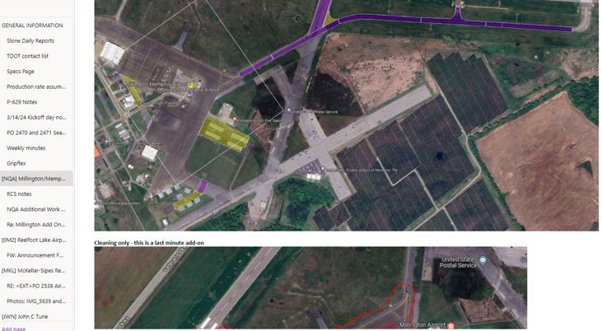
Figure 32. Map of Millington airport maintenance work

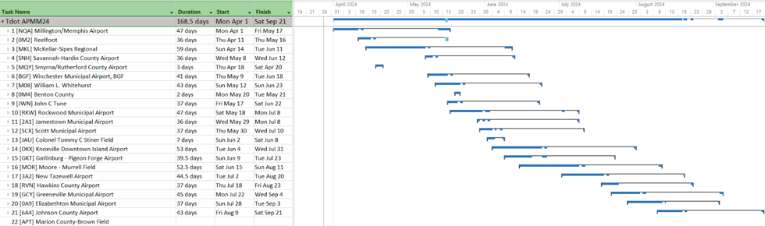
Figure 33. Gantt Chart for TDOT 2024 calendar year maintenance work

CHAPTER 5
RESULTS

Computation Setup
The mathematical formulations were implemented using Python 3 and solved using the commercial optimization solver Gurobi (version 8.1.0). All computations were carried out on a standard desktop with a 64-bit architecture running Windows 10 Pro. The machine is equipped with an Intel Core i7–1165G7 processor operating at 2.80 GHz and 8 GB of RAM. The heuristic algorithm was also developed in Python and executed within the PyCharm Integrated Development Environment (IDE) on the same computing platform.

Results for the two methodologies
The initial results between the two solvers are as follows:
- Heuristic Solver:
  - Number of airports fully repaired is: 15
  - Number of airports work conducted: 16
  - Remaining Budget: $44,680.00
  - Remaining Days: 142 days
  - Number of Distresses Addressed (Total Actions): 1,466
- Commercial Solver – Gurobi
  - Number of airports fully repaired is: 24
  - Number of airports work conducted: 66
  - Remaining Budget: $5,912.00
  - Remaining Days: 110 days
  - Number of Distresses Addressed (Total Actions): 1,908

Comparisons
From initial comparisons, Gurobi as a commercial solver can find 9 additional airports that was able to be repaired while also being able to maximize the available budget and days to minimize the remaining amounts. The number of distresses were also able to increase. From initial review, the heuristic solver was set up as a “greedy approach” where the best option is first found out until resources ran out. This led to the issue where it was less advantageous than the commercial solver as the “greedy approach” pushed to select based on lowest cost and days prioritizing Commercial to Regional to Community Business to Community Service airports then to lower cost than to lower days to repair as shown in Figure 34. Since Commercial has a higher number of sections and square area, the cost was exponential thus the heuristic quickly consumes the budget and days without ever reaching the lower status airports like Community Business and Community Service. The major issue is a lack of a balancing mechanism. Gurobi on the other hand and as an optimization model, proves to be better as Gurobi actively seeks a balance, maximizing airport coverage under the budget and time constraints required while pushing to touch all airport Tennessee Airport System Plan (TASP) categories. Since Gurobi was actively seeking a global score, it was able to assign work to the smaller airports like community business and service, and able to obtain the best overall score.
It was then from curiosity to see what happens to the data if the order of category concerning type of airport was flipped. If you flip the order of the order to start with the smallest category of TASP roles as shown in the results of Figure 35, Community Service dominates in all categories with only a few actions at Community Business and Commercial Service while Regional Service was 2nd in the amount of actions, but not even 1% of the cost. The total days kept rounding down for each action thus the simplistic options were taken at 3 of the 4. This was an interesting find as
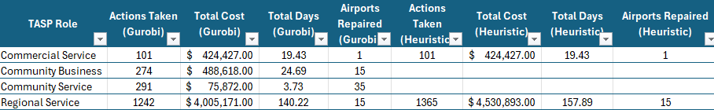
Figure 34. Gurobi versus Heuristic

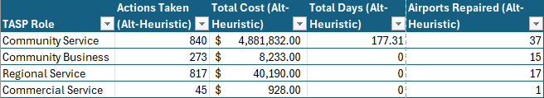
Figure 35. Gurobi versus Alternative Heuristic

it showcased that within one year, all the time and the majority of funds could be utilized in “Community Service” that would then not allow for other work to conduct in the other categories. It was noted that some repairs was being conducted at the other TASP role airports, but compared to the amount of funds being associated, it was not enough to see a balanced approach being taking into consideration. This illustrated the amount of work present just in one category thus a more balanced approach was still needed to level out the work across all the different TASP roles to be taken into consideration to ensure that all airport assets were being maintained rather than only being one-dimensional in terms of just their TASP role in the Tennessee aviation system.
Again, the commercial solver wins in balancing between all airports. Taking this further to find a way to balance the heuristic with results showing in Figure 36, a role weight was introduced with a composite score to help value the dollar associated to cost and the amount of time for the repairs of the distress instead of only using a static factor. The main purpose was testing the ability to replicate how a commercial solver would find a solution thus not have to be dependent on a commercial solver for reasonable solutions. The other main goal as specified beforehand is ensuring that this is a multi-layered approach to determine work to be conducted on a system level basis rather than individual airports only. While the goal is always to help individual airports, the other goal that has to also be realized is system level performance metrics thus ensuring a balance it maintained is always a critical goal. The results were promising as it showcased a more balanced approach for the amount of actions taken as well as cost and time. Compared to the previous, this resembled more closer to what a commercial solver would seek for year one. It was also good to see that not one category dominated the others so work can not only benefit an airport, but benefit the system of airports to ensure that system-wide pavement
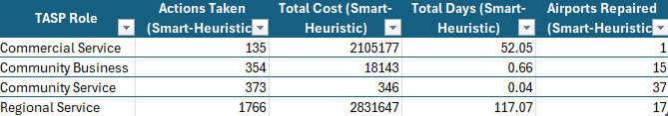
Figure 36. Gurobi versus Smart Heuristic
management was being conducted to ensure that the system level metrics are being impacted.
The factors that were used are shown below that was used to create the “Smart-Heuristic”.
Static Factor:
sort by: TASP Role (Commercial → Community), Cost Airport (low → high), Cost Distress (low → high)
Role Weight:
- Commercial: 80⁴
- Regional: 80³
- Community Business: 80²
- Community Service: 80
Score = role_weight / (1 + cost_distress + days_distress)
The end result was that the original heuristic was looking at only airport roles in order and then obtaining the cheapest item in order while the smart heuristic looks at each category first to figure out how important each airport role is then looks at value to obtain the best value you are obtaining per dollar associated to each airport role. The original heuristic was just a brute force method sorting the most important TASP role and then finding the cheapest option per role to execute, whereas, the smart introduces the ability to balance value, cost and time while balancing all the airport roles, which then the end result in Figure 37 showcases similar results between the Gurobi in terms of the number of action executed versus the new heuristic.This means a more dynamic approach that will calculate value per unit cost/time weighted by role importance. This also allowed for all airports to benefit with maintenance being executed at each airport. Comparing both the Gurobi and both Heuristic options is similar to comparing Gurobi v. Heuristic v. Manual, which is discussed in the next section.
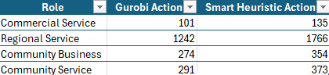
Figure 37. Comparison of Gurobi actions versus Smart Heuristic actions

One interesting perspective is that the original heuristic acted like a hyper “brute force” method of filtering different columns and doing several iterations of copying and pasting whereas the “Smart-heuristic” started to act like Gurobi where it would use the multiplier to create a dynamic scoring method that then influenced the priority of projects. The comparisons are shown in Figure 38. The “brute force” method would be like using a pivot table in excel and running iterations. It is not very sophisticated thus very linear in the approach used to find a reasonable solution. This also ensured that only the higher role airports received maintenance work, which goes against the purpose of maintenance on a system-level goal where it is actively searching to benefit all airports when needed pending on the available distresses as more severe distresses means that the asset is nearing a major shift to rehabilitation or reconstruction. Cost and time were also not linear anymore as it gave the ability to create a priority score instead to help determine which should be selected within that TASP role. The end result was that projects were then selected by a value per unit cost/time that was then weighted by the TASP role. Below in Figure 39 showcases the performance between the original heuristic versus Gurobi in terms of total actions, total cost, total days and total airports where work was conducted. Originally, the amount of cost and days of time being utilized was very similar, but the quality of performance was absolutely terrible concerning the heuristic. The heuristic effectively acted like a human in terms of sorting and resorting linearly to find a solution that maximized cost and time.
Below in Figure 40 compares the commercial solver Gurobi to the “smart” Heuristic. This was incredibly promising as the iterative approach created a result that mimicked what a commercial solver like Gurobi would create. It was also observed interestingly that the “smart” Heuristic was able to outperform the commercial solver Gurobi in terms of “Total Actions” with the commercial solver at 1,908 versus the heuristic at 2,628 and “Airports Repaired” with the
Figure 38. Comparison of original versus modified Heuristic

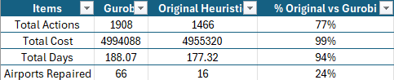
Figure 39. Comparison of original versus Gurobi by percentages

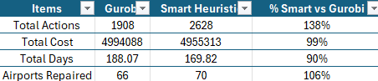
Figure 40. Comparison of modified Heuristic versus Gurobi by percentages

commercial solver at 66 versus the heuristic at 70 while being similar to cost, but also minimizing the number of days being needed with the commercial solver requiring 188 days compared to the 169 days that the heuristic was able to uncover.
This was incredibly promising as then a commercial solver would not have to be used thus future modifications for a system type implementation would be easier to create as a separate process flow would not have to be required to enable the need of the commercial solver to be a part of the solution intake. This also showcased those simple corrections to how the heuristic was understanding value worked well to balance the amount of work across the entire airport system rather than just one group of classifications or linearly.
This allows for a global approach to be achieved while also considering each airport individually. This also ensure that a worst-first approach was not taken, but rather a needs approach based on the amount of distresses found in each pavement section that was being evaluated had actions created that were then executed.
Below in Figure 41 compares the commercial solver Gurobi to both the original Heuristic and the “smart” Heuristic. This was a great moment in the evaluation as it showed how ineffective and also inefficient the current process is on how selecting projects linearly are. It is easier when the entire airport system needs initial maintenance as covering all airports will be the only goal.
The problem becomes exasperating when the initial repairs have been conducted system-wide and now just incremental maintenance is now needed based on consideration to distress and the number of distresses present. Obtaining an initial list of where work should be conducted that then allows staff to verify if the work is warranted allows for staff to optimize their time when having to review potential projects for the next year. The end result was showing how ineffective the original was compared to what the “Smart heuristic” was able to obtain. Mimicking the brute
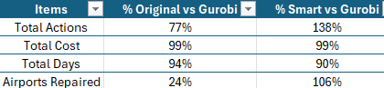
Figure 41. Comparison of original and modified versus Gurobi by percentages

force method to a “Smart heuristic” that is similar to Gurobi showcases that it can still maximize the cost and days, but the number of actions is nearly doubled while the amount of airports that are repaired are nearly 4 times more. The resolution was the ability to create a Heuristic that utilizes similar techniques that Gurobi uses so that for future improvement, utilizing multiple processes to determine a list of maintenance projects would not have to be needed.

Implementation
Since there is now a model that selects which distress to repair, what repair decision is necessary, which airport is selected to be fully repaired while staying within time and budget limits, feasibility and exclusions being applied and a system-wide performance cap, the other item of need is the ability to conduct the work itself. Tennessee recently announced on a LinkedIn post the ability to conduct a work-order based maintenance solution for their airports in the State of Tennessee. The major need now is the ability to push out a list of work that then could enable the team to visit the airports to confirm the work.

Improvements to research with PCI Modeling
With multiple years within being repaired, the major item needing to associate are deterioration curves that can anticipate how much lag time can be introduced to further depreciate the asset PCI score before action is enacted. This means that years 1, 2 and 3 could actually be delayed for maintenance that could impact the entire airport to be delayed or parts of an airport to be delayed when it is a higher value to be executed. The other item to improve is the ability to have a sorting function to clean up the airports in an order that makes it more sequential to execute work based on weather patterns in terms of temperature and rainfall.
Operations Data Counters have been enacted this year by TDOT Aeronautics that will count the type of aircraft and the count of aircraft in the state at the public-use general aviation airports. This can help to better understand the types of treatments associated to how heavy the aircraft is and/or the number of aircraft presently utilizing the airport. This will also help with geofencing as it will tell TDOT how much of the airfield different pavement sections are being utilized as that will indicate how much maintenance should be conducted till that section needs to be retired.
As part of the heuristic model, Pavement Condition Index (PCI) improvement was necessary to figure out the second half of the objective function. In order to turn the PCI graphs into integers, ASTM D5340-23, Airport Pavement Condition Index Surveys’ charts throughout the document was re-created as X and Y coordinates and then a python script was created to model the graph to fit a quartic best-fit line. The first goal was to generate a quartic polynomial regression for each asphalt pavement distress type for each condition from an excel file that was created from manually picking points off the deduct curves in the ASTM D5340-23 document. Example of the results is shown on the next page in Figure 42. The second need was to generate a quartic polynomial regression for each concrete pavement distress type for each condition from an excel file that was created from manually picking points off the deduct curves in the ASTM D5340-23 document. The third and fourth goal was to generate a quartic polynomial regression for corrected values if there were more than one distress in each type of pavement in their respective section whether it was asphalt or concrete pavement in the two charts shown in the ASTM D5340-23 document. This then allowed for the ability to recalculate the PCI values if repaired were assumed for each pavement distress in each pavement section. As specified before, once a repair is conducted, the pavement distress severity is reduced to a “low” severity thus not returning to a PCI score of 100 until the pavement section is replaced with a new asphalt layer from rehabilitation or reconstruction. After trying a cubic, quartic then a 5th degree polynomial regression best-fit line, it was visually apparent that the 4th degree or quartic was the best.
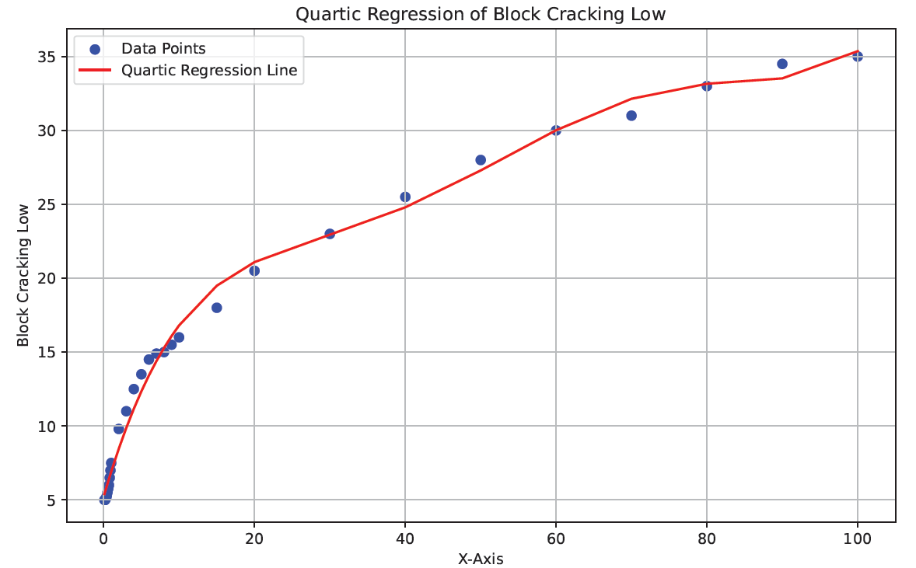
Figure 42. Example of modeling quartic regression

Since the goal was to automate a means of recalculating PCI values by utilizing equations developed with python to create the equations as shown below in Figure 43 and 44, so that if the pavement was repaired, the pavement section can be associate with a new PCI score and corrections to the PCI score can be made automatically if there are more than 2 distresses present in that pavement section. The PCI difference could then be calculated from subtracting the new PCI score from the old PCI score for each section then weighted averaged for the airport. The score for the airport was then saved to the table, which after running for each airport, the analysis is able to be conducted as we now have the 2nd part of the objective function. The objective function also had a corresponding constraint assigned such that after 3 years, the PCI improvement does not surpass 75.
Concerning the lack of a true fit was disregarded, which could pose error in the dataset that would have to be further evaluated as another opportunity as the assumption is that this is a subjective method of evaluating pavement that is repeatable thus there would be some sort of tolerance of error that would be considered acceptable.
The coding process that was required to obtain all 4 goals were similar so I will state the process for only asphalt via goal 1.
The pseudo-code is below:
- In order to perform the regression, after the excel was created with the x and y points, the python scrip extracted the data to create a two-dimensional array for regression analysis.
- It then created a PDF file that will store all the plots plus a new excel workbook to store all the equations.
- For the data processing and regression analysis, the script first filters out rows where either X or Y data is not a number.
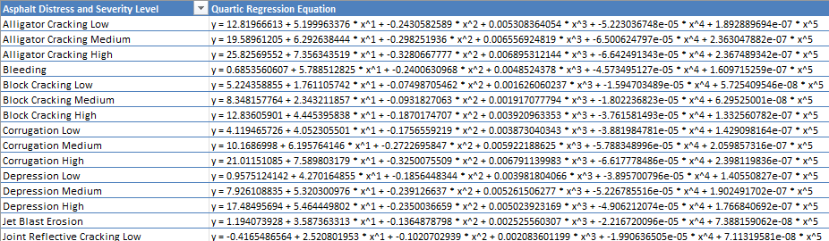
Figure 43. Example of asphalt quartic regression equations of distresses

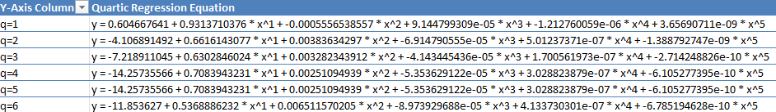
Figure 44. Example of asphalt quartic regression equations correction values

- It then checks if the data contains at least two points as it is minimum to calculate regression. If this checks valid, then a polynomial up to the 5th degree for the x data is computed. A line is then fitted.
- The next step is plotting the data with the fitted regression line with also labeling and saving as a PDF file.
The last couple of steps are getting the coefficients to ten significant figures and applying them to the excel workbook.

CHAPTER 6
BUSINESS INSIGHTS
For General Aviation (GA) airports, maintenance has been left to the airports across the nation to be enacted to ensure the federal, state and local investments are upheld. There are federal grant assurances that require the expected service lives to be obtained. The main concern is that service lives can be obtained by doing virtually no maintenance or limited maintenance. Serviceability may be concern with pavement debris, also known as Foreign Object Debris or FOD, being able to be displaced. With buying power decreasing as demonstrated in Chapter 3, extending service life is now more critical to offset rehabilitation or reconstruction cost to enable budgets to cover the need of expansion and other revenue enabling projects for the airport as hangar demand from airports continue to be requested around the state due to population growth and relocated aircraft to Tennessee airports. Reviewing the TDOT Pavement Resurfacing Program Standard Operating Guidelines have shown that maintenance treatments are leveraged to extend pavement life as Crack Seal can give up to 3 years of life back to the pavement asset, seal coats giving 4 years, Microsurfacing giving 8 years, whereas a chip seal can add 10 years of life back, which is a similar life expectancy of rehabilitated pavements according to the Federal Aviation Administration (FAA) Airport Improvement Program (AIP) table 3-7 requirements. As shown in the 2013 version of the TDOT Pavement Resurfacing Program Standard Operating Guidelines, a Concept of Pavement Preservation is show below as Figure 45. The idea of the figure is that as maintenance is conducted and surface preservation is enacted, the pavement life is being extended and condition maintained. The goal of the airport program would mirror this aspect of being able to extend further than the 30 years expected from the FAA AIP Handbook for new construction asphalt pavement.
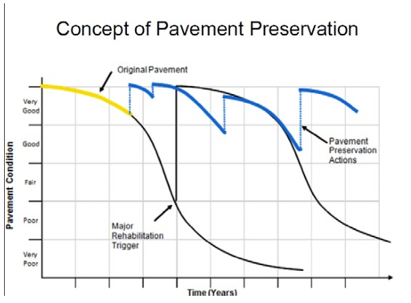
Figure 45. TDOT’s roadway concept of Pavement Preservation

Since there is now a model that selects which distress to repair, what repair decision is necessary, which airport is selected to be fully repaired while staying within time and budget limits, feasibility and exclusions being applied and a system-wide performance cap, the other item of need is the ability to conduct the work itself. Tennessee recently announced on a LinkedIn post the ability to conduct a work-order based maintenance solution for the public-use General Aviation (GA) airports in the State of Tennessee. This will pair well with the ability to further conduct maintenance on a more timely and planned methodology. TDOT Aeronautics’ goal of maintaining a PCI of 65 for Runways and PCI of 60 for other airfield pavements from their Airport Pavement Management Program (PMP) report would be achievable pending on available supporting budget associated to their maintenance program. As a test, a PCI of 75 for the entire system was selected and the result of everything was being able to produce a table of work to be conducted as shown on Figure 46. The other and more import was redefining what PCI actually means associated to what industry has been trying to redefine the intentions of ASTM. From this dissertation, a modified figure (Figure 47) was created to illustrate the goal of this dissertation, which was to inform readers that since ASTM is a means of creating an objective score to signify that maintenance or rehabilitation could be needed pending on what the PCI score is and how fast it is changing, then taking the score only would lead the reader astray as distresses have to be taken into consideration to determine the appropriate course of action. Again, it illustrates the idea that if the PCI is low, it is a trigger mechanism that by the pavement issues present known as distresses, either maintenance or rehabilitation/reconstruction is necessary to correct the pavement issues to ensure that the airport pavement life cycle continues as intended. This ensures that ASTM D5340-23 is held true to the intentions.

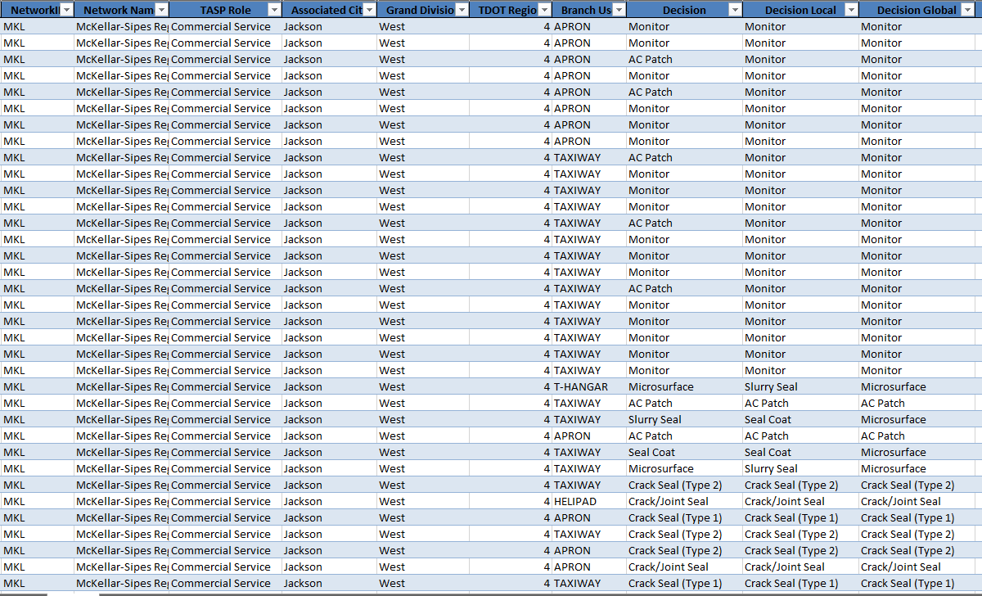
Figure 46. Example list of maintenance prioritized by Heuristic solver
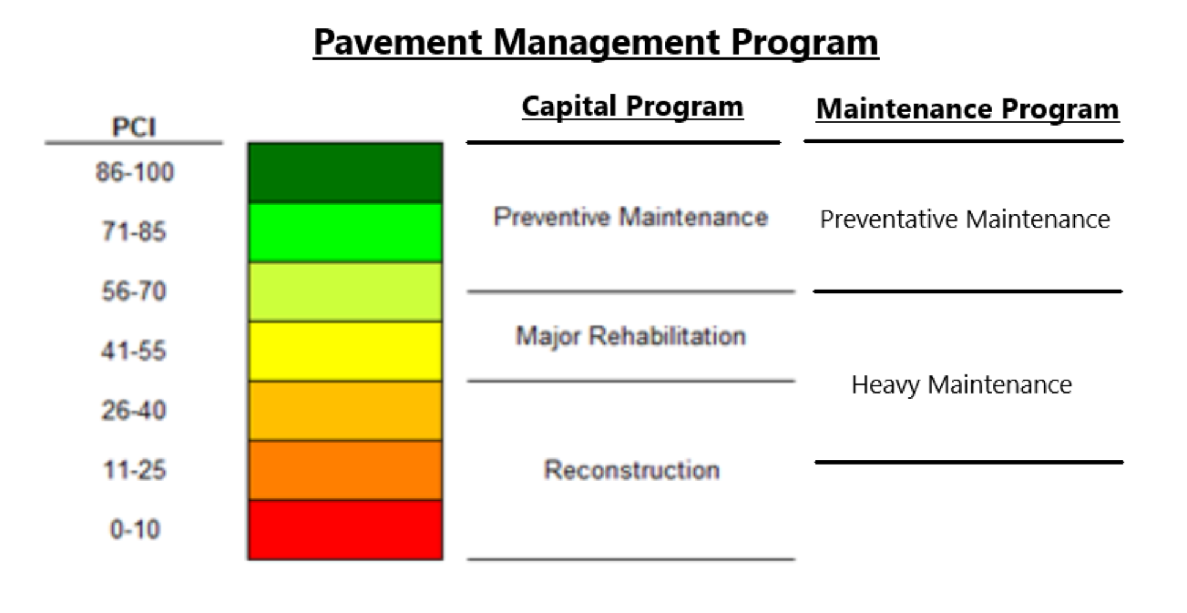
Figure 47. Example of PCI associated to capital and maintenance program

CHAPTER 7
CONCLUSION
This dissertation was able to achieve the ability to optimize pavement maintenance for public-use General Aviation (GA) airport and set the ability to create a policy of objectives to target and achieve as part of an airfield pavement management strategy. The desire was to shorten manual work that is required to review the results from the Federal Aviation Administration (FAA) Pavement Condition Index (PCI) Survey results to create a maintenance plan that would be like following a recipe for the state agency or airport sponsor that is in charge of more than one airport or a complex airport system where evaluating all the airfield pavement to understand what needs are is impossible without the use of modeling. As specified beforehand, the ASTM PCI survey is a statistical sampling with the ability to add additional samples pending on irregularities found. Irregular distresses would be assumed to be more accurate while regular distresses could be moreso inaccurate due to sampling area assumption being smaller or larger than what is present thus when extrapolated, the results of cracking could be off as much as thirty percent from my personal experience. This is still very sufficient for a system level survey as anything more requires a preliminary engineering study at an airport level. To help with cracking data, TDOT Aeronautics is working on a crack learning algorithm that could be utilized into this model in the future to increase the accuracy of work orders needing to be accomplished. This would make the need of preliminary engineering studies for maintenance projects not needed while making those preliminary engineering studies more valuable for capital projects and/or rehabilitation/reconstruction projects. This turns maintenance into moreso only needing PCI studies being completed and a drone survey to augment the cracking data plus placing cracking data severities into more accurate categories that will allow the state to only need to invest into preliminary site reviews by the consultant executing the airport resident project representative and the construction administrator. This allows for rapid ramp-up for work to be completed to maintain pavement life and allow budgets to go further for other needed investments at the airport for the public and their community to benefit from.

REFERENCES
Abaza, K. A., Ashur, S. A., & Al-Khatib, I. A. (2004). Integrated pavement management system with a Markovian prediction model. Journal of Transportation Engineering, 130(1), 24-33.
Ali, A. A., et al. (2023). Predicting pavement condition index based on the utilization of machine learning techniques: A case study. Journal of Road Engineering, 3(3), 266-278.
ASI. (2019). Best practices P-608 emulsified asphalt seal coat. Salt Lake City, UT.
ASTM International. (2023). Standard test method for airport pavement condition index surveys (D5340-23). https://www.astm.org/d5340-23.html
Babashamsi, P., et al. (2022). Perspective of life-cycle cost analysis and risk assessment for airport pavement in delaying preventive maintenance. Sustainability, 14(5), 2905. https://doi.org/10.3390/su14052905
Boyapati, B., & Kumar, R. P. (2015). Prioritisation of pavement maintenance based on pavement condition index. Indian Journal of Science and Technology, 8(14), 1-5.
Chen, L., et al. (2020). Optimization model of network-level pavement maintenance decision considering user travel time and vehicle fuel consumption costs. Journal of Advanced Transportation, 2020, Article ID 9237963, 1-15. https://doi.org/10.1155/2020/9237963
Chung, N., & Ho, G. (2010). Using integer programming for airport service planning in staff scheduling. International Journal of Engineering Business Management, 2.
Federal Aviation Administration. (2025). AIP handbook order 5100-38D Chg1. https://www.faa.gov/sites/faa.gov/files/AIP-Handbook-Order-5100-38D-Chg1.epub
Federal Aviation Administration. (2025). Asphalt surfaced airfields distress manual. https://www.faa.gov/documentLibrary/media/Advisory_Circular/Asphalt-Surfaced-Airfields-Distress-Manual.pdf
Federal Aviation Administration. (2025). Concrete-surfaced airfields distress manual. https://www.faa.gov/documentLibrary/media/Advisory_Circular/Concrete-Surfaced-AirfieldsDistress-Manual.pdf
Federal Aviation Administration. (2025). Guidelines and procedures for maintenance of airport pavements (AC 150-5380-6C). https://www.faa.gov/documentLibrary/media/Advisory_Circular/150-5380-6C.pdf
Federal Aviation Administration. (2014). Airport pavement management program (AC 150/5380-7B). https://www.faa.gov/airports/resources/advisory_circulars/index.cfm/go/document.current/documentNumber/150_5380-7
Freeman, T. J., et al. (2016). Pavement maintenance guidelines for general aviation airport management. Transportation Research Board. https://acrp-pavement-tool.tti.tamu.edu/docs/ACRP-09-11-Guidebook.pdf
Gu, W., Ouyang, Y., & Madanat, S. (2012). Joint optimization of pavement maintenance and resurfacing planning. Transportation Research Part B: Methodological, 46(4), 511-519.
Hosseini, S. A., & Smadi, O. (2021). How prediction accuracy can affect the decision-making process in pavement management system. Infrastructures, 6(2), 28.
Issa, A., Samaneh, H., & Ghanim, M. (2022). Predicting pavement condition index using artificial neural networks approach. Ain Shams Engineering Journal, 13(1), Article 101490.
Joslin, K., Murillo, J. P., & Hicks, R. G. (2019). Literature review on performance, best practices, and training needs for chip seals, slurry surfacing, and cape seals. Mineta Transportation Institute. https://transweb.sjsu.edu/sites/default/files/1845D-Cheng-Pavement-Maintenance-Literature-Review.pdf
Karballaeezadeh, N., et al. (2020). Intelligent road inspection with advanced machine learning: Hybrid prediction models for smart mobility and transportation maintenance systems. Energies, 13(7), 1718. https://doi.org/10.3390/en13071718
Márquez, A. C., Gómez, D., & Poyatos, J. M. (2008). The maintenance management framework: A practical view to maintenance management. In Safety, reliability and risk analysis (pp. 707-712). CRC Press.
National Academies of Sciences, Engineering, and Medicine. (2011). Guidelines for the preservation of high-traffic-volume roadways. Washington, DC.
National Academies of Sciences, Engineering, and Medicine. (2015). Preventive maintenance at general aviation airports. Volume 1: Primer. https://doi.org/10.17226/22117
Noruzoliaee, M., & Zou, B. (2019). Airfield infrastructure management using network-level optimization and stochastic duration modeling. Infrastructures, 4(1), 2. https://doi.org/10.3390/infrastructures4010002
Nunez, M. M., & Shahin, M. Y. (1986). Pavement condition data analysis and modeling. Transportation Research Record, (1070), 125-132.
Peshkin, D. G., et al. (2004). Optimal timing of pavement preventative maintenance treatment applications. NCHRP.
Roh, S., et al. (2023). Airport pavement maintenance decision-making system with condition cases optimization. Applied Sciences, 13(24), 13167. https://doi.org/10.3390/app132413167
SealMaster. (2023). Polymer-modified masterseal (PMM) ultra pavement sealer. https://sealmaster.net/pdf/specification/Sealmaster%20spec%20sheets/polymer-modified-masterseal-PMM.pdf
Sirvio, K. M. (2015). Intelligent systems in maintenance planning and management. In Intelligent techniques in engineering management: Theory and applications (pp. 221-245).
Tennessee Department of Finance and Administration. (2005). The budget, fiscal year 2005-2006. https://digitaltennessee.tnsos.gov/fa_budget_vol_1/23/
Tennessee Department of Finance and Administration. (2022). The budget: Fiscal year 2022-2023, volume 1. https://www.tn.gov/content/dam/tn/finance/budget/documents/2023BudgetDocumentVol1.pdf
Tennessee Department of Transportation. (2023). TDOT Aeronautics Division and the Tennessee Airport Authority celebrate 2023 annual conference success! LinkedIn. https://www.linkedin.com/posts/tennessee-department-of-transportation_tdot-aeronautics-division-and-the-tennessee-activity-7156322348902600704-Q1-A
Tennessee Department of Transportation. (2018). TDOT pavement resurfacing program standard operating guidelines. https://www.tn.gov/content/dam/tn/tdot/maintenance/pavement-office/TDOT-ResurfacingGuidelines-27April2018.pdf
Tennessee Department of Transportation. (n.d.). Construction pavement management program. https://www.tn.gov/content/dam/tn/tdot/construction/old_web_page/Const_Pavement_Managment_program.pdf
Tennessee Department of Transportation Aeronautics Division. (2023). Tennessee airport pavement management program update. Nashville, TN.
Tennessee Department of Transportation. (2023). Tennessee IDEA pavement management portal. https://idea.appliedpavement.com/hosting/tennessee/index.html
Tighe, S. L., & Covalt, M. (2008). Implementation of an airport pavement management system. Transportation Research Circular, (E-C127).
U.S. Department of Transportation. (2025). NHI inflation dashboard. Federal Highway Administration. https://explore.dot.gov/views/NHIInflationDashboard/NHCCI_1
Wang, H., Guo, L., & Chen, X. (2019). Airfield pavement management framework using a multi-objective decision making process (Report No. CAIT-UTC-REG 6). Rutgers University, Center for Advanced Infrastructure and Transportation.
Zou, B., & Noruzoliaee, H. (2017). Protecting the airfield assets at O'Hare International Airport: Developing prediction capability for taxiway pavement conditions and review of federal guidelines and state-of-the-practice in airfield assets condition rating. University of Illinois at Chicago and University of Illinois at Urbana-Champaign.

APPENDIX

Treatment Flow Chart and Policies for Heuristic Model
import pandas as pd
import numpy as np
def generate_output(decision_file, data_file):
# Load raw data for decision tree and constraints
df_treatment = pd.read_excel(decision_file, sheet_name='Treatment')
df_annual_constraints = pd.read_excel(decision_file, sheet_name='Annual Global Constraints')
# Load raw data for processing
df_data = pd.read_excel(data_file, sheet_name='Sheet1')
# Generate decisions based on the decision tree and local/global policies
decision_tree = generate_decision_tree(df_treatment)
df_decision = generate_decision(df_data, decision_tree)
df_adjusted_local = decision_adjustment_local_policy(df_decision)
df_adjusted_global = decision_adjustment_global_policy(df_adjusted_local)
df_resource_requirements = generate_resources_requirement(df_adjusted_global, df_annual_constraints)
# Export the final DataFrame to an Excel file
output_file_name = 'output.xlsx'
df_resource_requirements.to_excel(output_file_name, index=False)
print(f"Results exported to {output_file_name}")
def generate_decision_tree(dataframe):
"""
The following codes generate the decision tree according to the dataframe, which is the "Treatment" tab
of the Excel "Data with Distresses".
"""
decision_tree = {}
for index, row in dataframe.iterrows():
distress_code = row['Distress Code']
severity = row['Severity']
maintenance = row['Maintenance']
decision_tree[distress_code, severity] = maintenance
return decision_tree
def generate_decision(dataframe, decision_tree):
"""The following codes generate initial decisions according to the decision tree."""
# Duplicate a new data frame
df = dataframe.copy()
# Add a new column 'DistressID' starting from 1
df.insert(0, 'DistressID', range(1, 1 + len(df)))
# Function to apply the decision tree
def apply_decision(row):
try:
distress = row['Distress Code']
except:
distress = 'N/A'
severity = row['Severity']
key = (distress, severity)
return decision_tree.get(key, float('nan'))
# Applying the decision function to each row
df['Decision'] = df.apply(apply_decision, axis=1)
return df
def decision_adjustment_local_policy(dataframe):
"""The following codes use local policies to adjust the decisions."""
df = dataframe.copy()
# Duplicate decisions
df['Decision Local'] = df['Decision']
# Update 'decision' based on local conditions
# ALLIGATOR CRACKING, Low Sevirity, <=30% pf area: AC Patch-> Monitor
df.loc[
(df['Distress Code'] == 41) &
(df['Severity'] == 'Low') &
(df['Distress Quantity'] <= 0.3 * df['Section True Area']),
'Decision Local'] = 'Monitor'
# ALLIGATOR CRACKING, Medium Sevirity, <=10% pf area: AC Patch-> Monitor
df.loc[
(df['Distress Code'] == 41) &
(df['Severity'] == 'Medium') &
(df['Distress Quantity'] <= 0.1 * df['Section True Area']),
'Decision Local'] = 'Monitor'
# ALLIGATOR CRACKING, High Sevirity, <=10% pf area: AC Patch-> Monitor
df.loc[
(df['Distress Code'] == 41) &
(df['Severity'] == 'High') &
(df['Distress Quantity'] <= 0.1 * df['Section True Area']),
'Decision Local'] = 'Monitor'
# DEPRESSION, Low Sevirity, <=30% pf area: AC Patch-> Monitor
df.loc[
(df['Distress Code'] == 45) &
(df['Severity'] == 'Low') &
(df['Distress Quantity'] <= 0.3 * df['Section True Area']),
'Decision Local'] = 'Monitor'
# DEPRESSION, Medium Sevirity, <=20% pf area: AC Patch-> Monitor
df.loc[
(df['Distress Code'] == 45) &
(df['Severity'] == 'Medium') &
(df['Distress Quantity'] <= 0.2 * df['Section True Area']),
'Decision Local'] = 'Monitor'
# DEPRESSION, High Sevirity, <=10% pf area: AC Patch-> Monitor
df.loc[
(df['Distress Code'] == 45) &
(df['Severity'] == 'High') &
(df['Distress Quantity'] <= 0.1 * df['Section True Area']),
'Decision Local'] = 'Monitor'
# PATCHING, Medium or High Severity, >=2500 SqFT, <30%: AC Patch -> Statewide Contract
df.loc[
(df['Distress Code'] == 50) &
((df['Severity'] == 'Medium') | (df['Severity'] == 'High')) &
(df['Distress Quantity'] >= 2500) &
(df['Distress Quantity'] < 0.3 * df['Section True Area']),
'Decision Local'] = 'Statewide Contract'
# PATCHING, Medium, >=2500 SqFT, >=30%: AC Patch -> Inventation to Bid
df.loc[
(df['Distress Code'] == 50) &
(df['Severity'] == 'Medium') &
(df['Distress Quantity'] >= 2500) &
(df['Distress Quantity'] >= 0.3 * df['Section True Area']),
'Decision Local'] = 'Inventation to Bid'
# RAVELING, Medium Severity, <=10%: Slurry Seal -> Seal Coat
df.loc[
(df['Distress Code'] == 52) &
(df['Severity'] == 'Medium') &
(df['Distress Quantity'] <= 0.1 * df['Section True Area']),
'Decision Local'] = 'Seal Coat'
# RAVELING, High Severity, <=10%: Microsurface -> Slurry Seal
df.loc[
(df['Distress Code'] == 52) &
(df['Severity'] == 'High') &
(df['Distress Quantity'] <= 0.1 * df['Section True Area']),
'Decision Local'] = 'Slurry Seal'
# WEATHERING, Medium Severity, <=10%: Slurry Seal -> Seal Coat
df.loc[
(df['Distress Code'] == 57) &
(df['Severity'] == 'Medium') &
(df['Distress Quantity'] <= 0.1 * df['Section True Area']),
'Decision Local'] = 'Seal Coat'
# WEATHERING, High Severity, <=10%: Microsurface -> Slurry Seal
df.loc[
(df['Distress Code'] == 57) &
(df['Severity'] == 'High') &
(df['Distress Quantity'] <= 0.1 * df['Section True Area']),
'Decision Local'] = 'Slurry Seal'
return df
def decision_adjustment_global_policy(dataframe):
"""The following codes use global policies to adjust the decisions."""
# Load the specific sheet ('Treatment') from the Excel file
df = dataframe.copy()
# Obtain each individual section according to the PID
pid = df['PID']
pid = pid.drop_duplicates().tolist()
# Duplicate decisions
df['Decision Global'] = df['Decision Local']
for _id in pid:
df_section = df.loc[df['PID'] == _id]
# Check if any row in this section has 'Crack Seal (Type 2)' in 'decision adjusted with constraints'
if 'Crack Seal (Type 2)' in df_section['Decision Local'].values:
# Change 'Seal Coat', 'Slurry Seal', and 'Microsurface' to 'Microsurface' in the main DataFrame
df.loc[(df['PID'] == _id) & (df['Decision Local'].isin(
['Seal Coat', 'Slurry Seal', 'Microsurface'])), 'Decision Global'] = 'Microsurface'
for _id in pid:
df_section = df.loc[df['PID'] == _id]
# Check if any row in this section has 'Crack Seal (Type 3)' in 'decision adjusted with constraints'
if 'Crack Seal (Type 3)' in df_section['Decision Local'].values:
# Change 'Seal Coat', 'Slurry Seal', and 'Microsurface' to 'Cape Seal' in the main DataFrame
df.loc[(df['PID'] == _id) & (df['Decision Local'].isin(
['Seal Coat', 'Slurry Seal', 'Microsurface'])), 'Decision Global'] = 'Cape Seal'
# Filter the DataFrame for rows where 'decision' is 'Microsurface' or "slurry seal"
microsurface_df = df[df['Decision Global'] == 'Microsurface']
slurryseal_df = df[df['Decision Global'] == 'Slurry Seal']
# Group by 'AirportID' and sum 'distress quantity' for each group
microsurface_quantity_sum = microsurface_df.groupby('NetworkID')['Distress Quantity'].sum()
slurryseal_quantity_sum = slurryseal_df.groupby('NetworkID')['Distress Quantity'].sum()
# Convert the Series to a dictionary
microsurface_quantity_dict = microsurface_quantity_sum.to_dict()
slurryseal_quantity_dict = slurryseal_quantity_sum.to_dict()
# Obtain each individual airport according to the PID
airportID = df['NetworkID'].drop_duplicates().tolist()
for airport in airportID:
# If "Microsurface" and "Slurry Seal" are on the same airport
if (airport in microsurface_quantity_dict) and (airport in slurryseal_quantity_dict):
# "Slurry Seal" is <30% of surface area
if slurryseal_quantity_dict[airport] < 0.3 * (
slurryseal_quantity_dict[airport] + microsurface_quantity_dict[airport]):
# Change 'Slurry Seal' to 'Microsurface' in the main DataFrame
df.loc[(df['NetworkID'] == airport) & (
df['Decision Global'] == 'Slurry Seal'), 'Decision Global'] = 'Microsurface'
# "Slurry Seal" is <30% of surface area
if (microsurface_quantity_dict[airport] < 0.1 * (
slurryseal_quantity_dict[airport] + microsurface_quantity_dict[airport])) and (
microsurface_quantity_dict[airport] <= 20000):
# Change 'Microsurface' to 'Slurry Seal' in the main DataFrame
df.loc[(df['NetworkID'] == airport) & (
df['Decision Global'] == 'Microsurface'), 'Decision Global'] = 'Slurry Seal'
return df
def generate_resources_requirement(dataframe, dataframe_annual):
"""The codes below calculate the cost and days to execute each individual distress."""
# Duplicate the current data
df = dataframe.copy()
# Create a dictionary with 'Maintenance' as keys
cost_factor_dict = dataframe_annual.set_index('Maintenance')['Average Unit Cost ($/Unit)'].to_dict()
accomplish_factor_dict = dataframe_annual.set_index('Maintenance')['Accomplish Units Per Day'].to_dict()
accomplish_team_dict = dataframe_annual.set_index('Maintenance')['Team'].to_dict()
# Function to apply the decision tree
def apply_cost(row):
if row['Distress Quantity']:
decision = row['Decision Global']
distress_quantity = row['Distress Quantity']
cost_factor = cost_factor_dict.get(decision, -1) # Returns 0 if decision is not found
if cost_factor == -1:
raise Exception(f'Missing Info: The cost factor for decision {decision} is unknown.')
return int(distress_quantity * cost_factor)
else:
return float('nan')
def apply_accomplish_days(row):
if row['Distress Quantity']:
quantity = row['Distress Quantity']
decision = row['Decision Global']
accomplish_per_day = accomplish_factor_dict.get(decision, -1) # Returns 0 if decision is not found
if accomplish_per_day == -1:
raise Exception(f'Missing Info: The labor factor for decision {decision} is unknown.')
accomplish_days = quantity / accomplish_per_day
return round(accomplish_days, 2)
else:
return float('nan')
def apply_accomplish_team(row):
if row['Distress Quantity']:
decision = row['Decision Global']
team = accomplish_team_dict.get(decision, -1) # Returns 0 if decision is not found
if team == -1:
raise Exception(f'Missing Info: The team for decision {decision} is unknown.')
return team
else:
return float('nan')
# Add column: Cost Distress
df['Cost Distress'] = df.apply(apply_cost, axis=1)
# Add colum: Cost Maintenance
total_cost_maintenance = df.groupby(['NetworkID', 'Decision Global'])['Cost Distress'].sum().reset_index(
name='Cost Maintenance')
total_cost_maintenance['Cost Maintenance'] = np.ceil(total_cost_maintenance['Cost Maintenance']).astype(
int) # Round up
df = df.merge(total_cost_maintenance, on=['NetworkID', 'Decision Global'], how='left')
# Add column: Cost Airport
total_cost_airport = df.groupby('NetworkID')['Cost Distress'].sum().reset_index(name='Cost Airport')
total_cost_airport['Cost Airport'] = np.ceil(total_cost_airport['Cost Airport']).astype(int) # Round up
df = df.merge(total_cost_airport, on='NetworkID', how='left')
# Add column: Days Distree
df['Days Distress'] = df.apply(apply_accomplish_days, axis=1)
# Add column: Days Maintenance
total_days_maintenance = df.groupby(['NetworkID', 'Decision Global'])['Days Distress'].sum().reset_index(
name='Days Maintenance')
total_days_maintenance['Days Maintenance'] = np.ceil(total_days_maintenance['Days Maintenance']).astype(
int) # Round up
df = df.merge(total_days_maintenance, on=['NetworkID', 'Decision Global'], how='left')
# Add column: Days Airport
total_days_airport = total_days_maintenance.groupby('NetworkID')['Days Maintenance'].sum().reset_index(
name='Days Airport')
df = df.merge(total_days_airport, on='NetworkID', how='left')
df['Team'] = df.apply(apply_accomplish_team, axis=1)
return df
# Hjkhkj

Evaluation Function
import pandas as pd
import numpy as np
def evaluation(df):
num_airport = check_num_airport(df)
rm_budget = check_remaining_budget(df)
rm_days = check_remaining_days(df)
print('The number of airports repaired is:', num_airport)
print('The remaining budget is:', rm_budget)
print('The ramining days is:', rm_days)
print('The number of distress addressed is:', df['Action'].sum())
return
def check_num_airport(df):
# Create a set 'A' from the 'NetworkID' column in the DataFrame
A = set(df['NetworkID'])
# Number of distress in the airports
N = {a: 0 for a in A}
for index, row in df.iterrows():
if row['Exclude'] != 1 and not pd.isna(row['Distress Code']):
N[row['NetworkID']] += 1
# Number of distress repaired in the airports
Nr = {a: 0 for a in A}
for index, row in df.iterrows():
if row['Action'] == 1:
Nr[row['NetworkID']] += 1
# Count the number of airports that will be repaired
num_airports_repaired = 0
for a in A:
if Nr[a] == N[a]:
num_airports_repaired += 1
if Nr[a] > N[a]:
raise Exception('Error: wrong results.')
return num_airports_repaired
def check_remaining_budget(df, budget = 7000000):
for index, row in df.iterrows():
action = row['Action']
cost = row['Cost Distress']
if action == 1:
budget -= cost
return budget
def check_remaining_days(df, initial_days=616):
# Create a set 'A' from the 'NetworkID' column in the DataFrame
A = set(df['NetworkID'])
D = set(df['Decision Global'])
count_days = {(a, d): 0 for a in A for d in D}
for index, row in df.iterrows():
decision = row['Decision Global']
airport = row['NetworkID']
distress = row['DistressID']
action = row['Action']
days_distress = row['Days Distress']
if action == 1:
count_days[airport, decision] += days_distress
for a in A:
for d in D:
count_days[a, d] = np.ceil(count_days[a, d])
return initial_days - sum(count_days.values())
# # Load raw data for decision tree and constraints
# df_gurobi = pd.read_excel('output_gurobi.xlsx', sheet_name='Sheet1')
# df_heuristic = pd.read_excel('output_heuristic.xlsx', sheet_name='Sheet1')
# evaluation(df_gurobi)
# evaluation(df_heuristic)

Gurobi Commercial Solver
!pip install gurobipy
import gurobipy as gp
print("Gurobi Version:", gp.gurobi.version())
import pandas as pd
from util import evaluation
from decisionTree import generate_output
"""# Generate Initial Decisions
The code below generates potential decisions for addressing distresses, guided by the decision tree, local policy, and global policy. The required files are '*Data with Distresses.xlsx*' and '*Data.xlsx*'.
"""
generate_output(data_file='Data.xlsx', decision_file='Data with Distresses.xlsx')
"""# Prepare parameters
"""
# Load the sheets from the Excel file
file_name = 'Data with Distresses.xlsx'
df_treat = pd.read_excel(file_name, sheet_name='Treatment')
df_annual_global_constr = pd.read_excel(file_name, sheet_name='Annual Global Constraints')
df_other_global_constr = pd.read_excel(file_name, sheet_name='Other Global Constraints')
# File name of the Excel file containing the data
file_name = 'output.xlsx'
df_output = pd.read_excel(file_name, sheet_name='Sheet1')
# Create a set 'I' from the 'DistressID' column in the DataFrame
I = set(df_output['DistressID'])
# Create a set 'A' from the 'NetworkID' column in the DataFrame
A = set(df_output['NetworkID'])
A1 = set(df_output[df_output['TASP Role'] == 'Commercial Service']['NetworkID'])
A2 = set(df_output[df_output['TASP Role'] == 'Regional Service']['NetworkID'])
A3 = set(df_output[df_output['TASP Role'] == 'Community Business']['NetworkID'])
A4 = set(df_output[df_output['TASP Role'] == 'Community Service']['NetworkID'])
# Total number of airports
num = 80
# Create a set 'D' from the 'Maintenance' column in the DataFrame
D = set(df_annual_global_constr['Maintenance'])

# Create the ExclusionSet 'U'
U = set(df_output[df_output['Exclude'] == 1]['DistressID'])
# # Print the number of unique elements in each set
# print(f"The number of distress is {len(I)}. For example {list(I)[:5]}")
# print(f"The number of airports is {len(A)}. For example {list(A)[:5]}")
# print(f"The number of unique maintenance types is {len(D)}. For example {list(D)[:5]}")
# print(f"The number of distress in the ExclusionSet is {len(U)}. For example {list(U)[1:6]}")
# Dictionary: distresses within an airport
S = {}
for a in A:
S[a] = set(df_output[df_output['NetworkID'] == a]['DistressID'])
# Dictionary: cost factor for a specific maintenance
c = {}
for d in D:
c[d] = df_annual_global_constr[df_annual_global_constr['Maintenance'] == d]['Average Unit Cost ($/Unit)'].iloc[0]
# Dictionary: daily accomplishment
m = {}
for d in D:
m[d] = df_annual_global_constr[df_annual_global_constr['Maintenance'] == d]['Accomplish Units Per Day'].iloc[0]
# Dictionary: the quantity of a distress
q = {}
for i in I:
q[i] = df_output[df_output['DistressID'] == i]['Distress Quantity'].iloc[0]
# Dictionary: the acceptable decision of a distress
p = {(i,d): 0 for i in I for d in D}
for i in I:
d = df_output[df_output['DistressID'] == i]['Decision Global'].iloc[0]
if pd.isna(d):
continue
else:
p[i, d] = 1
# Budget
B = df_other_global_constr.loc[df_other_global_constr['Contraint'] == 'Total Budget', 'Quantity'].iloc[0]
B_bar = B
# Available Days
T = df_other_global_constr.loc[df_other_global_constr['Contraint'] == 'Number of Work Days', 'Quantity'].iloc[0]
T_bar = T
# Number of distress in the airports
N = {}
for a in A:
# Filter the dataframe for the given conditions
filtered_df = df_output[(df_output['NetworkID'] == a) & (df_output['Exclude'] != 1)]
# Remove rows where 'Distress Code' is NaN
filtered_df = filtered_df[~filtered_df['Distress Code'].isna()]
# Assign the count to the dictionary
N[a] = len(filtered_df)
# Create the mathmatical model
### Step 1: Create an environment with your WLS license
params = {
"WLSACCESSID": 'e5e8bc7d-f85b-43ca-9e29-8b2c3a054043',
"WLSSECRET": 'a7ac66fa-df1f-4a12-9513-2c001b447491',
"LICENSEID": 2411014
}
env = gp.Env(params=params)
model = gp.Model(env=env)
model.setParam('TimeLimit', 60*60)
### Step 2: Create decision variables
x = {}
for i in I:
for d in D:
x[i, d] = model.addVar(vtype=gp.GRB.BINARY)
y = {}
for a in A:
for d in D:
y[a, d] = model.addVar(vtype=gp.GRB.INTEGER)
z = {}
for a in A:
z[a] = model.addVar(vtype=gp.GRB.BINARY)
### Step 3: Set objective function
airports_repaired = (num**4) * gp.quicksum(z[a] for a in A1) + (num**3) * gp.quicksum(z[a] for a in A2) + (num**2) * gp.quicksum(z[a] for a in A3) + gp.quicksum(z[a] for a in A4)
model.setObjective(airports_repaired, gp.GRB.MAXIMIZE)
### Step 4: Create the constraints
# Constr (1)
model.addConstr(gp.quicksum(c[d] * q[i] * x[i,d] for i in I for d in D) <= B)
# Constr (2)
for a in A:
for d in D:
model.addConstr(y[a, d] >= gp.quicksum((q[i]/m[d])*x[i, d] for i in S[a]))
# Constr (3)
model.addConstr(gp.quicksum(y[a, d] for a in A for d in D) <= T)
# Constr (4)
for i in I:
for d in D:
model.addConstr(gp.quicksum(x[i, d] for d in D) <=1)
# Constr (5)
for i in I:
for d in D:
model.addConstr((1-p[i,d])*x[i,d] <= 0)
# Constr (6)
model.addConstr(B - gp.quicksum(c[d]*x[i,d] for i in I for d in D) <= B_bar)
# Constr (7)
model.addConstr(T - gp.quicksum(y[a,d] for a in A for d in D) <= T_bar)
# Constr (8)
for a in A:
model.addConstr(z[a]*(N[a] - gp.quicksum(x[i, d] for i in S[a] for d in D)) <= 0)
# Constr (9)
for i in U:
model.addConstr(gp.quicksum(x[i,d] for d in D) <= 0)
### Step 5: Solve the model
model.update()
model.optimize()
"""# Analyse the solution"""
# Obtain the solution
action = {i: 0 for i in I for d in D}
for i in I:
for d in D:
if x[i, d].x >= 0.5:
action[i] = 1
df_output['Action'] = [action[id] for id in df_output['DistressID']]
evaluation(df_output)
# Export the final DataFrame to an Excel file
output_file_name = 'output_gurobi.xlsx'
df_output.to_excel(output_file_name, index=False)
print(f"Results exported to {output_file_name}")

Heuristic solver
from util import evaluation
from decisionTree import generate_output
import pandas as pd
"""# Generate Initial Decisions
The code below generates potential decisions for addressing distresses, guided by the decision tree, local policy, and global policy. The required files are '*Data with Distresses.xlsx*' and '*Data.xlsx*'.
"""
generate_output(data_file='Data.xlsx', decision_file='Data with Distresses.xlsx')
"""# Heuristic Solutions
The following codes sort the distresses according to heuristic rules:
1. Put excluded distresses to the end
2. Put distresses in good condition to the end ("Distress Code" is None)
2. TASP rule
3. Total maintenance cost for the entire airport
4. Cost for individual distress
"""
# Read the current output file
df = pd.read_excel('output.xlsx')
# Assign a sort key for "Exclude" (1 at the end)
df['Exclude Sort'] = df['Exclude'].apply(lambda x: 1 if x == 1 else 0)
# Assign a sort key for "Distress Code" (NaN at the end)
df['Good Condition'] = df['Distress Code'].isna().astype(int)
# Define the custom order for "TASP Role"
tasp_role_order = ["Commercial Service", "Regional Service", "Community Business", "Community Service"]
df['TASP Role'] = pd.Categorical(df['TASP Role'], categories=tasp_role_order, ordered=True)
# Sort the DataFrame by "TASP Role", "Cost Airport", and "Cost".
# Exclude: False -> Push excluded distresses to the end
# Good Condition: True -> Push good distresses to the end
# TASP Role: True -> Commercial Service to Community Service
# Cost Airport: True -> Low to High
# Cost Distress: True -> Low to High
df = df.sort_values(by=['Exclude Sort', 'Good Condition', 'TASP Role', 'Cost Airport', 'Cost Distress'], ascending=[True, True, True, True, True])
"""The following codes determine if the distress can be reparied according to the remaining budget and remaining days."""
# Initialize initial budget and team days available
file_name = 'Data with Distresses.xlsx'
df_other_global_constr = pd.read_excel(file_name, sheet_name='Other Global Constraints')
remain_budget = df_other_global_constr.loc[df_other_global_constr['Contraint'] == 'Total Budget', 'Quantity'].iloc[0]
remain_days = df_other_global_constr.loc[df_other_global_constr['Contraint'] == 'Number of Work Days', 'Quantity'].iloc[0]
# Count the number of airports that can be repaired
airports_repaired = set()
# Initialize remaining budget and team days columns
df['Action'] = 0
# Calculate the remaining budget and days for each team iteratively
for index, row in df.iterrows():
# Subtract the cost from the remaining budget
cost_to_repair = row['Cost Distress']
days_to_repair = row['Days Distress']
# Check if there are enough budget and days to repair the distress
if remain_budget > cost_to_repair and remain_days > days_to_repair:
df.at[index, 'Action'] = 1
remain_budget -= cost_to_repair
remain_days -= days_to_repair
airports_repaired.add(row['NetworkID'])
else:
break
evaluation(df)
# Export the DataFrame with the new 'Total Cost Airport' column to an Excel file
df.to_excel('output_heuristic.xlsx', index=False)

VITA
Christopher Starr was born in Watertown, New York on August 27, 1987, and raised in many different places including South Korea as his father was in the military and mother was a native from South Korea. He graduated from La Vergne High School. He then earned a Bachelor of Science degree in Civil Engineering from Tennessee Technological University or Tennessee Tech. He went on to earn a Master of Science degree in Civil Engineering from the University of Tennessee Knoxville and Master of Business Administration degree from Tennessee Technological University. He also served in the military in the United States Army in the Reserves of the enlisted ranks as a 31B or Military Police. He has worked for both the private sector, but moreso over the last 12 years in the public sector of transportation in Tennessee associated to field engineering in construction as an inspector, leadership roles in field maintenance, headquarters maintenance and asset management. He is currently serving in a leadership role for the state of Tennessee Department of Transportation in Aeronautics. He is a husband to a beautiful wife and father to 4 sons and 3 daughters of whom his family is the world to him.

