New Genomic Resources for Understanding Old Pathogens: Lessons using Discula destructiva Redlin, the Causal Agent of Dogwood Anthracnose

A Thesis Presented for the
Master of Science
Degree
The University of Tennessee, Knoxville

Israel Shade Niece
August 2024

Copyright © 2024 by Israel Shade Niece
All rights reserved.

DEDICATION

I dedicate this thesis to my late father, whose unexpected loss during COVID came just half a year before I began my master's journey. At that time, I had just started working in the Trigiano lab as a lab technician, with the goal of pursuing my master's degree. He was one of my greatest supporters, always encouraging me to follow my dreams and continue my education. He believed that I could achieve anything I set my mind to. Without his encouragement throughout my life, I would not have come this far.
ACKNOWLEDGEMENTS
I would like to extend my deepest gratitude to my advisor, Dr. Marcin Nowicki, for his guidance throughout this journey and for the opportunity to perform this research. I am also extremely thankful to my committee members, Dr. Robert Trigiano, Dr. Kimberly Gwinn, and Dr. William Klingeman III, whose expertise has helped guide the success of this research. This research is the result of collaboration with many wonderful individuals and labs, and I would like to express my appreciation to the members of the Staton lab, Beever lab, Hadziabdic lab, Klingeman lab, Shoemaker lab, and the EPP office staff. I would also like to thank the many internal and external organizations for their continued funding and support of this research: the United States Department of Agriculture (USDA), the USDA’s Agricultural Research Service (ARS), the University of Tennessee Plant Research Colloquium, the University of Tennessee Graduate Student Senate, and the University of Tennessee Institute of Agriculture Genomics Center. Finally, I want to thank my partner, friends, family, and my four fur children for being such a wonderful support system outside of research. This research is the product of the collective support of many individuals and organizations, and it would not have been possible without them. Thank you.

ABSTRACT
Fungal pathogens of forest trees have dramatically altered forest biodiversity across North America. Understanding the genomic underpinnings of pathogenicity, e.g., evasion of host defenses or horizontal gene transfer, is crucial to predicting and preventing future epidemics, especially under anthropogenic climate change. Dogwood anthracnose, caused by the fungus, Discula destructiva Redlin, has decimated native flowering dogwood and pacific dogwood trees (Cornus florida L. and C. nuttallii Aud., respectively) in North America since the 1970s. This pathogen survives as an anamorphic hemibiotroph and is one of many notable pathogens of forest trees within the ascomycete order, Diaporthales. Despite the extensive impact of Diaporthalean pathogens on forest ecosystems, scant genomic resources (i.e., annotated, chromosome-scale reference genomes) exist to help understand traits that dictate pathogenicity. Thus, the overall goal of this research is to develop and characterize foundational genomic resources for D. destructiva, in the form of an annotated, chromosome-scale reference genome and transcriptome, thereby advancing our understanding of the pathogenic tendency within Diaporthales. Oak water agar and potato dextrose agar were found to promote abundant tissue growth necessary for DNA and RNA extractions. The first gapless, chromosome-scale genome of D. destructiva isolate AS111 yielded a 46.655 Mb assembly with eight chromosome-scale scaffolds and an overall genome completeness of 97.64%. There were 10,373 predicted genes identified with structural annotations. Functional annotation resulted in 10,505 predicted genes and a 17.202 Mb transcriptome assembly with an overall BUSCO completeness of 96.45%. There were 162 significantly upregulated and 78 significantly downregulated genes (adjusted P values < 0.05, respectively) identified for isolates under sporulation compared to non-sporulation. Gene Ontology (GO) Enrichment revealed that the significantly upregulated genes were involved in various processes targeting plant cell wall degradation such as hydrolase activity and carbohydrate and polysaccharide binding. Significantly downregulated genes were involved in various processes involving electron carrier activity and the binding of iron and heme. These novel genomic resources for D. destructiva will enable fine-scale profiling of virulence genes and facilitate comparative genomics with other Diaporthalean pathogens. Development of such resources is a critical first step to understanding historical epidemics to apply past lessons to novel pathogen invasions.

Table of Contents
CHAPTER ONE INTRODUCTION 1
1.1 Fungal Pathogens in a Changing World 1
CHAPTER TWO LITERATURE REVIEW 5
2.1 Introduction to Dogwoods (Cornus spp.) 5
2.2 Introduction to Discula destructiva Redlin 6
2.3 The Spread of Dogwood Anthracnose 8
2.4 Genetic Resources in Response to Discula destructiva Redlin 11
2.5 Genomic Resources for Discula destructiva Redlin and Diaporthales 12
CHAPTE THREE MATERIALS AND METHODS 14
3.1 Isolation and Maintenance of Fungal Isolates 14
3.2 Identification of Fungal Isolates using Internally Transcribed Spacer Region (ITS) Primers and Sanger Sequencing 14
3.3 Media Growth Comparisons 16
3.4 High Molecular Weight (HMW) DNA Extractions for Filamentous Fungi 17
3.5 DNA Library Preparation and Sequencing 21
3.6 Genome Assembly and Genome Annotation 22
3.7 RNA Extractions for Filamentous Fungi 24
3.8 RNA Library Preparation and RNA Sequencing (RNAseq) 26
3.9 Differential Gene Expression and Gene Ontology (GO) Enrichment 27
CHAPTER FOUR RESULTS 29
4.1 Verification of Fungal Isolate Identity 29
4.2 Media Growth Comparisons 29
4.3 Quality Assessment of Extracted High Molecular Weight (HMW) DNA and HiFi Libraries 31
4.4 Genome Assembly and Genome Annotation 32
4.5 Assessment of RNA Extractions and RNA Sequencing (RNAseq) Libraries 35
4.6 Differential Gene Expression Analysis and Gene Ontology (GO) Enrichment 36
CHAPTER FIVE DISCUSSION 39
5.1 Fungal Isolate Identification using ITS Primers 39
5.2 Media Growth Comparisons 39
5.3 Assessment of Extracted High Molecular Weight (HMW) DNA and Sequencing Libraries 41
5.4 Genome Assembly and Genome Annotation 43
5.5 Assessment of RNA Extractions and RNA Sequencing (RNAseq) Libraries 48
5.6 Differential Gene Expression and Gene Ontology (GO) Enrichment 50
5.7 Future Directions 56
CHAPTER SIX CONCLUSIONS 59
6.1 Foundational Genomic Resources for Discula destructiva 59
BIBLIOGRAPHY 61
APPENDIX 79
Figures 79
Tables 94
VITA 114

LIST OF TABLES

Table 1. Data for Discula destructiva isolates that were initially identified by amplifying the Internal Transcribed Spacer (ITS) ITS1 and ITS2 ribosomal RNA (rRNA) regions using the ITS1 and ITS4 primers………………………………………………...………94
Table 2. Identity of the 25 Discula destructiva cultures used in the media growth comparisons study..………………………………………………………………………96
Table 3. Composition of media used in the media growth comparisons study..………...97
Table 4. Two-way ANOVA summary displaying different effects of media and timepoint on the raw growth of 25 Discula destructiva cultures used in the media growth comparisons study. ………………………………………………………………………98
Table 5. Tukey’s Honestly Significance Difference (HSD) test showing the significant comparison of means for the raw growth measurements of 25 Discula destructiva cultures used in the media growth comparisons study. ………………………………….99
Table 6. Presence and absence observation records for the formation of spores among all 25 Discula destructiva cultures used in the media growth comparisons study. ……….100
Table 7. Raw HiFi long-read sequencing statistics for the Discula destructiva isolate, AS111. …………………………………………………………………………………101
Table 8. Genome assembly statistics for the 100× downsampled nuclear genome of Discula destructiva isolate, AS111, generated using the BBMap (v39.06) stats function. …………………………………………………………………………………………..102
Table 9. Overall genome completeness statistics generated via BUSCO (v5.5.0), Compleasm (v0.2.6), and Merqury (v1.3-2) for the final, gapless chromosome-scale genome assembly of Discula destructiva isolate, AS111. ……………………………..103
Table 10. Genome assembly statistics using the BBMap (v39.06) stats function for the mitochondrial genome of Discula destructiva isolate, AS111, generated by OATK (v1.0). …………………………………………………………………………………………..104
Table 11. Mapping rates of Discula destructiva and Juglanconis japonica RNAseq reads to the Discula destructiva isolate, AS111, reference genome using STAR (v2.7.11b)...105
Table 12. Structural annotation statistics generated from BRAKER3 (v3.0.8) for the Discula destructiva isolate, AS111, reference genome. ……………………………….106
Table 13. Genome completeness statistics using BUSCO (v5.5.0) for the predicted proteins of the Discula destructiva isolate, AS111, reference genome generated from the structural annotation pipeline using BRAKER3 (v3.0.8). ……………………………..107
Table 14. RNAseq read statistics for Discula destructiva and Juglanconis japonica RNAseq reads before and after quality trimming using bbduk (v39.06). ……………108
Table 15. The most significantly downregulated genes among all Discula destructiva and Juglanconis japonica RNAseq samples under sporulation conditions and their associated Kyoto Encyclopedia of Genes and Genomes (KEGG) terms. …………………………109
Table 16. The most significantly upregulated genes among all Discula destructiva and Juglanconis japonica RNAseq samples under sporulation conditions and their associated Kyoto Encyclopedia of Genes and Genomes (KEGG) terms. …………………………110
Table 17: Discula destructiva isolate, AS111, mitochondrial genome statistics compared to other high-quality Diaporthales genome assemblies available in NCBI. …………111
Table 18: Discula destructiva isolate, AS111, nuclear genome statistics compared to other high-quality Diaporthales genome assemblies available in NCBI. ……………112
Table 19. List of future research questions that could be addressed using the knowledge and resources generated in this thesis. ………………………………………………113.

LIST OF FIGURES

Figure 1. Raw growth data (mm²) of 25 Discula destructiva cultures on four types of media over 21 days. ……………………………………………………………………79
Figure 2. A Neighbor-Joining (NJ) phylogenetic tree displaying the relationship between all fungal isolates identified in this study. ………………………………………………80
Figure 3. Box and whisker plot displaying significant comparisons of raw growth (mm²) of 25 Discula destructiva cultures on four types of media over 21 days. ………………81
Figure 4. Example of observed sporulation for two Discula destructiva cultures used in media growth comparisons study. ……………………………………………………….82
Figure 5. Visualization of High Molecular Weight (HMW) DNA for the Discula destructiva isolate, AS111, using TapeStation. …………………………………………83
Figure 6. Mitochondrial genome annotations for Discula destructiva isolate, AS111, generated using OGDRAW (v1.3.1) and GESeq (v2.02) via Chlorobox………………..84
Figure 7. Hi-C contact map generated using Juicebox Assembly Tools (JBAT) (v2.15), displaying the genomic interactions across the final genome assembly for Discula destructiva isolate, AS111. ……………………………………………………………85
Figure 8. TapeStation results of diluted messenger RNA (mRNA) for Discula destructiva isolates, AS111 and WAP31, and Juglanconis japonica isolate, VA17B. ……………86
Figure 9. TapeStation results of complementary DNA (cDNA) libraries for Discula destructiva isolates, AS111 and WAP31, and Juglanconis japonica isolate, VA17B. …87
Figure 10. MA Plot showing the significantly upregulated and significantly downregulated genes identified from differential expression analysis (DESeq2; v1.42.1) of Discula destructiva isolates, AS111 and WAP31, and Juglanconis japonica isolate, VA17B. …………………………………………………………………………………88
Figure 11. Principal Component Analysis (PCA) plot illustrating variance in gene expression profiles among Discula destructiva isolates, AS111 and WAP31, and Juglanconis japonica isolate, VA17B. ……………………………………………...89
Figure 12. Enhanced volcano plot showing the most significantly expressed upregulated and downregulated genes identified from differential expression analysis (DESeq2; v1.42.1) of Discula destructiva isolates, AS111 and WAP31, and Juglanconis japonica isolate, VA17B. ………………………………………………………………90
Figure 13. Heatmap illustrating the expression patterns of the top 40 differentially expressed genes (based on highest gene count) among Discula destructiva isolates, AS111 and WAP31, and Juglanconis japonica isolate, VA17B. ………………………91
Figure 14. Bar plot illustrating the top enriched Gene Ontology (GO) terms (adjusted P value < 0.05) among the 162 significantly downregulated genes using the clusterProfiler R package (v2024.4.2.764). ……………………………………………………………92
Figure 15. Bar plot illustrating the top enriched Gene Ontology (GO) terms (adjusted P value < 0.05) among the 78 significantly downregulated genes using the clusterProfiler R package (v2024.4.2.764). ………………………………………………………………93
LIST OF ATTACHMENTS

Consensus Sequence of Discula destructiva ITS Regions used for Phylogenetic Tree (ITS_Consensus_Fasta.txt)
HMW DNA Extraction Protocol for Filamentous Fungi (HMW_DNA_Extractions_Protocol.pdf)
Polysaccharide Precipitation Protocol for DNA Purification (Polysaccharide_Precipitation_Protocol.pdf)
RNA Extraction Protocol for Filamentous Fungi
(RNA_Extraction_Protocol.pdf)
Metadata for all Discula destructiva and Juglanconis japonica isolates
(Discula_Isolate_Metadata.xlsx)
Raw Growth Measurements of Discula destructiva on Various Media (Media_Growth_Measurements.xlsx)
Full TapeStation Report HMW DNA of Discula destructiva isolate AS111
(HMW_DNA_TapeStation.pdf)
Full FEMTO Pulse Report HMW DNA of Discula destructiva isolate AS111
(HMW_DNA_FEMTO_Pulse.pdf)
Full TapeStation Report Diluted mRNA of Discula destructiva and Juglanconis japonica
(Diluted_mRNA_TapeStation.pdf)
Full TapeStation Report Final cDNA Libraries used for RNA Sequencing
(Final_cDNA_Libraries_TapeStation.pdf)
Sequencing Report for Hi-C Short-Reads of Discula destructiva isolate AS111
(Hi-C_Sequencing_Report.pdf)
Sequencing Report for HiFi Long-Reads of Discula destructiva isolate AS111
(Pacbio_Sequencing_Report.pdf)
LIST OF ABBREVIATIONS
PCR (Polymerase Chain Reaction)
PDA++ (Potato Dextrose Agar supplemented with antibiotics)
OWA (Oak Water Agar)
SDA (Sabouraud Dextrose Agar)
ITS (Internal Transcribed Spacer Region)
HMW DNA (High Molecular Weight DNA)
mRNA (messenger RNA)
cDNA (complementary DNA)
rRNA (ribosomal RNA)
tRNA (transfer RNA)
CDS (Protein Coding Sequence)
BUSCO (Benchmarking Universal Single-Copy Ortholog)

Introduction

1.1 Fungal Pathogens in a Changing World
Fungal pathogens pose a substantial global threat to various kingdoms of life, including animals, plants, and microorganisms (Lebarbenchon et al., 2008; Nnadi and Carter, 2021). Anthropogenic-mediated climate change has been and continues to be an ever-growing concern, particularly among phytopathogenic fungi. As global climates change, phytopathogenic fungi can exploit novel niches, adapt their pathogenic mechanisms, and infect previously unaffected plant hosts (Lebarbenchon et al., 2008; Nnadi and Carter, 2021). In addition to climate change, human-mediated activities such as global trade and habitat destruction facilitate the spread of phytopathogenic fungi (Lebarbenchon et al., 2008). Natural landscapes such as forest ecosystems are especially susceptible to these novel invasions due to their abundant biodiversity that provides a large range of naïve hosts (Mitchell et al., 2023).
Advancements in genetic technologies over the past several decades have revolutionized our understanding of phytopathogenic fungi. The development and application of second- or next-generation sequencing technologies have enabled massive advancements in genetic research through the creation of tools such as simple sequence repeats (SSRs) and microsatellites, which are valuable for genotyping and population genetics (Ouborg et al., 2010; Arya et al., 2022; Gabaldón, 2020). More recently, third-generation sequencing, also known as long-read sequencing, has further advanced our genomic capabilities (Arya et al., 2022; Gabaldón, 2020). Third-generation sequencing provides longer read lengths that enable whole genome scans, allowing for a more comprehensive analysis of an organism’s entire genetic material. This approach is critical for resolving larger, more complex genomic regions, such as structural variants, which were previously difficult to capture with second-generation short reads (Bleidorn, 2016; Chin et al., 2013; Arya et al., 2022; Gabaldón, 2020). These advancements enhance our knowledge of evolutionary biology, disease research, functional genomics, and conservation (Bleidorn, 2016; Chin et al., 2013; Arya et al., 2022; Gabaldón, 2020).
Specifically, the field of fungal genomics has provided a basis for better understanding the genomic underpinnings that influence fungal biology and their interactions with the world. Fungal genomes vary widely in size, ranging from 2.3 megabases (Mb) in Encephalitozoon intestinalis A.Cali, D.P.Kotler & J.M.Orenstein to 2.1 gigabases (Gb) in Massospora platypediae Peck, reflecting the diverse biology and life cycles of fungi (National Center for Biotechnology Information, 1988; Gabaldón, 2020). Fungal genomes are often characterized by numerous gene clusters that reflect their diverse life and reproductive cycles, repetitive elements such as transposable elements, and abundance of non-coding regions such as introns (Stajich, 2017). These factors all contribute to the genome plasticity that enables fungi to adapt to various environments and hosts, enhancing their evolutionary success and pathogenic potential (Gabaldón, 2020; Stajich, 2017).
Genomics plays a pivotal role in addressing and managing future fungal epidemics in forest trees by providing crucial insights into genetic resistance, pathogen adaptation, and evolutionary trends (Gabaldón, 2020; Stajich,2017). High-quality genomic resources facilitate comparative studies on pathogenicity-related elements, such as virulence factors, enzymes, and toxins, which fungi use to invade plant hosts and evade defenses (Gabaldón, 2020; Stajich, 2017). Additionally, genomics helps track genome adaptation and evolution, offering insights into patterns of genomic shifts that may influence pathogen emergence and spread (Gabaldón, 2020; Stajich, 2017; Bleidorn, 2016; Chin et al., 2013). Fungal genomic resources can also be used in understanding the interactions between host plants and fungal pathogens to reveal plant resistance genes (Gabaldón, 2020; Stajich, 2017). By comparing fungal reference genomes with those of resistant and susceptible plant species, researchers can identify resistance genes and incorporate them into conservation and breeding programs (Gabaldón, 2020; Stajich, 2017). This comparison not only helps pinpoint specific resistance genes but also reveals mechanisms of pathogenicity, enhances disease diagnostics, informs integrated pest management strategies, and supports functional and evolutionary studies of host-pathogen interactions (Gabaldón, 2020; Stajich, 2017).
One important example of fungal genomics in action is Cryphonectria parasitica (Murrill) M.E. Barr, a phytopathogen belonging to the Diaporthales order that is responsible for chestnut blight, which devastated North American chestnuts (Castanea dentata (Marsh.) Borkh.) in the early 20th century (Stauber et al., 2020). The establishment of eight reference genomes has enabled comparative genomics to reveal the loss of carbohydrate-active enzyme (CAZyme) genes in this fungal pathogen (Stauber et al., 2020). The absence of CAZyme genes was likely to have contributed to the increased pathogenicity and successful invasion of C. parasitica on North American chestnuts (Stauber et al., 2020). This CAZyme gene loss provided valuable insights into the virulence and suggested recent transition to a more pathogenic lifestyle for C. parasitica (Stauber et al., 2020). This case of leveraging comparative genomics to study pathogenicity underscores the importance of fine-scale profiling of virulence genes and genomic signatures. This can ultimately aid in detecting species with the potential to become pathogenic and inform pathogen management, as well as conservation and breeding programs (Stauber et al., 2020; Westbrook et al., 2019).
It is important to consider other impactful pathogens within the Diaporthales order when addressing the development of fungal genomic resources. These pathogens also have profound impacts on various plant species and ecosystems. The Diaporthales order encompasses a diverse range of fungi that infect economically and ecologically important plants, making them a crucial system to study unique and conserved pathogenic signatures that relate to their invasive potential. High-quality genomic data enable researchers to uncover the genetic bases of virulence, track evolutionary changes, and develop effective management strategies. Despite the importance of these fungi on numerous agricultural and natural ecosystems, there is a notable scarcity of comprehensive genomic resources within this group. Currently, there are only four high-quality genomes, classified as chromosome-level or complete, available in the National Center for Biotechnology Information (NCBI) Genbank database (National Center for Biotechnology Information, 1988). These include: Chrysoporthe puriensis sp. nov. (Stem Canker of Eucalyptus), Immersiporthe knoxdaviesiana S. F. Chen, M. J. Wingf. & Jol. Roux (Stem Canker of Cape Beech), Valsa mali Miyabe & G. Yamada (Apple Valsa Canker), and C. parasitica (Chestnut Blight). These pathogens affect both agricultural and natural ecosystems, especially forest ecosystems. Another ecologically important Diaporthalean phytophatogen that does not have any published high-quality genomic resources is Discula destructiva Redlin (Dogwood Anthracnose) (Redlin, 1991). This pathogen decimated North American flowering and pacific dogwoods starting in the 1970’s (Redlin, 1991: Mantooth et al., 2017; Hadziabdic et al., 2010; Oswalt and Oswalt, 2010). Diaporthalean fungi cover a broad range of plant hosts and geography, which makes Diaporthales a great system to study for their pathogenicity, management, and effects of economically and ecologically important plants. The limited number of well-characterized genomes highlights a gap in our understanding of many Diaporthales pathogens. The availability of additional high-quality genomic data would substantially enhance our ability to study their pathogenicity, management, and effects on various plant species. Expanding these resources will support more effective pathogen control strategies and contribute to the preservation of both economically and ecologically impactful plant species.

Literature Review

2.1 Introduction to Dogwoods (Cornus spp.)
Cornus L., broadly referred to as dogwoods, are a diverse group of small shrubs and trees native to various continents, North America being particularly rich in species (Eyde, 1988). Four major subgroups of dogwoods are recognized: big-bracted, blue- or white-fruited, Cornelian cherries, and dwarf dogwoods (Nowicki et al, 2018; Xiang et al., 2006; Fan and Xiang, 2001). Two of the most notable North American dogwoods are flowering dogwood (C. florida L.) and pacific dogwood (C. nuttallii Aud.); however, kousa dogwoods (C. kousa Hance), a species native to regions of Asia such as China, Japan, and Korea, have become increasingly popular in North America over the past several decades (Mantooth et al., 2017; Windham et al., 2005; Ranney et al., 1995; Nowicki et al., 2020). North American dogwoods have a vast distribution across the continent, ranging as far north as Alaska and Canada and as far south as California and Mexico (Call et al., 2016; Keir et al., 2011). In North America, the Great Lakes region became deglaciated approximately 10,000 years ago, leading to the dispersion of species northwards from refugia in the southern portions of the Unites States of America (USA) into Canada (Call et al., 2016; Mitchell et al., 2023; Thomas, 1969). Populations of C. florida retreated south during the last glacial maximum and expanded northward post-glacially (Call et al., 2016; Mitchell et al., 2023). This vast distribution and wide variety of dogwoods in the natural landscape has contributed to the broad appeal not only in North America but also globally, where they hold ecological and economical importance (Nowicki et al, 2018; Boyd et al., 2013). Dogwoods, specifically flowering dogwoods, perform a substantial amount of calcium cycling in the forest by way of leaf litter and contribute to second-growth hardwood stands, which are an important understory composition of old-growth forests (Orwig and Abrams, 1994; Jenkins and Parker, 1998; Jenkins et al., 2007; Holzmueller et al., 2007; Boring et al., 1981). North American native animal species including bears, birds, and squirrels depend on the drupes (resulting fruit from flower pollination), which serve as an additional nutrition source rich in proteins, carbohydrates, and fats (Eyde, 1988; Mitchell et al., 1988). Some species of dogwoods such as the common dogwood (C. sanguinea L.), kousa dogwood (C. kousa), and the cornelian cherry (C. mas L.) have been utilized for medicinal and pharmaceutical purposes due to the abundance of antioxidants present in drupes and leaves (Truba et al., 2020; Jones, 1868). Dogwoods are also highly sought-after deciduous flowering plants due to their year-round features such as colorful bracts (modified leaves) in spring as well as their leaf color and bright red drupes in autumn and winter (Mantooth et al., 2017; Boyd et al., 2013). As a result, nearly 150 cultivars of dogwoods have been developed through breeding programs to enhance ornamental variety (Dirr, 2009; Nowicki et al., 2020), resulting in an annual revenue of nearly $30 million in deciduous flowering tree sales (Boyd et al., 2013; USDA-NASS (2020)). This diverse range of flowering dogwood cultivars has been additionally developed towards incorporation of tolerance to common pathogens affecting dogwoods in both natural and cultivated landscapes (Windham et al., 1998; Boyd et al., 2013).

2.2 Introduction to Discula destructiva Redlin
Dogwoods are susceptible to several pathogens that cause disease, the majority of which result in superficial blemishes and very rarely, mortality. Erysiphe pulchra (Cooke & Peck) Braun & Takamatsu, the causal agent of powdery mildew, is a fungal pathogen that results in a white, powdery appearance on leaves and a distorted tree canopy (Hansen, 2009; McRitchie, 1994). These conditions are aesthetically unacceptable for growers and consumers, but mortality is not commonly observed (Hansen, 2009; McRitchie, 1994). Elsinoe corni Jenkins & Bitancourt, the causal agent of spot anthracnose, is another fungal pathogen that induces brown, necrotic lesions on bracts and leaves, usually accompanied by red-to-purple rings (Anderson et al., 1994; Hagan and Mullen, 1999; Hansen, 2009). Similarly to E. pulchra, mortality of flowering dogwoods due to E. corni is not commonly observed (Anderson et al., 1994; Hagan and Mullen, 1999; Hansen, 2009). Contrastingly, one of the most devastating phytopathogens of both pacific and flowering dogwoods that often results in mortality is Discula destructiva Redlin, the causal agent of dogwood anthracnose (Redlin, 1991). The D. destructiva pathogen induces brown, necrotic lesions on bracts and leaves similar to those seen in E. corni infections (Redlin, 1991; Mantooth et al., 2017; Windham et al., 1998; Daughtrey and Hibben 1983; Hibben and Daughtrey, 1988). One of the features of dogwood anthracnose that distinguishes D. destructiva from the other fungal pathogens previously mentioned is the formation cankers. These cankers eventually coalesce and girdle trees, resulting in canopy dieback and eventual mortality (Redlin, 1991; Mantooth et al., 2017; Windham et al., 1998; Daughtrey and Hibben, 1983; Hibben and Daughtrey, 1988). Management practices to prevent dogwood mortality typically involve pruning out infected tissue, removing any plant debris that falls below the tree, and sometimes, application of copper-based fungicides such as propiconazole (Windham et al., 1998; Daughtrey and Hibben 1983; Hibben and Daughtrey, 1988: Hansen, 2009)
Discula destructiva is a haploid, ascomycete fungal pathogen in the Diaporthales order and Gnomoniaceae family (Redlin, 1991: Voglmayr et al., 2017). Although other species of Discula have known teleomorphs (sexual forms), D. destructiva does not have a known teleomorph in vitro or in vivo (Redlin, 1991; Smith-Salogga, 1982). It is currently known to only exist as a haploid anamorph (asexual form) (Redlin, 1991; Smith-Salogga, 1982). This asexual reproduction results in the formation of asexual spores called conidiospores or conidia, which are produced from acervular conidiomata (Redlin, 1991; Smith-Salogga, 1982). Also, D. destructiva obtains nutrients through a process called heterotrophic absorption in which secreted extracellular catalytic enzymes break down complex polymers within plant tissue into simpler monomers that can then be absorbed by the hyphae, resulting in cell death of the host (Stajich, 2017). In the landscape, the preferred growing conditions of D. destructiva are cool, moist, and partially shaded environments (Anderson et al., 1994; Chellemi and Britton, 1992; Erbaugh et al., 1994). Infection is characterized by a dormancy period followed by active growth. Spores of D. destructiva overwinter in cankers and leaf litter. Rain, insects such as arthropods, and other wildlife such as migratory birds vector the dispersal of spores in the fall and spring to new shoots and leaves, enabling spore germination and the progression of infection (Holliday, 1992; Colby et al., 1995: Hed et al., 1999; Holt, 1995). As D. destructiva grows throughout the trees during spring and summer, necrosis symptoms arise from the production of toxins and other enzymes that break down the host tissue (Colby et al., 1995: Hed et al., 1999; Holt, 1995; Daughtrey and Hibben, 1983; Hansen, 2009). Sporulation beginning in spring and summer allow the cycle to restart as beginning in fall and winter.

2.3 The Spread of Dogwood Anthracnose
In 1976, pacific dogwoods in Washington were first reported to be experiencing an unknown disease that rapidly killed the trees with symptoms of leaf and bract necrosis, branch dieback, and canker formation (Byther and Davidson, 1979; Pirone, 1980). Shortly after in 1977, flowering dogwoods in New York and Connecticut were first reported to be experiencing similar disease symptoms as seen in pacific dogwoods (Daughtrey and Hibben 1983; Hibben and Daughtrey, 1988). This unknown pathogen at the time began simultaneously spreading at a rapid rate and caused unprecedented mortality of pacific and flowering dogwoods (Pirone, 1980; Byther and Davidson, 1979; Daughtrey and Hibben 1983). Several identities were given to the novel fungal pathogen at the time, but the official description and identity was classified as Discula destructiva Redlin (Byther and Davidson, 1979; Pirone, 1980; Redlin, 1991). An associated fungus was routinely isolated with D. destructiva from infected dogwoods, which was initially classified as Discula Type II but later classified as Juglanconis (Daughtrey and Hibben, 1983; Trigiano et al., 1991; Voglmayr, 2017). Juglanconis was observed to produce similar disease symptoms as D. destructiva, but differences in colony and conidiomata morphology, the absence of polyphenol oxidase production, and genetic divergence based on ITS sequencing eventually led to its differentiation from D. destructiva (Trigiano et al., 1991; Voglmayr, 2017). Polyphenol oxidase production was an important distinction because this enzyme is constitutively expressed in D. destructiva and can be used as a presumptive test for assessing degradation of lignin, a polymer found within woody plant tissue (Ownley and Trigiano, 2017; Stajich, 2017). This enzyme is responsible for the oxidation of gallic acid substrates and other phenolic compounds, which results in the production of quinones and subsequent browning that is commonly observed within D. destructiva infected tissue (Ownley and Trigiano, 2017; Davidson et al., 1938).
Several studies have provided substantial evidence that D. destructiva is an introduced pathogen to North America and existed as an endophyte in kousa dogwoods when they were imported into major North American ports such as Seattle, Washington and New York City, New York (Mielke and Langdon, 1986; Caetano-Anollés et al., 2001; Manthooth et al., 2017; Zhang, 2002). This hypothesis is supported by several factors: evidence for a genetic basis of resistance from screenings of dogwood anthracnose resistance between North American and some Asian dogwood cultivars of C. kousa, C. alba, C. stolonifera (Hibben and Daughtrey, 1988; Sherald et al., 1994; Santamour and McArdle, 1989; Windham et al., 1998; Trigiano et al., 1995), the verified identity of D. destructiva in kousa dogwoods from China and Japan via qPCR before its first report in North America (Miller et al., 2016), and the sudden, simultaneous spread along separate coasts of North America accompanied by a general lack of resistance from North American dogwoods (Redlin, 1991; Mantooth et al., 2017; Mielke and Langdon, 1986; Caetano-Anollés et al., 2001). Arthropod insects such as the lady beetle have been attributed to perpetuating short-range dispersal of D. destructiva (Colby et al., 1995; Holt, 1995). The “slimy” spores of D. destructiva possess a viscid outer protein matrix that, in part, contributes to their ability to attach to pollinators and insects during pollination and general physical contact (Redlin, 1991; Colby et al., 1995). Animals and migratory birds have also been attributed to longer-range dispersal of D. destructiva spores through the transportation of infected drupes and seeds (Colby et al., 1995; Windham et al., 1998). The largest factor that likely contributed to perpetuating the rapid spread of D. destructiva over large geographic distances was trade of infected ornamental trees by humans (Daughtrey et al., 1996). As a result of the unimpeded spread of D. destructiva, it is estimated that billions of dogwoods have died in the natural and cultivated landscapes since the first report in 1976 (Anderson et al., 1994; Oswalt and Oswalt, 2010). Due to the unimpeded outbreak of D. destructiva in North America, pacific dogwoods were decimated. Small, disjunct populations of pacific dogwoods in Idaho, USA are now listed as critically imperiled (NatureServe Explorer, 2024). This imperiled status implies that these pacific dogwoods are at high risk of extinction or collapse in these regions due to factors such as restricted range, low population numbers, steep declines, and sever threats (NatureServe Explorer, 2024). Similar to pacific dogwoods, flowering dogwoods in North America were decimated with the unimpeded spread of D. destructiva. Small, restricted populations of flowering dogwood are listed as imperiled in Toronto, Canada and listed as critically imperiled in Vermont, USA and Maine, USA (NatureServe Explorer, 2024; Mitchell et al., 2023). This critically imperiled status implies that these flowering dogwoods are at very high risk of extinction in these regions due to factors such as highly restricted range, low population numbers, steep declines, and severe threat (NatureServe Explorer, 2024).
At the peak of the D. destructiva outbreak in the 1990’s, one truly resistant cultivar of flowering dogwood was developed and distributed into the nursery and breeding industry, ‘Appalachian Spring’ (Windham et al., 1998). The parent tree of this cultivar was initially discovered as a lone survivor by a group of plant pathologists in Catoctin Mountain Park, Maryland (Windham et al., 1998). It then underwent propagation and rigorous pathogen resistance testing before being designated as the first truly resistant cultivar of flowering dogwood (Windham et al., 1998). Given the observed genetic basis for resistance in ‘Appalachian Spring’, the 'Appalachian' series of flowering dogwoods was developed to introduce tolerance to a broader range of flowering dogwoods, aiming to combat the spread of D. destructiva (Windham et al., 1998). Other cultivars of flowering dogwoods have been developed to display tolerance of D. destructiva, but ‘Appalachian Spring’ remains the only truly resistant cultivar (Windham et al., 1998; Santamour and McArdle, 1989). In recent years, D. destructiva and the associated outbreak of dogwood anthracnose have become less concerning (Fulcher et al., 2012). This decline is attributed to the use of fungicides, environmental control measures in nurseries to eliminate favorable conditions towards fungal growth (cool, moist, shaded environments), and the introduction of the resistant ‘Appalachian Spring’ cultivar with the subsequent ‘Appalachian’ series of flowering dogwoods (Trigiano et al., 2023; Windham et al., 1998). In natural landscapes, favorable conditions for D. destructiva have diminished either because susceptible dogwoods are no longer present or because remaining dogwoods are now in environments that are no longer conducive to the growth or spread of D. destructiva (Trigiano et al., 2023).

2.4 Genetic Resources in Response to Discula destructiva Redlin
While the concern over D. destructiva has largely decreased in recent years compared to the initial outbreak, it remains a threat in fragmented populations within natural landscapes that offer favorable conditions for high disease occurrence. Flowering dogwoods are critically imperiled in the Carolinian Forest of southern Ontario, Canada (Mitchell et al., 2023). As a result, genetic diversity of these flowering dogwoods is a growing concern. Researchers found that, although genetic diversity has not yet been substantially impacted, local dispersal of genetic material within fragmented habitats may be impeded over time (Mitchell et al., 2023). Consequently, reduced gene flow and increased inbreeding could hinder adaptation of future populations to D. destructiva, further perpetuating population declines (Mitchell et al., 2023). A similar study was conducted on flowering dogwoods in the Great Smoky Mountains National Park (GSMNP), in which they were once a prevalent tree species but have now dwindled due to D. destructiva (Hadziabdic et al., 2010). Flowering dogwood mortality in the GSMNP is estimated to have ranged from 48% to 98%, which prompted genetic studies to assess potential genetic diversity declines due to D. destructiva (Hadziabdic et al., 2010). Genetic diversity of flowering dogwoods in the GSMNP was found to be unimpeded at present due to large effective population size and high dispersal rates, but monitoring would be necessary as there would likely be longer-term genetic effects (Hadziabdic et al., 2010).
With the substantial impact of D. destructiva on North American dogwoods, several studies have assessed the genetic diversity of D. destructiva (Caetano-Anollés et al., 1996; Zhang and Blackwell, 2002; Yao et al., 1997). During the peak of the outbreak in the 1990’s, DNA amplification fingerprinting was leveraged to determine that populations of D. destructiva collected from western and eastern North America were highly homogenous, but isolates still displayed genetic distinction between the separate regions (Caetano-Anollés et al., 1996; Trigiano et al., 1995). Further research into the genetic diversity of D. destructiva leveraged second-generation sequencing of microsatellites (Mantooth et al., 2017). Four distinct genetic clades in North America that separated based on eastern and western region distribution were discovered using microsatellites (Mantooth et al., 2017). A draft reference genome was also constructed in this study using Illumina short-reads, resulting in a genome assembly of approximately 49 megabases (Mb). This research was beneficial in providing a resource to perform future genetic diversity assessments between North American and Asian dogwoods to elucidate the origin of D. destructiva (Mantooth et al., 2017).

2.5 Genomic Resources for Discula destructiva Redlin and Diaporthales
The progression of genomics and long-read sequencing provides a unique opportunity leverage the knowledge generated from these previous genetic diversity studies and assess the biology and genomic underpinning of D. destructiva at a finer-scale resolution. Long-read sequencing technologies such as Pacific BioSciences (PacBio) enable the creation of highly contiguous genome assemblies, capturing complex regions of the genome that are often missed with short-read sequencing (Bleidorn, 2016; Chin et al., 2013). This allows for a more accurate and comprehensive identification of genetic variations, including microsatellites and other repetitive elements. By constructing a high-quality reference genome using long-read sequencing, researchers can gain deeper insights into the genetic structure and evolutionary history of D. destructiva (Bleidorn, 2016; Chin et al., 2013). This approach can facilitate the discovery of novel genetic markers and provide a more detailed understanding of gene flow, population structure, and adaptive mechanisms in response to environmental shifts and disease outbreaks (Stajich, 2017). Furthermore, integrating genomic data with phenotypic and ecological information can enhance our understanding of D. destructiva’s biology, pathogenicity, and interactions with native pacific and flowering dogwoods (Stajich, 2017). Despite this potential for advancement in genomics, curation of genomic resources for not only D. destructiva, but the broader Diaporthales order, remain underdeveloped.
Currently, only four Diaporthales genomes exist within NCBI that are classified as being chromosome-level or complete (National Center for Biotechnology Information, 1988). These classifications are important because they represent genomes that are highly contiguous or complete, providing an accurate and robust foundation for genomic research. These high-quality genomes are for a range of agriculturally and ecologically harmful fungal pathogens: Chrysoporthe puriensis sp. nov. (Stem Canker of Eucalyptus), Immersiporthe knoxdaviesiana S. F. Chen, M. J. Wingf. & Jol. Roux (Stem Canker of Cape Beech), Valsa mali Miyabe & G. Yamada (Apple Valsa Canker), and C. parasitica (Chestnut Blight). Diaporthalean fungi cover a broad range of plant hosts across the globe, which makes Diaporthales a great system to study for evolutionary biology, comparative genomics, functional genomics, host-pathogen interactions, among many other research avenues. Developing these genomic resources will enable more fine-scale assessments of pathogenicity, inform specific pathogen management strategies, and support conservation and breeding programs aimed at effectively combatting fungal pathogens. Thus, the overall objective of this research was to develop foundational genomic resources for D. destructiva to contribute towards advancing the current understanding of the pathogenic tendency of the Diaporthales pathogens. To accomplish this overall objective, I had three specific objectives: 1) evaluate isolate growth on different media to optimize conditions for DNA and RNA extractions, 2) assemble the first chromosome-level, annotated reference genome for Discula destructiva to provide a high-quality metric for future genomic research, and 3) gain insights on mechanisms of pathogenicity by utilizing RNAseq data to explore differential gene expression between sporulating and non-sporulating treatments. I hypothesize that 1) isolates of D. destructiva will exhibit differential growth rates on various media types, with specific media conditions significantly enhancing the yield of growth that will be required for DNA and RNA extractions, 2) using PacBio HiFi reads to assemble a chromosome-level reference genome for D. destructiva will reveal a highly contiguous and complete genome structure, providing a comprehensive resource for identifying key genomic features and improving the accuracy of future genomic and functional studies, and 3) differential gene expression analysis using RNA-seq data will identify specific genes and pathways that are significantly upregulated and downregulated in D. destructiva and J. japonica during sporulation compared to non-sporulation conditions, revealing key mechanisms underlying pathogenicity and life style transitions.

Materials and Methods

3.1 Isolation and Maintenance of Fungal Isolates
The starting cultures utilized for this research were D. destructiva (n=20 isolates) and J. japonica (n=2 isolates), which were initially collected from infected flowering and pacific dogwoods from 1989 to 2000 across the eastern and western United States of America (USA) (Table 1) (all tables can be found within the appendix). Thirteen of these isolates were sourced from a cryogenic fungal collection at the University of Tennessee (UTK; Knoxville, TN, USA) (Mantooth, 2016) (Table 1). Five of these isolates were sourced from a cryogenic fungal collection at Rutgers University (RU; New Brunswick, NJ, USA) (Mantooth, 2016; Miller et al., 2016) (Table 1). The United States Department of Agriculture (USDA; Washington, D.C., USA) provided three type isolates of D. destructiva (Table 1).
To assess viability and purity, fungal isolates that had been maintained at -80 °C were inoculated onto Petri dishes of half strength potato dextrose agar (PDA) (Thermo Scientific; Hampton, NH, USA) that was amended with chlortetracycline hydrochloride and streptomycin sulfate (PDA ++) (Beever and Bollard, 1970). Subcultures were taken as needed to obtain axenic (pure) cultures of each isolate. Obtaining axenic cultures through the process of subculturing was vital to ensuring that pure isolates of D. destructiva and J. japonica were being utilized for subsequent research. Axenic stock cultures of each isolate were maintained on half strength PDA++ at room temperature (21 °C) under constant light up to 14 days prior to polymerase chain reaction (PCR) and Sanger sequencing. The viability of stock cultures was maintained by subculturing every two months.

3.2 Identification of Fungal Isolates using Internally Transcribed Spacer Region (ITS) Primers and Sanger Sequencing
The identity of each axenic culture maintained on half strength PDA++ was determined by amplifying the Internal Transcribed Spacer 1 (ITS1) and ITS2 regions of the fungal 5.8S ribosomal DNA using the Phire Plant Direct PCR Kit (Thermo Scientific; Hampton, NH, USA). The following components were utilized to create 19.5 μL of PCR reaction for each sample: mycelial tissue collected directly from cultures, 10 μL of 2✕ Phire Plant Tissue PCR Buffer, 1 μL of 10 uM ITS1 (5’ - TCCGTAGGTGAACCTGCGG - 3’), 1μL of 10 uM ITS4 (5’ - TCCTCCGCTTATTGATATGC - 3’) (White et al., 1990), 0.4 μL of Phire Hot Start II DNA Polymerase, and 7.1 μL of sterile water. Each PCR reaction was conducted using a SimpliAmp™ Thermal Cycler (Thermo Scientific; Hampton, NH, USA). The PCR program used had one initial denaturation at 98 °C for five minutes. This was followed by 30 cycles of the following conditions: denaturation at 98 °C for five seconds, annealing at 52 °C for five seconds and extension at 72 °C for 20 seconds. One final extension step at 72 °C for one minute completed the PCR cycle. A 2% agarose gel stained with ethidium bromide was used to electrophorese 4 μL of PCR products. To estimate PCR product fragment sizes on the 2% agarose gel, 6 μL of the GeneRuler 100 bp DNA Ladder (Thermo Scientific; Hampton, NH, USA) was utilized. The 2% agarose gel was run on 100 V/cm² for 45 minutes and visualized under ultraviolent light on the Analytik Jena UVP GelStudio (Analytik; Jena, Germany, Europe). Samples that had successful amplification of the fungal 5.8S ribosomal DNA then underwent PCR clean-up using ExoSAP-IT PCR Product Cleanup Reagent (Thermo Scientific; Hampton, NH, USA). For every 6 μL of PCR product, 2 μL of the ExoSAP-IT PCR Product Cleanup Reagent was added. This reaction was then run on the SimpliAmp™ Thermal Cycler. The program had a cleanup step at 37 °C for four minutes and an inactivation step at 80 °C for one minute. This process enzymatically removes excess primers and nucleotides, ensuring clean PCR products for Sanger sequencing (Sanger et al., 1977). Cleaned PCR products were sent to Eurofins (Lancaster, PA, USA) for paired-end Sanger sequencing. Sequence data was processed through manual base calling and overhang trimming using Sequencher (v5.4.6; Ann Arbor, MI, USA). The resulting sequences were queried using the Basic Local Alignment Search Tool (BLAST) in the NCBI Genbank database and aligned to existing ITS sequences (Sayers et al., 2022). The top hit, represented by the lowest E-value and highest percent identity, were used to identify each isolate’s identity. To determine phylogenetic relationships of all verified isolates, including contaminated isolates, sequences were first aligned using MAFFT (v7.511; Katoh et al., 2019). Aligned sequences were used to construct a Neighbor-Joining (NJ) phylogenetic tree, which was visualized using Phylo.io (v1.0.0; Robinson et al., 2016). The consensus sequence of all FASTA-formatted sequences that was used to construct the NJ phylogenetic tree can be found in the list of attachments (ITS_Consensus_Fasta.txt). Cultures whose identity were neither D. destructiva nor J. japonica were not used during the remainder of the study.

Media Growth Comparisons
To assess effects of differing nutrient availability from various media on vegetative growth rate, 25 cultures (13 unique isolates and 12 subcultures) of only D. destructiva were used (Table 2). Each of the 25 cultures were plated onto four separate 100 mm Petri dishes containing the following: half strength PDA++, oak water agar (OWA) (McElreath and Tainter, 1993), Sabouraud dextrose agar (SDA) (Odds, 1991), and modified Plich (Van West et al., 1999). This resulted in a total of 100 cultures being used in this study. The composition of each type of medium can be found in Table 3. To produce powdered white oak (Quercus alba L.) leaves required for OWA, healthy leaves were harvested from trees and dried in a constant temperature oven (Baxter; Deerfield, IL, USA) at 50 °C for 48 hours. Dried leaves were then ground to a fine powder using a coffee bean grinder. All four types of media were autoclaved on a liquid 15-minute sterilization cycle.
Peripheral mycelial plugs (approximately 5 mm²) from stock cultures grown on half strength PDA++ were transferred onto each medium using a scalpel, and cultures were incubated at room temperature (21 °C) under constant light. Photographs of culture surfaces were taken once every seven days over the course of 21 days to document growth progress, providing three weekly time measurements for seven, 14, and 21 days. To compare growth rates among cultures on each type of medium, ImageJ (version 1.53) (National Institutes of Health; Bethesda, MD, USA) was used to measure the area of growth (mm²). RStudio (v2024.4.2.764; Posit team, 2024) was used to input the raw growth data and visualize the development of growth over time. A two-way analysis of variance (ANOVA) was performed using RStudio (v2024.4.2.764; Posit team, 2024) on the raw growth data to assess the effects of media, timepoint, and their interaction on the area of growth of the D. destructiva cultures. The two-way ANOVA was set with a significance level of 95% (α = 0.05). A Tukey’s Honestly Significant Difference (HSD) test was also performed on the raw growth data to explore significant differences between media and timepoint groups, with a significance level of 95% (α = 0.05). The data generated from these growth measurements and subsequent statistical analyses were used to inform selection of media for DNA and RNA extractions.

High Molecular Weight (HMW) DNA Extractions for Filamentous Fungi
To perform library preparation and downstream DNA sequencing, high molecular weight (HMW) DNA was extracted from D. destructiva isolate AS111. This specific isolate was selected because it displayed the greatest area of growth (mm²) among all isolates tested on half strength PDA++ during the media growth comparisons study (Figure 1), which ensured abundant vegetative growth would be produced for extractions (all figures can be found within the appendix). Various DNA extraction methods were tested such as: a modified CTAB technique (Doyle and Doyle, 1987), the Omega Biotek E.Z.N.A. HP Fungal DNA Mini Kit (Norcross, GA, USA), and the MagMAX™ DNA Multi-Sample Kit (Thermo Scientific; Hampton, NH, USA). Ultimately, a modified protocol using the Qiagen MagAttract HMW DNA Kit (Qiagen; Valencia, CA, USA) was selected due to producing the highest yield of DNA while maintaining DNA integrity. A detailed, stepwise HMW DNA extraction protocol can be found in the list of attachments (HMW_DNA_Extractions_Protocol.pdf).
Prior to inoculating stock cultures onto growing medium, sterilized cellophane disks (BIO-RAD Laboratories; Hercules, CA, USA) were overlaid upon half strength PDA++ in 100 mm Petri dishes (Mattman and Farkas, 1958). Peripheral mycelial plugs (approximately 5 mm²) from stock cultures grown on half strength PDA++ were then inoculated onto these sterilized cellophane disks. Half strength PDA++ was selected to ensure abundant vegetative growth of mycelia while minimizing sporulation. This choice helps prevent additional DNA extraction complications associated with sporulation, such as viscidity, pigmentation, and production of additional secondary metabolites (Colby, 1996; Seekles, 2023). Cultures were incubated at room temperature (21 °C) under constant light for up to 14 days or until the fungal mycelium reached the periphery of the cellophane disk.
Approximately 100 to 150 mg of fungal mycelium was collected from the cellophane overlaid upon the half strength PDA++ using a scalpel and placed into a sterilized mortar. Liquid nitrogen was added to the mortar, and the fungal mycelium was ground with a sterilized pestle until a fine, homogeneous powder was obtained. This powder was then scraped into a 2 mL screw cap conical tube and placed into liquid nitrogen or a freezer held at -80 °C until needed. Prior to beginning lysis, a 5% (w/v) Yatalase Enzyme solution (Takara Bio Inc; Kusatsu, Shiga, Japan) was prepared by adding Yatalase Enzyme powder to HPLC water (Agilent; Santa Clara, CA, USA). Yatalase Enzyme is commonly used in degradation of fungal cell walls and contains numerous enzymes including chitinase, chitobioase, and β-1,3-glucanase (“Yatalase Enzyme”). The lysis step was initiated by adding 1 mL of ATL buffer (Qiagen; Valencia, CA, USA) and 30 μL of 5% (w/v) Yatalase Enzyme solution to each 2 mL tube containing the homogenized fungal mycelium. Tubes were inverted several times to form a homogeneous solution and then incubated at 37 °C while being shaken at 1,000 RPM for 1 hour using a ThermoMixer C (Eppendorf; Hamburg, Germany). Tubes were then removed from the ThermoMixer C, and 90 uL of proteinase K solution (20 μg/μL) (Qiagen; Valencia, CA, USA) and 15 μL of RNase A (100 mg/mL) (Qiagen; Valencia, CA, USA) were added to each tube. Tubes were inverted several times to form a homogeneous solution and then incubated at 56 °C while being shaken at 1,000 RPM for 1 hour using a ThermoMixer C. Tubes were removed from the ThermoMixer C and placed into a 10 °C centrifuge (Eppendorf; Hamburg, Germany) at 20,000 × g for 5 minutes. Approximately 400 to 450 μL of lysate was removed and placed into a new 2 mL microcentrifuge tube, ensuring any debris was left behind. After the lysis step was completed, 8 μL of RNase A (100 mg/mL) (Qiagen; Valencia, CA, USA) was added to each tube containing the lysate. Tubes were inverted to form a homogenous solution and incubated at room temperature (21 °C) for 2 minutes. The following were added to each tube after the 2-minute incubation: 300 μL Buffer AL (Qiagen; Valencia, CA, USA), 560 μL Buffer MB (Qiagen; Valencia, CA, USA), and 80 μL of MagAttract Suspension G (Qiagen; Valencia, CA, USA). Tubes were inverted again to ensure a homogenous solution was obtained and then incubated at 20 °C with shaking using the ThermoMixer C as listed before. Tubes were then placed onto the MagAttract magnetic rack (Qiagen; Valencia, CA, USA) until all magnetic beads were fully pelleted (approximately 1 to 5 minutes depending on the amount of DNA present). The supernatant was carefully removed and discarded while tubes remained on the magnetic rack, ensuring that the pellet was not disturbed. Tubes were removed from the magnetic rack, and 1,400 μL of Buffer MW1 (Qiagen; Valencia, CA, USA) was added, ensuring dispersal of the pellet. Tubes were incubated at 20 °C for 2 minutes with shaking using the ThermoMixer C as listed before. After the brief incubation, tubes were placed back onto the magnetic rack to remove and discard the supernatant. A second DNA wash step with 1,400 μL of Buffer MW1 was performed. After the second Buffer MW1 wash step, tubes were removed from the magnetic rack, and 1,400 μL of Buffer PE (Qiagen; Valencia, CA, USA) was added to each tube, ensuring dispersal of the pellet. Tubes were incubated at 20 °C for 2 minutes with shaking using the ThermoMixer C as listed before. Tubes were placed back onto the magnetic rack to remove and discard the supernatant. A second DNA wash step with 1,400 μL of Buffer PE was performed. After the second Buffer PE wash step and with tubes still on the magnetic rack, 1,400 μL of HPLC water was carefully added, ensuring the pellets were not disturbed. Tubes were incubated at room temperature (21 °C) for 1 minute while stationary, and the supernatant was removed and discarded. A second water rinse with 1,400 μL of HPLC water was performed. Tubes were removed from the magnetic rack, and 100 μL of Qiagen Elution Buffer (EB) (Qiagen; Valencia, CA, USA) was added, ensuring dispersal of the pellet to obtain a homogenous solution. Tubes were incubated at 20 °C for 3 minutes with shaking using the ThermoMixer C as listed before. Tubes were then placed onto the magnetic rack to pellet the magnetic beads (1 to 5 minutes), and the Qiagen EB containing the HMW DNA was slowly removed and placed into a new 1.5 mL microcentrifuge tube labeled “Elution A”.
To maximize the yield and integrity of extracted HMW DNA, the following additional elutions were implemented. Tubes were removed from the magnetic rack, and 100 μL of Qiagen EB was added to each tube, ensuring dispersal of the pellet to obtain a homogenous solution. Tubes were then incubated in either of the two methods: (1) incubation at 20 °C for 1 to 2 hours using a ThermoMixer C while being shaken at 500 RPM, or (2) overnight incubation at 4 °C. Tubes were then incubated at 37 °C for 7 minutes using the ThermoMixer C with shaking at 1,000 RPM. Tubes were then placed onto the magnetic rack until beads were fully pelleted (1 to 5 minutes). The Qiagen EB containing the HMW DNA was slowly removed and placed into a new 1.5 mL microcentrifuge tube labeled “Elution B”. For a third elution, tubes were removed from the magnetic rack, and 50 μL of Qiagen EB was added to each tube, ensuring dispersal of the pellet to obtain a homogenous solution. Tubes were incubated at 4 °C overnight and incubated the next day at 37 °C for 10 minutes using the ThermoMixer C with shaking at 1,000 RPM. Tubes were then placed onto the magnetic rack until beads were fully pelleted (1 to 5 minutes). The Qiagen EB containing the HMW DNA was slowly removed and placed into a new 1.5 mL microcentrifuge tube labeled “Elution C”. All eluted HMW DNA was assessed on the TapeStation Genomic DNA ScreenTape (Agilent; Santa Clara, CA, USA) to quantify amount and quality of DNA prior to being stored at -20 °C until library preparation and sequencing. A subset (n=4) of the 12 best performing extraction samples were sent to the University of Washington PacBio Sequencing Services (Pacific Biosciences) and then analyzed on the FEMTO Pulse System (Agilent; Santa Clara, CA, USA) prior to polysaccharide precipitation, library preparation, and sequencing. Due to challenges such as the presence of chitinous cell walls and high levels of secondary metabolites (Müller et al., 1998) that complicate HMW DNA extractions from filamentous fungi, specifically D. destructiva, polysaccharide precipitation can be implemented to improve quality of DNA. For these four extraction samples, an additional polysaccharide precipitation was implemented if the A260/A280 ratio (ideally ~1.8 for pure DNA) and A260/A230 ratio (ideally ~2.0 to 2.2 for pure DNA) were substantially lower than the ideal values, indicating potential contamination or insufficient nucleic acid purity. This polysaccharide precipitation, using a modified PacBio protocol developed by Katy Munson at the University of Washington PacBio Sequencing Services improves the quality of nucleic acid samples for accurate sequencing results. A detailed protocol of the polysaccharide precipitation steps can be found in the list of attachments (Polysaccharide_Precipitation_Protocol.pdf). These four cleaned samples were then combined and used as the input DNA for library preparation and sequencing.

DNA Library Preparation and Sequencing
After polysaccharide precipitation, library preparation began by size selecting purified HMW DNA with a high-pass cutoff of 14,000 bp using the PippenHT instrument. The PacBio SMRTbell prep kit 3.0 was used for library preparation. Library quality and quantity were assessed on the FEMTO Pulse System (Agilent; Santa Clara, CA, USA). Final libraries were sequenced on the PacBio Revio system using a 30-hour movie time, adaptive loading, Revio chemistry v1, and SMRTLink v13.1. PacBio (Menlo Park, CA, USA) High Fidelity (HiFi) long-read sequencing was conducted on D. destructiva isolate AS111 at the University of Washington (Seattle, WA, USA) to generate the long reads required for constructing the first chromosome-scale genome assembly of Discula.
To construct a comprehensive view of the genome’s 3D structure and achieve chromosome-level resolution in the genome assembly, Proximo high-throughput Chromosome Conformation Capture (Hi-C) library preparation and sequencing (2 × 150 bp) were performed at Phase Genomics (Seattle, WA, USA). Mycelial tissue was prepared by overlaying sterilized cellophane disks onto half-strength PDA++ in 100 mm Petri dishes (Mattman and Farkas, 1958). Peripheral mycelial plugs (approximately 5 mm²) from stock cultures of D. destructiva isolate AS111, grown on half-strength PDA++, were inoculated onto these cellophane disks. Cultures were incubated at room temperature (21 °C) under constant light for up to 14 days or until fungal mycelium reached the periphery of the cellophane disk. Phase Genomics requires 2 to 3 g of raw tissue (non-homogenized), so fungal mycelium from multiple cultures of D. destructiva isolate AS111 were collected by using a scalpel and placed into one 15 mL Falcon tube. A total of 1.5 g of fungal mycelium was collected and immediately flash frozen in liquid nitrogen. The frozen tissue was then shipped on dry ice to preserve DNA quality. The Proximo Hi-C (Fungal) Kit Protocol was used to extract DNA and prepare libraries for paired-end (2 × 150 bp) Illumina sequencing. The following combination of restriction enzymes were used for Hi-C library preparation: DpnII (restriction enzyme cut site /GATC), Ddel (restriction enzyme cut site C/TNAG), MseI (restriction enzyme cut site T/TAA), Hinfl (restriction enzyme cut site G/ANTC).

Genome Assembly and Genome Annotation
The following steps are listed in the D. destructiva HiFi assembly GitHub (https://github.com/ShadeNiece/DisculaDestructiva_GenomeAssembly-Annotation/wiki/Discula-destructiva-HiFi-Assembly-%5BUPDATED%5D). FastQC (v0.11.7; Andrews, 2010) was used to assess the quality of read pairs and potential adapter contamination generated from the raw Hi-C reads. Seqtk (v1.2-r94; “Lh3/Seqtk”) was used to downsample the raw HiFi reads from ~1,900× to 100× coverage. Downsampling to 100× is generally advisable when working with raw long reads that need to be downsampled (Chakraborty et al., 2015; Nie et al., 2024). Hifiasm (v0.19.8; Cheng et al. 2021) was used to assemble a scaffold-level genome assembly using both HiFi and Hi-C data. BBMap (v39.06; Bushnell, 2014) was then utilized to generate statistics on the genome assembly such as the assembly size, presence of gaps, and number of scaffolds. The completeness and quality of the prefiltered genome assembly was assessed using the BUSCO (v5.5.0; Simão et al., 2015) sordariomycetes_odb10 database, the Compleasm (v0.2.6; Huang and Li, 2023) sordariomycetes_odb10 database, and Merqury (v1.3-2; Rhie et al., 2020). Utilizing multiple programs provides a more comprehensive estimation of genome completeness and quality. BUSCO and Compleasm both use BUSCO databases, with Compleasm incorporating an updated algorithm for more accurate ortholog estimates (Huang and Li, 2023). Merqury, a k-mer-based tool, evaluates assembly completeness and quality by comparing k-mers from the assembly to k-mers from raw HiFi reads (Rhie et al., 2020). After the initial genome was assembled, filtering of potential contamination was performed by first using the NCBI Foreign Contamination Screen (FCS) tool suite. Specifically, FCS-GX (v0.5.0; Sayers et al., 2022) and FCS-ADAPTOR (v0.5.0; Sayers et al., 2022) were used to identify and remove any contaminant sequences derived from other organisms and sequencing adaptors. Next, the mitochondrial genome was assembled using the raw HiFi reads that were downsampled to 100× to filter out any mitochondrial derived sequences from the nuclear genome assembly. The mitochondrial genome was assembled using OATK (v1.0; c-zhou). BBMap (v39.06; Bushnell, 2014) was used to assess the general statistics of the assembly. Since no program such as BUSCO exists to assess completeness of organelle genomes, GESeq2 (v2.03; Tillich et al., 2017) was used to annotate the mitochondrial genome and identify conserved gene complexes such as ATP synthase, transfer RNA (tRNA), and ribosomal RNA (rRNA). Mitochondrial-derived sequences present in the nuclear genome assembly were filtered out by running a custom python script that identified mapped regions with more than 90% coverage and removed these regions. Genome assembly statistics were generated on the resulting filtered assembly using BBMap (v39.06; Bushnell, 2014). Genome completeness was reassessed using the BUSCO (v5.5.0; Simão et al., 2015) sordariomycetes_odb10 database, the Compleasm (v0.2.6; Huang and Li, 2023) sordariomycetes_odb10 database, and Merqury (v1.3-2; Rhie et al., 2020). Hi-C scaffolding was then performed with “Yet another Hi-C scaffolding tool” (yahs) (v1.2a.2-2; Zhou et al., 2022) to orient and order chromosomes based on Hi-C data. The chromosome-oriented assembly was then visualized and manually corrected with Juicebox Assembly Tools (JBAT) (v2.15; Durand et al., 2016), which facilitates the inspection and adjustment of genome assemblies using Hi-C interaction maps. Post-scaffolding genome assembly statistics were generated on the resulting assembly using BBMap (v39.06; Bushnell, 2014). Post-scaffolding genome completeness was again reassessed using the BUSCO (v5.5.0; Simão et al., 2015) sordariomycetes_odb10 database, the Compleasm (v0.2.6; Huang and Li, 2023) sordariomycetes_odb10 database, and Merqury (v1.3-2; Rhie et al., 2020). To obtain a completely contiguous genome assembly, gaps were closed with TGS-GapCloser (v1.1.1), which aligns and assembles missing sequences from raw HiFi reads to the assembly (Xu et al., 2020). Genome statistics for the final gapless, filtered genome assembly were once again generated using BBMap (v39.06; Bushnell, 2014). Genome completeness was again reassessed using the BUSCO (v5.5.0; Simão et al., 2015) sordariomycetes_odb10 database and the Compleasm (v0.2.6; Huang and Li, 2023) sordariomycetes_odb10 database, with the addition of the ascomycota_odb10 database for each program. Merqury (v1.3-2; Rhie et al., 2020) was also run again to assess genome quality and completeness. After constructing the gapless, chromosome-level genome assembly for D. destructiva isolate AS111, annotation of the genome was performed with the following steps listed in the D. destructiva genome annotation GitHub (https://github.com/ShadeNiece/DisculaDestructiva_GenomeAssembly-Annotation/wiki/Discula-destructiva-Genome-Annotation). RepeatModeler (v2.0.5; Flynn et al., 2020) was used to identify and classify repetitive elements within the reference genome previously discussed above, which helps identify unique regions for gene prediction. RepeatMasker (v4.1.6; Smit et al.) was used to mask the repetitive elements identified by RepeatModeler (v2.0.5) and improve subsequent mapping of reads from RNA sequencing (RNAseq) to the reference genome. Spliced Transcripts Alignment to a Reference (STAR) (v2.7.11b; Dobin et al., 2013) was then used to align raw RNAseq reads to the reference genome. The BRAKER3 pipeline (v3.0.8; Gabriel et al., 2023) was then used to perform structural annotation using the mapped reads generated from STAR (v2.7.11b). To assess the completeness and quality of the annotated genome after BRAKER3 (v3.0.8), the BUSCO (v5.5.0; Simão et al., 2015) sordariomycetes_odb10 database and ascomycota_odb10 database were used. The EnTAP pipeline (v1.0.0; Hart et al., 2020) was then used to validate functional gene prediction and assemble a final transcriptome.

RNA Extractions for Filamentous Fungi
To assess differential gene expression between sporulating and non-sporulating treatments, RNA extractions and downstream RNA sequencing (RNAseq) were performed using two D. destructiva isolates and one J. japonica isolate. The two D. destructiva isolates, AS111 and WAP31, were chosen based on their distinctive genetic clusters (Mantooth et al., 2017) that relates to their geographical dispersion in the USA and original collection date: AS111 from the southern region (collected in 2000) and WAP31 from the western region (collected in 1989). The J. japonica isolate VA17B, originally identified as Discula Type II, was chosen due to its distinct conidiophore and colony morphology, absence of polyphenol oxidase production, and because it was commonly co-isolated from infected dogwoods during the initial description of D. destructiva (Trigiano et al., 1991; Redlin, 1991). The experimental design of this study was as follows: each isolate (n=3) had biological replicates (n=3) for each treatment (n=2), totaling 18 samples for RNA extractions and RNAseq. The OWA medium was designated as the sporulation treatment, and half strength PDA++ was designated as the non-sporulation treatment. The OWA was chosen as the sporulation treatment due to the documented formation of conidiospores and mycelia in D. destructiva (McElreath and Tainter, 1993). Half strength PDA++ was chosen as the vegetative non-sporulating growing medium based on the previous media growth comparison study described above. Prior to inoculating stock cultures onto growing medium, sterilized cellophane disks were overlaid upon OWA and half strength PDA++ in 60 mm Petri dishes (Mattman and Farkas, 1958). Peripheral mycelial plugs (approximately 5 mm²) from stock cultures grown on OWA and half strength PDA++ were then inoculated onto these sterilized cellophane disks. The samples (n=18) were incubated at room temperature (21 °C) under constant light up to 14 days or until the sporulation and/or fungal mycelium reached the periphery of the cellophane disk. At the end of the incubation period, isolates grown on half-strength PDA++ that showed any signs of visible sporulation were excluded before collecting tissue for extractions, which ensured proper separation between sporulating and non-sporulating treatments.
The following RNA extraction protocol is provided as a detailed, stepwise protocol in the list of attachments (RNA_Extraction_Protocol.pdf). Approximately 100 mg of fungal mycelium and/or spores were collected from the cellophane overlaid upon the growing media using a scalpel. The tissue from each of the 18 samples was placed into MN Bead Tubes Type C (Macherey-Nagel; Allentown, PA, USA) with 1 mL of TRIzol™ Reagent (Invitrogen; Waltham, MA, USA), then homogenized by vortexing at 3,200 RPM for 20 minutes. This homogenate was centrifuged at 24 °C and 17,700 × g for five minutes. Then, 900 μL of the lysate was transferred to a new 1.5 mL microcentrifuge tube. To the lysate, 200 μL of chloroform (Fisher Scientific; Hampton, NH, USA) was added and vortexed three times at 3,200 RPM until fully homogeneous. The entire volume was then pipetted into a Phasemaker™ Tube (Invitrogen; Waltham, MA, USA) and inverted up to 10 times. This ensured proper distribution of the polymer within the Phasemaker™ Tubes (Thermo Scientific; Hampton, NH, USA) throughout the lysate/chloroform mixture. Samples were centrifuged at 24 °C and 17,700 × g for 10 minutes. Approximately 600 μL of the top aqueous layer was removed and added to a new 1.5 mL microcentrifuge tube containing 500 μL of 100% isopropanol (Thermo Scientific; Hampton, NH, USA). Samples were gently inverted up to 10 times and centrifuged at 24 °C and 17,700 × g for 10 minutes to pellet the RNA. The supernatant was decanted, and the RNA pellet was air dried for 10 minutes. The RNA pellet was then washed by adding 1 mL of 75% ethanol and gently inverted several times to ensure sufficient washing. This mixture was centrifuged at 24 °C and 17,700 × g for 10 minutes. Supernatant was decanted, and the RNA pellet was air dried for 10 minutes or until there was no residual ethanol. Next, 2 μL of RNase Inhibitor (Applied Biosystems; Waltham, MA, USA) was added, and total RNA was eluted in 100 μL of DEPC-Treated Water (Invitrogen; Waltham, MA, USA). Total RNA quality and quantity were assessed using the TapeStation High Sensitivity RNA ScreenTape and stored at -20 °C until used for library preparation and RNAseq.

RNA Library Preparation and RNA Sequencing (RNAseq)
To identify differentially expressed genes between sporulating and non-sporulating treatments, extracted total RNA was processed for library preparation using the SMART-Seq mRNA LP (with UMIs) Kit (Takara Bio Inc; Kusatsu, Shiga, Japan). The extracted total RNA was enriched to isolate messenger RNA (mRNA) using poly(A) selection with magnetic beads. This mRNA was reverse transcribed to produce complementary DNA (cDNA) using the SMART-Seq mRNA LP (with UMIs) Kit. This produced a total of 18 cDNA libraries. Illumina paired-end sequencing (2 × 150 bp) was performed on the 18 prepared cDNA libraries using the Illumina NovaSeq platform (San Diego, CA, USA) with a SP, 300 cycle flow cell at the University of Tennessee Genomics Core (Knoxville, TN, USA).

Differential Gene Expression and Gene Ontology (GO) Enrichment
The following steps are listed in the D. destructiva RNAseq GitHub (https://github.com/ShadeNiece/DisculaDestructiva_RNAseq/wiki). The quality of raw, paired-end (2 × 150 bp) RNAseq reads and potential adapter contamination were determined using FastQC (v0.11.7; Andrews, 2010) and MultiQC (v1.18; Ewels et al., 2016). Read pairs for the 18 RNAseq samples were separately trimmed using bbduk (v39.06; Bushnell, 2014) to remove Illumina adaptor contamination and erroneous base calls with Phred quality scores (Q) lower than 30, which maintains only those bases called with at least 99.9% accuracy. FastQC (v0.11.7; Andrews, 2010) and MultiQC (v1.18; Ewels et al., 2016) were run again to verify the quality of trimmed reads and absence of adapters in the trimmed reads. STAR (v2.5.3; Dobin et al., 2013) was used to align the trimmed RNAseq reads to the D. destructiva isolate AS111 reference genome previously discussed above. FeatureCounts (v2.0.6; Liao et al., 2014) was used to quantify the number of RNAseq reads mapped to individual genomic features, such as genes or exons. The output counts matrix file from FeatureCounts (v2.0.6; Liao et al., 2014), containing genes count data, was subsequently used as input for the DESeq2 pipeline (v1.42.1; Love et al., 2014). DESeq2 (v1.42.1; Love et al., 2014) was used to perform differential gene expression analysis, comparing sporulation and non-sporulation treatments. A metadata data frame was first created to match samples with their respective treatment, then aligned to the counts matrix generated from FeatureCounts (v2.0.6; Liao et al., 2014). This alignment of data was saved as an object that was used to run DESeq2 (v1.42.1; Love et al., 2014). To identify genes with the most significant expression changes, a confidence level of 95% (α = 0.05) was applied, allowing for the determination of significantly upregulated and downregulated genes.
These significant differentially expressed genes were then used as input for GO Enrichment. When performing GO Enrichment on a non-model organism such as D. destructiva, a custom GO database must be created prior to performing the analysis by extracting relevant information such as the gene ID and the GO term. GO Enrichment analysis was then conducted to determine which GO terms were significantly enriched among the significantly upregulated genes (α = 0.05) under the sporulating treatment (P value < 0.05). This provided information about which biological, cellular, and molecular processes are overrepresented during sporulation. An additional GO Enrichment analysis was conducted to determine which GO terms were significantly enriched among the significantly downregulated genes (α = 0.05) under the sporulating treatment (P value < 0.05). This provided information about which biological, cellular, and molecular processes are underrepresented during sporulation.

Results

4.1 Verification of Fungal Isolate Identity
After querying the trimmed ITS sequences (n=22) through NCBI BLAST, the top hits were identified based on the lowest E-values and highest percent identities. This resulted in 16 D. destructiva isolates and two J. japonica isolates being identified (Table 1). Four isolates originally designated as D. destructiva were identified as other fungal species, likely due to contamination (Table 1). The four contaminated isolates were excluded from further analyses throughout this study. The metadata for all isolate information including full NCBI BLAST hit descriptions and full sequence information can be found in the list of attachments (Discula_Isolate_Metadata.xlsx). After constructing a Neighbor-Joining (NJ) phylogenetic tree using trimmed ITS sequences from all isolates, including those not identified as D. destructiva or J. japonica, the isolates of D. destructiva and J. japonica formed distinct monophyletic groups (Figure 2). This confirmed their species-specific clades.

Media Growth Comparisons
After using ImageJ (v1.53) to analyze the 25 D. destructiva cultures (n=13 unique isolates; n=12 subcultures) across the four types of media and each weekly timepoint (seven, 14, and 21 days), a total of 300 raw growth measurements were collected. This raw growth data for all 300 measurements can be found in the list of attachments (Media_Growth_Measurements.xlsx). It should be noted that of these 300 raw measurements, eight lacked growth data due to the images being corrupted from the camera memory card. This resulted in eight “N/A” values present within the dataset. OWA exhibited the greatest area of growth (mm²) 21 days after inoculation (DAI) (Figure 1). The growth of all cultures plated on OWA increased from seven to 14 DAI but stabilized from 14 to 21 DAI, with final growth at 21 DAI ranging from approximately 1,766 mm² to 2,015 mm² (Figure 1). The growth of all cultures plated on half strength PDA++ gradually increased across all three weekly timepoints, with final growth at 21 DAI ranging from approximately 38 mm² to 1,104 mm² (Figure 1). The growth of all cultures plated on SDA also gradually increased across all three weekly timepoints, with final growth at 21 DAI ranging from approximately 80 mm² to 1,558 mm² (Figure 1). The growth of all cultures plated on modified Plich also gradually increased across all three weekly timepoints, with final growth at 21 DAI ranging from approximately 17 mm² to 1,047 mm² (Figure 1). After conducting a two-way ANOVA on the raw growth data (Table 4), media type had a statistically significant effect on growth area (F value = 618.1; P value < 2.2 × 10⁻¹⁶), indicating that different media types significantly impact fungal growth across all cultures used. Timepoint also had a statistically significant effect on growth area (F value = 282.1; P value < 2.2 × 10⁻¹⁶), indicating that growth area significantly varies over time (Table 4). The interaction between media type and timepoint also had a statistically significant effect on growth area (F value = 65.5; P value < 2.2 × 10⁻¹⁶), indicating that the influence of media type varies with the duration of growth (Table 4).
Based on the Tukey’s HSD test, OWA consistently promoted greater growth compared to modified Plich, SDA, and half strength PDA++ (Figure 3). Conversely, modified Plich supported less growth (adjusted P value < 0.001) of all cultures tested compared to OWA, SDA, and half strength PDA++ (Figure 3). The growth of all cultures was significantly lower (adjusted P value = 0) on modified Plich compared to OWA, with a mean difference of -1,270.26 mm² (Table 5). The growth of all cultures was significantly lower (adjusted P value = 0) on half strength PDA++ compared to OWA, with a mean difference of -1,117.83 mm² (Table 5). The growth of all cultures was significantly lower (adjusted P value = 0) on SDA compared to OWA, with a mean difference of -1,075.63 mm² (Table 5). The growth of all cultures was significantly higher (adjusted P value = 3.17×10⁻⁵) on half strength PDA++ compared to modified Plich, with a mean difference of 152.43 mm² (Table 5). The growth of all cultures was also significantly higher (adjusted P value = 1.0×10⁻⁷) on SDA compared to modified Plich, with a mean difference of 194.63 mm² (Table 5). There was no significant difference (adjusted P value = 0.582) between SDA and half strength PDA++, with a mean difference of 42.20 mm² (Table 5).
An additional observation, although not formally quantified, was that cultures incubated on OWA displayed greater amounts of sporulation at 21 DAI compared to the other media types. Mycelial growth was primarily observed at seven DAI, but mycelial growth in addition to sporulation could be observed beginning at 14 DAI, with abundant sporulation at 21 DAI (Table 6). Abundance of sporulation produced on OWA 21 DAI also varied among cultures tested. For example, D. destructiva cultures E145-1 and AS14.2-1.1 had visible differences in sporulation abundance, with AS14.2-1 possessing more sporulation than E145-1.1 (Figure 4). Also, cultures incubated on SDA appeared to sporulate, although not as visually abundant as OWA. Mycelial growth was primarily observed at seven DAI, but mycelial growth in addition to sporulation could be observed beginning from 14 DAI to 21 DAI (Table 6). As with cultures on OWA, sporulation varied among cultures incubated on SDA. Figure 4 also illustrates D. destructiva cultures E145-1 and AS14.2-1.1 that developed sporulation on SDA. Data generated from these growth measurements, their subsequent statistical analyses, and sporulation observations were used to inform selection of media for DNA and RNA extractions. As a result, OWA was chosen as the sporulation medium for RNA extraction, and half strength PDA++ was chosen as the vegetative, non-sporulating medium for DNA and RNA extractions.

4.3 Quality Assessment of Extracted High Molecular Weight (HMW) DNA and HiFi Libraries
    - Quality of the HMW DNA extractions from D. destructiva isolate AS111 were initially assessed using the TapeStation, which verified the presence of 12 high-quality samples (Figure 5). The full TapeStation report for the HMW DNA can be found in the list of attachments (HMW_DNA_TapeStation.pdf). The DNA Integrity Number (DIN) represents a quality metric for DNA that estimates the integrity of DNA on a scale of 0 to 10, with 0 being the lowest quality and 10 being the highest quality. The DIN among all 12 extraction samples ranged from 8.4 to 9.7 (Figure 5). Concentrations ranged from 10.2 ng/μL to 19.0 ng/μL. All DNA fragment sizes were estimated to be greater than 60,000 bp long using the TapeStation Genomic DNA ScreenTape. The four extraction samples that were sent to the University of Washington PacBio Sequencing Services Center and assessed on the FEMTO Pulse System estimated the quality of DNA fragment sizes to be slightly lower than what the TapeStation estimated. The FEMTO Pulse System estimated the DNA fragment sizes to range from 40,206 bp to 50,900 bp. The full FEMTO Pulse System report can be found in the list of attachments (HMW_DNA_FEMTO_Pulse.pdf). The total mass of DNA among all four samples was estimated by Qubit (Thermo Scientific; Hampton, NH, USA) to be 2,767 ng prior to polysaccharide precipitation (“Polysaccaride Precipitation Protocol”). After polysaccharide precipitation, the total mass of DNA among all four samples was estimated by Qubit to be 1,600 ng, which was a 58% yield from the starting mass. This cleaned DNA was then used as input for SMRTbell library preparation. After PippinHT size selection during SMRTbell library preparation, the final mass among all four samples was estimated by Qubit to be 240 ng, which was a 15% library yield from the cleaned DNA. PippinHT size selection filtered for DNA fragments that ranged from 10,000 bp to 20,000 bp long, and the mean library length was estimated by the FEMTO Pulse System to be 18,631 bp.

4.4 Genome Assembly and Genome Annotation
After HiFi sequencing of the SMRTbell libraries for D. destructiva isolate AS111, a total of 1,179 Gb were sequenced, generating approximately 5.8 million raw HiFi reads and 93.51 Gb of HiFi data (Table 7). A full PacBio HiFi sequencing report can be found in the list of attachments (Pacbio_Sequencing_Report.pdf). After sequencing the Hi-C libraries for D. destructiva isolate AS111, approximately 50.6 million raw total read pairs were generated and analyzed. A full Hi-C sequencing report can be found in the list of attachments (Hi-C_Sequencing_Report.pdf). Of those 50.6 million reads pairs, 74.45% of read pairs were of high quality, indicated by a minimum mapping rate ≥ 20 to the provided Illumina-based D. destructiva reference genome that was previously generated (Mantooth et al., 2017). An average of 701.40 high-quality read pairs were generated per contig that were informative for identifying contigs belonging on the same chromosomes.
The PacBio HiFi sequencing report indicated that the raw, non-downsampled HiFi reads had a median read quality of Q35, with 93.40% of reads having a base quality ≥ Q35 (Table 7). After performing FastQC (v0.11.7; Andrews, 2010) on the raw Hi-C reads, reads had an average per sequence quality score of Q39 with complete absence of adaptor contamination (Table 7). Based on the previously constructed Illumina-based D. destructiva genome assembly of approximately 49 Mb, raw HiFi sequencing coverage was estimated to be 1,893 × coverage (Mantooth et al., 2017). After using seqtk (v1.2-r94; “Lh3/Seqtk”) to downsample the raw HiFi reads from 1,893× coverage to 100× coverage and running the hifiasm (v0.19.8; Cheng et al. 2021) assembler, a gapless 46,885,455 bp contig-level genome was constructed. This downsampled (100× coverage) genome assembly was comprised of ten scaffolds, with 100% of contigs placed within these ten scaffolds (Table 8). Assessment of genome completeness with the BUSCO (v5.5.0; Simão et al., 2015) sordariomycetes_odb10 database on this pre-scaffolded genome assembly indicated a high completeness score (complete benchmarking universal single-copy orthologs identified) of 95.7%. Assessment of genome completeness with the Compleasm (v0.2.6; Huang and Li, 2023) sordariomycetes_odb10 database on this pre-scaffolded genome assembly indicated a high completeness score of 97.30%. Assessment of genome completeness with Merqury (v1.3-2; Rhie et al., 2020) k-mer analysis on this pre-scaffolded genome assembly indicated a high completeness score of 98.92% with an estimated assembly consensus quality value of Q71 and error rate of 1.25 × 10⁻⁸. A mitochondrial genome (232,874 bp) was assembled after running OATK (v1.0; c-zhou) on the 100 × downsampled HiFi data, which was comprised of one, circularized scaffold with 100% of contigs placed within that one scaffold (Table 10). Genome annotation for the mitochondrial assembly was performed with GESeq (v2.03; Tillich et al., 2017), which revealed conserved mitochondrial-specific genes encoding for the following: NADH dehydrogenase, ubiquinol cytochrome c reductase, cytochrome c oxidase, ATP synthase, ribosomal RNAs (rRNA), and transfer RNAs (tRNA) (Figure 6). After removing the mitochondrial-derived sequences from the nuclear genome assembly and scaffolding the Hi-C reads to the filtered genome assembly using yahs (v1.2a.2-2; Zhou et al., 2023), a 46,653,042 bp scaffold-level genome assembly with 0.001% gaps was generated (Table 8). This post-scaffolded, filtered genome assembly consisted of eight chromosome-level scaffolds, with 100% of the contigs placed within these eight chromosome-level scaffolds (Table 8). Assessment of genome completeness with the BUSCO (v5.5.0; Simão et al., 2015) sordariomycetes_odb10 database on this post-scaffolded, filtered genome assembly indicated a high completeness score of 95.6%. Assessment of genome completeness with the Compleasm (v0.2.6; Huang and Li, 2023) sordariomycetes_odb10 database on this post-scaffolded, filtered genome assembly indicated a high completeness score of 97.30%. Assessment of genome completeness with Merqury (v1.3-2; Rhie et al., 2020) k-mer analysis on this post-scaffolded, filtered genome assembly indicated a high completeness score of 98.45% with an estimated assembly consensus quality value of Q79 and error rate of 1.26 × 10⁻⁸. After running TGS-GapCloser (v1.1.1; Xu et al., 2020), a final 46,654,619 bp chromosome-level genome assembly with 0.00% gaps was constructed (Figure 7; Table 8). Assessment of genome completeness with the BUSCO (v5.5.0; Simão et al., 2015) sordariomycetes_odb10 and ascomycota_odb10 databases on this final chromosome-level genome assembly indicated a high completeness score of 95.60% and 97.40%, respectively (Table 9). Assessment of genome completeness with the Compleasm (v0.2.6; Huang and Li, 2023) sordariomycetes_odb10 and ascomycota_odb10 databases on this final chromosome-level genome assembly indicated a high completeness score of 97.30% and 99.47%, respectively (Table 9). Assessment of genome completeness with Merqury (v1.3-2; Rhie et al., 2020) k-mer analysis on this final chromosome-level genome assembly indicated a high completeness score of 98.45% with an estimated assembly consensus quality value of Q79 and error rate of 1.26 × 10⁻⁸ (Table 9).
After mapping all trimmed RNAseq reads (corresponding to D. destructiva isolates AS111 and WAP31; J. japonica isolate VA17B) to the D. destructiva isolate AS111 reference genome using STAR (v2.7.11b; Dobin et al., 2013), the amount of uniquely mapped reads was lower for J. japonica isolate VA17B than the amount of uniquely mapped reads for D. destructiva isolates AS111 and WAP31 (Table 11). This discrepancy was likely due to genus-level divergence between the reference genome (D. destructiva) and the RNA-seq isolate (J. japonica). The uniquely mapped RNAseq reads of J. japonica isolate VA17B ranged from 0.80% to 1.10%, with a mean mapping rate of 0.96% (Table 11). The uniquely mapped RNAseq reads of D. destructiva isolate AS111 ranged from 87.85% to 91.68%, with a mean mapping rate of 90.45% (Table 11). The uniquely mapped RNAseq reads of D. destructiva isolate WAP31 ranged from 54.98% to 82.75%, with a mean mapping rate of 77.15% (Table 11). BRAKER3 (v3.0.8; Gabriel et al., 2023) performed structural annotation using the STAR (v2.7.11b; Dobin et al., 2013) output, which identified 29,610 predicted exons and 10,373 predicted genes (Table 12). Assessment of gene completeness from structural annotation with the BUSCO (v5.5.0; Simão et al., 2015) sordariomycetes_odb10 and ascomycota_odb10 databases indicated a high completeness score (complete benchmarking universal single-copy orthologs identified) of 95.50% and 97.40%, respectively (Table 13). EnTAP (v1.0.0; Hart et al., 2020) functionally annotated 10,505 genes, resulting in 98.74% of genes being retained from structural annotation to functional annotation. EnTAP (v1.0.0; Hart et al., 2020) identified 8,330 unique sequences with at least one GO term and 2,725 unique sequences with at least one Kyoto Encyclopedia of Genes and Genomes (KEGG) pathway assignment. The transcriptome assembly produced from EnTAP (v1.0.0; Hart et al., 2020) was estimated to be 17,202,825 bp with an N50 of 1,770 bp. All raw HiFi long-reads and Hi-C short-reads will be deposited into the NCBI Genbank database under the same BioProject for public access, along with both nuclear and mitochondrial genome assemblies and annotations.

4.5 Assessment of RNA Extractions and RNA Sequencing (RNAseq) Libraries
The quality of the RNA extractions from D. destructiva isolates AS111 and WAP31 and J. japonica isolate VA17B were assessed using the TapeStation, which displayed the varying quantity and quality of RNA between isolates and treatments (Figure 8). The quality of the diluted mRNA that was enriched from total RNA samples (n=18) was marginal to good (Figure 8). The full TapeStation report for the diluted mRNA can be found in the list of attachments (Diluted_mRNA_TapeStation.pdf). The mRNA displayed banding at approximately 2,000 and 4,000 nucleotide (nt) fragment sizes for all samples, corresponding to the small ribosomal subunit (40S) that contains 18S rRNA and to the large ribosomal subunit (60S) that contains 28S rRNA, respectively (Figure 8). The RNA Integrity Number (RIN) of the diluted mRNA that was used prior to constructing cDNA libraries ranged from 3.6 to 9.2 (Figure 8). The RIN estimates RNA quality based on the electrophoresis pattern of the total RNA along with any traces of degradation. A RIN ≥ 6 is generally an acceptable minimum (Sonntag and Woo, 2018). The two samples with RINs of 3.6 and 5.8 were selected to move forward after multiple unsuccessful attempts to improve extractions and subsequent mRNA enrichment. The concentrations of diluted mRNA ranged from 1,730 pg/μL to 6,350 pg/μL. The presence of unintentional banding around the 200 nt marker was consistently observed on the TapeStation (Figure 8). This banding was observed from the point of total RNA extractions up until diluted mRNA selection was performed. Successful removal of this 200nt banding was performed during the cDNA library preparation (Figure 9). The full TapeStation report for the final cDNA libraries used for RNAseq can be found in the list of attachments (Final_cDNA_Libraries_TapeStation.pdf). Fragment sizes for the 18 cDNA libraries were approximately 1,000 bp, and concentration ranged from 2,200 pg/μL to 85,700 pg/μL (Figure 9).

Differential Gene Expression Analysis and Gene Ontology (GO) Enrichment
After Illumina sequencing of the 18 cDNA libraries for D. destructiva isolates AS111 and WAP31 and J. japonica isolate VA17B, a total of 94.24 GB of raw RNAseq data was generated (Table 14). After performing FastQC (v0.11.7; Andrews, 2010) on raw RNAseq read-pairs, a total of 1,198,907,960 reads were retrieved, ranging from 23,591,991 reads to 42,654,016 reads (Table 14). The output from these 18 libraries averaged approximately 33,302,999 reads (Table 14). The FastQC (v0.11.7; Andrews, 2010) report also provided an average per sequence quality score of 36 for all libraries and identified universal Illumina adaptors present within the sequences. After trimming read-pairs with bbduk (v39.06; Bushnell, 2014) to remove adaptor contamination, a total of 1,181,440,126 reads were generated, ranging from 23,196,850 reads to 42,125,744 reads per library (Table 14). Adaptor contamination persisted after trimming with bbduk (v39.06; Bushnell, 2014), but these contaminated sequences composed < 2% of the total sequences. As a result, reads with adaptor contamination were included in the analysis because these adaptor regions do not align to the reference genome during subsequent RNAseq read mapping. Approximately 98.54% of reads were retained after trimming, which were then mapped to the D. destructiva isolate AS111 reference genome using STAR (v2.7.11b; Dobin et al., 2013). As mentioned above during RNAseq mapping using STAR (v2.7.11b; Dobin et al., 2013) for genome annotation, the amount of uniquely mapped reads was lower for J. japonica isolate VA17B than the amount of uniquely mapped reads for D. destructiva isolates AS111 and WAP31 (Table 11). This discrepancy was likely due to genus-level divergence between the reference genome (D. destructiva) and the RNA-seq isolate (J. japonica). The uniquely mapped RNAseq reads of J. japonica isolate VA17B ranged from 0.80% to 1.10%, with a mean mapping rate of 0.96% (Table 11). The uniquely mapped RNAseq reads of D. destructiva isolate AS111 ranged from 87.85% to 91.68%, with a mean mapping rate of 90.45% (Table 11). The uniquely mapped RNAseq reads of D. destructiva isolate WAP31 ranged from 54.98% to 82.75%, with a mean mapping rate of 77.15% (Table 11). FeatureCounts (v2.0.6; Liao et al., 2014) assigned a total of 219,193,003 RNAseq reads to unique genomic features of the D. destructiva isolate AS111 reference genome, ranging from 241,575 reads to 23,831,457 reads. Following read assignment with featureCounts (v2.0.6; Liao et al., 2014), differential expression analysis was conducted using the DESeq2 package in RStudio (v2024.4.2.764; Posit team, 2024). This analysis identified a total of 240 significant differentially expressed genes (adjusted P value < 0.05), 162 of which were upregulated and 78 of which were downregulated under the sporulation treatment (Figure 10). Based on the differential expression analysis, a principal component analysis (PCA) was conducted to identify how samples cluster based on gene expression profiles. In Figure 11, principal component 1 (PC1) and principal component 2 (PC2) explain 54% and 16% of the variance, respectively. Samples separated based on isolate and species, with treatment groups clustering together (Figure 11). An enhanced volcano plot was created to visualize the most significantly upregulated and downregulated genes (adjusted P value = 1×10⁻⁷; log₂FC = 2) under the sporulation treatment compared to the non-sporulation treatment, resulting in the five most significantly downregulated genes and the four most significantly upregulated genes being identified (Figure 12). A heatmap was created to view the expression patterns of the top 40 differentially expressed genes (based on highest gene count) among the total 240 that were identified, which is beneficial in identifying clusters of genes (Figure 13). These top 40 genes separated into two main clusters (rows), and the two treatments (OAK-sporulation and PDA-non-sporulation) displayed general inverse patterns of up- and down-regulation between the two gene clusters (Figure 13).
GO Enrichment was performed to determine which GO terms were significantly enriched among all 240 significantly upregulated genes (α = 0.05). GO terms were used to gain insight on gene functions, processes, and locations, whereas KEGG terms were used to gain insight into the relationship between differentially expressed genes and specific biological pathways. The five most significantly downregulated genes (adjusted P value = 1×10⁻⁷; log₂FC = 2) identified from the sporulation treatment underwent GO Enrichment analysis, and KEGG terms involving the destruction of radicals and ferric-chelate reductase were enriched (Table 15). One enriched gene, g9868, did not have an annotated KEGG term associated with the gene ID (Table 15). The four most significantly upregulated genes (adjusted P value = 1×10⁻⁷; log₂FC = 2) identified from the sporulation treatment underwent GO Enrichment analysis, and KEGG terms involving sugar transportation and catalysis of cell wall components were enriched (Table 16). To assess the top enriched GO terms among all 162 significantly downregulated genes on the sporulation treatment, processes involved in heme binding, tetrapyrrole binding, electron carrier activity, and iron ion binding were identified (Figure 14). To assess the top enriched GO terms among all 78 significantly upregulated genes on the sporulation treatment, processes involved in processes such as hydrolase activity, carbohydrate metabolic and catabolic processes, and polysaccharide metabolic and catabolic processes were identified (Figure 15).

Discussion

5.1 Fungal Isolate Identification using ITS Primers
After the identity of 16 D. destructiva isolates and two J. japonica isolates was confirmed based on ITS sequences, the two species separated into two monophyletic groups and were paraphyletic to one another (Figure 2). The separation of D. destructiva and J. japonica into two distinct monophyletic groups confirms that they are evolutionarily separate but share a common ancestor with one another that is not shared outside of the group. Also, the paraphyly between D. destructiva and J. japonica suggests that while each species forms a distinct lineage, there may be a shared evolutionary history. This finding is consistent with previous research that initially identified J. japonica as a Discula Type II species but later reclassified it as J. japonica due to these distinct linages that form by using ITS sequences (Redlin, 1991; Voglmayr et al., 2017). Four isolates originally designated as D. destructiva were identified as Penicillium sp. (n=1), Aspergillus terreus Thom (n=2), and Exophiala sp. (n=1) (Table 1). These are all common environmental fungi (Latgé, 1999; Park et al., 2019; Revankar and Sutton, 2010), so contamination could have likely been introduced when cultures were initially place in long term storage or when cultures were removed from long term storage and plated out. This demonstrates not only the importance of understanding the phylogenetic relationships between isolates, but also the importance to verify isolate identity prior to beginning any analyses. ITS sequences for the confirmed 16 D. destructiva isolates and two J. japonica isolates will be uploaded to NCBI Genbank to serve as a resource for future isolate identity verification.

5.2 Media Growth Comparisons
The inoculation of D. destructiva isolates across various types of media revealed notable differences in growth and sporulation, which were crucial for optimizing growth conditions required for DNA and RNA extractions. OWA was the most effective medium at promoting growth in addition to sporulation. Growth on OWA was substantially higher compared to the other media tested (SDA, modified Plich, and half strength PDA++). The two-way ANOVA confirmed that OWA provides optimal environmental conditions conducive to robust development of fungal mycelium and sporulation. These results align with previous research that determined oak-supplemented water agar promotes the greatest amount of sporulation, despite the use of flowering dogwood-supplemented water agar in the comparison (McElreath and Tainter, 1993). It was hypothesized that the stimulatory agent(s) of sporulation for D. destructiva was not specific to dogwood as sporulation occurred the greatest with oak (McElreath and Tainter, 1993). This likely explains that the specific nutrients or physical properties of OWA better support the metabolic requirements of sporulation for D. destructiva than other media tested (SDA, modified Plich, and half strength PDA++). Various fungi including Colletotrichum spp. and Fusarium spp. have been shown to sporulate more rapidly and abundantly under low nutrient conditions than with conditions where nutrients are readily available (Su et al., 2012). This suggests that these fungi may produce spores as a survival strategy in response to unfavorable conditions, which is likely the case with the D. destructiva cultures used in this study.
Conversely, modified Plich medium exhibited the least amount of growth. The significant difference in growth on modified Plich compared to OWA highlights its suboptimal conditions for supporting the growth of D. destructiva isolates. This in turn suggests that modified Plich may provide comparably less favorable conditions conducive to promoting robust fungal mycelium development. The SDA and half strength PDA++ media also supported growth of D. destructiva, although not to the extent of OWA. The pairwise comparisons between SDA and half-strength PDA++ displayed no significant difference in growth, which suggested similar efficacy for these media in supporting D. destructiva growth. These observations of isolate growth among different media types informed the decision to designate OWA as the sporulation treatment for RNA extractions. Modified Plich resulted in significantly lower average growth (SDA, OWA, and half strength PDA++) compared to the other three media types, so it was not chosen for any subsequent experiments (Figure 3). The SDA medium was also not selected as growing medium for any subsequent experiments for several reasons. Growth amount in SDA was not significant when compared to growth amount for half strength PDA++ (Table 5). Also, sporulation on SDA was observed starting 14 DAI (Figure 4), which would be problematic if cultures were being grown on this medium for DNA and RNA extractions. Sporulation often introduces additional extraction complications, such as viscidity, pigmentation, and production of additional secondary metabolites (Colby et al., 1996; Redlin, 1991; Seekles, 2023). As a result, half strength PDA++ was designated as the vegetative, non-sporulating medium for DNA and RNA extractions. As sporulation was only visually assessed once every seven days in this study and not formally quantified, future experiments could quantify sporulation abundance at more frequent timepoints to better understand temporal dynamics. Additional media types such as Oatmeal Agar (Ghajar et al., 2006) or Cornmeal Agar (Kumar et al., 2010) could also be implemented to further compare growth and sporulation dynamics. Increasing the amount of D. destructiva isolates used in growth comparisons could also be implemented in future experiments to determine of any differences in growth and/or sporulation exist between the four genetic clades of D. destructiva (Mantooth et al., 2017).

5.3 Assessment of Extracted High Molecular Weight (HMW) DNA and Sequencing Libraries
Initial quality assessments using the TapeStation indicated successful extractions with highly intact DNA. The DNA concentrations and DNA fragment size estimations further indicated the high level of intact DNA. Conversely, concentration of extracted DNA did not perform as well as the quality, which is a common issue in HMW DNA extractions of filamentous fungi. This difficulty arises from various factors such as the rigid, chitinous cell walls, which are challenging to degrade and subsequently allow for release of DNA (Müller et al., 1998). Also, the increased presence of polysaccharides, pigments, and nucleases commonly associated with filamentous fungi contribute to lower concentration yields as they can co-precipitate and degrade DNA (Müller et al., 1998). This could also explain the variation in concentration and quality that was observed among the 12 extraction samples as seen on the TapeStation report (Figure 5). Variation in final DNA quantity and quality occurred despite extracting DNA from the same isolate, so performing multiple extractions ensures sufficient amounts (HiFi requires minimum ~ 1-5 μg) of high-quality DNA for downstream applications and helps account for any inconsistencies. Further DNA assessments using the FEMTO Pulse System provided slightly lower estimates of DNA fragment sizes than the TapeStation. The FEMTO Pulse System requires less DNA input while providing improved sensitivity and accuracy, which likely explains the variation in DNA fragment size estimations. In a study that assembled the genome for Aspergillus flavus NRRL 3357, HMW DNA fragment sizes estimated using the FEMTO Pulse System averaged approximately 130,000 bp (Skerker et al., 2021). Although the HMW DNA fragment sizes for D. destructiva isolate AS111 (~ 40 kb – 51 kb) were smaller than those estimated for A. flavus NRRL 3357 (~130 kb), they were still of high quality and suitable for SMRTbell library preparation and PacBio HiFi sequencing. The successful extraction and preparation of HMW DNA is crucial for organisms with challenging DNA extraction profiles like D. destructiva with no reference genome. Future studies should continue to refine these protocols to improve yields and maintain high-quality standards, thereby facilitating advanced genomic research.
During SMRTbell library preparation, PippinHT size selection resulted in an approximately 84% reduction of the total DNA mass. This size selection step was critical for enriching the HiFi libraries with fragments of optimal length for PacBio HiFi sequencing. It also highlights the need, at least with D. destructiva, to provide multiple input samples as substantial DNA mass was lost throughout the process of library preparation. HiFi sequencing of the SMRTbell librarires resulted in an abundance of raw HiFi reads that generated an excess of the expected 90 Gb of HiFi data. Hi-C sequencing produced an abundance of raw Hi-C read pairs, which was greater than the expected 50 million read pairs of Hi-C data. Despite the inconsistencies in DNA fragment sizes between the TapeStation and FEMTO Pulse System as well as the yield loss during SMRTbell library preparation, the exceptional yield of raw HiFi data further indicates the overall success of DNA extractions and SMRTbell library preparation.

5.4 Genome Assembly and Genome Annotation
The PacBio HiFi sequencing report indicated that the quality of the raw, non-downsampled HiFi reads were of substantially high quality. The HiFi reads all displayed a high base call accuracy and very low probability of incorrect base calling. FastQC of raw Hi-C reads also resulted in an excellent base call accuracy and very low probability of incorrect base calling, further verifying the high quality of the sequencing. The depth of sequencing coverage for raw HiFi data was downsampled from 1,893× coverage to 100× coverage to construct the pre-scaffolded genome assembly. This sequencing coverage refers to the average number of times a base was sequenced for the entire the genome, and choosing an appropriate coverage is important for obtaining an accurate genome assembly (Desai et al., 2013; Mirebrahim et al., 2015). Assembly with too much coverage can lead to redundant data and increased computational complexity, whereas assembly with too little coverage can lead to gaps and incomplete assemblies (Desai et al., 2013; Mirebrahim et al., 2015). Although genome size and the genome assembler being used influences assembly quality, downsampling to 100× is generally considered acceptable for producing complete, high-quality genome assemblies (Chakraborty et al., 2015; Desai et al., 2013; Nie et al., 2024; Mirebrahim et al., 2015).
Assessment of pre-scaffolded genome completeness using the BUSCO and Compleasm Sordariomycetes database indicated high completeness scores. BUSCO (Benchmarking Universal Single-Copy Orthologs) evaluates genome assembly completeness by identifying the presence of universal single-copy orthologs, providing a percentage of complete genes present in the genome (Simão et al., 2015). Compleasm assesses genome assembly accuracy and completeness using BUSCOs as well, but with the addition of updated algorithms that provide higher accuracy than the original BUSCO tool (Huang and Li, 2023). The Sordariomycetes BUSCO database was used to assess genome completeness because D. destructiva belongs to this class of fungi, and it represents the most specific taxonomic resolution currently available (Simão et al., 2015). Assessment of pre-scaffolded genome completeness using Merqury also indicated high completeness scores. The excellent assembly consensus accuracy estimation of Q79 provided by Merqury indicates that the pre-scaffolded genome was assembled with an accuracy of approximately 99.99999%. High completeness and accuracy scores from these three tools indicate that the pre-scaffolded genome assembly contains a high proportion of expected genetic content. This suggests that the initial assembly is of high quality and provides a strong foundation for further refinement.
The mitochondrial genome was also successfully assembled, resulting in one circularized scaffold. Mitochondrial genomes exist within multiple conformations, but genomes are usually assembled in a circularized form (Fonseca et al., 2021). The fact that the assembly consists of a single scaffold with all contigs placed within it highlights the robustness and completeness of the mitochondrial genome reconstruction. Fungal mitochondrial genomes are highly variable in size and genic content, but conserved gene families exist such as protein-coding genes, ribosomal genes, and tRNA genes (Fonseca et al., 2021). The subsequent genome annotation using GESeq (v2.03; Tillich et al., 2017) identified a range of conserved mitochondrial-specific genes. These included protein-coding genes for NADH dehydrogenase, ubiquinol cytochrome c reductase, cytochrome c oxidase, ATP synthase, as well as rRNA and tRNA. The presence of these genes is indicative of a well-characterized and functional mitochondrial genome, as they are essential components of the mitochondrial respiratory chain and protein synthesis machinery. Cross-referencing the annotated genes content with other Diaporthales mitochondrial genomes could provide information about conserved genes across the order and further boost the confidence in assembly and annotation quality. Comparison of the mitochondrial genome of D. destructiva with those of the four Diaporthalean fungi with high-quality genomes available in NCBI revealed that D. destructiva possesses the largest mitochondrial genome among the five (Table 17). Additionally, assembly metrics such as genome circularization are comparable across these species (Table 17). With the generation of the mitochondrial genome for D. destructiva, five mitochondrial genomes now exist that relate to the five highest quality nuclear genome assemblies available for Diaporthalean fungi (Table 17). These mitochondrial genomes provide a foundation to better understand phylogenetic relationships between taxa, understand patterns of gene loss, adaptive changes that may contribute to pathogenicity (Tonti-Filippini et al., 2017).
A final, gapless post-scaffolded genome assembly was organized into eight chromosome-level scaffolds. Assessment of the final genome assembly’s completeness using the BUSCO and Compleasm Sordariomycetes database indicated high completeness scores. The Ascomycota BUSCO database was used in addition to the Sordariomycetes BUSCO database for the final genome assembly to provide a more comprehensive understanding of genome completeness at the phylum and class level. Assessment of the final genome assembly’s completeness using the BUSCO and Compleasm Ascomycota database indicated high completeness scores. The final genome assembly’s completeness estimations using the Ascomycota database were higher than estimations using the Sordariomycetes database. The Ascomycota database has 1,706 BUSCOs, whereas the Sordariomycetes database contains 3,817 BUSCOs (Simão et al., 2015). The larger number of BUSCOs present in the Sordariomycetes database might include more specific genes that could be less conserved across the group, so if an assembly lacks some of those more specific BUSCOs, that could result in slightly lower completeness scores. Conversely, a smaller database like Ascomycota could have more general set of universally present BUSCOs, which could result in slightly higher completeness scores. Assessment of the final genome assembly’s completeness using Merqury indicated high completeness scores with very high accuracy and low error rate of assembly. The estimated assembly consensus accuracy of Q79 provided by Merqury indicates that the final genome was assembled with an accuracy of approximately 99.99999%. High completeness and accuracy scores from these three tools indicate that final genome assembly contains a high proportion of expected genetic content.
Prior to annotating the newly assembled D. destructiva isolate AS111 reference genome, RNAseq reads had to first be mapped to this reference genome for gene prediction. After mapping all trimmed RNAseq reads to the reference genome, the amount of uniquely mapped RNAseq reads widely varied between reads belonging to the D. destructiva isolates AS111 and WAP31 and the J. japonica isolate VA17B (Table 11). The J. japonica isolate VA17B had a very low mean mapping rate, whereas the mean mapping rate for D. destructiva isolates AS111 and WAP31 were substantially higher. This mapping rate refers to the number of RNAseq reads that aligned to the reference genome. This large discrepancy in mapping rate between Juglanconis and Discula was likely due to genus-level and family-level divergence (Dobin et al., 2013). As of 2017, Juglanconis was re-classified and assigned its own family, Juglanconidaceae (Voglmayr et al., 2017). The substantial genetic divergence between these genera likely resulted in fewer homologous sequences of J. japonica isolate VA17B that could be accurately aligned to the D. destructiva reference genome, leading to a lower percentage of uniquely mapped reads. The lower mapping rates of D. destructiva isolate WAP31 compared to D. destructiva isolate AS111 could be due to intra-species genetic variation, likely explained by the two belonging to different genetic clades within D. destructiva (Mantooth et al., 2017). These differences in mapping rates highlight the potential for intra-species and inter-familial variability to affect RNA-seq read mapping. This also highlights the importance of considering such variability to maximize mapping efficiency.
After RNAseq read mapping to the D. destructiva isolate AS111 reference genome, structural annotation was performed and demonstrated a comprehensive representation of the coding regions within the genome (Table 12). The assessment of gene completeness from structural annotation using the BUSCO Sordariomycetes and Ascomycota databases indicated high completeness scores (Table 13). As with the assessment of gene completeness with the reference genome discussed above, these two BUSCO databases were used to provide a more comprehensive understanding of gene completeness at the phylum and class level. These scores suggest that the majority of the expected core genes were successfully identified, highlighting the high quality of the structural annotation. The slight discrepancy between the completeness scores from the two databases could be attributed to the higher number of BUSCOs in the Sordariomycetes database (3,817 BUSCOs), which represents a more specific taxonomic group within Ascomycota (1,706 BUSCOs). Functional annotation using EnTAP resulted in the retention of a very high proportion of the structurally annotated genes. This high retention rate highlights the accuracy and robustness of the structural annotation process. During functional annotation, sequences were also annotated with Gene Ontology (GO) terms and Kyoto Encyclopedia of Genes and Genomes (KEGG) pathway assignments. These annotations provide a functional context to the predicted genes, enabling a deeper understanding of the biological processes, molecular functions, and cellular components within D. destructiva. Functional annotation also resulted in a transcriptome being assembled. The comprehensive structural and functional annotation of the D. destructiva genome provides a valuable resource for future studies aimed at understanding the molecular mechanisms underlying its pathogenicity, adaptation, and evolution at a fine scale. The high completeness and annotation rates achieved in this study provide a well-established resource for further functional genomics and comparative studies within Discula and the Diaporthales order. Despite the high quality of genome annotations, future research could further focus on refining annotations through experimental validation, exploring the functional roles of annotated genes, and investigating the evolutionary dynamics of genes within D. destructiva in comparison to other pathogenic fungi within Diaporthales. The high-quality genome assembly and annotations of D. destructiva isolate AS111 presented in this study provide a substantial advancement in the development of foundational genomic resources for not only Discula as a genus, but also for the Diaporthales order. The completeness and accuracy of the assembled genome, as evidenced by the high BUSCO and Merqury scores and extensive structural and functional annotations, make it a reliable resource for comparative genomics. This is particularly relevant when considering other destructive fungal pathogens within the Diaporthales order, such as the chestnut blight pathogen, C. parasitica (Crouch et al., 2020). Comparison of the nuclear genome of D. destructiva with those of the four Diaporthalean fungi with high-quality genomes available in NCBI revealed that D. destructiva possesses the largest nuclear genome among the five (Table 18). Additionally, assembly metrics such as the absence of gaps and number of scaffolds are comparable across these species (Table 18). With the generation of the nuclear genome for D. destructiva, five high-quality nuclear genomes now exist for Diaporthalean fungi (Table 18). By comparing the genomic features of D. destructiva with those of other Diaporthales pathogens, researchers can identify conserved and unique genetic elements that contribute to their pathogenicity and adaptability. Plant pathogenic fungi are known to have undergone gene family expansions and contractions that enable plant host colonization and the evasion of plant host defense mechanisms (Stajich, 2017). Comparative genomics research regarding the CAZyme (carbohydrate-active enzyme) gene family and effectors have informed researchers on the evolution of pathogenicity mechanisms necessary for fungal pathogens to degrade plant host tissue and kill plant host cells (Stajich, 2017; Stauber et al., 2020). Specifically, a comparative genomics study of C. parasitica discovered a common CAZyme gene loss that likely contributed towards a recent lifestyle transition into a more pathogenic lifestyle (Stauber et al., 2020). Moreover, this high-quality genome assembly facilitates the identification of potential molecular targets for developing effective control strategies. Understanding the genetic basis of virulence, host interactions, and resistance mechanisms can inform breeding and conservation programs, especially for native flowering and pacific dogwoods. The genomic resources generated in this study not only enhance our understanding of D. destructiva but also provide a valuable framework for exploring the broader evolutionary and pathogenic dynamics within the Diaporthales order. Future research leveraging these foundational genomic resources will be crucial in mitigating the impacts of these devastating fungal pathogens on agricultural and natural ecosystems, particularly with the concern of anthropogenic-mediated climate change enabling novel pathogen invasions.

5.5 Assessment of RNA Extractions and RNA Sequencing (RNAseq) Libraries
I demonstrated a successful protocol for the isolation of RNA from a filamentous fungus. Differences in RNA quality were observed among extraction samples as evidenced by the initial TapeStation report (Figure 8). In general, RNA samples from D. destructiva isolates AS111 and WAP31 on the non-sporulation treatment performed better, as indicated by the higher RIN values, than their equivalents on the sporulation treatment. The opposite case was observed for the RNA samples from J. japonica isolate VA17B. These samples from the sporulation treatment performed better than their equivalents on the non-sporulation treatment. This opposite pattern of RNA extraction quality between the D. destructiva isolates and the J. japonica isolate could be explained by the presence of polysaccharides or different secondary metabolite profiles produced during the treatments. One explanation for this could be due to the production of polyphenol oxidase enzymes that oxidize gallic acid among other phenolic substrates, which are commonly found within plant tissue (Trigiano et al., 1991; Mantooth et al., 2017). This polyphenol oxidase enzyme is produced by D. destructiva, whereas J. japonica does not (Trigiano et al., 1991; Mantooth et al., 2017). The sporulation treatment is composed of oak supplemented water agar, so the presence of oak tissue may trigger the production of polyphenol oxidase within the D. destructiva isolates but not J. japonica isolate VA17B. Interestingly, the consistent presence of banding around the 200 nt marker was also observed for all RNA samples (n=18). This banding could be the result of RNA degradation or the presence of 5.8S rRNA, which is a component of the large subunit of the eukaryotic ribosome that encodes for micro RNA (miRNA) (Cortés-Maldonado et al., 2020; Wang et al., 2018). A study that developed a protocol for extracting high-quality RNA from Amylomyces rouxii Calmette consistently extracted three RNA fragments (28S rRNA, 18S rRNA, and 5.8S rRNA) that resemble the fragment sizes obtained in this current research with D. destructiva (Cortés-Maldonado et al., 2020). Nonetheless, the potential for RNA degradation cannot be ruled out as the presence of RNA smearing can be observed on the TapeStation report (Diluted_mRNA_TapeStation.pdf), as indicated by the light grey smears below the 28S and 18S rRNA banding (Figure 8).
After constructing cDNA libraries for RNAseq, fragment sizes for the 18 samples equalized, indicating that the variance within the RNA samples (Figure 8) was normalized prior to sequencing (Figure 9). These cDNA libraries used for Illumina paired-end (2 × 150 bp) sequencing were crucial for genome annotation and transcriptomic analyses, providing a foundation for understanding differences in gene expression between sporulation and non-sporulation treatments. As evidenced by the variability in RNA sample quality between species and treatments, future refinement of RNA extractions could be implemented to further obtain high-quality RNA. Additionally, isolation of the proposed 5.8S rRNA fragments around 200 nt could be performed to validate or reject the theory that this banding might be the 5.8S rRNA. Confirmation of the 5.8S rRNA presence could allow future research in the production of miRNA and their regulation of gene expression, which can be of importance for studying gene regulation within pathogenic fungi (Wang et al., 2018).

5.6 Differential Gene Expression and Gene Ontology (GO) Enrichment
After completing FastQC on raw RNAseq read-pairs generated from Illumina paired-end (2 × 150 bp) sequencing, the average per sequence quality (Phred score) was substantially high. This corresponded to a high base call accuracy and low probability of a base being incorrectly called. The presence of universal Illumina adaptors was also identified within the raw RNAseq reads after completion of FastQC. After trimming the raw RNAseq reads with bbduk to remove the universal Illumina adaptors, a negligible proportion of the total sequences still contained these adaptors. Nonetheless, reads with adaptor contamination post-trimming were not excluded. This is because adaptor regions fail to align to the reference genome during subsequent RNAseq read mapping (Dobin et al., 2013). Prior to performing differential gene expression analysis, RNAseq reads had to first be mapped to the D. destructiva isolate AS111 reference genome. After mapping all trimmed RNAseq reads to the reference genome, the amount of uniquely mapped RNAseq reads widely varied between reads belonging to the D. destructiva isolates AS111 and WAP31 and the J. japonica isolate VA17B (Table 11). The J. japonica isolate VA17B had a substantially lower mapping rate to the reference genome, whereas the mean mapping rate for D. destructiva isolates AS111 and WAP31 were comparably higher. This mapping rate refers to the number of RNAseq reads that aligned to the reference genome. This large discrepancy in mapping rate between Juglanconis and Discula was likely due to genus-level and family-level divergence (Dobin et al., 2013). As of 2017, Juglanconis was re-classified and assigned its own family, Juglanconidaceae (Voglmayr et al., 2017). The substantial genetic divergence between these genera likely resulted in fewer homologous sequences of J. japonica isolate VA17B that could be accurately aligned to the D. destructiva reference genome, leading to a lower percentage of uniquely mapped reads. The lower mapping rates of D. destructiva isolate WAP31 compared to D. destructiva isolate AS111 could be due to intra-species genetic variation, likely explained by the two belonging to different genetic clades within D. destructiva (Mantooth et al., 2017). These differences in mapping rates highlight the potential for intra-species and inter-familial variability to affect RNA-seq read mapping. This also highlights the importance of considering such variability to maximize mapping efficiency. After counting the number of RNAseq reads that mapped to the reference genome using featureCounts, differential gene expression analysis was performed using DESeq2 and identified significant differentially expressed genes present between the sporulation and non-sporulation treatments. Of those significant differentially expressed genes, more were significantly upregulated genes than significantly downregulated genes (Figure 10). The substantial number of upregulated genes in the sporulation treatment suggests an activation of pathways or processes associated with sporulation, which were assessed in the subsequent GO Enrichment analysis. Conversely, the downregulated genes in the sporulation treatment suggests a suppression of pathways or processes associated with sporulation, which were also assessed in the subsequent GO Enrichment analysis.
After differential gene expression analysis, several plots were generated to make general inferences about the gene expression patterns between treatments. The PCA generated after completing differential gene expression analysis (Figure 11) displayed a clear clustering of samples based on genetic differentiation between different species. Te PC1 explained a greater amount of variance than the PC2, both of which captured most of the dataset’s variability. The separation observed along the PC1 relates to the species divergences between D. destructiva and J. japonica. The separation observed along the PC2 relates to the genetic clusters within D. destructiva. Isolate AS111 belongs to the southern region (collected in 2000) genetic cluster, whereas isolate WAP31 belongs to the western region (collected in 1989) genetic cluster (Mantooth et al., 2017). Although not surprising, these PCA results highlight how inter-species and intra-species genetic variation can influence gene expression studies and should be considered when designing RNAseq experiments. This highlights the interesting fact that the treatments (sporulation vs non-sporulation) were not the primary variables that explained most of the dataset’s variability. Although significant differentially expressed genes were identified between treatments, metabolic differences between the two treatments were not the overall separating variable when compared to the genetic differentiation. A heatmap was created to view the expression patterns of the top 40 differentially expressed genes among the total 240 that were identified as significant, which is beneficial in identifying clusters of genes (Figure 13). The 40 genes clustered into two clades and separated by treatment (sporulation vs non-sporulation). Inverse upregulation and downregulation expression patterns were observed between gene clades and between treatments. Specifically, the first clade of genes on the sporulation treatment displayed a general pattern of downregulation, whereas the same clade of genes on the non-sporulation treatment displayed a general pattern of upregulation (Figure 13). This inverse relationship highlights the impact of treatment conditions on gene expression patterns within gene clades. An enhanced volcano plot was created to visualize the most significantly upregulated and downregulated genes among all of the identified significant differentially expressed genes on the sporulation treatment (Figure 12). Although the starting gene set was significant, application of more stringent significance parameters were selected to focus on the genes with the largest, most significant shifts in expression from the non-sporulation treatment to the sporulation treatment. This resulted in identifying the significantly downregulated genes (Table 15) and the most significantly upregulated genes (Table 16). These most significantly up- and downregulated were used to identify the largest, most significant gene expression shifts by performing subsequent GO Enrichment analysis. This was of particular use to more accurately reflect the biological processes, molecular function, and cellular components that are most impacted by the sporulation treatment.
GO Enrichment was performed to determine which GO terms and KEGG terms were significantly enriched among the significantly up- and downregulated genes. GO terms provided insight on gene functions, processes, and locations (Ashburner et al., 2000; Aleksander et al., 2023), while KEGG terms provided insight on the relationship between genes and their specific biological pathways (Kanehisa et al., 2016). Regarding the most significantly downregulated genes on the sporulation treatment that were identified with the enhanced volcano plot, four were assigned KEGG terms while one gene did not have an assignment (Table 15). These downregulated genes are associated with critical functions such as radical scavenging and stress management. Specifically, genes involved in radical destruction and oxidative stress management, such as those encoding radical scavengers and ferric-chelate reductase, were downregulated. This downregulation suggests that D. destructiva may have a reduced capacity to manage oxidative stress during sporulation. As the pathogen shifts its focus to proliferation and sporulation rather than active infection, it may prioritize sporulation over the ability to neutralize harmful radicals, thereby increasing its susceptibility to oxidative damage and potentially affecting its pathogenic capabilities (Brown et al., 2009; Yaakoub et al., 2022). Similarly, downregulation of genes involved in iron uptake and nitrogen metabolism, such as ferric-chelate reductase and NADP octopine nopaline dehydrogenase, could impair D. destructiva’s ability to acquire essential nutrients from the plant host, thereby slowing the active spread of infection (Brown et al., 2009; Li et al., 2019; Stajich, 2017). This impairment might limit growth and virulence during sporulation. Additionally, downregulation of the Ctr copper transporter family, which is crucial for copper ion transport, could disrupt copper homeostasis and enzymatic functions, further disrupting the ability to adapt to the host environment (Li et al., 2019). Copper fungicides such as propiconazole have been utilized to manage the spread of D. destructiva, so disruptions in copper homeostasis during sporulation may play important roles in efficacy of fungicide applications (Daughtrey et al., 1996; Li et al., 2009). The cytoplasm of fungal spores contains high amounts of trehalose, which leads to this highly viscid “glassy state” within the cytoplasm (Seekles, 2023). This results in decreased enzymatic activity because proteins are no longer allowed to move freely in this highly viscid “glassy state” (Seekles, 2023). This could be another explanation for the general enrichment of downregulation of metabolic activities. An unannotated gene, g9868, did not have an associated KEGG term, making it challenging to determine its predicted function. Despite this, its downregulation could still influence the pathogen's physiology and pathogenicity. Future research could aim to functionally characterize this gene through knockout or knockdown studies. This could provide an opportunity to investigate its expression patterns under various conditions to better understand its role without current KEGG assignments.
Regarding the four most significantly upregulated genes on the sporulation treatment that were identified with the enhanced volcano plot, all four genes were assigned KEGG terms (Table 16). These upregulated genes identified during sporulation were linked to processes involved in pathogen adaptation and infection. Upregulated genes included those encoding xyloglucan endohydrolase, which targets xyloglucan, a major component of plant cell walls (Ransom and Walton, 1997; Stajich, 2017; Sun et al., 2021). The upregulation of this enzyme indicates an enhanced ability of D. destructiva to degrade plant host cell walls, facilitating pathogen invasion and colonization within hosts (Stajich, 2017). Similarly, genes encoding sugar and nutrient transporters were upregulated, reflecting an increased capacity for nutrient acquisition from the plant host, which supports growth and survival of the pathogen. Moreover, the upregulation of arabinan endo-1,5-α-L-arabinosidase and inositol oxygenase suggests an intensified breakdown of plant polysaccharides and a potential influence on the D. destructiva’s response to plant host signals and stress conditions (Ransom and Walton, 1997; Reynolds et al., 2009). These adaptations are likely critical for the development of virulence and successful infection. It is important to note that sporulation does not necessarily equate to active infection. Sporulation is a survival mechanism and a form of asexual reproduction, typically triggered by unfavorable conditions (Hernández-Cervantes et al., 2020). The presence of both spores and mycelia in the sporulation medium offers insights into potential infection processes, but it does not completely correlate to active infection. Moreover, future research should focus on specifically isolating DNA from spores without the presence of mycelia. Additionally, spores were not assessed under a microscope to determine of germination had occurred, so future transcriptomic research could implement utilization of RNA extractions from spores that have specifically germinated. Performing RNA extractions from inoculated isolates in vivo and from various temporal infection points could also provide a more accurate representation of what processes are occurring during active infection. Transcriptome profiles can vary depending on the conditions under which RNA is extracted (Tan et al., 2009; Tinoco et al., 2010). For example, in vitro transcriptome profiles obtained from cultured pathogens or controlled laboratory conditions often provide different insights compared to in vivo transcriptome profiles, which more accurately reflect the pathogen’s behavior within the plant host environment (Tan et al., 2009; Tinoco et al., 2010). Specifically for this system, the conidiomata that produce the spores of D. destructiva appear as slimy and pale grey to pink in vitro, but appearance of conidiomata changes to shiny and black when observed in vivo on dogwoods (Redlin, 1991). This discrepancy underscores the importance of considering the context in which the transcriptome is analyzed. In vitro conditions might not fully capture the pathogen's interactions with its plant host or the complexities of its infection strategy, potentially leading to incomplete or skewed interpretations of gene expression data.
Comparing the gene expression profiles of D. destructiva with other Diaporthales pathosystems, such as the chestnut blight pathogen, C. parasitica, and the butternut canker pathogen, Ophiognomonia clavigignenti-juglandacearum (N.B.Nair, Kostichka & Kuntz), reveals several similarities and differences. Both D. destructiva and C. parasitica upregulate genes involved in cell wall degradation, such as xyloglucan endohydrolase and CAZymes, highlighting the importance of this process in pathogenicity (Stauber et al., 2020; Kubicek et al., 2014). Similarly, upregulated nutrient transporters in both pathogens suggest a conserved strategy for nutrient acquisition (Stauber et al., 2020: Kubicek et al., 2014). Similarly, the upregulation of hydrolytic enzymes in both D. destructiva and O. clavigignenti-juglandacearum further highlights the importance of polysaccharide degradation in fungal pathogenicity (Wu et al., 2020). Gene pathway analysis in D. destructiva and other Diaporthales pathogens reveals similar metabolic shifts, such as enhanced cell wall degradation and shifts in stress response mechanisms, which allows researchers to identify both conserved and divergent strategies in fungal pathogenicity. When conducting GO and KEGG enrichment analyses, it must be recognized that the reliability and accuracy of the results are directly influenced by the underlying database used for annotations. These databases are built from existing knowledge, which may vary substantially in coverage and specificity depending on the organism and methods used. Different researchers might use different databases, such as custom species-specific databases, more generalized databases, or databases curated for well-studied model organisms like the model ascomycete, Neurospora crassa Shear & B.O. Dodge. This variability can lead to differences in enrichment results, as the gene annotations and pathways available in one database might not be representative of another. For example, a database with comprehensive coverage of fungal genes will yield more precise GO and KEGG enrichment results for fungal pathogens compared to a more generalized or incomplete database. Discrepancies between databases can lead to differences in identified pathways, enriched GO terms, and even in the biological interpretations made from these analyses. This highlights the importance to try to normalize methods so more accurate interpretations can be made. With that taken into consideration, further functional validation and comparative genomics of identified genes in D. destructiva and other related pathogens can provide deeper insights into their roles in pathogenic processes, thereby enhancing our understanding of fungal pathogenesis within the Diaporthales order. Understanding these gene pathways at a finer scale helps elucidate the mechanisms underlying pathogenicity and may guide the development of targeted interventions for control and potential prediction of outbreaks.

5.7 Future Directions
Great progress was made over the course of the previously mentioned studies, but further, more-detailed experiments could still benefit. Firstly, the largest challenges during this research were developing successful protocols that allowed for the extraction of HMW DNA and RNA suitable for PacBio HiFi sequencing and RNAseq. Various DNA extraction methods were tested such as: a modified CTAB technique (Doyle and Doyle, 1987), the Omega Biotek E.Z.N.A. HP Fungal DNA Mini Kit (Norcross, GA, USA), and the MagMAX™ DNA Multi-Sample Kit (Thermo Scientific; Hampton, NH, USA). Ultimately, the modified protocol using the Qiagen MagAttract HMW DNA Kit (Qiagen; Valencia, CA, USA) was selected due to producing the highest quality of DNA with moderate volume output. The use of magnetic bead separation in addition to the implementation of Yatalase Enzyme (Takara Bio Inc; Kusatsu, Shiga, Japan) resulted in the largest improvement of all methods tested. Proper degradation of the chitinous cell walls more than likely resulted in the large improvement in HMW DNA quality. Extracting DNA from cultures before pigmentation developed into a dark color also seemed to benefit extraction quality. RNA extraction trials all involved a modified form of CTAB, with slight modifications a different timepoints to pinpoint where the improvement occurred. Ultimately, the introduction of TRIzol™ Reagent yielded the best results. Several studies had suggested to implementation of TRIzol™ Reagent (Cortés-Maldonado et al., 2020; Schumann et al., 2013), but cost ($392.65 USD) was the largest barrier at the time of extraction trials until collaboration with the UTIA Genomics Center (UTK; Knoxville, TN, USA) began. Another barrier to performing genomic research on a non-model organism, especially a filamentous fungus such as D. destructiva, is the requirement to generate a majority of the resources de novo. No genomic resources previously existed other than an Illumina short-read genome assembly (Mantooth et al., 2017). To perform accurate genome annotations, a more contiguous reference genome was required to map the RNAseq reads to for structural and functional annotations. Generating high-quality data for RNAseq was also required to ensure accurate gene prediction, particularly for this study looking at differential gene expression between sporulation and non-sporulation treatments. With the current knowledge of the novel molecular (media nutritional requirements) and genomic resources (genome assembly, annotation, differentially expressed genes, and GO Enrichment), various subsequent research question can be addressed (Table 19). Additionally, improvements to this current research could be implemented in the future. As previously stated throughout the discussion, the media growth comparisons study could be largely improved by quantifying sporulation rates across shorter time intervals to better assess the temporal dynamics of sporulation on different media. The genome assembly for D. destructiva isolate AS111 was completely contiguous, but future research could utilize this reference genome to construct more high-quality genomes for the genus. Incorporating RNA-seq reads from a broader range of D. destructiva isolates, particularly including at least one isolate from each genetic clade of the species, would enhance the annotation of the reference genome. This approach would provide more comprehensive and biologically relevant gene information for differential gene expression analysis, leading to more robust and insightful findings.

Conclusions

6.1 Foundational Genomic Resources for Discula destructiva
Fungal pathogens have historically had negative impacts on agricultural and natural ecosystems, and with anthropomorphic-mediated climate change, pathogens are being exposed to novel environments that can perpetuate their severe negative impacts. Specifically, pathogen within the Diaporthales order of fungi have had an extensive history of introductions and invasions in our local forest ecosystems. Despite this, genomic resources needed to provide fine-scale resolution of pathogenic characteristics are lacking for the order and its lower taxonomic levels. In this study, I have confirmed that D. destructiva exhibits significant differential growth rates on various media types, with OWA promoting the most growth and abundant sporulation. Modified Plich was found to promote the least amount of growth, while half strength PDA++ and SDA results in similar growth. With these results, OWA and half strength PDA++ were selected as the growing media for DNA and RNA extractions, which yielded copious amounts of tissue. I was also successful in constructing the first nuclear and mitochondrial genome assemblies for D. destructiva isolate AS111 by utilizing HiFi long-reads and Hi-C short-reads. The 46.655 Mb nuclear genome is completely contiguous, with eight chromosome-level scaffolds and an average completeness of 97.64% between five assembly completeness metrics. There were 10,373 structurally annotated genes and 10,505 functionally annotated genes for the nuclear genome. The 233,813 kb mitochondrial genome assembly contains one circularized scaffold with protein-coding genes, ribosomal RNAs, and transfer RNAs annotated. These high-quality annotated reference genomes provide valuable information for future research on loci related to pathogenic pathways, including the production of phenylpropanoids, effectors, and toxins. Additionally, I was successful in identifying significantly upregulated and downregulated genes in D. destructiva and J. japonica between sporulating and non-sporulating treatments. Significantly differentially expressed genes (n=240) were identified in this study to assess gene enrichment differences. The most significantly upregulated genes related to pathways involving cell wall degradation and nutrient acquisition, suggesting facilitation of pathogen invasion and colonization within plant hosts. The most significantly downregulated genes related to pathways involving stress management and nutrient acquisition, indicating that D. destructiva shifts its focus during sporulation towards survival rather than active infection. This has provided insight into the enriched genes and processes between sporulating and non-sporulating treatments, offering a glimpse into the key mechanisms underlying pathogenicity and lifecycle transitions. Overall, this study demonstrates the successful development of high-quality genomic resources that will serve as a foundation for future genomic research within D. destructiva and the broader Diaporthales order. The novel genomic resources generated here will support future fine-scale comparative genomic research, targeted strategies for disease management, and breeding and conservation programs for dogwoods. Although D. destructiva was first reported in the 1970s, much genomic research remains to be explored and applied to new pathogen invasions. With these new D. destructiva genomic resources, there are now five high-quality reference genomes at the chromosome level or higher available for Diaporthales in NCBI. These resources will enable the comparison of genomic signatures of pathogenicity between species and genera, enhancing our understanding of the invasive nature of pathogens, particularly within Diaporthales.

Bibliography
“Cornus florida | NatureServe Explorer.” Accessed July 28, 2024. https://explorer.natureserve.org/Taxon/ELEMENT_GLOBAL.2.149695/Cornus_florida.
“Cornus nuttallii | NatureServe Explorer.” Accessed July 28, 2024. https://explorer.natureserve.org/Taxon/ELEMENT_GLOBAL.2.159922/Cornus_nuttallii
“Lh3/Seqtk: Toolkit for Processing Sequences in FASTA/Q Formats.” Accessed July 7, 2024. https://github.com/lh3/seqtk.
“Yatalase Enzyme.” Accessed July 7, 2024. https://www.takarabio.com/products/cloning/modifying-enzymes/nucleases/yatalase.
Aleksander, S. A., Balhoff, J., Carbon, S., Cherry, J. M., Drabkin, H. J., Ebert, D., Feuermann, M., et al. “The Gene Ontology Knowledgebase in 2023.” Genetics 224, no. 1 (March 3, 2023): iyad031. https://doi.org/10.1093/genetics/iyad031.
Anderson, R. L., Knighten, J. L., Windham, M., Langdon, K., Hedrix, F., and Roncadori, R. (1994). “Dogwood Anthracnose and its spread in the South.” https://www.fs.usda.gov/Internet/FSE_DOCUMENTS/stelprdb5447373.pdf
Andrews S. (2010). “FastQC: a quality control tool for high throughput sequence data.” Available online at: http://www.bioinformatics.babraham.ac.uk/projects/fastqc.
Arya, Lalit, Monika Singh, Amit Kumar Singh, and Manjusha Verma. “Paradigm Shift from Genetics to Genomics: Characterization of Diversity and Prospects of Molecular Markers.” In The Finger Millet Genome, edited by Anil Kumar, Salej Sood, B. Kalyana Babu, Sanjay Mohan Gupta, and B. Dayakar Rao, 57–82. Compendium of Plant Genomes. Cham: Springer International Publishing, 2022. https://doi.org/10.1007/978-3-031-00868-9_4.
Ashburner, Michael, Catherine A. Ball, Judith A. Blake, David Botstein, Heather Butler, J. Michael Cherry, Allan P. Davis, et al. “Gene Ontology: Tool for the Unification of Biology.” Nature Genetics 25, no. 1 (May 2000): 25–29. https://doi.org/10.1038/75556.
Beever, R. E., and E. G. Bollard. “The Nature of the Stimulation of Fungal Growth by Potato Extract.” Microbiology 60, no. 2 (1970): 273–79. https://doi.org/10.1099/00221287-60-2-273.
Bleidorn, Christoph. “Third Generation Sequencing: Technology and Its Potential Impact on Evolutionary Biodiversity Research.” Systematics and Biodiversity 14, no. 1 (January 2, 2016): 1–8. https://doi.org/10.1080/14772000.2015.1099575.
Boring, L.R., Monk, C.D., and Swank, W.T. (1981). “Early regeneration of a clear-cut southern Appalachian forest.” Ecology. 62(5): 1244-1253.
Boyd I, Freer-Smith P, Gilligan C, Godfray H. “The consequence of tree pests and diseases for ecosystem services.” Science. 2013; 342(6160):1235773.https://doi.or g/10.1126/science.1235773 PMID: 24233727
Britton, K.O. (1993). “Anthracnose infection of dogwood seedlings exposed to natural inoculum in western North Carolina.” Plant Disease. 77(1): 34-37.
Britton, K.O., Roncadori, R.W., and Hendrix, F.F. (1993). “Isolation of Discula destructiva and other fungi from seeds of dogwood trees.” Plant Disease. 77(10): 1026-1028.
Brown, Alistair JP, Ken Haynes, and Janet Quinn. “Nitrosative and Oxidative Stress Responses in Fungal Pathogenicity.” Current Opinion in Microbiology 12, no. 4 (August 2009): 384–91. https://doi.org/10.1016/j.mib.2009.06.007.
Bushnell, Brian. 2014. “BBMap: A Fast, Accurate, Splice-Aware Aligner.” https://escholarship.org/uc/item/1h3515gn (May 12, 2024).
Byther, R.S., and Davidson Jr., R.M. (1979). “Dogwood anthracnose.” Ornamentals Northwest Newsletter. Cooperative Extension Service. 3: 20-21.
c-zhou. “C-Zhou/Oatk.” C, June 28, 2024. https://github.com/c-zhou/oatk.
Caetano-Anollés, G., Trigiano, R. N., and Windham, M. T. (2001). “Patterns of evolution in Discula fungi and the origin of dogwood anthracnose in North America, studied using arbitrarily amplified and ribosomal DNA.” Curr. Genet. 39:346-354.
Caetano-Anollés, Gustavo, Robert N. Trigiano, and Mark T. Windham. “Sequence Signatures from DNA Amplification Fingerprints Reveal Fine Population Structure of the Dogwood Pathogen Discula destructiva.” FEMS Microbiology Letters 145, no. 3 (December 1996): 377–83. https://doi.org/10.1111/j.1574-6968.1996.tb08604.x.
Call, Ashley, Yan-Xia Sun, Yan Yu, Peter B. Pearman, David T. Thomas, Robert N. Trigiano, Ignazio Carbone, and Qiu-Yun (Jenny) Xiang. “Genetic Structure and Post-Glacial Expansion of Cornus florida L. (Cornaceae): Integrative Evidence from Phylogeography, Population Demographic History, and Species Distribution Modeling.” Journal of Systematics and Evolution 54, no. 2 (2016): 136–51. https://doi.org/10.1111/jse.12171.
Chakraborty, Mahul, James G. Baldwin-Brown, Anthony D. Long, and J.J. Emerson. “Contiguous and Accurate de Novo Assembly of Metazoan Genomes with Modest Long Read Coverage.” October 16, 2015. https://doi.org/10.1101/029306.
Chellemi, D.O., and Britton K.O. (1992). “Influence of canopy microclimate on incidence and severity of dogwood anthracnose.” Canadian Journal of Botany. 70: 1093-1096.
Cheng, H., Concepcion, G. T., Feng, X., Zhang, H., and Li, H. “Haplotype-Resolved de Novo Assembly Using Phased Assembly Graphs with Hifiasm.” Nature Methods 18, no. 2 (2021): 170–75. https://doi.org/10.1038/s41592-020-01056-5.
Chin, Chen-Shan, David H. Alexander, Patrick Marks, Aaron A. Klammer, James Drake, Cheryl Heiner, Alicia Clum, et al. “Nonhybrid, Finished Microbial Genome Assemblies from Long-Read SMRT Sequencing Data.” Nature Methods 10, no. 6 (June 2013): 563–69. https://doi.org/10.1038/nmeth.2474.
Colby, Deanna M. “Transportation and Viability of Conidia of Discula Destructiva on Hippodamia Convergens.” Plant Disease 80, no. 7 (1996): 804. https://doi.org/10.1094/PD-80-0804.
Cortés-Maldonado, Leyda, Jaime Marcial-Quino, Saúl Gómez-Manzo, Francisco Fierro, and Araceli Tomasini. “A Method for the Extraction of High Quality Fungal RNA Suitable for RNA-Seq.” Journal of Microbiological Methods 170 (March 1, 2020): 105855. https://doi.org/10.1016/j.mimet.2020.105855.
Crouch, Jo Anne, Angus Dawe, Andrea Aerts, Kerrie Barry, Alice C. L. Churchill, Jane Grimwood, Bradley I. Hillman, et al. “Genome Sequence of the Chestnut Blight Fungus Cryphonectria parasitica EP155: A Fundamental Resource for an Archetypical Invasive Plant Pathogen.” Phytopathology 110, no. 6 (June 2020): 1180–88. https://doi.org/10.1094/PHYTO-12-19-0478-A.
Daughtrey, M. L., Cornell University, Long Island Horticultural Research Laboratory, Riverhead, NY;. Craig R. Hibben, Brooklyn Botanic Garden; Kerry O. Britton, U.S. Forest Service; Mark T. Windham, University of Tennessee, Knoxville; and Scott C. Redlin, U.S. Department of Agriculture.. “Dogwood Anthracnose: Understanding a Disease New to North America.” Plant Dis. 80:349. Copyright 1996 The American Phytopathological Society. DOI: 10.1094/PD-80-0349.
Daughtrey, M.L., and Hibben, C.R. (1983). “Lower branch dieback, a new disease of northeastern dogwoods.” Abstract. Phytopathology. 73(2): 365.
Davidson, R., Campbell, V., & Blaisdell, D. J. “Differentiation of Wood-Decaying Fungi by Their Reactions on Gallic or Tannic Acid Medium.” J. Agr. Res 57, (1938): 633-95.
Desai, Aarti, Veer Singh Marwah, Akshay Yadav, Vineet Jha, Kishor Dhaygude, Ujwala Bangar, Vivek Kulkarni, and Abhay Jere. “Identification of Optimum Sequencing Depth Especially for De Novo Genome Assembly of Small Genomes Using Next Generation Sequencing Data.” PLOS ONE 8, no. 4 (April 12, 2013): e60204. https://doi.org/10.1371/journal.pone.0060204.
Dirr, Michael A.” Manual of Woody Landscape Plants: Their Identification, Ornamental Characteristics, Culture, Propagation and Uses.” 6th Edition. Stipes Publishing, Champaign, IL, 2009.
Dobin, A., Davis, C. A., Schlesinger, F., Drenkow, J., Zaleski, C., Jha, S., Batut, P., Chaisson, M., and Gingeras, T. R. “STAR: Ultrafast Universal RNA-Seq Aligner.” Bioinformatics 29, no. 1 (2013): 15–21. https://doi.org/10.1093/bioinformatics/bts635.
Doyle, J. J., and Doyle, J. L. “A Rapid DNA Isolation Procedure for Small Quantities of Fresh Leaf Tissue.” Phytochemical Bulletin, (1987).
Durand, N. C., Robinson, J. T., Shamim, M. S., Machol, I., Mesirov, J. P., Lander, E. S., and Aiden, E. L. “Juicebox Provides a Visualization System for Hi-C Contact Maps with Unlimited Zoom.” Cell Systems 3, no. 1 (2016): 99–101. https://doi.org/10.1016/j.cels.2015.07.012.
Erbaugh, D., Windham, M., Stodola, A., and Auge, R. (1994). “Light intensity and drought stress as predisposition factors for dogwood anthracnose.” Phytopathology. 83:1410. Abstract.
Ewels, P., Magnusson, M., Lundin, S., and Käller, M.. “MultiQC: Summarize Analysis Results for Multiple Tools and Samples in a Single Report.” Bioinformatics 32, no. 19 (2016): 3047–48. https://doi.org/10.1093/bioinformatics/btw354.
Eyde, R.H. (1988). “Comprehending Cornus: puzzles and progress in the systematics of the dogwoods.” The Botanical Review. 54(3): 233-351.
Fan, Chuanzhu, and (Jenny) Qiu-Yun Xiang. “Phylogenetic Relationships within Cornus (Cornaceae) Based on 26S rDNA Sequences.” American Journal of Botany 88, no. 6 (2001): 1131–38. https://doi.org/10.2307/2657096.
Flynn, J. M., Hubley, R., Goubert, C., Rosen, J., Clark, A. G., Feschotte, C., and Smit, A. F.. “RepeatModeler2 for Automated Genomic Discovery of Transposable Element Families.” Proceedings of the National Academy of Sciences 117, no. 17 (2020): 9451–57. https://doi.org/10.1073/pnas.1921046117.
Fonseca, Paula L. C., Ruth B. De-Paula, Daniel S. Araújo, Luiz Marcelo Ribeiro Tomé, Thairine Mendes-Pereira, Wenderson Felipe Costa Rodrigues, Luiz-Eduardo Del-Bem, Eric R. G. R. Aguiar, and Aristóteles Góes-Neto. “Global Characterization of Fungal Mitogenomes: New Insights on Genomic Diversity and Dynamism of Coding Genes and Accessory Elements.” Frontiers in Microbiology 12 (December 1, 2021): 787283. https://doi.org/10.3389/fmicb.2021.787283.
Fulcher A, Hale F, Windham A. 2012. Dogwood—Cornus spp. IPM for Select Deciduous Trees in Southeastern US Nursery Production. Southern Nursery IPM Working Group.
Gabaldón, Toni. “Grand Challenges in Fungal Genomics and Evolution.” Frontiers in Fungal Biology 1 (2020). https://www.frontiersin.org/articles/10.3389/ffunb.2020.594855.
Gabriel, L., Brůna, T., Hoff, K. J., Ebel, M., Lomsadze, A., Borodovsky, M., and Stanke, M. “BRAKER3: Fully Automated Genome Annotation Using RNA-Seq and Protein Evidence with GeneMark-ETP, AUGUSTUS and TSEBRA.” bioRxiv: The Preprint Server for Biology, (2023): 2023.06.10.544449. https://doi.org/10.1101/2023.06.10.544449.
Ghajar, Feridon, Paul Holford, Khalaf Alhussaen, Andrew Beattie, and Eric Cother. “Optimising Sporulation and Virulence in Drechslera avenacea.” Biocontrol Science and Technology 16, no. 5 (May 1, 2006): 471–84. https://doi.org/10.1080/09583150500532659.
Greiner S, Lehwark P and Bock R (2019). “OrganellarGenomeDRAW (OGDRAW) version 1.3.1: expanded toolkit for the graphical visualization of organellar genomes.” Nucleic Acids Research 47: W59-W64.
Hadziabdic, D., B. M. Fitzpatrick, X. Wang, P. A. Wadl, T. A. Rinehart, B. H. Ownley, M. T. Windham, and R. N. Trigiano. “Analysis of Genetic Diversity in Flowering Dogwood Natural Stands Using Microsatellites: The Effects of Dogwood Anthracnose.” Genetica 138, no. 9 (October 1, 2010): 1047–57. https://doi.org/10.1007/s10709-010-9490-8.
Hagan, A.K. and Mullen, J.M., (1999). “Occurrence of diseases in native stands of flowering dogwood in north Alabama.” Alabama Agricultural Experiment Station. Bulletin 639.
Hansen, Mary Ann. “Foliar Diseases of Dogwood.” Virginia Cooperative Extension, publication 450-611, 2009.
Hart, A. J., Ginzburg, S., Xu, M. (Sam), Fisher, C. R., Rahmatpour, N., Mitton, J. B., Paul, R., and Wegrzyn, J. L. “EnTAP: Bringing Faster and Smarter Functional Annotation to Non-Model Eukaryotic Transcriptomes.” Molecular Ecology Resources 20, no. 2 (2020): 591–604. https://doi.org/10.1111/1755-0998.13106.
Hed, Bryan E., Mark T. Windham, and Jerome F. Grant. “Survival of Conidia of Discula destructiva in Frass of the Convergent Lady Beetle.” Plant Disease 83, no. 9 (September 1999): 806–9. https://doi.org/10.1094/PDIS.1999.83.9.806.
Hernández-Cervantes, Arturo, Sadri Znaidi, Lasse van Wijlick, Iryna Denega, Virginia Basso, Jeanne Ropars, Natacha Sertour, et al. “A Conserved Regulator Controls Asexual Sporulation in the Fungal Pathogen Candida albicans.” Nature Communications 11 (December 4, 2020): 6224. https://doi.org/10.1038/s41467-020-20010-9.
Hibben, C.R., and Daughtrey, M.L. (1988). “Dogwood anthracnose in northeastern United States.” Plant Disease. 72: 199-203.
Holliday, P. (1992). “A Dictionary of Plant Pathology.” (No. Ed. 2). Cambridge University Press.
Holt, Howard. “Incidence of Arthropods Infested with Conidia of Discula destructiva Redlin in Forest and Cage Environments.” Masters Theses, May 1, 1995. https://trace.tennessee.edu/utk_gradthes/6880.
Holzmueller, Eric J., Shibu Jose, and Michael A. Jenkins. “Relationship between Cornus florida L. and Calcium Mineralization in Two Southern Appalachian Forest Types.” Forest Ecology and Management 245, no. 1 (June 30, 2007): 110–17. https://doi.org/10.1016/j.foreco.2007.04.004.
Huang, Neng, and Heng Li. “Compleasm: A Faster and More Accurate Reimplementation of BUSCO.” Edited by Tobias Marschall. Bioinformatics 39, no. 10 (October 3, 2023): btad595. https://doi.org/10.1093/bioinformatics/btad595.
Jenkins, Michael A, and George R Parker. “Composition and Diversity of Woody Vegetation in Silvicultural Openings of Southern Indiana Forests.” Forest Ecology and Management 109, no. 1 (September 16, 1998): 57–74. https://doi.org/10.1016/S0378-1127(98)00256-4.
Jenkins, Michael A., Shibu Jose, and Peter S. White. “Impacts of an Exotic Disease and Vegetation Change on Foliar Calcium Cycling in Appalachian Forests.” Ecological Applications 17, no. 3 (2007): 869–81. https://doi.org/10.1890/06-1027.
Jones J. “Indigenous Remedies of the Southern States.” Atlanta Med Surg J. 1868 Jul-Aug;9A(3):139-156. PMID: 35824503; PMCID: PMC8843500.
Kanehisa, Minoru, Yoko Sato, Masayuki Kawashima, Miho Furumichi, and Mao Tanabe. “KEGG as a Reference Resource for Gene and Protein Annotation.” Nucleic Acids Research 44, no. D1 (January 4, 2016): D457-462. https://doi.org/10.1093/nar/gkv1070.
Katoh, Kazutaka, John Rozewicki, and Kazunori D Yamada. “MAFFT Online Service: Multiple Sequence Alignment, Interactive Sequence Choice and Visualization.” Briefings in Bioinformatics 20, no. 4 (July 19, 2019): 1160–66. https://doi.org/10.1093/bib/bbx108.
Keir, K., Bemmels, J., and Aitken, S. (2011). “Low genetic diversity, moderate local adaptation, and phylogeogrphic insights in Cornus nuttallii (Cornaceae).” American Journal of Botany. 98(8): 1327-1336. DOI: 10.3732/ajb.1000466.
Kubicek, Christian P., Trevor L. Starr, and N. Louise Glass. “Plant Cell Wall–Degrading Enzymes and Their Secretion in Plant-Pathogenic Fungi.” Annual Review of Phytopathology 52, no. Volume 52, 2014 (August 4, 2014): 427–51. https://doi.org/10.1146/annurev-phyto-102313-045831.
Kumar, Gupta Vijai, Misra Ashok Kumar, and Gaur Rajarshi Kumar. “Growth Characteristics of Fusarium Spp. Causing Wilt Disease in Psidium guajava L. in India.” Journal of Plant Protection Research 50, no. 4 (December 20, 2010): 452–62. https://doi.org/10.2478/v10045-010-0076-3.
Latgé, Jean-Paul. “Aspergillus Fumigatus and Aspergillosis.” Clinical Microbiology Reviews 12, no. 2 (April 1999): 310–50.
Lebarbenchon, Camille, Sam P. Brown, Robert Poulin, Michel Gauthier-Clerc, and Frédéric Thomas. “Evolution of Pathogens in a Man-Made World.” Molecular Ecology 17, no. 1 (2008): 475–84. https://doi.org/10.1111/j.1365-294X.2007.03375.x.
Li, Chao, Yanjian Li, and Chen Ding. “The Role of Copper Homeostasis at the Host-Pathogen Axis: From Bacteria to Fungi.” International Journal of Molecular Sciences 20, no. 1 (January 2019): 175. https://doi.org/10.3390/ijms20010175.
Li, Y., Mmbaga, M. T., Windham, A. S., Windham, M. T., & Trigiano, R. N. (2009). “Powdery mildew of dogwoods: Current status and future prospects.” Plant disease, 93(11), 1084-1092.
Liao, Yang, Gordon K. Smyth, and Wei Shi. “featureCounts: An Efficient General Purpose Program for Assigning Sequence Reads to Genomic Features.” Bioinformatics 30, no. 7 (April 1, 2014): 923–30. https://doi.org/10.1093/bioinformatics/btt656.
Love, M. I., Huber, W., and Anders, S.. “Moderated Estimation of Fold Change and Dispersion for RNA-Seq Data with DESeq2.” Genome Biology 15, no. 12 (2014): 550. https://doi.org/10.1186/s13059-014-0550-8.
Mantooth, K. L., "A Population Genetics Study of Discula destructiva, the Causal Agent of Dogwood Anthracnose." Master's Thesis, University of Tennessee, (2016). https://trace.tennessee.edu/utk_gradthes/4268.
Mantooth, K., Hadziabdic, D., Boggess, S., Windham, M., Miller, S., Cai, G., Spatafora, J., et al. “Confirmation of Independent Introductions of an Exotic Plant Pathogen of Cornus Species, Discula destructiva, on the East and West Coasts of North America.” PLOS ONE 12, no. 7 (2017): e0180345. https://doi.org/10.1371/journal.pone.0180345.
Mattman, L. H., and Farkas, M. E. “Cellophane Membranes in Growth of L Variants of the Genus Proteus.” Applied Microbiology 6, no. 2 (1958): 153–54. https://doi.org/10.1128/am.6.2.153-154.1958.
McElreath, S. D., and Tainter, F. H. “A Sporulation Medium for Discula destructiva, the Dogwood Anthracnose Fungus.” Current Microbiology 26, no. 2 (1993): 117–21. https://doi.org/10.1007/BF01577347.
McRitchie, J.J. (1994). “Powdery mildew of flowering dogwood.” Fla. Dept. Agric. & Consumer Services, Division of Plant Industry.
Mielke, M. E., & Langdon, K. (1986). “Dogwood anthracnose threatens Catoctin Mountain Park.” Park Science (Winter), 6-8
Miller, Stephen, Hayato Masuya, Jian Zhang, Emily Walsh, and Ning Zhang. “Real-Time PCR Detection of Dogwood Anthracnose Fungus in Historical Herbarium Specimens from Asia.” PLoS ONE 11, no. 4 (April 20, 2016): e0154030. https://doi.org/10.1371/journal.pone.0154030.
Mirebrahim, Hamid, Timothy J. Close, and Stefano Lonardi. “De Novo Meta-Assembly of Ultra-Deep Sequencing Data.” Bioinformatics 31, no. 12 (June 15, 2015): i9–16. https://doi.org/10.1093/bioinformatics/btv226.
Mitchell, Emily, Sage Fleming, Marcel Dorken, and Joanna Freeland. “Susceptibility of Endangered Cornus florida (Eastern Flowering Dogwood) to the Introduced Fungal Pathogen Discula destructiva (Dogwood Anthracnose) in the Canadian Carolinian Forest: Insights from Environmental, Ecological, and Population Genetics Assessments.” Botany, February 6, 2023. https://doi.org/10.1139/cjb-2022-0088.
Mitchell, W.A., Gibbs, P.A., and Martin, C.O. (1988). Flowering dogwood (Cornus florida): Section 7.5.9, U.S. Army Corps of Engineers Wildlife Resources Management Manual. Technical Report EL-88-9. U.S. Army Engineer Waterways Experiment Station, Vicksburg, Mississippi.
Müller, Frank-Michael C., Katherine E. Werner, Miki Kasai, Andrea Francesconi, Stephen J. Chanock, and Thomas J. Walsh. “Rapid Extraction of Genomic DNA from Medically Important Yeasts and Filamentous Fungi by High-Speed Cell Disruption.” Journal of Clinical Microbiology 36, no. 6 (June 1998): 1625–29. https://doi.org/10.1128/jcm.36.6.1625-1629.1998.
National Center for Biotechnology Information (NCBI)[Internet]. Bethesda (MD): National Library of Medicine (US), National Center for Biotechnology Information; [1988] – [2024 July 25]. Available from: https://www.ncbi.nlm.nih.gov/.
Nie, Fan, Peng Ni, Neng Huang, Jun Zhang, Zhenyu Wang, Chuanle Xiao, Feng Luo, and Jianxin Wang. “De Novo Diploid Genome Assembly Using Long Noisy Reads.” Nature Communications 15, no. 1 (April 5, 2024): 2964. https://doi.org/10.1038/s41467-024-47349-7.
Nnadi, Nnaemeka Emmanuel, and Dee A. Carter. “Climate Change and the Emergence of Fungal Pathogens.” PLOS Pathogens 17, no. 4 (April 29, 2021): e1009503. https://doi.org/10.1371/journal.ppat.1009503.
Nowicki, Marcin, Logan C. Houston, Sarah L. Boggess, Anthony S. Aiello, Miriam Payá-Milans, Margaret E. Staton, Mitsuhiro Hayashida, Masahiro Yamanaka, Shigetoshi Eda, and Robert N. Trigiano. “Species Diversity and Phylogeography of Cornus kousa (Asian Dogwood) Captured by Genomic and Genic Microsatellites.” Ecology and Evolution 10, no. 15 (2020): 8299–8312. https://doi.org/10.1002/ece3.6537.
Nowicki, Marcin, Sarah L. Boggess, Arnold M. Saxton, Denita Hadziabdic, Qiu-Yun Jenny Xiang, Thomas Molnar, Matthew L. Huff, Margaret E. Staton, Yichen Zhao, and Robert N. Trigiano. “Haplotyping of Cornus florida and C. kousa Chloroplasts: Insights into Species-Level Differences and Patterns of Plastic DNA Variation in Cultivars.” PLoS ONE 13, no. 10 (October 23, 2018): e0205407. https://doi.org/10.1371/journal.pone.0205407.
Odds, F.C. “Sabouraud('s) Agar.” Journal of Medical and Veterinary Mycology 29, no. 6 (1991): 355–59. https://doi.org/10.1080/02681219180000581.
Orwig, David A., and Marc D. Abrams. “Land-Use History (1720–1992), Composition, and Dynamics of Oak–Pine Forests within the Piedmont and Coastal Plain of Northern Virginia.” Canadian Journal of Forest Research 24, no. 6 (June 1, 1994): 1216–25. https://doi.org/10.1139/x94-160.
Oswalt, Christopher M., and Sonja N. Oswalt. “Documentation of Significant Losses in Cornus florida L. Populations throughout the Appalachian Ecoregion.” International Journal of Forestry Research 2010 (March 15, 2010): e401951. https://doi.org/10.1155/2010/401951.
Ouborg, N. Joop, Cino Pertoldi, Volker Loeschcke, R. (Kuke) Bijlsma, and Phil W. Hedrick. “Conservation Genetics in Transition to Conservation Genomics.” Trends in Genetics 26, no. 4 (April 1, 2010): 177–87. https://doi.org/10.1016/j.tig.2010.01.001.
Ownley, B. H. and Trigiano, R. N. (Robert N. (Eds.). “Plant Pathology Concepts and Laboratory Exercises” Third edition. Taylor & Francis (2017): 495-515.
Pacific Biosciences. (n.d.). “Guidelines for using a salt chloroform wash to clean up.” https://www.pacb.com/wp-content/uploads/2015/09/Shared-Protocol-Guidelines-for-Using-a-Salt-Chloroform-Wash-to-Clean-Up-gDNA.pdf.
Park, Myung Soo, Seung-Yoon Oh, Jonathan J. Fong, Jos Houbraken, and Young Woon Lim. “The Diversity and Ecological Roles of Penicillium in Intertidal Zones.” Scientific Reports 9, no. 1 (September 19, 2019): 13540. https://doi.org/10.1038/s41598-019-49966-5.
Pirone, P.P. (1980). “Parasitic fungus affects region’s dogwood.” New York Times. Sunday, Feb.24: 34,37.
Posit team (2024). “RStudio: Integrated Development Environment for R.” Posit Software, PBC, Boston, MA. URL http://www.posit.co/.
Ranney, T. G., Grand, L. F., and Knighten, J. L. 1995. “Susceptibility of cultivars and hybrids of kousa dogwood to dogwood anthracnose and powdery mildew.” J. Arboric. 21:11-16.
Ransom, Richard F., and Jonathan D. Walton. “Purification and Characterization of Extracellular β-Xylosidase and α-Arabinosidase from the Plant Pathogenic Fungus Cochliobolus carbonum.” Carbohydrate Research 297, no. 4 (February 14, 1997): 357–64. https://doi.org/10.1016/S0008-6215(96)00281-9.
Redlin, Scott C. “Discula destructiva Sp. Nov., Cause of Dogwood Anthracnose.” Mycologia 83, no. 5 (1991): 633–42. https://doi.org/10.2307/3760218.
Revankar SG, Sutton DA. (2010). “Melanized Fungi in Human Disease.” Clin Microbiol Rev 23:.https://doi.org/10.1128/cmr.00019-10.
Reynolds, Todd B. “Strategies for Acquiring the Phospholipid Metabolite Inositol in Pathogenic Bacteria, Fungi and Protozoa: Making It and Taking It.” Microbiology 155, no. 5 (May 1, 2009): 1386–96. https://doi.org/10.1099/mic.0.025718-0.
Rhie, Arang, Brian P. Walenz, Sergey Koren, and Adam M. Phillippy. “Merqury: Reference-Free Quality, Completeness, and Phasing Assessment for Genome Assemblies.” Genome Biology 21, no. 1 (December 2020): 245. https://doi.org/10.1186/s13059-020-02134-9.
Robinson, Oscar, David Dylus, and Christophe Dessimoz. “Phylo.Io : Interactive Viewing and Comparison of Large Phylogenetic Trees on the Web.” Molecular Biology and Evolution 33, no. 8 (August 2016): 2163–66. https://doi.org/10.1093/molbev/msw080.
Sanger, F., Nicklen, S., and Coulson, A. R. “DNA Sequencing with Chain-Terminating Inhibitors.” Proceedings of the National Academy of Sciences 74, no. 12 (1977): 5463–67. https://doi.org/10.1073/pnas.74.12.5463.
Santamour, Jr., F.S., and McArdle, A.J. (1989). “Susceptibility of flowering dogwood of various provenances to dogwood anthracnose.” Plant Disease. 73(7): 590-591.
Sayers, E. W., Bolton, E. E., Brister, J. R., Canese, K., Chan, J., Comeau, D. C., Connor, R., Funk, K., Kelly, C., Kim, S., Madej, T., Marchler-Bauer, A., Lanczycki, C., Lathrop, S., Lu, Z., Thibaud-Nissen, F., Murphy, T., Phan, L., Skripchenko, Y., Tse, T., Sherry, S. T. (2022). “Database resources of the national center for biotechnology information.” Nucleic acids research, 50(D1), D20–D26. https://doi.org/10.1093/nar/gkab1112.
Schumann, U., Smith, N.A. & Wang, MB. “A fast and efficient method for preparation of high-quality RNA from fungal mycelia.” BMC Res Notes 6, 71 (2013). https://doi.org/10.1186/1756-0500-6-71.
Seekles, Sjoerd Johan. “The Breaking of Fungal Spore Dormancy: A Coordinated Transition.” PLOS Biology 21, no. 4 (April 21, 2023): e3002077. https://doi.org/10.1371/journal.pbio.3002077.
Sherald, James L., Tammy M. Stidham, and Libby E. Roberts. “Evaluation of Eight Species of Cornus for Resistance to Dogwood Anthracnose.” Journal of Environmental Horticulture 12, no. 2 (June 1, 1994): 61–64. https://doi.org/10.24266/0738-2898-12.2.61.
Simão, F. A., Waterhouse, R. M., Ioannidis, P., Kriventseva, E. V., and Zdobnov, E. M. “BUSCO: Assessing Genome Assembly and Annotation Completeness with Single-Copy Orthologs.” Bioinformatics 31, no. 19 (2015): 3210–12. https://doi.org/10.1093/bioinformatics/btv351.
Skerker, Jeffrey M, Kaila M Pianalto, Stephen J Mondo, Kunlong Yang, Adam P Arkin, Nancy P Keller, Igor V Grigoriev, and N Louise Glass. “Chromosome Assembled and Annotated Genome Sequence of Aspergillus flavus NRRL 3357.” G3 Genes|Genomes|Genetics 11, no. 8 (August 1, 2021): jkab213. https://doi.org/10.1093/g3journal/jkab213.
Smit, AFA, Hubley, R., and Green, P. RepeatMasker Open-4.0. 2013-2015 <http://www.repeatmasker.org>.
Smith-Salogga, D. (1982). “Occurrence, Symptoms and Probable cause, Discula sp., of Cornus leaf anthracnose.” Master’s Thesis. University of Washington, Seattle. Chapter 6 Conclusions.
Sonntag, Kai-Christian, and Tsung-Ung W. Woo. “Chapter 18 - Laser Microdissection and Gene Expression Profiling in the Human Postmortem Brain.” In Handbook of Clinical Neurology, edited by Ingeborg Huitinga and Maree J. Webster, 150:263–72. Brain Banking. Elsevier, 2018. https://doi.org/10.1016/B978-0-444-63639-3.00018-9.
Stajich, Jason E. “Fungal Genomes and Insights into the Evolution of the Kingdom.” Microbiology Spectrum 5, no. 4 (July 2017): 10.1128/microbiolspec.FUNK-0055–2016. https://doi.org/10.1128/microbiolspec.FUNK-0055-2016.
Stauber, Lea, Simone Prospero, and Daniel Croll. “Comparative Genomics Analyses of Lifestyle Transitions at the Origin of an Invasive Fungal Pathogen in the Genus Cryphonectria.” mSphere 5, no. 5 (October 14, 2020): 10.1128/msphere.00737-20. https://doi.org/10.1128/msphere.00737-20.
Su, Yuan-Ying, Ya-Lin Qi, and Lei Cai. “Induction of Sporulation in Plant Pathogenic Fungi.” Mycology 3, no. 3 (September 2012): 195–200. https://doi.org/10.1080/21501203.2012.719042.
Sun, Peicheng, Xinxin Li, Adiphol Dilokpimol, Bernard Henrissat, Ronald P. de Vries, Mirjam A. Kabel, and Miia R. Mäkelä. “Fungal Glycoside Hydrolase Family 44 Xyloglucanases Are Restricted to the Phylum Basidiomycota and Show a Distinct Xyloglucan Cleavage Pattern.” iScience 25, no. 1 (December 21, 2021): 103666. https://doi.org/10.1016/j.isci.2021.103666.
Tan, Kar-Chun, Simon V. S. Ipcho, Robert D. Trengove, Richard P. Oliver, and Peter S. Solomon. “Assessing the Impact of Transcriptomics, Proteomics and Metabolomics on Fungal Phytopathology.” Molecular Plant Pathology 10, no. 5 (2009): 703–15. https://doi.org/10.1111/j.1364-3703.2009.00565.x.
Thomas, W. (1969). “Accumulation and cycling of calcium by dogwood trees.” Ecological Monographs. 39(2): 101-120.
Tillich M, Lehwark P, Pellizzer T, Ulbricht-Jones ES, Fischer A, Bock R and Greiner S (2017). “GeSeq – versatile and accurate annotation of organelle genomes.” Nucleic Acids Research45: W6-W11.
Tinoco, Maria Laine P., Bárbara BA Dias, Rebeca C. Dall’Astta, João A. Pamphile, and Francisco JL Aragão. “In Vivo Trans-Specific Gene Silencing in Fungal Cells by in Planta Expression of a Double-Stranded RNA.” BMC Biology 8, no. 1 (March 31, 2010): 27. https://doi.org/10.1186/1741-7007-8-27.
Tonti-Filippini, Julian, Paul G. Nevill, Kingsley Dixon, and Ian Small. “What Can We Do with 1000 Plastid Genomes?” The Plant Journal 90, no. 4 (2017): 808–18. https://doi.org/10.1111/tpj.13491.
Trigiano RN, Gerhaty NE, Windham MT, Brown DA. “A simple assay for separating fungi associated with dogwood anthracnose.” Proceedings of Southern Nursery Association Research Conference. 1991;36:209–11.
Trigiano, Robert N., Gustavo Caetano-Anollés, Brant J. Bassam, and Mark T. Windham. “DNA Amplification Fingerprinting Provides Evidence That Discula destructiva, the Cause of Dogwood Anthracnose in North America, Is an Introduced Pathogen.” Mycologia 87, no. 4 (1995): 490–500. https://doi.org/10.2307/3760766.
Trigiano, Robert N., Trinity P. Hamm, Sarah L. Boggess, and Margaret E. Staton. “‘Rebecca’s Appalachian Angel’: A Cultivar of Flowering Dogwood (Cornus florida) with Large Leaves and Floppy White Bracts.” HortScience 58, no. 8 (August 1, 2023): 881–84. https://doi.org/10.21273/HORTSCI17234-23.
Truba, J., Stanisławska, I., Walasek, M., Wieczorkowska, W., Woliński, K., Buchholz, T., ... & Czerwińska, M. E. (2020). “Inhibition of digestive enzymes and antioxidant activity of extracts from fruits of Cornus alba, Cornus sanguinea subsp. hungarica and Cornus florida–A comparative study.” Plants, 9(1), 122.
USDA. (2020). U.S. Department of Agriculture 2020 Census of Horticultural Specialties. Washington, DC.
Van West, P., Kamoun, S., Van’t Klooster, J. W., and Govers, F.. “Internuclear Gene Silencing in Phytophthora Infestans.” Molecular Cell 3, no. 3 (1999): 339–48. https://doi.org/10.1016/S1097-2765(00)80461-X.
Voglmayr, H., L.A. Castlebury, and W.M. Jaklitsch. “Juglanconis Gen. Nov. on Juglandaceae, and the New Family Juglanconidaceae (Diaporthales).” Persoonia - Molecular Phylogeny and Evolution of Fungi 38, no. 1 (June 30, 2017): 136–55. https://doi.org/10.3767/003158517X694768.
Wang, Lingling, Xingye Xu, Jian Yang, Lihong Chen, Bo Liu, Tao Liu, and Qi Jin. “Integrated microRNA and mRNA Analysis in the Pathogenic Filamentous Fungus Trichophyton Rubrum.” BMC Genomics 19, no. 1 (December 14, 2018): 933. https://doi.org/10.1186/s12864-018-5316-3.
Westbrook, Jared W., Qian Zhang, Mihir K. Mandal, Eric V. Jenkins, Laura E. Barth, Jerry W. Jenkins, Jane Grimwood, Jeremy Schmutz, and Jason A. Holliday. “Optimizing Genomic Selection for Blight Resistance in American Chestnut Backcross Populations: A Trade‐off with American Chestnut Ancestry Implies Resistance Is Polygenic.” Evolutionary Applications 13, no. 1 (December 29, 2019): 31–47. https://doi.org/10.1111/eva.12886.
White, T. J., Bruns, T., Lee, S. J. W. T., & Taylor, J. “Amplification and direct sequencing of fungal ribosomal RNA genes for phylogenetics.” PCR protocols: a guide to methods and applications, no. 18(1) (1990): 315-322.
Windham, M. T., E. T. Graham, W. T. Witte, J. L. Knighten, and R. N. Trigiano. “Cornus florida `Appalachian Spring’: A White Flowering Dogwood Resistant to Dogwood Anthracnose.” HortScience 33, no. 7 (December 1, 1998): 1265–67. https://doi.org/10.21273/HORTSCI.33.7.1265.
Wu, Guangxi, Taruna A. Schuelke, Gloria Iriarte, and Kirk Broders. “The Genome of the Butternut Canker Pathogen, Ophiognomonia Clavigignenti-Juglandacearum Shows an Elevated Number of Genes Associated with Secondary Metabolism and Protection from Host Resistance Responses.” PeerJ 8 (June 29, 2020): e9265. https://doi.org/10.7717/peerj.9265.
Xiang, J., Thomas, D., Zhang, W., Manchester, S., and Murrell, Z. “Species Level Phylogeny of the Genus Cornus (Cornaceae) Based on Molecular and Morphological Evidence-Implications for Taxonomy and Tertiary Intercontinental Migration.” Taxon 55 (February 1, 2006): 9–30. https://doi.org/10.2307/25065525.
Xu, M., Guo, L. Gu, S., Wang, O., Zhang, R., Peters, B. A., Fan, G., et al. “TGS-GapCloser: A Fast and Accurate Gap Closer for Large Genomes with Low Coverage of Error-Prone Long Reads.” GigaScience 9, no. 9 (September 1, 2020): giaa094. https://doi.org/10.1093/gigascience/giaa094.
Yaakoub, H., Mina, S. Calenda, A., Bouchara, J-P., and Papon, N. “Oxidative Stress Response Pathways in Fungi.” Cellular and Molecular Life Sciences 79, no. 6 (June 1, 2022): 333. https://doi.org/10.1007/s00018-022-04353-8.
Yao, G., Chen, W., Sun, J., Wang, X., Wang, H., Meng, T., Zhang, L., and Guo, L. “Gapless Genome Assembly of Fusarium Verticillioides, a Filamentous Fungus Threatening Plant and Human Health.” Scientific Data 10, no. 1 (April 20, 2023): 229. https://doi.org/10.1038/s41597-023-02145-8.
Zhang, N., and Blackwell, M.. “Population Structure of Dogwood Anthracnose Fungus.” Phytopathology® 92, no. 12 (December 2002): 1276–83. https://doi.org/10.1094/PHYTO.2002.92.12.1276.
Zhou, C., McCarthy, S. A., and Durbin, R.. “YaHS: Yet Another Hi-C Scaffolding Tool.” Edited by Can Alkan. Bioinformatics 39, no. 1 (January 1, 2023): btac808. https://doi.org/10.1093/bioinformatics/btac808.

Appendix

Figures
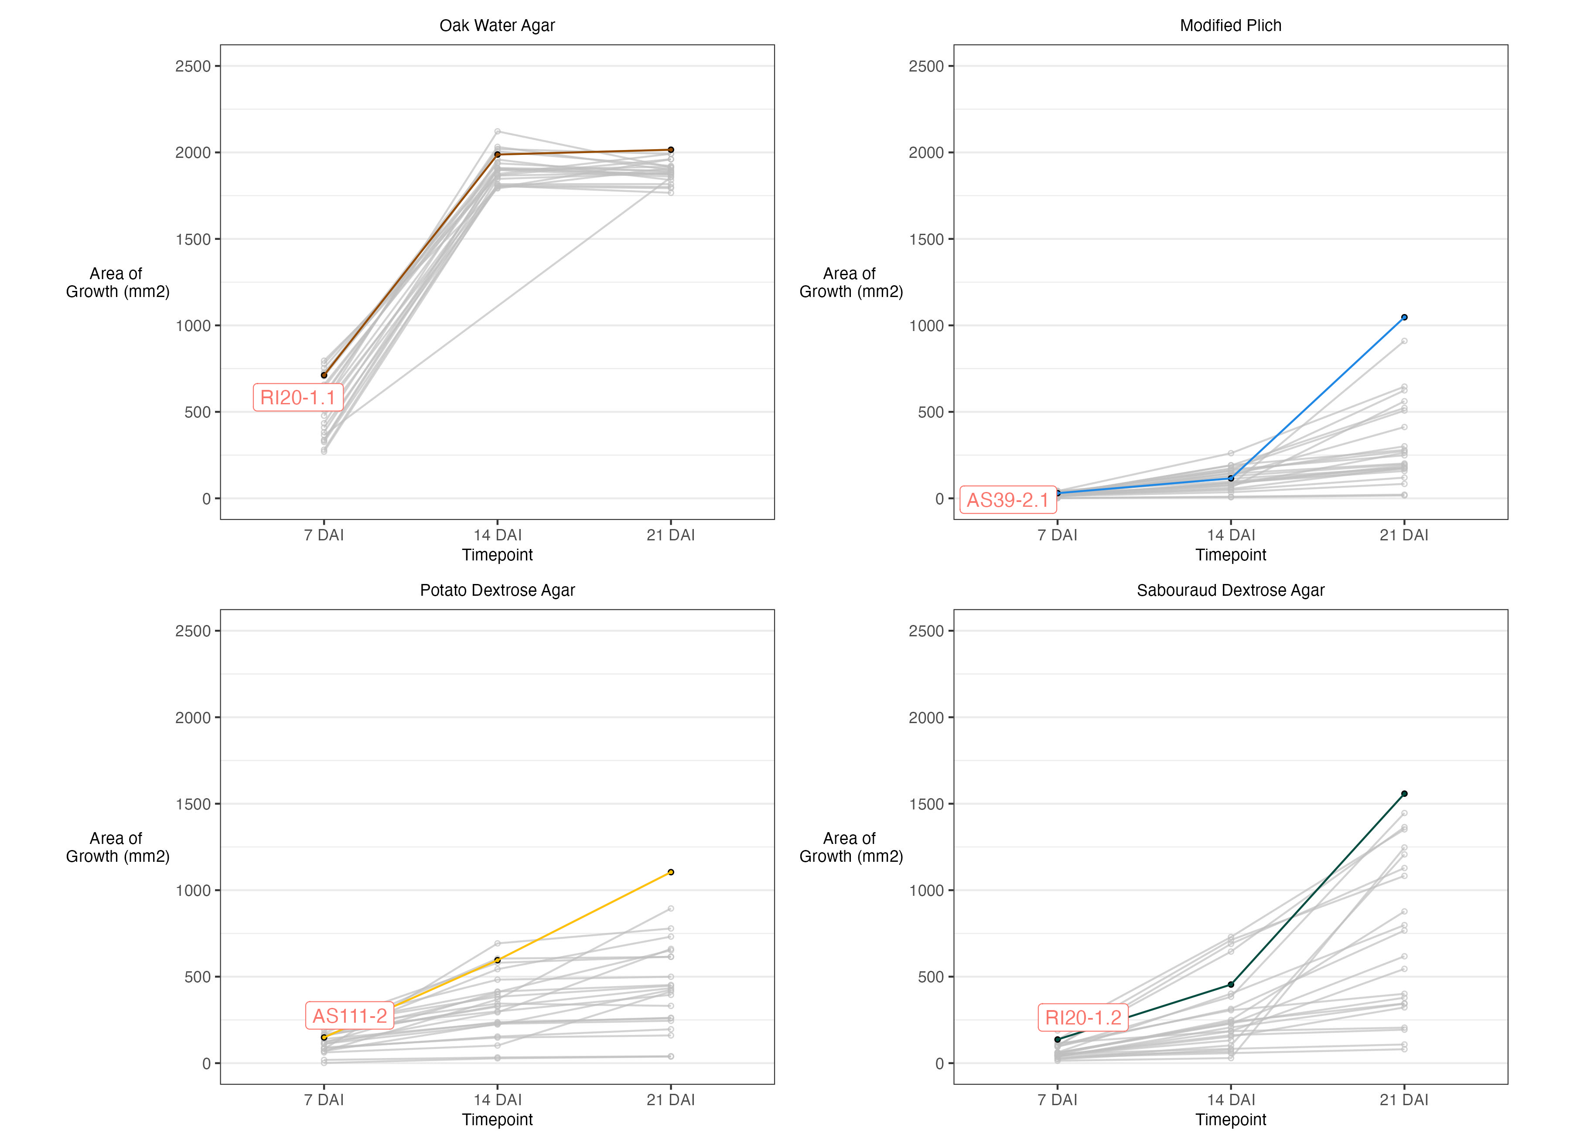
Figure 1. Raw growth data (mm²) of 25 Discula destructiva cultures on four types of media over 21 days. The x-axis represents the number of days after inoculation (DAI) at which growth was recorded for all cultures. The y-axis represents the area of growth measured (mm²). The culture with the greatest amount of growth 21 DAI is highlighted for each respective medium plot.

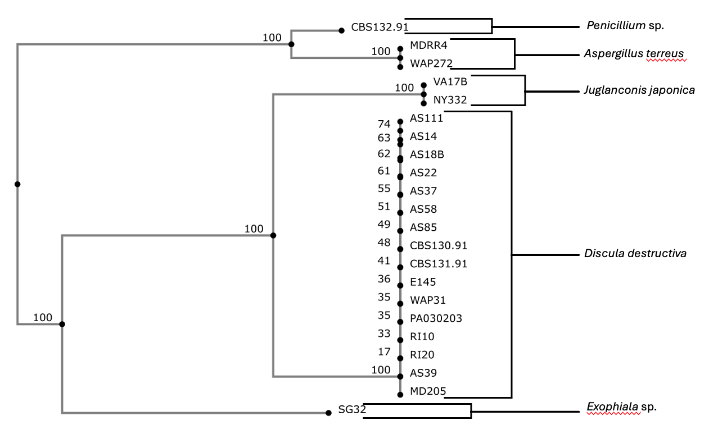
Figure 2. A Neighbor-Joining (NJ) phylogenetic tree displaying the relationship between all fungal isolates identified in this study. Amplified sequences of ITS1 and ITS2 rRNA regions were used to construct the NJ tree using MAFFT (v7.511). All isolates including those verified as not being Discula destructiva or Juglanconis japonica were included in the construction of this NJ tree. Katoh, Kazutaka, John Rozewicki, and Kazunori D Yamada. “MAFFT Online Service: Multiple Sequence Alignment, Interactive Sequence Choice and Visualization.” Briefings in Bioinformatics 20, no. 4 (July 19, 2019): 1160–66. https://doi.org/10.1093/bib/bbx108.

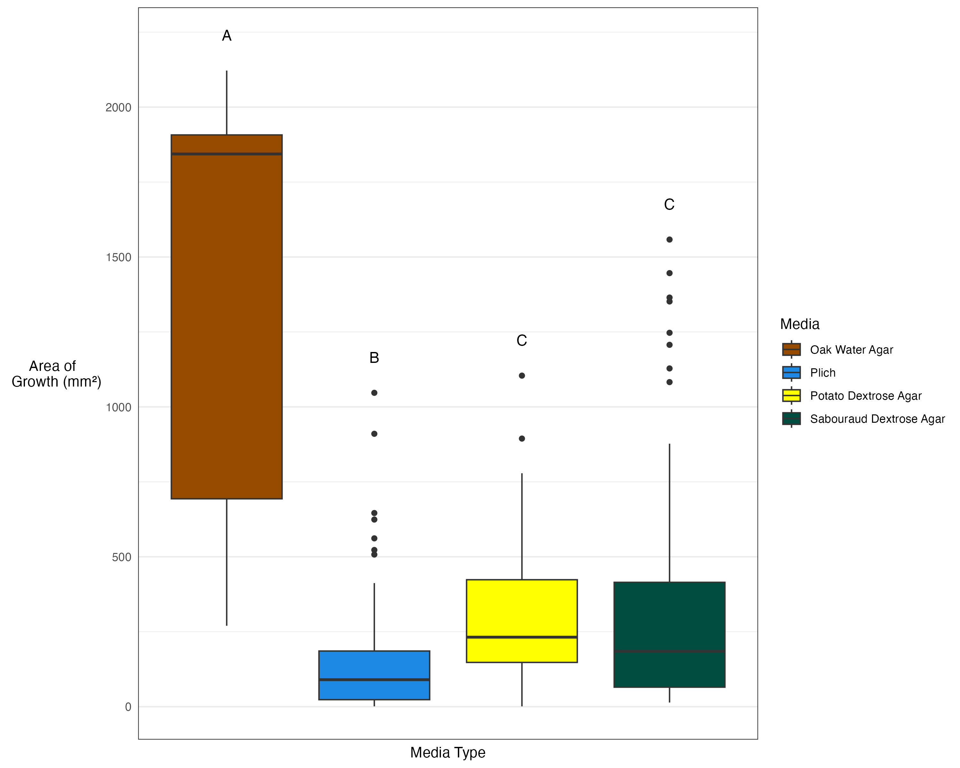
Figure 3. Box and whisker plot displaying significant comparisons of raw growth (mm²) of 25 Discula destructiva cultures on four types of media over 21 days. The x-axis represents the four types of media that the 25 cultures of Discula destructiva were grown on. The y-axis represents the area of growth (mm²). Letters above boxes indicate significant (α = 0.05) comparisons between media types generated using Tukey’s Honestly Significant Difference (HSD) test. Media with different letters indicate significant differences, whereas media with the same letter indicate non-significant differences.

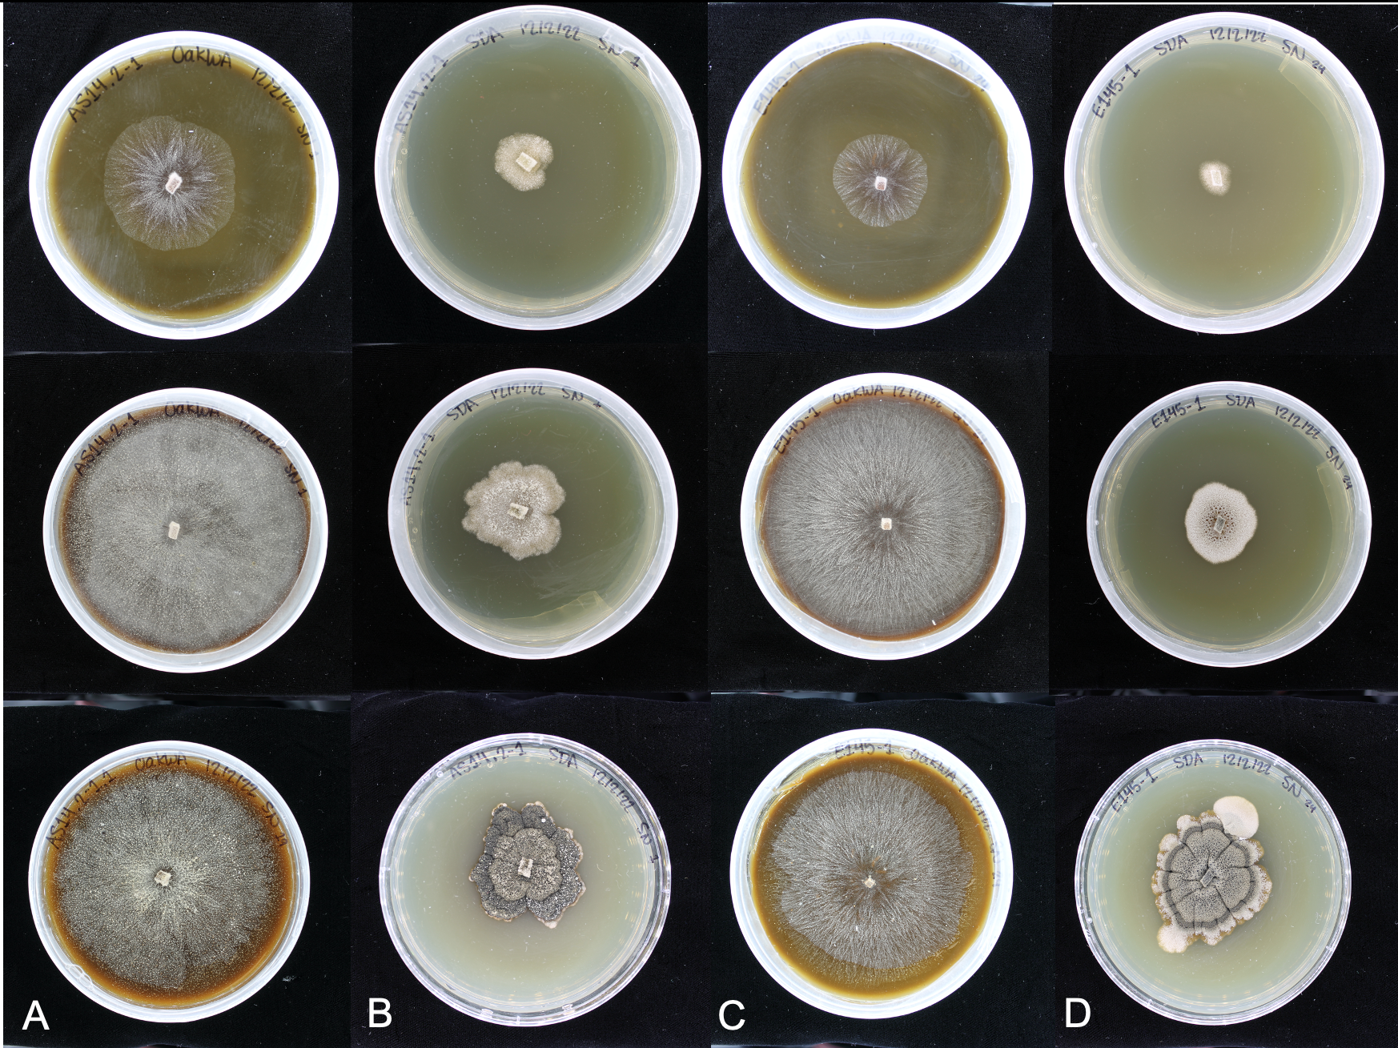
Figure 4. Example of observed sporulation for two Discula destructiva cultures used in media growth comparisons study. This example shows the presence of spores in Discula destructiva cultures, AS14.2-1 (columns A-B) and E145-1 (columns C-D), that were grown on Oak Water Agar (OWA; columns A, C) and Sabouraud Dextrose Agar (SDA; columns B, D). Images were recorded at 7, 14, and 21 days after inoculation (top, middle bottom, respectively).

    - 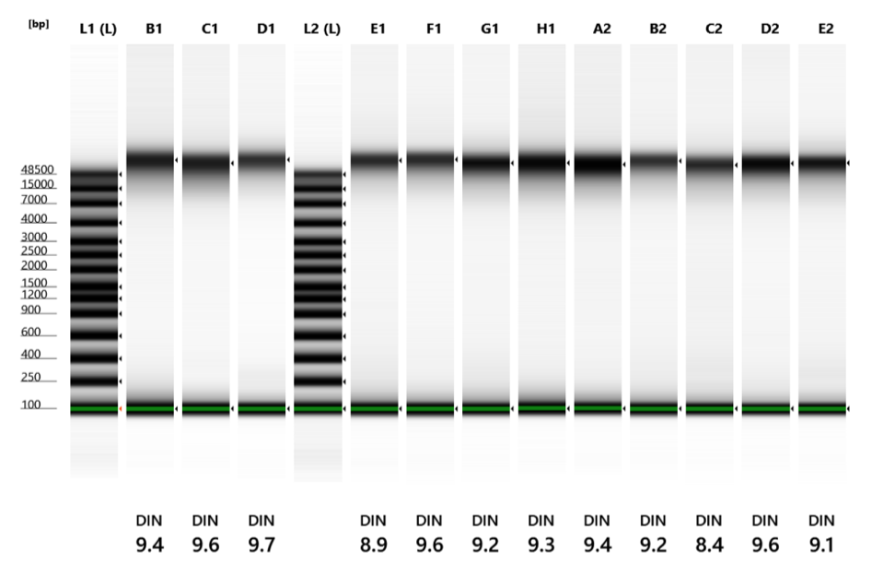
Figure 5. Visualization of High Molecular Weight (HMW) DNA for the Discula destructiva isolate, AS111, using TapeStation. This is a summary of the HMW DNA fragment sizes in base pairs (bp), indicated by the dark bands above the 48,5000 bp marker. Lanes L1 and L2 contain the ladder, which displays expected fragment sizes. Lanes B1-E2 represent the 12 extraction replicates. The DNA Integrity Number (DIN) located at the bottom of each lane indicates the quality of DNA on a scale of 0-10, with 0 being the lowest quality and 10 being the highest quality.

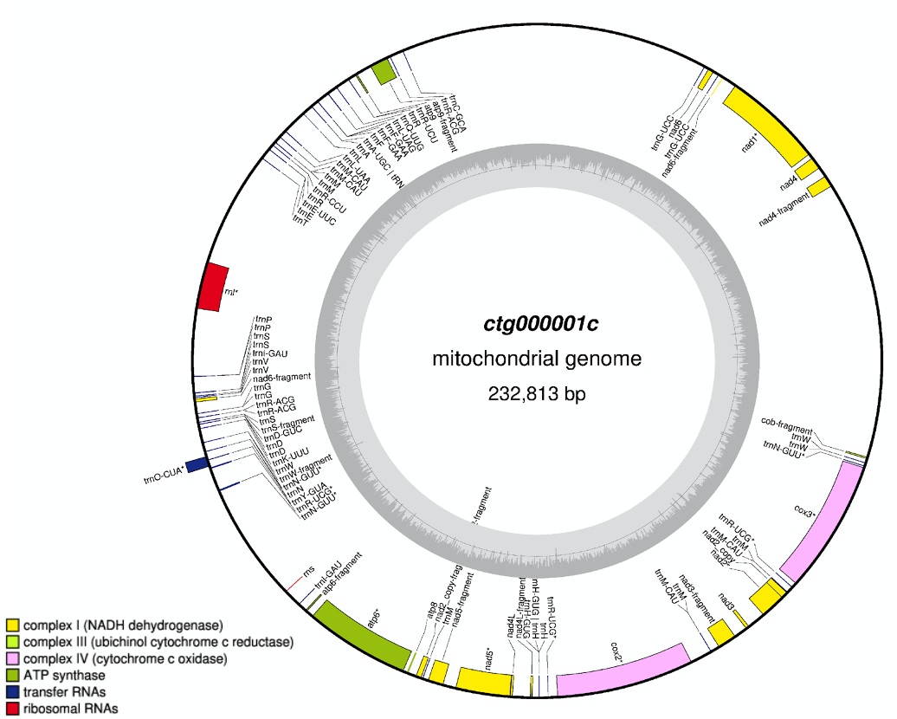
Discula destructiva
Isolate AS111

Figure 6. Mitochondrial genome annotations for Discula destructiva isolate, AS111, generated using OGDRAW (v1.3.1) and GESeq (v2.02) via Chlorobox. The 232,813 bp circularized genome presented here was annotated using GESeq (v2.03) and consists of 1 scaffold. Annotations of predicted gene families (lower left corner) are indicated on the genome assembly by the colored bars. The inner, grey circle represent GC content. OGDRAW: Greiner S, Lehwark P and Bock R (2019) OrganellarGenomeDRAW (OGDRAW) version 1.3.1: expanded toolkit for the graphical visualization of organellar genomes. Nucleic Acids Research 47: W59-W64. GESeq: Tillich M, Lehwark P, Pellizzer T, Ulbricht-Jones ES, Fischer A, Bock R and Greiner S (2017) GeSeq – versatile and accurate annotation of organelle genomes. Nucleic Acids Research45: W6-W11.
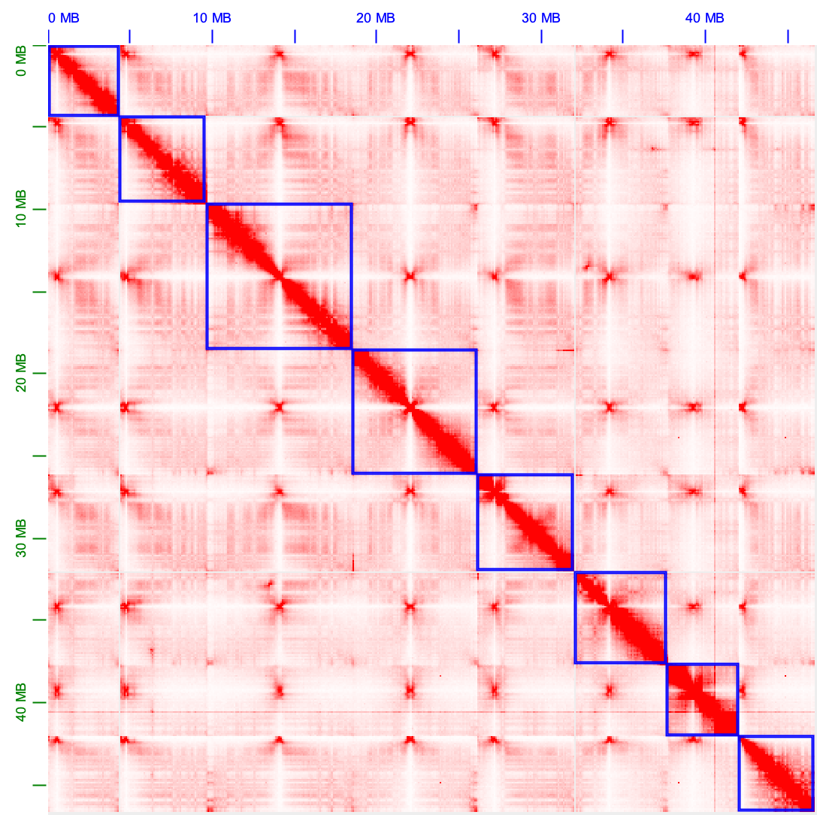
Figure 7. Hi-C contact map generated using Juicebox Assembly Tools (JBAT) (v2.15), displaying the genomic interactions across the final genome assembly for Discula destructiva isolate, AS111. Darker red regions indicate regions with higher frequencies of genomic contacts. The dark red diagonal line represents regions of the genome in linear order, while off-diagonal interactions represent spatial proximity between non-adjacent genomic regions. Blue boxes outline chromosome-level scaffolds with corrected orientation and placement. Both the x- and y-axis are labeled with genomic coordinates in megabases (Mb). Durand, N. C., Robinson, J. T., Shamim, M. S., Machol, I., Mesirov, J. P., Lander, E. S., and Aiden, E. L. “Juicebox Provides a Visualization System for Hi-C Contact Maps with Unlimited Zoom.” Cell Systems 3, no. 1 (2016): 99–101. https://doi.org/10.1016/j.cels.2015.07.012.

    - 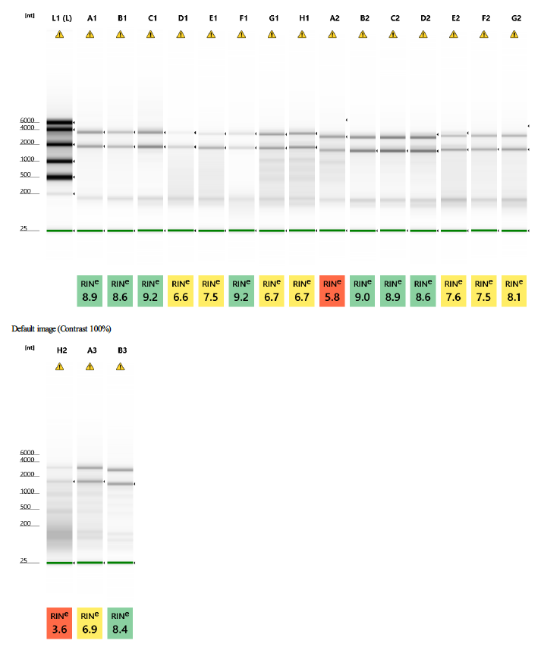
Figure 8. TapeStation results of diluted messenger RNA (mRNA) for Discula destructiva isolates, AS111 and WAP31, and Juglanconis japonica isolate, VA17B. This is a summary of the diluted mRNA fragment sizes in nucleotides (nt), indicated by the dark bands around the 2,000 and 4,000 nt markers. Lane L1 contains a ladder, which displays expected fragment sizes. Lanes A1-F1 represent D. destructiva isolate, AS111, with three PDA treatments (A1-C1) followed by three OWA treatments (D1-F1). Lanes G1-D2 represent J. japonica isolate, VA17B, with three PDA treatments (G1-A2) followed by three OWA treatments (B2-D2). Lanes E2-B3 represent D. destructiva isolate, WAP31, with three PDA treatments (E2-G2) followed by three OWA treatments (H2-B3). The RNA Integrity Number (RIN) located at the bottom of each lane indicates the quality of RNA on a scale of 0-10, with 0 being the lowest quality and 10 being the highest quality.
    - 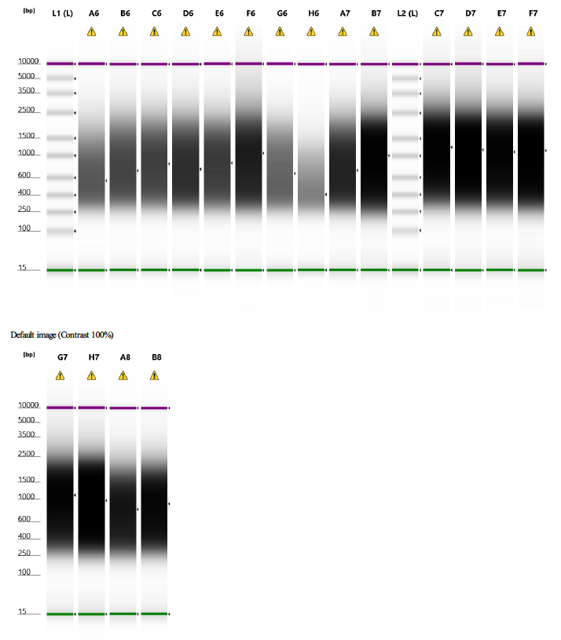
    - Figure 9. TapeStation results of complementary DNA (cDNA) libraries for Discula destructiva isolates, AS111 and WAP31, and Juglanconis japonica isolate, VA17B. This is a summary of the average cDNA fragment sizes in nucleotides (bp), indicated by the dark color and small arrows to the right of each lane. Lanes L1 and L2 contain a ladder, which displays expected fragment sizes. Lanes A6-F6 represent D. destructiva isolate, AS111, with three PDA treatments (A6-C6) followed by three OWA treatments (D6-F6). Lanes G6-D7 represent J. japonica isolate, VA17B, with three PDA treatments (G6-A7) followed by three OWA treatments (B7-D7). Lanes E7-B8 represent D. destructiva isolate, WAP31, with three PDA treatments (E7-G7) followed by three OWA treatments (H7-B8).
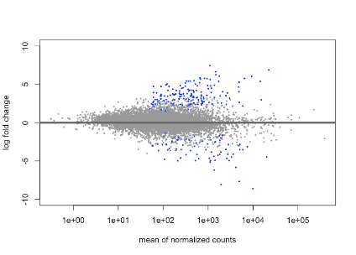
Figure 10. MA Plot showing the significantly upregulated and significantly downregulated genes identified from differential expression analysis (DESeq2; v1.42.1) of Discula destructiva isolates, AS111 and WAP31, and Juglanconis japonica isolate, VA17B. Each point represents a gene, with the gray points indicating genes with non-significant differential expression and blue points highlighting genes with statistically significant changes in expression levels (adjusted P value < 0.05). Genes below the horizontal line represent significantly down-regulated genes. Genes above the horizontal line represent significantly up-regulated genes. The x-axis represents the mean of normalized counts, which corresponds the average expression level of genes across all samples. The y-axis represents the log fold change, which corresponds to the change in expression between the treatments (sporulating and non-sporulating). Love, M. I., Huber, W., and Anders, S.. “Moderated Estimation of Fold Change and Dispersion for RNA-Seq Data with DESeq2.” Genome Biology 15, no. 12 (2014): 550. https://doi.org/10.1186/s13059-014-0550-8.

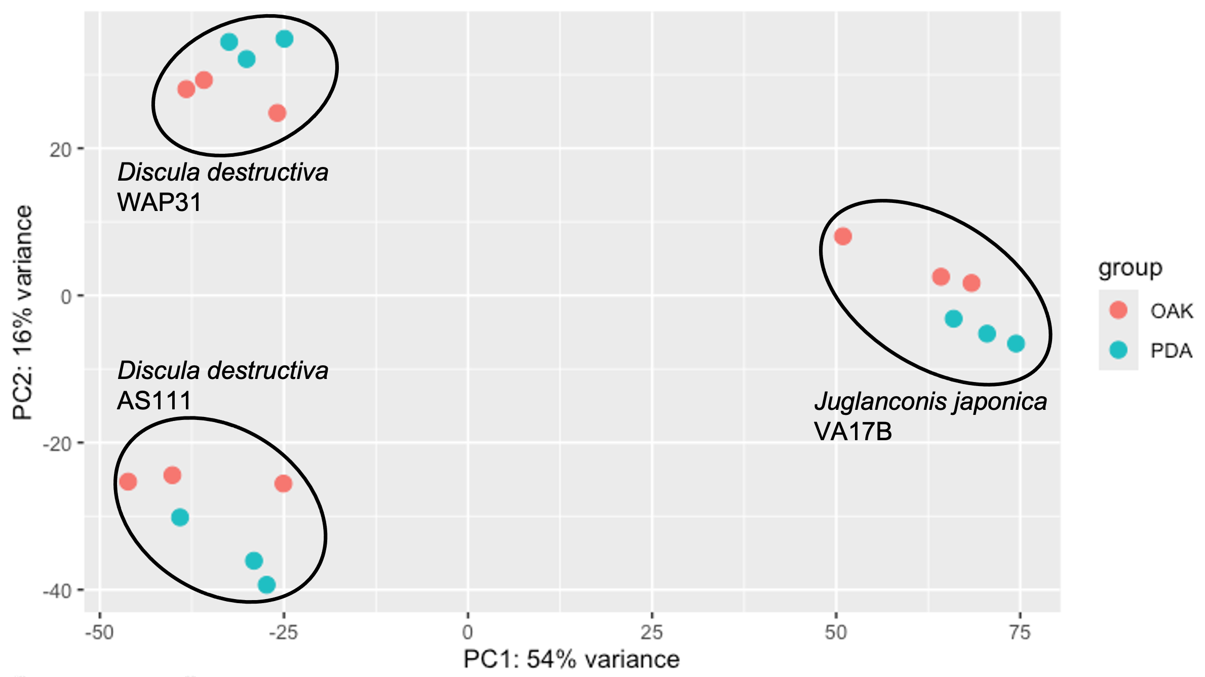
Figure 11. Principal Component Analysis (PCA) plot illustrating variance in gene expression profiles among Discula destructiva isolates, AS111 and WAP31, and Juglanconis japonica isolate, VA17B. The PCA was generated using differential expression analysis (DESeq2; v1.42.1). The x-axis (PC1) and y-axis (PC2) represent the first two principal components, accounting for 54% and 16% of the total variance, respectively. Each point represents a sample (n=18), color-coded by growth medium group (OWA or sporulation treatment in red; PDA or non-sporulation treatment in teal). The clustering of samples within each isolate is highlighted by black ellipses. Love, M. I., Huber, W., and Anders, S. “Moderated Estimation of Fold Change and Dispersion for RNA-Seq Data with DESeq2.” Genome Biology 15, no. 12 (2014): 550. https://doi.org/10.1186/s13059-014-0550-8.

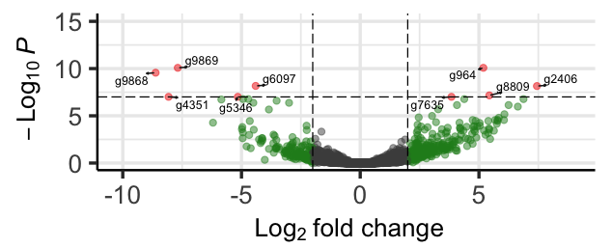
Figure 12. Enhanced volcano plot showing the most significantly expressed upregulated and downregulated genes identified from differential expression analysis (DESeq2; v1.42.1) of Discula destructiva isolates, AS111 and WAP31, and Juglanconis japonica isolate, VA17B. Each point represents a gene, with the x-axis showing the log₂ fold change (log₂FC) and the y-axis representing the -log₁₀ adjusted P value. Genes that meet the defined cutoffs (adjusted P value ≤ 1×10⁻⁷;log₂FC = 2) are highlighted in red, indicating the most significant changes in gene expression among the sporulation treatment. Red points to the left indicate the most significantly downregulated genes, whereas red points to the right indicate the most significantly upregulated genes. Genes that meet the defined log₂FC cutoff of 2 but not the adjusted P value ≤ 1×10⁻⁷ cutoff are highlighted in green. Non-significant genes are indicated by grey points. Love, M. I., Huber, W., and Anders, S. “Moderated Estimation of Fold Change and Dispersion for RNA-Seq Data with DESeq2.” Genome Biology 15, no. 12 (2014): 550. https://doi.org/10.1186/s13059-014-0550-8.

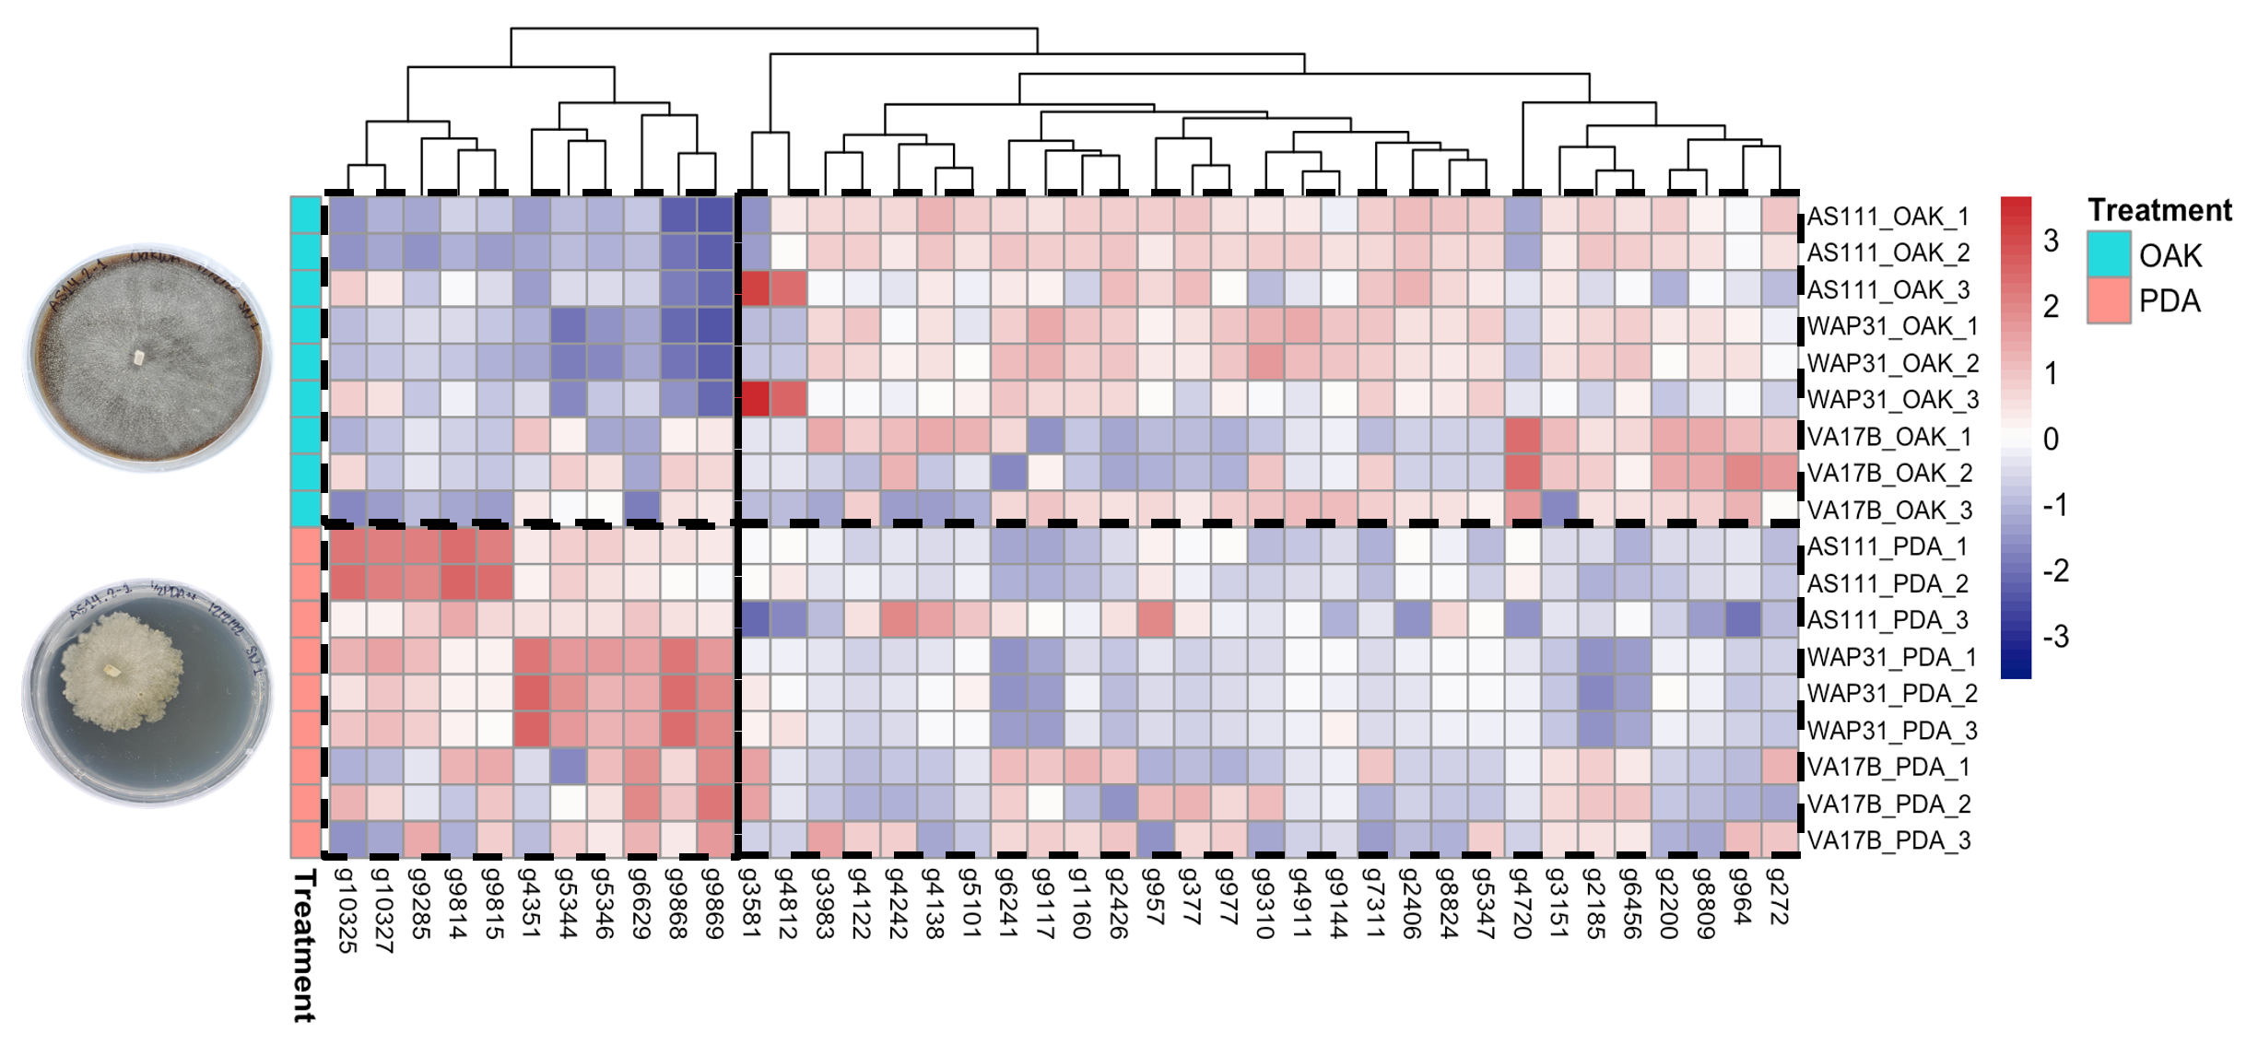
Figure 13. Heatmap illustrating the expression patterns of the top 40 differentially expressed genes (based on highest gene count) among Discula destructiva isolates, AS111 and WAP31, and Juglanconis japonica isolate, VA17B. The heatmap was generated using differential expression analysis (DESeq2; v1.42.1). The sporulation treatments are indicated by the blue (OAK) row on the left, while the non-sporulation treatments are indicated by the red (PDA) row on the left. The color and hue of each box represent the expression level of that specific gene for the sample. Blue indicates downregulation while red indicates upregulation. The dendrogram (top) represents that clustering of genes (bottom) based on their expression patters. Same names are listed on the right of the heatmap. Love, M. I., Huber, W., and Anders, S. “Moderated Estimation of Fold Change and Dispersion for RNA-Seq Data with DESeq2.” Genome Biology 15, no. 12 (2014): 550. https://doi.org/10.1186/s13059-014-0550-8.

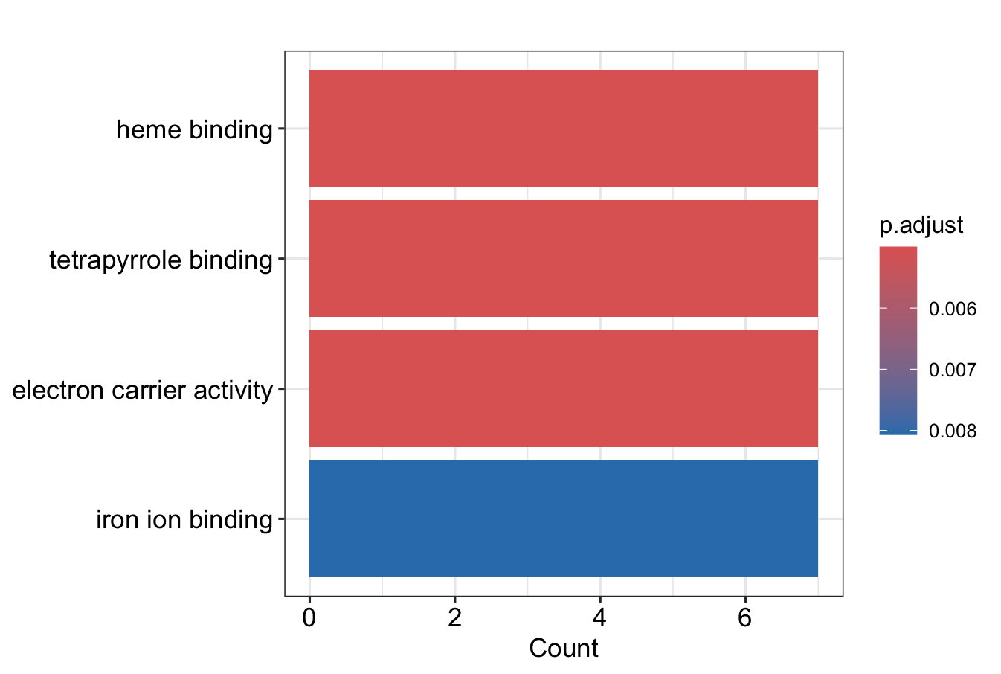
Figure 14. Bar plot illustrating the top enriched Gene Ontology (GO) terms (adjusted P value < 0.05) among the 162 significantly downregulated genes using the clusterProfiler R package (v2024.4.2.764). GO Enrichment was performed for Discula destructiva isolates, AS111 and WAP31, and Juglanconis japonica isolate, VA17B grown under the sporulation treatment. Significance is indicated by the bar on the right of the bar plot. The x-axis represents the number of enriched GO terms that were counted. The y-axis represents GO term names. Posit team (2024). RStudio: Integrated Development Environment for R. Posit Software, PBC, Boston, MA. URL http://www.posit.co/.

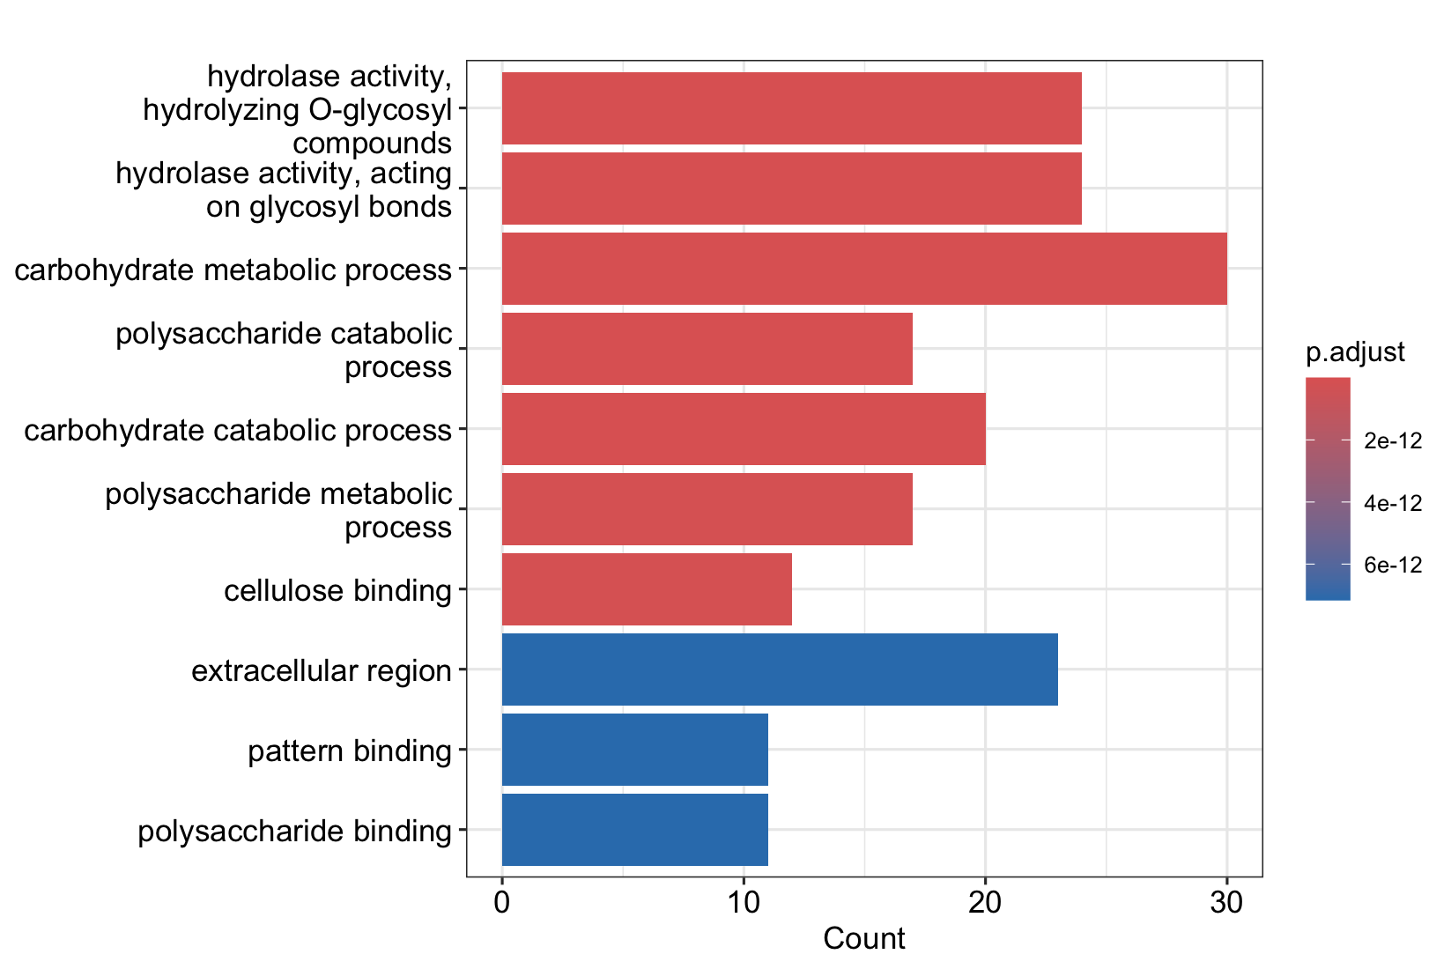
Figure 15. Bar plot illustrating the top enriched Gene Ontology (GO) terms (adjusted P value < 0.05) among the 78 significantly downregulated genes using the clusterProfiler R package (v2024.4.2.764). GO Enrichment was performed for Discula destructiva isolates, AS111 and WAP31, and Juglanconis japonica isolate, VA17B grown under the sporulation treatment. Significance is indicated by the bar on the right of the bar plot. The x-axis represents the number of enriched GO terms that were counted. The y-axis represents GO term names. Posit team (2024). RStudio: Integrated Development Environment for R. Posit Software, PBC, Boston, MA. URL http://www.posit.co/.

Tables
Table 1. Data for Discula destructiva isolates that were initially identified by amplifying the Internal Transcribed Spacer (ITS) ITS1 and ITS2 ribosomal RNA (rRNA) regions using the ITS1 and ITS4 primers.
Unverified Speciesª | Isolate | Location/Year^{b} | Collection^{c} | Host Species | State Isolated | Reference | Verified Species^{d}
Discula destructiva | AS111 | S/2000 | UTK | Cornus florida | Tennessee | Mantooth et al., 2017 | Discula destructiva
 | AS14 | S/2000 | UTK | Cornus florida | Tennessee | Mantooth et al., 2017 | Discula destructiva
 | AS18b | S/2000 | UTK | Cornus florida | Tennessee | Mantooth et al., 2017 | Discula destructiva
 | AS22 | S/2000 | UTK | Cornus florida | Tennessee | Mantooth et al., 2017 | Discula destructiva
 | AS37 | S/2000 | UTK | Cornus florida | Tennessee | Mantooth et al., 2017 | Discula destructiva
 | AS39 | S/2000 | UTK | Cornus florida | Tennessee | Mantooth et al., 2017 | Discula destructiva
 | AS58 | S/2000 | UTK | Cornus florida | Tennessee | Mantooth et al., 2017 | Discula destructiva
 | AS85 | S/2000 | UTK | Cornus florida | Tennessee | Mantooth et al., 2017 | Discula destructiva
 | CBS130.91 | NA/1989 | USDA | Cornus kousa | Massachusetts | Redlin, 1991 | Discula destructiva
 | CBS131.91 | NA/1990 | USDA | Cornus nuttallii | Washington | Redlin, 1991 | Discula destructiva
 | CBS132.91 | NA/1990 | USDA | Cornus florida | Maryland | Redlin, 1991 | Penicillium sp.
 | E145 | S/1991 | UTK | Cornus florida | Tennessee | Mantooth et al., 2017 | Discula destructiva
 | MD205 | NA/1190 | RU | Cornus florida | Maryland | Zhang and Blackwell, 2002 | Discula destructiva
 | MDRR4 | N/1999 | RU | Cornus florida | Maryland | Mantooth et al., 2017 | Aspergillus terreus
 | PA030203 | N/Pre-1993 | RU | Cornus florida | Pennsylvania | Mantooth et al., 2017 | Discula sp.

Table 1 continued
Unverified Speciesª | Isolate | Location/Year^{b} | Collection^{c} | Host Species | State Isolated | Reference | Verified Species^{d}
 | RI10 | S/1991 | UTK | Cornus florida | Tennessee | Mantooth et al., 2017 | Discula destructiva
 | RI20 | S/1991 | UTK | Cornus florida | Tennessee | Mantooth et al., 2017 | Discula destructiva
 | SG32 | NA/1991 | UTK | Cornus florida | Tennessee | Mantooth et al., 2017 | Exophiala sp.
 | WAP272 | W/1990 | RU | Cornus nuttallii | Washington | Mantooth et al., 2017 | Aspergillus terreus
 | WAP31 | W/1989 | RU | Cornus nuttallii | Washington | Mantooth et al., 2017 | Discula destructiva
Juglanconis japonica | NY332 | NA/ Pre-1993 | UTK | Cornus florida | New York | Trigiano et al., 1995 | Melanconium sp.
 | VA17B | NA/1991 | UTK | Cornus florida | Virginia | Mantooth et al., 2017 | Melanconium sp.
ª Original classification of Juglanconis japonica: Discula Type II.
^{b} Geographic locations where isolates were originally collected: S = South USA; N = North USA; W = West USA; NA=unknown; designations listed as "Pre-1993" correspond to isolates whose year of isolation are unknown.
Mantooth, K., Hadziabdic, D., Boggess, S., Windham, M., Miller, S., Cai, G., Spatafora, J., et al. “Confirmation of Independent Introductions of an Exotic Plant Pathogen of Cornus Species, Discula Destructiva, on the East and West Coasts of North America.” PLOS ONE 12, no. 7 (2017): e0180345. https://doi.org/10.1371/journal.pone.0180345.
^{c} UTK = University of Tennessee, Knoxville; RU = Rutgers University; USDA = United States Department of Agriculture.
^{d} Isolates labeled “Melanconium sp.” possess new classification as Juglanconis.
Voglmayr, H., L.A. Castlebury, and W.M. Jaklitsch. “Juglanconis Gen. Nov. on Juglandaceae, and the New Family Juglanconidaceae (Diaporthales).” Persoonia - Molecular Phylogeny and Evolution of Fungi 38, no. 1 (June 30, 2017): 136–55. https://doi.org/10.3767/003158517X694768.

Table 2. Identity of the 25 Discula destructiva cultures used in the media growth comparisons study.
Verified Speciesª | Isolate ID^{b} | Culture Name^{c} | Location/Year^{d}
Discula destructiva | AS111 | AS111-2 | S/2000
 |  | AS111-2.1
 |  | AS111-2.2
 | AS14 | AS14.2-1
 |  | AS14.2-1.1
 |  | AS14.2-1.2
 | AS18B | AS18B-1.1
 |  | AS18B-1.2
 | AS22 | AS22-2
 |  | AS22-2.2
 | AS37 | AS37-2
 | AS39 | AS39-2.1
 |  | AS39-2.2
 | AS58 | AS58-1.2
 | AS85 | AS85.1-2.1
 |  | AS85.1-2.2
 | E145 | E145-1.1 | S/1991
 |  | E145-1.2
 |  | E145-2
 | MD205 | MD205-1 | NA/1190
 | PA030203 | PA030203-2.2 | N/Pre-1993
 | RI10 | RI10.1-3.1 | S/1991
 | RI20 | RI20-1
 |  | RI20-1.1
 |  | RI20-1.1
ª Verified species identity using the Internal Transcribed Spacer (ITS) ITS1 and ITS2 ribosomal RNA (rRNA) regions.
^{b} Original isolate name prior to subculturing.
^{c} Culture name after obtaining subcultures of original isolates.
^{d} Geographic locations where isolates were originally collected: S = South USA; N = North USA; W = West USA; NA=unknown; designations listed as "Pre-1993" correspond to isolates whose year of isolation are unknown.
Mantooth, K., Hadziabdic, D., Boggess, S., Windham, M., Miller, S., Cai, G., Spatafora, J., et al. “Confirmation of Independent Introductions of an Exotic Plant Pathogen of Cornus Species, Discula Destructiva, on the East and West Coasts of North America.” PLOS ONE 12, no. 7 (2017): e0180345. https://doi.org/10.1371/journal.pone.0180345.

Table 3. Composition of media used in the media growth comparisons study.
Medium | Composition | Reference
Oak Water Agar (OWA) | 14 g of BD Difco™ Bacteriological Agar (Thermo Scientific; Hampton, NH, USA), 40 g of powdered white oak (Quercus alba L.) leaves, and 1 L of Nanopure water. | McElreath, S. D., and Tainter, F. H. “A Sporulation Medium for Discula Destructiva, the Dogwood Anthracnose Fungus.” Current Microbiology 26, no. 2 (1993): 117–21. https://doi.org/10.1007/BF01577347.
Sabouraud Dextrose Agar (SDA) | 20 g of BD Difco™ Bacteriological Agar (Thermo Scientific; Hampton, NH, USA), 40 g of D-(+)-Dextrose (Thermo Scientific; Hampton, NH, USA), 10 g of Peptone (Thermo Scientific; Hampton, NH, USA), and 1 L of Nanopure water. | Odds, F.C. “Sabouraud('s) Agar.” Journal of Medical and Veterinary Mycology 29, no. 6 (1991): 355–59. https://doi.org/10.1080/02681219180000581.
Half Stength PDA++ | 14 g of BD Difco™ Bacteriological Agar (Thermo Scientific; Hampton, NH, USA), 12 g of BD Difco™ Potato Dextrose Broth (Thermo Scientific; Hampton, NH, USA), and 1 L of Nanopure water, antibiotics. | Beever, R. E., and E. G. Bollard. “The Nature of the Stimulation of Fungal Growth by Potato Extract.” Microbiology 60, no. 2 (1970): 273–79. https://doi.org/10.1099/00221287-60-2-273.
Modified Plich | 14 g of BD Difco™ Bacteriological Agar (Thermo Scientific; Hampton, NH, USA), 0.5 g of potassium phosphate monobasic (KH₂PO₄) (Thermo Scientific; Hampton, NH, USA), 0.25 g of magnesium sulfate heptahydrate (MgSO₄•7H₂O) (Thermo Scientific; Hampton, NH, USA), 1 mg of thiamine hydrochloride (MilleporeSigma; Burlington, MA, USA), 10 mg of β-Sitosterol (MilleporeSigma; Burlington, MA, USA), 25 g of sucrose (Thermo Scientific; Hampton, NH, USA), and 1 L of Nanopure water. 1 g of L-(+)-Asparagine (Thermo Scientific; Hampton, NH, USA) was added to the medium after autoclaving. | Van West, P., Kamoun, S., Van’t Klooster, J. W., and Govers, F.. “Internuclear Gene Silencing in Phytophthora Infestans.” Molecular Cell 3, no. 3 (1999): 339–48. https://doi.org/10.1016/S1097-2765(00)80461-X.

Table 4. Two-way ANOVA summary displaying different effects of media and timepoint on the raw growth of 25 Discula destructiva cultures used in the media growth comparisons study.
 | Degrees of Freedom (DF) | Sum of Squares | Mean of Squares | F Value | Pr (>F) | Significance Codesª
Media | 3 | 74040548 | 24680183 | 618.1 | <2e-16 | ***
Timepoint | 2 | 22533197 | 11266598 | 282.1 | <2e-16 | ***
Media:Timepoint | 6 | 15691970 | 2615328 | 65.5 | <2e-16 | ***
Residuals | 280 | 11180797 | 39931 | NA | NA | NA
ª Significance Codes: 0 ‘***’ 0.001 ‘**’ 0.01 ‘*’ 0.05 ‘.’ ≥0.1 ‘ ‘

Table 5. Tukey’s Honestly Significance Difference (HSD) test showing the significant comparison of means for the raw growth measurements of 25 Discula destructiva cultures used in the media growth comparisons study.
Media^{a,b} | Difference^{c} | Lower^{d,e} | Upper^{d,f} | Adjuster P Value
Modified Plich-OWA^{g} | -1270.26363 | -1355.47547 | -1185.0518 | 0.0000000
Half Strength PDA++-OWA | -1117.83246 | -1203.61412 | -1032.0508 | 0.0000000
SDA^{h}-OWA | -1075.63117 | -1161.70813 | -989.5542 | 0.0000000
Half Strength PDA++-Modified Plich | 152.43117 | 67.51763 | 237.3447 | 0.0000317
SDA-Modified Plich | 194.63246 | 109.42062 | 279.8443 | 0.0000001
SDA-PDA++ | 42.20129 | -42.58038 | 127.9830 | 0.5818688
ª Media being compared.
^{b} Fit: aov(formula = `Area (mm2)` ~ Media + Timepoint + Media”Timepoint, data = growth_over_time)).
^{c} Difference in mean between groups.
^{d} 95% confidence interval (α = 0.05).
^{e} Lower bound of confidence interval.
^{f} Upper bound of confidence interval.
^{g} OWA: Oak Water Agar
^{h} SDA: Sabouraud Dextrose Agar

Table 6. Presence and absence observation records for the formation of spores among all 25 Discula destructiva cultures used in the media growth comparisons study.
Media Type |  | Timepoint^{a,b}
 | 7 DAI | 14 DAI | 21 DAI
OWAc | No | Yes | Yes
SDAd | No | Yes | Yes
Half Strength PDA++ | No | No | No
Modified Plich | No | No | No
ª The presence of sporulation on any culture at the designated timepoint as indicated by visual assessment of acervular conidiomata.
^{b} DAI: Days After Inoculation.
^{c} OWA: Oak Water Agar
^{d} SDA: Sabouraud Dextrose Agar

Table 7. Raw HiFi long-read sequencing statistics for the Discula destructiva isolate, AS111.
Quality Metrics | Value
Reads (million) | 5.8
Reads Yield (Gb)ª | 93.51
Reads Length (mean, kb)^{b} | 16.14
Reads Length (median, bp)^{c} | 15,700
Read Length N50 (bp) | 16,264
Read Quality (median) | Q35
Base Quality ≥Q30 (%) | 93.4%
Number of Passes (mean) | 9
ª Gb: Gigabases.
^{b} kb: kilobases.
^{c} bp: basepairs.

Table 8. Genome assembly statistics for the 100× downsampled nuclear genome of Discula destructiva isolate, AS111, generated using the BBMap (v39.06) stats function.
Assembly Metrics | Pre-Scaffolded Genome | Post-Scaffolded Genome
 | Pre-Gap Closing | Pre-Gap Closing | Post-Gap Closing
Assembly size (Mb)ª | 46.885 Mb | 46.653 Mb | 46.655 Mb
Number of contigs | 10 | 10 | 8
Max contig length | 8.889 Mb | 8.889 Mb | 8.889 Mb
Numbers of scaffolds | 10 | 10 | 8
Max scaffold length | 8.889 Mb | 8.889 Mb | 8.889 Mb
% Gaps | 0.000% | 0.001% | 0.000%
Contig N/L50 | 4/5.597 Mb | 4/5.597 Mb | 4/5.597 Mb
Scaffold N/L50 | 4/5.597 Mb | 7/41.594 Mb | 4/5.597 Mb
% Main Genome in Scaffolds > 50 kb^{b} | 100.00% | 100.00% | 100.00%
ª Mb: Megabases.
^{b} kb: kilobases.
Bushnell, Brian. 2014. “BBMap: A Fast, Accurate, Splice-Aware Aligner.” https://escholarship.org/uc/item/1h3515gn (May 12, 2024).

Table 9. Overall genome completeness statistics generated via BUSCO (v5.5.0), Compleasm (v0.2.6), and Merqury (v1.3-2) for the final, gapless chromosome-scale genome assembly of Discula destructiva isolate, AS111.
Genome Completeness Database | Genome Completeness
BUSCOª (Ascomycota) | 97.40%
Compleasm^{b} (Ascomycota) | 99.47%
BUSCO (Sordariomycetes) | 95.60%
Compleasm (Sordariomycetes) | 97.30%
Merqury^{c} Completeness | 98.45%
ª Simão, F. A., Waterhouse, R. M., Ioannidis, P., Kriventseva, E. V., and Zdobnov, E. M. “BUSCO: Assessing Genome Assembly and Annotation Completeness with Single-Copy Orthologs.” Bioinformatics 31, no. 19 (2015): 3210–12. https://doi.org/10.1093/bioinformatics/btv351.
^{b} Huang, Neng, and Heng Li. “Compleasm: A Faster and More Accurate Reimplementation of BUSCO.” Edited by Tobias Marschall. Bioinformatics 39, no. 10 (October 3, 2023): btad595.
^{c} Merqury Rhie, Arang, Brian P. Walenz, Sergey Koren, and Adam M. Phillippy. “Merqury: Reference-Free Quality, Completeness, and Phasing Assessment for Genome Assemblies.” Genome Biology 21, no. 1 (December 2020): 245. https://doi.org/10.1186/s13059-020-02134-9.

Table 10. Genome assembly statistics using the BBMap (v39.06) stats function for the mitochondrial genome of Discula destructiva isolate, AS111, generated by OATK (v1.0).
Assembly Metrics | Scaffold-level Genome
Assembly size (Mb)ª | 0.233 Mb
Number of contigs | 1
Max contig length | 232.871 kb
Numbers of scaffolds | 1
Max scaffold length | 232.874 kb
% Gaps | 0.001%
Contig N/L50 | 1/232.871 kb
Scaffold N/L50 | 1/232.874 kb
% Main Genome in Scaffolds > 50 kb^{b} | 100.00%
ª Mb: Megabases.
^{b} kb: kilobases.
Bushnell, Brian. 2014. “BBMap: A Fast, Accurate, Splice-Aware Aligner.” https://escholarship.org/uc/item/1h3515gn (May 12, 2024).

Table 11. Mapping rates of Discula destructiva and Juglanconis japonica RNAseq reads to the Discula destructiva isolate, AS111, reference genome using STAR (v2.7.11b).
Species | Sample^{a,b} | % Uniquely Mapped Reads to Reference
Discula destructiva | AS111_1_OAK | 87.85%
 | AS111_1_PDA | 91.62%
 | AS111_2_OAK | 90.01%
 | AS111_2_PDA | 90.80%
 | AS111_3_OAK | 90.74%
 | AS111_3_PDA | 91.68%
Juglanconis japonica | VA17B_1_OAK | 0.80%
 | VA17B _1_PDA | 0.98%
 | VA17B _2_OAK | 0.89%
 | VA17B _2_PDA | 1.10%
 | VA17B _3_OAK | 0.93%
 | VA17B _3_PDA | 1.06%
Discula destructiva | WAP31_1_OAK | 82.75%
 | WAP31 _1_PDA | 82.29%
 | WAP31 _2_OAK | 80.08%
 | WAP31 _2_PDA | 80.72%
 | WAP31 _3_OAK | 54.98%
 | WAP31 _3_PDA | 82.07%
ª OAK: sporulation treatment
^{b} PDA: non-sporulation treatment
Dobin, A., Davis, C. A., Schlesinger, F., Drenkow, J., Zaleski, C., Jha, S., Batut, P., Chaisson, M., and Gingeras, T. R. “STAR: Ultrafast Universal RNA-Seq Aligner.” Bioinformatics 29, no. 1 (2013): 15–21. https://doi.org/10.1093/bioinformatics/bts635.

Table 12. Structural annotation statistics generated from BRAKER3 (v3.0.8) for the Discula destructiva isolate, AS111, reference genome.
Genomic Feature | Number of Features Counted
Messenger RNA (mRNA) | 11,480
Exon | 29,610
Protein Coding Sequence (CDS) | 29,610
Intron | 18,130
Gene | 10,373
Start Codon | 11,473
Stop Codon | 11,473
These statistics were generated by mapping all raw RNAseq reads for D. destructiva (isolates AS111 and WAP31) and J. japonica (isolate VA17B) to the D. destructiva (isolate AS111) reference genome.
Gabriel, L., Brůna, T., Hoff, K. J., Ebel, M., Lomsadze, A., Borodovsky, M., and Stanke, M. “BRAKER3: Fully Automated Genome Annotation Using RNA-Seq and Protein Evidence with GeneMark-ETP, AUGUSTUS and TSEBRA.” bioRxiv: The Preprint Server for Biology, (2023): 2023.06.10.544449. https://doi.org/10.1101/2023.06.10.544449.

Table 13. Genome completeness statistics using BUSCO (v5.5.0) for the predicted proteins of the Discula destructiva isolate, AS111, reference genome generated from the structural annotation pipeline using BRAKER3 (v3.0.8).
 | BUSCO (Sordariomycetes) | BUSCO (Ascomycota)
Complete BUSCOs  (C) | 3,647 (95.5%) | 1,663 (97.4%)
Single Copy Complete Genes (S) | 3,268 (85.6%) | 1,526 (89.4%)
Duplicated Complete Genes (D) | 379 (9.9%) | 137 (8.0%)
Fragmented Genes -subclass 1 (F) | 16 (0.4%) | 7 (0.4%)
Missing Genes  (M) | 154 (4.1%) | 36 (2.2%)
Total Number of BUSCOs  (n) | 3,817 | 1,706
The following abbreviations are used in the table: S: Single Copy Complete Genes; D: Duplicated Complete Genes; F: Fragmented Genes, subclass 1-only a portion of the gene is present and could be aligned; I: Fragmented Genes, subclass 2-different portions of the gene align to different portions of the assembly; M: Missing Genes.
Simão, F. A., Waterhouse, R. M., Ioannidis, P., Kriventseva, E. V., and Zdobnov, E. M. “BUSCO: Assessing Genome Assembly and Annotation Completeness with Single-Copy Orthologs.” Bioinformatics 31, no. 19 (2015): 3210–12. https://doi.org/10.1093/bioinformatics/btv351.
Gabriel, L., Brůna, T., Hoff, K. J., Ebel, M., Lomsadze, A., Borodovsky, M., and Stanke, M. “BRAKER3: Fully Automated Genome Annotation Using RNA-Seq and Protein Evidence with GeneMark-ETP, AUGUSTUS and TSEBRA.” bioRxiv: The Preprint Server for Biology, (2023): 2023.06.10.544449. https://doi.org/10.1101/2023.06.10.544449.

Table 14. RNAseq read statistics for Discula destructiva and Juglanconis japonica RNAseq reads before and after quality trimming using bbduk (v39.06).
 | Pre-Trimming | Post-Trimming
Reads Yield (GB)ª | 94.24 | N/A
Reads (bp)^{b} | 1,198,907,960 | 1,181,440,126
Mean Reads Per Library (bp) | 33,302,999 | 32,817,781
Mean Sequence Length (bp) | 151 | 145
Mean Base Quality (Q) | 36 | 36
ª GB: Gigabytes of data
^{b} bp: basepairs
Statistics were generated using FastQC (v0.11.7).
Andrews S. (2010). FastQC: a quality control tool for high throughput sequence data. Available online at: http://www.bioinformatics.babraham.ac.uk/projects/fastqc.
Bushnell, Brian. 2014. “BBMap: A Fast, Accurate, Splice-Aware Aligner.” https://escholarship.org/uc/item/1h3515gn (May 12, 2024).

Table 15. The most significantly downregulated genes among all Discula destructiva and Juglanconis japonica RNAseq samples under sporulation conditions and their associated Kyoto Encyclopedia of Genes and Genomes (KEGG) terms.
Gene ID | KEGG term
g9869 | Destroys radicals which are normally produced within the cells and which are toxic to biological systems (By similarity)
g9868 | NA
g6097 | Ferric-chelate reductase
g5346 | NAD NADP octopine nopaline dehydrogenase
g4351 | Ctr copper transporter family
Significantly downregulated genes: (Adjusted P value = 1e-7 & log₂FC = 2)

Table 16. The most significantly upregulated genes among all Discula destructiva and Juglanconis japonica RNAseq samples under sporulation conditions and their associated Kyoto Encyclopedia of Genes and Genomes (KEGG) terms.
Gene ID | KEGG term
g8809 | Catalyzes endohydrolysis of 1,4-beta-D-glucosidic linkages in xyloglucan with retention of the beta=configuration of the glycosyl residues. Specific for xyloglucan and does not hydrolyze other cell wall components
g7635 | Sugar (and other) transporter
g2406 | Arabinan endo-1,5-alpha-L-arabinosidase
g964 | Inositol oxygenase
Significantly downregulated genes: (Adjusted P value = 1e-7 & log₂FC = 2)

Table 17: Discula destructiva isolate, AS111, mitochondrial genome statistics compared to other high-quality Diaporthales genome assemblies available in NCBI.
Assembly Metrics | Pathogen
 | Discula destructiva | Chrysoporthe puriensis | Immersiporthe knoxdaviesiana | Cryphonectria parasitica | Valsa mali
 | Dogwood Anthracnose | Stem Canker of Eucalyptus | Stem Canker of Cape Beech | Chestnut Blight | Apple Valsa Canker
Assembly Size (bp)ª | 232,813 | 123,856 | 184,479 | 158,413 | 128,022
Number of Scaffolds | 1 | 1 | 1 | 1 | 1
Number of  Contigs | 1 | 1 | 1 | 1 | 1
Circularized | Yes | Yes | Yes | Yes | Yes
Year Published in NCBI | In Progress | 2020 | 2021 | 2016 | 2022
ª bp: basepairs
High-quality is determined by being chromosome-level or complete (completely contiguous).

Table 18: Discula destructiva isolate, AS111, nuclear genome statistics compared to other high-quality Diaporthales genome assemblies available in NCBI.
Assembly Metrics | Pathogen
 | Discula destructiva | Chrysoporthe puriensis | Immersiporthe knoxdaviesiana | Cryphonectria parasitica | Valsa mali
 | Dogwood Anthracnose | Stem Canker of Eucalyptus | Stem Canker of Cape Beech | Chestnut Blight | Apple Valsa Canker
Ploidy (n)ª | 1 | 1 | 1 | 1 | 1
Assembly Level | Complete | Complete | Complete | Chromosome | Chromosome
Assembly Size (Mb)^{b} | 46.65 | 44.54 | 38.80 | 43.16 | 44.73
Number of Scaffolds | 8 | 13 | 11 | 17 | 13
Number of Contigs | 8 | 13 | 11 | 18 | 1,475
% gaps | 0.000% | 0.000% | 0.000% | 0.000% | 0.937%
Year published in NCBI | In Progress | 2020 | 2021 | 2021 | 2015
ª n: haploid number.
^{b} Mb: Megabases.

Table 19. List of future research questions that could be addressed using the knowledge and resources generated in this thesis.
Current Study Research | Question
Media Growth Comparisons | At what quantifiable rate does sporulation occur on Oak Water Agar (OWA) in comparison to other media?
Genomic Resources | What are the roles of exuded proteins in the hemibiotrophic lifestyle of Discula destructiva?
Genomic Resources | What genomic signatures may be associated with effector production, and the thereby, the pathogenicity of Discula destructiva?
Genomic Resources | What are the toxin production pathways in Discula destructiva that contribute to pathogenicity?
Genomic Resources | Can signatures of a diploid state in Discula destructiva be identified through mating type analysis?
Genomic Resources | Are there any conserved gene families across the Diaporthalean fungi that may impart their virulence towards variance hosts?

VitA
Israel (Shade) Niece was born and raised in Knoxville, Tennessee. He graduated from the University of Tennessee, Knoxville in 2020 with his B.S. in Biological Sciences concentrating in Biochemistry & Cellular and Molecular Biology. He then joined the Department of Entomology and Plant Pathology in 2021, where he began working as a lab technician in the Trigiano lab to gain research experience. He subsequently joined the Nowicki lab in 2022 to pursue his master’s degree concentrating in bioinformatics and genomics. He has received several scholarships and fellowships throughout his graduate degree that has enabled him to present his fungal genomics research at national and international conferences.

