Investigation of Parasites and Other Pathogens Associated with Eastern Wild Turkey (Meleagris gallopavo silvestris) Declines in Tennessee

A Dissertation Presented for the

Doctor of Philosophy

Degree

The University of Tennessee, Knoxville

Laura K. Horton

August 2024
DEDICATION
I dedicate this work to my parents, brother, and friends—you have all supported me in so many ways throughout these five years and I could not have achieved this without each of you. I love you all so much—thank you to the end of time for being my cheerleaders and believing in me. To Grandpa, yes—I’m finally “a doctor now!” this one’s for you and Grandma. Also, to Lua and Noodle for being the best cat/dog children and making sure I never had to write or work alone, you’ll both always be my favorite turkeys. Lastly, this work is dedicated to the wild and magical natural world which has always deeply inspired me, taught me appreciation, brought me both infinite wonder and peace, and for which all of my work has purpose.

ACKNOWLEDGEMENTS
I would like to thank my incredible advisor Dr. Richard Gerhold for believing in me when I wasn’t sure if I believed in myself, imparting all of your knowledge to me, allowing me to fail and helping me back up, risking gaining a few grey hairs on my behalf, and for helping me grow into the scientist I am now. To my committee members, Dr. David Buehler, Dr. Dan Grove, Dr. Michelle Dennis, and Dr. John Schaefer, thank you all so much for supporting me and my growth through this process. I truly could not have completed this achievement without the input and time commitment from each of you along the way. Roger Shields and the rest of the Tennessee Wildlife Resource Agency staff—thank you all so much for the labor hours that were involved with assisting with our sampling, for your commitment to this project, and your expertise from the management perspective (as well as funding and land access). A huge thank you to Lindsey Phillips, Joe Quehl, Vinnie Johnson, and Sawsan Ammar for all of your help and collaborative efforts on this extensive project. Thank you to Dr. Chunlei Su for helping with all aspects of Toxoplasma gondii testing and lab space for this project, as well as Dr. Tania Dawant for assistance with sample processing. Thank you Howard Onyuth for assistance with GIS map planning and execution. Thank you to Dr. Sawsan Ammar for being my mentor and teaching me everything I knew nothing about when I started, as well as for being a wonderful friend and collaborator. Thank you to our lab techs and student workers for help processing samples. Thank you to the National Wild Turkey Federation for funding this project and making it possible for me to complete this research. Thank you to the University of Tennessee Comparative Experimental Medicine program and Center for Veterinary Medicine for resources, funding, and laboratory space. Thank you to the Southeastern Cooperative Wildlife Disease Study and Dr. Nicole Nemeth for assistance with the retrospective study and access to archived necropsy reports. Last but certainly not least, thank you to my phenomenal lab mates and graduate student community—I absolutely could not have completed this without your friendship, patience, help, collaboration, and incredible array of expertise.

ABSTRACT
This multi-part research project was carried out in order to investigate and address disease aspects which may be at play in the Middle Tennessee Wild Turkey population. This population has been experiencing declines since a restoration period which spanned from 1990-2000. In combined effort with Tennessee Wildlife Resource Agency, the National Wild Turkey Federation, and collaboration with other research groups at the University of Tennessee, this survey of parasites and diseases of known risk to Wild Turkeys was carried out in the study population from 2020-2023. We evaluated the prevalence of the following pathogens for three field seasons: Histomonas meleagridis, Toxoplasma gondii, Leucocytozoon smithi, Haemoproteus spp., Plasmodium spp., avian influenza, Newcastle disease virus, Mycoplasma gallisepticum and Mycoplasma synoviae, Eimeria spp., Ascarid spp., Cestodes, and Capillaria spp. Additionally, a retrospective study was conducted to synthesize archived reports of any post-mortem submissions of abnormal Wild Turkeys from the state to the University of Tennessee or to the Southeastern Cooperative Wildlife Disease Study from 2000-2023. Our overall results provide both a surveillance report of baseline pathogen prevalence during the study period as well as can help inform management as to what disease aspects are circulating in the population and the relative impacts of each.

TABLE OF CONTENTS
REVIEW OF LITERATURE 1
Introduction – Parasites and Diseases of Wild Turkeys 1
Protozoan Parasites of Wild Turkeys 4
Histomonas meleagridis 4
Toxoplasma gondii 9
Leucocytozoon smithi 11
Haemoproteus spp. 14
Plasmodium spp. 18
Gastrointestinal Parasites of Wild Turkeys 21
Eimeria spp. 21
Ascarid spp. 24
Cestodes 26
Capillaria spp. 27
Viral and Bacterial Diseases of Wild Turkeys 28
Avian Influenza Virus 28
Newcastle Disease Virus 31
Mycoplasma gallisepticum & Mycoplasma synoviae 34
Conclusion 37
CHAPTER I Prevalence of Histomonas meleagridis in a Wild Turkey (Meleagris gallopavo silvestris) Population in Tennessee 48
Abstract 49
Introduction 49
Methods 53
Study Area and Trapping 53
Active and Passive Sampling of Wild Turkeys for Diagnostic Screening 53
Results 57
Discussion 58
REFERENCES 64
CHAPTER II 67
Abstract 68
Introduction 69
Methods 72
Study Area and Trapping 72
Modified Agglutination Test for Toxoplasma gondii 73
Molecular Testing for Haemoprotozoan Parasites 73
Statistical Analyses 75
Results 76
Toxoplasma gondii 76
Leucocytozoon smithi, Haemoproteus spp., and Plasmodium spp. 80
Discussion 82
REFERENCES 85
CHAPTER III 88
Abstract 89
Introduction 90
Methods 94
Study Area and Trapping 94
Antibody Screening 95
Gastrointestinal Parasite Screening 95
Statistical Analyses 96
RESULTS 97
Serology (AI, NCD, MG/MS) 97
Gastrointestinal Parasites (Eimeria spp., Ascarid spp., Cestodes, Capillaria spp.) 102
Discussion 104
REFERENCES 109
CHAPTER IV 113
Abstract 114
Introduction 115
Methods 119
Results 122
Discussion 130
Infectious Diagnoses 130
Non-Infectious Diagnoses 135
Incidental Findings 136
Demographics 140
Conclusion 141
REFERENCES 142
CONCLUSION 147
VITA 148

LIST OF TABLES
Table 1.1 Total Histomonosis Cases in Study Area 2020-2023 61
Table 2.1 Total samples tested for each pathogen 77
Table 2.2 MAT results for T. gondii 79
Table 2.3 PCR results for Haemoproteus spp 81
Table 3.1 Total serum samples…for AI, NCD, MG/MS 98
Table 3.2 serology results for NCD 100
Table 3.3 serology results for MG/MS 101
Table 3.4 Gastrointestinal parasite detections 107
Table 4.1 Summary chart showing totals for all diagnoses 123
Table 4.2 Chart of all infectious diagnoses 124
Table 4.3 Chart of all non-infectious diagnoses 124
Table 4.4 Chart of all incidental findings 126
Table 4.5 LPDV case results summary 128
Table 4.6 REV case results summary 129
Table 4.7 All submissions broken down by all counties 132

LIST OF FIGURES
Figure 1.1 Example of potential transmission pathway of Histomonas meleagridis 51
Figure 1.2 Map of Tennessee showing 5 study counties 55
Figure 1.3 Map of Tennessee Layer operations 56
Figure 2.1 Map showing results for T. gondii…L. smithi & Haemoproteus spp 78
Figure 3.1 Map showing seropositivity…NCD & MG/MS 103
Figure 4.1 Map…showing Histomonosis, avian pox, LPDV & REV 117
Figure 4.2 Map…showing total number of different conditions per county 118
Figure 4.3 Map…showing total number of submissions per county 120

REVIEW OF LITERATURE
EASTERN WILD TURKEY (MELEAGRIS GALLOPAVO SILVESTRIS) PATHOGENS OF CONCERN FOR POTENTIAL POPULATION DECLINE EFFECTS

Introduction – Parasites and Diseases of Wild Turkeys
Across their native range, the Eastern Wild Turkey (Meleagris gallopavo silvestris) population has been experiencing variable perceived decreases based on hunter surveys (Schexnayder et al. 2013). Since 1920, the Eastern Wild Turkey has reportedly disappeared from 18 of the 38 states to which it is historically native. In Tennessee specifically, Wild Turkeys were reported to have disappeared from 33 counties in the 1940’s, which led to a restoration effort spearheaded by the Tennessee Wildlife Resource Agency (TWRA), the National Wild Turkey Federation (NWTF) and other partners (Mosby and Handley 1943; Lewis 1964). In Tennessee, successful hunter harvest data collected by TWRA indicated stable populations in 2010. However, since then, hunter success has indicated decline once again and is still a concern in Tennessee today (Byrne et al. 2016). These perceived declines concerned wildlife managers and hunting agencies and led to the ongoing investigation initiative headed by TWRA and the NWTF. Various biotic and abiotic factors are being investigated as to the reason for these perceived declines, including poult recruitment, nesting success, habitat availability, and hen survival (Roberts et al. 1995; Byrne et al. 2016). In 2014 two investigations into Wild Turkey health began in collaboration with both the Buehler Avian Ecology Lab and the Gerhold Molecular Wildlife Parasitology Lab at the University of Tennessee College of Veterinary Medicine (UTCVM).
From 2014-2015 the project investigating Wild Turkey health in middle Tennessee investigated possible pathogens which may be associated with population declines. In this project, hunter-killed birds were examined from two groups of counties—one declining group experiencing perceived declines (Wayne, Lawrence, and Giles counties) and one stable group not experiencing perceived declines (Maury, and Bedford counties). The carcasses of these birds were examined for lesions and necropsied for histological samples to be examined microscopically and serologically to screen for avian influenza virus (AI), Newcastle disease virus (NCD), Mycoplasma spp., and the protozoan parasite Histomonas meleagridis the causative agent of Blackhead disease (Gerhold et al. 2016). Avian influenza had the highest prevalence in the stable counties (2.73%), however, NCD and Mycoplasma spp. were most prevalent in the declining counties (25.89%, 7.91% respectively). All birds that tested positive for H. meleagridis (2.16%) were harvested from declining counties.
Infection with H. meleagridis in poultry turkeys results in severe, rapid clinical disease, has a high mortality rate, and can be transmitted from commercial chickens, which experience mild or no clinical signs associated with infection (Atkinson et al., 2008). The transmission pathway for H. meleagridis has been widely researched and is most commonly the result of the parasite being shed fecally into the environment, ingested by an intermediate parasite, the cecal nematode Heterakis gallinarum. These worms then incorporate the histomonads into their ova, which are then ingested by paratenic hosts including earthworms and darkling beetles. When a turkey directly consumes the histomonads via fecal material, cloacal drinking, or ingestion of H. gallinarum and/or infected paratenic hosts, ultimately the turkey then becomes infected with H. meleagridis. This is most commonly observed in the poultry industry when chickens and turkeys are housed or allowed to forage together in the same areas but has been theorized as a potential concern for transmission from poultry operations to Wild Turkeys through the use of poultry farm chicken litter as fertilizer spread on agricultural fields where Wild Turkeys forage. When present in high quantities, H. meleagridis may also be ingested by the bird directly from the environment (Atkinson et al., 2008). This understanding of H. meleagridis transmission lent to conducting a feeding experiment to elucidate hunter-harvested birds that were PCR positive for H. meleagridis in Tennessee in 2014-2015 could have contracted the parasite from commercial poultry litter in the area. In the experiment, litter collected from a broiler/breeder poultry farm in one of the declining counties where Wild Turkeys tested positive for H. meleagridis was used in an experimental infection bioassay on domestic turkeys. Two of the domestic turkeys involved in the feeding study developed histomonosis, which supported the proposed transmission pathway, but also highlighted the need for further research on H. meleagridis prevalence in the Wild Turkey population and to confirm this transmission pathway.
In a continuation of the research that was performed in previous years, the present study will add to the body of data collected up to this point in the ongoing Tennessee Wild Turkey decline project. We have expanded on the previous research and the focal concern of H. meleagridis infections to investigate prevalence of other aspects of Wild Turkey disease including AI, NCD, Mycoplasma spp. seropositivity, Toxoplasma gondii, Leucocytozoon spp., Plasmodium spp., Haemoproteus spp., and the community of their various intestinal parasites to gain a better understanding of the various pathogens in the study populations. Additionally, we have applied a novel technique for assessing the fertilization status, and embryonic development/early embryonic death of unhatched Wild Turkey eggs in our research area. Furthermore, in order to create a snapshot of the Wild Turkey diseases reported in Tennessee over time and throughout both active and passive sampling years, we have compiled a review paper of all TN Wild Turkey cases submitted to the Southeastern Cooperative Wildlife Disease Study (SCWDS) and UTCVM from 2000-2023.

Protozoan Parasites of Wild Turkeys

Histomonas meleagridis
Histomonosis is a disease almost exclusively of galliform birds caused by the protozoan parasite Histomonas meleagridis. This disease was recognized in the late 1800’s, mainly for its damage to the domestic poultry (specifically turkey) industry (Atkinson et al., 2008; Forrester and Spalding, 2003). Histomonosis is now also recognized as a major disease threat to Wild Turkeys and some other galliform birds. Early research traced the origin of the evolution of H. meleagridis to Asia where it was likely initially a parasite of Ring-necked Pheasants, Phasianus colchicus (Atkinson et al., 2008). Histomonads are 4-30 microns in diameter, rounded, have a single nucleus, exhibit active ameboid movement, and may have a single flagellum depending on the stage of infection and location of the parasite. Both ameboid and flagellate trophozoites exist in the cecal lumen of infected birds, while those within lesions of the cecal wall or liver lack a flagellum. H. meleagridis has no cyst form or environmentally resistant stage thus trophozoites shed in feces do not survive outside the host (Atkinson et al., 2008).
Under natural conditions, the transmission of H. meleagridis is dependent on the cecal nematode Heterakis gallinarum, which also infects most species of galliform birds (Atkinson et al., 2008; Forrester and Spalding, 2003). In addition to infecting the ceca of the bird, H. meleagridis also infects these cecal worms. Within the ovaries of the female H. gallinarum the histomonads become incorporated in the eggs of the cecal worm. The covering of the cecal worm’s egg protects the histomonads which cannot persist alone in the environment. When infective larvated histomonad-bearing eggs of H. gallinarum are ingested by a suitable host, both parasites are released in the cecum. In addition to the direct transmission by H. gallinarum eggs, earthworms are also known paratenic hosts of histomonad-infected H. gallinarum larvae (Atkinson et al., 2008; Forrester and Spalding, 2003). Earthworms are capable of accumulating and storing large numbers of heterakid larvae and transmission of both typically occurs together, especially after large rainfall events when earthworms are at the surface of the soil and readily consumed by birds. It has been demonstrated that H. meleagridis can also be transmitted via the fecal-oral route, although this is typically limited to commercial birds living in high-density conditions (Atkinson et al., 2008).
Histomonas meleagridis organisms are detached from H. gallinarum larvae in the cecum where they reproduce in the lumen (Atkinson et al., 2008). Within 4-7 days, H. meleagridis parasites can be detected within small ulcerations in the cecal mucosa where they elicit an inflammatory response of predominantly heterophils. Necrosis follows and focal mucosal and submucosal lesions expand and merge together, eventually extending to the muscularis layer. The lumen of the ceca then becomes filled with cecal contents, serous and hemorrhagic exudates, inflammatory cells, and necrotic debris, all of which form a caseous cecal core. Histomonads continue to reproduce within the cecal wall where they may gain entry to the vascular system. They are then carried to the liver where they continue to reproduce and develop discrete foci of hepatic necrosis grossly visible within about 10 days; these initially appear as small white spots and then progress to narrow hemorrhagic rims. As these enlarge, they may progress to large firm white/yellow fibrotic spots known as the typical “target lesion”. Most birds die 14-21 days following infection (Atkinson et al., 2008).
Clinical signs for H. meleagridis are well documented for domestic turkeys and typically appear 1-3 weeks after infection (Atkinson et al., 2008). Altered serum enzymes, serum proteins, and histochemicals in the cecum and liver have been documented in domestic turkeys. Infected birds are inactive, depressed, develop inappetence, and are seen standing with drooped wings, closed eyes, retracted heads, and ruffled feathers. Feces may be sulfur colored and/or contain flecks of blood and mucus. Birds that survive beyond several weeks may become emaciated as well. Similar signs have been perceived in wild galliform game birds; however, due to the difficulties of monitoring wildlife most affected birds are only perceived because they become so ill that they are easily captured or are found dead (Atkinson et al., 2008; Forrester and Spalding, 2003). Together, necrotic cecal cores and multifocal hepatic necrosis in galliform birds are strong suggestive evidence of histomonosis. Histologic demonstration of histomonads in ceca or liver using various stains or demonstration of live histomonads in saline mount preparations from ceca or liver are also diagnostic (Atkinson et al., 2008).
Historically histomonosis was a major disease specific to domestic turkeys, however research has revealed the role of domestic chickens in the transmission to turkeys and led to the understanding for the preventative separation of chicken and turkey flocks (Atkinson et al., 2008; Forrester and Spalding, 2003). Despite the number of publications raising general awareness of histomonosis as a significant disease of wild galliform birds, specifically Wild Turkeys, primary accounts of the disease in wild populations are lacking. Again, despite this lack of formal reports of histomonosis in Wild Turkeys, it is generally understood that Blackhead Disease is a major disease of this species in the southeastern US and has accounted for a significant percentage of non-trauma diagnoses (Atkinson et al., 2008; Davidson et al., 1985; Forrester and Spalding, 2003).
Prevention and control of histomonosis is predicted based on separating reservoir hosts from vulnerable wild species and breaking the cycle involving the cecal worm vector. In the declining counties in this study, there is evidence of chicken litter from poultry farms being spread as fertilizer in fields frequented by Wild Turkeys for feeding, which suggests an ideal transmission pathway to infection and loss of Wild Turkeys in these areas.
While much is known about H. meleagridis in the poultry industry and in terms of infection route and pathogenesis, survey reports of prevalence in Wild Turkey populations are greatly lacking. The lack of an antemortem diagnostic screening method for detecting H. meleagridis is partially to blame for this data gap. Thus, we must rely on catching infected birds on the landscape before the clinical signs of the disease set in. This is quite difficult when baiting and live trapping due to the rapid disease progression infected birds often become lethargic and thus become more susceptible to predation (Gladkowski 2021). Primarily, instances of diagnosing histomonosis rely on community reports of “sick” or strange acting birds which are then dispatched and necropsied. For example, Hurst (1980) reported on three cases of moribund Wild Turkeys in Mississippi diagnosed in precisely this manner. While this report certainly suggests, by finding three histomonosis cases in the state in one year, there is likely a much higher instance of the disease than we have data for with only a sample size of three for this state. In similar collection style, Thogmartin et al. (1999) reported a histomonosis prevalence of 63 out of 573 (11%) dispatched Wild Turkey cases in Arkansas from 1992 to 1997. Hunter harvest screenings are often utilized in order to try to catch H. meleagridis cases before the birds become sick. However, this method often relies on gross visual evaluation of the liver and ceca of harvested birds, but as explained previously, often the gross abnormalities associated with H. meleagridis do not appear until the disease process is further along. In order for this method to truly be useful it requires both histological sampling and pathology review to look for histomonads in liver or cecal tissues, and then validation by PCR. The study by Oates et al. (2005) sampled 154 hunter harvest carcasses by only using gross visual exam of the organs and reported a 0% prevalence of histomonosis which may not be true due to the probability of missing infections which may have been present but not progressed enough to cause gross changes to the organs. Another way that these cases are often reported is through review studies which retrospectively evaluate Wild Turkey accessions in wildlife disease diagnostic centers’ databases. For example, the study by Davidson et al. (1985) summarized Wild Turkey accession histories from the Southeastern Cooperative Wildlife Disease Study (SCWDS) for the region of the Southeastern United States from 1972-1983 where they reported 11 cases out of 108 submissions (10%). The most recent published review by MacDonald et al. (2016) used the same methods and summarized Wild Turkey accession histories from the Canadian Wildlife Health Center (CWHC) for Ontario, Canada from 1992-2014 where they reported three cases out of 56 total submissions (5.4%). These few published reports of histomonosis prevalence from selected areas clearly supports the effort of reporting on such information for Tennessee’s Wild Turkey population to widen the breadth of knowledge on this disease occurrence in North America.

Toxoplasma gondii
Toxoplasma gondii is a zoonotic parasitic infection with a global distribution, prolonged environmental persistence, and ability to infect a large variety of intermediate hosts, including wild birds (Wilson et al., 2020). This parasite requires a two-host life cycle, a felid as the definitive host which usually contracts the parasite from the muscle tissue of prey, and an intermediate host which usually contracts the parasite from environmental contamination or prey containing oocysts (Wilson et al., 2020). Field signs are not frequently observed but may include nonspecific signs such as anorexia, depression, dull or ruffled feathers, diarrhea, or dyspnea (Atkinson et al., 2008). Toxoplasmosis has been cited as a disease of Wild Turkeys, with the first documented case of fatal toxoplasmosis in a Wild Turkey reported by Howerth & Rodenroth in 1985; However, there has been little published information about its current prevalence since a study by Quist et al. (1995). Additionally, seroprevalence of T. gondii in Wild Turkey populations has been suggested to have the potential to serve as an indicator of environmental contamination with oocysts (Sá et al., 2016).
While studies on T. gondii infections in wildlife are increasing in surveillance of a variety of reservoir species, we still have limited knowledge of the infection rates in Wild Turkeys specifically. Many studies concerning toxoplasmosis in wild birds focus on carnivorous birds or birds of prey, understandably, given their connection to the parasite’s life cycle through consumption of rodents. It is becoming more studied in other wild bird species, however, due to the potential to use these infection rates to understand environmental presence of oocysts, especially in gallinaceous species (Sá et al., 2016). Presently, there is still a scarcity of prevalence studies which may be due in part to the commonality of toxoplasmosis typically appearing as a subclinical disease in Wild Turkeys, although it is capable of producing clinical disease in this species.
The retrospective study by Davidson et al. (1985) of Wild Turkey accession histories from SCWDS for the region of the Southeastern United States from 1972-1983 reported 1 case of toxoplasmosis out of 108 submissions (0.9%). A more recent geographically broad study by Quist et al. (1995) surveyed Wild Turkeys from 21 locations across the Southeast where they reported a 10% seroprevalence out of 130 birds sampled. A seroprevalence study by Lindsay et al. (1994) sampled 17 Wild Turkeys and reported a 71% seroprevalence. To better understand the prevalence in this area a follow up study with a larger sample size is warranted. A more recent study by Cerqueira-Cézar (2018) which also had a low sample size reported a seroprevalence of 25% out of 20 Wild Turkeys in Pennsylvania. More recently in Tennessee from 2014-2018, a study was conducted on toxoplasmosis in Wild Turkeys with a sample size of 381 and a seroprevalence of 20.5% (Ammar 2019). The present study aims to add to the knowledge and surveillance of toxoplasmosis in Tennessee Wild Turkeys in the last four years.

Leucocytozoon smithi
Leucocytozoon smithi is a common blood protozoan parasite of Wild Turkeys throughout their entire range, and is specific to wild and domestic turkeys (Atkinson et al., 2008). Leucocytozoon smithi is thought to have originated from Florida but is now prevalent across the entire range of the Wild Turkey population. Infections seem to only be found in turkeys of at least 30 days of age, not typically seen in younger poults. Leucocytozoon smithi is transmitted by black flies of the genus Simulium which require running water for breeding, and infections of L. smithi are heaviest during the months of July-October. Transmission of L. smithi is understood to typically occur in the tree canopy while turkeys are roosting, although transmission may also occur on the ground (Atkinson et al., 2008).
L. smithi has been associated with significant mortality in Wild Turkeys, although it has been determined that L. smithi may not have been the cause of death but rather a significant stressor which accelerated the disease process of other pathogens simultaneously present in concurrence (Atkinson et al., 2008). Most of what is known about the pathogenic effects of L. smithi is based on observation of the disease in Wild Turkeys. Leucocytozoon is known to affect the shape and form of red blood cells in hosts, elongating them and causing them to form horn-like extensions of the nucleus at each end of the cell.
Signs of Leucocytozoonosis in turkeys include anorexia, polydipsia, depression, muscle incoordination, head drooping, hemorrhaging of the small intestine, and sudden death (Atkinson et al., 2008). The disease tends to be rapid in young turkeys and typically leads to death. Death is caused by obstruction of the circulatory system by multitudes of parasites and is seen on necropsy as congestion of the liver, spleen, small intestine, and lungs, as well as enlargement of the spleen and liver. Birds which recover are typically less vigorous and tend to die when stressed. Infected gobblers are known to exhibit reduced mating activity and hens experience a decrease in production, weight, and hatchability of their eggs (Atkinson et al., 2008).
There is no current viable treatment of Leucocytozoonosis in wild birds (Atkinson et al., 2008). The primary control of Leucocytozoon depends on vector control and elimination to minimize transmission from infected birds to healthy birds. Most techniques rely on habitat management and reduction/elimination of breeding sites for vectors (Atkinson et al., 2008).
Leucocytozoonosis in Wild Turkey populations in North America has been studied varyingly, but most studies were carried out in the 1960’s-80’s, warranting a need for updated surveillance studies. The study by Kozicky (1948) reported a rate of 100% infection from a very small sample size of only 5 Wild Turkeys from 1941-1947, which does not represent a reliable infection rate in the state of Pennsylvania. The study by Cook et al. (1966) conducted on Rio Grande Turkeys (Meleagris gallopavo intermedia), a sub-species to the Wild Turkey (Meleagris gallopavo silvestris), from 1963-1965 in Texas reported a 0% infection rate from 133 sampled birds. A similar study was conducted from 1967-1968 in West Virginia by Eve et al. (1972) where 76 birds were sampled, with an 83% infection rate. Forrester et al. (1974) conducted a study of the same type but on a more robust sample size of 605 Wild Turkeys in Florida from 1969-1972 and reported a 72% infection rate. Likewise, Guenthner (1976) conducted the same style of surveillance study in Illinois from 1971-1976 with a sample size of 152 birds and a 0% infection rate. A larger spanning geographical study was conducted by Castle et al. (1990) from 1983-1984 surveying birds from Wisconsin (n=125, 2% positivity), Missouri (n=136, 4% positivity), and Minnesota (n=18, 6% positivity). The study by Stacey et al. (1990) surveyed Mississippi Wild Turkeys and reported a 33% infection rate out of 145 sampled birds from 1985-1988. In 1986 Hopkins et al. (1990) conducted a surveillance study in Arkansas where they reported a 33% infection rate out of 27 birds examined. Most recently, Fedynich et al. (1995) conducted a state-wide survey for South Carolina and reported a 100% infection rate for all 76 birds in the study. While there is a variety of geographical representation in the existing body of knowledge on Leucocytozoonosis in Wild Turkeys, the present study will provide information on the current infection rate for Tennessee.

Haemoproteus spp.
The species of Haemoproteus that infect birds are vector-transmitted, intracellular parasitic protozoans that live within the blood cells and tissues of their avian hosts (Atkinson et al., 2008). They are very closely related to the genera Plasmodium, and Leucocytozoon. Haemoproteus differ from other closely related genera of Haemosporidia in that they undergo asexual reproduction (merogony) within the tissues of the host rather than in circulating erythrocytes. While Haemoproteus are some of the most common and widespread blood parasites of wild birds, their population effect is largely unknown due to lack of information about their life cycles, vectors, and epizootiology (Atkinson et al., 2008). Some species of Haemoproteus are known to be highly pathogenic and cause myositis in their hosts, this is predominantly documented in Northern Bobwhite (Colinus virginianus), Luzon Bleeding-heart (Gallicolumba luzonica), Rock Pigeons (Columba livia), House Sparrows (Passer domesticus), Blossom-headed Parakeets (Psittacula roseate), and Wild Turkeys (Meleagris gallopavo) (Forrester et al., 1974).
The life cycle of Haemoproteus involves both sexual and asexual reproduction in the vector, as well as asexual reproduction in the avian host. Known vectors of Haemoproteus include flies in the genus Culicoides and hippoboscid flies (Atkinson et al., 2008). The sexual cycle of the parasite begins when a blood meal containing mature sexual stages of the parasite is taken from an infected host. The sexual stages undergo gametosis and fertilization in the midgut of the vector to produce a motile zygote (ookinete) which then penetrates the midgut wall to develop under the basal lamina of the midgut as an oocyst during the asexual cycle. Sporogony in ceratopogonid flies takes 4-6 days and produces fewer than 100 sporozoites from a single sporoblast. Sporogony in hippoboscid flies takes up to 10 days and produces thousands of sporozoites from multiple sporoblasts in the oocyst. Most species of Haemoproteus have only been observed to be transmitted by one genus of vector or the other, not by both (Haemoproteus meleagridis is vectored by Culicoides spp.). Life cycles for all Haemoproteus species are not known, the majority of research has been focused on three species; Haemoproteus columbae (pigeons & doves), Haemoproteus meleagridis (Wild Turkeys), and Haemoproteus danilewskii (blue jays). Internal development for these species begins when infective sporozoites are inoculated at the site where the vector takes a blood meal. The sporozoites then develop within cells of either the lymphoid-macrophage system, capillary endothelium, and/or myofibroblasts, undergoing one or more generations of asexual reproduction or merogony before penetrating circulating erythrocytes where they develop as gametocytes and become infective to vectors 7-10 days after invading blood cells. Haemoproteus species are transmitted by Ceratopogonid flies is seasonally limited to the spring and summer based on the viability of temperature for the vector (i.e., in subtropical habitats can occur year-round). Within individual hosts, intensity of infection varies after the acute phase and is influenced by complex interactions between host immunity, seasonal variables, hormonal/reproductive changes, and stress-mediated variables like habitat quality, food availability, concurrent infections, and reproductive effort (Atkinson et al., 2008).
Clinical signs are typically absent in low-intensity infections but may become apparent when erythrocytic parasitemia and number of tissue meronts reach high intensities in the acute phase (Atkinson et al., 2008). Turkey poults are typically seen with lameness in one or both legs, as well as lower weight and growth rate. Northern Bobwhites are typically reluctant to move, have a ruffled, depressed appearance, and show neurological signs like loss of balance and difficulty walking. Signs in Rock Pigeons include weakness, anemia, and anorexia. Elevation in numbers of circulating lymphocytes, heterophils, basophils, eosinophils, and monocytes are usually seen in infected birds, likely due to a cell-mediated response to erythrocytic and pre-erythrocytic stages of the parasite’s life cycle. Observed anemia in birds with Haemoproteus infections varies in literature and is not consistently seen. There is also little information known about pathology associated with Haemoproteus infections in birds, however, liver, spleen, and lung tissue lesions are commonly seen. Severe myositis is also typically demonstrated on histological examination of muscle tissue showing thick walled megalomeronts, as well as grossly in the form of visible white flecks or dark hemorrhagic streaks in skeletal and cardiac muscle. Diagnosis is made by the gold standard of a Giemsa-stained blood smear showing the presence of erythrocytic gametocytes and absence of erythrocytic meronts diagnostic for Plasmodium infections (Atkinson et al., 2008).
A variety of antimalarial drugs may be used to reduce parasitemia in wild and domestic birds with Haemoproteus infections, however this is not widely applicable for wild bird populations (Atkinson et al., 2008). The main preventative effort is in controlling vector prevalence; however, this is not very feasible either as the vector species utilize such widely naturally available breeding sites which are virtually impossible to control (Atkinson et al., 2008).
The existing literature on Haemoproteus spp. infections in Wild Turkeys of North America is similarly represented to that of Leucocytozoon spp. due to many of the studies being conducted simultaneously to survey for both parasites. The Kozicky et al. (1948) study spanning 1941-1947 infections in Pennsylvania’s Wild Turkeys reported a 5.2% infection rate out of 97 birds examined. The study by Cook et al. (1966) that surveyed Wild Turkeys in Texas from 1963-1965 tested 133 birds and reported an 80% infection rate. Eve et al. (1972) sampled 76 birds from West Virginia from 1967-1968 with a 49% infection rate. Guenthner (1976) surveyed 152 Wild Turkeys in Illinois and reported an 18% infection rate. Castle & Christensen (1984) tested 52 birds between Kentucky and Tennessee and reported an infection rate of 39% for Kentucky and 18% for Tennessee. Castle et al. (1990) further surveyed the states of Wisconsin (n=125, 34% positivity), Missouri (n=50, 8% positivity), and Minnesota (n=18, 44% positivity) from 1979-1980. Sasseville et al. (1988) tested 19 Wild Turkeys from California from 1983-1984 and reported a 0% infection rate. Two hundred and four Wild Turkeys from Mississippi were tested from 1985-1988 with an 84% infection rate (Stacey et al., 1990). Hopkins et al. (1990) tested 27 birds from Arkansas in 1986 and reported a 30% infection rate. Most recently, a study by Fedynich et al. (1995) surveyed 76 birds in South Carolina and reported a 54% infection rate. The present study will add to the geographic range of knowledge of Haemoproteus spp. infection prevalence by reporting Tennessee’s infection rates.

Plasmodium spp.
Avian malaria is a common mosquito-transmitted disease of wild birds caused by a protozoan parasite in the genus Plasmodium (Atkinson et al., 2008). The infections caused by this group include a complex of more than 40 species that largely vary based on host range, geographic distribution, vector specificity, and pathogenicity. Avian species of Plasmodium share many morphological and functional features related to haemosporidian parasites but are distinguished by their ability to perform asexual reproduction within circulating erythrocytes. Both wild and captive birds experience significant disease following infection with avian malaria. There is a cosmopolitan distribution of species of Plasmodium that infect birds and their presence has been noted on all continents excluding Antarctica (due to lack of mosquito vectors which transmit the protozoans). Plasmodium relictum and P. circumflexum have the widest geographic distribution. Plasmodium infections have been reported in birds from all avian orders with the exception of Struthioniformes, Coliiformes, and Trogoniformes. The greatest diversity of species of Plasmodium has been recorded for Galliformes, Columbiformes, and Passeriformes (Atkinson et al., 2008).
The general life cycle of Plasmodium begins when infective sporozoites are inoculated by a mosquito vector into a suitable host where sporozoites then invade macrophages and fibroblasts near the location of the bite where they undergo merogony (asexual reproduction) (Atkinson et al., 2008). Ovid merozoites are then released to invade the lymphoid-macrophage system in brain, spleen, kidney, lung, and liver tissue where they then undergo a second generation of merogony resulting in metacryptozoites. These mature and release merozoites that invade erythrocytes and capillary endothelial cells of the major organs and many mature into meronts containing 8-32 gametocytes infective to mosquito vectors. During growth in the erythrocytes the parasites ingest erythrocyte cytoplasm and digest host hemoglobin, from which merogony may continue indefinitely. The various species of Plasmodium are specific to different species of mosquito vectors; of the species of Plasmodium present in the US, all are vectored by Culex spp. mosquitos (Atkinson et al., 2008).
There is little evidence that avian Plasmodium spp. are the cause of major epizootic die-offs in their natural hosts (Atkinson et al., 2008). The most significant mortality events reported for Plasmodium spp. are from within captive or geographically isolated bird populations. Infected birds are usually anemic, anorexic, lethargic, and have ruffled feathers. Hematocrits for infected birds typically drop by at least 50% and green diarrhea, pulmonary issues, leg edema, and paraplegia or paralysis are common. Upon necropsy, enlarged liver and spleen are extremely common. The gold standard for diagnosis of Plasmodium is a Giemsa-stain on a blood smear which demonstrates the presence of erythrocytic meronts and gametocytes with prominent pigment granules (Atkinson et al., 2008).
Treatment has shown varying levels of success with antiparasitic drugs amongst avian species, however, treatment for wild bird populations is difficult (Atkinson et al., 2008). The best method of prevention is mosquito vector control and monitoring of parasite presence and circulation in populations.
Again, the existing literature on Plasmodium spp. infections in Wild Turkeys are similarly represented to that of Leucocytozoon spp. and Haemoproteus spp. due to many of the studies being conducted simultaneously to survey for all three parasites, however, less documented than the prior two species groups. The Cook et al. (1966) Texas survey of Wild Turkeys from 1963-1965 tested 133 birds and reported an 0% infection rate. Eve et al. (1972) sampled 76 birds from West Virginia from 1967-1968 with a 0% infection rate. Likewise, the survey by Guenthner (1976) tested 152 Wild Turkeys in Illinois and reported an 0% infection rate. The survey by Castle et al. (1990) reported varying infection rates for the Midwest from 1979-1980; Wisconsin (n=154, 9.4% positivity), Missouri (n=137, 9.5% positivity), North Dakota (n=2, 100% positivity) and Minnesota (n=17, 29% positivity). Hopkins et al. (1990) tested 27 birds from Arkansas in 1986 and reported a 0% infection rate. Most recently, a study by Fedynich et al. (1995) surveyed 76 birds in South Carolina and reported a 1% infection rate. Further, the present study will add to the geographic range of knowledge of Plasmodium spp. infection prevalence by reporting Tennessee’s infection rates.

Gastrointestinal Parasites of Wild Turkeys

Eimeria spp.
Eimeria spp. are a diverse group of protozoan parasites containing many species, many of which do not cause clinical disease (Atkinson et al., 2008). Most of the species which cause clinical symptoms typically invade the intestinal tract of their hosts, but some species invade other organs such as the kidneys or liver. In birds specifically, the most pathogenic coccidian parasites belong to the genus Eimeria. Clinical disease caused by this group of parasites are referred to generally as coccidiosis, however, their presence without clinical disease is referred to as coccidiosis. In many cases of coccidiosis birds will develop immunity from the disease and recover unless re-infected. The occurrence of disease in a host typically depends on the number of host cells destroyed by the juvenile form of the parasite. Severely infected birds tend to die very quickly; the damage caused by the infection typically disrupts the function of the intestines and proper feeding/nutrient absorption to the point that the bird suffers from dehydration/nutrient absorption deficiencies that increase susceptibility to other diseases. Most coccidia are species specific, but where coccidiosis has previously not been a concern for free ranging birds, habitat losses have increased the emergence and spread of coccidiosis to wild bird populations (Atkinson et al., 2008).
The general life cycle of most intestinal coccidia involves the invasion of a single specific host for development to sexual maturity, completed in 1-2 weeks. A mature female parasite in the intestines of an infected host produces noninfective embryonated oocysts passed into the environment via the feces of the infected host bird. Oocysts develop in the environment and once ingested by uninfected birds when eating or drinking, the infective oocysts invade the bird’s intestines. Within the intestines oocysts may or may not undergo several developmental stages pending the species before they become sexually mature. This variability lends to the differential capability of species to infect and destruct the epithelial cells and then pass on noninfective oocysts back into the environment, continuing the life cycle again (Atkinson et al., 2008).
Field signs of free-ranging birds have not been widely reported. Nonspecific clinical signs reported for captive birds include inactivity, anemia, weight loss, unthrifty appearance, and greenish or bloody diarrhea. Gross lesions vary with the species of coccidia and with the severity of infection. In acutely-infected waterfowl, bloody inflammation or enteritis is common in the upper small intestine. Chronic lesions of coccidiosis in other birds take different forms, sometimes appearing as distinct light-colored areas within the intestinal walls. Diagnosis is made by large numbers of oocysts found in the feces of infected birds concurrent with diarrhea, emaciation, and pale skin. A diagnosis of death due to coccidiosis requires necropsy evaluation and identification of causative species of coccidia. Fecal examinations are not reliable due to the potential for large numbers of oocysts that may develop before disease is present (Atkinson et al., 2008).
Oocysts are capable of building up in the environment when infected birds are in overcrowded situations for a prolonged period of time. Disease probability increases significantly when these conditions result in oocyst contamination of common feeding or drinking areas. In caprice or industrial poultry situations, good husbandry and sanitation including removal of contaminated food or water sources is critical in controlling disease spread and outbreaks (Atkinson et al., 2008).
There is no known seasonality related to coccidiosis infections of birds and little is known about the environmental conditions that may lead to the development of the disease in wild birds, although the general understanding that birds may become diseased more frequently during periods of stress remains valid. Most examples of intestinal coccidiosis in waterfowl in the upper Midwest of the US tend to occur in early spring during the stressful staging period before spring migration. Mississippi sandhill cranes are also known to die from the disease in the early spring (Atkinson et al., 2008).
The existing literature on coccidiosis of Wild Turkeys in North America is lacking, especially in comparison to the extensive information on coccidia of domestic turkeys and chickens. The study by Kozicky et al. (1948) surveyed 95 Wild Turkeys from 1941-1943 and reported a 40% infection rate. The Jackson (1974) study surveyed 68 birds in Illinois from 1972-1973 and reported a 9.6% infection rate. The Sasseville et al. (1988) paper which surveyed 300 Wild Turkeys reported an infection rate of less than 3%. Oates et al. (2005) tested 154 birds from Nebraska with a 37% infection rate. Most recently, a study by MacDonald et al. (2019) tested 131 birds from Ontario, Canada in 2015 and reported a 75.6% infection rate. The present study will once again contribute to expanding our geographical understanding of coccidiosis in Tennessee’s Wild Turkey population.

Ascarid spp.

Ascaridida is a nematode (roundworm) order which includes Ascaridia and Heterakis, both of which have direct life cycles and are typically found in the gastrointestinal tract of their hosts (Atkinson et al., 2008). Severity of clinical concern ranges by species within this group, with more members of Ascaridia being known to cause complications in hosts than those of Heterakis. Studies tend to be focused on the species of each which are known to have economic/production impacts on commercial fowl. The true health implications for many of the species not associated with such industry losses are not well understood. As interest in the potential for these worms to pass between wild and captive populations grew in the twentieth century, with particular concern for such spillover in wild game birds, research on these species expanded. Thus, many of the early studies on the species of Ascaridia and Heterakis made up the foundation of what we now know about their role in the management of disease and health in Wild Turkeys, as well as other game birds of North America. Species of Heterakis are small (5.5-31 mm) and typically found in the ceca of their hosts, while Ascaris species are large (16-122 mm) and found throughout the gastrointestinal tract. Two economically important species, Heterakis gallinarum and Ascaradia galli are known to infect Wild Turkeys frequently, and also utilize various transport hosts such as earthworms and beetles (Atkinson et al., 2008; Forrester and Spalding, 2003). Prevalence of Ascaridia and Heterakis vary largely by species, host species, environmental factors, and geographical location from zero to thousands per host. Clinical signs of ascariasis and heterakiasis also vary by species and infection intensity–often they are sublethal in small numbers and in generally healthy birds. When clinical signs are present, they are typically nonspecific and may include emaciation, weakness, diarrhea, dyspnea, and anemia (Atkinson et al., 2008; Forrester and Spalding, 2003). Due to the poor understanding of the sublethal implications of these parasites, population level impacts are poorly understood.
The existing literature on ascariasis and heterakiasis of Wild Turkeys has been sparsely studied. The Maxfield et al. (1963) study surveyed nematodes of Wild Turkeys from Alabama, Arkansas, Florida, Georgia, Kentucky, Louisiana, Maryland, Mississippi, Tennessee, and Virginia from 1960-1961 tested 390 birds and reported highly varying infection rates, with the highest rates being in birds from Alabama, Arkansas, and Tennessee. The study by Jackson (1974) surveyed 68 birds for nematodes from Illinois between 1972-1973 and found a 48.5% infection rate as well as a Heterakis infection rate of 13.2%. A study conducted by Hon et al. (1975) surveyed 220 birds from Florida from 1969-1972 and reported an 88% infection rate. Castle and Christensen (1984) surveyed 59 birds from Kentucky and Tennessee between 1979-1980 and reported infection rates of 79% for Ascarids in Kentucky, and 92% in Tennessee. The study conducted in Connecticut by Sasseville et al. (1988) examined 300 birds for nematodes and Heterakis and reported a 52% infection rate for nematodes and 3% infection rate for Heterakis. Most recently, a study was conducted in Nebraska from 1997-1998 by Oates et al. (2005) which examined 154 birds and reported a 34% infection rate. The present study will further add to the existing body of knowledge of prevalence of Ascarids by updating the information for Tennessee’s Wild Turkey population.

Cestodes
Cestodes, commonly referred to as tapeworms (or segmented worms), are typical parasites of most birds and are primarily found in the intestinal tract (Atkinson et al., 2008). Birds have been noted to have the most diverse fauna of this order compared to any other species group. Cestode infections typically outnumber any other group of helminth parasites in bird parasite prevalence surveys. Cestodes require one or two intermediate hosts to complete their indirect life cycles. Intermediate hosts vary by species but typically involve an arthropod and if a second intermediate host is necessary, they may range from fish to amphibians, reptiles, and mammals. Many times, apparently healthy birds can be infected with large numbers of these worms and show no clinical effects, and there is little evidence of their presence being attributed to birds showing signs of disease. The primary damage caused by these groups includes lesions or damage at their attachment sites, but ultimately has rarely been attributed to morbidity or mortality of avian hosts. It has remained difficult to assess population level implications of Cestode infections, but they are generally considered to be non-pathogenic to wild birds under normal conditions (Atkinson et al., 2008).
Maxfield et al. (1963) found a varying prevalence of Cestodes in their survey of 390 Wild Turkeys from Alabama, Arkansas, Florida, Georgia, Kentucky, Louisiana, Maryland, Mississippi, Tennessee, and Virginia from 1960-1961 with the highest rates of infection being from Alabama, Arkansas, and Tennessee. The study by Hon et al. (1975) surveyed 220 birds from Florida between 1969-1972 and reported a prevalence of 69%. Jackson (1974) surveyed 68 Wild Turkeys from Illinois and reported a 41.1% infection rate. A study by Sasseville (1988) surveyed 300 birds and found a 37% Cestode infection rate. Most recently, Oates et al. (2005) sampled 154 Wild Turkeys for cestodes and reported an infection rate of 39.6%. Based on the last report on Cestode infection rates in Wild Turkeys from Tennessee being from 1963, further surveillance executed in the present study will update our understanding of the prevalence for this state during the study’s span.

Capillaria spp.
Capillarid nematodes are very small, thread-like worms which infect the gastrointestinal tract of birds (Atkinson et al., 2008). Most Capillarids have a direct life cycle, but the ecology and prevalence of these species is poorly understood in wild birds, while very well studied in domestic fowl. Capillaria have a wide global distribution and, for avian species, typically have a low host range. The extent of knowledge of Capillaria in Wild Turkeys is limited to typically observing eggs in fecal floats, and because birds are usually infected at such low numbers, this method likely underestimates their true prevalence in this species of bird. Due to the small size and typical low infection rate associated with these worms, it is very rare to observe clinical signs or even histological lesions in their hosts. Thus, due to this low pathogenicity, population effects of this species group are extremely rare in wild birds (Atkinson et al., 2008).
Studies reporting Capillaria infection rates in Wild Turkeys are extremely limited, likely due to minimal concern for their impact on flock and population health. Maxfield et al. (1963) reported an overall infection rate of 1.3% in their survey of 390 Wild Turkeys from Alabama, Arkansas, Florida, Georgia, Kentucky, Louisiana, Maryland, Mississippi, Tennessee, and Virginia from 1960-1961. The study by Castle & Christensen (1984) examined 59 birds and reported a 0% infection rate for Kentucky and 3% for Tennessee. The most recent survey by Sasseville et al. (1988) surveyed 300 Wild Turkeys from Connecticut between 1984-1986 and reported a <3% infection rate. The lacking literature on Capillaria infection prevalence in Wild Turkeys warrants the consideration of these infections which is explored in the present study for the Tennessee population.

Viral and Bacterial Diseases of Wild Turkeys

Avian Influenza Virus
Avian influenza viruses (AI) are found in a number of serotypes and subtypes, but all are currently known to originate from reservoir hosts in the orders Anseriformes and Charadriiformes (Atkinson et al., 2008). Type A infections are most common in wild bird populations. Infections can be found in ducks year-round, but infection prevalence is highest in the summer and early fall when young are typically infected. The majority of AI infections have been isolated from mallards but have also been generally found in almost all North American duck species; trends in shorebird populations are not well documented aside from work done by several researchers monitoring AI in shorebirds of the Northeastern US (Maxted et al., 2012; Stallknecht 2003). Avian influenza viruses do not typically produce clinical signs in wild birds under normal conditions, however, when strains from poultry birds spillover and enter wild bird populations they can cause mortality events (Atkinson et al., 2008).
Virus subtypes are grouped into two major antigen categories, hemagglutinan (H) and neuraminidase (N) (Atkinson et al., 2008). There are 15 H antigen subtypes and 9 N antigen subtypes that have been identified, with H6 and H3 being the predominant subtypes. Shorebird AI (mainly H9 & H13) are more commonly seen infecting other wild birds rather than domestic birds, whereas subtypes H5 and H7 are most closely associated with mortality in chickens and turkeys. Most infections in wild birds are associated with the intestinal tract and the virus is shed in large numbers in the feces of infected birds, thus the main transmission pathway is believed to be the fecal-oral route. The virus is also known to persist in water for long periods, further complicating control of breakouts. AI has historically been less important as a mortality factor for wild birds, but consistently recognized as a huge threat to poultry birds. This changed, however, around 2002 when descendants of the H5N1 Gs/GD lineage began to be sporadically detected in wild bird mortality events (Ramey et al., 2022). This trend continued through the emergence of a new clade of 2.3.4.4 Gs/GD lineage AI from 2010-2014 which was identified as the cause of mortality in even more migratory bird die-offs and reported as the largest AI die-off historically (Ramey et al., 2022). This evidence suggests that AI is no longer a low-risk issue to wild birds and warrants the continued and increased monitoring for the virus in wild populations (Ramey et al., 2022). Due to the association of AI with poultry, there are public health considerations as direct transmission of influenza from domestic birds to humans has been confirmed (Atkinson et al., 2008).
Sampling for AI usually involves virus isolation in the trachea or cloaca on swabs then applied to embryonating chicken eggs (Atkinson et al., 2008). PCR and serological protocols may also be used but can prove to be difficult due to the large number of AI subtypes. Clinical signs in the field are not reliable due to the vague and variable signs associated with varying strains and varying manifestations in different bird species. Gross lesions are also rarely seen in AI infected birds but have been seen in experimentally infected birds producing firm, purple nodules in the lung and cloudy lung coverings. Isolating domestic birds from wild birds is the best practice for preventing AI introduction to poultry and keeping viral genetic material from avian influenza out of the human population. Avian influenza cannot be controlled in wild bird populations due to the large number of constantly changing subtypes and emergence of new subtypes. Vaccination is a common method for reducing infection rates/mortality in poultry (Atkinson et al., 2008).
Considering the relevance and concern surrounding avian influenza viruses (especially in the commercial poultry industry), it is rather surprising how few studies have evaluated its presence in Wild Turkeys. This may be due to the very high association with waterfowl as carriers and low association of other wild birds has skewed studies over time. Davidson et al. (1988) carried out a seroprevalence survey from 1981-1986 which evaluated 322 Wild Turkeys from Georgia (n=111), Kentucky (n=21), Louisiana (n=22), North Carolina (n=118), Tennessee (n=19), Missouri (n=24), and Iowa (n=7) with an overall 0% positivity. A study by Rocke & Yuilli (1987) surveyed 440 Rio Grande Wild Turkeys from Texas from 1983-1985 with a 0% seropositivity. Sasseville et al. (1988) tested 86 birds from Connecticut from 1984-1986 also with 0% seropositivity. Hopkins et al. (1990) tested 86 birds from Arkansas in 1986 with a 0% seropositivity. The study by Charlton (2000) examined 383 birds from California from 1986-1996 with a 0.3% seropositivity. Most recently, a study by Peterson et al. (2002) surveyed 70 Rio Grande Wild Turkeys from Texas with a 0% seropositivity. While the current body of literature on AI in Wild Turkeys reveals a very low prevalence of seropositivity, the four years of data reported within the present study will elucidate current risk and status for Wild Turkeys in Tennessee.

Newcastle Disease Virus
Newcastle Disease (NCDV) is caused by viruses known as serotype 1 avian paramyxoviruses (PMV-1); viruses in this category widely range in terms of virulence and are further subclassified as lentogenic (mild), mesogenic (intermediate), or velogenic (severe), and velogenic viruses are further subclassified as viscerotropic (VVND) if they mostly infect the gastrointestinal organs or neurotrophic (NVND) if they attack the central nervous system (Atkinson et al., 2008). Both VVND and NVND are considered foreign avian diseases in the United States. Transmission of NCDV occurs primarily from direct contact with secretions and from aerosols. The virus may also be spread by mechanical means on surfaces of contaminated boots, clothing, equipment, or rodents (Atkinson et al., 2008).
Lentogenic strains are most common in wild birds and typically do not result in clinical signs, with the only exceptions being several outbreaks in double-crested cormorants and some other birds including white pelicans and ring-billed gulls in midwestern states/Canadian provinces in 1975, 1990, 1992, 1995, and 1999 wherein clinical signs included dehydration, emaciation, weakness, diarrhea, respiratory distress, paralysis of wings and/or legs, incoordination, and torticollis (Atkinson et al., 2008). The most consistent gross lesions in these outbreaks included swelling around the eyes, and a markedly enlarged hemorrhagic spleen. Other lesions included swollen lungs, necrotic liver, intestinal wall inflammation, and general tissue swelling and mild hemorrhage. Lesions and organs should be further investigated using histopathology to confirm microscopic evidence of NCDV. Domestic poultry infected with velogenic strains of ND typically develop similar lesions with additional damage to the reproductive tract, and lowered egg production. Newcastle disease can only be confirmed with viral isolation. Serological tests include hemagglutination-inhibition, virus neutralization, and ELISA, as well as fluorescent antibody tests performed on tissue samples. Distinction between VVND and VNND is performed by inoculating susceptible chickens and observing resultant disease manifestation (Atkinson et al., 2008).
Velogenic NCDV’s are known to be highly contagious to domestic poultry with mortality and morbidity rates close to 100% in unvaccinated birds. Some major VVND outbreaks have been linked to the pet bird trade and manifested as poultry outbreaks noted in California from 1971-1974. The best-known practice for controlling NCDV outbreaks is complete separation of domestic poultry and other avian species (Atkinson et al., 2008).
The existing literature on prevalence of NCDV in North American Wild Turkey populations is certainly one of the better studied pathogen prevalence for this species, it is still lacking for current information on populations in Tennessee. The study by Glazner et al. (1967) tested 143 Rio Grande Wild Turkeys from Texas between 1963-1965 and reported a 12% seroprevalence. A study by Trainer et al. (1968) also surveyed Rio Grande Turkeys, from 1964-1967, 513 birds were tested, with a seroprevalence of 0%. The study by Hensley & Cain (1979) also surveyed primarily Rio Grande Turkeys (n=1 Eastern Wild Turkey) from 1976-1977 and reported a 0% seroprevalence. The study by Rocke & Yuilli (1987) also examined Rio Grande Turkeys, of which there was again a 0% seroprevalence rate for 440 sampled birds from 1983-1985. Sasseville et al. (1988) conducted a seroprevalence study in Connecticut including 86 Wild Turkeys from 1984-1986 also with a 0% seroprevalence. The study by Hopkins et al. (1990) from Arkansas surveyed 44 birds in 1986 with a 34% seroprevalence. The study by Charlton (2000) which surveyed 430 birds from California between 1986-1996 reported a 0.2% seroprevalence. Peterson et al. (2002) conducted a follow-up study on 64 Texas Rio Grande Turkeys with a seroprevalence of 0% once again. And finally, the study by Ingram et al. (2015) reported on seroprevalence of 24 Wild Turkeys from Georgia and Florida with a 54% seroprevalence. The data reported in the present study will contribute to this body of knowledge and give current updates on seroprevalence in Tennessee.

Mycoplasma gallisepticum & Mycoplasma synoviae
Mycoplasma infections are bacterial and characterized by respiratory symptoms and lesions, and in birds, are known to primarily infect chickens and turkeys. Mycoplasma gallisepticum (MG) is often seen manifesting as infectious sinusitis in turkeys but is also seen in partridge, pheasants, peafowl, quail, guinea fowl, ducks, geese, finches, and pigeons. This pathogen is capable of infecting all ages of birds but most clinical manifestations are seen in adult birds (Atkinson et al., 2008).
Mycoplasma gallisepticum (MG) is the causative agent for mycoplasmosis in birds. Most frequently, coinfections with infectious bronchitis virus, Newcastle disease virus (NCDV), Escherichia coli, Pasteurella multocida, and Avibacterium paragallinarum tend to complicate MG cases infections. Carrier birds are essential to the survival of MG as it can only live for a short time outside of an avian host. Oftentimes in chickens the bacteria may be present but show no clinical signs until the bird is further stressed. Host susceptibility, clinical presentation, and immune response vary with different strains of MG. Mycoplasma gallisepticum can be transmitted horizontally transovarially and to the progeny once they hatch and the bacteria is emitted through coughing and feeding. It is also transmitted mechanically on the surfaces of dust, feathers, feed containers, crates, bird feeders, etc. where other carrier species can introduce the bacteria to the environment (Atkinson et al., 2008).
Clinical signs vary in severity with the strain of MG and are similar to those of other avian respiratory diseases to include coughing, sneezing, snicks, rales, ocular discharge, and nasal discharge. Feed consumption and egg production often drop and growth rate in broilers typically drops. Additionally, turkeys are more susceptible to MG and have increased likelihood of severe symptoms. Poor body condition is typically apparent in cases of mycoplasmosis, as well as inflammation of the nasal passages, sinuses, trachea, bronchi, and air sacs. Diagnosis is typically confirmed with positive serum plates or tube agglutination tests for MG (Atkinson et al., 2008).
Removal of the flock and disinfection of the houses is recommended. Once the cleaned quarters have been left empty and disinfected for several weeks, a healthy flock may be reintroduced to the quarters. Ensuring eggs and chicks are MG-free when obtained is also important for not introducing the agent to the rest of the flock. Most states recommend live vaccines for flocks against MG. Antibiotics can be given to treat infection but often result in flare-ups when discontinued (Atkinson et al., 2008).
The existing literature on the prevalence of MS/MG in Wild Turkeys is certainly the most well-studied of all pathogen groups represented in this review of literature. This being noted, there is still a need for more current and extended geographical evaluation of the pathogens’ presence. The study by Trainer et al. (1968) surveyed 96 Rio Grande Turkeys from Texas and reported a 0% seroprevalence. The study by Hensely & Cain (1979) surveyed 250 Rio Grande Turkeys from Texas with a seroprevalence of 5% for MG. A small study by Davidson et al. (1982) from Georgia reported an outbreak of 100% in 3 Wild Turkeys in 1980. A more geographically encompassing report from Davidson et al. (1988) tested a total of 322 Wild Turkeys with the following seroprevalences; Georgia (n=111), Kentucky (n=21), Louisiana (n=22), North Carolina (n=118), Tennessee (n=19), Missouri (n=24), and Iowa (n=7) resulted in a total of 5% seroprevalence for MS and 0% for MG. A study by Rocke & Yuilli (1987) surveyed 422 Wild Turkeys in Texas from 1983-1985 and reported a 0% seroprevalence rate for Mycoplasma spp. infections. Sasseville et al. (1988) conducted a survey of 86 birds from Connecticut from 1984-1986 with a 0% seroprevalence. The study by Luttrell et al. (1992) was conducted from 1985-1990 in South Carolina and reported a 0% seroprevalence from 457 examined Wild Turkeys. In Arkansas, Hopkins et al. (1990) 44 samples were tested and resulted in a 0% seroprevalence for MG and/or MS. The Fritz et al (1992) study that encompassed North Dakota, Colorado, Arizona, Oklahoma, New Mexico, and Texas involved testing 724 birds for MG and 461 birds for MS and resulted in a 28% seroprevalence for MG and 39% seroprevalence for MS. The study by Charlton (2000) surveyed 715 Wild Turkeys between 1986-1996 with a 0.5% seroprevalence for MG and 10% seroprevalence for MS. The study by Luttrell et al. (1991) from 1988 examined 88 Wild Turkeys and reported a 0% seroprevalence. Vestch et al. (1998) surveyed 1164 birds for MG and reported a o.09% seropositivity. A study by Cobb et al. (1992) surveyed 15 birds from North Carolina and reported a 33% seroprevalence for MG and 0% for MS. A study by Hoffman et al. (1997) surveyed 119 Merriam’s Wild Turkeys (Meleagris gallopavo merriami), a sub-species to the Wild Turkey (Meleagris gallopavo silvestris), in Colorado from 1992-1993 and reported a 20% seroprevalence for MG and 37% for MS. Crupper et al. (2002) surveyed 47 birds from Kansas and reported a 17% seroprevalence for MG and 10.6% seroprevalence for MS. A study by Peterson et al. (2002) examined 70 Rio Grande Turkeys from Texas in 2001 and reported an 80% seroprevalence for both MG and MS. The study by Ingram et al. (2015) surveyed 24 Wild Turkeys from Georgia and Florida from 2005-2008 and reported a 0% seroprevalence. Most recently, the study by MacDonald et al. 2019 reported a seroprevalence of 0.7% for Wild Turkeys in Ontario, Canada in 2015.

Conclusion
There are many diseases and conditions associated with Wild Turkey health assessment of population declines which exist at different rates based on geographic location, as well as fluctuate over time. Here we outline the existing publications associated with the disease and parasite aspects which were evaluated in the present study. Work that has been done to evaluate such pathogens is spotty in terms of full geographical spread of North American Wild Turkey populations. Thus, further research in more areas, as well as updates on areas which were evaluated many years ago, is warranted. Studies contributing to increasing and updating disease surveillance of Wild Turkeys will help provide a more thorough understanding of the prevalence and range of pathogens and their impacts to the population, ultimately allowing wildlife agencies to better manage their resources.

REFERENCES
Ammar, Sawsan, "Transmission and ecology of Toxoplasma gondii in various wild bird species. " PhD diss., University of Tennessee, 2019. https://trace.tennessee.edu/utk_graddiss/5732
Atkinson, C. T., Thomas, N. J., & Hunter, D. B. (2008). Parasitic Diseases of Wild Birds.
Byrne, M. E., Chamberlain, M. J., & Collier, B. A. (2015). Potential density dependence in wild turkey productivity in the southeastern United States. In Proceedings of the National Wild Turkey Symposium (Vol. 11, pp. 329-351).
Castle, M. D., & Christensen, B. M. (1984). Blood and gastrointestinal parasites of eastern wild turkeys from Kentucky and Tennessee. Journal of wildlife diseases, 20(3), 190-196.
Castle, M. D., & Christensen, B. M. (1990). Hematozoa of wild turkeys from the midwestern United States: translocation of wild turkeys and its potential role in the introduction of Plasmodium kempi. Journal of Wildlife Diseases, 26(2), 180-185.
Cerqueira-Cézar, C. K., Da Silva, A. F., Murata, F. H., Sadler, M., Abbas, I. E., Kwok, O. C., ... & Dubey, J. P. (2019). Isolation and genetic characterization of Toxoplasma gondii from tissues of wild turkeys (Meleagris gallopavo) in Pennsylvania. Journal of Parasitology, 105(3), 391-394.
Charlton, K. G. (2000). Antibodies to selected disease agents in translocated wild turkeys in California. Journal of Wildlife Diseases, 36(1), 161-164.

Cobb, D. T., Ley, D. H., & Doerr, P. D. (1992). Isolation of Mycoplasma gallopavonis from free-ranging wild turkeys in coastal North Carolina seropositive and culture-negative for Mycoplasma gallisepticum. Journal of wildlife diseases, 28(1), 105-109.
Cook, R. S., Trainer, D. O., & Glazener, W. C. (1966). Haemoproteus in wild turkeys from the coastal bend of South Texas. The Journal of Protozoology, 13(4), 588-590.
Davidson, W. R., Nettles, V. F., Couvillion, C. E., & Yoder, H. W. (1982). Infectious sinusitis in wild turkeys. Avian Diseases, 26(2), 402–405. https://doi.org/10.2307/1590112
Davidson, W. R., Nettles, V. F., Couvillion, C. E., & Howerth, E. W. (1985). Diseases diagnosed in wild turkeys (Meleagris gallopavo) of the southeastern United States. Journal of Wildlife Diseases, 21(4), 386-390.
Davidson, W. R., Yoder, H. W., Brugh, M., & Nettles, V. F. (1988). Serological monitoring of eastern wild turkeys for antibodies to Mycoplasma spp. and avian influenza viruses. Journal of Wildlife Diseases, 24(2), 348-351
Davis, J. R., Barnhill, H. R., Guynn Jr, D. C., Larkin, R. E., & Baughman, W. M. (1995). Wild turkey nesting ecology in the Lower Coastal Plain of South Carolina. In Proceedings of the Annual Conference of the Southeastern Association of Fish and Wildlife Agencies (Vol. 49, pp. 454-465).
Eve, J. H., Kellogg, F. E., & Bailey, R. W. (1972). Blood parasites in wild turkeys of Eastern West Virginia. The Journal of Wildlife Management, 624-627.

Fedynich, A. M., & Rhodes Jr, O. E. (1995). Hemosporid (Apicomplexa, Hematozoea, Hemosporida) community structure and pattern in wintering wild turkeys. Journal of Wildlife Diseases, 31(3), 404-409.
Forrester, D.J., Hon, L.T., Williams, L.E., JR. and Austin D.H. (1974), Blood protozoa of wild turkeys in Florida. The Journal of Protozoology, 21: 494-497. https://doi-org.utk.idm.oclc.org/10.1111/j.1550-7408.1974.tb03685.x
Forrester, DJ., & Spalding, MG. (2003). Wild turkeys, 558-569. In Parasites and Diseases in Wild Birds in Florida. University Press of Florida, Gainesville, FL.
Fritz, B. A., Thomas, C. B., & Yuill, T. M. (1992). Serological and microbial survey of Mycoplasma gallisepticum in wild turkeys (Meleagris gallopavo) from six western states. Journal of Wildlife Diseases, 28(1), 10-20.
Gerhold, R., Nobrega, G., & Applegate, R. (2016). Health survey and laboratory study of the potential transmission of pathogens from poultry litter to Wild Turkeys (Meleagris gallopavo). (Unpublished) Tennessee Wildlife Resources Agency, University of Tennessee, Knoxville.
Gladkowski, D. (2021, August 18). Life Expectancy of a Wild Turkey. https://www.nwtf.org/content-hub/life-expectancy-of-a-wild-turkey
Glazener, W. C., Cook, R. S., & Trainer, D. O. (1967). A serologic study of diseases in the Rio Grande Turkey. The Journal of Wildlife Management, 31(1), 34–39. https://doi.org/10.2307/3798357

Green, H. E. (1982). Reproductive behavior of female wild turkeys in northern Lower Michigan. The Journal of Wildlife Management, 46(4), 1065-1071.
Grabensteiner, E., & Hess, M. (2006). PCR for the identification and differentiation of Histomonas meleagridis, Tetratrichomonas gallinarum and Blastocystis spp. Veterinary Parasitology, 142(3-4), 223-230.
Guenthner, U. G. (1976). Blood parasites of Illinois wild turkeys.
Hensley, T. S., & Cain, J. R. (1979). Prevalence of certain antibodies to selected disease-causing agents in wild turkeys in Texas. Avian Diseases, 23(1), 62–69. https://doi.org/10.2307/1589672
Hoffman, R. W., Page Luttrell, M., Davidson, W. R., & Ley, D. H. (1997). Mycoplasmas in wild turkeys living in association with domestic fowl. Journal of wildlife diseases, 33(3), 526-535.
Hon, L. T., Forrester, D. J., & Williams Jr, L. E. (1975, January). Helminths of wild turkeys in Florida. In Proc. Helminthol. Soc. Wash (Vol. 42, No. 2, pp. 119-127).
Hopkins, B. A., Skeeles, J. K., Houghten, G. E., Slagle, D., & Gardner, K. (1990). A survey of infectious diseases in wild turkeys (Meleagridis gallopavo silvestris) from Arkansas. Journal of wildlife diseases, 26(4), 468-472.
Howerth, E. W., & Rodenroth, N. (1985). Fatal systemic toxoplasmosis in a wild turkey.
Hurst, G. A. (1980). Histomoniasis in wild turkeys in Mississippi. Journal of Wildlife Diseases, 16(3), 357-358.

Ingram, D. R., Miller, D. L., Baldwin, C. A., Turco, J., & Lockhart, J. M. (2015). Serologic survey of wild turkeys (Meleagris gallopavo) and evidence of exposure to avian encephalomyelitis virus in Georgia and Florida, USA. Journal of Wildlife Diseases, 51(2), 374-379.
Jackson, J. W. (1974). Helminth parasites of Illinois wild turkeys.
Kozicky, E. L. (1948). Some protozoan parasites of the eastern wild turkey in Pennsylvania. The Journal of Wildlife Management, 263-266.
Lewis, J. 1964. Tennessee's turkey management program. Tennessee Game & Fish Commission. 1, 1-8.
Lindsay, D. S., Smith, P. C., & Blagburn, B. L. (1994). Prevalence and isolation of Toxoplasma gondii from wild turkeys in Alabama.
Luttrell, M. P., Kleven, S. H., & Davidson, W. R. (1991). An investigation of the persistence of Mycoplasma gallisepticum in an eastern population of wild turkeys. Journal of wildlife diseases, 27(1), 74-80.
MacDonald, A. M., Jardine, C. M., Campbell, G. D., & Nemeth, N. M. (2016). Mortality and disease in wild turkeys (Meleagris gallopavo silvestris) in Ontario, Canada, from 1992 to 2014: A retrospective review. Avian Diseases, 60(3), 644-648.
MacDonald, A. M., Jardine, C. M., Rejman, E., Barta, J. R., Bowman, J., Cai, H. Y., ... & Nemeth, N. M. (2019). High prevalence of Mycoplasma and Eimeria species in free-ranging eastern wild turkeys (Meleagris gallopavo silvestris) in Ontario, Canada. Journal of wildlife diseases, 55(1), 54-63.

Maxfield, B. G., Reid, W. M., & Hayes, F. A. (1963). Gastrointestinal Helminths from turkeys in Southeastern United States. The Journal of Wildlife Management, 27(2), 261–271. https://doi.org/10.2307/3798405
Maxted, A. M., Luttrell, M. P., Goekjian, V. H., Brown, J. D., Niles, L. J., Dey, A. D., ... & Stallknecht, D. E. (2012). Avian influenza virus infection dynamics in shorebird hosts. Journal of Wildlife Diseases, 48(2), 322-334.
Miller, D. A., Leopold, B. D., & Hurst, G. A. (1998). Reproductive characteristics of a wild turkey population in Central Mississippi. The Journal of Wildlife Management, 62(3), 903–910. https://doi.org/10.2307/3802541
Moore, W. F., Kilgo, J. C., Carlisle, W. D., Guynn Jr, D. C., & Davis, J. R. (2010). Nesting success, nest site characteristics, and survival of wild turkey hens in South Carolina. In Proceedings of the Southeastern Association of Fish and Wildlife Agencies (Vol. 64, pp. 24-29).
Mosby, H. S., & Handley, C. O. (1943). The wild turkey in Virginia: its status, life history and management.
Norman, G. W., Pack, J. C., Taylor, C. I., Steffen, D. E., & Pollock, K. H. (2001). Reproduction of eastern wild turkeys in Virginia and West Virginia. The Journal of Wildlife Management, 65(1), 1–9. https://doi.org/10.2307/3803269
Oates, D. W., Wallner-Pendleton, E. A., Kanev, I., Sterner, M. C., Cerny, H. E., Collins, M., Bischof, R., & Boyd, E. D., "A survey of infectious diseases and parasites in wild turkeys from Nebraska" (2005). Transactions of the Nebraska Academy of Sciences and Affiliated Societies. 45.
Paisley, R. N., Wright, R. G., Kubisiak, J. F., & Rolley, R. E. (1998). Reproductive ecology of eastern wild turkeys in southwestern Wisconsin. The Journal of wildlife management, 911-916.
Peterson, M. J., Aguirre, R., Ferro, P. J., Jones, D. A., Lawyer, T. A., Peterson, M. N., & Silvy, N. J. (2002). Infectious disease survey of Rio Grande wild turkeys in the Edwards Plateau of Texas. Journal of Wildlife Diseases, 38(4), 826-833.
Quist, C. F., Dubey, J. P., Luttrell, M. P., & Davidson, W. R. (1995). Toxoplasmosis in wild turkeys: a case report and serologic survey. Journal of Wildlife Diseases, 31(2), 255-258.
Ramey, A. M., Hill, N. J., DeLiberto, T. J., Gibbs, S. E., Camille Hopkins, M., Lang, A. S., ... & Wan, X. F. (2022). Highly pathogenic avian influenza is an emerging disease threat to wild birds in North America. The Journal of Wildlife Management, 86(2), e22171.
Roberts, S. D., Coffey, J. M., & Porter, W. F. (1995). Survival and reproduction of female wild turkeys in New York. The Journal of Wildlife Management, 59(3), 437–447. https://doi.org/10.2307/3802449
Rocke, T. E., & Yuill, T. M. (1987). Microbial infections in a declining wild turkey population in Texas. The Journal of Wildlife Management, 51(4), 778–782. https://doi.org/10.2307/3801739
Sá, S., Lima, D., Silva, L., Pinheiro Júnior, J., Dubey, J., Silva, J. & Mota, R. (2016). Seroprevalence of Toxoplasma gondii among turkeys on family farms in the state of Northeastern Brazil. Acta Parasitologica, 61(2), 401-405. https://doi.org/10.1515/ap-2016-0053
Sasseville, V. G., Miller, B., & Nielsen, S. W. (1988). A pathologic study of wild turkeys in Connecticut. The Cornell Veterinarian, 78(4), 353-364.
Schexnayder, S., Griffin, A., & Fly, J. M. (2013). Spring 2012 Tennessee hunting survey. Human Dimensions Research Lab, Department of Forestry, Wildlife and Fisheries, University of Tennessee, Knoxville, TN.
Stacey, L. M., Couvillion, C. E., Siefker, C., & Hurst, G. A. (1990). Occurrence and seasonal transmission of hematozoa in wild turkeys. Journal of Wildlife Diseases, 26(4), 442-446.
Stallknecht, D. E. (2003). Ecology and epidemiology of avian influenza viruses in wild bird populations: waterfowl, shorebirds, pelicans, cormorants, etc. Avian diseases, 47, 61-69.
Thogmartin, W. E., Johnson, J. E., Schaeffer, B. A., & Ciriano, C. C. (1999). Survey of diseases in wild turkeys in Arkansas. Journal of the Arkansas Academy of Science, 53(1), 114-119.
Trainer, D. O., Glazener, W. C., Hanson, R. P., & Nassif, B. D. (1968). Infectious disease exposure in a wild turkey population. Avian Diseases, 12(1), 208–214. https://doi.org/10.2307/1588102

Tyl, R. M., Rota, C. T., & Lehman, C. P. (2020). Factors influencing productivity of eastern wild turkeys in northeastern South Dakota. Ecology and Evolution, 10(16), 8838-8854.
Vander Haegen, W. M., Dodge, W. E., & Sayre, M. W. (1988). Factors affecting productivity in a northern wild turkey population. The Journal of Wildlife Management, 127-133.
Vangilder, L. D., Kurzejeski, E. W., Kimmel-Truitt, V. L., & Lewis, J. B. (1987). Reproductive parameters of wild turkey hens in North Missouri. The Journal of Wildlife Management, 51(3), 535–540. https://doi.org/10.2307/3801265
Vangilder, L. D., & Kurzejeski, E. W. (1995). Population ecology of the eastern wild turkey in Northern Missouri. Wildlife Monographs, 130, 3–50. http://www.jstor.org/stable/3830761
Veatch, J. K., Applegate, R. D., & Osborne, S. J. (1998). serologic incidence of some diseases in Kansas wild turkeys. Avian Diseases, 42(2), 393–396. https://doi.org/10.2307/1592492
Westerskov, K. (1950). Methods for determining the age of game bird eggs. The Journal of Wildlife Management, 14(1), 56–67. https://doi.org/10.2307/3795978
Wilson, A. G., Lapen, D. R., Mitchell, G. W., Provencher, J. F., & Wilson, S. (2020). Interaction of diet and habitat predicts Toxoplasma gondii infection rates in wild birds at a global scale. Global ecology and biogeography, 29(7), 1189-1198.

Wong, S. (1998). Estimating the hatch dates of Australian brush-turkey embryos by candling. Wildlife Research, 25(6), 669-676.

CHAPTER I
Prevalence of Histomonas meleagridis in a Wild Turkey (Meleagris gallopavo silvestris) Population in Tennessee

Abstract
From 2014-2015 a project investigating Wild Turkey health in Middle Tennessee has investigated possible pathogens which may be associated with population declines. Hunter killed birds were examined from two groups of counties—one declining group experiencing perceived declines and one stable group not experiencing perceived declines. Three positive cases of Histomonas meleagridis infection were confirmed in the declining counties which prompted further comprehensive disease monitoring for the Wild Turkey population. The present study expanded on H. meleagridis detection in these study areas with increased concern for the declining counties confirmed to be experiencing declines in. Due to this coinciding with an increase in the use of poultry litter as organic fertilizer in the area led to interest in investigating potential linkages between these two occurrences. Active (hunter harvest carcass evaluation) and passive (reports of abnormally behaving birds from the public) surveillance methods were used from 2020-2022. This resulted in the evaluation of 465 total Wild Turkeys, from which four positive cases were detected, three of which originated from declining counties.

Introduction
Histomonosis is a disease almost exclusively of galliform birds caused by the protozoan parasite Histomonas meleagridis. This pathogen was initially associated primarily as a concern to the domestic poultry industry (specifically turkeys for which it is fatal) (Atkinson et al., 2008; Forrester and Spalding 2003). However, it is now recognized as a major disease threat to Wild Turkeys as well (Atkinson et al., 2008). Typically, transmission of H. meleagridis is dependent on the cecal nematode Heterakis gallinarum, which infects most species of galliform birds, wherein the protozoa are incorporated into the eggs of the cecal worm H. gallinarum. Protected from the environment by the egg of H. gallinarum, infective larvated histomonad-bearing eggs of H. gallinarum are ingested by a suitable avian host and both parasites are released in the cecum. Darkling beetles (Alphitobius diaperinus) are also known paratenic hosts of histomonad-infected H. gallinarum larvae and are extensively present in commercial poultry houses (Atkinson et al., 2008; Cupo & Beckstead 2019; Forrester and Spalding 2003). Both of these paratenic hosts are capable of accumulating high numbers of histomonads, and both are commonly present in poultry litter which is often sold as organic fertilizer to agricultural farmers (Gerhold et al., 2016; Figure 1.1).
Histomonas meleagridis organisms detach from H. gallinarum larvae in the cecum where they reproduce and 4-7 days later can be detected in small ulcerations in the cecal mucosa where they elicit an inflammatory response (Atkinson et al., 2008). Necrosis follows and focal mucosal and submucosal lesions expand leading to the lumen of the ceca becoming filled with cecal contents, serous and hemorrhagic exudates, inflammatory cells, and necrotic debris, all of which form a caseous cecal core. Histomonads continue to reproduce within the cecal wall where they gain entry to the vascular system and are then carried to the liver where they further reproduce and develop discrete foci of hepatic necrosis grossly visible within about 10 days; these lesions progress to large firm white/yellow fibrotic spots known as the typical
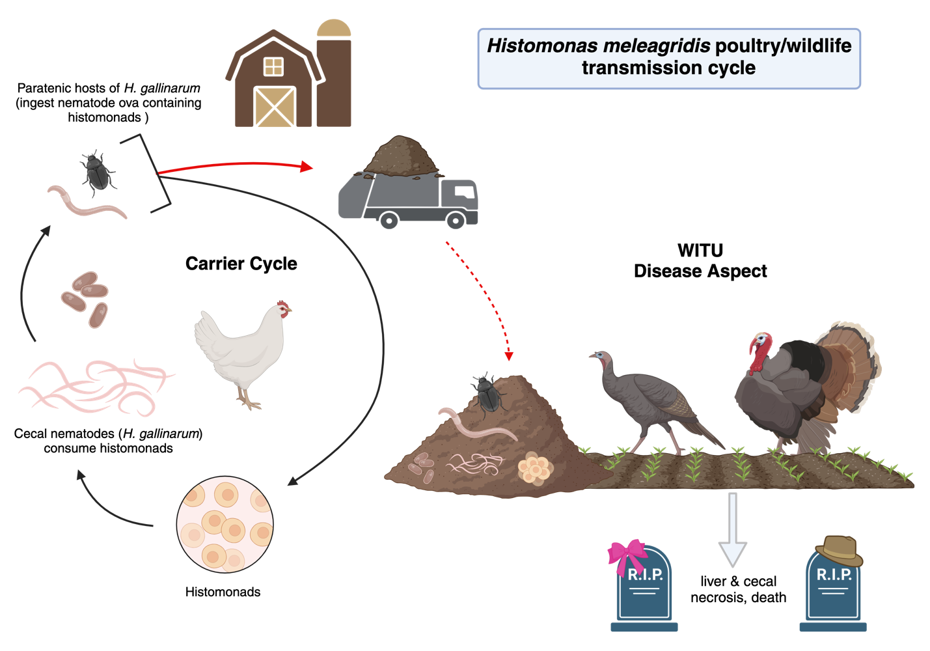 Figure 1.1. Example of potential transmission pathway of Histomonas meleagridis from poultry (carrier) cycle to Wild Turkey (disease) cycle of infected litter spread on agricultural fields. Created with BioRender.com.

“target lesion”. Most birds die 14-21 days following infection with clinical signs including sulfur-colored diarrhea, depression, inappetence, and a drooping head (Atkinson et al., 2008).
The use of poultry litter as an organic agricultural crop fertilizer has increased due to the rise in cost of produced fertilizers (Zhang et al., 2013). Poultry litter has been identified as a natural fertilizer source high in Nitrogen and Phosphorous, and due to its wide availability in areas with large poultry operations, has become a popular option among crop farmers as well as livestock farmers who use it to fertilize grazing fields (Ashworth et al., 2020; Cunningham et al., 2009; Zhang et al., 2013). A prior study by Quehl (2023) on this population revealed that fecundity and survival are in better standing in the southern declining counties than those considered overall stable in the northern counties which suggests the concern for the effect of H. meleagridis on the population may be negligible if detectable at all. However, the use of chicken litter and potential for H. meleagridis spread through this pathway still warrants investigation into the prevalence of histomonosis cases in areas where this practice is occurring and where Wild Turkey populations are also declining in order to rule this concern in or out. The present study is one part of a multi-part project investigating potential disease-related aspects of a declining Wild Turkey population in Middle Tennessee. In this study we report the number of histomonosis cases reported for Wild Turkeys in the five counties (from two county groupings, declining and stable) in our study areas over the three years of active and passive surveillance.

Methods

Study Area and Trapping

Five counties in middle Tennessee were selected for study, consisting of two county type groupings. The stable group consisted of Bedford and Maury counties, where the Wild Turkey population has not been reported as experiencing declines, while the declining group consisted of three counties (Lawrence, Wayne, and Giles) where the Wild Turkey population has been confirmed to be declining (Figure 1.2; Phillips et al., unpublished). Commercial chicken houses occur in high concentration in the declining counties (Figure 1.3; Menard et al., 2024) and spreading of chicken litter is common in agricultural fields frequented by Wild Turkeys in the area (Menard et al., 2024).

Active and Passive Sampling of Wild Turkeys for Diagnostic Screening
For the active surveillance portion of this study, we necropsied hunter-killed wild turkeys brought to Tennessee Wildlife Resource Agency (TWRA) check stations in the stable and declining counties during the Tennessee turkey hunting seasons from 2021-2022, as well as donated carcasses from 2020 when large-scale collection was not able to be completed due to COVID-19 regulations. Tissue sections from the cecum and liver of all birds were grossly examined for signs of histomonosis and suspicious samples were then prepared for histological examination using Hematoxylin and Eosin (H&E) stain to examine histologically for histomonads. The passive surveillance portion of this study consisted of the public (landowners, farmers, hunters, etc.) reporting instances of birds acting abnormally or showing signs of potential illness. We encouraged the public to report such cases immediately to TWRA or the research field technicians. Such cases were evaluated in the form of videos or photos sent in by observers and dispatched when deemed necessary. All birds from public reports also went through full necropsy, gross evaluation of tissues, and subsequent testing when necessary. Collection of dispatched birds spanned 2020-2022. Tissue sections suspected of H. meleagridis infection went through DNA extraction using a DNeasy Blood and Tissue Extraction Kit (QIAGEN, Valencia, CA). Extracted DNA was then tested via PCR using the Hmf & Hmr primers developed by Grabensteiner & Hess (2006) which specifically target conserved and variable regions in the small subunit rRNA sequences of H. meleagridis (Hmf 5’-
GAAAGCATCTATCAAGTGGAA-3’, Hmr 5’-GATCTTTTCAAATTAGCTTTAAA-3’). Each PCR reaction consisted of 12.5μl DreamTaq DNA Polymerase (Thermo Fisher Scientific, Waltham, MA), 8.5μl Nuclease-Free Water (Thermo Fisher Scientific, Waltham, MA), 1μl forward primer (Hmf), 1μl reverse primer (Hmr), and 2μl extracted DNA (total reaction volume of 25μl). The PCR settings were as follows: initial denaturation step at 95°C for 15 min, 40 cycles of heat denaturation at 94°C for 30 s, primer annealing at 55°C for 1 min and DNA extension at 72°C for 1 min, then maintained at 72°C for 10 min for the final extension step. PCR products were then run on a 1.5% agarose gel with ethidium bromide and visualized under ultraviolet light. All amplicons were then prepared with
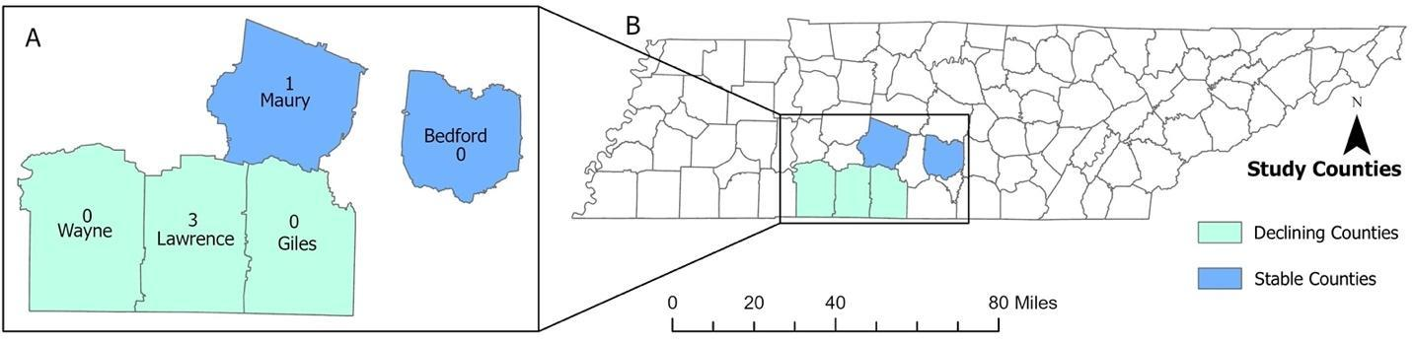
Figure 1.2. Map of Tennessee (B) showing the 5 study counties (A) and the number of confirmed Histomonas meleagridis positive cases. Declining counties included Wayne, Lawrence and Giles and the stable counties included Maury and Bedford. Lawrence County had 3 and Maury County had 1 confirmed H. meleagridis positive cases. The rest of the study sites had 0 positive cases. The map was created by the authors of the study using ArGISPro Software. The geographic boundary file was obtained from the United States Census Bureau TIGER Geodatabase. These files are publicly available and do not require permission to be reproduced.

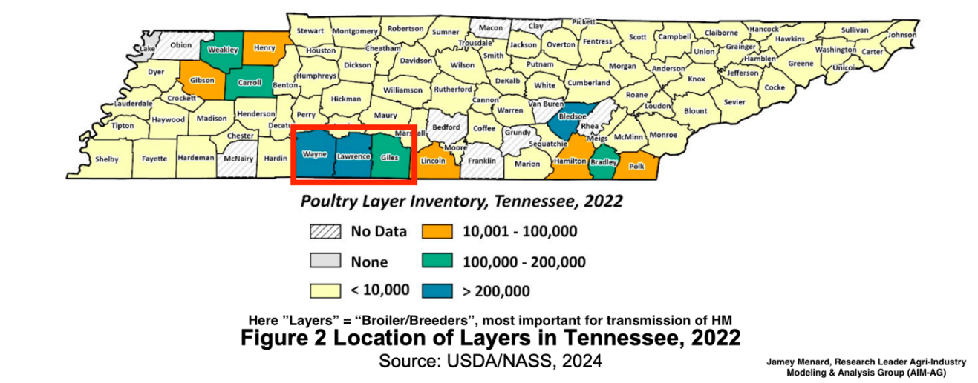
Figure 1.3. Map of Tennessee Layer operations inventory developed by Menard et al. (2024) and altered by author to highlight declining counties from present study (Wayne, Lawrence, Giles) to show area of overlap with locations of H. meleagridis cases confirmed.

ExoSAP-IT PCR Product Cleanup Reagent (Thermo Fisher Scientific, Waltham, MA) and sequenced at the University of Tennessee sequencing laboratory. Resulting sequences were analyzed using the GenBank database.

Results
Totals of donated (2020 only) and hunter-harvested birds examined grossly for signs of H. meleagridis infection each year are as follows; 2020 n=75, 2021 n=174, 2022 n=216. No birds from hunter-harvest check stations resulted in positive diagnoses for H. meleagridis by molecular testing. However, four birds were molecularly tested due to abnormal gross anatomy of liver or ceca but did not result in positive detections. Four birds reported by the public due abnormal behavior consistent with histomonosis–drooping heads, lethargy, and lack of fear of humans approaching--were dispatched by TWRA and submitted for necropsy. These cases were confirmed as positives by PCR testing of liver and/or cecum tissues, all of which cases had grossly visible lesions consistent with histomonosis in the liver and/or cecum (Table 1.1).
One bird in 2021 was an adult female from Lawrence County (declining county). Two birds were from 2022, one a juvenile female from Lawrence County (declining county), and one was a juvenile of unknown sex from Maury County (stable county). The final bird from 2023 was a male poult from Lawrence County (declining county). Overall, four detections of histomonosis were confirmed, with three occurring in declining counties and one in a stable county (Table 1.1, Figure 1.3).

Discussion
Overall, the detections of H. meleagridis infections in the study area are not of a sufficient sample size (n=4; Table 1.1) to indicate a significant population level effect. This may be due to many factors including but not limited to, the documented rapid disease progression of H. meleagridis in turkeys, hunter harvest timing in contrast to timing of chicken litter application, origin of poultry operation type from which litter is obtained, infection status/confirmation of birds from the operation where litter was obtained, and confirmation of feeding of Wild Turkeys in the research area feeding on these litter sources. It is reasonable to assume that in the lack of this confirmation of detail, it is possible that none of the birds harvested could have ever been exposed to H. meleagridis infected litter unless a more systematic investigation is conducted which specifically tracks and tests all check points in the transmission cycle for parasite presence. For that reason, this study still cannot confirm risk level to Wild Turkeys of commercial poultry litter as fertilizer in overlapping areas despite confirmation of the confirmed transmission cycle. More systematically designed and pointed research is certainly warranted for this purpose.
It is difficult to compare extant literature to the hunter-harvest results portion of our study due to the predominant sampling method for most prior studies being post-mortem submissions of abnormally behaving birds. For example, Hurst (1980), Davidson et al. (1985), and MacDonald et al. (2014) all reported on only post-mortem cases of histomonosis. These studies are similar to ours in the number of post-mortem observations of the disease, however, they did not examine hunter-harvest samples. Thogmartin et al. (1999) examined 573 live caught birds with no observations of any disease attributes but did report 19 post-mortem submissions which included two histomonosis cases. In terms of hunter-harvest surveillance for histomonosis, Oates et al. (2005) did examine 154 hunter-harvested birds in Nebraska with zero detections but did not report on and post-mortem findings from the season of sampling. These findings were quite similar to our lack of any detections of H. meleagridis in hunter-harvest birds.
For future testing efforts for this pathogen, it is noteworthy to consider that our hunter-harvest check station screening efforts did not result in any detections of histomonosis in any of the donated carcasses from our study areas during this study period. Multiple factors suggest that going forward, hunter-harvest surveys are not supported as the most informative surveillance technique for detecting population-level effects of histomonosis in Wild Turkeys. The average time from infection to signs of morbidity is approximately 7-14 days and average time from morbidity to mortality is approximately 14-12 days (Atkinson et al., 2008). This illustrates how difficult it can be, in terms of a small window of time, to encounter birds on the landscape early enough in the disease process to both come to the call of a hunter and be harvested, but not fall away from their flock and become isolated due to morbidity. Once the clinical signs of disease set in, moribund birds also become more likely to be predated or simply to die on the landscape and be scavenged. This disease progression timeline creates a limitation when grossly examining hunter-harvested birds because it is possible that a bird may be harvested during the very early stages of infection when no gross abnormalities may yet be apparent. Ideally, all liver and cecal tissues sampled from each of these hunter-harvested birds would be run via PCR to test for detection of H. meleagridis, however, that option was not plausible for the monetary and time constraints of this project. If funding becomes available, it would be fruitful to return to these preserved tissue samples and perform such standardized testing for every bird harvested regardless of gross appearance of liver and ceca. Even still, this scenario presents limitations with the potential for early-stage infections in low tissue concentration to only be present in small portions of the affected organ. Thus, the sampled sections of liver and cecum from any given bird may be from a portion of tissue which has not yet been infiltrated by histomonads at a high enough concentration to be detected without sectioning and extracting the entire organ for PCR testing, which would not be feasible with our sample size (Atkinson et al., 2008). It is also important to note that there is a lack of understanding whether H. meleagridis is universally fatal to Wild Turkeys, as existing research has been primarily conducted in domestic turkeys. It would be informative for future experiments to also conduct experimental infections in Wild Turkeys with various different H. meleagridis isolates to better understand the outcomes of infection in Wild Turkeys.
Another limitation of the detection success in this study is the lack of knowledge as to when poultry litter is being spread on the landscape in the study counties. Hawkins and Walker (“Litter Land Application Management,” publication date unknown) outline recommended dates of litter application on agricultural fields which varies from the fall season through April depending on crop type. Without knowing exactly when litter was spread in our study areas, we cannot be sure that
Table 1.1. All positive cases of H. meleagridis identified from Wild Turkeys originating in the study area from 2020-2023, including county location and bird descriptors.
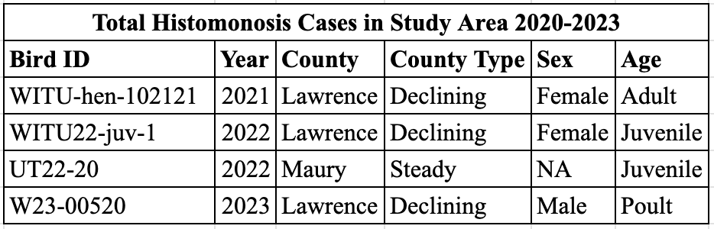

hunter harvest sampling is either too early that the birds have not fed on the litter and become infected yet by time of hunting season, or too late where hunting season occurs long after infection and disease process have already resulted in mortality for infected birds, either scenario resulting in non-detections during hunter-harvest sampling.
A beneficial avenue for future research would be to collect and test litter samples from the counties in the study to detect H. meleagridis and H. gallinarum DNA. The use of trail cameras to confirm exactly how many birds are feeding in fields where the litter is spread would also be informative. This information could help inform questions surrounding the transmission pathway which is suspected to be at play. The public perception and fear of the potential repercussions of confirming this transmission pathway poses a threat to farmers who rely on chicken litter as an affordable organic fertilizer option, and this greatly limited the cooperation we received from farmers to allow us to collect chicken litter from their farms for this purpose. We recommend future investigations into this transmission pathway and disease presence in Wild Turkey populations in other geographic areas where population declines are observed and where poultry operations simultaneously exist, as well as more focused studies directed towards elucidating the impact of this specific disease’s impact on those populations.
Despite the lack of H. meleagridis detections in our hunter-harvest screening efforts, our study did find evidence of cases of histomonosis in Wild Turkeys in our study areas through public reporting. With a disease process as time sensitive as with H. meleagridis, it proved extremely valuable to engage the community in reporting abnormally behaving Wild Turkeys they witnessed, and then follow through with TWRA dispatch to obtain carcasses for full necropsy. From this survey method, we detected four cases of histomonosis, with three out of four (75%) cases coming from declining counties (representing 60% of our study sites). This does shed light on the occurrence of the disease in our study areas. It is worth noting that half of these cases originated from Lawrence County, which has the highest concentration of known poultry operations of our three declining county locations (Menard et al., 2024). Ultimately, we must consider that these cases only provide us with one piece of our investigative puzzle into the potential diseases at play in the Wild Turkey populations in these counties experiencing declines. Our data do not suggest this pathogen is implicated in significant population-level detriment to the Wild Turkeys in the study area but do illustrate that H. meleagridis is indeed one pathogen which is present.

REFERENCES
Arnold, G. (2020). Poultry Litter Application. Poultry Litter Application | Agronomic
Crops Network.
https://agcrops.osu.edu/newsletter/corn-newsletter/2020-26/poultry-litter-application#:~:text=Typical%20nutrient%20ranges%20in%20poultry,%2Dyear%20corn%2Fsoybean%20rotation.
Ashworth, A. J., Chastain, J. P., & Moore Jr, P. A. (2020). Nutrient characteristics of
poultry manure and litter. Animal manure: production, characteristics, environmental
concerns, and management, 67, 63-87.
Atkinson, C. T., Thomas, N. J., & Hunter, D. B. (2008). Parasitic Diseases of Wild
Birds.
Cunningham, D. L., Ritz, C. W., & Merka, W. C. (2009). Best management practices
for storing and applying poultry litter.
Cupo, KL., & Beckstead, RB. (2019). PCR detection of Heterakis gallinarum in
environmental samples. Veterinary Parasitology, 271, 1-6.
Davidson, W. R., Nettles, V. F., Couvillion, C. E., & Howerth, E. W. (1985). Diseases
diagnosed in wild turkeys (Meleagris gallopavo) of the southeastern United States.
Journal of Wildlife Diseases, 21(4), 386-390.
Forrester, DJ., & Spalding, MG. (2003). Wild turkeys, 558-569. In Parasites and
Diseases in Wild Birds in Florida. University Press of Florida, Gainesville, FL.
Gerhold, R., Nobrega, G., & Applegate, R. (2016). Health Survey and Laboratory
Study of the Potential Transmission of Pathogens from Poultry Litter to Wild Turkeys
(Meleagris gallopavo). (Unpublished) Tennessee Wildlife Resources Agency,
University of Tennessee, Knoxville.
Grabensteiner, E., & Hess, M. (2006). PCR for the identification and differentiation of
Histomonas meleagridis, Tetratrichomonas gallinarum and Blastocystis spp.
Veterinary Parasitology, 142(3-4), 223-230.
Hawkins, S., and F. Walker. “Litter Land Application Management.” W 796.
Department of Biosystems Engineering and Soil Science, University of Tennessee Extension. Available at extension.tennessee.edu/publications/ Documents/W796.pdf.
Hurst, G. A. (1980). Histomoniasis in wild turkeys in Mississippi. Journal of Wildlife
Diseases, 16(3), 357-358.
MacDonald, A. M., Jardine, C. M., Rejman, E., Barta, J. R., Bowman, J., Cai, H. Y.,
...& Nemeth, N. M. (2019). High prevalence of Mycoplasma and Eimeria species in
free-ranging eastern wild turkeys (Meleagris gallopavo silvestris) in Ontario, Canada.
Journal of wildlife diseases, 55(1), 54-63.
Menard, J., & Agri-Industry Modeling & Analysis Group. (2024). Tennessee
agri-industry brief: poultry fact sheet. Publication Series: Tennessee Agri-Industry
Brief Fact Sheets. Retrieved June 6, 2024, from
https://arec.tennessee.edu/wpcontent/uploads/sites/17/2023/10/FINAL_PoultryFactSheet.pdf.
Thogmartin, W. E., Johnson, J. E., Schaeffer, B. A., & Ciriano, C. C. (1999). Survey of diseases in wild turkeys in Arkansas. Journal of the Arkansas Academy of Science,
53(1), 114-119.
Oates, D. W., Wallner-Pendleton, E. A., Kanev, I., Sterner, M. C., Cerny, H. E.,
Collins, M., Bischof, R., & Boyd, E. D., "A survey of infectious diseases and parasites
in wild turkeys from Nebraska" (2005). Transactions of the Nebraska Academy of
Sciences and Affiliated Societies. 45.
Quehl, J. (2023). Assessing the effects of the spring hunting season start date on wild
turkey seasonal productivity and hunter behavior.
Zhang, H., Hamilton, D. W., & Payne, J. (2013). Using poultry litter as fertilizer.
Oklahoma Cooperative Extension Service.

CHAPTER II
PREVALENCE OF PROTOZOAN PARASITES TOXOPLASMA GONDII, LEUCOCYTOZOON SMITHI, HAEMOPROTEUS SPP., AND PLASMODIUM SPP. IN A WILD TURKEY (MELEAGRIS GALLOPAVO SILVESTRIS) POPULATION IN MIDDLE TENNESSEE

Abstract
As part of an investigation into disease aspects which are present in a declining Wild Turkey population in Middle Tennessee, the prevalence of several Protozoan parasites were evaluated. The study design included sampling birds from three declining counties experiencing population declines (Lawrence, Giles, and Wayne) and two stable counties not experiencing reported declines (Bedford and Maury). Total serum samples tested for Toxoplasma gondii and total percent positives each year were as follows; 2020 (n=135) 13.3%, 2021 (n=135) 10.4%, 2022 (n=30) 10%. Prevalence was highest for T. gondii in declining counties in 2020, in stable counties in 2021, and again in declining counties in 2022. Total blood samples tested for Leucocytozoon smithi and total percent positives were as follows; 2020 (n=175) 0%, 2021 (n=123) 0%, 2022 (n=205) 2.4%. There were no detections of L. smithi in 2020 or 2021, and in 2022 prevalence was minimally higher in stable counties. Total blood samples tested for Plasmodium spp. and total percent positives were as follows; 2020 (n=173) 0%, 2021 (n=126) 0%, 2022 (n=184) 0%. There were no detections of Plasmodium spp. in any of the sampled years. Total blood samples tested for Haemoproteus spp. and total percent positives were as follows; 2020 (n=173) 27.7%, 2021 (n=126) 23%, 2022 (n=184) 20.1%. Detections of Haemoproteus spp. were highest in declining counties each sampled year. Various statistical tests were run for each parasite, however, only those run for Haemoproteus spp. were significant.

Introduction
There are a variety of Protozoan parasites which are known to infect Wild Turkeys, most of which cause highly variable degrees of morbidity and mortality under different circumstances. Throughout time different Protozoan parasites have been studied in Wild Turkey populations, however this baseline data is predominantly lacking for Tennessee. While Toxoplasma gondii has been investigated in Tennessee Wild Turkeys once from 2014-2018 (Ammar et al., 2019) and Haemoproteus spp. once in 1980 (Castle & Christensen 1984), Leucocytozoon smithi and Plasmodium spp. have not. Wild Turkeys in our study area have been experiencing population declines and research into the potential disease aspects at play in these declines is warranted. As a part of a larger multi-part disease study, we tested Wild Turkeys in Middle Tennessee from five counties; Maury & Bedford (stable) which had populations not experiencing declines, and Lawrence, Wayne & Giles (declining) which are experiencing population declines. We tested birds from these counties for T. gondii, Leucocytozoon smithi, Haemoproteus spp., and Plasmodium spp. from 2020-2022 to determine baseline infection rates.
Toxoplasma gondii is a zoonotic parasitic infection with a global distribution and prolonged environmental persistence, and the ability to infect Wild Turkeys (Wilson et al., 2020). This parasite involves a two-host life cycle including a felid definitive host which usually contracts the parasite from the muscle tissue of prey, and an intermediate host which usually contracts the parasite from environmental contamination or prey containing oocysts (Wilson et al., 2020). Often field signs are not seen in wild birds but can include anorexia, depression, dull or ruffled feathers, diarrhea, or dyspnea (Atkinson et al., 2008). Toxoplasmosis has been cited as a disease of Wild Turkeys, with the first documented case of fatal toxoplasmosis in a Wild Turkey reported by Howerth & Rodenroth in 1985, and seroprevalence of T. gondii in Wild Turkey populations has been suggested to have the potential to serve as an indicator of environmental contamination with oocysts (Sá et al., 2016). While studies on T. gondii infections in wildlife are increasing in surveillance of a variety of reservoir species, we still have limited knowledge of the infection rates in Wild Turkeys specifically. These factors deem investigating its prevalence in this population valuable.
Leucocytozoon smithi is a common blood protozoan parasite of Wild Turkeys throughout their entire range and is specific to wild and domestic turkeys (Atkinson et al., 2008). Leucocytozoon smithi are transmitted by black flies of the genus Simulium which require running water for breeding, and infections are heaviest during the months of July-October. Leucocytozoonosis has been associated with significant mortality in Wild Turkeys, although it has been determined that the parasite may not have been the cause of death but rather a significant stressor which accelerated the disease process of other pathogens simultaneously present in concurrence due to the effect it has on misshaping the red blood cells it infects (Atkinson et al., 2008). Clinical signs in turkeys include anorexia, polydipsia, depression, muscle incoordination, head drooping, hemorrhaging of the small intestine, and sudden death (Atkinson et al., 2008). Death is caused by obstruction of the circulatory system by large numbers of parasites and even birds which recover are typically less vigorous and tend to die when stressed. Infected gobblers are also known to exhibit reduced mating activity and hens experience a decrease in production, weight, and hatchability of their eggs (Atkinson et al., 2008).
The species of Haemoproteus that infect birds are vector-transmitted, intracellular parasitic protozoans that live within the blood cells and tissues of their avian hosts (Atkinson et al., 2008). They are very closely related to the genera Plasmodium, and Leucocytozoon. Known vectors of Haemoproteus include flies in the genus Culicoides and hippoboscid flies (Atkinson et al., 2008). While Haemoproteus are some of the most common and widespread blood parasites of wild birds, their population effect is largely unknown due to lack of information about their life cycles, vectors, and epizootiology (Atkinson et al., 2008). Some species of Haemoproteus are known to be highly pathogenic and cause myositis in their hosts, including in Wild Turkeys. Clinical signs are typically absent in low-intensity infections but may become apparent when erythrocytic parasitemia and number of tissue meronts reach high intensities in the acute phase but may present as lameness or weakness of the legs and ataxia (Atkinson et al., 2008).
Avian malaria is a common mosquito-transmitted disease of wild birds caused by a protozoan parasite in the genus Plasmodium (Atkinson et al., 2008). The infections caused by this group include a complex of more than 40 species that largely vary based on host range, geographic distribution, vector specificity, and pathogenicity. Avian species of Plasmodium share many morphological and functional features related to haemosporidian parasites but are distinguished by their ability to perform asexual reproduction within circulating erythrocytes. The parasite is vectored by mosquitoes. Hematocrits for infected birds typically drop by at least 50% and green diarrhea, pulmonary issues, leg edema, and paraplegia or paralysis are common. Both wild and captive birds experience significant disease following infection with avian malaria.
The present study aimed to contribute to the wider body of knowledge about the prevalence and potential population level impacts of these parasites on Wild Turkeys in Middle Tennessee. Our results address prevalence gaps as well as explore relationships to county type and weight and body condition in order to determine if sublethal effects are detectable because these birds have not been seen showing clinical signs.

Methods

Study Area and Trapping
Five counties in Middle Tennessee were selected, consisting of two county type groupings. The stable county group consisted of two counties (Bedford and Maury) where the Wild Turkey population has not been reported as experiencing declines, while the declining county group consisted of three counties (Lawrence, Wayne, and Giles) where the Wild Turkey population has been confirmed to be experiencing declines (Figure 1.2, page 52). Each year there were approximately 10 trap sites with two in each of the five counties. In total, there were 21 successful trapping attempts in 2020, 23 in 2021, and 26 in 2022. The birds from this study were part of a larger-scale project focusing on radio telemetry and were live-caught with rocket nets and then sampled for the purposes of this study through biological measurements (body condition score 1-4 & weight), as well as collected blood for molecular and serological testing.

Modified Agglutination Test for Toxoplasma gondii
Serum was isolated from blood samples and used to test for the presence of antibodies to T. gondii using the Modified Agglutination Test (MAT) protocol developed by Dubey & Desmonts (1987) which has been shown to have the highest sensitivity of the available serological testing methods for T. gondii detection Dubey et al. (1995). The MAT uses formalin fixed T. gondii tachyzoites to detect IgG antibodies produced by the host bird against the parasite when it is present. The antigen solution used was made in the lab of Dr. Chunlei Su at the University of Tennessee Knoxville, Department of Microbiology, Knoxville, Tennessee, USA. The serum samples were diluted from 1:25 up to 1:3600. Samples that had titers greater than or equal to 1:25 were considered positive.

Molecular Testing for Haemoprotozoan Parasites
Whole genomic DNA was extracted from whole blood samples using a DNeasy Blood and Tissue Extraction Kit (QIAGEN, Valencia, CA). Each PCR reaction (for both primer sets) consisted of 12.5μl DreamTaq DNA Polymerase (Thermo Fisher Scientific, Waltham, MA), 8.5μl Nuclease-Free Water (Thermo Fisher Scientific, Waltham, MA), 1μl forward primer, 1μl reverse primer, and 2μl extracted DNA (total reaction volume of 25μl).
Testing for Leucocytozoon smithi utilized the primers HaemFL forward (ATGGTGTTTTAGATACTTACATT) and HaemR2L reverse (CATTATCTGGATGAGATAATGGIG) to target the cytochrome b gene of the parasite following the PCR amplification as described in Hellgren et al. (2004). The PCR settings were as follows: initial denaturation step at 94°C for 3 min, 35 cycles of heat denaturation at 94°C for 30 s, primer annealing at 50°C for 30 s, and DNA extension at 72°C for 45 s, then maintained at 72°C for 10 min for the final extension step.
For Plasmodium spp. and Haemoproteus spp. the primers HaemF forward (ATGGTGCTTTCGATATATGCATG) and HaemR2 reverse (GCATTATCTGGATGTGATAATGGT) which target the cytochrome b gene were used for PCR amplification as described in Bensch et al. (2000). The PCR settings were as follows: initial denaturation step at 94°C for 3 min, 35 cycles of heat denaturation at 94°C for 30 s, primer annealing at 55°C for 30 sec, and DNA extension at 72°C for 45 sec, then maintained at 72°C for 10 min for the final extension step.
PCR products from both primer sets were then run on a 1.5% agarose gel with ethidium bromide and visualized under ultraviolet light. All amplicons were then prepared with ExoSAP-IT PCR Product Cleanup Reagent (Thermo Fisher Scientific, Waltham, MA) and sequenced at the University of Tennessee sequencing laboratory. Resulting sequences were analyzed using the GenBank database.

Statistical Analyses
All statistical analyses were run in SPSS (IBM SPSS Statistics for Mac, Version 29.0.2.0 Armonk, NY: IBM Corp). No statistical analyses were computed for Plasmodium spp. due to there being no positive samples. For T. gondii and Haemoproteus spp. Chi Square tests were run, and for Leucocytozoon smithi Fisher's exact test was run (rather than a chi-squared test) due to more than 20% of the sample size data being less than 5. For all pathogens these tests were run separated by year in order to meet the assumption of independence for the test due to the presence of recaptured birds across multiple years. In some cases when values of zero existed in a county type year’s grouping, these analyses were invalid and excluded due to not meeting the assumptions of Chi Square or Fisher’s exact test where no values of zero can exist.
Due to only having positives for Leucocytozoon smithi in 2022, a Fisher’s exact test was run for this year only. These tests aimed to identify if there were differences in positive/negative results per county category (declining or stable) per year.
Independent t-tests were run for T. gondii, Leucocytozoon smithi, and Haemoproteus spp. to determine if there were differences between the bird body condition score (scored 1-4 with 1 being lowest quality and 4 being highest, based on physical keel palpation) or weight between the positive and negative birds. Levene’s test for equal variances was run for all t-tests to ensure assumptions of equal variance were met for each group. Two types of linear regressions were run for these three pathogens as well, the first was run with body and weight to determine if these coefficients had an influence on positive/negative result, and the second was run with county type (declining/stable) to determine if this coefficient had an influence on positive/negative result. All tests were run with a 95% confidence interval and resulting p-values <0.05 were considered significant.

Results

Toxoplasma gondii
Total serum samples tested for T. gondii each year are as follows; 2020 n=135, 2021 n=135, 2022 n=30 (Table 2.1, Figure 2.1). In 2020, 81 samples were tested from
declining counties with a 14.8% seropositivity (n=12) and 54 samples from stable counties with an 11.1% seropositivity (n=6) (Table 2.2). Seventy-three samples from declining counties were tested in 2021 with an 8.2% seropositivity (n=6) and 62 samples from stable counties with a 14.5% seropositivity (n=9) (Table 2.2). In 2022, 27 samples from declining counties were tested with an 11.1% seropositivity (n=3) and 3 from stable counties with a 0% seropositivity rate (Table 2.2). Results from Chi Square tests for T. gondii by year were as follows: 2020 was not significant (p=0.613), 2021 was not significant (p=0.281) and the 2022 test had positive values of zero in at least one category and thus the test for this year had to be excluded. Results from independent t-tests for T. gondii showed no significant difference in the mean weight (p=0.789) or body condition score (0.956) of positive vs. negative birds. The first logistic regression analysis for T. gondii resulted in neither body condition score (p=0.960) nor weight (p=0.874) having significant p-values, meaning neither covariate Table 2.1. Total samples tested for each pathogen, broken down by year and showing total positives each year.
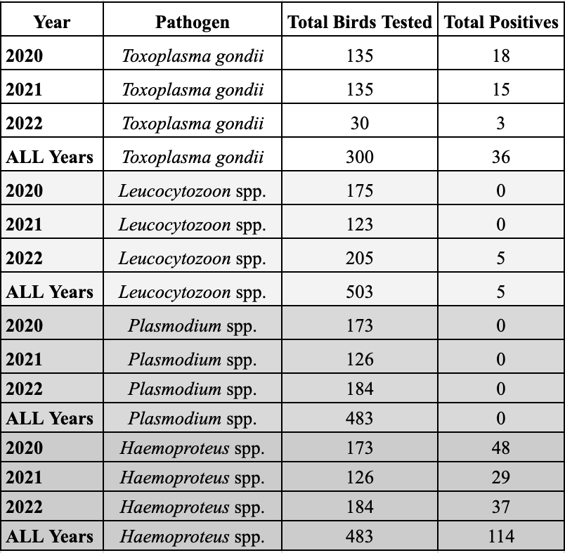
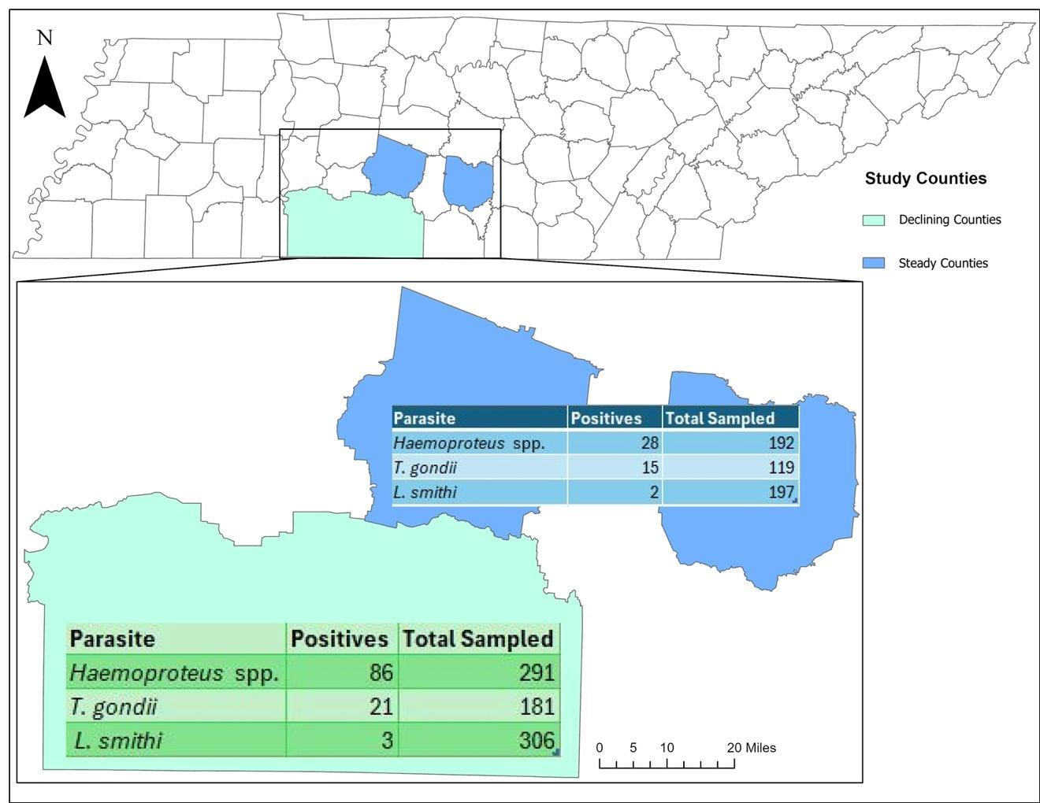
Figure 2.1. Map showing results for Middle Tennessee Wild Turkey population from all years of the study (2020-2021), showing total samples tested and results as positive MAT (T. gondii) or PCR (L. smithi, Haemoproteus spp.) detections, broken down between declining (Lawrence, Giles, and Wayne) and stable (Bedford and Maury) county groups.

Table 2.2. Middle Tennessee Wild Turkey population Modified Agglutination Test results for T. gondii from each year of the study (2020-2022), showing total serum samples tested and results as percent positives broken down between declining (Lawrence, Giles, and Wayne) and stable (Bedford and Maury) county groups.
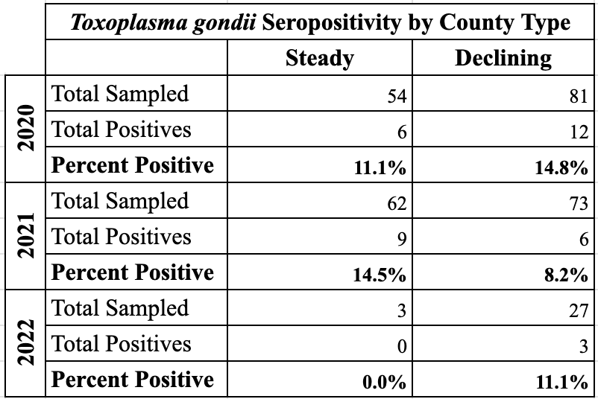

Leucocytozoon smithi, Haemoproteus spp., and Plasmodium spp.
Total blood samples tested for Leucocytozoon smithi each year are as follows; 2020 n=175, 2021 n=123, 2022 n=205 (Table 2.1, Figure 2.1). In 2020, 113 samples were tested from declining counties and 62 from stable counties, both with 0% prevalence rates (Table 2.3). Similarly, in 2021, 66 samples from declining and 57 from stable counties both resulted in 0% prevalence rates (Table 2.1). One hundred and twenty-seven samples from declining counties were tested in 2022 with a 2.4% prevalence (n=3) and 78 samples from stable counties with a 2.6% prevalence (Table 2.1). Further statistical analyses were not performed for L. smithi due to low sample size of positive results.
Total blood samples tested for Haemoproteus spp., and Plasmodium spp. each year are as follows; 2020 n=173, 2021 n=126, 2022 n=184 (Table 2.1, Figure 2.1). For Plasmodium spp., in 2020, 173 samples were tested, in 2021, 126 were tested, and in 2022, 184 were tested, all of which had 0% prevalence. (Table 2.1). In 2020 Haemoproteus spp. was tested for in 112 samples from declining counties with a 30% prevalence (n=34) and 61 samples from stable counties were tested with a 23% prevalence (n=14) (Table 2.3).
Sixty-six samples were tested in 2021 for Haemoproteus spp. from declining counties with a 39.4% prevalence (n=26) and 60 samples from stable counties with a 5% prevalence (n=3) (Table 2.3). In 2022 113 samples from declining counties were tested for Haemoproteus spp. with a 23% prevalence rate (n=26) and 71 were tested from stable counties with a 15.5% prevalence rate (n=11) (Table 2.3).
Table 2.3. Middle Tennessee Wild Turkey population PCR test results for Haemoproteus spp. from each year of the study (2020-2022), showing total blood samples tested and results as percent positives broken down between declining (Lawrence, Giles, and Wayne) and stable (Bedford and Maury) county groups.
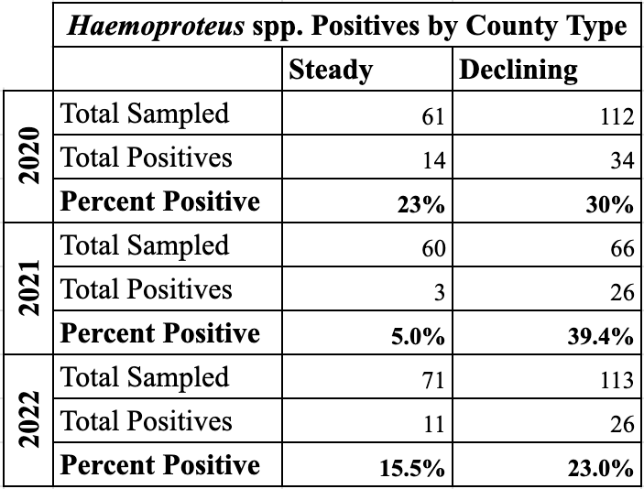

Chi square tests for Haemoproteus spp. by year were as follows: 2020 was not significant (p=0.375), in 2021 there was a highly significant difference between the positive groups by county type (stable vs. declining) (p<0.001), and the 2022 test was not significant (p=0.259). Results from independent t-tests for Haemoproteus spp. showed no significant difference in the mean body condition score (p=0.174) of positive vs. negative birds; weight however, showed a statistically significant (p<0.001) difference in means of 0.7249 kg between positive vs. negative birds (95% CI 0.3117, 1.1382). The first logistic regression analysis for Haemoproteus spp. resulted in neither body condition score (p=0.342) nor weight (p=0.207) having significant p-values, meaning neither covariate made a bird more likely to be positive. The second logistic regression was highly significant (p<0.001) with a Beta coefficient of 2.457 (95% CI 1.531, 3.944) meaning that a bird from a declining county would be 2.457 times more likely to be positive than if they came from a stable county.

Discussion
The results of this study varied by parasite species but were ultimately not extremely dissimilar to other studies of this type from other regions; these results ultimately fill the knowledge gap as to these parasites’ prevalence in the Middle Tennessee Wild Turkey population and allow for such conclusive comparison across the literature. Overall, there were no positives for Plasmodium spp. across all three years which was consistent with almost all existent studies similar to ours in other regions (Hopkins et al., 1990; Cook et al., 1966; Guenthner 1976; Eve et al., 1972). Results for Toxoplasma gondii in our study population totaled 12% which was quite similar to what was found by Quist et al. (1995) across various states with a 10% prevalence, however, a study by Ammar (2019) which evaluated the same population as our study from 2014-2018 prior reported a 20.5% prevalence. Other studies have reported higher, ranging from 33.3%-71% (Cerqueira-Cézar et al., 2019; & Lindsay et al., 1994).
Leucocytozoon smithi had no positives from 2020-2021, but interestingly did have several positives in 2023 (n=5). The most likely reason for this is due to changes in the black fly vector abundance, but we cannot know entirely because data on the vector population was not collected as a part of this study. Our results for L. smithi with a prevalence of 1% were similar to those of Guenthner (1976) who found a 0% prevalence in an Illinois Wild Turkey population, Cook et al. (1966) who also reported a prevalence of 0%, and Castle & Christensen (1990) who reported a range of 0-6% in the states they sampled in the Midwest.
Results for Haemoproteus spp. prevalence in our study population was 23.6% which fell approximately in the middle of what was found in most published studies of the same type in other areas. On the lower end, Kozicky (1948) reported a 5.2% prevalence in Pennsylvania although this study had a very small sample size (n=5). The study by Sasseville et al. (1988) reported a 0% prevalence but also had a small sample size of 19. Castle and Christensen (1984) reported a prevalence of 18% in Tennessee, similar to our study, and 39% in Kentucky. Guenthner (1976) reported an 18% prevalence in Illinois, also similar to our findings. The upper end of prevalence which were much higher than ours ranged from 30-84% (Cook et al., 1966; Eve et al., 1972; Stacey et al., 1990; Hopkins et al., 1990; & Fedynich & Rhodes (1995).
While there were no statistically significant results or comparative trends for T. gondii or Leucocytozoon smithi Prevalence, Haemoproteus spp. results were statistically very informative. Chi square results for this parasite in 2021 had significant differences (p<0.001) in the prevalence between stable and declining counties with declining counties having more positives. The independent t-tests for Haemoproteus spp. were also strongly significant (p<0.001) showing a difference in means of 0.7249 kg between positive and negative birds. The second logistic regression was also highly significant (p<0.001), revealing that birds from declining counties were more likely to be positive. It is important to interpret these results critically, because these parasitic infections are typically not seen causing severe morbidity or mortality in Wild Turkeys and were not seen causing clinical signs in the birds we sampled. As noted, our results were not extremely different in comparison to similar studies in other locations. However, this information is still incredibly valuable to the study as these infections, when compounded by additional stressors (environmental or physiological) can certainly have a collective negative effect on a bird’s health and livelihood.

REFERENCES
Ammar, Sawsan, "Transmission and ecology of Toxoplasma gondii in various wild
bird species. " PhD diss., University of Tennessee, 2019.
https://trace.tennessee.edu/utk_graddiss/5732
Atkinson, C. T., Thomas, N. J., & Hunter, D. B. (2008). Parasitic Diseases of Wild
Birds.
Byrne, M. E., Chamberlain, M. J., & Collier, B. A. (2015). Potential density
dependence in wild turkey productivity in the southeastern United States. In
Proceedings of the National Wild Turkey Symposium (Vol. 11, pp. 329-351).
Bensch, S., Stjernman, M., Hasselquist, D., Ústman, Ú., Hansson, B., Westerdahl, H.,
& Pinheiro, RT. (2000). Host specificity in avian blood parasites: a study of
Plasmodium and Haemoproteus mitochondrial DNA amplified from birds. Proc. R.
Soc. Lond., 267, 1583-1589.
Castle, M. D., & Christensen, B. M. (1984). Blood and gastrointestinal parasites of
eastern wild turkeys from Kentucky and Tennessee. Journal of wildlife diseases, 20(3),
190-196.
Cerqueira-Cézar, C. K., Da Silva, A. F., Murata, F. H., Sadler, M., Abbas, I. E., Kwok,
O. C., ... & Dubey, J. P. (2019). Isolation and genetic characterization of Toxoplasma
gondii from tissues of wild turkeys (Meleagris gallopavo) in Pennsylvania. Journal of
Parasitology, 105(3), 391-394.
Cook, R. S., Trainer, D. O., & Glazener, W. C. (1966). Haemoproteus in wild turkeys
from the coastal bend of South Texas. The Journal of Protozoology, 13(4), 588-590.
Dubey, J. P., & Desmonts, G. (1987). Serological responses of equids fed Toxoplasma
gondii oocysts. Equine veterinary journal, 19(4), 337-339.
Dubey, JP., Thulliez, P., Weigel, R., Andrew, C., Lind, P., & Powell, E. (1995).
Sensitivity and specificity of various serologic tests for detection of Toxoplasma gondii infection in naturally infected sows. Am. J. Vet. Res., 56: 1030-1036.
Eve, J. H., Kellogg, F. E., & Bailey, R. W. (1972). Blood parasites in wild turkeys of
eastern West Virginia. The Journal of Wildlife Management, 624-627.
Fedynich, A. M., & Rhodes Jr, O. E. (1995). Hemosporid (Apicomplexa, Hematozoea,
Hemosporida) community structure and pattern in wintering wild turkeys. Journal of
Wildlife Diseases, 31(3), 404-409.
Guenthner, U. G. (1976). Blood parasites of Illinois wild turkeys.
Hellgren, O., Waldenström, J., & Bensch, S. (2004). A new PCR assay for
simultaneous studies of Leucocytozoon, Plasmodium, and Haemoproteus from avian
blood. Journal of Parasitology, 90(4), 797– 802. https://doi.org/10.1645/GE-184R1
Hopkins, B. A., Skeeles, J. K., Houghten, G. E., Slagle, D., & Gardner, K. (1990). A
survey of infectious diseases in wild turkeys (Meleagridis gallopavo silvestris) from
Arkansas. Journal of wildlife diseases, 26(4), 468-472.
Howerth, E. W., & Rodenroth, N. (1985). Fatal systemic toxoplasmosis in a wild
turkey.
Hurst, G. A. (1980). Histomoniasis in wild turkeys in Mississippi. Journal of Wildlife
Diseases, 16(3), 357-358.

Kozicky, E. L. (1948). Some protozoan parasites of the eastern wild turkey in
Pennsylvania. The Journal of Wildlife Management, 263-266.
Lindsay, D. S., Smith, P. C., & Blagburn, B. L. (1994). Prevalence and isolation of
Toxoplasma gondii from wild turkeys in Alabama.
Quist, C. F., Dubey, J. P., Luttrell, M. P., & Davidson, W. R. (1995). Toxoplasmosis in wild turkeys: a case report and serologic survey. Journal of Wildlife Diseases, 31(2), 255-258.
Sá, S., Lima, D., Silva, L., Pinheiro Júnior, J., Dubey, J., Silva, J. & Mota, R. (2016).
Seroprevalence of Toxoplasma gondii among turkeys on family farms in the state of
Northeastern Brazil. Acta Parasitologica, 61(2), 401-405.
https://doi.org/10.1515/ap-2016-0053
Wilson, A. G., Lapen, D. R., Mitchell, G. W., Provencher, J. F., & Wilson, S. (2020).
Interaction of diet and habitat predicts Toxoplasma gondii infection rates in wild birds
at a global scale. Global ecology and biogeography, 29(7), 1189-1198.

CHAPTER III
SURVEY OF COMMON COMMERCIAL POULTRY PATHOGEN EXPOSURE IN A WILD TURKEY (MELEAGRIS GALLOPAVO SILVESTRIS) POPULATION IN MIDDLE TENNESSEE

Abstract

This study was conducted as part of a multi-part investigation into disease aspects which are present in a declining Wild Turkey population in Middle Tennessee. The prevalence of several diseases of concern for poultry and Wild Turkeys alike were evaluated. The study design included sampling birds from three declining counties experiencing population declines and with some of the highest concentration of poultry operations in the state (Lawrence, Giles, and Wayne) and two stable counties not experiencing reported declines and with lower poultry operation density (Bedford and Maury). Total serum samples tested for AI antibodies each year and total percent positives were as follows; 2020 (n=136) 0%, 2021 (n=226) 0%, 2022 (n=35) 0%. There were no detections of AI in any of the sampled years. Total serum samples tested for NCD antibodies and total percent positives each year were as follows; 2020 (n=130) 10%, 2021 (n=225) 2.4%, 2022 (n=29) 0%. Detections of NCD were highest in declining counties each sampled year. Total serum samples tested for MG/MS antibodies and total percent positives each year were as follows; 2020 (n=97) 16.5%, 2021 (n=223) 0.4%, 2022 (n=34) 5.9%. Detections of MG/MS were highest in declining counties each sampled year. In 2020, 97 total fecal samples were evaluated, and in 2021, 145 were evaluated. Of the samples evaluated, there were 143 non-detections. In 2020 Eimeria spp., Ascarid spp., and Cestodes were in highest prevalence in declining counties, while Capillaria spp. Were in highest prevalence in stable counties. In 2021 Eimeria spp. Prevalence was even in declining and stable counties, Ascarid spp. and Capillaria spp. were highest in stable counties, and Cestodes were highest in declining counties. Of the statistical tests run, the following were significant; the independent t-test run for MG/MS showed differences in the mean weights of positive vs. negative bird groups (p=0.047) with them being significantly lower in positive birds, and the logistic regression run for Eimeria spp. between positive vs. negative bird groups showed weight (p=0.003) had a significant effect on making a bird more likely to be positive.

Introduction
Many common poultry diseases are known to infect Wild Turkey populations, yet the prevalence data for such pathogens in wild populations is generally lacking and geographically sparse. In the declining counties of this Middle Tennessee study area the Wild Turkey population is declining, while sharing the landscape with the highest concentration of poultry facilities in the state (Menard 2022). Here we investigated the occurrence of antibody presence for 3 major poultry pathogens of commercial concern in the declining Wild Turkey population in Middle Tennessee; avian influenza (AI), Newcastle disease virus (NCD), Mycoplasma gallisepticum and Mycoplasma synoviae (MG/MS) from 2020-2023. Additionally, we evaluated the presence of common gastrointestinal parasites shared by both commercial poultry and Wild Turkeys (from 2020-2022). Due to the increased use of poultry litter as low-cost organic fertilizer in the study area, and the known transmission pathways for the above pathogens of interest, the potential for overflow between commercial poultry and Wild Turkeys holds value for investigation. This study aimed to elucidate the frequency at which antibodies to each pathogen were present in the study population. We investigated common gastrointestinal parasites which can infect both commercial poultry and Wild Turkeys. Due to the lack of active clinical disease seen in these birds which were sero-sampled and fecal-sampled, we aimed to explore if body condition or weight may have any correlative insight into the subclinical effects positive birds may experience.
We evaluated antibody presence for AI in 397 Wild Turkeys from 2020-2022. Waterfowl and shorebirds are the reservoir for low-path AI viruses, most of which do not have clinical signs in wild birds (Maxted et al., 2012; Hanson et al., 2003). However, this has changed since highly pathogenic avian influenza virus (HPAI) strains have emerged 11 times between 1996 and 2008 (Alexander & Brown 2009). Such HPAI strains have made intermittent emergences which have typically first been reported as waterfowl and shorebird die-offs but then spread to other wild birds and commercial poultry (Alexander & Brown 2009; Atkinson et al., 2008; Ramey et al., 2022). Currently, there is heightened concern for the potential for HPAI infections to spillover to humans, as the infection has recently spread to mammalian hosts such as livestock and marine mammals (Garg 2024; Lair et al., 2024; Ly 2024).
Antibody presence for NCD was evaluated for 380 Wild Turkeys from 2020-2022. Newcastle disease virus is caused by serotype 1 avian paramyxoviruses (PMV-1); viruses in this category range widely in terms of virulence but are considered foreign avian diseases in the United States (Atkinson et al., 2008). Transmission occurs primarily from direct contact between birds or with secretions or aerosols but may also spread by mechanical means on infected surfaces or rodents (Atkinson et al., 2008). It has also been determined that NCD vaccine strains used to vaccinate poultry have been detected in wild birds, this reverse spillover is likely made possible because vaccine is excreted by poultry and then wild birds (i.e., Wild Turkey) are exposed to such fecal material (Alaya et al., 2016). Velogenic-type NCD strains are known to be highly contagious to domestic poultry with mortality and morbidity rates close to 100% in unvaccinated birds (Atkinson et al., 2008). This gives reason to evaluate NCD antibodies circulating in Wild Turkey populations, which has been evaluated in many other states but for which we have no current data in Tennessee (Hensley & Cain 1979; Sasseville et al., 1988; Hopkins et al., 1990; Charlton 2000; Ingram et al., 2015).
Mycoplasma gallisepticum and Mycoplasma synoviae (MG/MS) antibody presence was evaluated for 354 Wild Turkeys from 2020-2022. Mycoplasma spp. infections are bacterial and typically include clinical manifestations through respiratory signs and lesions and are known to primarily infect chickens and turkeys (Atkinson et al., 2008). Mycoplasma gallisepticum (MG) typically manifests more severely as infectious sinusitis in turkeys, while Mycoplasma synoviae (MS) tends to cause more mild synovitis and airsacculitis in turkeys (Yadav et al., 2022). While there are more Mycoplasma spp. than just MG & MS, these are the two that are noted to have the largest impact on poultry in general. This pathogen is capable of infecting all ages of birds both horizontally and vertically, but most clinical cases are seen in adult birds (Atkinson et al., 2008; Yadav et al., 2022).
Fecal samples for 242 Wild Turkeys were evaluated for samples from 2020-2021. Species groups identified included Eimeria spp., Ascarid spp., Cestodes, and Capillaria spp. These are all common parasites of both poultry and wild birds (i.e., Wild Turkey) and they range in their impact on birds’ overall health, typically depending on parasite load (not evaluated in this study) and coinfections. Eimeria spp. are the causative species group of coccidiosis, some species of which do not cause clinical disease, but those which do typically result in clinical signs associated with intestinal issues (Atkinson et al., 2008). Ascarid spp. are roundworms from the order Ascaridida which includes Heterakis gallinarum, the transport host of the protozoan parasite H. meleagridis, the causative agent of Blackhead disease in turkeys. Cestodes are known as tapeworms or segmented worms and are generally non-pathogenic to birds in tolerable quantities (Atkinson et al., 2008). Capillaria spp. are extremely small thread-like nematodes whose impacts are not well understood in wild birds, but rarely documented causing clinical complications due to typically being present in very small quantities (Atkinson et al., 2008). It is not uncommon for birds to recover from these parasitic infections or exist with no clinical signs when infected at a tolerable level.
The present study is part of a multi-part project investigating potential disease-related aspects of a declining Wild Turkey population in Middle Tennessee. In this study we report the number of seropositive birds for each tested pathogen as well as the gastrointestinal parasite infections detected for Wild Turkeys in the declining and stable counties (n=5 counties) in our study areas over three years of active and passive surveillance. We hope to gain insight into the seroprevalence of these pathogens and present parasitic communities in this population of Wild Turkeys to better understand if any of these infectious agents may be at play in the population decline.

Methods

Study Area and Trapping
Five counties in Middle Tennessee were selected, consisting of two county type groupings. The stable county group consisted of two counties (Bedford and Maury) where the Wild Turkey population has not been reported as experiencing declines, while the declining county group consisted of three counties (Lawrence, Wayne, and Giles) where the Wild Turkey population has been confirmed to be experiencing declines (Figure 1.2 page 53). Additionally, in the declining counties there is a known high concentration of commercial chicken houses as well as the spread of chicken litter in agricultural fields frequented by Wild Turkeys.
Each year there were approximately 10 trap sites with two in each of the five counties. In total there were 21 successful trapping attempts in 2020, 23 in 2021, and 26 in 2022. The birds from this study were part of a larger-scale project focusing on radio telemetry and were live-caught with rocket nets and then sampled for the purposes of this study through biological measurements (body condition score 1-4 & weight), as well as collected blood for serological testing and fecal samples for gastrointestinal parasite screening (only for 2020-2021).

Antibody Screening
Serum was isolated from blood samples and subsequently run in triplicate for the following testing. Antibody tests for AI, NCD, and MG/MS were run using IDEXX kits specific for each target. The Mycoplasma spp. kit detects both M. gallisepticum and M. synoviae antibodies but does not differentiate between the two species. Serum testing was prioritized with AI first (all of which were ultimately re-run in triplicate due to plate malfunction for the primary test), NCD second, and MG/MS third. The IDEXX AI MultiS-Screen Ab Test (IDEXX Laboratories, Inc., Norcross, GA) is an enzyme-linked immunosorbent assay (ELISA) which detects antibody to AI in avian serum. The IDEXX Newcastle Disease Virus Ab Antibody Test (IDEXX Laboratories, Inc., Norcross, GA) is an enzyme-linked immunosorbent assay (ELISA) which detects antibody to NCD in avian serum. The IDEXX MG/MS Ab Test (IDEXX Laboratories, Inc., Norcross, GA) is an enzyme-linked immunosorbent assay (ELISA) which detects antibody to both M. gallisepticum and M. synoviae in avian serum. Protocols for all serology tests followed manufacturer instructions and accompanying IDEXX screening software for plate-reading.

Gastrointestinal Parasite Screening
Fecal samples were obtained from the bottom of holding boxes for each bird when available, then stored in 70% ethanol until the time of laboratory evaluation. Fecal samples were only collected during 2020-2021 trapping seasons. Fecal floats were run using a laboratory-prepared Sheather's sugar fecal floatation solution with a specific gravity of approximately 1.27 which is high enough to float most parasite ova. Four grams of fecal material were mixed with 1.5 mL of sugar solution which was then filtered through cheesecloth to remove large debris. Resulting filtrate was then centrifuged at 1200 rpm for 5 minutes and wet mounted following centrifugation. Slides were initially viewed at 10x and then at 40x to identify ova to genus only, due to the quality of the ethanol-preserved samples. Results were only noted for presence/non-detection, not for degree of infection, and the entire coverslip was viewed for each sample.

Statistical Analyses
All statistical analyses were run in SPSS (IBM SPSS Statistics for Mac, Version 29.0.2.0 Armonk, NY: IBM Corp). No statistical analyses were computed for AI due to there being no positive samples. Chi Square tests were run for MG/MS and NCD positive vs. negative results by county type, results for each year were analyzed separately for both pathogens to meet the assumption of independence for the test due to the presence of recaptured birds across multiple years. In some cases when values of zero existed in a county type year’s grouping, these analyses were invalid and excluded due to not meeting the assumptions of a Chi Square test where no values of zero can exist. These tests aimed to identify if there were differences in positive/negative results per county category (declining or stable) per year.
Independent T-Tests were run for MG/MS and NCD to determine if there were differences between the bird body condition score (scored 1-4 with 1 being lowest quality and 4 being highest, based on physical keel palpation) or weight between the positive and negative birds. Levene’s test for equal variances was run for all T-Tests to ensure assumptions of equal variance were met for each group. Two types of linear regressions were run for MG/MS, NCD, Eimeria spp., Ascarid spp., Cestodes, and Capillaria spp., the first was run with body and weight to determine if these coefficients had an influence on positive/negative result, and the second was run with county type (declining/stable) to determine if this coefficient had an influence on positive/negative result. All tests were run with a 95% confidence interval and resulting p-values <0.05 were considered significant.

RESULTS

Serology (AI, NCD, MG/MS)
Out of 397 samples tested for AI, there were no detections from 2020-2022 (Table 3.1). A total of 384 samples were tested for NCD from 2020-2022 with five birds re-tested as recaptures and no seroconversions (birds were seronegative both years of capture) (Table 3.1). In 2020 there was a 9% seropositivity for NCD in stable counties out of 47 samples tested, and an 11% seropositivity in declining counties out of 83 samples tested (Table 3.2). In 2021, 101 samples were tested from stable counties with a 0% seropositivity, while 124 were tested from declining counties with a 2.4% seropositivity (Table 3.2). In 2022 there was a 0% seropositivity for both county groups with 6 samples tested for stable counties and 23 for declining counties (Table 3.2). A total of 354 Wild Turkeys were tested for MG/MS from 2020-2022 with three birds re-tested as recaptures, one of which remained seronegative both years of capture and two of which seroconverted from positive at first time of capture to negative at the next year of capture (Table 3.1). In 2020 there was a 14% seropositivity
Table 3.1. Total serum samples collected from Wild Turkeys in Middle Tennessee research counties from 2020-2022 tested for AI, NCD, and MG/MS, broken down by year and showing total seropositives each year.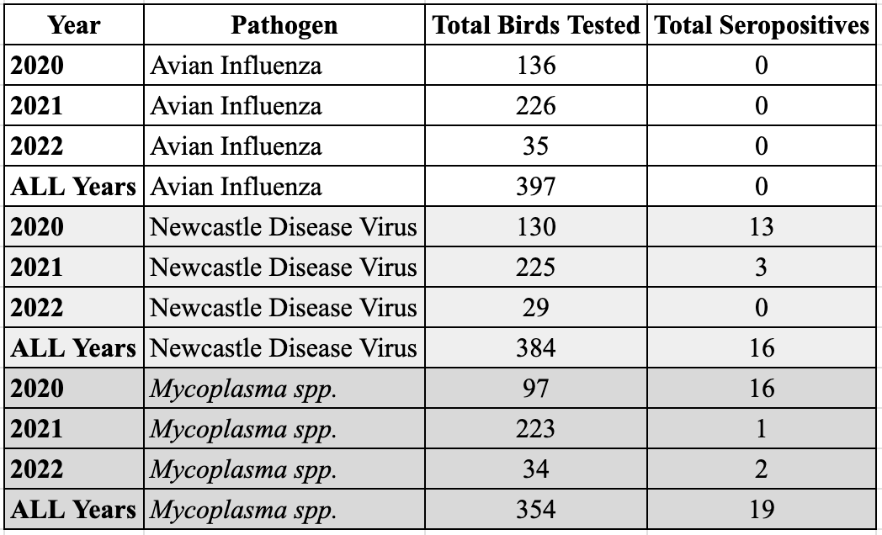

for stable counties out of 29 samples tested, and 18% seropositivity for declining counties out of 68 samples tested (Table 3.3). Out of 103 samples there was a seropositivity of 0% for stable counties in 2021 and 0.8% out of 120 samples for declining counties (Table 3.3). In 2022 stable counties had a seropositivity of 0% out of 9 samples tested, and for declining counties 8% out of 25 samples tested (Table 3.3, Figure 3.1).
Results from Chi Square tests were as follows: MG/MS 2020 Chi Square was not significant (p=0.770), and the 2021 and 2022 tests both had positive values of zero in at least one category and thus the tests for these years had to be excluded. NCD 2020 Chi Square was not significant (p=0.613), 2021 Chi Square was not significant (p=0.281), and the 2022 test had a positive value of zero in at least one category and thus the test for this year had to be excluded. Results from Independent T-Tests were as follows: For MG/MS body condition score was not significant (p=0.657), with weight there was amarginal significant difference in the mean weight of positive vs. negative bird groups (p=0.047) with the mean difference in weights being 0.7926 kg at 95% CI (0.0110, 1.5742). For NCD neither body condition score (p=0.956) nor weight (p=0.789) had significant differences in their means in positive vs. negative bird groups.
Results from logistic regressions were as follows: For the first analysis of MG/MS neither body condition score (p=0.918) nor weight (p=0.184) had significant p-values meaning neither covariate made a bird more likely to be seropositive. The
Table 3.2. Middle Tennessee Wild Turkey population serology results for NCD from each year of the study (2020-2022), showing total serum samples tested and results as percent positives broken down between declining (Lawrence, Giles, and Wayne) and stable (Bedford and Maury) county groups.
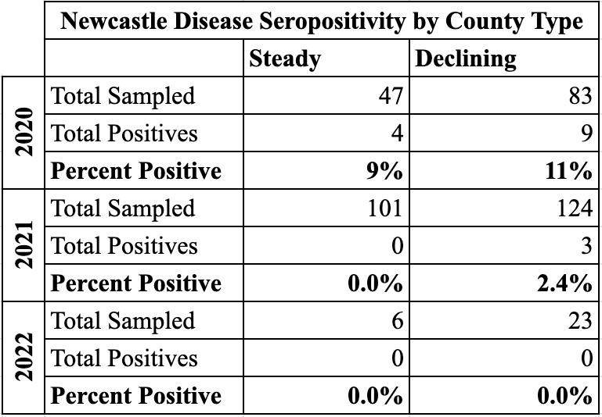

Table 3.3. Middle Tennessee Wild Turkey population serology results for MG/MS from each year of the study (2020-2022), showing total serum samples tested and results as percent positives broken down between declining (Lawrence, Giles, and Wayne) and stable (Bedford and Maury) county groups.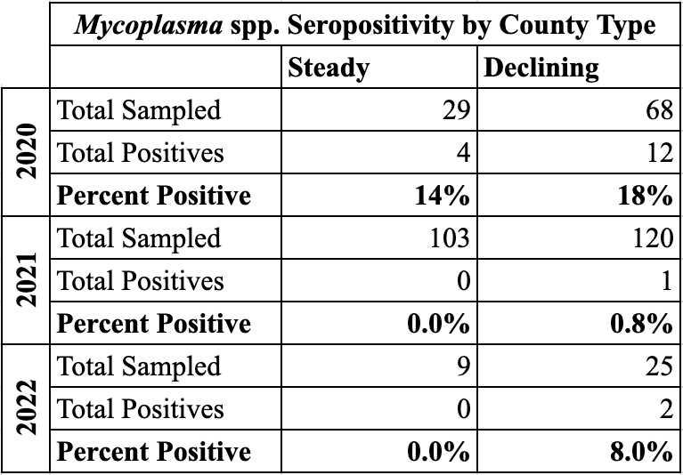

second analysis for MG/MS was also not significant (p=0.096) meaning county type (declining/stable) where a bird resided did not make a bird significantly more likely to be seropositive. For the first analysis of NCD neither body condition score (p=0.723) nor weight (p=0.721) had significant p-values meaning neither covariate made a bird more likely to be seropositive. The second analysis for NCD was also not significant (p=0.217) meaning county type (declining/stable) where a bird resided did not make a bird significantly more likely to be seropositive.

Gastrointestinal Parasites (Eimeria spp., Ascarid spp., Cestodes, Capillaria spp.)
A total of 242 fecal samples were evaluated between 2020-2021, seven of which were evaluated over two years as recaptures. Two of these cases remained negative for both years of capture, two were initially completely negative and became positive for Eimeria spp. the next year, two were positive for Eimeria spp. on first capture and then cleared the infection by the next year, and one was initially positive for Eimeria spp. and cleared that infection by the next year but had newly become positive for Ascarid spp. infection. Of the 241 samples evaluated, 32% were positive for Eimeria spp. (n=77), 11.6% (n=28) were positive for Ascarid spp., 3.3% (n=8) were positive for Cestodes, 0.8% (n=2) were positive for Capillaria spp., and 59.3% (n=143) were negative for any GI parasites (Table 3.4).
Results from logistic regressions were as follows: For the first analysis of Eimeria spp. body condition score (p=0.248) was not significant, however weight (p=0.003) had a significant effect on making a bird more likely to be positive. The
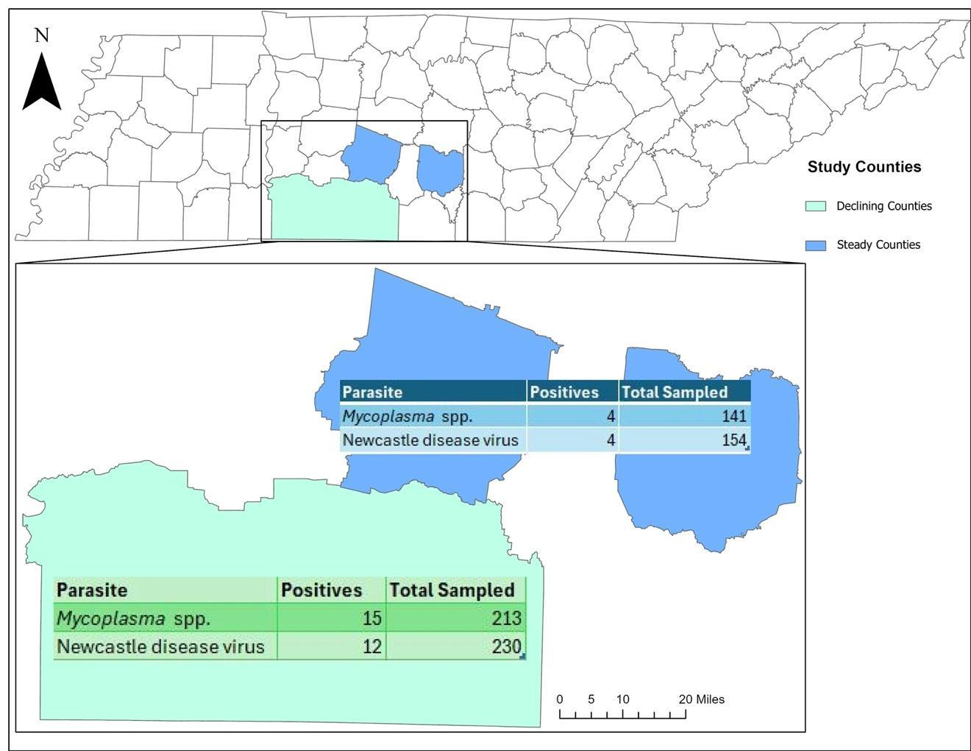
Figure 3.1. Map showing seropositivity results for Middle Tennessee Wild Turkey population from all years of the study (2020-2021), showing total samples tested and results as positive serological detections (NCD & MG/MS), broken down between declining (Lawrence, Giles, and Wayne) and stable (Bedford and Maury) county groups.

second analysis for Eimeria spp. was not significant (p=0.761) meaning county type (declining/stable) where a bird resided did not make a bird significantly more likely to be infected with Eimeria spp. For the first analysis of Ascarid spp. neither body condition score (p=0.402) nor weight (p=0.082) had a significant effect on making a bird more likely to be infected with Ascarid spp. The second analysis for Ascarid spp. was not significant t (p=0.410) meaning county type (declining/stable) where a bird resided did not make a bird significantly more likely to be infected with Ascarid spp. For the first analysis of Cestodes neither body condition score (p=0.066) nor weight (p=0.150) had a significant effect on making a bird more likely to be infected with Cestodes. The second analysis for Cestodes was not significant (p=0.315) meaning county type (declining/stable) where a bird resided did not make a bird significantly more likely to be infected with Cestodes. For the first analysis of Capillaria spp. neither body condition score (p=0.533) nor weight (p=0.546) had a significant effect on making a bird more likely to be infected with Capillaria spp. The second analysis for Capillaria spp. was not significant (p=0.996) meaning county type (declining/stable) where a bird resided did not make a bird significantly more likely to be infected with Capillaria spp.

Discussion
The results of this study showed that while antibodies for all serological testing (excluding AI) were present to a degree in this population, our results do not greatly vary from similar studies in the literature. Our results for Eimeria spp. and Capillaria spp. are similarly situated in comparison to other studies, however, our detections for Ascarid spp. and Cestodes were lower than what is reported in much of the Southeast, which is suspected to be related to a difference in detection method. Our results of 0% positivity for AI were very similar to other studies which all reported 0-<1% positivity rates as well (Davidson et al., 1988; Rocke & Yuill 1987; Hopkins et al., 1990; Sasseville et al., 1988; Charlton 2000; Peterson et al., 2001). Our results for MG/MS in 2020 at 16.5% positivity were similar to those from the study by Crupper and Applegate (2002) where they reported a total positivity 17% for MG and 10.6% for MS in a hybrid Rio Grande and Eastern Wild Turkey population in Kansas. Our results for MG/MS in 2021 totaled 0.8% which was similar to the findings from Vetach et al. (1998) who reported a 0.09% positivity in their study of 11 Rio Grande Wild Turkeys in Kansas, and MacDonald et al. (2019) who reported a 0.7% positivity for their study population in Ontario. Positivity for MG/MS in 2022 in our study was 8% which compared similarly to Hensley & Cain (1979) who found a 5% positivity in one county they tested in Texas. Overall, our results fell about in the middle of the range reported in the literature for other areas. To our knowledge there was only one prior study conducted in Tennessee with a small sample size (n=19) included from 1981-1986 which reported 0% positivity for those 19 birds whereas every year of the study we had anywhere from 1-16 total positives ranging from 0.8-18%. Our results for NCD in 2020 were 10% positivity which was similar to those from the study by Glazener et al. (1967) who reported a 12% positivity in their study population in Texas. Our 2021 results were 2.4% and in 2022 were 0% which was on par with results from several studies that reported 0% positivity in four Texas studies, one in Connecticut, and one in California (Trainer et al., 1968; Hensley & Cain 1979; Rocke & Yuill 1987; Peterson et al., 2002; Sasseville et al., 1988; & Charlton 2000). Overall, our results ranged from 0-10% over the three years of the study which was much lower than the results from two studies from Arkansas (34% positivity) and Georgia and Florida (54% positivity) (Hopkins et al., 1990 & Ingram et al., 2015).
Our results for gastrointestinal parasites in most categories in both years were quite different than in similar studies in other regions except for Eimeria spp. in 2021 with a 35.9% prevalence which was similar to the study by Kozicky (1948) in Pennsylvania with a prevalence of 40% and the study by Oates et al. (2005) in Nebraska with a prevalence of 37%. Our fecal samples were stored preserved in 70% ethanol for 2-3 years which appeared to have a compromising effect on the quality of ova which were viewed and should be taken into consideration for future studies. Eimeria spp. prevalence tended to range regionally in the literature; Sasseville et al., (1988) found Eimeria spp. present in less than 3% of their samples from Connecticut and in that by Jackson (1974) in Illinois they reported 9.6% which are both much lower than our study’s overall 31.8% prevalence. The study by MacDonald et al. (2019) in Ontario, Canada reported a prevalence of 75.6%, which is much higher than what we found in our study area. The prevalence for Ascarid spp. in our study population was much lower at 11.6%, than the findings of several other studies which ranged from 88-48.5% although it is important to note these studies evaluated sieved intestinal contents whereas we evaluated ova presence via fecal floatation (Hon et al., 1974; Jackson 1974; Castle & Christensen 1984; Oates et al., 2005). Our study’s
Table 3.4. Gastrointestinal parasite detections from the Middle Tennessee Wild Turkey population from each year of the study when fecal samples were collected (2020-2021), showing total fecal samples tested and results as positive detections, including samples with no detections, broken down between declining (Lawrence, Giles, and Wayne) and stable (Bedford and Maury) county groups.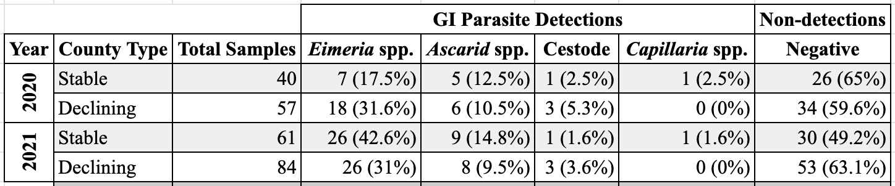

findings of Cestodes at 3.3% was also much lower than is reported in other areas which ranged from 69-37%, but again, these findings were also reported from sieving rather than fecal floatation (Hon et al., 1974; Oates et al., 2005; Sasseville et al., 1988). Our findings of Capillaria spp. at 0.8% were similarly low as in other studies such as Sasseville et al. (1988) who reported a prevalence less than 3% in Connecticut Wild Turkeys and Oates et al. (2005) who reported a prevalence in a Nebraska population at 2.6%.
General results from this study showed seropositivity for NCD and MG/MS were in higher percentage in declining counties in most cases, however, these results were not statistically significant when evaluated by Chi Square tests when assumptions of the test were met (Image 1). Statistical significance was observed from the Independent T-Test for MG/MS where differences in the mean weights of positive vs. negative bird groups (p=0.047) were significantly lower in positive birds. All other Independent T-Tests and logistic regressions for MG/MS and NCD were not significant. For the Eimeria spp. logistic regression weight (p=0.003) had a significant effect on making a bird more likely to be positive. No other logistic regression models were statistically significant for any other gastrointestinal parasite categories. These two highlighted significant models were ultimately the most informative in terms of significance, however the baseline data collected in this study still carries value in terms of documenting pathogen presence in this Wild Turkey population and can be valuable for other states’ similar studies for comparison of results.

REFERENCES
Ayala, A. J., Dimitrov, K. M., Becker, C. R., Goraichuk, I. V., Arns, C. W., Bolotin, V.I., ... & Afonso, C. L. (2016). Presence of vaccine-derived Newcastle disease viruses in wild birds. PloS one, 11(9), e0162484.
Alexander, D. J., & Brown, I. H. (2009). History of highly pathogenic avian influenza.
Revue scientifique et technique (International Office of Epizootics), 28(1), 19-38.
Atkinson, C. T., Thomas, N. J., & Hunter, D. B. (2008). Parasitic Diseases of Wild Birds.
Castle, M. D. & Christensen, B. M. (1984). Blood and gastrointestinal parasites of
eastern wild turkeys from Kentucky and Tennessee. J. Wildl. Dis. 20: 190-196.
Charlton, K. G. (2000). Antibodies to selected disease agents in translocated wild
turkeys in California. Journal of Wildlife Diseases, 36(1), 161-164.
Crupper, S. S., & Applegate, R. D. (2002). Incidence of antibodies to selected bacterial
pathogens in wild turkeys (Meleagris gallopavo) in Kansas, USA.
Garg, S. (2024). Outbreak of highly pathogenic avian influenza A (H5N1) viruses in
US dairy cattle and detection of two human cases—United States, 2024. MMWR.
Morbidity and Mortality Weekly Report, 73.
Glazener, W. C., Cook, R. S., & Trainer, D. O. (1967). A serologic study of diseases in the Rio Grande Turkey. The Journal of Wildlife Management, 31(1), 34–39.
https://doi.org/10.2307/3798357
Hanson, B. A., Stallknecht, D. E., Swayne, D. E., Lewis, L. A., & Senne, D. A.
(2003). Avian influenza viruses in Minnesota ducks during 1998–2000. Avian
diseases, 47(s3), 867-871.
Hensley, T. S., & Cain, J. R. (1979). Prevalence of certain antibodies to selected
disease-causing agents in wild turkeys in Texas. Avian Diseases, 23(1), 62–69.
https://doi.org/10.2307/1589672
Hopkins, B. A., Skeeles, J. K., Houghten, G. E., Slagle, D., & Gardner, K. (1990). A
survey of infectious diseases in wild turkeys (Meleagridis gallopavo silvestris) from
Arkansas. Journal of wildlife diseases, 26(4), 468-472.
Ingram, D. R., Miller, D. L., Baldwin, C. A., Turco, J., & Lockhart, J. M. (2015).
Serologic survey of wild turkeys (Meleagris gallopavo) and evidence of exposure to
avian encephalomyelitis virus in Georgia and Florida, USA. Journal of Wildlife
Diseases, 51(2), 374-379.
Jackson, J. W. (1974). Helminth parasites of Illinois wild turkeys.
Kozicky, E. L. (1948). Some protozoan parasites of the eastern wild turkey in
Pennsylvania. The Journal of Wildlife Management, 263-266.
Lair, S., Quesnel, L., Signore, A. V., Delnatte, P., Embury-Hyatt, C., Nadeau, M. S., …& Berhane, Y. (2024). Outbreak of highly pathogenic avian influenza A (H5N1)
virusin Seals, St. Lawrence Estuary, Quebec, Canada. Emerging infectious diseases,
30(6), 1133-1143.
Ly, H. (2024). Highly pathogenic avian influenza H5N1 virus infections of dairy cattle
and livestock handlers in the United States of America. Virulence, 15(1), 2343931.
MacDonald, A. M., Jardine, C. M., Rejman, E., Barta, J. R., Bowman, J., Cai, H. Y., ...
& Nemeth, N. M. (2019). High prevalence of Mycoplasma and Eimeria species in
free-ranging eastern wild turkeys (Meleagris gallopavo silvestris) in Ontario, Canada.
Journal of wildlife diseases, 55(1), 54-63.
Maxted, A. M., Luttrell, M. P., Goekjian, V. H., Brown, J. D., Niles, L. J., Dey, A. D.,
... & Stallknecht, D. E. (2012). Avian influenza virus infection dynamics in shorebird
hosts. Journal of Wildlife Diseases, 48(2), 322-334.
Menard, J. (2022). Tennessee Agri-Industry Brief: Poultry Fact Sheet. Retrieved June
27, 2024, from https://arec.tennessee.edu/wpcontent/uploads/sites/17/2023/10/FINAL_PoultryFactSheet.pdf.
Oates, D. W., Wallner-Pendleton, E. A., Kanev, I., Sterner, M. C., Cerny, H. E.,
Collins, M., Bischof, R., & Boyd, E. D., "A survey of infectious diseases and parasites
in wild turkeys from Nebraska" (2005). Transactions of the Nebraska Academy of
Sciences and Affiliated Societies. 45.
Peterson, M. J., Aguirre, R., Ferro, P. J., Jones, D. A., Lawyer, T. A., Peterson, M. N.,
& Silvy, N. J. (2002). Infectious disease survey of Rio Grande wild turkeys in the
Edwards Plateau of Texas. Journal of Wildlife Diseases, 38(4), 826-833.
Ramey, A. M., Hill, N. J., DeLiberto, T. J., Gibbs, S. E., Camille Hopkins, M., Lang,
A. S., ... & Wan, X. F. (2022). Highly pathogenic avian influenza is an emerging
disease threat to wild birds in North America. The Journal of Wildlife
Management, 86(2), e22171.
Rocke, T. E., & Yuill, T. M. (1987). Microbial infections in a declining wild turkey
population in Texas. The Journal of Wildlife Management, 51(4), 778–782.
https://doi.org/10.2307/3801739
Sasseville, V. G., Miller, B., & Nielsen, S. W. (1988). A pathologic study of wild
turkeys in Connecticut. The Cornell Veterinarian, 78(4), 353-364.
Trainer, D. O., Glazener, W. C., Hanson, R. P., & Nassif, B. D. (1968). Infectious
disease exposure in a wild turkey population. Avian Diseases, 12(1), 208–214.
https://doi.org/10.2307/1588102
Veatch, J. K., Applegate, R. D., & Osborne, S. J. (1998). Serologic incidence of some
diseases in Kansas wild turkeys. Avian Diseases, 42(2), 393–396.
https://doi.org/10.2307/1592492
Yadav, J. P., Tomar, P., Singh, Y., & Khurana, S. K. (2022). Insights on Mycoplasma
gallisepticum and Mycoplasma synoviae infection in poultry: a systematic review.
Animal biotechnology, 33(7), 1711-1720.

CHAPTER IV
POSTMORTEM FINDINGS IN MIDDLE TENNESSEE WILD TURKEYS (MELEAGRIS GALLOPAVO SILVESTRIS) FROM 2000-2023

Abstract

Here we describe postmortem findings in Wild Turkeys from Tennessee that were submitted as carcasses either to the Southeastern Cooperative Wildlife Disease Study (SCWDS) or the University of Tennessee College of Veterinary Medicine (UTCVM). Evaluation of 54 turkeys from 2000-2023 resulted in 138 diagnoses (many turkeys had multiple diagnoses). The most common infectious findings were bacterial infections, collectively accounting for 56.7% (n=34), avian pox (16.7%; n=10), and lymphoproliferative disease virus (LPDV; 11.7%; n=7). Non-infectious diagnoses (in descending order of frequency) were emaciation (60% of noninfectious diagnoses; n=15), unknown (28%; n=7), and trauma (12%; n=3). The most commonly reported incidental findings were protozoal infection (20.8%; n=11), cestode infection and hemosiderosis (equally) (17%; n=9 for both), and lymphoproliferative disease (LPDV*) detection (13.2%; n=7) (*absence of characteristic pathological disease signs of LPDV). Total submissions included 23.6% (n=13) which occurred during a passive surveillance period (2000-2014), after which an active surveillance period (2014-2023) encompassed 76.3% (n=42) of submissions, was initiated in response to regional Wild Turkey population declines. These results contribute toward understanding Wild Turkey health threats in Tennessee amidst population declines in the state, as well as provide valuable information for other states to compare to the cases seen in their declining populations.

Introduction
Across their native range, the Eastern Wild Turkey (Meleagris gallopavo silvestris) population has been experiencing variable perceived decreases based on hunter surveys (Schnyder et al. 2013). Since 1920, the Eastern Wild Turkey has reportedly disappeared from 18 of the 38 U.S. states from which it is historically native. In Tennessee specifically, in the 1940’s Wild Turkeys were reported to have disappeared from 33 counties (Mosby and Handley 1943; Lewis 1964). In Tennessee, successful hunter harvest data collected by the Tennessee Wildlife Resource Agency (TWRA) indicated stable populations in 2010 which have since declined (Byrne et al. 2016). Not only is this a concern for the potential loss of their specific role in the environment or for loss of their ecosystem services, but also the conservation dollars brought in from Wild Turkey hunting licenses. Hunting and fishing licenses, tags, and stamps (including those for Wild Turkey hunting) brought in approximately $30,454,104 dollars for Tennessee in 2023, and this income is then distributed across all taxa (game animal and non-game animal) for conservation (Stacker 2023). Thus, in the face of hunters reporting declines in Wild Turkey populations, there is a huge risk of economic loss for conserving this species and others in Tennessee.
Various biotic and abiotic factors have been investigated to determine possible causes for these perceived declines, including poult recruitment, nesting success, habitat availability, and hen survival (Roberts et al. 1995; Byrne et al. 2016; Johnson et al. 2022). However, little is known about the disease processes which may be at play in the Tennessee Wild Turkey population. We examined Wild Turkey necropsy findings from the Southeastern Cooperative Wildlife Disease Study (SCWDS), College of Veterinary Medicine, The University of Georgia originating from Tennessee as well as morbidity and mortality submissions to the University of Tennessee College of Veterinary Medicine (UTCVM) through their joint Wild Turkey decline study with Tennessee Wildlife Resource Agency. From 2001 to 2023, thirty-nine Wild Turkeys from Tennessee were submitted to SCWDS where they underwent full necropsies including gross and histological examination of major organs, as well as various other diagnostic tests to determine conditions present, except in one case where only skin lesions were submitted to be tested for Avian Pox Virus (Figures 4.1-4.3). From 2020 to 2023, 15 birds from the TWRA Wild Turkey disease study were submitted to UTCVM where they were subjected to full necropsies including gross and histological examination of major organs, as well as various other diagnostic tests to determine conditions present, and significant findings were observed (Figures 4.1-4.3). In many of the cases a final cause of mortality was not determined, rather the various diagnosed conditions and pathogens were reported. Additionally, many cases involved multiple diagnoses. For this reason, we are reporting the diagnoses and not the cause of morbidity or mortality for these birds, as many birds had multiple concurrent infections and conditions; in total there were 138 diagnoses given for 55 total cases submitted (Table 4.1, Figures 4.1-4.3). It is also important to note the inherently biased nature of these data because birds with certain conditions are more grossly “noticeable” (e.g., a bird with a pox infection) than those with conditions which are 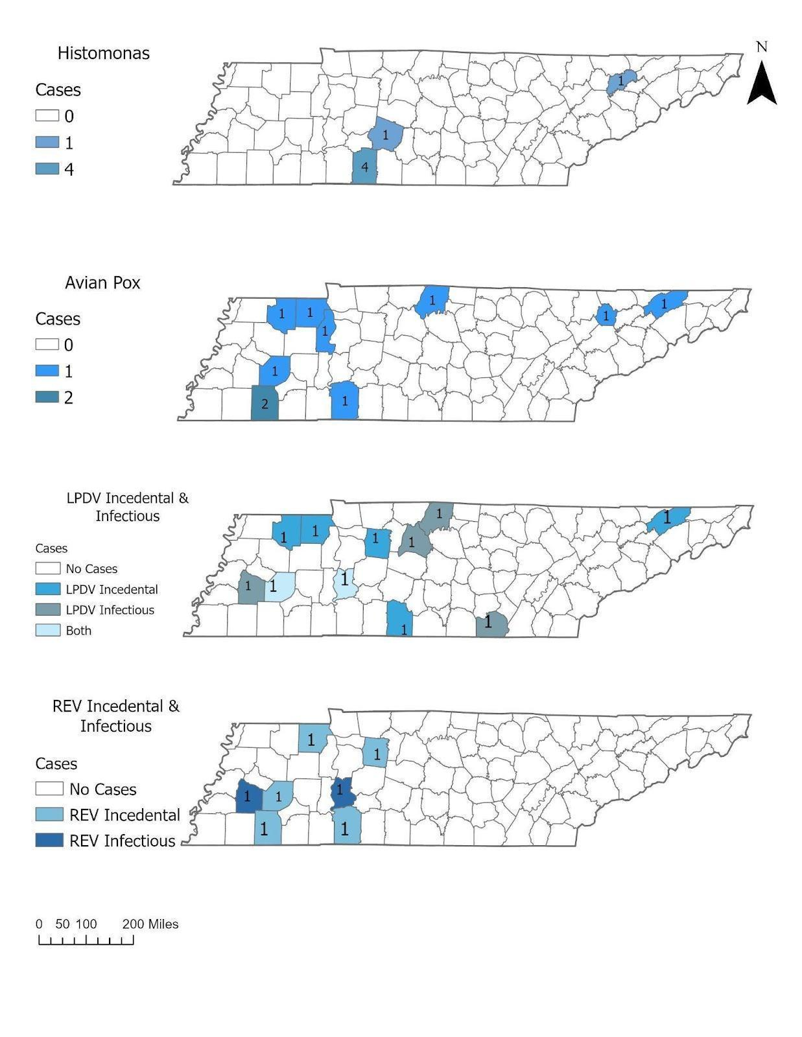Figure 4.1. Map of Tennessee counties showing counties where Histomonas meleagridis, avian pox, LPDV (incidental vs. infectious), and REV (incidental vs. infectious) originated from, including number of such cases per county.
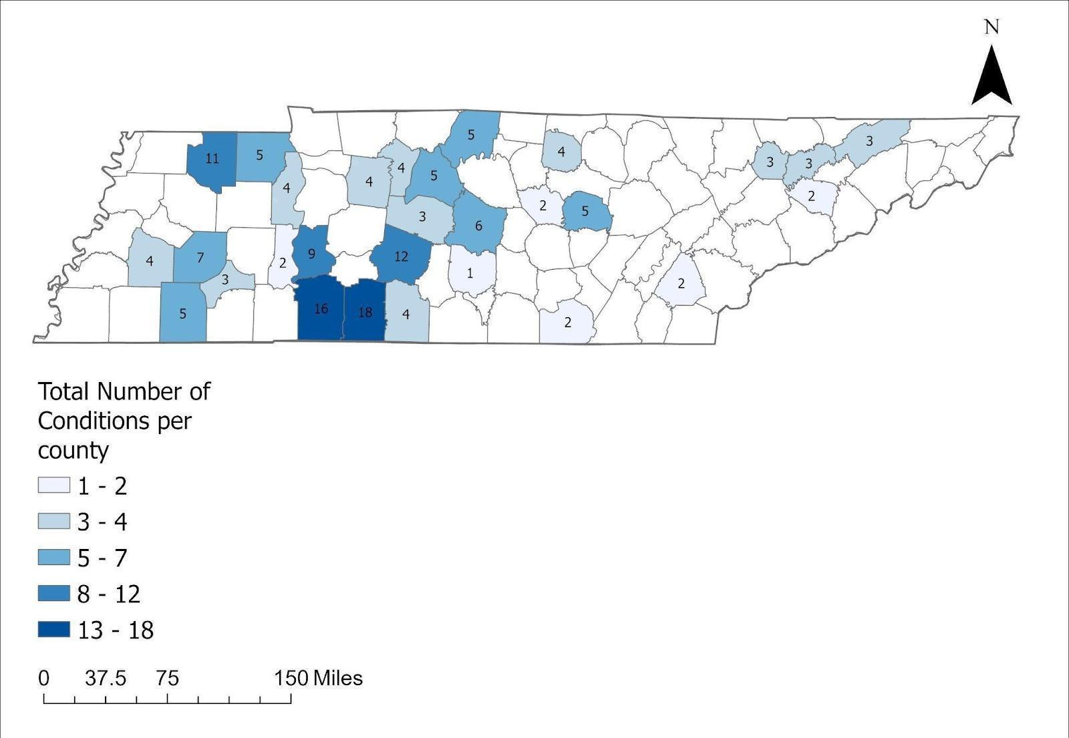
Figure 4.2. Map of Tennessee counties showing total number of different conditions (i.e., diagnoses) per county.

not necessarily grossly visible externally (e.g., Histomonosis). Similarly, there is certainly inherent bias in these data between chronic illness with which birds can survive for some time with (e.g., pox virus) versus acute illnesses which may result in the bird dying quickly without the signs being noticed and reported (e.g., Histomonosis).

Methods
It is important to note the two methods of surveillance utilized in this study—both active and passive surveillance were employed for different time periods in the collection of these data, both of which have advantages and disadvantages (Macdonald et al., 2020). Passive surveillance for disease involves post-mortem evaluation of known or suspected sick birds which can be helpful in determining etiology and also requires low sampling effort, however, it relies on the detection of a carcass before autolysis or a report of an observed moribund bird. This can lead to bias in under-reporting of less “visible” diseases and over-reporting of more “noticeable” diseases. Active surveillance for disease alternatively can result in more robust and even reporting because sampling events are planned and systematic, which often results in more accurate reporting of disease occurrence; however, this typically requires a large increase in labor hours and effort which is generally much more expensive. In this study, from 2000-2014 only passive surveillance was employed. Once an observed wild turkey population decline was reported by many Tennessee turkey hunters in 2014, TWRA and the University of Tennessee joined in the active
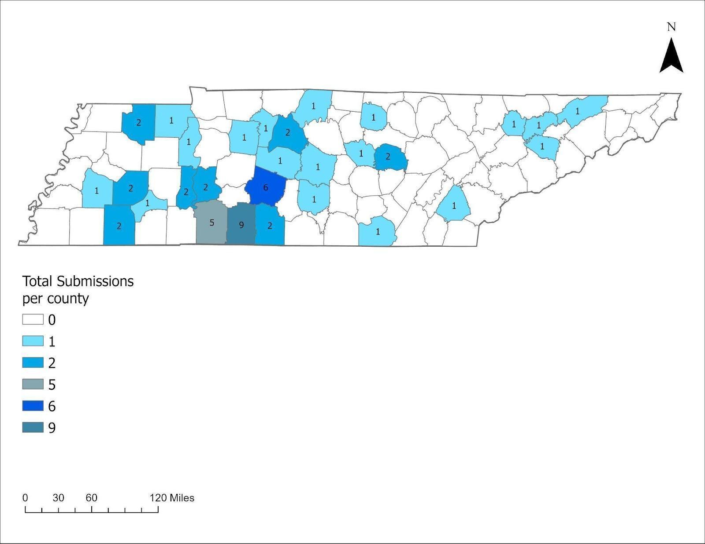
Figure 4.3. Map of Tennessee counties showing total number of submissions per county.

sampling effort of this disease surveillance project (Schexnayder et al., 2013) (Figure 4.3). During the time since this active sampling project began (2014-present) passive surveillance was also in effect in conjunction with the goal of increasing the robustness and accuracy of the present dataset for the middle Tennessee wild turkey population (Figure 4.3).
All archived Wild Turkey necropsy reports from SCWDS originating from Tennessee from 2000-2023 (n=39) which underwent full necropsies including gross and histological examination of major organs, as well as various other diagnostic tests to determine conditions present were included for this report. Only one case differed in that only skin lesions were submitted. Additionally, following increased active surveillance efforts starting in 2020, all Wild Turkey necropsy submissions to UTCVM between 2020-2023 were included in this report as well (n=15). All UTCVM cases also underwent full necropsies including gross and histological examination of major organs but were not subjected to additional routine testing for LPDV and REV which is standard for SCWDS necropsies. The findings were categorized into diagnosis occurrence, age and sex (when relevant). A chi-squared test (alpha=0.05) was used to determine if significant differences existed between these categories of interest. Polymerase chain reaction (PCR) testing for LPDV and REV followed the published protocol by Adcock et al. (2024) and PCR for H. meleagridis detection followed the protocol by Grabensteiner and Hess (2006).
The full list of diagnoses has been split into three categories. Infectious diagnoses were categorized as those findings which were caused by pathogenic organisms and seen causing clinical disease in the bird, as reported by the veterinary pathologist assessing each case (Table 4.1-4.2). Non-infectious diagnoses were categorized as findings reported as resulting from non-pathogenic sources. Incidental findings included both some infectious and some non-infectious findings which were categorized as not observed to be causing considerable or any clinical disease, as noted by the veterinary pathologist on the case (Table 4.3). The findings were categorized into diagnosis type, age, sex, and county of submission. A chi-squared test (alpha=0.05) was used to determine if significant differences existed between the categories of interest.

Results
In total, 54 Wild Turkey cases were reported from 2000-2023, which yielded 138 individual diagnoses (Table 4.1). The top four infectious diagnoses from this data set were bacterial infections (56.7% (n=34), avian pox (16.7%; n=10), and LPDV (11.7%; n=7), collectively accounting for 85% (n=51) of infectious diagnoses and for 43.5% (n=60) of all diagnoses (Tables 4.1-4.2). Of the other infectious diagnoses (in descending order of frequency) Histomonosis accounted for 10% (n=6), Reticuloendotheliosis virus (REV) for 3.3% (n=2), and Syngamus trachea for 1.7% of cases (n=1) (Table 4.2). Top non-infectious diagnoses included emaciation (60%; n=15), unknown (28%; n=7), and trauma (12%; n=3), collectively accounting for 18.1% (n=25) of all diagnoses (Table 4.3).
Top reported incidental findings were protozoal infection (20.8%; n=11; *not causing clinical disease), cestode infection (*not causing clinical disease) and
Table 4.1. Summary chart showing totals for all diagnoses (n=155) for all cases broken down by the three major groupings.
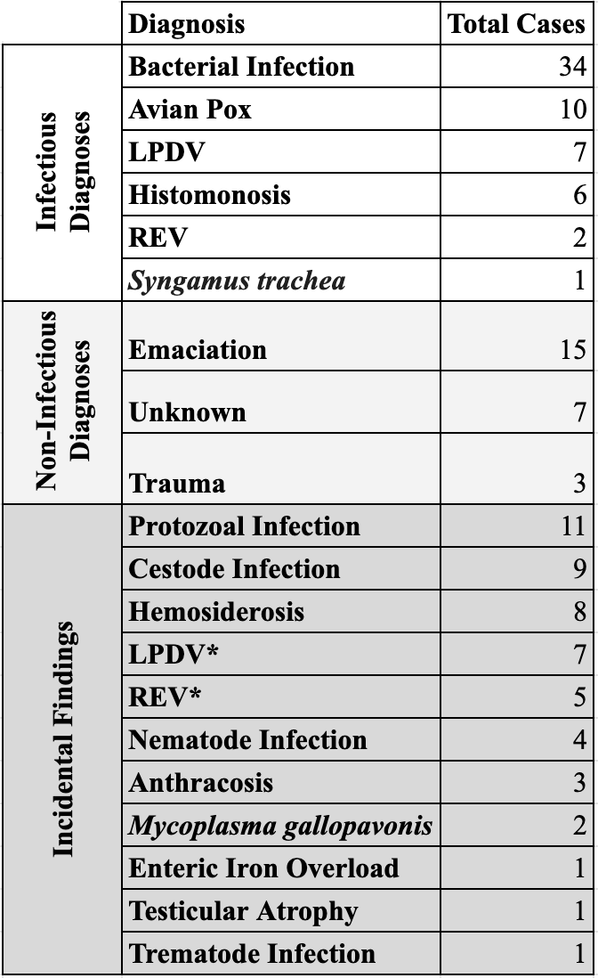

Table 4.2. Chart of all infectious diagnoses, categorized as caused by pathogenic organisms and seen causing clinical disease in the bird histologically, the percent occurrence of each within the grouping, and the percent occurrence of each across all categories total findings/diagnoses reported. 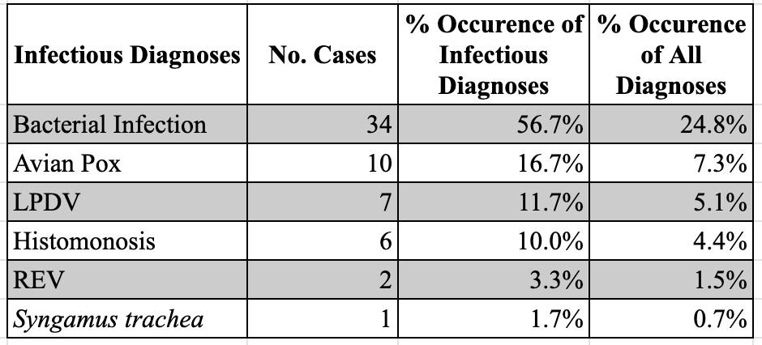

Table 4.3. Chart of all non-infectious diagnoses, categorized as not being caused by pathogenic organisms, the percent occurrence of each within the grouping, and the percent occurrence of each across all categories total findings/diagnoses reported.
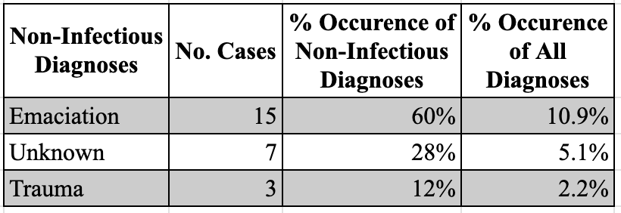
hemosiderosis (equally) (17%; n=9 for both), and LPDV* detection (13.2%; n=7) (*casesin absence of characteristic disease signs of LPDV but with a positive PCR result), collectively these accounted for 67.9% (n=36) of incidental findings and 38.4% (n=53) of all diagnoses. Other incidental findings included (in descending order of frequency) REV* (*cases in absence of characteristic disease signs of REV but with a positive PCR result) 9.4% (n=5); nematode infection 7.5% (n=4; *not causing clinical disease); anthracosis 5.7% (n=3); Mycoplasma gallopavonis 3.8% (n=2; *not causing clinical disease); and enteric iron overload, testicular atrophy, and trematode infection (*not causing clinical disease) in equal occurrence at 1.9% each (n=1 for each) (Table 4.4).
A significantly greater number of male (X^2=7.69, df=1, P<0.005) and adult (X^2=12.25, df=1, P<0.0005) Wild Turkeys were submitted versus females and juveniles respectively. 23.6% (n=13) of submissions occurred during a passive surveillance period (2000-2014), after which an active surveillance period (2014-2023), which encompassed 76.3% (n=42) of submissions, was initiated in response to regional Wild Turkey population declines.
Cases of LPDV and REV were not consistent across terms of both histological evidence of clinical disease and accompanying PCR test results, thus these categories were split into categories in both infectious and incidental categories, with cases of general lymphoproliferative disease (Tables 4.5-4.6). Out of 14 total LPDV/LPDV* cases only 5 had both histological lesions seen and an accompanying PCR positive
Table 4.4. Chart of all incidental findings, which include both infectious and non-infectious diagnoses, categorized as all findings NOT seen causing clinical disease in the bird on histological evaluation, the percent occurrence of each within the grouping, and the percent occurrence of each across all categories total findings/diagnoses reported. Findings with a * denote findings which were from pathogenic sources, however, were NOT seen causing clinical disease histologically (thus excluded from the infectious diagnoses grouping).
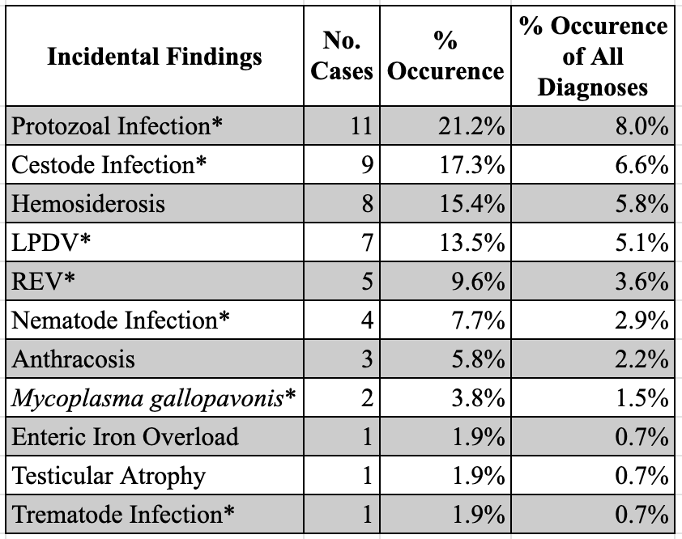

result (categorized as LPDV), while 7 cases had no histological evidence of the disease yet had an accompanying PCR positive result (categorized as LPDV*). In 2 cases, histological lesions were seen but the PCR result was negative (Table 4.5). Out of 7 total REV cases only 2 had both histological lesions seen and an accompanying PCR positive result, while 5 cases had no histological evidence of the disease yet had an accompanying PCR positive result. There were no REV cases where histological lesions were seen but the PCR result was negative (Table 4.6).
All findings were categorized into diagnosis type, age, sex, and year of submission. A chi-squared test (alpha=0.05) was used to determine if significant differences existed between categories of interest. Ultimately, 54 total Tennessee sick or abnormal Wild Turkey cases were submitted from 2000-2022, with a total of 138 diagnoses recorded. Of these submissions, 23.6% (n=13) were made before the active surveillance period began in 2014 (passive surveillance period), while 76.3% (n=42) were made during the active surveillance period (2014-2023) once the TWRA/University of Tennessee Wild Turkey decline study was launched. A chi-squared analysis confirmed there were significantly more Wild Turkey submissions during the active surveillance period (2014-2023) than during the passive surveillance period (2000-2013) ((X^2=15.29, df=1, P<0.0001). Additionally, the three counties with the greatest number of submissions were from the counties which were target research areas during the active surveillance project (Table 4.7). A significantly greater number of male (X^2=7.69, df=1, P<0.005) and adult (X^2=12.25, df=1,

Table 4.5. LPDV case results summary showing which cases were shown causing disease (included in infectious diagnoses (Table 4.2)), and which cases were NOT causing disease (included in incidental findings denoted with * (Table 4.4)), as well as corresponding PCR and histology result totals.
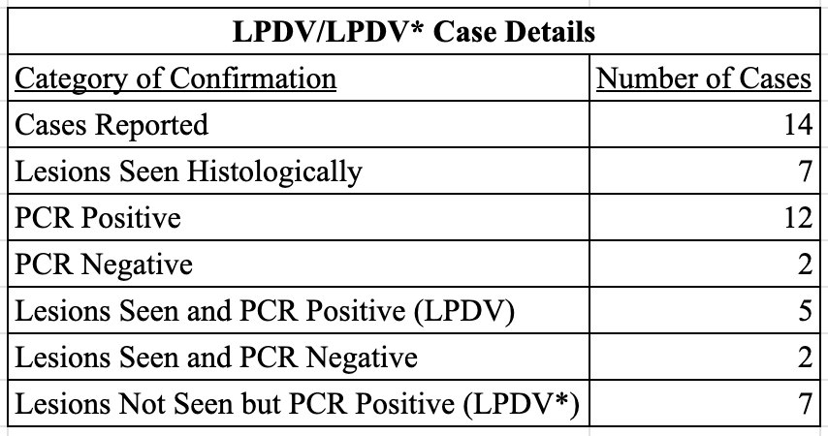

Table 4.6. REV case results summary showing which cases were shown causing disease (included in infectious diagnoses (Table 4.2), and which cases were NOT causing disease (included in incidental findings denoted with * (Table 4.4), as well as corresponding PCR and histology result totals.
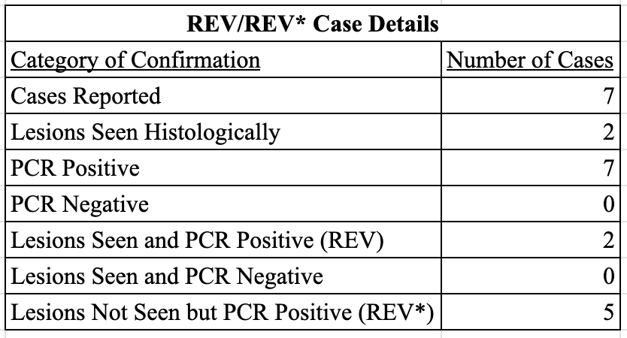

P<0.0005) Wild Turkeys were submitted to SCWDS and UTCVM compared to females and juveniles respectively.

Discussion

Infectious Diagnoses
The top four infectious diagnoses (defined as pathogenic AND seen causing clinical disease) from this data set include bacterial infections, avian pox, and LPDV accounting for 85% (n=51) of infectious diagnoses (n=60). Bacterial infections were pooled together and constituted 56.7% (n=34) of infectious diagnoses, with varying specificities and bacterial agents as the causes (Tables 8-9). While various bacterial infections can be present on their own and have very non-specific etiologies and lack large-scale population occurrence data in Wild Turkeys, they are seen in these data co- occurring with other conditions. Bacterial pneumonia in Wild Turkeys is typically diagnosed secondarily to other infections from which the pneumonia-causing bacteria gain entry into the body. For example, in our data 60% (n=3) of bacterial pneumonia cases were co-diagnosed with bacterial dermatitis suspected as the initial infection route. Granulomatous typhlitis was diagnosed in these data as cases where typhlitis with granulomas were seen on histology and histomonosis was suspected but was not confirmed through PCR, nor were histomonads seen on histology. Similarly, hepatitis was diagnosed in 50% of cases when liver inflammation was seen, suggestive of histomonosis, but no organisms were seen on histology nor were PCR results positive. Little is known about occurrence data for bacterial pneumonia, granulomatous typhlitis, or hepatitis in Wild Turkeys as these diagnoses are not grossly visible in birds on the landscape and are likely more commonly diagnosed when doing active targeted surveillance (such as in this study). All cases of granulomatous typhlitis in this study (n=4) and 50% (n=2) of hepatitis cases were diagnosed in the active sampling phase of this study. Sepsis, which also has a wide variety of etiologies, tends to result in more obvious clinical signs due to the severity of the condition, which may lead to more passive surveillance reporting. All cases of sepsis (n=3) in this study were diagnosed during the passive surveillance phase.
Avian pox is a virus known to circulate in Wild Turkey populations in the United States and is highly transmissible within populations due its ability to spread both through direct transmission as well as through arthropod vectors (MacDonald et al., 2019). Typically, infections are self-limiting and do not directly cause mortality, however, when cutaneous nodules progress to extreme states they can impair a bird’s sight, foraging ability, and ability to escape–which may indirectly lead to death. Many birds with pox infections are found in poor body condition, which is reflected in the present data where 40% (n=4) of birds diagnosed with avian pox were also diagnosed with emaciation. Bacterial dermatitis is also often concurrent in pox infections due to the pox lesions opening a gateway for bacterial colonization, which was seen in these data with 30% (n=3) of pox cases reported concurrent with bacterial dermatitis (Elsmo et al., 2016).
Lymphoproliferative disease virus (causing clinical disease) accounted for 11.7% (n=7) of the infectious diagnoses. Lymphoproliferative disease virus is a neoplastic retrovirus responsible for several epizootic events overseas in commercial
Table 4.7. All submissions broken down by total from all counties with ≥1 case submission. Grey highlighted counties denote research counties targeted in active surveillance period; counties with stars denote the counties with the top three submission rates, counties with two stars denote counties experiencing reported population declines.
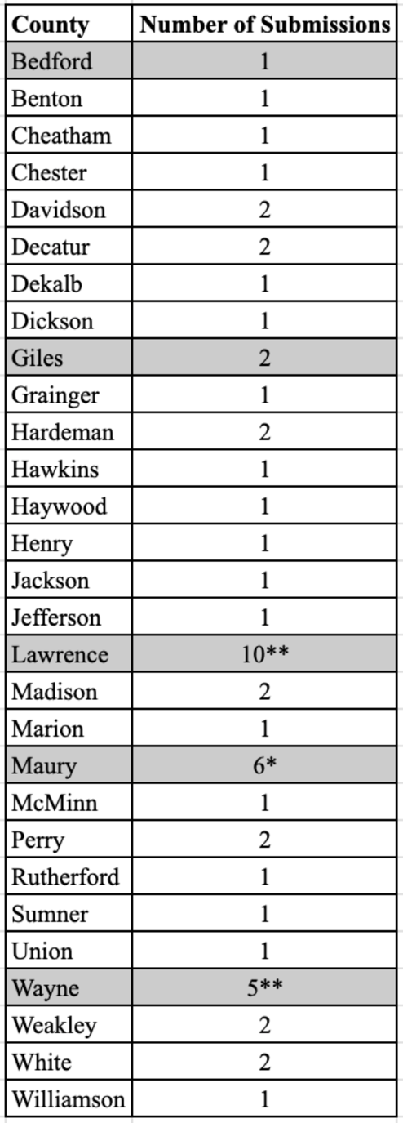

turkey flocks and was first detected in Wild Turkeys in the United States in 2009 (Allison et al., 2014). This type of virus can be sporadic in nature or spurred by another viral infection, with viral infections typically being caused by one of several viruses including Reticuloendotheliosis virus (REV) (Thomas et al., 2014). The population impacts of LPDV are poorly understood in Wild Turkeys with clinical manifestations being extremely rare while PCR positivity rates in most of the Southeast remain high (Allison et al., 2014; Thomas et al., 2015). This conundrum is reflected in our data as well, where we ultimately needed to separate all LPDV/LPDV* cases into two subgroups; one for cases of clinical manifestation (LPDV, referenced here) and one for completely subclinical cases (LPDV*, incidental group, section c) (Table 6). For this reason, although this was one of the most frequently reported infectious diagnoses (as was its sub-clinical grouping in incidental findings), it is extremely unclear what, if any, population impacts LPDV has on Wild Turkeys in Tennessee and more research is needed on understanding the implications of this virus (Allison et al., 2014; Thomas et al., 2015).
Of the other infectious diagnoses (in descending order of frequency) Histomonosis accounted for 10% (n=6), REV for 3.3% (n=2), and Syngamus trachea infection for 1.7% of cases (n=1) (Table 4.2). Histomonosis is a disease almost exclusively of Galliform birds caused by the protozoan parasite H. meleagridis which causes necrotic lesions in the liver and cecum and typically resulting in mortality in turkeys within roughly a week of infection (Forrester & Spalding 2003; Friend & Franson 1999). This disease was recognized in the late 1800’s, mainly for its damage to the domestic poultry (specifically turkey) industry (Atkinson et al., 2008). Histomonosis is now also recognized as a major disease threat to Wild Turkeys (Atkinson et al., 2008; Forrester and Spalding, 2003; Hauck & Hafez 2013). Historically, histomonosis was a major disease specific to domestic turkeys, however research has revealed the role of domestic chickens in the transmission to turkeys and raised concern about the use of chicken litter to fertilize fields where Wild Turkeys graze (Atkinson et al., 2008; Forrester and Spalding, 2003). Despite the plethora of literature raising general awareness of histomonosis as a significant disease Wild Turkeys, primary accounts of the disease in wild populations are lacking. Again, despite this lack of formal reports of histomonosis in Wild Turkeys, it is generally understood that histomonosis is a major disease of this species in the southeastern US and has accounted for a significant percentage of non-trauma diagnoses (Atkinson et al., 2008; Davidson et al., 1985; Forrester and Spalding, 2003).
Reticuloendotheliosis virus (REV) is a retrovirus found in both domestic fowl and game birds globally which can be transmitted both vertically and horizontally (McDougall et al., 1980; Witter and Salter 1989; Barbosa et al., 2007). Much like LPDV, clinical manifestations are rarely seen in infected Wild Turkeys yet detections of the virus in birds without clinical signs are frequent (Ley et al., 1989). The primary noted consequence of REV infections is its immunosuppressive effect which has specifically been associated with concurrent pox infections (Davidson & Silva 2008). There is also thought to be a potential connection between coinfection of pox, LPDV, and REV which is reflected in these data as well with 66.7% (n=4) of birds diagnosed with REV (clinical and non-clinical cases pooled together) also diagnosed with pox, and 28.6% of (n=4) of birds diagnosed with LPDV (clinical and non-clinical cases pooled together) also diagnosed with pox. The understanding of this association is poorly understood and requires further research (MacDonald et al., 2019). Additionally, REV is one of the viruses associated with predisposing birds to LPDV (Thomas et al., 2014); in this data 71.4% (n=5) birds with REV were coinfected with LPDV (clinical and non-clinical cases pooled together for both viruses). While this correlation is documented in literature, still, the population impacts of the pathogen are poorly understood and in need of further research to understand their implications (Ley et al., 1989).
The singular case of Syngamus trachea had no coinfections–S. trachea (or gapeworm) is known for infecting the trachea of some birds, which can clog and obstruct the airway making breathing difficult or insufficient (Krone et al., 2007).

Non-Infectious Diagnoses
The non-infectious diagnoses from this data set were emaciation accounting for 60% (n=15) of non-infectious diagnoses, unknown for 28% (n=7), and trauma accounting for 12% (n=3) (Table 4.3). Emaciation is commonly used as an indicator of general animal health due to its typical secondary association with clinical disease. While not a primary diagnosis, emaciation can be seen in this data set as accompanying various diseases; 40% (n=4) of avian pox cases were co-diagnosed with emaciation, 35.7% of LPDV/LPDV* (clinical and non-clinical cases pooled together) cases, and 85.7% of REV/REV* (clinical and non-clinical cases pooled together) cases.
Definitive diagnoses (“unknown”) were not found in seven cases, two in which a hunter reported a strange appearance in a bird’s skin but upon evaluation no lesions were detected by the pathologist. In two other cases, dead poults were submitted which appeared to have been electrocuted. In two more cases birds were seen exhibiting neurological signs but upon histological examination, testing for toxicosis, and high pathogenicity avian influenza negative results, no definitive conclusions could be drawn for the causes of morbidity. While not an infectious disease or physiological condition, trauma is a generally common diagnosis which accounts for a significant percentage of wildlife deaths, including Wild Turkeys, due to the nature of anthropogenic interactions with natural land and organisms (Davidson et al., 1985; MacDonald et al., 2016). In the present data set, the trauma cases diagnosed were caused by presumed automobile-accidents (66.7%, n=2), and hunter harvest which resulted in no other diagnosable observations (33.3%, n=1).

Incidental Findings
The top four incidental findings from this data set were protozoal infection, cestode infection and hemosiderosis (equally), and LPDV*, all accounting for 67.9% of incidental findings. Protozoal infections (*not causing clinical disease) accounted for 20.8% (n=11) of incidental findings, cestode infection (*not causing clinical disease) and hemosiderosis equally each for 17% (n=9), and LPDV* (*not causing clinical disease) for 13.2% (n=7). Of the other incidental findings (in descending order of frequency) REV (*not causing clinical disease) accounted for 9.4% (n=5), nematode infection (*not causing clinical disease) for 7.5% (n=4), anthracosis for 5.7% (n=3), Mycoplasma gallopavonis (*not causing clinical disease) for 3.8% (n=2), and equally enteric iron overload, testicular atrophy, and trematode infection (*not causing clinical disease) each for 1.9% (n=1 for all) (Table 4.4).
Protozoal infections in Wild Turkeys range in their severity. The specific species reported in this data set included Sarcosystis spp., and Leucocytozoon spp. While H. meleagridis (causative agent of histomonosis outlined prior in the infectious diagnoses section a) is indeed a protozoan parasite, cases of histomonosis were not included in the protozoal infection grouping due to the known pathogenicity of H. meleagridis in turkeys, and that all cases of this protozoal infection resulted in clinical disease in these data. Avian species typically become infected with Sarcosystis spp. through feeding in areas contaminated with infected carnivore feces, which makes Wild Turkey infections with the parasite relatively common due to their feeding behaviors. Infection severity of Sarcosystis spp. varies by species, and can range from subclinical infections of few encysted protozoa seen in muscle tissue of a bird, to full systemic infections which can cause morbidity and mortality (Dubey et al., 2000). All cases of Sarcosystis spp. infection in these data were seen causing no disease in the birds, thus they were marked as incidental findings despite being an infectious parasite. Leucocytozoon spp. are intraerythrocytic protozoan parasites transmitted by black flies of the genus Simulium. These parasites are commonly found in Wild Turkeys. Infections of Leucocytozoon spp. range in severity by species, with Leucocytozoon smithi being the species currently understood to pose the highest risk of morbidity and mortality in Wild Turkeys (Atkinson et al., 2008). All cases of Leucocytozoon spp. infections in these data were seen causing no disease and were marked as incidental findings despite being an infectious parasite.
Cestode infections noted in the data set were seldom identified beyond classification as segmented worms, but included Railleitina spp. Cestodes are common gastrointestinal parasites of Wild Turkeys and little is known about their population-level effects (Prestwood et al., 1974). Cestode infections rarely cause clinical disease unless they become so numerous that they cause blockages–no clinical cases of cestodiasis were seen in this data set, thus all instances were listed as incidental findings.
Nematode infections, similarly to Cestode infections, are quite common in Wild Turkeys and also rarely cause clinical disease unless they too are so numerous that they block portions of the gastrointestinal tract (Prestwood et al., 1974). Ascaridia spp. were noted in these data and also not seen causing clinical disease. Thus, all cases of nematodiasis were categorized as incidental findings.
Hemosiderosis is a condition in which excessive iron deposits are stored in the parenchymal or phagocytic cells (Raymond 2008). This condition is poorly studied in Wild Turkeys but noted as frequently seen concurrent with apicomplexan parasite infections in passerine birds and penguins (Donovan et al., 2008; Ewbank 2016). None of the cases of hemosiderosis in this data set appeared to be causing clinical manifestations in the birds, however, it is important to note the frequency with which this was seen, especially in the absence of understanding of its occurrence.
Cases of LPDV* and REV* included in the incidental findings category were all cases in which no histological evidence of disease was seen, yet PCR testing detected proviral DNA. As prior discussed, (infectious diagnoses; section a) the population impacts of LPDV* and REV are not well understood in Wild Turkeys, especially in cases with no clinical manifestations (which are most common) but with high PCR positivity rates (Allison et al., 2014; Thomas et al., 2015). To avoid adding to the confusion around the severity of these two viruses, here we have separated non-clinical cases (marked as incidental) from clinical cases (marked as infectious) to give an accurate representation of the range of what is seen as clinically relevant with these two pathogens. The reason for these cases of LPDV* and REV* which had no accompanying disease process is likely due to the standard practice of SCWDS to test all Wild Turkeys submitted for both viruses. We believe that this number of non-clinical cases may be higher if the birds collected for the UT project were all standardly tested for the viruses as well, however this testing was outside of the scope of interest of that project’s funding sources.
Mycoplasma gallopavonis is commonly isolated from Wild Turkeys and has not been shown to cause disease (Cai et al., 2008). Enteric iron overload was seen in one case which was a suspected toxicosis case, however toxicology testing came back normal, and this was the only abnormality seen on histology, thus its implications are unknown. The one case of testicular atrophy noted in the data set did not have any pathological explanation that was identified, and there is a lack of information about potential causes of this abnormality. The singular case of a Trematode infection was seen on a histological cross section of liver–not seen causing clinical disease. While there are 11 noted species of Trematodes which can infect Wild Turkeys, they are seen in such low prevalence that there is very little known about them and little concern for population-level impacts (Prestwood et al., 1974).

Demographics
All findings were categorized by demographic aspects to better understand differences in submission rates. Significantly more sick or abnormal Wild Turkeys were submitted during the active surveillance period (2014-2023; 76.3% (n=42)) than during the passive surveillance period (2000-2013; 23.6% (n=13)) ((X^2=15.29, df=1, P<0.0001). This follows the logic of the expanded awareness of what the public should be looking for if they see a bird that appears unhealthy, as well as the increased efforts to get information about the study and disease reporting out to hunters and landowners during the active surveillance period. Also, unsurprising, the three counties with the most submissions were from counties which were targeted during active surveillance, and two of the three top submitting counties were from counties experiencing reported population declines (Table 4.7). This, too, is expected due to the amount of effort put into public education in these target counties during the active surveillance research project timeline. In addition, significantly more male (X^2=7.69, df=1, P<0.005) and adult (X^2=12.25, df=1, P<0.0005) Wild Turkeys were submitted than females and juveniles respectively. This is also unsurprising given that the active surveillance efforts primarily focused on taking samples from hunter harvested birds (which by hunting regulation must be male, and where larger (more mature) birds are preferred).

Conclusion
From this collection of cases, we can see there are a variety of pathogenic and non-pathogenic disorders affecting the Wild Turkey population in Tennessee. Each of the diagnoses seen in these submissions have varying degrees of impact on Wild Turkey health but together help give us broader insight as to what this population may be experiencing. While some of these diagnoses may not be definitive causes of morbidity or mortality, they all have a potential substantial impact when there are concurrent infections, or an initial condition compromises the immune system of the bird and sets a pathway allowing for further disease to occur. It is also important to note that some of these cases were opportunistically identified because of hunter harvest, thus the diagnoses listed here do not give us estimations of prevalence in the population, rather give us information about individual birds in the population. The information collected here can aid management decisions in the event of future pathogen outbreaks in the area, as well as to better document these previously understudied pathogens and incidental findings. This data may be useful for Wild Turkey researchers in other regions as well, to compare what diagnoses are seen in populations across varying geographic areas. Overall, collecting and analyzing these data is an important way to monitor pathogens and identify potential health threats to Wild Turkey conservation as we move forward with trying to understand their population declines.

REFERENCES
Adcock, K. G., Berghaus, R. D., Goodwin, C. C., Ruder, M. G., Yabsley, M. J., Mead,
D. G., & Nemeth, N. M. (2024). Lymphoproliferative disease virus and
reticuloendotheliosis virus detection and disease in wild turkeys (Meleagris
gallopavo). The Journal of Wildlife Diseases, 60(1), 139-150.
Allison, A. B., Keel, M. K., Philips, J. E., Cartoceti, A. N., Munk, B. A., Nemeth, N.
M., Welsh, T. I., Thomas, J. M., Crum, J. M., Lichtenwalner, A. B. Fadly, A. M.,
Zavala, G., Holmes, E. C., Brown, J. D. Avian oncogenesis induced by
lymphoproliferative disease virus: A neglected or emerging retroviral pathogen?,
Virology, Volumes 450–451, 2014, Pages 2-12, ISSN 0042-6822.
Atkinson, C. T., & Forrester, D. J. (1987). Myopathy associated with megaloschizonts
of Haemoproteus meleagridis in a wild turkey from Florida. Journal of Wildlife
Diseases, 23(3), 495-498.
Atkinson, C. T., Thomas, N. J., & Hunter, D. B. Parasitic Diseases of Wild Birds:
Ames, Iowa: Wiley-Blackwell; 2008.
Barbosa, T., Zavala, G., Cheng, S., & Villegas, P. 2007. Pathogenicity and
Transmission of Reticuloendotheliosis Virus Isolated from Endangered Prairie
Chickens. Avian Dis 51(1):33–39.
Bennett, G. F., Peirce, M. A., & Ashford, R. W. (1993). Avian haematozoa: mortality
and pathogenicity. Journal of Natural History, 27(5), 993-1001.
Byrne, M. E., Chamberlain, M. J., & Collier, B. A. (2015). Potential densit
dependence in wild turkey productivity in the southeastern United States. In
Proceedings of the National Wild Turkey Symposium (Vol. 11, pp. 329-351).
Cai, H. Y., Bell-Rogers, P., Parker, L., Ferencz, A., & Pozder, P. (2008). Development
and field validation of a Mycoplasma iowae real-time polymerase chain reaction assay.
Journal of veterinary diagnostic investigation, 20(2), 230-235.
Davidson, W. R., Nettles, V. F., Couvillion, C. E., & Howerth, E. W. (1985). Diseases
diagnosed in wild turkeys (Meleagris gallopavo) of the southeastern United States.
Journal of Wildlife Diseases, 21(4), 386-390.
Davidson, I., & Silva, R. F. (2008). Creation of diversity in the animal virus world by
inter-species and intra-species recombinations: lessons learned from poultry viruses.
Virus Genes, 36, 1-9.
Donovan, T. A., Schrenzel, M., Tucker, T. A., Pessier, A. P., & Stalis, I. H. (2008). Hepatic hemorrhage, hemocoelom, and sudden death due to Haemoproteus infection in passerine birds: eleven cases. Journal of Veterinary Diagnostic Investigation, 20(3), 304-313.
Dubey, J. P., Quist, C. F., & Fritz, D. L. (2000). Systemic sarcocystosis in a wild
turkey from Georgia. Journal of wildlife diseases, 36(4), 755-760.
Elsmo, E. J., Allison, A. B., & Brown, J. D. (2016). A retrospective study of causes of
skin lesions in wild turkeys (Meleagris gallopavo) in the eastern USA, 1975–2013.
Journal of wildlife diseases, 52(3), 582-591.
Ewbank, A. C. (2016). Morphometric evaluation of hepatic hemosiderosis and
necrosis in Magellanic penguins (Spheniscus magellanicus) naturally infected by
Plasmodium spp. (Doctoral dissertation, Universidade de São Paulo).
Forrester, D. J., & Spalding, M. G. (2003). Wild turkeys, 558-569. In Parasites and
Diseases in Wild Birds in Florida. University Press of Florida, Gainesville, FL
Friend, M., & Franson, C. (1999). Field manual of wildlife diseases: general field
procedures and diseases of birds. U.S. Department of the Interior, U.S. Geological
Survey.
Grabensteiner, E., & Hess, M. (2006). PCR for the identification and differentiation of
Histomonas meleagridis, Tetratrichomonas gallinarum and Blastocystis spp.
Veterinary parasitology, 142(3-4), 223–230.
https://doi.org/10.1016/j.vetpar.2006.07.011
Hauck, R., & Hafez, H. (2013). Experimental infections with the protozoan parasite
Histomonas meleagridis: a review. Parasitology Research, 112(1), 19–34.
Johnson, V. M., Harper, C. A., Applegate, R. D., Gerhold, R. W., & Buehler, D. A.
Nest-site selection and survival of Wild Turkeys in Tennessee. Journal of the
Southeastern Association of Fish and Wildlife Agencies, 9, 134-143.
Krone, O., Friedrich, D., & Honisch, M. (2007). Specific status and pathogenicity of
syngamid nematodes in bird species (Ciconiformes, Falconiformes, Gruiformes) from
Germany. Journal of helminthology, 81(1), 67-73.
Lewis, J. 1964. Tennessee's turkey management program. Tennessee Game & Fish
Commission. 1, 1-8.
Ley, D. H., Ficken, M. D., Cobb, D. T., & Witter, R. L. (1989). Histomoniasis and
reticuloendotheliosis in a wild turkey (Meleagris gallopavo) in North Carolina. Journal
of Wildlife Diseases, 25(2), 262-265.
Lindsay, D. S., & Blagburn, B. L. (1999). Prevalence of encysted apicomplexans in
muscles of raptors. Veterinary Parasitology, 80(4), 341-344.
MacDonald, A. M., Jardine, C. M., Campbell, G. D., & Nemeth, N. M. (2016).
Mortality and disease in wild turkeys (Meleagris gallopavo silvestris) in Ontario,
Canada, from 1992 to 2014: A retrospective review. Avian Diseases, 60(3), 644-648.
McDougall, J. S., Shilleto, R. W., & Biggs, P. M. (1980). Experimental infection and
vertical transmission of reticuloendotheliosis virus in the turkey. Avian Pathology,
9(3), 445-454.
Mosby, H. S., & Handley, C. O. (1943). The wild turkey in Virginia: its status, life
history and management. Pittman-Robertson Projects-Division of Game and Inland
Fisheries, Richmond, VA.
Oates, D. W., Wallner-Pendleton, E. A., Kanev, I., Sterner, M. C., Cerny, H. E.,
Collins, M., Bischof, R., & Boyd, E. D., "A survey of infectious diseases and parasites
in wild turkeys from Nebraska" (2005). Transactions of the Nebraska Academy of
Sciences and Affiliated Societies. 45.
Prestwood, A. K., Kellogg, F. E., & Doster, G. L. (1975, February). Parasitism among
wild turkeys in the southeast. In Proc. 3rd Natl. Wild Turkey Symp. Wildlife Society,
Washington, DC (pp. 27-32).
Raymond, J. L. (2010). The Armed Forces Institute of Pathology Department of
Veterinary Pathology Wednesday Slide Conference 2009-2010 Conference 25.
Roberts, SD., Coffey, JM., & Porter, WF. (1995). Survival and reproduction of female
wild turkeys in New York. Journal of Wildlife Management, 59, 437-447.
Schexnayder, S., Griffin, A., & Fly, J. M. (2013). Spring 2012 Tennessee hunting
survey. Human Dimensions Research Lab, Department of Forestry, Wildlife and
Fisheries, University of Tennessee, Knoxville, TN.
Stacey, L. M., Couvillion, C. E., Siefker, C., & Hurst, G. A. (1990). Occurrence and
seasonal transmission of hematozoa in wild turkeys. Journal of Wildlife Diseases,
26(4), 442-446.
Stacker. (2023, October 22).
https://www.wkrn.com/news/tennessee-news/tn-registered-hunters/. The Number of
Registered Hunters in Tennessee. Retrieved March 3, 2024, from
https://www.wkrn.com/news/tennessee-news/tn-registered-hunters/.
Thomas, J. M., Allison, A. B., Holmes, E. C., Phillips, J. E., Bunting, E. M., Yabsley,
M. J., & Brown, J. D. (2015). Molecular surveillance for lymphoproliferative disease
virus in wild turkeys (Meleagris gallopavo) from the eastern United States. PLoS One,
10(4), e0122644.
Witter, R. L., & Salter, D. W. (1989). Vertical transmission of reticuloendotheliosis
virus in breeder turkeys. Avian Diseases, 226-235.

CONCLUSION
Overall, the results of each section of this multi-part study provide valuable baseline pathogen prevalence data for the Middle Tennessee Wild Turkey population. These data do not suggest any kind of silver bullet in terms of a specific pathogen causing high-impact population level loss, rather highlight what infections are circulating in the population and at what frequency. The ultimate cause of declines in this population is likely a combination of all of the stressors these birds are encountering (i.e., climate change, habitat loss, anthropogenic landscape effects, etc.) which must be considered as a whole. Disease is clearly an aspect which is confirmedly present in many forms as demonstrated by the data throughout this dissertation, however, the impact level these pathogens have on the Wild Turkey population will undoubtedly vary in conjunction with these other non-disease factors which may stress the animals to a point which these predominantly subclinical diseases are harder or impossible for the birds to recover from. For this reason, it is important that continued disease monitoring occurs in the future, especially if the population declines once more, so that data can be compared to this existent robust catalog of pathogen prevalence.

VITA
Laura Horton began her education at Belmont University in Nashville, Tennessee in 2012 and began her research career with Dr. Darlene Panvini completing an undergraduate research project studying invasive earthworms in relation to invasive plant cover in urban green spaces. She graduated with a B.S. in biology in 2016. She then began her Master’s program at Tennessee State University in Nashville, Tennessee in 2017 where she studied anthropogenic disturbance aspects and their health impacts on freshwater wetland turtles and their leech parasitism under the advisement of Dr. William Sutton in the Wildlife Ecology Lab. She graduated with her M.S. in agricultural science in 2019 and promptly moved to Knoxville, Tennessee where she began her doctoral studies under the advisement of Dr. Richard Gerhold in the University of Tennessee Center for Veterinary Medicine Molecular Parasitology Lab. Her dissertation work involved studying disease and parasite aspects of a declining Wild Turkey population in Middle Tennessee. She received her doctorate in Comparative Experimental Medicine in August 2024 and accepted a one-year post-doctoral teaching/research position at the University of Tennessee through the SEC Emerging Scholars program.

