Exploring the Browning and Anti-Diabetic Effects of Resveratrol: Impact of Sex and Diabetic Status

A Dissertation Presented for the

Doctor of Philosophy

Degree

The University of Tennessee, Knoxville

Xinyun Xu

August 2025

Copyright © 2025 by Xinyun Xu.
All rights reserved.

ACKNOWLEDGEMENTS
I would like to express my deepest gratitude to my advisor, Dr. Ling Zhao. From the very beginning, she saw potential in me before I fully understood what research truly meant. She gave me the opportunity to grow, taught me experimental techniques with patience and care, and guided me to think independently as a scientist. I am especially thankful for her generosity in sharing her knowledge, experience, and insights, as well as the time she devoted to each meeting and discussion. Her mentorship has guided me through challenges, inspired new ideas, and shaped the way I approach science.
I am also sincerely thankful to my committee members, Dr. Guoxun Chen, Dr. Jiangang Chen, and Dr. Jun Lin, for their valuable guidance, feedback, and encouragement throughout my Ph.D. training.
I would also like to thank our collaborator at Arizona State University, Dr. Shu Wang. Her support and contributions were essential to the success of this dissertation, and I truly appreciate her time, effort, and expertise.
Many thanks to my labmate, Haoying Wu, for her technical help and support in the lab. I also want to thank my dear friends for their encouragement, humor, and unwavering friendship through the ups and downs of my life.
To my parents, grandmother, aunt, and the rest of my family, thank you for always being there for me, whether near or far.
My final thanks go to those who see my flaws and love me anyway.
ABSTRACT
Impaired thermogenesis and decreased energy expenditure as a result are hallmarks of obesity and obesity-associated metabolic dysfunction, such as type 2 diabetes mellitus (T2DM). By increasing the number of thermogenic adipocytes, the browning of white adipocytes has emerged as a promising target for increasing energy expenditure and treating obesity and its associated metabolic dysfunctions. However, the thermogenic and browning capacity of insulin-resistant models in response to dietary browning agents, such as resveratrol (RES), and the underlying mechanisms linking browning to improved insulin sensitivity remain incompletely understood. In this dissertation, the thermogenic capacities of diabetic db/db mice (characterized with a loss-of-function mutation in the leptin receptor) and the browning potential of their adipose tissue-derived stromal cells (ADSCs) in response to RES were investigated and compared to those of wild-type mice with a focus on sex differences. Also, as a proof-of-concept, the contribution of UCP1-mediated browning to insulin sensitization in response to rosiglitazone (ROSI), a well-studied anti-diabetic drug, was examined using 3T3-L1 adipocytes with UCP1 gene knockout (KO).
It was found that db/db mice exhibited markedly reduced energy expenditure and impaired cold tolerance, along with lower expression of thermogenic genes in brown and white adipose tissue, indicating diminished thermogenic capacities in these diabetic mice, regardless of sex. Despite systemic insulin resistance, the ADSCs from db/db mice retained the ability to undergo browning in response to RES and ROSI, as evidenced by increased Ucp1, Pgc1α mRNA expression, and mitochondrial uncoupling. This browning effect is accompanied by insulin-sensitizing improvement. Sex differences were also observed in response to treatments. Finally, it was found that ROSI enhanced insulin signaling in scrambled control cells but not Ucp1 KO 3T3-L1 adipocytes, demonstrating a significant contribution of Ucp1-mediated thermogenesis to ROSI-induced insulin sensitization.
In summary, this dissertation provides new insights into the thermogenic defects in db/db mice and demonstrates that db/db mice’s ADSCs retain browning capacities and can be browned by RES. Moreover, UCP1 is shown to play a significant role in mediating the insulin-sensitizing effects of ROSI. Overall, these results highlight the therapeutic potential of targeting adipose browning and thermogenesis with dietary or pharmacological agents for the treatment of obesity and obesity-associated T2DM.

TABLE OF CONTENTS
CHAPTER I INTRODUCTION 1
CHAPTER II lITERATURE REVIEW 5
2.1 Obesity 6
2.1.1 Global Prevalence of Obesity 6
2.1.2 Causes of Obesity 7
2.1.3 Metabolic Dysfunction Associated with Obesity 10
2.1.4 Sex Differences in Obesity 12
2.2 Adipose Tissue Biology 14
2.2.1 White Adipose Tissue 14
2.2.2 Brown Adipose Tissue 15
2.2.3 Beige Adipose Tissue 16
2.2.4 Metabolic Benefits of Thermogenic Fat Activation in Obesity and Diabetes 17
2.3 Browning of White Adipose Tissue 18
2.3.1 Mechanism of Browning 18
2.3.2 The Role of UCP1 in Browning 19
2.3.3 β-Adrenergic Receptor-Mediated Pathway in Browning 20
2.3.4 Thermal Stimulation in Browning 21
2.3.5 Nutrient-Mediated Browning 22
2.3.6 Sex Differences in Browning 25
2.4 Resveratrol as a Browning Agent 27
2.4.1 Structure and Sources of Resveratrol 27
2.4.2 Biological Effects of Resveratrol 29
CHAPTER III DETERMINE IF DIABETIC DB/DB MICE HAVE THERMOGENIC DEFECTS AND COMPARE SEX DIFFERENCES 38
3.1 Abstract 39
3.2 Introduction 40
3.3 Materials and Methods 41
3.3.1 Animal Models and Housing 41
3.3.2 Indirect Calorimetry 41
3.3.3 Cold Tolerance Test 42
3.3.4 Body Weight and Tissue Collection 42
3.3.5 Western Analysis 42
3.3.6 Statistical Analysis 43
3.4 Results 43
3.4.1 Body Weight and Adipose Tissue Mass 43
3.4.2 Core Body Temperature and Cold Tolerance 44
3.4.3 Heat Production 45
3.4.4 Thermogenic Marker Expression in BAT and sWAT 46
3.5 Discussion 46
3.6 Conclusion 50
Appendix 51
CHAPTER IV INVESTIGATE RESVERATROL’S EFFECTS ON BROWNING AND INSULIN SENSITIVITY IN THE ADSCS FROM DIABETIC MICE 57
4.1 Abstract 58
4.2 Introduction 59
4.3 Materials and Methods 60
4.3.1 Animal Models and Housing 60
4.3.2 Isolation and Differentiation of Adipose-Derived Stromal Cells (ADSCs) 61
4.3.3 Semi-Quantitative Real-time PCR (qRT-PCR) 62
4.3.4 Mitochondrial Stress Test 62
4.3.5 Western Blot Analysis of Insulin Signaling 63
4.3.6 Statistical Analysis 64
4.4 Results 64
4.4.1 RES Induces Browning by Increasing Pgc1α and Ucp1 mRNA Expression 64
4.4.2 Sex and Genotype Differences in the Pgc1α and Ucp1 mRNA Expression in Response to ISO and RES 65
4.4.3 RES Increased Mitochondrial Uncoupling 66
4.4.4 Sex and Genotype Differences in the Mitochondrial Uncoupling in Response to RES 68
4.4.5 RES Improved Insulin Signaling by Enhancing Insulin-stimulated AKT Phosphorylation 68
4.4.6 Sex and Genotype Differences in Insulin Sensitivity Markers in Response to Insulin and RES 69
4.5 Discussion 70
4.6 Conclusion 74
Appendix 76
CHAPTER V BROWNING AND INSULIN SIGNALING IN 3T3-L1 ADIPOCYTES: EVALUATING THE CONTRIBUTION OF UCP1 88
5.1 Abstract 89
5.2 Introduction 90
5.3 Materials and Methods 91
5.3.1 Generation of Ucp1 Knockout 3T3-L1 Preadipocytes 91
5.3.2 sgRNA Design and Lentiviral Transfection 92
5.3.3 Generation of Scrambled Control Cells 92
5.3.4 Single Cell Cloning and Validation 93
2.5. Sanger Sequencing 94
5.3.5 Adipogenic Differentiation 94
5.3.6 Semi-Quantitative Real-time PCR (qRT-PCR) 95
5.3.7 Mitochondrial Stress Test by Seahorse XF Analyzer 95
5.3.8 Insulin Signaling Study and Western Blot Analysis 96
5.3.9 Statistical Analysis 97
5.4 Results 97
5.4.1 Validation of Ucp1 Knockout in 3T3-L1 Cells 97
5.4.2 Ucp1 Knockout Affected Adipogenic Differentiation and Proton Leak 98
5.4.3 Ucp1 Knockout Attenuated the Browning Effect by Rosiglitazone 98
5.4.4 Ucp1 Knockout Attenuated Rosiglitazone-Enhanced Insulin Signaling 99
5.5 Discussion 99
5.6 Conclusion 104
Appendix 105
CHAPTER VI CONCLUSION AND FUTURE DIRECTIONS 114
7.1 Conclusion 115
7.2 Significance of Study 116
7.3 Limitations and Future Directions 117
References 119
VITA 184

LIST OF TABLES
Table 1. Primer sequences for qRT-PCR using SYBR green. 112
Table 2. Primer sequences for Sanger sequencing, Ucp1 deletion verification, and genomic DNA quality. 113

LIST OF FIGURES
Figure 3.1 Body weight and fat pad weights in db/db vs. WT mice. 51
Figure 3.2 The db/db mice exhibited elevated random serum glucose and insulin levels compared to the WT mice. 52
Figure 3.3 Impaired cold tolerance and reduced heat production in db/db mice. 53
Figure 3.4 Energy expenditure and respiratory exchange ratios in the db/db compared to the WT mice. 54
Figure 3.5 Diminished thermogenic protein expression of PGC1⍺ and UCP1 in BAT from db/db and WT mice of both sexes. 55
Figure 3.6 Diminished thermogenic protein expression of PGC1⍺ and UCP1 in WAT from db/db and WT mice of both sexes. 56
Figure 4.1 RES induced browning by increasing Pgc1α and Ucp1 mRNA expression in the differentiated ADSCs derived from (A) male WT, (B) female WT, (C) male db/db, and (D) female db/db mice. 76
Figure 4.2 Fold changes in thermogenic gene expression following isoproterenol and resveratrol treatment in the adipocytes derived from ADSCs of male and female WT and db/db mice. 77
Figure 4.3 Resveratrol enhanced mitochondrial uncoupling in the differentiated ADSCs from male WT mice. 78
Figure 4.4 Resveratrol enhanced mitochondrial uncoupling in the differentiated ADSCs from female WT mice. 79
Figure 4.5 Resveratrol enhanced mitochondrial uncoupling in the differentiated ADSCs from male db/db mice. 80
Figure 4.6 Resveratrol enhanced mitochondrial uncoupling in the differentiated ADSCs from female db/db mice. 81
Figure 4.7 Fold changes in proton leak and coupling efficiency following resveratrol treatment in the differentiated ADSCs from male and female WT and db/db mice. 82
Figure 4.8 Resveratrol improved insulin sensitivity in the differentiated ADSCs from male WT mice. 83
Figure 4.9 Resveratrol improved insulin sensitivity in the differentiated ADSCs from female WT mice. 84
Figure 4.10 Resveratrol improved insulin sensitivity in the differentiated ADSCs from male db/db mice. 85
Figure 4.11 Resveratrol improved insulin sensitivity in the differentiated ADSCs from female db/db mice. 86
Figure 4.12 Fold changes in insulin sensitivity markers following insulin and resveratrol treatment in the differentiated ADSCs from male and female WT and db/db mice. 87
Figure 5.1 Vector map of Cas9-expressing plasmid. 105
Figure 5.2 Vector map for mouse Ucp1 sgRNA-a and c. 106
Figure 5.3 Vector map for mouse scrambled shRNA plasmid. 107
Figure 5.4 Validation of Ucp1 knockout in 3T3-L1 cells by fluorescence microscopy, genomic PCR, and Sanger sequencing. 108
Figure 5.5 Ucp1 KO affected adipogenic differentiation and reduced proton leak in 3T3L1 adipocytes. 109
Figure 5.6 Ucp1 KO attenuated the browning response to rosiglitazone in 3T3-L1 adipocytes. 110
Figure 5.7 Ucp1 KO attenuated the enhancement of insulin signaling by rosiglitazone in 3T3-L1 adipocytes. 111

LIST OF ABBREVIATION
18F-FDG | 18F-fluorodeoxyglucose
ACACα | Acetyl-CoA Carboxylase Alpha
ACC | Acetyl-CoA Carboxylase
ADRB3 | Beta-3 Adrenergic Receptor
ADSCs | Adipose-Derived Stromal Cells
AKT | Protein Kinase B
AKT1 | AKT Serine/threonine Kinase 1
ALT | Alanine Aminotransferase
AMPK | AMP-Activated Protein Kinase
AR | Androgen Receptor
ASP | Acylation-stimulating Protein
AST | Aspartate Aminotransferase
ATAD3 | ATPase Family AAA Domain Containing Protein 3
ATF2 | Activating Transcription Factor 2
ATGL | Adipose Triglyceride Lipase
AUC | Under the Curve
AdipoQ | Adiponectin
BAT | Brown Adipose Tissue
BCL | B-cell Lymphoma
BDNF | Brain-derived Neurotrophic Factor
BMI | Body Mass Index
BNP | Brain Natriuretic Peptide
BPA | Bisphenol A
C/EBP | CCAAT/Enhancer Binding Protein
CD81 | Cluster of Differentiation 81
CHOP | C/EBP Homologous Protein
CIDEA | Cell Death Inducing DFFA Like Effector A
CKD | Chronic Kidney Disease
CLAMS | Comprehensive Lab Animal Monitoring System
CNS | Central Nervous System
COX-2 | Cyclooxygenase 2
COX7A1 | Cytochrome C Oxidase 7A1
COX8b | Cytochrome C Oxidase 8b
CPT1 | Carnitine Palmitoyltransferase 1
CREB | cAMP Response Element-Binding Protein
CRISPR | Clustered Regularly Interspaced Short Palindromic Repeats
CRP | C-Reactive Protein
CVD | Cardiovascular Disease
CXCL16 | C-X-C Motif Chemokine Ligand 16
Cas | CRISPR-associated Protein
DIO | Diet-induced Obese
DIO2 | Iodothyronine Deiodinase Type II
DJ-1 | Parkinson Disease Protein 7
DMEM | Dulbecco's Modified Eagle Medium
EDCs | Endocrine-disrupting Chemicals
EGCG | Epigallocatechin Gallate
ER | Endoplasmic Reticulum
ERK1/2 | Extracellular Signal-regulated Kinase 1/2
Erα | Estrogen Receptor Alpha
Erβ | Estrogen Receptor Beta
ETC | Electron Transport Chain
FABP4 | Fatty Acid Binding Protein 4
FASN | Fatty Acid Synthase
FBS | Fetal Bovine Serum
FFA | Free Fatty Acid
FGF21 | Fibroblast Growth Factor 21
FMT | Fecal Microbiota Transplantation
FOXO1/3 | Forkhead-related Transcription Factors O1/O3
GLP-1 | Glucagon-like Peptide-1
GLUT | Glucose Transporter
GLUT4 | Glucose Transporter Type 4
GRP78 | Glucose-Regulated Protein 78
GSF | Grape Seed Flour
GSK-3β | Glycogen Synthase Kinase 3 beta
GTE | Green Tea Extract
GWAS | Genome-wide Association Studies
HFD | High-Fat Diet
HO-1 | Heme Oxygenase-1
HOMA-IR | Homeostatic Model Assessment of Insulin Resistance
HSL | Hormone-Sensitive Lipase
HoxC9 | Homeobox C9
IL-1β | Interleukin-1 Beta
IL-6 | Interleukin-6
IRS | Insulin Receptor Substrate
ISO | Isoproterenol
JNK | c-Jun N-terminal Kinase
KO | Knockout
LDL-C | Low-Density Lipoprotein Cholesterol
LEP | Leptin Gene
LEPR | Leptin Receptor
LPL | Lipoprotein Lipase
LPS | Lipopolysaccharides
LXR | Liver X Receptor
MACF | Mitochondrial Anion Carrier Family
MC4R | Melanocortin 4 Receptor
MCD | Methionine and Choline-deficient
MCP-1 | Monocyte Chemoattractant Protein-1
MDA | Malondialdehyde
MEKK1 | Mitogen-Activated Protein Kinase Kinase Kinase 1
MPK-1 | Mitogen-Activated Protein Kinase-1
MYH11 | Myosin Heavy Chain 11
NAF-1 | Nutrient-Deprivation Autophagy Factor-1
NAFLD | Non-alcoholic Fatty Liver Disease
NF-κB | Nuclear Factor Kappa B
NGF | Nerve Growth Factor
NPY | Neuropeptide Y
NRG4 | Neuregulin 4
Nrf2 | Nuclear Factor Erythroid 2–related Factor 2
OCR | Oxygen Consumption Respiration
PCBs | Polychlorinated Biphenyls
PCOS | Polycystic Ovary Syndrome
PDGFR | Platelet-derived Growth Factor Receptor
PET | Positron Emission Tomography
PGC1-α | Peroxisome Proliferator-Activated Receptor Gamma Coactivator 1-Alpha
PGC1-β | Peroxisome Proliferator-activated Receptor Gamma Coactivator 1-beta
PKA | Protein Kinase A
PPAR | Peroxisome Proliferator-Activated Receptor
PPAR𝛄 | Peroxisome Proliferator-Activated Receptor Gamma
PRDM16 | PR Domain Containing 16
PYY | Peptide YY
RAR | Retinoic Acid Receptor
RES | Resveratrol
RIP140 | Receptor Interacting Protein 140
ROS | Reactive Oxygen Species
ROSI | Rosiglitazone
RXR | Retinoid X Receptor
SAT | Subcutaneous Adipose Tissue
SCA-1 | Spinocerebellar Ataxia Type 1
SCD1 | Stearoyl-CoA Desaturase 1
SCFAs | Short-Chain Fatty Acids
SCR | Scrambled Control
SGBS | Simpson-Golabi-Behmel Syndrome
SIRT1 | Sirtuin 1
SLNP | Solid Lipid Nanoparticle
SNP | Single-Nucleotide Polymorphism
SNS | Sympathetic Nervous System
SOCS | Suppressor of Cytokine Signaling
SOD | Superoxide Dismutase
SREBP-1c | Sterol Regulatory Element-Binding Protein-1c
Shox2 | Short stature homeobox 2
T2DM | Type 2 Diabetes Mellitus
TAGs | Triacylglycerols
TH | Tyrosine Hydroxylase
TLR | Toll-Like Receptor
TMEM26 | Transmembrane Protein 26
TNF-α | Tumor Necrosis Factor Alpha
TZD | Thiazolidinedione
UCP1 | Uncoupling Protein 1
UPR | Unfolded Protein Response
UV | Ultraviolet
VAT | Visceral Adipose Tissue
VEGF | Vascular Endothelial Growth Factor
WAT | White Adipose Tissue
WT | Wild Type
ZAG | Zinc-α2-Glycoprotein
ZFP516 | Zinc Finger Protein 516
cAMP | Cyclic Adenosine Monophosphate
gWAT | Gonadal White Adipose Tissue
iNOS | Inducible Nitric Oxide Synthase
iWAT | Inguinal White Adipose Tissue
p-AKT | Phosphorylated Akt
sWAT | Subcutaneous White Adipose Tissue
sgRNA | Single-guide RNA
β3-AR | Beta-3-adrenergic receptor

CHAPTER I INTRODUCTION

Obesity is an increasing global health issue ¹. It is linked to the main metabolic disease complications like type 2 diabetes mellitus (T2DM), cardiovascular issues, and even non-alcoholic fatty liver disease (NAFLD) ². The causes of obesity are multifactorial, but can be simplified as the result of an imbalance between caloric intake and energy expenditure (EE) ³. As an energy reservoir, white adipose tissue (WAT) is traditionally considered to store triglycerides during times of surplus and release free fatty acids (FFAs) during times of deficit ⁴. It is now understood that adipose tissue is a dynamic and metabolically active organ, critically important in governing endocrine, energy balance, and metabolism ⁵. Unlike WAT, brown adipose tissue (BAT) dissipates energy through non-shivering thermogenesis ⁶. This action is mediated by uncoupling protein 1 (UCP1), a protein located in mitochondria that compromises the proton gradient formed by oxidative phosphorylation, releasing energy as heat instead of storing it in the form of ATP ⁷. BAT has a rich supply of mitochondria and UCP1, which enables its ability to generate heat ⁸.
Beige adipocytes, which emerge within white adipocytes under certain stimuli, such as cold exposure or pharmacological agents, exhibit similar thermogenic characteristics to classical brown adipocytes, including UCP1 expression and increased mitochondrial content ⁹. The transformation of white to beige adipocytes, referred to as “browning,” has attracted significant attention as a potential approach for treating obesity and metabolic disorders by increasing EE ¹⁰. By enhancing the uptake and utilization of fuel substrates (primarily glucose and lipids) in adipocytes, UCP1-mediated thermogenesis is thought to act as a “metabolic sink” to improve metabolic dysfunction ¹¹. Adipose-derived stromal cells (ADSCs) from WAT serve as precursors for beige adipocytes and are capable of undergoing browning ¹². They can be stimulated to undergo browning by PPARγ agonists, β-adrenergic agonists, cold, and certain dietary phytonutrients ¹³. Rosiglitazone (ROSI), a PPARγ agonist, belonging to the thiazolidinedione class, is well known for its insulin-sensitizing properties in the treatment of T2DM ¹⁴. In addition to increasing insulin signaling, ROSI promotes browning of white adipocytes by upregulating UCP1 and other thermogenic genes, resulting in increased mitochondrial uncoupling and EE ¹⁵. As UCP1-mediated browning effects are known to enhance glucose uptake and utilization, it is unknown whether browning effects induced by ROSI contribute to its insulin-sensitizing effects.
Resveratrol (RES) is a polyphenol primarily found in grapes, which has recently gained attention for its antioxidant, anti-obesity, and browning properties ¹⁶. Studies have demonstrated that RES has the ability to induce browning by stimulating mitochondrial biogenesis and upregulating thermogenic genes such as Ucp1 and Pgc1α ¹⁷. However, most investigations have been limited to non-diabetic models. In addition, no research has comprehensively explored the differences between biological sex in the cellular response to RES, leaving a knowledge gap about how biological sex impacts the effectiveness of RES interventions.
In this dissertation, the thermogenic capacity of diabetic db/db mice and the browning potential of their ADSCs by RES were systematically investigated and compared. First, we evaluated physiological and molecular markers of thermogenesis in db/db compared to their wildtype (WT) counterparts, including cold tolerance, heat production, and the expression of thermogenic proteins in the BAT and subcutaneous white adipose tissue (WAT) (Chapter III). Second, the browning and insulin response of the primary adipocytes from the ADSCs derived from the WAT of db/db and WT mice in response to RES and ROSI treatments were assessed in vitro, with a focus on sex differences (Chapter IV). Lastly, as a proof-of-concept, we assessed the contribution of UCP1-mediated browning to insulin sensitization by ROSI using 3T3L1 adipocytes with UCP1 knockout (KO) (Chapter V). Together, these studies aim to elucidate the mechanisms underlying impaired thermogenesis in obesity, highlight the influence of biological sex on adipocyte responsiveness to browning, and identify therapeutic targets for enhancing energy expenditure and improving insulin sensitivity in metabolically compromised conditions.

CHAPTER II lITERATURE REVIEW

Obesity

Global Prevalence of Obesity
Obesity is a chronic disease characterized by excessive accumulation of adipose tissue or abnormal adipose tissue function and is associated with many adverse health consequences ¹⁸. Body mass index (BMI) is the traditional tool for classifying obesity. It is calculated using body weight and height [(weight in kg)/(height in m2)], and a BMI ≥ 30 is considered obese ¹⁹. However, BMI-based classifications have significant limitations. It does not reflect fat distribution, inter-individual differences in fat metabolism, or susceptibility to adipose tissue dysfunction ²⁰. Furthermore, a BMI-based definition does not account for the impact of obesity on health or well-being, which is a defining characteristic of any disease ²¹. Since these limitations have been recognized, alternative methods have been proposed for defining obesity. Direct measures of adipose tissue distribution include waist circumference, waist-to-hip ratio, and fat percentage, as well as clinical markers of metabolic dysfunction, such as insulin resistance, dyslipidemia, and inflammatory profiles, which can also be used to determine obesity ^{22,23}.
There has been a significant increase in obesity rates globally over the last three decades, with significant differences across regions and sexes. As of 2022, approximately 2.5 billion adults aged 18 years and older are overweight (BMI ≥ 25), including over 890 million who are obese ²⁴. By 2050, over half of global adults will be overweight or obese, which will be 3.8 billion ²⁵. The prevalence of obesity varies considerably between regions. In Oceania, North Africa, and the Middle East, obesity and overweight prevalence rates are among the highest in the world, which are over 80% ²⁵. On the other hand, nations such as Vietnam, Bangladesh, and Ethiopia have much lower prevalence rates, which are typically below 5%, highlighting significant geographic disparities in the global obesity burden ²⁵. Over the last decade, obesity prevalence has increased by 155.1% among men and 104.9% among women ²⁵. However, obesity prevalence is higher in females (44%) than in males (43%) globally ²⁴, particularly pronounced in low- and middle-income countries ²⁶. For instance, in sub-Saharan Africa, the prevalence of obesity in females is over 100% higher than in males for adults aged 25–79 years ²⁵. High-income super-regions showed the smallest difference in obesity prevalence between males and females ²⁵.

Causes of Obesity
Obesity is strongly impacted by genetic considerations such as monogenic, polygenic, and syndromic factors ²⁷. Monogenic obesity is caused by rare mutations within single genes that are essential for controlling appetite and regulating energy balance ²⁸. Noteworthy mutations include those in the LEP, LEPR, and MC4R genes within the leptin-melanocortin pathway ²⁹. Those who bear these mutations usually suffer from childhood obesity, marked by hyperphagia, and rapid weight accumulation since childhood ³⁰. The obesity caused by the combined impact of gene variants, most of which contribute modestly to the risk of obesity, is referred to as polygenic obesity ³¹. It is the most prevalent form of obesity among the population. Numerous gene variations that modify the risk of increased waist circumference affect the average BMI of a population, as highlighted in studies based on the entire genome ^{32–34}. Syndromic obesity is also associated with other genetic syndromes, such as Prader-Willi and Bardet-Biedl, where obesity is one of many clinical features ³⁵. These explain the inheritability of obesity alongside the need for thorough research on the genetics of obesity.
Aside from heritable traits, obesity is primarily influenced by early-life exposures and epigenetic modifications ³⁶. Metabolic pathways related to overweight or obesity can be influenced by DNA methylation and histone modification, which facilitate changes in gene expression without altering the underlying DNA sequence ³⁷. Overnutrition, smoking in pregnancy, and gestational diabetes are maternal factors known to increase the risks of obesity in children ³⁸. These factors have the potential to cause epigenetic modifications that make children more susceptible to body weight gain and other metabolic disorders ³⁹. Subsequently, a higher risk of obesity is linked to postnatal factors, such as rapid weight gain in infancy, short sleep duration, and early weaning from breast milk ^{40–42}. It is evident from these observations that certain critical phases during early life are particularly sensitive to environmental influences and can permanently increase vulnerability to obesity later in life ⁴³.
Lifestyle factors, such as a sedentary lifestyle and specific eating habits, are primary causes of obesity ^{44,45}. Low energy expenditure resulting from insufficient physical activity contributes to an energy imbalance ⁴⁶. Engaging in light-intensity physical activities, such as walking or doing household tasks, contributes significantly to maintaining energy balance and weight control ^{47,48}. Easy access to inexpensive, calorie-dense foods, coupled with incessant advertisements, encourages unhealthy eating habits and contributes to an increased consumption of non-nutritious, calorie-rich processed foods, including soft drinks and snacks ⁴⁹. Additionally, irregular eating schedules combined with frequent visits to fast food restaurants are linked to higher rates of obesity and BMI ^{50,51}. Such lifestyle choices, alongside genetic factors, increase the risks of obesity ⁵².
Obesity is also a result of multiple underlying medical and psychosocial issues ⁵³. Primary endocrine conditions include hypothyroidism and polycystic ovary syndrome (PCOS), which cause patients to gain weight due to an imbalance in metabolism ^{54,55}. Some classes of medication, such as antipsychotics, antidepressants, and corticosteroids, have the side effects of increased appetite and weight gain ^{56–58}. Chronic psychosocial stressors, such as chronic stress, clinical depression, and low socioeconomic status, impact diet and nutrition profoundly ^{59–61}. Stress eating is associated with increased consumption of calorie-dense foods high in fats and sugars, and it is a common coping mechanism to manage emotional distress, resulting in more weight gain ^{62–64}. Also, lacking access to healthy and nutritious foods, and limited appropriate healthcare and recreational facilities greatly lead to obesity in the impoverished communities ⁶⁵.
In addition, gut microbiota influences obesity by regulating host energy metabolism, nutrient absorption, and inflammation ⁶⁶. Studies on germ-free mice have found that adiposity increases when these mice are colonized with the gut microbes from obese animals, suggesting a role for microbiota in fat storage, regardless of calorie consumption ^{67,68}. Another well-documented observation is that the increased Prevotella-to-Bacteroides ratio is associated with greater energy extraction from food during obesity ⁶⁷. In addition, the bacterial fermentation of dietary fibers into short-chain fatty acids (SCFAs) increases the release of gut hormones, such as glucagon-like peptide-1 (GLP-1) and peptide YY (PYY), which suppress appetite and increase insulin responsiveness ^{69,70}. However, an altered gut barrier can allow lipopolysaccharides (LPS) to enter the circulation, leading to low-grade inflammation, insulin resistance, and subsequent weight gain ⁷¹. The multifaceted interactions underscore an important role that the gut microbiome plays in the development of obesity.
Environmental exposure to chemicals plays a significant role in the development of obesity through the action of endocrine-disrupting chemicals (EDCs) and obesogens, which may enhance preadipocyte recruitment and maturation, leading to hyperplasia and hypertrophy of white adipose tissue ^{72,73}. Obesogens, such as bisphenol A (BPA), phthalates, and polychlorinated biphenyls (PCBs), act through a medley of mechanisms, including receptor-mediated ones, like peroxisome proliferator-activated receptor gamma (PPARγ) activation, insulin resistance in skeletal muscle, and enhanced lipogenic activity in the liver as well as adipose tissues ^{74–76}. During critical development windows, such as pregnancy and early childhood, exposure to environmental contaminants is especially detrimental, as it may result in epigenetic reprogramming and subsequent modifications to metabolic pathways, thus increasing the risks of obesity throughout the lifespan ^{77–79}. Moreover, obesogens have been shown to disrupt circadian rhythm, increase inflammation, and elevate oxidative stress in adipose tissue, further exacerbating already altered metabolism with obesity ^{80,81}.

Metabolic Dysfunction Associated with Obesity
Obesity is recognized as a chronic condition, which markedly disrupts homeostasis and directly or indirectly causes a myriad of dysfunctions and chronic diseases ⁸². It is directly associated with the development of insulin resistance, a hallmark of T2DM ⁸³. It also further exacerbates non-alcoholic fatty liver disease (NAFLD) through inflammation, adipokine imbalance, and lipid accumulation ⁸⁴. Prolonged obesity triggers chronic inflammation, characterized by the augmented release of pro-inflammatory cytokines, such as tumor necrosis factor α (TNF-α) and interleukin 6 (IL-6), which accelerates endothelial dysfunction, atherogenesis, and significantly exacerbates cardiovascular diseases (CVD) ^{85,86}. These inflammatory activities also contribute to kidney injury via modifying renal hemodynamics, causing glomerular damage and progression to the chronic stage of kidney disease (CKD) ^{87,88}. Apart from these repercussions, obesity is known to increase risks of developing some cancers, such as hepatocellular carcinoma and breast cancer, which is attributed to insulin resistance, inflammation of adipose tissues, and increased secretion of tumor-promoting substances ^{89–91}. Accordingly, the diverse effects of obesity on various pathways contribute to the development of chronic diseases that are indicative of partial metabolic failure.
T2DM is directly related to excess body weight through insulin resistance and β-cell failure through numerous pathways ^{92,93}. The chronic, low-grade inflammation resulting from obesity due to the excessive deposition of fat as adipose tissue is characterized by the secretion of pro-inflammatory cytokines such as tumor necrosis factor-alpha (TNF-α), interleukin 1 beta (IL-1β), monocyte chemoattractant protein 1 (MCP-1), and IL-6 by adipocytes and macrophages ^{94,95}. The activation of these cytokines triggers inflammatory signaling pathways such as c-Jun N-terminal kinase (JNK), which disrupts insulin signaling by serine phosphorylation of insulin receptor substrates (IRS1 and IRS2) and inhibits insulin-driven glucose uptake in peripheral tissues ^{96,97}. Additionally, the expression of suppressor of cytokine signaling (SOCS) proteins is upregulated in obesity ⁹⁸. SOCS proteins would further inhibit insulin signaling by binding directly to IRS1 and IRS2, leading to their degradation and preventing the tyrosine phosphorylation of these two proteins ^{98,99}. Moreover, adipose tissue dysfunction also contributes to the disturbed lipid balance by significantly increasing lipolysis and the release of free fatty acids, which promotes ectopic fat deposition in the liver and muscle ^{100,101}.
Mitochondrial dysfunction and endoplasmic reticulum (ER) stress are also critical to the development of obesity-related metabolic disorders ¹⁰². In obesity, adipose tissue undergoes mitochondrial dysfunction, resulting in a decline in oxidative phosphorylation and an increase in the generation of reactive oxygen species, which further induces oxidative stress and disrupts the insulin signaling pathway ^{103–105}. Simultaneously, hypertrophic adipocyte ER stress activates unfolded protein response (UPR) and pro-inflammatory responses, further impairing insulin signaling and enhancing lipotoxicity ^{106–108}. Inflammation, oxidative stress, and organelle dysfunction collectively lead to metabolic imbalances, which ultimately contribute to T2DM ¹⁰⁹.

Sex Differences in Obesity
Sex differences in the biology of adipose tissue and energy metabolism help explain why women and men experience obesity and its complications differently ¹¹⁰. Generally, females have a greater percentage of total body fat compared to males at the same BMI level, with greater subcutaneous adipose tissue (SAT) deposition in the gluteofemoral region. In contrast, men tend to have greater visceral adipose tissue (VAT) deposition ^{111,112}. Differences in fat distribution between males and females are the result of differences in lipoprotein lipase (LPL) activity and adrenergic receptor expression ^{113,114}. In premenopausal women, there is greater LPL activity in SAT compared to VAT, which promotes triglyceride uptake and fat storage in the gluteofemoral and subcutaneous region ^{115–117}. In men, abdominal fat tissue tends to accumulate more fat as LPL activity increases in visceral fat ¹¹⁸. In addition, premenopausal women have a greater proportion of α2-adrenergic receptors compared to β1 and β2 adrenergic receptors in SAT ^{119,120}. This expression pattern inhibits lipolysis induced by catecholamines, resulting in less fat breakdown in SAT and more fat accumulation in the subcutaneous and gluteofemoral regions ¹²¹. In contrast, visceral fat in men has a relatively lower ratio of α2 to β1-2 adrenergic receptors, leading to increased lipolysis and re-esterification of fats in visceral adipose tissue, resulting in enhanced visceral fat storage ¹²².
In addition, sex hormones differentially regulate the biology of adipose tissue and thermogenesis in a sex-specific manner ^{110,123}. In females, estrogen primarily acts via the estrogen receptor alpha (ERα) to promote hyperplasia and the expansion of subcutaneous adipose tissue ¹²⁴. In the SAT, ERα signaling increases the expression of α2A-adrenergic receptors, which inhibits catecholamine-stimulated lipolysis and enables lipid accumulation in the gluteofemoral regions ¹²⁰. In contrast, lower ERα expression in male VAT contributes to increased lipolytic activity and visceral fat accumulation ¹²⁵. Estrogen also has central regulatory action in the hypothalamus through ERα, which activates the AMP-activated protein kinase (AMPK) in the ventromedial hypothalamus to increase thermogenesis ¹²⁶. On the other hand, a deficiency of testosterone promotes the deposition of visceral fat and is associated with negative metabolic profiles in men through the action of the androgen receptor (AR) ^{127,128}. While testosterone replacement therapy helps reduce SAT, it does not affect VAT ¹²⁹. Collectively, these mechanisms, which are impacted by hormones, help clarify why fat distribution varies by sex.
At the molecular level, genome-wide association studies (GWAS) have identified sex-differentiated single-nucleotide polymorphisms (SNPs) associated with the distribution of body fat and metabolic traits, illustrating the heritable factors that contribute to sex differences ¹³⁰. For example, the waist-hip circumference ratio was found to have the highest number of sex-dimorphic SNPs, with 2,421 variants across 100 different loci ¹³¹. Men and women also differ in the patterns of adipokine secretion ¹³². Leptin is one of the adipokines primarily secreted by adipose tissue and regulates appetite ¹³³. Leptin levels are higher in females compared to males, and it is associated with higher subcutaneous fat mass ^{134–136}. Adiponectin is an anti-inflammatory and insulin-sensitizing adipokine that also has a greater concentration in females than males and inversely correlates with VAT accumulation ¹³⁷. These variations, both genetic and endocrine, suggest that sex is a crucial biological variable in understanding the pathophysiology of obesity.

Adipose Tissue Biology

White Adipose Tissue
White Adipose tissue is essential for maintaining systemic energy balance while performing endocrine functions ¹³⁸. It was first described in terms of its capability to store energy in the form of triacylglycerols (TAGs), while subsequent landmark discoveries in the 1980s showed that WAT is crucial for health due to its secretory function, producing adipsin, acylation-stimulating protein (ASP), and leptin ^{139–141}. In addition to its endocrine functions, WAT also demonstrates high insulin sensitivity, facilitating the uptake of glucose, and regulates lipid turnover in adipocytes ^{142,143}. Lipid storage, hormone secretion, and insulin sensitivity are key adipocyte functions for maintaining metabolic balance; disruption in these processes leads to a variety of metabolic diseases ¹⁴⁴. The recognition of the systemic importance of WAT coincided with the increased rates of obesity in the late 20th century when epidemiologic studies began correlating obesity and excess fat accumulation with T2DM and 13 types of cancers ¹⁴⁵. Currently, more than 890 million adults across the globe are living with obesity ¹⁴⁶.

Brown Adipose Tissue
Brown adipose tissue is a unique type of adipose tissue that plays an important role in thermogenesis¹⁴⁷. In rodents, BAT is found in the supraclavicular and interscapular regions, while in humans, it can be found in the cervical, axillary, paraspinal areas, and around organs ^{148,149}. BAT was thought to be exclusive to hibernating animals and infants in the 19th century ¹⁵⁰, but recent studies have found the presence of metabolically active BAT in adult humans using 18F-fluorodeoxyglucose (18F-FDG)-positron emission tomography (PET) ¹⁵¹. The primary function of BAT is non-shivering thermogenesis, which is facilitated by uncoupling protein 1 (UCP1) located in the inner membrane of mitochondria ¹⁵². UCP1, upon activation by long-chain fatty acids, enhances proton (H⁺) leakage across the mitochondrial membrane and catalyzes the uncoupling of the proton gradient dissipated by the electron transport chain to produce heat rather than ATP ^{153,154}. Thermogenesis helps maintain systemic lipid metabolism, including the removal of circulating triglycerides and limiting lipid storage, which can be activated by cold temperatures and signals from the sympathetic nervous system (SNS) ^{155,156}. Although FFAs are the primary fuel for non-shivering thermogenesis, cold exposure also significantly increases glucose uptake in rodents, indicating that glucose serves as an additional energy substrate ^{157–159}. In rodents, this uptake occurs even in the absence of insulin and is driven by SNS activation, which enhances the expression, redistribution, and functional activity of glucose transporters, such as glucose transporter 1 (GLUT1) and glucose transporter 4 (GLUT4), in BAT ^{158,160,161}.
Along with its metabolic roles, BAT also possesses endocrine-like functions and releases a variety of signaling molecules commonly termed “batokines,” which include fibroblast growth factor 21 (FGF21), neuregulin 4 (NRG4), vascular endothelial growth factor (VEGF), and IL-6 ^{162,163}. The endocrine influences of BAT in humans are not yet fully understood, given its relatively small portion, 1–2% of total body fat, but their paracrine and autocrine functions are increasingly recognized ²³. Additionally, sustained exposure to cold temperatures results in BAT recruitment, including the expansion and activation of BAT depots, through the proliferation and differentiation of precursor cells, thus enhancing their thermogenic capacity and metabolic effect ^{164,165}.

Beige Adipose Tissue
Beige adipose tissue, a thermogenically inducible fat type, forms within WAT under specific conditions, such as chronic cold exposure or β-adrenergic stimulation ^{166,167}. Beige adipocytes acquire brown fat-like features, characterized by multilocular lipid droplets, high mitochondrial content, and the expression of UCP1, which enables them to carry out non-shivering thermogenesis ¹⁶⁵. However, unlike classical brown adipocytes, beige adipocytes originate from a distinct developmental lineage ¹⁶⁸. Classical brown fat cells are derived from Myf5⁺ precursors, a lineage shared with myogenic cells, which explains why brown adipocytes exhibit high expression of basal thermogenic genes ¹⁶⁹. Beige adipocytes instead are derived from Myf5⁻ precursor cells in WAT and are usually thermogenically inactive until stimulated by environmental factors ¹⁶⁹. In the absence of thermogenic stimuli, beige fat cells can adopt a white adipocyte-like phenotype, characterized by unilocular lipid droplets and lower mitochondrial activity ^{170,171}. The reversible nature of beige fat facilitates the adaptive regulation of thermogenic processes in response to metabolic requirements and environmental stimuli ¹⁷². Additionally, while the thermogenic capacity of beige fat is not permanent, once activated, beige adipocytes markedly enhance energy expenditure and improve the overall metabolic health of the organism ¹⁷³. Since the total amount of classical BAT in adult humans is limited, the capability to recruit and activate beige adipocytes within existing depots of WAT represents a novel approach for the treatment of obesity and related metabolic disorders ¹⁵⁵.

Metabolic Benefits of Thermogenic Fat Activation in Obesity and Diabetes
The brown and beige types of adipose tissue are novel therapeutic targets due to their roles in regulating systemic energy, glucose, and lipid metabolism in both obesity and T2DM ¹⁷⁴. BAT is specialized for thermogenesis and dissipates energy through uncoupled mitochondrial respiration ¹⁶⁸. The primary fuel source for thermogenesis is mainly the β-oxidation of fatty acids ¹⁷⁵. Nevertheless, BAT is one of the tissues with the highest sensitivity to insulin ¹⁷⁶. Insulin promotes glucose uptake in brown adipocytes, which can be further metabolized through de novo lipogenesis or triglyceride formation ¹⁷⁷. It can reduce the burden on pancreatic β-cells by decreasing the need for insulin secretion ¹⁷⁸. Studies using PET imaging have shown that individuals with active BAT have lower fasting glucose levels than those without detectable BAT ¹⁷⁹. BAT function is often impaired in obesity, with both the thermogenic response and insulin-stimulated glucose uptake significantly reduced in individuals with obesity compared to lean individuals ¹⁸⁰. Experimental approaches, such as cold exposure or BAT transplantation, have been shown to improve glucose tolerance and enhance insulin sensitivity ^{181,182}. In contrast, the deletion of the insulin receptor in the BAT leads to severe, progressive BAT atrophy and an inability to secrete insulin from the islets in response to glucose ¹⁸³. This suggests that insulin signaling is indeed crucial to the development of BAT and the regulation of glucose metabolism.
In addition to classical BAT, beige adipocytes, which are thermogenically active cells recruited within white adipose tissue (WAT) under stimuli such as cold exposure or β3-adrenergic agonists, have come into focus as additional modulators of metabolic health ¹⁶⁸. Beige adipocyte activation enhances energy expenditure by promoting glucose and lipid uptake, thereby contributing to improved glucose tolerance and insulin sensitivity ¹⁸⁴. By taking up glucose and FFAs, beige adipocytes indirectly enhance pancreatic function and lower the body’s demand for insulin ¹⁷⁴. Collectively, the activation of brown and beige adipocytes reduces blood glucose levels and decreases lipid accumulation ¹⁸⁴.

Browning of White Adipose Tissue

Mechanism of Browning
The evolution of beige adipocytes can be attributed to two mechanisms: de novo differentiation and transdifferentiation ¹⁸⁵. De novo differentiation refers to the process of producing beige adipocytes from available progenitor cells in white adipose tissue, as a result of cold exposure, β-adrenergic signaling, exercise, thyroid hormones, certain types of phytonutrients, and so on ¹⁸⁶. These stimuli induce thermogenic and adipogenic transcriptional programs via the upregulation of Ucp1, Prdm16, Zfp516, and Pgc1α and coordinate mitochondrial biogenesis ¹⁸⁷. Progenitor cells that are capable of differentiating into beige adipocytes include cells that are positive for Myh11, Pdgfrβ, Sca-1, and Cd81, showing the diversity of the adipose stem cells ^{188–190}.
On the other hand, transdifferentiation suggests that fully developed white adipocytes can be directly and reversibly converted into beige adipocytes without the involvement of progenitor cells ¹⁹¹. This mechanism is mainly observed in subcutaneous WAT and is often triggered by external stimuli, such as cold stimulation and specific dietary components ¹⁹². UCP1 expression alongside mitochondrial biogenesis within these cells is controlled by the browning transcription factors without dedifferentiation into a progenitor state ^{192,193}. Collectively, these findings imply that browning is an adaptive response to the environmental stimuli that reprogram white adipose tissue at the cellular level.

The Role of UCP1 in Browning
UCP1 is responsible for non-shivering thermogenesis and resides in the inner membrane of mitochondria ¹⁹⁴. UCP1 is a member of the mitochondrial anion carrier family (MACF) and is primarily found in brown and beige adipose tissues, where it comprises about 10% of the total mitochondrial protein in human epicardial fat ^{195,196}. On the electron transport chain (ETC), UCP1 facilitates the passage of protons across the mitochondrial membrane, thereby dissipating the proton gradient formed during oxidative phosphorylation ¹⁹⁷. Thus, the chemical energy conserved for ATP synthesis is then released as heat. Cytosolic purine nucleotides inhibit this process, whereas it is activated by long-chain fatty acids ¹⁹⁷. As one of the primary drivers of thermogenesis, UCP1 is a crucial molecular indicator and primary marker for the browning of WAT ¹⁹⁸.
Besides post-translational regulation by purine nucleotides and long-chain fatty acids, UCP1 undergoes complex regulation at the transcriptional level ¹⁹⁹. Various trans-acting factors within the 5′ regulatory region of UCP1 can respond to physiological changes and activities ^{200,201}. For example, CREB and C/EBP binding sites in the proximal promoter region mediate the cAMP-induced UCP1 activation ²⁰². Moreover, ATF2, in cooperation with the co-activator PGC1α, increases UCP1 expression at the transcriptional level ¹⁹⁹. This regulation is mediated in part by a distal enhancer located over 2 kb upstream of the UCP1 gene, which contains binding sites for nuclear hormone receptors, including PPARγ ²⁰³. PPARγ activates UCP1 transcription when bound to its ligand, but represses it in cooperation with LXR and the co-repressor RIP140 ²⁰⁴. RIP140 exerts this effect by recruiting DNA and histone methyltransferases, thereby altering chromatin structure and limiting transcriptional accessibility ²⁰⁵.

β-Adrenergic Receptor-Mediated Pathway in Browning
The process of browning WAT, which enables white fat to acquire thermogenic properties similar to BAT, is regulated by the activation of β3-adrenergic receptors (β3-ARs) ^{206,207}. These receptors are known to be highly abundant in murine WAT and BAT, while the expression levels are lower in human adipose tissue; β3-ARs are known to regulate energy expenditure, thermogenesis, as well as glucose metabolism ^{208,209}. Adrenergic stimuli, including catecholamines, norepinephrine, and epinephrine, can induce browning by binding to β3-ARs located on adipocyte membranes, then further enhance the expression of thermogenic-related genes, like UCP1, one of the key indicators of non-shivering thermogenesis ^{180,210}.
The underlying signaling mechanism involves the activation of the Gs-coupled β3-adrenergic receptor (β3-AR), which stimulates adenylyl cyclase to increase intracellular cyclic adenosine monophosphate (cAMP) levels ^{211,212}. This elevation in cAMP activates protein kinase A (PKA), which phosphorylates downstream targets to enhance lipolysis and promote UCP1 expression ^{180,211}. This axis, β3-AR-cAMP-PKA, is considered a tightly regulated pathway that initiates heat production in response to cold exposure ¹⁸⁰. Supporting this, animal models lacking all β-ARs have shown poor thermogenic capacity, as well as demonstrating greater vulnerability to cold-induced hypothermia and a higher risk of diet-induced obesity ^{211,213}.
In addition to cold exposure, β3-AR agonists demonstrate the ability to promote browning and improve metabolic outcomes by increasing mitochondrial biogenesis and thermogenesis ²¹⁴. However, the application of these findings in humans has been challenging due to the adverse cardiovascular side effects associated with the use of non-selective agonists ^{214,215}. A more refined treatment with mirabegron, a selective β3-AR agonist used to treat overactive bladder, has been shown to activate BAT at a dose of 200 mg in healthy adults, with a slight increase in heart rate and blood pressure ²¹⁴. Furthermore, polymorphisms in β3-AR and G-proteins may modify an individual’s response to browning through changes in receptor coupling and lipolysis ²¹⁶. Collectively, this demonstrates the importance of the β3-AR in the thermogenic process.

Thermal Stimulation in Browning
Thermal stimuli, cold exposure in particular, contribute to the activation of non-shivering thermogenesis, which is essential in the browning process ^{217,218}. The non-shivering thermogenesis is predominantly fueled by BAT and beige adipocytes ²¹⁹. This process is initiated by thermal sensory input from cutaneous thermoreceptors, which are then transmitted through afferent nerves to the central nervous system (CNS) ^{220,221}. Sympathetic nerves, in turn, release norepinephrine, which binds to β3-ARs and induces the expression of thermogenic genes, such as UCP1, and the oxidation of free fatty acids (FFAs) ²²⁰. These alterations lead to increased heat production and browning of WAT ^{214,222}. Other changes include the induction of Zinc-α2-glycoprotein (ZAG), leading to increased secretion of adipokines and metabolic activation in BAT and WAT tissues ²²³.
Although compelling results were found from rodent models, the applicability of cold-induced browning in humans is challenging. Clinical studies have shown that only around half of BAT in human subjects is responsive to cold exposure, resulting in limited thermogenic activity ²²⁴. In addition, individuals with obesity are noted to have impaired cold tolerance and lower energy expenditure in a cold environment ²²⁵. Systemic climate factors may also influence BAT activity. For example, research conducted in the United States shows that higher ambient temperatures are associated with poorer glycemic control, increased rates of obesity, and lower BAT activity ²²⁶. Therefore, projections of global climate change, alongside a rise in average temperatures, would lead to an increase in obesity prevalence by more than 10% over the next 120 years ²²⁷.
Due to the limitations and the systemic impacts of cold-induced browning in humans, alternative strategies have been considered. Beige adipocyte activation has been induced via localized photothermal therapy with hydrogels, without causing local tissue damage or systemic stress ²²⁸. In both mice and human subjects, active browning was observed when localized body temperature was elevated to approximately 41 °C ²²⁸. The results are consistent with previous studies on WAT browning after burn injuries, emphasizing the therapeutic potential of temperature control to induce browning ^{229,230}. However, considering the indiscriminate thermogenic variability and complexity of human responses, further studies are warranted to clarify the mechanisms for optimizing temperature application in inducing browning.

Nutrient-Mediated Browning
Recent studies have shown that activating thermogenesis with phytonutrients in WAT to treat obesity is promising ²³¹. Green tea extract (GTE) is among the most extensively studied compounds and is rich in catechins, such as (-)-epigallocatechin gallate (EGCG) ²¹⁵. GTE has been shown to promot the conversion of white adipocytes to beige adipocytes and enhancing thermogenesis ^{232,233}. A human study has shown that subjects supplemented with 856.8 mg of EGCG per day over 3 months had significant decreases in adipose tissue mass, body weight, and LDL-C levels ²³⁴. Similar results were observed in diet-induced obese rodents given GTE supplements at 500 mg/kg body weight for 12 weeks, and the potential mechanisms of these results were linked to activation of AMPK and suppression of microRNA-335 expression in adipose tissue ^{235,236}. Furthermore, EGCG supplementation has been shown to reduce inflammation along with increasing energy expenditure and enhancing insulin sensitivity ^{237,238}.
Curcumin, another active flavonoid, was found to enhance the mRNA expression of several brown adipocyte markers, such as Ucp1, Prdm16, Pgc1α, and Tmem26, in 3T3-L1 adipocytes ^{239,240}. Furthermore, it increased fat oxidation and mitochondrial activity by upregulating CPT1 and cytochrome C, and increasing the ratio of phosphorylated AMPK/AMPK and phosphorylated ACC protein levels, thereby promoting lipolysis ^{239,240}.
The terpenoid is the largest class of secondary metabolites in nature, which can be found in plants, fungi, marine life, and animals ²⁴¹. Terpenes are composed of isoprene subunits (C₅H₈) that are repetitively bonded together, hence, classification is done according to the number of units into: monoterpenes (C10), sesquiterpenes (C15), diterpenes (C20), sesterterpenes (C25), triterpenes (C30), and tetraterpenes (C40) ²⁴². Among all terpenoids, carotenoids have attracted significant attention due to their role in modulating adipose tissue and lipid metabolism ²⁴³. Retinol and carotenoids are mostly stored in non-esterified forms within adipocytes, often associated with triacylglycerol in lipid droplets and cell membranes ²⁴⁴. Carotenoids inhibit adipocyte differentiation and lipid accumulation by binding nuclear receptors such as Retinoic Acid Receptor (RAR), Retinoid X Receptor (RXR), and Peroxisome Proliferator-Activated Receptor (PPAR) ²⁴⁵. For example, β-carotene suppresses adipogenesis by being converted into all-trans retinoic acid and Apo-14’-carotenal, which both inhibit PPAR and RXR signaling ²⁴⁶.
Lycopene, a tetraterpene found in tomatoes and other red fruits, has been researched and found to have anti-obesity properties in specific tissues, such as the liver and adipose tissue ^{247,248}. Cis isomers are more bioavailable than the trans form, due to the cis form preferentially accumulating in the liver and adipose tissues ²⁴⁹. Studies have indicated that lycopene assists with the browning of WAT by activating thermogenic markers such as UCP1, PPAR, and SIRT1 ²⁴⁹. Moreover, some clinical research has shown that young women who consumed raw and ripe tomatoes, rich in lycopene, before meals exhibited a considerable decline in body fat, triglycerides, blood glucose, and cholesterol levels²⁵⁰. Xanthophylls from marine sources, especially fucoxanthin, have also been reported to promote adaptive thermogenesis ²⁵¹. Research indicates that fucoxanthin enhances the expression of Adrb3 mRNA in WAT, which may increase the activity of the SNS and UCP1 expression ²⁵¹. Another xanthophyll, zeaxanthin, decreased lipid accumulation, adipocyte size, and total adipose tissue mass by modulating AMPK phosphorylation and downregulating adipogenic transcription factors in 3T3-L1 cells and high-fat diet-induced obese mice ²⁵².
Besides well-known compounds, some lesser-known phytonutrients, as well as fiber-rich extracts, have also demonstrated promising effects on inducing browning of adipose tissue. For example, gallic acid, a simple phenolic acid, has been shown to promote lipolysis, inhibit fatty acid synthesis, and reduce lipid accumulation within adipocytes ^{253,254}. An apple-derived bioactive compound, Phlorizin, showed anti-obesity actions by reducing fat and adipocyte volume independent of food intake ²⁵⁵. This is possibly due to the modulation of gut microbiota and lipid absorption ²⁵⁵. Grape seed flour (GSF), rich in polyphenols and dietary fiber, was found to promote thermogenesis in BAT and induce browning in WAT via upregulation of Ucp1 mRNA expression ²⁵⁶. Extracts from germinated waxy black rice also promoted the mRNA expression of browning-related genes Ucp1, Ucp2, Cpt-1, and Pgc1α, thereby increasing mitochondrial oxidative metabolism and suppressing lipogenesis²⁵⁷.
In summary, numerous dietary nutrients have been shown to promote browning of WAT and increase thermogenesis. A variety of mechanisms are involved in the action of these bioactive compounds, including the stimulation of AMPK, SIRT1, and PPAR pathways; the upregulation of thermogenic genes such as UCP1 and PGC1α; the suppression of adipogenesis; and the enhancement of mitochondrial function. These findings underscore the potential of nutritional interventions in obesity management through browning and highlight the need for further mechanistic and translational research to harness their therapeutic utility.

Sex Differences in Browning
Recent studies have revealed notable sex differences in the browning processes of WAT, with females consistently exhibiting greater browning capacities than males. A study has noted differences in the browning response by fat depot and sex when assessing the impact of β3-adrenergic stimulation via CL316,243, the β3-adrenergic agonist, on male and female C57BL/6 mice ²⁵⁸. In gonadal WAT (gWAT), female, but not male, mice showed significant upregulation of thermogenic markers protein expression, including UCP1 and PGC1α, as well as increased mRNA expression of Cox8b and tyrosine hydroxylase (TH) protein level, suggesting enhanced mitochondrial activity and sympathetic innervation ²⁵⁸. Furthermore, neurotrophic factors, such as nerve growth factor (NGF) and brain-derived neurotrophic factor (BDNF), known to enhance sympathetic nerve activity, were markedly elevated in female gWAT ²⁵⁸. These differences were not observed in inguinal WAT (iWAT) ²⁵⁸. In addition, ovarian failure induced by 4-vinylcyclohexene resulted in decreased protein levels of UCP1, TH, as well as mRNA expression of Bdnf in female gWAT, emphasizing the essential role of sex hormones in mediating browning responses ²⁵⁸.
In another study, neuropeptide Y (NPY) was examined for its impact on thermoregulation and its sexually dimorphic effects. In female NPY knockout (NPY−/−) mice, upregulation of key thermogenic genes, including Ucp1, Cox7a1, Cox8b, Pparα, and Dio2, was observed in iWAT compared with wild-type controls ²⁵⁹. On the other hand, male mice did not show any noticeable changes ²⁵⁹. Similarly, an in vivo study also demonstrated the significance of estrogen receptor β (ERβ) by showing that its activation with LY3201 stimulated mRNA expression of Ucp1, Cidea, Pparγ, Pgc1β, and Dio2 in mammary WAT of older female mice, whereas age-matched male and younger mice did not respond ²⁶⁰. Treatment with LY3201 also elevated the protein expression of TH and β3-adrenoceptor in female WAT, suggesting that ERβ promotes the mobilization of sympathetic nerves and the responsiveness to adrenergic signals in a sex-specific manner ²⁶⁰.
Further studies reinforce the important influence of estrogen on the browning of white adipose tissue. Tamoxifen, an estrogen receptor ligand, was reported to increase Ucp1 mRNA expression in iWAT of female mice at both room temperature and cold conditions, while the response was not observed in males ²⁶¹. Leucine supplementation during the lactation during lactation and adulthood under a subsequent high-fat diet increased leptin and Pparγ mRNA expression in both sexes; however, Cidea, HoxC9, and Shox2 showed greater mRNA expression in males ²⁶². Moreover, in mice with a methionine and choline-deficient (MCD) diet, only female mice showed upregulated mRNA expression of Ucp1, Elovl3, and Cox8b in gWAT ²⁶³. Based on this observation, another study using a high-fat, high-sucrose diet showed that female mice had greater Ucp1 mRNA expression in gWAT than males ²⁶⁴. Gonadectomy further revealed that UCP1 staining persisted in females under both chow and obesogenic conditions but was nearly absent in males, underscoring the influence of sex hormones ²⁶⁴.
However, some studies did not find differences based on sex. Dietary arachidonic acid supplementation found no sex differences in upregulating browning markers in gWAT in diet-induced obese (DIO) mice ²⁶⁵. Overall, the existing literature suggests that the browning of WAT is more easily triggered in females compared to males in response to a wide range of physiological, hormonal, and dietary factors ²⁶⁶. The enhanced responsiveness is particularly related to estrogen signaling dependence ²⁶⁷. Estrogen signaling inhibition reduces browning in females, whereas receptor activation increases thermogenic gene expression and sympathetic innervation ²⁶⁷. These results emphasize sex as a significant biological variable in adipose tissue thermogenesis and suggest that effective interventions to enhance browning may require sex-specific approaches ²⁶⁸.

Resveratrol as a Browning Agent

Structure and Sources of Resveratrol
Resveratrol (E-5-(4-hydroxystyryl) benzene-1,3-diol) is classified as a polyphenol and belongs to a class of phytoestrogens. Other members of the phytoestrogens family include isoflavonoids, flavonoids, and lignans ²⁶⁹. These compounds are found in soy, fruits, and vegetables ²⁷⁰. Specifically, trans-RES and its glycoside form have attracted the most interest due to their various health benefits, which include antioxidant, anti-inflammatory, anticarcinogenic, and estrogenic or anti-estrogenic activities ²⁷¹. "French Paradox" theory first brought RES to light by linking moderate consumption of red wine with cardiovascular benefits, leading to the discovery of new RES sources ²⁷². It has been reported in more than 70 species of plants and is particularly abundant in red grapes, as it acts as a phytoalexin produced in response to fungal infection ²⁷¹. Besides dietary sources, such as berries, peanuts, and wine, industrial RES is usually produced through chemical or microbial processes, including fermentation with Saccharomyces cerevisiae ^{273–275}.
Resveratrol is a stilbenoid wherein an ethylene linkage joins two aromatic moieties. The molecule exists as two geometric isomers: the cis and trans forms ²⁷⁶. The trans-RES is predominant in nature and is more biologically active in inducing anti-proliferative cellular responses, such as cell cycle arrest, differentiation, and apoptosis ²⁷⁷. Ultraviolet (UV) radiation can convert the trans form to its cis isomer ²⁷⁸. Most therapeutic studies focused on trans-RES due to its relative stability and increased activity. Despite having many biological functions, the efficacy of RES is low due to its low bioavailability and rapid metabolism ²⁷⁹. In plants and foods, RES exists as a glycoside (most often as piceid), which enhances its chemical stability by preventing oxidation and enzymatic degradation ²⁸⁰. The only form of RES that can be actively absorbed by the intestine is the aglycone, the non-sugar component of the glycoside, which must be released through the action of glycosidases ²⁸¹. Consequently, the ratio of glycosylated to free forms in food is critical for absorption efficacy ²⁸¹.
In order to overcome the challenges associated with bioavailability, multiple systems based on nanotechnology have been developed ²⁸². These systems include solid lipid nanoparticles (SLNPs), polycaprolactone and polyethylene glycol micelles, and nanostructured lipid carriers ²⁸³. Suspended formulations of RES are reported to improve their solubility, retention in the body, and absorption, thereby increasing bioavailability over threefold ²⁸⁴. For instance, methylated-β-cyclodextrin complexes not only preserve the bioactive properties of RES but also exhibit 400-fold enhanced solubility in water ²⁸⁵.

Biological Effects of Resveratrol

Cardioprotective Effects
Cardiovascular diseases continue to be a major cause of global morbidity and mortality, notably in the elderly and diabetic patients ²⁸⁶. There is increasing evidence of the multifaceted benefits of RES, focusing on inflammation, oxidative stress, cardiac remodeling, and metabolic dysregulation at the cellular level, which suggests profound cardioprotective effects of RES ²⁸⁷. RES has been shown to improve cardiovascular function in diabetic rat models by preserving both the regenerative capacity of cardiac stem and progenitor cells and the viability of mature cardiomyocytes ^{288,289}. This was accompanied by a reduction in local inflammation and attenuation of adverse ventricular remodeling, resulting in improved ventricular performance ²⁹⁰. In heart failure, RES has been shown to improve left ventricular function, decrease cardiac hypertrophy and contractile dysfunction, as well as myocardial remodeling and interstitial fibrosis ²⁹⁰. A significant decrease in plasma brain natriuretic peptide (BNP) levels was also observed, indicating systemic cardiovascular improvement ²⁹⁰. These changes were attributed to the inhibition of pro-hypertrophic signaling pathways, enhanced calcium handling in the myocardium, activation of myocardial protective kinases, such as AKT-1 and GSK-3β, and increased MKP-1 stress response signaling. At the same time, RES lowered iNOS and COX-2 activity along with ROS production ²⁹⁰.
Furthermore, RES treatment significantly decreased blood glucose, plasma triglyceride levels, heart rate, body weight, and the AST/ALT ratio, while also increasing plasma insulin levels ^{289,291}. Malondialdehyde, an indicator of lipid peroxidation and oxidative stress, also showed a significant reduction in response to RES treatment ²⁹². RES has also been shown to suppress autophagy in ischemia-reperfusion injury models by upregulating the antioxidant signaling protein DJ-1, as well as the MEKK1/JNK pathway, indicating that RES is active in mitigating autophagy during myocardial stress ²⁹³. In diabetic cardiomyopathy, RES improved systolic and diastolic dysfunction, myocardial structural abnormalities, fibrosis, and cardiomyocyte apoptosis ²⁹⁴. Following carbon monoxide-mediated hypoxic damage, RES at 1, 5, and 10 mg/kg doses decreased cardiac damage while increasing AKT protein expression in the myocardium ²⁹⁵. Beyond intracellular signal transduction, RES at physiological concentrations also elicited vasodilation, further attenuating vascular tone and blood pressure ²⁹⁶. The cardioprotective effects of RES are consistent with the traditional use of its natural source, Polygonum cuspidatum, for the treatment of hyperlipidemia and atherosclerosis ^{297–299}. In conclusion, the cardiovascular protective effects of RES are purported to involve multiple molecular pathways and may be beneficial for metabolic syndrome and heart failure ³⁰⁰.

Antioxidant Effects
RES is widely recognized for its potent antioxidant capacity, which depends significantly on both the molecular structure and the pattern of hydroxyl group substitutions ²⁸⁷. Hydroxyl groups at the 3-, 4′-, and 5-positions are known to significantly enhance their capacity for free radical neutralization and transition metal chelation ^{301,302}. Modeling trans-RES using quantum chemical and computational kinetics techniques verified that trans-RES scavenges hydroperoxyl (•OOH) and peroxyl (•OOR) radicals in aqueous environments ³⁰³. In lipid-based systems, RES delays lipid oxidation, prevents the accumulation of toxic peroxidation products, and extends the chemical stability of lipid-rich pharmaceutical and food formulations ^{304,305}. In cellular models, pretreatment with RES improved survival under oxidative challenges from hydrogen peroxide and ultraviolet irradiation ^{306,307}. This protective effect was partly attributed to its ability to induce cellular antioxidant systems. For example, RES increased the levels of heme oxygenase-1 (HO-1), carbon monoxide, and free iron, all of which possess antioxidant and anti-inflammatory properties ³⁰⁸. RES decreased the tissue level of ROS and thus reduced oxidative stress by activating HO-1 ³⁰⁸. Key antioxidant enzymes, such as glutathione peroxidase, superoxide dismutase (SOD), and glutathione, were also enhanced by RES ³⁰⁹. In parallel, it decreased oxidative damage indicators, such as malondialdehyde, while suppressing inflammatory mediators, including TNF-α ³⁰⁹. These effects have been validated in organs exposed to oxidative injury, such as the liver and kidneys, in septic models ³⁰⁹. These antioxidant effects help mitigate endothelial dysfunction and vascular oxidative damage, which are significant contributors to atherosclerosis ³¹⁰.

Anti-Inflammatory Effects
RES has anti-inflammatory activity targeting both pro-inflammatory mediators and upstream signaling pathways. One primary mechanism involves the inhibition of Toll-like receptors (TLRs), particularly TLR2 and TLR4, which are commonly upregulated by reactive oxygen species (ROS) and initiate innate immune responses ³¹¹. The nano-formulated form of RES has been shown to enhance its effect in suppressing TLR4 and inflammatory mediator activation in mouse brain hippocampus ³¹². RES also prevented cortical neuronal inflammatory injury by altering the miR-223-3p/NLRP3 signaling pathway, protecting neurons and microglial BV-2 cells from caspase-1-mediated processing of IL-1β and IL-18³¹³. In addition, RES decreased IL-8 and iNOS expression by activating the Nrf2/HO-1 pathway, alleviating gastric mucosal inflammation in a model of helicobacter pylori-induced gastric inflammation ^{314–316}.
Additionally, RES displays anti-inflammatory properties in metabolic disease models. In Goto-Kakizaki rats, which are considered a non-obese type 2 diabetic model, treatment of RES for ten weeks markedly diminished inflammatory processes in the skeletal muscle and reduced hepatic IL-1β and TNF-α protein levels ³¹⁷. Earlier studies have also found that RES relieved inflammation caused by manganese-induced neurotoxicity through the SIRT1 pathway ³¹⁸. RES also inhibited the NF-κB pathway by blocking nuclear translocation, reducing the transcriptional activity of NF-κB ³¹⁹. Moreover, RES affects the AP-1 transcription factor by modifying upstream kinase signaling, thereby interfering with its ability to induce cytokine gene expression ³¹⁹. Additionally, through the arachidonic acid pathway, RES inhibits the cyclooxygenase and lipoxygenase enzymes, leading to a decrease in the synthesis of pro-inflammatory eicosanoids, prostaglandins, and leukotrienes ³¹⁹. As a result of its actions on inflammatory signaling pathways, RES has a potent and multitargeted anti-inflammatory profile.

Anti-Cancer Effects
Research on RES confirms its wide-ranging anticancer capacity in both in vitro and in vivo studies. Its antitumor effects involve the modulation of apoptosis, proliferation, inflammation, angiogenesis, and metastasis ³²⁰. In human cervical carcinoma HeLa cells, RES induced apoptosis by activating caspase-3 and -9, upregulating the pro-apoptotic Bax and downregulating the anti-apoptotic BCL-2 and BCL-XL, as well as increasing p53 protein expression ³²¹. RES additionally suppressed DNA synthesis by directly binding to DNA polymerases, particularly to DNA polymerase α and δ, thereby disrupting the replication process in proliferating cells ²³⁹. This action is highly dependent on its structural features, specifically the presence of a 4′-hydroxyl group on the B ring and the trans-configuration of its stilbene backbone ^{301,302}. In pancreatic cancer cells, RES promoted apoptosis and inhibited proliferation by activating NRF2 signaling, downregulating NAF-1 protein expression, and promoting the accumulation of reactive oxygen species ³²³. In colon cancer cells, RES inhibited Inducible Nitric Oxide Synthase (iNOS) expression and modulate the IGF-1R/Akt/Wnt signaling pathway, while activating p53 and thereby preventing tumor formation ³²⁴. Additionally, RES inhibited NF-κB signaling in cancer cells, which is involved in sustaining cell viability and promoting drug resistance ³²⁴. It decreased NF-κB acetylation and phosphorylation, and blocked NF-κB translocation into the nucleus, thereby preventing the transcription of downstream genes ³²⁴. Therefore, RES enhances the efficacy of chemotherapy by inhibiting this signaling pathway ^{324–326}.

Anti-Obesity and Anti-Diabetic Effects
RES exhibits strong anti-obesity and anti-diabetic effects due to multiple mechanisms, one of which is the suppression of adipogenesis ³²⁷. In vitro studies with 3T3-L1 adipocytes demonstrated that RES inhibited the expression of crucial adipogenic transcription factors, including C/EBPβ, C/EBPα, and PPARγ, as well as lipid-associated proteins FABP4 and FASN, resulting in reduced lipid accumulation, lower triglyceride content, and impaired white adipocyte differentiation and maturation ³²⁸. Corresponding in vivo evidence showed that RES supplementation in diet-induced obese mice not only attenuated fat mass and adipocyte hypertrophy but also suppressed pro-adipogenic and lipogenic gene protein expression, PPARγ, C/EBPα, SREBP-1c, and FASN in epididymal WAT (eWAT) ³²⁹. Obese patients also showed that RES supplementation improved body composition with decreased adiposity, especially when RES was combined with lifestyle changes ³³⁰.
RES is particularly notable for its ability to induce browning and thermogenesis. In 3T3-L1 and human Simpson-Golabi-Behmel syndrome (SGBS) cells, RES treatment increased the protein expression of ATAD3 and cytochrome c, thereby stimulating mitochondrial biogenesis and oxygen consumption ³³¹. Furthermore, RES treatment induced thermogenic gene expression and increased energy expenditure in the BAT and iWAT of HFD-fed mice ^{332,333}. Interestingly, fecal microbiota transplantation from RES-treated mice to untreated mice also significantly inhibited the fat accumulation and induced browning of WAT ³³⁴. In clinical trials, supplementation with RES was shown to increase the mRNA expression of UCP1, PRDM16, and PGC1α in the SAT of obese patients ³³⁵.
Browning induced by RES is mechanistically mediated through the activation of the AMPK and SIRT1 signaling pathways ^{336,337}. In vitro studies demonstrated the complete loss of RES-induced thermogenic and mitochondrial gene expression with SIRT1 and AMPK knockdown, highlighting the reliance upon these pathways ^{338,339}. Likewise, in HFD-fed and diabetic mice, RES supplementation resulted in increased AMPK phosphorylation and upregulation of SIRT1 protein expression within WAT, which correlated with increased fatty acid oxidation and thermogenesis ^{340–343}. Biopsies from humans confirmed increased SIRT1 mRNA expression after RES supplementation; however, results from varying trials suggest possible individual or tissue-specific variability ³⁴⁴.
RES also mitigates the inflammation and oxidative stress associated with obesity, both of which contribute significantly to metabolic dysfunction ³⁴⁵. RES diminished COX-2 mRNA expression and secretion of pro-inflammatory cytokines, such as IL-6, IL-1β, LPS, and TNF-α in human adipocytes ^{346–348}. RES also alleviated ER stress markers, such as GRP78 and CHOP, and reduced ROS levels in adipocytes ³⁴⁷. In mice fed with an HFD, RES suppressed inflammatory cytokines and ER stress in adipose tissues ³⁴⁹. Clinical trials also reported that RES reduced systemic inflammatory markers, including C-reactive protein (CRP), IL-6, and TNF-α, as well as oxidative stress markers, MDA and SOD, in obese participants ³⁵⁰.
Furthermore, RES enhances insulin sensitivity and glucose metabolism ^{351,352}. In human muscle cells, RES enhanced glucose uptake by promoting GLUT4 translocation and activating IRS-1 and AKT signaling ³⁵³. These effects are amplified by the activation of AMPK, a central energy sensor ³⁵⁴. In type 2 diabetic models, RES reduced gluconeogenesis by inhibiting the forkhead-related transcription factors (FOXO1 and FOXO3) ³⁵⁵. RES counteracted the pro-gluconeogenic effects of dapagliflozin, thereby further demonstrating its hypoglycemic potential ³⁵⁶. Additionally, the inhibition of intestinal α-glucosidase by RES aids in controlling postprandial glucose levels by regulating carbohydrate digestion and absorption ³⁵⁷. In preclinical studies involving animals with HFD-induced diabetes, RES enhanced insulin sensitivity, improved fasting glucose control, decreased triglyceride concentration, and reduced body weight ^{358,359}. In clinical trials, RES also improved HOMA-IR scores and reduced fasting glucose levels in individuals with obesity ³⁵⁰. However, the effects of RES on metabolism were minimal in subjects who were neither obese nor metabolically healthy, suggesting that its benefits may be greater in the presence of metabolic stress ³⁶⁰.
Type 1 diabetes can also benefit from RES. Research indicates that RES can suppress islet CXCL16 protein expression, thereby reducing inflammation in the pancreas ³⁶¹. This anti-inflammatory action is complemented by its ability to protect pancreatic β-cells through modulation of the CXCL16/oxidized LDL pathway, ultimately preserving insulin secretion capacity ³⁶¹.
As part of its metabolic benefits, RES appears to alter the gut microbiota composition ³⁶². In both HFD and db/db mice, RES altered the gut microbial composition by increasing the relative abundance of Bacteroidetes and reducing Firmicutes, a shift commonly associated with improved metabolic profiles ^{363,364}. Fecal microbiota transplantation (FMT) from RES-treated mice to recipient mice also reduced weight gain, WAT mass, glucose, and improved insulin sensitivity ³⁶⁵. In addition, FMT recipients displayed increased mRNA expression of thermogenic and browning genes Ucp1, Prdm16, Pgc1α, Sirt1, and reduced expression of lipogenic genes Srebp1c, Fasn, Scd1, and Acacα in WAT and BAT ³⁶³. Supporting the animal data, a human randomized controlled trial in Caucasian male obese subjects with metabolic syndrome showed that 30 days of supplementation with RES (1 g twice daily) significantly increased the relative abundance of Akkermansia, Barnesiella, and Odoribacter ³⁶⁶. The alterations in microbiota compositions were linked with enhanced maintenance of glucose levels and insulin sensitivity, highlighting the possibilities that RES modulates host metabolism through the gut microbiome in both preclinical and clinical settings ³⁶⁷.
Overall, research suggests that RES may promote metabolic health by enhancing insulin sensitivity and promoting the browning of WAT through several molecular pathways ^{368,369}. However, while several studies have reported the browning and anti-diabetic effects of RES, the causal relationship between adipose tissue browning and improved insulin signaling remains unclear. Also, it is unclear whether these effects persist in diabetic models or whether sex differences influence the response to RES. Thus, studies investigating how RES-induced browning affects insulin sensitivity in diabetic adipocytes and how these effects differ between males and females are warranted.

CHAPTER III DETERMINE IF DIABETIC DB/DB MICE HAVE THERMOGENIC DEFECTS AND COMPARE SEX DIFFERENCES

Abstract
Obesity is a chronic metabolic disorder characterized by an energy imbalance that affects multiple systems, including thermoregulation. This study aimed to analyze thermogenesis and thermogenic protein expression in adipose tissue in leptin receptor-deficient (db/db) mice and their lean wild-type (WT) counterparts, with a focus on sex differences. As reported previously, the db/db mice had much higher body weight and absolute adipose tissue mass and adipose tissue mass/body weight percentages compared to the WT mice. Female db/db mice had the lowest core temperature among all 4 groups at room temperature, which were significantly lower than female WT controls. Moreover, the core temperatures of db/db mice dropped significantly faster than their same sex WT controls in response to cold stress, indicating impaired thermoregulation. Even though absolute heat production was greater in the db/db mice at room temperature, they were significantly lower when adjusted for body weight, indicating reduced metabolic efficiency. Furthermore, both PGC1α and UCP1 protein levels were found to be lower in the brown adipose tissue (BAT) and the subcutaneous white adipose tissue (sWAT) of the db/db mice of both sexes with no significant sex differences. Taken together, we show that db/db mice have impaired thermogenic capacity under room temperature and in response to cold. Sex differences in the thermoregulation and cold tolerance in the db/db mice warrant further investigation.

Introduction
Obesity is a chronic metabolic disease characterized by excessive fat storage in adipose tissue due to prolonged energy intake exceeding energy expenditure ^{370,371}. Although the accumulation of obesity is influenced by numerous factors, including genetics, personal habits, and environment, the imbalance of energy equilibrium remains the leading factor of concern ^{372,373,5–9}. Obesity is also associated with an increased risk of a sort of metabolic disorders like insulin resistance, inflammation, and impaired thermoregulation ^{378,379–381,382}.
Thermogenesis, particularly non-shivering thermogenesis mediated by brown adipose tissue (BAT) and the browning of white adipose tissue (WAT), plays a central role in maintaining energy balance ^{383,384}. The thermogenic processes are profoundly influenced by PGC1α and UCP1 ^{385,386,1819387}. PGC1α promotes UCP1’s transcription alongside other thermogenic genes ^{388,389}. UCP1 is found within the inner membrane of mitochondria in brown and beige fat cells, and it produces heat via the uncoupling of oxidative phosphorylation from ATP synthesis ^{390,391}. Together, they drive energy expenditure and maintain thermal homeostasis through thermogenesis in mitochondria. Deficiencies in these proteins are closely related to metabolic inefficiency and thermogenic failure in obesity.
The db/db mice are deficient in the leptin receptor and are widely used as models of obesity and type 2 diabetes, which spontaneously develop uncontrolled large appetites, massive body fat, and concurrent insulin insensitivity ³⁹². Metabolic responses, particularly the thermogenic phenotype of db/db mice, are not yet fully understood, nor are sex differences. While prior studies have demonstrated impaired BAT function in obese rodents, few have systematically examined the interplay between obesity, sex, and thermogenic dysfunction at both the physiological and molecular levels ^{393,394}.
In this study, we evaluated the thermogenic and metabolic traits of db/db mice in comparison to their wild-type (WT) counterparts, with a focus on sex differences.

Materials and Methods

Animal Models and Housing
A pair of heterozygous (B6. BKS (D)-Lepr^{db}/J) mice were purchased at 6 weeks of age from the Jackson Laboratory and bred in house to generate db/db and wild-type littermates. Offspring were genotyped at weaning (3 weeks old) to identify wild-type and db/db mice, a previously reported ³⁹⁵, which were used for experiments. Mice were housed under a 12-hour light/dark cycle in a temperature-controlled (22-23 ºC) facility. Mice were provided ad libitum access to a standard chow diet and water. All experimental procedures were approved by the Institutional Animal Care and Use Committee (IACUC) at the University of Tennessee (Protocol# 2320) and complied with institutional and national guidelines for the ethical use of animals.

Indirect Calorimetry
Heat production was assessed using the Comprehensive Lab Animal Monitoring System (CLAMS, Columbus Instruments, Columbus, OH, USA). Mice were individually housed in metabolic chambers under a 12-hour light/dark cycle in a temperature-controlled environment with ad libitum access to food and water. Mice remained in the system for 72 hr, with an initial 24-hr acclimation period followed by 48 hours of continuous metabolic measurements.

Cold Tolerance Test
Mice were individually housed in pre-cooled cages at 4°C without bedding. Mice had ad libitum access to food and water. Core body temperature was measured at 0 min, 30 min, 1 hr, 2 hr, 3 hr, and 4 hr using a rectal thermometer (Physitemp Instruments, Clifton, NJ). Mice were immediately returned to room temperature (∼22°C) if their temperature fell below 30 °C and were removed from the test.

Body Weight and Tissue Collection
At 13-15 weeks of age, mice were fasted for 12-15 hr and euthanized via CO₂ asphyxiation followed by cervical dislocation. Body weight was recorded to the nearest 0.1 g using a scale. Various fat pads, including gonadal WAT (gWAT) and inguinal subcutaneous WAT (sWAT) and interscapular BAT, were dissected, cleared of connective tissue, and weighed.

Western Analysis
BAT and sWAT samples were homogenized in ice-cold RIPA lysis buffer (Cell Signaling, Danvers, MA). Tissue homogenates were centrifuged at 12,000 × g for 15 minutes at 4°C, and supernatants were stored at -80°C. Protein concentrations were determined via Pierce™ BCA protein assay kit (ThermoFisher Scientific, Waltham, MA). Equal amounts of protein were separated on 10% SDS-PAGE gels and transferred to PVDF membranes. Membranes were blocked with 5% non-fat milk in TBST (Tris-buffered saline with 0.1% Tween-20) for 1 hour and incubated overnight at 4°C with primary antibodies: Anti-PGC1α (1:1000; Cat# AB3242; Millipore Sigma), Anti-UCP1 (1:1000; Cat# U6382; Sigma Aldrich), anti-ERK1/2 (1:2000; Cat# 9102S; Cell Signaling Technology) or anti-ERK1/2 (1:2000; Cat# 4695S; Cell Signaling Technology). After washing, membranes were incubated with HRP-conjugated secondary antibodies (1:4000; Cat# 7074S; Cell Signaling Technology) for 1 hour at room temperature. Protein bands were visualized using SuperSignal West Pico Chemiluminescent Substrate (ThermoFisher Scientific, Waltham, MA) and ChemiDoc XRS+ system (Bio-Rad, Hercules, CA). The densitometry of bands was quantified by ImageJ (NIH, Bethesda, MD).

Statistical Analysis
Data are presented as mean ± SEM. One-way ANOVA was used for Figures 3.1, 3.3, and 3.4. Two-way ANOVA was used for Figures 3.2, 3.5 and 3.6. A p-value < 0.05 was considered statistically significant. All analyses were performed using GraphPad Prism (GraphPad Software, San Diego, CA).

Results

Body Weight and Adipose Tissue Mass
Male and female wild-type (WT) and db/db mice were evaluated for body weight and adipose tissue mass at termination at 13–15 weeks of age. As reported previously ³⁹⁶, the db/db mice had much greater body weights than their WT control mice in both sexes (28.35 ± 0.70 g (M-WT), 22.02 ± 0.56 g (F-WT), 51.87 ± 0.85 g (M-db/db), and 53.8 ± 1.07 g (F-db/db) (Figure 3.1A). There were sex differences in WT mice; female WT mice had significantly lower body weights compared to male WT mice; however, the sex differences in body weights were lost in the db/db mice (Figure 3.1A). The interscapular BAT weights were also significantly elevated in the db/db mice compared to their WT controls in both sexes (0.134 ± 0.01 g (M-WT), 0.10 ± 0.01 g (F-WT), 0.42 ± 0.02 g (M-db/db), and 0.52 ± 0.05 g (F-db/db) (Figure 3.1B). Similarly, BAT weight/body weight percentages were also elevated in the db/db mice of both sexes compared to WT controls (0.47 ± 0.03 % (M-WT), 0.44 ± 0.02 % (F-WT), 0.81 ± 0.04 % (M-db/db), and 0.98 ± 0.10 % (F-db/db)) (Figure 3.1C). No sex differences in the BAT weight or BAT weight/body weight percentages were found in the WT or db/db mice. As reported previously ^{397,398}, db/db mice show elevated random blood glucose and insulin levels, regardless of sex (Figure 3.2).
Consistently, subcutaneous white adipose tissue (sWAT) weights were significantly increased in the db/db mice compared to the WT mice (0.57 ± 0.06 g (M-WT), 0.51 ± 0.11 g (F-WT), 3.66 ± 0.11 g (M-db/db), 3.66 ± 0.28 g (F-db/db) (Figure 1D). Similarly, sWAT/body weight percentages were higher in the db/db mice than the WT mice (2.01 ± 0.23 % (M-WT), 2.30 ± 0.28 % (F-WT), 7.05 ± 0.18 % (M-db/db), and 6.80 ± 0.14 % (F-db/db)) (Figure 3.1E). Moreover, the db/db mice exhibited significantly greater gonadal WAT (gWAT) fat mass (0.68 ± 0.05 g (M-WT), 0.46 ± 0.06 g (F-WT), 2.93 ± 0.11 g (M-db/db), and 4.08 ± 0.19 g (F-db/db)) (Figure 3.1F) and greater gWAT/body weight percentages (2.41 ± 0.19 % (M-WT), 2.06 ± 0.23 % (F-WT), 5.66 ± 0.26 % (M-db/db), and 7.60 ± 0.33 % (F-db/db)) (Figure 3.1G) than WT controls. It is noted that female db/db mice had significantly higher gWAT mass and gWAT/body weight percentage than male db/db mice, whereas no sex difference was observed in the WT mice.

Core Body Temperature and Cold Tolerance
At room temperature, male db/db mice had similar core body temperature compared to their WT controls (36.72 ± 0.28 °C (M-db/db) vs. 37.58 ± 0.29 °C (M-WT)) (Figure 3.3A). However, female db/db mice had significantly lower core body temperature than their WT controls (35.73 ± 0.40 °C (F-db/db) vs. 37.03 ± 0.23 °C (F-WT)) (Figure 3.3A). Cold tolerance was evaluated by placing mice at 4°C and assessing their ability to maintain their core body temperature. The db/db mice were less cold-tolerant than WT mice, as they demonstrated a much greater decline in core body temperature in the cold relative to the WT (Figure 3.3B). The changes of core temperature over time for the db/db mice show smaller areas under the curve (AUC) compared to those of the WT mice (Figure 3.3C). Male db/db mice had an average AUC of 169.40 ± 1.05 compared to 183.40 ± 0.38 in male WT mice, and female db/db mice had 163.30 ± 1.50 versus 183.3 ± 0.59 in female WT mice.

Heat Production
Heat production, measured using indirect calorimetry over two consecutive days, was significantly higher in the db/db mice than in WT mice, regardless of sex (Figure 3.3D). The heat produced over the two-day period shows an average AUC of 12.25 ± 0.12 kcal for male db/db mice compared to 10.38 ± 0.10 kcal for male WT mice (Figure 3.3E). The average AUCs for female db/db mice are 11.93 ± 0.14 kcal compared to 9.34 ± 0.13 kcal for female WT mice (Figure 3.3E). These heat production patterns were maintained through light and dark cycles. Similar patterns were observed for VO₂ and VCO₂. However, no differences in respiratory exchange ratio (RER) were noted (Figure 3.4).
In contrast, after normalization by body weight, total heat production/body weight was significantly lower in the db/db mice compared to WT controls, regardless of sex (Figure 3.3F). Male db/db mice exhibited 0.24 ± 0.01 kcal/g compared to 0.40 ± 0.02 kcal/g in male WT mice, while female db/db mice showed 0.25 ± 0.01 kcal/g compared to 0.44 ± 0.1 kcal/g in female WT mice (Figure 3.3F). It is also noted that female WT mice had significantly lower heat production than male WT mice. No other sex differences were found in heat production or heat production/body weight.

Thermogenic Marker Expression in BAT and sWAT
We further analyzed the protein expression of primary thermogenic markers PGC1α and UCP1 in the BAT (Figure 3.5) and sWAT (Figure 3.6). Db/db mice had diminished expression of both PGC1α and UCP1 in the BAT and sWAT compared to the WT mice, regardless of sex. Moreover, there were no sex differences in the thermogenic protein expression in the tissue examined (Figure 3.5-3.6).

Discussion
This study aimed to determine whether db/db mice have a defect in thermogenic function and elucidate the mechanisms involved in the impairment, with an emphasis on PGC1α- and UCP1- mediated non-shivering thermogenesis. We also explored sex differences in metabolic phenotype and thermogenic capacity. We found that severe obesity in db/db mice was associated with reduced heat production, impaired cold tolerance, and reduced thermogenic protein expression in the BAT and sWAT (Figure 3.3-3.6).
In db/db mice, body weight is significantly higher than in WT mice, regardless of sex. While male WT mice weighed more than females, this sex difference disappeared in db/db mice (Figure 3.1). This suggests that severe obesity could mask the sex-based weight differences in mice. This finding aligns with prior studies showing that severe obesity could mask the sex-based weight differences in mice. In the uninephrectomized db/db mice, there are no differences in body weight at 16 weeks old ³⁹⁹. A similar result was found in DIO mice. Although female mice gained weight later than male mice, both males and females reached similar body weights after 22 weeks of consuming a high-fat diet ⁴⁰⁰. Despite similar body weights in db/db mice, female db/db mice exhibited significantly greater gWAT weight and gWAT/body weight percentage than their male counterparts, a sex difference not observed in WT animals. This finding contrasts with the traditional view that males preferentially accumulate visceral fat, while females exhibit subcutaneous fat ⁴⁰¹. Sex hormones play a critical role in regulating adipose tissue distribution ^{402,403}. Estrogen promotes subcutaneous fat storage and suppresses visceral fat accumulation, contributing to the typically lower visceral adiposity observed in premenopausal females ^{36,37}. Female db/db mice exhibited reduced estrogen receptor alpha (ERα) protein levels in the liver compared to WT controls, suggesting attenuated estrogen signaling in obese and diabetic animals ⁴⁰⁵. The increased gWAT observed in female db/db mice compared to their male counterparts may be partially attributed to reduced estrogen levels.
Beyond differences in body weight and fat mass, db/db mice demonstrated significant compromises in thermoregulation (Figure 3.3-3.6). The db/db mice had higher absolute heat production compared to the WT mice. Higher resting heat production is also observed in the human population with obesity compared to the lean population ⁴⁰⁶. Despite the higher heat production, db/db mice showed significantly reduced heat production when normalized to body weight (Figure 2E). In WT mice, females exhibited lower heat production, as heat production is positively correlated with body weight (Figure 3.1A; Figure 3.3E) ⁴⁰⁷. However, the sex difference in heat production in WT mice disappeared after normalization by body weight, indicating that body weight was the cause of the variation in energy expenditure. No sex differences in heat production were found in the db/db mice.
The cold tolerance test further confirmed the impairment of the thermogenic capacity of db/db mice (Figure 3.3). The core temperature of both male and female db/db mice dropped rapidly when exposed to cold. This supports our hypothesis that db/db mice have a severe deficit in thermogenesis, likely due to the downregulation of key thermogenic regulators PGC1α and UCP1 compared to WT mice (Figure 3.5-3.6). Masaki et al. also reported similar results between male db/db mice and C57Ksj lean mice, in which db/db mice have difficulty maintaining body temperature in response to cold exposure due to an impaired response of UCP1 mRNA expression in BAT ⁴⁰⁸. Besides UCP1, we also found that db/db mice have impaired response of PGC1α in both BAT and sWAT. The observed thermogenic inefficiency was accompanied by significantly reduced expression of UCP1 and PGC1α proteins in both BAT and sWAT in db/db mice, supporting a molecular basis for the impaired energy dissipation (Figure 3.5-3.6). These two thermogenic regulators are critical for non-shivering thermogenesis. UCP1 functions by uncoupling oxidative phosphorylation from ATP production to release energy as heat, while PGC1α drives mitochondrial biogenesis and activates thermogenic gene programs ^{409,410}. In line with our findings, prior report has shown that downregulation of UCP1 and PGC1α in obesity is associated with diminished thermogenic function and impaired BAT activity ⁴¹¹.
We also first reported the sex differences between males and females in db/db and WT mice. We found that female WT mice had lower body weight and produced less heat at room temperature than males (Figure 3.3E). Meanwhile, female db/db mice had higher gWAT/body weight percentages than males (Figure 3.1F). Traditionally, males preferentially accumulate visceral fat, whereas females preferentially accumulate subcutaneous fat ⁴⁰¹. However, this was not supported in the db/db mice, indicating that additional mechanisms may be responsible for these sex differences in gonadal fat distribution. Estrogen, primarily via ERα, promotes subcutaneous adipose tissue expansion in females by inducing hyperplasia and increasing α2A-adrenergic receptor expression, which inhibits catecholamine-stimulated lipolysis ^{120,124}. In contrast, lower ERα expression in visceral depots has been associated with greater lipolytic activity and visceral fat accumulation in males ¹²⁵. Obesity has been associated with reduced ER expression in adipose tissue; therefore, attenuated estrogen signaling in female db/db mice may contribute to their higher gWAT accumulation relative to male db/db mice ^{124,404,405}. Furthermore, female HFD-fed mice exhibited larger adipocyte size and higher adiponectin mRNA expression in gWAT compared to males ⁴¹². These sex-specific features of adipose tissue are consistent with the greater gWAT accumulation in female db/db mice observed in our study. The fact that there were no significant sex differences in protein expression of PGC1α and UCP1 suggests that UCP1-mediated non-shivering thermogenesis may not be the primary cause of the sex differences in cold intolerance found in the db/db mice. While a study showed young healthy male mice have higher mitochondrial respiration in BAT, and female mice had higher mitochondrial respiration in WAT ⁴¹³, we did not observe sex-specific differences in the protein expression of key thermogenic regulators in either BAT or sWAT.
There are limitations to this study. We did not measure hormonal influences or sympathetic nervous system activity, both of which are important regulators of thermogenesis and may be involved in the sex differences we found. Therefore, the contribution of these factors to the metabolic impairments of db/db mice should be evaluated in future studies. Furthermore, investigating ways to reestablish PGC1α and UCP1 expression may reveal opportunities for therapeutic intervention in obesity-related metabolic derangements. More studies are warranted to identify whether there is a need for sex-specific therapies addressing adipose tissue distribution, thermogenic potential, and energy expenditure in the obese population.

Conclusion
In summary, we report defects in thermogenesis at room temperature and in response to cold and attenuated thermogenic protein expression in the BAT and sWAT of the db/db mice and highlight some sex differences in body weight, fat pad weight, core body temperature, and cold tolerance. Sex differences in the thermoregulation and cold tolerance in the db/db mice warrant further investigation. Understanding these differences is crucial for developing targeted interventions to mitigate obesity-related metabolic impairments.

Appendix
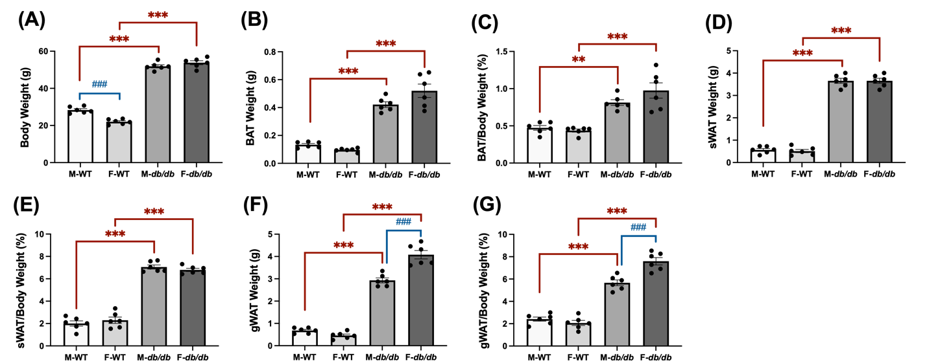
Figure 3.1 Body weight and fat pad weights in db/db vs. WT mice.
Male and female WT and db/db mice were maintained on a standard chow and water until termination at 13-15 weeks old. Body weight and various fat pad weights were measured at termination. (A) Body weight, (B) Interscapular brown adipose tissue (BAT) weight, (C) BAT as a percentage of body weight, (D) Subcutaneous WAT (sWAT) weight, (E) sWAT as a percentage, (F) Gonadal white adipose tissue (gWAT) weight, and (G) gWAT as a percentage of body weight from male wild-type (M-WT), female wild-type (F-WT), male db/db (M-db/db), and female db/db (F-db/db) mice. Data = mean ± SEM (n = 6 per group). Statistical significance was determined by one-way ANOVA. # represents differences between sexes. ∗ represents differences between genotypes (WT vs. db/db). ##,** p < 0.01; ###,*** p < 0.001.

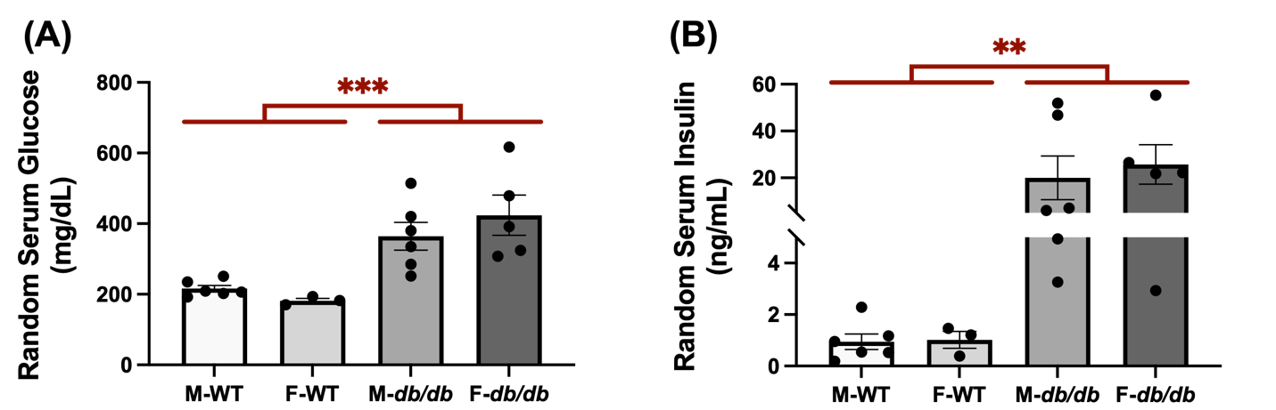
Figure 3.2 The db/db mice exhibited elevated random serum glucose and insulin levels compared to the WT mice.
Male and female WT and db/db mice were maintained on a standard chow and water until 13-15 weeks old. Random (non-fasting) blood samples were collected at termination. (A) Serum glucose levels and (B) Serum insulin levels from male WT, female WT, male db/db, and female db/db mice. Data = mean ± SEM (n = 3-6 per group). Statistical significance was determined by two-way ANOVA. * represents differences between genotypes (WT vs. db/db). ** p < 0.01; *** p < 0.001.

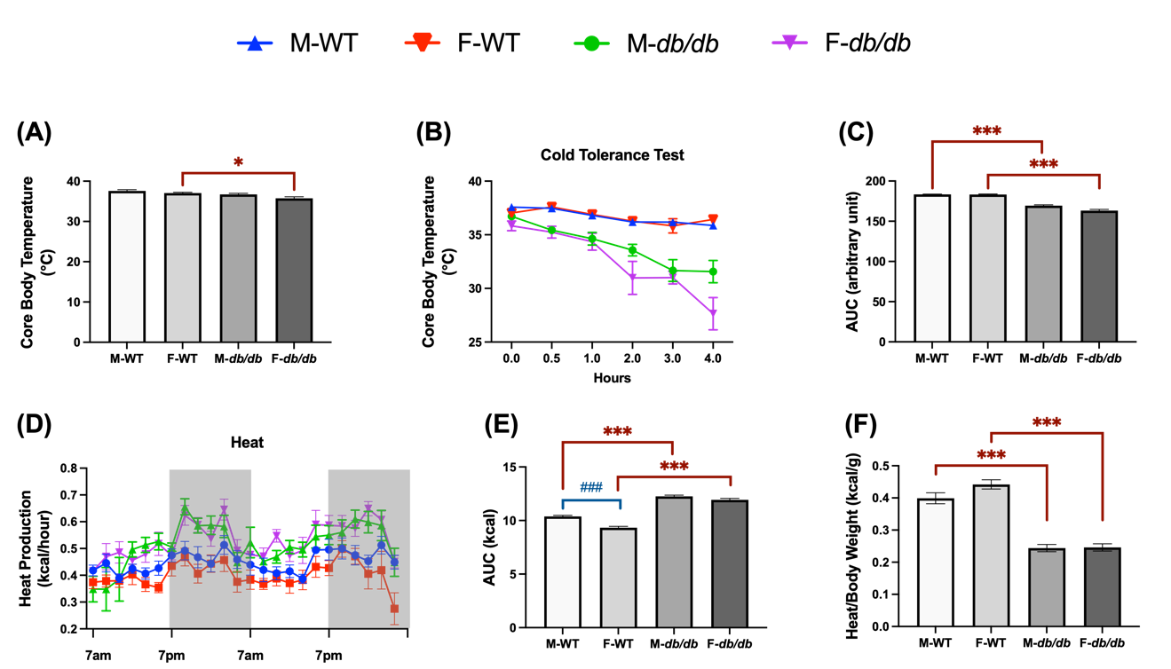
Figure 3.3 Impaired cold tolerance and reduced heat production in db/db mice.
Male and female db/db and WT mice were housed with free access to a standard chow diet and water. Mice were undergoing cold tolerance and indirect calorimetry tests around 10-15 weeks old. (A) Core body temperature was measured at room temperature. (B) Cold tolerance test in a 4°C environment over 4 hours. (C) Area under the curve (AUC) for core body temperature during the cold tolerance test. (D) Heat production was recorded over two consecutive days. (E) AUC of total heat production over the same period. (F) Total heat production normalized to body weight. Data = mean ± SEM (n = 6 per group). One-way ANOVA was used for all statistical comparisons among groups. # represents differences between sexes. ∗ represents differences between genotypes (WT vs. db/db). #, *p < 0.05; ###, ***p < 0.001.

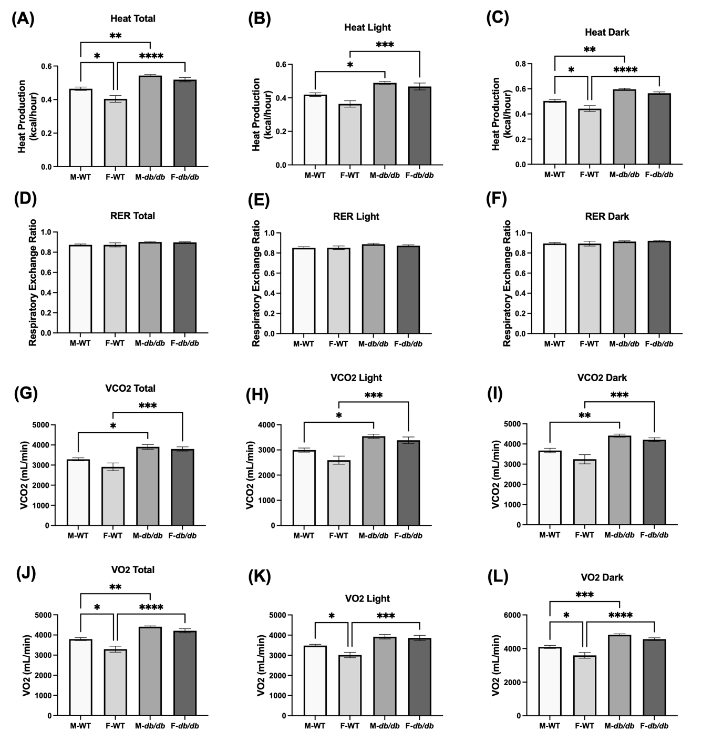
Figure 3.4 Energy expenditure and respiratory exchange ratios in the db/db compared to the WT mice.
Male and female db/db and WT mice underwent indirect calorimetry tests. (A–C) Heat production, (D–F) Respiratory exchange ratio (RER), (G–I) Carbon dioxide production (VCO₂), and (J–L) Oxygen consumption (VO₂) during the total (A, D, G, J), light (B, E, H, K), and dark (C, F, I, L) cycles in male WT, female WT, male db/db, and female db/db mice. Data = mean ± SEM (n = 6 per group). Statistical significance was determined by one-way ANOVA. * p < 0.05; ** p < 0.01; *** p < 0.001; **** p < 0.0001.

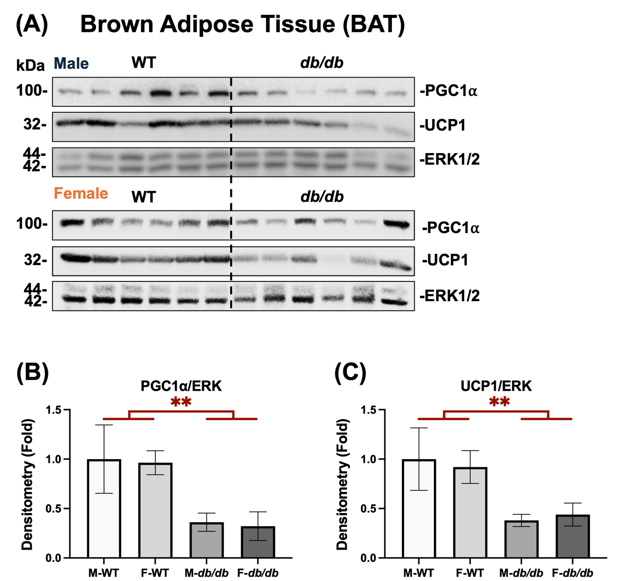
Figure 3.5 Diminished thermogenic protein expression of PGC1⍺ and UCP1 in BAT from db/db and WT mice of both sexes.
The BAT was collected from both male and female WT and db/db mice and subjected to protein analysis, normalized by the housekeeping protein ERK1/2. (A) Protein expression of PGC1α and UCP1 in the BAT of WT and db/db male (top) and female mice (bottom). (B, C) Fold changes of densitometric quantifications of PGC1α and UCP1 protein expression. Densitometry was quantified using ImageJ software. Data = mean ± SEM (n = 6). Statistical significance was determined using two-way ANOVA to assess both genotype and sex differences. ** p < 0.01.

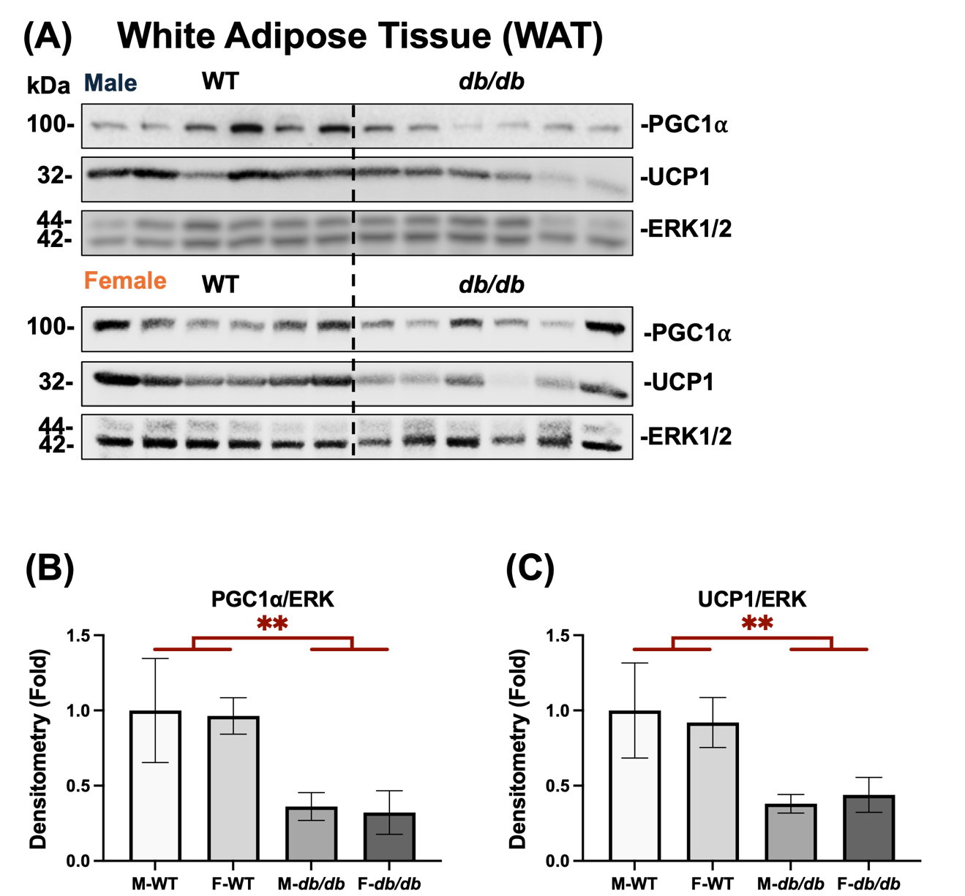
Figure 3.6 Diminished thermogenic protein expression of PGC1⍺ and UCP1 in WAT from db/db and WT mice of both sexes.
The sWAT was collected from both male and female WT and db/db mice and subjected to protein analysis, normalized by the housekeeping protein ERK1/2. (A) Protein expression of PGC1α and UCP1 in the sWAT of WT and db/db male (top) and female mice (bottom). (B, C) Fold changes of densitometric quantifications of PGC1α and UCP1 protein expression. Densitometry was quantified using ImageJ software. Data = mean ± SEM (n = 6). Statistical significance was determined using two-way ANOVA to assess both genotype and sex differences. ** p < 0.01.

CHAPTER IV INVESTIGATE RESVERATROL’S EFFECTS ON BROWNING AND INSULIN SENSITIVITY IN THE ADSCS FROM DIABETIC MICE

Abstract
Excess accumulation of white adipose tissue (WAT) is linked with the development of obesity and type 2 diabetes, both of which are associated with systemic metabolic dysfunction. One promising approach is to brown white adipocytes into beige adipocytes with greater thermogenic potential and improved insulin-sensitivity. Resveratrol (RES), a polyphenolic compound known to have multiple metabolic benefits, has been reported to improve insulin signaling and promote browning of adipose tissue; however, whether sex and diabetic state modify RES’s effects have not been reported. The goal of this study was to evaluate the ability of RES to induce browning and increase insulin sensitivity in the adipose-derived stromal cells (ADSCs) derived from diabetic db/db mice and explore the extent to which these responses are impacted by sex and diabetic status. Subcutaneous ADSCs were isolated from wild-type (WT) and diabetic (db/db) male and female mice, and then treated with RES during the beige adipocyte differentiation. RES enhanced the expression of Pgc1α and Ucp1 mRNA and increased the mitochondrial proton leak in the ADSCs of both WT and db/db mice. RES further enhanced the insulin-induced AKT phosphorylation in all groups of ADSCs. It is noted that the effects of RES on browning the adipocytes and insulin signaling were influenced by the sex and diabetic status of the cells, as female diabetic ADSCs showed different responses compared with their WT or male counterparts. These findings highlight the importance in considering sex and diabetic status in developing browning strategies to target obesity and diabetes.

Introduction
Obesity and its associated metabolic diseases, primarily type 2 diabetes (T2DM), have become a major concern for public health globally ^{414,415}. Excessive accumulation of body fat, particularly white adipose tissue (WAT) ⁴¹⁶, leads to metabolic disorders due to its contribution to chronic inflammation ^{23,95,417}, insulin resistance ^{418,419}, and ectopic lipid deposition ^{420,421}. One of the most novel therapeutic strategies to combat these conditions is the “browning” of WAT, i.e., the induction of beige adipocytes within WAT depots ^{219,422} with increased mitochondria number and increased UCP1 expression, similar to classical brown fat ^{423,424}. This browning increases fatty acid and glucose uptake and utilization, , which enhances energy expenditure (via heat production) and insulin sensitivity throughout the body ⁴²⁵.
Resveratrol (RES), a polyphenolic compound found most abundantly in grapes and red wine, has been shown to positively impact metabolic health ^{426,427}. Animal studies have demonstrated that RES supplementation decreases fat accumulation and insulin resistance, and improves the biogenesis and function of mitochondria in various tissues, including adipose tissue ^{428–430}. This might be due to the fact that RES acts on important cellular energetic regulators like AMP-activated protein kinase (AMPK) and sirtuin 1 (SIRT1), which further activate peroxisome proliferator-activated receptor gamma coactivator 1 alpha (PGC1α) signaling pathways responsible for mitochondrial biosynthesis and elevation of oxidative metabolism ^{429–431}. Moreover, RES has also been reported to stimulate the browning of adipocytes via proliferator-activated receptor gamma (PPARγ), a nuclear receptor fundamental to adipogenesis and thermogenic gene expression ⁴³². PPARγ activation leads to transcriptional control of UCP1 and other genes characteristic of beige fat, thus aiding in the development of a thermogenic phenotype in white adipocytes ^{432,433}.
However, whether sex or diabetic status modulates RES’s browning effects is unknown. Both preclinical and clinical research have shown sex differences in metabolic health, with females generally displaying more plasticity and flexibility of adipose tissue, as well as lower resistance to obesity-related metabolic dysfunction compared to males ^{433–436}. Furthermore, the metabolic changes due to obesity and diabetes, including chronic inflammatory processes and insulin resistance, greatly influence the responsiveness to therapies ^{437,438}. Hence, understanding the interaction between RES treatment and sex and diabetic status is essential for precision nutrition for obesity and T2DM.
In this study, we investigate the impacts of sex and diabetic status on the browning and enhancing insulin sensitivity by RES using adipose-derived stromal cells from db/db and wildtype (WT) mice of both sexes.

Materials and Methods

Animal Models and Housing
A heterozygous breeding pair of leptin receptor-deficient mice (B6.BKS(D)-Lepr^{db}/J, Strain #:000697) was purchased from the Jackson Laboratory at six weeks of age to generate db/db and WT littermates. Offspring were genotyped at weaning (3 weeks old) to select WT and db/db mice for experiments as previously reported ³⁹⁵. Mice were housed in a temperature-controlled (71.6 ± 3.6°F) facility with a 12-hour light/dark cycle. Mice were provided ad libitum access to a standard chow diet and water. All experimental procedures were approved by the University of Tennessee’s Institutional Animal Care and Use Committee (IACUC) (Protocol# 2320).

Isolation and Differentiation of Adipose-Derived Stromal Cells (ADSCs)
ADSCs were isolated from the subcutaneous WAT (sWAT) of 10-12 week male and female WT and db/db mice. Mice were anesthetized with isoflurane, followed by a terminal blood draw through cardiac puncture. After euthanasia, the sWAT depots were aseptically dissected, rinsed twice with ice-cold PBS, and minced, followed by digestion with 55 µL/mL of 100 mg/mL collagenase type I (Worthington Biochemical Corporation, Lakewood, NJ) at 2 mL/mg in isolation buffer at 37°C for 45 minutes with gentle shaking. The digested tissue was filtered through a 100 μm cell strainer (Fisher Scientific, Hampton, NH) , followed by centrifugation at 500 g for 6 minutes at 4°C. The stromal vascular fraction was resuspended in the Dulbecco's Modified Eagle Medium (DMEM)/high glucose supplemented with 10% FBS and 1% P/S, and cultured until confluency in a 37°C incubator with 5% CO₂.
Brown-like adipocyte differentiation was induced with an induction medium of DMEM/high glucose containing 5 µg/ml insulin, 1µM Dex, 0.5 mM IBMX, 125 µM Indo, and 1 nM T3 for three days, followed by four days in maintenance medium (DMEM/high glucose with 10% FBS, 1% P/S, 5 µg/ml insulin, and 1 nM T3) ⁴³⁹. Throughout the differentiation period, the following treatments were applied: 1) no additives (the negative control), 2) DMSO (the vehicle control), 3) resveratrol (RES, 10 μM), 4) rosiglitazone (ROSI, 1 μM). Each treatment was done in biological triplicate for each genotype and sex. On day 7, cells were treated for 6 hours with either isoproterenol (ISO, 1 μM) to activate brown-like adipocytes (ISO-stimulated conditions) or with the vehicle control (H₂O) (the basal conditions) prior to total RNA isolation. ISO is a non-selective β-adrenergic agonist that mimics cold exposure in vitro ³⁸³.

Semi-Quantitative Real-time PCR (qRT-PCR)
On day 7 of differentiation, total RNA was extracted via TRI Reagent (Molecular Research Center, Inc., Cincinnati, OH). Quantification and quality evaluation of the RNA were processed on a NanoDrop spectrophotometer (ThermoFisher Scientific, Waltham, MA). The High-Capacity cDNA Reverse Transcription Kit (Applied Biosystems, Foster City, CA) was used for reverse transcription of cDNA from 2 µg of total RNA. The expression levels of Pgc1α and Ucp1 were quantified using SYBR Green PCR Master Mix (Applied Biosystems, Foster City, CA) on a 7300 Real-Time PCR System (Applied Biosystems, Foster City, CA). Results are presented as folds of differences from the negative control group, while the 2^-ΔΔCt method was used to calculate the relative expression of target genes normalized by the housekeeping gene 36B4.

Mitochondrial Stress Test
Mitochondrial respiration on day 8 of differentiation was measured using a Seahorse XFe24 Analyzer (Agilent Technologies, Santa Clara, CA). Cells were plated in 24-well microplates for at least three hours before the test. The cell was washed and replaced with Seahorse XF assay medium with 10 mM glucose, 2 mM glutamine, and 1 mM sodium pyruvate. The cells were then placed in a 37°C incubator for one hour in a non-CO₂ incubator.
Basal respiration, ATP-linked respiration, maximal respiration, and non-mitochondrial respiration were measured sequentially after adding oligomycin (1.5 μM), FCCP (6.5 μM), and rotenone/antimycin A (1 μM each). Measurement results from the experiments were exported as oxygen consumption respiration (OCR) data and manually analyzed in Microsoft Excel (Microsoft Corporation, Redmond, WA) using the manufacturer-provided equations. OCR values were adjusted based on the number of cells seeded per well.

Western Blot Analysis of Insulin Signaling
At day 7 of differentiation, cells were serum-starved for 15-16 hours, followed by 50 nM insulin stimulation for 20 minutes at 37°C. The cells were then lysed in RIPA buffer (Cell Signaling Technology, Danvers, MA) containing protease and phosphatase inhibitor cocktails. Protein concentration was determined using the Pierce™ BCA Protein Assay Kit (ThermoFisher Scientific). Equal amounts of protein were loaded onto SDS-PAGE gels and transferred to PVDF membranes. Membranes were blocked with 5% non-fat milk, followed by incubation with primary antibodies anti-phospho-AKT Ser473 (1:1000; Cell Signaling Technology; Cat# 4060S), anti-(total) AKT (1:1000; Cell Signaling Technology; Cat# 9272), anti-ERK1/2 (1:1000; Cell Signaling Technology; Cat# 4695S), or anti-ERK1/2 (1:1000; Cell Signaling Technology; Cat# 9102S) at 4°C overnight. ERK1/2 was used as a loading control. Subsequently, membranes were washed and incubated with HRP-conjugated secondary antibodies (1:4000; Cell Signaling Technology; Cat# 7074S) for 1 hour at room temperature. Protein bands were detected using the chemiluminescent substrate SuperSignal™ West Pico PLUS (ThermoFisher Scientific, Waltham, MA) and imaged with the ChemiDoc XRS+ (Bio-Rad, Hercules, CA). Band intensity was quantified using ImageJ (NIH, Bethesda, MD), and AKT phosphorylation was calculated as the ratio of p-AKT to total AKT (p-AKT/AKT).

Statistical Analysis
Data are presented as mean ± SEM. To evaluate the effects of basal in comparison with isoproterenol or insulin treatments, two-way ANOVA followed by Tukey’s post hoc test was performed where applicable. Within each group, one-way ANOVA was used to compare fold changes relative to the control. A p-value < 0.05 was considered statistically significant. All statistical analyses were conducted using GraphPad Prism 9 (Dotmatics, Inc.; San Diego, CA).

Results

RES Induces Browning by Increasing Pgc1α and Ucp1 mRNA Expression
To investigate the browning effect of RES on subcutaneous white adipose tissue-derived stromal cells (ADSCs), we assessed the mRNA expression of thermogenic markers Pgc1α and Ucp1 at both basal and ISO-stimulated states in the ADSCs derived from male and female WT and db/db mice and were differentiated for 7 days in the presence or absence of 10 µM of RES, ROSI (as a positive control), or the vehicle control (DMSO).
In the differentiated male WT ADSCs (Figure 4.1A), ROSI significantly increased in Pgc1α mRNA expression, while no significant changes in Pgc1α expression were found in RES-treated groups compared to the negative and vehicle (DMSO) controls under both basal and ISO-stimulated conditions. For Ucp1 expression, ROSI and RES robustly increased Ucp1 mRNA in both basal and ISO conditions as well. In the differentiated female WT ADSCs (Figure 4.1B), ROSI and RES both significantly enhanced Pgc1α mRNA expression under ISO stimulation but not in basal condition compared to the control groups. While Ucp1 mRNA expression was significantly upregulated by ROSI and RES under both basal and ISO conditions.
In contrast, a robust increase in Pgc1α mRNA expression was shown in the differentiated male db/db ADSCs (Figure 4.1C) following ROSI and RES treatments under both basal and ISO-stimulated conditions. Ucp1 mRNA expression was similarly elevated by ROSI and RES. A similar pattern was observed in the differentiated female db/db ADSCs (Figure 4.1D). ROSI greatly induced Pgc1α mRNA expression compared to RES under basal conditions, but not after ISO stimulation. ROSI also significantly elevated Ucp1 mRNA expression under both conditions. RES significantly increased both Pgc1α and Ucp1 mRNA expression under both basal and ISO-stimulated conditions.

Sex and Genotype Differences in the Pgc1α and Ucp1 mRNA Expression in Response to ISO and RES
To understand the impact of genotype and sex on the differentiated ADSC’s response to ISO and RES, we compared the relative fold changes in Pgc1α and Ucp1 mRNA expression in response to ISO stimulation (Figure 4.2A, C). No statistical significances were found in ISO-stimulated Pgc1α upregulation among the cells from male and female WT or db/db mice (Figure 4.2A). We further compared the relative fold changes in Pgc1α mRNA expression following RES under basal or ISO stimulated conditions (Figure 4.2B). RES-induced Pgc1α upregulation was higher in the db/db adipocytes than the WT adipocytes under ISO-stimulated conditions, reaching statistical significance only in male db/db adipocytes (Figure 4.2B). Male db/db adipocytes also had higher RES-induced Pgc1α upregulation than female db/db adipocytes (Figure 4.2B).
ISO stimulation induced significant increases in Ucp1 mRNA expression in the differentiated ADSCs from female db/db mice compared to female WT mice (Figure 4.2C). Moreover, differentiated female db/db ADSCs had significantly greater Ucp1 induction than male db/db counterparts after ISO stimulation (Figure 4.2C). In comparison, RES induced Ucp1 upregulation to the similar extent in all groups under both basal- and ISO-stimulated conditions, and there were no significant differences across sexes or genotypes (Figure 4.2D).

RES Increased Mitochondrial Uncoupling
The mitochondrial stress test was performed to measure mitochondrial respiration in ADSCs differentiated in the presence or absence of 10 μM of RES, ROSI, or the vehicle control. In the differentiated male WT ADSCs, RES did not significantly alter basal respiration, maximal respiration, or proton leak compared to both negative and vehicle control (Figure 4.3B-D). However, ATP production was significantly increased by RES relative to the vehicle control, which itself suppressed ATP production compared to the untreated negative control (Figure 4.3E). RES further reduced coupling efficiency (Figure 4.3F), indicating enhanced mitochondrial uncoupling, which is a marker for thermogenic activation.
In the differentiated female WT ADSCs, basal respiration was significantly increased by DMSO, RES, and ROSI compared to the negative control, with no significant differences among the three treatments (Figure 4.4B). Maximal respiration was significantly elevated by both RES and ROSI compared to the negative and vehicle controls (Figure 4.4C), indicating enhanced respiratory capacity. Proton leak was also increased by RES and ROSI relative to the negative control but not significantly different from the vehicle control (Figure 4.4D). Although both RES and ROSI elevated ATP production compared to the negative control, both treatments induced modest but significant reductions in ATP production compared to the vehicle control (Figure 4.4E). Finally, RES significantly decreased coupling efficiency compared to both the negative and vehicle controls, while ROSI only significantly reduced coupling efficiency compared to the negative control (Figure 4.4F).
In the differentiated male db/db ADSCs, RES did not significantly affect basal respiration, whereas ROSI significantly increased basal respiration compared to both the negative and vehicle controls (Figure 4.5B). However, RES, but not ROSI, significantly increased maximal respiration compared to both controls (Figure 4.5C). Both RES and ROSI significantly elevated proton leak compared to the negative and vehicle controls (Figure 4.5D). While ROSI significantly increased ATP production, RES had no significant effect on ATP production (Figure 4.5E). Consequently, RES, but not ROSI, significantly decreased coupling efficiency compared to both the negative and vehicle controls in the differentiated male db/db ADSCs (Figure 4.5F).
In differentiated female db/db ADSCs, RES did not significantly affect basal respiration, whereas ROSI significantly increased basal respiration compared to both the negative and vehicle controls (Figure 4.6B). Maximal respiration was elevated by the vehicle (DMSO), RES, and ROSI compared to the negative control (Figure 4.6C). While ROSI significantly increased proton leak and ATP production compared to both the negative and the vehicle controls, RES caused modest but not significant elevation in the proton leak but significantly decreased ATP production compared to the vehicle control (Figure 4.6D-E). As a result, RES significantly reduced coupling efficiency compared to both controls while ROSI and DMSO reduced the coupling efficiency only compared to the negative control in the differentiated female db/db ADSCs (Figure 4.6F).

Sex and Genotype Differences in the Mitochondrial Uncoupling in Response to RES
To assess the relative uncoupling responses across different differentiated ADSCs, fold changes in proton leak and coupling efficiency induced by RES relative to the vehicle control were calculated (Figure 4.7). There were no significant differences among the four groups in the fold changes of proton leak induced by RES compared to the vehicle control (Figure 4.7A). In contrast, RES significantly reduced more coupling efficiency in the differentiated male db/db ADSCs than in the male WT and female db/db counterparts (Figure 4.7B).

RES Improved Insulin Signaling by Enhancing Insulin-stimulated AKT Phosphorylation
Insulin-stimulated AKT phosphorylation was assessed as a marker of insulin sensitivity in the four types of ADSCs differentiated in the presence or absence of RES, ROSI, or the vehicle control. In the differentiated male WT ADSCs, ROSI significantly increased total AKT protein levels only following insulin stimulation compared to both the negative and vehicle controls, whereas RES had no effect on total AKT levels under either basal or insulin-stimulated conditions (Figure 4.8B). Both RES and ROSI significantly increased insulin-stimulated p-AKT (Ser473) levels compared to the negative and vehicle controls (Figure 4.8C). Consequently, only RES significantly increased the p-AKT/AKT ratio compared to the vehicle control in the differentiated male WT ADSCs (Figure 4.8D).
Similar results were found in the differentiated female WT ADSCs. ROSI, but not RES, significantly increased total AKT levels following insulin stimulation compared to the vehicle control (Figure 4.9B). Under insulin stimulation, both RES and ROSI significantly elevated p-AKT (Ser473) levels compared to the negative and vehicle controls (Figure 4.9C). While both treatments increased the p-AKT/AKT ratios, only RES’s effects reach statistical significance compared to both the negative and vehicle controls (Figure 4.9D).
Similar to the differentiated male WT ADSCs, ROSI, but not RES, significantly increased total AKT protein levels under insulin-stimulated conditions in the differentiated male db/db ADSCs (Figure 4.10B). Similarly, both RES and ROSI significantly increased p-AKT (Ser473) levels compared to the negative and vehicle controls (Figure 4.10C). However, no significant differences were observed in p-AKT/AKT ratios across groups, although both RES and ROSI showed a non-significant trend toward increased p-AKT/AKT ratios compared to the controls (Figure 4.10D).
In contrast, ROSI seemed to increase total AKT levels under both basal and insulin-stimulated conditions, effects of which only reached significance under basal conditions compared to the negative control, while RES did not have any effects under both conditions in the differentiated female db/db ADSCs (Figure 4.11B). While ROSI also significantly elevated p-AKT (Ser473) levels under both basal and insulin-stimulated conditions compared to both the negative and vehicle controls, RES only increased p-AKT (Ser473) levels under insulin-stimulated conditions (Figure 4.11C). However, no significant differences were observed in p-AKT/AKT ratios by RES, ROSI, or DMSO under either basal or insulin-stimulated conditions in the differentiated female db/db ADSCs (Figure 4.11D).

Sex and Genotype Differences in Insulin Sensitivity Markers in Response to Insulin and RES
To understand the impact of genotype and sex on the differentiated ADSCs’ response to insulin and RES, fold changes in p-AKT/ERK and p-AKT/AKT in response to insulin (Figure 4.12A, C) and to RES relative to the vehicle control under basal and insulin-stimulated conditions (Figure 4.12B, D) were calculated and compared for the four groups of differentiated ADSCs. Insulin (at 50 nM) induced significantly higher p-AKT levels in the differentiated female db/db ADSCs compared to the differentiated female WT and male db/db ADSCs (Figure 4.12A). However, there were no significant differences in the p-AKT/AKT ratios in response to insulin among all four groups of differentiated ADSCs (Figure 4.12C). Although RES induced higher levels of p-AKT levels and higher p-AKT/AKT ratios under insulin-stimulated conditions in all groups differentiated ADSCs, there were no significant differences in p-AKT or p-AKT/AKT in response to RES among the groups under either basal or insulin-stimulated conditions (Figure 4.12D).

Discussion
This study demonstrates that resveratrol (RES) at a physiologically achievable dose of 10 μM promotes the browning of adipocytes and increases insulin signaling in the subcutaneous adipose-derived stromal cells (ADSCs) from both wild-type (WT) and diabetic (db/db) mice. To our knowledge, this is the first study that has directly compared the effects of RES on browning and improving insulin sensitivity in differentiated ADSCs derived from diabetic mice with their WT controls, as well as in females compared to their male counterparts. Our results demonstrate that sex and diabetic status affect the responses of differentiated ADSCs to physiological stimulations, such as the β-adrenergic agonist isoproterenol and insulin, as well as to the dietary bioactive compound RES.
Adrenergic activation, primarily through the sympathetic nervous system, plays a crucial role in thermogenesis and energy expenditure as heat in brown and brown-like adipocytes. As a nonselective β-adrenergic agonist, ISO induces thermogenic activation by upregulating Pgc1α and Ucp1 mRNA expression in all four groups of differentiated ADSCs. Higher ISO-stimulated Pgc1α mRNA induction was found in the differentiated db/db ADSCs of both sexes, although the differences were not statistically significant compared to their WT counterparts (Figure 4.2A). In contrast, the differentiated ADSCs from female db/db mice showed significantly higher ISO-stimulated Ucp1 mRNA induction compared to female WT controls or male db/db counterparts (Figure 4.2C). The results suggest that cellular adrenergic activation pathways in the differentiated ADSCs from db/db mice are functional and may be upregulated to some extent, compensating for the genetic defects ⁴⁴⁰. The sex differences in ISO-induced Ucp1 mRNA upregulation might be due to potential sex-specific differences in adrenergic receptor expression ^{441–443} and/or response to ISO in the differentiated ADSCs. Moreover, the results also suggest that cold intolerance and lower heat production/body weight found in the db/db mice are likely due to other defects, perhaps upstream of cellular adrenergic activation in the adipocytes.
To our surprise, RES induced similar Ucp1 mRNA upregulation under both basal and ISO stimulated conditions in all groups of differentiated ADSCs (Figure 4.2D). In contrast, the inductions of Pgc1α mRNA expression by RES, particularly under ISO stimulated conditions, were more robust in the differentiated ADSCs from the db/db mice compared to WT mice in both sexes, and female db/db cells had a higher response to RES compared to the male db/db cells (Figure 4.2B). These results suggest that differentiated db/db ADSCs can also respond to the browning effects of RES (even to a higher degree). Our findings not only align with a previous report demonstrating RES’s browning effects on the differentiated white adipose stromal cells from wildtype mice ¹, but also extend the findings to the white adipose stromal cells from diabetic db/db mice of both sexes.
To correlate thermogenic gene expression, mitochondrial respiration and uncoupling in response to RES were further examined in the four groups of differentiated ADSCs. Although there were no significant differences in RES-induced changes in proton leak (Figure 4.7A), there were significant differences in RES-induced changes in coupling efficiency among the four groups of differentiated ADSCs (Figure 4.7B), as differentiated male db/db ADSCs showed significantly lower coupling efficiency in response to RES than male WT cells and female db/db cells (Figure 4.7B). The facts that RES induced similar changes in Ucp1 mRNA expression but significant differences in mitochondrial coupling efficiency in the four groups of differentiated ADSCs suggest that i) RES may have differential effects on ATP production among the four groups of differentiated ADSCs; ii) RES may have differential effects on Ucp1 gene post transcription, translation, and/or post translational modification. It is known that the functionality of the UCP1 protein is determined not only by Ucp1 gene expression but also by its post-translational modifications, which are controlled by fatty acid presence, purine nucleotides, and the cellular redox state ^{154,444–446}. Hence, future studies are needed to explore the mechanisms underlying the differential effects of RES in reducing mitochondrial uncoupling in the four groups of differentiated ADSCs. Moreover, the results underscore the importance of assessing mitochondrial uncoupling in conjunction with thermogenic gene expression when studying the browning effects in differentiated ADSCs from diabetic animals compared to WT controls, or in males compared to females.
Insulin signaling was further studied in the differentiated ADSCs in response to RES. Although insulin-induced p-AKT levels (p-AKT/ERK) varied (Figure 4.12A), insulin-induced p-AKT/AKT ratios were not different among the four differentiated ADSCs (Figure 4.12C), indicating that although insulin may have differential effects on total AKT levels, differentiated ADSCs respond to insulin with a similar degree of AKT phosphorylation, regardless of sex and diabetic status. Because we used insulin at 50 nM, which is supraphysiological as db/db mice’s random serum insulin levels were ~ 20 ng/ml or ~3.4 nM (Chapter III), the results suggest differentiated db/db ADSCs respond to supraphysiological levels of insulin in a similar manner to those of differentiated WT ADSCs.
In addition to its influence on mitochondrial uncoupling and energy expenditure, RES showed similar fold increases in p-AKT (Figure 4.12B) and p-ATK/AKT (Figure 4.12D) under insulin-stimulated conditions in the differentiated ADSCs, as there were no differences in RES-induced p-AKT and p-AKT/AKT ratios under insulin-stimulated conditions among the four groups of differentiated ADSCs (Figure 4.12B and D). The results suggest that under the tested conditions, RES has similar beneficial effects in enhancing insulin signaling in the differentiated ADSCs, regardless of sex and diabetic conditions.
Our study has several limitations. Primarily, the experiments were performed in vitro with differentiated ADSCs, which does not capture the full complexity of adipose tissue in vivo, considering the interplay of systemic hormones, nervous connections, and immune constituents. In addition, while we analyzed gene expression and mitochondrial respiration, we did not measure other functional outputs, including glucose uptake and fatty acid oxidation. Furthermore, only one concentration of RES was investigated. Determining therapeutic margins will require consideration of dose-dependent effects and in vivo pharmacokinetics. Lastly, although the use of the db/db mice model captures critical features of obesity and obesity associated T2DM, further investigations using human cells or mouse transplantation models will be important for developing a browning strategy for treating human obesity and T2DM.

Conclusion
Overall, the study demonstrates significant differences in response to physiological stimulation, such as adrenergic activation and insulin, among differentiated ADSCs from diabetic mice compared to the WT controls and from males compared to the females. Moreover, RES enhances browning, mitochondrial uncoupling, and insulin sensitivity in the differentiated ADSCs in a manner that depends on sex and diabetic status. The stronger effects of RES-induced PGC1α/UCP1 mRNA expression and mitochondrial uncoupling were observed in the differentiated ADSCs from the db/db mice, with female db/db cells showing a greater response to RES than male db/db cells. Furthermore, under tested conditions, RES shows similar enhancement in insulin signaling in all four groups of differentiated ADSCs, regardless of sex and diabetic status.
These findings reinforce the therapeutic potential of RES as an active phytonutrient that induces the browning of white adipocytes, increases mitochondrial uncoupling, and enhances insulin sensitivity, particularly in the context of obesity and T2DM. Our study reveals the importance of sex and diabetic status in modifying the beneficial effects of RES, particularly in browning and mitochondrial uncoupling. Further work should focus on validating these effects in vivo, elucidating the molecular pathways that drive sex- and genotype-dependent differences, and investigating the potential for translating RES-based interventions for the treatment of human obesity and T2DM.

Appendix
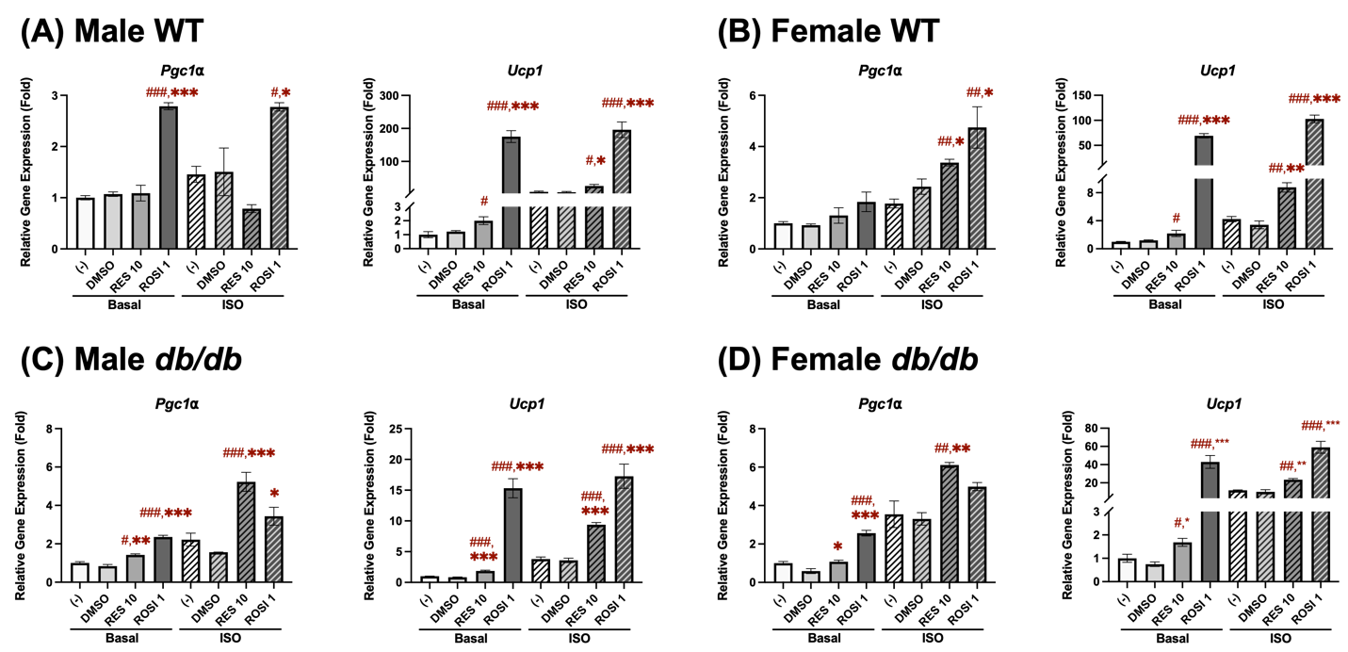
Figure 4.1 RES induced browning by increasing Pgc1α and Ucp1 mRNA expression in the differentiated ADSCs derived from (A) male WT, (B) female WT, (C) male db/db, and (D) female db/db mice.
The ADSCs were isolated from subcutaneous white adipose tissue in mice aged 10-12 weeks. Pgc1α and Ucp1 mRNA expressions were measured in pooled ADSCs from 3-5 mice following a 7-day differentiation in the presence or absence of either resveratrol (RES, 10 µM) or rosiglitazone (ROSI, a positive control, 1 µM) or the vehicle control (DMSO). Isoproterenol (ISO, 1 µM) was added for the final 6 hours to activate brown-like adipocytes. Data = mean ± SEM (n = 3). One-way ANOVA was used for all statistical analyses in basal or ISO conditions. #, ##, ### indicate p < 0.05, p < 0.01, and p < 0.001, respectively, compared to the negative control (–) group, while *, **, *** indicate p < 0.05, p < 0.01, and p < 0.001, respectively, compared to the DMSO group.
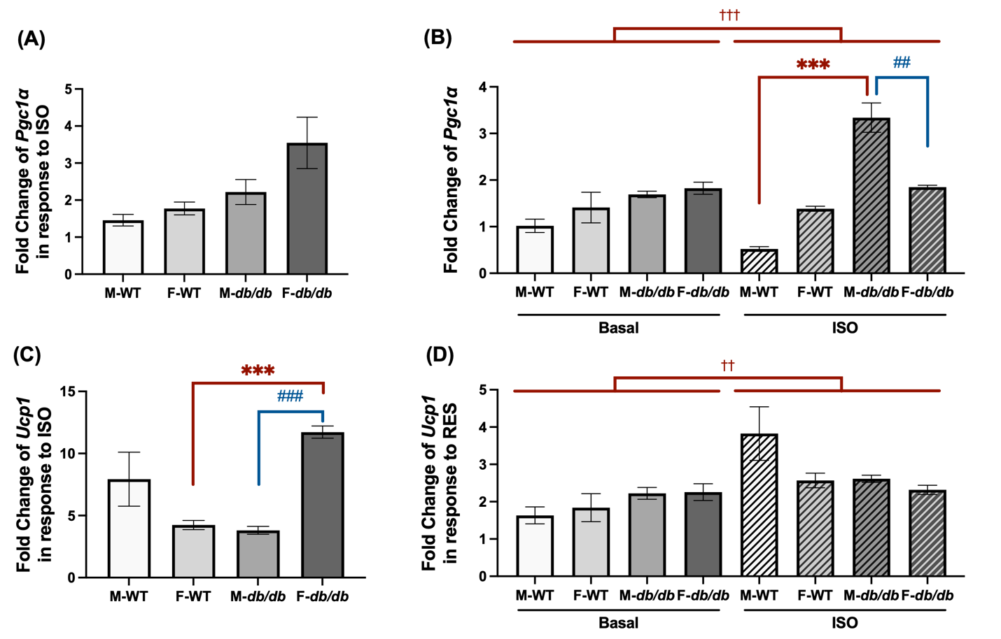
Figure 4.2 Fold changes in thermogenic gene expression following isoproterenol and resveratrol treatment in the adipocytes derived from ADSCs of male and female WT and db/db mice.
(A) Fold changes of Pgc1α and (C) Ucp1 mRNA expression in response to isoproterenol (ISO) stimulation were calculated for all groups. (B) Fold changes of Pgc1α and (D) Ucp1 mRNA expression in response to RES relative to the DMSO were calculated under basal or ISO-stimulated conditions. Data = mean ± SEM (n = 3). One-way ANOVA was used for statistical analysis in (A) and (C); two-way ANOVA was used in (B) and (D). ##, ### indicate p < 0.01 and p < 0.001 for comparisons between males and females. *** indicate p < 0.001 for comparisons between WT and db/db mice. †† indicates p < 0.01 for comparisons between basal and ISO conditions.
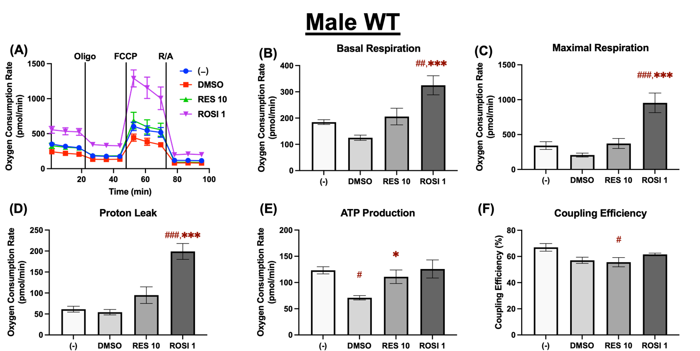
Figure 4.3 Resveratrol enhanced mitochondrial uncoupling in the differentiated ADSCs from male WT mice.
The ADSCs were first differentiated in the presence or absence of RES (10 µM), ROSI (1 µM), or DMSO for 7 days, then were reseeded into a Seahorse XFe assay plate. The cells underwent real-time oxygen consumption rate (OCR) measurements for a mitochondrial stress test after reseeding. (A) OCR recordings over time, (B) Basal respiration, (C) Maximal respiration, (D) Proton leak, (E) ATP production, and (F) Coupling efficiency are shown. Data = mean ± SEM (n = 3–5). One-way ANOVA was used for statistical analysis. #, ##, ### indicate p < 0.05, p < 0.01, and p < 0.001, respectively, compared to the (-) group, while *, **, *** indicate p < 0.05, p < 0.01, and p < 0.001, respectively, compared to the DMSO group.
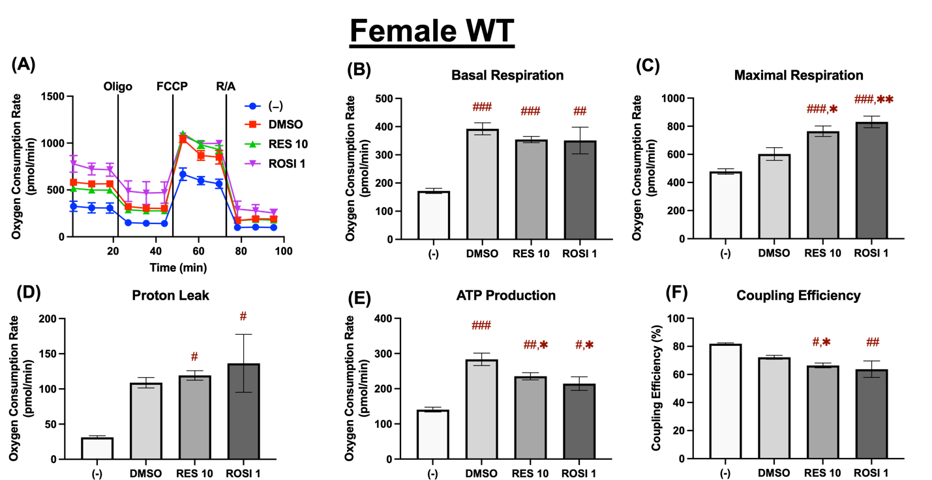
Figure 4.4 Resveratrol enhanced mitochondrial uncoupling in the differentiated ADSCs from female WT mice.
The ADSCs were first differentiated in the presence or absence of RES (10 µM), ROSI (1 µM), or DMSO for 7 days, then were reseeded into a Seahorse XFe assay plate. The cells underwent real-time oxygen consumption rate (OCR) measurements for a mitochondrial stress test after reseeding. (A) OCR recordings over time, (B) Basal respiration, (C) Maximal respiration, (D) Proton leak, (E) ATP production, and (F) Coupling efficiency are shown. Data = mean ± SEM (n = 3–5). One-way ANOVA was used for statistical analysis. #, ##, ### indicate p < 0.05, p < 0.01, and p < 0.001, respectively, compared to the (-) group, while *, **, *** indicate p < 0.05, p < 0.01, and p < 0.001, respectively, compared to the DMSO group.

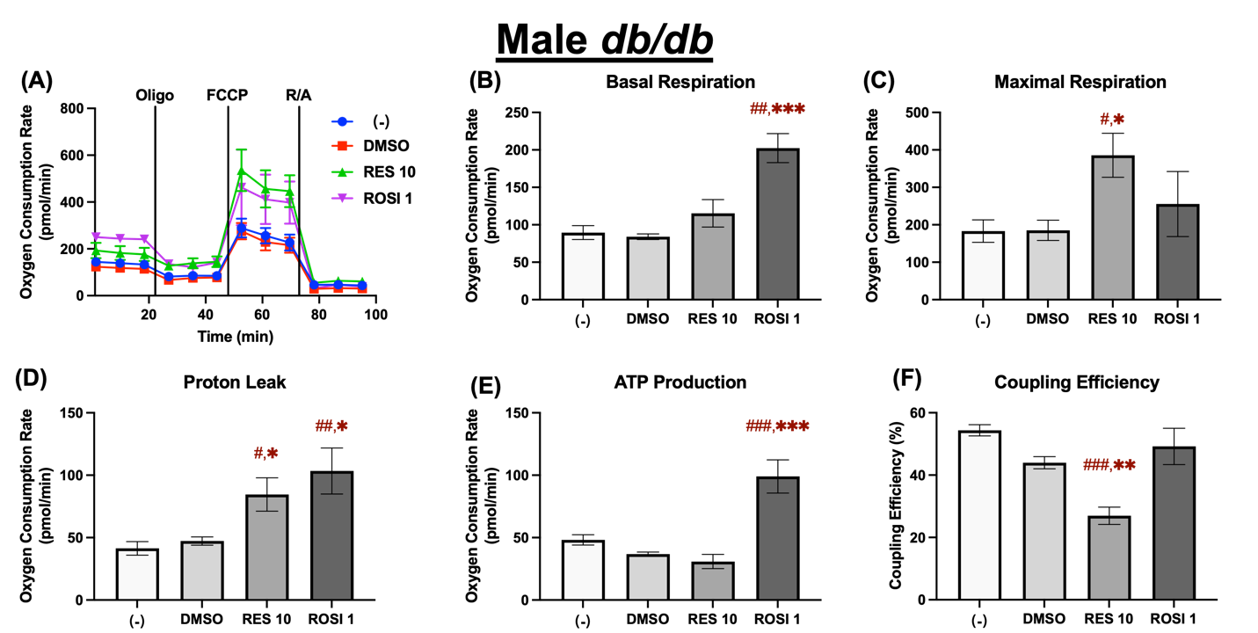
Figure 4.5 Resveratrol enhanced mitochondrial uncoupling in the differentiated ADSCs from male db/db mice.
The ADSCs were first differentiated in the presence or absence of RES (10 µM), ROSI (1 µM), or DMSO for 7 days, then were reseeded into a Seahorse XFe assay plate. The cells underwent real-time oxygen consumption rate (OCR) measurements for a mitochondrial stress test after reseeding. (A) OCR recordings over time, (B) Basal respiration, (C) Maximal respiration, (D) Proton leak, (E) ATP production, and (F) Coupling efficiency are shown. Data = mean ± SEM (n = 3–5). One-way ANOVA was used for statistical analysis. #, ##, ### indicate p < 0.05, p < 0.01, and p < 0.001, respectively, compared to the (-) group, while *, **, *** indicate p < 0.05, p < 0.01, and p < 0.001, respectively, compared to the DMSO group.

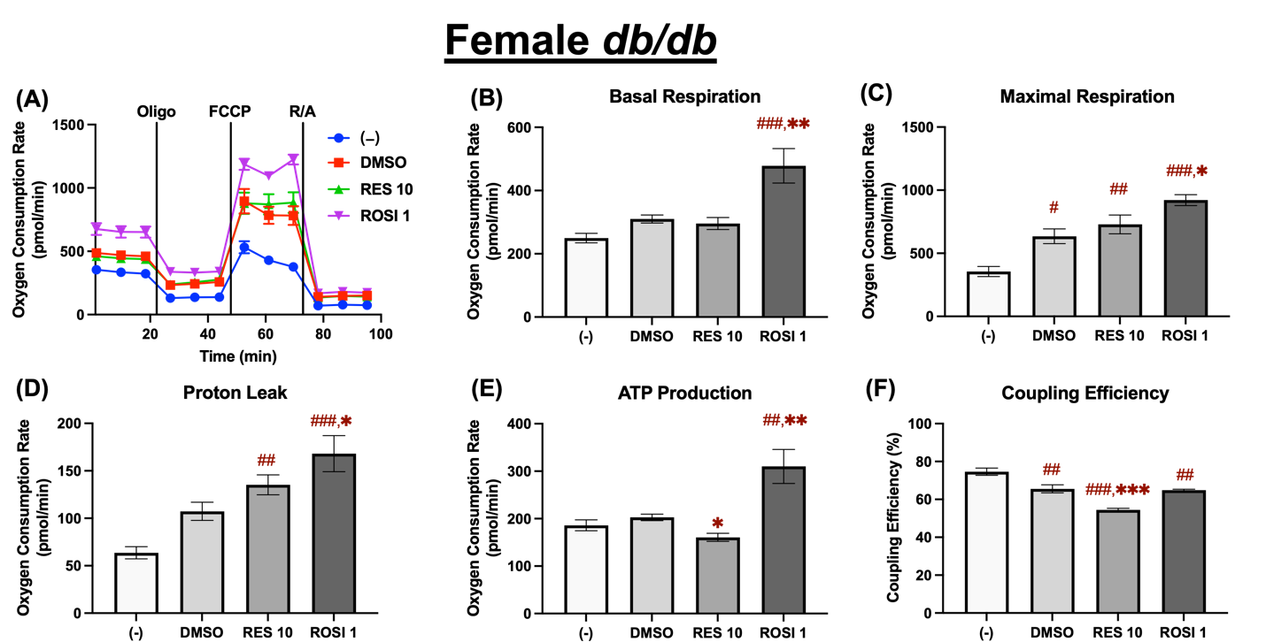
Figure 4.6 Resveratrol enhanced mitochondrial uncoupling in the differentiated ADSCs from female db/db mice.
The ADSCs were first differentiated in the presence or absence of RES (10 µM), ROSI (1 µM), or DMSO for 7 days, then were reseeded into a Seahorse XFe assay plate. The cells underwent real-time oxygen consumption rate (OCR) measurements for a mitochondrial stress test after reseeding. (A) OCR recordings over time, (B) Basal respiration, (C) Maximal respiration, (D) Proton leak, (E) ATP production, and (F) Coupling efficiency are shown. Data = mean ± SEM (n = 3–5). One-way ANOVA was used for statistical analysis. #, ##, ### indicate p < 0.05, p < 0.01, and p < 0.001, respectively, compared to the (-) group, while *, **, *** indicate p < 0.05, p < 0.01, and p < 0.001, respectively, compared to the DMSO group.

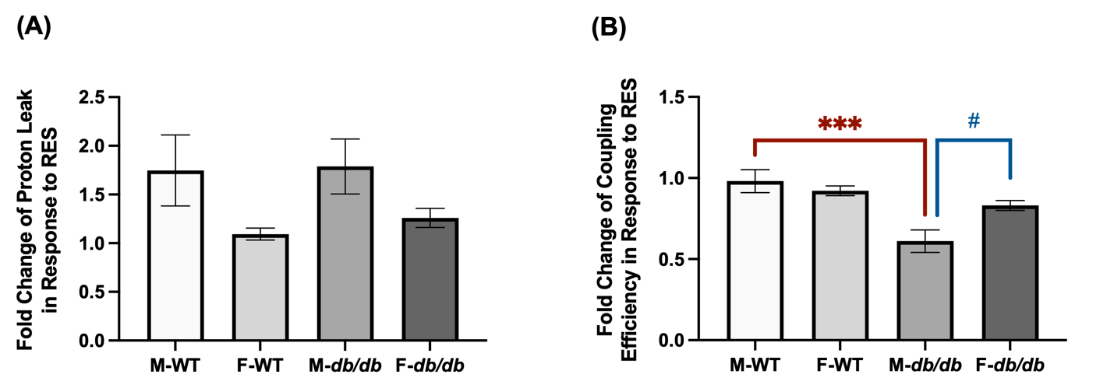
Figure 4.7 Fold changes in proton leak and coupling efficiency following resveratrol treatment in the differentiated ADSCs from male and female WT and db/db mice.
(A) Fold changes of proton leak and (B) coupling efficiency in response to RES relative to DMSO were calculated for each of the 4 groups, highlighting sex-specific responses and differences between the WT and db/db. Data = mean ± SEM (n = 3-5). One-way ANOVA was used for statistical analysis. # indicates p < 0.05 compared between sexes, and *** indicates p < 0.001 compared between the WT and db/db.
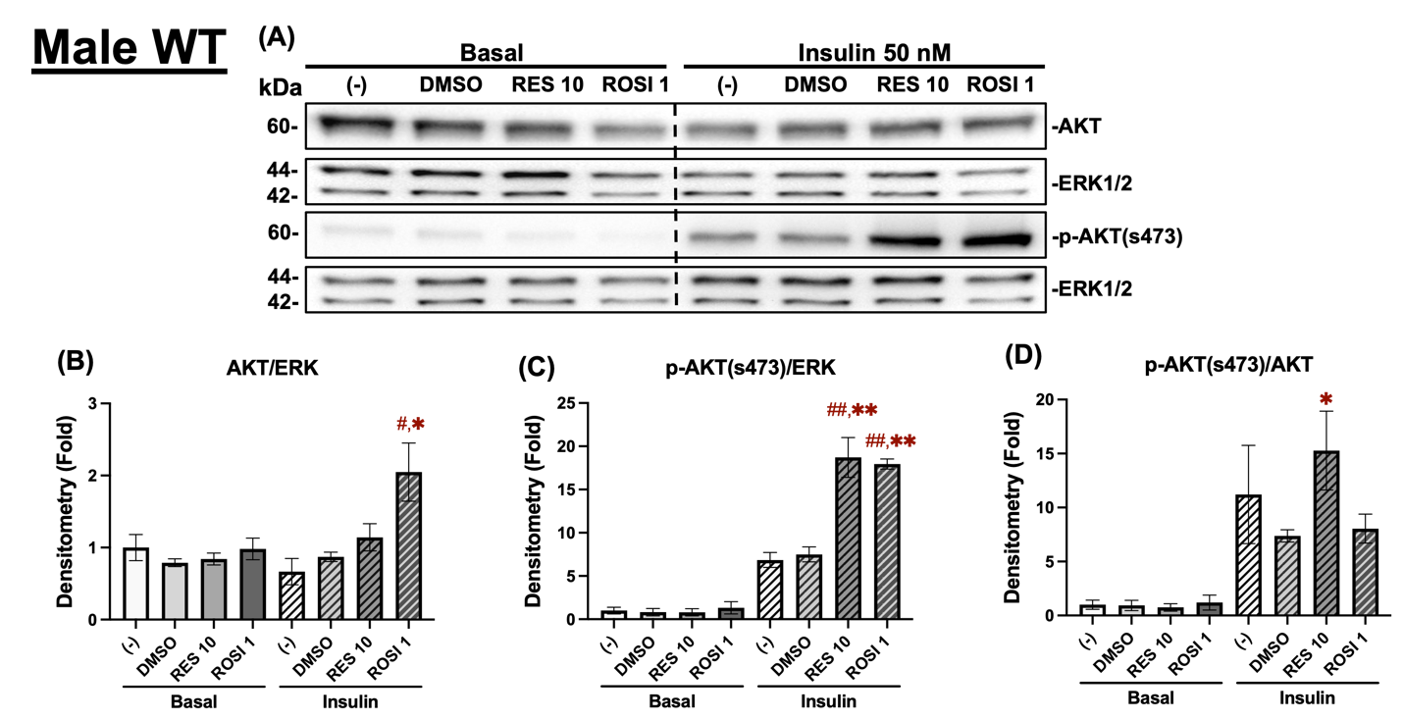
Figure 4.8 Resveratrol improved insulin sensitivity in the differentiated ADSCs from male WT mice.
The ADSCs from the male WT mice were differentiated for 7 days in the presence or absence of RES (10 µM), ROSI (a positive control, 1 μM), or DMSO, followed by overnight starvation in DMEM/high glucose without FBS. Cells were then stimulated with or without insulin (50 nM) for 20 minutes, and protein lysates were collected for Western blot analysis. (A) Total AKT, p-AKT (ser473), and their respective loading control ERK1/2 are shown. The left panel corresponds to the basal condition (-Insulin), and the right panel to the insulin-stimulated condition (+Insulin). Quantification of total AKT/ERK1/2 (B), p-AKT/ERK1/2 (C), and p-AKT/total AKT (D) are presented as fold change relative to the (-) group under basal conditions. Data = mean ± SEM (n = 3). One-way ANOVA was used for statistical analysis. #, ## indicate p < 0.05 and p < 0.01 compared to the (-) group. *, ** indicate p < 0.05 and p < 0.01 compared to the DMSO group.
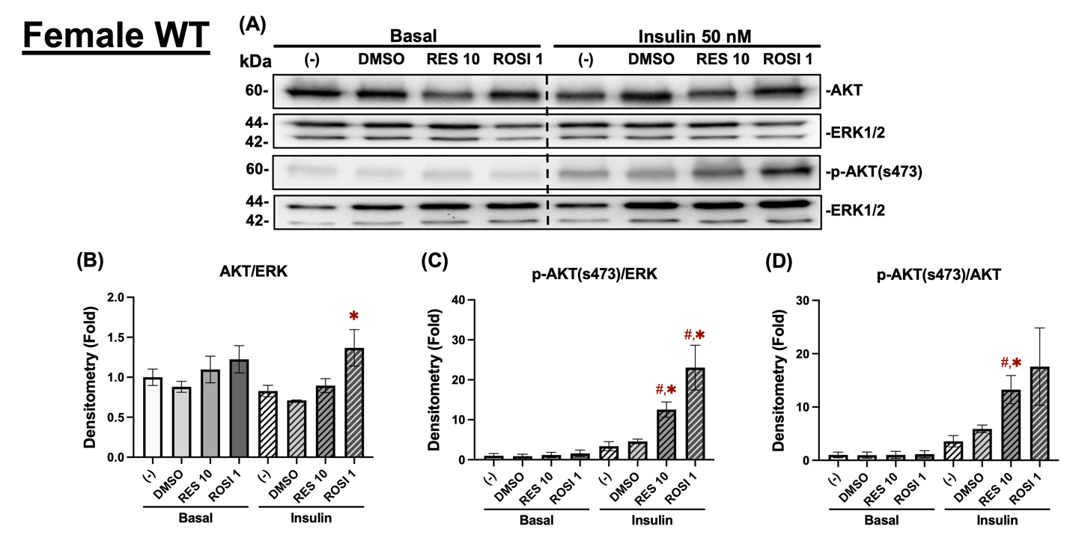
Figure 4.9 Resveratrol improved insulin sensitivity in the differentiated ADSCs from female WT mice.
The ADSCs from the female WT mice were differentiated for 7 days in the presence or absence of RES (10 µM), ROSI (a positive control, 1 μM), or DMSO, followed by overnight starvation in DMEM/high glucose without FBS. Cells were then stimulated with or without insulin (50 nM) for 20 minutes, and protein lysates were collected for Western blot analysis. (A) Total AKT, p-AKT (ser473), and their respective loading control ERK1/2 are shown. The left panel corresponds to the basal condition (-Insulin), and the right panel to the insulin-stimulated condition (+Insulin). Quantification of total AKT/ERK1/2 (B), p-AKT/ERK1/2 (C), and p-AKT/total AKT (D) are presented as fold change relative to the (-) group under basal conditions. Data = mean ± SEM (n = 3). One-way ANOVA was used for statistical analysis. # indicates p < 0.05 compared to the (-) group. * indicates p < 0.05 compared to the DMSO group.
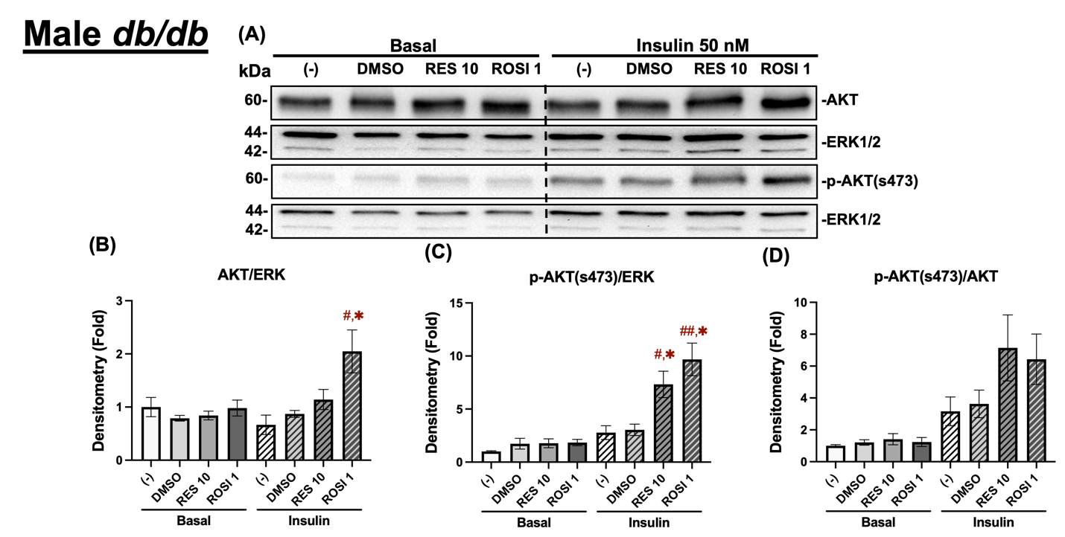
Figure 4.10 Resveratrol improved insulin sensitivity in the differentiated ADSCs from male db/db mice.
The ADSCs from the male db/db mice were differentiated for 7 days in the presence or absence of RES (10 µM), ROSI (a positive control, 1 μM), or DMSO, followed by overnight starvation in DMEM/high glucose without FBS. Cells were then stimulated with or without insulin (50 nM) for 20 minutes, and protein lysates were collected for Western blot analysis. (A) Total AKT, p-AKT (ser473), and their respective loading control ERK1/2 are shown. The left panel corresponds to the basal condition (-Insulin), and the right panel to the insulin-stimulated condition (+Insulin). Quantification of total AKT/ERK1/2 (B), p-AKT/ERK1/2 (C), and p-AKT/total AKT (D) are presented as fold change relative to the (-) group under basal conditions. Data = mean ± SEM (n = 3). One-way ANOVA was used for statistical analysis. #, ## indicate p < 0.05 and p < 0.01 compared to the (-) group. * indicates p < 0.05 compared to the DMSO group.
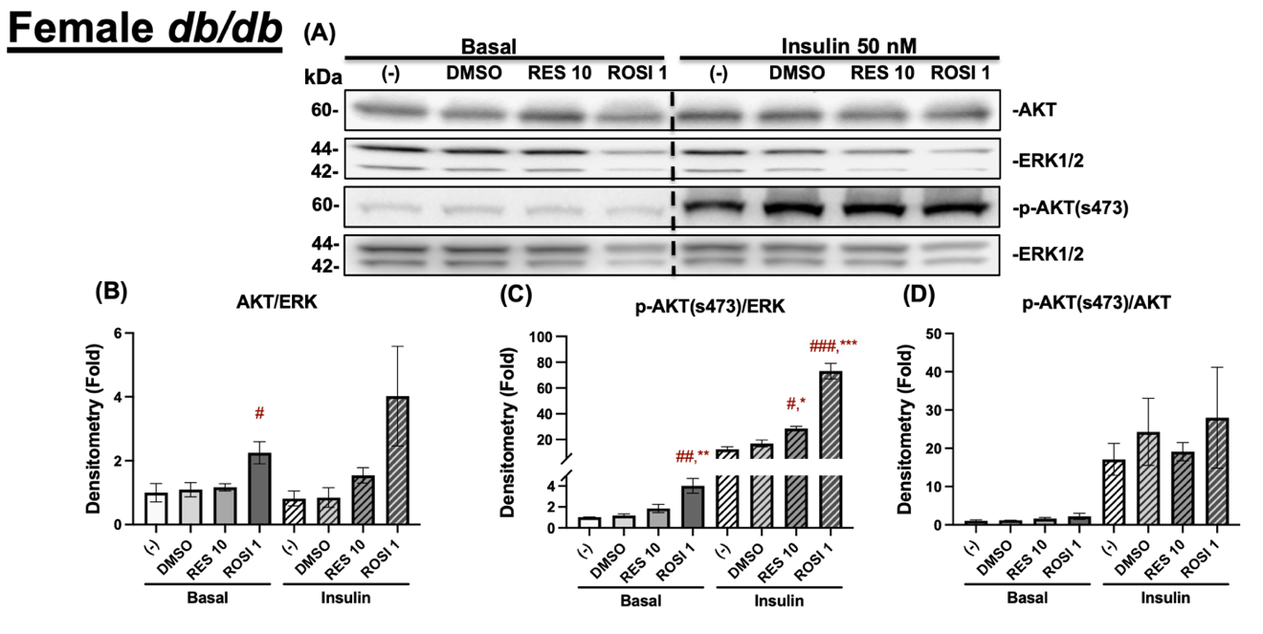
Figure 4.11 Resveratrol improved insulin sensitivity in the differentiated ADSCs from female db/db mice.
The ADSCs from the female db/db mice were differentiated for 7 days in the presence or absence of RES (10 µM), ROSI (a positive control, 1 μM), or DMSO, followed by overnight starvation in DMEM/high glucose without FBS. Cells were then stimulated with or without insulin (50 nM) for 20 minutes, and protein lysates were collected for Western blot analysis. (A) Total AKT, p-AKT (ser473), and their respective loading control ERK1/2 are shown. The left panel corresponds to the basal condition (-Insulin), and the right panel to the insulin-stimulated condition (+Insulin). Quantification of total AKT/ERK1/2 (B), p-AKT/ERK1/2 (C), and p-AKT/total AKT (D) are presented as fold change relative to the (-) group under basal conditions. Data = mean ± SEM (n = 3). One-way ANOVA was used for statistical analysis. #, ##, ### indicate p < 0.05, p < 0.01, and p < 0.001, respectively, compared to the (-) group. *, **, *** indicate p < 0.05, p < 0.01, and p < 0.001, respectively, compared to the DMSO group.
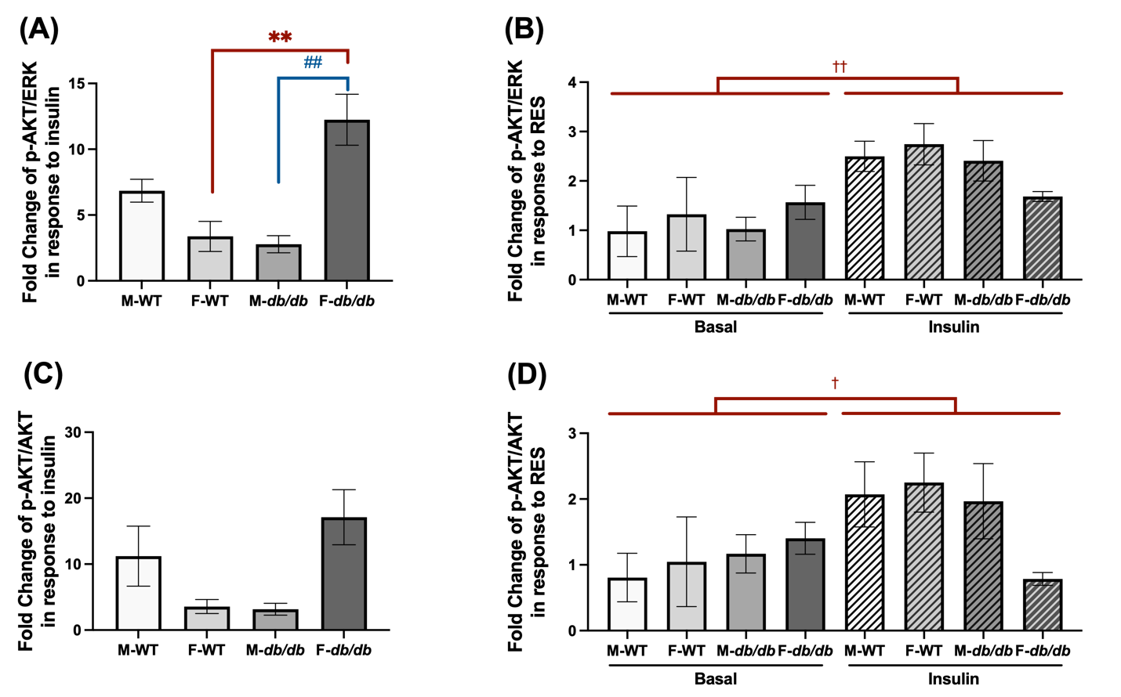
Figure 4.12 Fold changes in insulin sensitivity markers following insulin and resveratrol treatment in the differentiated ADSCs from male and female WT and db/db mice.
(A) Fold changes of p-AKT/ERK and (C) p-AKT/AKT in response to insulin were calculated for all groups. (B) Fold changes of p-AKT/ERK and (D) p-AKT/AKT in response to RES relative to the DMSO group under basal and insulin-stimulated conditions were calculated. Data = mean ± SEM (n = 3). One-way ANOVA was used for statistical analysis in (A) and (C), and two-way ANOVA was used in (B) and (D). ## indicate p < 0.01 for comparisons between males and females, while ** indicate p < 0.01 for comparisons between WT and db/db mice. †, †† indicate p < 0.05 and p < 0.01 for comparisons between basal and insulin conditions.

CHAPTER V BROWNING AND INSULIN SIGNALING IN 3T3-L1 ADIPOCYTES: EVALUATING THE CONTRIBUTION OF UCP1

Abstract
Uncoupling protein 1 (UCP1) is a central marker of browning in white adipose tissue and plays an important role in thermogenic function. Rosiglitazone (ROSI), a PPARγ agonist used to treat insulin resistance, is known to promote adipocyte differentiation and browning, which includes increased UCP1 expression. In the previous chapter, we observed that ROSI enhanced both UCP1 expression and insulin-stimulated AKT phosphorylation in the adipose-derived stromal cells, suggesting a possible connection between browning and improvement of insulin signaling. To examine whether UCP1-mediated browning contributes to enhanced insulin signaling by ROSI, we generated a 3T3-L1 cell line with Ucp 1 knockout (KO) using CRISPR/Cas9 technology. Ucp1 KO attenuated ROSI-induced differentiation of adipocytes but did correlate with the absence of proton leak and uncoupling process in mitochondria. Notably, ROSI failed to enhance insulin-stimulated AKT phosphorylation in UCP1 KO adipocytes. These findings indicate that UCP1-dependent thermogenesis is likely involved in the insulin-sensitizing actions of rosiglitazone and also support the potential implication of adipocyte browning in the modulation of insulin sensitivity and responsiveness to rosiglitazone.

Introduction
Brown and beige adipocytes are specialized types of fat cells that dissipate energy as heat instead of storing it as fat, a process known as non-shivering thermogenesis ^{447–449}. This process is mediated by uncoupling protein 1 (UCP1), a mitochondrial protein that allows protons to flow across the inner mitochondrial membrane, producing heat instead of synthesizing ATP ^{450,451}. UCP1 expression can be strongly induced by cold exposure and β-adrenergic stimulation ^{452,453}, which contributes to systemic energy expenditure and thermoregulation ⁴⁵⁴. Recently, increasing evidence from rodent and human studies suggests that activation of thermogenic fat not only increases energy expenditure but also improves glucose metabolism, as indicated by increased insulin sensitivity and glucose uptake ^{455,456}.
Rosiglitazone (ROSI) is one of the thiazolidinedione (TZD) medicines that have been used for treating type 2 diabetes mellitus ⁴⁵⁷. It primarily acts through the activation of the nuclear receptor peroxisome proliferator-activated receptor gamma (PPARγ), an important transcriptional regulator of lipid metabolism and adipocyte differentiation ^{458–460}. By activation of PPARγ, ROSI stimulates the formation of insulin-responsive adipocytes by increasing the expression of GLUT4, glucose uptake, and secretion of adiponectin, which is an adipose tissue-derived cytokine that enhances the sensitivity of the body to insulin ^{461–464}. ROSI decreases the production of pro-inflammatory cytokines TNF-α and IL-6, thus decreasing inflammation in adipose tissue ^{465–467}. ROSI has also been reported to induce browning of the white adipose tissue ^{468,469}. Mechanistically, ROSI activates PPARγ, which increases the expression of PGC1α, a transcriptional coactivator that enhances mitochondrial biogenesis and oxidative metabolism ⁴⁷⁰. PGC1α, in collaboration with PPARγ, activates the thermogenic gene Ucp1 to promote the browning of white adipocytes and increase mitochondrial thermogenesis ⁴⁷¹.
In the previous chapter, we found that ROSI induced both UCP1 expression and insulin-stimulated AKT phosphorylation in adipose-derived stromal cells (ADSCs) from mice. However, whether UCP1 is essential in the insulin-sensitizing effects of ROSI or is a co-induced effect through PPARγ activation is unclear. To answer this question, we created a CRISPR/Cas9-generated Ucp1 knockout 3T3-L1 cell model to directly test the hypothesis that UCP1 is required for enhancing insulin signaling in adipocytes by ROSI.

Materials and Methods

Generation of Ucp1 Knockout 3T3-L1 Preadipocytes
To investigate the role of UCP1 in insulin signaling in browning, the Ucp1 knockout (KO) 3T3-L1 cells were generated using the Clustered Regularly Interspaced Short Palindromic Repeats (CRISPR)/CRISPR-associated protein (Cas) 9 genome-editing approach. We first developed 3T3-L1 preadipocytes with stable expression of Cas-9 enzyme. Briefly, 3T3-L1 cells were seeded at ~70% confluency and transduced with lentiviral particles that carry the CP-LvC9NU-09 plasmid (GeneCopoeia, Rockville, MD) in the presence of 6 µg/mL polybrene (Santa Cruz Biotechnology, Dallas, TX). The diagram of the Cas9-expressing plasmid co-expressing a GFP reporter is shown in Figure 5.1. 24 hr later, the viral particle-containing media was removed, and the cells were maintained in normal cell culture media. 48 hours later, cells were selected with 600 μg/mL G418 for about two to three weeks.

sgRNA Design and Lentiviral Transfection
Subsequently, single-guide RNAs (sgRNAs) were introduced into the stable cell line of Cas-9 generated above. We employed a tandem guide RNA-based strategy to enhance the efficiency of genome editing by deleting approximately 90 nucleotides between the two sgRNAs ⁴⁷². Two sgRNAs targeting Ucp1 exon 1 were designed. The sequences of the two sgRNA were:
sgRNA-a:
5’-AACCCGACAACTTCCGAAGTGCAACCCACCATGGGGGTCAAGATCTTCTC-3’
sgRNA-c:
5’-CTGCCAAAGTCCGCCTTCAGGTAGAGTTAGTGACATTGATGAGGCTTCTC-3’
Each sgRNA was cloned into a lentiviral expression plasmid as shown in Figure 5.4. To introduce sgRNAs, Cas9-expressing 3T3-L1 cells were seeded at ~70% confluency and transduced with sgRNAs in the presence of 6 µg/mL polybrene (Santa Cruz Biotechnology, Dallas, TX). 24 hours later, the viral particle-containing media was removed, and the cells were maintained in normal cell culture media. 48 hours later, cells were selected with 2 μg/mL puromycin and 400 μg/mL G418 for about one week. These cells were then expanded and used in parallel with the scrambled control cells in the downstream experiments.

Generation of Scrambled Control Cells
The scrambled shRNA lentiviral plasmid (Cat# CSHCTR001-LVRU6P) purchased from GeneCopoeia (Rockville, MD, USA), as shown in Figure 5.3, was transduced into stable Cas9-expressing 3T3-L1 cells under the same conditions described above. Cells were then selected with 2 μg/mL puromycin and 400 μg/mL G418 for one week. These cells were expanded and used in parallel with Ucp1 KO cells in the downstream experiments.
The sequence of scrambled control:
5’-GATCCGNNNNNNNNNNNNNNNNNTCAAGAGNNNNNNNNNNNNNNNNNTTTTTTGGAATT-3’

Single Cell Cloning and Validation
The sgRNA transduced cells were grown under both G418 and puromycin selections until they reached confluence in a 35 mm plate. Single-cell clones were then isolated by serial dilution in 96-well plates. Expanded clones were screened by fluorescence microscopy to confirm co-expression of Cas9 (green) and sgRNA (cherry red), respectively. Approximately 40 single-cell clones were screened for their co-expression of Cas-9 (green) and sgRNA (cherry red). Individual clones with co-expression of both green and red fluorescence were further expanded and used for subsequent indel verification. Briefly, the genomic DNA was extracted from the cells, and PCR was performed using Ucp1-specific primers (1259 bp product), as shown Table 2. A second set of primer pairs was used to detect indel with the reverse primer designed within the cutting site of the second sgRNA to verify the absence of the PCR band on the agarose gel (the PCR product of intact Ucp1 is expected to be ~ 496 bp).
PCR amplification was performed using an Eppendorf Master cycler X50 (Eppendorf North America, Enfield, CT). 12.5 µl of PCR reaction system contained 2 μl of crude extraction supernatant (approximately 28–36 ng of DNA), 6.25 μl of DreamTaq 2× PCR master mix (ThermoFisher Scientific, Waltham, MA, USA), 0.25 µl of each primer (10 μM) (to reach final concentration of 0.2 μM). The PCR parameters were as follows: initial denaturation at 95 °C for 3 min, followed by 31 cycles of denaturation at 95 °C for 30 s, annealing at 60 °C for 40 s, and extension at 72 °C for 1 min. The final elongation step was 72 °C for 7 min. PCR products were resolved on a 1% agarose gel. A control PCR detecting the murine soluble epoxide hydrolase (sEH) gene was used to confirm DNA integrity. The primer of sEH is shown in Table 2. The image was captured by Bio-Rad ChemiDoc XRS+ with Image Lab image acquisition and analysis software (Image LabTM Software, Version 5.2.1, Bio-Rad, Hercules, CA, USA). Individual clones with co-expression of Cas-9 (green) and gRNAs (cherry red) and no detectable Ucp1 band were considered putative Ucp1 knockouts.
2.5. Sanger Sequencing
To confirm gene disruption at the nucleotide level, PCR products were purified using a ZymoCleanTM Gel DNA Recovery Kit (Zymo Research, Tustin, CA) and submitted for Sanger sequencing (Eurofins, Lancaster, PA). Sequences were aligned to the reference Ucp1 locus using the Nucleotide Blast of the National Library of Medicine (https://blast.ncbi.nlm.nih.gov/Blast.cgi). Clones with Indel in Ucp1 exon-1 on the sequencing chromatogram were used to confirm the success of Ucp1 knockout. One validated clone (Clone 8B) was selected for the subsequent experiments.

Adipogenic Differentiation
Ucp1 KO 3T3-L1 preadipocytes (Clone 8B) and scrambled control (SCR) cells were differentiated using the protocol described in Chapter IV. Briefly, differentiation was induced with an induction medium (DMEM with 10% FBS, 5 μg/ml insulin, 1 μM Dex, 0.5 mM IBMX, 125 μM Indo, and 1 nM T3) for 3 days followed by 4 days in maintenance medium (DMEM with 10% FBS, 1% P/S, 5 ug/ml insulin, and 1 nM T3). During differentiation, cells were treated with either 1 μM rosiglitazone (ROSI), 0.1% DMSO (vehicle control), or no treatment (negative control). On day 7, half of the cells were stimulated with 1 µM isoproterenol (ISO) for 6 hours to assess β-adrenergic responsiveness. ISO is a non-selective β-adrenergic agonist that mimics cold exposure in vitro³⁸³.

Semi-Quantitative Real-time PCR (qRT-PCR)
On day 7 of differentiation, total RNA was extracted via TRI Reagent (Molecular Research Center, Inc., Cincinnati, OH). Quantification and quality evaluation of the RNA were processed on a NanoDrop spectrophotometer (ThermoFisher Scientific, Waltham, MA). 2 µg of total RNA was reverse-transcribed to cDNA with the High-Capacity cDNA Reverse Transcription Kit (Applied Biosystems, Foster City, CA). The expression levels of Pgc1α, Ucp1, Pparγ, and Adiponectin were quantified using SYBR Green PCR Master Mix (Applied Biosystems, Foster City, CA) on a 7300 Real-Time PCR System (Applied Biosystems, Foster City, CA). Results are presented as folds of differences from the negative control group, while the 2^-ΔΔCt method was used to calculate the relative expression of target genes normalized by the housekeeping gene 36B4.

Mitochondrial Stress Test
Mitochondrial respiration on differentiated adipocytes was measured using a Seahorse XFe24 Analyzer (Agilent Technologies, Santa Clara, CA). Cells were plated in 24-well microplates for three hours in a maintenance medium. The cell was washed and replaced with Seahorse XF assay medium with 10 mM glucose, 2 mM glutamine, and 1 mM sodium pyruvate. The cells were then placed in a 37°C incubator for one hour in a non-CO₂ incubator.
Basal respiration, ATP-linked respiration, maximal respiration, and non-mitochondrial respiration were measured sequentially after adding oligomycin (1.5 μM), FCCP (6.5 μM), and rotenone/antimycin A (1 μM each). Measurement results from the experiments were exported as oxygen consumption respiration (OCR) over time data and calculated as OCR-linked basal and maximal respiration, proton leak, and ATP-linked respiration and coupling efficiency, based on the manufacturer’s instructions.

Insulin Signaling Study and Western Blot Analysis
At day 7 of differentiation, cells were serum starved for 15-16 hr followed by insulin (50 nM) stimulation for 20 minutes at 37°C. Post-stimulation cells were lysed in RIPA buffer (Cell Signaling Technology, Danvers, MA) containing protease and phosphatase inhibitor cocktails. Protein concentration was determined using the Pierce™ BCA Protein Assay Kit (ThermoFisher Scientific). Equal amounts of protein were loaded onto SDS-PAGE gels and transferred to PVDF membranes. Membranes were blocked with 5% non-fat milk, followed by incubation with primary antibodies anti-phospho-AKT Ser473 (1:1000; Cell Signaling Technology; Cat# 4060S), anti-total AKT (1:1000; Cell Signaling Technology; Cat# 9272), anti-ERK1/2 (1:2000; Cell Signaling Technology; Cat# 4695S) or anti-ERK1/2 (1:2000; Cell Signaling Technology; Cat# 9102S) at 4°C overnight. ERK1/2 was used as a loading control. Subsequently, membranes were washed and incubated with HRP-conjugated secondary antibodies (1:4000; Cell Signaling Technology; Cat# 7074S) for 1 hr at room temperature. Protein bands were detected using the chemiluminescent substrate SuperSignal™ West Pico PLUS or West Femto Maximum Sensitivity Substrate (ThermoFisher Scientific, Waltham, MA) and imaged with the ChemiDoc XRS+ (Bio-Rad, Hercules, CA). Band intensity was quantified using ImageJ (NIH, Bethesda, MD). AKT phosphorylation was calculated as the ratio of p-AKT to total AKT.

Statistical Analysis
Data are presented as mean ± standard error of the mean (SEM). Different statistical methods were applied as appropriate based on the experimental design and data distribution. Two-way ANOVA was used for Figure 5.5 (B, C); Figure 5.6B and Figure 5.7. Student’s t-tests were used for Figure 5.5 (E-I). One-way ANOVA was used for Figure 5.6A. A p-value < 0.05 was considered statistically significant. All statistical analyses were performed using GraphPad Prism 9 (GraphPad Software, San Diego, CA).

Results

Validation of Ucp1 Knockout in 3T3-L1 Cells
Fluorescence microscopy confirmed co-expression of Cas9-GFP and sgRNA-cherry red prior to individual clone selection through serial dilution (Figure 5.4A-D). Genomic PCR demonstrated the absence of the Ucp1 band in clone 8B, while the housekeeping gene sEH was consistently amplified, confirming DNA integrity (Figure 5.4E-F). To confirm disruption of the Ucp1 locus, PCR amplicons were subjected to Sanger sequencing (Figure 5.4G). Sequences were aligned to the reference Ucp1 locus using the Nucleotide BLAST tool of the National Library of Medicine. We attempted to use flow cytometry to sort individual cells with both green and cherry red expression into single wells of a 96-wells plate. However, we found that co-transfected 3T3-L1 cells were unable to survive beyond 3-4 days when cultured individually. We then adopted a serial dilution approach. However, in practice, the level of clonality assurance after a single round of limiting dilution remained low, likely due to insufficient cell-cell interactions and signaling required to support cell proliferation when cells were cultured individually. We finally were able to establish a few mixed clones from wells with 3-4 cells seeded. Subsequent Sanger sequencing indicated that one of these mixed clones had the expected indel at the expected locus. Therefore, it was used for all the subsequent experiments. Clone 8B showed deletion mutations in exon 1 of the Ucp1 gene; therefore, it was considered a successful knockout cell population and used for all subsequent experiments.

Ucp1 Knockout Affected Adipogenic Differentiation and Proton Leak
To evaluate adipogenic gene expression, mRNA levels of Pparγ and AdipoQ were measured on day 7 of differentiation in both the Ucp1 KO and the scrambled control (SCR) cells. In the SCR cells, ROSI significantly increased Pparγ and AdipoQ mRNA expression compared to the negative and DMSO groups (Figure 5.5B, C). In contrast, both induction of Pparγ and Adipoq expression by ROSI was markedly blunted in Ucp1 KO cells (Figure 5.5B, C). Although basal and maximal respiration were slightly reduced in Ucp1 KO cells, these differences were not statistically significant (Figure 5.5E, F). Notably, KO cells exhibited a significant reduction in proton leak and an increase in mitochondrial coupling efficiency, consistent with loss of UCP1-dependent uncoupling (Figure 5.5G, I). In addition, ATP-linked respiration was unchanged between the SCR and Ucp1 KO cells (Figure 5.5H).

Ucp1 Knockout Attenuated the Browning Effect by Rosiglitazone
Ucp1 mRNA expression was induced by ROSI under both basal and ISO stimulations in the SCR cells. As expected, Ucp1 mRNA expression was absent in the Ucp1 KO cells (Figure 5.6A). Pgc1α mRNA expression was induced by ROSI under ISO stimulation in the SCR cells, but this induction was absent in the Ucp1 KO cells. Moreover, Pgc1α mRNA expression under basal conditions was lower in the Ucp1 KO cells compared to the SCR controls (Figure 5.6B).

Ucp1 Knockout Attenuated Rosiglitazone-Enhanced Insulin Signaling
In the SCR cells, ROSI significantly enhanced insulin-stimulated phosphorylation of AKT at serine 473 residue, indicated by both p-AKT/ERK and p-AKT/AKT levels, compared to both vehicle and negative controls (Figure 5.7C, D). In contrast, Ucp1 KO cells exhibited no increase in insulin-stimulated AKT phosphorylation in response to ROSI treatment, suggesting that UCP1 is required for the insulin-sensitizing effects of ROSI in this model (Figure 5.7C, D).

Discussion
To evaluate the effects of UCP1 in adipocyte differentiation, mRNA expression of two differentiation markers Pparγ and AdipoQ was examined. Pparγ is a master transcriptional regulator of adipocyte differentiation, which is necessary to drive the conversion of precursor cells into adipocytes ⁴⁷³. It controls the expression of genes involved in lipid and glucose metabolism in adipocytes ⁴⁷⁴. AdipoQ is one of the most abundant adipocyte-secreted proteins and is expressed especially in mature adipocytes ⁴⁷⁵. Together, the expression of Pparγ and AdipoQ serves as a reliable indicator of adipocyte differentiation. ROSI upregulated both Pparγ and AdipoQ expression in both scrambled and Ucp1 KO cells, while ROSI-induced induction was markedly reduced in the Ucp1 KO cells compared to the SCR cells (Figure 5.5B, C). These results demonstrated that UCP1 is important for the full transcriptional response to ROSI, especially for genes involved in adipocyte differentiation and function (Pparγ and AdipoQ). Without UCP1, the adipogenic effects of ROSI are markedly attenuated. Recent evidence suggests that UCP1 KO causes widespread mitochondrial dysfunction in BAT, such as reduced electron transport chain protein expression, impaired calcium buffering, and greater vulnerability to ROS-induced permeability transition ⁴⁷⁶. These mitochondrial dysfunctions caused by UCP1 KO may disrupt the transcriptional environment needed for full PPARγ activation, providing a possible explanation for the diminished ROSI-induced Pparγ and AdipoQ mRNA expression observed in our study.
To evaluate mitochondrial uncoupling and confirm the functional impact of UCP1 knockout, we performed mitochondrial stress tests in the SCR and Ucp1 KO adipocytes. Mitochondrial stress test results reveal that compared to the scrambled controls, Ucp1 KO 3T3-L1 adipocytes exhibited significantly reduced proton leak and increased coupling efficiency (Figure 5.5G, I). Proton leak represents oxygen consumption not coupled to ATP synthesis and is a major readout of UCP1 activity in thermogenic adipocytes ⁴⁷⁷. Coupling efficiency quantifies the percentage of respiration used for ATP production ⁴⁷⁸. The decreased proton leak and increased coupling efficiency are consistent with the known role of UCP1 in dissipating the proton gradient to generate heat, rather than to support ATP synthesis⁴⁷⁹. Although the differences were not statistically significant, a trend toward reduced basal and maximal respiration was observed in the Ucp1 KO cells (Figure 5.5E, F). Moreover, ATP production was unchanged between the KO and the SCR cells (Figure 5.5H). Together, these results suggest that Ucp1 deletion disrupts mitochondrial uncoupling without affecting mitochondrial ATP synthesis.
Regarding the browning effect, ROSI induced the mRNA expression of thermogenic genes in the SCR cells; however, this effect was either absent or attenuated in the Ucp1 KO cells. In the SCR cells, Ucp1 mRNA expression was significantly upregulated by ROSI not only under both basal conditions and β-adrenergic stimulation (ISO) (Figure 5.6A). This is consistent with a previous report that ROSI upregulated the thermogenic regulator Ucp1 in white adipocytes ⁴⁸⁰. Pgc1α mRNA expression was also elevated by ROSI in response to ISO stimulation in the SCR control cells, in line with its role as a coactivator of PPARγ and regulator of mitochondrial gene expression ⁴⁸¹. PGC1α is also a well-known upstream regulator of UCP1 ⁴¹⁰. Both genes are often co-induced by stimuli such as cold or β-adrenergic agonists, reflecting the coordinated activation of the browning program ^{482,483}. However, ROSI failed to induce the mRNA expression of Pgc1α in the Ucp1 KO cells under both basal and ISO conditions, suggesting that deletion of Ucp1 disrupts the transcriptional programs underlying browning responses.
ROSI has been shown to enhance both thermogenesis and insulin sensitivity ^{484–486}. To examine whether these two effects are mechanistically linked, we evaluated insulin signaling in the Ucp1 KO adipocytes compared to the SCR controls. Phosphorylation of AKT at Ser473 was measured following acute insulin stimulation as a functional indicator of insulin signaling in adipocytes. In the SCR control cells, ROSI significantly enhanced insulin-stimulated AKT phosphorylation (Figure 5.7), consistent with previous findings that ROSI induced glucose uptake and AKT phosphorylation in insulin-resistant 3T3L1 adipocytes ⁴⁸⁷. In contrast, Ucp1 KO cells showed no enhancement in insulin-stimulated AKT phosphorylation following ROSI treatment under the same conditions (Figure 5.7). This difference suggests that ablation of UCP1 may interfere with the signaling pathway involved in ROSI's insulin-sensitizing effect in adipocytes.
Previous in vivo studies have also shown that activation of brown or beige adipose tissue improves systemic insulin sensitivity ^{488,489}, while Ucp1 KO mice often maintain normal or improved insulin responsiveness under certain conditions, likely due to compensatory mechanisms of elevated FGF21 and remodeling of iWAT ³⁹. In contrast, our in vitro model enables us to examine the direct effects of Ucp1 KO on adipocytes in the absence of systemic regulation, providing direct evidence that UCP1 facilitates the ROSI-induced enhancement in insulin signaling in adipocytes.
While this study provides insight into the potential role of UCP1 in ROSI-induced enhancement of insulin signaling, several limitations should be considered when interpreting the findings. The use of 3T3-L1 cells, although well established for adipocyte studies, may not fully represent the complexity of in vivo adipose tissue environment. While CRISPR/Cas9-based gene knockout enables precise perturbation of target gene function in cells, this requires a lengthy process of isolating KO subclones ⁴⁹⁰. The use of a tandem two sgRNAs approach helped achieve our near 100% indel rate. Although clone 8B was still considered a KO clone pool, it has been reported that KO cell pools generated with the tandem gRNAs can exhibit clearly identifiable phenotypes ⁴⁹⁰. Additionally, although Ucp1 knockout was confirmed at the genomic and transcript levels, this study did not assess any potential off-target effects of CRISPR editing ⁴⁹¹. Moreover, the functional impact of insulin signaling was only evaluated through AKT phosphorylation. Further studies are needed to determine whether other markers of insulin signaling or insulin-induced downstream events, such as glucose uptake, are similarly affected. To evaluate the effects of UCP1 in adipocyte differentiation, two differentiation markers Pparγ and AdipoQ mRNA levels were examined. Pparγ is a master transcriptional regulator of adipocyte differentiation, which is necessary to drive the conversion of precursor cells into adipocytes ⁴⁷³. It controls the expression of genes involved in lipid and glucose metabolism in adipocytes ⁴⁷⁴. AdipoQ is one of the most abundant adipocyte-secreted proteins and is expressed especially in mature adipocytes ⁴⁷⁵. Together, the expression of Pparγ and AdipoQ serves as a reliable indicator of adipocyte differentiation. ROSI treatment upregulated both Pparγ and AdipoQ expression in both scrambled and UCP1 KO cells, while ROSI-induced induction was markedly reduced in UCP1 KO cells compared to SCR cells (Figure 5.5B, C). These results demonstrated that UCP1 is important for the full transcriptional response to ROSI, especially for genes involved in adipocyte differentiation and function (Pparγ and AdipoQ). Without UCP1, the adipogenic effects of ROSI are markedly attenuated. Recent evidence suggests that UCP1 KO causes widespread mitochondrial dysfunction in BAT, such as reduced electron transport chain protein expression, impaired calcium buffering, and greater vulnerability to ROS-induced permeability transition ⁴⁷⁶. These mitochondrial dysfunctions caused by UCP1 KO may disrupt the transcriptional environment needed for full PPARγ activation, providing a possible explanation for the diminished ROSI-induced Pparγ and AdipoQ mRNA expression observed in our study.
While this study provides insight into the potential role of UCP1 in ROSI-induced enhancement of insulin signaling, several limitations should be considered when interpreting the findings. The use of 3T3-L1 cells, although well established for adipocyte studies, may not fully represent the complexity of in vivo adipose tissue environment. While CRISPR/Cas9-based gene knockout enable precise perturbation of target gene function in human cells, this requires the lengthy process of isolating KO subclones ⁴⁹⁰. We used a tandem two sgRNAs approach which is fast and could give close to 100% of indel rate. Although clone 8B was still considered a KO clone pool, it has been reported that using KO cell pools generated with the tandem gRNAs can lead to more clearly identifiable phenotypes ⁴⁹⁰. Additionally, although UCP1 knockout was confirmed at the genomic and transcript levels, this study did not assess potential off-target effects of CRISPR editing ⁴⁹¹. Moreover, the functional impact of insulin signaling was only evaluated through AKT phosphorylation. Further studies are needed to determine whether other markers of insulin signaling or glucose metabolism are similarly affected.

Conclusion
Using a CRISPR-based Ucp1 KO 3T3-L1 adipocyte model, we observed that compared to the SCR cells, Ucp1 KO cells had attenuated adipocyte differentiation, decreased proton leak, and increased coupling efficiency. As expected, Ucp1 KO adipocytes had impaired ROSI-induced browning. Moreover, ROSI-induced enhancement of insulin signaling was blunt in the Ucp1 KO adipocytes. These results, together with the findings from adipose-derived stromal cells from mice in Chapter IV, strongly suggest that UCP1 may facilitate the insulin-sensitizing effect of ROSI in adipocytes. Our studies shed light on the interaction between UCP1-mediated browning and enhancement of insulin signaling by ROSI and suggest the possibility that UCP1 may contribute to ROSI’s beneficial effects in adipocytes.

Appendix
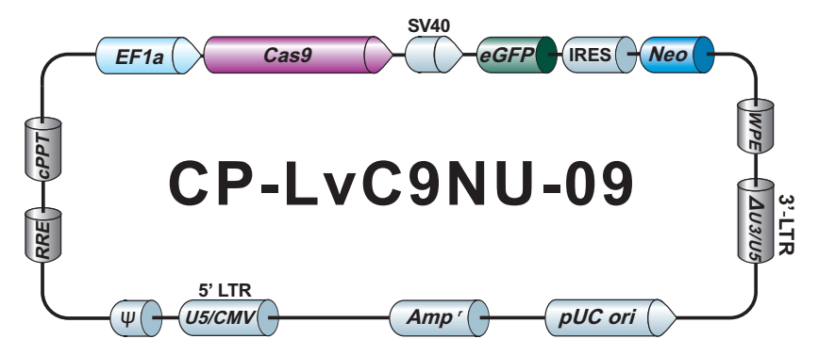
Figure 5.1 Vector map of Cas9-expressing plasmid.
This vector is used for stable expression of Cas9 in 3T3-L1 cells.

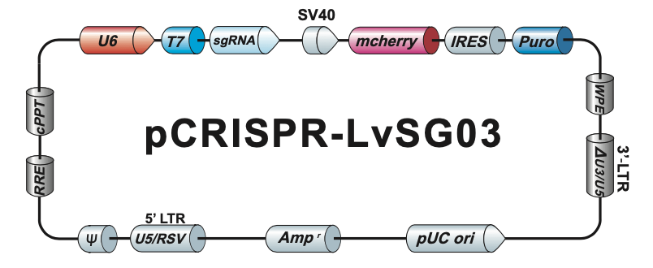
Figure 5.2 Vector map for mouse Ucp1 sgRNA-a and c.
This vector is used for generating Ucp1 Knockout 3T3-L1 cells.

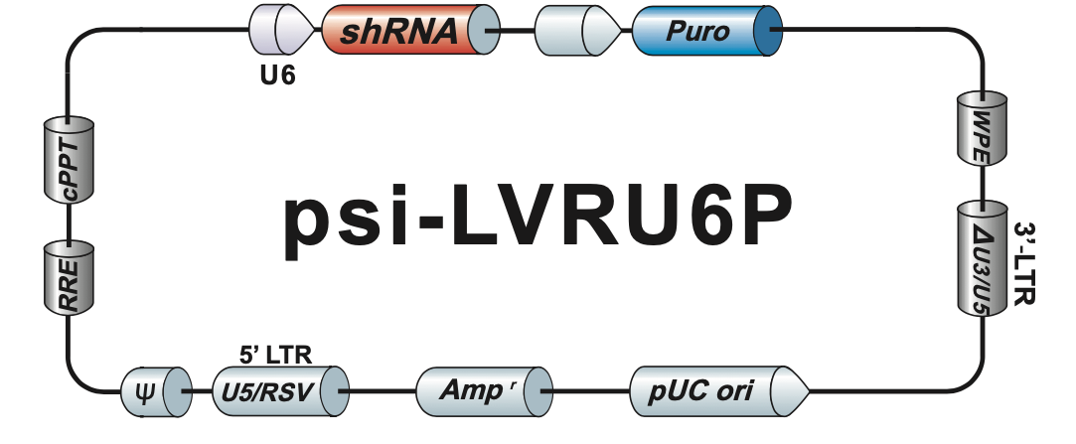
Figure 5.3 Vector map for mouse scrambled shRNA plasmid.
This vector is used for generating scrambled control 3T3-L1 cells.
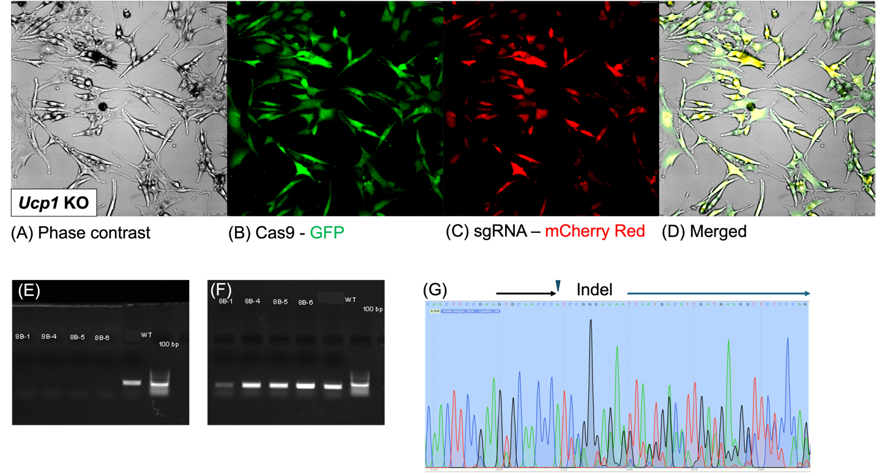
Figure 5.4 Validation of Ucp1 knockout in 3T3-L1 cells by fluorescence microscopy, genomic PCR, and Sanger sequencing.
(A–D) Fluorescence microscopy of Ucp1 KO 3T3-L1 cells after co-transfection with Cas9 and sgRNA. (A) Phase contrast image of transduced cells. (B) Green fluorescence showed Cas9 expression. (C) Cherry red fluorescence showed sgRNA expression. (D) The merged image showed the co-expression of Cas9 and sgRNA in the same cells, confirming successful delivery of CRISPR/Cas9 components. (E–F) Genomic PCR validation of Ucp1 knockout in clonal populations. (E) PCR using Ucp1-specific primers designed to amplify a 496 bp region flanking the CRISPR cut sites showed no detectable band in edited clones (8B-1, 8B-4, 8B-5, 8B-6), but a clear band for non-related sEH gene amplicons, indicating deletion of the target sequence. (F) PCR for the sEH gene served as a genomic DNA control and showed consistent amplification across all samples tested. (G) Sanger sequencing chromatogram of Clone 8B confirms the presence of insertions and/or deletions (Indels) near the expected Cas9 cut sites.

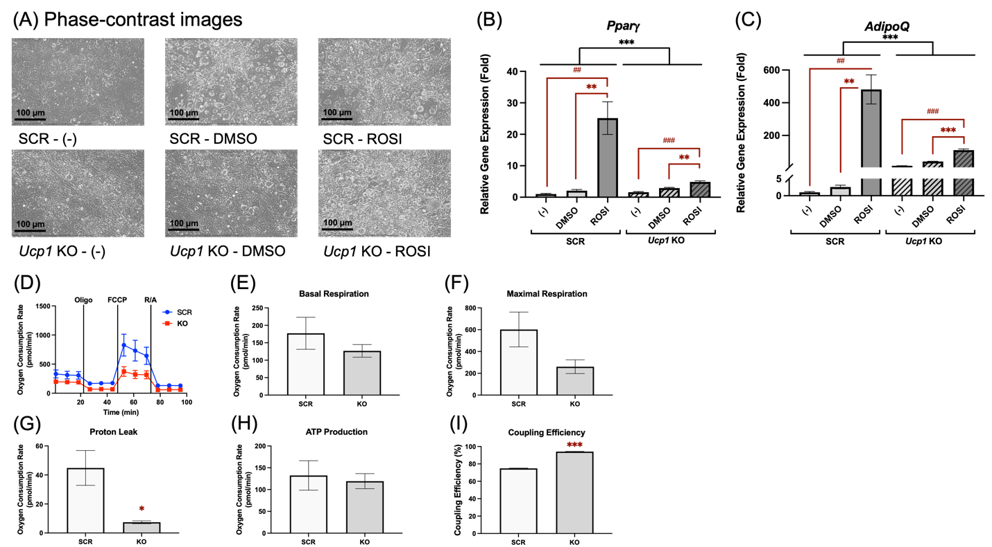
Figure 5.5 Ucp1 KO affected adipogenic differentiation and reduced proton leak in 3T3L1 adipocytes.
The scrambled control (SCR) and Ucp1 KO 3T3-L1 cells were differentiated for 7 days using a brown adipogenic protocol and treated with 1 µM of rosiglitazone (ROSI), 0.1% DMSO (vehicle), or no treatment (negative control). (A) Representative phase contrast images on day 7 show lipid droplet accumulation in the two groups. Relative mRNA expression of (B) Pparγ and (C) Adipoq was assessed. Data are presented as mean ± SEM (n=3). (D)-(I) Both SCR and Ucp1 KO 3T3-L1 preadipocytes were first differentiated for 7 days, then reseeded into a Seahorse XFe assay plate. The cells underwent real-time oxygen consumption rate (OCR) measurements for a mitochondrial stress test 3 hr after reseeding. Oxygen consumption rate (OCR) was measured under basal conditions and following sequential injections of oligomycin (Oligo), FCCP, and rotenone/antimycin A (R/A). (D) OCR over time, (E) Basal respiration, (F) Maximal respiration, (G) Proton leak, (H) ATP production, and (I) Coupling efficiency are shown. Data = mean ± SEM (n = 5). Two-way ANOVA was used for statistical analysis in (B) and (C). Student’s t-test was used for statistical analysis in (D)-(I). # indicates the comparison of ROSI vs. (–) within genotype and condition for (B, C). Red * indicates the comparison of ROSI vs. DMSO within genotype and condition for (B, C). Black * indicates the comparison of SCR vs. Ucp1 KO (B, C). #, ##, ### indicate p < 0.05, p < 0.01 and p < 0.001; *, **, *** indicate p < 0.05, p < 0.01, and p < 0.001, respectively.

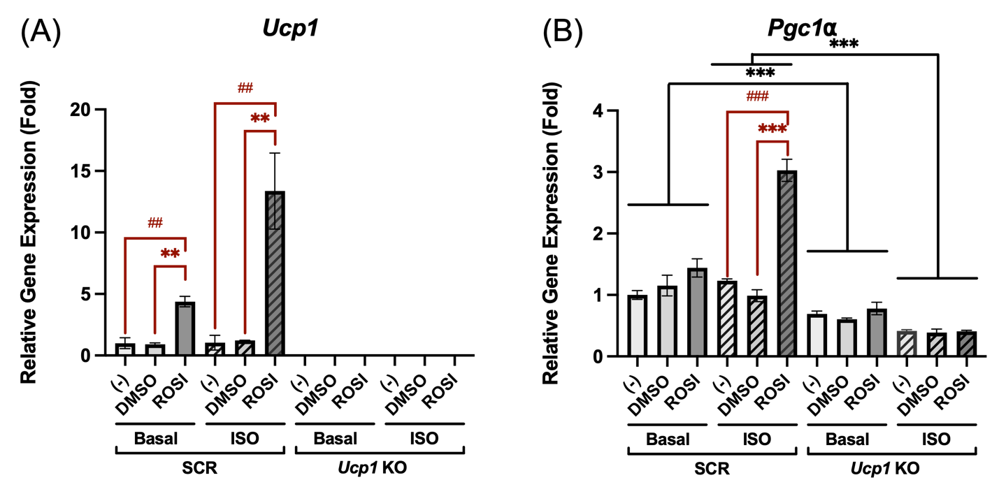
Figure 5.6 Ucp1 KO attenuated the browning response to rosiglitazone in 3T3-L1 adipocytes.
The scrambled control and Ucp1 KO 3T3-L1 preadipocytes were differentiated for 7 days using a brown adipogenic protocol and treated with 1 µM of rosiglitazone (ROSI), 0.1% DMSO (vehicle control), or without treatment (negative control). Relative mRNA expression of (A) Ucp1 and (B) Pgc1α was assessed under basal or 1 µM isoproterenol (ISO) stimulation for 6 hr. Data are presented as mean ± SEM (n=3). One-way ANOVA was used for statistical analysis in (A). Two-way ANOVA was used for statistical analysis in (B). # indicates the comparison of ROSI vs. (–) within genotype and condition; * indicates the comparison of ROSI vs. DMSO within genotype and condition. ##, ### indicate p < 0.01 and p < 0.001; **, *** indicate p < 0.01 and p < 0.001.

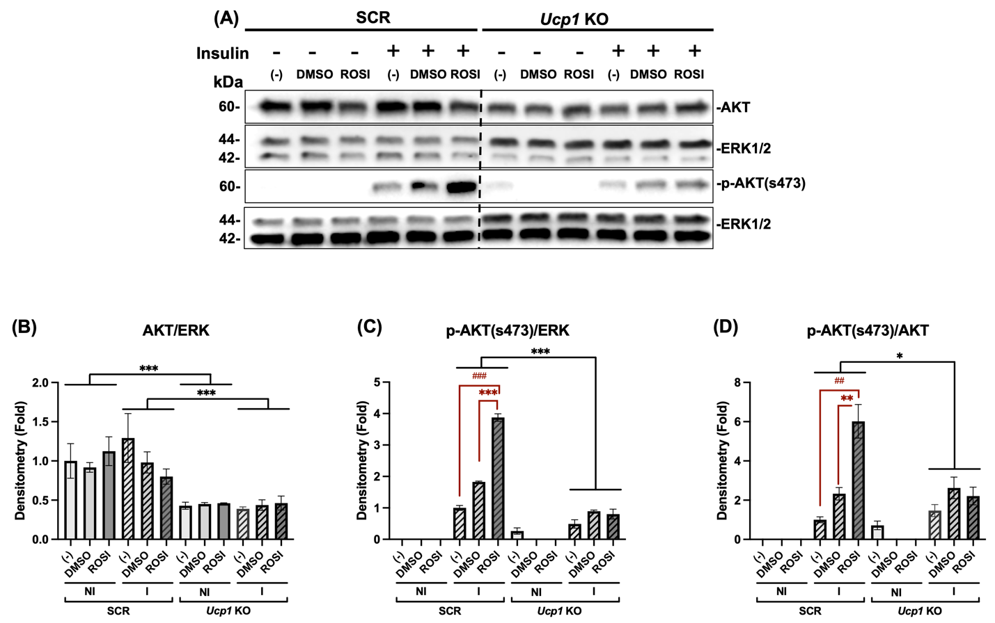
Figure 5.7 Ucp1 KO attenuated the enhancement of insulin signaling by rosiglitazone in 3T3-L1 adipocytes.
The scrambled control and Ucp1 KO 3T3-L1 adipocytes were differentiated for 7 days in the presence of ROSI (1 µM), 0.1% DMSO (vehicle control), or without treatment (negative control). On day 7, cells were starved overnight in DMEM/high glucose without FBS. Cells were then stimulated with or without insulin (50 nM) for 20 minutes, and protein lysates were collected for Western blot analysis. (A) Representative western blots showing expression of total AKT, phospho-AKT (s473), and ERK1/2 (loading control). (B) Quantification of total AKT/ERK1/2, (C) p-AKT/ERK1/2, and (D) p-AKT/total AKT presented as fold change relative to basal negative control (-) in the SCR cells. Data = mean ± SEM (n = 3). Two-way ANOVA was used for statistical analysis. ##, ### indicate p < 0.01 and p < 0.001 compared to the negative control group (-); red * indicates the comparison of ROSI vs. DMSO within genotype and condition; black * indicates the comparison of SCR vs. Ucp1 KO. ##, ### indicate p < 0.01 and p < 0.001.*, **, *** indicate p < 0.05, p < 0.01, and p < 0.001, respectively.
Table 1. Primer sequences for qRT-PCR using SYBR green.
36b4 | Forward | GCTTCGTGTTCACCAAGGAGGA
36b4 | Reverse | GTCCTAGACCAGTGTTCTGAGC
Pgc1α | Forward | GAATCAAGCCACTACAGACACCG
Pgc1α | Reverse | CATCCCTCTTGAGCCTTTCGTG
Pparγ | Forward | GTACTGTCGGTTTCAGAAGTGCC
Pparγ | Reverse | ATCTCCGCCAACAGCTTCTCCT
Ucp1 | Forward | GCTTTGCCTCACTCAGGATTGG
Ucp1 | Reverse | CCAATGAACACTGCCACACCTC
Ucp1 (Chapter V) | Forward | TTTCAGCTTGCCTGGCAGAT
Ucp1 (Chapter V) | Reverse | AGACCGCTGTACAGTTTCGG
Adipoq | Forward | AGATGGCACTCCTGGAGAGAAG
Adipoq | Reverse | ACATAAGCGGCTTCTCCAGGCT

Table 2. Primer sequences for Sanger sequencing, Ucp1 deletion verification, and genomic DNA quality.
Gene name | Primer sequences
Ucp1 | Forward | ATCAGAGGTGATGTGGCCAG
Ucp1 | Reverse | ATCTGCCAGGCAAGCTGAAA
sEH | Forward | TGGCACGACCCTAATCTTAGGTTC
sEH | Reverse | TGCACGCTGGCATTTTAACACCAG

CHAPTER VI CONCLUSION AND FUTURE DIRECTIONS

Conclusion
Three interrelated research projects advance our understanding of thermogenic dysfunction in obesity, the therapeutic potential of resveratrol (RES) in browning and insulin sensitization, and the role of UCP1-mediated browning in adipocyte insulin sensitivity.
Chapter III focuses on the physiological and molecular thermogenic phenotype of leptin receptor-deficient (db/db) mice in comparison to wild-type controls. It was found that db/db mice have impaired thermogenesis, as evidenced by lower core body temperatures during cold exposure, reduced metabolic efficiency, and decreased expression of thermogenic proteins (PGC1α and UCP1) in both BAT and sWAT. Notably, although obesity abolished sex differences in weight, female db/db mice had greater cold intolerance and increased sWAT accumulation compared to males. These differences, however, did not appear to be linked to differences in PGC1 and UCP1 protein expression, as there do not appear to be significant differences in those protein expressions between female and male db/db mice. These findings suggest that db/db mice possess systemic defects in thermogenesis and highlight sex-specific vulnerability in cold defense mechanisms in these mice.
Chapter IV focuses on the browning capacity and insulin sensitizing effect of the ADSCs isolated from the sWAT of db/db and WT mice in response to RES or ROSI. Similar to ROSI, RES significantly upregulated the mRNA levels of thermogenic genes (Ucp1 and Pgc1α) in the ADSCs from both lean and diabetic mice, regardless of sex. RES also enhanced mitochondrial proton leak, decreased coupling efficiency, and improved insulin-induced AKT phosphorylation, although the levels of improvement differed by diabetic status and sex. Together, these data suggest that although diabetic mice exhibit thermogenic impairment, their ADSCs remain responsive to browning stimuli, and that RES acts as both a browning agent and an insulin sensitizer. Furthermore, this study demonstrates sexually dimorphic responsiveness to RES in diabetic ADSCs.
Chapter V aims to determine the functional contribution of UCP1-mediated browning to the insulin-sensitizing effects of ROSI. Using a CRISPR-generated Ucp1 KO 3T3-L1 adipocyte model, we demonstrated that 3T3-L1 cells with Ucp1 KO show attenuated adipogenic differentiation, decreased mitochondrial proton leak and increased coupling efficiency, and no enhancement of insulin-stimulated AKT phosphorylation by ROSI. Our work highlights the extent to which UCP1 contributes to the metabolic benefits of pharmacological browning and underscores the requirement of UCP1 functionality in developing adipose-targeted insulin sensitizers.
In summary, this dissertation demonstrates that thermogenic deficiencies in db/db mice are deep at the physiological and molecular levels, although they are not entirely irreparable. Both ROSI and RES can induce browning and improve insulin signaling in the diabetic stromal cells. Importantly, UCP1 plays an important role in mediating these effects, and its absence compromises the insulin-sensitizing effect of ROSI. These findings offer new insights into sex-specific thermogenic regulation, highlight RES as a potential candidate for metabolic therapy, and clarify the functional significance of UCP1 in mediating insulin-sensitizing effects in adipocytes.

Significance of the Studies
This dissertation contributes to the understanding of thermogenesis, adipocyte function, and insulin action in the context of obesity and T2DM. Through the study of db/db mice, this work provides a comprehensive physiological and molecular profiling of thermogenic deficiency, identifies sex-specific vulnerabilities in cold tolerance, and demonstrates that the ADSCs retain the potential to undergo functional browning even in diabetic conditions. In the ADSCs from diabetic mice, RES also induced browning and insulin sensitization, indicating its therapeutic potential in a metabolically compromised context. Furthermore, ROSI's insulin-sensitizing effects are dependent on UCP1 in adipocytes, providing direct evidence that mitochondrial uncoupling contributes to ROSI’s insulin-sensitizing effects in adipocytes. Collectively, these studies highlight the potential of browning adipocytes as therapeutic approaches to obesity and T2DM, while emphasizing the need to consider biological sex, diabetic status, and thermogenic function of the host.

Limitations and Future Directions
While the findings presented in this dissertation provide important advances in understanding adipose tissue thermogenesis and insulin sensitivity, several limitations need to be acknowledged. First, although db/db mice serve as a well-established genetic model for obesity and T2DM, the complete absence of leptin signaling in these animals may not fully replicate the complexity of human obesity and T2DM. Thus, future studies are needed to confirm key findings using alternative models, such as diet-induced obesity or leptin-resistant mice. In addition, although sex differences were a central focus of the research, we did not assess hormone levels or the activity of the sympathetic nervous system, both of which likely influence the sex-specific thermogenic responses. Future studies should evaluate these variables using hormonal assays and neuroanatomical analyses to determine whether they contribute to the observed sex-specific thermogenic responses. In the CRISPR-based UCP1 knockout model, challenges arose from technical difficulties in clonal selection. Specifically, the difficulty in obtaining a stable single-cell clone and the observed batch-to-batch variability posed risks of confounding. Moreover, while phosphorylated AKT signaling is a reliable readout of insulin signaling, more comprehensive profiling of other downstream insulin-responsive processes, such as GLUT4 translocation and glucose uptake, would yield a more thorough evaluation of functional insulin sensitivity. Collectively, these approaches will enhance our understanding of the relationship between adipose tissue plasticity and metabolic health, and facilitate the development of novel and effective therapies for obesity and T2DM.

References
1. Balasundaram P, Daley SF. Public Health Considerations Regarding Obesity. In: StatPearls. StatPearls Publishing; 2025. Accessed June 12, 2025. http://www.ncbi.nlm.nih.gov/books/NBK572122/
2. Yang M, Liu S, Zhang C. The Related Metabolic Diseases and Treatments of Obesity. Healthcare. 2022;10(9):1616. doi:10.3390/healthcare10091616
3. Panuganti KK, Nguyen M, Kshirsagar RK. Obesity. In: StatPearls. StatPearls Publishing; 2025. Accessed June 12, 2025. http://www.ncbi.nlm.nih.gov/books/NBK459357/
4. Richard AJ, White U, Elks CM, Stephens JM. Adipose Tissue: Physiology to Metabolic Dysfunction. In: Feingold KR, Ahmed SF, Anawalt B, et al., eds. Endotext. MDText.com, Inc.; 2000. Accessed June 12, 2025. http://www.ncbi.nlm.nih.gov/books/NBK555602/
5. Choe SS, Huh JY, Hwang IJ, Kim JI, Kim JB. Adipose Tissue Remodeling: Its Role in Energy Metabolism and Metabolic Disorders. Front Endocrinol. 2016;7. doi:10.3389/fendo.2016.00030
6. Saito M, Okamatsu-Ogura Y. Thermogenic Brown Fat in Humans: Implications in Energy Homeostasis, Obesity and Metabolic Disorders. World J Mens Health. 2023;41(3):489-507. doi:10.5534/wjmh.220224
7. Fedorenko A, Lishko PV, Kirichok Y. Mechanism of Fatty-Acid-Dependent UCP1 Uncoupling in Brown Fat Mitochondria. Cell. 2012;151(2):400-413. doi:10.1016/j.cell.2012.09.010
8. Townsend KL, Tseng YH. Brown Fat Fuel Utilization and Thermogenesis. Trends Endocrinol Metab. 2014;25(4):168-177. doi:10.1016/j.tem.2013.12.004
9. Wu J, Boström P, Sparks LM, et al. Beige Adipocytes are a Distinct Type of Thermogenic Fat Cell in Mouse and Human. Cell. 2012;150(2):366-376. doi:10.1016/j.cell.2012.05.016
10. Liu X, Zhang Z, Song Y, Xie H, Dong M. An update on brown adipose tissue and obesity intervention: Function, regulation and therapeutic implications. Front Endocrinol (Lausanne). 2023;13:1065263. doi:10.3389/fendo.2022.1065263
11. Cohen P, Kajimura S. The cellular and functional complexity of thermogenic fat. Nat Rev Mol Cell Biol. 2021;22(6):393-409. doi:10.1038/s41580-021-00350-0
12. Singh AM, Zhang L, Avery J, et al. Human beige adipocytes for drug discovery and cell therapy in metabolic diseases. Nat Commun. 2020;11(1):2758. doi:10.1038/s41467-020-16340-3
13. Navarro-Perez J, Carobbio S. Adipose tissue-derived stem cells, in vivo and in vitro models for metabolic diseases. Biochemical Pharmacology. 2024;222:116108. doi:10.1016/j.bcp.2024.116108
14. Soccio RE, Chen ER, Lazar MA. Thiazolidinediones and the Promise of Insulin Sensitization in Type 2 Diabetes. Cell Metabolism. 2014;20(4):573-591. doi:10.1016/j.cmet.2014.08.005
15. Bartesaghi S, Hallen S, Huang L, et al. Thermogenic Activity of UCP1 in Human White Fat-Derived Beige Adipocytes. Molecular Endocrinology. 2015;29(1):130-139. doi:10.1210/me.2014-1295
16. Farhan M, Rizvi A. The Pharmacological Properties of Red Grape Polyphenol Resveratrol: Clinical Trials and Obstacles in Drug Development. Nutrients. 2023;15(20):4486. doi:10.3390/nu15204486
17. Zhang X, Li X, Fang H, et al. Flavonoids as inducers of white adipose tissue browning and thermogenesis: signalling pathways and molecular triggers. Nutr Metab (Lond). 2019;16:47. doi:10.1186/s12986-019-0370-7
18. Gregg EW, Shaw JE. Global Health Effects of Overweight and Obesity. New England Journal of Medicine. 2017;377(1):80-81. doi:10.1056/NEJMe1706095
19. Eknoyan G. Adolphe Quetelet (1796–1874)—the average man and indices of obesity. Nephrology Dialysis Transplantation. 2008;23(1):47-51. doi:10.1093/ndt/gfm517
20. Whitlock EP, Williams SB, Gold R, Smith PR, Shipman SA. Screening and Interventions for Childhood Overweight: A Summary of Evidence for the US Preventive Services Task Force. Pediatrics. 2005;116(1):e125-e144. doi:10.1542/peds.2005-0242
21. Lingvay I, Cohen RV, Roux CW le, Sumithran P. Obesity in adults. The Lancet. 2024;404(10456):972-987. doi:10.1016/S0140-6736(24)01210-8
22. McLaughlin T, Abbasi F, Cheal K, Chu J, Lamendola C, Reaven G. Use of Metabolic Markers To Identify Overweight Individuals Who Are Insulin Resistant. Ann Intern Med. 2003;139(10):802-809. doi:10.7326/0003-4819-139-10-200311180-00007
23. Chait A, den Hartigh LJ. Adipose Tissue Distribution, Inflammation and Its Metabolic Consequences, Including Diabetes and Cardiovascular Disease. Front Cardiovasc Med. 2020;7. doi:10.3389/fcvm.2020.00022
24. Obesity and overweight. Accessed May 28, 2025. https://www.who.int/news-room/fact-sheets/detail/obesity-and-overweight
25. Ng M, Gakidou E, Lo J, et al. Global, regional, and national prevalence of adult overweight and obesity, 1990–2021, with forecasts to 2050: a forecasting study for the Global Burden of Disease Study 2021. The Lancet. 2025;405(10481):813-838. doi:10.1016/S0140-6736(25)00355-1
26. Ford ND, Patel SA, Narayan KMV. Obesity in Low- and Middle-Income Countries: Burden, Drivers, and Emerging Challenges. Annu Rev Public Health. 2017;38(1):145-164. doi:10.1146/annurev-publhealth-031816-044604
27. Tirthani E, Said MS, Rehman A. Genetics and Obesity. In: StatPearls. StatPearls Publishing; 2025. Accessed June 11, 2025. http://www.ncbi.nlm.nih.gov/books/NBK573068/
28. Chung WK. An Overview of Mongenic and Syndromic Obesities in Humans. Pediatr Blood Cancer. 2012;58(1):122-128. doi:10.1002/pbc.23372
29. Saeed S, Bonnefond A, Manzoor J, et al. Genetic variants in LEP, LEPR, and MC4R explain 30% of severe obesity in children from a consanguineous population. Obesity. 2015;23(8):1687-1695. doi:10.1002/oby.21142
30. Chaves C, Kay T, Anselmo J. Early onset obesity due to a mutation in the human leptin receptor gene. Endocrinol Diabetes Metab Case Rep. 2022;2022:21-0124. doi:10.1530/EDM-21-0124
31. Hinney A, Hebebrand J. Polygenic Obesity in Humans. Obes Facts. 2008;1(1):35-42. doi:10.1159/000113935
32. Hinney A, Nguyen TT, Scherag A, et al. Genome Wide Association (GWA) Study for Early Onset Extreme Obesity Supports the Role of Fat Mass and Obesity Associated Gene (FTO) Variants. PLOS ONE. 2007;2(12):e1361. doi:10.1371/journal.pone.0001361
33. Grant SFA, Li M, Bradfield JP, et al. Association Analysis of the FTO Gene with Obesity in Children of Caucasian and African Ancestry Reveals a Common Tagging SNP. PLOS ONE. 2008;3(3):e1746. doi:10.1371/journal.pone.0001746
34. Thorleifsson G, Walters GB, Gudbjartsson DF, et al. Genome-wide association yields new sequence variants at seven loci that associate with measures of obesity. Nat Genet. 2009;41(1):18-24. doi:10.1038/ng.274
35. Gunay-Aygun M, Cassidy SB, Nicholls RD. Prader–Willi and Other Syndromes Associated with Obesity and Mental Retardation. Behav Genet. 1997;27(4):307-324. doi:10.1023/A:1025683829856
36. Mahmoud AM. An Overview of Epigenetics in Obesity: The Role of Lifestyle and Therapeutic Interventions. Int J Mol Sci. 2022;23(3):1341. doi:10.3390/ijms23031341
37. Wu YL, Lin ZJ, Li CC, et al. Epigenetic regulation in metabolic diseases: mechanisms and advances in clinical study. Sig Transduct Target Ther. 2023;8(1):1-27. doi:10.1038/s41392-023-01333-7
38. Mantzorou M, Papandreou D, Pavlidou E, et al. Maternal Gestational Diabetes Is Associated with High Risk of Childhood Overweight and Obesity: A Cross-Sectional Study in Pre-School Children Aged 2–5 Years. Medicina (Kaunas). 2023;59(3):455. doi:10.3390/medicina59030455
39. Bao W, Michels KB, Tobias DK, et al. Parental smoking during pregnancy and the risk of gestational diabetes in the daughter. Int J Epidemiol. 2016;45(1):160-169. doi:10.1093/ije/dyv334
40. Taveras EM, Rifas-Shiman SL, Oken E, Gunderson EP, Gillman MW. Short Sleep Duration in Infancy and Risk of Childhood Overweight. Archives of Pediatrics & Adolescent Medicine. 2008;162(4):305-311. doi:10.1001/archpedi.162.4.305
41. Woo Baidal JA, Locks LM, Cheng ER, Blake-Lamb TL, Perkins ME, Taveras EM. Risk Factors for Childhood Obesity in the First 1,000 Days: A Systematic Review. Am J Prev Med. 2016;50(6):761-779. doi:10.1016/j.amepre.2015.11.012
42. Reilly JJ, Armstrong J, Dorosty AR, et al. Early life risk factors for obesity in childhood: cohort study. BMJ. 2005;330(7504):1357. doi:10.1136/bmj.38470.670903.E0
43. Young BE, Johnson SL, Krebs NF. Biological Determinants Linking Infant Weight Gain and Child Obesity: Current Knowledge and Future Directions. Advances in Nutrition. 2012;3(5):675-686. doi:10.3945/an.112.002238
44. Leitzmann M. Physical activity, sedentary behaviour, and obesity. In: Romieu I, Dossus L, Willett WC, eds. Energy Balance and Obesity. IARC Working Group Reports. International Agency for Research on Cancer; 2017. Accessed June 11, 2025. http://www.ncbi.nlm.nih.gov/books/NBK565813/
45. Moschonis G, Trakman GL. Overweight and Obesity: The Interplay of Eating Habits and Physical Activity. Nutrients. 2023;15(13):2896. doi:10.3390/nu15132896
46. Verhavert Y, De Martelaer K, Van Hoof E, Van Der Linden E, Zinzen E, Deliens T. The Association between Energy Balance-Related Behavior and Burn-Out in Adults: A Systematic Review. Nutrients. 2020;12(2):397. doi:10.3390/nu12020397
47. Wilkin LD, Cheryl A, Haddock BL. Energy expenditure comparison between walking and running in average fitness individuals. J Strength Cond Res. 2012;26(4):1039-1044. doi:10.1519/JSC.0b013e31822e592c
48. Wilke NA, Sheldahl LM, Dougherty SM, Hanna RD, Nickele GA, Tristani FE. Energy expenditure during household tasks in women with coronary artery disease. Am J Cardiol. 1995;75(10):670-674. doi:10.1016/S0002-9149(99)80651-1
49. Tsochantaridou A, Sergentanis TN, Grammatikopoulou MG, Merakou K, Vassilakou T, Kornarou E. Food Advertisement and Dietary Choices in Adolescents: An Overview of Recent Studies. Children (Basel). 2023;10(3):442. doi:10.3390/children10030442
50. MOHAMMADBEIGI A, ASGARIAN A, MOSHIR E, et al. Fast food consumption and overweight/obesity prevalence in students and its association with general and abdominal obesity. J Prev Med Hyg. 2018;59(3):E236-E240. doi:10.15167/2421-4248/jpmh2018.59.3.830
51. Adnan D, Trinh J, Bishehsari F. Inconsistent eating time is associated with obesity: A prospective study. EXCLI J. 2022;21:300-306. doi:10.17179/excli2021-4324
52. Kim MS, Shim I, Fahed AC, et al. Association of genetic risk, lifestyle, and their interaction with obesity and obesity-related morbidities. Cell Metabolism. 2024;36(7):1494-1503.e3. doi:10.1016/j.cmet.2024.06.004
53. Segal Y, Gunturu S. Psychological Issues Associated With Obesity. In: StatPearls. StatPearls Publishing; 2025. Accessed June 11, 2025. http://www.ncbi.nlm.nih.gov/books/NBK603747/
54. Barber TM, Hanson P, Weickert MO, Franks S. Obesity and Polycystic Ovary Syndrome: Implications for Pathogenesis and Novel Management Strategies. Clin Med Insights Reprod Health. 2019;13:1179558119874042. doi:10.1177/1179558119874042
55. Sanyal D, Raychaudhuri M. Hypothyroidism and obesity: An intriguing link. Indian J Endocrinol Metab. 2016;20(4):554-557. doi:10.4103/2230-8210.183454
56. Dayabandara M, Hanwella R, Ratnatunga S, Seneviratne S, Suraweera C, de Silva VA. Antipsychotic-associated weight gain: management strategies and impact on treatment adherence. Neuropsychiatr Dis Treat. 2017;13:2231-2241. doi:10.2147/NDT.S113099
57. Petimar J, Young JG, Yu H, et al. Medication-Induced Weight Change Across Common Antidepressant Treatments. Ann Intern Med. 2024;177(8):993-1003. doi:10.7326/M23-2742
58. Rogers CC, Alloway RR, Buell JF, et al. Body Weight Alterations Under Early Corticosteroid Withdrawal and Chronic Corticosteroid Therapy with Modern Immunosuppression. Transplantation. 2005;80(1):26. doi:10.1097/01.TP.0000164290.17030.BC
59. Bremner JD, Moazzami K, Wittbrodt MT, et al. Diet, Stress and Mental Health. Nutrients. 2020;12(8):2428. doi:10.3390/nu12082428
60. Selvaraj R, Selvamani TY, Zahra A, et al. Association Between Dietary Habits and Depression: A Systematic Review. Cureus. 14(12):e32359. doi:10.7759/cureus.32359
61. Pechey R, Monsivais P. Socioeconomic inequalities in the healthiness of food choices: Exploring the contributions of food expenditures. Prev Med. 2016;88:203-209. doi:10.1016/j.ypmed.2016.04.012
62. Oliver G, Wardle J, Gibson EL. Stress and Food Choice: A Laboratory Study. Biopsychosocial Science and Medicine. 2000;62(6):853.
63. Epel E, Lapidus R, McEwen B, Brownell K. Stress may add bite to appetite in women: a laboratory study of stress-induced cortisol and eating behavior. Psychoneuroendocrinology. 2001;26(1):37-49. doi:10.1016/S0306-4530(00)00035-4
64. Zellner DA, Loaiza S, Gonzalez Z, et al. Food selection changes under stress. Physiology & Behavior. 2006;87(4):789-793. doi:10.1016/j.physbeh.2006.01.014
65. Carvajal-Aldaz D, Cucalon G, Ordonez C. Food insecurity as a risk factor for obesity: A review. Front Nutr. 2022;9:1012734. doi:10.3389/fnut.2022.1012734
66. Fujisaka S, Watanabe Y, Tobe K. The gut microbiome: a core regulator of metabolism. Published online March 1, 2023. doi:10.1530/JOE-22-0111
67. Turnbaugh PJ, Ley RE, Mahowald MA, Magrini V, Mardis ER, Gordon JI. An obesity-associated gut microbiome with increased capacity for energy harvest. Nature. 2006;444(7122):1027-1031. doi:10.1038/nature05414
68. Bäckhed F, Ding H, Wang T, et al. The gut microbiota as an environmental factor that regulates fat storage. Proceedings of the National Academy of Sciences. 2004;101(44):15718-15723. doi:10.1073/pnas.0407076101
69. Tolhurst G, Heffron H, Lam YS, et al. Short-Chain Fatty Acids Stimulate Glucagon-Like Peptide-1 Secretion via the G-Protein–Coupled Receptor FFAR2. Diabetes. 2012;61(2):364-371. doi:10.2337/db11-1019
70. Psichas A, Sleeth ML, Murphy KG, et al. The short chain fatty acid propionate stimulates GLP-1 and PYY secretion via free fatty acid receptor 2 in rodents. Int J Obes. 2015;39(3):424-429. doi:10.1038/ijo.2014.153
71. Cani PD, Amar J, Iglesias MA, et al. Metabolic Endotoxemia Initiates Obesity and Insulin Resistance. Diabetes. 2007;56(7):1761-1772. doi:10.2337/db06-1491
72. Jaskulak M, Zimowska M, Rolbiecka M, Zorena K. Understanding the role of endocrine disrupting chemicals as environmental obesogens in the obesity epidemic: A comprehensive overview of epidemiological studies between 2014 and 2024. Ecotoxicology and Environmental Safety. 2025;299:118401. doi:10.1016/j.ecoenv.2025.118401
73. Egusquiza RJ, Blumberg B. Environmental Obesogens and Their Impact on Susceptibility to Obesity: New Mechanisms and Chemicals. Endocrinology. 2020;161(3):bqaa024. doi:10.1210/endocr/bqaa024
74. Grün F, Blumberg B. Minireview: The Case for Obesogens. Mol Endocrinol. 2009;23(8):1127-1134. doi:10.1210/me.2008-0485
75. Griffin MD, Pereira SR, DeBari MK, Abbott RD. Mechanisms of action, chemical characteristics, and model systems of obesogens. BMC Biomed Eng. 2020;2:6. doi:10.1186/s42490-020-00040-6
76. Naomi R, Yazid MD, Bahari H, et al. Bisphenol A (BPA) Leading to Obesity and Cardiovascular Complications: A Compilation of Current In Vivo Study. Int J Mol Sci. 2022;23(6):2969. doi:10.3390/ijms23062969
77. Gharipour M, Craig JM, Stephenson G. Epigenetic programming of obesity in early life through modulation of the kynurenine pathway. Int J Obes (Lond). 2025;49(1):49-53. doi:10.1038/s41366-024-01647-8
78. Alvarado-Cruz I, Alegría-Torres JA, Montes-Castro N, Jiménez-Garza O, Quintanilla-Vega B. Environmental Epigenetic Changes, as Risk Factors for the Development of Diseases in Children: A Systematic Review. Ann Glob Health. 84(2):212-224. doi:10.29024/aogh.909
79. Li S, Chen M, Li Y, Tollefsbol TO. Prenatal epigenetics diets play protective roles against environmental pollution. Clin Epigenetics. 2019;11:82. doi:10.1186/s13148-019-0659-4
80. Heindel JJ, Lustig RH, Howard S, Corkey BE. Obesogens: a unifying theory for the global rise in obesity. Int J Obes. 2024;48(4):449-460. doi:10.1038/s41366-024-01460-3
81. Han SJ, Lee SH. Nontraditional Risk Factors for Obesity in Modern Society. Journal of Obesity & Metabolic Syndrome. 2021;30(2):93-103. doi:10.7570/jomes21004
82. Shah A, Davarci O, Chaftari P, Avenatti E. Obesity as a Disease: A Primer on Clinical and Physiological Insights. Methodist Debakey Cardiovasc J. 21(2):4-13. doi:10.14797/mdcvj.1515
83. Chandrasekaran P, Weiskirchen R. The Role of Obesity in Type 2 Diabetes Mellitus—An Overview. International Journal of Molecular Sciences. 2024;25(3):1882. doi:10.3390/ijms25031882
84. Adolph TE, Grander C, Grabherr F, Tilg H. Adipokines and Non-Alcoholic Fatty Liver Disease: Multiple Interactions. Int J Mol Sci. 2017;18(8):1649. doi:10.3390/ijms18081649
85. Battineni G, Sagaro GG, Chintalapudi N, Amenta F, Tomassoni D, Tayebati SK. Impact of Obesity-Induced Inflammation on Cardiovascular Diseases (CVD). International Journal of Molecular Sciences. 2021;22(9):4798. doi:10.3390/ijms22094798
86. Fuster JJ, Ouchi N, Gokce N, Walsh K. Obesity-induced Changes in Adipose Tissue Microenvironment and Their Impact on Cardiovascular Disease. Circ Res. 2016;118(11):1786-1807. doi:10.1161/CIRCRESAHA.115.306885
87. Stasi A, Cosola C, Caggiano G, et al. Obesity-Related Chronic Kidney Disease: Principal Mechanisms and New Approaches in Nutritional Management. Front Nutr. 2022;9:925619. doi:10.3389/fnut.2022.925619
88. Stenvinkel P, Chertow GM, Devarajan P, et al. Chronic Inflammation in Chronic Kidney Disease Progression: Role of Nrf2. Kidney Int Rep. 2021;6(7):1775-1787. doi:10.1016/j.ekir.2021.04.023
89. Iyengar NM, Gucalp A, Dannenberg AJ, Hudis CA. Obesity and Cancer Mechanisms: Tumor Microenvironment and Inflammation. J Clin Oncol. 2016;34(35):4270-4276. doi:10.1200/JCO.2016.67.4283
90. Doerstling SS, O’Flanagan CH, Hursting SD. Obesity and Cancer Metabolism: A Perspective on Interacting Tumor–Intrinsic and Extrinsic Factors. Front Oncol. 2017;7:216. doi:10.3389/fonc.2017.00216
91. Kolb R, Zhang W. Obesity and Breast Cancer: A Case of Inflamed Adipose Tissue. Cancers (Basel). 2020;12(6):1686. doi:10.3390/cancers12061686
92. Inaishi J, Saisho Y. Beta-Cell Mass in Obesity and Type 2 Diabetes, and Its Relation to Pancreas Fat: A Mini-Review. Nutrients. 2020;12(12):3846. doi:10.3390/nu12123846
93. Ruze R, Liu T, Zou X, et al. Obesity and type 2 diabetes mellitus: connections in epidemiology, pathogenesis, and treatments. Front Endocrinol (Lausanne). 2023;14:1161521. doi:10.3389/fendo.2023.1161521
94. Kim K yong, Kim HY, Kim JH, et al. Tumor necrosis factor-α and interleukin-1β increases CTRP1 expression in adipose tissue. FEBS Letters. 2006;580(16):3953-3960. doi:10.1016/j.febslet.2006.06.034
95. Hildebrandt X, Ibrahim M, Peltzer N. Cell death and inflammation during obesity: “Know my methods, WAT(son).” Cell Death Differ. 2023;30(2):279-292. doi:10.1038/s41418-022-01062-4
96. Aguirre V, Werner ED, Giraud J, Lee YH, Shoelson SE, White MF. Phosphorylation of Ser307 in Insulin Receptor Substrate-1 Blocks Interactions with the Insulin Receptor and Inhibits Insulin Action *. Journal of Biological Chemistry. 2002;277(2):1531-1537. doi:10.1074/jbc.M101521200
97. Lee YH, Giraud J, Davis RJ, White MF. c-Jun N-terminal Kinase (JNK) Mediates Feedback Inhibition of the Insulin Signaling Cascade *. Journal of Biological Chemistry. 2003;278(5):2896-2902. doi:10.1074/jbc.M208359200
98. Emanuelli B, Peraldi P, Filloux C, et al. SOCS-3 Inhibits Insulin Signaling and Is Up-regulated in Response to Tumor Necrosis Factor-α in the Adipose Tissue of Obese Mice *. Journal of Biological Chemistry. 2001;276(51):47944-47949. doi:10.1074/jbc.M104602200
99. Ueki K, Kondo ,Tatsuya, and Kahn CR. Suppressor of Cytokine Signaling 1 (SOCS-1) and SOCS-3 Cause Insulin Resistance through Inhibition of Tyrosine Phosphorylation of Insulin Receptor Substrate Proteins by Discrete Mechanisms. Molecular and Cellular Biology. 2004;24(12):5434-5446. doi:10.1128/MCB.24.12.5434-5446.2004
100. Blüher M. Adipose tissue dysfunction contributes to obesity related metabolic diseases. Best Practice & Research Clinical Endocrinology & Metabolism. 2013;27(2):163-177. doi:10.1016/j.beem.2013.02.005
101. Chadt A, Scherneck S, Joost HG, Al-Hasani H. Molecular links between Obesity and Diabetes: “Diabesity.” In: Feingold KR, Ahmed SF, Anawalt B, et al., eds. Endotext. MDText.com, Inc.; 2000. Accessed June 11, 2025. http://www.ncbi.nlm.nih.gov/books/NBK279051/
102. Pagliassotti MJ, Kim PY, Estrada AL, Stewart CM, Gentile CL. Endoplasmic Reticulum Stress in Obesity and Obesity-Related Disorders: An Expanded View. Metabolism. 2016;65(9):1238-1246. doi:10.1016/j.metabol.2016.05.002
103. Rains JL, Jain SK. OXIDATIVE STRESS, INSULIN SIGNALING AND DIABETES. Free Radic Biol Med. 2011;50(5):567-575. doi:10.1016/j.freeradbiomed.2010.12.006
104. Xia W, Veeragandham P, Cao Y, et al. Obesity causes mitochondrial fragmentation and dysfunction in white adipocytes due to RalA activation. Nat Metab. 2024;6(2):273-289. doi:10.1038/s42255-024-00978-0
105. Nono Nankam PA, Nguelefack TB, Goedecke JH, Blüher M. Contribution of Adipose Tissue Oxidative Stress to Obesity-Associated Diabetes Risk and Ethnic Differences: Focus on Women of African Ancestry. Antioxidants (Basel). 2021;10(4):622. doi:10.3390/antiox10040622
106. Cunha DA, Hekerman P, Ladrière L, et al. Initiation and execution of lipotoxic ER stress in pancreatic β-cells. Journal of Cell Science. 2008;121(14):2308-2318. doi:10.1242/jcs.026062
107. Cnop M, Igoillo-Esteve M, Cunha DA, Ladrière L, Eizirik DL. An update on lipotoxic endoplasmic reticulum stress in pancreatic β-cells. Biochemical Society Transactions. 2008;36(5):909-915. doi:10.1042/BST0360909
108. Vilas-Boas EA, Almeida DC, Roma LP, Ortis F, Carpinelli AR. Lipotoxicity and β-Cell Failure in Type 2 Diabetes: Oxidative Stress Linked to NADPH Oxidase and ER Stress. Cells. 2021;10(12):3328. doi:10.3390/cells10123328
109. Yousef H, Khandoker AH, Feng SF, Helf C, Jelinek HF. Inflammation, oxidative stress and mitochondrial dysfunction in the progression of type II diabetes mellitus with coexisting hypertension. Front Endocrinol. 2023;14. doi:10.3389/fendo.2023.1173402
110. Shi H, Seeley RJ, Clegg DJ. Sexual Differences in the Control of Energy Homeostasis. Front Neuroendocrinol. 2009;30(3):396-404. doi:10.1016/j.yfrne.2009.03.004
111. Blaak E. Gender differences in fat metabolism. Current Opinion in Clinical Nutrition & Metabolic Care. 2001;4(6):499.
112. Frank AP, de Souza Santos R, Palmer BF, Clegg DJ. Determinants of body fat distribution in humans may provide insight about obesity-related health risks. J Lipid Res. 2019;60(10):1710-1719. doi:10.1194/jlr.R086975
113. Lumish HS, O’Reilly M, Reilly MP. Sex Differences in Genomic Drivers of Adipose Distribution and Related Cardiometabolic Disorders. Arteriosclerosis, Thrombosis, and Vascular Biology. 2020;40(1):45-60. doi:10.1161/ATVBAHA.119.313154
114. Perreault L, Lavely JM, Kittelson JM, Horton TJ. Gender Differences in Lipoprotein Lipase Activity after Acute Exercise. Obesity Research. 2004;12(2):241-249. doi:10.1038/oby.2004.31
115. Kotani K, Tokunaga K, Fujioka S, et al. Sexual dimorphism of age-related changes in whole-body fat distribution in the obese. Int J Obes Relat Metab Disord. 1994;18(4):207-202.
116. Dua A, Hennes MI, Hoffmann RG, et al. Leptin: A Significant Indicator of Total Body Fat but Not of Visceral Fat and Insulin Insensitivity in African-American Women. Diabetes. 1996;45(11):1635-1637. doi:10.2337/diab.45.11.1635
117. Havel PJ, Kasim-Karakas S, Mueller W, Johnson PR, Gingerich RL, Stern JS. Relationship of plasma leptin to plasma insulin and adiposity in normal weight and overweight women: effects of dietary fat content and sustained weight loss. The Journal of Clinical Endocrinology & Metabolism. 1996;81(12):4406-4413. doi:10.1210/jcem.81.12.8954050
118. Nauli AM, Matin S. Why Do Men Accumulate Abdominal Visceral Fat? Front Physiol. 2019;10:1486. doi:10.3389/fphys.2019.01486
119. Park BS, Yang HR, Kang H, et al. α2-Adrenergic Receptors in Hypothalamic Dopaminergic Neurons: Impact on Food Intake and Energy Expenditure. International Journal of Molecular Sciences. 2025;26(8):3590. doi:10.3390/ijms26083590
120. Pedersen SB, Kristensen K, Hermann PA, Katzenellenbogen JA, Richelsen B. Estrogen Controls Lipolysis by Up-Regulating α2A-Adrenergic Receptors Directly in Human Adipose Tissue through the Estrogen Receptor α. Implications for the Female Fat Distribution. The Journal of Clinical Endocrinology & Metabolism. 2004;89(4):1869-1878. doi:10.1210/jc.2003-031327
121. Palmer BF, Clegg DJ. The sexual dimorphism of obesity. Molecular and Cellular Endocrinology. 2015;402:113-119. doi:10.1016/j.mce.2014.11.029
122. Garenc C, Pérusse L, Chagnon YC, et al. The Alpha2-Adrenergic Receptor Gene and Body Fat Content and Distribution: The HERITAGE Family Study. Mol Med. 2002;8(2):88-94. doi:10.1007/BF03402078
123. Kaikaew K, Grefhorst A, Visser JA. Sex Differences in Brown Adipose Tissue Function: Sex Hormones, Glucocorticoids, and Their Crosstalk. Front Endocrinol (Lausanne). 2021;12:652444. doi:10.3389/fendo.2021.652444
124. Kuryłowicz A. Estrogens in Adipose Tissue Physiology and Obesity-Related Dysfunction. Biomedicines. 2023;11(3):690. doi:10.3390/biomedicines11030690
125. Tao Z, Zheng LD, Smith C, et al. Estradiol signaling mediates gender difference in visceral adiposity via autophagy. Cell Death Dis. 2018;9(3):1-13. doi:10.1038/s41419-018-0372-9
126. Martínez de Morentin PB, González-García I, Martins L, et al. Estradiol Regulates Brown Adipose Tissue Thermogenesis via Hypothalamic AMPK. Cell Metab. 2014;20(1):41-53. doi:10.1016/j.cmet.2014.03.031
127. Yu IC, Lin HY, Sparks JD, Yeh S, Chang C. Androgen Receptor Roles in Insulin Resistance and Obesity in Males: The Linkage of Androgen-Deprivation Therapy to Metabolic Syndrome. Diabetes. 2014;63(10):3180-3188. doi:10.2337/db13-1505
128. Gangitano E, Scannapieco F, Lubrano C, Gnessi L. Metabolic Syndrome, Hepatic Steatosis and Testosterone: A Matter of Sex. Livers. 2024;4(4):534-549. doi:10.3390/livers4040038
129. Frederiksen L, Højlund K, Hougaard DM, et al. Testosterone therapy decreases subcutaneous fat and adiponectin in aging men. European Journal of Endocrinology. 2012;166(3):469-476. doi:10.1530/EJE-11-0565
130. Pulit SL, Karaderi T, Lindgren CM. Sexual dimorphisms in genetic loci linked to body fat distribution. Bioscience Reports. 2017;37(1):BSR20160184. doi:10.1042/BSR20160184
131. Bernabeu E, Canela-Xandri O, Rawlik K, Talenti A, Prendergast J, Tenesa A. Sex differences in genetic architecture in the UK Biobank. Nat Genet. 2021;53(9):1283-1289. doi:10.1038/s41588-021-00912-0
132. Cheung OKW, Cheng ASL. Gender Differences in Adipocyte Metabolism and Liver Cancer Progression. Front Genet. 2016;7. doi:10.3389/fgene.2016.00168
133. Picó C, Palou M, Pomar CA, Rodríguez AM, Palou A. Leptin as a key regulator of the adipose organ. Rev Endocr Metab Disord. 2022;23(1):13-30. doi:10.1007/s11154-021-09687-5
134. Roemmich JN, Clark PA, Berr SS, et al. Gender differences in leptin levels during puberty are related to the subcutaneous fat depot and sex steroids. American Journal of Physiology-Endocrinology and Metabolism. 1998;275(3):E543-E551. doi:10.1152/ajpendo.1998.275.3.E543
135. Hellström L, Wahrenberg H, Hruska K, Reynisdottir S, Arner P. Mechanisms behind gender differences in circulating leptin levels. Journal of Internal Medicine. 2000;247(4):457-462. doi:10.1046/j.1365-2796.2000.00678.x
136. Fried SK, Ricci MR, Russell CD, Laferrère B. Regulation of Leptin Production in Humans. The Journal of Nutrition. 2000;130(12):3127S-3131S. doi:10.1093/jn/130.12.3127S
137. Christen T, Trompet S, Noordam R, et al. Sex differences in body fat distribution are related to sex differences in serum leptin and adiponectin. Peptides. 2018;107:25-31. doi:10.1016/j.peptides.2018.07.008
138. Richard AJ, White U, Elks CM, Stephens JM. Adipose Tissue: Physiology to Metabolic Dysfunction. In: Feingold KR, Ahmed SF, Anawalt B, et al., eds. Endotext. MDText.com, Inc.; 2000. Accessed June 12, 2025. http://www.ncbi.nlm.nih.gov/books/NBK555602/
139. Zhang Y, Proenca R, Maffei M, Barone M, Leopold L, Friedman JM. Positional cloning of the mouse obese gene and its human homologue. Nature. 1994;372(6505):425-432. doi:10.1038/372425a0
140. Cook KS, Min HY, Johnson D, et al. Adipsin: A Circulating Serine Protease Homolog Secreted by Adipose Tissue and Sciatic Nerve. Science. 1987;237(4813):402-405.
141. Cianflone K, Maslowska M, Sniderman AD. Acylation stimulating protein (ASP), an adipocyte autocrine: new directions. Seminars in Cell & Developmental Biology. 1999;10(1):31-41. doi:10.1006/scdb.1998.0272
142. Arner P, Bernard S, Appelsved L, et al. Adipose lipid turnover and long-term changes in body weight. Nat Med. 2019;25(9):1385-1389. doi:10.1038/s41591-019-0565-5
143. Smith U, Kahn BB. Adipose tissue regulates insulin sensitivity: role of adipogenesis, de novo lipogenesis and novel lipids. J Intern Med. 2016;280(5):465-475. doi:10.1111/joim.12540
144. Virtue S, Vidal-Puig A. Adipose tissue expandability, lipotoxicity and the Metabolic Syndrome — An allostatic perspective. Biochimica et Biophysica Acta (BBA) - Molecular and Cell Biology of Lipids. 2010;1801(3):338-349. doi:10.1016/j.bbalip.2009.12.006
145. CDC. Obesity and Cancer. Cancer. February 3, 2025. Accessed June 4, 2025. https://www.cdc.gov/cancer/risk-factors/obesity.html
146. Obesity and overweight. Accessed June 4, 2025. https://www.who.int/news-room/fact-sheets/detail/obesity-and-overweight
147. Cypess AM, Kahn CR. The Role and Importance of Brown Adipose Tissue in Energy Homeostasis. Curr Opin Pediatr. 2010;22(4):478-484. doi:10.1097/MOP.0b013e32833a8d6e
148. Sacks H, Symonds ME. Anatomical Locations of Human Brown Adipose Tissue. Diabetes. 2013;62(6):1783-1790. doi:10.2337/db12-1430
149. Mo Q, Salley J, Roshan T, et al. Identification and characterization of a supraclavicular brown adipose tissue in mice. JCI Insight. 2017;2(11). doi:10.1172/jci.insight.93166
150. Minni A, Barbaro M, Vitolo D, Filipo R. Hibernoma of the para-glottic space: an unusual tumour of the larynx. Acta Otorhinolaryngol Ital. 2008;28(3):141-143.
151. Borga M, Virtanen KA, Romu T, et al. Chapter Eight - Brown Adipose Tissue in Humans: Detection and Functional Analysis Using PET (Positron Emission Tomography), MRI (Magnetic Resonance Imaging), and DECT (Dual Energy Computed Tomography). In: Macdougald OA, ed. Methods in Enzymology. Vol 537. Methods of Adipose Tissue Biology, Part A. Academic Press; 2014:141-159. doi:10.1016/B978-0-12-411619-1.00008-2
152. Ricquier D. Uncoupling Protein 1 of Brown Adipocytes, the Only Uncoupler: A Historical Perspective. Front Endocrinol (Lausanne). 2011;2:85. doi:10.3389/fendo.2011.00085
153. Fedorenko A, Lishko PV, Kirichok Y. Mechanism of fatty-acid-dependent UCP1 uncoupling in brown fat mitochondria. Cell. 2012;151(2):400-413. doi:10.1016/j.cell.2012.09.010
154. Divakaruni AS, Humphrey DM, Brand MD. Fatty Acids Change the Conformation of Uncoupling Protein 1 (UCP1). J Biol Chem. 2012;287(44):36845-36853. doi:10.1074/jbc.M112.381780
155. Landsberg L, Saville ME, Young JB. Sympathoadrenal system and regulation of thermogenesis. American Journal of Physiology-Endocrinology and Metabolism. 1984;247(2):E181-E189. doi:10.1152/ajpendo.1984.247.2.E181
156. Wade G, McGahee A, Ntambi JM, Simcox J. Lipid Transport in Brown Adipocyte Thermogenesis. Front Physiol. 2021;12:787535. doi:10.3389/fphys.2021.787535
157. Takahashi A, Shimazu T, Maruyama Y. Importance of sympathetic nerves for the stimulatory effect of cold exposure on glucose utilization in brown adipose tissue. Jpn J Physiol. 1992;42(4):653-664. doi:10.2170/jjphysiol.42.653
158. Greco-Perotto R, Zaninetti D, Assimacopoulos-Jeannet F, Bobbioni E, Jeanrenaud B. Stimulatory effect of cold adaptation on glucose utilization by brown adipose tissue. Relationship with changes in the glucose transporter system. J Biol Chem. 1987;262(16):7732-7736.
159. Shibata H, Pérusse F, Vallerand A, Bukowiecki LJ. Cold exposure reverses inhibitory effects of fasting on peripheral glucose uptake in rats. Am J Physiol. 1989;257(1 Pt 2):R96-101. doi:10.1152/ajpregu.1989.257.1.R96
160. Dallner OS, Chernogubova E, Brolinson KA, Bengtsson T. Beta3-adrenergic receptors stimulate glucose uptake in brown adipocytes by two mechanisms independently of glucose transporter 4 translocation. Endocrinology. 2006;147(12):5730-5739. doi:10.1210/en.2006-0242
161. Shimizu Y, Satoh S, Yano H, Minokoshi Y, Cushman SW, Shimazu T. Effects of noradrenaline on the cell-surface glucose transporters in cultured brown adipocytes: novel mechanism for selective activation of GLUT1 glucose transporters. Biochem J. 1998;330 ( Pt 1)(Pt 1):397-403. doi:10.1042/bj3300397
162. Ziqubu K, Mazibuko-Mbeje SE, Dludla PV. Regulation of adipokine and batokine secretion by dietary flavonoids, as a prospective therapeutic approach for obesity and its metabolic complications. Biochimie. 2025;230:95-113. doi:10.1016/j.biochi.2024.11.007
163. Yang FT, Stanford KI. Batokines: Mediators of Inter-Tissue Communication (a Mini-Review). Curr Obes Rep. 2022;11(1):1-9. doi:10.1007/s13679-021-00465-7
164. Giralt M, Villarroya F. White, Brown, Beige/Brite: Different Adipose Cells for Different Functions? Endocrinology. 2013;154(9):2992-3000. doi:10.1210/en.2013-1403
165. Wang W, Seale P. Control of brown and beige fat development. Nat Rev Mol Cell Biol. 2016;17(11):691-702. doi:10.1038/nrm.2016.96
166. Himms-Hagen J, Melnyk A, Zingaretti MC, Ceresi E, Barbatelli G, Cinti S. Multilocular fat cells in WAT of CL-316243-treated rats derive directly from white adipocytes. American Journal of Physiology-Cell Physiology. 2000;279(3):C670-C681. doi:10.1152/ajpcell.2000.279.3.C670
167. Barbatelli G, Murano I, Madsen L, et al. The emergence of cold-induced brown adipocytes in mouse white fat depots is determined predominantly by white to brown adipocyte transdifferentiation. American Journal of Physiology-Endocrinology and Metabolism. 2010;298(6):E1244-E1253. doi:10.1152/ajpendo.00600.2009
168. Mulya A, Kirwan JP. Brown and Beige Adipose Tissue. Endocrinol Metab Clin North Am. 2016;45(3):605-621. doi:10.1016/j.ecl.2016.04.010
169. Enerbäck S. The Origins of Brown Adipose Tissue. New England Journal of Medicine. 2009;360(19):2021-2023. doi:10.1056/NEJMcibr0809610
170. Altshuler-Keylin S, Shinoda K, Hasegawa Y, et al. Beige Adipocyte Maintenance Is Regulated by Autophagy-Induced Mitochondrial Clearance. Cell Metabolism. 2016;24(3):402-419. doi:10.1016/j.cmet.2016.08.002
171. Rosenwald M, Perdikari A, Rülicke T, Wolfrum C. Bi-directional interconversion of brite and white adipocytes. Nat Cell Biol. 2013;15(6):659-667. doi:10.1038/ncb2740
172. Ikeda K, Maretich P, Kajimura S. The common and distinct features of brown and beige adipocytes. Trends Endocrinol Metab. 2018;29(3):191-200. doi:10.1016/j.tem.2018.01.001
173. Lizcano F. The Beige Adipocyte as a Therapy for Metabolic Diseases. Int J Mol Sci. 2019;20(20):5058. doi:10.3390/ijms20205058
174. Cheng L, Wang ,Jingkang, Dai ,Hongyu, et al. Brown and beige adipose tissue: a novel therapeutic strategy for obesity and type 2 diabetes mellitus. Adipocyte. 2021;10(1):48-65. doi:10.1080/21623945.2020.1870060
175. Lee J, Ellis JM, Wolfgang MJ. Adipose fatty acid oxidation is required for thermogenesis and potentiates oxidative stress induced inflammation. Cell Rep. 2015;10(2):266-279. doi:10.1016/j.celrep.2014.12.023
176. Orava J, Nuutila P, Lidell ME, et al. Different Metabolic Responses of Human Brown Adipose Tissue to Activation by Cold and Insulin. Cell Metabolism. 2011;14(2):272-279. doi:10.1016/j.cmet.2011.06.012
177. Santoro A, McGraw TE, Kahn BB. Insulin action in adipocytes, adipose remodeling, and systemic effects. Cell Metabolism. 2021;33(4):748-757. doi:10.1016/j.cmet.2021.03.019
178. Singh AK, Aryal B, Chaube B, et al. Brown adipose tissue derived ANGPTL4 controls glucose and lipid metabolism and regulates thermogenesis. Molecular Metabolism. 2018;11:59-69. doi:10.1016/j.molmet.2018.03.011
179. Lee P, Greenfield JR, Ho KKY, Fulham MJ. A critical appraisal of the prevalence and metabolic significance of brown adipose tissue in adult humans. American Journal of Physiology-Endocrinology and Metabolism. 2010;299(4):E601-E606. doi:10.1152/ajpendo.00298.2010
180. Alcalá M, Calderon-Dominguez M, Serra D, Herrero L, Viana M. Mechanisms of Impaired Brown Adipose Tissue Recruitment in Obesity. Front Physiol. 2019;10:94. doi:10.3389/fphys.2019.00094
181. Dewal RS, Yang FT, Baer LA, et al. Transplantation of committed pre-adipocytes from brown adipose tissue improves whole-body glucose homeostasis. iScience. 2024;27(2):108927. doi:10.1016/j.isci.2024.108927
182. Hanssen MJW, Hoeks J, Brans B, et al. Short-term cold acclimation improves insulin sensitivity in patients with type 2 diabetes mellitus. Nat Med. 2015;21(8):863-865. doi:10.1038/nm.3891
183. Guerra C, Navarro P, Valverde AM, et al. Brown adipose tissue–specific insulin receptor knockout shows diabetic phenotype without insulin resistance. J Clin Invest. 2001;108(8):1205-1213. doi:10.1172/JCI13103
184. Harms M, Seale P. Brown and beige fat: development, function and therapeutic potential. Nat Med. 2013;19(10):1252-1263. doi:10.1038/nm.3361
185. Shao M, Wang QA, Song A, et al. Cellular Origins of Beige Fat Cells Revisited. Diabetes. 2019;68(10):1874-1885. doi:10.2337/db19-0308
186. Machado SA, Pasquarelli-do-Nascimento G, da Silva DS, et al. Browning of the white adipose tissue regulation: new insights into nutritional and metabolic relevance in health and diseases. Nutrition & Metabolism. 2022;19(1):61. doi:10.1186/s12986-022-00694-0
187. Tabuchi C, Sul HS. Signaling Pathways Regulating Thermogenesis. Front Endocrinol. 2021;12. doi:10.3389/fendo.2021.595020
188. Shao M, Vishvanath L, Busbuso NC, et al. De novo adipocyte differentiation from Pdgfrβ+ preadipocytes protects against pathologic visceral adipose expansion in obesity. Nat Commun. 2018;9(1):890. doi:10.1038/s41467-018-03196-x
189. Oguri Y, Shinoda K, Kim H, et al. CD81 Controls Beige Fat Progenitor Cell Growth and Energy Balance via FAK Signaling. Cell. 2020;182(3):563-577.e20. doi:10.1016/j.cell.2020.06.021
190. Long JZ, Svensson KJ, Tsai L, et al. A Smooth Muscle-Like Origin for Beige Adipocytes. Cell Metabolism. 2014;19(5):810-820. doi:10.1016/j.cmet.2014.03.025
191. Himms-Hagen J, Melnyk A, Zingaretti MC, Ceresi E, Barbatelli G, Cinti S. Multilocular fat cells in WAT of CL-316243-treated rats derive directly from white adipocytes. Am J Physiol Cell Physiol. 2000;279(3):C670-681. doi:10.1152/ajpcell.2000.279.3.C670
192. Cuevas-Ramos D, Mehta R, Aguilar-Salinas CA. Fibroblast Growth Factor 21 and Browning of White Adipose Tissue. Front Physiol. 2019;10:37. doi:10.3389/fphys.2019.00037
193. Luo L, Liu M. Adipose tissue in control of metabolism. J Endocrinol. 2016;231(3):R77-R99. doi:10.1530/JOE-16-0211
194. Golozoubova V, Cannon B, Nedergaard J. UCP1 is essential for adaptive adrenergic nonshivering thermogenesis. Am J Physiol Endocrinol Metab. 2006;291(2):E350-357. doi:10.1152/ajpendo.00387.2005
195. Klingenberg M, Echtay KS, Bienengraeber M, Winkler E, Huang SG. Structure–Function Relationship in UCP1. Int J Obes. 1999;23(6):S24-S29. doi:10.1038/sj.ijo.0800939
196. HULL D. THE STRUCTURE AND FUNCTION OF BROWN ADIPOSE TISSUE. British Medical Bulletin. 1966;22(1):92-96. doi:10.1093/oxfordjournals.bmb.a070447
197. Ježek P, Jabůrek M, Porter RK. Uncoupling mechanism and redox regulation of mitochondrial uncoupling protein 1 (UCP1). Biochimica et Biophysica Acta (BBA) - Bioenergetics. 2019;1860(3):259-269. doi:10.1016/j.bbabio.2018.11.007
198. Macher G, Koehler M, Rupprecht A, Kreiter J, Hinterdorfer P, Pohl EE. Inhibition of mitochondrial UCP1 and UCP3 by purine nucleotides and phosphate. Biochimica et Biophysica Acta (BBA) - Biomembranes. 2018;1860(3):664-672. doi:10.1016/j.bbamem.2017.12.001
199. Villarroya F, Peyrou M, Giralt M. Transcriptional regulation of the uncoupling protein-1 gene. Biochimie. 2017;134:86-92. doi:10.1016/j.biochi.2016.09.017
200. Yubero P, Barberá M, Alvarez R, et al. Dominant Negative Regulation by c-Jun of Transcription of the Uncoupling Protein-1 Gene through a Proximal cAMP-Regulatory Element: A Mechanism for Repressing Basal and Norepinephrine-Induced Expression of the Gene before Brown Adipocyte Differentiation. Molecular Endocrinology. 1998;12(7):1023-1037. doi:10.1210/mend.12.7.0137
201. Kozak UC, Kopecky J, Teisinger J, Enerbäck S, Boyer B, Kozak LP. An upstream enhancer regulating brown-fat-specific expression of the mitochondrial uncoupling protein gene. Mol Cell Biol. 1994;14(1):59-67. doi:10.1128/mcb.14.1.59
202. Manchado C, Yubero P, Viñas O, et al. CCAAT/enhancer-binding proteins α and β in brown adipose tissue: evidence for a tissue-specific pattern of expression during development. Biochemical Journal. 1994;302(3):695-700. doi:10.1042/bj3020695
203. CASSARD-DOULCIER AM, GELLY C, BOUILLAUD F, RICQUIER D. A 211-bp enhancer of the rat uncoupling protein-1 (UCP-1) gene controls specific and regulated expression in brown adipose tissue. Biochemical Journal. 1998;333(2):243-246. doi:10.1042/bj3330243
204. Wang H, Zhang Y, Yehuda-Shnaidman E, et al. Liver X Receptor α Is a Transcriptional Repressor of the Uncoupling Protein 1 Gene and the Brown Fat Phenotype. Mol Cell Biol. 2008;28(7):2187-2200. doi:10.1128/MCB.01479-07
205. Kiskinis E, Hallberg M, Christian M, et al. RIP140 directs histone and DNA methylation to silence Ucp1 expression in white adipocytes. EMBO J. 2007;26(23):4831-4840. doi:10.1038/sj.emboj.7601908
206. Lim S, Park J, Um JY. Ginsenoside Rb1 Induces Beta 3 Adrenergic Receptor–Dependent Lipolysis and Thermogenesis in 3T3-L1 Adipocytes and db/db Mice. Front Pharmacol. 2019;10. doi:10.3389/fphar.2019.01154
207. Bargut TCL, Souza-Mello V, Aguila MB, Mandarim-de-Lacerda CA. Browning of white adipose tissue: lessons from experimental models. Horm Mol Biol Clin Investig. 2017;31(1). doi:10.1515/hmbci-2016-0051
208. Arner P. Human fat cell lipolysis: Biochemistry, regulation and clinical role. Best Practice & Research Clinical Endocrinology & Metabolism. 2005;19(4):471-482. doi:10.1016/j.beem.2005.07.004
209. Susulic VS, Frederich RC, Lawitts J, et al. Targeted Disruption of the β3-Adrenergic Receptor Gene *. Journal of Biological Chemistry. 1995;270(49):29483-29492. doi:10.1074/jbc.270.49.29483
210. Arner P. Human fat cell lipolysis: biochemistry, regulation and clinical role. Best Pract Res Clin Endocrinol Metab. 2005;19(4):471-482. doi:10.1016/j.beem.2005.07.004
211. Guilherme A, Yenilmez B, Bedard AH, et al. Control of Adipocyte Thermogenesis and Lipogenesis through β3-Adrenergic and Thyroid Hormone Signal Integration. Cell Reports. 2020;31(5). doi:10.1016/j.celrep.2020.107598
212. Seki T, Hosaka K, Lim S, et al. Endothelial PDGF-CC regulates angiogenesis-dependent thermogenesis in beige fat. Nat Commun. 2016;7(1):12152. doi:10.1038/ncomms12152
213. Jimenez M, Barbatelli G, Allevi R, et al. Beta 3-adrenoceptor knockout in C57BL/6J mice depresses the occurrence of brown adipocytes in white fat. Eur J Biochem. 2003;270(4):699-705. doi:10.1046/j.1432-1033.2003.03422.x
214. Cypess AM, Weiner LS, Roberts-Toler C, et al. Activation of human brown adipose tissue by a β3-adrenergic receptor agonist. Cell Metab. 2015;21(1):33-38. doi:10.1016/j.cmet.2014.12.009
215. Finlin BS, Memetimin H, Confides AL, et al. Human adipose beiging in response to cold and mirabegron. JCI Insight. 3(15):e121510. doi:10.1172/jci.insight.121510
216. Arner P. Human fat cell lipolysis: biochemistry, regulation and clinical role. Best Pract Res Clin Endocrinol Metab. 2005;19(4):471-482. doi:10.1016/j.beem.2005.07.004
217. Evans SS, Repasky EA, Fisher DT. Fever and the thermal regulation of immunity: the immune system feels the heat. Nat Rev Immunol. 2015;15(6):335-349. doi:10.1038/nri3843
218. Castellani JW, Young AJ. Human physiological responses to cold exposure: Acute responses and acclimatization to prolonged exposure. Auton Neurosci. 2016;196:63-74. doi:10.1016/j.autneu.2016.02.009
219. Magro BS, Dias DPM. Brown and beige adipose tissue: New therapeutic targets for metabolic disorders. Health Sciences Review. 2024;10:100148. doi:10.1016/j.hsr.2024.100148
220. Morrison SF. Central neural control of thermoregulation and brown adipose tissue. Auton Neurosci. 2016;196:14-24. doi:10.1016/j.autneu.2016.02.010
221. Clapham JC. Central control of thermogenesis. Neuropharmacology. 2012;63(1):111-123. doi:10.1016/j.neuropharm.2011.10.014
222. Luo X, Jia R, Zhang Q, Sun B, Yan J. Cold-Induced Browning Dynamically Alters the Expression Profiles of Inflammatory Adipokines with Tissue Specificity in Mice. Int J Mol Sci. 2016;17(5):795. doi:10.3390/ijms17050795
223. Fan G, Dang X, Li Y, Chen J, Zhao R, Yang X. Zinc-α2-glycoprotein promotes browning of white adipose tissue in cold-exposed male mice. Mol Cell Endocrinol. 2020;501:110669. doi:10.1016/j.mce.2019.110669
224. Leitner BP, Huang S, Brychta RJ, et al. Mapping of human brown adipose tissue in lean and obese young men. Proceedings of the National Academy of Sciences. 2017;114(32):8649-8654. doi:10.1073/pnas.1705287114
225. Brychta RJ, Huang S, Wang J, et al. Quantification of the Capacity for Cold-Induced Thermogenesis in Young Men With and Without Obesity. The Journal of Clinical Endocrinology & Metabolism. 2019;104(10):4865-4878. doi:10.1210/jc.2019-00728
226. Rudaya AY, Steiner AA, Robbins JR, Dragic AS, Romanovsky AA. Thermoregulatory responses to lipopolysaccharide in the mouse: dependence on the dose and ambient temperature. American Journal of Physiology-Regulatory, Integrative and Comparative Physiology. 2005;289(5):R1244-R1252. doi:10.1152/ajpregu.00370.2005
227. Kanazawa S. Does global warming contribute to the obesity epidemic? Environmental Research. 2020;182:108962. doi:10.1016/j.envres.2019.108962
228. Li Y, Wang D, Ping X, et al. Local hyperthermia therapy induces browning of white fat and treats obesity. Cell. 2022;185(6):949-966.e19. doi:10.1016/j.cell.2022.02.004
229. Vinaik R, Barayan D, Abdullahi A, Jeschke MG. NLRP3 inflammasome mediates white adipose tissue browning after burn. American Journal of Physiology-Endocrinology and Metabolism. 2019;317(5):E751-E759. doi:10.1152/ajpendo.00180.2019
230. Patsouris D, Qi P, Abdullahi A, et al. Burn Induces Browning of the Subcutaneous White Adipose Tissue in Mice and Humans. Cell Reports. 2015;13(8):1538-1544. doi:10.1016/j.celrep.2015.10.028
231. Boccellino M, D’Angelo S. Anti-Obesity Effects of Polyphenol Intake: Current Status and Future Possibilities. International Journal of Molecular Sciences. 2020;21(16):5642. doi:10.3390/ijms21165642
232. Macêdo APA, Gonçalves M dos S, Barreto-Medeiros JM, et al. Green Tea Induces the Browning of Adipose Tissue—Systematic Review. Obesities. 2023;3(3):193-206. doi:10.3390/obesities3030016
233. Neyrinck AM, Bindels LB, Geurts L, Van Hul M, Cani PD, Delzenne NM. A polyphenolic extract from green tea leaves activates fat browning in high-fat-diet-induced obese mice. The Journal of Nutritional Biochemistry. 2017;49:15-21. doi:10.1016/j.jnutbio.2017.07.008
234. Chen IJ, Liu CY, Chiu JP, Hsu CH. Therapeutic effect of high-dose green tea extract on weight reduction: A randomized, double-blind, placebo-controlled clinical trial. Clinical Nutrition. 2016;35(3):592-599. doi:10.1016/j.clnu.2015.05.003
235. Otton R, Bolin AP, Ferreira LT, Marinovic MP, Rocha ALS, Mori MA. Polyphenol-rich green tea extract improves adipose tissue metabolism by down-regulating miR-335 expression and mitigating insulin resistance and inflammation. The Journal of Nutritional Biochemistry. 2018;57:170-179. doi:10.1016/j.jnutbio.2018.03.024
236. Rocha A, Bolin AP, Cardoso CAL, Otton R. Green tea extract activates AMPK and ameliorates white adipose tissue metabolic dysfunction induced by obesity. Eur J Nutr. 2016;55(7):2231-2244. doi:10.1007/s00394-015-1033-8
237. Jang HJ, Ridgeway SD, Kim J a. Effects of the green tea polyphenol epigallocatechin-3-gallate on high-fat diet-induced insulin resistance and endothelial dysfunction. Am J Physiol Endocrinol Metab. 2013;305(12):E1444-E1451. doi:10.1152/ajpendo.00434.2013
238. Zhou J, Mao L, Xu P, Wang Y. Effects of (−)-Epigallocatechin Gallate (EGCG) on Energy Expenditure and Microglia-Mediated Hypothalamic Inflammation in Mice Fed a High-Fat Diet. Nutrients. 2018;10(11):1681. doi:10.3390/nu10111681
239. Tung YC, Hsieh PH, Pan MH, Ho CT. Cellular models for the evaluation of the antiobesity effect of selected phytochemicals from food and herbs. J Food Drug Anal. 25(1):100-110. doi:10.1016/j.jfda.2016.10.018
240. Lone J, Choi JH, Kim SW, Yun JW. Curcumin induces brown fat-like phenotype in 3T3-L1 and primary white adipocytes. The Journal of Nutritional Biochemistry. 2016;27:193-202. doi:10.1016/j.jnutbio.2015.09.006
241. Siddiqui SA, Azmy Harahap I, Suthar P, Wu YS, Ghosh N, Castro-Muñoz R. A Comprehensive Review of Phytonutrients as a Dietary Therapy for Obesity. Foods. 2023;12(19):3610. doi:10.3390/foods12193610
242. Blanco-Lizarazo CM, Betancourt-Cortés R, Lombana A, Carrillo-Castro K, Sotelo-Díaz I. Listeria monocytogenes behaviour and quality attributes during sausage storage affected by sodium nitrite, sodium lactate and thyme essential oil. Food sci technol int. 2017;23(3):277-288. doi:10.1177/1082013216686464
243. Bonet ML, Canas JA, Ribot J, Palou A. Carotenoids in Adipose Tissue Biology and Obesity. In: Stange C, ed. Carotenoids in Nature: Biosynthesis, Regulation and Function. Springer International Publishing; 2016:377-414. doi:10.1007/978-3-319-39126-7_15
244. Luisa Bonet M, Canas JA, Ribot J, Palou A. Carotenoids and their conversion products in the control of adipocyte function, adiposity and obesity. Archives of Biochemistry and Biophysics. 2015;572:112-125. doi:10.1016/j.abb.2015.02.022
245. Mounien L, Tourniaire F, Landrier JF. Anti-Obesity Effect of Carotenoids: Direct Impact on Adipose Tissue and Adipose Tissue-Driven Indirect Effects. Nutrients. 2019;11(7):1562. doi:10.3390/nu11071562
246. Lobo GP, Amengual J, Li HNM, et al. β,β-Carotene Decreases Peroxisome Proliferator Receptor γ Activity and Reduces Lipid Storage Capacity of Adipocytes in a β,β-Carotene Oxygenase 1-dependent Manner *. Journal of Biological Chemistry. 2010;285(36):27891-27899. doi:10.1074/jbc.M110.132571
247. Shafe MO, Gumede NM, Nyakudya TT, Chivandi E. Lycopene: A Potent Antioxidant with Multiple Health Benefits. Journal of Nutrition and Metabolism. 2024;2024(1):6252426. doi:10.1155/2024/6252426
248. Imran M, Ghorat F, Ul-Haq I, et al. Lycopene as a Natural Antioxidant Used to Prevent Human Health Disorders. Antioxidants (Basel). 2020;9(8):706. doi:10.3390/antiox9080706
249. Zhu R, Chen B, Bai Y, et al. Lycopene in protection against obesity and diabetes: A mechanistic review. Pharmacological Research. 2020;159:104966. doi:10.1016/j.phrs.2020.104966
250. Vinha AF, Barreira ,Sérgio V. P., Costa ,Anabela S. G., Alves ,Rita C., and Oliveira MBPP. Pre-meal tomato (Lycopersicon esculentum) intake can have anti-obesity effects in young women? International Journal of Food Sciences and Nutrition. 2014;65(8):1019-1026. doi:10.3109/09637486.2014.950206
251. Li H, Qi J, Li L. Phytochemicals as potential candidates to combat obesity via adipose non-shivering thermogenesis. Pharmacological Research. 2019;147:104393. doi:10.1016/j.phrs.2019.104393
252. Liu M, Liu H, Xie J, et al. Anti-obesity effects of zeaxanthin on 3T3-L1 preadipocyte and high fat induced obese mice. Food Funct. 2017;8(9):3327-3338. doi:10.1039/C7FO00486A
253. Dludla PV, Nkambule BB, Jack B, et al. Inflammation and Oxidative Stress in an Obese State and the Protective Effects of Gallic Acid. Nutrients. 2019;11(1):23. doi:10.3390/nu11010023
254. Sun W, Shahrajabian MH. Therapeutic Potential of Phenolic Compounds in Medicinal Plants—Natural Health Products for Human Health. Molecules. 2023;28(4):1845. doi:10.3390/molecules28041845
255. Yun YR, Park BY, Kim SH, Jung JH. Antioxidant, Anti-Obesity, and Anti-Aging Activities of Jeju Citrus Blended Vinegar. Foods. 2021;10(7):1441. doi:10.3390/foods10071441
256. Zhou F, Yin M, Liu Y, et al. Grape seed flour intake decreases adiposity gain in high-fat-diet induced obese mice by activating thermogenesis. Journal of Functional Foods. 2019;62:103509. doi:10.1016/j.jff.2019.103509
257. Lim WC, Ho JN, Lee HS, Cho HY. Germinated waxy black rice extract inhibits lipid accumulation with regulation of multiple gene expression in 3T3-L1 adipocytes. Food Sci Biotechnol. 2016;25(3):821-827. doi:10.1007/s10068-016-0137-0
258. Kim SN, Jung YS, Kwon HJ, Seong JK, Granneman JG, Lee YH. Sex differences in sympathetic innervation and browning of white adipose tissue of mice. Biol Sex Differ. 2016;7(1):67. doi:10.1186/s13293-016-0121-7
259. Park S, Nayantai E, Komatsu T, Hayashi H, Mori R, Shimokawa I. NPY Deficiency Prevents Postmenopausal Adiposity by Augmenting Estradiol-Mediated Browning. The Journals of Gerontology: Series A. 2020;75(6):1042-1049. doi:10.1093/gerona/gly282
260. Miao Y fei, Su W, Dai Y bing, et al. An ERβ agonist induces browning of subcutaneous abdominal fat pad in obese female mice. Sci Rep. 2016;6(1):38579. doi:10.1038/srep38579
261. Zhao L, Wang B, Gomez NA, de Avila JM, Zhu MJ, Du M. Even a low dose of tamoxifen profoundly induces adipose tissue browning in female mice. Int J Obes. 2020;44(1):226-234. doi:10.1038/s41366-019-0330-3
262. Servera M, López N, Serra F, Palou A. Expression of “brown-in-white” adipocyte biomarkers shows gender differences and the influence of early dietary exposure. Genes Nutr. 2014;9(1):1-9. doi:10.1007/s12263-013-0372-4
263. Lee YH, Kim SH, Kim SN, et al. Sex-specific metabolic interactions between liver and adipose tissue in MCD diet-induced non-alcoholic fatty liver disease. Oncotarget. 2016;7(30):46959-46971. doi:10.18632/oncotarget.10506
264. Norheim F, Hasin-Brumshtein Y, Vergnes L, et al. Gene-by-Sex Interactions in Mitochondrial Functions and Cardio-Metabolic Traits. Cell Metabolism. 2019;29(4):932-949.e4. doi:10.1016/j.cmet.2018.12.013
265. Zhuang P, Shou Q, Lu Y, et al. Arachidonic acid sex-dependently affects obesity through linking gut microbiota-driven inflammation to hypothalamus-adipose-liver axis. Biochimica et Biophysica Acta (BBA) - Molecular Basis of Disease. 2017;1863(11):2715-2726. doi:10.1016/j.bbadis.2017.07.003
266. van den Beukel JC, Grefhorst A, Hoogduijn MJ, et al. Women have more potential to induce browning of perirenal adipose tissue than men. Obesity. 2015;23(8):1671-1679. doi:10.1002/oby.21166
267. Zhao L, Wang B, Gomez NA, de Avila JM, Zhu MJ, Du M. Even a low dose of tamoxifen profoundly induces adipose tissue browning in female mice. Int J Obes. 2020;44(1):226-234. doi:10.1038/s41366-019-0330-3
268. Gómez-García I, Trepiana J, Fernández-Quintela A, Giralt M, Portillo MP. Sexual Dimorphism in Brown Adipose Tissue Activation and White Adipose Tissue Browning. International Journal of Molecular Sciences. 2022;23(15):8250. doi:10.3390/ijms23158250
269. Kalantari H, Das DK. Physiological effects of resveratrol. BioFactors. 2010;36(5):401-406. doi:10.1002/biof.100
270. Zhang LX, Li CX, Kakar MU, et al. Resveratrol (RV): A pharmacological review and call for further research. Biomedicine & Pharmacotherapy. 2021;143:112164. doi:10.1016/j.biopha.2021.112164
271. Salehi B, Mishra AP, Nigam M, et al. Resveratrol: A Double-Edged Sword in Health Benefits. Biomedicines. 2018;6(3):91. doi:10.3390/biomedicines6030091
272. Renaud S, Lorgeril M de. Wine, alcohol, platelets, and the French paradox for coronary heart disease. The Lancet. 1992;339(8808):1523-1526. doi:10.1016/0140-6736(92)91277-F
273. Wang Y, Halls C, Zhang J, Matsuno M, Zhang Y, Yu O. Stepwise increase of resveratrol biosynthesis in yeast Saccharomyces cerevisiae by metabolic engineering. Metabolic Engineering. 2011;13(5):455-463. doi:10.1016/j.ymben.2011.04.005
274. Nawaz W, Zhou Z, Deng S, et al. Therapeutic Versatility of Resveratrol Derivatives. Nutrients. 2017;9(11):1188. doi:10.3390/nu9111188
275. Li M, Kildegaard KR, Chen Y, Rodriguez A, Borodina I, Nielsen J. De novo production of resveratrol from glucose or ethanol by engineered Saccharomyces cerevisiae. Metabolic Engineering. 2015;32:1-11. doi:10.1016/j.ymben.2015.08.007
276. Chen X, He H, Wang G, et al. Stereospecific determination of cis- and trans-resveratrol in rat plasma by HPLC: application to pharmacokinetic studies. Biomedical Chromatography. 2007;21(3):257-265. doi:10.1002/bmc.747
277. Gambini J, Inglés M, Olaso G, et al. Properties of Resveratrol: In Vitro and In Vivo Studies about Metabolism, Bioavailability, and Biological Effects in Animal Models and Humans. Oxid Med Cell Longev. 2015;2015:837042. doi:10.1155/2015/837042
278. Nour V, Trandafir I, Muntean C. Ultraviolet Irradiation of Trans-Resveratrol and HPLC Determination of Trans-Resveratrol and Cis-Resveratrol in Romanian Red Wines. Journal of Chromatographic Science. 2012;50(10):920-927. doi:10.1093/chromsci/bms091
279. Kapetanovic IM, Muzzio M, Huang Z, Thompson TN, McCormick DL. Pharmacokinetics, oral bioavailability, and metabolic profile of resveratrol and its dimethylether analog, pterostilbene, in rats. Cancer Chemother Pharmacol. 2011;68(3):593-601. doi:10.1007/s00280-010-1525-4
280. Walle T. Bioavailability of resveratrol. Annals of the New York Academy of Sciences. 2011;1215(1):9-15. doi:10.1111/j.1749-6632.2010.05842.x
281. Fan P, Marston A, Hay AE, Hostettmann K. Rapid separation of three glucosylated resveratrol analogues from the invasive plant Polygonum cuspidatum by high-speed countercurrent chromatography. Journal of Separation Science. 2009;32(17):2979-2984. doi:10.1002/jssc.200900057
282. Tingting Yang TY, Li Wang LW, Meixiao Zhu MZ, Lirong Zhang LZ, Lianhe Yan LY. Properties and molecular mechanisms of resveratrol: a review. Pharmazie. 2015;(8):501-506. doi:10.1691/ph.2015.5571
283. Gokce EH, Korkmaz E, Dellera E, Sandri G, Bonferoni MC, Ozer O. Resveratrol-loaded solid lipid nanoparticles versus nanostructured lipid carriers: evaluation of antioxidant potential for dermal applications. Int J Nanomedicine. 2012;7:1841-1850. doi:10.2147/IJN.S29710
284. Shen J, Zhou Q, Li P, et al. Update on Phytochemistry and Pharmacology of Naturally Occurring Resveratrol Oligomers. Molecules. 2017;22(12):2050. doi:10.3390/molecules22122050
285. Duarte A, Martinho A, Luís Â, et al. Resveratrol encapsulation with methyl-β-cyclodextrin for antibacterial and antioxidant delivery applications. LWT - Food Science and Technology. 2015;63(2):1254-1260. doi:10.1016/j.lwt.2015.04.004
286. Dal Canto E, Ceriello A, Rydén L, et al. Diabetes as a cardiovascular risk factor: An overview of global trends of macro and micro vascular complications. European Journal of Preventive Cardiology. 2019;26(2_suppl):25-32. doi:10.1177/2047487319878371
287. Salehi B, Mishra AP, Nigam M, et al. Resveratrol: A Double-Edged Sword in Health Benefits. Biomedicines. 2018;6(3):91. doi:10.3390/biomedicines6030091
288. Delucchi F, Berni R, Frati C, et al. Resveratrol Treatment Reduces Cardiac Progenitor Cell Dysfunction and Prevents Morpho-Functional Ventricular Remodeling in Type-1 Diabetic Rats. PLOS ONE. 2012;7(6):e39836. doi:10.1371/journal.pone.0039836
289. Yan F, Sun X, Xu C. Protective effects of resveratrol improve cardiovascular function in rats with diabetes. Exp Ther Med. 2018;15(2):1728-1734. doi:10.3892/etm.2017.5537
290. Riba A, Deres L, Sumegi B, Toth K, Szabados E, Halmosi R. Cardioprotective Effect of Resveratrol in a Postinfarction Heart Failure Model. Oxidative Medicine and Cellular Longevity. 2017;2017(1):6819281. doi:10.1155/2017/6819281
291. Öztürk E, Arslan AKK, Yerer MB, Bishayee A. Resveratrol and diabetes: A critical review of clinical studies. Biomedicine & Pharmacotherapy. 2017;95:230-234. doi:10.1016/j.biopha.2017.08.070
292. Bishayee A, Barnes KF, Bhatia D, Darvesh AS, Carroll RT. Resveratrol Suppresses Oxidative Stress and Inflammatory Response in Diethylnitrosamine-Initiated Rat Hepatocarcinogenesis. Cancer Prevention Research. 2010;3(6):753-763. doi:10.1158/1940-6207.CAPR-09-0171
293. Liu S, Ren J, Liu S, et al. Resveratrol inhibits autophagy against myocardial ischemia-reperfusion injury through the DJ-1/MEKK1/JNK pathway. European Journal of Pharmacology. 2023;951:175748. doi:10.1016/j.ejphar.2023.175748
294. Diao J, Wei J, Yan R, Fan G, Lin L, Chen M. Effects of resveratrol on regulation on UCP2 and cardiac function in diabetic rats. J Physiol Biochem. 2019;75(1):39-51. doi:10.1007/s13105-018-0648-7
295. Hashemzaei M, Barani AK, Iranshahi M, et al. Effects of resveratrol on carbon monoxide-induced cardiotoxicity in rats. Environmental Toxicology and Pharmacology. 2016;46:110-115. doi:10.1016/j.etap.2016.07.010
296. Xia N, Daiber A, Förstermann U, Li H. Antioxidant effects of resveratrol in the cardiovascular system. Br J Pharmacol. 2017;174(12):1633-1646. doi:10.1111/bph.13492
297. Kurita S, Kashiwagi T, Ebisu T, Shimamura T, Ukeda H. Content of resveratrol and glycoside and its contribution to the antioxidative capacity of Polygonum cuspidatum (Itadori) harvested in Kochi. Bioscience, Biotechnology, and Biochemistry. 2014;78(3):499-502. doi:10.1080/09168451.2014.890032
298. Zahedi HS, Jazayeri S, Ghiasvand R, Djalali M, Eshraghian MR. Effects of Polygonum Cuspidatum Containing Resveratrol on Inflammation in Male Professional Basketball Players. Int J Prev Med. 2013;4(Suppl 1):S1-S4.
299. Zhang H, Li C, Kwok ST, Zhang QW, Chan SW. A Review of the Pharmacological Effects of the Dried Root of Polygonum cuspidatum (Hu Zhang) and Its Constituents. Evid Based Complement Alternat Med. 2013;2013:208349. doi:10.1155/2013/208349
300. Rauf A, Imran M, Suleria HAR, Ahmad B, Peters DG, Mubarak MS. A comprehensive review of the health perspectives of resveratrol. Food Funct. 2017;8(12):4284-4305. doi:10.1039/C7FO01300K
301. Stivala LA, Savio M, Carafoli F, et al. Specific Structural Determinants Are Responsible for the Antioxidant Activity and the Cell Cycle Effects of Resveratrol *. Journal of Biological Chemistry. 2001;276(25):22586-22594. doi:10.1074/jbc.M101846200
302. Szekeres T, Fritzer-Szekeres M, Saiko P, Jäger W. Resveratrol and Resveratrol Analogues—Structure—Activity Relationship. Pharm Res. 2010;27(6):1042-1048. doi:10.1007/s11095-010-0090-1
303. Iuga C, Alvarez-Idaboy JR, Russo N. Antioxidant Activity of trans-Resveratrol toward Hydroxyl and Hydroperoxyl Radicals: A Quantum Chemical and Computational Kinetics Study. J Org Chem. 2012;77(8):3868-3877. doi:10.1021/jo3002134
304. Bhullar KS, Hubbard BP. Lifespan and healthspan extension by resveratrol. Biochimica et Biophysica Acta (BBA) - Molecular Basis of Disease. 2015;1852(6):1209-1218. doi:10.1016/j.bbadis.2015.01.012
305. Gülçin İ. Antioxidant properties of resveratrol: A structure–activity insight. Innovative Food Science & Emerging Technologies. 2010;11(1):210-218. doi:10.1016/j.ifset.2009.07.002
306. Means JC, Gerdes BC, Koulen P. Distinct Mechanisms Underlying Resveratrol-Mediated Protection from Types of Cellular Stress in C6 Glioma Cells. International Journal of Molecular Sciences. 2017;18(7):1521. doi:10.3390/ijms18071521
307. Konyalioglu S, Armagan G, Yalcin A, Atalayin C, Dagci T. Effects of resveratrol on hydrogen peroxide-induced oxidative stress in embryonic neural stem cells. Neural Regen Res. 2013;8(6):485-495. doi:10.3969/j.issn.1673-5374.2013.06.001
308. Kishimoto Y, Kondo K, Momiyama Y. The Protective Role of Heme Oxygenase-1 in Atherosclerotic Diseases. Int J Mol Sci. 2019;20(15):3628. doi:10.3390/ijms20153628
309. Fabris S, Momo F, Ravagnan G, Stevanato R. Antioxidant properties of resveratrol and piceid on lipid peroxidation in micelles and monolamellar liposomes. Biophysical Chemistry. 2008;135(1):76-83. doi:10.1016/j.bpc.2008.03.005
310. Huang X, Sun J, Chen G, et al. Resveratrol Promotes Diabetic Wound Healing via SIRT1-FOXO1-c-Myc Signaling Pathway-Mediated Angiogenesis. Front Pharmacol. 2019;10. doi:10.3389/fphar.2019.00421
311. Terrone G, Balosso S, Pauletti A, Ravizza T, Vezzani A. Inflammation and reactive oxygen species as disease modifiers in epilepsy. Neuropharmacology. 2020;167:107742. doi:10.1016/j.neuropharm.2019.107742
312. Siddiqui MA, Asad M, Akhter J, et al. Resveratrol-Loaded Glutathione-Coated Collagen Nanoparticles Attenuate Acute Seizures by Inhibiting HMGB1 and TLR-4 in the Hippocampus of Mice. ACS Chem Neurosci. 2022;13(8):1342-1354. doi:10.1021/acschemneuro.2c00171
313. Jiao P, Wang XP, Luoreng ZM, et al. miR-223: An Effective Regulator of Immune Cell Differentiation and Inflammation. Int J Biol Sci. 2021;17(9):2308-2322. doi:10.7150/ijbs.59876
314. Cho K, Lee HG, Piao JY, Kim SJ, Na HK, Surh YJ. Protective Effects of Silibinin on Helicobacter pylori-induced Gastritis: NF-κB and STAT3 as Potential Targets. Journal of Cancer Prevention. 2021;26(2):118-127. doi:10.15430/JCP.2021.26.2.118
315. Zhang X, Jiang A, Qi B, et al. Resveratrol Protects against Helicobacter pylori-Associated Gastritis by Combating Oxidative Stress. International Journal of Molecular Sciences. 2015;16(11):27757-27769. doi:10.3390/ijms161126061
316. Kumar S, Patel GK, Ghoshal UC. Helicobacter pylori-Induced Inflammation: Possible Factors Modulating the Risk of Gastric Cancer. Pathogens. 2021;10(9):1099. doi:10.3390/pathogens10091099
317. Szkudelska K, Okulicz M, Hertig I, Szkudelski T. Resveratrol ameliorates inflammatory and oxidative stress in type 2 diabetic Goto-Kakizaki rats. Biomedicine & Pharmacotherapy. 2020;125:110026. doi:10.1016/j.biopha.2020.110026
318. Fraiz GM, da Conceição AR, de Souza Vilela DL, Rocha DMUP, Bressan J, Hermsdorff HHM. Can resveratrol modulate sirtuins in obesity and related diseases? A systematic review of randomized controlled trials. Eur J Nutr. 2021;60(6):2961-2977. doi:10.1007/s00394-021-02623-y
319. Meng T, Xiao D, Muhammed A, Deng J, Chen L, He J. Anti-Inflammatory Action and Mechanisms of Resveratrol. Molecules. 2021;26(1):229. doi:10.3390/molecules26010229
320. Brockmueller A, Sameri S, Liskova A, et al. Resveratrol’s Anti-Cancer Effects through the Modulation of Tumor Glucose Metabolism. Cancers (Basel). 2021;13(2):188. doi:10.3390/cancers13020188
321. Li L, Qiu RL, Lin Y, et al. Resveratrol suppresses human cervical carcinoma cell proliferation and elevates apoptosis via the mitochondrial and p53 signaling pathways. Oncol Lett. 2018;15(6):9845-9851. doi:10.3892/ol.2018.8571
322. Locatelli GA, Savio M, Forti L, et al. Inhibition of mammalian DNA polymerases by resveratrol: mechanism and structural determinants. Biochem J. 2005;389(Pt 2):259-268. doi:10.1042/BJ20050094
323. Cheng L, Yan B, Chen K, et al. Resveratrol-Induced Downregulation of NAF-1 Enhances the Sensitivity of Pancreatic Cancer Cells to Gemcitabine via the ROS/Nrf2 Signaling Pathways. Oxid Med Cell Longev. 2018;2018:9482018. doi:10.1155/2018/9482018
324. De Sá Coutinho D, Pacheco MT, Frozza RL, Bernardi A. Anti-Inflammatory Effects of Resveratrol: Mechanistic Insights. International Journal of Molecular Sciences. 2018;19(6):1812. doi:10.3390/ijms19061812
325. Roccaro AM, Leleu X, Sacco A, et al. Resveratrol Exerts Antiproliferative Activity and Induces Apoptosis in Waldenström’s Macroglobulinemia. Clinical Cancer Research. 2008;14(6):1849-1858. doi:10.1158/1078-0432.CCR-07-1750
326. Shukla Y, Singh R. Resveratrol and cellular mechanisms of cancer prevention. Annals of the New York Academy of Sciences. 2011;1215(1):1-8. doi:10.1111/j.1749-6632.2010.05870.x
327. Ali D, Chen L, Kowal JM, et al. Resveratrol inhibits adipocyte differentiation and cellular senescence of human bone marrow stromal stem cells. Bone. 2020;133:115252. doi:10.1016/j.bone.2020.115252
328. Shih MK, Hsieh SL, Huang YW, Patel AK, Dong C di, Hou CY. Resveratrol butyrate esters inhibit lipid biosynthesis in 3T3-L1 cells by AMP-activated protein kinase phosphorylation. J Food Sci Technol. 2023;60(3):1015-1025. doi:10.1007/s13197-022-05436-x
329. Kim S, Jin Y, Choi Y, Park T. Resveratrol exerts anti-obesity effects via mechanisms involving down-regulation of adipogenic and inflammatory processes in mice. Biochemical Pharmacology. 2011;81(11):1343-1351. doi:10.1016/j.bcp.2011.03.012
330. Batista-Jorge GC, Barcala-Jorge AS, Silveira MF, et al. Oral resveratrol supplementation improves Metabolic Syndrome features in obese patients submitted to a lifestyle-changing program. Life Sciences. 2020;256:117962. doi:10.1016/j.lfs.2020.117962
331. Li S, Bouzar C, Cottet-Rousselle C, et al. Resveratrol inhibits lipogenesis of 3T3-L1 and SGBS cells by inhibition of insulin signaling and mitochondrial mass increase. Biochimica et Biophysica Acta (BBA) - Bioenergetics. 2016;1857(6):643-652. doi:10.1016/j.bbabio.2016.03.009
332. Wang S, Liang X, Yang Q, et al. Resveratrol induces brown-like adipocyte formation in white fat through activation of AMP-activated protein kinase (AMPK) α1. Int J Obes. 2015;39(6):967-976. doi:10.1038/ijo.2015.23
333. Alberdi G, Rodríguez VM, Miranda J, Macarulla MT, Churruca I, Portillo MP. Thermogenesis is involved in the body-fat lowering effects of resveratrol in rats. Food Chemistry. 2013;141(2):1530-1535. doi:10.1016/j.foodchem.2013.03.085
334. Liao W, Yin X, Li Q, et al. Resveratrol-Induced White Adipose Tissue Browning in Obese Mice by Remodeling Fecal Microbiota. Molecules. 2018;23(12):3356. doi:10.3390/molecules23123356
335. Andrade JMO, Barcala-Jorge AS, Batista-Jorge GC, et al. Effect of resveratrol on expression of genes involved thermogenesis in mice and humans. Biomedicine & Pharmacotherapy. 2019;112:108634. doi:10.1016/j.biopha.2019.108634
336. Lam CS, Xia YX, Chen BS, Du YX, Liu KL, Zhang HJ. Dihydro-Resveratrol Attenuates Oxidative Stress, Adipogenesis and Insulin Resistance in In Vitro Models and High-Fat Diet-Induced Mouse Model via AMPK Activation. Nutrients. 2023;15(13):3006. doi:10.3390/nu15133006
337. Wang S, Liang X, Yang Q, et al. Resveratrol induces brown-like adipocyte formation in white fat through activation of AMP-activated protein kinase (AMPK) α1. Int J Obes. 2015;39(6):967-976. doi:10.1038/ijo.2015.23
338. Andrade JMO, Barcala-Jorge AS, Batista-Jorge GC, et al. Effect of resveratrol on expression of genes involved thermogenesis in mice and humans. Biomedicine & Pharmacotherapy. 2019;112:108634. doi:10.1016/j.biopha.2019.108634
339. Imamura H, Nagayama D, Ishihara N, et al. Resveratrol attenuates triglyceride accumulation associated with upregulation of Sirt1 and lipoprotein lipase in 3T3-L1 adipocytes. Mol Genet Metab Rep. 2017;12:44-50. doi:10.1016/j.ymgmr.2017.05.003
340. Gimeno-Mallench L, Mas-Bargues C, Inglés M, et al. Resveratrol shifts energy metabolism to increase lipid oxidation in healthy old mice. Biomedicine & Pharmacotherapy. 2019;118:109130. doi:10.1016/j.biopha.2019.109130
341. Wang S, Liang X, Yang Q, et al. Resveratrol induces brown-like adipocyte formation in white fat through activation of AMP-activated protein kinase (AMPK) α1. Int J Obes. 2015;39(6):967-976. doi:10.1038/ijo.2015.23
342. Lam CS, Xia YX, Chen BS, Du YX, Liu KL, Zhang HJ. Dihydro-Resveratrol Attenuates Oxidative Stress, Adipogenesis and Insulin Resistance in In Vitro Models and High-Fat Diet-Induced Mouse Model via AMPK Activation. Nutrients. 2023;15(13):3006. doi:10.3390/nu15133006
343. Zou T, Chen D, Yang Q, et al. Resveratrol supplementation of high‐fat diet‐fed pregnant mice promotes brown and beige adipocyte development and prevents obesity in male offspring. J Physiol. 2017;595(5):1547-1562. doi:10.1113/JP273478
344. Andrade JMO, Barcala-Jorge AS, Batista-Jorge GC, et al. Effect of resveratrol on expression of genes involved thermogenesis in mice and humans. Biomedicine & Pharmacotherapy. 2019;112:108634. doi:10.1016/j.biopha.2019.108634
345. Manna P, Jain SK. Obesity, Oxidative Stress, Adipose Tissue Dysfunction, and the Associated Health Risks: Causes and Therapeutic Strategies. Metab Syndr Relat Disord. 2015;13(10):423-444. doi:10.1089/met.2015.0095
346. Kennedy A, Overman A, LaPoint K, et al. Conjugated linoleic acid-mediated inflammation and insulin resistance in human adipocytes are attenuated by resveratrol. J Lipid Res. 2009;50(2):225-232. doi:10.1194/jlr.M800258-JLR200
347. Chen L, Wang T, Chen G, et al. Influence of resveratrol on endoplasmic reticulum stress and expression of adipokines in adipose tissues/adipocytes induced by high-calorie diet or palmitic acid. Endocrine. 2017;55(3):773-785. doi:10.1007/s12020-016-1212-2
348. Tran HT, Liong S, Lim R, Barker G, Lappas M. Resveratrol ameliorates the chemical and microbial induction of inflammation and insulin resistance in human placenta, adipose tissue and skeletal muscle. PLOS ONE. 2017;12(3):e0173373. doi:10.1371/journal.pone.0173373
349. Li X, Li J, Wang L, et al. The role of metformin and resveratrol in the prevention of hypoxia‐inducible factor 1α accumulation and fibrosis in hypoxic adipose tissue. Br J Pharmacol. 2016;173(12):2001-2015. doi:10.1111/bph.13493
350. Batista-Jorge GC, Barcala-Jorge AS, Silveira MF, et al. Oral resveratrol supplementation improves Metabolic Syndrome features in obese patients submitted to a lifestyle-changing program. Life Sciences. 2020;256:117962. doi:10.1016/j.lfs.2020.117962
351. Ma N, Zhang Y. Effects of resveratrol therapy on glucose metabolism, insulin resistance, inflammation, and renal function in the elderly patients with type 2 diabetes mellitus: A randomized controlled clinical trial protocol. Medicine (Baltimore). 2022;101(32):e30049. doi:10.1097/MD.0000000000030049
352. Liu K, Zhou R, Wang B, Mi MT. Effect of resveratrol on glucose control and insulin sensitivity: a meta-analysis of 11 randomized controlled trials123. The American Journal of Clinical Nutrition. 2014;99(6):1510-1519. doi:10.3945/ajcn.113.082024
353. Tran HT, Liong S, Lim R, Barker G, Lappas M. Resveratrol ameliorates the chemical and microbial induction of inflammation and insulin resistance in human placenta, adipose tissue and skeletal muscle. PLOS ONE. 2017;12(3):e0173373. doi:10.1371/journal.pone.0173373
354. Habegger KM, Hoffman NJ, Ridenour CM, Brozinick JT, Elmendorf JS. AMPK Enhances Insulin-Stimulated GLUT4 Regulation via Lowering Membrane Cholesterol. Endocrinology. 2012;153(5):2130-2141. doi:10.1210/en.2011-2099
355. Asadi S, Rahimi Z, Saidijam M, Shabab N, Goodarzi MT. Effects of Resveratrol on FOXO1 and FOXO3a Genes Expression in Adipose Tissue, Serum Insulin, Insulin Resistance and Serum SOD Activity in Type 2 Diabetic Rats. Int J Mol Cell Med. 2018;7(3):176-184. doi:10.22088/IJMCM.BUMS.7.3.176
356. Sun X, Cao Z, Ma Y, et al. Resveratrol attenuates dapagliflozin-induced renal gluconeogenesis via activating the PI3K/Akt pathway and suppressing the FoxO1 pathway in type 2 diabetes. Food Funct. 2021;12(3):1207-1218. doi:10.1039/D0FO02387F
357. Zhang AJ, Rimando AM, Mizuno CS, Mathews ST. α-Glucosidase inhibitory effect of resveratrol and piceatannol. The Journal of Nutritional Biochemistry. 2017;47:86-93. doi:10.1016/j.jnutbio.2017.05.008
358. Kim S, Jin Y, Choi Y, Park T. Resveratrol exerts anti-obesity effects via mechanisms involving down-regulation of adipogenic and inflammatory processes in mice. Biochemical Pharmacology. 2011;81(11):1343-1351. doi:10.1016/j.bcp.2011.03.012
359. Jeon SM, Lee SA, Choi MS. Antiobesity and Vasoprotective Effects of Resveratrol in ApoE-Deficient Mice. J Med Food. 2014;17(3):310-316. doi:10.1089/jmf.2013.2885
360. Yoshino J, Conte C, Fontana L, et al. Resveratrol supplementation does not improve metabolic function in non-obese women with normal glucose tolerance. Cell Metab. 2012;16(5):658-664. doi:10.1016/j.cmet.2012.09.015
361. Darwish MA, Abdel-Bakky MS, Messiha BAS, Abo-Saif AA, Abo-Youssef AM. Resveratrol mitigates pancreatic TF activation and autophagy-mediated beta cell death via inhibition of CXCL16/ox-LDL pathway: A novel protective mechanism against type 1 diabetes mellitus in mice. European Journal of Pharmacology. 2021;901:174059. doi:10.1016/j.ejphar.2021.174059
362. Prakash V, Bose C, Sunilkumar D, Cherian RM, Thomas SS, Nair BG. Resveratrol as a Promising Nutraceutical: Implications in Gut Microbiota Modulation, Inflammatory Disorders, and Colorectal Cancer. International Journal of Molecular Sciences. 2024;25(6):3370. doi:10.3390/ijms25063370
363. Wang P, Li D, Ke W, Liang D, Hu X, Chen F. Resveratrol-induced gut microbiota reduces obesity in high-fat diet-fed mice. Int J Obes. 2020;44(1):213-225. doi:10.1038/s41366-019-0332-1
364. Hui S, Liu Y, Huang L, et al. Resveratrol enhances brown adipose tissue activity and white adipose tissue browning in part by regulating bile acid metabolism via gut microbiota remodeling. Int J Obes. 2020;44(8):1678-1690. doi:10.1038/s41366-020-0566-y
365. Liao W, Yin X, Li Q, et al. Resveratrol-Induced White Adipose Tissue Browning in Obese Mice by Remodeling Fecal Microbiota. Molecules. 2018;23(12):3356. doi:10.3390/molecules23123356
366. Walker JM, Eckardt P, Aleman JO, et al. The effects of trans-resveratrol on insulin resistance, inflammation, and microbiota in men with the metabolic syndrome: A pilot randomized, placebo-controlled clinical trial. J Clin Transl Res. 2018;4(2):122-135.
367. Fernandez-Quintela A, Macarulla MT, Gómez-Zorita S, González M, Milton-Laskibar I, Portillo MP. Relationship between changes in microbiota induced by resveratrol and its anti-diabetic effect on type 2 diabetes. Front Nutr. 2023;9:1084702. doi:10.3389/fnut.2022.1084702
368. Hou CY, Tain YL, Yu HR, Huang LT. The Effects of Resveratrol in the Treatment of Metabolic Syndrome. International Journal of Molecular Sciences. 2019;20(3):535. doi:10.3390/ijms20030535
369. Peredo-Escárcega AE, Guarner-Lans V, Pérez-Torres I, et al. The Combination of Resveratrol and Quercetin Attenuates Metabolic Syndrome in Rats by Modifying the Serum Fatty Acid Composition and by Upregulating SIRT 1 and SIRT 2 Expression in White Adipose Tissue. Evid Based Complement Alternat Med. 2015;2015:474032. doi:10.1155/2015/474032
370. Rubino F, Cummings DE, Eckel RH, et al. Definition and diagnostic criteria of clinical obesity. The Lancet Diabetes & Endocrinology. 2025;13(3):221-262. doi:10.1016/S2213-8587(24)00316-4
371. Dhurandhar NV. What is obesity? Int J Obes. 2022;46(6):1081-1082. doi:10.1038/s41366-022-01088-1
372. Matheson EM, King DE, Everett CJ. Healthy Lifestyle Habits and Mortality in Overweight and Obese Individuals. J Am Board Fam Med. 2012;25(1):9-15. doi:10.3122/jabfm.2012.01.110164
373. Loos RJF, Yeo GSH. The genetics of obesity: from discovery to biology. Nat Rev Genet. 2022;23(2):120-133. doi:10.1038/s41576-021-00414-z
374. Lee A, Cardel M, Donahoo WT. Social and Environmental Factors Influencing Obesity. In: Feingold KR, Ahmed SF, Anawalt B, et al., eds. Endotext. MDText.com, Inc.; 2000. Accessed July 10, 2025. http://www.ncbi.nlm.nih.gov/books/NBK278977/
375. Romieu I, Dossus L, Barquera S, et al. Energy balance and obesity: what are the main drivers? Cancer Causes Control. 2017;28(3):247-258. doi:10.1007/s10552-017-0869-z
376. Speakman JR. Obesity: The Integrated Roles of Environment and Genetics. The Journal of Nutrition. 2004;134(8):2090S-2105S. doi:10.1093/jn/134.8.2090S
377. Lee A, Cardel M, Donahoo WT. Social and Environmental Factors Influencing Obesity. In: Feingold KR, Ahmed SF, Anawalt B, et al., eds. Endotext. MDText.com, Inc.; 2000. Accessed June 13, 2025. http://www.ncbi.nlm.nih.gov/books/NBK278977/
378. Wu H, Ballantyne CM. Metabolic Inflammation and Insulin Resistance in Obesity. Circulation Research. 2020;126(11):1549-1564. doi:10.1161/CIRCRESAHA.119.315896
379. Speakman JR. Chapter 26 - Obesity and thermoregulation. In: Romanovsky AA, ed. Handbook of Clinical Neurology. Vol 156. Thermoregulation: From Basic Neuroscience to Clinical Neurology Part I. Elsevier; 2018:431-443. doi:10.1016/B978-0-444-63912-7.00026-6
380. Kahn BB, Flier JS. Obesity and insulin resistance. J Clin Invest. 2000;106(4):473-481.
381. Wu H, Ballantyne CM. Metabolic Inflammation and Insulin Resistance in Obesity. Circulation Research. 2020;126(11):1549-1564. doi:10.1161/CIRCRESAHA.119.315896
382. Bastardot F, Marques-Vidal P, Vollenweider P. Association of body temperature with obesity. The CoLaus study. Int J Obes. 2019;43(5):1026-1033. doi:10.1038/s41366-018-0218-7
383. Machado SA, Pasquarelli-do-Nascimento G, da Silva DS, et al. Browning of the white adipose tissue regulation: new insights into nutritional and metabolic relevance in health and diseases. Nutrition & Metabolism. 2022;19(1):61. doi:10.1186/s12986-022-00694-0
384. van Marken Lichtenbelt WD, Schrauwen P. Implications of nonshivering thermogenesis for energy balance regulation in humans. American Journal of Physiology-Regulatory, Integrative and Comparative Physiology. 2011;301(2):R285-R296. doi:10.1152/ajpregu.00652.2010
385. Hussain MF, Roesler A, Kazak L. Regulation of adipocyte thermogenesis: mechanisms controlling obesity. The FEBS Journal. 2020;287(16):3370-3385. doi:10.1111/febs.15331
386. Uldry M, Yang W, St-Pierre J, Lin J, Seale P, Spiegelman BM. Complementary action of the PGC-1 coactivators in mitochondrial biogenesis and brown fat differentiation. Cell Metabolism. 2006;3(5):333-341. doi:10.1016/j.cmet.2006.04.002
387. Johnson JM, Peterlin AD, Balderas E, et al. Mitochondrial phosphatidylethanolamine modulates UCP1 to promote brown adipose thermogenesis. Sci Adv. 2023;9(8):eade7864. doi:10.1126/sciadv.ade7864
388. Barberá MJ, Schlüter A, Pedraza N, Iglesias R, Villarroya F, Giralt M. Peroxisome Proliferator-activated Receptor α Activates Transcription of the Brown Fat Uncoupling Protein-1 Gene: A LINK BETWEEN REGULATION OF THE THERMOGENIC AND LIPID OXIDATION PATHWAYS IN THE BROWN FAT CELL*. Journal of Biological Chemistry. 2001;276(2):1486-1493. doi:10.1074/jbc.M006246200
389. Sears IB, MacGinnitie MA, Kovacs LG, Graves RA. Differentiation-dependent expression of the brown adipocyte uncoupling protein gene: regulation by peroxisome proliferator-activated receptor gamma. Mol Cell Biol. 1996;16(7):3410-3419.
390. Bertholet AM, Kazak L, Chouchani ET, et al. Mitochondrial Patch-Clamp of Beige Adipocytes Reveals UCP1-positive and UCP1-negative Cells Both Exhibiting Futile Creatine Cycling. Cell Metab. 2017;25(4):811-822.e4. doi:10.1016/j.cmet.2017.03.002
391. Ikeda K, Yamada T. UCP1 Dependent and Independent Thermogenesis in Brown and Beige Adipocytes. Front Endocrinol. 2020;11. doi:10.3389/fendo.2020.00498
392. Wang B, P. CC, Pippin JJ. Leptin- and Leptin Receptor-Deficient Rodent Models: Relevance for Human Type 2 Diabetes. Curr Diabetes Rev. 2014;10(2):131-145. doi:10.2174/1573399810666140508121012
393. Bournat JC, Brown CW. Mitochondrial dysfunction in obesity. Current Opinion in Endocrinology, Diabetes and Obesity. 2010;17(5):446. doi:10.1097/MED.0b013e32833c3026
394. Nedergaard J, Cannon B. The Browning of White Adipose Tissue: Some Burning Issues. Cell Metabolism. 2014;20(3):396-407. doi:10.1016/j.cmet.2014.07.005
395. Peng B yu, Wang Q, Luo Y hong, He J feng, Tan T, Zhu H. A novel and quick PCR-based method to genotype mice with a leptin receptor mutation (db/db mice). Acta Pharmacol Sin. 2018;39(1):117-123. doi:10.1038/aps.2017.52
396. Suriano F, Vieira-Silva S, Falony G, et al. Novel insights into the genetically obese (ob/ob) and diabetic (db/db) mice: two sides of the same coin. Microbiome. 2021;9(1):147. doi:10.1186/s40168-021-01097-8
397. Burke SJ, Batdorf HM, Burk DH, et al. db/db Mice Exhibit Features of Human Type 2 Diabetes That Are Not Present in Weight-Matched C57BL/6J Mice Fed a Western Diet. J Diabetes Res. 2017;2017:8503754. doi:10.1155/2017/8503754
398. Hummel KP, Dickie MM, Coleman DL. Diabetes, a New Mutation in the Mouse. Science. 1966;153(3740):1127-1128. doi:10.1126/science.153.3740.1127
399. Sembach FE, Fink LN, Johansen T, et al. Impact of sex on diabetic nephropathy and the renal transcriptome in UNx db/db C57BLKS mice. Physiol Rep. 2019;7(24). doi:10.14814/phy2.14333
400. Casimiro I, Stull ND, Tersey SA, Mirmira RG. Phenotypic Sexual Dimorphism in Response to Dietary Fat Manipulation in C57BL/6J Mice. J Diabetes Complications. 2021;35(2):107795. doi:10.1016/j.jdiacomp.2020.107795
401. Lumish HS, O’Reilly M, Reilly MP. Sex Differences in Genomic Drivers of Adipose Distribution and Related Cardiometabolic Disorders. Arteriosclerosis, Thrombosis, and Vascular Biology. 2020;40(1):45-60. doi:10.1161/ATVBAHA.119.313154
402. Gavin KM, Bessesen DH. Sex Differences in Adipose Tissue Function. Endocrinol Metab Clin North Am. 2020;49(2):215-228. doi:10.1016/j.ecl.2020.02.008
403. Chang E, Varghese M, Singer K. Gender and Sex Differences in Adipose Tissue. Curr Diab Rep. 2018;18(9):69. doi:10.1007/s11892-018-1031-3
404. Bracht JR, Vieira-Potter VJ, De Souza Santos R, Öz OK, Palmer BF, Clegg DJ. The role of estrogens in the adipose tissue milieu. Annals of the New York Academy of Sciences. 2020;1461(1):127-143. doi:10.1111/nyas.14281
405. Yang W, Jiang W, Liao W, et al. An estrogen receptor α-derived peptide improves glucose homeostasis during obesity. Nat Commun. 2024;15:3410. doi:10.1038/s41467-024-47687-6
406. Prentice AM, Black AE, Coward WA, et al. High levels of energy expenditure in obese women. Br Med J (Clin Res Ed). 1986;292(6526):983-987. doi:10.1136/bmj.292.6526.983
407. Buresh R, Berg K, Noble J. Heat Production and Storage Are Positively Correlated With Measures of Body Size/Composition and Heart Rate Drift During Vigorous Running. Research Quarterly for Exercise and Sport. 2005;76(3):267-274. doi:10.1080/02701367.2005.10599298
408. Masaki T, Yoshimatsu H, Chiba S, Sakata T. Impaired response of UCP family to cold exposure in diabetic ( db/db ) mice. American Journal of Physiology-Regulatory, Integrative and Comparative Physiology. 2000;279(4):R1305-R1309. doi:10.1152/ajpregu.2000.279.4.R1305
409. Rousset S, Alves-Guerra MC, Mozo J, et al. The biology of mitochondrial uncoupling proteins. Diabetes. 2004;53 Suppl 1:S130-135. doi:10.2337/diabetes.53.2007.s130
410. Abu Shelbayeh O, Arroum T, Morris S, Busch KB. PGC-1α Is a Master Regulator of Mitochondrial Lifecycle and ROS Stress Response. Antioxidants (Basel). 2023;12(5):1075. doi:10.3390/antiox12051075
411. Sharma BK, Patil M, Satyanarayana A. Negative Regulators of Brown Adipose Tissue (BAT)-Mediated Thermogenesis. J Cell Physiol. 2014;229(12):1901-1907. doi:10.1002/jcp.24664
412. Nickelson KJ, Stromsdorfer KL, Pickering RT, et al. A Comparison of Inflammatory and Oxidative Stress Markers in Adipose Tissue from Weight-Matched Obese Male and Female Mice. Journal of Diabetes Research. 2012;2012(1):859395. doi:10.1155/2012/859395
413. Sarver DC, Saqib M, Chen F, Wong GW. Mitochondrial respiration atlas reveals differential changes in mitochondrial function across sex and age. eLife. 2024;13. doi:10.7554/eLife.96926.3
414. Pillon NJ, Loos RJF, Marshall SM, Zierath JR. Metabolic consequences of obesity and type 2 diabetes: Balancing genes and environment for personalized care. Cell. 2021;184(6):1530-1544. doi:10.1016/j.cell.2021.02.012
415. Obesity and overweight. Accessed April 28, 2025. https://www.who.int/news-room/fact-sheets/detail/obesity-and-overweight
416. Reyes-Farias M, Fos-Domenech J, Serra D, Herrero L, Sánchez-Infantes D. White adipose tissue dysfunction in obesity and aging. Biochemical Pharmacology. 2021;192:114723. doi:10.1016/j.bcp.2021.114723
417. Kawai T, Autieri MV, Scalia R. Adipose tissue inflammation and metabolic dysfunction in obesity. American Journal of Physiology-Cell Physiology. 2021;320(3):C375-C391. doi:10.1152/ajpcell.00379.2020
418. An SM, Cho SH, Yoon JC. Adipose Tissue and Metabolic Health. Diabetes Metab J. 2023;47(5):595-611. doi:10.4093/dmj.2023.0011
419. Ahmed B, Sultana R, Greene MW. Adipose tissue and insulin resistance in obese. Biomedicine & Pharmacotherapy. 2021;137:111315. doi:10.1016/j.biopha.2021.111315
420. Kawai T, Autieri MV, Scalia R. Adipose tissue inflammation and metabolic dysfunction in obesity. Am J Physiol Cell Physiol. 2021;320(3):C375-C391. doi:10.1152/ajpcell.00379.2020
421. Guebre-Egziabher F, Alix PM, Koppe L, et al. Ectopic lipid accumulation: A potential cause for metabolic disturbances and a contributor to the alteration of kidney function. Biochimie. 2013;95(11):1971-1979. doi:10.1016/j.biochi.2013.07.017
422. Cheng L, Wang J, Dai H, et al. Brown and beige adipose tissue: a novel therapeutic strategy for obesity and type 2 diabetes mellitus. Adipocyte. 10(1):48-65. doi:10.1080/21623945.2020.1870060
423. Kajimura S, Spiegelman BM, Seale P. Brown and Beige Fat: Physiological Roles beyond Heat Generation. Cell Metabolism. 2015;22(4):546-559. doi:10.1016/j.cmet.2015.09.007
424. Wu J, Boström P, Sparks LM, et al. Beige Adipocytes are a Distinct Type of Thermogenic Fat Cell in Mouse and Human. Cell. 2012;150(2):366-376. doi:10.1016/j.cell.2012.05.016
425. Harms M, Seale P. Brown and beige fat: development, function and therapeutic potential. Nat Med. 2013;19(10):1252-1263. doi:10.1038/nm.3361
426. Gehm BD, McAndrews JM, Chien PY, Jameson JL. Resveratrol, a polyphenolic compound found in grapes and wine, is an agonist for the estrogen receptor. Proceedings of the National Academy of Sciences. 1997;94(25):14138-14143. doi:10.1073/pnas.94.25.14138
427. Singh CK, Liu X, Ahmad N. Resveratrol, in its natural combination in whole grape, for health promotion and disease management. Ann N Y Acad Sci. 2015;1348(1):150-160. doi:10.1111/nyas.12798
428. Zu Y, Zhao L, Hao L, et al. Browning white adipose tissue using adipose stromal cell-targeted resveratrol-loaded nanoparticles for combating obesity. Journal of Controlled Release. 2021;333:339-351. doi:10.1016/j.jconrel.2021.03.022
429. Baur JA, Pearson KJ, Price NL, et al. Resveratrol improves health and survival of mice on a high-calorie diet. Nature. 2006;444(7117):337-342. doi:10.1038/nature05354
430. Terzo M, Iantomasi M, Tsiani E. Effects of Resveratrol on Adipocytes: Evidence from In Vitro and In Vivo Studies. Molecules. 2024;29(22):5359. doi:10.3390/molecules29225359
431. Wang S, Liang X, Yang Q, et al. Resveratrol enhances brown adipocyte formation and function by activating AMP-activated protein kinase (AMPK) α1 in mice fed high-fat diet. Mol Nutr Food Res. 2017;61(4):10.1002/mnfr.201600746. doi:10.1002/mnfr.201600746
432. Qiang L, Wang L, Kon N, et al. Brown Remodeling of White Adipose Tissue by SirT1-Dependent Deacetylation of Pparγ. Cell. 2012;150(3):620-632. doi:10.1016/j.cell.2012.06.027
433. Lasar D, Rosenwald M, Kiehlmann E, et al. Peroxisome Proliferator Activated Receptor Gamma Controls Mature Brown Adipocyte Inducibility through Glycerol Kinase. Cell Reports. 2018;22(3):760-773. doi:10.1016/j.celrep.2017.12.067
434. Mo YY, Han YX, Xu SN, et al. Adipose Tissue Plasticity: A Comprehensive Definition and Multidimensional Insight. Biomolecules. 2024;14(10):1223. doi:10.3390/biom14101223
435. Mita V, Cameron G, Kaitlin M, Leila E, Simin A, Singer K. Female adipose tissue has improved adaptability and metabolic health compared to males in aged obesity. Aging (Albany NY). 2020;12(2):1725-1746. doi:10.18632/aging.102709
436. Chang E, Varghese M, Singer K. Gender and Sex Differences in Adipose Tissue. Curr Diab Rep. 2018;18(9):69. doi:10.1007/s11892-018-1031-3
437. Li Q, Pan Y. Differential Responses to Dietary Protein and Carbohydrate Ratio on Gut Microbiome in Obese vs. Lean Cats. Front Microbiol. 2020;11. doi:10.3389/fmicb.2020.591462
438. Goyal A, Tariq MD, Khan AM, et al. Outcomes in diabetic vs nondiabetic patients requiring cardiac resynchronization therapy for heart failure: A meta-analysis. Heart Rhythm O2. Published online March 5, 2025. doi:10.1016/j.hroo.2025.02.020
439. Liisberg Aune U, Ruiz L, Kajimura S. Isolation and Differentiation of Stromal Vascular Cells to Beige/Brite Cells. J Vis Exp. 2013;(73):50191. doi:10.3791/50191
440. Careau V, Halsey LG, Pontzer H, et al. Energy compensation and adiposity in humans. Current Biology. 2021;31(20):4659-4666.e2. doi:10.1016/j.cub.2021.08.016
441. Riedel K, Deussen AJ, Tolkmitt J, et al. Estrogen determines sex differences in adrenergic vessel tone by regulation of endothelial β-adrenoceptor expression. American Journal of Physiology-Heart and Circulatory Physiology. 2019;317(2):H243-H254. doi:10.1152/ajpheart.00456.2018
442. Klinge CM. Estrogenic Control of Mitochondrial Function and Biogenesis. J Cell Biochem. 2008;105(6):1342-1351. doi:10.1002/jcb.21936
443. Ventura-Clapier R, Piquereau J, Veksler V, Garnier A. Estrogens, Estrogen Receptors Effects on Cardiac and Skeletal Muscle Mitochondria. Front Endocrinol. 2019;10. doi:10.3389/fendo.2019.00557
444. Chouchani ET, Kazak L, Jedrychowski MP, et al. Mitochondrial ROS regulate thermogenic energy expenditure and sulfenylation of UCP1. Nature. 2016;532(7597):112-116. doi:10.1038/nature17399
445. Bast-Habersbrunner A, Fromme T. Purine Nucleotides in the Regulation of Brown Adipose Tissue Activity. Front Endocrinol (Lausanne). 2020;11:118. doi:10.3389/fendo.2020.00118
446. Chouchani ET, Kazak L, Spiegelman BM. Mitochondrial reactive oxygen species and adipose tissue thermogenesis: Bridging physiology and mechanisms. Journal of Biological Chemistry. 2017;292(41):16810-16816. doi:10.1074/jbc.R117.789628
447. Magro BS, Dias DPM. Brown and beige adipose tissue: New therapeutic targets for metabolic disorders. Health Sciences Review. 2024;10:100148. doi:10.1016/j.hsr.2024.100148
448. Cannon B, Nedergaard J. Brown Adipose Tissue: Function and Physiological Significance. Physiological Reviews. 2004;84(1):277-359. doi:10.1152/physrev.00015.2003
449. Lowell BB, Spiegelman BM. Towards a molecular understanding of adaptive thermogenesis. Nature. 2000;404(6778):652-660. doi:10.1038/35007527
450. Nicholls DG. Mitochondrial proton leaks and uncoupling proteins. Biochimica et Biophysica Acta (BBA) - Bioenergetics. 2021;1862(7):148428. doi:10.1016/j.bbabio.2021.148428
451. Demine S, Renard P, Arnould T. Mitochondrial Uncoupling: A Key Controller of Biological Processes in Physiology and Diseases. Cells. 2019;8(8):795. doi:10.3390/cells8080795
452. Razzoli M, Emmett MJ, Lazar MA, Bartolomucci A. β-Adrenergic receptors control brown adipose UCP-1 tone and cold response without affecting its circadian rhythmicity. FASEB J. 2018;32(10):5640-5646. doi:10.1096/fj.201800452R
453. Velickovic K, Lugo Leija HA, Bloor I, et al. Low temperature exposure induces browning of bone marrow stem cell derived adipocytes in vitro. Sci Rep. 2018;8(1):4974. doi:10.1038/s41598-018-23267-9
454. Karami E, Rostamkhani F, Abdollahi M, Ahmadifard M. Targeting the UCP1-dependent thermogenesis pathway with CRISPR/Cas9: a new approach to obesity management. Current Research in Biotechnology. 2025;9:100295. doi:10.1016/j.crbiot.2025.100295
455. Tews D, Pula T, Funcke JB, et al. Elevated UCP1 levels are sufficient to improve glucose uptake in human white adipocytes. Redox Biol. 2019;26:101286. doi:10.1016/j.redox.2019.101286
456. Horino M, Ikeda K, Yamada T. The Role of Thermogenic Fat Tissue in Energy Consumption. Current Issues in Molecular Biology. 2022;44(7):3166-3179. doi:10.3390/cimb44070219
457. Quintanilla Rodriguez BS, Correa R. Rosiglitazone. In: StatPearls. StatPearls Publishing; 2025. Accessed May 23, 2025. http://www.ncbi.nlm.nih.gov/books/NBK544230/
458. Lehmann JM, Moore LB, Smith-Oliver TA, Wilkison WO, Willson TM, Kliewer SA. An Antidiabetic Thiazolidinedione Is a High Affinity Ligand for Peroxisome Proliferator-activated Receptor γ (PPARγ) ∗. Journal of Biological Chemistry. 1995;270(22):12953-12956. doi:10.1074/jbc.270.22.12953
459. Della-Morte D, Palmirotta ,Raffaele, Rehni ,Ashish K, et al. Pharmacogenomics and Pharmacogenetics of Thiazolidinediones: Role in Diabetes and Cardiovascular Risk Factors. Pharmacogenomics. 2014;15(16):2063-2082. doi:10.2217/pgs.14.162
460. Elte JWF, Blicklé JF. Thiazolidinediones for the treatment of type 2 diabetes. European Journal of Internal Medicine. 2007;18(1):18-25. doi:10.1016/j.ejim.2006.09.007
461. Majuri A, Santaniemi M, Rautio K, et al. Rosiglitazone treatment increases plasma levels of adiponectin and decreases levels of resistin in overweight women with PCOS: a randomized placebo-controlled study. European Journal of Endocrinology. 2007;156(2):263-269. doi:10.1530/eje.1.02331
462. Martinez L, Berenguer M, Bruce MC, Le Marchand-Brustel Y, Govers R. Rosiglitazone increases cell surface GLUT4 levels in 3T3-L1 adipocytes through an enhancement of endosomal recycling. Biochemical Pharmacology. 2010;79(9):1300-1309. doi:10.1016/j.bcp.2009.12.013
463. Armoni M, Kritz N, Harel C, et al. Peroxisome Proliferator-activated Receptor-γ Represses GLUT4 Promoter Activity in Primary Adipocytes, and Rosiglitazone Alleviates This Effect *. Journal of Biological Chemistry. 2003;278(33):30614-30623. doi:10.1074/jbc.M304654200
464. Lautamäki R, Airaksinen KEJ, Seppänen M, et al. Rosiglitazone Improves Myocardial Glucose Uptake in Patients With Type 2 Diabetes and Coronary Artery Disease. Diabetes. 2005;54(9):2787-2794. doi:10.2337/diabetes.54.9.2787
465. Lagathu C, Bastard JP, Auclair M, Maachi M, Capeau J, Caron M. Chronic interleukin-6 (IL-6) treatment increased IL-6 secretion and induced insulin resistance in adipocyte: prevention by rosiglitazone. Biochemical and Biophysical Research Communications. 2003;311(2):372-379. doi:10.1016/j.bbrc.2003.10.013
466. Mulder P, Morrison MC, Verschuren L, et al. Reduction of obesity-associated white adipose tissue inflammation by rosiglitazone is associated with reduced non-alcoholic fatty liver disease in LDLr-deficient mice. Sci Rep. 2016;6(1):31542. doi:10.1038/srep31542
467. Hernandez R, Teruel T, de Alvaro C, Lorenzo M. Rosiglitazone ameliorates insulin resistance in brown adipocytes of Wistar rats by impairing TNF-α induction of p38 and p42/p44 mitogen-activated protein kinases. Diabetologia. 2004;47(9):1615-1624. doi:10.1007/s00125-004-1503-7
468. PPARγ agonists and adipocyte browning—new insights. Nat Rev Endocrinol. 2015;11(3):132-132. doi:10.1038/nrendo.2014.243
469. Petrovic N, Walden TB, Shabalina IG, Timmons JA, Cannon B, Nedergaard J. Chronic Peroxisome Proliferator-activated Receptor γ (PPARγ) Activation of Epididymally Derived White Adipocyte Cultures Reveals a Population of Thermogenically Competent, UCP1-containing Adipocytes Molecularly Distinct from Classic Brown Adipocytes *. Journal of Biological Chemistry. 2010;285(10):7153-7164. doi:10.1074/jbc.M109.053942
470. Puigserver P, Wu Z, Park CW, Graves R, Wright M, Spiegelman BM. A Cold-Inducible Coactivator of Nuclear Receptors Linked to Adaptive Thermogenesis. Cell. 1998;92(6):829-839. doi:10.1016/S0092-8674(00)81410-5
471. Kajimura S, Seale P, Spiegelman BM. Transcriptional Control of Brown Fat Development. Cell Metabolism. 2010;11(4):257-262. doi:10.1016/j.cmet.2010.03.005
472. Joberty G, Fälth-Savitski M, Paulmann M, et al. A Tandem Guide RNA-Based Strategy for Efficient CRISPR Gene Editing of Cell Populations with Low Heterogeneity of Edited Alleles. CRISPR J. 2020;3(2):123-134. doi:10.1089/crispr.2019.0064
473. Tontonoz P, Hu E, Spiegelman BM. Stimulation of adipogenesis in fibroblasts by PPARγ2, a lipid-activated transcription factor. Cell. 1994;79(7):1147-1156. doi:10.1016/0092-8674(94)90006-X
474. Lefterova MI, Haakonsson AK, Lazar MA, Mandrup S. PPARγ and the Global Map of Adipogenesis and Beyond. Trends Endocrinol Metab. 2014;25(6):293-302. doi:10.1016/j.tem.2014.04.001
475. Esfahani M, Movahedian A, Baranchi M, Goodarzi MT. Adiponectin: an adipokine with protective features against metabolic syndrome. Iran J Basic Med Sci. 2015;18(5):430-442.
476. Kazak L, Chouchani ET, Stavrovskaya IG, et al. UCP1 deficiency causes brown fat respiratory chain depletion and sensitizes mitochondria to calcium overload-induced dysfunction. Proceedings of the National Academy of Sciences. 2017;114(30):7981-7986. doi:10.1073/pnas.1705406114
477. Cheng J, Nanayakkara G, Shao Y, et al. Mitochondrial Proton Leak Plays a Critical Role in Pathogenesis of Cardiovascular Diseases. Adv Exp Med Biol. 2017;982:359-370. doi:10.1007/978-3-319-55330-6_20
478. Rousset S, Alves-Guerra MC, Mozo J, et al. The Biology of Mitochondrial Uncoupling Proteins. Diabetes. 2004;53(suppl_1):S130-S135. doi:10.2337/diabetes.53.2007.S130
479. Nicholls DG. Mitochondrial proton leaks and uncoupling proteins. Biochimica et Biophysica Acta (BBA) - Bioenergetics. 2021;1862(7):148428. doi:10.1016/j.bbabio.2021.148428
480. Merlin J, Sato M, Chia LY, et al. Rosiglitazone and a β3-Adrenoceptor Agonist Are Both Required for Functional Browning of White Adipocytes in Culture. Front Endocrinol (Lausanne). 2018;9:249. doi:10.3389/fendo.2018.00249
481. Abu Shelbayeh O, Arroum T, Morris S, Busch KB. PGC-1α Is a Master Regulator of Mitochondrial Lifecycle and ROS Stress Response. Antioxidants (Basel). 2023;12(5):1075. doi:10.3390/antiox12051075
482. Yao L, Cui X, Chen Q, et al. Cold-Inducible SIRT6 Regulates Thermogenesis of Brown and Beige Fat. Cell Reports. 2017;20(3):641-654. doi:10.1016/j.celrep.2017.06.069
483. Dempersmier J, Sambeat A, Gulyaeva O, et al. Cold-Inducible Zfp516 Activates UCP1 Transcription to Promote Browning of White Fat and Development of Brown Fat. Molecular Cell. 2015;57(2):235-246. doi:10.1016/j.molcel.2014.12.005
484. Peng XR, Gennemark P, O’Mahony G, Bartesaghi S. Unlock the Thermogenic Potential of Adipose Tissue: Pharmacological Modulation and Implications for Treatment of Diabetes and Obesity. Front Endocrinol. 2015;6. doi:10.3389/fendo.2015.00174
485. Wang S, Goodspeed L, Turk KE, Houston B, den Hartigh LJ. Rosiglitazone Improves Insulin Resistance Mediated by 10,12 Conjugated Linoleic Acid in a Male Mouse Model of Metabolic Syndrome. Endocrinology. 2017;158(9):2848-2859. doi:10.1210/en.2017-00213
486. Fryklund C, Morén B, Neuhaus M, Periwal V, Stenkula KG. Rosiglitazone treatment enhances intracellular actin dynamics and glucose transport in hypertrophic adipocytes. Life Sciences. 2022;299:120537. doi:10.1016/j.lfs.2022.120537
487. Yang S, Luo T, Zhou H, et al. Rosiglitazone Inhibits Expression and Secretion of PEDF in Adipose Tissue and Liver of Male SD Rats Via a PPAR-γ Independent Mechanism. Endocrinology. 2014;155(3):941-950. doi:10.1210/en.2013-1813
488. Stanford KI, Middelbeek RJW, Townsend KL, et al. Brown adipose tissue regulates glucose homeostasis and insulin sensitivity. J Clin Invest. 2013;123(1):215-223. doi:10.1172/JCI62308
489. Peres Valgas da Silva C, Shettigar VK, Baer LA, et al. Brown adipose tissue prevents glucose intolerance and cardiac remodeling in high-fat-fed mice after a mild myocardial infarction. Int J Obes. 2022;46(2):350-358. doi:10.1038/s41366-021-00999-9
490. Joberty G, Fälth-Savitski M, Paulmann M, et al. A Tandem Guide RNA-Based Strategy for Efficient CRISPR Gene Editing of Cell Populations with Low Heterogeneity of Edited Alleles. CRISPR J. 2020;3(2):123-134. doi:10.1089/crispr.2019.0064
491. Guo C, Ma X, Gao F, Guo Y. Off-target effects in CRISPR/Cas9 gene editing. Front Bioeng Biotechnol. 2023;11:1143157. doi:10.3389/fbioe.2023.1143157

VITA
Xinyun Xu was born in Changzhou, China. She earned a Bachelor of Science degree in Nutrition from the University of Tennessee, Knoxville in 2020. Following this, she was admitted to the PhD program in Biomedical Nutrition Science at the University of Tennessee, Knoxville, under the mentorship of Dr. Ling Zhao. Her doctoral research focused on obesity, diabetes, thermogenesis, and the browning of white adipose tissue. Her work involved both in vivo and in vitro models, including studies on adipose-derived stromal cells, varies mouse models, CRISPR/Cas9 gene editing, and the metabolic effects of phytonutrients such as resveratrol. Her research interests include adipose tissue, insulin sensitivity, energy metabolism, sex differences in metabolic regulation, and molecular biology.

