Complementary relative phase shifting strategy to improve microwave heating performance in dual-port solid-state system

A Dissertation Presented for the

Doctor of Philosophy

Degree

The University of Tennessee, Knoxville

Arjun Ghimire
May 2025
Copyright © 2022 by Arjun Ghimire.
All rights reserved.

DEDICATION

To Mom.
For showing me the true meaning of courage.
To Dad.
for your endless support and quiet strength.
And, To Wife and Son.
For filling my life with love, laughter, and purpose.

ACKNOWLEDGEMENTS
I would like to express my deepest gratitude to my advisor, Dr. Jiajia Chen, for offering me this Ph.D. position - an opportunity that has truly transformed my life. None of this work would have been possible without his patience, unwavering support, and timely feedback. His dedication and remarkable work ethic have been a constant source of inspiration throughout my scientific journey. I will forever appreciate this incredible opportunity that has allowed me to explore new horizons in food science.
I am also sincerely grateful to my committee members, Dr. Mark Morgan, Dr. Aly Fathy, and Dr. Hao Gan, for their invaluable guidance, insightful advice, and encouragement to think critically and push beyond my limits. Their support has played a pivotal role in shaping my academic and professional growth.
My heartfelt thanks go to my lab mates, friends, and the wonderful faculty and staff at UTK for their kindness, collaboration, and encouragement. Their support has made this journey both enjoyable and fulfilling. I would also like to extend my appreciation to my dear friends who have stood by me through thick and thin, offering their unwavering support and care.
A special note of gratitude goes to my family back in Nepal, whose love and encouragement have always been a source of strength. To my beloved wife, Ranjana Poudel, and my adorable son, Aaron Ghimire- thank you for filling my life with love, joy, and endless motivation. Life is never lonely or dull with you by my side.
Finally, my deepest appreciation is reserved for those who mean the most to me - my parents and my supportive sister, Zina Ghimire. Their unwavering belief in me, their encouragement, and their unconditional love have been the foundation of my journey. Thank you for allowing me to be my true self and for always standing by my side.

ABSTRACT
Solid-state microwave heating, particularly dual-port systems, presents a promising alternative to conventional magnetron-based microwave ovens by offering dynamic control over relative phases to enhance heating uniformity. This study explores the evolution of a predictive complementary relative phase shifting strategy through three stages: development, optimization, and validation in real food products.
In the initial phase, a combined-sweeping and complementary relative phase shifting strategy was introduced to improve heating uniformity. By sweeping relative phases between two microwave ports from 0° to 315° in 45° [degree] intervals, relative phase-dependent thermal contributions were identified. Complementary relative phases were then selectively applied during heating, achieving superior uniformity in a model food, gellan gel, compared to fixed or sweeping-only strategies, demonstrating the promise of the complementary relative phase shifting strategy.
Building on these findings, the second stage of this dissertation aimed to optimize the approach by reducing the extensive sweeping process, which previously occupied about 44% of the heating time. A predictive-complementary relative phase strategy was developed, leveraging the sinusoidal variation of spatial microwave power dissipation. Instead of full-phase sweeping, only three relative phases (0°, 90°, and 180° [degree]) were measured, and a predictive model was used to estimate all other thermal contributions. This approach increased the complementary shifting duration to about 83% of the heating time, significantly improving heating uniformity and energy absorption efficiency. The model was validated with high correlation (R² [R-squared] = 0.91-0.97) and low RMSE [Root Mean Square Error] (0.17-1.02°C).
Finally, the strategy was comprehensively tested in real commercial food products to assess their effectiveness beyond model foods. Five commercial/prepared food products, ranging from single components to multicompartment meals, were evaluated. The strategy consistently improved energy absorption efficiency in all the foods, with the highest improvement in multi-layered food Lasagna (41.03%) compared to magnetron-based system. The total improvements of 22.98% in the solid-state heating was found in the mean temperature rise compared to the magnetron-based heating, with comparable HUI in both the systems.
Overall, the predictive complementary relative phase shifting strategy demonstrates a robust and efficient approach for next-generation solid-state microwave ovens, enabling more precise and uniform heating across diverse food matrices. This study highlights its potential for practical applications in commercial food reheating, paving the way for intelligent microwave heating solutions.

PREFACE
The motivation for this research stems from my deep interest in microwave heating technology and its critical role in food processing. Over the years, microwave ovens have become an indispensable part of both domestic and industrial food applications, yet challenges related to non-uniform heating and energy inefficiency persist. This study explores a novel approach to improving heating uniformity in a dual-port solid-state microwave system through the development and optimization of the complementary relative phase heating strategy.
The journey of this research involved designing and testing an advanced heating algorithm that dynamically adjusts microwave phase parameters based on real-time thermal feedback. The study began with gellan gel as a model food, enabling controlled experimentation before expanding to a variety of real food products. The experimental process required meticulous thermal data collection, phase optimization, and algorithmic refinement to enhance heating efficiency and power absorption. Through rigorous analysis, this study demonstrated that the complementary relative phase strategy significantly outperforms traditional fixed and sweeping phase approaches, offering a smarter and more precise heating method for future microwave applications.
This research would not have been possible without the support and guidance of my advisor, Jiajia Chen, whose expertise and encouragement played a crucial role in shaping this work. I would also like to extend my sincere gratitude to my colleagues at Department of Food Science, University of Tennessee, Knoxville, USA for their valuable insights and technical assistance throughout the experimental process. Additionally, I am thankful for the financial and institutional support for USDA National Institute of Food and Agriculture Hatch Multistate Research capacity funding program (Accession Number 1023982) and the USDA National Institute of Food and Agriculture AFRI project (Grant No: 2021-67017-33444), which facilitated this research.
Finally, I express my deepest appreciation to my family and friends for their unwavering support and patience throughout this journey. Their encouragement helped me stay motivated during the most challenging phases of this research.
TABLE OF CONTENTS
Introduction 15
CHAPTER I A combined-sweeping & complementary-relative-phase strategy to improve heating performance in a dual-port solid-state microwave system 19
1.1 Abstract 21
1.2 Introduction 22
1.3 Materials and Methods 24
1.3.1 Solid-state microwave system 24
1.3.2 Model Food Preparation 25
1.3.3 Microwave relative phase heating strategies 25
1.3.4 Microwave heating performance evaluation 26
1.3.5 Statistical analysis 27
1.4 Results and Discussion 27
1.4.1 Relative-phase-dependent thermal contributions during relative phase sweeping 27
1.4.2 Determination of complementary relative phases 28
1.4.3 Relative phase shifting sequences in the Complementary relative phase strategy 29
1.4.4 Comparison of microwave heating performance of three relative phase heating strategies 30
1.4.5 Discussion 31
1.5 Conclusions 32
1.6 Acknowledgments 33
References 34
Appendix-I 37
CHAPTER II A real-time predictive complementary relative phase shifting strategy for dual-port solid-state microwave heating process 45
2.1 Abstract 47
2.2 Introduction 48
2.3 Materials and Methods 51
2.3.1 Theoretical foundation for predicting relative phase-dependent thermal contributions 51
2.3.2 Experimental validation of the predictive thermal contributions 53
2.3.3 Development and implementation of the predictive complementary strategy 55
2.3.4 Performance evaluation of the predictive complementary relative phase heating strategy 55
2.4 Results and Discussion 57
2.4.1 Prediction and validation of relative phase-dependent thermal contributions 57
2.4.2 Determination of complementary relative phase in the predictive complementary strategy 58
2.4.3 Relative phase shifting sequences in the predictive complementary relative phase strategy 59
2.4.4 Comparison of microwave heating performances among four heating strategies 60
2.4.5 Discussion 61
2.5 Conclusion 63
2.6 Acknowledgments 63
References 64
Appendix-II 68
CHAPTER III Comprehensive evaluation of microwave reheating performance using predictive complementary relative phase shifting strategy in a solid-state system 78
3.1 Abstract 79
3.2 Introduction 80
3.3 Materials and Methods 80
3.3.1 Microwave Systems 82
3.3.2 Food product preparation 82
3.3.3 Heating Strategies 83
3.3.4 Thermal contribution analysis and relative phase selection during solid-state heating 84
3.3.5 Post-heating performance evaluation 85
3.3.6 Data Analysis 88
3.4 Results and Discussions 88
3.4.1 Microwave Heating Performance 88
3.4.2 Overall improvement in heating profiles 93
3.5 Conclusions 94
References 96
Appendix-III 101
Overall Conclusion 116
Future work 118
Vita 119

LIST OF TABLES
Table I- 1. Microwave heating performance for different relative phase heating strategies. 37
Table II- 1. Microwave heating performance for four different relative phase heating strategies 68
Table III- 1. Different characteristics of food products taken in the study 101
Table III- 2. Overall comparison of microwave heating performance between solid-state microwave with complementary relative-phase heating and magnetron-based heating 102

LIST OF FIGURES
Figure I- 1. Set-up of the dual-port solid-state microwave heating system. 38
Figure I- 2. Relative phase sequences of: Fixed and Sweeping relative phase strategies for 3 min of the heating process. 39
Figure I- 3. Algorithm for complementary relative phase strategy. 40
Figure I- 4. Relative-phase-dependent thermal contributions collected during the sweeping stage of the Complementary relative phase strategy heating. 41
Figure I- 5. The calculated potential superimposed thermal results of microwave heating of gellan gum for the first dynamic relative phase selection after sweeping (t = 80 s). 42
Figure I- 6. Relative phase shifting sequences for three replications of complementary relative phase strategy. 43
Figure I- 7. The thermal profiles collected at the top and middle layers of the gellan gel samples after 3 min microwave heating with different relative phase heating strategies. 44
Figure II- 1. The dual-port solid-state microwave heating system 69
Figure II- 2. Algorithm for predictive-complementary relative phase heating 70
Figure II- 3. Relative phase heating process over for (a) Fixed relative phase, (b) Sweeping relative phase, and (c) one example of Sweeping-Complementary relative phase strategies 71
Figure II- 4. Relative phase-dependent thermal contributions of (a) Experimentally collected and (b) Experimentally collected of 0°, 90°, and 180° (in the red label) and other predicted (in the green label). 72
Figure II- 5. Correlations of collected and predicted thermal contributions at relative phases from 0 to 330° at intervals of 30° heated for 10 s. 73
Figure II- 6. The calculated potential superimposed thermal results of microwave heating of gellan gum for the first complementary relative phase selection after pattern collection (t = 30 s). 74
Figure II- 6. Continued 75
Figure II- 7. Relative phase shifting sequences for three replications of predictive complementary relative phase strategy 76
Figure II- 8. The thermal profiles collected at the top and middle layers of the gellan gel samples after 3 min microwave heating with four different relative phase heating strategies 77
Figure III- 1. Schematic diagram of the solid-state microwave system. 103
Figure III- 2. Domestic microwave power output recorded under power level 2 for calibration 104
Figure III- 3. Image processing: (A) Initial image (B) Food Mask creation (C) Final image after masking 105
Figure III- 4. A simplified pseudo example of temperature distribution over the two surfaces 106
Figure III- 5. Top surface thermal patterns for five various foods using solid-state and magnetron-based heating. 107
Figure III- 6. The variations in the relative phase during predictive complementary relative phase heating for tested foods. 108
Figure III-7. (A) Thermal pattern of Beef in Gravy sample after 30 s heating for replication 1 (B) Predicted relative phase-dependent thermal contributions of Beef in Gravy sample for replication 1. 109
Figure III- 8. Comparison of HUI for the top surface of the foods between solid-state and magnetron-based heating. 110
Figure III- 9. (A) Thermal pattern of Pulled chicken sample after 30 s heating for replication 1 (B) Predicted relative phase-dependent thermal contributions of Pulled chicken sample for replication 3. 111
Figure III- 10. Comparison of Average STG for the top surface of the foods between solid-state and magnetron-based heating. 112
Figure III- 11. Comparison of mean temperature rise for the top surface of the foods between solid-state and magnetron-based heating. 113
Figure III- 12. Comparison of mean temperature span for the top surface of the foods between solid-state and magnetron-based heating. 114
Figure III- 13. Comparison of overall heating performance by solid-state and magnetron-based heating for (A) HUI (B) Mean temperature rise (C) Temperature span 115

INTRODUCTION
Solid-state microwave processing offers various advantages over conventional magnetron-based systems, including precise control over microwave parameters of frequency, power, and relative phase (Atuonwu & Tassou, 2018). Zhou, Pedrow, et al. (2023) reported that solid-state generators have better spectral quality than magnetrons. Food heating patterns are consistent and reliable because the solid-state generators can produce microwaves at precisely the right frequency using a narrow band. The previous works in solid-state-based microwave heating were mainly focused on evaluating the effect of frequency on microwave heating performance (Dinani et al., 2021; Du et al., 2019; Kalinke et al., 2023; Tang et al., 2018; Yang et al., 2022b). Du et al. (2019) and Dinani et al. (2021) found that orderly shifting of microwave frequencies between 2.40 and 2.50 GHz can enhance heating performance. Kalinke et al. (2023) found that the heating uniformity and energy efficiency can be improved by selectively exciting frequencies near the sample's resonant frequencies (± 2 MHz), optimizing for maximum uniformity and maintaining high energy efficiency. Furthermore, various studies have shown to utilize the frequency-dependent thermal patterns and developed a complementary frequency-shifting strategy that demonstrated more uniform heating performance than that of the orderly shifting strategy on various homogeneous and heterogeneous food products (Yang et al., 2022a, 2022b; Yang et al., 2023).
These frequency-dependent thermal contributions have been studied and utilized for heating uniformly by selecting the complementary patterns at various frequencies. These complementary frequencies can be selected to deliver microwave power to different locations. Frequency shifting during microwave heating, especially with dynamic complementary strategies, improves heating performance and uniformity, making it a versatile option for different food products and potential integration into smart microwave ovens. Although with great advantages, current frequency-shifting strategies that use single solid-state microwave sources have limitations in their relatively lower microwave powers than that of commercial magnetron-based microwave systems (~ 1000 W). For example, the solid-state microwave in Yang et al. (2022a) and Yang et al. (2022b) only used 200 W of microwave power, and that in Dinani et al. (2020) used 500 W but needed an additional water cooling system.
The use of multiple solid-state microwave sources could address the low microwave power issue and potentially result in better microwave heating performance. In solid-state microwave heating using multiple sources, the relative phase between sources can be accurately controlled and microwaves from multiple sources can form constructive and destructive interactions to generate desired heating (Verma et al., 2024). Bows et al. (1999) split a single microwave source and changed the traveling distances of the two split waves to control their relative phases in microwave-heating foods. It has been shown that direct control of the microwave field and the resulting temperature distribution throughout a range of food types is possible by modifying the relative phases of two microwave signals. Luan et al. (2016) showed that the heating uniformity of packaged foods could be enhanced by modifying the relative phase of standing waves (0°, 90°, and 180°) between two waveguides within an industrial scale 915 MHz range microwave oven cavity. The results showed that the dominating electric field component of the microwave heating chamber can be adjusted by properly selecting relative phase to control the heating pattern of packaged foods. Another 915 MHz study by Wang et al. (2021) found that the heating patterns at the top surface of the potato samples can change significantly with relative phase in using a WR975 rectangular waveguide as a heating chamber, where the hot and cold spots could even be converted to cold and hot spots, respectively. Upon the relative phase-dependent thermal patterns, Wang et al. (2021) developed an orderly shifting relative phase strategy that improved the microwave heating uniformity by 39.1% in the 915 MHz microwave system. The multi-source microwave heating performance was also evaluated for 2.45 GHz systems with improved results. Jeong et al. (2019) proposed a power-controlled phase-shifting strategy that used four 1 kW 2.45 GHz magnetrons and controlled their relative phases (90° between adjacent sources) through four waveguides in different lengths. Compared to the conventional heating without relative phase control (waveguides of the same lengths), the proposed power-controlled phase-shifting method improved the microwave heating uniformity by 64.4% in heating 20 g water filled in 49 small paper cups each. Verma et al. (2024) simulated a dual-port microwave heating of mashed potatoes and reported that the thermal patterns changed with the relative phase between two sources. However, the thermal pattern change was not as significant as that reported for the 915 MHz using the WR975 rectangular waveguide as a heating chamber, which might be caused by the complicated constructive and destructive microwave interactions in 2.45 GHz multimode cavity.
Moreover, there is much need for a relative phase heating approach with a complementary strategy which has proven to achieve the highest heating performance in the frequency-dependent study. The results from the previous studies by Wang et al. (2021) show that like the frequency-dependent thermal contributions, the relative phase heating also exhibits complementary patterns. There are interchangeably hot and cold spots at certain relative phases that can be well utilized for heating with complementary patterns and hence develop the efficient dynamic complementary relative phase heating approach. Although the relative phase-dependent thermal patterns were observed in the 2.45 GHz multimode cavity, the effectiveness of shifting relative phase in improving microwave heating uniformity needs further evaluation. Moreover, inspired by the complementary frequency shifting work (Yang et al., 2022a, 2022b; Yang et al., 2023), a similar complementary relative phase shifting strategy may also be developed to demonstrate better heating performance than the orderly shifting strategy. In the complementary strategy, the relative phase-dependent thermal contributions are necessary components, which can be first collected through a relative phase orderly-sweeping- process. The thermal contributions changed with the change of relative phases. Hot and cold spots can convert between each other at some locations with relative phase changes.
Relative phase-dependent thermal contributions can be used in the complementary heating strategy to determine the relative phases that have complementary heating patterns to the real-time heating results. The Complementary relative phase strategy that dynamically monitors the heating results and selects specific relative phases with complementary thermal contributions can be a robust approach to accommodating sample variations providing high microwave heating performance.
The objective of this study is to study and improve the heating performance of a dual-port solid-state microwave system by developing the relative phase complementary heating strategy. This main goal is divided into three specific objectives:
The first objective aims to: a. Characterize the relative-phase-dependent thermal contributions during orderly-sweeping-relative-phase in a dual-port microwave heating of food in a 2.45 GHz multimode cavity. b. Develop a combined-sweeping & complementary-relative-phase-shifting strategy using the collected relative-phase-dependent thermal contributions. c. Compare the microwave heating performances between the combined sweeping & complementary-relative-phase-shifting strategy and other reported fixed-relative-phase and orderly-sweeping-relative-phases strategies.
Objective 2 seeks to: a. to develop the approach in predicting phase-dependent heating results at any arbitrary relative phases from the base thermal profiles at three different relative phases. b. to implement the developed approach in a real-time microwave oven through a predictive dynamic complementary relative phase heating strategy and, c. to compare the developed predictive dynamic complementary relative phase heating strategy with the fixed, sweeping, and combined-sweeping & complementary-relative-phase-shifting strategies.
Finally, Objective 3 builds upon the previous objective by assessing the effectiveness of the previously developed dynamic predictive complementary-relative phase strategy in a solid-state oven. The hypothesis proposes that the reheating performance of this strategy offers significant improvements over magnetron-based domestic ovens with turntable enabled across a range of commercial and prepared foods. The objective of this project seeks to: a. Comprehensively compare the reheating performance of the dynamic predictive complementary-relative phase strategy in a solid-state oven with the performance of currently used domestic ovens on various commercial and/or prepared foods. b. Quantitatively evaluate performance improvement and identify the limitations of the dynamic strategy.

CHAPTER I
A COMBINED-SWEEPING & COMPLEMENTARY-RELATIVE-PHASE STRATEGY TO IMPROVE HEATING PERFORMANCE IN A DUAL-PORT SOLID-STATE MICROWAVE SYSTEM

A version of this chapter was originally published by Arjun Ghimire and Jiajia Chen:
Ghimire, A., & Chen, J. (2024). A combined-sweeping & complementary-relative-phase strategy to improve heating performance in a dual-port solid-state microwave system. Food and Bioproducts Processing, 148, 392-399.

As the first author of this research article, I made the main contribution to writing the original draft, visualization, experimental validation, Software analysis, Methodology, Investigation, Formal analysis, Data curation, and Conceptualization. Dr. Jiajia Chen as the major Professor and corresponding author, contributed to Writing- review & editing, Supervision, Project administration, Methodology, Investigation, Funding acquisition, and Conceptualization.

1.1 Abstract
Dual-port solid-state microwave heating could address the single-port low microwave power issue and potentially result in better microwave heating performance. This study developed and evaluated a combined-sweeping & complementary-relative-phase-shifting heating strategy for dual-port microwave heating of foods. The combined-sweeping & complementary-relative-phase-shifting strategy first orderly swept the relative phases between two ports from 0° to 315° at an interval of 45° operated at a frequency of 2.45 GHz and a power level of 200 W each port to determine relative phase-dependent thermal contributions. Then relative phases that have complementary thermal contributions to the real-time heating results were determined and used in the heating process. The performance of microwaving a tray of 300 g gellan gel model food for 3 minutes was compared with that of the fixed-relative-phase and orderly-sweeping-relative-phase strategies. The results showed that the complementary strategy delivered significantly more uniform heating results (HUI = 0.27 ± 0.01) than the other strategies. Similar microwave power absorption and maximum and minimum temperatures were observed in the complementary and orderly sweeping heating strategies, which was better than the fixed heating strategy. Overall, the complementary strategy showed superior heating uniformity followed by the orderly sweeping and then the fixed-relative-phase heating strategy. The complementary relative phase shifting strategy is promising to be incorporated into solid-state microwave systems for smart heating processes.

1.2 Introduction
Solid-state microwave processing offers various advantages over conventional magnetron-based systems, including precise control over microwave parameters of frequency, power, and relative phase (Atuonwu & Tassou, 2018). Zhou, Pedrow, et al. (2023) reported that solid-state generators have better spectral quality than magnetrons. Food heating patterns are consistent and reliable because the solid-state generators can produce microwaves at precisely the right frequency using a narrow band. The previous works in the solid state based microwave heating were mainly focused on evaluating the effect of frequency on microwave heating performance (Dinani et al., 2021; Du et al., 2019; Kalinke et al., 2023; Tang et al., 2018; Yang et al., 2022b). Du et al. (2019) and Dinani et al. (2021) found that orderly shifting of microwave frequencies between 2.40 and 2.50 GHz can enhance heating performance. Kalinke et al. (2023) found that the heating uniformity and energy efficiency can be improved by selectively exciting frequencies near the sample's resonant frequencies (± 2 MHz), optimizing for maximum uniformity and maintaining high energy efficiency. Furthermore, various studies have shown to utilize the frequency-dependent thermal patterns and developed a complementary frequency-shifting strategy that demonstrated more uniform heating performance than that of the orderly shifting strategy on various homogeneous and heterogeneous food products (Yang et al., 2022a, 2022b; Yang et al., 2023). Frequency shifting during microwave heating, especially with dynamic complementary strategies, improves heating performance and uniformity, making it a versatile option for different food products and potential integration into smart microwave ovens. Although with great advantages, current frequency-shifting strategies that use single solid-state microwave sources have limitations in their relatively lower microwave powers than that of commercial magnetron-based microwave systems (~ 1000 W). For example, the solid-state microwave in Yang et al. (2022a) and Yang et al. (2022b) only used 200 W microwave power, and that in Dinani et al. (2020) used 500 W but need additional water cooling system.
The use of multiple solid-state microwave sources could address the low microwave power issue and potentially result in better microwave heating performance. In solid-state microwave heating using multiple sources, the relative phase between sources can be accurately controlled and microwaves from multiple sources can form constructive and destructive interactions to generate desired heating (Verma et al., 2024). Bows et al. (1999) split a single microwave source and changed the traveling distances of the two split waves to control their relative phases in microwave-heating foods. It has been shown that direct control of the microwave field and the resulting temperature distribution throughout a range of food types is possible by modifying the relative phases of two microwave signals. Luan et al. (2016) showed that the heating uniformity of packaged foods could be enhanced by modifying the relative phase of standing waves (0°, 90°, and 180°) between two waveguides within an industrial scale 915 MHz range microwave oven cavity. The results showed that the dominating electric field component of the microwave heating chamber can be adjusted by properly selecting relative phase to control the heating pattern of packaged foods. Another 915 MHz study by Wang et al. (2021) found that the heating patterns at the top surface of the potato samples can change significantly with relative phase in using a WR975 rectangular waveguide as a heating chamber, where the hot and cold spots could even be converted to cold and hot spots, respectively. Upon the relative phase-dependent thermal patterns, Wang et al. (2021) developed an orderly shifting relative phase strategy that improved the microwave heating uniformity by 39.1% in the 915 MHz microwave system. The multi-source microwave heating performance was also evaluated for 2.45 GHz systems with improved results. Jeong et al. (2019) proposed a power-controlled phase-shifting strategy that used four 1 kW 2.45 GHz magnetrons and controlled their relative phases (90° between adjacent sources) through four waveguides in different lengths. Compared to the conventional heating without relative phase control (waveguides of the same lengths), the proposed power-controlled phase-shifting method improved the microwave heating uniformity by 64.4% in heating 20 g water filled in 49 small paper cups each. Verma et al. (2024) simulated a dual-port microwave heating of mashed potatoes and reported that the thermal patterns changed with the relative phase between two sources. However, the thermal pattern change was not as significant as that reported for the 915 MHz using the WR975 rectangular waveguide as a heating chamber, which might be caused by the complicated constructive and destructive microwave interactions in 2.45 GHz multimode cavity.
Although the relative phase-dependent thermal patterns were observed in the 2.45 GHz multimode cavity, the effectiveness of shifting relative phase in improving microwave heating uniformity needs further evaluation. Moreover, inspired by the complementary-frequency shifting work (Yang et al., 2022a, 2022b; Yang et al., 2023), a similar complementary relative phase shifting strategy may also be developed to demonstrate better heating performance than the orderly shifting strategy. In the complementary strategy, the relative phase-dependent thermal contributions are necessary components, which can be first collected through a relative phase orderly-sweeping- process.
Therefore, the specific objectives of this study were to:
- Characterize the relative-phase-dependent thermal contributions during orderly-sweeping-relative-phase in a dual-port microwave heating of food in a 2.45 GHz multimode cavity.
- Develop a combined-sweeping & complementary-relative-phase-shifting strategy using the collected relative-phase-dependent thermal contributions.
- Compare the microwave heating performances between the combined-sweeping & complementary-relative-phase-shifting strategy and other reported fixed-relative-phase and orderly-sweeping-relative-phases strategies.

1.3 Materials and Methods

1.3.1 Solid-state microwave system
The solid-state microwave system used in this study is depicted in Figure I- 1 [All tables and figures are in the appendix]. Four coaxial wires, four rectangular waveguides, a solid-state generator, and a multimode oven cavity made up the setup. The microwave oven chamber was modified by removing the magnetron source and waveguide from a commercial microwave oven (Panasonic Model NN-SN936W). Four waveguides (CWR340 CentricRF) were attached to the oven cavity walls with one on the left, one on the right, and two on the back walls. Four coaxial cables were used to connect a four-port solid-state microwave generator (PA-2.40-2.50GHz-200W-4, Junze Technology) to the four waveguides. The solid-state microwave generator can produce microwaves at frequencies between 2.40 and 2.50 GHz and power between 0 and 200 W. The relative phases between any source can be accurately regulated between 0° and 360° with a step of 5.6°. In this study, only two ports (on the left- and right-side walls) were used. Both ports were controlled with a fixed frequency of 2.45 GHz and a maximum power output of 200 W each. A radiometric-capable thermal camera module (Lepton 3.5) was inserted in a 4 mm-sized hole on the top wall of the oven chamber to capture real-time thermal pictures (Khan, 2020).

1.3.2 Model Food Preparation
Gellan gel was used as a model food because it was easy to prepare, which decreased experimental errors, and could be modified to replicate a variety of food products, such as pasta, meat, and vegetables (Zhang et al., 2015). The gellan gel sample was prepared by using deionized water, 1% gellan gum powder (MP Biomedicals, OH, USA), and 0.17% calcium chloride (Honeywell Research Chemicals, Muskegon, MI, USA). Deionized water and powdered gellan gum were combined and heated to 90 °C for 15 minutes (Birla et al., 2009). The heated solution was then mixed with calcium chloride (CaCl₂) to help form a firm, stable, and slice-able gel sample (Bornhorst et al., 2017). 300 g of the prepared sample was then promptly put in the food containers. To ensure gel setting, the heated samples in the food containers were allowed to cool to room temperature for about half an hour. The gellan gel samples were then kept at 4 °C in a refrigerator overnight before experiments.

1.3.3 Microwave relative phase heating strategies
Three distinct microwave relative phase heating strategies, namely fixed-relative-phase, orderly-sweeping-relative-phase, and combined-sweeping & complementary-relative-phase-shifting, were compared in this study. These three relative phase heating strategies will be referred to as Fixed, Sweeping, and Complementary relative phase strategies for easy discussion. The Fixed relative phase strategy used a single constant relative phase of 0°; the Sweeping relative phase strategy orderly swept the microwave relative phases from 0° to 315° with an arbitrary interval of 45° for 10 s heating each in a loop until a total heating time of 3 min. The time-dependent relative phases for the two strategies are shown in Figure I- 2.
The Complementary relative phase strategy is a dynamic heating process with relative phases dynamically determined based on real-time heating results and closed-loop feedback. Figure I- 3 shows the algorithm of the Complementary relative phase strategy with two relative phase shifting stages: sweeping and complementary shifting stages, similar to the complementary-frequency strategy as described by Yang et al. (2022b). In the sweeping stage, the relative phase was orderly swept from 0° to 315° at an interval of 45°, and each relative phase was used for 10 s microwave heating. At the end of each 10 s heating, the top-mounted thermal image camera was used to record the thermal profiles of the heated samples, where the differences between two adjacent thermal profiles were calculated as the relative-phase-dependent thermal contributions. The interval of 45° was used to balance the number of relative-phase-dependent thermal profiles to be collected and the heating time in the sweeping stage. A total of 8 relative-phase-dependent thermal contributions were determined from the 80 s (44.4% of the total) microwave heating process. Then, in the complementary shifting stage, one complementary relative phase was determined for each heating step (10 s) by selecting the one with balanced heating performance (uniformity and power absorption, details in next paragraph) from eight potential superimposed thermal profiles. The potential superimposed thermal profiles were obtained by adding the thermal results of the most recent heating profile (collected after each 10 s heating) with the relative-phase-dependent thermal contributions. The complementary relative phases were determined and used every 10 s until the total heating time of 3 min was completed.
To determine the complementary relative phase in each heating step, the heating uniformity index (HUI, will be discussed in Section 2.4 Equation (1) in detail), the average temperature, and the standard deviation of the eight superimposed thermal profiles were evaluated following a 5% rule that balanced the power absorption efficiency and temperature uniformity as described by Yang et al. (2022a). First, the relative phase with a minimum HUI was set as the baseline; then the differences in the average temperatures and standard deviations of the superimposed thermal profiles between other relative phases and the baseline relative phase were evaluated based on the 5% rule: if any other relative phase showed more than 5% average temperature higher (significant energy efficiency difference) but less than 5% standard deviation lower (not significant uniformity difference) than the baseline relative phase, this new relative phase was selected as the baseline relative phase and compare with other relative phases. After all relative phases were evaluated, the relative phase that met the minimum HUI and/or 5% rule was determined as the complementary relative phase and used in the 10 s heating process. Based on the collected spatial thermal contributions and the superimposed thermal profiles from the real-time heating profiles, the complementary relative phase was chosen for each of 10 s heating steps until the whole heating time (3 min) was completed.

1.3.4 Microwave heating performance evaluation
During and at the end of the microwave heating process, thermal profiles were collected to evaluate the microwave heating performance. During the heating, the thermal profiles were recorded by the top-mounted thermal image camera. After heating, the samples were immediately removed from the microwave system to capture the thermal profiles at the top surface of the food products using a handheld thermal imaging camera (FLIR A300, Boston, MA). After the thermal images at the top surface were recorded, the gel sample was sliced at the center by a slicer to record the temperature profiles at the middle layer. The average temperature was calculated by averaging the pixeled temperature data of the food domain. The heating uniformity index (HUI) was computed using Equation I-1 (Alfaifi et al., 2014):
(I-1)
where ΔT_{ave} (°C) is the average temperature rise over the layer during heating and S_{layer} is the area of the combined layer. A lower HUI value indicates more uniform heating. Equation I-2 was utilized to determine the microwave power absorption efficiency (PAE) by evaluating the average temperature change of the combined top and middle layers after the heating process (Yang et al., 2022b).
(I-2)
where m is the sample weight (300 g), C_{p} is the specific heat capacity of the samples (4.16 J⋅g⁻ ¹°C⁻ ¹ for gellan gel (Birla et al., 2008), ΔT is the mean temperature increase (°C), P_{input} is the total input microwave power (400 W), and Δt is the total heating time (3 min).

1.3.5 Statistical analysis
The study was conducted in triplicates for all three relative phase strategies. The statistical analysis was conducted using JMP v16 with a one-way analysis of variance (ANOVA) and HSD Tukey's post-test with a 95% confidence interval. The data visualization and image processing were done using Matplotlib and OpenCV libraries in Python v 3.10.14.

1.4 Results and Discussion

1.4.1 Relative-phase-dependent thermal contributions during relative phase sweeping
The sweeping stage of the combined-sweeping & complementary-relative-phase-shifting strategy swept eight relative phases orderly to determine the relative-phase-dependent thermal contributions. Figure I- 4 shows three replications of relative-phase-dependent thermal contributions. As can be observed in any one replication (one column), the thermal contributions varied with the relative phases with hot and cold spots changing their locations with relative phases. The relative-phase-dependent thermal patterns (contributions) were also reported by Wang et al. (2021). However, different from that 915 MHz work in a rectangular waveguide cavity, significant edge heating was observed for all the relative phases where hot spots on the left-side edge for almost all relative phases. A similar phenomenon of relative-phases-dependent thermal contribution was reported by Verma et al. (2024). The significant edge heating which is common for microwave heating at 2.45 GHz using a multimode cavity, the thermal patterns at a few locations showed great change with the relative phases. For example, in the first replication figures (Rep1), the bottom middle region (marked as a square box in red color) changed from a cold spot to a hot spot and then to a cold spot again when the relative phase changed from 0° to 315°; the right middle region (marked as a circle in blue color) changed from a hot to cold and then hot spot again with relative phase change. When compared among three replications, slight differences were observed for the relative-phase-dependent thermal contributions at any same relative phase (same row), which might be due to the slight sample difference. This indicated that the thermal imaging system mounted at the top surface could identify the specific heating performance of a specific product, which may lead to different relative phases during the heating process. From the relative-phase-dependent thermal contributions, it can be generally observed that the thermal contributions of 0°, 225°, 270° and 315° showed complimentary patterns to other relative phases. These complimentary patterns may be used to lead to more uniform heating results.

1.4.2 Determination of complementary relative phases
During a microwave heating process, after the relative-phase-dependent thermal contributions were obtained from the sweeping stage, the complementary-shifting stage used the most recent heating results and the relative-phase-dependent thermal contributions to determine the complementary relative phase for the heating process.
Figure I- 5 demonstrates an example of determining the first complementary relative phase in the replication 1 experiment. At the end of the sweeping stage heating (80 s), a thermal image profile was recorded at the top surface of the heated sample with an average temperature of 17.776 °C and HUI value of 0.375. By adding the pixeled thermal profiles with eight relative-phase-dependent thermal contributions individually, eight potential superimposed thermal profiles after another 10 s heating were obtained with their average temperature values and HUI values calculated, as shown in Table I-1. The minimum HUI value was observed for two relative phases of 225° and 270° as 0.371. The relative phase of 225° was determined as the baseline relative phase for its relatively higher average temperature than 270°. Then, by comparing the baseline relative phase with all other relative phases on their microwave power absorption efficiency, the relative phase of 45° showed a higher average temperature (2.6%) than that of the baseline relative phase. However, the temperature difference did not meet the 5% rule. Thus, the relative phase of 225° was determined as the first complementary relative phase. Following similar procedures, complementary relative phases were determined for each heating step (10 s) until the end of the whole heating process.

1.4.3 Relative phase shifting sequences in the Complementary relative phase strategy
Figure I- 6 shows the relative phase sequences of the Complementary relative phase strategy in three replications. The Complementary relative phase strategy first swept the eight relative phases orderly in the sweeping stage (from 0 to 80 s), and then dynamically changed the relative phases in the complementary shifting stage (from 80 to 180 s). Different from the Sweeping strategy where all relative phases were treated equally in the sweeping process, the Complementary relative phase strategy specifically selected several relative phases (i.e., 225°, 270°, and 315°) for the complementary stage heating process. As discussed in Section 3.2, the relative phase of 225° was determined as the first complementary relative phase, shown in the first replication sequence. After that, different complementary relative phases were determined and used in the complementary stage heating.
Different from the Fixed relative phase strategy and the Sweeping relative phase strategy where relative phase profiles were always the same for different replications, differences were observed among three replications for the Complementary relative phase strategy. For example, in replication one, three relative phases (225°, 270°, and 315°) were used, while only 270° and 315° were used in replication 2, and 225° and 315° were used in replication 3. The different relative phases used in different replications may be attributed to the slight difference in samples used in replications, which was also observed in the complementary-frequency work by Yang et al. (2022b). Although the difference was observed among replications, only the three relative phases were used in the complementary shifting stage, indicating their complementary characteristics in thermal heating patterns with the dynamic heating results, which aligned with the observations from the relative-phase-dependent thermal contributions. The slightly different but similar relative phases demonstrated the robustness of the proposed complementary relative phase strategy in dynamically adjusting the heating conditions to accommodate different samples and real-time heating results.

1.4.4 Comparison of microwave heating performance of three relative phase heating strategies

1.4.4.1 Temperature profiles
Figure I- 7 shows the thermal profiles at the top and the middle layers of the heated gellan gel samples after 3 min dual-port microwave heating using different relative phase heating strategies. The minor variations in the thermal profiles in the replicates might be due to the slight sample variations but the heating pattern was seen to be persistent. The identical heating patterns between replications indicated the stable performance of the solid-state microwave source, which was also observed in the study by Zhou, Pedrow, et al. (2023).
Differences in thermal profiles were observed among different relative phase heating strategies. When the gellan gel sample was heated using the fixed relative phase strategy, multiple hot spots were seen at the corners, and a wide region of cold spots was distributed from the bottom right corner towards the center for both the top and middle layers. The Sweeping relative phase strategy showed slightly smaller hot spot regions than the Fixed relative phase strategy but with higher temperatures in the cold spot regions, especially a minor warm spot was formed around the central region. The Complementary relative phase strategy further reduced the hot spots region at corners and increased the warm spot areas at the center. The improved temperature distribution was observed in the Sweeping and Complementary relative phase strategies.

1.4.4.2 Quantitative analysis of heating parameters across different heating strategies
The thermal profiles at the top and the middle layers after heating were combined to quantitatively evaluate the microwave heating performance. The HUI and PAE were calculated by using Equation 1 and Equation 2 and summarized in Table I- 1 along with the maximum (T_{max}) and minimum temperatures (T_{min}).
The lowest HUI value was observed for the Complementary relative phase strategy (0.27 ± 0.01), which was significantly smaller (p < 0.05) than that of the Fixed (0.39 ± 0.02) and Sweeping (0.31 ± 0.02) relative phase strategies, suggesting better heating uniformity for the Complementary relative phase strategy. In terms of PAE, the Complementary relative phase strategy showed slightly higher values than the other two strategies but without significant differences (p > 0.05). The Fixed relative phase strategy was observed with the highest maximum temperature (68.04 ± 1.12 °C) and lowest minimum temperature (7.94 ± 0.57 °C) among the three heating strategies. The largest temperature difference between the maximum and minimum temperatures indicated that the Fixed relative phase strategy had the worst heating performance, which was due to the fixed microwave-food interactions at a constant relative phase where the electric field would not change during the whole heating process. Similar maximum and minimum temperatures were observed between the Sweeping and Complementary relative phase strategies without significant difference (p>0.05). Overall, the Complementary relative phase strategy demonstrated the best heating performance among the three strategies. This result aligned with the complementary-frequency work as stated by Yang et al. (2022b), where the microwave heating performance can be ranked as Complementary relative phase strategy, Sweeping, and Fixed frequency heating strategies.

1.4.5 Discussion
The developed Complementary relative phase strategy is a dynamic heating process that includes real-time data collection, data analysis, decision-making, and dynamic control. The integration of a thermal imaging camera with the solid-state microwave system allows for real-time heating performance monitoring. The self-customized Python program was used in analyzing the real-time heating results and achieving dynamic and precise control of solid-state microwave parameters. This developed approach could adapt dynamically to a variety of food products and sample variations, thus ensuring its robust applicability in actual microwave heating contexts. Moreover, this dynamic adjustment is particularly impactful because it unlocks the full potential of solid-state-based microwave technology that allows precise controls of specific microwave parameters (i.e., relative phases) and uses their complementary effects, facilitating flexible and uniformly efficient heating across different conditions. The use of multiple sources allows for higher microwave power. This innovative combination signifies a substantial leap towards the realization of smart kitchen technologies.
Although showing great promise, the Complementary relative phase strategy in this study may be further improved for better real-life implementation. The proposed methodology relies heavily on the sweeping stages to determine relative phase-dependent thermal contributions, which is inherently time-consuming. For example, this study evaluated 8 relative phases for every 45° in the sweeping stage, and the total sweeping time (80 s) took about 44.4% of the total heating time (180 s). The long sweeping time would reduce the heating time of the complementary stage and may reduce the effectiveness of the complementary effect of relative phases in improving heating uniformity. Therefore, it is desired to develop a more efficient approach than using the sweeping stage to determine relative phase-dependent thermal contributions. Several strategies may be considered to determine the relative phase-dependent thermal contributions more efficiently. First, studies have demonstrated constructive and destructive interactions between waves with different phases, where the superimposed wave from two sources can be mathematically described as the vector and scalar sum of two waves (Bows et al., 1999; Verma et al., 2024). The superimpose wave principle may be utilized to determine relative phase-dependent thermal contributions without sweeping all relative phases. In addition, an innovative machine-learning approach may be developed to predict relative phase-dependent thermal contributions. Using the thermal imaging camera system mounted at the top of the oven cavity, extensive microwave heating performance for a variety of food samples heated in the oven can be collected, and the thermal images can be used to develop a convolutional neural network to predict thermal patterns. For example, a deep learning-based image classifier has been developed to learn the type of foods that are heated in a household microwave oven and provide heating suggestions for target temperature (Khan, 2020).

1.5 Conclusions
This study developed and evaluated a combined-sweeping & complementary-relative-phase heating strategy for dual-port solid-state microwave heating of foods. The key conclusions of this study are:
- Relative phase-dependent thermal contributions can be determined from the sweeping of the relative phases orderly. The thermal contributions changed with the change of relative phases. Hot and cold spots can convert between each other at some locations with relative phase changes.
- The relative phase-dependent thermal contributions can be used in the complementary heating strategy to determine the relative phases that have complementary heating patterns to the real-time heating results.
- The comparison of heating performance between the Complementary relative phase strategy and the Fixed and Sweeping relative phase heating strategies showed that the Complementary relative phase strategy had the best heating uniformity, microwave power absorption, and temperature difference between maximum and minimum temperatures among the three heating strategies. The Complementary relative phase strategy that dynamically monitored the heating results and selected specific relative phases with complementary thermal contributions is a robust approach to accommodate sample variations.
- The dual-port microwave heating using the Complementary relative phase strategy could be incorporated into the solid-state microwave heating systems to increase the total microwave power and improve the heating uniformity.

1.6 Acknowledgments
This study is based on research that the Tennessee Agricultural Experiment Station supported with funding from the USDA National Institute of Food and Agriculture Hatch Multistate Research capacity funding program (Accession Number 1023982) and the USDA National Institute of Food and Agriculture AFRI project (Grant No: 2021-67017-33444).

REFERENCES
Alfaifi, B., Tang, J., Jiao, Y., Wang, S., Rasco, B., Jiao, S., & Sablani, S. (2014). Radio frequency disinfestation treatments for dried fruit: Model development and validation. Journal of food engineering, 120, 268-276. https://doi.org/10.1016/j.jfoodeng.2013.07.015
Atuonwu, J. C., & Tassou, S. A. (2018). Quality assurance in microwave food processing and the enabling potentials of solid-state power generators: A review. Journal of Food Engineering, 234, 1-15. https://doi.org/10.1016/j.jfoodeng.2018.04.009
Birla, S., Pitchai, K., Subbiah, J., & Jones, D. D. (2009). Development of novel microwave cooking model for Not-Ready-to Eat Foods.
Birla, S. L., Wang, S., & Tang, J. (2008). Computer simulation of radio frequency heating of model fruit immersed in water. Journal of food engineering, 84(2), 270-280. https://doi.org/10.1016/j.jfoodeng.2007.05.020
Bornhorst, E. R., Tang, J., Sablani, S. S., & Barbosa-Cánovas, G. V. (2017). Thermal pasteurization process evaluation using mashed potato model food with Maillard reaction products. LWT-Food Science and Technology, 82, 454-463. https://doi.org/10.1016/j.lwt.2017.04.019
Bows, J. R., Patrick, M. L., Janes, R., & Dibben, D. C. (1999). Microwave phase control heating. International journal of food science & technology, 34(4), 295-304. https://doi.org/10.1046/j.1365-2621.1999.00272.x
Dinani, S. T., Feldmann, E., & Kulozik, U. (2021). Effect of heating by solid-state microwave technology at fixed frequencies or by frequency sweep loops on heating profiles in model food samples. Food and Bioproducts Processing, 127, 328-337. https://doi.org/10.1016/j.fbp.2021.03.018
Dinani, S. T., Kubbutat, P., & Kulozik, U. (2020). Assessment of heating profiles in model food systems heated by different microwave generators: Solid-state (semiconductor) versus traditional magnetron technology. Innovative Food Science & Emerging Technologies, 63, 102376. https://doi.org/10.1016/j.ifset.2020.102376
Du, Z., Wu, Z., Gan, W., Liu, G., Zhang, X., Liu, J., & Zeng, B. (2019). Multi-physics modeling and process simulation for a frequency-shifted solid-state source microwave oven. IEEE Access, 7, 184726-184733. https://doi.org/10.1109/ACCESS.2019.2960317
Jeong, C. H., Ahn, S. H., & Lee, W. S. (2019). Four‐kilowatt homogeneous microwave heating system using a power‐controlled phase‐shifting mode for improved heating uniformity. Electronics Letters, 55(8), 465-467. https://doi.org/10.1049/el.2019.0060
Kalinke, I., Pusl, F., Häderle, F., & Kulozik, U. (2023). A comparative study of frequency-shifting strategies for uniform and energy-efficient microwave heating in solid-state microwave systems. Innovative Food Science & Emerging Technologies, 86, 103388. https://doi.org/10.1016/j.ifset.2023.103388
Khan, T. (2020). An intelligent microwave oven with thermal imaging and temperature recommendation using deep learning. Applied System Innovation, 3(1), 13. https://doi.org/10.3390/asi3010013
Luan, D., Tang, J., Pedrow, P. D., Liu, F., & Tang, Z. (2016). Analysis of electric field distribution within a microwave assisted thermal sterilization (MATS) system by computer simulation. Journal of Food Engineering, 188, 87-97. https://doi.org/10.1016/j.jfoodeng.2016.05.009
Tang, Z., Hong, T., Liao, Y., Chen, F., Ye, J., Zhu, H., & Huang, K. (2018). Frequency-selected method to improve microwave heating performance. Applied Thermal Engineering, 131, 642-648. https://doi.org/10.1016/j.applthermaleng.2017.12.008
Verma, K., Yang, R., Gan, H., Fathy, A., Morgan, M., & Chen, J. (2024). An integrated numerical and analytical model to understand the effect of relative phase in a dual-port solid-state microwave heating process. Journal of Food Engineering, 367, 111869. https://doi.org/10.1016/j.jfoodeng.2023.111869
Wang, C., Yao, W., Zhu, H., Yang, Y., & Yan, L. (2021). Uniform and highly efficient microwave heating based on dual‐port phase‐difference‐shifting method. International Journal of RF and Microwave Computer‐Aided Engineering, 31(9), e22784. https://doi.org/10.1002/mmce.22784
Yang, R., Fathy, A. E., Morgan, M. T., & Chen, J. (2022a). Development of a complementary-frequency strategy to improve microwave heating of gellan gel in a solid-state system. Journal of Food Engineering, 314, 110763. https://doi.org/10.1016/j.jfoodeng.2021.110763
Yang, R., Fathy, A. E., Morgan, M. T., & Chen, J. (2022b). Development of online closed-loop frequency shifting strategies to improve heating performance of foods in a solid-state microwave system. Food Research International, 154, 110985. https://doi.org/10.1016/j.foodres.2022.110985
Yang, R., Morgan, M., Fathy, A., Luckett, C., Wang, Z., & Chen, J. (2023). A comprehensive evaluation of microwave reheating performance using dynamic complementary-frequency shifting strategy in a solid-state system. Food and bioprocess technology, 16(5), 1061-1075. https://doi.org/10.1007/s11947-022-02974-2
Zhang, W., Luan, D., Tang, J., Sablani, S. S., Rasco, B., Lin, H., & Liu, F. (2015). Dielectric properties and other physical properties of low-acyl gellan gel as relevant to microwave assisted pasteurization process. Journal of Food Engineering, 149, 195-203. https://doi.org/10.1016/j.jfoodeng.2014.10.014
Zhou, X., Pedrow, P. D., Tang, Z., Bohnet, S., Sablani, S. S., & Tang, J. (2023). Heating performance of microwave ovens powered by magnetron and solid-state generators. Innovative Food Science & Emerging Technologies, 83, 103240. https://doi.org/10.1016/j.ifset.2022.103240

APPENDIX-I
Table I- 1. Microwave heating performance for different relative phase heating strategies.
Heating strategies | HUI | PAE, % | T_{max}, °C | T_{min}, °C
Fixed relative phase | 0.39 ± 0.02ª | 48.81 ± 0.85ª | 68.04 ± 1.12ª | 7.94 ± 0.57ª
Sweeping relative phase | 0.31 ± 0.02^{b} | 50.76 ± 0.85ª | 64.76 ± 0.98ª | 16.22 ± 1.21^{b}
Complementary relative phase | 0.27 ± 0.01^{c} | 51.60 ± 1.20ª | 64.04 ± 2.25ª | 16.79 ± 1.00^{b}
*All results are calculated based on the temperature files shown in mean ± std from the triplicates. Different letters in the same column indicate statistically different results (p < 0.05).

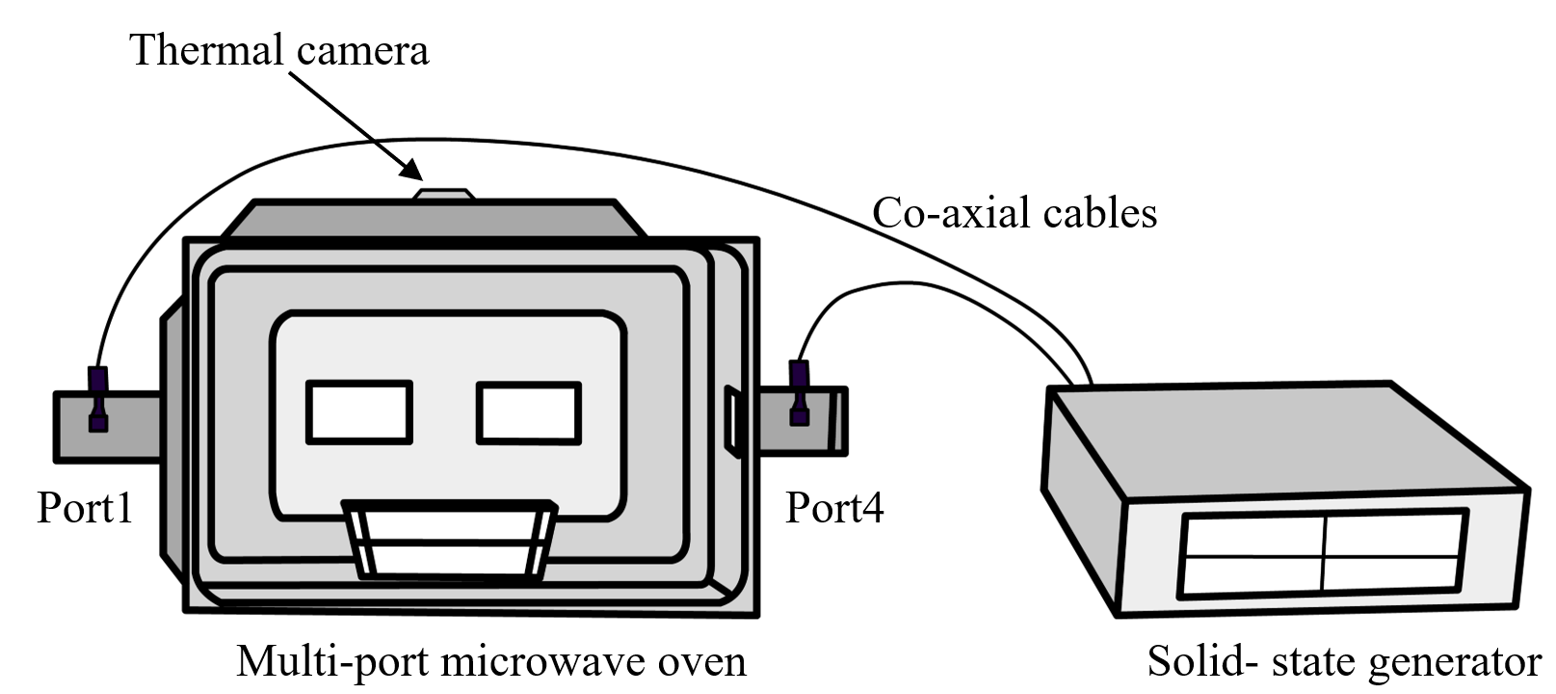
Figure I- 1. Set-up of the dual-port solid-state microwave heating system.

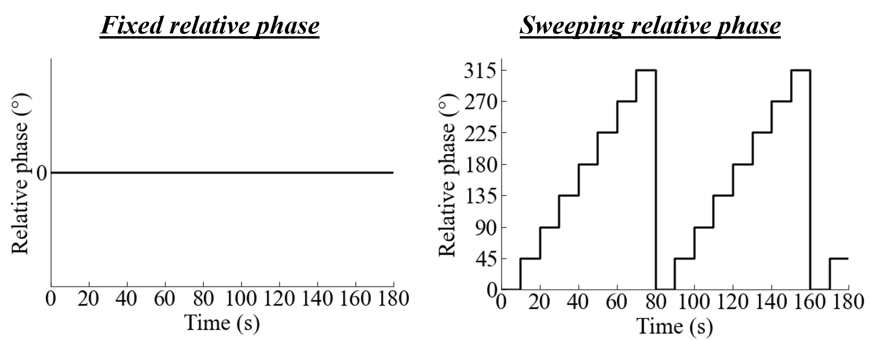
Figure I- 2. Relative phase sequences of: Fixed and Sweeping relative phase strategies for 3 min of the heating process.

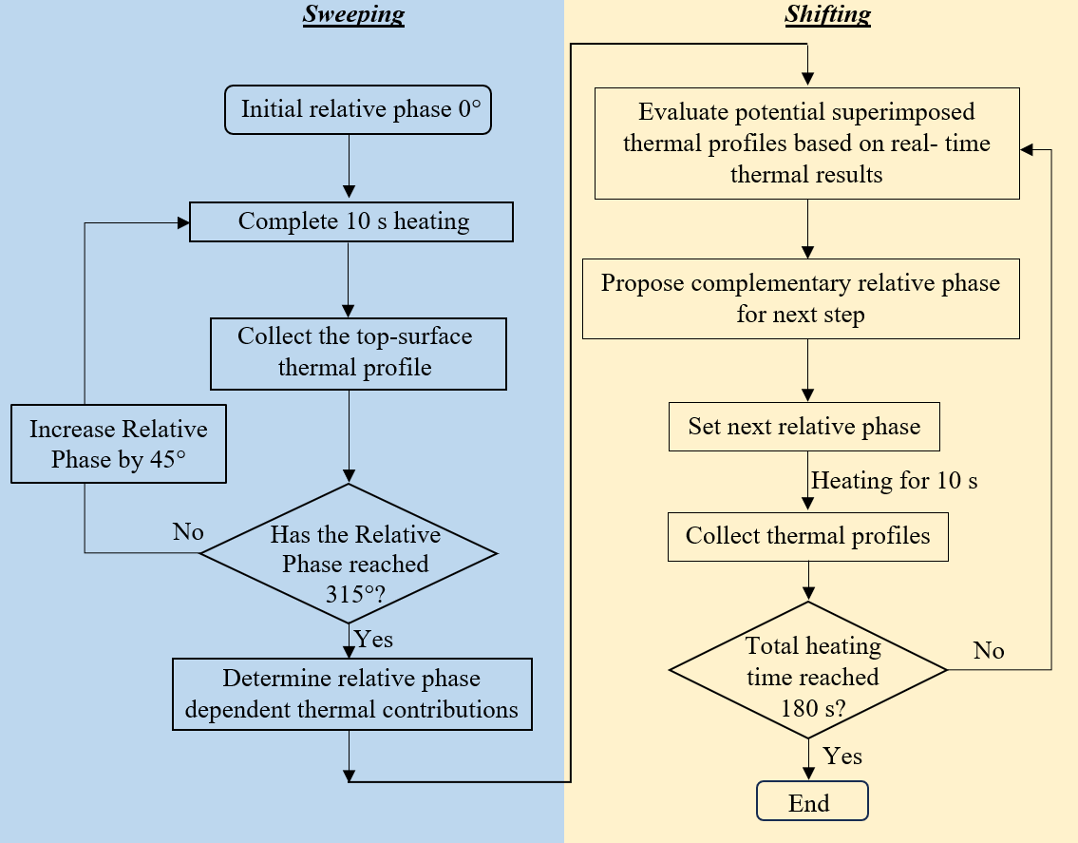
Figure I- 3. Algorithm for complementary relative phase strategy.

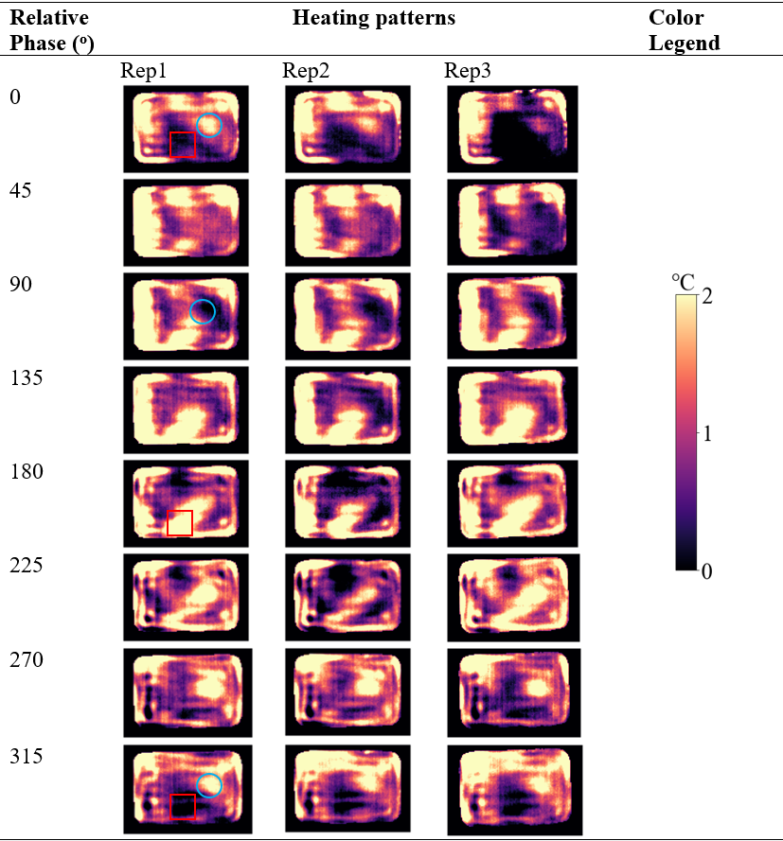
Figure I- 4. Relative-phase-dependent thermal contributions collected during the sweeping stage of the Complementary relative phase strategy heating.

Thermal Image after sweeping | Superimposed Relative Phase | Superimposed Thermal Image | Superimposed Average Temp. (ºC) | Superimposed HUI | Color Legend
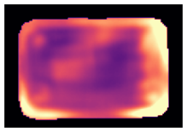 | 0 | 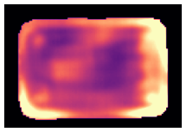 | 19.164 | 0.387 | 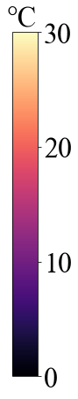
Avg. Temp =17.776 ºC  HUI=0.375 | 45 | 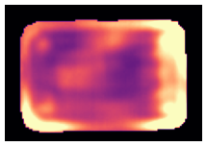 | 19.751 | 0.394
Avg. Temp =17.776 ºC  HUI=0.375 | 90 | 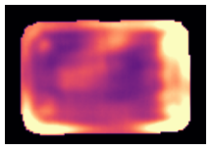 | 19.566 | 0.396
Avg. Temp =17.776 ºC  HUI=0.375 | 135 | 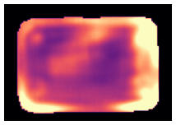 | 19.580 | 0.384
Avg. Temp =17.776 ºC  HUI=0.375 | 180 | 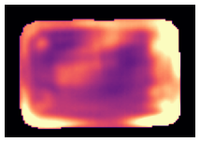 | 19.288 | 0.380
Avg. Temp =17.776 ºC  HUI=0.375 | 225 | 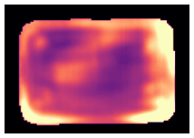 | 19.245 | 0.371
Avg. Temp =17.776 ºC  HUI=0.375 | 270 | 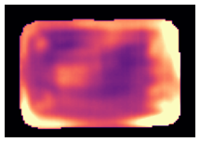 | 19.089 | 0.371
Avg. Temp =17.776 ºC  HUI=0.375 | 315 | 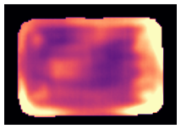 | 18.943 | 0.376
*The images were obtained from the first replicate of the gellan gum sample heated by the combined-sweeping & complementary-relative-phase-shifting algorithm.

Figure I- 5. The calculated potential superimposed thermal results of microwave heating of gellan gum for the first dynamic relative phase selection after sweeping (t = 80 s).

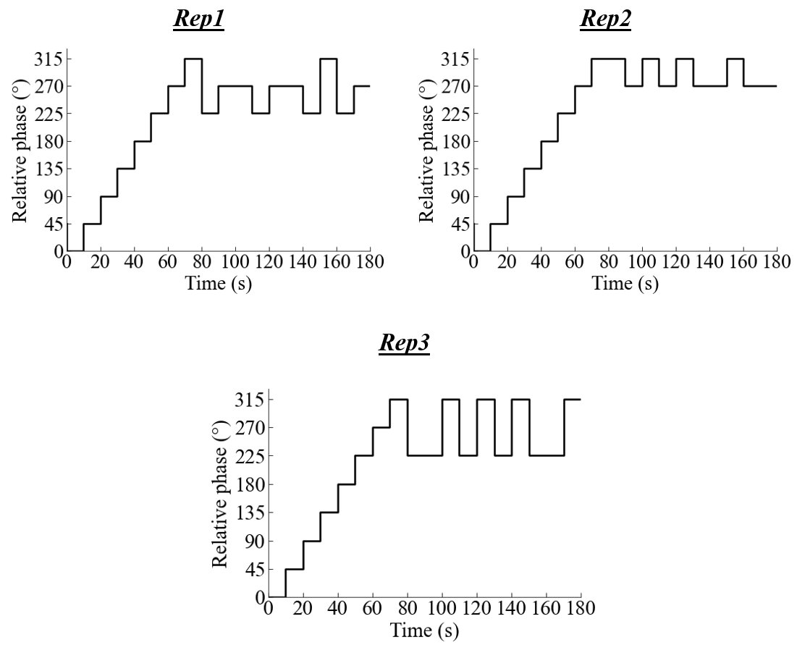
Figure I- 6. Relative phase shifting sequences for three replications of complementary relative phase strategy.

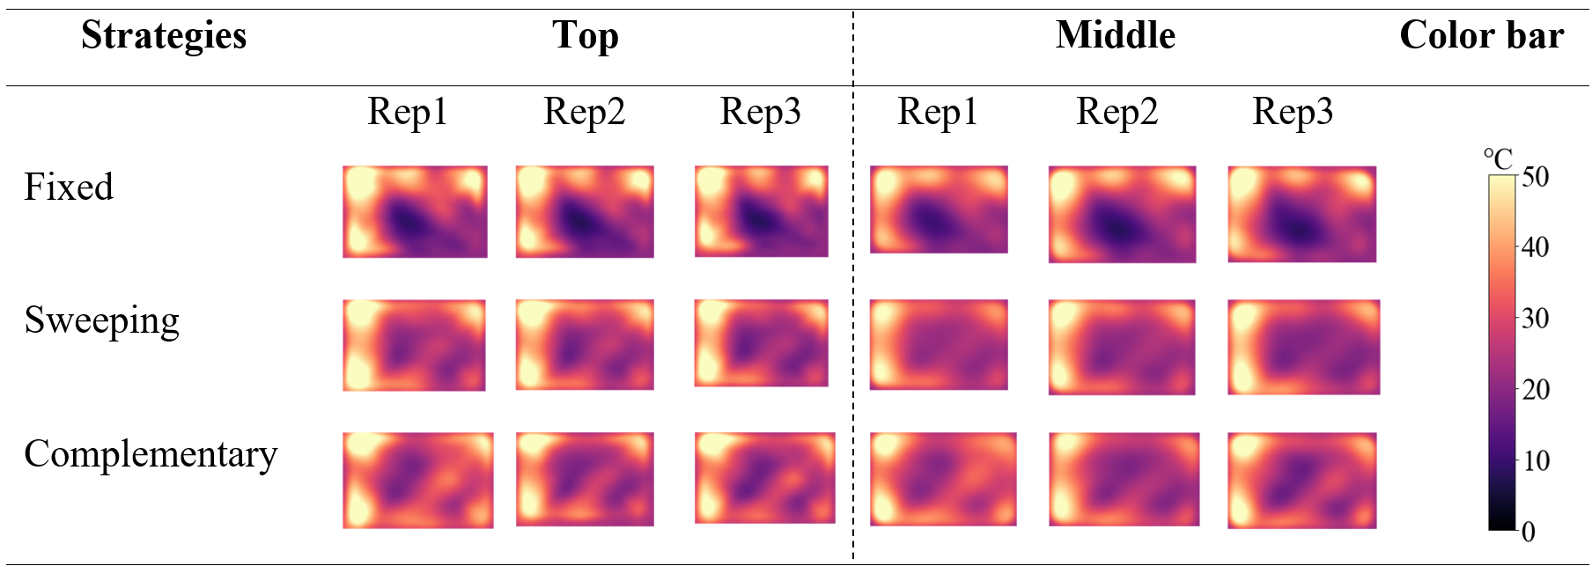

Figure I- 7. The thermal profiles collected at the top and middle layers of the gellan gel samples after 3 min microwave heating with different relative phase heating strategies.

CHAPTER II
A real-time predictive complementary relative phase shifting strategy for dual-port solid-state microwave heating process

A version of this chapter was originally published by Arjun Ghimire and Jiajia Chen:
Ghimire, A., & Chen, J. (2025). A real-time predictive complementary relative phase shifting strategy for dual-port solid-state microwave heating process. Journal of Food Engineering, 112544.

As the first author of this research article, I made the main contribution to Writing-original draft, Visualization, Validation, Software, Methodology, Investigation, Formal analysis, Data curation. Dr. Jiajia Chen as the major Professor and corresponding author, contributed to Writing – review & editing, Visualization, Supervision, Resources, Project administration, Methodology, Investigation, Funding acquisition, Formal analysis, Conceptualization.

2.1 Abstract
Relative phases between two sources can be precisely and dynamically controlled in dual-port microwave processes. Previously, a combined sweeping and complementary relative phase strategy was used to deliver more uniform heating than microwave heating processes using fixed or orderly sweeping relative phases. However, extensive relative phase sweeping (e.g., ~44% of the 3-min whole heating time) is needed to collect relative phase-dependent thermal contributions to implement the complementary strategy. This limitation can be addressed by utilizing the constructive and destructive dual-port microwave interactions to develop a more efficient complementary strategy. Built upon the observation that the spatial microwave power dissipation density varies in a sinusoidal wave shape, this study developed a predictive-Complementary relative phase strategy. Instead of collecting relative phase-dependent thermal contributions using extensive relative phase sweeping, the predictive approach only collected three thermal contributions at relative phases of 0°, 90°, and 180° and then predicted all others for implementing the complementary strategy. The predicted thermal contributions were validated by comparing them with the experimentally collected ones in dual-port microwave heating of gellan gel samples, which showed good correlations with R² values between 0.91 and 0.97 and Root Mean Square Error (RMSE) values between 0.17 and 1.02 °C. By comparing with other reported Fixed, Sweeping, and Sweeping-Complementary relative phase strategies, the predictive-complementary relative phase strategy devoted ~83% of the 3-min heating time in the complementary shifting stage and showed the best microwave heating uniformity and power absorption efficiency. The predictive-complementary relative phase strategy presented an efficient approach to predicting relative phase-dependent thermal contributions for more uniform microwave heating using complementary relative phases. The algorithm can be integrated as an advanced relative phase heating strategy in smart solid-state microwave systems.

2.2 Introduction
The widespread adoption of microwave technology for convenient food preparation has led to the microwave oven becoming a staple in nearly every household (Ekezie et al., 2017). However, nonuniform microwave heating has been a consistent problem that influences food quality and safety (Atuonwu & Tassou, 2018). The recent development of the solid-state microwave process has the potential to address the issues. The solid-state microwave system allows precise and flexible control over the operational parameters of frequency, power, and relative phase (if multiple ports are used) during the heating process. The control of these parameters makes it promising to achieve better heating performance than the magnetron-based system by dynamically disturbing electrical field distribution (Atuonwu & Tassou, 2019). Extensive research has demonstrated various frequency-shifting strategies, such as orderly frequency shifting (Tang et al., 2018; Yang & Chen, 2022) and complementary frequency shifting (Yang et al., 2022a, 2022b; Yang et al., 2023), that could improve microwave heating uniformity in single-port solid-state microwave systems. The improvement of heating uniformity of the frequency strategies is attributed to the frequency-dependent heating profiles that complement each other for better heating results. Studies also showed that resonant frequencies can be selected to improve the energy efficiency of the single-port microwave heating processes (Kalinke et al., 2023; Kaysan et al., 2024; Sickert et al., 2023).
Besides single-port microwave heating, multi-port microwave systems have been studied, where the relative phase between ports is one key microwave parameter that influences microwave heating performance significantly (Ghimire & Chen, 2024; Ghimire et al., 2024; Wang et al., 2021). When microwaves propagate from two ports to the cavity, the waves can interact with each other and form constructive and destructive interactions that influence the electric field distribution and energy efficiency (Bows et al., 1999). Earlier relative phase work used a single power source and split into two channels in the oven cavity, allowing wave interactions (Bows et al., 1999). The result showed that the variation of the relative phases between the two microwave signals generated different thermal patterns and temperature distribution in the foods. Wang et al. (2021) used a WR975 rectangular waveguide as the heating chamber in a dual-port microwave heating of potato block using frequency of 915 MHz and varied relative phases. The results showed that the orderly sweeping relative phase improved the uniformity by 39.1% at the same temperature rise compared to the heating using fixed relative phase. Ghimire et al. (2024) studied the combined impact of relative phase sweeping and active packaging on the performance of microwave heating in a dual-port solid-state system at 2.45 GHz. It was seen that the sweeping relative phase approach improved the heating uniformity by about 25% when compared with the fixed relative phase heating at 180°. These orderly shifting relative phase studies only used several arbitrary relative phases without distinguishing the relative phase-dependent thermal contributions.
To further improve the dual-port microwave heating process, a complementary relative phase strategy (Ghimire & Chen, 2024) was developed inspired by the complementary frequency strategy (Yang et al., 2022a, 2022b; Yang et al., 2023). In the complementary relative phase study, a combined-sweeping & complementary-relative-phase approach was used where the relative phases were controlled through two stages – the sweeping stage and the complementary stage. In the sweeping stage, the relative phase was orderly swept from 0° to 315° with an interval of 45° for 10 s microwave heating at each relative phase, and the relative phase-dependent thermal contributions were determined by collecting the thermal images through a top-mounted thermal camera. Then, relative phases with complementary heating patterns were selected dynamically in the complementary stage. This combined-sweeping & complementary-relative-phase strategy showed about 13% improvement in heating uniformity compared to the orderly sweeping relative phase strategy.
However, the combined-sweeping & complementary-relative-phase strategy has a significant limitation in collecting relative phase-dependent thermal contributions. For example, in order to balance the heating times used for sweeping and complementary stages, a relatively large interval of 45° was used to collect only 8 relative phase-dependent thermal contributions and about 44.4% of the whole heating time was used for the sweeping process. The significant amount of time used in the sweeping process to collect the relative phase-dependent thermal contributions may mitigate the contribution of the complementary strategy and reduce the effectiveness of the complementary effect of relative phases in improving heating uniformity. Therefore, a more efficient approach to determining relative phase-dependent thermal contributions is needed to improve the robustness of the complementary strategy.
The relative phase-dependent thermal contribution could be (partially) predicted for constructive and destructive microwave interactions of dual port heating to reduce the time for the relative phase sweeping stage. Verma et al. (2024) modeled a dual-port microwave heating process and found that the microwave power dissipation densities varied in a sinusoidal wave shape along with the change of the relative phases between two ports in the dual-port microwave heating process. This implies that the relative phase-dependent thermal contributions are approximately (not exactly due to thermal conduction) vary in a sinusoidal wave shape. If thermal contributions at three arbitrary relative phases are known, the thermal contributions at other relative phases can be mathematically calculated following the sinusoidal wave function. Thus, instead of pre-collecting the relative phase-dependent heating results at all (or many, e.g., 8 or more) relative phases, the thermal contributions at three relative phases can be first collected and then used to predict all other thermal contributions at any arbitrary relative phases, assuming constant dielectric properties are used. Then, relative phases with complementary heating results can be easily selected for efficient and uniform microwave heating. This predictive approach presents a novel strategy for efficiently determining relative phase-dependent thermal contributions and integrating them with the complementary relative phase concept to improve solid-state microwave heating of foods using dual ports.
The overall goal of this study is to develop a real-time predictive complementary relative phase heating strategy for the dual-port solid-state microwave heating process. The specific objectives include developing and validating a predictive approach that utilizes three relative phase-dependent heating results to predict thermal contributions at arbitrary relative phases, integrating this predictive approach with the complementary relative phase concept as a predictive complementary relative phase strategy in the dual-port microwave heating process, and comparing the developed predictive complementary relative phase heating strategy with other reported strategies-namely fixed, orderly sweeping, and combined sweeping and complementary relative phase shifting- based on their microwave heating performances.

2.3 Materials and Methods
The overall concept of the predictive complementary relative phase strategy is developed upon the constructive and destructive microwave interactions from two ports. This Materials and Method section will discuss the theoretical foundation of the predictive concept (Section 2.1), experimental validation of the predicted relative phase-dependent thermal contributions (Section 2.2), development and implementation of the predictive complementary relative phase strategy in microwave heating (section 2.3), and performance evaluation of the predictive complementary strategy (section 2.4).

2.3.1 Theoretical foundation for predicting relative phase-dependent thermal contributions
The microwave heat transfer of food products can be described by the transient Fourier’s heat transfer equation added with the microwave power source term:
$ρ∙C_{p}∙\frac{∂T}{∂t}=∇∙\left(k∙∇T\right)+P$ (II-1)
where ρ is the density (kg/m³), $C_{p}$ is the specific heat capacity (J/kg∙K), T is the Temperature (K), t is the time (s), k is the thermal conductivity (W/m∙K), and P is the microwave power dissipation density (W/m³).
As can be seen from Equation II-1, the heating rate ($\frac{∂T}{∂t})$of a solid food product at one specific location is governed by the microwave power dissipation density (P) and the heat transfer from surroundings upon temperature gradient $∇∙\left(k∙∇T\right)$. In a microwave heating process, the dissipated microwave power is the major heat source compared to the conductive heat source. If ignoring the conductive heat transfer and assuming constant food material properties of density and specific heat capacity, the heating rate of the food product can be estimated proportional to the microwave power density as described in Equation II-2:
$\frac{∂T}{∂t} ∝ P$ (II-2)
As reported in previous studies by Verma et al. (2024) and Bows et al. (1999), the dissipated microwave power densities for a dual port microwave heating process vary as a sinusoidal wave function with the change of relative phase between two ports ($θ$). Thus, the heating rate also varies as a sinusoidal wave function with the relative phase. For a short heating period $∆t$, the temperature change of the food (referred to as thermal contribution from microwave heating, $∆T$) at one location will also vary as a sinusoidal wave function with the relative phase. This sinusoidal wave function can be written as in Equation II-3:
$∆T_{θ}=a∙Cos\left(θ_{0}+θ\right)+b$ (II-3)
where $∆T_{θ}$ is the thermal contribution at relative phase $θ$ in a dual-port microwave heating, a is the amplitude of the wave function, b is the vertical shift, θ₀ is the initial relative phase angle, and θ is the source relative phase angle between two ports.
Mathematically, the three wave function parameters (a, θ₀, and b) can be solved from three equations of three thermal contributions ($∆T_{θ}$) at three relative phases (θ). Note that, due to the nonuniform microwave heating, the thermal contributions are spatially nonuniform, and thus, the sinusoidal wave function parameters (a, θ₀, and b) are spatially different and will be determined spatially. In the microwave heating process, the thermal contributions at one relative phase can be obtained by subtracting two thermal profiles collected after and before the microwave heating by using a thermal imaging camera.
Theoretically, the thermal contributions at any three relative phases can be used to determine the wave function parameters. To simplify the calculation, this study proposed to use three thermal contributions at three specific relative phases (0°, 90°, and 180°). The a, b, and θ₀ can be determined from these three thermal contributions (Equations II- 4- II-6):
ΔT₀ = aCosθ_{o} + b (II-4)
ΔT₉₀ = aCos (θ_{o}+90) + b = -aSinθ_{o} + b (II-5)
ΔT₁₈₀ = aCos (θ_{o}+180) + b = -aCosθ_{o}+ b (II-6)
where ΔT is the spatial thermal contribution at the top surface of the food product.
The a, b, and θ_{o} can be obtained as:
(II-7)
(II-8)
(II-9)
After the three wave function parameters are determined as shown in Equation II-7 to Equation II-9, the thermal contribution at any arbitrary relative phase can be determined.

2.3.2 Experimental validation of the predictive thermal contributions
Before implementing the predictive complementary strategy, the predicted relative phase-dependent thermal contributions were experimentally validated.

2.3.2.1 Solid-state microwave system
A solid-state microwave system was used to heat the food products to collect relative phase-dependent thermal contributions. The solid-state microwave system is composed of a solid-state microwave generator, a multi-mode oven cavity, multiple waveguides, and coaxial cables, as depicted in Figure II- 1. The solid-state microwave generator (PA-2.40-2.50GHz-200W-4, Junze Technology, China) has four ports, and each can produce microwaves at frequencies between 2.40 and 2.50 GHz and power between 0 and 200 W. The multi-mode oven cavity was fabricated by removing the original magnetron source and waveguide from a commercial microwave oven (Panasonic Model NN-SN936W, USA) and attaching four waveguides (CWR340 CentricRF, USA) at the left, right, and back walls of the cavity. Four coaxial cables (UltraFlex Coaxial Assembly, SHOWMECABLES, USA) are used to connect the generator's four sources to the waveguides. A radiometric thermal camera module (FLIR, Lepton 3.5, USA) was installed into a 4 mm-sized hole on the top wall of the oven chamber to take the real-time thermal image profiles.
In this study, only two ports on the left and right sides of the oven walls were used. The microwave sources were operated at a fixed frequency of 2.45 GHz and a maximum power of 200 W each. The relative phases between the two sources were controlled by a customized Python program with variations between 0° and 360°.

2.3.2.2 Model food preparation
Gellan gel was used as a model food for its easy preparation with reduced experimental errors. The gellan gel sample was prepared by using deionized water, 1% gellan gum powder (MP Biomedicals, OH, USA), and 0.17% calcium chloride (Honeywell Research Chemicals, Muskegon, MI, USA). Deionized water and powdered gellan gum were mixed with a magnetic stirrer and heated to 90 °C for 15 minutes as a solution using a VWR Hotplate/Stirrer (Model: 97042, ALT, USA). The heated solution was then mixed with calcium chloride (CaCl₂) to help form a firm, stable, and slice-able gel sample (Bornhorst et al., 2017). The prepared sample (300 g) was then promptly put in the food containers. To ensure gel setting, the heated samples in the food containers were allowed to cool down to room temperature for half an hour. The gellan gel samples were then kept at 4 °C in a refrigerator overnight before experiments.

2.3.2.3 Relative phase-dependent thermal contributions for validation
In the validation process, the relative phase-dependent thermal contributions were experimentally collected and compared with the thermal contributions predicted from three relative phases. To collect the relative phase-dependent thermal contributions, one single gellan gel sample (23 °C) was heated in the oven using different relative phases without replacing it with new samples. The repeated use of a single sample at different relative phases was because the wave function parameters (a, b, and θ_{o}) were location-dependent and determined upon pixeled temperature values. It is important to ensure the pixel-based thermal contributions at various relative phases are consistent for more accurate validation. Moreover, to minimize the effect of sample temperature on the collected relative phase-dependent thermal contributions, the sample was heated for 10 s with one relative phase and then was allowed to cool down to room temperature before heating using another relative phase. The thermal profiles at the top surface of the food product were collected before and after each 10-s heating process. The thermal contribution was determined by calculating the difference between the thermal patterns after and before the heating process. The relative phase-dependent thermal contributions were obtained for relative phases from 0° to 330° at an interval of 30°. In the predictive approach, the three thermal contributions of relative phases of 0°, 90°, and 180° were used to calculate the relative phase-dependent thermal contributions following Equations 4-6.
The experimentally collected and predicted relative phase-dependent thermal contributions were qualitatively and quantitatively compared for concept validation. Since a single sample was used to collect the relative phase-dependent thermal contributions, the pixel-based thermal contributions of various relative phases can match perfectly with each other among relative phases. In qualitative validation, the thermal contributions were calculated as the differences of the pixeled temperature values between after and before heating, and then thermal patterns of hot and cold spots were visually compared. In quantitative validation, the pixel-based correlation was performed by directly mapping the pixel temperature values of the experimentally collected profiles to those of the predicted profiles for each relative phase. The Coefficient of Determination (R²) and the Root Mean Square Error (RMSE) values of the correlation were calculated using Equations II-10 and II-11.
(II-10)
(II-11)
where X_{i} and Y_{i} represent the predicted and the experimentally observed values of each pixel, $\overline{Y}$ is the mean of the observed pixel values, and m is the total number of pixels.

2.3.3 Development and implementation of the predictive complementary strategy
After the experimental validation of the predictive thermal contributions, microwave heating with the predictive complementary strategy (referred to as predictive-complementary) was developed and implemented in a real-time microwave heating process using the developed algorithm shown in Figure II- 2. The microwave heating process was composed of two stages: (a) thermal contribution collection and prediction and (b) complementary relative phase shifting.
In the stage of thermal contribution collection and prediction, the gellan gel sample was heated at three relative phases of 0°, 90°, and 180° for 10 s each to determine relative phase-dependent thermal contributions from 0° to 330° with an interval of 30°. Then, the 12 relative phase-dependent thermal contributions were used in the following complementary relative phase shifting stage for the remaining heating time. The complementary relative phases at each time step (10 s) were dynamically selected based on the complementary concept, as described by Ghimire and Chen (2024). In general, the relative phase was selected if its potential superimposed thermal profile (addition of its thermal contribution and the real-time microwave heating results) had the minimum Heating Uniformity Index (HUI, which will be explained in Eqn. 12 in detail) unless its average temperature was much lower (i.e., 5%) than other relative phase conditions.

2.3.4 Performance evaluation of the predictive complementary relative phase heating strategy

2.3.4.1 Other relative phase heating strategies for comparison
The microwave heating performance of the predictive-complementary relative phase heating strategy was evaluated by comparing it with the other three previously reported heating strategies, including Fixed, Sweeping, and Sweeping-Complementary relative phase strategies. The time-dependent relative phases for these three strategies are shown in Figure II- 3.
The Fixed relative phase strategy (Figure II- 3a) used a constant relative phase (0°) throughout the whole heating process (180 s). The Sweeping relative phase strategy (Figure II- 3b) orderly swept the relative phases from 0° to 330° with an interval of 30° every 10 s and then repeated the swept relative phase until the end of the heating process. The Sweeping-Complementary strategy (Figure II- 3c) first swept the relative phase at an incremental order from 0° to 330° with a 30° interval and then selected the complementary relative phase for the remaining period based on the real-time heating performance, similar to the complementary shifting stage shown Figure II- 2.

2.3.4.2 Microwave heating performance evaluation
After the heating process, the samples were immediately removed from the microwave system to capture the thermal profiles at the top and middle layers of the food products using a thermal imaging camera (FLIR A300, Boston, MA). After the thermal images at the top surface were recorded, the gel sample was sliced at the center by a slicer to record the temperature profiles at the middle layer. The average temperature was calculated by averaging the pixeled temperature data of the top and middle thermal profiles. The heating uniformity index (HUI) was computed using Equation II-12 (Alfaifi et al., 2014).
(II-12)
where ΔT_{ave} (°C) is the average temperature rise over the layer during heating and S_{layer} is the area of the combined layer. More even heating is indicated by a lower HUI value.
Equation II-13 was utilized to determine the microwave power absorption efficiency (PAE) by combining the temperature profiles of the top and middle layers (Yang et al., 2022b).
(II-13)
where m is the sample weight (300 g), Cp is the specific heat capacity of the samples (4.16 J/g K) for gellan gel (Birla et al., 2008), ΔT is the mean temperature increase calculated from the combined top and middle layers (°C), P_{input} is the total input microwave power (400 W), and Δt is the total heating time (180 s). Furthermore, the minimum temperature and the maximum temperature of the top and the middle surfaces were also compared among the 4 relative phase shifting strategies - fixed, sweeping, sweeping-complementary, and predictive-complementary relative phase strategy.

2.3.4.3 Statistical analysis
The heating process was conducted in triplicates for all four relative phase strategies. The statistical analysis was conducted using JMP v16 with a one-way analysis of variance (ANOVA) and HSD Tukey's post-test with a 95% confidence interval. The data visualization and image processing were done using Matplotlib and OpenCV libraries in Python v 3.10.14.

2.4 Results and Discussion

2.4.1 Prediction and validation of relative phase-dependent thermal contributions
Figure II- 4 shows the experimentally collected (a) and predicted (b) relative phase-dependent thermal contributions from 0° to 330° with an interval of 30°.
As seen from the collected relative phase-dependent thermal contributions (Figure II- 4a), the hot and cold spots changed their locations with relative phases significantly. For example, at the middle-lower region of the thermal images (marked as a square box in red color), this region gradually changed from a cold spot to a hot spot and then to a cold spot again when the relative phase changed from 0° to 180° to 330°. The right-middle region (marked as a circle in blue color) changed from a hot to cold spot at 150° and then turned back to a hot spot again with relative phase at 330°. Similar hot/cold spot reversing phenomenon was also observed by Meier and De Swardt (2000), Wang et al. (2021), and Verma et al. (2024). This change of hot/cold spot is due to a sinusoidal change of microwave power densities with the relative phases from the interactions of microwaves from two ports, as discussed in section 2.1. Figure II- 4b shows the three collected thermal contributions (0°, 90°, and 180°) on the red label and other predicted thermal contributions on the green label. By comparing with the collected relative phase-dependent thermal contributions, the predicted ones showed similar thermal distribution patterns across the various relative phase angles, indicating good prediction results.
The quantitative validation of the predicted thermal contributions was conducted by correlating the thermal contributions at each pixel between the collected and the predicted thermal contributions at each relative phase studied, as shown in Figure II- 5. Each subplot in Figure II- 5 displays pixeled thermal contributions that are experimentally collected (x-axis) and predicted (y-axis). The red triangle line denotes a perfect correlation. As seen in Figure II- 5, all the data points were plotted on the triangle line for the relative phases of 0°, 90°, and 180° with R² = 1.00 and RMSE = 0.00 °C. This is because the sinusoidal wave function was determined from these three base thermal contributions. For all other relative phases, the data points were plotted around the triangle line (with R² values in the ranges of 0.91 and 0.97), showing a good correlation between predicted and experimentally collected values. The RMSE between the collected and predicted values were between 0.17 and 1.02 °C. These slight differences between the predicted and collected thermal contributions may be attributed to the assumptions used in the predictive approach. First, the predictive model was developed by ignoring the thermal conduction between hot and cold spots. Furthermore, the predictive model assumed that the material has uniform and constant dielectric properties such that the thermal contributions do not change over the heating period. However, in the context of real experimentations, a single sample was heated using one relative phase and then cooled down to room temperature for heating using another relative phase. This repeated use of a single sample was to avoid the food placement change and pixel mismatch in collecting relative phase-dependent thermal contributions. Thus, the temperature variations of samples for heating and the change of dielectric properties during heating could also introduce prediction and experimental errors. Therefore, the predictive assumptions may not fully capture the complexities of real-world thermal behaviors, leading to systematic deviations (e.g., general overestimation for relative phases of 210° and 240°, general estimation for the relative phase of 30°).

2.4.2 Determination of complementary relative phase in the predictive complementary strategy
After obtaining the predicted relative-phase-dependent thermal contributions, the complementary shifting stage used the most recent heating results and the relative phase-dependent thermal contributions to determine the complementary relative phase for the heating process. Figure II- 6 demonstrates the process of determining the first complementary relative phase. The first column shows the thermal profile after sweeping three relative phases (0°, 90°, and 180°) for 10 s heating each. The average temperature after sweeping was found to be 9.457 °C, and the HUI was 0.425.
After the 30 s heating, this thermal profile was added by the 12 predicted relative phase-dependent thermal contributions individually to get 12 superimposed thermal profiles (column 3). The average temperature and HUI values of the 12 superimposed thermal profiles were calculated and shown in columns 4 and 5, respectively. The average temperature of the superimposed thermal profile increased slightly from the relative phase of 0° to 150° and then decreased gradually, with the highest superimposed temperature of 11.380 °C at 150°. The superimposed HUI values increased with changes in the relative phase from 0° to 90° and then decreased from 90° with the lowest superimposed value of 0.390 observed at 270°. Although the relative phase at 150° had the highest temperature, compared to that of the relative phase at 270° (10.943 °C), the average temperature was only 4.0% higher, which was lower than the arbitrary rule of 5% set in the complementary algorithm. Thus, the relative phase of 270° was selected as the first complementary relative phase for heating from 30 to 40 s.

2.4.3 Relative phase shifting sequences in the Predictive-Complementary relative phase strategy
Figure II- 7 shows the relative phase sequences of the predictive complementary relative phase strategy in three replications. The predictive complementary relative phase strategy first operated the 3 relative phases (0°, 90°, and 180°) and then predicted the thermal profiles for the other relative phases dynamically. It then calculated the thermal contributions as described in Section 3.2, choosing the complementary relative phase for the next shifting step. For example, the relative phase of 270° was determined as the first complementary relative phase for the first replication, as shown in Figure II- 7. After that, different complementary relative phases were determined and used in the complementary stage heating. The same process was applied for the rest of the steps until the end of the heating process.
Compared among the three replications of the predictive complementary relative phase strategy, the used relative phases showed great variations. The replications 1 and 2 showed that the relative phases of 210° and 330° were mainly used in the complementary stage, while the replications 3 mainly used 0°, 180°, 240°, and 330°. The observed differences among replications may be attributed to the variations of the food products in preparation and their heating process (e.g., placement on the turntable). The different complementary relative phases were selected based on real-time heating results for that specific food product, showcasing the robustness of the proposed predictive dynamic complementary relative phase strategy in dynamically adjusting the heating parameters to accommodate sample variations and real-time heating results. A similar phenomenon was also observed in the complementary-frequency work by Yang et al. (2022b).

2.4.4 Comparison of microwave heating performances among four heating strategies

2.4.4.1 Qualitative comparison of temperature profiles
Figure II- 8 shows the thermal profiles at the top and the middle layers of the heated gellan gel samples after 3 min dual-port microwave heating using different relative phase heating strategies: fixed, sweeping, sweeping-complementary, and predictive-complementary.
For the top layer, the Fixed strategy showed a bright yellow region (hot spot) at the left upper and lower corners and a dark blue region (cold spot) at the center and lower locations. The thermal profiles for the Sweeping strategy and Sweeping-Complementary strategies appeared relatively more uniform than the Fixed strategy, where a minor hot spot was observed at the center region that separated the connected cold spot shown in the Fixed strategy. This minor hot spot was contributed by the varying relative phases, which would help improve the heating uniformity by transferring heat from hot to cold spots. The predictive-complementary strategy further expanded the minor hot spot at the center region beyond the Sweeping and Sweeping-Complementary strategy. This improvement might be attributed to the use of specific relative phases that have a minor hot spot around the center region (e.g., 270 °C). A similar trend was observed for the middle layer, with the predictive-complementary strategy showing more uniform heat distribution than the Fixed and the Sweeping strategy.

2.4.4.2 Quantitative analysis of heating performance across different heating strategies
After heating, the thermal profiles at the top and the middle layers were combined to quantitatively evaluate the microwave heating performance. The maximum (T_{max}) and minimum temperatures (T_{min}), HUI, and PAE are summarized in Table II- 1.
The Fixed relative phase strategy showed the worst heating performance with the lowest minimum and (almost) highest maximum temperature among the four strategies, indicating the most significant temperature difference between hot and cold spots. The significant temperature difference between hot and cold spots was due to the consistent heating patterns at a single relative phase condition, which has been observed in Figure II- 8 and reported by Wang et al. (2021) and Yakovlev (2018). For the other three strategies with varying relative phases, different relative phase-dependent thermal contributions could heat the food products with multiple hot spots to reduce the temperature difference between hot and cold spots, which would improve the overall heating uniformity. As shown in the HUI results, the lowest HUI value was observed for the Sweeping-Complementary and the predictive-complementary relative phase strategies (0.26 ± 0.01), which was significantly smaller (p < 0.05) than that of the Fixed (0.39 ± 0.02) and Sweeping (0.31 ± 0.01) relative phase strategies, suggesting better heating uniformity for the complementary relative phase strategies. However, the two complementary relative phase strategies have no significant difference in HUI. In terms of PAE, the predictive-complementary strategy showed significantly higher values than the other three strategies (p < 0.05), indicating the most microwave power energy efficiency in the heating process.
The more uniform heating and higher power absorption in the complementary relative phase strategies than the Fixed and Sweeping relative phase strategies were attributed to the specific selection of complementary thermal contributions with balanced heating uniformity and energy efficiency as defined in the algorithms. To compare the predictive- and sweeping-complementary strategies, the predictive one did not show significantly more uniform heating but significantly higher microwave power energy efficiency than the sweeping one, showing better heating performance. The higher microwave power energy efficiency of the predictive-complementary strategy might be attributed to the longer heating time (150 s) used in the complementary stage compared to that in the Sweeping-Complementary strategy (100 s or less).

2.4.5 Discussion
The current study introduces a predictive complementary relative phase heating strategy for dual-port solid-state microwave heating based on the theory of constructive and destructive microwave interactions. Unlike previous approaches that extensive relative phase sweeping was used to gather relative phase-dependent thermal contributions, this predictive approach only needs thermal contributions at three relative phases to predict all others, which then could devote more heating time for the complementary heating stage to improve the overall heating performance, as demonstrated from the results. However, this study only used a simple model food (gellan gel) to demonstrate and validate the predictive-complementary relative phase strategy. The use of various commercial or prepared microwaveable foods is needed to comprehensively evaluate the performance of the predictive-complementary relative phase strategy, especially for multicompartment and/or multilayer commercial meals. Moreover, the current predictive-complementary strategy did not consider the temperature-dependent dielectric properties change during the microwave heating process, which may introduce prediction errors, especially at the later stage of the heating process for food products with significant properties change. A comprehensive evaluation of the predictive-complementary strategy for various food products would further demonstrate its robustness. In addition, the variations of other physical properties of density, thermal conductivity, and specific heat capacity may show a similar impact, depending on their temperature-dependent characteristics.
Furthermore, the complementary relative phase strategies were inspired by the complementary frequency strategy developed by (Yang et al., 2022a), where frequencies with complementary thermal contributions were dynamically selected and used to improve the heating performance. As reported by Yang et al. (2022b), the complementary frequency strategy was used in heating the gellan gel sample and yielded an HUI value of 0.16, which was lower than that of the complementary relative phase strategies (0.26) in this study, showing better microwave heating performance. The more uniform heating from the complementary frequency strategy than the complementary relative phase strategy might be partially attributed to the lower single-port microwave power (200 W) used in the 6-minute complementary frequency heating process, where the extended heating time could enhance the heat transfer between hot and cold spots to improve heating uniformity. More importantly, the more uniform heating from the complementary frequency strategy might be attributed to their better complementary thermal contributions compared to the complementary relative phase strategy. In complementary frequency work, the hot and cold spots varied much with the frequency, where the hot spots of one frequency can be fully changed to a cold spot at another frequency. However, as shown in the relative phase-dependent thermal contributions (Figure II- 4), the thermal contributions at a location change as a sinusoidal function, which is limited within the amplitude of the sinusoidal function, constraining the hot/cold spots conversion with relative phase change. Thus, considering the highly predictable relative phase-dependent thermal contributions and better complementary frequency-dependent thermal contributions, it is promising to develop the complementary strategy further by combining complementary frequency and relative phase to develop the complementary strategy further.

2.5 Conclusion
This study developed and evaluated a predictive relative phase-dependent pixeled thermal contribution approach for dual-port solid-state microwave heating of foods, providing significant advancements in the field of microwave heating. The findings demonstrate that the relative phase-dependent pixeled thermal contributions exhibit a sinusoidal wave pattern when heated over a short time interval, enabling their prediction using data from the top surface at three arbitrary relative phase angles. By integrating this predictive approach with the complementary relative phase strategy, the study introduces a predictive-complementary heating strategy, which outperforms existing methods, such as the sweeping-complementary strategy, by allocating more time to the complementary heating stage. Among the four evaluated strategies - fixed, sweeping, sweeping-complementary, and predictive-complementary, the predictive strategies demonstrated more uniform heating performance on the model food (gellan gel). The predictive-complementary strategy also showed better microwave power absorption efficiency, highlighting its potential for real-time applications. Further studies should focus on applying the predictive relative phase-dependent pixeled thermal contribution approach to a variety of real commercial and prepared meals. This will help evaluate its practicality and efficiency in diverse food products, considering their complex compositions, geometries, and thermal properties.

2.6 Acknowledgments
This study is based on research that the Tennessee Agricultural Experiment Station supported with funding from the USDA National Institute of Food and Agriculture Hatch Multistate Research capacity funding program (Accession Number 1023982) and the USDA National Institute of Food and Agriculture AFRI project (Grant No: 2021-67017-33444).

REFERENCES
Ahn, S. H., Jeong, C. H., & Lee, W. S. (2023). 0.5 kWatt 2.45 GHz GaN‐based microwave heating system design with active phase control. Microwave and Optical Technology Letters. https://doi.org/10.1002/mop.33689
Alfaifi, B., Tang, J., Jiao, Y., Wang, S., Rasco, B., Jiao, S., & Sablani, S. (2014). Radio frequency disinfestation treatments for dried fruit: Model development and validation. Journal of Food Engineering, 120, 268-276. https://doi.org/10.1016/j.jfoodeng.2013.07.015
Atuonwu, J. C., & Tassou, S. A. (2018). Quality assurance in microwave food processing and the enabling potentials of solid-state power generators: A review. Journal of Food Engineering, 234, 1-15. https://doi.org/10.1016/j.jfoodeng.2018.04.009
Atuonwu, J., & Tassou, S. (2019). Energy issues in microwave food processing: A review of developments and the enabling potentials of solid-state power delivery. Critical reviews in food science and nutrition, 59(9), 1392-1407. https://doi.org/10.1080/10408398.2017.1408564
Birla, S. L., Wang, S., & Tang, J. (2008). Computer simulation of radio frequency heating of model fruit immersed in water. Journal of Food Engineering, 84(2), 270-280. https://doi.org/10.1016/j.jfoodeng.2007.05.020
Bornhorst, E. R., Tang, J., Sablani, S. S., & Barbosa-Cánovas, G. V. (2017). Thermal pasteurization process evaluation using mashed potato model food with Maillard reaction products. LWT-Food Science and Technology, 82, 454-463. https://doi.org/10.1016/j.lwt.2017.04.019
Bows, J. R., Patrick, M. L., Janes, R., & Dibben, D. C. (1999). Microwave phase control heating. International journal of food science & technology, 34(4), 295-304. https://doi.org/10.1046/j.1365-2621.1999.00272.x
Ekezie, F.-G. C., Sun, D.-W., Han, Z., & Cheng, J.-H. (2017). Microwave-assisted food processing technologies for enhancing product quality and process efficiency: A review of recent developments. Trends in Food Science & Technology, 67, 58-69. https://doi.org/10.1016/j.tifs.2017.05.014
Ghimire, A., & Chen, J. (2024). A combined-sweeping & complementary-relative-phase strategy to improve heating performance in a dual-port solid-state microwave system. Food and Bioproducts Processing. https://doi.org/10.1016/j.fbp.2024.10.007
Ghimire, A., Yang, R., & Chen, J. (2024). The combined effect of active packaging and relative phase sweeping on microwave heating performance in a dual-port solid-state system. Journal of Microwave Power and Electromagnetic Energy, 1-16. https://doi.org/10.1080/08327823.2024.2378670
Kalinke, I., Pusl, F., Häderle, F., & Kulozik, U. (2023). A comparative study of frequency-shifting strategies for uniform and energy-efficient microwave heating in solid-state microwave systems. Innovative Food Science & Emerging Technologies, 86, 103388. https://doi.org/10.1016/j.ifset.2023.103388
Kaysan, T., Zhou, X., & Gaukel, V. (2024). Process intensification of microwave-assisted freeze-drying by frequency adjustment in real-time using solid-state technology. Journal of Food Engineering, 112221. https://doi.org/10.1016/j.jfoodeng.2024.112221
Li, J., Xiong, Q., Shi, X., & Liang, S. (2015). Combined reference tracking and genetic algorithm to control microwave power and phase during heating process. Paper presented at the The 27th Chinese Control and Decision Conference (2015 CCDC). https://doi.org/10.1109/CCDC.2015.7162587
Meier, I., & De Swardt, J. B. (2000). Synthesis of heating patterns by interference of microwaves. International Journal of Electronics, 87(6), 725-734. https://doi.org/10.1080/002072100131913
Ohlsson, T., & Risman, P. O. (1994). Temperature distribution in microwave oven heating—The influence of different cavity modes. Paper presented at the Developments in Food Engineering: Proceedings of the 6th International Congress on Engineering and Food. https://doi.org/10.1007/978-1-4615-2674-2_99
Pérez‐Reyes, M., Gómez‐Salazar, J., López‐Malo, A., & Sosa‐Morales, M. E. (2021). Influence of fat content and water activity on the heating pattern of model systems submitted to microwave heating. Journal of Food Science, 86(12), 5329-5339. https://doi.org/10.1111/1750-3841.15949
Sakai, N. (2006). Theoretical analysis of electromagnetic wave heating of food. Japan Journal of Food Engineering (Japan), 7(2).
Sickert, T., Kalinke, I., Christoph, J., & Gaukel, V. (2023). Microwave-assisted freeze-drying with frequency-based control concepts via solid-state generators: A simulative and experimental study. Processes, 11(2), 327. https://doi.org/10.3390/pr11020327
Tang, Z., Hong, T., Liao, Y., Chen, F., Ye, J., Zhu, H., & Huang, K. (2018). Frequency-selected method to improve microwave heating performance. Applied Thermal Engineering, 131, 642-648. https://doi.org/10.1016/j.applthermaleng.2017.12.008
Verma, K., Yang, R., Gan, H., Fathy, A., Morgan, M., & Chen, J. (2024). An integrated numerical and analytical model to understand the effect of relative phase in a dual-port solid-state microwave heating process. Journal of Food Engineering, 367, 111869. https://doi.org/10.1016/j.jfoodeng.2023.111869
Wang, C., Yao, W., Zhu, H., Yang, Y., & Yan, L. (2021). Uniform and highly efficient microwave heating based on dual‐port phase‐difference‐shifting method. International Journal of RF and Microwave Computer‐Aided Engineering, 31(9), e22784. https://doi.org/10.1002/mmce.22784
Yakovlev, V. V. (2018). Effect of frequency alteration regimes on the heating patterns in a solid-state-fed microwave cavity. Journal of Microwave Power and Electromagnetic Energy, 52(1), 31-44. https://doi.org/10.1080/08327823.2017.1417105
Yang, R., & Chen, J. (2022). Dynamic solid-state microwave defrosting strategy with shifting frequency and adaptive power improves thawing performance. Innovative Food Science & Emerging Technologies, 81, 103157. https://doi.org/10.1016/j.ifset.2022.103157
Yang, R., Fathy, A. E., Morgan, M. T., & Chen, J. (2022a). Development of a complementary-frequency strategy to improve microwave heating of gellan gel in a solid-state system. Journal of Food Engineering, 314, 110763. https://doi.org/10.1016/j.jfoodeng.2021.110763
Yang, R., Fathy, A. E., Morgan, M. T., & Chen, J. (2022b). Development of online closed-loop frequency shifting strategies to improve heating performance of foods in a solid-state microwave system. Food Research International, 154, 110985. https://doi.org/10.1016/j.foodres.2022.110985
Yang, R., Morgan, M., Fathy, A., Luckett, C., Wang, Z., & Chen, J. (2023). A Comprehensive Evaluation of Microwave Reheating Performance Using Dynamic Complementary-Frequency Shifting Strategy in a Solid-state System. Food and Bioprocess Technology, 16(5), 1061-1075. https://doi.org/10.1007/s11947-022-02974-2
Zhou, X., Pedrow, P. D., Tang, Z., Bohnet, S., Sablani, S. S., & Tang, J. (2023). Heating performance of microwave ovens powered by magnetron and solid-state generators. Innovative Food Science & Emerging Technologies, 83, 103240. https://doi.org/10.1016/j.ifset.2022.103240

APPENDIX-II
Table II- 1. Microwave heating performance for four different relative phase heating strategies
Heating Strategies | T_{max}, (°C) | T_{min}, (°C) | HUI | PAE, %
Fixed | 68.04 ±1.12ª | 7.94 ±0.57ª | 0.39 ±0.02ª | 48.41 ±0.85ª
Sweeping | 62.54 ±2.34^{b} | 16.76 ±0.20^{b} | 0.31 ±0.01^{b} | 51.98 ±0.75^{b}
Sweeping- Complimentary | 60.02 ±0.07^{b} | 18.19 ±0.78^{b} | 0.26 ±0.01^{c} | 51.93 ±0.33^{b}
Predictive-Complementary | 69.00 ±0.71ª | 17.75 ±0.41^{b} | 0.26 ±0.01^{c} | 54.52 ±0.76^{c}
*All results are calculated based on the temperature files shown in mean ± std from the triplicates. Different letters in the same column indicate statistically different results (p < 0.05).

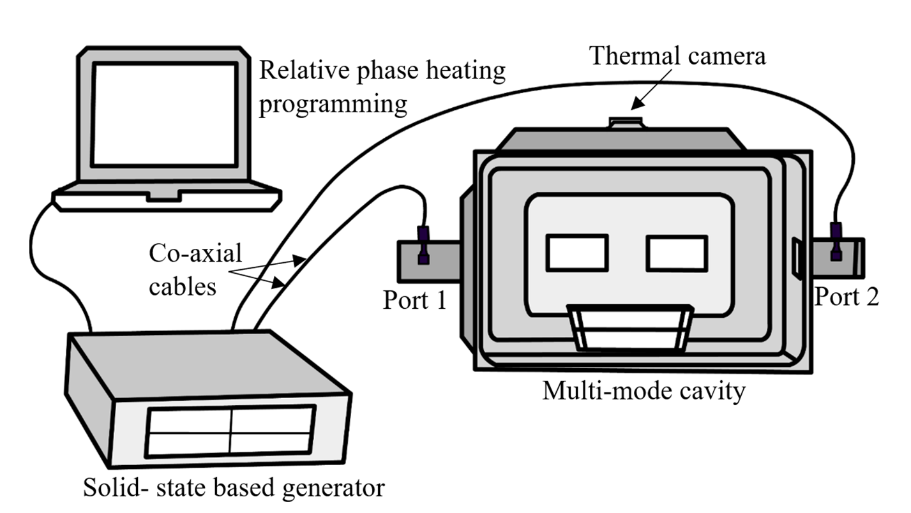
Figure II- 1. The dual-port solid-state microwave heating system

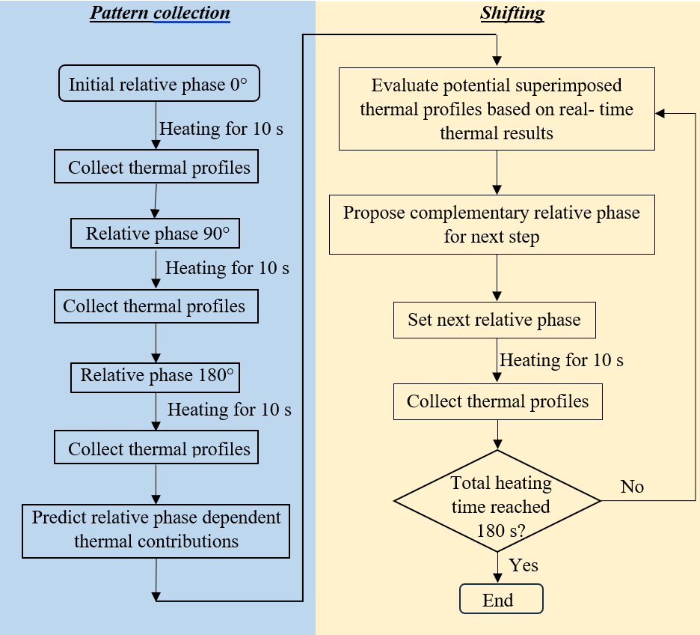
Figure II- 2. Algorithm for predictive-complementary relative phase heating

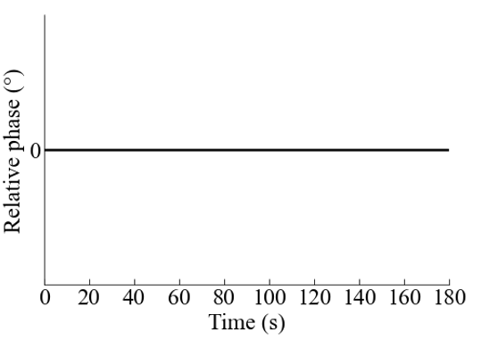 | 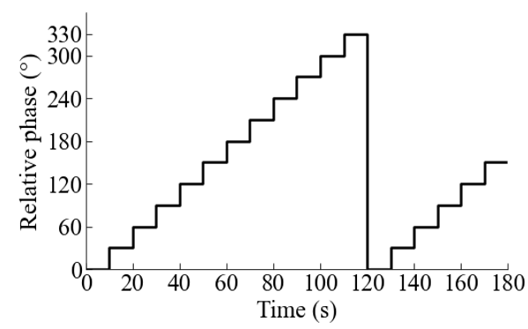
- Fixed relative phase | - Sweeping relative phase
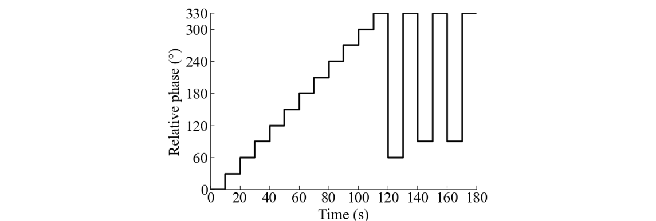
- Sweeping-Complementary relative phase
Figure II- 3. Relative phase heating process over for (a) Fixed relative phase, (b) Sweeping relative phase, and (c) one example of Sweeping-Complementary relative phase strategies

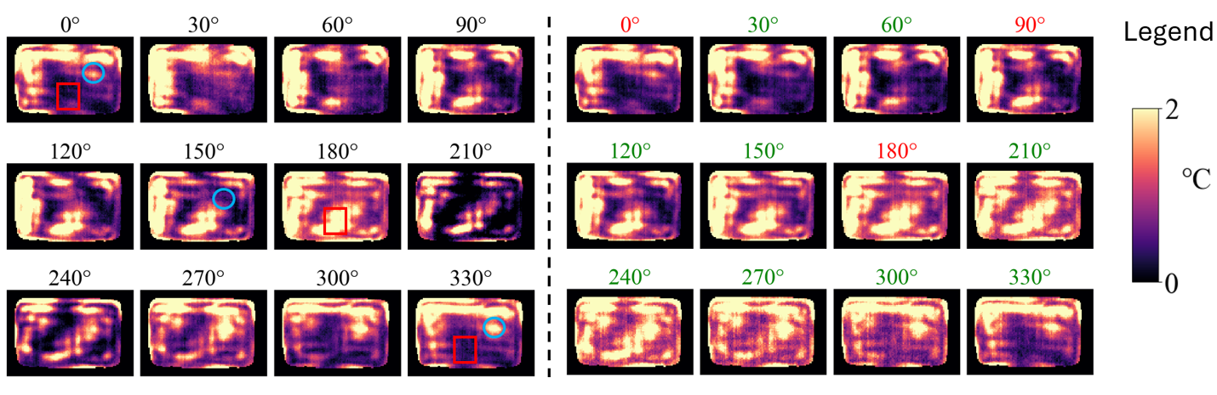
- Experimentally collected | - Experimentally collected of 0°, 90°, and 180° (in the red label) and other predicted (in the green label)

Figure II- 4. Relative phase-dependent thermal contributions of (a) Experimentally collected and (b) Experimentally collected of 0°, 90°, and 180° (in the red label) and other predicted (in the green label).
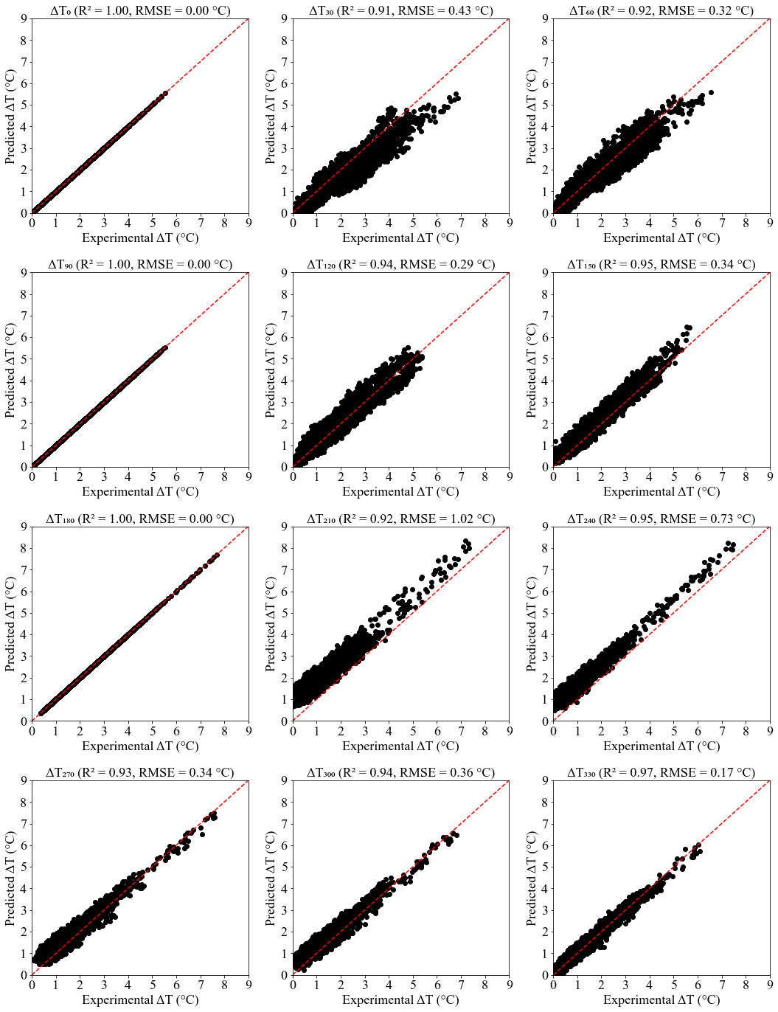
Figure II- 5. Correlations of collected and predicted thermal contributions at relative phases from 0 to 330° at intervals of 30° heated for 10 s.

Thermal Image after sweeping | Superimposed Relative Phase (°) | Superimposed Thermal Image | Superimposed Average Temp. (°C) | Superimposed HUI | Color Legend
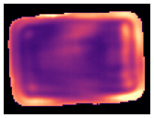  Avg. Temp =9.457 °C  HUI=0.425 | 0 | 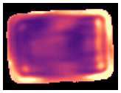 | 10.930 | 0.417 | 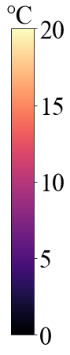
 | 30 | 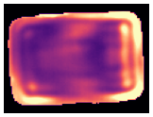 | 11.047 | 0.434
 | 60 | 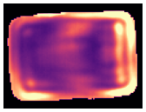 | 11.183 | 0.448
 | 90 |  | 11.304 | 0.453
 | 120 | 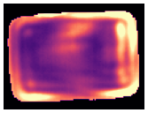 | 11.376 | 0.449
 | 150 | 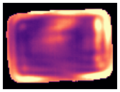 | 11.380 | 0.436

Figure II- 6. The calculated potential superimposed thermal results of microwave heating of gellan gum for the first complementary relative phase selection after pattern collection (t = 30 s).

Thermal Image after sweeping | Superimposed Relative Phase (°) | Superimposed Thermal Image | Superimposed Average Temp. (°C) | Superimposed HUI | Color Legend
Avg. Temp =9.457 °C  HUI=0.425 | 180 | 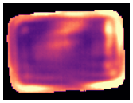 | 11.316 | 0.420
 | 210 | 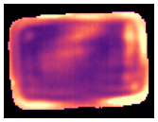 | 11.200 | 0.404
 | 240 | 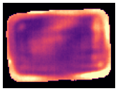 | 11.063 | 0.394
 | 270 | 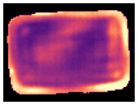 | 10.943 | 0.390
 | 300 | 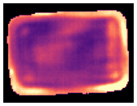 | 10.871 | 0.393
 | 330 | 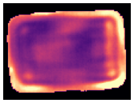 | 10.866 | 0.402

Figure II- 6. Continued

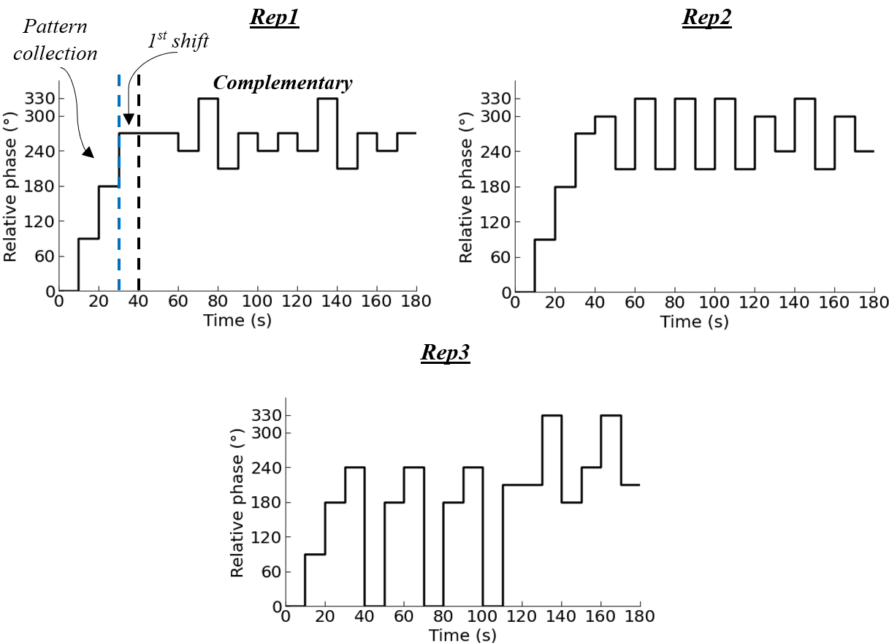
Figure II- 7. Relative phase shifting sequences for three replications of predictive complementary relative phase strategy

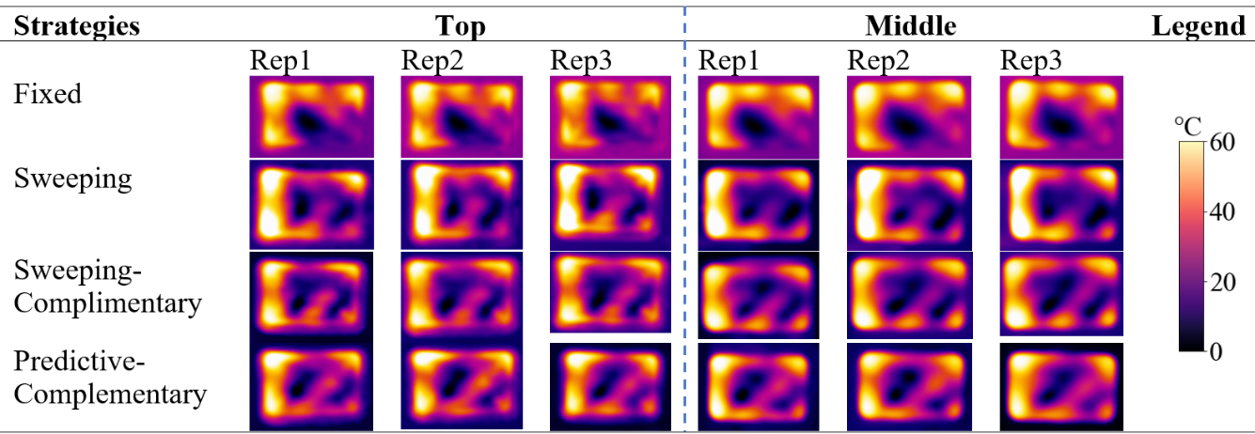
Figure II- 8. The thermal profiles collected at the top and middle layers of the gellan gel samples after 3 min microwave heating with four different relative phase heating strategies

CHAPTER III
Comprehensive Evaluation of Microwave Reheating Performance Using PREDICTIVE Complementary Relative Phase Shifting Strategy in a SOLID-STATE System

3.1 Abstract
Solid-state microwave technology offers a potential solution to the nonuniform heating limitations of conventional magnetron-based microwave ovens. A previously developed dynamic predictive complementary-relative-phase shifting strategy has demonstrated superior performance in simple model foods compared to fixed-phase shifting approaches. This study comprehensively evaluated the reheating performance of solid-state microwave heating using the dynamic strategy across five commercial and/or prepared food products: Pulled Chicken (single component), Beef in Gravy (multicomponent), Lasagna (multilayer), Pulled Chicken & Lasagna (multicompartment), and Mashed Potato & Beef in Gravy (multicompartment), and compared their heating performances with that in domestic microwave heating with rotational turntable. Results revealed that the dynamic predictive complementary relative phase strategy significantly improved microwave heating performance across most food products compared to the magnetron-based heating. The solid-state microwave heating with predictive complementary relative phase strategy had an overall improvement of 4.6% in the heating uniformity and 22.9% on average temperature rise compared to the magnetron-based heating. Hence, this study confirms that predictive complementary relative phase shifting strategies present a promising advancement for next-generation solid-state microwave ovens, enabling more precise and efficient reheating of complex food matrices.

3.2 Introduction
Solid-state microwave generators hold the potential to overcome the nonuniform microwave heating as it can precisely control the operating parameters of frequency, power, and relative phases (for multiple sources) to disturb the wave patterns (Atuonwu & Tassou, 2018; Yang et al., 2022a). Solid-state generators operate within a narrow frequency bandwidth, ensuring better control over energy distribution and minimizing power reflection, thereby improving efficiency (Zhou, Tang, et al., 2023). They are more precise, efficient and have longer lifespan offering advanced process optimization and feedback mechanisms to customize the tailored algorithms (Atuonwu & Tassou, 2018).
The relative phase control in dual-port solid-state microwave heating has shown to enhance significantly heating uniformity and efficiency in foods. Verma et al. (2024) developed numerical and analytical models to better understand microwave interactions and their dependence on relative phases. The constructive and destructive interference patterns could be manipulated by controlling the relative phase shifts, and the proper control could improve the efficiency and uniformity in heating​. Ahn et al. (2023) introduced active phase control using four operating modes with a 90° phase difference between adjacent operating modes in a GaN-based 0.5 kW 2.45 GHz microwave heating system. They achieved a 70.7% improvement in heating uniformity and system efficiency by approximately 31.3% over conventional magnetron-based systems when tested on water​. Furthermore, the comparison between the relative phase heating strategies was done by Wang et al. (2021) using WR975 rectangular waveguide in 915 MHz system where they found the relative phase shifting improved heating uniformity by 39.1% and heating efficiency increased by 97.8% compared to fixed-phase heating of potato samples. Then, the complementary phase-shifting strategies were developed using gellan gel as a model food product to dynamically collect the thermal patterns and then select complementary relative phases that optimize heating performance, demonstrating superior uniformity over simple sweeping methods (Ghimire & Chen, 2024).
More recently, predictive complementary strategy has been proposed by Ghimire and Chen (2025), which uses only 3 collected thermal profiles and predicts the rest thermal contributions, significantly improving efficiency​. Instead of extensive phase sweeping, they utilized the sinusoidal nature of microwave power dissipation to predict relative phase-dependent thermal contributions from just three relative phases (0°, 90°, and 180°). This strategy allocated ~83% of heating time to optimized complementary shifting, significantly improving both efficiency and the heating uniformity. This predictive complementary relative phase shifting strategy showed 33.33% improvement on heating uniformity and 12.62% improvement on power absorption efficiency compared to the fixed relative phase heating strategy.
However, in practical applications, the foods are complex, and the efficiency and effectiveness of microwave heating is influenced by food composition, volume, shape, package, and compartment/component arrangements (Bhattacharya & Basak, 2017; Gulati et al., 2015; He et al., 2020; Liu et al., 2013). Therefore, comprehensive testing of the microwave relative phase heating strategy with different foods that mimic the household applications is needed to further validate its robustness and validity. The comparison of the heating performance with domestic heating with rotational turntable is also necessary. Therefore, this study first comprehensively performed microwave reheating of five commercial/prepared food products using the dynamic predictive complementary-relative phase strategy in a solid-state oven, and then quantitatively evaluated their heating performances and compared them with the domestic heating processes. The limitations of the dynamic predictive complementary relative phase strategy were also discussed.

3.3 Materials and Methods

3.3.1 Microwave Systems
The experimental setup of the solid-state microwave system is schematically represented in Figure III-1. The system comprises a multi-mode cavity (Panasonic Model NN-SN936W) with a turntable disabled where the prepared or commercial meals were placed for heating.
A radiometric-capable thermal camera module (Lepton 3.5, 160×120) was positioned at the top of the cavity for collecting real-time thermal patterns during the heating process. A self-customized Python programming was used to regulate the predictive complementary relative phase heating algorithm which processes the collected thermal imaging profiles, determine the relative phase-dependent thermal contributions, and analyze the heating performance to select proper relative phase for the complementary shifting process. A domestic commercial magneton-based microwave oven with the same oven cavity was used in this study for comparison purpose.

3.3.2 Food product preparation
The different foods with varying properties that mimic the household microwave heating usage were considered in selecting the representative food products to comprehensively evaluate the performance of the solid-state microwave system using predictive complementary relative phase shifting strategy. The details of the food samples, their weight, compartment placement, and packaging configurations are summarized in Table III-1.
The commercial fully cooked Pulled Chicken (Kroger Company, Cincinnati, OH, USA) weighing 453 g was used, representing a simple homogeneous product. The Beef in Gravy (Slow Simmered Beef Tips & Gravy, Hormel Foods Corporation, Austin, MN, USA) weighing 425 g consisted of thick gravy and solid beef chunks, representing a multi-component meal. Both meals were packaged with a steam-venting feature to allow controlled moisture release during heating and their original commercial packages were used in the heating process. Refrigerated Lasagna product (Nestle USA, INC. SOLON, OH, 44139 USA) weighing 375 g (±5 g) was used, representing a multi-layered sample with 100% beef, herb-seasoned tomato sauce, and real mozzarella cheese that was used without packaging. Since the Lasagna Pack is in family serving size, it was divided equally into 4 quarters and each quarter was taken for the experiment. Besides using the three commercial products directly, 2 multi-compartment meals were prepared: Lasagna & Pulled Chicken, and Beef in Gravy & Mashed Potato. The Lasagna & Pulled Chicken sample consisted of two separate portions: Lasagna (100 g ±1 g) and Pulled Chicken (300 g ±5 g). Beef in Gravy & Mashed Potato sample included Beef in Gravy (150 g ±1 g) and Mashed Potatoes (150 g ±1 g) placed in two compartments. Commercial Lasagna, Pulled Chicken, and Beef in Gravy were the same specifications as used above individually, while the Mashed Potato was prepared following the procedure of Yang et al. (2021). All the meals were prepared in advance and stored at 4 °C overnight before experiments.

3.3.3 Heating Strategies

3.3.3.1 Magnetron oven heating
For comparison purposes, the same/similar total microwave power inputs were used in both the magnetron-based oven and the solid-state microwave system. So, the suitable power level in the magnetron-based microwave oven was first determined to generate similar power outputs to those by the solid-state system (400 W). A smart energy monitor (Emporia Smart Plug, Emporia Corp., Littleton, CO, USA) was used to continuously record the total power consumption during a 10-minute microwave reheating process. The recorded power consumption by the magnetron-based microwave oven working under power level 2 is shown in Figure III-2. The power level fluctuated between high-power pulses and low-power pulses from 29 to 995 W with an average of 408 W. Thus, for the magnetron-based domestic oven, power level 2 was selected for use. The original turntable of the oven was enabled during the domestic microwave heating process with a rotational speed of 6 rpm.

3.3.3.2 Solid-state microwave heating
During the solid-state microwave heating, the turntable was disabled, and both the port frequencies were set to 2.45 GHz. The solid-state oven was operated at a total power (400 W) with two ports each at 200 W following the previously developed dynamic predictive complementary-relative phase shifting strategy, as described by Ghimire and Chen (2025). In brief, the predictive complementary relative phase shifting strategy continuously monitored the thermal profiles of the products in real-time and dynamically updated the microwave relative phase that had a complementary heating pattern. The whole dynamic microwave process includes three stages: the collection of relative phase thermal profiles at 0°, 90°, and 180°; the prediction of the thermal contributions at the arbitrary relative phases; and the complementary relative phase shifting stage. In the collection stage, the thermal profiles were recorded by the top thermal camera after each 10 s heating for a total of 30 s of heating at relative phases of 0°, 90°, and 180°, and the thermal pattern contributed by each of these three relative phases were determined by subtracting two adjacent thermal profiles after and before the heating using that relative phase. Then, all relative phase-dependent thermal contributions at relative phases of 30° intervals from 0° to 330° were determined using the predictive principles developed by Ghimire and Chen (2025). Then, in the relative phase shifting stage, one optimal relative phase whose thermal pattern could best complement the most current heating pattern was selected based on the heating performance of heating uniformity and average temperature increase (detailed discussion in Section 3.3.4) and then used for the upcoming shifting step (10 s). Such complementary-relative phase selection and updating processes were repeated until the end of the whole heating process (180 s).

3.3.4 Thermal contribution analysis and relative phase selection during solid-state heating
The microwave heating performance of solid-state microwave heating was evaluated during the whole heating process dynamically to select complementary relative phases. During the heating process, the thermal images at the top surface of food products were collected by the top-mounted thermal imaging camera. The food shapes were irregular and hence, the food boundary was created and only the datasets of the food regions were analyzed. Figure III-3 illustrates the step-by-step process of masking to eliminate the background from thermal images captured during microwave heating. This process ensures that only the region of interest (the food sample) was analyzed, leading to accurate thermal analysis.
The first image (Figure III-3A) showed the initial thermal data captured from the top camera. The image includes both the food sample, package, and the oven background. The second image (Figure III-3B) displays the binary mask generated to isolate the food sample. The mask was created by applying a thresholding technique in the OpenCV package in Python, where pixels corresponding to the background and package were set to black (0), and the food region was set to white (1). This segmentation accurately differentiated the sample from its surroundings, ensuring only the relevant thermal data was retained for further processing. The third image (Figure III-3C) represents the final thermal image obtained by applying the mask to the original data. The background had been completely removed, and only the food sample remained. Since the food product was stationary, this masked image provides a clear view of the temperature distribution of the sample at the top surface during the heating process, allowing precise thermal analysis and evaluation of heating uniformity and average temperature rise.
Following the predictive complementary relative phase algorithm as developed in section 3.3.3.2, the real-time thermal profile was combined with the predicted relative phase-dependent thermal contributions as potential superimposed thermal image for heating performance evaluation to select the complementary relative phase at each time heating step. The average temperature and heating uniformity of the superimposed thermal images were analyzed. The average temperature value was calculated as the mean value of pixel temperature data within the food boundary from each thermal image. The heating uniformity was determined by calculating the heating uniformity index (HUI) as shown in Equation III-1 following Alfaifi et al. (2014):
(III-1)
where $∆\overline{T}$ is the average temperature increase after heating, ∆STD is the change in the standard deviation of the temperature profiles compared to the unheated products calculated by Equation III-2.
(III-2)
where S_{food} is the area for the thermal image of a food domain. T is the temperature (°C) of each pixel from the thermal image, and $\overline{T}$ is the average temperature (°C) is calculated based on all the pixel temperatures.
In complementary relative phase selection, the relative phase with the smallest HUI value (best heating uniformity) was generally selected and used in the next 10 s heating step, as described in section 3.3.3.2.

3.3.5 Post-heating performance evaluation
After the heating process, the thermal images at the top surface of all food products heated in both solid-state microwave system and magnetron-based oven were collected by using a handheld thermal camera (FLIR A300, Boston, MA).
The quantitative analysis of final microwave heating performance was done by calculating the HUI and Mean temperature rise after heating (Ghimire & Chen, 2025; Tang et al., 2018; Wang et al., 2021; Yang et al., 2023), and T_{span} (Kalinke et al., 2023; Vadivambal & Jayas, 2010; Zhou et al., 2018) which have been widely used in evaluating the microwave heating performance in previous studies.
The Mean temperature rise () was calculated as the difference of final average temperature after heating ()and the initial temperature ()of the food surface (Equation III-3).
(III-3)
Similarly, Temperature span () was calculated as the difference between maximum () and minimum temperature () of the food surface as shown in Equation III-4.
(III-4)
The temperature improvement (%), uniformity improvement (%) and Temperature span improvement (%) by using the solid-state oven, were also compared with the magnetron oven with turntable (Equation III-5 to Equation III-7), which were calculated as:
(III-5)
(III-6)
(III-7)
Where and are the average final temperature and average HUI of samples for the three replicates by the solid-state oven, respectively. and are the average final temperature and the average HUI for the three replicates by the magnetron-based domestic oven, respectively. Similarly, and are the temperature span of the magnetron and solid-state based microwave oven respectively.
In addition to the commonly used quantitative evaluation parameters described above, another quantitative parameter, Spatial Temperature Gradient (STG), was used to evaluate the post-heating uniformity, considering the effect spatial distribution of hot and cold spots on heat transfer and the temperature uniformity after microwave heating but before food consumption. This additional parameter was introduced to complement HUI that provides a numerical representation of overall temperature variability. As suggested by the cooking instructions of many microwaveable food products, a “let-it-stay” time is suggested before consuming the foods after microwaving. This waiting time is to allow more heat transfer between hot and cold spots that improves the heating uniformity.
Figure III-4 shows the pseudo- example of two different heating results with 4×4 matrix. The matrix has the same pixeled temperature values but different spatial distribution (that may present in microwave heating due to nonuniform heating). Yet, they can exhibit the same HUI (0.41) and have different temperature distribution after the “let-it-stay” period. Thus, to measure the spatial temperature distributions across the top surface, the term Spatial Temperature Gradient (STG) was introduced to measure the spatial variability in surface temperature across the pixels. The spatial temperature gradient has been used by several researchers for measuring various geological changes including climate studies, urbanization and ocean dynamics (Agemar et al., 2012; Kumar & Shekhar, 2016; Maske et al., 2014). STG is defined as the average temperature gradient is a physical quantity describing the direction and rate at which the temperature changes around a particular location. The temperature gradient is a dimensional quantity expressed in units of degrees (on a particular temperature scale) per unit length. Upon few modifications for the surface dataset after reheating of foods, STG was calculated for the food surface over the pixeled surface as given in Equation III-8:
(III-8)
Where, T_{i,j}, and T_{k,l} are the temperature values at a specific grid cell (i,j), and (k,l) respectively. The summation runs over all valid neighboring pairs (top, bottom, left, right).
The average Spatial Temperature Gradient (Average STG) was then calculated as in Equation III-9.
(III-9)
The Units are expressed as °C² per pixel.’

3.3.6 Data Analysis
The experiment was conducted in triplicates and the results were shown as the mean ± standard deviation for all data. The qualitative images, relative phase shifting diagram, correlation analysis, bar charts and box plots were plotted using Python programming v3.10. The statistical analysis was done among the result means using JMP v16 using paired t-test at a 5% level of significance between the results from solid-state and magnetron-based heating.

3.4 Results and Discussions

3.4.1 Microwave Heating Performance
During the solid-state microwave heating process, the dynamic relative phases between dual ports were recorded for heating of various food products. After the solid-state and magnetron-based heating processes, the microwave heating performance (HUI, mean temperature rise and temperature span) were compared for each product. This section presents the microwave heating results of five tested food products from section 3.4.1.1 to section 3.4.1.3. Section 3.4.1.1 shows thermal images collected after the heating process; Section3.4.1.2 shows the three replications of time-dependent relative phases; and section 3.4.1.3 shows the quantitative results for the thermal images.

3.4.1.1 Qualitative analysis of thermal patterns
The thermal images (Figure III-5) illustrate the temperature distribution on the top layer of five different foods after heating using two different strategies: predictive complementary relative phase heating and magnetron-based heating.
The thermal images showed that there were some variations in the heating patterns between the two strategies, with more heat distributed towards the center in the complementary heating compared to magnetron-based heating. The consistent images from the triplicates (except for Lasagna) indicate the solid-state could deliver the fixed patterns with slight variations every time. This repeatability is similar with findings from Yang et al. (2023), who reported that solid-state can deliver repeatable and consistent thermal patterns, especially when adaptive complementary frequency strategies is used. However, Lasagna, being a multi-layered food (with different layers of cheese, sauce, and meats) and the regular shape in preparation, presented the most challenging scenario for consistent heating, resulting in inconsistent thermal patterns. Zhang et al. (2007)
Compared to magnetron-based edge heating that was observed in all the samples, the solid-state generated more heat distributions over the top surface with high intensity clearly observed mainly in Pulled chicken and Beef in Gravy samples. However, for the multicompartment sample with Lasagna & Pulled Chicken, the Pulled Chicken showed much larger cold spots indicating its presence increasing with the increasing food size. This follows Ryynänen (2002) findings, which showed that geometric complexity and component positioning significantly influence heating uniformity, and that modifications in recipe or microwave strategy alone may not fully overcome these effects​. While, for the Beef in Gravy & Mashed Potato sample, the solid-state heating showed that the complementary effect in the multi-compartment and high intensity heating was observed around the edges with more hot spots distributed to the center.

3.4.1.2 Time dependent relative phases
Figure III-6 illustrates the complementary relative phase shifting angles for three replicates during a 180 s microwave heating experiment in solid-state heating. The first 3 relative phases were collected at 0°, 90°, and 180° for 30 s and the thermal contributions at other relative phases (30°, 60°, 120°, 150°, 210°, 240°, 270°, 300°, and 330°) were predicted from the collected thermal datasets. Then the complementary shifting ran from 30 s to total heating of 180 s at the time interval of 10 s.
The results showed that the solid-state microwaves can alter the relative phase continuously to improve energy distribution and heating uniformity, highlighting its adaptive nature. Each food sample undergoes different patterns of relative phase adjustments, depending on its composition, moisture content, and dielectric properties, allowing for more efficient heating. The multi- component meal of Beef in Gravy and multi-compartment meal of Beef in Gravy & Mashed Potato did not show many variations in the complementary shifting and ran through the slight variations in relative phase ensuring it was the best relative phase in terms of overall microwave heating performance. Contrastingly, the other samples showed high fluctuations in the complementary shifting process. For instance, in multilayered and complex samples like Lasagna that have varying thermal properties across layers, the frequent and irregular relative phase adjustments were observed in all replicates which highlight the challenges of achieving uniform heating. Overall, the different relative phase selections in the complementary shifting stages showed that the predictive complementary approach was dynamic and set according to the sample variations in different geometrical factors as observed in the previous studies (Ghimire & Chen, 2024, 2025; Ghimire et al., 2024).
To better understand the complementary phenomena and select the specific relative phase in the complementary stage for the Beef in Gravy samples, the heating pattern of Beef in Gravy after 30 s heating along with the relative phase-dependent thermal contribution for the replication 1 experiment were analyzed as shown in Figure III-7. It was found that the thermal contribution at relative phase of 90° exhibited one centralized hotspot and more distributed hotspots on edges. The potential superimposed thermal profiles could result in more heating uniformity at this relative phase balancing the overall temperature profile. Therefore, this sample took the 90° relative phase at each complementary heating step where the central hotspots optimized the best heating uniformity. This result was similar to the previous findings by Yang et al. (2023) where they found the Beef in gravy samples used a fixed frequency during the complementary shifting stage.

3.4.1.3 Quantitative analysis of thermal patterns
  - 3.4.1.3.1 HUI
The comparison of the HUI was done between the solid-state and the magnetron-based heating for the top surface of five different commercial foods tested and shown in Figure III-8.
The results showed that the HUI was significantly higher (P<0.05) in the solid-state (0.36 ± 0.02) heating compared to the magnetron-based heating (0.25 ± 0.02) for the Pulled Chicken samples, showing more uniformity in the magnetron-based heating. However, the other foods showed improved uniformity over the top surface where the improvement of HUI was significant (P<0.05) in Beef in Gravy and the Lasagna samples, demonstrating the effect of complementary relative phase-dependent thermal contributions. These observations align with the findings of Wang et al. (2021), who reported enhanced thermal consistency in potato samples when dual-port solid-state systems were used to modulate microwave distribution dynamically​. The findings also support Çavuşoğlu Kaplan and Fıratlıgil (2024) findings that precise control of microwave parameters in solid-state systems enhances energy distribution and heating stability. Likewise, the HUI improvement for multi-layered food like Lasagna containing layers of pasta, cheese, and sauce, this could be due to variation in energy penetration with the complementary strategy.
Although the complementary relative phase strategy showed promises for most samples, the pulled chicken samples showed different observations. To better understand the heating result of the pulled chicken samples, the thermal image captured after 30 s heating of the Pulled Chicken samples and the relative phase-dependent thermal contributions in replication 3 is shown in Figure III-9. All the relative phase-dependent thermal contributions showed similar heating patterns with prominent hot spots particularly in the top-left region of the sample. Although different relative phases were selected at different heating steps, the complementary heating pattern strategy was not effective due to their similar relative phase-dependent patterns. This showed significant contrast to the Beef in Gravy sample, where although single relative phase was always selected, the relative phase with complementary heating pattern could heat the cold spots more during the complementary shifting stage and deliver better heating results.
For multicompartment meals, the quantitative results for Lasagna & Pulled Chicken showed similar HUI values (P>0.05), with slightly better uniformity observed for solid-state heating (0.25 ± 0.03). Similarly, for the Beef in Gravy & Mashed potato samples, it was found that both the heating strategies produced identical HUI values, indicating similar levels of heating uniformity. This suggested that both methods distribute heat relatively evenly across the top layer. This can be explained by Ryynänen (2002) study that interactions between components with varying dielectric properties often lead to inconsistent heating, and that achieving uniformity in such systems remains a significant challenge. Although the heating uniformity was observed similar right after the microwave heating, the distinct hot and cold spots distribution influences the further heat transfer during the “let-it-stay" period after the heating and before the consumption. The Average Spatial Temperature Gradient (STG) was further analyzed (Figure III-10) to assess differences in localized temperature variations for the two multi-compartment foods since they had similar HUI.
As seen from Figure III-10, the solid-state heating exhibited a slightly higher Average STG in both the multi-compartment foods than the magnetron-based heating suggesting marginally greater spatial temperature variation, although non-significant (P>0.05). Despite similar HUI values, this marginal variation in Average STG highlights the importance of solid-state after heating performance where the thermal gradients are high increasing the rate of heat flow across the surface thereby increasing the uniformity after heating and before food consumption.

  - 3.4.1.3.2 Mean temperature rise
The comparison of the mean temperature rise was done between the solid-state and the magnetron-based heating for the top surface of five different commercial foods tested and shown in Figure III-11.
In all food samples, solid-state microwave heating consistently resulted in a higher mean temperature rise compared to magnetron-based heating (P<0.05), except for pulled chicken samples. Although the mean temperature rise was higher in Pulled Chicken samples, it was not significant (P>0.05) among the 2 strategies studied. The overall results suggest that solid-state technology could deliver more efficient energy absorption, leading to higher overall heating performance through complementary strategy.
The more difference was observed in Lasagna samples, indicating that the predictive complementary strategy can be more effective for multi-layered and complex food structures. The dynamic complementary relative phase shifting in solid-state systems allows for better heat distribution, reducing cold spots and improving overall heating efficiency which was similar to the earlier results for gellan gel as reported by Ghimire and Chen (2025).
  - 3.4.1.3.3 Average Temperature span
The comparison of the temperature span was done between the solid-state and the magnetron-based heating for the top surface of five different commercial foods tested and shown in Figure III-12.
For most of the food items including Pulled Chicken, Lasagna, and Lasagna & Pulled Chicken, the temperature span between the two heating strategies were relatively similar, with no significant difference (P<0.05). The Beef in Gravy sample had significantly lower temperature span (P<0.05), indicating good balance between the maximum and the minimum temperatures. These results are promising for solid-state heating where the mean temperature rise was significantly higher than magnetron-based heating as discussed in section 3.4.1.3.2. However, the temperature span was found to be significantly higher (P<0.05) in solid-state heating for the Beef in Gravy & Mashed Potato sample. Even though the minimum temperature in the individual food compartment were found to be similar (P>0.05), the maximum temperature was found to be significantly higher (P<0.05) in these foods for solid-state heating .These findings suggest that while solid-state heating was more effective in driving microwave energy into the system, it may also have introduced localized hot spots in certain compartments which might be due to dielectric property differences between the gravy and the mashed potatoes. However, the let- it period after heating may still help lower the higher temperature gradients and lead to increased uniformity.

3.4.2 Overall improvement in heating profiles
Table III-2 provides a quantitative analysis of the heating uniformity and thermal performance improvements in solid-state heating compared to the magnetron-based heating obtained for different food samples under experimental microwave heating.
The solid-state heating showed improvements on heating uniformity for all foods except for Pulled Chicken, where the results were worsened by 30.6%, and no improvements were seen for Beef in Gravy & Mashed Potato. The maximum HUI improvements were noticed for Lasagna (16.8%), followed by Beef in Gravy (15.5%), and Lasagna & Pulled Chicken (13.8%). In terms of mean temperature rise, Lasagna showed the highest increase at 41.0%, followed by Lasagna & Pulled Chicken (22.7%). The other foods demonstrated moderate increase from 16.8% and 18.8%, respectively, indicating consistent heat improvement across meat-based meals. Similarly, the study of mean temperature span found that Pulled Chicken (-17.3%) and Beef in Gravy & Mashed Potato (-37.4%) had significant reductions revealing that solid-state heating resulting in less uniform heating for these foods. However, the other foods showed a moderate increase in temperature ranges from 4.0% to 17.3%, suggesting that these foods had lower temperature variations in the solid-state system.
The overall heating parameters comparison is made in Figure III-13 between solid-state and magnetron-based heating which revealed improvements over multiple parameters.
The overall HUI is compared in Figure III-13A which showed that both heating methods had some degree of variation, but they were quite similar with 4.6% improvement in the HUI for solid- state heating. The mean HUI for solid state (0.33 ± 0.09) was not significantly different (P > 0.05) from the HUI of the magnetron-based heating (0.35 ± 0.12). The outlier points seen were for the samples Beef in Gravy where the HUI were extreme in both the heating strategies, with magnetron having higher HUI. The study of overall mean temperature rise (Figure III- 13B) found that the solid-state heating (32.9± 2.3 °C) had a significantly higher temperature rise (P < 0.05) than the magnetron-based heating (26.8± 1.7 °C). The total improvements of 22.9% in the solid-State heating were found in the overall mean temperature rise compared to the magnetron-based heating. Similarly, both the systems showed similar values (P > 0.05) of mean temperature span over the entire foods tested as shown in Figure III-13C. The mean temperature span for solid-state and magnetron-based heating were found to be 43.7 ± 5.7 °C and 42.9 ± 9.8 °C respectively. However, the solid-state system demonstrates a significantly lower median temperature span, implying fewer extreme variations. The magnetron system, by contrast, exhibits a larger spread of values and higher median temperature span, meaning that it produced more temperature variations across food samples.
These findings were compared with the study done by Yang et al. (2023) where they studied the validation of the complementary frequency approach in the same foods this current study tested but with time variations. The complementary frequency approach demonstrated a remarkable improvement in HUI (P < 0.05) across all five commercial/prepared meals, with an average of 27% improvement than the magnetron-based heating, indicating significantly more uniform heating. In contrast, the predictive complementary relative phase heating led to only a 4.6% improvement in HUI compared to the magnetron-based heating, and this difference is not statistically significant (P > 0.05). Although both methods resulted in variations in HUI across different food samples, complementary frequency strategy had a significantly greater impact on heating uniformity.
In terms of mean temperature rise, the predictive complementary relative phase approach was more effective than complementary frequency approach. The solid-state heating system using relative phase achieved a mean temperature rise of 22.9%, indicating a stronger influence on increasing overall heating efficiency. In comparison, the complementary frequency method increased the mean temperature by about only 7%. Based on these findings, complementary frequency approach was proved as the better strategy if the goal is achieving better heating uniformity. The significant improvement in HUI suggests that frequency shifting effectively reduces cold spots as the thermal patterns showed a sharp change with change in frequency and creates a more even heating distribution, making it a more desirable method for food reheating applications. On the other hand, predictive complementary relative phase strategy is more effective in increasing the overall temperature rise, but it did not significantly improve heating uniformity. Hence to achieve both uniformity and temperature rise, a combination of frequency and relative phase combinations could be explored in future studies to enhance microwave heating performance.

3.5 Conclusion
This study comprehensively evaluated the microwave reheating performance of a dynamic predictive complementary relative phase shifting strategy in a solid-state microwave system compared to a conventional magnetron-based microwave oven with a rotating turntable. Five commercial food products, varying in composition and structure (single-component, multicomponent, multilayer, and multicompartment), were tested to compare the effectiveness of complementary strategy in solid-state and magnetron-based heating in improving heating uniformity and energy efficiency. The results demonstrated that the dynamic solid-state heating strategy improved overall heating performance with the increasement of mean temperature rise by 22.9% and about 4.6% improvement on heating uniformity on average. Compared to the complementary frequency shifting strategy, the relative phase strategy was less effective. This study confirms the potential of solid-state microwave technology as a next-generation heating solution that can enhance reheating efficiency and uniformity without requiring food rotation. Future research could focus on optimizing the complementary strategy by integrating frequency and relative phases for better performance across diverse food matrices. Additionally, advancements in high-power, cost-effective solid-state microwave generators will accelerate their adoption in both domestic and industrial microwave applications.

REFERENCES
Agemar, T., Schellschmidt, R., & Schulz, R. (2012). Subsurface temperature distribution in Germany. Geothermics, 44, 65-77. https://doi.org/10.1016/j.geothermics.2012.07.002
Ahn, S. H., Jeong, C. H., & Lee, W. S. (2023). 0.5 kWatt 2.45 GHz GaN‐based microwave heating system design with active phase control. Microwave and Optical Technology Letters. https://doi.org/10.1002/mop.33689
Alfaifi, B., Tang, J., Jiao, Y., Wang, S., Rasco, B., Jiao, S., & Sablani, S. (2014). Radio frequency disinfestation treatments for dried fruit: Model development and validation. Journal of Food Engineering, 120, 268-276. https://doi.org/10.1016/j.jfoodeng.2013.07.015
Atuonwu, J. C., & Tassou, S. A. (2018). Quality assurance in microwave food processing and the enabling potentials of solid-state power generators: A review. Journal of Food Engineering, 234, 1-15. https://doi.org/10.1016/j.jfoodeng.2018.04.009
Bhattacharya, M., & Basak, T. (2017). A comprehensive analysis on the effect of shape on the microwave heating dynamics of food materials. Innovative food science & emerging technologies, 39, 247-266. https://doi.org/10.1016/j.ifset.2016.12.002
Birla, S., Pitchai, K., Subbiah, J., & Jones, D. D. (2009). Development of novel microwave cooking model for Not-Ready-to Eat Foods.
Birla, S. L., Wang, S., & Tang, J. (2008). Computer simulation of radio frequency heating of model fruit immersed in water. Journal of food engineering, 84(2), 270-280. https://doi.org/10.1016/j.jfoodeng.2007.05.020
Bornhorst, E. R., Tang, J., Sablani, S. S., & Barbosa-Cánovas, G. V. (2017). Thermal pasteurization process evaluation using mashed potato model food with Maillard reaction products. LWT-Food Science and Technology, 82, 454-463. https://doi.org/10.1016/j.lwt.2017.04.019
Bows, J. R., Patrick, M. L., Janes, R., & Dibben, D. C. (1999). Microwave phase control heating. International journal of food science & technology, 34(4), 295-304. https://doi.org/10.1046/j.1365-2621.1999.00272.x
Çavuşoğlu Kaplan, G., & Fıratlıgil, E. (2024). Effects of 910 MHz Solid-State Microwave Cooking on the Quality Properties of Broccoli (Brassica olearacea L. var. Italica Plenck), Carrots (Daucus carota subsp. Sativus), and Red Peppers (Capsicum annuum L. cv. Kapya). Foods, 13(21), 3459. https://doi.org/10.3390/foods13213459
Dinani, S. T., Feldmann, E., & Kulozik, U. (2021). Effect of heating by solid-state microwave technology at fixed frequencies or by frequency sweep loops on heating profiles in model food samples. Food and bioproducts processing, 127, 328-337. https://doi.org/10.1016/j.fbp.2021.03.018
Dinani, S. T., Kubbutat, P., & Kulozik, U. (2020). Assessment of heating profiles in model food systems heated by different microwave generators: Solid-state (semiconductor) versus traditional magnetron technology. Innovative food science & emerging technologies, 63, 102376. https://doi.org/10.1016/j.ifset.2020.102376
Du, Z., Wu, Z., Gan, W., Liu, G., Zhang, X., Liu, J., & Zeng, B. (2019). Multi-physics modeling and process simulation for a frequency-shifted solid-state source microwave oven. IEEE Access, 7, 184726-184733. https://doi.org/10.1109/ACCESS.2019.2960317
Ekezie, F.-G. C., Sun, D.-W., Han, Z., & Cheng, J.-H. (2017). Microwave-assisted food processing technologies for enhancing product quality and process efficiency: A review of recent developments. Trends in Food Science & Technology, 67, 58-69. https://doi.org/10.1016/j.tifs.2017.05.014
Ghimire, A., & Chen, J. (2024). A combined-sweeping & complementary-relative-phase strategy to improve heating performance in a dual-port solid-state microwave system. Food and bioproducts processing, 148, 392-399. https://doi.org/10.1016/j.fbp.2024.10.007
Ghimire, A., & Chen, J. (2025). A real-time predictive complementary relative phase shifting strategy for dual-port solid-state microwave heating process. Journal of Food Engineering, 112544. https://doi.org/10.1016/j.jfoodeng.2025.112544
Ghimire, A., Yang, R., & Chen, J. (2024). The combined effect of active packaging and relative phase sweeping on microwave heating performance in a dual-port solid-state system. Journal of Microwave Power and Electromagnetic Energy, 58(3), 170-185. https://doi.org/10.1080/08327823.2024.2378670
Gulati, T., Zhu, H., Datta, A. K., & Huang, K. (2015). Microwave drying of spheres: Coupled electromagnetics-multiphase transport modeling with experimentation. Part II: Model validation and simulation results. Food and bioproducts processing, 96, 326-337. https://doi.org/10.1016/j.fbp.2015.08.001
He, J., Yang, Y., Zhu, H., Li, K., Yao, W., & Huang, K. (2020). Microwave heating based on two rotary waveguides to improve efficiency and uniformity by gradient descent method. Applied Thermal Engineering, 178, 115594. https://doi.org/10.1016/j.applthermaleng.2020.115594
Jeong, C. H., Ahn, S. H., & Lee, W. S. (2019). Four‐kilowatt homogeneous microwave heating system using a power‐controlled phase‐shifting mode for improved heating uniformity. Electronics Letters, 55(8), 465-467. https://doi.org/10.1049/el.2019.0060
Kalinke, I., Pusl, F., Häderle, F., & Kulozik, U. (2023). A comparative study of frequency-shifting strategies for uniform and energy-efficient microwave heating in solid-state microwave systems. Innovative food science & emerging technologies, 86, 103388. https://doi.org/10.1016/j.ifset.2023.103388
Khan, T. (2020). An intelligent microwave oven with thermal imaging and temperature recommendation using deep learning. Applied System Innovation, 3(1), 13. https://doi.org/10.3390/asi3010013
Kumar, D., & Shekhar, S. (2016). Linear gradient analysis of kinetic temperature through geostatistical approach. Modeling Earth Systems and Environment, 2, 1-14. https://doi.org/10.1007/s40808-016-0198-3
Liu, S., Fukuoka, M., & Sakai, N. (2013). A finite element model for simulating temperature distributions in rotating food during microwave heating. Journal of Food Engineering, 115(1), 49-62. https://doi.org/10.1016/j.jfoodeng.2012.09.019
Luan, D., Tang, J., Pedrow, P. D., Liu, F., & Tang, Z. (2016). Analysis of electric field distribution within a microwave assisted thermal sterilization (MATS) system by computer simulation. Journal of Food Engineering, 188, 87-97. https://doi.org/10.1016/j.jfoodeng.2016.05.009
Maske, H., Ochoa, J., Almeda‐Jauregui, C., Ruiz‐de la Torre, M., Cruz‐López, R., & Villegas‐Mendoza, J. (2014). Near‐surface temperature gradient in a coastal upwelling regime. Journal of Geophysical Research: Oceans, 119(8), 4972-4982. https://doi.org/10.1002/2014JC010074
Ryynänen, S. (2002). Microwave heating uniformity of multicomponent prepared foods. Helsingin yliopisto,
Tang, Z., Hong, T., Liao, Y., Chen, F., Ye, J., Zhu, H., & Huang, K. (2018). Frequency-selected method to improve microwave heating performance. Applied Thermal Engineering, 131, 642-648. https://doi.org/10.1016/j.applthermaleng.2017.12.008
Vadivambal, R., & Jayas, D. (2010). Non-uniform temperature distribution during microwave heating of food materials—A review. Food and bioprocess technology, 3, 161-171. https://doi.org/10.1007/s11947-008-0136-0
Verma, K., Yang, R., Gan, H., Fathy, A., Morgan, M., & Chen, J. (2024). An integrated numerical and analytical model to understand the effect of relative phase in a dual-port solid-state microwave heating process. Journal of Food Engineering, 367, 111869. https://doi.org/10.1016/j.jfoodeng.2023.111869
Wang, C., Yao, W., Zhu, H., Yang, Y., & Yan, L. (2021). Uniform and highly efficient microwave heating based on dual‐port phase‐difference‐shifting method. International Journal of RF and Microwave Computer‐Aided Engineering, 31(9), e22784. https://doi.org/10.1002/mmce.22784
Yang, R., Chen, Q., & Chen, J. (2021). Comparison of heating performance between inverter and cycled microwave heating of foods using a coupled multiphysics-kinetic model. Journal of Microwave Power and Electromagnetic Energy, 55(1), 45-65. https://doi.org/10.1080/08327823.2021.1877244
Yang, R., Fathy, A. E., Morgan, M. T., & Chen, J. (2022a). Development of a complementary-frequency strategy to improve microwave heating of gellan gel in a solid-state system. Journal of Food Engineering, 314, 110763. https://doi.org/10.1016/j.jfoodeng.2021.110763
Yang, R., Fathy, A. E., Morgan, M. T., & Chen, J. (2022b). Development of online closed-loop frequency shifting strategies to improve heating performance of foods in a solid-state microwave system. Food Research International, 154, 110985. https://doi.org/10.1016/j.foodres.2022.110985
Yang, R., Morgan, M., Fathy, A., Luckett, C., Wang, Z., & Chen, J. (2023). A comprehensive evaluation of microwave reheating performance using dynamic complementary-frequency shifting strategy in a solid-state system. Food and Bioprocess Technology, 16(5), 1061-1075. https://doi.org/10.1007/s11947-022-02974-2
Zhang, L., Lyng, J. G., & Brunton, N. P. (2007). The effect of fat, water and salt on the thermal and dielectric properties of meat batter and its temperature following microwave or radio frequency heating. Journal of Food Engineering, 80(1), 142-151. https://doi.org/10.1016/j.jfoodeng.2006.05.016
Zhang, W., Luan, D., Tang, J., Sablani, S. S., Rasco, B., Lin, H., & Liu, F. (2015). Dielectric properties and other physical properties of low-acyl gellan gel as relevant to microwave assisted pasteurization process. Journal of Food Engineering, 149, 195-203. https://doi.org/10.1016/j.jfoodeng.2014.10.014
Zhou, J., Li, Y., Li, N., Liu, S., Cheng, L., Sui, S., & Gao, J. (2018). A multi-pattern compensation method to ensure even temperature in composite materials during microwave curing process. Composites Part A: Applied Science and Manufacturing, 107, 10-20. https://doi.org/10.1016/j.compositesa.2017.12.017
Zhou, X., Pedrow, P. D., Tang, Z., Bohnet, S., Sablani, S. S., & Tang, J. (2023). Heating performance of microwave ovens powered by magnetron and solid-state generators. Innovative Food Science & Emerging Technologies, 83, 103240. https://doi.org/10.1016/j.ifset.2022.103240
Zhou, X., Tang, Z., Pedrow, P. D., Sablani, S. S., & Tang, J. (2023). Microwave heating based on solid-state generators: New insights into heating pattern, uniformity, and energy absorption in foods. Journal of Food Engineering, 357, 111650. https://doi.org/10.1016/j.jfoodeng.2023.111650

APPENDIX-III
Table III- 1. Different characteristics of food products taken in the study
Food | Weight (g) | Compartment | Steam venting Package | Image
Pulled Chicken | 453 | 1 | Yes | 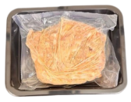
Beef in Gravy | 425 | 1 | Yes | 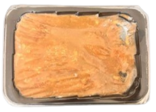
Lasagna | 375 (±5) | 1 | No | 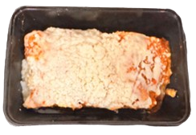
Lasagna & Pulled Chicken | 100 (±1) & 300 (±5) | 2 | No | 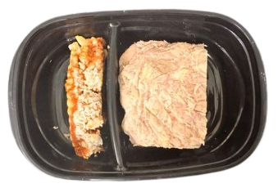
Beef in Gravy & Mashed Potato | 150 (±1) & 150 (±1) | 2 | No | 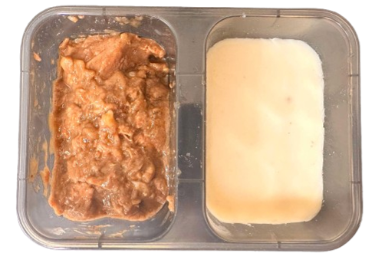

Table III- 2. Overall comparison of microwave heating performance between solid-state microwave with complementary relative-phase heating and magnetron-based heating
Foods | HUI improvement % | Mean temperature rise improvement % | Mean T_{span} impovement %
Pulled Chicken | -30.56 | +16.83 | -17.32
Beef in Gravy | +15.52 | +18.80 | +17.29
Lasagna | +16.67 | +41.03 | +4.00
Lasagna & Pulled Chicken | +13.79 | +22.72 | +9.00
Beef in Gravy & Mashed Potato | 0.00 | +17.22 | -37.44

Figure III- 1. Schematic diagram of the solid-state microwave system.

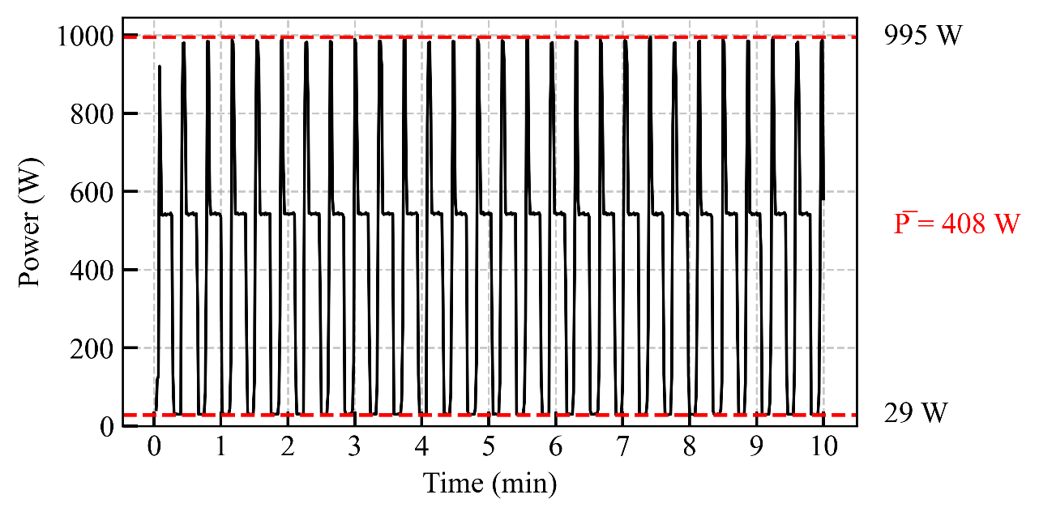
Figure III- 2. Domestic microwave power output recorded under power level 2 for calibration

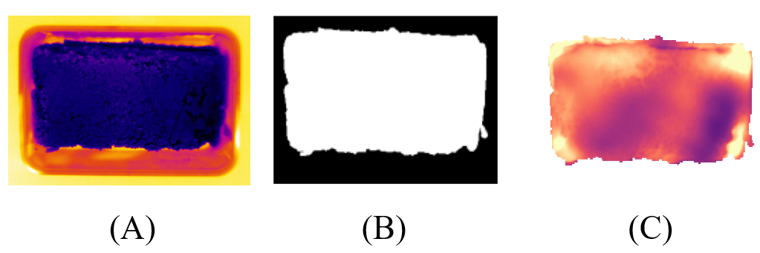
Figure III- 3. Image processing: (A) Initial image (B) Food Mask creation (C) Final image after masking

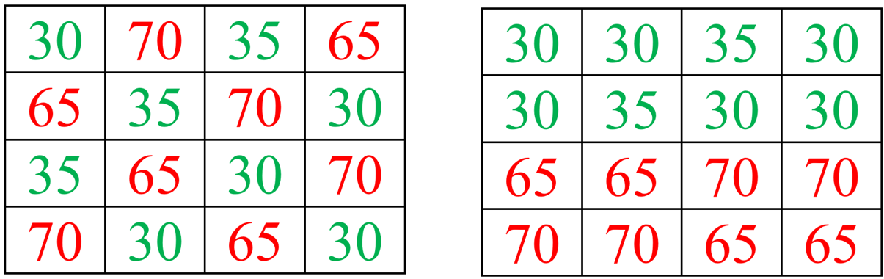
- (B)
Figure III- 4. A simplified pseudo example of temperature distribution over the two surfaces

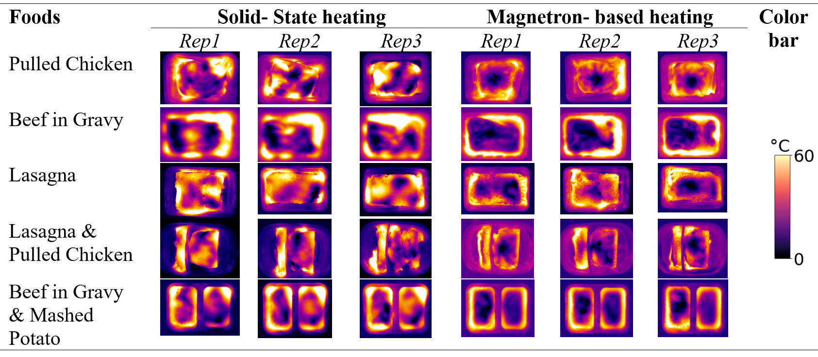
Figure III- 5. Top surface thermal patterns for five various foods using solid-state and magnetron-based heating.

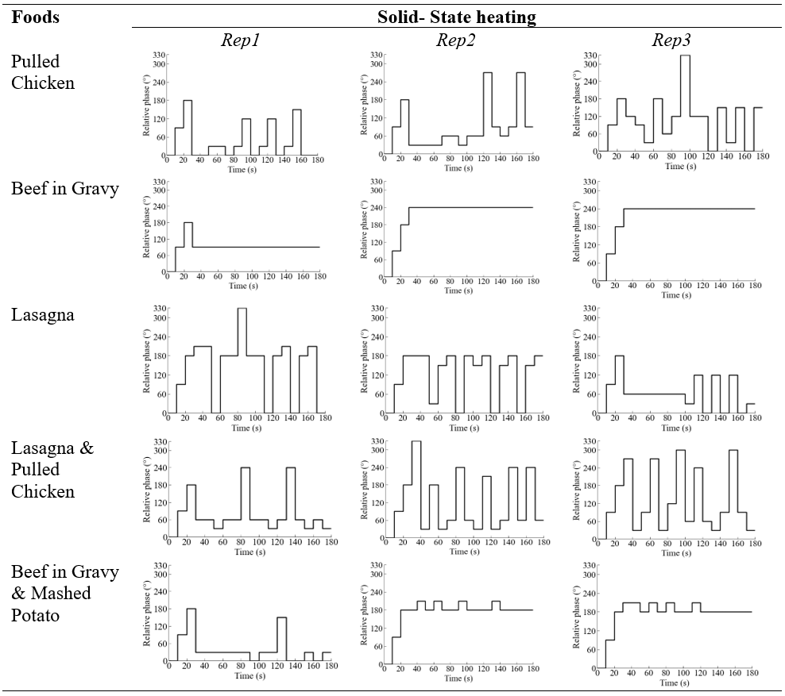
Figure III- 6. The variations in the relative phase during predictive complementary relative phase heating for tested foods.

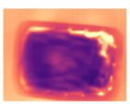  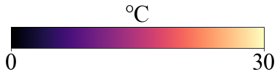 | 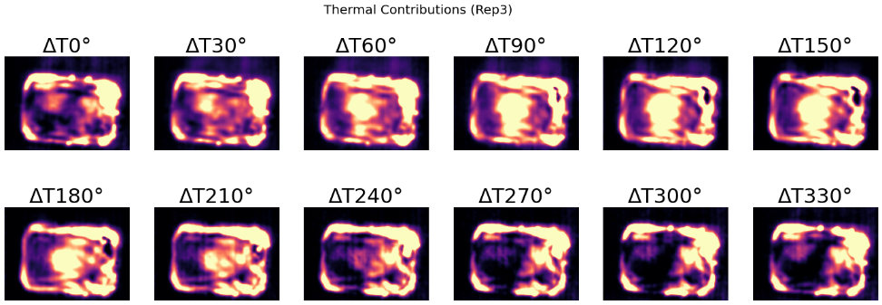  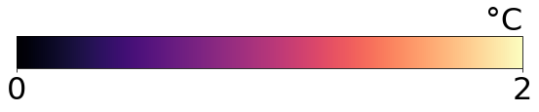
(A) | (B)
Figure III-7. (A) Thermal pattern of Beef in Gravy sample after 30 s heating for replication 1 (B) Predicted relative phase-dependent thermal contributions of Beef in Gravy sample for replication 1.

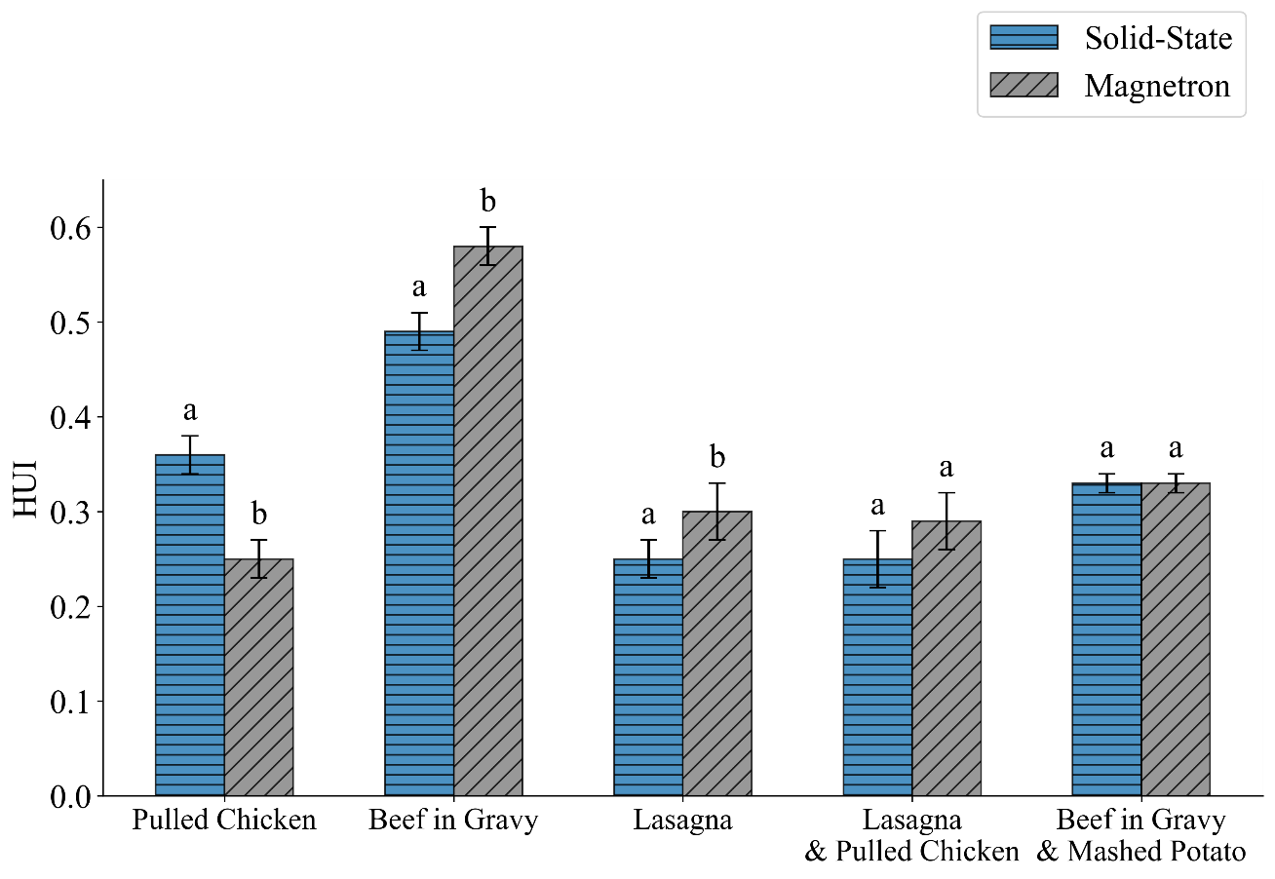
Figure III- 8. Comparison of HUI for the top surface of the foods between solid-state and magnetron-based heating.

*Different alphabetical letters in the bars for the same food indicate they are significantly different (P<0.05).

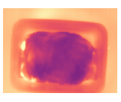 | 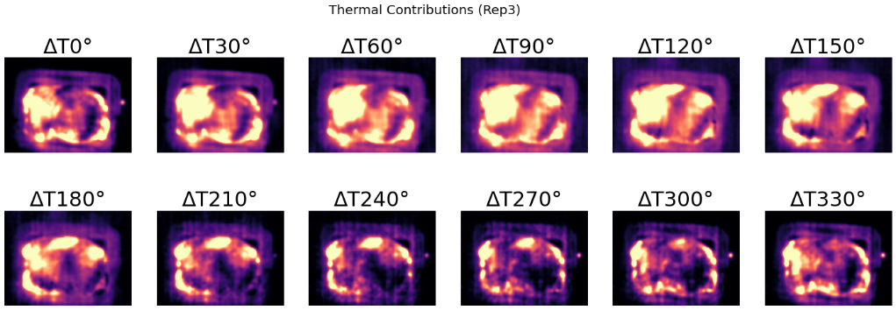  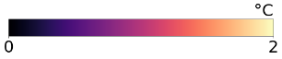
(A) | (B)
Figure III- 9. (A) Thermal pattern of Pulled chicken sample after 30 s heating for replication 1 (B) Predicted relative phase-dependent thermal contributions of Pulled chicken sample for replication 3.

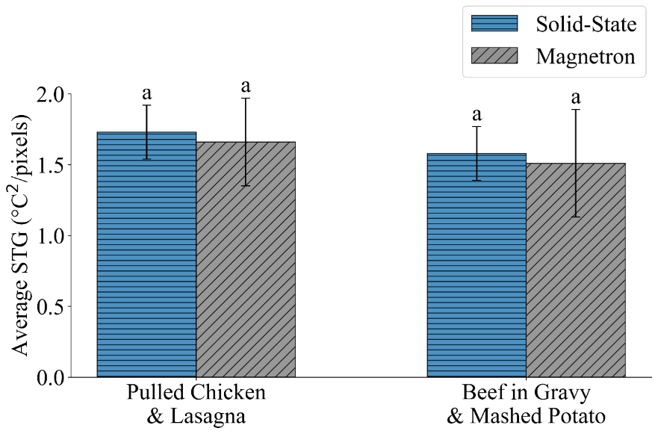
Figure III- 10. Comparison of Average STG for the top surface of the foods between solid-state and magnetron-based heating.

*Similar alphabetical letters in the bars for the same food indicate they are not significantly different (P<0.05).

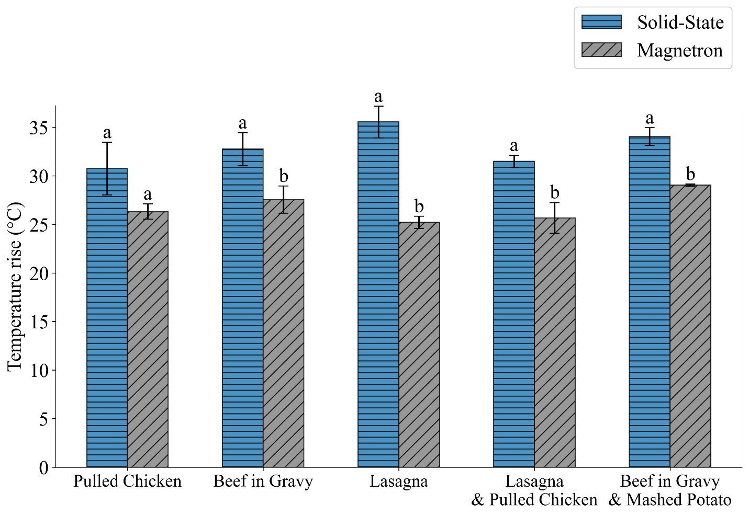
Figure III- 11. Comparison of mean temperature rise for the top surface of the foods between solid-state and magnetron-based heating.

*Different alphabetical letters in the bars for the same food indicate they are significantly different (P<0.05).

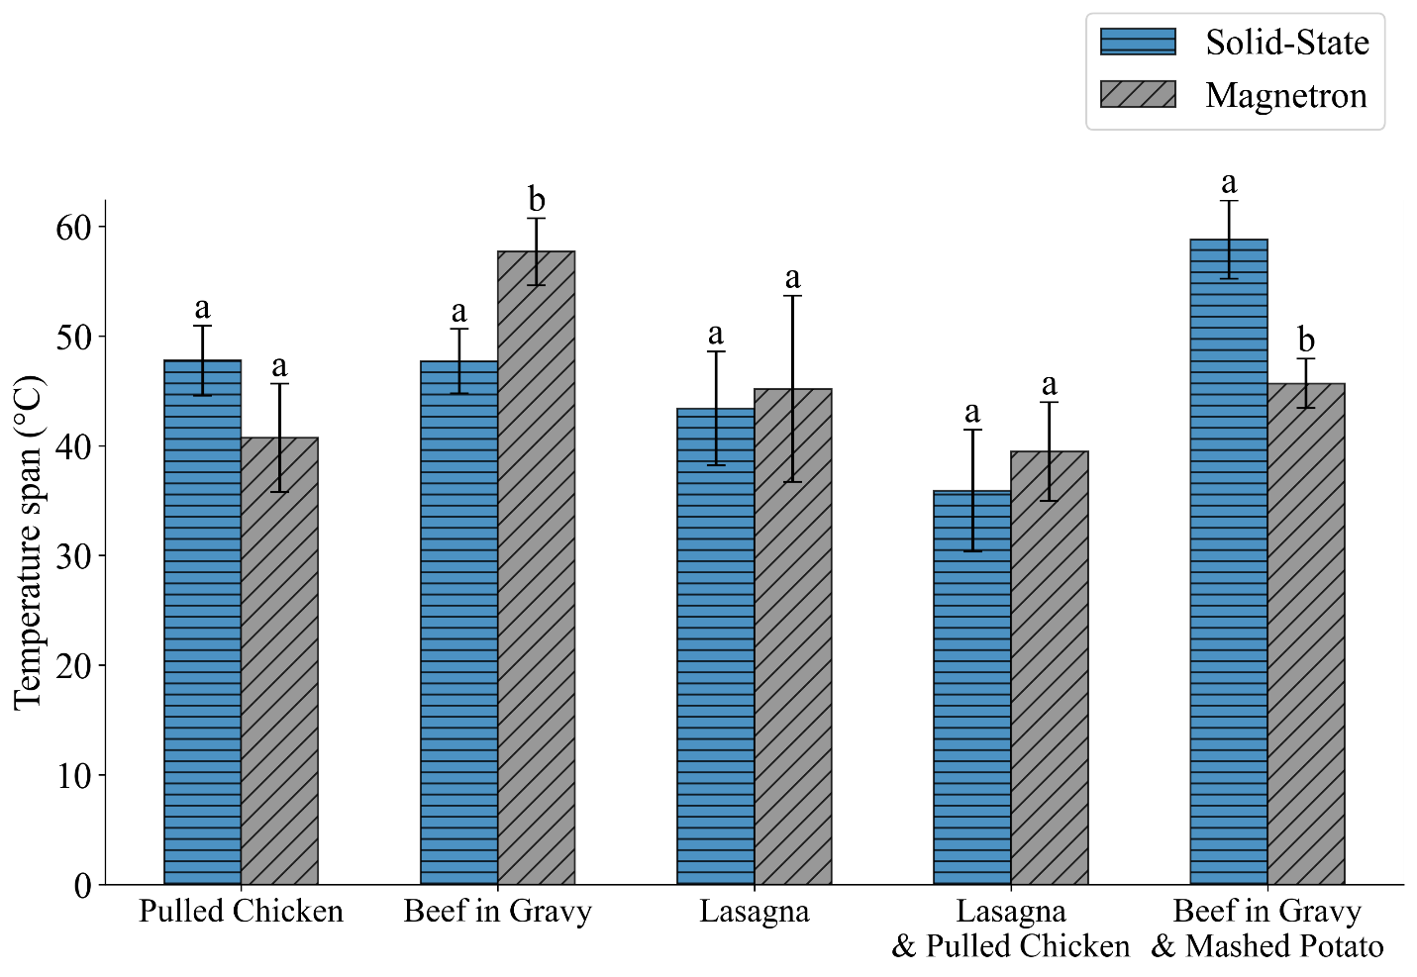
Figure III- 12. Comparison of mean temperature span for the top surface of the foods between solid-state and magnetron-based heating.

*Different alphabetical letters in the bars for the same food indicate they are significantly different (P<0.05).

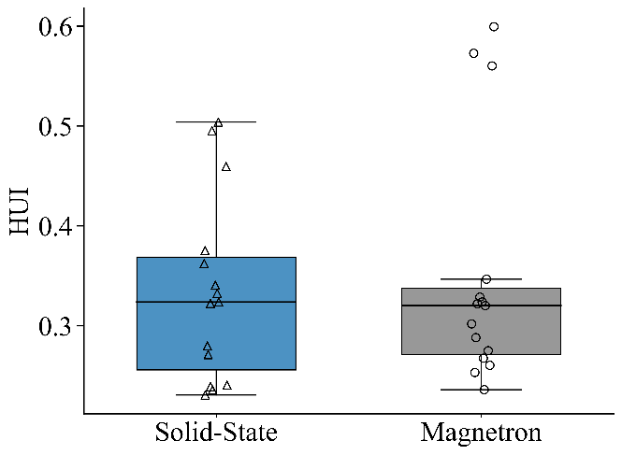 | 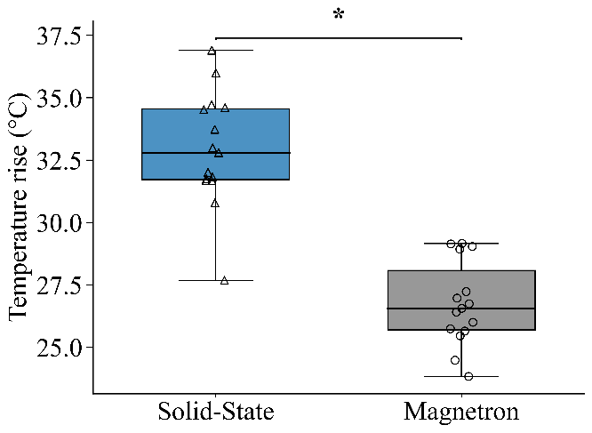
(A) | (B)
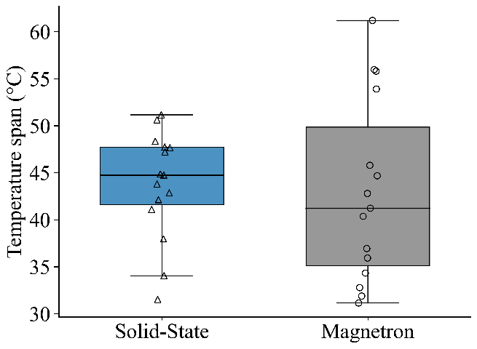
(C)
Figure III- 13. Comparison of overall heating performance by solid-state and magnetron-based heating for (A) HUI (B) Mean temperature rise (C) Temperature span

Overall CONCLUSION
Solid-state technology is an innovative approach that shows great promise in enhancing microwave performance compared to conventional magnetron-based microwave ovens. Unlike magnetrons, solid-state systems allow for precise control over the relative phase of the microwaves emitted from multiple sources. By adjusting this relative phase, it is possible to dynamically change the electromagnetic field distribution to improve the overall microwave heating performance. Although limited research has been conducted on implementing relative phase control algorithms for solid-state systems, this study aimed to develop a robust complementary relative-phase heating strategy. The goal was to improve microwave heating performance and enable automatic adaptation to variations in various foods.
In Chapter I, this research systematically developed, optimized, and validated a dynamic complementary relative phase shifting strategy for dual-port solid-state microwave heating, advancing the field of microwave heating through two key stages. Initially, the thermal patterns were collected and analyzed for the thermal contributions in the combined-sweeping stage. By sweeping the relative phases in an orderly manner, phase-dependent thermal contributions were identified, demonstrating that hot and cold spots could interchange depending on phase selection. Then the complementary shifting stage was run by analyzing the thermal dataset in terms of performance parameters. Incorporating these insights, complementary heating strategy was developed that allowed for real-time adjustments, significantly enhancing heating uniformity, microwave power absorption, and temperature distribution. This strategy proved to be a promising approach for integration into solid-state microwave systems, offering a robust solution for uniform heating.
In Chapter II, the research further introduced a predictive modeling approach to overcome the limitations of extensive phase sweeping. It was observed that phase-dependent thermal contributions followed a sinusoidal pattern, enabling the prediction of arbitrary relative phases using just three measured phases (0°, 90°, and 180°). The resulting predictive-complementary relative phase strategy significantly improved heating efficiency by reducing the time allocated for phase sweeping and increasing the duration of complementary shifting. The predictive complementary relative phase heating strategy demonstrated the best microwave heating efficiency among the Fixed, Sweeping, and Sweeping-Complementary approach highlighting its potential for real-time applications. Future research was recommended to expand this approach to more complex food products to further validate their practicality.
In Chapter III, the developed predictive relative phase heating strategy was tested on a diverse range of commercial food products, including single-component, multicomponent, multilayer, and multi-compartment meals. Compared to conventional magnetron-based heating with a turntable, the predictive complementary strategy improved the microwave heating performance. The most significant improvements were observed in temperature rise due to precise relative phase control optimizing constructive interference compared to the magnetron-based heating.
Upon completion of this study, the predictive complementary relative phase shifting as a next-generation heating solution for solid-state microwave systems is developed. Experimental results demonstrated that the proposed approach could be more effective than the microwave heating using magnetrons, achieving improved heating performance across a variety of real food samples. These outcomes highlight both the robustness of the predictive complementary dynamic algorithm and the significant potential of solid-state technology for applications in the food industry.

Future work
This study introduced and validated a dynamic complementary-relative phase control algorithm for solid-state microwave heating, demonstrating clear benefits over traditional magnetron-based systems in terms of heating uniformity and energy distribution. While the outcomes are encouraging, several opportunities exist to expand and strengthen this line of research.
For research purposes, the current implementation was conducted on a dual-port solid-state microwave system operating under relatively moderate power levels (up to 200 W per port), which are significantly lower than those in standard domestic microwave ovens (~1000 W total). Future investigations should involve higher-power systems to better simulate real-world heating conditions and to explore how increased energy input interacts with relative phase control. In addition, while this work focused specifically on relative phase control, solid-state systems offer simultaneous control over frequency and power, both of which can significantly influence microwave behavior. Future algorithms that can coordinate multiple control dimensions in real time may yield even more effective heating outcomes. Future research should explore the combined control of frequency and relative phase in solid-state microwave systems, as each parameter uniquely contributes to different aspects of heating performance. Developing intelligent algorithms capable of coordinating frequency-relative phase interaction will be a crucial next step. These algorithms must account for the complex electromagnetic behavior within the cavity, the changing state of the food, and practical constraints such as processing time and power limitations. When successfully implemented, this integrated approach could set a new benchmark for smart, adaptive microwave heating, enabling future solid-state ovens to deliver uniform heating across a wide range of food applications.
Finally, the cost and complexity of solid-state systems remain a significant hurdle for widespread use in consumer appliances. While prices are expected to drop with ongoing development, early adoption may be most feasible in commercial or industrial applications, where the priority is on performance and consistency rather than affordability. Continued collaboration with microwave technology developers will be key to refining the hardware and control systems for broader accessibility.

VITA
Arjun Ghimire was born on September 5, 1985, in Nepal. He earned his Bachelor of Technology (B.Tech) in Food Technology in 2008 and his Master of Technology (M.Tech) in Food Technology in 2010 from the Central Campus of Technology, Nepal. He is currently pursuing a Ph.D. in Food Science at the University of Tennessee, Knoxville, with an expected completion in 2025. His research focuses on solid-state microwave heating, specifically the development of predictive complementary relative phase shifting strategies to improve heating uniformity and energy efficiency in food processing.
Before beginning his doctoral studies, he worked as an Assistant Professor at the Central Campus of Technology, Nepal, from 2017 to 2022, where he also previously served as a Teaching Assistant and part-time instructor. He has authored multiple peer-reviewed publications in high-impact journals and presented his research at international conferences, including the International Microwave Power Institute (IMPI). His contributions to the field have earned him several awards, including the Robert F. Schiffmann Memorial Scholarship and the Herbert College of Agriculture Fellowship for Graduate Excellence.
In addition to his academic and research endeavors, he has actively participated in various professional workshops and training programs related to food processing, microwave power engineering, and computational modeling. His expertise includes microwave heating strategies, food preservation technologies, and computational modeling using Python programming, COMSOL Multiphysics, and data analysis. He aims to advance smart heating solutions for food processing industries by integrating solid-state microwave technology into commercial applications.

