Dispersal rate of the Asian Clam (Corbicula fluminea):
A study with PIT tagging
Tommy Cianciolo, Michael L. McKinney*
Department of Earth & Planetary Sciences,
University of Tennessee,
Knoxville, TN 37916

*Corresponding author: mmckinne@utk.edu
Abstract
The Asian clam (Corbicula fluminea) was introduced to the West coast of the United States in the 1930’s and is now the most widespread non-native bivalve mollusk in North America. Despite its abundance in U.S. lakes and streams, there is a surprising lack of knowledge about how fast Corbicula disperse, especially upstream. Unlike native mussels, Corbicula do not use fish as larval hosts; instead releasing their fully formed offspring into the water column. In this study, we attempt to quantify the rate of downstream and upstream dispersal for Corbicula located in Pistol Creek, an urban stream that flows through Alcoa and Maryville in Blount County, TN. Passive Integrated Transponder (PIT) tags were glued onto Corbicula found within a 375m section of Pistol Creek and measured for growth and initial location using GPS coordinates in decimal degrees. Follow up surveys of the stream using the Biomark HPR portable antenna identified tagged individuals. These follow-up surveys attempted to cover as much area of the 375m section as possible including 30m upstream and downstream. Preliminary results show that, for a 7-month period including significant rainfall with high volume discharge, the large majority Corbicula did not move from their original locations. The greatest movement was found in two individuals that moved 21 and 25 m downstream. How Corbicula are moving upstream in this urban creek system remains to be determined.

Introduction
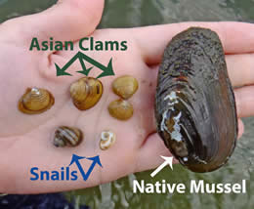
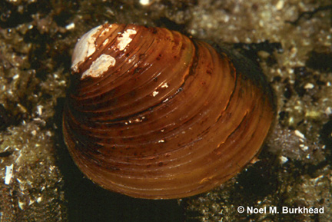
The Asian clam (Corbicula fluminea) was introduced to the West coast of the United States in the 1930’s and is now the most widespread non-native bivalve mollusk in North America (Appendix A). Corbicula is native to parts of Asia, Australia, and Africa and is thought to have been brought to North America as a food source by Chinese immigrants (Counts 1986). Corbicula can invade new areas extraordinarily fast because it is more mobile, has a shorter lifespan (one to five years), grows more rapidly reaching maturity faster, and has a higher fecundity than native mollusk species (Figure 1). Corbicula is generally described as a hermaphroditic species (Sousa et al. 2008) where fertilization occurs within the paleal cavity and young are released to the water column as completely formed with a shell, digestive system, foot, and gills (Ilarri and Sousa 2012). Corbicula displays an r-selected population growth strategy producing many offspring multiple times per year with low survival rates (Sousa et al. 2008). These life history traits along with a lack of natural predators has resulted in the rapid spread of Corbicula across the US. High population densities of Corbicula can cause numerous ecological and economical damages including: biofouling, competition for food and habitat, higher water filtration rates, and introduction of diseases and parasites (Sousa et al. 2008; see Appendix B).
Figure 1: Top: image comparing Corbicula to native mussels and snails. Source: http://www.lakegeorgeassociation.org/what-we-do/Invasive-Species/Asian-Clam.asp
Bottom: Image of Corbicula. (Foster et al. 2017)

Dispersal

Corbicula can disperse both actively and passively throughout its life cycle. Active dispersal describes unaided movement whereas passive dispersal describes movement resulting from vectors such as water current, other animals, or human activities. Passive dispersal can transport Corbicula many miles and is important for large-scale invasions. Larva can drift downstream without the input of energy and can travel many miles in the ballast water of ships. It has been suggested that passive dispersion of Corbicula also includes natural vectors such as birds and fish (Voelz et al. 1998). While it is known that the Asian clam does not use fish as larval hosts like native mussels, it is possible that fish can ingest Corbicula that pass through the digestive tract of the fish unharmed (Gatlin et al. 2013). Passive dispersal through fish, as well as unaided, active dispersal upstream were suggested in a study that found Corbicula 8 km upstream from its original source (Voelz et al. 1998). This finding is significant because it eliminated both avian and human dispersal as causes for upstream movement on the remote Savannah river site in South Carolina. Passive dispersal of Corbicula through birds is unlikely because of the high temperatures and acidic conditions of avian gizzards (Thompson and Sparks 1977). Corbicula can also attach themselves to ships via byssus threads and can be carried hundreds of miles up and down rivers and into entirely different watersheds. In the interconnected and heavily trafficked Rhine River in Europe, Corbicula were shown to travel up to 276 km/year via human transport (Leuven et al. 2009). Active dispersal, however, is important on the local scale of Corbicula invasions and can only occur in the aquatic environment (Kappes and Haase 2012). The rate of active movement is dependent on numerous factors including: water velocity, sediment heterogeneity, temperature, reproductive status of the individual, and food availability (Kappes and Haase 2012). Although there have been numerous studies on the passive dispersal of Corbicula, little is known about the role of active dispersal in Corbicula invasions and even less has been done to quantify the rate of active dispersal. In this study, we attempt to quantify the rate of upstream, active dispersal for Corbicula located in Pistol creek, an urban stream located in Blount County, TN. We hope to shed light on how Corbicula are moving upstream in the absence of passive dispersal through natural and anthropogenic vectors.

Pistol Creek, TN
Pistol Creek is a heavily urbanized creek that flows from southwest to northeast in Blount County, TN. It travels through farmland and the urban centers of Alcoa and Maryville during its 13-mile-long journey from its headwater springs to its junction with the Little River. The 2011 National Land Cover dataset was used to analyze the percentage of different land cover types in the Pistol Creek watershed (Appendix C). Land cover in the Pistol Creek watershed was divided into 6 unique classifications (Figure 2). Developed land makes up the largest percentage (63%) of land cover in the Pistol Creek watershed. The Tennessee Department of Environment and Conservation placed Pistol Creek on the 2016 303d list for impaired streams for loss of biological integrity due to siltation and excessive E. coli concentrations. The creek has also been heavily invaded by non-native species with Corbicula being a common presence. Despite its impaired status, Pistol creek is vital to local biota and provides a great amenity to the local community as a paved greenway follows the creek for almost 9 miles (Appendix D). This greenway provided access to the stream for field work throughout much of its length. Pistol creek provided an excellent location for field work because of its high concentrations of Corbicula, relatively good water quality for an urban creek, streamside greenway, and abundance of good habitat for Corbicula.
Figure 2: Analysis of Land cover composition of the Pistol creek watershed

Methods
Passive Integrated Transponder (PIT) tags have been used to locate tagged mussels in freshwater environments for monitoring and relocation purposes (Boisen 2016, Kurth et al. 2007) and research has been conducted on the most effective ways to attach PIT tags to mussels (Young and Isley 2008). However, there is a clear absence of studies that use GPS signal from PIT tags to calculate movement over time. In this study, we used 8.5mm and 9mm PIT tags glued onto Corbicula found in Pistol Creek to record rates of movement over an eight-month period. Corbicula were found in the stream by digging gently in the top layer of sediment. Only individuals large enough (minimum 12mm) were selected for PIT tag placement. Selected Corbicula were dried on the streambank with a towel. A drop of Loctite Superglue Gel was placed onto the outside of the shell, making sure to avoid gluing the hinges of the clam together. A PIT tag was placed on the glue and allowed to dry completely (approximately 10 minutes). While the PIT tag was drying, the length of the clam was measured using an electronic caliper to the nearest 0.01 mm. Corbicula were tagged approximately every 5m in the stream working in the upstream direction. The tagged clam was then placed back in the stream as close as possible to its original position and passed through the handheld loop antenna of the PIT tag reader (Biomark® HPRplus) to record the unique ID and acquire latitude and longitude coordinates of the original location (Boisen 2016). The information stored on the tag reader was uploaded into a data file after each day in the field.
A total of 64 individuals were tagged in Pistol creek along a 375m section of stream. Follow-up surveys were conducted using the Biomark HPR portable antenna which senses the PIT tags in the water just like a metal detector senses metallic objects. The antenna was placed just above the surface of the sediment and dragged over the streambed to cover as much area as possible. When the antenna reads a tag, it records the unique ID and current GPS coordinates. For each follow-up survey, the stream was surveyed throughout the 375m section as well as 30m below the furthest downstream mussel and 30m above the furthest upstream mussel. On some of these follow-up days in the field, the recorded individuals were removed from the sediment to measure growth and to see if the tag was still attached.
Problems and Solutions to initial method
After the first few surveys, it became apparent that Loctite Superglue Gel was not the best material for tagging Corbicula as only 20 out of 31 recaptured tags remained on the individuals while the remaining tags were found loose in the sediment. Gorilla glue was then used on subsequent tagging days to reduce tag loss. Follow-up surveys have revealed that 100% of tags glued with Gorilla glue have stayed on the tagged Corbicula. Gorilla glue was not initially used due to concerns of longer drying time in the air (approximately 10 minutes). No mortality of Gorilla glue-tagged individuals has been recorded however.
Unfortunately, GPS is not accurate on small scales and error is present in every measurement that is made. An error curve for the Biomark HPR Plus GPS measurements was calculated by taking one PIT tag and recording the latitude and longitude in the same location 55 times. Ideally, the GPS coordinates should be the same for every measurement. Latitude and longitude for the 55 points were uploaded into a data file and converted to x,y,z, coordinates. Then, the distance formula was applied to each point against the average x,y,z coordinate. A cumulative distribution plot was made with probability on the x-axis and distance on the y-axis (Figure 3). For alpha 0.05, the cumulative distribution reveals that measured distances of greater than 20.04m are statistically significant of movement in some direction. This presented a problem because the inaccuracies of the GPS only reveal significant changes in location.
To address this problem, tagged Corbicula were labeled in the stream with pink flagging attached to streamside vegetation with the ID of the clam written in permanent ink. A map of the locations of all individuals was created and carried in the field on follow-up surveys. In this way, a distance could be directly measured between the individual’s current location and initial location labelled with pink flagging.
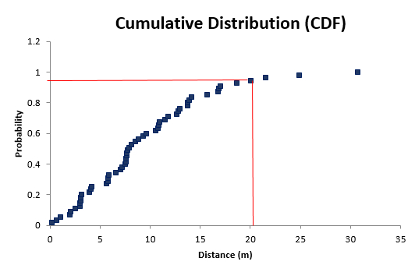
Figure 3: Cumulative distribution plot of GPS error for the Biomark 9mm PIT tags. The plot displays the probability of a measured distance caused by an actual change in movement rather than natural error present in GPS. At an alpha value of 0.05, a measured distance of 20.04m is required for us to be confident that the tagged mussel has moved some distance.
Results
Over the course of 8 months (Aug 2016-Mar 2017), 64 Corbicula individuals were tagged in Pistol Creek with 8.5 and 9.0mm PIT tags. Follow-up surveys recorded a total of 92 tagged individuals with some tagged Corbicula recorded on multiple surveys. 90 of the identified tagged Corbicula showed no movement: either the GPS distance between the current and initial locations was inside the range of error (which was quite large) or the clam was in the same location that it was placed and marked with the pink flagging. Two individuals, however, did move from their initial location, both in the downstream direction. For these two, a direct measurement was made in the stream using a measuring tape (Figure 4).

Figure 4: Data from the two Corbicula that moved downstream
Length and width growth rates were calculated as a monthly rate and graphed by season (Figure 5). Summer showed the highest growth rates for length and width with decreasing rates in Fall and Winter. Change in length against change in width was also graphed (Figure 6). A linear regression was fitted to the data with an R² value of 0.7646 and a slope of 0.8895. The data do not show a 1:1 ratio between growth in length and width. Rather, a change in width of 1 mm would result in a change in length of 0.8895 mm. This indicates an allometric shape change with increasing size, becoming wider with age.

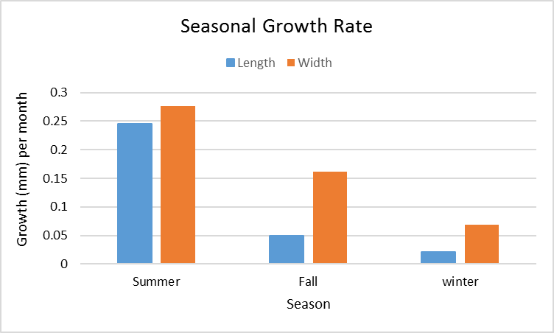
Figure 5: growth rates by season of the month
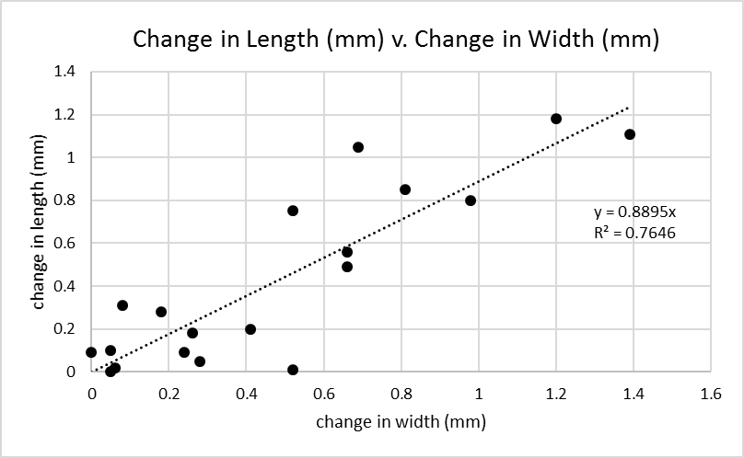
Figure 6: change in length (mm) plotted against change in width (mm)

Discussion & Conclusion
Establishing a repeatable methodology was challenging in this study. First, a suitable stream location need to be identified. Beaver creek, located in Halls, TN, was our initial location but walking upstream and downstream was difficult in this creek due to deep pools, steeply eroding banks, and private land ownership. Pistol Creek was a much better study site because of its flat streambed and streamside greenway. Access to Pistol Creek was simple and follow-up surveys could be conducting throughout the entire 375m reach of stream where Corbicula were tagged, including 30m upstream and downstream. The material used to glue the PIT tag to the shell of the Corbicula was also a problem that needed to be addressed. Loctite Super Glue Gel was not a great material for tagging Corbicula; Gorilla glue was much more effective despite its longer drying time.
The original intention of this project was to use the GPS feature of the Biomark HPR Plus tag reader to calculate distances travelled of tagged clams. The GPS has inherent error so exact distance measurements were impossible to calculate using latitude and longitude. Corbicula needed to be marked in the stream so any movement from its original location could be physical measured in the field.
90 out of the 92 Corbicula found on follow-up surveys had not moved from their original locations. Movement on the scale of centimeters would have been impossible to see using this method however, so small movements cannot be eliminated from discussion. 2 individuals had moved downstream 21 and 25 m respectively. This provides evidence for active dispersal of Corbicula downstream. Our results show no evidence for large movements in Corbicula upstream. How they are moving upstream in this urban creek system remains to be determined.

References
Boisen, Dorottya. "Vertical movement of the endangered James Spinymussel (Pleurobema collina) and the Notched Rainbow mussel (Villosa constricta) in response to floods at different temperatures and substrates: Implications for conservation and management." (2016).
Counts III, Clement L. 1986. "The zoogeography and history of the invasion of the United States by Corbicula fluminea (Bivalvia: Corbiculidae)." American Malacological Bulletin. Special Edition 2:7-39

Foster, A.M., P. Fuller, A. Benson, S. Constant, D. Raikow, J. Larson, and A. Fusaro. 2017. Corbicula fluminea. USGS Nonindigenous Aquatic Species Database, Gainesville, FL.
https://nas.er.usgs.gov/queries/factsheet.aspx?speciesid=92 Revision Date: 1/8/2016

Gatlin, Michael R., Daniel E. Shoup, and James M. Long. "Invasive zebra mussels (Driessena polymorpha) and Asian clams (Corbicula fluminea) survive gut passage of migratory fish species: implications for dispersal." Biological invasions 15.6 (2013): 1195-1200.

Homer, Collin G., et al. "Completion of the 2011 National Land Cover Database for the conterminous United States-Representing a decade of land cover change information." Photogrammetric Engineering and Remote Sensing 81.5 (2015): 345-354.

Ilarri, Martina, and Ronaldo Sousa. "Corbicula fluminea Müller (Asian clam)." A handbook of global freshwater invasive species. Earthscan, London (2012): 173-183.

Kappes, Heike, and Peter Haase. "Slow, but steady: dispersal of freshwater molluscs." Aquatic Sciences 74.1 (2012): 1-14.

Kurth, J., Loftin, C., Zydlewski, J., & Rhymer, J. (2007). PIT tags increase effectiveness of freshwater mussel recaptures. Journal of the North American Benthological Society, 26(2), 253-260.

Leuven, Rob SEW, et al. "The river Rhine: a global highway for dispersal of aquatic invasive species." Biological invasions 11.9 (2009): 1989-2008.

Sousa, R., C. Antunes, and L. Guilhermino. "Ecology of the invasive Asian clam Corbicula fluminea (Müller, 1774) in aquatic ecosystems: an overview." Annales de Limnologie-International Journal of Limnology. Vol. 44. No. 2. EDP Sciences, 2008.

Thompson, Carl M., and Richard E. Sparks. "Improbability of dispersal of adult Asiatic clams, Corbicula manilensis, via the intestinal tract of migratory waterfowl." American Midland Naturalist (1977): 219-223.

Voelz, Neal J., J. Vaun McArthur, and Russell B. Rader. "Upstream Mobility of the Asiatic Clam Corbicula fluminea: Identifying Potential Dispersal Agents." Journal of Freshwater Ecology 13.1 (1998): 39-45
Young, S. P., & Isely, J. J. (2008). Evaluation of methods for attaching PIT tags and biotelemetry devices to freshwater mussels. Molluscan Research, 28(3), 175-178.

Appendix A

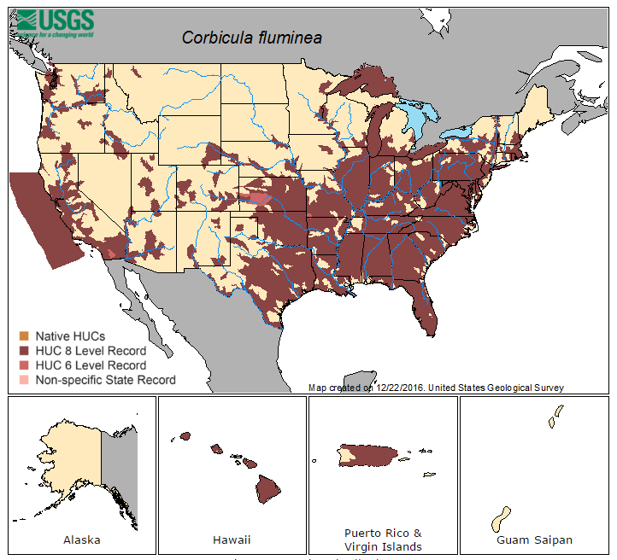
Shown above is the distribution of the Asian Clam in the United States and its territories. It can be found in every major river system in the U.S. and is especially prevalent in the Southeastern states. (Foster et al. 2017)

Appendix B

Table 1: Positive and negative effects that may occur after Corbicula invasions (Sousa et al. 2008)
Appendix C

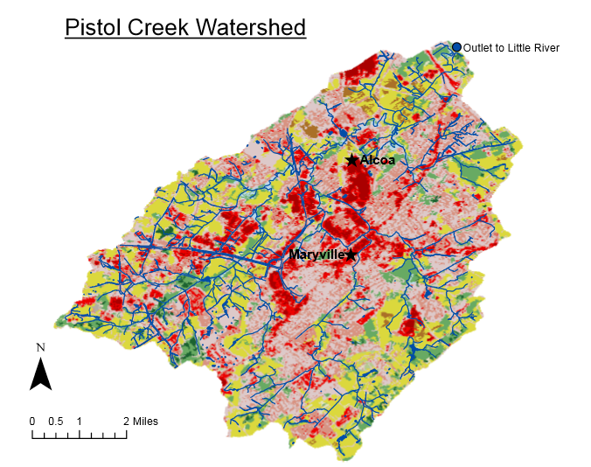
This map was created in ArcMap 10_4 using watershed shapefiles from the USGS and the 2011 National Land Cover dataset (Homer et al. 2015). Shapefiles of streams and ponds were downloaded from State of Tennessee STS GIS Downloadable Data Site.

Appendix D
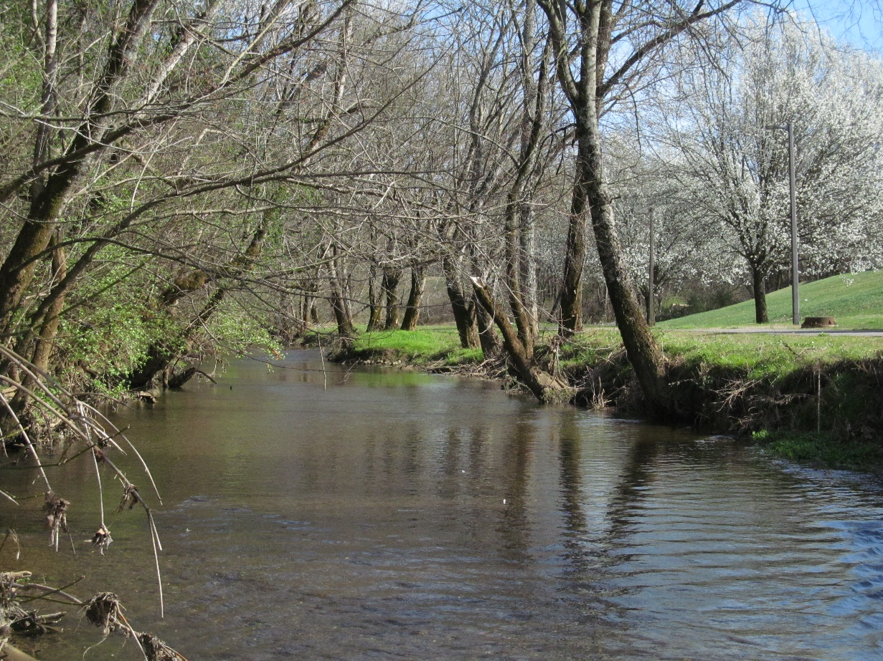
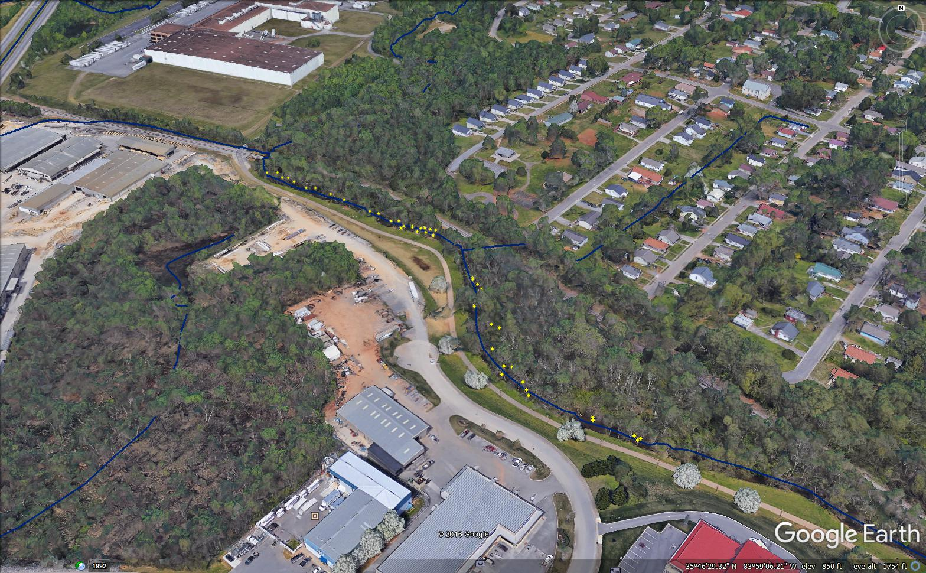
Images of the study location on Pistol Creek. Yellow dots on the bottom image are locations of tagged Corbicula.

