Switching Performance Evaluation, Design, and Test of a Robust 10 kV SiC MOSFET Based Phase Leg for Modular Medium Voltage Converters

A Dissertation Presented for the
Doctor of Philosophy
Degree
The University of Tennessee, Knoxville

Xingxuan Huang
December 2021

Dedicated to my parents, Rigao Huang and Xiaoqing Yang.

ACKNOWLEDGEMENTS

ABSTRACT
10 kV SiC MOSFETs are one of the most promising power semiconductor devices for next-generation high-performance modular medium voltage (MV) converters. With extraordinary device characteristics, 10 kV SiC MOSFETs also bring a variety of challenges in the design and test of MV converters. To tackle these inherent challenges, this dissertation focuses on a robust half bridge (HB) phase leg based on 10 kV SiC MOSFETs for modular MV converters. A baseline design and test of the phase leg is established first as the foundation of the research in this dissertation.
Thorough evaluation of 10 kV SiC MOSFETs’ switching performance in a phase leg is necessary before applying them in MV converters. The impact of parasitic capacitors and the freewheeling diode is investigated to understand the switching performance more extensively and guide the converter design.
One non-negligible challenge is the flashover fault resulting from the premature insulation breakdown, a short circuit fault with extremely fast transients. A device model is established to analyze the behavior of 10 kV SiC MOSFETs when the fault occurs in a phase leg thoroughly. Subsequently, the gate driver and protection design considerations are summarized to achieve lower short circuit current and overvoltage and ensure the survival of the MOSFET that in ON state when the fault happens.
Furthermore, it is challenging to design the overcurrent/short circuit protection with fast response and strong noise immunity under fast switching transients for 10 kV SiC MOSFETs. The noise immunity of the desaturation (desat) protection is studied quantitatively to provide design guidelines for noise immunity enhancement. Then, the protection scheme based on desat protection is developed and validated with <350 ns response time. Based on the investigation results of the noise immunity, the strong noise immunity of the developed protection is also successfully validated.
In addition, a simple test scheme is proposed and validated experimentally, in order to qualify the HB phase leg based on the 10 kV SiC MOSFET comprehensively for the modular MV converter applications. The test scheme includes the ac-dc continuous test with two phase legs in series to create the testing condition similar to what is generated in a modular MV converter, especially the high dv/dt. The test scheme can fully test the capability of the phase leg to withstand high dv/dt and its resulting noise.

Table of Contents

Ch 1. Introduction 1
1.1 Modular Medium Voltage Converters 1
1.2 10 kV SiC MOSFETs for MV Applications 5
1.3 Motivation and Objective 9
1.4 Dissertation Outline 12
Ch 2. Literature Review 14
2.1 Switching Performance Evaluation 14
2.1.1 Characterization and Influencing Factors of Switching Performance 14
2.1.2 Impact of Freewheeling Diode on Switching Performance 20
2.2 Design of 10 kV SiC MOSFET Based Phase Leg 23
2.2.1 Gate Driver Design 24
2.2.2 Overcurrent Protection Design 28
2.2.3 Impact of Flashover Fault on Gate Driver Design 33
2.3 Testing of 10 kV SiC MOSFET Based Phase Leg 35
2.4 Summary 37
Ch 3. Baseline Design and Test of a 10 kV SiC MOSFET Based Phase Leg 39
3.1 Overview of the Phase Leg 39
3.1.1 10 kV SiC MOSFET 39
3.1.2 Architecture of the Phase Leg 40
3.2 Gate Driver Design 41
3.2.1 Signal Transfer and Feedback Stage 42
3.2.2 Gate Driving Stage 47
3.2.3 Overcurrent Protection Stage 48
3.3 Baseline Test of the Phase Leg 55
3.3.1 Testing Procedures 55
3.3.2 Testing Results 58
3.4 Summary 61
Ch 4. Switching Performance Evaluation 63
4.1 Impact of Parasitic Capacitor in Load Inductor 67
4.2 Impact of Parasitic Capacitors Due to Heatsink 72
4.3 Impact of Body Diode and Anti-parallel JBS Diode 77
4.3.1 Device under Test and Experimental Setup 78
4.3.3 Impact of Anti-parallel JBS Diode 84
4.4 Summary 88
Ch 5. Analysis and Gate Driver Considerations of 10 kV SiC MOSFETs under Flashover Fault 90
5.1 Model of 10 kV SiC MOSFET 91
5.2 10 kV SiC MOSFET under Flashover Fault 95
5.2.1 Flashover Fault and Simulation Model 95
5.2.2 10 kV SiC MOSFET without Kelvin Source 95
5.2.3 10 kV SiC MOSFET with Kelvin Source 98
5.3 Gate Driver Design Considerations 99
5.3.1 10 kV SiC MOSFET without Kelvin Source 99
5.3.2 10 kV SiC MOSFET with Kelvin Source 101
5.3.3 Summary 102
5.4 Short Circuit Energy Loss and Protection Design 102
5.4.1 Simulation of FUL Fault and HSF Fault 103
5.4.2 Comparison between Flashover and FUL Fault 104
5.4.3 Comparison between Flashover Fault and HSF Fault 106
5.5 Summary 108
Ch 6. Overcurrent Protection Design with Strong Noise Immunity and Fast Response 109
6.1 Noise Immunity Analysis and Enhancement of Desat Protection 109
6.1.1 Noise Immunity Analysis 111
6.1.2 Noise Immunity Enhancement 120
6.1.3 Summary 130
6.2 Improved Desat Protection with Digital Blanking Time 131
6.2.1 Working Principles 131
6.2.2 Implementation 133
6.2.3 Discussions of Response Time 135
6.2.4 Experimental Results 138
6.3 Summary 141
Ch 7. Comprehensive Test Scheme of a 10 kV SiC MOSFET Based Phase Leg 143
7.1 Overview of Test Scheme 143
7.1.1 Overview of ac-dc Continuous Test 144
7.1.2 Modulation Scheme 146
7.2 Open-loop Voltage Balancing Scheme 148
7.3 Simulation Results 151
7.4 Experimental Setup and Results 153
7.5 Summary 157
Ch 8. Conclusions and Future Work 159
8.1 Conclusions 159
8.2 Future Work 161
8.2.1 Proposed future work 161
8.2.2 Other future work 164
References 166
Vita 175

LIST OF TABLES

Table 1. Material properties of Si and SiC for power electronic applications. 4
Table 2. Specifications of the designed gate driver. 43
Table 3. Specifications of the designed desat overcurrent protection. 50
Table 4. Distribution of the total response time in one gate driver prototype. 54
Table 5. Details of four steps in the systematic testing of the phase leg. 56
Table 6. Summary of the selected measurement setup for the DPT. 66
Table 7. Switching performance of Configuration A and B at 3 kV, 125 ˚C. 84
Table 8. Measured resistance of body diode at different temperatures. 85
Table 9. Switching performance comparison between Configuration B and Configuration C at 3 kV/20 A. 85
Table 10. Gate driver design considerations from the standpoint of flashover fault 102
Table 11. Summary of design recommendations of different parameters to reduce spikes in V_{desat} due to high positive dv/dt. 116
Table 12. Summary of selection and design guidelines about comparator to enhance noise immunity of the desat protection 122
Table 13. Summary of design guidelines to enhance noise immunity of desat protection 130

LIST OF FIGURES

Fig. 1- 1. Physical structure and current flow of IGBT and power MOSFET [17]. 3
Fig. 1- 2. Device-level and converter-level benefits of 10 kV SiC MOSFETs [10]. 6
Fig. 1- 3. Specific on-resistance vs. breakdown voltage for Si and SiC [30]. 7
Fig. 1- 4. Summary of challenges brought by 10 kV SiC MOSFETs. 10

Fig. 2- 1. Two circuit configurations used in DPT: (a) phase leg configuration; (b) switch/diode pair. 15
Fig. 2- 2. Switching energy loss as a function of external gate resistance (left) and drain current (right) for the 3rd generation 10 kV SiC MOSFET at 150 ˚C [29]. 18
Fig. 2- 3. Detailed device model of 10 kV SiC MOSFET [44]. 18
Fig. 2- 4. Turn-on and turn-off waveforms of the 10 kV SiC MOSFET at 25 ˚C [44]. 19
Fig. 2- 5. Turn-on and turn-off waveforms of the 10 kV SiC MOSFET at 125 ˚C [44]. 19
Fig. 2- 6. Circuit diagram of DPT for diode reverse recovery characterization. 23
Fig. 2- 7. Basic function diagram of a gate driver for a power MOSFET [10]. 25
Fig. 2- 9. Implementation of desat protection for SiC MOSFETs [66]. 30

Fig. 3- 1. Discrete 10 kV SiC MOSFET in the half bridge phase leg (left) and its forward characteristic at room temperature (right). 40
Fig. 3- 2. Half bridge phase leg based on 10 kV SiC MOSFETs: (a) Architecture of the phase leg; (b) Detailed 3D model of the phase leg. 41
Fig. 3- 3. Block diagram of designed gate driver for 10 kV SiC MOSFETs. 43
Fig. 3- 4. Diagram of the generation of final gate signal sent to gate drive IC with 500 ns dead time realized in gate driver. 44
Fig. 3- 5. Diagram of the generation of final feedback signal sent back to controller. 46
Fig. 3- 6. (a) Designed circuit for the update scheme to realize status feedback function; (b) Generation of final feedback signal with the updated feedback scheme. 47
Fig. 3- 7. Experimental waveforms of final feedback signal with the updated feedback scheme: (a) 0 V dc bus voltage; (b) 3 kV ac-dc continuous test of phase leg. 47
Fig. 3- 8. Output characteristic of the 10 kV /20 A SiC MOSFET under different temperatures. 50
Fig. 3- 9. Implementation of desat protection in the gate driver for 10 kV SiC MOSFETs. 52
Fig. 3- 10. Turn-on transient of the 10 kV SiC MOSFET at 6.25 kV/20 A. 53
Fig. 3- 11. Circuit diagram of the continuous test of the designed phase leg. 58
Fig. 3- 12. (a) Phase leg prototype in the high voltage test platform; (b) Thermal image of the phase leg prototype during 6 kV ac-dc continuous test. 59
Fig. 3- 13. HSF short circuit test waveforms: (a) Lower device in the phase leg; (b) Upper device in the phase leg. 61
Fig. 3- 14. Zoom-in waveform of the continuous test of the phase leg at 6.5 kV. 61

Fig. 4- 1. Three major sources of the parasitic capacitance in the power stage. 63
Fig. 4- 2. Circuit diagram of the DPT based on the designed half bridge phase leg. 64
Fig. 4- 3. DPT test setup based on the designed half bridge phase leg together with measurement setup. 66
Fig. 4- 4. High voltage load inductor with external capacitor to increase its EPC. 68
Fig. 4- 5. Turn-on and turn-off energy loss at 6.25 kV when load inductor has different EPCs. 70
Fig. 4- 6. Turn-on and turn-off dv/dt at 6.25 kV when the load inductor has different EPCs. 70
Fig. 4- 7. Turn-off transient waveform at 6.25 kV when load inductor has different EPCs. 71
Fig. 4- 8. Turn-off transient waveform at 6.25 kV/20 A when the load inductor has different EPCs. 72
Fig. 4- 9. Two thermal designs implemented in the half bridge phase leg. 74
Fig. 4- 10. Comparison of turn-on and turn-off energy loss between the thermal design A and B at 6.25 kV. 75
Fig. 4- 11. Comparison of turn-on and turn-off dv/dt between thermal design A and B at 6.25 kV. 76
Fig. 4- 12. Impact of the 106 pF parasitic capacitor due to heatsink on the switching energy loss and dv/dt (Normalized based on data from thermal design A). 77
Fig. 4- 13. 10 kV SiC MOSFET module (H-bridge) packaged by Danfoss. 78
Fig. 4- 14. Three device configurations for one switch available in the 10 kV SiC MOSFET module. 79
Fig. 4- 15. Picture of DPT setup to evaluate the impact of body diode and anti-parallel JBS diode. 80
Fig. 4- 16. Switching energy loss vs. temperature (Configuration C, 3 kV/20 A). 82
Fig. 4- 17. Turn-on and turn-off dv/dt vs. temperature (Configuration C, 3 kV/20 A). 83
Fig. 4- 18. Switching transient waveforms of Configuration A and B at 75 ˚C (3 kV, 10 A). 83
Fig. 4- 19. Switching transient waveforms of Configuration B and C at 125 ˚C. 85

Fig. 5- 1. Equivalent circuit of the established 10 kV SiC MOSFET model. 91
Fig. 5- 2. Circuit model of the 10 kV SiC MOSFET in ON state under flashover fault modeled by closing an ideal switch. 94
Fig. 5- 3. Simulation waveforms of flashover fault at 7 kV with 1 nH common source inductance L_{ss}, 15 Ω R_{g,on,} and 2.5 Ω R_{g,off}: (a) Waveforms of V_{ds,int}, I_{d}, and V_{gs,int}; (b) Waveforms of V_{gs,m} and gate current I_{gate}. 96
Fig. 5- 4. Flashover fault simulation results at 7 kV with 1 nH L_{ss}, 15 Ω R_{g,on,} and 0 Ω R_{g,off}: (a) Waveforms of V_{ds,int}, I_{d}, and V_{gs,int}; (b) Waveforms of V_{gs,m} and I_{gate}. 97
Fig. 5- 5. Simulation waveforms of flashover fault at 7 kV with 0.15 nH L_{ss} and 15 Ω R_{g,on}: (a) 0 Ω R_{g,off.} (b) 2.5 Ω R_{g,off.} 98
Fig. 5- 6. Simulation waveforms of flashover fault at 7 kV with 1 nH L_{ss}: (a) 15 Ω R_{g,on} and 7.5 Ω R_{g,off}, (b) 15 Ω R_{g,on} and 2.5 Ω R_{g,off.} as well as a 500 pF external capacitor. 100
Fig. 5- 7. Simulation waveforms of flashover fault at 7 kV with 0.15 nH L_{ss}, 15 Ω R_{g,on,} and 7.5 Ω R_{g,off.} 101
Fig. 5- 8. Short circuit energy loss under flashover fault at 7 kV with different gate resistances and common source inductance. 104
Fig. 5- 9. Simulation waveforms of FUL and flashover fault at 7 kV with 0.15 nH L_{ss}, 15 Ω R_{g,on,} and 2.5 Ω R_{g,off.} 106
Fig. 5- 10. Short circuit energy loss comparison between FUL and flashover fault at 7 kV with 0.15 nH L_{ss}, 15 Ω R_{g,on}, and 2.5 Ω R_{g,off}. 106
Fig. 5- 11. Simulation waveforms of HSF and flashover fault at 7 kV with 0.15 nH L_{ss}, 15 Ω R_{g,on}, and 2.5 Ω R_{g,off}. 107
Fig. 5- 12. Short circuit energy loss comparison between HSF fault and flashover fault at 7 kV with 0.15 nH L_{ss}, 15 Ω R_{g,on}, and 2.5 Ω R_{g,off}. 108

Fig. 6- 1. Two different implementations of desat protection for high voltage SiC MOSFETs: (a) Based on discrete components; (b) Realized with gate driver IC. 110
Fig. 6- 2. Analysis of displacement current caused by C_{desat} and negative dv_{ds}/dt in desat protection circuitry. 111
Fig. 6- 3. Analysis of displacement current caused by C_{desat} and positive dv_{ds}/dt in desat protection circuitry. 112
Fig. 6- 4. Desat protection for 10 kV/20 A SiC MOSFET from Wolfspeed. 113
Fig. 6- 5. Simulation waveforms of desat protection for 10 kV/20 A SiC MOSFETs: (a) C_{blk}=56 pF; (b) C_{blk}=20 pF. 115
Fig. 6- 6. Bode plot of V_{desat}(s)/V_{ds}(s) as L_{desat} increases (parameters in Fig. 6-4). 115
Fig. 6- 7. Bode plot of V_{desat}(s)/V_{ds}(s) as R_{damp} increases (L_{desat}=3 µH). 116
Fig. 6- 8. Desat protection circuitry considering parasitic capacitances between drain and protection circuitry. 117
Fig. 6- 9. (a) Simulation results of V_{desat} and V_{comp} with 0.004 pF C_{p3} and 1 pF C_{d} considered for 10 kV and 1.7 kV SiC MOSFETs with 100 V/ns dv/dt; (b) Calculation result of V_{spike} as a function of t_{rise}. 119
Fig. 6- 10. Contour plot of V_{spike} as a function of dv/dt and voltage rise time t_{rise}. 120
Fig. 6- 11. Calculation result of V_{spike} as a function of t_{rise}: (a) Impact of voltage divider impedance; (b) Impact of R_{cla}. 123
Fig. 6- 12. Contour plot of V_{spike} as a function of dv/dt and t_{rise} (0.001 pF C_{p3}). 123
Fig. 6- 13. Contour plot of V_{spike} as a function of C_{d} and t_{rise} (0.004 pF C_{p3;} 100 V/ns dv/dt). 124
Fig. 6- 14. Waveforms of 6 kV continuous ac-dc test of a phase leg based on 10 kV SiC MOSFETs with desat protection in Fig. 6-4. 126
Fig. 6- 15.Waveforms of 6 kV continuous ac-dc test of a phase leg based on 10 kV SiC MOSFETs with 90 Ω R_{cla}. (a) Waveform of V_{comp} when desat protection is falsely triggered. (b) Waveform of V_{desat}. 127
Fig. 6- 16. Waveforms of 6 kV continuous ac-dc test of a phase leg with 90 Ω R_{cla} and an external shielding layer installed. 128
Fig. 6- 17. Waveforms of V_{comp} of new desat protection board with improved noise immunity: (a) 6 kV continuous ac-dc test; (b) 7 kV continuous ac-dc test. 129
Fig. 6- 18. Improved desat protection in the gate driver for 10 kV SiC MOSFETs. 132
Fig. 6- 19. Implementation details of 600 ns digital blanking time. 134
Fig. 6- 20. (a) Detailed 3D design of the phase leg. (b) Prototype of half bridge phase leg with improved desat protection in high voltage test platform. 136
Fig. 6- 21. HSF short circuit test waveform of lower MOSFET in the phase leg. 139
Fig. 6- 22. FUL short circuit test waveform of lower MOSFET in the phase leg. 139
Fig. 6- 23. Waveforms of ac-dc continuous test at 6.5 kV. 141

Fig. 7- 1. Circuit diagram of the proposed ac-dc continuous test circuit for the qualification of half bridge phase legs. 146
Fig. 7- 2. (a) DC circuit model of the two phase legs used to study V_{offset}. (b) DC circuit model of the two phase legs after adding a resistor in parallel with the capacitor. 151
Fig. 7- 3. Simulated waveforms of load voltage and load current at 6 kV dc-link voltage (modulation index m=0.25, R_{load} =1 Ω, L_{load} =175 mH): (a) Overview (V_{g} ramps up from 0 to 6 kV within 0.15 s); (b) Zoom-in waveforms. 152
Fig. 7- 4. Simulated phase leg voltage waveforms (modulation index m=0.25, V_{g}= 6 kV, R_{load} =1 Ω, L_{load} =175 mH): (a) Without parallel resistor for voltage balancing; (b) With a 100 kΩ parallel resistor for voltage balancing. 152
Fig. 7- 5. Experimental setup of the ac-dc continuous test circuit: (a) Zoom-in view of the two cascaded phase legs; (b) Overview of the whole test setup (the load inductor is not visible). 153
Fig. 7- 6. Waveforms of the continuous test with the proposed ac-dc continuous test circuit at 2.1 kV. 155
Fig. 7- 7: Zoom-in waveforms of the continuous test with the proposed ac-dc continuous test circuit at 2.1 kV: (a) Phase leg output voltage rises; (b) Phase leg output voltage decreases. 155
Fig. 7- 8: Waveforms of the continuous test with the proposed ac-dc continuous test circuit at 6 kV. 156

Ch 1. Introduction

1.1 Modular Medium Voltage Converters
Nowadays, power electronics converters with high power conversion efficiency are playing an indispensable part as the essential infrastructure for our society. Particularly, medium voltage (MV, from 1 to 35 kV AC) power converters with high power rating are required to support numerous critical and fundamental applications, including MV motor drives [1] and the modern grid.
MV motor drives are indispensable driving forces in industrial, transportation, and military applications. With the same power rating, MV motor drives achieve lower losses and higher power density compared to low voltage drives [2]. Motors and their drives consume a large percentage of electricity supplied to the industry, hence MV drives with higher efficiency and better performance will make a profound difference.
MV power converters have a wide range of applications in the modern power grid. Various MV converters are needed to support the grid operation, such as solid state circuit breaker and fault current limiter for protection [3], [4], active power filter (APF) for improved power quality [5], static synchronous compensator (STATCOM), and unified power flow controller [6]. New MV converters for grid applications have also been developed to achieve more advanced functions, such as solid-state transformer [7] and continuously variable series reactor [8]. MV converters can interface the renewable energy sources with the grid efficiently due to fewer stages and less complicated structure, hence drawing increasing attention ss the capacity of the installed renewable energy sources keeps soaring. MV DC transmission system enabled by MV converters is promising in interfacing the utility-level solar farms and offshore wind farms to the grid with lower cost and higher efficiency [9], [10]. MV power conditioning system (PCS) is essential to realize novel system configurations in distribution grids, including working as the interface of a microgrid to form an asynchronous microgrid, which benefits the microgrid on dynamic decoupling, resilience promotion, and other aspects [11]-[13]. Besides asynchronous microgrids, the MV PCS can also be applied in combined heat and power system, flexible manufacturing plants to improve the system flexibility and assist renewable energy integration [14].
Among various MV converters, modular MV converters with modular topology stand out due to reduced complexity in converter design and debugging and easy extension to higher voltage level. Modular multi-level converter (MMC), cascaded H-bridge converter, and other modular topologies composed of many identical modules, has been gaining increasing popularity in MV converters [11], [15]. In MV applications with relatively high voltage and high power rating, topologies which are not modular, such as flying capacitor multi-level converter and neutral point clamped multilevel converter, are less competitive compared to modular MV converters. With reduced complexity and inherent scalability, modular MV converters have extraordinary potential to benefit a great variety of MV applications at different voltage levels [16].
Si-based power semiconductor devices dominate in current MV converters, including IGBTs, thyristors, gate turn-off thyristors (GTOs), and integrated gate-commutated thyristors (IGCTs) [10]. The Si IGBT shown in Fig. 1-1 is prevalent in MV converters because of simple gate driver design and relatively high switching frequency.
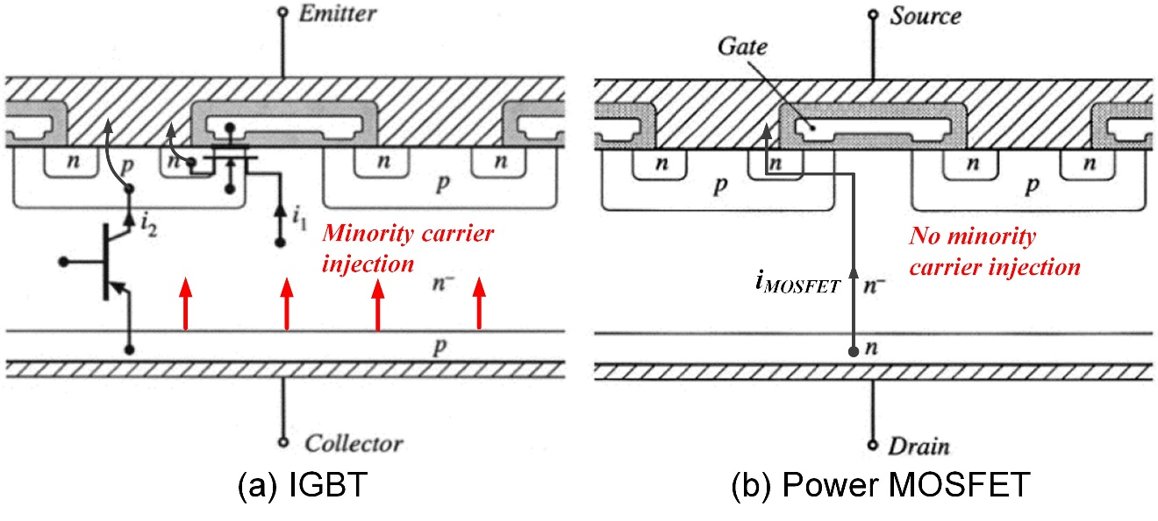
Fig. 1- 1. Physical structure and current flow of IGBT and power MOSFET [17].
Thyristors, GTOs, and IGCTs are usually only considered for extremely high power applications, due to their low conduction loss at large current. Si MOSFETs shown in Fig.1-1, typically with lower switching loss than Si IGBTs, are not suitable in MV converters, suffering from the exceptionally large conduction loss [10], [17].
However, Si IGBTs have gradually become the bottleneck in the development of high-performance MV converters. The limitations of Si IGBTs for MV applications include relatively low blocking voltage, high switching loss, and low switching frequency. The design and fabrication process of Si IGBTs are mature and approaching the limit of Si material. Power semiconductor devices with higher blocking voltage are highly desirable, yet the voltage rating of Si IGBTs commercially available for MV applications is limited to 6.5 kV, due to the conduction loss. Also, because of current i₂ in Fig. 1-1 that cannot be actively shut down and the resulting tail current, it is difficult to further reduce the switching loss of Si IGBTs [17]. Therefore, the switching frequency of MV converters based on 6.5 kV Si IGBTs is usually limited to 1 kHz. In summary, Si IGBTs with limited blocking voltage and low switching frequency are not suitable for future high-performance MV converters [10].
Recently, the rapid development of the silicon carbide (SiC) material has laid a solid foundation for better power semiconductor devices for MV applications. As displayed in Table 1, with much wider bandgap than Si, SiC has superior material properties relevant to power electronics applications, such as electric breakdown field, saturated electron drift velocity, and thermal conductivity [10], [18], [19]. SiC has several different polymorphic crystalline structures, and only 4H-SiC is considered and discussed in this dissertation because it has the best prospect in practical power electronics applications [20].
Excellent material properties of SiC bring the SiC power semiconductor devices higher blocking voltage, higher operation temperature, and potential for higher switching frequency. Tremendous progress has been made in SiC power semiconductor devices, resulting in a wide range of high voltage SiC power semiconductor devices (>3.3 kV) designed and produced for MV applications, including junction barrier Schottky (JBS)
Table 1. Material properties of Si and SiC for power electronic applications.
Properties | Silicon (Si) | Silicon Carbide (SiC)
Bandgap | 1.12 eV | 3.26 eV
Electric breakdown field | 0.3 MV/cm | 2.0 MV/cm
Thermal conductivity | 1.5 W/cm-K | 4.9 W/cm-K
Electron mobility | 1500 cm²/V-s | 950 cm²/V-s (along a-axis)  1190 cm²/V-s (along c-axis)
Saturated electron drift velocity | 1.0 x 10⁷ cm/s | 1.0 x 10⁷ cm/s
Dielectric constant | 11.8 | 10.0

diode, MOSFET, IGBT, thyristor, etc [10], [21]-[25]. Due to the ten times higher critical electric field of SiC material, high voltage SiC devices can achieve much higher voltage rating than their Si counterparts. With rated voltage ranging from 6.5 kV to 20 kV, these emerging SiC devices leveraging the superior characteristics of SiC material provide an unprecedented opportunity to expand what can be accomplished with MV converters.

1.2 10 kV SiC MOSFETs for MV Applications
The 10 kV SiC MOSFET is one of the most promising high voltage SiC power semiconductor devices to replace Si IGBTs in MV applications [26]-[29]. As the leader in SiC power semiconductor devices, Wolfspeed has designed and fabricated three generations of 10 kV SiC MOSFETs, with the specific on-resistance reduced from 160 mΩ-cm² to 100 mΩ-cm² at room temperature [26]-[29]. Compared to Si IGBTs for MV applications, 10 kV SiC MOSFETs have higher voltage rating and operation temperature, lower switching loss, and faster switching speed, as shown in Fig. 1-2 [10]. These benefits at the device level further facilitate comprehensive benefits at the converter level, such as simpler converter topology and design, higher efficiency, smaller size and weight, and higher control bandwidth [10]. Therefore, 10 kV SiC MOSFETs are one of the prospective building blocks of the future high-performance MV converters.
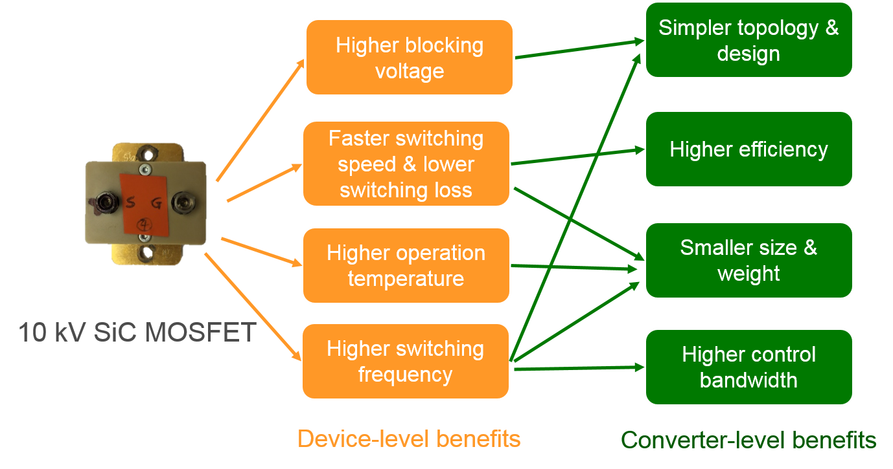
Fig. 1- 2. Device-level and converter-level benefits of 10 kV SiC MOSFETs [10].
10 kV SiC MOSFETs have relatively low on-resistance because of low specific on-state resistance of SiC unipolar devices [30]. To achieve the same blocking voltage level, much thinner drift layer and much higher doping density can be used if Si wafer is replaced by SiC wafer. Therefore, the on-resistance of SiC majority carrier devices is tremendously reduced compared to their Si-based counterparts at the same voltage level. Fig. 1-3 shows the comparison of the specific on-resistance and its theoretical limit of SiC and Si majority carrier devices [30]. The newest generation of 10 kV SiC MOSFETs has specific on-resistance close to its theoretical limit.
Furthermore, 10 kV SiC MOSFETs have faster switching speed, >20X lower switching losses, and hence are able to switch at much higher frequency than 6.5 kV Si IGBTs with similar current rating [22], [29]. Due to the lower specific on-resistance shown in Fig. 1-3, SiC MOSFETs typically have small die size, including 10 kV SiC MOSFETs. As a result, the parasitic capacitors are smaller, contributing to the faster switching speed. The high saturated electron velocity of SiC material reinforces the fast switching speed of 10 kV SiC MOSFETs. From a fundamental standpoint, the 10 kV SiC MOSFET as a majority carrier device, has faster switching transients by eliminating the injection of minority charges and hence the turn-off tail current, as illustrated in Fig. 1 [17]. Thanks to the shorter minority carrier lifetime of SiC material [20], the body diode of 10 kV SiC MOSFETs also has much lower reverse recovery loss than Si PiN diodes, which also supports high switching frequency capability of 10 kV SiC MOSFETs.
MV converters benefit from the superior performance of 10 kV SiC MOSFETs in numerous aspects [27], [31]. The fast switching speed and low switching energy loss give rise to the low converter switching loss and reduced volume and weight of the cooling system. The switching frequency can be increased to tens of kilohertz to achieve smaller size of passive components and higher power density. The high blocking voltage of 10 kV SiC MOSFETs decreases the number of required devices and simplify the converter
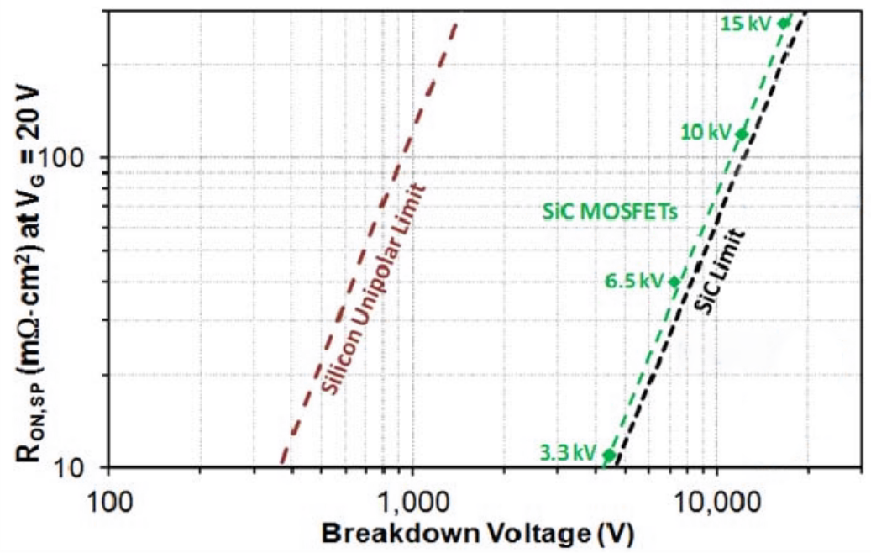
Fig. 1- 3. Specific on-resistance vs. breakdown voltage for Si and SiC [30].
topology and design [11]. With 10 kV SiC MOSFETs, two-level topologies can be adopted for MV drives with 4.16 kV line-to-line voltage.
High switching frequency enabled by 10 kV SiC MOSFETs can support the high-speed direct motor drives without the gearbox, leading to MV drives with smaller footprint and higher system density [32], [33]. Simpler multi-level topologies can be used to directly interface the distribution grid by using 10 kV SiC MOSFETs, without the series connection of switching devices. Moreover, high control bandwidth enabled by 10 kV SiC MOSFETs is capable of supporting more advanced control functions for grid-connected MV converters. For instance, the transformerless PCS based on 10 kV SiC MOSFETs designed for 13.8 kV asynchronous microgrid can achieve APF function to filter 19th order harmonics (1140 Hz) in the distribution grid. These benefits from 10 kV SiC MOSFETs are also of great significance in emerging MV applications, such as electric vehicle (EV) fast charger and data center power supply [31], [34]-[36].
In addition to benefits, superior device-level characteristics of 10 kV SiC MOSFETs bring new challenges. For instance, the drain-to-source voltage V_{ds} of the 10 kV SiC MOSFET typically falls from 6 kV to nearly 0 V within 100 ns during the turn-on transient. Because of high blocking voltage, the high dv/dt lasts for much longer time than the high dv/dt generated by low voltage (<6.5 kV) SiC MOSFETs. It is challenging to design MV power conversion systems based on the 10 kV SiC MOSFET while fully utilizing its device-level benefits. The gate driver should isolate high voltage with high dv/dt in power and signal transmission. The common-mode current caused by high dv/dt should be tackled, and the cross-talk issue should be evaluated and addressed [24]. Not only can the high PWM voltage coupled with high dv/dt and switching frequency lead to accelerated insulation degradation, but also the premature insulation failure hence becomes a more serious issue which should be taken into consideration in MV converter design based on 10 kV SiC MOSFETs [37]-[39]. Moreover, the fast switching speed makes the switching transients of 10 kV SiC MOSFETs more sensitive to the parasitics in the power stage, especially parasitic capacitors. It is important to address these challenges in order to fully leverage the comprehensive benefits of 10 kV SiC MOSFETs.

1.3 Motivation and Objective
The half bridge (HB) phase leg is one of the most fundamental building blocks for modular MV converters [10]. It can function as the basic building block of MMCs and other topologies based on MMC. Two HB phase legs can form a full bridge or H-bridge, the fundamental building block of various MV converters, such as the cascaded H-bridge converter. The investigation results of the HB phase leg based on 10 kV SiC MOSFETs are the foundation for the study and design of modular MV converters. The device’s switching performance in a HB phase leg is also widely accepted to guide the converter loss estimation and design. Hence, this dissertation concentrates on the study of the HB phase leg based on 10 kV SiC MOSFETs. In this dissertation, the phase leg is defined as the HB phase leg with two identical switches allowing bi-directional current. To support the bi-directional current flow, each switching device should have a freewheeling diode.
The premier motivation of this work is to design and build a robust 10 kV SiC MOSFET based HB phase leg for modular MV converters and tackle the challenges brought by the intrinsic characteristics of 10 kV SiC MOSFETs. The challenges are summarized in Fig. 1-4.
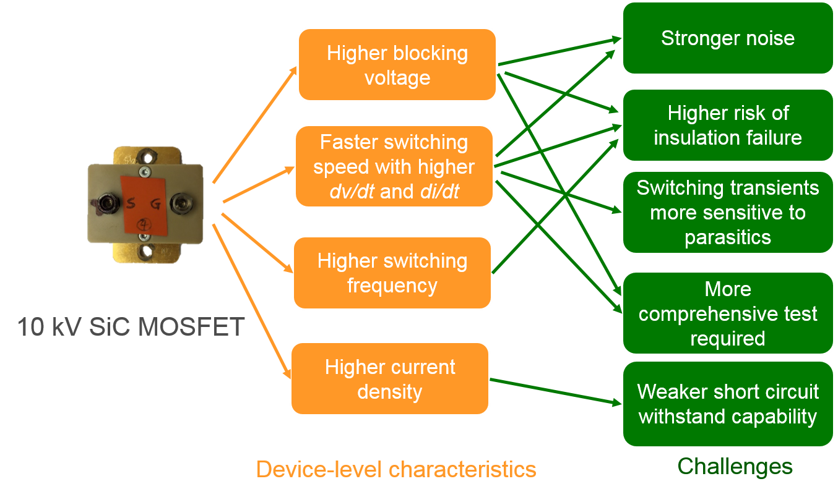
Fig. 1- 4. Summary of challenges brought by 10 kV SiC MOSFETs.
With much faster switching speed than Si IGBTs, switching transients of 10 kV SiC MOSFETs are more sensitive to the parasitics in the converter. Particularly, parasitic capacitors influence the switching energy loss and dv/dt. Nonetheless, the test setup used to test 10 kV SiC MOSFETs is often designed and built to minimize the parasitics in the power stage, and hence have different characteristics from MV converters. As a result, the previous study is unable to identify and investigate the impact of parasitic capacitors in the power stage on the switching performance, leading to inaccurate switching performance evaluation results. The freewheeling diode also impacts the switching performance of the 10 kV SiC MOSFET in the phase leg, which can be implemented with body diode and the external anti-parallel JBS diode. Adding the external anti-parallel JBS diode also introduces the additional parasitic capacitance. Therefore, this dissertation aims to investigate how switching transients and performance of 10 kV SiC MOSFETs are impacted by the parasitic capacitances and the freewheeling diode.
10 kV SiC MOSFETs generate PWM voltage with high magnitude, switching frequency, and dv/dt. As a result, insulation design is more difficult and challenging in the phase leg, and there is higher risk of premature insulation failure [39]. The insulation failure generates the flashover fault, the most serious type of short circuit fault in MV converters [37]. In this dissertation, it is defined that the flashover fault happens because protective insulation fails resulting in a shorted component, such as the MOSFET package, the isolated power supply, and the voltage sensor. Thereby, this dissertation aims to take the flashover fault into account and endeavor to reduce the damage if the flashover fault happens in the phase leg design.
With small chip area and high current density, 10 kV SiC MOSFETs possess worse short-circuit ruggedness than Si IGBTs. It is hence challenging to design the protection which is required to have faster response to turn off the MOSFET safely under short circuit/overcurrent conditions. Now that the flashover fault is one type of short circuit fault that should be considered in the phase leg based on 10 kV SiC MOSFETs, the requirement for the overcurrent/short circuit protection becomes even stricter.
The high dv/dt and di/dt generated by 10 kV SiC MOSFETs also result in stronger noise which disturbs the normal operation of the phase leg. Particularly, the overcurrent/short circuit protection with fast response could be falsely triggered due to strong noise. It is of profound significance to analyze the interference mechanism of the noise and address the noise immunity problem of the overcurrent/short circuit protection. Hence, one objective of this dissertation is to design the overcurrent/short circuit protection with fast response and strong immunity simultaneously after fully understanding how the noise interferences with the protection.
The comprehensive testing and qualification of the HB phase leg based on 10 kV SiC MOSFETs is necessary to ensure the robust operation of the modular MV converter. It is desirable to test the phase leg comprehensively so that problems can be found at the phase leg level before assembling and testing the full converter, which is much more complex than one phase leg. The qualification of phase legs based on 10 kV SiC MOSFETs is more crucial and challenging compared to their counterparts based on Si IGBTs, considering the higher dc voltage and much higher dv/dt and hence much more challenging insulation and noise immunity design. Meanwhile, the qualification should not be too complicated and time-consuming. One target of this dissertation is to develop a simple and comprehensive test scheme to fully qualify the HB phase leg based on 10 kV SiC MOSFETs.

1.4 Dissertation Outline
The focus of this dissertation is a 10 kV SiC MOSFET based phase leg which can function as a robust building block of a modular MV converter. To address these challenges summarized in Fig. 1-4, the research of the phase leg is conducted from three perspectives, including switching performance investigation, design, and testing. Detailed outline of this dissertation is as follows.
Chapter 2 reviews the previous switching performance investigation of 10 kV SiC MOSFETs. The design and testing of the 10 kV SiC MOSFET based phase leg are also reviewed, focusing on the gate driver design and overcurrent protection scheme. Chapter 3 introduces the baseline design and testing of the 6.5 kV HB phase leg based on the discrete 10 kV/20 A SiC MOSFETs. Chapter 4 investigates the impact of parasitic capacitors in the converter on the switching performance of the 10 kV SiC MOSFET. How the added anti-parallel SiC JBS diode and the body diode impact switching transients and losses is also studied in depth. The switching performance with and without the anti-parallel JBS diode is compared quantitatively to draw a conclusion about the JBS diode.
Chapter 5 studies the behavior of the 10 kV SiC MOSFET under the flashover fault due to insulation failure, the worst short circuit fault in MV converters with extremely fast transients. Gate driver design considerations are discussed from the standpoint of the flashover fault. Chapter 6 focuses on the desat protection designed to protect 10 kV SiC MOSFETs from short circuit/overcurrent conditions with fast response and strong noise immunity. Noise immunity of the desat protection is analyzed thoroughly in a quantitative way. Chapter 7 introduces a simple test scheme to test the HB phase leg based on 10 kV SiC MOSFETs comprehensively. Chapter 8 concludes the work presented in this dissertation, and the future work about the phase leg design and the switching performance investigation is presented in detail.

Ch 2. Literature Review
Numerous efforts have been spent on the HB phase leg based on 10 kV SiC MOSFETs recently, in order to apply this next generation SiC MOSFET in high-performance MV power conversion systems in the future. In this chapter, the previous research efforts about the 10 kV SiC MOSFETs will be summarized, including switching performance evaluation, phase leg design, and comprehensive test and assessment. Since the literature about 10 kV SiC MOSFETs is still limited, the research about other high voltage SiC devices (>3.3 kV) will also be reviewed.

2.1 Switching Performance Evaluation
With fast switching speed, the switching performance of 10 kV SiC MOSFETs is sensitive to numerous influencing factors. Switching performance evaluation should be conducted in detail to understand how to control the switching transients and improve the switching performance. The switching performance essential to the converter design is the research focus, especially the switching energy loss and dv/dt. Switching loss contributes to a large portion of the total converter loss in converters based on SiC devices with high switching frequency, and it has profound influence on the switching frequency selection and passive component design. The common mode (CM) noise caused by dv/dt poses great challenge to the gate driver design with the isolated power supply and the control circuits and signals [23], [24].

2.1.1 Characterization and Influencing Factors of Switching Performance
The most common method used to characterize the switching performance of a power semiconductor device is DPT with the clamped inductive load circuit [18], [40]. The basic operation principle of DPT is that the gate-to-source voltage V_{gs} of the device under test (DUT) has two short pulses for the characterization of both turn-on and turn-off transient in hard switching condition. Detailed working principles of DPT will not be covered in this dissertation. The essential aspects of DPT include the control signal for DUT, the load inductor, the freewheeling path, and the measurement setup.
Two circuit configurations are usually used in DPT for the switching performance characterization, depending on the complementary switch to conduct the current when DUT is off. As shown in Fig. 2-1, the phase leg configuration is one of them, in which the upper device that is always off provides the current path when DUT is off. The other circuit configuration is the switch/diode pair, a discrete diode with similar current and voltage rating to the DUT is used as the freewheeling diode. The DUT is usually the lower device because of its grounded source and the convenience in measurement. With a hotplate or oven, the junction temperature of the DUT can be regulated.
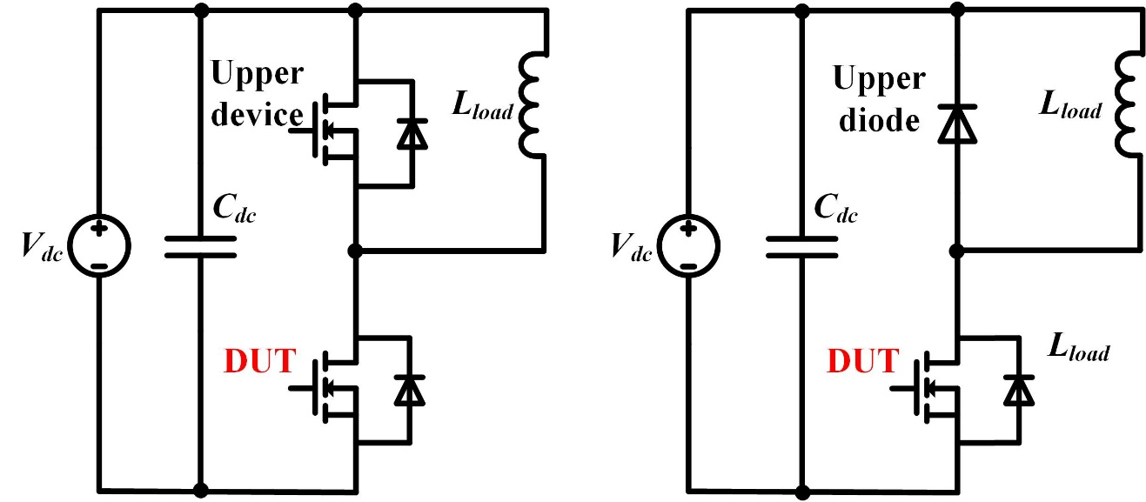
(a) (b)
Fig. 2- 1. Two circuit configurations used in DPT: (a) phase leg configuration; (b) switch/diode pair.
The HB phase leg can be easily reconfigured as the phase leg configuration for DPT with the purpose of switching performance evaluation. Although the data obtained in DPT with switch/diode pair are not accurate to indicate the dv/dt and switching loss of the phase leg, DPT with switch/diode pair is helpful in understanding the turn-on and turn-off transient and the influence of temperature and gate driver on the switching performance. Therefore, the switching performance evaluation with the switch/diode pair will also be reviewed.
Numerous researchers have used DPT to evaluate the switching performance of high voltage SiC devices. The switching behavior and the impact of some factors have been revealed by analyzing the switching waveforms and data. In [41], the DPT setup with switch/diode pair is built to investigate the switching performance of the 15 kV SiC MOSFET under different gate resistances and junction temperatures. It is found that smaller gate resistance and higher junction temperature are able to accelerate the turn-on process. The turn-off transient is mainly capacitive charging process and hence is less dependent on gate driver parameters and the junction temperature. The switching performance of 15 kV SiC IGBTs have also been characterized with the switch/diode pair [41], [42], with both switching energy loss and dv/dt analyzed in detail.
The 3rd generation 10 kV SiC MOSFET from Wolfspeed has been first characterized by Wolfspeed researchers with DPT in phase leg configuration [29], [43]. The influence of the gate resistance and the drain current on the switching performance is investigated in detail, as shown in Fig. 2-2, while the detailed analysis of the impact of the junction temperature is not provided. The large gate resistance slows down both turn-on and turn-off transient, and the gate resistance has strong control on the turn-on transient. Turn-on energy loss dominates the total switching energy loss. The investigation results coincide well with the conclusions in the investigation of 15 kV SiC MOSFETs with switch/diode pair in [41].
The temperature-dependent switching performance of the 3rd generation 10 kV SiC MOSFET is systematically studied in [44] in a HB phase leg. A detailed device model in Fig. 2-3 is built to perform the systematic study of the switching behavior and performance. Temperature has slight impact on the turn-on transient and negligible effect on the turn-off transient, as indicated in the switching waveforms in Fig. 2-4 and Fig. 2-5 (R_{goff} = 3 Ω, R_{gon} = 15 Ω). During the turn-off transient, the channel current drops to zero quickly due to low channel current (<20 A) and high dv/dt. The turn-off process is thereby mainly the charging/discharging of parasitic output capacitors of the MOSFETs, and dv/dt is hence higher at higher load current. The parasitic capacitors are independent of temperature. The junction temperature has little influence on the turn-off transient, and the measured turn-off loss is mainly the energy stored in the output capacitance of the DUT [44], [45].
Turn-on transient is slightly impacted by the temperature. The turn-on dv/dt is higher at higher junction temperature due to the lower gate threshold voltage. Meanwhile, the overshoot in drain current I_{d} increases because of the increased displacement current in the parasitic capacitors. The turn-on loss reduces slightly at higher temperature. Generally, junction temperature only slightly impacts the switching transients of the 3rd generation 10 kV SiC MOSFET, and higher junction temperature makes the turn-on transient faster. Such temperature-dependent switching behaviors of 15 kV SiC MOSFETs have also been reported [46], [47].
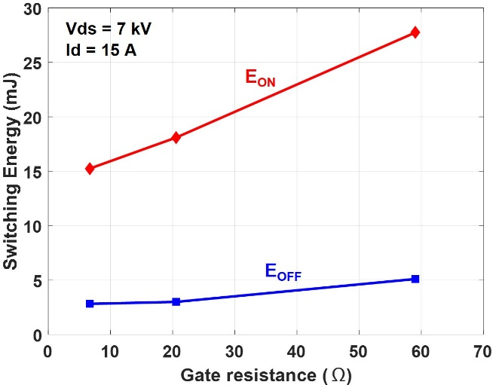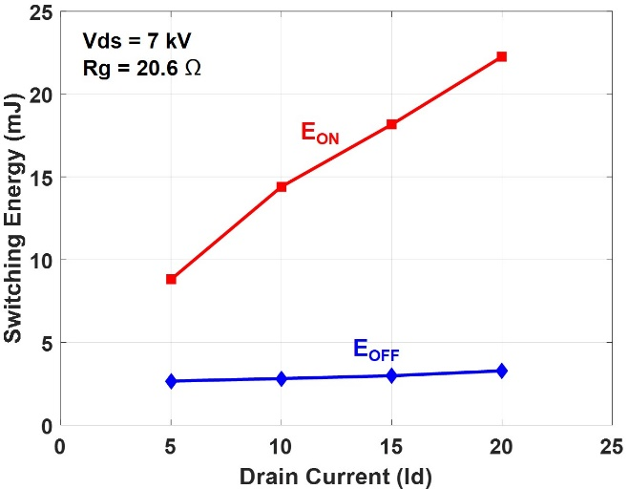
Fig. 2- 2. Switching energy loss as a function of external gate resistance (left) and drain current (right) for the 3rd generation 10 kV SiC MOSFET at 150 ˚C [29].
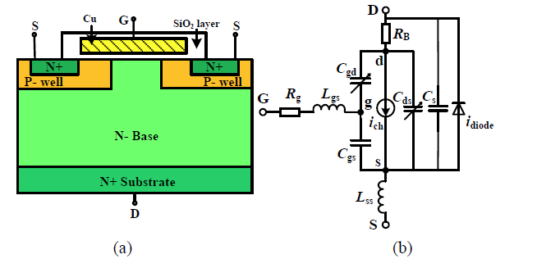
Fig. 2- 3. Detailed device model of 10 kV SiC MOSFET [44].

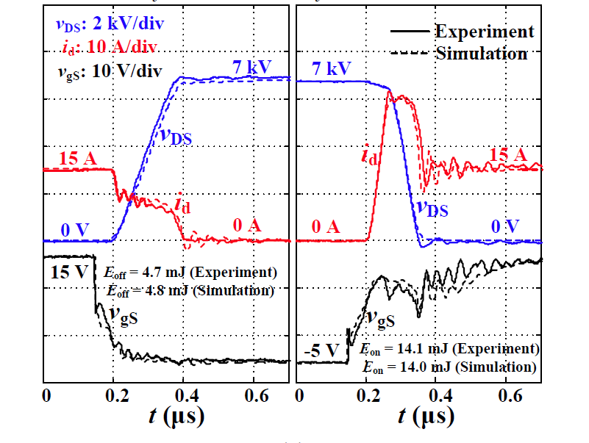
Fig. 2- 4. Turn-on and turn-off waveforms of the 10 kV SiC MOSFET at 25 ˚C [44].

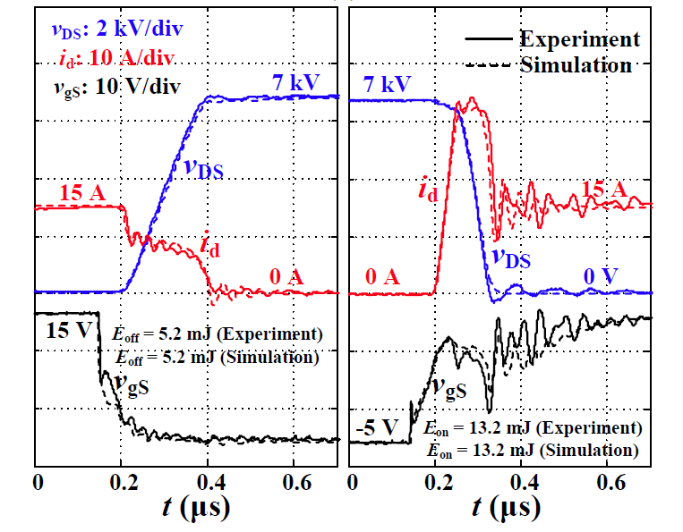
Fig. 2- 5. Turn-on and turn-off waveforms of the 10 kV SiC MOSFET at 125 ˚C [44].

In summary, characterization results show that the junction temperature only has slight influence on the switching performance. The turn-on transient of 10 kV SiC MOSFETs is mainly controlled by the gate driver parameters, while the turn-off transient is mainly determined by the parasitic capacitors since the channel current decreases to zero quickly.
Nevertheless, most previous studies have not investigated the impact of parasitic capacitors in the MV converter on the switching performance of high voltage SiC devices. The conventional DPT setup used in previous investigation is designed to minimize the circuit parasitics, hence different from the real converters with parasitics from numerous sources. For instance, the load inductor in conventional DPT setup typically only has single-layer winding to reduce the parasitic capacitance as much as possible, which is often not the case in MV converters [42], [44]. In fact, the fast switching speed of SiC devices makes their switching transients sensitive to the parasitic capacitors [10], [48], [49]. If the parasitic capacitors are negligible in DPT setup, the switching transients and losses obtained in DPT could deviate significantly from experimental results in real converters based on SiC devices. The switching loss in real converters could be significantly higher than what is estimated based on DPT results [50]. Therefore, it is necessary to investigate the impact of parasitic capacitors in the converter on the switching performance of 10 kV SiC MOSFETs.

2.1.2 Impact of Freewheeling Diode on Switching Performance
It is required that every switch in the phase leg should provide the freewheeling diode in voltage source converters. The freewheeling diode provides the conduction path for the load current when both switches are turned off in the HB phase leg. The freewheeling diode is also one of the influencing factors of the switching performance that should not be neglected.
In terms of SiC MOSFETs, their own body diode with small reverse recovery charge can serve as the freewheeling diode [20]. Meanwhile, an external anti-parallel SiC Schottky diode with negligible reverse recovery charge can be added to function as the freewheeling diode. Anti-parallel Schottky diode is recommended in converters based on low voltage SiC MOSFETs to achieve stable switching energy loss at different junction temperatures [18], [51]. This is because the body diode of the low voltage SiC MOSFET has significantly worse reverse recovery performance as junction temperature rises [51], [52]. The SiC Schottky diode should be selected to ensure that the reduction in switching loss due to improved reverse recovery performance is more substantial than the switching loss increase brought by its output capacitance [18], [51].
10 kV SiC JBS diode can be added as the anti-parallel diode to improve the loss due to reverse recovery in the phase leg based on 10 kV SiC MOSFETs. Experimental results have revealed that the anti-parallel 10 kV SiC JBS diode has nearly zero reverse recovery charge at various temperatures [53]. Currently, the body diode of 10 kV SiC MOSFET is sufficiently reliable to function as the freewheeling diode [54], [55]. Several years ago, most 10 kV SiC MOSFETs available for switching performance evaluation possess an anti-parallel JBS diode inside the package, because the MOSFET will degrade if its body diode conducts current [56]. With the anti-parallel JBS diode inside the package, the JBS diode conducts a major portion of the freewheeling current, and it is thereby difficult to study the reverse recovery performance of the body diode and the impact of the body diode or the external JBS diode on the switching transients and performance of 10 kV SiC MOSFETs over a wide temperature range.
The reverse recovery performance of a diode is also commonly characterized with DPT with a setup similar to the DPT setup for MOSFETs, as drawn in Fig. 2-6. If the body diode of a MOSFET is under test, the channel of that MOSFET is always kept off. When the upper switch S turns on, the diode current is forced to commutate to the upper switch, and the reverse recovery performance can be evaluated by measuring the diode current. With DPT, researchers at Wolfspeed have characterized the body diode of the 3rd generation 10 kV/20 A SiC MOSFET, revealing that the body diode has the reverse recovery charge of 1.2 μC and 1.8 μC at 25 ˚C and 150 ˚C, respectively [22]. The measured reverse recovery current, however, also includes the displacement current in parasitic capacitor C_{j} which is charged during the turn-on process of the upper switch. Because of the high dv/dt of the upper switch, the 10 kV SiC MOSFET in this case, the capacitive current accounts for a large portion of the measured reverse recovery current.
The substantial effect of the capacitive current on the reverse recovery characterization of 10 kV SiC diodes is demonstrated in [57]. After eliminating the effect of the capacitive current, the calculated reverse recovery current I_{rr} of the body diode in 10 kV/10 A SiC MOSFET is lower than 2 A at 25 ˚C and 125 ˚C. The reverse recovery charge of the body diode is not calculated. It is concluded that the body diode of the 10 kV SiC MOSFET has small reverse recovery current at different temperatures.
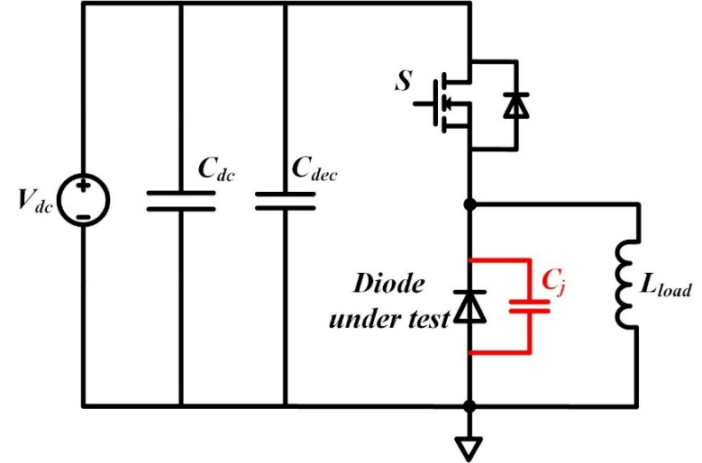
Fig. 2- 6. Circuit diagram of DPT for diode reverse recovery characterization.
In summary, the freewheeling diode in the phase leg plays an essential role in the switching transients of 10 kV SiC MOSFETs, especially the turn-on transient. The reverse recovery characterization of the freewheeling diode for 10 kV SiC MOSFETs should consider the effect of the capacitive current due to the parasitic capacitor of the diode. The reverse recovery current of the body diode in 10 kV/10 A SiC MOSFET is lower than 2 A at 25 ˚C and 125 ˚C, but the reverse recovery charge is not calculated. What is the impact of the reverse recovery of body diode on the switching performance is still unknown at different temperatures. Neither is the outcome after adding the anti-parallel JBS diode with nearly zero reverse recovery charge.

2.2 Design of 10 kV SiC MOSFET Based Phase Leg
As illustrated in Fig. 1-4, device-level characteristics of 10 kV SiC MOSFETs bring numerous challenges in the design of the phase leg, especially in the gate driver design and overcurrent protection design. The relevant previous work about the gate driver and overcurrent protection design is reviewed in this section. The literature about the flashover fault, an emerging topic in SiC-based MV converters, is also covered in this section.

2.2.1 Gate Driver Design
The basic function of gate driver is to drive the MOSFET with appropriate driving voltage and current and protect the MOSFET in short circuit/overcurrent conditions [10]. When the short circuit or overcurrent happens, the gate driver should be able to detect the fault and turn off the device safely. Particularly, the study of protection design will be reviewed in the next subsection.
Fig. 2-7 displays the basic block diagram of a gate driver for the MOSFET. The gate driver consists of signal isolator, gate drive IC, buffer circuit, and the isolated power supply grounded at the source terminal of the MOSFET. The signal isolator isolates the control circuit from the power loop. The function of gate drive IC and buffer is to drive the device with the designed voltage level and sufficient current with low switching losses and acceptable switching speed. The isolated power supply is not within scope of this dissertation, and hence will not be reviewed in this chapter.
In the phase leg based on 10 kV SiC MOSFETs and other high voltage SiC devices, the signal isolator should withstand high PWM voltage coupled with high dv/dt. The main challenge is to have high isolation voltage and high common mode transient immunity (CMTI) (>100 V/ns) simultaneously [10]. The signal isolator for high voltage SiC devices is dominated by the solution with fiber optic transmitter and receiver. The isolation voltage and CMTI of this solution can be extremely high if the power supplies in each side offer sufficient isolation [10]. With the fiber optic cable, the clearance and creepage requirements are easily satisfied.
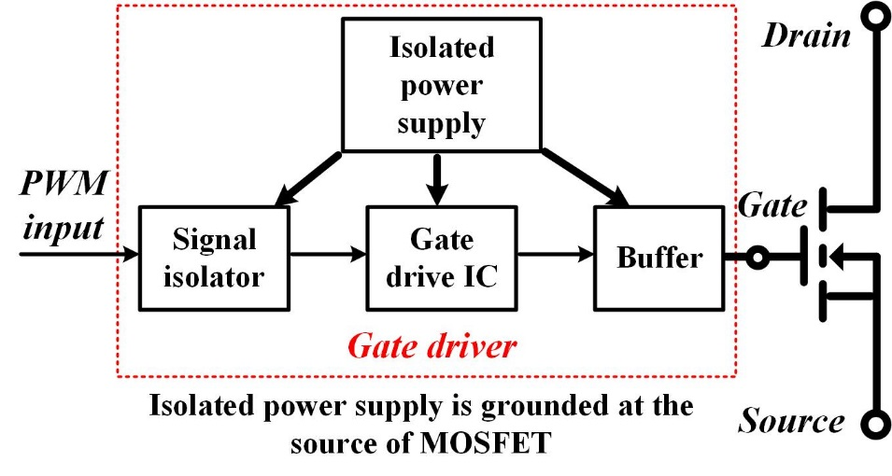
Fig. 2- 7. Basic function diagram of a gate driver for a power MOSFET [10].
The gate drive IC and buffer operate together with gate resistors and other auxiliary circuitry to drive the MOSFET and control the switching speed. The buffer is optional and only adopted to boost the driving current. The gate drive voltage and gate resistors are selected based on the static characteristics, switching performance, and short circuit performance. The off-state gate voltage V_{g,off} for 10 kV SiC MOSFETs usually ranges from -6 V and -1 V to ensure the reliable turn-off. For 10 kV SiC MOSFETs, gate drive voltage in on state V_{g,on} ranges from 15 V to 20 V. Actually the on-resistance only has slight difference as V_{g,on} increases from 15 V to 20 V [44], yet higher V_{g,on} increases the short circuit current and energy loss, leading to stricter requirement on the response time of the protection [58], [59].
After V_{g,on} and V_{g,off} are selected, gate resistors are tuned to achieve the desired switching transients and losses. Different gate resistors can be designed for turn-on and turn-off transients. In the case of 10 kV SiC MOSFETs, gate resistors are selected based on the trade-off between switching loss and switching speed, especially during the turn-on transient. Then, the required peak driving current can be calculated as follows.
$$\begin{aligned}I_{source}=\frac{V_{g,on}-V_{g,off}}{R_{g,on}}\#\left(2.1\right)\end{aligned}$$
$$\begin{aligned}I_{sink}=\frac{V_{g,on}-V_{g,off}}{R_{g,off}}\#\left(2.2\right)\end{aligned}$$
The selection of gate drive IC should particularly consider the peak driving current, rise/fall time, and propagation delay. The peak source/sink drive current of the gate drive IC should be higher than the required current, otherwise the buffer is needed. The buffer can be IC with high driving current or BJT-based current boosters in parallel [60], [61]. Short rise/fall time and propagation delay time are required to fully utilize the fast switching speed of the 10 kV SiC MOSFETs.
The cross-talk issue should also be evaluated and tackled in the gate driver design for high voltage SiC devices. In a half bridge phase leg, if dv/dt is too high during the turn-on transient, the spurious gate voltage in the other switching device could be higher than the gate threshold voltage due to the Miller current, resulting in partial shoot-through and higher losses [62]. The cross-talk issue will set the upper limit for the turn-on dv/dt of SiC MOSFETs, if it is not addressed. The partial shoot-through has been reported in the phase leg based on high voltage SiC MOSFETs when the turn-on gate resistance is low [46].
Active Miller clamping is a common method to suppress the cross-talk without sacrificing the switching speed significantly [63]-[65]. The gate driver for 10 kV/10 A SiC MOSFET in [63] adopts an active Miller clamping design. When high dv/dt occurs during the turn-on transient of one MOSFET, the gate driver for the other MOSFET in off state provides a low impedance path for the Miller current and clamps the gate voltage to ensure the reliable turn-off. The clamping circuit is only activated when device is off.
Analytical analysis of cross-talk in low voltage SiC MOSFETs is also effective in the evaluation of cross-talk of high voltage SiC devices. In fact, previous analysis shows that cross-talk is not serious in some high voltage SiC devices. After evaluating the cross-talk of 3rd generation 10 kV/20 A SiC MOSFET, it is concluded that specific anti-cross-talk design is not necessary in the gate driver [44]. The excellent performance in cross-talk is attributed to the much larger input capacitance of the 10 kV/20 A SiC MOSFET, compared to its Miller capacitance. The calculated maximum increase in V_{gs} is 5.0 V in the worst case when all Miller capacitive current charges the input capacitor of MOSFET. Therefore, partial shoot-through does not occur when V_{g,off} is below -4 V. DPT results of 10 kV SiC MOSFETs show that the cross-talk has little impact on the turn-on transient and loss (15 Ω turn-on gate resistor). Yet the spurious gate voltage is not measured to provide the direct evidence.
In summary, the previous gate driver design for high voltage SiC devices usually focuses on realizing fast switching speed and reliable isolation. Signal isolation is typically achieved by fiber optics. The selection of components emphasizes the driving capability and low delay. Cross-talk in the 3rd generation 10 kV SiC MOSFET is significantly alleviated by its large input capacitance, yet it is an issue for some high voltage SiC devices [65]. With emphasis on the fast switching speed, most gate driver design for high voltage SiC devices in the literature has not paid enough attention to the continuous operation. The feedback signal sent back to the controller only reports the overcurrent fault. Considering the higher cost and less robustness of high voltage SiC devices, more efforts can be spent on the continuous operation of the gate driver and the device. Also, the impact of the flashover fault on the gate driver design has not been fully discussed in MV converters based on high voltage SiC devices, which will be reviewed in Subsection 2.2.3.

2.2.2 Overcurrent Protection Design
The overcurrent/short circuit protection function in the gate driver plays a more crucial part in MV converters, in which power semiconductor devices are more costly. The overcurrent/short circuit protection scheme should have fast response, good noise immunity, and simple implementation for both discrete devices and power modules [10]. Featuring smaller die, lower thermal capacitance, and higher current density, SiC devices have shorter short circuit withstand time than Si IGBTs and MOSFETs. Fast response to clear the fault is thereby desired, which often contradicts the strong noise immunity. The noise resulting from fast switching transients of SiC devices makes it more challenging to achieve fast response with satisfactory noise immunity. Short response time is also desirable as it benefits the long-term reliability of SiC MOSFETs. In this subsection, overcurrent protection schemes for SiC MOSFETs are reviewed.
Desaturation (Desat) protection scheme dominating the overcurrent protection of Si IGBTs has been successfully implemented in a variety of SiC MOSFETs, including 10 kV SiC MOSFETs [60], [66], [67]. Desat protection monitors V_{ds} of the MOSFET and the protection is triggered once the monitored V_{ds} exceeds the threshold. The desat diode with the same voltage rating as the MOSFET is necessary to isolate the high voltage in the drain terminal. The design shown in Fig. 12 for 1.2 kV SiC MOSFET has achieved the response time of 210 ns [66].
Desat protection possesses numerous salient advantages, which explain its popularity in the gate drivers for Si IGBTs and SiC MOSFETs. Desat protection is effective in detecting all kinds of overcurrent and short circuit faults, although it does not directly measure the device current. Desat protection feature simple implementation for both discrete devices and modules, and usually only off-the-shelf components are required. Some gate driver ICs with desat protection function make it even simpler to implement the protection. Strong noise immunity can be ensured, although it is often realized at the cost of increasing response time.
In desat protection, the blanking time is required to disable the protection during the turn-on transient until V_{ds} reaches the steady state. Usually the response speed of desat protection is limited by the blanking time. In the design practices, the response time is also often sacrificed to enhance the noise immunity. In terms of the desat protection for 10 kV SiC MOSFETs and other high voltage SiC MOSFETs, some methods are introduced to avoid the false triggering during the turn-on and turn-off transient, yet the relationship between noise immunity and response time has never been thoroughly investigated. It is still unknown how fast the desat protection can be with noise immunity not sacrificed.
The threshold current of desat protection is determined by the device’s output characteristic and the threshold voltage. With the same drain current, SiC MOSFETs have significantly higher V_{ds} at higher junction temperature. Thus, desat protection for SiC MOSFETs has different threshold currents as junction temperature varies. The threshold current is higher at lower junction temperature. Also, since the drain current of SiC MOSFETs does not have hard saturation, the current rise during the response time should be taken into account when determining the threshold current.
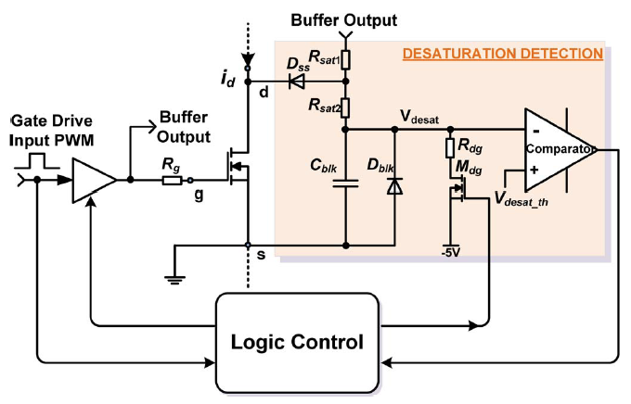
Fig. 2- 8. Implementation of desat protection for SiC MOSFETs [66].
Other overcurrent protection schemes for SiC MOSFETs have been proposed by evaluating the current in a way independent of the I-V characteristic of the MOSFET to obtain a constant threshold current. The stray inductance in series with the source terminal of the SiC MOSFET can be used as a sensor to derive the current and serve for the protection, with the carried di/dt information [66], [67]. It is difficult to implement this method for SiC MOSFETs with different packages and ensure high noise immunity. A sufficient, but not too large, parasitic inductance with readily connectible terminals is indispensable to implement this method. Then debugging and testing are necessary to measure the stray inductance for the threshold selection and check the noise immunity. Protection schemes based on the current sensor are also investigated. It is concluded that Rogowski coil has excellent overall performance in terms of accuracy, bandwidth and linearity among numerous current sensing methods, such as shunt resistor, Hall sensor, and current transducer [68]-[70].
High-bandwidth Rogowski coil sensor with an active integrator has been demonstrated in the protection of SiC discrete devices and modules [69], [71]-[76]. PCB-based Rogowski coil stands out due to low profile, integration capability, and repeatability. The protection scheme based on Rogowski coil detects the fault within 100 ns, regardless of the short circuit type and the junction temperature. The total response time is short and constant in different conditions, so the threshold current can be easily selected. Nonetheless, the active integrator has to be reset periodically when the device is off to overcome the difficulty of Rogowski coil in measuring DC current, otherwise the sensor error keeps increasing [73], [74]. To ensure the accuracy of the sensor and the protection, the device should be turned off periodically with the off-state longer than a minimum length. It is generally complicated and expensive to implement this method in order to achieve good accuracy and noise immunity [71]-[76].
The protection scheme based on the air-gapped current transformer has been adopted to protect the discrete 10 kV SiC MOSFETs [37]. By measuring the device current directly with a current transformer in the source path of the MOSFET, the protection scheme with ultrafast response can clear the short circuit fault within 150 ns. However, when using this scheme to protect the 10 kV SiC MOSFET module with a half-bridge configuration or other configurations, the current of the top device can only be measured at its drain terminal, leading to the high isolation voltage between primary winding and secondary side of the current transformer for the top device. Higher cost and more complicated implementation are hence necessary to achieve reliable insulation. The clearance and creepage requirements also increase the size of the current transformer. It is hence difficult to implement this protection scheme based on current transformer in 10 kV SiC MOSFET modules. It is a competitive solution for the discrete SiC MOSFETs, but not suitable for SiC MOSFET modules.
In addition, the protection method based on the measured gate charge and V_{gs} during the turn-on transient has been reported [77]. The response speed is fairly acceptable, but it is only demonstrated that it can clear one kind of short circuit fault. Its response to other kinds of short circuit and overcurrent cases is still uncertain.
In summary, desat protection and the protection based on Rogowski coil sensor are the two methods suitable for protecting both the SiC discrete devices and modules with excellent overall performance. With fast response, the method based on Rogowski coil sensor requires complicated and high-cost implementation to realize sufficient sensor accuracy and noise immunity when protecting SiC MOSFETs with fast transients and both conducted and radiated EMI noise. Desat protection is hence more competitive thanks to its simple implementation and adoption of off-the-shelf components. Yet the relatively long response time of desat protection due to blanking time and noise immunity consideration may prevent its usage in some cases. The trade-off between response time and noise immunity of desat protection should be examined carefully to maintain strong noise immunity while speeding up the response.

2.2.3 Impact of Flashover Fault on Gate Driver Design
In MV converters based on 10 kV SiC MOSFETs and other high voltage SiC devices, the flashover fault due to insulation breakdown becomes a much more serious issue compared to traditional MV converters utilizing Si IGBTs, due to high PWM voltage coupled with high switching frequency (>5 kHz) and dv/dt (>20 V/ns) [37]-[39]. The insulation design of MV converters based on 10 kV SiC MOSFETs is faced with unprecedented challenges, and there is a higher risk of premature breakdown in the insulation of some essential components of the MV converter, which subsequently generates the flashover fault with extremely fast transients.
In the last decade, increasing research efforts have been spent in investigating the relationship between the PWM voltage with semi-square shape and the accelerated degradation of the insulation material. The insulation materials widely adopted in the power electronics applications are selected as the test samples for the research, including Polyethylenterephtalat (PET) insulation foil [39], Polyimide (PI) films [78], ethylene propylene rubber (EPR) [38], and other materials. It is concluded that if partial discharge (PD) is initiated inside the insulation material, the total PD charge and its detrimental impact on the insulation material increases as the magnitude, dv/dt and switching frequency of the applied PWM voltage become higher, leading to accelerated insulation failure and shorter lifetime [39], [79].
In fact, it is difficult to determine accurately the real partial discharge inception voltage (PDIV) of the insulation material exposed to the PWM-type voltage, since a typical PD tester can only output 50/60 Hz sinusoidal voltage, resulting in higher measured PDIV. In practical applications, the real PDIV of the insulation material inside MV converters can be further reduced in harsh operating conditions, which makes it even tougher to achieve PD-free insulation design [78]. Moreover, high dv/dt and switching frequency exacerbate the overvoltage and dielectric loss inside the insulation material, both of which can also cause the premature insulation breakdown [39], [80]. Therefore, premature insulation failure and the resulting flashover fault are one of the crucial challenges that should be tackled when designing MV converters based on 10 kV SiC MOSFETs.
The issue brought by premature insulation breakdown and the flashover fault can be addressed from two perspectives. This issue can be tackled by enhancing the insulation design to minimize the risk of premature insulation breakdown. The research in this field is out of the scope of this dissertation. The other perspective involves the gate driver and protection design to achieve better performance of the 10 kV SiC MOSFET and reduce the damage caused by the flashover fault. The flashover fault with extremely high dv_{ds}/dt (>1 kV/ns) and di/dt (>30 A/ns) particularly poses a great threat to the 10 kV SiC MOSFET already in ON state, which should be protected from damage, unless the insulation inside its own package fails [37].
So far the flashover fault has received little attention in the design of a MV phase leg or converter based on high voltage SiC devices. The flashover fault in a HB phase leg based on 10 kV SiC MOSFETs is analyzed partially in [37]. It is demonstrated that the short circuit protection successfully protects the MOSFET that is in ON state when the flashover fault happens. However, the behavior of the 10 kV SiC MOSFET with Kelvin source is not analyzed thoroughly, and the gate driver and protection design considerations are not comprehensively studied and summarized after considering the flashover fault. Therefore, comprehensive study about the behavior and gate driver design considerations of 10 kV SiC MOSFETs under the flashover fault is of great significance, but still absent in the literature.

2.3 Testing of 10 kV SiC MOSFET Based Phase Leg
The phase leg should be fully tested to validate its capability to operate continuously at rated voltage and power and function as a robust module of a modular MV converter. The thermal performance, insulation design, and the capability to withstand high dv/dt and the resulting noise of the phase leg should be thoroughly tested and qualified.
Testing and debugging the phase leg is much less challenging than testing the whole modular MV converter. Thus, the phase leg testing should be carefully designed so that all issues of the phase leg can be pinpointed and solved before assembling and testing the modular MV converter, which will make the converter testing more efficient. Continuous test of the phase leg is hence indispensable, which should create the condition similar to the real condition in a modular MV converter. The testing should be designed and implemented to make sure that all components in the phase leg are fully validated at the rated condition, including insulation voltage, CM voltage, dv/dt, device current, etc. Particularly high dv/dt and the resulting high CM current could generate strong noise and lead to the malfunction of the gate driver and the phase leg. Achieving the dv/dt that will occur in the modular MV converter should be one of the focuses when devising the continuous test.
How to test the HB phase leg or the converter based on high voltage SiC devices comprehensively has not received much discussion in previous literature. DPT and short circuit test are usually conducted before the continuous test to validate the SiC device and the gate driver. MV converters based on high voltage SiC devices have been designed and tested at rated voltage and power, yet the detailed incremental testing steps are not covered [31],[34]. In [81], comprehensive testing and qualification of the gate driver and its isolated power supply for high voltage SiC MOSFETs and IGBTs are discussed in detail, including DPT, short circuit test, and continuous test. The testing focuses on validating the gate driver’s thermal performance and its performance in withstanding the CM voltage and current, instead of the performance of the HB phase leg. The dc-dc continuous test as the buck-boost converter is adopted since it can generate CM voltage with high magnitude. Nonetheless, the dc-dc continuous test generates the dv/dt different from that occurs in the phase leg when it functions as part of a modular MV converter, especially when the converter is used in dc/ac applications.
In [65], a detailed testing methodology is developed to fully qualify the HB phase leg based on the 10 kV SiC MOSFET module, which is built to serve as the building block of a MMC converter. In the system-level testing of the phase leg, the continuous test with pump-back configuration is required in both dc-dc and dc-ac mode. The continuous test involves two identical HB phase legs. One phase leg draws the power from the dc source, and the other phase leg pumps the power back to the source. However, the pump-back test setup is different from the MMC converter and other modular MV converters with multiple modules connected in series, where the phase leg can experience much higher dv/dt and hence CM current than those in the continuous test with pump-back configuration. For example, the phase leg in one MMC can experience ≥2X dv/dt of a single high voltage SiC device. In terms of the capability of withstanding high dv/dt and CM voltage, the phase leg cannot be fully qualified with the testing method in [65].
In summary, the testing of the phase leg based on high voltage SiC devices has not received much attention, although MV converters based on high voltage SiC devices have been demonstrated. The continuous test setups developed to test the phase leg in the literature are not able to fully qualify the phase leg for modular MV converter applications, in which the thorough qualification of phase leg’s capability to withstand high dv/dt and the resulting noise cannot be provided. Test setups in the literature can only generate the dv/dt of a single high voltage SiC device, but the phase leg can experience much higher dv/dt in a modular MV converter.

2.4 Summary
Previous work on the switching performance evaluation of 10 kV SiC MOSFETs and other high voltage SiC devices as well as the design and testing of the phase leg based on high voltage SiC devices is reviewed in this chapter. The switching performance evaluation with DPT is reviewed together with the influencing factors of the switching performance. Two influencing factors that have not been investigated in detail include the parasitic capacitance and the freewheeling diode, which can be realized by the body diode or adding an external anti-parallel JBS diode.
Existing work on the design and testing of the HB phase leg is summarized, especially the gate driver design together with the overcurrent protection. Among the reviewed overcurrent protection methods, desat protection stands out in the protection for 10 kV SiC MOSFETs, because of its excellent overall performance in terms of response speed, noise immunity, and ease of implementation. Desat protection is not as fast as other methods based on Rogowski coil and current transformer, which may prevent its usage in some occasions. It is still challenging to design the desat protection with faster response while maintaining the excellent noise immunity. In addition, the premature insulation breakdown and the resulting flashover fault become non-negligible in MV converters based on 10 kV SiC MOSFETs. Yet the gate driver design considerations after taking the flashover fault into account are still not studied comprehensively.
In terms of testing, the comprehensive testing of the phase leg has not attracted plenty of attention in the research community. The main drawback of the test methods in the literature is their inability to fully test the phase leg’s capability to withstand high dv/dt and the resulting noise. This drawback is considerable because the phase leg could experience much higher dv/dt and hence stronger noise in a modular MV converter.

Ch 3. Baseline Design and Test of a 10 kV SiC MOSFET Based Phase Leg
A baseline design of a HB phase leg based on 10 kV SiC MOSFETs with continuous operation capability is introduced in this chapter, which is validated in the ac-dc continuous test at 6.5 kV dc-link voltage. The target of the baseline design is that the phase leg can operate as a building block of a modular MV converter. Thus, the baseline design serves as the foundation for the research about switching performance evaluation and phase leg design. Baseline testing procedures and results of the phase leg are also presented in detail.

3.1 Overview of the Phase Leg

3.1.1 10 kV SiC MOSFET
The half bridge phase leg is based on 10 kV/20 A discrete SiC MOSFETs from Wolfspeed (XPM3-10000-0350B). The device has a non-isolated package with the large drain plate also for heat dissipation, as shown in Fig. 3-1. Inside the package is one 3rd generation 10 kV/350 mΩ SiC MOSFET die [29]. Due to the issue in device package design, connection between the wire bond and the gate terminal of the package is not robust.
Characterization results with a curve tracer show that the 10 kV SiC MOSFETs available for the phase leg construction have almost the same on-resistance in forward conduction and reverse conduction with the same gate-source voltage and junction temperature. The 3rd generation 10 kV/350 mΩ SiC MOSFET from Wolfspeed does not have the degradation issue during the body diode conduction [54], [55]. Therefore, the body diode is used as the freewheeling diode, and external anti-parallel JBS diode is not needed in the phase leg. Gate-to-source voltage V_{gs} has little influence on the on-resistance as long as it exceeds 15 V, as indicated in Fig. 3-1.

3.1.2 Architecture of the Phase Leg
The designed 6.5 kV half bridge phase leg consists of two MOSFETs, two isolated power supplies, the gate driver, the heatsink, the PCB busbar, and the dc-link capacitor. The architecture of the phase leg is shown in Fig. 3-2(a). Such architecture is designed to ensure that the phase leg has the capability to operate as a building block for a modular MV converter. The communication interface marked in green in Fig. 3-2(a) communicates with the controller via fiber optics. Four terminals are available for connection, including DC+, DC-, midpoint of DC-link, and midpoint of the half bridge phase leg. The phase leg has an 8.75 μF dc-link capacitor, realized by four 1.9 kV film capacitors in series. The rated dc-link voltage of the phase leg is 6.5 kV, with 1.1 kV margin for overvoltage during the switching transients.
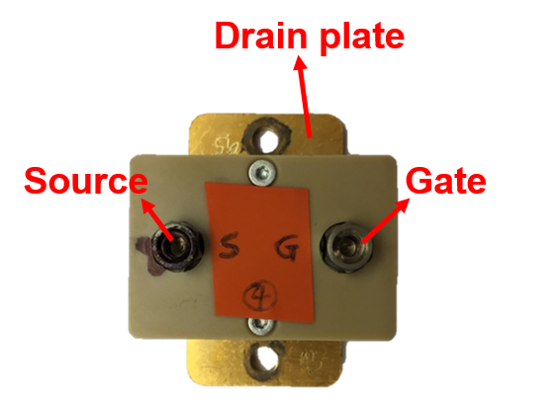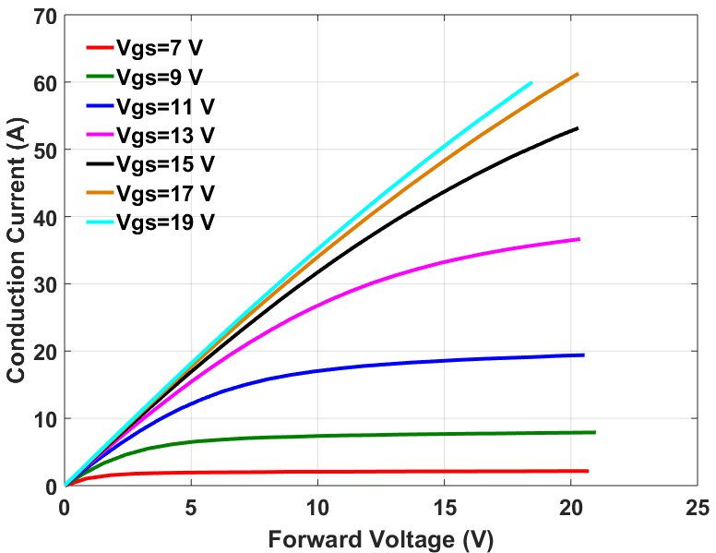Fig. 3- 1. Discrete 10 kV SiC MOSFET in the half bridge phase leg (left) and its forward characteristic at room temperature (right).
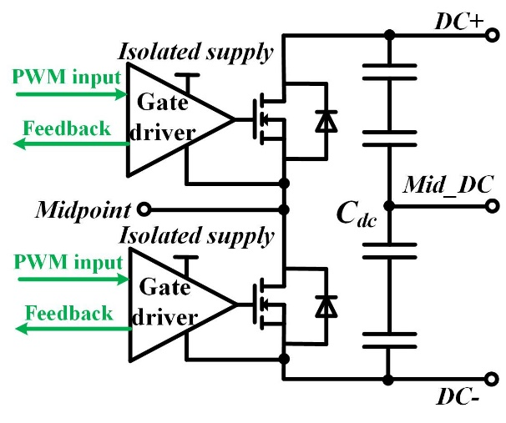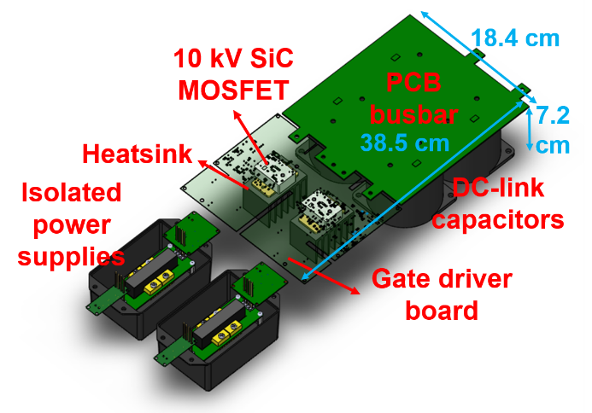
(a) (b)
Fig. 3- 2. Half bridge phase leg based on 10 kV SiC MOSFETs: (a) Architecture of the phase leg; (b) Detailed 3D model of the phase leg.
The detailed three-dimensional (3D) design of the phase leg is drawn in Fig. 3-2(b). A gate driver board is placed above the two MOSFETs to drive the devices, powered by two isolated power supplies. The PCB busbar finally finishes the power loop by connecting the dc-link capacitor with the MOSFETs. FR4 is the insulation material in the PCB busbar, and better material can be adopted for more reliable insulation in the future.
Each MOSFET in the phase leg has a separate floating heatsink for heat dissipation. The heatsink is not isolated from the MOSFET, hence the heatsink has the same potential as the drain plate of the MOSFET it is connected to. During the continuous operation, a fan is used to cool devices and heatsinks. In the design, clearance distance requirements in IPC-2221B standard and creepage requirements in UL 60950-1 standard are followed to ensure reliable insulation [82], [83].

3.2 Gate Driver Design
The gate driver for the 10 kV/20 A SiC MOSFETs is designed to realize fast switching speed and robust continuous operation of the MOSFET. To achieve the target, specifications of the gate driver are developed and summarized in Table 2. The main challenges are high voltage insulation and high dv/dt. The gate driver board is designed to meet the clearance and creepage requirement for 10 kV to achieve robust insulation [39]. The dead time function is desirable to prevent the shoot-through. Feedback signal sent back to the controller in every switching cycle is necessary for the controller to monitor the status of the communication and gate driver during the continuous operation. If a short circuit or overcurrent fault is detected, a fault signal is sent back to the controller via the feedback signal.
The specifications in Table 2 have been successfully achieved in the designed gate driver, which is composed of signal transfer and feedback stage, gate driving stage, and overcurrent protection stage. The block diagram of the gate driver is shown in Fig. 3-3.

3.2.1 Signal Transfer and Feedback Stage
Signal transfer and feedback stage is responsible for the communication between the controller and the gate driver during the continuous operation. The communication is realized with fiber optics to provide ample signal isolation between the controller and the gate driver.
The dead time function is implemented with a delay IC in this stage. With a AND logic IC and the delay IC, the dead time is realized by applying 500 ns delay to the rising edge of the initial gate signal and zero delay to the falling edge. The updated gate signal becomes the final gate signal for gate drive IC if overcurrent fault is not detected. The final gate signal is always LOW if the overcurrent protection is triggered until it is reset. The generation of the gate signal sent to the gate drive IC is summarized in Fig. 3-4.
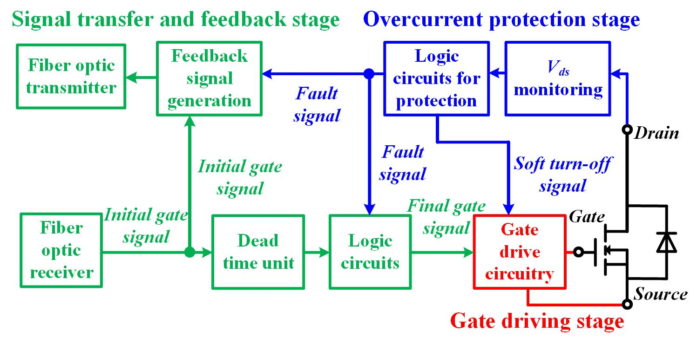
Fig. 3- 3. Block diagram of designed gate driver for 10 kV SiC MOSFETs.

Table 2. Specifications of the designed gate driver.
Specification | Requirement | Design result
Driving voltage range | Minimum: -5 V;  Maximum: +20 V | -5 V for off state;  15 V for on state
Peak driving current | > 8 A | 9 A
Rise and fall times | < 30 ns | 22 ns rise time;  15 ns fall time
Short circuit protection | < 1.5 us response time with soft turn-off | < 1.3 us response time with soft turn-off
Status feedback | Status feedback signal sent back to controller in every switching cycle | Feedback signal generated for every rising or falling edge in gate signal
Dead time | Dead time realized in the gate driver with hardware | 500 ns dead time realized

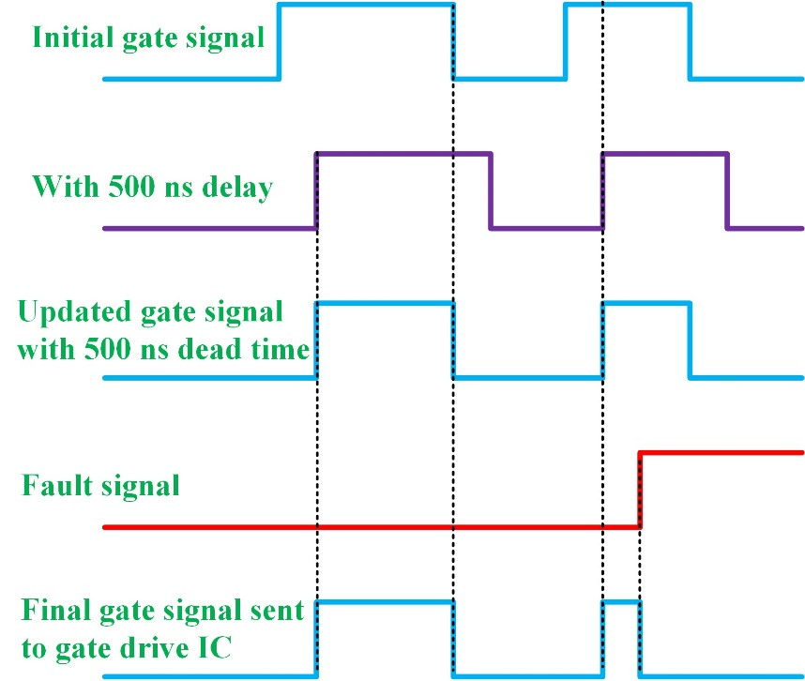
Fig. 3- 4. Diagram of the generation of final gate signal sent to gate drive IC with 500 ns dead time realized in gate driver.
The feedback signal sent from the gate driver is essential during the continuous operation. In most gate drivers for SiC MOSFETs reported in the literature, the feedback signal is only designed to transmit the overcurrent fault signal. In this case, the controller knows nothing about the status of the gate driver and communication until the overcurrent or short circuit fault happens. Such delay is not acceptable in a MV converter. Hence, a feedback signal sent back to the controller is desirable to monitor the status of communication and gate driver in every switching cycle. In fact, this function is provided by numerous commercial gate drivers from Power Integrations, but the circuit design details are not disclosed.
To realize this target, a simple feedback scheme is designed to generate a feedback signal acknowledging every rising edge and falling edge in the received gate signal. The feedback scheme utilizes the delay IC in the dead time unit and a XOR logic gate, as can be seen in Fig. 3-5. The final feedback signal is also able to report the overcurrent fault. After the gate signal from the controller has a rising edge or falling edge, the feedback signal should stay LOW for 500 ns. Since the overcurrent fault signal lasts for a much longer time, the overcurrent fault is recognized by the controller if the feedback signal remains LOW for over 600 ns.
Several considerations should be recognized in the selection of the length of the signal to acknowledge the rise or falling edge in the received gate signal. This feedback scheme requires the conduction time of the 10 kV SiC MOSFET to be longer than the signal for the acknowledgement. Long feedback signal for the acknowledgement limits the duty cycle when the MOSFET operates at higher frequency. The discrete 10 kV SiC MOSFETs have the switching frequency up to 80 kHz in soft-switching converters [31], [34]. The long feedback signal for the acknowledgement also leads to long delay time for the controller to identify the overcurrent fault based on the received feedback signal. The feedback signal for the edge acknowledgement should not be too short for the controller to read. In this case, it could be overwhelmed by the highly unpredictable noise in the feedback signal. Finally, the feedback signal for the edge acknowledgement is determined to be 500 ns LOW to achieve strong noise immunity, and it only requires the duty cycle higher than 4% at 80 kHz switching frequency.
The simple feedback scheme can monitor the status of fiber optic communication and some components of the gate driver. If the feedback signal does not turn LOW within 200 ns after the rising or falling edge in the gate signal, the fault is detected by the controller. However, the simple feedback scheme cannot confirm that the gate signal is properly transformed to the correct V_{gs} of MOSFET. If the gate driver IC fails, the status
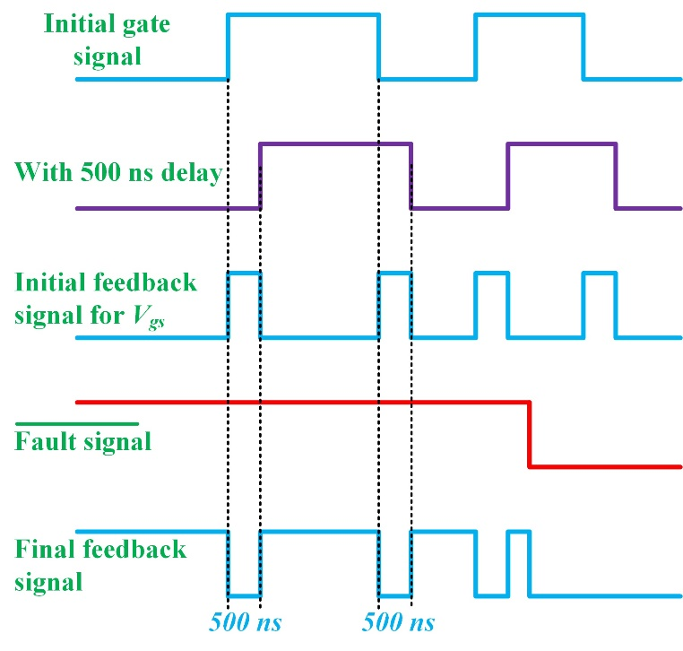
Fig. 3- 5. Diagram of the generation of final feedback signal sent back to controller.
feedback signal will not report the fault in time. An updated feedback scheme is developed to overcome this drawback by generating the feedback signal based on the measured V_{gs}.
Details of updated feedback scheme are displayed in Fig. 3-6, including the designed circuit. The measured gate voltage from the voltage divider is compared with the gate threshold voltage to check if the MOSFET is turned on or off. The voltage divider and the comparator are grounded at -5 V which should be the same as -5 V for the gate loop, and DGND has the same potential as the source of MOSFET. Threshold voltage of the comparator is selected so that the comparator outputs HIGH when V_{gs} is higher than +3 V, the gate threshold voltage of the 10 kV SiC MOSFET at 100 ˚C [44]. The selected voltage divider ratio is 1/5, and the comparator threshold voltage is -3.4 V. Then, the comparator output signal is sent to a XOR logic gate together with the initial gate signal to generate status feedback signal. The length of status feedback signal is 550 ns, which is slightly longer than 500 ns with the purpose of simplifying circuit design. As illustrated in Fig. 3-7(a), benchtop test results show that the final feedback signal coincides well with the design in Fig. 3-6(b). Fig. 3-7 also demonstrates that the feedback signal can monitor the status of the gate driver during the ac-dc continuous of the phase leg in every switching cycle.
(a) (b)
Fig. 3- 6. (a) Designed circuit for the update scheme to realize status feedback function; (b) Generation of final feedback signal with the updated feedback scheme.
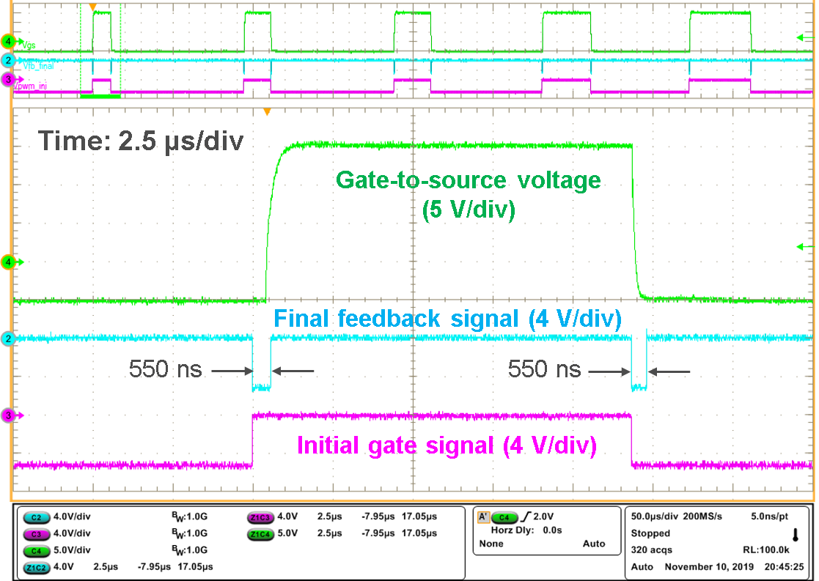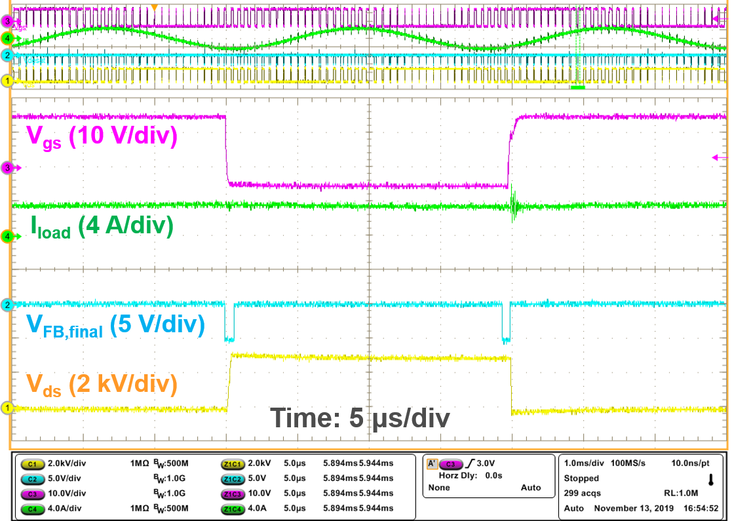
(a) (b)
Fig. 3- 7. Experimental waveforms of final feedback signal with the updated feedback scheme: (a) 0 V dc bus voltage; (b) 3 kV ac-dc continuous test of phase leg.

3.2.2 Gate Driving Stage
The gate drive IC is selected based on the developed specifications in Table 1. The main considerations are peak driving current, rise/fall time, and propagation delay. The desat protection function in gate drive IC is not considered, and more details are introduced in the design of overcurrent protection stage. Signal isolation is also not required since the fiber optics provide ample isolation. The peak driving current of the gate drive IC should be higher than 8 A, otherwise a buffer is needed which further increases the propagation delay. Among numerous candidates, IXDD609SI from IXYS with 9 A peak driving current is selected due to its short propagation delay and rise/fall time.
The on-state and off-state driving voltage are 15 V and -5 V, respectively. 15 V is adopted to achieve lower current and energy loss in short circuit condition. -5 V for off-state ensures the reliable turn-off of the device. The turn-on and turn-off gate resistance are 15 Ω and 3 Ω, respectively, to achieve the trade-off between switching speed and switching loss. With -5 V V_{gs} in off state, active Miller clamp circuit to prevent cross-talk is not necessary for the 10 kV/20 A SiC MOSFET, thanks to its large ratio between input capacitance and Miller capacitance [44]. The 15 Ω turn-on resistance and 3 Ω turn-off resistance are also helpful in limiting the turn-on dv/dt to 100 V/ns and the spurious gate voltage [84].

3.2.3 Overcurrent Protection Stage
Among the several overcurrent protection schemes for SiC MOSFETs, desat protection scheme stands out in the protection of the discrete 10 kV/20 A SiC MOSFETs. Desat protection has relatively easy implementation to achieve fast response time, high noise immunity, and effective protection in different cases. Other methods, such as protection based on Rogowski coils, require much more efforts in design and testing to guarantee high noise immunity.
The designed desat protection scheme protects the 10 kV SiC MOSFET in short circuit/overcurrent condition with a response time of less than 1.3 μs. After the fault is detected, soft turn-off is applied with a gate resistance of 47 Ω to safely turn off the MOSFET, and the fault is reported to the controller via the feedback signal. The short circuit withstand time of the 10 kV/20 A SiC MOSFETs typically ranges from 2 μs to 10 μs. Such a wide range of short circuit performance is reasonable since the device is still in R&D stage and not mature enough for commercial applications. Wolfspeed has also reported the 3rd generation 10 kV SiC MOSFET with enhanced short circuit performance and over 13.6 μs short circuit withstand time at 5 kV [22]. Therefore, the protection should respond within 1.5 μs after a short circuit or overcurrent fault occurs to safely protect the MOSFET. Considering the tolerance of components and other non-ideal factors, the specification for the response time is 1.3 μs.
The threshold voltage of desat protection is determined based on the output characteristic of the 10 kV/20 A SiC MOSFET, which is heavily influenced by the junction temperature, as illustrated in Fig. 3-8. The threshold current is lower at higher temperature due to the higher on-state voltage drop. The threshold voltage is selected based on the output characteristic at 125 ˚C to avoid the false triggering during the normal operation at lower junction temperature. The threshold current should be set as low as possible, since the drain current of the SiC MOSFET still increases rapidly in active region. At 125 ˚C, the selected threshold current is 20 A, the rated current of the 10 kV SiC MOSFET. Taking into account slight variances in the output characteristic among different devices, the threshold voltage is 15 V, leading to 42.85 A threshold current at 25 ˚C. The specifications of the designed desat protection are summarized in Table 3.

Table 3. Specifications of the designed desat overcurrent protection.
Specification | Detail
Response time | <1.3 μs
Threshold current | 20 A at 125 ˚C  42.85 A at 25 ˚C
Soft turn-off | Turn-off with 47 Ω gate resistance
Output signal to controller | Always LOW signal via fiber optics if triggered
Voltage rating of desat diode | >10 kV
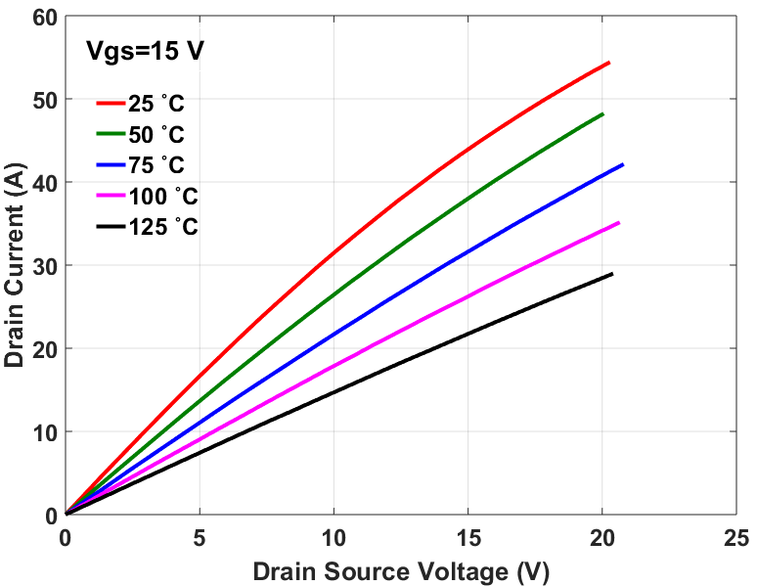
Fig. 3- 8. Output characteristic of the 10 kV /20 A SiC MOSFET under different temperatures.

In addition, the voltage drop on the desat diode should be considered when determining the threshold voltage. The desat diode blocks the dc-link voltage when the MOSFET is in off state to protect the desat protection circuitry. The rated voltage of the desat diode should be the same as that of the MOSFET to achieve good reliability. The desat diode with 10 kV blocking voltage is implemented with four 3.3 kV SiC Schottky diodes (GAP3SLT33-220FP) in series together with balancing resistors. The pads in PCB for the 3.3 kV diode are coated with insulation material (Konform SR). Such design ensures good commercial availability and robustness. Also, the parasitic capacitance in parallel with the desat diode and the displacement current are reduced effectively, which significantly benefits the noise immunity of the protection. Still, the implementation with four diodes introduces 4 V total voltage drop [85]. Thus, the eventual selected threshold voltage is 19 V for the desat protection.
Desat protection can be implemented by either the gate drive IC with desat protection function or the circuitry based on discrete components. The gate drive IC with desat protection typically requires a large blanking capacitor to suppress the noise, leading to long response time. Also, the 19 V threshold voltage for the 10 kV/20 A SiC MOSFET is much higher than the threshold of desat protection provided by the gate drive IC. The circuitry based on discrete components is hence designed to realize desat protection, whose details are shown in Fig. 3-9, in which the parasitic capacitors marked in red should be considered in the design.

Fig. 3- 9. Implementation of desat protection in the gate driver for 10 kV SiC MOSFETs.
Resistors R₁, R₂, and blanking capacitor C_{blk} together realize the blanking time which prevents the false triggering during the turn-on transient when the drain-to-source voltage V_{ds} drops quickly to on-state voltage. The clamping diode D_{blk} limits the voltage V_{desat} to 21 V to protect the comparator. The comparator and the logic control circuit are grounded at -5 V. Resistor R_{cla} (20 Ω) and MOSFET M_{cla} clamps V_{desat} at -5 V when the 10 kV SiC MOSFET is shut off, and they prevent the false triggering due to the high dv/dt during the turn-off transient.
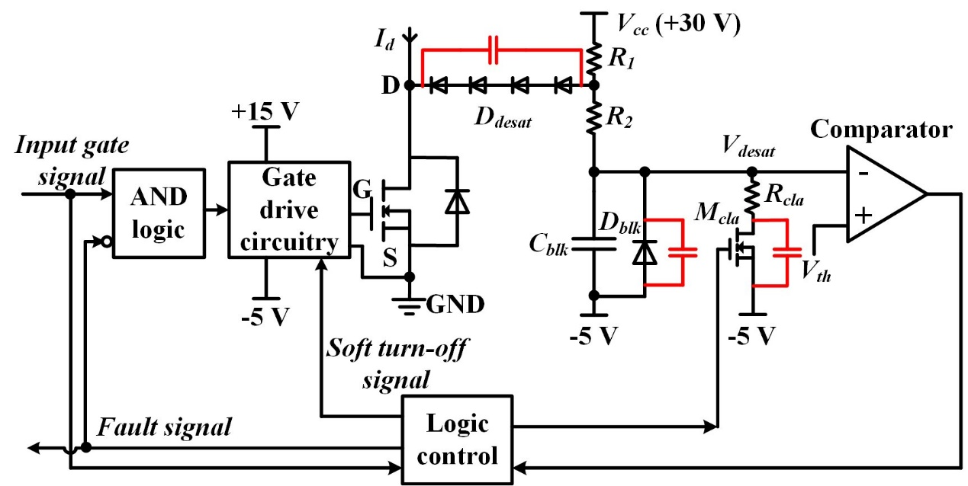
The response time of desat protection is mainly determined by the blanking time. The blanking time should not be over until the drain-to-source voltage V_{ds} drops to on-state voltage without ringing. If blanking time is too short, V_{desat} will be charged to exceed the threshold before it is clamped by D_{desat}. It is necessary to check the turn-on transients of the 10 kV SiC MOSFET to set a suitable blanking time. Preliminary DPT results show that required blanking time is longer if the load current is higher. According to the DPT results at 6.25 kV/20 A with the same gate driver parameters in Fig. 3-10, it takes 480 ns for V_{ds} to reach steady state, after V_{gs} starts to rise. The junction temperature has little influence on the length of this time interval. Considering the delay in gate drive IC, the blanking time should be longer than 550 ns to avoid the false triggering of the protection when the 10 kV SiC MOSFET turns on normally. The minimum response time that can be achieved by the designed desat protection is 600 ns with enough noise immunity.
High noise immunity during the turn-off transient with positive dv/dt is necessary for desat protection. The displacement current through the parasitic capacitor of the desat diode charges C_{blk} and increases V_{desat} during the turn-off transient with positive dv/dt, and the protection can be falsely triggered. The oscillation owing to the high dv/dt makes the situation worse. To dampen the ringing due to high dv/dt, a small resistor R₂ (47 Ω) is added. R_{cla} and M_{cla} are designed to clamp V_{desat} before high turn-off dv/dt occurs. In other words, the clamp should be effective within the turn-off delay time. If the gate signal has a falling edge, V_{desat} is pulled down to -5 V after 80 ns delay. V_{desat} is clamped at -5 V
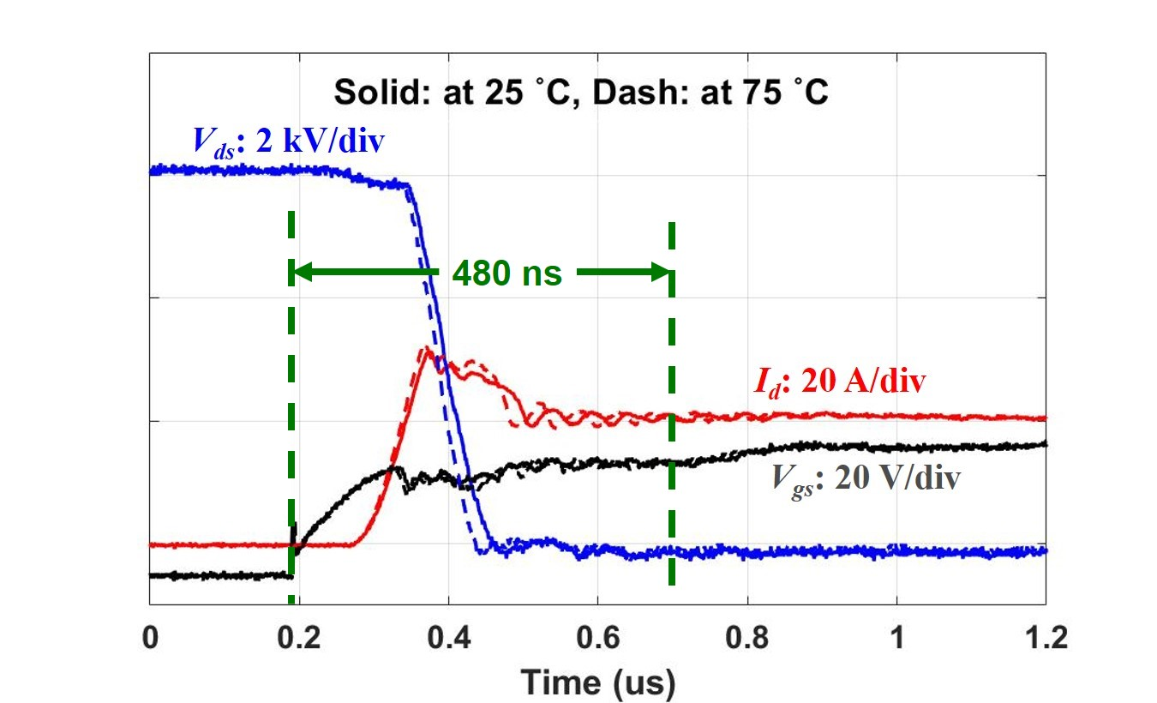
Fig. 3- 10. Turn-on transient of the 10 kV SiC MOSFET at 6.25 kV/20 A.
before the positive dv/dt occurs during the turn-off transient. A RC circuit is added in the gate of M_{cla} to realize the 80 ns delay and suppress the noise at the gate of M_{cla}. During the turn-on transient, V_{desat} is also clamped at -5 V for 80 ns before it starts to rise. Hence, the 80 ns delay in the gate of M_{cla} is part of the blanking time.
The blanking time is tuned by changing R₁ and C_{blk}. The blanking time is indeed the time it takes to charge V_{desat} from -5 V to the 19 V threshold voltage V_{th}. Hence, all parasitic capacitors between V_{desat} and -5 V should be considered, including nonlinear parasitic capacitors from D_{blk} and M_{cla} as well as the capacitor due to the PCB layout. The blanking time is calculated with the following equation, in which the effect of the voltage divider connected with V_{desat} is neglected.
$$\begin{aligned}t_{blk}=C_{total}(R_{1}+R_{2})ln⁡(\frac{V_{cc}+5}{V_{cc}-V_{th}})\#\left(3.1\right)\end{aligned}$$
In the equation, C_{total} is the total capacitance between V_{desat} and -5 V. A large C_{blk} is preferred to suppress the noise in V_{desat} and achieve better noise immunity. Finally, 6.49 kΩ R₁ and 75 pF C_{blk} are selected to provide 1.2 μs blanking time and strong noise suppression. In one prototype of the gate driver, the distribution of 1.26 μs total response time is shown in Table 4, determined by the experiment in the initial test at 0 V dc-link voltage. The parasitic capacitors account for 44.3% of the total blanking time (1.22 μs).
Table 4. Distribution of the total response time in one gate driver prototype.
Total response time | Comparator and control delay | Blanking time due to C_{blk} | Blanking time due to all parasitic caps | Blanking time due to delay in the gate of M_{cla}
1.26 μs | 0.04 μs | 0.6 μs | 0.54 μs | 0.08 μs

The shorter response time is achievable by reducing R₁ and parasitic capacitor due to D_{blk} and M_{cla} as well as layout. Blanking capacitor C_{blk} should only be reduced slightly. By choosing 4 kΩ R₁ and 56 pF C_{blk}, the response time will be reduced to 730 ns.

3.3 Baseline Test of the Phase Leg
The designed half bridge phase leg should be tested comprehensively to be qualified for a building block of a modular MV converter. The ac-dc continuous test at rated voltage is thus required. Considering high dc-link voltage together with high dv/dt and the immaturity of the MOSFETs, the testing becomes more important and challenging. The cautious testing procedures should be designed to quickly identify any issues and prevent the damage of the expensive 10 kV SiC MOSFETs. In this section, the baseline testing procedures and testing results of the phase leg will be presented.

3.3.1 Testing Procedures
Detailed and systematic testing procedures have been developed to standardize the testing. Generally, the baseline test is designed to be nondestructive and reduce the risk of damage of the expensive and fragile MOSFETs. Before the testing at phase leg level, each part is tested individually. The testing of the phase leg is conducted step by step with four steps in total, as listed in Table 5. The testing steps should be conducted in sequence. Only after the phase leg operates well in the previous step could the testing move on to the next.
In the initial test, it is necessary to check the electrical connection between the MOSFET die and the gate driver board. Particularly, the connection of gate terminal is a concern, since the wire bond for the gate is a weak point. The gate-to-source voltage V_{gs} is measured and checked with the PWM gate signal applied, especially the rising edge and falling edge. The rising time and falling time of V_{gs} are measured and compared with the estimated value. If the rising or falling time is too short, the gate region of the die is not well connected with the gate driver board. Desat protection together with soft turn-off is examined by disconnecting the desat diode from the drain terminal and feeding in the gate signal. In addition to the soft turn-off, attention should be paid to the response time and feedback signal. In summary, this step checks the gate loop and the circuitry for desat protection and soft turn-off.
The next step is DPT of both the upper MOSFET and lower MOSFET. DPT is the fundamental electrical test for the MOSFETs, including the functionality and insulation capability of all components. Even if the insulation failure occurs in this step, the damage is still limited. DPT of the upper MOSFET also provides the preliminary test of the capability of the gate driver and the isolated power supply to withstand high common mode voltage with high dv/dt.
The short circuit test is conducted for the upper and lower MOSFETs as the No. 3 step to make sure that the overcurrent protection can protect the MOSFET at rated dc-link voltage. Two types of short circuit tests are commonly conducted, including the hard switching fault (HSF) and fault under load (FUL) [86]-[88]. The desat protection has
Table 5. Details of four steps in the systematic testing of the phase leg.
Step | Name | Purposes
No. 1 | Initial test | 1. Electrical connection check; 2. Gate drive function and protection at 0 V
No. 2 | Double pulse test (DPT) | Fundamental test of MOSFETs and the phase leg up to 6.5 kV/ 20 A
No. 3 | Short circuit test | Desat protection of the gate driver at 6.5 kV dc-link voltage
No. 4 | Continuous test | Continuous operation of the half bridge phase leg at 6.5 kV dc-link voltage

shorter response time and lower energy loss in FUL fault due to the positive dv/dt in the drain-to-source voltage, and the dv/dt results in negligible increase in V_{gs} and short circuit current of the 10 kV/20 A SiC MOSFET [66], [87]. Therefore, only HSF short circuit test is conducted. After the HSF short circuit test of the lower MOSFET is finished, the test setup is reconfigured to test the desat protection for the upper MOSFET.
Continuous test is the last step to test the continuous operation capability of the phase leg at 6.5 kV rated voltage. In the ac-dc continuous test, the half bridge phase leg is configured as a half bridge inverter with inductive load (175 mH), as shown in Fig. 3-11. The continuous test as an inverter enables both MOSFETs in the phase leg to conduct time-varying and bi-directional current in one line cycle. It is thereby a more comprehensive test than the continuous test as a DC-DC converter.
175 mH is the highest inductance that can be realized with the high voltage inductive load in the laboratory, and the rated peak current for continuous operation is 9 A. 300 Hz fundamental frequency is chosen to further increase the impedance of the inductive load and limit the magnitude of output AC current. The active power is the power loss in the test setup. The continuous test adopts bipolar SPWM modulation to regulate output sinusoidal current, with the switching frequency of 10 kHz. The peak value of the fundamental component of the output AC current I_{out} is calculated with the following equation.
$$\begin{aligned}I_{out}=\frac{0.5mV_{in}}{2πf_{line}L_{load}}\#\left(3.2\right)\end{aligned}$$

Fig. 3- 11. Circuit diagram of the continuous test of the designed phase leg.
The modulation index m regulates the magnitude of the output AC current as the
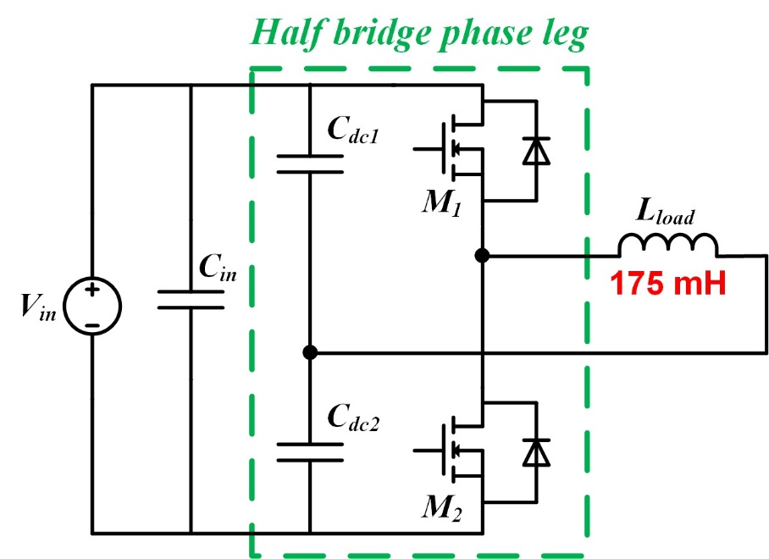
dc-link voltage V_{in} increases. L_{load} is 175 mH, and f_{line} is 300 Hz, the fundamental frequency of the test. The continuous test should last for at least five minutes. The continuous test is also conducted at lower dc-link voltage first, and the results are carefully evaluated before the test at higher dc-link voltage.

3.3.2 Testing Results
The built half bridge phase leg has been tested by following the developed testing procedures. Other than step No. 1, all testing procedures should be conducted with the designed high voltage test platform. The test platform is equipped with high voltage DC power supply from Spellman, different high voltage load inductors, the input capacitor, the controller with fiber optic interface, and so on. Therefore, the test platform can be easily configured for DPT, short circuit test for both lower and upper MOSFET, and the continuous test. The half bridge phase leg prototype in the test platform can be seen in Fig. 3-12(a). The 7 mH air core inductor serves as the load inductor in DPT, and the fan is only
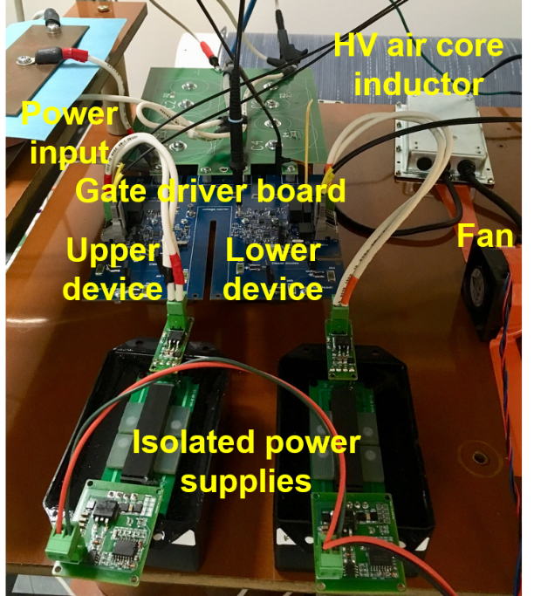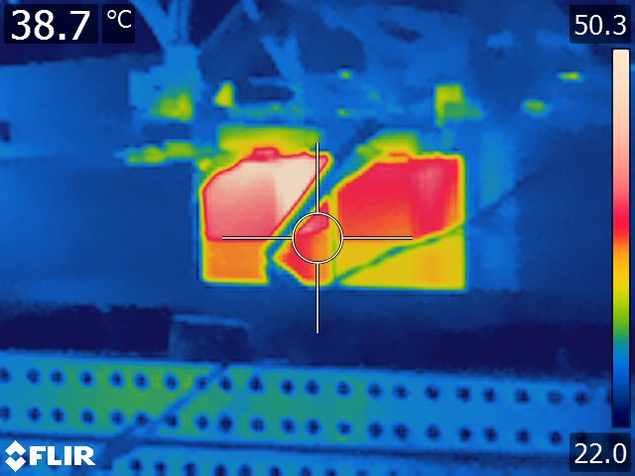
(a) (b)
Fig. 3- 12. (a) Phase leg prototype in the high voltage test platform; (b) Thermal image of the phase leg prototype during 6 kV ac-dc continuous test.
used for the continuous test.
Testing results have shown that the designed phase leg is capable of operating continuously at 6.5 kV rated dc-link voltage, with satisfactory performance in all testing procedures. Results of the short circuit test and the continuous test will be discussed in detail. The DPT results are not shown in this chapter, since DPT results and switching performance will be studied in depth in Chapter 4.
Short circuit test results explicitly prove that the designed protection is able to protect the MOSFET at 6.5 kV. As shown in the HSF test waveform of the lower MOSFET in Fig. 3-13(a), the soft turn-off with a di/dt of 0.57 A/ns is triggered after the 1.27 μs response time, leading to negligible overvoltage under 160.8 A peak current. The MOSFET is safely turned off at 6.5 kV rated voltage. The HSF test results of the upper MOSFET at 6.5 kV is displayed in Fig. 3-13(b), and the MOSFET is safely turned off with 1.2 μs response time. The peak current is still lower than 20X rated current of the MOSFET. V_{gs} of the upper MOSFET cannot be measured due to the high common voltage, still the di/dt and voltage overshoot indicate the soft turn-off. The response time of desat protection for both MOSFETs meets the 1.3 μs specification, and the slight difference is caused by the components’ tolerances.
The continuous test of the phase leg has been conducted with the dc-link voltage up to 6.5 kV. The continuous test as a half bridge inverter outputs the sinusoidal load current, as can be seen in the continuous test waveform at 6.5 kV in Fig. 3-14. With a modulation index of 0.5, the maximum load current is ~6 A. The high frequency component in the load current during the switching commutation is due to the displacement current in the parasitic capacitor of the load inductor. The main window of the waveform features the turn-off transient of the lower MOSFET as the synchronous rectifier with 5.5 A load current. The body diode of the lower MOSFET still conducts after its channel is shut off, so V_{ds} of the lower device is nearly zero until the upper MOSFET turns on. V_{ds} of the lower MOSFET is measured with a high voltage differential probe, and V_{gs} of the lower MOSFET is monitored with a 1 GHz passive voltage probe. Without any anti-cross-talk circuit, V_{gs} of the lower MOSFET increases slightly due to high dv/dt (>70 V/ns), yet the margin between its peak and the gate threshold voltage is still large. This waveform demonstrates that the cross-talk is not a serious issue in the 10 kV/20 A SiC MOSFETs due to high input capacitance compared to Miller capacitance. The designed phase leg also
has good thermal performance. Fig. 3-12(b) displays the thermal image of the phase leg at 6 kV/6 A, in which the peak temperature is less than 60 ˚C.

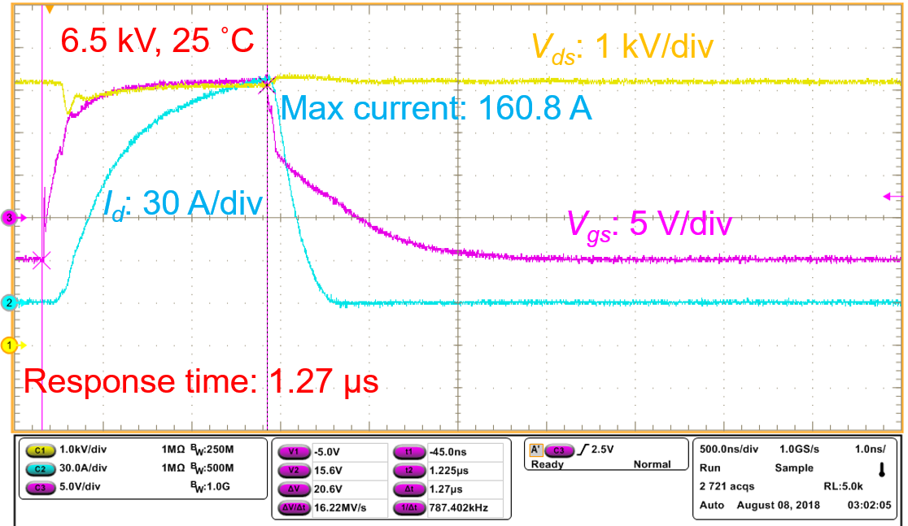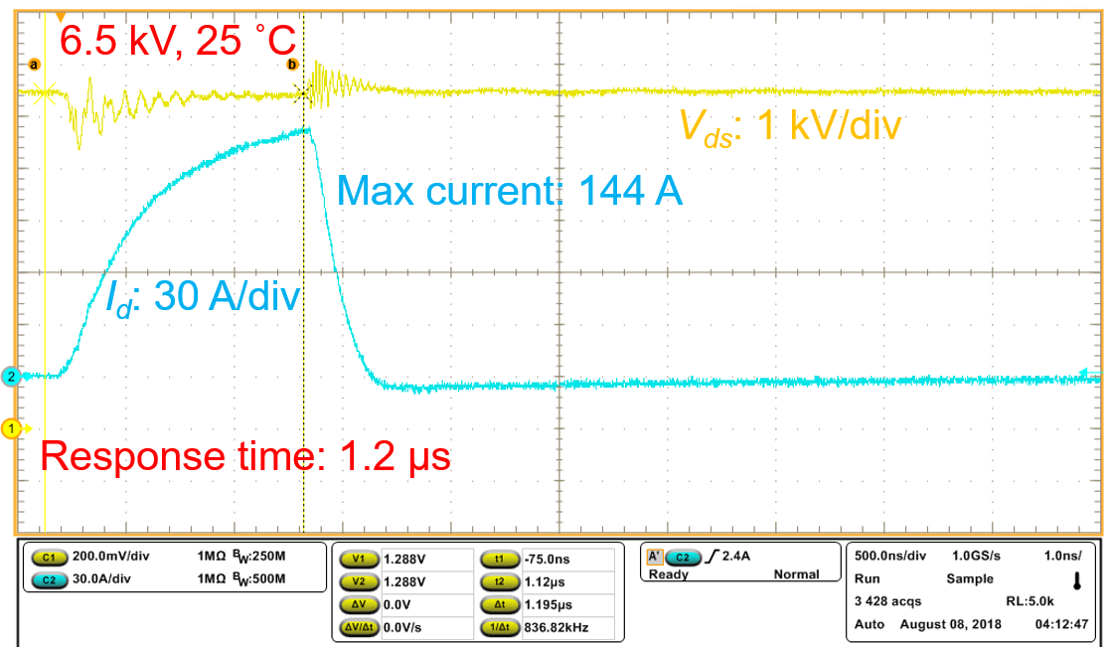
(a) (b)
Fig. 3- 13. HSF short circuit test waveforms: (a) Lower device in the phase leg; (b) Upper device in the phase leg.
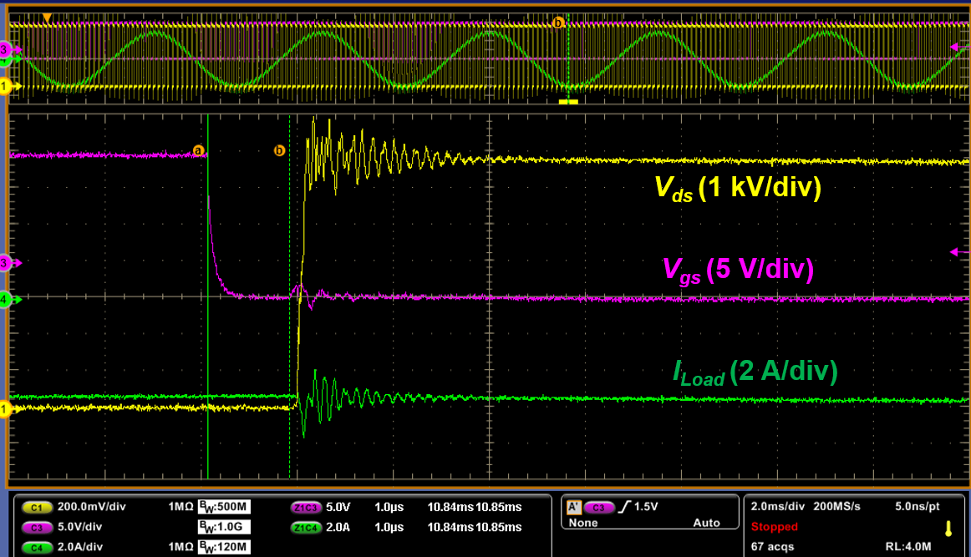Fig. 3- 14. Zoom-in waveform of the continuous test of the phase leg at 6.5 kV.

3.4 Summary
Based on the discrete 10 kV/20 A SiC MOSFETs, the baseline design and test of the 6.5 kV half bridge phase leg are presented in this chapter. The designed gate driver fully utilizes the fast switching speed of 10 kV SiC MOSFETs and supports the robust continuous operation of the phase leg, with overcurrent protection, dead time function, and status feedback signal in every switching cycle. The feedback signal from the gate driver helps the controller monitor the status of the fiber optic communication and gate driver in every switching cycle.
Baseline testing procedures are developed to test the phase leg, including DPT, HSF short circuit test, and ac-dc continuous test. With strict sequence, the testing procedures are able to test the phase leg comprehensively and endeavor to minimize the risk of device damage. Testing results show that the designed protection responds within 1.3 μs in short circuit condition, and the peak current is lower than 10X rated current of the MOSFET. The continuous operation capability of the phase leg is validated by the continuous test at 6.5 kV as a half bridge inverter.

Ch 4. Switching Performance Evaluation
The parasitic capacitances in the power stage of 10 kV SiC MOSFET-based converters and their influence on the switching performance of the HB phase leg are investigated in this chapter. The baseline phase leg design in Chapter 3 is leveraged in the DPT setup for the switching performance evaluation. The parasitic capacitances are mainly caused by the heatsink, the anti-parallel SiC JBS diode, and the load inductor, as summarized in Fig. 4-1. In this chapter, the impact of the parasitic capacitance from the three sources on the switching behavior and performance will be evaluated in detail.
The circuit diagram of DPT based on the HB phase leg introduced in Chapter 3 is shown in Fig. 4-2. A large input capacitor is added in parallel with the dc-link capacitor to serve as energy storage capacitor during DPT. Before DPT, the dc-link voltage is charged to the desired voltage level by a 15 kV/800 mA high voltage DC power supply from Spellman. It is required that the negative terminal of the DC power supply is solidly
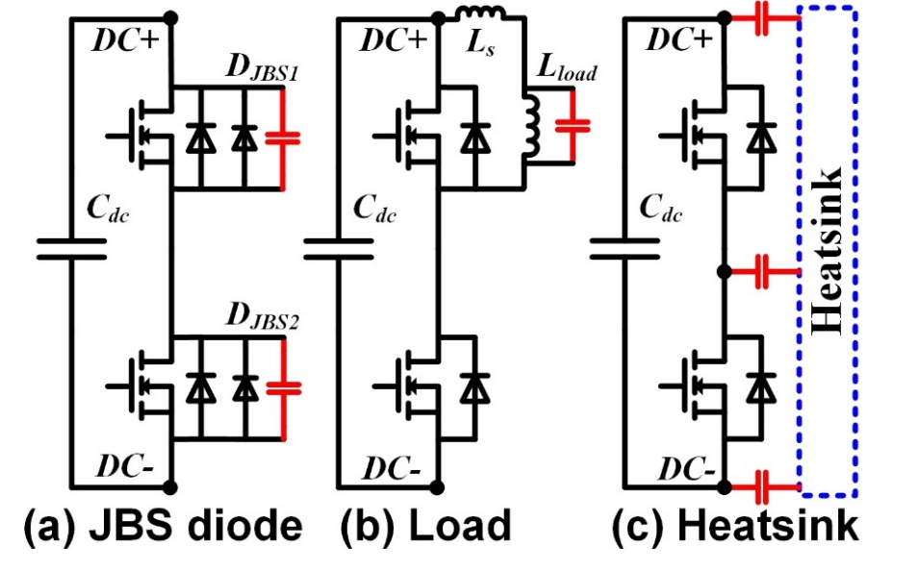
Fig. 4- 1. Three major sources of the parasitic capacitance in the power stage.

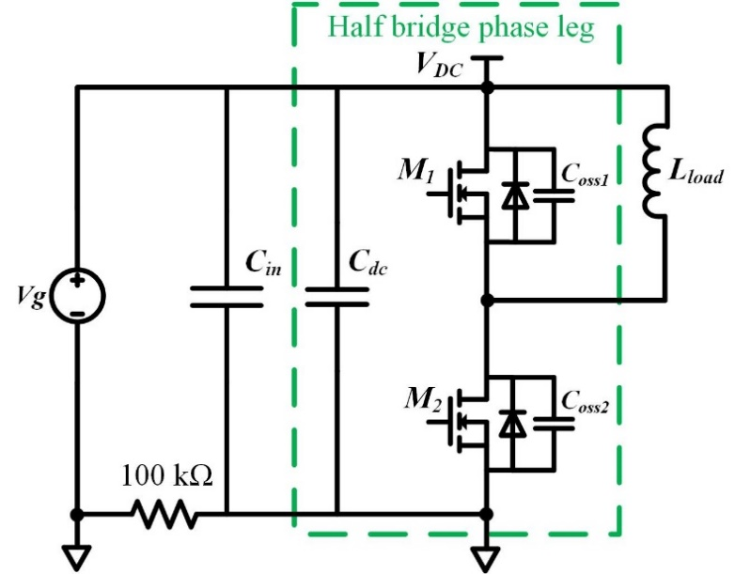
Fig. 4- 2. Circuit diagram of the DPT based on the designed half bridge phase leg.
grounded. Then, the power supply is shut down, so DPT is completed by using the energy stored in the dc-link capacitor C_{dc} and the input capacitor C_{in}. The two auxiliary power supplies for the gate driver board and the oscilloscope are grounded at the grounding point of the half bridge phase leg. A 100 kΩ resistor is inserted between the grounding point of the phase leg and the grounding point of the DC power supply, which makes the DPT setup a single point grounded system during DPT.
The compact HB phase leg design poses a challenge to the accurate measurement of the fast switching transient of the drain current I_{d} and the drain-to-source voltage V_{ds} of DUT, which is the lower device in the HB phase leg. The voltage measurement is conducted with a 75 MHz high voltage passive probe through Kelvin connection. Commercial Rogowski coil and current probe are the two current measurement methods commonly used in the DPT of high voltage SiC MOSFETs. The commercial Rogowski coil current transducer is preferable in the current measurement of the compact phase leg due to its flexibility, but it has a low bandwidth of 30 MHz. Also, the measurement results of Rogowski coil are easily interfered by fast switching transients with high dv/dt [71]. Therefore, a current probe (TCP0030A from Tektronix) is selected due to its higher bandwidth (120 MHz) and better noise immunity under high dv/dt. An additional wire is inserted in the power loop of the phase leg to accommodate the current probe, resulting in an increase of 72 nH in the power loop inductance. Table 6 summarizes the adopted measurement setup for DPT. In addition, common mode chokes are used to suppress the impact of CM current on the measurement. The test setup together with the measurement setup can be seen in Fig. 4-3. The probes are connected with a high-speed oscilloscope on the top layer of the cabinet in which the high voltage test platform is established. The cabinet is solidly grounded at the grounding point of the phase leg.

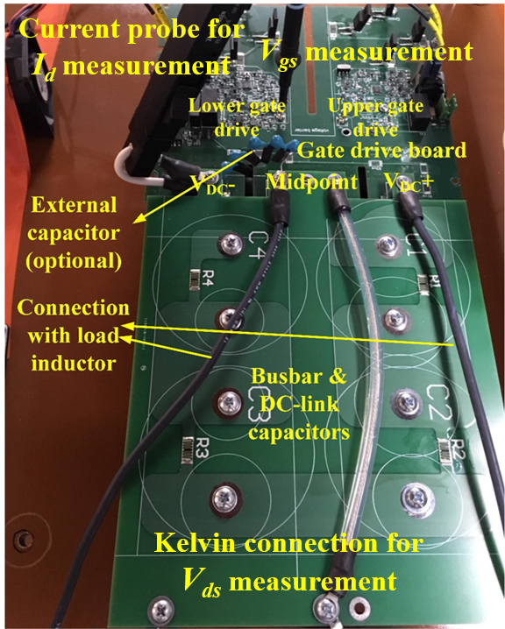
Fig. 4- 3. DPT test setup based on the designed half bridge phase leg together with measurement setup.

Table 6. Summary of the selected measurement setup for the DPT.
Measurement | Drain current | Drain-to-source  voltage | Gate-to-source  voltage
Probe | Tektronix  TCP0030A | Tektronix  P6015A | Tektronix  TPP1000
Bandwidth | 120 MHz | 75 MHz | 1 GHz

4.1 Impact of Parasitic Capacitor in Load Inductor
The load inductor in practical applications has non-negligible equivalent parallel capacitance (EPC), hence introducing considerable parasitic capacitance in the converter. EPC of the load inductor is charged or discharged during the switching transients, and hence should not be neglected when investigating the switching performance. To evaluate the impact of EPC of the load inductor, an 85 mH inductor manufactured by Control Transformer for 15 kV distribution grid applications is used as the load inductor in the DPT setup, which passes the hipot test at 31 kV and can serve in practical MV applications. Keysight E4990A impedance analyzer shows that it has a parasitic EPC of 35.1 pF.
High voltage wire or cable is needed to connect the load inductor with the switching devices, bringing parasitics in series with the load. Usually the distance between the load and the switching devices of the MV converter is considerable. In the experimental setup, high voltage (15 kV) AWG 12 wire is used for the connection between the phase leg and the inductor, since the high voltage cable is expensive and not available in the laboratory. The high voltage wire with a length of 5.92 m in the DPT setup can be modeled as a 6.46 μH inductor in series with a small resistance, since its parasitic capacitance is negligible. The parasitic inductance L_{s} in Fig. 4-1 is thus 6.46 μH and should be considered in the analysis. MV converters for industrial applications use MV cables for the connection, which effectively increases EPC of load due to its shielding layer. In the DPT setup, the EPC of load inductor can be adjusted by adding the external EPC in parallel with the load inductor, as can be seen in Fig. 4-4. Two capacitors (27 pF and 106 pF) have been used to increase EPC of the load inductor. Considering MV cables’ significant impact on EPC of load in practical converters, such increase in EPC by adding external capacitors is reasonable.
DPT results at 6.25 kV reveal that the larger parasitic EPC in the load inductor slows down both turn-on and turn-off transient of the 10 kV SiC MOSFET and results in higher total switching energy loss. The turn-on energy loss increases as the parasitic EPC of the load increases, while the turn-off energy loss decreases, as shown in the DPT results as load current varies from 4 A to 20 A in Fig. 4-5. Larger EPC in the load inductor results in higher total switching energy loss because the turn-on energy loss dominates. An increase of 106 pF in the EPC (4X EPC) results in 16% increase in total switching energy loss at 4 A and 11.1% increase at 20 A. As load current increases from 4 A to 20 A, the percentage increase in total switching energy loss becomes lower.
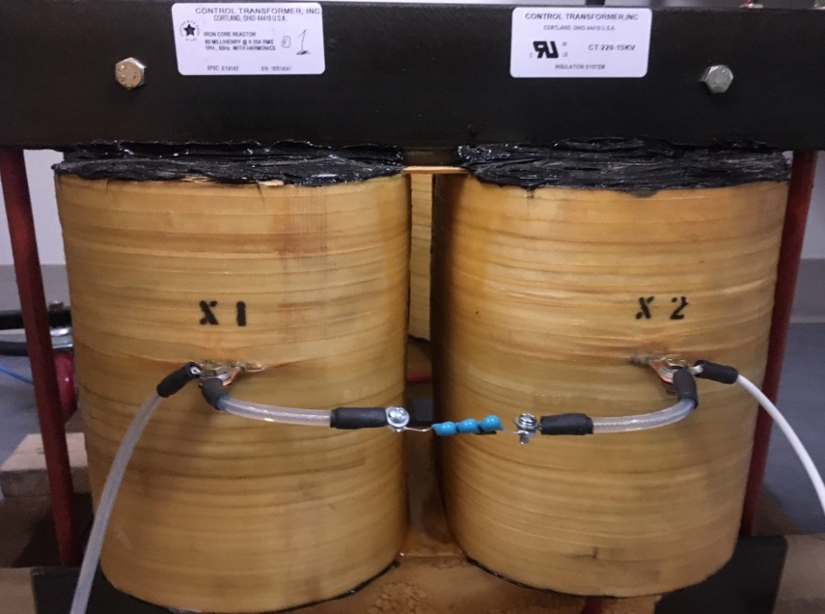
Fig. 4- 4. High voltage load inductor with external capacitor to increase its EPC.
The increase in turn-on energy loss is mainly attributed to the increased current overshoot and longer voltage fall time in the turn-on transient. With increased EPC in the load inductor, a larger effective capacitance needs to be charged from 0 V to 6.25 kV during the turn-on transient. The current overshoot during the turn-on of the 10 kV SiC MOSFET is higher, since its turn-on current overshoot is dominated by the charging current of capacitors in parallel with the synchronous device [57]. The longer voltage fall time leads to lower turn-on dv/dt, as indicated in Fig. 4-6. In the switching transient analysis, the dv/dt is calculated as the average dv/dt when V_{ds} of the MOSFET changes from 90% to 10% of the dc-link voltage.
Meanwhile, the turn-off energy loss decreases as EPC of the load inductor becomes larger. The turn-off transient becomes slower with longer voltage rise time if the load inductor has a larger EPC. In fact, the turn-off transient is slowed down more substantially than the turn-on transient. The drain current of DUT drops more quickly, and meanwhile its V_{ds} rises more slowly, as shown in the switching waveform in Fig. 4-7. The measured turn-off loss of the 10 kV SiC MOSFET consists of the loss due to the overlap between V_{ds} and the channel current and the energy stored in the output capacitance of DUT. The overlap loss decreases, while the energy stored in the capacitor remains the same. Therefore, the turn-off energy loss benefits from the increased EPC in the load inductor.

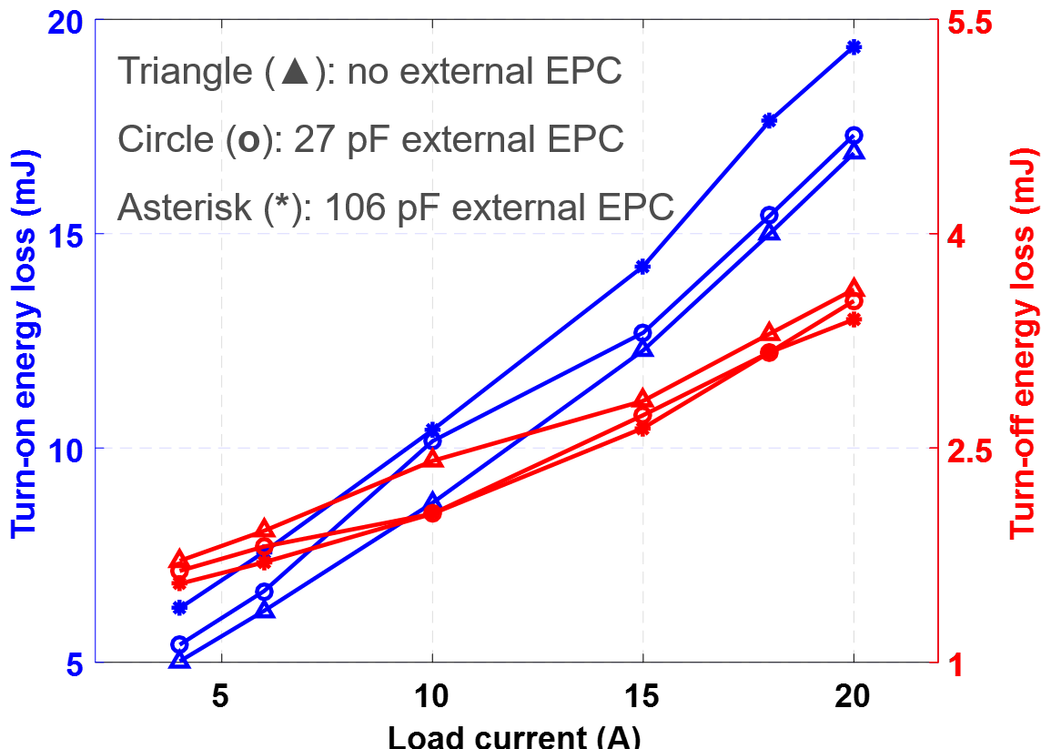
Fig. 4- 5. Turn-on and turn-off energy loss at 6.25 kV when load inductor has different EPCs.

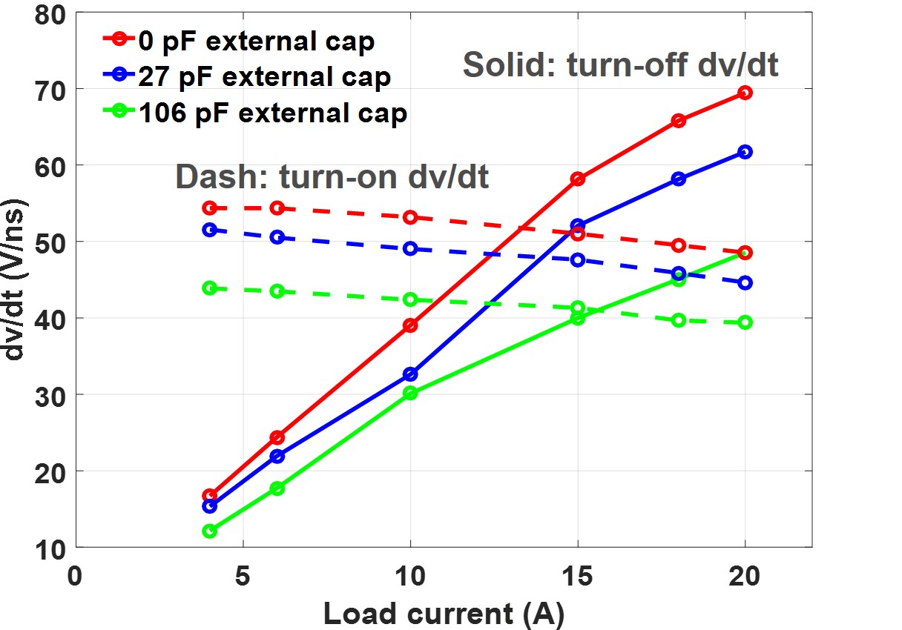
Fig. 4- 6. Turn-on and turn-off dv/dt at 6.25 kV when the load inductor has different EPCs.
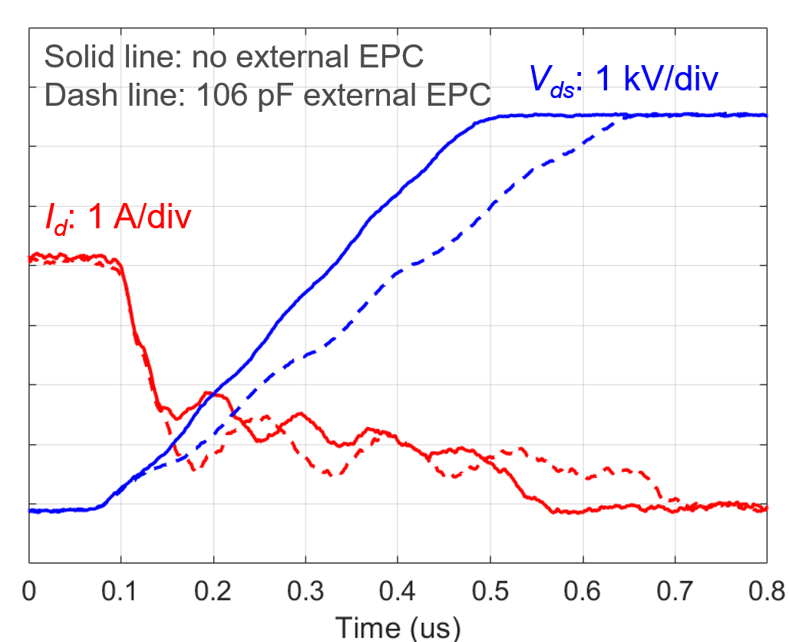
Fig. 4- 7. Turn-off transient waveform at 6.25 kV when load inductor has different EPCs.
The switching transients are heavily shaped by the resonance between the parasitic inductance L_{s} and EPC of the load inductor, which results in considerable ringing in the load current during switching transients. The turn-off transient, particularly, is influenced which counts on the load current to charge the output capacitance of DUT. The impact of the resonance on the turn-off transient is easily observed at lower load current when the turn-off time is longer (see Fig. 4-7). Drain current has significant ringing during the current fall time, resulting in the slight ringing in V_{ds}. The ringing is attributed to the considerable oscillation in the load current owing to the large L_{s}. At higher load current, the turn-off dv/dt changes dramatically during the voltage rise time, as can be seen in Fig. 4-8. The low instantaneous dv/dt period is caused by the slower discharge of the EPC in the load inductor and hence the negative di/dt in the load current. Then, the instantaneous dv/dt becomes high again since the load current rises as the resonance continues. Fig. 4-8 also illustrates that larger EPC in the load inductor leads to longer voltage rise time and lower average dv/dt, but the peak dv/dt is still almost the same.
In summary, the resonance between the parasitic inductance L_{s} and EPC brings oscillation in the load current and hence the ringing in V_{ds} and I_{d}, especially during the turn-off transient. Larger EPC in the load inductor results in higher turn-on energy loss, lower turn-off energy loss, and higher total switching energy loss. Larger EPC in the load also slows down both the turn-on and turn-off transient and reduces the average dv/dt, but it does not necessarily alleviate the peak dv/dt stress.

4.2 Impact of Parasitic Capacitors Due to Heatsink
The heatsink is also able to cause non-negligible parasitic capacitors in the converter. Parasitic capacitors brought by the heatsink design and their impacts on the switching transients are complicated, depending on the heatsink design and grounding
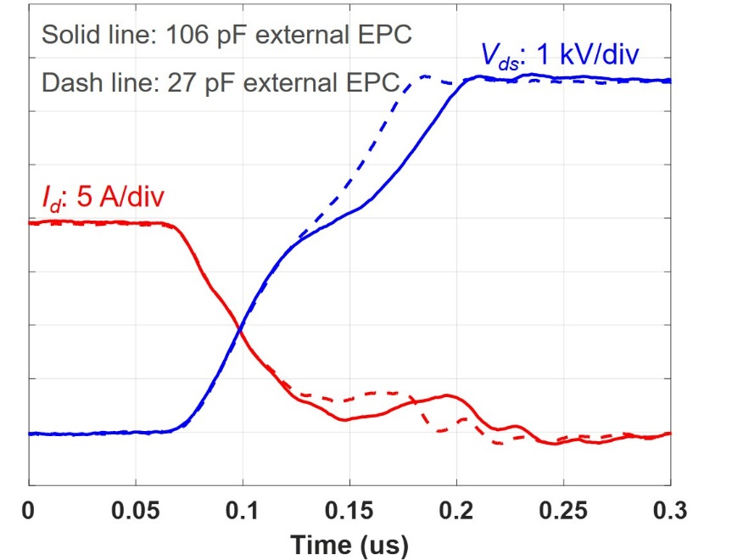
Fig. 4- 8. Turn-off transient waveform at 6.25 kV/20 A when the load inductor has different EPCs.
scheme of the heatsink [48] [89]. In this work, DPT is conducted in the phase leg with two different thermal designs to analyze the effect of the parasitic capacitance due to the heatsink on the switching performance of the 10 kV SiC MOSFET.
Two thermal designs have been implemented in the HB phase leg, as summarized in Fig. 4-9. Thermal design A with two separate heatsinks for two MOSFETs is the thermal design for the half bridge phase leg introduced in Chapter 3. The two heatsinks are not grounded, and their potentials follow the potential of the drain plate they are connected to. Thermal design B has only one grounded heatsink for the two MOSFETs. The thermal pad with high voltage insulation capability is added between the devices’ drain plates and the grounded heatsink. Therefore, two considerable parasitic capacitors between the drain plate and the heatsink, C_{p1}, and C_{p2}, are generated. C_{p1} is in parallel with the lower MOSFET since its source is also grounded. C_{p2} between the dc-link and the ground can be neglected when analyzing the switching transients of DUT. In terms of parasitic capacitance, thermal design A is a better design, in which the parasitic capacitance due to heatsink is too small to consider, yet the heatsink for the lower MOSFET has high dv/dt during switching transients. The parasitic capacitance between the two heatsinks in thermal design A is less than 0.3 pF.

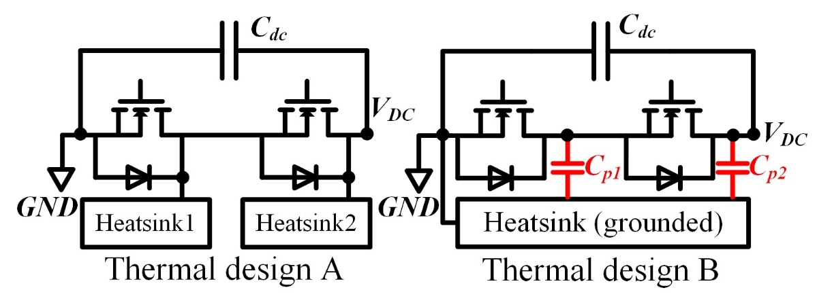
Fig. 4- 9. Two thermal designs implemented in the half bridge phase leg.
In reality, the phase leg with thermal design B utilizes a grounded hotplate as the heatsink, and a 3.4 mm ceramic layer with 20.8 kV/mm insulation capability is placed between the MOSFETs and the grounded hotplate for insulation. The calculated capacitance of C_{p1} is 29.7 pF, which is small due to the thick ceramic layer. In fact, the parasitic capacitance is likely to be so small in MV converters using 10 kV SiC MOSFET power modules instead of the discrete device with the large drain plate. The thermal design can be easily switched between thermal design A and thermal design B. An air core inductor with single-layer winding is used as the load inductor to reduce the impact of parasitics from the load. Measurement setup for DPT is the same as Table 6.
DPT results at 6.25 kV show that the parasitic capacitance generated in thermal design B significantly slows down the turn-off transient and increases the turn-off loss. With thermal design B, the turn-off transient of the DUT is significantly slower with lower turn-off dv/dt and increased turn-off loss. The slower turn-off transient can be explained by the existence of C_{p1} which effectively increases the output capacitance of the DUT. A significant part of the measured turn-off loss of the 10 kV SiC MOSFET is the energy stored in the output capacitance of the DUT. Thus, as shown in Fig. 40, the increase in turn-off loss with thermal design B, ~0.65 mJ, is approximately the same as the energy stored in C_{p1} from 0 V to 6.25 kV. Since C_{p1} is small in the implemented phase leg with thermal design B, there is little difference in the turn-on transient of the DUT in the phase leg with thermal design A and thermal design B, as can be seen in Fig. 4-10 and Fig. 4-11. With a 29.7 pF increase in the output capacitance of the DUT, the total switching energy loss at 6.25 kV increases by 13.4% at 4 A, and it only has 4.8% increase at 20 A load current. Therefore, thermal design A is a better design in terms of switching loss.
The large drain plate of the discrete 10 kV SiC MOSFET for heat extraction makes it easy to form large parasitic capacitor due to the heatsink. With thermal design B, C_{p1}
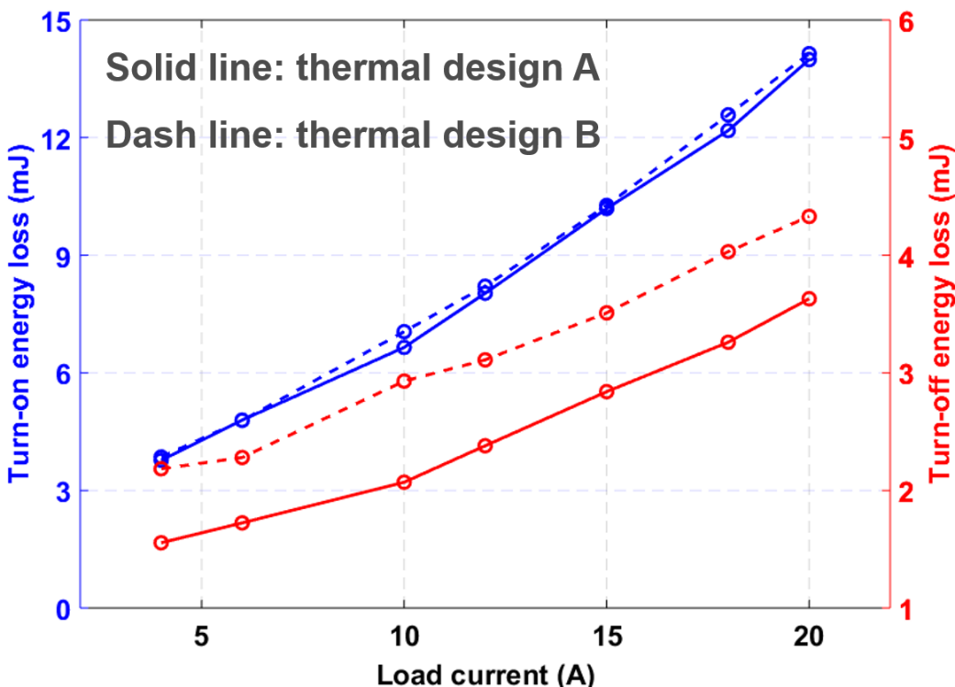
Fig. 4- 10. Comparison of turn-on and turn-off energy loss between the thermal design A and B at 6.25 kV.

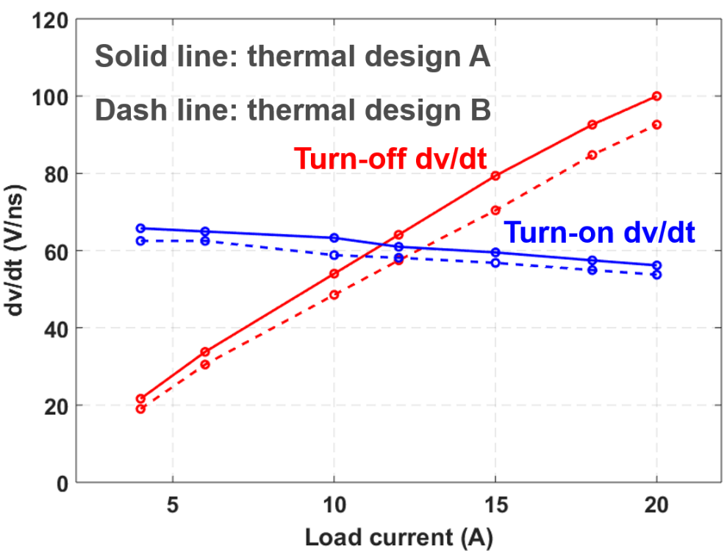
Fig. 4- 11. Comparison of turn-on and turn-off dv/dt between thermal design A and B at 6.25 kV.
could be larger than 29.7 pF since the thermal pad between the device and the heatsink is usually thinner than 1.5 mm for low thermal resistance. For instance, assuming the adoption of the insulated thermal pad SARCON 100X-m with a thickness of 1 mm, C_{p1} will be 53.9 pF. To investigate the influence of a larger C_{p1} caused by thermal design B, an external capacitor (106 pF) is added in parallel with the lower device in the phase leg with thermal design A, which is shown as the external capacitor in Fig. 4-4.
Test results show that a large parasitic capacitor caused by the thermal design B also slows down the turn-on transient and results in significantly increased switching energy loss. The influence of the external 106 pF capacitor on the switching performance of DUT is summarized in Fig. 4-12. The switching energy loss and dv/dt data are normalized based on test results with thermal design A,
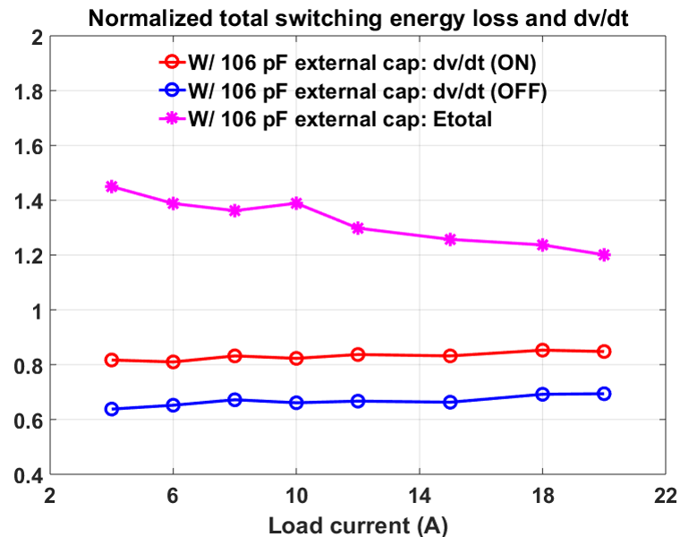
Fig. 4- 12. Impact of the 106 pF parasitic capacitor due to heatsink on the switching energy loss and dv/dt (Normalized based on data from thermal design A).
which can be seen in Fig. 4-10 and Fig. 4-11. Typically the turn-on energy loss increases by ~10% after the 106 pF capacitor is added. Meanwhile, the total switching energy loss has a percentage increase of 44.5% and 20.1%, at 4 A and 20 A, respectively, which is mainly contributed by the increased turn-off loss. Hence, the total switching loss of the converter based on the discrete 10 kV SiC MOSFET increases by >20% if a 106 pF parasitic capacitor is introduced by the grounded heatsink. The impact of the considerable parasitic capacitance caused by thermal design B on the converter switching loss is more significant at light load.

4.3 Impact of Body Diode and Anti-parallel JBS Diode
In this section, the impact of the body diode and the anti-parallel JBS diode on the switching performance of the 3rd generation 10 kV SiC MOSFET from Wolfspeed (CPM3-10000-0350-ES) is investigated in detail at various junction temperatures. The 10 kV SiC MOSFET module with an anti-parallel JBS diode in each switch, as shown in Fig. 43, provides a suitable platform for the investigation. The switching performance of three device configurations for one switch is tested and compared, by which the impact of the body diode and the anti-parallel JBS diode can be quantitatively analyzed. The investigation also guides the 10 kV SiC MOSFET based converter design in the selection of the freewheeling diode.

4.3.1 Device under Test and Experimental Setup
The 10 kV SiC MOSFETs are packaged in a module (H-bridge) by Danfoss Silicon Power, as displayed in Fig. 4-13. Every MOSFET in the module has a 10 kV/20 A anti-parallel SiC JBS diode (CPW3-10000-Z015B-ES from Wolfspeed). The detailed configuration of one switch in the module is drawn as Configuration A in Fig. 44. In addition to the 10 kV SiC MOSFET and JBS diode, a low voltage Si Schottky diode is added in every switch which is able to prevent reverse current flowing through the body diode of MOSFET. Both the Si Schottky diode and JBS diode could be bypassed with a designed interface board.
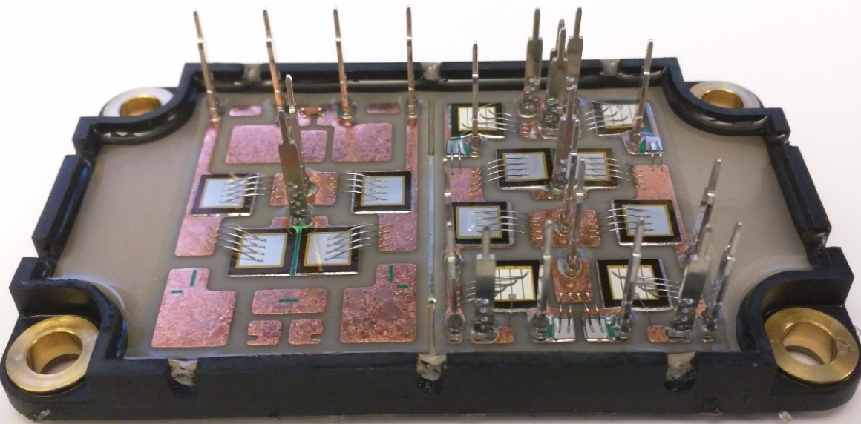
Fig. 4- 13. 10 kV SiC MOSFET module (H-bridge) packaged by Danfoss.
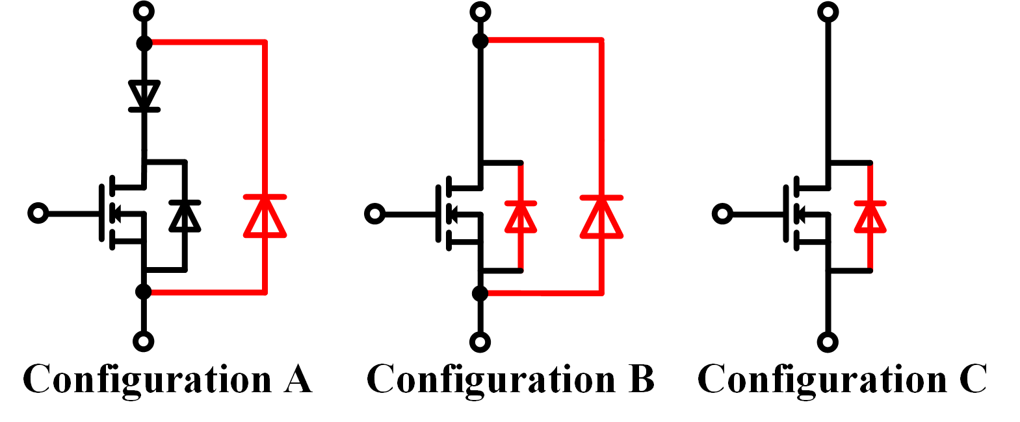
Fig. 4- 14. Three device configurations for one switch available in the 10 kV SiC MOSFET module.
The switching performance of three different device configurations can be tested, as shown in Fig. 4-14. The three device configurations have different combinations of freewheeling diodes during switching commutation. The diode in red serves as the freewheeling diode. For example, the current commutates between the channel of the MOSFET and the anti-parallel JBS diode in Configuration A, while the switching commutation occurs between the channel of the MOSFET and the body diode in Configuration C. With the high voltage DPT setup, the performance of different device configurations can be quantitatively compared, and the impact of the body diode and the anti-parallel JBS diode on the switching transients can be investigated in detail.
DPT setup is established for the switching performance investigation under various temperatures. The setup is similar to that introduced in Section 4.1, so only the differences are introduced. The 10 kV SiC MOSFET module is connected with the interface board and gate driver board through vertical pins. The Si Schottky diode and the anti-parallel JBS diode can be bypassed with the switches in the interface board. Hence, the reconfiguration between different device configurations can be easily realized. The turn-on and turn-off gate resistance are 22 Ω and 11 Ω, respectively. The gate drive IC outputs 20 V/-5 V to drive the MOSFET. The grounded hotplate (H0909AA from Wenesco) under the module regulates the device junction temperature. A thermal pad is applied for electrical insulation between the module and the hotplate. The thermal pad also results in a temperature difference of several degree Celsius between the MOSFET and the hotplate. The temperature difference can be obtained and compensated with an offline test. The only difference in measurement setup is the drain current measurement with the Rogowski coil (CWT Ultra mini from PEM). The compact module design makes it difficult to accommodate the high-bandwidth current probe to measure the drain current. When placing the Rogowski coil in the experimental setup, the positions close to the switch node with high dv/dt should be avoided. The DPT setup can be seen in Fig. 4-15, in which the 10 kV SiC MOSFET module is placed between the gate driver board and the grounded hotplate.
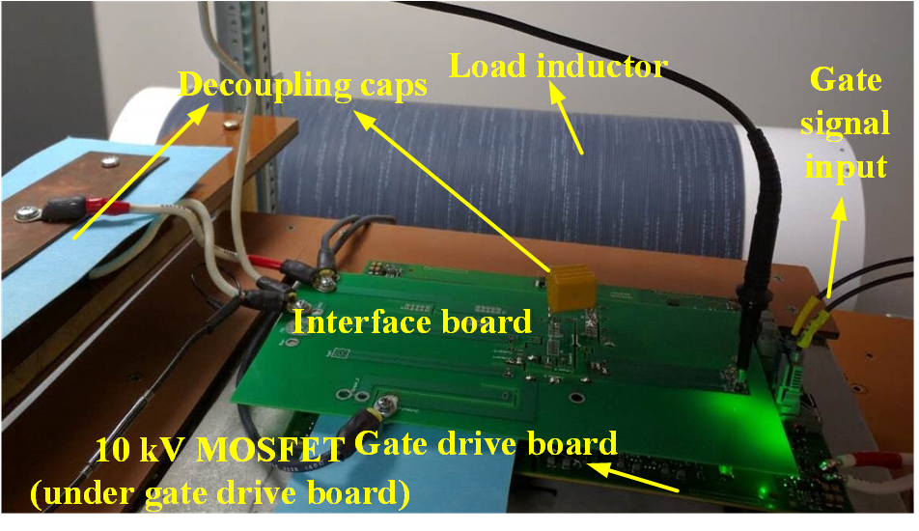
Fig. 4- 15. Picture of DPT setup to evaluate the impact of body diode and anti-parallel JBS diode.
Configuration C with only the body diode is suitable for the evaluation of the impact of the body diode on the switching performance. Switching performance of the phase leg with Configuration C from 25 ˚C to 125 ˚C is investigated. The turn-on energy loss decreases as the junction temperature increases. This phenomenon is different from what has been reported in low voltage SiC MOSFETs [18], [52]. The body diode of the 1.2 kV SiC MOSFET causes a significant increase of turn-on energy loss at higher temperature due to the rapid increase of reverse recovery charge as temperature rises. As for the 10 kV SiC MOSFET, the switching loss decreases with the increasing temperature, indicating stable reverse recovery performance of the body diode as temperature changes. The current overshoot during the turn-on transient increases at higher temperature due to larger displacement current caused by higher dv/dt. Still, the faster switching speed and higher dv/dt makes the turn-on loss lower at higher temperature, as shown in Fig. 4-16 and Fig. 4-17. At 3 kV/20 A, the turn-on loss decreases by 16% from 25 ˚C to 125 ˚C. For the 10 kV SiC MOSFET, utilizing the body diode as freewheeling diode leads to lower switching energy loss as temperature rises.
Switching performance comparison of Configuration A and B affirms that the reverse recovery of the body diode has little impact on the switching transients of the DUT. Experimental results show that the switching performance of Configuration A is almost the same as that of Configuration B, as shown in data obtained at 3 kV and 125 ˚C in Table 7. Detailed switching transients displayed in Fig. 4-18 also indicate the almost identical switching performance between Configuration A and B, which is tested at 75 ˚C. Since Configuration A and B have almost the same switching performance, the reverse recovery performance of the body diode is almost as good as that of the JBS diode. Considering the nearly zero reverse recovery charge of the SiC JBS diode [53], the reverse recovery of the body diode of the 10 kV SiC MOSFET is also negligible.
The excellent reverse recovery performance of the body diode is originally due to the negligible excess carrier injection in on-state of the body diode. Output characteristic of the body diode indicates the impact of excess carrier injection and its reverse recovery performance. When the body diode has large on-state current, the conductivity modulation due to injection of excessive minority carriers effectively reduces the resistance of the body diode, but also results in reverse recovery current since they should be swept out during the turn-off transient. Therefore, the minority carrier injection and reverse recovery of the body diode can be evaluated by investigating the on-resistance of the body diode as a function of the on-state current. Table 8 lists the measured resistance of the body diode as
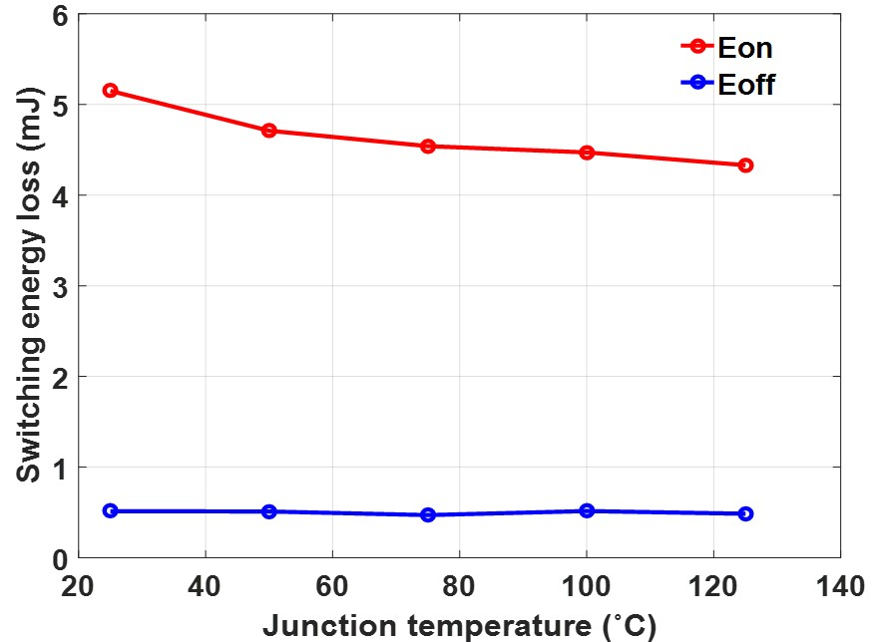
Fig. 4- 16. Switching energy loss vs. temperature (Configuration C, 3 kV/20 A).

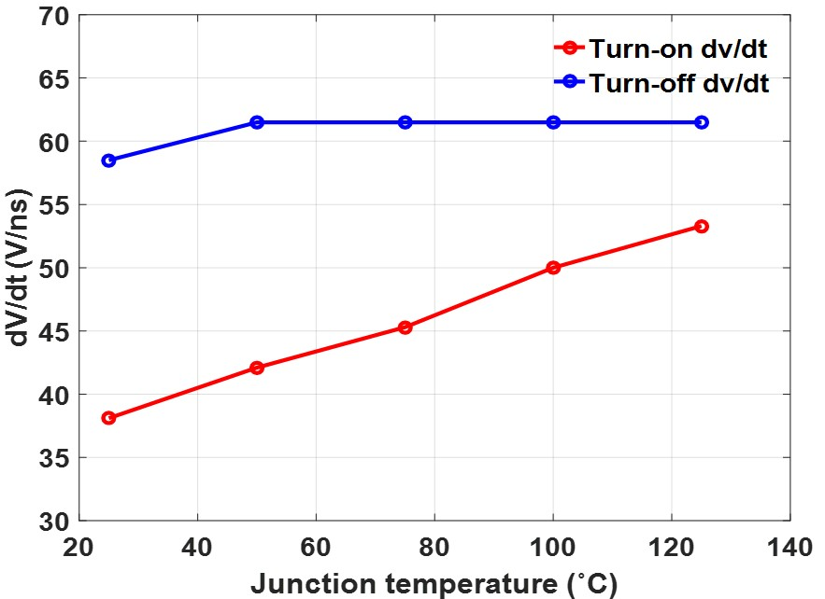
Fig. 4- 17. Turn-on and turn-off dv/dt vs. temperature (Configuration C, 3 kV/20 A).

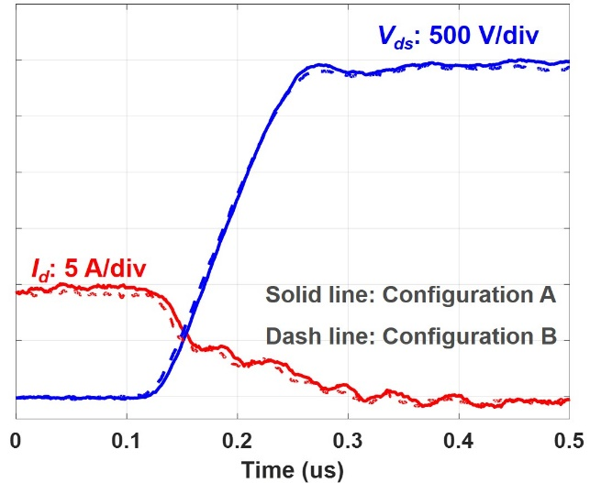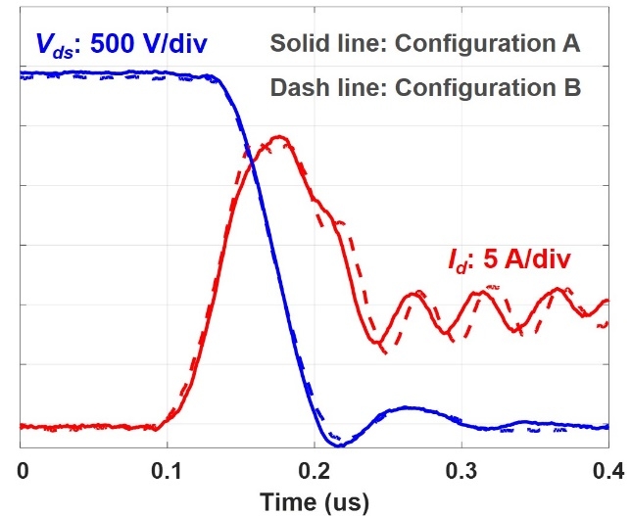
Fig. 4- 18. Switching transient waveforms of Configuration A and B at 75 ˚C (3 kV, 10 A).

Table 7. Switching performance of Configuration A and B at 3 kV, 125 ˚C.
Load current | Parameter | Configuration A | Configuration B
10 A | dv/dt (OFF) | 22.6 V/ns | 22.0 V/ns
10 A | Loss (OFF) | 0.76 mJ | 0.72 mJ
10 A | dv/dt (ON) | 54.5 V/ns | 50.0 V/ns
10 A | Loss (ON) | 2.71 mJ | 2.87 mJ
20 A | dv/dt (OFF) | 48.0 V/ns | 46.1 V/ns
20 A | Loss (OFF) | 0.76 mJ | 0.82 mJ
20 A | dv/dt (ON) | 51.1 V/ns | 49.0 V/ns
20 A | Loss (ON) | 4.06 mJ | 4.49 mJ
a function of the conduction current at different temperatures, based on measured output characteristic of the body diode. At 125 ˚C, the body diode resistance only drops by 6.67% as current increases from 5 A to 25 A. Resistance of the body diode is almost constant as current increases, indicating the slight impact of excess carrier injection. It can be concluded that the body diode of the 3rd generation 10 kV SiC MOSFET has excellent reverse recovery performance over a wide temperature range.

4.3.3 Impact of Anti-parallel JBS Diode
In terms of the switching performance, outcomes of adding external anti-parallel SiC JBS diode are studied to provide a guide for MV converter design. Configuration B is achieved by adding an anti-parallel JBS diode in Configuration C. The effect of adding a 10 kV anti-parallel JBS diode is hence analyzed with the comparison of the switching performance between Configuration B and C.
Fig. 4-19 shows the switching transient waveforms of the phase leg based on Configuration B and C at 3 kV/20 A, 125 ˚C. Configuration C without anti-parallel diode
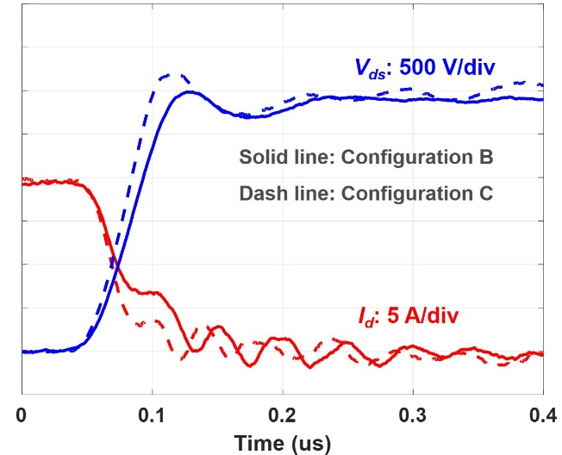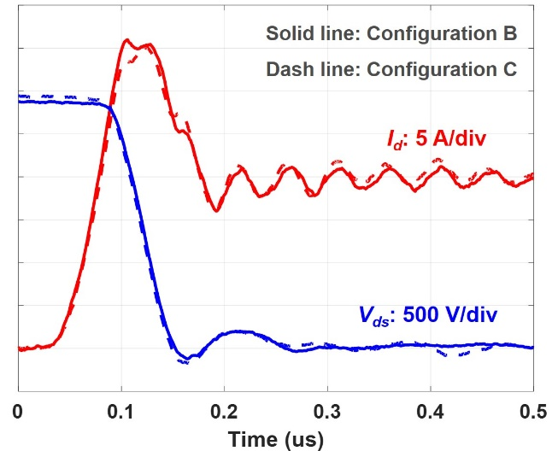
Fig. 4- 19. Switching transient waveforms of Configuration B and C at 125 ˚C.
Table 8. Measured resistance of body diode at different temperatures.
Current | 5 A | 10 A | 15 A | 20 A | 25 A
Resistance of body diode at 25 ˚C | 372.3 mΩ | 352.2 mΩ | 342.5 mΩ | 337.2 mΩ | 335.9 mΩ
Resistance of body diode at 75 ˚C | 549 mΩ | 530 mΩ | 513.7 mΩ | 508 mΩ | 504.4 mΩ
Resistance of body diode at 125 ˚C | 741 mΩ | 722 mΩ | 709.6 mΩ | 697.7 mΩ | 691.6 mΩ

Table 9. Switching performance comparison between Configuration B and Configuration C at 3 kV/20 A.
Configuration | Parameter | At 25 ˚C | At 75 ˚C | At 125 ˚C
Configuration B  (W/ anti-parallel JBS diode) | dv/dt (OFF) | 48 V/ns | 48 V/ns | 46.15 V/ns
Configuration B  (W/ anti-parallel JBS diode) | Loss (OFF) | 0.83 mJ | 0.83 mJ | 0.824 mJ
Configuration B  (W/ anti-parallel JBS diode) | dv/dt (ON) | 36.2 V/ns | 46.2 V/ns | 48.98 V/ns
Configuration B  (W/ anti-parallel JBS diode) | Loss (ON) | 5.32 mJ | 4.86 mJ | 4.49 mJ
Configuration C  (W/O anti-parallel JBS diode) | dv/dt (OFF) | 57.14 V/ns | 60 V/ns | 58.54 V/ns
Configuration C  (W/O anti-parallel JBS diode) | Loss (OFF) | 0.513 mJ | 0.47 mJ | 0.485 mJ
Configuration C  (W/O anti-parallel JBS diode) | dv/dt (ON) | 35.82 V/ns | 45.3 V/ns | 50 V/ns
Configuration C  (W/O anti-parallel JBS diode) | Loss (ON) | 5.15 mJ | 4.54 mJ | 4.33 mJ

during turn-off has higher dv/dt, shorter turn-off time, and lower measured turn-off energy loss. Meanwhile, adding external anti-parallel JBS diode only has slight impact on the turn-on transient. Table 9 illustrates the impact of the anti-parallel JBS diode on the switching performance of the 10 kV SiC MOSFET at different temperatures tested at 3 kV/20 A, including dv/dt and switching energy loss. The anti-parallel diode also increases the turn-on energy loss slightly. The turn-off transient is significantly slower after adding the anti-parallel JBS diode, leading to about 70% increase in turn-off energy loss. At 25 ˚C and 75 ˚C, the total switching energy loss increases by 8.6% and 13.6% at 3 kV/20 A, respectively, after adding the JBS diode. In terms of the switching performance, adding the anti-parallel diode increases the switching loss of the 10 kV SiC MOSFET and significantly slows down its turn-off transient.
The external anti-parallel JBS diode influences the reverse recovery and adds a nonlinear capacitor across the drain and source of the MOSFET, from the perspective of the switching performance evaluation. The body diode of the tested 10 kV SiC MOSFET has excellent reverse recovery performance over a wide temperature range. The benefit of JBS diode in the reverse recovery is thus negligible. Then, in the switching transient analysis, adding the anti-parallel JBS diode can be modeled by adding a nonlinear capacitor in parallel with the MOSFET. The nonlinear capacitor introduced by the anti-parallel JBS diode has an equivalent capacitance of 64.97 pF in terms of the energy at 3 kV.
With the anti-parallel JBS diode, the added nonlinear capacitor slows down the turn-off transient, which is dominated by the capacitive charging process. The increase in the output capacitance of the device results in longer voltage rise time and lower turn-off dv/dt. The measured turn-off loss increases since the capacitor caused by the anti-parallel diode also stores energy during the turn-off transient, which will be dissipated in the channel during the next turn-on transient in hard-switching condition. The energy stored in the output capacitance of the JBS diode at 3 kV is calculated as follows.
$$\begin{aligned}E_{JBS,3kV}=\int_{0}^{3kV}{C_{JBS}v}dv=0.292 mJ\#\left(4.1\right)\end{aligned}$$
The energy stored in the output capacitance of the JBS diode is only slightly lower than the increased turn-off loss after adding the anti-parallel diode.
In terms of the turn-on transient, the influence of the nonlinear capacitor caused by the anti-parallel diode is limited. The turn-on transient is mainly influenced by gate driver parameters and temperature [44], [45]. The added nonlinear capacitor is not the dominant factor during the voltage fall time. The larger output capacitance of the MOSFET due to the anti-parallel diode results in higher current overshoot during the turn-on transient. As shown in Fig. 49, Configuration B with the anti-parallel JBS diode has slightly higher current spike because of larger output capacitance and displacement current. The displacement current contributing to the turn-on current spike in Configuration B is calculated as follows.
$$\begin{aligned}I_{dis}=(C_{oss}+C_{JBS})\frac{dv}{dt}\#\left(4.2\right)\end{aligned}$$
C_{oss} is the output capacitance of the upper MOSFET, and C_{JBS} is the output capacitance of the anti-parallel JBS diode. In Configuration B, C_{JBS} effectively increases the displacement current and hence the current overshoot during the turn-on transient. Thereby, the turn-on energy loss is also slightly higher after adding the anti-parallel JBS diode, as can be seen in Table 9.

4.4 Summary
The HB phase leg prototype developed with the baseline design in Chapter 3 has been utilized to perform DPT to study the impact of the parasitic capacitances in the MV converter on the switching performance of 10 kV SiC MOSFETs.
The larger EPC in the load inductor makes both the turn-on and turn-off transient slower, leading to increased total switching energy loss. An increase of 106 pF in EPC (4X EPC) results in 16% increase in total switching energy loss at 4 A and lower percentage increase (11%) at 20 A. The large parasitic inductance in series with the load causes ringing during the switching transients, especially the turn-off transient. The larger EPC in the load inductor extends the duration of switching transients and reduces average dv/dt, but not necessarily reduces peak dv/dt.
Two different thermal designs bringing different parasitic capacitances have been implemented in the phase leg. The 106 pF parasitic capacitance that could be caused by the grounded heatsink, slows down both turn-on and turn-off transient significantly, leading to around 40% increase in total switching energy loss when load current is lower than 10 A. In terms of switching loss, the best heatsink design for the 10 kV SiC MOSFET with non-isolated package is to have a floating heatsink for each MOSFET, in order to minimize the resulting parasitic capacitance. At the converter level, parasitic capacitances result in higher percentage increase in switching loss when converter operates at lighter load.
The influence of the body diode and the anti-parallel SiC JBS diode on the switching performance of the 10 kV SiC MOSFET is also investigated in detail. The investigation and analysis are based on experimental results of three different device configurations of one semiconductor switch with different freewheeling diodes. The reverse recovery of the body diode is negligible at various temperatures. Using its body diode as the freewheeling diode, the 10 kV SiC MOSFET has lower switching loss as junction temperature rises. Adding the anti-parallel JBS diode does not benefit the reverse recovery performance and introduces additional parasitic capacitance, which increases the switching loss (>8.6% at 3 kV/20 A) and significantly slows down its turn-off transient. Adding the anti-parallel JBS diode as the freewheeling diode is not recommended for the converter based on 10 kV SiC MOSFETs.

Ch 5. Analysis and Gate Driver Considerations of 10 kV SiC MOSFETs under Flashover Fault
The short circuit performance of 10 kV SiC MOSFETs under the HSF fault and the FUL fault has been investigated [59]. Nonetheless, it is also essential to study the behavior of 10 kV SiC MOSFETs under the flashover fault, the most serious type of short circuit fault in MV converters [37]. In fact, the flashover fault can be regarded as the most extreme case of FUL fault with exceptionally fast transients (>1 kV/ns dv_{ds}/dt and >30 A/ns di/dt).
The flashover fault poses a great threat to the 10 kV SiC MOSFET already in ON state [37]. When the flashover fault happens, the MOSFET that is already in ON state should be protected from damage, unless the insulation inside its own package fails. The detailed and comprehensive analysis of 10 kV SiC MOSFETs under the flashover fault is necessary for protection design and survival of the MOSFET from the flashover fault.
This chapter focuses on the analysis of 10 kV SiC MOSFETs under the flashover fault to provide guidelines for gate driver design from the perspective of flashover fault. A simplified model of a 10 kV SiC MOSFET is established, with the focus on its behavior in the active region. Both 10 kV SiC MOSFETs with and without Kelvin source are analyzed in terms of their behavior under the flashover fault, and gate driver design considerations are discussed accordingly. Section 5.4 compares the energy loss generated by the flashover fault and HSF as well as FUL fault and discusses the protection design, followed by the summary of this chapter.

5.1 Model of 10 kV SiC MOSFET
The 10 kV SiC MOSFET investigated in this chapter is the 3rd generation 10 kV SiC MOSFET from Wolfspeed [29]. The 10 kV/20 A SiC MOSFET with only one die is studied as an example, as shown in Fig. 3-1. Power modules with higher current rating are realized by paralleling multiple dies with 20 A current rating. In order to study the behavior of 10 kV SiC MOSFETs under the flashover fault, a simplified model of the 10 kV/20 A SiC MOSFET is established. Fig. 5-1 displays the equivalent circuit of the MOSFET model.
Fig. 5- 1. Equivalent circuit of the established 10 kV SiC MOSFET model.
The established model of a 10 kV SiC MOSFET is based on the classic quadratic model of MOSFET [90] and the model in [44]. The 10 kV SiC MOSFET model is composed of two parts, which model the bare die and the package, respectively. As shown in Fig. 1(b), components inside the red rectangle are used to model the bare die. The MOSFET channel is modeled with a controlled current source dependent on internal gate voltage V_{gs,int}, gate threshold voltage V_{th}, transconductance factor k_{p}, and internal drain-to-source voltage V_{ds,int}. The channel current is always zero when the MOSFET operates in cutoff mode.
$$\begin{aligned}i_{ch}=0 \left(V_{gs,int}-V_{th}<0\right)\#\left(5.1\right)\end{aligned}$$
In the ohmic region, where $V_{gs,int}-V_{th}$ is higher than $V_{ds,int}$, V_{ds,int} increases as channel current rises, which can be described with the following equation.
$$\begin{aligned}i_{ch}=k_{p}\left[\left(V_{gs,int}-V_{th}\right)V_{ds,int}-\frac{{V_{ds,int}}^{2}}{2}\right] \#\left(5.2\right)\end{aligned}$$
As V_{ds,int} keeps increasing and exceeds $V_{gs,int}-V_{th}$, which is still higher than 0 V, the MOSFET operates in the active region, and the channel current will gradually saturate, as described in the equation below.
$$\begin{aligned}i_{ch}=\frac{k_{p}}{2}{\left(V_{gs,int}-V_{th}\right)}^{2}\# \left(5.3\right)\end{aligned}$$
Gate threshold voltage V_{th} of the 10 kV SiC MOSFET is a function of junction temperature and V_{ds,int}, but it is dominated by V_{ds,int} as V_{ds,int} keeps increasing in the active region due to the short channel effect [91]. Higher V_{ds,int} reduces V_{th} and hence leads to higher saturation current of the channel, based on (5.3). k_{p} can be extracted with a curve tracer, and it is almost independent of junction temperature.
In the established model of the MOSFET channel, k_{p} is 2.02 A/V². V_{th} is a function of junction temperature and the internal drain-to-source voltage V_{ds,int}. Considering the extremely fast transient during the flashover fault, the junction temperature indeed soars rapidly to eventually over 400 ˚C, so the impact of initial junction temperature before the flashover fault is negligible. The influence of initial junction temperature is hence neglected to simplify the model. As V_{ds,int} increases, the depletion layer becomes thicker leading to decreased V_{th}. Once V_{ds,int} exceeds 4 kV, the depletion layer starts to occupy the N+ substrate region, and its thickness saturates, so V_{th} remains the same as long as V_{ds,int} is higher than 4 kV. According to [59], the saturation current increases with a coefficient of 0.111/kV as V_{ds,int} rises from 500 V to 4000 V. When V_{ds,int} is lower than 500 V, V_{th} is 2.85 V in the model, which is the extracted V_{th} at 125 ˚C. Based on (5.3) and the saturation current at different V_{ds,int}, the gate threshold voltage at different V_{ds,int} from 500 V to 4 kV can be calculated accordingly.
Also, base resistance R_{base} due to the thick N- base region is not considered since it models the N- base resistance when the MOSFET operates in the ohmic region. When the MOSFET stays in the active region, the impact of N- base region is considered by the channel model with short channel effect and the nonlinear C_{ds} model. The body diode is modeled with a resistor in series with its forward voltage drop, based on the measured I-V characteristic.
Parasitic capacitors of the 10 kV SiC MOSFET are also modeled based on extracted data with the curve tracer. Gate-to-source capacitance C_{gs} is modeled with a linear capacitor of 5.4 nF. Both gate-to-drain capacitance C_{gd} and drain-to-source capacitance C_{ds} are a nonlinear function of the internal drain-to-source voltage V_{ds,int}. Both C_{ds} and C_{gd} are realized by a variable capacitor model, which is determined by a look-up table established with the curve tracer data. The look-up table should include as many data points as possible, especially in the highly nonlinear region where C_{gd} and C_{ds} decrease dramatically as V_{ds,int} rises slightly. The parasitic capacitance in parallel with C_{ds} contributed by such external components as heatsinks is not considered in this chapter.
Internal module parasitics of the MOSFET package should also be carefully modeled. So, the model for the MOSFET with and without Kelvin source is slightly different in Fig. 5-1. Common source inductance L_{ss} is 1 nH for discrete 10 kV SiC MOSFETs without Kelvin source [6]. With a Kelvin source, L_{ss} can be reduced drastically, and L_{s} represents the parasitic inductance in the source terminal that is exclusively in the power loop. L_{d} is the parasitic inductance in the drain terminal. Internal gate resistance R_{g,int} (2 Ω) and internal gate loop inductance L_{gs,int} (1 nH) model the parasitic resistance and inductance in the gate loop inside the device package, which are caused by mechanical connectors, the bond wire, etc. L_{d} and L_{s} typically have negligible impact on the short circuit performance of the 10 kV SiC MOSFET, since it only increases the power loop inductance slightly. Nonetheless, L_{d}, L_{s}, and L_{ss} result in the difference between the internal drain-to-source voltage V_{ds,int} and the measured drain-to-source voltage V_{ds,m}. In fact, L_{ss}, together with R_{g,int} and L_{gs,int} also makes the measured gate-to-source voltage V_{gs,m} different from the internal gate-to-source voltage V_{gs,int}.
Fig. 5- 2. Circuit model of the 10 kV SiC MOSFET in ON state under flashover fault modeled by closing an ideal switch.

5.2 10 kV SiC MOSFET under Flashover Fault
In this section, the 10 kV SiC MOSFET under the flashover fault is analyzed with the circuit model in Fig. 5-2, which models a typical flashover fault case in a HB phase leg. The flashover fault happens when the low-side MOSFET under investigation is already turned on. In order to model the insulation breakdown, the ideal switch, high-side switch in the phase leg, is shorted and generates the flashover fault. Due to the extremely high di/dt in the power loop, common source inductance L_{ss} plays an essential role in the behavior of the 10 kV SiC MOSFET under the flashover fault. Therefore, both the 10 kV SiC MOSFET with Kelvin source and without Kelvin source are evaluated in this section.

5.2.1 Flashover Fault and Simulation Model
The flashover fault due to insulation failure in MV voltage converters is devastating because of its extremely fast dynamics. So, the fault is generated by closing an ideal switch in the phase leg, as shown in Fig. 5-2. Before the fault happens, the ideal switch withstands all of the dc-link voltage, and the 10 kV SiC MOSFET is fully ON with 15 V V_{gs,int} . In summary, the circuit in Fig. 5-2 can effectively model the flashover fault in a real HB phase leg based on 10 kV SiC MOFETs.
The simulation model in Fig. 5-2 is established in PLECS. The phase leg has a power loop inductance L_{p} of 80 nH and a dc-link capacitance of 8.75 µF. The 10 kV SiC MOSFET gate driver has a gate loop inductance L_{gs} of 5 nH, and the decoupling capacitor C_{dec} is 2.18 µF. V_{driver} is always 15 V in the simulation.

5.2.2 10 kV SiC MOSFET without Kelvin Source
In 10 kV SiC MOSFETs without Kelvin source, the gate loop is heavily influenced by extremely fast voltage and current transients due to the flashover fault. High di/dt disturbs the gate loop by inducing a high voltage across L_{ss}. Meanwhile, high dv/dt and Miller capacitance C_{gd} introduce the Miller current. The simulation waveforms at 7 kV are displayed in Fig. 5-3, in which turn-on gate resistance R_{g,on} and turn-off gate resistance R_{g,off} are 15 Ω and 2.5 Ω, respectively. The fault occurs at t=50 ns.
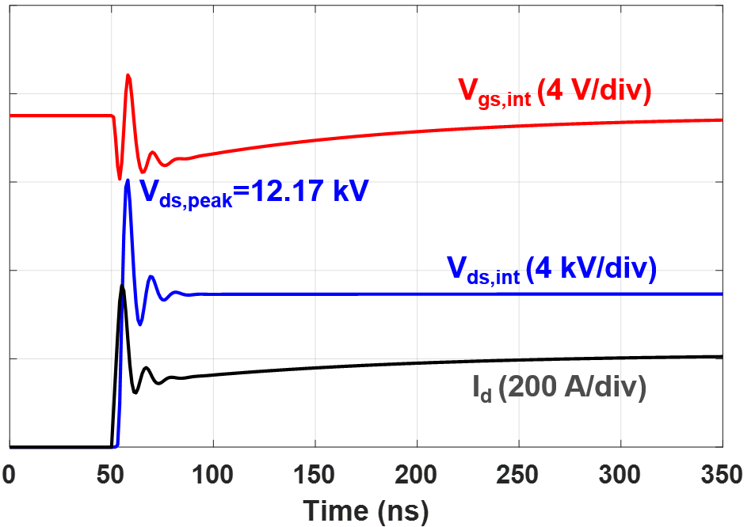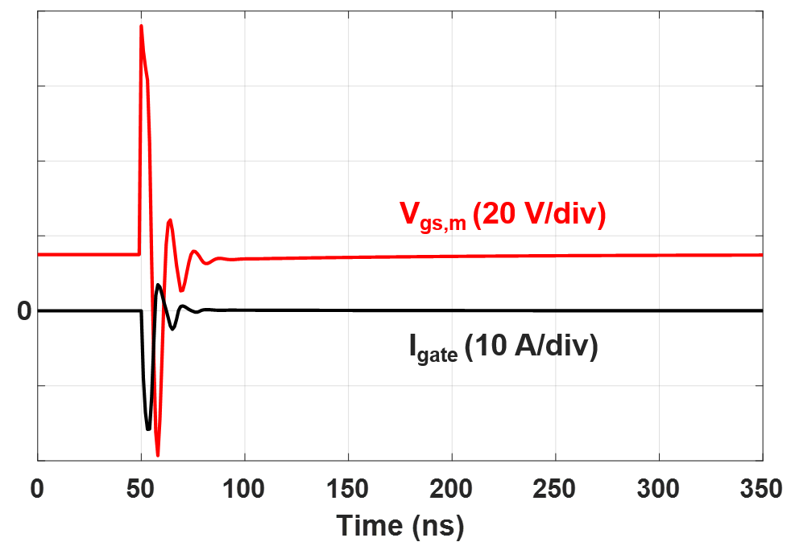
(a) (b)
Fig. 5- 3. Simulation waveforms of flashover fault at 7 kV with 1 nH common source inductance L_{ss}, 15 Ω R_{g,on,} and 2.5 Ω R_{g,off}: (a) Waveforms of V_{ds,int}, I_{d}, and V_{gs,int}; (b) Waveforms of V_{gs,m} and gate current I_{gate}.
The high di/dt resulting from the flashover fault induces a high positive voltage across L_{ss}, leading to -16.2 A instantaneous gate current I_{gate} and reduced V_{gs,int}, as shown in Fig. 5-3(b). The channel current decreases accordingly. Meanwhile, the drain current is not allowed to change rapidly because of the power loop inductance, hence C_{ds} is effectively charged, leading to high dv/dt and a large overshoot in V_{ds,int}. V_{gs,int} and drain current effectively decrease as the oscillation continues, since the gate current discharging C_{gs} is higher because the selected R_{g,off} is 1/6 of R_{g,on}. After the oscillation ends, it takes around 300 ns for V_{gs,int} to rise back to 15 V, and then the drain current reaches the saturation current. In this case, the risk of device damage due to overvoltage is considerable.
The Miller current from C_{gd} counteracts the effect of voltage across L_{ss} on V_{gs,int} and channel current. With asymmetrical gate resistance, the negative spike of I_{gate} is more substantial than its positive spike, and V_{gs,int} continues decreasing until the oscillation ends. This phenomenon is alleviated by the Miller current. When positive di/dt occurs, the voltage drop across L_{ss} generates current to discharge C_{gs}, and meanwhile the Miller current due to the positive dv/dt (>1 kV/ns) enters the gate loop and effectively increases V_{gs,int}.
In addition, if the asymmetry in gate resistance becomes worse with a smaller R_{g,off}, the effect of the voltage across L_{ss} completely dominates. If R_{g,off} is 0 Ω, V_{gs,int} drops rapidly to 0 V within 30 ns once the flashover fault happens, as displayed in Fig. 5-4(a). The tremendous decline in V_{gs,int} is attributed to the gate current I_{gate} with high negative peaks shown in Fig. 5-4(b) due to asymmetrical gate resistance. Such “self turn-off” behavior results in smaller short circuit current and energy loss, but the disadvantage is the extremely high peak voltage (15.85 kV) in V_{ds,int}. The channel is effectively shut off for a short time, and severe ringing (77 MHz) occurs in V_{ds,int} due to the resonance between the 80 nH L_{p} and 48 pF C_{ds} (when V_{ds,int} > 3 kV).
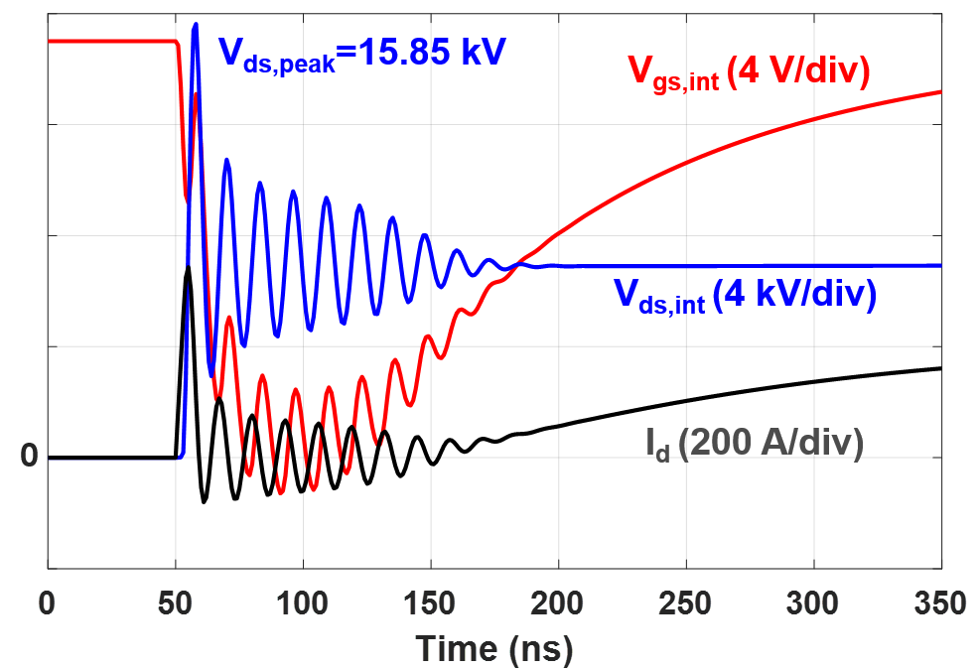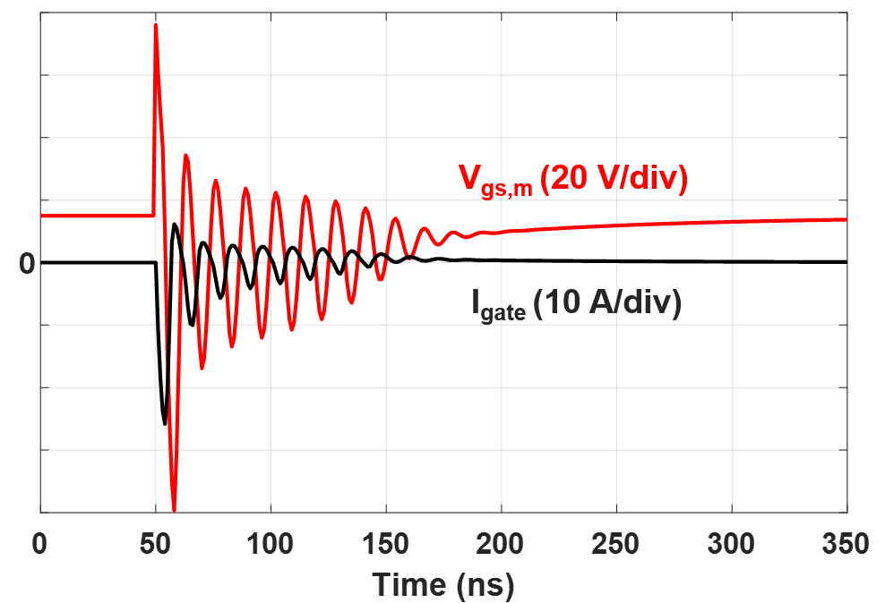
(a) (b)
Fig. 5- 4. Flashover fault simulation results at 7 kV with 1 nH L_{ss}, 15 Ω R_{g,on,} and 0 Ω R_{g,off}: (a) Waveforms of V_{ds,int}, I_{d}, and V_{gs,int}; (b) Waveforms of V_{gs,m} and I_{gate}.
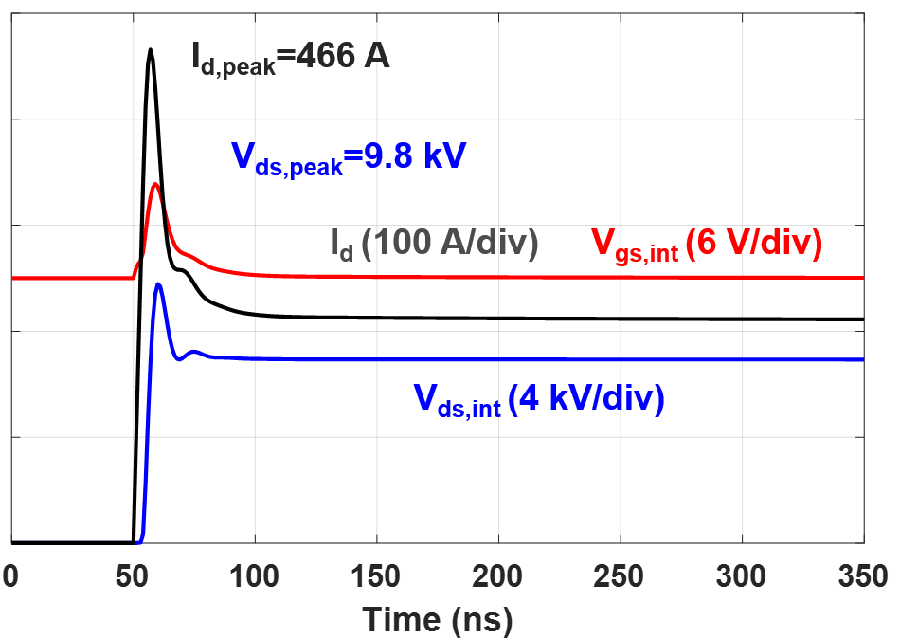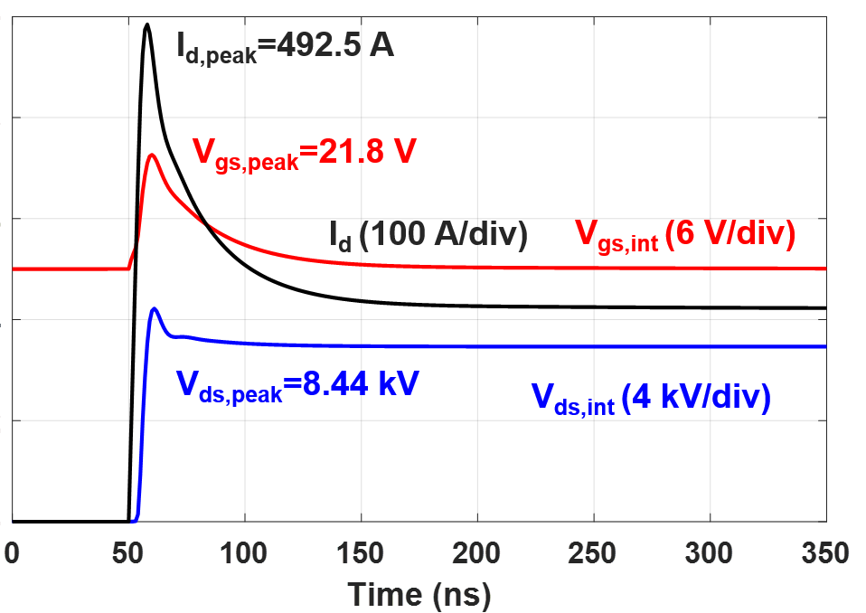
(a) (b)
Fig. 5- 5. Simulation waveforms of flashover fault at 7 kV with 0.15 nH L_{ss} and 15 Ω R_{g,on}: (a) 0 Ω R_{g,off.} (b) 2.5 Ω R_{g,off.}

5.2.3 10 kV SiC MOSFET with Kelvin Source
With a Kelvin source in the 10 kV SiC MOSFET, extremely fast transients under the flashover fault are mainly coupled to the gate loop via the Miller capacitance C_{gd}. If L_{ss} is negligible, the flashover fault induces positive voltage spike in V_{gs,int} and high device current and energy loss, according to simulation waveforms in Fig. 5-5. To simulate this case, it is assumed that L_{ss} is 0.15 nH with an 85% reduction compared to the MOSFET without Kelvin source.
With negligible L_{ss}, the significant oscillations in the gate loop and power loop are eliminated. In this case, the extremely high dv/dt and the nonlinear Miller capacitance result in the substantial spike in V_{gs,int}. V_{gs,int} increases by 45% to 21.8 V with 15 Ω R_{g,on,} and 2.5 Ω R_{g,off}. The peak drain current is higher than 2X saturation current of the channel (211 A), leading to high short circuit energy loss. On the other hand, the overvoltage in V_{ds,int} is reduced compared to the case without Kelvin source, thanks to increasing V_{gs,int} and channel current at the early stage of flashover fault. The MOSFET damage due to overvoltage is not likely in this case, which is obviously a major concern for the MOSFET without Kelvin source. The device damage due to high energy loss and junction temperature is the concern that should be tackled in gate driver design.

5.3 Gate Driver Design Considerations
This section discusses how to improve the performance of the 10 kV SiC MOSFET and reduce the risk of device damage under the flashover fault from the perspective of gate driver design. The design target is to lower peak V_{ds,int} and I_{d,peak} under the flashover fault. Gate driver design guidelines are provided for gate resistance selection, gate loop inductance, and whether to add an external capacitor across gate and source terminal. The short circuit energy loss and the impact of flashover fault on short circuit protection design are not covered in this section, since both are investigated in detail in Section 5.4.

5.3.1 10 kV SiC MOSFET without Kelvin Source
Without a Kelvin source available in device package, a relatively high turn-off gate resistance should be selected. The small R_{g,off} and significant asymmetry in gate loop result in reduced V_{gs,int} and substantial voltage overshoot that could damage the MOSFET at the beginning of the flashover fault. Such asymmetrical gate resistance should be avoided in the 10 kV SiC MOSFET gate driver. As shown in Fig. 5-3, Fig. 5-4, and Fig. 5-6(a), as R_{g.off} keeps increasing from 0 Ω to 7.5 Ω (with a 15 Ω R_{g,on}), the peak value of V_{ds,int} decreases from 15.85 kV to 9.42 kV. Hence, higher R_{g,off} is preferred to reduce the voltage stress. In fact, increasing R_{g,off} from 0 Ω to 7.5 Ω hardly impacts the turn-off transient of the 10 kV/20 A SiC MOSFET during the normal operation [44].
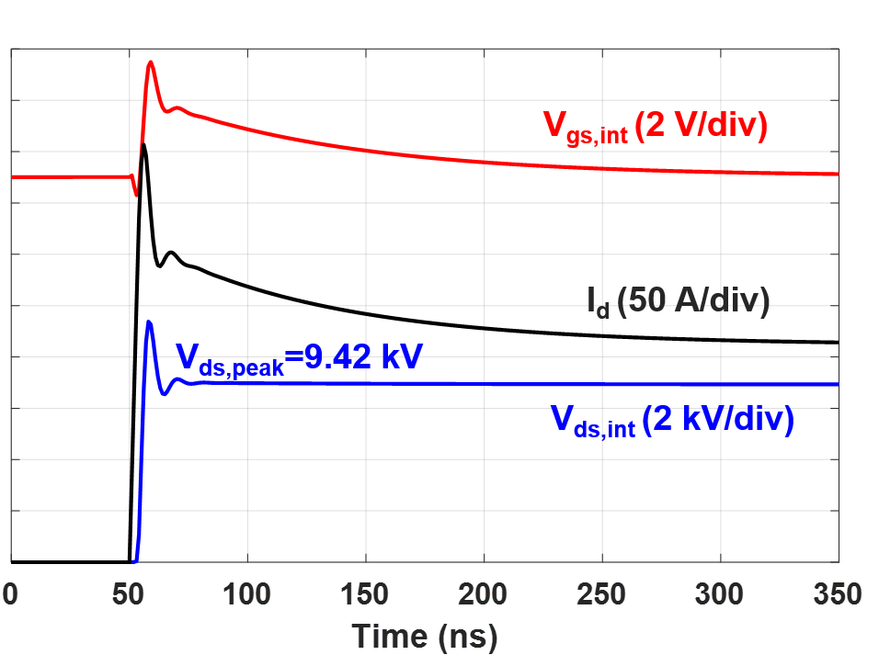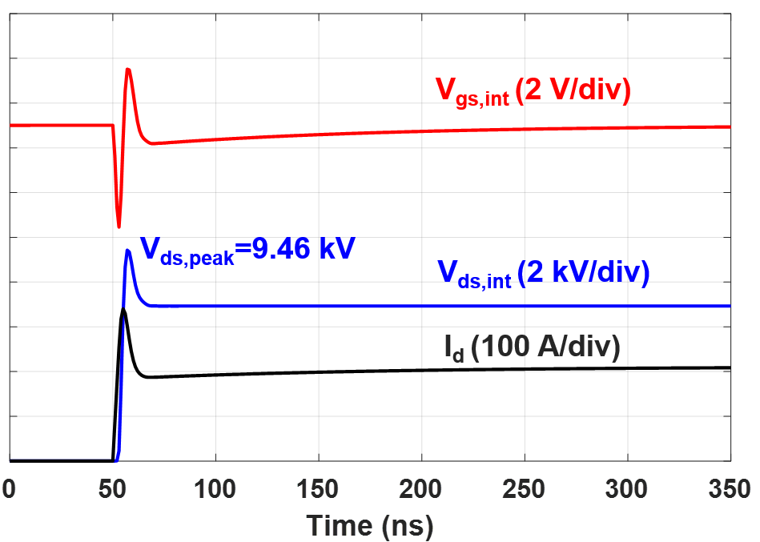
(a) (b)
Fig. 5- 6. Simulation waveforms of flashover fault at 7 kV with 1 nH L_{ss}: (a) 15 Ω R_{g,on} and 7.5 Ω R_{g,off}, (b) 15 Ω R_{g,on} and 2.5 Ω R_{g,off.} as well as a 500 pF external capacitor.
Adding an external capacitor across gate and source terminal suppresses oscillations in gate loop and reduces voltage overshoot in V_{ds,int} during the flashover fault, as can be seen in Fig. 5-6(b). With 15 Ω R_{g,on} and 2.5 Ω R_{g,off.} , the peak V_{ds,int} reduces from 12.17 kV to 9.46 kV after adding a 500 pF external capacitor between gate and source terminal of the MOSFET. Adding a larger external capacitor is not recommended since the capacitor will result in higher converter switching loss. A smaller capacitor only increases switching loss slightly, yet it will be less effective in reducing the overvoltage of V_{ds,int}. Generally, the best solution to suppressing overvoltage in V_{ds,int} is a relatively large R_{g,off} to achieve lower R_{g,on}/R_{g,off}, although a small external capacitor is also effective.
In addition, a small gate loop inductance L_{gs} is desirable from the perspective of flashover fault. A large gate loop inductance L_{gs} causes higher V_{gs,int} and device current and energy loss during the flashover fault, since the large impedance of L_{gs} alleviates the asymmetric impedance in the gate loop and hence the effect of L_{ss}. On the other hand, larger L_{gs} strengthens the effect of Miller current, and a larger portion of Miller current flows to C_{gs}. Compared to the case in Fig. 5-3(a), the peak device current surges from 367 A to 435 A when L_{gs} rises from 5 nH to 30 nH. Hence a large gate loop inductance should be avoided in PCB layout.

5.3.2 10 kV SiC MOSFET with Kelvin Source
If L_{ss} is negligible, a smaller turn-off gate resistance and gate loop inductance are preferable to reduce current and energy loss during a flashover fault. To suppress positive voltage spike in V_{gs,int} due to Miller current, it is crucial to reduce the gate loop impedance when the gate current is negative. R_{g,off} as well as L_{gs} thereby should be as small as possible, while R_{g,on} should still be determined by the switching performance during the normal operation. As displayed in Fig. 5-7, a large R_{g,off} (7.5 Ω) causes 7.9 V spike in V_{gs,int} and 12.2% increase in peak current compared to the case with 0 Ω R_{g,off}, and the 523 A peak device current is 2.5X device saturation current, which will be increased further to 539 A with 30 nH L_{gs} due to poor PCB layout.
With negligible L_{ss}, adding an external capacitor across the gate and source terminal is not recommended because it only reduces the peak current slightly. With a 1 nF external capacitor, the peak current only drops by 2.9% compared to 492.5 A in Fig. 5-5(b). Because
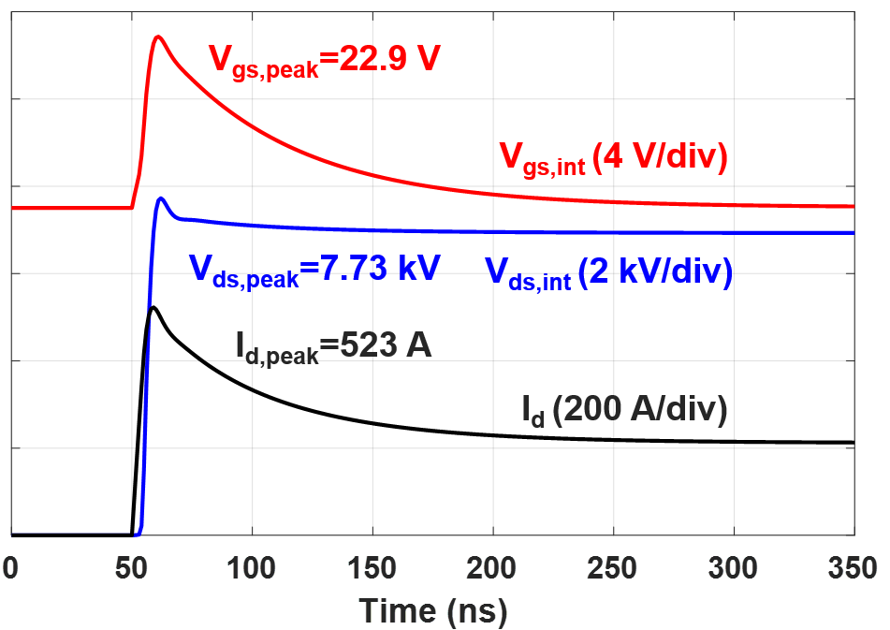
Fig. 5- 7. Simulation waveforms of flashover fault at 7 kV with 0.15 nH L_{ss}, 15 Ω R_{g,on,} and 7.5 Ω R_{g,off.}
of 2 Ω R_{g,int} and 1 nH L_{gs,int} inside the device package, it is not likely that a small external capacitor can reduce device current under the flashover fault substantially.

5.3.3 Summary
The 10 kV SiC MOSFET gate driver design guidelines are summarized in Table 10, to achieve lower device damage risk and better performance under the flashover fault.
Table 10. Gate driver design considerations from the standpoint of flashover fault
10 kV SiC MOSFET | w/ Kelvin source | w/o Kelvin source
Gate loop inductance L_{gs} | Reduce L_{gs} in layout | Reduce L_{gs} in layout
Turn-off gate resistance R_{g,off} | Select a relatively small R_{g,off} | Select a larger R_{g,off} to avoid high R_{g,on} /R_{g,off}
External capacitor across gate and source | Adding an external capacitor is not effective | Adding an external capacitor is effective but not recommended

5.4 Short Circuit Energy Loss and Protection Design
The flashover fault usually generates high energy loss, because V_{ds,int} and I_{d} soar rapidly to reach dc-link voltage and saturation current, respectively. In this section, the energy loss of the 10 kV SiC MOSFET under the flashover fault is investigated quantitatively, which is essential in short circuit protection design. Nonetheless, the response time of short circuit protection is typically determined based on short circuit performance under the HSF and FUL fault, instead of the flashover fault. As a result, the designed protection may not be fast enough to safely turn off the MOSFET under a flashover fault. A fair comparison between the flashover fault and the FUL fault as well as the HSF fault is made to quantitatively show how much higher energy loss the flashover fault produces. Response time required to safely clear the flashover fault is provided to guide short circuit protection design.

5.4.1 Simulation of FUL Fault and HSF Fault
The same 10 kV SiC MOSFET model in the simulation of flashover fault is adopted in the simulation of FUL fault in order to make a fair comparison. To emulate FUL fault, the ideal switch in Fig. 5-2 should be replaced by a power semiconductor device with much higher saturation current so that the 10 kV SiC MOSFET eventually withstands complete dc-link voltage during the fault.
When simulating FUL fault, the ideal switch is replaced by a 10 kV SiC MOSFET module composed of three identical 10 kV/20 A dies in parallel. Such implementation ensures sufficiently high saturation current and makes full use of the established 10 kV SiC MOSFET model in Section 5.1. The gate resistance of the 10 kV SiC MOSFET module is selected to ensure fast turn-on process to emulate the short circuit in the load side. The power loop inductance and dc-link capacitance are the same as those in the flashover fault simulation.
In the simulation of HSF fault, the ideal switch in the HB phase leg in Fig. 5-2 is completely shorted. C_{DC} and L_{p} are not changed. The HSF fault occurs once the 10 kV SiC MOSFET is turned on. During the HSF fault, V_{ds,int} remains close to the dc-link voltage, so gate threshold voltage V_{th} is not dominated by V_{ds,int} any more. Instead, V_{th} decreases dramatically as device junction temperature T_{j} rises rapidly under the HSF fault. V_{th} in the model of the MOSFET channel should hence be modified for more accurate simulation result under the HSF fault. An empirical model of V_{th} as a function of T_{j} is derived based on the experimental data of the 10 kV/20 A SiC MOSFET under the HSF fault. The nonlinear model of V_{th} is realized with a look-up table in PLECS. The instantaneous T_{j} during the fault is estimated with the energy loss and thermal capacitance of the drift region of the device, which is 6.4 mJ/K [59]. Other parts of the MOSFET model in Section 5.1 remain unchanged to make a fair comparison.

5.4.2 Comparison between Flashover and FUL Fault
Common source inductance L_{ss} makes a difference in the behavior of the 10 kV SiC MOSFET under the flashover fault. A large L_{ss} reduces V_{gs,int} and device current in the early stage of a flashover fault. However, as displayed in Fig. 5-8, a large L_{ss} is only able to significantly reduce short circuit energy loss as R_{g,off} approaches zero, inevitably giving rise to huge spike in V_{ds,int} which can damage the MOSFET. Therefore, it is not realistic to take advantage of a large L_{ss} to reduce energy loss during a flashover fault. In summary, if gate resistance is correctly selected to prevent device damage from overvoltage under the flashover fault, common source inductance has little influence on the energy loss during the flashover fault.
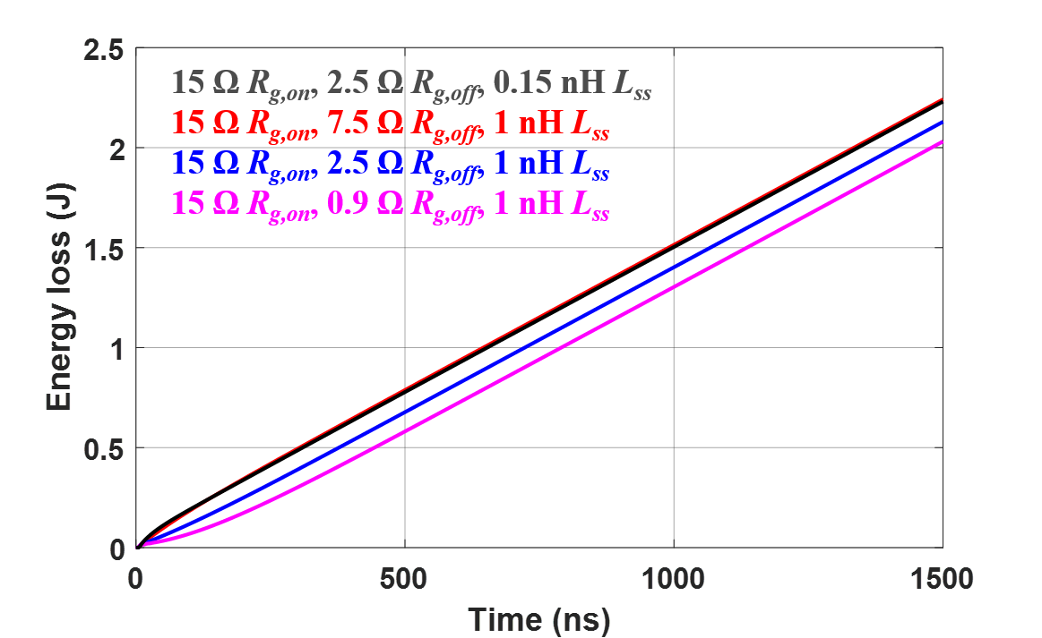
Fig. 5- 8. Short circuit energy loss under flashover fault at 7 kV with different gate resistances and common source inductance.

Simulation waveforms of the 10 kV SiC MOSFET under both the flashover and the FUL fault at 7 kV are displayed in Fig. 5-9, both of which last for 1.5 µs. The gate driver for the 10 kV SiC MOSFET with Kelvin source has 15 Ω R_{g,on,} and 2.5 Ω R_{g,off.} Compared to a flashover fault, a FUL fault results in much slower transient. After the FUL fault occurs, it takes 760 ns for V_{ds,int} and I_{d} to reach their saturation levels. V_{ds,int} rises slowly with an average dv/dt of 13.6 V/ns. In fact, there is a 230 ns delay before V_{ds,int} starts to increase with a high slew rate. The slow transient contributes to lower energy loss under the FUL fault than that under the flashover fault, with details shown in Fig. 5-10. In the first 500 ns, the energy loss under the FUL fault is 0.1 J, while the flashover fault has a 0.77 J energy loss. After 1.5 µs, the flashover fault produces 49.5% higher energy loss than the FUL fault.
With 49.5% higher device energy loss under the flashover fault than the FUL fault, a shorter response time is required in the short circuit protection design to prevent device damage due to high energy loss. In fact, after V_{ds,int} and I_{d} reach steady state, the energy loss difference between FUL and flashover fault is ~0.74 J. The energy loss difference is mainly established in the first 500 ns of the fault. For instance, based on Fig. 11, the energy loss under the flashover fault reaches 1.5 J at t=1 µs, while the energy loss under the FUL fault reaches 1.5 J at t=1.5 µs. From the perspective of critical energy, in order to achieve the same margin, the short circuit response time under the flashover fault should be ~500 ns shorter than that under FUL fault.
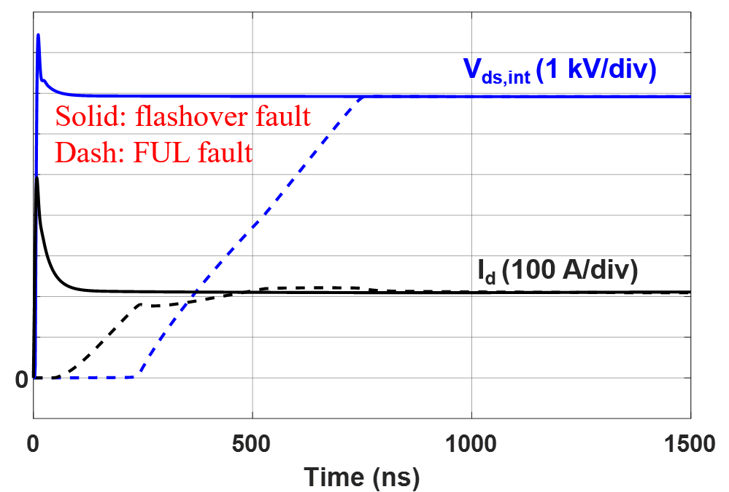
Fig. 5- 9. Simulation waveforms of FUL and flashover fault at 7 kV with 0.15 nH L_{ss}, 15 Ω R_{g,on,} and 2.5 Ω R_{g,off.}
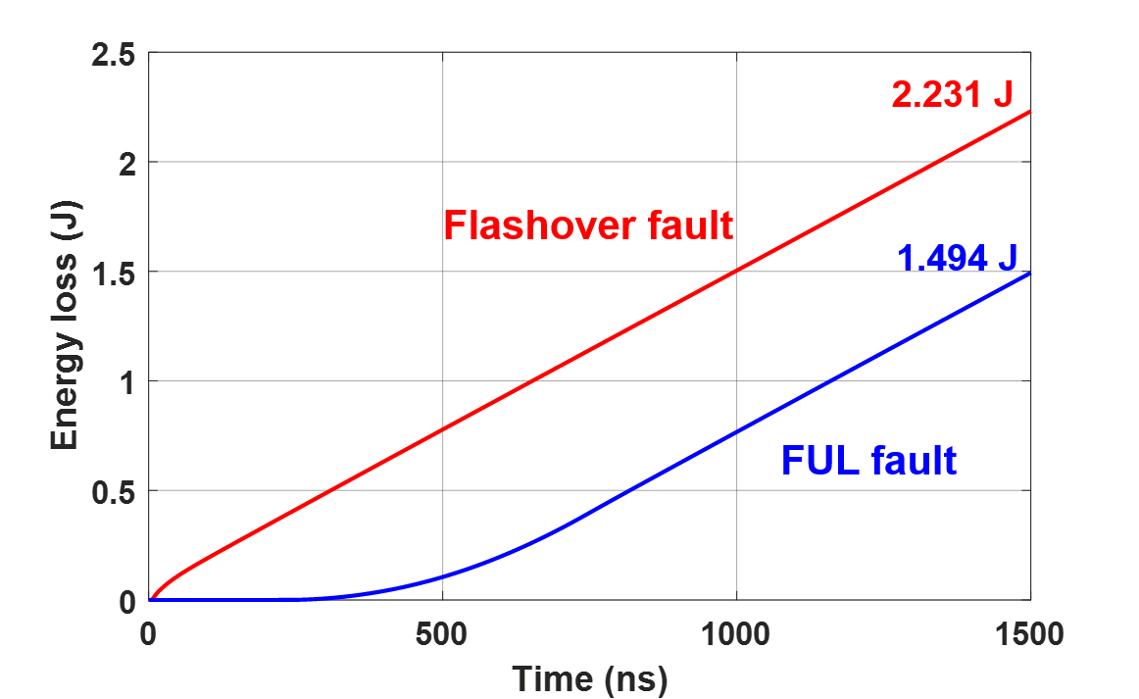
Fig. 5- 10. Short circuit energy loss comparison between FUL and flashover fault at 7 kV with 0.15 nH L_{ss}, 15 Ω R_{g,on}, and 2.5 Ω R_{g,off}.

5.4.3 Comparison between Flashover Fault and HSF Fault
Similar analysis can be conducted to compare the performance of the 10 kV SiC MOSFET under the flashover fault and the HSF fault, with details displayed in Fig. 5-11 and Fig. 5-12. Under both faults, L_{ss} is 0.15 nH, and the MOSFET is driven with 15 Ω R_{g,on,} and 2.5 Ω R_{g,off}. Fig. 5-11 displays the typical behavior of the 10 kV SiC MOSFET under HSF fault. V_{ds,int} has a small dip and subsequently climbs back to the dc-link voltage (7 kV) quickly, and the device always operates in the active region.
After 1.5 µs, the flashover fault produces 29.5% higher energy loss than HSF fault. The 0.51 J energy loss difference between the two kinds of faults is mainly due to the short circuit current during the first 800 ns. The device current under the flashover fault soars immediately with a huge overshoot, while the short circuit current under the HSF fault rises slowly with an average di/dt of 0.223 A/ns. After the device current saturates, the instantaneous power loss under the two faults is almost the same.
Based on the simulation result, in order to limit the energy loss to the same level, the short circuit response time under the flashover fault should be ~350 ns shorter than that under HSF fault. For example, if 1.5 J critical energy is assumed, the flashover fault should be cleared within 997 ns, and the HSF fault should be cleared within 1.348 µs to guarantee the same margin in short circuit protection.
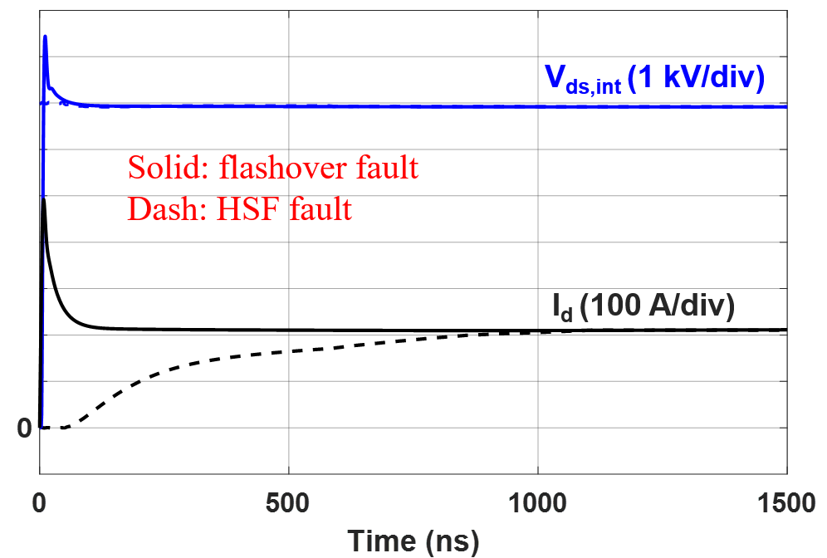
Fig. 5- 11. Simulation waveforms of HSF and flashover fault at 7 kV with 0.15 nH L_{ss}, 15 Ω R_{g,on}, and 2.5 Ω R_{g,off}.

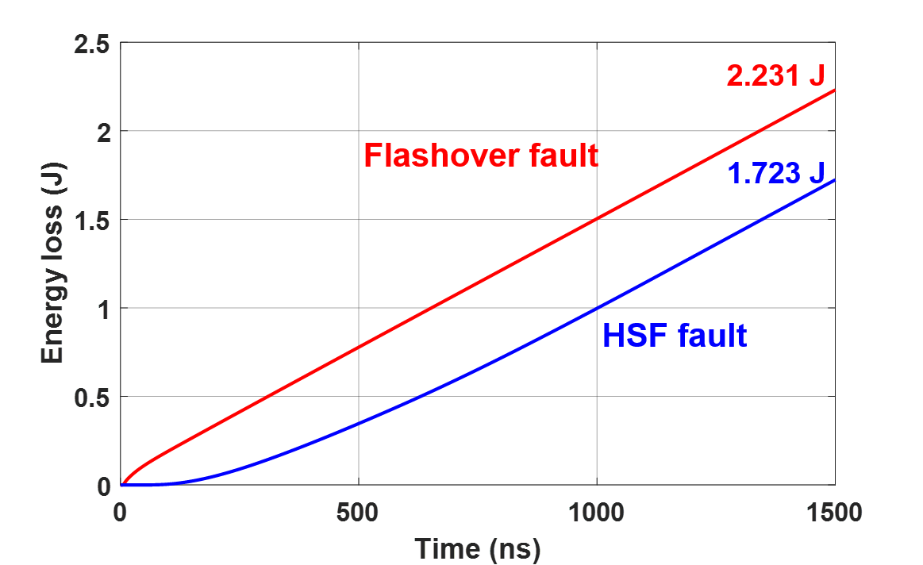
Fig. 5- 12. Short circuit energy loss comparison between HSF fault and flashover fault at 7 kV with 0.15 nH L_{ss}, 15 Ω R_{g,on}, and 2.5 Ω R_{g,off}.

5.5 Summary
The 10 kV SiC MOSFET under the flashover fault due to insulation failure is analyzed comprehensively, where dv/dt, di/dt, and energy loss are higher than those under FUL and HSF short circuit fault. Extremely fast transients impact the gate loop via common source inductance and Miller capacitance. Higher R_{g,off} is suggested for 10 kV SiC MOSFETs without Kelvin source to avoid a large R_{g,on}/R_{g,off} , while a relatively small R_{g,off} is recommended for the MOSFET with Kelvin source. Design guidelines for gate loop inductance or adding an external capacitor across gate and source terminal are also provided to achieve better device performance under the flashover fault. Short circuit performance under a flashover fault, FUL, and HSF fault is compared at 7 kV and 15 V gate-to-source voltage. With 49.5% higher energy loss under the flashover fault, the required response time to clear the flashover fault should be ~500 ns shorter than that designed to clear FUL fault. The response time to clear a flashover fault should be ~350 ns shorter than the response time determined by HSF fault.

Ch 6. Overcurrent Protection Design with Strong Noise Immunity and Fast Response
This chapter is aimed at further accelerating the response of the desat protection for 10 kV SiC MOSFETs and other high voltage (> 3.3 kV) SiC MOSFETs. To pursue desat protection with faster response, the noise immunity of the desat protection under high dv/dt is examined carefully, which yields systematic design guidelines to improve the noise immunity significantly. An improved desat protection scheme is introduced with much faster response than the desat protection in the baseline design in Section 3.2, and the strong noise immunity is maintained.

6.1 Noise Immunity Analysis and Enhancement of Desat Protection
When pursuing desat protection with faster response for high voltage SiC MOSFETs, there is always a concern that its noise immunity will be sacrificed. The desat protection could be often falsely triggered. Therefore, the noise immunity of the desat protection circuitry should be thoroughly evaluated in order to realize desat protection with fast response. This section concentrates on the desat protection circuitry for high voltage SiC MOSFETs from the perspective of noise immunity. The high positive dv/dt with considerable voltage rise time is identified as a major obstacle to achieving high noise immunity. In some cases, extremely small parasitic capacitances (<0.01 pF) between drain and protection circuitry dominate the noise immunity of the desat protection circuitry. The noise immunity margin is derived quantitatively with numerous factors considered. Different noise immunity enhancement methods are developed and validated in the experiment, such as adding a shielding layer, reducing clamping impedance, and so on.
Desat protection for high voltage SiC MOSFETs can be implemented with circuitry composed of discrete components or with a gate driver IC with an integrated desat protection function, as illustrated in Fig. 6-1. The gate driver IC with desat protection function (MC33153 and FOD8318 from On Semiconductor, STGAP1AS from STMicroelectronics, etc) enables more compact layout, yet leads to too low threshold current for some high voltage SiC MOSFETs due to low its threshold voltage (<10 V) for desat protection [60], [61], [92]. With a voltage divider and a discrete comparator, desat protection based on discrete components has better flexibility to realize desired performance for high voltage SiC MOSFETs, although the design is more complicated. Also, noise immunity investigation of desat protection based on discrete components will benefit the noise immunity analysis and enhancement of desat protection realized with gate driver ICs. Therefore, this dissertation focuses on desat protection based on discrete components.
(a) (b)
Fig. 6- 1. Two implementations of desat protection for high voltage SiC MOSFETs: (a) Based on discrete components; (b) Realized with gate driver IC.

6.1.1 Noise Immunity Analysis
The noise issue and spurious triggering of desat protection are mainly caused by high dv/dt, particularly high positive dv_{ds}/dt. High dv/dt disturbs the operation of the protection circuitry via the parasitic capacitance C_{desat} of the desat diode D_{desat}. as illustrated in Fig. 6-2 and Fig. 6-3. The parasitic inductance L_{desat} in series with the desat diode should also be considered. A well-known mechanism of spurious triggering is that the blanking capacitor voltage V_{desat} rises substantially due to the interference of high dv_{ds}/dt [59], [66].
With negative dv_{ds}/dt generated by high voltage SiC MOSFETs, V_{desat} could experience a voltage dip if the displacement current of C_{desat} (100 mA if 2 pF C_{desat} and 50 V/ns dv/dt are assumed) is much higher than the current from V_{cc} in Fig. 6-1(a) and I_{cc} in Fig. 6-1(b). As shown in Fig. 6-2, C_{blk} will be discharged to contribute to the displacement current of C_{desat}, and V_{desat} will continue decreasing during the voltage fall time of V_{ds}, which effectively prolongs the blanking time. Therefore, the negative dv_{ds}/dt does not contribute to the voltage rise in V_{desat}, and more analysis about the negative dv_{ds}/dt and its resulting displacement current will be covered in the last section of this chapter.
Fig. 6- 2. Displacement current caused by C_{desat} and negative dv_{ds}/dt in desat protection circuitry.
Fig. 6- 3. Displacement current due to C_{desat} and positive dv_{ds}/dt in desat protection circuitry.
The positive dv_{ds}/dt results in the voltage rise in V_{desat} and hence heavily impacts the noise immunity of the protection circuitry. Traditionally, R_{damp} is added to dampen the oscillation, and R_{cla} and M_{cla} are installed to clamp V_{desat} [66]. As illustrated in Fig. 6-3, R_{cla} and M_{cla} are introduced with the purpose of absorbing the displacement current of C_{desat} due to high positive dv_{ds}/dt, without which V_{desat} will increase dramatically and could lead to spurious triggering. R_{cla} and M_{cla} are necessary if the output voltage of gate driver IC cannot serve as V_{cc} since the required magnitude of V_{cc} is higher than V_{gs,on}. This is often the case when designing desat protection for high voltage SiC MOSFETs requiring relatively high threshold voltage. Even with R_{damp}, R_{cla}, and M_{cla}, there will be spikes and oscillations in V_{desat} due to high dv_{ds}/dt, which should be studied when evaluating the noise immunity. As shown in Fig. 6-4, the desat protection designed for the 10 kV/20 A SiC MOSFET used to build the phase legs in this dissertation is studied as an example for noise immunity analysis, whose simulation model is established in PLECS. Parameters and other details of the desat protection circuitry can be seen in Fig. 6-4.
C_{desat} of the desat diode is nonlinear and decreases rapidly as V_{ds} increases. Meanwhile, the resulting displacement current does not change significantly since dv_{ds}/dt is low when the parasitic capacitance of the desat diode is large. The nonlinear C_{desat} of the diode (three 3.3 kV SiC Schottky diodes in series) is modeled with its equivalent capacitance in terms of charge (2.3 pF) in the simulation [93]. In the simulation, M_{cla} and R_{cla} clamp V_{desat} to V_{clamp} (-5 V) before V_{ds} rises from 0 to 7 kV with a dv/dt of 100 V/ns. V_{ds} starts to rise at t=20 ns, and the voltage rise time t_{rise} of V_{ds} is 70 ns.
Fig. 6- 4. Desat protection for 10 kV/20 A SiC MOSFET from Wolfspeed.
Simulation waveforms of both V_{desat} and V_{comp} (shown in Fig. 6-4) are displayed in Fig. 6-5. The analysis of V_{desat} during the voltage rise time of V_{ds} is presented first, which will benefit the noise immunity analysis of both desat protection based on discrete components in Fig. 6-1(a) and desat protection realized with gate driver IC in Fig. 6-1(b).
V_{desat} goes through oscillations before reaching steady state during the 70 ns voltage rise time. At steady state, the spike of V_{desat} is proportional to R_{cla}, C_{desat}, and dv_{ds}/dt, all of which heavily influence the noise immunity of the desat protection.
The peak value of V_{desat} is determined by the oscillations at the beginning of the voltage rise time. According to simulation waveforms in Fig. 6-5, higher L_{desat} increases the peak value of V_{desat} slightly. If C_{blk} is reduced to 20 pF for shorter response time, the oscillations caused by high dv_{ds}/dt will become more serious, leading to higher peak in V_{desat}. A larger R_{damp} is effective in suppressing the oscillations and positive spike in V_{desat}, especially when the circuitry has a large L_{desat} and/or a small C_{blk}.
High frequency oscillation of V_{desat} at the beginning of t_{rise} can be analyzed via circuit analysis in frequency domain. In the analysis, R_{blk} and the voltage divider formed by R_{d1} and R_{d2} are neglected due to their high impedance. The difference between V_{clamp} (-5 V) and 0 V (potential of the source of the 10 kV SiC MOSFET) is also neglected to simplify the analysis. The relationship between V_{ds} and V_{desat} can be expressed as:
$$\begin{aligned}\frac{V_{desat}\left(s\right)}{V_{ds}\left(s\right)}=\frac{sC_{desat}R_{cla}}{s^{3}LC_{desat}R_{cla}C_{blk}+s^{2}\left(LC_{desat}+{R_{damp}C}_{desat}R_{cla}C_{blk}\right)+s\left(C_{desat}R_{cla}+C_{blk}R_{cla}+C_{desat}R_{damp}\right)+1}\#\left(6.1\right)\end{aligned}$$
Based on the Bode plot of V_{desat}(s)/V_{ds}(s) in Fig. 6-6, the peak magnitude is reached at the resonance frequency $ω_{r}=\frac{1}{\sqrt{L_{desat}C_{desat}}}$. $ω_{r}$ is also the oscillation frequency of V_{desat} in Fig. 6-5, and the oscillation is excited by V_{ds} with high dv/dt and rich high frequency component. The peak magnitude of V_{desat}(s)/V_{ds}(s) can be expressed as follows.
$$\begin{aligned}V_{d,pk}=\frac{R_{cla}}{\sqrt{{\left(R_{cla}+R_{damp}\right)}^{2}+\frac{{\left(R_{cla}R_{damp}C_{blk}\right)}^{2}}{L_{desat}C_{desat}}}}\#\left(6.2\right)\end{aligned}$$
Higher L_{desat} leads to higher quality factor in the resonant circuit and higher spike caused by the oscillations. Based on Fig. 6-6, the resonance frequency $ω_{r}$ becomes lower as L_{desat} increases. According to Fourier analysis results, the magnitude of $V_{ds}({jω}_{r})$ increases as $ω_{r}$becomes lower and lower. This is another reason why a higher L_{desat} makes the oscillations more serious.
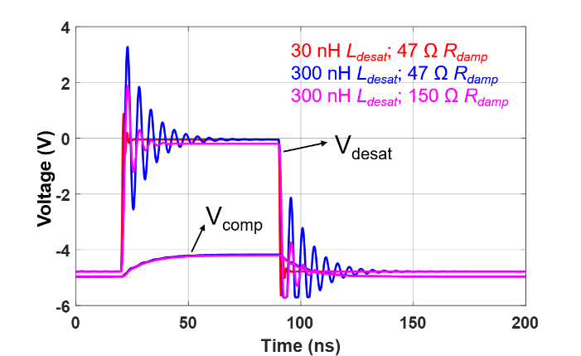
Fig. 6- 5. Simulation waveforms of desat protection for 10 kV/20 A SiC MOSFETs: (a) C_{blk}=56 pF; (b) C_{blk}=20 pF.
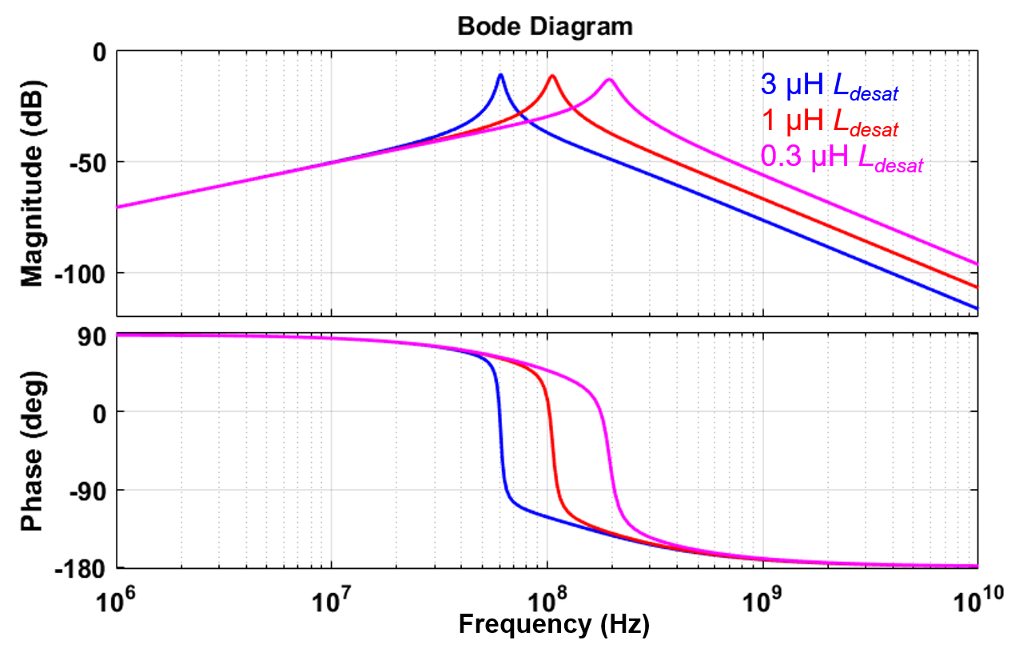
Fig. 6- 6. Bode plot of V_{desat}(s)/V_{ds}(s) as L_{desat} increases (parameters in Fig. 6-4).
The effect of R_{damp} on oscillation of V_{desat} is clearly demonstrated in (6.2) and Fig. 6-7. The peak magnitude of V_{desat}(s)/V_{ds}(s) declines substantially with a higher R_{damp} selected. The maximum magnitude of V_{desat}(s)/V_{ds}(s) is 0 dB, which is achieved when R_{damp} is 0 Ω. A low R_{cla} effectively shields V_{desat} from the influence of the high positive dv/dt, which reduces both the oscillations and the steady state level of V_{desat} during the voltage rise time. According to (6.2), increasing C_{blk} also reduces the high frequency oscillations in V_{desat}, which is proved in simulation waveforms in Fig. 6-5. The analysis and design recommendations of different parameters in the circuit are summarized in Table 11, from the standpoint of reducing spikes in V_{desat} due to high positive dv/dt. Also, the analysis about V_{desat} is valid for the desat protection realized with gate driver IC in Fig. 6-1(b), where the discharge switch S_{dis} can be modeled by R_{cla} when S_{dis} is turned on as the high voltage SiC MOSFET is in OFF state.
Table 11. Summary of design recommendations of different parameters to reduce spike in V_{desat} due to high positive dv/dt.
Parameter | Recommendation | Suppress oscillations in V_{desat} during voltage rise time of V_{ds}? | Reduce steady-state value of V_{desat} during voltage rise time of V_{ds}?
L_{desat} | Reduce L_{desat} | Yes | No
C_{desat} | Reduce C_{desat} | Yes | Yes
R_{damp} | R_{damp} should be added | Yes | No
C_{blk} | Increase C_{blk} | Yes | No
R_{cla} | Reduce R_{cla} | Yes | Yes

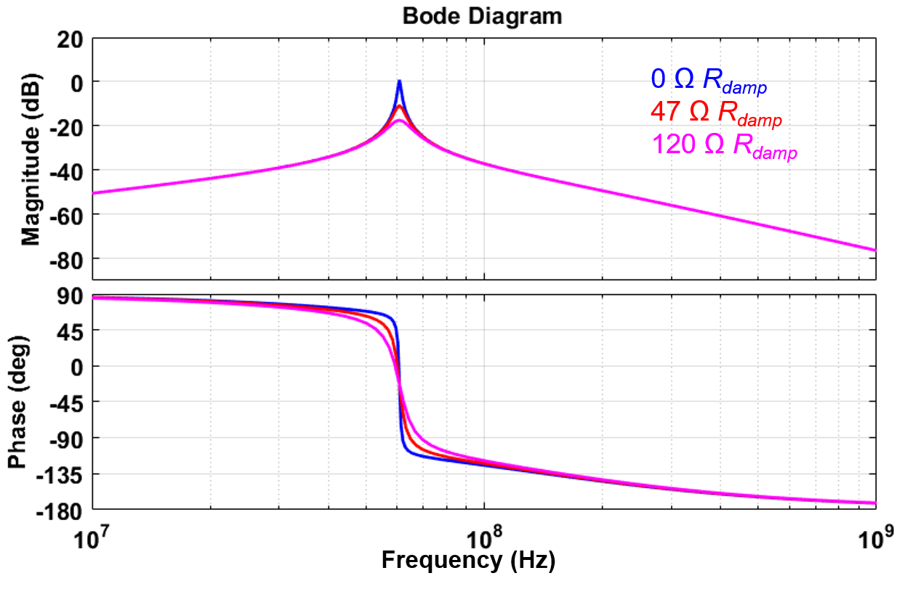
Fig. 6- 7. Bode plot of V_{desat}(s)/V_{ds}(s) as R_{damp} increases (L_{desat}=3 µH).
In the desat protection based on discrete components, V_{comp} should be investigated when evaluating the noise immunity. According to Fig. 6-5, V_{comp} is hardly impacted by high frequency oscillations in V_{desat}, because the voltage divider and C_{d} (1 pF in simulation) due to the comparator and PCB layout form an effective low pass filter.
However, parasitic capacitances between the drain terminal and PCB traces or polygons of the protection circuitry should also be considered, which can be calculated with finite element analysis. As drawn in Fig. 6-8, These parasitic capacitances (< 1 pF) are critical due to the high dv/dt with considerable t_{rise} generated by high voltage SiC MOSFETs. C_{p1} and C_{p2} effectively increase the value of C_{desat}. C_{p3} results in a substantial voltage spike in V_{comp} due to the high impedance of the voltage divider.
Fig. 6- 8. Desat protection circuitry considering parasitic capacitances between drain and protection circuitry.
Therefore, V_{comp} is not only determined by V_{desat}, but also heavily influenced by the current source I_{p3} caused by displacement current of C_{p3}. It is assumed that V_{ds} rises with a constant dv/dt to simplify the study. With superposition theorem, V_{comp} in s domain can be calculated with the following equation.
$$\begin{aligned}V_{comp}\left(s\right)=V_{desat}\left(s\right)\frac{R_{d2}}{sC_{d}R_{d1}R_{d2}+R_{d2}+R_{d1}}+I_{p3}\left(s\right)\frac{R_{d1}R_{d2}}{sC_{d}R_{d1}R_{d2}+R_{d1}+R_{d2}}\#\left(6.3\right)\end{aligned}$$
In equations in this section, the reference point of V_{desat} and V_{comp} is V_{clamp} (-5 V), unless their reference point is explicitly noted. V_{desat}(s) is mainly determined by the displacement current flowing through C_{desat}, C_{p1}, and C_{p2}, which are named I_{desat}, I_{p1}, and I_{p2}, respectively. The equation of V_{desat}(s) is expressed as:
$$\begin{aligned}V_{desat}\left(s\right)=\left(I_{desat}\left(s\right)+I_{p1}\left(s\right)+I_{p2}\left(s\right)\right)\frac{R_{cla}}{1+sC_{blk}R_{cla}}\#\left(6.4\right)\end{aligned}$$
In the equation, effect of the voltage divider and R_{blk} is neglected because of their high impedance. The high frequency oscillation in V_{desat} is also neglected. Once the high dv/dt is generated, V_{desat} rises to a constant value quickly thanks to the extremely small time constant R_{cla}C_{blk}, which is usually much smaller than t_{rise}. Hence, V_{desat} can be modeled as a dc voltage source during the voltage rise time. V_{desat} is rewritten as:
$$\begin{aligned}{V_{desat}=R}_{cla}\left(C_{desat}+C_{p1}+C_{p2}\right)\frac{dv}{dt}\#\left(6.5\right)\end{aligned}$$
Meanwhile, $I_{p3}$ can also be modeled as a dc current source due to the constant dv/dt assumption. The peak voltage spike V_{spike} of V_{comp}, can be derived with (6.6), which is the value of V_{comp}(t) at the end of the voltage rise time t_{rise}. The reference point of V_{spike} is also V_{clamp} (-5 V).
$$\begin{aligned}V_{spike}=V_{comp}\left(t_{rise}\right)=\left[R_{d1}C_{p3}+R_{cla}\left(C_{desat}+C_{p1}+C_{p2}\right)\right]\frac{R_{d2}}{R_{d1}+R_{d2}}\frac{dv}{dt}[1-e^{\frac{-t_{rise}}{{C_{d}(R}_{d1}//R_{d2})}}]\#\left(6.6\right)\end{aligned}$$
High dv/dt with long voltage rise time generated by high voltage SiC MOSFETs can make the desat protection circuitry vulnerable to noise and spurious triggering. Fig. 6-9 shows that 0.004 pF C_{p3} induces a sufficiently high spike in V_{comp} to spuriously trigger the protection for 10 kV SiC MOSFETs in Fig. 6-4, which is 60% higher than that in 1.7 kV SiC MOSFETs with the same dv/dt and much shorter t_{rise}. In the simulation, C_{p1}, C_{p2}, and C_{p3} are 0 pF, 0 pF, and 0.004 pF, respectively, and C_{desat} is still modeled with a 2.3 pF capacitor. Fig. 6-9 also illustrates that the measured V_{spike} in simulation waveforms coincides well with the calculated result based on (6.6).
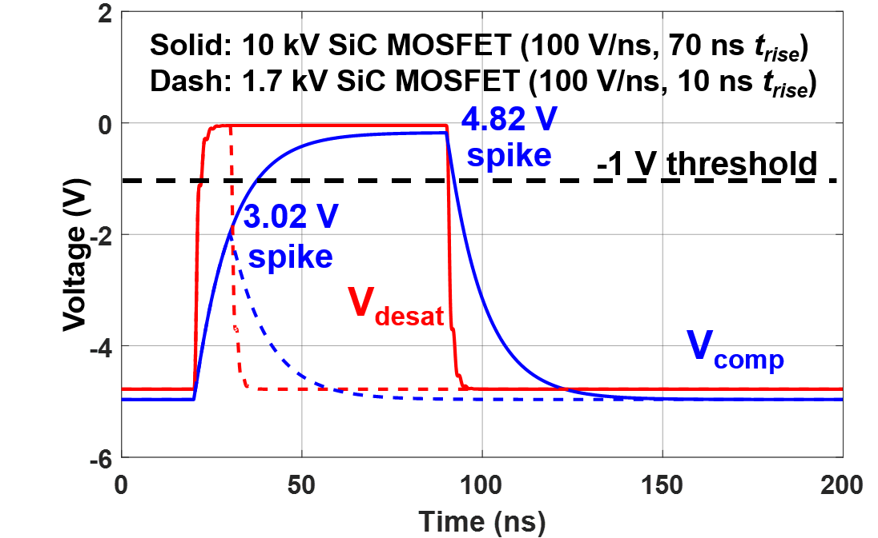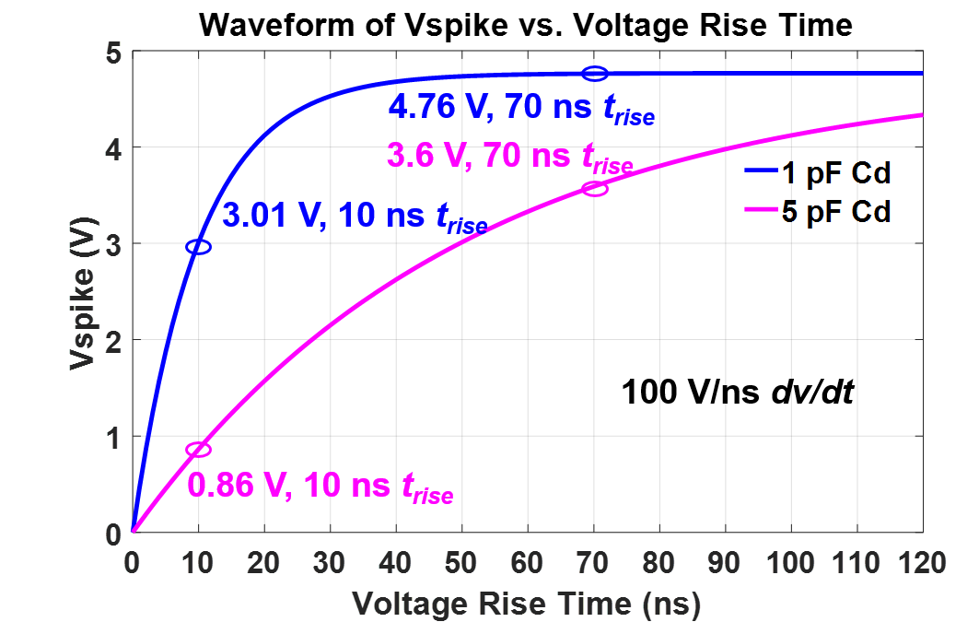
(a) (b)
Fig. 6- 9. (a) Simulation results of V_{desat} and V_{comp} with 0.004 pF C_{p3} and 1 pF C_{d} considered for 10 kV and 1.7 kV SiC MOSFETs with 100 V/ns dv/dt; (b) Calculation result of V_{spike} as a function of t_{rise}.
With the established model of V_{spike} in (6.6), the impact of the voltage rise time t_{rise} can be analyzed quantitively, as plotted in Fig. 6-9(b). Longer t_{rise} results in higher spike in the comparator input voltage V_{comp}, making the protection more susceptible to spurious triggering. As t_{rise} becomes longer, V_{spike} starts to increase more slowly and eventually saturate. The maximum value of V_{spike} can be expressed as:
$$\begin{aligned}V_{spike,max}=\left[R_{d1}C_{p3}+R_{cla}\left(C_{desat}+C_{p1}+C_{p2}\right)\right]\frac{R_{d2}}{R_{d1}+R_{d2}}\frac{dv}{dt}\#\left(6.7\right)\end{aligned}$$
In fact, if R_{cla}C_{blk} is not considerably smaller than t_{rise}, the expression of V_{spike} can be modified as follows.
$$\begin{aligned}V_{spike}=\left[R_{d1}C_{p3}+R_{cla}\left(C_{desat}+C_{p1}+C_{p2}\right)\left(1-e^{\frac{-t_{rise}}{{C_{blk}R}_{cla}}}\right)\right]\frac{R_{d2}}{R_{d1}+R_{d2}}\frac{dv}{dt}[1-e^{\frac{-t_{rise}}{{C_{d}(R}_{d1}//R_{d2})}}]\#\left(6.8\right)\end{aligned}$$
Based on (6.8), the magnitude of V_{spike} as a function of voltage rise time and dv/dt is evaluated in Fig. 6-10, in which C_{p1}, C_{p2}, C_{p3}, and C_{d} are still 0 pF, 0 pF, 0.004 pF, and 1 pF, respectively. In terms of generating high V_{spike} in desat protection circuitry, it is the worst case to have high dv/dt and long voltage rise time simultaneously. It is hence concluded that the desat protection of high voltage SiC MOSFETs is more vulnerable to noise caused by dv/dt, compared to other power semiconductor devices, including 1.2 and 1.7 kV SiC MOSFETs also with high dv/dt and 3.3 kV, 4.5 kV, and 6.5 kV Si IGBTs which are currently dominant in MV applications.
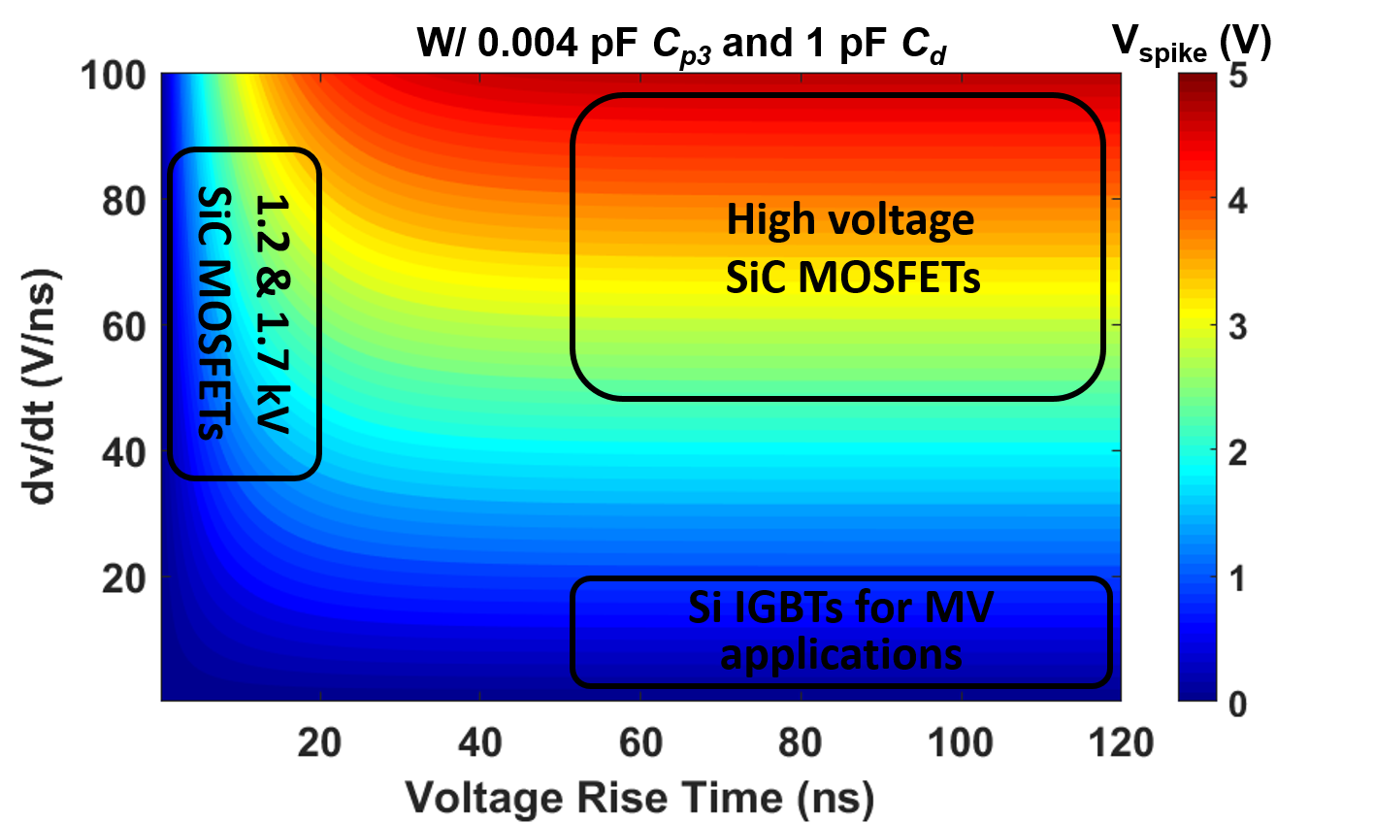
Fig. 6- 10. Contour plot of V_{spike} as a function of dv/dt and voltage rise time t_{rise}.

6.1.2 Noise Immunity Enhancement
High positive dv_{ds}/dt with a long t_{rise} leads to a voltage spike in V_{desat} and V_{comp}, although V_{desat} is clamped to V_{clamp} (-5 V in Fig. 6-4) by a clamping branch. The noise immunity margin V_{margin} in V_{comp} can be estimated as follows.
$$\begin{aligned}V_{margin}=V_{th}-V_{clamp}-V_{spike}\#\left(6.9\right)\end{aligned}$$
V_{th} is the threshold voltage of the comparator. V_{th}-V_{clamp} is closely coupled with the threshold voltage of desat protection V_{desat,th} and the voltage divider design. The reference point of V_{th} and V_{desat,th} is 0 V. The quantitative analysis is as follows.
$$\begin{aligned}V_{th}-V_{clamp}=\left(V_{desat,th}-V_{clamp}\right)\frac{R_{d2}}{R_{d1}+R_{d2}}\#\left(6.10\right)\end{aligned}$$
V_{spike} can be calculated with (6.6), since high voltage SiC MOSFETs usually have long t_{rise}. Then, the expression of V_{margin} can be rewritten as:
$$\begin{aligned}V_{margin}=\frac{R_{d2}}{R_{d1}+R_{d2}}\left(V_{desat,th}-V_{clamp}-\left[R_{d1}C_{p3}+R_{cla}\left(C_{desat}+C_{p1}+C_{p2}\right)\right]\frac{dv}{dt}\left(1-e^{\frac{-t_{rise}}{{C_{d}(R}_{d1}//R_{d2})}}\right)\right)\#(6.11)\end{aligned}$$
Noise immunity of the desat protection circuitry can be enhanced by achieving a higher V_{th}-V_{clamp} and reducing V_{spike}. Since V_{desat,th} is completely determined by the output characteristic and threshold current of the MOSFET, increasing $V_{th}-V_{clamp}$will lead to a higher voltage divider ratio $\frac{R_{d2}}{R_{d1}+R_{d2}}$, and a higher V_{margin}. The selection of comparator should consider its capability of supporting a high V_{th}-V_{clamp}. Hence, comparators with higher power supply voltage V_{cc} can have larger noise immunity margin of desat protection. For example, 5 V comparators are preferable compared to 3.3 V comparators. Also, comparators with high input voltage range are suggested so that V_{th}-V_{clamp} can be as close to power supply voltage V_{cc} of the comparator as possible. For example, LT1719 requires its input voltage to be lower than V_{cc} - 1.2 V, so V_{th}-V_{clamp} is limited to V_{cc} - 1.2 V. By replacing it with comparators (ADCMP600, TLV3501, etc) allowing input voltage to reach V_{cc}, better noise immunity of the desat protection can be realized.
Also, comparators with longer propagation delay contributes to better noise immunity of desat protection, which will not respond to those extremely short spikes in V_{comp}. Longer propagation delay of the comparator requires V_{comp} to maintain above comparator threshold voltage for a longer time before the comparator output is flipped. In other words, longer propagation delay leads to effectively higher comparator threshold voltage and hence higher noise immunity margin. Also, comparators with long propagation delay are not recommended which slows down the response of desat protection. The voltage reference used as threshold voltage of the comparator should also be stable and immune from the impact of high dv/dt. Whether the voltage reference is provided by a resistive voltage divider or a power supply, a filter capacitor should be placed as close as possible to the voltage reference terminal of the comparator. The selection and design guidelines about the comparator are summarized in Table 12 to improve the noise immunity of the desat protection.
Table 12. Summary of selection and design guidelines of comparator to enhance noise immunity of desat protection
Parameter | Selection or design guideline
Power supply voltage | Higher power supply voltage is preferred
Input voltage range | Higher input voltage range is preferred
Propagation delay | Slightly longer propagation delay is preferred;  Trade-off: longer delay leads to desat protection with slower response
Threshold voltage | Higher threshold voltage preferred;  Filter capacitor added to stabilize threshold voltage
To improve the noise immunity, V_{spike} can be suppressed by reducing R_{cla}, the parasitic capacitances, the voltage divider impedance, and increasing C_{d}. If R_{cla} is reduced from 20 Ω to 2 Ω in the desat protection design in Fig. 6-4, V_{spike} is decreased to 4.1 V with 14% reduction. The reduction is not tremendous because the noise immunity margin in this case is dominated by the displacement current from C_{p3}, instead of the displacement current from the desat diode. Therefore, if the voltage divider impedance is reduced by 67%, V_{spike} can be reduced from 4.76 V to 2.1 V. If C_{p3} is suppressed to 0.001 pF, V_{spike} will further be reduced to 1.8 V, as displayed in Fig. 6-12. Increasing C_{d} can also lower V_{spike} and improve the noise immunity. Fig. 6-9(b) demonstrates that V_{spike} is brought down to 3.6 V with 24% reduction by increasing C_{d} from 1 pF to 5 pF. Increasing C_{d} is more effective in noise immunity enhancement when t_{rise} is shorter, as indicated in the contour plot of V_{spike} in Fig. 6-13. With a long t_{rise}, a large C_{d} is needed to achieve significant reduction in V_{spike}, which will slow down the response of desat protection. When increasing C_{d}, the trade-off between response time and noise immunity must be considered.
(a) (b)
Fig. 6- 11. Calculation result of V_{spike} as a function of t_{rise}: (a) Impact of R_{cla}; (b) Impact of voltage divider impedance.
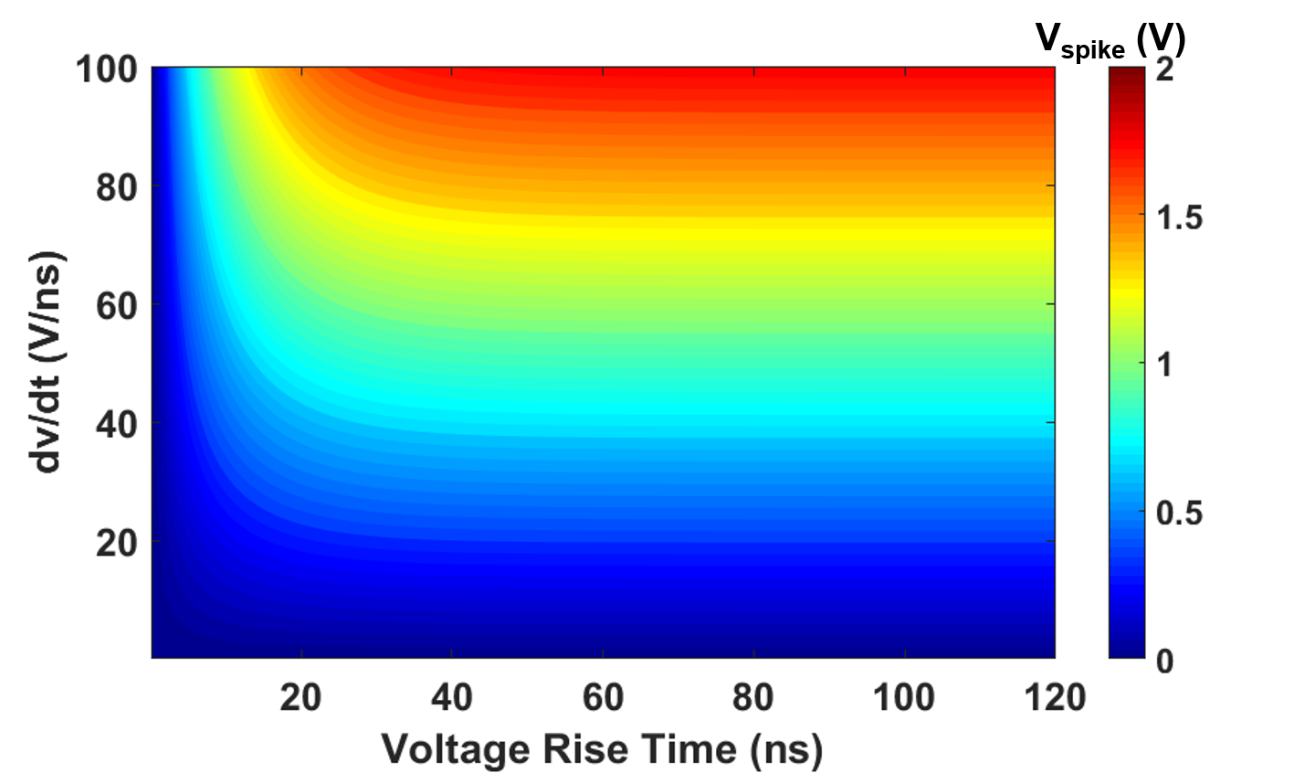
Fig. 6- 12. Contour plot of V_{spike} as a function of dv/dt and t_{rise} (0.001 pF C_{p3}).

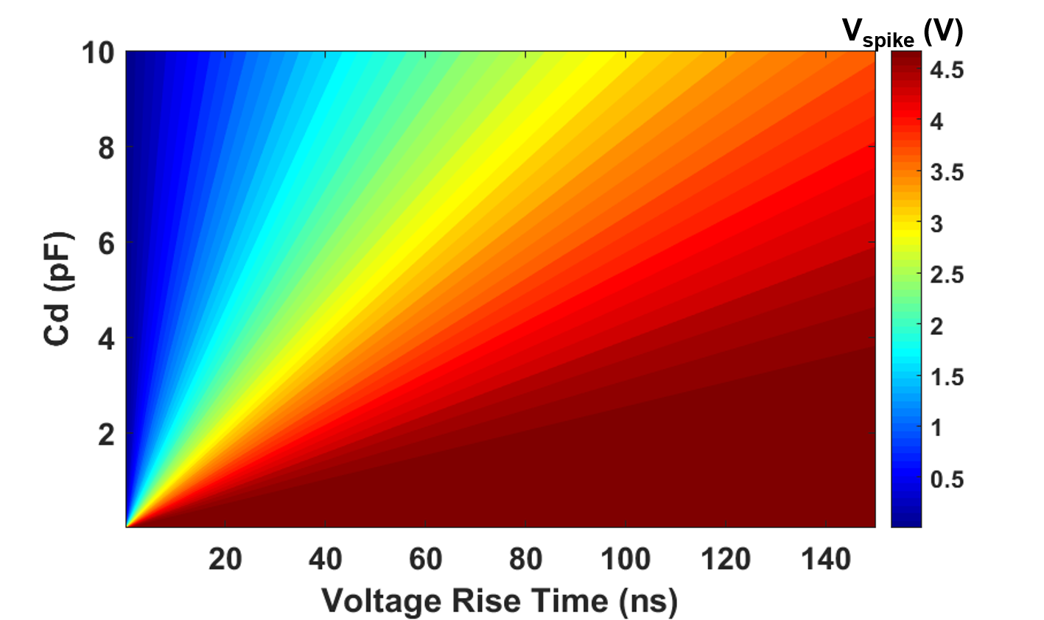
Fig. 6- 13. Contour plot of V_{spike} as a function of C_{d} and t_{rise} (0.004 pF C_{p3;} 100 V/ns dv/dt).
Ac-dc continuous test of the phase leg is utilized to validate noise immunity enhancement methods of the desat protection designed for the 10 kV SiC MOSFET [10]. Parameters of the desat protection implemented in the phase leg are displayed in Fig. 6-4. V_{comp} of the desat protection for the lower MOSFET is measured with a 1 GHz TPP1000 probe (3.9 pF input capacitance). 6 kV continuous test results in Fig. 6-14 show that the peak positive spike in V_{comp} is 2.56 V with 1.44 V noise immunity margin. Selecting higher R_{cla} will reduce the noise immunity margin significantly. As shown in Fig. 6-15, the desat protection for the lower MOSFET is falsely triggered by the positive dv/dt (~65 V/ns) during the 6 kV ac-dc continuous test introduced in Section 3.3, with R_{cla} increased from 20 Ω to 90 Ω. The measured spike V_{spike} in V_{comp} which falsely triggers the protection is 3.8 V. The equivalent C_{d} is 5.3 pF with the input capacitance of the passive probe considered. Meanwhile, the measured peak voltage spike in V_{desat} is 11.2 V, which generates a voltage spike of 1.55 V in V_{comp}. The additional 2.25 V voltage spike in V_{comp} is due to the displacement current from C_{p3}.
In fact, R_{d1} in the desat protection circuitry shown in Fig. 6-4 is implemented with two 30 kΩ resistors in series, as illustrated in Fig. 6-16. Therefore, the drain terminal is coupled with the voltage divider via two parasitic capacitances, C_{p3,a} and C_{p3,b}. C_{p3,a} and C_{p3,b} are mainly caused by the large drain plate of the 10 kV SiC MOSFET and the heatsink with the same potential as the drain plate [10], [31], which are included in the simulation model in Ansys Q3D. The finite element analysis in Ansys Q3D reveals that C_{p3,a} and C_{p3,b} are 0.0031 pF and 0.00131 pF, respectively. Based on the analysis in Section III, the additional spike in V_{comp} due to C_{p3,a} and C_{p3,b} can be calculated as 1.54 V, which is slightly lower than the measured result, 2.25 V. The discrepancy is mainly a result of the Ansys Q3D model that does not include all objects in the phase leg which have the same potential as the drain terminal of the 10 kV SiC MOSFET. In other words, the finite element analysis results still underestimate the capacitive coupling between the voltage divider and the drain terminal of the MOSFET.
To suppress the impact of C_{p3}, an external copper shielding layer connected with the source of the MOSET is installed beneath the desat protection part of PCB, since the MOSFET is under the gate driver PCB. Still with 90 Ω R_{cla}, the peak voltage spike in V_{comp} declines from 3.8 V to 2.2 V, and spurious triggering of desat protection is eliminated, as shown in Fig. 6-17. The role played by C_{p3,a} and C_{p3,b} in the generation of positive voltage spike in V_{comp} is hence proved. It is also proved that shielding is an effective method to suppress the noise propagated to desat protection circuitry via small parasitic capacitances.
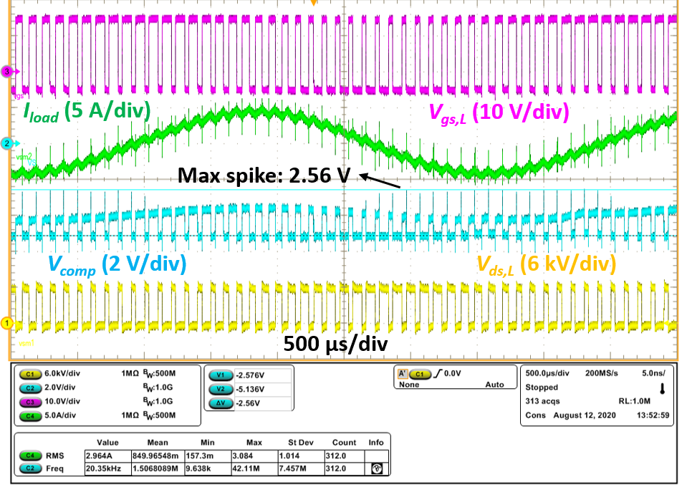
Fig. 6- 14. Waveforms of 6 kV continuous ac-dc test of a phase leg based on 10 kV SiC MOSFETs with desat protection in Fig. 6-4.
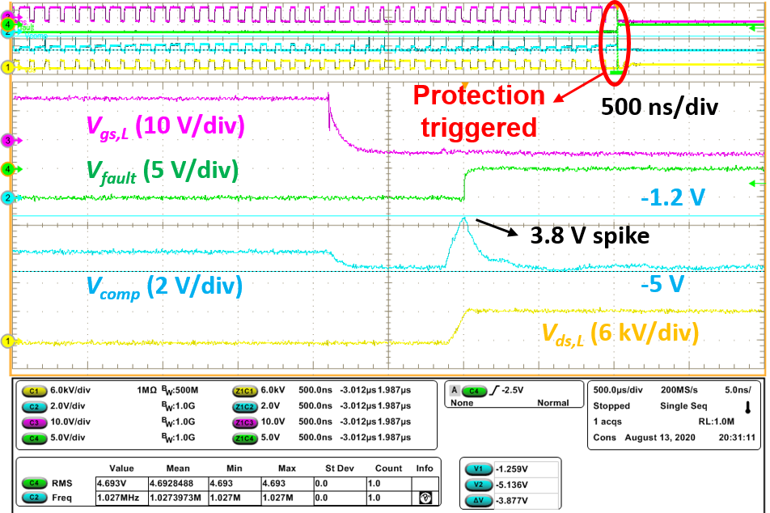
(a)
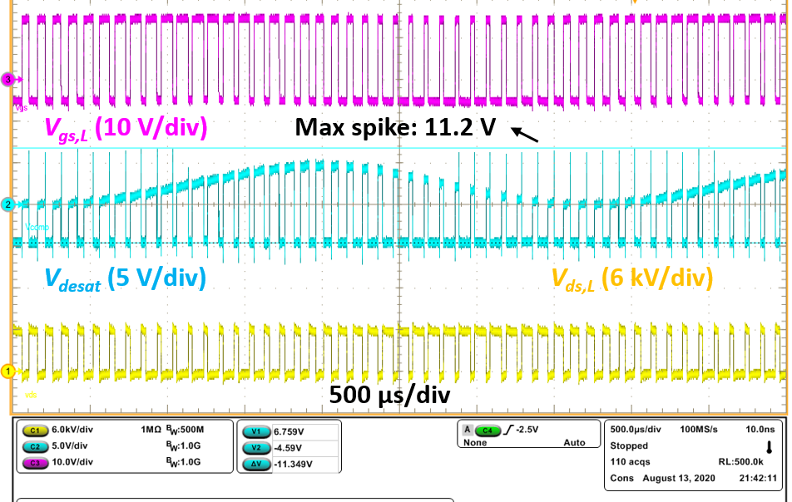
(b)
Fig. 6- 15.Waveforms of 6 kV continuous ac-dc test of a phase leg based on 10 kV SiC MOSFETs with 90 Ω R_{cla}. (a) Waveform of V_{comp} when desat protection is falsely triggered. (b) Waveform of V_{desat}.

Fig. 6- 16. Details of capacitive coupling between the voltage divider in the desat protection circuitry and the drain terminal of the 10 kV SiC MOSFET.
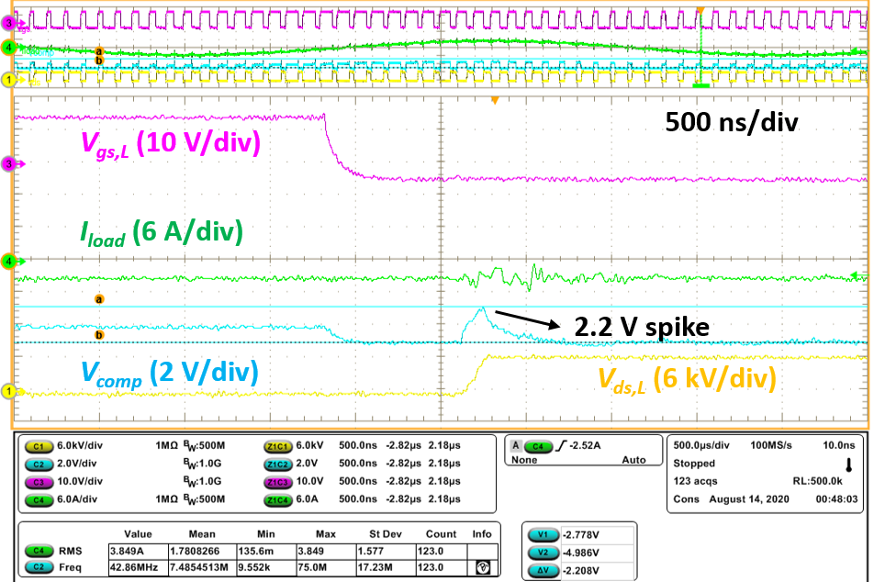
Fig. 6- 17. Waveforms of 6 kV continuous ac-dc test of a phase leg with 90 Ω R_{cla} and an external shielding layer installed.
Based on the analysis and experimental results, a new iteration of desat protection circuitry is designed to further boost its noise immunity under high dv/dt. Several methods are adopted simultaneously in PCB layout and component selection. Compared to the design in Fig. 6-4, R_{d1} and R_{d2} are reduced by 66.7%. R_{cla} is reduced from 20 Ω to 10 Ω. All components of the desat protection circuitry are placed on top layer of the PCB, and thereby completely shielded by large grounding planes in the inner layers of the PCB. Such PCB design not only tremendously suppresses the influence from parasitic capacitances C_{p1}, C_{p2}, and C_{p3}, but also leads to parasitic capacitance which effectively increases C_{d}. Ansys Q3D reveals that C_{p3} is reduced to 0.82 fF, and large grounding planes used as the shielding layer contributes to an increase of 1.3 pF in C_{d}. Further decreasing R_{cla} will benefit the noise immunity margin, but R_{cla} and M_{cla} could be damaged due to high instantaneous current if they are not properly selected.
Ac-dc continuous test results of the new desat protection design in Fig. 6-18 show that the spikes in V_{comp} is almost eliminated. Waveforms captured during a 6 kV continuous test prove that spikes in V_{comp} have an amplitude of 0.5 V, with 80% reduction compared to the previous design. The noise immunity margin V_{margin} increases from 1.44 V to 3.5 V. Since C_{p1}, C_{p2}, and C_{p3} are almost zero, spikes in V_{comp} is mainly caused by displacement current from C_{desat}. The waveform of V_{comp} during 7 kV ac-dc continuous test reaffirms the substantial improvement of the new design in noise immunity, in which positive spikes of V_{comp} due to high positive dv/dt have an amplitude of 0.5 V.
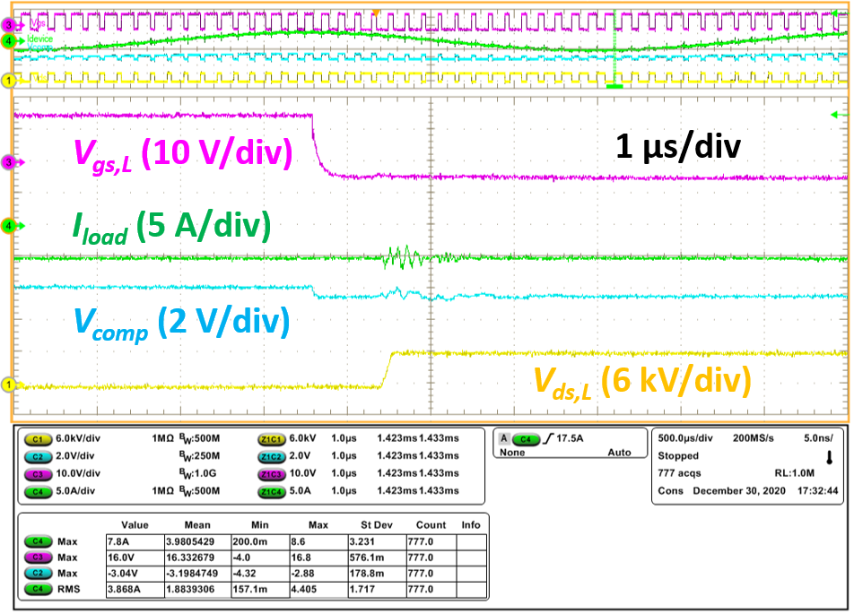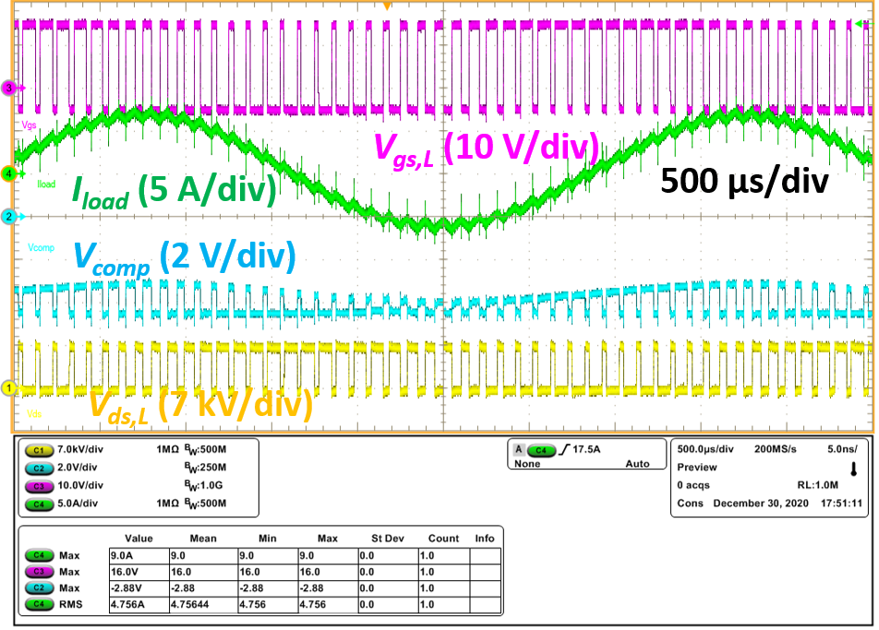
(a) (b)
Fig. 6- 18. Waveforms of V_{comp} of new desat protection board with improved noise immunity: (a) 6 kV continuous ac-dc test; (b) 7 kV continuous ac-dc test.
Based on the theoretical analysis and experimental results, design guidelines can be summarized to realize better noise immunity of the desat protection for high voltage SiC MOSFETs with high dv/dt. Circuit design guidelines are presented in Table 13, including the design trade-off that should be considered when implementing the guidelines. Some design guidelines in Table 13 can be used to strengthen the noise immunity of both the desat protection based on discrete components and the desat protection realized with gate driver IC.
Table 13. Summary of design guidelines to enhance noise immunity of desat protection
Design guideline | Detailed guideline | Design trade-off
Reduce C_{desat} | Select or implement desat diode with as low parasitic capacitance as possible | Increasing cost and perhaps size
Reduce L_{desat} | Achieve lower parasitic inductance in PCB layout and connection | Case by case
Add R_{damp} | Use slightly higher R_{damp} if L_{desat} is higher | No considerable trade-off if R_{damp} << R_{blk}
Reduce R_{d1} | Reduce voltage divider impedance | Slightly higher loss and slower response
Reduce C_{p1}, C_{p2}, and C_{p3} | Design shielding layer and/or box when doing PCB layout | Slightly slower response due to slightly higher C_{d}
Increase C_{d} | Add an external capacitor to increase C_{d} | Slower response
Reduce R_{cla} | Select a low R_{cla} | R_{cla} and M_{cla} need to handle higher pulse current

6.1.3 Summary
Noise immunity of the desat protection for high voltage (> 3.3 kV) SiC MOSFETs is comprehensively analyzed in this section. The main issue is the high positive dv_{ds}/dt, which lasts for a much longer time than that generated by low voltage SiC MOSFETs. In addition to the parasitic capacitance of the desat diode, the parasitic capacitance (< 10 fF) coupled with the voltage divider significantly influences the noise immunity of desat protection circuitry based on discrete components. Other factors’ effect on noise immunity is also studied, such as parasitic inductance, voltage divider impedance, damping resistance, and duration of high dv/dt. The mathematical model of the noise immunity margin is established to support the noise immunity improvement. The noise immunity analysis and improvements are supported by simulation and experimental results. Different methods and their experimental validation based on the derived noise immunity margin are presented to enhance noise immunity. Comprehensive circuit design guidelines to boost noise immunity are summarized, including component selection and PCB layout.

6.2 Improved Desat Protection with Digital Blanking Time
An improved desat protection scheme is designed to achieve <400 ns response time in overcurrent/short circuit condition. Meanwhile, advantages of the conventional desat protection are kept in the improved desat protection scheme, including relatively easy implementation and strong noise immunity. The response time is defined as the time it takes for the device current to start to decrease after it exceeds the threshold current.

6.2.1 Working Principles
Details of the improved desat protection scheme are provided in Fig. 6-19. The fundamental idea is the same as the conventional desat protection for SiC MOSFETs, which is to monitor V_{ds} and output V_{desat} to indicate the device current. Once the overcurrent protection signal is generated, an SR latch will lock the signal and output fault signal to activate soft turn-off of MOSFET and notify the controller.
Response time of the conventional desat protection is mainly determined by the blanking time to avoid false triggering during the turn-on transient [66]. Based on DPT results in Fig. 3-10, 10 kV/20 A SiC MOSFETs require a blanking time longer than 550 ns to ensure that V_{ds} reaches the steady state. With the conventional desat protection scheme which is adopted in the baseline phase leg design in Chapter 3, a relatively large blanking capacitor C_{blk} is selected to provide over 550 ns blanking time, leading to long response time in all types of short circuit faults [61], including HSF, FUL, and flashover fault.

Fig. 6- 19. Improved desat protection in the gate driver for 10 kV SiC MOSFETs.
The improved desat protection scheme utilized the digital blanking time to enable the use of a small blanking capacitor C_{blk}. The blanking time is realized by digital ICs and hence independent of C_{blk}. A 600 ns digital blanking time is designed after the rising edge of the input gate signal of gate driver IC to screen the output signal from the desat comparator. Then, even if the comparator output voltage flips during the 600 ns digital blanking time, the protection will not be triggered since the protection is equivalently disabled by the blanking time. A Zener diode D_{blk} with sufficient power rating ensures V_{desat} lower than 21 V to protect the comparator.
The screening effect is only effective for 600 ns after the rising edge of the gate signal for gate driver IC. During the normal turn-on transient, V_{ds} of MOSFET has already reached the steady state when the digital blanking time expires, thus the protection will not be falsely triggered. If the digital blanking time is much shorter than 550 ns, overcurrent protection might be triggered immediately after the digital blanking time expires.
With the digital blanking time, a small blanking capacitor is used to enable V_{desat} to follow V_{ds} quickly when the MOSFET is fully on, leading to fast response when FUL or flashover fault happens. In other words, the response time when FUL or flashover fault happens is no longer influenced by the required blanking time. The response time under HSF fault is still strongly impacted by the length of the digital blanking time. If HSF fault occurs, the protection will be triggered immediately after the digital blanking time is over. If the digital blanking time is longer, the time it takes to clear the HSF fault will be longer.

6.2.2 Implementation
The improved desat protection scheme with 600 ns digital blanking time is implemented with numerous digital ICs. The protection scheme can be easily realized with a microcontroller, yet the gate driver is not equipped with a microcontroller. Instead, the digital blanking time and other digital signals of the protection scheme are generated by logic ICs and delay ICs.
When implementing the protection scheme, it is necessary to generate a signal to screen the output signal from the comparator to realize the 600 ns digital blanking time. The designed signal with digital blanking time is output by a XOR logic gate, and the details can be seen in Fig. 6-20. One input of the XOR gate is the initial gate signal with 1 μs delay. The other input of the XOR gate is the gate signal after the 400 ns dead time insertion, which is the final gate signal for gate driver IC during the normal operation. The signal with digital blanking time stays HIGH for 600 ns after the rising edge of gate signal for gate driver IC, and then stays LOW as long as gate signal is still HIGH. It is able to screen the signal from desat comparator to realize digital blanking time since they both are sent to an OR logic
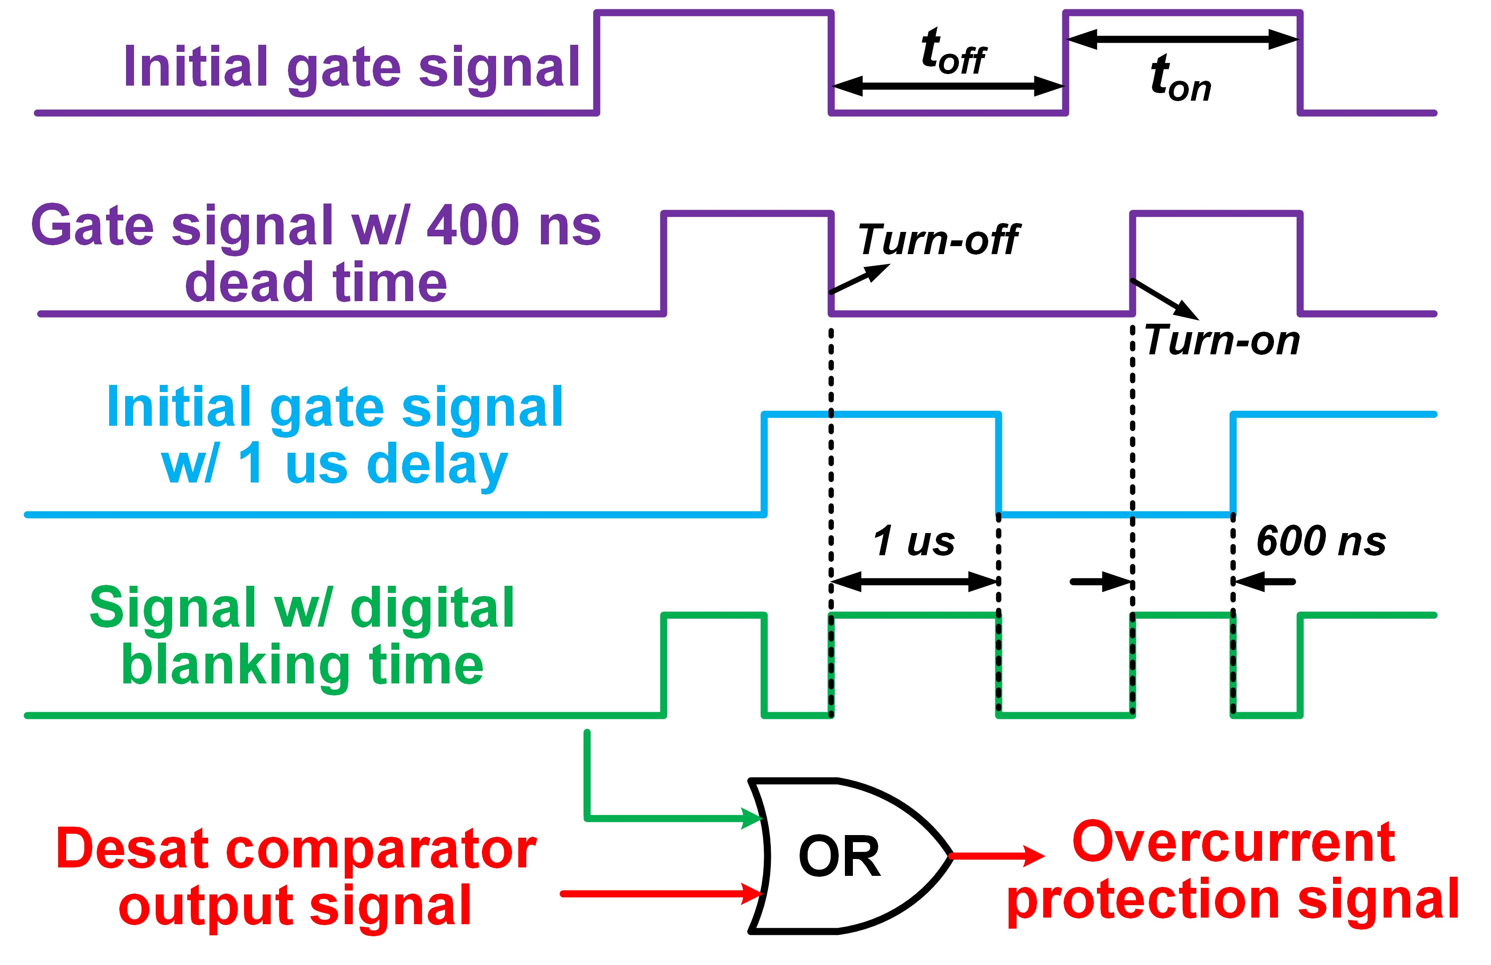
Fig. 6- 20. Implementation details of 600 ns digital blanking time.
gate. Thereby, even if the desat comparator outputs LOW during the 600 ns blanking time, overcurrent protection signal stays HIGH, and the fault signal will not be generated.
Such implementation scheme of 600 ns digital blanking time also screens the comparator output signal for 1 μs after the falling edge of gate signal. As shown in Fig. 6-20, signal with digital blanking time from an XOR gate maintains HIGH for 1 μs after the falling edge of gate signal. In fact, overcurrent protection is not required when the MOSFET is turned off. Such effect also eliminates false triggering during the high dv/dt turn-off transient and leads to better noise immunity. However, such implementation requires the MOSFET to stay off for at least 600 ns, otherwise the signal with digital blanking time can be wrong. This requirement sets an upper limit for the duty cycle of the MOSFET, which is 94% when the switching frequency is as high as 100 kHz.
The 10 kV desat diode D_{desat} is realized by the series connection of three 3.3 kV SiC Schottky diodes (GAP3SLT33-220FP). Each SiC diode is in parallel with a 50 MΩ/4 kV resistor (HVC4020V5005JET from Ohmite) to ensure voltage balancing during the steady state and switching transients. Also, insulation design for the 10 kV desat diode usually results in increased gate driver footprint, as can be seen in Fig. 3-2. To overcome this drawback, a daughter board perpendicular to the mother board is designed to accommodate the 10 kV desat diode, in which diodes are soldered as surface-mount devices, as shown in Fig. 6-21(a). A high voltage wire is used to connect the daughter board with the drain terminal of MOSFET. The daughter board is coated with insulating material (Super Corona Dope) to reduce the insulation distance requirement. Hence, the desat diode does not increase the gate driver footprint and the volume of the phase leg. Series connection of SiC diodes also effectively reduces C_{desat}. 3 V voltage drop of the desat diode should be considered when determining the threshold voltage. Based on the I-V characteristic of the 10 kV SiC MOSFET, the designed protection threshold is 15 V, leading to 20 A threshold current at 125 ˚C and 42.85 A threshold current at 25 ˚C. The final threshold voltage is 18 V to compensate the 3 V voltage drop of the desat diode.

6.2.3 Discussions of Response Time
The improved desat protection scheme has fast response when the FUL and the flashover fault happen, depending on how fast V_{desat} can follow V_{ds}. When the HSF fault happens, the response time is determined by the 600 ns digital blanking time and di/dt of short circuit current. If a longer digital blanking time is implemented, response to clear the HSF fault will be slower, and the response time under the FUL or the flashover fault will not be influenced. Therefore, tuning R_{blk}, R_{damp}, and C_{blk} only changes the response time under the FUL or flashover fault.
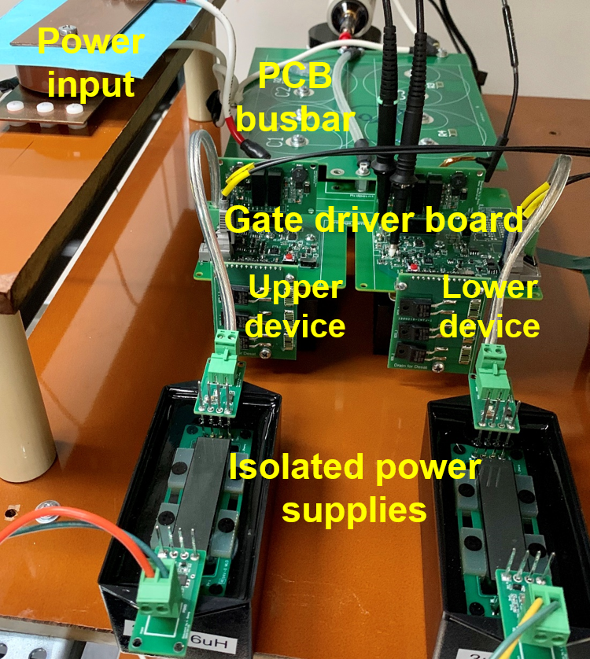
(a) (b)
Fig. 6- 21. (a) Detailed 3D design of the phase leg. (b) Prototype of half bridge phase leg with improved desat protection in high voltage test platform.
With the improved desat protection scheme, the response time under the FUL and flashover fault is adjusted by changing Rblk and Cblk. A 90 Ω Rdamp is introduced to dampen the oscillations. Under the FUL or flashover fault, the capability of Vdesat to track Vds depends on Cblk and Ichg, the current available to charge Cblk. To achieve faster tracking speed and shorter response time, a small Cblk and a high Ichg are desired, and Ichg can be calculated as follows.
$$\begin{aligned}I_{chg}=\frac{V_{cc}-V_{desat}}{R_{blk}+R_{damp}}-\frac{R_{blk}}{R_{blk}+R_{damp}}I_{desat}\#\left(6.12\right)\end{aligned}$$
Vcc in the equation is the power supply voltage, +30 V, and Idesat is the displacement current of the desat diode. A smaller R_{blk} and a Vcc higher than +30 V lead to faster response, but the power loss of R_{blk} when the 10 kV MOSFET is turned off also rises.
Under the flashover fault and the FUL fault with high dv_{ds}/dt at the beginning of the fault, the desat diode almost immediately becomes reverse biased, and all current from V_{cc} is used to charge C_{blk}. Under the flashover fault with extremely high dvds/dt and di/dt, Idesat turns zero and then negative (-Cdesatdv/dt) within several nanoseconds. Assuming that the short circuit current reaches the peak when Vgs starts to drop, the response time in this case can be estimated as follows.
$$\begin{aligned}V_{desat}\left(t\right)=\left[\frac{\left(V_{cc}-V_{clamp}\right)R_{blk,eq}}{R_{blk}}+V_{clamp}-V_{ini}\right]\left(1-e^{\frac{-t}{C_{blk}R_{blk,eq}}}\right)+V_{ini}\#\left(6.13\right)\end{aligned}$$
$$\begin{aligned}t_{res}=C_{blk}R_{blk,eq}\ln\left[\frac{\left(V_{cc}-V_{clamp}\right)R_{blk,eq}+{R_{blk}(V}_{clamp}-V_{ini})}{\left(V_{cc}-V_{clamp}\right)R_{blk,eq}+R_{blk}{(V}_{clamp}-V_{desat,th})}\right]\#\left(6.14\right)\end{aligned}$$
In the equations, R_{blk,eq} (R_{blk,eq} = R_{blk} // (R_{d1}+R_{d2})) is the parallel resistance of R_{blk} and R_{d1}+R_{d2}. C_{blk} should be the total capacitance between V_{clamp} and V_{desat}, including the parasitic capacitances. The impact of the positive dv_{ds}/dt during the fault is also neglected.
In terms of the FUL fault, the other case is that the desat diode is still in conduction mode at the beginning of the fault. As the short circuit current accumulates, V_{ds} increases accordingly without a high dv/dt. As a result, V_{desat} rises and tracks V_{ds}. When the short circuit current reaches the threshold, V_{desat} is already close to V_{desat,th}. Thereby, the response time under this kind of FUL fault could be shorter.
Finally, 12 pF Cblk and 3.25 kΩ Rblk are selected for the improved desat protection scheme. The estimated response time is 139.5 ns based on (6.14), assuming 3 V Vini at 0 A device current. Rblk will have 377 mW power loss when the MOSFET is off. Under the FUL and flashover fault with high positive dv_{ds}/dt, the considerable Idesat makes the response time even shorter. If the flashover fault happens when the device current is negative, the response will be slightly slower. Generally, <200 ns response time under FUL and flashover fault can be guaranteed.

6.2.4 Experimental Results
Captured waveforms of the lower MOSFET of the phase leg under HSF short circuit fault can be seen in Fig. 6-22. When conducting the HSF short circuit test, the upper MOSFET is shorted with a high voltage wire with a parasitic inductance of 171 nH. The improved desat protection responds immediately after the 600 ns digital blanking time expires, triggering the soft turn-off process. The turn-off di/dt is -0.438 A/ns leading to small voltage overshoot in V_{ds}. The short circuit response time is 340 ns, and the total short circuit energy loss is 178 mJ. Before the protection is triggered, V_{desat} has already exceeded the 18 V threshold, proving the effectiveness of the digital blanking time. The digital blanking time is slightly shorter than 600 ns, which is likely owing to the propagation delay in the gate driver IC.
Fig. 6-23 displays the test result of the same phase leg under FUL fault at 6.5 kV. When both MOSFETs are turned off, the measured V_{ds} of the lower MOSFET is ~2 kV, lower than V_{dc}/2, because the lower MOSFET of the phase leg has lower leakage resistance than the upper MOSFET. FUL fault is generated by turning on the upper MOSFET when the lower MOSFET is already in ON state. As short circuit current increases rapidly, V_{ds} of the lower device and V_{desat} rise accordingly, while the upper device under HSF fault takes most of dc-link voltage. After 290 ns, V_{gs} starts to decrease to turn off the device, and meanwhile the short circuit current keeps increasing. V_{ds} does not increase with high dv/dt (66 V/ns) until short circuit current starts to drop. In this case, the displacement current caused by dv/dt has little impact on V_{desat} before the protection is triggered.
The measured response time under the FUL fault is 195 ns thanks to the small C_{blk}. Under this kind of FUL fault, the measured waveforms show that the short circuit current
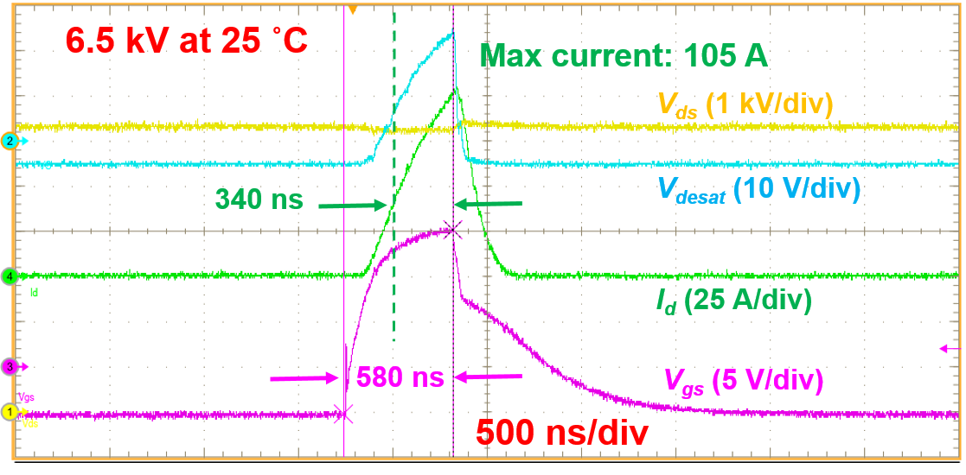Fig. 6- 22. HSF short circuit test waveform of lower MOSFET in the phase leg.

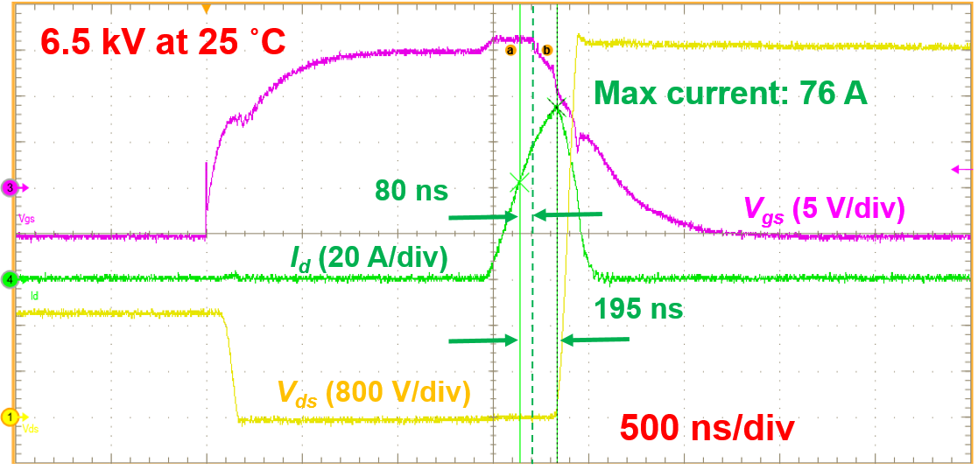
Fig. 6- 23. FUL short circuit test waveform of lower MOSFET in the phase leg.

continues increasing for 115 ns after soft turn-off process is initiated. It is difficult to estimate the response time because of difficulty in predicting when the short circuit current reaches the peak value. The peak short circuit current is 76 A, significantly lower than that under HSF fault. The total power loss is 29.77 mJ, including the turn-off loss. Also, the measured V_{gs} waveform is distorted by the voltage drop on the common source inductance L_{ss}. When the short circuit current increases, the positive voltage drop on L_{ss} results in the measured V_{gs} higher than 15 V. Voltage drop on L_{ss} also changes drastically when short circuit current reaches the peak, since the di/dt changes from 0.24 A/ns to -0.4 A/ns.
Unfortunately there is no experimental setup available in the lab for the flashover fault test with an extremely high dv/dt. Since <200 ns response time has been verified in the FUL fault test, similar response should also be achieved under the flashover fault, and the higher positive dv_{ds}/dt during the flashover fault could lead to shorter response time.
Continuous test of the phase leg is conducted to fully qualify the noise immunity of the improved desat protection. In the continuous ac-dc test, the HB phase leg is configured as an inverter with the fundamental frequency of 300 Hz, the same as the continuous test in the baseline test in Chapter 3. Fig. 6-24 displays the continuous test waveform at 6.5 kV. The total dead time is 600 ns with 200 ns dead time generated by the controller. The modulation index is 0.55 to output the load current with the peak value of ~6 A. V_{desat} used for overcurrent protection also has a sinusoidal shape, indicating that it is able to follow V_{ds} quickly when the MOSFET is in ON state. It can also be seen that V_{desat} is clamped at -5 V when MOSFET is turned off. Successful continuous ac-dc test demonstrates the excellent noise immunity of the improved desat protection.
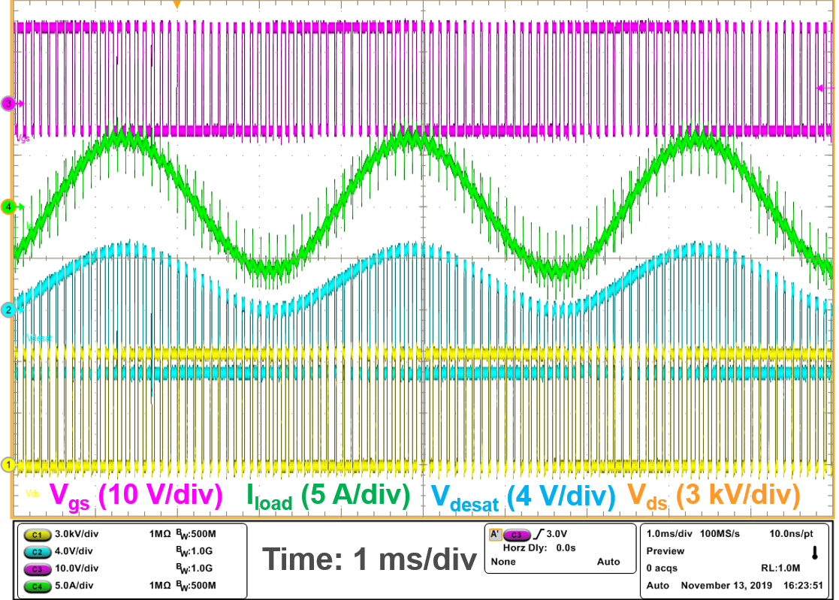
Fig. 6- 24. Waveforms of ac-dc continuous test at 6.5 kV.

6.3 Summary
The noise immunity of the desat protection for 10 kV SiC MOSFETs and other high voltage SiC MOSFETs is analyzed extensively and quantitatively to achieve the desat protection with fast response and strong noise immunity concurrently. The high positive dv_{ds}/dt is identified as the major concern which could falsely trigger the desat protection via the extremely small parasitic capacitance (< 0.01 pF). The mathematical model of the noise immunity margin is established to evaluate the noise immunity and support the noise immunity improvement. According to Fig. 6- 10, the worst case for noise immunity margin is the high positive dv_{ds}/dt with a long voltage rise time, which explains why the desat protection for high voltage SiC MOSFETs is more vulnerable to noise than desat protection for other devices. Systematic design guidelines are summarized to enhance the noise immunity of the desat protection, which are supported by the experimental results.
An improved desat protection scheme with 600 ns digital blanking time is developed for 10 kV SiC MOSFETs to realize fast response and excellent noise immunity concurrently. The digital blanking time implementation decouples the length of blanking time from the R-C network in desat protection circuitry. The R-C network with a smaller time constant can hence be used to accelerate the protection response, especially the response under the FUL and the flashover fault. Short circuit test results at 6.5 kV demonstrate that the HSF fault can be clearly with a response time of 340 ns, and the response time is 195 ns under the FUL fault. Meanwhile the noise immunity is not impaired by leveraging the design guidelines obtained from the noise immunity analysis.

Ch 7. Comprehensive Test Scheme of a 10 kV SiC MOSFET Based Phase Leg
The comprehensive test scheme for the phase leg based on 10 kV SiC MOSFETs should be able to provide an operating condition similar to the real condition in a modular MV converter, such as device current, dv/dt, CM voltage, and so on. Specifically, the test scheme should fully validate its thermal performance, insulation design, and the capability to withstand high dv/dt and the resulting noise when the phase leg operates as part of a modular MV converter. For example, high dv/dt can distort PWM signals and falsely trigger protections via various mechanisms [24], [94], and such issues should be found at the stage of phase leg testing, instead of MV converter testing.
In this chapter, a simple test method is proposed to fully qualify a HB phase leg based on 10 kV SiC MOSFETs, especially its ability to withstand high dv/dt. First, the proposed test scheme is introduced in detail, whose essential step is the ac-dc continuous test in which two phase legs are connected in series to resemble the operation of modular MV converters with multiple cascaded phase legs. Secondly, an open loop voltage balancing scheme is introduced to balance the voltage of two cascaded phase legs. Detailed simulation and experimental results are provided to validate the proposed test method, followed by the summary of this chapter.

7.1 Overview of Test Scheme
The proposed test scheme for the HB phase leg is a simple three-step scheme with the focus on the ac-dc continuous test. The first step is the component qualification and phase leg assembly. Initial tests are conducted to check the gate loop and gate driver functions in the second step. In the first step, components should be tested and qualified individually before the phase leg assembly, including gate driver, voltage sensor, MOSFETs, and busbar. After the phase leg is assembled, the vital functions of the gate driver are examined, including rising/falling edge of gate-to-source voltage V_{gs}, feedback signal, short circuit protection as well as soft turn-off. The last step is the ac-dc continuous test which should be conducted carefully by starting from low dc-link voltage operation. Compared to the baseline testing procedures introduced in Chapter 3, the proposed test scheme does not require DPT and short circuit test for each MOSFET, and hence is much simpler, less time-consuming, and more efficient, which is important when many phase legs need to be tested. It is acceptable to skip DPT and short circuit test since the 10 kV/20 A SiC MOSFET and its package in the phase leg have become more mature and reliable. In other words, DPT and short circuit test are necessary if the device is still in early stage with its performance not fully guaranteed. Meanwhile, more comprehensive tests of the gate driver functions are required in the second step.

7.1.1 Overview of ac-dc Continuous Test
A proposed ac-dc continuous test circuit with two cascaded phase legs is the core of the test scheme, as shown in Fig. 7-1. The proposed ac-dc continuous test circuit has a simple configuration, including a high voltage dc power supply, which is commercially available from various manufacturers, an input capacitor, two cascaded HB phase legs, and the load. During the normal operation with the voltage of two phase legs well-balanced, the dc component of the phase leg voltage is approximately equal to the input voltage V_{g}. Thereby, the high voltage dc power supply should be able to output the rated dc bus voltage of the HB phase leg. The load can be easily realized with inductors and the resistive load built for the test of MV converters. R_{load} can be adjusted to achieve the desired active power. Typically, the active power and the value of R_{load} are limited by the output current capability of the dc power supply.
The proposed continuous test circuit has two cascaded phase legs to resemble numerous modular MV converters with a string of phase legs in series, including MMC and cascaded H-bridge converter. During the ac-dc continuous test, Phase Leg 1 in Fig. 7-1 is the phase leg under test, with floating potential and high dv/dt in all of its terminals resulting from the switching actions in Phase Leg 2. Phase Leg 2 can be regarded as part of the ac-dc continuous test setup. Usually Phase Leg 2 has the same gate resistance and switching speed as the phase leg under test. The gate resistance of Phase Leg 2 can also be reduced to further increase the dv/dt in order to fully test the dv/dt immunity of the phase leg under test. A fiber optic voltage probe which is able to withstand high common mode voltage can be used to monitor the gate signal, the output signal of the short circuit protection, and other signals [95], to evaluate the noise immunity of the phase leg under test under high dv/dt. In parallel with the ac-dc continuous test, the thermal design can be evaluated online by measuring device temperature with a fiber optic temperature sensor. Acoustic partial discharge detection method is effective in the online validation of the insulation design under PWM voltage with high dv/dt [96].
Fig. 7- 1. Circuit diagram of the proposed ac-dc continuous test circuit for the qualification of half bridge phase legs.

7.1.2 Modulation Scheme
In the ac-dc continuous test, a modulation scheme is implemented to force the phase leg under test to undergo high dv/dt that might be generated by the modular MV converter. Cascaded phase legs are leveraged to generate ≥2X normal dv/dt of a single 10 kV SiC MOSFET, which is likely to occur in the modular MV converter with many modules in series. In this chapter, normal dv/dt is defined as the dv/dt of a single 10 kV SiC MOSFET with the selected gate resistance for the phase leg. Bipolar SPWM modulation with the same modulation index is implemented in both Phase Leg 1 and 2. With zero phase shift between the PWM signals for Phase Leg 1 and 2, M₁ shares the same gate signal with M₃, and M₂ and M₄ receive the same gate signal.
If Phase leg 2 and the phase leg under test have the same switching speed and switching frequency, the source of M₁ in Phase Leg 1 will undergo the voltage rise from 0 to 2V_{g} with 2X normal turn-on dv/dt of M₁ as M₁ and M₃ turn on simultaneously. The source potential of M₁ drops from 2V_{g} to 0 with 2X normal turn-off dv/dt of M₁, as M₁ shuts off. In modular MV converters, in fact, such switching actions with 2X normal dv/dt could occur when multiple cascaded modules switch their modes simultaneously [97]. The voltage step change between 0 and 2V_{g} with 2X normal dv/dt results in 2X CM current flowing through the gate driver and its isolated power supply. Also, the insulation capability of the isolated power supply for the gate driver can be fully tested in this case.
In addition, the gate resistance of Phase Leg 2 can be tuned and different from the phase leg under test. If the gate resistance for MOSFETs in Phase Leg 2 is adjusted to be lower than the gate resistance in Phase Leg 1 to achieve higher dv/dt, >2X normal dv/dt and CM current can be realized for the phase leg under test. Meanwhile, the DC- terminal of the phase leg under test undergoes dv/dt higher than the normal dv/dt of 10 kV SiC MOSFETs in a modular MV converter. Hence, the dv/dt that the phase leg under test experiences during the continuous test can be fully controlled for the purpose of evaluating the dv/dt immunity margin. The noise immunity of the phase leg under high dv/dt, especially the short circuit protection and the isolated power supply, can thereby be fully tested. Subsequently, the phase leg under test can be tested and debugged to achieve the capability to handle the desired level of dv/dt. With such modulation scheme, the ac-dc continuous test setup is a suitable platform to test the capability of the phase leg to withstand high dv/dt when operating as a building block of a modular MV converter.
The ac-dc continuous test setup has the capability to validate the thermal and insulation design of the phase leg under test at the rated dc bus voltage and current. The rated dc bus voltage of the phase leg can be realized by increasing V_{g}. The load voltage is a PWM-type voltage with step changes between V_{g} and -V_{g}. Normally the load current has a sinusoidal shape due to the high impedance of the load inductor at high frequency. The magnitude of the load current can be adjusted by changing the modulation index and the fundamental frequency. The peak value of the fundamental component of the load current I_{fund,pk} can be estimated with the equation below.
$$\begin{aligned}I_{fund,pk}=\frac{mV_{g}}{\sqrt{{(2πf_{line}L_{load})}^{2}+{R_{load}}^{2}}}\#\left(7.1\right)\end{aligned}$$
In the equation, f_{line} is the fundamental frequency, and m is the modulation index, both of which are determined by the modulation signal. The dc component of the load current I_{load,DC} is determined by the active power consumed in the continuous test setup, which can be calculated with the following equation.

$$\begin{aligned}I_{load,DC}=\frac{P_{loss}+R_{load}I_{RMS}^{2}}{V_{g}}\#\left(7.2\right)\end{aligned}$$
I_{RMS} is the RMS value of the load current, and P_{loss} is the power loss in the ac-dc continuous test setup. If the resistive load is not installed, the dc component of the load current will be almost zero.

7.2 Open-loop Voltage Balancing Scheme
Voltage balancing is essential to the proposed ac-dc continuous test circuit with two cascaded HB phase legs. In order to further simplify the test setup and control, an open loop voltage balancing scheme is adopted, whose details are presented in this section.
The two cascaded phase legs ideally have balanced dc capacitor voltage, since the two capacitors always have the same current with the designed modulation scheme. In ideal conditions, M₁ and M₃ always conduct at the same time to achieve the natural voltage balancing. In reality, the two phase legs could have different dead times due to nonideal factors in the controller and the gate driver board. Also, there could be slight phase shift between V_{gs} of M₁ and M_{3,} or V_{gs} of M₂ and M₄. For example, the fiber optic transmitter or receiver with the same part number could have different propagation delay. Especially, longer dead time contributes to higher dc capacitor voltage no matter what the direction of the load current is. Without any voltage balancing method, the dc capacitor voltage of the two phase legs would diverge from each other, and the dc capacitor voltage of the phase leg with shorter dead time finally drops to zero. This can be explained by the difference between the average capacitor current of the two phase legs, which is named the offset current, I_{offset}. In the dc circuit model in Fig. 7-2(a), the dc capacitor voltage of the two phase legs is marked as $∆V_{dc1}$ and $∆V_{dc2}$, because the initial dc voltage is neglected. The dc voltage difference V_{offset}, defined as $∆V_{dc1}-∆V_{dc2}$, will continue to increase in magnitude as long as I_{offset} exists due to the different dead time, and the voltage of one phase leg will eventually drop to zero.
The magnitude and polarity of I_{offest} is determined by the load current as well as the dead time difference and phase shift between V_{gs} for the MOSFETs of the two phase legs. In fact, the magnitude and polarity of I_{offest} can be time-varying. For instance, assuming 20 ns phase shift between V_{gs} for M₁ and M₃ (V_{gs} for M₁ leading) and zero phase shift between V_{gs} for M₂ and M₄, the instantaneous I_{offset} is almost zero when the load current is positive, because M₁ and M₃ are synchronous devices whose body diodes conduct current during the dead time. If the load current is negative, the phase shift between V_{gs} for M₁ and M₃ will play a part, and the instantaneous I_{offset}(t) can be described with the following equation.

$$\begin{aligned}I_{offset}(t)=\frac{1}{T_{s}}(\int_{t}^{t+DT_{s}}{I_{load}(t)dt}-\int_{t+∆t}^{t+∆t+DT_{s}}{I_{load}(t)dt})\#\left(7.3\right)\end{aligned}$$
In the equation, T_{s} is the switching period, D is the duty cycle, and $∆t$ is the phase shift. The equation shows that the magnitude and polarity of I_{offset} depend on the instantaneous phase angle of the load current. In fact, it is likely that different dead time and slight phase shift between V_{gs} for M₁ and M₃ as well as between V_{gs} for M₁ and M₃ influence I_{offset} simultaneously. As a result, the average I_{offset} over a line cycle is not zero in steady state, and hence the voltage balancing cannot be achieved.
An open loop method with an external parallel resistor is developed to suppress the impact of I_{offset} and achieve voltage balancing. As can be seen in Fig. 7-2(a), I_{offset} that could be caused by numerous nonideal factors can only flow through the capacitor, and hence keeps charging or discharging the capacitor. After adding a resistor in parallel with the capacitor, as shown in Fig. 2(b), all of the offset current will be absorbed by the resistor, and the capacitor voltage will reach steady state. The dc capacitor voltage of the two phase legs in steady state still has some difference V_{offest}, whose equation is shown in Fig. 7-2(b). V_{offest} is only determined by the added parallel resistor and the magnitude of I_{offset} and is independent of the capacitance and parasitics of the dc capacitor.
It is difficult to calculate the average I_{offset} in a line cycle in an analytical way. However, the average I_{offset} can be obtained easily based on simulation results. The parallel resistor should be selected based on the trade-off between the V_{offest} and the power loss of the resistor. A small parallel resistance is attractive due to better voltage balancing results, yet bulky power resistors must be selected which may also require additional heatsinks or fans and lead to complicated experimental setup. A large parallel resistance results in
(a) (b)
Fig. 7- 2. (a) DC circuit model of the two phase legs used to study V_{offset}. (b) DC circuit model of the two phase legs after adding a resistor in parallel with the capacitor.
simple test setup, but the large V_{offset} makes it difficult to control the voltage of the phase leg under test in a convenient way, and increases the risk of device damage due to overvoltage.

7.3 Simulation Results
The proposed ac-dc continuous test circuit with the open loop voltage balancing method is simulated in Matlab/Simulink. Fig. 7-3 shows simulation results of the case with zero phase shift between gate signals for the two phase legs and 500 ns dead time for both phase legs. The dc capacitor voltage of two phase legs is hence perfectly balanced, and the PWM-type load voltage and the load current with a sinusoidal shape can be seen in the simulation waveforms. The load current is regulated at ~6 A peak with almost zero DC component, since R_{load} is 1 Ω. In addition, Fig. 7-4 displays the simulated phase leg voltage waveforms without and with the open loop voltage balancing method to prove its effectiveness. The case where two phase legs have significantly different dead time is simulated since it provides a large I_{offset}. Without the added parallel resistor, the voltage of Phase Leg 2 with 100 ns shorter dead time keeps decreasing, and V_{offset} increases rapidly to ~800 V within 3 s. The calculated I_{offset} based on simulation results is 2.4 mA, and the calculated V_{offset} at t=3 s is 782 V based on the equation in Fig. 7-2(a). Then a relatively small parallel resistor is added in both phase legs in order to achieve voltage balancing even faster and reduce computational burden in the simulation. After adding a 100 kΩ resistor, the voltage of two phase legs is balanced, and reaches steady state with a constant V_{offset} of ~200 V, close to the calculated 240 V V_{offset}, based on the equation in Fig. 7-2(b). The dc capacitor voltage of the phase leg has the line frequency ripple with a peak-to-peak value of ~300 V, similar to the submodule voltage ripple observed in a MMC converter.
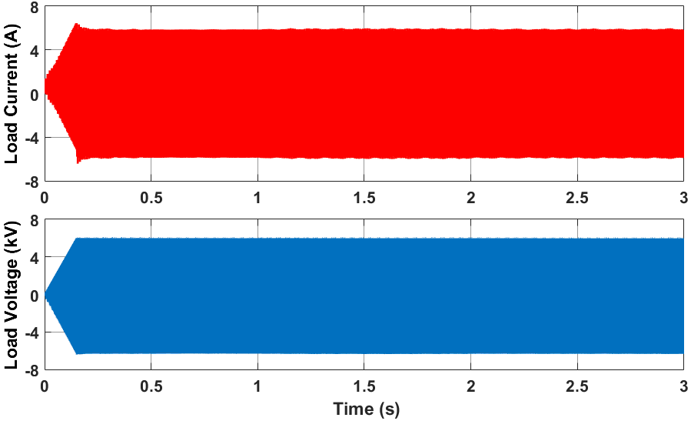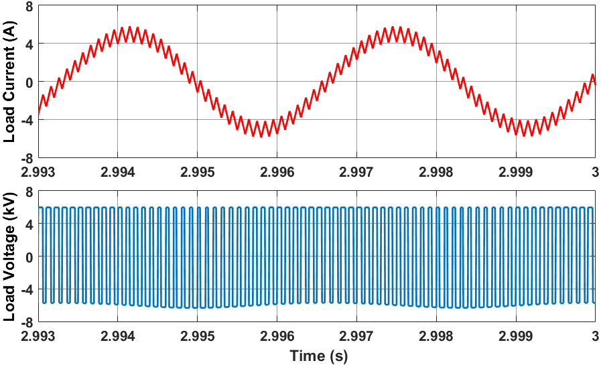
(a) (b)
Fig. 7- 3. Simulated waveforms of load voltage and load current at 6 kV dc-link voltage (modulation index m=0.25, R_{load} =1 Ω, L_{load} =175 mH): (a) Overview (V_{g} ramps up from 0 to 6 kV within 0.15 s); (b) Zoom-in waveforms.
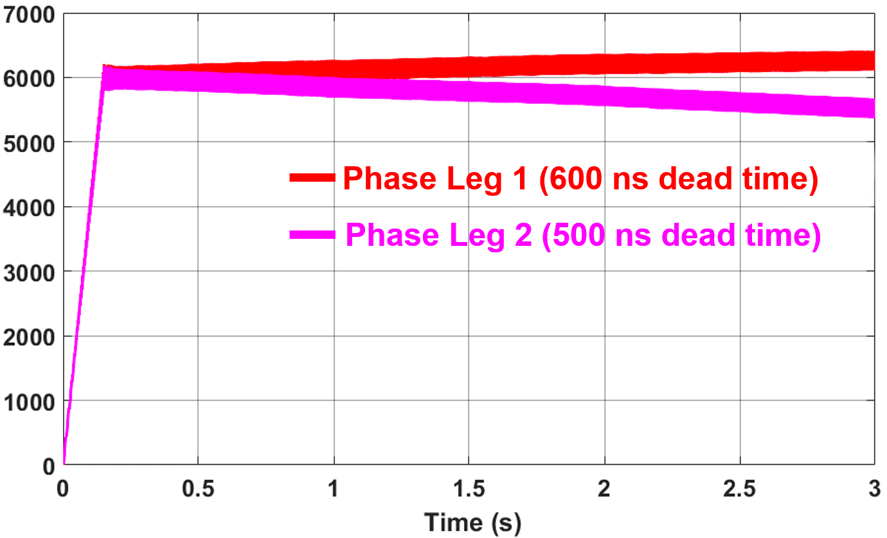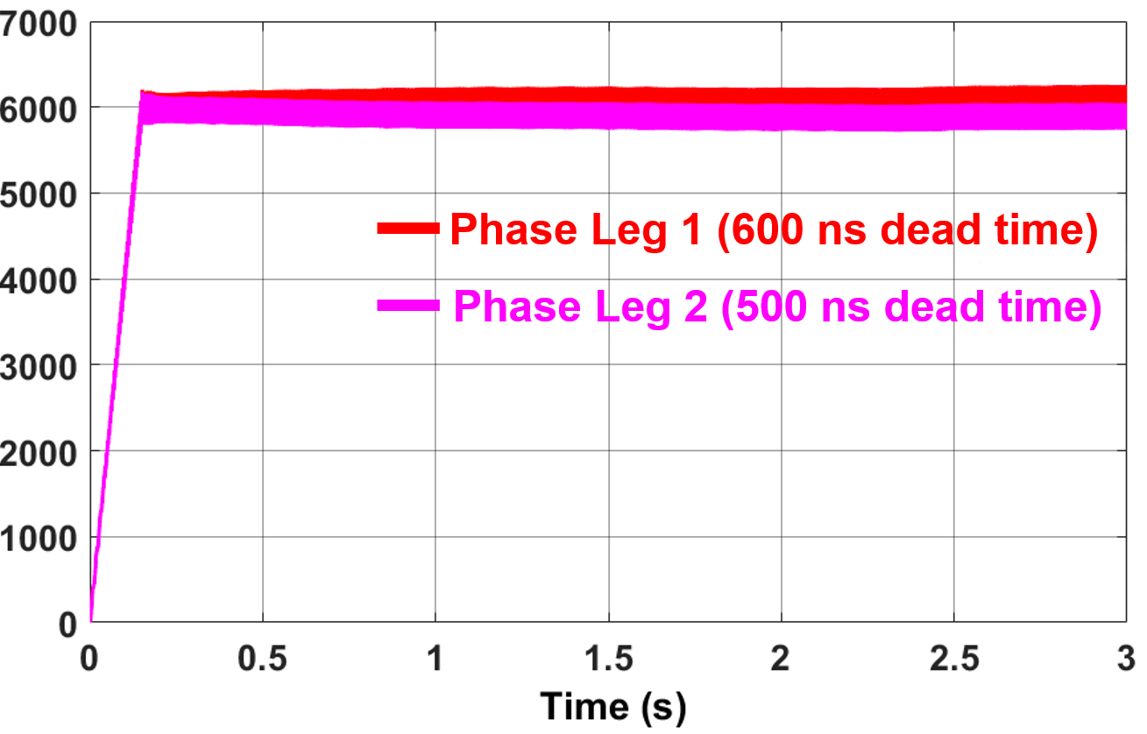
(a) (b)
Fig. 7- 4. Simulated phase leg voltage waveforms (modulation index m=0.25, V_{g}= 6 kV, R_{load} =1 Ω, L_{load} =175 mH): (a) Without parallel resistor for voltage balancing; (b) With a 100 kΩ parallel resistor for voltage balancing.

7.4 Experimental Setup and Results
The proposed ac-dc continuous test circuit is realized with the experimental setup shown in Fig. 7-5. The high voltage dc power supply from Spellman (Part Number: ST15P12) can output the dc voltage up to 15 kV with the maximum power of 12 kW. The input capacitor C_{in} is implemented with a capacitor bank whose equivalent capacitance is 46.7 µF. The load inductor is implemented with two high voltage inductors in series with a total inductance of 175 mH. The resistive load is not installed due to the 0.8 A output current limit of the power supply. In fact, in order to reduce the output current ripple of the DC power supply, a 470 Ω resistor is inserted between the DC+ terminal of the power supply and C_{in}, otherwise an overcurrent fault will be reported from the power supply.
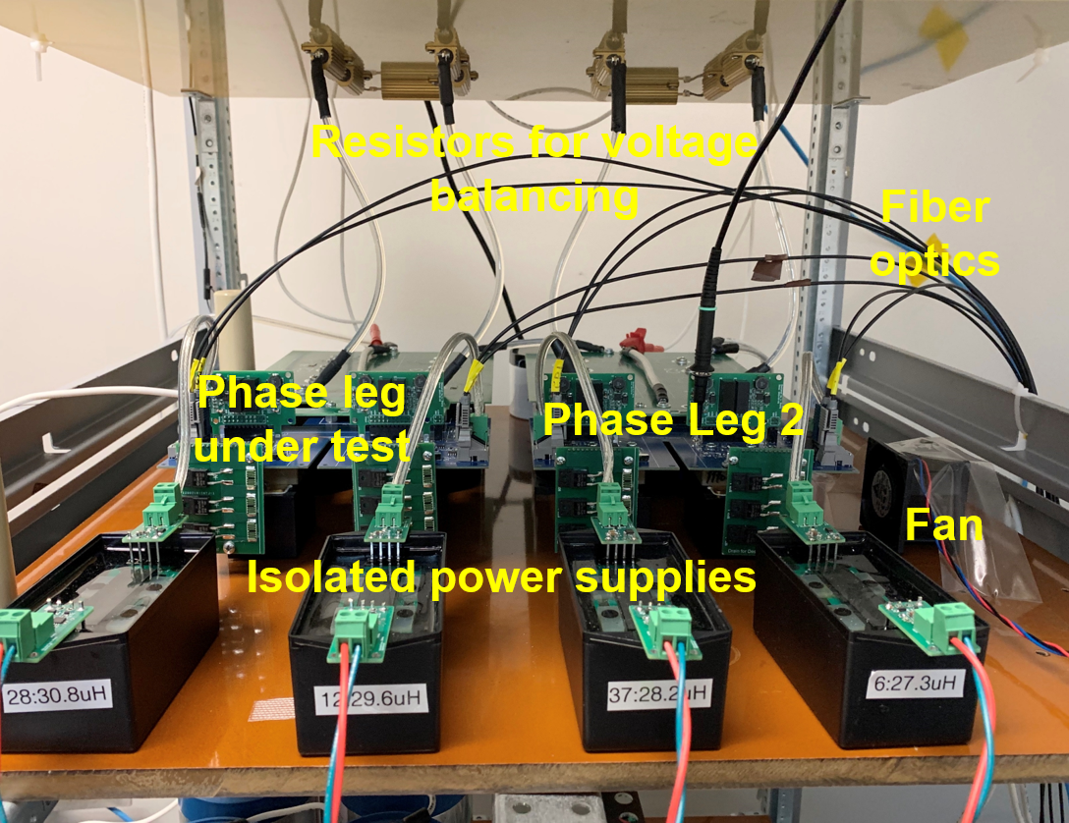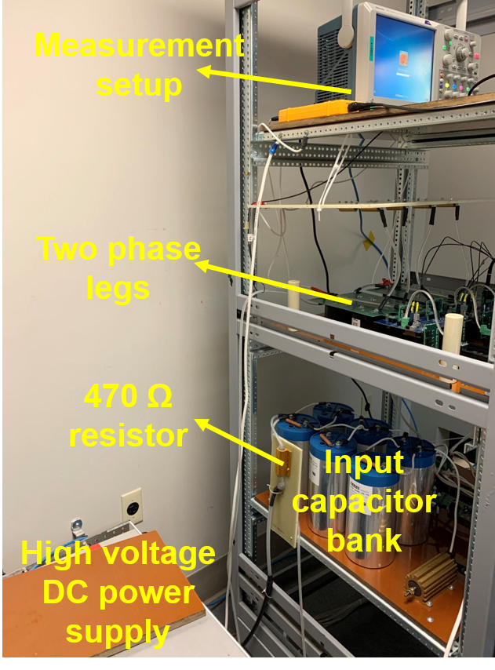
(a) (b)
Fig. 7- 5. Experimental setup of the ac-dc continuous test circuit: (a) Zoom-in view of the two cascaded phase legs; (b) Overview of the whole test setup (the load inductor is not visible).
Two cascaded phase legs are placed next to each other. Each phase leg has two 24 V isolated power supplies with 20 kV insulation capability to provide the auxiliary power [18], whose primary side is connected to a 110 V AC power adapter. Each phase leg has a 500 kΩ resistor for voltage balancing which is composed of five 100 kΩ resistors (RH050100K0FE02 from Vishay) in series to support the continuous test up to 6 kV V_{g}. Without any additional heatsinks or fans, the 500 kΩ resistor has a power rating of 100 W, which is 39% higher than its expected power loss at 6 kV. The 500 kΩ resistor can support the test setup even when nonideal factors result in I_{offset} up to 4 mA and the voltage of one phase leg up to 7 kV. As shown in Fig. 7-5, the resistors for voltage balancing are placed on a garolite board.
The cabinet is solidly grounded by connecting it with the grounded case of the high voltage dc power supply to achieve single-point grounding. The DSP controller and human-machine interface (HMI) are far away from the high voltage test setup and isolated via fiber optics. The selected fundamental frequency is 300 Hz, which is higher than 60 Hz in order to limit the magnitude of the load current. The switching frequency of the 10 kV SiC MOSFETs is 10 kHz.
Experimental results of the ac-dc continuous test at 2.1 kV dc-link voltage are displayed in Fig. 7-6 and Fig. 7-7. Before the continuous test, both phase legs have passed the first two steps of the proposed test scheme. Both phase legs have the same gate resistance: 15 Ω for turn-on, and 3 Ω for turn-off. In terms of the measurement setup, a CWT Ultra Mini Rogowski coil from PEM is adopted for the load current measurement, and two differential voltage probes are used to measure the output voltage of the two phase legs. V_{gs} of M₄ is monitored by a low voltage passive probe TPP1000 from Tektronix, whose source is solidly grounded. With a modulation index of 0.45, the sinusoidal load current with 10 kHz ripple has a peak value of ~3 A, which coincides with the estimation
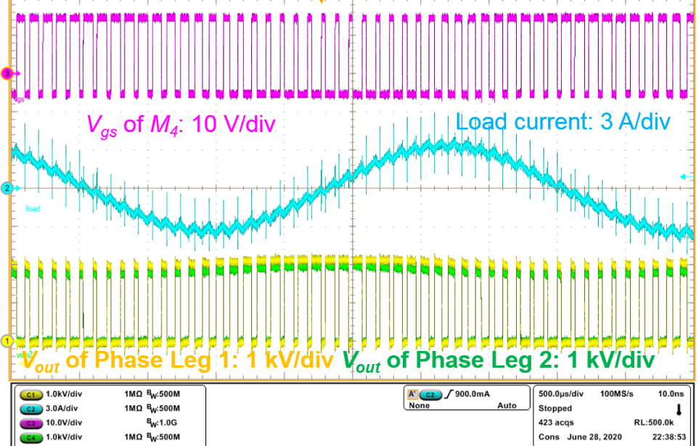
Fig. 7- 6. Waveforms of the continuous test with the proposed ac-dc continuous test circuit at 2.1 kV.
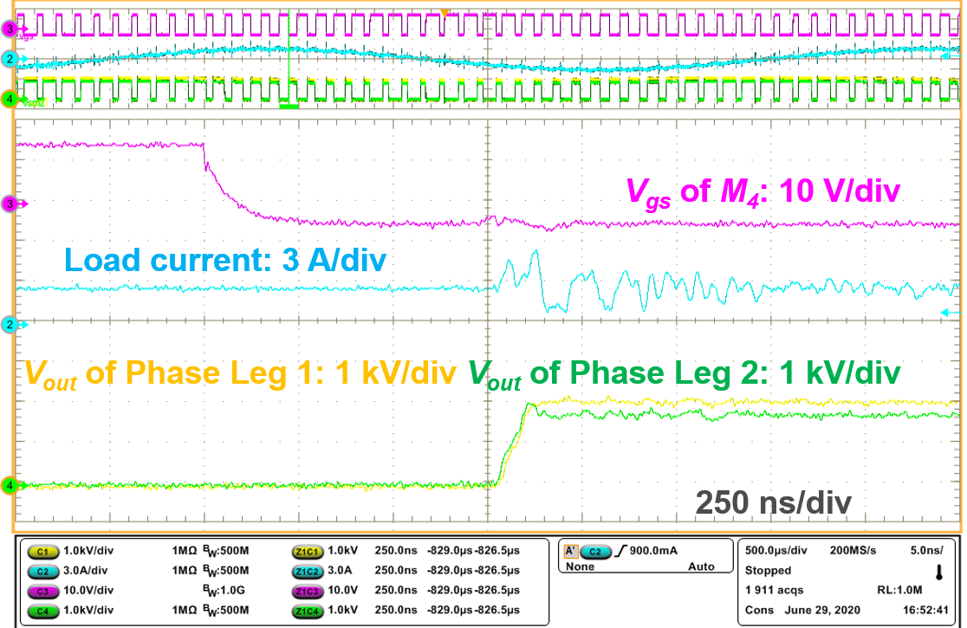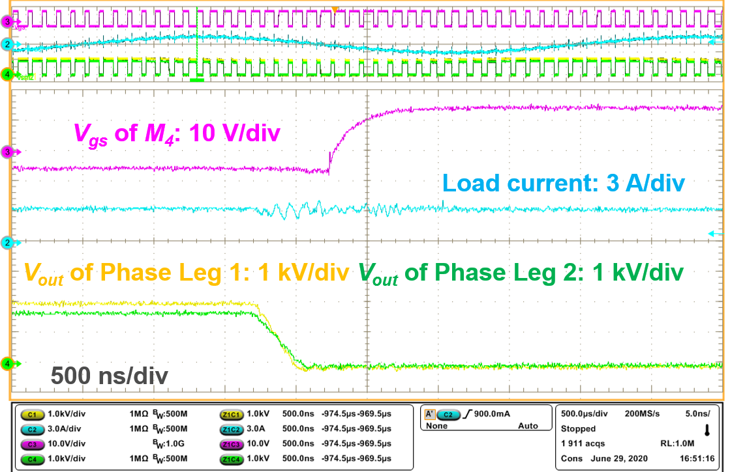
(a) (b)
Fig. 7- 7: Zoom-in waveforms of the continuous test with the proposed ac-dc continuous test circuit at 2.1 kV: (a) Phase leg output voltage rises; (b) Phase leg output voltage decreases.
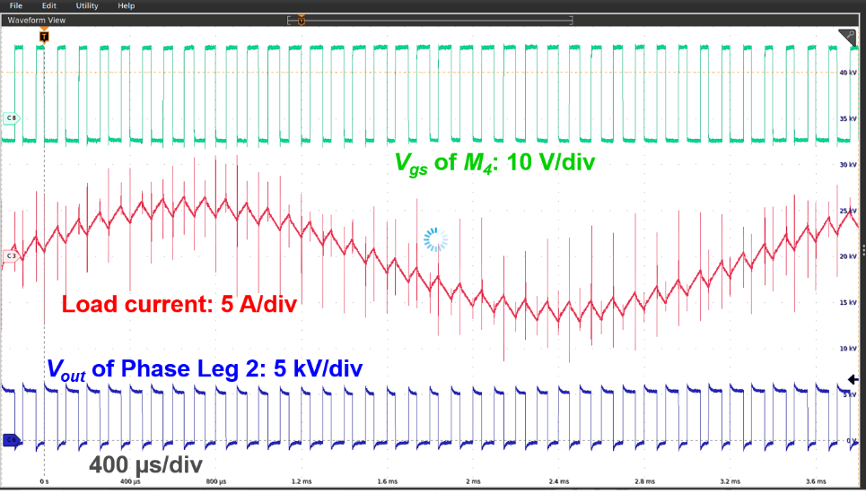
Fig. 7- 8: Waveforms of the continuous test with the proposed ac-dc continuous test circuit at 6 kV.
result and the simulation result. The low frequency ripple of the phase leg voltage is also clearly indicated in Fig. 7-6.
The voltage of two phase legs is well balanced with the help of the 500 kΩ parallel resistor. The voltage difference between the two phase legs V_{offset} is less than 250 V with a dc-link voltage of 2.1 kV. In fact, only one pair of PWM signal is generated in the DSP controller, so the same gate signal is sent to the gate driver of M₁ and M₃ via fiber optics, as well as M₂ and M₄. The voltage difference is mainly attributed to the phase shift between the V_{gs} of M₁ and M₃, and M₂ and M₄, which is due to the propagation delay difference of the components in the gate driver board. According to the zoom-in waveforms in Fig. 8, the output voltage of the two phase legs rises and drops almost simultaneously, with a phase shift of <20 ns. It is thereby proved that the designed modulation scheme forces the source of M₁ to undergo 2X dv/dt that M₂ and M₃ withstand. The dv/dt that M₁ and M₂ of the phase leg under test experience continuously will be higher if Phase Leg 2 is modified to switch with higher dv/dt.
The ac-dc continuous test is successfully conducted at 6 kV dc-link voltage, with the waveforms displayed in Fig. 7-8. Since the differential voltage probe is not capable of withstanding 6 kV common mode voltage with high dv/dt, the output voltage of the phase leg under test (Phase Leg 1) cannot be measured any more. The output voltage of Phase Leg 2 is measured with a high voltage passive probe, P6015A from Tektronix. At 6 kV, the modulation index is reduced to 0.25 because the continuous operation of the load inductor only allows <9 A peak current. The maximum load current flowing through the inductor and MOSFETs is ~6 A. Because the source of M₁ experiences 2X normal dv/dt of the 10 kV SiC MOSFET, substantial displacement current flows through EPC of the load inductor, as clearly indicated in the measured load current waveform. Measurement results of the output voltage of Phase Leg 2 show that the capacitor voltage of Phase Leg 2 varies from 5.1 kV to 5.4 kV. Therefore, it is estimated that the voltage of the phase leg under test (Phase Leg 1) varies from 6.6 kV to 6.9 kV. The proposed open loop voltage balancing method effectively achieves voltage balancing in the ac-dc continuous test setup. With a larger I_{offset} due to the higher load current, the voltage difference V_{offset} is higher than 1 kV. In addition, more accurate phase leg voltage measurement results and V_{offset} can be obtained with better high voltage differential voltage probes in the future.

7.5 Summary
This chapter focuses on a simple test scheme to test phase legs based on 10 kV SiC MOSFETs comprehensively. The test scheme provides a comprehensive and efficient qualification of the phase leg, including its thermal design, insulation design, and its capability to withstand high dv/dt. In the test scheme, an ac-dc continuous test circuit with two phase legs in series is developed to qualify the phase leg as the final step. With the designed modulation scheme, the phase leg under test needs to continuously withstand 2X normal dv/dt of 10 kV SiC MOSFETs, which could occur during the operation of a real modular MV converter. In fact, the dv/dt that the phase leg under test will undergo is controllable so that the capability of the phase leg to operate normally under high dv/dt can be fully tested and evaluated. An open loop voltage balancing method with the external parallel resistor is adopted to simplify the test setup. The developed continuous test circuit is fully validated with the built test setup and the ac-dc continuous test up to 6 kV.

Ch 8. Conclusions and Future Work

8.1 Conclusions
10 kV SiC MOSFETs with superior device performance are one of the essential enablers of future MV converters with higher efficiency and control bandwidth as well as much smaller size and weight. To apply them in modular MV power conversion systems, a series of challenges caused by device-level characteristics of 10 kV SiC MOSFETs should be addressed, such as high blocking voltage and high dv/dt. This dissertation, throughout which these challenges are analyzed and tackled, intends to investigate the switching performance evaluation, design, and testing of a robust 10 kV SiC MOSFET based phase leg for modular MV converters.
First, a baseline design of a 6.5 kV HB phase leg based on 10 kV SiC MOSFETs is presented for the continuous operation as a building block of a modular MV converter. The developed gate driver is equipped with desat protection, dead time insertion, and status feedback function in every switching cycle to support the continuous operation of the phase leg. Baseline testing procedures are developed to validate the baseline design.
Then, how the parasitic capacitors in the MV converter and the freewheeling diode influence the switching performance is evaluated in detail. Higher EPC of the load inductor makes switching transients slower, leading to lower turn-off loss and higher total switching energy loss. The parasitic capacitance caused by the heatsink prolongs switching transitions and increases the switching loss. With negligible reverse recovery charge, the body diode is suitable to serve as the freewheeling diode in the HB phase leg. Adding the 10 kV anti-parallel JBS diode is not recommended because it introduces additional parasitic capacitance and leads to higher switching loss.
The 10 kV SiC MOSFET under the flashover fault caused by premature insulation failure is studied in detail, where dv/dt and di/dt are much higher than those under conventional short circuit faults. To reduce the overvoltage and short circuit current under the flashover fault, a higher R_{g,off} is suggested for 10 kV SiC MOSFETs without Kelvin source to avoid a large R_{g,on}/R_{g,off}, while a small R_{g,off} is recommended for the MOSFET with Kelvin source. The analysis also provides design guidelines about the gate loop inductance and whether to add an external capacitor across gate and source terminal. Based on simulation results at 7 kV, the short circuit energy loss is compared between the flashover fault and two conventional short circuit faults, HSF and FUL fault. The required response time to clear a flashover fault should be ~350 ns shorter than the response time determined by conventional short circuit faults.
The noise immunity of the desat protection for 10 kV SiC MOSFETs and other high voltage SiC MOSFETs is examined quantitatively and comprehensively in the pursuit of the desat protection with faster response and strong noise immunity. The main concern is the high positive dv_{ds}/dt: the high dv_{ds}/dt together with the long voltage rise time makes the desat protection for high voltage SiC MOSFETs more vulnerable to noise than that protection for other Si and SiC devices, as shown in Fig. 6- 10. Design guidelines, including component selection, circuit design, and PCB layout, to enhance the noise immunity of the desat protection are summarized. Leveraging the knowledge acquired in noise immunity analysis, an improved desat protection scheme with digital blanking time is developed for 10 kV SiC MOSFETs to realize fast response and excellent noise immunity concurrently. The response time is 340 ns under the HSF fault, and the response time is 195 ns under the FUL fault at 6.5 kV.
Finally, a simple test scheme has been proposed to thoroughly test HB phase legs based on 10 kV SiC MOSFETs. With an ac-dc continuous test circuit featuring two phase legs connected in series, the test scheme provides a comprehensive and efficient qualification of the phase leg as a robust building block for modular MV converters, including its thermal design, insulation design, and its capability to withstand high dv/dt and its resulting noise. The phase leg under test needs to continuously withstand ≥2X normal dv/dt of a single 10 kV SiC MOSFET, which might be generated in a modular MV converter. In the continuous test circuit, the dv/dt is controllable to fully test the operation of the phase leg under high dv/dt. To further simplify the test setup, an open loop voltage balancing method with the external parallel resistor is adopted. The built experimental setup successfully validates the proposed ac-dc continuous test circuit at 6 kV.

8.2 Future Work

8.2.1 Proposed future work
One proposed future work is the desat protection with ultrafast response for 10 kV SiC MOSFETs. Its working principle is the same as the conventional desat protection for the 10 kV SiC MOSFET, yet it is designed after fully considering the influence of the negative dv/dt on the blanking time during the fast turn-on transient. Meanwhile, the noise immunity will not be impaired by following the design guidelines in Section 6.1.
The blanking time is required in desat protection to prevent false triggering during the turn-on transient. Usually it is assumed that V_{desat} will be dominated by R-C charging process during the blanking time. Based on this assumption, the waveform of V_{desat} is drawn in Fig. 8-1(a). However, the assumption is not valid during the fast turn-on transients of high voltage SiC MOSFETs. The high dv_{ds}/dt also plays a non-negligible part in shaping V_{desat} via the parasitic capacitance C_{desat}. The high dv_{ds}/dt during the normal turn-on transient is negative and generates the displacement current that should be sourced by the desat protection circuitry as displayed in Fig. 8-2. As a result, V_{desat} will be heavily shaped by the high dv_{ds}/dt during the blanking time. As shown in Fig. 8-1, the effective blanking time can be much longer after considering the impact of the high dv_{ds}/dt and the reverse recovery process of D_{blk} and the body diode of M_{cla}.
Since the real blanking time of desat protection can be effectively prolonged by the high dv/dt and the reverse recovery process, a R-C network with a much smaller time constant can be designed to realize the desat protection with ultrafast response. To achieve the desat protection with ultrafast response, R_{blk} and C_{blk} are selected so that V_{desat} will keep dropping and later be clamped at V_{clamp} during the voltage fall time with high dv/dt. A Si Zener diode and a Si MOSFET are selected to serve as D_{blk} and M_{cla}, respectively, in order to take advantage of the reverse recovery effect for longer blanking time.

(a) (b) (c)
Fig. 8-1. Waveforms of V_{desat} during blanking time: (a) impact of high dv/dt neglected; (b) Reverse recovery process neglected; (c) both high dv/dt and reverse recovery considered.
Fig. 8-2. Circuit diagram of desat protection with ultrafast response for 10 kV/20 A SiC MOSFET
How V_{desat} is shaped by the high dv_{ds}/dt during the turn-on transient of the MOSFET will be examined extensively with the support of experimental results, together with the detailed working principles of the desat protection with ultrafast response. Discussions about the response time and design trade-offs will be presented as well. Also, short circuit test results will be presented to demonstrate the ultrafast response. It is expected that the protection can clear both FUL and HSF faults within 200 ns. This part will be presented as one section in Chapter 6 of the final dissertation.
The other proposed future work is to design and build a robust HB phase leg based on a 10 kV/100 A SiC MOSFET module for a 1 MW modular MV converter. With 6 dies in parallel in each switch position, the XHV-9 half-bridge 10 kV SiC MOSFET module from Wolfspeed can be used in future high-performance MV converters, while the discrete 10 kV/20 A SiC MOSFET is just the engineering sample for research. In addition, the module possesses the isolated package and Kelvin source terminal for each switch. The knowledge gained from previous research presented in this dissertation will be leveraged when designing the HB phase leg, including gate driver design, short circuit protection design, etc. Design details and experimental results of the phase leg based on the 10 kV/100 A SiC MOSFET module will be presented in Chapter 9 in the final dissertation.

8.2.2 Other future work
With much higher dv/dt and di/dt than Si IGBTs, the switching transients of 10 kV SiC MOSFETs are sensitive to both parasitic capacitors and parasitic inductors in the MV converter. Only parasitic capacitors’ impact on switching transients is studied in this work, since the parasitic inductance is not a dominant influencing factor in the switching transient of the 10 kV/20 A SiC MOSFET [31]. However, parasitic inductance, especially the power loop inductance, could cause much more significant ringing and higher overvoltage in 10 kV SiC MOSFET modules with higher current rating, and hence should be addressed in future work.
Regarding the gate driver design for 10 kV SiC MOSFETs, one of the challenges is how to deal with the CM current and its resulting noise, which is not covered in detail in this dissertation. The CM current results from the parasitic capacitance C_{ps} of the isolated power supply and the high dv/dt. The CM current could lead to the malfunction of the gate driver if it is sufficiently large. However, how the CM current impacts the normal operation of the gate driver has not been thoroughly investigated, and some mechanisms should be identified. Gate driver design guidelines should be provided to solve the problems induced by the CM current, in addition to reducing C_{ps} of the isolated power supply.
In terms of the flashover fault, a comprehensive discussion of methods to alleviate the impact of the flashover fault is still greatly needed, such as a fast V_{gs} clamping circuit. It is also necessary to establish a high voltage test platform for the flashover fault and develop protocols to ensure that the test is safe and nondestructive. The experimental validation of the analysis based on simulation results and discussions based on test results will benefit the study of the flashover fault and guide the SiC-based MV converter design in the future.

                - References
[1] ABB, [online]. Available: http: //new.abb.com /drives /medium - voltage - ac – drives.
[2] G. Baoming, F. Z. Peng, A. T. de Almeida, and H. Abu-Rub, “An effective control technique for medium-voltage high-power induction motor fed by cascaded neutral-point-clamped inverter,” IEEE Trans. Ind. Electron., Vol. 57, no. 8, pp. 2659-2668, Aug. 2010.
[3] J. Haefner and B. Jacobson, “Proactive hybrid HVDC breakers - a key innovation for reliable HVDC grids,” CIGRE symposium, Sep. 2011.
[4] A. Abramovitz, K. M. Smedley, “Survey of solid-state fault current limiters,” IEEE Trans. Power Electron., vol. 27, no. 6, pp. 2770-2782, Jun, 2012.
[5] M. Montero, E. Cadaval, F. Gonzalez, “Comparison of control strategies for shunt active power filters in three-phase four-wire systems,” IEEE Trans. Power Electron., vol. 22, no. 1, pp. 229-236, Jan. 2007.
[6] F. Z. Peng, Y. Liu, S. Yang, S. Zhang, D. Gunasekaran and U. Karki, "Transformer-Less Unified Power-Flow Controller Using the Cascade Multilevel Inverter," IEEE Trans. on Power Electron., vol. 31, no. 8, pp. 5461-5472, Aug. 2016.
[7] S. Xu, A. Q. Huang, and R. Burgos, “Review of solid-state transformer technologies and their application in power distribution systems,” IEEE Journal of Emerging and Selected Topics in Power Electronics, vol. 1, pp. 186-198, Sep. 2013.
[8] S. Zheng, J. Wang, F. Yang, F. Wang, L. Tolbert, D. Costinett, “A DC controller for continuous variable series reactors (CVSRs),” in Proc. of IEEE Energy Conversion Congress and Exposition (ECCE), pp. 5786-5793, 2015.
[9] J. Thoma, D. Chilachava and D. Kranzer, “A highly efficient DC-DC-converter for medium-voltage applications,” in Proc. of IEEE International Energy Conference (ENERGYCON), Cavtat, Croatia, 2014, pp. 127-131.
[10] Xingxuan Huang, “Design and Switching Performance Evaluation of a 10 kV SiC MOSFET Based Phase Leg for Medium Voltage Applications.” Master’s Thesis, University of Tennessee, 2019.
[11] S. Ji et al., “Medium Voltage (13.8 kV) Transformer-less Grid-Connected DC/AC Converter Design and Demonstration Using 10 kV SiC MOSFETs,” in Proc. of IEEE Energy Conversion Congress and Exposition (ECCE), Baltimore, MD, USA, 2019, pp. 1953-1959.
[12] M. Barnes and P. Binduhewa, “Asynchronous interconnection of a microgrid,” CIRED Seminar, Frankfurt, Germany, 2008, pp. 64-68.
[13] D. Li, S. Ji, X. Huang, J. Palmer, F. Wang and L. M. Tolbert, “Controller Development of an Asynchronous Microgrid Power Conditioning System (PCS) Converter Considering Grid Requirements,” in Proc. of IEEE Applied Power Electronics Conference and Exposition (APEC), New Orleans, LA, USA, 2020, pp. 616-621.
[14] J. Desai, M. Ruth, P. Lemar, M. S. Bhandari, J. Storey, K. Srivastava, J. Rogers and H. Schwartz, Modeling the Impact of Flexible CHP on the Future Electric Grid in California. United States. https://doi.org/10.2172/1649545
[15] A. I. Elsanabary, G. Konstantinou, S. Mekhilef, C. D. Townsend, M. Seyedmahmoudian and A. Stojcevski, “Medium Voltage Large-Scale Grid-Connected Photovoltaic Systems Using Cascaded H-Bridge and Modular Multilevel Converters: A Review,” IEEE Access, vol. 8, pp. 223686-223699, 2020.
[16] X. Yuan, “A Set of Multilevel Modular Medium-Voltage High Power Converters for 10-MW Wind Turbines,” IEEE Transactions on Sustainable Energy, vol. 5, no. 2, pp. 524-534, April 2014.
[17] R. Erickson and D. Maksimovic, Fundamentals of Power Electronics. Kluwer Academics, 2000.
[18] Zheyu Zhang, “Characterization and Realization of High Switching-speed Capability of SiC Power Devices in Voltage Source Converter.” PhD dissertation, University of Tennessee, 2015.
[19] Edward Andrew Jones, “Characterization Methodology, Modeling, and Converter Design for 600 V Enhancement-Mode GaN FETs.” PhD dissertation, University of Tennessee, 2018.
[20] “SiC power devices and modules,” Rohm Semiconductor Co., Appl. Note 13103EAY01, Jun. 2013.
[21] Q. Zhang, R. Callanan, M. Das, S. Ryu, A. Agarwal. J. Palmour, “SiC Power devices for microgrids,” IEEE Trans. Power Electron., vol. 25, no. 12, pp. 2889-2896, Dec. 2010.
[22] J. B. Casady, T. McNutt, D. Girder, and J. Palmour, “Medium voltage SiC R&D update,” Wolfspeed, April 2016.
[23] S. Ji, Z. Zhang and F. Wang, “Overview of high voltage SiC power semiconductor devices: development and application,” CES Transactions on Electrical Machines and Systems, vol. 1, no. 3, pp.254-264, 2017.
[24] B. Hu et al., “A Survey on Recent Advances of Medium Voltage Silicon Carbide Power Devices,” in Proc. of IEEE Energy Conversion Congress and Exposition (ECCE), Portland, OR, 2018, pp. 2420-2427.
[25] K. Fukuda et al., “Development of Ultrahigh-Voltage SiC Devices,” IEEE Transactions on Electron Devices, vol. 62, no. 2, pp. 396-404, Feb. 2015.
[26] J. Wang, T. Zhao, J. Li, A. Q. Huang, R. Callanan, F. Husna, A. Agarwal, “Characterization, modeling, and application of 10-kV SiC MOSFET,” IEEE Trans. Electron Devices, vol. 55, no. 8, pp. 1798-1806, Aug. 2008.
[27] D. Grider, M. Das, A. Agarwal, J. Palmour, S. Leslie, J. Ostop, R. Raju, M. Schutten, A. Hefner, “10 kV/120 A SiC DMOSFET half H-bridge power modules for 1 MVA solid state power substation,” in Proc. of ESTS, pp. 131-134, 2011.
[28] E. Eni, B. I. Incau, T. Kerekes, R. Teodorescu, S. Nielsen “Characterisation of 10 kV 10 A SiC MOSFET,” in Proc. of International Aegean Conference on Electrical Machine & Power Electronics (ACEMP), 2015, pp. 675-680.
[29] J. B. Casady et al., “New Generation 10 kV SiC Power MOSFET and Diodes for Industrial Applications,” in Proc. of PCIM Europe, Nuremberg, Germany, 2015, pp. 1-8.
[30] E. Van Brunt, D. Grider, V. Pala, S. Ryu, J. Casady and J. Palmour, “Development of medium voltage SiC power technology for next generation power electronics,” in Proc. of IEEE International Workshop on Integrated Power Packaging (IWIPP), Chicago, IL, 2015, pp. 72-74.
[31] D. Rothmund, T. Guillod, D. Bortis and J. W. Kolar, “99.1 % Efficient 10 kV SiC-Based Medium Voltage ZVS Bidirectional Single-Phase PFC AC/DC Stage,” IEEE Journal of Emerging and Selected Topics in Power Electronics. vol. 7, no. 2, pp. 779-797, June 2019.
[32] F. Wang and L. M. Tolbert, ‘‘SiC high-speed MV direct drive vs. Si low-speed MV drive in compressor applications,’’ presented at the HMW Drive Workshop II NIST, Gaithersburg, MD, USA, 2014.
[33] S. Madhusoodhanan, K. Mainali, A. Tripathi, K. Vechalapu and S. Bhattacharya, "Medium voltage (≥ 2.3 kV) high frequency three-phase two-level converter design and demonstration using 10 kV SiC MOSFETs for high speed motor drive applications," in Proc. of IEEE Applied Power Electronics Conference and Exposition (APEC), Long Beach, CA, 2016, pp. 1497-1504.
[34] D. Rothmund, T. Guillod, D. Bortis and J. W. Kolar, “99% Efficient 10 kV SiC-Based 7 kV/400 V DC-Transformer for Future Data Centers,” IEEE Journal of Emerging and Selected Topics in Power Electronics., vol. 7, no. 2, pp. 753-767, June 2019.
[35] X. Liang, S. Srdic, J. Won, E. Aponte, K. Booth and S. Lukic, “A 12.47 kV Medium Voltage Input 350 kW EV Fast Charger using 10 kV SiC MOSFET,” in Proc. of IEEE Applied Power Electronics Conference and Exposition (APEC), Anaheim, CA, USA, 2019, pp. 581-587.
[36] G. V. Bharath, S. Kiran Voruganti, V. T. Nguyen, V. Uttam Pawaskar and G. Gohil, “Performance Evaluation of 10kV SiC-based Extreme Fast Charger for Electric Vehicles with Direct MV AC Grid Interconnection,” in Proc. of IEEE Applied Power Electronics Conference and Exposition (APEC), New Orleans, LA, USA, 2020, pp. 3547-3554.
[37] D. Rothmund, D. Bortis and J. W. Kolar, “Highly compact isolated gate driver with ultrafast overcurrent protection for 10 kV SiC MOSFETs,” CPSS Transactions on Power Electronics and Applications, vol. 3, no. 4, pp. 278-291, Dec. 2018.
[38] B. Florkowska, M. Florkowski, J. Roehrich, and P. Zydron, “The influence of PWM stresses on degradation processes in electrical insulation systems,” in Proc. Annu. Rep. Conf. Electr. Insul. Dielectic Phenomena, West Lafayette, IN, 2010, pp. 1-4.
[39] R. Färber, T. Guillod, F. Krismer, J. W. Kolar, and C. M. Franck, “Endurance of polymeric insulation foil exposed to dc-biased medium frequency rectangular pulse voltage stress,” Energies, vol. 13, no. 1, p. 13, Dec. 2019.
[40] Z. Zhang, B. Guo, F. F. Wang, E. A. Jones, L. M. Tolbert and B. J. Blalock, “Methodology for Wide Band-Gap Device Dynamic Characterization,” IEEE Trans. Power Electron., vol. 32, no. 12, pp. 9307-9318, Dec. 2017.
[41] G. Wang et al., “Static and dynamic performance characterization and comparison of 15 kV SiC MOSFET and 15 kV SiC n-IGBTs,” in Proc. of IEEE 27th International Symposium on Power Semiconductor Devices & IC's (ISPSD), Hong Kong, 2015, pp. 229-232.
[42] A. Kadavelugu et al., “Characterization of 15 kV SiC n-IGBT and its application considerations for high power converters,” in Proc. of IEEE Energy Conversion Congress and Exposition (ECCE), Denver, CO, 2013, pp. 2528-2535.
[43] J. W. Palmour et al., “Silicon carbide power MOSFETs: Breakthrough performance from 900 V up to 15 kV,” in Proc. of IEEE 26th International Symposium on Power Semiconductor Devices & IC's (ISPSD), Waikoloa, HI, 2014, pp. 79-82.
[44] S. Ji, S. Zheng, F. Wang and L. M. Tolbert, “Temperature-Dependent Characterization, Modeling and Switching Speed Limitation Analysis of Latest Generation 10 kV SiC MOSFET,” IEEE Trans. on Power Electron., vol. 33, no. 5, pp. 4317-4327, 2018.
[45] S. Ji, S. Zheng, Z. Zhang, F. Wang and L. M. Tolbert, “Protection and temperature-dependent switching characterization of latest generation 10 kV SiC MOSFETs,” in Proc. of IEEE Applied Power Electronics Conference and Exposition (APEC), Tampa, FL, 2017, pp. 783-788.
[46] K. Vechalapu, S. Bhattacharya, E. Van Brunt, S. Ryu, D. Grider and J. W. Palmour, “Comparative Evaluation of 15-kV SiC MOSFET and 15-kV SiC IGBT for Medium-Voltage Converter Under the Same dv/dt Conditions,” IEEE Journal of Emerging and Selected Topics in Power Electronics, vol. 5, no. 1, pp. 469-489, March 2017.
[47] J. Thoma, S. Kolb, C. Salzmann and D. Kranzer, “Characterization of high voltage SiC devices with 15 kV blocking voltage,” in Proc. of IEEE International Power Electronics and Motion Control Conference (PEMC), Varna, 2016, pp. 946-951.
[48] I. Josifović, J. Popović-Gerber and J. A. Ferreira, “Improving SiC JFET Switching Behavior Under Influence of Circuit Parasitics,” IEEE Trans. Power Electron., vol. 27, no. 8, pp. 3843-3854, Aug. 2012.
[49] S. Walder and X. Yuan, “Effect of load parasitics on the losses and ringing in high switching speed SiC MOSFET based power converters,” in Proc. of IEEE Energy Conversion Congress and Exposition (ECCE), Montreal, QC, 2015, pp. 6161-6168.
[50] Z. Zhang, F. Wang, L. M. Tolbert, B. J. Blalock and D. J. Costinett, “Evaluation of Switching Performance of SiC Devices in PWM Inverter-Fed Induction Motor Drives,” IEEE Trans. Power Electron., vol. 30, no. 10, pp. 5701-5711, Oct. 2015.
[51] X. Zhang, L. Gant, G. Sheh and S. Banerjee, “Characterization and Optimization of SiC Freewheeling Diode for Switching Losses Minimization Over Wide Temperature Range,” in Proc. of PCIM Europe, Nuremberg, Germany, 2017, pp. 1-7.
[52] C. DiMarino, W. Zhang, N. Haryani, Q. Wang, R. Burgos and D. Boroyevich, “A high-density, high-efficiency 1.2 kV SiC MOSFET module and gate drive circuit,” in Proc. of IEEE Workshop on Wide Bandgap Power Devices and Applications (WiPDA), Fayetteville, AR, 2016, pp. 47-52.
[53] Jun Wang, Yu Du, S. Bhattacharya and A. Q. Huang, “Characterization, modeling of 10-kV SiC JBS diodes and their application prospect in X-ray generators,” in Proc. of IEEE Energy Conversion Congress and Exposition (ECCE), San Jose, CA, 2009, pp. 1488-1493.
[54] C. DiMarino, D. Boroyevich, R. Burgos, M. Johnson and G. Lu, “Design and development of a high-density, high-speed 10 kV SiC MOSFET module,” in Proc. of 19th European Conference on Power Electronics and Applications (EPE'17 ECCE Europe), Warsaw, 2017, pp. P.1-P.10.
[55] B. Hull et al., “Reliability and stability of SiC power mosfets and next-generation SiC MOSFETs,” in Proc. of IEEE Workshop on Wide Bandgap Power Devices and Applications (WiPDA), Knoxville, TN, 2014, pp. 139-142.
[56] A. Agarwal, H. Fatima, S. Haney, S. H. Ryu, “A new degradation mechanism in high-voltage SiC power MOSFETs,” IEEE Electron Device Lett., vol. 25, no. 7, pp. 587-589, 2007.
[57] A. Kumar, K. Vechalapu, S. Bhattacharya, V. Veliadis, E. V. Brunt, D. Grider, S. Sabri, B. Hull, “Effect of capacitive current on reverse recovery of body diode of 10kV SiC MOSFETs and external 10kV SiC JBS diodes,” in IEEE Workshop on Wide Bandgap Power Devices and Applications (WiPDA), Albuquerque, NM, 2017, pp. 208-212.
[58] E. Eni, S. Bęczkowski, S. Munk-Nielsen, T. Kerekes and R. Teodorescu, “Short-circuit characterization of 10 kV 10A 4H-SiC MOSFET,” in Proc. of IEEE Applied Power Electronics Conference and Exposition (APEC), Long Beach, CA, 2016, pp. 974-978.
[59] S. Ji, M. Laitinen, X. Huang, J. Sun, W. Giewont, F. Wang and L. M. Tolbert, “Short circuit characterization and protection of 10 kV SiC MOSFET,” IEEE Trans. Power Electron., vol. 34, no. 2, pp. 1755-1764, Feb. 2019.
[60] C. DiMarino, J. Wang, R. Burgos and D. Boroyevich, “A high-power-density, high-speed gate driver for a 10 kV SiC MOSFET module,” in Proc. of IEEE Electric Ship Technologies Symposium (ESTS), Arlington, VA, 2017, pp. 629-634.
[61] A. Anurag, S. Acharya, Y. Prabowo, G. Gohil and S. Bhattacharya, “Design Considerations and Development of an Innovative Gate Driver for Medium Voltage Power Devices with High dv/dt,” IEEE Trans. Power Electron., vol. 34, no. 6, pp. 5256-5267, June 2019.
[62] Z. Zhang, F. Wang, L. M. Tolbert and B. J. Blalock, “Active Gate Driver for Crosstalk Suppression of SiC Devices in a Phase-Leg Configuration,” IEEE Trans. Power Electron., vol. 29, no. 4, pp. 1986-1997, April 2014.
[63] D. N. Dalal et al., “Gate driver with high common mode rejection and self turn-on mitigation for a 10 kV SiC MOSFET enabled MV converter,” in Proc. of 19th European Conference on Power Electronics and Applications (EPE'17 ECCE Europe), Warsaw, 2017, pp. P.1-P.10.
[64] X. Zhang et al., “A Gate Drive With Power Over Fiber-Based Isolated Power Supply and Comprehensive Protection Functions for 15-kV SiC MOSFET,” IEEE Journal of Emerging and Selected Topics in Power Electronics, vol. 4, no. 3, pp. 946-955, Sept. 2016.
[65] S. Mocevic et al., “Power-Cell Design and Assessment Methodology based on a High-Current 10 kV SiC MOSFET Half-Bridge Module,” IEEE Journal of Emerging and Selected Topics in Power Electronics, doi: 10.1109/JESTPE.2020.2995386.
[66] Z. Wang, X. Shi, Y. Xue, L. M. Tolbert, F. Wang and B. J. Blalock, “Design and Performance Evaluation of Overcurrent Protection Schemes for Silicon Carbide (SiC) Power MOSFETs,” IEEE Transactions on Industrial Electronics, vol. 61, no. 10, pp. 5570-5581, Oct. 2014.
[67] A. E. Awwad and S. Dieckerhoff, “Short-circuit evaluation and overcurrent protection for SiC power MOSFETs,” in Proc. of 17th European Conference on Power Electronics and Applications (ECCE-Europe), Geneva, 2015, pp. 1-9.
[68] Chucheng Xiao, Lingyin Zhao, T. Asada, W. G. Odendaal and J. D. van Wyk, “An overview of integratable current sensor technologies,” in Proc. of 38th IAS Annual Meeting on Conference Record of the Industry Applications Conference, Salt Lake City, UT, USA, 2003, pp. 1251-1258 vol.2.
[69] Y. Xue, J. Lu, Z. Wang, L. M. Tolbert, B. J. Blalock and F. Wang, “A compact planar Rogowski coil current sensor for active current balancing of parallel-connected Silicon Carbide MOSFETs,” in Proc. of IEEE Energy Conversion Congress and Exposition (ECCE), Pittsburgh, PA, 2014, pp. 4685-4690.
[70] W. F. Ray, R. M. Davis, “High frequency improvements in wide bandwidth Rogowski current transducers,” in Proc. of IEEE European Conference on Power Electronics and Application (EPE), Sept. 1999, pp. 1-9.
[71] J. Wang, Z. Shen, R. Burgos and D. Boroyevich, “Design of a high-bandwidth Rogowski current sensor for gate-drive short circuit protection of 1.7 kV SiC MOSFET power modules,” in Proc. of IEEE 3rd Workshop on Wide Bandgap Power Devices and Applications (WiPDA), Blacksburg, VA, 2015, pp. 104-107.
[72] J. Wang, Z. Shen, C. DiMarino, R. Burgos and D. Boroyevich, “Gate driver design for 1.7kV SiC MOSFET module with Rogowski current sensor for short circuit protection,” in Proc. of IEEE Applied Power Electronics Conference and Exposition (APEC), Long Beach, CA, 2016, pp. 516-523.
[73] J. Wang, Z. Shen, R. Burgos and D. Boroyevich, “Integrated switch current sensor for short circuit protection and current control of 1.7-kV SiC MOSFET modules,” in Proc. of IEEE Energy Conversion Congress and Exposition (ECCE), Milwaukee, WI, 2016, pp. 1-7.
[74] S. Mocevic et al., “Comparison between desaturation sensing and Rogowski coil current sensing for short circuit protection of 1.2 kV, 300 A SiC MOSFET module,” in Proc. of IEEE Applied Power Electronics Conference and Exposition (APEC), San Antonio, TX, 2018, pp. 2666-2672.
[75] J. Wang, S. Mocevic, R. Burgos and D. Boroyevich, “High-Scalability Enhanced Gate Drivers for SiC MOSFET Modules with Transient Immunity Beyond 100 V/ns,” IEEE Transactions on Power Electronics, vol. 35, no. 10, pp. 10180-10199, Oct. 2020.
[76] S. Mocevic et al., “Comparison and Discussion on Short circuit Protections for Silicon-Carbide MOSFET Modules: Desaturation Versus Rogowski Switch-Current Sensor,” IEEE Transactions on Industry Applications, vol. 56, no. 3, pp. 2880-2893, May-June 2020
[77] T. Horiguchi, S. Kinouchi, Y. Nakayama and H. Akagi, “A fast short-circuit protection method using gate charge characteristics of SiC MOSFETs,” in Proc. of IEEE Energy Conversion Congress and Exposition (ECCE), Montreal, QC, Canada, 2015, pp. 4759-4764.
[78] E. Sili, J. P. Cambronne, N. Naude and R. Khazaka, “Polyimide lifetime under partial discharge aging: effects of temperature, pressure and humidity,” IEEE Transactions on Dielectrics and Electrical Insulation, vol. 20, no. 2, pp. 435-442, April 2013.
[79] T. J. A. Hammarström, T. Bengtsson, J. Blennow and S. M. Gubanski, “Partial discharges in motor wires at PWM voltages of different smoothness,” in Proc. of International Symposium on Electrical Insulating Materials, Niigata, 2014, pp. 184-187.
[80] B. Sonerud, T. Bengtsson, J. Blennow and S. M. Gubanski, “Dielectric heating in insulating materials subjected to voltage waveforms with high harmonic content,” IEEE Tran. Dielectr. Electr. Insul., vol. 16, no. 4, pp. 926-933, August 2009.
[81] S. Parashar, A. Kumar and S. Bhattacharya, “Qualification of Gate drivers for Operation of High Voltage SiC MOSFETs and IGBTs,” in Proc. of 9th IEEE International Symposium on Power Electronics for Distributed Generation Systems (PEDG), Charlotte, NC, 2018, pp. 1-5.
[82] Generic Standard on Printed Board Design, IPC-2221B, 2012.
[83] Standard for Safety of Information Technology Equipment- Part 1: General Requirements, UL 60950-1, 2007.
[84] Z. Zhang, W. Zhang, F. Wang, L. M. Tolbert and B. J. Blalock, "Analysis of the switching speed limitation of wide band-gap devices in a phase-leg configuration," in Proc. of IEEE Energy Conversion Congress and Exposition (ECCE), Raleigh, NC, 2012, pp. 3950-3955.
[85] GeneSiC Semiconductor, “GAP3SLT33-220FP 3300 V SiC MPS Diode”, GAP3SLT33-220FP datasheet, Sep. 2018.
[86] Z. Wang et al., “Temperature-Dependent Short-Circuit Capability of Silicon Carbide Power MOSFETs,” IEEE Trans. Power Electron., vol. 31, no. 2, pp. 1555-1566, Feb. 2016.
[87] R. S. Chokhawala, J. Catt, and L. Kiraly, “A discussion on IGBT shortcircuit behavior and fault protection schemes,” IEEE Trans. Ind. Appl., vol. 31, no. 2, pp. 256–263, Mar. 1995.
[88] S. Ji et al., “Short circuit characterization of 3rd generation 10 kV SiC MOSFET,” in Proc. of IEEE Applied Power Electronics Conference and Exposition (APEC), San Antonio, TX, 2018, pp. 2775-2779.
[89] A. B. Jørgensen et al., “Reduction of parasitic capacitance in 10 kV SiC MOSFET power modules using 3D FEM,” in Proc. of 19th European Conference on Power Electronics and Applications (EPE'17 ECCE Europe), Warsaw, 2017, pp. P.1-P.8.
[90] B. Van Zeghbroeck. Principles of Semiconductor Devices, 1997; Available at: ecee.colorado.edu/~bart/book/book/chapter7/ch7_1.htm
[91] M. Noborio, Y. Kanzaki, Jun Suda and T. Kimoto, “Experimental and theoretical investigations on short-channel effects in 4H-SiC MOSFETs,” IEEE Trans. Electron Devices, vol. 52, no. 9, pp. 1954-1962, Sept. 2005.
[92] STMicroelectronics, “gapDRIVE: Galvanically isolated single gate driver,” STGAP1AS, Datasheet, pp. 1-67, Rev. 3, 2015.
[93] D. Costinett, D. Maksimovic and R. Zane, “Circuit-oriented treatment of nonlinear capacitances in switched-mode power supplies,” IEEE Trans. Power Electron., vol. 30, no. 2, pp. 985-995, Feb. 2015.
[94] D. Kranzer, J. Thoma, B. Volzer, D. Derix and A. Hensel, “Development of a 10 kV three-phase transformerless inverter with 15 kV Silicon Carbide MOSFETs for grid stabilization and active filtering of harmonics,” in Proc. of 19th European Conference on Power Electronics and Applications (EPE'17 ECCE Europe), Warsaw, 2017, pp. P.1-P.8.
[95] K. Johnson and D. Maliniak, “Oscilloscope Probes for Power Electronics: Be Sure to Choose the Right Probe for Accurate Measurements,” IEEE Power Electronics Magazine, vol. 5, no. 1, pp. 37-44, March 2018.
[96] Y. Xu, C. Zhang, C. Gao, J. Wang, R. Burgos, D. Boroyevich, and M. Ren, “Insulation Online Monitoring for Critical Components inside SiC based Medium Voltage Converter Prototype,” in Proc. of IEEE Electric Ship Technologies Symposium (ESTS), Washington, DC, USA, 2019, pp. 484-491.
[97] S. Ji, L. Zhang, X. Huang, J. Palmer, F. Wang and L. M. Tolbert, “A Novel Voltage Balancing Control With dv/dt Reduction for 10-kV SiC MOSFET-Based Medium Voltage Modular Multilevel Converter,” IEEE Trans. Power Electron., vol. 35, no. 11, pp. 12533-12543, Nov. 2020.
                - Vita
Xingxuan Huang was born in June, 1995, in Jiangxi Province, China. He started his undergraduate study in Xi’an Jiaotong University in 2012 at Xi’an, China, and graduated with a bachelor’s degree in Electrical Engineering in 2016. He then moved to US and began his graduate research with a concentration on power electronics at The University of Tennessee at Knoxville (UTK) in 2016 and received his MS degree in Electrical Engineering from UTK in 2019. In his spare time, he enjoys outdoor activities in East Tennessee, such as jogging, hiking, kayaking, etc.

