

The University of Tennessee’s Campus Environment: Health Status, Perception, and its Effect on Health-Related Behaviors

Alexandra L. Otto

The University of Tennessee, Knoxville
Chancellor’s Honors Senior Thesis Project
Spring 2016

Faculty Advisor: Dr. Sarah E. Colby
Background
Overweight and Obesity in College Students
More than one-third United States (U.S.) adults are obese; this equates to nearly 78.6 million American adults.¹ Obesity status is determined by Body Mass Index (BMI), which can be calculated by dividing weight in kilograms by height in meters squared. Overweight is defined as an adult having a BMI between 25 and 29.9 kg/m² and obesity is an individual having a BMI of 30 kg/m² or higher.² Obesity can result from a multitude of different factors; however, the two most common contributors are inadequate physical activity and/or excess calorie consumption.³ Obesity is often a precursor to other more serious health conditions. Obese individuals have a 50 to 100 percent increased risk of premature death when compared to individuals with a BMI within the normal range.⁴ Some obesity-related conditions include type 2 diabetes, heart disease, stroke, and certain types of cancer.⁵ Likewise, unhealthy dietary habits and sedentary behavior together account for approximately 300,000 deaths every year.⁶
Obesity is increasingly a major health concern among college-age students, especially because more students are entering college at an unhealthy weight.⁷ As of 2008, students arriving to college campuses are on average heavier than ever before with approximately 12.7 million children and adolescents ages 2-19 being classified as obese.⁸ In addition, the American College Health Association National College Health Assessment in spring of 2015 indicated that the prevalence of overweight or obese students was 35% (BMI>25 kg/m², using self-reported height and weight), which had increased approximately 2.6% from the spring 2011 data.⁹ A cross-sectional survey using the Behavioral Risk Factor Surveillance system indicated that the greatest increase in obesity prevalence, increasing from 7.1 to 12.1% from 1991 to 1998, was found among 18-29 year olds.¹⁰ Another study examined weight gain in the first and second years of college and concluded that students gained the most weight during their freshman year.¹¹ Current research indicates that college students may be more susceptible to adopting unhealthy eating and lifestyle habits and gaining weight when entering early adulthood, especially in the first year of college. Obesity young adulthood is likely to track into adulthood. REF To determine contributing factors associated with the development of overweight and obesity among college-age students, it is imperative to consider this population current fruit and vegetable intake related behavior, transitions that occur during emerging adulthood, and possible barriers to and facilitators of healthy living on a college campus.

Fruit and Vegetable Intake Related Behavior of College Students
Since fruits and vegetables are essential components of a healthy diet,¹² several studies have been conducted to determine fruit and vegetable intake of university students. The 2015 Dietary Guidelines for Americans recommends at least 2 ½ cup equivalents of a variety of vegetables and 2 cup equivalents of a variety of fruits per day (based on a 2,000-calorie per day diet).¹² On average, college students fail to meet those daily recommendations. The spring 2015 undergraduate data from the National College Health Assessment II reported the usual number of fruit and vegetable servings per day of college students with 7.4% of students r 0 servings per day, 61.4% of students reporting 1-2 servings per day, 26.3% reporting 3-4 servings per day, and only 4.8% of students reporting consuming the recommended 5 or more servings of fruits and vegetables per day.⁹ As college students continue to fall short on meeting fruit and vegetable intake recommendations, it is important to explore what factors may contribute to their unhealthy dietary habits.
There are several environmental, behavioral and psychosocial factors that influence fruit and vegetable intake of college students. Barriers for sufficient consumption of fruits and vegetables were identified as cost, availability, and seasonal influences.¹³ Most students on tight budgets claimed that they were limited in purchasing a variety of fruits and vegetables and considered readymade take-away food much easier and less expensive. Participants reported there was limited availability of fruits and vegetables on the college campus (dining halls, cafés, snack shops) as compared to what had been available when they had been living in their parent’s home.¹³ While the obstacles college students face for achieving sufficient fruit and vegetable consumption are extremely important to recognize, it is necessary to explore how health behaviors develop and how this relates to cognitive changes in the late adolescent population.

Behavior Changes in Emerging Adulthood
As of 2014, there are over 20 million students enrolled in over 7,000 post-secondary institutions in the U.S., and college enrollment has gradually increased over the past 20 years.¹⁴ College-age individuals are most often classified as emerging adults. Emerging adulthood is defined as a period of profound change and importance for individuals between the ages of 18 and 25.¹⁵ This period is characterized by important transitions in life, such as leaving home and increased independence in making decisions. This often describes the transition of young adults to college campus life. Emerging adulthood is an important time for developing long-term health behavior patterns.¹⁵ The newfound independence gained by emerging adults on campus is often associated with an influx of changes in health behaviors that are often influenced by the campus environment.¹⁶ Unfortunately, these new health behaviors are often associated with excessive weight gain.¹⁷ While the Freshman 15 seems to be a popular belief about weight gain of college freshmen, studies show that the average weight gain of students was only about 2.7 lbs over about 7 months.¹⁸ However, this is a serious health concern considering the amount of weight gain was six times greater than the general population.¹⁸ There are several potential predictors of weight gain in college age individuals, such as decreased physical activity, increased calorically-dense food consumption, high baseline weight or BMI, high levels of stress, and evening snacking.¹⁹ Almost all of these predictors are common behaviors associated with adjustment to college environment.
Many theories attempting to explain health-related behaviors focus on interaction between individuals and their environment. Ajzen’s Theory of Planned Behavior (TPB) affirms that behavior may be predicted based on two variables: perceived behavior control and intention.²⁰ Intention is defined as the amount of effort an individual will devote to performing a specific behavior.²⁰ Perceived behavior control can influence behavior directly or indirectly through intentions, and intentions can be determined by attitudes and subjective norms.²⁰ In terms of diet and healthy eating, according to the TPB, college students may have a strong intention to consume a healthy diet if they have a positive attitude toward eating healthy foods, feel confident in their ability to maintain a healthy diet, and perceive social pressures of healthy eating behaviors from peers.
However, intention and perceived behavioral control may also rely on a person’s environment and personal beliefs related to food choices. A study by Boyle and colleagues hypothesized that college students who reported positive beliefs and positive environmental perceptions would engage in healthier eating than students who reported more negative personal beliefs and environmental perceptions.²¹ The study concluded that the students who had greater confidence in their ability to eat nutrient-dense foods, or a higher self-efficacy, ate an overall healthier diet.²¹ More specifically, a study by Armitage and colleagues sought to distinguish between self-efficacy and perceptions of control over food choice behaviors for the consumption of a low-fat diet.²² The results indicated that intention was the only significant predictor of behavior, which means changing health behaviors is only possible through changing underlying beliefs toward eating healthy.²²
Multiple reasons exist to explain the inadequate intake of fruits and vegetables in a college population, but much it of may be explained by TPB and self-efficacy. Hartman and colleagues analyzed the psychosocial determinants of fruit and vegetable consumption of university students and found that attitude, self-efficacy, habit, and several environmental barriers had a large impact on food and eating behaviors.¹³ Upon assessing attitude of participants, factors of taste, health consequences and satiety were indicated as motivators for eating more fruits and vegetables.¹³ Participants also claimed social influence as a contributing factor stating friends, parents, partners, roommates etc. had both positive and negative influences on fruit and vegetable intake. There was a large variation in individuals’ self-efficacy in eating fruits and vegetables because surveyed students had a variety of reasons behind their eating habits including current knowledge, perception of health foods, and lifestyle factors.¹³ This lack of confidence in knowledge of healthy eating may also be supported by the Theory of Planned Behavior since intention to perform a certain behavior, in this case eating the recommended servings of fruits and vegetables, would be decreased. In order to make significant changes to the underlying health beliefs of college students, it is important to evaluate what factors influence food choice and the impact of college environment on eating behaviors and food choices.

Campus Environment: Facilitators and Barriers of Healthy Eating
The college campus environment has a substantial influence on students’ eating behaviors and food choice.²³ Greaney and colleagues conducted a qualitative study analyzing the barriers and enablers for healthful weight management among college students. Students addressed the difficulties of weight management from environmental influences associated with a college campus such as the unhealthful food served in university cafeterias, ready access to unhealthful food, lack of access to healthful food on campus, and high monetary costs associated with healthful behaviors.²⁴ Another barrier associated with positive health behaviors in young adults was the lack of knowledge on what was deemed “healthy”. According to a study by Kolodinsky, increased knowledge of the dietary guidelines was positively related to more healthful eating patterns.²⁵ However, it was difficult to define and assess the overall health knowledge of the college student population, and what was defined as healthy was rather unclear.
A qualitative study by Croll sought to determine how young adults define healthy eating and how these perceptions translated into their daily diets.²⁶ Healthy eating was defined by several different food characteristics, eating situations, behaviors, and importance. The study found that young adults define healthy eating as having a balanced, varied diet, eating energy-dense foods in moderation whereas unhealthy eating was characterized by eating large amount of chips, candy, fast food and soda.²⁶ Several different studies discussed the barriers faced by young adults in healthy eating, which included lack of time, lack of importance, inconvenience, flavor, stress, high monetary cost, various social situations, and lack of knowledge of healthy eating.⁶ More specifically, the barriers and enablers of healthy eating associated with the college environment could be addressed by defining the students’ perception of their environment and also identifying personal habits or motives for maintaining a healthy lifestyle on campus. Table 1 summarizes the results of a qualitative study by Greaney and colleagues that sought to identify barriers and enablers for healthy weight management of college students, which were defined on an intrapersonal, interpersonal, and environmental level.²⁴

Table 1. Facilitators and Barriers of healthy eating on the college campus²⁴
 | Intrapersonal | Interpersonal | Environmental
Facilitators | - Regulation of personal food intake  - Regular physical activity  - High metabolism | - Social support (friends, family, peers, etc.) | - University dining services have healthy options
Barriers | - Temptation  - Lack of discipline  - Boredom  - Stress  - Lack of knowledge of healthy eating  - Lack of urgency  - Lack of importance | - Social situations (eating out, alcohol consumption) | - Lack of time  - Easy access to unhealthy foods in campus cafeterias or dining areas  - Lack of access to healthy foods  - High monetary costs of healthy foods

A similar study by Deliens sought to further describe the factors influencing eating behaviors in university students.²⁷ Similar to Greaney’s study, this study was subdivided into four major levels: individual, social environment, physical environment, and macro environment. When focusing specifically on environment, the elements of the campus physical environment included availability and accessibility of healthy foods or cooking supplies, the appeal of foods, and food cost. Likewise, the macro environment of this study addressed more distant university factors associated with health behaviors such as policy and legislation, socio-cultural norms and values, as well as media and advertising.²⁷ The results of this study resembled Greaney’s study, however several opportunities to improve the food environment were addressed by Deliens. The findings revealed that students believed campus dining could be improved by providing healthier food menus, reductions in price of healthy foods, improved availability of healthy foods in campus vending machines, and by providing nutritional information on every campus dining menu.²⁷ From these two studies, it appears that student perception is key to assessing healthiness of a university campus. Since students are the ones engaging in these eating behaviors and choosing what they are eating every day, it is important to understand how they perceive their environment and what factors in particular have the greatest influence on their choices and behaviors. Universities can strive to develop new health initiatives and campus policies that specifically target areas of campus environment that are perceived as unhealthy or promoting unhealthy behaviors.

Objective
This cross-sectional analysis aims to determine the various factors of the University of Tennessee’s campus environment and the influence of those factors on eating behaviors of university students. This study will also examine the relationship of daily fruit and vegetable intake, and BMI in comparison with campus environment perceptions and food choice priorities.

Methods
This secondary data analysis is associated with the Get Fruved research study, which was approved by the University of Tennessee Institutional Review Board. Participants for Fruved were first-year students considered to be at increased risk for weight gain during their first year at college. Participants were recruited, at eight different universities, as part of a larger United States Department of Agriculture (USDA) grant funded project; however on data collected at the University of Tennessee was used in this secondary data analysis project. Recruitment of subjects was conducted in-person and with marketing materials from June through September of 2015. First-year students were eligible to participate in the study if they had less than optimal fruit and vegetable intake and met at least one of the following additional criteria: first generation college student, racial or ethnic minority status, reported one or more of their parents as overweight or obese, were overweight or obese, or came from a lower income household. Each participant was provided with compensation through grant funding. Data was collected September through October 2015 via an online survey. In addition, trained researchers obtained anthropometric measurements from participants.
Variables from the online survey chosen for analysis included the National Cancer Institute fruit and vegetable screener (NCI F/V), the College Environmental Perceptions Survey (CEPS), and a questionnaire about Food Choice Priorities (FCP). The validated NCI F/V questionnaire consisted of a series of specific variables that were used to estimate the total number of servings of fruits and vegetables consumed daily.²⁸
CEPS is a tool developed by a multi-state USDA research team with experience in obesity prevention and nutrition education and is currently being validated in the population of this study. The CEPS survey was designed to help explain objective college environment assessments and included a 15-item tool measuring five constructs: physical activity, water, vending, healthy food, and policy. The total possible CEPS score was 100 points, which included all 5 constructs. For this particular study, only CEPS total, total food, total policy, and total vending were analyzed. The constructs of physical activity and water were not included in this analysis to allow for a more specific focus on food environment issues. Total food questions addressed availability of healthy foods on campus, in dining halls, and in campus grocery stores as well as the cost of healthy foods available on campus. Policy questions assessed student perception of policies on campus promoting physical activity and healthy eating. Questions on campus vending assessed perception of availability of healthy choices in vending machines and signs indicating healthy foods within vending machines. Both policy questions (n=2) and healthy food questions (n=2) were scored as 10 points each for a total of 20 point per factor. Vending questions (n=2) were assigned a possible score of 6 points each for a total of 12 points. For individual answer choices within each questions, the total possible points were assigned to the “strongly agree” answer choice, with evenly decreasing increments for “agree,” “neither agree nor disagree” and “disagree” choices. The “strongly disagree” and “choose not to answer” choices were scored as zero for all questions.²⁹
The (FCP) tool was developed to understand the reason for food choices in college students and is currently being validated in this population. It consists of 12 different items with a 5 point Likert scale for each question, allowing importance of each item when choosing food items to be ranked. Additionally, Body Mass Index (BMI) was calculated from the anthropometric measurements.
In order to better understand the college environment specific to this sample, data from objective environmental assessments was also analyzed. The Healthy Campus Environmental Audit (HCEA) was developed by the multi-state USDA team and is currently being validated on college campuses. It assesses the college environment, with a specific focus on dining halls, vending machines, and convenience stores.³⁰ Data was collected by trained researchers in the late spring and summer of 2015. Assessments were scored according to the campus’s ability to follow the recommended “Best Practices” from the CDC’s Health and Sustainability Guidelines for Federal Concessions in Vending Operations. The dining and restaurant audit assessed the campus’s availability of vegetarian options, availability of high-calorie beverages, promotion and availability of deep-fried foods, visual appeal of healthy options, and availability of dessert items. Vending machines were assessed based on calories and sugar content of beverages and snack items as well as the ratio of healthy to unhealthy items available in each machine. Assessment of campus food stores was scored based on convenience of location and hours, availability of fresh fruits and vegetables, cost of healthy foods, promotion or advertisement of healthy choices, and the ability to offer numerous low-fat dairy options and healthy staple foods such as high fiber breads and cereals.
Data was cleaned and analyzed for missing data. Participants were given a “Choose not to answer” option for all questions, and these responses were coded as missing data for analysis. The BMI continuous variable was used to create a new category to evaluate BMI categories (based on national recommendations) among the sample. The categories of BMI were divided into underweight, normal weight, overweight, and obese. BMI classifications were defined as underweight individuals having a BMI less than 18.5 kg/m², normal weight individuals having a BMI of 18.5-24.9 kg/m², overweight individuals having a BMI of 25.0-29.9 kg/m², and obese individuals having a BMI of 30 kg/m² or higher.² Descriptive statistics, simple linear regression models, and bivariate correlations were conducted using SPSS v. 23.

Results
Participants
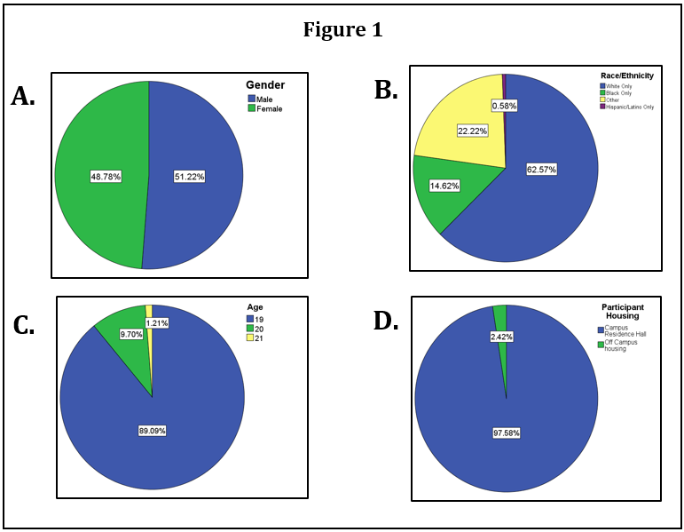
The sample population of college students in the Get Fruved research study is described in Figures 1 and 2. 51.22% of students were male and 48.78% were female as shown in Figure 1-A. The majority of the students were classified as white at 62.57%, with 22.22% classified as “Other”, 14.62% classified as “Black only”, and 0.58% classified as “Hispanic/Latino only” when asked to define their race/ethnicity as shown in Figure 1-B. As all of the participants were first-year university students, the age range was 19-21 years old, with 89.09% 19 years old, 9.7% 20 years old, and 1.21% 21 years old as shown in Figure 1-C. Figure 1-D shows the percentage of students living on campus, with the majority of students (97.58%) living in campus residence halls and the remaining few living in off campus housing.
Figure 1. University of Tennessee’s sample population defined according to gender (A), race/ethnicity (B), age (C), and housing (D)
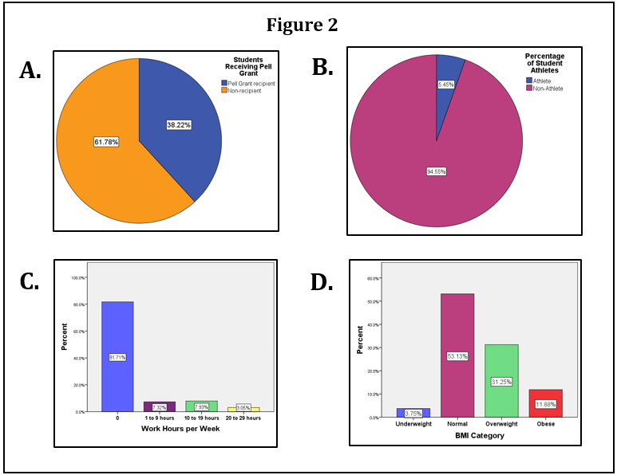
Figure 2-A shows that 38.22% of this population received a Federal Pell Grant. Only 5.45% of this population was considered a student athlete as shown in Figure 2-B. Figure 2-C indicates the hours of paid work per week. The majority of these students (81.71%) were unemployed, with 7.32% working up to 9 hours per week, 7.93% working up to 19 hours per week, and only 3.05% working up to 20 hours per week. In Figure 2-D, the participants are categorized by BMI as being underweight, normal, overweight, or obese with 3.75% of students underweight, 53.13% normal weight, 31.25% overweight, and 11.88% obese. The average BMI was 24.78 kg/m².
Figure 2. University of Tennessee’s sample population defined according to Pell Grant recipients (A), student athletes (B), hours worked per week (C), and BMI categories (D)

University of Tennessee Campus Environment
The results of the Healthy Campus Environmental Audits conducted at the University of Tennessee were compared to the average scores of multiple audits conducted at number of different universities. These audits were formatted and scored according to their adherence to the CDC Guidelines for Federal Concessions and Vending Operations on a scale of 0-60 based on availability, accessibility, price, quality of food, and how food was marketed. For overall campus dining, the University of Tennessee scored below average in the healthfulness of the fast food/café and dining hall/cafeteria/buffet categories, but scored above average in the healthfulness of sit down restaurants when compared to other campuses. For vending machines, UT scored above average in healthfulness of both the snack and beverage categories when compared to other universities nationally. Based on this data, there is a potential issue with the food environment offered at UT, particularly in dining services. These audits are important not only for assessing the healthiness of the UT campus environment, but also for comparing to how its students perceive the environment (reflected in the CEPS scoring).
The CEPS scores from this study reflect an objective assessment of the college environment in terms of total perception, total healthy food perception, total policy, and total vending. Table 2 shows the average CEPS scores for the sample population at the University of Tennessee are as follows: CEPS total=61.713, CEPS total policy=9.763, CEPS total food=13.284, and CEPS total vending=2.805.

Table 2. CEPS scores of University of Tennessee sample population according to constructs
 | CEPS total | CEPS total policy | CEPS total food | CEPS total vending
Mean | 61.713 | 9.763 | 13.284 | 2.805
Median | 62 | 10 | 15 | 3
Total Possible Points | 100 | 20 | 20 | 12

Influence on Eating Behavior
Figure 3 shows the reported food choice priorities and level of importance based on the 5-point Likert scale. Although there were other food choice priorities that were considered such as the influence of appearance of food, family influence, routine, impact on health, and advertising, most UT students reported that price, convenience, and taste had a significant impact on their food choices. For price, 42.6% of students reported that it was extremely important, 29% reported price as very important, 19.5% reported price as important, 8.9% reported price as slightly important, and 0% reported that price was not important at all in their food choices. Convenience of food for students was reported as 23.7% extremely important, 32.5% very important, 31.4% important, 11.8% slightly important, and 0.6% not important. Finally, taste of food was reported as 40.8% extremely important, 43.2% very important, 13.6% important, 1.8% slightly important, and 0.6% not important. These priorities in choosing certain foods at campus dining halls, stores, and restaurants may have had a positive or negative influence on how the students perceived their food environment.

Figure 3. Assessment of Food choice priorities of the University of Tennessee’s sample population according to importance

BMI and NCI F/V
The average BMI for this sample was 24.78 kg/m² and the average NCI F/V score, or number of servings of fruits and vegetables per day, was only 2.3148. A linear regression was conducted to determine if there was a relationship between BMI and fruit and vegetable intake. In the initial scatter plot shown in Figure 4, there seemed to be no relationship between the two. However, after looking at the distribution of NCI F/V scores, Figure 5 indicates that there were a number of significant outliers. In order to eliminate significant outliers within the dependent variable, NCI F/V scores greater than 7 were eliminated. After eliminating significant outliers, the linear analysis was rerun and there was a clear relationship. Figure 6 indicates a negative relationship between BMI and NCI F/V scores. In other words, as BMI increases, the number of servings of fruits and vegetables per day decreases. The relationship between BMI and NCI F/V score was significant with a Pearson correlation p-value of 0.003.

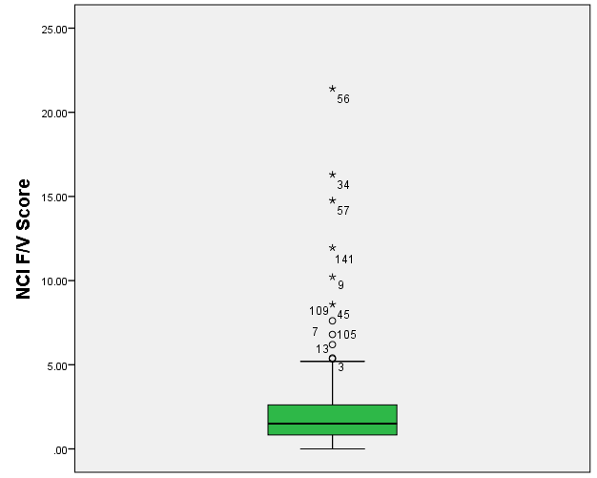
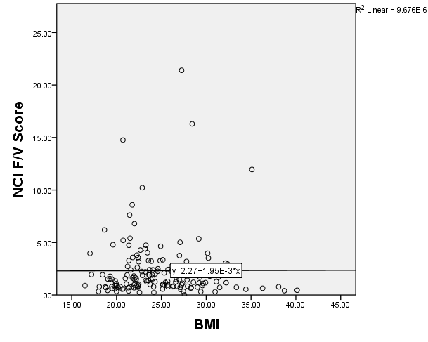
Figure 4. Linear regression for all reported BMIs. This graph shows that there is no linear relationship.
Figure 5. This boxplot shows that there are several outliers within the calculated NCI F/V scores.
Correlations
 |  | NCI F/V Score | BMI
Pearson Correlation | NCI F/V Score | 1.000 | .003*
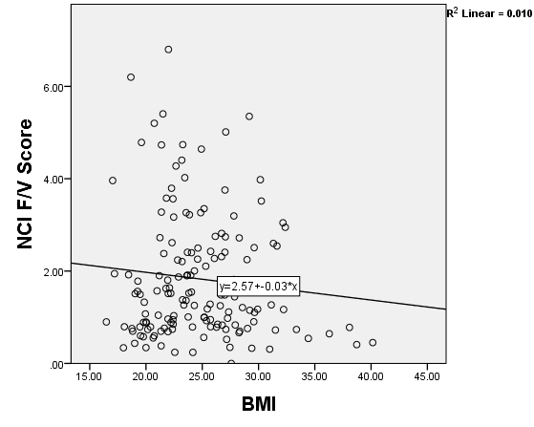
Table 3. Pearson correlation of NCI F/V score and BMI.
*Correlation is significant at 0.01 level
Table 3. Pearson correlation of NCI F/V score and BMI.
*Correlation is significant at 0.01 level

Figure 6. This linear regression shows the relationship between BMI and NCI F/V Score after eliminating outliers and including only NCI F/V scores less than 7.

CEPS and NCI F/V Score
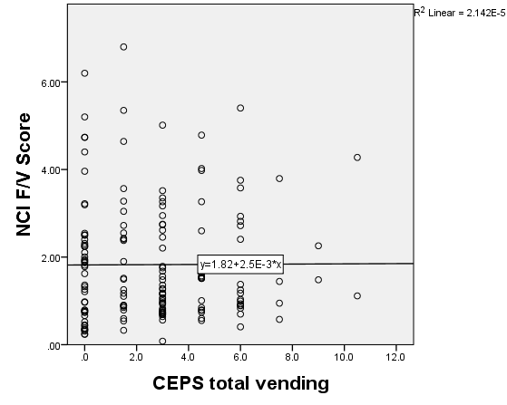
Simple linear regressions of NCI F/V in comparisons with CEPS total, food, and vending were run. These analyses were conducted in order to determine if fruit and vegetable intake was dependent on the perceived healthiness of campus environment. Significant outliers remained excluded from this test. In Figure 7, a positive relationship between CEPS total score and NCI F/V score was observed. Figure 8 shows a slightly negative relationship between CEPS total vending score and NCI F/V score. Figure 9 shows a clear positive relationship between CEPS total food and NCI F/V score. While all Pearson correlations were significant in a two-tailed test, CEPS total showed the strongest relationship with NCI F/V score with a p-value of 0.002. Table 4 indicates correlations and significance of all CEPS scores with NCI F/V scores.
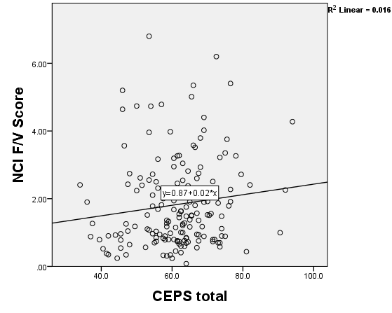

Figure 7. Linear regression of NCI F/V score in comparison with CEPS total score.
Figure 8. Linear regression of NCI F/V score in comparison with CEPS total vending score.

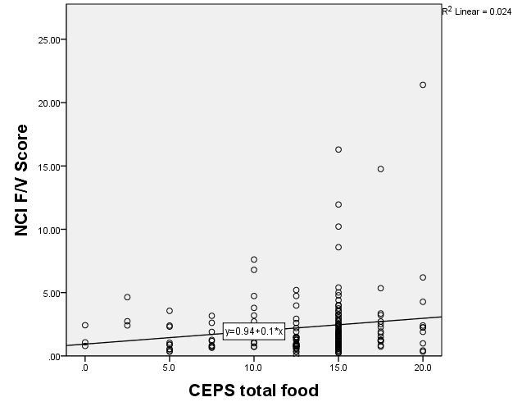

Table 4. Pearson correlation of NCI F/V score and CEPS totals.
* Correlation is significant at the 0.05 level (2-tailed)

Figure 9. Linear regression of NCI F/V score in comparison with CEPS total food score.
 |  | CEPS total | CEPS total food | CEPS total vending
NCI F/V Score | Pearson Correlation | .234 | .156 | .155
NCI F/V Score | Sig. (2-tailed) | .002* | .043* | .045*

Figure 7. Linear regression of NCI F/V score in comparison with CEPS total score.

CEPS and BMI
Simple linear regressions of BMI in comparison with CEPS total, food, and vending were run. These analyses were run in order to determine if the BMI of the University of Tennessee’s sample population was dependent on the perceived healthiness of campus environment. Significant outliers remained excluded from this test. Figure 10 shows a negative relationship between CEPS total and BMI. Figure 11 also shows a negative relationship between CEPS total food and BMI. Figure 12 shows a positive relationship between CEPS total vending and BMI. While all graphs indicate a clear positive or negative relationship with BMI, Table 5 shows that none of the Pearson correlations were significant and all p-values exceeded 0.05.

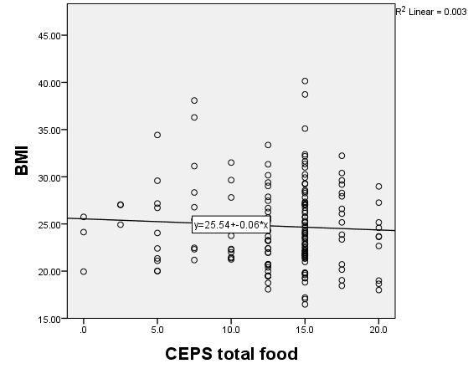
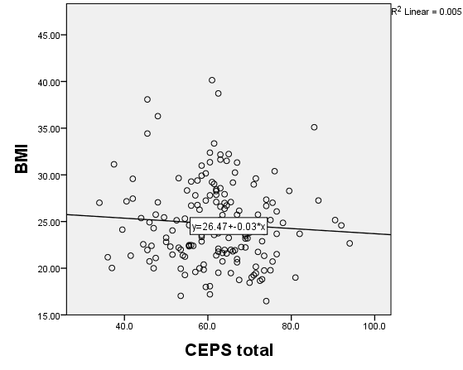
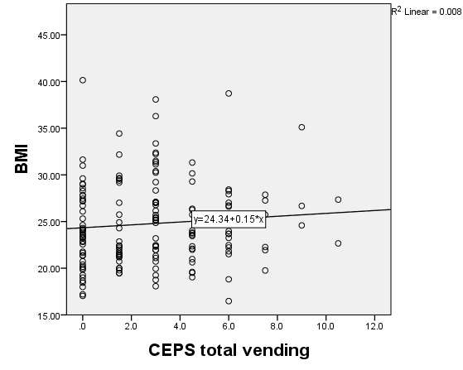
Figure 10. Linear regression of BMI in comparison with CEPS total score.
Figure 11. Linear regression of BMI in comparison with CEPS total food score.
 |  | CEPS total | CEPS total vending | CEPS total food
BMI | Pearson Correlation | -.069 | .087 | -.056
BMI | Sig. (1-tailed) | .193 | .138 | .240
Table 6. Pearson correlation between CEPS and food choice priorities
* Correlation is significant at the 0.05 level
Figure 12. Linear regression of BMI in comparison with CEPS total vending score.
CEPS and Food Choice Priorities
After determining the correlations of CEPS with BMI and NCI F/V score, bivariate correlations were run between CEPS and food choice priorities. Food choice priorities were convenience, taste, and price. Bivariate correlations were ran between each food choice priority and CEPS total, food, and vending. Table 6 shows Pearson correlations between food choice priorities and CEPS scores, and there were significant relationships between price and CEPS total as well as price and CEPS total food. Table 7 shows Kendall’s tau_b correlations between food choice priorities and CEPS scores. CEPS total food scores had a significant Kendall’s tau_b correlation with convenience, taste, and price. CEPS total score had a significant Kendall’s tau_b correlation with price.
Table 5. Pearson correlation of BMI and CEPS totals.
 | Convenience | Taste | Price
CEPS total | 0.101 | .152 | -0.02*
CEPS total food | 0.052 | 0.074 | -0.042*
CEPS total vending | 0.075 | 0.112 | -0.082

Table 7. Kendall’s tau_b correlation between CEPS and food choice priorities
* Correlation is significant at the 0.05 level

 | Convenience | Taste | Price
CEPS total | 0.074 | .141 | -0.006*
CEPS total food | 0.032* | 0.045* | -0.027*
CEPS total vending | 0.051 | 0.087 | -0.073

Food Choice Priorities and NCI F/V
Bivariate correlations were run between NCI F/V score and food choice priorities. Food choice priorities were price, taste, and convenience. Table 8 shows that there were no significant Pearson correlations between NCI F/V score and the three food choice priorities, and all p-values were greater than 0.05.

 |  | Price | Taste | Convenience
NCI F/V Score | Pearson Correlation | .120 | .077 | .070
NCI F/V Score | Sig. (2-tailed) | .121 | .322 | .367
NCI F/V Score | N | 169 | 169 | 169
Table 8. Pearson correlation between NCI F/V and food choice priorities

Discussion
Environmental Perceptions
When CEPS scores were correlated with BMI, NCI F/V score and Food choice priorities, there were several observed relationships. Overall, the higher the CEPS score, or the healthier the environment was perceived to be, the better the health behaviors. More specifically, as CEPS score increased, NCI F/V score increased, indicating a positive relationship between the two. This means that if individuals perceived their environment to be healthier, they most likely had higher daily fruit and vegetable intake.²⁰ In relationship to TPB,²⁰ a strong intention and greater confidence to eat healthy would lead to greater success in eating a healthy diet. If individuals had a positive perceived healthiness of their environment, it was more likely they would have greater confidence and greater success in maintaining a healthy diet on campus.
There was also a negative relationship observed between most of the CEPS scores and BMI. When perceived environment total and food score increased, BMI decreased. In other words, individuals who perceived their environment to be healthier most likely had a lower BMI. This also correlates with the TBP. If students had a stronger intention to eat healthier, they most likely had greater success managing their weight.²⁰ An increased CEPS score can be defined as having a positive view of the healthiness of the UT campus, which will therefore increase students’ intentions to adopt healthier eating habits. The only surprising relationship was the positive relationship between CEPS vending score and BMI. As perceived environment of healthy campus vending increased, BMI of participants increased.
Finally, we found several significant relationships between CEPS scores and food choice priorities, with price being the most significant determinant of food choice and campus environment perceptions. Our results indicated a significant negative correlation between price and CEPS, which means that as students perceived their environment as healthier, the importance of price decreased. This is surprising, because it is a common assumption that college students live on a tight budget. The studies by Greaney and Deliens showed that cost of food was a concern for most students,^{24,27} but the results of our study showed that price was not of great concern in relation to eating healthy. This may be because those who prioritized eating healthy were willing to pay more and they did not see price as the biggest barrier. Although our results contradict other evidence regarding the importance of price and perceived healthiness of campus, efforts should be made to make healthy foods more affordable and accessible for college students because it is possible that price was still an important barrier for those with the poorest dietary patterns. More research is needed to further explore those possible associations. CEPS total food score also had positive significant correlation with convenience and taste of food. This means that as students perceived campus food to be healthier, the importance of convenience and taste increased.
Based on the HCEA audits, there is a potential for improvement in the campus food environment, specifically in dining halls.³⁰ When considering students’ perceptions of their food environment, it is appropriate to conclude that a change or intervention could be targeted at improving taste and appearance of healthy food items while also providing convenience. This could include grab-n-go items at registers in the dining halls.

College obesity
For this particular sample, over 40% of students were overweight or obese. This number is much higher than National American College Health Assessment results for spring 2015 but reflect the inclusion criteria established for the larger grant project.⁹ The results of this study indicated that increased fruit and vegetable intake was associated with a lower BMI. We can interpret this as students who ate more fruits and vegetables were more likely to have a lower BMI. This is not surprising, as higher fruit and vegetable intake is associated with a healthier diet and better health outcomes according to the Dietary Guidelines.¹²
The relationship observed with BMI and CEPS scores may be very useful when attempting to improve overall wellness of UT students. Students who perceived a healthier campus environment had a lower BMI. Therefore, once changes are made to improve the healthiness of campus and healthy foods are more readily available, health status of students may gradually increase.

Food Choice Priority
For this particular sample, price, convenience, and taste were of highest importance in food choice priorities. The goal of assessing food choice priorities was to improve the campus environment based on the needs of the majority of students. With price being one of the most important factors influencing food choice, campus interventions should focus on making healthy food on campus more affordable. This might be done by reducing the amount of processed snack foods available on campus and replacing them with healthier items in dining halls and campus grocery stores. Since purchasing food in bulk can reduce the overall cost, by purchasing more healthy foods, the costs of fresh foods should decrease and healthy foods would be more accessible.
We also found taste to be extremely important when it comes to food choice of college students. From the qualitative studies by Greaney and Deliens,^{24,27} one chief complaint of students was that healthy foods did not always taste as good or were not as satisfying as other foods available on campus. While this statement is rather obvious, intervention is necessary to educate students on how they can prepare healthy foods and make them taste just as good as other less healthy items. While it is difficult to appeal to every student’s particular food preferences, efforts can be made to inform the students on how they can incorporate healthy foods into their diet and make them taste good.
Convenience of food was also an important food choice priority for UT students. While the UT campus offers several dining locations, food stores, and campus vending for students, interventions to make the food options at these locations healthier is necessary if we want to improve the campus’s overall health status. Healthy snacks and meals should be offered in every dining venue and several healthy items should be made to-go or portable, in order to adjust for the busy lifestyle of a college student.
Although there was no significant relationship between food choice priorities and NCI F/V score, the overall results of this analysis indicate that it is important for all campus dining venues to offer a variety of healthy foods at more reasonable prices. While addressing the taste of healthy foods in interventions can be challenging, one approach would be to educate students on different ways to prepare the healthy foods to make them more appealing.

Strengths
There were several strengths of this research study. Data collection from this study utilized a number of validated tools such as the NCI F/V screener and CDC BMI recommendations, and several tools currently being validated were also used such as CEPS and FCP. The Healthy Campus Environmental Audits allowed for comparison of perceived campus healthiness with actual healthfulness of the environment.

Limitations
While this study did present valid evidence, there were a few limitations with the data collected. There was a lack of diversity in this particular sample of UT students, as more than half were white and less than 1% were Hispanic/Latino. For this reason, the sample population used for data collection at UT may not be generalizable to other campuses across the country. Another limitation is the fact that the nutrition tools may have a social desirability bias. In other words, students may have not honestly answered the survey questions regarding nutrition because their actual health behavior patterns were not considered healthy. Another factor that was not addressed in this research study was previous nutrition knowledge. Since this study was conducted in the Department of Nutrition at UT, it is possible that some participants may have had a particular interest or academic focus in the field of nutrition or health sciences. By obtaining information on previous nutrition knowledge, this study could have possibly eliminated any other significant outliers in order to focus specifically on the general population of students on campus. However, these participants were beginning their first year at college and thus previous formal nutrition education exposures may have been limited. There were also some major outliers in the data collected from the NCI F/V screener. Although these were accounted for in assessing variable relationships, these outliers may have contributed to a decreased power for the statistical analyses. Finally, while the Likert scale seemed to be a good option for assessing Food Choice Priority, ranking importance is often difficult or overlooked in assessments by college age students. A ranking system may have been more appropriate for measuring this particular variable and there may have been more observed significance when correlated with NCI F/V and CEPS variables.

Conclusion
This study found several significant relationships regarding the influence of campus environment on eating behaviors, environmental perceptions, and overall dietary intake of students on the University of Tennessee’s campus. By assessing students’ perception of the University of Tennessee’s healthiness, several factors such as cost of food, convenience, and taste were recognized as influential to student health behaviors and eating patterns. Additionally, we found that UT students who already consumed a healthy diet rich in fruits and vegetables, had a lower BMI and also perceived the UT campus to be much healthier. In order to increase health and wellness on the UT campus, it is important that the university consider the environmental perceptions and food choice priorities observed in this study and strive to improve campus dining and adopt new policies to promote healthy eating of students.

References
- Ogden CL, Carroll MD, Kit BK, Flegal KM. Prevalence of childhood and adult obesity in the United States, 2011-2012. JAMA. 2014;311:806–14.
- Centers for Disease Control and Prevention. Defining Adult Overweight and Obesity. CDC Website. http://www.cdc.gov/obesity/adult/defining.html. Published April 27, 2012. Accessed March 10, 2016.
- Office of the Surgeon General (US); Office of Disease Prevention and Health Promotion (US); Centers for Disease Control and Prevention (US); National Institutes of Health (US). The Surgeon General's Call To Action To Prevent and Decrease Overweight and Obesity. Rockville (MD): Office of the Surgeon General (US); 2001. Available from: http://www.ncbi.nlm.nih.gov/books/NBK44206/
- Rubenstein AH. Obesity: A modern epidemic. Trans Am Clin Climatol Assoc. 2005;116:103–11.
- Centers for Disease Control and Prevention. Adult Obesity Causes and Consequences. CDC Website. http://www.cdc.gov/obesity/adult/causes.html. Published June 16, 2015. Accessed March 3, 2016.
- Allison DB, Fontaine KR, Manson JE, Stevens J, VanItallie TB. Annual deaths attributable to obesity in the United States. JAMA. 1999;282(16):1530–8.
- Sparling PB. Obesity on campus. Prev Chronic Dis. 2007 Jul. Available from: http://www.cdc.gov/pcd/issues/2007/jul/06_0142.htm.
- Centers for Disease Control and Prevention. Obesity and Overweight. CDC Website. http://www.cdc.gov/nchs/fastats/obesity-overweight.htm. Published January 21, 2014. Accessed March 10, 2016.
- American College Health Association. American College Health Association-National College Health Assessment II: Reference Group Executive Summary Spring 2015. Hanover, MD: American College Health Association; 2015.
- Mokdad AH, Ford ES, Bowman BA, Dieta WH, Vinicor F, Bales VS, et al. Prevalence of obesity, diabetes and obesity-related health risk factors. JAMA. 2001;289(1):76-9.
- Lloyd-Richardson EE, Bailey S, Fava JL, Wing R. A Prospective Study of Weight Gain During the College Freshman and Sophomore Years. Preventive medicine. 2009;48(3):256-261.
- U.S. Department of Health and Human Services and U.S. Department of Agriculture. 2015 – 2020 Dietary Guidelines for Americans. 8th Edition. December 2015. Available at http://health.gov/dietaryguidelines/2015/guidelines/.
- Hartman H, Wadsworth DP, Penny S, van Assema P, Page R. Psychosocial determinants of fruit and vegetable consumption among students in a New Zealand University: Results of focus group interviews. Appetite. 2013; 65:35–42
- Snyder TD, Dillow SA. Digest of Education Statistics 2011 (NCES 2012). National Center for Education Statistics, Institute of Education Sciences, U.S. Department of Education. Washington, DC.
- Arnett JJ. Emerging adulthood, a theory of development from the late teens through the twenties. Am Psych. 2000;55:469-480.
- Nelson MC, Story M, Larson NI, Neumark‐Sztainer D, Lytle LA. Emerging adulthood and college‐aged youth: an overlooked age for weight‐related behavior change. Obesity. 2008;16(10):2205-11.
- Racette SB, Deusinger SS, Strube MJ, Highstein GR, Deusinger RH. Weight changes, exercise, and dietary patterns during freshman and sophomore years of college. J Am Coll Health. 2005;53:245-251.
- Mihalopoulos N.L., Auinger P., Klein J.D. The freshman 15: is it real? J. Am. Coll. Health. 2008;56:531–533.
- Vella-Zarb R.A., Elgar F.J. The ‘freshman 5’: a meta-analysis of weight gain in the freshman year of college. J. Am. Coll. Health. 2009;58:161–166.
- Ajzen I, Madden T. Prediction of Goal-Directed Behavior: Attitudes, Intentions, and Perceived Behavioral Control. J Exper Soc Psych. 1986;22:453-474.
- Boyle, JR, LaRose, NR. Personal beliefs, the environment and college students' exercise and eating behaviors. American Journal of Health Studies. 2008;23(4):195-200.
- Armitage CJ, Conner M. Distinguishing Perceptions of Control From Self-Efficacy: Predicting Consumption of a Low-Fat Diet Using the Theory of Planned Behavior. Journal of Applied Social Psychology. 1999;29:72-90.
- Tseng M, DeGreef K, Fishler M, Gipson R, Koyano K, Neill DB. Assessment of a University Campus Food Environment, California, 2015. Prev Chronic Dis. 2016;13:150455.
- Greaney ML, Less FD, White AA, Dayton SF, Riebe D, Blissmer B, et al. College students' barriers and enablers for healthful weight management: a qualitative study. J Nutr Educ Behav. 2009;41(4):281–286.
- Kolodinsky J, Harvey-Berino JR, Berlin L, Johnson RK, Reynolds TW. Knowledge of current dietary guidelines and food choice by college students: better eaters have higher knowledge of dietary guidance. J Am Diet Assoc. 2007;107(8):1409–1413
- Croll JK, Neumark-Sztainer D, Story M. Healthy Eating: What Does It Mean to Adolescents? Journal of Nutrition Education. 2001;33:193.
- Deliens T, Clarys P, De Bourdeaudhuij I, Deforche B. Determinants of eating behaviour in university students: a qualitative study using focus group discussions. BMC Public Health. 2014;14:53.
- National Cancer Institute. Scoring the All-Day Screener. 2010 Available at: http://riskfactor.cancer.gov/diet/screeners/fruitveg/scoring/allday.html.
- Horacek TM, Byrd-Bredbenner C, Colby SE, et al. Assessment of the dining environment on and near the campuses of 15 post-secondary institutions. Public Health Nutrition. 2013;16(7):1186-1196.
- Horacek T, Szklany K, Byrd-Bredbenner C, Shelnutt K, Morrell J, Kattlemann K. P2 development and testing of a Healthy Campus Environmental Audit and the LEAN index. J Nutr Educ Behav. 2011;43:S21.

