Nighttime Pedestrian Safety in Burdened Communities: Application of Artificial Intelligence Techniques

Sheikh M. Usman
Graduate Research Assistant
Department of Civil & Environmental Engineering,
The University of Tennessee, TN, 37996, USA
susman1@vols.utk.edu

Asad J. Khattak
Beaman Professor & Transportation Program Coordinator
Department of Civil & Environmental Engineering,
The University of Tennessee, TN, 37996, USA
akhattak@utk.edu

A. Latif Patwary
Postdoctoral Research Associate
Transportation Analytics & Decision Sciences Group,
Oak Ridge National Laboratory, Oak Ridge, TN, 37830, USA
patwarya@ornl.gov
Word Count: 5920 words text + 6 tables x 250 words (each) = 7420 words
ABSTRACT
Pedestrian safety is a growing concern in the US transportation sector, with around 7500 pedestrian crash fatalities reported in 2021. Already highly susceptible to traffic crashes, pedestrians are at an even higher risk of crashes at night. This study integrates six unique transportation burden indicators—Economy, Health, Equity, Resilience, Environmental, and Transportation Access—developed by the United States Department of Transportation at the census tract level with nighttime pedestrian crash data from 2016-2019 in North Carolina. The pedestrian crash data are extracted from police reports using the Pedestrian and Bicyclist Crash Analysis Tool, which provides high-quality detailed crash-type descriptors, resulting in a unique and comprehensive pedestrian crash database. The study applies rigorous methods for analysis, including the inference-based ordered logit model, to quantify key correlates of nighttime pedestrian crashes in burdened communities (BCs). The model results reveal unique and novel associations of the Economy and Transportation Burden indicators, roads without lights, pedestrian crossing violations, and alcohol impairment with nighttime pedestrian crash injury severity. To improve forecasting of pedestrian crashes and the resulting injury severity in BCs for planning purposes, an Artificial Intelligence (AI) based heterogeneous ensemble method, “Stacking,” is applied with an Ordered Logit model and machine-learning techniques, Gradient Boosting, Decision Tree, and Random Forest as the base learners. The stacked model yields better predictive accuracy than the individual base learners. The study findings and the application of AI techniques can assist safety practitioners in improving planning and implementing targeted interventions in BCs to improve roadway infrastructure and overall safety.

Keywords: Pedestrian Crash, Injury Severity, Burdened Communities, Heterogeneous Ensemble Methods, Stacking.
- INTRODUCTION
In the United States, pedestrian fatalities have risen in the recent past, with an increase of more than 50% from 2009 to 2019, with more than 85% of those pedestrian fatalities occurring at night (1). Around 75% of pedestrian fatalities occurred at night in 2019, while total pedestrian fatalities in traffic crashes were estimated to be about 7500 in 2021, the highest in the last four decades (2). Although the United States Department of Transportation (USDOT) is motivated to achieve its ambitious target of zero traffic fatalities and severe injuries by 2050 (Vision Zero Goal), the recent pedestrian crash statistics indicate that considerable efforts must be made to accomplish this. One such effort is the development of the National Roadway Safety Strategy (NRSS) by the USDOT to promote safe driving practices, equip vehicles with advanced safety technologies, develop safe transportation infrastructure, and identify historically marginalized populations that bear a disproportionate burden of traffic crashes (3). The US government allocates funds every year for safety improvements. Those funds should be equitably distributed to burdened communities. The Justice40 initiative aims to deliver at least 40% of federal investments in clean energy, climate, and transportation to burdened communities (BCs) to promote social justice and racial equity (4). This initiative requires the USDOT to identify the historically underserved communities for prioritizing targeted interventions to bridge the gaps in transportation infrastructure and promote a safe, affordable, and equitable transportation system. The USDOT has defined communities marked with a lack of transportation infrastructure, low income, low level of education attainment, adverse impacts of climate change, etc., as BCs by collecting data for 22 socioeconomic indicators at the census tract level and classifying them into six broad themes of transportation burden. The census tracts are designated as burdened regarding transportation access, economy, health, resilience, equity, and environment and can be accessed through an interactive, comprehensive dashboard developed by the USDOT. The availability of this unique data provides new research pathways to explore the relationship between the transportation-burden indicators and pedestrian crash injury severity through statistical modeling and novel ML techniques.
This study investigates the association of the six unique indicators of transportation-burdened communities and the conventional crash contributing factors (vehicle, driver, pedestrian, and roadway characteristics) with nighttime pedestrian crash injury severity by applying an inference-based Ordered Logit model. Furthermore, for accurate forecasting of pedestrian crashes and the resulting injury severity for effective planning and infrastructure improvements, the study applies a heterogenous ensemble method (HEM) known as “Stacking.” The study reflects one of USDOT’s top priorities, safety in burdened communities, and aligns with the Safe Systems Approach by addressing the safe users and safe road infrastructure components. The study findings can assist federal and state policymakers and safety practitioners in implementing more effective pedestrian safety countermeasures tailored to meet the specific requirements of BCs.
- LITERATURE REVIEW
Many studies have explored various aspects of nighttime pedestrian safety, including the absence of road lights (5), consumption of alcohol or drugs by pedestrians or drivers (6–8), pedestrian crashes with large trucks and SUVs (9, 10), at mid-blocks, straight road segments, multilane roads, and roads with posted speed limits of 45-50 mph (11–13) resulting in serious and fatal injuries. However, exploring the disparities in pedestrians’ sociodemographic, socioeconomic, and racial attributes is important to understand their impact on pedestrian crash injury severity in BCs. Studies have found that pedestrian crashes in the US are linked to a higher population density, a greater number of people aged 15-64 years, and an increase in pedestrians who walk in pedestrian-unfriendly areas (14). Another study focused on the racial and ethnic division among pedestrians in the US found that Black and Native American pedestrians are more likely to suffer fatal injuries in nighttime pedestrian-vehicle crashes than White pedestrians, with a higher percentage of fatalities 79% and 83%, respectively (15). Parametric statistical models were widely used for pedestrian injury severity analysis in these studies, including the Multinomial Logit, Ordered Logit and Probit, Mixed logit, and Partial Proportional Odds models. However, the predictive accuracy of statistical models is usually lower than ML models due to the inherent restrictions on model specifications in these models. Unlike statistical models, machine learning methods offer more flexibility in model specifications and are better suited for capturing complex nonlinear relationships in crash data modeling (16). While ML methods generally offer higher prediction accuracy than statistical models, they explicitly address the bias-variance trade-off, with different approaches minimizing either bias or variance (17). Hence, relying solely on a single supervised or unsupervised ML method may lead to less accurate predictions. More robust and diverse HEM can be utilized to enhance further the prediction performance of ML methods (18). Heterogeneous ensembles, such as stacking, use various feature selection algorithms (e.g., Ordered logit, Decision Tree, Random Forest, and Gradient Boosting), where a stacking meta-learner combines the optimal predictions from the individual models, also called base-learners, acting as a single decision-maker in the second stage (19). Studies suggest that heterogeneous ensembles outperform conventional statistical models and other ML methods, demonstrating superior prediction performance (17, 20).
Notably, applying heterogeneous ensembles (stacking) to predict nighttime pedestrian crash injury severity is new and novel. Importantly, nighttime pedestrian safety in BCs was also not studied previously. This study addresses the existing gaps in the literature by applying the inference-based Ordered models and a rigorous and robust heterogeneous ensemble (stacking) approach to accurately forecast nighttime pedestrian crash injury severity resulting from vehicle-pedestrian crashes in transportation-burdened census tracts in North Carolina.
3. DATA DESCRIPTION
This study uses two datasets for analysis. Nighttime pedestrian crash information from 2016-2019 for the state of North Carolina is obtained from police-reported crash data coded by a comprehensive tool known as the Pedestrian and Bicycle Crash Analysis Tool (PBCAT). The key variables present in the PBCAT database include driver and pedestrian sociodemographic details (e.g., age, gender, and race), driver and pedestrian impairment (due to alcohol or drugs), the position of pedestrians at the time of a crash, roadway factors (roadway types/classes, and configuration), lighting conditions, speed limit, land use, etc. (independent variables). The injury severity of both pedestrians and drivers is reported on a five-level KABCO injury classification scale. However, given the scope of the present study, only the pedestrian injury severity is selected as the dependent variable for the analysis.
This study integrates the burdened communities’ indicators data, launched as an interactive dashboard by the US Department of Transportation, with the pedestrian crash dataset. These indicators address six broad themes of transportation burdens: economy, environment, equity, health, resilience, and transportation. A brief description of these themes is provided below:

3.1 Economic Burden
This theme identifies communities affected by high poverty, low-income levels, low education status, insufficient local jobs, disproportionate distribution of resources, and low homeownership. Economic challenges may result in a higher concentration of older vehicles with outdated safety features, limited or no access to driver education programs and training, lack of pedestrian-specific infrastructure, etc.

3.2 Environmental Burden
This theme identifies communities that suffer from irregularly high hazardous emissions and inferior environmental quality. These communities are more vulnerable to traffic crashes in fog, smog, or high pollution due to limited/insufficient visibility.

3.3 Equity Burden
This theme identifies communities where a high percentile of the population’s English-speaking skills are not satisfactory. Limited English proficiency can lead to communication barriers, making it difficult for residents to comprehend traffic signs, road safety guidelines, etc. Misinterpretation of traffic rules may result in unsafe driver/pedestrian behaviors and an increased risk of crashes.

3.4 Health Burden
This theme identifies communities with poor health conditions, disabilities, and environmental exposures. These communities have limited access to healthcare and emergency response services which can result in delayed or inadequate medical attention after a crash, adversely impacting the chances of recovery for those injured.

3.5 Resilience Burden
This theme identifies communities more likely to be affected adversely by climate change. Resilience-burdened census tracts are more prone to natural calamities, such as flooding or landslides, which can create hazardous driving conditions.

3.6 Transportation Access Burden
This theme identifies communities affected by more costly and slow means of transportation. These communities are often heavily dependent on personal vehicles due to limited access to public transportation and travel longer distances to access essential services or job opportunities. Higher commute times can lead to driver fatigue and an elevated risk of crashes.

Data for these six unique indicators are based on the Center for Disease Control (CDC) Social Vulnerability Index, Census America Community Survey, Environmental Protection Agency (EPA) Smart Location Map, Housing and Urban Development (HUD) Location Affordability Index, EPA Environmental Justice Screening, Federal Emergency Management Agency (FEMA) Resilience Analysis & Planning Tool, and FEMA National Risk Index for the year 2018 (21). Each theme’s relevant indicators are averaged to form an aggregated burden indicator. Using the crash location in the pedestrian crash dataset, the indicators of burdened communities are obtained from USDOT’s interactive dashboard for transportation-burdened census tracts in North Carolina and included in the pedestrian crash dataset as indicator variables having values of 1 and 0. The census tracts that are burdened in terms of four or more themes of BCs are considered overall burdened. A total of 2,620 crash records were obtained initially. However, some of the crash observations had many missing or unknown values. After removing the crash observations with missing values, the final dataset contained 2329 nighttime pedestrian crash observations. The descriptive statistics of the study variables are presented in Table 1.
TABLE 1: Results of Descriptive Statistics of Key Variables
Variables | Descriptive Statistics (N = 2,329)
Pedestrian Injury Severity (Dependent Variable) | Frequency | Percentage % | Min | Max
No injury (O) | 90 | 3.86 | 0 | 1
Possible Injury (C) | 656 | 28.17 | 0 | 1
Minor injury (B) | 882 | 37.87 | 0 | 1
Incapacitating/Serious Injury (A) | 352 | 15.11 | 0 | 1
Fatal Injury (K) | 349 | 14.98 | 0 | 1
Burden Indicators
Transportation Access Burden Indicator
Crashes in Transportation Access BCs | 1246 | 53.50 | 0 | 1
Crashes in All Other BCs | 1083 | 46.50 | 0 | 1
Health Burden Indicator
Crashes in Health BCs | 1670 | 71.70 | 0 | 1
Crashes in All Other BCs | 659 | 28.30 | 0 | 1
Economy Burden Indicator
Crashes in Economy BCs | 2110 | 90.60 | 0 | 1
Crashes in All Other BCs | 219 | 9.40 | 0 | 1
Equity Burden Indicator
Crashes in Equity BCs | 1096 | 47.06 | 0 | 1
Crashes in All Other BCs | 1233 | 52.94 | 0 | 1
Resilience Burden Indicator
Crashes in Resilience BCs | 726 | 31.17 | 0 | 1
Crashes in All Other BCs | 1603 | 68.83 | 0 | 1
Environment Burden Indicator
Crashes in Environmental BCs | 1554 | 66.72 | 0 | 1
Crashes in All Other BCs | 775 | 33.28 | 0 | 1
Overall Burden Indicator
Crashes in Overall BCs | 1252 | 53.76 | 0 | 1
Crashes in Non-Overall BCs | 1077 | 46.24 | 0 | 1
Driver Gender
Male Drivers | 1468 | 63.03 | 0 | 1
Female Drivers | 861 | 36.97 | 0 | 1
Driver Age
Drivers aged less than 25 years | 443 | 19.02 | 0 | 1
Drivers aged 25-60 years | 1484 | 63.72 | 0 | 1
Drivers aged above 60 years | 402 | 17.26 | 0 | 1
Alcohol/Drug use
Driver alcohol/drug use | 102 | 4.38 | 0 | 1
Pedestrian alcohol/drug use | 630 | 27.05 | 0 | 1
Both driver and pedestrian alcohol/drug use | 46 | 1.98 | 0 | 1
No alcohol/drug use | 1551 | 66.59 | 0 | 1
Pedestrian Gender
Male Pedestrians | 1618 | 69.47 | 0 | 1
Female Pedestrians | 711 | 30.53 | 0 | 1
Pedestrian Age
Pedestrians aged less than 25 years | 534 | 22.93 | 0 | 1
Pedestrians aged 25-60 years | 1539 | 66.08 | 0 | 1
Pedestrians aged above 60 years | 256 | 10.99 | 0 | 1
Pedestrian Race
Asian | 33 | 1.42 | 0 | 1
Black | 1010 | 43.37 | 0 | 1
Hispanic | 165 | 7.08 | 0 | 1
Native American | 42 | 1.80 | 0 | 1
White | 1079 | 46.33 | 0 | 1
Crash Location
Intersection | 540 | 23.19 | 0 | 1
Non-intersection | 1535 | 65.91 | 0 | 1
Intersection related | 254 | 10.91 | 0 | 1
Type of Vehicle
Commercial Bus | 499 | 21.43 | 0 | 1
Motorcycle | 17 | 0.73 | 0 | 1
Passenger Car | 1280 | 54.96 | 0 | 1
Truck/Trailer | 66 | 2.83 | 0 | 1
SUV | 467 | 20.05 | 0 | 1
Lighting Conditions
Roadway with Lights | 1116 | 47.92 | 0 | 1
Roadway without lights | 1213 | 52.08 | 0 | 1
Weather Conditions
Clear | 1713 | 73.55 | 0 | 1
Cloudy | 286 | 12.28 | 0 | 1
Fog | 21 | 0.90 | 0 | 1
Rain | 288 | 12.37 | 0 | 1
Snow | 21 | 0.90 | 0 | 1
Roadway Functional Classification
Interstates | 54 | 2.32 | 0 | 1
Major Arterial | 552 | 23.70 | 0 | 1
Minor Arterial | 260 | 11.16 | 0 | 1
Collector Roads | 165 | 7.08 | 0 | 1
Local Roads | 1298 | 55.73 | 0 | 1
Position of Pedestrian
In Travel Lane | 1750 | 75.14 | 0 | 1
At Crosswalk | 316 | 13.57 | 0 | 1
At intersection | 35 | 1.50 | 0 | 1
Paved Shoulder | 93 | 3.99 | 0 | 1
Sidewalk | 27 | 1.16 | 0 | 1
Unpaved Right of Way | 108 | 4.64 | 0 | 1

All the crash-related variables used for analysis in this study were categorical. Hence, the reported descriptive statistics in Table 1 include the crash frequencies and percentages associated with the categories of the categorical variables. Of 2,329 crashes at night, 37.87% resulted in minor injuries to pedestrians, while serious and fatal injuries accounted for 15.11% and 14.98% of crashes. Most of the crashes occurred in economy-burdened census tracts (90.60%), followed by health (71.70%) and environment-burdened (66.72%). Male drivers were mostly involved in pedestrian crashes at night (63.03)% while male pedestrians mostly experienced crashes at night (69.47%) compared to their female counterparts (30.53%). Pedestrian crashes in which neither the driver nor the pedestrian was impaired with alcohol/drugs were the most frequent (66.59%), followed by crashes involving impaired pedestrians only (27.05%). Drivers alone were found to be impaired with alcohol/drugs in 4.38% of crashes, while only 1.98% of crashes involved the impairment of the driver and the pedestrian both. Among different racial groups, White pedestrians experienced most of the crashes at night (46.33%), followed by Black (43.37%), Hispanic (7.08%), Native American (1.80%), and Asian (1.42%) pedestrians. Most crashes involved collisions with passenger cars (54.96%), while collisions with commercial buses and sport utility vehicles (SUVs) were 21.43% and 20.05%, respectively. A high percentage of crashes was observed on roads without lighting arrangements (51.22%) compared to roads with road lights (47.92%). Pedestrian crashes in clear weather were the most frequent (73.55%) compared to adverse weather conditions like rain (12.37%), fog (0.90%), and snow (0.90%). Most crashes occurred on local roads (55.73%), followed by major arterials (23.70%), minor arterials (11.16%), collectors (7.08%), and interstates (2.32%). Most pedestrian crashes occurred when pedestrians were in the travel lane at the time of a crash (75.14%), indicating pedestrian crossing violations. In comparison, only 13.57% of crashes occurred when pedestrians were at crosswalks. This difference in frequency indicates the higher risk of pedestrian crashes involved with crossing violations.
4. METHODOLOGY
A frequentist inference-based ordered model is estimated to explore the correlates of nighttime crashes. A stacking approach is adopted for prediction, combining the predictions of four base learners (Ordered Logit, Decision Tree, Random Forest, and Gradient Boosting Model). A description of the stacking framework, the individual models, and performance measures for the models is provided in the subsequent sections.
4.1 STACKING
Stacking represents a HEM that combines the output of multiple classification models using a meta-classifier also called a super-learner (22). Typically, it consists of two layers. Individual classification models are trained on the complete training set in the first layer. In the second layer, the meta-classifier is fitted based on the outputs of the first layer’s models. The final result is the output of the meta-classifier. This framework allows the integration of various methods’ advantages to enhance classification performance. Figure 1 represents a visual illustration of the study methodology.

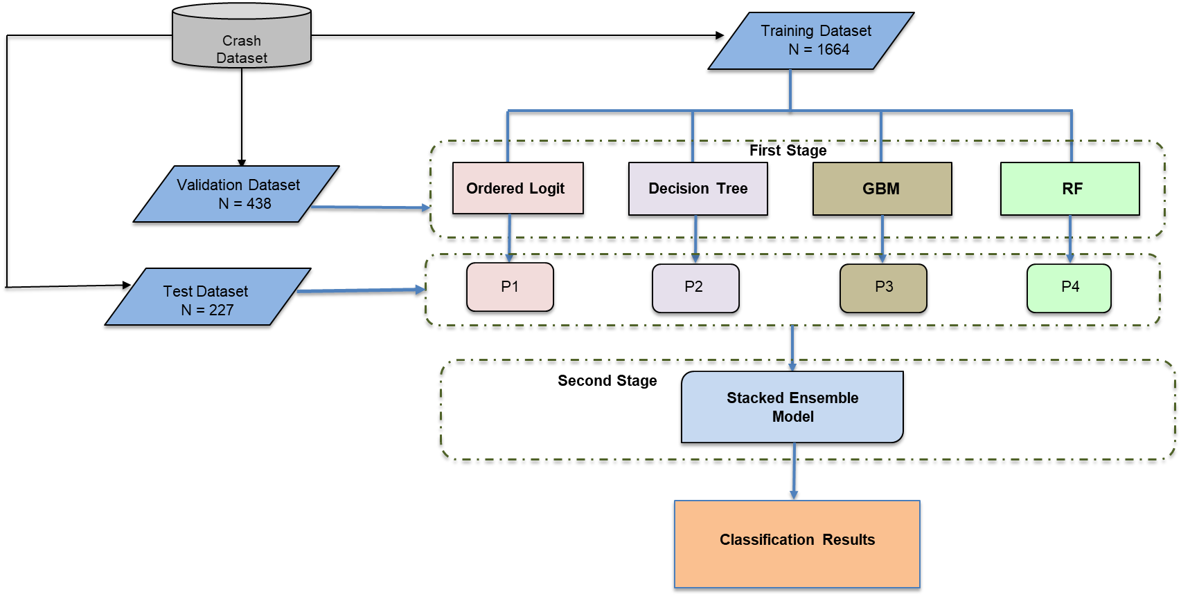
Figure 1: Visual Illustration of Stacking Methodology
4.2 Ordered Logit Model
The ordered Logit Model is appropriate for modeling a categorical response variable whose outcomes possess some intrinsic ranking. The formulation of the ordered logit model is provided in Equation 1.

Logit[P(Y≤j)] = α_{j} + β₁x₁+ β₂x₂+ β₃x₃+⋯+β_{n}x_{n} = α_{j} + β’X (1)

Equation 1 indicates that for different categories j of the response variable Y, the effect of explanatory variables x₁, x₂, …, x_{n} is captured by a single coefficient β, which is important in interpreting this model.
4.3 Decision Tree
The decision tree algorithm readily divides the training data repeatedly into smaller subsets based on minimizing the Gini impurity (23). Gini impurity quantifies the probability of misclassifying a randomly chosen data point from the node. Mathematically, the Gini impurity of a node with multiple classes (C) is given in Equation 2.
Gini impurity = 1 - ∑(p_{i})² (2)
p_{i} is the probability of a data point belonging to class i in the node.
A fully grown decision tree is usually prone to overfitting and has poor generalizing capabilities (24). The tree is pruned to prevent overfitting. Pruning refers to the process of simplifying the tree structure by removing some nodes from the tree to prevent it from capturing random noise.
4.4 Gradient Boosting Decision Tree
Friedman introduced Gradient Boosting (GB) in 2001 (25). GB is a widely applied method to optimize parameters and improve model performance, achieved by updating parameters in the gradient descent direction of the previous model’s loss function. The loss function is used to evaluate model performance, with a smaller value indicating better performance. Gradient Boosting Decision Tree (GBDT) jointly makes decisions by iterating through multiple decision trees. Each decision tree learns the residuals of all previous trees and fits a current decision tree. Iterations continue until a predefined number of trees are built or a specific stopping criterion is met. The final result accumulates all the decision trees generated throughout the iteration.
4.5 Random Forest
Breiman proposed a machine-learning algorithm called Random Forest (RF) in 2001 (26). It builds an ensemble of decision trees using the bootstrap sampling method, which repeatedly selects training sets from the original data with replacement. Using a bagging technique, random operations are used in selecting sample subsets to create training sets from the original samples. Bagging is used again to select subsets of features from the entire set. Additionally, the importance of each feature can be ranked based on its contribution to the final decision. Incorporating random operations in the random forest greatly improves its classification performance. (27–32).

4.6 Performance Measures
Four performance measures are used to evaluate the predictive performance of the statistical and ML models using the test dataset as a holdout sample in this study. These measures include accuracy, precision, recall, and F1 score.
4.6.1 Accuracy
Classification accuracy is the ratio of correctly classified observations by the model to the total number of observations in the dataset. It can be calculated using Equation 1.
Accuracy = Number of correctly classified events (6)
Total number of events
4.6.2 Precision
Precision for a specific class of the response variable is the ratio of the correctly classified events in a class to the total number of events classified in that class. Precision is obtained using Equation 2.

Precision = Number of correctly classified events in a class (7)
Total events (Correct and Incorrect) classified in the class
4.6.3 Recall
Recall for a specific class of the response variable is the ratio of the correctly classified events in a class (True positives) to the sum of the correctly and incorrectly classified events related to the target class (True positives + False negatives). Recall is obtained from Equation 3.
Recall = Number of correctly classified events in a class (True positives) (8)
True positives + False negatives
4.6.4 F1 Score
The F1 score considers both precision and recall in the model’s performance evaluation and provides a balanced overall model performance measure. The higher the F1 score of a class, the better the predictive performance of the model specific to that class. The F1 score is calculated using Equation 9.
F1 Score = 2 * Precision * Recall (9)
Precision + Recall
5. DISCUSSION OF STUDY FINDINGS
5.1 Inference-Based Analysis
The pedestrian crash dataset was split into three sets in a 70:20:10 proportion. The training dataset consisting of around 70% of the data (N_{train} = 1664) was used to train the individual base learners, while approximately 20% of the data (N_{val} = 438) was used as a validation dataset to obtain predictions from the trained models. About 10% of the data (N = 227) were used as a test (holdout) sample to evaluate the models’ predictive performance. Ordered logit model was selected as the first base learner due to the ordinal nature of the response variable (Pedestrian injury severity). Table 2 presents the results of the Ordered Logit Model. The explanatory variables included in the final model were found statistically significant at a 95% and higher confidence level. Results from the model indicate that the Economy and Transportation Burden indicators were positively associated with higher levels of pedestrian injury severity. The marginal effects of these indicators suggest that pedestrian crashes at night in the economy and transportation-burdened census tracts are associated with a respective increase of 0.0057 and 0.0063 units in the probability of fatal injury to pedestrians. This result is intuitive as Economy burdened census tracts are marked with high poverty, low educational attainment, and limited or no driver and pedestrian road safety awareness. Similarly, transportation-burdened communities experience higher commute times, leading to fatigued driving and can result in pedestrian crashes. Pedestrian crashes in BCs involving impairment of only the pedestrian due to alcohol/drug use, only the driver, and both the driver and pedestrian were found highly likely to result in incapacitating and fatal injuries to the pedestrians. The marginal effects of these variables indicate that pedestrian crashes at night involving alcohol-impaired pedestrians are associated with an increase of 0.0845 units in the probability of fatal pedestrian injury. Crashes involving alcohol-impaired drivers are associated with a rise of 0.0905 units in the likelihood of fatal pedestrian injury. The probability of fatal pedestrian injury increases by an even higher amount, i.e., 0.1929 units in pedestrian crashes when both driver and pedestrian are alcohol-impaired. Similarly, the association of other explanatory variables with the categories of the dependent variable could be assessed from the marginal effects. Furthermore, pedestrian crashes at night occurring on roads without proper lighting, in rural areas, on multilane roads (more than two-lane roads), involving male drivers, elderly pedestrians (above 60 years of age), etc., were found to be positively associated with higher levels of pedestrian injury severity. Hit-and-run crashes on roads with a speed limit of 60-75 mph and pedestrians in the travel lane (indicating pedestrian crossing violations) were positively associated with incapacitating and fatal pedestrian injuries.
Referring to the model goodness-of-fit statistics, the model yields a log-likelihood value of -2223.7 at convergence and a Pseudo R-squared value of 0.167, indicating a reasonable model fit, as suggested by previous literature (33–37). The model is overall statistically significant (Prob > χ²(13) = 0.0000), and the Akaike Information Criteria (AIC) and Bayesian Information Criteria (BIC) values of the model are 4481.5 and 4573.6.

TABLE 2:Results of Ordered Logit Model for Training Dataset
Variable | Coeff. | t-stat | p-value | Marginal Effects
 |  |  |  | No Injury | Possible Injury | Minor Injury | Severe Injury | Fatal Injury
Economy Burden (1/0) | 0.436 | 4.51 | 0.000 | -0.0017 | -0.0077 | 0.0001 | 0.0035 | 0.0057
Transportation Burden (1/0) | 0.801 | 3.43 | 0.001 | -0.0019 | -0.0084 | 0.0002 | 0.0038 | 0.0063
Dark Roads without Lights (1/0) | 0.618 | 5.85 | 0.000 | -0.0219 | -0.0972 | 0.0019 | 0.0444 | 0.0726
Multilane Roads (1/0) | 0.518 | 5.23 | 0.000 | -0.0183 | -0.0814 | 0.0017 | 0.0372 | 0.0608
Driver Alcohol impairment (1/0) | 0.770 | 3.27 | 0.001 | -0.0273 | -0.1211 | 0.0025 | 0.0553 | 0.0905
Pedestrian Alcohol impairment (1/0) | 0.718 | 6.77 | 0.000 | -0.0254 | -0.1130 | 0.0023 | 0.0516 | 0.0845
Driver and Pedestrian Both Alcohol-impaired (1/0) | 1.640 | 5.12 | 0.000 | -0.0581 | -0.2580 | 0.0053 | 0.1179 | 0.1929
Hit & Run Crash (1/0) | 1.015 | 4.33 | 0.000 | -0.0360 | -0.1597 | 0.0033 | 0.0730 | 0.1194
Pedestrian Age above 60 (1/0) | 0.407 | 2.83 | 0.005 | -0.0144 | -0.0640 | 0.0013 | 0.0293 | 0.0478
Rural Locality (1/0) | 0.293 | 2.29 | 0.022 | -0.0104 | -0.0461 | 0.0009 | 0.0210 | 0.0344
Speed limit 60-75 mph (1/0) | 0.994 | 4.55 | 0.000 | -0.0352 | -0.1565 | 0.0032 | 0.0715 | 0.1170
Pedestrian Crossing Violations (1/0) | 0.667 | 6.16 | 0.000 | -0.0236 | -0.1049 | 0.0021 | 0.0479 | 0.0785
Male Driver (1/0) | 0.185 | 1.97 | 0.049 | -0.0065 | -0.0291 | 0.0005 | 0.0133 | 0.0218
Threshold Values
µ₁ | -1.783
µ₂ | 0.858
µ₃ | 2.618
µ₄ | 3.665
Model Statistics
Number of Observations | 1664
Log-likelihood at null | -2672.369
Log-likelihood at convergence | -2223.7747
Pseudo R-squared | 0.167
LR χ² (13) | 897.18
Prob > χ² | 0.000
AIC | 4481.549
BIC | 4573.638
Note: (1/0) means indicator variables containing only 1 and 0 values.
5.2 Prediction-based Analysis
This part of the analysis involves obtaining predictions from the trained Ordered logit model and three ML models: Decision Tree, Gradient Boosting, and Random Forest for the validation and test datasets. Prediction results for each of the ML models are provided below.
5.2 Decision Tree
Decision Tree (DT) was used as the second base learner for classification. Initially, a single decision tree was estimated for the training data. The tree was pruned to avoid overfitting and increase its generalizing ability. A decision tree with 20 terminal nodes was the optimal tree with minimum pruning error corresponding to a cost-complexity parameter (cp) value of 0.0047, shown in Figure 2.
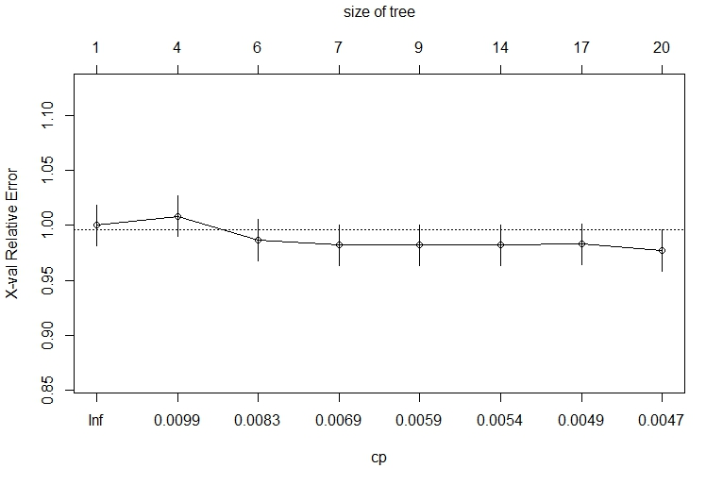
Pruning Error
Cost Complexity
Figure 2: Selection of Regularization Parameter for Decision Tree Model
Figure 3 presents the classification of pedestrian injury severity by the pruned decision tree. The decision tree contains 20 terminal nodes and uses several key predictor variables such as Local Street, Pedestrian in Travel Lane (“PedinTravelLane”), Intoxicated Drivers (“DrivAlcohol”), Both drivers and pedestrians intoxicated (“BothAlcohol”), Health Burdened Community (“Health_Disadv”), etc., to classify the pedestrian crash observations in one of the five injury severity classes. The number of observations classified in a particular injury severity class is mentioned at each terminal node.
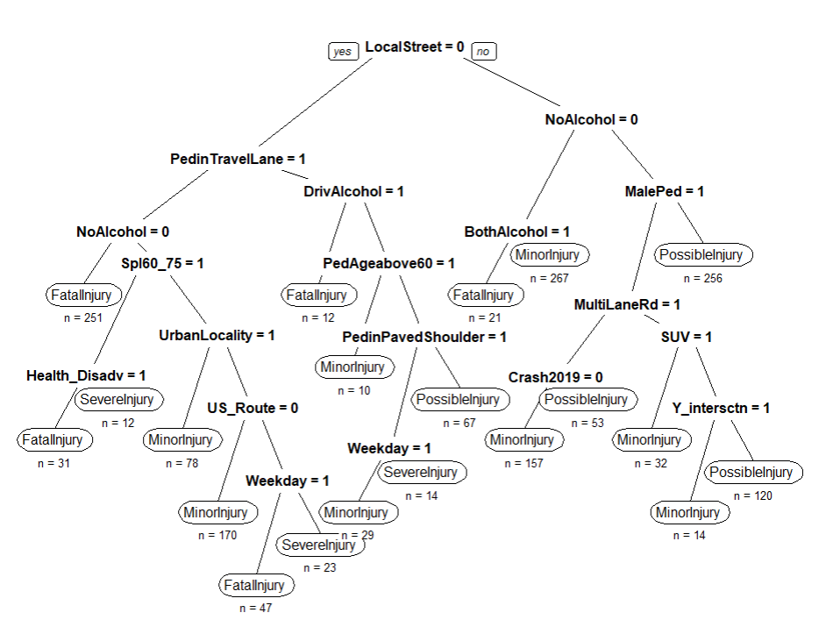
Figure 3: Pruned Decision Tree Model
5.3 Gradient Boosting
This method performs classification using predictions from multiple decision trees, producing more reliable and stable results than a single decision tree. The hyperparameters of the model include shrinkage rate (also called learning rate), number of trees, minimum number of observations in the trees’ terminal nodes, and interaction depth. The model hyperparameters were tuned using an extended grid search and 10-fold cross-validation. The 10-folds cross-validation process involves dividing the available data into ten equal subsets. Nine of these subsets are used for training the model, while one subset is kept for testing to evaluate the model’s predictive accuracy. This procedure is repeated ten times, with each subset serving as the testing data once. The final estimation is obtained by averaging the results from all ten iterations. A range of values for the shrinkage rate (0.005, 0.01, 0.05, 0.1, 0.5), minimum number of observations in the terminal nodes (3,5,7), and interaction depth (1,3,5,7,10) were considered in the optimization grid search among which the optimal shrinkage rate, the number of trees corresponding to the optimal shrinkage rate, minimum observations at the terminal node, and the interaction depth were found to be 0.005, 1064, 7, and 5, respectively, resulting in a minimum cross-validation error of 1.24. Figure 4 presents the results of the grid search for the first five combinations of the model hyperparameters ranked according to increasing cross-validation error.

Figure 4: Results of Tuning GB Model Hyperparameters
The final model was estimated with the optimal hyperparameters obtained from the grid search. Figure 5 presents the ten most important variables in the GB model. Referring to Figure 5, most of the important variables in the GB model were statistically significant in the Ordered Logit Model and were also used to grow the decision tree. Hence, the ML models complement the results obtained from the statistical model.
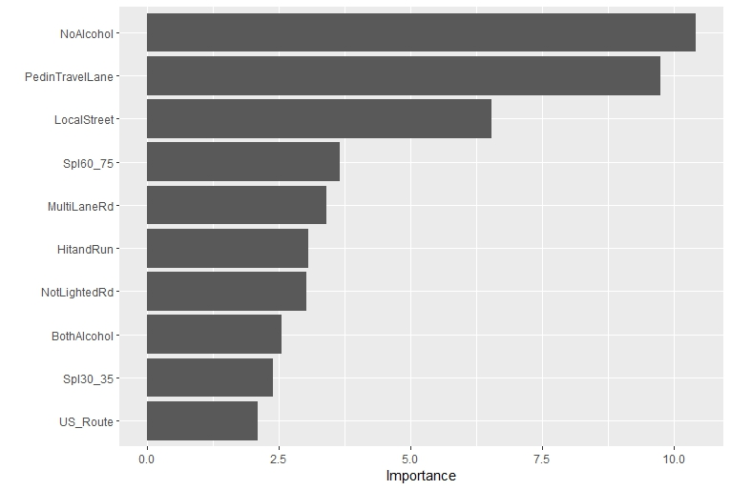
Figure 5: Relative Importance Plot of Top 10 Predictor Variables in Gradient Boosting Model

5.4 Random Forest
Random Forest was used as the final base learner in this study. Like the GB model, the model hyperparameters were tuned using an extended grid search optimization and 10-fold cross-validation. The hyperparameters of the model include the number of trees, the number of variables considered for splitting at each node, the minimum node size, and the sample fraction. A range of values for the number of trees (600, 900, 1200, 1500), number of variables considered for splitting at each node (5, 10, 20, 40), minimum node size (1, 5, 10, 15, 20) and fraction of the sample used (0.6, 0.7, 0.8) were considered in the optimization grid search among which the optimal values for the number of trees, number of variables for splitting each node, minimum node size, and the sample fraction were found to be 900, 5, 5, and 0.7, respectively. The combination resulted in a minimum cross-validation error of 0.775. Figure 6 presents the results of the grid search for the first ten combinations of the model hyperparameters ranked according to increasing cross-validation error.

Figure 6: Results of Tuning RF Model Hyper Parameters
Figure 7 presents the ten most important variables in the RF model. Referring to Figure 7, variables indicating BCs (Equity and Environmental Burden Indicators) and pedestrian racial attributes (Black and White pedestrians) were found to be more important in the RF model than the other models. These results can give more valuable insights into the distribution of pedestrian crashes across various racial groups in BCs.
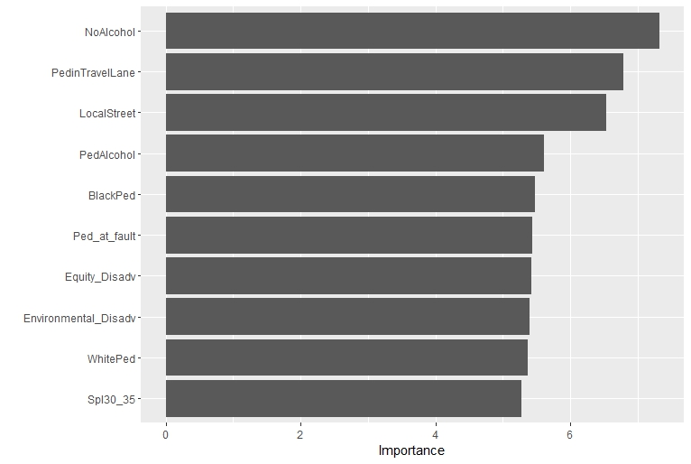
Figure 7: Relative Importance Plot of Top 10 Predictor Variables in Random Forest Model

5.5 Stacking Individual Base Learners and Comparison of Models’ Performance
The validation dataset (N_{val} = 438) was provided as input to the trained base learners, and predictions on pedestrian injury severity were obtained from each base learner for the validation dataset. Subsequently, this set of predictions was used as input for the meta-learner in the second layer of the stacking methodology. Furthermore, the predictive performance of the trained base learners was assessed using the test dataset (N_{test} = 227). Confusion matrices, widely used to evaluate the predictive performance of the ML models, were obtained, and performance measures discussed in the previous section were calculated to determine the trained models’ predictive ability. Results from the confusion matrices indicate that the ML models’ prediction accuracy was higher than the frequentist model, which conforms to the usual norm. The RF model predicted pedestrian injury severity with the highest accuracy (73.56%) among the base learners. The confusion matrices for the base learner models are presented in Tables 3 and 4.

TABLE 3: Confusion Matrices for Test Dataset (N_{test} = 227) for Ordered Logit and DT Model
Ordered Logit Model
Observed Outcomes | Predicted Outcomes |  |  |  |  | Total
Observed Outcomes | Fatal Injury | Severe Injury | Minor Injury | Possible Injury | No Injury
Fatal Injury | 15 | 10 | 7 | 2 | 1 | 35
Severe Injury | 10 | 11 | 8 | 3 | 0 | 32
Minor Injury | 2 | 6 | 70 | 14 | 0 | 92
Possible Injury | 0 | 1 | 12 | 45 | 2 | 60
No Injury | 0 | 0 | 1 | 4 | 3 | 8
Total | 27 | 28 | 98 | 68 | 6
Performance Measures
Accuracy | 63.44%
Precision | 0.5555 | 0.3928 | 0.7143 | 0.6618 | 0.5000
Recall | 0.4285 | 0.3437 | 0.7609 | 0.7500 | 0.3750
F1 Score | 0.4838 | 0.3666 | 0.7369 | 0.7031 | 0.4286
Decision Tree Model
Observed Outcomes | Predicted Outcomes |  |  |  |  | Total
Observed Outcomes | Fatal Injury | Severe Injury | Minor Injury | Possible Injury | No Injury
Fatal Injury | 16 | 10 | 5 | 3 | 1 | 35
Severe Injury | 10 | 14 | 4 | 3 | 1 | 32
Minor Injury | 7 | 18 | 64 | 2 | 1 | 92
Possible Injury | 0 | 1 | 9 | 47 | 3 | 60
No Injury | 0 | 0 | 1 | 1 | 6 | 8
Total | 33 | 43 | 83 | 56 | 12
Performance Measures
Accuracy | 64.75%
Precision | 0.4848 | 0.3256 | 0.7711 | 0.8393 | 0.5000
Recall | 0.4571 | 0.4375 | 0.6956 | 0.7833 | 0.7500
F1 Score | 0.4705 | 0.3733 | 0.7314 | 0.8103 | 0.6000

TABLE 4: Confusion Matrices for Test Dataset (N_{test} = 227) for GB and RF Model
Gradient Boosting Model
Observed Outcomes | Predicted Outcomes |  |  |  |  | Total
Observed Outcomes | Fatal Injury | Severe Injury | Minor Injury | Possible Injury | No Injury
Fatal Injury | 24 | 4 | 3 | 2 | 2 | 35
Severe Injury | 6 | 20 | 3 | 2 | 1 | 32
Minor Injury | 12 | 5 | 73 | 2 | 0 | 92
Possible Injury | 3 | 4 | 12 | 38 | 3 | 60
No Injury | 0 | 0 | 1 | 1 | 6 | 8
Total | 45 | 33 | 92 | 45 | 12
Performance Measures
Accuracy | 70.9%
Precision | 0.5333 | 0.6061 | 0.7935 | 0.8444 | 0.5000
Recall | 0.6857 | 0.6250 | 0.7935 | 0.6333 | 0.7500
F1 Score | 0.5999 | 0.6154 | 0.7935 | 0.7237 | 0.6000
Random Forest
Observed Outcomes | Predicted Outcomes |  |  |  |  | Total
Observed Outcomes | Fatal Injury | Severe Injury | Minor Injury | Possible Injury | No Injury
Fatal Injury | 22 | 5 | 4 | 3 | 1 | 35
Severe Injury | 6 | 23 | 2 | 1 | 0 | 32
Minor Injury | 3 | 12 | 75 | 2 | 0 | 92
Possible Injury | 0 | 2 | 11 | 42 | 5 | 60
No Injury | 0 | 0 | 1 | 2 | 5 | 8
Total | 31 | 42 | 93 | 50 | 11
Performance Measures
Accuracy | 73.56%
Precision | 0.7097 | 0.5476 | 0.8064 | 0.8400 | 0.4545
Recall | 0.6286 | 0.7187 | 0.8152 | 0.7000 | 0.6250
F1 Score | 0.6667 | 0.6216 | 0.8107 | 0.7636 | 0.5263

The ML models were used as the meta-learner in the stacked ensemble model due to their superior predictive performance than the frequentist model for the test dataset in the first stage. The RF model yielded the highest prediction accuracy when used as a meta-learner in the stacked ensemble model (78.85%) compared to the GB (76.21%) and DT (74.44%) models. Note that the predictive performance of the stacked ensemble model was superior to the individual base learners for each of the ML models used as the meta learner. This result provides substantial evidence of this method’s superiority in predictive capabilities over individual ML techniques. The RF model, used as a meta learner, was tuned to 100 trees, two variables used for splitting each node, minimum node size of 3, and sample fraction of 0.8 using extended grid search and 10-fold cross-validation, resulting in a minimum cross-validation error of 0.46. Figure 8 represents the selection of optimal hyperparameters for the RF model in the stacked ensemble model. The variable importance plot for the stacked model, shown in Figure 9, indicates the predictions obtained from the RF base learner for the validation dataset as most important, followed by the predictions obtained from the GB model, while the predictions from the Ordered Logit model were ranked the least important by the model. This result also provides evidence in support of the ML models’ superior predictive performance compared to the frequentist models. The confusion matrix for the stacked ensemble model with RF as the meta-learner is provided in Table 5. Table 6 compares the predictive performance of the individual base learners and the stacked models with all possible meta-learners. The stacked models with RF, GB, and DT as meta learners resulted in a percentage increase in model prediction accuracy of 7.19%, 3.60%, and 1.19%, respectively, from the highest accuracy of RF base learner (73.56%) considered as the base.

Figure 8: Selection of Optimal Hyperparameters for RF as Meta Learner
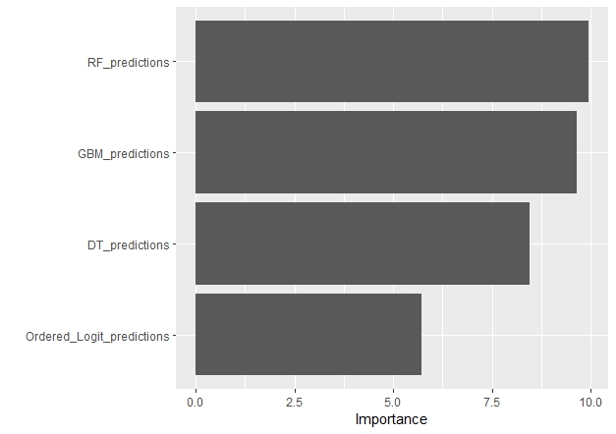
Figure 9: Variable Importance Plot for Stacked Model with RF as Meta Learner
TABLE 5: Confusion Matrix for Test Dataset for Stacked Ensemble Model (RF as Meta Learner)
Observed Outcomes | Predicted Outcomes
Observed Outcomes | Fatal Injury | Severe Injury | Minor Injury | Possible Injury | No Injury
Fatal Injury (35) | 28 | 5 | 2 | 0 | 0
Severe Injury (32) | 3 | 26 | 2 | 1 | 0
Minor Injury (92) | 4 | 11 | 76 | 1 | 0
Possible Injury (60) | 0 | 3 | 7 | 44 | 6
No Injury (8) | 0 | 0 | 1 | 2 | 5
Total | 35 | 45 | 88 | 48 | 11
Performance Measures
Accuracy | 78.85%
Precision | 0.8000 | 0.5777 | 0.8636 | 0.9167 | 0.4545
Recall | 0.8000 | 0.8125 | 0.8261 | 0.7333 | 0.6250
F1 Score | 0.8000 | 0.6753 | 0.8444 | 0.8148 | 0.5263
Note: Values in parentheses next to the injury class indicate the frequency of that class.
TABLE 6: Comparison of Out-of-Sample Prediction Performance of all Models
Models | Status | Accuracy | % Change in Accuracy from the Base
Random Forest | (Meta learner) | 78.85% | 7.19%
Gradient Boosting | (Meta learner) | 76.21% | 3.60%
Decision Tree | (Meta learner) | 74.44% | 1.19%
Random Forest | (Base learner) | 73.56% | (Base)
Gradient Boosting | (Base learner) | 70.9% | -3.62%
Decision Tree | (Base learner) | 64.75% | -11.97%
Ordered Logit | (Base learner) | 63.44% | -13.75%

6. LIMITATIONS
The study findings are derived from pedestrian crashes only in North Carolina. The magnitude of the key correlates of nighttime pedestrian crashes found in the study could vary across different geographical locations due to the varying traffic characteristics, socioeconomic characteristics, and spatial contexts. However, the direction of association of most factors with pedestrian injury severity is generally assumed to be similar to that found in this study. With the availability of similar comprehensive data for other parts of the US, it would be more appropriate to conduct a similar study which may lead to more generalizable results. Furthermore, the study methodology (stacking) does not provide variable importance directly of the study explanatory variables in the second stage as it aggregates only the predictions obtained from the base learners.
7. CONCLUSIONS
This study used a unique database and applied a combination of robust inferential and prediction-based models to analyze nighttime pedestrian crash injury severity in BCs. The study estimated Ordered logit model to obtain accurate inferences to the correlates of nighttime pedestrian crashes in BCs and a robust and novel heterogeneous ensemble methodology (stacking) to assist in effective safety planning and infrastructure improvements by accurately forecasting nighttime pedestrian crashes and the resulting injury severity in BCs. The stacking methodology utilizes the inferential base of statistical models and the prediction framework of ML methods to furnish more robust and accurate predictions. The inferential results obtained from the Ordered Logit Model highlighted the association of the Economy and Transportation Burden indicators in addition to other significant predictors such as roads without proper lights, driver and pedestrian alcohol impairment, rural and multilane roads, hit and run crashes, and crashes involving older pedestrians (aged above 60 years), with pedestrian crash injury severity in BCs. RF yielded the highest out-of-sample prediction accuracy among the base learners and was subsequently applied as a meta-learner in the stacked ensemble model, resulting in an even higher prediction accuracy for the stacked model. The study suggests suitable nighttime pedestrian safety countermeasures that include the installation of high-intensity roadway lights at locations with poor or no lighting, enforcing stringent penalties on alcohol-impaired driving and walking on the road, conducting road safety awareness seminars and campaigns for pedestrians and drivers, ensuring faster response of emergency medical services in pedestrian crash situations to mitigate pedestrian injury severity given a crash. This study contributes to the existing knowledge about pedestrian safety in BCs by utilizing a more robust stacking approach that combines the predictive advantages of individual statistical and ML models to provide more accurate results. In the next step, the model can be deployed to help state DOTs anticipate future nighttime pedestrian crashes in burdened and non-burdened communities, enabling transportation planners and engineers to make informed and equitable decisions about resource allocation. A tool can be developed that integrates the model and links it with incoming safety data for updating and interfacing with transportation professionals. For instance, for BCs, the model can predict hotspots where targeted safety interventions can be implemented, e.g., installing lighting, pedestrian and driver warnings, nighttime vehicle speed advisories, safety education programs, and faster emergency response services.
ACKNOWLEDGMENT
This study was partially supported by the Collaborative Sciences Center for Road Safety, CSCRS, a US DOT-funded National University Transportation Center, under Grant No. 69A3551747113.

AUTHOR CONTRIBUTIONS
The authors confirm their contribution to the paper as follows:
Study Conception and Design: Sheikh M. Usman, Asad J. Khattak, A. Patwary; Data Collection and Preliminary Analysis: Sheikh M. Usman; Analysis and Interpretation of Results: Sheikh M. Usman, A. Patwary, Asad J. Khattak; Draft Manuscript Preparation: Sheikh M. Usman, Asad J. Khattak, A. Patwary. All authors reviewed the results and approved the final version of the manuscript.
REFERENCES
1. FARS 2019. Fatality Analysis Reporting System. National Highway Traffic Safety Administration (NHTSA). 2019. https://www-fars.nhtsa.dot.gov/Main/index.aspx. Accessed May 10, 2023.
2. GHSA. 2020 PRELIMINARY DATA by State Traffic Fatalities Pedestrian. 2021.
3. USDOT. National Roadway Safety Strategy. https://www.transportation.gov/NRSS. Accessed May 10, 2023.
4. USDOT. Justice40 Initiative. https://www.transportation.gov/equity-Justice40. Accessed May 10, 2023.
5. Siddiqui, N. A., X. Chu, M. Guttenplan, N. A. Siddiqui, and X. Chu. Crossing Locations, Light Conditions, and Pedestrian Injury Severity. Transportation Research Record: Journal of the Transportation Research Board, Vol. 1982, No. 1, 2006, pp. 141–149. https://doi.org/10.1177/0361198106198200118.
6. Pour-Rouholamin, M., and H. Zhou. Investigating the Risk Factors Associated with Pedestrian Injury Severity in Illinois. Journal of Safety Research, Vol. 57, 2016, pp. 9–17. https://doi.org/10.1016/j.jsr.2016.03.004.
7. Ferenchak, N. N., and M. G. Abadi. Nighttime Pedestrian Fatalities: A Comprehensive Examination of Infrastructure, User, Vehicle, and Situational Factors. Journal of Safety Research, Vol. 79, 2021, pp. 14–25. https://doi.org/10.1016/j.jsr.2021.07.002.
8. Usman, S., and A. Khattak. Applying Artificial Intelligence Techniques to Examine Nighttime Pedestrian Crash Injury Severity at Intersections. Journal of Transportation Safety & Security, 2025, pp. 1–47. https://doi.org/10.1080/19439962.2025.2548807.
9. Kim, J. K., G. F. Ulfarsson, V. N. Shankar, and S. Kim. Age and Pedestrian Injury Severity in Motor-Vehicle Crashes: A Heteroskedastic Logit Analysis. Accident Analysis and Prevention, Vol. 40, No. 5, 2008, pp. 1695–1702. https://doi.org/10.1016/j.aap.2008.06.005.
10. Usman, S., and A. Khattak. Beyond the Conventional: Exploring Pedestrian Safety on Interstates with Bayesian and Machine Learning Models. Journal of Safety Research, Vol. 94, 2025, pp. 141–156. https://doi.org/10.1016/j.jsr.2025.06.018.
11. Das, S., S. Ashraf, A. Dutta, and L. N. Tran. Pedestrians under Influence (PUI) Crashes: Patterns from Correspondence Regression Analysis. Journal of Safety Research, Vol. 75, 2020, pp. 14–23. https://doi.org/10.1016/j.jsr.2020.07.001.
12. Chen, Z., and W. (David) Fan. A Multinomial Logit Model of Pedestrian-Vehicle Crash Severity in North Carolina. International Journal of Transportation Science and Technology, Vol. 8, No. 1, 2019, pp. 43–52. https://doi.org/10.1016/j.ijtst.2018.10.001.
13. Aziz, H. M. A., S. V. Ukkusuri, and S. Hasan. Exploring the Determinants of Pedestrian-Vehicle Crash Severity in New York City. Accident Analysis and Prevention, Vol. 50, 2013, pp. 1298–1309. https://doi.org/10.1016/j.aap.2012.09.034.
14. Chimba, D., A. Musinguzi, and E. Kidando. Associating Pedestrian Crashes with Demographic and Socioeconomic Factors. Case Studies on Transport Policy, Vol. 6, No. 1, 2018, pp. 11–16. https://doi.org/10.1016/j.cstp.2018.01.006.
15. Sanders, R. L., and R. J. Schneider. An Exploration of Pedestrian Fatalities by Race in the United States. Transportation Research Part D: Transport and Environment, Vol. 107, 2022. https://doi.org/10.1016/j.trd.2022.103298.
16. Pan, G., L. Fu, and L. Thakali. Development of a Global Road Safety Performance Function Using Deep Neural Networks. International Journal of Transportation Science and Technology, Vol. 6, No. 3, 2017, pp. 159–173. https://doi.org/10.1016/j.ijtst.2017.07.004.
17. Ahmad, N., B. Wali, and A. J. Khattak. Heterogeneous Ensemble Learning for Enhanced Crash Forecasts – A Frequentist and Machine Learning Based Stacking Framework. Journal of Safety Research, Vol. 84, 2023, pp. 418–434. https://doi.org/10.1016/j.jsr.2022.12.005.
18. Bhatt, S., E. Cameron, S. R. Flaxman, D. J. Weiss, D. L. Smith, and P. W. Gething. Improved Prediction Accuracy for Disease Risk Mapping Using Gaussian Process Stacked Generalization. Journal of the Royal Society Interface, Vol. 14, No. 134, 2017. https://doi.org/10.1098/rsif.2017.0520.
19. Chali, Y., S. A. Hasan, and M. Mojahid. Complex Question Answering: Homogeneous or Heterogeneous, Which Ensemble Is Better? 2014.
20. Petrakova, A., M. Affenzeller, and G. Merkurjeva. Heterogeneous versus Homogeneous Machine Learning Ensembles. Information Technology and Management Science, Vol. 18, No. 1, 2015, pp. 135–140.
21. Transportation Disadvantaged Census Tracts. Historically Disadvantaged Communities. https://www.transportation.gov/priorities/equity/justice40/transportation-disadvantaged-census-tracts-historically-disadvantaged. Accessed May 10, 2023.
22. Wolpert, D. Stacked Generalization. Neural Networks, Vol. 5, No. 2, 1992, pp. 241–259.
23. Torgo, L. Inductive Learning of Tree-Based Regression Models. Universidade do Porto., 1999.
24. Kotsiantis, S. B. Decision Trees: A Recent Overview. Artificial Intelligence Review, Vol. 39, 2013, pp. 261–283.
25. Friedman, J. Greedy Function Approximation: A Gradient Boosting Machine. The Annals of Statistics, Vol. 29, No. 5, 2001, pp. 1189–1232.
26. Breiman, L. Random Forests. Machine Learning, Vol. 45, 2001, pp. 5–32.
27. Parmar, A., R. Katariya, and V. Patel. A Review on Random Forest: An Ensemble Classifier. 2018.
28. Usman, S., A. Khattak, and L. Patwary. Nighttime Pedestrian Safety in Different Communities: Application of Artificial Intelligence Techniques. Journal of Safety Research, Vol. 94, 2025, pp. 340–361. https://doi.org/10.1016/j.jsr.2025.06.028.
29. Usman, S., A. Khattak, and A. L. Patwary. Are There Differences in Public Interest toward Automated Vehicles’ Ownership in Burdened and Non-Burdened Communities? Transportation Planning and Technology, 2025, pp. 1–28. https://doi.org/10.1080/03081060.2025.2546096.
30. Khattak, A., S. Chakraborty, I. Mahdinia, and S. Usman. Safety Enhancement by Detecting Driver Impairment Through Analysis of Real-Time Volatilities. Collaborative Sciences Center for Road Safety, 2023, pp. 1–75.
31. Khattak, A., M. King, M. Adeel, S. Usman, and I. Mahdinia. Advancing Crash Investigation With Connected and Automated Vehicle Data–Phase 2. Collaborative Sciences Center for Road Safety, Vol. CSCRS R-42, 2024.
32. Adeel, M., M. King, S. Usman, and A. Khattak. Advancing Crash Investigation with Connected and Automated Vehicle Data: Insights from a Survey of Law Enforcement. Journal of Transportation Safety & Security, 2025, pp. 1–30. https://doi.org/10.1080/19439962.2025.2462803.
33. Ijaz, M., L. Lan, S. M. Usman, M. Zahid, and A. Jamal. Investigation of Factors Influencing Motorcyclist Injury Severity Using Random Parameters Logit Model with Heterogeneity in Means and Variances. International journal of crashworthiness, Vol. 27, No. 5, 2021, pp. 1412–1422. https://doi.org/10.1080/13588265.2021.1959153.
34. Ijaz, M., L. Liu, Y. Almarhabi, A. Jamal, S. M. Usman, and M. Zahid. Temporal Instability of Factors Affecting Injury Severity in Helmet-Wearing and Non-Helmet-Wearing Motorcycle Crashes: A Random Parameter Approach with Heterogeneity in Means and Variances. International Journal of Environmental Research and Public Health, Vol. 19, No. 17, 2022. https://doi.org/10.3390/ijerph191710526.
35. Rashid, H., S. Shah, and S. Usman. Factors Influencing Motorists’ Injury Severities: An Empirical Assessment of Crashes in District Peshawar, Pakistan. Global Social Sciences Review, VIII, 2023, pp. 211–224. https://doi.org/10.31703/gssr.2023(VIII-II).20.
36. Usman, S., and M. Adeel. Exploring University Campus Community’s Perceptions and Barriers toward Biking: A Case Study of the University of Tennessee Knoxville. Journal of Transportation Technologies, Vol. 14, No. 2, 2024, pp. 161–178. https://doi.org/10.4236/jtts.2024.142010.
37. Usman, S., A. Khattak, S. Chakraborty, I. Mahdinia, and R. Tavassoli. Detection of Distracted Driving through the Analysis of Real-Time Driver, Vehicle, and Roadway Volatilities. Journal of Transportation Safety & Security, Vol. 16, No. 12, 2024, pp. 1426–1447. https://doi.org/10.1080/19439962.2024.2341393.

