To the Graduate Council:

I am submitting herewith a thesis written by Robert Trenton Jett entitled “Underwater observation and habitat utilization of three rare darters (Etheostoma cinereum, Percina burtoni, and Percina williamsi) in the Little River, Blount County, Tennessee.” I have examined the final electronic copy of this thesis for form and content and recommend that it be accepted in partial fulfillment of the requirements for the degree of Master of Science, with a major in Wildlife and Fisheries Science.

J. Larry Wilson , Major Professor

We have read this thesis
and recommend its acceptance:

David A. Etnier

Jason G. Henning

Patrick L. Rakes

Accepted for the Council:

Carolyn R. Hodges
Vice Provost and Dean of the Graduate School

(Original signatures are on file with official student records.)
UNDERWATER OBSERVATION AND HABITAT UTILIZATION OF THREE RARE DARTERS (ETHEOSTOMA CINEREUM, PERCINA BURTONI, AND PERCINA WILLIAMSI) IN THE LITTLE RIVER, BLOUNT COUNTY, TENNESSEE

A Thesis Presented for
the Master of Science
Degree
The University of Tennessee, Knoxville

Robert Trenton Jett
May 2010

Dedication
This thesis is dedicated to my best friend, Jesus Christ, who gives me the passion for each new day.

Acknowledgements
I would like to thank my advisor, Dr. Larry Wilson, for providing the encouragement and opportunity to pursue this degree. I would also like to thank my committee members, Dr. David Etnier, Dr. Jason Henning, and Patrick Rakes, for providing the guidance and advice needed to make this project a success. Thanks to Charlie Saylor from the Tennessee Valley Authority for being a mentor and role-model every time we worked together, and for his guidance in the direction of this project.
I wish to thank the University of Tennessee and the Department of Forestry, Wildlife and Fisheries for providing the funding for my research assistantship and this project. J. R. Shute and Conservation Fisheries Inc. provided great photo material and advice on sampling in the Little River.
A special thanks to Joyce Coombs, Casey Dunn, Gai Janekitkarn, Michael Jones, Nikki Maxwell, and Will Pruitt who worked so hard in the field. Thanks for enduring the rainy days, high flows, turbid waters, and never complaining. Thanks also for asking the difficult questions that motivate us to do better science; I hope we never stop challenging each other.
Thanks to my family who have always encouraged, or at least tolerated, my zeal for all things wild, and especially to my Dad for building the foundation for my future career by teaching me how to love and care for the diversity of nature.
And thanks most of all to my beautiful wife, Bethany, for supporting me at all times; no matter what soapbox I find to stand on, or “treasure” I bring home from the creek, she still loves me. Thanks.
ABSTRACT
The Little River in Blount County is home to one of the richest darter faunas in East Tennessee. Increases in agriculture and development on several tributaries and the main stem of the Little River are suspected as causes for reduced abundance in fish populations. Earlier research on the Little River identified three species, Etheostoma cinereum (ashy darter), Percina burtoni (blotchside logperch), and P. williamsi (sickle darter), as having low densities. From May – October 2009, snorkel observations were made at 16 predetermined sites along the mainstem of the river to determine abundance and habitat association of these target species, as well as abundance of P. aurantiaca (tangerine darter) for comparison with historic surveys. All fish observed while snorkeling were identified and microhabitat measurements were taken at the location of all target species. Observations included 39 fish species, including 273 P. aurantiaca, 58 P. burtoni, and 7 P. williamsi. Etheostoma cinereum were not encountered during this study. Our observations documented that darter populations during 2009 were significantly different than historic populations, indicating that local populations of the target species have been negatively impacted since the historic survey.
E. cinereum has been consistently difficult to collect on the Little River, and previous sampling efforts have observed this species with less frequency in the last 30 years. The absence of this species in this study may be an artifact of habitat degradation due to development and agriculture, two consecutive years of drought in 2007-2008, or potential sampling bias due to high flows in 2009. Habitat measurements documented that P. burtoni were frequently associated with gravel and cobble substrates. This habitat association is indicative of the feeding habits of P. burtoni who use their padded snout to flip small stones and feed on the aquatic insects found underneath. Turbidity was closely associated with river mile, with a consistent increase in turbidity at downstream sites in the watershed.

TABLE OF CONTENTS
Chapter Page
CHAPTER 1 1
INTRODUCTION 1
CHAPTER 2 6
LITERATURE REVIEW 6
Target Species 6
Habitat 10
CHAPTER 3 14
METHODS 14
Study Area 14
Field Sampling 15
Habitat Sampling 18
Statistical Analyses 20
CHAPTER 4 21
RESULTS 21
CHAPTER 5 27
DISCUSSION 27
CHAPTER 6 34
SUMMARY AND RECOMMENDATIONS 34
LITERATURE CITED 36
VITA 41

LIST OF FIGURES
Figure Page
Figure 1. Photos of the four target species from the Little River.. 4

Figure 2. Map of study sites on the Little River, Tennessee. 15

Figure 3. Schematic showing path of snorkeler in an upstream direction. 17

Figure 4. PVC grid used to determine substrate percentages. 19

Figure 5. Graphic illustrating correlation between turbidity (NTU) and river mile (NTU= Nephelometric turbidity units). 25

Figure 6. Catch per unit effort (CPUE) of Percina aurantiaca, P. burtoni, and P. williamsi by river mile. 31
LIST OF TABLES
Table Page
Table 1. Site locations and dates sampled. 16

Table 2. List of species observed during 30 snorkel surveys on the Little River, Blount County, Tennessee, in 2009. 22

Table 3. Total observations of target fish during three seasons in 2009. 23

Table 4. CPUE of samples made during three seasons in 2009 and one survey in 1995. 24

Table 5. Average percent (%) substrates located at observed target species. 25

Table 6. Additional fish seen outside established sample sites. 26

Table 7. Summary of total area sampled and sampling effort for sites surveyed in summer 2009 and 1995. 32

CHAPTER 1

INTRODUCTION
Tennessee has the richest fauna of freshwater fish in the United States (Etnier and Starnes 1993). The five major river drainage systems that occur in the state (Tennessee, Mississippi, Cumberland, Barren, and Conasauga) contain more than 300 fish species statewide. In this list are species with very large geographic ranges, such as Lepomis macrochirus (bluegill), which can be found in all 50 states, and species with very limited ranges such as Phoxinus saylori (laurel dace) which is found only in three streams on the Cumberland Plateau. There are also six major physiographic provinces in the state, which provide many distinct habitats for this abundant diversity of fish. Tennessee is not only known for its fish diversity; Parmalee and Bogan (1998) listed Tennessee’s historical freshwater mussel fauna as second only to that of Alabama in diversity. This distinct combination of multiple physiographic regions coupled with these unique river drainages has provided the groundwork for the most diverse assemblage of freshwater fish in the United States.
Despite the diversity of fish in the state and in the southeastern United States, many of these species are at risk. Warren et al. (2000) stated that 28% of freshwater and diadromous fish in the southern United States merit the rank of extinct, endangered, threatened, or vulnerable. These numbers of imperiled species are increasing, with a 75% increase since 1989 and a 125% increase since 1979. Currently the fishes of the southeastern United States face an extinction crisis “in which more taxa may be lost than the total native fish faunas of some western states!” (Warren and Burr 1994).
The causes of decline of native fish fauna in the southeastern United States are mostly associated with human induced-habitat degradation across the landscape (Angermeier 1995; Warren et al. 2000). Often these degrading impacts are in the form of physical habitat alterations such as channelization, impoundment, sedimentation, and flow modification, which are often listed as leading variables threatening freshwater fish species. However, Weaver and Garman (1994) found that even in the absence of major physical impacts to a stream, the cumulative result of long-term, low-intensity urbanization can also negatively affect warmwater stream fish assemblages. These impacts often fragment local populations of fishes, thereby making them more susceptible to local extinctions, which is often a prelude to widespread extinction of a species (Angermeier 1995). The underlying cause of these impacts to aquatic habitat is human population growth, which is and will continue to be the greatest challenge to aquatic resource managers (Warren et al. 2000).
Another growing threat to species diversity is the introduction of exotic species (Gido and Brown 1999). The introduction of these species can be the result of intentional introductions for aquaculture or angling, ballast water transfers, aquarium releases, and illegal stocking (Rahel 2000). These aquatic aliens compete with native fish for both food and space, and are often the better competitor due to a lack of natural predators. The multiple threats to such a diverse assemblage of fish should make the aquatic ecosystems of the southeastern United States a top priority for conservation efforts (Lydeard and Mayden 1995).
A perfect example of Tennessee’s immense fish diversity is the Little River. The Little River is a 5th order stream located in Blount and Sevier counties, Tennessee. The headwaters originate near Clingman’s Dome, and approximately one-third of the stream watershed is contained within the boundaries of the Great Smoky Mountain National Park (GSMNP). Since the establishment of the GSMNP in 1934, this watershed has been virtually unaltered, allowing a return to its original state prior to pre-park timber impacts. This provides an opportunity for excellent stream conditions in the absence of the impacts which are often associated with human development. As such, the Little River is home to one of the most diverse assemblages of darters in Tennessee (D. A. Etnier, University of Tennessee, personal communication). The Little River drains into the mainstem of the Tennessee River at River Mile 635 (TRM 635), currently Fort Loudoun Reservoir.
There have been 89 species of fish historically collected from the Little River, of which 17 are darter species from the two genera, Etheostoma (11) and Percina (6). The snail darter (Percina tanasi) and the marbled darter (Etheostoma marmorpinnum) are the only two of these species accredited federal status, and are both listed on the Endangered Species List (Federal Register 1975; Federal Register 1993). The snail darter is a rather well-known fish that was instrumental in the early establishment of the Endangered Species Act in 1973 (Bennett 1981), while the marbled darter was only recently described from the duskytail darter (Etheostoma percnurum) complex (Blanton and Jenkins 2008). Eleven species of fish from the Little River do appear on Tennessee Wildlife Resources Agency’s (TWRA) list of greatest conservation need (TWRA 2005). Among these are the three species with which this study was concerned: Etheostoma cinereum (ashy darter), Percina burtoni (blotchside logperch), and P. williamsi (sickle darter) (Figure 1).
Heacock (1995), in a previous study of darter populations in the Little River, documented the presence of Percina aurantiaca (tangerine darter), P. burtoni, and P. macrocephala (longhead darter). This last darter (longhead darter) was later described as the sickle darter (P. williamsi) (Page and Near 2007).
The Little River has remained largely unaltered since this historic study. The surrounding communities are mostly rural with the exception of the town of Maryville with a population of 27,000. The watershed outside of the GSMNP is dominated by agriculture, both pastured livestock and row crops. Unfortunately, this creates opportunities for increased sedimentation inputs and chemical inputs associated with fertilizers and pesticides. Despite these impacts the

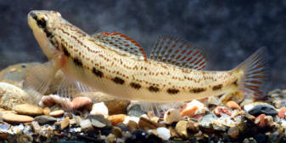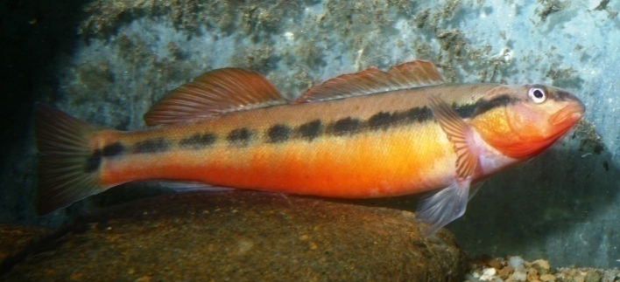
Etheostoma cinereum (ashy darter) Percina aurantiaca (tangerine darter)

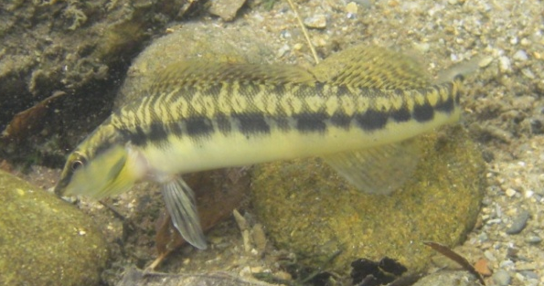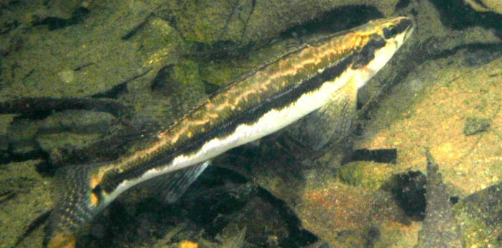
Percina burtoni (blotchside logperch) Percina williamsi (sickle darter)
Figure 1. Photos of the four target species from the Little River. Photos courtesy of J. R. Shute.

Little River stands in stark contrast to the neighboring Little Pigeon River located less than 20 kilometers to the north. The Little Pigeon River, like the Little River, has headwaters in the GSMNP, but it then flows through the heavily populated towns of Gatlinburg, Pigeon Forge, and Sevierville, Tennessee. The presence of these three very developed cities on the Little Pigeon River has been a major factor affecting stream health.
In an effort to re-examine these fish populations on the Little River, a thesis project was designed with similar objectives to previous research. The focus of this study was twofold: 1) to survey 20 sites along the river as defined by Heacock (1995), and compare abundances of all target fish observed, and 2) to characterize the habitat where each individual Etheostoma cinereum, Percina burtoni, and P. williamsi was observed to determine the types of habitat utilized by these three species.

CHAPTER 2

LITERATURE REVIEW

Target Species
Darters are often used in biological assessments of streams and rivers as an indicator of stream condition. Their inclusion as a metric (specialized insectivore or number of darter species) in many indexes of biotic integrity (IBI) is a reflection of their sensitivity to stream health (Karr 1981). These small fish generally have reduced or absent swim bladders and cryptic dorsal coloration to accommodate their primarily benthic lifestyle. They feed mostly by sight on immature aquatic insects dwelling in the streams, rivers, lakes, and wetland areas. This lifestyle makes darters especially susceptible to environmental impacts, which often decrease available benthic habitat and could eventually reduce the abundance and diversity of local darter populations (Stauffer et al. 1996). The following is a description of the three darters which were the primary focus of this study (E. cinereum, P. burtoni, and P. williamsi), and P. aurantiaca which was a focus of the previous study (Heacock 1995). These darters were selected based on their classification as species of greatest conservation need in the state of Tennessee by the Tennessee Wildlife Resources Agency (TWRA 2005) and a downward trend in abundance in the Little River (D. A. Etnier, University of Tennessee, unpublished data).
Etheostoma cinereum
Etheostoma cinereum, the ashy darter, was originally described in 1845 by D. H. Storer (1845) from specimens collected near Florence, Alabama. It was described, along with general body characteristics, as being 76-102 millimeters in length and caught in deep, still water. Since then, the literature has been updated by Shepard and Burr (1984) with information including more specific details concerning historical and current watershed range, morphology, habitat associations, life span, reproductive behavior, and diet. Shepard and Burr (1984) also discussed characters which indicate potentially distinct populations of this darter existing in the Cumberland, Duck, and upper Tennessee River drainages. Powers et al. (2004) further discussed these populations after completing a phylogenetic analysis of cytochrome b from individuals collected in each of the drainages. Their study suggested that, at a minimum, there should be three different management units for Etheostoma cinereum, each deserving some form of conservation. The ashy darter has also been mentioned in several conservation oriented papers (Etnier and Starnes 1993; Warren et al. 2000; Powers and Mayden 2002), each describing its current status as threatened. Threatened status indicates that a species or subspecies is likely to become endangered throughout all or a significant portion of its range (Warren et al. 2000). Despite this knowledge, this species is not currently included on the Endangered Species List.
Percina aurantiaca
The adult tangerine darter (P. aurantiaca) is perhaps one of the most brilliantly colored fishes of East Tennessee. This rather large darter (up to 172 mm) is an inhabitant of large to moderately sized headwater tributaries of the Tennessee River. Confined to the upper Tennessee River this species is found in relatively high numbers in smaller Tennessee River tributaries such as the Emory, Little, Little Pigeon, Tellico, and Hiwassee rivers (Etnier and Starnes 1993). Tangerine darters can be found most commonly in deep riffles and runs with large boulders, rubble, and bedrock substrates. Percina aurantiaca is a very curious fish and can be readily observed by snorkeling, but they are not often taken by other sampling efforts such as seining or electrofishing due, in part, to the difficulties of sampling in fast flowing deep water with uneven substrate. While P. aurantiaca is currently listed on TWRA’s list of greatest conservation need (TWRA 2005) continues to be reasonably widespread and abundant despite fragmentation of its range by the extensive reservoir system in the Tennessee River drainage (Etnier and Starnes 1993).
Percina burtoni
There are currently 10 groups of logperch that are recognized to species level. In general, these species of logperch are relatively large darters characterized as having padded snouts and a long cylindrical body shape. They also exhibit traits of rapid speciation, with major events occurring in the last 4.2 million years (Near and Bernard 2004). The logperch (Percina caprodes) has the largest range in this group, extending from north of the Great Lakes to the lower Mississippi River. The Conasauga logperch (Percina jenkinsi) has the most restricted range, being found in only a small reach (18 km) of the Conasauga River (Etnier and Starnes 1993).
The target species for this study, Percina burtoni (blotchside logperch), is endemic to the Tennessee and Cumberland drainages of the southeastern United States. It was originally described by Fowler (1945) as a subspecies of P. caprodes and elevated to species status by Bailey et al. (1970). It is described as a large darter (up to 160 mm) with habits similar to that of the more common P. caprodes, with which it often occurs (Etnier and Starnes 1993). One intriguing habit of the blotchside logperch deserving discussion is its unusual feeding technique. Adults and juveniles use their padded snout to flip small stones on clean swept substrate to expose a variety of larval aquatic insects that often occur in this habitat. This practice can also draw the attention of other fish as an opportunistic feeding opportunity.
The current literature is somewhat limited for this species, but one paper by George et al. (2006) has focused on conservation genetics by examining individuals from 10 populations of P. burtoni. After examining genetic variation among 74 individuals, George et al. (2006) found that there are two distinct groups of blotchside logperch, one located in the middle and upper Tennessee River drainage, and another found in the Duck River and a small tributary to the lower Tennessee River. It is assumed that extensive damming of the mainstem of the Tennessee River and many of its major tributaries has contributed to this and other species isolation or extirpation (Etnier and Starnes 1993; George et al. 2006).
George et al. (2006) also discussed the potential impacts of reintroduction programs utilizing captive-reared blotchside logperch, when fine scale geographic structures are not taken into consideration. This is a significant consideration as agencies are currently working on augmenting native populations of rare and endangered fishes using captive propagation techniques. Among these current propagations are efforts by Conservation Fisheries Incorporated (CFI), who have introduced ~173 juvenile blotchside logperch into the Tellico River since 2008 (P. Rakes, CFI, personal communication).
Percina williamsi
Page (1978) discussed the distribution and variation in the longhead darter (Percina macrocephala), stating that there were at least three distinct populations, one each in the upper Tennessee River system, the Green River system, and the upper Ohio River system. Subsequently, the longhead darter population located in the upper Tennessee River drainage was described by Page and Near (2007) as the sickle darter (P. williamsi). This species is a rather large Percina, and, as such, inhabits larger flowing pools at least one meter deep where it is often found swimming a few centimeters above the substrate. They are often associated with woody debris or vegetation where they can be found capturing prey from these underwater surfaces. The contents of five stomachs from 10 adult Percina macrocephala were found to contain small crayfish, suggesting that this fish may utilize a larger prey source due to a proportionately larger mouth (Page 1978). This preference for slow flowing pools and feeding on submerged structure apparently makes them intolerant of siltation and turbidity (Etnier and Starnes 1993).
The sickle darter has not been given a formal conservation status under federal or state law since its description as a species in 2007. However, P. macrocephala is recognized as a species of special concern by TWRA (2005).

Habitat
Influences on habitat
Every organism has specific environmental and physical needs that must be met in order for it to survive and flourish. Streams are often a closed environment for the organisms that reside in them, offering no alternate shelter or escape if the habitat is altered. Therefore, it is critical to understand the specific habitat needs of rare and threatened species in these environments, as this can allow for more precise and effective management strategies (Freeman and Freeman 1994; Jones et al. 1999; Osier and Welsh 2007).
The determination of which variables should be measured to gain an understanding of a specific habitat need is often very complicated. As mentioned earlier, darters occupy a unique benthic habitat niche. Since these fishes are often very small (40-130 mm), the specific habitat variables we wish to measure are often difficult to access. Examples of this are water velocity and sedimentation measurements. While average flows can be easily measured for a stream, it is very difficult to get a precise flow measurement in the small crevices where these darters feed and spawn. Soil erosion issues associated with irresponsible land-use practices have been shown to reduce available habitat because sediment fills in the critical interstitial spaces that many darters depend on for feeding and spawning (Walser and Bart 1999; Mattingly and Galat 2002).
Often the most difficult part of characterizing a benthic vertebrate’s habitat is in the interpretation of the collected data. As with all studies of this nature, a laboratory simulation of a large stream is often impossible. Although they have been done (Matthews 1985; Hlohowskyj and Wissing 1986), field studies are the more practical option. These studies, however, lack the ability to control for multiple variables, and therefore increase the risks to reliability when interpreting results.
Habitat measurements and techniques
There have been numerous papers presenting research on microhabitat studies of darters (McCormick and Aspinwall 1983; Greenberg 1991; Kessler et al. 1995; Stauffer et al. 1996; Welsh and Perry 1998). These studies have focused on the physical characteristics of a stream in which the target species is known to exist. The most common variables measured in these studies were substrate composition, velocity, and depth. Stauffer et al. (1996) and Welsh and Perry (1998) documented that these three variables were important in explaining segregation of Etheostoma species.
Greenberg (1991) studied 13 benthic fishes in the Little River and recorded that habitat use was consistent with the hypothesis that size-selective predation may cause smaller fish to avoid deep water areas. He also found that Percina species spent most of the time swimming above the substrate whereas Etheostoma spent little time above the substrate and exhibited low levels of swimming activity. Velocity measurements taken during these studies were usually recorded a few centimeters above the substrate in an attempt to capture the flow where most of these darters were found. Stauffer et al. (1996) stated that water velocity measurements taken at the substrate plane adequately quantified the flows influencing the majority of individuals they observed. In addition, a second velocity measurement was taken at 60% depth since a significant portion of the Percina encountered were suspended in the water column.
Substrate measurements can be a bit more complex. Typically, a standardized grid of fixed dimensions is placed on the substrate and estimates of substrate size are taken based on the abundance of particle size in each grid (Greenberg 1991; Kessler and Thorp 1993; Kessler et al. 1995; Stauffer et al. 1996). The complexity comes in when determining where and how many measurements need to be taken to capture the habitat needs of an organism. Cummins (1962) suggested that the portion of fauna under study should determine the areas to be sampled, number of samples taken, and sampling procedure. For studies on large faunistic groups, more sampling will be required and in all habitats present, whereas in studies of one or two species, sampling of the particular micro-habitat selected by these species would be appropriate. Cummins (1962) also suggested that in order to adequately describe micro-distribution of benthic organisms, samples must be taken on a year-round basis in order to capture seasonal movement into and out of a specific habitat.
The collection methods of seining and snorkeling have been discussed thoroughly by Whitworth and Schmidt (1980), Hanking and Reeves (1988), and Ensign et al. (1995). These authors noted the advantages of snorkeling as increased probability of species detection, increased ability to quantify habitat, increased ability to estimate total abundance of a local population, and decreased costs in relation to sampling equipment and labor. Goldstein (1978) found that, while snorkeling, at least as many species were identified as when using seining techniques; however, not every species was detected by either method. He also found that seining tends to be biased toward the smaller species, indicating that the larger, more mobile species escape seine capture. Coombs (2003) recorded that a snorkeler could often approach within a few centimeters of a darter without eliciting any evasive actions. This indicates that, for population surveys of small benthic fish, snorkeling is often the most valid option when equipment and workforce are limited. However, the drawbacks of snorkeling include misidentification of fishes, visibility issues associated with turbidity, inability to snorkel shallow water, and poor detection rates for cryptic and nocturnal species (Whitworth and Schmidt 1980).
CHAPTER 3

METHODS

Study Area
Twenty sites along the Little River were selected to re-measure sites previously surveyed by Heacock (1995), with Site 1 just downstream of the boundary of the GSMNP at river mile 35 (LRM 35.0), and Site 20 just above the Tennessee Highway 33 bridge at LRM 8.3 (Figure 2). Sites 1 and 2 were typical of higher elevation streams with a noticeable gradient change, higher velocities, and large rubble and cobble dominating the site. Sites 3 through 11 were characterized by longer, slower flowing pool sections, increased macrophyte presence, and obvious transitions between runs and pools. Sites 12 through 16 were similar to the previous group except they contained increasingly deep pool sections, in excess of 4 meters, and noticeable sedimentation in pool habitat. The remaining sites, 17-20, exhibited much lower velocities, a wider stream channel, and heavier sedimentation in both pool and run sections.
In preparation to repeat the survey by Heacock (1995), all original sites, which were selected based on land owner access and habitat suitability, were scouted to determine current access and habitat changes which may have occurred. As a result, it was determined that sites would be surveyed in total (left bank to right bank) and that Site 10 would be removed from the study because habitat had changed to an extent that it was no longer suitable for snorkeling due to infilling from sediment. Sites were generally composed of a riffle-run-pool complex, but often stream morphology prevented the instream development of a run or pool, and thus they were not always present to sample at each site. Riffles were not sampled in this study based on
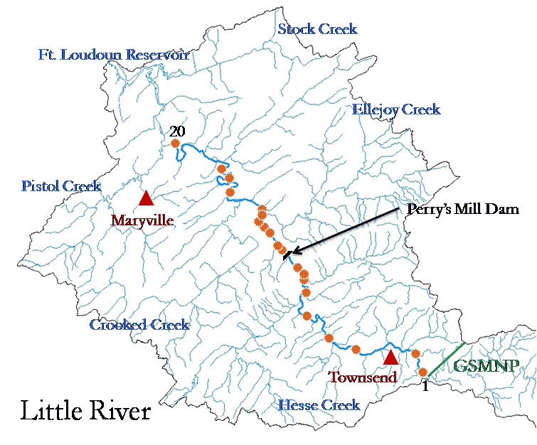
Not sampled in 2009
Figure 2. Map of study sites on the Little River, Tennessee.

habitat preferences of the three target species as previously described.

Field Sampling
Field samples were scheduled and completed during three seasons: spring (May-June), summer (June-July), and fall (September-October). Above average precipitation and the corresponding high turbidity during the 2009 sample season prevented a full survey of the 20 sites. This resulted in a total of 30 individual surveys made during the three seasons (Table 1).
At each site, dimensions of the pool and run habitat were recorded and a turbidity measurement was taken to determine visibility. This visibility determination was based on a comparison of turbidity readings and a Secchi disk reading taken during several initial site visits, and was subject to snorkeler experience and confidence. The visibility distance was used to calculate the number of transects that needed to be snorkeled. Thus, a site 10 meters wide

Table 1. Site locations and dates sampled.
Site # | River Mile | Latitude/Longitudeª | Spring | Summer | Fall
1 | 35.0 | N35° 40 05 – W83° 42 54 | 13 May 2009 | 17 June 2009 | 24 Sept 2009
2 | 34.4 | N35° 40 38 – W83° 43 01 | 13 May 2009 | 17 June 2009 | 24 Sept 2009
3 | 31.0 | N35° 40 34 – W83° 45 59 | NA | 17 June 2009 | 24 Sept 2009
4 | 29.0 | N35° 41 04 – W83° 47 33 | 20 May 2009 | 15 July 2009 | NA
5 | 26.5 | N35° 42 10 – W83° 48 54 | NA | 15 July 2009 | NA
6^{b} | 24.4 | N35° 43 31 – W83° 49 05 | NA | NA | NA
7 | 23.9 | N35° 43 43 – W83° 49 00 | 21 May 2009 | 2 July 2009 | NA
8 | 23.8 | N35° 43 46 – W83° 48 58 | 21 May 2009 | 2 July 2009 | NA
9 | 23.5 | N35° 43 54 – W83° 48 57 | NA | 28 July 2009 | NA
10^{c} | 21.8 | N35° 45 02 – W83° 50 16 | NA | NA | NA
11 | 21.8 | N35° 45 03 – W83° 50 17 | 28 May 2009 | 26 June 2009 | NA
12 | 20.8 | N35° 45 40 – W83° 50 51 | 1 June 2009 | 30 June 2009 | NA
13 | 20.7 | N35° 45 47 – W83° 51 00 | 1 June 2009 | 30 June 2009 | NA
14 | 20.3 | N35° 45 56 – W83° 51 23 | 2 June 2009 | 30 June 2009 | NA
15 | 19.7 | N35° 46 19 – W83° 51 07 | 9 June 2009 | 10 July 2009 | NA
16 | 19.6 | N35° 46 26 – W83° 51 07 | 9 June 2009 | 22 July 2009 | NA
17 | 17.3 | N35° 47 10 – W83° 53 01 | NA | NA | 10 Sept 2009
18^{b} | 14.5 | N35° 47 55 – W83° 52 57 | NA | NA | NA
19 | 14.2 | N35° 48 00 – W83° 53 17 | NA | NA | 10 Sept 2009
20^{b} | 8.3 | N35° 49 11 – W83° 56 08 | NA | NA | NA
a = NAD 83, b = site not sampled due to seasonal conditions, c = site not sampled due to habitat alteration.
with a visibility of 1.0 meters would mean that five transects would need to be snorkeled, since observers could see only one meter to each side. Snorkelers would then begin at the farthest downstream portion of the site and snorkel upstream side by side at the established width (Figure 3). All fish observed during the survey were identified to the lowest taxonomic level possible by the observer. When a target fish was seen, the snorkeler would describe any activity in which the fish was involved (feeding, resting, schooling, or fleeing), and then a leaded marker was placed where the fish was first observed. Snorkelers communicated with each other during

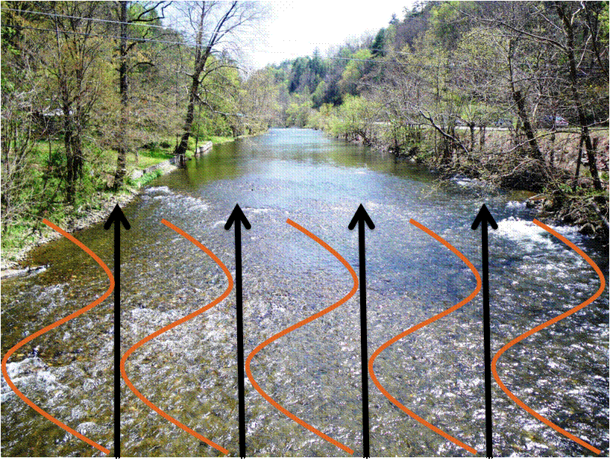
Figure 3. Schematic showing path of snorkeler in an upstream direction.
the survey to avoid duplicate fish counts. At the end of a transect, snorkelers would return downstream and repeat the process for any remaining transects.
The historic study by Heacock (1995) differed in several ways from this study. Samples made historically were conducted in the same fashion with the exception that only ideal habitat, as identified by the author, was sampled and only one snorkeler was present at each sample time. The Heacock (1995) study also differed in that six sequential surveys were conducted of the 20 sites from July to October. This is in contrast to the three surveys made in the current study which were designed to survey fish abundance and, habitat associations during three seasons. No habitat data was recorded in the previous study.

Habitat Sampling
Physical measurements, as well as water chemistry data, were recorded at each site. Turbidity was measured in Nephelometric Turbidity Units (NTU) with a LaMotte 2020 turbidimeter at the beginning of each survey. Temperature (C°) and dissolved oxygen (mg/L) were measured with an YSI Model 550A, while pH was measured with an YSI Model 60. Conductivity (µs) and total dissolved solids (ppm) were measured with a Eutech Instruments PCSTestr 35 Multi-Parameter tester. Average velocity (nearest 0.01 m/sec) was measured with a Rickly Hydrological Company Type AA current meter, and average depth (nearest 0.01 m) was measured for both pools and runs. Silt was visually estimated (mm) in pool habitats and a total count of large woody debris was recorded for both pool and run habitat.
A 1.0-meter square grid was constructed using ¾-inch PVC piping and ¼-inch plastic tubing with 25 equal size squares. By centering this grid over each of the leaded markers where darters were observed, a percentage of substrate types was calculated (Figure 4). The dominant substrate (bedrock, boulder, rubble, cobble, gravel, sand, and silt) was recorded for each of the 25 squares to determine a percentage of all substrates used by each darter. Substrate classes were based on a modified Wentworth Scale (Cummins 1962), except substrate in the cobble size class, as defined by Cummins, which were split into two classes, cobble 65-159 mm, and rubble 160-256 mm, in an attempt to more precisely describe the substrate utilized by blotchside logperch for feeding as described above.

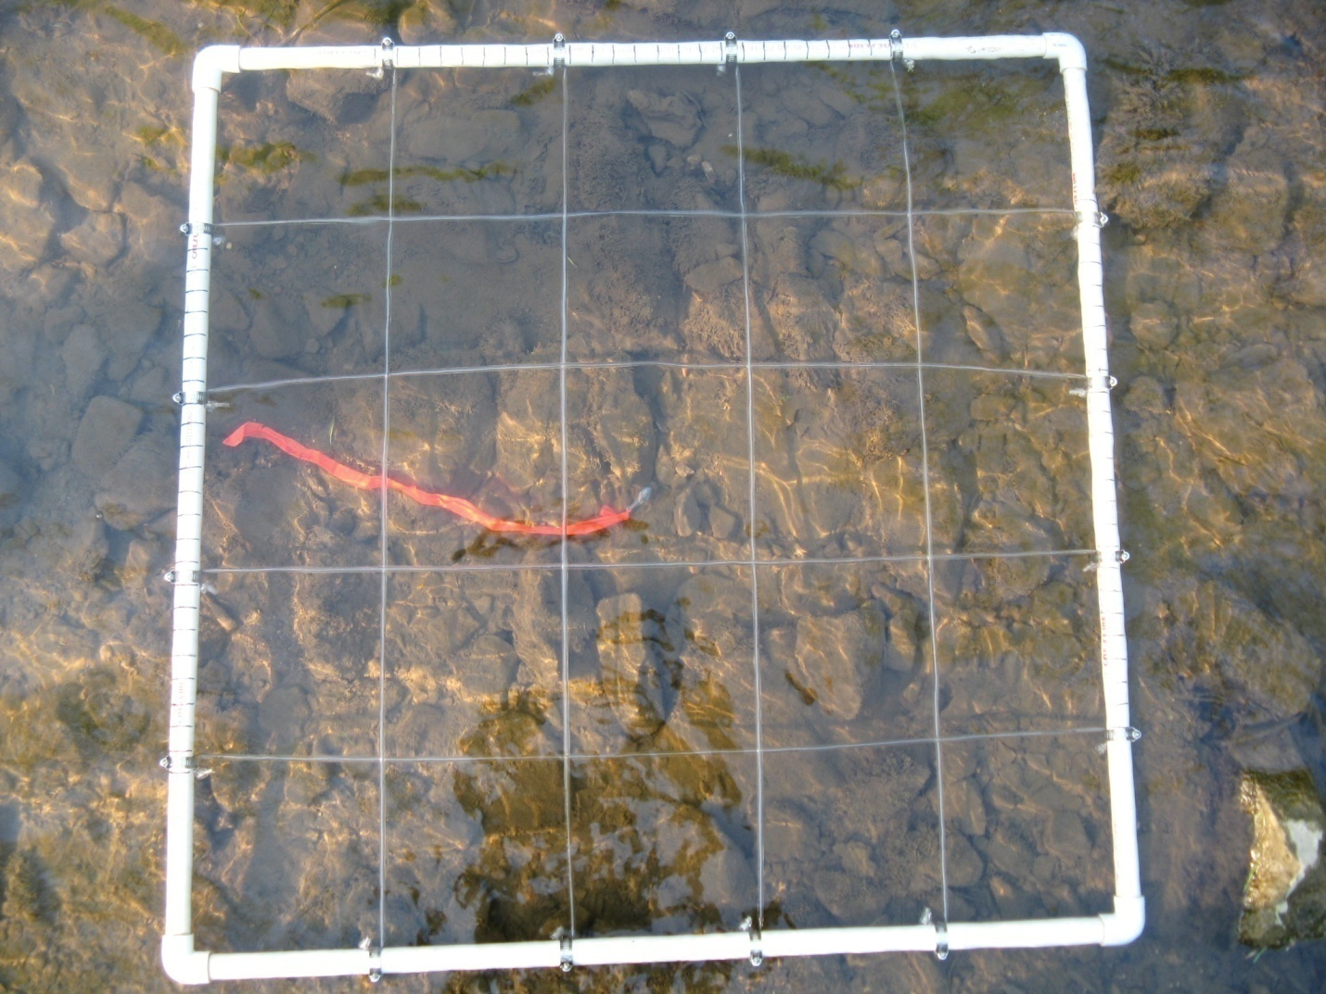
Figure 4. PVC grid used to determine substrate percentages.

Statistical Analyses
Due to the change in sampling procedures at sites between the historic study (Heacock 1995) and the current study, a method was needed to normalize data for comparison. Catch per unit effort (CPUE) (Murphy and Willis 1996) was determined to be the most easily computed value for this, as it could be calculated for the present study and the 1995 data. Catch per unit effort values were calculated as CPUE=${\left(\# of observed fish\right)}/{(snorkel time*\# of observers})$ . Catch per unit effort was calculated for each target species observed (P. aurantiaca, P. burtoni, and P. williamsi) and comparisons were made for all sites sampled in both the 1995 survey one (Heacock 1995) and the 2009 summer survey. Differences between CPUE values from the previous study (Heacock 1995) and this study were not normally distributed so a Wilcoxon Signed-Rank test was used to detect any differences. Likewise, habitat values were not normally distributed, so a Spearman Rank Correlation was used to estimate correlations among the habitat variables recorded as well as with CPUE calculations. All statistics were calculated in SAS©9.2.

CHAPTER 4

RESULTS
Thirty-nine species of fish were observed in the 30 surveys made during this study (Table 2). A total of 273 P. aurantiaca, 58 P. burtoni, and 7 P. williamsi were recorded from the 16 sites sampled. No E. cinereum were observed in this survey. The number of target fish seen at each site is summarized in Table 3. A Wilcoxon Signed-Rank test of CPUE by site and individual species detected that there were significant differences between the 2009 study and the historic study by Heacock (1995) (Table 4). The average difference between CPUE for the three target species measured in the summer of 2009 and Heacock’s 1995 measurements for the 14 sites was -0.32 with a p-value of <=0.0001 from a Wilcoxon Singed Rank test.
Substrate measurements at the site where each individual fish was observed revealed that Percina burtoni were found over substrates that averaged 39% gravel and 27% cobble (Table 5). No significant correlations were noted between physical habitat measurements (depth, large woody debris, average silt, and mean velocity) or chemical measurements (conductivity, pH, temperature, total dissolved solids, and turbidity) and CPUEs. Turbidity was found to be strongly correlated with river mile (Figure 5), and with an increase in turbidity at sites closer to the confluence of the Little River and the Tennessee River. Several sources of turbidity input into the mainstem of the Little River were noted during this study. In particular, turbidity associated with the Ellejoy Creek tributary was high. Turbidity measurements taken June 9, 2009 at the mouth of Ellejoy Creek were 14.2 NTUs, a substantial increase as compared with measurements taken a few meters upstream, which were 1.9 NTUs.
Table 2. List of species observed during 30 snorkel surveys on the Little River, Blount County, Tennessee, in 2009.
Common name | Scientific name
lamprey | Petromyzontidae
longnose gar | Lepisosteus osseus
largescale stoneroller | Campostoma oligolepis
whitetail shiner | Cyprinella galactura
spotfin shiner | Cyprinella spiloptera
blotched chub | Erimystax insignis
bigeye chub | Hybopsis amblops
striped shiner | Luxilus chrysocephalus
warpaint shiner | Luxilus coccogenis
river chub | Nocomis micropogon
Tennessee shiner | Notropis leuciodus
silver shiner | Notropis photogenis
telescope shiner | Notropis telescopus
mimic shiner | Notropis volucellus
stargazing minnow | Phenacobius uranops
creek chub | Semotilus atromaculatus
northern hogsucker | Hypentelium nigricans
redhorse | Moxostoma sp.
rainbow trout | Oncorhynchus mykiss
northern studfish | Fundulus catenatus
banded sculpin | Cottus carolinae
rockbass | Ambloplites rupestris
redbreast sunfish | Lepomis auritus
bluegill | Lepomis macrochirus
longear sunfish | Lepomis megalotis
smallmouth bass | Micropterus dolomieu
largemouth bass | Micropterus salmoides
greenside darter | Etheostoma blennioides
bluebreast darter | Etheostoma camurum
blueside darter | Etheostoma jessiae
redline darter | Etheostoma rufilineatum
snubnose darter | Etheostoma simoterum
wounded darter | Etheostoma vulneratum
banded darter | Etheostoma zonale
tangerine darter | Percina aurantiaca
blotchside logperch | Percina burtoni
logperch | Percina caprodes
gilt darter | Percina evides
sickle darter | Percina williamsi

Table 3. Total observations of target fish during three seasons in 2009.
Site | Percina aurantiaca |  |  | Percina burtoni |  |  | Percina williamsi
# | Spring | Summer | Fall | Spring | Summer | Fall | Spring | Summer | Fall
1 | 0 | 1 | 0 | 0 | 0 | 0 | 0 | 0 | 0
2 | 1 | 2 | 0 | 0 | 0 | 0 | 0 | 0 | 0
3 | NA | 16 | 12 | NA | 6 | 1 | NA | 0 | 0
4 | 3 | 10 | NA | 0 | 4 | NA | 0 | 0 | NA
5 | NA | 17 | NA | NA | 3 | NA | NA | 0 | NA
7 | 25 | 19 | NA | 10 | 6 | NA | 0 | 0 | NA
8 | 3 | 1 | NA | 5 | 4 | NA | 0 | 0 | NA
9 | NA | 2 | NA | NA | 6 | NA | NA | 0 | NA
11 | 0 | 3 | NA | 1 | 0 | NA | 2 | 2 | NA
12 | 0 | 40 | NA | 1 | 4 | NA | 0 | 0 | NA
13 | 18 | 31 | NA | 1 | 0 | NA | 0 | 0 | NA
14 | 13 | 17 | NA | 0 | 0 | NA | 1 | 1 | NA
15 | 6 | 3 | NA | 0 | 0 | NA | 1 | 0 | NA
16 | 2 | 10 | NA | 6 | 0 | NA | 0 | 0 | NA
17 | NA | NA | 11 | NA | NA | 0 | NA | NA | 0
19 | NA | NA | 7 | NA | NA | 0 | NA | NA | 0
Total | 71 | 172 | 30 | 24 | 33 | 1 | 4 | 3 | 0
NA = Not sampled.

Table 4. CPUE of samples made during three seasons in 2009 and one survey in 1995.
 | Spring 2009 |  | Summer 2009 |  | Fall 2009 |  | 1995ª
Site # | CPUE (abw)^{b} | CPUE (bw)^{c} | CPUE (abw)^{b} | CPUE (bw)^{c} | CPUE (abw)^{b} | CPUE (bw)^{c} | CPUE (abw)^{b} | CPUE (bw)^{c}
1 | 0 | 0 | 0.0042 | 0 | 0 | 0 | 0.3 | 0
2 | 0.0019 | 0 | 0.0042 | 0 | 0 | 0 | 0.102 | 0
3 | NA | NA | 0.0407 | 0.0111 | 0.0722 | 0.0056 | 0.7143 | 0.3214
4 | 0.0056 | 0 | 0.0333 | 0.0095 | NA | NA | 0.4444 | 0
5 | NA | NA | 0.0417 | 0.0062 | NA | NA | 0.16 | 0
7 | 0.0648 | 0.0185 | 0.0595 | 0.0143 | NA | NA | 0.1515 | 0.0303
8 | 0.0133 | 0.0083 | 0.0208 | 0.0167 | NA | NA | 0.6522 | 0.1304
9 | NA | NA | 0.0444 | 0.0333 | NA | NA | 0.1707 | 0.122
11 | 0.0045 | 0.0045 | 0.0133 | 0.0053 | NA | NA | 0.4 | 0.15
12 | 0.0019 | 0.0019 | 0.0733 | 0.0067 | NA | NA | 0.3276 | 0.0345
13 | 0.0469 | 0.0025 | 0.0827 | 0 | NA | NA | 0.7368 | 0
14 | 0.0444 | 0.0032 | 0.06 | 0.0033 | NA | NA | 0.4211 | 0
15 | 0.0233 | 0.0033 | 0.0075 | 0 | NA | NA | 0.0741 | 0.037
16 | 0.019 | 0.0143 | 0.0313 | 0 | NA | NA | 0.4444 | 0
17 | NA | NA | NA | NA | 0.0524 | 0 | 0.0645 | 0
19 | NA | NA | NA | NA | 0.0389 | 0 | 0.0465 | 0
Mean | 0.0205 | 0.0051 | 0.0369 | 0.0076 | 0.0327 | 0.0011 | 0.3256 | 0.0516
a = From Heacock (1995) survey July 13-20, b = CPUE calculated using Percina aurantiaca + P. burtoni + P. williamsi, c = CPUE calculated using P. burtoni + P. williamsi, NA=not sampled.

Table 5. Average percent (%) substrates located at observed target species.
Species | bedrock | boulder | rubble | cobble | gravel | sand | silt
Percina burtoni | 2 | 7 | 12 | 27 | 39 | 11 | 0
Percina williamsi | 0 | 12 | 9 | 19 | 17 | 31 | 13

Figure 5. Graphic illustrating correlation between turbidity (NTU) and river mile (NTU= Nephelometric turbidity units).
Multiple observations were made of P. burtoni and P. williamsi in areas adjacent to study sites. This information is included in Table 6 but was not included in any data analysis. At Site 11, there were an additional three P. burtoni observed and two P. williamsi observed during the spring and summer sample sessions. Site 12 observations included an additional five P. williamsi that were observed 150 meters downstream from the sample site during the spring sample. One P. burtoni and two P. williamsi were observed in pool habitats adjacent to Site 14 in the summer. Also, one P. burtoni and one P. williamsi were observed in a pool located upstream from Site 16 during the spring sample.

Table 6. Additional fish seen outside established sample sites.
Season | Site | Percina burtoni | Percina williamsi | Comments
Spring | 11 | 1 | 2 | Seen in swimming area at base of Perry’s Mill Dam 300 m upstream from Site 11.
Spring | 12 |  | 5 | Right bank just below gravel shoal in pool 150 m downstream from Site 12.
Spring | 16 | 1 | 1 | Deep pool 150 m upstream from Site 16.
Summer | 11 | 1 |  | In swift run habitat just outside Site 11.
Summer | 14 | 1 | 2 | Over detritus pile just downstream from Site 14, near swimming access.

CHAPTER 5

DISCUSSION
The Little River in East Tennessee is an excellent example of the aquatic diversity that characterizes this state. Yet this river, as most rivers in developing areas of the eastern United States, is under many stresses associated with increasing population growth (Warren et al. 2000). Although having its headwaters spared from the multitude of influences often associated with localized urbanization, there are still negative impacts from acid rain (Haines 1981) and invasive species (Gido and Brown 1999). The mouth of the Little River is heavily influenced by Ft. Loudoun Reservoir. Not only does this large reservoir create an unnatural barrier to the natural ebb and flow of species often associated with major rivers and their tributaries, it provides an additional avenue for the introduction of non-native species to the Little River (Gido and Brown 1999).
The influence of above average precipitation in East Tennessee in 2009 may have affected the results of this study. Of the originally 60 surveys planned for this study (20 sites surveyed during three seasons) only 30 were completed. However, 69% of the target fish counted during this study were seen between Site 7 and Site 16. This percentage was similar (68%) to the result in the 1995 study (Heacock 1995). These percentages increase to 89% and 91%, respectively, if Sites 3-6 are included, indicating that this central portion of the Little River is of critical importance to these species. Thus, any impacts in this reach of the river may constitute a greater threat to these fish than in other areas of the river where they occur.
One current impact to this portion of the river is the Perry’s Mill Dam. This dam was constructed in 1906 as a mill dam, but is currently unused except as a local recreation area. Etheostoma cinereum and Percina williamsi have never been recorded above the dam. During this study, two P. williamsi were observed at Site 11 which is located approximately 300 meters downstream of the mill dam; two other P. williamsi were observed at the base of the mill dam during a reconnaissance visit. A second mill dam is located between Site 2 and Site 3. Percina burtoni have never been observed above this impediment; however, they were recorded at Site 3 which is located only two river miles downstream. If these two mill dams did not exist and habitat remained contiguous throughout these areas as it appears it would, there is the potential that these darters would have access to several more river miles of stream. However, the presence of these dams and the large upstream pools associated with each of them may act as a sink for fine sediments. Thus their removal could allow for additional impacts to this portion of the river by increasing the sediment load.
A second impact to the Little River is excessive sedimentation. A few of the negative impacts that sedimentation can have on fish communities include the filling of important interstitial spaces, a decrease of coarse substrate, reduced reproductive success, reduced feeding rates, and an overall reduction of stream fish diversity (Berkman and Rabeni 1987; Walser and Bart 1999; Burkhead and Jelks 2001; Bonner and Wilde 2002; Mattingly and Galat 2002). Page and Near (2007) stated that the most likely proximate principal threats to P. williamsi are increased turbidity and siltation, which result from agricultural, industrial, and municipal development. Shepard and Burr (1984) and Powers et al. (2004) list siltation of pool habitats as a leading threat to E. cinereum.
Few fish were observed below Site 16 in the present study or the Heacock (1995) study. Of significant influence to this observation is the presence of Ellejoy Creek which flows into the Little River at Site 16. The Ellejoy Creek watershed is heavily influenced by agriculture. It is not uncommon for livestock to have direct access to the mainstem of the Little River, but that situation is especially prevalent in Ellejoy Creek. Personal observations of sedimentation and turbidity were more consistently observed at this site than at any other site along the entire Little River during this study.
The University of Tennessee-Knoxville (UTK) has recently purchased 212 hectares of property at the confluence of the Little River and Ellejoy Creek. The property was purchased as a relocation site for the UTK dairy, which through its development can provide a unique educational opportunity. Substantial planning has gone into the development of this site to prevent and monitor the impacts of dairy cattle on the aquatic ecosystem. This property borders the lower 1.2 kilometers of Ellejoy Creek. It is characteristic of other agriculture land in the watershed, with pasture and row crops covering most of the property, and often adjacent to the stream bank. Future management objectives of this property could include placing proper buffer zones along the banks of the creek, preventing livestock from having direct access to the stream, and implementing best management practices. These practices could establish the UTK property as an excellent example of streamside erosion control and a consequent reduction in sedimentation associated with agriculture.
The absence of the ashy darter from this study was not completely unexpected. This fish has become increasingly rare on the Little River in recent years (Powers and Mayden 2002). A presence-absence survey of fish collections made by the University of Tennessee at the US Highway 411 bridge (Site 17) from 1969-2000 indicated that the occurrence of E. cinereum has decreased from 73% (1969-1978) to 23% (1991-2000) (D. A. Etnier, University of Tennessee, unpublished data). Conservation Fisheries Incorporated from Knoxville, Tennessee, has only encountered E. cinereum in seven snorkel sites on the Little River from 1999-2008 (P. Rakes, CFI, unpublished data). Of the original 120 surveys conducted in the river in 1995, only two E. cinereum were encountered (Heacock 1995).
In contrasts with adult E. cinereum found in the Big South Fork, Buffalo, and Duck River systems populations found in the Little River may tend to be a crepuscular species, with a decrease in activity during midday, thus reducing the chance that snorkelers would observe them during this time (P. Rakes, CFI, personal communication). Shepard and Burr (1984) indicated that even at localities where reproducing populations of E. cinereum are known to occur, they are not often seen unless special efforts are made to thoroughly collect in its habitat. Therefore, it is suggested that the apparent absence of this fish from some tributary systems is perhaps an artifact of inadequate sampling. As stated in the methods, the limitations of sampling in this study due to increased precipitation and the associated turbidity are likely causes that E. cinereum was undetected.
The sighting of P. williamsi outside the established sites suggested that either this species was not well targeted in the original study or that habitat at these sites has changed such that P. williamsi no longer prefer it. This may also be the case for E. cinereum. Future studies would benefit from a more thorough investigation of the preferred habitat of P. williamsi on the Little River before site selections are made.
A comparison of differences of CPUE values for the 14 sites sampled in the summer of 2009 and the same sites sampled in survey one of Heacock’s study were statistically different (Figure 6). These differences could indicate several things. If populations of these fishes are lower as indicated by the CPUE value differences, some impact has occurred to these areas of the Little River over the last 14 years that has had a negative impact. As mentioned earlier, increased sedimentation and surface runoff pollutions associated with both agriculture and

Figure 6. Catch per unit effort (CPUE) of Percina aurantiaca, P. burtoni, and P. williamsi by river mile.
human development would likely be factors of this. Another consideration is differences in sampling methods between the two studies. In the Heacock (1995) study, samples were made in what the author determined as ideal habitat within each site. Since no values were associated with this selection of habitat the current study was designed to survey the entire site (left bank to right bank) at each location (Table 7). Finally, seasonal conditions were not ideal during the current study. High flows and the associated turbidity limited site access and reduced snorkeler visibility. It is important to note, however, that the largest percentage of target fish observed during both studies was P. aurantiaca. The other two species (P. burtoni and P. williamsi), which were targeted in both studies, consistently had lower CPUE values.

Table 7. Summary of total area sampled and sampling effort for sites surveyed in summer 2009 and 1995.
 | Summer 2009 |  | 1995ª
Site | Total area | Sample effort (min) | Total area | Sample effort (min)
1 | 1029.0 | 240 | 270.5 | 20
2 | 1531.8 | 480 | 871.2 | 49
3 | 1355.9 | 540 | 276.9 | 28
4 | 1572.8 | 420 | 508.2 | 18
5 | 2329.9 | 480 | 169.7 | 25
7 | 1476.0 | 420 | 565.8 | 66
8 | 1221.1 | 240 | 269.4 | 23
9 | 807.0 | 180 | 297.3 | 41
11 | 738.0 | 375 | 401.3 | 20
12 | 2070.4 | 600 | 832.5 | 58
13 | 1191.8 | 375 | 288.5 | 19
14 | 677.4 | 300 | 289.9 | 19
15 | 450.4 | 400 | 587.5 | 27
16 | 1259.5 | 320 | 692.4 | 27
Mean | 1265.07 | 383.57 | 451.51 | 31.43
a = From Heacock (1995) survey July 13-20.
Little River populations of these fish are still in jeopardy of local impacts to this stream and should be monitored more consistently.
Average substrate data collected revealed that P. burtoni were observed over substrates containing a mixture of 39% gravel and 27% cobble. These fish were most frequently observed feeding or schooling with other fish. Feeding habits described earlier explain the regularity of this species over these substrates. The lack of correlation between other habitat measurements taken and CPUE values is best explained by the effects of the increased precipitation in 2009. This increase in precipitation not only reduced the sample size of this study by increasing flows and turbidity, it also influenced the flows during the time samples were made. Increased flows affected many aspects of the habitat data including the dimensions of pool and run habitats, the velocity readings at both 60% depth and at the substrate, the mean depth at each site, and turbidity readings.

CHAPTER 6

SUMMARY AND RECOMMENDATIONS
Snorkel surveys were conducted on the Little River in 2009 for comparison with survey data from 1995 (Heacock 1995). These surveys were hindered by above average precipitation and associated turbidity, which limited the amount of data that could be collected. However, valuable information was determined from this study and is listed below.
- Current CPUE values were found to be detectably different from historic CPUE values when tested using a Wilcoxon Signed-Rank test.
- Sites located in the central portion of the Little River (Site 3 – Site 16) were the most productive, containing 89% of all target fish observed.
- There were no E. cinereum observed in the current study. Only two were observed in the previous study by Heacock (1995).
- P. burtoni were found to be most frequently associated with gravel and cobble substrates.
The low CPUE values associated with sites 17-20 in both the present study and the historic study could to be a reflection of habitat loss due to sedimentation or a consequence of sampling inefficiency associated with high turbid flows during sample times. It is recommended that landowners in this watershed be encouraged to participate in agricultural best management practices, which could alleviate a significant sedimentation burden in the Little River.
Future studies would benefit from a combination of sampling techniques including snorkeling and seining, which would allow sufficient sampling in all available habitat. Additionally, sampling in areas other than the 20 sites established in 1995, and surveyed again in this study, would provide data on possible additional locations of P. williamsi and E. cinereum. SCUBA surveys would also provide important population data in portions of the river where snorkeling techniques are inefficient due to water depth. It is further recommended that monitoring protocols be established at sites along the Little River to assess changes in available habitat which may be occurring.
The introduction of P. williamsi into available habitat about the Perry’s Mill Dam located between Site 9 and Site 10 could potentially extend the range of this species 10 river miles upstream. Also, further studies should be conducted to locate any P. burtoni above Site 3. Suitable habitat is located from this site upstream to the boundary of the GSMNP.

LITERATURE CITED
Angermeier, P. L. 1995. Ecological attribues of extinction-prone species: Loss of freshwater fishes of Virginia. Conservation Biology 9(1):143-158.
Bailey, R. M., J. E. Fitch, E. S. Herald, E. A. Lachner, C. C. Lindsey, C. R. Robins, and W. B. Scott. 1970. A list of common and scientific names of fishes from the United States and Canada, 3rd ed. American Fisheries Society Special Publication 6. American Fisheries Society, Bethesda, Maryland.
Bennett, G. 1981. The classic environmental issue. The Environmentalist 1:217-221.
Berkman, H. E., and C. F. Rabeni. 1987. Effects of siltation on stream fish communities. Environmental Biology of Fishes 18:285-294.
Blanton, R. E., and R. E. Jenkins. 2008. Three new darter species of the Etheostoma percnurum species complex (Percidae, subgenus Catonotus) from the Tennessee and Cumberland river drainages. Zootaxa (1963):1-24.
Bonner, T. H., and G. R. Wilde. 2002. Effects of turbidity on prey consumption by prairie stream fishes. Transactions of the American Fisheries Society 131:1203-1208.
Burkhead, N. M., and H. L. Jelks. 2001. Effects of suspended sediment on the reproductive success of the tricolor shiner, a crevice-spawning minnow. Transactions of the American Fisheries Society 130(5):959-968.
Coombs, J. A. 2003. Tag retention in re-introduced species of selected darters in the Pigeon River, TN. Master's thesis. University of Tennessee, Knoxville.
Cummins, K. W. 1962. An evaluation of some techniques for the collection and analysis of benthic samples with special emphasis on lotic waters. American Midland Naturalist 67(2):477-504.
Ensign, W. E., P. L. Angermeier, and C. A. Dolloff. 1995. Use of line transect methods to estimate abundance of benthic stream fishes. Canadian Journal of Fisheries and Aquatic Sciences 52(1):213-222.
Etnier, D. A., and W. C. Starnes. 1993. The fishes of Tennessee. University of Tennessee Press, Knoxville.
Federal Register. 1975. Amendment listing the snail darter as an endangered species. Office of the Federal Register, National Archives and Records Administration 40(197):47505-47506.

Federal Register. 1993. Endangered and threatened wildlife and plants; Determination of endangered status for the duskytail darter, palezone shiner and pygmy madtom. Office of the Federal Register, National Archives and Records Administration 58(79):25758-25763.
Fowler, H. W. 1945. A study of the fishes of the southern Piedmont and Coastal Plain. Monographs of the Academy of Natural Sciences, Philadelphia, Pennsylvania.
Freeman, B. J., and M. C. Freeman. 1994. Habitat use by an endangered riverine fish and implications for species protection. Ecology of Freshwater Fish 3:49-58.
George, A. L., D. A. Neely, and R. L. Mayden. 2006. Conservation genetics of an imperiled riverine fish from Eastern North America, the blotchside logperch, Percina burtoni (Teleostei : Percidae). Copeia 2006:585-594.
Gido, K. B., and J. H. Brown. 1999. Invasion of North American drainages by alien fish species. Freshwater Biology 42:387-399.
Goldstein, R. M. 1978. Quantitative comparison of seining and underwater observation for stream fishery surveys. Progressive Fish-Culturist 40(3):108-111.
Greenberg, L. A. 1991. Habitat use and feeding-behavior of 13 species of benthic stream fishes. Environmental Biology of Fishes 31(4):389-401.
Haines, T. A. 1981. Acidic precipitation and its consequences for aquatic ecosystems: A review. Transactions of the American Fisheries Society 110(6):669-707.
Hankin, D. G., and G. H. Reeves. 1988. Estimating total fish abundance and total habitat area in small streams based on visual estimation methods. Canadian Journal of Fisheries and Aquatic Sciences 45(5):834-844.
Heacock, C. H. 1995. A repeatable, visual survey of three rare Percina (Osteichthyes: Percidae) fish in Little River, Blount County, Tennessee. Master's thesis. The University of Tennessee, Knoxville.
Hlohowskyj, I., and T. E. Wissing. 1986. Substrate selection by fantail (Etheostoma flabellare), greenside (E. blennioides), and rainbow (E. caeruleum) darters. Ohio Journal of Science 86(3):124-129.
Jones, E. B. D., G. S. Helfman, J. O. Harper, and P. V. Bolstad. 1999. Effects of riparian forest removal on fish assemblages in southern Appalachian streams. Conservation Biology 13(6):1454-1465.
Karr, J. R. 1981. Assessment of biotic integrity using fish communities. Fisheries 6(6):21-27.
Kessler, R. K., A. F. Casper, and G. K. Weddle. 1995. Temporal variation in microhabitat use and spacial relations in the benthic fish community of a stream. American Midland Naturalist 134(2):361-370.
Kessler, R. K., and J. H. Thorp. 1993. Microhabitat segregation of the threatened spotted darter (Etheostoma maculatum) and closely related orangefin darter (E. bellum). Canadian Journal of Fisheries and Aquatic Sciences 50(5):1084-1091.
Lydeard, C., and R. L. Mayden. 1995. A diverse and endangered aquatic ecosystem of the southeast United States. Conservation Biology 9(4):800-805.
Matthews, W. J. 1985. Critical current speeds and microhabitats of the benthic fishes Percina roanoka and Etheostoma flabellare. Environmental Biology of Fishes 12(4):303-308.
Mattingly, H. T., and D. L. Galat. 2002. Distributional patterns of the threatened Niangua darter, Etheostoma nianguae, at three spatial scales, with implications for species conservation. Copeia 2002:573-585.
McCormick, F. H., and N. Aspinwall. 1983. Habitat selection in three species of darters. Environmental Biology of Fishes 8(3/4):279-282.
Murphy, B. R., and D. W. Willis, editors. 1996. Fisheries techniques, 2nd edition. American Fisheries Society, Bethesda, Maryland.
Near, T. J., and M. F. Bernard. 2004. Rapid allopatric speciation in logperch darters (Percidae: Percina). Evolution 58(12):2798-2808.
Osier, E. A., and S. A. Welsh. 2007. Habitat use of Etheostoma maculatum (spotted darter) in Elk River, West Virginia. Northeastern Naturalist 14(3):447-460.
Page, L. M. 1978. Redescription, distribution, variation and life history notes on Percina macrocephala (Percidae). Copeia 1978:655-664.
Page, L. M., and T. J. Near. 2007. A new darter from the upper Tennessee River drainage related to Percina macrocephala (Percidae : Etheostomatinae). Copeia 2007:605-613.
Parmalee, P. W., and A. E. Bogan. 1998. The Freshwater Mussels of Tennessee. The University of Tennessee Press, Knoxville, TN.
Powers, S. L., and R. L. Mayden. 2002. Threatened fishes of the world: Etheostoma cinereum Storer, 1845 (Percidae). Environmental Biology of Fishes 63(3):264-264.
Powers, S. L., R. L. Mayden, and D. A. Etnier. 2004. Conservation genetics of the ashy darter, Etheostoma cinereum (Percidae : subgenus Allohistium), in the Cumberland and Tennessee Rivers of the southeastern United States. Copeia 2004:632-637.
Rahel, F. J. 2000. Homogenization of fish faunas across the United States. Science 288:854-856.
Shepard, T. E., and B. M. Burr. 1984. Systematics, status, and life-history aspects of the ashy darter, Etheostoma cinereum (Pisces, Percidae). Proceedings of the Biological Society of Washington 97(4):693-715.
Stauffer, J. R., J. M. Boltz, K. A. Kellogg, and E. S. van Snik. 1996. Microhabitat partitioning in a diverse assemblage of darters in the Allegheny River system. Environmental Biology of Fishes 46(1):37-44.
Storer, D. H. 1845. [Description of hitherto undescribed fishes]. Proceedings of the Boston Society of Natural History 2:47-50.
Tennessee Wildlife Resources Agency. 2005. Tennessee's comprehensive wildlife conservation strategy, Nashville, TN.
Walser, C. A., and H. L. Bart. 1999. Influence of agriculture on in-stream habitat and fish community structure in Piedmont watersheds of the Chattahoochee River System. Ecology of Freshwater Fish 8(4):237-246.
Warren, M. L., and B. M. Burr. 1994. Status of freshwater fishes of the United States: Overview of an imperiled fauna. Fisheries 19(1):6-18.
Warren, M. L., B. M. Burr, S. J. Walsh, H. L. Bart, R. C. Cashner, D. A. Etnier, B. J. Freeman, B. R. Kuhajda, R. L. Mayden, H. W. Robison, S. T. Ross, and W. C. Starnes. 2000. Diversity, distribution, and conservation status of the native freshwater fishes of the southern United States. Fisheries 25(10):7-31.
Weaver, L. A., and G. C. Garman. 1994. Urbanization of a watershed and historical changes in stream fish assemblage. Transactions of the American Fisheries Society 123(2):162-172.
Welsh, S. A., and S. A. Perry. 1998. Habitat partitioning in a community of darters in the Elk River, West Virginia. Environmental Biology of Fishes 51(4):411-419.
Whitworth, W. R., and R. E. Schmidt. 1980. Snorkeling as a means of evaluating fish populations in streams. New York Fish and Game Journal 27(1):91-94.

VITA
Robert Trenton Jett was born October 27, 1978. He received an Associate of Arts degree from Okaloosa Walton Community College in 1997. Wanting to pursue a degree in Wildlife and Fisheries, he enrolled in the University of Tennessee as an undergraduate in 2004 in the Wildlife and Fisheries Science program. Upon graduation in 2008 with a Bachelor of Science, Trent continued in the University of Tennessee as a master’s student. In May of 2010, a Master of Science degree in Wildlife and Fisheries Science was awarded.

