Avian use of agricultural cover crop fields during winter, migration stopover, and the breeding season in Tennessee

A Thesis Presented for the
Master of Science
Degree
The University of Tennessee, Knoxville

Brittany Panos
May 2024

ACKNOWLEDGEMENTS

Thank you to my advisor, Dr. David Buehler, as well as to my committee members, Dr. Craig Harper and Dr. Hannah Herrero, for their guidance and support during the completion of this thesis. I would also like to thank Robin Mayberry, Mike Hansborough, and the district conservationists of Tennessee’s Natural Resources Conservation Service who have been integral in assisting with the procurement of fields for this study as well as providing much needed support and help during the process of this study. Additional thanks to Dr. Doug Raybuck for assisting in the analysis of this thesis upon which my conclusions are based. Thank you to all the field technicians who helped assist me during the field seasons in the collection of data for this thesis and to the landowners who allowed us to work on their fields. Finally, thank you to the University of Tennessee School of Natural Resources and the U. S. Department of Agriculture Natural Resources Conservation Service for providing the financial support necessary to complete this project.

ABSTRACT

The U.S. Department of Agriculture Natural Resources Conservation Service administers the cover crop program to provide technical and financial assistance to agricultural producers to sow herbaceous plant seeds to establish cover crops to protect agricultural fields from soil erosion during the non-growing season (late fall through spring). Soil retention and water quality benefits have been documented, but potential benefits for avian wildlife remain largely unknown. I used line-transect avian and vegetation surveys to examine use of cover crop fields by birds during the non-breeding period (winter), migration, and the breeding season. I compared avian use of cover crop fields with no-till row-crop fields without cover crops (controls). Analyses of variance (ANOVA) were used to compare vegetation parameters by season, year, and enrollment type. I modeled single species occupancy for focal species, multispecies richness, cumulative avian conservation scores from Partners in Flight, and calculated species accumulation curves to compare avian use of cover crop and control fields.
Overall, implementation of the cover crop practice was successful in that >80% of the fields had >75% cover in cover crops by spring in 2021 and 2022. Based on the ANOVAs, cover crop fields had greater percent vegetated cover, and lesser percent bare ground than control fields. Six of the fourteen focal species occupancy models showed a relationship between occupancy and field type, with five of the six preferring cover crops over control fields. A large diversity of avian species was detected using cover crop fields (n = 70). However, confidence intervals in species accumulation curves overlapped, suggesting that cover crop and control fields would be used by a similar number of species if survey effort was equal. Species richness and cumulative conservation score per transect were about 10% greater in cover crop fields than in control fields. I documented limited breeding activity in cover crop fields early in the breeding season in April, suggesting that some birds were attempting to breed prior to cover crop termination and subsequent planting. However, given the timing of this breeding activity, it is unlikely that cover crop fields provided a significant resource for avian nesting cover.

TABLE OF CONTENTS
Section 1. Introduction and Justification 1
Section 2. Study Site Selection 11
Section 3. Methods 11
Establishment and Termination 12
Vegetation Surveys 12
Bird Surveys 13
Breeding Bird Surveys 13
Section 4. Statistical Analyses 14
Vegetation Analyses 14
Avian Analyses 15
Section 5. Results 17
Vegetation Analyses 17
Species Accumulation Curves and Species Relative Abundance 19
Occupancy Models for Selected Species, Overall Species Counts, and PIF Scores 21
Section 6. Discussion 22
Literature Cited 27
Figures 32
Tables 47
Appendix 62
Vita 66

LIST OF TABLES
Table 1. Establishment and Termination Dates 47
Table 2. Analysis of Variance of Forest and Cropland Cover Composition 48
Table 3. Analysis of Variance of Percent Cover Crops, Percent Forbs, and Percent Grasses 49
Table 4. Analysis of Variance of Vegetation Parameters 50
Table 5. Year-Round Avian Species Detections and Percent Abundances 52
Table 6. Wintering Avian Species Detections and Percent Abundances 54
Table 7. Migratory Avian Species Detections and Percent Abundances 55
Table 8. Breeding Avian Species Detections and Percent Abundances 57
Table 9. Single Species Occupancy Models 59
Table 10. Multispecies Richness and PIF Models 61

Appendix 1. Latin Names, USFWS Alpha Codes, and PIF CCS-Max Scores 62
Appendix 2. Cover Crop and Prominent Plant Species 65

LIST OF FIGURES
Figure 1. Middle and Western TN County Maps 32
Figure 2. Landscape Composition Pie Charts 36
Figure 3. Plant Species Composition Pie Charts 40
Figure 4. Avian Species Accumulation Curves 44
Figure 5. Avian Species Percent Abundance 46

Introduction and Justification

Agricultural cover crops consist of herbaceous plantings involving single grass/forb species or mixtures of species, such as cereal rye, various types of clover, winter wheat, or buckwheat. Cover crops planted during fall in harvested row crop fields improve water quality and reduce soil erosion (Dabney et al. 2001). Cover crops may also aid in weed suppression, and insect and disease control (Creamer et al. 1995, Bottenberg et al. 1997). As a result of the perceived agricultural and environmental benefits, farmers across Tennessee are given technical assistance and financial incentives administered by the Department of Agriculture’s Natural Resources Conservation Service (NRCS) to utilize cover crops practices as part of their row crop management system. In 2016-2017, over 38,000 ha of cover crops were planted on a total of 4,200 individual fields as a result of NRCS incentive programs in Tennessee. This practice has continued to grow in Tennessee with 287,338 ha planted in cover crops between 2019 and 2022, with farmers being paid on average $20/ha during the time of this study. Given the amount of acreage in this practice, the NRCS cover crop program is one of the largest conservation practices on private lands in Tennessee (NRCS unpublished data).
The driving force behind promoting the use of cover crops is prevention of soil erosion and improvement of water quality. Dabney et al. (2001) reported that various types of cover crops provided multiple agricultural benefits. Cover crops acted as conduits for greater Nitrogen (N) exchange between the soil and subsequent crops. A mixture of grass and legume crops increased carbon inputs to the soil while also maintaining suitable N levels for sequestering between crops. Soil hydrology studies documented that cover crops, such as cereal rye, can prevent subsurface drainage by as much as 21% (Qi and Helmers 2010), which reduces nitrate (NO₃) leaching (Sainju and Singh 1997). Nitrate (NO₃) leaching is directly associated with the amount of water drainage. With cover crop implementation, NO₃ leaching can be reduced by helping to retain groundwater and precipitation due to a mulch effect by the crops (Sainju and Singh 1997). Soil microbial health may also be improved by cover crop usage. Certain single and mixed species cover crops had more diverse and a greater abundance of soil microbes compared to other single species cover crops or compared to fields left fallow (Finney et al. 2017). Thus, there is growing evidence of the benefits of cover crops to improving soil and water quality.
Although knowledge about cover crop effects on soil and water is fairly extensive, very few studies have evaluated the effects of this practice on wildlife. European studies have demonstrated that cover crops can suppress European rabbit (Oryctolagus cuniculus) foraging damage on cash crops (Barrio et al. 2012, Carpio et al. 2017) and have documented squamate species richness and abundance across a variety of cover types (Carpio et al. 2017). Cover crops have been noted as beneficial to game birds in the United Kingdom by providing food and cover; these cover crops can also provide habitat for declining migrating and over-wintering passerines (Stoate et al. 2003, Sage et al. 2005).
Avian studies on cover crop usage in North America are limited but growing as the practice becomes more widely implemented. To date, there have been several studies in North America focusing on cover crops and birds. Wilcoxen et al. (2018) documented greater avian use of cover crops by spring migrants and resident species than use of fallow control fields. Zagorski and Swihart (2020) demonstrated that raptors used cover crop fields when artificial perches were provided. Ring-necked pheasant (Phasianus colchicus) use of cover crops have also been evaluated in both Iowa and Kansas. In Iowa, Shirley and Janke (2023) examined nest-site selection in fall-seeded cover crop fields and suggested that fall-seeded cover crop fields provided small improvements in pheasant nesting cover availability, but not to the extent that cover crops would replicate nesting needs for avian species that use grasslands. In Kansas, cover crops were unable to provide the necessary vertical cover needed for nesting pheasants, however, cover crops did provide brood-rearing cover and aided in female survival if cover crops were planted near quality nesting habitat (Annis 2019). Additional information is needed that documents avian use during other critical time periods, such as over-wintering for passerines, migration stopover, and nesting/breeding seasons in North America. Understanding the dynamics of cover crop establishment, growth, and the termination process related to avian use may have important conservation implications.
Population declines have been documented for a variety of avian species groups, including grassland obligate species (Peterjohn et al. 1995, Peterjohn and Sauer 1999), shorebirds (Howe et al. 1989), and upland gamebirds, such as the Northern Bobwhite (Colinus virginianus (Brennan and Kuvlesky Jr 2005, Hernández et al. 2013). Rosenberg et al. (2019) provided a contemporary analysis of avian population trends, confirming that there have been significant declines across all avian groups, with approximately 30% of bird populations lost since the North American Breeding Bird Survey began in 1966. In general, habitat loss has been postulated as the over-riding factor linked with most of these declines (Mineau et al. 2013, Hill et al. 2014). Habitat quality and quantity needs to be addressed throughout the annual life cycle of species of conservation concern, including during the nesting season, during migration, and during the stationary, non-breeding season (‘winter’). Given the need to address habitat losses during the full life cycle of grassland birds, and the extent that cover crops may be used by grassland-associated species during critical life stages, it is important to evaluate the potential benefits the cover crop practice may provide in avian conservation.

Wintering Bird Ecology
The stationary, non-breeding (‘winter’) period is a critical stage of the life cycle in birds. Migratory species must replenish fat that was burned during migration, in most cases molt, and prepare ultimately for spring migration (Helms and Drury 1960, Rogers and Smith 1993). In general, there has been much less research on winter bird ecology than research during the breeding season. Habitat for wintering birds must meet basic requirements for food, shelter from inclement weather, and cover to avoid predation (Hutto 1985). Evaluation of avian use of cover crops should be conducted with these requirements in mind.
Some research has been conducted on cover crops and winter bird use as the practice continues to gain popularity. A study in England evaluated avian use of winter bird crops, which are crops that are planted during fall and are available during the winter as a food resource to farmland birds (Henderson et al. 2004). A variety of different winter bird crops were used, varying from herbaceous plant species such as kale, to seed-producing species, like sunflower and buckwheat. The variety of plantings attracted a diversity of bird species during winter. Henderson et al. (2004) concluded that planting a variety of winter bird crops could increase bird use four-fold in agricultural fields compared to simply leaving agricultural fields fallow.
Over-wintering raptors can be commonly seen near or on cover crop and other agricultural fields, most likely based on food and perch availability (Pearlstine et al. 2006). With the implementation of cover crops, presence of small mammals, such as voles (Microtus spp.), found in these fields may increase (Prier and Swihart 2020). An increase in small mammals may provide prey for raptors, such as American Kestrel (Falco sparverius) and Northern Harrier (Circus hudsonius) in cover crop fields. In Indiana, raptor foraging on cover crop fields was analyzed for four focal species during the over-wintering season: American Kestrel, Northern Harrier, Red-tailed Hawk (Buteo jamaicensis), and Rough-legged Hawk (Buteo lagopus) (Zagorski and Swihart 2020; Zagorski and Swihart 2021). Zagorski and Swihart found that American Kestrels were more likely to forage on cover crop fields than other raptor species. The availability of perches, such as roadsides with utility lines, which often border cover crop fields, was integral in kestrel use.
While information concerning cover crop practices and wintering birds in North America is sparse, studies have been completed on wintering bird use of other agricultural practices. Studies done in the midwestern United States have assessed avian abundance during winter on both agricultural row crop fields and Conservation Reserve Program (CRP) fields (Best et al. 1998). Row crop fields were used commonly by Horned Larks (Eremophila alpestris), and American Tree Sparrows (Spizella arborea), and were also used by Mourning Doves (Zenaida macroura), Eastern Meadowlarks (Sturnella magna), Northern Bobwhite, Lapland Longspur (Calcarius lapponicus), and Canada Goose (Branta canadensis). CRP fields had greater species richness across the years of the study (>30 species/year dependent on state), whereas species richness in row crop fields during the winter was lesser and more variable. Some years in some states row crop fields had >18 species documented, whereas row crop fields in other states had <10 species documented in a given winter. Although the composition and structure of CRP fields differs from cover crop fields, cover crop fields may similarly enhance avian use in winter above what has been documented in row crop fields by Best et al. (1998).
Reduced tillage practices in North America have also been studied with respect to avian use in winter. In Texas, researchers monitored avian use of reduced and conventional tillage fields, specifically looking into how differences in vegetation structure affected avian use (Flickinger and Pendleton 1994). While reduced tillage may seem similar to no-till (which is commonly practiced in Tennessee row crop management), reduced tillage differs in that it provides furrows for grain crop irrigation. Using bird counts and cover measurements, Flickinger and Pendleton (1994) found that during winter, avian use was greater in reduced tillage fields compared to conventional (fall) tillage fields for some species, such as Eastern Meadowlark. Cover density and height were the most important indicators for differences in avian use, as opposed to cover composition. Because cover crops are typically planted during October to early November, cover crop height and density during the winter period may influence avian use.
Migratory Stopover Ecology
Two-thirds of a migratory bird’s lifetime is spent away from their breeding grounds (Yong et al. 1998). To get to their breeding grounds, migratory birds must undergo spring migration, where they leave their wintering grounds in the southern latitudes of North America or the Neotropics and return to North America to breed. Spring migration occurs typically in mid-March-early May, with few species migrating earlier or later in the season. During this migration, birds stop to feed and rest at various locations (stopover sites) for variable periods of time on their way to their breeding grounds.
In eastern North America, a vast majority of native grass-dominated landscapes have been converted into agricultural and human-developed land uses, with native grasslands becoming one of the most endangered plant communities on the continent (Samson and Knopf 1994, Noss and Scott 1995). Because most migratory avian species stop to rest daily during migration (Newton 2010), birds must use stopover sites that are now located in highly human-altered landscapes. This study is focused on documenting to what extent cover crop fields were used by migrating species as stopover sites in agriculture-dominated landscapes.
Based on a comprehensive review by Blount et al. (2021), agricultural areas with specific crop types, such as corn, as well as specific farming practices that encouraged a wide diversity of native plant species, were preferred by both migratory and breeding species. Avian species that are considered generalists, as well as species that typically preferred grasslands, plains, and woodlands, made significant use of agricultural areas as stopover habitat. Crop heterogeneity was considered an important attribute linked to stopover use, as the increase in vegetative diversity typically led to greater abundance and variety of food resources for migratory species. Cover crops can provide diverse vegetative cover, consisting of seed mixes that include a variety of legumes as well as grasses. Given the potential structural diversity, cover crops could provide cover that is accessible and potentially of value for migratory species (Blount 2021).
In Illinois, avian use of cover crop fields was compared to avian use of non-cover crop fields during spring migration (mid-March to mid-May; Wilcoxen et al. 2018). The fields surveyed consisted of soybean, corn, and wheat rotations, and tilling practices, such as no-till versus minimum till, were also evaluated. The non-cover crop fields studied included corn or soybean stubble. Grassland obligate species, such as Eastern Meadowlarks, Grasshopper Sparrows (Ammodramus savannarum) and Savannah Sparrows (Passerculus sandwichensis), were more abundant in cover crop fields than in control fields. Generalist species, such as American Robins (Turdus migratorius) and European Starlings (Sturnus vulgaris), used both cover and non-cover crop fields equally (Wilcoxon et al. 2018). Fields that were planted with a monotypic grass cover crop had greater bird abundance compared to fields that were planted with a mixture of cover crop species. Overall, the study concluded that bird abundance during the migratory period was greater in fields with cover crops compared to bird abundance in non-cover crop fields, perhaps because of greater vegetative cover in cover crop fields (Wilcoxen et al. 2018).
The availability of food resources is another key component of bird migration stopover habitat requirements (Best et al. 1998). The types of crops planted in cover crop seed mixtures may affect the avian species using these fields because of differences in preferred food availability. In the Prairie Pothole Region (PPR) of North Dakota, row crop agriculture practices affected avian species richness and diversity, particularly during critical migratory stopover periods (Galle et al. 2009). Removal of weed seed and waste grain via clean farming practices limited food availability for migratory birds. Avian species richness and density differed by row crop type. Harvested corn and sunflower fields supported greater species richness and density than avian richness and density in harvested small grain and soybean fields (Galle et al. 2009).
Nesting Ecology
Grassland bird breeding populations have been declining based on North American Breeding Bird Survey (BBS) analyses more than any other group of birds (Peterjohn and Sauer 1999, Rosenberg et al. 2019), largely because of conversion of native grasslands to agriculture and other land uses (With et al. 2008). It is unknown to what extent cover crop vegetation is attractive to breeding grassland birds in agricultural landscapes. Grassland structure is generally more important than composition to nesting grassland birds (Fletcher Jr and Koford 2002), with individual avian species differences in terms of preferred vegetation height, density, and grass/forb composition (Roth et al. 2005).
Cover crop fields clearly differ from native grass/forb fields as nesting cover for grassland birds because the live vegetation is ‘terminated’ in late spring in preparation for planting row crops, such as corn or soybeans (Best et al. 1995). Cover crops are typically terminated by application of herbicides, which kills existing grasses and forbs. Dead vegetation residue present while the new row crop germinates and grows may still provide structure attractive to some nesting grassland bird species. The timing of the cover crop termination may also be critical in terms of whether a given nesting pair can fledge a nest prior to termination and planting of the new crop.
Once termination in cover crops occurs during the breeding season, the planting of the selected row crop begins. Most of the row crops in Tennessee are planted with a no-till seed drill and the new crops fairly rapidly germinate and begin growing, which ultimately may limit the value of cover crop fields to nesting birds. In cornfields in Iowa and Illinois during early May (Best et al. 1990), 27 species were observed using the cornfields, and five species actually nested there (Horned Larks, Killdeer [Charadrius vociferous], Red-winged Blackbirds [Agelaius phoeniceus], Mourning Doves, and Vesper Sparrows [Pooecetes gramineus]) with Brown-headed Cowbirds (Molothrus ater) being a common nest parasite. Best et al. (1990) concluded that edge type adjacent to cornfields had the greatest effect on avian use of the cornfields themselves. Best et al. (2001) also demonstrated that adjacent land cover types influenced bird use of row crop fields as well.
Focal nesting species in Tennessee that may use cover crop fields include Northern Bobwhite (Colinus virginianus) and several species of passerines. Northern Bobwhites use grasslands/shrublands that provide grass clumps for nesting and bare ground that facilitates chick movement (Cook 2004, Potter et al. 2011, Janke and Gates 2013). Grasshopper Sparrow nest in grass-dominated fields and therefore may find cover crop fields attractive (Vickery 1996). Killdeer and Horned Larks, both of which have been previously observed in row crop fields, such as cornfields, are also likely to use cover crop fields (Beason 1995, Jackson and Jackson 2000). Both Killdeer and Horned Larks are ground-nesters that prefer bare ground, which can often be found on the edges of cover crop fields. Eastern Meadowlarks are grassland obligates that have adapted well to agricultural landscapes, with nesting recorded in crop fields and on field borders (Lanyon 1995). Red-winged Blackbirds also can be regularly found on crop fields, including during the breeding season (Yasukawa and Searcy 1995). Field Sparrows (Spizella pusilla) typically nest in old fields with woody cover or on field edges (Carey et al. 1994). Given their nesting requirements, they may also be found using cover crop fields as part of their breeding territories, although actual nest sites would likely be on the edge of the fields.
Objectives
For this study, I documented relative bird abundance and species richness during the wintering, migration stopover, and nesting seasons for species using cover crop fields in middle and western Tennessee. The influence of vegetation on bird use was also monitored through vegetation surveys. I also documented the timing and method of cover crop establishment and termination and related these data to avian use. Assessment of these factors will yield an understanding of the potential benefits cover crops may provide for birds. Specific objectives for this study included:
- Document the characteristics of establishment, vegetation growth, and termination of the cover crop practice across a broad range of fields in middle and western Tennessee.
- Document avian use of cover crop fields during the winter, migration stopover, and nesting periods.
- Document the extent to which nesting is occurring by avian species using the cover crop fields and determine how termination method and timing may influence the value of the cover crop practice for providing nesting habitat.
Study Site Selection
I selected four focal counties for cover crop field evaluation based on general availability of the practice in these counties; two counties were in middle Tennessee (Coffee and Robertson), and two counties were in western Tennessee (Lauderdale and Crockett, Figure 1). An additional county in western Tennessee (Dyer) was added during the 2022 season to add more control fields to provide a more balanced sampling design. The fields selected contained a mixture of cover crops planted on a rotational basis with either corn, soybean, or cotton row crops. In addition to cover crop fields, I selected row crop fields (minimum tillage) with no cover crops to serve as control fields. Field selection was determined with the aid of the NRCS biologists and District Conservationists within each county. A GIS layer containing fields enrolled within the cover crop program was provided by NRCS. Fields were randomly selected that were ≥12 ha and were able to fit two 100-m transects with a 100-m buffer from the field’s edge. A total of 134 fields were surveyed over the two-year (2021-2022) study period, including 45 cover crop and 24 control fields in middle Tennessee and 41 cover crop and 24 control fields in western Tennessee. ArcMap (ESRI, Redlands, CA) was used to delineate field perimeters, to create 100-m edge buffers and to place two 100-m transects in each field. Landowners were contacted to get their approval for access for this project, as well as providing information to NRCS staff on establishment dates and cover crop seed mixtures.
Methods
Fieldwork was conducted from January to July in 2021 and 2022, with the intent of surveying each field twice during three consecutive time periods: wintering period (15 January - 15 March), migratory stopover period (16 March – 1 May), and breeding period (15 April - 10 July). In some cases, resident bird breeding activity overlapped with migratory species use, particularly from 15 April – 1 May. In 2021, a total of 6 survey replicates were completed from 19 January – 14 June, while in 2022, a total of 5 survey replicates were completed from 10 February – 10 July. In 2021, cover crop fields were surveyed a total of 375 times and control fields were surveyed 141 times, while in 2022, cover crop fields were surveyed a total of 366 times and control fields were surveyed 226 times.
Establishment and Termination
Establishment and termination dates of cover crops were noted during each year of study. These dates varied across the various counties surveyed. Establishment was defined as the time at which a landowner or producer sowed a cover crop mixture of seeds on the field of study, typically in the months of October and November. Termination was defined as the date on which a landowner or producer implemented a termination strategy, such as herbicide or mechanical tilling, that either removed or killed the cover crop in preparation for planting of row crops. An average of these dates was taken for establishment and termination in each county, except for Dyer County, which only contained control fields and no fields with cover crops.
Vegetation Surveys
Vegetation surveys coincided with bird surveys in January – July, commencing ~3-4 months after cover crops were established in the fall. In 2021, the vegetation on cover crop fields was documented 375 times, while vegetation on control fields was documented 141 times (Figure 1). Meanwhile, in 2022, vegetation on cover crop fields was documented 366 times and control field vegetation was documented 226 times. I used the point-intercept method to collect vegetative data at 5-m intervals along the 100-m transect, including the presence of live vegetation, litter and bare ground, and I noted the three most prominent plant species. I also measured the average height (cm) of live vegetation at each 5-m point. Percent cover and bare ground were calculated as the number of points out of 20 points total x 100% within a transect that had vegetation present or bare ground. Species composition was summarized by the percent of points on each transect that contained forbs and grasses.
Bird Surveys
I monitored avian use in selected fields along 100-m line transects (Amundson et al. 2014, Buckland et al. 2016), with a goal of sampling each field twice within the wintering, migratory stop-over, and breeding periods. Surveys were conducted for 10-min duration per transect to ensure consistent coverage along each transect. Observations were recorded for both visual and aural detections. For each detection, the perpendicular distance from the transect to the bird was visually estimated. Distances >100 m were recorded as >100 m. Species that were observed flying over fields were recorded as” flyovers “and specific behaviors, such as aerial gleaning, were noted. Flyovers were excluded from the analysis because it was unclear how field type would influence flyover use. Weather conditions (temperature, cloud cover, and wind speeds- Beaufort scale) were also noted. Surveys were conducted between sunrise and 1200 h when it was not raining, or snowing, and when wind speeds were <4 on the Beaufort scale (Robbins 1981).
Breeding Bird Surveys
From mid-April through July, breeding bird surveys were conducted as part of regular line-transect surveys. Species that were seen displaying breeding behaviors were noted (males singing on territory, defending of territory, food carries to the nest, fecal sac removal from the nest, chasing behaviors, and nest building/attendance). We did not systematically nest search on selected fields because of time constraints with the monitoring although potential nest sites were explored when bird behavior suggested nesting might be in process.
Statistical Analyses

Vegetation Analyses
I characterized the landscape composition within a 1-km buffer surrounding surveyed fields, consistent with a spatial scale relevant for grassland bird species (Rodewald and Yahner 2001, Hamer et al. 2006). Surveyed fields were excluded from the buffer to prevent fields from skewing the landscape composition. I used the 2020 North American Land Cover layer (30-m pixel resolution) provided by the North American Land Change Monitoring System (NALCMS, http://www.cec.org/north-american-land-change-monitoring-system/), to determine the landcover types present within the 1-km buffers. The percentage of each landcover type within the buffers was calculated in ArcGIS as the number of pixels within one landcover type divided by the total number of pixels within the buffer.
Each plant species documented on vegetation transects was assigned to cover crop species (crimson clover, hairy vetch, Austrian winter pea, daikon radish, triticale, and winter wheat), other forb, or other grass categories (complete list of plant species detected can be found in Appendix Table 2). Percent cover of forbs, grasses, or cover crop species, then, was calculated for each field surveyed across all survey periods. The success of cover crop establishment was determined by whether a field met an arbitrary standard of ≥75% of the field in cover by cover-crop plant species. Success was calculated during both winter and migration periods, prior to termination of the cover crop in the spring. I included percent cover in forbs and grasses as covariates in the avian occupancy models to determine whether forb/grass cover was linked to occupancy for individual bird species.
I used analysis of variance in R (R Core Team, 2013) to compare multiple vegetation parameters using field type (cover crop versus control), seasonal (winter, migration, and breeding), and year as classification variables (Causton 2012). These vegetation parameters include average height (cm), percent vegetation cover, percent bare ground, vertical variance, and horizontal variance. Vertical variance was the variance of average height of vegetation, calculated as variance of the transect sample measurements. The horizontal cover variance was a measure of vegetation patchiness and was calculated based on the binomial variance equation. Each vegetation parameter was visualized first via boxplots in R before ANOVAs were performed. Global ANOVAs that consisted of all seasons were done for each vegetation parameter. Once the ANOVAs were conducted, I used Tukey Honest Significant Differences to perform multiple pairwise-comparisons between the means of each significant group.
Avian Analyses
I used an occupancy modeling approach for analysis of the bird survey data. Occupancy modeling has been utilized extensively within the field of avian ecology, as it allows for not only single-species modeling, but also multispecies modeling as well (Guillera-Arroita 2019). The benefit to using occupancy modeling is that it accounts for imperfect detection, or detection in which individual birds are missed during the survey period for a variety of reasons. I used binomial generalized linear mixed models using the packages GLMMAdaptive and LME4 in program R (Bates 2015, Rizopoulos 2022) for analysis of bird occupancy data. Binomial generalized linear mixed models are ideal when dealing with binary data, which ties well with presence-absence occupancy modeling (Bolker 2015). Using this approach, I determined what covariates were related to avian use (presence) of a given field type (cover crop or control). I evaluated zero-inflated negative binomial, Poisson, zero-inflated Poisson, and binomial models for goodness of fit. Based on ΔAIC scores, the binomial model was the best fit for the data. I included vegetation and year covariates in the occupancy modeling.
I developed models for both single species occupancy and multispecies richness. For the single species models, I selected 14 species to run models on that had sufficient detections (i. e., >20) to permit modeling: American pipit, American robin, barn swallow, dickcissel, eastern meadowlark, field sparrow, indigo bunting, killdeer, northern bobwhite, red-winged blackbird, savannah sparrow, vesper sparrow, Wilson’s snipe, and wild turkey (scientific names of all species detected are in Appendix Table 1). Northern bobwhite and wild turkey were included in the occupancy modeling because they are species of conservation concern in Tennessee (Tennessee Wildlife Resources Agency 2015). Each species was assigned to specific groups based on their status: year-round species were resident species present during all monitoring periods, wintering species occurred only within the wintering period, migratory stop-over species were migrants only present during the migration period, and breeding species included year-round residents and other species detected during the breeding season.
For species that were not detected throughout the January-July period (i. e., not year-round residents), I only included surveys for occupancy analysis which were conducted during the time period in which a given species was present. For example, indigo buntings are a breeding-only species and were first detected on 27 April, thus the occupancy model for Indigo buntings included survey data from the 27 April – 1 July period. Individual data subsets were created for indigo bunting, barn swallow, dickcissel, vesper sparrow, Wilson’s snipe, American pipit, and savannah sparrow. The other seven species in the occupancy analysis were year-round residents and their occupancy models were based on all the survey data.
To assess relative conservation value of the species detected on cover crop versus control fields, I incorporated Partners in Flight (PIF) conservation concern global scores (Bird Conservancy of the Rockies, 2013) in the analysis with a negative binomial mixed model. PIF is an avian conservation network that assesses landbird species conservation vulnerability and management need. Greater scores are assigned to species of greater conservation need. I used the CCS-max (Continental Combined Score) as an index of species threat level and summed the CCS-max PIF score across species encountered during the study for each individual survey on a given transect to create a response variable. This response variable, then, was used to evaluate whether the composite bird community present on cover crop fields differed in terms of conservation concern value from the composite bird community using control fields.
I used species accumulation curves (SAC) generated by the SpecAccum function in the package Vegan in R to estimate the number of species detected within both cover crop fields and control fields (Oksanen 2017). Species accumulation curves have been used in a variety of ecological studies as they can be a good method to describe diversity within study sites when sampling effort differs (Willot 2001, Deng et al. 2015). Specifically, I used species accumulation curves to describe the relationship between the number of sampled fields and the cumulative species richness across all fields with a given type (cover crop or control). Species accumulation curves were generated for species detected throughout a given sampling year (2021 and 2022).
Results
Vegetation Analyses
In 2021, establishment of cover crops varied by county, with county averages being as early as 15 October (Coffee County) and as late as 30 October (Lauderdale) (Table 1). In 2022, the average establishment date across all four counties was 20 October. The county average termination date in 2021 ranged between 20 – 25 April, while in 2022, the county average termination date ranged between 25 - 30 April. The “success” for cover crop establishment was high in both years. In 2021, >61% of enrolled fields had >75% of the field vegetated within cover crop plants during winter (January until 15 March) and then had >84% of enrolled fields >75% of the field vegetated with cover crop plants by the end of the migratory period (end of April). In 2022, >79% of enrolled fields had >75% of the field vegetated within cover crop plants during winter (January until 15 March), and then had >80% of enrolled fields had ≥75% of fields vegetated with cover crop plants by the end of April.
Landscape composition did not differ between cover crop and control fields overall (P = 0.46) or within individual counties (P = 0.08). Of the eight different landcover types within the 1-km buffer (cropland, forest, shrubland, grassland, wetland, urban, water, and barren), cropland was the most prevalent type surrounding both cover crop and control fields. Because landscape composition did not differ between cover crop and control fields, we did not include landcover type in the occupancy modeling.
Plant species composition did not differ between cover crop and control fields by season (winter and migration) and year, when summarized into percent forb and percent grass classes (P > 0.05, Figure 3, Table 3). During 2021, cover crop field cover consisted of 58.1% cover crops, 46.9% forbs, and 67.9% grasses, whereas control field cover was 43.4% forbs and 52.2% grasses. In comparison, cover crop fields in 2022 consisted of 54% cover crops, 97.3% forbs, and 14.0% grasses, and control fields in 2022 consisted of 93.5% forbs and 20.8% grasses.
Vegetation height (cm) differed by season (P < 0.001), by year (P < 0.001) but not by enrollment type (P = 0.33). Average height was greater during the migration period (x̅ = 19.1, SE = 0.8) than in winter (x̅ = 5.3, SE = 0.3) and greater in 2022 (x̅ = 47.9 SE = 1.9) than in 2021 (x̅ = 16.5, SE = 0.8) (Table 4). Percent cover in vegetation and percent bare ground did not differ by season (P > 0.05) but percent cover in vegetation was slightly greater in cover crop fields (x̅ = 0.96, SE = 0.003) than in control fields (x̅ = 0.94, SE = 0.007, P = 0.003) and was slightly greater in 2022 overall (x̅ = 0.97, SE = 0.003) than in 2021 (x̅ = 0.93, SE = 0.006, P < 0.001, Table 3). Conversely, percent bare ground was slightly greater in control fields (x̅ = 0.06, SE = 0.007) than in cover crop fields (x̅ = 0.04, SE = 0.003, P = 0,002) and was slightly greater in 2021 overall (x̅ = 0.07, SE = 0.006) than in 2022 (x̅ = 0.03, SE = 0.003, P < 0.001). Vertical variance did not differ by enrollment type, but did differ in season (P < 0.001) and year (P < 0.001), with greater vertical variance in winter (x̅ = 18271.8, SE = 1536.6) compared to migration (x̅ = 170.1, SE = 110) and in 2021 overall (x̅ = 7338.2, SE = 688.1) than in 2022 (x̅ = 587.1, SE = 89.7) (Table 4). Horizontal variance did not differ by season or enrollment type (P > 0.05) but horizontal variance differed by year, with 2021 overall (x̅ = 0.73, SE = 0.05) having greater horizontal variance than in 2022 (x̅ = 0.25, SE = 0.03) (Table 4).
Species Accumulation Curves and Species Relative Abundances
A total of 70 and 66 species were detected in cover crop fields in 2021 (Figure 2a) and 2022 (Figure 2b), respectively, whereas a total of 54 species and 64 species were detected in control fields in 2021 and 2022, respectively. In both 2021 and 2022, the 95% confidence bands for the species accumulation curves for cover crop fields overlapped with the 95% confidence bands for the control fields when based on a similar number of visits. Based on visual inspection, it appears that total species detected did not differ among the two field types in either year if the sampling rate was equal.
Year-round resident species represented 79.1% and 84.5% of all individuals detected in cover crop fields during 2021 and 2022, respectively (n = 6,298 and n = 9,671). Year-round residents represented 74.1% and 83.1% of all individuals detected in 2021 and 2022, respectively, in control fields (n = 2,649 and n = 5,377). The most common year-round resident species in cover crop fields were very similar to the most common year-round residents in control fields with some minor exceptions (Table 5). The top five year-round species in cover crop fields in 2021 were Red-winged Blackbird (46.1%), American Robin (12.7%), European Starling (6.4%), Eastern Meadowlark (7.1%), and Field Sparrows (6.438%). The top five year-round resident species in control fields in 2021 were Red-winged Blackbirds (26.2%), European Starlings (24.8%), American Robins (16.7%), Killdeer (8.3%), and Common Grackles (7.39%). In 2022, the top five year-round resident species in cover crop fields were Red-winged Blackbirds (61.2%), Field Sparrows (6.5%), Eastern Meadowlark (6.3%), European Starling (6.5%), and Killdeer (4.6%). The top five year-round resident species in control fields in 2022 were Red-winged Blackbirds (44.3%), European Starling (10.1%), Killdeer (9.6%), Field Sparrow (7.3%), and American Robin (4.9%).
Wintering species in 2021 consisted of 12.5% of total detections (n = 998) in cover crop fields and 20.7% of total detections in control fields (n = 741), and in 2022, 2.5% of total detections in cover crop fields (n = 290) and 2.37% of total detections in control fields (n = 153) (Table 6). The wintering period had the fewest overall number of species detected (9 wintering species, not counting year-round residents) compared to the other periods. In cover crop fields during 2021 and 2022, the top three wintering species were Savannah Sparrows (49.7%, 65.6%), American Pipit (40.0%, 8.6%), and Wilson’s Snipe (8.4%, 21.4%), respectively. For control fields, the top three wintering species in 2021 were Snow Goose (57.4%), Savannah Sparrows (15.0%), and Greater White-fronted Goose (11.2%), whereas the top 3 species in 2022 were Savannah Sparrows (65.5%), Wilson’s Snipe (21.4%), and American Pipit (8.6%).
Eighteen species (not counting year-round residents) were detected in the migratory period and represented the fewest total detections of any period, but twice as many species detected as during the winter period. Migratory species only accounted for 1.5% and 0.8% of total detections in cover crop fields in 2021 (n = 119) and 2022 (n = 92), and only 0.3% and 0.6% of total detections in control fields in 2021 (n = 12) and 2022 (n = 39), respectively (Table 7). The top three migratory species detected in cover crop fields in 2021 were Bobolinks (41.1%), Blue-winged Teal (26.1%), and Palm Warblers (8.4%). Only four migratory species were detected in control fields in 2021: Vesper Sparrows (58.3%), Mississippi Kite (25.0%), Bobolink (8.3%), and Solitary Sandpiper (8.3%). In 2022, the top three migratory species in cover crop fields were Short-billed Dowitcher (44.6%), Vesper Sparrow (29.3%), and Bobolinks (20.7%). Similarly, to 2021, only five migratory species were detected in control fields in 2022: Short-billed Dowitcher (46.2%), Vesper Sparrow (35.9%), Yellow-rumped Warbler (7.7%), Yellow Warbler (5.1%), and Blue-winged Teal (2.6%).
Thirteen species were detected solely as breeding species (not counting year-round residents). Breeding species consisted of 6.9% and 12.1% of total detections in cover crop fields in 2021 (n = 546) and 2022 (n = 1386), and 4.8% and 13.9% of total detections in control fields in 2021 (n = 171) and 2022 (n = 900), respectively, (Table 8). In cover crop fields in 2021 and 2022, the top three species were Barn Swallows (24.9%, 13.1%), Dickcissels (18.0%, 18.0%), and Indigo Buntings (11.1%, 46.6%). The top three breeding species in control fields in 2021 and 2022 were Barn Swallows (37.4%, 12.3%), Dickcissels (14.6%, 7.6%), Purple Martins (12.9%, 2021) and Indigo Buntings (53.3%, 2022).
Occupancy Models for Selected Species, Overall Species Counts, and PIF Scores
Of the fourteen individual species occupancy models, six species models (Dickcissel [P < 0.01], Eastern Meadowlark [P = 0.01], Field Sparrow [P < 0.01], Killdeer [P = 0.01], Red-winged Blackbird [P = 0.01], and Savannah Sparrow [P < 0.01]) had significant relationships between occupancy and field type (cover crop v. control), Table 9). Five of these species had greater occurrence in cover crop fields (positive slopes in the models) (Dickcissel [x̅ = 0.19, SE = 0.01], Eastern Meadowlark [x̅ = 0.18, SE = 0.01], Field Sparrow [x̅ = 0.25, SE = 0.01], Red-winged Blackbird [x̅ = 0.28, SE = 0.01], and Savannah Sparrow [x̅ = 0.20, SE = 0.01]) than in control fields (Dickcissel [x̅ = 0.07, SE = 0.009], Eastern Meadowlark [x̅ = 0.13, SE = 0.01], Field Sparrow [x̅ = 0.2, SE = 0.01], Red-winged Blackbird [x̅ = 0.22, SE = 0.02], and Savannah Sparrow [x̅ = 0.14, SE = 0.01]) whereas Killdeer had greater occurrence in control fields (negative slope) (x̅ = 0.04, SE = 0.005) than in cover crop fields (x̅ = 0.12, SE = 0.01). Occupancy for the other species modeled (American Pipit, American Robin, Barn Swallow, Indigo Bunting, Northern Bobwhite, Vesper Sparrow, Wilson’s Snipe, and Wild Turkey), did not show a strong relationship (P > 0.5) with field type (cover crop or control, Table 9).
Species richness per transect was about 10% greater in cover crop fields (x̅ = 2.05, SE = 0.04) than species richness per transect in control fields (x̅ = 1.85, SE = 0.05, P < 0.01, Table 10). The cumulative PIF score also was about 10% greater in cover crop fields, on average, (x̅ = 18.6, SE = 0.04) than cumulative PIF score in control fields (x̅ = 16.6, SE = 0.05, P < 0.01, Table 10).
Discussion
Agricultural cover crops are one of the most extensive conservation practices on private lands in Tennessee, with almost 300,000 hectares established from 2019 – 2022, at an annual investment of ~$1.5 million. As such, understanding the wildlife conservation value of this practice is important to federal (NRCS), state and private land managers, biologists, and landowners. We evaluated the implementation of the cover crop practice and documented avian use for two years (2021-2022) in five counties in middle and western Tennessee. Based on this evaluation, we have documented the relative success landowners had in implementing the practice, the vegetation that resulted from these plantings, and the conservation value in terms of avian use of the fields that were enrolled in cover crops.
Overall, the implementation of the cover crop practice was successful across both years. Landowners and producers that were enrolled within the program implemented cover crops on their fields via aerial seeding or drilling. In 61% (2021) to 79% (2022) of the cases, cover crops were successfully established (>75% cover) on enrolled fields by the winter evaluation period (Jan-Feb), even despite winter weather events (snow and ice) that greatly impacted vegetation growth, in some cases for several weeks. By spring, >80% of the cover crop fields were well-vegetated in cover crops (>75% cover). In a few cases, cover crops never grew on fields for unknown reasons. In general, we documented greater vegetation coverage and lesser bare ground in fields enrolled in the cover crop program compared to control fields during both the winter (Jan-Feb) and migration (Mar-Apr) monitoring periods. Even in control fields, however, vegetative coverage was >60% during the winter period and >80% during the migration period. Greater vegetation coverage on crop fields, regardless of whether it comes from planting cover crops or germination from the seed bank, can yield potential benefits to soil conservation and water quality (Groff 2015). Even planting single species cover crops, such as winter wheat, can have a positive effect on maintaining soil structure and quality (Kasper and Singer 2015).
The relative composition of cover crop fields did not appear to be important in avian field habitat selection in that the percent cover of forbs and grasses were not important covariates in individual avian occupancy models. Both cover crop and control fields typically had diverse and extensive forb and grass cover, apparently at sufficient levels to be attractive for avian field selection. Heterogeneity of plant species can provide benefits in terms of food and cover resources. Most of the fields planted in cover crops in this study were planted in a mixture of plant species (i.e., legumes, winter wheat, cereal rye, buckwheat). Excluding the cover crop species themselves, cover crop and control fields during both years had similar forb and grass composition. Although planting cover crops increased vegetative cover, the natural seed bank also created heterogenous species composition on these fields that provided some soil and water protection.
We documented a large diversity of avian species using cover crop fields (i.e., 70 species), which suggests that this practice has potential value for providing avian wintering and migration stopover habitat. The fields monitored in this study occurred in landscapes dominated by agriculture, which can influence avian use (Lituma and Buehler 2020). However, landscape composition did not differ between cover crop and control fields in our study. Thus, the differences in avian use we documented in cover crop versus control fields reflected differences in the vegetation present on the fields, rather than differences in landscape composition the fields were located in.
For five of the fourteen focal species modeled (Dickcissel, Eastern Meadowlark, Field Sparrow, Savannah Sparrow, and Red-winged Blackbird), occupancy was significantly greater by 5-12% in cover crop fields than in control fields in winter and migratory periods. Conversely, only 1 species (Killdeer) occurred more frequently in control fields, whereas 8 species showed no preference for field type. These results are consistent with a similar study from Illinois, where cover crop fields had greater avian abundance than avian abundance in control fields during migration (Wilcoxen et al. 2018).
Cover crop fields also had about 10% greater species richness and cumulative conservation scores (CCS-max), which suggests that the cover crop practice was enhancing conservation of species of conservation concern. Most of the species of high conservation score documented preferring cover crop fields (i.e., Grasshopper Sparrow, Savannah Sparrow, Field Sparrow, Dickcissel, Eastern Meadowlark) are facultative or obligate grassland species. Grassland species in general are the most threatened group of birds in North America (Rosenburg et al. 2019), thus their use of cover crop fields can be seen as a positive benefit of this conservation practice. Further cost-benefit analysis is warranted to determine whether the $1.5 million annually in landowner incentives in Tennessee is a worthwhile investment given the documented increases in soil and water quality and the ~10% increase in avian use by species of conservation concern.
Avian use during the breeding season of cover crop fields was common by a diversity of species, but we documented very little actually nesting activity in cover crop (or control) fields. As such, the value of cover crops for providing breeding habitat appears to be very limited. Because cover crop termination occurred by mid- to late-April and the new row crop was planted and became established relatively quickly (i.e., ~7-10 days), the cover crop fields quickly became very similar structurally to typical row crop fields. As such, our results were very similar to studies on row crop systems elsewhere in that we documented very little actual nesting activity in cover crop fields (Best et al. 1995, Annis 2019, Shirley and Janke 2022).
Most grassland avian species in Tennessee begin breeding from mid-April to the beginning of May, with the exception of Dickcissel, which begin breeding ~10 May (Giocomo et al. 2008). Most producers want to plant row crops as soon as soil temperature and moisture conditions warrant it, during the same period that most grassland birds are beginning to nest. Thus, most first nesting attempts in cover crop fields are destined to fail either during crop termination or planting of the next generation of row crops. Since grassland bird nesting cycles from nest building to fledging are typically ~30 days (Ehrlich et al. 1988), cover crop termination and planting would have to be delayed until late May to allow grassland birds to potentially produce one successful nest attempt. Delaying termination and planting until late May may be untenable from an agronomic point of view because successful planting and early plant growth is linked to soil temperature and moisture most suitable in late April (Bollero et al. 1996). On the other hand, requiring producers enrolled in the cover crop program to terminate their cover crops by 15 April may discourage most grassland species from attempting to nest in these fields, which might encourage nesting elsewhere where the probability for success might be greater.
Summary
Cover crops are a conservation practice that is continuing to grow not only in Tennessee, but elsewhere across the United States. Enhancement of soil and water quality (Dabney et al. 2001) and the documented modest increases in avian wildlife use for species of conservation concern in this study demonstrate the environmental benefits of this practice. Possible negative effects of this practice involve the encouragement of grassland species to begin nesting in cover crop fields, ensuring failure of their first nesting attempt. Moving the termination dates earlier in April could mitigate against this potential negative effect of the practice.

Literature Cited

Amundson, C. L., J. A. Royle, and C. M. Handel. 2014. A hierarchical model combining distance sampling and time removal to estimate detection probability during avian point counts. Auk 131:476-494.
Annis, A.C., 2019. Ring-necked pheasant survival, nest habitat use, and predator occupancy in Kansas spring cover crops. Doctoral dissertation, Kansas State University, Manhattan, USA.
Barrio, I. C., R. Villafuerte, and F. S. Tortosa. 2012. Can cover crops reduce rabbit-induced damages in vineyards in southern Spain? Wildlife Biology 18:88-96.
Bates D., M. Mächler, B. Bolker and S. Walker. 201). Fitting Linear Mixed-Effects Models Using lme4. Journal of Statistical Software, 67(1), 1–48. doi:10.18637/jss.v067.i01.
Beason, R. C. 1995. Horned Lark (Eremophila alpestris). In The Birds of North America, no. 195 (A. Poole and F. Gill, Eds.). Academy of Natural Sciences, Philadelphia, and American Ornithologists’ Union, Washington, D.C.
Best, L. B., T. M. Bergin, and K. E. Freemark. 2001. Influence of landscape composition on bird use of rowcrop fields. Journal of Wildlife Management:442-449.
Best, L. B., H. Campa III, K. E. Kemp, R. J. Robel, M. R. Ryan, J. A. Savidge, H. P. Weeks Jr, and S. R. Winterstein. 1998. Avian abundance in CRP and crop fields during winter in the Midwest. The American Midland Naturalist 139:311-324.
Best, L. B., K. E. Freemark, J. J. Dinsmore, and M. Camp. 1995. A review and synthesis of habitat use by breeding birds in agricultural landscapes of Iowa. American Midland Naturalist 134:1.
Best, L. B., K. E. Freemark, J. J. Dinsmore, and M. Camp. 1995. A review and synthesis of habitat use by breeding birds in agricultural landscapes of Iowa. American Midland Naturalist 134:1.
Bird Conservancy of the Rockies. 2013. Avian conservation assessment database scores, Partners in Flight Databases. https://pif.birdconservancy.org/avian-conservation-assessment-database-scores/) (Accessed: 20 October 2023).
Blount, J. D., J. J. Horns, K. D. Kittelberger, M. H. Neate-Clegg, and Ç. H. Şekercioğlu. 2021. Avian use of agricultural areas as migration stopover sites: A review of crop management practices and ecological correlates. Frontiers in Ecology and Evolution 9: 65061.
Bolker, B. M. 2015. Linear and generalized linear mixed models. Pages 309-333 in G. Fox, S. Negrete‐Yankelevich, & V. Sosa (Eds.), Ecological statistics: contemporary theory and application. Oxford: Oxford University Press. UK.Bollero, G. A., D. G. Bullock, D. G., and S. E. Hollinger.1996. Soil temperature and planting date effects on corn yield, leaf area, and plant development. Agronomy Journal 88(3): 385-390.
Bottenberg, H., J. Masiunas, C. Eastman, and D. M. Eastburn. 1997. The impact of rye cover crops on weeds, insects, and diseases in snap bean cropping systems. Journal of Sustainable Agriculture 9:131-155.
Brennan, L. A., and W. P. Kuvlesky Jr. 2005. North American grassland birds: an unfolding conservation crisis? Journal of Wildlife Management 69:1-13.
Bryant, L., R. Stockwell, and T. White. 2013. Counting cover crops. National Wildlife Federation, Washington, D. C.
Buckland, S. T., E. Rexstad, L. Thomas, and D. L. Borchers. 2016. Distance sampling surveys of population size: enabling better decision-making by wildlife managers. Pages 45-51 in UK Success stories in industrial mathematics. Springer International Publishing, Cham, Germany.
Buler, J. J., F. R. Moore, and S. Woltmann. 2007. A multi‐scale examination of stopover habitat use by birds. Ecology 88:1789-1802.
Carey, M., D. E. Burhans, and D. A. Nelson (2020). Field Sparrow (Spizella pusilla), version 1.0. In Birds of the World (A. F. Poole, Editor). Cornell Lab of Ornithology, Ithaca, NY, USA.Carpio, A. J., M.-A. Soriano, J. Guerrero-Casado, L. M. Prada, F. S. Tortosa, Á. Lora, and J. A. Gómez. 2017. Evaluation of an unpalatable species (Anthemis arvensis L.) as an alternative cover crop in olive groves under high grazing pressure by rabbits. Agriculture, Ecosystems and Environment 246:48-54.
Causton, D. R. 2012. Introduction to vegetation analysis: principles, practice and interpretation. Springer, Dordrecht, Netherlands.
Cook, M. P. 2004. Northern bobwhite breeding season dispersal, habitat use, and survival in a southeastern agricultural landscape. M. S. thesis, University of Georgia, Athens.
Creamer, N., B. Plassman, M. Bennett, R. Wood, B. Stinner, and J. Cardina. 1995. A method for mechanically killing cover crops to optimize weed suppression. American Journal of Alternative Agriculture 10:157-162.
Dabney, S., J. Delgado, and D. Reeves. 2001. Using winter cover crops to improve soil and water quality. Communications in Soil Science and Plant Analysis 32:1221-1250.
Dechant, J.A., M.L. Sondreal, D.H. Johnson, L.D. Igl, C.M. Goldade, A.L. Zimmerman and B.R. Euliss, 2002. Effects of management practices on grassland birds: Dickcissel. Unpublishhed report, USGS Northern Prairie Wildlife Research Center, Jamestown, N.D. https://pubs.usgs.gov/publication/93880
Deng, C., T. Daley, and A. Smith. 2015. Applications of species accumulation curves in large-scale biological data analysis. Quantitative Biology 3:135–144.
Ehrlich, P., D. S. Dobkin, and D. Wheye. 1988. Birder's handbook. Simon and Schuster, Inc., New York, NY
Finney, D., J. Buyer, and J. Kaye. 2017. Living cover crops have immediate impacts on soil microbial community structure and function. Journal of Soil and Water Conservation 72:361-373.
Fletcher Jr, R. J., and R. R. Koford. 2002. Habitat and landscape associations of breeding birds in native and restored grasslands. Journal of Wildlife Management 66:1011-1022.
Flickinger, E. L., and G. W. Pendleton. 1994. Bird use of agricultural fields under reduced and conventional tillage in the Texas panhandle. Wildlife Society Bulletin (1973-2006) 22:34-42.
Galle, A. M., G. M. Linz, H. J. Homan, and W. J. Bleier. 2009. Avian use of harvested crop fields in North Dakota during spring migration. Western North American Naturalist 69:491-500.
Giocomo, J. J., E. D. Moss, D. A. Buehler, and W. G. Minser. 2008. Nesting biology of grassland birds at Fort Campbell, Kentucky and Tennessee. Wilson Journal of Ornithology 120(1): 111-1190.
Groff, S. 2015. The past, present, and future of the cover crop industry. Journal of Soil and Water Conservation 70:130A-133A.
Guillera‐Arroita, G., M. Kéry and J.J. Lahoz‐Monfort, 2019. Inferring species richness using multispecies occupancy modeling: Estimation performance and interpretation. Ecology and Evolution 9(2): 780-792.
Helms, C. W., and W. H. Drury. 1960. Winter and migratory weight and fat field studies on some North American buntings. Bird-banding 31:1-40.
Henderson, I., J. Vickery, and N. Carter. 2004. The use of winter bird crops by farmland birds in lowland England. Biological Conservation 118:21-32.
Hernández, F., L. A. Brennan, S. J. DeMaso, J. P. Sands, and D. B. Wester. 2013. On reversing the northern bobwhite population decline: 20 years later. Wildlife Society Bulletin 37:177-188.
Howe, M. A., P. H. Geissler, and B. A. Harrington. 1989. Population trends of North American shorebirds based on the International Shorebird Survey. Biological Conservation 49:185-199.
Hutto, R. L. 1985. Habitat selection by nonbreeding, migratory land. Pages 455 - 473 in M.L. Cody, editor. Habitat selection in birds. Academic Press, Orlando, Florida, USA.
Jackson, B. J. S., and J. A. Jackson. 2000. Killdeer (Charadrius vociferus). In The Birds of North America, No. 517 (A. Poole and F. Gill, eds.). The Birds of North America, Inc., Philadelphia, PA.
Janke, A. K., and R. J. Gates. 2013. Home range and habitat selection of northern bobwhite coveys in an agricultural landscape. Journal of Wildlife Management 77:405-413.
Lanyon, W.E., 1995. Eastern Meadowlark: Sturnella Magna. American Ornithologists' Union.Lituma, C. M. and D. A. Buehler. 2020. Cost-share conservation practices have mixed effects on priority grassland and shrubland breeding bird occupancy in the Central Hardwoods Bird Conservation Region, USA. Biological Conservation 244: 108510.
Lituma, C. M. and D. A. Buehler. 2020. Cost-share conservation practices have mixed effects on priority grassland and shrubland breeding bird occupancy in the Central Hardwoods Bird Conservation Region, USA. Biological Conservation 244: 108510.
Kaspar, T. C., and J. W. Singer. 2015. The use of cover crops to manage soil. Pages 321-337 in J.L. Hatfield and T.J. Sauer, editors. Soil Management: Building a Stable Base for Agriculture. American Society of Agronomy, Madison, Wisconsin, USA.
Newton, I. 2010. The migration ecology of birds. Elsevier Publishing Amsterdam, Netherlands.
Noss, Reed F., and J. Michael Scott. Endangered ecosystems of the United States: a preliminary assessment of loss and degradation. Vol. 28. US Department of the Interior, National Biological Service, 1995
Patterson, M. P., and L. B. Best. 1996. Bird abundance and nesting success in Iowa CRP fields: The importance of vegetation structure and composition. American Midland Naturalist 135:153.
Pearlstine, E. V., F. J. Mazzotti, and M. H. Kelly. 2006. Relative distribution and abundance of wintering raptors in agricultural and wetland landscapes of south Florida. Journal of Raptor Research 40:81-85.
Peterjohn, B. G., and J. R. Sauer. 1999. Population status of North American grassland birds from the North American breeding bird survey. Studies in Avian Biology 19:27-44.
Peterjohn, B. G., J. R. Sauer, and C. S. Robbins. 1995. Population trends from the North American Breeding Bird Survey. Pages 3-39 in D.M. Finch and T.E. Martin, editors. Ecology And Management Of Neotropical Migratory Birds. Oxford University Press, New York, New York, USA.
Potter, L. M., D. L. Otis, and T. R. Bogenschutz. 2011. Nest success of northern bobwhite on managed and unmanaged landscapes in southeast Iowa. Journal of Wildlife Management 75:46-51.
Prieur, A.-G. A., and R. K. Swihart. 2020. Palatability of common cover crops to voles (Microtus). Crop Protection 133:105141.
Qi, Z., and M. J. Helmers. 2010. Soil water dynamics under winter rye cover crop in central Iowa. Vadose Zone Journal 9:53-60.
Rizopoulos, D. 2023. GLMMadaptive: Generalized Linear Mixed Models using Adaptive Gaussian Quadrature. https://drizopoulos.github.io/GLMMadaptive/, https://github.com/drizopoulos/GLMMadaptive.
Robertson, B. A., D. A. Landis, T. S. Sillett, E. R. Loomis, and R. A. Rice. 2013. Perennial agroenergy feedstocks as en route habitat for spring migratory birds. Bioenergy Research 6:311-320.
Rogers, C. M., and J. N. Smith. 1993. Life‐history theory in the nonbreeding period: trade‐offs in avian fat reserves? Ecology 74:419-426.
Rosenberg, K. V., A. M. Dokter, P. J. Blancher, J. R. Sauer, A. C. Smith, P. A. Smith, J. C. Stanton, A. Panjabi, L. Helft, and M. Parr. 2019. Decline of the North American avifauna. Science:eaaw1313.
Sage, R. B., D. M. Parish, M. I. Woodburn, and P. G. Thompson. 2005. Songbirds using crops planted on farmland as cover for game birds. European Journal of Wildlife Research 51:248-253.
Sainju, U. M., and B. P. Singh. 1997. Winter cover crops for sustainable agricultural systems: influence on soil properties, water quality, and crop yields. HortScience 32:21-28.
Samson, F., and F. Knopf. 1994. Prairie conservation in North America. BioScience 44:418-421.
Shirley, T. R. and A. K. Janke. 2023. Ring‐necked pheasant nest site selection in a landscape with high adoption of fall‐seeded cover crops. Wildlife Society Bulletin 47(1): e1394.
Stoate, C., J. Szczur, and N. J. Aebischer. 2003. Winter use of wild bird cover crops by passerines on farmland in northeast England. Bird Study 50:15-21.
Tennessee Wildlife Resources Agency. 2015. Tennessee Wildlife Action Plan, Tennessee State Government - TN.gov. https://www.tn.gov/twra/wildlife/action-plan/tennessee-wildlife-action-plan.html (Accessed: 20 October 2023).
U.S. Fish and Wildlife Service. 2021. Birds of Conservation Concern 2021. https://fws.gov/sites/default/files/documents/birds-of-conservation-concern-2021.pdf (Accessed: 20 October 2023).
Vickery, P. D. 1996. Grasshopper Sparrow (Ammodramus savannarum). In The Birds of North America, No. 239 (A. Poole and F. Gill, eds.). The Academy of Natural Sciences, Philadelphia, PA, and The American Ornithologists' Union, Washington D.C.
Wilcoxen, C. A., J. W. Walk, and M. P. Ward. 2018. Use of cover crop fields by migratory and resident birds. Agriculture, ecosystems & environment 252:42-50.
Willott, S. J. 2001. Species accumulation curves and the measure of sampling effort. Journal of Applied Ecology 38:484–486.
With, K. A., A. W. King, and W. E. Jensen. 2008. Remaining large grasslands may not be sufficient to prevent grassland bird declines. Biological Conservation 141:3152-3167.
Yasukawa, K. and W. A. Searcy (1995). Red-winged Blackbird (Agelaius phoeniceus), version 1.0. In The Birds of North America (A. F. Poole and F. B. Gill, Editors). Cornell Lab of Ornithology, Ithaca, NY, USA.
Yong, W., D. M. Finch, F. R. Moore, and J. F. Kelly. 1998. Stopover ecology and habitat use of migratory Wilson's Warblers. Auk 115:829-842.
Zagorski, M. E., and R. K. Swihart. 2020. Killing time in cover crops? Artificial perches promote field use by raptors. Annals of Applied Biology 177: 358–366.
Zagorski, M. and R. Swihart. 2021. Raptor resource use in agroecosystems: cover crops and definitions of availability matter. Avian Conservation and Ecology 16(1).

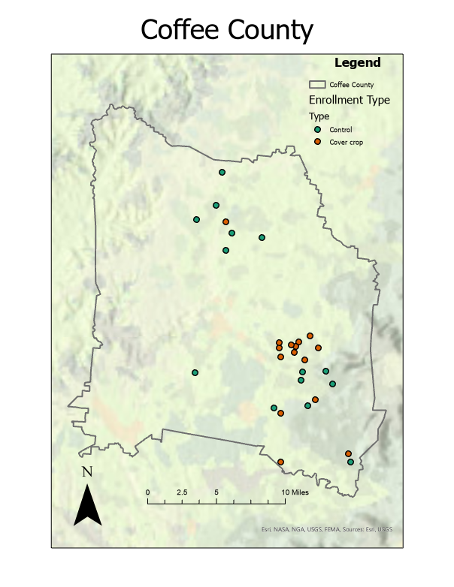
Appendices
Figure 1. Locations of cover crop and control fields monitored for avian use in the study by Tennessee county, 2021-2022.

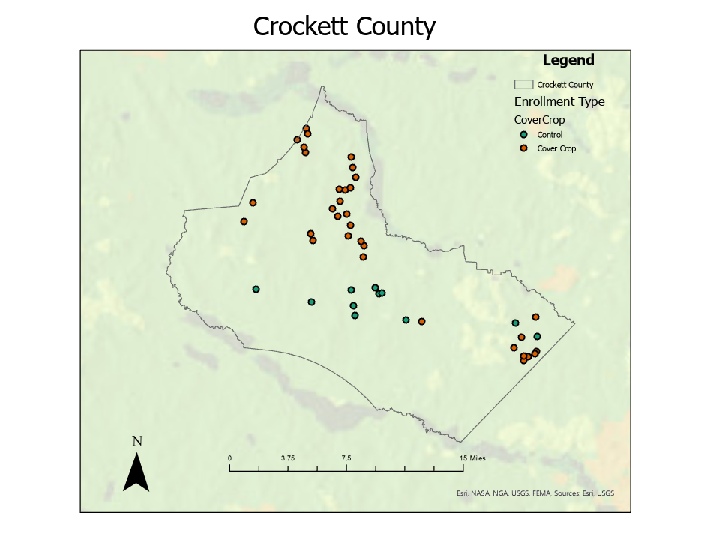
Figure 1 (cont.)

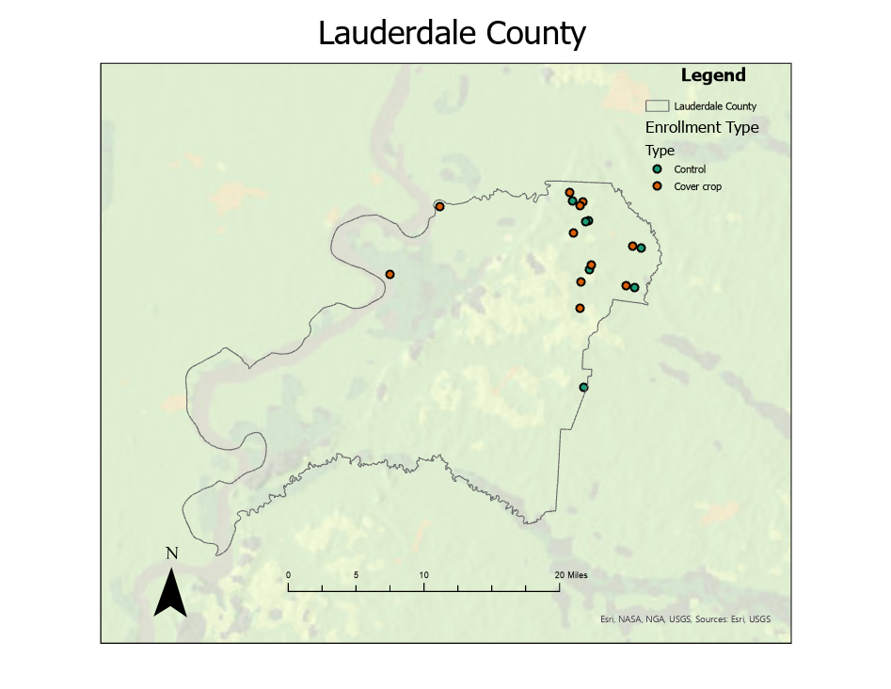
Figure 1 (cont.)

Figure 1 (cont.)
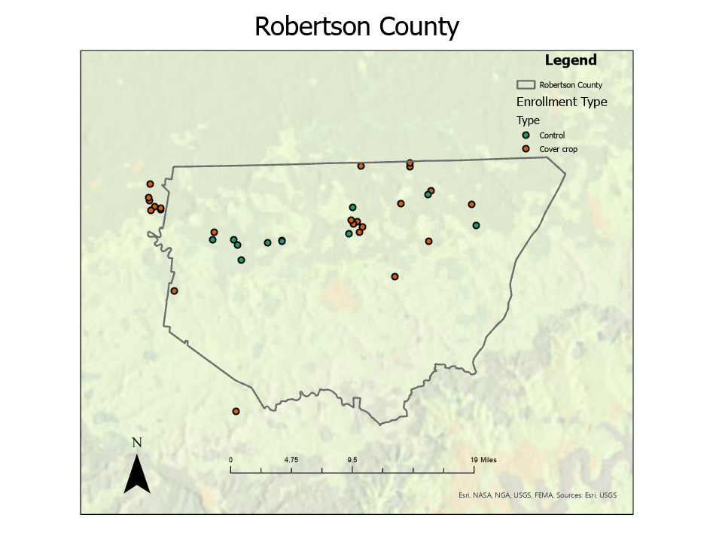
Figure 2. Landscape composition of cover crop and control fields across all four major survey counties in Tennessee (Coffee, Crockett, Lauderdale, and Robertson). Landscape composition analyses were done within a 1-km buffer around the perimeter of each field surveyed. (North American Land Change Monitoring System, 2022)

Figure 2 (cont.)

Figure 2 (cont.)

Figure 2 (cont.)

Figure 3. Plant species composition of cover crop and control fields in 2021 – 2022, for counties surveyed in Tennessee (Coffee, Crockett, Lauderdale, and Robertson). Plant species were assigned to forb or grass categories based on species, and cover crop species were assigned to the cover crop category.

Figure 3 (cont.)

Figure 3 (cont.)

Figure 3 (cont.)

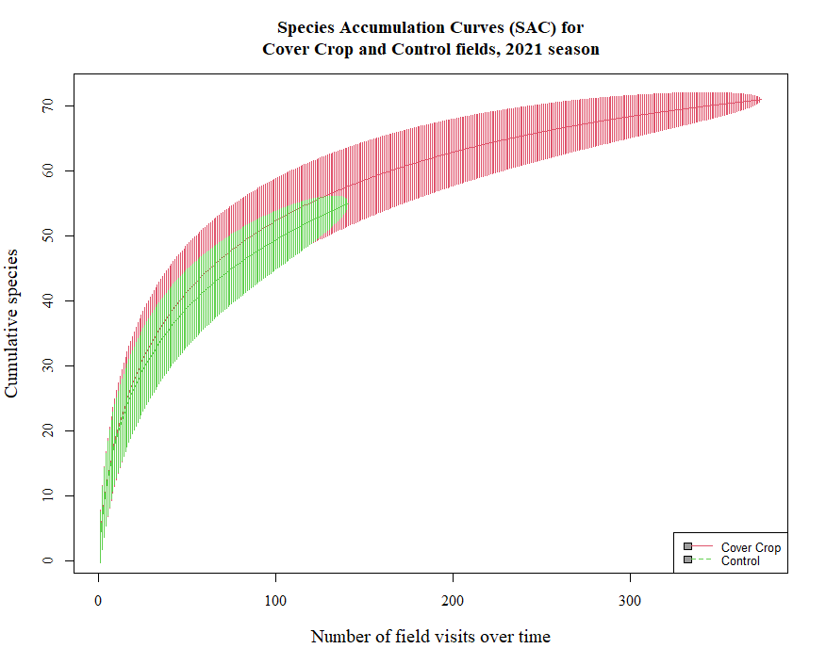
Figure 4. Avian Species Accumulation Curves (SAC) based on species detected on transect surveys of cover crop vs. control fields for 2021 (a) and 2022 (b) in middle and western Tennessee. SAC were created using the SpecAccum function within R.

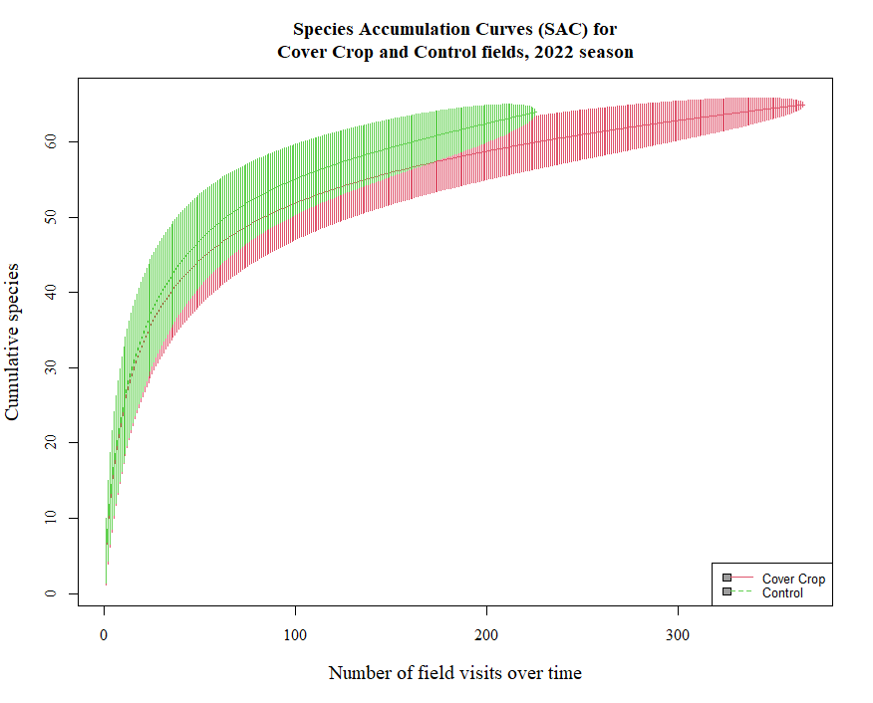
Figure 4 (cont.)

Figure 5. Avian species percent abundance of total detections by field type for 2021 and 2022 with standard error bars. Percents were calculated by taking the total individual detections of each species within a given year divided by the sum of all other species detections.

Table 1. Average date of establishment of cover crops and average date of termination of cover crops by county and year, middle and western Tennessee, 2021-2022.
County | Establishment Date |  |  |  | Termination Date
 | 2021 | Date Range | 2022 | Date Range | 2021 | Date Range | 2022 | Date Range
Coffee | 15-Oct | 10-Oct –  10-Nov | 20-Oct | 10-Oct –  1-Nov | 25-Apr | 10-Apr –  15-May | 30-Apr | 15-Apr –  15-May
Crockett | 20-Oct | 10-Oct –  5-Nov | 20-Oct | 10-Oct –  10-Nov | 20-Apr | 10-Apr –  20-May | 25-Apr | 10-Apr –  15-May
Lauderdale | 30-Oct | 15-Oct –  10-Nov | 20-Oct | 10-Oct –  15-Nov | 20-Apr | 10-Apr –  10-May | 25-Apr | 10-Apr –  15-May
Robertson | 20-Oct | 10-Oct –  10-Nov | 20-Oct | 10-Oct –  15-Nov | 25-Apr | 10-Apr –  15-May | 25-Apr | 15-Apr –  15-May
Table 2. Analysis of variance of forest and cropland cover composition within 1-km buffers of crop fields by county and enrollment type (cover crop vs. control), for four counties in middle and western Tennessee, 2021-2022. Forest and cropland cover types were derived from the North American Land Cover, 2020 layer (NALCMS, 2022) and analyzed in ArcGIS (Redlands, CA).

% Cropland | Sum of Squares | df | Mean Square | F | P
Enrollment Type | 18.1 | 1 | 18.06 | 0.714 | 0.460
County | 797546 | 3 | 160.66 | 6.350 | 0.082

% Forested | Sum of Squares | df | Mean Square | F | P
Enrollment Type | 0.6 | 1 | 0.65 | 0.134 | 0.738
County | 323.2 | 3 | 107.74 | 22.248 | 0.015

Table 3. Analysis of variance of percent cover crops, percent forbs, and percent grasses by season, year, and enrollment type (cover crop vs. control), for four counties in middle and western Tennessee, 2021-2022.

Percent Cover Crops | Sum of Squares | DF | Mean Square | F | P
Season | 217.6 | 1 | 217.6 | 1.35 | 0.45
Year | 173.7 | 1 | 173.7 | 1.08 | 0.49

Percent Forbs | Sum of Squares | DF | Mean Square | F | P
Season | 226.1 | 1 | 226.1 | 4.56 | 0.10
YEAR | 110.04 | 1 | 110.04 | 2.22 | 0.21
ENROLLMENT TYPE | 9.14 | 1 | 9.14 | 0.18 | 0.69
Percent Grasses | Sum of Squares | DF | Mean Square | F | P
Season | 515.5 | 1 | 515.5 | 2.553 | 0.19
YEAR | 374.8 | 1 | 374.8 | 1.86 | 0.25
ENROLLMENT TYPE | 37.7 | 1 | 37.7 | 0.19 | 0.69

Table 4. Analysis of variance of average height (cm), percent cover, percent bare ground, vertical variance, and horizontal variance by season, year, and enrollment type (cover crop vs. control), for four counties in middle and western Tennessee, 2021-2022.

Average Height | Sum of Squares | df | Mean Square | F | P
Enrollment | 2149 | 1 | 2149 | 0.943 | 0.332
Season | 797546 | 2 | 398773 | 174.934 | <0.001
Year | 337119 | 1 | 337119 | 159.829 | <0.001

Percent Cover | Sum of Squares | df | Mean Square | F | P
Enrollment | 0.17 | 1 | 0.17472 | 8.568 | 0.00346
Season | 0.11 | 2 | 0.05333 | 2.615 | 0.07342
Year | 1.27 | 1 | 1.2668 | 64.113 | <0.001

Percent Bare Ground | Sum of Squares | df | Mean Square | F | P
Enrollment | 0.2 | 1 | 0.19973 | 9.583 | 0.00199
Season | 0.09 | 2 | 0.04452 | 2.136 | 0.11842
Year | 1.22 | 1 | 1.2216 | 60.382 | <0.01

Vertical Variance | Sum of Squares | df | Mean Square | F | P
Enrollment | 2.07 E+08 | 1 | 2.07 E+08 | 1.438 | <0.001
Season | 9.00 E+10 | 2 | 4.50 E+10 | 311.953 | <0.001
Year | 1.885 E+10 | 1 | 1.885 E+10 | 140.00 | <0.001

Table 4 (cont.)

Horizontal Variance | Sum of Squares | df | Mean Square | F | P
Enrollment | 0 | 1 | 0.0006 | 0 | 0.984
Season | 2.7 | 2 | 1.3477 | 0.916 | 0.40
Year | 121.3 | 1 | 121.28 | 85.941 | <0.001

Table 5. Number of detections of year-round species on cover crop and control fields in 2021 – 2022 in Tennessee. Species within this group were detected throughout the January – July sampling period, 2021 and 2022.
Year- round Species | Number of Detections per Field |  |  |  | Relative Abundance in Group (%) |  |  |  | Relative Abundance in Season (%)
 | Cover Crop |  | Control |  | Cover Crop |  | Control |  | Cover Crop |  | Control
 | 2021 | 2022 | 2021 | 2022 | 2021 | 2022 | 2021 | 2022 | 2021 | 2022 | 2021 | 2022
American Crow | 0.11 | 0.35 | 0.01 | 0.19 | 0.65 | 1.32 | 0.08 | 0.82 | 0.52 | 1.12 | 0.06 | 0.68
American Goldfinch | 0.02 | 0.04 | 0.11 | 0.03 | 0.13 | 0.13 | 0.57 | 0.11 | 0.1 | 0.11 | 0.42 | 0.09
American Kestrel | 0.06 | 0.03 | 0.11 | 0.03 | 0.37 | 0.12 | 0.57 | 0.13 | 0.29 | 0.1 | 0.42 | 0.11
American Robin | 2.13 | 0.68 | 3.13 | 1.17 | 12.69 | 2.56 | 16.69 | 4.93 | 10.04 | 2.17 | 12.37 | 4.1
Bald Eagle | 0.01 | 0.00 | 0.01 | 0.01 | 0.05 | 0.01 | 0.08 | 0.04 | 0.04 | 0.01 | 0.06 | 0.03
Belted Kingfisher | - | - | - | 0.01 | - | - | - | 0.04 | - | - | - | 0.03
Brown-headed Cowbird | 0.03 | 0.18 | 0.01 | 0.01 | 0.21 | 0.68 | 0.08 | 1 | 0.16 | 0.58 | 0.06 | 0.83
Blue Jay | 0.03 | 0.14 | 0.01 | 0.24 | 0.16 | 0.52 | 0.04 | 0.33 | 0.13 | 0.44 | 0.03 | 0.28
Black Vulture | 0.03 | 0.02 | 0.01 | 0.08 | 0.19 | 0.06 | 0.08 | 0.04 | 0.15 | 0.05 | 0.06 | 0.03
Brown Thrasher | 0.01 | 0.02 | - | 0.01 | 0.03 | 0.09 | - | 0.11 | 0.03 | 0.08 | - | 0.09
Canada Goose | 0.08 | 0.12 | 0.10 | 0.03 | 0.48 | 0.45 | 0.53 | 0.8 | 0.38 | 0.38 | 0.39 | 0.66
Cackling/Canada Goose* | - | 0.02 | - | 0.19 | - | 0.06 | - | - | - | 0.05 | - | -
Common Grackle | 0.16 | 0.80 | 1.37 | 1.11 | 0.95 | 3.04 | 7.29 | 4.67 | 0.75 | 2.57 | 5.4 | 3.88
Cooper's Hawk | 0.00 | - | 0.02 | - | 0.02 | - | 0.11 | - | 0.01 | - | 0.08 | -
Eastern Bluebird | 0.27 | 0.13 | 0.26 | 0.12 | 1.59 | 0.49 | 1.36 | 0.48 | 1.26 | 0.41 | 1.01 | 0.4
Eastern Meadowlark | 1.19 | 1.66 | 0.76 | 1.10 | 7.08 | 6.27 | 4.04 | 4.63 | 5.6 | 5.3 | 2.99 | 3.85
Eastern Phoebe | 0.01 | 0.02 | 0.01 | 0.03 | 0.06 | 0.09 | 0.08 | 0.11 | 0.05 | 0.08 | 0.06 | 0.09
Eastern Towhee | - | 0.16 | - | 0.24 | - | 0.6 | 0.04 | 1.02 | - | 0.51 | 0.03 | 0.85
Eurasian Collared Dove | 0.01 | 0.01 | - | - | 0.05 | 0.03 | - | - | 0.04 | 0.03 | - | -
European Starling | 1.39 | 1.28 | 4.66 | 2.40 | 8.29 | 4.83 | 24.8 | 10.1 | 6.56 | 4.08 | 18.39 | 8.39
Field Sparrow | 1.07 | 1.72 | 0.55 | 0.01 | 6.38 | 6.51 | 2.94 | 7.29 | 5.05 | 5.51 | 2.18 | 6.06
Fish Crow | - | 0.05 | - | 1.73 | - | 0.18 | - | 0.06 | - | 0.15 | - | 0.05
Great Blue Heron | 0.01 | 0.05 | - | 0.08 | 0.03 | 0.19 | - | 0.32 | 0.03 | 0.16 | - | 0.26
House Finch | 0.00 | - | - | - | 0.02 | - | - | - | 0.01 | - | - | -
Table 5 (cont).
Year- round Species | Number of Detections |  |  |  | Relative Abundance in Group (%) |  |  |  | Relative Abundance in Season (%)
 | Cover Crop |  | Control |  | Cover Crop |  | Control |  | Cover Crop |  | Control
 | 2021 | 2022 | 2021 | 2022 | 2021 | 2022 | 2021 | 2022 | 2021 | 2022 | 2021 | 2022
Horned Lark | 0.91 | 0.22 | 0.62 | 0.47 | 5.4 | 0.84 | 3.28 | 1.97 | 4.27 | 0.41 | 2.43 | 1.64
Killdeer | 0.38 | 1.21 | 1.56 | 2.27 | 2.24 | 4.57 | 8.31 | 9.56 | 1.77 | 5.3 | 6.16 | 7.95
Loggerhead Shrike | 0.01 | 0.00 | 0.01 | - | 0.05 | 0.01 | 0.04 | - | 0.04 | 0.08 | 0.03 | -
Mallard | 0.28 | 0.02 | 0.05 | 0.01 | 1.65 | 0.08 | 0.26 | 0.04 | 1.31 | 0.51 | 0.2 | 0.03
Mourning Dove | 0.20 | 0.19 | 0.22 | 0.36 | 1.17 | 0.73 | 1.17 | 1.53 | 0.93 | 0.03 | 0.87 | 1.27
Northern Bobwhite | 0.06 | 0.10 | 0.08 | 0.07 | 0.35 | 0.39 | 0.42 | 0.3 | 0.28 | 4.08 | 0.31 | 0.25
Northern Cardinal | 0.01 | 0.37 | 0.02 | 0.32 | 0.08 | 1.41 | 0.11 | 1.36 | 0.06 | 0.41 | 0.08 | 1.13
Northern Flicker | 0.04 | 0.00 | 0.01 | 0.02 | 0.22 | 0.01 | 0.08 | 0.07 | 0.18 | 0.01 | 0.06 | 0.06
Northern Harrier | 0.03 | 0.02 | 0.02 | 0.02 | 0.21 | 0.06 | 0.11 | 0.07 | 0.16 | 0.05 | 0.08 | 0.06
Northern Mockingbird | 0.01 | 0.06 | 0.04 | 0.11 | 0.06 | 0.23 | 0.19 | 0.46 | 0.05 | 0.19 | 0.14 | 0.39
Rock Pigeon | 0.01 | - | - | 0.03 | 0.05 | - | - | 0.11 | 0.04 | - | - | 0.09
Red-shouldered Hawk | 0.01 | 0.01 | 0.01 | 0.01 | 0.05 | 3 | 0.04 | 0.06 | 0.04 | 0.04 | 0.03 | 0.05
Red-tailed Hawk | 0.05 | 0.06 | 0.04 | 0.09 | 0.3 | 21 | 0.19 | 0.39 | 0.24 | 0.2 | 0.14 | 0.32
Red-winged Blackbird | 7.74 | 16.1 | 4.93 | 10.55 | 46.11 | 61.22 | 26.24 | 44.34 | 36.48 | 51.76 | 19.45 | 36.85
Sharp-shinned Hawk | - | 0.00 | - | - | - | 0.01 | - | - | - | 0.01 | - | -
Song Sparrow | 0.01 | 0.24 | 0.01 | 0.35 | 0.05 | 0.9 | 0.04 | 1.45 | 0.04 | 0.76 | 0.03 | 1.21
Turkey Vulture | 0.09 | 0.18 | 0.01 | 0.21 | 0.51 | 0.69 | 0.08 | 0.89 | 0.4 | 0.59 | 0.06 | 0.74
Wild Turkey | 0.34 | 0.06 | - | 0.07 | 2.03 | 0.24 | - | 0.3 | 1.61 | 0.2 | - | 0.25
Wood Duck | 0.01 | 0.02 | 0.02 | 0.02 | 0.06 | 0.06 | 0.11 | 0.07 | 0.05 | 0.05 | 0.08 | 0.06

Table 6. Analysis of wintering species detected in 2021 and 2022 cover crop fields and control fields with total number of detections, percent abundance within the group, and percent abundance within the season. Species within this table were only noted during the wintering period of the sampling season, between January 15th and March 15th in both 2021 and 2022.
Wintering Species | Number of Detections |  |  |  | Percent Abundance in Group |  |  |  | Percent Abundance in Season
 | Cover Crop |  | Control |  | Cover Crop |  | Control |  | Cover Crop |  | Control
 | 2021 | 2022 | 2021 | 2022 | 2021 | 2022 | 2021 | 2022 | 2021 | 2022 | 2021 | 2022
American Pipit | 1.06 | 0.07 | 0.37 | 0.26 | 39.98 | 8.62 | 7.02 | 38.56 | 5.01 | 0.22 | 1.46 | 0.91
Gadwall | <0.01 | - | - | - | 0.1 | - | - | - | 0.01 | - | - | -
Greater White-fronted Goose | 0.04 | - | 0.59 | - | 1.5 | - | 11.2 | - | 0.19 | - | 2.32 | -
Sandhill Crane | - | - | - | 0.04 | - | - | - | 5.88 | - | - | - | 0.14
Savannah Sparrow | 1.32 | 0.52 | 0.79 | 0.26 | 49.7 | 65.52 | 14.98 | 38.56 | 6.23 | 1.66 | 3.11 | 0.91
Snow Goose | - | - | 3.01 | - | - | - | 57.35 | - | - | - | 11.89 | -
White-crowned Sparrow | <0.01 | 0.01 | - | - | 0.1 | 0.69 | - | 1.31 | 0.01 | 0.02 | - | 0.03
Wilson's Snipe | 0.22 | 0.17 | 0.50 | 0.07 | 8.42 | 21.38 | 9.45 | 10.46 | 1.06 | 0.54 | 1.96 | 0.25
White-throated Sparrow | 0.01 | 0.03 | - | 0.04 | 0.2 | 3.79 | - | 5.23 | 0.03 | 0.1 | - | 0.12

Table 7. Analysis of migratory species detected in 2021 and 2022 cover crop fields and control fields with total number of detections, percent abundance within the group, and percent abundance within the season. Species within this table were only noted during the migratory period of the sampling season, between March 16th and May 1st 2021 and 2022.

Migratory Species | Number of Detections |  |  |  | Percent Abundance in Group |  |  |  | Percent Abundance in Season
 | Cover Crop |  | Control |  | Cover Crop |  | Control |  | Cover Crop |  | Control
 | 2021 | 2022 | 2021 | 2022 | 2021 | 2022 | 2021 | 2022 | 2021 | 2022 | 2021 | 2022
Bobolink | 0.131 | 0.052 | 0.007 | - | 41.18 | 20.65 | 8.33 | - | 0.62 | 0.17 | 0.03 | -
Blue-winged Teal | 0.083 | 0.003 | - | 0.004 | 26.05 | 1.09 | - | 2.56 | 0.39 | 0.01 | - | 0.02
Cedar Waxwing | - | 0.003 | - | - | - | 1.09 | - | - | - | 0.01 | - | -
Greater Yellowlegs | 0.008 | 0.003 | - | - | 2.52 | 1.09 | - | - | 0.04 | 0.01 | - | -
Least Sandpiper | 0.005 | - | - | - | 1.68 | - | - | - | 0.03 | - | - | -
Lincoln's Sparrow | 0.003 | - | - | - | 0.84 | - | - | - | 0.01 | - | - | -
Mississippi Kite | - | - | 0.021 | - | - | - | 25 | - | - | - | 0.08 | -
Palm Warbler | 0.027 | - | - | - | 8.4 | - | - | - | 0.13 | - | - | -
Pectoral Sandpiper | 0.003 | - | - | - | 0.84 | - | - | - | 0.01 | - | - | -
Pine Warbler | - | 0.003 | - | - | - | 1.09 | - | - | - | 0.01 | - | -
Prairie Warbler | - | 0.003 | - | - | - | 1.09 | - | - | - | 0.01 | - | -
Short-billed Dowitcher | - | 0.112 | - | 0.004 | - | 44.57 | - | 46.15 | - | 0.36 | - | 0.28
Solitary Sandpiper | 0.019 | - | 0.007 | - | 5.88 | - | 8.33 | - | 0.09 | - | 0.03 | -

Table 7. cont
Migratory Species | Number of Detections |  |  |  | Percent Abundance in Group |  |  |  | Percent Abundance in Season
 | Cover Crop |  | Control |  | Cover Crop |  | Control |  | Cover Crop |  | Control
 | 2021 | 2022 | 2021 | 2022 | 2021 | 2022 | 2021 | 2022 | 2021 | 2022 | 2021 | 2022
Stilt Sandpiper | 0.013 | - | - | - | 4.2 | - | - | - | 0.06 | - | - | -
Vesper Sparrow | 0.024 | - | 0.050 | - | 7.56 | 29.33 | 58.33 | 35.90 | 0.11 |  | 0.2
Western Meadowlark | 0.003 | - | - | - | 0.84 | - | - | - | 0.01 | - | - | -
Yellow Warbler | - | - | - | 0.009 | - | - | - | 5.13 | - | - | - | 0.03
Yellow-rumped Warbler | - | - | - | 0.013 | - | - | - | 7.69 | - | - | - | 0.05

Table 8. Analysis of breeding species detected in 2021 and 2022 cover crop fields and control fields with total number of detections, percent abundance within the group, and percent abundance within the season. Species within this table were only noted during the breeding period of the sampling season, between May 1st and July 10th 2021 and 2022.

Breeding Species | Number of Detections |  |  |  | Percent Abundance in Group |  |  |  | Percent Abundance in Season
 | Cover Crop |  | Control |  | Cover Crop |  | Control |  | Cover Crop |  | Control
 | 2021 | 2022 | 2021 | 2022 | 2021 | 2022 | 2021 | 2022 | 2021 | 2022 | 2021 | 2022
Barn Swallow | 0.363 | 0.497 | 0.454 | 0.491 | 24.91 | 13.13 | 37.43 | 12.33 | 1.71 | 1.59 | 1.79 | 1.72
Blue Grosbeak | 0.032 | 0.101 | 0.021 | 0.115 | 2.2 | 2.67 | 1.75 | 2.89 | 0.15 | 0.32 | 0.08 | 0.4
Chipping Sparrow | 0.037 | 0.052 | 0.050 | 0.040 | 2.56 | 1.37 | 4.09 | 1 | 0.18 | 0.17 | 0.2 | 0.14
Cliff Swallow | 0.069 | 0.057 | 0.021 | 0.279 | 4.76 | 1.52 | 1.75 | 7 | 0.33 | 0.18 | 0.08 | 0.97
Common Yellowthroat | 0.016 | 0.156 | - | 0.124 | 1.1 | 4.11 | - | 3.11 | 0.08 | 0.5 | - | 0.43
Dickcissel | 0.328 | 0.683 | 0.177 | 0.301 | 22.53 | 18.04 | 14.62 | 7.56 | 1.55 | 2.19 | 0.7 | 1.05
Eastern Kingbird | 0.123 | 0.011 | 0.064 | 0.049 | 8.42 | 0.29 | 5.26 | 1.22 | 0.58 | 0.03 | 0.25 | 0.17
Grasshopper Sparrow | 0.107 | 0.230 | 0.007 | 0.173 | 7.33 | 6.06 | 0.58 | 4.33 | 0.5 | 0.73 | 0.03 | 0.6
Great Egret | - | - | - | 0.009 | - | - | - | 0.22 | - | - | - | 0.03
Indigo Bunting | 0.163 | 1.765 | 0.085 | 2.124 | 11.17 | 46.61 | 7.02 | 53.33 | 0.77 | 5.65 | 0.34 | 7.42
Lark Sparrow | 0.013 | 0.003 | 0.071 | 0.044 | 0.92 | 0.07 | 5.85 | 1.11 | 0.06 | 0.01 | 0.28 | 0.15

Table 8. cont.

Breeding Species | Number of Detections |  |  |  | Percent Abundance in Group |  |  |  | Percent Abundance in Season
 | Cover Crop |  | Control |  | Cover Crop |  | Control |  | Cover Crop |  | Control
 | 2021 | 2022 | 2021 | 2022 | 2021 | 2022 | 2021 | 2022 | 2021 | 2022 | 2021 | 2022
Northern Rough-winged Swallow | 0.072 | 0.087 | 0.064 | 0.049 | 4.95 | 2.31 | 5.26 | 1.22 | 0.34 | 0.28 | 0.25 | 0.17
Purple Martin | 0.075 | 0.060 | 0.156 | 0.044 | 5.13 | 1.59 | 12.87 | 1.11 | 0.35 | 0.19 | 0.62 | 0.15
Ruby-throated Hummingbird | 0.005 | 0.005 | - | 0.004 | 0.37 | 0.14 | - | 0.11 | 0.03 | 0.02 | - | 0.02
Tree Swallow | 0.053 | 0.079 | 0.043 | 0.137 | 3.66 | 2.09 | 3.51 | 3.44 | 0.25 | 0.25 | 0.17 | 0.48

Table 9. Occupancy models for selected avian species in cover crop versus control fields, Tennessee 2021-2022, based on percent abundance within seasonal groups and conservation concern. Occupancy was calculated using binomial linear mixed-models with Enrollment type (Cover crop versus Control) and Year as our variables. Slope, number of transects with detections, confidence intervals, and p-values are noted. Occupancy estimates were calculated using the proportion of detections of select species within their respective seasonal ranges. All data were pooled between both sampling seasons, 2021 and 2022, and put into the model.

Species | Season(s) | Number of transects with detections | Occupancy estimates (±SE) |  | Slope  (cover crop compared with control) | 95% CI | P
 |  |  | Cover | Control
AMPI | Winter, Migration | 41 | 0.04 ± 0.009 | 0.05 ± 0.01 | -0.26 | -1.00 to 0.47 | 0.48
AMRO | Year-round | 320 | 0.05 ± 0.006 | 0.07 ± 0.009 | -0.40 | -0.80 to -0.01 | 0.05
BARS | Breeding, Migration | 245 | 0.15 ± 0.01 | 0.13 ± 0.01 | 0.15 | -0.19 to 0.50 | 0.39
DICK | Breeding, Migration | 430 | 0.19 ± 0.01 | 0.07 ± 0.01 | 1.41 | 0.77 to 2.05 | <0.01
EAME | Year-round | 529 | 0.18 ± 0.01 | 0.13 ± 0.01 | 0.61 | 0.14 to 1.07 | 0.01
FISP | Year-round | 764 | 0.25 ± 0.01 | 0.2 ± 0.01 | 0.46 | 0.16 to 0.76 | <0.01
INBU | Breeding, Migration | 990 | 0.39 ± 0.018 | 0.42 ± 0.02 | 0.19 | -0.09 to 0.48 | 0.19
KILL | Year-round | 202 | 0.04 ± 0.005 | 0.12 ± 0.01 | -1.24 | -1.76 to -0.73 | <0.01
NOBO | Year-round | 84 | 0.03 ± 0.005 | 0.02 ± 0.006 | 0.27 | -0.45 to 0.99 | 0.47

Table 9 (cont.)

Species | Season(s) | Number of transects with detections | Occupancy estimates (±SE) |  | Slope  (cover crop compared with control) | 95% CI | P
 |  |  | Cover | Control
RWBB | Year-round | 564 | 0.28 ± 0.01 | 0.22 ± 0.02 | 0.42 | 0.09 to 0.75 | 0.01
SAVS | Winter, Migration | 477 | 0.20 ± 0.01 | 0.14 ± 0.02 | 0.50 | 0.19 to 0.82 | <0.01
VESP | Migration | 12 | 0.02 ± 0.007 | 0.03 ± 0.01 | -0.53 | -1.71 to 0.66 | 0.38
WISN | Winter, Migration | 63 | 0.05 ± 0.009 | 0.04 ± 0.01 | 0.07 | -0.86 to 0.99 | 0.89
WITU | Year-round | 18 | 0.01 ± 0.003 | 0.001 ± 0.001 | 2.03 | -0.24 to 4.30 | 0.08

Table 10. Species richness per transect and PIF CCS-max values per transect for cover crop and control fields, middle and western Tennessee, 2021- 2022. Slope, confidence intervals, and P-values are from negative binomial mixed model analyses.
Response |  |  | Means |  |  |  | Standard Error |  |  |  | Slope (cover crop compared with control) |  | 95% CI |  | P
 | Cover |  |  | Control |  | Cover |  |  | Control
 | 2021 | 2022 |  | 2021 | 2022 | 2021 |  | 2022 | 2021 | 2022 | 2021 | 2022 | 2021 | 2022 | 2021 | 2022
Species Richness | 1.76 | 2.36 |  | 1.45 | 2.09 | 0.05 |  | 0.06 | 0.07 | 0.07 | 0.19 | 0.12 | 0.05 to 0.32 | 0.04 to 0.20 | <0.01 | <0.01
PIF Continental Combined Score | 15.85 | 21.52 |  | 12.61 | 19.05 | 0.48 |  | 0.53 | 0.63 | 0.62 | 0.23 | 0.12 | 0.07 to 0.39 | 0.02 to 0.23 | <0.01 | 0.02

Appendix 1. Latin names, USFWS alpha codes, and Partners in Flight Continental Combine Scores (CCS-Max) for avian species detected throughout the project and used in the analysis.

Common Name | Latin Name | Alpha Code | PIF CCS-max Score
American Crow | Corvus brachyrhynchos | AMCR | 6
American Goldfinch | Spinus tristis | AMGO | 6
American Kestrel | Falco sparverius | MAKE | 10
American Pipit | Anthus rubescens | AMPI | 9
American Robin | Turdus migratorius | AMRO | 5
Bald Eagle | Haliaeetus leucocephalus | BAEA | 9
Barn Swallow | Hirundo rustica | BARS | 8
Belted Kingfisher | Megaceryle alcyon | BEKI | 10
Black Vulture | Coragyps atratus | BLVU | 4
Blue-winged Teal | Spatula discors | BWTE | 7
Blue Grosbeak | Passerina caerulea | BLGR | 8
Blue Jay | Cyanocitta cristata | BLJA | 9
Bobolink | Dolichonyx oryzivorus | BOBO | 14
Brown-headed Cowbird | Molothrus ater | BHCO | 7
Brown Thrasher | Toxostoma rufum | BRTH | 10
Cackling/Canada Goose | Branta hutchinsii/canadensis | CCGO | (no score given for hybrid species)
Canada Goose | Branta canadensis | CANG | 5
Cedar Waxwing | Bombycilla cedrorum | CEDW | 6
Chipping Sparrow | Spizella passerine | CHSP | 9
Cliff Swallow | Petrochelidon pyrrhonota | CLSW | 6
Common Grackle | Quiscalus quiscula | COGR | 9
Common Yellowthroat | Geothlypis trichas | COYE | 9
Cooper’s Hawk | Accipiter cooperii | COHA | 7
Dickcissel | Spiza americana | DICK | 11
Eastern Bluebird | Sialia sialis | EABL | 7
Eastern Kingbird | Tyrannus tyrannus | EAKI | 11
Eastern Meadowlark | Sturnella magna | EAME | 11
Eastern Phoebe | Sayornis phoebe | EAPH | 8
Eurasian Collared-Dove | Streptopelia decaocto | EUCD | 4
European Starling | Sturnus vulgaris | EUST | 7
Eastern Towhee | Pipilo erythrophthalmus | EATO | 11
Field Sparrow | Spizella pusilla | FISP | 12
Fish Crow | Corvus ossifragus | FICR | 10
Gadwall | Mareca strepera | GADW | 8
Grasshopper Sparrow | Ammodramus savannarum | GRSP | 12
Great Blue Heron | Ardea Herodias | GBHE | 8
Great Egret | Ardea alba | GREG | 6
Greater White-fronted Goose | Anser albifrons | GWFG | 7
Greater Yellowlegs | Tringa melanoleuca | GRYE | 11
House Finch | Haemorhous mexicanus | HOFI | 6
Horned Lark | Eremophila alpestris | HOLA | 9
Indigo Bunting | Passerina cyanea | INBU | 9
Killdeer | Charadrius vociferus | KILL | 10
Lark Sparrow | Chondestes grammacus | LASP | 10
Least Sandpiper | Calidris minutilla | LESA | 9
Lincoln’s Sparrow | Melospiza lincolnii | LISP | 7
Loggerhead Shrike | Lanius ludovicianus | LOSH | 11
Mallard | Anas platyrhynchos | MALL | 7
Mississippi Kite | Ictinia mississippiensis | MIKI | 9
Mourning Dove | Zenaida macroura | MODO | 6
Northern Bobwhite | Colinus virginianus | NOBO | 12
Northern Cardinal | Cardinalis cardinalis | NOCA | 5
Northern Flicker | Colaptes auratus | NOFL | 9
Northern Harrier | Circus hudsonius | NOHA | 11
Northern Mockingbird | Mimus polyglottos | NOMO | 8
Northern Rough-winged Swallow | Stelgidopteryx serripennis | NRWS | 10
Palm Warbler | Setophaga palmarum | PAWA | 9
Pectoral Sandpiper | Calidris melanotos | PESA | 13
Pine Warbler | Setophaga pinus | PIWA | 7
Prairie Warbler | Setophaga discolor | PRWA | 14
Purple MartIn | Progne subis | PUMA | 10
Red-shouldered Hawk | Buteo lineatus | RSHA | 8
Red-tailed hawk | Buteo jamaicensis | RTHA | 6
Red-winged Blackbird | Agelaius phoeniceus | RWBL | 8
Rock Pigeon | Columba livia | ROPI | 7
Ruby-throated Hummingbird | Archilochus colubris | RTHU | 8
Savannah Sparrow | Passerculus sandwichensis | SAVS | 8
Sharp-shinned Hawk | Accipiter striatus | SSHA | 7
Short-billed Dowitcher | Limnodromus griseus | SBDO | 14
Snow Goose | Anser caerulescens | SNGO | 8
Solitary Sandpiper | Tringa solitaria | SOSA | 11
Song Sparrow | Melospiza melodia | SOSP | 8
Stilt Sandpiper | Calidris himantopus | STSA | 12
Tree Swallow | Tachycineta bicolor | TRES | 10
Turkey Vulture | Cathartes aura | TUVU | 5
Vesper Sparrow | Pooecetes gramineus | VESP | 11
Western Meadowlark | Sturnella neglecta | WEME | 10
Wild Turkey | Meleagris gallopavo | WITU | 7
Wilson’s Snipe | Gallinago delicata | WISN | 9
White-crowned Sparrow | Zonotrichia leucophrys | WCSP | 7
White-throated Sparrow | Zonotrichia albicollis | WTSP | 9
Wood Duck | Aix sponsa | WODU | 7

Appendix 2. A list of predominant plant species seen throughout the project period (2021 and 2022).

Species | Type
Crimson Clover | Cover Crop
Hairy Vetch | Cover Crop
Austrian Winter Pea | Cover Crop
Daikon Radish | Cover Crop
Triticale | Cover Crop
Winter Wheat | Cover Crop
Deadnettle sp.
Bittercress sp.
Chickweed sp.
White Clover
Red Clover
Butterweed sp.
Buttercup sp.
Wild Garlic
Pansy sp.

Vita

Brittany Panos was born and raised in Fort Lauderdale, Florida on January 24th, 1994, where she attended primary and secondary schooling in the Broward County area. She graduated high school at Archbishop Edward A. McCarthy High School in Cooper City, Florida in May 2012 and went on to attend the University of Florida in Gainesville, FL. Brittany obtained her undergraduate degree in May 2017 with a Bachelor’s of Science in Wildlife Ecology and Conservation. Before attending graduate school, she worked multiple seasonal wildlife jobs across the United States, focusing on avian ecology and fieldwork. She began her Master’s work at the University of Tennessee in Knoxville starting August 2019, focusing on the avian use of cover crops, in Dr. David Buehler’s lab and graduated with her master’s degree in May 2024. Brittany currently works for Audubon Mid-Atlantic as the Coastal Avian Biologist on the team.

