To the Graduate Council:

I am submitting herewith a thesis written by Jarrod Dwayne Blue entitled “Soil nitrogen amendments and insect herbivory alter above-and belowground plant biomass in an old-field ecosystem”. I have examined the final electronic copy of this thesis for form and content and recommend that it be accepted in partial fulfillment of the requirements for the degree of Master of Science, with a major in Ecology and Evolutionary Biology.

Nathan J. Sanders, Major Professor

We have read this thesis
and recommend its acceptance:

Aimee T. Classen

Jennifer A. Schweitzer

Accepted for the Council:

Carolyn R. Hodges
Vice Provost and Dean of the Graduate School

Soil nitrogen amendments and insect herbivory alter above-and belowground plant biomass in an old-field ecosystem

A Thesis
Presented for the
Master of Science
Degree
The University of Tennessee, Knoxville

Jarrod Dwayne Blue
August 2010

ACKNOWLEDGEMENTS

I thank Phillip Allen, Jacqueline Areson, Lauren Breza, Claire Brown, Windy A. Bunn, Karianne Chung, Melissa Cregger, Cavenne Engle, Colleen Iversen, Jean-Philippe Lessard, Laura Marsh, Martin Nuñez, Mariano Rodriguez-Cabal, Noelia Barrios, Tara Sackett, Tander Simberloff, Haley Smith, Katie Stuble, Heather Tran, Jeramy Webb, Jake Weltzin, and Phoebe Wright for help with field and laboratory work. Jake Weltzin was integral in establishing the experiment. The work was partially supported by grants from Department of Ecology and Evolutionary Department at the University of Tennessee.

ABSTRACT
Nutrient availability and herbivory can regulate primary production in ecosystems, but little is known about how, or whether, they may interact with one another. Here I investigate how nitrogen availability and insect herbivory interact to alter above- and belowground plant community biomass in an old-field ecosystem. In 2004, 36 experimental plots were established in which soil nitrogen (N) availability (at three levels) was manipulated and insect abundance (at two levels) in a completely randomized plot design. In 2009, after six years of treatment, I measured aboveground biomass and assessed root production at peak growth. Overall, I found a significant effect of soil N availability on both above- and belowground plant biomass while insects affected only aboveground biomass of subdominant plant species and coarse root production; there were no statistical interactions between N availability and insect herbivory for any response variable. Specifically, responses of aboveground and belowground community biomass to nutrients were driven by reductions in soil N, but not additions, indicating that soil N may not be primarily limiting production in this ecosystem. Insect herbivory altered the aboveground biomass of the subdominant plant species and altered allocation patterns to coarse root production belowground. Overall, the results of six years of nutrient amendments and insect removals suggest strong bottom-up influences on total plant community productivity.

TABLE OF CONTENTS
INTRODUCTION 1
MATERIAL AND METHODS 4
Statistical analyses 7
RESULTS 8
Aboveground Biomass 8
Belowground Biomass 9
DISCUSSION 10
Bottom-up Effects 10
Top-Down Effects 11
Conclusions 13
LITERATURE CITED 14
APPENDIX I 23
VITA 33

This Thesis is prepared in manuscript format for future submission to the journal Oecologia, with coauthors Lara Souza, Aimee Classen, Jennifer Schweitzer, and Nathan Sanders. I completed all field work. Lara Souza and Nathan Sanders supervised the project. Aimee Classen and Jennifer Schweitzer provided research concept feedback.

INTRODUCTION

Ecologists have long debated the relative importance of bottom-up (i.e., resource availability) and top-down (i.e., herbivory) effects on plant community structure and productivity (Elton 1927; Hairston et al. 1960; Sih et al. 1985; Power 1992; Worm et al. 2003; Borer et al. 2006). Over the past decade, the debate has moved away from arguments about which factors, top-down or bottom-up processes, have the biggest influence on primary productivity toward an increasing recognition that both processes can influence productivity across a variety of ecosystems (Borer et al. 2006; Hillebrand 2007; Gruner et al. 2008; Kohyani et al. 2009). In particular, bottom-up factors such as the addition or reduction of nitrogen (N) can result in dramatic increases in total aboveground biomass (Craine et al. 2003; Gruner et al. 2008) likely resulting from N limitation across ecosystems (LeBauer and Treseder 2006). Conversely, reducing N availability in the soil can lead to reductions in total aboveground biomass (Wedin and Tilman 1993; Throop et al. 2005). Herbivores, especially large mammals, can exert top-down control aboveground plant biomass by consuming plant biomass (Maron and Crone 2006; Gruner et al. 2008). Indeed, some terrestrial herbivores consume approximately 15% of net primary productivity (NPP) (Cyr and Pace 1993). The overall effects of herbivory by insects on total aboveground biomass, however, are mixed (Hunter 2001, Coupe and Cahill 2003), with some studies indicating that herbivory by insects reduces aboveground biomass (Schowalter 2000; McIntire and Hik 2005). A meta-analysis by Coupe and Cahill (2003) suggested that, on average, insects reduce primary production by 13% in temperate herbaceous plant communities. But, there was considerable variation among studies - some showed increases in or no effects of insect herbivory on total aboveground biomass (Carson and Root 2000; Coupe and Cahill 2003; Chapman et al. 2003; Del-Val and Crawley 2005; Gao et al. 2008).
While it is clear that both herbivory and nutrient availability can affect total aboveground biomass in plant communities, the relative and combined effects of herbivory and nutrient availability have been less well explored, especially with regard to herbivory by insects. In a recent meta-analysis, Gruner et al. (2008) found that producer community biomass increased with fertilization in marine, freshwater, and terrestrial ecosystems. In contrast, herbivores generally limited producer biomass in both freshwater and marine systems, but the effects of herbivory were inconsistent and non-significant overall in terrestrial ecosystems (Gruner et al. 2008). Additionally, most of the experimental studies analyzed by Gruner et al. (2008) showed only limited support for interactive effects of nutrient amendment and herbivory on producer biomass.
Moreover, of the 15 terrestrial studies reviewed by Gruner et al. (2008) that examined the interactive effects of herbivory and nutrient amendment on producer biomass, only one study focused on herbivory by invertebrates (a slug and a grass aphid). That study by Buckland and Grime (2000) found that herbivory by slugs (but not by aphids) decreased plant biomass across treatments (i.e., there was a main effect of herbivory in their models), but within each nutrient treatment there was no effect of herbivory on aboveground biomass. Given the ubiquity and importance of invertebrate herbivory on producer biomass (Coupe et al. 2009), it is somewhat surprising that so few studies have examined the interactive effects of invertebrate herbivory and soil nutrient amendment on total aboveground biomass of intact plant communities in the field.
Another important, but often overlooked, aspect of many studies that have examined the effects of herbivory and nutrient amendment on producer biomass is belowground biomass, which, in some ecosystems, can account for >50% of total plant biomass (Candell et al. 1996; Schenk and Jackson 2002). One recent study looking at increased soil N availability on Festuca campestris found that fertilization led to higher root production, specifically higher investment in coarse roots relative to fine roots, indicative of root exploration for nutrients (McInenly et al. 2010).
In terrestrial ecosystems, root production often declines with foliar herbivory because tissue loss can result in reallocation of nutrients towards aboveground biomass for tissue regrowth (Brown 1994; Schadler et al. 2004). Other studies, however, have found that foliar herbivory can increase root productivity (Bardgett et al. 1998; Pucheta et al. 2004) and alter root turnover and nutrient release (Classen et al. 2007). For example, herbivory by spider mites increased root biomass in a nutrient rich environment (Nishida et al. 2009). However, the effects of nutrient amendment and aboveground herbivory on belowground biomass of entire plant communities in the field has been under examined.
Though aboveground and belowground compartments of ecosystems are often linked (Wardle et al. 2004), belowground responses may not simply mirror aboveground responses to herbivory and nutrient amendments (Van der Putten et al. 2001; Wardle et al. 2004). For example, increased abundance of root feeding insects enhanced nutrition quality of aboveground plant tissue, whereas increased abundance of aboveground insect herbivores reduced belowground plant quality (Masters and Brown 1997). Moreover, while a growing number of studies have examined how aboveground processes, such as herbivory, might influence belowground processes, no studies to date have examined the relative and combined effects of foliar herbivory and nutrient availability on belowground biomass (Bardgett et al. 2005). Furthermore, nutrient amendments and insect herbivory can alter species interactions and overall plant community composition and functional diversity (Wardle et al. 2000; Hooper et al. 2005). Thus, dominant and subdominant plants may respond differently to nutrients and insect herbivory, especially if herbivores preferentially select dominant or subdominant plants and/or the dynamics of competition between dominant and subdominant plants depend on nutrient availability.
After six years of manipulating soil N (at three levels) and insect herbivory (at two levels) in an old-field ecosystem, I examined the effect of soil N fertilization, insect herbivory, and their interactive effects on above- and belowground biomass of the entire plant community as well as specific components of the aboveground community. Given that most plants are nutrient limited and that herbivores can consume approximately 15% of total plant NPP, I hypothesized that (i) total aboveground biomass would increase with fertilization but decrease with herbivory; (ii) total aboveground biomass would increase with fertilization only when herbivory was reduced; (iii) total belowground biomass would be reduced with fertilization and herbivory due to shifts in nutrient allocation; and (iv) dominant and subdominant plant species would respond differentially to fertilization and herbivory.

MATERIAL AND METHODS

A field experiment was established in the spring 2004 within a ~10-ha old-field community at Oak Ridge National Environmental Research Park near Oak Ridge, Tennessee, USA (35°58’N, 84°17’W). Agricultural practices were discontinued at the site in 1943. And since 2003, many of the fields have been mowed annually to manage for open-space and wildlife habitat. The soil, classified as a Typic Hapludult, has a silty clay loam texture and is moderately well drained (Phillips et al. 2001). Precipitation is evenly distributed throughout the year, with an annual mean rainfall of 1322 mm, an average January minimum temperature of 2.7°C, and average July maximum temperature of 31.2°C. Dominant plant species (those that comprise the greatest proportion of the biomass) at the site include Solidago altissima, Verbesina occidentalis, and Verbesina virginica (Wardle 1999; Hooper et al. 2005). Solidago altissima, V. occidentalis, and V. virginica have been identified as dominant plant species based on two sets of studies. First, Souza et al. (In review) experimentally manipulated the presence of S. altissima and both V. occidentalis and V. virginica and found that both Solidago and Verbesina altered the structure of the subdominant community and other experiments have shown that Solidago species can have strong effects on the rest of the plant community (Schmitz 2003; Crustinger et al. 2008). Second, surveys of 17 neighboring old fields showed that S. altissima and V. virginica and V. occidentalis made up 40% of the total aboveground biomass (Souza et al. In Review). Approximately 60 other sub-dominant plant species, both herbaceous and woody, are present at the site (Sanders et al. 2007; Table 1; all Figures and Tables in Appendix 1).
In April 2004, 36 plots (3 m × 3 m, including a 0.5-m buffer around each plot) were established within an existing old-field community, with 2-m spacing between plots (Note: in the first two years of the study, we also manipulated propagule supply of an invasive plant species, Lespedeza cuneata, in 36 of the original 72 plots; here we do not include those 36 plots in analyses because of the potential effects of that species on the response variables of interest in this study.). A 3-m tall fence was erected around the experimental site to exclude deer. In a fully crossed, completely randomized plot design, we manipulated soil N and the presence of insects in randomly assigned plots. We manipulated soil N by (1) adding N (applied as urea fertilizer, at a rate of 20 g m⁻² yr ⁻¹), (2) adding carbon (C) (applied as sucrose at a rate of 167 g m⁻² yr ⁻¹) and (3) unmanipulated control plots. Nitrogen manipulation rates in this experiment are similar to other studies addressing the role of N fertilization on dynamics in grasslands and old fields (McLendon and Redente 1992; Larson and Siemann 1998). The addition of C in the form of sucrose provides microbial communities with a surplus source of labile C ultimately leading to N immobilization (Craine et al. 2007). In 2004, after fertilization, soil N availability (NO₃-N + NH₄-N) in the soil was five times greater in the N addition plots, and three times lower in the N reduction plots than in the control plots (P < 0.0001). Urea additions increased both NO₃-N and NH₄-N (P < 0.0001), but sucrose additions decreased NO₃-N (P < 0.0001) and had no effect on NH₄-N (P = 0.50) (Sanders et al. 2007).
I manipulated the abundance of insects at two levels: (1) unmanipulated controls (in which insects were present) and (2) the reduction of insects. Insects were reduced by permethrin insecticide (Hi-Yield Kill-A-Bug, Voluntary Purchasing Group, Bonham, Texas, USA) applied with a backpack sprayer at a rate of 0.23 L m⁻² every 2-3 weeks during the growing season. The use of pyrethroid-based insecticides effectively reduced insect abundance. I sampled the plots using a combination of sweep-netting, vacuum sampling, and visual scanning, insect abundance was on average four times lower in the insect-reduced plots (Sanders et al. 2007), a reduction consistent with that of other studies (e.g., Mulder et al. 1999). In addition, insecticide application had no confounding effect on plant growth for two reasons: insecticide application was equivalent to watering levels that were two orders of magnitude less than average rainfall at the study site, and NO₃-N and NH₄-N in the soil solution did not differ (t tests; P > 0.45 in all cases) between insecticide and control plots (Sanders et al. 2007).
I determined the aboveground biomass at the end of the growing season of 2009 (September) by randomly placing a 0.5 m × 1 m quadrat within each experimental plot. I clipped aboveground biomass within each 0.5 m² quadrat to ground level and then sorted the clipped biomass into the following categories: dominant species (i.e.. S. altissima, Verbesina spp.) and subdominant species (combined all other species). Finally, I oven dried the clipped biomass samples at 60°C for approximately 36 hours and then weighed the samples to the nearest 0.1 g.
I assessed root production over the growing season of 2009 using root ingrowth core methods (Cuevas and Medina 1983; Steen 1984). Roots were removed from a volume of soil prior to the growing season and the re-growth of roots into the root-free soil was measured after 15 weeks (Lauenroth 2000, Bessler et al. 2009). Root ingrowth cores (5 cm diameter × 15 cm depth) were established in May, at the beginning of the growing season, and removed in August. Roots were extracted from cores using a hydropneumatic elutriator, and a 250 μm sieve. Roots were scanned using Win Rhizo Pro v. 2008a (1993-2008 by Regent Instruments, Inc.) for total root production as well as for root diameter. I further portioned total root production into two categories, fine roots (those < 2mm in diameter) and coarse roots (those > 2mm in diameter), to examine differential responses of roots that actively take up nutrients. In addition, all roots were oven-dried at 60°C for approximately 48 hours, and all biomass data are presented as g dry mass per m⁻².

Statistical analyses

I analyzed the main and interactive effects of nutrient amendments and insect herbivory (as fixed effects), using independent two-way analysis of variance (ANOVA) models on the following response variables: total community aboveground biomass, biomass of dominant species, biomass of subdominant species, total belowground biomass production, as well as fine (<2mm) and coarse root (>2mm) production. A Tukey “honestly significant difference” (HSD) test was performed after each ANOVA to determine differences among treatments. Finally, I tested whether belowground biomass was an important covariate mediating aboveground biomass responses to nutrient amendments and herbivores using analysis of covariance (ANCOVA). All response variables were log-transformed prior to analyses to improve normality, but we show untransformed values in all figures. All analyses were conducted in JMP 7.0.1 © SAS Institute.

RESULTS

Aboveground Biomass

Overall, a significant effect was found of soil N amendment on total aboveground biomass and on the biomass of the subdominant plant species, while insect herbivory had a significant effect on only the biomass of subdominant plant species (Table 2). Total aboveground biomass was 19% greater in the N addition than in the N reduction plots, but neither differed from the control plots (Figure 1A). Herbivore reduction did not have a significant effect on total aboveground biomass (Figure 1B; Table 2), and there was no significant nutrient × herbivore removal interaction on any response variable.
Aboveground biomass of dominant plant species responded only slightly to soil N amendment. There was a trend for the aboveground biomass of dominant species to be higher in both N addition plots and control plots relative to N reduction plots, but the result was not statistically significant (P = 0.103; Figure 1C; Table 2). Insects did not alter the aboveground biomass of dominant species (Figure 1D; Table 2), and there was no significant nutrient × herbivore removal interaction on the aboveground biomass of dominant species.
Both nutrient amendments and insect herbivory had significant effects on the biomass of subdominant plant species. Aboveground biomass of subdominant species was 66% higher in the N addition and control plots relative to the N reduction plots (P = 0.049; Figure 1E; Table 2). In addition, aboveground biomass of subdominant species was 52% higher in the insects present plots than in the insects reduced plots (P = 0.032; Figure 1F; Table 2).

Belowground Biomass

Total belowground biomass and the biomass of both coarse and fine roots responded to nutrient amendments while insect herbivory affected only the biomass of coarse roots. Nitrogen availability significantly promoted total root production (P = 0.033) (Figure 2A; Table 3). Belowground production in N reduction plots was on average 57% lower relative to the control and the N addition plots (Figure 2A). Coarse root production in N reduction plots was 54% and 44% lowered than in the control and N addition plots respectively (Figure 2C; Table 3). In addition, fine roots in the N reduction and N addition plots were 54% and 38% lower than in the control plots, respectively (P = 0.008) (Figure 2E; Table 3).
Insect herbivory did not influence total belowground biomass or fine root production, but did influence coarse root production (Figure 2B; Table 3). Coarse root biomass when insects were present was 41% lower than when insects were reduced (P = 0.023; Figure 2D; Table 3). Insect herbivory did not significantly affect the biomass of fine roots (Figure 2F; Table 3). Furthermore, there was no significant nutrient × herbivore removal interaction on the production of total belowground biomass, course root biomass, or fine root biomass (Table 3).
Both above- and belowground biomass responded similarly across nutrient treatments, with biomass in the N reduced plots being lower than on average than in the N addition plots. However, belowground biomass was not a significant covariate in the ANCOVA model in modifying aboveground response to herbivory and nutrients (P = 0.23; Table 4).

DISCUSSION

Bottom-up process (i.e. nutrient availability) shaped total aboveground biomass, but both top-down (i.e. insect herbivory) and bottom-up factors influenced the biomass of subdominant species in the community. In addition, bottom-up processes altered total belowground biomass production, coarse root, and fine root production. But top-down processes altered only coarse root production. Interestingly, and in contrast to research hypotheses, the nutrient effects were mostly in the N reduction plots indicating that ambient levels of soil N do not limit production (i.e. fertilization did not significantly increase biomass). Finally, there was no statistical interaction between top-down and bottom-up processes for any of the belowground or aboveground response variables in this ecosystem. Put another way, the effects of herbivory did not depend on N availability in the soil, or vice versa.

Bottom-up Effects

The strongest overall effects of the study were found in the N amendment treatments (i.e., bottom-up effects). Interestingly, the aboveground biomass in the N addition plots did not differ from aboveground biomass in the control plots. This suggests that biomass production in this ecosystem is not primarily N limited. I can think of two lines of support for this claim. First, root biomass was not lower in N added plots than in the control plots. One would predict that if N availability limited production, then once N was elevated, plant biomass would increase, but this was not the case. However, in this study root production was lower when soil N was reduced than it was in either the control or N addition plots. Secondly, previous research in a nearby old-field ecosystem demonstrated that symbiotic N-fixation rates in local old fields can be quite high and the entire plant community can indirectly benefit via reduced community demands on soil N supplies (Garten et al. 2008). Given the increase in soil N from fixation, it is possible that biomass production in this old-field ecosystem may be primarily limited by a nutrient other than N, such as phosphorus. For example, the abundance and biomass of N-fixers increased by phosphorus fertilization in a old-field in Connecticut (Finzi and Rodgers 2009).
Dominant species are known to affect the structure of plant communities, mainly by suppressing the establishment and/or success of subdominant species (Wardle and Barker 1997; Wardle et al. 1999; Diaz et al. 2003). However, nutrient availability may reduce the effect of dominant biomass on subdominant species by shifting competitive dynamics and ultimately altering community structure. In this study, nutrients had no effect on the biomass of dominant species, but significantly promoted aboveground biomass of subdominant species. This study showed that N fertilization led to a decline in aboveground biomass of subdominant species, specifically of forbs. Future research in a resource-limited ecosystem may reveal whether the biomass of dominant species serves as a buffer to the effects of nutrient limitation on biomass of subdominant species

Top-Down Effects

Insect herbivory can influence plant biomass production and community structure (Coupe and Cahill 2003; Scherber et al. 2006; Unsicker et al. 2006, Stein et al. 2010). However, I found no significant effects of insect herbivory on total aboveground biomass or on the biomass of dominant plant species. But I did find significant effects of herbivory on the biomass of subdominant plant species. Because aboveground herbivores often preferentially select high quality host plants, they can have dramatic effects on biomass of particular species (Hunter 2001), but still have little or no effect on total aboveground biomass of the entire plant community (e.g, Stein et al. 2010). Gruner et al. (2008) listed several reasons why the effects of herbivory on aboveground biomass may be weak relative to nutrient amendment. First, herbivores may have been limited by their own predators or by intraguild processes, which might be more common in high productivity environments (Oksanen and Oksanen 2000). Second, some degree of compensation for herbivory, either by individual plant species or by the entire community, may occur such that if the biomass of one species goes down, the biomass of another (or others) increases. Third, taxa other than aboveground herbivorous insects (e.g., gastropods, voles, belowground herbivores) may consume more biomass in this ecosystem, and they were likely not affected by treatments. Distinguishing among these possibilities would require experiments that have yet to be conducted in any system.
Insect herbivory in some instances may influence root production (Kaplan et al. 2008; Olson et al. 2008). Insect herbivory may serve as a stimulus for retranslocating nutrients from aboveground shoot production to belowground root production (Dyer and Bokhari 1976). Brown (1994) observed that foliar grazing by a chrysomelid beetle decreased root biomass. Likewise, grazing by sheep in grasslands led to a reduction of root mass and an increase in the allocation of nutrients to shoots of Festuca reubra and Cynosurus criistatus (Guitian and Bardgett 2000). However, in this study, insect herbivory did not have an effect on total belowground biomass production or fine root production, but insect herbivory did affect production of coarse roots. Invertebrate herbivores may not affect belowground biomass for the same reasons listed above.
This is not to downplay the role of insect herbivores as influences on plant communities, because numerous studies have shown that they can affect plant population dynamics and alter the dynamics of competing species (Crawley 1983; Tscharntke and Greiler 1995). Still others have indicated that pesticides simply reduce the density of (all) insects rather than completely exclude the herbivorous insects (e.g., Coupe and Cahill 2003), which was the case in this study. I predicted that herbivory would alter the aboveground biomass of dominant and subdominant species in this ecosystem. This would especially be the case if herbivores selectively targeted dominant species, releasing subdominant species from competitive exclusion (Schmitz 2003). I observed that insect herbivory did not affect biomass of dominant species; however, when insects were present, I found greater aboveground biomass of subdominant species relative to plots where insects were reduced, similar to results found by Schadler et al. (2008). Research results also support an earlier study by Carson and Root (2000), which found that herbivory by a chrysomelid beetle on S. altissima, increased biomass of subdominant species as a result of increased resource availability.

Conclusions

In this study, soil nutrient amendment had a significant effect on total aboveground biomass and affected belowground biomass in all size classes of roots. Insect herbivory, in contrast, had a significant effect on only the aboveground biomass of subdominant species and coarse root biomass. It appears that, in this old-field ecosystem at least, bottom-up processes dominated plant production. Limited studies to date have explored the long-term effects of soil N availability in concert with insect herbivory on plant productivity. Thus, further research is needed to tease apart how bottom-up and top-down processes may interact (or may not) under different resource manipulations, and with different suites of herbivores across different ecosystems. One possibility is that perhaps there are no generalities among systems in the interactions between foliar herbivory aboveground and the effects of nutrient availability belowground.

LITERATURE CITED

Bardgett RD, Wardle DA, Yeates, GW (1998) Linking aboveground and belowground interactions: How plant responses to foliar herbivory influence soil organisms. Soil Biol Biochem 30:1867-1878
Bardgett, RD, Bowman WD, Kaufmann R, Schmidt SK (2005) A temporal approach to linking aboveground and belowground ecology. Trends Ecol and Evol 20:634-641
Bessler H, Temperton VM, Roscher C, Buchmann N, Schmid B, Schulze E, Weisser W, Engels C (2009) Aboveground overyielding in grassland mixtures in associated with reduced biomass partitioning to belowground organs. Ecology 90:1520-1530
Borer ET, Halpern BS, Seabloom EW (2006) Asymmetry in community regulation: effects of predators and productivity. Ecology 87:2813-2820
Brown DG (1994) Beetle folivory increases resource availability and alters plant invasion in monocultures of goldenrod. Ecology 75:1673-1683
Buckland SM, Grime JP (2000) The effects of trophic structure and soil fertility on the assembly of plant communities: a microcosm experiment. Oikos 91:336-352
Canadell J, Jackson RB, Ehleringer JR, Mooney HA, Sala OE, Schulze ED (1996) Maximum rooting depth of vegetation types at the global scale. Oecologia. 108: 583-595
Carson WP, Root RB (2000) Herbivory and plant species coexistence: community regulation by an outbreaking phytophagous insect. Ecol Monogr 70:73-99
Chapman SK, Hart SC, Cobb NS, Whitham TG, Koch GW (2003) Insect herbivory increases litter quality and decomposition: an extension of the acceleration hypothesis. Ecology 84:2867-2876
Classen AT, Chapman SK, Whitham TG, Hart SC, Koch GW (2007) Genetic-based plant resistance and susceptibility traits to herbivory influence needle and root litter nutrient dynamics. Journal of Ecol 95:1181-1194
Coupe MD, Stacey JN, Cahill JF (2009) Limited effects of above- and belowground insects on community structure and function in a species-rich grassland. J Veg Sci 20:121-129
Coupe MD, Cahill JF (2003) Effects of insects on primary production in temperate herbaceous communities: a meta-analysis. Ecol Ent 28:511-521.
Craine JM, Reich PB, Tilman D, Ellesworth D, Fargione J, Knops J, Naeem S (2003) The role of plant species in biomass production and response to elevated CO₂ and N. Ecol Lett 6:623-630
Craine JM, Morrow C, Fierer N (2007) Microbial nitrogen limitation increases decomposition. Ecology 88:2105-2113
Crawley MJ (1983) Herbivory: the dynamics of animal-plant interactions. Blackwell Scientific Publications, Oxford, England
Crustinger GM, Habenicht MN, Classen AT, Schweitzer JA, Sanders NJ (2008) Galling by Rhopalomyia solidaginis alters Solidago altissima architecture and litter nutrient dynamics in an old-field ecosystem. Plant Soil 303:95-103.
Cuevas E, Medina E (1983) Root production and organic matter decomposition in a tierra firme forest of the upper Rio Negro basin. In: Bohm W, Kutshera L, Lichtenberger E, Gumpenstein V(eds) Root ecology and its practical application, Austria pp 653-666
Cyr H, Pace ML (1993) Magnitude and patterns of herbivory in aquatic and terrestrial ecosystems. Nature 361:148-150
Del-Val E, Crawley MJ (2005) What limits herb biomass in grasslands: competition or herbivory. Oecologia 142:202-211
Diaz S, Symstad AJ, Chapin FS, Wardle DA, Huenneke LF (2003) Functional diversity revealed by removal experiments. Trends Ecol and Evol 18:140-146
Dyer MI, Bokhari UG (1976) Plant-animal interactions: studies of the effects of grasshopper grazing on blue grama grass. Ecology. 57:762-772
Elton CS (1927). Animal Ecology. Sidgwick and Jackson Limited, London, U.K.
Finzi AC, Rodgers VL (2009) Bottom-up rather than top-down processes regulate the abundance and activity of nitrogen fixing plants in two Connecticut old-field ecosystems. Biogeochemistry 95:309-321
Gao Y, Wang D, Ba L, Bai Y, Liu B (2008) Interactions between herbivory and resource availability on grazing tolerance of Leymus chinensis. Environ Exp Bot. 63:113-122
Garten Jr. CT, Classen AT, Norby RJ, Brice DJ, Weltzin JF, and Souza L (2008) Role of N₂-fixation in constructed old-field communities under different regimes of [CO₂], temperature, and water availability. Ecosystems 11:125-137
Gruner DS, Smith JE, Seabloom EW, Sandin SA, Ngai JT, Hillebrand H, Harpole WS, Elser JJ, Cleland EE, Bracken MES, Borer ET, Bolker BM (2008) A cross-system synthesis of consumer and nutrient resource control on producer biomass. Ecol Lett 11:740-755
Guitian R, Bardgett RD (2000) Plant and soil microbial responses to defoliation in temperate semi-natural grassland. Plant and Soil 220: 271-277
Hairston NG, Smith FE, Slobodkin LB. 1960. Community Structure, population control, and competition. Am Nat 94:421-425
Hillebrand, H, Gruner DS, Borer ET, Bracken MES, Cleland EE, Elser JJ, Harpole WS, Ngai JT, Seabloom EW, Shurin JB, Smith JE (2007) Consumer versus resource control of producer diversity depends on ecosystem type and producer community structure. P Natl A Sci-Biol 104:10904-10909
Hooper DU, Chapin III FS, Ewel JJ, Hector A, Inchausti P, Lavorel S, Lawton JH, Lodge D,
Loreau M, Naeem S, Schmid B, Setälä H, Symstad AJ, Vandermeer J, Wardle DA (2005) Effects of biodiversity on ecosystem functioning: A consensus of current knowledge. Ecol Monogr 75:3-35
Hunter MD (2001) Insect population dynamics meets ecosystem ecology: effects of herbivory on soil nutrient dynamics. Agr Forest Entomol 3:77-84.
Kaplan I, Halitschke R, Kessler A, Rehill BJ, Sardanelli S, Denno RF (2008) Physiological integration of roots and shoots in plant defense strategies links above-and belowground herbivory. Ecol Lettt 8: 841-851
Kohyani PT, Bossuyt B, Bonte D, Hoffmann M (2009) Differential herbivory tolerance of dominant and subordinate plant species along gradients of nutrient availability and competition. Plant Ecol 201:611-619.
Larson JL, Siemann E (1998) Legumes may be symbiont-limited during old-field succession. The Am Midl Nat 140:90-95.
Lauenroth WK (2000) Methods of estimating belowground net primary production. In: Sala OE, Jackson RB, Mooney HA, Howarth RW (eds) Methods in Ecosystem Science. Springer, New York City, pp 58-69
LeBauer DS, Treseder KK (2008) Nitrogen limitation of net primary productivity in terrestrial ecosystems in globally distributed. Ecology 89:371-379
Maron JL Crone E (2006) Herbivory: effects on plant abundance, distribution and population growth. P Roy Soc 273:2575-2584
Masters GJ, Brown VK (1997) Host-plant mediated interactions between spatially separated herbivores: effects on community structure In: Gange, AC, Brown VK (eds) Multitrophic Interactions in Terrestrial Ecosystems, Blackwell Science, Oxford, pp. 217-237
McInenly LE, Merrill EH, Cahill JF (2010) Festuca campestris alters root morphology and growth in response to simulated grazing and nitrogen form. Funct Ecol. 24:283-292
McIntire EJ, Hik DS (2005) Influences of chronic and current season grazing by collard pikas on above-ground biomass and species richness in subartic alpine meadows. Oecologia 145:288-297
McLendon T, Redente EF (1992) Effects of nitrogen limitation on species replacement dynamics during early secondary succession on a semiarid sagebrush site. Oecologia 91:312-317
Mulder, CPH, Koricheva J, Huss-Danell K, Hogberg P, Joshi J. 1999. Insects affect relationships between plant species richness and ecosystem processes. Ecol Lett 2:237-246
Nishida T, Izumi N, Katayama N, Ohgushi, T (2009) Short-term response of abuscular mycorrhizal association to spider mite herbivory. Popul Ecol 51:329-334
Oksanan L, Okasanen T (2000) The logic and realism of the hypothesis of exploitation ecosystems. Am Nat 155:703-723
Olson DM, Davis RF, Wackers FL, Rains GC, Potter T (2008) Plant-herbivore-carnivore interactions in cotton, Gossypium hirsutum: linking belowground and aboveground. J Chem Ecol 10:1341-1348
Phillips DH, Foss JE, Stiles CA, Trettin CC, Luxmoore RJ (2001) Soil-landscape relationships at the lower reaches of a watershed at Bear Creak near Oak Ridge, Tennessee. Castena 44:205-222
Power ME (1992) Top-down and bottom-up forces in foodwebs: do plants have primacy? Ecology 73:733-746
Pucheta E. Bonamici I, Cabido M, Diaz S (2004) Belowground biomass and productivity of a grazed site and a neighboring ungrazed exclosure in a grassland in central Argentina. Austral Ecol 29: 201-208
Sanders NJ, Weltzin JF, Crustinger GM, Fitzpatrick MC, Nunez MA, Oswalt CM, Lane KE (2007) Insects mediate the effects of propagule supply and resource availability on a plant invasion. Ecology 89:2383-2391
Schadler M, Alphei J, Scheu S, Brandl R, Auge H (2004) Resource dynamics in an early-successional plant community are influenced by insect exclusion. Soil Biol Biochem. 36:1817-1826
Schadler M, Rottstock T, Brandl R (2008) Do nutrients and invertebrate herbivory interact in an artificial plant community? Basic and Appl Ecol 9:550-559
Schenk HJ, Jackson RB (2002) The global biogeography of roots. Ecol Monogr. 72:
311-328
Scherber C, Mwangi PN, Temperton VM, Roscher C, Schumacher J, Schmid B, Weisser WW
(2006) Effects of plant diversity on invertebrate herbivory in experimental grassland. Oecologia 147: 489-500
Schmitz OJ (2003) Top predator control of plant biodiversity and productivity in an old field ecosystem. Ecol Lett 6:156-163
Schowalter TD (2000) Insect ecology: an ecosystem approach. Academic Press, San Diego.
Sih A, Crowley P, McPeek M, Petranka J, Strohmeier K (1985) Predation, competition, and prey communities: a review of field experiments. Ann Rev Ecol Syst 16:269-311
Steen E (1984) Variation of root growth in a grass ley studied with a mesh bag technique. Swedish J Agric Res 14: 93-97
Stein C, Unsicker SB, Kahmen A, Wagner M, Audorff V, Auge H, Prati, D, Weisser WW (2010) Impact of invertebrate herbivory in grasslands depends on plant species diversity. Ecology 91:1639-1650
Throop HL (2005) Nitrogen deposition and herbivory affect biomass production and allocation
in an annual plant. Oikos 111:91-100
Tscharntke T, Greiler HJ (1995) Insect communities, grasses, and grasslands. Ann Rev Entomol 40: 535-558
Unsicker SB, Baer N, Kahmen A, Wagner M, Buchmann N, Weisser (2006) Invertebrate herbivory along a gradient of plant species diversity in extensively managed grasslands. Oecologia 150: 233-246
Van der Putten WH, Vet LEM, Harvey JA, Wackers FL (2001) Linking above-and belowground multitrophic interactions of plants, herbivores, pathogens, and their antagonists. Trends Ecol Evol 16:547-554
Wardle DA, Barker GA (1997) Competition and herbivory in establishing grassland
communities: implications for plant biomass, species diversity and soil microbial activity. Oikos 80: 470-480
Wardle DA, Bonner KI, Barker GM, Yeates GW, Nicholson KS, Bardgett RD, Watson RN,
Ghani A. (1999) Plant removals in perennial grassland: vegetation dynamics,
decomposers, soil biodiversity, and ecosystem properties. Ecol Monogr 69: 535-568
Wardle DA, Bonner KI, Barker GM (2000) Stability of ecosystem properties in response to above-ground functional group richness and composition. Oikos. 89: 11-23
Wardle DA, Bardgett RD, Klironomos JN, Setälä H, Van der Putten WH, Wall DH (2004) Ecological linkages between aboveground and belowground biota. Science 304:1629-1633
Wedin D, Tilman D. (1993) Competition among grasses along nitrogen gradient- initial conditions and mechanisms of competition. Ecol Monogr 173:199-229
Worm B, Lotze HK, Hillebrand H, Sommer U (2002) Consumer versus resource control of species diversity and ecosystem functioning. Nature 417:848-851

APPENDIX I

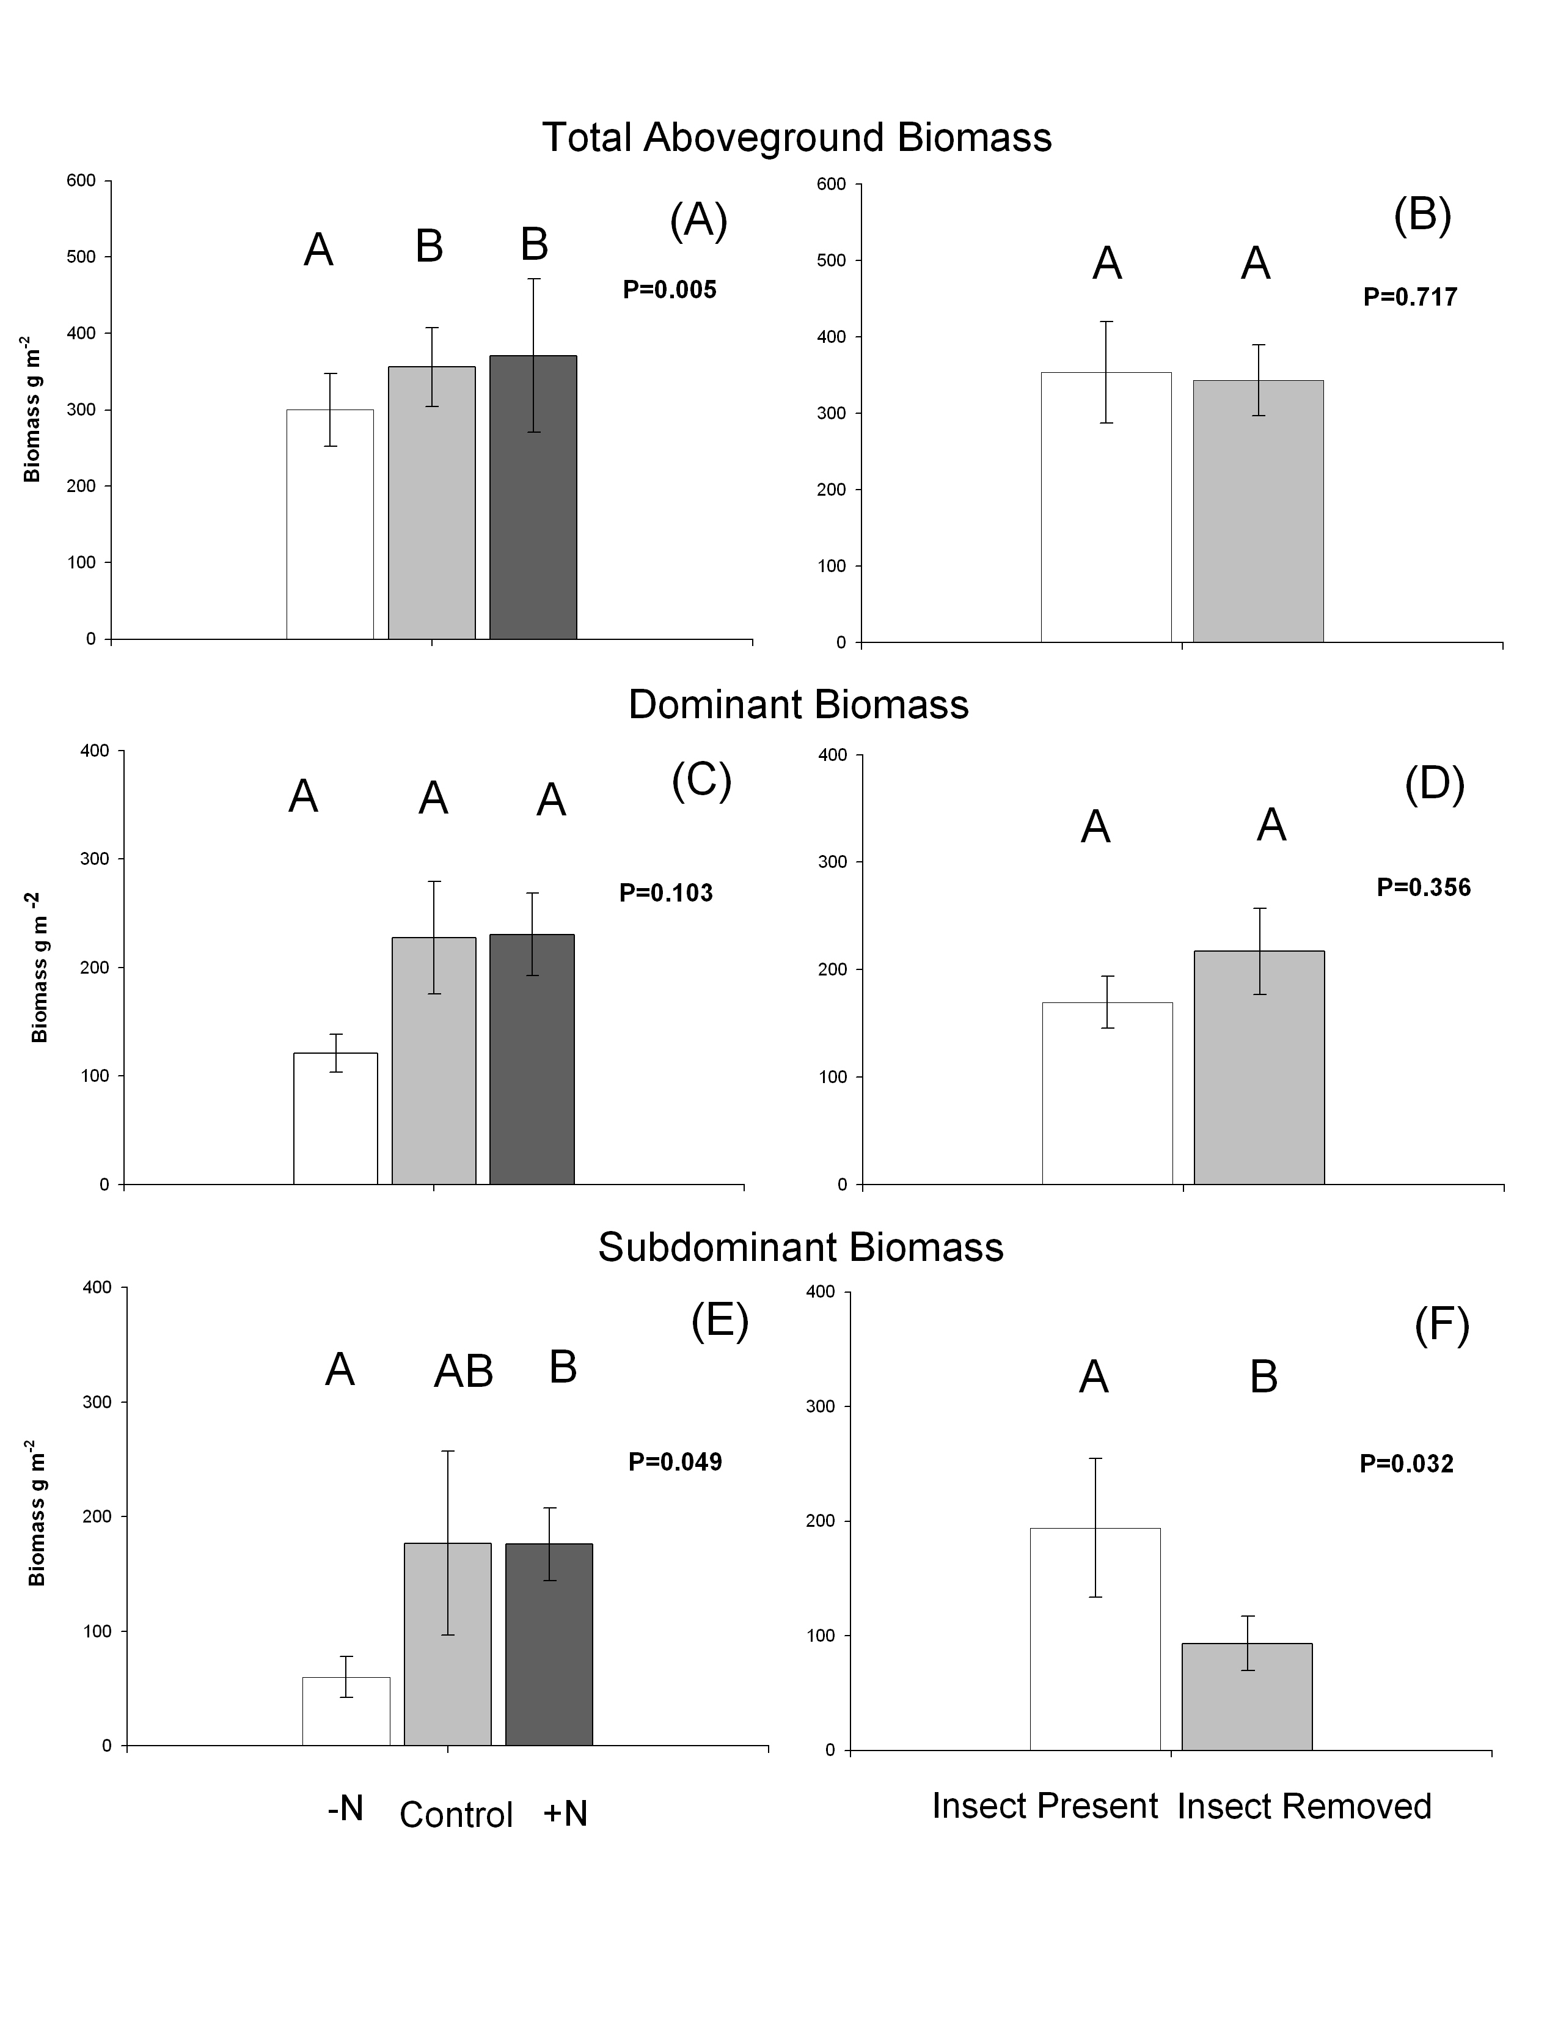

Figure 1. The effect of nitrogen (N) manipulation (3 levels) and insect herbivory (2 levels) on mean (+ SE) total aboveground plant biomass (A-B), dominant plant biomass (C-D), and subdominant plant biomass (E-F). Different letters above bars indicate means that are statistically different from one another (α= 0.05).

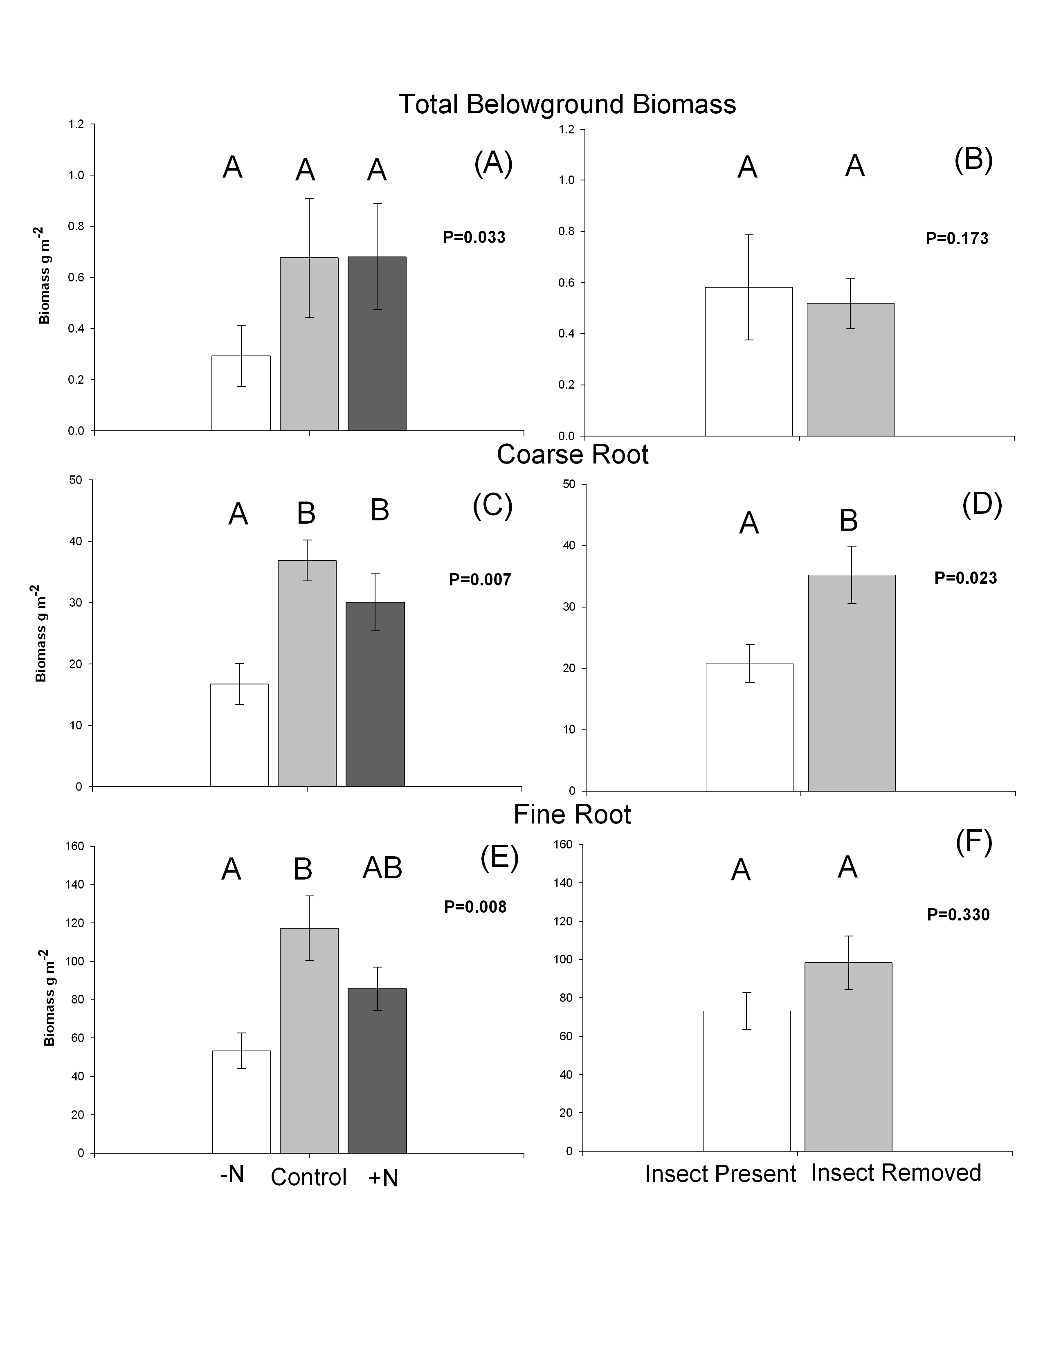
Figure 2. The effect of nitrogen (N) manipulation (3 levels) and insect herbivory (2 levels) on mean (+ SE) total root biomass (A-B), biomass of coarse roots (> 2mm diameter) (C-D), and biomass of fine roots (<2 mm diameter) (E-F). Different letters above bars indicate means that are statistically different from one another (α= 0.05).

Table 1
Observed plant species in the Summer of 2009 at the research site.

Scientific Name | Family | Functional Group | Life Cycle
Acalypha rhomboidea | Euphorbiaceae | C₃ forb | Annual
Acer rubrum | Aceraceae | C₃ woody | Perennial
Acer Sachrum | Sapindaceae | C₃ woody | Perennial
Agrimonia parviflora | Rosaceae | C₃ forb | Perennial
Allium vineale | Liliaceae | C₃ forb | Perennial
Andropogon virginicus | Poaceae | Graminoid | Perennial
Andropogon sp. | Poaceae | Graminoid | Perennial
Apocynum cannabinum | Apocynaceae | C₃ forb | Perennial
Asclepias syriaca | Asclepiadaceae | C₃ forb | Perennial
Aster pilosus | Asteraceae | C₃ forb | Annual
Bromus commutatus | Poaceae | Graminoid | Annual
Bromus inermis | Poaceae | Graminoid | Perennial
Calystegia sepium | Convolvulaceae | C₃ forb | Perennial
Campsis radicans | Bignoniaceae | C₃ forb | Perennial
Carex complanata | Cyperaceae | Graminoid | Perennial
Carex sp. | Cyperaceae | Graminoid | Perennial
Cirsium discolor | Asteraceae | C₃ forb | Biennial/Perennial
Coronilla varia | Fabaceae | N-fixer | Perennial
Croton glandulosus | Euphorbiaceae | C₃ forb | Annual
Cuscuta sp. | Convolvulaceae | C₃ forb | Perennial
Desmodium sp. | Fabaceae | N-fixer | Perennial
Diospyros virginiana | Ebenaceae | C₃ woody | Perennial
Diodia virginiana | Rubiaceae | C₃ forb | Annual/Perennial
Duchesnea indica | Rosaceae | C₃ forb | Perennial
Elaeagnus umbellata | Elaegnaceae | C₃ woody | Perennial
Elephantopus carolinianus | Asteraceae | C₃ forb | Perennial
Galium parisiense | Rubiaceae | C₃ forb | Annual
Hypericum punctatum | Clusiaceae | C₃ forb | Perennial
Lespedeza cuneata | Fabaceae | N-fixer | Perennial
Ligustrum sp. | Oleaceae | C₃ woody | Perennial
Lonicera japonica | Caprifoliaceae | C₃ woody | Perennial
Oxalis stricta | Oxalidaceae | C₃ forb | Perennial
Parthenocissus quinquefolia | Vitaceae | C₃ forb | Perennial
Passiflora incarnata | Passifloraceae | C₃ forb | Perennial
Prunus serotina | Rosaceae | C₃ woody | Perennial
Rubus argutus | Rosaceae | C₃ woody | Perennial
Rosa multiflora | Rosaceae | C₃ woody | Perennial
Rumex crispus | Polygonaceae | C₃ forb | Perennial
Setaria parviflora | Poaceae | Graminoid | Perennial
Smallanthus uvedalius | Asteraceae | C₃ forb | Perennial
Smilax bona-nox | Smilacaceae | C₃ shrub | Perennial
Smilax glauca | Smilacaceae | C₃ shrub | Perennial
Solidago altissima | Asteraceae | C₃ forb | Perennial
Solanum carolinense | Solanaceae | C₃ forb | Perennial
Sorghum halepense | Poaceae | Graminoid | Perennial
Toxicodendron radicans | Ancardiaceae | C₃ forb | Perennial
Trifolium campestre | Fabaceae | N-fixer | Annual/Biennial
Tridens flavus | Poaceae | Graminoid | Perennial
Trifolium repens | Fabaceae | N-fixer | Perennial
Ulmus sp | Ulmaceae | C₃ woody | Perennial
Veronia gigantean | Asteraceae | C₃ forb | Perennial
Verbesina occidentalis | Asteraceae | C₃ forb | Perennial
Verbesina virginica | Asteraceae | C₃ forb | Perennial
Vitis vulpina | Vitaceae | C₃ woody | Perennial

Table 2. Results from ANOVA analyses of treatment effects (insect presence and nutrient manipulation) and their interaction on total aboveground biomass of the plant community, on total aboveground dominant (Solidago altissima and Verbesina spp.) plant biomass, and total subdominant plant biomass. Significant variables (P < 0.05) are in bold.

 | Total aboveground Biomass |  |  |  | Dominant biomass |  |  |  | Subdominant biomass
Factor | Df | SS | F | P | df | SS | F | P | df | SS | F | P
Insects | 1 | 0.008 | 0.134 | 0.717 | 1 | 0.097 | 0.880 | 0.356 | 1 | 1.341 | 5.007 | 0.033
Nitrogen Availability | 2 | 0.743 | 6.308 | 0.005 | 2 | 0.542 | 2.448 | 0.103 | 2 | 1.795 | 3.351 | 0.049
Insects × Nitrogen Availability | 2 | 0.072 | 0.614 | 0.548 | 2 | 0.060 | 0.270 | 0.765 | 2 | 0.143 | 0.268 | 0.767
Error | 31 |  |  |  | 31 |  |  |  | 30

Table 3. Results from ANOVA analyses of treatment effects (insect presence and nutrient manipulation) and their interaction on community total root biomass, coarse root biomass, and fine root biomass. Significant variables (P < 0.05) are in bold.

 | Total Belowground Biomass |  |  |  | Coarse root biomass |  |  |  | Fine root biomass
Factor | df | SS | F | P | df | SS | F | P | df | SS | F | P
Insects | 1 | 0.390 | 1.949 | 0.173 | 1 | 0.603 | 5.779 | 0.023 | 1 | 0.084 | 0.979 | 0.330
Nitrogen Availability | 2 | 1.533 | 3.830 | 0.033 | 2 | 1.226 | 5.881 | 0.007 | 2 | 0.970 | 5.675 | 0.008
Insects × Nitrogen Availability | 2 | 0.826 | 2.063 | 0.145 | 2 | 0.078 | 0.373 | 0.692 | 2 | 0.101 | 0.593 | 0.559
Error | 35 |  |  |  | 34 |  |  |  | 29

Table 4. Results from ANCOVA analysis using nutrient amendments and insect herbivory as main effects and plant belowground biomass as a covariate on total aboveground biomass.

Factor | df | SS | F | P
Insects | 1 | 0.001 | 0.001 | 0.971
Nitrogen availability | 2 | 0.677 | 1.509 | 0.242
Aboveground biomass | 1 | 0.044 | 0.197 | 0.661
Insects × nitrogen availability | 2 | 0.558 | 1.242 | 0.307
Insects × aboveground biomass | 1 | 0.056 | 0.248 | 0.623
Nitrogen availability × aboveground biomass | 2 | 0.219 | 0.489 | 0.619
Insects× nitrogen availability× aboveground biomass | 2 | 0.316 | 0.704 | 0.505
Error | 25

VITA

Jarrod Dwayne Blue was born in December 1985 in Charlotte, North Carolina. He graduated with high honors and International Baccalaureate Diploma from Independence High School in Charlotte, North Carolina. He graduated from Davidson College, in 2008 with a Bachelors of Science in Biology. Jarrod received his Masters of Science degree in Ecology and Evolutionary Biology from the University of Tennessee in August 2010.

