Formation of dimer interface and Involvement in negative regulation by the N-terminus of the Saccharomyces cerevisiae G protein-coupled receptor Ste2p

A dissertation Presented for the
Doctor of Philosophy Degree
The University of Tennessee, Knoxville

M. Seraj Uddin
August 2013

Copyright©2013 by Mohammad Seraj Uddin
All rights reserved

Dedication

I would like to dedicate this dissertation to my parents, Rashid Ahmed and Laila Begum, and to who stood by me, supported me and pray for me all the times. I would also like to dedicate this work to my wife, Fahmida Chowdhury, and my son Zarif for all the support and encouragement they gave me. Without their love, I could never have completed this work.

Acknowledgments
I would like to thank many people who, without their help, this dissertation would not be possible. My first and deepest appreciation goes to my mentor Dr. Jeffrey M. Becker. It was really a great pleasure to work for such an enthusiastic scientist whose knowledge, guidance, support and directions will be with me for the rest of my career. I could not have done it without him. I am thankful that he was so patient and supportive during the time I was struggling with my projects. His critical suggestions and guidance helped me overcome lots of stumbling blocks that I would not even try without him. It is a great pleasure and honor to work for such a great scientist.
I also would like to give my very appreciation to my committee members Dr. Timothy E. Sparer, Dr. Todd B. Reynolds, and Dr. Cynthia Peterson for their suggestions, critical reviews and guidance during my studies. Their extraordinary patience and encouragement motivated me.
I would like to thank Dr. Fred Naider for his support and valuable ideas on critical decisions throughout these studies. I also want to thank all the Dr. Naider laboratory members for the peptide syntheses that made this study possible.
I really appreciate all the lab members in Dr. Becker’s laboratory: Special thanks to Dr. Melinda Hauser, Dr. Byung-Kwon Lee, and Dr. Tom Masi for their guidance and help during my study. I also want to thank Sarah Kauffman, George Umanah, Liyin Huang, Elena Ganusova, Steve Minkin, Heejung Kim, Giljun Park, Kyung Sik, Amanda Deyo, Madelyn Crawford, Jordan Kim, Brandon Sidney, Julie Maccarone, John Lockart, who made Becker lab such an enjoyable and fun place to work at.
Finally I am greatly indebted to my family in Bangladesh, Fahmida Chowdhury and my little son Zarif for all the love and support they gave me during all these years. And a big thank you to everyone who has been a friend and colleague throughout this process. I could not have it without you all.

Abstract

G protein-coupled receptors (GPCRs), the largest family of membrane proteins on the cell surface, play essential roles in signal transduction in all organisms. These proteins are responsible for sensing and detecting a wide range of extracellular stimuli and translating them to intracellular responses. This signaling requires a tight control for receptor activation without which abnormal signal leads to diseases. In fact, malfunctions of these receptors are associated with numerous pathological conditions and currently an estimated 40-50% of therapeutic drugs are designed to target these receptors suggesting that further increases in understanding of GPCRs and the signaling pathways they initiate will lead to new and more specific drug targets. We have used Saccharomyces cerevisiae GPCR Ste2p as a model system to understand structure-function relationships of these receptors. In this study, the role of the extracellular N-terminus has been examined using various biophysical methods with the anticipation to uncover its role in receptor function. It was found that some residues in the extracellular N-terminus was not accessible to a sulfhydryl reagent and that the alternating pattern of accessibility is consistent with the structure of a beta strand. This beta strand was found to be involved in dimer formation. Moreover, a conserved tyrosine residues in the middle of the beta strand was found to interact with two residues in the extracellular loop 1. It was also found that the N-terminus is involved in negative regulation and important for cell surface expression.

Contents
Chapter 1: G protein-coupled receptors: an overview 9
Classification of GPCRs: 11
GPCR Crystal Structures: 15
Fungal GPCRs 18
GPCRs and signal transduction in S. cerevisiae 19
Ste2p as a model GPCR: structural analysis 24
Oligomerization/dimerization of Ste2p 25
References 27
Chapter 2 : Substituted Cysteine Accessibility Studies of the N-terminus of Ste2p 35
Abstract: 37
INTRODUCTION: 38
METHODS: 40
RESULTS: 45
DISCUSSION: 61
Conclusion: 65
REFERENCES 67
Chapter 3: The N-terminus of Saccharomyces cerevisiae G protein-coupled receptor Ste2p is involved in negative regulation 76
Abstract: 77
Introduction: 78
Methods: 80
Results 85
Discussion 1
References: 6

Chapter 1: General introduction

G protein-coupled receptors: an overview
Signal transduction is an essential biological process that is required to maintain cellular homeostasis and coordinated cellular activity in all organisms. The membrane proteins at the cell surface play crucial roles in these fundamental processes communicating between the external and internal environment of the cell. The largest and most diverse membrane protein family on the cell surface is the G protein-coupled receptors (GPCRs) that are involved in nearly all important physiological processes in eukaryotic organisms [2]. These proteins function by sensing an astonishing variety of extracellular signals, including photons, protons, ions, odorants, amino acids, nucleotides, steroids, fatty acids, proteins and peptides [3].
The GPCR family of proteins comprises approximately 4% of the encoded human genes corresponding to over 800 members [2, 4-6]. Modifications in the signaling of these receptors are pertinent for many pathological conditions including cardiovascular and pulmonary diseases, pain perception, obesity, cancer, and neurological disorders [2, 7, 8]. In fact, GPCRs are considered one of the most successful therapeutic targets with more than 25% of all modern prescription drugs are based on GPCRs as the target [9-13]. However, only a very small fraction of the known GPCRs represent the target of the currently prescribed drugs. Many GPCRs remain ‘orphan’, which have not been assigned functions. Even for many receptors whose ligands are known, there is a need for identifying agonist and antagonist ligands. Regarding these facts, it is suggested that GPCRs will continue to be drug targets of the future [2, 14-16]. Thus, the studies of GPCRs will contribute significantly to the understanding and treatment of a variety of diseases.
These receptors share a common structural organization with an extracellular N-terminus, seven transmembrane domains connected by extracellular and intracellular loops, and a cytoplasmic C-terminus [17-19]. Despite the astounding diversity of their ligands, biological function and lack of strong sequence similarity, all GPCRs share common mechanisms of signal transduction. i.e., they couple the binding of ligands to the activation of specific heterotrimeric guanine nucleotide-binding proteins (G proteins) and/or non-G protein mediated signaling, leading to the modulation of downstream effector proteins and gene expression [20-23].
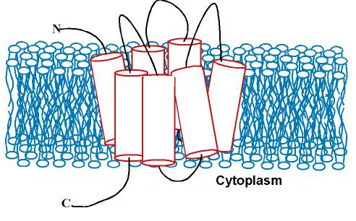
Figure 1. Cartoon of a GPCR showing the seven transmembrane domains connected by alternating extracellular and intracellular loops (adapted from http://structbio.vanderbilt.edu/sanders/Research_Julia_Ver_1/temp.html)
Upon ligand binding, the receptor induces a conformational change in the intracellular heterotrimeric G proteins that act as molecular switch leading to intracellular responses. The G proteins are composed of three subunits (α, βγ dimer). Activation of GPCRs leads to exchange of GDP by GTP on the Gα-subunit triggering the dissociation of the α-subunit from the receptor and the βγ dimer [24]. Both the GTP bound α-subunit and the released βγ-dimer can mediate the stimulation or inhibition of effector proteins such as enzymes and ion channels [e.g, adenylate cyclase, guanylyl cyclase, phospholipase C, mitogen-activated protein kinases (MAPKs), Ca+2, and K+ channels]. Thus, stimulation of GPCRs with specific agonists results in changes in the concentration of second-messenger molecules [24]. However, this general mechanism of signal transduction by GPCRs may be different in yeast.

Classification of GPCRs:
GPCRs have been classified into groups or classes based on different criteria including how their ligand binds and physiological and structural features of the receptors. The most commonly used systems classify the GPCRs into 6 clans A, B, C, D, E, and F to include all GPCRs in vertebrates and invertebrates based on sequence similarity in their transmembrane domains [25, 26]. Each clan is again divided into families based on common biochemical properties (Table 1).
Table 1. Sequence-based groupings within the G-protein-coupled receptors
Clan A: rhodopsin-like receptors
Family I | Olfactory receptors, adenosine receptors, melanocortin receptors, and others
Family II | Biogenic amine receptors
Family III | Vertebrate opsins and neuropeptide receptors
Family IV | Invertebrate opsins
Family V | Chemokine, chemotactic, somatostatin, opioids, and others
Family VI | Melatonin receptors and others
Clan B: calcitonin and related receptors
Family I | Calcitonin, calcitonin-like, and CRF receptors
Family II | PTH/PTHrP receptors
Family III | Glucagon, secretin receptors and others
Family IV | Latrotoxin receptors and others
Clan C: metabotropic glutamate and related receptors
Family I | Metabotropic glutamate receptors
Family II | Calcium receptors
Family III | GABA-B receptors
Family IV | Putative pheromone receptors
Clan D: STE2 pheromone receptors
Clan E: STE3 pheromone receptors
Clan F: cAMP receptors and archaebacterial opsins
Table adapted from Flower [27]
Human GPCRs have been recently classified into five families using a GRAFS (Glutamate, Rhodopsin, Adhesion, Frizzled/taste2, Secretin) system that is based on phylogenetic relationship in the transmembrane regions: rhodopsin (clan A), secretin (clan B), glutamate (clan C), adhesion, and frizzled/taste2 receptor families [5]. Additionally, some GPCRs in human were not classified into any of the families as sequences were very divergent. However, the other receptors clearly form five families as determined by the extensive phylogenetic analyses. All receptors with the exception of the members of the rhodopsin family have long N termini. However, a few members of the rhodopsin family has long N-termini. Although these long N termini are particularly evident for the receptors within the adhesion family, the members of the other families also contain long N termini that are fairly rich in Cys residues.
The rhodopsin family (class A) has the largest number of receptors. Currently, there are more than 700 receptors in this family as recognized by the IUPHAR database (International Union of basic and clinical PHARmacology, http://www.iuphar-db.org/) [28]. The members of the rhodopsin family have several characteristics. Most members of the rhodopsin contains NSxxNPxxY motif in transmembrane domain VII (TMVII), the DRY motif or D(E)-R-Y(F) at the border between transmembrane domain III (TMIII) and intracellular loop 2 (IL2). The ligands for most of the rhodopsin receptors bind within a cavity between the TM regions [29].
The receptors of the secretin family (class B) bind to large peptide ligands that share high sequence similarity and most often act in a paracrine manner. The N terminus of these receptors are long with ∼60 and 80 amino acids, and contains conserved Cys-Cys bridges that are important for ligand binding. This family consisting of peptide and neuropeptide hormones such the secretin, calcitonin (CALC), vasoactive intestinal peptide (VIP), the glucagon (GCG), the parathyroid hormone (PTH), and PACAP receptors currently contains ~55 members as recognized by the IUPHAR database [28].
The glutamate receptor family (class C) consists of eight metabotropic glutamate receptors (GRM), two gamma-aminobutyric acid (GABA) receptors (GABA_{B1} GABA_{B2}; functional GABA receptors contain both GABA_{B1} and GABA_{B2} subunits), a single calcium-sensing receptor (CASR), three receptors that are believed to be taste receptors (TAS1) and seven orphan receptors [28]. All receptors of this family contain long N-terminus. The metabotropic glutamate receptors contain a very long N terminus (∼280 to 580 amino acids) that forms two distinct lobes separated by a cavity in which glutamate binds, forming the so-called “Venus fly trap” where the glutamate causes the lobes to close around the ligand. The CASR also has a long cysteine-rich N terminus, which is important for mediating the signal of Ca²⁺ although it is not known if it is involved in Ca²⁺ binding. The GABA receptors have a long N-terminus that contains the ligand-binding site but lacks the cysteine-rich domain found in the other receptors of this family. The TAS1 receptors are expressed in the tongue and believed to mediate taste signals. These receptors also have a long N terminus with a series of conserved Cys residues.
The members of the adhesion family of GPCRs contain N-termini of variable length (~200 to ~2800 amino acids) and are often rich in glycosylation sites and proline residues. The long N-termini of these GPCRs contain motifs that are likely to participate in cell adhesion [30, 31].
The frizzled/taste2 receptor family includes two groups: the frizzled and the TAS2 receptors. There are several consensus motifs (IFL in TMII, SFLL in TMV, and SxKTL in TMVII) in the members of this family which are not found in the other four families. The TAS2 receptors have a very short N terminus that is unlikely to contain a ligand-binding domain. The TAS2 receptors are expressed in the tongue and palate epithelium, and are believed to function as bitter taste receptors [5]. The frizzled family of receptors contain a long N-terminus (~200-amino acid) with conserved cysteines that are believed to be involved in ligand binding. The receptors of this family are responsible for controlling cell fate, proliferation, and polarity during metazoan development.[5, 32, 33]. Although GPCRs have weak sequence similarity, they all have similar structures with (i) an extracellular region consisting of the N-terminus, three extracellular loops, (ii) the TM region, consisting of sevenα-helices; and (iii) the intracellular region, consisting of three intracellular loops, an intracellular amphipathic helix, and the C-terminus. Fungal GPCRs are described below in a separate section.

GPCR Crystal Structures:
Structural information of GPCRs is vital to understand how these signaling molecules carry out their function and also for drug development. However, little is known about the structural basis of GPCR function in spite of extensive studies in both academic and industrial institutions [34-36]. The most commonly used methods to gain structural information of proteins include X-ray crystallography, electron microscopy or diffraction, NMR spectroscopy and molecular modeling. All of these methods require high concentrations of dissolved purified protein. Additionally, crystallization and NMR require proteins in mostly insoluble media that provide a good environment for study. In order to maintain their native structures, membrane proteins are required to be maintained in a lipid-like environment making the structural studies by crystallization and NMR more challenging. In fact, crystallization of GPCRs is one of the most challenging subjects in current structural biology due to the poor natural abundance and high intrinsic flexibility of these membrane proteins. Bovine rhodopsin was the first GPCR to be crystallized about a decade ago by Palczewski et al [37]. However, it took several years to solve the crystal structure of a second GPCR in 2007 [38, 39]. Since then there has been almost an exponential growth in the number of solved structures due to the application of several innovative protein engineering techniques and crystallography methods. Until now 75 crystal structures of 18 GPCRs have been solved (see Table 2) adapted from Maeda 2013) [40]. These structures will provide insights into the structural and functional diversity of these receptors and will be helpful to discover the molecular signatures of the GPCRs. These structures will also aid in understanding the molecular changes that undergoes during receptor activation. The structural data combined with data from the biophysical, biochemical and computational studies will allow us to understand the structure-function relationships of GPCRs.
Due to the tremendous diversity of GPCRs and their involvement in so many pathways in the cells, there remains huge potential for the development of drugs to ameliorate many diseases including neurological disorders, inflammatory diseases, cancer and metabolic imbalances. Therefore, structures of more GPCRs and understanding the molecular mechanism of receptor activation is important for fundamental biology as well as for improving human health by facilitating structure-based in-silico drug discovery and the development of drugs with improved specificity and pharmacodynamics.

Table 2. GPCR structures solved in the 2000-2013 period
GPCR | Species | Year | PDB code | Reference
Rhodopsin | Bovine | 2000 | 1F88 | [37]
β1 Adrenergic | Turkey | 2008 | 2VT4 | [41]
β2 Adrenergic | Human | 2007 | 2R4R | [38]
D3 dopamine | Human | 2010 | 3PBL | [42]
H1 histamine | Human | 2011 | 3RZE | [43]
M2 muscarinic acetylcholine | Human | 2012 | 3UON | [44]
M3 muscarinic acetylcholine | Rat | 2012 | 4DAJ | [45]
A2A_Adenosine | Human | 2008 | 3EML | [46]
Chemokine CXCR4 | Human | 2010 | 3ODU | [47]
Chemokine CXCR1 | Human | 2012 | 2LNL | [48]
μ-Opioid | Mouse | 2012 | 4DKL | [49]
κ-Opioid | Human | 2012 | 4DJH | [50].
δ-Opioid | Mouse | 2012 | 4EJ4 | [51]
N/OFQ opioid | Human | 2012 | 4EA3 | [52]
Neurotensin receptor | Rat | 2012 | 4GRV | [53]
PAR1 | Human | 2012 | 3VW7 | [54]
Sphingosine 1-phosphate | Human | 2012 | 3V2W | [55]
Smoothened | Human | 2013 | 4JKV | [56]
Serotonin 5-HT_{1B} | Human | 2013 | 4IAR | [57]
Table adapted from Maeda [40].

Fungal GPCRs
Like all other living organisms, fungi also possess GPCRs that respond to extracellular signals to ensure proper cellular response. Although many GPCRs have been identified in different fungi, only a few were included in the GPCR classification system (A-F system, Table 1) described in the previous section [27]. As a result, the fungal GPCRs were categorized separately into six classes based on sequence homology and ligand sensing (Table 3). These are Ste2p-like pheromone receptors, Ste3p-like pheromone receptors, carbon/amino acid receptor, putative nutrient receptor, cAMP receptor-like, and microbial opsin [23].
Although a number of GPCRs have been identified in fungi based on conserved sequences and structures, only a few are well studied. Specifically the Saccharomyces cerevisiae mating pheromone receptors Ste2p and Ste3p have been studied more extensively than the other GPCRs due to the availability of whole genome sequence and the ability to manipulate easily. In fact, the studies on S. cerevisiae GPCR system have considerably advanced our understanding the mating system at molecular level.
Table 3. Six classes of GPCRs in fungi
Species | Ste2-like pheromone receptor | Ste3-like pheromone receptor | Carbon/amino acid receptor | Putative nutrient receptor | cAMP receptor-like | Microbial Opsin
Saccharomyces cerevisiae | Ste2 | Ste3 | Gpr1 | SCRG_01312 SCRG_02823 SCRG_00179 | – | –
Schizosaccharomyces pombe | Mam2 | Map3 | Git3 | Stm1 | – | –
Candida albicans | Ste2 | Ste3 | Gpr1 | CAWG_02899 CAWG_06059 CAWG_02686 | – | –
Aspergillus nidulans | GprA | GprB | GprC GprD GprE | GprF GprG AN5720 | GprH GprI AN8262 | AN3361
Aspergillus fumigatus | Afu3g14330 | Afu5g07880 | Afu7g04800 | Afu5g04100 Afu1g06840 Afu1g11900 | Afu3g01750 Afu5g04140 Afu3g00780 | Afu7g01430
Neurospora crassa | Pre-2 | Pre-1 | Gpr-4 | Gpr-5 Gpr-6 | Gpr-1 Gpr-2 Gpr-3 | Nop-1 ORP-1
Magnaporthe grisea | MGG_04711 | MGG_06452 | MGG_08803 | MGG_04698 MGG_02855 | MGG_06738 | MGG_09015
Cryptococcus neoformans | – | Ste3α/Ste3a Cpr2 | Gpr4 | Gpr2 Gpr3 | Gpr4 Gpr5 | CNAG_03572 (Ops1)
Ustilago maydis | – | Pra1 Pra2 | – | UM06006 UM01546 | UM03423 | UM02629 UM04125
Coprinopsis cinerea | – | Rcb1 Rcb2 Rcb3 CC1G_02129 | – | CC1G_07132 CC1G_04180 | CC1G_02288 CC1G_02310 | –
Rhizopus oryzae | – | –
Table adapted from Xue et. al. [23].

GPCRs and signal transduction in S. cerevisiae
GPCR studies using eukaryotic systems present huge complexity due to cross-talk between different types of receptors and an assortment of G proteins that regulate multiple pathways. The unicellular, genetically tractable eukaryotic organism S. cerevisiae presents a simple biological system with only a few GPCRs and G proteins [58, 59]. The mitogen-activated protein kinase (MAPK) pathway activated by the GPCRs of this organism exhibits high homology to that of the mammalian system [60]. In spite of little sequence similarity, several mammalian GPCRs were successfully expressed in yeast and were capable of activating the MAPK pathway [59, 61, 62]. Yeast GPCRs have also been shown to exhibit signaling when expressed in mammalian cells [63]. S. cerevisiae has only three GPCRs: Ste2p, Ste3p and Gpr1p. The Ste2p and Ste3p are pheromone receptors and the Gpr1p is a carbohydrate sensor. Although the pheromone and the carbohydrate sensing receptors share some downstream components, no cross-talk occurs between the two receptor systems as they couple to two different G proteins.
S. cerevisiae exists as a haploid or diploid cell [64]. The haploid cells exist as one of two mating types, MATa and MATα, which are distinguished by the expression of a set of genes involved in mating that are not expressed by the diploids. MATa cells express GPCR Ste2p and the pheromone a-factor, a hydrophobic, farnesylated, carboxymethylated, dodecapeptide with the sequence YIIKGVFWDPAC(Farnesyl)-OCH3. MATα cells express GPCR Ste3p and the pheromone α-factor, a tridecapeptide with the sequence WHWLQLKPGQPMY. The pheromones a- and α-factor, bind to Ste3p and Ste2p, respectively, initiating the mating and eventual fusion of the two haploid cells resulting in a diploid cell. Pheromone binding causes a conformational change in the receptor that triggers the activation of the intracellular heterotrimeric G proteins consisting of Gpa1p (G_{α}), Ste4p (G_{β}) and Ste18p (G_{γ}) leading to the G1 cell cycle arrest, polarized growth, dissolution of the cell wall and membranes followed by cellular fusion [65]. Receptor activation triggers the exchange of GDP with GTP at Gpa1p (Gα) subunit releasing the Ste4p/Ste18p (Gβγ) dimer which in turn transmits the signal required for mating. Thus Gpa1p acts as a negative regulator in the signaling pathway. However, Gpa1p has also been shown to stimulate the downstream signaling in several studies. For example, a GTPase-deficient mutant (GDP-bound form) of Gpa1p was shown to couple with an RNA binding protein Scp160 [66] and endosomal Vps15/Vps34 subunits [67-69].
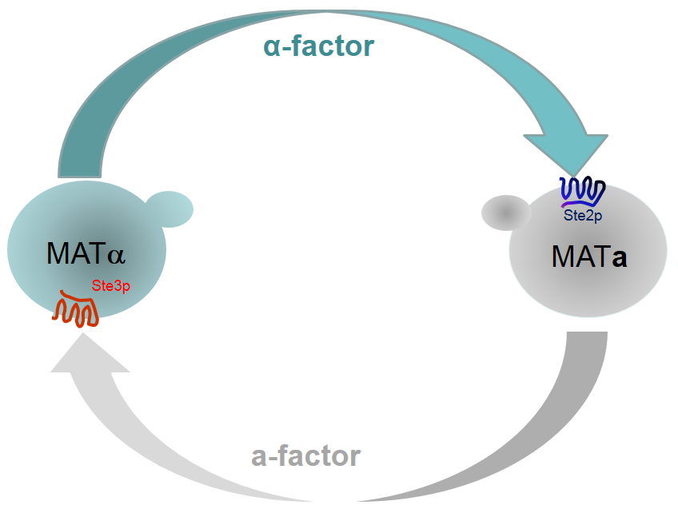
Figure 2. Pheromone mediated mating in Saccharomyces cerevisiae. Schematic representation of the pheromone/receptor mediated communication between MATa and MATα haploid cells prior to mating.
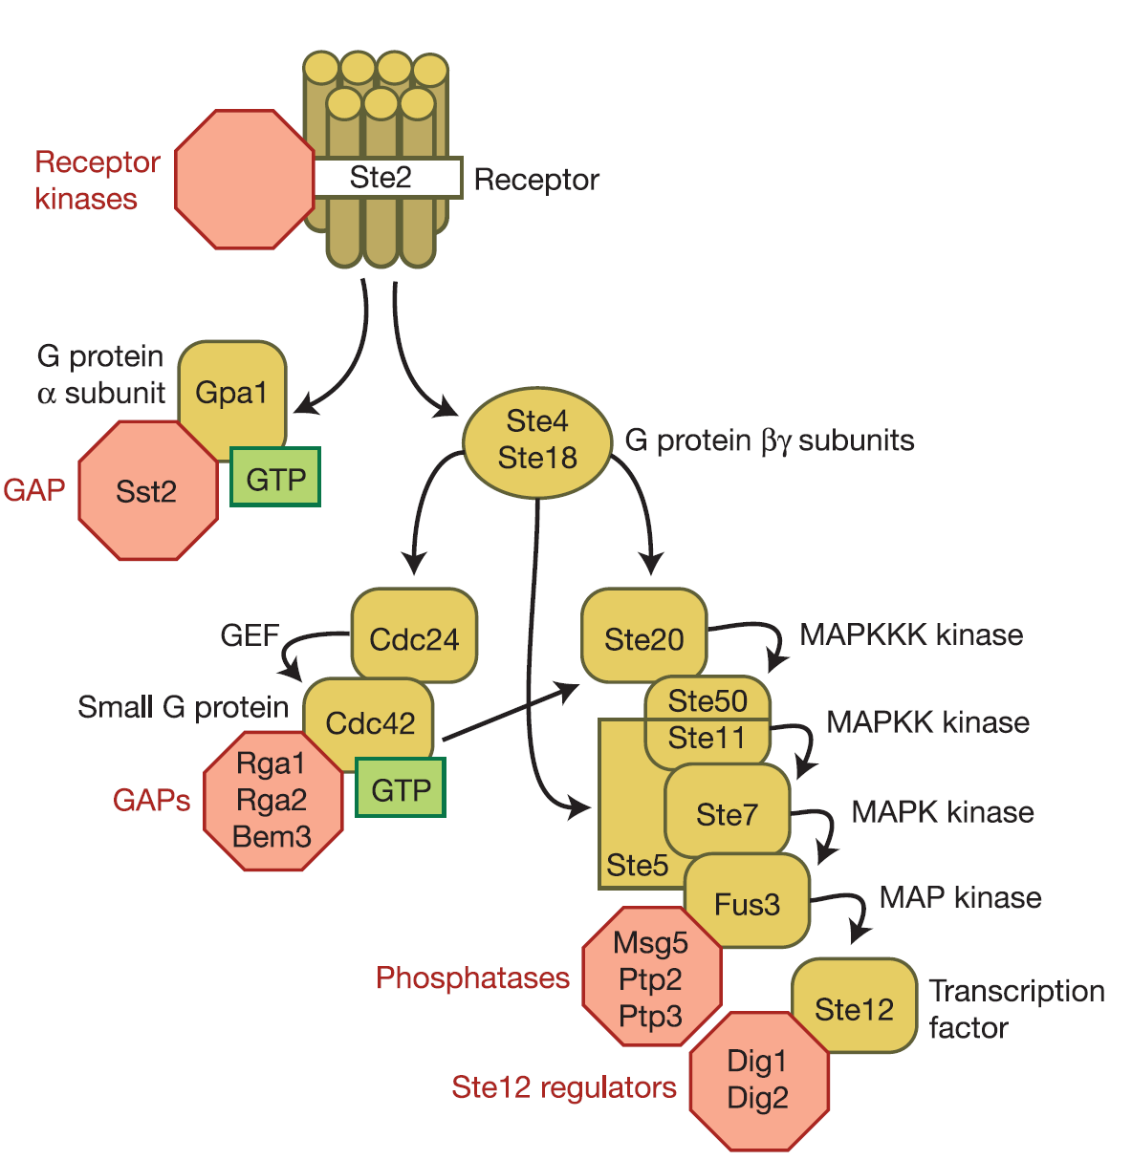
The Ste4p/Ste18p complex transmits the signal to a mitogen-activated protein (MAP) kinase cascade through at least three effector proteins: a guanine-nucleotide exchange factor Cdc24p, a protein kinase Ste20p, and a kinase scaffolding protein Ste5p [65]. Cdc24p is the guanine nucleotide exchange factor for the Rho G-protein Cdc42p [70] that regulates MAP kinase signaling through PAK (p21-activated kinase)-family kinase Ste20p [71]. Ste20p activates the downstream MAP kinase cascade upon binding with Ste4p/Ste18p and Cdc42p [72, 73]. The scaffold protein Ste5p serves to facilitate interactions among Ste11p (MAPKKK), Ste7p (MAPKK) and Fus3p (MAPK) [74, 75]. Fus3p then phosphorylates Far1p [76] and Ste12p, a transcription factor [77]. Far1p inhibits Cdc28-G1 cyclin complex and promotes G1 cell cycle growth arrest [78]. The transcriptional transactivator Ste12p binds to the pheromone response element (PRE) at the promoter region of target genes such as FUS1, FUS2, FIG1, FIG2, and AGA1 that are induced for cell fusion [79]. The two haploid cells of the opposite mating types form shmoos, [80] followed by degradation of the cell wall, plasma membrane and finally fusion of their nuclei to become one a/α diploid zygote [81].
Figure 3. Components of the pheromone response pathway in yeast. Adapted from Wang and Dohlman [1].
The mating pathway in yeast is highly regulated by several mechanisms like many other GPCRs. The extracellular protease Bar1p produced by the MATa cell cleaves α-factor [82] allowing the cells to recover from α-factor induced growth arrest. Sst2p, a member of the regulator of G-protein signaling (RGS), interferes with GTP-bound Gpa1p and down-regulates mating signal [83]. Yeast casein kinases, Yck1p and Yck2p, are involved in budding morphogenesis and internalization of pheromone receptors [84]. Yck-mediated phosphorylation of the mating receptors is required for vesicle trafficking at the cell membrane [85]. Eventually phosphorylation at the C-terminus of the receptor leads to ubiquitination, internalization and degradation [86].
Taking advantage of the simplicity of the yeast system and power of yeast genetics along with the low cost of yeast cell culture, yeast GPCR system have enabled many researchers worldwide to use it as a model for structural and functional analysis of GPCRs. Moreover, yeast GPCR in a haploid cell can replaced with a mammalian GPCR and the pathway can be activated. This technique has enabled researchers to develop cell-based functional assay in a eukaryotic host free from endogenous responses and can be used for ligand identification and pharmacological characterization [59, 61, 63].

Ste2p as a model GPCR: structural analysis
Ste2p, the α-factor pheromone receptor of S. cerevisiae, shares common architectural organization of GPCRs with the signature seven transmembrane domains. Although there is no significant sequence homology across the members of the GPCR superfamily, their mechanism of signal transduction is thought to be similar. In fact, comparative analysis of two widely divergent GPCRs, Ste2p (a Class D GPCR) and rhodopsin (a Class A GPCR) exhibited several similarities [21]. For example, ligand binding occurs within the core of the 7TM helices [87-89]; the third intracellular loop plays key roles in G protein activation [90-92];.and the C-terminus is the target for desensitization by phosphorylation and ligand-mediated down-regulation by receptor endocytosis [93, 94]. In addition, conserved residues important for receptor function are located in TM1 and TM3 of both receptors. Strongly polar amino acids in Ste2p that mediate helix interactions are also located in similar positions in rhodopsin. Mutation of these residues leads to loss of function or constitutive activity. In both receptors, small and weakly polar amino acids located in identical positions facilitate tight helix packing. Location of conserved amino acids and sites of constitutively active mutations are located in TM3, TM6 and TM7. Proline is essential at similar positions in TM6 and TM7. Moreover, Ste2p can activate mammalian Golf subunits [95] and certain mammalian GPCRs can activate the pheromone-responsive G protein pathway in yeast [96, 97]. Thus these structure-function similarities provide strong support that the underlying mechanism of signal transduction in these receptors is similar.
Although there has been an explosion of x-ray crystal structures of GPCRs since 2007, x-ray crystallography of Ste2p is still a far cry due to difficulties in obtaining sufficient amount of pure protein. As a result, structure-function information of Ste2p has been mainly obtained by mutational analysis. Substituted Cysteine Accessibility method (SCAM), modeling and biophysical analysis have been used in several studies to obtain structural information of Ste2p. A recent study using SCAM it has been proposed that the N-terminus has a β-strand between residues 20-30 and that this β-strand participates in homodimer formation [98]. Another study using SCAM by Hauser et al. proposed that residues 106-114 in the EL1 form a 3₁₀ helix [99]. Modeling and biophysical studies by Akal-Strader et.al. predicted that the C-terminus of the EL1 comprising residues 126-135 contain two short β-strands [100]. The solvent accessibility of the several residues was also reported to change in a ligand-dependent manner. Hauser et. al. proposed that part of the EL1 is buried in a solvent-inaccessible environment and that this part interacts with the extracellular part of the transmembrane domains 5 and 6. Choi and Konopka [101] used SCAM to determine the TM boundaries. They proposed that TM domains of Ste2p vary in length and that some TM domains are tilted relative to the plan of the membrane similar to that in rhodopsin.

Oligomerization/dimerization of Ste2p
Interactions among proteins play essential roles in the organization and function of cellular signaling. GPCRs were have been considered to exist and function as monomers for many years. However, an increasing number of studies demonstrated that GPCRs are able to form dimers or higher order oligomers. Several studies reported that dimerization/Oligomerization are often essential for modulation of receptor function (Error! Reference source not found.) [11, 102-108].
Table 4. Proposed roles of GPCR dimerisation/oligomerisation
Role of dimerisation/oligomerisation | Receptor(s) | References
Protein folding | β₂-adrenoceptor | [109]
Protein folding | CXCR1 | [110]
Protein folding | α₂-adrenoceptors | [111]
Protein folding | TSH receptor | [112]
Protein folding | Frizzled 4 | [113]
Protein folding | Calcium sensing receptor | [114]
Protein folding | Melacortin-1 receptor | [115]
Protein folding | CXCR1–CXCR2 hetero-dimer | [110]
Efficient signal transduction | Rhodopsin | [116, 117]
Efficient signal transduction | BLT1 leukotriene B4 receptor | [118]
G-protein selectivity (hetero-dimers) | MOP and DOP receptors | [119, 120]
G-protein selectivity (hetero-dimers) | D1 and D2 dopamine receptors | [121, 122]
Signal alteration/modulation (hetero-dimers) | Orexin-1 receptor and cannabinoid CB1 | [123]
Signal alteration/modulation (hetero-dimers) | Melatonin MT1 and GPR50 | [124]
Signal alteration/modulation (hetero-dimers) | MrgD and MrgE | [125]
Signal alteration/modulation (hetero-dimers) | DOP receptor and SNSR-4 | [126]
Signal alteration/modulation (hetero-dimers) | Somatostatin sst2a and sst3 | [127]
Control of physiological function (heterodimers) | DOP and KOP receptors | [128]
Control of physiological function (heterodimers) | Angiotensin AT₁ and Bradykinin B2 | [129, 130]
Control of physiological function (heterodimers) | Angiotensin AT₁ and Mas | [131, 132]
Control of physiological function (heterodimers) | EP1 prostanoid receptor and β2-adrenoceptor | [133]
Control of physiological function (heterodimers) | Various adenosine and dopamine receptors | [134-137]
Control of physiological function (heterodimers) | Adenosine A₁ and A_{2A} | [138]
Control of physiological function (heterodimers) | Dopamine D2 and cannabinoid CB1? | [139]
Table adapted from Milligan 2007 [102].
Ste2p has also been identified as oliogmers in intact cells and membranes although functional significance of this oligomerization/dimerization is not clear. Gehret et. al. [140] used bioluminescence resonance energy transfer (BRET) to demonstrate that co-expressed Ste2p tagged with cyan or yellow fluorescent proteins (CFP or YFP) co-oligomerize. Their study indicated that individual receptors that form oligomers do not act independently. Analysis of Ste2p mutants using fluorescence resonance energy transfer (FRET) Overton and Blumer [141] demonstrated that the N-terminus, TM1 and TM2 mediate oligomerization of Ste2p. Another study used disulfide cross-linking to demonstrate that TM1 and TM4 are dimer interfaces of Ste2p. These two transmembrane domains have also been reported to be dimer contacts in rhodopsin, a class A GPCR, providing evidence that structure and function are highly conserved across GPCRs [142]. Another study by Kim et. al. demonstrated that TM1 and TM7 of Ste2p also participate in dimerization. They also demonstrated that the dimers formed by TM7 changes upon receptor activation [143]. More recently, Umanah et al. demonstrated that IL3 of Ste2p also participate in the dimerization [144]. Uddin et al. demonstrated that the N-terminus of Ste2p also participates in Ste2p dimerization. Thus,

References
1. Wang, Y. and H.G. Dohlman, Pheromone signaling mechanisms in yeast: a prototypical sex machine. Science, 2004. 306(5701): p. 1508-9.
2. O'Hayre, M., et al., The emerging mutational landscape of G proteins and G-protein-coupled receptors in cancer. Nat Rev Cancer, 2013. 13(6): p. 412-24.
3. Maller, J.L., Signal transduction. Fishing at the cell surface. Science, 2003. 300(5619): p. 594-5.
4. Ding, X., X. Zhao, and A. Watts, G-protein-coupled receptor structure, ligand binding and activation as studied by solid-state NMR spectroscopy. Biochem J, 2013. 450(3): p. 443-57.
5. Fredriksson, R., et al., The G-protein-coupled receptors in the human genome form five main families. Phylogenetic analysis, paralogon groups, and fingerprints. Mol Pharmacol, 2003. 63(6): p. 1256-72.
6. Gloriam, D.E., R. Fredriksson, and H.B. Schioth, The G protein-coupled receptor subset of the rat genome. BMC Genomics, 2007. 8: p. 338.
7. Salon, J.A., D.T. Lodowski, and K. Palczewski, The significance of G protein-coupled receptor crystallography for drug discovery. Pharmacol Rev, 2011. 63(4): p. 901-37.
8. Kobilka, B.K., Structural insights into adrenergic receptor function and pharmacology. Trends Pharmacol Sci, 2011. 32(4): p. 213-8.
9. Klabunde, T. and G. Hessler, Drug design strategies for targeting G-protein-coupled receptors. Chembiochem, 2002. 3(10): p. 928-44.
10. Jacoby, E., et al., The 7 TM G-protein-coupled receptor target family. ChemMedChem, 2006. 1(8): p. 761-82.
11. George, S.R., B.F. O'Dowd, and S.P. Lee, G-protein-coupled receptor oligomerization and its potential for drug discovery. Nat Rev Drug Discov, 2002. 1(10): p. 808-20.
12. Rask-Andersen, M., M.S. Almen, and H.B. Schioth, Trends in the exploitation of novel drug targets. Nat Rev Drug Discov, 2011. 10(8): p. 579-90.
13. Ma, P. and R. Zemmel, Value of novelty? Nat Rev Drug Discov, 2002. 1(8): p. 571-2.
14. Venter, J.C., et al., The sequence of the human genome. Science, 2001. 291(5507): p. 1304-51.
15. Wise, A., K. Gearing, and S. Rees, Target validation of G-protein coupled receptors. Drug Discov Today, 2002. 7(4): p. 235-46.
16. Hopkins, A.L. and C.R. Groom, The druggable genome. Nat Rev Drug Discov, 2002. 1(9): p. 727-30.
17. Kristiansen, K., Molecular mechanisms of ligand binding, signaling, and regulation within the superfamily of G-protein-coupled receptors: molecular modeling and mutagenesis approaches to receptor structure and function. Pharmacol Ther, 2004. 103(1): p. 21-80.
18. Gether, U., Uncovering molecular mechanisms involved in activation of G protein-coupled receptors. Endocr Rev, 2000. 21(1): p. 90-113.
19. Venkatakrishnan, A.J., et al., Molecular signatures of G-protein-coupled receptors. Nature, 2013. 494(7436): p. 185-94.
20. Umanah, G.K., et al., Identification of residue-to-residue contact between a peptide ligand and its G protein-coupled receptor using periodate-mediated dihydroxyphenylalanine cross-linking and mass spectrometry. J Biol Chem, 2010. 285(50): p. 39425-36.
21. Eilers, M., et al., Comparison of class A and D G protein-coupled receptors: common features in structure and activation. Biochemistry, 2005. 44(25): p. 8959-75.
22. Oldham, W.M. and H.E. Hamm, Heterotrimeric G protein activation by G-protein-coupled receptors. Nat Rev Mol Cell Biol, 2008. 9(1): p. 60-71.
23. Xue, C., Y.P. Hsueh, and J. Heitman, Magnificent seven: roles of G protein-coupled receptors in extracellular sensing in fungi. FEMS Microbiol Rev, 2008. 32(6): p. 1010-32.
24. Pierce, K.L., R.T. Premont, and R.J. Lefkowitz, Seven-transmembrane receptors. Nat Rev Mol Cell Biol, 2002. 3(9): p. 639-50.
25. Attwood, T.K. and J.B. Findlay, Fingerprinting G-protein-coupled receptors. Protein Eng, 1994. 7(2): p. 195-203.
26. Kolakowski, L.F., Jr., GCRDb: a G-protein-coupled receptor database. Receptors Channels, 1994. 2(1): p. 1-7.
27. Flower, D.R., Modelling G-protein-coupled receptors for drug design. Biochim Biophys Acta, 1999. 1422(3): p. 207-34.
28. Sharman, J.L., et al., IUPHAR-DB: updated database content and new features. Nucleic Acids Res, 2013. 41(Database issue): p. D1083-8.
29. Baldwin, J.M., Structure and function of receptors coupled to G proteins. Curr Opin Cell Biol, 1994. 6(2): p. 180-90.
30. McKnight, A.J. and S. Gordon, The EGF-TM7 family: unusual structures at the leukocyte surface. J Leukoc Biol, 1998. 63(3): p. 271-80.
31. Stacey, M., et al., LNB-TM7, a group of seven-transmembrane proteins related to family-B G-protein-coupled receptors. Trends Biochem Sci, 2000. 25(6): p. 284-9.
32. Barnes, M.R., D.M. Duckworth, and L.J. Beeley, Frizzled proteins constitute a novel family of G protein-coupled receptors, most closely related to the secretin family. Trends Pharmacol Sci, 1998. 19(10): p. 399-400.
33. Slusarski, D.C., V.G. Corces, and R.T. Moon, Interaction of Wnt and a Frizzled homologue triggers G-protein-linked phosphatidylinositol signalling. Nature, 1997. 390(6658): p. 410-3.
34. Rosenbaum, D.M., S.G. Rasmussen, and B.K. Kobilka, The structure and function of G-protein-coupled receptors. Nature, 2009. 459(7245): p. 356-63.
35. Lundstrom, K., An overview on GPCRs and drug discovery: structure-based drug design and structural biology on GPCRs. Methods Mol Biol, 2009. 552: p. 51-66.
36. Ratnala, V.R. and B. Kobilka, Understanding the ligand-receptor-G protein ternary complex for GPCR drug discovery. Methods Mol Biol, 2009. 552: p. 67-77.
37. Palczewski, K., et al., Crystal structure of rhodopsin: A G protein-coupled receptor. Science, 2000. 289(5480): p. 739-45.
38. Rasmussen, S.G., et al., Crystal structure of the human beta2 adrenergic G-protein-coupled receptor. Nature, 2007. 450(7168): p. 383-7.
39. Cherezov, V., et al., High-resolution crystal structure of an engineered human beta2-adrenergic G protein-coupled receptor. Science, 2007. 318(5854): p. 1258-65.
40. Maeda, S. and G.F. Schertler, Production of GPCR and GPCR complexes for structure determination. Curr Opin Struct Biol, 2013.
41. Warne, T., et al., Structure of a beta1-adrenergic G-protein-coupled receptor. Nature, 2008. 454(7203): p. 486-91.
42. Chien, E.Y., et al., Structure of the human dopamine D3 receptor in complex with a D2/D3 selective antagonist. Science, 2010. 330(6007): p. 1091-5.
43. Shimamura, T., et al., Structure of the human histamine H1 receptor complex with doxepin. Nature, 2011. 475(7354): p. 65-70.
44. Haga, K., et al., Structure of the human M2 muscarinic acetylcholine receptor bound to an antagonist. Nature, 2012. 482(7386): p. 547-51.
45. Kruse, A.C., et al., Structure and dynamics of the M3 muscarinic acetylcholine receptor. Nature, 2012. 482(7386): p. 552-6.
46. Jaakola, V.P., et al., The 2.6 angstrom crystal structure of a human A2A adenosine receptor bound to an antagonist. Science, 2008. 322(5905): p. 1211-7.
47. Wu, B., et al., Structures of the CXCR4 chemokine GPCR with small-molecule and cyclic peptide antagonists. Science, 2010. 330(6007): p. 1066-71.
48. Park, S.H., et al., Structure of the chemokine receptor CXCR1 in phospholipid bilayers. Nature, 2012. 491(7426): p. 779-83.
49. Manglik, A., et al., Crystal structure of the micro-opioid receptor bound to a morphinan antagonist. Nature, 2012. 485(7398): p. 321-6.
50. Wu, H., et al., Structure of the human kappa-opioid receptor in complex with JDTic. Nature, 2012. 485(7398): p. 327-32.
51. Granier, S., et al., Structure of the delta-opioid receptor bound to naltrindole. Nature, 2012. 485(7398): p. 400-4.
52. Thompson, A.A., et al., Structure of the nociceptin/orphanin FQ receptor in complex with a peptide mimetic. Nature, 2012. 485(7398): p. 395-9.
53. White, J.F., et al., Structure of the agonist-bound neurotensin receptor. Nature, 2012. 490(7421): p. 508-13.
54. Zhang, C., et al., High-resolution crystal structure of human protease-activated receptor 1. Nature, 2012. 492(7429): p. 387-92.
55. Hanson, M.A., et al., Crystal structure of a lipid G protein-coupled receptor. Science, 2012. 335(6070): p. 851-5.
56. Wang, C., et al., Structure of the human smoothened receptor bound to an antitumour agent. Nature, 2013. 497(7449): p. 338-43.
57. Wang, C., et al., Structural basis for molecular recognition at serotonin receptors. Science, 2013. 340(6132): p. 610-4.
58. Naider, F. and J.M. Becker, The alpha-factor mating pheromone of Saccharomyces cerevisiae: a model for studying the interaction of peptide hormones and G protein-coupled receptors. Peptides, 2004. 25(9): p. 1441-63.
59. Minic, J., et al., Yeast system as a screening tool for pharmacological assessment of g protein coupled receptors. Curr Med Chem, 2005. 12(8): p. 961-9.
60. Thalhauser, C.J. and N.L. Komarova, Signal response sensitivity in the yeast mitogen-activated protein kinase cascade. PLoS One, 2010. 5(7): p. e11568.
61. Dowell, S.J. and A.J. Brown, Yeast assays for G protein-coupled receptors. Methods Mol Biol, 2009. 552: p. 213-29.
62. King, K., et al., Control of yeast mating signal transduction by a mammalian beta 2-adrenergic receptor and Gs alpha subunit. Science, 1990. 250(4977): p. 121-3.
63. Yin, D., et al., Successful expression of a functional yeast G-protein-coupled receptor (Ste2) in mammalian cells. Biochem Biophys Res Commun, 2005. 329(1): p. 281-7.
64. Sprague, G.F., Jr., R. Jensen, and I. Herskowitz, Control of yeast cell type by the mating type locus: positive regulation of the alpha-specific STE3 gene by the MAT alpha 1 product. Cell, 1983. 32(2): p. 409-15.
65. Bardwell, L., A walk-through of the yeast mating pheromone response pathway. Peptides, 2005. 26(2): p. 339-50.
66. Guo, M., et al., The yeast G protein alpha subunit Gpa1 transmits a signal through an RNA binding effector protein Scp160. Mol Cell, 2003. 12(2): p. 517-24.
67. Slessareva, J.E. and H.G. Dohlman, G protein signaling in yeast: new components, new connections, new compartments. Science, 2006. 314(5804): p. 1412-3.
68. Coria, R., L. Ongay-Larios, and L. Birnbaumer, Separate roles for N- and C-termini of the STE4 (beta) subunit of the Saccharomyces cerevisiae G protein in the mediation of the growth arrest. Lack of growth-arresting activity of mammalian beta gamma complexes. Yeast, 1996. 12(1): p. 41-51.
69. Hirschman, J.E., et al., The G beta gamma complex of the yeast pheromone response pathway. Subcellular fractionation and protein-protein interactions. J Biol Chem, 1997. 272(1): p. 240-8.
70. Mionnet, C., S. Bogliolo, and R.A. Arkowitz, Oligomerization regulates the localization of Cdc24, the Cdc42 activator in Saccharomyces cerevisiae. J Biol Chem, 2008. 283(25): p. 17515-30.
71. Takahashi, S. and P.M. Pryciak, Identification of novel membrane-binding domains in multiple yeast Cdc42 effectors. Mol Biol Cell, 2007. 18(12): p. 4945-56.
72. Leeuw, T., et al., Interaction of a G-protein beta-subunit with a conserved sequence in Ste20/PAK family protein kinases. Nature, 1998. 391(6663): p. 191-5.
73. Moskow, J.J., et al., Role of Cdc42p in pheromone-stimulated signal transduction in Saccharomyces cerevisiae. Mol Cell Biol, 2000. 20(20): p. 7559-71.
74. Printen, J.A. and G.F. Sprague, Jr., Protein-protein interactions in the yeast pheromone response pathway: Ste5p interacts with all members of the MAP kinase cascade. Genetics, 1994. 138(3): p. 609-19.
75. Flotho, A., et al., Localized feedback phosphorylation of Ste5p scaffold by associated MAPK cascade. J Biol Chem, 2004. 279(45): p. 47391-401.
76. Elion, E.A., B. Satterberg, and J.E. Kranz, FUS3 phosphorylates multiple components of the mating signal transduction cascade: evidence for STE12 and FAR1. Mol Biol Cell, 1993. 4(5): p. 495-510.
77. Blackwell, E., H.J. Kim, and D.E. Stone, The pheromone-induced nuclear accumulation of the Fus3 MAPK in yeast depends on its phosphorylation state and on Dig1 and Dig2. BMC Cell Biol, 2007. 8: p. 44.
78. Olson, K.A., et al., Two regulators of Ste12p inhibit pheromone-responsive transcription by separate mechanisms. Mol Cell Biol, 2000. 20(12): p. 4199-209.
79. Bardwell, L., A walk-through of the yeast mating pheromone response pathway. Peptides, 2004. 25(9): p. 1465-76.
80. Melloy, P., et al., Nuclear fusion during yeast mating occurs by a three-step pathway. J Cell Biol, 2007. 179(4): p. 659-70.
81. Philips, J. and I. Herskowitz, Osmotic balance regulates cell fusion during mating in Saccharomyces cerevisiae. J Cell Biol, 1997. 138(5): p. 961-74.
82. MacKay, V.L., et al., The Saccharomyces cerevisiae BAR1 gene encodes an exported protein with homology to pepsin. Proc Natl Acad Sci U S A, 1988. 85(1): p. 55-9.
83. Dohlman, H.G., et al., Sst2, a negative regulator of pheromone signaling in the yeast Saccharomyces cerevisiae: expression, localization, and genetic interaction and physical association with Gpa1 (the G-protein alpha subunit). Mol Cell Biol, 1996. 16(9): p. 5194-209.
84. Babu, P., et al., Plasma membrane localization of the Yck2p yeast casein kinase 1 isoform requires the C-terminal extension and secretory pathway function. J Cell Sci, 2002. 115(Pt 24): p. 4957-68.
85. Panek, H.R., et al., Suppressors of YCK-encoded yeast casein kinase 1 deficiency define the four subunits of a novel clathrin AP-like complex. EMBO J, 1997. 16(14): p. 4194-204.
86. Dohlman, H.G. and J.W. Thorner, Regulation of G protein-initiated signal transduction in yeast: paradigms and principles. Annu Rev Biochem, 2001. 70: p. 703-54.
87. Henry, L.K., et al., Identification of a contact region between the tridecapeptide alpha-factor mating pheromone of Saccharomyces cerevisiae and its G protein-coupled receptor by photoaffinity labeling. Biochemistry, 2002. 41(19): p. 6128-39.
88. Lin, J.C., K. Duell, and J.B. Konopka, A microdomain formed by the extracellular ends of the transmembrane domains promotes activation of the G protein-coupled alpha-factor receptor. Mol Cell Biol, 2004. 24(5): p. 2041-51.
89. Chen, S., et al., Mutation of a single TMVI residue, Phe(282), in the beta(2)-adrenergic receptor results in structurally distinct activated receptor conformations. Biochemistry, 2002. 41(19): p. 6045-53.
90. O'Dowd, B.F., et al., Site-directed mutagenesis of the cytoplasmic domains of the human beta 2-adrenergic receptor. Localization of regions involved in G protein-receptor coupling. J Biol Chem, 1988. 263(31): p. 15985-92.
91. Schandel, K.A. and D.D. Jenness, Direct evidence for ligand-induced internalization of the yeast alpha-factor pheromone receptor. Mol Cell Biol, 1994. 14(11): p. 7245-55.
92. Stefan, C.J. and K.J. Blumer, The third cytoplasmic loop of a yeast G-protein-coupled receptor controls pathway activation, ligand discrimination, and receptor internalization. Mol Cell Biol, 1994. 14(5): p. 3339-49.
93. Chen, Q. and J.B. Konopka, Regulation of the G-protein-coupled alpha-factor pheromone receptor by phosphorylation. Mol Cell Biol, 1996. 16(1): p. 247-57.
94. Hicke, L. and H. Riezman, Ubiquitination of a yeast plasma membrane receptor signals its ligand-stimulated endocytosis. Cell, 1996. 84(2): p. 277-87.
95. Crowe, M.L., B.N. Perry, and I.F. Connerton, Golf complements a GPA1 null mutation in Saccharomyces cerevisiae and functionally couples to the STE2 pheromone receptor. J Recept Signal Transduct Res, 2000. 20(1): p. 61-73.
96. Broach, J.R. and J. Thorner, High-throughput screening for drug discovery. Nature, 1996. 384(6604 Suppl): p. 14-6.
97. Pausch, M.H., G-protein-coupled receptors in Saccharomyces cerevisiae: high-throughput screening assays for drug discovery. Trends Biotechnol, 1997. 15(12): p. 487-94.
98. Uddin, M.S., et al., Identification of residues involved in homodimer formation located within a beta-strand region of the N-terminus of a Yeast G protein-coupled receptor. J Recept Signal Transduct Res, 2012. 32(2): p. 65-75.
99. Hauser, M., et al., The first extracellular loop of the Saccharomyces cerevisiae G protein-coupled receptor Ste2p undergoes a conformational change upon ligand binding. J Biol Chem, 2007. 282(14): p. 10387-97.
100. Akal-Strader, A., et al., Residues in the first extracellular loop of a G protein-coupled receptor play a role in signal transduction. J Biol Chem, 2002. 277(34): p. 30581-90.
101. Choi, Y. and J.B. Konopka, Accessibility of cysteine residues substituted into the cytoplasmic regions of the alpha-factor receptor identifies the intracellular residues that are available for G protein interaction. Biochemistry, 2006. 45(51): p. 15310-7.
102. Milligan, G., G protein-coupled receptor dimerisation: molecular basis and relevance to function. Biochim Biophys Acta, 2007. 1768(4): p. 825-35.
103. Bouvier, M., Oligomerization of G-protein-coupled transmitter receptors. Nat Rev Neurosci, 2001. 2(4): p. 274-86.
104. Devi, L.A., Heterodimerization of G-protein-coupled receptors: pharmacology, signaling and trafficking. Trends Pharmacol Sci, 2001. 22(10): p. 532-7.
105. Milligan, G., G protein-coupled receptor dimerization: function and ligand pharmacology. Mol Pharmacol, 2004. 66(1): p. 1-7.
106. Milligan, G., A day in the life of a G protein-coupled receptor: the contribution to function of G protein-coupled receptor dimerization. Br J Pharmacol, 2008. 153 Suppl 1: p. S216-29.
107. Maurice, P., M. Kamal, and R. Jockers, Asymmetry of GPCR oligomers supports their functional relevance. Trends Pharmacol Sci, 2011. 32(9): p. 514-20.
108. Ferre, S., et al., Functional relevance of neurotransmitter receptor heteromers in the central nervous system. Trends Neurosci, 2007. 30(9): p. 440-6.
109. Salahpour, A., et al., Homodimerization of the beta2-adrenergic receptor as a prerequisite for cell surface targeting. J Biol Chem, 2004. 279(32): p. 33390-7.
110. Wilson, S., G. Wilkinson, and G. Milligan, The CXCR1 and CXCR2 receptors form constitutive homo- and heterodimers selectively and with equal apparent affinities. J Biol Chem, 2005. 280(31): p. 28663-74.
111. Zhou, F., et al., Cell-surface targeting of alpha2-adrenergic receptors -- inhibition by a transport deficient mutant through dimerization. Cell Signal, 2006. 18(3): p. 318-27.
112. Calebiro, D., et al., Intracellular entrapment of wild-type TSH receptor by oligomerization with mutants linked to dominant TSH resistance. Hum Mol Genet, 2005. 14(20): p. 2991-3002.
113. Kaykas, A., et al., Mutant Frizzled 4 associated with vitreoretinopathy traps wild-type Frizzled in the endoplasmic reticulum by oligomerization. Nat Cell Biol, 2004. 6(1): p. 52-8.
114. Pidasheva, S., et al., Calcium-sensing receptor dimerizes in the endoplasmic reticulum: biochemical and biophysical characterization of CASR mutants retained intracellularly. Hum Mol Genet, 2006. 15(14): p. 2200-9.
115. Sanchez-Laorden, B.L., et al., Dimerization of the human melanocortin 1 receptor: functional consequences and dominant-negative effects. J Invest Dermatol, 2006. 126(1): p. 172-81.
116. Fotiadis, D., et al., Structure of the rhodopsin dimer: a working model for G-protein-coupled receptors. Curr Opin Struct Biol, 2006. 16(2): p. 252-9.
117. Fotiadis, D., et al., The G protein-coupled receptor rhodopsin in the native membrane. FEBS Lett, 2004. 564(3): p. 281-8.
118. Baneres, J.L. and J. Parello, Structure-based analysis of GPCR function: evidence for a novel pentameric assembly between the dimeric leukotriene B4 receptor BLT1 and the G-protein. J Mol Biol, 2003. 329(4): p. 815-29.
119. George, S.R., et al., Oligomerization of mu- and delta-opioid receptors. Generation of novel functional properties. J Biol Chem, 2000. 275(34): p. 26128-35.
120. Fan, T., et al., A role for the distal carboxyl tails in generating the novel pharmacology and G protein activation profile of mu and delta opioid receptor hetero-oligomers. J Biol Chem, 2005. 280(46): p. 38478-88.
121. So, C.H., et al., D1 and D2 dopamine receptors form heterooligomers and cointernalize after selective activation of either receptor. Mol Pharmacol, 2005. 68(3): p. 568-78.
122. Lee, S.P., et al., Dopamine D1 and D2 receptor Co-activation generates a novel phospholipase C-mediated calcium signal. J Biol Chem, 2004. 279(34): p. 35671-8.
123. Hilairet, S., et al., Hypersensitization of the Orexin 1 receptor by the CB1 receptor: evidence for cross-talk blocked by the specific CB1 antagonist, SR141716. J Biol Chem, 2003. 278(26): p. 23731-7.
124. Levoye, A., et al., The orphan GPR50 receptor specifically inhibits MT1 melatonin receptor function through heterodimerization. EMBO J, 2006. 25(13): p. 3012-23.
125. Milasta, S., et al., Interactions between the Mas-related receptors MrgD and MrgE alter signalling and trafficking of MrgD. Mol Pharmacol, 2006. 69(2): p. 479-91.
126. Breit, A., et al., Simultaneous activation of the delta opioid receptor (deltaOR)/sensory neuron-specific receptor-4 (SNSR-4) hetero-oligomer by the mixed bivalent agonist bovine adrenal medulla peptide 22 activates SNSR-4 but inhibits deltaOR signaling. Mol Pharmacol, 2006. 70(2): p. 686-96.
127. Pfeiffer, M., et al., Homo- and heterodimerization of somatostatin receptor subtypes. Inactivation of sst(3) receptor function by heterodimerization with sst(2A). J Biol Chem, 2001. 276(17): p. 14027-36.
128. Waldhoer, M., et al., A heterodimer-selective agonist shows in vivo relevance of G protein-coupled receptor dimers. Proc Natl Acad Sci U S A, 2005. 102(25): p. 9050-5.
129. AbdAlla, S., et al., Mesangial AT1/B2 receptor heterodimers contribute to angiotensin II hyperresponsiveness in experimental hypertension. J Mol Neurosci, 2005. 26(2-3): p. 185-92.
130. AbdAlla, S., et al., Increased AT(1) receptor heterodimers in preeclampsia mediate enhanced angiotensin II responsiveness. Nat Med, 2001. 7(9): p. 1003-9.
131. Kostenis, E., et al., G-protein-coupled receptor Mas is a physiological antagonist of the angiotensin II type 1 receptor. Circulation, 2005. 111(14): p. 1806-13.
132. Canals, M., et al., Up-regulation of the angiotensin II type 1 receptor by the MAS proto-oncogene is due to constitutive activation of Gq/G11 by MAS. J Biol Chem, 2006. 281(24): p. 16757-67.
133. McGraw, D.W., et al., Airway smooth muscle prostaglandin-EP1 receptors directly modulate beta2-adrenergic receptors within a unique heterodimeric complex. J Clin Invest, 2006. 116(5): p. 1400-9.
134. Fuxe, K., et al., Adenosine A2A and dopamine D2 heteromeric receptor complexes and their function. J Mol Neurosci, 2005. 26(2-3): p. 209-20.
135. Gines, S., et al., Dopamine D1 and adenosine A1 receptors form functionally interacting heteromeric complexes. Proc Natl Acad Sci U S A, 2000. 97(15): p. 8606-11.
136. Torvinen, M., et al., Adenosine A2A receptor and dopamine D3 receptor interactions: evidence of functional A2A/D3 heteromeric complexes. Mol Pharmacol, 2005. 67(2): p. 400-7.
137. Tsai, S.J., Adenosine A2a receptor/dopamine D2 receptor hetero-oligomerization: a hypothesis that may explain behavioral sensitization to psychostimulants and schizophrenia. Med Hypotheses, 2005. 64(1): p. 197-200.
138. Ciruela, F., et al., Presynaptic control of striatal glutamatergic neurotransmission by adenosine A1-A2A receptor heteromers. J Neurosci, 2006. 26(7): p. 2080-7.
139. Rios, C., I. Gomes, and L.A. Devi, mu opioid and CB1 cannabinoid receptor interactions: reciprocal inhibition of receptor signaling and neuritogenesis. Br J Pharmacol, 2006. 148(4): p. 387-95.
140. Gehret, A.U., et al., Oligomerization of the yeast alpha-factor receptor: implications for dominant negative effects of mutant receptors. J Biol Chem, 2006. 281(30): p. 20698-714.
141. Overton, M.C. and K.J. Blumer, The extracellular N-terminal domain and transmembrane domains 1 and 2 mediate oligomerization of a yeast G protein-coupled receptor. J Biol Chem, 2002. 277(44): p. 41463-72.
142. Wang, H.X. and J.B. Konopka, Identification of amino acids at two dimer interface regions of the alpha-factor receptor (Ste2). Biochemistry, 2009. 48(30): p. 7132-9.
143. Kim, H., et al., Identification of specific transmembrane residues and ligand-induced interface changes involved in homo-dimer formation of a yeast G protein-coupled receptor. Biochemistry, 2009. 48(46): p. 10976-87.
144. Umanah, G.K., et al., Changes in conformation at the cytoplasmic ends of the fifth and sixth transmembrane helices of a yeast G protein-coupled receptor in response to ligand binding. Biochemistry, 2011. 50(32): p. 6841-54.

: Substituted Cysteine Accessibility Studies of the N-terminus of Ste2p

This section is a version of an article that first appeared in the Journal of Receptors and Signal Transduction under the same title by M. Seraj Uddin, Heejung Kim, Amanda Deyo, Fred Naider, and Jeffrey M. Becker. It is reprinted with permission from the journal.

M. Seraj Uddin, Heejung Kim, Amanda Deyo, Fred Naider, and Jeffrey M. Becker. Identification of residues involved in homodimer formation located within a β-strand region of the N-terminus of a Yeast G protein-coupled receptor. J Recept Signal Transduct Res. 2012 Apr;32(2):65-75. doi: 10.3109/10799893.2011.647352.

My contribution to this paper was to make Ste2p mutants, determination of signaling activities and accessibility of the residues, and much of the literature review and writing.

Abstract:
G protein-coupled receptors (GPCRs) are members of a superfamily of cell surface signaling proteins that play critical roles in many physiological functions; malfunction of these proteins is associated with multiple diseases. Understanding the structure-function relationships of these proteins is important, therefore, for GPCR-based drug discovery. The yeast Saccharomyces cerevisiae tridecapeptide pheromone α-factor receptor Ste2p has been studied as a model to explore the structure-function relationships of this important class of cell surface receptors. Although transmembrane domains of GPCRs have been examined extensively, the extracellular N-terminus and loop regions have received less attention. We have used the substituted cysteine accessibility method (SCAM) to probe the solvent accessibility of single cysteine residues engineered to replace residues Gly20 through Gly33 of the N-terminus of Ste2p. Unexpectedly, our analyses revealed that the residues Ser22, Ile24, Tyr26, and Ser28 in the N-terminus were solvent inaccessible, whereas all other residues of the targeted region were solvent accessible. The periodicity of accessibility from residues Ser22 to Ser28 is indicative of an underlying structure consistent with a β-strand that was predicted computationally in this region. Moreover, a number of these Cys-substituted Ste2p receptors (G20C, S22C, I24C, Y26C, S28C and Y30C) were found to form increased dimers compared to the Cys-less Ste2p. Based on these data, we propose that part of the N-terminus of Ste2p is structured and that this structure forms a dimer interface for Ste2p molecules. Dimerization mediated by the N-terminus was affected by ligand binding indicating an unanticipated conformational change in the N-terminus upon receptor activation.

INTRODUCTION:
G protein-coupled receptors (GPCRs) belong to a superfamily of cell surface signaling proteins that play pivotal roles in many physiological processes including responses to hormones and neurotransmitters as well as being responsible for vision, olfaction and taste (1). Malfunction of GPCRs is associated with multiple diseases including Alzheimer’s, Parkinson’s, diabetes, color blindness, asthma, depression, hypertension, stress, cardiovascular, and immune disorders. Because these receptors are involved in a wide range of cellular functions, modulation of GPCR function is an important therapeutic goal with about 40-50% of drugs used in clinical medicine designed to affect GPCRs (2-4). Nonetheless, only a fraction of the GPCR superfamily is targeted by current drugs (5).

To date detailed atomic-level structural information for seven GPCRs has been obtained (6-12). These crystal structures have played a crucial role in understanding the structure-function relationships of these receptors. However, further structural information for additional GPCRs is vital for a more comprehensive understanding of receptor function and ultimately for drug development (1, 2, 13). In addition, most of the studies have revealed structural information focused on the transmembrane domains, although a large portion of all GPCRs is composed of intracellular and extracellular loops as well as N- and C- termini. These regions have received less consideration with respect to structural analysis because many of the crystals analyzed contained a large unnatural replacement within the third intracellular loop and the extracellular regions were not always visualized. It is generally believed that the loop regions and N- and C-termini are flexible and all the residues in the extracellular domains are solvent accessible. However, accessibility analysis of extracellular loop 1 of Ste2p indicated that all extracellular residues are not accessible; and the accessibility of some residues changes upon receptor activation (14). Therefore, we decided that a rational first approach to studying the structure and function of the N-terminus was to probe systematically its solvent accessibility by the substituted cysteine accessibility method (SCAM) so that we might uncover structural elements of the N-terminus and their functional roles. Solvent accessibility determines whether particular Cys residues are in a hydrophilic or hydrophobic environment. Residues that face the low dielectric of the membrane or are located in tightly packed regions are inaccessible to a highly soluble, hydrophilic SCAM reagent. Conversely, Cys residues that react well with the reagent are predominantly exposed to a hydrophilic milieu outside the membrane or are not packed closely in a solvent excluding environment.
We carried out Cys scanning mutagenesis of residues G20 to G33 of Ste2p and probed the solvent accessibility of the Cys residue in these mutant receptors using SCAM (15, 16). Our analysis revealed a periodicity of accessible residues in the N-terminus which supported the computational prediction of a β-strand in this portion of Ste2p. In addition, we observed that certain Cys residues in the N-terminus promoted dimer formation suggesting the involvement of a 14-amino acid region of the N-terminus in Ste2p dimerization.

METHODS:
Media, Reagents, Strains, and Plasmids: S. cerevisiae strain LM102 [MATa ste2 FUS1-lacZ::URA3 bar1 ura3 leu2 his4 trp1 met1] (17) was used for growth arrest, FUS1-lacZ gene induction and saturation binding assays, and the protease-deficient strain BJS21 [MATa, prc1-407 prb1-1122 pep4-3 leu2 trp1 ura3-52 ste2::Kan^{R} (18) was used for protein isolation, SCAM and immunoblot analyses to decrease receptor degradation during analyses (19). The plasmid pBEC2 containing C-terminal FLAG™ and His-tagged STE2 (14) was transformed by the method of Geitz (20). Transformants were selected by growth on yeast media (21) lacking tryptophan (designated as MLT) to maintain selection for the plasmid. The cells were cultured in MLT and grown to mid log phase at 30°C with shaking (200 rpm) for all assays.

Growth Arrest Assays: S. cerevisiae LM102 cells expressing Cys-less Ste2p and single Cys mutants were grown at 30°C overnight in MLT, harvested, washed three times with water, and resuspended at a final concentration of 5×10⁶cells/mL (22). Cells (1 mL) were combined with 3.5 mL of agar noble (1.1%) and poured as a top agar lawn onto a MLT medium agar plate. Filter disks (BD, Franklin Lakes, NJ) impregnated with α-factor (2, 1, 0.5, 0.25 and 0.125 µg/disk) were placed on the top agar. The plates were incubated at 30°C for 24h and then observed for clear halos around the disks. The experiment was repeated at least three times, and reported values represent the mean of these tests.

FUS1-lacZ Gene Induction Assay: LM102 cells expressing Cys-less Ste2p and single Cys mutants were grown at 30 ºC in selective media, harvested, washed three times with fresh media and resuspended at a final concentration of 5 x 10⁷ cells/mL. Cells (500 µl) were combined with α-factor pheromone (final concentration of 1μM) and incubated at 30ºC for 90 min. The cells were transferred to a 96-well flat bottom plate (Corning Incorporated, Corning, NY) in triplicate, permeabilized with 0.5% Triton X-100 in 25 mM PIPES buffer (pH 7.2) and then β-galactosidase assays were carried out using fluorescein di-β-galactopyranoside (Molecular Probes, Inc., Eugene, OR) as a substrate as described previously (18, 23). The reaction mixtures were incubated at 37°C for 60 min and 1.0 M Na₂CO₃ was added to stop the reaction. The fluorescence of the samples (excitation of 485 nm and emission of 530 nm) was determined using a 96-well plate reader Synergy2 (BioTek Instruments, Inc., Winooski, VT). The data were analyzed using Prism software (GraphPad Prism version 5.03 for Windows, GraphPad Software, San Diego CA). The experiments were repeated at least three times and reported values represent the mean of these tests.
Binding Assays: Tritiated [³H] α-factor (9.33 Ci/mmol) prepared as previously described (24) was used in saturation binding assays on whole cells. LM102 cells expressing Cys-less or single Cys mutant of Ste2p were harvested, washed 3 times with YM1 (25), and adjusted to a final concentration of 3 × 10⁷cells/mL. Cells (600 µL) were combined with 150 µL of ice-cold 5X binding medium (YM1 plus protease inhibitors [YM1i ](25) supplemented with [³H]α-factor and incubated at room temperature for 30 min. The final concentration of [³H]α-factor ranged from 0.5 × 10⁻¹⁰ to 1 × 10⁻⁶ M. Upon completion of the incubation interval, 200 µL aliquots of the cell-pheromone mixture were collected in triplicate and washed over glass fiber filter mats using the Standard Cell Harvester (Skatron Instruments, Sterling, VA). Retained radioactivity on the filter was counted by liquid scintillation spectroscopy. LM102 cells lacking Ste2p were used as a nonspecific binding control for the assays. Binding assays were repeated a minimum of three times, and similar results were observed for each replicate. Specific binding for each mutant receptor was calculated by subtracting the nonspecific values from those obtained for total binding. Specific binding data were analyzed by nonlinear regression analysis for single-site binding using Prism software (GraphPad Software, San Diego, CA) to determine the K_{d} and B_{max} values for each mutant receptor.

Immunoblots: BJS21 cells expressing Cys-less or single Cys mutants grown in MLT were used to prepare total cell membranes isolated as previously described (25). Protein concentration was determined by BioRad protein assay (BioRad, Hercules, CA)(14), and membranes were solubilized in sodium dodecyl sulfate (SDS) sample buffer (10% glycerol, 5% 2-mercaptoethanol, 1% SDS, 0.03% bromophenol blue, 62.5 mM Tris, pH 6.8). For studies of disulfide cross-linking, membranes were solubilized in SDS sample buffer without 2-mercaptoethanol. Proteins were fractioned by SDS−PAGE (10% acrylamide) along with pre-stained Precision Plus protein standards (BioRad) and transferred to an ImmobilonTMP membrane (Millipore Corp., Bedford, MA). The blot was probed with anti-FLAG™ M2 antibody (Sigma/Aldrich Chemical, St. Louis, MO), and bands were visualized with the West Pico chemiluminescent detection system (Pierce). The total intensity of all Ste2p bands in each lane was determined using a ChemiDoc XRS photodocumentation system with Quantity One one-dimensional analysis software (version 4.6.9, BioRad, Hercules, CA). Multiple repeats of immunoblot experiments yielded similar results. Constitutively-expressed membrane protein Pma1p was used as a loading control as described previously (26) using Pma1p antibody (Thermo Scientific, Rockford, IL).

Whole-cell MTSEA Labeling, Membrane Preparation, and Immunoblots:
MTSEA-biotin (2-((biotinoyl)amino)ethyl methanethiosulfonate) (Biotium, Hayward, CA) labeling was performed as described previously (14). To eliminate reaction with native Cys in Ste2p, all the mutants were constructed in a Cys-less receptor background. This Cys-less receptor contained a FLAG™ epitope tag and a 6XHis tag at the C-terminus of the receptor. Experiments were completed at least three times as described below. BJS21 cells expressing single Cys mutations in Ste2p or Cys-less receptor were grown in MLT at 30°C overnight. Cells were harvested at mid-log phase (A₆₀₀ ~ 1.5), washed, and resuspended in phosphate-buffered saline (PBS; 10 mM Na2HPO4, 1.5 mM KH2PO4,3.0 mM KCl, 150 mM NaCl, pH 7.4) at 20-fold concentration. One ml of this cell suspension was warmed to room temperature and then supplemented with MTSEA-biotin (20 mM in dimethyl sulfoxide) to a final concentration of 0.1 mM. The reaction was stopped after 2 min by the addition of ice-cold citrate buffer to a final concentration of 50 mM (0.25M Citric Acid/KH₂PO₄, pH 4.0) and was incubated on ice for an additional 5 min. The low pH has previously been shown to prevent disulfide exchange reactions that might complicate the analysis (27). All subsequent steps were performed at 4°C unless otherwise indicated. MTSEA-biotin-treated cells were pelleted, resuspended in PBS, and lysed by vortexing with glass beads. Following a low speed spin (700 X g, 5 min) to remove cell wall debris, unbroken cells, and glass beads, the resulting supernatant was centrifuged at high speed (15,000 X g, 30 min) to pellet membranes. The pellet was resuspended in PBS, and protein concentration was determined using the BioRad (BioRad, Hercules, CA) protein assay. Membranes were solubilized in RIPA buffer (0.1% SDS, 1% Triton X-100, 0.5% deoxycholic acid, 1 mM EDTA in 1X PBS, pH 7.4) for1h at room temperature with end-over-end mixing. The solubilized, biotinylated proteins were collected on UltraLink Immobilized Streptavidin Plus beads (Thermo Scientific, Rockford, IL) by incubation overnight at 4°C with end-over-end mixing. The beads were washed four times with ice-cold RIPA buffer, once with 2% SDS in PBS (room temperature), followed by a final wash with ice-cold RIPA buffer. During the washes the beads were resuspended and then allowed to settle by gravity for 20 min prior to removal of the supernatant. Bound proteins were extracted from the beads using SDS sample buffer (10% glycerol, 5% 2-mercaptoethanol, 1% SDS, 0.03% bromophenol blue, 62.5 mM Tris, pH 6.8, 55°C, 5 min) and used for immunoblot analysis. Solubilized proteins were resolved by SDS-PAGE and immunoblotted using anti-FLAG™ M2 antibody as described under “immunoblots” in Methods. To verify Ste2p expression levels, an aliquot of total membrane proteins was solubilized in SDS sample buffer, fractionated by SDS-PAGE (5-10 µg/lane), and immuno-blotted in parallel with the biotinylated proteins extracted from the beads.

Disulfide Cross-Linking with Cu-Phenanthroline: One hundred µg of membrane protein preparation was treated with a fresh preparation (pH 7.4) of Cu(II)-1,10-phenanthroline (Cu-P; final concentration, 2.5 μM CuSO4 and 7.5 μM phenanthroline). The reaction was carried out at room temperature for 20 min, terminated with 50 mM EDTA, and kept on ice for 20 min followed by adding SDS sample buffer without 2-mercaptoethanol. In experiments designed to prevent disulfide bond formation, the membranes were treated with 5 mM NEM (N-ethylmaleimide) for 20 min prior to incubation with Cu-P reagent. Alpha-factor or antagonist (desW¹,desH²-α-factor) (10 µM final concentration) were added to the membrane preparation and incubation was allowed to proceed for 30 min prior to Cu-P treatment in experiments performed to examine the influence of ligand on dimerization.

RESULTS:
Expression and Biological Activities of Single Cys and Cys-less Receptors
We targeted residues G20 to G33 in the N-terminus of Ste2p, which comprised the predicted β-strand (T23 to Y30) (28, 29) and an additional three residues on both the N- and C-termini of the strand, for determining the solvent accessibility. To eliminate any non-specific reactivity with MTSEA-biotin in SCAM experiments (reported below), we used the Cys-less receptor that had been used previously for SCAM studies in our lab and those of others. In this receptor, the two native cysteine residues at C59 and C252 were replaced with serine resulting in a fully active receptor (30). Individual residues in the region of interest were replaced one at a time with cysteine to generate a total of 14 Cys mutants of Ste2p. Before embarking on SCAM, expression level and biological activities of each mutant receptor were measured.
For determination of total receptor expression levels, membranes from yeast cells harboring a plasmid with each single Cys mutant receptor tagged with a FLAG- epitope were prepared, run on SDS-PAGE under reducing conditions, and immunoblotted using the FLAG™ antibody. Two additional single-Cys mutants (T199C and Y266C) were also studied as they served as controls in SCAM experiments reported below. Multiple repeats of immunoblot experiments yielded similar results and the standard deviation for each expression is indicated for each receptor (Table 1). Representative blots are shown in Fig. 1. Relative total expression level of the mutant receptors (monomers and dimers were both included in the calculating total expression; dimer formation is examined in greater detail below) was compared to the Cys-less receptor and normalized to the constitutively-expressed membrane protein Pma1p which was used as a loading control (Table 1). Expression levels of different mutants varied from ~4 fold lower (S22C) to ~1.6 fold higher (G31C) than the Cys-less Ste2p. Because SCAM experiments were carried out in whole cells using a membrane impermeable reagent, surface expression of the receptors will directly affect the relative solvent accessibility of the mutants as reported below. Therefore, surface expression of the mutants was measured by saturation binding assays using tritiated [³H]α-factor in whole cells. Since the relative Bmax value from saturation binding experiments represents the relative surface expression of a receptor, the Bmax values of the mutants were compared to that of the Cys-less receptors. As shown in Table 1, mutant surface expressions varied from ~5 fold lower (Y26C) to ~1.8 fold higher (T23C) as compared to the Cys-less Ste2p. When experimental error was taken into account 9 of the 14 Cys mutants showed a good correlation between the relative total expression and surface expression. Most significantly, correlation was quite good for the poorly expressed (G20C, S22C and Y26C) mutants. Three of the mutants (Q21C, T27C and N32C) showed a low surface expression compared to total expression and two (T23C and Y30C) showed a higher relative surface expression compared to total expression.

Table 5. Relative expression levels of Ste2p
Receptor | Relative Total Expression Levelª |  |  | Relative Surface Expression Level^{b}
Cys-less | 1.00 | ± | 0.06 | 1.00 | ± | 0.01
T199C | 0.81 | ± | 0.10 | 1.25 | ± | 0.36
Y266C | 0.72 | ± | 0.13 | 1.14 | ± | 0.15
G20C | 0.49 | ± | 0.06 | 0.43 | ± | 0.13
Q21C | 1.06 | ± | 0.02 | 0.69 | ± | 0.05
S22C | 0.25 | ± | 0.06 | 0.20 | ± | 0.07
T23C | 1.13 | ± | 0.17 | 1.85 | ± | 0.05
I24C | 0.64 | ± | 0.20 | 0.75 | ± | 0.37
N25C | 1.09 | ± | 0.33 | 0.87 | ± | 0.36
Y26C | 0.26 | ± | 0.07 | 0.19 | ± | 0.04
T27C | 1.35 | ± | 0.21 | 0.78 | ± | 0.05
S28C | 0.63 | ± | 0.09 | 0.57 | ± | 0.21
I29C | 1.33 | ± | 0.08 | 1.57 | ± | 0.24
Y30C | 0.95 | ± | 0.14 | 1.51 | ± | 0.04
G31C | 1.56 | ± | 0.27 | 1.26 | ± | 0.07
N32C | 1.30 | ± | 0.13 | 0.76 | ± | 0.08
G33C | 1.06 | ± | 0.05 | 0.84 | ± | 0.05

ªRelative expression level of the Cys mutants of Ste2p. Ste2p band intensity was quantitated by Quantity One software (BioRad) and normalized to the Pma1p band intensity (amount of light emitted from the chemiluminecent signal as read by Quantity One) (for protein loading on the gel) and the Cys-less receptor. Expression level of each receptor on the same PAGE immunoblot was calculated as
$\left\{\frac{Ste2p Cys-mutant band intensity}{Pma1p band intensity of the mutant}\right\}×\left\{\frac{Pma1p band intensity of Cys-less }{Ste2p Cys-less band intensity}\right\}$

^{b}Relative surface expression Cys mutants of Ste2p. Surface expression was determined by saturation binding assay using tritiated [³H] α-factor with whole cells. The surface expression of receptors was determined from the Bmax values obtained from saturation binding assays using tritiated [³H] α-factor with whole cells and the relative surface expression was expressed as $\frac{Bmax value of the mutant}{Bmax value of the Cys-less receptor}$.

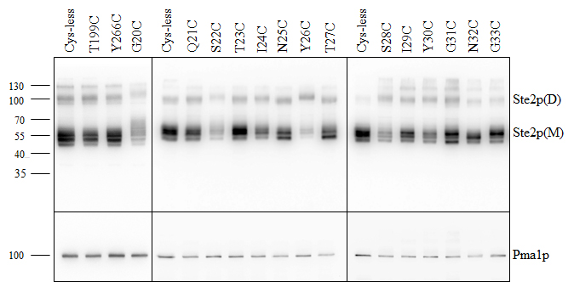
Figure 4. Ste2p expression levels. Total membranes prepared from cells expressing single Cys mutants of Ste2p (G20C to G33C, T199C, and Y266C) and the Cys-less receptor were run on separate gels shown in the three panels. Five µg of total membrane preparations from each mutant was immunoblotted using antibody against the C-terminal FLAG™ epitope tag. Molecular mass markers (kDa) are indicated on the left-hand side. M and D indicate the monomeric and dimeric forms of Ste2p, respectively. The same blot was stripped and then re-probed with anti-Pma1p antibody as a loading control.

The biological activities of each mutant were measured by growth arrest, reporter gene activity, and binding assays and were normalized to those of the Cys-less receptor (Table 2). Pheromone-induced growth arrest activity of all the mutants was similar to that of the Cys-less receptor (between 85% and 103% of Cys-less receptor). One receptor, Y26C, was reported in a previous study to fail to trigger growth arrest (29). We believe the discrepancy between our study and that of Shi et al. is due to differences in the strain background used. Signaling activity as measured by the pheromone-induced FUS1-lacZ reporter gene activation assay was between 57% (Y30C) and 127% (I24C) of the Cys-less receptor. Although expression of two receptors [S22C (25%) and Y26C (26%)] was lower than 50%, these mutants exhibited effective growth arrest and β-galactosidase activities suggesting that even the low expression of Ste2p was sufficient to elicit a strong biological response to pheromone. Previous studies also indicated that low levels of Ste2p were sufficient to manifest full biological responses (31-34). Finally, the alpha-factor binding affinity of each mutant was measured by saturation binding assays using whole cells. The binding affinity varied from ~50% (I29C) lower to ~50% (G33C) higher in comparison to that of the Cys-less receptor (Table 2). From the results of the above experiments, we conclude that all the single Cys mutants of Ste2p exhibited effective signaling and strong binding, and therefore Cys substitution did not cause any global change in the receptor conformation.

Table 6. Biological activities of Cys-less and single Cys mutants of Ste2p
Receptor | Growth Arrest Activity (%)ª | β-galactosidase Activity (%)^{b} | Relative Kd^{c}
Cys-less | 100 ± 0.3 | 100 ± 2.0 | 1.00 ± 0.21
T199C | 93± 7.0 | 96± 5.0 | 0.99 ± 0.20
G20C | 89 ± 0.7 | 71 ± 2.1 | 1.15 ± 0.50
Q21C | 97 ± 3.0 | 125 ± 4.4 | 0.71 ± 0.06
S22C | 87 ± 8.1 | 89 ± 4.4 | 1.38 ± 0.79
T23C | 97 ± 3.7 | 113 ± 2.7 | 1.44 ± 0.05
I24C | 101 ± 3.5 | 127 ± 6.2 | 0.78 ± 0.39
N25C | 89 ± 3.5 | 108 ± 3.8 | 0.75 ± 0.49
Y26C | 85 ± 7.5 | 113 ± 8.3 | 1.09 ± 0.23
T27C | 98 ± 8.0 | 65 ± 8.2 | 1.06 ± 0.08
S28C | 103 ± 1.3 | 58 ± 2.9 | 0.65 ± 0.28
I29C | 100 ± 2.3 | 96 ± 3.6 | 1.52 ± 0.20
Y30C | 97 ± 3.5 | 57 ± 4.6 | 1.13 ± 0.30
G31C | 101 ± 3.5 | 71 ± 2.1 | 1.49 ± 0.21
N32C | 99 ± 1.3 | 117 ± 2.4 | 0.88 ± 0.15
G33C | 100 ± 4.0 | 61 ± 1.2 | 0.53 ± 0.13
ªRelative growth arrest activity (halo size ±standard deviation) was compared to that of the Cys-less receptor at 0.5 μg of α-factor applied to a disk (the halo size of Cys-less was 23mm).
^{b}Relative β-galactosidase activity (±standard deviation) was compared with that of Cys-less at 1 μM α-factor.
^{c}The Kd values (±standard deviation) are presented relative to those of the Cys-less receptor. The Kd was determined by saturation binding of radioactive α-factor according to the protocol described in experimental procedures. (Kd of Cys-less receptor was 10.8 nM).

Accessibility of N-terminal Cys residues
The substituted cysteine accessibility method (SCAM) has proven to be an important means to determine the accessibility of residues as well as to gain knowledge about the secondary structure of transmembrane proteins. SCAM was performed in order to uncover the solvent accessibility of a portion of the N-terminus previously predicted to have secondary structure. For SCAM we used MTSEA-biotin, a thiol-specific, membrane-impermeable reagent. To ensure that the topology of the receptor was not perturbed by membrane preparation, whole cells were used instead of isolated membranes as in previous SCAM experiments in our laboratory which probed the first extracellular domain of Ste2p (14). The receptors T199C and Y266C were used as accessibility controls as they were shown to be fully accessible (T199C) and inaccessible (Y266C) to MTSEA-Biotin in previous studies (14, 35). Representative examples of immunoblots are shown in Fig. 2. As shown in all panels, no detectable labeling was observed in the Cys-less and Y266C receptors but strong labeling was observed in T199C as had been reported previously. However, substantial variation in the labeling of the mutants was observed. Since cell surface expression of each mutant was different, the labeling of each mutant was normalized to its cell surface expression to determine accessibility. This was done to ensure that the solvent accessibility was not affected by the differential surface expression. Finally, accessibility of each mutant was normalized to that of T199C, which was assigned as the positive control for accessibility (100% labeling by MTSEA-biotin) (Table 3).

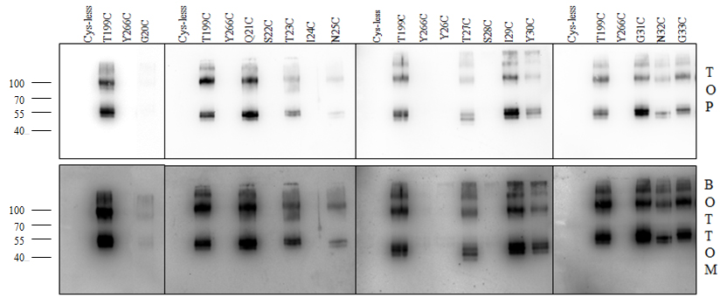

Figure 5. MTSEA labeling of the N-terminal residues of Ste2p. Ste2p Cys mutants at positions G20-G33 were labeled with MTSEA as described under Methods. T199C was used as a positive control, and Y266C and Cys-less receptors were used as negative controls. Molecular mass markers (kDa) are indicated on the left-hand side of the Fig. The bottom panel shows overexposed immunoblots of the top panels.

Table 7. Relative MTSEA-biotin labeling of Cys-scanned mutants of Ste2p
Receptor | Labelingª
T199C | 1.00 ± 0.15
Y266C | 0
Cys-less | 0
G20C | 0.09 ± 0.06
Q21C | 2.19 ± 0.05
S22C | 0
T23C | 0.32 ± 0.02
I24C | 0
N25C | 0.19 ± 0.04
Y26C | 0
T27C | 1.08 ± 0.02
S28C | 0
I29C | 2.00 ± 0.20
Y30C | 0.71 ± 0.02
G31C | 1.30 ± 0.03
N32C | 0.61 ± 0.04
G33C | 1.19 ± 0.06

ªMTSEA-biotin labeling was adjusted to the surface expression of each mutant and normalized to the labeling of T199C as calculated by the following formula.

$$\left\{\frac{band intensity of mutant}{Bmax of mutant}×\frac{Bmax of T199C}{Band intensity of T199C}\right\}$$
Examination of normalized accessibilities revealed that the residues in the target region are not equally solvent accessible despite the fact that the N-terminus of Ste2p is extracellular; residues in this region are expected to be equally solvent accessible. We found that four residues (S22C, I24C, Y26C and S28C) were not detectably labeled (even when the gels were overexposed, Fig. 2 bottom). G20C, T23C and N25C were poorly labeled (<40%) and all of the other residues in this targeted region (Q21C, T27C, I29C, Y30, G31, N32, and G33) were labeled to 60% or more of the positive control. The amount of accessibility varied from ~5-fold less (N25C) to ~2-fold higher (Q21C and I29C) as compared to T199C (Table 3). Many mutants exhibited a lack of correlation between the surface expression and the solvent accessibility. For example, residues I24C and N32C have similar surface expression (75% and 76%, respectively) as compared to the Cys-less, receptor (Table 1) but their accessibility is entirely different, i.e., N32C is highly accessible but I24C is completely inaccessible.
The periodicity of accessibility from S22 to S28 in the N-terminus with residues S22, I24, Y26, and S28 showing no apparent accessibility and residues Q21, T23, N25, T27, and I29 demonstrating accessibility would be consistent with that region of the N-terminus forming a β-strand structure as predicted in previous studies (28, 29) with one face of the β-strand being shielded from solvent. One explanation for the solvent inaccessibility would be involvement of that portion of the N-terminus in a dimer interface. Previous studies have shown that deletion of the first 45 residues of the N-terminus decreased dimerization of Ste2p (36). Thus we explored the involvement of these β-strand residues in Ste2p dimerization.

Involvement of specific N-terminal residues in dimer formation
Cells expressing each of the different Cys mutants were grown and membranes were prepared. The samples were analyzed by SDS-PAGE in non-reducing conditions and probed with anti-FLAG™ antibody. A small dimer band at ~110 kD was observed with the Cys-less Ste2p and all of the Ste2p Cys mutants under non-reducing (Fig. 3A) and reducing conditions (Fig. 1). This “SDS-resistant” band has been observed consistently in studies of Ste2p (29, 33, 37, 38). Under the non-reducing conditions (Fig. 3A) there was an increase in the dimer/monomer for many of the mutants. For example in Fig. 1 under reducing conditions I24C is mostly in the monomeric form whereas in non-reducing conditions (Fig. 3A) it is mostly dimeric. We attribute the increased dimers to disulfide formation between the Cys-substituted residues in the N-terminus as evidenced by the reversal of dimer formation by NEM pretreatment (compare Fig. 3B & 3E) and by the lower dimer/monomer ratio under reducing conditions (Fig. 1). Under non-reducing conditions and in the absence of a catalyst, whereas the majority species was monomeric in the Cys-less and the Q21C, T23C, N25C, T27C, I29C, G31C, N32C, and G33C receptors, the G20C, S22C, I24C, Y26C, S28C, and Y30C receptors were mostly in the dimer form (Fig. 3A). In previous studies, we have shown that Cys cross-linking of Ste2p transmembrane domains and intracellular residues was promoted by Cu-P (Cu(II)-1,10-phenanthroline) treatment. Cu-P treatment provides a more oxidative environment and has been used in many experiments to determine Cys-Cys disulfide formation in membrane proteins (39-43). With Cu-P treatment, many of the six Cys mutants (G20C, S22C, I24C, Y26C, S28C, and Y30C) that showed a high dimer formation under non-reducing conditions (Fig. 3A) exhibited an even higher dimer population (Fig. 3B). In addition, in the presence of Cu-P three mutants (N25C, T27C, and I29C), which did not form a significant proportion of dimer under non-reducing conditions, showed increased dimerization (compare Fig. 3A and 3B). Dimer formation in the other mutants (Q21C, T23C, G31C, N32C, and G33C) was not affected to a major extent by Cu-P treatment. To verify that the Cu-P stimulated increase in higher molecular weight band was due to disulfide bond formation, samples were treated with NEM (N-ethylmaleimide) prior to Cu-P addition. NEM alkylates the free −SH group of cysteine irreversibly, so that disulfide bond formation cannot occur after NEM treatment. Representative data for five mutants (N25C to I29C) are shown in Fig. 3E. NEM pre-treatment was found to block Cu-P stimulated dimerization for mutants N25C, T27C, and I29C (compare Fig. 3B and Fig. 3E).

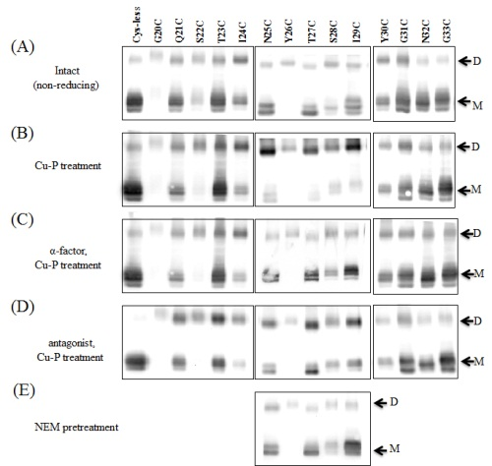
Figure 6. Dimer formation by the Ste2p N-terminal Cysteine mutants. Membrane proteins untreated (A), treated with Cu-P (B), incubated with α-factor followed by Cu-P (C), incubated with antagonist followed by Cu-P (D) or NEM added prior to Cu-P (E) were separated by SDS-PAGE, then immunoblotted and probed with anti-FLAG™ antibody. The upper band (~110 kDa) represents dimerized receptor (indicated by “D”) and the lower band (~55 kDa) represents monomer (indicated by “M”).
Effect of ligand binding on dimerization
It has been observed that ligand binding can induce a change in a GPCR dimer interface (44, 45). To examine the effect of ligand on Cys-mediated dimerization, membranes were incubated with either α-factor (agonist) or [desW¹desH²]α-factor (an antagonist) prior to Cu-P treatment. Notable reduction was observed in dimer formation for the N25C, T27C, and I29C mutants in the presence of α-factor (compare Fig. 3B to 3C). In contrast, dimerization of receptors with Cys in the other residues of this region was not greatly affected by agonist binding. In addition, Cu-P stimulated dimerization was not affected significantly by antagonist treatment for the mutants analyzed (compare Fig. 3B and Fig. 3D).

DISCUSSION:
Binding of ligand to its cognate GPCR induces conformational changes in the receptor which promote signal transduction across the membrane and activate a G-protein mediated signal transduction cascade (46, 47). Ste2p, the α-factor pheromone receptor, is a GPCR expressed in the yeast Saccharomyces cerevisiae and has been used extensively as a model for peptide-responsive GPCRs (48-50). Though Ste2p does not share sequence similarity with mammalian GPCRs or even with Ste3p, the a-factor pheromone receptor of yeast, all GPCRs have the same overall membrane architecture and manifest functional similarities such as G-protein coupling. The extracellular N-termini of GPCRs are highly variable differing greatly in length and sequence. Even within subfamilies, the N-termini often show low sequence homology. However, recent studies have indicated that the N-terminal regions of GPCRs play important roles in receptor function. For example, the N-terminus of several GPCRs has been found to be involved in ligand binding (51-53), and receptor dimerization (36, 54), and cell surface targeting (55).
For Ste2p, extensive structure and function studies have been conducted on the intracellular domains and transmembrane domains, while fewer studies have focused on the extracellular N-terminal region. In those studies where this portion of Ste2p was studied, the role of the N-terminus in glycosylation (56), dimerization (36) and mating (28, 29) was examined. The Ste2p N-terminus is 48 amino acids long, and residues N25 and N32 are sites of N-linked glycosylation (56). Nevertheless, removal of these glycosylation sites still resulted in a fully active receptor (56). Deletion of the N-terminal 45 residues yielded a receptor that was deficient in dimer formation (36), and deletion of the first 30 amino acids of the N-terminus of Ste2p resulted in a cell that could not mate and showed weak signaling after pheromone addition (28). In another study, 17 residues in the N-terminus (P15, P19, T23 to I36 and, N46) were investigated by substituting with Cys and Ala. This study showed that none of the substitutions affected signaling, but mutation of residues P15, I24 and I29 greatly lowered the mating ability of the cells carrying these mutations (29).
In this study we have explored the solvent accessibility and involvement in dimer formation of a portion of the N-terminus of Ste2p to gain insights into the structure and function of this domain of the receptor. SCAM has been used previously to study the lining of pores of channels and transport proteins (57-59) and the binding site of acetylcholine receptors (60). More recently, this method has been applied to study G protein-coupled receptors (14, 15, 27, 61-64). Previous studies had suggested that certain residues in the N-terminus of Ste2p were critical for pheromone induced mating but not for G1 arrest. Marsh and co-workers using S. cerevisiae/S. kluyveri chimeras concluded that residues 1-45 were not involved in pheromone binding specificity (65). Our binding studies on the Cys mutants of residues 20-33 of Ste2p would be consistent with this observation. Despite the minor influence of the Cys mutations on receptor signaling and pheromone binding here we report the first experimental evidence that all residues in the N-terminus are not equally accessible and that the part of the N-terminus of Ste2p that putatively contains a β-strand participates in dimerization of Ste2p. Notably, we uncovered a change in the conformation of the N-terminus upon agonist binding as determined by differences in disulfide-mediated dimer formation in the active and inactive stages of Ste2p.
Our accessibility analyses showed that there were striking variations in the solvent exposure of residues in the region of the N-terminus between residues S22 and S28. Residues S22C, I24C, Y26C, and S28C were completely inaccessible to a membrane-impermeable, hydrophilic, thiol-specific reagent MTSEA-biotin even though I24C and S28C receptors were expressed at the cell surface as well as, or nearly as well as receptors (Q21C, T27C, N32C, and G33C) whose Cys residues were accessible to MTSEA-biotin (Table 1 and Table 3). Residues adjacent to the inaccessible residues readily reacted with the reagent. The differential labeling of residues G20-S33 of the N-terminal residues is surprising since all these extracellular residues were expected to be readily solvent accessible. The alternating pattern of accessibility of consecutive engineered cysteines suggests an underlying structure of this region which is consistent with predicted β-strand spanning from Thr 23 to Tyr 30 (28, 29).
Based on the above SCAM analysis we hypothesized that the putative β-strand in the N-terminus of Ste2p may be involved in dimerization of Ste2p, as the N-terminus of Ste2p had been shown previously to be part of the Ste2p dimer interface (36). Indeed, our results show that the cysteine-substituted residues S22, I24, Y26 and S28, which were not solvent accessible as judged by disulfide crosslinking to a biotinylation reagent, were involved in dimer formation. On the other hand, residues which would be on the opposite face of the β-strand and thereby accessible to biotinylation were not involved in dimer formation under non-reducing conditions. Dimerization of the S28C mutant was blocked by NEM pre-treatment (Fig. 3E) corroborating the fact that dimerization was mediated by disulfide cross-linking of two nearby Cys residues. Disulfide bond formation suggests that the α-carbons of the two Cys residues are located close to each other, within 7Å as the maximum distance, in order to result in a disulfide bond (33, 66-68). Our modeling shows that disulfide formation between residues in the N-terminus the putative β-strand region would require a parallel arrangement of two Ste2p molecules. In contrast to our results, previous studies indicated that residue I24C was accessible in a SCAM experiment (29). The different outcomes between our and the previous investigation may reflect differences in the assay conditions used. In our assay, labeling experiments were performed with MTSEA-biotin using intact cells, whereas Shi and co-workers used isolated membranes and fluorescein-5-maleimide. We have observed that accessibility was found to differ in experiments performed on isolated membranes versus whole cells in a study of Ste2p EL1 residues (14).
Our results also demonstrate that agonist-induced conformational changes occur in the N-terminus of Ste2p as indicated by α-factor induced changes in the Cu-P catalyzed oxidation of dimerization for the N25C, T27C, and I29C mutants (compare Fig. 3B and 3C). However, treatment with antagonist, which binds but does not activate the receptor, did not prevent the Cu-P-mediated increase in dimerization (compare Fig. 3B, 3C and 3D). We postulate that the conformation of the N-terminus changes in the active state of the receptor such that the distance between these residues is too great for Cu-P induced disulfide bond formation. In contrast, the residues involved in dimer formation in the non-reducing conditions (22, 24, 26, and 28) still form a dimer interface in the activated state of the receptor. For these interactions between receptor monomers to occur, the parallel β-strands must have enough flexibility to allow formation of disulfide bonds with residues on both faces of the β-strands as observed with Cu-P in the absence of alpha-factor.

Conclusion:
In conclusion SCAM analysis and disulfide crosslinking clearly show that in a short segment of the N-terminus of Ste2p certain residues do not react with a soluble biotinylation reagent and appear to be involved in receptor dimerization. The accessibility pattern, in particular, is consistent with a stretch of β-sheet-like structure involving residues G20-Y30. Based on oxidative disulfide crosslinking studies, the dimer interface of the receptor changes in response to pheromone indicating a change in conformation of the N-terminus of the receptor during receptor activation. These studies provide evidence that the N-terminus of Ste2p possesses a discrete structural domain that appears to participate in the signaling mechanism. Information on the extracellular surface of other GPCRs should be useful in designing agents that can modulate signaling and thereby influence cell physiology. The methods applied to Ste2p should be applicable, therefore, to mammalian G protein-coupled receptors.

Acknowledgements:
We thank Li-yin Huang for help in the binding assay.

REFERENCES
- Rosenbaum DM, Rasmussen SG, Kobilka BK. The structure and function of G-protein-coupled receptors. Nature. 2009;459(7245):356-63.
- Lundstrom K. An overview on GPCRs and drug discovery: structure-based drug design and structural biology on GPCRs. Methods Mol Biol. 2009;552:51-66.
- Williams C, Hill SJ. GPCR signaling: understanding the pathway to successful drug discovery. Methods Mol Biol. 2009;552:39-50.
- De Amici M, Dallanoce C, Holzgrabe U, Trankle C, Mohr K. Allosteric ligands for G protein-coupled receptors: a novel strategy with attractive therapeutic opportunities. Med Res Rev. 2010;30(3):463-549.
- Lappano R, Maggiolini M. G protein-coupled receptors: novel targets for drug discovery in cancer. Nat Rev Drug Discov. 2011;10(1):47-60.
- Palczewski K, Kumasaka T, Hori T, Behnke CA, Motoshima H, Fox BA, et al. Crystal structure of rhodopsin: A G protein-coupled receptor. Science. 2000;289(5480):739-45.
- Jaakola VP, Griffith MT, Hanson MA, Cherezov V, Chien EY, Lane JR, et al. The 2.6 angstrom crystal structure of a human A2A adenosine receptor bound to an antagonist. Science. 2008;322(5905):1211-7.
- Wu B, Chien EY, Mol CD, Fenalti G, Liu W, Katritch V, et al. Structures of the CXCR4 chemokine GPCR with small-molecule and cyclic peptide antagonists. Science. 2010;330(6007):1066-71.
- Chien EY, Liu W, Zhao Q, Katritch V, Han GW, Hanson MA, et al. Structure of the human dopamine D3 receptor in complex with a D2/D3 selective antagonist. Science. 2010;330(6007):1091-5.
- Warne T, Moukhametzianov R, Baker JG, Nehme R, Edwards PC, Leslie AG, et al. The structural basis for agonist and partial agonist action on a beta(1)-adrenergic receptor. Nature. 2011;469(7329):241-4.
- Warne T, Serrano-Vega MJ, Baker JG, Moukhametzianov R, Edwards PC, Henderson R, et al. Structure of a beta1-adrenergic G-protein-coupled receptor. Nature. 2008;454(7203):486-91.
- Cherezov V, Rosenbaum DM, Hanson MA, Rasmussen SG, Thian FS, Kobilka TS, et al. High-resolution crystal structure of an engineered human beta2-adrenergic G protein-coupled receptor. Science. 2007;318(5854):1258-65.
- Ratnala VR, Kobilka B. Understanding the ligand-receptor-G protein ternary complex for GPCR drug discovery. Methods Mol Biol. 2009;552:67-77.
- Hauser M, Kauffman S, Lee BK, Naider F, Becker JM. The first extracellular loop of the Saccharomyces cerevisiae G protein-coupled receptor Ste2p undergoes a conformational change upon ligand binding. J Biol Chem. 2007;282(14):10387-97.
- Javitch JA, Shi L, Liapakis G. Use of the substituted cysteine accessibility method to study the structure and function of G protein-coupled receptors. Methods Enzymol. 2002;343:137-56.
- Karlin A, Akabas MH. Substituted-cysteine accessibility method. Methods Enzymol. 1998;293:123-45.
- Marsh L. Substitutions in the hydrophobic core of the alpha-factor receptor of Saccharomyces cerevisiae permit response to Saccharomyces kluyveri alpha-factor and to antagonist. Mol Cell Biol. 1992;12(9):3959-66.
- Umanah GK, Huang L, Ding FX, Arshava B, Farley AR, Link AJ, et al. Identification of residue-to-residue contact between a peptide ligand and its G protein-coupled receptor using periodate-mediated dihydroxyphenylalanine cross-linking and mass spectrometry. J Biol Chem. 2010;285(50):39425-36.
- Son CD, Sargsyan H, Naider F, Becker JM. Identification of ligand binding regions of the Saccharomyces cerevisiae alpha-factor pheromone receptor by photoaffinity cross-linking. Biochemistry. 2004;43(41):13193-203.
- Turcatti G, Nemeth K, Edgerton MD, Meseth U, Talabot F, Peitsch M, et al. Probing the structure and function of the tachykinin neurokinin-2 receptor through biosynthetic incorporation of fluorescent amino acids at specific sites. J Biol Chem. 1996;271(33):19991-8.
- Sherman F. Getting started with yeast. Methods Enzymol. 1991;194:3-21.
- Huang LY, Umanah G, Hauser M, Son C, Arshava B, Naider F, et al. Unnatural amino acid replacement in a yeast G protein-coupled receptor in its native environment. Biochemistry. 2008;47(20):5638-48.
- Slauch JM, Mahan MJ, Mekalanos JJ. Measurement of transcriptional activity in pathogenic bacteria recovered directly from infected host tissue. Biotechniques. 1994;16(4):641-4.
- Raths SK, Naider F, Becker JM. Peptide analogues compete with the binding of alpha-factor to its receptor in Saccharomyces cerevisiae. J Biol Chem. 1988;263(33):17333-41.
- David NE, Gee M, Andersen B, Naider F, Thorner J, Stevens RC. Expression and purification of the Saccharomyces cerevisiae a-factor receptor (Ste2p), a 7-transmembrane-segment G protein-coupled receptor. Faseb Journal. 1997;11(9):2805.
- Pinson B, Chevallier J, Urban-Grimal D. Only one of the charged amino acids located in membrane-spanning regions is important for the function of the Saccharomyces cerevisiae uracil permease. Biochem J. 1999;339 ( Pt 1):37-42.
- Choi Y, Konopka JB. Accessibility of cysteine residues substituted into the cytoplasmic regions of the alpha-factor receptor identifies the intracellular residues that are available for G protein interaction. Biochemistry. 2006;45(51):15310-7.
- Shi C, Kaminskyj S, Caldwell S, Loewen MC. A role for a complex between activated G protein-coupled receptors in yeast cellular mating. Proc Natl Acad Sci U S A. 2007;104(13):5395-400.
- Shi C, Kendall SC, Grote E, Kaminskyj S, Loewen MC. N-terminal residues of the yeast pheromone receptor, Ste2p, mediate mating events independently of G1-arrest signaling. J Cell Biochem. 2009;107(4):630-8.
- Akal-Strader A, Khare S, Xu D, Naider F, Becker JM. Residues in the first extracellular loop of a G protein-coupled receptor play a role in signal transduction. J Biol Chem. 2002;277(34):30581-90.
- Martin NP, Celic A, Dumont ME. Mutagenic mapping of helical structures in the transmembrane segments of the yeast alpha-factor receptor. J Mol Biol. 2002;317(5):765-88.
- Shah A, Marsh L. Role of Sst2 in modulating G protein-coupled receptor signaling. Biochem Biophys Res Commun. 1996;226(1):242-6.
- Kim H, Lee BK, Naider F, Becker JM. Identification of specific transmembrane residues and ligand-induced interface changes involved in homo-dimer formation of a yeast G protein-coupled receptor. Biochemistry. 2009;48(46):10976-87.
- Stefan CJ, Overton MC, Blumer KJ. Mechanisms governing the activation and trafficking of yeast G protein-coupled receptors. Mol Biol Cell. 1998;9(4):885-99.
- Lin JC, Duell K, Konopka JB. A microdomain formed by the extracellular ends of the transmembrane domains promotes activation of the G protein-coupled alpha-factor receptor. Mol Cell Biol. 2004;24(5):2041-51.
- Overton MC, Blumer KJ. The extracellular N-terminal domain and transmembrane domains 1 and 2 mediate oligomerization of a yeast G protein-coupled receptor. J Biol Chem. 2002;277(44):41463-72.
- Reneke JE, Blumer KJ, Courchesne WE, Thorner J. Cell. 1988;55(null):221.
- Yesilaltay A, Jenness DD. Homo-oligomeric complexes of the yeast alpha-factor pheromone receptor are functional units of endocytosis. Mol Biol Cell. 2000;11(9):2873-84.
- Li JH, Hamdan FF, Kim SK, Jacobson KA, Zhang X, Han SJ, et al. Ligand-specific changes in M3 muscarinic acetylcholine receptor structure detected by a disulfide scanning strategy. Biochemistry. 2008;47(9):2776-88.
- Li JH, Han SJ, Hamdan FF, Kim SK, Jacobson KA, Bloodworth LM, et al. Distinct structural changes in a G protein-coupled receptor caused by different classes of agonist ligands. J Biol Chem. 2007;282(36):26284-93.
- Ward SD, Hamdan FF, Bloodworth LM, Siddiqui NA, Li JH, Wess J. Use of an in situ disulfide cross-linking strategy to study the dynamic properties of the cytoplasmic end of transmembrane domain VI of the M3 muscarinic acetylcholine receptor. Biochemistry. 2006;45(3):676-85.
- Yu H, Kono M, McKee TD, Oprian DD. A general method for mapping tertiary contacts between amino acid residues in membrane-embedded proteins. Biochemistry. 1995;34(46):14963-9.
- Yu H, Kono M, Oprian DD. State-dependent disulfide cross-linking in rhodopsin. Biochemistry. 1999;38(37):12028-32.
- Guo W, Shi L, Filizola M, Weinstein H, Javitch JA. Crosstalk in G protein-coupled receptors: changes at the transmembrane homodimer interface determine activation. Proc Natl Acad Sci U S A. 2005;102(48):17495-500.
- Mancia F, Assur Z, Herman AG, Siegel R, Hendrickson WA. Ligand sensitivity in dimeric associations of the serotonin 5HT2c receptor. EMBO Rep. 2008;9(4):363-9.
- Eilers M, Hornak V, Smith SO, Konopka JB. Comparison of class A and D G protein-coupled receptors: common features in structure and activation. Biochemistry. 2005;44(25):8959-75.
- Karnik SS, Gogonea C, Patil S, Saad Y, Takezako T. Activation of G-protein-coupled receptors: a common molecular mechanism. Trends Endocrinol Metab. 2003;14(9):431-7.
- Naider F, Becker JM. The alpha-factor mating pheromone of Saccharomyces cerevisiae: a model for studying the interaction of peptide hormones and G protein-coupled receptors. Peptides. 2004;25(9):1441-63..
- Celic A, Connelly SM, Martin NP, Dumont ME. Intensive mutational analysis of G protein-coupled receptors in yeast. Methods Mol Biol. 2004;237:105-20.
- Dohlman HG, Thorner J, Caron MG, Lefkowitz RJ. Model systems for the study of seven-transmembrane-segment receptors. Annu Rev Biochem. 1991;60:653-88.
- Ho HH, Du D, Gershengorn MC. The N terminus of Kaposi's sarcoma-associated herpesvirus G protein-coupled receptor is necessary for high affinity chemokine binding but not for constitutive activity. J Biol Chem. 1999;274(44):31327-32.
- Hawtin SR, Wesley VJ, Parslow RA, Simms J, Miles A, McEwan K, et al. A single residue (arg46) located within the N-terminus of the V1a vasopressin receptor is critical for binding vasopressin but not peptide or nonpeptide antagonists. Mol Endocrinol. 2002;16(3):600-9.
- Hagemann IS, Narzinski KD, Floyd DH, Baranski TJ. Random mutagenesis of the complement factor 5a (C5a) receptor N terminus provides a structural constraint for C5a docking. J Biol Chem. 2006;281(48):36783-92.
- Gurevich VV, Gurevich EV. How and why do GPCRs dimerize? Trends Pharmacol Sci. 2008;29(5):234-40.
- Dong C, Wu G. Regulation of anterograde transport of alpha2-adrenergic receptors by the N termini at multiple intracellular compartments. J Biol Chem. 2006;281(50):38543-54.
- Mentesana PE, Konopka JB. Mutational analysis of the role of N-glycosylation in alpha-factor receptor function. Biochemistry. 2001;40(32):9685-94.
- Akabas MH, Stauffer DA, Xu M, Karlin A. Acetylcholine receptor channel structure probed in cysteine-substitution mutants. Science. 1992;258(5080):307-10.
- Javitch JA. Probing structure of neurotransmitter transporters by substituted-cysteine accessibility method. Methods Enzymol. 1998;296:331-46.
- Mueckler M, Makepeace C. Analysis of transmembrane segment 8 of the GLUT1 glucose transporter by cysteine-scanning mutagenesis and substituted cysteine accessibility. J Biol Chem. 2004;279(11):10494-9.
- Stauffer DA, Karlin A. Electrostatic potential of the acetylcholine binding sites in the nicotinic receptor probed by reactions of binding-site cysteines with charged methanethiosulfonates. Biochemistry. 1994;33(22):6840-9.
- Prevost M, Vertongen P, Raussens V, Roberts DJ, Cnudde J, Perret J, et al. Mutational and cysteine scanning analysis of the glucagon receptor N-terminal domain. J Biol Chem. 2010;285(40):30951-8.
- Lemaire K, Van de Velde S, Van Dijck P, Thevelein JM. Glucose and sucrose act as agonist and mannose as antagonist ligands of the G protein-coupled receptor Gpr1 in the yeast Saccharomyces cerevisiae. Mol Cell. 2004;16(2):293-9.
- Chen S, Lin F, Xu M, Graham RM. Phe(303) in TMVI of the alpha(1B)-adrenergic receptor is a key residue coupling TM helical movements to G-protein activation. Biochemistry. 2002;41(2):588-96.
- Xu W, Li J, Chen C, Huang P, Weinstein H, Javitch JA, et al. Comparison of the amino acid residues in the sixth transmembrane domains accessible in the binding-site crevices of mu, delta, and kappa opioid receptors. Biochemistry. 2001;40(27):8018-29.
- Sen M, Marsh L. Noncontiguous domains of the alpha-factor receptor of yeasts confer ligand specificity. J Biol Chem. 1994;269(2):968-73.
- Wang HX, Konopka JB. Identification of amino acids at two dimer interface regions of the alpha-factor receptor (Ste2). Biochemistry. 2009;48(30):7132-9.
- Falke JJ, Dernburg AF, Sternberg DA, Zalkin N, Milligan DL, Koshland DE, Jr. Structure of a bacterial sensory receptor. A site-directed sulfhydryl study. J Biol Chem. 1988;263(29):14850-8.
- Srinivasan N, Sowdhamini R, Ramakrishnan C, Balaram P. Conformations of disulfide bridges in proteins. Int J Pept Protein Res. 1990;36(2):147-55.

Chapter 3

The N-terminus of Saccharomyces cerevisiae G protein-coupled receptor Ste2p is involved in negative regulation

Abstract:
Yeast pheromone receptor Ste2p is a G protein-coupled receptor that initiates cellular responses to α-mating pheromone, a 13-residue peptide. We have examined the role of the extracellular N-terminus of this receptor in signal transduction. Sequential deletion of the N-terminal residues affected cell surface expression without affecting ligand-binding affinity suggesting that the N-terminus is required for efficient cell surface targeting. Deletion of portions of the N-terminus was found to affect signaling activity as determined by quantitative FUS1-LacZ gene reporter induction assay. However, when the receptor surface expression levels of deletion mutants were taken into account, the signaling activity was found to increase. This provides evidence that the N-terminus of Ste2p is involved in the negative regulation of receptor signaling.

Introduction:
Signal transduction is a fundamental biological process that is essential to maintain cellular homeostasis and processes in all organisms. The cells’ membrane proteins at the cell surface communicate between the extracellular and intracellular environments of the cell and respond accordingly to maintain cellular function. G protein-coupled receptors (GPCRs) represent one of the largest families of plasma membrane receptors in eukaryotes. More than 800 GPCRs are encoded in the human genomes [1, 2]. These receptors play central roles in human physiology and thus modifications in the signaling of these receptors are pertinent for many diseases or pathological conditions including cardiovascular and pulmonary diseases, pain perception, obesity, cancer, and neurological disorders. [3-5]
GPCRs share a common structural organization with an extracellular N-terminus, seven transmembrane domains connected by extracellular and intracellular loops, and a cytoplasmic C-terminus [6, 7]. Despite the astonishing diversity of their ligands and a lack of strong sequence similarity, the underlying mechanisms of signal transduction are similar as GPCRs couple the binding of ligands to the activation of specific heterotrimeric guanine nucleotide-binding proteins (G proteins) and/or non-G protein mediated signaling, leading to the modulation of downstream effector proteins and gene expression [8-10].
The GPCR superfamily of receptors is divided into several subgroups on the basis of phylogenetic criteria, conserved residues within the transmembrane helices and according to the size and characteristics of the N-terminal domain of its members. Historically, the bulk of attention of GPCR studies have focused on the transmembrane helices. However, a number of studies indicate that the N-terminus also plays an important role in receptor function [6, 11, 12]. A conserved N-terminal cysteine network in class B secretin receptors stabilizes their structure, the alteration of which impairs ligand interactions [13]. Likewise, a diverse variety of N-terminal domain motifs in the N-terminal domain of class B adhesion receptors determine ligand specificity. The conserved N-terminal Venus flytrap domain in Class C glutamate receptors and N-terminal Wnt-binding domains in Frizzled/Smoothened receptors have been reported to regulate ligand binding and receptor activation [6, 12, 14, 15]. The N-terminal domain of protease-activated receptors (PARs) and glycoprotein hormone receptors (GpHRs) plays an important role in their activation [16, 17]. Recently, the N-terminus of GPR56, an adhesion G protein-coupled receptor that plays a key role in cortical development, has been reported to constrain receptor activity [18]. Truncation of the N-terminus of several GPCRs including CB1 cannabinoid [19], α_{1D} adrenergic [20] and GPR37 [21] has been shown to enhance cell surface expression.
Here we investigate the function of the N-terminus of the α-factor pheromone receptor Ste2p of Saccharomyces cerevisiae, which has been studied as a model for peptide-responsive GPCRs [22, 23]. Though there has been considerable study of the extracellular and intracellular loops as well as the C-terminus and transmembrane domains of Ste2p, less is known about the role of the N-terminal domain in signaling. The N-terminus of Ste2p is ~48 amino acids long, and it harbors two glycosylation sites (N25 and N32) which were eliminated by mutation (N25A and N32A) without affecting receptor function [24]. Other studies indicated that the N-terminus contributed to receptor dimerization[25, 26], and three residues (Pro 15, Ile24, and Ile29) were found to be essential for mating but not for signaling as measured by growth arrest and reporter gene (FUS1) activation assays [27, 28]. Truncation of parts of the N-terminus implicated this domain in cellular fusion (mating) during late stages of conjugation of opposite mating types [28]. We performed deletion mutagenesis on the N-terminus and analyzed the mutant receptors by protein expression, ligand binding and signaling assays. The results showed that deletion of the N-terminus affected the surface expression levels of the receptor and results in enhanced signaling activities of the receptor, suggesting that the N-terminus is involved in negative regulation of signaling.

Methods:
Media, Reagents, Strains, and Plasmids: S. cerevisiae strain LM102 [MATa ste2 FUS1-lacZ::URA3 bar1 ura3 leu2 his4 trp1 met1] [29] was used for growth arrest, FUS1-lacZ gene induction, mating and saturation binding assays, and the protease-deficient strain BJS21 [MATa, prc1-407 prb1-1122 pep4-3 leu2 trp1 ura3-52 ste2::Kan^{R} [8] was used for protein isolation to decrease receptor degradation during immunoblot analyses [30]. S. cerevisiae strain DK102 [MATa, Ste2::HIS3, bar1 ade2, trp1, ura3, his, leu2, lys2] [31] was used for expression of the receptor under the control of Cu-inducible promoter CUP1. The plasmid pBEC2 containing C-terminal FLAG™ and His-tagged STE2 [32] was transformed by the method of Geitz [33]. Yeast transformants were selected by growth on yeast minimal medium [34] lacking tryptophan and supplemented with casamino acids (10g/L, Research Products International Corp., Prospect, IL.) designated as MLT to maintain selection for the plasmid. The cells were cultured in MLT and grown to mid log phase at 30°C with shaking (200 rpm) for all assays. S. cerevisiae strain TBR1 [MATα FLO11 ura3 his2 leu2] [35] was used the opposite mating type (LM102 MATa) for mating assays. [Lys⁷ (7-nitrobenz-2-oxa-1,3-diazol-4-yl),Nle¹²]α-factor abbreviated as [K⁷(NBD),Nle¹²]α-factor was synthesized as previously described [36].
Growth Arrest Assays: S. cerevisiae LM102 cells, expressing Cys-less Ste2p and single Cys mutants, were grown at 30°C overnight in MLT, harvested, washed three times with water, and resuspended at a final concentration of 5 × 10⁶cells/mL [37]. Cells (1 mL) were combined with 3.5 mL of agar noble (1.1%) and poured as a top agar lawn onto a MLT medium agar plate. Filter disks (BD, Franklin Lakes, NJ) impregnated with α-factor (4, 2, 1, 0.5, 0.25 µg/disk) were placed on the top agar. The plates were incubated at 30°C for 24h and then observed for clear halos around the disks. The experiment was repeated at least three times, and reported values represent the mean of these tests. For determination of growth arrest at various receptor expression levels, DK102 cells expressing receptors under the control of CUP1 promoter were grown for 16 hrs at 30C in minimal media. Cells were mixed with various final concentrations of CuSO₄ and poured onto agar plates with minimal media.
FUS1-lacZ Gene Induction Assay: LM102 cells, expressing Cys-less Ste2p and single Cys mutants, were grown at 30 ºC in selective media, harvested, washed three times with fresh media and resuspended at a final concentration of 5 x 10⁷ cells/mL. Cells (500 µl) were combined with α-factor (final concentration of 1.0 μM; this concentration is expected to saturate all the receptors on the surface) and incubated at 30ºC for 90 min. The cells were transferred to a 96-well flat bottom plate (Corning Incorporated, Corning, NY) in triplicate, permeabilized with 0.5% Triton X-100 in 25 mM PIPES buffer (pH 7.2) and then β-galactosidase assays were carried out using fluorescein di-β-galactopyranoside (Molecular Probes, Inc., Eugene, OR) as a substrate as described previously [8, 38]. The reaction mixtures were incubated at 37°C for 60 min and 1.0 M Na₂CO₃ was added to stop the reaction. The fluorescence of the samples (excitation of 485 nm and emission of 530 nm) was determined using a 96-well plate reader Synergy2 (BioTek Instruments, Inc., Winooski, VT). The data were analyzed using Prism software (GraphPad Prism version 5.03 for Windows, GraphPad Software, San Diego CA). The experiments were repeated at least three times and reported values represent the mean of these tests. For FUS1-LacZ induction in DK102 cells expressing wild type Ste2p under the control of CUP1 promoter, cells were grown overnight in minimal media containing adenine, histidine, tryptophan and lysine in the presence of various concentrations of CuSO₄ (0.1-200 µM) before incubation with α-factor.
Whole cell radioligand binding experiments: Tritiated [³H] α-factor (9.33 Ci/mmol) prepared as previously described previously [39] was used in saturation binding assays on whole cells. Cells (LM102) expressing wild type or mutant Ste2p were harvested, washed 3 times with YM1 [40], and adjusted to a final concentration of 3 × 10⁷cells/mL. Cells (600 µL) were combined with 150 µL of ice-cold 5× binding medium (YM1 plus protease inhibitors [YM1i] [40] supplemented with [³H]α-factor and incubated at room temperature for 30 min. The final concentration of [³H]α-factor ranged from 0.5 × 10⁻¹⁰ to 1 × 10⁻⁶ M. Upon completion of the incubation interval, 200 µL aliquots of the cell-pheromone mixture were collected in triplicate on glass fiber filter mats and washed for 5 seconds with phosphate buffered saline, pH 7.4 using the Standard Cell Harvester (Skatron Instruments, Sterling, VA). Retained radioactivity on the filter was counted by liquid scintillation spectroscopy. Cells lacking Ste2p were used as a nonspecific binding control for the assays. Binding assays were repeated a minimum of three times, and similar results were observed for each replicate. Specific binding for each mutant receptor was calculated by subtracting the nonspecific values (radioactivity obtained from cells lacking receptor) from those obtained for total binding. Specific binding data were analyzed by nonlinear regression analysis for single-site binding using GraphPad Prism 5.04 (GraphPad Software, San Diego, CA) to determine the K_{d} and B_{max} values for each mutant receptor.
Immunoblots: BJS21 cells, expressing wild type or the N-terminal deletion mutants of Ste2p grown in MLT, were used to prepare total cell membranes isolated as previously described [40]. Protein concentration was determined by the BioRad protein assay (BioRad, Hercules, CA)[32], and membranes were solubilized in sodium dodecyl sulfate (SDS) sample buffer (10% glycerol, 5% 2-mercaptoethanol, 1% SDS, 0.03% bromophenol blue, 62.5 mM Tris, pH 6.8). Proteins were fractioned by SDS−PAGE (10% acrylamide with 5% stacking gel) along with pre-stained Precision Plus protein standards (BioRad) and transferred to an ImmobilonTMP membrane (Millipore Corp., Bedford, MA). The blot was probed with anti-FLAG™ M2 antibody (Sigma/Aldrich Chemical, St. Louis, MO), and bands were visualized with the West Pico chemiluminescent detection system (Pierce). The total intensity of all Ste2p bands in each lane was determined using a ChemiDoc XRS photodocumentation system with Quantity One one-dimensional analysis software (version 4.6.9, BioRad, Hercules, CA). Immunoblot experiments were repeated at least three times and yielded similar results. Constitutively-expressed membrane protein Pma1p was used as a loading control as described previously [41] using Pma1p antibody (Thermo Scientific, Rockford, IL).
Deglycosylation of Membrane Proteins: Total membrane proteins prepared as described above were resuspended in sodium phosphate (50 mM, pH 7.5), supplemented with 500 units of glycerol-free PNGase F (New England Biolabs, Inc., Beverly, MA), and incubated at 37 °C for 2 h. A negative control was run in parallel in which no enzyme was added prior to incubation at 37 °C. Upon termination of the incubation interval, the membranes were pelleted by centrifugation (15,000 × g, 10 min), and the resulting pellet was dissolved in SDS sample buffer. The samples were used for FLAG immunoblot analysis as described above.
Quantitative Mating Assay: MATa cells expressing various Ste2p constructs and MATα cells expressing wild type receptor were grown overnight at 30°C, harvested by centrifugation, resuspended in fresh YEPD, and counted using a hemocytometer. MATa cells (2×10⁶) were mixed with MATα cells (1×10⁷) in a final volume of 100 µL, incubated at 30°C for 5 hours, washed three times with water and resuspended in a final volume of 1 ml water. Then 20 µL of the cell suspension was plated on minimal media lacking lysine and tryptophan and containing histidine and leucine and incubated for 2 days at 30°C. Diploid colonies formed on the plates were counted and analyzed by using GraphPad Prism. This experiment was repeated at least three times and the mating efficiency was expressed as a percentage of diploid colonies formed by mating between the wild type MATa (LM102) and MATα (TBR1) strains.
Flow Cytometry: S. cerevisiae strain DK102 expressing wild type Ste2p under the control of CUP1 promoter was grown for 16 hrs at 30C with various concentrations of CuSO₄ and washed three times with 15 mM sodium acetate buffer (pH 4.6) containing sodium azide. Cells were re-suspended in the same buffer to a final concentration of 1.5×10⁶ cells/ml. Cells (500 µl of the suspension) were incubated with 1 µM final concentration of a fluorescent α-factor analogue [K⁷(NBD),Nle¹²]α-factor for 30 minutes at room temperature with end-over-end mixing. The cells were then washed three times with the same buffer containing sodium azide (10 mM) and 200 µl of this cell suspension were added into a well of a 96-well plate and analyzed on a EMD Millipore (MA, USA) flow cytometer (Guava 6HT-2L) using excitation at 488 nm and emission at 525/30 nm (as specified by the Guava instrument). The samples were protected from light during pre-incubations and flow cytometry analysis. The mean fluorescence intensity obtained at various concentrations of CuSO₄ was used to calculate relative cell surface expression. The mean fluorescence data obtained from the Guava were analyzed by GraphPad Prism using non-linear regression analysis.

Results
The mutant receptors are expressed but differentially glycosylated:
To gain insight into the role of the N-terminus of the yeast α-factor receptor Ste2p in receptor function, we set out to identify specific regions in the N-terminus that influence receptor function (See Fig. 1A for Ste2p snake diagram). For this purpose, we carried out deletion mutagenesis of the region between residues S2 to Y30 generating five mutants [Ste2pΔ2-10, Ste2pΔ11-20, Ste2pΔ21-30, Ste2pΔ2-20 and Ste2pΔ2-30 (Fig. 1B)] on the backbone of the full-length, Cys-less receptor (Ste2p-C52S and C259S) with a His and FLAG tag extending from the C-terminus of Ste2p that we refer to herein as the wild type (Fig. 1A). Previous studies have established that this “wild-type” receptor was equivalent in expression and activity to the naturally occurring wild-type Ste2p [26, 32, 42]. All mutants as well as the wild type receptor were expressed from a high copy yeast expression vector under the control of the constitutive GPD promoter [8, 32].

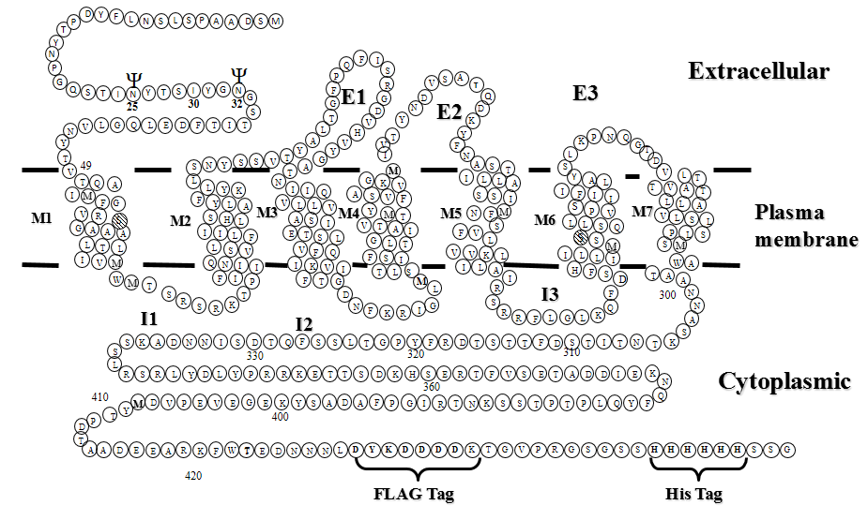
B
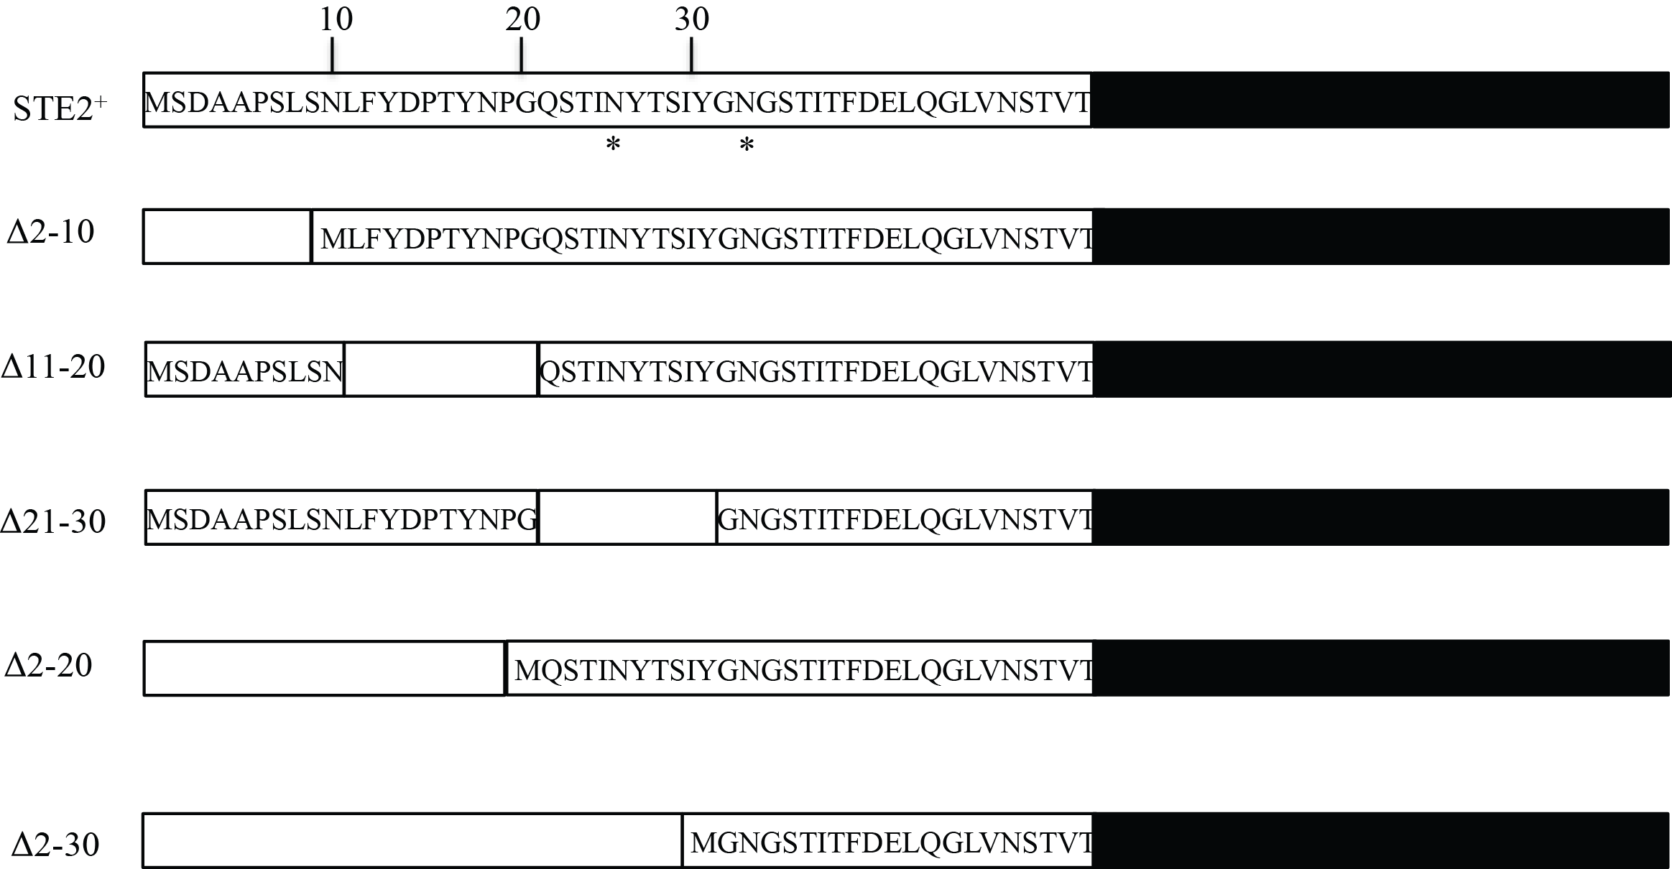
Figure 7. A) Diagram of Ste2p. The transmembrane domains are shown between the two parallel lines indicating the leaflets of the lipid bilayer. The intracellular and extracellular boundaries for the transmembrane domains are based on information obtained by SCAM analysis as reported previously [43]. The receptor residues are numbered from the N terminus (residue 1) to the C terminus (residue 458) and include the inserted FLAG and His epitope tags (residues 432– 439 and 450 – 455, respectively), and spacer residues between the FLAG and His tags in the C-terminal portion. The two endogenous Cys residues mutated to Ser to generate the Cys-less Ste2p background are indicated by cross-hatching in TM1 and TM6. B) Schematic representation of the α-factor receptor and deletion mutants analyzed in this study. Each mutant is designated by the residue numbers deleted from the N-terminus and shown by the Δ symbol in the Fig. The upper line depicts the amino acid sequence for the N-terminal domain (box with amino acid sequence) and the seven transmembrane domains along with the C-terminal domain is indicated in black shades, not to scale. The potential glycosylation sites (N25 and N32) are indicated by the symbol Ψ. For each deletion mutation, the remaining Ste2p sequence is indicated (box with letters). The deleted sequence is indicated by empty box.

To test the mutant receptor expression, total membranes were prepared from yeast carrying each of the mutant constructs and the wild type control, the membrane proteins were solubilized and run on SDS-PAGE, immunoblotted, and probed with FLAG™ antibody (Fig. 2). As a loading control for immunoblot experiments, the same immunoblots were washed and re-probed with antibody against the constitutively expressed membrane protein Pma1p. The experiment was repeated at least three times with similar results obtained in each experiment. Wild type Ste2p (Lane 2) appeared as a set of three major bands between 50 and 55 kDa, plus small amounts of higher molecular weight dimers (~100 kD) and oligomers, as observed in many previous studies, for example [32, 44, 45]. Based on the primary amino acid sequence of the FLAG- and His-tagged receptor construct used in this study, the predicted molecular mass is 50.8 kDa [32]. Glycosylation of the protein has been shown to result in the disparity of molecular weights of the Ste2p monomer [24, 32, 46, 47].
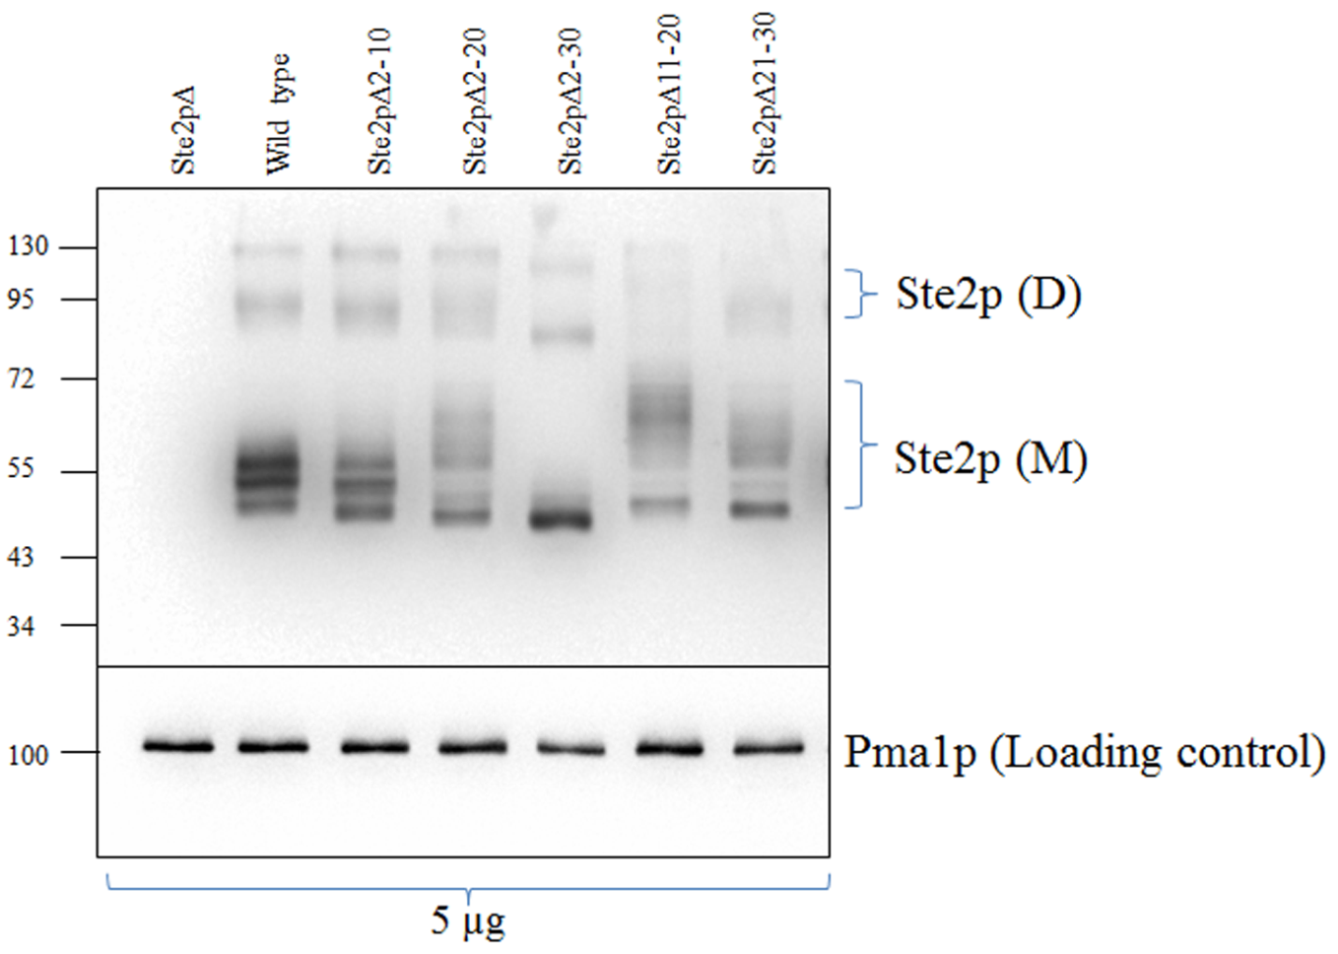
Figure 8. Ste2p total expression levels. Proteins were solubilized from total membranes (5 µg) prepared from cells expressing various N-terminal deletion mutants (Ste2pΔ2-10, Ste2pΔ2-20, Ste2pΔ2-30, Ste2pΔ11-20, Ste2pΔ21-30) and the wild type receptor and run on a SDS-PAGE gel and immunoblotted using antibody against the C-terminal FLAG™ epitope tag. M and D indicate the monomeric and dimeric forms of Ste2p, respectively. Molecular mass markers (kDa) are indicated on the left-hand side. The same blot was stripped and then re-probed with anti-Pma1p antibody as a loading control.
The expression level of each mutant receptor in the total membrane preparation was determined from the FLAG-reactive bands in each lane (monomer, dimer, and higher molecular weight bands), the loading in each lane was normalized to the Pma1p control, and then the expression levels were compared to the wild type receptor (Table 1, the wild type receptor expression level was considered 100%). The total membrane expression levels were found to range from 54% (Ste2pΔ2-30) to 81% (Ste2pΔ11-20) of the wild type.

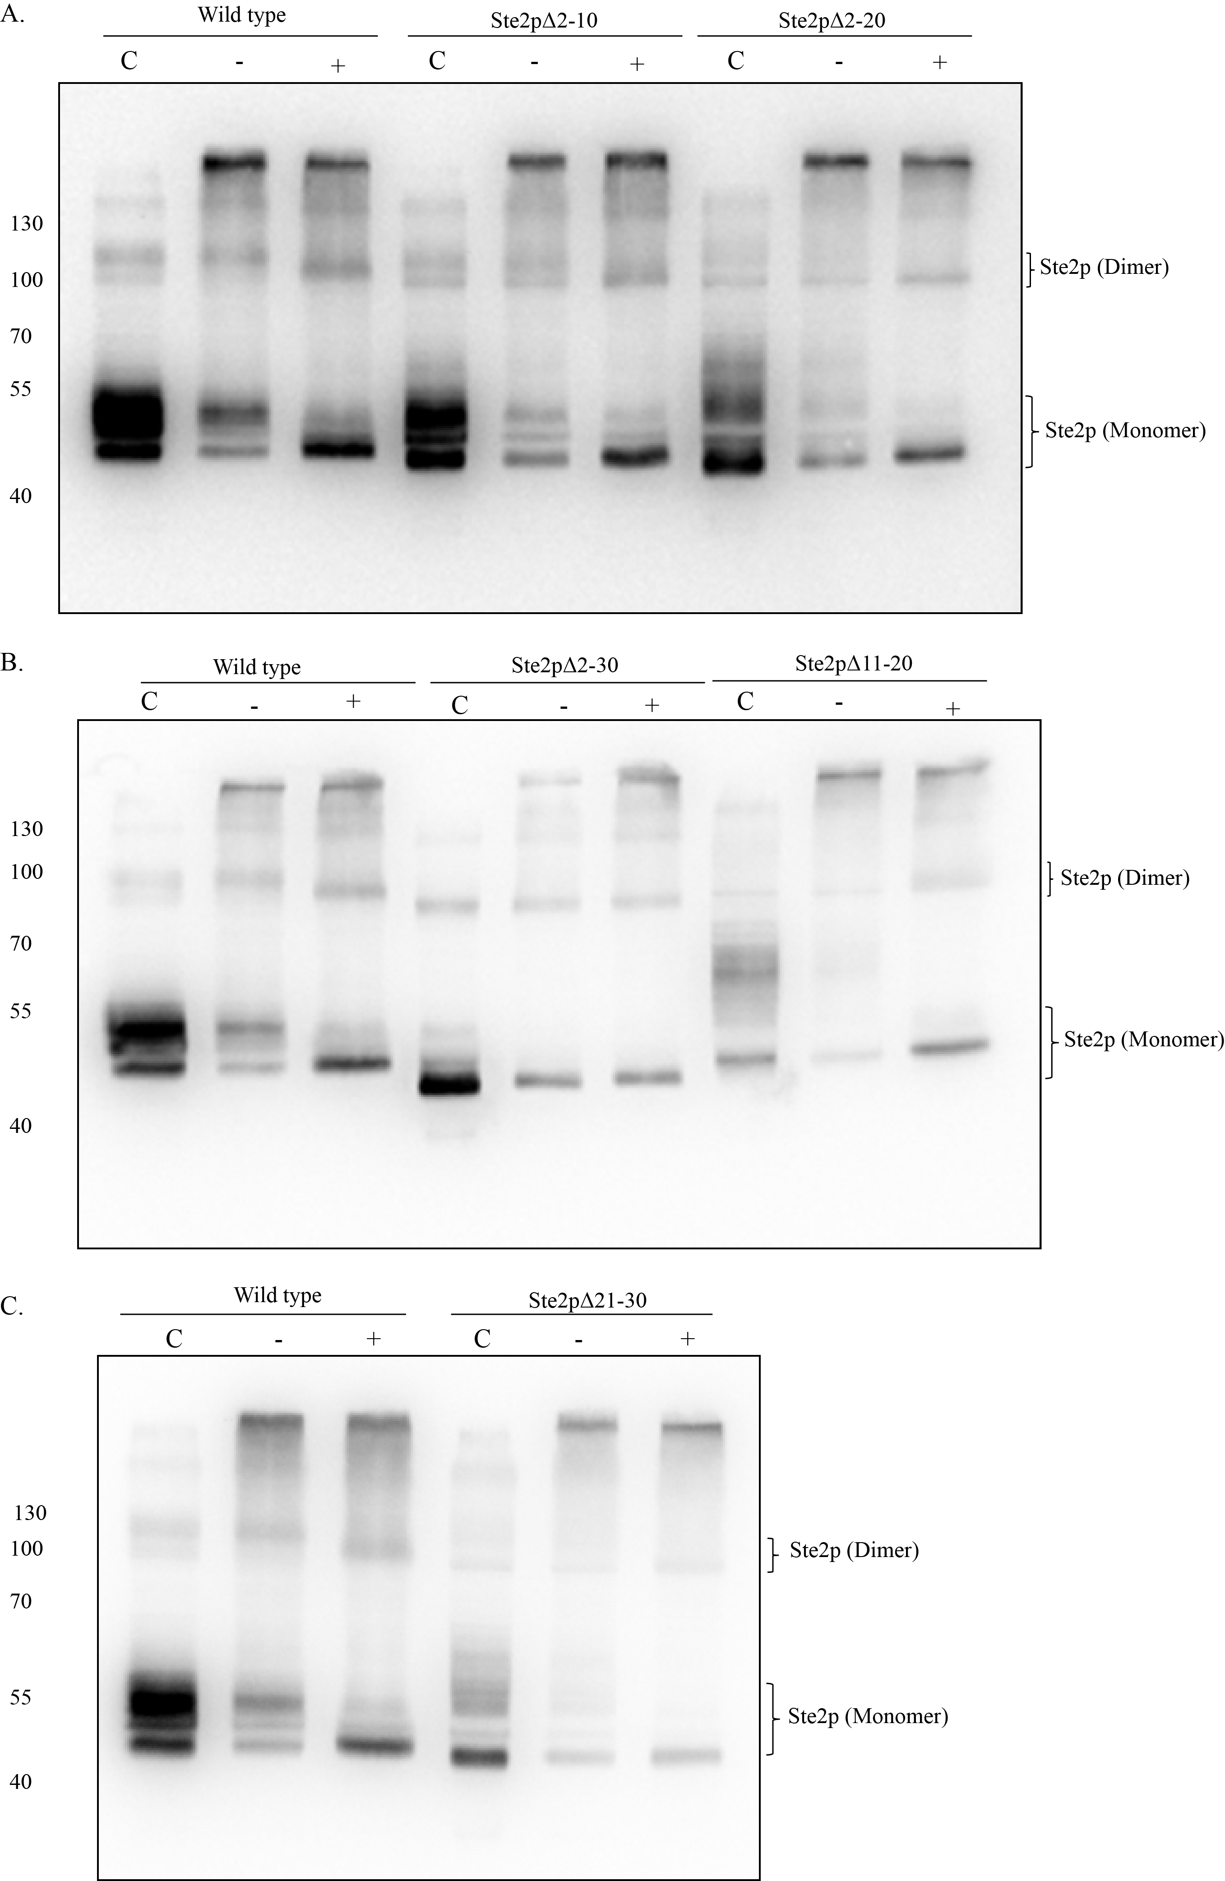
Figure 9. Deglycosylation of N-terminal deletion mutants of Ste2p. Total membrane proteins derived from cells expressing wild-type or deletion mutant receptors indicated were treated (+) with PNGase F as described under “Experimental Procedures” or incubated in parallel in the absence of enzyme (-) to control for degradation or aggregation which might occur as a result of exposure to elevated temperature. The proteins were then analyzed by immunoblot analysis using the anti-FLAG antibody. In control lanes (C) membrane proteins were solubilized directly into denaturing sample buffer immediately prior to SDS-PAGE and subsequent immunoblot analysis. Molecular mass markers (kDa) are indicated on the left-hand side of each panel. The prominent bands visible at ∼50 kDa corresponds to the monomeric forms of glycosylated Ste2p, whereas deglycosylated receptor (Ste2p, degly-M) appears as a band of reduced molecular weight.

In addition to the reduced levels of expression, the mutants Ste2pΔ2-20, Ste2pΔ2-30, Ste2pΔ11-20, and Ste2pΔ21-30 exhibited altered banding patterns as compared with the wild type (Fig. 2; Fig. 3 lanes designated by C). We postulated that the different banding patterns were due to differential glycosylation of the mutant receptors as the two glycosylation sites of the receptor (N25 and N32) are located either within or adjacent to the deletion sites. To test this assumption, membranes were prepared from the mutants as well as the wild type cells, treated with PNGase F at 37°C to deglycosylate the receptor, and the banding pattern was examined. The higher molecular weight forms (greater than 130Kda) of Ste2p are attributable to receptor aggregation as a result of the incubation of the sample at 37°C for 2 hours which are conditions necessary for the deglycosylation reaction [Fig 3, Lanes (-) and Lanes (+)]. The aggregation of the receptor is likely responsible for the significant reduction in the overall intensity of the Ste2p monomer band after the treatment (Compare lanes C and _ or + in Fig. 3). Such temperature-dependent aggregation has been observed previously by our lab [32]. The results indicated that the variability in the number of bands was diminished after PNGaseF treatment with all receptors exhibiting a prominent single band and the aforementioned high MW aggregate near the top of the gel (Fig. 3.). The collapse of the multiple bands at 50-55 kDa into one major band at about 50 kDa after PNGaseF treatment has been reported previously [24, 32].

The N-terminus is important for efficient surface expression but not required for ligand-binding:
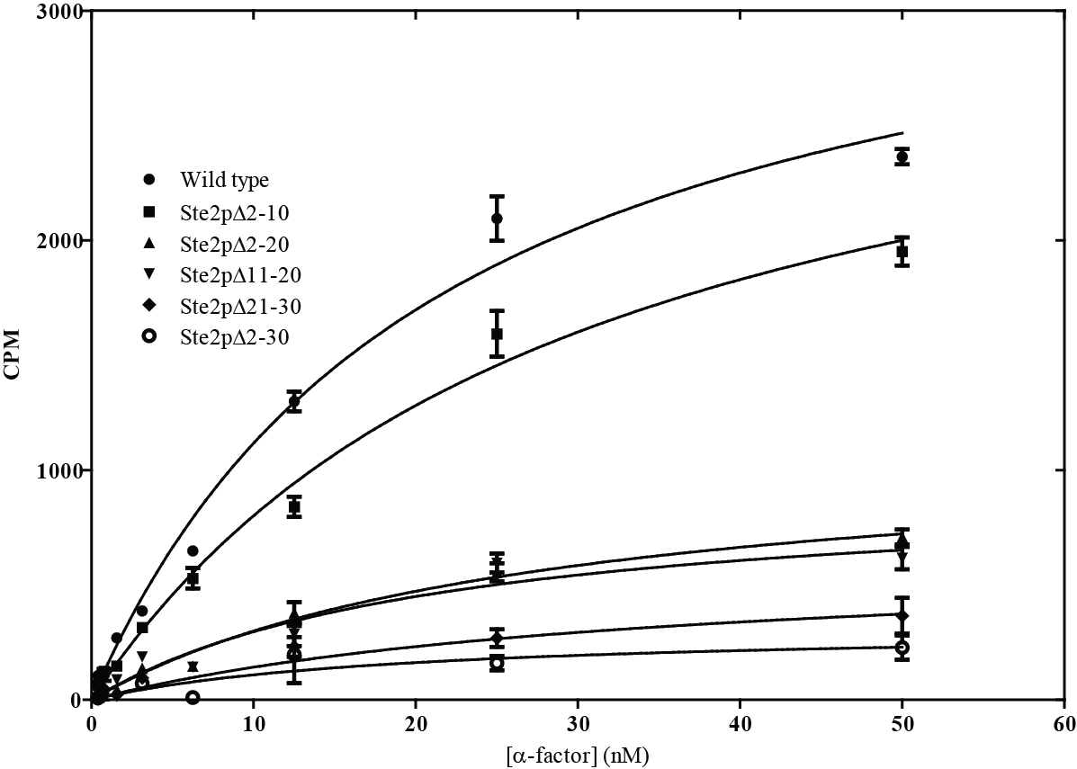
The immunoblot analysis measured total receptor expression in the membrane fraction, but it did not provide information regarding receptor expression on the cell surface. Consequently, the surface expression of the mutants was determined by whole cell saturation binding assays using [³H]α-factor as described previously [40, 42, 48]. The Bmax values from the saturation binding curves (Fig. 4) were used to calculate the number of receptors on the cell surface [48].The surface expression level of Ste2pΔ2-10 was approximately 90% of the wild type, but the surface expression levels of the other mutants were significantly lower (p= 0.05) and varied between 9% (Ste2pΔ2-30) and 31% (Ste2pΔ2-20) of the wild type (Table 1). These results indicate that receptors with N-terminal deletions are well expressed as judged by total expression levels but they exhibited reduced cell surface expression. The involvement of the N-terminus in surface expression is consistent with our previous study [26] and those of others [49, 50].
Figure 10. Saturation binding of [³H]α factor to various N-terminally deleted Ste2p. Whole cell saturation binding assay of [³H]α-factor to wild type Ste2p and N-terminal deletion mutants were determined. The data represent specific binding to cells as determined by subtracting the binding to an isogenic strain lacking the receptor from binding to cells containing wild type or mutant Ste2p.

Table 1. Total expression, surface expression and binding affinity of Ste2p N-terminal deletion mutants

Receptors | Relative total expression levelsª | Relative B_{max}^{b} | Relative K_{d}^{c}
Wild type | 1.00 ± 0.07 | 1.00 ± 0.08 | 1.00 ± 0.16
Ste2pΔ2-10 | 0.79 ± 0.08 | 0.89 ± 0.07 | 1.33 ± 0.22
Ste2pΔ2-20 | 0.62 ± 0.06 | 0.31 ± 0.02 | 1.18 ± 0.17
Ste2pΔ11-20 | 0.81 ± 0.07 | 0.26 ± 0.03 | 0.93 ± 0.22
Ste2pΔ21-30 | 0.56 ± 0.06 | 0.17 ± 0.03 | 1.48 ± 0.49
Ste2pΔ2-30 | 0.54 ± 0.05 | 0.09 ± 0.01 | 1.00 ± 0.23

ªRelative total expression level (±SEM) of the N-terminal deletion mutants of Ste2p. Ste2p band intensity was quantitated by Quantity One software (BioRad) and normalized to the Pma1p band intensity (for protein loading on the gel) and the Cys-less wild type receptor. Expression level of each receptor was calculated as
$\left\{\frac{Ste2p mutant band intensity}{Pma1p band intensity of the mutant}\right\}×\left\{\frac{Pma1p band intensity of Cys-less WT }{Ste2p Cys-less WT band intensity}\right\}$
^{b}Relative surface expression (±SEM) of N-terminal deletion mutants of Ste2p. Surface expression was determined by saturation binding assay using tritiated [³H] α-factor with whole cells. The relative surface expression was expressed as $\frac{Bmax value of the mutant}{Bmax value of the Cys-less WT receptor}$
^{c}The Kd values (±SEM) are presented relative to those of the Cys-less wild type receptor. The Kd was determined by saturation binding of radioactive α-factor according to the protocol described in experimental procedures. (Kd of wild type receptor was 21.93 nM).

The binding affinities of the receptors as determined by whole cell saturation binding assays [32, 40] were not significantly different (p= 0.05) from the wild type receptor (Table 1). These results indicated that the N-terminus was not directly involved in ligand binding and did not influence the formation of the ligand-binding pocket which is consistent with the observation by Sen and Marsh that the N-terminus of Ste2p was not involved in determining ligand specificity [51].
Deletion of portions of the N-terminal enhanced pheromone-induced signaling activity:
To investigate the role of the N-terminus in signaling activities, we examined the mutant receptors by pheromone-induced growth arrest and FUS1-LacZ induction assays as well as quantitative mating assays. The growth arrest assay measures the response of cells expressing Ste2p to arrest growth at the G1 phase based on the size of halos surrounding disks impregnated with various amounts of pheromone applied to lawn of pheromone-responsive cells. This assay measures response over a 24 to 48 h time frame. The FUS1-LacZ induction assay measures an early response (1 to 2 h) of the yeast cells to pheromone as detected by induction of β-galactosidase activity through a reporter gene construct consisting of a fusion between FUS1, a pheromone-responsive promoter, and the LacZ gene [52]. Mating assays, measure the ability of the cells to conjugate with cells of the opposite mating type producing diploid cells. The number of diploid colonies formed as a result of mating between the two mating types can be compared to that of the wild type indicating mating efficiency. The signaling responses of the mutants in each experiment were normalized to those of the wild type (Fig. 5, 6, 7, Table 2, and Supplementary Figs. S1, S2, and S3).

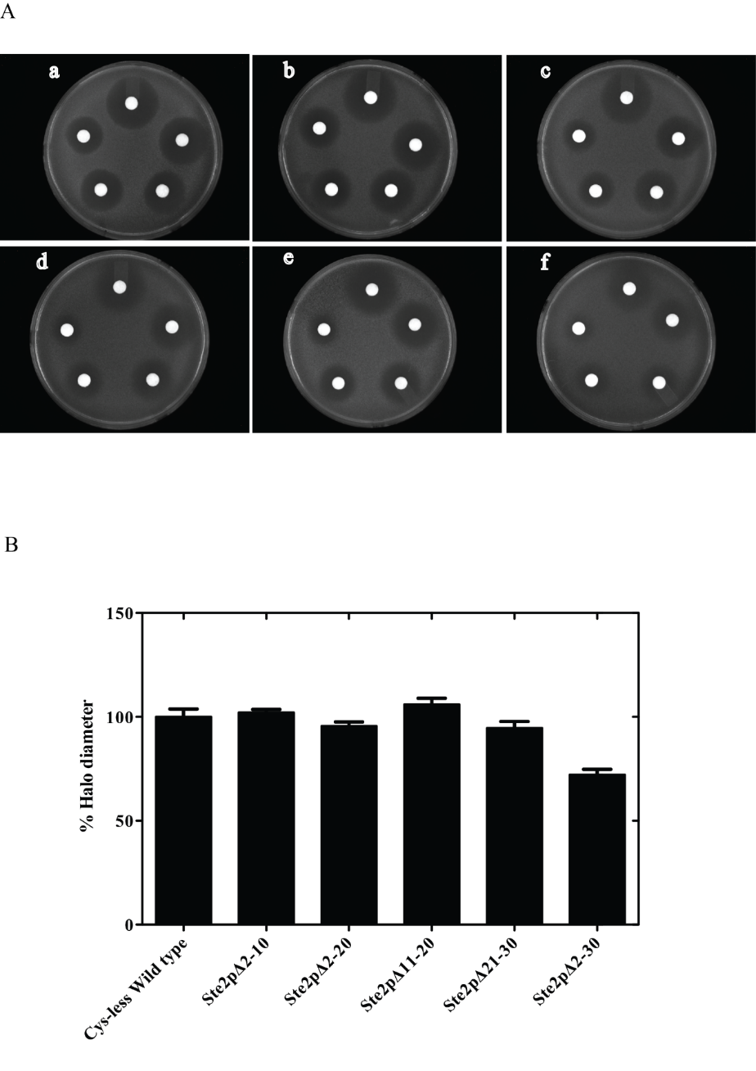
Figure 5. Growth arrest (halo) assays of wild type and deletion mutant receptors. (A) Cells containing wild type Ste2p or cells with N-terminally truncated Ste2p were plated onto medium. Disks containing α-factor (4.0, 2.0, 1.0, 0.5, and 0.25 µg/disk, starting at the 12 O’clock position on each plate and moving clockwise) were placed onto the lawn of cells. The plates were incubated for 48−72 h at 30°C: a) wild type, b) Ste2pΔ2-10, c) Ste2pΔ11-20 d) Ste2pΔ21-30 e) Ste2pΔ2-20, f) Ste2pΔ2-30. (B) Halo size produced by the wild type and various mutants at 1.0 µg α-factor was compared.
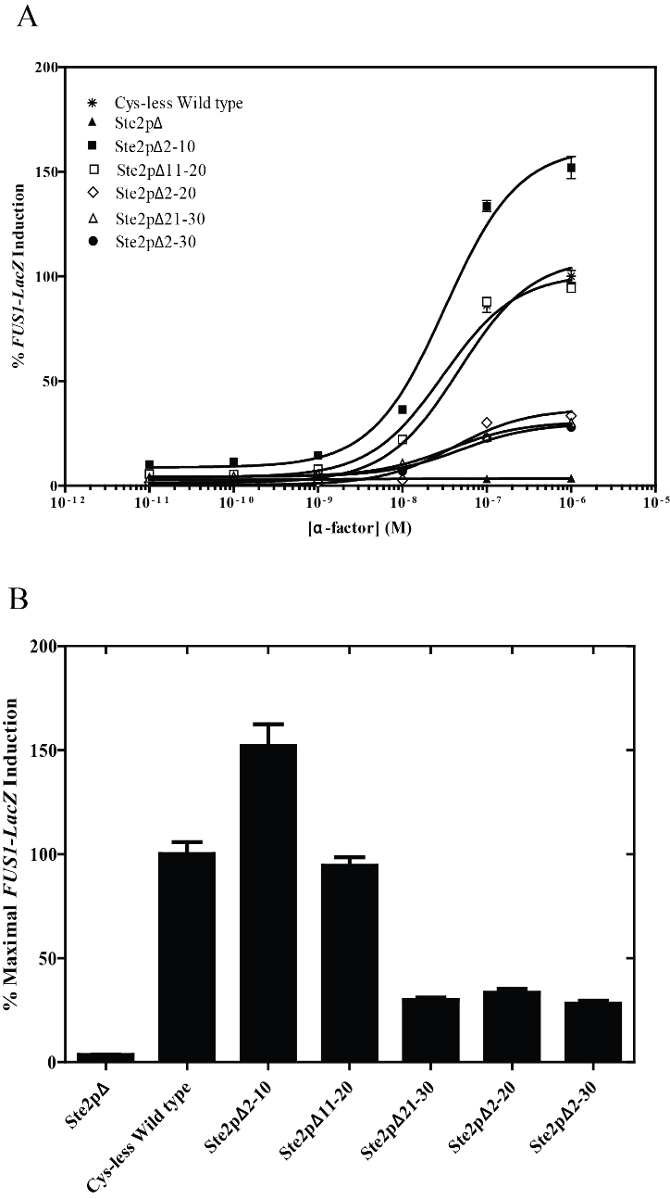
Figure 6. Pheromone-induced FUS1-LacZ induction (A) Dose-response curves for α-factor stimulated FUS1–lacZ induction of the N-terminal deletion mutants. Data are expressed as a percentage of the maximal response stimulated by the full length wild type receptor. (B) Maximal induction (%) is determined from the data on panel A with the highest concentration of α-factor (1 µM). Results represent average from three independent experiments performed in quadruplicate. One-way ANOVA followed by Dunnett’s post hoc test was used to determine statistical significance (n = 4; p < 0.05).
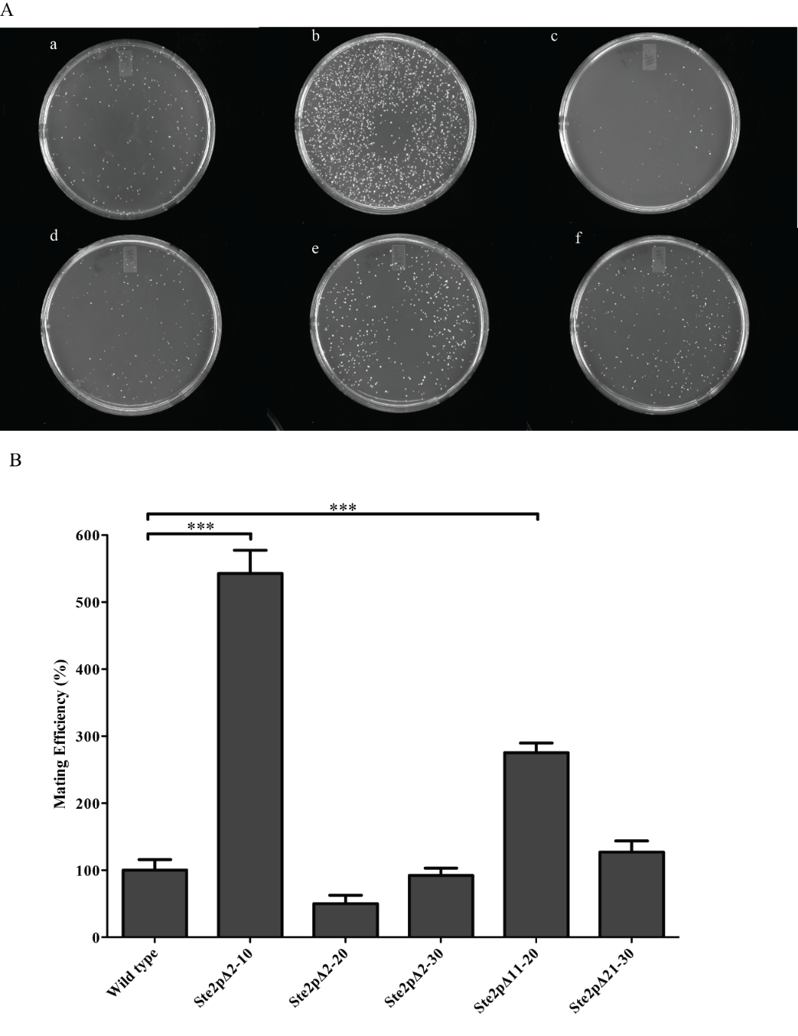
Figure 7. (A) Auxotrophic MATα strain (TBR1 was mated with MATa STE2Δ yeast strain (LM012) expressing wild type (a) Ste2pΔ2-10 (b), Ste2pΔ2-20 (c) Ste2pΔ21-30 (d), Ste2pΔ11-20 (e) and Ste2pΔ2-30 (f). (B) Mating efficiency of the strains were analyzed and compared to that of the wild type. Statistical significance was analyzed at p<0.001 by using GraphPad Prism.

In growth arrest assays, the halo diameter produced by the same amount of ligand was compared (Fig. 5, Table 2, and Fig. S1). The results showed that the growth arrest responses of the mutants were nearly the same as those of the wild type, with the exception of Ste2pΔ2-30 which had a 25% decrease in halo diameter compared to the wild type at 1.0 µg α-factor (Fig. S1). Although the number of receptors on the cell surface of the mutants was different (Table 1), the growth arrest activity of the mutants was similar with the exception of Ste2pΔ2-30. Therefore, the growth arrest response in the N-terminal deletion mutants was not proportional to the level of receptor expressed on the surface.
.
Table 8.
Receptors | Relative growth arrest activityª | Relative maximal FUS1-LacZ Induction^{b} | EC₅₀(nM)^{c} | Maximal FUS1-LacZ induction/Surface expression^{d}
Wild type | 1.00 ± 0.05 | 1.00 ± 0.06 | 46 ±5 | 1.00 ± 0.06
Ste2pΔ2-10 | 1.02 ± 0.04 | 1.52 ± 0.01 | 32 ± 4 | 1.7 ± 0.08
Ste2pΔ2-20 | 0.96 ± 0.04 | 0.39 ± 0.03 | 56 ± 2 | 1.3± 0.07
Ste2pΔ11-20 | 1.06 ± 0.05 | 0.94 ± 0.04 | 36 ± 3 | 3.6± 0.30
Ste2pΔ21-30 | 0.95 ± 0.05 | 0.30 ± 0.01 | 44 ± 1 | 1.8 ± 0.18
Ste2pΔ2-30 | 0.72 ± 0.04 | 0.28 ± 0.02 | 48 ± 1 | 3.1 ± 0.20

ªRelative growth arrest activity (halo size ±SEM) was compared to that of the Cys-less wild type receptor at 1.0 μg of α-factor applied to a disk (the halo size of the Cys-less wild type was 23mm).
^{b}Relative maximal FUS1-LacZ induction (±SEM) of each mutant was calculated with respect to Cys–less wild type receptor when induced with the highest concentration of α-factor (1 µM).
^{c}Determined from FUS1–lacZ assays. EC₅₀ (potency) reflects the concentration of α-factor required to cause half–maximal induction.
^{d}Maximal FUS1-LacZ induction of each mutant was normalized to its surface expression level and compared to that of the Cys-less wild type.
In FUS1-LacZ induction assays (Table 2 and Fig. S2) all mutant receptors exhibited potencies (EC₅₀ values) similar, not less than or greater than 30%, of that of wild type receptor. Also constitutive signaling, as measured by gene reporter activity in the absence of added α-factor, was the same as wild type for each receptor (data not shown). In contrast, the maximal signaling activity or efficacy, (FUS1-LacZ expression obtained at 1×10⁻⁶ M α-factor) exhibited variation among the receptors with signaling between 28% (Ste2pΔ2-30) and 152% (Ste2pΔ2-10) of the wild type (Table 2 and Fig. S2). Out of the five mutants tested, Ste2pΔ2-20, Ste2pΔ21-30, and Ste2pΔ2-30 exhibited a significant decrease in signaling (p<0.05), Ste2pΔ11-20 exhibited similar activity as the wild type and Ste2pΔ2-10 appeared to increase the signaling activity.
In the mating assay, the efficiency of Ste2pΔ2-20 and Ste2pΔ2-30 was ~50% and ~92% of the wild type, respectively (Fig. 7 and Fig.S3). The other three mutants (Ste2pΔ2-10, Ste2pΔ11-20, Ste2pΔ21-30) exhibited enhanced mating efficiency. Statistical analyses revealed that the mating efficiency of the Ste2pΔ2-10 and Ste2pΔ11-20 was significantly higher than the wild type (p<0.01).
We have shown that deletion of portions of the N-terminal tail of Ste2p decreased the surface expression level of mutant receptors without any significant change in their binding affinities (Table 1). Although surface expression of Ste2p has been found to affect signaling activity as determined by FUS1-LacZ reporter assay (Fig. 6), the calculated signaling activities do not take into account the level of surface expression. Therefore, to compare the signaling activities of the mutants based on the cell surface expression the maximal FUS1-LacZ activation was normalized to the amount of receptor on the cell surface as determined by saturation binding experiments. Interestingly, although the apparent signaling activity of the mutants was weaker than that of the wild type, this normalization revealed that the maximum FUS1-LacZ response of the mutants was in fact stronger than the wild type (Fig. 8). We observed that truncation of the N-terminus significantly enhanced the relative FUS1-LacZ response by 2- to 3-fold. Thus, receptors lacking portions of the N-terminus are actually more effective with respect to signaling than the wild type.
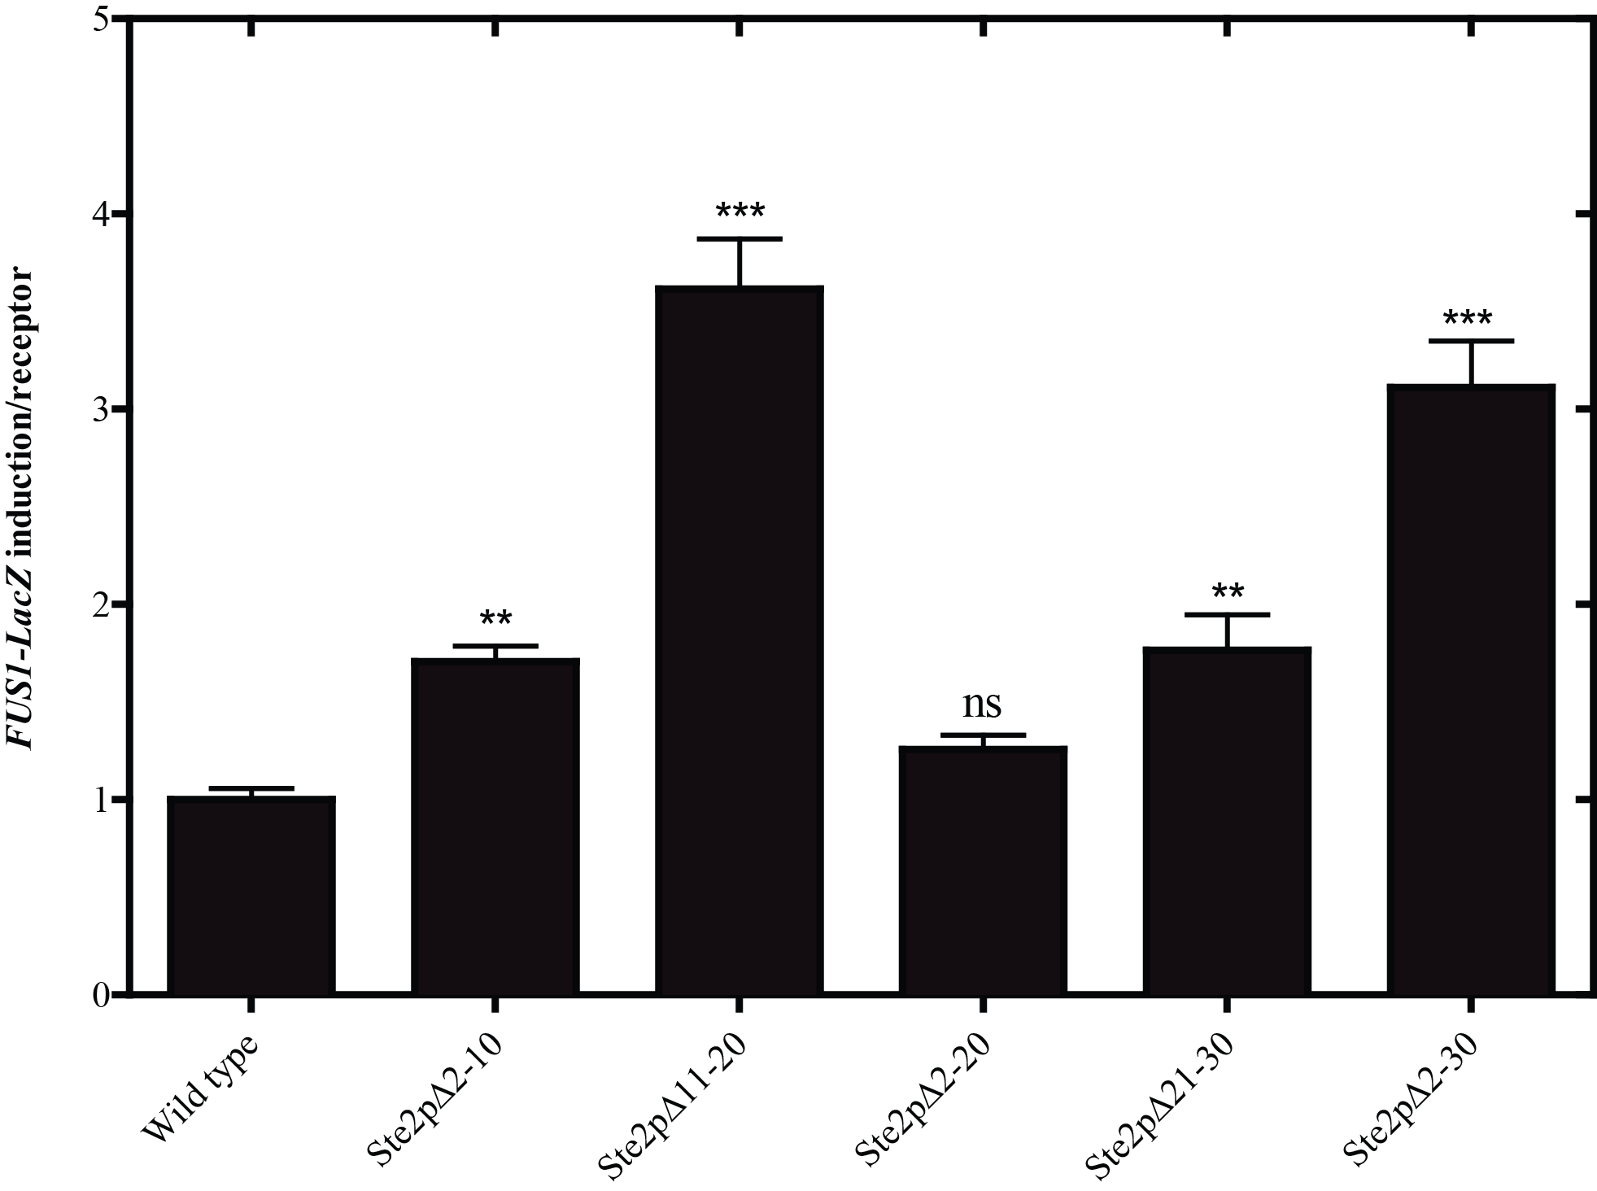
Figure 8. Normalized FUS1-LacZ activity of each receptor construct as compared the wild type. The maximal signaling activity of each construct was normalized to the number of receptors expressed on the cell surface. One way ANOVA was carried out at p<0.05 to determine statistical significance using GraphPad Prism.
In order to further evaluate the relationship of signaling to surface expression of various Ste2ps, we ascertained the surface expression and signaling activity with the same wild type receptor expressed at various levels. The wild type Ste2p was expressed under the control of Copper-inducible promoter CUP1 from the URA3 based plasmid pCBEC2 [53]. We performed growth arrest and FUS1-LacZ assays to determine if there was any correlation between the surface expression level and signaling activities. Relative surface expression levels at various concentrations of CuSO₄ was determined using a fluorescent α-factor analogue [K⁷(NBD),Nle¹²]α-factor [36, 54] by flow cytometer. We were able to regulate the surface expression level of Ste2p in a dose-dependent manner such that incubation with increasing concentrations of CuSO₄ led to increasing the amount of [K⁷(NBD),Nle¹²]α-factor on the surface as measured by mean fluorescence intensity (Fig. 9A & 9B). As judged from Fig. 9B there was a large increase in the number of receptors at 50 μM CuSO₄.

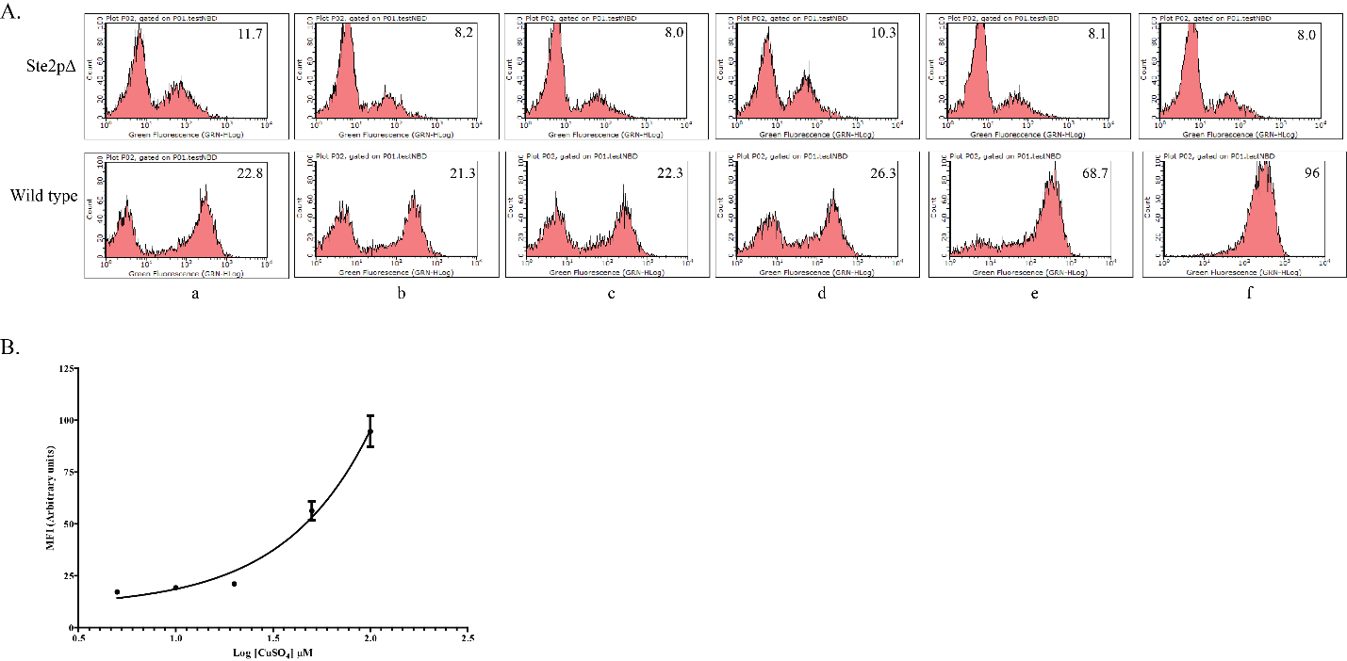
Figure 9. Receptor expression level at the cell surface determined by flow Cytometry. (Wild type Ste2p expressed under the control of copper-inducible promoter at different concentrations of CuSO₄. A) FACS histograms of cells expressing no receptors (top panels) and wild type (bottom panels) in the presence of saturating concentration of the ligand. The concentrations of CuSO₄ (μM) were 0 (a), 5 (b), 10 (c), 20 (d), 50 (e) and 100 (f) B). The histograms represent the number of cells (Y-axis) plotted against the fluorescence intensity (X-axis). The mean fluorescence intensity obtained from the histograms (insert number, upper right hand corner of histograms) was analyzed using non-linear regression analysis in GraphPad Prism.
Growth arrest assay indicated that the halos were turbid with indistinct edges at lower receptor expression levels. However, at higher expression levels, the halos were less turbid with distinct edges (Fig. 10A). The results indicated that halo size was similar at the various concentrations of CuSO₄ used in the experiment. The result is consistent with previous studies in which it has been shown that halo size produced by cells with different receptor expression level was similar [55]. In FUS1-LacZ induction assays increasing signal was observed as the concentration of CuSO₄ increased (Fig 10B). Detection of increase in FUS1-LacZ activity (Figl. 10B) was more sensitive to lower CuSO₄ induction levels than was detection of surface expression of Ste2p (Fig. 9A and B). These results supported our hypothesis that signaling activity judged by the gene induction assay is indeed dependent on receptor expression levels.

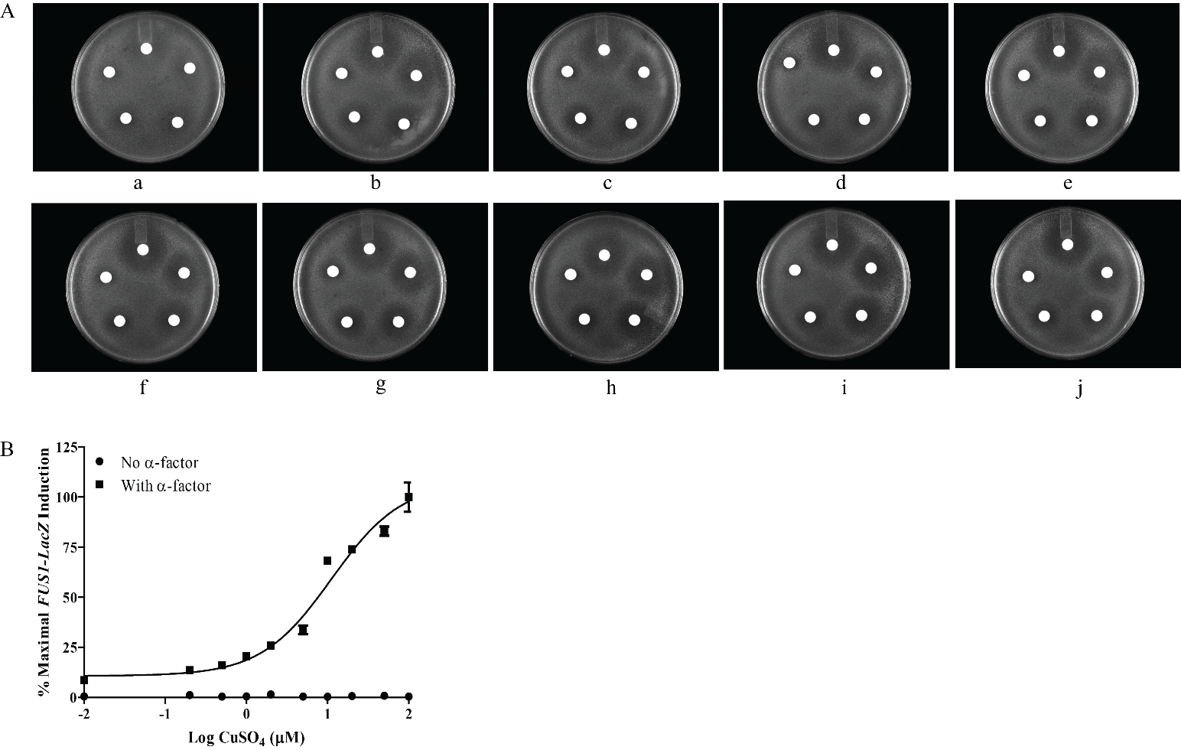
Figure 10. Signaling activities of the wild type receptor expressed at different levels. (A) Growth arrest assay at various concentrations of CuSO₄ (μM): (a) 0 (No added CuSO₄) (b) 0.2, (c) 0.5, (d) 1.0, (e) 2.0, (f) 5.0, (g) 10.0, (h) 20.0, (i) 50.0, (j) 100. (B) FUS1-LacZ induction at different concentrations of CuSO₄ (μM): 0 (no added CuSO₄), 0.2, 0.5, 1.0, 2.0, 5.0, 10, 20, 50 and 100. Data from FUS1-LacZ assay were analyzed by non-linear regression analysis using GraphPad Prism.

Discussion
The N-termini of several GPCRs have been reported to play roles in receptor function such as constraining receptor activation [18] or acting as a tethered ligand [56]. The N-terminus of Ste2p was previously associated with dimerization [25, 26, 28], mating [27, 28] and as a site for glycosylation [24]. Consistent with previous studies [50, 51], we found that the N-terminus was important for cell surface expression but not required for ligand binding. Our experiments on the N-terminus indicated that deletion of N-terminal regions resulted in enhanced signaling as analyzed by FUS1-LacZ assays when normalized to Ste2p surface expression.
It is generally assumed that the signaling activity of Ste2p is independent of receptor expression level [47, 57, 58]. This assumption was based on signaling activities determined by the growth arrest assay and direct measurement of surface receptor expression level determined by a binding assay [55]. In addition, the Dumont group supported this conclusion based on their analysis of the FUS1-LacZ assay [45]. However, interpretation of the Gehret et al. experiments involving the signaling activity as determined by the FUS1-LacZ assay was complicated by the fact that only the total expression, not the surface expression of Ste2p, was evaluated for the two strains: Ste2p expressed from the normal chromosomal STE2 locus versus Ste2p expressed under repressed condition from the GAL1 promoter (absence of galactose and the presence of glucose) . The interpretation is also complicated by the concerns that receptor expression level on the cell surface and the number of G protein subunits available to interact with the activated receptor can affect the signaling activity. It has been reported that the number of G proteins is approximately equal to the number of receptors in cells containing normal chromosomal copies of the genes encoding receptors and G protein subunits [59-61]. Therefore, if the available G proteins are saturated with the receptors expressed on the surface, increasing the expression level of Ste2p beyond the available of G proteins will not increase signaling.
The FUS1-LacZ reporter gene assay has been used as a quantitative assay for measurement of pheromone-induced signaling through Ste2p and its mutants in numerous studies [29, 48, 52, 62, 63]. Our analyses with wild type receptor expressed under the control of a copper-inducible promoter CUP1 demonstrated that signaling activity as measured by FUS1-LacZ was dependent on the number of surface expressed receptors (Fig. 9 & 10B). This observation is consistent with the idea that the signaling activity as determined by the FUS1-LacZ assay is dependent on the surface expression level of Ste2p. However, the signaling activity as determined by growth arrest assay does not correlate to the level of expression at the levels of copper used in the experiments (Fig. 10). The difference in the two measurements of signaling activities indicates that the long-term growth arrest assay is relatively less responsive to the amount of receptor expressed at the cell surface. The apparent differences in the results of the two assays may be a consequence of difference in the level of receptor expression in cells grown in suspension versus cells grown on agar or the time frame of the assays.
Mutants that were found to exhibit the greatest reduction in cell surface expression demonstrated marked changes in the banding pattern for Ste2p on SDS-PAGE (Fig. 2 & 3). It is probable that the changes in the banding pattern were due to altered glycosylation of the mutants because of either deletion of, or proximity to, the mutation of the two Ste2p glycosylation sites at N25 and N32. Accordingly, deglycosylation of the receptors resulted in the collapse of several bands into a major band which is consistent with previous studies in our lab [32] and others [24]. However, removal of the two glycosylation sites does not affect receptor activity or subcellular localization [24]. Thus reduced surface expression cannot be attributed simply to changes in the glycosylation pattern of the receptors. It has been reported previously that the charged residues in the N-terminus are important for proper orientation of the receptor in the membrane [50]. It is reasonable that a combination of the modification in the glycosylation pattern and changes in the electrostatic properties of the N-terminus influence the localization of Ste2p and its orientation in the plasma membrane.
Despite reduced surface expression and altered glycosylation, the mutant receptors were still functional, i.e., they exhibited similar ligand binding affinity and responded to ligand effectively in both growth arrest and gene induction assays. When the signaling activities of the mutant Ste2ps were normalized to the number of receptors that bound α-factor, the mutants actually exhibited a greater response than wild type. In fact the Ste2pΔ11-20 and Ste2pΔ2-30 mutants are more than 3-fold more effective than the full-length receptor in the signaling efficacies as measured by the reporter gene assay. Our control experiments with wild type receptor at various expression levels support the conclusion that maximal signaling activity as measured by gene reporter is dependent on receptor expression levels on the cell surface.
For measurement of signaling activities, we used pheromone-induced growth arrest and FUS1-lacZ assays. The growth arrest activities of the mutants were found to be similar to the wild type with the exception of Ste2p∆2-30. The reduced signaling of Ste2p∆2-30 mutant may be attributed to inefficient targeting to the membrane [50]. However, this mutant construct still binds the ligand efficiently and signals. This mutant was reported previously to exhibit weaker growth arrest activity with indistinct halo edges as compared to ours [27]. As shown in our control experiment with the wild type receptor, the fuzzy halo may result from poor expression level on the cell surface (Figure 10A). The difference in the signaling activity by growth arrest may also be attributed to the differences in strain background and promoter used in our study as compared to that of Shi, et al. [27]. We expressed the receptor from a constitutively active GPD promoter while they used an inducible GAL1 promoter. Further examination of signaling activities using a more sensitive, quantitative and shorter term reporter gene activation assay (FUS1-LacZ) revealed that the signaling activity of the mutants was enhanced as compared to the wild type when receptor expression levels at the cell surface are taken into account to normalize signaling activities.
The results from the gene induction assay (Fig. 8) indicate that the N-terminus of Ste2p is involved in negative regulation of signaling activity by this GPCR. In fact, the N-terminus of another GPCR, GPR56, has been reported to constrain receptor activity [18]. The N-terminus of GPR61, an orphan GPCR that is abundantly expressed in the brain, was also reported to be essential for constitutive activity [64]. Thus the results from our analysis of the role of the N-terminus of Ste2p in its function, and those of others involving different mammalian GPCRs, indicate an increasing importance for the N-terminus in the biology of GPCRs. Although the N-terminus may not be essential for GPCR signaling, its role in the regulation of signaling has been ignored to some extent in previous studies. The N-terminus may be required for fine tuning the signaling process and thus may be an important drug target for future drug design studies in which the GPCR function can be regulated more specifically.

The involvement of the N-terminus in negative regulation of Ste2p as observed in the absence of any influence on ligand binding suggests that the N-terminus may stabilize the inactive state of the receptor. To do this the N-terminus must interact with receptor domains that are important for signal transduction and which can assume different conformational states. A secondary structure analysis suggested that regions of the N-terminus, in particular residues 20-30, have a strong tendency to form β-sheet structures, [26, 27]. It is possible that removal of portions of the N-terminal domain lowers either intramolecular interactions within Ste2p or intermolecular contacts with other domains of the Ste2p dimer [25, 26]. The sum of these β-sheet like contacts may help to maintain the receptor in its inactive conformation and their removal would thereby facilitate transition to an activated state upon ligand binding. We speculate that the interacting domain with the N-terminus is the extracellular loop one (EL1) as mutation of residues in this loop has been found to change the glycosylation patterns of the receptor and its ability to be activated, and a structure prediction also indicates a tendency to form sheet secondary structures [27, 32]. However, we do not exclude the possibility of interactions with other Ste2p domains.

References:

1. Venkatakrishnan, A.J., et al., Molecular signatures of G-protein-coupled receptors. Nature, 2013. 494(7436): p. 185-94.
2. Fredriksson, R., et al., The G-protein-coupled receptors in the human genome form five main families. Phylogenetic analysis, paralogon groups, and fingerprints. Mol Pharmacol, 2003. 63(6): p. 1256-72.
3. O'Hayre, M., et al., The emerging mutational landscape of G proteins and G-protein-coupled receptors in cancer. Nat Rev Cancer, 2013. 13(6): p. 412-24.
4. Salon, J.A., D.T. Lodowski, and K. Palczewski, The significance of G protein-coupled receptor crystallography for drug discovery. Pharmacol Rev, 2011. 63(4): p. 901-37.
5. Kobilka, B.K., Structural insights into adrenergic receptor function and pharmacology. Trends Pharmacol Sci, 2011. 32(4): p. 213-8.
6. Kristiansen, K., Molecular mechanisms of ligand binding, signaling, and regulation within the superfamily of G-protein-coupled receptors: molecular modeling and mutagenesis approaches to receptor structure and function. Pharmacol Ther, 2004. 103(1): p. 21-80.
7. Gether, U., Uncovering molecular mechanisms involved in activation of G protein-coupled receptors. Endocr Rev, 2000. 21(1): p. 90-113.
8. Umanah, G.K., et al., Identification of residue-to-residue contact between a peptide ligand and its G protein-coupled receptor using periodate-mediated dihydroxyphenylalanine cross-linking and mass spectrometry. J Biol Chem, 2010. 285(50): p. 39425-36.
9. Eilers, M., et al., Comparison of class A and D G protein-coupled receptors: common features in structure and activation. Biochemistry, 2005. 44(25): p. 8959-75.
10. Oldham, W.M. and H.E. Hamm, Heterotrimeric G protein activation by G-protein-coupled receptors. Nat Rev Mol Cell Biol, 2008. 9(1): p. 60-71.
11. Kobilka, B.K., G protein coupled receptor structure and activation. Biochim Biophys Acta, 2007. 1768(4): p. 794-807.
12. Lagerstrom, M.C. and H.B. Schioth, Structural diversity of G protein-coupled receptors and significance for drug discovery. Nat Rev Drug Discov, 2008. 7(4): p. 339-57.
13. Beinborn, M., Class B GPCRs: a hidden agonist within? Mol Pharmacol, 2006. 70(1): p. 1-4.
14. Kobilka, B.K. and X. Deupi, Conformational complexity of G-protein-coupled receptors. Trends Pharmacol Sci, 2007. 28(8): p. 397-406.
15. Ersoy, B.A., et al., Mechanism of N-terminal modulation of activity at the melanocortin-4 receptor GPCR. Nat Chem Biol, 2012. 8(8): p. 725-30.
16. Scarborough, R.M., et al., Tethered ligand agonist peptides. Structural requirements for thrombin receptor activation reveal mechanism of proteolytic unmasking of agonist function. J Biol Chem, 1992. 267(19): p. 13146-9.
17. Vassart, G., L. Pardo, and S. Costagliola, A molecular dissection of the glycoprotein hormone receptors. Trends Biochem Sci, 2004. 29(3): p. 119-26.
18. Paavola, K.J., et al., The N terminus of the adhesion G protein-coupled receptor GPR56 controls receptor signaling activity. J Biol Chem, 2011. 286(33): p. 28914-21.
19. Andersson, H., et al., Membrane assembly of the cannabinoid receptor 1: impact of a long N-terminal tail. Mol Pharmacol, 2003. 64(3): p. 570-7.
20. Hague, C., et al., The N terminus of the human alpha1D-adrenergic receptor prevents cell surface expression. J Pharmacol Exp Ther, 2004. 309(1): p. 388-97.
21. Dunham, J.H., et al., GPR37 surface expression enhancement via N-terminal truncation or protein-protein interactions. Biochemistry, 2009. 48(43): p. 10286-97.
22. Dohlman, H.G., et al., Model systems for the study of seven-transmembrane-segment receptors. Annu Rev Biochem, 1991. 60: p. 653-88.
23. Slessareva, J.E. and H.G. Dohlman, G protein signaling in yeast: new components, new connections, new compartments. Science, 2006. 314(5804): p. 1412-3.
24. Mentesana, P.E. and J.B. Konopka, Mutational analysis of the role of N-glycosylation in alpha-factor receptor function. Biochemistry, 2001. 40(32): p. 9685-94.
25. Overton, M.C. and K.J. Blumer, The extracellular N-terminal domain and transmembrane domains 1 and 2 mediate oligomerization of a yeast G protein-coupled receptor. J Biol Chem, 2002. 277(44): p. 41463-72.
26. Uddin, M.S., et al., Identification of residues involved in homodimer formation located within a beta-strand region of the N-terminus of a Yeast G protein-coupled receptor. J Recept Signal Transduct Res, 2012. 32(2): p. 65-75.
27. Shi, C., et al., A role for a complex between activated G protein-coupled receptors in yeast cellular mating. Proc Natl Acad Sci U S A, 2007. 104(13): p. 5395-400.
28. Shi, C., et al., N-terminal residues of the yeast pheromone receptor, Ste2p, mediate mating events independently of G1-arrest signaling. J Cell Biochem, 2009. 107(4): p. 630-8.
29. Marsh, L., Substitutions in the hydrophobic core of the alpha-factor receptor of Saccharomyces cerevisiae permit response to Saccharomyces kluyveri alpha-factor and to antagonist. Mol Cell Biol, 1992. 12(9): p. 3959-66.
30. Son, C.D., et al., Identification of ligand binding regions of the Saccharomyces cerevisiae alpha-factor pheromone receptor by photoaffinity cross-linking. Biochemistry, 2004. 43(41): p. 13193-203.
31. Dohlman, H.G., et al., Pheromone action regulates G-protein alpha-subunit myristoylation in the yeast Saccharomyces cerevisiae. Proc Natl Acad Sci U S A, 1993. 90(20): p. 9688-92.
32. Hauser, M., et al., The first extracellular loop of the Saccharomyces cerevisiae G protein-coupled receptor Ste2p undergoes a conformational change upon ligand binding. J Biol Chem, 2007. 282(14): p. 10387-97.
33. Turcatti, G., et al., Probing the structure and function of the tachykinin neurokinin-2 receptor through biosynthetic incorporation of fluorescent amino acids at specific sites. J Biol Chem, 1996. 271(33): p. 19991-8.
34. Sherman, F., Getting started with yeast. Methods Enzymol, 1991. 194: p. 3-21.
35. Reynolds, T.B. and G.R. Fink, Bakers' yeast, a model for fungal biofilm formation. Science, 2001. 291(5505): p. 878-81.
36. Bajaj, A., et al., A fluorescent alpha-factor analogue exhibits multiple steps on binding to its G protein coupled receptor in yeast. Biochemistry, 2004. 43(42): p. 13564-78.
37. Huang, L.Y., et al., Unnatural amino acid replacement in a yeast G protein-coupled receptor in its native environment. Biochemistry, 2008. 47(20): p. 5638-48.
38. Slauch, J.M., M.J. Mahan, and J.J. Mekalanos, Measurement of transcriptional activity in pathogenic bacteria recovered directly from infected host tissue. Biotechniques, 1994. 16(4): p. 641-4.
39. Raths, S.K., F. Naider, and J.M. Becker, Peptide analogues compete with the binding of alpha-factor to its receptor in Saccharomyces cerevisiae. J Biol Chem, 1988. 263(33): p. 17333-41.
40. David, N.E., et al., Expression and purification of the Saccharomyces cerevisiae alpha-factor receptor (Ste2p), a 7-transmembrane-segment G protein-coupled receptor. J Biol Chem, 1997. 272(24): p. 15553-61.
41. Pinson, B., J. Chevallier, and D. Urban-Grimal, Only one of the charged amino acids located in membrane-spanning regions is important for the function of the Saccharomyces cerevisiae uracil permease. Biochem J, 1999. 339 ( Pt 1): p. 37-42.
42. Umanah, G.K., et al., Changes in conformation at the cytoplasmic ends of the fifth and sixth transmembrane helices of a yeast G protein-coupled receptor in response to ligand binding. Biochemistry, 2011. 50(32): p. 6841-54.
43. Lin, J.C., K. Duell, and J.B. Konopka, A microdomain formed by the extracellular ends of the transmembrane domains promotes activation of the G protein-coupled alpha-factor receptor. Mol Cell Biol, 2004. 24(5): p. 2041-51.
44. Wang, H.X. and J.B. Konopka, Identification of amino acids at two dimer interface regions of the alpha-factor receptor (Ste2). Biochemistry, 2009. 48(30): p. 7132-9.
45. Gehret, A.U., S.M. Connelly, and M.E. Dumont, Functional and physical interactions among Saccharomyces cerevisiae alpha-factor receptors. Eukaryot Cell, 2012. 11(10): p. 1276-88.
46. Jenness, D.D., et al., Elimination of defective alpha-factor pheromone receptors. Mol Cell Biol, 1997. 17(11): p. 6236-45.
47. Blumer, K.J., J.E. Reneke, and J. Thorner, The STE2 gene product is the ligand-binding component of the alpha-factor receptor of Saccharomyces cerevisiae. J Biol Chem, 1988. 263(22): p. 10836-42.
48. Akal-Strader, A., et al., Residues in the first extracellular loop of a G protein-coupled receptor play a role in signal transduction. J Biol Chem, 2002. 277(34): p. 30581-90.
49. Overton, M.C., S.L. Chinault, and K.J. Blumer, Oligomerization, biogenesis, and signaling is promoted by a glycophorin A-like dimerization motif in transmembrane domain 1 of a yeast G protein-coupled receptor. J Biol Chem, 2003. 278(49): p. 49369-77.
50. Harley, C.A. and D.J. Tipper, The role of charged residues in determining transmembrane protein insertion orientation in yeast. J Biol Chem, 1996. 271(40): p. 24625-33.
51. Sen, M. and L. Marsh, Noncontiguous domains of the alpha-factor receptor of yeasts confer ligand specificity. J Biol Chem, 1994. 269(2): p. 968-73.
52. Trueheart, J., J.D. Boeke, and G.R. Fink, Two genes required for cell fusion during yeast conjugation: evidence for a pheromone-induced surface protein. Mol Cell Biol, 1987. 7(7): p. 2316-28.
53. Gebhart, D., A.K. Bahrami, and A. Sil, Identification of a copper-inducible promoter for use in ectopic expression in the fungal pathogen Histoplasma capsulatum. Eukaryot Cell, 2006. 5(6): p. 935-44.
54. Tantry, S., et al., Binding of fluorinated phenylalanine alpha-factor analogues to Ste2p: evidence for a cation-pi binding interaction between a peptide ligand and its cognate G protein-coupled receptor. Biochemistry, 2010. 49(24): p. 5007-15.
55. Shah, A. and L. Marsh, Role of Sst2 in modulating G protein-coupled receptor signaling. Biochem Biophys Res Commun, 1996. 226(1): p. 242-6.
56. Adams, M.N., et al., Structure, function and pathophysiology of protease activated receptors. Pharmacol Ther, 2011. 130(3): p. 248-82.
57. Reneke, J.E., et al., The carboxy-terminal segment of the yeast alpha-factor receptor is a regulatory domain. Cell, 1988. 55(2): p. 221-34.
58. Konopka, J.B., D.D. Jenness, and L.H. Hartwell, The C-terminus of the S. cerevisiae alpha-pheromone receptor mediates an adaptive response to pheromone. Cell, 1988. 54(5): p. 609-20.
59. Yi, T.M., H. Kitano, and M.I. Simon, A quantitative characterization of the yeast heterotrimeric G protein cycle. Proc Natl Acad Sci U S A, 2003. 100(19): p. 10764-9.
60. Hao, N., et al., Regulators of G protein signaling and transient activation of signaling: experimental and computational analysis reveals negative and positive feedback controls on G protein activity. J Biol Chem, 2003. 278(47): p. 46506-15.
61. Bardwell, L., A walk-through of the yeast mating pheromone response pathway. Peptides, 2005. 26(2): p. 339-50.
62. Dube, P. and J.B. Konopka, Identification of a polar region in transmembrane domain 6 that regulates the function of the G protein-coupled alpha-factor receptor. Mol Cell Biol, 1998. 18(12): p. 7205-15.
63. Mathew, E., et al., Differential interactions of fluorescent agonists and antagonists with the yeast G protein coupled receptor Ste2p. J Mol Biol, 2011. 409(4): p. 513-28.
64. Toyooka, M., T. Tujii, and S. Takeda, The N-terminal domain of GPR61, an orphan G-protein-coupled receptor, is essential for its constitutive activity. J Neurosci Res, 2009. 87(6): p. 1329-33.

