Deeply Rooted: A Feasibility Study
testing the Potential for AMS Dating
through
Paleoethnobotanical RECOVERY Methods
at the Topper Site (38AL23)

A Thesis Presented for the
Master of Arts
Degree
The University of Tennessee, Knoxville

Sarah Elizabeth Walters
August 2016

Copyright © 2016 Sarah Elizabeth Walters
All Rights Reserved

This thesis is dedicated to those who aren’t afraid to question.

ACKNOWLEDGEMENTS
Like all academic research, this project is not the product of the work of a single person. I would like to thank everyone who has grabbed a shovel and sharpie or offered advice or comments on this project during the duration of this research.
Much of my gratitude goes towards my thesis committee. Without the support of Dr. David G. Anderson, I would likely not have had the opportunities that have been afforded me at the University of Tennessee. It has been an honor to work with him during my tenure at the University. I am also appreciative of his support of this project and allowing me to use flotation equipment set up at the Bells Bend Archaeological Project in Nashville to process my test samples and to teach his undergraduates the basics of paleoethnobotanical research.
Dr. Kandace Hollenbach has been unswerving in her support, education, and encouragement during this project. Dr. Boyce Driskell has encouraged me since my first semester and has offered helpful advice throughout my graduate career.
I would especially thank Dr. Albert C. Goodyear for having me back year after year as part of the Topper Staff, and also for his advice, thoughtful consideration, and support of this project. I would also like to thank Tom Pertierra for his dedicated support of the Allendale Expedition Project and the students who were able to learn and develop because of his friendship as well as his unwavering and ever enthusiastic support.
Dr. Gail Wagner was a wonderful resource and was also kind enough to invite me on the 2011 Carolina Pulse, at the Shealy’s Pond Heritage Preserve, in order to get a better idea of what botanists do in the field. I also appreciate the advice, flotation training, and encouragement of Dr. Stephen Carmody.
I also sincerely appreciate Dr. Gerald Schroedl’s encouragement in applying for UTK Patricia Black funding to pay for partial AMS dating for this project. I would also like to thank Dr. D. Shane Miller (who also received his PhD after this project as well) for his part in helping to date an additional sample for this project, along with the University of Arizona, Tucson Radiocarbon Laboratory. Dr. Miller also kindly provided assistance with the creation of the Topper site map.
I would also like to extend my gratitude to the Department of Anthropology, University of Tennessee, the Department of Anthropology’s Patricia Black Fund, and the University of Tennessee Knoxville Graduate Student Travel Award for funding different aspects of my thesis research. An anonymous donor also graciously provided funding that allowed for a third sample to be dated through AMS.
The South Carolina Institute of Archaeology and Anthropology (SCIAA), located on the campus of the University of South Carolina, was kind enough to support the Topper expedition, and to allow for the storage of a majority of the artifacts recovered from the site.
Personnel at the University of Tennessee’s Archaeological Research Laboratory under the direction of Boyce Driskell, Kandace Hollenbach, and Michael Angst provided a majority of the much-needed equipment and lab space for the analysis. Much thanks goes to them for their ongoing support.
I greatly appreciate Dr. John Foss taking the time to analyze the soil morphology for the research column.
Dr. Michael McKinney of the Department of Earth and Planetary Sciences, at the University of Tennessee, was instrumental in the chemical testing portion of this project. He provided the encouragement and instruction, as well as the materials for the testing, free of charge.
My eternal thanks goes also to the Topper Family of Staff and Volunteers, who were with me for the first eight years of my archaeological career, and have provided lasting support, encouragement, and education for the students who worked alongside them each year. I especially appreciate all the assistance that Joan Plummer has given this project, by providing associated data in support of this research.
I could not have taken my original test column without the assistance of Kat Forst, who helped me to excavate and recover the first few hundreds of pounds of dirt floated from the site. It was this test column that helped to demonstrate the existence of paleoethnobotanical remains at the Topper site, and led to this expanded research project and the resulting thesis.
Special thanks go to Bill Covington, a long-time Topper Volunteer and Friend. His support and curiosity has, in large part, made this research what it is today.
I could not have pulled the samples as efficiently as I did without the assistance of Hubert Gibson, Sarah Shafer, Chelsea Coates, Christina Portillo, and Chauntele Scarlett. They were also instrumental in assisting with flotation and bagging of the samples. I am also grateful for the initial lab processing assistance of Johnathan R. Hunt.
I am sorry to say that I do not remember the name of the Topper intern or volunteer who first brought my attention to the carbonized maypop seed found in the unit I was supervising. Without this observation, this project would likely not have happened. My lasting thanks and gratitude go to this person for starting me down this fruitful (pun intended) path.
I would like to extend my deepest gratitude to colleague and friend Sean Cary von Gunter for being willing to be a sounding board for my ideas, my late night and last minute editor, and my constant defender, champion, and relentless supporter throughout this entire process.
Lastly, I would like to thank my parents, Beth and Larry Walters, for being constantly and wholly supportive of my archaeological pursuits — as unexpected as they were. From the day I decided to follow this path, they have been there for me with links to archaeological forums, newspaper clippings, numerous questions, and above all, unwavering encouragement.
The ability to follow my dream and to be able to share that with the people I care so much for has been the best part of the past decade. I look forward to seeing what the future holds.
You will find something more in woods than in books. Trees and stones will teach you that which you can never learn from masters.
-Saint Bernard
Don't believe it 'cause they say it's so/
If it's not true, you have a right to know/
Put it to the test (put it to the test). . .
-They Might Be Giants

ABSTRACT
Archaeologists often make limiting operational choices that — though considered and logical — are (sometimes) necessarily selective in nature. One such a priori framework posits that costly paleoethnobotanical recovery and associated analyses are not worthwhile when working in sandy, acidic soils; as dateable organic remains are too rapidly destroyed by inherent chemical and mechanical processes to allow for differential preservation. This research demonstrates that these destructive processes are largely misunderstood. Indeed, the successful collection of significant paleoethnobotanical material is possible from certain types of sandy soils previously thought to be organically sterile. Moreover, such paleoethnobotanical recovery efforts can yield viable, datable material needed to establish an absolute chronology where not otherwise possible. Clovis, Archaic, Woodland, Mississippian, and Historic-aged carbonized plant remains were recovered from the late Quaternary sediments at the Topper Site (38AL23) (a chert-quarry based archaeological site located in South Carolina) and were dated via Accelerator Mass Spectrometry (AMS). Additional supplementary chemical testing was also undertaken in support of the paleoethnobotanical recovery. The resulting data are shown to: (1) quantify the age of the associated lithic deposits; and (2) independently corroborate Topper’s vertical stratigraphic integrity. Too often, the utility of paleoethnobotany is narrowly conceived as only able to address matters of subsistence. Paleoethnobotanical recovery, however, can address a greater range of questions — the answers to which better inform the largely unresolved debates surrounding the archaeological questions of our time.

TABLE OF CONTENTS

ACKNOWLEDGEMENTS iv

ABSTRACT viii

TABLE OF CONTENTS ix

LIST OF TABLES xii

LIST OF FIGURES xvi

PREFACE xviii

CHAPTER 1: INTRODUCTION 1
Project Background 5

CHAPTER 2: THE TOPPER SITE (38AL23) 7
Topper Site History and Background 8
Topper Site Location and Environment 14
The Current and Future Role of the Topper Site in South Carolina Archaeology 18

CHAPTER 3: METHODS 20
Test Column Recovery Methods 20
Refined Sampling Methods 27
Laboratory Methods 29
Accelerator Mass Spectrometry Dating 30
General Dating Background 30
Specimen Selection and Identification 33

CHAPTER 4: RESULTS 36
Test Column HSN166E36 36
Research Column HSN205E64 38
Accelerator Mass Spectrometry Dating 46

CHAPTER 5: SUPPLEMENTAL ANALYSES AND OTHER CONSIDERATIONS 56
Chemical Testing Introduction and Methods 56
Chemical Testing Results 57
Lithic Debitage Analysis Introduction and Methods 65
Lithic Debitage Analysis Results 68
Testing for Correlations between Archaeobotanical, Lithic and Chemical Data 75
Understanding Bioturbation Processes at the Topper Site 81

CHAPTER 6: DISCUSSION AND CONCLUSIONS 84
Further Research 87

REFERENCES CITED 90

APPENDICES 99
Appendix A: Recovery Results from Test Column HSN166E36 (Levels 10-21) 100
Appendix B: Recovery Results from Research Column HSN205E64 102
Appendix C: Records of Lithic Data from Research Column HSN205E64, as well as the adjacent 4x4 Quadrants HSN207E64, HSN207E66, HSN209E64, and HSN209E66 143
Appendix D: Reported Radiometric Data Recovered from the Topper Site and Associated Excavation Sites 150
Appendix E: Chemical Data from HSN205E54 154
Appendix F: AMS Radiometric Dating Report Data 156
Appendix G: Soil Profile Description for Research Column HSN205E64 163
Appendix H: Photos of Sample Recovery, Processing and Lab Research 165

VITA 184

LIST OF TABLES
Table 1 Identified taxa from the Test Column HSN166E36 37
Table 2 Archaeobotanical summary of Research Column HSN205E64 39
Table 3 Recalculated Ubiquity for Zea mays for levels 1-11 of Research Column HSN205E64 41
Table 4 Complete List of all taxa recovered from the Test and Research Columns and Associated Uses and Seasonality 43
Table 5 AMS Dated Samples, and Column Association 48
Table 6 A Cultural Sequence and Timescale for Southeastern Archaeology 51
Table 7 Recovered Lithic Materials from HSN205E64 by Count and Weight 69
Table 9 Raw data from Chemical Testing at HSN205E64 154

Table A-1 Table of Results from Test Column HSN166E36 (Levels 10-21) 100

Table B-1 Recovered Organic Material (by Count) – HSN205E64 – Level 1 102
Table B-2 Recovered Organic Material (by Weight) – HSN205E64 – Level 1 103
Table B-3 Recovered Organic Material (by Count) - HSN205E64 - Level 2 104
Table B-4 Recovered Organic Material (by Weight) - HSN205E64 - Level 2 105
Table B-5 Recovered Organic Material (by Count) – HSN205E64 – Level 3 106
Table B-6 Recovered Organic Material (by Weight) - HSN205E64 - Level 3 107
Table B-7 Recovered Organic Material (by Count) - HSN205E64 - Level 4 108
Table B-8 Recovered Organic Material (by Weight) - HSN205E64 - Level 4 109
Table B-9 Recovered Organic Material (by Count) - HSN205E64 - Level 5 110
Table B-10 Recovered Organic Material (by Weight) - HSN205E64 - Level 5 111
Table B-11 Recovered Organic Material (by Count) – HSN205E64 – Level 6 112
Table B-12 Recovered Organic Material (by Weight) - HSN205E64 - Level 6 113
Table B-13 Recovered Organic Material (by Count) - HSN205E64 - Level 7 114
Table B-14 Recovered Organic Material (by Weight) - HSN205E64 - Level 7 115
Table B-15 Recovered Organic Material (by Count) - HSN205E64 - Level 8 116
Table B-16 Recovered Organic Material (by Weight) - HSN205E64 - Level 8 117
Table B-17 Recovered Organic Material (by Count) - HSN205E64 - Level 9 118
Table B-18 Recovered Organic Material (by Weight) - HSN205E64 - Level 9 119
Table B-19 Recovered Organic Material (by Count) - HSN205E64 - Level 10 120
Table B-20 Recovered Organic Material (by Weight) - HSN205E64 - Level 10 121
Table B-21 Recovered Organic Material (by Count) - HSN205E64 - Level 11 122
Table B-22 Recovered Organic Material (by Weight) - HSN205E64 - Level 11 123
Table B-23 Recovered Organic Material (by Count) - HSN205E64 - Level 12 124
Table B-24 Recovered Organic Material (by Weight) - HSN205E64 - Level 12 125
Table B-25 Recovered Organic Material (by Count) - HSN205E64 - Level 13 126
Table B-26 Recovered Organic Material (by Weight) - HSN205E64 - Level 13 127
Table B-27 Recovered Organic Material (by Count) - HSN205E64 - Level 14 128
Table B-28 Recovered Organic Material (by Weight) - HSN205E64 - Level 14 129
Table B-29 Recovered Organic Material (by Count) - HSN205E64 - Level 15 130
Table B-30 Recovered Organic Material (by Weight) - HSN205E64 - Level 15 131
Table B-31 Recovered Organic Material (by Count) - HSN205E64 - Level 16 132
Table B-32 Recovered Organic Material (by Weight) - HSN205E64 - Level 16 133
Table B-33 Recovered Organic Material (by Count) - HSN205E64 - Level 17 134
Table B-34 Recovered Organic Material (by Weight) - HSN205E64 - Level 17 135
Table B-35 Recovered Organic Material (by Count) - HSN205E64 - Level 18 136
Table B-36 Recovered Organic Material (by Weight) - HSN205E64 - Level 18 137
Table B-37 Recovered Organic Material (by Count) - HSN205E64 - Level 19 138
Table B-38 Recovered Organic Material (by Weight) - HSN205E64 - Level 19 139
Table B-39 Recovered Organic Material (by Count) - HSN205E64 - Level 20 140
Table B-40 Recovered Organic Material (by Weight) - HSN205E64 - Level 20 141

Table D-1 All Published Radiometric Data from the Upper Hillside Excavation area at Topper 150
Table D-2 Radiometric Data from the Big Pine Tree Site (38AL143) 151
Table D-3 Radiometric Data from the Pleistocene Terrace at the Topper Site (38AL23) 152

Table F-1 AMS Results Provided by the Arizona AMS Laboratory 161

Table G - 1 Profile Description for Research Column HSN205E64 (South Wall) 163

LIST OF FIGURES
Figure 1 Passiflora incarnata (Maypop) seeds xxiv
Figure 2 Passiflora incarnata (Maypop) flower and fruit found close to the Topper site basecamp xxv
Figure 3 Major Physiographic Regions of the Southeastern United States 13
Figure 4 General Soil Map and Physiographic Regions of South Carolina with the approximate location of the Topper site indicated in red 14
Figure 5 Map of the Topper and Big Pine Tree sites in relation to each other 16
Figure 6 The three major excavation areas at the Topper Site 20
Figure 7 Location of the Test and Research Columns on the Topper Upper Hillside 23
Figure 8 Test Column HSN166E36 on the Topper Upper Hillside during sample excavation 29
Figure 9 Modified SMAP-type flotation system used for processing the samples from both the test column and the research column 31
Figure 10 Visual Vertical Representation of the location of the three carbon samples recovered and dated from Research Column HSN205E64 63
Figure 11 Soil pH of the United States 74
Figure 12 Quantified Soil pH for Research Column HSN205E64 75
Figure 13 Quantified Nitrogen Levels for Research Column HSN205E64 76
Figure 14 Quantified Phosphorus levels for Research Column HSN205E64 79
Figure 15 Simple Trend Lines for Phosphorus and Nitrogen Levels from Research Column HSN205E64 80
Figure 16 Photograph of the 4 x 4 Block Unit associated with Research Column HSN205E64 83
Figure 17 Thermally altered lithic debitage by count from the Research Column HSN205E64 89
Figure 18 Non-thermally altered lithic debitage by count from the Research Column HSN205E64 90
Figure 19 General Trend Lines for Thermally Altered and Non-Thermally Altered Chert from Research Column HSN205E64 91
Figure 20 Lithic Trends by Count for Research Column HSN205E64 and Associated Excavated 4 x 4 meter Block Archaeological Unit 92
Figure 21 Location of Research Column HSN205E64 in relation to the 4x4 Excavation Unit used for additional analyses 94

Figure F-1 Beta Analytic Summary Radiocarbon Report - Two Samples from HSN205E64 157
Figure F-2 Beta Analytic Report for the Corn Cupule selected for dating from HSN205E64 158
Figure F-3 Beta Analytic Report for the piece of Hickory selected for dating from HSN205E64 159
Figure F-4 Sample Beta-350126 (Corn Cupule) during processing at the Beta Analytic Lab 160
Figure F-5 Sample Beta-350127 (Hickory) during processing at the Beta Analytic Lab 161

Figure H-1 Test Column HSN166E36 prior to paleoethnobotanical sample removal 166
Figure H-2 Test Column HSN166E36 after complete paleoethnobotanical sample removal 167
Figure H-3 Research Column HSN205E64 prior to sample removal 168
Figure H-4 Research Column HSN205E64 after complete paleoethnobotanical sample removal 169
Figure H-5 Flotation processing at the Bells Bend Archaeological Project 170
Figure H-6 Flotation processing at the Topper site basecamp 171
Figure H-7 Flotation processing at the Topper site basecamp 172
Figure H-8 Flotation remains flowing from the Heavy Fraction mesh (Left) into the Light Fraction mesh (Right) during processing 173
Figure H-9 Heavy and Light Fractions hanging to dry at the Bells Bend Archaeological Project 174
Figure H-10 Heavy and Light Fractions hanging to dry at the Topper site basecamp 175
Figure H-11 Bagging dried samples from the Test Column for transport back to Knoxville 176
Figure H-12 The author in the University of Tennessee’s Archaeological Research Paleoethnobotany Lab with separated carbon samples 177
Figure H-13 The author separating samples underneath a low-powered microscope in the University of Tennessee’s Archaeological Research Paleoethnobotany Lab 178
Figure H-14 The corn cupule chosen from Research Column HSN205E64 for AMS dating 179
Figure H-15 The author recovering additional samples from Research Column HSN205E64 for chemical testing 180
Figure H-16 Soil samples removed from Research Column HSN205E64, ready for chemical testing 181
Figure H-17 The author testing a soil sample in order to determine pH level 182
Figure H-18 A partially uncovered Paleoindian occupational floor from the 4x4 block adjacent to Research Column HSN205E64 183

PREFACE
This project would not have been possible if not for a Topper volunteer who spotted the first carbonized plant recovered from the soils at the site and asked me about it. After further research it turned out that the item recovered, which was in surprisingly good condition, was a carbonized and intact maypop (Passiflora incarnata) seed. While this seed has since been temporarily lost to the myriad boxes full of Topper site artifacts stored in the South Carolina Institute of Archaeology and Anthropology’s (SCIAA) warehouses, it was this simple and astute observation that spurred the curiosity that eventually led to this research project.
While this project made use of paleoethnobotanical recovery and analysis methods in order to test the hypothesis that carbonized plant remains are in fact still present within the highly acidic soils of the Southeast, it is not considered a traditional paleoethnobotanical project in terms of focusing on the reconstruction of the foodways, diet and plant use of the past occupants of the site. While these common uses of paleoethnobotanical data are considered herein, this project utilized proven paleoethnobotanical methods in the recovery, identification and association of carbonized remains, rather than focusing on a specific reconstruction of native diets, plant uses and foodways. These data are subsequently used to date associated lithic materials for a site that previously had few radiocarbon dates, and none reported in association with significant artifact floors.
Paleoethnobotanical research is commonly used in many areas of southeastern archaeology. However, because the regular recovery of paleoethnobotanical materials is not routinely conducted at the Topper site, this endeavor was undertaken in order to test the hypothesis that carbonized remains are preserved within the highly acidic and sandy soils found in the Coastal Plain of the Southeastern United States, and, if present, test the ability to date them through radiometric means.
While another line of directed research, focusing more specifically on traditional paleoethnobotanical research, would undoubtedly be of great utility at the Topper site, the research presented here utilized recovered carbonized remains and their association with other artifact categories as multidisciplinary lines of evidence in order to expand our understanding of the archaeologically significant artifacts routinely found buried throughout the site. In presenting the results of this research, I hope to demonstrate the added benefit of utilizing paleoethnobotanical methodologies, such as the one presented here, to further analyze archaeological sites. This research is especially directed towards other archaeological sites that contain a depositional environment similar to what is found at the Topper site.

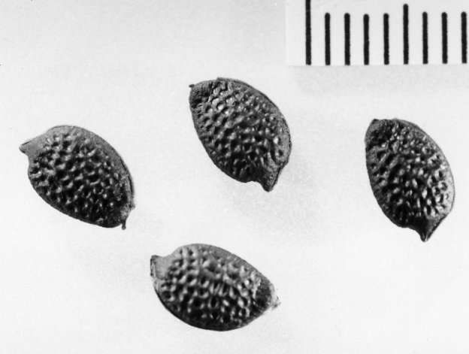
Figure 1 Passiflora incarnata (Maypop) seeds

(Powell 2012)
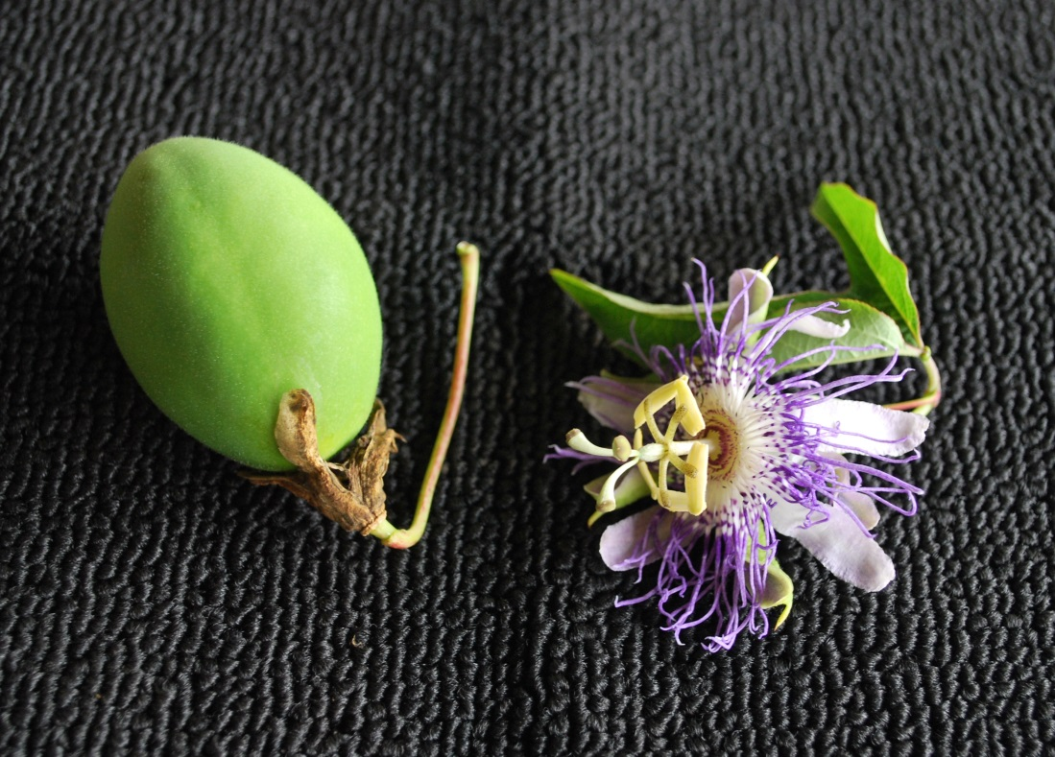
Figure 2 Passiflora incarnata (Maypop) flower and fruit found close to the Topper site basecamp
(Photograph by Sarah E. Walters)

CHAPTER 1: INTRODUCTION
One of the greatest challenges in archaeology is the accurate and absolute dating of sites. This challenge only becomes more difficult in the Southeastern United States, where the relative lack of identified deeply-stratified sites offering datable, organic remains seems particularly evident, especially when compared to the rest of the North American continent (Anderson and Sassaman 2012; Miller and Gingerich 2013; Waters et al. 2009).
This is especially notable where Paleoindian and Early Archaic occupations are concerned. Waters et al. (2009:1300) pointed out the fact that “stratified Paleoamerican sites are rare in the Southeastern United States.” Anderson and Sassaman (2012:57) later echoed that sentiment, stating that “few well-dated deeply stratified sites spanning the Middle Paleoindian through the Early Archaic periods and Clovis through side- and corner-notched forms have been found in the region, making determining the age of assemblages and hence the study of change over time difficult.” As recently as two years ago, while analyzing the current radiocarbon record for the terminal Pleistocene and early Holocene in the Eastern United States, Miller and Gingerich (2013:176) lamented that, “despite the abundance and variety of artifacts, there is one glaring obstacle that hampers the study of the terminal Pleistocene and early Holocene record of the eastern United States – the rarity of stratified sites with datable material.” With a few notable exceptions, like Dust Cave in Alabama (Hollenbach 2009), such sites are indeed rare in the region.
In the Southeastern United States, a number of significant considerations have played an important role with regard to the recovery of organic remains, and more specifically on the subfield of paleoethnobotany, which is an aspect of archaeological research that specifically focuses on understanding past human and plant interactions (Pearsall 2010:2). Paleoethnobotanical analysis is typically achieved through the directed recovery of archaeobotanical materials utilizing specialized recovery and processing methodologies, which have been developed specifically for such purposes. Unfortunately, prevailing thought-paradigms have, in large part, precluded routine, systematic recovery efforts of paleoethnobotanical remains from the acidic, sandy soils of the Southeast — sans testing and/or demonstrating an absence of such remains prior to making the decision to exclude, even when deeply stratified archaeological sites are located and identified.
Anecdotally, a common belief in southeastern archaeology has been that, because of the highly acidic soils found throughout the region, which work to degrade and/or completely destroy organic remains, there is consistently little to no carbon-based material present in the soils of the region that could potentially be recovered, analyzed, and submitted for carbon dating. The dominant perception associated with these acidic soils, which are found throughout the Southeast, is that the high soil acidity works to chemically degrade most, if not all, organic material before it has the chance to preserve. Dunnell opined that, due to the widespread presence of highly acidic soils (as well as the perceived constant and seemingly ubiquitous nature of plant and animal bioturbation), organic preservation throughout the Southeastern United States “is not so hot” (Dunnell 1990:13), a sentiment with which most archaeologists working in the region seem to concur.
Furthermore, an additional layer in the argument against routine paleoethnobotanical recovery — especially in predominantly sand-based matrices, such as those found throughout the Coastal Plain — is the perceived mechanical destruction of organic remains by sand. It is understood that associated crushing mechanisms work to mechanically degrade — and inevitably destroy — those fragile organics that do manage to evade chemical destruction. Sandy soils are often perceived as high-energy destructive environments that are thought to be not conducive to the long-term preservation of archaeobotanical remains. This is a logical thought process – but only if one characterizes the entirety of sandy environments as the same.
While it has been demonstrated that there are indeed environments in which forces act to cyclically ‘churn’ the soil matrix, thus grinding any surviving carbonized organic remains (in addition to destroying existing stratigraphic context) (Michie 1990), the well-studied dynamics of high-energy marine/riverine sandy environments have incorrectly been transposed onto the entirety of the landscape encompassed by the Southeastern Coastal Plain. Here, it is important to reiterate that all sandy deposits (regardless of geographical region) and the environments in which they were formed, and currently exist, are not the same. Sand-based matrices exist throughout the region that were neither formed nor were affected, postdepositionally, by such high-energy marine or riverine energies (Cooke 1936). In better understanding the robust nature of organic materials (especially carbonized remains), the above premise should perhaps be reconsidered when deliberating the potentially for the retrieval of organic remains from archaeological contexts located in both sandy and acidic environments.
When considered more abstractly, the purported inability for organic remains to differentially preserve in the acidic sands of the Southeastern Coastal Plain seems to be centered upon the following generalized perceptions and concerns:
- That biological decomposition destroys most (if not all) organic material deposited on the surface;
- That high soil acidity chemically degrades any remaining organics before such has the chance to preserve;
- That crushing mechanisms, associated with sandy environments, work to mechanically degrade – and inevitably destroy – whatever fragile organics that manage to evade both biological and chemical destruction, even if/when carbonized;
- That these same mechanical actions also act to destroy any horizontal and/or vertical stratigraphic integrity; thus invalidating any data derived from organic remains, if actually recovered; and
- That small, light, carbonized and non-carbonized remains may be transported downwards through bioturbation processes.
The well-documented, poor preservation environment found throughout the Southeast has indeed proven to be the likely culprit when considering the recovery of non-carbonized organic remains in Coastal Plain settings. Relative to other regions of the United States, the dearth of data regarding the recovery of organic material, especially outside of specialized preservation contexts, is readily evident when the corpus of archaeological literature is examined for the region (Dunnell 1990). However, the fundamental problem with the aforementioned perspective is that it misunderstands the robust ability of fully carbonized organic remains, especially archaeobotanical materials (e.g. seeds, nutshell, wood masses etc.) to differentially preserve. When considering the recovery of carbonized plant remains, it should be understood that elemental carbon does not appear to react at all with the highly acidic soils common to the region. In short, elemental carbon appears to be immune to acidic degradation.
Additionally, it is possible that unusually significant finds in archaeology – brought about through specialized depositional events or through the protection of differential preservation environments (such as the oxygen-reducing environments provided by bogs, water-logged sites, and heavy clays; the pH-neutralizing abilities of shell-rich environments, etc.) – have somewhat skewed our ideas as to how viable organic remains should appear. Unusually preserved organic remains such as the skeletal remains, textiles and tools intentionally submerged in a peat pond bottom at the Windover Site in Florida (Tuross et al. 1994:289), the preservation of whole households burned and protected in situ such as those at the Berry Site in North Carolina (Beck et al. 2006:72), and the innumerable organic remains (e.g. bones, plants, building materials, human footprints, hide, and soft tissue) found preserved under a peat layer at the Monte Verde II site in Chile (Dillehay et al. 2008:784) are outstanding examples of some of the better preservation environments in which fragile organic materials have been recovered.
While the majority of archaeological sites are not likely to contain such substantial and well-preserved evidence for the utilization of organic materials by prehistoric and historic populations, there may be additional environments, beyond those well understood for excellent preservation, from which we can pull data, albeit in a somewhat less impressive, but no less additive, fashion. The scale of recoverable archaeobotanical remains will likely be less impressive than the extraordinary examples previously mentioned. However, if present, these remains will be no less useful for archaeological research and interpretation.
It is important to note, however, that the aforementioned thought-paradigms are certainly not the case for all archaeological undertakings within the Southeast. Many Southeastern archaeologists commonly test for the presence of organic remains through paleoethnobotanical research, and see this testing as both routine and standard, regardless of the results (i.e. Icehouse Bottom (Chapman and Crites 1987), and Dust Cave (Walker et al. 2001). In his review, directed at the changing trends in South Carolina archaeology (the location of this research project), Anderson noted that, since the 1990s, the “concern for the recovery of paleosubsistence data has also grown. Ethnobotanical and zooarchaeological analyses are now a routine part of research” (2002:158).
This is promising information when considering the expanded inclusion and expanded recovery of paleosubsistance and archaeobotanical data in South Carolina archaeology. It logically follows that routine testing for the presence of organic remains, utilizing paleoethnobotanical recovery methodologies, should be undertaken at all stratified sites in the South Carolina, and also in other regions with similar depositional environments. Through the research detailed here, I hope to expand the understanding of the environments in which such data may be found. If such remains are found to be present, the directed recovery of such materials from any such site in the form of paleoethnobotanical research must become a routine part of site assessment and standard archaeological practice.

Project Background
All of the field research for this project was conducted at the Topper site (38AL23), which is a quarry and quarry-based habitation site located in Allendale County, South Carolina. Topper is an important site, especially in South Carolina, due to the fact that the archaeological components of the site (which extend from the Paleoindian to historic periods) are all stratified and deeply buried, a rarity in the region. The depositional environment, which is highly acidic and primarily sand-based, provided the ideal soil matrix in which to test the hypothesis of this thesis – that, in utilizing paleoethnobotanical methodologies, it is possible to establish that there are extant carbonized remains present within a greater range of preservation environments than previously thought, and that the recovery of these remains may aid in the radiometric dating of significant archaeological occupations, many of which have no other way to be dated through absolute means.
This project’s intent is two-fold:
- Demonstrate that viable carbonized organic remains can, in fact, be systematically recovered (using considered paleoethnobotanical methodology) from sandy and acidic depositional environment, and can also be dated through radiometric means.
- Demonstrate the greater scientific utility of paleoethnobotanical recovery methodologies, through analysis of associated artifact classes recovered using a whole-column bulk sampling (WCBS) methodology, such as the one presented here.
The aim of this thesis, then, is to demonstrate that, not only are there recoverable, identifiable remains in the sandy, acidic soils of the Southeastern United States Coastal Plain, but that these remains can sometimes be stratigraphically intact, and can result in highly accurate dates, even back as far as the Paleoindian time period. This research will demonstrate the necessity and value of regular paleoethnobotanical assessment, especially through bulk-sampling techniques, and argues that such procedures should be included as a routine part of any excavation in such depositional conditions.
I also argue that paleoethnobotanical research is not only useful in reconstructing an accurate record of botanical utility by the historic and prehistoric inhabitants of an archaeological site, but may also prove valuable by allowing for accurate absolute dating of associated artifact floors as well as associated features, when encountered. Additional macro- and micro-artifact classes are also likely to be recovered through a whole-column bulk sampling (WCBS) strategy, such as the one specifically created for this research (Chapter 3). These additional data may offer additional, valuable information about the historic and prehistoric past, as well as potentially serving to corroborate stratigraphic integrity, an essential component in the interpretation of all data recovered within.
With the results of this research, this thesis hopes to demonstrate that the thought-paradigm that acidic soils and mechanical actions work to break down organic remains should only be applied to non-carbonized organic remains, and perhaps even this concept should be further tested. It has now been shown that fully carbonized remains are both present and also do not seem to be negatively affected by acidic or sandy soils. This research provides a paleoethnobotanical-based methodology for testing the ability to date sites traditionally thought to be devoid of materials necessary for absolute dating through radiometric means.
As this thesis will show, specimens derived from what was previously thought to be a poor depositional environment, unsuited to the recovery of organic remains, have the ability to yield accurate AMS dates. For a quarry site like Topper, where the major focus has long been on lithic technology, such efforts, if expanded in application, have the potential to effectively establish an accurate absolute chronology for all accepted occupations in the Southeastern United States, where previously, none was thought possible.

CHAPTER 2: THE TOPPER SITE (38AL23)
The Topper site was specifically selected for this research because it provided an ideal environment in which to test for the presence of carbonized plant remains. It is a well-known and extensively excavated archaeological site, with deeply buried, stratified and widespread amounts of artifacts that span the whole of Southeastern prehistoric and historic periods (Goodyear 1998, 2005; King 2012; Miller 2010; Sain 2010, 2015; Smallwood 2010).
Limited information on organic remains recovered from the site and surrounding region, provided limited direction in determining the potential for the recovery of carbonized remains. The majority of the information found, prior to this project, concluded that organic remains were likely not present within the soil matrix at the Topper site, especially within the Paleoindian and Archaic occupational layers (e.g. Goodyear and Charles 1984; Waters et al. 2009). In a paper published in 1984 by Dr. Albert Goodyear (the Topper site Primary Investigator until his retirement in 2013) and Tommy Charles, they state that, “for most areas of the eastern United States, the only surviving records of Paleoindian and Archaic groups is that of their lithic technologies. In the majority of cases all that we shall ever know will be based on interpretations of chipped stone assemblages and the geoarchaeological contexts within which they are found” (Goodyear and Charles 1984:1). However, the sandy soil matrix found through the site, most likely highly acidic (as are most soils in the region), combined with the relative lack of published paleoethnobotanical data from the site, made Topper a perfect candidate at which to test the ability to recover archaeobotanical remains from a sandy, acidic archaeological site located in the Southeastern United States.
Most of the artifacts typically encountered and/or recovered from the Topper site are ceramic sherds from Woodland, Mississippian, and Historic periods; partially finished, broken, or discarded stone tools (e.g. spear points, arrowheads, blades, scrapers); as well as large quantities of lithic debitage from the Paleoindian through Woodland periods (Goodyear 2005; King 2012; Miller 2010; Sain 2010, 2015). Non-carbonized organic artifacts are rarely encountered, and are typically found either in upper levels where the acidic soils have not had enough time to work to degrade the unprotected organic material, or are found in unusual preservation contexts. Due to this perceived dearth of organic remains, flotation processing to recover paleoethnobotanical artifacts was not routinely conducted. The basis for this thesis research was to evaluate the utility of flotation procedures, and specifically to evaluate whether carbonized remains were present at the site.
Eager to begin testing for archaeobotanical remains, I proposed a test study of the Topper site in order to examine the potential for carbonized organic materials to survive in the soil matrix, and we agreed that a presence/absence study should be undertaken before more thorough research could commence. With the approval and assistance of Dr. Goodyear, a test study was organized, a recovery methodology was constructed, and the recovery of the soil from the test column was carried out during the 2010 summer Topper field season. Based on the overwhelmingly positive results of the test study, as discussed in Chapter 4, the original test study was refined and expanded into a larger research study with the full support and encouragement of the Topper team. It is this research study that forms the basis for this Master’s Thesis. Data collected during this project, as well as a detailed photographic account of the fieldwork, are provided in Appendices A-H.

Topper Site History and Background
The Topper archaeological site, designated 38AL23, is a Coastal Plain chert quarry and associated quarry-related habitation site located in the Coastal Plain region of South Carolina, in Allendale County (Figures 3 and 4) (Goodyear and Steffy 2003:23). Located along the Savannah River, less than a mile east of the South Carolina — Georgia border, the landscape surrounding the Topper site was an ideal stop for Native Americans moving across the landscape. This is due to the fact that it is where a large Allendale Coastal Plain chert outcrop (part of the larger Flint River formation) occurs, that was clearly once a valuable and consistently visited resource for Native Americans (Smallwood 2010:2414). This is readily evident in the large number of potentially valuable quarry-related archaeological sites that have been identified throughout the area around the Topper site (Goodyear and Charles 1984). Prior to 2009, excavations at the Topper site proper had uncovered more than 590 m² of the Clovis site component (Smallwood 2010:2414).
Visible chert nodules and associated surface artifacts were first brought to the attention of South Carolina archaeologists Al Goodyear and Tommy Charles in 1980 by a local resident of Fairfax, South Carolina, Mr. David Topper, from whom the site received its eventual name (Goodyear and Charles 1984:80). Pedestrian survey, surface collections, and selective excavations were undertaken in the areas surrounding what is now known as the Topper site as part of the 1983-1984 Allendale County Quarry Survey. This survey was a concentrated effort by the archaeologists of South Carolina to identify and map chert outcrops and quarries and to assess their eligibility for the National Register of Historic Places (NRHP) (Goodyear and Charles 1984).
Figure 3 Major Physiographic Regions of the Southeastern United States
The red square denotes the general location of the Topper Site. (Modified from Anderson and Sassaman 2012:6)
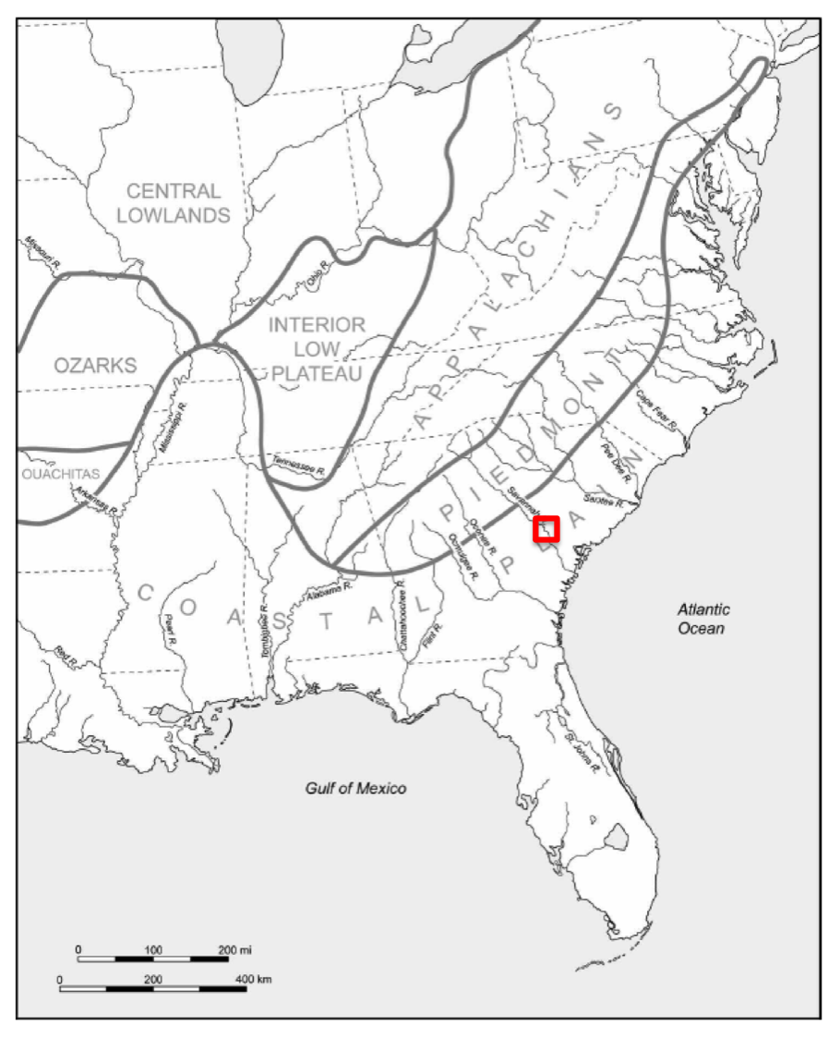
While limited in scope and time, the testing efforts during the quarry survey demonstrated the potentially important nature of the information that could be recovered, especially from sites 38AL23 and 38AL139, which are now collectively known as the Topper site, and at the time, were thought to have “excellent potential to inform about quarry utilization through time” (Goodyear and Charles 1984:82).
Additional test excavations were conducted in 1984, 1985 and 1986 (Goodyear and Steffy 2003:23), and long-term excavations through the Allendale Paleoindian Expedition began in 1998 (Goodyear and Steffy 2003:23; Sain 2015). These extensive excavation efforts readily demonstrated that earlier assessments in regard to the potential of the site were indeed correct.
However, while Topper has been the major focus of almost yearly excavations (1998-2016), it was not the only site in the area subject to extensive archaeological excavation. Topper is only one of the many registered archaeologically significant sites that sit within the extensive property boundaries of what was (during main excavations) the Clariant chemical plant and which is now the Archroma U.S Inc. chemical plant.

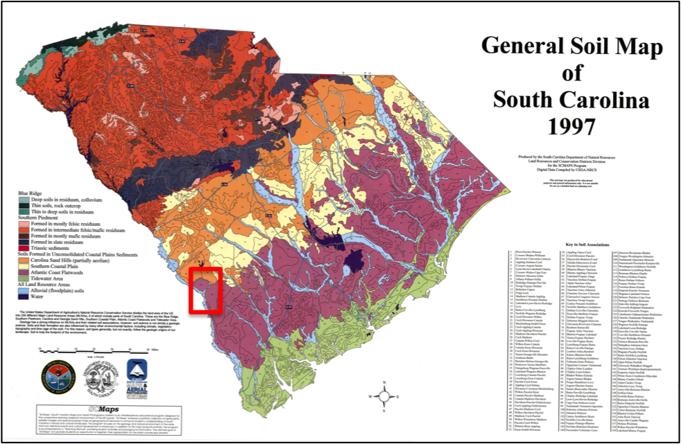
Figure 4 General Soil Map and Physiographic Regions of South Carolina with the approximate location of the Topper site indicated in red
(Map modified from SCDNR LRCDD 1997)

The Big Pine Tree site (38AL143) (Figure 5) was one of the first excavation areas within the
Figure 0-C Map of the Topper and Big Pine Tree sites in relation to each other
(Waters et al. 2009: 1301)

property. It is located along a small offshoot of the Savannah River known as Smith Lake Creek, was first identified in 1983, and was subject to excavations in 1983-1984, 1992, and 1995-1997 (Bland 1995; Russell 2015:1). In 1998, Smith Lake Creek flooded, forcing excavations to move to what is now known as Topper, and since the inundation of the Big Pine Tree site, the majority of the scientific excavations in the quarry locality were conducted within the Topper site (1998-2016) (Figure 5). However, with the assistance of the SCIAA Underwater Archaeology Division, selective underwater recovery, via dredging, continued to be performed in Smith Lake Creek at the Big Pine Tree site in the early 2000s — providing what is likely one of the largest and best scientifically collected lithic tool and point-type assemblages in the Southeast.

Figure 6 Map of the Topper and Big Pine Tree sites in relation to each other

While the area surrounding the Topper site contains a total of thirteen currently identified chert quarries, twenty years of excavation at the site have demonstrated the constant and repeated utilization of this specific quarry and the surrounding property by Native Americans, from the Paleoindian (Paleo-American) period through historic times (Goodyear and Charles 1984; Smallwood 2010; Miller 2007; Sain 2010; Waters 2009).
There are also a number of documented historic settlements throughout the property as evidenced by numerous artifact types found both on the ground surface and during site excavations, including (but certainly not limited to) ceramic vessels and sherds, pipe stems, and manganese glass shards. Due to these aforementioned extensive excavation efforts, Topper has since been accepted as a significant archaeological site, providing evidence for extensive quarry-related activities, as well as widespread and stratified evidence for occupation of all time-periods associated with Southeastern archaeology.
Because Topper was primarily used as a tool-stone quarry, it only makes sense that the main focus of these excavations at Topper has been aimed at the extensive lithic material that is now known to be almost omnipresent throughout the site (Miller 2007; Smallwood 2010; Weidman 2013). And while Topper easily provides one of the best examples of Clovis lithic technology in North America (as well as containing notable assemblages from subsequent prehistoric, Contact, and Historic periods), there is myriad other data at the site that also have the potential to expand our knowledge of the archaeological record in South Carolina.
Even after decades of excavation, the amount of information that remains buried throughout the site is so prolific that, even after the retirement of Dr. Goodyear in 2013, excavations at the site continue today, making Topper an undeniably significant resource for South Carolina and Eastern United States archaeology when considering the future of archaeological research in the region.

Topper Site Location and Environment
Topper is located in the Upper Atlantic Coastal Plain physiographic region of South Carolina (Figure 4) (Smallwood 2010: 2414; Waters et al. 2009: 1300). The Fall Line, which is located northwest of Topper, divides the Piedmont and Coastal Plain across the state of South Carolina (SCDOT 2008). Everything to the southeast of the Fall Line, Topper included, is considered to be within this Coastal Plain region (SCDOT 2008). Above the Fall Line, throughout the Piedmont, the physiographic region is dominated by bedrock, while the Coastal Plain is covered by sedimentary soils that were created from “unconsolidated sand, clay, gravel, marl, cemented sands, and limestone” (SCDOT 2008).
Geologically, the site is located at the boundary between Tertiary Paleocene, Eocene and Miocene deposits and later Quaternary sediments (Cooke 1936; SCDOT 2008). The areas of the site from which this research was undertaken are mostly unconsolidated, well-drained late Quaternary sediments – specifically a mixture of aeolian sands and colluvium (Waters et al. 2009:1303) – with little evidence of the formation of lamellae or visible distinctions for soil stratification. These sands are located on top of the Miocene Altamaha Formation, which Waters et al. described as “weathered, red colored deposits of sand, silt, and clay” (2009:1303). The Miocene Altamaha Formation, in turn, rests on top of the late Eocene Tobacco Road Formation (Waters et al. 2009: 1303). The late Quartenary colluvium and associated aeolian sediments were deposited on top of the Eocene and Miocene formations over thousands of years and it is through these processes that the significant artifact floors found throughout the Topper site were buried (Waters et al. 2009: 1303).
The Topper site is located on multiple terraces that sit just above the Savannah River, and is split into three major excavation areas; the Pleistocene Terrace, the Hillside, and the Upper Hillside (Figure 8). The Pleistocene Terrace is located just above the Savannah River, and work in this area has primarily been focused on the potential Pre-Clovis deposits. However, it should be noted that there are also significant later occupations located in the sands above the more compact Pleistocene Terrace formation. Excavations on the Topper Hillside and Upper Hillside

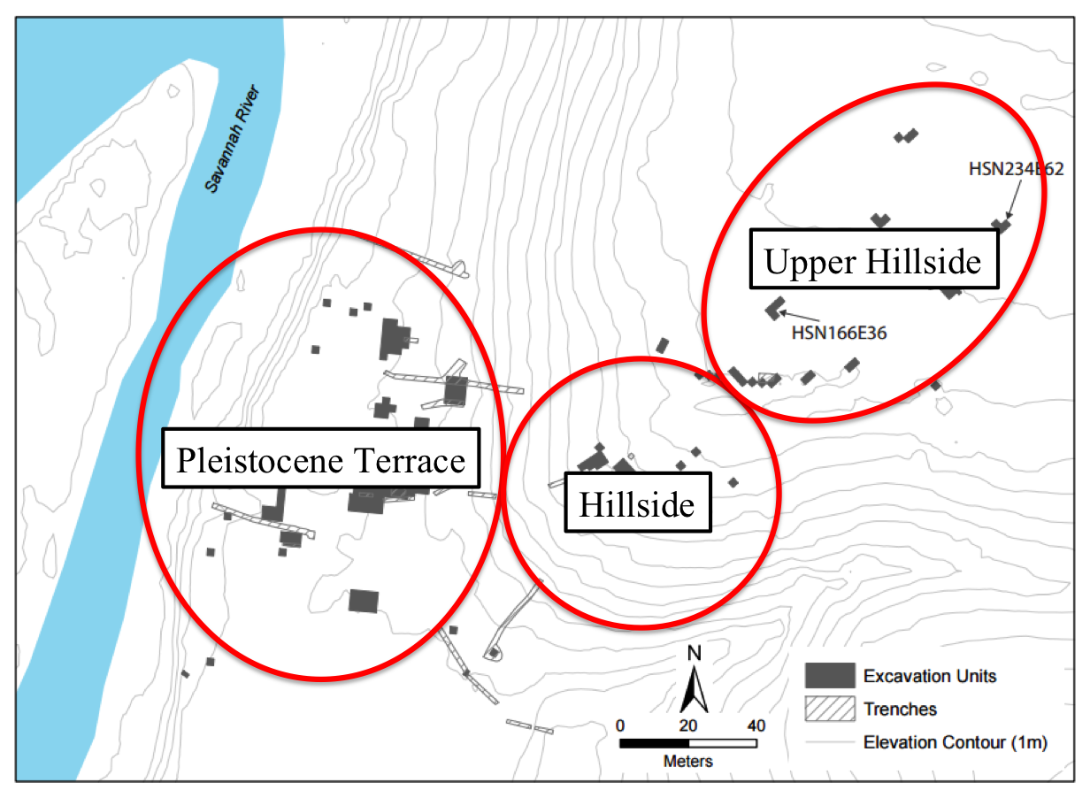
Figure 0-E The three major excavation areas at the Topper Site
(Modified from map provided by Dr. D. Shane Miller)

are located, as the name suggests, uphill from the Pleistocene Terrace. The Hillside excavations are situated adjacent to the chert outcropping, which has been eroding out of the Topper hillside for thousands of years (Cooke 1936). The Upper Hillside is located along a flat, sparsely wooded area at the pinnacle of the site. Other smaller units and short-term trenches for scientific evaluation have been excavated throughout the property, but the Upper Hillside, Hillside, and Terrace are the mains areas where fieldwork has occurred at Topper.
In regard to the potential for the recovery of carbonized remains from the Topper site, and according to the most extensive geoarchaeological assessment currently published for the site, it is likely any wood and plant macrofossils recovered from older strata at Topper were likely introduced through plant bioturbation, or were found in situ only in rare reducing environments Waters et al. (2009:1304). In the same report, it was stated that both “charcoal and wood are rare at the Topper site” (Waters et al. 2009:1304).

Figure 8 The three major excavation areas at the Topper Site

As evidence, Waters et al. (2009) were able to test thirteen organic samples recovered from the Topper site. However, eight of these samples were radiometrically dated and were subsequently rejected due to that fact that they returned dates that were greater than 44,000 14C yr B.P. ± 1 sd, a date which lies well beyond the accepted occupation boundaries for the Southeastern United States (Waters et al 2009:1306). Of the other five samples processed, four were taken from recovered humic acids, and the last was from a sample of charcoal and was also rejected due to the fact that its date was much younger than the associated feature from which it was recovered (Waters et al. 2009:1305). This discontinuity was determined to have been caused by modern plant bioturbation into the Archaic feature (Waters et al. 2009:1305).
It should be noted that the study conducted by Waters et al. (2009) singularly focused on excavations undertaken below the chert outcropping eroding from the Topper hillside. The hillside is located approximately halfway between the Upper Hillside and the Pleistocene Terrace. It was this terrace that was the location of the Waters et al. 2009 research (Waters et al. 2009:1302). The Pleistocene Terrace is perhaps the best known area of the Topper site, due to the presence of inferred Pre-Clovis aged remains of great antiquity (Goodyear 2005, King 2012; Sain 2015); Topper has, as a result, become caught up in the larger, somewhat controversial, Pre-Clovis debate. None of the research detailed in the 2009 paper was conducted in the vicinity of the Upper Hillside excavations, where the research for this project was undertaken (Figure 7).

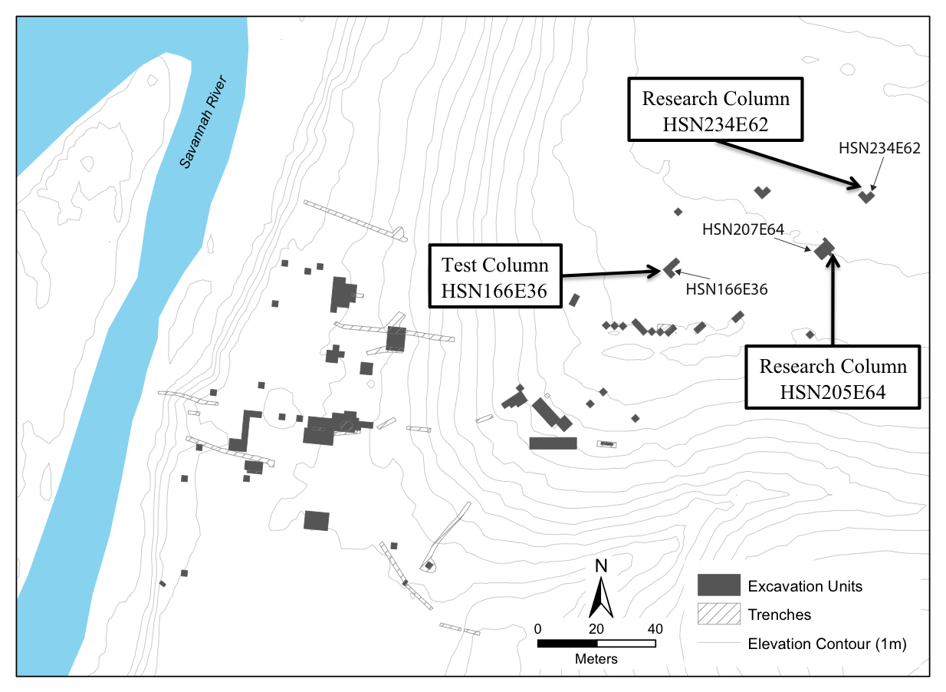
Figure 9 Location of the Test and Research Columns on the Topper Upper Hillside
(Modified from map provided by Dr. D. Shane Miller.)

The Current and Future Role of the Topper Site in South Carolina Archaeology
In regard to Paleoindian research throughout the Southeastern United States, “the actual archaeological evidence for initial settlement has only rarely been examined from a holistic perspective” (Anderson 1990:163). Because sites such as Topper are a rarity on the landscape throughout the Southeast and South Carolina in particular, it is crucial that all aspects of the archaeological assemblage at Topper — not just the lithic materials — are studied in order to preserve this data for posterity, to better understand the site record and the people who inhabited it over thousands of years. It is this understanding that spurred the research detailed here.

Figure 10
According to Anderson, “much of the early and middle Paleoindian material found to date in the Southeast has come from surface contexts” (1990:179), a fact that only makes the deeply buried, and stratigraphically intact artifacts located across the Topper site more significant. In fact, it was not until the 1980s that any stratified Paleoindian deposits with “stratigraphic integrity, clarity and interpretable assemblages” (Goodyear et al. 1989:28) would be recognized in South Carolina. Prior to this shift, the most fruitful archaeological data in the state was provided by the statewide lanceolate point survey (Goodyear et al, 1989:28). While significant research is still undertaken through state and nationwide point surveys (e.g. the Paleoindian Database of the Americas (PIDBA), the ability to recover diagnostic lithic tools directly from a deeply buried site, such as Topper, allows for an increased understanding of the nature of the activities centered around quarry-related environments.
Because “stratified Paleo-American sites are rare in the Southeastern United States” (Waters et al. 2009:1300), Topper is unique in the fact that it has intact, stratigraphically layered evidence for the occupation of the site in all firmly accepted periods throughout southeastern historic and prehistory — Paleoindian, Archaic, Woodland, Mississippian and Historic. Indeed, “the Topper and Big Pine Tree sites provide evidence that stratified Paleo-American sites exist in the Southeastern United States” (Waters et al. 2009:1310), meaning a site such as Topper, and the archaeological data contained within are exceptionally precious and archaeologically valuable.
Deeply stratified sites in the Southeast, such as Dust Cave in Alabama (Hollenbach 2009), are crucial for providing both the stratigraphic sequences and absolute dates necessary to test the relative chronologies that have been constructed, especially for the Paleoindian period (Anderson and Sassaman 2012:57; Anderson et al. 2015; Dunnell 1990; Miller and Gingerich 2013). The Topper site is a rare southeastern archaeological resource, in terms of the deeply buried and stratified nature of the deposits for all known and currently accepted archaeological occupations in this part of the region, both historic and prehistoric. The significant and constant nature of the known archaeological remains at the Topper site, when coupled with increased, systematic recovery and analysis of carbonized remains (and other associated artifact classes), may provide archaeologists the opportunity to add even more valuable chronological and sequence data to the archaeological record of South Carolina and the southeast in general.

CHAPTER 3: METHODS

Test Column Recovery Methods
In collaboration with a number of colleagues I initially designed and conducted a simple presence/absence study using soils recovered from a single test column (50-cm x 50-cm square, with 5-cm vertical arbitrary levels) that was excavated at the Topper Site during the 2010 summer field season. This was done to assess the feasibility and potential of recovering carbonized remains from the acidic, sandy soil matrices ubiquitously found throughout the site. The recovery and processing protocols created during this primary test column survey were the basis on which I created the specific and refined protocols used for this thesis project.
The soils recovered from this test column were later processed through water flotation at the 2010 Bells Bend Archaeological Project, a University of Tennessee summer field school under the direction of Dr. David G. Anderson of the University of Tennessee, Knoxville. The ability to process the column samples at the field school provided a unique chance not only to move forward with my initial analysis of the recovered soils from the test column, but also to instruct the students working at the Bells Bend field school in how to process column samples and conduct simple analyses on soils recovered from paleoethnobotanical investigation.
Detailed laboratory analysis, under the direction of Dr. Hollenbach, determined that clearly identifiable, carbonized remains were ubiquitously preserved downward through the 1.3-meter stratigraphy of the test column. Given the classification and associated context of the carbonized flora identified, it was quickly evident that many of these materials were likely culturally deposited.
The preliminary results of the original test column were first reported at the 2011 Annual Meeting of the Southeastern Archaeological Conference (SEAC), held in Jacksonville, Florida. This initial research was then developed further to become the subject of this master’s thesis work. The study was expanded to include an additional two columns, the analysis results from one of which is reported here (again, 50-cm x 50-cm square, with 5-cm vertical arbitrary levels) and several controls were tightened, utilizing data gathered from the original test column. These changes are discussed in more detail below.
Understanding both the monetary and time constraints that most archaeological sites must function within, it quickly became evident that it would take firm evidence of the presence of recoverable carbonized remains before in-depth paleoethnobotanical investigationsurvey and flotation would become routine at the Topper site. Thus, a research plan for test column recovery and analysis was established in conjunction with a number of site staff and faculty members from the University of Tennessee.
The protocols for the excavation of the initial test column were developed through a series of discussions between Stephen Carmody, Dr. Goodyear, Dr. Hollenbach, Dr. Wagner, Sean Cary von Gunter, Kat Forst, and myself. The recovery methodology developed for this project is described as a whole-column bulk sampling strategy (WCBS), which differentiates it from other commonly used sampling strategies (e.g. blanket, feature, in situ). This methodology is discussed further below.
The strategy for excavation involved the removal of a column of soil from the east wall of a previously excavated Topper Upper Hillside unit and was designated HSN166E36 (HSN standing for “Hillside North 166 East 36”, following standard unit naming protocol at Topper) (Figure 8). Based on suggestions for the amount of soil needed for substantial paleoethnobotanical recovery in the Southeastern United States (Wagner 1988), this column was approximately 50-cm x 50-cm square, and each level of soil removed was taken in 5-cm units (approximately 12.50 liters of soil recovered per level) from the ground surface to the depth of one meter (Figure 8).
With the help of one additional Topper staff member, the complete removal of the test column was conducted over a single weekend during the 2010 summer field season. Prior to soils removal, the top of the unit was scraped clear of modern debris and detritus. Standard archaeological trowels were used to remove the soil, which was then scooped into a dustpan and from there into the soil sample bag. Each level was placed in its own double or triple bagged clean plastic trash bags, which in turn were placed in a large five-gallon bucket for support during excavation. Redundant flagging tape strips with site, unit number, and specific level information were placed into each bag with the soil sample, and an additional label was tied around the top of each bag to ensure correct identification of each sample. The soil samples were moved from the site and were stored in a protected location at the Topper basecamp until they could be transported for processing. Once the field season had ended, the samples were transported to another archaeological site, located outside of Nashville, Tennessee.
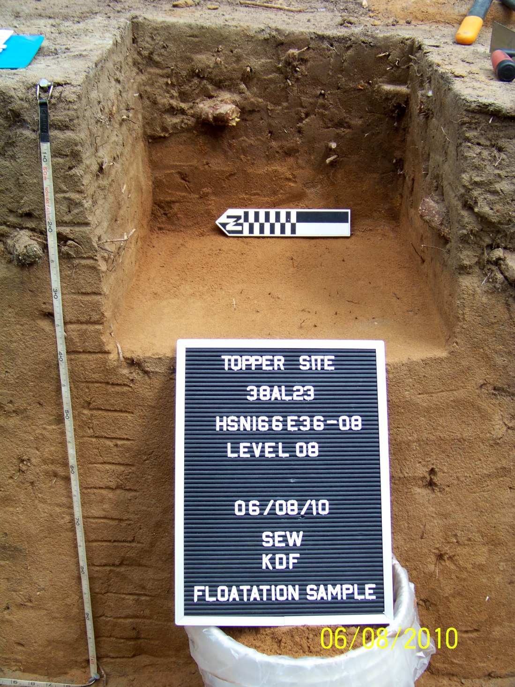
Figure 11 Test Column HSN166E36 on the Topper Upper Hillside during sample excavation

All of the samples were processed through machine-assisted water flotation later that summer at the 2010 Bells Bend Field School, which took place at the Bells Bend Park outside Nashville, TN. Dr. David G. Anderson was the PI and project director. During the field school, I was able to learn from and work with Stephen Carmody, who was already experienced with paleoethnobotanical recovery and processing, to supervise the entirety of the flotation process. This latter part of the project also served as an opportunity for the field school students at Bells Bend to learn, first-hand, about both the importance of paleoethnobotanical recovery, and the pragmatic procedures behind the science.
The flotation process involved the use of a simple, modified SMAP-type tank (SMAP-Shell Mound Archaeological Project) that was provided for my use by the Archaeological Research Lab at the University of Tennessee. This flotation tank followed the main system components introduced by Patty Jo Watson in the mid-1970s (Pearsall 2010:27).
The tank was essentially a large, heavy plastic drum with the top cut off and a metal spout fitted to one edge of the rim (Figure 10). A metal wire grill was set halfway down into the tank and sat on metal brackets in order to support the heavy fraction collection mesh from collapsing completely into the tank. Just below the grill, on the side of the tank opposite from the metal spout, was a PVC pipe input for a garden hose, the means by which the tank was filled. The hose, which was equipped with a shutoff valve for ease of use, was then connected through a hole in the tank wall to two additional connected PVC pipes, which were drilled with small holes, allowing for the pressure from the garden hose to create a “bubbling” or agitation effect that assisted in the flotation processing (Figure 9). A small portable field table was place in front of the tank, just under the spout.
The flotation process results in the separation of the soil sample into two parts; the “heavy” fraction and the “light” fraction. The netting for the heavy fraction, standard “no-see-um” screen door mesh (approximately 1/20th x 1/18th of an inch in size), was purchased from a hardware store and cut into pieces large enough to sink down into the tank, while allowing enough to fold over the edges of the tank. The lighter fraction mesh, with much smaller openings than that of the heavy fraction mesh, was made out of nylon wedding veil mesh purchased from a fabric store. Unfortunately, it was not possible to determine the exact mesh size of this material. It was also cut into pieces large enough to fit a standard round metal geological sieve.

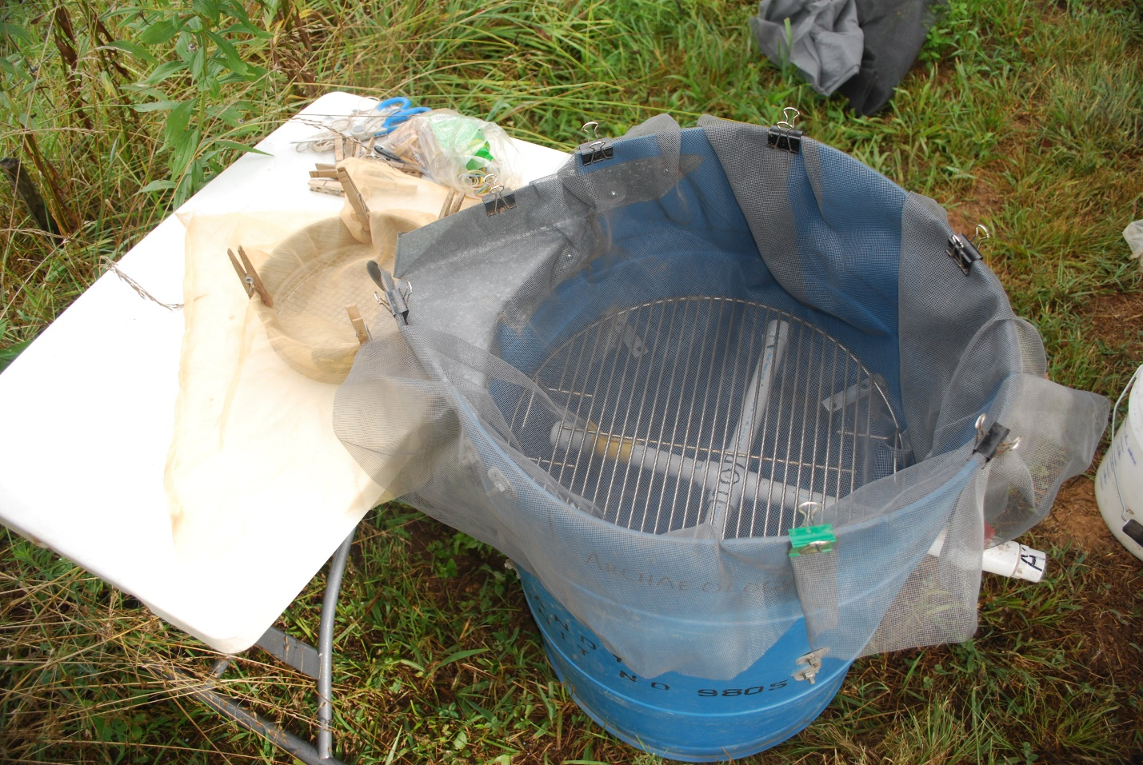
Figure 12 Modified SMAP-type flotation system used for processing the samples from both the test column and the research column
(Flotation system equipment provided for my use by the Archaeological Research Laboratory, at the University of Tennessee, Knoxville)

The geological sieve with the light fraction mesh was placed on the table, just below the spout, to catch any remains that would float and be transported out of the tank through the agitation and flow of water. The light and heavy pieces of mesh were clipped to the edges of the sieve and tank with standard binder clips to hold the heavy fraction and clothespins to hold the lighter. Once the station was set, the hose was turned on and the tank was filled.
Once the tank was nearly full, a sample was selected for processing. Using a plastic pitcher, each sample was measured (in liters) before it was poured into the tank, and this measurement was recorded for each level processed. The soils were slowly poured into the tank in order to minimize the risks of splashing or spillover. During the float process, the majority of the soil falls through the heavy fraction mesh, leaving behind carbonized remains, artifacts, and larger sand grains, while lighter objects float and spill over into the light fraction mesh. The staff and students working the float station provided a small amount of gentle agitation to assist with the processing of the samples. However, to avoid crushing any carbon samples, great care was taken not to rub anything against the mesh or walls of the tank. The flagging tape strips with level information were recovered from each sample bag and one was placed into each fraction during the flotation process. This ensured the accuracy of identification for each sample once they were dry and ready to be bagged.
After each sample was complete, the hose was removed from the tank and the water was allowed to slowly run from the tank through the hose attachment pipe. As the samples were carefully removed from the tank it was often necessary to use the hose to wash remaining materials down into the mesh from the sides, where they clung during the float process. Each fraction was then gathered together and secured with a rubber band. They were then hung on the drying rack.
This rack consisted of 2” x 4” wood rails hung horizontally, with eyehooks screwed into the wood every few inches. From these were hung small ropes that were finished with slipknots. The fractions were either slipped into the knots and tightened or were clipped to them with binder clips, and were later collected when they were completely dry. As suggested by Deborah Pearsall, the heavy and light fractions were hung so that they were shaded by the overhang of the back porch at the Bells Bend Outdoor Center and were out of direct sunlight. This precaution was taken in order to prevent unnecessary breakage due to the too rapid drying of wet charcoal (Pearsall 2010:43). With the addition of warm summer temperatures, and often lightly breezy weather, the majority of samples dried in less than a day.
After the samples were hung up to dry, the remainder of the sands and soils in the flotation tank were dumped along the fence line with the approval of the site manager, and any remaining material was flushed out via the garden hose used to fill the tank. The tank was thoroughly hosed down, both inside and out, between each processing cycle, in order to avoid any cross contamination between levels. When clean, the tank was reset, and a new sample was chosen for processing.
Once dry, each fraction was gently removed from the drying rack and brought inside to the Bells Bend Archaeological Project Lab. Samples were gently shaken from the mesh onto clean, paper-lined cafeteria trays, and then into marked curation-quality ziplock bags. The flagging tape strips were also inserted into each bag with the remainder of the soil samples. Each bag was marked with the same information, and, once complete, they were placed into a plastic tub until they could be transported back to the Archaeological Research Lab (ARL) at the University of Tennessee. Because it was necessary to recycle both the heavy and light fraction mesh squares on a daily basis, they were cleaned with water, again from the garden hose, and were dried on picnic tables in the sun before reuse.
Once back in Knoxville, the samples, which were protected in a large plastic tub, were placed in the ARL’s paleoethnobotanical laboratory until analysis could commence. They now reside in the paleoethnobotany lab, and will remain there until this project is complete, at which time the author will return them to the location of Topper site collections at South Carolina Institute of Archaeology and Anthropology in Columbia, South Carolina for curation in perpetuity. In agreement with Dr. Goodyear, all lithic materials larger than ¼” were set aside and will be separately returned to the site curation location at SCIAA once research is complete. The same was done with the lithics from the research column, which is discussed below. The samples and associated records from the research column analysis will also be returned to SCIAA for curation once this project is finalized.
A number of the levels recovered through the test process were analyzed by Sean Cary von Gunter as part of his project for the paleoethnobotany class at the University of Tennessee, under the direction of Dr. Kandace Hollenbach. I also analyzed a number of the levels as well, identifying a variety of different species of carbonized plant remains throughout. It quickly became apparent that the recovery of these remains at the Topper site was a feasible project that required more in-depth study. It was also clear that the recovery methods needed to be refined to aid in ease of both transport and processing.

Refined Sampling Methods
Once it was established that this project should be expanded and two additional column samples could be taken in support of this research, I discussed with colleagues familiar with the standard paleoethnobotany methodologies how best to refine and tighten the protocols from the test column, in hopes of making the recovery even more rigorous, as well as more likely to produce viable quantities of carbonized remains.
The additional research columns were also located on the Upper Hillside, to the northeast of the test column, and were designated HSN205E64 and HSN234E62 (Figure 7). These two columns were taken from the walls of previously excavated units, the same protocol as the test column. With the assistance of undergraduate students and project volunteers, these additional research columns were both excavated and processed through water flotation during the 2011 Topper field season.
While two additional columns were recovered and processed in the field, the resulting data from only one of the two columns was used for this research—HSN205E64. Both excavated research columns (HSN205E64 and HSN234E62) were associated with large block excavations. The unit in association with column HSN205E64 provided large quantities of lithic materials throughout the entire strata, while the unit associated with column HSN234E62 was not nearly as artifact-rich. The additional artifact classes recovered from the research columns were used for supplemental research and provided enough data to support the hypothesis without an analysis of both columns. Due to the rich nature of associated deposits, research column HSN205E64 was utilized for the purposes of this research and no data from column HSN234E62 will be presented here. Future analysis of the second column is planned and will likely help to supplement the data presented here.
Because the initial recovery process of the test columns was somewhat time consuming, likely due to the use of hand tools (i.e., trowels), for the research column, I made use of a short handled, flat bladed shovel that greatly shortened the time it took to collect the samples. It also had the added bonus of allowing the soils to be removed in a few scoops as possible, likely minimizing any physical damage the metal tools may do to the artifacts, including charcoal fragments, present within the soil matrix.
Instead of using plastic trash bags to contain level fill, which were found to be cumbersome, weak, and awkward, each level taken from the research column was placed in its own clean, plastic five-gallon bucket, which was labeled both inside and out, again with flagging tape labels, and then sealed with a tight-fitting lid. This allowed for better protection of samples and also greatly aided in the ease of transport. It should be noted that each bucket was cleaned (using a hose at the Topper basecamp) between each sample, as were all of the tools used during excavation.
Finally, given that the amount of soil from each level (approximately 12.5 liters) greatly exceeded the suggested minimum four to eight liters per sample for paleoethnobotanical recovery in the Southeast (Wagner 1988:26), the research column was excavated in the same proportions as the test column, 50-cm x 50-cm x 5-cm arbitrary levels. Unlike the test column, however, the 30 cm of topsoil for the research column had already been removed prior to primary paleoethnobotanical excavation efforts, a standard safety practice at Topper for any unit likely to be excavated deeper than 1 meter. Thus any data that may have been gathered from these levels could not be included in this research design. Subsequent research in 2015 has shown that the upper humus zone was an old plowzone, so paleobotanical materials within it were likely somewhat mixed and degraded. Specific paperwork was created in order to better record the paleoethnobotany field recovery, and also helped to ensure the certainty of provenience throughout the process. Additional photographic records were also taken to document the removal of samples while in the field.
Once the additional two research columns were recovered, processed and sorted, and based on available funding, three specific and representative samples from a single research column were selected to be radiocarbon dated through Accelerator Mass Spectrometry (AMS) methods. The overwhelmingly positive results of the AMS dating were presented at the Paleoamerican Odyssey Conference in Santa Fe, New Mexico in October 2013 (Walters et al. 2013).
One of the many questions I have received since beginning this project is regarding the location from which the carbonized remains were recovered. Many people have asked if the samples were recovered from specific features, a pattern which seems to be where a significant amount of southeastern paleoethnobotany lies. While there does appear to be great utility in recovering samples from features, as they are often likely to provide interesting data, focusing specifically on features means missing data located elsewhere at a site. I would argue that it would be the featureless, mundane, and routine whole-column, bulk units that would be more likely to provide the most honest picture of an occupation of an archaeological site. The event that led to the creation of a feature might potentially bias the data from the start, especially if not compared with the likely more ubiquitous data of the everyday found through what Deborah Pearsall calls a “blanket sampling strategy” for flotation (Pearsall 2010:66). This is a specific sampling strategy in which soil for flotation processing is taken from all excavation contexts (Pearsall 2010:66). Analyzing samples from as many contexts as possible (through blanket sampling) will likely result in the most accurate interpretation of ethnobotanical use by past peoples.
In the case that features may be encountered during this whole-column bulk sampling strategy, the 5-cm resolution of the levels is small enough to allow for the identification of anomalous variances within the soil strata. If any such variance were encountered during excavation, it would be quite simple to separately remove soils that were perceived as a possible feature, and would also allow for the direct comparison of artifact remnants both within and directly without any feature contexts post water flotation processing.

Laboratory Methods
All of the flotation samples were processed and analyzed according to the most accepted standards with regard to current paleoethnobotanical procedures (Hastorf 1999; Hastorf and Popper 1988; Pearsall 2010). All lab analysis was conducted under the direct supervision of Dr. Hollenbach, a trained archaeologist and paleoethnobotanist. She was also responsible for double-checking my identifications of the sample genera and/or species. Due to the inherent difficulty and learning curve with paleoethnobotanical identification, Dr. Hollenbach conducted specific taxa identification to the lowest possible taxonomic level when necessary.
Individually, both light and heavy fractions were weighed and then poured through five standard, round, metal geologic nested sieves. These five sieves were sized from ¼” (not traditionally a standard measurement where paleoethnobotanical analysis is concerned, but was used to remove any large lithic artifacts or debitage that may have potentially crushed smaller carbonized botanical remains or other artifacts), 2 mm, 1.4 mm, .71 mm, and the pan, which was used to collect the smallest portions of the samples that fell through all of the sieves. Once sorted, each size-grade was again weighed and then analyzed under a low-powered stereoscopic microscope at 10- to 40-power magnification. All carbonized remains from the ¼” and 2 mm sieves were set aside for further separation and identification. These were sorted into piles according to type including, but not limited to, wood, hickory, pitch, seed and unidentifiable; each category was then counted, weighed and then bagged separately. Both the .71 mm and Pan fractions were also checked for any taxa not identified in the ¼”, 2 mm and 1.4 mm subsamples. Counts were recorded for all taxa remains 2 mm or greater. Taxa were only recorded (counted) for subsequent size grades, if not present in the 2 mm sort. The data obtained from these analyses is included in the appendices.
All lithic materials from the ¼”, 2 mm and 1.4 mm sieves were also separated, counted, and weighed (Appendix C). Because the thermal alteration of chert is not uncommon at Topper (Miller 2010), each piece of lithic material from the ¼”, 2 mm and 1.4 mm sieves was also classified as either thermally altered (TA), or as not thermally altered (Not TA). Once the analysis was complete, all artifact classes were bagged separately and were then returned to their appropriate level bags.

General Dating Background
The ability to date sites, levels, artifacts, and/or occupational floors is a necessary and primary component of all archaeological research. Without the ability to place these archaeological remains within an understood temporal context, there would be no way to create site-based chronologies, and in the larger scale, no way to place answers to larger archaeological questions regarding movement across the landscape, interaction between groups of people, and even variability and change throughout time into an accurate timescale.
There are two major ways in which to date artifacts from archaeological sites; 1) through relative dating, and; 2) through absolute dating. Relative dating is an archaeological technique that is based on the geologic principle of the law of superposition. The law of superposition states that, in unadulterated stratigraphic sequences, older strata, which were deposited first, will be found at the bottom; while the most recently formed strata will be found at the top. Archaeologically, an assessment of site-specific stratigraphic integrity, geomorphology, and depositional processes – coupled with the identification of patterned technological artifact classifications (such as channel or overshot flaking as a Paleoindian lithic attribute) and the adoption of certain technologies (e.g. steatite or ceramic cooking vessels; the identification of domesticated plant materials) – leads to the eventual formation of unique and separate occupational events.
Eventually, as more sites are excavated and specific artifact patterns are repeatedly identified across multiple sites, a relative chronology (exclusive of actual dates) can be assembled. It is through this form of dating that the majority of archaeological chronologies were established, such as the lithic technological sequence around which many of the prehistoric groups are now identified (e.g. Clovis, Dalton, and Yadkin traditions etc.). Luckily, some records kept during the contact period detailed Native American life. This information allowed for somewhat accurate dates to be assigned to some archaeological sites and features in the post-contact period, exclusive from absolute dating techniques discussed below. However, it is only through the routine application of absolute dating techniques, wherever possible, that an accurate chronological record can be fully constructed for the historic and prehistoric past.
However, the assignment of actual dates to prehistoric archaeological occupational levels, artifacts, and sites was not feasible until the mid-twentieth century with the advent of radiocarbon dating techniques (Arnold and Libby 1949). Since this radiocarbon revolution, there are now five currently accepted methods in which various materials from a site may be dated through absolute means. Two of these methods, standard radiocarbon dating and Accelerator Mass Spectrometry dating, rely on analyzing the standard rate of decay of the radioactive carbon isotope ¹⁴C to measure the age of a sample. Because these dating methods can be used only on organic materials, the scope of the field of paleoethnobotany was able to expand during the later twentieth century to include carbon dating.
With the introduction and acceptance of AMS dating in the late-twentieth century as a viable (and increasingly cost effective) resource for archaeological research, it is now possible to get accurate dates from very small materials (<.002 g). Standard radiometric dating (which continues to require the use of larger samples) is still widely used as a cost effective method for absolute dating. While the current minimum threshold for AMS dating is approximately 0.002 g, the current minimum for standard radiometric data is 15 g. These size thresholds greatly informed my decision in regard to choice of dating technique and also as to what to have analyzed.
While an overwhelmingly significant contribution to the archaeological field, standard radiometric and AMS dating are also somewhat limited by the range of decay for the ¹⁴C isotope, which is approximately 47,000 years B.P., and specimens that are older do not return acceptable dates which must be rejected. These methods also require the presence and recovery of organic remains from archeological contexts, which is not always feasible. In such cases other (non-radiometric) means of dating are required.
In comparison to standard radiometric and AMS dating, the other three methods, Optically Stimulated Luminescence (OSL), Thermally Stimulated Luminescence (TSL (sometimes TL)), and Infrared Stimulated Luminescence (IRSL) are not organically radiometric in nature, and instead rely on the absorption and release of energy (either light or heat) from an object in order to assess the absolute age of a sample (Feathers 2002). Because OSL, TSL, and IRSL dating methods can be used on non-organic remains (e.g. ceramics, lithics, and soil sediments etc.), these methods have greatly expanded the range and variability of artifact categories that can be used for dating. TSL works exceptionally well on fired ceramic materials, and OSL is typically used for sediment dating, especially now that single-grain analysis (conducted through a process called single-aliquot regenerative-dose (SAR)) is feasible (Feathers 2002:1496; 1502). Lithic material – while often heat-treated either to improve the flaking qualities of the tool-stone, or as a stylistic choice – is not always suited to dating through TSL, due to the fact that the material was often not heated to a high enough temperature (>500 ºC) (Feathers 2002:1495).
Unlike radiometric dating, there is also no temporal limit for the date ranges OSL, TSL and IRSL methods can measure. These methods are especially useful in regions of the world where archaeological sites date to greater than 47,000 years B.P.
Of the five dating techniques discussed above, it should also be noted that all are necessarily destructive in application. In terms of cost, standard radiocarbon dating is the least expensive, while OSL, TSL, and IRSL analyses are the most costly. AMS dating costs typically fall somewhere between the standard radiometric dating and luminescence dating.
As discussed in Chapter 2, earlier research into absolute dating at the Topper site was conducted in 1999 (Waters at al. 2009). Both radiometric and luminescence dating methods were applied during this study (Waters et al. 2009). A total of thirteen specimens (including charcoal, humic acids, wood, hickory, and reduced woody plant macroflora) were dated by AMS means, and an additional eighteen samples (including alluvium, colluvium and modern soils) were dated through OSL (Waters et al. 2009:1306-1307). This earlier research provided the most complete guide to absolute dating attempts at the Topper site and the resulting data helped to direct and inform this thesis research.
All of these factors were taken into consideration when choosing how best to date the Topper site through absolute means. Because the recovery and dating of organic paleoethnobotanical remains was the main focus of this research, OSL, TSL, and IRSL dating methods were not suitable. In many cases, such as Topper, the carbon remains are typically too small for standard radiometric dating, with the majority of the individual pieces of carbonized remains pulled from both the test and research columns each weighing less than 0.01 g. Unless a mixture of some or all of the carbon from a single level was utilized for analysis, standard radiometric would not have been feasible on the specimens from Topper. When used, dates recovered from amalgamations of multiples pieces are typically not as accurate as dates garnered from a single piece, and the range tends to result in a wider spread. Because it allows for the dating of smaller (individual) specimens than standard radiometric techniques, radiocarbon dating through the AMS method was selected for this research project.

Specimen Selection and Identification
A goal of the project research was to see if accurate radiocarbon determinations could be obtained from charcoal recovered from general level fill through flotation. Accordingly, samples were selected for dating from the materials recovered through flotation.
All three samples selected for AMS dating were from the research column (HSN205E64). This unit was associated with previously excavated units that yielded robust amounts of temporally diagnostic lithic materials, connected through relative lithic dating with specific North American culture periods, including a dense Paleoindian occupation located over a meter below the ground surface (Appendix C). It also made logical sense to select several samples from a single unit, in order to test the hypothesis that bioturbation could be responsible for the vertical and/or horizontal movement of microartifacts through the soil matrices.
The first sample (ID: AA100294 2012-3) sent to D. Shane Miller for dating at The University of Arizona, Tucson (Appendix F), was pulled from level 18, which, throughout the Upper Hillside area of Topper, seems to represent the very bottom of the Paleoindian occupation. Level 18 is often the level below which two sterile levels are excavated before each unit is considered complete. I was able to identify the chosen piece as wood, while Dr. Hollenbach more accurately identified the sample as Spruce, Fir or Larch – all cold weather wood species. This identification was an indication that the date for this piece, if successfully dated, was likely to come back as an older date. The laboratory data for the collected radiocarbon samples is provided in Appendix D. The date obtained 10,958±65 ¹⁴C yr B.P. (12,792-12,990 cal yr B.P.), is discussed in further detail in the next chapter.
This is significant because it was during the late Paleoindian period that the cooler and dryer Pleistocene epoch drew to a close and the warmer and wetter weather of the Holocene epoch began to spread throughout the North American continent (Anderson and Sassaman 2012:5, 56). Beginning approximately 14,700 cal yr B.P. there was a rapid rise in temperature that signaled the beginning of the end of the last ice age. The next two thousand years through Clovis times was a period of general warming temperatures, with some colder reversals (Anderson and Sassaman 2012:38).
The Younger Dryas event, which began ca. 12,850 cal yr B.P., was the final major environmental shift to occur before the Pleistocene epoch gave way to the Holocene. This was a period of great environmental change that lasted for 1,200 years and rapidly cooled the warming climate and saw a return to earlier ice age temperatures (Anderson and Sassaman 2012:38). The end of the Younger Dryas occurred around 11,650 cal yr B.P., and it was during this time that the Holocene climactic conditions began to spread throughout the continent and temperatures began a steady shift towards what we are familiar with today (Anderson and Sassaman 2012:38). With these rising temperatures, the variety of flora (such as the cold-weather plant species dated from level 18 in the first research column) and fauna present throughout the Southeast began to irrevocably change to warmer climate species.
The second and third samples sent for analysis (ID: Beta 350126; ID: Beta 350127; see Appendix D) were also chosen from the research column taken from HSN205E64, identified in levels 5 and 8 respectively. I identified sample Beta 350126 as a corn cupule (Zea mays) found in level 5 (50-55 centimeters below surface (cmbs), and sample Beta 350127 was determined to be a piece of hickory (Carya sp.) recovered from level 8 (65-70 cmbs). The dates obtained, 890±30 (730-910 cal yr B.P.) and 4730±30 (5,330-5,580 cal yr B.P.), are discussed in greater detail in the next chapter.
Since the dating of these three samples, additional carbonized remains for AMS dating have been selected from the Upper Hillside at the Topper site by other researchers, some from feature contexts and others recovered from the screen material (Appendix D) (Anderson et al 2016). Although I argue in this thesis for the uniform and regular recovery of paleoethnobotanical remains through whole-column bulk sampling techniques, I also understand that there are other contexts in which different sampling strategies may prove as effective or necessary.
Of the other six AMS dates that have been run from Topper since the study conducted here, all were either collected from 1/8” screen mesh, or in situ (Anderson et al. 2016). I believe that this variety in sampling strategy provides an excellent opportunity to better understand the nature of carbonized remains extant at the Topper site, and also may provide the opportunity to compare the efficacy of these different sampling strategies.
For this project it was a conscious decision to take arbitrary columns in order to get a more even look at the rate of deposition and retention of carbonized remains throughout time at the site, rather than date from the few, somewhat anomalous features documented during the fieldwork. Based on the data presented here, it is my interpretation that the whole-column bulk sampling manner of recovery is likely to provide the most strenuous controls when considering the context of archaeobotanical remains, as well as the potential for contamination. The other artifact categories that are commonly and automatically provided through whole-column, bulk sample recovery not only offer additional data (gathered at a comparable rate as the carbonized remains), but also offer significant controls when assessing the integrity of the soils matrix, and hence the paleoethnobotanical remains. It also, most importantly, offers the chance to expand the number of absolute dates in association with known lithic artifact occupation floors — so important at a deeply stratified site such as Topper, a rare commodity in South Carolina, and in southeastern archaeology.

CHAPTER 4: RESULTS

Test Column HSN166E36
Research was initially undertaken at unit HSN166E36 in the summer of 2010 in order to determine if there were indeed significant amounts of carbonized plant remains present in the soil matrix at the Topper site. As part of a requirement for a paleoethnobotany class at the University of Tennessee, graduate student Sean Cary von Gunter conducted the initial assessment of this column. A total of 16 different categories of carbonized plant materials were identified through this research, from levels throughout the column.
It should be noted, that, once it was demonstrated that fully carbonized remains were present throughout the column, the preliminary results of the study at that point were summarized and the test column was put to the side. The table below provides the identification, taxonomic name (where possible), and seasonality for the current results of the test column. No chemical testing or radiometric dating was performed for this test column. Further data, including a basic ubiquity table for the test column, may be found in Appendix A.

Research Column HSN205E64
The research column was taken from the south wall of unit HSN207E64 on the Upper Hillside of the Topper site during the 2011 field season and was designated HSN205E64. It is this column that ended up as the main focus of this research. The results of research column are as follows, with summary ethnobotanical data presented in Table 3, and primary data presented in Appendix B.
The twenty levels of soil recovered from this column were processed at the Topper site basecamp. In total, 325.25 liters of soil were removed from this column. The average amount of soil removed from each 5cm level was 16.26 liters, which was significantly more than the suggested minimum size (4-8 liters) for recovery for paleoethnobotanical studies in the Southeast (Wagner 1988:26). During subsequent laboratory analysis, three samples from levels 5, 8 and 18 were identified and removed for AMS dating (which is discussed further below).

Table 1 Identified taxa from the Test Column HSN166E36
Common Name | Taxonomic Name | Seasonality
Nuts
Acorn | Quercus sp. | fall
Hickory | Carya sp. | fall
Walnut family | Juglandaceae | fall
Fruits
Black gum | Nyssa sylvatica | late summer/fall*
Grape | Vitis sp. | summer
Persimmon | Diospyros virginiana | fall
Cultivated Seeds
Chenopod | Chenopodium sp. | late summer/fall
Maygrass | Phalaris caroliniana | spring/early summer
Miscellaneous
Bud
Pine cone | Pinus sp.
Pine needle | Pinus sp.
Pitch
Unidentified
Unidentified seeds
Wood, carbonized
Wood, U/I structure carbonized

* Bandle and Day (1985) conducted a comparative study and literature review, which suggests that black gum species are the most nutritious in the month of August. If ethnographic example is any indication, cultures dependent upon hunting and foraging for their subsistence would have been sensitive to the relative nutrient values of plants throughout their life-cycle by gauging (chemical) taste and color as de facto correlates. The paleoclimate of the region has changed significantly since the late Pleistocene, where August would most certainly feel more autumn-like as compared to present day. (Chart provided by Sean Cary von Gunter).

In following standard paleoethnobotanical practice, a synopsis of the archaeobotanical materials, including density by count and weight, as well as ubiquity determinations, was produced summarizing the results of this column (Table 2). Density is calculated through the weight or count divided by the total liters for the column. In terms of count, wood was the highest, at 50.1% of the whole assemblage, and hickory was second at 24.4% (Table 2). However, when weight is considered, rather than count, the two are much close together; wood comprises 44% of the total assemblage by weight, while hickory is 35.3% of the total assemblage (Table 2). This disparity is possibly due to the delicate nature of wood charcoal when compared to hickory. Wood split quite easily during the analysis process, which artificially raised the total count for wood. Hence, weight is a more accurate representation in this case.
Ubiquity, which measures the overall presence for each plant class throughout the column, is calculated as the number of levels in which the plant class is present, divided by the total number of levels. Ubiquity is typically reported as a percentage, and was calculated by totaling the number of levels in which the plant category was present, divided by the total number of levels present in that respective column. The most ubiquitous types of carbonized remains recovered from the HSN205E64 column included wood charcoal (100%), pitch (85%), hickory (85%), and unidentifiable carbonized remains (65%) (Table 2).
However, while the ubiquity of Zea mays appears to be relatively low when the whole column is examined (Table 2), it should be taken into account that corn agriculture was not present in the region until the Early Mississippian period. Hence, the seemingly low ubiquity of Zea mays (Corn Cupule cf. – 10%, Corn Kernel – 25%, Corn Kernel cf. – 45%) needed to be reconsidered. Aside from a possible outlier in level 15 (n=1 Corn kernel cf.), there is no evidence for Zea mays deeper than level 11 (80-85cmbs). When ubiquity is recalculated for Zea mays in levels 1-11, the ubiquity is much higher than previously (Corn Cupule cf. – 18.2%, Corn Kernel – 45.5%, Corn Kernel cf. – 72.7%), and is likely a better representation of the distribution of Zea mays throughout the research column. Nine of the eleven upper levels have some form of evidence for corn agriculture, resulting in a total ubiquity for Zea mays being 81.8%, which places it well within the range of the more ubiquitous plant categories from the research column (wood charcoal (100%), pitch (85%), hickory (85%), corn (81.8%)) (Tables 2 and 3).
When considering the plant assemblage as a whole for the research column, wood charcoal comprised 50.45% of the total assemblage, and hickory comprised 24.43%, while the remaining carbonized remains completed the remaining 25.12%. The only material found ubiquitously through all 20 layers was wood charcoal. When considering the total densities of all plant remains recovered, either by weight or count (n/L or g/L), the amount of carbonized plant material found within the 325.25 liters of soil removed from the column in total was quite low.

Table 2 Archaeobotanical summary of Research Column HSN205E64
Plant Class | Count (n) | Weight (g) | Density n/L | Density g/L | Percentage of Plant Assemblage | Ubiquity by Level*
Acorn | 12 | 0.08 | 0.04 | <0.01 | 0.63% | 20.00%
Acorn CF | 3 | 0.02 | 0.01 | <0.01 | 0.16% | 10.00%
Acorn Cup CF | 2 | 0.02 | 0.01 | <0.01 | 0.11% | 10.00%
Bark | 19 | 0.14 | 0.06 | <0.01 | 1.00% | 40.00%
Bedstraw | 1 | 0.01 | <0.01 | <0.01 | 0.05% | 5.00%
Black Gum | 1 | 0.01 | <0.01 | <0.01 | 0.05% | 5.00%
Black Gum CF | 1 | 0.01 | <0.01 | <0.01 | 0.05% | 5.00%
Bud | 10 | 0.09 | 0.03 | <0.01 | 0.53% | 30.00%
Catkin | 3 | 0.03 | 0.01 | <0.01 | 0.16% | 15.00%
Corn Cupule CF | 2 | 0.02 | 0.01 | <0.01 | 0.11% | 10.00%
Corn Kernel | 125 | 0.74 | 0.38 | <0.01 | 6.58% | 25.00%
Corn Kernel CF | 27 | 0.15 | 0.08 | <0.01 | 1.42% | 45.00%
Hickory | 464 | 4.71 | 1.43 | 0.01 | 24.43% | 85.00%
Hickory CF | 2 | 0.02 | 0.01 | <0.01 | 0.11% | 10.00%
Maypop | 2 | 0.01 | 0.01 | <0.01 | 0.11% | 5.00%
Maypop CF | 1 | 0.01 | <0.01 | <0.01 | 0.05% | 5.00%
Persimmon CF | 2 | 0.02 | 0.01 | <0.01 | 0.11% | 10.00%
Persimmon Seed Coat | 1 | 0.01 | <0.01 | <0.01 | 0.05% | 5.00%
Pinecone | 36 | 0.17 | 0.11 | <0.01 | 1.90% | 55.00%
Pinecone CF | 3 | 0.02 | 0.01 | <0.01 | 0.16% | 10.00%
Pinecone/Bark | 1 | 0.01 | <0.01 | <0.01 | 0.05% | 5.00%
Pitch | 116 | 0.74 | 0.36 | <0.01 | 6.11% | 85.00%
Poke | 1 | 0.01 | <0.01 | <0.01 | 0.05% | 5.00%
Receptacle | 1 | 0.01 | <0.01 | <0.01 | 0.05% | 5.00%
Spore Clump | 1 | 0.01 | <0.01 | <0.01 | 0.05% | 5.00%
Stem | 3 | 0.03 | 0.01 | <0.01 | 0.16% | 15.00%
Sumac CF | 1 | 0.01 | <0.01 | <0.01 | 0.05% | 5.00%
U/I | 92 | 0.27 | 0.28 | <0.01 | 4.84% | 65.00%
U/I Seed | 4 | 0.05 | 0.01 | <0.01 | 0.21% | 15.00%
U/I Seed Coat | 1 | 0.01 | <0.01 | <0.01 | 0.05% | 5.00%
U/I Seed Fragment | 1 | 0.01 | <0.01 | <0.01 | 0.05% | 5.00%
U/I Seed/Hickory | 1 | 0.01 | <0.01 | <0.01 | 0.05% | 5.00%
Wild Bean | 1 | 0.01 | <0.01 | <0.01 | 0.05% | 5.00%
Wood | 958 | 5.86 | 2.95 | 0.02 | 50.45% | 100.00%
Total | 1899 | 13.33 | 5.84 | 0.04 | 100.00%

Table 3 Recalculated Ubiquity for Zea mays for levels 1-11 of Research Column HSN205E64
Level | CMBS | Corn Cupule cf. | Corn Kernel | Corn Kernel cf. | Total Presence
1 | 30-35 | x | x | x | x
2 | 35-40 |  | x | x | x
3 | 40-45 |  | x | x | x
4 | 45-50 | x | x | x | x
5 | 50-55 |  | x |  | x
6 | 55-60 |  |  | x | x
7 | 60-65 |  |  | x | x
8 | 65-70
9 | 70-75 |  |  | x | x
10 | 75-80
11 | 80-85 |  |  | x | x
Ubiquity* |  | 18.2% | 45.5% | 72.7% | 81.8%

The total presence column summarizes the ubiquity of all parts of Zea mays found at the site. There is one additional Corn Kernel cf. that was identified in level 15. However, because the identification was not firm, and because corn kernels can sometimes appear very similar to pitch (often making accurate identification difficult), it is likely an outlier and was not included in the above analysis.)

While Wagner (1988) considered 4-8 liters of soil to be adequate for water flotation in the Southeast, it is likely that without the average of more than 15 liters per level, these densities would have been much lower, resulting in the recovery of even fewer carbonized remains from this column. The recovery, processing and analyzing of the larger soil samples was not by any means excessively more time-consuming, expensive or difficult, and the resulting data were well worth the added effort. The results of the paleoethnobotanical analysis, by level, can be found in Appendix B.

Accelerator Mass Spectrometry Dating
In total, three samples were sent from the Upper Hillside Column HSN205E64 for Accelerator Mass Spectrometry (AMS) radiometric dating in 2013 (Table 5). The first sample, considered large enough to be dated through AMS process, was chosen and initially identified by the author as a sample of wood charcoal. This sample was prepared for testing by Dr. D Shane Miller, and was then dated at the University of Arizona Radiometric Lab in Tucson, Arizona. The second and third samples, a corn cupule and piece of hickory respectively, which were pulled from levels 5 and 8, were dated at the Beta Analytic Lab, located in Miami, Florida. Figure 10 provides a visual representation of the placement of these three samples within the research column.
Due to the difficult nature of wood identification – which requires additional education and experience beyond the basic paleoethnobotanical identification process undertaken as part of this research – the specific species of wood for this sample was identified by Dr. Hollenbach. Dr. Hollenbach determined that the sample was a cold-weather species of wood, either spruce (Picea), larch (Larix) or fir (Abies) — all from the family Pinaceae. According to the United States Department of Agriculture National Resources Conservation Service (USDA NRCS), the family Pinaceae contains 9 genera and a total of 128 accepted taxa. The 9 taxa include the genera fir, cedar, keteleeria, larch, spruce, pine, golden larch, Douglas-fir, and hemlock (USDA NRCS).
Identifying this piece as a cold-weather species was the first indicator that the processing of the sample would likely result in an older date (Anderson and Sassaman 2012:44). Between the Pleistocene and Holocene transition (which occurred between 11,500-11,900 cal yr B.P.) (Table 6), great changes occurred in the environment throughout the Southeastern United States (Anderson and Sassaman 2012). Both flora and fauna of the region were greatly affected, as seen in the widespread and rapid extinction of more than 35 genera of Pleistocene megafauna including mammoths, mastodons, giant ground sloths, camels, dire wolves and saber-toothed tigers as well as in the number of cold-adapted plant species that receded north during this period (Anderson and Sassaman 2012:40-44).
Great change also took place in the species of plants that were adapted to the colder Pleistocene environment. As the colder Pleistocene climate warmed towards the end of the Paleoindian period, and post the Younger Dryas shift, these colder-weather species started to shift north, and away from the Southeastern United States (William et al. 2004; Anderson and Sassaman 2012:44). As the Pleistocene transitioned into the Holocene, warmer weather plants such as the now ubiquitous pine species found throughout the Southeast, which were better suited to the warmer and wetter climate, started to take over the niches earlier occupied by these cold-weather species, and are now widespread throughout the region (Anderson and Sassaman 2012:44-45).
The result of the first sample was received excitedly by the Topper staff — an AMS date of 10,958±65 ¹⁴C yr B.P. – since it falls within the age range accepted for Clovis (Anderson and Sassaman 2012:5; Waters and Stafford 2007) (Table 6), and was the very first date obtained during this project. When corrected (using CalPal) this gives the date of 12792 - 12990 calendar years before present (cal year B.P.). This was a promising result for the very first sample sent for dating from this project, and the error of ±65 is remarkably small for a date this old, especially when the material dated was wood — which has a much longer life than a seed or annual plant and typically results in a larger spread (Personal Communication, Dr. Kandace Hollenbach). The other two samples returned dates that also appear to be chronologically sound, and are in the least, in correct stratigraphic superposition, that is the dates become older as the strata deepen. The corn cupule, found in level 5, returned a date of 890±30 ¹⁴C yr B.P. or 730-910 cal yr B.P. The piece of hickory dated from level 8 dated to 4730±30 ¹⁴C yr B.P. or 5330-5580 cal yr B.P.
According to the recent cultural sequence and timescale provided by Anderson and Sassaman (Table 6) (2015:5), the date from the corn cupule (730-910 cal yr. B.P.) recovered from level 5, corresponds to the Mississippian period, which lasted from approximately 1,020-600 cal yr. B.P. (Table 6) (Anderson and Sassaman 2012:5). Due to ideal environmental conditions, maize-agriculture (introduced just prior to “classic Mississippian culture”) intensified during the Mississippian period, and larger, more stable populations had a greater reliance on agriculture to provide necessary nutrition (Anderson and Sassaman 2012:160, 163, 165-166). The date found in level 5 falls well within the Mississippian period, and the identification of the piece as a corn cupule corresponds with the increased use of maize as an important agricultural commodity during this period.

Table 4 Complete List of all taxa recovered from the Test and Research Columns and Associated Uses and Seasonality
Common Name | Scientific Name | Plant Category | Uses | Seasonality
Acorn | Quercus sp. | Nut | F | Fall
Acorn cf. | Quercus sp. cf. | Nut | F | Fall
Acorn Cap cf. | Quercus sp. cf. | Nut | F | Fall
Bark
Bedstraw | Galium sp. |  | D, O
Black Gum | Nyssa sylvatica | Fruit | M | Late Summer/Fall
Black Gum cf. | Nyssa sylvatica cf. | Fruit | M | Late Summer/Fall
Bud
Catkin
Chenopod | Chenopodium sp. | Cultivar | F | Late Summer/Fall
Corn Cupule | Zea mays | Cultivar | F, M, O | Late Summer/Fall
Corn Cupule cf. | Zea mays cf. | Cultivar | F, M, O | Late Summer/Fall
Corn Kernel | Zea mays | Cultivar | F, M, O | Late Summer/Fall
Corn Kernel cf. | Zea mays cf. | Cultivar | F, M, O | Late Summer/Fall
Grape | Vitis sp. | Fruit | F, M | Summer
Hickory | Carya sp. | Nut | F, M, O | Fall
Hickory cf. | Carya sp. cf.
Maypop | Passiflora incarnata | Fruit | F, M
Maypop CF | Passiflora incarnata cf. | Fruit | F, M
Maygrass | Phalaris caroliniana | Cultivar | F | Spring/Early Summer
Persimmon | Diospyros virginiana | Fruit | F, M | Fall
Persimmon CF | Diospyros virginiana cf. | Fruit | F, M
Persimmon Seed Coat | Diospyros virginiana | Fruit | F, M
Pinecone | Pinus sp. |  | F, M, O
Pinecone CF | Pinus sp. cf. |  | F, M, O
Pinecone/Bark | Pinus sp. |  | F, M, O
Pine Needle | Pinus sp. |  | F, M, O | Year Round
Pitch
Poke | Phytolacca americana | Greens | M, D, O | Summer/Fall
Receptacle
Spore Clump
Stem
Sumac CF | Rhus sp. cf. | Fruit | F, M, D
Unidentifiable
Unidentifiable Seed
Unidentifiable Seed Coat
Unidentifiable Seed Fragment
Unidentifiable Seed/Hickory
Walnut | Juglans sp. | Nut | F, M, D, O | Fall
Wild Bean | Apios americana |  | F
Wood
Key: F-Food M-Medicine D-Dye O-Other (From Hamel and Chiltoskey 1975)

(From Asch and Asch 1977; Hally 1981; Hamel and Chiltoskey 1975; and Jakes and Ericksen 2001)

Table 5 AMS Dated Samples, and Column Association
Sample ID | Date  (B.P.) | Date  (Calibrated B.P.) | Material | Associated Period | HSN205E64  Column Level | CMBS (CM Below Surface)
Beta 350126 | 890±30 | 730-910 | Corn Cupule | Mississippian | 5 | 50-55
Beta 350127 | 4730±30 | 5330-5580 | Hickory | Late Archaic | 8 | 65-70
AA100294  2012-3 | 10958±65 | 12792-12990 | Cold-Weather Wood (Spruce (Picea), Larch (Larix) or  Fir (Abies)) | Middle Paleoindian | 18 | 115-120

Figure 13 Visual Vertical Representation of the location of the three carbon samples recovered and dated from Research Column HSN205E64

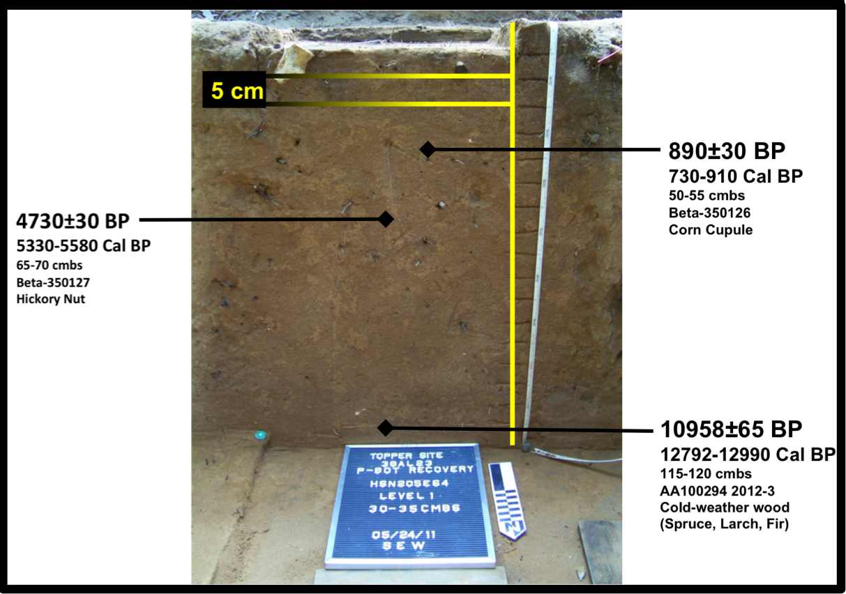
(Location of the carbon samples of Figure 10 is representative of the vertical level at which they were recovered but not of the horizontal positioning within the unit, which is unknown because of the specific sampling strategy used for this research)

Table 6 A Cultural Sequence and Timescale for Southeastern Archaeology
Calendrical (dates approximate) | Conventional (cal yr B.P.) | Uncalibrated Radiocarbon | Period | Culture Complex | Climatic Event
 |  |  |  |  | Pronounced Warming
AD 1950 | 50 | 0 | Modern
 |  |  |  | Industrial Revolution | Little Ice Age Ends
AD 1700 | 300 | 250 | Colonial
AD 1500 | 500 | 450 | Contact | European Colonization
AD 1350 | 600 | 600 |  |  | Little Ice Age Begins
AD 1050 | 950 | 1000 | Mississippian | Mississippian
AD 930 | 1020 | 1100 |  |  | Medieval Warm Period
AD 550 | 1400 | 1500 | Late Woodland | Coles Creek
AD 225 | 1725 | 1800
 |  |  | Middle Woodland | Hopewell | Subatlantic
300 BC | 2225 | 2200
 |  |  | Early Woodland | Adena
1200 BC | 3200 | 3000
1800 BC | 3800 | 3500 |  | Poverty Point
2500 BC | 4500 | 4000 | Late Archaic | Stallings Island | Sub-Boreal
3800 BC | 5800 | 5000
 |  |  |  | Watson Brake | Hypsithermal Ends
4350 BC | 6300 | 5500
4900 BC | 6850 | 6000 | Middle Archaic | Benton | Atlantic
5900 BC | 7850 | 7000
 |  |  |  |  | Hypsithermal Begins
6900 BC | 8900 | 8000
 |  |  |  | Bifurcate
8200 BC | 10,100 | 9000 | Early Archaic
 |  |  |  | Corner Notched | Boreal
9550 BC | 11,500 | 10,000 |  | Early Side Notched | HOLOCENE
 |  |  |  |  | PLEISTOCENE
9950 BC | 11,900 | 10,200 |  |  | Younger Dryas Ends/Preboreal
10,500 BC | 12,450 | 10,500 | Late Paleoindian | Dalton/Sloan
10,950 BC | 12,850 | 10,900 |  |  | Younger Dryas Begins
11,000 BC | 12,900 | 11,000 | Middle Paleoindian | Clovis Fluted Points
11,050 BC | 13,000 | 11,100 |  |  | Allerod
 |  |  |  |  | Inter-Allerod Cold Period
12,000 BC | 14,000 | 12,000 |  |  | Allerod
 |  |  | Early Paleoindian | Pre-Clovis | Older Dryas
12,850 BC | 14,800 | 12,500 |  |  | Bolling
19,700 BC | 21,700 | 18,000 |  |  | Last Glacial Maximum
(From Anderson and Sassaman 2012:5)

According to Dr. Chris Judge, who is doing similar research on the radiocarbon dating of corn at the Kolb site, located in Darlington County, South Carolina, the date from Topper corn cupule represents one of the oldest corn dates currently known in South Carolina (Personal Communication, Dr. Chris Judge). While not as significantly old as the wood species found in level 18, this date is also important for the Topper site (not only in assessing site integrity and original inceptions of corn into the site), because also “corn discoveries and associated radiocarbon dates in South Carolina have been elusive and minimal” (Michie and Crites 1991:49). The data garnered from this date (as well as more that may be taken in the future) may be significant in helping to form a more robust chronology for the adoption of corn agriculture throughout the state of South Carolina.
In reviewing the vertical distribution of corn in research column HSN205E64, there are additional pieces that are positioned deeper in the in strata than the corn sample chosen for dating, which was recovered from level 5 (Table 3). Further research into the age of corn from this column could easily be accomplished through additional AMS dating of these lower samples and is likely a future addition to this research.
The date of the hickory (5,330-5,580 cal yr. B.P.), recovered from level 8, corresponds to the Late Archaic period, which lasted from approximately 5,800-3,300 cal yr. B.P. (Table 6). Because it provided significant amounts of necessary carbohydrates and fat calories, hickory (and other mast species) was an important resource for all native peoples (Abrams and Nowacki 2008: 1124). Hickory nutshell also may have provided a fuel source, and the intense exploitation of this resource, coupled with the robust nature of hickory to preserve, may explain the 85% ubiquity of hickory in the HSN205E64 research column (Table 2) (Hally 1981:737; 739).
The cold-weather wood date (12,792-12,990 cal yr B.P.), recovered from level 18 (the purported beginning of Clovis occupations at the Topper site), corresponds to the Middle Paleoindian period (approximately 13,000-12,850 cal yr B.P.). Not only does this date (taken from a Pleistocene species of plant material) line up with expected pre-Holocene transition dates (prior to 11,500 cal yr B.P.), but also falls within an accurate date range for the lithic materials with which it was associated, a known, robust Clovis occupation found across the Topper site, typically found to begin around level 18 on the Upper Hillside. Because of this association with the deepest (hence, earliest) lithic materials found on the Upper Hillside, and what appears to be an intact and stratigraphically-sound soil matrix, it is now possible to reason that the earliest occupations on the Upper Hillside were likely those of Middle Paleoindian peoples, and they likely arrived in this area of South Carolina during the very beginning of the Middle Paleoindian period.
As recently as 2012, no AMS dates falling around the 13,000 cal yr B.P. date had been reported from the Topper site (Anderson and Sassaman 2012:47). Dates from this period were reported from the site prior to 2012, but were dated through Optically Stimulated Luminescence (OSL) rather than radiocarbon means (Anderson and Sassaman 2012:47). This makes the Middle Paleoindian date from this project – which was found in direct association with large amounts of diagnostic Clovis lithic materials and debitage – the first of its kind, reported from the site through direct radiocarbon means.
With this data I have demonstrated the ability not only to recover and identify carbonized remains from what was previously thought to be a difficult matrix, but also obtain plausible and indeed, quite accurate dates, achieving the main goal of this project.

CHAPTER 5: SUPPLEMENTAL ANALYSES AND OTHER CONSIDERATIONS
Because the whole-column bulk sampling strategy designed for this research project utilized the complete removal of soil matrices for analysis, other artifact classes were collected along with the archaeobotanical remains during the flotation process. The recovery of these additional artifact classes provided an opportunity for a multi-variant comparison of the materials from within a single research column. Because topper is such a lithic-rich site, a simple analysis of the lithic materials recovered during paleoethnobotanical investigation was conducted in order to demonstrate the added utility of such a sampling strategy.
A simple chemical analysis of the soils associated with research column HSN205E64 was also undertaken in order to test soil pH, nitrogen, and phosphorus. Because a chemical analysis of the Topper soil matrix was not included in the original project scope, the soils used for chemical testing were recovered from the side of the previously excavated research column after primary paleoethnobotanical sample recovery. However, such analyses should be factored in prior to excavation efforts, so that small amounts of soil necessary for chemical analysis could easily be set aside during the recovery of the main column samples, saving both time and effort in regard to recovery.

Chemical Testing Introduction and Methods
It seemed to be a logical step to supplement my assessment of the paleoethnobotanical remains at Topper with simple chemical testing. If chemical signatures representative of human occupation, such as phosphorus or nitrogen, could be recovered from the research column, then they could be potentially be treated as an additional category of (geo)artifact and could possibly be correlated with the counts of identified human-made lithic debitage at the site, as well as any recovered carbonized remains. According to Petersen and Mohler, “it has been demonstrated that concentrations of a suite of particular chemical elements…can aid in the identification of buried cultural horizons if examined relative to vertical artifact distributions” (Petersen and Mohler 2002:117). Any potential correlation between the human-derived chemical signatures and the artifacts recovered during this project could add an additional category of data to site, and might have the potential to help strengthen our understanding of the various occupations, and help to direct future research at the Topper site.
I was provided a simple LaMotte Soil testing kit for the analysis of nitrogen, phosphorus and soil pH. Because I was provided with a limited amount of supplies, I chose to test only a single column. Based on my time supervising the excavation of the 4-m-x-4-m unit block associated with the research column recovered from HSN205E64, I was aware of significant levels of artifact counts located throughout, both vertically and horizontally. Because the goal of this chemical testing was to test the ability of human-deposited chemical signatures to fix in the sandy soils at Topper, it followed that, of the excavated flotation columns, the one with the strongest evidence of intensive and long-term occupation would be the unit most likely to retain such data. Research column HSN205E64 was chosen as the unit with the most potential to yield such signatures.
Accompanied by Sean Cary von Gunter, a return trip was made to Topper in the off-season in order to remove small, fresh soil samples from the walls of the previously excavated research unit so that these chemical tests could be conducted. After cleaning the debris that had accumulated in the excavated unit since the summer excavations, samples for chemical testing were recovered from the research column location. A smaller column was taken from the wall of the original research column, at the same 5 cm levels as previously excavated. The soils were removed from each level by trowel, and placed directly into labeled curation-quality ziplock bags. They were then transported back to Knoxville for testing. Each level provided approximately 500 ml of soil for testing, far more, as it turns out, than was actually needed.
Chemical testing for all recovered soil samples was conducted in the kitchen of my house. Care was taken to clear off the working surfaces before sample bags were opened or tested. The testing involved placing small, uniform samples of the recovered soils into vials of specific chemicals. Based on the residual chemical signature in the soil, (or lack thereof) the chemical solution changed color, which was then compared with the provided color chart in order to determine the results. All testing vials and other equipment were thoroughly washed and dried before being reused. The entirety of the chemical testing was conducted in a matter of days in order to prevent possible bias stemming from long-term removal of the samples from their original context, and all results were recorded for later analysis, as discussed in the next chapter.

Chemical Testing Results
The chemical analysis testing for phosphorus and nitrogen signatures in the sandy soils, as well as the assessment of soil pH, all conducted on the research column HSN205E64, provided an additional layer of data that was in some parts expected and in others unexpected. Given the widespread and pervasive nature of the acidic soils prevalent throughout the Southeastern United States, it follows that the tested soil pH levels from the research column at HSN205E64 averaged a pH of 5.4375 (Figure 13), a strong acid when considering soil pH. The tested and quantified soil pH level corresponds with published records for this region (Figures 22 and 14).
Extant nitrogen signatures in soil matrices are often utilized as a chemical analog for evidence of past human occupation (Petersen and Mohler 2002). However, the initial examination of the results of the nitrogen analysis conducted in the HSN205E64 column determined that any nitrogen signature, likely once present in the soil matrix, seemed to be too rapidly leached from the soil to be of any scientific value. There appeared to be a single, small spike of nitrogen in the upper levels of the column, around 35-40 cmbs, but this quickly vanished as deeper samples were tested (Figure 13).
Petersen and Mohler (2002:103) confirmed the accuracy of this analysis when they described the inability of nitrogen (as well as calcium and carbon) to fix, especially in sandy soils; citing the “immediate and steady loss by leaching” as soon as nitrogen is deposited. Even if past human occupations did leave a remaining signature in the form of nitrogen, it appears, based on this initial data, that the chemical marker is too quickly dissipated for it likely be of use at the Topper site. While the initial testing for this chemical returned little usable data, it is advisable that further testing, using more sophisticated equipment should be undertaken to confirm these results before nitrogen testing is no longer used in such soil matrices, such as those found at the Topper site.
While nitrogen signatures seems too rapidly dispersed to be of any utility, phosphorus tends to act in the exact opposite manner, making it an ideal choice for testing as an analog for human activities throughout the past (Petersen and Mohler 2002:103). According to Petersen and Mohler (2002:116), “phosphates are widely viewed as perhaps the most reliable chemical indicators of past human activity.” In analyzing the phosphorous concentrations, there were a number of spikes throughout the entirety of the unit (Figure 13), which initially seemed promising as a possible indicator for past human activity (Carpenter 2008:11039; Petersen and Mohler 2002).
Because phosphorous is a necessary component for the formation of all organic life, agricultural practices rapidly deplete the soil of nutrients, including, but certainly not limited to, phosphorus. Hence, the extant, measurable amounts of phosphorus remaining in the soil matrix of the Upper Hillside seem to indicate that the area was likely not used for extensive agricultural use over the past ten thousand years. Evidence for the regional use of agriculture is apparent in the high numbers of Zea mays found throughout the upper 11 levels of the HSN205E64 research column.

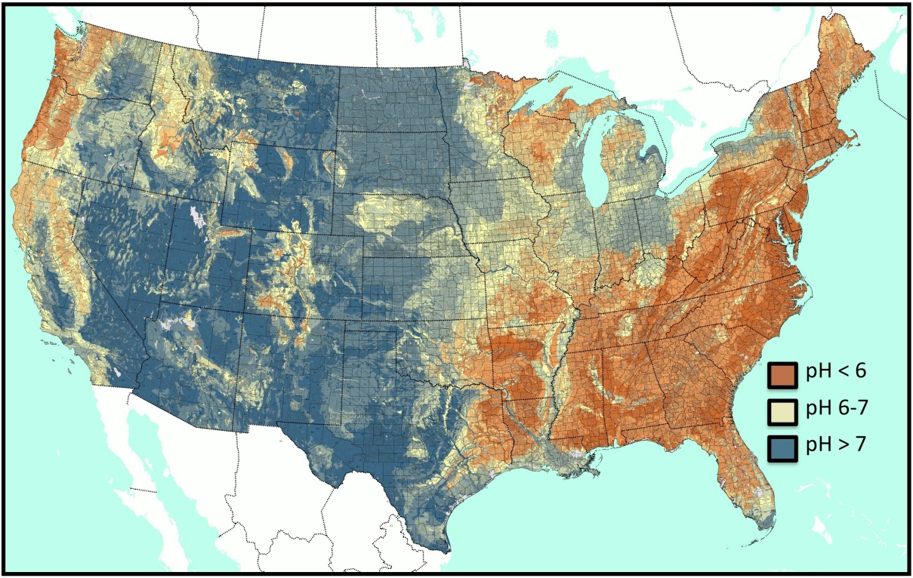
Figure 14 Soil pH of the United States
(Modified from BONAP 2013)

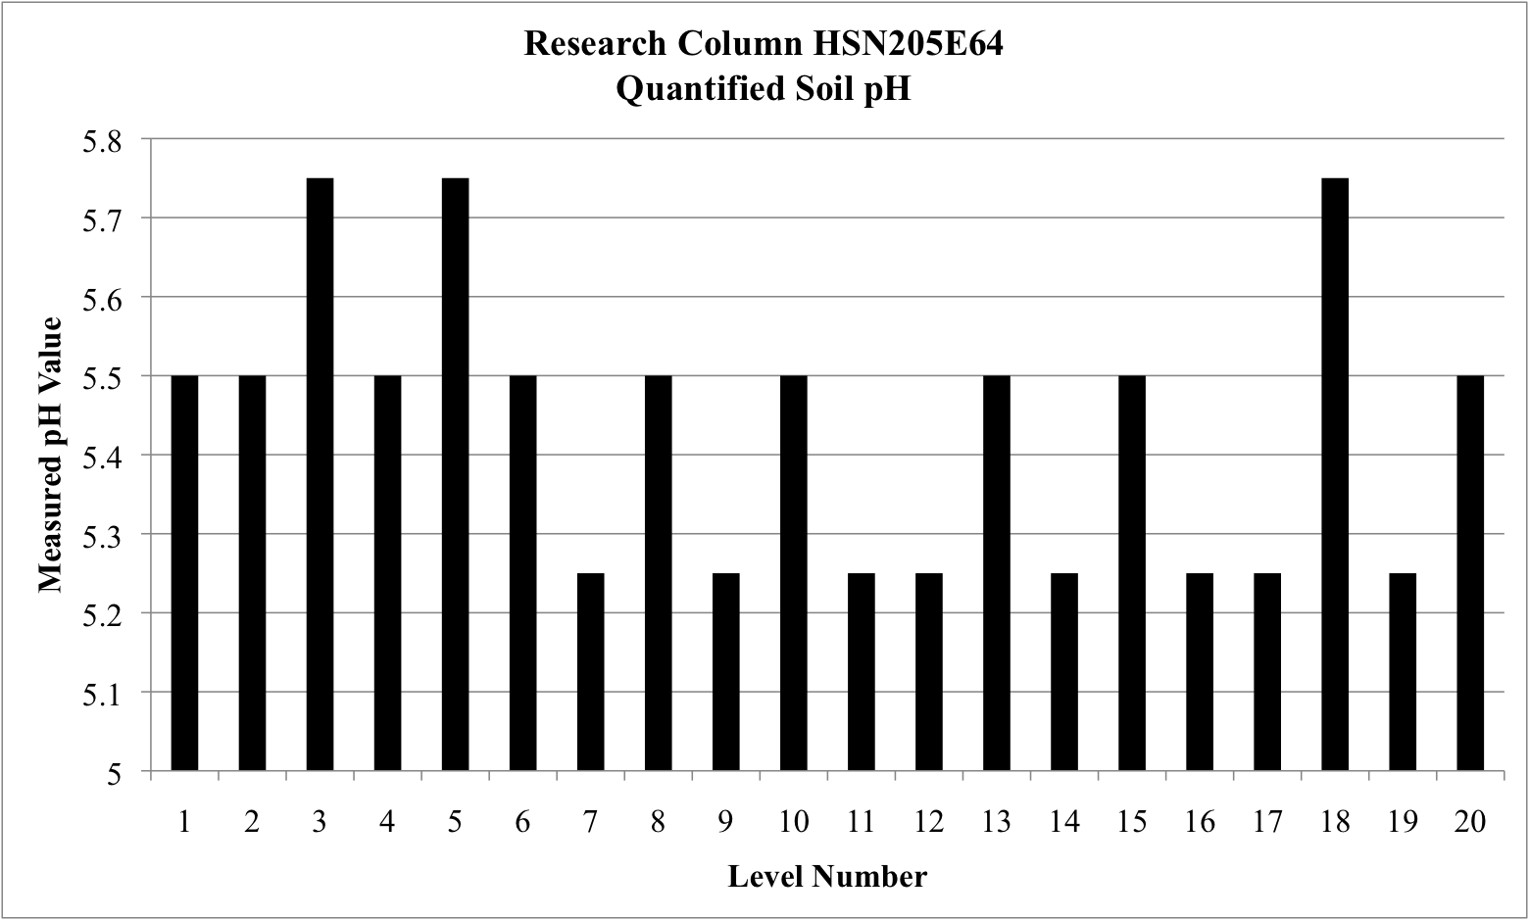
Figure 15 Quantified Soil pH for Research Column HSN205E64
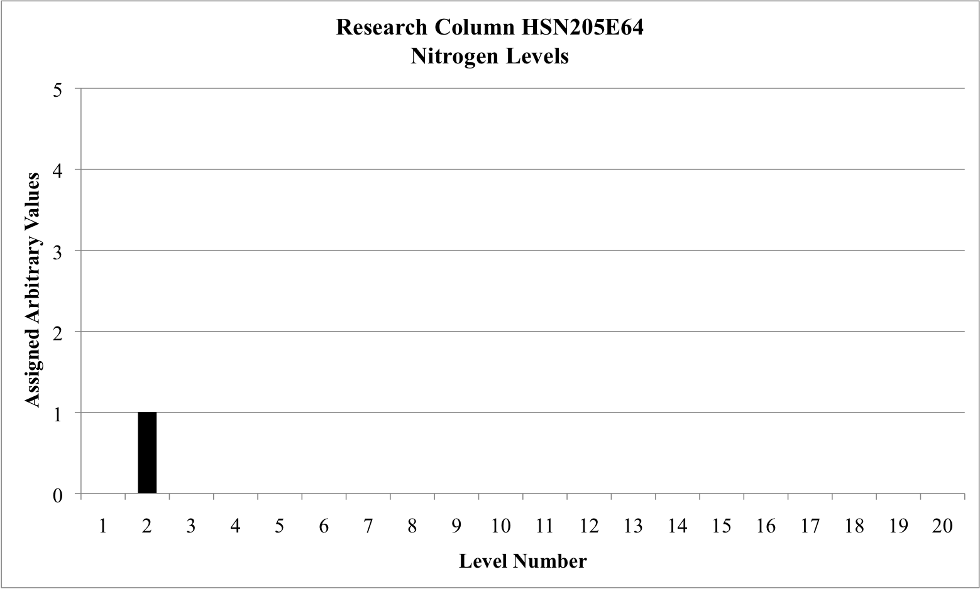
Figure 16 Nitrogen Levels for Research Column HSN205E64
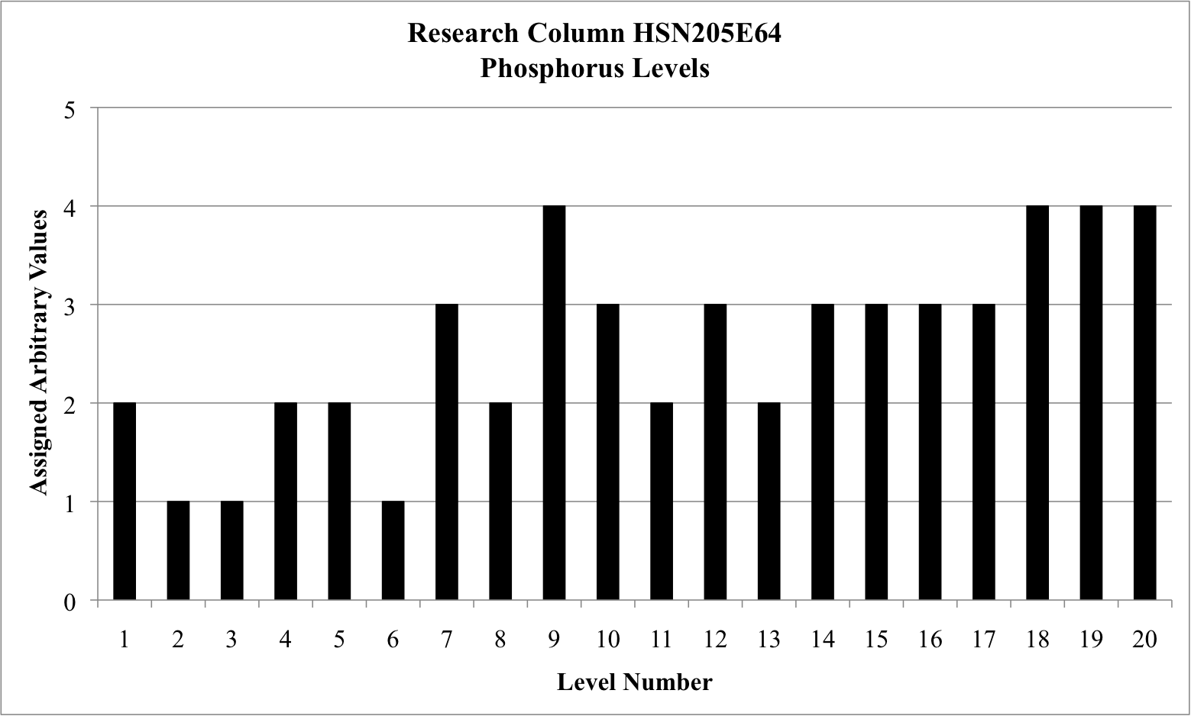
Figure 17 Phosphorus Levels for Research Column HSN205E64
Scale for Analysis:
1) Trace Amounts; 2) Low Amount (0-50 lb/acre); 3) Medium Amount (50-100 lb/acres); and 4) High Amount (+100 lb/acre)
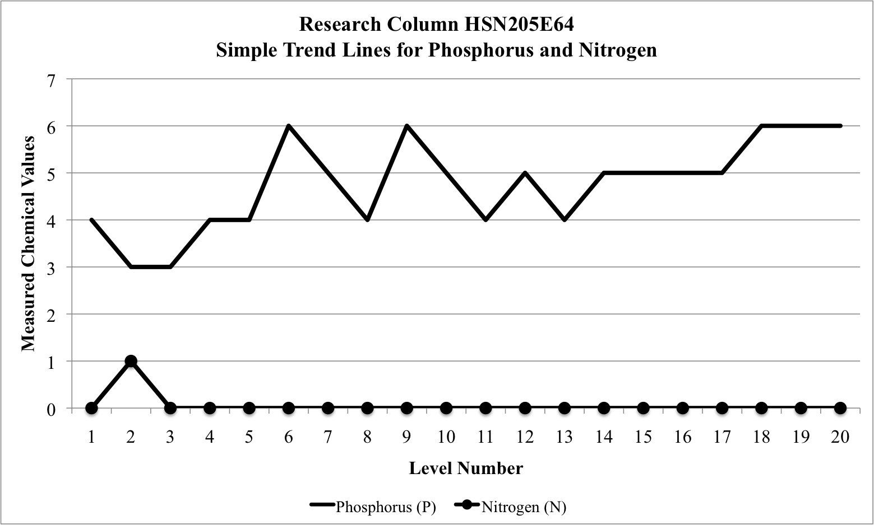
Figure 0-E Simple Trend Lines comparing Phosphorus and Nitrogen Levels from Research Column HSN205E64

This is significant in that is provides an additional line of evidence for the argument that the majority of carbonized remains recovered from the site are directly linked to the human occupation of the site, rather than through natural deposition and associated fire events.
The utility of such analyses is best described by Petersen and Mohler, when they state that:
[T]he tracking of vertical artifact densities, as well as the distribution of vertical phosphate levels, can serve together to establish levels of site integrity at cultural deposits where such an assessment might otherwise be elusive. To the archaeologist in the field, the ability to make assessments of integrity based on supporting geoarchaeological data allows for more efficient and effective archaeological survey and opens up new avenues of research. Additionally, this knowledge can then be applied in deciphering the complex stratigraphic records at sites experiencing more intensive occupation over longer periods of time (2002:117).
Further chemical analysis of the soils, using more sensitive equipment, would likely yield more significant results. However the data shown here corroborates the understood level of soil pH, demonstrates that nitrogen does not likely fix in the sandy and acidic soils at topper, while phosphorus (a good indicator of past human occupation) does. Further research into phosphorus at the Topper site could prove invaluable, especially if then compared with other evidence for human occupation throughout time at the site.

Lithic Debitage Analysis Introduction and Methods
Two additional artifact categories were noted when examining the dried heavy and light fractions in order to remove and identify the carbonized remains from the research column samples. These categories included ceramics (pottery) and lithic materials, primarily in the form of small flakes or debitage. The pottery sherds were not analyzed, due to the fact that they were only present in the higher levels of the column (likely Woodland occupations and later), and hence, would not be as useful when determining complete stratigraphic integrity of the soils. However, further analysis on the pottery sherds would likely be useful in future research, and in association with carbonized plant remains, may allow for a more accurate understanding for the date and period during which pottery began to be used at the site, as well as how the pottery itself may have been used.

As discussed previously, the main focus of long-term archaeology at the Topper site has been the myriad lithic materials buried across the site. The recovery of lithic debitage from the flotation samples prompted me to undertake a simple analysis of the lithic materials from the research column.
The lithic materials, found throughout the entirety of the research column, were examined in order to further assess the stratigraphic integrity of the soils and associated artifacts recovered from the column. The amount of thermal alteration (“TA” – which refers to the application of heat to tool stone, either intentionally or unintentionally) of the lithic material was also assessed in order to; 1) better understand the occurrence of thermal alteration of chert materials at the site, which anecdotally occurred more commonly in later occupations; and 2) evaluate the potential for the plant remains to have been naturally carbonized through forest fires. The intentional application of heat to tool-stone has been well documented across the Southeastern United States (Anderson 1979:224-225). Due to the fact that the intentional utilization of heat to modify the recovered artifacts could not be directly assessed, the terminology ‘heat-treated’ will not be used. The application of this terminology implies evidence of directed human modification of the tool stone, and such could not be assessed here, hence the use of the more general term of thermal alteration.
The application of heat to tool stone commonly results in a change of the coloration and/or texture of the stone matrix that is often identifiable through analysis, in this case through a low-powered microscope. The lithic analysis of HSN205E64 demonstrates that the majority of lithic material recovered from the flotation column was local Coastal Plain (Allendale) chert, a white, chalky material on which thermal alteration is easily seen, either in a red, purple, or bluish discoloration, and/or through a shiny, waxy feel to the texture of the chert indicative of a realignment of the silica matrix through the application of temperatures greater than 300 ^{º}C for an extended amount of time (Anderson 1979:222-223; Russell 2015:12-13).
While the physical and chemical effects of thermal alteration are rather well understood (having been replicated through multiple experimental efforts), the reasoning behind the directed and intentional heat-treatment of tool-stone is not as readily elucidated (Anderson 1979:221). Potential reasons for the thermal alteration of tool-stone include; accident, specific appearance, improved quality (overall knappability or workability), sharp cutting edges, soft hammer or pressure flaking efficiency and raw material conservation (Anderson 1979:227). Experimental research conducted on Coastal Plain chert recovered from quarry locations in Allendale County found that the majority of Coastal Plain tool-stone is of low quality. Data on thermally altered materials from the Rice site (38AL14), which is also located in Allendale County, determined that instances of thermal alteration were at their highest during the Early Archaic period and subsequently decreased through the Woodland and Mississippian periods (Anderson 1979:235). Further research confirmed that thermal alteration appears to be a technological hallmark of both the Middle and Late Archaic periods in South Carolina (Russell 2015:13).
It should be noted that there are three major classifications of the Coastal Plain chert found throughout the Topper site; 1) the tool stone in raw form, which is typically white, or off-white in color; 2) tool stone that has been affected by heat, either intentionally or unintentionally, and exhibits streaks or pockets of red, blue, pink and/or purple colors throughout. This modified tool stone may also be somewhat ‘waxy’ feeling, and will likely reflect more light than the raw material; and 3) tool stone, typically found in large nodules, that was submerged in either the Savannah River, the side channel of the Savannah River that runs just west of the site, the nearby Smith Lake Creek, or another local water body, for an extended period of time. Long term submersion in the water tend to stain the outside of these chert nodules, resulting in the dark yellowish, tan or brown color to the chert, especially on the exposed rind (Russell 2015:12). Due to the discoloration of both thermally altered tool-stone and tool-stone stained through long-term water exposure, it is common for debitage – discolored by water – to be accidentally classified as thermally altered, rather than as stained raw material, unexposed to heat. Because I did not identify any pieces that appeared to stained, I chose to place all of the lithic debitage from research column HSN205E64 into two distinct categories; thermally-altered and not thermally-altered. The results of these analyses are detailed in the following section.

Lithic Debitage Analysis Results
During my analysis, the majority of the lithic debitage recovered appeared to either be unaltered, whitish yellow Coastal Plain chert, or thermally altered Coastal Plain chert, exhibiting diagnostic red, purple, and blue marks as discussed previously. Thermal alteration was evident on 18.9% of the total lithic material assemblage (by count) from the HSN205E64 unit (Table 7). The rest (81.1%) exhibited no evidence of thermal alteration (Table 7).
When the trends for thermally altered lithic debitage recovered from column HSN205E64 are examined, it appears that thermal alteration is most commonly found in the upper levels of the unit, with visible spikes at level 2 (35-40 cmbs), level 7 (60-65 cmbs) (Figure 17). The amount of thermally altered debitage decreases sharply below level 7 (Figure 17). When considered in association with the study of thermal alteration at the Rice site, which placed the highest amounts of thermal alteration in the Archaic period, the data presented here seems to trend in a different pattern (Figure 17) (Anderson 1979:235-236). Based on the late Archaic recovered date from level 8 (4730±30 B.P./5330-5580 cal yr B.P), artifacts above this level were likely deposited during or after the late Archaic period. The trend in the thermal alteration of lithic material from the Upper Hillside of the Topper site presented here seems to directly contradict the data reported from the Rice site. In contrast, the temporal tends of non-thermally altered chert at Topper appears to follow the pattern reported at the Rice site for thermally altered tool-stone. In the Topper research column, non-thermally altered materials spike at level 15 (100-105 cmbs), which is located between the middle Paleoindian and late Archaic dates at levels 18 and 8, respectively, and are likely representative of the late Paleoindian/early Archaic occupation of the site (Table 5; Figure 18). I do not understand why the trends for lithic thermal alteration between two closely located sites would be so different. The continuation of lithic studies, including the microdebitage collected through flotation, that focuses on specific attributes such as thermal alteration may prove valuable, especially in better understanding larger, regional trends.

Testing for Correlations between Archaeobotanical and Lithic Data
As an additional, supplemental line of research, the archaeobotanical remains recovered from the HSN205E64 research column were graphically compared with the lithic debitage, also from the research column, by both count and weight (Figures X and X). It is somewhat feasible that natural fires could carbonized organic materials while also thermally altering associated lithic materials. If natural forest fires were the case for the origin of the carbonized remains at Topper, it follows that any associated lithic material would also likely be thermally altered. In examining both comparisons by count, there does not appear to be any correlation between the carbonized and lithic materials (Figure X). However, when they are examined by weight, it appears that the carbonized remains and lithic materials trends similarly from level 1 through level 14 (Figure X). At level 15, they trend immediately away from each other, with the lithic debitage spiking sharply (Figure X). With such little data, there does not appear to be enough evidence to demonstrate either anthropormorphic or natural causes for both the carbonized remains and lithic materials at the Topper site. However, there is enough variability between the two materials, by weight and count, to indicate anthropomorphic origins for at least some of the carbonized organic remains recovered herein, and when added to the extensive evidence for human occupation at the site, this seems even more likely.

Table 7 Recovered Lithic Materials from HSN205E64 by Count and Weight
Level | CMBS | Total by Count | TA by Count | Non-TA by Count | Total by Weight | TA by Weight | Non-TA by Weight
1 | 30-35 | 155 | 58 | 97 | 7.42 | 2.77 | 4.65
2 | 35-40 | 186 | 82 | 104 | 81.28 | 34.8 | 46.48
3 | 40-45 | 142 | 60 | 82 | 14.45 | 12.71 | 1.74
4 | 45-50 | 106 | 49 | 57 | 7.14 | 5.91 | 1.23
5 | 50-55 | 83 | 34 | 49 | 9.24 | 3.16 | 6.08
6 | 55-60 | 87 | 43 | 44 | 17.49 | 15.91 | 1.58
7 | 60-65 | 108 | 49 | 59 | 50.26 | 1.93 | 48.33
8 | 65-70 | 94 | 38 | 56 | 10.42 | 6.27 | 4.15
9 | 70-75 | 63 | 25 | 38 | 4.63 | 4.13 | 0.5
10 | 75-80 | 71 | 16 | 55 | 1.02 | 0.54 | 0.48
11 | 80-85 | 75 | 12 | 63 | 3.22 | 1.89 | 1.33
12 | 85-90 | 125 | 6 | 119 | 3.48 | 1.4 | 2.08
13 | 90-95 | 185 | 6 | 179 | 7.47 | 0.16 | 7.31
14 | 95-100 | 194 | 3 | 191 | 14.28 | 0.28 | 14
15 | 100-105 | 278 | 5 | 273 | 17.77 | 0.01 | 17.76
16 | 105-110 | 206 | 1 | 205 | 57.05 | 0.1 | 56.95
17 | 110-115 | 200 | 3 | 197 | 136.44 | 0.17 | 136.27
18 | 115-120 | 159 | 6 | 153 | 11.57 | 0.24 | 11.33
19 | 120-125 | 58 | 0 | 58 | 1.78 | 0 | 1.78
20 | 125-130 | 42 | 0 | 42 | 3.32 | 0 | 3.32
Total |  | 2617 | 496 | 2121 | 459.73 | 92.38 | 367.35

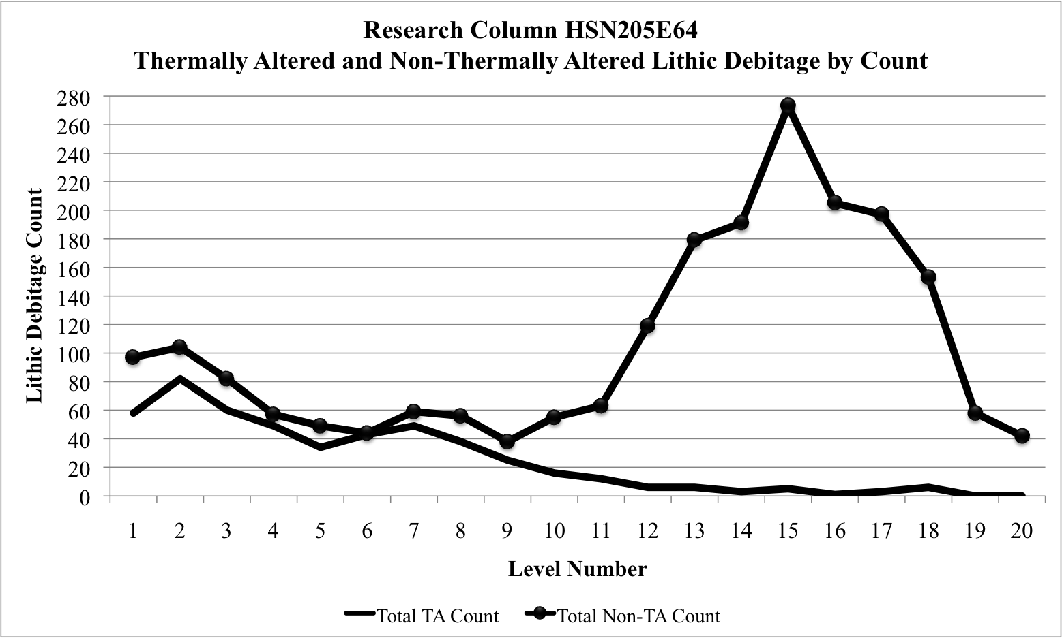
Figure 19 General Trend Lines for Thermally Altered and Non-Thermally Altered Chert from Research Column HSN205E64

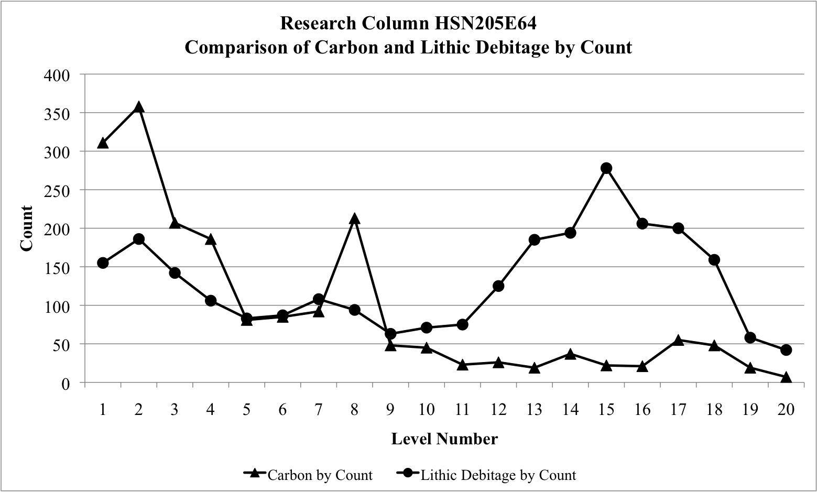
Figure 20 A Comparison of Carbon and Lithic Materials by Count for Research Column HSN205E64
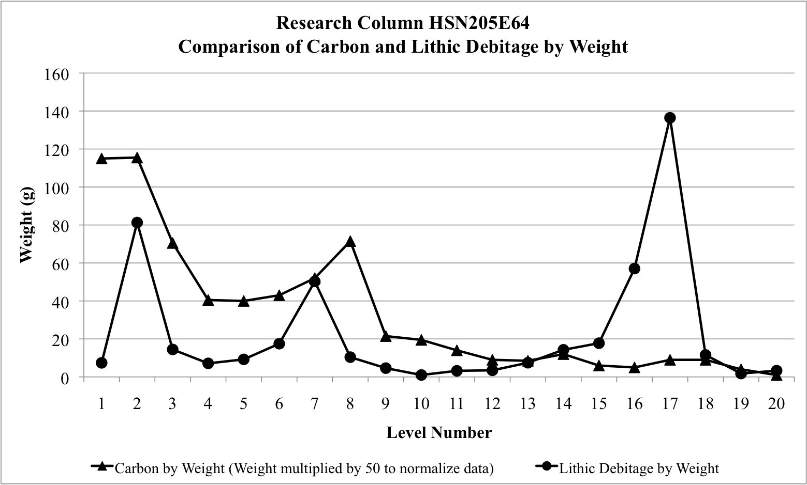
Figure 21 A Comparison of Carbon and Lithic Materials by Weight for Research Column HSN205E64

(The measured weight of the carbon samples were multiplied by 50 for the benefit of this graph. Without doing so, it would not have been possible to plot both materials on the same chart. While the weights presented here differ from those reported for the column, they are still representative of the trends throughout time of the carbonized remains.)
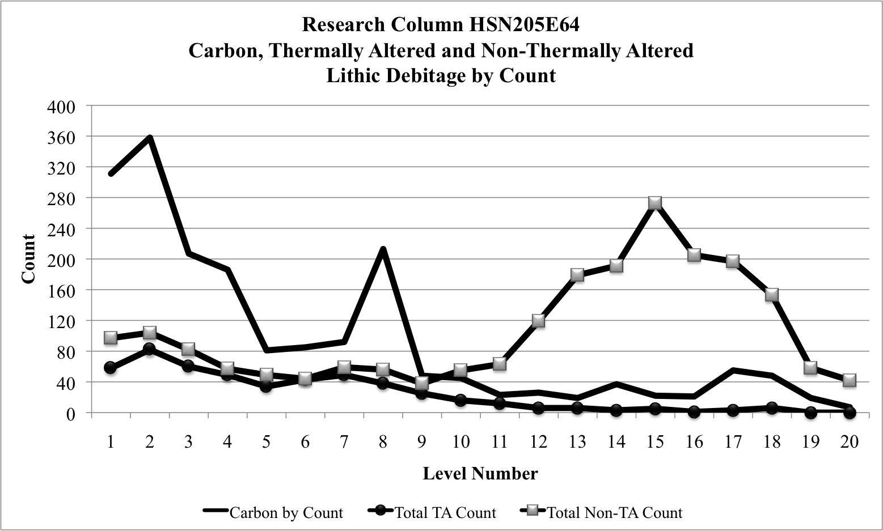
Figure 22 A Comparison of Carbonized Remains, Thermally Altered Debitage, and Non-Thermally Altered Debitage from Research Column HSN205E64

Understanding Bioturbation Processes at the Topper Site
An additional consideration regarding the utility and validity of paleoethnobotanical investigation, in all contexts, is the degree to which bioturbation — that is, the subsurface movement of plants and animals — may dislodge, disturb, or relocate artifacts within the soil matrix (e.g. Dunnell 1990; Michie 1990; Stein 1983). Postoccupational disturbance through faunal turbation has been reported, in the Southeastern United States, to have been caused by ants, earthworms, spiders and crickets, among other animal species (Stein 1983: 277).
Bioturbation, either by the intrusion of flora or fauna, is considered to be a commonly occurring issue with which all archaeologists must contend. The soil matrices of the Southeastern United States are most often affected by the sub-surface burrowing of insects and earthworms, as well as the movement of roots of plant materials, all of which may adversely affect an archaeological site postdepositionally (Stein 1983). While no formal testing was conducted during this research, certain observations were noted in regard to the potentiality for bioturbation, both during the excavation process and during the resulting analysis.
Existing plant roots were present throughout the columns, and became less prevalent as the depth below ground surface increased. Larger tree roots were only present in the upper layers of the columns, while smaller rootlets were noted in all of the levels of each column, but again were not as common in the deeper levels of the unit.
No evidence of insect or animal intrusions was noted during excavations. Macroscopically, the soils appeared intact, with no residual burrows or cavities having been found while the soils were being removed. However, during the laboratory analyses, the carcasses of smaller ants and grubs were identified in a number of the levels from each unit. No larger animal remains were identified during the laboratory analysis, (i.e. carcasses of earthworms or cicadas). While one of the known largest causes of archaeological site destruction, the likelihood for earthworm bioturbation at the Topper site seems rather unlikely, as discussed further below (Stein 1983: 277).
The optimal conditions for earthworm activity include a soil texture that does not include a large amount of sand, with an optimal amount of moisture retention, a neutral pH, and an optimum soil temperature of 10 ºC (50 ºF), and an area that has not been greatly disturbed by agricultural practices or the introduction of harmful chemical compounds (Stein 1983: 277). Because the soils at Topper are primarily sand, are well-drained, allowing for little water retention, are highly acidic, and have been somewhat subject to past silvicultural practices, the likelihood for extensive bioturbation due to earthworms, and potentially other animals that exist under similar conditions, is rather low.
The question as to the extent of postdepositional bioturbation in the soils matrix at Topper should continue to be considered and investigated as a part of understanding the site as a whole. However, the lack of visible evidence of macroscopic bioturbation, coupled with the low numbers of insect remains found during analysis, soil conditions not likely ideal for certain insect types known for causing extensive damage, and the intact nature of the micro-artifact classes found within the column sampled, demonstrates that bioturbation does not appear to have impacted the integrity or validity of the research presented here. When considered in tandem with the stratigraphically correct positioning of the AMS dates in association with diagnostic artifacts, bioturbation is likely not a major concern when considering the validity of paleoethnobotanical recovery in soil matrices similar to those found at the Topper site.

CHAPTER 6: DISCUSSION AND CONCLUSIONS
It is when aspects of research are discarded before they are scientifically tested for viability, that the idea of unbiased, scientific study breaks down, and important information that can never be replicated may be thrown into the back-dirt piles and is once again lost to history. However, a major (and ever present) consideration is the limited time and cost structure under which most archaeological projects are managed. The sciences as a whole are struggling more and more often with issues of funding, or the lack thereof. Following, it is a logical — and sometimes necessary — consideration that certain analyses, demonstrated to be unlikely to yield significant results, may be cut out of a research design. This is an important consideration that most archaeologists will be forced to contend with during their career. Accordingly, when deciding which analyses to triage, we must be certain that our assumptions are actually accurate. Our decisions should initially be informed by an analysis of the relevant published literature. However, these assessments should rely most heavily on directed scientific testing and site assessment (i.e. “ground-truthing”).
Based on the data presented here — and in full consideration of other archaeological, geological, and site-specific contextual data — it can confidently be stated that the question of presence and preservation of intact, identifiable paleoethnobotanical remains, in the referenced soil matrix at Topper, has been overwhelmingly answered in the affirmative.
As mentioned in Chapter 1, there appeared to be five basic assumptions that were preventing archaeologists from more commonly attempting paleoethnobotanical recovery, especially in sandy, acidic soils, such as those found throughout the Southeastern Coastal Plain of South Carolina.
The results of this project now refute each in turn:
- Biological decomposition destroys most (if not all) organic material deposited on the surface; Because all organic remains recovered were fully carbonized, it appears that only non-carbonized organic remains are likely to decompose on (or below) the surface (unless protected by a specialized context).
- High soil acidity chemically degrades any remaining organics before such has the chance to preserve; Because all organic remains recovered were fully carbonized, it appears that high soil acidity does not play a significant role in the decomposition of organic samples that are completely carbonized, only on those that are not fully carbonized.
- Crushing mechanisms, associated with sandy environments, work to mechanically degrade – and, inevitably destroy – whatever fragile organics that manage to evade both biological and chemical destruction -- even if/when carbonized; Due to the fact that there were significant numbers of identifiable carbonized remains recovered from every level of the columns sampled, mechanical actions do not seem to completely destroy carbonized remains, leaving enough for positive identification as well as allowing utilization for radiocarbon and/or AMS dating.
- These same mechanical actions also act to destroy any horizontal and/or vertical stratigraphic integrity; thus invalidating any data derived from plant remains, if actually recovered; The repeatedly intact layers of lithic materials and debitage at the Topper site, as well as the AMS dates of the carbonized remains found in apparent correct superposition, coupled with matching chemical signatures and spikes in lithic counts, both indicative of human occupation, demonstrate that horizontal and vertical stratigraphy are not an immediate concern when looking to recover plant remains from sandy soils that are not constantly inundated such as those found along coastlines.
- Small, light carbonized and non-carbonized plant remains may be transported downwards through bioturbation processes (Waters et al. 2009:1304). The results of this project recovered carbonized remains that were datable through AMS means and were found to be in apparent correct superposition and were positively correlated with date ranges for associated, diagnostic lithic materials.
As an additional consideration, it seems that the scientific utility of paleoethnobotany is too often narrowly conceived as only able to address matters of plant subsistence. Conceptually, this thought-paradigm unnecessarily limits the perceived utility of paleoethnobotanical research.
Lithic studies, conducted at Topper, demonstrated a high degree of stratigraphic integrity in at least parts of site, less than 9 cm vertical movement was observed in an excavation block opened on the Hillside (Miller 2007, 2010; Smallwood and Miller 2009). When the site is evaluated as a whole, known archaeological culture-types are typically recovered, with remarkable consistency, in expected stratigraphic (super)position. Furthermore, there is scant evidence that bioturbation has played a significant role in the re-positioning of lithic artifacts. Following the analyses discussed here, the same seems to follow for other artifact types as well, including carbonized plant remains.
Radiometric dating of carbonized plant remains stands as the only real means capable of determining the stratigraphic integrity of those remains. Toward that end, I believe that the AMS results presented here are quite promising. All three samples were vertically positioned in expected relative (super)position, suggesting that vertical integrity remains intact. When combined with the other data analyzed from the test and research column, as well as the chemical data, which suggests a robust human occupation, the stratigraphy of the Upper Hillside seems to be intact and quite robust. All three samples also produced productive, accurate dates with low standard deviations, which allow for more accurate dating of the robust artifact densities found across the Topper site. While the number of samples sent for testing was not enough to be statistically significant, the fact that all three of these samples produced accurate dates with low standard deviations offers hope that further sampling through the methods discussed here are likely to produce similar results.
The integrity of the data recovered also indicates that issues of bioturbation at the site are likely not significant enough to skew the artifacts recovered through paleoethnobotanical means to any substantial degree. While additional research into the specific mechanisms of bioturbation at the Topper site would likely provide additional information, this research presents promising results indicating that bioturbation by both flora and fauna is of a minimal concern when analyzing materials and artifacts recovered.
The lack of deeply stratified sites in the Southeast, especially those without Paleoindian and Early Archaic components, has provided the region with arguably a less robust record of absolute dates to support the (largely relative) chronologies that have been constructed [Dust Cave, Russell Cave, and Icehouse Bottom are exceptions]. While a great many sites pointedly perform radiometric dating on samples pulled only from individual features (such as hearths) or on seemingly in situ pieces of carbon, the ubiquitous presence of carbonized plant remains found in the whole-column, bulk samples I recovered from Topper (Appendix B), allowed me the unique opportunity to begin the process of systematically dating a site that can now be confirmed, through both lithic and paleoethnobotanical analysis, as having been continuously occupied since the Paleoindian Period (Anderson et al. 2016; Goodyear 1999a, 1999b, 2005; Miller 2010; Walters et al. 2013). Too, paleoethnobotanical research utilizing the whole-column bulk sampling methods developed as a part of this research could assist in the construction of more complete absolute chronologies in the Southeast, as well in any locations where similar depositional processes and matrices are found.

Future Research
While this project could likely spur a number of additional inquiries into the sandy, acidic soils at the Topper site, for example, researching the potential for preservation and utility of palynological and phytological data, this thesis represents the culmination of my primary line of research. With additional time and money, there is an almost unlimited amount of research that could be undertaken as a result of this project. This research focused primarily on the question of the presence of carbonized plant remains at the Topper site, as well as the ability to date these samples through radiometric methods. Now that it has been firmly demonstrated that there are indeed extant carbonized plant remains in the sandy, acidic soils at the Topper site, additional research can and should be conducted that centers around the entirety of information that can be recovered through the whole-column bulk sampling method produced in the course of this research. This includes developing a better understanding of the subsistence patterns for each subsequent culture group that is already well represented at the site in the form of myriad archaeobotanical evidence. However, future research should not be limited to paleoethnobotanical investigation. Instead, the recovery strategy proposed here, which encompasses all artifacts classes recovered, should be used for multi-variant analyses that support other data recovered from the site.
It is possible that, if an unoccupied zone could be located somewhat close to the already excavated units on the Upper Hillside, additional columns could be taken in order to assess the potential and possibly eliminate the natural signatures of plant remains, caused by natural forest fires or other events, from the area of known human occupation, within the site boundaries. However, finding a sterile zone, suitably close to artifact-rich units could be quite difficult due to the widespread nature of the artifact distribution at Topper.
Soil samples recovered from the same levels as the carbonized plant remains could be analyzed for grain-size, and may provide useful information when considering issues of bioturbation, and the integrity of the soil matrix. Further research into the average sizes of carbonized remains and how they trend throughout the research columns may offer a way to quantify the impact of mechanical degradation throughout time.
Because this research demonstrated the ability to recover carbonized plant remains from a wider array of geologic categories than previously thought, an expansion of this paleoethnobotanical research could yield a more detailed and expansive record of botanical use from all of the known North American time periods represented at this deeply stratified archaeological site. The data gathered here may now start to be linked with the extensive records of lithic materials from the site, adding a new layer of research data to the already massive collection from Topper.
Additional analysis performed on the lithic debitage may yield more specific diagnostic traits that add to the growing evidence for stratigraphic integrity throughout the Upper Hillside late Quaternary sediments. Further study of the ceramic remains, already recovered along with the archaeobotanical and lithic data, may also yield information in regard to the beginning of pottery use at the site. It is possible that trends in plant use changed significantly with the technological change brought about with the introduction of pottery vessels, especially since no cooking vessels other than pottery have, as of yet, been recovered from the site (e.g. steatite bowls). If associated plant remains can be analyzed before and after the introduction of pottery cooking vessels, these trends may become visible, and add to the knowledge of foodways at the site.
Additional research determining whether or not pollen or plant phytoliths still remain in the soils at Topper, while certainly a daunting task, may yet yield results that can corroborate, strengthen or even start to fill in gaps within the now tenuous but extant recovered macrobotanical record from the site. Residue and starch grain analyses on the pottery sherds that are ubiquitous throughout the upper levels of the site may do the same. Those avenues of research will be left for potential researchers to undertake in the future. Regardless of the results, this testing should certainly be conducted in order to better understand not only past lifeways at the Topper site, but if and how organic remains and compounds, beyond the carbonized ones discussed here, survive in the sandy, acidic soils of the Southeast. It is research that may also be apropos to other regions with similar geologic and environmental attributes.
While this is a good start to a better understanding of the native and historic peoples that once occupied the Topper site, there is still almost unlimited research that can and should be conducted at the site (as well as at other sites with similar soil matrices). My hope is that the results of this project will encourage a second look at the potential for paleoethnobotanical remains at acidic, sandy matrix archaeological sites throughout the Southeast (and elsewhere), and also expand the utility of and inspire the addition of whole-column bulk sampling paleoethnobotanical recovery as routine and necessary for all future archaeological research.
The extensive utility of adopting a whole-column bulk sampling strategy has been demonstrated. It not only allows for standard paleoethnobotanical analyses (e.g. plant use, seasonality, introduction of domestication and agricultural practices), but also provides carbonized remains for radiometric dating, and also offers additional data (through other artifact forms uniformly recovered in direct association with the archaeobotanical data) that can be used to assess the integrity of extant carbonized remains. The additional data may also be used to answer other questions about a site (e.g. changes in trends for lithic tool stone use, or the adoption of new technologies such as pottery). Features can and should be recovered separately and compared with column data in order to analyze any differences between the artifacts found within and without of the feature boundaries.
With the conclusion of this project, it is my hope that the perception that carbonized plant remains are not present at the Topper site may finally be put to rest. Carbonized remains, in archaeologically significant amounts, are indeed present throughout the entirety of the vertical strata found on the Upper Hillside of the Topper site. These carbonized remains are easily datable through radiometric means and provide import temporal data for a region that is somewhat lacking in widespread radiocarbon sequencing. When associated with the myriad diagnostic lithic materials also found throughout the Upper Hillside, it is possible to begin constructing an absolute chronology for the past occupation of the Topper site. A whole-column bulk sampling methodology, such as the one presented here, allows for the directed and unbiased collection of all artifacts classes found throughout a site. These artifacts, when coupled with associated radiocarbon dates and other site-specific data, may be used to assess issues of site stratigraphy and integrity through multi-variant means, and, in turn, may offer new insight into the greater archaeological questions of our time.

REFERENCES CITED
Abrams, Marc D. and Gregory J. Nowacki
2008 Native Americans as active and passive promoters of mast and fruit trees in the eastern USA. The Holocene Vol. 18(7): 1123-1137.
Anderson, David G.
1979 Prehistoric Selection for Intentional Thermal Alteration: Tests of a Model Employing Southeastern Archaeological Materials. Midcontinental Journal of Archaeology 4(2): 221-254.
1990 The Paleoindian Colonization of Eastern North America: A View from the Southeastern United States. In Early Paleoindian Economies of Eastern North America, edited by Kenneth Tankersley and Barry Isaac, pp. 163-216. Research in Economic Anthropology Supplement 5.
2002 A History of Archaeological Research in South Carolina. In Histories of Southeastern Archaeology, edited by Shannon Tushingham, Jane Hill and Charles H. McNutt, pp.145-159. The University of Alabama Press, Tuscaloosa, Alabama.
2005 Pleistocene Human Occupations of the Southeastern United States: Research Directions for the Early 21st Century. In Paleoamerican Origins: Beyond Clovis, edited by Robson Bonnichsen, Bradley T. Lepper, Dennis Stanford, and Michael R. Waters, pp. 29-43. Center for the Study of the First Americans, Texas A&M University Press. College Station, Texas.
Anderson, David G., Derek T. Anderson, Ashley M. Smallwood, Albert C. Goodyear and Sarah E. Walters
2016 The Paleoindian and Early Archaic Hilltop Occupations at the Topper Site. Tennessee Archaeology 8 (In Press).
Anderson, David G. and Kenneth E. Sassaman
2012 Recent Developments in Southeastern Archaeology: From Colonization to Complexity. The Society for American Archaeology Press (Washington, DC).

Arnold, J. R., and W. F. Libby
1949 Age determinations by radiocarbon content: checks with samples of known age. Science 110(2869):678-680.
Asch, David L., and Nancy B. Asch
1977 Chenopod as Cultigen: A Revaluation of some Prehistoric Collections from Eastern North America. Midcontinental Journal of Archaeology, 2(1): 3-45.
Beck Jr., Robin A., David G. Moore, and Christopher B. Rodning
2006 Identifying Fort San Juan: A Sixteenth-Century Spanish Occupation at the Berry Site, North Carolina. Southeastern Archaeology 25(1): 65-77.
Biota of North America Program
2008 Soil pH of the United States. Maps generated by Greg J. Schmidt, Misako Nishino and John Kartesz. Accessed at http://www.bonap.org/2008_Soil/pH20110321.png.
Bland, M.C.P.
1995 Late Archaic Plant Use at the Big Pine Tree Site (38AL143), Allendale County, South Carolina. Master’s Thesis. Department of Anthropology, University of South Carolina.
Carpenter, Stephen R.
2008 Phosphorous control is crucial to mitigating eutrophication. Proceedings of the National Academy of Science, 105(32): 11039-11040.
Chandler, James M.
2006 Clovis at Topper. Mammoth Trumpet 21(4): 1-4, 15-20.
Chapman, Jefferson and Gary D. Crites
1987 Evidence for Early Maize (Zea Mays) from the Icehouse Bottom Site, Tennessee. American Antiquity 52(2):352-354.

Cooke, C. Wythe
1936 Geology of the Coastal Plain of South Carolina. US Geological Survey Bulletin 867. Washington, DC.
Dillehay, Tom D., C. Ramírez. M. Pino, M. B. Collins, J. Rossen, and J. D. Pino-Navarro
2008 Monte Verde: Seaweed, Food, Medicine, and the Peopling of South America. Science 320: 784-786.
Dunnell, Robert C.
1990 The Role of the Southeast in American Archaeology. Southeastern Archaeology. 9:11-22.
Feathers, James K.
2002 Use of luminescence dating in archaeology. Measurement Science and Technology 14:1403-1509.
Fritz, Gayle J.
1990 Multiple Pathways to Farming in Precontact Eastern North America. Journal of World Prehistory 4(4): 387-435.
Fritz, Gayle J., Virginia Drywater Whitekiller and James W. McIntosh
2001 Ethnobotany of Ku-Nu-Che: Cherokee Hickory Nut Soup. Journal of Ethnobiology 21(2): 1-27.
Goodyear, Albert C.
1982 The Chronological Position of the Dalton Horizon in the Southeastern United States. American Antiquity 47(2): 382-395.
1999a Results of the 1999 Allendale Paleoindian Expedition. Legacy 1-3: 8-13.
1999b The Early Holocene occupation of the Southeastern United States: A geoarchaeological summary, in R. Bonnichsen and K. Tunmire, eds. Ice Age Peoples of North America, pp. 432-481. Corvallis, Oregon: Center for the Study of the First Americans.
2005 Evidence of Pre-Clovis Sites in the Eastern United States. In Paleoamerican Origins: Beyond Clovis, edited by Robson Bonnichsen, Bradley T. Lepper, Dennis Stanford, and Michael R. Waters, pp. 103-112. Center for the Study of the First Americans, Texas A&M University Press. College Station, Texas.
2013 Update on the 2012-2013 Activities of the Southeastern Paleoamerican Survey. Legacy 17(1): 10-12.
Goodyear, Albert C. and Tommy Charles
1984 An Archaeological Survey of Chert Quarries in Western Allendale County, South Carolina. Research Manuscript Series, Book 187.
Goodyear, Albert C. and Kenn Steffy.
2003 Evidence of a Clovis Occupation at the Topper Site, 38AL23, Allendale County, South Carolina. Current Research in the Pleistocene 20: 23-25.
Gremillion, Kristen J.
2002 Foraging Theory and Hypothesis Testing in Archaeology: An Exploration of Methodological Problems and Solutions. Journal of Anthropological Archaeology 21: 142-164.
2003 Eastern Woodlands Overview, in People and Plants in Ancient Eastern North America. Ed. Paul E. Minnis. Smithsonian Books (Washington and London).
Hally, David J.
1981 Plant Preservation and the Content of Paleobotanical Samples: A Case Study. American Antiquity 46(4): 723-742.
Hamel, Paul B. and Mary Chiltoskey
1975 Cherokee Plants and their uses — a 400-year history. Cherokee Publications.
Hastorf, Christine A.
1999 Recent Research in Paleoethnobotany. Journal of Archaeological Research 7(1): 55-103.
Hellborg, Ragnar and Göran Skog
2008 Accelerator Mass Spectrometry. Mass Spectrometry Reviews 27: 398-427.
Hollenbach, Kandace D.
2009 Foraging in the Tennessee River Valley, 12,500 to 8,000 Years Ago. The University of Alabama Press, Tuscaloosa, Alabama.
Jakes, Kathryn A. and Annette G. Ericksen
2001 Prehistoric use of Sumac and Bedstraw as Dye Plants in Eastern North America. Southeastern Archaeology 20(1): 56-66.
King, Megan Hoak
2012 The Distribution of Paleoindian Debitage from the Pleistocene Terrace at the Topper Site: An Evaluation of a Possible Pre-Clovis Occupation. Master’s Thesis. The University of Tennessee, Knoxville.
Lennstrom, Heidi A. and Christine A. Hastorf
1995 Interpretation in Context: Sampling and Analysis in Paleoethnobotany. American Antiquity 60(4): 701-721.
Linick, T. W., P. E. Damon, D. J. Donahue and A. J. T. Tull
1989 Accelerator Mass Spectrometry: The New Revolution in Radiocarbon Dating. Quaternary International 1: 1-6.
Meltzer, David J.
2009 First People in a New World: Colonizing Ice Age America. The University of California Press (Berkeley, CA).
Michie, James L.
1990 Bioturbation and Gravity as a Potential Site Forming Process: The Open Area Site (36GE26), Georgetown, South Carolina. South Carolina Antiquities 22: 27-46.
Michie, James L. and Gary D Crites
1991 Charred Corn Fragments from the Waccamaw River Area of Georgetown County, South Carolina. South Carolina Antiquities 23:48-50.
Miksicek, Charles H.
1987 Formation Processes of the Archaeobotanical Record. Advances in Archaeological Method and Theory 10: 211-247.
Miller, D. Shane
2007 Site formation processes in an upland Paleoindian site: The 2005-2007 Topper firebreak excavations. Master’s Thesis. University of Tennessee, Knoxville.
2010 Clovis Excavations at Topper 2005-2007: Examining Site Formation Processes at an Upland Paleoindian Site along the Middle Savannah River. Occasional Papers 1 Southeastern Paleoamerican Survey, South Carolina Institute of Archaeology and Anthropology, University of South Carolina, Columbia, South Carolina.
Miller, D. Shane and Joseph A. M. Gingerich
2013 Regional variation in the terminal Pleistocene and early Holocene radiocarbon record of eastern North America. Quartenrary Research 79:175-188.
Miller, D. Shane and Ashley M. Smallwood
2012 Beyond Stages: Modeling Clovis Biface Production at the Topper Site (38AL23), South Carolina. In Lithic Analysis: Problems, Solutions, and Interpretations. Edited by P. Carr, A. Bradbury, and S. Price, University of Alabama Press, Tuscaloosa.
Moore, Christopher R., and Mark J. Brooks.
2011 “Evidence for Widespread Aeolian Activity in the Coastal Plain Uplands of North and South Carolina Revealed by High-Resolution LiDAR Data.” Poster presented at the 60th Annual Meeting of the Southeastern Section, Geological Society of America, Wilmington, NC.

Pearsall, Deborah M.
2010 Paleoethnobotany: A Handbook of Procedures. Second Edition. Left Coast Press Inc. (Walnut Creek, CA)
Petersen, Shane C. and Paul J. Mohler
2002 The Archaeology of Sandy Soil Sites: A New Approach to the Field Valuation of Site Integrity. North Carolina Archaeology 51: 98-122.
Pinter, Nicholas, Stuart Fiedel and Jon E. Keeley
2011 Fire and Vegetation shifts in the Americas at the vanguard of Paleoindian migration. Quaternary Science Reviews xxx: 1-4.
Powell, Gina S.
2012 Passiflora incarnata L. - Maypops (passionflower; mayhaw). From the Paleoethnobotany Laboratory Guide, Washington University at St. Louis. Web accessed on 3/18/16 at http://pages.wustl.edu/files/pages/peblabguide/articles/fig-1.maypops-seeds.jpg.
Russell, Adam Daniel
2015 Casting Stones: An Analysis of the Late Archaic Period at the Big Pine Tree Site, South Carolina, Based in Behavioral Ecology. Master's Thesis, University of Tennessee, 2015. http://trace.tennessee.edu/utk_gradthes/3507.
Sain, Douglas
2010 A Technological Analysis of Clovis Blades from the Topper Site, 38AL23, Allendale County, South Carolina. Current Research in the Pleistocene 27:
2015 Pre Clovis at Topper: Evaluating the Role of Human versus Natural Agency in the Formation of Lithic Deposits from a Pleistocene Terrace in the American Southeast. Doctoral dissertation, Department of Anthropology, University of Tennessee, Knoxville.

South Carolina Department of Transportation
2008 Chapter 11 South Carolina Geology and Seismicity. SCDOT Geotechnical Design Manual. http://www.scdot.org/doing/technicalpdfs/geotechnicaldesign/‌chapter%‌2011%20sc%‌20geology%‌20and%‌20seismicity%‌20final%20(07282008).pdf. Accessed October 9, 2015.
South Carolina Department of Natural Resources, Land Resources and Conservation Districts Division
1997 General Soil Map of South Carolina. Digital data compiled by the USDA-NRCS.http://www.ces.clemson.edu/‌scmaps/‌cartography‌/‌Digitized‌Maps/‌SoilsMap.jpg. Accessed April 11, 2016.
Smallwood, Ashley M.
2010 Clovis biface technology at the Topper site, South Carolina: evidence for variation and technological flexibility. Journal of Archaeological Science 37(10): 2413–2425.
Smith, Bruce D.
2006 Eastern North America as an Independent Center of Plant Domestication. Proceedings of the National Academy of Sciences of the United States of America 103(33): 12223-12228.
Stanford, Dennis J. and Bruce A. Bradley
2013 Beyond Atlantic Ice: The Origins of America’s Clovis Culture. University of California Press. Oakland, California.
Stein, Julie K.
1983 Earthworm Activity: A Source of Potential Disturbance of Archaeological Sediments. American Antiquity 48(2): 277-289.
Tuross, Noreen, Marilyn L. Fogel, Lee Newsom, and Glen H. Doran
1994 Subsistence in the Florida Archaic: The Stable-Isotope and Archaeobotanical Evidence from the Windover Site. American Antiquity 59(2): 288-303.

Wagner, G.E.
1988 Comparability among Recovery Techniques. In Current Paleoethnobotany: Analytical Methods and Cultural Interpretations of Archaeological Plant Remains, eds. Christine A. Hastorf and Virginia S. Popper, pp. 17-35. The University of Chicago Press, Chicago, Illinois.
Walker, Renee B., Kandace R. Detwiler, Scott C. Meeks, and Boyce N. Driskell
2001 Berries, Bones, and Blades: Reconstructing Late Paleoindian Subsistence at Dust Cave, Alabama. Midcontinental Journal of Archaeology 26(2):169-197.
Walters, Sarah E., Sean Cary von Gunter, and Albert C. Goodyear
2013 The Secret Life of Carbonized Plant Remains: A Guide to Dating in the Age of Clovis. Poster session presented at the Paleoamerican Odyssey Conference, Santa Fe, New Mexico.
Waters, Michael and Thomas W. Stafford Jr.
2007 Redefining the Age of Clovis: Implications for the Peopling of the Americas. Science 315: 1122-1126.
Waters, Michael, Steven L. Forman, Thomas W. Stafford, Jr., and John Foss
2009 Geoarchaeological investigations at the Topper and Big Pine Tree sites, Allendale County, South Carolina. Journal of Archaeological Science 36: 1300-1311.
Watts, W. A.
1980 The Late Quaternary Vegetation History of the Southeastern United States. Annual Review of Ecology and Systematics 11: 387-409.
Williams, J. W., B. N. Shuman and T. Webb III
2001 Dissimilarity analyses of Late Quaternary vegetation and climate in Eastern North America. Ecology 82(12): 3346-3362.

APPENDICES

Appendix A: Recovery Results from Test Column HSN166E36

Table A-1 Table of Results from Test Column HSN166E36 (Levels 10-21)
37.5% | 0.002 | 0.001 | 0.001 |  |  |  |  |  | Acorn (Acorn cf.)
12.5% | 0.001 |  |  |  |  |  |  |  | Black Gum
12.5% |  | 0.001 |  |  |  |  |  |  | Cabbage Palm cf.
12.5% | 0.001 |  |  |  |  |  |  |  | Chenopod
37.5% |  |  |  |  | 0.001 | 0.001 | 0.001 |  | Grape (Grape cf.)
12.5% | 0.001 |  |  |  |  |  |  |  | Grass (Maygrass)
100% | 0.030 | 0.002 | 0.160 | 0.150 | 0.230 | 0.040 | 0.002 | 0.060 | Hickory (Hickory cf.)
12.5% | 0.001 |  |  |  |  |  |  |  | Monocot Stem
25.0% | 0.020 | 0.001 |  |  |  |  |  |  | Persimmon cf.
12.5% |  |  |  |  |  |  | 0.001 |  | Pine Needle
87.5% | 0.031 | 0.001 | 0.002 | 0.001 |  | 0.001 | 0.001 | 0.001 | Pinecone
100% | 0.010 | 0.001 | 0.030 | 0.020 | 0.010 | 0.020 | 0.001 | 0.001 | Pitch
25.0% |  |  | 0.001 | 0.001 |  |  |  |  | U/I (Bud)
50.0% |  | 0.010 |  | 0.001 | 0.020 |  | 0.001 |  | U/I (Plant)
25.0% |  |  |  | 0.001 | 0.001 |  |  |  | U/I (Seed)
12.5% |  | 0.001 |  |  |  |  |  |  | U/I (Wood Structure)
37.5% | 0.010 |  |  |  |  | 0.090 | 0.001 |  | Walnut (Black & Family sp.)
Ubiquity | Level 10 | Level 11 | Level 16 | Level 17 | Level 18 | Level 19 | Level 20 | Level 21
 | 0.24 | 0.07 | 0.031 | 0.011 | 0.051 | 0.001 | 0.002 | 0.002 | Wood (in grams)
 | 45 to 50 | 50 to 55 | 75 to 80 | 80 to 85 | 85 to 90 | 90 to 95 | 95 to 100 | 100 to 105 | Centimeters Below Surface

(Table of taxa identifications, associated levels, and ubiquity for Test Column HSN166E36 Compiled and provided by Sean Cary von Gunter)

Appendix B: Recovery Results from Research Column HSN205E64

Table B-1 Recovered Organic Material (by Count) – HSN205E64 – Level 1
IDENTIFICATION  OF ORGANIC MATERIAL  (BY TAXA) | COUNTS
IDENTIFICATION  OF ORGANIC MATERIAL  (BY TAXA) | TOTALS |  |  | HEAVY FRACTION (HF) |  |  |  | LIGHT FRACTION (LF)
IDENTIFICATION  OF ORGANIC MATERIAL  (BY TAXA) | HF + LF | HF | LF | 1/4" + | 2.00 mm | 1.40 mm | 0.71 mm | 1/4"+ | 2.00 mm | 1.40 mm | 0.71 mm
Acorn | 4 | 4 | 0 | 0 | 1 | 3 | 0 | 0 | 0 | 0 | 0
Acorn CF | 2 | 2 | 0 | 0 | 0 | 2 | 0 | 0 | 0 | 0 | 0
Bark | 3 | 3 | 0 | 0 | 3 | 0 | 0 | 0 | 0 | 0 | 0
Bud | 1 | 0 | 1 | 0 | 0 | 0 | 0 | 0 | 0 | 1 | 0
Catkin | 1 | 1 | 0 | 0 | 0 | 0 | 1 | 0 | 0 | 0 | 0
Corn Cupule CF | 1 | 1 | 0 | 0 | 1 | 0 | 0 | 0 | 0 | 0 | 0
Corn Kernel | 63 | 60 | 3 | 0 | 28 | 32 | 0 | 0 | 3 | 0 | 0
Corn Kernel CF | 13 | 7 | 6 | 0 | 6 | 1 | 0 | 0 | 6 | 0 | 0
Hickory | 6 | 6 | 0 | 0 | 6 | 0 | 0 | 0 | 0 | 0 | 0
Pinecone | 2 | 0 | 2 | 0 | 0 | 0 | 0 | 0 | 0 | 2 | 0
Pinecone CF | 2 | 2 | 0 | 0 | 2 | 0 | 0 | 0 | 0 | 0 | 0
Pitch | 26 | 22 | 4 | 0 | 22 | 0 | 0 | 0 | 4 | 0 | 0
Stem | 1 | 0 | 1 | 0 | 0 | 0 | 0 | 0 | 0 | 1 | 0
U/I | 16 | 4 | 12 | 0 | 4 | 0 | 0 | 0 | 12 | 0 | 0
U/I Seed Fragment | 1 | 1 | 0 | 0 | 0 | 0 | 1 | 0 | 0 | 0 | 0
Wood | 169 | 59 | 110 | 0 | 59 | 0 | 0 | 0 | 110 | 0 | 0
TOTAL COUNTS | 311 | 172 | 139 | 0 | 132 | 38 | 2 | 0 | 135 | 4 | 0

Table B-2 Recovered Organic Material (by Weight) – HSN205E64 – Level 1
IDENTIFICATION  OF ORGANIC MATERIAL  (BY TAXA) | WEIGHTS
IDENTIFICATION  OF ORGANIC MATERIAL  (BY TAXA) | TOTALS |  |  | HEAVY FRACTION (HF) |  |  |  | LIGHT FRACTION (HF)
IDENTIFICATION  OF ORGANIC MATERIAL  (BY TAXA) | HF + LF | HF | LF | 1/4" + | 2.00 mm | 1.40 mm | 0.71 mm | 1/4"+ | 2.00 mm | 1.40 mm | 0.71 mm
Acorn | 0.02 | 0.02 | 0 | 0 | 0.01 | 0.01 | 0 | 0 | 0 | 0 | 0
Acorn CF | 0.01 | 0.01 | 0 | 0 | 0 | 0.01 | 0 | 0 | 0 | 0 | 0
Bark | 0.01 | 0.01 | 0 | 0 | 0.01 | 0 | 0 | 0 | 0 | 0 | 0
Bud | 0.01 | 0 | 0.01 | 0 | 0 | 0 | 0 | 0 | 0 | 0.01 | 0
Catkin | 0.01 | 0.01 | 0 | 0 | 0 | 0 | 0.01 | 0 | 0 | 0 | 0
Corn Cupule CF | 0.01 | 0.01 | 0 | 0 | 0.01 | 0 | 0 | 0 | 0 | 0 | 0
Corn Kernel | 0.27 | 0.26 | 0.01 | 0 | 0.19 | 0.07 | 0 | 0 | 0.01 | 0 | 0
Corn Kernel CF | 0.05 | 0.04 | 0.01 | 0 | 0.03 | 0.01 | 0 | 0 | 0.01 | 0 | 0
Hickory | 0.04 | 0.04 | 0 | 0 | 0.04 | 0 | 0 | 0 | 0 | 0 | 0
Pinecone | 0.01 | 0 | 0.01 | 0 | 0 | 0 | 0 | 0 | 0 | 0.01 | 0
Pinecone CF | 0.01 | 0.01 | 0 | 0 | 0.01 | 0 | 0 | 0 | 0 | 0 | 0
Pitch | 0.18 | 0.17 | 0.01 | 0 | 0.17 | 0 | 0 | 0 | 0.01 | 0 | 0
Stem | 0.01 | 0 | 0.01 | 0 | 0 | 0 | 0 | 0 | 0 | 0.01 | 0
U/I | 0.05 | 0.02 | 0.03 | 0 | 0.02 | 0 | 0 | 0 | 0.03 | 0 | 0
U/I Seed Fragment | 0.01 | 0.01 | 0 | 0 | 0 | 0 | 0.01 | 0 | 0 | 0 | 0
Wood | 1.6 | 0.79 | 0.81 | 0 | 0.79 | 0 | 0 | 0 | 0.81 | 0 | 0
TOTAL WEIGHTS | 2.3 | 1.4 | 0.9 | 0 | 1.28 | 0.1 | 0.02 | 0 | 0.87 | 0.03 | 0

Table B-3 Recovered Organic Material (by Count) - HSN205E64 - Level 2
IDENTIFICATION  OF ORGANIC MATERIAL  (BY TAXA) | COUNTS
IDENTIFICATION  OF ORGANIC MATERIAL  (BY TAXA) | TOTALS |  |  | HEAVY FRACTION (HF) |  |  |  | LIGHT FRACTION (LF)
IDENTIFICATION  OF ORGANIC MATERIAL  (BY TAXA) | HF + LF | HF | LF | 1/4" + | 2.0 mm | 1.4 mm | .71 mm | 1/4"+ | 2.0 mm | 1.4 mm | .71 mm
Acorn | 5 | 4 | 1 | 0 | 3 | 1 | 0 | 0 | 1 | 0 | 0
Bark | 3 | 0 | 3 | 0 | 0 | 0 | 0 | 0 | 3 | 0 | 0
Black Gum | 1 | 0 | 1 | 0 | 0 | 0 | 0 | 0 | 1 | 0 | 0
Bud | 3 | 0 | 3 | 0 | 0 | 0 | 0 | 0 | 2 | 1 | 0
Corn Kernel | 37 | 34 | 3 | 0 | 34 | 0 | 0 | 0 | 3 | 0 | 0
Corn Kernel CF | 2 | 0 | 2 | 0 | 0 | 0 | 0 | 0 | 2 | 0 | 0
Hickory | 17 | 13 | 4 | 0 | 13 | 0 | 0 | 0 | 4 | 0 | 0
Maypop | 2 | 2 | 0 | 0 | 0 | 2 | 0 | 0 | 0 | 0 | 0
Pinecone | 9 | 5 | 4 | 0 | 5 | 0 | 0 | 0 | 4 | 0 | 0
Pitch | 22 | 18 | 4 | 0 | 18 | 0 | 0 | 0 | 4 | 0 | 0
Stem | 1 | 1 | 0 | 0 | 1 | 0 | 0 | 0 | 0 | 0 | 0
Sumac CF | 1 | 1 | 0 | 0 | 0 | 1 | 0 | 0 | 0 | 0 | 0
Unidentifiable | 24 | 16 | 8 | 0 | 16 | 0 | 0 | 0 | 7 | 1 | 0
Wild Bean | 2 | 2 | 0 | 0 | 0 | 0 | 2 | 0 | 0 | 0 | 0
Wood | 229 | 59 | 170 | 0 | 59 | 0 | 0 | 0 | 170 | 0 | 0
TOTAL COUNTS | 358 | 155 | 203 | 0 | 149 | 4 | 2 | 0 | 201 | 2 | 0

Table B-4 Recovered Organic Material (by Weight) - HSN205E64 - Level 2
IDENTIFICATION  OF ORGANIC MATERIAL  (BY TAXA) | WEIGHTS
IDENTIFICATION  OF ORGANIC MATERIAL  (BY TAXA) | TOTALS |  |  | HEAVY FRACTION (HF) |  |  |  | LF
IDENTIFICATION  OF ORGANIC MATERIAL  (BY TAXA) | HF + LF | HF | LF | 1/4" + | 2.00 mm | 1.40 mm | 0.71 mm | 1/4"+ | 2.00 mm | 1.40 mm | 0.71 mm
Acorn | 0.03 | 0.02 | 0.01 | 0 | 0.01 | 0.01 | 0 | 0 | 0.01 | 0 | 0
Bark | 0.05 | 0 | 0.05 | 0 | 0 | 0 | 0 | 0 | 0.05 | 0 | 0
Black Gum | 0.01 | 0 | 0.01 | 0 | 0 | 0 | 0 | 0 | 0.01 | 0 | 0
Bud | 0.02 | 0 | 0.02 | 0 | 0 | 0 | 0 | 0 | 0.01 | 0.01 | 0
Corn Kernel | 0.26 | 0.25 | 0.01 | 0 | 0.25 | 0 | 0 | 0 | 0.01 | 0 | 0
Corn Kernel CF | 0.01 | 0 | 0.01 | 0 | 0 | 0 | 0 | 0 | 0.01 | 0 | 0
Hickory | 0.11 | 0.1 | 0.01 | 0 | 0.1 | 0 | 0 | 0 | 0.01 | 0 | 0
Maypop | 0.01 | 0.01 | 0 | 0 | 0 | 0.01 | 0 | 0 | 0 | 0 | 0
Pinecone | 0.02 | 0.01 | 0.01 | 0 | 0.01 | 0 | 0 | 0 | 0.01 | 0 | 0
Pitch | 0.12 | 0.11 | 0.01 | 0 | 0.11 | 0 | 0 | 0 | 0.01 | 0 | 0
Stem | 0.01 | 0.01 | 0 | 0 | 0.01 | 0 | 0 | 0 | 0 | 0 | 0
Sumac CF | 0.01 | 0.01 | 0 | 0 | 0 | 0.01 | 0 | 0 | 0 | 0 | 0
Unidentifiable | 0.04 | 0.02 | 0.02 | 0 | 0.02 | 0 | 0 | 0 | 0.01 | 0.01 | 0
Wild Bean | 0.01 | 0.01 | 0 | 0 | 0 | 0 | 0.01 | 0 | 0 | 0 | 0
Wood | 1.6 | 0.48 | 1.12 | 0 | 0.48 | 0 | 0 | 0 | 1.12 | 0 | 0
TOTAL WEIGHTS | 2.31 | 1.03 | 1.28 | 0 | 0.99 | 0.03 | 0.01 | 0 | 1.26 | 0.02 | 0

Table B-5 Recovered Organic Material (by Count) – HSN205E64 – Level 3
IDENTIFICATION  OF ORGANIC MATERIAL  (BY TAXA) | COUNTS
IDENTIFICATION  OF ORGANIC MATERIAL  (BY TAXA) | TOTALS |  |  | HEAVY FRACTION (HF) |  |  |  | LIGHT FRACTION (LF)
IDENTIFICATION  OF ORGANIC MATERIAL  (BY TAXA) | HF + LF | HF | LF | 1/4" + | 2.00 mm | 1.40 mm | 0.71 mm | 1/4"+ | 2.00 mm | 1.40 mm | 0.71 mm
Acorn | 2 | 1 | 1 | 0 | 0 | 0 | 1 | 0 | 0 | 1 | 0
Acorn Cup CF | 1 | 0 | 1 | 0 | 0 | 0 | 0 | 0 | 1 | 0 | 0
Black Gum CF | 1 | 1 | 0 | 0 | 1 | 0 | 0 | 0 | 0 | 0 | 0
Bud | 3 | 0 | 3 | 0 | 0 | 0 | 0 | 0 | 1 | 2 | 0
Corn Kernel | 20 | 16 | 4 | 0 | 16 | 0 | 0 | 0 | 4 | 0 | 0
Corn Kernel CF | 1 | 1 | 0 | 0 | 1 | 0 | 0 | 0 | 0 | 0 | 0
Hickory | 11 | 10 | 1 | 0 | 10 | 0 | 0 | 0 | 1 | 0 | 0
Pinecone | 5 | 0 | 5 | 0 | 0 | 0 | 0 | 0 | 5 | 0 | 0
Pinecone/Bark | 1 | 0 | 1 | 0 | 0 | 0 | 0 | 0 | 1 | 0 | 0
Pitch | 16 | 11 | 5 | 0 | 11 | 0 | 0 | 0 | 5 | 0 | 0
Poke | 1 | 1 | 0 | 0 | 0 | 0 | 1 | 0 | 0 | 0 | 0
Spore Clump | 1 | 1 | 0 | 0 | 0 | 0 | 1 | 0 | 0 | 0 | 0
Stem | 1 | 1 | 0 | 0 | 0 | 1 | 0 | 0 | 0 | 0 | 0
Unidentifiable | 12 | 5 | 7 | 0 | 5 | 0 | 0 | 0 | 7 | 0 | 0
Unidentifiable Seed | 2 | 1 | 1 | 0 | 0 | 0 | 1 | 0 | 0 | 0 | 1
Unidentifiable Seed Coat | 1 | 1 | 0 | 0 | 0 | 1 | 0 | 0 | 0 | 0 | 0
Wood | 128 | 38 | 90 | 0 | 38 | 0 | 0 | 0 | 90 | 0 | 0
TOTAL COUNTS | 207 | 88 | 119 | 0 | 82 | 2 | 4 | 0 | 115 | 3 | 1

Table B-6 Recovered Organic Material (by Weight) - HSN205E64 - Level 3
IDENTIFICATION  OF ORGANIC MATERIAL  (BY TAXA) | WEIGHTS
IDENTIFICATION  OF ORGANIC MATERIAL  (BY TAXA) | TOTALS |  |  | HEAVY FRACTION (HF) |  |  |  | LF
IDENTIFICATION  OF ORGANIC MATERIAL  (BY TAXA) | HF + LF | HF | LF | 1/4" + | 2.00 mm | 1.40 mm | 0.71 mm | 1/4"+ | 2.00 mm | 1.40 mm | 0.71 mm
Acorn | 0.02 | 0.01 | 0.01 | 0 | 0 | 0 | 0.01 | 0 | 0 | 0.01 | 0
Acorn Cup CF | 0.01 | 0 | 0.01 | 0 | 0 | 0 | 0 | 0 | 0.01 | 0 | 0
Black Gum CF | 0.01 | 0.01 | 0 | 0 | 0.01 | 0 | 0 | 0 | 0 | 0 | 0
Bud | 0.02 | 0 | 0.02 | 0 | 0 | 0 | 0 | 0 | 0.01 | 0.01 | 0
Corn Kernel | 0.19 | 0.14 | 0.05 | 0 | 0.14 | 0 | 0 | 0 | 0.05 | 0 | 0
Corn Kernel CF | 0.01 | 0.01 | 0 | 0 | 0.01 | 0 | 0 | 0 | 0 | 0 | 0
Hickory | 0.18 | 0.17 | 0.01 | 0 | 0.17 | 0 | 0 | 0 | 0.01 | 0 | 0
Pinecone | 0.01 | 0 | 0.01 | 0 | 0 | 0 | 0 | 0 | 0.01 | 0 | 0
Pinecone/Bark | 0.01 | 0 | 0.01 | 0 | 0 | 0 | 0 | 0 | 0.01 | 0 | 0
Pitch | 0.12 | 0.07 | 0.05 | 0 | 0.07 | 0 | 0 | 0 | 0.05 | 0 | 0
Poke | 0.01 | 0.01 | 0 | 0 | 0 | 0 | 0.01 | 0 | 0 | 0 | 0
Spore Clump | 0.01 | 0.01 | 0 | 0 | 0 | 0 | 0.01 | 0 | 0 | 0 | 0
Stem | 0.01 | 0.01 | 0 | 0 | 0 | 0.01 | 0 | 0 | 0 | 0 | 0
Unidentifiable | 0.02 | 0.01 | 0.01 | 0 | 0.01 | 0 | 0 | 0 | 0.01 | 0 | 0
Unidentifiable Seed | 0.02 | 0.01 | 0.01 | 0 | 0 | 0 | 0.01 | 0 | 0 | 0 | 0.01
Unidentifiable Seed Coat | 0.01 | 0.01 | 0 | 0 | 0 | 0.01 | 0 | 0 | 0 | 0 | 0
Wood | 0.75 | 0.25 | 0.5 | 0 | 0.25 | 0 | 0 | 0 | 0.5 | 0 | 0
TOTAL WEIGHTS | 1.41 | 0.72 | 0.69 | 0 | 0.66 | 0.02 | 0.04 | 0 | 0.66 | 0.02 | 0.01

Table B-7 Recovered Organic Material (by Count) - HSN205E64 - Level 4
IDENTIFICATION  OF ORGANIC MATERIAL  (BY TAXA) | COUNTS
IDENTIFICATION  OF ORGANIC MATERIAL  (BY TAXA) | TOTALS |  |  | HEAVY FRACTION (HF) |  |  |  | LIGHT FRACTION (LF)
IDENTIFICATION  OF ORGANIC MATERIAL  (BY TAXA) | HF + LF | HF | LF | 1/4" + | 2.00 mm | 1.40 mm | 0.71 mm | 1/4"+ | 2.00 mm | 1.40 mm | 0.71 mm
Acorn | 1 | 1 | 0 | 0 | 1 | 0 | 0 | 0 | 0 | 0 | 0
Acorn Cup CF | 1 | 1 | 0 | 0 | 0 | 1 | 0 | 0 | 0 | 0 | 0
Bark | 4 | 1 | 3 | 0 | 0 | 1 | 0 | 0 | 2 | 1 | 0
Catkin | 1 | 0 | 1 | 0 | 0 | 0 | 0 | 0 | 0 | 1 | 0
Corn Cupule CF | 1 | 0 | 1 | 0 | 0 | 0 | 0 | 0 | 0 | 1 | 0
Corn Kernel | 4 | 4 | 0 | 0 | 0 | 4 | 0 | 0 | 0 | 0 | 0
Corn Kernel CF | 4 | 3 | 1 | 0 | 1 | 2 | 0 | 0 | 0 | 1 | 0
Hickory | 51 | 51 | 0 | 0 | 19 | 32 | 0 | 0 | 0 | 0 | 0
Pitch | 11 | 9 | 2 | 0 | 1 | 8 | 0 | 0 | 0 | 2 | 0
Unidentifiable | 13 | 6 | 7 | 0 | 0 | 6 | 0 | 0 | 0 | 7 | 0
Unidentifiable Seed | 1 | 0 | 1 | 0 | 0 | 0 | 0 | 0 | 0 | 1 | 0
Wood | 94 | 38 | 56 | 0 | 8 | 30 | 0 | 0 | 16 | 40 | 0
TOTAL COUNTS | 186 | 114 | 72 | 0 | 30 | 84 | 0 | 0 | 18 | 54 | 0

Table B-8 Recovered Organic Material (by Weight) - HSN205E64 - Level 4
IDENTIFICATION  OF ORGANIC MATERIAL  (BY TAXA) | WEIGHTS
IDENTIFICATION  OF ORGANIC MATERIAL  (BY TAXA) | TOTALS |  |  | HEAVY FRACTION (HF) |  |  |  | LF
IDENTIFICATION  OF ORGANIC MATERIAL  (BY TAXA) | HF + LF | HF | LF | 1/4" + | 2.00 mm | 1.40 mm | 0.71 mm | 1/4"+ | 2.00 mm | 1.40 mm | 0.71 mm
Acorn | 0.01 | 0.01 | 0 | 0 | 0.01 | 0 | 0 | 0 | 0 | 0 | 0
Acorn Cup CF | 0.01 | 0.01 | 0 | 0 | 0 | 0.01 | 0 | 0 | 0 | 0 | 0
Bark | 0.03 | 0.01 | 0.02 | 0 | 0 | 0.01 | 0 | 0 | 0.01 | 0.01 | 0
Catkin | 0.01 | 0 | 0.01 | 0 | 0 | 0 | 0 | 0 | 0 | 0.01 | 0
Corn Cupule CF | 0.01 | 0 | 0.01 | 0 | 0 | 0 | 0 | 0 | 0 | 0.01 | 0
Corn Kernel | 0.01 | 0.01 | 0 | 0 | 0 | 0.01 | 0 | 0 | 0 | 0 | 0
Corn Kernel CF | 0.03 | 0.02 | 0.01 | 0 | 0.01 | 0.01 | 0 | 0 | 0 | 0.01 | 0
Hickory | 0.31 | 0.31 | 0 | 0 | 0.24 | 0.07 | 0 | 0 | 0 | 0 | 0
Pitch | 0.03 | 0.02 | 0.01 | 0 | 0.01 | 0.01 | 0 | 0 | 0 | 0.01 | 0
Unidentifiable | 0.02 | 0.01 | 0.01 | 0 | 0 | 0.01 | 0 | 0 | 0 | 0.01 | 0
Unidentifiable Seed | 0.02 | 0.01 | 0.01 | 0 | 0 | 0.01 | 0 | 0 | 0 | 0.01 | 0
Wood | 0.32 | 0.12 | 0.2 | 0 | 0.06 | 0.06 | 0 | 0 | 0.12 | 0.08 | 0
TOTAL WEIGHTS | 0.81 | 0.53 | 0.28 | 0 | 0.33 | 0.2 | 0 | 0 | 0.13 | 0.15 | 0

Table B-9 Recovered Organic Material (by Count) - HSN205E64 - Level 5
IDENTIFICATION  OF ORGANIC MATERIAL  (BY TAXA) | COUNTS
IDENTIFICATION  OF ORGANIC MATERIAL  (BY TAXA) | TOTALS |  |  | HEAVY FRACTION (HF) |  |  |  | LIGHT FRACTION (LF)
IDENTIFICATION  OF ORGANIC MATERIAL  (BY TAXA) | HF + LF | HF | LF | 1/4" + | 2.00 mm | 1.40 mm | 0.71 mm | 1/4"+ | 2.00 mm | 1.40 mm | 0.71 mm
Bark | 2 | 0 | 2 | 0 | 0 | 0 | 0 | 0 | 2 | 0 | 0
Bud | 1 | 0 | 1 | 0 | 0 | 0 | 0 | 0 | 1 | 0 | 0
Corn Kernel | 1 | 0 | 1 | 0 | 0 | 0 | 0 | 0 | 1 | 0 | 0
Hickory | 36 | 35 | 1 | 0 | 35 | 0 | 0 | 0 | 1 | 0 | 0
Pinecone | 4 | 1 | 3 | 0 | 0 | 1 | 0 | 0 | 1 | 2 | 0
Pitch | 5 | 5 | 0 | 0 | 5 | 0 | 0 | 0 | 0 | 0 | 0
Unidentifiable | 1 | 0 | 1 | 0 | 0 | 0 | 0 | 0 | 1 | 0 | 0
Wood | 31 | 9 | 22 | 0 | 9 | 0 | 0 | 1 | 21 | 0 | 0
TOTAL COUNTS | 81 | 50 | 31 | 0 | 49 | 1 | 0 | 1 | 28 | 2 | 0

Table B-10 Recovered Organic Material (by Weight) - HSN205E64 - Level 5
IDENTIFICATION  OF ORGANIC MATERIAL  (BY TAXA) | WEIGHTS
IDENTIFICATION  OF ORGANIC MATERIAL  (BY TAXA) | TOTALS |  |  | HEAVY FRACTION (HF) |  |  |  | LIGHT FRACTION (HF)
IDENTIFICATION  OF ORGANIC MATERIAL  (BY TAXA) | HF + LF | HF | LF | 1/4" + | 2.00 mm | 1.40 mm | 0.71 mm | 1/4"+ | 2.00 mm | 1.40 mm | 0.71 mm
Bark | 0.01 | 0 | 0.01 | 0 | 0 | 0 | 0 | 0 | 0.01 | 0 | 0
Bud | 0.01 | 0 | 0.01 | 0 | 0 | 0 | 0 | 0 | 0.01 | 0 | 0
Corn Kernel | 0.01 | 0 | 0.01 | 0 | 0 | 0 | 0 | 0 | 0.01 | 0 | 0
Hickory | 0.4 | 0.39 | 0.01 | 0 | 0.39 | 0 | 0 | 0 | 0.01 | 0 | 0
Pinecone | 0.03 | 0.01 | 0.02 | 0 | 0 | 0.01 | 0 | 0 | 0.01 | 0.01 | 0
Pitch | 0.01 | 0.01 | 0 | 0 | 0.01 | 0 | 0 | 0 | 0 | 0 | 0
Unidentifiable | 0.01 | 0 | 0.01 | 0 | 0 | 0 | 0 | 0 | 0.01 | 0 | 0
Wood | 0.32 | 0.04 | 0.28 | 0 | 0.04 | 0 | 0 | 0.08 | 0.2 | 0 | 0
TOTAL WEIGHTS | 0.8 | 0.45 | 0.35 | 0 | 0.44 | 0.01 | 0 | 0.08 | 0.26 | 0.01 | 0

Table B-11 Recovered Organic Material (by Count) – HSN205E64 – Level 6
IDENTIFICATION  OF ORGANIC MATERIAL  (BY TAXA) | COUNTS
IDENTIFICATION  OF ORGANIC MATERIAL  (BY TAXA) | TOTALS |  |  | HEAVY FRACTION (HF) |  |  |  | LIGHT FRACTION (LF)
IDENTIFICATION  OF ORGANIC MATERIAL  (BY TAXA) | HF + LF | HF | LF | 1/4" + | 2.00 mm | 1.40 mm | 0.71 mm | 1/4"+ | 2.00 mm | 1.40 mm | 0.71 mm
Acorn CF | 1 | 1 | 0 | 0 | 0 | 1 | 0 | 0 | 0 | 0 | 0
Corn Kernel CF | 1 | 0 | 1 | 0 | 0 | 0 | 0 | 0 | 0 | 1 | 0
Hickory | 52 | 50 | 2 | 0 | 50 | 0 | 0 | 0 | 2 | 0 | 0
Maypop CF | 1 | 0 | 1 | 0 | 0 | 0 | 0 | 0 | 1 | 0 | 0
Persimmon CF | 1 | 1 | 0 | 0 | 1 | 0 | 0 | 0 | 0 | 0 | 0
Pinecone | 4 | 3 | 1 | 0 | 0 | 3 | 0 | 0 | 1 | 0 | 0
Pitch | 5 | 4 | 1 | 0 | 2 | 2 | 0 | 0 | 1 | 0 | 0
Receptacle | 1 | 0 | 1 | 0 | 0 | 0 | 0 | 0 | 1 | 0 | 0
Unidentifiable | 2 | 0 | 2 | 0 | 0 | 0 | 0 | 0 | 2 | 0 | 0
Wood | 17 | 9 | 8 | 0 | 9 | 0 | 0 | 0 | 8 | 0 | 0
TOTAL COUNTS | 85 | 68 | 17 | 0 | 62 | 6 | 0 | 0 | 16 | 1 | 0

Table B-12 Recovered Organic Material (by Weight) - HSN205E64 - Level 6
IDENTIFICATION  OF ORGANIC MATERIAL  (BY TAXA) | WEIGHTS
IDENTIFICATION  OF ORGANIC MATERIAL  (BY TAXA) | TOTALS |  |  | HEAVY FRACTION (HF) |  |  |  | LIGHT FRACTION (HF)
IDENTIFICATION  OF ORGANIC MATERIAL  (BY TAXA) | HF + LF | HF | LF | 1/4" + | 2.00 mm | 1.40 mm | 0.71 mm | 1/4"+ | 2.00 mm | 1.40 mm | 0.71 mm
Acorn CF | 0.01 | 0.01 | 0 | 0 | 0 | 0.01 | 0 | 0 | 0 | 0 | 0
Corn Kernel CF | 0.01 | 0 | 0.01 | 0 | 0 | 0 | 0 | 0 | 0 | 0.01 | 0
Hickory | 0.63 | 0.62 | 0.01 | 0 | 0.62 | 0 | 0 | 0 | 0.01 | 0 | 0
Maypop CF | 0.01 | 0 | 0.01 | 0 | 0 | 0 | 0 | 0 | 0.01 | 0 | 0
Persimmon CF | 0.01 | 0.01 | 0 | 0 | 0.01 | 0 | 0 | 0 | 0 | 0 | 0
Pinecone | 0.02 | 0.01 | 0.01 | 0 | 0 | 0.01 | 0 | 0 | 0.01 | 0 | 0
Pitch | 0.03 | 0.02 | 0.01 | 0 | 0.01 | 0.01 | 0 | 0 | 0.01 | 0 | 0
Receptacle | 0.01 | 0 | 0.01 | 0 | 0 | 0 | 0 | 0 | 0.01 | 0 | 0
Unidentifiable | 0.01 | 0 | 0.01 | 0 | 0 | 0 | 0 | 0 | 0.01 | 0 | 0
Wood | 0.12 | 0.04 | 0.08 | 0 | 0.04 | 0 | 0 | 0 | 0.08 | 0 | 0
TOTAL WEIGHTS | 0.86 | 0.71 | 0.15 | 0 | 0.68 | 0.03 | 0 | 0 | 0.14 | 0.01 | 0

Table B-13 Recovered Organic Material (by Count) - HSN205E64 - Level 7
IDENTIFICATION  OF ORGANIC MATERIAL  (BY TAXA) | COUNTS
IDENTIFICATION  OF ORGANIC MATERIAL  (BY TAXA) | TOTALS |  |  | HEAVY FRACTION (HF) |  |  |  | LIGHT FRACTION (LF)
IDENTIFICATION  OF ORGANIC MATERIAL  (BY TAXA) | HF + LF | HF | LF | 1/4" + | 2.00 mm | 1.40 mm | 0.71 mm | 1/4"+ | 2.00 mm | 1.40 mm | 0.71 mm
Bud | 2 | 0 | 2 | 0 | 0 | 0 | 0 | 0 | 0 | 2 | 0
Corn Kernel CF | 1 | 1 | 0 | 0 | 0 | 1 | 0 | 0 | 0 | 0 | 0
Hickory | 63 | 53 | 10 | 1 | 52 | 0 | 0 | 0 | 10 | 0 | 0
Pinecone | 5 | 2 | 3 | 0 | 0 | 2 | 0 | 0 | 1 | 2 | 0
Pitch | 2 | 2 | 0 | 0 | 2 | 0 | 0 | 0 | 0 | 0 | 0
Wood | 19 | 4 | 15 | 0 | 4 | 0 | 0 | 0 | 15 | 0 | 0
TOTAL COUNTS | 92 | 62 | 30 | 1 | 58 | 3 | 0 | 0 | 26 | 4 | 0

Table B-14 Recovered Organic Material (by Weight) - HSN205E64 - Level 7
IDENTIFICATION  OF ORGANIC MATERIAL  (BY TAXA) | WEIGHTS
IDENTIFICATION  OF ORGANIC MATERIAL  (BY TAXA) | TOTALS |  |  | HEAVY FRACTION (HF) |  |  |  | LIGHT FRACTION (HF)
IDENTIFICATION  OF ORGANIC MATERIAL  (BY TAXA) | HF + LF | HF | LF | 1/4" + | 2.00 mm | 1.40 mm | 0.71 mm | 1/4"+ | 2.00 mm | 1.40 mm | 0.71 mm
Bud | 0.01 | 0 | 0.01 | 0 | 0 | 0 | 0 | 0 | 0 | 0.01 | 0
Corn Kernel CF | 0.01 | 0.01 | 0 | 0 | 0 | 0.01 | 0 | 0 | 0 | 0 | 0
Hickory | 0.88 | 0.78 | 0.1 | 0.1 | 0.68 | 0 | 0 | 0 | 0.1 | 0 | 0
Pinecone | 0.03 | 0.01 | 0.02 | 0 | 0 | 0.01 | 0 | 0 | 0.01 | 0.01 | 0
Pitch | 0.01 | 0.01 | 0 | 0 | 0.01 | 0 | 0 | 0 | 0 | 0 | 0
Wood | 0.1 | 0.01 | 0.09 | 0 | 0.01 | 0 | 0 | 0 | 0.09 | 0 | 0
TOTAL WEIGHTS | 1.04 | 0.82 | 0.22 | 0.1 | 0.7 | 0.02 | 0 | 0 | 0.2 | 0.02 | 0

Table B-15 Recovered Organic Material (by Count) - HSN205E64 - Level 8
IDENTIFICATION  OF ORGANIC MATERIAL  (BY TAXA) | COUNTS
IDENTIFICATION  OF ORGANIC MATERIAL  (BY TAXA) | TOTALS |  |  | HEAVY FRACTION (HF) |  |  |  | LIGHT FRACTION (LF)
IDENTIFICATION  OF ORGANIC MATERIAL  (BY TAXA) | HF + LF | HF | LF | 1/4" + | 2.00 mm | 1.40 mm | 0.71 mm | 1/4"+ | 2.00 mm | 1.40 mm | 0.71 mm
Bedstraw | 1 | 0 | 1 | 0 | 0 | 0 | 0 | 0 | 1 | 0 | 0
Bud | 1 | 0 | 1 | 0 | 0 | 0 | 0 | 0 | 1 | 0 | 0
Hickory | 139 | 124 | 15 | 0 | 79 | 45 | 0 | 0 | 2 | 13 | 0
Persimmon CF | 1 | 1 | 0 | 0 | 0 | 1 | 0 | 0 | 0 | 0 | 0
Pinecone | 2 | 0 | 2 | 0 | 0 | 0 | 0 | 0 | 0 | 2 | 0
Pitch | 5 | 5 | 0 | 0 | 1 | 4 | 0 | 0 | 0 | 0 | 0
Unidentifiable | 9 | 5 | 4 | 0 | 0 | 5 | 0 | 0 | 1 | 3 | 0
Wood | 55 | 21 | 34 | 0 | 6 | 15 | 0 | 0 | 9 | 25 | 0
TOTAL COUNTS | 213 | 156 | 57 | 0 | 86 | 70 | 0 | 0 | 14 | 43 | 0

Table B-16 Recovered Organic Material (by Weight) - HSN205E64 - Level 8
IDENTIFICATION  OF ORGANIC MATERIAL  (BY TAXA) | WEIGHTS
IDENTIFICATION  OF ORGANIC MATERIAL  (BY TAXA) | TOTALS |  |  | HEAVY FRACTION (HF) |  |  |  | LIGHT FRACTION (HF)
IDENTIFICATION  OF ORGANIC MATERIAL  (BY TAXA) | HF + LF | HF | LF | 1/4" + | 2.00 mm | 1.40 mm | 0.71 mm | 1/4"+ | 2.00 mm | 1.40 mm | 0.71 mm
Bedstraw | 0.01 | 0 | 0.01 | 0 | 0 | 0 | 0 | 0 | 0.01 | 0 | 0
Bud | 0.01 | 0 | 0.01 | 0 | 0 | 0 | 0 | 0 | 0.01 | 0 | 0
Hickory | 1.24 | 1.22 | 0.02 | 0 | 1.13 | 0.09 | 0 | 0 | 0.01 | 0.01 | 0
Persimmon CF | 0.01 | 0.01 | 0 | 0 | 0 | 0.01 | 0 | 0 | 0 | 0 | 0
Pinecone | 0.01 | 0 | 0.01 | 0 | 0 | 0 | 0 | 0 | 0 | 0.01 | 0
Pitch | 0.02 | 0.02 | 0 | 0 | 0.01 | 0.01 | 0 | 0 | 0 | 0 | 0
Unidentifiable | 0.03 | 0.01 | 0.02 | 0 | 0 | 0.01 | 0 | 0 | 0.01 | 0.01 | 0
Wood | 0.1 | 0.02 | 0.08 | 0 | 0.01 | 0.01 | 0 | 0 | 0.05 | 0.03 | 0
TOTAL WEIGHTS | 1.43 | 1.28 | 0.15 | 0 | 1.15 | 0.13 | 0 | 0 | 0.09 | 0.06 | 0

Table B-17 Recovered Organic Material (by Count) - HSN205E64 - Level 9
IDENTIFICATION  OF ORGANIC MATERIAL  (BY TAXA) | COUNTS
IDENTIFICATION  OF ORGANIC MATERIAL  (BY TAXA) | TOTALS |  |  | HEAVY FRACTION (HF) |  |  |  | LIGHT FRACTION (LF)
IDENTIFICATION  OF ORGANIC MATERIAL  (BY TAXA) | HF + LF | HF | LF | 1/4" + | 2.00 mm | 1.40 mm | 0.71 mm | 1/4"+ | 2.00 mm | 1.40 mm | 0.71 mm
Corn Kernel CF | 3 | 0 | 3 | 0 | 0 | 0 | 0 | 0 | 3 | 0 | 0
Hickory | 31 | 14 | 17 | 0 | 14 | 0 | 0 | 0 | 17 | 0 | 0
Pinecone | 2 | 0 | 2 | 0 | 0 | 0 | 0 | 0 | 2 | 0 | 0
Pinecone CF | 1 | 0 | 1 | 0 | 0 | 0 | 0 | 0 | 1 | 0 | 0
Unidentifiable Seed | 1 | 0 | 1 | 0 | 0 | 0 | 0 | 0 | 0 | 1 | 0
Wood | 10 | 0 | 10 | 0 | 0 | 0 | 0 | 0 | 10 | 0 | 0
TOTAL COUNTS | 48 | 14 | 34 | 0 | 14 | 0 | 0 | 0 | 33 | 1 | 0

Table B-18 Recovered Organic Material (by Weight) - HSN205E64 - Level 9
IDENTIFICATION  OF ORGANIC MATERIAL  (BY TAXA) | WEIGHTS
IDENTIFICATION  OF ORGANIC MATERIAL  (BY TAXA) | TOTALS |  |  | HEAVY FRACTION (HF) |  |  |  | LIGHT FRACTION (HF)
IDENTIFICATION  OF ORGANIC MATERIAL  (BY TAXA) | HF + LF | HF | LF | 1/4" + | 2.00 mm | 1.40 mm | 0.71 mm | 1/4"+ | 2.00 mm | 1.40 mm | 0.71 mm
Corn Kernel CF | 0.01 | 0 | 0.01 | 0 | 0 | 0 | 0 | 0 | 0.01 | 0 | 0
Hickory | 0.34 | 0.18 | 0.16 | 0 | 0.18 | 0 | 0 | 0 | 0.16 | 0 | 0
Pinecone | 0.01 | 0 | 0.01 | 0 | 0 | 0 | 0 | 0 | 0.01 | 0 | 0
Pinecone CF | 0.01 | 0 | 0.01 | 0 | 0 | 0 | 0 | 0 | 0.01 | 0 | 0
Unidentifiable Seed | 0.01 | 0 | 0.01 | 0 | 0 | 0 | 0 | 0 | 0 | 0.01 | 0
Wood | 0.05 | 0 | 0.05 | 0 | 0 | 0 | 0 | 0 | 0.05 | 0 | 0
TOTAL WEIGHTS | 0.43 | 0.18 | 0.25 | 0 | 0.18 | 0 | 0 | 0 | 0.24 | 0.01 | 0

Table B-19 Recovered Organic Material (by Count) - HSN205E64 - Level 10
IDENTIFICATION  OF ORGANIC MATERIAL  (BY TAXA) | COUNTS
IDENTIFICATION  OF ORGANIC MATERIAL  (BY TAXA) | TOTALS |  |  | HEAVY FRACTION (HF) |  |  |  | LIGHT FRACTION (LF)
IDENTIFICATION  OF ORGANIC MATERIAL  (BY TAXA) | HF + LF | HF | LF | 1/4" + | 2.00 mm | 1.40 mm | 0.71 mm | 1/4"+ | 2.00 mm | 1.40 mm | 0.71 mm
Bark | 4 | 0 | 4 | 0 | 0 | 0 | 0 | 0 | 4 | 0 | 0
Bud | 2 | 0 | 2 | 0 | 0 | 0 | 0 | 0 | 0 | 2 | 0
Catkin | 1 | 1 | 0 | 0 | 1 | 0 | 0 | 0 | 0 | 0 | 0
Hickory | 20 | 20 | 0 | 0 | 20 | 0 | 0 | 0 | 0 | 0 | 0
Hickory CF | 1 | 0 | 1 | 0 | 0 | 0 | 0 | 0 | 1 | 0 | 0
Pinecone | 1 | 0 | 1 | 0 | 0 | 0 | 0 | 0 | 0 | 1 | 0
Pitch | 1 | 0 | 1 | 0 | 0 | 0 | 0 | 0 | 1 | 0 | 0
Wood | 15 | 9 | 6 | 0 | 9 | 0 | 0 | 0 | 6 | 0 | 0
TOTAL COUNTS | 45 | 30 | 15 | 0 | 30 | 0 | 0 | 0 | 12 | 3 | 0

Table B-20 Recovered Organic Material (by Weight) - HSN205E64 - Level 10
IDENTIFICATION  OF ORGANIC MATERIAL  (BY TAXA) | WEIGHTS
IDENTIFICATION  OF ORGANIC MATERIAL  (BY TAXA) | TOTALS |  |  | HEAVY FRACTION (HF) |  |  |  | LIGHT FRACTION (HF)
IDENTIFICATION  OF ORGANIC MATERIAL  (BY TAXA) | HF + LF | HF | LF | 1/4" + | 2.00 mm | 1.40 mm | 0.71 mm | 1/4"+ | 2.00 mm | 1.40 mm | 0.71 mm
Bark | 0.01 | 0 | 0.01 | 0 | 0 | 0 | 0 | 0 | 0.01 | 0 | 0
Bud | 0.01 | 0 | 0.01 | 0 | 0 | 0 | 0 | 0 | 0 | 0.01 | 0
Catkin | 0.01 | 0.01 | 0 | 0 | 0.01 | 0 | 0 | 0 | 0 | 0 | 0
Hickory | 0.25 | 0.25 | 0 | 0 | 0.25 | 0 | 0 | 0 | 0 | 0 | 0
Hickory CF | 0.01 | 0 | 0.01 | 0 | 0 | 0 | 0 | 0 | 0.01 | 0 | 0
Pinecone | 0.01 | 0 | 0.01 | 0 | 0 | 0 | 0 | 0 | 0 | 0.01 | 0
Pitch | 0.01 | 0 | 0.01 | 0 | 0 | 0 | 0 | 0 | 0.01 | 0 | 0
Wood | 0.08 | 0.07 | 0.01 | 0 | 0.07 | 0 | 0 | 0 | 0.01 | 0 | 0
TOTAL WEIGHTS | 0.39 | 0.33 | 0.06 | 0 | 0.33 | 0 | 0 | 0 | 0.04 | 0.02 | 0

Table B-21 Recovered Organic Material (by Count) - HSN205E64 - Level 11
IDENTIFICATION  OF ORGANIC MATERIAL  (BY TAXA) | COUNTS
IDENTIFICATION  OF ORGANIC MATERIAL  (BY TAXA) | TOTALS |  |  | HEAVY FRACTION (HF) |  |  |  | LIGHT FRACTION (LF)
IDENTIFICATION  OF ORGANIC MATERIAL  (BY TAXA) | HF + LF | HF | LF | 1/4" + | 2.00 mm | 1.40 mm | 0.71 mm | 1/4"+ | 2.00 mm | 1.40 mm | 0.71 mm
Bark | 1 | 1 | 0 | 0 | 1 | 0 | 0 | 0 | 0 | 0 | 0
Corn Kernel CF | 1 | 1 | 0 | 0 | 1 | 0 | 0 | 0 | 0 | 0 | 0
Hickory | 16 | 16 | 0 | 0 | 16 | 0 | 0 | 0 | 0 | 0 | 0
Pinecone | 1 | 1 | 0 | 0 | 0 | 1 | 0 | 0 | 0 | 0 | 0
Pitch | 2 | 2 | 0 | 0 | 2 | 0 | 0 | 0 | 0 | 0 | 0
Wood | 2 | 0 | 2 | 0 | 0 | 0 | 0 | 0 | 2 | 0 | 0
TOTAL COUNTS | 23 | 21 | 2 | 0 | 20 | 1 | 0 | 0 | 2 | 0 | 0

Table B-22 Recovered Organic Material (by Weight) - HSN205E64 - Level 11
IDENTIFICATION  OF ORGANIC MATERIAL  (BY TAXA) | WEIGHTS
IDENTIFICATION  OF ORGANIC MATERIAL  (BY TAXA) | TOTALS |  |  | HEAVY FRACTION (HF) |  |  |  | LIGHT FRACTION (HF)
IDENTIFICATION  OF ORGANIC MATERIAL  (BY TAXA) | HF + LF | HF | LF | 1/4" + | 2.00 mm | 1.40 mm | 0.71 mm | 1/4"+ | 2.00 mm | 1.40 mm | 0.71 mm
Bark | 0.01 | 0.01 | 0 | 0 | 0.01 | 0 | 0 | 0 | 0 | 0 | 0
Corn Kernel CF | 0.01 | 0.01 | 0 | 0 | 0.01 | 0 | 0 | 0 | 0 | 0 | 0
Hickory | 0.14 | 0.14 | 0 | 0 | 0.14 | 0 | 0 | 0 | 0 | 0 | 0
Pinecone | 0.01 | 0.01 | 0 | 0 | 0 | 0.01 | 0 | 0 | 0 | 0 | 0
Pitch | 0.1 | 0.1 | 0 | 0 | 0.1 | 0 | 0 | 0 | 0 | 0 | 0
Wood | 0.01 | 0 | 0.01 | 0 | 0 | 0 | 0 | 0 | 0.01 | 0 | 0
TOTAL WEIGHTS | 0.28 | 0.27 | 0.01 | 0 | 0.26 | 0.01 | 0 | 0 | 0.01 | 0 | 0

Table B-23 Recovered Organic Material (by Count) - HSN205E64 - Level 12
IDENTIFICATION  OF ORGANIC MATERIAL  (BY TAXA) | COUNTS
IDENTIFICATION  OF ORGANIC MATERIAL  (BY TAXA) | TOTALS |  |  | HEAVY FRACTION (HF) |  |  |  | LIGHT FRACTION (LF)
IDENTIFICATION  OF ORGANIC MATERIAL  (BY TAXA) | HF + LF | HF | LF | 1/4" + | 2.00 mm | 1.40 mm | 0.71 mm | 1/4"+ | 2.00 mm | 1.40 mm | 0.71 mm
Hickory | 6 | 6 | 0 | 0 | 6 | 0 | 0 | 0 | 0 | 0 | 0
Persimmon Seed Coat | 1 | 1 | 0 | 0 | 0 | 1 | 0 | 0 | 0 | 0 | 0
Pitch | 4 | 2 | 2 | 0 | 1 | 1 | 0 | 0 | 2 | 0 | 0
Unidentifiable | 1 | 1 | 0 | 0 | 1 | 0 | 0 | 0 | 0 | 0 | 0
Wood | 14 | 14 | 0 | 0 | 14 | 0 | 0 | 0 | 0 | 0 | 0
TOTAL COUNTS | 26 | 24 | 2 | 0 | 22 | 2 | 0 | 0 | 2 | 0 | 0

Table B-24 Recovered Organic Material (by Weight) - HSN205E64 - Level 12
IDENTIFICATION  OF ORGANIC MATERIAL  (BY TAXA) | WEIGHTS
IDENTIFICATION  OF ORGANIC MATERIAL  (BY TAXA) | TOTALS |  |  | HEAVY FRACTION (HF) |  |  |  | LIGHT FRACTION (HF)
IDENTIFICATION  OF ORGANIC MATERIAL  (BY TAXA) | HF + LF | HF | LF | 1/4" + | 2.00 mm | 1.40 mm | 0.71 mm | 1/4"+ | 2.00 mm | 1.40 mm | 0.71 mm
Hickory | 0.07 | 0.07 | 0 | 0 | 0.07 | 0 | 0 | 0 | 0 | 0 | 0
Persimmon Seed Coat | 0.01 | 0.01 | 0 | 0 | 0 | 0.01 | 0 | 0 | 0 | 0 | 0
Pitch | 0.03 | 0.02 | 0.01 | 0 | 0.01 | 0.01 | 0 | 0 | 0.01 | 0 | 0
Unidentifiable | 0.01 | 0.01 | 0 | 0 | 0.01 | 0 | 0 | 0 | 0 | 0 | 0
Wood | 0.06 | 0.06 | 0 | 0 | 0.06 | 0 | 0 | 0 | 0 | 0 | 0
TOTAL WEIGHTS | 0.18 | 0.17 | 0.01 | 0 | 0.15 | 0.02 | 0 | 0 | 0.01 | 0 | 0

Table B-25 Recovered Organic Material (by Count) - HSN205E64 - Level 13
IDENTIFICATION  OF ORGANIC MATERIAL  (BY TAXA) | COUNTS
IDENTIFICATION  OF ORGANIC MATERIAL  (BY TAXA) | TOTALS |  |  | HEAVY FRACTION (HF) |  |  |  | LIGHT FRACTION (LF)
IDENTIFICATION  OF ORGANIC MATERIAL  (BY TAXA) | HF + LF | HF | LF | 1/4" + | 2.00 mm | 1.40 mm | 0.71 mm | 1/4"+ | 2.00 mm | 1.40 mm | 0.71 mm
Hickory | 5 | 4 | 1 | 0 | 4 | 0 | 0 | 0 | 1 | 0 | 0
Pinecone | 1 | 0 | 1 | 0 | 0 | 0 | 0 | 0 | 0 | 1 | 0
Pitch | 2 | 2 | 0 | 0 | 2 | 0 | 0 | 0 | 0 | 0 | 0
Unidentifiable | 4 | 1 | 3 | 0 | 1 | 0 | 0 | 0 | 3 | 0 | 0
Unidentifiable Seed/Hickory | 1 | 1 | 0 | 0 | 1 | 0 | 0 | 0 | 0 | 0 | 0
Wood | 6 | 5 | 1 | 0 | 5 | 0 | 0 | 0 | 1 | 0 | 0
TOTAL COUNTS | 19 | 13 | 6 | 0 | 13 | 0 | 0 | 0 | 5 | 1 | 0

Table B-26 Recovered Organic Material (by Weight) - HSN205E64 - Level 13
IDENTIFICATION  OF ORGANIC MATERIAL  (BY TAXA) | WEIGHTS
IDENTIFICATION  OF ORGANIC MATERIAL  (BY TAXA) | TOTALS |  |  | HEAVY FRACTION (HF) |  |  |  | LIGHT FRACTION (HF)
IDENTIFICATION  OF ORGANIC MATERIAL  (BY TAXA) | HF + LF | HF | LF | 1/4" + | 2.00 mm | 1.40 mm | 0.71 mm | 1/4"+ | 2.00 mm | 1.40 mm | 0.71 mm
Hickory | 0.08 | 0.07 | 0.01 | 0 | 0.07 | 0 | 0 | 0 | 0.01 | 0 | 0
Pinecone | 0.01 | 0 | 0.01 | 0 | 0 | 0 | 0 | 0 | 0 | 0.01 | 0
Pitch | 0.01 | 0.01 | 0 | 0 | 0.01 | 0 | 0 | 0 | 0 | 0 | 0
Unidentifiable | 0.02 | 0.01 | 0.01 | 0 | 0.01 | 0 | 0 | 0 | 0.01 | 0 | 0
Unidentifiable Seed/Hickory | 0.01 | 0.01 | 0 | 0 | 0.01 | 0 | 0 | 0 | 0 | 0 | 0
Wood | 0.04 | 0.03 | 0.01 | 0 | 0.03 | 0 | 0 | 0 | 0.01 | 0 | 0
TOTAL WEIGHTS | 0.17 | 0.13 | 0.04 | 0 | 0.13 | 0 | 0 | 0 | 0.03 | 0.01 | 0

Table B-27 Recovered Organic Material (by Count) - HSN205E64 - Level 14
IDENTIFICATION  OF ORGANIC MATERIAL  (BY TAXA) | COUNTS
IDENTIFICATION  OF ORGANIC MATERIAL  (BY TAXA) | TOTALS |  |  | HEAVY FRACTION (HF) |  |  |  | LIGHT FRACTION (LF)
IDENTIFICATION  OF ORGANIC MATERIAL  (BY TAXA) | HF + LF | HF | LF | 1/4" + | 2.00 mm | 1.40 mm | 0.71 mm | 1/4"+ | 2.00 mm | 1.40 mm | 0.71 mm
Hickory | 1 | 1 | 0 | 0 | 1 | 0 | 0 | 0 | 0 | 0 | 0
Unidentifiable | 4 | 3 | 1 | 0 | 3 | 0 | 0 | 0 | 1 | 0 | 0
Wood | 32 | 17 | 15 | 0 | 17 | 0 | 0 | 0 | 3 | 12 | 0
TOTAL COUNTS | 37 | 21 | 16 | 0 | 21 | 0 | 0 | 0 | 4 | 12 | 0

Table B-28 Recovered Organic Material (by Weight) - HSN205E64 - Level 14
IDENTIFICATION  OF ORGANIC MATERIAL  (BY TAXA) | WEIGHTS
IDENTIFICATION  OF ORGANIC MATERIAL  (BY TAXA) | TOTALS |  |  | HEAVY FRACTION (HF) |  |  |  | LIGHT FRACTION (HF)
IDENTIFICATION  OF ORGANIC MATERIAL  (BY TAXA) | HF + LF | HF | LF | 1/4" + | 2.00 mm | 1.40 mm | 0.71 mm | 1/4"+ | 2.00 mm | 1.40 mm | 0.71 mm
Hickory | 0.01 | 0.01 | 0 | 0 | 0.01 | 0 | 0 | 0 | 0 | 0 | 0
Unidentifiable | 0.02 | 0.01 | 0.01 | 0 | 0.01 | 0 | 0 | 0 | 0.01 | 0 | 0
Wood | 0.21 | 0.14 | 0.07 | 0 | 0.14 | 0 | 0 | 0 | 0.05 | 0.02 | 0
TOTAL WEIGHTS | 0.24 | 0.16 | 0.08 | 0 | 0.16 | 0 | 0 | 0 | 0.06 | 0.02 | 0

Table B-29 Recovered Organic Material (by Count) - HSN205E64 - Level 15
IDENTIFICATION  OF ORGANIC MATERIAL  (BY TAXA) | COUNTS
IDENTIFICATION  OF ORGANIC MATERIAL  (BY TAXA) | TOTALS |  |  | HEAVY FRACTION (HF) |  |  |  | LIGHT FRACTION (LF)
IDENTIFICATION  OF ORGANIC MATERIAL  (BY TAXA) | HF + LF | HF | LF | 1/4" + | 2.00 mm | 1.40 mm | 0.71 mm | 1/4"+ | 2.00 mm | 1.40 mm | 0.71 mm
Bark | 1 | 0 | 1 | 0 | 0 | 0 | 0 | 0 | 1 | 0 | 0
Corn Kernel CF | 1 | 0 | 1 | 0 | 0 | 0 | 0 | 0 | 0 | 1 | 0
Hickory | 3 | 3 | 0 | 0 | 3 | 0 | 0 | 0 | 0 | 0 | 0
Pitch | 2 | 2 | 0 | 0 | 2 | 0 | 0 | 0 | 0 | 0 | 0
Unidentifiable | 1 | 0 | 1 | 0 | 0 | 0 | 0 | 0 | 1 | 0 | 0
Wood | 14 | 14 | 0 | 0 | 14 | 0 | 0 | 0 | 0 | 0 | 0
TOTAL COUNTS | 22 | 19 | 3 | 0 | 19 | 0 | 0 | 0 | 2 | 1 | 0

Table B-30 Recovered Organic Material (by Weight) - HSN205E64 - Level 15
IDENTIFICATION  OF ORGANIC MATERIAL  (BY TAXA) | WEIGHTS
IDENTIFICATION  OF ORGANIC MATERIAL  (BY TAXA) | TOTALS |  |  | HEAVY FRACTION (HF) |  |  |  | LIGHT FRACTION (HF)
IDENTIFICATION  OF ORGANIC MATERIAL  (BY TAXA) | HF + LF | HF | LF | 1/4" + | 2.00 mm | 1.40 mm | 0.71 mm | 1/4"+ | 2.00 mm | 1.40 mm | 0.71 mm
Bark | 0.01 | 0 | 0.01 | 0 | 0 | 0 | 0 | 0 | 0.01 | 0 | 0
Corn Kernel CF | 0.01 | 0 | 0.01 | 0 | 0 | 0 | 0 | 0 | 0 | 0.01 | 0
Hickory | 0.01 | 0.01 | 0 | 0 | 0.01 | 0 | 0 | 0 | 0 | 0 | 0
Pitch | 0.01 | 0.01 | 0 | 0 | 0.01 | 0 | 0 | 0 | 0 | 0 | 0
Unidentifiable | 0.01 | 0 | 0.01 | 0 | 0 | 0 | 0 | 0 | 0.01 | 0 | 0
Wood | 0.07 | 0.07 | 0 | 0 | 0.07 | 0 | 0 | 0 | 0 | 0 | 0
TOTAL WEIGHTS | 0.12 | 0.09 | 0.03 | 0 | 0.09 | 0 | 0 | 0 | 0.02 | 0.01 | 0

Table B-31 Recovered Organic Material (by Count) - HSN205E64 - Level 16
IDENTIFICATION  OF ORGANIC MATERIAL  (BY TAXA) | COUNTS
IDENTIFICATION  OF ORGANIC MATERIAL  (BY TAXA) | TOTALS |  |  | HEAVY FRACTION (HF) |  |  |  | LIGHT FRACTION (LF)
IDENTIFICATION  OF ORGANIC MATERIAL  (BY TAXA) | HF + LF | HF | LF | 1/4" + | 2.00 mm | 1.40 mm | 0.71 mm | 1/4"+ | 2.00 mm | 1.40 mm | 0.71 mm
Bark | 1 | 0 | 1 | 0 | 0 | 0 | 0 | 0 | 1 | 0 | 0
Pitch | 5 | 1 | 4 | 0 | 1 | 0 | 0 | 0 | 0 | 4 | 0
Unidentifiable | 4 | 3 | 1 | 0 | 3 | 0 | 0 | 0 | 1 | 0 | 0
Wood | 11 | 11 | 0 | 0 | 7 | 4 | 0 | 0 | 0 | 0 | 0
TOTAL COUNTS | 21 | 15 | 6 | 0 | 11 | 4 | 0 | 0 | 2 | 4 | 0

Table B-32 Recovered Organic Material (by Weight) - HSN205E64 - Level 16
IDENTIFICATION  OF ORGANIC MATERIAL  (BY TAXA) | WEIGHTS
IDENTIFICATION  OF ORGANIC MATERIAL  (BY TAXA) | TOTALS |  |  | HEAVY FRACTION (HF) |  |  |  | LIGHT FRACTION (HF)
IDENTIFICATION  OF ORGANIC MATERIAL  (BY TAXA) | HF + LF | HF | LF | 1/4" + | 2.00 mm | 1.40 mm | 0.71 mm | 1/4"+ | 2.00 mm | 1.40 mm | 0.71 mm
Bark | 0.01 | 0 | 0.01 | 0 | 0 | 0 | 0 | 0 | 0.01 | 0 | 0
Pitch | 0.02 | 0.01 | 0.01 | 0 | 0.01 | 0 | 0 | 0 | 0 | 0.01 | 0
Unidentifiable | 0.02 | 0.01 | 0.01 | 0 | 0.01 | 0 | 0 | 0 | 0.01 | 0 | 0
Wood | 0.05 | 0.05 | 0 | 0 | 0.04 | 0.01 | 0 | 0 | 0 | 0 | 0
TOTAL WEIGHTS | 0.1 | 0.07 | 0.03 | 0 | 0.06 | 0.01 | 0 | 0 | 0.02 | 0.01 | 0

Table B-33 Recovered Organic Material (by Count) - HSN205E64 - Level 17
IDENTIFICATION  OF ORGANIC MATERIAL  (BY TAXA) | COUNTS
IDENTIFICATION  OF ORGANIC MATERIAL  (BY TAXA) | TOTALS |  |  | HEAVY FRACTION (HF) |  |  |  | LIGHT FRACTION (LF)
IDENTIFICATION  OF ORGANIC MATERIAL  (BY TAXA) | HF + LF | HF | LF | 1/4" + | 2.00 mm | 1.40 mm | 0.71 mm | 1/4"+ | 2.00 mm | 1.40 mm | 0.71 mm
Hickory | 3 | 3 | 0 | 0 | 0 | 3 | 0 | 0 | 0 | 0 | 0
Pitch | 4 | 4 | 0 | 0 | 1 | 3 | 0 | 0 | 0 | 0 | 0
Wood | 48 | 43 | 5 | 0 | 14 | 29 | 0 | 0 | 1 | 4 | 0
TOTAL COUNTS | 55 | 50 | 5 | 0 | 15 | 35 | 0 | 0 | 1 | 4 | 0

Table B-34 Recovered Organic Material (by Weight) - HSN205E64 - Level 17
IDENTIFICATION  OF ORGANIC MATERIAL  (BY TAXA) | WEIGHTS
IDENTIFICATION  OF ORGANIC MATERIAL  (BY TAXA) | TOTALS |  |  | HEAVY FRACTION (HF) |  |  |  | LIGHT FRACTION (HF)
IDENTIFICATION  OF ORGANIC MATERIAL  (BY TAXA) | HF + LF | HF | LF | 1/4" + | 2.00 mm | 1.40 mm | 0.71 mm | 1/4"+ | 2.00 mm | 1.40 mm | 0.71 mm
Hickory | 0.01 | 0.01 | 0 | 0 | 0 | 0.01 | 0 | 0 |  | 0 | 0
Pitch | 0.02 | 0.02 | 0 | 0 | 0.01 | 0.01 | 0 | 0 |  | 0 | 0
Wood | 0.15 | 0.13 | 0.02 | 0 | 0.08 | 0.05 | 0 | 0 | 0.01 | 0.01 | 0
TOTAL WEIGHTS | 0.18 | 0.16 | 0.02 | 0 | 0.09 | 0.07 | 0 | 0 | 0.01 | 0.01 | 0

Table B-35 Recovered Organic Material (by Count) - HSN205E64 - Level 18
IDENTIFICATION  OF ORGANIC MATERIAL  (BY TAXA) | COUNTS
IDENTIFICATION  OF ORGANIC MATERIAL  (BY TAXA) | TOTALS |  |  | HEAVY FRACTION (HF) |  |  |  | LIGHT FRACTION (LF)
IDENTIFICATION  OF ORGANIC MATERIAL  (BY TAXA) | HF + LF | HF | LF | 1/4" + | 2.00 mm | 1.40 mm | 0.71 mm | 1/4"+ | 2.00 mm | 1.40 mm | 0.71 mm
Hickory | 4 | 4 | 0 | 0 | 0 | 4 | 0 | 0 | 0 | 0 | 0
Hickory CF | 1 | 1 | 0 | 0 | 0 | 1 | 0 | 0 | 0 | 0 | 0
Pitch | 3 | 3 | 0 | 0 | 0 | 3 | 0 | 0 | 0 | 0 | 0
Wood | 40 | 33 | 7 | 0 | 9 | 24 | 0 | 0 | 2 | 5 | 0
TOTAL COUNTS | 48 | 41 | 7 | 0 | 9 | 32 | 0 | 0 | 2 | 5 | 0

Table B-36 Recovered Organic Material (by Weight) - HSN205E64 - Level 18
IDENTIFICATION  OF ORGANIC MATERIAL  (BY TAXA) | WEIGHTS
IDENTIFICATION  OF ORGANIC MATERIAL  (BY TAXA) | TOTALS |  |  | HEAVY FRACTION (HF) |  |  |  | LIGHT FRACTION (HF)
IDENTIFICATION  OF ORGANIC MATERIAL  (BY TAXA) | HF + LF | HF | LF | 1/4" + | 2.00 mm | 1.40 mm | 0.71 mm | 1/4"+ | 2.00 mm | 1.40 mm | 0.71 mm
Hickory | 0.01 | 0.01 | 0 | 0 | 0 | 0.01 | 0 | 0 | 0 | 0 | 0
Hickory CF | 0.01 | 0.01 | 0 | 0 | 0 | 0.01 | 0 | 0 | 0 | 0 | 0
Pitch | 0.01 | 0.01 | 0 | 0 | 0 | 0.01 | 0 | 0 | 0 | 0 | 0
Wood | 0.15 | 0.11 | 0.04 | 0 | 0.05 | 0.06 | 0 | 0 | 0.03 | 0.01 | 0
TOTAL WEIGHTS | 0.18 | 0.14 | 0.04 | 0 | 0.05 | 0.09 | 0 | 0 | 0.03 | 0.01 | 0

Table B-37 Recovered Organic Material (by Count) - HSN205E64 - Level 19
IDENTIFICATION  OF ORGANIC MATERIAL  (BY TAXA) | COUNTS
IDENTIFICATION  OF ORGANIC MATERIAL  (BY TAXA) | TOTALS |  |  | HEAVY FRACTION (HF) |  |  |  | LIGHT FRACTION (LF)
IDENTIFICATION  OF ORGANIC MATERIAL  (BY TAXA) | HF + LF | HF | LF | 1/4" + | 2.00 mm | 1.40 mm | 0.71 mm | 1/4"+ | 2.00 mm | 1.40 mm | 0.71 mm
Pitch | 1 | 1 | 0 | 0 | 0 | 1 | 0 | 0 | 0 | 0 | 0
Wood | 18 | 16 | 2 | 0 | 4 | 12 | 0 | 0 | 1 | 1 | 0
TOTAL COUNTS | 19 | 17 | 2 | 0 | 4 | 13 | 0 | 0 | 1 | 1 | 0

Table B-38 Recovered Organic Material (by Weight) - HSN205E64 - Level 19
IDENTIFICATION  OF ORGANIC MATERIAL  (BY TAXA) | WEIGHTS
IDENTIFICATION  OF ORGANIC MATERIAL  (BY TAXA) | TOTALS |  |  | HEAVY FRACTION (HF) |  |  |  | LIGHT FRACTION (HF)
IDENTIFICATION  OF ORGANIC MATERIAL  (BY TAXA) | HF + LF | HF | LF | 1/4" + | 2.00 mm | 1.40 mm | 0.71 mm | 1/4"+ | 2.00 mm | 1.40 mm | 0.71 mm
Pitch | 0.01 | 0.01 | 0 | 0 | 0 | 0.01 | 0 | 0 | 0 | 0 | 0
Wood | 0.07 | 0.05 | 0.02 | 0 | 0.04 | 0.01 | 0 | 0 | 0.01 | 0.01 | 0
TOTAL WEIGHTS | 0.08 | 0.06 | 0.02 | 0 | 0.04 | 0.02 | 0 | 0 | 0.01 | 0.01 | 0

Table B-39 Recovered Organic Material (by Count) - HSN205E64 - Level 20
IDENTIFICATION  OF ORGANIC MATERIAL  (BY TAXA) | COUNTS
IDENTIFICATION  OF ORGANIC MATERIAL  (BY TAXA) | TOTALS |  |  | HEAVY FRACTION (HF) |  |  |  | LIGHT FRACTION (LF)
IDENTIFICATION  OF ORGANIC MATERIAL  (BY TAXA) | HF + LF | HF | LF | 1/4" + | 2.00 mm | 1.40 mm | 0.71 mm | 1/4"+ | 2.00 mm | 1.40 mm | 0.71 mm
Unidentifiable | 1 | 0 | 1 | 0 | 0 | 0 | 0 | 0 | 0 | 1 | 0
Wood | 6 | 6 | 0 | 0 | 0 | 6 | 0 | 0 | 0 | 0 | 0
TOTAL COUNTS | 7 | 6 | 1 | 0 | 0 | 6 | 0 | 0 | 0 | 1 | 0

Table B-40 Recovered Organic Material (by Weight) - HSN205E64 - Level 20
IDENTIFICATION  OF ORGANIC MATERIAL  (BY TAXA) | WEIGHTS
IDENTIFICATION  OF ORGANIC MATERIAL  (BY TAXA) | TOTALS |  |  | HEAVY FRACTION (HF) |  |  |  | LIGHT FRACTION (HF)
IDENTIFICATION  OF ORGANIC MATERIAL  (BY TAXA) | HF + LF | HF | LF | 1/4" + | 2.00 mm | 1.40 mm | 0.71 mm | 1/4"+ | 2.00 mm | 1.40 mm | 0.71 mm
Unidentifiable | 0.01 | 0 | 0.01 | 0 | 0 | 0 | 0 | 0 | 0 | 0.01 | 0
Wood | 0.01 | 0.01 | 0 | 0 | 0 | 0.01 | 0 | 0 | 0 | 0 | 0
TOTAL WEIGHTS | 0.02 | 0.01 | 0.01 | 0 | 0 | 0.01 | 0 | 0 | 0 | 0.01 | 0

Appendix C: Record of Lithic Data from Research Column HSN205E64
Table C-1 Lithic Data from Research Column HSN205E64
Level | CMBS | Total by Count | TA by Count | Non-TA by Count | Total by Weight | TA by Weight | Non-TA by Weight
1 | 30-35 | 155 | 58 | 97 | 7.42 | 2.77 | 4.65
2 | 35-40 | 186 | 82 | 104 | 81.28 | 34.8 | 46.48
3 | 40-45 | 142 | 60 | 82 | 14.45 | 12.71 | 1.74
4 | 45-50 | 106 | 49 | 57 | 7.14 | 5.91 | 1.23
5 | 50-55 | 83 | 34 | 49 | 9.24 | 3.16 | 6.08
6 | 55-60 | 87 | 43 | 44 | 17.49 | 15.91 | 1.58
7 | 60-65 | 108 | 49 | 59 | 50.26 | 1.93 | 48.33
8 | 65-70 | 94 | 38 | 56 | 10.42 | 6.27 | 4.15
9 | 70-75 | 63 | 25 | 38 | 4.63 | 4.13 | 0.5
10 | 75-80 | 71 | 16 | 55 | 1.02 | 0.54 | 0.48
11 | 80-85 | 75 | 12 | 63 | 3.22 | 1.89 | 1.33
12 | 85-90 | 125 | 6 | 119 | 3.48 | 1.4 | 2.08
13 | 90-95 | 185 | 6 | 179 | 7.47 | 0.16 | 7.31
14 | 95-100 | 194 | 3 | 191 | 14.28 | 0.28 | 14
15 | 100-105 | 278 | 5 | 273 | 17.77 | 0.01 | 17.76
16 | 105-110 | 206 | 1 | 205 | 57.05 | 0.1 | 56.95
17 | 110-115 | 200 | 3 | 197 | 136.44 | 0.17 | 136.27
18 | 115-120 | 159 | 6 | 153 | 11.57 | 0.24 | 11.33
19 | 120-125 | 58 | 0 | 58 | 1.78 | 0 | 1.78
20 | 125-130 | 42 | 0 | 42 | 3.32 | 0 | 3.32
Total |  | 2617 | 496 | 2121 | 459.73 | 92.38 | 367.35

Appendix D: Reported Radiometric Data Recovered from the Topper Site and Associated Excavation Sites

Table D-1 All Published Radiometric Data from the Upper Hillside Excavation area at Topper
Location  / Unit | Date (B.P.) | Material | CMBS | Context | Delta-13C Value | Lab Number | Source
Upper Hillside  HSN205E64-5 | 890 ± 30 | Corn Cupule | 50-55 | Flotation | -8.2 | Beta-350126 | Walters at al. 2013
Upper Hillside  HSN205E64-8 | 4730 ± 30 | Hickory | 65-70 | Flotation | -25.1 | Beta-350127 | Walters at al. 2013
Upper Hillside  HSN205E64-18 | 10958 ± 65 | Cold-Weather Wood (Spruce (Picea), Larch (Larix) or Fir (Abies)) | 115-120 | Flotation | -24.2 | AA100294 2012-2 | Walters at al. 2013
Upper Hillside  HSN205E37-12 | 8,130 ± 40 | Hickory nut shell | 105-110 | 1/8” screen | -23.3 | Beta-296974 | Anderson et al. 2016 (In Press)
Upper Hillside  HSN207E37-12 | 9,840 ± 40 | Hardwood (diffuse-porous) | 108.8 | In situ | -25.3 | Beta-359836 | Anderson et al. 2016 (In Press)
Upper Hillside  HSN205E37-13 | 8,226 ± 55 | Muscadine | 111.7 | In situ | -26.3 | AA-100293 | Anderson et al. 2016 (In Press)
Upper Hillside  HSN207E37-14 | 3,306 ± 41 | Black gum | 120.4 | In situ | -23.5 | AA-100292 | Anderson et al. 2016 (In Press)
Upper Hillside  HSN209E66-10 | 2,070 ± 30 | Softwood | 107-112 | 1/8” screen | -24.4 | Beta-359835 | Anderson et al. 2016 (In Press)
Upper Hillside  HSN207E66-11 | 10,030 ± 50 | Softwood (cf. white pine) | 107-112 | 1/8” screen | -25.5 | Beta-359834 | Anderson et al. 2016 (In Press)

Table D-2 Radiometric Data from the Big Pine Tree Site (38AL143)
Source | Depth/Context | Date | Lab ID
Bland 1995:74 | Feature 8  90-100 cmbs | 3700 ±120 14C yr B.P.  cal BC 2462- 1867  (Calib 7.1) | Beta-80194  carbonized nutshell
Bland 1995:78 | Feature 10  90-100 cmbs | 3430±70 14C yr B.P.  cal BC 1920- 1603  (Calib 7.1) | Beta-80919;  carbonized nutshell
Bland 1995:79 | Hearth Feature  99-114 cmbs | 3830±110 14C yr B.P.  cal BC 2572- 1971  (Calib 7.1) | Beta-55371; wood
Goodyear 1998:21 | 65-75 cmbs | 3980±120 14C yr B.P.  cal BC 2875- 2198  (Calib 7.1) | Not reported
Goodyear 1998:21 | 75-85 cmbs | 4430±120 14C yr B.P.  cal BC 3501- 3429  (Calib 7.1) | Not reported
Goodyear 1998:21 | 85-95 cmbs | 4820±120 14C yr B.P.  cal BC 3941- 3857  (Calib 7.1) | Not reported
(Modified from Russell 2015:25)

Table D-3 Radiometric Data from the Pleistocene Terrace at the Topper Site (38AL23)
Stratigraphic Horizon | ¹⁴C yr B.P. ±  1 sd | AMS Lab No. | Material Dated | Comments | Depth Below Datum (m) | Depth below surface (m)
Unit 3b | 2170 ± 40 | CAMS-66110 | Charcoal | Rejected | 98.15 | 1.25
Unit 2c | 6670 ± 70 | CAMS-58430 | Humic Acids | Minimum age-modern C contamination | 97.70 | 0.70
Unit 1b | 8270 ± 60 | CAMS-58431 | Humic Acids | Minimum age-modern C contamination | 96.25 | 1.75
Unit 1b | 20,860 ± 90 | CAMS-58432 | Humic Acids | Minimum age-modern C contamination | 95.75 | 1.5
Unit 1b | 19,280 ± 140 | CAMS-59593 | Humic Acids | Minimum age-modern C contamination | 94.25 | 1.0
Unit 1a | 44,300 ± 1700 | CAMS-77496 | Humic Acids | Minimum age | 94.55 | 4.2
Unit 1a | 45,800 ±1000 | CAMS-78601 | Humic Acids | Minimum age | 94.55 | 4.2
Unit 1a | 48,700 ± 1500 | CAMS-78602 | Humic Acids | Minimum age | 94.55 | 4.2
Unit 1a | 49,900 ± 1300 | CAMS-80534 | Humic Acids | Minimum age | 94.55 | 4.2
Unit 1a | >54,700 | CAMS-79022 | Hickory (Carya sp.) nutshell | Minimum age-naturally accumulated plant remains | 93.60 | 4.95
Unit 1a | >55,500 | CAMS-79023 | cf. Abies wood | Minimum age-naturally accumulated plant remains | 93.60 | 4.95
Unit 1a | >50,300 | UCIAMS-11682 | Reduced woody plant macroflora | Minimum age feature 91 | 95.54 | 3.45
Unit 1a | >51,700 | UCIAMS-11683 | Reduced woody plant macroflora | Minimum age feature 91 | 95.54 | 3.45
(Modified from Waters et al. 2009:1306)

Appendix E: Chemical Data from HSN205E54

Table 9 Raw data from Chemical Testing at HSN205E64
Level | CMBS | Soil pH | Phosphorus | Nitrogen
1 | 30-35 | 5.5 | 2 | 0
2 | 35-40 | 5.5 | 1 | 1
3 | 40-45 | 5.75 | 1 | 0
4 | 45-50 | 5.5 | 2 | 0
5 | 50-55 | 5.75 | 2 | 0
6 | 55-60 | 5.5 | 4 | 0
7 | 60-65 | 5.25 | 3 | 0
8 | 65-70 | 5.5 | 2 | 0
9 | 70-75 | 5.25 | 4 | 0
10 | 75-80 | 5.5 | 3 | 0
11 | 80-85 | 5.25 | 2 | 0
12 | 85-90 | 5.25 | 3 | 0
13 | 90-95 | 5.5 | 2 | 0
14 | 95-100 | 5.25 | 3 | 0
15 | 100-105 | 5.5 | 3 | 0
16 | 105-110 | 5.25 | 3 | 0
17 | 110-115 | 5.25 | 3 | 0
18 | 115-120 | 5.75 | 4 | 0
19 | 120-125 | 5.25 | 4 | 0
20 | 125-130 | 5.5 | 4 | 0

(Soil pH is represented as actual pH. Phosphorus and Nitrogen are represented by an arbitrary scale, determined by La Motte Chemical Soil Testing Kit. For both Phosphorus and Nitrogen; trace amounts are represented by 1, low amounts by 2 (0-50 lb/acre), medium amounts by 3 (50-100 lb/acre), and high amounts by 4 (+100 lb/acre)

Appendix F: AMS Radiometric Dating Report Data

Figure F-1 Beta Analytic Summary Radiocarbon Report - Two Samples from HSN205E64

Figure F-2 Beta Analytic Report for the Corn Cupule selected for dating from HSN205E64

Figure F-3 Beta Analytic Report for the piece of Hickory selected for dating from HSN205E64

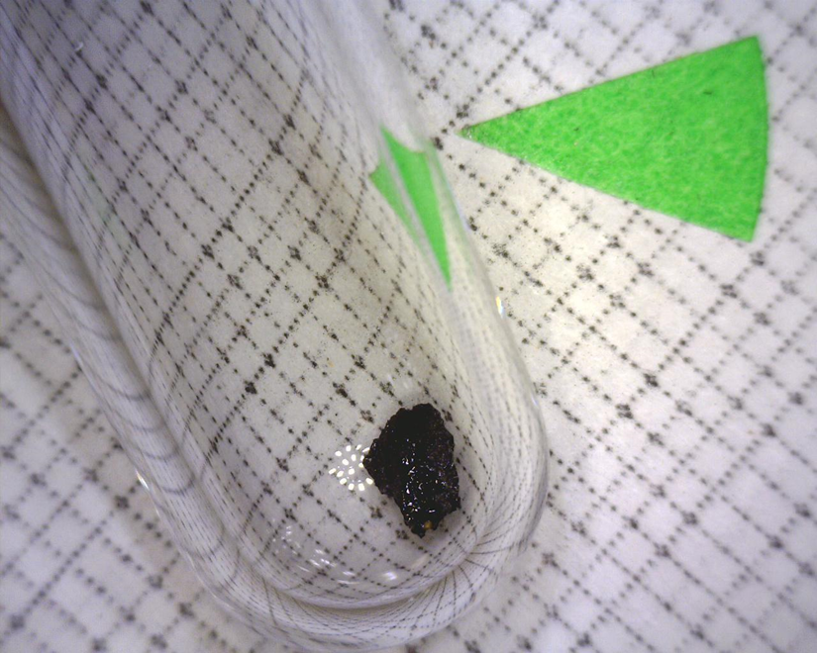
Figure F-4 Sample Beta-350126 (Corn Cupule) during processing at the Beta Analytic Lab

(Photograph provided by Beta Analytic)

Figure F-5 Sample Beta-350127 (Hickory) during processing at the Beta Analytic Lab
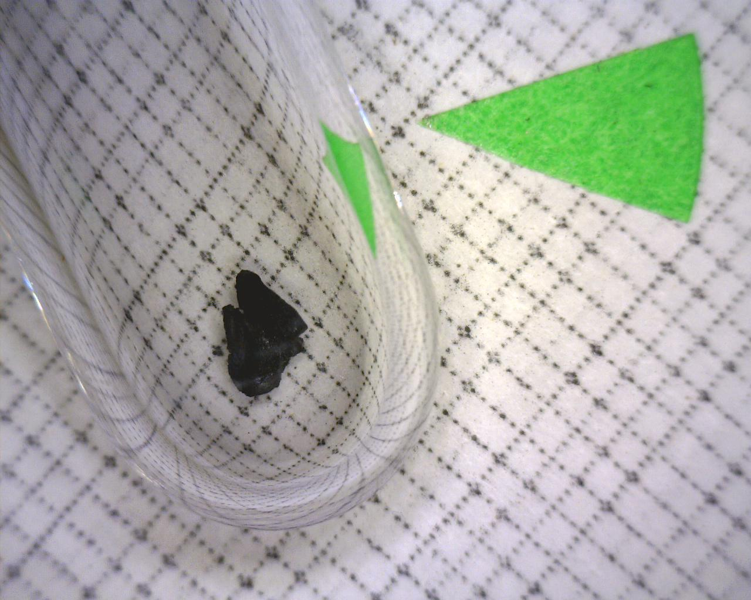
(Photograph provided by Beta Analytic)

Table F-1 AMS Results Provided by the Arizona AMS Laboratory
NSF-Arizona AMS Laboratory |  |  |  | Monday, March 18, 2013
Contact: Miller, S.
AA # Sample ID | Suite | Material | d13C | F | 14C age B.P. | Publication
AA100292 2012-1 | 1 of 3 | Nyssa sp. | -23.5 | 0.6626 +/- 0.0034 | 3306 +/- 41 | Anderson et al. 2016 (In Press)
AA100293 2012-2 | 2 of 3 | Monocot sp. | -26.3 | 0.3592 +/- 0.0025 | 8226 +/- 55 | Anderson et al. 2016 (In Press)
AA100294 2012-3 | 3 of 3 | Soft wood | -24.2 | 0.2556 +/- 0.0021 | 10958 +/- 65 | Walters et al. 2013

(The third date (AA100294 2012-3) was gathered in support of and is also reported in this thesis. The other two are currently awaiting review and publication through the Journal of Tennessee Archaeology — Personal Communication, Dr. Derek Anderson Mississippi State University)

Appendix G: Soil Profile Description for Research Column HSN205E64

Table G - 1 Profile Description for Research Column HSN205E64 (South Wall)
Horizon | Depth | Munsell Color | Texture | Remarks
AB | 0-16 | 7.5YR 4/2, 4/6 | Loamy sand | Clear smooth boundary
Bw1 | 16-38 | 5YR 4/6, 5/8 | Loamy sand | Gradual boundary
Bw2 | 38-68 | 5YR 4/6 | Loamy sand | Gradual boundary
Bw3 | 68-84 | 5YR 4/4, 4/6 | Sandy loam | Gradual boundary
Bw4 | 84-100 | 5YR 4/4, 4/6 | Sandy loam | -

(Notes: Surface Ap horizon has been removed (30cm); structure of all horizons was structureless, single grain; loose consistency although the Bw4 was somewhat more compact; appears to be a series of weak cambic-like horizons from 16-100 cm; slow deposition of sediment and continued weathering resulting in B horizon formation; described on 5/16/2012 by Dr. John Foss.)

Appendix H: Photos of Sample Recovery, Processing and Lab Research

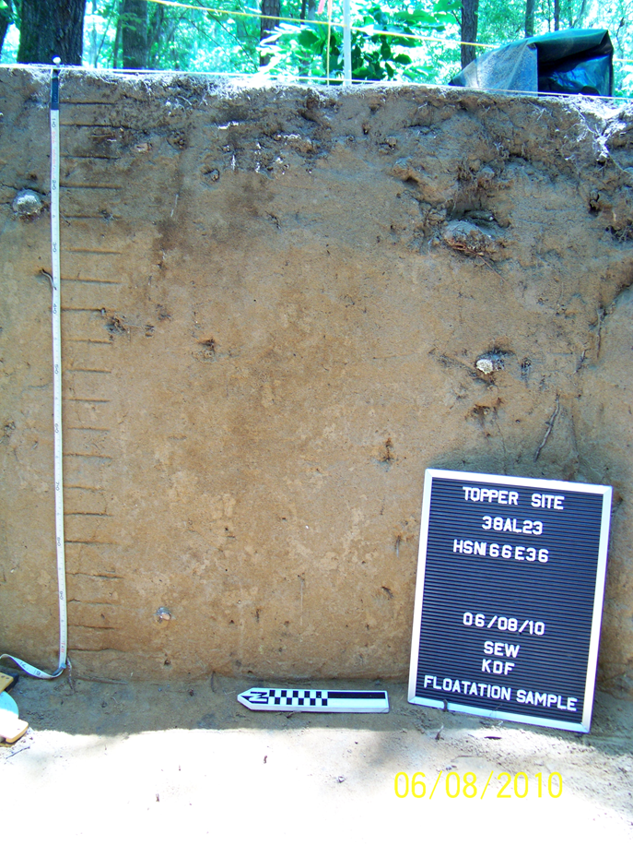
Figure H-1 Test Column HSN166E36 prior to paleoethnobotanical sample removal
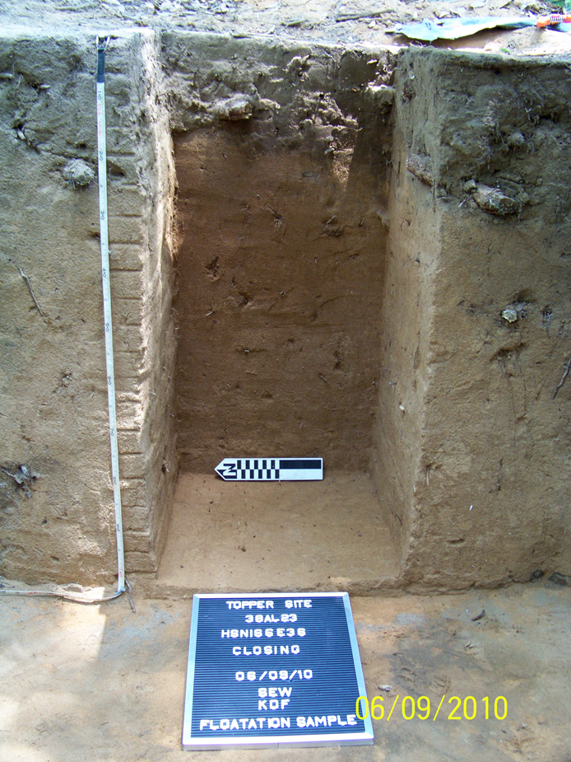
Figure H-2 Test Column HSN166E36 after complete paleoethnobotanical sample removal

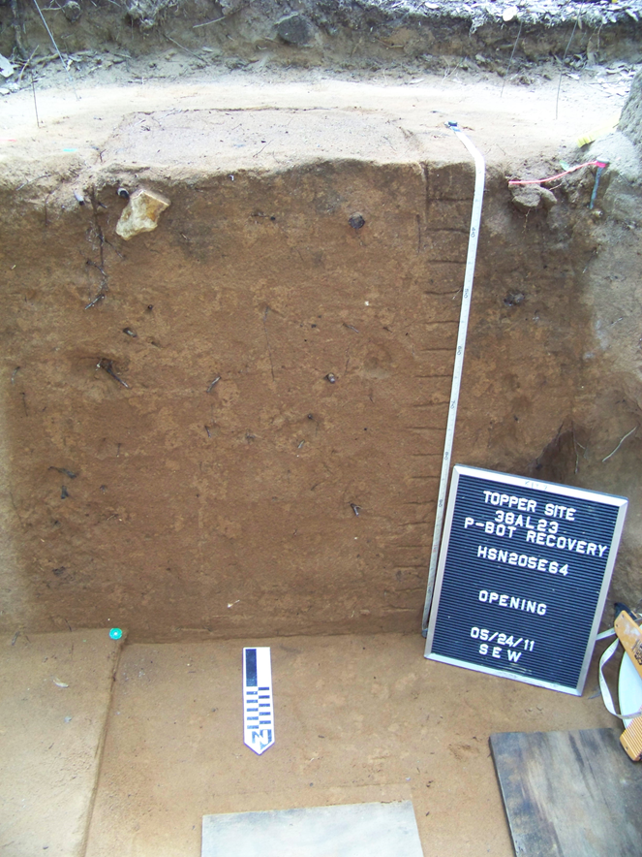
Figure H-3 Research Column HSN205E64 prior to sample removal

Figure H-4 Research Column HSN205E64 after complete paleoethnobotanical sample removal
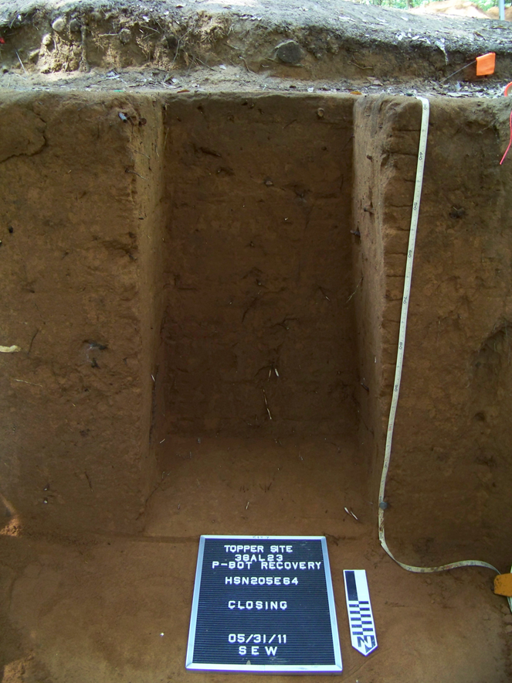

Figure H-5 Flotation processing at the Bells Bend Archaeological Project
(L-R Chauntele Scarlett and Stephen Carmody)
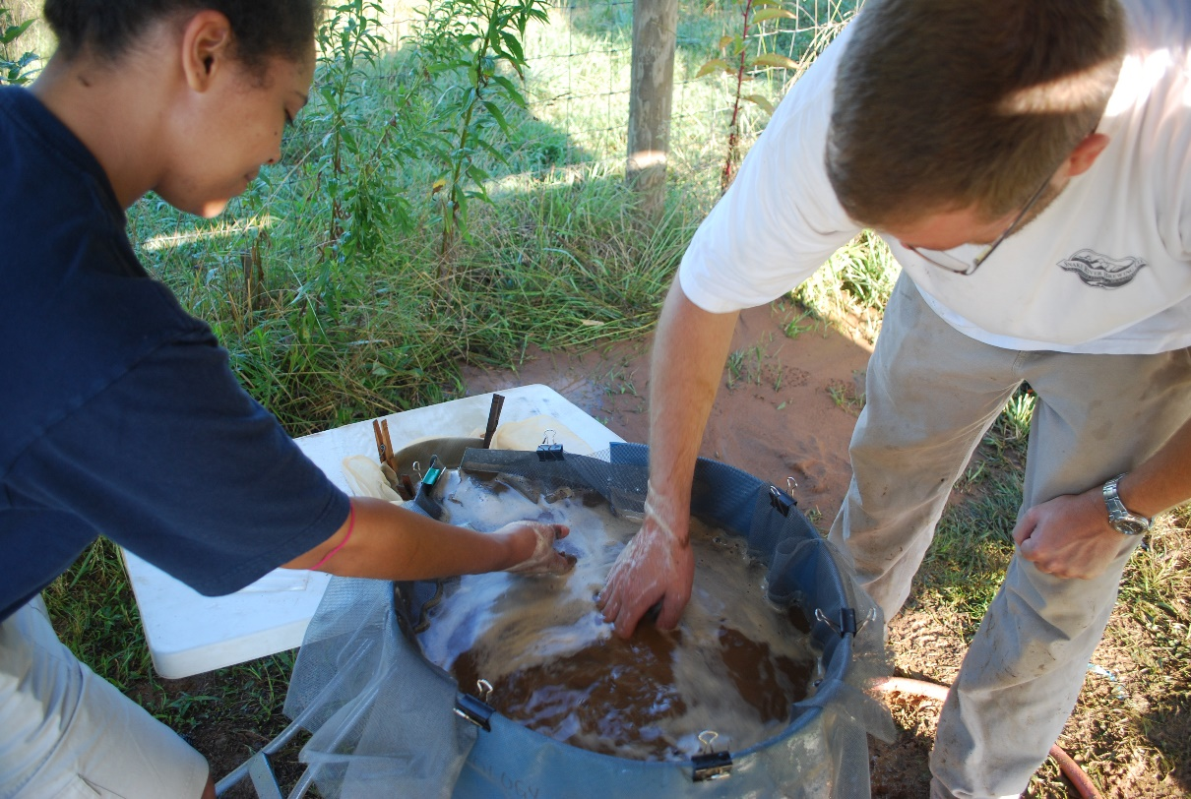
Figure H-6 Flotation processing at the Topper site basecamp
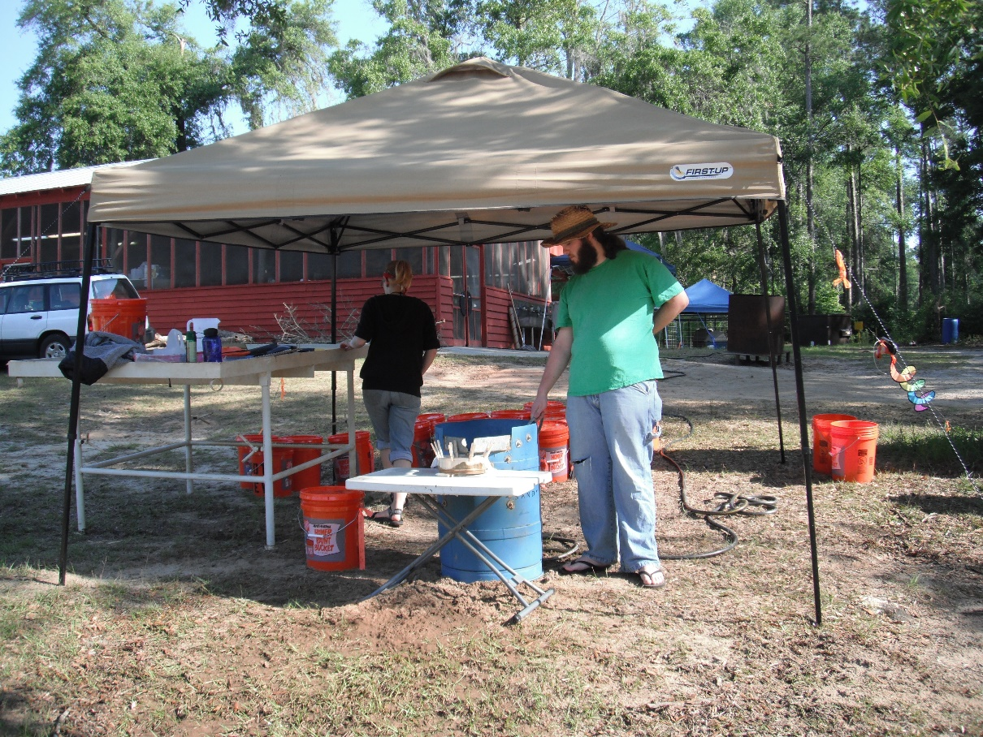
(L-R Sarah Shafer and Hubert Gibson)

Figure H-7 Flotation processing at the Topper site basecamp
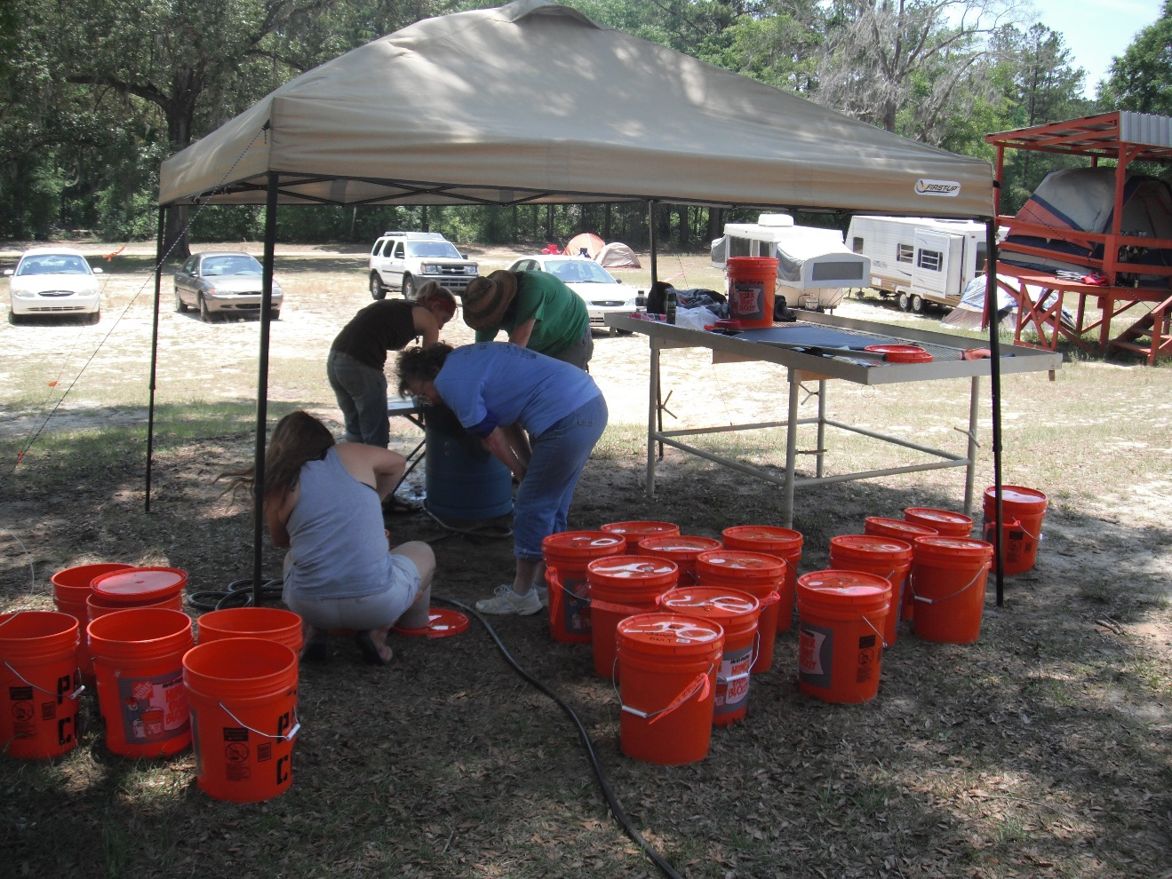

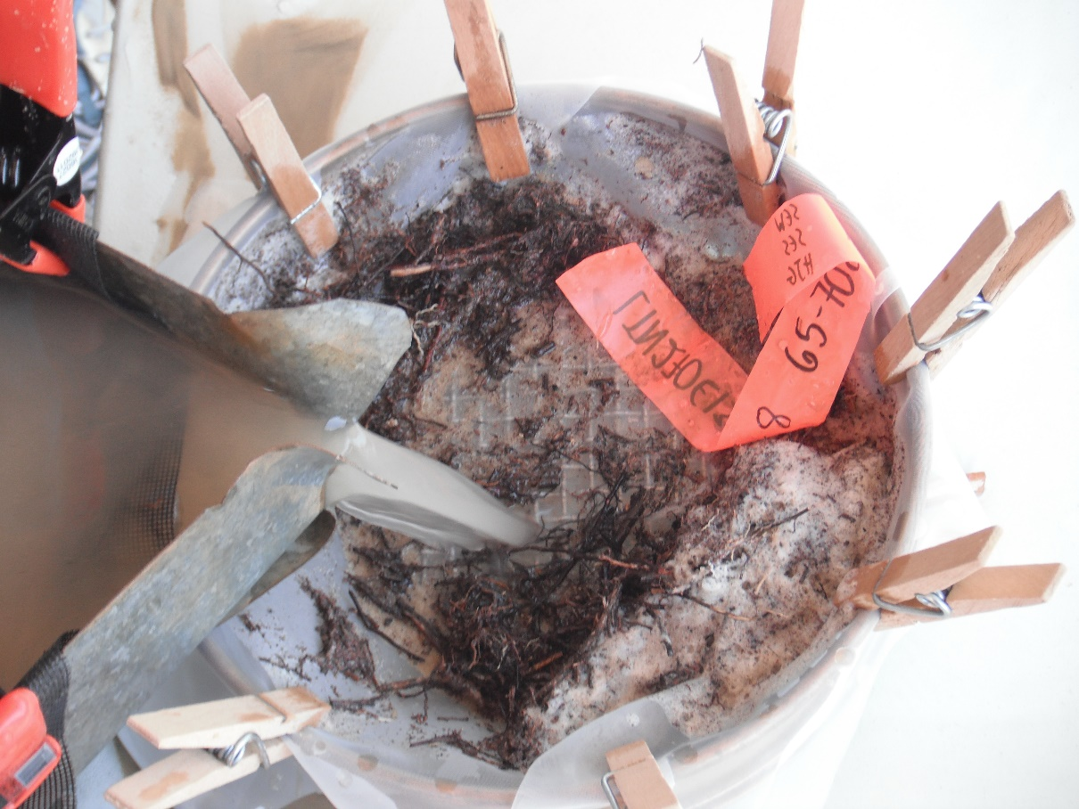
Figure H-8 Flotation remains flowing from the Heavy Fraction mesh (Left) into the Light Fraction mesh (Right) during processing

Figure H-9 Heavy and Light Fractions hanging to dry at the Bells Bend Archaeological Project
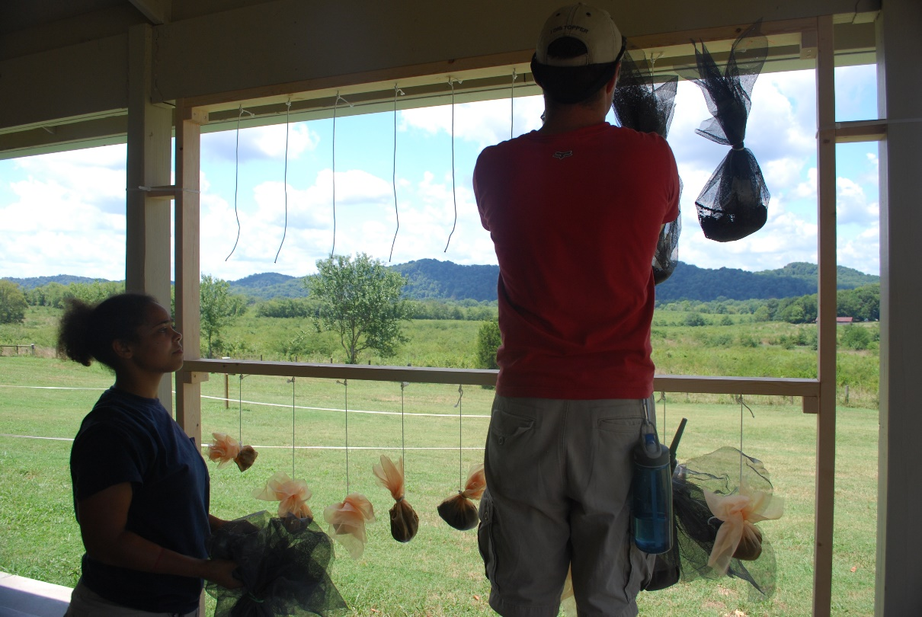
(L-R Chauntele Scarlett and John Pontiff)

Figure H-10 Heavy and Light Fractions hanging to dry at the Topper site basecamp
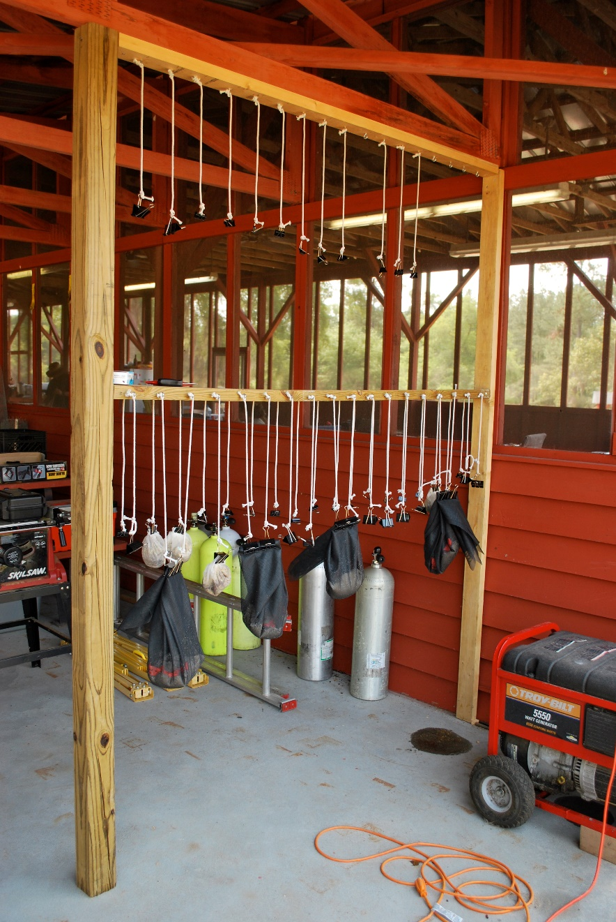
Figure H-11 Bagging dried samples from the Test Column for transport back to Knoxville
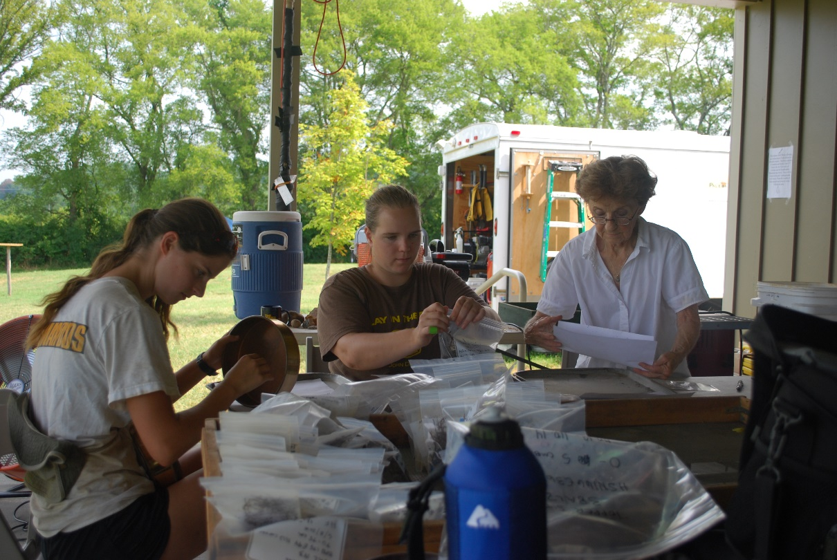
(L-R Alesha Marcum-Heiman, Sarah Walters and Kathy, a Bells Bend Volunteer)

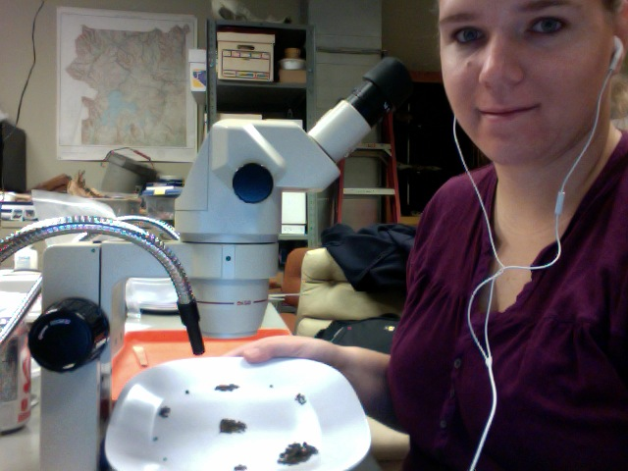
Figure H-12 The author in the University of Tennessee’s Archaeological Research Paleoethnobotany Lab with separated carbon samples

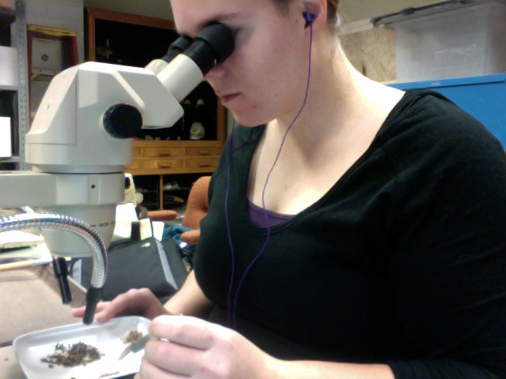
Figure H-13 The author separating samples underneath a low-powered microscope in the University of Tennessee’s Archaeological Research Paleoethnobotany Lab

Figure H-14 The corn cupule chosen from Research Column HSN205E64 for AMS dating
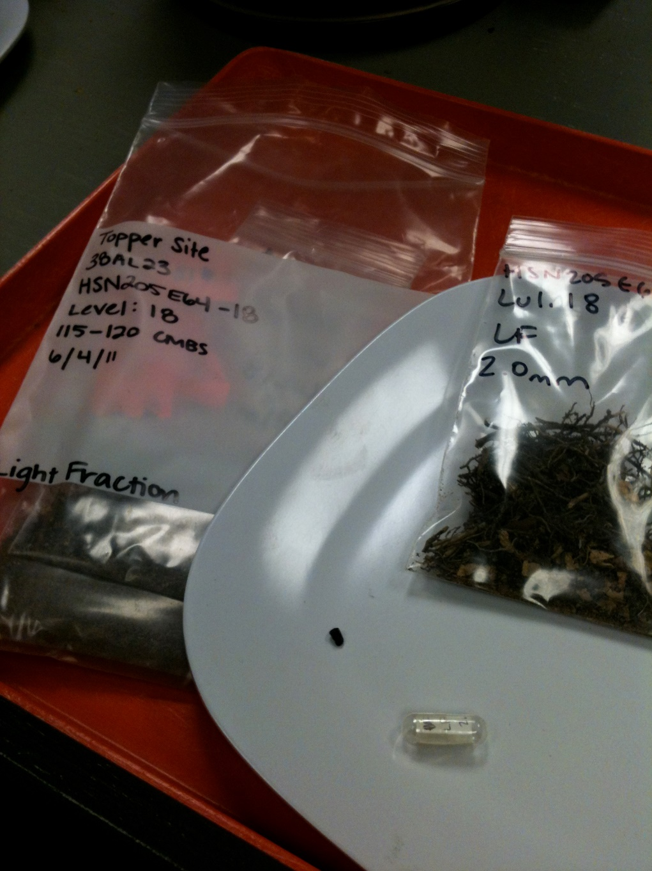

Figure H-15 The author recovering additional samples from Research Column HSN205E64 for chemical testing
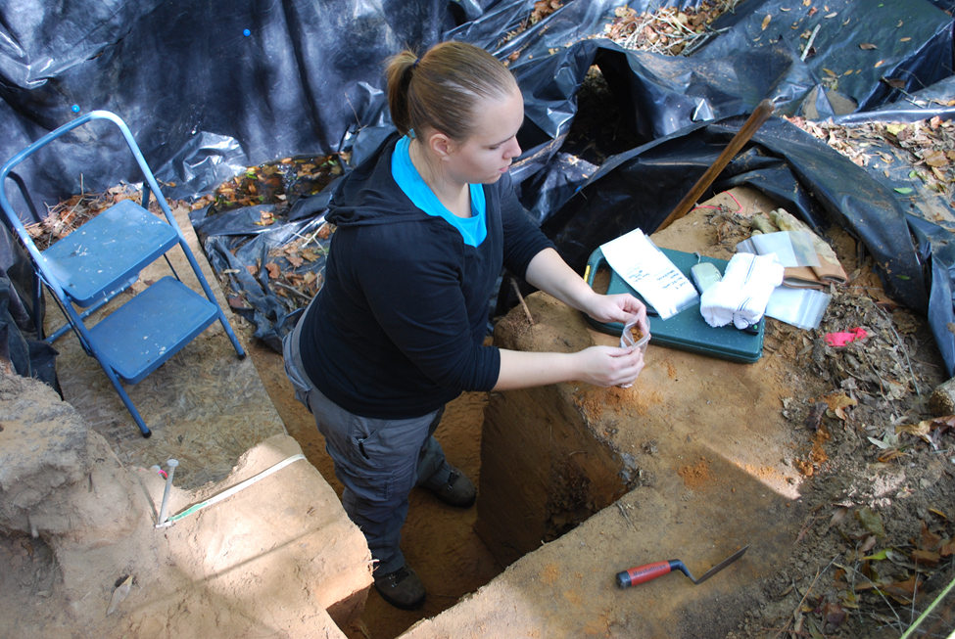

Figure H-16 Soil samples removed from Research Column HSN205E64, ready for chemical testing
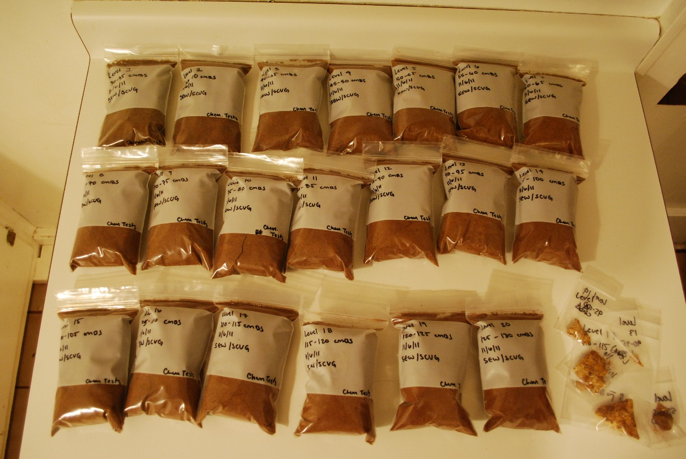

Figure H-17 The author testing a soil sample in order to determine pH level
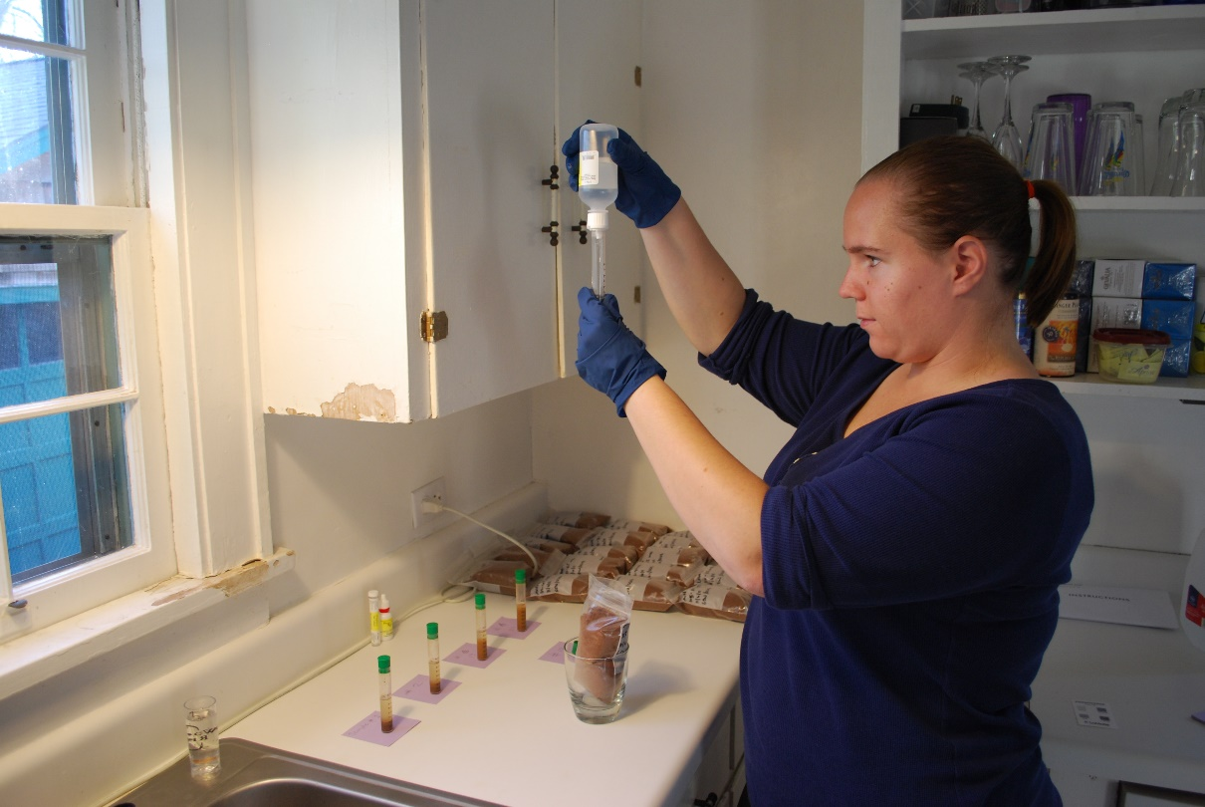

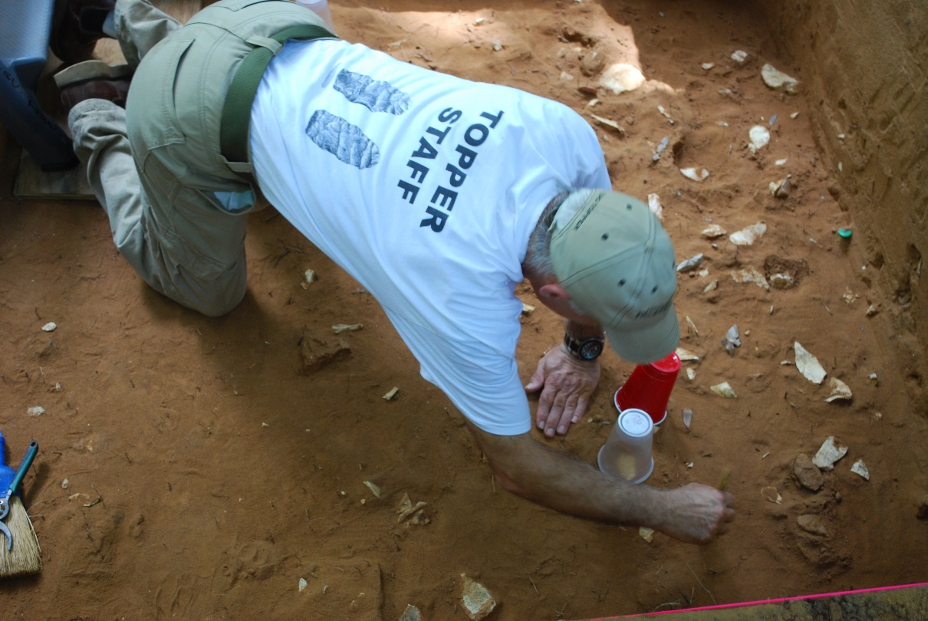
Figure H-18 A partially uncovered Paleoindian occupational floor from the 4x4 block adjacent to Research Column HSN205E64
(Tom Pertierra, Topper Site Logistics Director)

VITA
Sarah Elizabeth Walters was both born and raised in Charlotte, North Carolina and currently resides in Knoxville, Tennessee. Her mother, Elizabeth Walters, originally moved to Charlotte to work in the field of journalism, and her father, Larry, is an architect. Sarah graduated from Northwest School of the Arts in Charlotte in 2003, and decided on Louisiana State University in Baton Rouge, Louisiana, as her undergraduate alma mater.
Originally a music performance major, she later decided to switch to an Anthropology degree with a specific focus in Archaeology. Her first interest in the field was specifically in Egyptian archaeology. However, she completed her first two excavations the summer following her choice to change majors, one in Louisiana and the other in South Carolina, and was instantly hooked on all things archaeological. She graduated from LSU in the spring of 2009 with a BA in Anthropology. She then chose to move to Knoxville, Tennessee to continue her studies with a Master’s Degree in anthropology, focusing more specifically on prehistoric North American archaeology. She received her degree in the summer of 2016.
Sarah is most interested in prehistoric lithic technology, the movement of the first peoples into the Americas, Southwestern United States prehistoric and proto-historic cultures, and multi-dimensional archaeological research. Her recent interests involve understanding the interactions between people and food, especially the renewal and use of heritage and forgotten grains and other foodstuffs and their reintroduction to modern cuisine.
While her plan is to teach on a collegiate level, her work at Topper led her to want to involve a larger range of people in archaeological research. In the future, she would like to work closer with Native peoples, and also with the large number of ever-enthusiastic avocational archaeologists that are excited to play a role in scientific discovery. The model presented by the Topper site also helped her realize that there are alternative ways of supplementing the funding and running of archaeological research projects, especially in an economy where scientific funding is becoming more and more difficult to procure.
While she chose not to continue with a music degree during her tenure at LSU, she still loves to play the flute on occasion. She also enjoys travelling and hiking, kayaking, reading, cooking, riding her motorcycle, watching college football, spending time with her three cats Gracie, Sydney and Freya, and also pursuing her abilities as a marksman.

Please note the use of both Paleoindian and Paleo-American throughout this paper. The archaeological jury is still out on which is the correct term to employ. For now, they should be considered as synonymous (Anderson and Sassaman 2012; Meltzer 2009).
Partial funding for two AMS dates was provided through the Patricia Black Fund, awarded by the Department of Anthropology at the University of Tennessee. An anonymous (and generous) private donor supplemented the amount for these date that was not covered by the Patricia Black award.
Based on the data provided by Anderson and Sassaman 2012:5

