ASSESSMENT OF COMPONENT LEVEL TRITIUM TRANSPORT FOR FISSION AND FUSION SYSTEMS

A Thesis Presented for the
Master of Science
Degree
The University of Tennessee, Knoxville

Miles Landon O’Neal
August 2021
ACKNOWLEDGEMENTS

I would like to thank my supervisor, Dr. Nicholas R. Brown, for his guidance and mentorship throughout my graduate school experience as well as his investment in my development as a nuclear engineer. I would also like to thank Dr. Ivan G. Maldonado and Dr. David C. Donovan for being committee members for my Master’s thesis committee. Additionally, I would like to thank Dr. Seokbin Seo for his guidance on the use of BISON and support towards the completion of this work.
I am also grateful to my family for their support. Throughout my life they have pushed me forward and have instilled in me the values that have led me here. They have been a key motivator to work hard towards my goals.
This work was supported by the US Department of Energy, Office of Fusion Energy Sciences under contract No. DE-AC05-00OR22725.

ABSTRACT

In order to assess tritium transport behavior in component-level models of fission and fusion systems, the hydrogen transport code in the BISON fuel performance code was utilized. Models of different conditions which were of an ITER heat exchanger, LWR cladding, and FHR heat exchanger were conducted. Comparable results between reported values and BISON predictions demonstrated the ability of the model to predict tritium transport behavior through different steel materials for three different model conditions. Next, a method for sensitivity and uncertainty analysis was implemented in order to calibrate the model. This calibration method resulted in improving BISON predictions. Overall, the capabilities of the BISON code for component-level modeling of tritium transport are promising and BISON predictions showed good agreement for the three cases.

TABLE OF CONTENTS

CHAPTER ONE INTRODUCTION 1
CHAPTER TWO LITERATURE REVIEW 3
Hydrogen Transport in BISON code 4
Tritium Behavior in Fission Systems 5
Tritium Behavior in Breeding Blankets 7
CHAPTER THREE TRITIUM TRANSPORT MODELING OF STEEL STRUCTURES IN BISON 9
SS 316L Heat Exchanger for ITER 10
FeCrAl Cladding for an LWR 12
SS 316 Heat Exchanger for an FHR 15
CHAPTER FOUR SENSITIVITY ANALYSIS AND MODEL CALIBRATION 18
Calibration of ITER Heat Exchanger Model 23
Calibration of LWR Cladding Model 25
Calibration of FHR Heat Exchanger Model 26
CHAPTER FIVE CONCLUSIONS AND RECOMMENDATIONS 36
REFERENCES 38
VITA 42

LIST OF FIGURES

Figure 1. Cross section of the FNSF [7] 3
Figure 2. Evolution of tritium distribution across the SS 316L heat exchanger wall. 12
Figure 3. Steady state temperature distribution in the x-direction. 14
Figure 4. Time evolving tritium distribution in FeCrAl cladding. 15
Figure 5. Transient tritium concentration comparison between reported values and BISON predictions. 17
Figure 6. Sobol indices of input parameters for three steel models 22
Figure 7. Scatter plots of RMSE of tritium permeation rate through SS 316L heat exchanger 24
Figure 8. Scatter plot of RMSE of tritium concentration distribution across FeCrAl cladding 25
Figure 9. Time evolving tritium distribution in FeCrAl cladding. 26
Figure 10. Scatter plot of RMSE of time dependent tritium concentration within a SS 316 heat exchanger 28
Figure 11. Transient tritium concentration comparison between reported values, initial BISON predictions, and BISON predictions that resulted in the smallest RMSE 29
Figure 12. Sobol indices of sampled parameters for FHR heat exchanger model with variable alpha boundary conditions. 31
Figure 13. Scatter plots of RMSE of time dependent tritium concentration within a SS 316 heat exchanger tube wall with variable alpha boundary conditions 32
Figure 14. Transient tritium concentration comparison between reported values, initial minimum RMSE, and improved minimum RMSE BISON predictions 33
Figure 15. Sobol indices of input parameters for FHR heat exchanger model with calibrated alpha boundary conditions. 34
Figure 16. Scatter plot of RMSE of time dependent tritium content within a SS 316 heat exchanger with calibrated boundary conditions 34
Figure 17. Transient tritium concentration comparison between reported values and initial, variable alpha, and calibrated alpha minimum RMSE BISON predictions. 35

CHAPTER ONE INTRODUCTION

Nuclear energy, both fission and fusion, have the ability to provide large amounts of ultra-low carbon electricity [1]. With demand for energy expected to continue to grow, nuclear energy provides an important alternative to fossil fuels. Nuclear reactions require a multitude of considerations due to safety and economic needs. Tritium, a radioactive isotope of hydrogen, is a safety consideration and a key component of fuel for fusion reactors, and thereby, an economic consideration as well.
In both fission and fusion reactors, tritium production occurs due to nuclear reactions, and it readily permeates through solid structures such as steel and other metals. As per the guidance from the U.S. Department of Energy and NRC, tritium release to the environment must be regulated due to it being a radioactive isotope [2, 3]. Though tritium must be well controlled, it has multiple uses including one as fuel for fusion reactors. Considering its natural scarcity, an additional constraint on tritium inventory exists in which tritium will need to be produced for fusion energy and development to continue [4]. Therefore, tritium transport and behavior must be accounted for due to safety and economic considerations.
The work in this thesis was conducted to evaluate component-level tritium transport modeling using BISON and its hydrogen transport code. Steel components were assessed due to its common use as a structural material for both fission and fusion systems. To begin, three different tritium transport studies were modeled in BISON to examine its ability to predict and calculate key results of tritium buildup and permeation in structural materials. Following this, a sensitivity study of these models was conducted in order to develop a framework for sensitivity analysis/uncertainty quantification (SA/UQ) as well as optimization/calibration of tritium transport modeling of nuclear reactor systems. This work aims to assess expanding the use of BISON code to include tritium transport of fission and fusion systems.

CHAPTER TWO LITERATURE REVIEW

A literature review was conducted in order to understand the hydrogen transport code in BISON utilized to simulate tritium transport as well as tritium aspects of fission and fusion systems. Tritium production occurs in all fission reactors as a result of fission and neutron activation of tritium forming material [5]. Tritium is most commonly produced in heavy water and fast reactors [6]. In regards to fusion reactors, tritium production occurs in the coolant blankets where it is created due to a reaction between neutrons released from the core and a form of lithium in the blanket [7]. One considered blanket design is the dual coolant lead lithium (DCLL) blanket which have inherent design features such as a relatively high PbLi flow rate that result in limiting tritium losses. A cross section of a fusion reactor design for the Fusion Nuclear Science Facility (FNSF) can be seen in Figure 1.

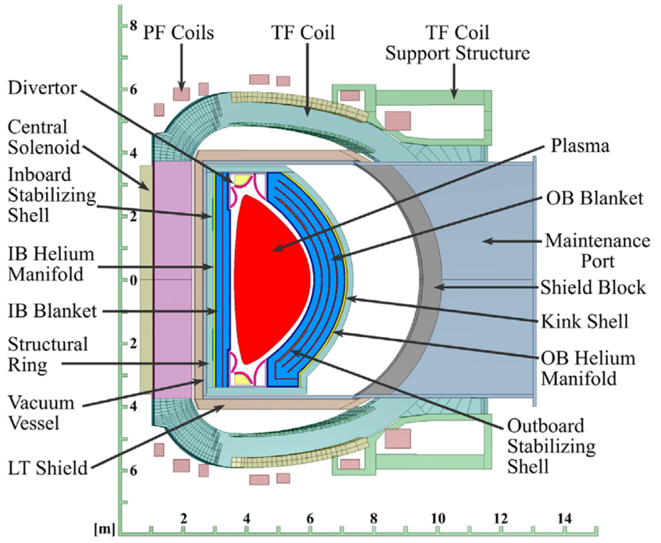
Figure 1. Cross section of the FNSF [7].

Hydrogen Transport in BISON code
BISON is based off of the Idaho National Laboratory (INL) Multiphysics Object-Oriented Simulation Environment (MOOSE) code which utilizes the finite element method to solve systems of coupled equations [8]. BISON can solve fully-coupled partial differential equations for heat transfer, species diffusion, and stress equilibrium for 3D solids, 2D plane, and 1D layer geometries. BISON has the ability to extend modeling considerations to include a coupled multiphysics analysis of a system and to conduct high fidelity analysis of steady state and transient conditions. For example, considering a dual coolant lead lithium (DCLL) blanket, BISON would be able to conduct complex 3D as well as simple 1D tritium transport simulations coupled to a neutronic code like MCNP to provide tritium production information and a thermal-hydraulics code providing coolant flow conditions such as RELAP5-3D [9, 10].
Previous studies have worked to implement a hydrogen migration and redistribution model as well as verify and validate simulations by comparing to historic experimental data [11-15]. The hydrogen transport model in BISON considers two principal phenomena for hydrogen transport behavior in zirconium alloy fuel cladding, hydrogen diffusion in solid solution and hydride precipitation and dissolution. As tritium is a radioactive isotope of hydrogen, its transport behavior in metals is similar to hydrogen though parameter values require adjustment depending on the material it is diffusing through. In this study, the models are of steels which are non-hydride forming metals, and therefore, hydride precipitation and dissolution phenomena as well as their equations within BISON were not considered [16, 17]. Diffusion of tritium in solid solution is driven by a concentration gradient defined by Fick’s law, J_{Fick}, and a temperature gradient known as the Soret effect, J_{Soret} [18-20]. The total tritium flux, J_{tot}, is therefore the sum of both contributions given by

$J_{tot}=J_{Fick}+J_{Soret}=-D_{H}∇C_{ss}-\frac{D_{H}C_{ss}Q^{*}}{RT^{2}}∇T$ (1)

where $C_{ss}$ is the tritium concentration in solid solution in the metal, $Q^{*}$ is the heat of transport in units of J/mol, $D_{H}$ is the tritium diffusion coefficient of the metal in units of m²/s, $R$ is the ideal gas constant, and $T$ is the temperature in Kelvin. The diffusion coefficient of tritium is dependent on temperature, and thus, defined by Arrhenius’ Law [18-22]:

$D_{H}=A_{D}exp⁡\left(-\frac{E_{D}}{RT}\right)$ (2)

where $A_{D}$ is the pre-exponential factor with units of m²/s and $E_{D}$ is the activation energy for diffusion of tritium in a metal with units of J/mol.

Tritium Behavior in Fission Systems
Several studies have been conducted to predict tritium behavior in nuclear fission reactor systems. Park et al. [23] analyzed tritium transport and permeation behavior through a steel heat exchanger wall of a high temperature gas cooled reactor (HTGR) in a 1D diffusion model. They accounted for tritium diffusion inside the material including impact from a temperature gradient on diffusivity, and determined tritium source as a boundary condition through a balance between solubility which was determined through Sieverts’ law and diffusivity in the metal wall. The study was able to accurately predict tritium permeation through steel heat exchanger walls by calculating effective diffusivity using an effective temperature, which revealed the significance of high-fidelity thermal analysis coupled to tritium transport modeling.
Guillou et al. [24] aimed at examining tritium behavior due to temperature in CO₂-cooled nuclear fission reactors also called uranium natural-graphite-gaz (UNGG). To do this, deuterium was implanted into graphite and Nuclear Reaction Analysis (NRA) at millimetric and micrometric scales was used to analyze its behavior. The graphite samples were subjected to high vacuum and inert Ar gas flow for temperatures ranging from 200 to 1200°C. Release of deuterium for the graphite sample was mainly driven by its thermal migration and release through its porous structure, and was found to occur from about 400-600°C. For the Saint-Laurent A2 (SLA2) reactor, it was extrapolated that thermal release of tritium due to reactor shutdown which had operated for 11 effective full-power years should be lower than 30% of the amount produced during reactor operation. Additionally, it was concluded that removal of all tritium would be more efficient in dry inert gas with temperatures greater than 1300°C.
A study by Ustinov et al. [6] investigated tritium behavior in fast reactors with nitride fuel. Tritium retention within the fuel may be the result of tritium binding to fission products in the fuel region. Additionally, steel cladding allows for the majority of produced tritium to easily permeate through and into the primary coolant. As tritium diffuses through the steel cladding, some tritium atoms can enter trap sites, and thereby, tritium can result in degrading the physical properties of steel.

Tritium Behavior in Breeding Blankets
Commercial fusion reactors utilize tritium as fuel, and due to its scarcity, coolant blankets around the core will need to produce more tritium than the reactor uses. As such, achieving tritium self-sufficiency is an important qualification for future fusion reactors.
In a study by Pattison et al. [25], tritium transport behavior in a fusion reactor’s dual coolant lead lithium (DCLL) blanket was investigated by modeling a single rectangular duct in a magnetic field with a SiC flow channel insert (FCI). The tritium advection/diffusion equations as well as the source terms and trapping were solved using boundary conditions provided by computing the flow field of the PbLi coolant with computational fluid dynamics (CFD) code. The study predicted that tritium was well-retained within the flow channel insert, the majority of tritium loss occurred in the PbLi gap flow, and tritium permeation into the helium coolant outside the RAFM structure was low. The results revealed the significance of low diffusivity of tritium inside SiC FCI, but it did not include thermal analysis that could account for temperature impacts due to the Soret effect on tritium diffusion.
Fukada et al. [26] examined tritium behavior in Pb-Li blanket systems. Coating F82H reduced activity ferrite/martensite (RAFM) steel with a Er₂0₃ ceramic film reduced tritium permeation by a factor greater than 10³. The reduced tritium permeation rate minimizes tritium inventory in the structural steel, and thereby, improving the potential safety of a reactor. Additionally, experiments using a transient permeation method were conducted in order to determine the solubility, diffusivity, and permeability of hydrogen isotopes in Pb-Li eutectic alloy. From this, the diffusivity of hydrogen was determined to be 1.4 times larger than deuterium.

CHAPTER THREE TRITIUM TRANSPORT MODELING OF STEEL STRUCTURES IN BISON

The simulations in this thesis are of component-level steel structures where the physical phenomena considered are the diffusion of tritium due to a concentration gradient and the temperature gradient. The concentration gradient drives tritium from higher to lower concentrations, and the Soret effect for steels drives tritium from colder to warmer temperatures. Two of the simulations which are of a LWR fuel pin and FHR heat exchanger have a tritium current into the steels as a boundary condition where temperatures are also hotter at one end of the steel structure compared to the other [27, 28]. Hence, tritium diffusion within these simulations have opposing forces. The remainder simulation also has a tritium current boundary condition, though, the temperature is constant across the structure meaning there is no impact by a temperature gradient [29]. The key figures of merit for these simulations are the tritium distribution and evolution with time from which the total concentration and permeation rate can be calculated.
A 2D mesh with elements along the x-axis and y-axis were used for all cases, but the temperatures and concentration fields along the y-axis are assumed to be constant. For cases with temperature gradients, the model consists of two scripts where the first one solves the temperature distribution at each mesh point for every time step. The subsequent script uses the solved time dependent temperature distribution to calculate the tritium distribution throughout the steel at each mesh point for every time step. In addition, kernels and material properties were used in the code to evaluate values associated with temperature calculations as well as the tritium transport model. Tritium transport parameters and their nominal values used for modeling these cases are listed in Table 1 following the order they are discussed in this chapter. The heat of transport was assumed the same value for each steel material considered [20]. Tritium transport parameter values for FeCrAl were assumed equivalent to those for tritium in SS 304.

Table 1. Values of tritium transport parameters for steel models in BISON.
Parameter | Unit | SS 316L | SS 304 | SS 316
Diffusivity Frequency Factor, A_{D} | m²/s | 5.90$×$10⁻⁷ | 1.24$×$10⁻⁶ | 6.32$×$10⁻⁷
Diffusivity Activation Energy, E_{D} | J/mole | 52095 | 56726 | 47800
Heat of Transport, Q* | J/mole | -6271 | -6271 | -6271

SS 316L Heat Exchanger for ITER
Nakamura et al. [29] studied tritium permeation through heat exchanger tubes made of stainless steel under similar conditions to those from ITER (International Thermonuclear Experimental Reactor). The SS 316L heat exchanger tubes had an outer diameter of 6 mm, thickness of 0.5 mm, and length of 0.3 m. Considering all 37 tubes, the total surface area where tritium permeation out into the secondary coolant occurred was 0.2 m². Both primary and secondary coolants were held at constant values for temperature at 423 K and for pressure at 0.9 MPa. For the primary coolant, tritiated water was filled inside of the tubes while tritium free water filled the chamber outside the tubes. The tritium diffusion coefficient was estimated to be 5$×$10⁻¹³ m²/s, and the derived tritium permeation rate from the experimental results was 4.2$×$10⁻³ Bq/m²/s [29].
A 1D model of a single heat exchanger tub was simulated in BISON code consisting of a single region made of SS 316L where the tritiated water was to the left and the pure water was to the right. As the two coolants had equivalent temperatures, a constant temperature of 423 K was assumed over the metal region. A constant tritium concentration equal to the reported value in [29] was applied at the left boundary. The right boundary tritium concentration was set to zero as it was assumed that tritium which reached the boundary was instantaneously released to the secondary coolant.
The calculated tritium distribution evolution inside the steel wall using BISON is presented in Figure 2. A non-linear distribution was calculated for the steady state model due to weakened diffusion of tritium towards the right end. This resulted from a small diffusion coefficient due to a low temperature field as well as the absence of thermal diffusion. The permeation flux was calculated by utilizing a linear approximation of Fick’s first law on the last few spatial nodes of the resulting tritium concentration, and was comparable to the experimental value. Predicted permeation flux of tritium was 1.29$×$10⁻³ Bq/m²/s which was on the same order of magnitude as that which is reported in the experiment [29].

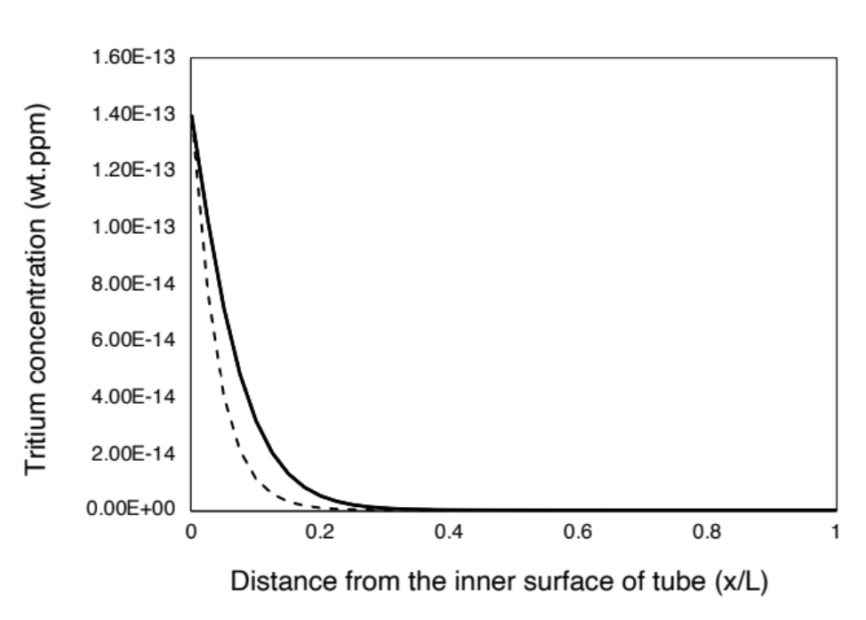
Increasing time
Figure 2. Evolution of tritium distribution across the SS 316L heat exchanger wall.

FeCrAl Cladding for an LWR
A study conducted by Hu et al. [28] evaluated tritium permeation in iron-chromium-aluminum (FeCrAl) ferritic steel alloy for LWR cladding applications. Hu et al. [28] also reported a simulation of tritium behavior for FeCrAl cladding in a 1000 MW 4-loop PWR using a 1D finite difference method and semi-implicit Crank-Nicolson scheme. Tritium production occurs within the fuel pellets where it then diffuses to and absorbed by the cladding. Further transport of tritium through the cladding to its interface with the primary coolant results in tritium release into the coolant. Fuel operating conditions assume a linear power of 220 W/cm and an 8.22 mm diameter fuel pellet of a LWR 17$×$17 geometry which result in a power density of 416.6 W/cm³. This thereby results in a fission rate of 1.26$×$10¹³ cm⁻³s⁻¹ and a tritium production rate of 1.335$×$10⁹ cm⁻³s⁻¹. It was assumed that once the tritium was produced in the fuel, 50% of it was released into the fuel cladding gap. The model accounted for the tritium production rate in the gap, absorption at the inner cladding surface, transport though the cladding structure, and radioactive decay. Absorption of tritium at the cladding surface was determined by Sievert’s law where the tritium concentration is proportional to the square root of the pressure in the gap. Transport and boundary conditions were also defined by diffusion following Fick’s laws. The initial concentration throughout the steel cladding was set to zero, and the boundary condition at the interface between the cladding and coolant assumed instantaneous isotope exchange. Hence, tritium is released into the coolant once it reaches this interface.
The model created in BISON code first solved a 1D heat conduction equation for the temperature distribution and then the tritium transport equation with the solved temperature field. This model consisted of three different regions that represented the UO₂ fuel, helium gas gap, and ferritic steel cladding. A constant volumetric heat source was assumed in the fuel region to match the average temperature of the fuel region reported in [28]. The left boundary was set to be insulated while the right boundary was convective heat transfer to the pressurized water coolant. Figure 3 shows that an appropriate temperature distribution was calculated over all regions. A constant left boundary condition for the tritium source was assumed equal to the tritium production rate reported in [28]. The right boundary condition was set to a concentration of zero to follow the assumption that tritium is instantaneously released to the coolant once it reaches the clad-coolant interface. The BISON simulation then solved the tritium transport equations in the cladding region utilizing the time dependent temperature distribution.

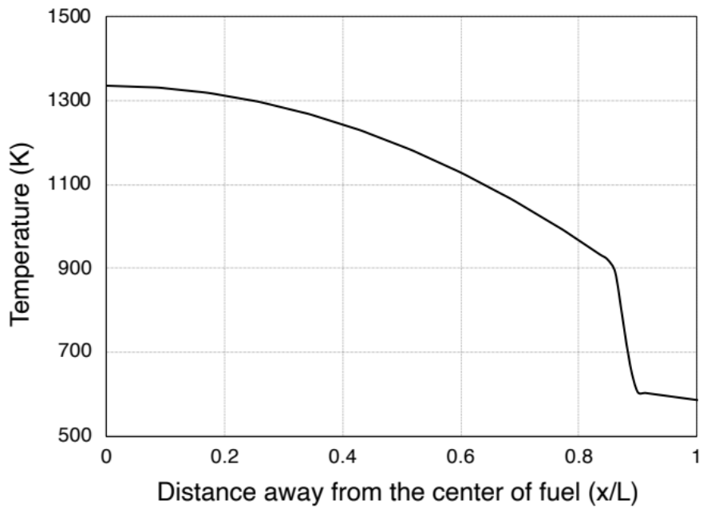
Figure 3. Steady state temperature distribution in the x-direction.

Figure 4 presents the resulting tritium distribution in the cladding predicted by BISON simulation dependent on time and distance from the inner cladding surface. The calculated tritium distribution is similar to that reported in [28], which demonstrated the ability of BISON code to calculate comparable results. There are some discrepancies once the model reaches approximately steady state where BISON slightly overpredicts tritium concentration in the center region of the steel.
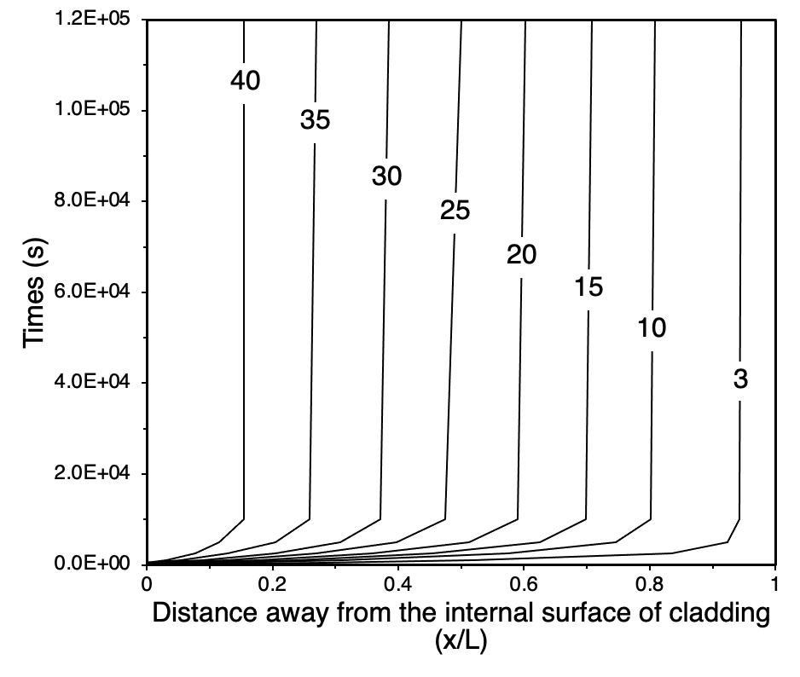
Figure 4. Time evolving tritium distribution in FeCrAl cladding. The numbers in the contour plot are tritium concentration (mol T/cm³) $×$ 10¹².

SS 316 Heat Exchanger for an FHR
Stempien [27] developed a tritium transport model to predict its behavior in a heat exchanger for FHRs during reactor startup. The hot leg SS 316 heat exchanger tubes were approximated as a single pipe with a thickness of 0.02 m, inner diameter of 0.792 m, and length of 29.74 m. Tritium production and accumulation occurs in the FLiBe primary coolant and provided the tritium source boundary condition for the steel wall. In the primary coolant side, the heat exchanger inlet and outlet temperatures were set to be 873.15 K and 973.15 K, respectively. For the secondary coolant, the temperature of 873 K was assumed throughout the secondary loop. The inner boundary balanced tritium fluxes from the bulk coolant to the wall interface and from the wall interface to the metal structure. For the outer boundary condition, it was assumed that tritium was instantly released to the secondary coolant.
The 1D BISON model was divided into two separate steps to calculate heat transfer with convective boundary conditions followed by time dependent tritium distribution. The model was of a single 1D metal block with the width equal to the heat exchanger tube’s thickness. For the left boundary temperature condition, the coolant temperature was assumed equal to the average of the heat exchanger inlet and outlet temperatures which was about 922 K. The right boundary was set to 873 K. An external data file was made to determine the time-dependent left boundary tritium concentration employing the method reported in [27]. This method essentially balances the amount of tritium within the primary coolant to that in the metal wall. In order to utilize this method, the steel wall was assumed to be a single segment and the centerline tritium concentration was set to be equal to reported values of tritium concentration in the wall. The right boundary condition assumed instant tritium release to the secondary coolant, and therefore, the concentration was set to zero.
Figure 5 shows the predicted concentration of tritium in the steel structure compared to the reported values in [27]. The resulting time dependent tritium concentration calculated by BISON was on the same order of magnitude and followed a similar trend as the reported values, though, BISON overall underpredicted the concentration. This was a result of assuming that the reported values of tritium concentration in the wall were equal to the centerline tritium concentration when determining the transient tritium boundary condition. This is only applicable for steady state conditions where the temperature gradient impacts the tritium concentration. As the conditions in the first few hours are a transient, the tritium distribution is more similar to an exponential decay rather than a linear relation, and thereby, result in underpredicting the tritium concentration.
BISON demonstrated its ability to predict comparable tritium behaviors across various steel materials, though, some discrepancies in tritium distribution exist between BISON code and other studies. This might come from the scattered data of diffusion properties of tritium in steel materials, which brought the need of the sensitivity analysis and calibration studies, presented in chapter 4.

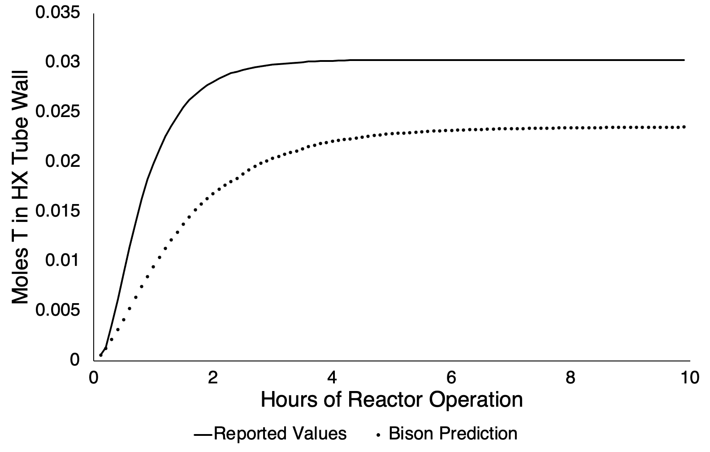
Figure 5. Transient tritium concentration comparison between reported values and BISON predictions.

CHAPTER FOUR SENSITIVITY ANALYSIS AND MODEL CALIBRATION

In this chapter, a global sensitivity study of the three steel models is demonstrated as a basis for implementation in a more comprehensive study of a component-level multiphysics fusion blanket. A global sensitivity analysis is used to determine and rank the key input parameters that influence a model’s output [30-32]. In this work, Sobol variance decomposition technique was employed for the sensitivity analysis [33]. This technique can account for both linear as well as non-linear correlations, and thereby, is a more general approach to quantify model uncertainties. The first order effect, $S_{i}$, from a Sobol analysis represents the contribution a given input has on the output variance and is defined as

$S_{i}=\frac{V_{X_{i}}\left(E_{X_{\sim i}}\left(f\left(X\right)|X_{i}\right)\right)}{V\left(f\left(X\right)\right)}$ (3)

where $V(f(X))$ is the variance of $f(X)$, and $E_{X}\left(f\left(X\right)|X_{i}\right)$ is the conditional expected value of $f\left(X\right)$ for a fixed input value $X_{i}$. Also, a total effect is determined which captures higher order influence in addition to the first order effect, and therefore, represents the contribution to output variance due to interaction with several variables. The total effect, $T_{i}$, is defined as

$T_{i}=\frac{E_{X_{\sim i}}\left(V_{X_{i}}\left(f\left(X\right)|X_{\sim i}\right)\right)}{V\left(f\left(X\right)\right)}$ (4)

where $E_{X_{\sim i}}\left(V_{X_{i}}\left(f\left(X\right)|X_{\sim i}\right)\right)$ is the mean of $f\left(X\right)$ for all possible values of $X_{\sim i}$ while holding $X_{i}$ constant.
A confidence interval below 0.05 ensures that calculated Sobol indices were converged. Total $N*(2D+2)$ different BISON input decks were generated by the sampler for the Sobol analysis where $N$ is a chosen sample number and $D$ is the number of parameters. Once all cases have been completed, the Saltelli’s scheme was used [34] to compute Sobol indices for a chosen Figure of Merit (FoM).
Sobol sensitivity analysis of the three studies previously modeled in BISON was conducted in order to verify the significance of the impact of diffusion parameters to the prediction as well as to incorporate the ability to calibrate these models. The parameters included in the sensitivity analysis were relevant model parameters for tritium diffusion within steel structures. As such, three input parameters analyzed were the pre-exponential factor for the diffusion coefficient, the diffusion activation energy, and the heat of transport. Ranges of the model parameters were chosen based off literature review and are listed in table 2.

Table 2. Major parameter variation ranges for Sobol sensitivity analysis.
Material | Parameter | Unit | Lower Bound | Upper Bound
SS 316L | Diffusivity Frequency Factor, A_{D} | m²/s | 5.31$×$10⁻⁷ | 6.49$×$10⁻⁷
SS 316L | Diffusivity Activation Energy, E_{D} | J/mole | 46885 | 57305
SS 304 | Diffusivity Frequency Factor, A_{D} | m²/s | 1.116$×$10⁻⁶ | 1.364$×$10⁻⁶
SS 304 | Diffusivity Activation Energy, E_{D} | J/mole | 51053 | 62399
SS 316 | Diffusivity Frequency Factor, A_{D} | m²/s | 5.688$×$10⁻⁷ | 6.952$×$10⁻⁷
SS 316 | Diffusivity Activation Energy, E_{D} | J/mole | 43020 | 52580
 | Heat of Transport, Q* | J/mole | -6899 | -5643

The model calibration study using the results from the sensitivity analysis is presented in this chapter in order to demonstrate this approach as a basis for implementation in a more comprehensive study of a component-level multiphysics fusion blanket system. RMSE values were calculated for each sample of the sensitivity study and is defined as

$RMSE= \sqrt{\frac{1}{n}\sum{({\hat{y}}_{i}-y_{i})}}$ (5)

where ${\hat{y}}_{i}$ are predicted values and $y_{i}$ are expected values. Note than an RMSE value is always positive, and the closer it is to zero means that the predicted values more closely match expected values. As such, the calibration study looked for the lowest RMSE value between all samples in order to determine the parameter values which result in improved model prediction.
In this study, the key FoM of the three cases was the tritium distribution and evolution with time inside the steel structures. Once all sampled BISON input decks ran, a Root Mean Square Error (RMSE) analysis was implemented in the Sobol sensitivity analysis in order to calibrate the models. Calculated RMSE values for each case compared values of tritium concentration distribution varying over time for the LWR FeCrAl cladding model, tritium permeation rate at steady state for the ITER SS316L heat exchanger model, and overall tritium concentration evolving with time in the steel structure for the FHR SS316 heat exchanger model. The RMSE values were then used to calculate Sobol indices.
Figure 6 presents the computed Sobol indices for their respective cases. While the activation energy for the diffusion coefficient had the largest contribution for all three cases, there is slight variation between the calculated indices. In regards to the heat of transport, it did not contribute to the outputs in the second benchmarking case where no temperature gradient existed. The first and third cases had temperature gradients, though, the temperature gradient in the first case was comparatively large to that in the third case. For the third case, the calculated tritium influx at the boundary was dependent on the parameters which determine the diffusion coefficient, and hence, results in a larger importance of the pre-exponential factor for the diffusion coefficient compared to the first case. Considering the pre-exponential factor for the diffusion coefficient, the second case was influenced the most between the three cases due to the exclusion of the input by the heat of transport.
(1)
(2)
(3)
Figure 6. Sobol indices of input parameters for three steel models: (1) ITER SS 316L heat exchanger, (2) LWR FeCrAl cladding, (3) FHR SS 316 heat exchanger.

Calibration of ITER Heat Exchanger Model
For the model of the ITER heat exchanger, calibration was conducted in regards to the tritium permeation rate into the secondary coolant at steady state between reported and BISON predicted values. As shown in Figure 7(1), there is a strong correlation between the diffusivity activation energy and the prediction of the permeation rate of tritium into the secondary coolant. As initial modeling conditions underpredicted the permeation rate compared to reported values, the model parameters should be adjusted to increase the amount of tritium diffusing through the steel. Considering the influence diffusivity activation energy has on the diffusion coefficient and subsequently tritium transport through steel as a whole, increasing activation energy reduces the amount of tritium diffusing from high concentrations to low concentrations. As such, the trend in Figure 7(1) which shows smaller values of the activation energy result in smaller RMSE values, thereby improved comparative prediction, was expected. Figure 7(2) presents the RMSE values in regards to the diffusivity frequency factor and shows a weaker trend compared to the activation energy. Again considering tritium diffusion as a whole, increasing the diffusivity frequency factor increases the amount of tritium diffusing from high to low concentrations. Therefore, increasing diffusivity frequency factor tended to improve the comparative prediction of tritium permeation rate. Note, however, that the permeation rate was more dependent on the activation energy which explains why not all conditions in where the frequency factor increased resulted in improved prediction. A set of diffusion parameters given by the minimum RMSE sample resulted in a calibrated prediction of the tritium permeation rate of 4.03$×$10⁻³ Bq/m²/s whereas the reported value was 4.2$×$10⁻³ Bq/m²/s.

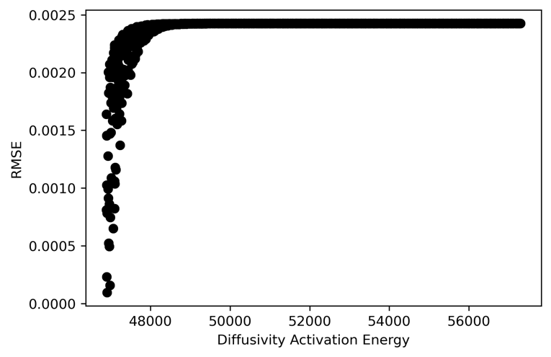
(1)
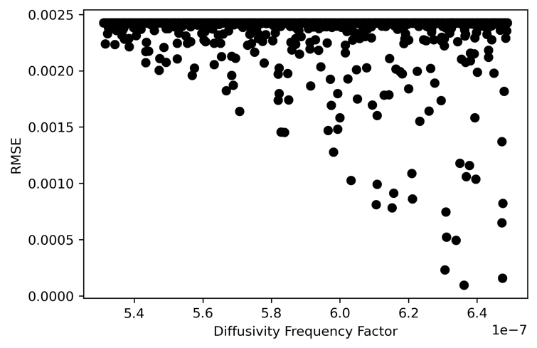
(2)
Figure 7. Scatter plots of RMSE of tritium permeation rate through SS 316L heat exchanger in regards to: (1) diffusivity activation energy, (2) diffusivity frequency factor.

Calibration of LWR Cladding Model
The calibration of the LWR FeCrAl cladding model determined RMSE values between reported and BISON predictions of tritium concentration distribution once steady state was established. Figure 8 presents the scatter plot of RMSE values pertaining to tritium distribution with regards to the diffusivity activation energy, and as expected, there is an obvious correlation between the model’s prediction and this parameter. There exists some trend between the diffusivity activation energy and RMSE values, though, there are cases throughout the range of the considered parameter with comparatively small RMSE values. This thereby reveals that the sensitivity to the other parameters can produce a large difference in the prediction.

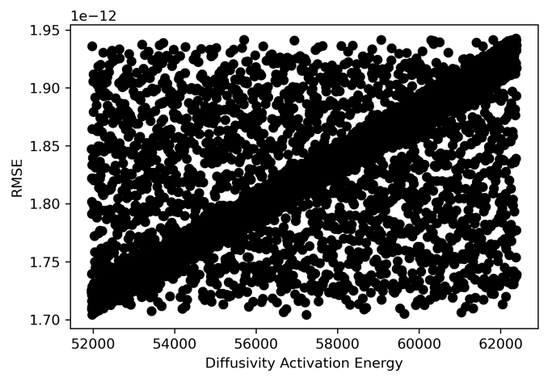
Figure 8. Scatter plot of RMSE of tritium concentration distribution across FeCrAl cladding in regards to diffusivity activation energy.

Figure 9 presents the results from inputting the parameter values which lead to the case with the smallest RMSE value back into the model. As the calibration method only considered tritium distribution once steady state was established, the adjusted boundary condition along with the min RMSE conditions led to the model in BISON to better match reported results.

Figure 9. Time evolving tritium distribution in FeCrAl cladding. The numbers in the contour plot are tritium concentration (mol T/cm³) $×$ 10¹² for adjusted tritium influx boundary condition.

Calibration of FHR Heat Exchanger Model
For the calibration of the FHR heat exchanger model, RMSE values were calculated between reported and predicted values of tritium concentration in the wall as time progressed during a transient in which the reactor was started. To account for the transient, all sampled cases were run four times in which all four sets ended at different times. These included three end times over the noticeable transient and one end time once steady state was fully established.
Figure 10 presents the scatter plot of RMSE values in regards to the diffusivity activation energy. The relation between this parameter and tritium concentration in the wall was complicated due to the consideration of the transient. Specifically, the left boundary condition for tritium concentration was dependent on the diffusion coefficient. Increasing the activation energy and decreasing the diffusivity frequency factor reduce the diffusion coefficient, and thereby, influence the influx of tritium from the primary coolant. This relation resulted in an increased tritium source at the boundary with increased values of the activation energy and decreased values of the diffusivity factor. As such, to calibrate the model which was previously underpredicting, the activation energy was increased while the diffusivity frequency factor decreased.

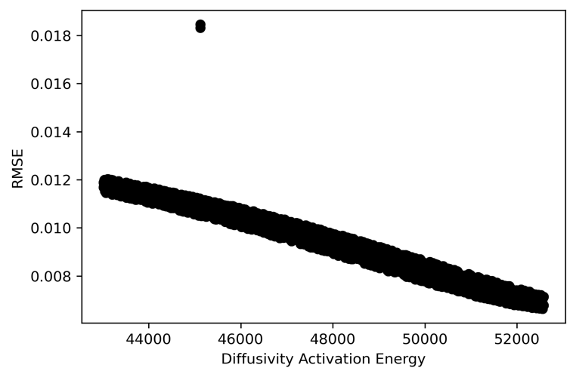
Figure 10. Scatter plot of RMSE of time dependent tritium concentration within a SS 316 heat exchanger tube wall in regards to diffusivity activation energy.

Figure 11 presents the results from the calibrated model. Prediction at steady state was improved, though, the model continued underpredicting for the transient. This was a result of the assumptions made in the method to determine the concentration at the left boundary. In this, the method implemented a linear approximation between the concentration at the wall in the steel to the concentration at the center of the steel. Though the implementation of this approximation applies to cases in which the heat of transport was included in simulations, it only applies to steady state conditions. Referring to Figure 2 as a visual aid, tritium concentration follows an exponentially decreasing trend during a transient. Accounting for the heat of transport, this exponential decrease begins to become more linear as the model approaches steady state. As such, the calibrated model slightly underpredicted the transient while matching the steady state value due to the method for determining the boundary condition calculating a smaller influx of tritium than expected.

Figure 11. Transient tritium concentration comparison between reported values, initial BISON predictions, and BISON predictions that resulted in the smallest RMSE.

As the resulting BISON prediction which resulted in the smallest RMSE continued to underpredict tritium content during the transient, a variable to adjust the centerline tritium concentration was introduced to the calibration method and referred to as alpha. The variable utilizes the reported tritium content within the metal wall as a maximum value when determining the influx of tritium. This variable ranges from 0.1 to 1.0 where a value of 1.0 would result in matching the previous method. As such, the variable attempts to account for the exponentially decreasing tritium concentration trend during a transient. The goal of introducing this variable is to determine tritium concentration boundary conditions which better predict tritium concentration in the steel wall over the transient.
Figure 12 presents the computed Sobol indices of the three physical parameters and boundary condition variable alpha. The physical parameters notably decreased in their influence on resulting BISON predictions, though, the activation energy had a comparatively large total effect. This mainly resulted from the interaction of the activation energy and alpha variable on the predicted tritium content. Scatter plots of these two parameters and calculated RMSE values presented in Figure 13 show how these parameters influence predicted tritium concentration. From this, a calibrated alpha variable can be determined. Figure 14 presents the improved model prediction due to introducing the alpha variable. In this, the prediction of time evolving tritium concentration during the transient better matched reported values. As such, the influence and impact on BISON predictions reveal the need for accurate boundary condition information especially for transients.

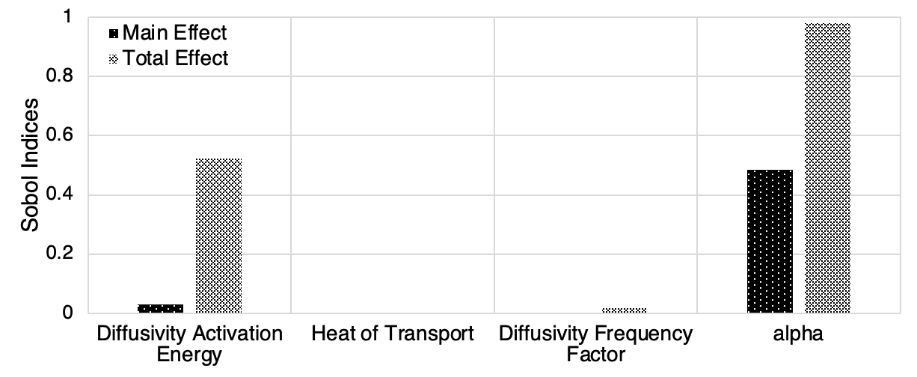
Figure 12. Sobol indices of sampled parameters for FHR heat exchanger model with variable alpha boundary conditions.

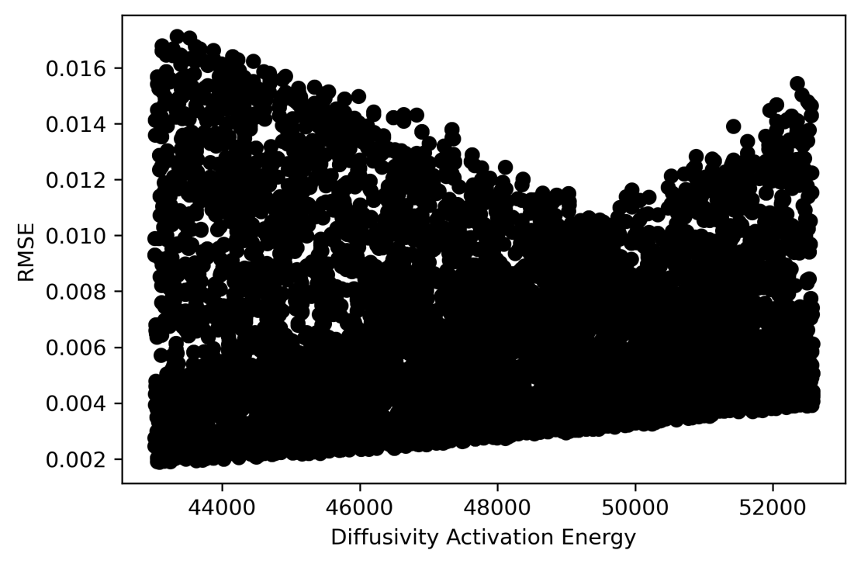
(1)
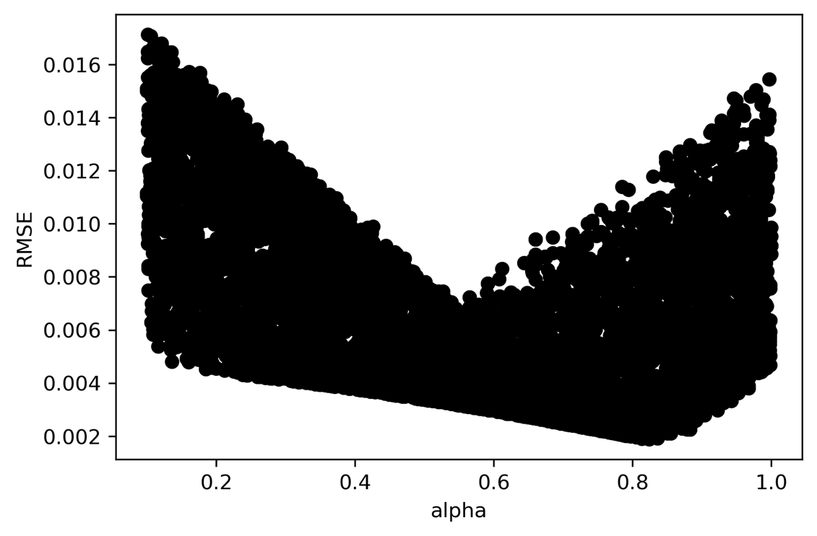
(2)
Figure 13. Scatter plots of RMSE of time dependent tritium concentration within a SS 316 heat exchanger tube wall with variable alpha boundary conditions in regards to: (1) diffusivity activation energy, (2) alpha.

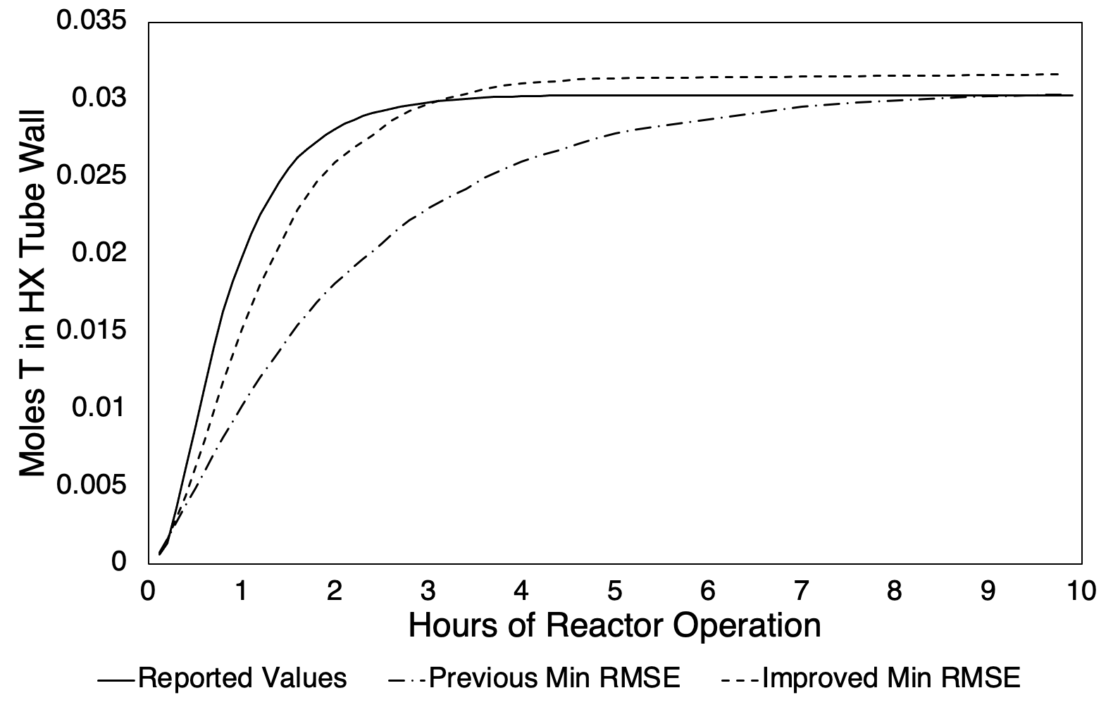
Figure 14. Transient tritium concentration comparison between reported values, initial minimum RMSE, and improved minimum RMSE BISON predictions.

The calibration method was rerun utilizing the calibrated boundary condition variable alpha as a constant in order to verify the importance of the model parameters with improved boundary conditions. Figure 15 shows the Sobol indices of the parameters in which they are similar to those determined before introducing the alpha variable. The scatter plot of RMSE values considering the diffusivity activation energy is shown in Figure 16. A different relation between the two than was determined in which smaller RMSE values were computed with smaller values of the activation energy rather than larger values, and thereby, revealing another impact of calibrating the boundary conditions. Figure 17 presents the results from calibrating the model with calibrated boundary conditions. The resulting best case closely matched the previous results, and therefore, resulted in improving model predictions compared to the initial calibration.

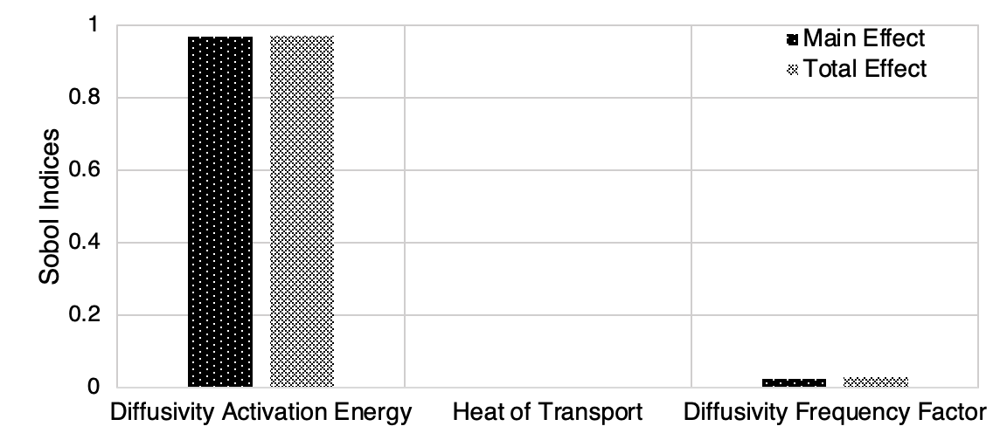
Figure 15. Sobol indices of input parameters for FHR heat exchanger model with calibrated alpha boundary conditions.
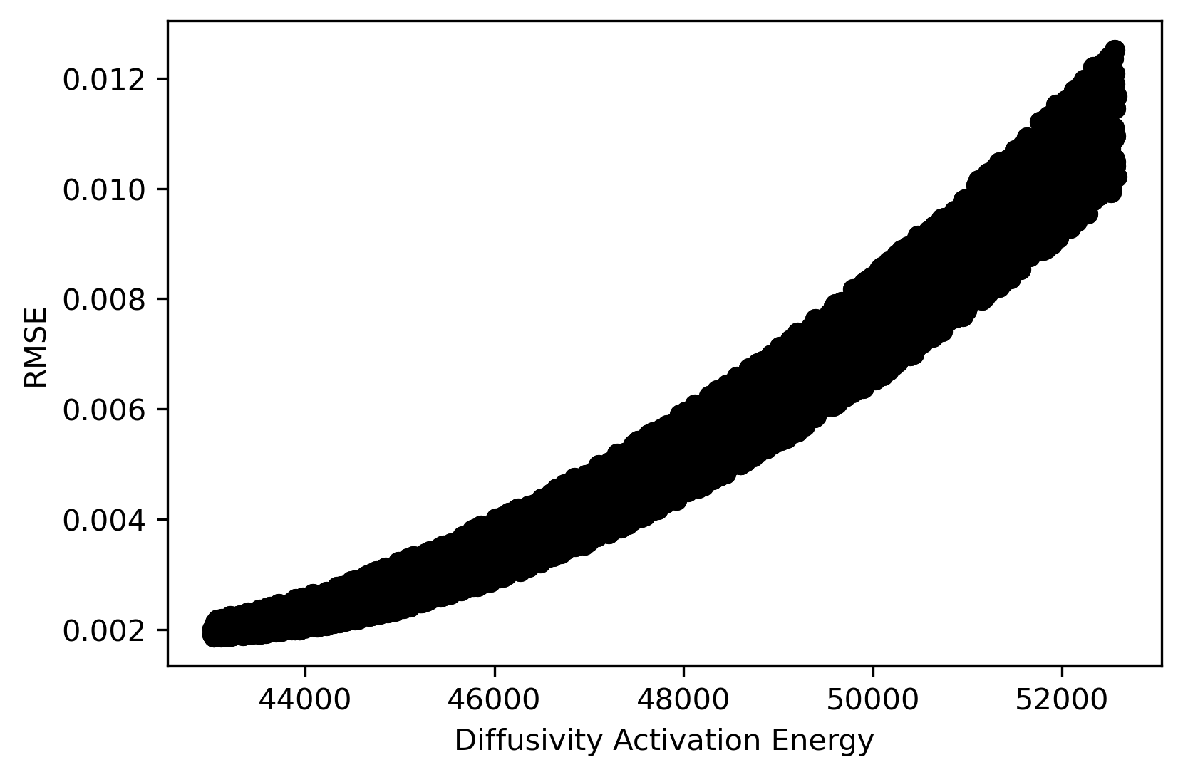
Figure 16. Scatter plot of RMSE of time dependent tritium content within a SS 316 heat exchanger with calibrated boundary conditions in regards to diffusivity activation energy.
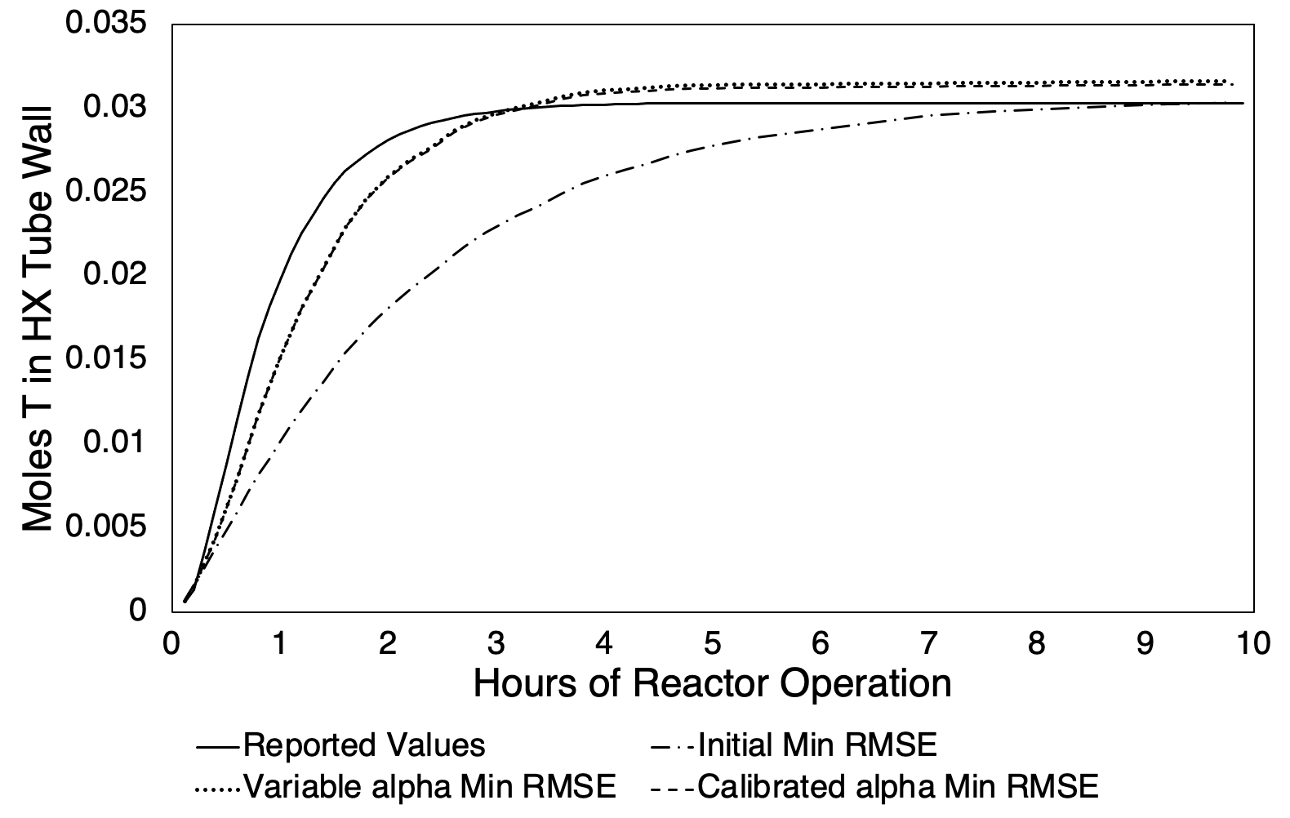
Figure 17. Transient tritium concentration comparison between reported values and initial, variable alpha, and calibrated alpha minimum RMSE BISON predictions.

CHAPTER FIVE CONCLUSIONS AND RECOMMENDATIONS

Tritium transport behavior is a primary concern for designs of fusion blanket systems for a commercial fusion reactor. Tritium transport is important to achieve tritium self-sufficiency as well as mitigate the introduction of this radioactive isotope to the outside environment. To account for multiple physical phenomena and the important information that can be determined from them such as energy extraction in the coolant system, the BISON hydrogen migration and redistribution model was assessed for component-level simulations of tritium transport. This analysis was conducted due to the ability of BISON to be readily coupled with other modeling codes such as MCNP and RELAP5-3D. Information from these codes such as tritium production and coolant flow conditions influence tritium transport behavior, and hence, can inform boundary conditions to a BISON model. Therefore, the work in this paper was conducted to assess BISON’s capability to predict tritium behavior in steels as it is a common material for both fission and fusion reactors, and develop a method for model analysis and calibration.
Tritium distribution and evolution with time was modeled for three different systems and conditions. Simulation results demonstrated the ability of the tritium transport model in BISON to predict comparable results to those from experiments and other models. A global sensitivity analysis was conducted to demonstrate the ability to extract information of key model parameters. In this Sobol sensitivity analysis, a calibration method was implemented through the use of RMSE analysis of model output. In conclusion, the ability for BISON to predict tritium transport behavior in steels as well as develop a method for sensitivity analysis and calibration was demonstrated. Further work in developing a coupled multiphysics fusion blanket model in BISON include the assessment of other expected blanket materials such as SiC for flow channel inserts, and the implementation of tritium transport behavior in liquids to assess PbLi and He coolant.

REFERENCES

[1] J. B. Greenblatt, N. R. Brown, R. Slaybaugh, T. Wilks, E. Stewart, and S. T. McCoy, "The Future of Low-Carbon Electricity," (in English), Annu Rev Env Resour, vol. 42, pp. 289-316, 2017, doi: 10.1146/annurev-environ-102016-061138.
[2] (1996). DOE. STD 6002-96, Safety of Magnetic Fusion Facilities.
[3] S. Sherman and T. Thad Adams, "TRITIUM BARRIER MATERIALS AND SEPARATION SYSTEMS FOR THE NGNP," 2008.
[4] R. J. Pearson, A. B. Antoniazzi, and W. J. Nuttall, "Tritium Supply and Use: a Key Issue for the Development of Nuclear Fusion Energy," Fusion Eng Des, vol. 136, pp. 1140-48, 2018, doi: 10.1016/j.fusengdes.2018.04.090.
[5] B. W. Gainey, "A Review of Tritium Behavior in HTGR Systems," 1976.
[6] O. A. Ustinov et al., "Tritium in Nitride Fuel of Fast Reactors," Atomic Energy, vol. 125, pp. 244-249, 2019, doi: 10.1007/s10512-019-00474-9.
[7] P. W. Humrickhouse and B. J. Merrill, "Tritium Aspects of the Fusion Nuclear Science Facility," Fusion Eng Des, vol. 135, pp. 302-13, 2018, doi: 10.1016/j.fusengdes.2017.04.099.
[8] R. L. Williamson et al., "Multidimensional multiphysics simulation of nuclear fuel behavior," (in English), J Nucl Mater, vol. 423, no. 1-3, pp. 149-163, Apr 2012, doi: 10.1016/j.jnucmat.2012.01.012.
[9] I. Palermo, I. Fernández-Berceruelo, D. Rapisarda, and A. Ibarra, "Neutronics Assessments Towards a Comprehensive Design of DEMO with DCLL Breeding Blanket," Fusion Eng Des, vol. 138, pp. 217-225, 2019, doi: 10.1016/j.fusengdes.2018.11.039.
[10] E. Martelli, A. D. Nevo, P. Lorusso, F. Giannetti, V. Narcisi, and M. Tarantino, "Investigation of heat transfer in a steam generator bayonet tube for the development of PbLi technology for EU DEMO fusion reactor," Fusion Eng Des, vol. 159, pp. 111772-, 2020, doi: 10.1016/j.fusengdes.2020.111772.
[11] O. Courty, A. T. Motta, and J. D. Hales, "Modeling and simulation of hydrogen behavior in Zircaloy-4 fuel cladding," (in English), J Nucl Mater, vol. 452, no. 1-3, pp. 311-320, Sep 2014, doi: 10.1016/j.jnucmat.2014.05.013.
[12] D. S. Stafford, "Multidimensional simulations of hydrides during fuel rod lifecycle," (in English), J Nucl Mater, vol. 466, pp. 362-372, Nov 2015, doi: 10.1016/j.jnucmat.2015.06.037.
[13] E. Lacroix, A. T. Motta, and J. D. Almer, "Experimental determination of zirconium hydride precipitation and dissolution in zirconium alloy," (in English), J Nucl Mater, vol. 509, pp. 162-167, Oct 2018, doi: 10.1016/j.jnucmat.2018.06.038.
[14] Z. Aly, A. Casagranda, G. Pastore, and N. R. Brown, "Variance-based sensitivity analysis applied to hydrogen migration and redistribution model in Bison. Part I: Simulation of historical experiments," (in English), J Nucl Mater, vol. 524, pp. 90-100, Oct 2019, doi: 10.1016/j.jnucmat.2019.06.035.
[15] Z. Aly, A. Casagranda, G. Pastore, and N. R. Brown, "Variance-based sensitivity analysis applied to the hydrogen migration and redistribution model in Bison. Part II: Uncertainty quantification and optimization," (in English), J Nucl Mater, vol. 523, pp. 478-489, Sep 2019, doi: 10.1016/j.jnucmat.2019.06.023.
[16] S. Lynch, "Hydrogen embrittlement phenomena and mechanisms," (in English), Corros Rev, vol. 30, no. 3-4, pp. 105-123, Jun 2012, doi: 10.1515/corrrev-2012-0502.
[17] J. Venezuela, Q. L. Liu, M. X. Zhang, Q. J. Zhou, and A. Atrens, "The influence of hydrogen on the mechanical and fracture properties of some martensitic advanced high strength steels studied using the linearly increasing stress test," (in English), Corros Sci, vol. 99, pp. 98-117, Oct 2015, doi: 10.1016/j.corsci.2015.06.038.
[18] A. Sawatzky, "The Diffusion and Solubility of Hydrogen in the Alpha-Phase of Zircaloy-2," (in English), J Nucl Mater, vol. 2, no. 1, pp. 62-68, 1960, doi: Doi 10.1016/0022-3115(60)90025-8.
[19] J. J. Kearns, "Diffusion-Coefficient of Hydrogen in Alpha Zirconium, Zircaloy-2 and Zircaloy-4," (in English), J Nucl Mater, vol. 43, no. 3, pp. 330-&, 1972, doi: Doi 10.1016/0022-3115(72)90065-7.
[20] T. J. Dolan and R. A. Anderl, "Assessment of database for interaction of tritium with ITER plasma facing materials," Idaho National Laboratory, 1994, vol. 26.
[21] T. Tanabe, Y. Yamanishi, K. Sawada, and S. Imoto, "Hydrogen Transport in Stainless-Steels," (in English), J Nucl Mater, vol. 123, no. 1-3, pp. 1568-1572, 1984, doi: Doi 10.1016/0022-3115(84)90304-0.
[22] N. Kishimoto, T. Tanabe, T. Suzuki, and H. Yoshida, "Hydrogen Diffusion and Solution at High-Temperatures in 316l Stainless-Steel and Nickel-Base Heat-Resistant Alloys," (in English), J Nucl Mater, vol. 127, no. 1, pp. 1-9, 1985, doi: Doi 10.1016/0022-3115(85)90056-X.
[23] M. Y. Park, B. J. Kim, and E. S. Kim, "Development of semi-empirical model for tritium permeation under non-uniform temperature distribution at heat exchanger tube wall," (in English), Ann Nucl Energy, vol. 75, pp. 413-420, Jan 2015, doi: 10.1016/j.anucene.2014.08.044.
[24] M. L. Guillou, N. Toulhoat, Y. Pipon, and N. Moncoffre, "Deuterium Migration in Nuclear Graphite: Consequences for the Behavior of Tritium in CO2-Cooled Reactors and for the Decontamination of Irratiated Graphite Waste," J Nucl Mater, vol. 461, pp. 72-77, 2015, doi: 10.1016/j.jnucmat.2015.03.005.
[25] M. J. Pattison, S. Smolentsev, R. Munipalli, and M. A. Abdou, "Tritium Transport in Poloidal Flows of a DCLL Blanket," Fusion Sci Technol, vol. 60, 2, pp. 809-813, 2011, doi: 10.13182/FST10-309.
[26] S. Fukada et al., "Clarification of Tritium Behavior in Pb-Li Blanket System," The Japan Institute of Metals and Materials, pp. 425-29, 2013, doi: 10.2320/matertrans.MG201203.
[27] J. D. Stempien and Massachusetts Institute of Technology. Department of Nuclear Science and Engineering., Tritium transport, corrosion, and Fuel performance modeling in the Fluoride Salt-Cooled High-Temperature Reactor (FHR). 2015, p. 398 pages.
[28] X. X. Hu, K. A. Terrani, B. D. Wirth, and L. L. Snead, "Hydrogen permeation in FeCrAl alloys for LWR cladding application," (in English), J Nucl Mater, vol. 461, pp. 282-291, Jun 2015, doi: 10.1016/j.jnucmat.2015.02.040.
[29] H. Nakamura and M. Nishi, "Experimental evaluation of tritium permeation through stainless steel tubes of heat exchanger from primary to secondary water in ITER," (in English), J Nucl Mater, vol. 329, pp. 183-187, Aug 1 2004, doi: 10.1016/j.jnucmat.2004.04.009.
[30] T. Ikonen, "Comparison of global sensitivity analysis methods – Application to fuel behavior modeling," Nuclear Engineering and Design, vol. 297, pp. 72-80, 2016, doi: 10.1016/j.nucengdes.2015.11.025.
[31] A. Saltelli, P. Annoni, I. Azzini, F. Campolongo, M. Ratto, and S. Tarantola, "Variance based sensitivity analysis of model output. Design and estimator for the total sensitivity index," Computer Physics Communications, vol. 181, no. 2, pp. 259-270, 2010, doi: 10.1016/j.cpc.2009.09.018.
[32] A. Saltelli, "Making best use of model evaluations to compute sensitivity indices," vol. 145, no. 2, pp. 280-297, 2002, doi: 10.1016/S0010-4655(02)00280-1.
[33] I. M. Sobol, "Sensitivity Estimates for Nonlinear Mathematical Models," Mathematical Modeling and Computational Experiment, vol. 1, pp. 407-414, 1993.
[34] J. Herman and W. Usher, "SALib: An open-source Python library for Sensitivity Analysis," Journal of Open Source Software, vol. 97, doi: 10.21105/joss.00097.

VITA
Miles L. O’Neal grew up in Texas where after high school, he attended Texas A&M University at College Station and graduated with a Bachelor of Science in Nuclear Engineering in December 2019. Miles began attending the University of Tennessee Knoxville in January 2020 where his anticipated graduation date for his Master of Science is August 2021.

