Casein-maltodextrin Conjugates as Emulsifiers for Preparation of Structured Calcium Carbonate Particles as Fat Globule Mimetics

A Thesis Presented for the
Master of Science
Degree
The University of Tennessee, Knoxville

Bai Qu
May 2014

Acknowledgments
My master study in Department of Food Science and Technology at University of Tennessee has been an unforgettable period in my life. It is with immense gratitude that I acknowledge the help from my advisor, Dr. Qixin Zhong. His tremendous knowledge, creative research ideas, and insightful thought have been inspiring and driving me to explore the world of science. I am also debited to my thesis committee members, Dr. P. Michael Davidson and Dr. Douglas G. Hayes. I sincerely appreciate their time and effort in helping me throughout my research. Their support and guidance have been pivotal in shaping this work. My sincere thanks also go to Dr. Yangchao Luo, Dr. Yongguang Guan, Dr. Jine Wu, Dr. John Dunlap and all my lab mates for their encouragement and friendship. They are remarkable friends who are nearby whenever I need help and my success could not be possible without them. I owe my deepest gratitude to my family for the unselfish and endless love and support during my master study. Last but not least, I also appreciate the entire University of Tennessee community for providing such a good academic environment.

Abstract
Removing fat globules to produce reduced-fat dairy products faces several quality defects such as flavor, mouth feel, viscosity, and appearance. Conversely, dairy products are important sources of calcium, but the addition of ionic calcium can cause protein aggregation, especially during thermal pasteurization and sterilization of milk, that deteriorates quality and shelf-life. To solve these issues, the first objective of the present study was to fabricate a group of dispersible fat globule mimetics (FGMs) that have calcium carbonate particles (CCPs) as the core, coated with two sequential layers of anhydrous milk fat (AMF) and milk protein. The second objective was to study impacts of addition of spray-dried FGMs on fat content, color, turbidity, and viscosity of skim milk. To fabricate FGMs, CCPs were suspended at 20-33.3% w/w in melted AMF at 80 °C that was then emulsified at 5% w/v into a neutral aqueous phase with 5% w/v sodium caseinate (NaCas), 10% w/v casein–maltodextrin (MD) conjugates, or NaCas-MD mixture with 5% w/v each. Span® 80 was used at different ratios to AMF to facilitate the encapsulation of CCPs. Smaller particles were observed when a higher amount of Span® 80 was used, which was concluded to have resulted from the greater reduction in interfacial tensions. The particle dimension followed the increasing order of casein-MD conjugate < casein-MD mixture < NaCas treatments, resulting from balances of surface activity and viscosity. The conjugate treatment had better encapsulation performance after spray drying. In addition, spray-dried FGMs prepared from the conjugate had better stability than the other two emulsifiers after hydration in skim milk, with the absence of visible precipitation and only 30.5% increase in particle dimension after 10 day storage at 5 °C. The inclusion of spray-dried FGMs in skim milk increased the viscosity, redness and yellowness, and turbidity. Skim milk with 10% FGMs had a viscosity higher than and turbidity similar to full fat (3.8%) milk, while the overall fat content was only 2%. Therefore, casein-MD conjugates are appropriate emulsifiers to prepare dispersible FGMs that may be used to simultaneously improve sensory properties and increase calcium content of reduced-fat products.

TABLE OF CONTENTS
Chapter1. Introduction 1
1. Quality of reduced fat milk 2
2. Fat globule mimetics 3
3. Fortification of calcium in food products 4
4. Hypothesis and objectives 5
Reference 7
Appendix 12
Chapter 2. Literature Review 15
1. Introduction 16
2. Sensory defects of reduced fat milk 17
3. Fortifying milk with calcium 17
4. Physicochemical properties important to sensory quality of emulsions 19
4.1. Particle size and distribution 19
4.2. Stability of emulsions as impacted by colloidal interactions 20
4.3. Optical properties 21
4.4. Rheology 22
5. Emulsions prepared from dairy proteins 23
5.1. Dairy proteins 23
5.2. Properties of emulsions prepared with dairy proteins 23
5.3. Properties of emulsions improved by using casein-saccharide conjugates 24
6. Conclusion 25
Reference 27
Appendix 36
Chapter 3. Casein-maltodextrin Conjugates as Emulsifiers for Preparation of Structured Calcium Carbonate Particles as Fat Globule Mimetics 42
Abstract 43
1. Introduction 44
2. Materials and methods 46
2.1. Materials 46
2.2. Preparation of casein-MD conjugates 47
2.3. Sodium dodecyl sulfate–polyacrylamide gel electrophoresis (SDS–PAGE) 47
2.4. Encapsulation of CCPs 48
2.5. Particle size analysis 48
2.6. Microstructure of particles 49
2.7. Encapsulation properties 50
2.7.1. Mass yield of spray dried samples 50
2.7.2. CCP loading 50
2.7.3. Encapsulation efficiency (EE) 51
2.8. Scanning electron microscopy (SEM) 52
2.9. Release of ionic calcium from spray-dried FGMs during simulated gastric and intestinal digestions 52
2.10. Properties of skim milk hydrated with spray-dried powder 53
2.10.1. Color measurement 54
2.10.2. Turbidity 54
2.10.3. Fat content of milk with and without FGMs 55
2.11. Viscosity 55
2.12. Statistical analysis 56
3. Results and Discussion 56
3.1. SDS-PAGE analysis of conjugates 56
3.2. Properties of fresh S/O/W suspensions 57
3.2.1. Droplet size 57
3.2.2. Structure of particles 58
3.3. Properties of spray-dried capsules 59
3.3.1. Morphology of spray-dried capsules 59
3.3.2. Encapsulation performance 60
3.3.3. Release profile of CCP from FGMs 61
3.4. Physicochemical properties of skim milk hydrated with spray-dried FGMs 62
3.4.1. Particle size distribution and stability 62
3.4.2. Turbidity 64
3.4.3. Viscosity 64
3.4.4. Color 65
3.4.5. Fat content 66
Reference 67
Appendix 73
Conclusions 88
Vita 89

LIST OF TABLES
Table 2.1 Recommended calcium intakes for men and women at different ages. 37
Table 2.2 Liking of bovine milk after fortification with various forms of calcium at 50 mg/100 ml (from 1-9, with 9 being most favorable). 38
Table 2.3. Properties of major proteins in bovine milk. 39
Table 3.1. Encapsulation properties of spray-drying S/O/W suspensions prepared with various aqueous phase emulsifiers.* 74
Table 3.2. Volume fraction-length mean diameters (d_{4,3}) of skim milk hydrated with spray-dried FGMs before and after 10-day storage at 5 °C.* 75
Table 3.3. Turbidity and fat content of skim milk with various amounts of spray-dried FGMs, in comparison to whole milk.# 76
Table 3.4. Color parameters of skim milk with various amounts of FGMs, in comparison to whole milk.# 77

LIST OF FIGURES
Fig. 1.1 The structure of FGMs to be fabricated. 13
Fig.1.2. Procedures of producing S/O/W suspension and preparation of spray-dried FGMs. 14
Fig. 2.1. The Maillard reaction scheme 41
Fig. 2.2. Early stages of the Maillard reaction 42
Fig. 3.1. SDS-PAGE analysis of NaCas (Lane 2), MD (Lane 3), mixture of NaCas and MD (Lane 4) and casein-MD conjugate (Lane 5). Lanes 1 and 2 are protein markers. 80
Fig. 3.2. Volume fraction-length mean diameter (d_{4,3}) of S/O/W suspensions prepared by emulsifying 5% w/v of a S/O suspension containing CCPs into an aqueous phase with 5% w/v NaCas, 5% w/v NaCas and 5% w/v MD, or 10% w/v casein-MD conjugates. The lipid phase was binary mixtures of Span® 80 and milk fat, with the amount of Span® 80 in the overall S/O suspension mass plotted on the X-axis. 82
Fig. 3.3. Rheograms of mixtures with different mass ratios of anhydrous milk fat (AMF) and Span® 80 at 80 C. 83
Fig. 3.4. Confocal images of S/O/W suspensions prepared by emulsifying 5% w/v of a S/O suspension containing 20% w/w CCP into an aqueous phase with 5% w/v NaCas and 5% w/v MD (A) or 10% w/v casein-MD conjugates (B). The lipid phase with equal mass of Span® 80 and milk fat was dissolved with Nile Red before preparation of suspensions that were later stained by green FITC probe. Suspensions were diluted 10 fold before imaging for FITC (left) and Nile Red (middle) fluorescence, with co-localized images shown on the right. 84
Fig. 3.5. Scanning electron micrographs of CCP as received (A), spray-dried powders prepared from suspensions emulsified by NaCas (B), NaCas-MD mixture (C), and casein-MD conjugates (D), with S/O suspension conditions detailed in Fig. 3.4. 85
Fig. 3.6. Kinetics of ionic calcium released from spray-dried powders during the first 2-h simulated gastric digestion and the subsequent 4-h simulated intestinal digestion. The powder samples were prepared from S/O/W suspensions emulsified by NaCas, NaCas-MD mixture or casein-MD conjugates, with S/O suspension compositions detailed in Fig. 3.4. Control CCPs at an amount equal to the conjugate treatment are compared. 86
Fig. 3.7. Size distributions of skim milk with 10% w/v spray-dried powder prepared from S/O/W suspensions emulsified by (A) NaCas, (B) NaCas-MD mixture, and (C) casein-MD conjugates before and after storage at 5 °C for 10 days. S/O suspension compositions are detailed in Fig. 3.4. 88
Fig. 3.8. Confocal microscopy images of skim milk with 10% w/v spray-dried powder prepared from S/O/W suspensions emulsified by NaCas (A), NaCas-MD mixture (B) or casein-MD conjugates (C). For each sample, images were acquired for FTIC staining protein in the continuous phase (left), Nile Red staining lipids (middle), and after co-localization (right). S/O suspension compositions are detailed in Fig. 3.4. 89
Fig. 3.9. Rheograms of skim milk hydrated with 0-10% w/v spray-dried powder prepared with casein-MD conjugates at 21 °C, in comparison to whole milk. 90

Chapter1. Introduction

1. Quality of reduced fat milk
Based on the World Health Organization (WHO), the level of total fat intake should be between 15% and 30% of the dietary energy and saturated fatty acids should account for less than 10% energy (Organization, 2005). Currently, reduction of dietary fat has been widely recommended by nutritionists. This has led to increased consumption of low or nonfat dairy products (Huth, DiRienzo, & Miller, 2006). However, producing low-fat dairy products is not a straightforward task. For example, the reduction of 3.5% fat in whole milk with to < 0.5% fat in skim milk significantly reduces the acceptance by most consumers (Alvarez, 2009; Food & Administration, 2012; Kähkönen & Tuorila, 1999).

Milk fat is composed of 98% triacylglycerols, <1% of phospholipids and small amounts of cholesterol, 1,2-diacylglycerols, mono-acylglycerols and free fatty acids(Wright, Hartel, Narine, & Marangoni, 2000).Generally, the reduction of fat causes the reduced whiteness and the slightly bluish color of skim milk(Quiñones, Barbano, & Phillips, 1997). In addition, removal of milk fat impacts taste, aroma, textural characteristics, and microbiological stability of dairy products.(D. J. McClements & Demetriades, 1998; Simuang, Chiewchan, & Tansakul, 2004). In addition to its own flavor, milk fat can influence the intensity, duration and balance of other flavors (Frøst, Dijksterhuis, & Martens, 2001; Romeih, Michaelidou, Biliaderis, & Zerfiridis, 2002; Sahan, Yasar, Hayaloglu, Karaca, & Kaya, 2008). Furthermore, fat-soluble flavor compounds are often unstable in aqueous environments, and the removal of fat has been linked to thin and ephemeral flavor, or even off-flavors of skim milk (Ognean, Darie, & Ognean, 2006; Walstra, 1999), some of which are described as stale, lack of freshness, or storage flavor by trained panelists(Coggins & Chamul, 2004).

Consumption of reduced-fat products may not provide satiety and consumers may increase the eating and drinking other food products, which could result in increased intake of calories (Brennan & Tudorica, 2008). For example, flavored milk has been suggested as an alternative to skim milk for school-age children and adolescents (Y. C. Wang, Bleich, & Gortmaker, 2008). While flavored milk can have 3 g less saturated fat per cup, it contains about 13 g more sugar than whole milk (Beets, Tilley, Kim, & Webster, 2011). Therefore, fat globule mimetics (FGMs) have been studied to address issues caused by fat reduction.

2. Fat globule mimetics
Physicochemical properties of milk fat globules are important to many properties of liquid dairy products during processing and storage (Huppertz & Kelly, 2006). Particle size distribution is one of the most important properties of fat globules in milk (Paquin, 1999). Natural fat globules in raw bovine milk have a diameter ranging from <0.2 to >15 µm (Huppertz, Upadhyay, Kelly, & Tamime, 2006). Homogenization is used to reduce fat globule size and prevent creaming during storage(Jost, 2007). Typically, fat globules in homogenized fluid milk have a dimension of 0.2–0.5 µm (Lopez, 2005).

Fat replacers can be classified as fat mimetics and fat substitutes. Fat mimetics are primarily protein or carbohydrate derivatives that are water-soluble and can bind water (Biliaderis & Izydorczyk, 2006). Carbohydrate-based fat mimetics include starches, maltodextrins and dextrins (L. Ma, Drake, BARBOSA‐CÁNOVAS, & Swanson, 1997). Their primary function is to increase viscosity and replaces fat by stabilizing substantial quantities of water in a gel-like matrix to provide lubrication and flow properties similar to those of fats (Sudha, Srivastava, Vetrimani, & Leelavathi, 2007). Protein-based mimetics have limited applications due to their aggregation and precipitation at acidity nearby their isoelectric points or due to thermal denaturation and aggregation that results in loss of fat-like texture (Lucca & Tepper, 1994). Additionally, proteins can bind with some flavor components to reduce flavor intensity or contribute to off-flavors of the reduced fat products (Beristain, Cruz-Sosa, Lobato-Calleros, Pedroza-Islas, Rodríguez-Huezo, & Verde-Calvo, 2006). Specific effects of protein-based mimetics are dependent on specific protein source and other ingredients present in the formulation. Fat mimetics may not replace the functional contributions of fat resulting from nonpolar properties such as flavor, texture, and mouth feel (M. Drake & Swanson, 1995). Because of the diverse roles of fat in foods, it is difficult to produce one group of fat mimetics that solve all issues associated with fat reduction(M. A. Drake & Civille, 2003). This may be improved by combination of two or more types of fat mimetics to produce desirable texture such as thickness and creaminess (M. Drake & Swanson, 1995).

3. Fortification of calcium in food products
It is well established that dairy products are important sources of dietary calcium that is important to the increased mass and density of bones for children and adults (Kranz, Lin, & Wagstaff, 2007). Currently, 1000 mg calcium daily is recommended for adults (Ross, Taylor, Yaktine, & Del Valle, 2011). Many food products do not contain such a level of calcium. For example, one 8-ounce cup of nonfat milk has 250-300 mg calcium (Mattson, Mo, Gil, & Quezada, 2011). Therefore, fortifying calcium in food products is recommended. Common ingredients of calcium are calcium carbonate and calcium citrate, with others including calcium lactate, gluconate, and hydroxyapatite (Straub, 2007). Calcium carbonate is the most common and least expensive form of calcium (Karp, Ketola, & Lamberg-Allardt, 2009). In addition, the concentration of calcium varies in ingredients, e.g., 40% in calcium carbonate and only 24.1% in calcium citrate (Hanzlik, Fowler, & Fisher, 2005). Calcium lactate and gluconate have even less calcium that is 13% and 9%, respectively, and therefore are not practical choices (Straub, 2007; Walker Harris & Jan De Beur, 2009).
The high calcium content and chemical stability of calcium carbonate suggest it might be an efficient source of calcium for food fortification. However, when incorporating calcium carbonate particles (CCPs) in liquid products, low solubility and sensory defects (i.e., the non-uniform mouth feel and visible precipitation) are two major challenges. Conversely, the addition of ionic calcium to milk can cause precipitation of casein micelles due to ionic bridging and cause instability(Dalgleish & Corredig, 2012). Calcium ions also cause the aggregation of whey proteins during thermal pasteurization and sterilization (Bansal & Chen, 2006). Therefore, novel strategies are needed to incorporate calcium in milk.

4. Hypothesis and objectives
The central hypothesis of this thesis is that CCPs can be encapsulated as dispersible FGMs for use in reduced fat dairy products. The structure of FGMs is shown in Fig. 1. CCPs can be fabricated to be the particle core that is coated with two sequential layers of anhydrous milk fat (AMF) and milk protein. This can be achieved by first suspending CCPs in melted AMF that can then be emulsified into an aqueous phase with proteins to create an S/O/W suspension (Fig. 2). The suspension can be spray-dried to obtain powdered FGMs for incorporation in dairy products.

The first objective of this thesis was to study physicochemical properties of FGMs fabricated according to the design in Figs. 1 and 2. Specific parameters included the composition of lipid and aqueous phases. The lipid phase with various proportions of AMF and a lipophilic nonionic surfactant Span® 80 was studied for the impact on particle dimension and stability of S/O/W suspensions. Span® 80 was dissolved in AFM to facilitate emulsification by lowering S/O and O/W interfaces. The aqueous phase was studied for types of protein emulsifiers - caseins before and after glycation with maltodextrins. Caseins were used because they constitute about 80% of bovine milk proteins (Lucey, Johnson, & Horne, 2003) and are well-known for their emulsifying properties and their ability to stabilize emulsions. Casein–maltodextrin conjugates were studied because many studies have demonstrated the improved emulsifying and stabilizing properties of proteins after glycation with reducing saccharides (Shepherd, Robertson, & Ofman, 2000).

The second objective was to study several quality parameters of skim milk hydrated with various amounts of spray-dried FGMs. These parameters included particle size, storage stability, turbidity, viscosity, fat content, and color difference.

Reference

Alvarez, V. B. (2009). Fluid milk and cream products. In The Sensory Evaluation Of Dairy Products, (pp. 73-133): Springer.
Bansal, B., & Chen, X. D. (2006). A critical review of milk fouling in heat exchangers. Comprehensive Reviews in Food Science and Food Safety, 5(2), 27-33.
Beets, M. W., Tilley, F., Kim, Y., & Webster, C. (2011). Nutritional policies and standards for snacks served in after-school programmes: a review. Public Health Nutrition, 14(10), 1882-1890.
Beristain, C., Cruz-Sosa, F., Lobato-Calleros, C., Pedroza-Islas, R., Rodríguez-Huezo, M., & Verde-Calvo, J. (2006). APPLICATIONS OF SOLUBLE DIETARY FIBERS IN BEVERAGES APLICACIONES DE LA FIBRA DIETETICA SOLUBLE EN BEBIDAS. Revista Mexicana de Ingenieria Quimica, 5, 81-95.
Biliaderis, C. G., & Izydorczyk, M. S. (2006). Functional Food Carbohydrates: CRC Press.
Brennan, C. S., & Tudorica, C. M. (2008). Carbohydrate‐based fat replacers in the modification of the rheological, textural and sensory quality of yoghurt: comparative study of the utilisation of barley beta‐glucan, guar gum and inulin. International Journal of Food Science & Technology, 43(5), 824-833.
Coggins, P. C., & Chamul, R. S. (2004). Food sensory attributes. Food Science And Technology-New York-Marcel Dekker-, 93-148.
Dalgleish, D. G., & Corredig, M. (2012). The structure of the casein micelle of milk and its changes during processing. Annual Review Of Food Science And Technology, 3, 449-467.
Drake, M., & Swanson, B. (1995). Reduced-and low-fat cheese technology: a review. Trends in Food Science & Technology, 6(11), 366-369.
Drake, M. A., & Civille, G. (2003). Flavor lexicons. Comprehensive Reviews In Food Science And Food Safety, 2(1), 33-40.
Food, U., & Administration, D. (2012). Code of federal regulations title 21. Chapter I, Subchapter B, Part, 173.
Frøst, M. B., Dijksterhuis, G., & Martens, M. (2001). Sensory perception of fat in milk. Food Quality and Preference, 12(5), 327-336.
Hanzlik, R. P., Fowler, S. C., & Fisher, D. H. (2005). Relative bioavailability of calcium from calcium formate, calcium citrate, and calcium carbonate. Journal of Pharmacology and Experimental Therapeutics, 313(3), 1217-1222.
Huppertz, T., & Kelly, A. (2006). Physical chemistry of milk fat globules. In Advanced Dairy Chemistry Volume 2 Lipids, (pp. 173-212): Springer.
Huppertz, T., Upadhyay, V., Kelly, A., & Tamime, A. (2006). Constituents and properties of milk from different species. Brined Cheeses, 1-42.
Huth, P., DiRienzo, D., & Miller, G. (2006). Major scientific advances with dairy foods in nutrition and health. Journal Of Dairy Science, 89(4), 1207-1221.
Jost, R. (2007). Milk and Dairy Products. Ullmann's Encyclopedia of Industrial Chemistry.
Kähkönen, P., & Tuorila, H. (1999). Consumer responses to reduced and regular fat content in different products: effects of gender, involvement and health concern. Food Quality and Preference, 10(2), 83-91.
Karp, H. J., Ketola, M. E., & Lamberg-Allardt, C. J. (2009). Acute effects of calcium carbonate, calcium citrate and potassium citrate on markers of calcium and bone metabolism in young women. British Journal of Nutrition, 102(09), 1341-1347.
Kranz, S., Lin, P.-J., & Wagstaff, D. A. (2007). Children’s dairy intake in the United States: too little, too fat? The Journal of pediatrics, 151(6), 642-646. e642.
Lopez, C. (2005). Focus on the supramolecular structure of milk fat. Reprod. Nutr. Dev, 45, 497-511.
Lucca, P. A., & Tepper, B. J. (1994). Fat replacers and the functionality of fat in foods. Trends in Food Science & Technology, 5(1), 12-19.
Lucey, J., Johnson, M., & Horne, D. (2003). Invited Review: Perspectives on the Basis of the Rheology and Texture Properties of Cheese. Journal Of Dairy Science, 86(9), 2725-2743.
Ma, L., Drake, M., BARBOSA‐CÁNOVAS, G., & Swanson, B. (1997). Rheology of Full‐fat and Low‐fat Cheddar Cheeses as Related to Type of Fat Mimetic.Journal Of Food Science, 62(4), 748-752.
Mattson, P. H., Mo, W., Gil, A. K., & Quezada, J. C. F. (2011). Low-calorie milk product. In): Google Patents.
McClements, D. J., & Demetriades, K. (1998). An integrated approach to the development of reduced-fat food emulsions. Critical Reviews In Food Science And Nutrition, 38(6), 511-536.
Ognean, C. F., Darie, N., & Ognean, M. (2006). FAT REPLACERS–REVIEW. J Agroalimentary Process Technol, 12, 433-442.
Organization, W. H. (2005). The World Health Report 2005: Make every mother and child count: World Health Organization.
Paquin, P. (1999). Technological properties of high pressure homogenizers: the effect of fat globules, milk proteins, and polysaccharides. International Dairy Journal, 9(3), 329-335.
Quiñones, H. J., Barbano, D. M., & Phillips, L. G. (1997). Influence of protein standardization by ultrafiltration on the viscosity, color, and sensory properties of skim and 1% milk. Journal of Dairy Science, 80(12), 3142-3151.
Romeih, E. A., Michaelidou, A., Biliaderis, C. G., & Zerfiridis, G. K. (2002). Low-fat white-brined cheese made from bovine milk and two commercial fat mimetics: chemical, physical and sensory attributes. International Dairy Journal, 12(6), 525-540.
Ross, A. C., Taylor, C. L., Yaktine, A. L., & Del Valle, H. B. (2011). Dietary reference intakes for calcium and vitamin D: National Academies Press.
Sahan, N., Yasar, K., Hayaloglu, A. A., Karaca, O. B., & Kaya, A. (2008). Influence of fat replacers on chemical composition, proteolysis, texture profiles, meltability and sensory properties of low-fat Kashar cheese. Journal of Dairy Research, 75(01), 1-7.
Shepherd, R., Robertson, A., & Ofman, D. (2000). Dairy glycoconjugate emulsifiers: casein–maltodextrins. Food Hydrocolloids, 14(4), 281-286.
Simuang, J., Chiewchan, N., & Tansakul, A. (2004). Effects of fat content and temperature on the apparent viscosity of coconut milk. Journal of Food Engineering, 64(2), 193-197.
Straub, D. A. (2007). Calcium supplementation in clinical practice: a review of forms, doses, and indications. Nutrition in Clinical Practice, 22(3), 286-296.
Sudha, M., Srivastava, A., Vetrimani, R., & Leelavathi, K. (2007). Fat replacement in soft dough biscuits: Its implications on dough rheology and biscuit quality. Journal of Food Engineering, 80(3), 922-930.
Walker Harris, V., & Jan De Beur, S. (2009). Postoperative hypoparathyroidism: medical and surgical therapeutic options. Thyroid, 19(9), 967-973.
Walstra, P. (1999). Dairy Technology: principles of milk properties and processes: CRC Press.
Wang, Y. C., Bleich, S. N., & Gortmaker, S. L. (2008). Increasing caloric contribution from sugar-sweetened beverages and 100% fruit juices among US children and adolescents, 1988–2004. Pediatrics, 121(6), e1604-e1614.
Wright, A. J., Hartel, R. W., Narine, S. S., & Marangoni, A. G. (2000). The effect of minor components on milk fat crystallization. Journal of the American Oil Chemists' Society, 77(5), 463-475.

Appendix

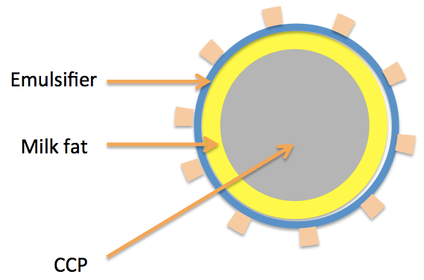

Fig. 1.1 The structure of FGMs to be fabricated.

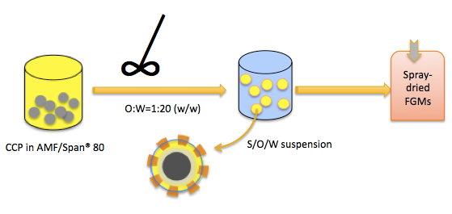

Fig.1.2. Procedures of producing S/O/W suspension and preparation of spray-dried FGMs.

Chapter 2. Literature Review

1. Introduction
Emulsions have many practical applications in the food industry to disperse lipophilic compounds in aqueous food matrices. Emulsions are thermodynamically unstable systems that can be destabilized by several mechanisms over time (D. McClements, 2000). The thermodynamic instability can be explained by two factors: the reduction of contact area between oil and water and density difference between dispersed and continuous phases (Turgeon, Schmitt, & Sanchez, 2007). Physical principles destabilizing an emulsion include gravitational separation, Ostwald ripening, aggregation, and coalescence. From product development perspective, emulsions can be produced to be kinetically stable during shelf-life storage, by adopting strategies minimizing destabilization mechanisms (D. McClements, 2000). In addition to deliver flavor and texture, the two phases of emulsions can be used to dissolve bioactive compounds to obtain various functions based on physical, chemical, and biological principles, which fall in the research area of delivery systems as studied in the pharmaceutical discipline (Grigoriev & Miller, 2009).
In the present study, the objective was to fabricate emulsions to deliver calcium carbonate particles (CCPs) in liquid products such as fluid milk. The encapsulated CCPs can be used as fat globule mimetics (FGMs) to increase turbidity and viscosity that are quality defects in reduced fat milk, and to simultaneously fortify milk with calcium. This requires the use of dairy proteins as ingredients. This chapter reviews quality defects of reduced fat milk, FGMs used to improve the quality of reduced fat milk, challenges of fortifying calcium in milk, properties of dairy proteins as emulsifying and stabilizing agents, and some quality parameters used to evaluate milk.

2. Sensory defects of reduced fat milk
Typically, milk has a neutral flavor profile impacted by its constituents, i.e., fat, proteins, minerals, lactose, and small amounts of other components (Walstra, 1999). The overall flavor of milk is described as pleasantly sweet, with no distinct aftertaste (Chandan, 2006). Skim milk of excellent quality is expected to “leave only a clean, pleasing sensation after the sample has been swallowed or expectorated”(Alvarez, 2009).
However, reduction of fat content causes several defects in dairy products since milk fat has an important role in flavor, texture and appearance of dairy products (Haque & Ji, 2003). Skim milk lacks the typical richness and mouth feel of whole milk, perceived as lacking of flavor, poor texture, weak body (Sandrou & Arvanitoyannis, 2000), and even off-flavor (H. Singh, Bennett, & Robinson, 2002). In the sensory evaluation of dairy products, some off-flavors are described as lacking freshness, stale, chalky, or storage flavor (Alvarez, 2009). Skim milk also suffers from the reduced whiteness and is slightly bluer and greener (lower b* and a* values, respectively) than whole milk (Phillips & Barbano, 1997; Quiñones, Barbano, & Philips, 1998).Changes in appearance result from the properties of fat globules scattering visible light(H. Singh, Ye, & Horne, 2009).

3. Fortifying milk with calcium
The Institute of Medicine (IOM) has set an adequate intake (AI) of calcium for all age groups (Table 1) based on calcium balance and changes in bone mineral density and content (Morgan, 2001). In human nutrition, adequate calcium intake is critical and calcium in dairy products is more effectively absorbed than other sources (Heaney, 2000). The calcium content in bovine milk is about 1 g per liter (Haug, Hostmark, & Harstad, 2007), and more than one-half of the calcium in the typical American diet is provide by dairy products (Insel, Turner, & Ross, 2004). Therefore, nutritional quality of dairy products can be improved by fortifying calcium.
Unfortunately, numerous obstacles exist in the development of calcium-fortified dairy products, including heat stability and sensory properties. When ionic calcium is added in dairy products, it reacts with proteins and weakens electrostatic repulsion to cause protein aggregation, sedimentation, and even gelation during heating (Vyas & Tong, 2004; Yazici, Alvarez, Mangino, & Hansen, 1997). Calcium chloride also imparts saltiness of milk resulting low overall acceptability (Tordoff, 1996). In a study evaluating sensory properties of milk fortified with 50 mg/100 ml of different forms of calcium (Table 2), undesirable properties were noticed, such as chalky, gritty mouth feel, off-flavors and undesirable coloration (G. Singh, Arora, Sharma, Sindhu, Kansal, & Sangwan, 2007), resulting in significantly reduced overall acceptability. In another study, calcium saccharate was the least acceptable and its impartation of stale flavor with bitter taste made it unsuitable for calcium fortification (Kuhn, Bufe, Winnig, Hofmann, Frank, Behrens, et al., 2004). Calcium lactate and calcium gluconate contribute no adverse effects to the flavor of milk (Table 2) but have quite low calcium content, with 13% and 9% calcium element, respectively (Straub, 2007; Walker Harris & Jan De Beur, 2009). Conversely, calcium carbonate has a high elemental content (40%) and is chemically stable and widely available. However, calcium carbonate is seldom used in fluid dairy products directly because it imparts chalkiness to milk and precipitates due to its low solubility (G. Singh, Arora, Sharma, Sindhu, Kansal, & Sangwan, 2007). The sensory defects of calcium carbonate may be overcome by appropriate encapsulation technologies such as emulsions.

4. Physicochemical properties important to sensory quality of emulsions

4.1. Particle size and distribution
Particle size plays an important role in appearance and stability of dispersion systems. Gradual reduction of particle size to a dimension comparable to and smaller than the wavelength of visible light changes the appearance of emulsions from turbid to translucent to transparent, because smaller particles are less effective in scattering visible light (D. J. McClements, 2011). Emulsions with smaller droplets have better stability against gravitational separation and aggregation because thermal energy driving the Brownian motion becomes more significant than the gravitational potential (Ahmed, Li, McClements, & Xiao, 2012). The stability of emulsions is affected by many factors, reviewed briefly below.

Droplet size is commonly measured using static or dynamic light scattering (DLS). DLS can be used to measure particles with a dimension from several nanometers to 3 micrometers, whereas static light scattering using instruments such as laser diffraction particle size analyzers is used to measure particles in the range of 0.04 to 2000 micrometers(Eshel, Levy, Mingelgrin, & Singer, 2004; Mason, Wilking, Meleson, Chang, & Graves, 2006; Santipanichwong, Suphantharika, Weiss, & McClements, 2008). DLS techniques directly measure hydrodynamic dimensions by estimating translational and/or rotational diffusion coefficients (Pecora, 2000). In DLS, a dispersion is typically assumed to be infinite dilute, i.e., no inter-particle interactions (Alexander & Dalgleish, 2006). In laser diffraction particle analysis, the Mie theory is used to obtain particle diameter from scattering data based on the assumption that particles are both spherical and homogeneous (Mao & McClements, 2012). Therefore, limitations exist for systems with non-spherical and heterogeneous particles, and particle dimensions are to be assessed using additional techniques such as an appropriate microscopy method (Li & McClements, 2014).

4.2. Stability of emulsions as impacted by colloidal interactions
Colloidal interactions among droplets determine the stability of emulsions. Repulsive electrostatic and steric interactions keep droplets from aggregation and stabilize emulsions, while van der Waals, hydrophobic, hydrogen bonding and depletion interactions are attractive forces destabilizing emulsions (D. J. McClements, 2005). In addition to physiochemical properties of continuous phase such as viscosity, temperature, pH, ionic strength, and solutes, the interfacial structure is the most critical factor that prevents the aggregation and coalescence of droplets. Generally, nanoemulsions had better stability against droplet aggregation and creaming than conventional emulsions(Lee, Choi, Li, Decker, & McClements, 2010). Desirable functional attributes, such as protection against chemical degradation, ease of handling, and ease of dispersion in products can be created by controlling the composition and microstructure of emulsions(Tokle & McClements, 2011).

The selection of an appropriate surfactant and its concentration is critical to form stable emulsions. Small molecular surfactants are simple amphiphilic molecules with distinct hydrophilic and lipophilic segments being in contact with aqueous and lipid phases of emulsions, respectively(Mackie & Wilde, 2005). Amphiphilic polymers such as some food polysaccharides and proteins are commonly studied for food emulsions because of their safety and availability (Benichou, Aserin, & Garti, 2002). In addition, some particles can stabilize O/W interface, forming Pickering emulsions (Binks & Lumsdon, 2001). Surfactants lower O/W interfacial tension during homogenization, which, together with homogenization conditions, is significant to reduce droplet dimension (Mun, Decker, & McClements, 2005). A good emulsifier shall also quickly adsorb on the new O/W interface formed during emulsification. Surfactants on the oil droplet surface should provide sufficient repulsive (electrostatic and/or steric) interaction forces to prevent droplet aggregation (Weiss, Decker, McClements, Kristbergsson, Helgason, & Awad, 2008).

4.3. Optical properties
The appearance of food product is the first sensory quality parameter determining the acceptance of consumers. The design of emulsion-based products can be improved with a better understanding of the relationship between the appearance and microstructure of the emulsions (D. J. McClements, 2002b). The optical properties of emulsions are mainly associated with their opacity and color, which can be quantitatively described using tristimulus color coordinates, such as the L*a*b* system (D. J. McClements, 2002a). In this color system, L*represents the lightness, while a* and b* are color coordinates. Positive and negative a* values are used to indicate red and green, respectively. Positive and negative b* values are for yellow and blue, respectively. The L* value has a range of 0-100, representing lightness from black to white (Viscarra Rossel, Minasny, Roudier, & McBratney, 2006). For emulsions, the L* value is correlated with the ability of droplets to scatter light which usually increases as droplet diameter increases from around 10 nm to 400 nm and then decreases with further increases in droplet dimension (Chung, Degner, & McClements, 2012). Other derived parameters such as color intensity [C* = (a*² + b*²)^{1/2}] also are used to indicate color properties. The C* is usually negatively correlated to L* (Qian, Decker, Xiao, & McClements, 2012). In addition to droplet dimension as discussed previously, the presence of other constituents such as pigments, relative refractive index and droplet concentration affect optical properties of emulsions (Chantrapornchai, Clydesdale, & McClements, 2001; Chung, Degner, & McClements, 2012; D. J. McClements, 2002b). Samples with high relative refractive index and droplet concentration normally have low L* (D. J. McClements, 2010).

4.4. Rheology
Rheology of emulsions is critical to sensory quality. Based on their composition, structure, and droplet interactions, emulsion systems can range from viscous liquids, viscoelastic liquids, viscoelastic solids, plastics, to elastic solids (Winter & Mours, 1997). Homogenized milk had characteristics of a Newtonian fluid (Floury, Grosset, Leconte, Pasco, Madec, & Jeantet, 2006). With a gradual increase of droplet concentration, the viscosity of an emulsion increases gradually initially, before steep increases when droplets become closely packed (D. J. McClements, 2010). At a given mass concentration of droplets, viscosity depends on the nature of the droplet interactions and the degree of aggregation (D. J. McClements, 1998). Deformation of lipid particles and breakup of flocculated droplets by shear forces can cause the shear thinning behavior(Tadros, 2004). The addition of fat globules into milk could increase viscosity (Villamiel & de Jong, 2000).Rheological properties can be correlated with sensory properties such as sensation and mouth feel (van Vliet, van Aken, de Jongh, & Hamer, 2009). This will require the characterization of rheological properties resulting from both shear and normal stresses (Mathmann, Kowalczyk, Petermeier, Baars, Eberhard, & Delgado, 2007).

5. Emulsions prepared from dairy proteins

5.1. Dairy proteins
Milk proteins are natural vehicles to deliver essential micronutrients and immune system components from mother to the newborn (Livney, 2010). The structure and properties of various milk proteins have been extensively reviewed (Gruet, Maincent, Berthelot, & Kaltsatos, 2001; Rabinow, 2004). Bovine milk can be classified as caseins and whey proteins, as listed in Table 3 (Livney, 2010).. Six proteins (α-lactalbumin, β-lactoglobulin G, α_{S1}-casein, α_{S2}-casein, β-casein, and κ-casein) consist of >90% of bovine milk proteins(Heck, Schennink, Van Valenberg, Bovenhuis, Visker, Van Arendonk, et al., 2009). Caseins can be precipitated from skim milk by adjusting pH to isoelectric point (pH 4.6), and proteins remain in the supernatant are whey proteins(Wong, Camirand, Pavlath, Parris, & Friedman, 1996). The acid-precipitated casein can be re-solubilized by increasing pH to 6.7 using a base such as sodium hydroxide, which is then spray-dried to obtain sodium caseinate as a commercial ingredient (O’Kennedy, Mounsey, Murphy, Duggan, & Kelly, 2006).

5.2. Properties of emulsions prepared with dairy proteins
Dairy proteins have the ability to adsorb at oil-water interfaces effectively, as emulsifiers to prepare emulsions (D. J. McClements, 2004). Dairy proteins are generally-recognized-as-safe and are therefore ideal polymer surfactants to produce food emulsions(Chen, Remondetto, & Subirade, 2006). When globular proteins approach the oil/water interface, water molecules at the interfacial region are replaced by the non-polar residues of proteins, which are thermodynamically favored because of the reduction of system free energy and is the primary driving force for protein adsorption. A secondary driving force originates from the unfolding of the adsorbed protein molecules on the interface(Dickinson, 2013). The structure of interfacial protein can continue to develop by interacting with proteins in the continuous phase. The protein structures on oil particles and the solution chemistry (pH, temperature, co-solutes, and ionic structure) determine the strength of colloidal interactions and therefore stability of droplets against aggregation, as discussed above(Jourdain, Leser, Schmitt, Michel, & Dickinson, 2008). Caseins are rheomorphic proteins that are frequently studied to form emulsions(Dickinson, 2006; Elzoghby, Abo El-Fotoh, & Elgindy, 2011). In addition to providing repulsive electrostatic interactions, caseins adsorbed on oil droplets can provide steric repulsion to prevent droplet aggregation(Dickinson, 2006; Everett & McLeod, 2005). Additionally, modification of protein structures has been studied to improve emulsion stabilities such as conjugation of proteins with reducing carbohydrates or crosslinking proteins on the interface(Meade, Reid, & Gerrard, 2005).

5.3. Properties of emulsions improved by using casein-saccharide conjugates
Conjugation of casein and reducing saccharides by the Maillard reaction at elevated temperatures offers a green process to produce ingredients that are still considered natural because heating is a part of food processing/cooking. The formation of covalent bonds between caseins and reducing saccharides is the initial stage of Maillard reaction (Fig. 1), followed by many complex processes (Figs 1 and 2) involving oxidation, dehydration, heterocyclic reaction and polymerization reactions(Martins, Jongen, & Van Boekel, 2000; O’Regan & Mulvihill, 2009).These reactions have been reviewed frequently and not detailed here (Hodge, 1953; Jimenez-Castano, Villamiel, & López-Fandiño, 2007; O’Regan & Mulvihill, 2009)(Dills, 1993)(Nursten, 2005). The later stages of the Maillard reaction produce extensively colored, water insoluble and fluorescent compounds referred as “melanoidins” that can impact flavor and quality (Virág, Kiss, Forgó, Csutorás, & Molnár, 2013; H.-Y. Wang, Qian, & Yao, 2011). The conjugation can be achieved by heating the protein-saccharide mixture in solutions (the wet method) or their powder mixture (the dry method). For the dry method, the degree of conjugation and the generation of advanced Maillard reaction products such as color and flavor are determined by reaction parameters of relative humidity, temperature, reaction time, and acidity, in addition to the structure and ratio of proteins and saccharides(Silván, Assar, Srey, Dolores del Castillo, & Ames, 2011).
Conjugating proteins with saccharides forms a structure similar to block copolymers, with more hydrophobic proteins and more hydrophilic saccharides that can self-assemble or adsorb onto an oil-water interface (Livney, 2010). When used to form emulsions, the saccharide moiety protruding to the aqueous phase forms a stabilizing ‘hairy layer’ like co-polymers to provide repulsive steric and possibly electrostatic interactions to stabilize emulsions (Dickinson, 2003; Livney, 2010). The -increased viscosity of the continuous phase additionally stabilizes oil droplets(Dickinson, 2003).These stabilizing effects of conjugates have also been shown for emulsions in a broadened ranges of pH, ionic strength, and temperature (Fechner, Knoth, Scherze, & Muschiolik, 2007; Lesmes & McClements, 2012). This is particularly significant for applications with acidity near the isoelectric point of caseins that would otherwise aggregate due to the weakened electrostatic repulsion(O’Regan & Mulvihill, 2009; Regan & Mulvihill, 2013).

6. Conclusion
Reduction of fat content in dairy products causes several quality defects such as flavor, viscosity, and appearance. Encapsulation of CCPs as dispersible colloidal particles may alleviate some of these defects while providing the important nutrient without causing protein aggregation in milk. Emulsions may be an approach to encapsulate CCPs. For emulsions, it is important to use not only ingredients native to milk but also those stabilizing particles. This may be studied by conjugating caseins with appropriate reducing saccharides. After incorporating encapsulated CCPs in milk, it is important to characterize optical properties, rheology, and color so that these sensory properties can meet expectations of improving the quality of reduced-fat dairy products.

Reference

Ahmed, K., Li, Y., McClements, D. J., & Xiao, H. (2012). Nanoemulsion-and emulsion-based delivery systems for curcumin: Encapsulation and release properties. Food Chemistry, 132(2), 799-807.
Alexander, M., & Dalgleish, D. G. (2006). Dynamic light scattering techniques and their applications in food science. Food Biophysics, 1(1), 2-13.
Alvarez, V. B. (2009). Fluid milk and cream products. In The Sensory Evaluation of Dairy Products, (pp. 73-133): Springer.
Benichou, A., Aserin, A., & Garti, N. (2002). Protein-polysaccharide interactions for stabilization of food emulsions. Journal of Dispersion Science And Technology, 23(1-3), 93-123.
Binks, B., & Lumsdon, S. (2001). Pickering emulsions stabilized by monodisperse latex particles: effects of particle size. Langmuir, 17(15), 4540-4547.
Chandan, R. C. (2006). Milk composition, physical and processing characteristics. Manufacturing Yogurt And Fermented Milks, 17.
Chantrapornchai, W., Clydesdale, F., & McClements, D. (2001). Influence of relative refractive index on optical properties of emulsions. Food Research International, 34(9), 827-835.
Chen, L., Remondetto, G. E., & Subirade, M. (2006). Food protein-based materials as nutraceutical delivery systems. Trends in Food Science & Technology, 17(5), 272-283.
Chung, C., Degner, B., & McClements, D. J. (2012). Rheology and microstructure of bimodal particulate dispersions: Model for foods containing fat droplets and starch granules. Food Research International, 48(2), 641-649.
Dickinson, E. (2003). Hydrocolloids at interfaces and the influence on the properties of dispersed systems. Food Hydrocolloids, 17(1), 25-39.
Dickinson, E. (2006). Structure formation in casein-based gels, foams, and emulsions. Colloids And Surfaces A: Physicochemical And Engineering Aspects, 288(1), 3-11.
Dickinson, E. (2013). Stabilising emulsion‐based colloidal structures with mixed food ingredients. Journal of the Science of Food And Agriculture, 93(4), 710-721.
Dills, W. (1993). Protein fructosylation: fructose and the Maillard reaction. The American Journal of Clinical Nutrition, 58(5), 779S-787S.
Elzoghby, A. O., Abo El-Fotoh, W. S., & Elgindy, N. A. (2011). Casein-based formulations as promising controlled release drug delivery systems. Journal of Controlled Release, 153(3), 206-216.
Eshel, G., Levy, G., Mingelgrin, U., & Singer, M. (2004). Critical evaluation of the use of laser diffraction for particle-size distribution analysis. Soil Science Society of America Journal, 68(3), 736-743.
Everett, D. W., & McLeod, R. E. (2005). Interactions of polysaccharide stabilisers with casein aggregates in stirred skim-milk yoghurt. International Dairy Journal, 15(11), 1175-1183.
Fechner, A., Knoth, A., Scherze, I., & Muschiolik, G. (2007). Stability and release properties of double-emulsions stabilised by caseinate–dextran conjugates. Food Hydrocolloids, 21(5), 943-952.
Floury, J., Grosset, N., Leconte, N., Pasco, M., Madec, M.-N., & Jeantet, R. (2006). Continuous raw skim milk processing by pulsed electric field at non-lethal temperature: effect on microbial inactivation and functional properties. Le Lait, 86(1), 43-57.
Grigoriev, D. O., & Miller, R. (2009). Mono-and multilayer covered drops as carriers. Current Opinion In Colloid & Interface Science, 14(1), 48-59.
Gruet, P., Maincent, P., Berthelot, X., & Kaltsatos, V. (2001). Bovine mastitis and intramammary drug delivery: review and perspectives. Advanced Drug Delivery Reviews, 50(3), 245-259.
Haque, Z., & Ji, T. (2003). Cheddar whey processing and source: II. Effect on non‐fat ice cream and yoghurt1. International Journal of Food Science & Technology, 38(4), 463-473.
Haug, A., Hostmark, A. T., & Harstad, O. M. (2007). Bovine milk in human nutrition–a review. Lipids Health Dis, 6(1), 25.
Heaney, R. P. (2000). Calcium, dairy products and osteoporosis. Journal of The American College of Nutrition, 19(sup2), 83S-99S.
Heck, J., Schennink, A., Van Valenberg, H., Bovenhuis, H., Visker, M., Van Arendonk, J., & Van Hooijdonk, A. (2009). Effects of milk protein variants on the protein composition of bovine milk. Journal of Dairy Science, 92(3), 1192-1202.
Hodge, J. E. (1953). Dehydrated foods, chemistry of browning reactions in model systems. Journal of Agricultural And Food Chemistry, 1(15), 928-943.
Insel, P., Turner, R., & Ross, D. (2004). Nutrition, American Dietetic Association. In): Jones and Bartlett Publ, Sadbury, Massachusetts.
Jimenez-Castano, L., Villamiel, M., & López-Fandiño, R. (2007). Glycosylation of individual whey proteins by Maillard reaction using dextran of different molecular mass. Food Hydrocolloids, 21(3), 433-443.
Jourdain, L., Leser, M. E., Schmitt, C., Michel, M., & Dickinson, E. (2008). Stability of emulsions containing sodium caseinate and dextran sulfate: relationship to complexation in solution. Food Hydrocolloids, 22(4), 647-659.
Kuhn, C., Bufe, B., Winnig, M., Hofmann, T., Frank, O., Behrens, M., Lewtschenko, T., Slack, J. P., Ward, C. D., & Meyerhof, W. (2004). Bitter taste receptors for saccharin and acesulfame K. The Journal Of Neuroscience, 24(45), 10260-10265.
Lee, S. J., Choi, S. J., Li, Y., Decker, E. A., & McClements, D. J. (2010). Protein-stabilized nanoemulsions and emulsions: comparison of physicochemical stability, lipid oxidation, and lipase digestibility. Journal of Agricultural and Food Chemistry, 59(1), 415-427.
Lesmes, U., & McClements, D. J. (2012). Controlling lipid digestibility: Response of lipid droplets coated by β-lactoglobulin-dextran Maillard conjugates to simulated gastrointestinal conditions. Food Hydrocolloids, 26(1), 221-230.
Li, Y., & McClements, D. J. (2014). Modulating lipid droplet intestinal lipolysis by electrostatic complexation with anionic polysaccharides: Influence of cosurfactants. Food Hydrocolloids, 35, 367-374.
Livney, Y. D. (2010). Milk proteins as vehicles for bioactives. Current Opinion in Colloid & Interface Science, 15(1), 73-83.
Mackie, A., & Wilde, P. (2005). The role of interactions in defining the structure of mixed protein–surfactant interfaces. Advances In Colloid And Interface Science, 117(1), 3-13.
Mao, Y., & McClements, D. J. (2012). Fabrication of functional micro-clusters by heteroaggregation of oppositely charged protein-coated lipid droplets. Food Hydrocolloids, 27(1), 80-90.
Martins, S. I., Jongen, W. M., & Van Boekel, M. A. (2000). A review of Maillard reaction in food and implications to kinetic modelling. Trends in Food Science & Technology, 11(9), 364-373.
Mason, T. G., Wilking, J., Meleson, K., Chang, C., & Graves, S. (2006). Nanoemulsions: formation, structure, and physical properties. Journal of Physics: Condensed Matter, 18(41), R635.
Mathmann, K., Kowalczyk, W., Petermeier, H., Baars, A., Eberhard, M., & Delgado, A. (2007). A numerical approach revealing the impact of rheological properties on mouthfeel caused by food. International Journal Of Food Science & Technology, 42(6), 739-745.
McClements, D. (2000). Comments on viscosity enhancement and depletion flocculation by polysaccharides. Food Hydrocolloids, 14(2), 173-177.
McClements, D. J. (1998). Food Emulsions: Principles, Practice, And Techniques: CRC press.
McClements, D. J. (2002a). Colloidal basis of emulsion color. Current Opinion In Colloid & Interface Science, 7(5), 451-455.
McClements, D. J. (2002b). Theoretical prediction of emulsion color. Advances In Colloid And Interface Science, 97(1), 63-89.
McClements, D. J. (2004). Protein-stabilized emulsions. Current Opinion in Colloid & Interface Science, 9(5), 305-313.
McClements, D. J. (2005). Theoretical analysis of factors affecting the formation and stability of multilayered colloidal dispersions. Langmuir, 21(21), 9777-9785.
McClements, D. J. (2010). Emulsion design to improve the delivery of functional lipophilic components. Annual Review Of Food Science And Technology, 1, 241-269.
McClements, D. J. (2011). Edible nanoemulsions: fabrication, properties, and functional performance. Soft Matter, 7(6), 2297-2316.
Meade, S. J., Reid, E. A., & Gerrard, J. A. (2005). The impact of processing on the nutritional quality of food proteins. Journal of AOAC International, 88(3), 904-922.
Morgan, S. L. (2001). Calcium and vitamin D in osteoporosis. Rheumatic Disease Clinics of North America, 27(1), 101-130.
Mun, S., Decker, E. A., & McClements, D. J. (2005). Influence of droplet characteristics on the formation of oil-in-water emulsions stabilized by surfactant-chitosan layers. Langmuir, 21(14), 6228-6234.
Nursten, H. E. (2005). The Maillard reaction: chemistry, biochemistry, and implications: Royal Society of Chemistry.
O’Kennedy, B. T., Mounsey, J. S., Murphy, F., Duggan, E., & Kelly, P. M. (2006). Factors affecting the acid gelation of sodium caseinate. International Dairy Journal, 16(10), 1132-1141.
O’Regan, J., & Mulvihill, D. M. (2009). Preparation, characterisation and selected functional properties of sodium caseinate–maltodextrin conjugates. Food Chemistry, 115(4), 1257-1267.
Pecora, R. (2000). Dynamic light scattering measurement of nanometer particles in liquids. Journal Of Nanoparticle Research, 2(2), 123-131.
Phillips, L. G., & Barbano, D. M. (1997). The influence of fat substitutes based on protein and titanium dioxide on the sensory properties of lowfat milks. Journal Of Dairy Science, 80(11), 2726-2731.
Qian, C., Decker, E. A., Xiao, H., & McClements, D. J. (2012). Physical and chemical stability of β-carotene-enriched nanoemulsions: Influence of pH, ionic strength, temperature, and emulsifier type. Food Chemistry, 132(3), 1221-1229.
Quiñones, H. J., Barbano, D. M., & Philips, L. G. (1998). Influence of protein standardization by ultrafiltration on the viscosity, color, and sensory properties of 2 and 3.3% milks. Journal of Dairy Science, 81(4), 884-894.
Rabinow, B. E. (2004). Nanosuspensions in drug delivery. Nature Reviews Drug Discovery, 3(9), 785-796.
Regan, J. O., & Mulvihill, D. M. (2013). Preparation, characterisation and selected functional properties of hydrolysed sodium caseinate–maltodextrin conjugate. International Journal of Dairy Technology, 66(3), 333-345.
Sandrou, D., & Arvanitoyannis, I. (2000). Low-fat/calorie foods: current state and perspectives. Critical Reviews in Food Science and Nutrition, 40(5), 427-447.
Santipanichwong, R., Suphantharika, M., Weiss, J., & McClements, D. (2008). Core‐Shell Biopolymer Nanoparticles Produced by Electrostatic Deposition of Beet Pectin onto Heat‐Denatured β‐Lactoglobulin Aggregates. Journal Of Food Science, 73(6), N23-N30.
Silván, J. M., Assar, S. H., Srey, C., Dolores del Castillo, M., & Ames, J. M. (2011). Control of the Maillard reaction by ferulic acid. Food Chemistry, 128(1), 208-213.
Singh, G., Arora, S., Sharma, G., Sindhu, J., Kansal, V., & Sangwan, R. (2007). Heat stability and calcium bioavailability of calcium-fortified milk. LWT-Food Science and Technology, 40(4), 625-631.
Singh, H., Bennett, R. J., & Robinson, R. (2002). Milk and milk processing. Dairy Microbiology Handbook: The Microbiology of Milk and Milk Products, Third Edition, 1-38.
Singh, H., Ye, A., & Horne, D. (2009). Structuring food emulsions in the gastrointestinal tract to modify lipid digestion. Progress in Lipid Research, 48(2), 92-100.
Straub, D. A. (2007). Calcium supplementation in clinical practice: a review of forms, doses, and indications. Nutrition in Clinical Practice, 22(3), 286-296.
Tadros, T. (2004). Application of rheology for assessment and prediction of the long-term physical stability of emulsions. Advances In Colloid And Interface Science, 108, 227-258.
Tokle, T., & McClements, D. J. (2011). Physicochemical properties of lactoferrin stabilized oil-in-water emulsions: Effects of pH, salt and heating. Food Hydrocolloids, 25(5), 976-982.
Tordoff, M. G. (1996). Some basic psychophysics of calcium salt solutions. Chemical Senses, 21(4), 417-424.
Turgeon, S., Schmitt, C., & Sanchez, C. (2007). Protein–polysaccharide complexes and coacervates. Current Opinion in Colloid & Interface Science, 12(4), 166-178.
van Vliet, T., van Aken, G. A., de Jongh, H. H., & Hamer, R. J. (2009). Colloidal aspects of texture perception. Advances In Colloid And Interface Science, 150(1), 27-40.
Villamiel, M., & de Jong, P. (2000). Influence of high-intensity ultrasound and heat treatment in continuous flow on fat, proteins, and native enzymes of milk. Journal of Agricultural and Food Chemistry, 48(2), 472-478.
Virág, D., Kiss, A., Forgó, P., Csutorás, C., & Molnár, S. (2013). Study on Maillard-reaction driven transformations and increase of antioxidant activity in lysine fortified biscuits. Microchemical Journal, 107, 172-177.
Viscarra Rossel, R., Minasny, B., Roudier, P., & McBratney, A. (2006). Colour space models for soil science. Geoderma, 133(3), 320-337.
Vyas, H., & Tong, P. (2004). Impact of source and level of calcium fortification on the heat stability of reconstituted skim milk powder. Journal of Dairy Science, 87(5), 1177-1180.
Walker Harris, V., & Jan De Beur, S. (2009). Postoperative hypoparathyroidism: medical and surgical therapeutic options. Thyroid, 19(9), 967-973.
Walstra, P. (1999). Dairy Technology: Principles Of Milk Properties And Processes: CRC Press.
Wang, H.-Y., Qian, H., & Yao, W.-R. (2011). Melanoidins produced by the Maillard reaction: structure and biological activity. Food Chemistry, 128(3), 573-584.
Weiss, J., Decker, E. A., McClements, D. J., Kristbergsson, K., Helgason, T., & Awad, T. (2008). Solid lipid nanoparticles as delivery systems for bioactive food components. Food Biophysics, 3(2), 146-154.
Winter, H. H., & Mours, M. (1997). Rheology of polymers near liquid-solid transitions. In Neutron spin echo spectroscopy viscoelasticity rheology, (pp. 165-234): Springer.
Wong, D. W., Camirand, W. M., Pavlath, A. E., Parris, N., & Friedman, M. (1996). Structures and functionalities of milk proteins∗. Critical Reviews in Food Science & Nutrition, 36(8), 807-844.
Yazici, F., Alvarez, V., Mangino, M., & Hansen, P. (1997). Formulation and Processing of a Heat Stable Calcium‐fortified Soy Milk. Journal Of Food Science, 62(3), 535-538.

Appendix

Table 2.1 Recommended calcium intakes for men and women at different ages (Morgan, 2001).
Age | Adequate intake (mg/d) | Upper limit (mg/d)
0–6 mo | 210 | Not determined
7–12 mo | 270 | Not determined
1–3 y | 500 | 2500
4–8 y | 800 | 2500
9–13 y | 1300 | 2500
14–18 y | 1300 | 2500
19–30 y | 1000 | 2500
31–50 y | 1000 | 2500
51–70 y | 1200 | 2500
>70 y | 1200 | 2500

Table 2.2 Liking of bovine milk after fortification with various forms of calcium at 50 mg/100 ml (from 1-9, with 9 being most favorable) (G. Singh, Arora, Sharma, Sindhu, Kansal, & Sangwan, 2007).
Characteristic | Unfortified milk | Types of calcium used to fortify milk
 |  | Calcium chloride | Calcium lactate | Calcium saccarate | Calcium gluconate | Calcium carbonate
Flavor | 8.25±0.25ª | 4.50±0.27^{b} | 7.62±0.19^{a,e} | 5.84±0.25^{c,f} | 7.62±0.24^{a,e} | 6.80±0.37^{d,e,f}
Body and mouth feel | 8.50±0.22ª | 7.44±0.24^{b,g} | 7.42±0.24^{c,g} | 5.00±0.35^{d,h} | 6.80±0.25^{e,g} | 4.15±0.40^{f,h}
Color and appearance | 8.50±0.22ª | 7.65±0.29^{b,g} | 7.45±0.19^{c,g} | 7.14±0.40^{d,g} | 7.22±0.25^{e,g} | 7.00±0.35^{f,g}
Overall acceptability | 8.55±0.22ª | 5.23±0.25^{b,g} | 7.40±0.24^{c,h} | 5.15±0.29^{d,g} | 7.24±0.25^{e,h} | 5.50±0.22^{f,g}

Table 2.3. Properties of major proteins in bovine milk (Livney, 2010).

Protein group | Type | Content in milk (g/l) | Molecular weight (kDa)
Caseins |  | 24-28
 | α_{s1} | 12-15 | 22.1-23.7
 | α_{s2} | 3-4 | 25.2-25.4
 | β | 9-11 | 23.9-24.1
 | κ | 3-4 | 19
Whey proteins |  | 5-7
 | β-lactoglobulin | 2-4 | 18.3
 | α-lactalbumin | 1-1.5 | 14.2
 | Bovine serum albumin | 0.1-0.4 | 66
 | Immunoglobulins | 0.6-1.0 | 146-1030
 | Lactoferrin | ~0.1 | 80
Milk fat globule membrane proteins |  | ~0.4 | 13-200
Total milk proteins |  | 30-35

Fig.2.1.The Maillard reaction scheme (Hodge, 1953).

Fig.2.2. Early stages of the Maillard reaction (Nursten, 2005).

Chapter 3. Casein-maltodextrin Conjugates as Emulsifiers for Preparation of Structured Calcium Carbonate Particles as Fat Globule Mimetics

Abstract
Dispersible fat globule mimetics (FGMs) are demanded in manufacturing reduced fat products. The objective of the present study was to fabricate a group of FGMs with calcium carbonate particles (CCPs) as the core, coated with two sequential layers of anhydrous milk fat (AMF) and milk protein. The encapsulation involved two steps, emulsifying an oil phase with CCPs suspended in AMF into an aqueous phase with dissolved emulsifiers to create an S/O/W suspension and spray drying the suspension. Experimentally, CCPs were suspended at 20-33.3%w/w in melted AMF at 80 °C that was then emulsified at 5%w/v into a neutral aqueous phase with 5% w/v sodium caseinate (NaCas), 10% w/v casein–maltodextrin (MD) conjugates, or 5% w/w NaCas and 5% w/v MD mixture. Particle size, encapsulation performance, and properties of skim milk hydrated with spray-dried powder were studied. The casein-MD conjugate treatment had the smallest particles (3.25µm), the best encapsulation performance, and the best stability in skim milk (an increase by 30.5% after 10day storage at 5 °C). After subsequent steps of simulated gastric and intestinal digestions, the FGMs fabricated with casein-MD conjugates showed 75.9% of calcium released as the ionic form. Overall, casein-MD conjugates are better emulsifiers than NaCas in preparation of the studied FGMs that may be used to simultaneously improve sensory properties and increase calcium contents of reduced-fat products.
Keywords: Casein-maltodextrin conjugates, calcium carbonate particle, S/O/W suspension, fat globule mimetic, in vitro digestion, reduced fat dairy products.

1. Introduction
Skim milk produced after removing fat globules in full fat milk is associated with quality defects such as the altered appearance, i.e., translucency and bluish color, and sensory quality(Drake, 2007). Sensory defects include loss of flavors native to dairy products, richness, and creaminess, as well as derived flavors due to hydrolysis, oxidation, or processing (Ohmes, Marshall, & Heymann, 1998). Particulates such as those of modified starch, polysaccharide, and/or protein have been studied to mimic the characteristic physicochemical properties of fat globules (Liu, Xu, & Guo, 2007; Ma, Cai, Wang, & Sun, 2006; McClements & Demetriades, 1998). Most mimetics can only replace partial properties of fat globules.
On the other hand, improving nutritional quality of reduced fat dairy products, such as increasing calcium content, is demanded. Calcium is an essential mineral for human nutrition, with the currently recommended dietary allowance (RDA) being 1000mg daily for adults(Ross, Taylor, Yaktine, & Del Valle, 2011). Dairy products are important sources of calcium, but one 8-ounce (~240 mL) cup of skim milk has only 250-300 mg calcium (Mattson, Mo, Gil, & Quezada, 2011). Calcium carbonate, citrate, gluconate and lactateare forms of calcium used in dietary supplements (Straub, 2007). Due to the highest percentage of elemental calcium (40% w/w) and chemical stability, calcium carbonate is the most widely used form of calcium(Kopic & Geibel, 2013). However, low solubility and sensory defects are two major concerns when incorporating calcium carbonate particles (CCPs) in liquid products. conversely, direct addition of ionic calcium may induce the aggregation of food proteins during processing and storage. Therefore, effective methods of fortifying calcium in liquid foods products are to be studied.

Delivering bioactive food components using properly designed colloidal particles may solve many challenges of incorporating calcium in liquid foods (McClements & Li, 2010). Fabricating these particles requires ingredients such as milk proteins and lipids to obtain physicochemical properties needed for their functionalities. Sodium caseinate (NaCas) is commonly used as an emulsifier in fabricating delivery systems. Conjugating NaCas with reducing saccharides such as maltodextrins (MD) can improve emulsifying and stabilizing functions important to delivery systems(Akhtar & Dickinson, 2007; Augustin & Udabage, 2007; Fechner, Knoth, Scherze, & Muschiolik, 2007; O’Regan & Mulvihill, 2010; Shah, Ikeda, Michael Davidson, & Zhong, 2012). Conjugation is commonly done by heating mixtures of proteins and reducing saccharides in solutions or their powder- the Maillard reaction (Oliver, Melton, & Stanley, 2006). Currently, very little has been done to produce structured particles to disperse CCPs using protein–saccharide conjugates in the form of S/O/W emulsions.

In the present study, the first objective was to study a novel group of dispersible fat globule mimetics (FGMs) by coating CCPs with a layer of anhydrous milk fat (AMF) emulsified by dairy proteins. AMF was used to compensate density of CCPs and partially improve flavor and texture properties of fat globules, while reducing lipid content(Clark, Bodyfelt, Costello, & Drake, 2009; Lopez, 2005). To produce FGMs, CCPs were suspended in the melted AMF dissolved with Span®80 that was used to reduce S/O and W/O interfacial tensions. The S/O suspension was emulsified in the aqueous phase with NaCas, NaCas-MD mixture, or casein-MD conjugates, followed by spray drying. In addition to encapsulation performance, FGMs were studied for particle size distribution, confocal laser scanning microscopy (CLSM),and release of encapsulated CCPs as ionic calcium during simulated gastric and intestinal digestions. The second objective was to study impacts of addition of spray-dried FGMs on fat content, color, turbidity, and viscosity of skim milk. The FGMs studied may improve visual and aroma properties of reduced fat dairy products within the regulated overall fat level.

2. Materials and methods

2.1. Materials
AMF was obtained from Land-O-Lakes, Inc. (Arden Hill, MN). NaCas was purchased from American Casein Co. (Burlington, NJ).MD, with an average dextrose equivalent of 18, was supplied by Grain Processing Corp. (Muscatine, IA). Food grade CCPs under trade name of ViCALity® Albafil® were received as a gift from Minerals Technologies, Inc. (Bronx, NY). Skim milk and full-fat milk (The Simple Truth™ brand) were products from Kroger Co. (Cincinnati, OH). Other chemicals were obtained from either Sigma-Aldrich Corp. (St. Louis, MO) or Thermo Fisher Scientiﬁc (Pittsburgh, PA).

2.2. Preparation of casein-MD conjugates
NaCas and MD were hydrated at 5.0% w/v each in deionized water overnight under room temperature (~21°C). The mixture solution was adjusted to pH 7.0 followed by spray drying at 170°C inlet temperature, 12% feed rate, and 35m³/h airflow rate using a B-290 mini spray-dryer (BÜCHI Labortechnik AG, Flawil, Switzerland). The outlet temperature was recorded to be 90–100°C. The spray-dried powder was incubated at 80 °C and 79% relative humidity for 2.5h to induce conjugation in a humidity-controlled incubator (model IG420U Environmental chamber, Yamato Scientific America Inc., Santa Clara, CA). The powder was then collected and stored at -18 °C before further use.

2.3. Sodium dodecyl sulfate–polyacrylamide gel electrophoresis (SDS–PAGE)
SDS-PAGE was performed according to a literature method (Wan Wang & Zhong, 2014) with some modifications. The protein sample was prepared by mixing 0.5 mg/mL powder in a SDS-PAGE loading buffer, followed by heating at 95 °C for 5 min in a water bath. A Tris-HCl gel (15% precast linear gradient polyacrylamide gel, Bio-Rad Laboratories, Hercules, CA) was used in electrophoresis at a constant voltage of 200V for 40 min using a Mini Protean Tetra Cell. The gel was stained with Coomassie Blue (Bio-Rad Laboratories, Inc., Hercules, CA).

2.4. Encapsulation of CCPs
AMF was melted by heating at 80°C, followed by adding varying amounts of CCPs and Span®80.The CCP: AMF: Span® 80 mass ratios were studied for 1:2:0.5, 1:2:1, 1:2:1.5, and 1:2:2.The mixture was blended at 15,000rpm for 5min using a high-speed homogenizer (T 25 digital ULTRA-TURRAX, IKA, Wilmington, NC) to prepare a S/O suspension. The aqueous phase was prepared by hydrating5% w/v NaCas, 5% w/v NaCas and 5% w/v MD mixture, or 10% w/v casein-MD conjugate in deionized water at room temperature (21 °C) overnight and adjusting pH to 7.0. The S/O suspension was emulsified at 5%w/v into the aqueous phase using the above high-speed homogenizer at 15,000rpm for 5min. The S/O/W suspension was spray-dried using a model B-290bench-top spray dryer (BÜCHI Corp., Flawil, St. Gallen, Switzerland) at an inlet temperature of 170°C, a feed rate of 10%,an aspirator setting of 100%, and an airflow rate35m³/h. The outlet temperature was recorded to be 90–100°C.

2.5. Particle size analysis
Particle size distribution of suspensions was determined using a laser(λ=750 nm) diffraction particle size analyzer (LS 13 320, Beckman Coulter Inc., Brea, CA).Samples were stirred at 300 rpm for 20 min before measurement to fully disperse particles.A sample was pipetted into the measurement chamber containing water until an optimum obscuration rate between 8 and 12% was obtained. The particle size distribution was calculated by the light scattering pattern based on the Mie theory. A refractive index of 1.33 and 1.472 was set for the continuous and dispersed phase, respectively. The volume-weighed mean diameter ($d_{4,3}, Eq. 1$)was compared because it is more sensitive than area-based mean diameter (d_{3,2}) for systems with large particles(McClements, 1998).
$d_{4,3}$= $\frac{\sum_{i=1}{n_{i}d_{i}^{4}}}{\sum_{i=1}{n_{i}d_{i}^{3}}}$ (1)
where n_{i} is the number of particles with diameter d_{i}.

2.6. Microstructure of particles
CLSM was conducted using a Leica TCS SP2 confocal microscope (Buffalo Grove, IL) in the fluorescence mode. Nile red was dissolved at 0.2 mg/ml in the lipid phase before preparing the S/O suspension, and the S/O/W suspension prepared as above was added with0.4-0.6 mg/mL Fluorescein isothiocyanate to stain proteins. Confocal images were acquired using a 63×oil objective with a numerical aperture of 0.7 at an excitation wavelength of488 and 543 nm for FITC and Nile red, respectively. The emission spectrum was recorded between 512 and 542 nm for FITC and between 557 and 625 nm for Nile red. The acquired images were analyzed using the Leica Confocal software. A co-localization in the same field of observation was performed by merging pictures acquired for protein and fat.

2.7. Encapsulation properties

2.7.1. Mass yield of spray dried samples
Mass yield was defined as the percentage of the collected mass of spray-dried powder with reference to the non-solvent mass in the corresponding suspension (feed) before spray drying:

Mass yield% =$\frac{Mass of collected product}{Non-solvent mass of feed}$ ×100% (2)

2.7.2. CCP loading
One g of the spray dried powder was added into15mLof 0.1N HCl to dissolve unencapsulated CCPs. After vortexing for 5 min, the suspension was centrifuged at 4194 × g and 5 °C for 30 min (Sorvall RC 5B Plus centrifuge, DuPont, Norwalk, CT). The precipitate was collected and resuspended in 15 mL of 0.1 N HCl, followed by centrifugation as above. The process was repeated for a third time to remove free CCPs. The final precipitate was washed using deionized water, followed by drying at 58°C overnight in an oven (Precision Economy Oven, Thermo Scientific, Barrington, IL). The ash content of the sample was then measured based on the AOAC Official Method 950.49 with some modification (AOAC, 2006).Briefly, the dried precipitate was contained in a pre-ashed ceramic crucible and heated in a model 1400Thermolyne furnace (Barnstead, Dubuque, IA)at 550°Covernight (12-18h). After cooling in a desiccator, the sample was weighed to determine the amount of ash. The same amounts of Span® 80, AMF, NaCas, NaCas-MD mixture and casein-MD conjugates as in fresh S/O/W suspension were also measured similarly. The net mass of ashed CCPs (CaO) was converted to mass of calcium carbonate by dividing 56% (mass percentage of CaO with respect to CaCO₃).The actual loading of CCP was then determined according to Eq. (3).

Loading%=$\frac{Mass of encapsulated CCP in spray-dried powder}{Total mass of spray-dried powder}$ ×100% (3)

2.7.3. Encapsulation efficiency (EE)
The EE was defined as the percentage of encapsulated CCP with respect to the CCP mass before spray-drying (Eq. 4).
EE%=$\frac{Mass of encapsulated CCP in spray-dried powder}{Mass of CCP before spray drying}$×100% (4)

Because factors such as sample collection errors from the lab-scale spray dryer and a small amount of solids being processed can cause inaccurate assessment of encapsulation(Eq. 4), another parameter, Retention%, was calculated to reflect how well different components in the feed retained according to their proportion after spray drying (Eq. 5). This was based on comparing the theoretical loading (Eq. 6), assuming only the solvent (water) is removed after spray drying, and the actual loading determined in Eq. 3.
Retention% =$\frac{Actual loading}{Theoretical loading}$×100% (5)
Theoretical loading% =$\frac{Mass of CCP in the feed}{Non-solvent mass in the feed}$×100% (6)

2.8. Scanning electron microscopy (SEM)
The morphology of CCPs and spray-dried powder was observed using SEM (LEO 1525 SEM, LEO Electron Microscopy, Oberkochen, Germany). A small amount of powder was spread onto an adhesive tape fixed on a stainless steel stub and coated with a gold layer of about ~5nm thickness before imaging.

2.9. Release of ionic calcium from spray-dried FGMs during simulated gastric and intestinal digestions
The simulated digestion of FGMs was performed according to a literature method (Wan Wang & Zhong, 2014) with some modifications. One g spray dried powder was hydrated in 30mL deionized water. To simulate gastric digestion, pH of the suspension was adjusted to 2.0 and mixed with 400μL of a freshly prepared model gastric juice with 10% w/v pepsin in 0.1 N HCl, corresponding to a level of 0.04g pepsin per g powder. The mixture was incubated at 37 °C for 2h in a shaking water bath (C76water bath shaker, New Brunswick Scientific, Edison, NJ) operating at 120 rpm. The gastric digestion was stopped by increasing pH to 7.5 with 1 N NaOH. The simulated intestinal juice was freshly prepared by dissolving 1g of pancreatin and 1g of bile extract in 10 mL of a 0.1 M NaHCO₃ solution. After adding 1mL of the simulated intestinal juice to the sample after gastric digestion, the mixture was incubated in the same shaking water bath for 4h. During the simulated digestions, the concentration of ionic calcium was determined using a calcium-selective electrode (Denver Instrument Company, Bohemia, NY), with reference to a calibration curve constructed using a series of standard solutions (pH=6.0) with 10−1000 ppm CaCl₂and 0.08 M KCl (used as an ionic strength adjuster)(Pan & Zhong, 2013). To estimate the maximum amount of ionic calcium, a separate set of samples was prepared by extending the intestinal digestion to 24and 48h, the pH of the mixture readjusted to 2 to fully dissolve calcium, and the calcium concentration determined as above and defined as the 100% release in this research. CCPs were studied identically by suspending 2.5mg/mL powder in the simulated gastric juice, followed by digestions as above. The solubility of CCPs was measure by suspending 2.5g mg/mL CCP powder in deionized water, adjusted to pH 2.0 or 7.5,incubated at 37 °C for 1.5h, and measured for ionic calcium concentration.

2.10. Properties of skim milk hydrated with spray-dried powder
Spray-dried FGMs prepared with casein-MD conjugates were hydrated at 1, 2, 5, and 10% w/v in skim milk at room temperature (~21°C) for 2 h. Sodium azide was added at 0.02% w/v as an antimicrobial to prevent microbial spoilage. Three independent replicates were prepared for each sample. Full-fat milk of the same brand was also compared to skim milk.

2.10.1. Color measurement
The influence of FGMs on the color of skim milk was determined using a MiniScan XE Plus Hunter Colorimeter (Hunter Associates Laboratory, Inc., Reston, VA). The instrument was calibrated with a standard white tile (L = 88.2, a = 0.309 and b = 0.316) before measurement. The Hunter chromaticity coordinates (L*, a*, b*) of each sample were measured three times. Based on Eq. 7, the total color difference (ΔE) was additionally calculated by the difference of L*, a* and b* values of a sample with respect to that of skim milk (ΔE1) and whole milk (ΔE2).
ΔE=$\sqrt{{(ΔL)}^{2}+{(Δa)}^{2}+{(Δb)}^{2}}$ (7)

2.10.2. Turbidity
The turbidity of milk samples with and without FGMs was measured for absorbance at 600 nm using a UV−vis spectrophotometer (Evolution 201, Thermo Scientific, Waltham, MA). Each sample was diluted 200 times in deionized water. Triplicate samples were measured.

2.10.3. Fat content of milk with and without FGMs
Total fat content of skim and full-fat milk with and without FGMs was measured using the Mojonnier method, based on the AOAC Official Method 989.05(Choi, Fusch, Rochow, Sheikh, & Fusch, 2013). Two g of milk sample was accurately weighed into a Mojonnier fat extraction flask. Then 0.3 mL of ammonium hydroxide was added and mixed with milk, followed by adding 2 mL of ethanol and mixing. Subsequently, 5 mL of diethyl ether was added in the mixture and was vortexed vigorously for 90 s, followed by adding 5 mL of petroleum ether and shaking for another 90 s. The final mixture was centrifuged using a Sorvall RC 5B Plus centrifuge (DuPont, Norwalk, CT) at 4194 ×g for 1min, and the top organic phase was transferred into a pre-dried clean dish. The remaining aqueous phase was extracted two more times using the above procedures. The organic phase from three extractions was combined and the organic solvents were evaporated in a model N7595-1 vacuum oven (Baxter Healthcare Corp. Deerfield, IL) at 100 °C for 1 h. After cooling to room temperature in a desiccator, the mass of dish with lipids was determined. A blank sample was performed using 2 g of water to replace milk. The total fat content was then calculated using Eq. (8):
Fat% = $\frac{Fat mass \left(g\right)-blank mass(g)}{Total sample mass (g)}$ × 100% (8)

2.11. Viscosity

The shear viscosity of samples was measured using a cone-plate set upon an AR2000 rheometer (TA Instruments, New Castle, DE).The aluminum cone has an angle of 1° and a diameter of 40mm. The shear rate ramps were conducted from 0.1 to 100s⁻¹at 21°C for milk samples and 80 °C for the mixtures of Span® 80 and AMF. Samples were measured in triplicate.

2.12. Statistical analysis
All experiments were carried out at least twice, and the mean and standard deviation of replications were reported. Duncan analysis was used to compare significant differences of encapsulation properties, particle size of FGMs, and physicochemical properties of skim milk hydrated with spray-dried FGMs. SPSS 16.0 statistical analysis system (SPSS Inc., Chicago, IL) was used. The significance level (P) was set at 0.05.
3. Results and Discussion

3.1. SDS-PAGE analysis of conjugates
SDS–PAGE was performed to confirm conjugation of casein and MD(Fig.1). The unprocessed NaCas and NaCas-MD mixture showed a weak band of κ-casein (MW = 19 kDa), a major band that did not allow the clear separation of α- (MW = 23.5 kDa) and β-caseins (MW = 24 kDa) at the studied conditions, and some fragments. A distinct increase in MW by ~4 kDa of the major band was observed for the casein-MD conjugate sample, verifying successful conjugation.

3.2. Properties of fresh S/O/W suspensions

3.2.1. Droplet size
S/O/W suspensions prepared with various amounts of Span® 80 were measured for particle dimension. These suspensions were prepared with an aqueous phase with 5% w/v NaCas, NaCas-MD mixture with 5% w/v each, and 10% w/v casein-MD conjugate. The results (Fig.2) showed that increasing Span® 80 content led to a decrease in d_{4,3}. The findings agreed with earlier studies indicating that the addition of Span® 80 as a surfactant decreased the particle size of emulsions primarily emulsified by Tween® 80(Leong, Wooster, Kentish, & Ashokkumar, 2009). The viscosity of dispersed phase and the O/W interfacial tension are two important parameters in disrupting the dispersed phase during high shear homogenization (Jafari, Assadpoor, He, & Bhandari, 2008; Vladisavljević, Shimizu, & Nakashima, 2006). A higher ratio of dispersed: continuous phase viscosity requires a higher critical shear stress to break oil droplets, which in our study would result in bigger droplets because of the same shear homogenization conditions. When the AMF and Span®80 mixtures were measured, the viscosity was higher at a higher percentage of Span®80 (Fig 3.). Therefore, smaller d_{4,3} at a higher concentration of Span®80 can be contributed by a greater reduction of O/W interfacial tension during homogenization.
When treatments with different surfactants in the aqueous phase were compared, casein-MD conjugates resulted in the smallest d_{4,3}, and treatments with the NaCas-MD mixture had smaller d_{4,3} than those with NaCas only (Fig. 2). The better emulsifying properties of conjugates than unconjugated mixture of protein and oligosaccharides are well-known(Dickinson, 2011; Livney, 2010; Morris, Sims, Robertson, & Furneaux, 2004). As for the NaCas treatments with and without MD, the aqueous phase with MD has a higher viscosity and therefore a lower ratio of dispersed: continuous phase viscosity, which requires a smaller critical shear stress to disrupt droplets (Dickinson, 2008; O’Regan & Mulvihill, 2009). Physically, the increased continuous phase viscosity reduces Brownian motion of droplets and thus droplet coalescence during homogenization(O’Regan & Mulvihill, 2010). The treatment with40% w/w Span® 80 in S/O suspensions, with CCP/AMF/Span 80 mass ratio of 1/2/2, was chosen for further studies.

3.2.2. Structure of particles
The CLSM micrographs are presented in Fig. 4. FGMs prepared with NaCas-MD mixture (5% w/v each)had bigger particles (up to ~10μm) that showed some flocculation(Fig. 4A). In contrast, discrete particles were observed in the dispersion prepared with NaCas-MD conjugates (Fig. 4B) and were smaller (<7μm). The CLSM results were in good agreement with the above particle size analysis that showed the d_{4,3}of 7.41±0.11 and 5.35±0.77µm for the suspension prepared by the NaCas-MD mixture and conjugates, respectively (Fig. 2).

3.3. Properties of spray-dried capsules

3.3.1. Morphology of spray-dried capsules
SEM images of spray-dried capsules are presented in Fig. 5. CCPs had heterogeneous structures with varying dimensions, mostly below 1 μm (Fig. 5A). Spray-dried samples had mostly spherical particles with a size from 5 to 10μm (Fig. 5B-D). These dimensions were similar to fresh suspensions (Fig. 4), suggesting likely one capsule per spray-dried particle. This indicates the particles in S/O/W suspensions are structurally robust enough to prevent coalescence during spray drying(Rodea-González, Cruz-Olivares, Román-Guerrero, Rodríguez-Huezo, Vernon-Carter, & Pérez-Alonso, 2012). The sample prepared with NaCas only had wrinkled surface (Fig. 5A), while those of NaCas-MD mixture or conjugates had smoother surfaces. The difference likely was caused by the smaller amount of solids in the aqueous phase containing NaCas only that cause wrinkles when the solvent in the atomized droplets is rapidly evaporated during drying (Wei Wang, Jiang, & Zhou, 2013).It also has been reported that MD can impact glass transition of proteins during solidification and result in spray-dried particles with a smooth surface (Danviriyakul, McClements, Decker, Nawar, & Chinachoti, 2002; Franceschinis, Salvatori, Sosa, & Schebor, 2014; Maisuthisakul & Gordon, 2012). MD likely also fills in defects on particle surface (Ferrari, Germer, & de Aguirre, 2012). Several particles prepared from NaCas-MD mixture showed minor defects such as holes and cracks (Fig. 5 C), caused by water evaporation, while those of conjugated NaCas did not (Fig. 5D). The difference can be explained by the fact that casein-MD conjugates are more surface active than NaCas and have better properties in forming solid films during drying.

3.3.2. Encapsulation performance
The encapsulation performance is summarized in Table 1. The treatments with MD, free or conjugated, had similar mass yields that were much lower than that with NaCas only (p < 0.05). It is known that MD is hygroscopic, lowers the drying rate, and increases the stickiness of power (Goula & Adamopoulos, 2008; Maury, Murphy, Kumar, Shi, & Lee, 2005). Due to this property, it is difficult to collect powder from the drying chamber, lowering the mass yield. The low mass yield resulted in low EE (Table 1) as estimated according to Eq. 4. This is typical in lab-scale spray drying experiments using a small sample volume and a low concentration of solids (Prinn, Costantino, & Tracy, 2002).
The loading of CCPs in spray-dried powders was evaluated (Table 1), showing the increasing order of NaCas < NaCas-MD mixture < casein-MD conjugate treatments. This enables the additional evaluation of encapsulation performance by comparing to the theoretical loading before spraying drying (Eq. 6), using the term of retention% (Eq. 5). The casein-MD conjugate treatment had a much higher retention% (92.1%) than that of NaCas-MD mixture (67.3%) and NaCas only (33.7%). This suggests most components in S/O/W suspension prepared with the casein-MD conjugate precipitated according to their proportions in atomized droplets during spray drying. This can again be explained by the better surface activity of casein-MD conjugates than caseins enabling better film forming properties during spray drying (Rodea-González, Cruz-Olivares, Román-Guerrero, Rodríguez-Huezo, Vernon-Carter, & Pérez-Alonso, 2012). The exact interfacial and transport phenomena however are to be studied.

3.3.3. Release profile of CCP from FGMs
Fig. 6 presents the kinetics of calcium released as the ionic form from spray-dried FGMs during in vitro simulated 2-h gastric and subsequent 4-h intestinal digestions. All three samples showed typical first-order kinetics with a similar rate, which likely resulted from the gradual digestion of surface casein causing the destabilization of FGMs to dissolving the CCP core as ionic calcium. The difference between treatments at the first time point (10 min gastric digestion) was also observed in later time points. The casein-MD conjugate treatment had the lowest release% at the first time point, possibly because of the better EE%, i.e., less free CCPs that were dissolved immediately by the acidic gastric juice. All samples showed a faster release during the gastric digestion than the intestinal digestion. This can be contributed by both the characteristics of first-order kinetics and the solubility properties of CCPs, which was determined to be 0.582 mg/mL at pH 2 and 0.041 mg/mL at pH 7.5 and 37 °C. Additionally, calcium ions are expected to bind with anionic caseins at intestinal pH (7.5) (Pan & Zhong, 2013). This may have caused a slight decrease of ionic calcium concentration when the system initially changed from gastric to intestinal conditions. The observations of continuous increases in ionic calcium during longer intestinal digestion suggest FGMs were still being digested to release ionic calcium, reaching 70-80% release at the end of digestion. The validity of release kinetics was compared to the CCP control that reached 100% release after 1-h in the simulated gastric fluid and maintained this level in later digestion stages, verifying that calcium ions in FGMs treatments did not reach the solubility limit. The results indicate the majority of calcium in FGMs can be available for absorption as calcium ions. However, the in vivo absorption of calcium is to be studied because there is no straightforward relationship between absorption and the solubility of calcium due to the complexity of calcium absorption(Brennan, Duncan, Wartofsky, Butler, & Wray, 1991).

3.4. Physicochemical properties of skim milk hydrated with spray-dried FGMs
The stability of FGMs prepared from NaCas, NaCas-MD mixture, and casein-MD conjugates in skim milk was first compared by visual inspection of precipitates and quantification of particle size changes during storage at 5 °C for 10 days. Spray-dried FGMs prepared from casein-MD conjugates were then hydrated at 1, 2, 5 and 10% w/v in skim milk, and several quality parameters were quantified and compared to those of full-fat milk.

3.4.1. Particle size distribution and stability
Particle size distributions of skim milk hydrated with 10% w/v of three types of FGMs are shown in Fig. 7. Skim milk had a mono-modal distribution with d_{4,3} of 0.46μm. After hydrating spray-dried FGMs prepared with NaCas, there was a peak overlapping that of skim milk and a second peak centered on around 6μm. Two overlapping peaks were observed for the treatment of NaCas-MD mixture in skim milk. The treatment with casein-MD conjugate had a broad peak with smaller particles than the other two treatments. It was also observed that particle dimensions of skim milk with hydrated FGMs (Fig. 7) were smaller than those of fresh suspensions (Fig. 2). This indicates spray-dried powder was hydrated well in skim milk. The smaller particles of FGMs hydrated in skim milk than those in fresh dispersions may result from the increased viscosity in milk and additional surface-active proteins in milk improving the stability of dispersed droplets against aggregation and coalescence (Rouimi, Schorsch, Valentini, & Vaslin, 2005).
The properties of FGMs in skim milk were additionally studied using CLSM (Fig. 8).Similar to fresh dispersions (Fig. 4),the dimension of FGMs hydrated in skim milk followed the decreasing order of NaCas, NaCas-MD mixture, and casein-MD conjugate, with respective average particle size of 6.06, 5.01, and 3.25 μm. Flocculated particles were observed for those prepared with NaCas and its mixture with MD, while those of casein-MD conjugates were discrete. The dimension ranges of FGMs hydrated in skim milk observed in CLSM (Fig. 8) were similar to particle size distributions in Fig. 7.

The stability of FGMs in skim milk was compared during refrigerated storage for 10 days. It was observed that the treatments prepared using NaCas with and without MD showed precipitation, while no obvious precipitation was observed in the treatment prepared with casein-MD conjugates (not shown). Changes in d_{4,3} of treatments are listed in Table 2. The treatment prepared using NaCas, with and without MD, showed a three-fold increase in d_{4,3} after 10-day storage, while the increase was only 30.5% for that prepared with casein-MD conjugates. The particle size distributions of skim milk with FGMs are shown in Fig. 7. A distinct peak of bigger particles was observed for all treatments indicating the aggregation or coalescence of FGMs during storage. Overall, FGMs prepared with casein-MD conjugates had the best stability. This is well-established that, during emulsification, the protein moiety of conjugates is anchored on oil droplets whereas the conjugated MD protrudes in the continuous aqueous phase, which provides a thick steric stabilizing layer inhibiting the coalescence and aggregation of oil droplets. (O’Regan & Mulvihill, 2009; Oliver, Melton, & Stanley, 2006).

3.4.2. Turbidity
The turbidity of skim milk with various amounts of spray dried FGMs prepared with casein-MD conjugates was compared with full-fat milk, presented in Table 3 for absorbance at 600 nm after 200-fold dilution. The increase in turbidity was observed for a larger amount of FGMs as micrometer-sized particles (Table 3) scattered light more extensively. The treatment with 10% w/v FGMs showed similar turbidity as full-fat milk.

3.4.3. Viscosity
Increasing the viscosity of skim milk is an important goal in studying FGMs. Viscosity of skim milk with various amounts of spray-dried FGMs prepared with casein-MD conjugates was compared with full-fat milk at the shear rate range of 1–100 s⁻¹ (Fig. 9). Both skim and whole milk showed the Newtonian behavior (shear-rate independent viscosity). The treatments with 2, 5 and 10% w/v FGMs in skim milk showed the shear thinning behavior. The shear-thinning behavior of colloidal dispersions can result from the breakup of aggregated particles and/or deformation of particles with fluid lipids (Dickinson & McClements, 1995). In the present case, the breakup of FGM particles is more likely because AMF is more solid-like at ambient conditions and CCPs are enclosed in FGMs.

3.4.4. Color
The influence of adding FGMs prepared with casein-MD conjugates on the color parameters of skim milk was characterized and compared to whole milk (Table 4). The lightness (L*) decreased after addition of FGMs in skim milk. In addition, greenness (negative a*) also decreased, which means the increase in redness (positive a*). On the other hand, yellowness (positive b*) was enhanced as the FGMs powder concentration increased. Increases in redness and yellowness are expected, due to pigments in conjugates produced during the Maillard reaction (Alvarez, 2009).When compared with skim milk, total color difference (ΔE1) increased from 1.77 to 6.36 when 1-10% FGMs were added. When compared to whole milk, total color difference (Δ E2) after adding 1-10% FGMs increased from 5.31 to 7.53. Both these two ΔE results indicated that the difference in color could be visually perceived as the FGMs concentration increased(O’Regan & Mulvihill, 2009). After storage for 10 days at 5°C, there were no significant changes in color parameters. This indicates the systems were stable because color parameters of emulsions are sensitive to changes in particle size growth (McClements, 2002).

3.4.5. Fat content
Fat content is a critical concern in studying FGMs, since AMF was used in encapsulating CCPs. Based on the U.S. Code of Federal Regulations (CFR), milk containing less than 0.5 %fat can be labeled as “skim”(Alvarez, 2009; Food & Administration, 2012). It was observed that increases in fat content were insignificant when 1% and 2% FGMs were added to skim milk. The total fat content of skim milk with 5% and 10% FGMs had a respective total fat content of 1% and2% that may be used in reduced fat milk and other dairy products to fortify calcium.

References
AOAC International (2006) Official methods of analysis of AOAC International, 2005, Revision 1, 2006 (18th ed.). AOAC International: Gaithersburg.
Akhtar, M., & Dickinson, E. (2007). Whey protein–maltodextrin conjugates as emulsifying agents: An alternative to gum arabic. Food Hydrocolloids, 21(4), 607-616.
Alvarez, V. B. (2009). Fluid milk and cream products. In The Sensory Evaluation Of Dairy Products, (pp. 73-133): Springer.
Augustin, M. A., & Udabage, P. (2007). Influence of processing on functionality of milk and dairy proteins. Advances In Food And Nutrition Research, 53, 1-38.
Brennan, M. J., Duncan, W. E., Wartofsky, L., Butler, V. M., & Wray, H. L. (1991). In vitro dissolution of calcium carbonate preparations. Calcified Tissue International, 49(5), 308-312.
Choi, A., Fusch, G., Rochow, N., Sheikh, N., & Fusch, C. (2013). Establishment of micromethods for macronutrient contents analysis in breast milk. Maternal & Child Nutrition.
Clark, S., Bodyfelt, F. W., Costello, M., & Drake, M. (2009). The sensory evaluation of dairy products: Springer.
Danviriyakul, S., McClements, D., Decker, E., Nawar, W., & Chinachoti, P. (2002). Physical Stability of Spray‐Dried Milk Fat Emulsion as Affected by Emulsifiers and Processing Conditions. Journal of Food Science, 67(6), 2183-2189.
Dickinson, E. (2008). Interfacial structure and stability of food emulsions as affected by protein–polysaccharide interactions. Soft Matter, 4(5), 932-942.
Dickinson, E. (2011). Double emulsions stabilized by food biopolymers. Food Biophysics, 6(1), 1-11.
Dickinson, E., & McClements, D. J. (1995). Advances in food colloids: Springer.
Drake, M. (2007). Invited review: Sensory analysis of dairy foods. Journal Of Dairy Science, 90(11), 4925-4937.
Fechner, A., Knoth, A., Scherze, I., & Muschiolik, G. (2007). Stability and release properties of double-emulsions stabilised by caseinate–dextran conjugates. Food Hydrocolloids, 21(5), 943-952.
Ferrari, C. C., Germer, S. P. M., & de Aguirre, J. M. (2012). Effects of spray-drying conditions on the physicochemical properties of blackberry powder. Drying Technology, 30(2), 154-163.
Food, U., & Administration, D. (2012). Code of federal regulations title 21. Chapter I, Subchapter B, Part, 173.
Franceschinis, L., Salvatori, D. M., Sosa, N., & Schebor, C. (2014). Physical and Functional Properties of Blackberry Freeze-and Spray-Dried Powders. Drying Technology, 32(2), 197-207.
Goula, A. M., & Adamopoulos, K. G. (2008). Effect of maltodextrin addition during spray drying of tomato pulp in dehumidified air: II. Powder properties. Drying Technology, 26(6), 726-737.
Jafari, S. M., Assadpoor, E., He, Y., & Bhandari, B. (2008). Re-coalescence of emulsion droplets during high-energy emulsification. Food Hydrocolloids, 22(7), 1191-1202.
Kopic, S., & Geibel, J. P. (2013). Gastric acid, calcium absorption, and their impact on bone health. Physiological Reviews, 93(1), 189-268.
Leong, T., Wooster, T., Kentish, S., & Ashokkumar, M. (2009). Minimising oil droplet size using ultrasonic emulsification. Ultrasonics Sonochemistry, 16(6), 721-727.
Liu, H., Xu, X., & Guo, S. D. (2007). Rheological, texture and sensory properties of low-fat mayonnaise with different fat mimetics. LWT-Food Science and Technology, 40(6), 946-954.
Livney, Y. D. (2010). Milk proteins as vehicles for bioactives. Current Opinion in Colloid & Interface Science, 15(1), 73-83.
Lopez, C. (2005). Focus on the supramolecular structure of milk fat. Reprod. Nutr. Dev, 45, 497-511.
Ma, Y., Cai, C., Wang, J., & Sun, D.-W. (2006). Enzymatic hydrolysis of corn starch for producing fat mimetics. Journal of Food Engineering, 73(3), 297-303.
Maisuthisakul, P., & Gordon, M. H. (2012). Influence of polysaccharides and storage during processing on the properties of mango seed kernel extract (microencapsulation). Food Chemistry, 134(3), 1453-1460.
Mattson, P. H., Mo, W., Gil, A. K., & Quezada, J. C. F. (2011). Low-Calorie Milk product. In): Google Patents.
Maury, M., Murphy, K., Kumar, S., Shi, L., & Lee, G. (2005). Effects of process variables on the powder yield of spray-dried trehalose on a laboratory spray-dryer. European Journal Of Pharmaceutics And Biopharmaceutics, 59(3), 565-573.
McClements, D. J. (1998). Food Emulsions: Principles, Practice, And Techniques: CRC press.
McClements, D. J. (2002). Colloidal basis of emulsion color. Current Opinion In Colloid & Interface Science, 7(5), 451-455.
McClements, D. J., & Demetriades, K. (1998). An integrated approach to the development of reduced-fat food emulsions. Critical Reviews In Food Science And Nutrition, 38(6), 511-536.
McClements, D. J., & Li, Y. (2010). Structured emulsion-based delivery systems: Controlling the digestion and release of lipophilic food components. Advances In Colloid And Interface Science, 159(2), 213-228.
Morris, G. A., Sims, I. M., Robertson, A. J., & Furneaux, R. H. (2004). Investigation into the physical and chemical properties of sodium caseinate-maltodextrin glyco-conjugates. Food Hydrocolloids, 18(6), 1007-1014.
O’Regan, J., & Mulvihill, D. M. (2009). Preparation, characterisation and selected functional properties of sodium caseinate–maltodextrin conjugates. Food Chemistry, 115(4), 1257-1267.
O’Regan, J., & Mulvihill, D. M. (2010). Sodium caseinate–maltodextrin conjugate stabilized double emulsions: Encapsulation and stability. Food Research International, 43(1), 224-231.
Ohmes, R., Marshall, R., & Heymann, H. (1998). Sensory and physical properties of ice creams containing milk fat or fat replacers. Journal Of Dairy Science, 81(5), 1222-1228.
Oliver, C. M., Melton, L. D., & Stanley, R. A. (2006). Creating proteins with novel functionality via the Maillard reaction: a review. Critical Reviews In Food Science And Nutrition, 46(4), 337-350.
Pan, K., & Zhong, Q. (2013). Improving Clarity and Stability of Skim Milk Powder Dispersions by Dissociation of Casein Micelles at pH 11.0 and Acidification with Citric Acid. Journal Of Agricultural And Food Chemistry, 61(38), 9260-9268.
Prinn, K. B., Costantino, H. R., & Tracy, M. (2002). Statistical modeling of protein spray drying at the lab scale. Aaps Pharmscitech, 3(1), 32-39.
Rodea-González, D. A., Cruz-Olivares, J., Román-Guerrero, A., Rodríguez-Huezo, M. E., Vernon-Carter, E. J., & Pérez-Alonso, C. (2012). Spray-dried encapsulation of chia essential oil (Salvia hispanicaL.) in whey protein concentrate-polysaccharide matrices. Journal of Food Engineering, 111(1), 102-109.
Ross, A. C., Taylor, C. L., Yaktine, A. L., & Del Valle, H. B. (2011). Dietary reference intakes for calcium and vitamin D: National Academies Press.
Rouimi, S., Schorsch, C., Valentini, C., & Vaslin, S. (2005). Foam stability and interfacial properties of milk protein–surfactant systems. Food Hydrocolloids, 19(3), 467-478.
Shah, B., Ikeda, S., Michael Davidson, P., & Zhong, Q. (2012). Nanodispersing thymol in whey protein isolate-maltodextrin conjugate capsules produced using the emulsion–evaporation technique. Journal of Food Engineering, 113(1), 79-86.
Straub, D. A. (2007). Calcium supplementation in clinical practice: a review of forms, doses, and indications. Nutrition in Clinical Practice, 22(3), 286-296.
Vladisavljević, G. T., Shimizu, M., & Nakashima, T. (2006). Production of multiple emulsions for drug delivery systems by repeated SPG membrane homogenization: influence of mean pore size, interfacial tension and continuous phase viscosity. Journal Of Membrane Science, 284(1), 373-383.
Wang, W., Jiang, Y., & Zhou, W. (2013). Characteristics of soy sauce powders spray-dried using dairy whey proteins and maltodextrins as drying aids. Journal of Food Engineering, 119(4), 724-730.
Wang, W., & Zhong, Q. (2014). Properties of whey protein–maltodextrin conjugates as impacted by powder acidity during the Maillard reaction. Food Hydrocolloids, 38, 85-94.

Appendix

Table 3.1. Encapsulation properties of spray-drying S/O/W suspensions prepared with various aqueous phase emulsifiers.*
Emulsifier | Theoretical loading (%w/w) | Mass yield(%) | Actual loading (%w/w) | CCP retention (%) | Encapsulation efficiency (%)
5%w/v NaCas | 6.7 | 54.8±5.8ª | 2.2±0.5^{c} | 33.7±8.9^{c} | 18.1±2.7^{c}
5% w/v NaCas + 5% w/v MD | 6.7 | 37.7±1.8^{b} | 4.5±0.6^{b} | 67.3±9.1^{b} | 25.3±2.5^{b}
10% w/vcasein-MD conjugates | 6.7 | 37.6±3.8^{b} | 6.1±0.2ª | 92.1±0.4ª | 34.7±4.6ª
*Suspensions were prepared by emulsifying 5% w/v S/O suspension containing CCP/AMF/Span 80 at a mass ratio of 1/2/2into the aqueous phase. Values are means ± standard errors of means from three replicates. Different superscript letters represent significant difference in the mean of the same parameter (P < 0.05).

Table 3.2. Volume fraction-length mean diameters (d_{4,3}, μm) of skim milk hydrated with spray-dried FGMs before and after 10-day storage at 5 °C.*
Time (d) | Skim milk (control) | Emulsifier in the aqueous phase used to prepare suspension for spray drying
Time (d) | Skim milk (control) | 5% w/v NaCas | 5% w/v NaCas + 5% w/v MD | 10% Casein-MD conjugate
0 | 0.46±0.01^{g} | 6.06±0.38^{c} | 5.01±0.29^{d} | 3.25±0.35^{f}
10 | 0.99±0.09^{g} | 17.48±0.69ª | 15.07±0.76^{b} | 4.24±0.37e
*Suspensions were prepared by emulsifying 5% w/v S/O suspension containing CCP/AMF/Span 80 at a mass ratio of 1/2/2into the aqueous phase. Values are means ± standard errors of means from three replicates. Different superscript letters represent significant difference in the mean (P < 0.05).

Table 3.3. Turbidity and fat content of skim milk with various amounts of spray-dried FGMs, in comparison to whole milk.#
Powder% w/v added | Absorbance at 600nm | Fat content%
0 (skim milk control) | 0.24±0.02^{d} | 0.16±0.05^{d}
1 | 0.61±0.08^{cd} | 0.23±0.14^{d}
2 | 0.91±0.12^{c} | 0.51±0.12^{d}
5 | 1.46±0.44^{b} | 1.17±0.23^{c}
10 | 1.99±0.26ª | 2.11±0.10^{b}
Whole milk | 2.01±0.15ª | 3.81±0.58ª
#Values are means ± standard errors of means from three replicates. Different superscript letters represent significant difference in the mean of the same parameter (P < 0.05).

Table 3.4. Color parameters of skim milk with various amounts of FGMs, in comparison to whole milk.#
 | Fresh samples |  |  |  |  | After 10-day storage at 5 °C
Powder% w/v added | L* | a* | b* | Δ E1 | Δ E2 | L* | a* | b* | Δ E1 | Δ E2
0 (skim milk control) | 86.00±0.83^{c} | −4.43±0.35ª | 6.42±0.59^{ab} | 0ª | 4.74±1.01^{b} | 84.94±0.72^{abc} | −4.27±0.36ª | 5.58±0.80ª | 0ª | 5.23±1.60^{b}
1 | 84.98±1.32^{abc} | −3.47±0.09^{b} | 6.64±0.30^{abc} | 1.77±0.59^{b} | 5.31±1.54^{b} | 84.31±1.38^{abc} | −4.08±0.68ª | 6.32±0.20^{ab} | 1.14±0.40^{ab} | 5.62±2.52^{b}
2 | 85.43±0.66^{bc} | −3.12±0.12^{b} | 7.99±0.29^{d} | 2.25±0.18^{b} | 4.85±0.90^{b} | 84.29±1.39^{abc} | −3.07±0.13^{b} | 7.69±0.43^{cd} | 2.38±0.09^{b} | 5.40±2.23^{b}
5 | 84.11±0.84^{abc} | −1.91±0.18^{c} | 10.14±0.48e | 4.91±0.51^{cd} | 6.74±1.16^{b} | 83.19±1.53ª | −1.99±0.28^{c} | 9.98±0.75e | 5.32±1.36^{cde} | 7.20±0.95^{b}
10 | 83.90±0.91^{ab} | −0.63±0.30^{d} | 11.01±0.78e | 6.36±0.63e | 7.53±1.27^{b} | 83.66±1.04^{ab} | −0.80±0.34^{d} | 10.85±1.21e | 6.28±0.70de | 7.40±1.72^{b}
Whole milk | 90.12±0.27^{d} | −2.29±0.09^{c} | 7.13±0.09^{bcd} | 4.74±1.01^{c} | 0ª | 89.59±1.08^{d} | −2.26±0.09^{c} | 6.78±0.38^{abc} | 5.23±1.60^{cde} | 0ª
#ΔE1 and ΔE2 (Eq. 7) are based on the comparison to skim milk and whole milk, respectively. Values are means ± standard errors of means from three replicates. Different superscript letters represent significant difference in the mean of the same parameter (P < 0.05).

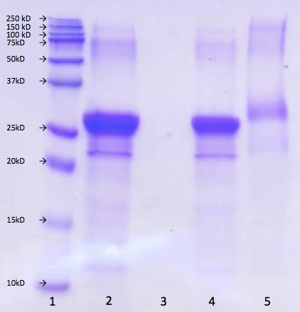

Fig.3.1. SDS-PAGE analysis of NaCas (Lane 2), MD (Lane 3), mixture of NaCas and MD (Lane 4) and casein-MD conjugate (Lane 5). Lanes 1 and 2 are protein markers.

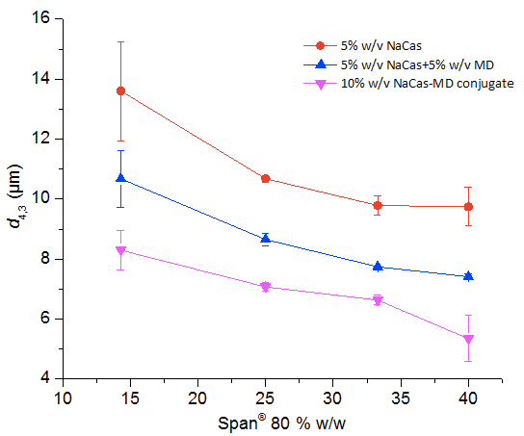
Fig.3.2. Volume fraction-length mean diameter (d4,3) of S/O/W suspensions prepared by emulsifying 5% w/v of a S/O suspension containing CCPs into an aqueous phase with 5% w/v NaCas, 5% w/v NaCas and 5% w/v MD, or 10% w/v casein-MD conjugates. The lipid phase was binary mixtures of Span® 80 and milk fat, with the amount of Span® 80 in the overall S/O suspension mass plotted on the X-axis.
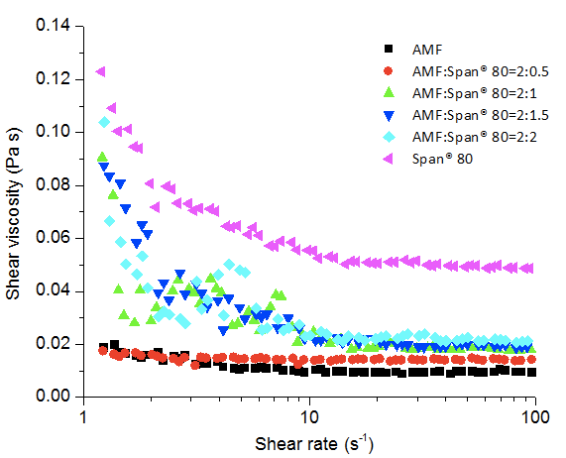

Fig. 3.3. Rheograms of mixtures with different mass ratios of anhydrous milk fat (AMF) and Span® 80 at 80 °C.

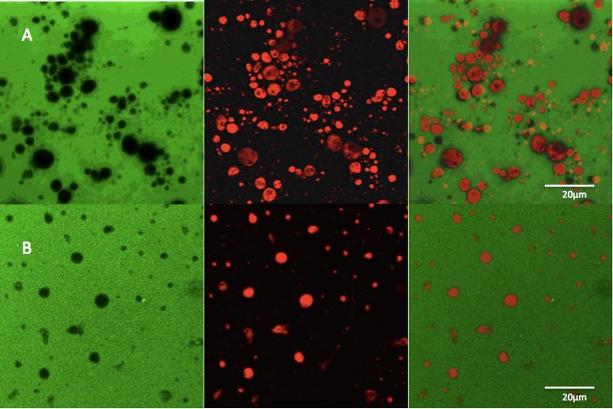

Fig. 3.4. Confocal images of S/O/W suspensions prepared by emulsifying 5% w/v of a S/O suspension containing 20% w/w CCP into an aqueous phase with5% w/v NaCas and 5% w/v MD (A) or 10% w/v casein-MD conjugates (B). The lipid phase with equal mass of Span®80 and milk fat was dissolved with Nile Red before preparation of suspensions that were later stained by green FITC probe. Suspensions were diluted 10 fold before imaging for FITC (left) and Nile Red (middle) fluorescence, with co-localized images shown on the right.

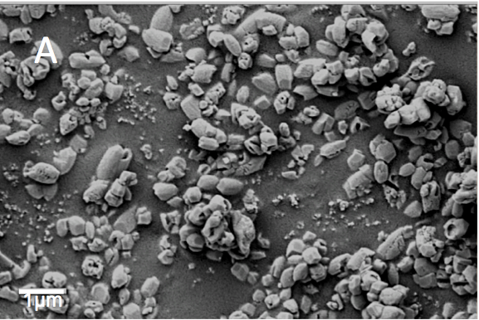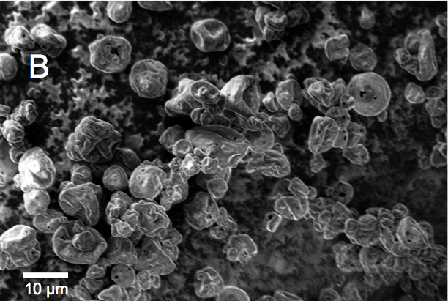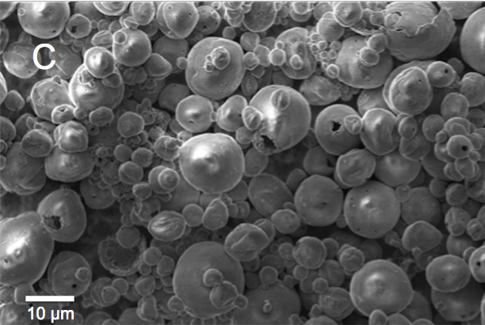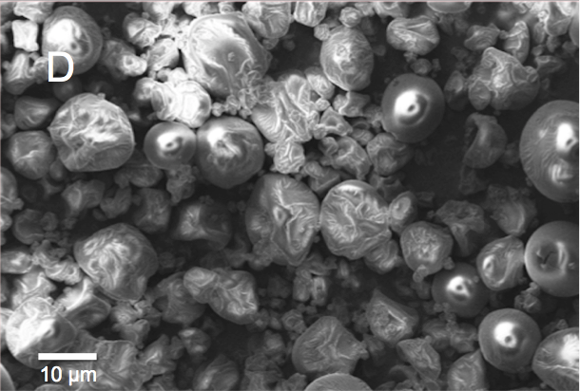

Fig. 3.5. Scanning electron micrographs of CCP as received(A), spray-dried powders prepared from suspensions emulsified by NaCas (B), NaCas-MD mixture (C), and casein-MD conjugates (D),with S/O suspension conditions detailed in Fig. 3.4.

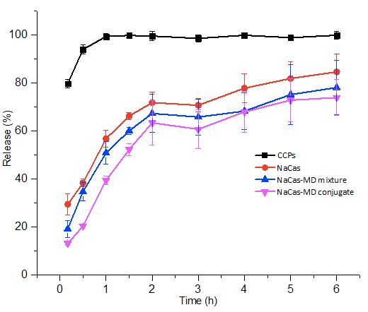

Fig. 3.6. Kinetics of ionic calcium released from spray-dried powders during the first 2-h simulated gastric digestion and the subsequent 4-h simulated intestinal digestion. The powder samples were prepared from S/O/W suspensions emulsified by NaCas, NaCas-MD mixture or casein-MD conjugates, with S/O suspension compositions detailed in Fig. 3.4. Control CCPs at an amount equal to the conjugate treatment are compared.

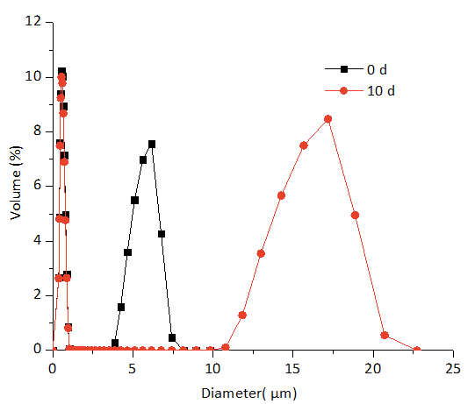
(A)

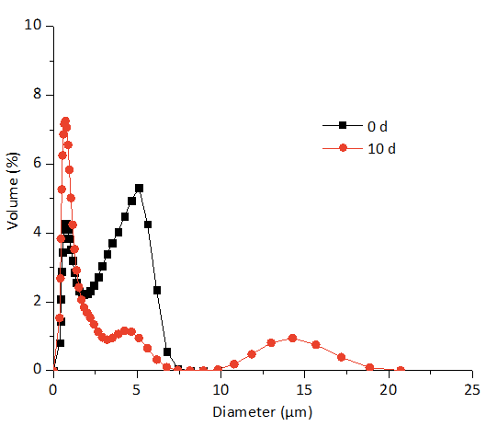
(B)
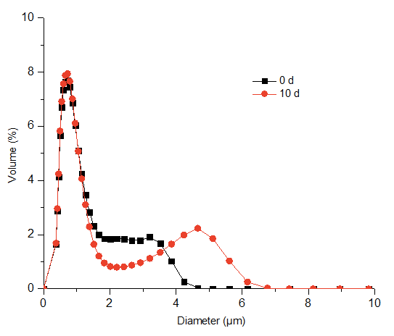
(C)

Fig. 3.7. Size distributions of skim milk with 10% w/v spray-dried powder prepared from S/O/W suspensions emulsified by (A) NaCas, (B) NaCas-MD mixture, and (C) casein-MD conjugates before and after storage at 5 °C for 10 days. S/O suspension compositions are detailed in Fig. 3.4.

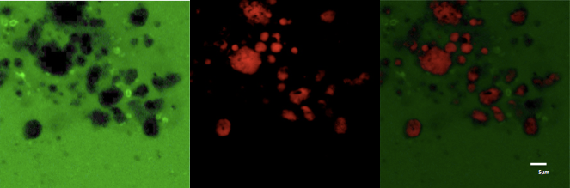
(A)
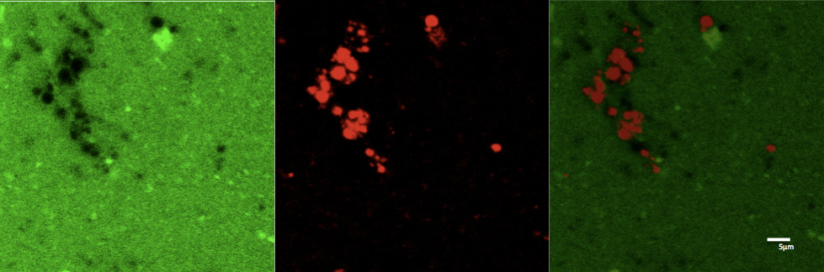
(B)
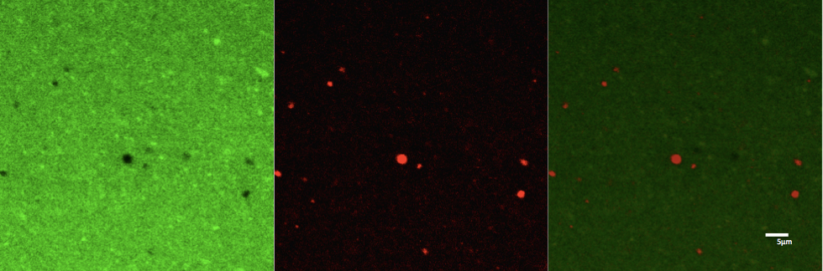
(C)

Fig. 3.8. Confocal microscopy images of skim milk with 10% w/v spray-dried powder prepared from S/O/W suspensions emulsified by NaCas (A), NaCas-MD mixture (B) or casein-MD conjugates (C). For each sample, images were acquired for FTIC staining protein in the continuous phase (left), Nile Red staining lipids (middle), and after co-localization (right). S/O suspension compositions are detailed in Fig. 3.4.

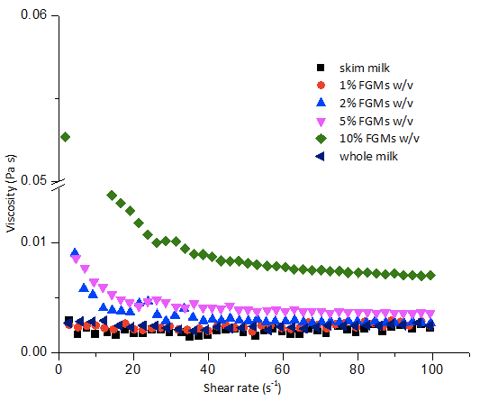

Fig. 3.9. Rheograms of skim milk hydrated with 0-10% w/v spray-dried powder prepared with casein-MD conjugates at21 °C, in comparison to whole milk.

Conclusions
The present study showed that casein-MD conjugates were more feasible than NaCas in encapsulating CCPs as dispersible FGMs because of the reduced particle size and improved stability against aggregation and coalescence. The reduction of interfacial tension by Span® 80 was also critical to reduce the dimension of FGMs. Spray-dried FGMs were hydrated well in skim milk, with those prepared from casein-MD conjugates showing no precipitation during 10-day storage at 5 °C. The addition of spray-dried FGMs prepared from conjugates in skim milk increased the desirable turbidity and viscosity but increased the undesirable redness and yellowness. The addition of 10% FGMs in skim milk resulted in a total fat content of about 2% but the turbidity similar to and viscosity higher than full-fat milk. Therefore, dispersible FGMs prepared from NaCas-MD conjugates may be used to simultaneously reduce fat and increase calcium contents of food products.

Vita
Bai Qu was born in Jinan, Shandong, China on June 26, 1989. After graduation from High School Attached to Shandong Normal University in 2008, she continued her education at the Shandong Agricultural University where she earned a B.S. degree majoring in Food Science. In May 2014, she will earn an M.S degree in Food Science and Technology with a concentration in Food Chemistry from the University of Tennessee, Knoxville.

