Clovis Lithic Manufacturing Variability at the Allendale Chert Quarries: A Preliminary View from 38AL228, Allendale County, South Carolina

A Thesis Presented for the
Master of Arts
Degree
The University of Tennessee, Knoxville

Andrew James Weidman
August 2013

ACKNOWLEDGEMENTS

I would first like to thank Dr. David G. Anderson for serving as my committee chair and graduate advisor. His encouragement, advice, and feedback throughout this project were invaluable. I would also like to thank Drs. Boyce Driskell and Gerald Schroedl for serving as committee members and providing comments on the manuscript of this thesis. I owe a debt of gratitude to Kenn Steffy for encouraging me to further document a site he spent years evaluating and to Dr. Albert Goodyear and Tom Pertierra for presenting me with the opportunity to use 38AL228 for my thesis. The research program they have developed is a model for the integration of professional archaeologists, students, and members of the public who have an interest in the past. I would also like to thank Dr. John Foss for his detailed analysis of the soils at the site.
The students and volunteers who helped during excavations at the site are too many to name, but I cannot thank them enough. I am privileged to have had the opportunity to know and work with them all. I would especially like to thank Katie Corcoran, Beatrix Dudzik, David Echeverry, and David Mercer for offering their time and effort to help me dig in a South Carolina swamp in the middle of summer. Finally, I would like to thank my wonderful wife Courtney for encouraging me throughout this process and listening when I wanted to talk about rocks.
ABSTRACT
This research is the result of archaeological testing that occurred from 2010–2012 at 38AL228, a multi-component quarry related site in Allendale County, South Carolina. This thesis 1) provides a summary of the testing in order to define the cultural sequence and isolate the Clovis component for further analysis, and 2) compares the Clovis lithic assemblage from 38AL228 with the Clovis lithic assemblage from the Topper site (38AL23) to explore possible manufacturing variability based on distance from the source of raw material within the Allendale chert quarries.
The premise for the comparative analysis is framed around the concept of differential lithic signatures and site functions within a lithic quarry region as developed by Gardner (1974, 1977) for the Flint Run Quarry Complex in Virginia. No naturally occurring source of Allendale chert has been found at 38AL228, the nearest being 150-200 meters away, while Topper is located directly adjacent to a primary chert source. The large quantity of tools, cores, and lithic manufacturing debris at 38AL228 suggests that raw material was transported in and tool manufacturing occurred at the site. This analysis tests whether any substantive variation in lithic manufacturing exists between the two assemblages and examines the results in the context of proximity to the raw material source.
The results of this analysis demonstrate variability in certain aspects of lithic manufacturing at 38AL228 and Topper and no recognizable variability in other aspects. Distance from the raw material source did not significantly influence Clovis biface production. All stages of Clovis biface manufacture are represented at 38AL228, and their distribution is proportionally similar to the Clovis bifaces recovered at Topper. Clovis blade technology is encountered more frequently at 38AL228 than Topper, suggesting that high-quality chert nodules or prepared blade cores were selectively imported into 38AL228 for blade manufacture. The types and frequency of Clovis flake tools indicate that non-lithic manufacturing activities were occurring in similar proportions at 38AL228 and Topper.

TABLE OF CONTENTS

Chapter I: Introduction and Background 1
Research Objectives 3
Physiography 7
Site Background 12
Site Location 12
Previous Research 12
Cultural Background 16
Paleoindian Period 18
Archaic Period 23
Woodland Period 27
Mississippian Period 30
Late Prehistoric and Historic Periods 32

Chapter II: The 2010-2012 Test Excavations at 38AL228 33
Research Design 35
Field Methodology 35
Isolating the Clovis Component 40
Clovis Bifacial Technology 42
Clovis Blade Technology 44
Testing Results 48
Area A 51
Area B 59
Area C 67
Area D 83
Surface Collection 87

Chapter III: The 38AL228 Clovis Lithic Assemblage 89
Clovis Bifaces 90
Clovis Blades 94
Clovis Cores 95
Flake Tools 98
Debitage 104
Chapter IV: Comparative Analysis of the 38AL228 and Topper Clovis Lithic Assemblages 106
The Topper Clovis Assemblage 108
Methods 109
Results 115
Discussion 127

Chapter V: Summary and Conclusions 131

List of References 134

Appendices 151
Appendix A: Artifact Photographs 152
Appendix B: Artifact Tables 169
Appendix C: Surface Collection Artifact Photographs 197

Vita 206

LIST OF TABLES

Table 1. Cultural chronology of Middle Savannah River Valley 17
Table 2. 38AL228 Total artifact summary. 33
Table 3. Artifact totals by Area and Test Unit. 49
Table 4. Representative description of soil profiles at Area B, 38AL228. 61
Table 5. Representative description of soil profiles at Area C, 38AL228. 69
Table 6. Representative description of soil profiles at Area D, 38AL228. 83
Table 7. 38AL228 Clovis artifact summary. 89
Table 8. 38AL228 Clovis biface attributes. 91
Table 9. 38AL228 Clovis bifaces: Metric attributes, reduction stage, biface type, and flaking index. 92
Table 10. 38AL228 Clovis blades 95
Table 11. 38AL228 Clovis cores. 96
Table 12. 38AL228 Clovis flake tools. 101
Table 13. 38AL228 Clovis endscrapers. 103
Table 14. 38AL228 Debitage, Area C, Test Trench Clovis levels. 105
Table 15. Relative frequencies of Clovis artifact types, 38AL228 and Topper. 113
Table 16. P-values for Fisher’s exact tests comparing 38AL228 to Topper Hillside Areas. 114
Table 17. Z-score standardized Fisher’s Exact test residuals “All artifact types” category comparing 38AL228 to Topper Hillside Areas. 116
Table 18. Comparison of Clovis biface stage of manufacture, 38AL228 and Topper. 119
Table 19. Comparison of Clovis biface stage of reduction without bifacial cores, 38AL228 and Topper. 119
Table 20. Relative frequencies of Clovis core types, 38AL228 and Topper. 122
Table 21. Clovis Blades at 38AL228. 124
Table 22. Comparison of Clovis flake tool types, 38AL228 and Topper. 126

Table B- 1. Artifact totals by Test Unit. 170
Table B- 2. Debitage aggregate analysis, all proveniences. 172
Table B- 3. Non-hafted bifaces. 182
Table B- 4. Flake tools. 186
Table B- 5. Hafted bifaces. 190
Table B- 6. Cores. 191
Table B- 7. Hammerstones. 193
Table B- 8. Prehistoric ceramics. 195

LIST OF FIGURES

Figure 1. Location of 38AL228 and nearest chert sources, USGS 1:24,000 Topographic Map, Martin quadrangle, South Carolina. 2
Figure 2. Location of 38AL228 and Topper (38AL23), USGS 1:24,000 Topographic Map, Martin Quadrangle, South Carolina. 4
Figure 3. Physiographic regions of South Carolina. 7
Figure 4. Disturbed area adjacent to 38AL228.. 15
Figure 5. Map showing site grid, testing areas, and locations of Test Units and Backhoe Trenches at 38AL228.. 34
Figure 6. Map of Area A with locations of individual test units. 52
Figure 7. Area A, facing west. Sharp drop into Smith Lake Creek to the left. 53
Figure 8. Map of Area B with locations of individual test units and backhoe trenches. 60
Figure 9. Area B facing south from access road 62
Figure 10. N1079 E1086, Feature 2, FCR concentration mid-excavation. 64
Figure 11. Map of Area C with locations of individual test units and backhoe trenches. 68
Figure 12. Photograph of West Wall Profile of Area C Test Trench, N1017 E1054 and N1018 E1055. 74
Figure 13. Vertical distribution of all diagnostic artifacts, plotted against west profile of 6 x 1 meter test trench. 75
Figure 14. Vertical distribution of Clovis bifaces (with FS#) and post-Clovis diagnostic artifacts, plotted against west profile of 6 x 1 meter test trench. 76
Figure 15. Vertical distribution of Clovis cores (with FS#) and post-Clovis diagnostic artifacts, plotted against west profile of 6 x 1 meter test trench. 76
Figure 16. Vertical distribution of Clovis blades (with FS#) and post-Clovis diagnostic artifacts, plotted against west profile of 6 x 1 meter test trench.. 77
Figure 17. Flake tools in Clovis levels in Area C, plotted against west profile of 6 x 1 meter test trench.. 77
Figure 18. Clay anomaly and undulating subsoil at base of N1020 E1055. 82
Figure 19. Map showing Area D with locations of individual test units and Road-Cut Profile. 84
Figure 20. Photograph showing general area of Road Surface Collection at 38AL228, facing northeast. 85
Figure 21. Evidence of looter activity at road-cut in Area D, 38AL228. 86
Figure 22. Hillside block excavations at 38AL23 (Topper).. 109
Figure 23. Boxplot of FI for bifaces at 38AL228 and Topper Hillside Area B. 120
Figure 24. Boxplot of FI and stage of reduction (1=early, 2=middle, 3=late) for 38AL228 bifaces. 120

Figure A- 1. Early stage Clovis bifaces 153
Figure A- 2. Middle stage Clovis bifaces 154
Figure A- 3. Late stage Clovis bifaces. 155
Figure A- 4. Clovis overshot flake, FS-1463. 156
Figure A- 5. Clovis bifacial cores. 157
Figure A- 6. Clovis conical blade cores 158
Figure A- 7. Clovis wedge-shaped cores 159
Figure A- 8. Clovis core tablet flakes. 160
Figure A- 9. Amorphous Clovis core 161
Figure A- 10. Clovis blades. 162
Figure A- 11. Clovis flake tools 163
Figure A- 12. Endscrapers 164
Figure A- 13. Woodland projectile points. 165
Figure A- 14. Middle and Late Archaic projectile points. 166
Figure A- 15. Early Archaic side-notched projectile point. 166
Figure A- 16. Dalton preforms. 167
Figure A- 17. Select examples of prehistoric ceramics at 38AL228. 168

Figure C- 1. Bifaces, 38AL228 surface collection. 198
Figure C- 2. Bifaces, 38AL228 surface collection. 199
Figure C- 3. Bifaces, 38AL228 surface collection. 200
Figure C- 4. Bifaces, 38AL228 surface collection. 201
Figure C- 5. Endscraper, 38AL228 surface collection. 202
Figure C- 6. Blades, 38AL228 surface collection. 203
Figure C- 7. Denticulated scrapers, 38AL228 surface collection. 203
Figure C- 8. Blade core fragment / error recovery blade, 38AL228 surface collection. 204
Figure C- 9. Amorphous cores, 38AL228 surface collection. 205

Chapter I:
Introduction and Background

38AL228 is part of a suite of quarry related sites associated with outcrops of high quality, cryptocrystalline Allendale chert located in the middle Savannah River Valley of the Atlantic Coastal Plain. The site is situated on both the first terrace of the Savannah River and Coastal Plains uplands at the junction of Smith Lake Creek and the Savannah River floodplain. The site was utilized extensively throughout the past 13,500 years for the acquisition of nearby Allendale chert for stone tool manufacture, leaving behind a large amount of manufacturing debris and an assortment of tools ranging from formalized projectile points to non-formalized flake tools.
38AL228 was initially recorded as “Kenn’s Clovis Site” in the South Carolina Site Inventory in 1989 by Kenn Steffy of the South Carolina Institute of Archaeology and Anthropology (SCIAA) during efforts to document archaeological sites related to the Allendale chert quarries. The official designation as an archaeological site followed the discovery of artifacts, some of which were diagnostic of the Paleoindian period, eroding from an unnamed access road-cut which bisects the site. The potential for intact subsurface archaeological deposits prompted the excavations that are summarized in this thesis. Figure 1 shows the location and boundaries of 38AL228. Tentative site boundaries were estimated based upon known areas that have produced artifacts, although no systematic survey has been conducted to determine the full extent of the site.
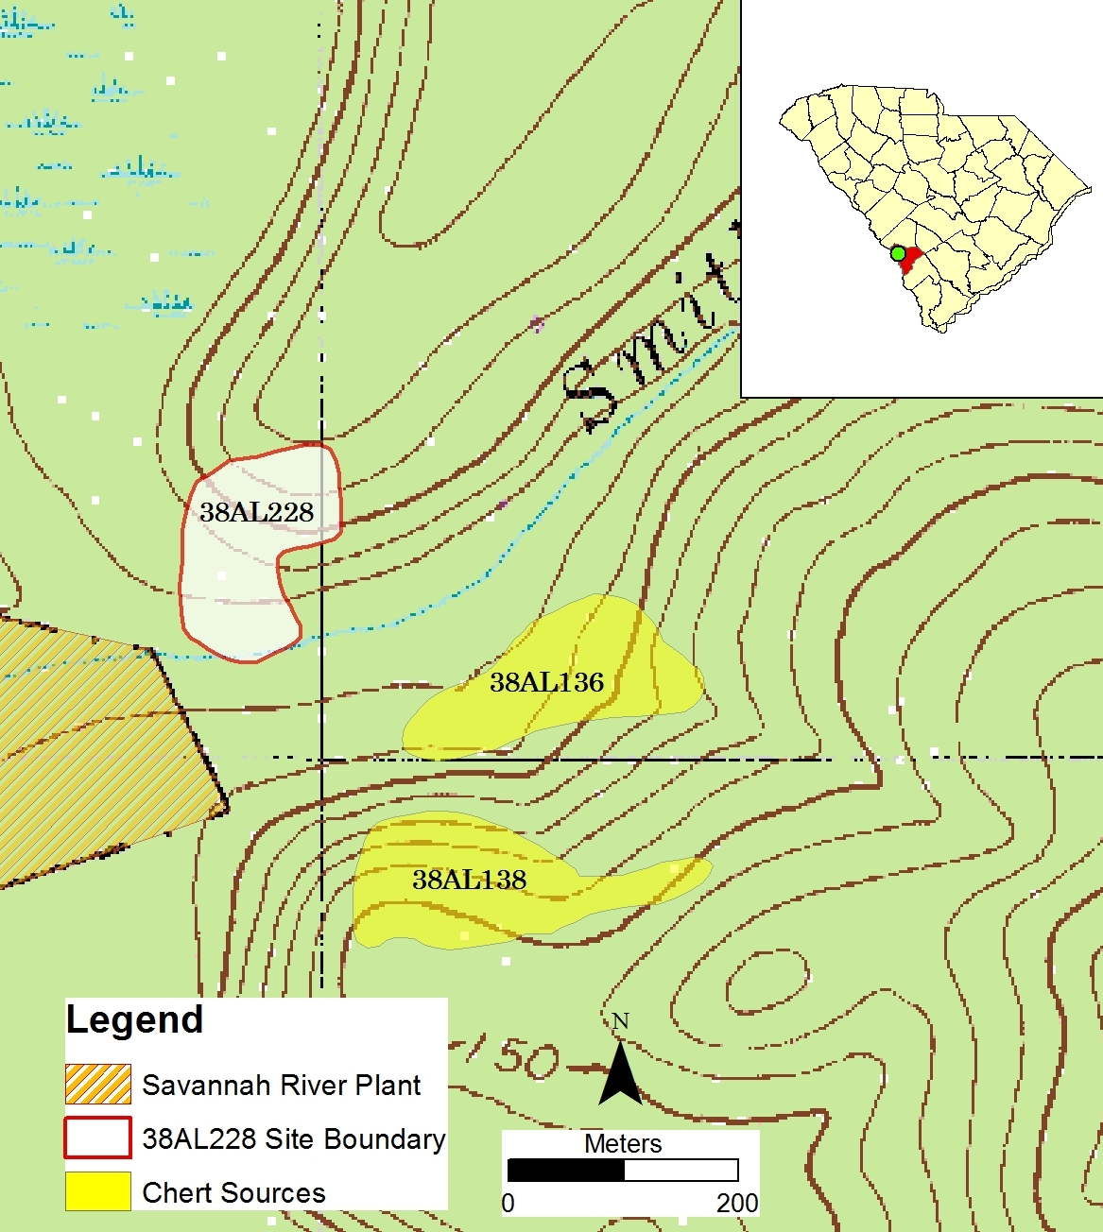
Figure 1. Location of 38AL228 and nearest chert sources, USGS 1:24,000 Topographic Map, Martin quadrangle, South Carolina (Chert source site locations adapted from Goodyear and Charles 1984).

Research Objectives

There are two central objectives of this thesis. The first is to provide an overview of the test excavations at 38AL228 from 2010–2012, with the explicit goal of delineating the cultural sequence of the site in order to isolate the Clovis component for further analysis. The second is to compare the Clovis lithic assemblage recovered from 38AL228 to the Clovis lithic assemblage from the Topper site (38AL23), located approximately 2.5 kilometers to the south (Figure 2), to identify and explore variability in lithic manufacture and site function based on distance from the source of raw material within the Allendale chert quarries. These objectives are described in detail below.

Excavations and Chronology

Research at Topper, a quarry related site with similar physiographic conditions, has demonstrated the potential for finding “buried, relatively undisturbed” Paleoindian deposits below the plow zone (Miller 2007, 2010; Smallwood 2011:25). However, the Allendale chert quarries were exploited for long periods of time by groups from the Paleoindian period through the Mississippian period, and there was concern that stratigraphic mixing of cultural deposits had occurred at 38AL228. In response to this, an objective of this research is to provide an examination of the test excavations and artifacts recovered at 38AL228 to establish a cultural chronology for the site, with a particular interest in delineating the Clovis artifact assemblage. The testing and artifact analysis demonstrates that certain areas of 38AL228 have stratified archaeological deposits ranging from the Woodland period to the Paleoindian period, while other areas are characterized by mixed deposits. Mixing of cultural deposits is likely the result of
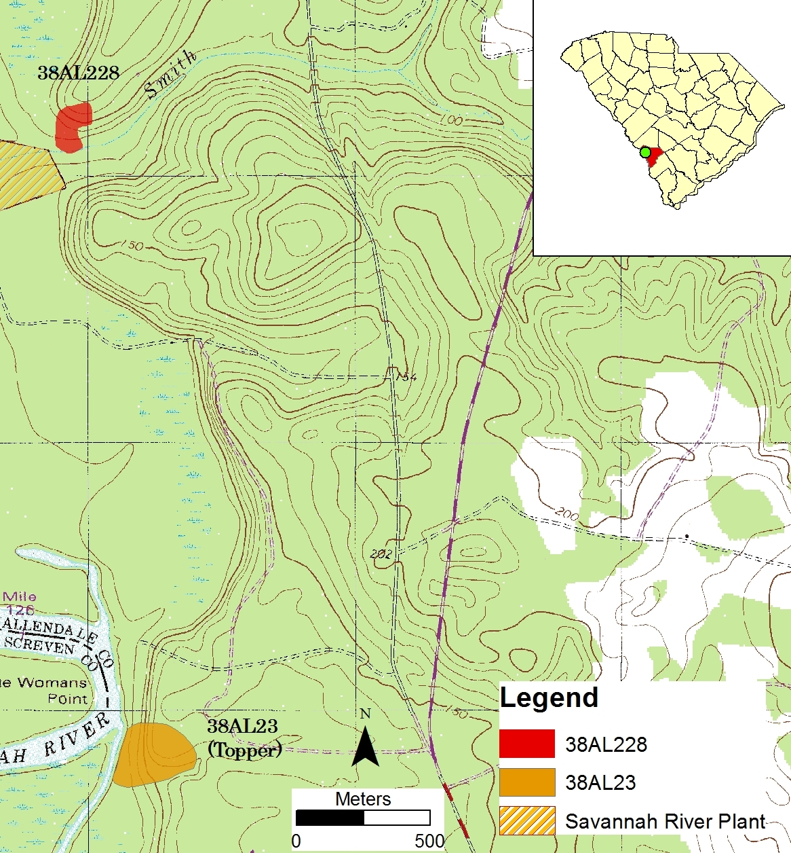
Figure 2. Location of 38AL228 and Topper (38AL23), USGS 1:24,000 Topographic Map, Martin Quadrangle, South Carolina (Topper site location adapted from Miller 2007).

bioturbation, where fibrous root systems, taproots, and animal burrowing have displaced the soil, facilitating the downward movement of artifacts (Michie 1990).
The specific emphasis on the Clovis occupation at 38AL228 is due in large part to the rarity of buried Clovis deposits in southeastern North America relative to later occupations. Much of the evidence of Clovis in the Southeast consists of isolated projectile points finds or surface lithic scatters (Anderson 2010; Anderson et al. 1996; Broster and Norton 1993, 1996; Goodyear 1999; Miller and Gingerich 2013; Sanders 1990). The buried Clovis archaeological deposits at 38AL228, some of which appear to remain intact, present an opportunity to better understand quarrying behavior among early North American hunter-gatherers at the Allendale chert quarries. Predefined criteria for inclusion in the Clovis lithic assemblage are described in Chapter II. All artifacts from 38AL228 assigned a Clovis designation are described in this thesis, including bifaces, cores, blades, flake tools, and debitage.

Exploring Variability in Lithic Manufacture

The second research goal of this thesis concerns whether/how the Clovis lithic assemblage at 38AL228 varies from the lithic assemblage at Topper, particularly when considering the variation in proximity to the raw material source between the two. Topper is located directly adjacent to a primary chert source, whereas 38AL228 has no known naturally occurring source of Allendale chert (Goodyear and Charles 1984; Goodyear and Steffy 2003). The nearest outcropping of chert to 38AL228 is located approximately 150-200 meters to the southeast along the escarpment on the opposite side of Smith Lake Creek at sites 38AL136 (the Beech Tree site) and 36AL138, both identified during Goodyear and Charles’ (1984) initial survey of the Allendale quarries and quarry related sites. 38AL138 is described as “an extremely large site with considerable evidence of chert exploitation by aboriginal populations” (Goodyear and Charles 1984:25) (Figure 1).
Since no Allendale chert outcrops have been identified on the same side of the creek as 38AL228, the substantial amount of tools, cores, and lithic manufacturing debris found at the site suggests that raw material was transported into the site from across Smith Lake Creek and its associated wetland. Considering that movement of toolstone to 38AL228 from the source location would require extra energy expenditure, it can be hypothesized that efforts would be made to maximize the portability of usable raw material and minimize the mass of unusable raw material imported into the site. This would suggest that initial reduction may have already occurred at the point of acquisition. To test this, bifaces at 38AL228 are analyzed and compared to bifaces recovered at Topper to determine if any substantive variation in the reduction process exists between the two assemblages. Part of this analysis tests the assumption that bifaces from 38AL228 demonstrate a later stage of reduction than bifaces located at the raw material source. In addition to bifaces, recognizable variability in other aspects of Clovis lithic technology, such as blade production and core technology, may be evident between the two sites and are considered in this research.
The comparisons between 38AL228 and Topper are generally framed around the concept of differential lithic signatures and site functions within a lithic quarry region as developed by William Gardner (1974, 1977) for the Flint Run Quarry Complex in the Shenandoah River Valley of Virginia. Gardner’s model has particular relevance in areas where lithic raw material sources are infrequent, such as the Atlantic Coastal Plain (Anderson and Sassaman 1996:23; Goodyear 1989:3).

Physiography

38AL228 is located in the Upper Atlantic Coastal Plain physiographic province of the Middle Savannah River Valley. The Upper Coastal Plain is bounded by the Piedmont physiographic province to the north and the Orangeburg scarp to the south, which marks the transition to the Middle Coastal Plain (Figure 3) (Nystrom et al. 1991:23-24).

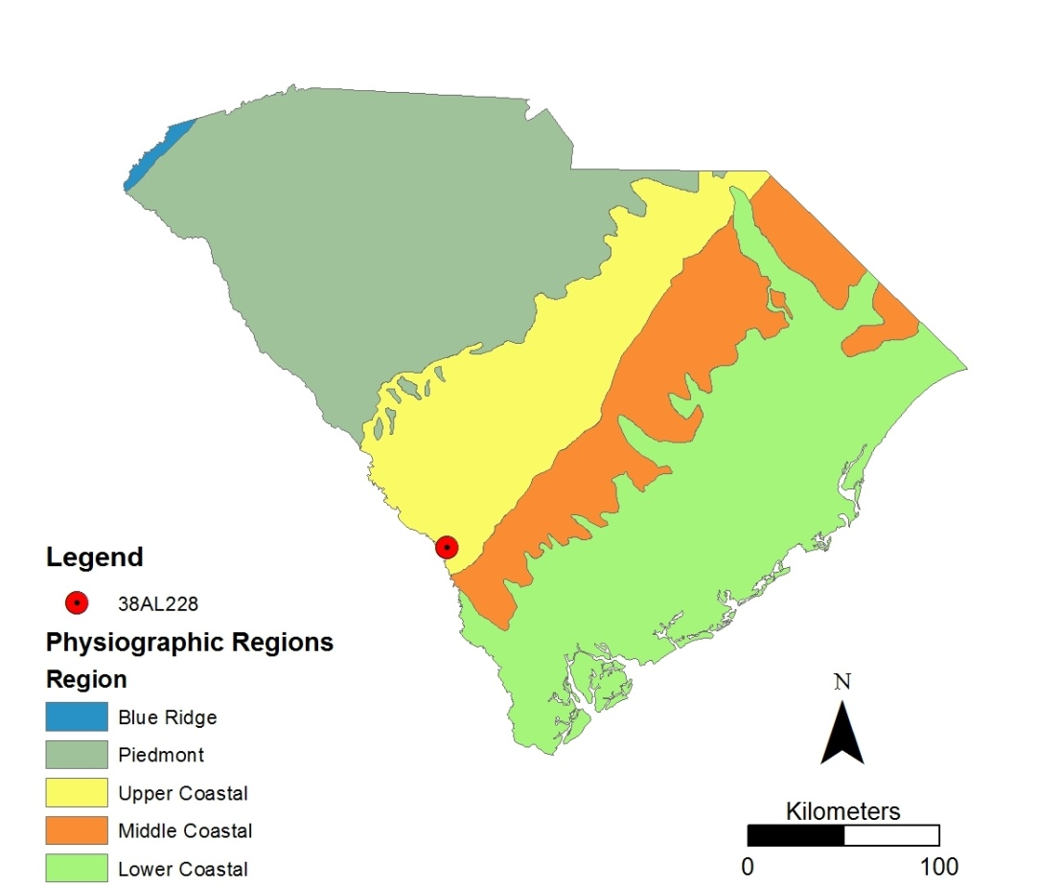

Figure 3. Physiographic regions of South Carolina. Source: South Carolina Department of Natural Resources, http://www.dnr.sc.gov/gis.html (Accessed 2/2013).

Geology and Lithic Resources

The general scarcity of naturally occurring chert throughout the Coastal Plain emphasizes the importance of areas such as the Allendale chert quarries to prehistoric peoples (Goodyear 1989). The Allendale chert quarries are the northernmost major exposure of the Flint River formation (Goodyear and Charles 1984:4; Smallwood 2010:14). Although several other chert sources are located in the South Carolina Coastal Plain, the chert at the Allendale quarries is the highest in quality and the most widely used throughout the state (Anderson et al. 1982:126). The Tertiary-aged marine chert from the Allendale quarries is a bright yellow to brown, waxy to vitreous variety of the Flint River Formation, which is recognized as unique to Allendale County, South Carolina and Screven County, Georgia along the Savannah River. This high-quality “Allendale-type” chert is fine-grained and homogeneous, although it varies in quality and non-silicified inclusions are common (Anderson et al. 1982:126; Upchurch 1984). These silicified grainstone outcrops were exposed through incising by the meandering Savannah River and were available in the form of both primary upland nodules and riverine cobbles. Thermal alteration of Allendale chert results in a color transformation to pink, red, and/or blue and causes an increase in glossy luster (Anderson 1979:242). Allendale chert is also characterized by its tendency to weather rapidly, forming an outer layer of lightened, coarse-grained material on the exterior of artifacts produced during the Late Archaic and Paleoindian period (Michie 1977; Goodyear and Charles 1984; Sassaman and Anderson 1990:174).

Soils

Soils at 38AL228 belong to the Lakeland series, specifically Lakeland B, described as excessively drained soils formed in sandy marine sediments and typically found on the broad tops and sides of ridges. These sandy soils are very strong to moderately acidic (Eppinette 1993:74). Because 38AL228 is located on both a terrace and an upland slope, the soils vary in depth and composition. During the March 2012 field season, retired University of Tennessee Plant and Soil Sciences professor Dr. John Foss conducted a field classification of the soils at 38AL228. Dr. Foss examined a sample of previously excavated test units to obtain a cross-section of soil sequences across the landform that 38AL228 is situated on.
On the terrace, soils are sandy and generally shallow (<75cm), with a soil sequence of Ap-BA-Bw-C1-C2 overlying an approximately 50,000 year-old paleosol (2Bt1b-2Bt2b) (Foss, personal communication 2012). Post-depositional processes appear to have commingled the archaeological deposits containing Paleoindian, Archaic, Woodland, and Historic artifacts to varying degrees. Some areas of the terrace, however, do not demonstrate stratigraphic mixing.
On the upland slope soils vary in depth, with the shallowest deposits occurring near the base. A soil sequence of Ap-AB-Bw-C1-C/B-C2-C3 overlying a 2Btb paleosol was identified at the highest point of excavation on the landform. Cultural deposits are located in the top 60-70 cm, although a deficiency of diagnostic cultural materials prohibits any statement on stratigraphic separation of temporal periods. At the lowest point of excavation on the slope, an 86 cm soil sequence of Ap-AB-Bw-C1-C2 overlaid the 2Btb paleosol (Foss, personal communication 2012). Again, a deficiency of diagnostic cultural materials prohibits any statement on stratigraphic separation of temporal periods. Additional results of the field classifications are presented in the context of the archaeological investigations in Chapter II.

Paleo-environmental Overview

The South Carolina Coastal Plain has experienced considerable shifts in climate, flora, and fauna throughout the span of human occupation there. When humans likely first arrived, the region was undergoing a gradual shift from a full-glacial, xeric, boreal environment dominated by spruce (Picea) and jack pine (Pinus) to one which was warmer and moister, where deciduous growth—oak (Quercus), beech (Fagus), hickory (Carya), hemlock (Tsuga), black walnut (Juglans nigra), hazelnut (Corylus), elm (Ulmus), birch (Betula) and ironwood (Ostrya/Carpinus)—was gradually replacing the boreal growth (Watts 1980; Delcourt and Delcourt 1985:19; Brooks et al. 1990:21).
The full transition to a dominant deciduous growth forest occurred at approximately 12,800 ₁₄C yr BP, which corresponds to a period of increased precipitation with warmer summers and cooler winters (Delcourt and Delcourt 1983; Watts 1980:192). The climate during this period, characterized as moister and cooler than present-day conditions, persisted until 9,550 ₁₄C yr BP at which point mixed pine and oak began to appear. Mixed pine and oak conditions continued until about 7,000 ₁₄C yr BP, when southern pine replaced oak as the dominant type and signified the beginning of essentially modern conditions (Delcourt and Delcourt 1985; Watts 1980:194).
During the terminal Pleistocene, 38AL228 was located in the temperate zone, which consisted of mixed temperate forests and grasslands. This also served as a transitional zone between the boreal zone to the north and the subtropical zone to the south. The temperate region provided opportunities for both grazing and browsing species, although the temperate Coastal Plain has been characterized as having a greater percentage of grasslands compared to the temperate Piedmont region to the northwest (Webb 1981:I-78).
The dominant megafaunal species native to the temperate zone was the American mastodon (Mammut americanum), although other grazers from the northern boreal zone, such as mammoth (Mammuthus columbi and Mammuthus primigenius), camel (Camelops), bison (Bison), amphibious rodents (Capybaras), and horse (Equus) would at times opportunistically migrate south from their northern boreal habitat. Similarly the subtropical fauna from the south—ground sloths (Megalonyx), giant tortoises (Geochelone crassiscutta), tapirs (Tapirus), and peccaries (Pecari)—would likely have been within the range of hunter-gatherer groups that utilized toolstone from the Allendale chert quarries (Webb 1981:I–78-I-80).

Site Background

Site Location

38AL228 is located in the middle Savannah River Valley of the Upper Atlantic Coastal Plain, situated on a terrace and upland ridge nose along the north side of Smith Lake Creek as it enters the floodplain of the Savannah River. The site is part of a suite of archaeological sites associated with the prehistoric use of the Allendale chert quarries, which consist of outcrops of Coastal Plain chert exposed through cutting by the meandering Savannah River (Goodyear and Charles 1984; Novick 1978; Upchurch 1984:135). The Allendale chert quarries are the northernmost major exposure of the Flint River formation and contain some of the highest-quality outcrops of toolstone in South Carolina (Anderson et al. 1982:126; Goodyear and Charles 1984:4; Smallwood 2010:14). Although prehistoric occupation of 38AL228 was likely related to the quarries, there are no outcrops of chert on the landform it is situated on (Goodyear and Charles 1984). Nonetheless, acquisition of the nearby chert for toolstone was likely a significant motive for the prehistoric occupants of 38AL228, as evidenced by the large amount of lithic manufacturing debris recovered during archaeological investigations.

Previous Research
The Allendale Chert Quarries
The first comprehensive, archaeological survey of the Allendale chert quarries was conducted by Albert C. Goodyear and Tommy Charles during the summer of 1983 and winter of 1984. Fourteen quarry and quarry related sites were documented, though 38AL228, which was found and recorded in 1989, was not one of them (Goodyear and Charles 1984). The Allendale chert quarries were nominated as eligible and listed in the National Register of Historic places in 1985 (Goodyear and Steffy 2003).
Of these fourteen sites, the most thorough archaeological investigations have occurred at Topper. The first evidence of a robust Clovis component at Topper was discovered in 1998, and since then nearly 600 m² of archaeological deposits have been excavated. There are two main areas of Clovis excavations at Topper—the first terrace of the Savannah River and the Coastal Plain uplands above the chert outcrop known as the “hillside” (Goodyear 2005; Goodyear and Steffy 2003; Miller 2007; Smallwood 2010, 2011; Smallwood et al. 2013).

38AL228
38AL228 was initially recorded as “Kenn’s Clovis Site” in the South Carolina Site Inventory in 1989 by Kenn Steffy of the South Carolina Institute of Archaeology and Anthropology (SCIAA) as part of efforts to document archaeological sites surrounding the Allendale chert quarries. The original documentation of the site by SCIAA archaeologists occurred following the discovery and surface collection of artifacts eroding out of the sides of an unnamed access road that bisects the site (Figure 2). The SCIAA staff, most notably Kenn Steffy, continued to periodically surface collect from this road cut for a number of years, amassing a substantial collection of lithic artifacts, some of which are diagnostic to the Paleoindian period. Mr. Steffy allowed the artifacts from this surface collection to be examined and photographed for the purpose of this thesis, and a sample of the collection is presented in Appendix C. Mr. Steffy’s dedication in the documentation of the site was the stimulus for all archaeological investigations presented in this thesis.

Modern Land Use

The majority of the Allendale chert quarries and quarry related sites, including 38AL228, are located within the property currently owned and managed by the Clariant Corporation and previously owned and managed by the Sandoz-Martin Works. Several lines of evidence suggest that prior to its purchase by the Sandoz Corporation, the area in which 38AL228 is located was used for agricultural/logging purposes. An undated aerial photograph shows rows of what is likely planted pine throughout the boundaries of the site. Also, discarded industrial tow-line wires used to relocate downed trees were found at the site.
An approximately 50 x 60 meter basin-shaped disturbance is located directly southeast of 38AL228. The origins of the feature are unknown, although it appears to be either a borrow pit where soil was removed for construction purposes or an abandoned retention pond (Figure 4). The soils removed in the construction of the feature likely contained archaeological deposits similar to those recovered from the 2010-2012 excavations at 38AL228.
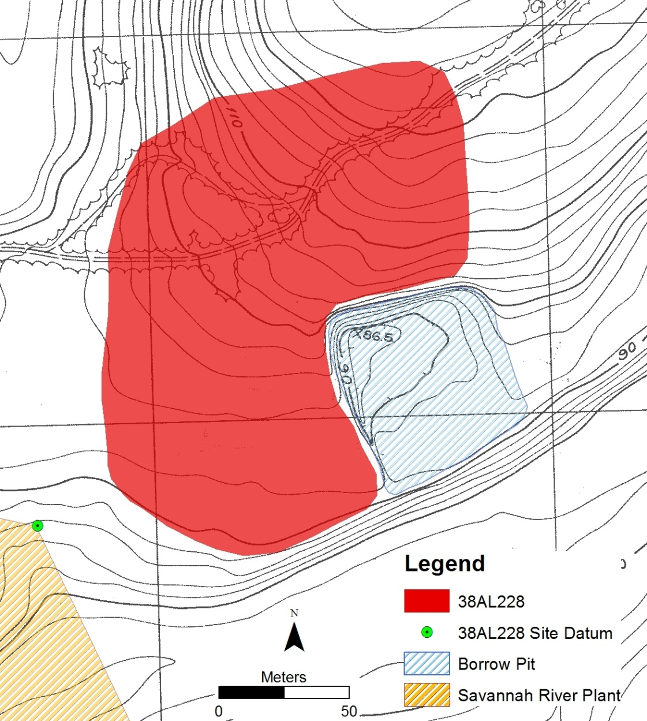
Figure 4. Disturbed area adjacent to 38AL228. Map produced in ESRI ArcGIS 10.0®. Source: Site Study, Martin, SC for Sandoz Colors and Chemicals.

Cultural Background

Prehistoric settlement of the Savannah River Valley dates back to as early as 11,500 ₁₄C yr BP, although current research suggests it perhaps occurred much earlier (Goodyear and Steffy 2003; Goodyear 2005; Goodyear et al. 2007; King 2012). Despite the possibility of an earlier occupation, the first widespread human presence in the Savannah River Valley was the Clovis culture (Anderson and Joseph 1988; Sassaman 1990:5-6; Sassaman and Anderson 1990).
Archaeological sites associated with the Allendale chert quarries are known to have been occupied by prehistoric Native Americans from the Paleoindian period until the Mississippian period (Goodyear and Steffy 2003). The natural abundance of high-quality toolstone at the Allendale chert quarries, particularly in a physiographic region characterized by a general scarcity of naturally occurring chert, the Atlantic Coastal Plain, underscores the significance of the area to prehistoric toolmakers (Goodyear 1989:3).
In the following sections, a brief summary is provided for each cultural period and sub-period in the Savannah River Valley describing the major technological, social, and cultural trends and the artifacts that are considered diagnostic of each period. Considering the importance of the Paleoindian period to the research goals of this thesis, there is a disproportionate amount of effort dedicated to it compared with later periods. A complete chronology is provided in Table 1 as a quick reference for diagnostic artifacts and their temporal designations.

Table 1. Cultural chronology of Middle Savannah River Valley (Adapted from Anderson 1994:159; Brooks et al.1986:295; King 2003; Sassaman 1990; Sassaman and Anderson 1990).
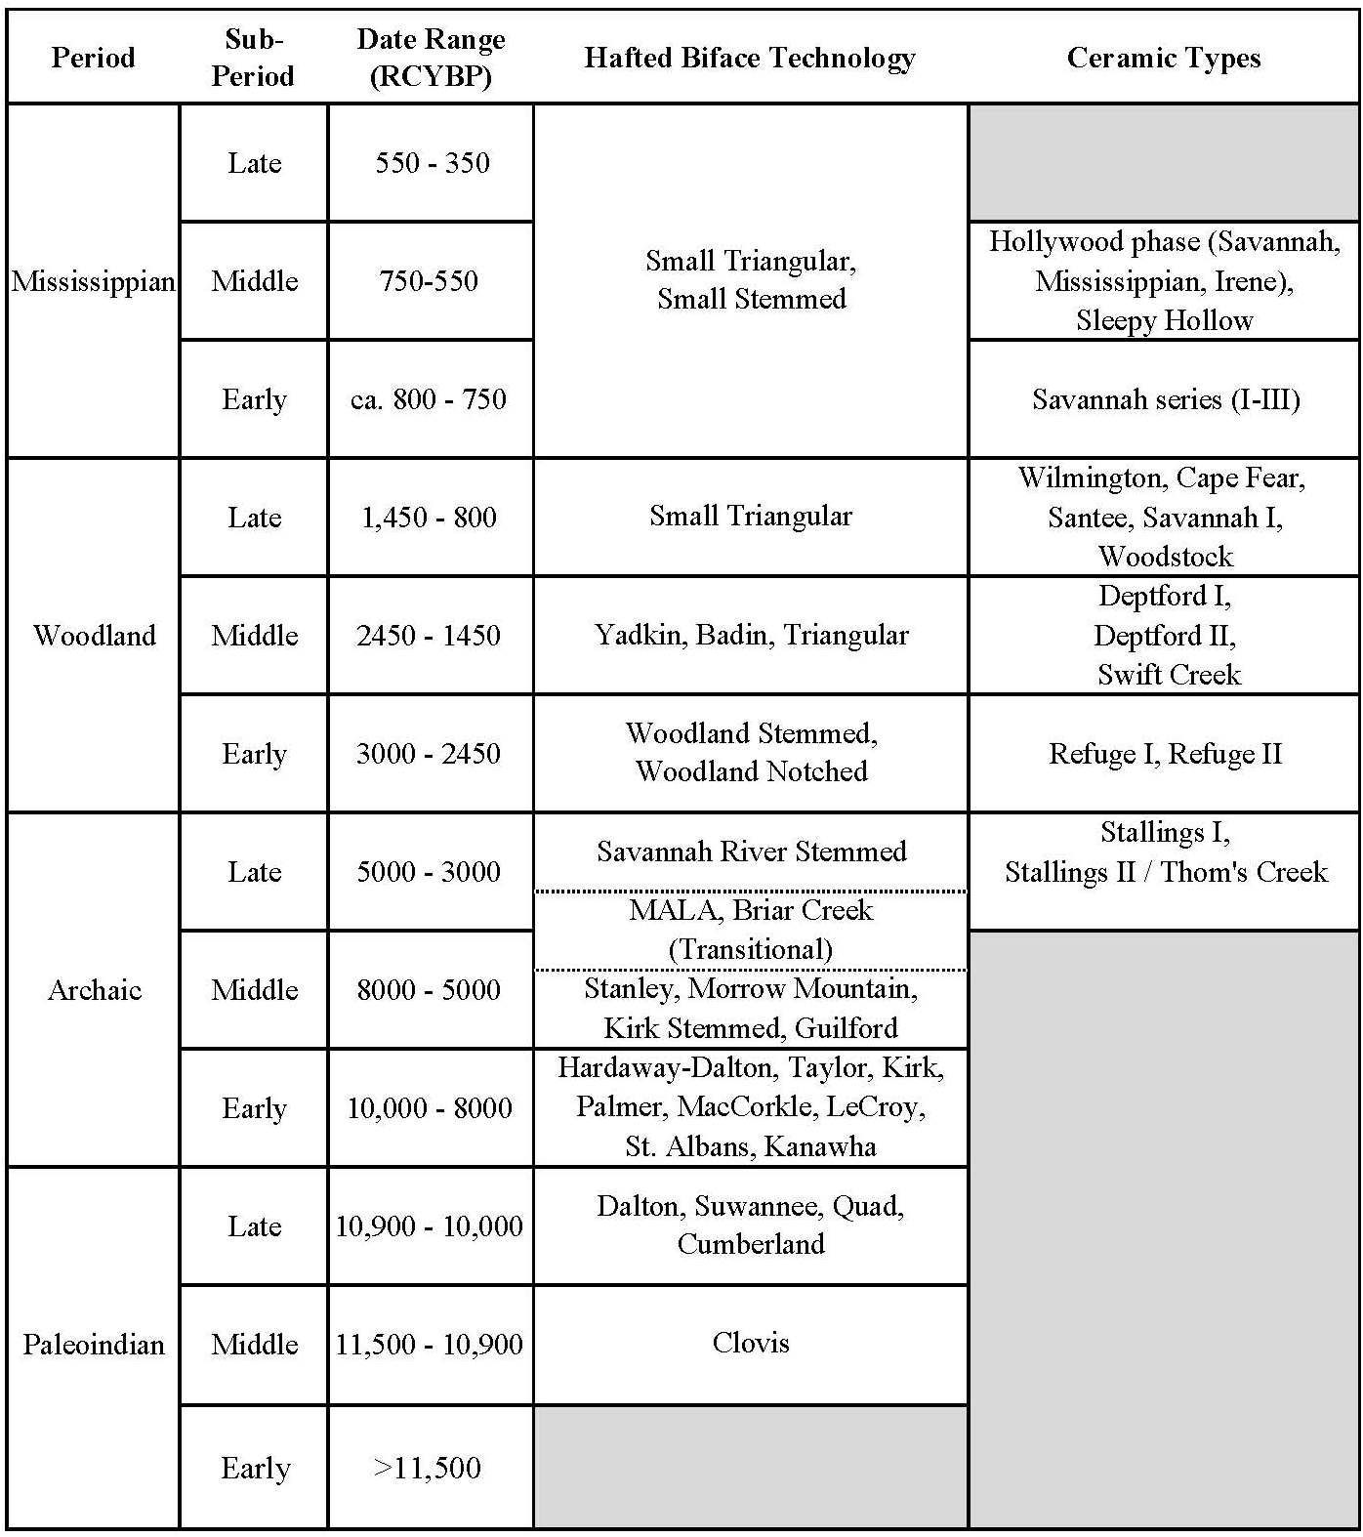

Paleoindian Period
Paleoindians in North America have traditionally been characterized as highly mobile big game hunters who, after migrating from North Asia, followed and preyed upon Pleistocene mammals as they migrated across the landscape. The abundance of virgin woodland with unsuspecting megafauna to exploit and minimal competition from preexisting inhabitants enabled them to spread rapidly across the continent (Caldwell 1958; Griffin 1952; Wormington 1957). In the recent decades, however, new archaeological data for the Paleoindian period and a re-evaluation of existing data suggest that Paleoindians, particularly in eastern North America, were likely opportunistic generalists that exploited a diverse range of biotic resources and may have been less mobile than they are often portrayed (Anderson 1990, 2013; Dincauze 1993; Hollenbach 2007; Meltzer 1988, 1993; Speth et al. 2013; Walker and Driskell 2007).
Kelly and Todd’s (1988) popular High Technology Forager (HTF) model builds upon the traditional concept of Paleoindian subsistence/mobility, arguing that Paleoindian bifacial core technology, which was portable, efficient, and versatile, enabled them to adapt to a variety of environments as they quickly spread across the landscape. The HTF model illustrates the importance of bifacial technology manufactured on high-quality toolstone to Paleoindians, yet does not fully address the role of access to lithic raw material sources in mobility patterns. Several alternative models address the central role that chert quarries play in Paleoindian mobility and subsistence, specifically in southeastern North America.
Based upon excavation at prehistoric quarry/quarry related sites in northern Virginia, Gardner’s Flint Run Lithic Determinism Model proposes that Paleoindians were, at least seasonally, based around (“tethered to”) lithic quarries, restraining settlement mobility (Anderson and Sassaman 1996:23; Gardner 1977, 1983). Quarries were fixed, predictable places in the landscape that hunter-gatherer groups could return to as needed for the acquisition of new toolstone. These known locations may have also been seen as points of congregation, where hunter-gatherer groups know that other hunter-gatherer groups would return to eventually (Gardner 1977:260). Gardner’s model has particular relevance in areas where lithic raw material sources are sparse, such as the Atlantic Coastal Plain (Anderson and Sassaman 1996; Goodyear 1989:3).
Goodyear’s “Cryptocrystalline Hypothesis” suggests that instead of being tethered to quarry areas, Paleoindian groups’ repeated exploitation of quarries was embedded within their subsistence/mobility patterns. Not necessarily tethered to the chert source, they would require a reliable and efficient means of carrying and conserving toolstone, which is reflected in their selection of high-quality raw material and their curated bifacial technology (Anderson and Sassaman 1996:26; Goodyear 1989).
Anderson (1990, 1995, 1996a; Anderson and Gillam 2000; see also Smallwood 2012) proposes a model of Paleoindian settlement that considers the evidence for both rapid dispersal of people across North America and the emergence of sub-regional traditions in geographically distinct areas. This “staging area” model follows the HTF model in that Paleoindians were highly mobile foragers that migrated eastward along the numerous river systems of western North America after arriving on the continent. The river valleys of the Ohio, Cumberland, and Tennessee rivers would have been rich in biotic resources and lithic resource, providing an impetus to remain in the areas for extended periods, perhaps generations, promoting population growth and further dispersal (Anderson 1996a:36). The Savannah River Valley, although not specifically mentioned as a staging area in the model, would have likely provided similar opportunities for Paleoindian settlement. The growing body of archaeological evidence of the Paleoindian presence in the Savannah River Valley, particularly surrounding the Allendale chert quarries, suggests that it may have served such a purpose.
Current understanding of the Paleoindian period in the southeastern North America acknowledges that considerable behavioral and technological variability occurred within the period and recognizes the high degree of regional variation. The Paleoindian period can be broadly divided into Early, Middle, and Late sub-periods (Anderson 2005:32; Anderson et al. 1990, 1996:9). Below is a brief depiction of each sub-period in the Savannah River Valley. All date ranges are given in radiocarbon years before present (₁₄C yr BP).

Early Paleoindian (>11,500 ₁₄C yr BP)
Several archaeological sites in Eastern North America demonstrate evidence of an Early Paleoindian occupation, including Meadowcroft Rockshelter in Pennsylvania, Saltville and Cactus Hill in Virginia, and Topper, which is located approximately 2.5 kilometers southwest of 38AL228 (Adovasio et al. 1998; Goodyear 2005; McAvoy and McAvoy 1997; McDonald 2000). Preliminary reports on the pre-Clovis lithic assemblage at Topper support the claims that some of the apparent artifacts were produced by prehistoric toolmakers, although the context remains in question (Goodyear 2005; King 2012). Excluding the Topper site, which has garnered fierce debate over the legitimacy of its pre-Clovis claims, evidence of the Early Paleoindian period in the Savannah River Valley has not been demonstrated.

Middle Paleoindian (11,500 – 10,900 ₁₄C yr BP)
The Middle Paleoindian period in the Savannah River Valley is marked by the widespread occurrence of the Clovis culture. Though the Clovis culture is recognized as the first to extensively occupy the Savannah River Valley, buried, stratified Clovis sites are rare, and only Topper has been extensively excavated and reported (Goodyear 2005; Goodyear and Steffy 2003; Miller 2007, 2010; Smallwood 2010, 2011; Smallwood et al. 2013). The Clovis culture is most easily recognized by its diagnostic lanceolate, fluted projectile points, although several additional aspects of their lithic technology have been established as diagnostic.
Transversely flaked, end-thinned bifacial preforms with expanding margins and an overall ‘rowboat’ shape are also considered diagnostic of Clovis technology (Goodyear and Steffy 2003:24; Morrow 1995). At quarry sites such as 38AL228 and Topper, these bifacial preforms, particularly those broken during manufacture and discarded, are encountered more often than finished bifaces. The manufacture of these Clovis projectile points and preforms involves the thinning of the biface through the controlled removal of overshot flakes, in which a flake originating at one lateral edge is removed in such a way that a portion of the opposite lateral edge is also removed (Bradley 1982; Bradley and Stanford 2004; Bradley et al. 2010; Morrow 1995). Large, prismatic blades have also been identified as diagnostic of Clovis, and a number of them have been recovered from the Clovis strata within the Allendale chert quarries (Collins 1999; Steffy and Goodyear 2006; Sain 2010a, 2010b; Sain and Goodyear 2012).

Late Paleoindian (10,900 – 10,000 ₁₄C yr BP)
The Late Paleoindian Period is marked by adaptive behaviors in response to a changing environment that was transitioning from one of large mammals and patchy resources to one more akin to our modern environment. The changing terminal Pleistocene climate caused major shifts in vegetation patterns in the Carolina Coastal Plain, increasing biotic resource homogeneity and perhaps contributing to the extinction of over thirty-five Pleistocene mammalian genera (Grayson 1991:195; Griffin 1967). Resources were becoming increasingly predictable and hunter-gatherer technological organization was being restructured toward the exploitation of a wider range of biotic resources (Goodyear 1974, 1982; Hollenbach 2007; Morse 1973; Morse et al. 1996; Walker 2007). There is an increase in projectile point variability, with the waisted and sometimes un-fluted Simpson and Suwannee types occurring in addition to a number of Clovis variants (Anderson et al.1996:11). The latter part of the Late Paleoindian period is marked by the appearance of the Dalton culture, which is seen by some as a major reorganization of subsistence and settlement patterns (Sassaman 2010a:39; Walker and Driskell 2007; Walthall 1998; Walthall and Koldehoff 1998). Dalton projectile points demonstrate a technological change—they are smaller, thin, oftentimes re-sharpened lanceolate points with concave bases—that has been attributed to a shift from hunting Pleistocene megafauna to hunting smaller mammals such as deer (Claggett and Cable 1982; Goodyear 1974:103, 1982; Morse 1973).

Archaic Period
The traditional view of the Archaic spans from the end of the Pleistocene to the beginnings of agriculture and the widespread occurrence of pottery, although this representation is problematic in that the social and technological complexity attributed to the later periods begins to appear during the Archaic period (Sassaman 2010a:21). The Archaic is again subdivided into three sub-periods, Early, Middle, and Late.

Early Archaic (10,000 – 8000 ₁₄C yr BP)
These adaptive responses to environmental factors that were manifest during the Late Paleoindian period continue to be seen in the Early Archaic period: an increase in residential mobility, more generalized hunting and gathering, regional and sub-regional traditions, and increased organizational complexity (Anderson and Hanson 1988; Claggett and Cable 1982; Grayson 1991; Sassaman et al. 1990; Sassaman and Anderson 1996). Models of Early Archaic settlement in the South Carolina Coastal Plain generally support this scenario. Increased residential mobility is reflected in the archaeological record as the predominant settlement strategy (Claggett and Cable 1982; Anderson and Schuldenrein 1983). Anderson and Hanson’s “band-macroband” model of Early Archaic settlement in the Savannah River Valley also supports this scenario, but includes considerations of population viability and interregional integration (Anderson and Hanson 1988; Daniel 1996:89-90). Based upon a large amount of archaeological data from Early Archaic sites within the Savannah River watershed, band-sized groups practiced seasonal mobility within the watershed based upon the availability of food, knappable toolstone, and other resources while maintaining an organizational structure that allowed for genetic, informational, and resource exchange within and between watersheds (Anderson and Hanson 1988).
Archaeologically, the features that distinguish the Early Archaic from the Paleoindian period are the appearance of side-notched, corner-notched, and bifurcate projectile points (Chapman 1976, 1985; Coe 1964; Michie 1966). Earliest diagnostic forms are side-notched, including the transitional Hardaway-Dalton points (10,500-9800 ₁₄C yr BP) and Taylor points (10,000-9000 ₁₄C yr BP). Later diagnostic forms include side notched Palmer-Kirk points (9500-8900 ₁₄C yr BP) and bifurcated MacCorkle, St. Albans, LeCroy, and Kanawha (8900-8100 ₁₄C yr BP) (Broyles 1971; Chapman 1976, 1985; Coe 1964).

Middle Archaic (8000 – 5000 ₁₄C yr BP)
The Middle Archaic period is bracketed by the beginning and end of the Hypsithermal Climatic Optimum, a warming trend that harbored the shift from mesic oak-hickory forests to pine forests in the inter-riverine uplands (Delcourt and Delcourt 1983, 1985; Watts et al. 1996). The Middle Archaic period in southeastern North America shows increasingly complex settlement strategies and subsistence patterns, and offers the first compelling evidence of monumentality and long distance social interaction (Sassaman and Anderson 1996; Smith 1986).
The Middle Archaic in the Savannah River Valley is recognized archaeologically by the appearance of stemmed Kirk (8000-7800 ₁₄C yr BP), square-stemmed Stanly (7800-7500 ₁₄C yr BP), contracting-stemmed Morrow Mountain (7500-6000 ₁₄C yr BP), and Guilford (6000-5000 ₁₄C yr BP) projectile point types (Blanton and Sassaman 1989; Chapman 1985; Coe 1964). Archaeological research at the nearby Savannah River Plant has suggested that Early Archaic and Middle Archaic assemblages are sometimes mixed and difficult to distinguish from one another. In the absence of diagnostic artifacts from either period, the degree of weathering can help delineate the two. “Middle Archaic stratigraphy [at the Savannah River Site] is again troublesome because of high co-occurrences of Morrow Mountain points with Early Archaic bifaces. Fortunately, differences in technology, formal specificity, and degree of weathering between the Early and Middle Archaic biface traditions are distinct enough to disentangle conflated assemblages” (Sassaman and Anderson 1990:174).
During the Middle Archaic, there is considerable variation in hafted biface typologies between the Coastal Plain region and the Piedmont region of the Savannah River Valley. The Coastal Plain region is more archaeologically complex than the neighboring Piedmont region in that there are lanceolate, notched, and stemmed hafted biface types in addition to those listed above. The Brier Creek Lanceolate type and the MALA (Middle Archaic/Late Archaic) hafted biface types are unique to the Coastal Plain region and are considered contemporaneous with the Guilford type in the Piedmont (Michie 1968; Sassaman 1985; Sassaman and Anderson 1990).

Late Archaic (5000 – 3000 ₁₄C yr BP)
The Late Archaic period in southeastern North America is characterized by increased organizational and technological complexity, increased population density, and increased settlement variability throughout the landscape. New developments during this period include extensive long-distance trade of prestige goods, construction of monumental architecture, increased warfare, ceramic pottery, increasingly complex burial practices, early plant domestication, exploitation of shellfish, and increased sedentism (Anderson and Sassaman 2012; Claassen 1996; Griffin 1967; Kidder 2006, 2010; Russo 2010; Sassaman 2010a). In the primary river valleys of the southeast, organizationally complex, partially sedentary groups maintained shell middens and rings that were in use for long term aggregation and ceremonial purposes, although some see the accumulations of shell as part of an annual subsistence cycle and argue that they are a product of increasing sedentism rather than intentionally constructed ceremonial centers (Milner and Jefferies (1998:130). Throughout the coastal environments of the southeast, Late Archaic groups adapted their subsistence strategies to exploit the immensely productive wetland and estuarine resources found there, constructing mounds of shell indicative of increased sedentism and perhaps permanent occupation (Russo 2010). A major technological advance during the Late Archaic in the Atlantic Coastal Plain is the development of ceramic pottery.
The Late Archaic in the Savannah River Valley is divided into pre-ceramic and ceramic periods (Sassaman 1993, 2010b, 2010b). The pre-ceramic (5000-4500 ₁₄C yr BP) is identified exclusively through the Savannah River Stemmed hafted bifaces and the lack of ceramic technology (Coe 1964). The ceramic Late Archaic consists of the Stallings I phase (4500-4000 ₁₄C yr BP), identified by mostly plain, fiber-tempered Stallings ceramic pottery, the Stallings II/Thom’s Creek phase (4000-3400 ₁₄C yr BP), identified by both decorated Stallings and sand-tempered Thom’s Creek types, and Thom’s Creek/Stallings III phase (3400-3000 ₁₄C yr BP), identified by a great deal of decorative variation and a complete absence of thickened and flanged rims (Sassaman and Anderson 1990:184-185; Stoltman 1974).

Woodland Period
Early Woodland Period (3000-2450 ₁₄C yr BP)
The archaeological record of the Early Woodland period in the Southeast presents a strikingly different picture of prehistoric life than seen during the Late Archaic. In general, Early Woodland society experienced large-scale group fissioning and diffusion from centralized locations, developing a more spatially dispersed pattern of settlement with less long-distance exchange, increased mobility, and perhaps significant population collapse (Anderson 2010; Kidder 2010:24; Sassaman 2010b:231). Increases in terrestrial faunal remains and lithic technology usage at Early Woodland sites suggest a shift to an immediate return hunting-based economy, and the sporadic use of sites suggests increased mobility, a signature of a foraging adaptation (Binford 1980; Thompson and Turck 2009:271-272). The large shell middens that functioned as social-interaction centers during the Archaic period are abandoned by the beginning of the Early Woodland period (Sassaman 1990:13; Sassaman 2010b:230-231; Thomas 2010).
A number of scholars have suggested that the changes at the Archaic/Woodland transition were related to climate change (Anderson 2001; Fiedel 2001; Gunn 1997; Kidder 2006, 2010; Marquardt 2010; Russo 1996; Sassaman 2010a; Thomas 2010; Thompson 2010). Following Mayewski et al. (2004), Kidder postulates that large scale climate fluctuations and catastrophic events occurred during the transitional period, facilitating generally cooler and wetter conditions and an increase in frequency and magnitude of flooding events and hurricanes (Kidder 2006:215).
Archaeologically, the Early Woodland is distinguished from the Late Archaic in the Middle Savannah River Valley by the appearance of Refuge pottery and a highly variable assemblage of small stemmed and notched bifaces (DePratter 1976; Hanson and DePratter 1985; Sassaman and Anderson 1990). The Early Woodland ceramic chronology for the Savannah River Valley is based upon two sub-phases of Refuge pottery. Refuge I (3000-2800 ₁₄C yr BP) includes the Punctate and Dentate Stamped types, while Refuge II (2800-2600 ₁₄C yr BP) includes the plain and simple stamped types (Sassaman and Anderson 1990:190-192). There is no universal trademark of Early Woodland lithic technology in the Savannah River Valley other than the generic ‘stemmed’ type. There is evidence, however, of stylistic localization of hafted bifaces, decreased instances of thermal alteration, use of lower quality raw material, and the reuse of bifaces from previous periods (Sassaman and Anderson 1990:161-162).

Middle Woodland Period (2450-1450 ₁₄C yr BP)
The Middle Woodland is a period of increasing social, political, and economic complexity throughout the Eastern Woodlands of North America. The Hopewell Interaction Sphere is the most recognizable manifestation of these advances, documented by the construction of mounds, elaborate burial tradition, and long-distance exchange of goods. Although direct archaeological evidence for Hopewellian influence in the Savannah River Valley is yet to be found, the material culture and settlement patterning of Middle Woodland groups indicate increasing sociopolitical complexity (Anderson 1985; Sassaman 1990:14).
The Middle Woodland period in the Savannah River Valley is recognized archaeologically by the presence of Deptford ceramics and the replacement of stemmed hafted bifaces with triangular projectile points (Sassaman and Anderson 1990). Deptford ceramics in the Middle Savannah River Valley are divided into two sub-phases. Deptford I encompasses from ca.2600-2000 ₁₄C yr BP, its beginning extending back into the Early Woodland period. Surface treatments found in this sub-phase include plain, linear check stamped, check stamped, and simple stamped. Deptford II spans the period from 2000-1500 ₁₄C yr BP and is distinguished by the appearance of Deptford Cord Marked, Swift Creek Complicated Stamped, and Deptford Zoned-Incised Punctate types in addition to those described as Deptford I (Sassaman and Anderson 1990:192-193, 200-201).
The abrupt replacement of Woodland stemmed hafted bifaces with triangular types is the distinguishing feature of the Middle Woodland lithic technology. Early triangular projectile points include the Badin and Yadkin triangular types with small, ambiguous triangular types appearing towards the end of the period (Coe 1964; Blanton et al. 1986).

Late Woodland Period (1,450-800 ₁₄C yr BP)
The Late Woodland period in the Atlantic Coastal Plain is characterized as a transitional phase in which later Mississippian traditions of large-scale agriculture, population aggregation, and political elitism begin to emerge (Anderson et al. 1986; Sassaman 1990:13). Dispersed upland settlement patterns perhaps indicate the adoption of slash-and-burn agriculture or the increased dependence on upland resources (Stoltman 1974). The period is separated into two sub-periods—early and later—based upon ceramic typology for the Middle Savannah River Valley (Sassaman and Anderson 1990:202-206). The Early-Late Woodland period (ca. 1500-1200 ₁₄C yr BP) sees the introduction of sand-tempered plain, cord-marked, and fabric-impressed Wilmington wares, although the period is best delineated from the Middle Woodland by the absence of Deptford pottery (DePratter 1979; Sassaman and Anderson 1990:202). The later Late Woodland period (1200-900 ₁₄C yr BP) is characterized by the appearance and rapid adoption of sand-tempered fine cross cordmarked ceramics and the less common parallel stamping, heavy cross stamping, Santee Simple Stamped, and Cape Fear Fabric Impressed (Sassaman and Anderson 1990:203. Late Woodland lithic technology is recognized by triangular projectile point types morphologically similar but considerably smaller than Middle Woodland Yadkin and Badin types (Coe 1964; Sassaman and Anderson 1990:164).

Mississippian Period
The Mississippian period (ca. 800-500 ₁₄C yr BP) in the Savannah River Valley follows the larger regional trend of Mississippian history. Mound centers were established as political and social centers of chiefly power. The hierarchical settlement pattern included smaller villages and hamlets peripheral to the mound centers. Large, well-established Mississippian societies were present in the Savannah River Valley by 800 ₁₄C yr BP. Shifts in political control are seen in the archaeological record through the patterning of mounds and the timing of their abandonment. Increased instability is noted by the presence of palisade fortifications within the Savannah River Valley at 650 ₁₄C yr BP, with rapid mass abandonment occurring ca. 500 ₁₄C yr BP, remaining vacant for almost two centuries (Anderson et al. 1986; Anderson 1994; Anderson 1996b:150-151).
The ceramic chronology for Mississippian period in the Middle Savannah River Valley is divided into three stages. The Early Mississippian (ca. 800-750 ₁₄C yr BP) is characterized as a continuation of the Late Woodland sequence for the coastal and Coastal Plain regions of the Savannah River Valley, and is recognized by the Savannah series (I-III) Complicated Stamped, Burnished Plain, fine cord marked, and check stamped types. Middle Mississippian (750-550 ₁₄C yr BP) ceramics include Hollywood phase Savannah Check Stamped, Mississippian Plain, Burnished Plain, Savannah Complicated Stamped, Irene Complicated Stamped, and Sleepy Hollow Complicated Stamped (Anderson 1994:370; DePratter 1979; King 2003; Sassaman and Anderson 1990). Late Mississippian (ca. 500-300 ₁₄C yr BP) sites are rare in the middle Savannah River Valley (Anderson 1994).
Lithic technology in the Savannah River Valley during the Mississippian period is again represented by small, triangular projectile points. There is no universally accepted method of differentiating between Late Woodland and Mississippian triangular types, although there is evidence that the Mississippian projectile points are generally smaller than their predecessors (Coe 1964; Keel 1976; Sassaman and Anderson 1990:164). Additionally, Mississippian Triangular bases are usually narrower at the base than Late Woodland types (Anderson et al. 1982; Blanton et al. 1986:107-110; Sassaman and Anderson 1990:167).

Late Prehistoric and Historic Periods
The Middle Savannah River Valley was abandoned at the time Hernando deSoto entered the area in 1540 A.D. Various Native American groups inhabited the area following the historic settlement of the coastal region, but knowledge of their settlements is sparse (DePratter 1983; Sassaman et al. 1990).
A minor historic component was identified within the boundaries of 38AL228, identified through five historic artifacts—a single cream colored ceramic sherd, a cut nail, a fragment of green glass, a single lead shot, and an unidentifiable piece of ferrous metal—although no historic structures are known to have existed. However, an undated aerial photograph showing rows of what are likely planted pine indicate that the site was used for agricultural purposes.

Chapter II:
The 2010-2012 Test Excavations at 38AL228

Test excavations at 38AL228 were conducted through the collaborative efforts of the Southeastern Paleoamerican Survey (SEPAS) and the South Carolina Institute of Archaeology and Anthropology. Mr. Tom Pertierra and Dr. Albert C. Goodyear, respectively, served as the project directors for the supporting programs. Three years (2010-2012) of seasonal field research at 38AL228 has yielded a multi-component artifact assemblage that includes Paleoindian, Archaic, Woodland, and historic components. Totaling 32 square meters, testing consisted of fourteen 1 x 1 meter units, four 1 x 2 meter units, one 2 x 2 meter unit, and a 6 x 1 meter line of 1 x 1 meter test units and recovered over 43,000 artifacts (Figure 5, Table 2). Four trenches were mechanically excavated using a backhoe to expose additional profiles for soil analysis (Figure 5). This chapter will describe the research design, methodology, and results of these investigations. Each excavation area and the test units they include are described in detail below.

Table 2. 38AL228 Total artifact summary.
Artifact Type | Total Count
Debitage | 43,021
Prehistoric Ceramics | 263
Non-hafted Bifaces | 89
Flake tools | 84
Hammerstones | 40
Cores | 34
Hafted Bifaces | 19
Blades | 7
Historic | 5
Total | 43,562

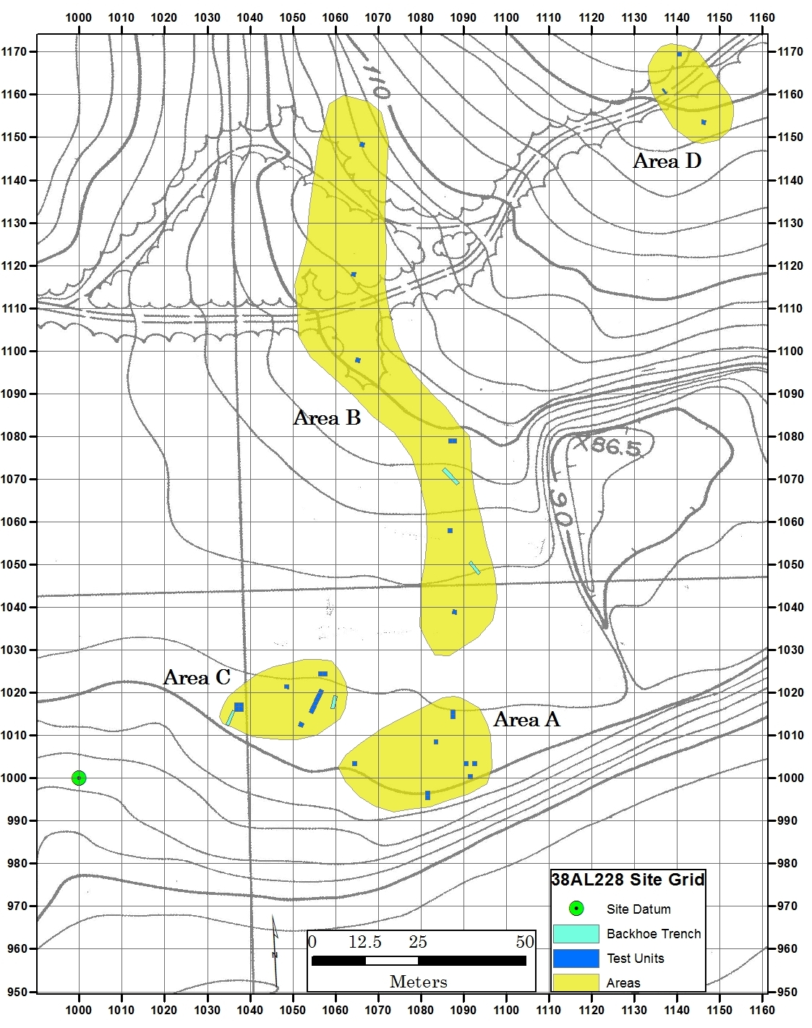
Figure 5. Map showing site grid, testing areas, and locations of Test Units and Backhoe Trenches at 38AL228. Source: Site Study, Martin, S.C. for Sandoz Colors and Chemicals. Map produced in ESRI ArcGIS 10.0®.

Research Design

Testing at 38AL228 was designed to determine whether intact, stratified prehistoric artifact deposits existed below the plow zone, with an explicit interest in identifying a Paleoindian component. Diagnostic Middle and Late Paleoindian artifacts had previously been recovered from a surface context, though no subsurface testing had been conducted prior to 2010. Because the Allendale chert quarries were exploited by groups from the Paleoindian period through the Mississippian period, there was concern that stratigraphic mixing of cultural deposits had occurred. Archaeological deposits in the Coastal Plain uplands in the Savannah River Valley are often restricted to shallow contexts, increasing the possibility that cultural horizons have been mixed due to post-depositional processes (Michie 1990; Miller 2007, 2010). In response to this, a principal objective of the research reported here is to examine the test excavations at 38AL228 and the artifacts recovered to establish a cultural chronology for the site, with a particular interest in delineating the Clovis artifact assemblage.

Field Methodology

Horizontal and Vertical Controls
An arbitrary site grid was established using U.S. Atomic Energy Commission Boundary Marker SRO-230 of the Savannah River Site as the permanent site datum, as it is clearly marked by a concrete post and its location in real space is known (North American Datum 1927 [NAD27], UTM coordinates [ft]: E 453804.235, N 3654114.638)
(Figure 5). This was the primary control point and served as both a horizontal control, with a location on the site grid at N1000 E1000, and vertical control, with an arbitrary elevation of 100 m. All elevations that are not given in centimeters below surface (cmbs) are in reference to this marker. A Topcon total station provided by SEPAS was used for establishing the site grid and site mapping, with the exception of a four-day field session in August 2011 in which a Topcon total station provided by the University of Tennessee Archaeological Research Laboratory was used.
Despite efforts to remain consistent, there are several methodological discrepancies resulting from staff miscommunication between field seasons. The orientations of the test units are not consistent throughout the site. Although most test units were laid out in accordance with the arbitrary site grid, several were oriented using magnetic north. The locations of the SW corners of all units in Area B were established using a metric pull-tape and compass. Once the corners of these units were manually established, the locations of the corners were mapped into the site grid using the total station. Within each test unit, vertical control was maintained using a line level and string attached to the corner of the unit with the highest elevation. All elevations recorded for each unit are relative to these unit datums.

Excavation Methods
Test units were excavated in arbitrary levels. The humic and plow zones were removed by shovel skimming in arbitrary levels of 20 cm or 10 cm and screened through 1/4” wire-mesh screens. Once the humic layer and plow zone were completely removed, each subsequent level was excavated in 10 cm increments by both shovel skimming and trowel scraping and screened through 1/4” wire-mesh. When excavations began to approach Early Archaic and Paleoindian deposits, as evidenced by the presence of a high-degree of thermally altered lithics and fire-cracked rock from the Middle and Late Archaic periods, levels were hand excavated using trowels and brushes in 5 cm increments and the fill was screened using 1/8” wire-mesh. Artifacts recovered from each level were bagged together and assigned a unique provenience number, with a small number of tools and tool fragments assigned individual specimen numbers in the field, and bagged separately. There were exceptions to this standard methodology. In Area A, where deposits were shallow and extensive commingling of cultural strata was evident during excavations, the transition to 5 cm levels and 1/8” screen was not applied.
In all levels below the plow zone, all tools, tool fragments, modified flakes, and cores and all lithic debris larger than 2.5 cm in diameter were plotted individually in three dimensions and assigned a unique artifact number. The northing and easting for each individually plotted artifact was recorded in relation to the whole-integer southwest unit coordinates as opposed to the actual grid coordinates in order to minimize conversion errors. Dip and strike were recorded for each individually plotted artifact, and the location of each was drawn on a planview map. Certain piece plotted artifacts, mostly Clovis diagnostics, were photographed in situ prior to their removal. Upon completion of each level, a photograph was taken of the final planview. For each level, soil color was recorded using a Munsell soil chart and soil texture was determined by estimation of grain size by feel.
Four backhoe trenches of varying dimensions and depths were mechanically excavated within the site to expose wider and deeper profiles of the soils than the individual test units could provide. Excavations were monitored by the author and Dr. John Foss. A non-systematic sample of backdirt from the trenches was screened through ½” wire-mesh and the artifacts from the screen were retained. Stone tools were pulled from the bulk sample and bagged individually. No diagnostic artifacts were recovered and the artifacts from the backhoe trenches are not included in the analysis or addressed in this thesis.
The crew for each unit included two or three people who rotated between excavating, screening, and maintaining field paperwork. Crews consisted of volunteers working through the Allendale Paleoamerican Expedition and SEPAS, undergraduate students participating in a field school offered through the University of Tennessee, graduate students from the University of Tennessee, and local volunteers with an avocational interest in archaeology. The author served as the field supervisor during the 2011-2012 field seasons, while Derek Anderson and Douglas Sain filled that role during the 2010 field season.

Field Processing
All non-individually plotted artifacts recovered were washed and dried at the temporary laboratory facility set up at the picnic pavilion located on the Clariant Corporation property. Individually plotted artifacts were cleaned upon their removal using a soft-bristled brush to remove excess soil. Unit paperwork and field notes were checked, digitized, and stored in the SEPAS mobile laboratory.

Laboratory Methods
Post-excavation artifact processing and all analyses occurred at laboratories provided by the University of Tennessee Department of Anthropology and the University of Tennessee Archaeological Research Laboratory. Each bulk provenience bag, piece-plotted artifact, and soil sample was given an arbitrary Field Specimen (FS) number. All materials from the bulk provenience bags were sorted and separated into one of the following types: debitage, tools, cores, hammerstones, prehistoric ceramics, charred organics, historic artifacts, daub/burned clay, and non-artifacts. All piece-plotted artifacts were re-evaluated and placed into the typological categories based upon established typologies that apply to the southeastern United States and the Middle Savannah River Valley (Broyles 1971; Chapman 1976, 1985; Coe 1964; Michie 1966, 1968; Sassaman et al. 1990; Sassaman and Anderson 1990). Artifact measurements were recorded using a digital scale and digital calipers. The methodology for recording measurements on the following artifact types follows Andrefsky (1998): individual flakes (1998:98-102), flake tools (1998:167-176), non-hafted bifaces (1998:180-181), and hafted bifaces (1998:186). No measurements other than weight were recorded on cores,

Isolating the Clovis Component

This section outlines the methodology used for isolating the Clovis component at 38AL228. An overview of Clovis lithic technology is provided along with a brief description of post-Clovis technologies in order to distinguish between temporal periods and identify instances of mixed cultural deposits. Used in conjunction with each other, the vertical positioning of these diagnostic artifacts was used to determine the presence and integrity of Clovis-aged archaeological deposits. Photographs of the artifacts referenced throughout this document are located in Appendix A. Artifact measurements and attributes by specific provenience are given in Appendix B.

Post-Clovis

Archaeologically, the Savannah River Valley is one of the most thoroughly documented river valleys in the southeast. Projectile point and ceramic typologies have been well-established for the Savannah River region and are used in this analysis to identify post-Clovis archaeological deposits. Table 1, located in Chapter 1, provides a list of diagnostic artifacts and their temporal designation in the Savannah River Valley, with additional information located in the “Cultural Background” section.
For the purpose of this research, sand-tempered prehistoric ceramics are assigned to the Woodland or Mississippian periods. The earliest ceramic technology present during the Late Archaic period in the Savannah River Valley was characterized by fiber tempering, although evidence of it was not recovered at 38AL228 (Sassaman and Anderson 1990:184-185; Stoltman 1974). Selected examples of the ceramics recovered at 38AL228 are shown in Figure A-17. A complete list of prehistoric ceramics and their provenience information can be found in Table B-8.

Clovis

Twenty-seven of the thirty-two (84%) test units excavated at 38AL228 failed to demonstrate evidence of stratigraphically secure Clovis deposits due to either stratigraphic mixing or an absence of diagnostic artifacts. In proveniences where stratigraphic mixing was observed, the most reliable method of partitioning out the Clovis component is through the identification of individual artifacts that are considered diagnostic within the Clovis lithic techno-complex. Clovis lithic technology has traditionally been recognized by the distinctive fluted Clovis projectile point (Collins 1999:35; Wormington 1957). However, a suite of additional technological features have been identified as characteristic of the Clovis lithic toolkit—blade production (Collins 1999:45), end-thinned, transversely flaked bifacial preform production (Goodyear and Steffy 2003:24; Morrow 1995:170), bifacial thinning through the intentional removal of overshot flakes (Bradley 1982; Bradley and Stanford 2004:461; Bradley et al. 2010; Frison and Bradley 1999), and bifacial core technology (Bradley et al. 2010:59-61; Wilke et al. 1991).
Although there is a degree of variability in what constitutes “Clovis” across the North American continent, particularly in eastern North America (Broster and Norton 1996; Sanders 1988, 1990; Tankersley 2004), the artifact classes considered diagnostic or characteristic of the Clovis lithic techno-complex are based on those defined by Bradley et al. (2010), but are modified to accommodate the unique properties of Allendale chert (i.e. weathering/patination). Each artifact class has a list of criteria that warrants a Clovis designation, which must be met in order to be included in the Clovis lithic assemblage. This is the primary method of identification used here.
The secondary method of defining the Clovis lithic assemblage pertains to artifacts in the above classes that do not exhibit all of the criteria for inclusion in the Clovis assemblage or artifacts that do not fall within these classes but were recovered in a secure context with other Clovis artifacts that did meet the criteria. This method first uses post-Clovis diagnostic artifacts to identify and exclude proveniences where mixing of Clovis and post-Clovis cultural horizons has occurred. If mixing is shown to have occurred, non-diagnostic potential Clovis artifacts were excluded from further analysis. In proveniences that have produced diagnostic Clovis artifacts and stratigraphic mixing is ruled out, artifacts that are partial or do not exhibit all of the attributes of Clovis technology were included in the analysis.
Only artifacts that can be distinguished via one of the two described methods are included as part of the Clovis lithic assemblage. Provided below are descriptions of artifact types that were included as part of the Clovis lithic assemblage and the requirements for inclusion in each artifact type.

Clovis Bifacial Technology

In order to be included as part of the Clovis assemblage, bifaces and bifacial preforms had to exhibit the following diagnostic characteristics of Clovis technology (Bradley et al. 2010; Cambron and Hulse 1964; Goodyear and Steffy 2003; Morrow 1995; Waters et al. 2011):
1) End-thinning removals (proximal fragments only)
2) Rowboat or lanceolate planview
3) Transverse flaking pattern, with overshot or overface removals
4) Patinated surfaces (Goodyear and Charles 1984:5; Smallwood 2011)

Bifaces are a key component of this lithic analysis for several reasons. First, Clovis lithic technology is biface-oriented. This includes bifacial projectile points, bifacial preforms, and bifacial cores for the production of tool blanks (Bradley et al. 2010; Callahan 1979). Second, biface manufacture, whether characterized as a staged process (e.g. Callahan 1979) or as a continuum (e.g. Bradbury and Carr 1999; Miller and Smallwood 2012; Shott 1996), can be quantified based upon metric and non-metric attributes. Finally, diagnostic Clovis bifaces, overshot flakes, and bifacial cores are present at both 38AL228 and Topper and can be comparatively analyzed to identify possible variation in biface manufacture between the two sites.
Although Clovis bifacial technology is most easily recognized by its lanceolate, fluted projectile points, additional aspects of their bifacial technology are considered diagnostic. Clovis lithic technology is now commonly recognized by transversely flaked, end-thinned bifacial preforms and the overshot flakes that were removed in the process of thinning the biface (Bradley et al. 2010; Frison and Bradley 1999; Goodyear and Steffy 2003). At quarry related sites within the Allendale chert quarry region, bifacial preforms, particularly those broken during manufacture and discarded, are encountered more often than finished bifaces (Goodyear and Steffy 2003:24). Unfortunately, bifacial preforms in the earliest stages of manufacture are less likely to exhibit traditional Clovis characteristics and are more difficult to assign a Clovis designation.

Overshot Flakes
The controlled removal of overshot flakes as a method of bifacial thinning is now a well-recognized property of Clovis bifacial technology (Bradley 1982; Bradley and Stanford 2002, 2004; Frison and Bradley 1999; Morrow 1995). Overshot flaking occurs when a flake originates along one margin of a biface and travels across the face, removing a portion of the opposing margin (Bradley et al. 2010:68). The advantage of this technology is twofold: the biface can be thinned considerably without a major reduction in width and the large, curved flake removals can be used for a variety of tasks. The intentional removal of this type of flake is not seen in post-Clovis lithic technology, although unintentional overshot removals sometimes occur (Bradley et al. 2010).

Clovis Blade Technology

Blades

Large, prismatic blades have been identified as diagnostic of Clovis lithic technology, and a large number of them have been recovered from sites within the Allendale chert quarries (Beck and Jones 2010; Bradley et al. 2010; Collins 1999; Miller 2007, 2010; Smallwood et al. 2013; Steffy and Goodyear 2006; Sain 2010a, 2010b). Traditionally, Clovis blades are >100 mm in length, narrow with parallel margins, thick in cross-section, and curved in longitudinal cross-section (Bradley et al. 2010). Clovis blades found at Topper tend to be shorter and less curved than those found at other Clovis sites, particularly in the American west. This may be a function of raw material constraints found in Allendale chert (Sain 2010a, 2010b; Steffy and Goodyear 2006). Recent analyses of the Topper blades also shows that generally, Clovis blades have wide, thick striking platforms with angles > 60°, have diffuse bulbs of force, range from 40 – 80 mm in length (average: approx. 77 mm), and are triangular or trapezoidal in cross-section (Sain 2010b:137).
In order to be included as part of the Clovis assemblage, blades had to exhibit the following attributes of Clovis blade technology, taking into consideration the variation seen in blades recovered from the Clovis levels at Topper (Bradley et al. 2010; Sain 2010a, 2010b; Steffy and Goodyear 2006; Waters et al. 2011):
1) Parallel margins
2) Triangular or trapezoidal cross-section
3) Platform angle > 60°
4) Unidirectional dorsal flake removals

Blade Cores

Certain types of blade manufacturing are now considered diagnostic of Clovis lithic technology (Beck and Jones 2010; Collins 1999). Likewise, the cores from which those blades were removed are indicative of Clovis blade technology. Clovis blade cores are recognized as having two distinct morphological types: conical cores and wedge-shaped cores. Conical blade cores have blade removal scars located around the perimeter of the core which originate from a single platform perpendicular to the removals (Bradley et al. 2010:20). Wedge-shaped, or “hoof shaped” cores are less formalized, characterized by the initial removal of blades from a single core face that originate from a single platform at an acute angle (Bradley et al. 2010:20; Goodyear 2005). If the initial core face does not produce satisfactory blades, the cores are oftentimes rotated and blades are removed perpendicular to the original core face (Bradley et al. 2010:20; Goodyear and Steffy 2003). Both conical blade cores and wedge-shaped blade cores are included in the Clovis lithic assemblage.

Clovis Flake Tools

In addition to formalized bifacial and blade technologies, the Clovis techno-complex includes artifacts that are generally included in the “flake tools” category (Shoberg 2010:143). Flake tools do not have a standardized morphology and can be either intentionally retouched or the product of utilization. Due to the lack of diagnostic artifacts and considerable stratigraphic mixing at 38AL228, identifying flake tools attributable to the Clovis culture is difficult. In order to be included in the Clovis assemblage, flake tools had to be recovered from Clovis deposits that did not exhibit mixing with later materials. The exception to this rule involves endscrapers, which are frequently seen in Clovis lithic assemblages and have been recovered from Clovis contexts within the Allendale chert quarries (Miller 2007, 2010; Smallwood 2011; Smallwood et al. 2013; Waters et al. 2011). In order to be included in the Clovis assemblage, endscrapers must demonstrate morphological similarity to either 1) traditional Clovis endscrapers, which are constructed on long, curved flakes, have downward-curving, convex beveled distal ends, and have expanding margins radiating from an intact platform (Frison and Stanford 1982; Waters et al. 2011:123), or 2) “snub-nosed” endscrapers recovered at Clovis sites in Eastern North America, such as the Adams Site and Topper, with thick cross-sections and cortex on the dorsal surface (Smallwood et al. 2013:290).
Within the category of flake tools, the typology used follows the same techno-morphological types that are commonly used to classify artifacts in the South Carolina Coastal Plain. The typology is based on inferred function of the tool and includes the following categories: Endscraper, Lateral/Side Scraper, Multiple Scraper, Scraper/Plane, Spokeshave, Burin, Backed Knife, Chopper, Adze, Composite Tool, Utilized Flake, Utilized Blade, and Indeterminate. Standard metric and non-metric attributes were recorded for all flake tools recovered. A complete listing of all flake tools, the attributes recorded, and the coding scheme used can be found in Table B-4.

Testing Results

The following section provides descriptions of the excavations at 38AL228 and the diagnostic artifacts recovered for the purpose of defining the cultural sequence at the site. Test units were grouped into four areas—A, B, C, and D—based upon the field season they were excavated or, in the case of Area D, their isolation from other areas. Table 3 provides artifact totals by testing area and artifact type. Photographs of artifacts referenced are located in Appendix A. The artifacts identified in this section as part of the Clovis assemblage are documented in detail in Chapter III, where metric and attribute data are provided. Descriptions are subdivided by testing areas and presented in numerical order. Each unit is named according to the closest corresponding whole-number arbitrary grid coordinate to its southwest corner. Figure A-17 provides examples of prehistoric ceramics referenced in the text.

Table 3. Artifact totals by Area and Test Unit.
Unit | Debitage | Non-Hafted Bifaces | Hafted Bifaces | Blades* | Cores | Flake Tools | Hammer-stones | Prehistoric Ceramics | Histor-ics | Totals
Area A
TU 1 | 1592 | 6 | 0 | 0 | 1 | 1 | 2 | 38 | 0 | 1640
N995 E1081 | 3034 | 1 | 0 | 1 | 6 | 7 | 2 | 20 | 0 | 3071
N996 E1081 | 2316 | 3 | 0 | 1 | 2 | 3 | 1 | 11 | 0 | 2337
N1000 E1091 | 966 | 2 | 0 | 0 | 0 | 0 | 0 | 16 | 0 | 984
N1003 E1064 | 2380 | 0 | 2 | 1 | 3 | 2 | 2 | 4 | 0 | 2394
N1003 E1092 | 2051 | 1 | 1 | 0 | 1 | 3 | 0 | 61 | 2 | 2120
N1008 E1083 | 824 | 4 | 2 | 0 | 0 | 4 | 1 | 11 | 0 | 846
N1014 E1087 | 969 | 4 | 1 | 0 | 0 | 2 | 1 | 17 | 0 | 994
N1015 E1087 | 1565 | 6 | 0 | 1 | 1 | 3 | 1 | 31 | 0 | 1608
Area Totals | 15697 | 27 | 6 | 4 | 14 | 25 | 10 | 209 | 2 | 15994
Area B
N1039 E1087 | 380 | 0 | 0 | 0 | 0 | 2 | 1 | 4 | 0 | 387
N1058 E1086 | 1999 | 3 | 0 | 0 | 4 | 1 | 2 | 1 | 0 | 2010
N1079 E1086 | 2934 | 1 | 0 | 0 | 0 | 2 | 6 | 7 | 0 | 2950
N1079 E1087 | 3360 | 5 | 0 | 0 | 0 | 2 | 8 | 3 | 0 | 3378
N1097 E1064 | 813 | 0 | 1 | 0 | 2 | 1 | 0 | 0 | 0 | 817
N1117 E1063 | 1593 | 5 | 0 | 0 | 0 | 1 | 0 | 0 | 0 | 1599
N1148 E1066 | 75 | 0 | 0 | 0 | 0 | 0 | 0 | 0 | 0 | 75
Area Totals | 11154 | 14 | 1 | 0 | 6 | 9 | 17 | 15 | 0 | 11216
Table 3. Continued.
Unit | Debitage | Non-Hafted Bifaces | Hafted Bifaces | Blades* | Cores | Modified Debitage | Hammer-stones | Prehistoric Ceramics | Histor-ics | Totals
Area C
N1012 E1051 | 1348 | 2 | 0 | 0 | 0 | 4 | 1 | 1 | 0 | 1356
N1015 E1054 | 579 | 2 | 0 | 1 | 2 | 3 | 2 | 7 | 0 | 596
N1016 E1036* | 4695 | 14 | 5 | 0 | 3 | 17 | 0 | 20 | 0 | 4754
N1016 E1054 | 925 | 0 | 1 | 1 | 1 | 1 | 0 | 2 | 0 | 931
N1017 E1054 | 1305 | 6 | 1 | 1 | 1 | 4 | 1 | 0 | 0 | 1319
N1018 E1055 | 1253 | 1 | 0 | 0 | 1 | 2 | 0 | 0 | 0 | 1257
N1019 E1055 | 1454 | 4 | 1 | 0 | 2 | 7 | 2 | 2 | 0 | 1472
N1020 E1055 | 1782 | 7 | 1 | 0 | 3 | 4 | 0 | 0 | 0 | 1797
N1021 E1048 | 394 | 2 | 0 | 0 | 0 | 4 | 1 | 0 | 0 | 401
N1024 E1056 | 705 | 4 | 2 | 0 | 0 | 0 | 3 | 1 | 0 | 715
N1024 E1057 | 577 | 0 | 1 | 0 | 1 | 2 | 3 | 0 | 0 | 584
Area Totals | 15017 | 42 | 12 | 3 | 14 | 48 | 13 | 33 | 0 | 15182
Area D
N1153 E1146 | 608 | 3 | 0 | 0 | 0 | 1 | 0 | 6 | 0 | 618
N1169 E1140 | 545 | 0 | 0 | 0 | 0 | 0 | 0 | 0 | 3 | 548
Area Totals | 1153 | 3 | 0 | 0 | 0 | 1 | 0 | 6 | 3 | 1166
Road
Surface | 0 | 3 | 0 | 0 | 0 | 1 | 0 | 0 | 0 | 4
Area Totals | 0 | 3 | 0 | 0 | 0 | 1 | 0 | 0 | 0 | 4
Site Totals | 43021 | 89 | 19 | 7 | 34 | 84 | 40 | 263 | 5 | 43562

Area A

Area A consists of nine 1 x 1 meter test units situated on a moderately level first terrace of the Savannah River, at the junction of an upland slope and a sharp drop into the wetland/floodplain of Smith Lake Creek (Figures 6, 7). The general soil profile of the area consists of an approximately 5 cm matrix of sandy humus, 20-30 cm of 10yr3/4 sandy loam, 20-30 cm of 10yr6/2 coarse sand, and an underlying 5yr4/6 sandy clay subsoil.
The first testing at 38AL228, a single 1 x 1 meter test unit (TU1), was opened and completed on March 14, 2010. TU1 yielded an end-thinned bifacial preform diagnostic of Clovis bifacial technology positioned stratigraphically below earlier cultural deposits and slightly above an approximately 50,000 year-old sandy clay paleosol (Bt horizon) (Waters et al. 2009) (Figure 6). The discovery of buried Clovis artifacts prompted additional testing from June 8 through June 10, 2010. This stage of testing consisted of eight 1 x 1 meter units in the locality where TU1 was excavated (Area A). Diagnostic Clovis bifaces and blades recovered from these units substantiated the claims of a Clovis component, but raised questions regarding the integrity of the shallow deposits, as there was evidence of commingling between artifacts diagnostic of the Paleoindian, Archaic, and Woodland periods.
The archaeological deposits throughout Area A are relatively shallow and generally commingled. Despite the compromised integrity of the deposits, diagnostic artifacts were recovered from the units in Area A, including Clovis artifacts (n=13). For all test units in Area A, the plow zone was removed in a single 20 cm arbitrary level. Upon removal of the plow zone, excavations continued using 10 cm arbitrary levels until sandy clay subsoil was reached. All test units in Area A were excavated during May and June 2010 unless otherwise noted.

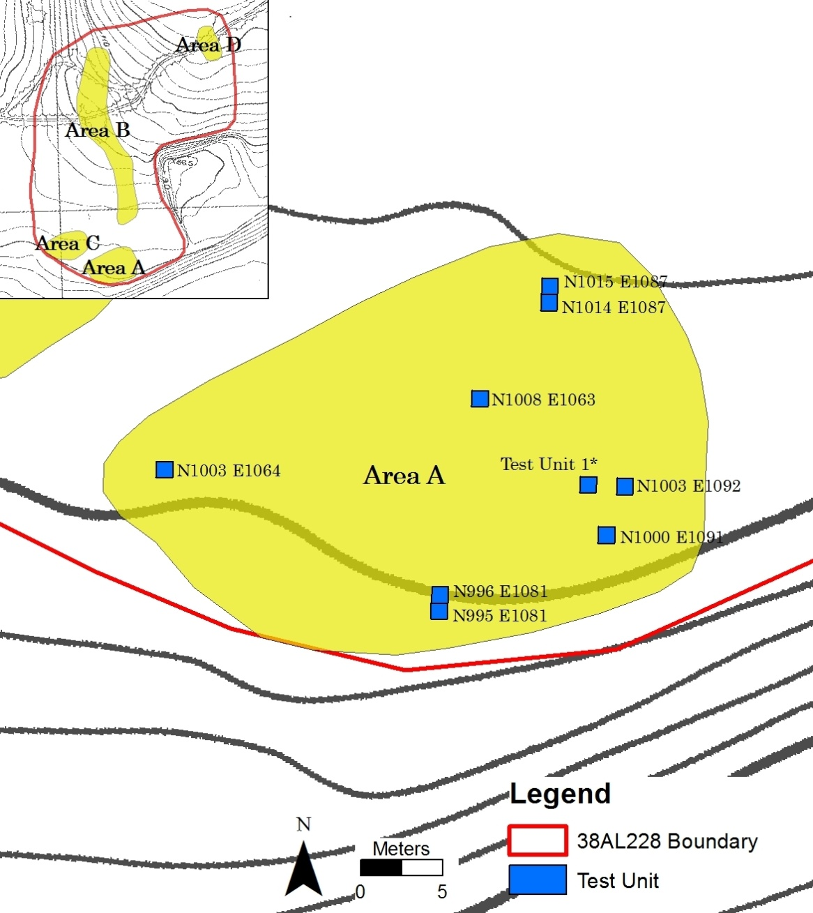
Figure 6. Map of Area A with locations of individual test units. (*) denotes approximate location of TU1. Source: Site Study, Martin, SC for Sandoz Colors and Chemicals. Map produced in ESRI ArcGIS 10.0®.

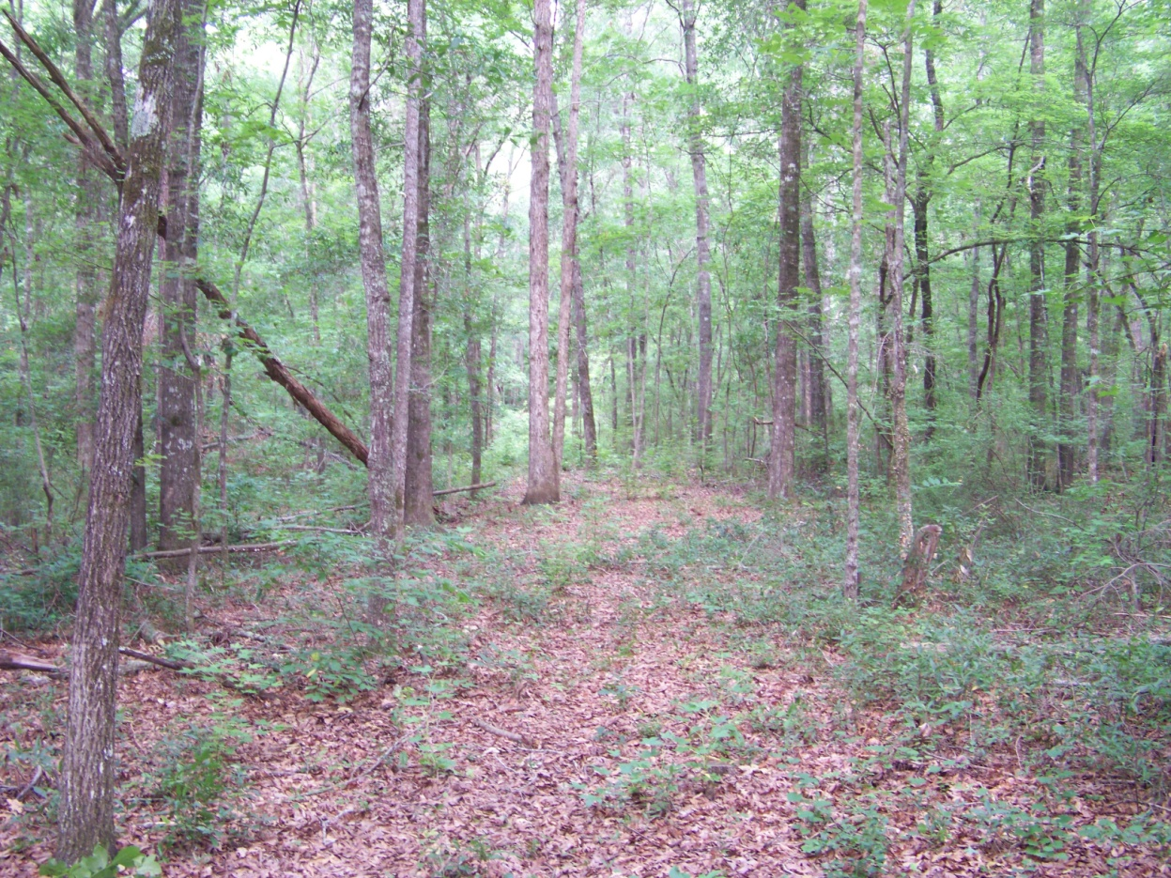
Figure 7. Area A, facing west. Sharp drop into Smith Lake Creek to the left.

TU 1
Test Unit 1 was excavated in March 2010 in order to determine the nature of subsurface deposits in Area A. The unit began as a single 30 cm diameter shovel test to explore the potential for subsurface deposits. When debitage and tools were recovered that appeared to be Clovis in age, the shovel test was expanded into a single 1 x 1 meter test unit. The exact location of the unit was not recorded, and its placement in Figure 6 is an approximation based upon field notes. Level 4 yielded the proximal end of an end-thinned Clovis preform (FS-733) at 37 cmbs, situated slightly above the sandy clay paleosol (Figure A-2). Two additional highly weathered preforms were recovered from the same context as the Clovis preform, although they do not exhibit the attributes required to be included in the Clovis assemblage. Prehistoric ceramics (n=38) were recovered throughout the unit, although each of the lowest two ten-centimeter levels yielded only one sherd. Due to the mixing of cultural deposits, only the diagnostic preform FS-733 was included in the Clovis sample. No other diagnostic artifacts were recovered.

N995 E1081
N995 E1081 was marked by shallow, mostly commingled deposits. Unidentifiable prehistoric ceramics were recovered from the first two levels of the unit (40 cmbs). The approximately 20 cm of remaining deposits yielded four artifacts that can be included in the Clovis assemblage. All of these tools exhibit the patination common to Paleoindian-aged Allendale chert artifacts and were found in association with a diagnostic Clovis artifact: an error-recovery blade (FS-13) (Figure A-10), a blade core tablet flake (FS-24) (Figure A-8), and two endscrapers (FS-26 & FS-29) (Figure A-12).

N996 E1081
Due to the concentration of Clovis artifacts recovered from N995 E1081, an expansion unit was excavated to the north. Similarly, N996 E1081 was marked by shallow, mostly commingled deposits. Eleven prehistoric ceramic sherds were recovered from the first 30 cm of the unit. A chipped-stone celt with signs of potential thermal damage (FS-39) was recovered from Level 2. The lone Clovis diagnostic artifact, a single highly patinated crested blade (FS-50), was recovered from Level 4 (Collins 1999:19) (Figure A-10).
N1000 E1091
N1000 E1091 was marked by shallow, commingled deposits and showed signs of heavy disturbance, likely the result of a tree throw. Unidentifiable prehistoric ceramics were recovered from the first two levels of the unit (40 cmbs). No diagnostic lithic artifacts were recovered.

N1003 E1064
N1003 E1064 was marked by shallow, commingled deposits. Unidentifiable prehistoric ceramics were recovered from the first level of the unit (0-20 cmbs). Two unidentifiable projectile point distal fragments were recovered from Level 3 during screening. The first exhibits intentional thermal alteration (FS-95), and the second shows evidence of extensive retooling and is crafted on a dark, exotic chert possibly from the Black Mingo formation located to the northwest in Clarendon, Williamsburg, and Georgetown Counties (FS-96) (Nystrom et al. 1991). Clovis artifacts recovered from the final level, all of which were within 5 cm of the sandy clay paleosol, included a complete macroblade (FS-90) (Figure A-10), a wedge-shaped blade core (FS-91) (Figure A-7), and a blade core tablet flake (FS-92) (Figure A-8).

N1003 E1092
N1003 E1092 was excavated approximately 1 m to the east of TU 1 and was marked by shallow, commingled deposits. Two historic artifacts were recovered from Level 1a (0-20 cmbs): unidentifiable ferrous metal (n=1) and lead shot (n=1). Prehistoric ceramics were recovered from the first two levels of the unit (0-30 cmbs), including Plain (n=5), Deptford Check Stamped (n=7), Deptford Simple Stamped (n=4), Woodland Cord Marked (n=2), and small, unidentifiable fragments (n=43). Two unidentifiable biface fragments were recovered from Level 2a, one of which was thermally altered. A small preform fragment that was broken during manufacture due to a fossil inclusion was recovered from Level 3, although there are no characteristics that warrant a cultural designation. There were no diagnostic Clovis materials recovered from this unit.

N1008 E1083
N1008 E1083 is characterized by the mixing of cultural deposits, although a series of diagnostic artifacts appear in proper stratigraphic context. Level 1a (0-10 cmbs) produced four unidentifiable prehistoric ceramic sherds. Additional ceramics were recovered from Level 2a (20-30 cmbs), including three unidentifiable, two plain, and four Deptford Linear Check Stamped sherds which date to the Middle Woodland period. Level 2 also produced an almost complete, thermally altered, Yadkin projectile point (FS-101) (Figure A-13) which also dates to the Middle Woodland period, and the proximal end of a bifacially retouched blade. Approximately 3 cm below the Yadkin point, an almost complete Middle Archaic Morrow Mountain projectile point was recovered (FS-104) (Figure A-14) (Coe 1964). Level 3 produced no diagnostic artifacts. Level 4 yielded a heavily-patinated distal preform fragment that exhibits the transverse flaking pattern diagnostic of Clovis preforms (FS-107) (Figure A-3). There has been extensive parallel pressure flaking along both margins and it possesses a unique shape that deviates slightly from the traditional Clovis lanceolate form. The unique shape may have resulted from an unintentional removal of the extreme distal tip, which appears to be missing. Despite its unique shape, FS-107 is included in the Clovis biface assemblage.

N1014 E1087
N1014 E1087 was marked by shallow, commingled deposits. Unidentifiable, plain, Woodland Cordmarked, and Complicated Stamped prehistoric ceramics (n=14) and a single Late Woodland Triangular projectile point base (FS-56) were recovered from the first level of the unit (0-20 cmbs) (Figure A-13). Plain and Deptford prehistoric ceramics (n=3) and a sidescraper were recovered from Level 2 (20-40cmbs). Level three produced a number of Early Archaic and Late Paleoindian diagnostic artifacts. A late-stage, beveled preform with remnants of the ventral surface of the original flake blank was recovered from 45 cmbs (FS-64). Its size and shape are consistent with Early Archaic side-notched projectile point preforms. The proximal portion of a thin, late-stage lanceolate preform that belongs to the Dalton/Beaver Lake/Quad point cluster was recovered from 44 cmbs (FS-63) (Figure A-16). Diagnostic Dalton-like features include flared basal corners, an incurvate base, and three end thinning flake removals (Goodyear 1974:19; Justice 1987:35-41; Morse 1971:13). Distinguishing early-stage Dalton points/preforms from Clovis preforms can be difficult in that non-resharpened Daltons share the same lanceolate outline as Clovis (Goodyear 1974:103). However, this specimen shows no evidence of overshot flake removals typical of Clovis biface manufacture. The preform was broken during manufacture, the result of a lateral snap fracture. There is a remnant of the ventral surface of the original flake blank showing on the preform. In addition, there is a prominent non-silicified inclusion in the center of the dorsal surface of the original flake, although it is unlikely to have played a role in the production failure.

N1015 E1087
Due to the concentration of potential Paleoindian artifacts recovered from N1014 E1087, an expansion unit was excavated directly adjacent to the north. Similarly, N1015 E1087 was marked by mixed deposits but also produced a number of diagnostic artifacts. Level 1 (0-20 cmbs) contained a large amount of prehistoric ceramics (n=20) that date to the Early and Middle Woodland period, including Refuge and Deptford Simple Stamped types. Level 2 (20-40 cmbs) contained unidentifiable and plain prehistoric ceramic fragments (n=10), two fragments of a bifacial preform that refit (FS-67 and FS-68), and a large Clovis blade (FS-66) (Figure A-10). A single unidentifiable ceramic sherd was recovered from directly above the sandy clay subsoil in Level 3, indicating that at least some stratigraphic mixing has occurred. Level 3 also yielded several artifacts with features that warrant a Paleoindian designation. Two large bifacial core fragments (FS-76 and FS-77) were recovered, one of which failed due to a large inclusion/material flaw, the other due to a perverse fracture (Crabtree 1972:82; Johnson 1981:46). Both fragments exhibit features consistent with leaf-shaped bifacial flake blank cores described by Bradley et al. (2010:58-61). Each has widely spaced, hard-hammer removals of straight, flat flakes that terminate in hinge or step fractures, have end-thinning removals, and have diagonal flake removals. Their elongated shape would have allowed them to be formed into smaller preforms through the removal of flakes (Figure A-5) (Bradley et al. 2010:59).

Area B
From May 18 through June 16, 2011, a second stage of testing was conducted at 38AL228 to determine if other areas within the site presented potential for intact, stratified deposits. All test units in Area B were excavated during this field season. Area B consists of seven dispersed 1 x 1 meter test units located on an upland slope, extending linearly in a northerly direction from Area A towards the high point of the landform (Figure 8). The general placement of the test units was determined by the goal of exploring the upland slope for evidence of stratigraphically distinct cultural deposits, particularly the Clovis component that was evident in the mixed deposits of Area A. Using a metric pull tape and compass, units were placed at 20 m intervals using magnetic North as a bearing. Although an attempt was made to place all test units in a linear pattern, a series of soil disturbances were encountered 20 m north of N1079 E1086 where the next test unit would have been located. To avoid the disturbances, the line of test units was offset approximately 23 m to the west. The exception to the 20 m interval between units was the northernmost test unit, N1148 E1066, which was placed 30 m north of the previous test unit due to a similar soil disturbance.
The soil profiles in Area B vary in sediment depth and composition depending on the location, though they become generally deeper as the surface elevation of the landform increases. Towards to high point of the landform, sandy sediments reach depths

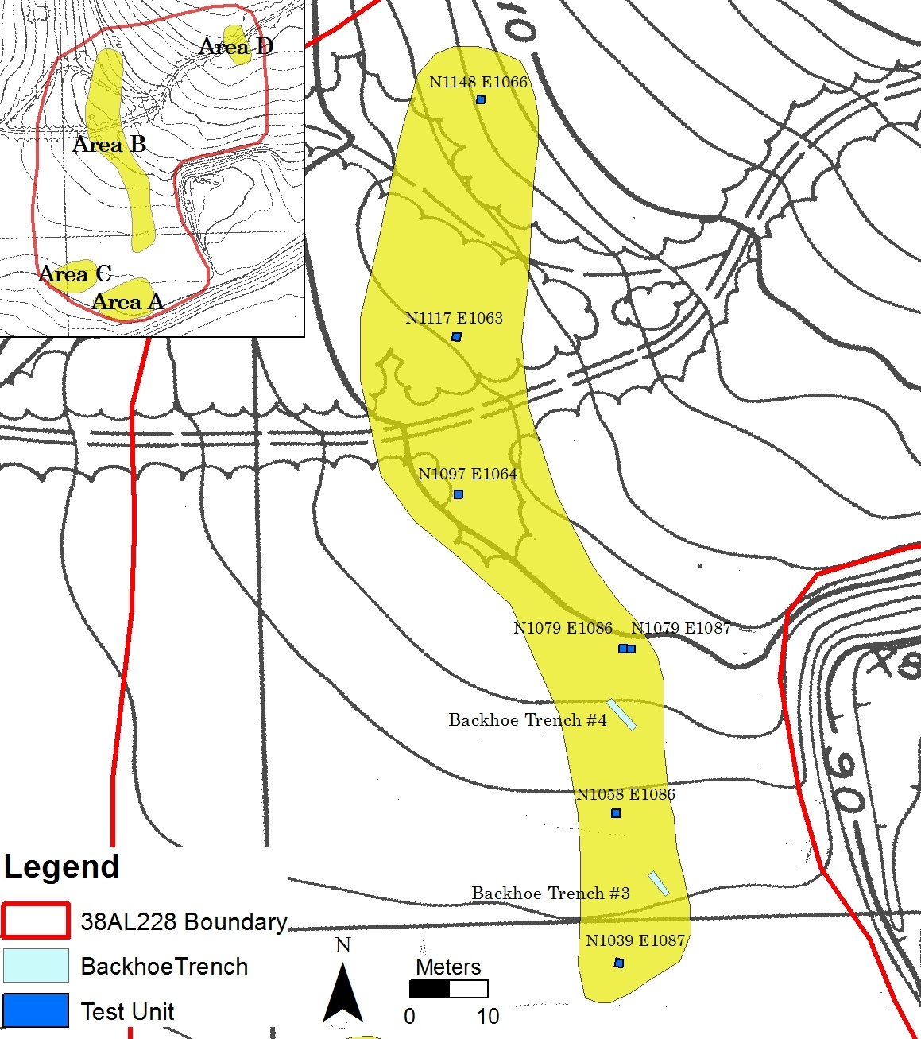

Figure 8. Map of Area B with locations of individual test units and backhoe trenches. Source: Site Study, Martin, SC for Sandoz Colors and Chemicals. Map produced in ESRI ArcGIS 10.0®.

of 170 cmbs before the approximately sandy clay paleosol is encountered (Foss, personal communication; Waters et al. 2009). Towards the base of the slope, sediments are considerably shallower, with the paleosol occurring at 86 cmbs. Table 4 illustrates the variability in soil structure at the highest and lowest elevations of Area B. The archaeological deposits throughout Area B generally appear to be more stratified than units in Area A, although they were not as productive in terms of diagnostic artifacts.

Table 4. Representative description of soil profiles at Area B, 38AL228, Allendale County, South Carolina (Courtesy Dr. John Foss).
Horizon Depth (cmbs) Munsell Color Texture Remarks
Test Unit N1097 E1064
Ap | 0-19 | 10YR 3/2 | loamy sand | -
AB | 19-28 | 7.5YR 4/2, 4/3 | loamy sand (lt) | Transitional horizon
Bw | 28-42 | 10YR 5/4, 5/3 | sandy loam (lt) | -
CB | 42-55 | 10YR 5/3,5/4 | loamy sand | -
C1 | 55-82 | 10YR 6/3,5/4 | loamy sand | -
C2 | 82-100 | 10YR 6/2 | sand | -
C/B | 100-150 | 7.5YR 4/4 (lamellae), 10YR 6/2 (Interlam.) | loamy sand | lamellae 5-7 cm space, .5 cm thick
C3 | 150-230 | Stratified | sand and gravel | -
2C4 | 230-240 | 5YR 5/6 | sandy loam | Clay balls
2C5 | 240-270 | 7.5YR5/6 | sandy loam | -
Test Unit N1039 E1087
Ap | 0-18 | 10YR 3/2 | sandy loam | -
AB | 18-28 | 10YR 3/2, 5/3 (20%) | sandy loam | -
Bw | 28-41 | 10YR 5/3,5/4 | sandy loam | weak B
C1 | 41-63 | 10YR 7/2,7/3 | sand | -
C2 | 63-86 | 10YR 7/2 | sand | -
2Btb | 86-110 | Reticulate mottling | sandy clay loam
 |  | 5YR 5/6, 4/4 (matrix)

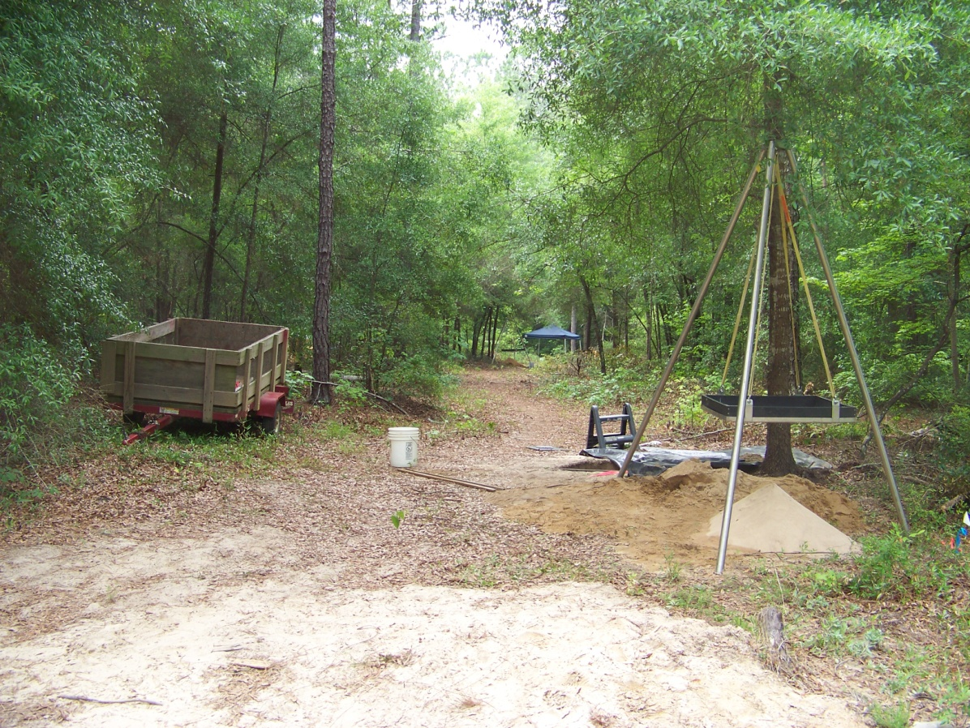
Figure 9. Area B facing south from access road. N1097 E1064 in foreground, N1058 E1064 under blue canopy in background.

N1039 E1087
Unidentifiable prehistoric ceramics (n=4) were encountered in the first 10 cm level only. No diagnostic lithic artifacts were recovered. A non-cultural feature (Feature 1) was first encountered in Level 5, extending beyond the sandy clay subsoil at the base of Level 11, and was excavated independently. The feature was recognized by its dark stain (10yr4/4) and charcoal inclusions. The eastern half was excavated and screened, while the western portion was collected as a flotation sample. Its constricting shape and high proportion of thermally altered lithic materials in the eastern portion (99.7%) suggests Feature 1 was a burned tree root. The lack of diagnostic artifacts makes it difficult to determine if stratified, intact deposits were present. Two highly weathered unifacial tools were recovered from Levels 8 (70-75 cmbs) and 9 (75-80 cmbs). However, the lack of additional diagnostic artifacts to contextualize them prohibits a cultural designation.

N1058 E1086
N1058 E1086 yielded no diagnostic artifacts other than a single plain prehistoric sherd encountered in the first 10 cm level. Artifact density was greatest in Levels 4-5, producing 90.5% of the total lithic material by weight for the entire unit. These levels were characterized by a mixture of thermally altered and non-thermally altered flake debris and several non-diagnostic chipped stone tools. The unit was excavated to 1 m below surface without encountering the sandy clay paleosol. A 30 x 30 cm square shovel test was excavated to a depth of 1.5 m below surface without encountering sterile subsoil. No Clovis materials were recovered, and there was no indication that stratified, intact deposits were present.

N1079 E1086
N1079 E1086 was opened up directly to the west of N1079 E1087 due to the frequency of archaeological remains in the latter. Though rich in cultural materials as well, this unit yielded no diagnostic artifacts. Prehistoric ceramics were recovered from Levels 2-4 (n=7), with a single large undecorated sherd found in Level 4. A thermally altered distal bifacial preform was recovered from Level 5. Throughout Levels 4 and 5, there was noticeable increase in the occurrence of fire-cracked rock (FCR) – blocky lithic material that was thermally altered or fire damaged. A distinct concentration of FCR was first encountered in Level 6, and was excavated separately as Feature 2 (Figure 10). No tools or diagnostic artifacts were recovered from within the feature. This unit was characterized by a mixture of thermally altered and non-thermally altered flake debris and several non-diagnostic chipped stone tools. No Clovis artifacts were recovered.

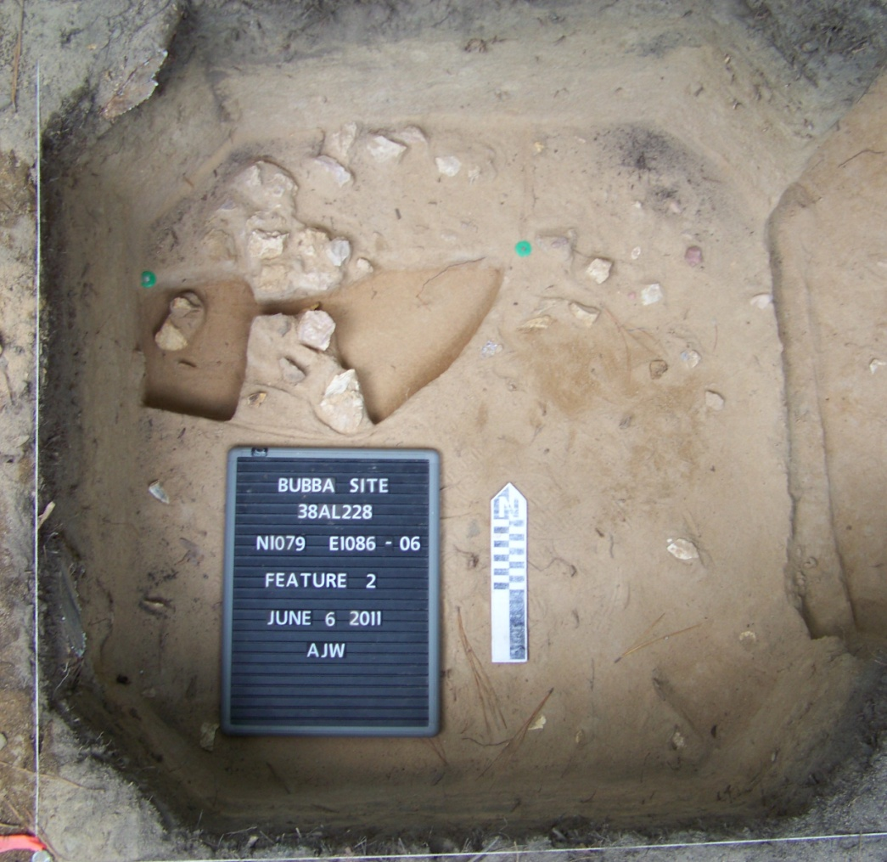
Figure 10. N1079 E1086, Feature 2, FCR concentration mid-excavation.

N1079 E1087
Middle and Late Woodland ceramics (n=3) were recovered from the first 31 cm. This unit yielded no diagnostic stone artifacts and there appears to be mixing of cultural deposits. This unit was characterized by a mixture of thermally altered and non-thermally altered flake debris, two non-diagnostic chipped stone tools, and two cores. No Clovis artifacts were recovered, and there does not appear to be any stratified cultural deposits in the test unit.

N1097 E1064
N1097 E1064 is located approximately five meters south of the access road leading into the site. There were no prehistoric ceramics recovered. A diagnostic Early Archaic Side-Notched projectile point (FS-521) was recovered from Level 7 at 73 cmbs (Figure A-15). It has been exhausted, the reworking of the edges causing a high degree of beveling. No additional diagnostic artifacts were recovered. Upon conclusion of Level 13 (105 cmbs), sterile subsoil had not yet been reached. A 30 x 30 cm square shovel test was excavated in 10 cm arbitrary levels to a depth of 1.55 m without encountering the sandy clay paleosol.

N1117 E1063
N1117 E1063 is located approximately six meters north of the access road leading into the site. No diagnostic artifacts were recovered. Several bifacial and unifacial tool fragments were recovered from Levels 5-7, some of them showing intentional thermal alteration. Beginning at 70 cmbs and continuing until the base of the unit, cultural materials became scarce and the frequency of river quartz pebbles increased, possible evidence of alluvial deposition.

N1148 E1066
N1148 E1066 was dominated by large amounts of quartz river gravel and produced the fewest artifacts of all test units at 38AL228 (Table B-1). In Level 2, an unusually large amount of rounded quartz gravel began to appear, increasing in frequency as the depth increased. At 70 cmbs, there was a dramatic increase in the size and frequency of the gravel and a marked decrease in cultural materials. Additional testing is required in the area to determine the source and extent of the gravels.

Area C
Area C consists of ten 1 x 1 m test units, one 2 x 2 m test unit, and two mechanically excavated backhoe trenches. It is situated on a moderately level first terrace of the Savannah River. The area is located at the junction of an upland slope and a sharp drop into the wetland/floodplain of Smith Lake Creek (Figure 11). From March 19 through March 24, 2012, a volunteer effort and archaeological field school was organized by SEPAS, SCIAA, and the University of Tennessee to continue testing at 38AL228. Ten 1 x 1 meter test units were excavated, including a 6 x 1 meter trench that produced the most convincing evidence for intact remnants of a Clovis-era occupation. The 6 x 1 meter trench was not initially planned, but was the result of an expansion from the original test unit that produced a seemingly logical stratigraphic sequence below the plow-zone, including diagnostic Clovis bifacial artifacts.
Additional testing occurred at Area C in June 2012. A series of four test trenches, two of which are contained in Area C (Backhoe Trenches 1-2), were mechanically excavated using a backhoe with the purpose of exposing additional areas of the site for soil analysis by Dr. Foss (Figure 11). The excavation of Backhoe Trench 2 in Area C uncovered a dense lithic concentration with a high percentage of large, cortical, early-stage lithic debris that was patinated to a degree that suggested a possible Paleoindian origin. A large, amorphous charcoal feature was uncovered at the base of the trench in the northeast corner, at which time the mechanical excavations were halted. In response, a 2 x 2 meter block was excavated adjacent to the northeast corner of Test Trench 2 in order to obtain a controlled sample of the rich concentration of artifacts and to explore the

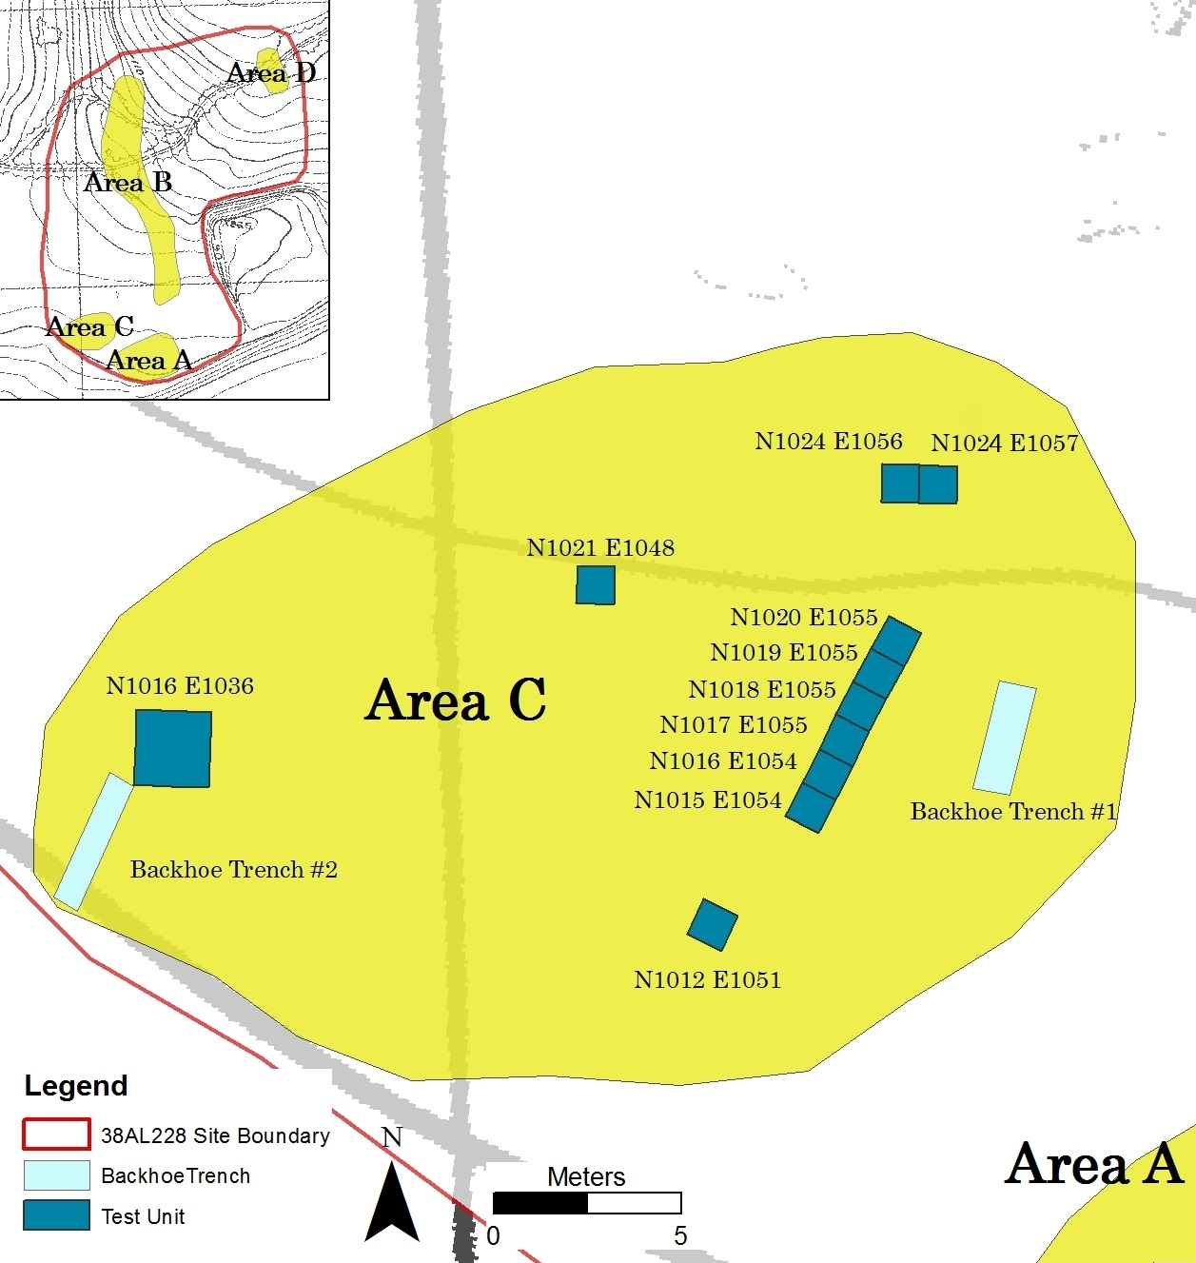
Figure 11. Map of Area C with locations of individual test units and backhoe trenches. Source: Site Study, Martin, SC for Sandoz Colors and Chemicals. Map produced in ESRI ArcGIS 10.0®.

extent of the charcoal feature. The general soil profile of the area is described below in Table 5.
The archaeological deposits in Area C are generally not as shallow as those in Area A, and several test units have cultural materials in logical stratigraphic order. Diagnostic artifacts from the Woodland period through the Paleoindian period were recovered from the units in Area C, including Clovis artifacts that are included in the comparative analysis.

Table 5. Representative description of soil profiles at Area C, 38AL228, Allendale County, South Carolina. (Courtesy of Dr. John Foss).
Horizon Depth (cmbs) Color Texture Remarks
Test Unit N1020 E1055
Ap | 0-19 |  | 10YR 3/2 | sandy loam | -
BA | 19-28 |  | 10YR 4/2 (20%),5/3 | sandy loam | -
Bw | 28-39 |  | 10YR 6/4 | sandy loam (lt) | Weak B horizon
C1 | 39-53 |  | 10YR 6/3 | loamy sand | mottles f1f, 10YR 5/6
C2 | 53-74 |  | 10YR 6/2 | sand | -
2Bt1b | 74-92 |  | 7.5YR 5/6 | sandy clay loam | mottles f1d, 5YR 5/6
2Bt2b | 92-110 |  | reticulate mottling, | sandy clay loam | clay coatings
 |  |  | 7.5YR 5/6 and
 |  |  | 2.5YR 5/8
_______________________________________________________________________

N1012 E1051
N1012 E1051 contained the shallowest deposits of all test units in Area C, continuing the trend of decreasing depth as the terrace moves towards the slope into Smith Lake Creek. The cultural deposits appear to be commingled and there is no sequence of diagnostic artifacts to suggest stratigraphic separation. A single sherd of unidentifiable prehistoric ceramic was recovered from the second level of the unit (10-20 cmbs). Level four produced two biface fragments, one a large distal preform fragment (FS-968), one a smaller indeterminate fragment (FS-969), neither of which is diagnostic or at an elevation consistent with the Clovis deposits in Area C.

N1016 E1036
N1016 E1036 is a 2 x 2 meter test unit located along the north edge of Backhoe Trench 2. The placement of the unit was determined by the dense lithic manufacturing debris recovered during the mechanical excavation of Trench 2 and the presence of a charcoal-based feature at a depth of approximately 60 cmbs. The first four levels were excavated as a single 2 x 2 meter unit. All materials recovered from the screen were bagged together, and all individually plotted artifacts were treated as if in a single unit level. The remaining levels were excavated in quadrants and treated as individual 1x1 m units.
Multiple diagnostic artifacts were recovered in N1016 E1036, though the cultural deposits recovered exhibit a general lack of stratigraphic integrity. Prehistoric ceramics (n=20) were recovered from the first three levels (0-40 cmbs), including Plain, Deptford Check Stamped, unidentifiable incised, and unidentifiable fragments. Level 1 (0-20 cmbs) yielded the distal portion of a small Woodland triangular projectile point (FS-1384) which refits with a proximal fragment found in Level 2 (20-30 cmbs) (FS-1391) (Figure A-13). Level 2 also produced the distal portion of a thermally altered projectile point (FS-1387) that refits with a Savannah River base recovered from Level 3 (30-40 cmbs) (FS-1394) (Figure A-14). Level 3 also produced two small, highly weathered preforms (FS-1435 and FS-1437), and a large late-stage preform / knife with the platform remnant of the original flake spall at the proximal end (FS-1392). Levels 4 (40-50 cmbs) and 5 (50-60 cmbs) produced five bifaces and biface fragments and one large core, none of which can be assigned a temporal designation. Seventeen flake tools were recovered from throughout the unit, although none could be assigned a temporal designation. A single Clovis artifact was recovered from Level 4 of this unit – a highly weathered, complete overshot flake (FS-1463) (Figure A-4). The charcoal feature that partially prompted the excavation of the unit was not encountered, being much smaller than originally thought.

N1021 E1048
No diagnostic artifacts were recovered from N1021 E1048. The first 40 cm of excavations yielded few artifacts. Cultural deposits in Level 4 (40-45 cmbs), Level 5 (45-50 cmbs), and Level 6 (50-55 cmbs) were rich but stratigraphically indistinguishable from each other, producing a number of unifacially (n=2) and bifacially (n=2) modified flakes. Two bifaces were recovered – one a complete preform that the toolmaker failed to thin (FS-998), the other a preform fragment that shows signs of utilization after it was broken (FS-989). No diagnostic Clovis artifacts were recovered from this unit.

N1024 E1056
The lack of diagnostic artifacts in N1024 E1056 precludes any discussion of intact cultural deposits. There are few indicators that extensive mixing of cultural strata has occurred, yet there is also no sequence of diagnostic artifacts to suggest stratigraphic separation. A single unidentifiable prehistoric ceramic sherd was recovered from Level 1 (0-20 cmbs). Three biface fragments were recovered from Level 2 (20-30 cmbs), one of which was thermally altered. Level 4 (30-40 cmbs) produced two biface fragments, both of which have been thermally altered, and Level 6 (55-60 cmbs) produced one bifacial preform with prominent river cortex on a single face. None of these stone tools can be assigned a temporal designation.

N1024 E1057
N1024 E1057 was opened to the east of N1024 E1056. No prehistoric ceramics were recovered. A single Woodland Stemmed projectile point was recovered from Level 3 (30-40 cmbs) (FS-777) (Figure A-13), although it was found in the screen. No additional diagnostic artifacts were recovered. The sandy clay subsoil in this unit was not uniformly level, sloping downward from east-to-west at the base of the unit.

6 x 1 Meter Test Trench
The test trench in Area C began as two individual 1 x 1 meter test units that were aligned but not adjacent to each other—N1020 E1055 and N1016 E1054. Both units produced Clovis artifacts in the correct stratigraphic position, prompting the decision to open up additional units—N1019 E1055 and N1017 E1055—adjacent to them. Again, each of these additional test units produced multiple Clovis artifacts, prompting the decision to expand the existing units. The decision to extend the units to form a trench took into consideration the value of having a continuous profile in an area where a large number of Clovis artifacts were being recovered directly above undulating sandy clay subsoil. Test units N1018 E1055 and N1015 E1054 completed the trench sequence.
The distribution of diagnostic artifacts in the 6 x 1 meter test trench suggests that a relatively secure Clovis component can be distinguished from later components. A series of diagnostic post-Clovis artifacts were recovered in proper stratigraphic order in the first 30 cm of deposits. In addition, there was an approximately 25 cm zone situated directly above the sandy clay paleosol in which seven Clovis bifaces, three Clovis blades, and four Clovis cores were recovered with no indication of stratigraphic mixing with post-Clovis deposits. Figures 13 through 17 display the positioning of these artifacts plotted against the west wall of the trench. The horizontal integrity of the Clovis deposits is suggested by a refitted Clovis biface from two fragments located 6 cm vertically removed from each other in adjacent units (Figures 13, 14). Detailed descriptions of the excavations and artifacts from each of the six 1x1 m test units that comprise the test trench are provided below.

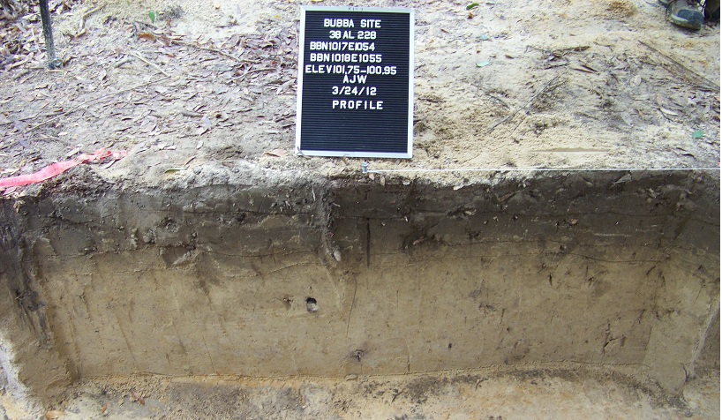

Figure 12. Photograph of West Wall Profile of Area C Test Trench, N1017 E1054 and N1018 E1055.

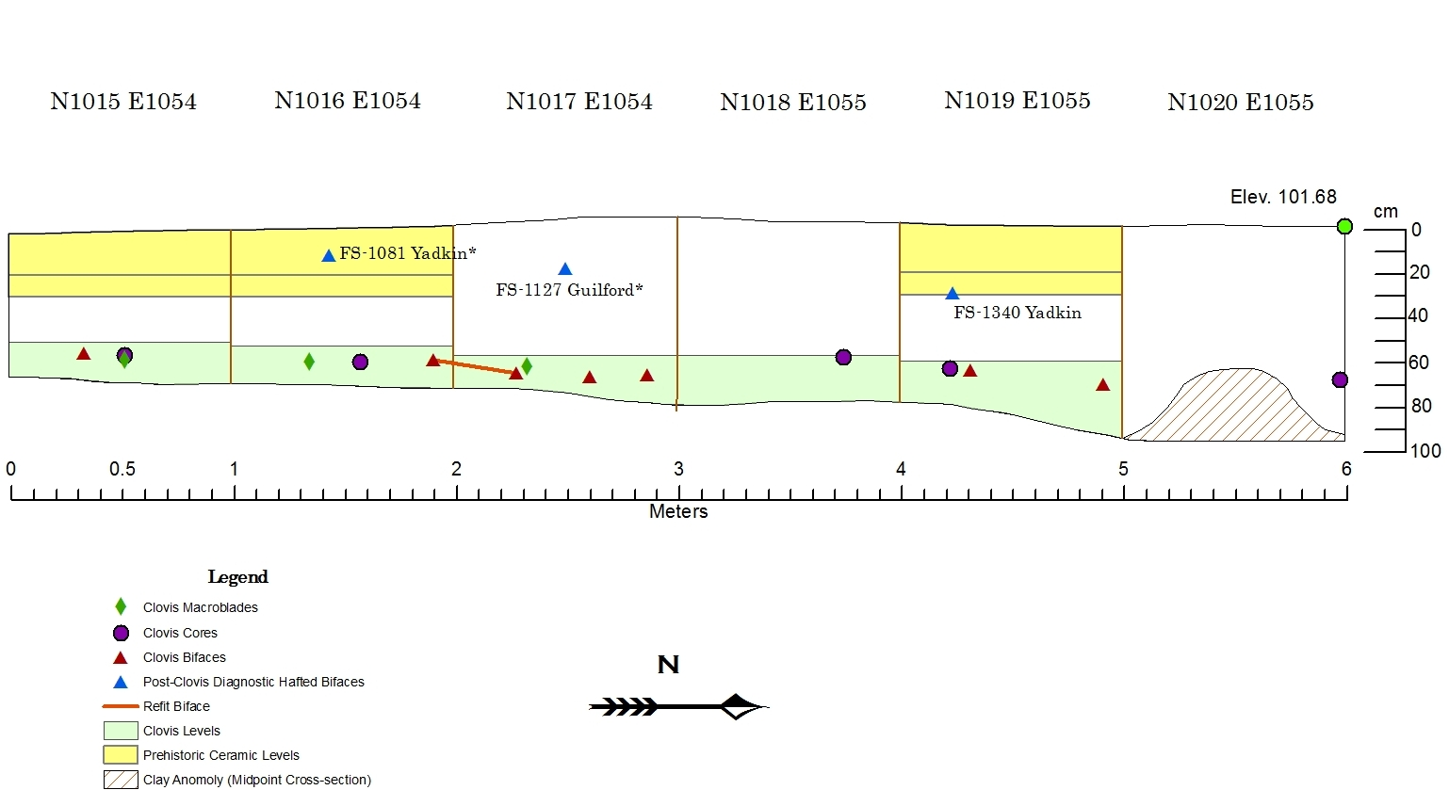

Figure 13. Vertical distribution of all diagnostic artifacts, plotted against west profile of 6 x 1 meter test trench. Map produced in ESRI ArcGIS 10.0®.

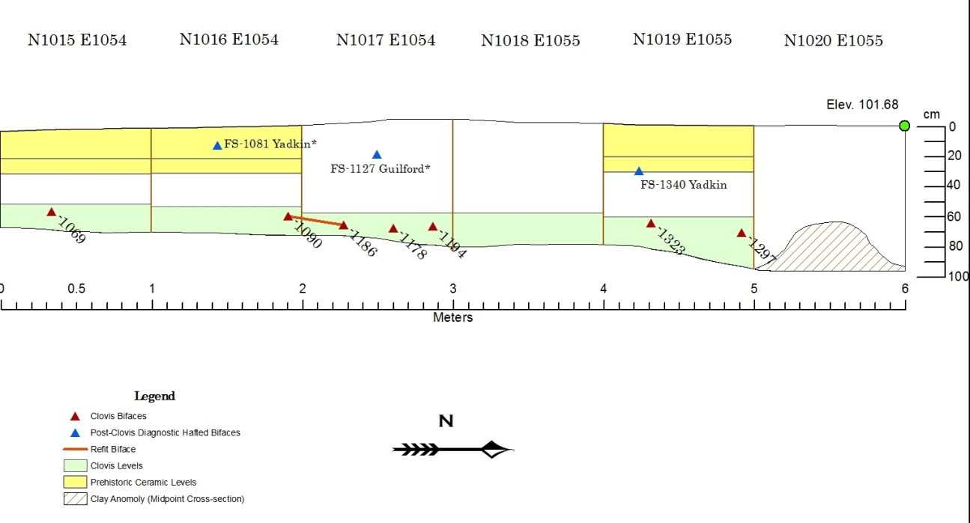

Figure 14. Vertical distribution of Clovis bifaces (with FS#) and post-Clovis diagnostic artifacts, plotted against west profile of 6 x 1 meter test trench. Map produced in ESRI ArcGIS 10.0®.

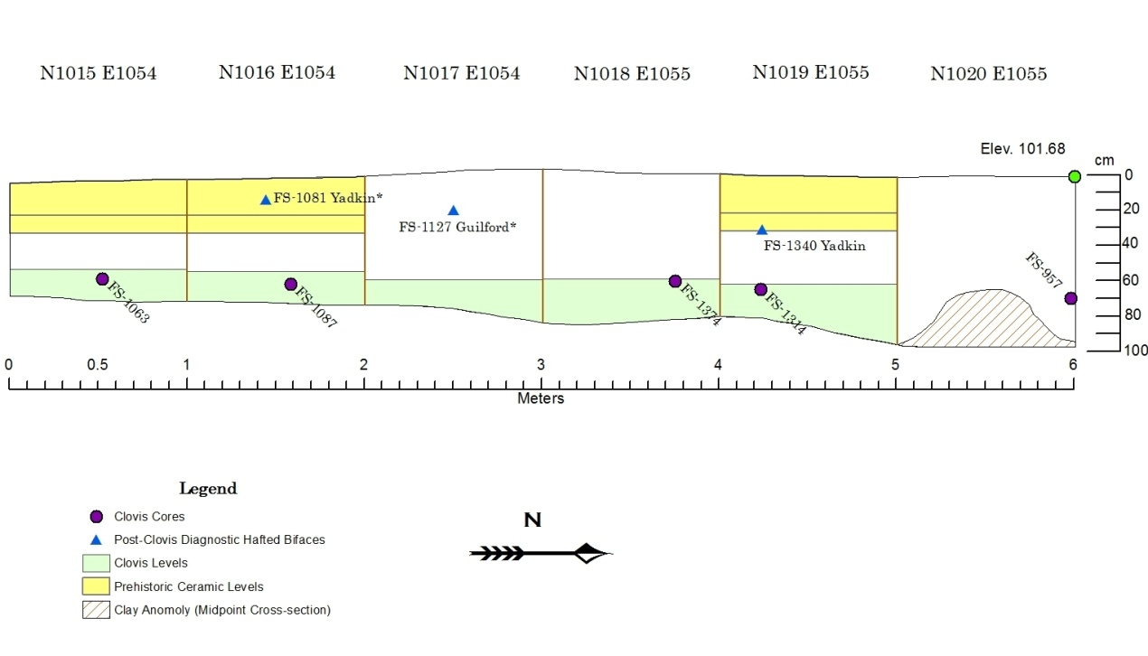

Figure 15. Vertical distribution of Clovis cores (with FS#) and post-Clovis diagnostic artifacts, plotted against west profile of 6 x 1 meter test trench. Map produced in ESRI ArcGIS 10.0®

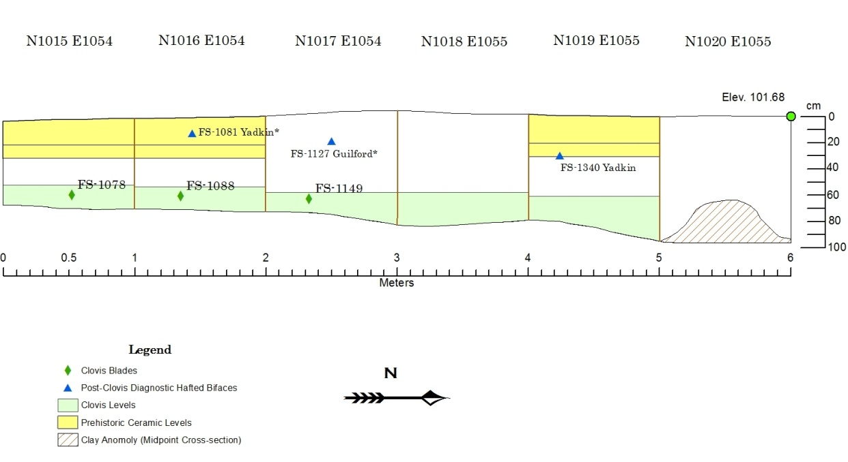

Figure 16. Vertical distribution of Clovis blades (with FS#) and post-Clovis diagnostic artifacts, plotted against west profile of 6 x 1 meter test trench. Map produced in ESRI ArcGIS 10.0®.

.

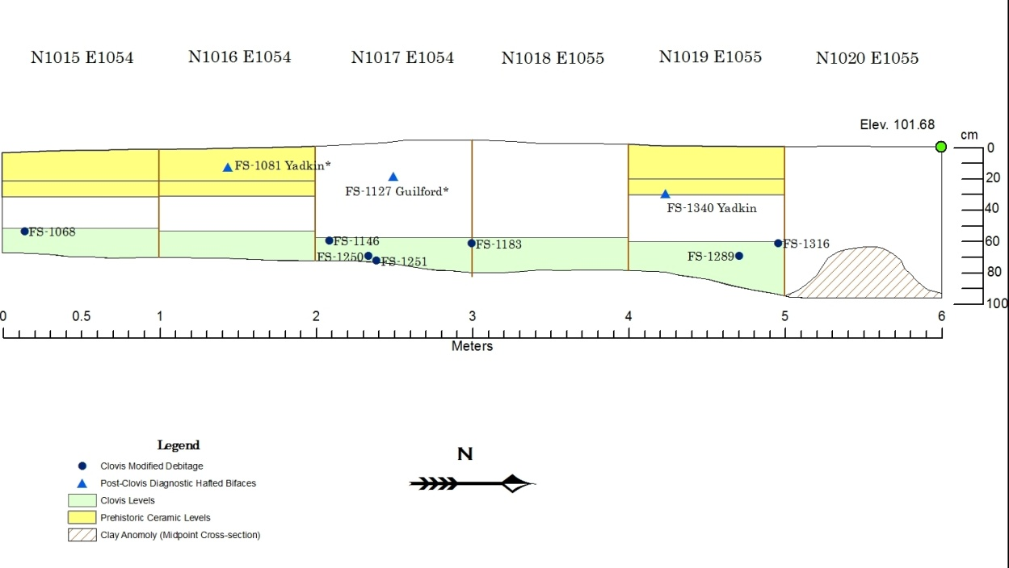

Figure 17. Flake tools in Clovis levels in Area C, plotted against west profile of 6 x 1 meter test trench. Map produced in ESRI ArcGIS 10.0®.

N1015 E1054
Prehistoric ceramics (n=7) were recovered from the first two levels (0-20 cmbs, 20-30 cmbs), including two large Middle Woodland Deptford Check Stamped sherds. No additional diagnostic artifacts were recovered. However, the following artifacts are included in the Clovis assemblage by virtue of their correspondence to the depths associated with Clovis artifacts in the other units in the test trench and the lack of stratigraphic mixing in those contexts. A nearly-complete early stage preform was recovered at an elevation of 101.11, although it is crude and does not have end-thinning or transverse removals (FS-1069). There is a considerable material flaw on one margin and may have prompted its discard (Figure A-1). A highly weathered wedge-shaped core was recovered at an elevation of 101.10 (FS-1063) (Figure A-7), with a large blade removed from a wedge-shaped core recovered 3 cm to the east at an elevation of 101.08 (FS-1078) (Figure A-10). The size, shape, raw material type, and edge layout of the latter suggest it may be a prior removal from the former (Figure 28). In addition a small unifacial tool with extremely fine retouch was recovered from an elevation of 101.14 (FS-1068) (Figure A-11).

N1016 E1054
N1016 E1054 produced diagnostic artifacts from the Woodland and Paleoindian periods in the proper stratigraphic sequence. Middle Woodland Deptford Check Stamped prehistoric ceramics (n=2) and a single, almost complete Middle Woodland Yadkin projectile point (FS-1081) (Figure A-13) were recovered from the first level (0-20 cmbs). Two artifacts are diagnostic of Clovis and correspond to the depths associated with Clovis artifacts in adjacent units. A highly weathered conical blade core was recovered at an elevation of 101.07 (FS-1087) (Figure A-6). A proximal early stage Clovis preform was recovered at an elevation of 101.08, with a single end-thinning removal and a prepared platform for additional end thinning removals (FS-1090). This proximal fragment refits with a distal biface fragment (FS-1186) recovered from N1017 E1054 (Figure A-2). A small utilized blade was also recovered from an elevation of 101.07 (FS-1088) and is included in the Clovis assemblage (Figure A-11).

N1017 E1054
N1017 E1054 provided the most Clovis tools of all test units (n=8). No prehistoric ceramics were recovered. A thermally altered biface, presumably Middle or Late Archaic in age, was recovered from Level 5 at an elevation of 101.2 (FS-1219). Level 8 yielded the proximal end of a Clovis macroblade that terminated at a material flaw at 101.05 (FS-1149) (Figure A-10) and a denticulated scraper, (FS-1146) (Figure A-11). The following Clovis diagnostic artifacts were all recovered from Level 9: a Clovis preform proximal fragment with a single end-thinning removal and a prepared beveled platform for additional end thinning removals (FS-1178) (Figure A-3), a distal portion of a biface (FS-1186) (Figure A-2) that refits with the Clovis proximal fragment (FS-1090) recovered from N1016 E1054, and a small, thin distal biface fragment at 101.01 with transverse flaking patterns consistent with Clovis-aged artifacts (FS-1194) (Figure A-3). Levels 9 and 10 also produced three flake tools (FS-1183, FS-1250, and FS-1251) located stratigraphically below multiple Clovis diagnostic artifacts (Figure A-11).

N1018 E1055
N1018 E1055 yielded no diagnostic artifacts. No prehistoric ceramics were recovered. However, one artifact can be included in the Clovis assemblage by virtue of its correspondence to the depths associated with Clovis artifacts in adjacent units and the apparent lack of stratigraphic mixing. A highly weathered core tablet flake was recovered at an elevation of 101.09 (FS-1374) (Figure A-8).

N1019 E1055
N1019 E1055 produced diagnostic artifacts from the Woodland and Paleoindian periods in the proper stratigraphic sequence. Unidentifiable prehistoric ceramics (n=2) were recovered from Level 1 (0-20 cmbs). A complete, heavily reworked Middle Woodland Yadkin projectile point (FS-1340) (Figure A-13) was recovered from Level 2 (20-30 cmbs). No artifacts can be identified as fully diagnostic of Clovis. Some, however, possess characteristics of Clovis lithic technology and correspond to the depths associated with diagnostic Clovis artifacts in adjacent units. Two fragmentary early-stage preforms were recovered from Level 8 at 101.03 (FS-1323) and Level 9 at 100.97 (FS-1297) (Figure A-1). Level 8 (60-65 cmbs) also yielded a crude unifacial scraper (FS-1316) (Figure A-11), and an amorphous core (FS-1314) (Figure A-9). From Level 9, a large unifacial scraper was recovered at an elevation of 100.982 (FS-1289) (Figure A-11). Their association with Clovis artifacts from a corresponding depth in adjacent units and the lack of stratigraphic mixing allows these artifacts to be included in the Clovis lithic assemblage.

N1020 E1055
The archaeological deposits from N1020 E1055 are unique among the units that comprise the test trench. A non-uniform, hard-packed sandy clay anomaly was encountered near the base of Level 5, although excavation of the sandy soils containing archaeological deposits continued until uniformly distributed sandy clay subsoil was reached at 100 cmbs (Figure 18). Following the excavation of the sandy soils, a sample of the sandy clay was excavated to determine if it was culturally sterile, and artifacts were recovered from within the anomaly. A total of 157 lithic artifacts were recovered from the sampled anomaly. The presence of artifacts in the anomaly suggests that the mixing of sandy clay paleosol and cultural deposits was the result of a natural disturbance, perhaps caused by a tree throw or bioturbation.
Despite the possibility of disturbance and the lack of post-Clovis diagnostic artifacts, N1020 E1055 yielded artifacts that are in proper stratigraphic sequence. No prehistoric ceramics were recovered. The distal end of what was likely a triangular Woodland projectile point was recovered from Level 3 (20-30 cmbs) (FS-847) (Figure A-13). The distal portion of an unidentifiable thin, broad projectile point was recovered from Level 4 at 101.19 (FS-853) (Figure A-14). One artifact can be included in the Clovis assemblage by virtue of its morphology - a highly weathered conical blade core was recovered from atop the anomaly at an elevation of 100.99 (FS-957) (Figure A-6).
The following heavily patinated, flake tools were recovered from excavations within the anomaly at the base of N1020 E1055. All were recovered at or below other Clovis contexts in the test trench, yet are not included in the Clovis flake tools assemblage because of the possible disturbance: a small, unifacially flaked burin / sidescraper (FS-939), a larger unifacially flaked sidescraper (FS-921), an unidentifiable flake tool (FS-919), and a bifacial chopping tool (FS-955).

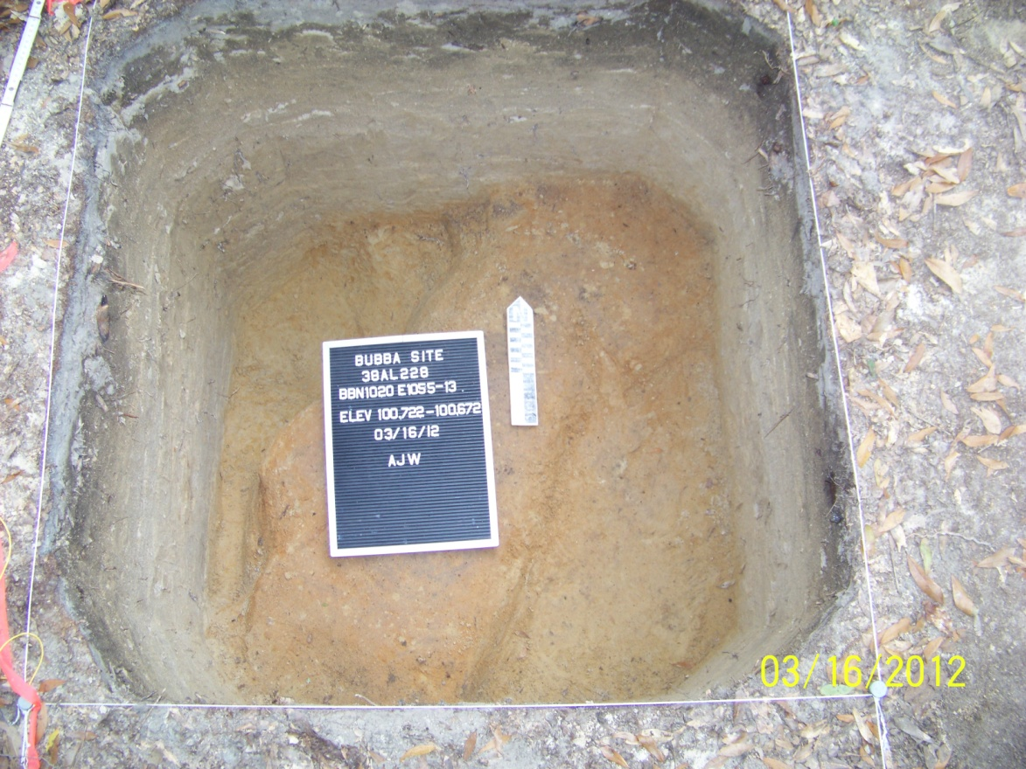

Figure 18. Clay anomaly and undulating subsoil at base of N1020 E1055.

Area D
Area D consists of two 1 x 1 meter test units and a profile of the road-cut located in an upland setting (Figure 19). The area was chosen as a locus for testing for several reasons. First, diagnostic Clovis lithic artifacts were recovered in a general surface collection of the road-cut, having eroded out and washed down slope (Figure 20). Second, there was evidence that artifact collectors had dug into the eroding walls of the road-cut in search of artifacts, leaving a series of shovel marks and backdirt piles (Figure 21). In June 2011, a profile was exposed on the north wall of the road-cut to provide information on the depth of the soils in the area. Test Unit N1153 E1146 was placed near the area from which the initial artifacts collected by Kenn Steffy had been recovered. Test Unit N1169 E1140 was excavated on the north side of the road during March 2012. The soils in Area D were the deepest encountered during excavations at the site, although no diagnostic artifacts were recovered. The general soil profile of the area is described in Table 6.

Table 6. Representative description of soil profiles at Area D, 38AL228, Allendale County, South Carolina. (Courtesy of Dr. John Foss).
Horizon Depth (cm) Color Texture Remarks
N1169 E1140
Ap | 0-19 |  | 10YR 4/3 | loamy sand | -
AB | 19-35 |  | 10YR 5/3,4/3 | loamy sand | Transitional
Bw | 35-48 |  | 10YR 5/4 | sandy loam | Iron coatings
C1 | 48-64 |  | 10YR 6/4 | loamy sand | -
C/B | 64-85 |  | 7.5YR 6/4,6/3 | loamy sand | Thin lamellae
C2 | 85-100 |  | 10YR 6/3,6/4 | loamy sand | -
C3 | 100-170 |  | 10YR 7/3 | Sand | Gravelly 160-170
2Btb | 170-173 |  | 5YR 5/6 | sandy clay loam | -
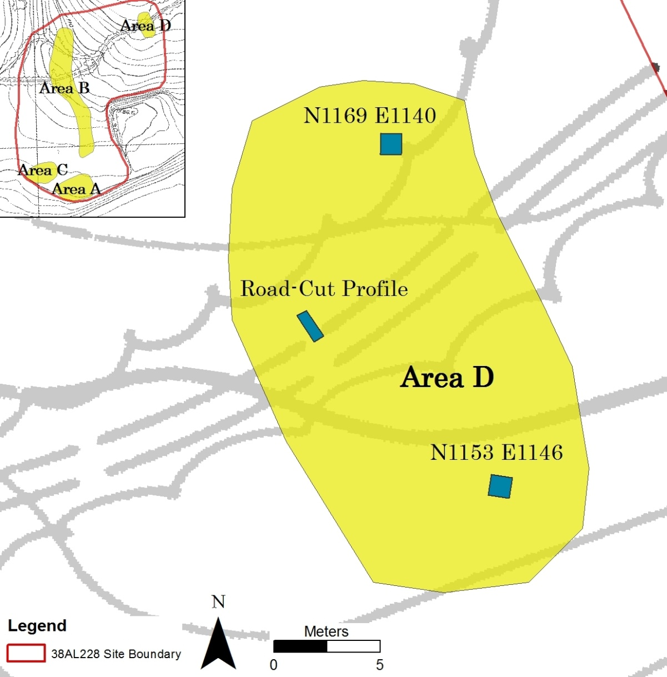

Figure 19. Map showing Area D with locations of individual test units and Road-Cut Profile. Source: Site Study, Martin, SC for Sandoz Colors and Chemicals. Map produced in ESRI ArcGIS 10.0®.

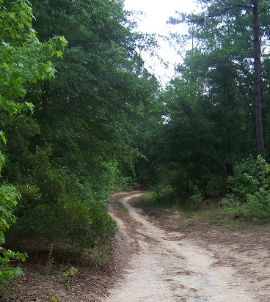
Figure 20. Photograph showing general area of Road Surface Collection at 38AL228, facing northeast.

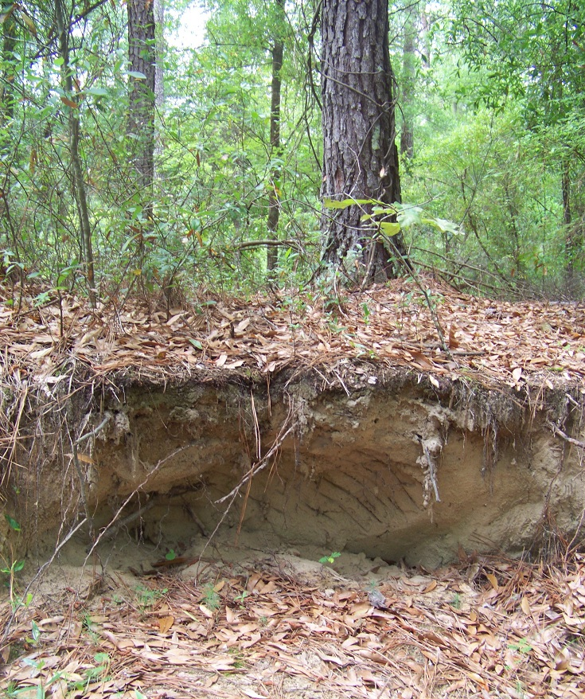

Figure 21. Evidence of looter activity at road-cut in Area D, 38AL228.

N1153 E1146
N1153 E1146 is located approximately 8 meters south of the dirt access road leading into the site. Six unidentifiable prehistoric ceramic sherds were recovered from the plow zone (~0-30 cmbs). The remainder of the unit produced a number of tools that could not be attributed to specific temporal periods. After reaching 100 cmbs without encountering sandy clay subsoil, a 30 x 30 cm shovel test was excavated until culturally sterile compact sand was encountered (10yr8/1). No Clovis artifacts were recovered from this unit.

N1169 E1140
N1169 E1140 is located approximately 5 meters north of the dirt access road leading into the site. The unit produced very few artifacts to help determine if stratigraphically distinct cultural deposits were present. A single unidentifiable prehistoric ceramic sherd, a single fragment of historic cream-colored ceramic, and a single historic cut nail were recovered from Level 1 (0-20 cmbs). One fragment of green glass was recovered from Level 2 (20-30 cmbs). All other artifacts were debris from the manufacture of stone tools. No diagnostic chipped stone tools were recovered.

Road-Cut Profile
During the May/June 2011 field season, a profile was exposed along the existing road-cut in an area where artifacts were eroding (Figure 19). The purpose of this was to expose the stratigraphic profile of the upland soils in Area D prior to excavating test units. No diagnostic artifacts were recovered.

Surface Collection
The initial evidence of cultural materials at 38AL228 was discovered eroding from the access road that bisects the site. The sloping road-cut leading into Area B provided the most opportunity for the recovery of Paleoindian artifacts, as the soils have almost entirely eroded, exposing the sandy clay paleosol and the artifacts situated just above it. SCIAA archaeologist Kenn Steffy periodically collected artifacts from the road surface, amassing a substantial collection of bifacial and unifacial tools, cores, and flake tools. Select Paleoindian and Clovis specimens from the surface artifact collection were photographically documented and are included in Appendix C, but no attribute or metric data are provided. Two undeniably Paleoindian late-stage preforms were collected from the road: a late-stage Dalton preform and a small, proximal section of a fluted Clovis preform (SC-550). The latter is the only artifact from this area that is included in the Clovis biface assemblage.

Chapter III: The 38AL228 Clovis Lithic Assemblage

A total of 43,254 chipped stone artifacts were recovered during the 2010-2012 excavations at 38AL228. Of these, 1,759 are Clovis in age (Table 7). Individual Clovis artifact types are addressed in the sections that follow, with metric and attribute data provided for each. Photographs of the artifacts described in this chapter are presented in Appendix A.

Table 7. 38AL228 Clovis artifact summary.
Artifact Type | Total Count
Debitage | 1723
Non-hafted bifaces | 11*
Flake tools | 9
Cores | 8
Blades | 7
Overshot flake | 1
Total | 1759
* Refitted biface counted as single artifact

Clovis Bifaces

Eleven total bifaces were recovered from the testing at 38AL228. No complete, intact bifaces were recovered during the 38AL228 excavations; those recovered were broken production failures. However, two biface fragments from the same provenience were refitted to form the only complete biface (FS-1090 & FS-1186) (Figure A-2, Tables 8, 9). Photographs documenting the Clovis biface assemblage from 38AL228 are presented in Appendix A. Figure A-1 shows the early-stage bifaces, Figure A-2 the middle-stage bifaces, and Figure A-3 the late-stage bifaces. Tables 8 and 9 below list the attributes, measurements, and flaking indices for all Clovis bifaces recovered from 38AL228.

Table 8. 38AL228 Clovis biface attributes (Waters et al. 2011:86-87).
FS # | Cortex | ET | OR ϯ | TF | Platform Isolation | Margins | Plan-View | Flake Removal Technique † | Transverse Cross-section | Reduction Stage
SC550 | N | Y |  |  | None | Abraded | Lanceolate | Light Percussion | Bi-Convex | Late
733 | N | Y | Y |  | Margins | Abraded | Lanceolate | Light Percussion | Irregular | Middle
107 | N |  | Y | Y | None | Non-abraded | Irregular Lanceolate | Pressure | Bi-Convex | Late
1069 | Y** | Y | N | N | Base, Margins | Abraded | Ovoid | Percussion | Irregular | Early
76 | Y |  | N | N | None | Abraded | Leaf-shaped | Percussion | Bi-Convex | Early
77 | Y** | Y | Y | N | Margins | Abraded | Leaf-shaped | Percussion | Bi-Convex | Early
1463 | Y** |  |  |  |  | Abraded |  | Light Percussion |  | Middle
1090 | N | Y | Y | Y | Base, Margins | Abraded | Irregular | Light Percussion | Bi-Convex | Middle*
1178 | N | Y | Y | Y | Base, Margins | Beveled, Abraded | Lanceolate | Light Percussion | Bi-Convex | Middle
1186 | * | * | * | * | * | * | * | * | * | *
1194 | N |  | Y | Y | None | Abraded | Lanceolate | Light Percussion | Plano-Convex | Late
1323 | Y** | N | N | N | Base | Non-abraded | Indet. | Percussion | Plano-Convex | Early
1297 | N | N |  |  | Base | Abraded | Ovoid | Light Percussion | Plano-Convex | Early
† Indicates highest degree of flake removal |  |  |  |  |  |  |  | ET - End-thinning (Presence/Absence)
* Refit biface; all measurements and attributes reflect whole biface |  |  |  |  |  |  |  | OR - Overshot removals (Presence/Absence)
** Non-siliceous inclusion |  |  |  |  |  |  |  | TF - Transverse flaking (Presence/Absence)
ϯ Overshot removals include flake removals that extend past midline
Entries left blank indicate specimen too fragmentary to display attribute

Table 9. 38AL228 Clovis bifaces: Metric attributes, reduction stage, biface type, and flaking index.
FS # | Unit | Lev | Condition | Weight (g) | Max Length | Max Width | Max Thick -ness | FI | W:T | Reduction Stage | Type (Miller and Smallwood 2012)
SC550 | Road - Surface |  | Prox | 9.81 | 27.7† | 41.4 | 8.8 | 0.143 | 4.70 | Late | Point Preform
733 | TU1 | 4 | Prox | 18.61 | 36.1† | 44.8 | 13.4 | 0.127 | 3.34 | Middle | Point Preform
107 | N1008 E1083 | 4 | Med-Dist | 26.15 | 51.4† | 39.9 | 12.8 | 0.242 | 3.12 | Late | Point Preform
1069 | N1015 E1054 | 6 | Complete | 83.76 | 78.5 | 48.1 | 24.7 | 0.079 | 1.95 | Early | Early Stage Biface
76 | N1015 E1087 | 3 | Prox-Med | 164.13 | 96.7† | 92.5 | 32.3 | 0.058 | 2.86 | Early | Oval-shaped Bifacial Tool
77 | N1015 E1087 | 3 | Indet. | 196.84 | 84.7† | 93.1 | 31.1 | 0.079 | 2.99 | Early | Oval-shaped Bifacial Tool
1463 | N1015 E1036 | 4 | Complete | 26.31 | 52.4 | 46.6 | 14.5 | 0.13 | NA | Middle | Overshot Flake
1090 | N1016 E1054 | 5 | Prox | 54.02* | 74.5* | 56.8* | 13.3* | 0.247* | 4.27* | Middle* | Oval-shaped Bifacial Tool
1178 | N1017 E1054 | 9 | Prox-Med | 31.66 | 45.4† | 52.1 | 12.2 | 0.259 | 4.27 | Late | Point Preform
1186 | N1017 E1054 | 9 | Distal | * | * | * | * | * | * | * | *
1194 | N1017 E1054 | 9 | Med-Dist | 12.4 | 45.5† | 32.9 | 9.9 | 0.24 | 3.32 | Late | Point Preform
1323 | N1019 E1055 | 8 | Indet. | 33.14 | 38.6† | 54.8 | 19 | 0.083 | 2.88 | Early | Early Stage Biface
1297 | N1019 E1055 | 9 | Prox | 24.12 | 33.8† | 55 | 15.1 | 0.133 | 3.64 | Early | Early Stage Biface
† Denotes measurement on incomplete specimen
* Denotes refit biface; all measurements and attributes reflect whole biface

Overshot Flakes
The controlled removal of overshot flakes as a method of bifacial thinning is now a well-recognized property of Clovis bifacial technology (Bradley 1982; Frison and Bradley 1999; Bradley and Stanford 2002). Overshot flaking occurs when a flake originates along one margin of a biface and travels across the face, removing a portion of the opposing margin (Bradley et al. 2010:68). The advantage of this technology is twofold: the biface can be thinned considerably without a major reduction in width and the large, curved flake removals can be used for a variety of tasks. The intentional removal of this type of flake is not seen in post-Clovis lithic technology, although unintentional overshot removals sometimes occur (Bradley et al. 2010). Only one complete overshot flake was recovered at 38AL228 (Figure A-4). Metric and attribute data for the overshot flake are included in Tables 8 and 9. A material flaw likely caused the removal of a larger-than-expected portion of the distal margin.

Bifacial Cores

Not all of the 38AL228 Clovis bifaces were manufactured as preforms for fluted points. Two large bifacial core fragments consistent with Clovis lithic technology were recovered, one of which failed due to a large inclusion/material flaw, the other due to a perverse fracture in which the fracture twists diagonally from margin to margin (Crabtree 1972:82; Johnson 1981:46). These bifaces represent variation in Clovis manufacturing trajectories at 38AL228, as the large, broad bifaces were likely intended as portable cores from which large flakes could be removed as needed. Both fragments exhibit features consistent with leaf-shaped bifacial flake blank cores described by Bradley et al. (2010). Both have widely spaced, hard-hammer removals of straight, flat flakes that terminate in hinge or step fractures. The margins exhibit multiple instances of platform preparation / grinding. Their elongated shape would have allowed them to eventually be formed into smaller preforms or projectile points (Bradley et al. 2010; Wilke et al. 1991). Metric data for these bifacial cores are in Tables 8 and 9. Photographs of the bifacial cores are in Figure A-5.

Clovis Blades

Seven Clovis blades were recovered at 38AL228 (Table 10; Figure A-10). Three blades were recovered from Area C, all within the 6 x 1 meter test trench. FS-1078 is irregular compared to other Clovis blades from 38AL228, with prepared platforms on both the proximal and distal end. Its morphology suggests that it may be a blade core fragment instead of a true blade. FS-1088 is a small, curved blade with evidence of utilization along a single margin. FS-1149 is a proximal end of a blade that terminated at an inclusion of un-silicified chert. It has four blade scars on its ventral surface.
Four blades were recovered from Area A. FS-13 is a large, triangular error recovery blade with hinge terminations on both dorsal and ventral surfaces (Bradley et al. 2010:19). FS-66 is a complete blade with a triangular cross section and a material flaw along one margin. FS-90 is a complete blade with a trapezoidal cross-section. FS-50 is a highly patinated crested blade, a bifacially-flaked initial removal from a blade core that does not have an area suitable for a first blade removal (Collins 1999:19). Metric and attribute data for all Clovis blades are located in Table 10, and they are presented photographically in Figure A-10.

Table 10. 38AL228 Clovis blades
FS # | Provenience | Lev. | Weight (g) | Max Length (mm) | Max Width (mm) | Max Thick (mm) | Cross- Section
13 | N995E1081 | 3 | 30.8 | 65.5 | 40.1 | 15.8 | Triangular
50 | N996E1081 | 4 | 15.79 | 60.8 | 23.5 | 13.5 | Irregular
66 | N1015E1087 | 2 | 41.08 | 78.5 | 36.7 | 17 | Triangular
90 | N1003E1064 | 3 | 25.59 | 74.2 | 28.5 | 14 | Trapezoidal
1078 | N1015E1054 | 7 | 36.4 | 70.2 | 42.4 | 14.7 | Irregular
1088** | N1016E1054 | 5 | 3.96 | 47.5 | 19.9 | 6.1 | Triangular
1149 | N1017E1054 | 8 | 27.14 | 45.2* | 36.2 | 14.5 | Trapezoidal
* Incomplete, terminating at non-siliceous inclusion
** Utilized blade

Clovis Cores

A total of eight Clovis non-bifacial cores were recovered at 38AL228, including both those designed to produce flakes (n=1) and those designed to produce blades (n=7). The single amorphous flake core (FS-1314), though not a diagnostic artifact, is attributed to the Clovis lithic assemblage by virtue of its association with other Clovis artifacts in an undisturbed context (Figure A-9). Clovis blade cores are described in detail below. Table 11 below provides a listing of all Clovis cores and their attributes. Photographs of the cores are in Figures A-6, A-7, A-8, and A-9.

Table 11. 38AL228 Clovis cores.
FS # | Provenience | Level | N | E | Elev. | Weight | Core Type | Directionality | % Cortex | Byproduct
24 | N995 E1081 | 4 | 995.65 | 1081.57 | 100.89 | 78.8 | Tablet | Unidirectional | 0 | Blades
91 | N1003 E1064 | 3 | 1003.578 | 1064.45 | 101.14 | 76.5 | Wedge-shaped | Multidirectional | <50 | Blades
92 | N1003 E1064 | 3 | 1003.743 | 1064.46 | 101.16 | 17.6 | Tablet | Indeterminate | 0 | Blades
1063 | N1015 E1054 | 6 | 1015.52 | 1054.72 | 101.1 | 160.9 | Wedge-shaped | Multidirectional | 0* | Blades
1087 | N1016 E1054 | 5 | 1016.58 | 1054.9 | 101.07 | 147.6 | Conical | Unidirectional | <50 | Blades
1374 | N1018 E1055 | 7 | 1018.75 | 1055.18 | 101.09 | 20.9 | Tablet | Indeterminate | <50 | Blades
1314 | N1019 E1055 | 8 | 1019.23 | 1055.77 | 101.04 | 193.21 | Amorphous | Multidirectional | >50 | Flakes
957 | N1020 E1055 | Trench | 1020.98 | 1055.79 | 100.99 | 70.4 | Conical | Unidirectional | 0 | Blades
* Non-siliceous inclusions present

Clovis Blade Cores
Seven blade cores and blade core fragments were recovered from Clovis contexts. Clovis blade cores at 38AL228 include both formal conical types (n=2) (Figure A-6), informal wedge-shaped, or “hoof shaped” cores (n=2) (Figure A-7, Table 11), and core tablet flakes removed to rejuvenate the striking surface of the core (n=3) (Bradley et al. 2010; Goodyear 2005; Steffy and Goodyear 2006).
Conical blade cores from 38AL228, both of which were recovered from the 6 x 1 meter test trench in Area C, were heavily exhausted. FS-957 has a clearly defined platform from which a core rejuvenation flake terminating in a hinge fracture has been removed. Seven flake scars cover the surface of the core, two of which retain the remnant bulbar scar, indicating the core was used and discarded after the final core rejuvenation flake was removed. FS-1087 also has a clearly defined platform from which a core tablet flake was removed. This core, however, was discarded following its removal, as none of the eleven flake scars exhibit a bulbar scar.
Wedge-shaped, or “hoof shaped” cores, are not as complex as conical cores and have a higher degree of variability. Their distinguishing characteristics are a) multiple striking platforms with acute angles between the striking platform and the area of detachment and b) a limited part of the core exterior from which blades are detached (Bradley et al. 2010; Collins 1999; Goodyear 2005). All of the wedge-shaped cores recovered at 38AL228 exhibited these characteristics. In Area A, FS-91 has three prepared platforms with ten total removals. FS-94 has two prepared platforms with six total removals. In Area C, FS-1063 is crudely crafted and has several material flaws. It has two identifiable prepared platforms with at least five removals.
Core tablet flakes are typically thick, short, cylindrical flakes with flake scars of proximal blades around the exterior. The flat, broad removal rejuvenates the striking surface of the original core, as evidenced by a single broad ventral surface on the core tablet flake (Bradley et al. 2010). Three core tablet flakes were recovered from 38AL228 (Figure A-8). FS-24 has seven facets indicating previous blade removals, three of which have bulbar scars. The other four facets are distal remnants of blade removals, indicating that the original core may have been multidirectional. FS-1374 has seven facets along the exterior, three of which have remnant bulbar scars. The flaking pattern is irregular, with flaking occurring in at least three directions. The angle between the area of detachment and the ventral surface of the rejuvenation flake is obtuse, creating an acute striking platform on the remaining core. FS-92 is irregular and has three clear facets where prior blades were removed, none of which have bulbar scars.

Flake Tools

The flake tools category includes flakes that have been modified from either intentional retouch or utilization. Classification of flake tools is based upon the artifact’s morphology, the nature of edge modification, and its inferred function. The typology divides flake tools into the following categories: Endscraper, Lateral/Side Scraper, Multiple Scraper, Scraper/Plane, Spokeshave, Burin, Backed Knife, Chopper, Adze, Composite Tool, Utilized Flake, Utilized Blade, and Indeterminate flake tool. Standard metric and non-metric attributes were recorded for all flake tools recovered. In addition, flake tools are assessed using Clarkson’s (2002) index of invasiveness technique. This method quantifies the degree of retouch on tools by segmenting both surfaces of the tool into eight regions and scoring each region by the presence and invasiveness of flaking. The index has proven to be a reliable means of quantifying the degree of retouch on scrapers, unifacially retouched flake tools, and bifacially retouched flake tools (Andrefsky 2005:175-177). A listing of all Clovis flake tools, the attributes recorded, and the coding scheme used is located below in Table 12. Photographs of all Clovis flake tools are provided in Figure A-11.
Due to the shallow cultural deposits and considerable stratigraphic mixing at 38AL228, identifying flake tools attributable to the Clovis culture is difficult. While there are a number of artifacts within the flake tools category recovered from the same context as diagnostic Clovis artifacts, those recovered from contexts where mixing of cultural deposits has occurred were not included. The exception to this is the two endscrapers recovered from Area A (FS-26 and FS-29) (Figure A-12; Table 13). FS-29 is morphologically similar to traditional Paleoindian endscrapers. Although it lacks a haft element, it was constructed on a long, curved flake, has a downward-curving, convex beveled distal end, and has generally expanding margins radiating from an intact platform (Frison and Stanford 1982; Waters et al. 2011:123). FS-26 is morphologically similar to “snub-nosed” endscrapers recovered at Clovis sites in Eastern North America, such as the Adams Site and Topper, with thick cross-sections, and cortex on the dorsal surface (Sanders 1990; Smallwood et al. 2013:290). All other flake tools included in the Clovis assemblage were recovered from the 6 x 1 meter test trench in Area C, the only area where a stratigraphically secure Clovis component was able to be isolated. All Clovis flake tools are listed below in Table 12. Photographs of all Clovis flake tools are located in Figure A-11. A complete list of all flake tools from 38AL228 is located in Table B-4.

Table 12. 38AL228 Clovis flake tools.
FS # | Provenience | Lev. | X | Y | Elev. | Weight (g) | ML | MW | MT | NE | EMT | WEFP | Tool Type | II
26 | N995 E1081 | 4 | 996 | 1081.57 | 100.95 | 27.25 | 48.5 | 42.4 | 18.1 | 1 | 1 | 3 | 1 | 0.125
29 | N995 E1081 | 4 | 995.38 | 1087 | 100.88 | 24.66 | 61.9 | 38.3 | 10.7 | 1 | 1 | 3 | 1 | 0.1875
1068 | N1015 E1054 | 6 | 1015.14 | 1054.33 | 101.14 | 3.34 | 39.4 | 14.2 | 7.1 | 1 | 1 | 3 | 7 | 0.0625
1146 | N1017 E1054 | 8 | 1017.09 | 1054.07 | 101.08 | 107.1 | 73.7 | 80.2 | 29 | 1 | 3 | 3 | 2 | 0.3125
1183 | N1017 E1054 | 9 | 1018 | 1054.88 | 101.06 | 94.5 | 75.5 | 54.7 | 26.8 | 1 | 1 | 3 | 15 | 0.125
1250 | N1017 E1054 | 10 | 1017.34 | 1054.72 | 100.98 | 4.18 | 24.8 | 29.7 | 11.5 | 1 | 3 | 5 | 2 | 0.125
1251 | N1017 E1054 | 10 | 1017.39 | 1054.5 | 100.95 | 23.09 | 46.3 | 54.3 | 16.1 | 1 | 1 | 2 | 7 | 0.0938
1316 | N1019 E1055 | 8 | 1019.96 | 1055.93 | 101.062 | 68.43 | 83.2 | 42.6 | 28.6 | 1 | 1 | 1 | 15 | 0.125
1289 | N1019 E1055 | 9 | 1019.71 | 1055.91 | 100.982 | 123.81 | 67.1 | 76.8 | 29.9 | 1 | 1 | 2 | 2 | 0.2188

Abbreviations for Clovis Flake tools:

ML | Maximum Length |  | NE | # of Edges |  | WEFP | Worked Edge Flaking Pattern
MW | Maximum Width |  | EMT | Edge Modification Type |  | II | Invasiveness Index
MT | Maximum Thickness

Table 12 – Continued.

Clovis Flake Tools Coding:

Edge Modification Type:
1=Plain Unifacial
2=Plain Bifacial
3=Denticulated Unifacial
4=Denticulated Bifacial
5=Other

Worked Edge Flaking Pattern
1=Straight
2=Concave
3=Convex
4=Angled
5=Irregular
6=Other

Tool Type:
1=Endscraper
2=Lateral/Side Scraper
3=Multiple Scraper
4=Spokeshave
5=Burin
6=Utilized Blade
7=Utilized Flake
8=Scraper/Plane
9=Backed Knife
10=Composite Tool
11=Chopper
12=Adze
15=Indeterminate
Table 13. 38AL228 Clovis endscrapers.
FS # | Provenience | Level | X |  | Y | Elev. | Weight (g) | ML |  | MW | MT |  | PW | PT | BW | BT | Edge Angle
26 | N995 E1081 | 4 | 996 |  | 1081.57 | 100.95 | 27.25 | 48.5 |  | 42.4 | 18.1 |  | 22.1 | 8.6 | 42.7 | 13.8 | 71.66°
29 | N995 E1081 | 4 | 995.38 |  | 1087 | 100.88 | 24.66 | 61.9 |  | 38.3 | 10.7 |  | 21.9 | 9.5 | 33.7 | 10.4 | 55°
Abbreviations for Clovis Endscrapers:

ML | Maximum Length |  | PW | Platform width |  |  | BT |  | Bit thickness
MW | Maximum Width |  | PT | Platform thickness |  |  | Edge Angle |  | Avg. of 3 measurements taken in 5° increments
MT | Maximum Thickness |  | BW | Bit width

Debitage

Lithic debitage is the most represented artifact class in the 38AL228 Clovis assemblage (n=1723) (98%). Unfortunately, isolating all Clovis debitage is not feasible at 38AL228, as the majority of the deposits have considerable stratigraphic mixing. The debitage included in the Clovis assemblage comes from the only secure Clovis context, the 6 x 1 meter trench in Area C. As expected at a quarry related site, there is a large degree of variability in the debitage sizes represented. Because raw material was readily available in the area, many large flakes removed in the production process that may have been valuable outside of the quarry area were discarded. Flakes within the 1” size grade represent 43 percent of the total weight of Clovis debitage, and flakes larger than .5” represent 82 percent (Table 14).
Making broad inferences about quarrying behavior from this aggregate analysis data is problematic, particularly when considering that the Clovis debitage assemblage is the product of numerous production events that involved multiple technological trajectories (Andrefsky 2009:82, 88). Considering this, the Clovis debitage data are not applied to the specific research questions addressed in this thesis. However, it may be valuable for future research in the Allendale Quarry Complex. Table 14 below presents the debitage aggregate analysis (following Ahler 1989) by unit and level for all secure Clovis contexts. All debitage mass analysis data from all proveniences is made available in Table B-2.

Table 14. 38AL228 Debitage, Area C, Test Trench Clovis levels.
Provenience | Lev | Lev Depth (cm) | 1.5” # | 1.5” Weight (g) | 1” # | 1” Weight (g) | .75” # | .75” Weight (g) | .5” # | .5” Weight (g) | .25” # | .25” Weight (g) | .125” # | .125” Weight (g) | Total # | Total Weight (g)
N1015 E1054 | 6 | 5 | 0 | 0 | 2 | 47.23 | 6 | 38.39 | 16 | 40.15 | 57 | 22.72 | 18 | 1.63 | 99 | 150.12
N1015 E1054 | 7 | 5 | 0 | 0 | 0 | 0 | 1 | 4.4 | 5 | 9.14 | 22 | 13.07 | 2 | 0.16 | 30 | 26.77
N1015 E1054 | 8 | 5 | 0 | 0 | 0 | 0 | 0 | 0 | 1 | 1.72 | 3 | 1.29 | 0 | 0 | 4 | 3.01
Unit Total |  |  |  |  |  |  |  |  |  |  |  |  |  |  | 133 | 179.9
N1016 E1054 | 5 | 10 | 1 | 167.55 | 3 | 77.3 | 8 | 36.41 | 22 | 51.67 | 108 | 39.5 | 40 | 2.14 | 182 | 374.57
N1016 E1054 | 6 | 5 | 1 | 56.68 | 0 | 0 | 5 | 30.85 | 8 | 12.57 | 61 | 23.07 | 30 | 1.98 | 105 | 125.15
N1016 E1054 | 7 | 5 | 0 | 0 | 0 | 0 | 0 | 0 | 3 | 5.15 | 22 | 5.59 | 14 | 0.87 | 39 | 11.61
Unit Total |  |  |  |  |  |  |  |  |  |  |  |  |  |  | 326 | 511.33
N1017 E1054 | 8 | 5 | 0 | 0 | 3 | 49.44 | 2 | 8.47 | 17 | 37.3 | 62 | 21.5 | 16 | 0.99 | 100 | 117.7
N1017 E1054 | 9 | 5 | 0 | 0 | 9 | 86.78 | 11 | 71.19 | 24 | 55.31 | 70 | 24.04 | 33 | 1.84 | 147 | 239.16
N1017 E1054 | 10 | 5 | 0 | 0 | 6 | 115.98 | 6 | 30.04 | 11 | 16.63 | 64 | 18.46 | 63 | 2.94 | 150 | 184.05
N1017 E1054 | 11 | 5 | 0 | 0 | 0 | 0 | 0 | 0 | 7 | 14.36 | 53 | 15.41 | 29 | 2.21 | 89 | 31.98
N1017 E1054 | 12 | 5 | 0 | 0 | 0 | 0 | 0 | 0 | 0 | 0 | 5 | 1 | 3 | 0.14 | 8 | 1.14
Unit Total |  |  |  |  |  |  |  |  |  |  |  |  |  |  | 494 | 574.03
N1018 E1055 | 8 | 5 | 1 | 80.61 | 0 | 0 | 7 | 42.45 | 22 | 52 | 99 | 35.4 | 28 | 2.45 | 157 | 212.91
N1018 E1055 | 9 | 5 | 0 | 0 | 0 | 0 | 0 | 0 | 12 | 25.57 | 48 | 15.79 | 27 | 1.69 | 87 | 43.05
N1018 E1055 | 10 | 5 | 0 | 0 | 0 | 0 | 0 | 0 | 3 | 7.35 | 34 | 10.39 | 20 | 1.32 | 57 | 19.06
Unit Total |  |  |  |  |  |  |  |  |  |  |  |  |  |  | 301 | 275.02
N1019 E1055 | 8 | 5 | 0 | 0 | 6 | 135.12 | 3 | 18.67 | 15 | 33.3 | 74 | 26.98 | 54 | 3.02 | 152 | 217.09
N1019 E1055 | 9 | 5 | 1 | 44.15 | 1 | 19.06 | 4 | 31.72 | 22 | 44.61 | 88 | 34.71 | 66 | 3.89 | 182 | 178.14
N1019 E1055 | 10 | 5 | 0 | 0 | 0 | 0 | 4 | 25.28 | 6 | 8.49 | 57 | 19.39 | 14 | 1.2 | 81 | 54.36
N1019 E1055 | 11&12 | 10 | 0 | 0 | 0 | 0 | 4 | 20.75 | 6 | 12.44 | 36 | 13.5 | 8 | 0.48 | 54 | 47.17
Unit Total |  |  |  |  |  |  |  |  |  |  |  |  |  |  | 469 | 496.76
Total |  |  |  |  |  |  |  |  |  |  |  |  |  |  | 1723 | 2037.04

Chapter IV:
Comparative Analysis of the 38AL228 and Topper Clovis Lithic Assemblages

For this research, the comparisons between 38AL228 and Topper can be framed around the concept of differential lithic signatures at “interrelated but functionally different” sites within a lithic quarry region as developed by Gardner (1974, 1977:257) for the Flint Run Quarry Complex in the Shenandoah River Valley of Virginia. Gardner’s model has particular relevance in regions where lithic raw material sources are uncommon, such as the Atlantic Coastal Plain (Anderson and Sassaman 1996; Goodyear 1989). Gardner’s model, later called the “Flint Run Lithic Determinism Model,” lists five site types, each having a distinct lithic signature (Anderson and Sassaman 1996:23; Carr et al. 2013:165; Gardner 1977). A sixth type was subsequently added to account for isolated points (Gardner 1983). Types were classified based on artifact variability, feature variability, activities represented, and presumed length of occupation (Carr et al. 2013:165).
1) Quarry sites
2) Lithic reduction stations
3) Quarry related base camps
4) Base camp maintenance stations
5) Non-quarry related camps
6) Isolated point finds

The first three site types—quarries, reduction stations, and quarry related base camps—are located adjacent to or relatively near to the raw material source. The variability in the lithic reduction sequence and the differential non-lithic procurement activities occurring within these quarry related sites can partially be explained as a function of distance from the primary source of raw material.
In Gardner’s model, quarry sites are camps used primarily for the extraction and decortication of lithic resources. Lithic reduction stations serve as transitional locations where the chert could be “initially reduced to forms that were both manageable and worthwhile to transport” (Gardner 1977:258; Carr et al. 2013). Quarry related base camps are “habitation site[s] and the staging area[s] used while the quarry was being exploited…[and] frequently occupied by band sized groups for relatively long periods of time” (Carr et al. 2013:171).
Gardner’s lithic reduction stations are all “located immediately adjacent to the main bedrock source and probably have small useable outcrops on site….and are distinguished by huge quantities of waste material including early and middle stage biface reduction” (Carr et al. 2013:167). The excavation blocks at Topper are all located adjacent to an outcrop of chert and have demonstrated the entire range of biface production (Smallwood et al. 2013). Although it has been shown that variation in activities can occur over small distances within the Topper Hillside area, it can generally be categorized as a lithic reduction station within Gardner’s classificatory system (Anderson 2013; Smallwood et al. 2013). 38AL228 is located approximately 150-200 meters away from the nearest chert outcrops and, although it too may be considered a lithic reduction station, its lithic signature might vary from sites located at or adjacent to the chert source.
The purpose in framing the research question around Gardner’s model is not to place 38AL228 and Topper into one of the three quarry related site types. There is the possibility that both 38AL228 and/or Topper do not fall within the boundaries of any of Gardner’s site types, but may be something else entirely. Furthermore, attempts to fit sites into specific types often fail to adequately acknowledge the immense variability in the archaeological record. Instead, this study borrows simply the conceptual premise that differences in lithic signatures might be partially explained by distance from the raw material source within the Allendale Quarry Complex, and there may very well be variation within Gardner’s categories, particularly the lithic reduction station category. The purpose of this study is to compare the 38AL228 and Topper Clovis lithic assemblages to identify possible differences in stone tool manufacture as a step towards a more fine-grained depiction of Clovis use of the Allendale chert quarries.

The Topper Clovis Assemblage

The Topper Clovis lithic assemblage is becoming increasingly documented in journal articles, book chapters, and theses/dissertations (Goodyear and Steffy 2003; Miller 2007, 2010; Miller and Smallwood 2012; Sain 2010a, 2010b; Sain and Goodyear 2012; Smallwood 2010, 2011, 2012; Smallwood et al. 2013; Steffy and Goodyear 2006). The Topper data used in this analysis consist of lithic artifacts from the 1998-2010 “hillside” excavations and come from Smallwood et al. 2013, Miller 2007, and Smallwood 2011. The Topper hillside excavations consist of three excavation blocks: Hillside Block A, Hillside Block B, and Hillside Block C (Figure 22). The thorough research conducted at the Topper hillside provides a baseline for which to compare the 38AL228 Clovis lithic assemblage.

Figure 22. Hillside block excavations at 38AL23 (Topper). Image used with permission from Smallwood et al. 2013.

Methods

The evaluation of the 38AL228 biface assemblage generally follows the protocol developed by Miller and Smallwood 2012 to evaluate Topper bifaces (see also Miller 2007; Smallwood 2010, 2011; Smallwood et al. 2013). Analysis of Clovis bifaces at Topper suggests that trajectories which consign bifaces into traditional reduction stages, ranging from an un-retouched spall to a finished projectile point, do not consider reduction strategies that are not intended to end with a finished fluted point. Clovis bifacial technology at Topper demonstrates additional forms such as chopper, adze, knife, and wedge (Miller 2007; Smallwood 2010, 2011). To account for the possible variability in production trajectory, bifaces that are irregular in planview or lack a square, beveled base for end-thinning removals are categorized as “oval-shaped bifacial tools” (Miller and Smallwood 2012:33; Smallwood 2010, 2011). The purpose of this is simply to identify bifaces that may not have been intended to be worked into completed Clovis projectile points, as the variability in reduction trajectory will influence biface morphology (Miller and Smallwood 2012:36).
The 38AL228 bifaces are broken down into three categories based upon morphological attributes—early, middle, and late—as a means of measuring the extent of bifacial reduction (Smallwood 2010, 2011; Waters et al. 2011). Assignment of stages is attribute-based as defined by Waters et al. (2011:84, 86-87). In addition to metric data, criteria used to assign stages are plan-view shape, cross-section shape, cortex, edge sinuosity and abrasion, thinning strategy, flake removal technique, flaking pattern, and platform preparation. Early stage bifaces generally have thick, plano or biconvex cross-sections, rectangular or ovoid planviews, some cortex, sinuous margins, isolated platforms, lightly abraded margins, end-thinning removals, percussion flaking, overshot flake removals, and widely-spaced flake scars. Middle stage bifaces generally have thinner, biconvex cross-sections, lanceolate planviews, no cortex, less sinuosity, increased platform isolation, abraded margins, beveled bases, light percussion or pressure flaking, overshot flake removals, and less widely spaced flake scars. Late stage bifaces generally have thin, biconvex cross-sections, lanceolate planviews, no cortex, less sinuosity, abraded margins, beveled bases, light percussion of pressure flaking, biface thinning removals that extend past the midline, and closely spaced flake scars (Waters 2011:85-86). Grouping of the 38AL228 bifaces into stages using this method was difficult for several reasons. First, biface production occurs as a continuum and the attributes used to assign bifaces into categories are sometimes absent or indistinguishable (Waters 2011:84). Secondly, some bifaces exhibited attributes that conflicted with each other in stage assignment. Finally, this process was made especially difficult because the 38AL228 bifaces are all incomplete.
In response to these problems, the flaking index (FI) developed specifically for bifaces in the Allendale quarries is employed because it allows for the quantification of incomplete bifaces (Miller 2007, 2010; Miller and Smallwood 2012; Smallwood 2010, 2011). This method measures the degree of reduction by counting the number of flake scars >2 mm that intersect the biface margin on both faces, and the index is the ratio of the total number of flake scars from both faces to the corresponding bifacial edge length (Miller 2007:91; Miller and Smallwood 2012:31; Smallwood 2010:2416, 2011:79). The expectation is that bifaces in the early stages of reduction will have large, widely spaced flake scars and those in the late stages of reduction will have smaller, more uniform flake scars (Miller and Smallwood 2012). The index has been shown to be an accurate proxy for three arbitrary stages of bifacial manufacture—early, middle, and late—at Topper and is used in this research to verify the accuracy of the stage-based classification of the 38AL228 bifaces (Smallwood 2010, 2011). All data from the Topper excavations are from Smallwood et al. 2013 unless otherwise noted.
In addition to the 38AL228 and Topper biface assemblages, cores, blades, and flake tools are compared between sites. Relative frequencies of artifact types at the two sites are analyzed to identify and compare the types of lithic manufacturing activities and non-lithic manufacturing activities occurring at the two sites. For these analyses, artifact types and totals from the Topper assemblage are from Smallwood et al. 2013. Table 15 provides the data used for the comparisons between the 38AL228 and Topper Clovis assemblages as well as their relative frequency within their respective total chipped-stone tool assemblages.
The comparisons between the 38AL228 and Topper lithic assemblages are performed with Statistical Product and Service Solutions (SPSS) version 19. Chi-squared exact tests (Fisher’s Exact Tests) were used in these analyses to evaluate artifact frequencies between the two sites and within the 38AL228 lithic assemblage. Fisher’s Exact tests were chosen to account for small sample sizes within artifact categories. However, one of the assumptions of the analyses is that each cell count must be greater than five. Several of the artifact types contain values less than five; and, therefore, the accuracy of statistical interpretation may be affected. Table 16 provides p-values indicating the analytical results.

Table 15. Relative frequencies of Clovis artifact types, 38AL228 and Topper.
Artifact Type | 38AL228 |  |  | Topper Hillside A |  | Topper Hillside B |  | Topper Hillside C |  | Topper Totals
Artifact Type | Count | % |  | Count | % | Count | % | Count | % | Count | %
Non-hafted bifaces | 11 | 29% |  | 25 | 22% | 39 | 27% | 5 | 9% | 69 | 22%
Finished projectile point | 0 | 0 |  | 0 | 0% | 1 | 1% | 0 | 0% | 1 | 0.30%
Overshot flakes | 1 | 3% |  | 9 | 8% | 7 | 5% | 0 | 0% | 16 | 5%
Blades | 7 | 18% |  | 4 | 3% | 6 | 4% | 36 | 61% | 46 | 15%
Cores | 8 | 21% |  | 44* | 38% | 49† | 34% | 6 | 10% | 99* | 31%
Flake tools | 11 | 29% |  | 34 | 29% | 41 | 29% | 12 | 20% | 87 | 27%
Totals | 38 |  |  | 116 |  | 143 |  | 59 |  | 318
* Topper Hillside A core tablet flakes also included in flake tools. Totals only include them once.
† Data from Smallwood 2011

Table 16. P-values for Fisher’s exact tests comparing 38AL228 to Topper Hillside Areas.
Comparison |  | Topper Hillside A |  | Topper Hillside B |  | Topper Hillside C |  | Topper Totals
All artifact types |  | 0.000 |  | 0.002 |  | 0.000 |  | 0.107
Biface stage |  | 0.293 |  | 0.287 |  | 0.368 |  | 0.311
Biface stage (w/o bifacial cores) |  | 0.291 |  | 0.301 |  | 0.401 |  | 0.157
Core type |  | 0.000 |  | 0.000 |  | 0.013 |  | 0.000

Constraints
Two major obstacles affect the comparison of the 38AL228 and Topper lithic assemblages. First there are major differences in the amount of intact Clovis deposits excavated at each site. The Topper Hillside excavations have unearthed 124 m² of buried Clovis deposits in larger, block-style excavations. The archaeological testing at 38AL228 was designed to explore different areas of the site in order to determine if buried, intact Clovis deposits were present. Of the 32 dispersed test units, 27 either contained no diagnostic Clovis artifacts or exhibited Clovis deposits mixed with cultural deposits from later occupations. Five out of the thirty-two test units excavated (16%) contained a stratigraphically isolated Clovis component. Thus, the results of any analyses must be considered preliminary and would benefit from a larger sample.
The second obstacle is a consequence of the first and concerns the different methodology used to define the Clovis assemblage at 38AL228. At Topper, the secure Clovis deposits enabled the identification of non-diagnostic artifacts as Clovis due to their association with known Clovis artifacts, presenting a large representative sample of Clovis artifacts. At 38AL228, the failure to identify secure Clovis deposits throughout much of the site limits the ability to compare the two assemblages, as the Clovis assemblage is biased towards the inclusion of diagnostic tool types. In the mixed deposits at 38AL228, diagnostic tools—Clovis bifaces, blades, and blade cores—were included in the Clovis assemblage to the exclusion of flake tools, debitage, and irregular cores. Similarly, in units with mixed deposits, there is a recognized bias towards the identification of late-stage bifaces over early stage bifaces, as bifaces in the earliest stages of manufacture are less likely to exhibit traditional Clovis biface characteristics and are less likely to be assigned a Clovis designation.

Results

Despite these obstacles, comparisons can still be made to identify differences between the two Clovis lithic assemblages. Detailed comparisons between the complete Clovis assemblages and individual artifact types at 38AL228 and Topper—bifaces, cores, blades, and flake tools—are provided in sections that follow.

All Artifact Types
The results of the Fisher’s Exact tests are provided in Table 16. The P-value (0.107) indicates that the distributions of all artifact type frequencies between 38AL228 and Topper are not significantly different from one another. However, when 38AL228 is compared individually with each Topper hillside area, results show significant differences in each comparison. These tests simply test the null hypothesis that distributions across all artifact types are similar between the two sites. In order to locate exactly which artifact types are driving the significant results found in the exact tests, comparisons of the z-score standardized Fisher’s Exact residuals were performed (Table 17). A positive residual indicates a greater number of artifacts at 38AL228 relative to Topper, and a negative residual demonstrates fewer artifacts. Given an alpha of 0.05, significant residuals will have a value of greater than 1.96 or less than -1.96. Table 17 shows that the significant exact tests for all artifacts types were due to significant differences in blade frequencies between 38AL228 and each Topper hillside area. The distribution of the other artifact types is not significantly different between the two sites.

Table 17. Z-score standardized Fisher’s Exact test residuals “All artifact types” category comparing 38AL228 to Topper Hillside Areas.
Artifact Type | Hillside Area A | Hillside Area B | Hillside Area C
Non-hafted bifaces | 0.7 | 0.2 | 1.9
Finished projectile point | na | -0.5 | na
Overshot flakes | -0.9 | -0.5 | 1
Blades | 2.6 | 2.6 | -2.4
Cores | -1.3 | -1.2 | 1.1
Flake tools | 0 | 0 | 0.7
Significant residuals (α=0.05)

Bifaces
When comparing the frequencies of biface reduction stages (early, middle, and late) among the two sites, Chi-square tests did not indicate significant differences between 38AL228 and the Topper hillside as a whole (Table 16). Likewise, when 38AL228 was compared separately with each individual Topper hillside area, it was found that the distribution of bifacial stages at 38AL228 cannot be considered significantly different from that of Topper. This lack of difference exists regardless of whether the bifacial cores recovered from 38AL228 were included or excluded from the analyses. The data used to perform these comparisons is in Tables 18 and 19.
Analyses of flaking index involved the production of simple boxplots, as well as non-parametric Kruskal-Wallis and Mann-Whitney tests to identify differences between 38AL228 and Topper and differences within 38AL228. Non-parametric tests were chosen to account for small sample sizes and unequal variance between groups. Figure 23 compares the range and distribution of flaking index between 38AL228 and a sample of flaking indices from Topper bifaces from Hillside Area B (Miller 2007). This boxplot demonstrates that the flaking index for all bifaces occupies a much wider range of variation at Topper than it does at 38AL228, which is likely attributable to the small sample size at 38AL228. The mean flaking index at 38AL228 is also slightly lower than the Topper sample, indicating the bifaces collectively exhibit an earlier stage of reduction than the Topper bifaces. However, a non-parametric Mann-Whitney test indicates that this difference is not statistically significant (p=.110, α=0.05).
Figure 24 compares flaking indices among the stages of reduction at 38AL228 and demonstrates an increase in flaking index with increased stage of reduction. A non-parametric Kruskal-Wallis test rejected the null hypothesis that the distribution of flaking index is the same across stages of reduction (p=.028, α=0.05). Post-hoc Mann-Whitney tests on each pairwise comparison were performed to determine which stages of reduction were significantly different from each other. The only statistically significant difference between reduction stages was between stage 1 and stage 3 (p=.001, α=0.05). Comparisons of stage 1 and stage 2 (p=.400, α=0.05) and stage 2 and stage 3 (p=.125, α=0.05) were not statistically significant.

Table 18. Comparison of Clovis biface stage of manufacture, 38AL228 and Topper.
Biface Stage | 38AL228 |  |  | Topper Hillside A |  | Topper Hillside B |  | Topper Hillside C |  | Topper Totals
Biface Stage | Count | % |  | Count | % | Count | % | Count | % | Count | %
Early Stage | 5 | 46% |  | 11 | 44% | 13 | 33% | 1 | 20% | 25 | 36%
Middle Stage | 2 | 18% |  | 8 | 32% | 16 | 41% | 2 | 40% | 26 | 38%
Late Stage | 4 | 37% |  | 6 | 24% | 10 | 26% | 2 | 40% | 18 | 26%
Totals | 11 |  |  | 25 |  | 39 |  | 5 |  | 69

Table 19. Comparison of Clovis biface stage of reduction without bifacial cores, 38AL228 and Topper.
Biface Stage | 38AL228 |  |  | Topper Hillside A |  | Topper Hillside B |  | Topper Hillside C |  | Topper Totals
Biface Stage | Count | % |  | Count | % | Count | % | Count | % | Count | %
Early Stage | 3 | 33% |  | 11 | 44% | 13 | 33% | 1 | 20% | 25 | 36%
Middle Stage | 2 | 22% |  | 8 | 32% | 16 | 41% | 2 | 40% | 26 | 38%
Late Stage | 4 | 44% |  | 6 | 24% | 10 | 26% | 2 | 40% | 18 | 26%
Totals | 9 |  |  | 25 |  | 39 |  | 5 |  | 69

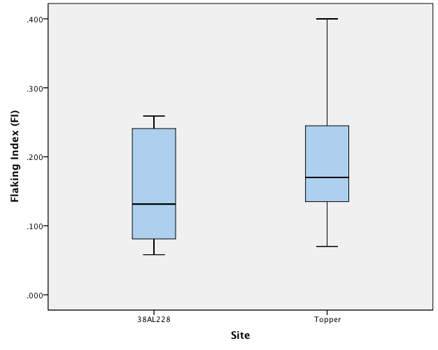
Figure 23. Boxplot of FI for bifaces at 38AL228 and Topper Hillside Area B.

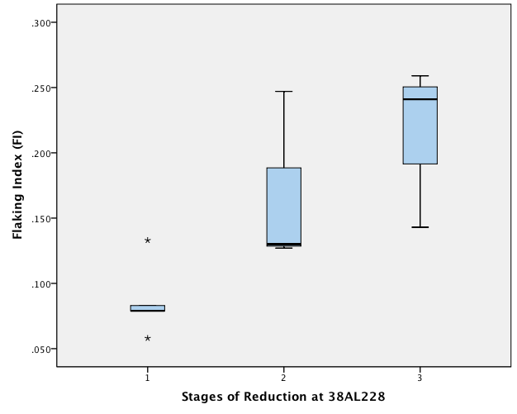
Figure 24. Boxplot of FI and stage of reduction (1=early, 2=middle, 3=late) for 38AL228 bifaces

Cores

An evaluation of the relative frequency and the Fisher’s Exact tests performed on the cores of both sites suggest that there are significant differences in core type frequencies between Topper and 38AL228 (Table 16, Table 20). Statistically significant differences are found when the Topper hillside as a whole and the individual hillside blocks are compared with 38AL228.
There are two major differences to note in the comparison of the 38AL228 and Topper cores (Table 20). First, the relative frequency of amorphous cores is much lower at 38AL228 (13%) than at Topper (87%). Second, the two exhausted formalized conical blade cores recovered at 38AL228 represent an aspect of Clovis technology that, given the large volume of excavated Clovis deposits at Topper, is rare. Blade cores (n=10) have been recovered from the Clovis deposits at Topper, and all but one of them are informal wedge-shaped cores (Smallwood et al. 2013).

Table 20. Relative frequencies of Clovis core types, 38AL228 and Topper.
Core Type | 38AL228 |  |  | Topper Hillside A |  | Topper Hillside B |  | Topper Hillside C |  | Topper Totals
Core Type | Count | % |  | Count | % | Count | % | Count | % | Count | %
Blade, conical | 2 | 25% |  | 1 | 2% | 0† | 0% | 0 | 0% | 1 | 1%
Blade, wedge-shaped | 2 | 25% |  | 2 | 4% | 5† | 10% | 2 | 33% | 9 | 9%
Core Tablet Flake | 3 | 38% |  | 2 | 4% | 1† | 2% | 0 | 0% | 3 | 3%
Amorphous | 1 | 13% |  | 41 | 89% | 43† | 88% | 4 | 66% | 88 | 87%
Totals | 8 |  |  | 46 |  | 49† |  | 6 |  | 101
† Data from Smallwood 2011

Blades

When comparing the frequencies of all artifact types in the Clovis assemblages, there are significant differences between 38AL338 and each of the Hillside Areas at Topper. The Z-score standardized Chi-square residuals indicate that blade frequency is the variable that is responsible for the significant difference (Table 16). The seven Clovis blades recovered at 38AL228 represent 18% of the Clovis lithic assemblage, while at Topper they collectively represent 15%. However, Hillside Area C of Topper has been identified as a possible blade-focused activity area and, though it is the smallest of the excavation blocks, contains 78% of all Topper blades (Smallwood et al. 2013). When Area C is excluded from the Topper sample, blade frequency at 38AL228 is considerably higher than at Hillside Area A and Hillside Area B of Topper (Table 15). Likewise, when the 38AL228 blades are compared with only Hillside Area C at Topper, significant differences are identified. Morphological and metric data that allow for attribute-based comparisons to the Topper blades are found in Table 21.

Table 21. Clovis Blades at 38AL228.
FS # | Max Length (mm) | Curvature | Platform Width (mm) | Platform Thickness (mm) | Platform Type | Platform Angle (°) | Bulb of Force | Cross- Section
13 | 65.5 | Straight | 28.8 | 13.3 | Flat | 110 | Diffuse | Triangular
50† | 60.8 | Straight | NA | NA | NA | NA | Diffuse | Irregular
66 | 78.5 | Slight | 21.3 | 8.4 | Flat | 95 | Diffuse | Triangular
90 | 74.2 | Straight | 10.7 | 8.7 | Flat | 90 | Diffuse | Trapezoidal
1078 | 70.2 | Curved | 22.6 | 8.9 | Abraded | 90 | Prominent | Irregular
1088** | 47.5 | Curved | 6.8 | 3.5 | Flat | 115 | Diffuse | Triangular
1149 | 45.2* | Straight | 25.4 | 9.3 | Flat | 95 | Prominent | Trapezoidal
Platform angle measured in 5° increments
* Incomplete, terminating at non-siliceous inclusion
** Utilized blade
† Crested blade, platform broken

Flake Tools

The relative frequency of flake tools at 38AL228 (29%) is essentially identical to Hillside Areas A and B (both 29%), and similar to that of the entire Topper Hillside (27%) (Table 15). Similar tool types have been documented at Topper, which has been classified as a multi-functional campsite (Smallwood 2010). The presence, types, and frequency of flake tools at 38AL228 suggest that it, too, served as a multi-functional site during Clovis times (Table 22).
Table 22. Comparison of Clovis flake tool types, 38AL228 and Topper.
Flake Tool Type | 38AL228 |  |  | Topper Hillside A |  | Topper Hillside B |  | Topper Hillside C |  | Topper Totals
Flake Tool Type | Count | % |  | Count | % | Count | % | Count | % | Count | %
Endscraper | 2 | 22% |  | 5 | 15% | 7 | 17% | 1 | 8% | 13 | 15%
Sidescraper | 2 | 22% |  | 5 | 15% | 10 | 24% | 8 | 67% | 23 | 26%
Denticulate | 1 | 11% |  | 2 | 6% | 5 | 12% | 3 | 25% | 10 | 12%
Scraper/Plane | 0 | 0% |  | 3 | 9% | 3 | 7% | 0 | 0% | 6 | 7%
Spokeshave | 0 | 0% |  | 1 | 3% | 0 | 0% | 0 | 0% | 1 | 1%
Graver | 0 | 0% |  | 0 | 0% | 1 | 2% | 0 | 0% | 1 | 1%
Modified Flake * | 4* | 44% |  | 18 | 53% | 15 | 37% | 0 | 0% | 33 | 38%
Totals | 9 |  |  | 34 |  | 41 |  | 12 |  | 87
* Includes utilized flakes and indeterminate tools

Discussion

The analysis of the Clovis lithic assemblage at 38AL228 and its comparison to the Clovis lithic assemblage from Topper was conducted to determine if differences can be observed between the two sites based upon proximity to the source of raw material. As no lithic raw material sources have been identified on the landform where 38AL228 is located, stone tools, cores, and lithic manufacturing debris found at the site suggest that raw material was transported to the site from chert sources located across Smith Lake Creek. Considering that movement of toolstone to 38AL228 from the source location would require extra energy expenditure, it can be hypothesized that initial reduction may have already occurred at the point of acquisition and lithic manufacturing at 38AL228 would differ from lithic manufacturing at sites located at the raw material source, such as Topper.
The comparison of the 38AL228 and Topper Clovis biface assemblages indicates that all stages of lithic reduction occurred at 38AL228 in frequencies that are not statistically different than at Topper (Tables 15, 16, 17). The expectation that later-stage bifaces would exist in greater proportions at 38AL228 than at Topper is not met. In fact, the 38AL228 bifaces tend to exhibit an earlier position in the reduction continuum than those from Topper (Figure 23). The fact that no natural outcrop of chert is located on the landform suggests that raw material used to produce bifaces was imported in either large spall or nodule form and all stages of production occurred at 38AL228 in similar proportions to areas where raw material was readily available.
The most noticeable differences observed between the 38AL228 and Topper Clovis lithic assemblages involve a) the frequency and types of core technologies and b) the relative frequency of blades (Tables 15, 16). Cores demonstrating blade technology (including blade core tablet flakes) represent 87% of the total cores at 38AL228, while they only account for 13% at Topper. The recovery of two exhausted conical blade cores from the limited testing at 38AL228 is surprising and open to interpretation. Conical blade cores represent a more difficult technology compared to wedge-shaped blade cores or informal flake cores and require a large piece of raw material devoid of flaws or inclusions (Bradley et al. 2010:20). The nature of Allendale chert, with its tendency to contain non-silicified inclusions, limits the probability of encountering a large chert nodule suitable for conical blade cores. Their disproportionate relative frequency among all cores at 38AL228 (25%) compared to Topper (1%) suggest that these high-quality blade cores were selectively chosen for transport into the site after initial reduction at the raw material source. This would have reduced the risk of transporting raw material that may not have been sufficient for blade manufacture. The fact that both conical blade cores are almost completely exhausted and tablet flakes were removed to rejuvenate the core platform suggest that high quality material was valued, even in areas where chert is abundant.
The dramatic difference in Clovis amorphous cores seen at 38AL228 (n=1) (13%) and Topper (n= 88) (87%) support the assumption that chert nodules and potential cores were selectively imported into 38AL228 (Tables 15, 20). Again, this suggests that initial core testing and reduction were occurring at the point of acquisition and efforts were made to minimize the transport of low-quality or unusable raw material into the site. The discrepancy, however, may be a product of a limited sample or sampling bias, as amorphous cores from mixed deposits could not be reliably identified as Clovis.
Clovis blade frequency at 38AL228 is not statistically different than at Topper. However, when the blade-focused activity area (Hillside Area C) is removed from the sample, it is clear that blades represent a much greater proportion of the Clovis assemblage at 38AL228 (18%) than Hillside Area A (3%) and Hillside Area B (4%) at Topper (Smallwood et al. 2013). Morphologically, the 38AL228 Clovis blades generally exhibit the same qualities seen in Clovis blades at Topper. The primary characteristic that distinguishes Topper Clovis blades from traditional Clovis blades is that they exhibit a lesser degree of curvature (Sain 2010a, 2010b:137; Sain and Goodyear 2012:51; Steffy and Goodyear 2003:148). Of these seven blades from 38AL228, five have very little or no curvature. The two blades that have significant curvature are morphologically different than the others in several ways (Figure A-10). FS-1088 is the smallest of the complete blades and is the only one which has evidence of modification. FS-1078 is likely a failed removal from a wedge-shaped blade core recovered from the same provenience (FS-1063). It is irregular compared to other Clovis blades from 38AL228, with prepared platforms on both the proximal and distal end. Its morphology suggests that it may be a blade core fragment instead of a true blade.
Although the sample of flake tools recovered from the 5 m² of secure Clovis context at 38AL228 is clearly too small to make definitive statements about differences in site function between the two sites, the types of artifacts and their relative frequencies can provide useful preliminary insights into possible differences between sites. The presence, types, and frequency of flake tools at 38AL228 suggest that it served as a multi-functional campsite during Clovis times in that non-quarry related activities were occurring to some degree (Andrefsky 1994, 2005; Lewenstein 1987). The recovery of two Clovis endscrapers, in addition to a number of blades, suggests that hide processing may have been occurring at the site (Andrefsky 2005:205; Stanford 1973). Denticulated flake tools are not traditionally found in Clovis assemblages, although a number have been recovered from Clovis deposits at the Topper site (Smallwood 2011; Smallwood et al. 2013; Steffy and Goodyear 2006). A single denticulated sidescraper was recovered at 38AL228 from the same context as other Clovis diagnostics which is morphologically similar to the denticulates from Topper. It is not abraded for hafting and has a cortical dorsal surface likely for hand-held use (Smallwood et al. 2013). These high backed, denticulated flake tools were likely used for plant processing at the Allendale quarries (Goodyear et al. 2007).
The intentional transport of raw material to 38AL228 represents an economic burden when considering the ubiquity of chert outcrops within the Allendale quarries, suggesting that 38AL228 was possibly desirable for other purposes and the costs of moving stone to the site were outweighed by the potential benefits. Gardner’s (1977) model suggests the movement of portable pieces of chert from the original source location to lithic reduction stations that are generally level and closer to the nearest water source (Carr et al. 2013). The location of 38AL228 at the junction of a creek and floodplain may have influenced the decision to transport raw material from less desirable locations. This research did not identify significant differences in biface portability, as measured by stage of production and FI, between Topper and 38AL228. However, the evidence from 38AL228 demonstrates portability in core technology. Initial core testing and reduction were occurring at the point of acquisition and efforts were made to minimize the transport of low-quality or unusable raw material into the site.

Chapter V:
Summary and Conclusions

The first goal of this thesis was to report on the test excavations that occurred from 2010–2012 at 38AL228, a quarry related site in Allendale County, South Carolina. The testing identified prehistoric cultural deposits ranging from the Woodland through the Paleoindian period in both mixed and unmixed contexts. The second goal was to isolate the Clovis lithic assemblage at 38AL228 for comparison to the Clovis lithic assemblage at Topper (38AL23), a quarry related site located approximately 2.5 kilometers to the south. The purpose of the comparative analysis was to determine if and how lithic manufacturing at sites adjacent to a raw material source, such as Topper, differs from lithic manufacturing at sites removed from the raw material source, such as 38AL228.
The comparisons between the Clovis assemblages at 38AL228 and Topper are framed around the concept of differential lithic signatures at “interrelated but functionally different” sites within a lithic quarry region as developed by Gardner (1974, 1977:257) for the Flint Run Quarry Complex. The results of this analysis demonstrate differences in certain aspects of lithic manufacturing at 38AL228 and Topper and no recognizable differences in other aspects. It was expected that as the distance from the raw material source increases, biface manufacture becomes skewed towards the later stages of production. This trend has been effectively demonstrated at the intra-site level within the Allendale chert quarries (Miller and Smallwood 2012; Smallwood et al. 2013). However, comparisons between bifacial technology at Topper and 38AL228 do not follow this pattern. The expected differences in the biface reduction continuum are not seen at 38AL228, where all stages are represented proportionally to their distribution at Topper. The fact that no natural outcrop of chert is located on the landform suggests that raw material was imported in large spall or nodule form and all stages of reduction occurred at 38AL228.
Distance from the source of raw material may, however, be a factor in the variability seen between non-bifacial aspects of Clovis lithic technology at 38AL228 and Topper. Blade and blade core technology at 38AL228 represents a significantly larger proportion of the Clovis assemblage at 38AL228 than at Topper and includes formalized blade cores not commonly recovered at Clovis sites in the Allendale chert quarries. Non-bifacial Clovis tools represent a similar proportion of the total Clovis assemblage at both 38AL228 and Topper.
The purpose in framing the research question around Gardner’s model is not to place 38AL228 and Topper into one of the three quarry related site types, as specific site types often fail to fully account for the variability in the archaeological record. While a variety of environmental and behavioral variables undoubtedly influenced Paleoindian use of the Allendale chert quarries, this study simply borrows the conceptual premise that differences in lithic signatures might be partially explained by distance from the raw material source. As the acquisition of quality, cryptocrystalline chert was the primary factor in exploitation of both the Allendale and Flint Run quarries, it is sensible to use distance from the raw material source as the central variable to frame the evaluation of quarry related sites. While the types of sites in Gardner’s model may not be suited to fully classify the complex archaeological record of the Allendale chert quarries, the concept of differential lithic signatures based on distance from raw material source can still be useful in organizing archaeological data from a wide range of quarry related sites. The evaluation of Clovis lithic assemblage variability at quarry related sites is important in that few have been documented and reported.
Due to the limited sample of Clovis artifacts recovered at 38AL228, the findings of these analyses should be considered preliminary. Additional excavations at 38AL228 are necessary in order to secure a large enough sample to fully evaluate these results. Area C showed the only instance of relatively undisturbed Clovis deposits and presents the best known opportunity for future block excavations. In addition, systematic sampling of the area to identify the extent of the Clovis deposits would perhaps introduce additional areas to be examined.

List of References

Adovasio, James M., J. Donahue, David R. Pedler, and Robert Stuckenrath
1998 Two Decades of Debate on Meadowcroft Rockshelter. North American Anthropologist 19:317-341.

Ahler, Stanley A.
1989 Mass Analysis of Flaking Debris: Study the Forest Rather than the Trees.
In Alternative Approaches to Lithic Analysis, edited by Donald O. Henry and George H. Odell. Archaeological Papers of the American Anthropological Association Number 1, pp. 85-118.

Anderson, David G.
1979 Prehistoric Selection for Thermal Alteration: Tests of a Model Employing Southeastern Archaeological Materials. Midcontinental Journal of Archaeology 4:221-254.

1985 Middle Woodland Societies on the Lower South Atlantic Slope: A View from Georgia and South Carolina. Early Georgia 13:29-66.

1990 The Paleoindian Colonization of Eastern North America: A View from the Southeastern United States. In Early Paleoindian Economies of Eastern North America, edited by Kenneth B. Tankersley and Barry L. Isaac, pp. 163-216. Research in Economic Anthropology, Supplement 5. Greenwich, Connecticut: JAI Press.

1994 The Savannah River Chiefdoms: Political Change in the Late Prehistoric Southeast. University of Alabama Press, Tuscaloosa, Alabama.

1995 Recent Advances and Paleoindian and Early Archaic Period Research in the Southeastern United States. Archaeology of Eastern North America 23:145-176.

1996a Models of Paleoindian and Early Archaic Settlement in the Lower Southeast. In The Paleoindian and Early Archaic Southeast, edited by David G. Anderson and Kenneth E. Sassaman, pp. 29-57. University of Alabama Press: Tuscaloosa.

1996b Chiefly Cycling and Large–Scale Abandonments as Viewed from the Savannah River Basin. In Political Structure and Change in the Prehistoric Southeastern United States, edited by John F. Scarry, pp. 150–191. University Presses of Florida.

2001 Climate and Culture Change in Prehistoric and Early Historic Eastern North America. Archaeology of Eastern North America 29:143-186.

2005 Pleistocene Human Occupation of the Southeastern United States: Research Directions for the Early 21st Century. In Paleoamerican Origins: Beyond Clovis, edited by Bradley T. Lepper, Robson Bonnichsen, Dennis Stanford, and Michael R. Waters, pp. 29-42. College Station: Texas A&M University Press.

2010 The End of the Southeastern Archaic: Regional Interaction and Archaeological Interpretation. In Trend, Tradition, and Turmoil: What Happened to the Southeastern Archaic? edited by David Hurst Thomas and Matthew C. Sanger, pp 273-302. Proceedings of the Third Caldwell Conference, St. Catherines Island, Georgia, May 9–11, 2008. Anthropological Papers of the American Museum of Natural History, New York, NY.

2013 Paleoindian Archaeology in Eastern North America: Current Approaches and Future Directions. In In the Eastern Fluted Point Tradition, edited by Joseph A. M. Gingerich, pp. 371-403. University of Utah Press, Salt Lake City

Anderson, David G., Charles E. Cantley, and A. Lee Novick
1982 The Mattassee Lake Sites: Archaeological Investigations Along the Lower Santee River in the Coastal Plain of South Carolina. Interagency Archaeological Services, National Park Service, Special Bulletin 1, Commonwealth Associates, Inc., Jackson, Michigan.

Anderson, David G., and J. Christopher Gillam
2000 Paleoindian Colonization of the Americas: Implications from an
Examination of Physiography, Demography, and Artifact Distribution. American
Antiquity 65(1):43–66.

Anderson, David G., David J. Hally, and James L. Rudolph
1986 The Mississippian Occupation of the Savannah River Valley. Southeastern Archaeology 5(1):32-51.

Anderson, David G., and Glenn T. Hanson
1988 Early Archaic Settlement in the Southeastern United States: A Case Study
from the Savannah River Valley. American Antiquity 53:262-286.

Anderson, David G., and J.W. Joseph
1988 Prehistory and History along the Upper Savannah River: Technical Synthesis of Cultural Resource Investigations, Richard B. Russell Multiple Resource Area. Russell Papers. Interagency Archaeological Services, National Park Service, Atlanta.

Anderson, David G., R. Jerald Ledbetter, and Lisa D. O’Steen.
1990 Paleoindian Period Archaeology of Georgia. Georgia Archaeological Research Design Paper 6. Laboratory of Archaeology Series Report 28. University of Georgia: Athens.

Anderson, David G., Lisa D. O'Steen, and Kenneth E. Sassaman
1996 Environmental and Chronological Considerations. In The Paleoindian and
Early Archaic Southeast, edited by David G. Anderson and Kenneth E. Sassaman, pp. 3-15. University of Alabama Press: Tuscaloosa.

Anderson, David G., and Kenneth E. Sassaman
1996 Modeling Paleoindian and Early Archaic Settlement in the Southeast: A Historical Perspective. In The Paleoindian and Early Archaic Southeast, edited by David G. Anderson and Kenneth E. Sassaman, pp. 16-29. University of Alabama Press: Tuscaloosa.

2012 Recent Developments in Southeastern Archaeology: From Colonization to Complexity. Society for American Archaeology Press, Washington, D.C.

Anderson, David G., and J. Schuldenrein
1983 Early Archaic Settlement on the Southeastern Atlantic Slope: A View from the Rucker's Bottom Site, Elbert County, Georgia. North American Archaeologist 4: 177-210.

Andrefsky, William, Jr.
1994 Raw Material Variability and the Organization of Technology. American
Antiquity 59(21-34).

2005 Lithics: Macroscopic Approaches to Analysis. Cambridge: Cambridge
University Press.

2009 The Analysis of Stone Tool Procurement, Production, and Maintenance. Journal of Archaeological Research 17:65-103.

Beck, Charlotte, and George T. Jones
2010 Clovis and Western Stemmed: Population Migration and the Meeting of Two Technologies. American Antiquity 75:81–116.

Binford, Lewis R.
1980 Willow Smoke and Dogs' Tails: Hunter-Gatherer Settlement Systems and Archaeological Site Formation. American Antiquity 45(1): 4-20.

Blanton, Dennis B., and Kenneth E. Sassaman
1989 Pattern and Process in the Middle Archaic Period of South Carolina. In Studies in South Carolina Archaeology in Honor of Dr. Robert L. Stephenson, edited by Albert C. Goodyear and Glen T. Hanson, pp. 53-72. Anthropological Studies 9. South Carolina Institute of Archaeology and Anthropology, University of South Carolina, Columbia.

Blanton, Dennis B., Christopher T. Espenshade, and Paul E. Brockington, Jr.
1986 An Archaeological Study of 38SU83: A Yadkin Phase Site in the Upper Coastal Plain of South Carolina. Garrow and Associates, Inc. Atlanta.

Bradbury, Andrew P., and Phillip J. Carr
1999 Examining Stage and Continuum Model of Flake Debris Analysis: An Experimental Approach. Journal of Archaeological Science 26:105-116.

Bradley, Bruce
1982 Lithic Typology and Technology at the Agate Basin Site. In The Agate Basin Site, edited by. George C. Frison and Dennis Stanford, pp. 181-208. Academic Press, New York.

Bradley, Bruce A., Michael B. Collins, and Andrew Hemmings
2010 Clovis Technology. International Monographs in Prehistory. Ann Arbor, Michigan.

Bradley, Bruce A., and Dennis Stanford
2002 Ocean Trails and Prairie Paths? Thoughts about Clovis Origins. In The
First Americans: The Pleistocene Colonization of the New World. Editor Nina G.
Jablonski, pp. 255–271, Vol. 27. San Francisco: Memoir of the California
Academy of Sciences

2004 The North Atlantic Ice-Edge Corridor: A Possible Paleolithic Route to the New World. World Archaeology 36(4):459-478.

Brooks, Mark J., Kenneth E. Sassaman, and Glen T. Hanson
1990 Environmental Background and Models. In Native American Prehistory of the Middle Savannah River Valley: A Synthesis of Archaeological Investigations on the Savannah River Site, Aiken and Barnwell Counties, South Carolina, by Kenneth E. Sassaman, Mark J. Brooks, Glen T. Hanson, and David G. Anderson pp. 19-64. Savannah River Archaeological Research Papers 1. South Carolina Institute of Archaeology and Anthropology, University of South Carolina, Columbia.

Brooks, Mark J., Peter A. Stone, Donald J. Colquhoun, Janice G. Brown, and Kathy B. Steele
1986 Geoarchaeological Research in the Coastal Plain Portion of the Savannah River Valley. Geoarchaeology 1:293-307.

Broster, John B., and Mark R. Norton
1993 The Carson-Conn-Short Site (40BN190): An Extensive Clovis Habitation in Benton County, Tennessee. Current Research in the Pleistocene 10:3-4.

1996 Recent Paleoindian Research in Tennessee. In The Paleoindian and Early Archaic Southeast, edited by David G. Anderson and Kenneth Sassaman, pp. 288-297. University of Alabama Press, Tuscaloosa.

Broyles, Bettye J.
1971 Second Preliminary Report: The St. Albans Site, Kanawha Valley, West Virginia. Report of Archeological Investigations 3. West Virginia Geological and Economic Survey, Charleston.

Caldwell, Joseph R.
1958 Trend and Tradition in the Prehistory of the Eastern United States. Memoirs of the American Anthropological Association, No. 88, Menasha, Wisconsin.

Callahan, Erret
1979 The Basics of Biface Knapping in the Eastern Fluted Point Tradition.
Archaeology of Eastern North America 7:1-180.

Cambron, James W., and David C. Hulse
1964 Handbook of Alabama Archaeology, Part I, Point Types. Birmingham,
Alabama: Archaeological Research Association of Alabama.

Carr, Kurt W., R. Michael Stewart, Dennis Stanford, and Michael Frank
2013 The Flint Run Complex: A Quarry related Paleoindian Complex in Northern Virginia. In In The Eastern Fluted Point Tradition, edited by Joseph A. M. Gingerich, pp. 156-217. University of Utah Press, Salt Lake City, Utah.

Chapman, Jefferson
1976 The Archaic Period in the Lower Tennessee River Valley: The Radiocarbon Dates. Tennessee Anthropologist 1:1-12.

1985 Archaeology and the Archaic Period in the Southern Ridge and Valley Province. In Structure and Process in Southeastern Archaeology, edited by Roy S. Dickens and H. Trawick Ward, pp. 137-153. University of Alabama Press, Tuscaloosa.

Claassen, Cheryl P.
1996 A Consideration of the Social Organization of the Shell Mound Archaic. In Archaeology of the Mid-Holocene Southeast, edited by Kenneth E. Sassaman and David G. Anderson, pp. 235-258. University Press of Florida, Gainesville.

Claggett, Stephen R., and John Cable
1982 The Haw River Site: Archaeological Investigations at Two Stratified Sites in the North Carolina Piedmont. Report R-2386. Jackson, Michigan: Commonwealth Associates.

Clarkson, Chris
2002 An Index of Invasiveness for the Measurement of Unifacial and Bifacial Retouch: A Theoretical, Experimental, and Archaeological Verification. Journal of Archaeological Science 29:65-75.

Coe, Joffre
1964 The Formative Cultures of the Carolina Piedmont. Transactions of the
American Philosophical Society 54(5):1-130.

Collins, Michael B.
1999 Clovis Blade Technology. Austin: University of Texas Press.

Crabtree, Don E.
1972 An Introduction of Flintworking. Occasional Papers of the Idaho State University Museum, No. 28, Pocatello.

Daniel, I. Randolph, Jr.
1996 Raw Material Availability and Early Archaic Settlement in the Southeast.
In The Paleoindian and Early Archaic Southeast, edited by David G. Anderson and Ken Sassaman, ed. Tuscaloosa: University of Alabama Press.

Delcourt, Hazel R., Delcourt, Paul A.
1985 Quaternary Palynology and Vegetational History of the Southeastern United States. In Pollen Records of the Late-Quaternary North American Sediments, edited by Bryant, V.M., Holloway, R.G. American Association of Stratigraphic Palynologist Foundation, pp. 1-37.

Delcourt, Paul A., Delcourt, Hazel R.
1983 Late-Quaternary Vegetational Dynamics and Community Stability Reconsidered. Quaternary Research 19:265-271.

DePratter, Chester B.
1976 The Refuge Phase on the Coastal Plain of Georgia. Early Georgia 4:1-15.

1979 Ceramics. In The Anthropology of St. Catherine’s Island. The Refuge-Deptford Mortuary Complex, edited by. David H. Thomas and Clark S. Larsen, pp.109-132. Anthropological Papers of the American Museum of Natural History.

1983 Late Prehistoric and Early Historic Chiefdoms in the Southeastern United States. Ph.D. Dissertation, University of Georgia.

Dincauze, Dena F.
1993 Fluted Points in the Eastern Forests. In From Kostenki to Clovis: Upper Paleolithic Paleo-Indian Adaptations, edited by. Olga Soffer and N.D. Praslov, pp. 279-292. New York: Plenum.

Eppinette, Robert T.
1993 Soil Survey of Allendale County, South Carolina. Washington, D.C.:
United States Department of Agriculture.

Fiedel, Stuart J.
2001 What Happened in the Early Woodland? Archaeology of Eastern North America 29:101-142.

Frison, George C., and Bruce Bradley
1999 The Fenn Clovis Cache. Santa Fe: One Horse Land and Cattle Co.

Frison, George C., and Dennis J. Stanford
1982 The Agate Basin Site: A Record of the Paleoindian Occupation of the Northwestern High Plains. Academic Press: New York.

Gardner, William M.
1974 The Flint Run Paleoindian Complex: A Preliminary Report 1971 through 1973 Seasons. Occasional Paper No. 1. Washington, D.C.: Archaeology Laboratory, Catholic University of America.

1977 Flint Run Paleoindian Complex and Its Implications for Eastern North
America Prehistory. Annals of the New York Academy of Sciences 288:251-263.

1983 Stop me if You’ve Heard This One Before: The Flint Run Paleoindian Complex Revisited. Archaeology of Eastern North America 11:49-59.

Goodyear, Albert C. III
1974 The Brand Site: A Techno-functional Study of a Dalton Site in Northeast Arkansas. Research Series 7, Arkansas Archaeological Survey, Fayetteville.

1982 The Chronological Position of the Dalton Horizon in the Southeastern United States. American Antiquity 47:382-395.

1989 A Hypothesis for the Use of Cryptocrystalline Raw Materials Among
Paleoindian Groups of North America. In Eastern Paleoindian Lithic Resource
Use, edited by Christopher Ellis and J.C. Lothrop, Boulder, Colorado:
Westview.

1999 The Early Holocene Occupation of the Southeastern United States: A Geoarchaeological Summary. In Ice Age Peoples of North America: Environments, Origins, and Adaptations of the First Americans, edited by Robson Bonnichsen and Karen L. Turnmire, pp. 432-481. Corvallis: Oregon State University Press.

1995 Update on the Big Pine Tree Site and the 1996 Allendale Paleoamerican Expedition. PastWatch: 4:10-11. South Carolina Institute of Archaeology and Anthropology.

2005 Evidence for Pre-Clovis sites in the Eastern United States. In Paleoamerican Origins: Beyond Clovis, edited by R. Bonnichsen, B. Bradley, D. Stanford, and M. Waters, pp. 103-112. Center for the Study of the First Americans, Texas A&M University.

Goodyear, Albert C., and Tommy Charles
1984 An Archaeological Survey of Chert Quarries in Western Allendale
County, South Carolina. Research Manuscript Series 195. Columbia: South
Carolina Institute of Archaeology and Anthropology.

Goodyear, Albert C. III, D. Shane Miller, and Ashley M. Smallwood
2007 Introducing Clovis at the Topper Site, 38AL23, Allendale County, South
Carolina. Paper presented at the 72nd Annual Meeting of the Society for
American Archaeology, April 27, 2007, Austin, Texas.

Goodyear, Albert C. III, and Kenn Steffy
2003 Evidence of a Clovis Occupation at the Topper Site, 38AL23, Allendale
County, South Carolina. Current Research in the Pleistocene 20:23-25.

Grayson, Donald K.
1991 Late Pleistocene Mammalian Extinctions in North America: Taxonomy, Chronology, and Explanations. Journal of World Prehistory 5:193-231.

Griffin, James B.
1952 (editor) Archaeology of the Eastern United States. Chicago: University of Chicago Press.

1967 Eastern North American Archaeology: A Summary. Science 156:175-191.

Gunn, Joel D.
1997 A Framework for the Middle-Late Holocene Transition: Astronomical and Geophysical Conditions. Southeastern Archaeology 16:134-151.

Hanson, Glen T., and Chester B. DePratter
1985 The Early and Middle Woodland Periods in the Savannah River Valley. Paper presented at the 42nd Annual Meeting of the Southeastern Archaeological Conference, Birmingham.

Hollenbach, Kandace D.
2007 Gathering in the Late Paleoindian Period: Archaeobotanical Remains from Dust Cave, Alabama. In Foragers of the Terminal Pleistocene in North America. Edited by Renee B. Walker and Boyce N. Driskell, pp. 132-147. University of Nebraska Press: Lincoln.

Johnson, Jay K.
1981 Lithic Procurement and Utilization Trajectories: Analysis, Yellow Creek Nuclear Power Plant Site, Tishomongo County, Mississippi. Yellow Creek Archaeological Papers Volume 2. Tennessee Valley Publications in Anthropology, No. 28.

Justice, Noel
1995 Stone Age Spear and Arrow Points of the Midcontinental and Eastern
United States: A Modern Survey and Reference. Bloomington: Indiana University
Press.

Keel, Bennie C.
1976 Cherokee Archaeology: A Study of the Appalachian Summit. University of Tennessee Press, Knoxville.

Kelly, Robert L., and Todd, Lawrence C.
1988 Coming into the Country: Early Paleoindian Hunting and Mobility.
American Antiquity 53(2):231–244.

Kidder, Tristram R.
2006 Climate Change and the Archaic to Woodland Transition (3000-2500 Cal. B.P.) in the Mississippi River Basin. American Antiquity 71(2):195-231

2010 Trend, Tradition, and Transition at the End of the Archaic. In Trend, Tradition, And Turmoil: What Happened to the Southeastern Archaic?, edited by David Hurst Thomas and Matthew C. Sanger, pp. 23-41. American Museum of Natural History, New York.

King, Adam
2003 The Sleepy Hollow Phase in the Aiken Plateau: Pisgah Pottery in the South Carolina Coastal Plain. Unpublished paper presented at the 60th Annual Meeting of the Southeastern Archaeological Conference, Charlotte, NC.

King, Megan
2012 The Distribution of Paleoindian Debitage from the Pleistocene Terrace at the Topper Site: An Evaluation of a Possible Pre-Clovis Occupation (38AL23). Unpublished MA Thesis. University of Tennessee, Knoxville.

Lewenstein, S.M.
1987 Stone Tool Use at Cerros: The Ethnoarchaeological and Use-wear Evidence. Austin: University of Texas Press.

Marquardt, William H.
2010 Mounds, Middens, and Rapid Climate Change During the Archaic-Woodland Transition in the Southeastern United States. In Trend, Tradition, And Turmoil: What Happened to the Southeastern Archaic?, edited by David Hurst Thomas and Matthew C. Sanger, pp. 253-272. American Museum of Natural History, New York.

Mayewski, Paul A., Eelco E. Rohling, J. Curt Stager, Wibjorn Karlen, Kirk A. Maasch, L. David Meeker, Eric A. Meyerson, Francoise Gasse, Shirley van Kreveld, Karin Holmgren, Julia Lee-Thorp, Grunhild Rosqvist, Frank Rack, Michael Staubwasser, Ralph R. Schneider, and Eric J. Steig
2004 Holocene Climate Variability. Quaternary Research 62:243-255.

McAvoy, J. M., and L. D. McAvoy, editors
1997 Archaeological Investigations of Site 44SX202, Cactus Hill, Sussex County, Virginia. Virginia Department of Historic Resources, Research Report Series No. 8., Richmond.

McDonald, Jerry N.
2000 An Outline of the Pre-Clovis Archaeology of SV-2, Saltville, Virginia, with Special Attention to a Bone Tool Dated 14,510 yr B.P. Jeffersoniana 9:1–59. Contributions from the Virginia Museum of Natural History, Martinsville.

Meltzer, David J.
1988 Late Pleistocene Human Adaptation in Eastern North America. Journal of World Prehistory 2:1-53.

1993 Is There a Clovis Adaptation? In From Kostenki to Clovis: Upper Paleolithic Paleo-Indian Adaptations, edited by Olga Soffer and N.D. Praslov, pp. 293-310. New York: Plenum.

Michie, James L.
1966 The Taylor Point. The Chesopiean 4:123.

1968 The Brier Creek Lanceolate. The Chesopiean 4 (5-6):76.

1977 The Late Pleistocene Human Occupation of South Carolina. Manuscript on file at the Institute of Archaeology and Anthropology, University of South Carolina.

1990 Bioturbation and Gravity as a Potential Site Formation Process: The Open
Area Site, 38GE261, Georgetown County, South Carolina. South Carolina
Antiquities 22(1-2):27-46.

Miller, D. Shane
2007 Site Formation Processes in an Upland Paleoindian Site: The 2005 - 2007 Topper Firebreak Excavations. Unpublished MA Thesis. University of Tennessee, Knoxville.

2010 Clovis Excavations at Topper 2005-2007: Examining Site Formation Processes at an Upland Paleoindian Site Along the Middle Savannah River. Occasional Papers 1, Southeastern Paleoamerican Survey, South Carolina Institute of Archaeology and Anthropology, University of South Carolina.

Miller, D. Shane, and Joseph A.M. Gingerich
2013 Paleoindian Chronology and the Eastern Fluted Point Tradition. In In The Eastern Fluted Point Tradition, edited by Joseph A. M. Gingerich, pp. 9-37. University of Utah Press, Salt Lake City, Utah.

Miller, D. Shane, and Ashley M. Smallwood
2012 Beyond Stages: Modeling Clovis Biface Production at the Topper Site, South Carolina. In Contemporary Lithic Analysis in the Southeast: Problems, Solutions, and Interpretations, edited by Phillip J. Carr, Andrew P. Bradbury, and Sarah E. Price, pp. 28-41. University of Alabama Press: Tuscaloosa.

Milner, George R., and Richard Jefferies
1998 The Read Archaic Shell Midden in Kentucky. Southeastern Archaeology 17:119–132.

Morrow, Juliet E.
1995 Clovis Projectile Point Manufacture: A Perspective from Ready/Lincoln
Hills Site, 11JY46, Jersey County, Illinois. Midcontinental Journal of
Archaeology 20:167-191.

Morse, Dan F.
1971 The Hawkins Cache: A Significant Dalton Find in Northeast Arkansas. The Arkansas Archaeologist 12(1):9-20.

1973 Dalton Culture in Northeast Arkansas. The Florida Anthropologist 26(63):23-38. Gainesville.

Morse, Dan F., David G. Anderson, and Albert C. Goodyear III
1996 The Pleistocene-Holocene Transition in Eastern North America. In Humans at the End of the Ice Age: The Archaeology of the Pleistocene – Holocene Transition. Interdisciplinary Contributions to Archaeology, edited by Lawrence Guy Straus, Berit Valentin Eriksen, Jon M. Erlandson, and David R. Yesner, pp. 319-338. Plenum Press: New York.

Novick, A. Lee
1978 Prehistoric Lithic Material Sources and Types in South Carolina: A Preliminary Statement. In The First Ten Years of South Carolina Antiquities, edited by W. Neighbors, pp. 422-437. Archaeological Society of South Carolina.

Nystrom, Paul G., Ralph H. Willoughby, and Lucille K. Price
1991 Cretaceous and Tertiary Stratigraphy of the Upper Coastal Plain, South Carolina. In The Geology of the Carolinas: 50th Anniversary Volume, pp. 221-240, edited by JW Horton, Jr., VA Zullo.

Russo, Michael
1996 Southeastern Archaic Mounds. In Archaeology of the Mid-Holocene Southeast, edited by Kenneth E. Sassaman and David G. Anderson, pp.177-199. University Press of Florida, Gainesville.

2010 Shell Rings and Other Settlement Features as Indicators of Cultural Continuity Between the Late Archaic and Woodland Periods of Coastal Florida. In Trend, Tradition, And Turmoil: What Happened to the Southeastern Archaic?, edited by David Hurst Thomas and Matthew C. Sanger, pp. 149-171. American Museum of Natural History, New York.

Sain, Douglas A.
2010a Clovis Blade Technology at the Topper Site (38AL23). Unpublished M.A. thesis, Department of Anthropology, Eastern New Mexico University, Portales.

2010b A Technological Analysis of Clovis Blades from the Topper Site, 38AL23, Allendale County, South Carolina. Current Research in the Pleistocene 27:136-139.

Sain, Douglas A., and Albert C. Goodyear III
2012 A Comparison of Clovis Blade Technologies at the Topper and Big Pine Tree Sites, Allendale County, South Carolina. In Contemporary Lithic Analysis in the Southeast: Problems, Solutions, and Interpretations, edited by Phillip J. Carr, Andrew P. Bradbury, and Sarah E. Price, pp. 42-54. University of Alabama Press: Tuscaloosa.

Sanders, Thomas N.
1988 The Adams Site: A Paleoindian Manufacturing and Habitation Site in Christian County, Kentucky. In Paleoindian and Archaic Research in Kentucky, edited by Charles D. Hockensmith, David Pollack, and Thomas N. Sanders, pp. 1-24. Kentucky Heritage Council, Frankfort

1990 Adams: The Manufacturing of Flaked Stone Tools at a Paleoindian Site in
Western Kentucky. Buffalo, New York: Persimmon.

Sassaman, Kenneth E.
1985 A Preliminary Typological Assessment of MALA Hafted Bifaces from the Pen Point Site, Barnwell County, South Carolina. South Carolina Antiquities 17:1-17.

1990 Introduction to the Prehistory and Archaeological Investigation of the Savannah River Site. In Native American Prehistory of the Middle Savannah River Valley: A Synthesis of Archaeological Investigations on the Savannah River Site, Aiken and Barnwell Counties, South Carolina, by Kenneth E. Sassaman, Mark J. Brooks, Glen T. Hanson, and David G. Anderson pp. 1-16. Savannah River Archaeological Research Papers 1. South Carolina Institute of Archaeology and Anthropology, University of South Carolina, Columbia.

1993 Early Pottery in the Southeast: Tradition and Innovation in Cooking
Technology. Tuscaloosa: University of Alabama Press.

2010a The Eastern Archaic, Historicized. Altamira: Lanham, Maryland.

2010b Getting from the Late Archaic to Early Woodland in Three Middle Valleys
(those being the Savannah, St. Johns, and Tennessee). In Trend, Tradition, And Turmoil: What Happened to the Southeastern Archaic?, edited by David Hurst Thomas and Matthew C. Sanger, pp. 229-234. American Museum of Natural History, New York.

Sassaman, Kenneth E., and David G. Anderson
1990 Typology and Chronology. In Native American Prehistory of the Middle Savannah River Valley: A Synthesis of Archaeological Investigations on the Savannah River Site, Aiken and Barnwell Counties, South Carolina, by Kenneth E. Sassaman, Mark J. Brooks, Glen T. Hanson, and David G. Anderson pp. 143-213. Savannah River Archaeological Research Papers 1. South Carolina Institute of Archaeology and Anthropology, University of South Carolina, Columbia.

1996 Archaeology of the Mid-Holocene Southeast. University Press of Florida,
Gainesville.

Shoberg, Marilyn
2010 Functional Analysis of Stone Tools. In Clovis Technology by Bruce A. Bradley, Michael B. Collins, and Andrew Hemmings, pp. 138-156. International Monographs in Prehistory, Archaeological Series 17.

Shott, Michael J.
1996 Stage versus Continuum in the Debris Assemblage from Production of a Fluted Biface. Lithic Technology 21:6-22.

Smallwood, Ashley M.
2010 Clovis Biface Technology at the Topper Site, South Carolina: Evidence for Variation and Technological Flexibility. Journal of Archaeological Science 37:2413-2425.

2011 Clovis Technology and Settlement in the American Southeast. Unpublished PhD. Dissertation. Department of Anthropology, Texas A&M University, College Station.

2012 Clovis Technology and Settlement in the American Southeast: Using Biface Analysis to Evaluate Dispersal Models. American Antiquity 77(4):689-713.

Smallwood, Ashley M., D. Shane Miller, and Douglas Sain
2013 Topper Site, South Carolina: An Overview of the Clovis Lithic Assemblage from the Topper Hillside. In In The Eastern Fluted Point Tradition, edited by Joseph A. M. Gingerich, pp. 280-298. University of Utah Press, Salt Lake City, Utah.

Smith, Bruce. D.
1986 The Archaeology of the Southeastern United States: From Dalton to deSoto, 10,500-500. Advances in World Archaeology 5:1-88.

Speth, John D., Khori Newlander, Andrew A. White, Ashley K. Lemke, and Lars E. Anderson
2013 Early Paleoindian Big-game Hunting in North America: Provisioning or Politics? Quaternary International 285:111-139.

Stanford, Dennis J.
1973 The Origins of the Thule Culture. Ph.D. dissertation, University of New Mexico, Albuquerque.

Steffy, Kenn, and Albert C. Goodyear
2006 Clovis Macro Blades from the Topper Site, 38AL23, Allendale County, South Carolina. Current Research in the Pleistocene 23:147–49.

Stoltman, James B.
1974 Groton Plantation: An Archaeological Study of a South Carolina Locality. Monograph of the Peabody Museum No.1, Cambridge.

Tankersley, Kenneth B.
2004 The Concept of Clovis and the Peopling of North America. In The Settlement of the American Continent: A Multidisciplinary Approach to Human Biogeography, edited by C. Michael Barton, Geoffrey A. Clark, David R. Yesner, and Georges A. Pearson, pp. 49-63. University of Arizona Press, Tucson.

Thomas, David Hurst
2010 “What Happened to the Southeastern Archaic?”: A Perspective from St. Catherines Island. In Trend, Tradition, And Turmoil: What Happened to the Southeastern Archaic?, edited by David Hurst Thomas and Matthew C. Sanger, pp. 173-197. American Museum of Natural History, New York.

Thompson, Victor D.
2010 The Rhythms of Space-time and the Making of Monuments and Places During the Archaic. In Trend, Tradition, And Turmoil: What Happened to the Southeastern Archaic?, edited by David Hurst Thomas and Matthew C. Sanger, pp. 217-227. American Museum of Natural History, New York.

Thompson, Victor D., and John A. Turck
2009 Adaptive Cycles of Coastal Hunter-Gatherers. American Antiquity 74(2):255-278.

Upchurch, Sam B.
1984 Petrology of Selected Lithic Materials from the South Carolina Coastal
Plain. In An Archaeological Survey of Chert Quarries in Western Allendale
County, South Carolina, by Albert C. Goodyear and Tommy Charles, pp. 125–60.
Research Manuscript Series 195. Columbia: South Carolina Institute of
Archaeology and Anthropology, University of South Carolina.

Walker, Renee B.
2007 Hunting in the Late Paleoindian Period: Faunal Remains from Dust Cave, Alabama. In Foragers of the Terminal Pleistocene in North America, edited by Renee Walker and Boyce N. Driskell, pp. 99-115. Univ. Of Nebraska Press: Lincoln.

Walker, Renee B., and Boyce N. Driskell
2007 Introduction: New Developments in Paleoindian Subsistence Studies. In Foragers of the Terminal Pleistocene in North America, edited by Renee B. Walker and Boyce N. Driskell, pp. ix-xv. University of Nebraska Press: Lincoln.

Walthall, John A.
1998 Rockshelters and Hunter-Gatherer Adaptation to the Pleistocene-Holocene Transition. American Antiquity 63:223-238.

Walthall, John A., and Brad Koldehoff
1998 Hunter-Gatherer Interaction and Alliance Formation: The Cult of the Long Blade. Plains Anthropologist 43:257-273.

Waters, Michael R., Steven L. Forman, Thomas W. Stafford Jr., and John Foss
2009 Geoarchaeological Investigations at the Topper and Big Pine Tree Sites, Allendale County, South Carolina. Journal of Archaeological Science 36:1300-1311.

Waters, Michael R., Charlotte D. Pevny, and David L. Carlsen
2011 Clovis Lithic Technology: Investigations of a Stratified Workshop at the Gault Site, Texas. Texas A&M University Press, College Station.

Watts, William A.
1980 Late-Quaternary Vegetation History at White Pond on the Inner Coastal
Plain of South Carolina, Quaternary Research 13:187-199.

Watts, William A., Eric C. Grimm, and T. C. Hussey
1996 Mid-Holocene Forest History of Florida and Coastal Plain of Georgia and South Carolina. In Archaeology of the Mid-Holocene Southeast, edited by Kenneth E. Sassaman and David G. Anderson, pp. 29-39. University of Florida Press: Gainesville.

Webb, S. David
1981 A Cultural Resources Survey of the Continental Shelf from Cape Hattaras to Key West. Volume 1: Introduction and Physical Environment, pp. I73-I112. Report submitted by Science Applications, Inc., to the Bureau of Land Management.

Wilke, Phillip J., J. Jeffrey Flenniken, and Terry L. Ozbun
1991 Clovis Technology at the Anzick Site, Montana. Journal of California and Great Basin Anthropology 10:3-31.

Wormington, H.M.
1957 Ancient Man in North America. Denver Museum of Natural History, Popular Series, 4th Edition.

Appendices

Appendix A: Artifact Photographs

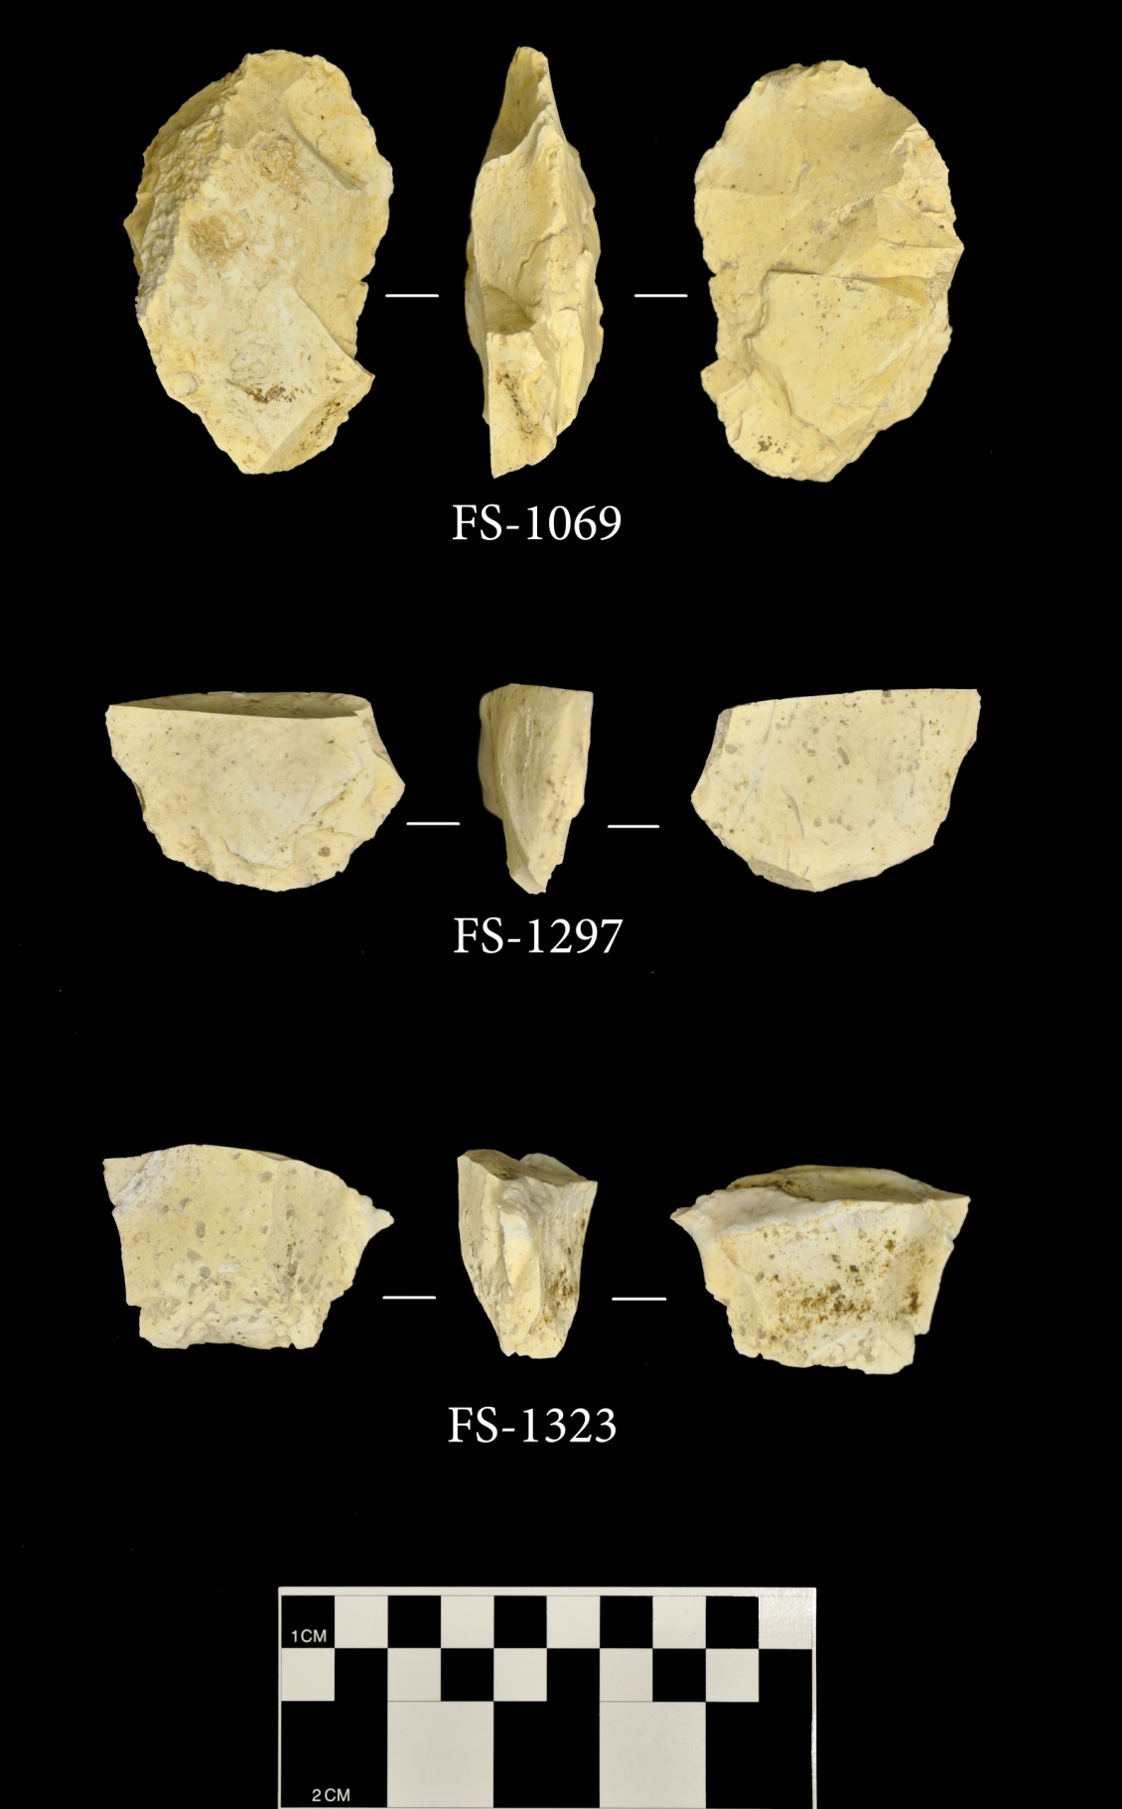

Figure A- 1. Early stage Clovis bifaces.

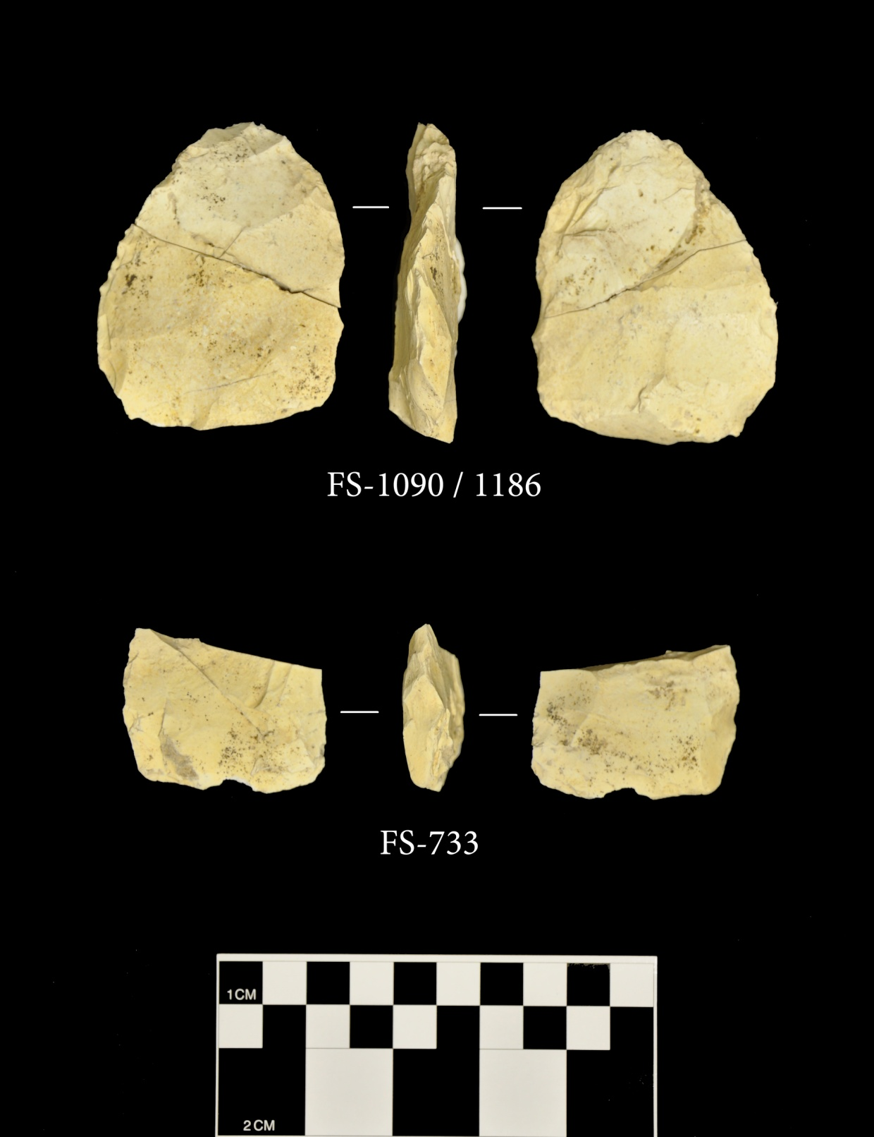

Figure A- 2. Middle stage Clovis bifaces.

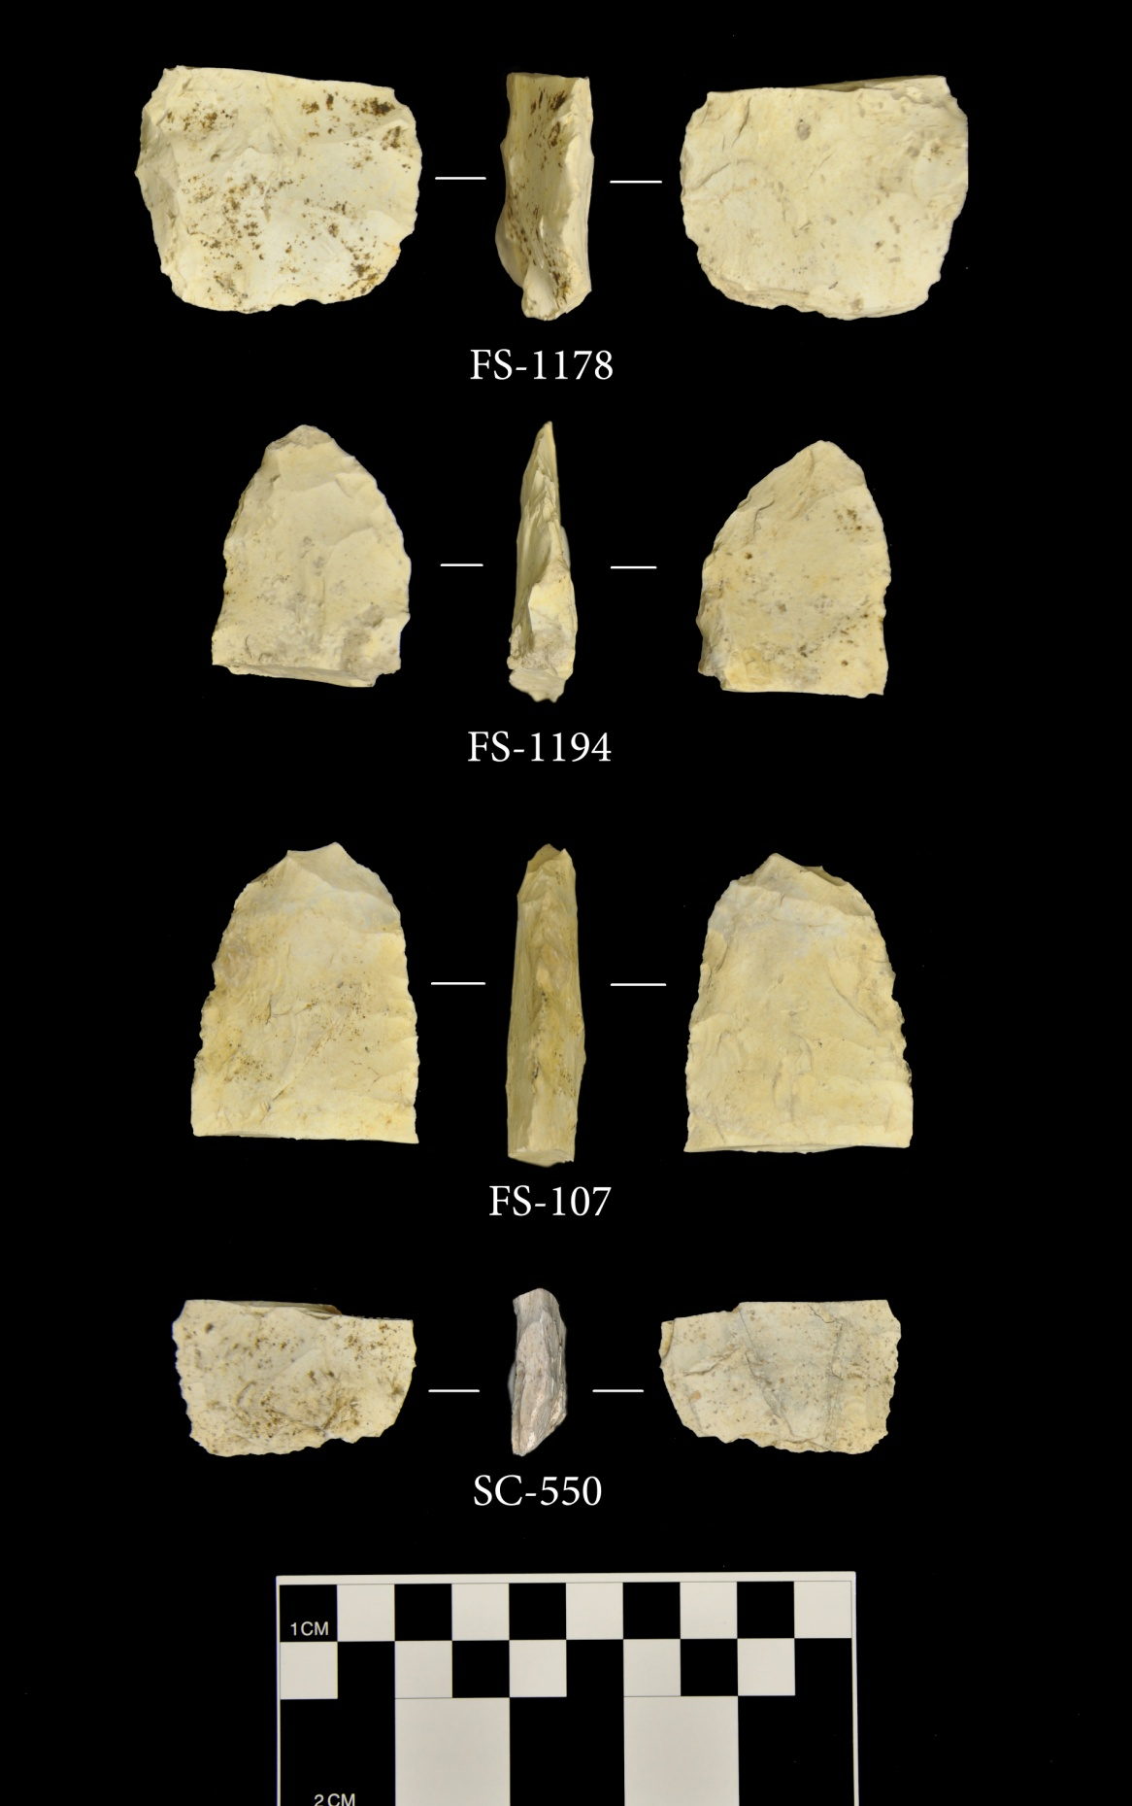

Figure A- 3. Late stage Clovis bifaces.

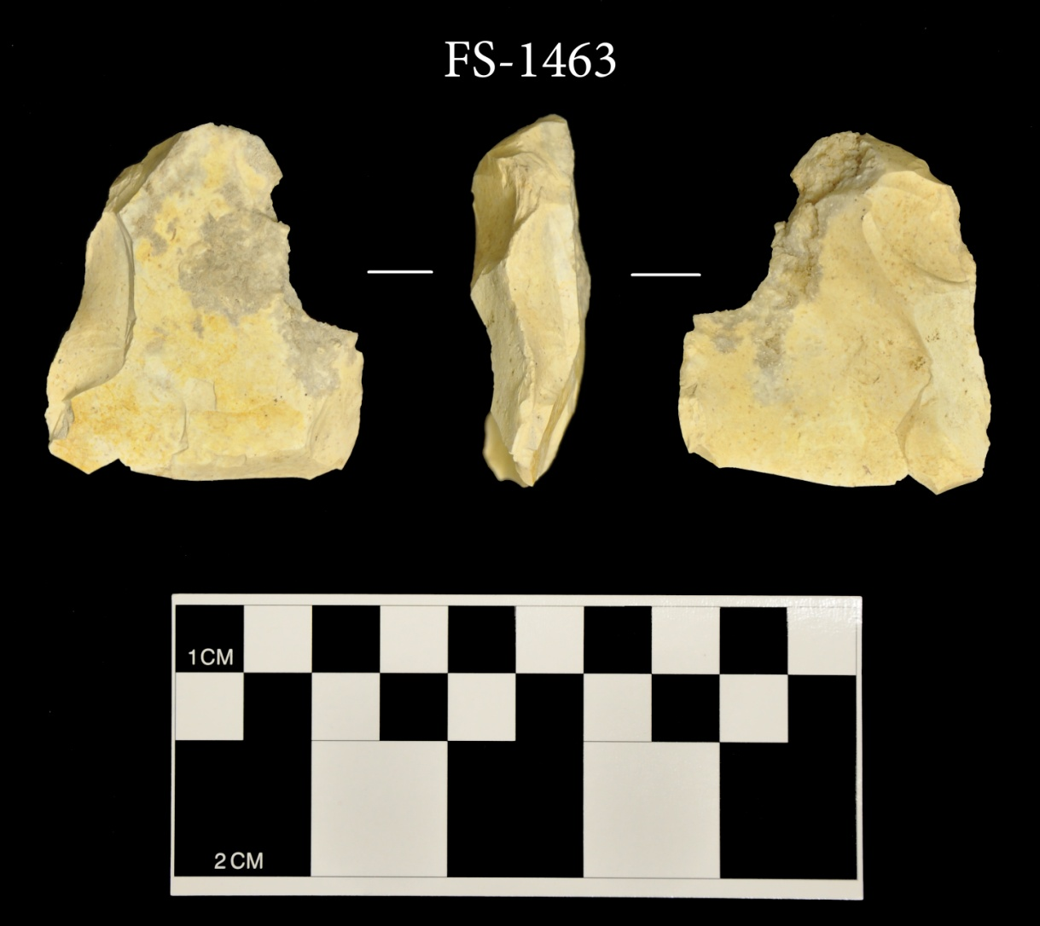

Figure A- 4. Clovis overshot flake, FS-1463.

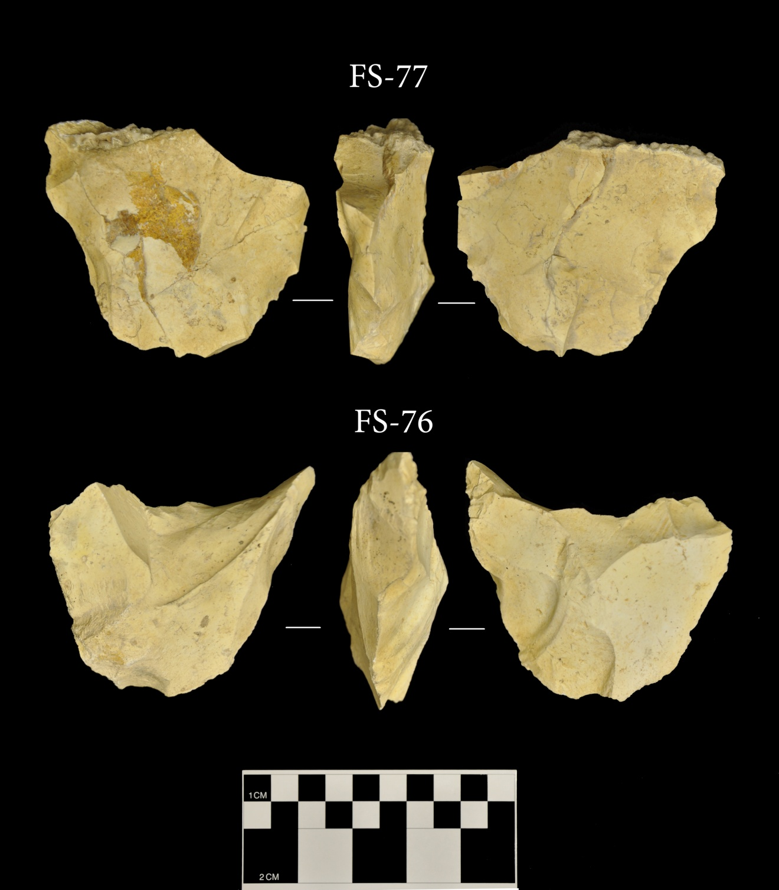

Figure A- 5. Clovis bifacial cores.

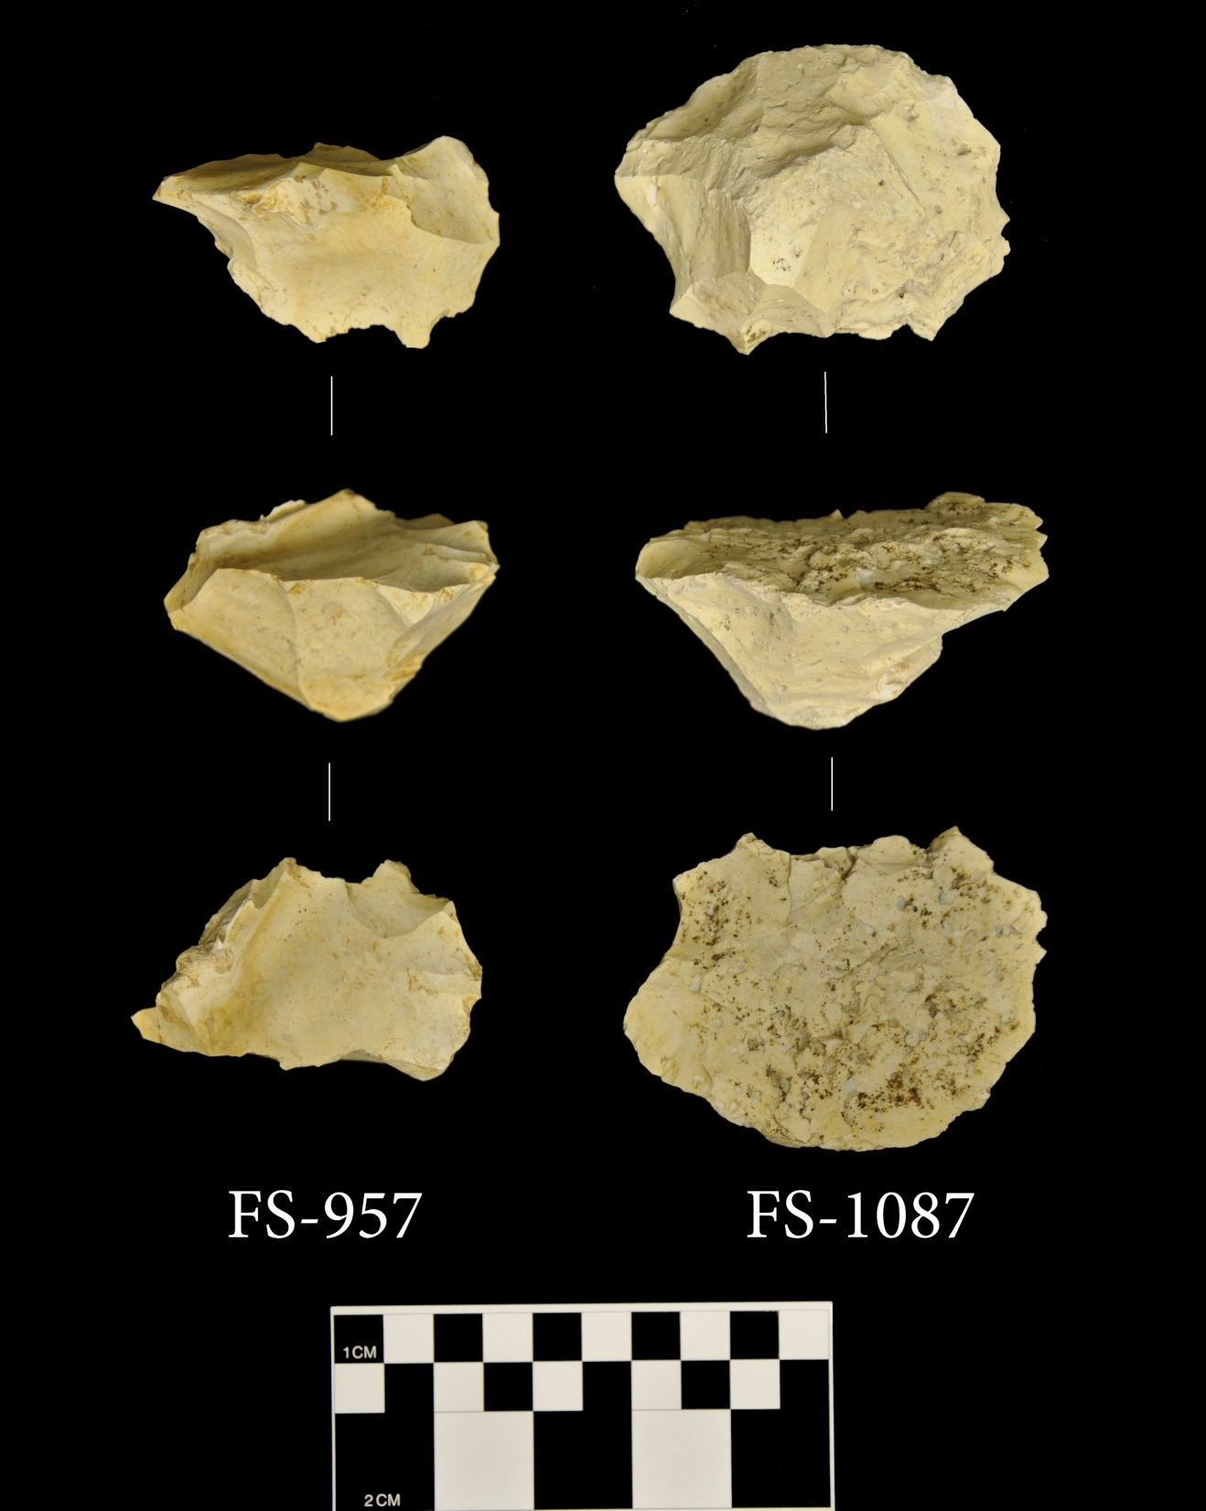

Figure A- 6. Clovis conical blade cores.

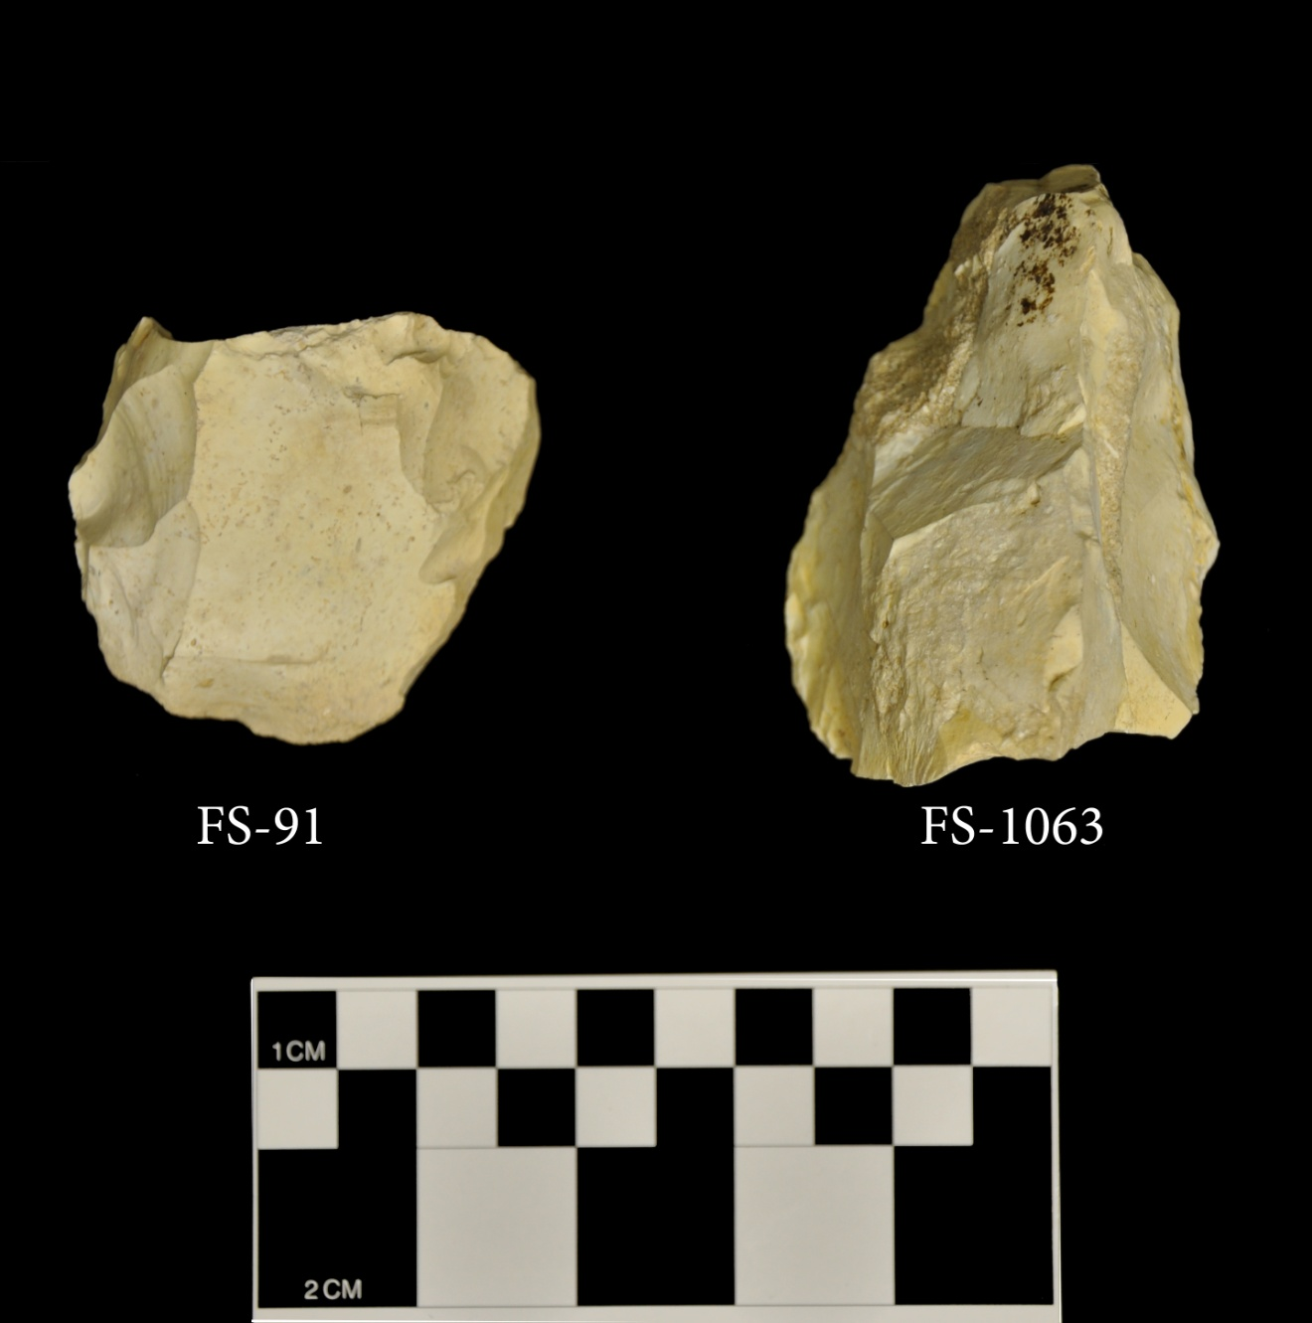

Figure A- 7. Clovis wedge-shaped cores.

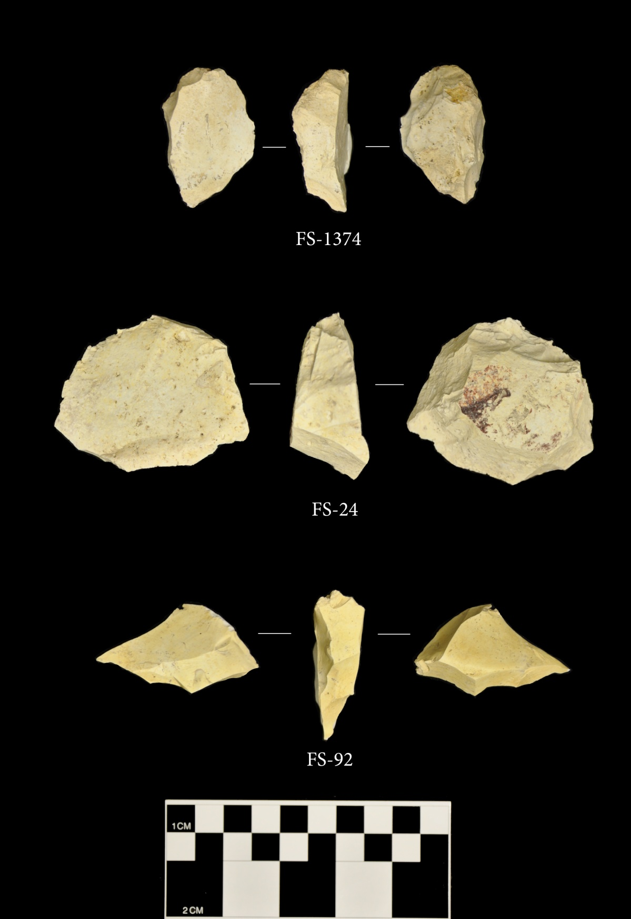

Figure A- 8. Clovis core tablet flakes.

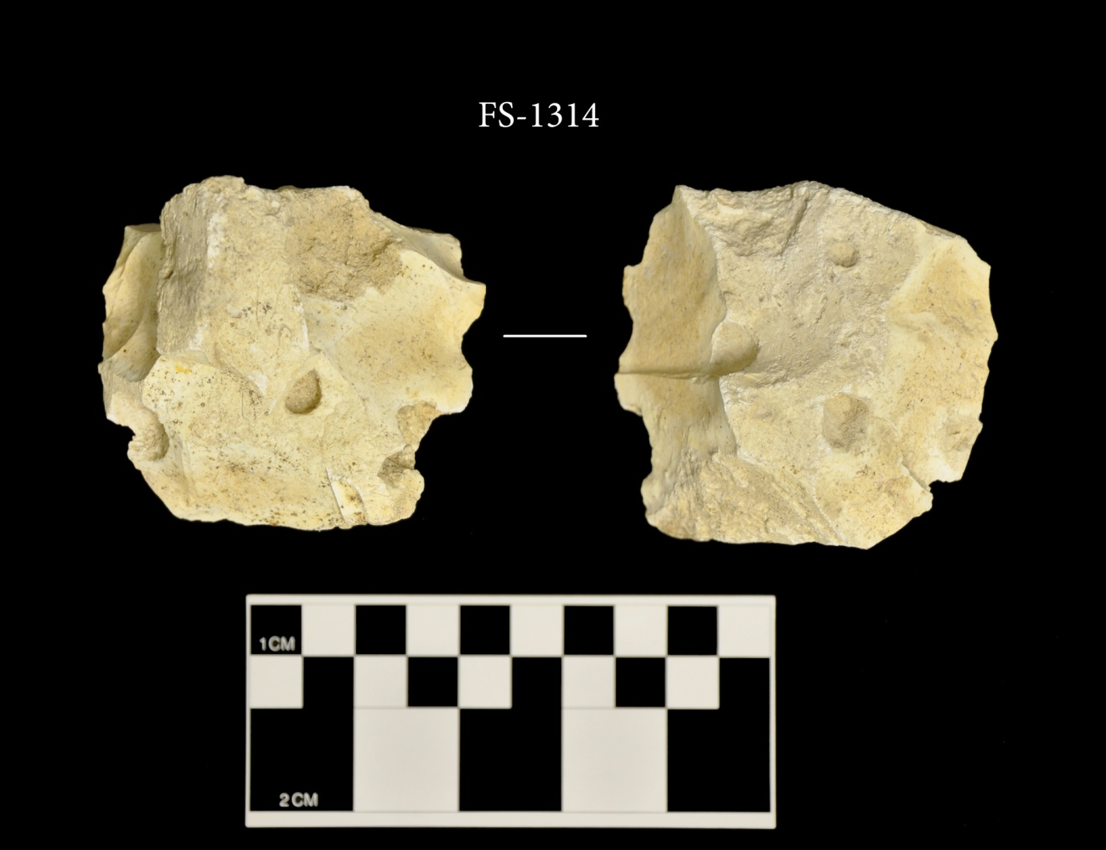

Figure A- 9. Amorphous Clovis core.

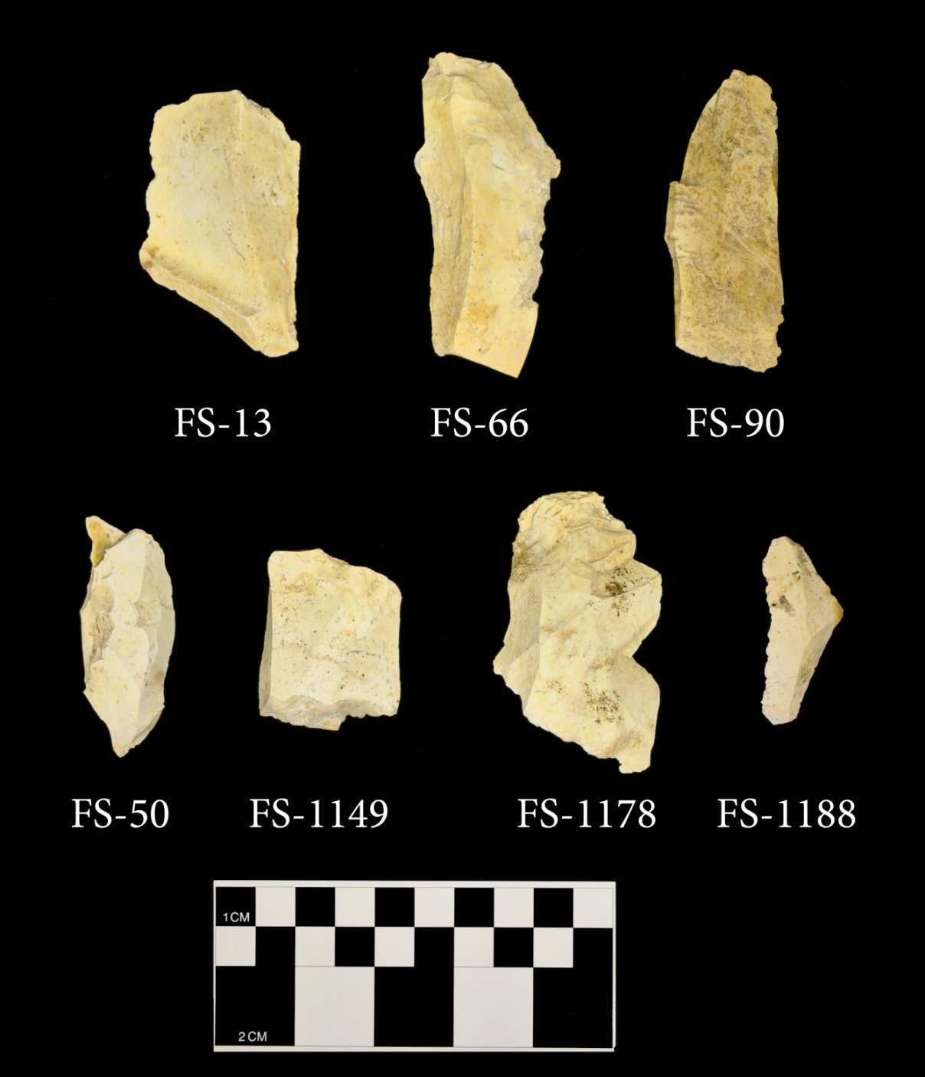

Figure A- 10. Clovis blades.

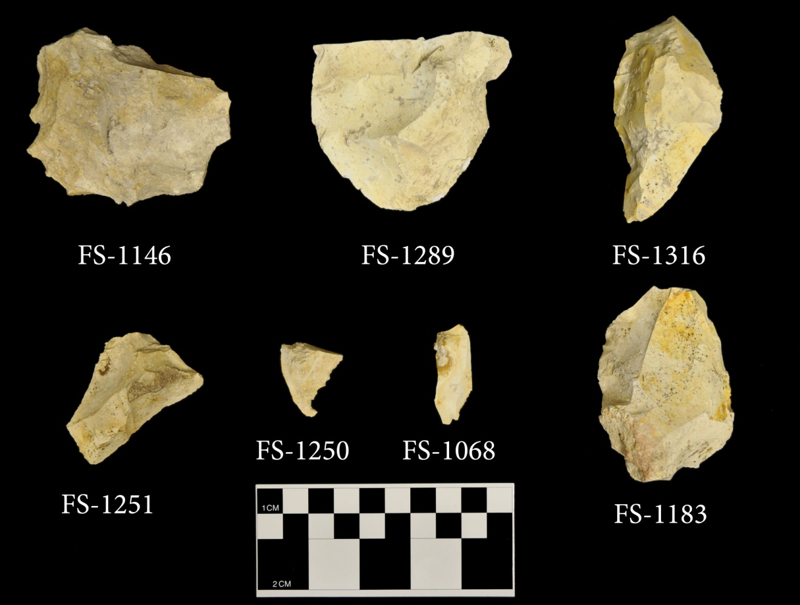

Figure A- 11. Clovis flake tools.

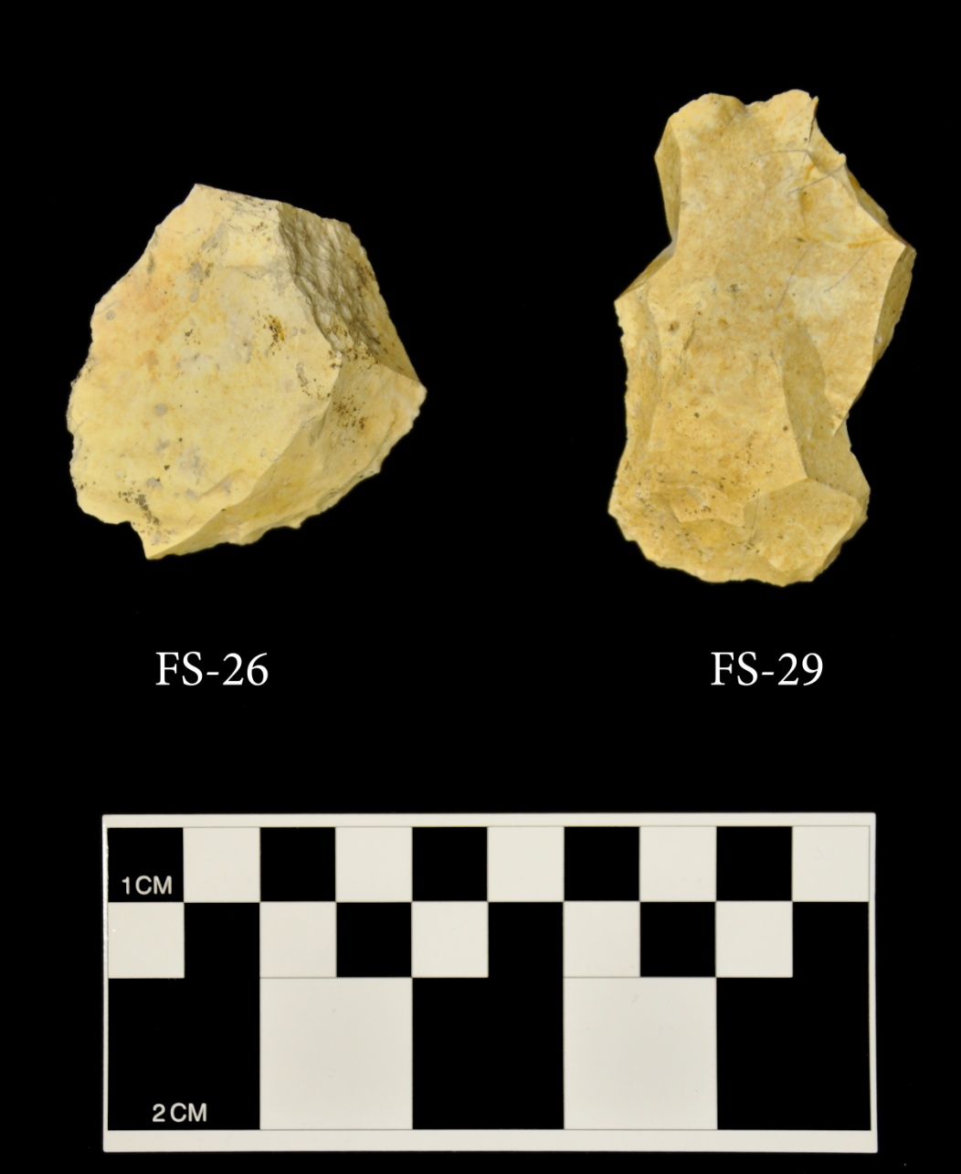

Figure A- 12. Endscrapers.

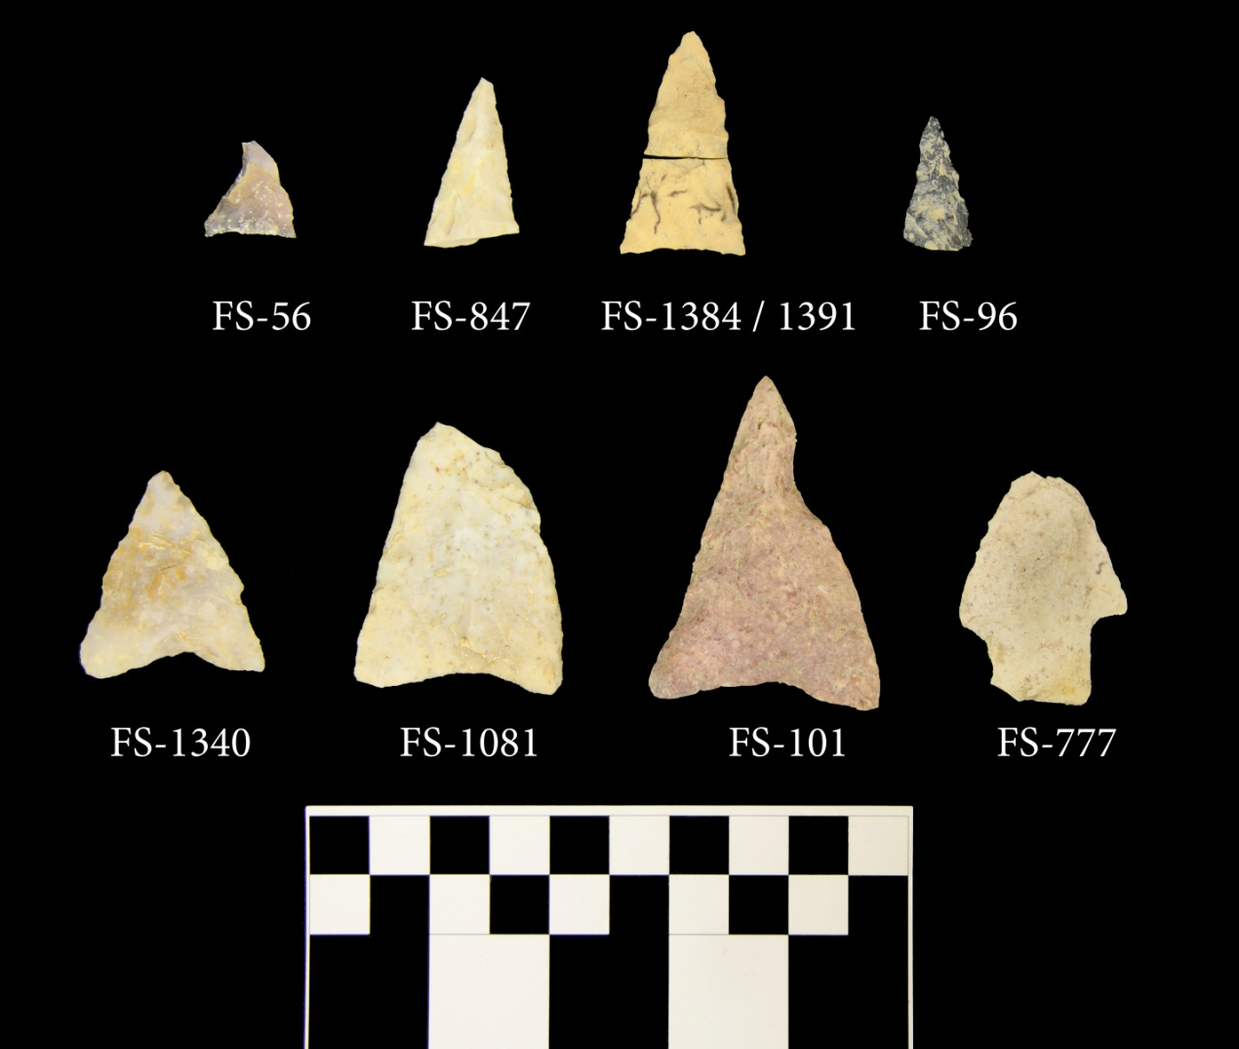

Figure A- 13. Woodland projectile points.

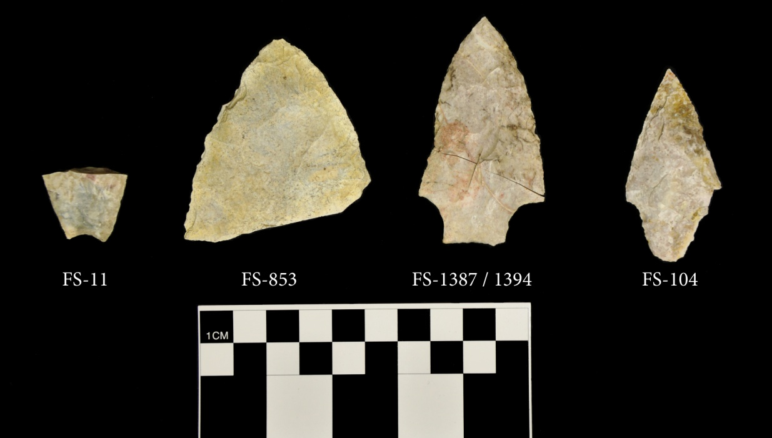

Figure A- 14. Middle and Late Archaic projectile points.

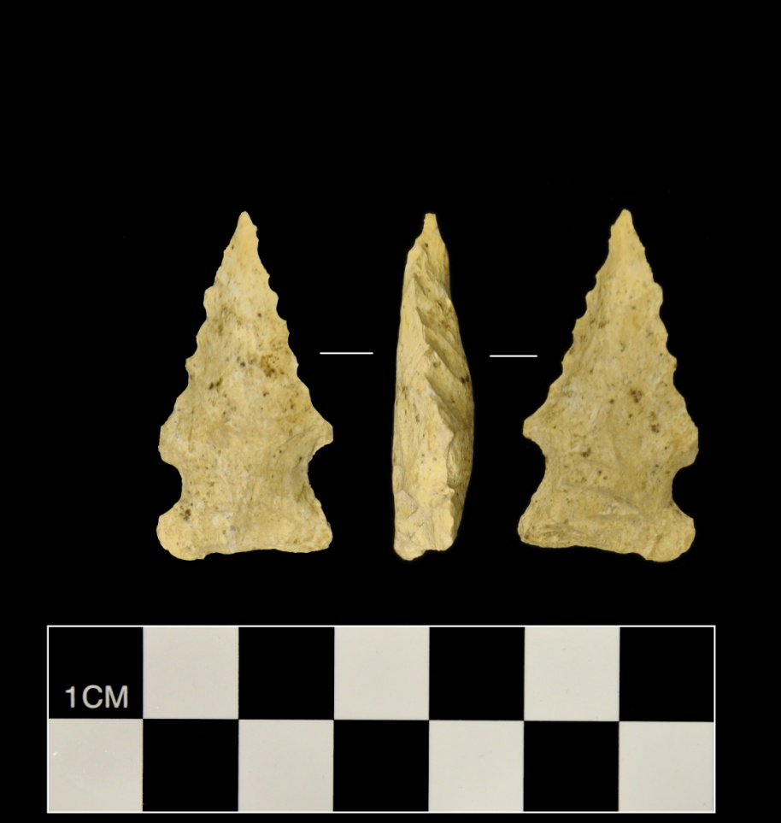

Figure A- 15. Early Archaic side-notched projectile point.

.

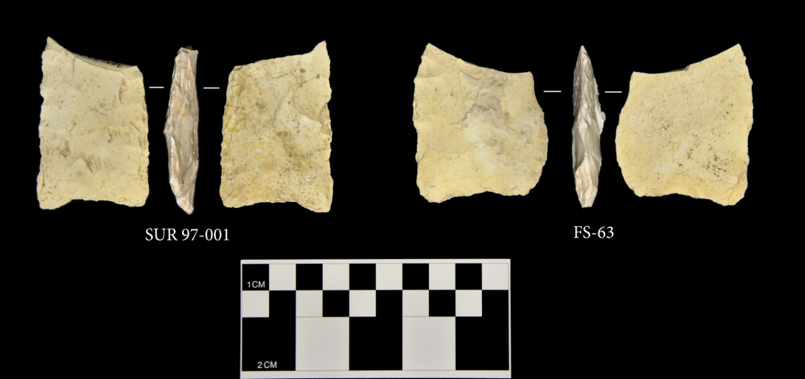

Figure A- 16. Dalton preforms.

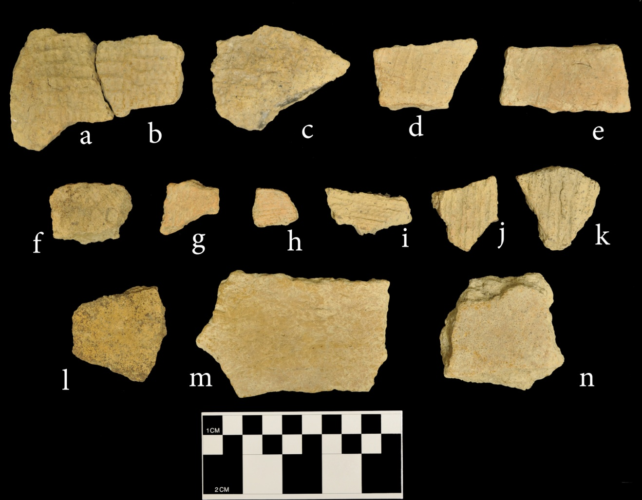

Figure A- 17. Select examples of prehistoric ceramics at 38AL228. a-e: Deptford Check Stamped; f: Deptford Simple Stamped; g: Woodland fabric impressed; h: Refuge; i-k: Woodland Cordmarked; l-n: Plain.

Appendix B: Artifact Tables

Table B- 1. Artifact totals by Test Unit.
Unit | Debitage | Non-Hafted Bifaces | Hafted Bifaces | Blades* | Cores | Flake tools | Hammer-stones | Prehistoric Ceramics | Histor-ics | Totals
TU 1 | 1592 | 6 | 0 | 0 | 1 | 1 | 2 | 38 | 0 | 1640
N995 E1081 | 3034 | 1 | 0 | 1 | 6 | 7 | 2 | 20 | 0 | 3071
N996 E1081 | 2316 | 3 | 0 | 1 | 2 | 3 | 1 | 11 | 0 | 2337
N1000 E1091 | 966 | 2 | 0 | 0 | 0 | 0 | 0 | 16 | 0 | 984
N1003 E1064 | 2380 | 0 | 2 | 1 | 3 | 2 | 2 | 4 | 0 | 2394
N1003 E1092 | 2051 | 1 | 1 | 0 | 1 | 3 | 0 | 61 | 2 | 2120
N1008 E1083 | 824 | 4 | 2 | 0 | 0 | 4 | 1 | 11 | 0 | 846
N1012 E1051 | 1348 | 2 | 0 | 0 | 0 | 4 | 1 | 1 | 0 | 1356
N1014 E1087 | 969 | 4 | 1 | 0 | 0 | 2 | 1 | 17 | 0 | 994
N1015 E1054 | 579 | 2 | 0 | 1 | 2 | 3 | 2 | 7 | 0 | 596
N1015 E1087 | 1565 | 6 | 0 | 1 | 1 | 3 | 1 | 31 | 0 | 1608
N1016 E1036* | 4695 | 14 | 5 | 0 | 3 | 17 | 0 | 20 | 0 | 4754
N1016 E1054 | 925 | 0 | 1 | 1 | 1 | 1 | 0 | 2 | 0 | 931
N1017 E1054 | 1305 | 6 | 1 | 1 | 1 | 4 | 1 | 0 | 0 | 1319
N1018 E1055 | 1253 | 1 | 0 | 0 | 1 | 2 | 0 | 0 | 0 | 1257
N1019 E1055 | 1454 | 4 | 1 | 0 | 2 | 7 | 2 | 2 | 0 | 1472
N1020 E1055 | 1782 | 7 | 1 | 0 | 3 | 4 | 0 | 0 | 0 | 1797
N1021 E1048 | 394 | 2 | 0 | 0 | 0 | 4 | 1 | 0 | 0 | 401
N1024 E1056 | 705 | 4 | 2 | 0 | 0 | 0 | 3 | 1 | 0 | 715
N1024 E1057 | 577 | 0 | 1 | 0 | 1 | 2 | 3 | 0 | 0 | 584
N1039 E1087 | 380 | 0 | 0 | 0 | 0 | 2 | 1 | 4 | 0 | 387
N1058 E1086 | 1999 | 3 | 0 | 0 | 4 | 1 | 2 | 1 | 0 | 2010
Table B-1. Continued.
Unit | Debitage | Non-Hafted Bifaces | Hafted Bifaces | Blades* | Cores | Flake tools | Hammer-stones | Prehistoric Ceramics | Histor-ics | Totals
N1079 E1086 | 2934 | 1 | 0 | 0 | 0 | 2 | 6 | 7 | 0 | 2950
N1079 E1087 | 3360 | 5 | 0 | 0 | 0 | 2 | 8 | 3 | 0 | 3378
N1097 E1064 | 813 | 0 | 1 | 0 | 2 | 1 | 0 | 0 | 0 | 817
N1117 E1063 | 1593 | 5 | 0 | 0 | 0 | 1 | 0 | 0 | 0 | 1599
N1148 E1066 | 75 | 0 | 0 | 0 | 0 | 0 | 0 | 0 | 0 | 75
N1153 E1146 | 608 | 3 | 0 | 0 | 0 | 1 | 0 | 6 | 0 | 618
N1169 E1140 | 545 | 0 | 0 | 0 | 0 | 0 | 0 | 0 | 3 | 548
Surface | 0 | 3 | 0 | 0 | 0 | 1 | 0 | 0 | 0 | 4
Totals | 43021 | 89 | 19 | 7 | 34 | 84 | 40 | 263 | 5 | 43562
* Blade counts include Clovis blades only

Table B- 2. Debitage aggregate analysis, all proveniences.
Provenience | Lev | Lev Depth (cm) | 1.5 # | 1.5 Weight | 1 # | 1 Weight | .75 # | .75 Weight | .5 # | .5 Weight | .25 # | .25 Weight | .125 # | .125 Weight | Total # | Total Weight
TU 1 | 1 | 20 | 0 | 0 | 0 | 0 | 2 | 10.76 | 26 | 57.11 | 144 | 61.59 | 7 | 0.55 | 179 | 130.01
TU 1 | 2 | 10 | 0 | 0 | 5 | 139.83 | 7 | 29.81 | 63 | 139.13 | 327 | 138.41 | 28 | 2.42 | 430 | 449.6
TU 1 | 3 | 10 | 0 | 0 | 3 | 35.65 | 19 | 94.84 | 61 | 131.35 | 316 | 128.33 | 92 | 5.67 | 491 | 395.84
TU 1 | 4 | 10 | 0 | 0 | 6 | 104.56 | 22 | 174.09 | 65 | 128.92 | 270 | 103.66 | 125 | 9.87 | 488 | 521.1
TU 1 | Hole 1A | NA | 0 | 0 | 1 | 8.99 | 0 | 0 | 1 | 1.87 | 2 | 0.9 | 0 | 0 | 4 | 11.76
N1000 E1091 | 1 | 20 | 1 | 109.35 | 11 | 198.13 | 33 | 271.42 | 101 | 254.37 | 427 | 224.52 | 30 | 3.85 | 603 | 1061.64
N1000 E1091 | 2 | 20 | 1 | 98.3 | 6 | 154.85 | 16 | 112.2 | 48 | 96.91 | 253 | 125.93 | 29 | 3.3 | 353 | 591.49
N1000 E1091 | 3 | 10 | 0 | 0 | 0 | 0 | 0 | 0 | 2 | 4.58 | 8 | 4.26 | 0 | 0 | 10 | 8.84
N1008 E1083 | 1A | 20 | 0 | 0 | 0 | 0 | 3 | 21.97 | 4 | 10.16 | 52 | 23.15 | 3 | 0.18 | 62 | 55.46
N1008 E1083 | 1B | 20 | 0 | 0 | 0 | 0 | 1 | 4.98 | 14 | 27.81 | 62 | 24.6 | 2 | 0.31 | 79 | 57.7
N1008 E1083 | 2A | 20 | 0 | 0 | 1 | 29.16 | 5 | 20.05 | 20 | 37.64 | 179 | 66.52 | 7 | 0.53 | 212 | 153.9
N1008 E1083 | 2B | 10 | 0 | 0 | 3 | 49 | 8 | 56.82 | 15 | 36.25 | 190 | 75.91 | 7 | 0.59 | 223 | 218.57
N1008 E1083 | 3 | 10 | 0 | 0 | 2 | 56.99 | 2 | 13.31 | 16 | 43.97 | 147 | 52.87 | 19 | 1.44 | 186 | 168.58
N1008 E1083 | 4 | 10 | 0 | 0 | 0 | 0 | 1 | 3.16 | 8 | 20.73 | 52 | 17.99 | 1 | 0.1 | 62 | 41.98
N1012 E1051 | 1 | 20 | 0 | 0 | 0 | 0 | 0 | 0 | 9 | 20.87 | 61 | 26.57 | 5 | 0.35 | 75 | 47.79
N1012 E1051 | 2 | 10 | 0 | 0 | 0 | 0 | 5 | 43.85 | 26 | 67.71 | 142 | 72.29 | 9 | 1.12 | 182 | 184.97
N1012 E1051 | 3 | 10 | 0 | 0 | 0 | 0 | 11 | 83.35 | 45 | 90.5 | 269 | 95.66 | 48 | 4.5 | 373 | 274.01
N1012 E1051 | 4 | 10 | 2 | 220.63 | 0 | 0 | 12 | 101.43 | 36 | 78.82 | 220 | 87.12 | 151 | 12.72 | 421 | 500.72
N1012 E1051 | 5 | 10 | 0 | 0 | 5 | 140.09 | 9 | 58.39 | 26 | 71.33 | 193 | 80.56 | 64 | 4.62 | 297 | 354.99
N1012 E1051 | 1 | 20 | 0 | 0 | 0 | 0 | 2 | 20.11 | 33 | 69.3 | 201 | 93.65 | 29 | 3.14 | 265 | 186.2
N1014 E1087 | 2 | 20 | 5 | 375.81 | 9 | 362.12 | 24 | 184.42 | 55 | 127 | 290 | 105.35 | 62 | 4.44 | 445 | 1159.14
N1014 E1087 | 3 | 10 | 0 | 0 | 6 | 216.85 | 13 | 107.75 | 21 | 110.92 | 182 | 65.9 | 37 | 2.03 | 259 | 503.45
Table B- 2. Continued.
Provenience | Lev | Lev Depth (cm) | 1.5 # | 1.5 Weight | 1 # | 1 Weight | .75 # | .75 Weight | .5 # | .5 Weight | .25 # | .25 Weight | .125 # | .125 Weight | Total # | Total Weight
N1015 E1054 | 1 | 20 | 0 | 0 | 0 | 0 | 1 | 8.86 | 16 | 38.68 | 73 | 29.94 | 3 | 0.27 | 93 | 77.75
N1015 E1054 | 2 | 10 | 0 | 0 | 0 | 0 | 3 | 19.83 | 13 | 41.95 | 50 | 19.87 | 13 | 1.02 | 79 | 82.67
N1015 E1054 | 3 | 10 | 0 | 0 | 1 | 22.75 | 5 | 41.37 | 17 | 41.23 | 78 | 35.49 | 17 | 1.24 | 118 | 142.08
N1015 E1054 | 4 | 5 | 0 | 0 | 3 | 79.49 | 3 | 22.56 | 8 | 27.37 | 65 | 23.43 | 7 | 0.59 | 86 | 153.44
N1015 E1054 | 5 | 5 | 2 | 319.35 | 0 | 0 | 9 | 55.28 | 9 | 23.61 | 44 | 14.67 | 6 | 0.77 | 70 | 413.68
N1015 E1054 | 6 | 5 | 0 | 0 | 2 | 47.23 | 6 | 38.39 | 16 | 40.15 | 57 | 22.72 | 18 | 1.63 | 99 | 150.12
N1015 E1054 | 7 | 5 | 0 | 0 | 0 | 0 | 1 | 4.4 | 5 | 9.14 | 22 | 13.07 | 2 | 0.16 | 30 | 26.77
N1015 E1054 | 8 | 5 | 0 | 0 | 0 | 0 | 0 | 0 | 1 | 1.72 | 3 | 1.29 | 0 | 0 | 4 | 3.01
N1015 E1087 | 1 | 20 | 0 | 0 | 1 | 18.22 | 7 | 52.16 | 56 | 108.39 | 221 | 94.8 | 17 | 1.91 | 302 | 275.48
N1015 E1087 | 2 | 20 | 1 | 79.33 | 22 | 526.2 | 42 | 337.14 | 115 | 284 | 595 | 248.72 | 63 | 6.41 | 838 | 1481.8
N1015 E1087 | 3 | 10 | 1 | 54.9 | 13 | 424.37 | 18 | 116.95 | 54 | 125.81 | 314 | 133.5 | 25 | 1.74 | 425 | 857.27
N1016 E1036 | 1 | 20 | 0 | 0 | 4 | 113.52 | 16 | 93.52 | 117 | 256.3 | 567 | 231.73 | 56 | 6.92 | 760 | 701.99
N1016 E1036 | 2 | 10 | 0 | 0 | 18 | 532.8 | 26 | 205.56 | 156 | 669.28 | 832 | 369.55 | 70 | 7.94 | 1102 | 1785.13
N1016 E1036 | 3 | 10 | 5 | 340.26 | 41 | 1153.35 | 55 | 447.29 | 260 | 427.61 | 992 | 426.2 | 116 | 14.54 | 1469 | 2809.25
N1016 E1036 | 4 NE | 5 | 1 | 129.71 | 1 | 20 | 2 | 32.52 | 11 | 22.05 | 61 | 28.65 | 6 | 0.52 | 82 | 233.45
N1016 E1036 | 4 NW | 5 | 2 | 190.37 | 3 | 96.53 | 6 | 44.34 | 10 | 32.06 | 62 | 23.81 | 5 | 0.51 | 88 | 387.62
N1016 E1036 | 4 SE | 5 | 3 | 359.98 | 5 | 100.12 | 14 | 108.34 | 30 | 74.79 | 127 | 52.44 | 17 | 1.6 | 196 | 697.27
N1016 E1036 | 4 SW | 5 | 1 | 55.98 | 9 | 276.55 | 9 | 92.49 | 20 | 34.7 | 176 | 65.78 | 21 | 1.97 | 236 | 527.47
N1016 E1036 | 5 NE | 5 | 1 | 66.68 | 3 | 50.61 | 3 | 33.54 | 13 | 26.16 | 51 | 22.8 | 8 | 0.93 | 79 | 200.72
N1016 E1036 | 5 NW | 5 | 1 | 132.26 | 8 | 197.43 | 2 | 15 | 9 | 18.82 | 78 | 26.51 | 21 | 2.16 | 119 | 392.18
N1016 E1036 | 5 SE | 5 | 1 | 54.75 | 0 | 0 | 7 | 52.2 | 7 | 15.44 | 93 | 35.69 | 12 | 1.3 | 120 | 159.38
N1016 E1036 | 5 SW | 5 | 1 | 78.52 | 4 | 106.24 | 3 | 23.6 | 14 | 39.03 | 96 | 36.33 | 17 | 1.51 | 135 | 285.23
N1016 E1036 | 6 NE | 5 | 0 | 0 | 0 | 0 | 1 | 21.98 | 6 | 14.21 | 24 | 6.68 | 5 | 0.68 | 36 | 43.55
N1016 E1036 | 6 NW | 5 | 2 | 153.15 | 1 | 21.26 | 0 | 0 | 3 | 7.23 | 24 | 7.97 | 6 | 0.4 | 36 | 190.01
N1016 E1036 | 6 SE | 5 | 0 | 0 | 0 | 0 | 0 | 0 | 1 | 1.07 | 24 | 5.21 | 9 | 0.69 | 34 | 6.97
N1016 E1036 | 6 SW | 5 | 0 | 0 | 2 | 45.37 | 2 | 13.15 | 10 | 22.27 | 99 | 35.8 | 45 | 2.81 | 158 | 119.4
Table B- 2. Continued.
Provenience | Lev | Lev Depth (cm) | 1.5 # | 1.5 Weight | 1 # | 1 Weight | .75 # | .75 Weight | .5 # | .5 Weight | .25 # | .25 Weight | .125 # | .125 Weight | Total # | Total Weight
N1016 E1036 | 7 NW | 5 | 0 | 0 | 1 | 15.33 | 0 | 0 | 1 | 1.35 | 10 | 4.2 | 1 | 0.05 | 13 | 20.93
N1016 E1036 | 7 SW | 5 | 0 | 0 | 0 | 0 | 0 | 0 | 0 | 0 | 9 | 2.94 | 0 | 0 | 9 | 2.94
N1016 E1036 | 8 NW | 5 | 0 | 0 | 0 | 0 | 1 | 5.12 | 0 | 0 | 6 | 0.8 | 2 | 0.11 | 9 | 6.03
N1016 E1036 | 8 SW | 5 | 0 | 0 | 0 | 0 | 0 | 0 | 0 | 0 | 1 | 0.1 | 0 | 0 | 1 | 0.1
N1016 E1036 | 9 NW | 5 | 0 | 0 | 0 | 0 | 0 | 0 | 1 | 3.13 | 2 | 2.02 | 4 | 0.18 | 7 | 5.33
N1016 E1036 | 9 SW | 5 | 0 | 0 | 0 | 0 | 0 | 0 | 0 | 0 | 3 | 3.17 | 3 | 0.04 | 6 | 3.21
N1016 E1054 | 1 | 20 | 0 | 0 | 0 | 0 | 3 | 22.17 | 10 | 20.92 | 92 | 41.35 | 15 | 1.29 | 120 | 85.73
N1016 E1054 | 2 | 10 | 2 | 92.58 | 0 | 0 | 1 | 11.05 | 12 | 26.41 | 64 | 26.08 | 12 | 0.83 | 91 | 156.95
N1016 E1054 | 3 | 10 | 0 | 0 | 1 | 16.47 | 2 | 18.86 | 12 | 28.15 | 110 | 37.89 | 31 | 2.22 | 156 | 103.59
N1016 E1054 | 4 | 10 | 2 | 133.08 | 2 | 55.41 | 9 | 68.15 | 31 | 63.06 | 132 | 47.61 | 56 | 3.7 | 232 | 371.01
N1016 E1054 | 5 | 10 | 1 | 167.55 | 3 | 77.3 | 8 | 36.41 | 22 | 51.67 | 108 | 39.5 | 40 | 2.14 | 182 | 374.57
N1016 E1054 | 6 | 5 | 1 | 56.68 | 0 | 0 | 5 | 30.85 | 8 | 12.57 | 61 | 23.07 | 30 | 1.98 | 105 | 125.15
N1016 E1054 | 7 | 5 | 0 | 0 | 0 | 0 | 0 | 0 | 3 | 5.15 | 22 | 5.59 | 14 | 0.87 | 39 | 11.61
N1017 E1054 | 1 | 20 | 0 | 0 | 0 | 0 | 3 | 13.45 | 9 | 25.49 | 92 | 46.06 | 11 | 1.1 | 115 | 86.1
N1017 E1054 | 2 | 10 | 0 | 0 | 0 | 0 | 0 | 0 | 8 | 16.77 | 43 | 16.84 | 2 | 0.09 | 53 | 33.7
N1017 E1054 | 3 | 10 | 0 | 0 | 2 | 83.07 | 5 | 25.39 | 16 | 30.06 | 99 | 38.78 | 20 | 1.53 | 142 | 178.83
N1017 E1054 | 4 | 10 | 0 | 0 | 2 | 34.4 | 4 | 19.69 | 20 | 34.41 | 125 | 47.13 | 25 | 2.34 | 176 | 137.97
N1017 E1054 | 5 | 5 | 4 | 122.95 | 2 | 62.99 | 4 | 25.13 | 13 | 28.61 | 78 | 29.46 | 12 | 0.74 | 113 | 269.88
N1017 E1054 | 6 | 5 | 0 | 0 | 0 | 0 | 8 | 38.28 | 11 | 19.55 | 78 | 26.15 | 12 | 0.98 | 109 | 84.96
N1017 E1054 | 7 | 5 | 0 | 0 | 0 | 0 | 3 | 24.03 | 11 | 20.58 | 65 | 24.17 | 24 | 1.55 | 103 | 70.33
N1017 E1054 | 8 | 5 | 0 | 0 | 3 | 49.44 | 2 | 8.47 | 17 | 37.3 | 62 | 21.5 | 16 | 0.99 | 100 | 117.7
N1017 E1054 | 9 | 5 | 0 | 0 | 9 | 86.78 | 11 | 71.19 | 24 | 55.31 | 70 | 24.04 | 33 | 1.84 | 147 | 239.16
N1017 E1054 | 10 | 5 | 0 | 0 | 6 | 115.98 | 6 | 30.04 | 11 | 16.63 | 64 | 18.46 | 63 | 2.94 | 150 | 184.05
N1017 E1054 | 11 | 5 | 0 | 0 | 0 | 0 | 0 | 0 | 7 | 14.36 | 53 | 15.41 | 29 | 2.21 | 89 | 31.98
N1017 E1054 | 12 | 5 | 0 | 0 | 0 | 0 | 0 | 0 | 0 | 0 | 5 | 1 | 3 | 0.14 | 8 | 1.14
Table B- 2. Continued.
Provenience | Lev | Lev Depth (cm) | 1.5 # | 1.5 Weight | 1 # | 1 Weight | .75 # | .75 Weight | .5 # | .5 Weight | .25 # | .25 Weight | .125 # | .125 Weight | Total # | Total Weight
N1018 E1055 | 1 | 20 | 0 | 0 | 0 | 0 | 2 | 12.09 | 10 | 19.88 | 70 | 28.89 | 9 | 0.48 | 91 | 61.34
N1018 E1055 | 2 | 10 | 0 | 0 | 0 | 0 | 1 | 3.03 | 11 | 25.32 | 63 | 24.36 | 8 | 0.57 | 83 | 53.28
N1018 E1055 | 3 | 10 | 0 | 0 | 2 | 103.18 | 3 | 21.68 | 17 | 34.87 | 91 | 31.26 | 30 | 1.9 | 143 | 192.89
N1018 E1055 | 4 | 10 | 0 | 0 | 2 | 36.09 | 1 | 10.51 | 18 | 37.64 | 116 | 42.44 | 46 | 3.14 | 183 | 129.82
N1018 E1055 | 5 | 5 | 0 | 0 | 3 | 83.16 | 2 | 15.12 | 11 | 21.94 | 85 | 28.53 | 47 | 2.87 | 148 | 151.62
N1018 E1055 | 6 | 5 | 0 | 0 | 1 | 9.54 | 7 | 44.15 | 14 | 28.6 | 91 | 27.85 | 43 | 3.2 | 156 | 113.34
N1018 E1055 | 7 | 5 | 0 | 0 | 1 | 29.67 | 1 | 7.63 | 19 | 46.95 | 94 | 34.05 | 33 | 3.06 | 148 | 121.36
N1018 E1055 | 8 | 5 | 1 | 80.61 | 0 | 0 | 7 | 42.45 | 22 | 52 | 99 | 35.4 | 28 | 2.45 | 157 | 212.91
N1018 E1055 | 9 | 5 | 0 | 0 | 0 | 0 | 0 | 0 | 12 | 25.57 | 48 | 15.79 | 27 | 1.69 | 87 | 43.05
N1018 E1055 | 10 | 5 | 0 | 0 | 0 | 0 | 0 | 0 | 3 | 7.35 | 34 | 10.39 | 20 | 1.32 | 57 | 19.06
N1019 E1055 | 1 | 20 | 0 | 0 | 0 | 0 | 0 | 0 | 3 | 6.03 | 16 | 6.95 | 6 | 0.42 | 25 | 13.4
N1019 E1055 | 2 | 10 | 1 | 112.02 | 1 | 14.29 | 5 | 29.47 | 20 | 36.23 | 101 | 42.8 | 12 | 1.17 | 140 | 235.98
N1019 E1055 | 3 | 10 | 1 | 66.62 | 2 | 52.39 | 6 | 25.58 | 26 | 63.65 | 159 | 54.81 | 41 | 3.58 | 235 | 266.63
N1019 E1055 | 4 | 5 | 0 | 0 | 4 | 55.8 | 4 | 22.67 | 11 | 20.59 | 104 | 35.76 | 24 | 2.18 | 147 | 137
N1019 E1055 | 5 | 5 | 1 | 109.09 | 3 | 44.65 | 4 | 27.33 | 11 | 22.93 | 112 | 42.3 | 14 | 1.06 | 145 | 247.36
N1019 E1055 | 6 | 5 | 0 | 0 | 3 | 44.63 | 5 | 40.36 | 15 | 32.41 | 84 | 28.73 | 30 | 1.65 | 137 | 147.78
N1019 E1055 | 7 | 5 | 0 | 0 | 4 | 87.28 | 6 | 44.53 | 11 | 21.46 | 95 | 33.56 | 40 | 2.34 | 156 | 189.17
N1019 E1055 | 8 | 5 | 0 | 0 | 6 | 135.12 | 3 | 18.67 | 15 | 33.3 | 74 | 26.98 | 54 | 3.02 | 152 | 217.09
N1019 E1055 | 9 | 5 | 1 | 44.15 | 1 | 19.06 | 4 | 31.72 | 22 | 44.61 | 88 | 34.71 | 66 | 3.89 | 182 | 178.14
N1019 E1055 | 10 | 5 | 0 | 0 | 0 | 0 | 4 | 25.28 | 6 | 8.49 | 57 | 19.39 | 14 | 1.2 | 81 | 54.36
N1019 E1055 | 11&12 | 10 | 0 | 0 | 0 | 0 | 4 | 20.75 | 6 | 12.44 | 36 | 13.5 | 8 | 0.48 | 54 | 47.17
N1020 E1055 | 1 | 20 | 0 | 0 | 0 | 0 | 0 | 0 | 14 | 34.37 | 91 | 42.06 | 7 | 0.78 | 112 | 77.21
N1020 E1055 | 2 | 10 | 0 | 0 | 0 | 0 | 5 | 35.54 | 26 | 65.1 | 142 | 64.86 | 7 | 0.89 | 180 | 166.39
N1020 E1055 | 3 | 10 | 1 | 215.3 | 5 | 139.75 | 12 | 100.78 | 26 | 62.13 | 202 | 74.78 | 64 | 4.01 | 310 | 596.75
N1020 E1055 | 4 | 10 | 1 | 39.64 | 10 | 237.01 | 19 | 126.96 | 38 | 96.9 | 215 | 74.15 | 68 | 5.63 | 351 | 580.29
N1020 E1055 | 5 | 10 | 2 | 164.44 | 9 | 265.95 | 14 | 103.48 | 36 | 79.2 | 198 | 58.58 | 79 | 6.33 | 338 | 677.98
N1020 E1055 | 6 | 5 | 0 | 0 | 3 | 72.7 | 0 | 0 | 5 | 9.07 | 42 | 13.31 | 12 | 0.82 | 62 | 95.9
Table B- 2. Continued.
Provenience | Lev | Lev Depth (cm) | 1.5 # | 1.5 Weight | 1 # | 1 Weight | .75 # | .75 Weight | .5 # | .5 Weight | .25 # | .25 Weight | .125 # | .125 Weight | Total # | Total Weight
N1020 E1055 | 7 | 5 | 0 | 0 | 0 | 0 | 2 | 8.68 | 23 | 52.63 | 73 | 25.54 | 22 | 1.47 | 120 | 88.32
N1020 E1055 | 8 | 5 | 1 | 86.23 | 0 | 0 | 0 | 0 | 0 | 0 | 32 | 9.84 | 11 | 1.05 | 44 | 97.12
N1020 E1055 | 9 | 5 | 0 | 0 | 2 | 34.9 | 1 | 11.09 | 3 | 4.84 | 24 | 8.89 | 11 | 0.78 | 41 | 60.5
N1020 E1055 | 10 | 5 | 0 | 0 | 1 | 16.41 | 0 | 0 | 0 | 0 | 13 | 4 | 9 | 0.61 | 23 | 21.02
N1020 E1055 | 11 | 5 | 0 | 0 | 0 | 0 | 1 | 5.34 | 2 | 2.1 | 23 | 4.77 | 7 | 0.45 | 33 | 12.66
N1020 E1055 | 12 | 5 | 0 | 0 | 0 | 0 | 0 | 0 | 2 | 5.3 | 7 | 1.82 | 3 | 0.24 | 12 | 7.36
N1020 E1055 | 13 | 5 | 0 | 0 | 0 | 0 | 0 | 0 | 0 | 0 | 4 | 0.67 | 0 | 0 | 4 | 0.67
N1020 E1055 | 14 / Clay Test Trench |  | 0 | 0 | 0 | 0 | 2 | 10.76 | 14 | 33.54 | 64 | 22.54 | 72 | 3.12 | 152 | 69.96
N1021 E1048 | 1 | 20 | 0 | 0 | 0 | 0 | 0 | 0 | 10 | 22.3 | 22 | 11.1 | 4 | 0.13 | 36 | 33.53
N1021 E1048 | 2 | 10 | 1 | 71.5 | 0 | 0 | 2 | 19.81 | 4 | 11.5 | 44 | 18.3 | 6 | 0.36 | 57 | 121.47
N1021 E1048 | 3 | 10 | 0 | 0 | 0 | 0 | 3 | 20.61 | 9 | 24.52 | 55 | 17.27 | 12 | 1.18 | 79 | 63.58
N1021 E1048 | 4 | 5 | 0 | 0 | 6 | 157.68 | 6 | 57.69 | 17 | 54.77 | 63 | 21.22 | 6 | 0.58 | 98 | 291.94
N1021 E1048 | 5 | 5 | 0 | 0 | 5 | 133.09 | 3 | 30.1 | 5 | 9.93 | 13 | 4.99 | 7 | 0.58 | 33 | 178.69
N1021 E1048 | 6 | 5 | 0 | 0 | 1 | 28.33 | 2 | 14.28 | 5 | 16.94 | 47 | 16.68 | 14 | 1.71 | 69 | 77.94
N1021 E1048 | 7 | 5 | 0 | 0 | 1 | 21.77 | 1 | 8.56 | 0 | 0 | 14 | 4.17 | 6 | 0.48 | 22 | 34.98
N1024 E1056 | 1 | 10 | 0 | 0 | 0 | 0 | 1 | 4.2 | 9 | 11.4 | 42 | 17.65 | 10 | 0.8 | 62 | 34.05
N1024 E1056 | 2 | 10 | 0 | 0 | 0 | 0 | 0 | 0 | 5 | 9.14 | 48 | 16.56 | 10 | 0.66 | 63 | 26.36
N1024 E1056 | 3 | 10 | 2 | 121.42 | 2 | 40.69 | 6 | 29.68 | 18 | 37.46 | 120 | 40.72 | 51 | 4.96 | 199 | 274.93
N1024 E1056 | 4 | 10 | 0 | 0 | 2 | 35.48 | 5 | 29.68 | 24 | 48.28 | 96 | 35.69 | 33 | 2.07 | 160 | 151.2
N1024 E1056 | 5 | 5 | 0 | 0 | 1 | 15.77 | 4 | 25.98 | 11 | 24.3 | 48 | 19.07 | 19 | 1.12 | 83 | 86.24
N1024 E1056 | 6 | 5 | 0 | 0 | 0 | 0 | 1 | 8.43 | 7 | 11.49 | 53 | 25.2 | 25 | 2.07 | 86 | 47.19
N1024 E1056 | 7 | 5 | 0 | 0 | 0 | 0 | 0 | 0 | 1 | 1.63 | 36 | 12.6 | 11 | 0.69 | 48 | 14.92
N1024 E1056 | 8 | 5 | 0 | 0 | 0 | 0 | 0 | 0 | 0 | 0 | 4 | 1.17 | 0 | 0 | 4 | 1.17
N1024 E1057 | 1 | 20 | 0 | 0 | 0 | 0 | 2 | 12.09 | 5 | 8.3 | 47 | 24.82 | 7 | 0.66 | 61 | 45.87
N1024 E1057 | 2 | 10 | 0 | 0 | 2 | 55.24 | 1 | 5.53 | 13 | 29.11 | 60 | 20.91 | 16 | 1.08 | 92 | 111.87
Table B- 2. Continued.
Provenience | Lev | Lev Depth (cm) | 1.5 # | 1.5 Weight | 1 # | 1 Weight | .75 # | .75 Weight | .5 # | .5 Weight | .25 # | .25 Weight | .125 # | .125 Weight | Total # | Total Weight
N1024 E1057 | 3 | 10 | 0 | 0 | 2 | 54.51 | 6 | 41.91 | 19 | 34.59 | 83 | 35.88 | 18 | 1.96 | 128 | 168.85
N1024 E1057 | 4 | 5 | 0 | 0 | 3 | 76.27 | 3 | 20.47 | 2 | 5.98 | 8 | 2.15 | 2 | 0.1 | 18 | 104.97
N1024 E1057 | 5 | 5 | 0 | 0 | 1 | 11.59 | 4 | 38.35 | 4 | 11.65 | 48 | 17.56 | 6 | 0.3 | 63 | 79.45
N1024 E1057 | 6 | 5 | 0 | 0 | 0 | 0 | 6 | 40.92 | 9 | 19.9 | 59 | 21.84 | 19 | 1.69 | 93 | 84.35
N1024 E1057 | 7 | 5 | 0 | 0 | 0 | 0 | 3 | 12.87 | 6 | 12.67 | 26 | 10.77 | 17 | 0.95 | 52 | 37.26
N1024 E1057 | 8 | 5 | 0 | 0 | 0 | 0 | 0 | 0 | 2 | 4.02 | 36 | 13.75 | 25 | 1.78 | 63 | 19.55
N1024 E1057 | 9 | 5 | 0 | 0 | 0 | 0 | 0 | 0 | 0 | 0 | 4 | 0.71 | 3 | 0.31 | 7 | 1.02
N1039 E1087 | 1 | 20 | 0 | 0 | 0 | 0 | 0 | 0 | 2 | 5.2 | 15 | 6.89 | 1 | 0.12 | 18 | 12.21
N1039 E1087 | 2 | 10 | 0 | 0 | 0 | 0 | 1 | 6.36 | 0 | 0 | 16 | 5.8 | 0 | 0 | 17 | 12.16
N1039 E1087 | 3 | 10 | 0 | 0 | 0 | 0 | 1 | 5.87 | 2 | 2.73 | 10 | 2.95 | 0 | 0 | 13 | 11.55
N1039 E1087 | 4 | 10 | 0 | 0 | 0 | 0 | 2 | 10.32 | 3 | 3.3 | 16 | 4.27 | 1 | 0.17 | 22 | 18.06
N1039 E1087 | 5 | 10 | 1 | 105.59 | 2 | 64.72 | 1 | 7.47 | 8 | 18.33 | 28 | 8.96 | 8 | 0.6 | 48 | 205.67
N1039 E1087 | 6 | 5 | 0 | 0 | 0 | 0 | 0 | 0 | 1 | 1.32 | 18 | 4.31 | 36 | 1.02 | 55 | 6.65
N1039 E1087 | 7 | 5 | 0 | 0 | 2 | 27.78 | 2 | 14.96 | 3 | 8.4 | 13 | 3.56 | 35 | 1.41 | 55 | 56.11
N1039 E1087 | 8 | 5 | 0 | 0 | 0 | 0 | 1 | 4.49 | 5 | 9.44 | 15 | 4.44 | 43 | 1.38 | 64 | 19.75
N1039 E1087 | 9 | 5 | 0 | 0 | 1 | 3.61 | 0 | 0 | 5 | 12.06 | 6 | 1.46 | 20 | 0.7 | 32 | 17.83
N1039 E1087 | 10 | 5 | 0 | 0 | 0 | 0 | 0 | 0 | 0 | 0 | 4 | 0.72 | 26 | 0.93 | 30 | 1.65
N1039 E1087 | 11 | 5 | 0 | 0 | 0 | 0 | 0 | 0 | 0 | 0 | 2 | 0.33 | 14 | 0.51 | 16 | 0.84
N1039 E1087 | Feat. 1 E. Zone | 10 | 0 | 0 | 0 | 0 | 1 | 1.8 | 0 | 0 | 2 | 1.14 | 7 | 0.53 | 10 | 3.47
N1058 E1086 | 1 | 20 | 0 | 0 | 0 | 0 | 0 | 0 | 0 | 0 | 2 | 1.37 | 0 | 0 | 2 | 1.37
N1058 E1086 | 2 | 10 | 0 | 0 | 0 | 0 | 0 | 0 | 10 | 16.45 | 30 | 11.03 | 6 | 0.51 | 46 | 27.99
N1058 E1086 | 3 | 10 | 0 | 0 | 0 | 0 | 6 | 40.1 | 28 | 51.04 | 152 | 52.11 | 28 | 1.73 | 214 | 144.98
N1058 E1086 | 4 | 10 | 8 | 797.73 | 6 | 178.35 | 27 | 154.16 | 94 | 175.06 | 356 | 112.96 | 134 | 7.05 | 625 | 1425.31
N1058 E1086 | 5 | 10 | 3 | 248.26 | 5 | 46.35 | 9 | 38.82 | 47 | 95.48 | 276 | 93.19 | 154 | 7.95 | 494 | 530.05
N1058 E1086 | 6 | 10 | 0 | 0 | 2 | 18.74 | 18 | 128.18 | 41 | 73.66 | 222 | 58.65 | 59 | 3.42 | 342 | 282.65
N1058 E1086 | 7 | 5 | 0 | 0 | 1 | 36.38 | 0 | 0 | 1 | 1.48 | 14 | 2.03 | 21 | 0.43 | 37 | 40.32
Table B- 2. Continued.
Provenience | Lev | Lev Depth (cm) | 1.5 # | 1.5 Weight | 1 # | 1 Weight | .75 # | .75 Weight | .5 # | .5 Weight | .25 # | .25 Weight | .125 # | .125 Weight | Total # | Total Weight
N1058 E1086 | 8 | 5 | 0 | 0 | 0 | 0 | 0 | 0 | 4 | 5.02 | 27 | 6.09 | 92 | 2.78 | 123 | 13.89
N1058 E1086 | 9 | 5 | 0 | 0 | 0 | 0 | 0 | 0 | 0 | 0 | 13 | 2.23 | 40 | 1.63 | 53 | 3.86
N1058 E1086 | 10 | 5 | 0 | 0 | 0 | 0 | 0 | 0 | 0 | 0 | 6 | 0.62 | 40 | 0.94 | 46 | 1.56
N1058 E1086 | 11 | 5 | 0 | 0 | 0 | 0 | 0 | 0 | 0 | 0 | 2 | 0.13 | 5 | 0.14 | 7 | 0.27
N1058 E1086 | 12 | 5 | 0 | 0 | 0 | 0 | 0 | 0 | 0 | 0 | 2 | 0.34 | 8 | 0.15 | 10 | 0.49
N1079 E1086 | 1 | 20 | 0 | 0 | 0 | 0 | 0 | 0 | 1 | 5.64 | 12 | 3.49 | 2 | 0.03 | 15 | 9.16
N1079 E1086 | 2 | 10 | 0 | 0 | 0 | 0 | 0 | 0 | 1 | 1.31 | 19 | 4.12 | 3 | 0.12 | 23 | 5.55
N1079 E1086 | 3 | 10 | 0 | 0 | 0 | 0 | 1 | 4.38 | 4 | 4.96 | 25 | 8.6 | 1 | 0.04 | 31 | 17.98
N1079 E1086 | 4 | 10 | 0 | 0 | 0 | 0 | 1 | 7.38 | 14 | 28.41 | 97 | 34.91 | 25 | 2.1 | 137 | 72.8
N1079 E1086 | 5 | 10 | 0 | 0 | 0 | 0 | 12 | 70.11 | 35 | 72.43 | 248 | 97.5 | 40 | 2.84 | 335 | 242.88
N1079 E1086 | 6 | 5 | 0 | 0 | 7 | 168.68 | 13 | 67.17 | 33 | 76.24 | 210 | 83.8 | 537 | 20.5 | 800 | 416.39
N1079 E1086 | Feat. 2 | 5 | 1 | 189.33 | 1 | 12.43 | 2 | 16.84 | 4 | 5.97 | 32 | 10.33 | 69 | 3.19 | 109 | 238.09
N1079 E1086 | 7 | 5 | 0 | 0 | 0 | 0 | 2 | 14.92 | 10 | 17.53 | 75 | 24.23 | 151 | 5.8 | 238 | 62.48
N1079 E1086 | 8 | 5 | 0 | 0 | 0 | 0 | 1 | 6.54 | 15 | 25.97 | 184 | 58.59 | 459 | 18.53 | 659 | 109.63
N1079 E1086 | 9 | 5 | 2 | 216.65 | 1 | 15.11 | 5 | 27.36 | 6 | 11.15 | 59 | 12.38 | 307 | 7.8 | 380 | 290.45
N1079 E1086 | 10 | 10 | 0 | 0 | 1 | 8.52 | 4 | 30.1 | 2 | 3.88 | 33 | 7.48 | 167 | 4.63 | 207 | 54.61
N1079 E1087 | 1 | 20 | 0 | 0 | 0 | 0 | 0 | 0 | 2 | 6.95 | 4 | 1.07 | 1 | 0.05 | 7 | 8.07
N1079 E1087 | 2 | 10 | 0 | 0 | 1 | 20.05 | 0 | 0 | 1 | 0.94 | 14 | 5.61 | 5 | 0.29 | 21 | 26.89
N1079 E1087 | 3 | 10 | 0 | 0 | 0 | 0 | 0 | 0 | 1 | 1 | 17 | 3.98 | 10 | 0.61 | 28 | 5.59
N1079 E1087 | 4 | 10 | 0 | 0 | 0 | 0 | 0 | 0 | 21 | 40.78 | 49 | 16.83 | 14 | 1.19 | 84 | 58.8
N1079 E1087 | 5 | 10 | 0 | 0 | 0 | 0 | 9 | 66 | 32 | 59.89 | 228 | 78.82 | 70 | 4.67 | 339 | 209.38
N1079 E1087 | 6 | 5 | 0 | 0 | 0 | 0 | 6 | 30.32 | 27 | 57.62 | 164 | 51.92 | 391 | 15.25 | 588 | 155.11
N1079 E1087 | 7 | 5 | 1 | 170.59 | 6 | 82.52 | 9 | 30.43 | 26 | 55.78 | 166 | 59.95 | 361 | 15.11 | 569 | 414.38
N1079 E1087 | 8 | 5 | 3 | 174.56 | 7 | 101.34 | 15 | 101.59 | 38 | 79.32 | 155 | 67.99 | 263 | 11.61 | 481 | 536.41
N1079 E1087 | 9 | 5 | 0 | 0 | 1 | 7.59 | 8 | 49.22 | 19 | 39.06 | 172 | 52.54 | 353 | 12.62 | 553 | 161.03
N1079 E1087 | 10 | 10 | 0 | 0 | 1 | 7.8 | 5 | 36.96 | 18 | 27 | 166 | 45.68 | 308 | 11.75 | 498 | 129.19
N1079 E1087 | 11 | 10 | 0 | 0 | 0 | 0 | 6 | 45.76 | 11 | 21.45 | 58 | 14.72 | 117 | 3.69 | 192 | 85.62
Table B- 2. Continued.
Provenience | Lev | Lev Depth (cm) | 1.5 # | 1.5 Weight | 1 # | 1 Weight | .75 # | .75 Weight | .5 # | .5 Weight | .25 # | .25 Weight | .125 # | .125 Weight | Total # | Total Weight
N1097 E1064 | 1 | 20 | 0 | 0 | 0 | 0 | 0 | 0 | 2 | 2.54 | 22 | 7.78 | 0 | 0 | 24 | 10.32
N1097 E1064 | 2 | 10 | 0 | 0 | 0 | 0 | 0 | 0 | 6 | 8.31 | 12 | 3.29 | 1 | 0.13 | 19 | 11.73
N1097 E1064 | 3 | 10 | 0 | 0 | 0 | 0 | 1 | 1.7 | 9 | 14.99 | 35 | 10.76 | 5 | 0.31 | 50 | 27.76
N1097 E1064 | 4 | 10 | 0 | 0 | 1 | 37.33 | 7 | 29.15 | 13 | 20.75 | 82 | 28.95 | 15 | 0.96 | 118 | 117.14
N1097 E1064 | 5 | 10 | 0 | 0 | 0 | 0 | 1 | 5.16 | 16 | 27.34 | 107 | 28.97 | 21 | 1.36 | 145 | 62.83
N1097 E1064 | 6 | 10 | 0 | 0 | 0 | 0 | 5 | 44.48 | 15 | 28.7 | 58 | 14.46 | 15 | 0.72 | 93 | 88.36
N1097 E1064 | 7 | 5 | 0 | 0 | 1 | 21.12 | 5 | 26.47 | 4 | 6.81 | 19 | 6.21 | 8 | 0.47 | 37 | 61.08
N1097 E1064 | 8 | 5 | 0 | 0 | 0 | 0 | 5 | 22.07 | 7 | 11.96 | 38 | 10.64 | 101 | 3.78 | 151 | 48.45
N1097 E1064 | 9 | 5 | 0 | 0 | 1 | 11.09 | 1 | 8.5 | 2 | 2.19 | 17 | 3.34 | 55 | 1.42 | 76 | 26.54
N1097 E1064 | 10 | 5 | 0 | 0 | 0 | 0 | 0 | 0 | 2 | 3.13 | 13 | 2.27 | 29 | 0.79 | 44 | 6.19
N1097 E1064 | 11 | 5 | 0 | 0 | 0 | 0 | 0 | 0 | 1 | 1.44 | 13 | 1.8 | 21 | 0.73 | 35 | 3.97
N1097 E1064 | 12 | 5 | 0 | 0 | 0 | 0 | 0 | 0 | 0 | 0 | 3 | 0.35 | 10 | 0.46 | 13 | 0.81
N1097 E1064 | 13 | 5 | 0 | 0 | 0 | 0 | 0 | 0 | 0 | 0 | 1 | 0.15 | 7 | 0.17 | 8 | 0.32
N1117 E1063 | 1 | 20 | 0 | 0 | 0 | 0 | 0 | 0 | 0 | 0 | 2 | 0.37 | 1 | 0.05 | 3 | 0.42
N1117 E1063 | 2 | 10 | 0 | 0 | 0 | 0 | 0 | 0 | 1 | 1.52 | 4 | 1.4 | 0 | 0 | 5 | 2.92
N1117 E1063 | 3 | 10 | 0 | 0 | 0 | 0 | 1 | 5.99 | 6 | 9.99 | 44 | 14.85 | 10 | 0.68 | 61 | 31.51
N1117 E1063 | 4 | 10 | 0 | 0 | 0 | 0 | 7 | 26.59 | 30 | 48.12 | 102 | 37.97 | 17 | 1.04 | 156 | 113.72
N1117 E1063 | 5 | 5 | 0 | 0 | 3 | 90.08 | 23 | 116.72 | 43 | 95.45 | 116 | 44.1 | 184 | 7.03 | 369 | 353.38
N1117 E1063 | 6 | 5 | 0 | 0 | 0 | 0 | 9 | 57.54 | 45 | 87.03 | 118 | 44.16 | 129 | 4.79 | 301 | 193.52
N1117 E1063 | 7 | 5 | 0 | 0 | 0 | 0 | 4 | 15.59 | 16 | 27.87 | 72 | 29.55 | 149 | 4.88 | 241 | 77.89
N1117 E1063 | 8 | 5 | 0 | 0 | 0 | 0 | 4 | 28.86 | 10 | 17.45 | 47 | 14.02 | 111 | 4.47 | 172 | 64.8
N1117 E1063 | 9 | 5 | 0 | 0 | 1 | 5.41 | 2 | 15.79 | 9 | 15.53 | 32 | 9.51 | 60 | 2.13 | 104 | 48.37
N1117 E1063 | 10 | 5 | 0 | 0 | 1 | 0 | 0 | 0 | 2 | 2.35 | 18 | 5.97 | 44 | 1.84 | 65 | 10.16
N1117 E1063 | 11 | 5 | 0 | 0 | 0 | 0 | 0 | 0 | 4 | 7.03 | 13 | 6.1 | 36 | 1.29 | 53 | 14.42
N1117 E1063 | 12 | 5 | 0 | 0 | 0 | 0 | 0 | 0 | 2 | 2.84 | 10 | 2.73 | 24 | 0.78 | 36 | 6.35
N1117 E1063 | 13 | 5 | 0 | 0 | 1 | 15.22 | 0 | 0 | 1 | 3.07 | 3 | 0.9 | 14 | 0.53 | 19 | 19.72
N1117 E1063 | 14 | 5 | 0 | 0 | 0 | 0 | 0 | 0 | 0 | 0 | 2 | 0.47 | 6 | 0.14 | 8 | 0.61
Table B- 2. Continued.
Provenience | Lev | Lev Depth (cm) | 1.5 # | 1.5 Weight | 1 # | 1 Weight | .75 # | .75 Weight | .5 # | .5 Weight | .25 # | .25 Weight | .125 # | .125 Weight | Total # | Total Weight
N1148 E1066 | 1 | 20 | 0 | 0 | 1 | 11.66 | 0 | 0 | 1 | 2.29 | 5 | 1.43 | 0 | 0 | 7 | 15.38
N1148 E1066 | 2 | 10 | 0 | 0 | 0 | 0 | 0 | 0 | 1 | 1.74 | 5 | 2.71 | 0 | 0 | 6 | 4.45
N1148 E1066 | 3 | 10 | 0 | 0 | 0 | 0 | 0 | 0 | 1 | 1.52 | 7 | 3.29 | 0 | 0 | 8 | 4.81
N1148 E1066 | 4 | 10 | 0 | 0 | 1 | 16.16 | 0 | 0 | 5 | 13.63 | 8 | 2.34 | 1 | 0.09 | 15 | 32.22
N1148 E1066 | 5 | 10 | 0 | 0 | 1 | 39.19 | 1 | 5.96 | 1 | 1.48 | 18 | 6.21 | 14 | 0.57 | 35 | 53.41
N1148 E1066 | 6 | 10 | 0 | 0 | 0 | 0 | 0 | 0 | 1 | 0.76 | 2 | 0.56 | 0 | 0 | 3 | 1.32
N1148 E1066 | 8 | 10 | 0 | 0 | 0 | 0 | 0 | 0 | 0 | 0 | 1 | 0.93 | 0 | 0 | 1 | 0.93
N1153 E1146 | 1 | 20 | 1 | 76.44 | 0 | 0 | 2 | 13.74 | 3 | 9.15 | 10 | 3.75 | 0 | 0 | 16 | 103.08
N1153 E1146 | 2 | 10 | 0 | 0 | 0 | 0 | 0 | 0 | 0 | 0 | 12 | 4.31 | 0 | 0 | 12 | 4.31
N1153 E1146 | 3 | 10 | 0 | 0 | 0 | 0 | 0 | 0 | 4 | 8.01 | 34 | 10.83 | 15 | 0.49 | 53 | 19.33
N1153 E1146 | 4 | 10 | 0 | 0 | 1 | 11.57 | 6 | 28.94 | 17 | 27.7 | 64 | 22.48 | 28 | 0.95 | 116 | 91.64
N1153 E1146 | 5 | 10 | 0 | 0 | 1 | 16.6 | 10 | 66.37 | 22 | 38.37 | 84 | 25.53 | 37 | 1.69 | 154 | 148.56
N1153 E1146 | 6 | 10 | 0 | 0 | 2 | 32.63 | 8 | 52.64 | 21 | 54.63 | 92 | 34.4 | 24 | 1.18 | 147 | 175.48
N1153 E1146 | 7 | 10 | 0 | 0 | 0 | 0 | 0 | 0 | 9 | 14.05 | 42 | 14.25 | 11 | 0.76 | 62 | 29.06
N1153 E1146 | 8 | 10 | 0 | 0 | 0 | 0 | 0 | 0 | 2 | 2.69 | 23 | 6.54 | 5 | 0.38 | 30 | 9.61
N1153 E1146 | 9 | 10 | 0 | 0 | 0 | 0 | 0 | 0 | 0 | 0 | 10 | 2.74 | 2 | 0.09 | 12 | 2.83
N1153 E1146 | STP 4 Lev 1 | 10 | 0 | 0 | 0 | 0 | 0 | 0 | 1 | 1 | 4 | 2.31 | 0 | 0 | 5 | 3.31
N1153 E1146 | STP 4 Lev 2 | 10 | 0 | 0 | 0 | 0 | 0 | 0 | 0 | 0 | 1 | 0.1 | 0 | 0 | 1 | 0.1
N1169 E1140 | 1 | 20 | 0 | 0 | 0 | 0 | 2 | 18.07 | 5 | 15.37 | 12 | 4.95 | 2 | 0.08 | 21 | 38.47
N1169 E1140 | 2 | 10 | 2 | 115.79 | 10 | 241.05 | 11 | 76.71 | 10 | 31.97 | 31 | 15.23 | 6 | 0.2 | 70 | 480.95
N1169 E1140 | 3 | 10 | 0 | 0 | 0 | 0 | 3 | 21.57 | 8 | 17.52 | 42 | 17 | 5 | 0.46 | 58 | 56.55
N1169 E1140 | 4 | 10 | 1 | 129.48 | 2 | 38.46 | 7 | 37.11 | 14 | 32.2 | 41 | 13.82 | 18 | 0.65 | 83 | 251.72
N1169 E1140 | 5 | 10 | 1 | 212.4 | 1 | 45.86 | 3 | 15.6 | 17 | 34.26 | 87 | 31.39 | 35 | 2.22 | 144 | 341.73
N1169 E1140 | 6 | 10 | 0 | 0 | 1 | 11.99 | 1 | 16.08 | 14 | 33.83 | 47 | 15.02 | 37 | 3.21 | 100 | 80.13
N1169 E1140 | 7 | 10 | 0 | 0 | 0 | 0 | 0 | 0 | 1 | 3.08 | 35 | 14.17 | 21 | 1.24 | 57 | 18.49
Table B- 2. Continued.
Provenience | Lev | Lev Depth (cm) | 1.5 # | 1.5 Weight | 1 # | 1 Weight | .75 # | .75 Weight | .5 # | .5 Weight | .25 # | .25 Weight | .125 # | .125 Weight | Total # | Total Weight
N1169 E1140 | 8 | 10 | 0 | 0 | 0 | 0 | 0 | 0 | 0 | 0 | 9 | 2.85 | 3 | 0.15 | 12 | 3

† All weights reported in grams (g)
± All size grades reported as inches

Table B- 3. Non-hafted bifaces.
FS # | Provenience | Lev | X | Y | Elev. | Weight (g) | ML | MW | MT | Cond | Cort | TA | PFT | W/T
733 | TU 1 | 4 | 100.95 | 100.23 | NA | 18.61 | 36.1 | 44.8 | 13.4 | 2 | 0 | 1 | 3 | 3.34
735 | TU 1 | 4 | 100.65 | 100.51 | NA | 15.82 | 33.4* | 42.5 | 12.3 | 2 | 1 | 1 | 2 | 3.46
736 | TU 1 | 4 | 100.37 | 100.33 | NA | 62.38 | NA | NA | 26.6 | 9 | 0 | 1 | 11 | NA
738 | TU 1 | 1A | NA | NA | NA | 35.35 | 59.2* | 43.6 | 15.7 | 9 | 1 | 2 | 11 | 2.78
738 | TU 1 | 1A | NA | NA | NA | 20.07 | NA | NA | NA | 5 | 1 | 1 | 4 | NA
738 | TU 1 | 1A | NA | NA | NA | 9.78 | NA | NA | NA | 7 |  | 1 | 11 | NA
28 | N995 E1081 | 4 | 995.75 | 1082.00 | 100.9 | 19.86 | 47.5 | 31.8 | 11.7 | 1 | 0 | 1 | 1 | 2.72
39 | N996 E1081 | 2 | 996.22 | 1081.97 | 101.15 | 124.08 | 77.5 | 55.4 | 32.8 | 1 | 2 | 2 | 1 | 1.69
45 | N996 E1081 | 3 | 996.58 | 1081.75 | 100.98 | 24.29 | 40* | 49 | 17.2 | 6 | 1 | 2 | 2 | 2.85
47 | N996 E1081 | 3 | 996.34 | 1081.21 | 100.98 | 221 | 86.4 | 83.5 | 27.8 | 1 | 0 | 3 | 1 | 3.00
53 | N1000 E1091 | 1 | NA | NA | NA | 18.7 | NA | NA | NA | 9 |  | 1 | 11 | NA
53 | N1000 E1091 | 1 | NA | NA | NA | 25.71 | NA | NA | NA | 9 |  | 1 | 11 | NA
83 | N1003 E1092 | 3 | NA | NA | 101.1† | 17.63 | NA | 44.4 | 12.8 | 9 | 0 | 1 | 10 | 3.47
102 | N1008 E1083 | 2 | 1008.79 | 1083.82 | 101.29 | 8.65 | NA | NA | NA | 9 | 0 | 2 | 4 | NA
103 | N1008 E1083 | 2 | 1008.60 | 1083.11 | 101.258 | 38.87 | 60.4* | 44* | 15.2 | 5 | 2 | 2 | 3 | 2.89*
105 | N1008 E1083 | 3 | NA | NA | 101.196† | 20.85 | 37.6 | 50.1 | 12.4 | 2 | 0 | 1 | 10 | 4.04
107 | N1008 E1083 | 4 | 1008.78 | 1083.41 | 101.118 | 26.15 | 51.4* | 39.9 | 12.8 | 5 | 0 | 1 | 2 | 3.12
968 | N1012 E1051 | 4 | 1012.02 | 1051.77 | 101.29 | 62.47 | NA | NA | NA | 5 | 0 | 1 | 4 | NA
969 | N1012 E1051 | 4 | 1012.39 | 1051.28 | 101.26 | 27.64 | 50.5 | 44.2 | 18.8 | 9 | 0 | 1 | 2 | 2.35
53 | N1014 E1087 | 1 | NA | NA | 101.55† | 2.71 | 29.1 | 16.2 | 7.2 | 1 | 0 | 2 | 1 | 2.25
63 | N1014 E1087 | 3 | 1014.80 | 1087.95 | 101.21 | 30.96 | 59.6* | 50.4 | 12.5 | 3 | 1 | 1 | 2 | 4.03
60 | N1014 E1087 | 3 | NA | NA | NA | 114.72 | 77.1 | 56.7 | 29.7 | 1 | 1 | 1 | 11 | 1.91
64 | N1014 E1087 | 3 | 1014.98 | 1087.38 | 101.2 | 12.58 | 56.8 | 33.8 | 7.8 | 1 | 0 | 1 | 1 | 4.33
1069 | N1015 E1054 | 6 | 1015.34 | 1054.44 | 101.11 | 83.76 | 78.5 | 48.1 | 24.7 | 1 | 0 | 1 | 11 | 1.95
67 | N1015 E1087 | 2 | 1015.77 | 1087.09 | 101.33 | 65.39 | 88.8 | 44.5 | 19.5 | 1 | 0 | 1 | 37 | 2.28
68 | N1015 E1087 | 2 | 1015.13 | 1087.19 | 101.32 | NA | NA | NA | NA | NA | NA | NA | NA | NA
73 | N1015 E1087 | 2 | 1015.65 | 1087.02 | 101.21 | 44.41 | 58 | 47.4 | 17.5 | 5 | 0 | 1 | 3 | 2.71
70 | N1015 E1087 | 2 | 1015.58 | 1087.29 | 101.29 | 18.21 | 32.3* | 39.3* | 13* | 2 | 0 | 1 | 2 | 3.02*
75 | N1015 E1087 | 3 | 1015.36 | 1087.92 | 101.17 | 38 | 57.6 | 48.6 | 14.3 | 1 | 0 | 1 | 7 | 3.40
77 | N1015 E1087 | 3 | 1015.42 | 1087.00 | 101.17 | 196.84 | 84.7* | 93.1 | 31.1 | 9 | 0 | 1 | 310 | 2.99
Table B- 3. Continued.
FS # | Provenience | Lev | X | Y | Elev. | Weight (g) | ML | MW | MT | Cond | Cort | TA | PFT | W/T
76 | N1015 E1087 | 3 | 1015.23 | 1087.11 | 101.15 | 164.13 | 96.7* | 92.5 | 32.3 | 3 | 1 | 1 | 4 | 2.86
1385 | N1016 E1036 | 2 | 1016.70 | 1036.22 | 101.378 | 17.32 | 43.6 | 37.8 | 13.3 | 5 | 1 | 1 | 2 | 2.84
1392 | N1016 E1036 | 3 | 1017.60 | 1037.00 | 101.278 | 55.86 | 88.2 | 46 | 13.1 | 1 | 0 | 1 | 1 | 3.51
1393 | N1016 E1036 | 3 | 1017.70 | 1037.21 | 101.268 | 19.11 | 45.6* | 50* | 10.9* | 9 | 0 | 1 | 11 | 4.55*
1437 | N1016 E1036 | 3 | NA | NA | NA | 6.15 | 44.3 | 21.9 | 8.6 | 1 | 0 | 1 | 1 | 2.55
1411 | N1016 E1036 | 3 | 1016.77 | 1037.15 | 101.208 | 125.3 | 79 | 49.3 | 34.1 | 1 | 0 | 1 | 11 | 1.45
1416 | N1016 E1036 | 3 | 1016.68 | 1037.29 | 101.208 | 62.65 | 86.1 | 49.2 | 22.1 | 8 | 1 | 1 | 4 | 2.23
1435 | N1016 E1036 | 3 | 1017.46 | 1087.50 | 101.208 | 9.68 | 45.6 | 28.1 | 7.8 | 1 | 0 | 1 | 1 | 3.60
1518 | N1016 E1036 | 4 | 1017.45 | 1036.20 | 101.168 | 21.18 | 46.1* | 34.4 | 12.7 | 9 | 0 | 3 | 10 | 2.71
1484 | N1016 E1036 | 4 | 1016.80 | 1037.13 | 101.148 | 67.61 | 63.7 | 46.3 | 25.5 | 1 | 0 | 1 | 1 | 1.82
1510 | N1016 E1036 | 4 | 1017.25 | 1036.98 | 101.148 | 6.78 | NA | NA | NA | 9 | 0 | 1 | 11 | NA
1543 | N1016 E1036 | 5 | 1017.86 | 1037.05 | 101.078 | 22.73 | 56.1* | 34.1* | 11.4 | 8 | 0 | 1 | 4 | 2.99*
1560 | N1016 E1036 | 5 | 1016.87 | 1036.64 | 101.108 | 221.8 | 87.1 | 68.1 | 42.5 | 9 | 1 | 1 | 2 | 1.60
1083 | N1016 E1036 | 5 | 1016.42 | 1054.78 | 101.14 | 19.52 | NA | NA | 16.9 | 9 | 0 | 2 | 4 | NA
1090 | N1016 E1054 | 5 | 1016.91 | 1054.60 | 101.08 | 35.65 | 42.1 | 56.8 | 13.3 | 2 | 0 | 1 | 210 | 4.27
1219 | N1017 E1054 | 5 | 1017.82 | 1054.80 | 101.2 | 6.48 | NA | NA | NA | 9 | 0 | 1 | 11 | NA
1257 | N1017 E1054 | 7 | 1017.11 | 1054.61 | 101.11 | 38.25 | 53 | 41.6 | 17.8 | 1 | 1 | 1 | 1 | 2.34
1183 | N1017 E1054 | 9 | 1018.00 | 1054.85 | 101.06 | 94.5 | 75.5 | 54.7 | 26.8 | 1 | 1 | 1 | 11 | 2.04
1186 | N1017 E1054 | 9 | 1017.28 | 1054.92 | 101.02 | 19.39 | 41.8* | 50.6 | 11.6 | 6 | 0 | 1 | 2 | 4.36
1194 | N1017 E1054 | 9 | 1017.87 | 1054.48 | 101.01 | 12.66 | 45.5* | 34 | 9.9 | 5 | 0 | 1 | 2 | 3.43
1178 | N1017 E1054 | 9 | 1017.61 | 1054.31 | 101 | 31.66 | 45.4* | 52.1 | 12.2 | 3 | 0 | 1 | 2 | 4.27
1353 | N1018 E1055 | 8 | 1018.06 | 1055.71 | 101.08 | 20.79 | 23.8* | 58.9* | 18.5* | 9 | NA | 1 | 4 | 3.18*
1279 | N1019 E1055 | 3 | 1019.76 | 1055.53 | 101.27 | 38.09 | 67.8 | 42.2 | 16.5 | 1 | 0 | 1 | 7 | 2.56
1278 | N1019 E1055 | 3 | 1019.74 | 1055.74 | 101.29 | 59.78 | 71.1* | 56.4* | 17.4 | 5 | 1 | 1 | 4 | 3.24*
1323 | N1019 E1055 | 8 | 1019.32 | 1055.03 | 101.032 | 33.14 | 38.6* | 54.8 | 19 | 2 | 0 | 1 | 2 | 2.88
1297 | N1019 E1055 | 9 | 1019.92 | 1055.06 | 100.97 | 24.12 | 33.8* | 55 | 15.1 | 2 | 0 | 1 | 3 | 3.64
860 | N1020 E1055 | 4 | 1020.93 | 1055.60 | 101.17 | 106.3 | 71 | 61.6 | 25.4 | 9 | 0 | 1 | 2 | 2.43
853 | N1020 E1055 | 4 | 1020.95 | 1055.32 | 101.19 | 28.97 | 60.4* | 58.9 | 10.2 | 5 | 0 | 1 | 4 | 5.77
885 | N1020 E1055 | 5 | 1020.44 | 1055.66 | 101.13 | 62.02 | 71.4 | 59 | 17 | 9 | 1 | 1 | 11 | 3.47
889 | N1020 E1055 | 5 | 1020.04 | 1055.68 | 101.07 | 9.12 | NA | NA | NA | 9 | 3 | 1 | 4 | NA
Table B- 3. Continued.
FS # | Provenience | Lev | X | Y | Elev. | Weight (g) | ML | MW | MT | Cond | Cort | TA | PFT | W/T
877 | N1020 E1055 | 5 | 1020.37 | 1055.42 | 101.11 | 13.32 | 30.3* | 44.1* | 10.2* | 2 | 0 | 1 | 11 | 4.32*
946 | N1020 E1055 | 8 | 1020.20 | 1055.92 | 100.92 | 32.08 | 50.7* | 46 | 13.2 | 2 | 1 | 1 | 8 | 3.48
934 | N1020 E1055 | 10 | 1020.55 | 1055.10 | 100.84 | 36.58 | 68.5 | 33.4* | 16.8 | 7 | 1 | 1 | 11 | 1.99*
989 | N1021 E1048 | 4 | 1021.39 | 1048.11 | 101.27 | 99.3 | 58.6* | 74.8* | 26.8 | 9 | 2 | 1 | 3 | 2.79*
998 | N1021 E1048 | 5 | 1021.75 | 1048.53 | 101.22 | 97.11 | 73.9 | 57.7 | 27.4 | 1 | 0 | 1 | 1 | 2.11
816 | N1024 E1056 | 2 | 1024.96 | 1056.89 | 101.29 | 101.29 | 67.71 | 57* | 54.1 | 3 | 0 | 1 | 3 | 1.05*
830 | N1024 E1056 | 4 | 1024.76 | 1056.92 | 101.31 | 22.32 | 50.2* | 35.1* | 23.5* | 6 | 1 | 2 | 2 | 1.49*
833 | N1024 E1056 | 4 | 1024.24 | 1056.42 | 101.26 | 5.85 | NA | NA | NA | 9 | 0 | 2 | 11 | NA
798 | N1024 E1056 | 6 | 1024.31 | 1057.88 | 101.2 | 21.26 | NA | 58.6 | 14.2 | 2 | 1 | 1 | 2 | 4.13
191 | N1058 E1086 | 5 | 1058.84 | 1086.52 | 102.472 | 15.36 | NA | NA | NA | 9 | NA | 1 | 4 | NA
195 | N1058 E1086 | 6 | 1058.23 | 1086.85 | 102.447 | 9.41 | 56.6* | 20.1* | 16.6* | 7 | 0 | 3 | 5 | 1.21*
197 | N1058 E1086 | 6 | 1058.58 | 1086.48 | 102.38 | 79.36 | 75.6* | 49.3 | 25.3 | 1 | 0 | 2 | 1 | 1.95
263 | N1079 E1086 | 5 | 1079.49 | 1086.02 | 103.96 | 22.34 | 44.3* | 44 | 10.3 | 5 | 0 | 2 | 4 | 4.27
359 | N1079 E1087 | 5 | 1079.11 | 1087.35 | 104.102 | 5.09 | NA | NA | NA | 9 | NA | 3 | 5 | NA
376 | N1079 E1087 | 6 | NA | NA | NA | 1.08 | NA | NA | NA | 9 | 0 | 1 | 11 | NA
407 | N1079 E1087 | 7 | 1079.31 | 1087.17 | 103.915 | 69.2 | 57.3* | 56.6 | 27 | 5 | 0 | 1 | 3 | 2.10
463 | N1079 E1087 | 9 | 1079.27 | 1087.15 | 103.82 | 5 | NA | NA | NA | 9 | 0 | 1 | 8 | NA
490 | N1079 E1087 | 10 | 1079.17 | 1087.87 | 103.74 | 29.61 | 59.4* | 47.3* | 11.6* | 9 | 1 | 1 | 11 | 4.08*
597 | N1117 E1063 | 5 | 1117.26 | 1063.50 | 104.819 | 29.6 | NA | 40.5 | 16.5 | 3 | 0 | 2 | 3 | 2.45
616 | N1117 E1063 | 5 | 1117.50 | 1063.20 | 104.799 | 17.52 | 42.6* | 23.3* | 12.7* | 5 | 0 | 1 | 2 | 1.83*
681 | N1117 E1063 | 6 | 1117.73 | 1063.14 | 104.739 | 10.29 | 55.5 | NA | NA | 5 | 0 | 1 | 4 | NA
686 | N1117 E1063 | 7 | 1117.20 | 1063.42 | 104.709 | 6.79 | NA | NA | NA | 9 | 0 | 2 | 11 | NA
705 | N1117 E1063 | 11 | 1117.28 | 1063.55 | 104.509 | 33 | 51.6* | 50.5 | 21.9 | 6 | NA | 1 | 3 | 2.31
555 | N1153 E1146 | 5 | 1153.92 | 1146.76 | 110.006 | 9.66 | 30.6* | 39.4 | 8.8 | 9 | 0 | 1 | 2 | 4.48
556 | N1153 E1146 | 5 | 1153.66 | 1146.88 | 110.066 | 169.55 | 83.6 | 68 | 39 | 1 | 0 | 1 | 1 | 1.74
566 | N1153 E1146 | 7 | 1153.56 | 1146.28 | 109.826 | 31.39 | NA | NA | NA | 9 | NA | 1 | 2 | NA
SC550 | Surface | Road | NA | NA | NA | 9.81 | 27.7 | 41.4 | 8.8 | 2 | 0 | 1 | 2 | 4.70
1516 | Surface | Road | NA | NA | NA | 19.55 | 51.4 | 53.8 | 7.8 | 5 | 0 | 1 | 2 | 6.90
1517 | Surface | Road | NA | NA | NA | 27 | 63.7 | 42.4 | 10.5 | 3 | 0 | 1 | NA | 4.04
Table B- 3. Continued.

Non-Hafted Bifaces Abbreviations:

ML | Maximum Length |  |  | Cond | Condition |  |  | TA | Thermal Alteration
MW | Maximum Width |  |  | Cort | Cortex % |  |  | W/T | Width-Thickness Ratio
MT | Maximum Thickness |  |  | PFT | Production Failure Type

* Denotes measurement on incomplete specimen
† Artifact unintentionally displaced, elevation estimated

Non-Hafted Bifaces Coding:

Thermal Alteration:
1=No
2=Yes
3=Heat Damage

Cortex:
0=Absent
1=Single Face
2= Both Faces
3=Margin

Condition:
1=Complete
2=Proximal
3=Prox-Medial
4=Medial
5=Medial-Distal
6=Distal
7=Lateral
8=Missing Corner
9=Indeterminate

Production Failure Type:
1=None/Complete
2=Lateral Snap
3=Transverse
4=Perverse
5=Thermal Fracture
6=Impact Fracture
7=Hinge/Step Fracture Buildup
8=Overshot/Outré passé
9=Haft Snap
10=Incipient Fracture Plane
11=Other

Table B- 4. Flake tools.
FS # | Provenience | Level | X | Y | Elev. | Weight (g) | ML | MW | MT | NE | % C | EMT | WEFP | Tool Type | II
 | Surface | Road | NA | NA | NA | 70.82 | 69.1 | 41.1 | 28.3 | 2 | 1 | 1 | 3 | 8 | 0.1563
738 | TU 1 | 1A | Bulk | Bulk | NA | 8.82 | 38.4 | 24.2 | 13.2 | 1 | 0 | 2 | 3 | 7 | 0.0625
8 | N995 E1081 | 2 | 995.7 | 1081.9 | 101.087 | 14.76 | 40.6 | 23.2 | 19.5 | 2 | 0 | 13† | 11† | 3 | 0.2188
30 | N995 E1081 | 4 | 995 | 1081.78 | 100.85 | 57.93 | 79.4 | 42.9 | 23.4 | 2 | 1 | 23† | 33† | 10 | 0.7813
19 | N995 E1081 | 4 | 995.72 | 1081.7 | 100.89 | 83.74 | 74.3 | 35.4 | 32.2 | 2 | 1 | 3 | 13 | 8 | 0.5
20 | N995 E1081 | 4 | 995.74 | 1081.53 | 100.92 | 48.71 | 67.5 | 46.5 | 23 | 1 | 2 | 1 | 3 | 2 | 0.0938
22 | N995 E1081 | 4 | 995.15 | 1081.22 | 100.92 | 29.24 | 47.9 | 35.8 | 16 | 2 | 1 | 3 | 33† | 8 | 0.5
26 | N995 E1081 | 4 | 996 | 1081.57 | 100.95 | 27.25 | 48.5 | 42.4 | 18.1 | 2 | 1 | 1 | 32† | 1 | 0.125
29 | N995 E1081 | 4 | 995.38 | 1087 | 100.88 | 24.66 | 61.9 | 38.3 | 10.7 | 1 | 0 | 1 | 3 | 1 | 0.1875
38 | N996 E1081 | 2 | 996.23 | 1081..4 | 101.21 | 115.24 | 89.9 | 47.6 | 25.4 | 1 | 2 | 1 | 4 | 1 | 0.125
44 | N996 E1081 | 3 | 996.23 | 1081.75 | 100.97 | 250.7 | 95.3 | 73.9 | 40.1 | 1 | 1 | 3 | 4 | 8 | 0.3125
49 | N996 E1081 | 4 | 996.11 | 1081.1 | 100.92 | 32.98 | 52.7 | 72.3 | 15.5 | 1 | 0 | 3 | 2 | 15 | 0.0938
87 | N1003 E1064 | 3 | Bulk | Bulk | 101.15* | 74.99 | 68.88 | 40.5 | 27.5 | 1 | 2 | 1 | 2 | 15 | 0.0625
93 | N1003 E1064 | 3 | 1003.83 | 1064.36 | 101.17 | 5.16 | 58.3 | 18.4 | 5.6 | 1 | 1 | 1 | 1 | 6 | 0.125
79 | N1003 E1092 | 1B | Bulk | Bulk | 101.503* | 1.42 | 29.3 | 21.8 | 2.7 | 1 | 0 | 1 | 1 | 7 | 0.0938
79 | N1003 E1092 | 1B | Bulk | Bulk | 101.503* | 9.48 | 58.7 | 18.1 | 11.6 | 1 | 1 | 1 | 1 | 6 | 0.1563
79 | N1003 E1092 | 1B | Bulk | Bulk | 101.503* | 11.32 | 39.4 | 37.2 | 10 | 2 | 0 | 12† | 13† | 7 | 0.25
99 | N1008 E1083 | 2A | Bulk | Bulk | 101.398* | 5.82 | 31.9 | 26.7 | 8.3 | 3 | 0 | 122† | 1 | 10 | 0.7188
100 | N1008 E1083 | 2B | Bulk | Bulk | 101.298* | 13.94 | 41.3 | 38.2 | 8.5 | 1 | 1 | 3 | 1 | 7 | 0.0625
105 | N1008 E1083 | 3 | Bulk | Bulk | 101.198* | 0.93 | 9.7 | 22.7 | 4.8 | 1 | 0 | 1 | 3 | 15
105 | N1008 E1083 | 3 | Bulk | Bulk | 101.198* | 10.45 | 63.3 | 38.7 | 7.7 | 1 | 0 | 1 | 1 | 2 | 0.125
962 | N1012 E1051 | 2 | Bulk | Bulk | 101.5 | 11.97 | 31.3 | 37.3 | 10.1 | 2 | 1 | 21† | 12† | 24† | 0.1875
966 | N1012 E1051 | 3 | Bulk | Bulk | 101.4 | 18.13 |  |  |  | 1 | 0 | 1 | 3 | 2 | 0.2188
970 | N1012 E1051 | 3 | 1012.43 | 1051.34 | 101.364 | 106.99 | 83.4 | 47.3 | 28.7 | 1 | 0 | 2 | 3 | 2 | 0.625
977 | N1012 E1051 | 5 | 1012.41 | 1051.98 | 101.22 | 4.14 | 21.3 | 32.7 | 8.4 | 1 | 0 | 1 | 3 | 15 | 0.1875
58 | N1014 E1087 | 2 | 1014.79 | 1087.2 | 101.25 | 34.2 | 70.3 | 36.1 | 19.1 | 1 | 2 | 3 | 3 | 2 | 0.0938
60 | N1014 E1087 | 3 | Bulk | Bulk | 101.198* | 219.5 | 84.5 | 67.6 | 44.8 | 1 | 2 | 2 | 3 | 11 | 0.5
1060 | N1015 E1054 | 6 | 1015.29 | 1054.5 | 101.126* | 16.87 | 41.7 | 35.7 | 12.1 | 3 | 0 | 112† | 331† | 3 | 0.625
1068 | N1015 E1054 | 6 | 1015.14 | 1054.33 | 101.14 | 3.34 | 39.4 | 14.2 | 7.1 | 1 | 1 | 1 | 3 | 7 | 0.0625
1078 | N1015 E1054 | 7 | 1015.52 | 1054.75 | 101.08 | 36.8 | 72.3 | 41.1 | 14.6 | 1 | 0 | 1 | 4 | 1 | 0.0938
Table B- 4. Continued.
FS # | Provenience | Level | X | Y | Elev. | Weight (g) | ML | MW | MT | NE | % C | EMT | WEFP | Tool Type | II
66 | N1015 E1087 | 2 | Bulk | Bulk | 101.35* | 6.21 | 53.3 | 15.2 | 9.5 | 1 | 0 | 3 | 1 | 4 | 0.125
66 | N1015 E1087 | 2 | Bulk | Bulk | 101.35* | 11.41 | 42.1 | 34.1 | 9.6 | 1 | 1 | 2 | 3 | 2 | 0.3438
74 | N1015 E1087 | 3 | 1015.69 | 1087.65 | 101.17 | 61.55 | 52.2 | 59.9 | 19.1 | 1 | 2 | 1 | 4 | 1 | 0.125
1391 | N1016 E1036 | 2 | Bulk | Bulk | 101.34 | 3.02 | 30.9 | 13 | 8 | 1 | 0 | 1 | 1 | 15 | 0.125
1391 | N1016 E1036 | 2 | Bulk | Bulk | 101.34 | 1.76 | 28.5 | 15.2 | 5.4 | 1 | 0 | 1 | 1 | 15 | 0.0625
1391 | N1016 E1036 | 2 | Bulk | Bulk | 101.34 | 6.05 |  | 25.4 | 5.8 | 1 | 0 | 1 | 3 | 6 | 0.0938
1386 | N1016 E1036 | 2 | 1017.84 | 1036.33 | 101.303 | 34.83 | 69.8 | 40.4 | 13.6 | 2 | 0 | 1 | 1 | 7 | 0.25
1388 | N1016 E1036 | 2 | 1016.9 | 1037.41 | 101.278 | 39.34 | 57.8 | 39.2 | 21 | 2 | 2 | 1 | 1 | 8 | 0.3125
1389 | N1016 E1036 | 2 | 1017.12 | 1036.76 | 101.308 | 69.47 | 63.9 | 39.4 | 25.7 | 3 | 1 | 3 | 3 | 8 | 0.5
1407 | N1016 E1036 | 3 | 1016.76 | 1036.95 | 101.188 | 30.52 | 75.5 | 33.6 | 28.3 | 2 | 0 | 3 | 2 | 15 | 0.2813
1419 | N1016 E1036 | 3 | 1016.88 | 1037.34 | 101.228 | 61.67 | 47.4 | 75 | 22 | 1 | 0 | 3 | 1 | 15 | 0.3125
1433 | N1016 E1036 | 3 | 1016.69 | 1037.94 | 101.248 | 26.65 | 54.7 | 41.8 | 11.2 | 2 | 0 | 12† | 12† | 15 | 0.1563
1434 | N1016 E1036 | 3 | 1017.66 | 1037.74 | 101.98 | 77.46 | 66.1 | 44.7 | 35.9 | 1 | 1 | 3 | 2 | 4 | 0.125
1442 | N1016 E1036 | 4 | 1017.06 | 1037.85 | 101.188 | 20.64 | 51.7 | 34.6 | 16.1 | 1 | 1 | 4 | 1 | 2 | 0.1563
1459 | N1016 E1036 | 4 | 1016.38 | 1036.6 | 101.138 | 36.02 | 49.2 | 44.2 | 17.4 | 2 | 0 | 1 | 5 | 1 | 0.1875
1494 | N1016 E1036 | 4 | 1016.9 | 1037.65 | 101.188 | 3.38 | 40.2 | 15.9 | 9.4 | 1 | 0 | 3 | 1 | 2 | 0.0938
1504 | N1016 E1036 | 4 | 1017.04 | 1036.7 | 101.148 | 131.24 | 64.3 | 78.5 | 22.2 | 1 | 1 | 1 | 3 | 2 | 0.125
1509 | N1016 E1036 | 4 | 1017.16 | 1037 | 101.148 | 17.38 | 48.6 | 28.5 | 17.2 | 2 | 1 | 21† | 3 | 15 | 0.4688
1521 | N1016 E1036 | 4 | 1017.4 | 1036.03 | 101.148 | 191.79 | 107.3 | 63.2 | 31.6 | 1 | 0 | 1 | 3 | 2 | 0.125
1526 | N1016 E1036 | 5 | 1017.11 | 1037.06 | 101.108 | 25.21 | 53.8 | 37.9 | 11.4 | 1 | 0 | 1 | 3 | 1 | 0.0625
1088 | N1016 E1054 | 5 | 1016.35 | 1054.2 | 101.07 | 3.99 | 47.3 | 19.5 | 6.1 | 1 | 0 | 1 | 1 | 6 | 0.125
1146 | N1017E1054 | 8 | 1017.09 | 1054.07 | 101.08 | 107.1 | 73.7 | 80.2 | 29 | 1 | 1 | 3 | 3 | 2 | 0.3125
1183 | N1017 E1054 | 9 | 1018.00 | 1054.88 | 101.06 | 94.5 | 75.5 | 54.7 | 26.8 | 1 | 1 | 1 | 3 | 15 | 0.125
1250 | N1017 E1054 | 10 | 1017.34 | 1054.72 | 100.98 | 4.18 | 24.8 | 29.7 | 11.5 | 1 | 1 | 3 | 5 | 2 | 0.125
1251 | N1017 E1054 | 10 | 1017.39 | 1054.5 | 100.95 | 23.09 | 46.3 | 54.3 | 16.1 | 1 | 1 | 1 | 2 | 7 | 0.0938
1369 | N1018 E1055 | 5 | 1018.09 | 1055.1 | 101.24 | 62.29 | 73.4 | 35.9 | 28 | 1 | 1 | 3 | 1 | 2 | 0.0938
1359 | N1018 E1055 | 5 | 1018.27 | 1055.88 | 101.2 | 131.4 | 70.9 | 68 | 28.8 | 2 | 1 | 13† | 12† | 24† | 0.1563
1341 | N1019 E1055 | 2 | 1019.84 | 1055.07 | 101.39 | 102.31 | 81.7 | 53.5 | 26.2 | 2 | 0 | 2 | 3 | 2 | 0.4688
1272 | N1019 E1055 | 3 | 1019.8 | 1055.9 | 101.29 | 30.26 | 52.1 | 46.5 | 14.6 | 2 | 0 | 1 | 31 | 15 | 0.125
1108 | N1019 E1055 | 4 | 1019.77 | 1055.01 | 101.25 | 18.2 | 42 | 42.1 | 13.3 | 1 | 1 | 1 | 3 | 15 | 0.125
Table B- 4. Continued.
FS # | Provenience | Level | X | Y | Elev. | Weight (g) | ML | MW | MT | NE | % C | EMT | WEFP | Tool Type | II
1314 | N1019 E1055 | 8 | 1019.23 | 1055.77 | 101.04 | 193.21 | 76.4 | 73.7 | 62.5 | 2 | 2 | 1 | 2 | 4 | 0.5313
1315 | N1019 E1055 | 8 | Bulk | Bulk | 101.04.* | 12 | 42.3 | 18.6 | 17.8 | 1 | 0 | 1 | 1 | 2 | 0.1875
1316 | N1019 E1055 | 8 | 1019.96 | 1055.93 | 101.062 | 68.43 | 83.2 | 42.6 | 28.6 | 1 | 0 | 1 | 1 | 15 | 0.125
1289 | N1019 E1055 | 9 | 1019.71 | 1055.91 | 100.982 | 123.81 | 67.1 | 76.8 | 29.9 | 1 | 0 | 3 | 2 | 2 | 0.2188
939 | N1020 E1055 | 9 | 1020.67 | 1055.3 | 100.88 | 4.46 | 36.1 | 19 | 5.9 | 1 | 0 | 1 | 4 | 2 | 0.1875
919 | N1020 E1055 | 13 | 1020.59 | 1055.43 | 100.85 | 6.64 | 33.1 | 30.6 | 10.1 | 1 | 0 | NA | NA | 15 | NA
921 | N1020 E1055 | 13 | 1020.55 | 1055.3 | 100.85 | 9.12 | 53.1 | 27.4 | 12.3 | 1 | 0 | 1 | 3 | 7 | 0.1875
955 | N1020 E1055 | 13 | 1020.46 | 1055.18 | 100.82 | 72.4 | 72.1 | 54 | 27.9 | 1 | 1 | 2 | 3 | 15 | 0.3125
996 | N1021 E1048 | 5 | 1021.72 | 1045.44 | 101.22 | 66.03 | 67.5 | 53.5 | 18.9 | 3 | 0 | 2 | 3 | 3 | 0.375
997 | N1021 E1048 | 5 | 1021.75 | 1048.53 | 101.21 | 87.5 | 85 | 49.2 | 29.2 | 1 | 1 | 1 | 2 | 4 | 0.0625
999 | N1021 E1048 | 5 | 1021.85 | 1048.42 | 101.22 | 35.5 | 75.7 | 39.5 | 17.8 | 2 | 1 | 13† | 13† | 2 | 0.1563
1003 | N1021 E1048 | 5 | 1021.98 | 1.48.23 | 101.24 | 69.49 | 74.6 | 41.3 | 27.3 | 1 | 1 | 3 | 4 | 1 | 0.0625
781 | N1024 E1057 | 6 | 1024.59 | 1057.98 | 101.2 | 8.93 | 24 | 34.1 | 13.4 | 1 | 2 | 2 | 1 | 2 | 0.4063
797 | N1024 E1057 | 6 | 1024.34 | 1057.64 | 101.2 | 58.9 | 52 | 60.6 | 23.5 | 2 | 1 | 1 | 31† | 3 | 0.125
758 | N1039 E1087 | 8 | 1039.94 | 1087.11 | 101.372 | 66.64 | 94.6 | 49 | 22.1 | 1 | 1 | 1 | 1 | 2 | 0.0625
121 | N1039 E1087 | 9 | 1039.36 | 1087.94 | 101.352 | 47.89 | 68.5 | 44.4 | 17.4 | 1 | 2 | 1 | 1 | 7 | 0.1563
206 | N1058 E1086 | 9 | 1058.22 | 1086.9 | 102.39 | 10.03 | 68.6 | 27.2 | 8.1 | 1 | 0 | 2 | 1 | 7 | 0.2188
265 | N1079 E1086 | 5 | 1079.82 | 1086.36 | 103.94 | 25.73 | 61.2 | 32.4 | 15.7 | 1 | 1 | 2 | 1 | 7 | 0.2188
276 | N1079 E1086 | 6 | 1079.68 | 1086.61 | 103.94 | 26.92 | 62.1 | 32.1 | 19.2 | 1 | 2 | 3 | 3 | 2 | 0.3125
439 | N1079 E1087 | 8 | 1079.17 | 1087.8 | 103.91 | 74.98 | 59 | 56.6 | 25.7 | 3 | 0 | 2 | 332† | 7 | 0.406
478 | N1079 E1087 | 9 | 1079.97 | 1087.81 | 103.85 | 3.93 | 23.6 | 30.2 | 7.4 | 1 | 1 | 1 | 3 | 1 | 0.125
509 | N1097 E1064 | 5 | Bulk | Bulk | 104.223* | 14.33 | 44.3 | 28.8 | 19.4 | 1 | 4 | 1 | 1 | 2 | 0.1563
684 | N1117 E1063 | 7 | 1117.11 | 1063.62 | 104.729 | 15.22 | 52.3 | 30.1 | 11.7 | 1 | 0 | 1 | 3 | 2 | 0.25
553 | N1153 E1146 | 5 | 1153.64 | 1146.67 | 110.036 | 23.31 | 73.5 | 31.6 | 19.9 | 1 | 0 | 1 | 3 | 15 | 0.406

* Elevation represented as vertical midpoint of level
† Multiple digits refer to total number of edges on artifact

Table B- 4. Continued.

Flake tools Coding:

Percent Cortex:
0=0
1=0-50
2=50-100
3=100

Edge Modification Type:
1=Plain Unifacial
2=Plain Bifacial
3=Denticulated Unifacial
4=Denticulated Bifacial
5=Other

Worked Edge Flaking Pattern
1=Straight
2=Concave
3=Convex
4=Angled
5=Irregular
6=Other

Proposed Tool Type:
1=Endscraper
2=Lateral/Side Scraper
3=Multiple Scraper
4=Spokeshave
5=Burin
6=Utilized Blade
7=Utilized Flake
8=Scraper/Plane
9=Backed Knife
10=Composite Tool
11=Chopper
12=Adze
15=Indeterminate

Abbreviations for Flake tools:

ML | Maximum Length |  | NE | # of Edges |  | WPFP | Worked Edge Flaking Pattern
MW | Maximum Width |  | % C | Percent Cortex |  | II | Invasiveness Index
MT | Maximum Thickness |  | EMT | Edge Modification Type

Table B- 5. Hafted bifaces.
 | FS # | Unit | Lev | Weight | ML |  | BL |  | BLW |  |  | NH |  | NW |  | HL |  | BSW |  |  | SC |  | T |  | Point Type |  | Temporal Period
 | 56 | N1014 E1087 | 1 | 0.76 |  |  |  |  |  |  |  |  |  |  |  |  |  |  |  |  |  |  |  |  | Triangular |  | Woodland
 | 80 | N1003 E1092 | 2a | 2.69 |  |  |  |  |  |  |  |  |  |  |  |  |  |  |  |  |  |  |  |  | Unid |  | NA
 | 95 | N1003 E1064 | 3 | 0.47 |  |  |  |  |  |  |  |  |  |  |  |  |  |  |  |  |  |  |  |  | Triangular |  | Woodland
 | 96 | N1003 E1064 | 3 | 1.38 |  |  |  |  |  |  |  |  |  |  |  |  |  |  |  |  |  |  |  |  | Unid |  | NA
 | 101 | N1008 E1083 | 2 | 13.75 | 54.9 |  | 54.9 |  | 38.4 |  |  |  |  |  |  |  |  | 38.4 |  |  |  |  | 12.2 |  | Yadkin |  | Woodland
 | 104 | N1008 E1083 | 2 | 12.9 | 58.9 |  | 40 |  | 28.7 |  |  | 18 |  | 28.7 |  | 18 |  | 10.3 |  |  | 18.6 |  | 9.6 |  | Morrow Mountain |  | Middle Archaic
 | 521 | N1097 E1064 | 7 | 3.23 | 35.2 |  | 26.7 |  | 18.3 |  |  | 7.5 |  | 13.3 |  | 10.1 |  | 18.4 |  |  | 11.1 |  | 8 |  | Taylor / Kirk |  | Early Archaic
 | 777 | N1024 E1057 | 3 | 7.33 | 39.1 |  | 25.5 |  | 28.3 |  |  | 15.7 |  | 17.4 |  | 14.4 |  | 11.9 |  |  | 11.3 |  | 2.8 |  | Woodland Stemmed |  | Woodland
 | 814 | N1024 E1056 | 2 | 4.99 |  |  |  |  |  |  |  |  |  |  |  |  |  |  |  |  |  |  |  |  | Unid |  | NA
 | 815 | N1024 E1056 | 2 | 15.68 |  |  |  |  |  |  |  |  |  |  |  |  |  |  |  |  |  |  |  |  | Unid |  | NA
 | 847 | N1020 E1055 | 3 | 1.65 |  |  |  |  |  |  |  |  |  |  |  |  |  |  |  |  |  |  |  |  | Poss. Triangular |  | Woodland
 | 1081 | N1016 E1054 | 1 | 10.51 | 44.3 |  | 44.3 |  | 34.3 |  |  |  |  |  |  |  |  | 34.3 |  |  |  |  | 7.9 |  | Yadkin |  | Woodland
 | 1127 | N1017 E1054 | 2 | 4.58 |  |  |  |  |  |  |  |  |  |  |  |  |  | 10.3 |  |  |  |  |  |  | Guilford |  | Middle Archaic
 | 1340 | N1019 E1055 | 2 | 6.88 | 34 |  |  |  | 30.5 |  |  |  |  |  |  |  |  | 30.5 |  |  |  |  | 9.7 |  | Yadkin |  | Woodland
 | 1384 | N1016 E1036 | 1 |  |  |  |  |  |  |  |  |  |  |  |  |  |  |  |  |  |  |  |  |  | Triangular |  | Woodland
 | 1387* | N1016 E1036 | 2 | * | * |  | * |  | * |  |  | * |  | * |  | * |  | * |  |  | * |  | * |  | * |  | *
 | 1391 | N1016 E1036 | 2 | 2.88 | 36.9 |  | 36.9 |  | 21 |  |  |  |  |  |  |  |  | 21 |  |  |  |  | 5.1 |  | Triangular |  | Woodland
 | 1394* | N1016 E1036 | 3 | 15.51* | 69.6* |  | 56.1* |  | 56.1* |  |  | 13.2* |  | 38.5* |  | 13.2* |  | 19.3* |  |  | 16.4* |  | 6.1* |  | Savannah River |  | Late Archaic
 | 1437 | N1016 E1036 | 3 |  |  |  |  |  |  |  |  |  |  |  |  |  |  |  |  |  |  |  |  |  | Unid |  | NA
†All measurements presented in mm
*Metrics include refitted complete point, withFS-1387

Hafted Biface Abbreviations:

ML | Maximum Length | NW | Neck Width | T | Thickness
BL | Blade Length | HL | Haft Length
BLW | Blade Width | BSW | Base Width
NH | Neck Height | SC | Shoulder-to-Corner

Table B- 6. Cores.
FS # | Provenience | Level | N | E | Elev. | Weight | Type | Shape | % Cortex | Byproduct
731 | TU 1 | 4 | NA | NA | NA | 101.7 | 2 | 4 | 0 | 4
14 | N995 E1081 | 3 | 995.3 | 1081.75 | 100.94 | 151.5 | 2 | 4 | 0 | 1
21 | N995 E1081 | 4 | 995.22 | 1081.09 | 100.92 | 402.2 | 2 | 4 | 1 | 1
18 | N995 E1081 | 4 | 995.86 | 1081.95 | 100.92 | 48.1 | 2 | 4 | 1 | 1
24 | N995 E1081 | 4 | 995.65 | 1081.57 | 100.89 | 78.8 | 4 | 2 | 0 | 4
16 | N995 E1081 | 4 | 995.87 | 1081.83 | 100.93 | 51 | 2 | 4 | 1 | 4
27 | N995 E1081 | 4 | 995.41 | 1081.39 | 100.88 | 159.4 | 2 | 4 | 1 | 1
41 | N996 E1081 | 2 | 996.88 | 1081.34 | 101.09 | 96.9 | 2 | 4 | 1 | 1
51 | N996 E1081 | 4 | 996.66 | 1081.04 | 100.87 | 79.6 | 2 | 4 | 1 | 1
91 | N1003 E1064 | 3 | 1003.578 | 1064.45 | 101.14 | 76.5 | 2 | 1 | 0 | 1
94 | N1003 E1064 | 3 | 1003.46 | 1064.28 | 101.13 | 245.5 | 1 | 4 | 1 | 1
92 | N1003 E1064 | 3 | 1003.743 | 1064.46 | 101.16 | 17.6 | 3 | 4 | 0 | 4
82 | N1003 E1092 | 1 | 1003.08 | 1092.31 | 101.2 | 65.8 | 2 | 4 | 0 | 2
1024 | N1015 E1054 | 3 | 1015.02 | 1054.53 | 101.25 | 191.4 | 2 | 4 | 1 | 1
1063 | N1015 E1054 | 6 | 1015.52 | 1054.72 | 101.1 | 160.9 | 2 | 1 | 0 | 1
72 | N1015 E1087 | 3 | 1015.2 | 1087.79 | 101.23 | 42.2 | 3 | 4 | 0 | 4
1087 | N1016 E1054 | 5 | 1016.58 | 1054.9 | 101.07 | 147.6 | 1 | 2 | 1 | 2
1443 | N1016 E1036 | 4 | 1017.16 | 1037.88 | 101.188 | 63.4 | 3 | 1 | 0 | 1
1455 | N1016 E1036 | 4 | 1016.49 | 1036.44 | 101.148 | 267.3 | 2 | 4 | 3 | 3
1529 | N1016 E1036 | 5 | 1017.12 | 1037.33 | 101.118 | 492.5 | 2 | 4 | 1 | 1
1118 | N1017 E1054 | 6 | 1017.56 | 1054.73 | 101.15 | 107.4 | 4 | 4 | 1 | 4
1374 | N1018 E1055 | 7 | 1018.75 | 1055.18 | 101.09 | 20.9 | 4 | 5 | 1 | 4
1303 | N1019 E1055 | 7 | 1019.97 | 1055.77 | 101.09 | 61.2 | 2 | 4 | 0 | 1
1374 | N1018 E1055 | 7 | 1018.75 | 1055.18 | 101.09 | 20.9 | 4 | 5 | 1 | 4
849 | N1020 E1055 | 4 | 1020.66 | 1055.63 | 101.25 | 192.2 | 2 | 1 | 1 | 1
944 | N1020 E1055 | 8 | 1020.78 | 1055.38 | 100.9 | 214.6 | 2 | 2 | 1 | 1
957 | N1020 E1055 | Trench | 1020.98 | 1055.79 | 100.99 | 70.4 | 1 | 2 | 1 | 2
799 | N1024 E1057 | 6 | 1024.35 | 1057.84 | 101.57 | 228.4 | 2 | 4 | 1 | 1
150 | N1058 E1086 | 4 | 1058.183 | 1086.125 | 102.587 | 111 | 2 | 4 | 1 | 1
168 | N1058 E1086 | 4 | 1058.19 | 1086.77 | 102.552 | 153.9 | 2 | 4 | 3 | 1
Table B- 6. Continued.
FS # | Provenience | Level | N | E | Elev. | Weight | Type | Shape | % Cortex | Byproduct
187 | N1058 E1086 | 5 | 1058.27 | 1086.9 | 102.512 | 94.9 | 2 | 4 | 1 | 4
174 | N1058 E1086 | 8 | 1058.92 | 1086.8 | 102.572 | 44.4 | 2 | 4 | 0 | 4
442 | N1079 E1087 | 8 | 1079.36 | 1087.98 | 103.87 | 64 | 4 | 2 | 0 | 4
466 | N1079 E1087 | 9 | 1079.03 | 1087.57 | 103.84 | 55 | 2 | 2 | 0 | 3
491 | N1079 E1087 | 10 | 1079.19 | 1087.99 | 103.8 | 10.8 | 4 | 2 | 0 | 4

Core Coding:

Type:
1=Unidirectional
2=Multidirectional
3=Indeterminate
4=Core Tablet

Shape:
1=Wedge
2=Conical
3=Bifacial
4=Amorphous

Byproduct:
1=Flakes
2=Blades
3=Both
4=Indeterminate

Table B- 7. Hammerstones.
Bag # | Unit | Level | Depth
6 | N995E1081 | 2a | 101.167
23 | N995E1081 | 4 | 100.93
46 | N996E1081 | 3 | 101.01
62 | N1014E1087 | 3 | 101.19
69 | N1015E1087 | 2 | 101.26
85 | N1003E1064 | 2a | 101.406-101.306
88 | N1003E1064 | 3 | 101
105 | N1008E1083 | 3 | 101.248-101.148
172 | N1058E1086 | 4 | 102.552
181 | N1058E1086 | 5 | 102.542
259 | N1079E1086 | 5 | 103.95
261 | N1079E1086 | 5 | 103.94
266 | N1079E1086 | 5 | 103.96
269 | N1079E1086 | 6 | 103.94
279 | N1079E1086 | 6 | 103.9
304 | N1079E1086 | 9 | 103.72
391 | N1079E1087 | 6 | 103.996
393 | N1079E1087 | 6 | 103.962
395 | N1079E1087 | 6 | 104.015
397 | N1079E1087 | 6 | 103.98
398 | N1079E1087 | 6 | 103.979
402 | N1079E1087 | 7 | 103.936
495* | N1079E1087 | 11 | 103.67
501* | N1079E1087 | 11 | 103.7
732 | TU 1 | 4 | 39 cmbs
734 | TU 1 | 4 | 38.5 cmbs
Table B- 7. - Continued.
Bag # | Unit | Level | Depth
739 | N1039E1087 | 5 | 101.582
766 | N1024E1057 | 2 | 101.51
769 | N1024E1057 | 2 | 101.46
806 | N1024E1057 | 7 | 101.15
817 | N1024E1056 | 2 | 101.29
835 | N1024E1056 | 4 | 101.23
843 | N1024E1056 | 6 | 101.13
973 | N1012E1051 | 5 | 101.57
1014 | N1021E1048 | 6 | 101.2
1021 | N1015E1054 | 3 | 101.31
1065 | N1015E1054 | 6 | 101.14
1215 | N1017E1054 | 5 | 101.22
1325 | N1019E1055 | 8 | 101.032
1326 | N1019E1055 | 8 | 101.032

* Denotes refit hammerstone fragments

Table B- 8. Prehistoric ceramics.
FS # | Provenience | Level | Elevation | Count | Weight (g) | Type
1 | N995E1081 | 1a | 101.44-101.29 | 3 | 10.14 | Unid (2), Plain (1)
2 | N995E1081 | 1b | 101.29-101.24 | 7 | 25.3 | Unid (7)
5 | N995E1081 | 2c | 101.24-101.04 | 10 | 22.05 | Unid (8), Plain (2),
33 | N996E1081 | 1a | 101.47-101.37 | 7 | 22.77 | Unid (5), Plain (1), Deptford Check Stamped (1)
34 | N996E1081 | 1b | 101.37-101.27 | 1 | 4.25 | Unid (1)
35 | N996E1081 | 2a | 101.27-101.17 | 3 | 3.44 | Unid (3)
53 | N1000E1091 | 1 | 101.50-101.30 | 12 | 56.45 | Plain (3), Unid (7), Woodland Cordmarked (2)
54 | N1000E1091 | 2 | 101.30-101.10 | 4 | 10.48 | Unid (4)
56 | N1014E1087 | 1 | 101.65-101.45 | 14 | 57.29 | Unid (5), Unid Complicated Stamped (3), Plain (5), Woodland Cordmarked (1)
57 | N1014E1087 | 2 | 101.45-101.25 | 3 | 22.79 | Plain (2), Deptford Check Stamped (1)
65 | N1015E1087 | 1 | 101.65-101.45 | 20 | 98.58 | Unid (9), Plain (5), Refuge(1), Woodland Cordmarked (3), Deptford Simple Stamped (2)
66 | N1015E1087 | 2 | 101.45-101.25 | 10 | 49.03 | Unid (8), Plain (2)
71 | N1015E1087 | 3 | 101.25-101.15 | 1 | 0.38 | Unid (1)
78 | N1003E1092 | 1a | 101.55-101.45 | 27 | 59.6 | Unid (22), Plain (1), Deptford Simple Stamped (4)
79 | N1003E1092 | 1b | 101.45-101.35 | 25 | 160.82 | Unid (15), Plain (4), Deptford Check Stamped (4), Woodland Cordmarked (2)
80 | N1003E1092 | 2a | 101.35-101.25 | 9 | 71.82 | Unid (6), Deptford Check Stamped (3)
84 | N1003E1064 | 1 | 101.606-101.406 | 4 | 4.81 | Unid (4)
97 | N1008E1083 | 1a | 101.648-101.548 | 2 | 2.65 | Unid (2)
99 | N1008E1083 | 2a | 101.448-101.348 | 9 | 65.91 | Unid(3), Plain(2), Deptford Linear Check Stamped (4)
108 | N1039E1087 | 1 | 102.102-101.902 | 4 | 3.52 | Unid (4)
133 | N1058E1086 | 1 | 103.05-103.85 | 1 | 3.26 | Unid (1)
242 | N1079E1086 | 2 | 104.34-104.24 | 4 | 8.55 | Unid (4)
243 | N1079E1086 | 3 | 104.24-104.14 | 2 | 6.54 | Unid (2)
244 | N1079E1086 | 4 | 104.14-104.04 | 1 | 17.21 | Plain (1)
Table B- 8. Continued.
FS # | Provenience | Level | Elevation | Count | Weight (g) | Type
331 | N1079E1087 | 2 | 104.31 | 1 | 14.91 | Deptford Simple Stamped
332 | N1079E1087 | 3 | 104.32-104.22 | 1 | 1.73 | Unid (1)
336 | N1079E1087 | 4 | 104.21 | 1 | 3.18 | Woodland Cordmarked (1)
546 | N1153E1146 | 1 | 110.596-110.396 | 5 | 11.04 | Unid (5)
547 | N1153E1146 | 2 | 110.396-110.296 | 1 | 3.32 | Unid (1)
726 | Road Cut Profile | 5 | 110-130 cmbs | 1 | 1.81 | Unid (1)
728 | TU 1 | 1 | 0-13 cmbs | 12 | 58.05 | Unid (9), Woodland Fabric Impressed (3) [2 REFIT]
729 | TU 1 | 2 | 13-23 cmbs | 24 | 341.98 | Plain (9) [REFIT], Unid (8), Woodland Fabric Impressed (4), Woodland Cordmarked (2), Miss. Complicated Stamped (1)
730 | TU 1 | 3 | 23-33 cmbs | 1 | 26.78 | Plain (1)
731 | TU 1 | 4 | 33-42 cmbs | 1 | 3.47 | Plain (1)
813 | N1024E1056 | 1 | 101.737-101.537 | 1 | 4.7 | Unid (1)
899 | N1169E1140 | 1 | 111.513-111.313 | 1 | 0.81 | Unid (1)
962 | N1012E1051 | 2 | 101.55-101.45 | 1 | 6.09 | Unid (1)
972 | N1015E1054 | 1 | 101.66-101.46 | 4 | 15.12 | Unid (4)
1016 | N1015E1054 | 1 | 101.45 | 1 | 27.4 | Deptford Check Stamped
1017 | N1015E1054 | 2 | 101.46-101.36 | 1 | 4.97 | Unid (1)
1019 | N1015E1054 | 2 | 101.41 | 1 | 29.77 | Deptford Check Stamped (1)
1081 | N1016E1054 | 1 | 101.66-101.46 | 1 | 8.18 | Deptford Check Stamped (1)
1092 | N1016E1054 | 1 | 101.458-101.358 | 1 | 19.51 | Deptford Check Stamped (1)
1228 | N1019E1055 | 1 | 101.672-101.472 | 1 | 1.9 | Unid Incised (1)
1229 | N1019E1055 | 2 | 101.472-101.372 | 1 | 1.3 | Unid (1)
1437 | N1016E1036 | 3 | 101.29-101.19 | 3 | 23.74 | Plain
1384 | N1016E1036 | 1 | 101.59-101.39 | 11 | 43.4 | Incised (Stallings?) Rim (1), Unid (1) plain (6), Deptford Check Stamped (3)
1391 | N1016E1036 | 2 | 101.39-101.29 | 6 | 32.64 | Plain (2), Unid (4)

Appendix C: Surface Collection Artifact Photographs

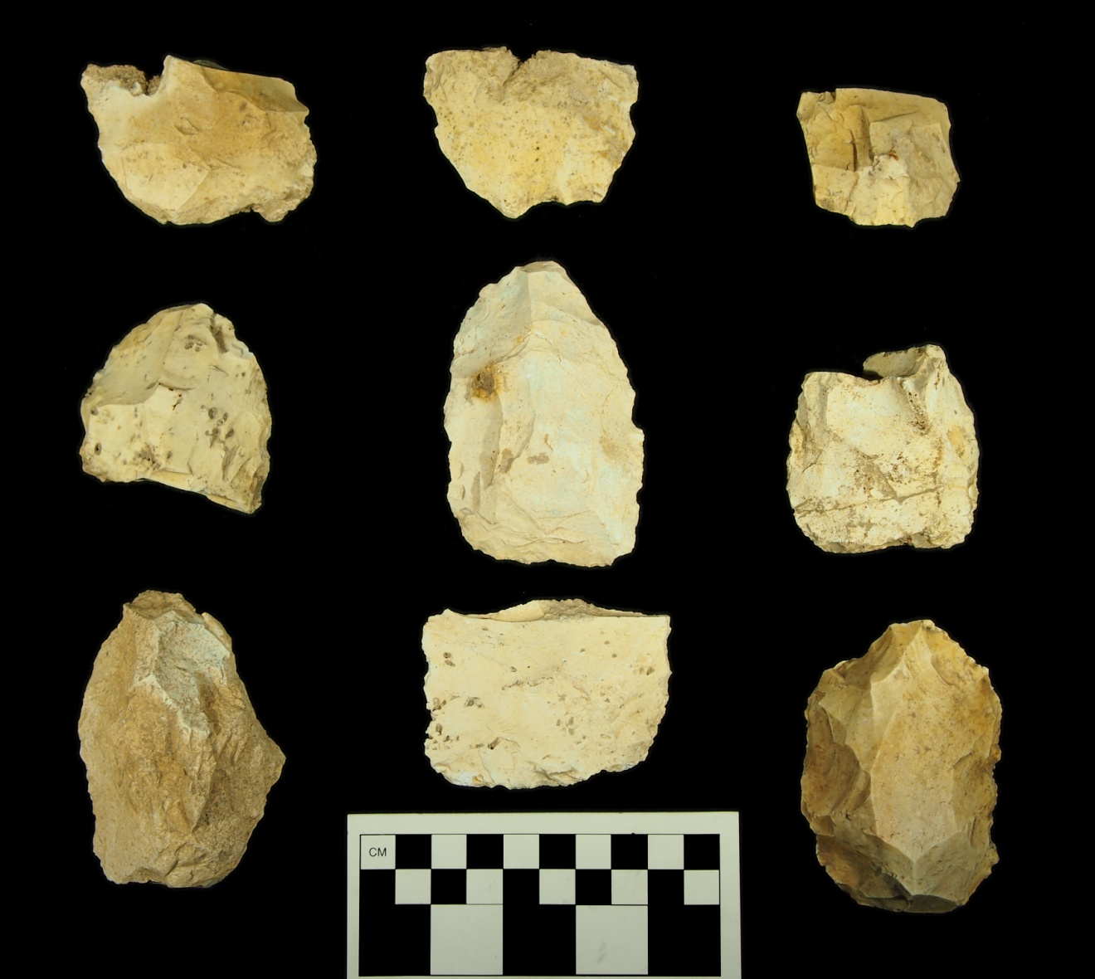

Figure C- 1. Bifaces, 38AL228 surface collection.

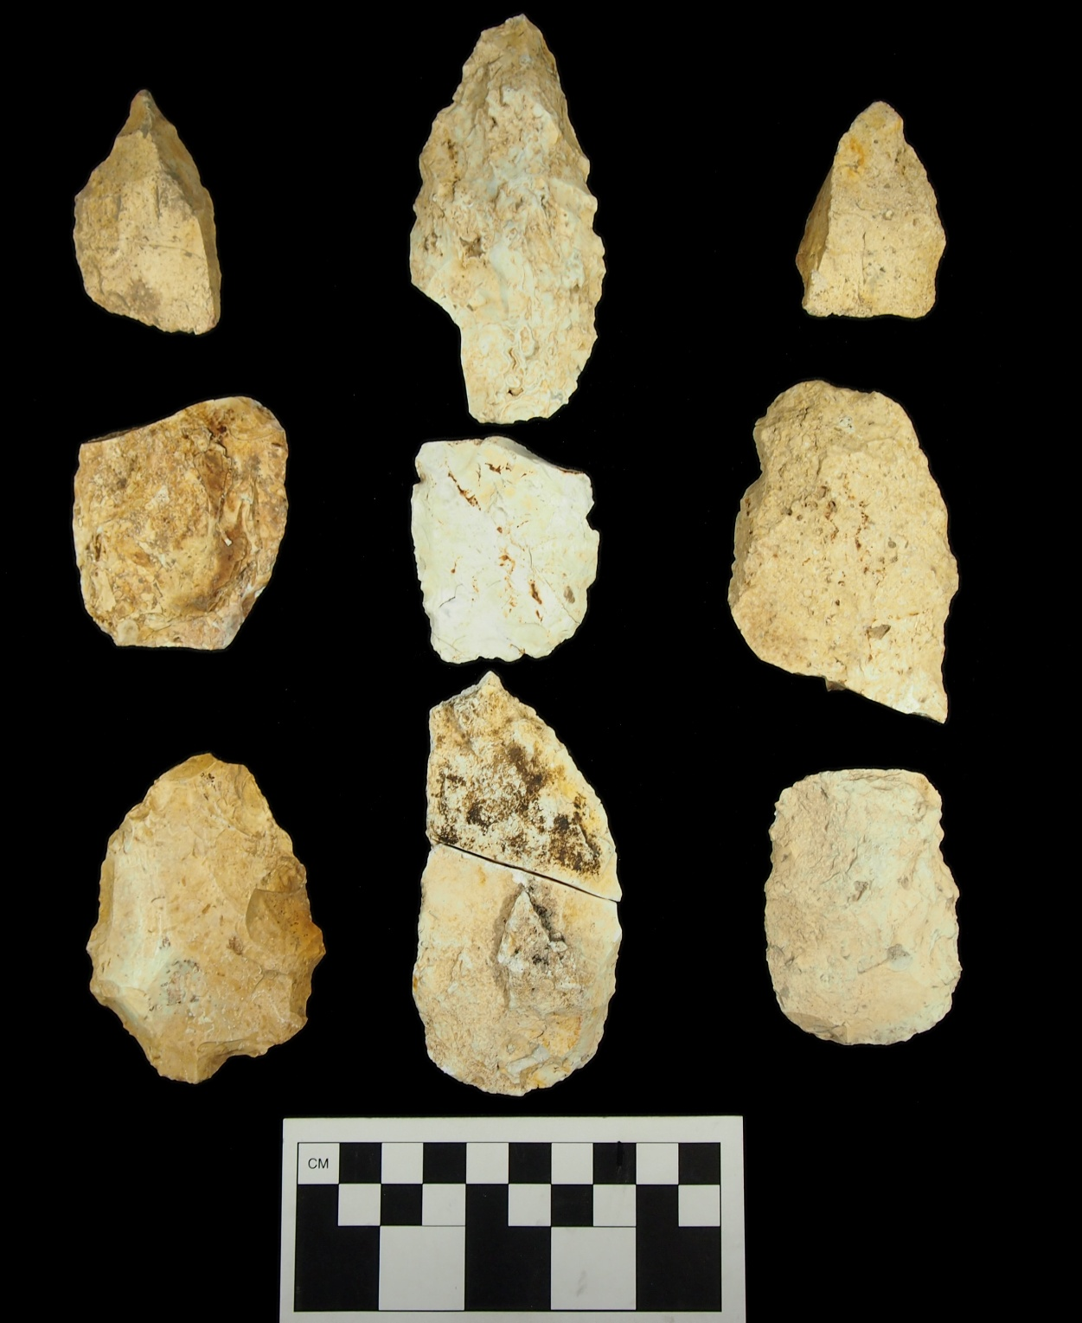

Figure C- 2. Bifaces, 38AL228 surface collection.

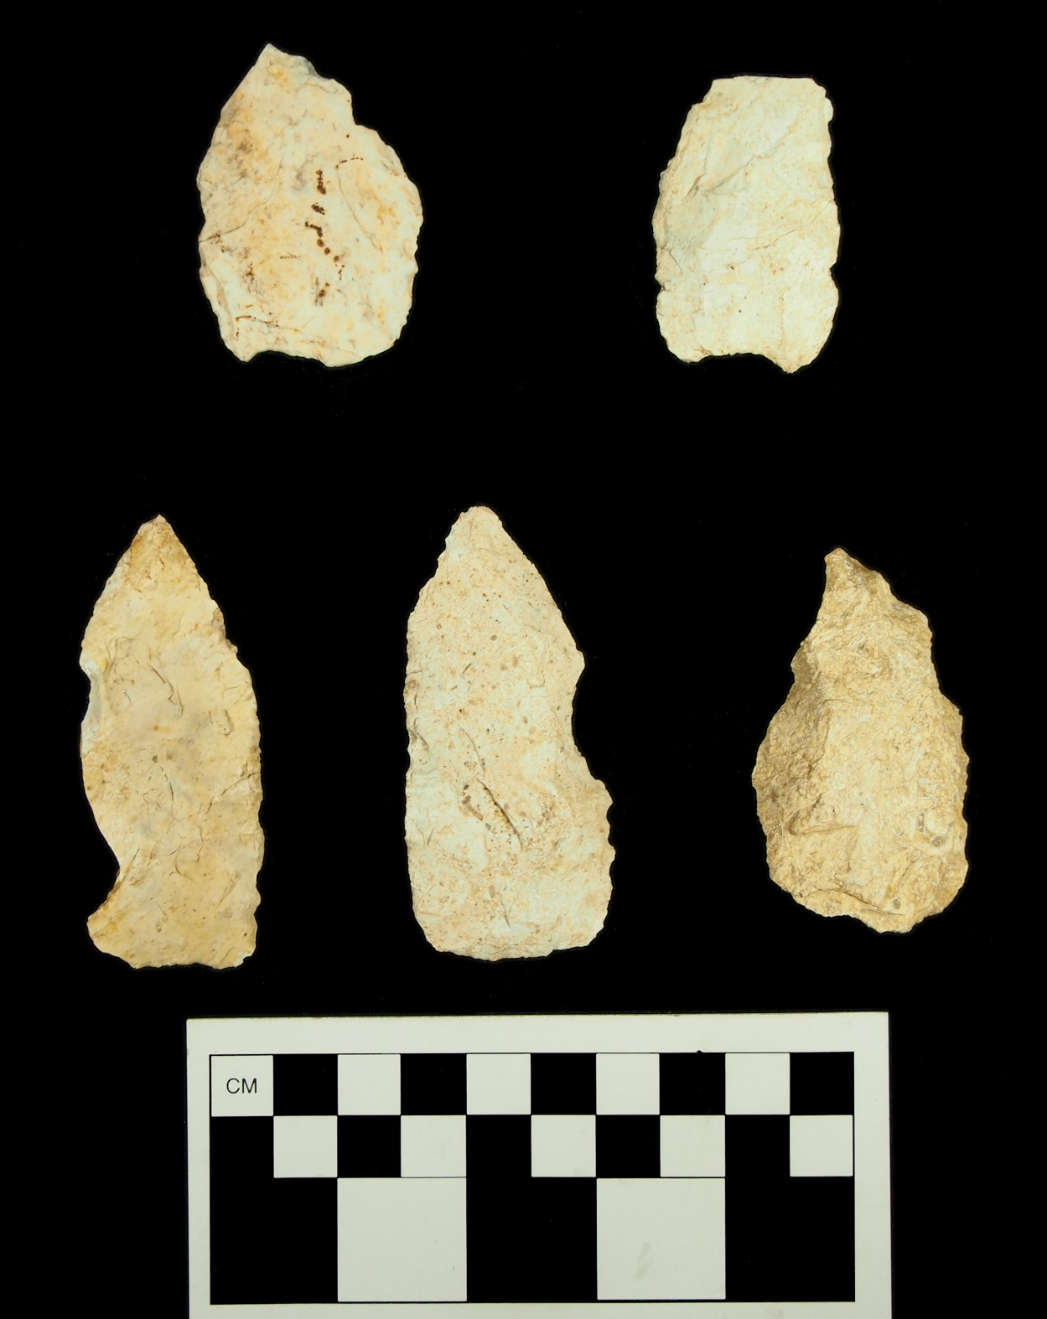

Figure C- 3. Bifaces, 38AL228 surface collection.

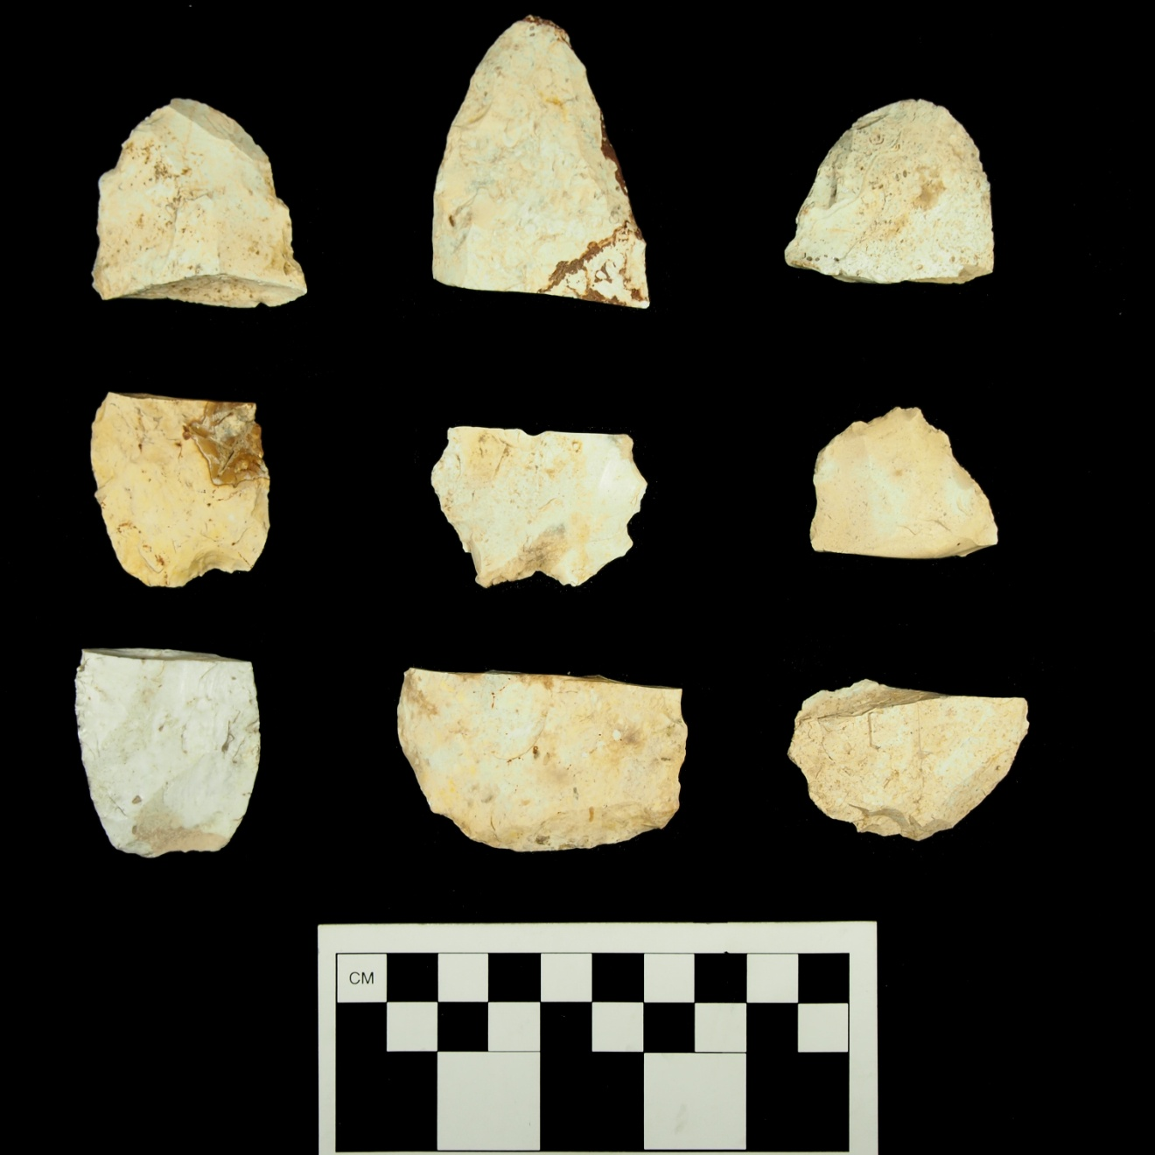

Figure C- 4. Bifaces, 38AL228 surface collection.

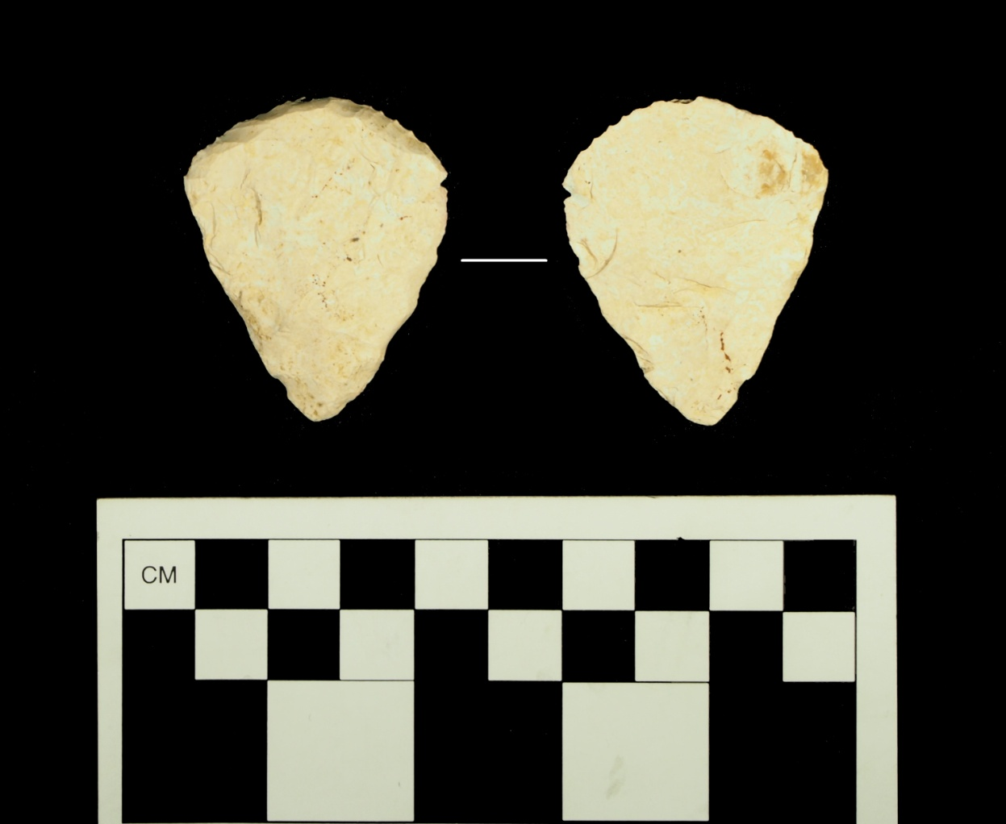

Figure C- 5. Endscraper, 38AL228 surface collection.

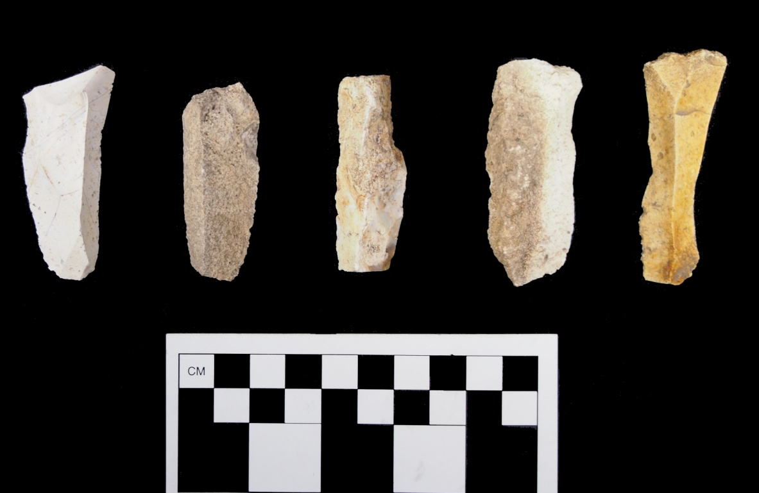

Figure C- 6. Blades, 38AL228 surface collection.

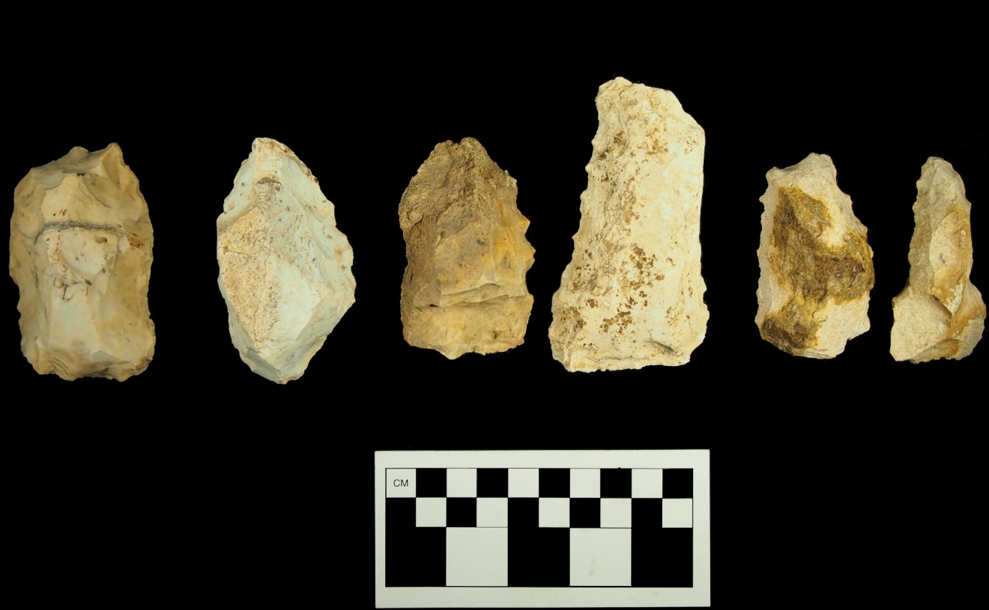

Figure C- 7. Denticulated scrapers, 38AL228 surface collection.
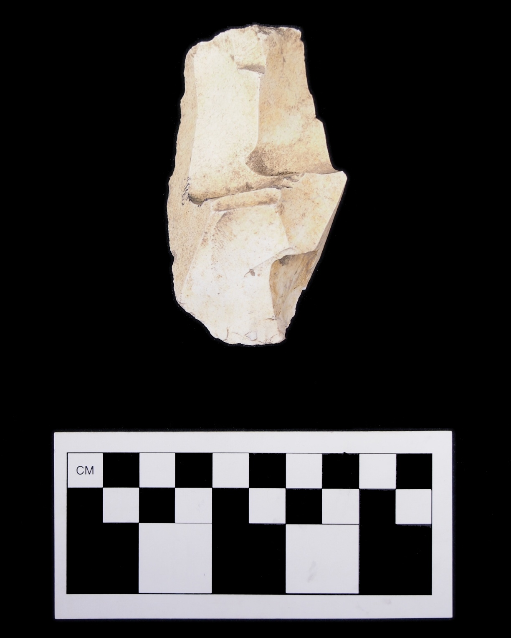

Figure C- 8. Blade core fragment / error recovery blade, 38AL228 surface collection.

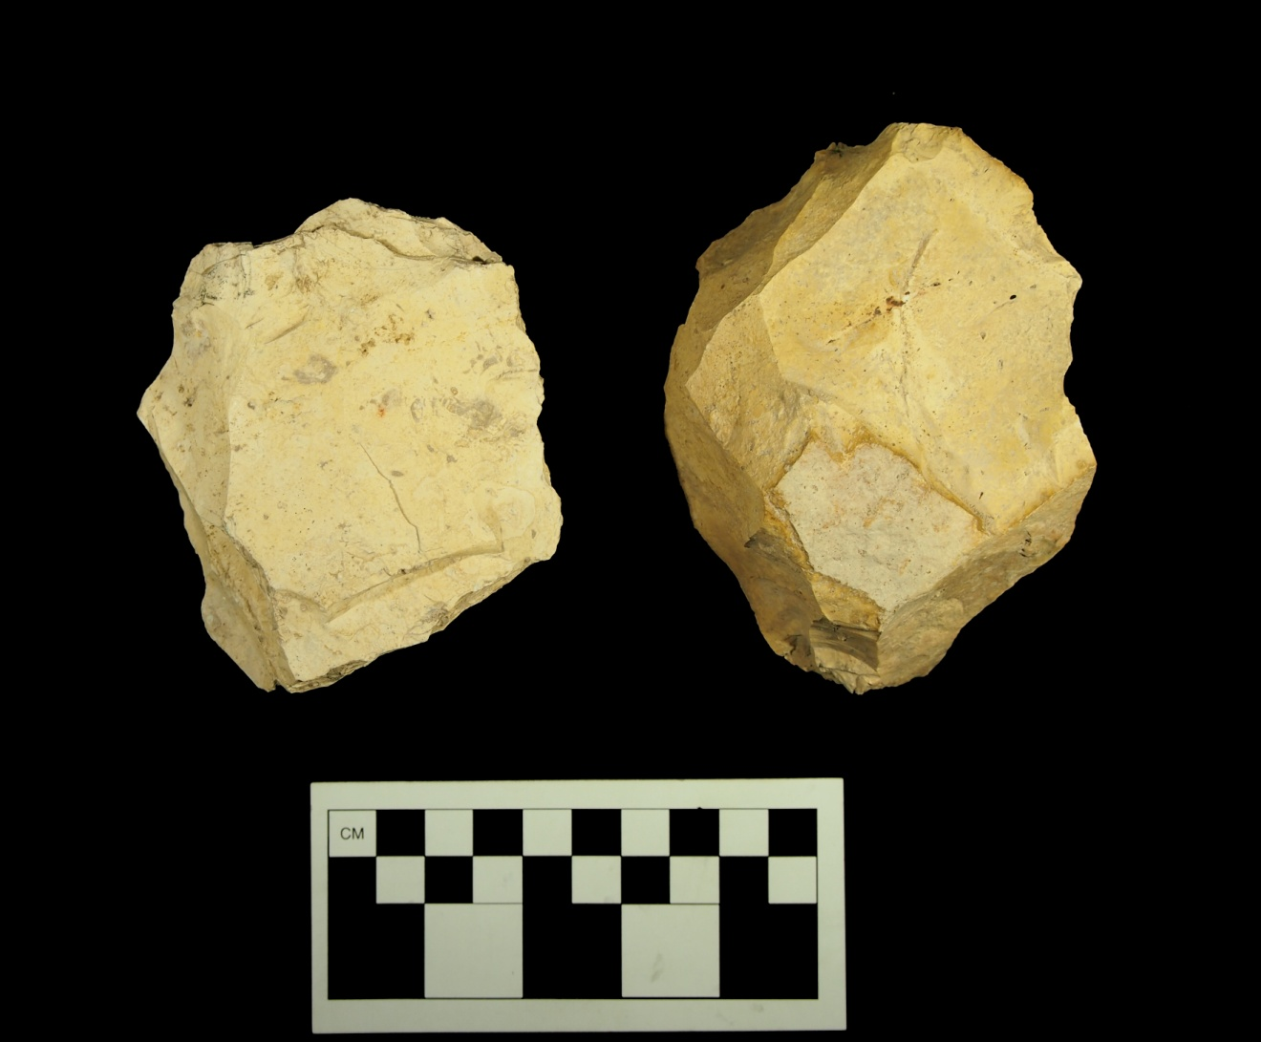

Figure C- 9. Amorphous cores, 38AL228 surface collection.

Vita

Andrew James Weidman was born July 16, 1982 in Detroit, Michigan. He was raised in Harrogate, Tennessee. He relocated to Knoxville, Tennessee in 1994, graduating from Karns High School in 2000. He received his B.A. from the University of Tennessee, Knoxville in 2006. He entered the graduate program in Anthropology at the University of Tennessee, Knoxville in 2010, and was awarded his M.A. in 2013.

The site is also unofficially referred to as the “Bubba Site,” which refers to a hunting stand located within the site inscribed with the name “Bubba”. For the purposes of this thesis, the trinomial site number (38AL228) is used to refer to the site in order to remain consistent and avoid confusion.
Paleoindian artifacts crafted on Allendale chert exhibit a degree of patination that distinguishes them from more recent periods (Goodyear and Charles 1984:5). However, Early Archaic artifacts can also exhibit the same type of patination patterns (Sassaman and Anderson 1990:174). Patination alone is not sufficient to designate an artifact as Paleoindian in age.
Additional fieldwork occurred during the first week of August 2011 to complete two test units and conduct additional mapping.
All test units in Area B were oriented using magnetic North and do not correspond to the arbitrary grid established for the site. Each unit is named according to the closest corresponding whole-number coordinate and all spatial data within each unit is based on this coordinate.
Test unit N1012 E1051 is not oriented properly with the arbitrary grid established for the site. The unit was named according to the closest corresponding whole-number coordinate and all spatial data within each unit is based off of this coordinate.
The test units that comprise the test trench do not correspond to the arbitrary grid established for the site. Each unit is named according to the closest corresponding whole-number coordinate and all spatial data within each unit is based on this coordinate. Incorrect unit names were not changed to avoid confusion and/or data loss.
The asterisk in Figures 13 through 17 indicate placement of artifact in exact center of level, as artifacts were recovered from screen and not individually plotted.
6N1153 E1146 was established using magnetic North and does not correspond to the arbitrary grid established for the site. The unit is named according to the closest corresponding whole-number coordinate and all spatial information is based on this arbitrary coordinate.
The depths of Clovis deposits were similar at both 38AL228 and the Topper Hillside (approx. 15-25 cm). Area examined (m²) serves as a proxy for volume.

