Mind, Body and Soul:
Performance Landscapes for a Healthy Community

A Thesis Presented for the
Master of Landscape Architecture
Degree
The University of Tennessee, Knoxville

Angelike G. Angelopoulos
December 2014

Copyright © 2014 by Angelike G. Angelopoulos
All rights reserved.
DEDICATION

This is dedicated to my wonderful family and friends. Your support was unwavering, your pep talks were numerous and your laughter was infectious. Thank you.

Baba: It all started with picking up sticks… it’ll only take 10 minutes.
Mama: Yiayia’s blessings came with your prayers.
Dina: There’s no one I’d rather vent to.
Soula: Pharmacist, therapist and cheerleader, your open ear was the best prescription.
Mia: I feel like… I want your lifestyle when I get out.
Christina, Adam & Mrs. Fluffy: Late nights, taco bell and movie lines. We are the Goonies.
Jacob: Thanks for going through this with me.
Melissa: Those 4AM walks hit the spot.

ACKNOWLEDGEMENTS

My deepest appreciation goes out to my thesis advisors. Brad Collett, John McRae and T.K. Davis: thank you for the patience, the encouragement and time that you gave to me throughout this long endeavor. You taught me so much about the process, the journey and myself. The commitment you showed me was immensely appreciated and this thesis would not have developed without your efforts. Lastly, my sincerest thank you goes to Sam Rogers for his endless stream of wisdom, support and efforts to the program, I am honored to have been able to work with you for 2 years.
This thesis would not have been possible without all the late night conversations and support from my amazing classmates. A special thanks goes out to Melissa Morris and Ben Dance, your encouragement and perspectives were truly valued. To the Second Year Landscape Architecture students, thank you for adopting me into your family. You are an amazing group of individuals and I am lucky to know you. John McRae, your insight is spot on, your leadership is inspiring and your kindness is heartwarming. It has been an absolute pleasure to work with you. Finally, I would like to further acknowledge Brad Collett for his dedication, positive attitude, impeccable diction, and lastly his constant stream of movie quotes. Brad has been a constant source of inspiration and encouragement for me as a student and in the future.
I have the utmost gratitude for my family and friends, your love and support made this achievement possible!

PREFACE

“Urban parks were originally created so people could escape from the dirty reality of city life. In the 21st Century, the best city parks are also multi-use destination and catalysts for community development.”
-Project for Public Spaces

***

“What is the city but the people?”
-William Shakespeare, Coriolanus

***

“The landscape becomes the new field of action in which the ‘users’ stop being normal observers and become indispensable elements for the definition of the space that hosts them”
-Luca Galofaro

A community’s connection to nature is increasing in importance as areas become urbanized and public open space decreases. Urban environments pose contemporary health challenges of its inhabitants increasing the need for a new approach to design. The physical, mental and social health of urban communities is becoming a key factor in design reform, spawning new guidelines and planning goals. Mind, Body & Soul is a thesis that explores how urban design and reclamation of underutilized landscapes can address these challenges.

ABSTRACT

According to the World Health Organization, there have been increases in the adverse physical, mental and social conditions amongst urban populations in recent years. These issues have been attributed to impediments to healthy lifestyles, a lack of physical activity and poor food choices (WHO 29). This can lead to obesity, increasing risk of diabetes, heart disease and other health related problems. Sedentary lifestyles are worsened by modern technologies such as cell phones, computers, and video games.
Urban landscapes have evolved over time to suit the needs of various, and sometimes-competing priorities of growing cities. As a result, the health of human inhabitants has not always been a primary consideration, and the manner with which the built environment has historically been planned and designed exacerbates the aforementioned health challenges. The harshness of the urban environment and limited access to nature has been know to increase rates of mental health issues such as anxiety and depression among city dwellers. Social challenges also arise with increased use of digital technology, limiting face-to-face interaction and straining support systems that are often provided by engaging a community.
Fragmented landscapes offer an opportunity for redesign and can help to counteract the open space and nature deficiencies found in the urban context. This project explores how the redevelopment of blighted and underutilized landscapes may be used as a method to mitigate or overcome social, mental, and physical health challenges posed by contemporary urban environments and the lifestyles they facilitate. The Blackstock site in downtown Knoxville, TN is selected as the test site for this exploration due to its central location, proximity to four historic neighborhoods where such challenges are observed to be persistent, and blighted. Program will be integrated within the project site to increase physical activity, mental stimulation and social interaction, as well as to improve air quality, and provide access to amenities that promote healthy dietary habits.

TABLE OF CONTENTS

- Chapter 1- Defining the Issues 1
  - Health Problems of Today 1
    - Physical Health Issues. 2
      - Contributing Factors 6
        - Asthma 6
        - Obesity 7
    - The Mental Health Issues 12
      - Contributing Factors 12
    - Social Health Issues 13
      - Contributing Factors 14

- Chapter 2 – What is Being Done to Address Health Issues 15
  - National and Local Program Efforts 15
  - Health-Related Quality of Life 19
  - The Art of Healing 20
  - The Roles of Nature, Parks and How Has It Evolved 21
  - Design Direction 28

- Designing for Health 30
  - Design Principles for Building Healthy Places 31
  - Design Precedents 33
    - Buffalo Bayou Promenade | Houston, Texas 35
    - The Highline | New York, New York 37

- Chapter – Site Selection 40
  - The Process and Criteria 40
    - Blackstock Area 41

- Inventory and Analysis 44
  - Health Report 44
  - Existing Conditions 47
    - Photo Inventory 48
    - The Neighborhoods 50
    - Diagrams 52

- Chapter 6- Actions for Change | Design Response 54
  - Project Overview 54
  - Objectives 54
  - Performance Park Site Design 57
  - Provide a Healthy Environment, Physically and Ecologically 57
  - Increase Community Involvement and Social Gathering 69
  - Provide Spaces for Natural Recharge 71
  - Provide Access for All 77

- Chapter 7- Conclusion 82

- List of References 87

- Appendix 92

- Vita 94

List of Figures

Figure A-1. Adolescent Obesity in Knox County 3
Figure A-2. Adult Obesity Percentage in Knox County 4
Figure A-3. “100 Most Challenging Places to Live with Asthma” 5
Figure A-4. Air Pollution Deaths 6
Figure A-5. Food Desert 10
Figure A-6. Field day Jumping jacks on the lawn of the White House 16
Figure A-7. Senator Jewel with youth outdoors 17
Figure A-8. Bird tour with ECO-TN 18
Figure A-9. Sculpture relaxation and reflection 20
Figure A-10. Contemplative art 21
Figure A-11. Passive public art 21
Figure A-12. Exploring nature 22
Figure A-13. Recreational Facility 24
Figure A-14. Central Park 25
Figure A-15. Paley Park 26
Figure A-16. Buffalo Bayou bikes 35
Figure A-17. BB-Before and After Pedestrian Bridge 36
Figure A-18. Spring on the Highline 37
Figure A-19. Users in the wild landscape 37
Figure A-20. Knoxville City Grid 1939 41
Figure A-21. Current Aerial image 43
Figure A-22. Knoxville’s Food desert 45
Figure A-23. Knoxville’s Health Report 46
Figure A-24. Context Locator 48
Figure A-25. Site photos 49
Figure A-26. View towards Mechanicsville, Next to the Valarium 50
Figure A-27. Neighborhood demographics & location 51
Figure A-28. Existing conditions diagrams 52
Figure A-29. Proximity to parks and green space 53
Figure A-30. Objectives 55
Figure A-31. Guiding Principles 56
Figure A-32. Site Plan for Performance Park 59
Figure A-33. Recreational Sports Diagram 60
Figure A-34. Pillar Climbing 61
Figure A-35. Trails and Paths Diagram 62
Figure A-36. Main Lawn Section Perspective 63 Figure A-37. Landforms Diagram 64
Figure A-38. Urban Tree Farm Diagram 65
Figure A-39. Urban Tree Program 66
Figure A-40. Systems and Processes Section-CO2 sequestration 67
Figure A-41. Community Garden & Market Perspective 68
Figure A-42. Community Center Diagram 70
Figure A-43. Overpass Canopies Perspective 72
Figure A-44. Section Perspective: Native Woodlands and Riparian Area 73
Figure A-45. Vegetation Diagram & Plant List 74
Figure A-46. Sculpture Diagram 75
Figure A-47. Perspective Rendering-Art in the Park Sculpture 76
Figure A-48. Access Diagram 78
Figure A-49. Grand Avenue Bridge Access 79 Figure A-50. Street Access & Way Finding 80
Figure A-51. Access to Downtown and Museum of Art 81

Chapter 1 – Defining the Issues
In 2010 the U.S. Census Bureau estimated that more than 80.7 % of the U.S. population lived in urban areas. That represents a 12.1% increase in urban population between 2000 and 2010 (U.S. Census 2014). The growth of urban populations has corresponded with, and in many cases has been facilitated by modern advancements in transportation such as railway and interstate infrastructure, while new industries, manufacturing processes, and technologies have created jobs in urban centers. Modern technologies such as computers, and cell phones make information readily accessible and enable social connections through digital forums, yet they also contribute to sedentary lifestyles and interpersonal isolation. Organizations such as the Centers for Disease Control use life expectancy as a means to measure the health status of a population. However, the life expectancy metric does not offer any information regarding the quality of the physical, mental, and social aspects of one’s life. This has highlighted a need to measure the quality of the years lived as promoted by the World Health Organization, and not just the length of time. (W.H.O.) (USDHHS 2014).

1.1 Health Problems of Today
Claudia Carol points out a contemporary reality facing health in our cities today, acknowledging that being healthy is no longer a simple association to exercise, but is instead a holistic lifestyle that encompasses complete mental and physical wellness (2014). This premise has been understood historically, but has recently become even more evident that a strong relationship exists between the design of the built urban environment and public well-being. Frederick Law Olmstead writes, “A man’s eyes cannot be as much occupied as they are in large cities… without a harmful effect, first on his mental and nervous system and ultimately on his entire constitutional organization.” Urban life and the pressure of business required tiring concentration that Olmstead felt could create permanent damage to the health of an individual (Beveridge 34). He documented Landscape Architecture’s effect on human health and “scenery’s” ability to positively contribute to a person’s well-being. The design focus of Olmstead was a ‘battle of the styles’ moving away from an aesthetic theory to one that included the essential whole health of human inhabitants (Beveridge 34).
In spite of Olmsted’s 19th century wisdom regarding the impact of city living on holistic wellness, 20th and 21st century cities have still seen a significant rise in health issues such as obesity, asthma and diabetes. The percentage of children and adults living with these chronic health conditions has increased exponentially in recent years (CDC 2011). While these conditions occur everywhere, urban environments are showing elevated levels of stresses to one’s physical, mental, and social well-being (Kjellstrom 2007).

    - Physical Health Issues
Obesity
More than one-third of U.S. adults (over 72 million people) and 17% (12.5 million) of U.S. children are obese (CDC 2011). Obesity is defined as excess body fat and is often measured by body mass index (BMI), a common scientific way to screen for whether a person is considered underweight, normal weight, overweight, or obese (CDC 2012). From 1980–2008, obesity rates doubled for adults and tripled for children. Studies indicate these instances are related to lifestyle choices such as inactivity and unhealthy eating habits, resulting in diseases that are both debilitating and expensive (Carol 2014).
Nearly one in three children in America are overweight or obese. The statistics are even higher in African American and Hispanic communities, where nearly 40% of the children are either overweight or obese (Let’s Move 2014). On a positive note, the obesity rate has dropped from 13.9% to 8.4% among children ages 2 to 5 since 2012 (CDC 2014).

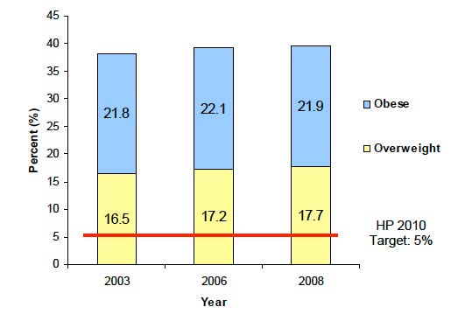
Figure A-1. Adolescent Obesity in Knox County. Source: Community Health Status Assessment- Knox County.

Obesity amongst children and adults is costly. The 34.9% of the obese adult population correlated to an estimated annual medical cost of $147 billion in 2008. The medical costs for obese individuals cost $1,429 more than that of individuals with normal weight. The leading obesity-related conditions include heart disease, stroke, type 2 diabetes and certain types of cancer. In 2013, the state of Tennessee ranked as the 10th most obese state in the nation. In addition, there are 13 states that have an obesity occurrence greater than 30%, half occurring in southern states (TFAH 2013).

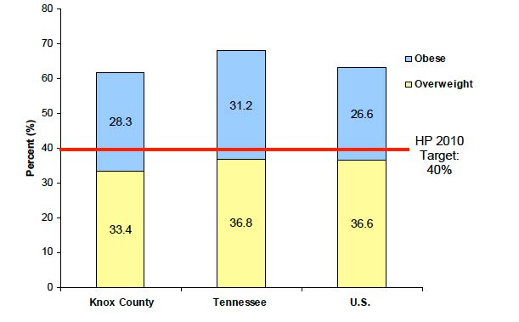
Figure A-2. Adult Obesity Percentage in Knox County. Source: Community Health Status Assessment- Knox County.

Asthma
Asthma is also on the rise and can be linked to a person’s weight. Obesity is a risk factor for asthma. It has been reported that asthma impedes the ability to maintain physical activity, implying that asthma could in turn contribute to obesity due to decreased activity levels. Nevertheless, growing evidence suggests that obesity precedes asthma and that the correlation is clear (Goodrich 2013). Research conducted by Charles River Laboratories supports findings that being overweight could affect lung physiology. Patients considered overweight have reduced lung volumes and elasticity due to the narrowing of peripheral airways thus causing them to close during normal breathing (Goodrich 2013). In 2013, Knoxville, TN ranked 10th amongst the 100 most challenging cities to live with asthma. Findings reported that Knoxville ranked worse than average for annual pollen, air quality and public smoke-free laws (AAFA 2013). This is an improvement from performance the prior year when Knoxville ranked 3rd worst city for living with asthma.

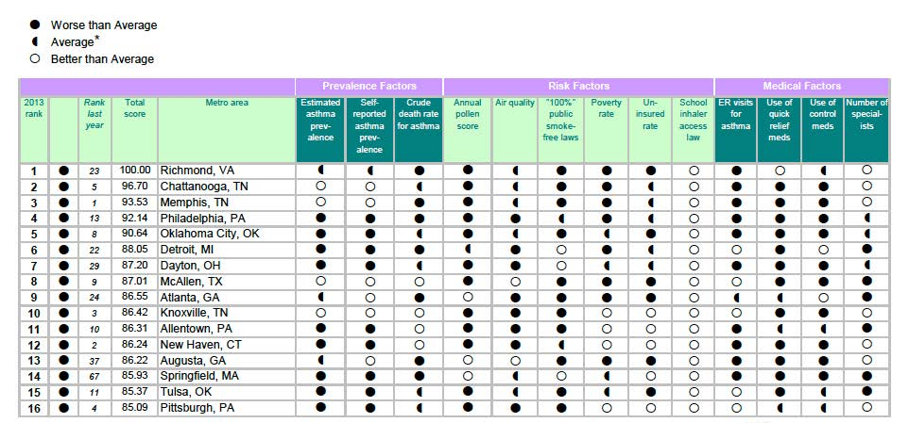
Figure A-3. “100 Most Challenging Places to Live with Asthma” Source: Asthma and Allergy Foundation of America.

      - Contributing Factors
1.1.1.1.1 Asthma
While definitive causes for asthma are unknown, factors that contribute to asthma have been identified. Asthma attacks are linked to allergens, exercise, smoke, occupational hazards and air pollution (CDC 2012). Individuals are especially prone to these factors in urban areas and some factors can additionally be linked to transport. Urban air pollution generated by vehicles and industry is associated with higher rates of cardiovascular and respiratory diseases, including asthma. More surprising is that urban air pollution is estimated to kill 1.2 million people annually around the world (WHO 2009).

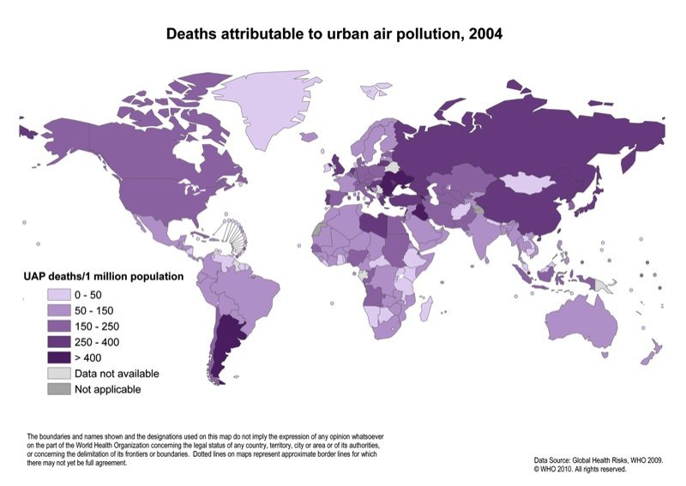
Figure A-4. Air Pollution Deaths. Source: World Health Organization

Particulates
Among the air pollutants created by vehicle traffic, small and fine particulates have the highest bearing on a person’s health. Small particles of less than 10 microns in diameter (PM10) and fine particles of less than 2.5 microns in diameter (PM 2.5) bypass the body's usual defenses against dust, embedding deep in the respiratory system. Elemental carbon or carbon compounds are what primarily make up small particles emitted by road vehicles. They are also made of heavy metals and sulfurs, and carcinogens known as benzene derivatives. Long-term exposure to higher levels of small and fine particulates is associated with reduced lung function and respiratory disease. Short-term effects of exposure to CO and NOx include respiratory issues as well as impaired exercise function (WHO 2009).

1.1.1.1.2 Obesity
There are many proven contributing factors leading to obesity, making it a complex health issue. Contemporary technology is making modern amenities easier to access and even easier to use. In addition, all people are not created equal adding to the various influences for becoming overweight or obese. Key factors include behavior, environment, genetics and dietary habits (CDC 2012).
Behavior
For adults, inactivity can sometimes be misjudged as laziness. However, in many cases one’s choice to not exercise is affected by exhaustion from long hours at work, shuttling children to and from programs, or a general lack of time in one’s day. Walking to and from places such as school, work or the market was part of daily activity thirty years ago, yet today it is a foreign concept. Reasons people no longer choose to walk and instead choose to drive may be linked to concerns for safety, distance, and time, weakening neighborhood foot traffic (Kjellstrom 2007). Another behavioral factor associated with obesity is the increased use of technology such as video games, televisions, and cell phones for entertainment rather than creative play and active exercise outdoors. One study suggests that adolescents ages 8 to 18 years old spend an average of 7.5 hours a day using entertainment media including TV, computers, video games, cell phones and movies straining motivation to go outside to play (Let’s Move 2014).
Environment
Today, the daily commute is a reality of contemporary urban life due in part to the development of the interstate highways, the dream of homeownership, and the manner with which urban sprawl has altered the physical environment in which we live. According to a study by the Harvard Health Watch, an average American spends 101 minutes driving per day. That means that in a lifetime a person can spend upwards of 37,935 hours driving a car. Even if one’s personal values suggest that the healthier choice to walk or bike to and from destinations is preferred, most cities have been built to facilitate the movement and storage of automobiles with little consideration to the pedestrian or cyclist.
Transportation infrastructure can enhance or hinder one’s ability to navigate a city as a pedestrian and even as a biker. Lack of sidewalks, for example, can either force pedestrians to drive or to navigate potentially dangerous situations. In addition, the lack of bike paths such as the Fort Sanders and Mechanicsville Neighborhoods in Knoxville creates a hazardous situation when users are forced to share roads without proper awareness or signage for drivers. Lack of recreational space discourages physical activity and contributes to obesity. In low-income areas that do have such amenities, the threat of crime keeps many people inside (Hood 2005).
Genetics
Although this is a factor that cannot be inherently changed, it is important to mention that heredity plays a role in the causes of obesity but according to Harvard School of Public Health, it is generally lesser in degree (HSPH 2014). Together with behavior, genes may increase one’s susceptibility for obesity requiring outside factors of little activity and abundant food supplies thus making genetics different from the other factors (CDC 2012).
Dietary Habits
Dietary habits are crucial to a healthy body. The phrase ‘you are what you eat’ has never been more relevant than in modern day as food additives, preservatives and chemicals find their way into the foods we eat everyday. The “world’s perception” of the large American diet is shaped by the expanding portion sizes and frequency of consumption. The Western diet has become frequent, large meals that are high in refined grains, red meat, unhealthy fats and elevated amounts of sugar. The foods needed to help with weight control and prevention such as fruits, vegetables and nuts, are lacking in the typical diet (HSPH 2014).
Residents’ access to healthy foods like fresh vegetables and fruits is further limited when a supermarket is not located in close proximity to their neighborhood, or when nearby groceries does not stock these items (Hood 2005). Such circumstances may qualify a community as a food desert. Food deserts are defined as urban neighborhoods and rural towns without access to fresh, healthy, and affordable food (USDA 2014). Identified by census tracts, food desert fall into two categories of “low-income” and “low-access” communities. Low-access communities are those in which at least 500 persons, or 33% of the census tracts, live more than one mile from a supermarket or large grocery store (USDA 2014).

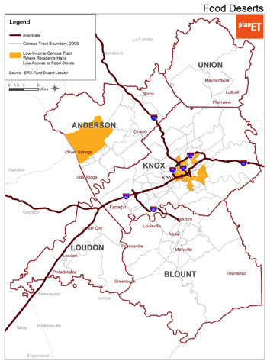
Figure A-5. Food Desert. Source: PlanET

Figure A-5 shows the distribution of Food Deserts in Knoxville, TN. The areas most affected are Anderson County and the city limits of Knoxville. It is more than evident that the city of Knoxville is largely a food dessert and the areas highlighted are also within low-income neighborhoods.

The Disparity Factor
Health disparities can be defined as inequalities that exist with individuals of a certain population group that do not benefit from the same health equity as another group. (FCCC 2014). There are many studies linking poor health to social and economic disparities. In 2008, disparities were reported for an estimated 233.5 million people living in urban areas while only 70.5 million exist in rural areas (USDHHS 2010). In 2012 The National Institutes of Health published a report detailing trends, progress and policy related to health inequalities. In the research, authors found that a gap still remains between education groups and income levels; those with the most education reported the highest amount of physical activity and those with less than a high-school education reported the lowest amount of physical activity (Bleich 2012). Blacks had 51% higher and Hispanics had 21% higher rates of obesity as compared to Whites (CDC 2010).
In the past decade, researchers have collected substantial scientific evidence revealing that various aspects of the built environment can have profound, and directly measurable effects on both physical and mental health symptoms. These symptoms typically occur among ethnic minority populations and low-income areas. The term ‘income segregation’ is commonly referred to as the practice of housing the poor in discrete areas of a city. This too, has also been linked with obesity and adverse mental health conditions (Hood 2005).
“Healthy People 2020” has set an all-encompassing goal focused on addressing disparities, aiming to provide the highest level of health for all levels of people. Health equity requires valuing all individuals equally, regardless of education level, socio-economic class or geographic location. Those living in urban areas are faced with additional stresses such anxiety and depression adding to the already complex problem (USDHHS 2010).

1.1.2 Mental Health Issues
Problems linked to emotional well-being are also related with city-dwelling. People living in cities have a 21% increased risk of anxiety disorders and a 39% increased risk of mood disorders (Carol 2014). Additionally, the impacts of poor health in urban workplaces are immense. Poor mental health can result in lost productivity and even absenteeism in the work place. According to a US Department of Health and Human Services study, “people with high levels of well-being are more productive at work and are more likely to contribute to the communities. This alone provides a compelling argument for addressing the well-being of employees through scalable solutions aimed at reversing unhealthy lifestyles. In addition, more research is supporting the view that positive emotions – which are central components of well-being – are not merely the opposite of negative emotions but rather may be independent dimensions of mental health.” (USDHHS 2)

      - Contributing Factors
Factors contributing to mental illnesses such as anxiety, stress and depression in adults living in urban areas vary from work and financial stresses to poor physical health (CDC 2012). Nature deficiency disorder, prevalent in urban areas, has also been linked to increased stress and intellectual impairment, which can have physical health consequences such, has high blood pressure, lack of sleep, or depression (Howard 2013). Urban variables include long and taxing commutes, and poor city development patterns that further separate one’s daily functions. Urbanization affects mental health through the influence of increased stressors and factors such as job demands, crowded and polluted environment, levels of violence, and lacking social support (Srivastava 2009).

    - Social Health Issues
According to the University of New Hampshire Health Services, social wellness is the ability to build personal connections with others, deal with conflict and to be a part of a positive social network (2014). Reports are documenting many of the negative effects social media has on our healthy and our personal relationships. It has been documented that social media provides a false sense of community adding to already existing anxiety (Campbell 2005). If social media weakens physical interactions, how will generations learn how to handle the stresses of school, work and life? Social health is important because it is directly related to a person’s ability to emotionally connect and handle stressors (Adli 2011). Mazda Adli reports that social stress may be the most important factor for the increased risk of mental disorders in urban areas (2011). As sometimes challenging as cities are, programs need to be focused on joining people together to foster positive support and engagement increasing life satisfaction UNHHS 2014). Health starts in our homes, schools, neighborhoods and communities. It is determined in part by access to social opportunities, social interactions and quantified by the quality of relationships we find support (USDHHS 2010).

      - Contributing Factors
In today’s digital age, social wellness is challenged by the increased use of insular technology for entertainment and reliance on maintaining relationship through online social media portals such as Facebook, twitter, and Snap Chat. Lack of social engagement may also be experienced as a social threat or as chronic social stress, both of which are likely to occur as a direct consequence of urban setting and high population densities (Adli 2011). Interpersonal relationships provide a sense of community and a sense of belonging. They allow individuals to cope with issues by finding support from people who understand and share the same principles. Transportation corridors are a driving force shaping cities and communities, affecting not only patterns of physical movement but also fundamental social interactions and patterns of social health and well-being. Transportation patterns center around getting from point a to point b as quickly as possible, increasing the need for vehicle use. Sprawl has also aided in the over saturation of vehicles. With amenities spread out, vehicles are the only option. It is typically more evident in low-income areas of cities (WHO 2009).
An Understanding
The research above provides the background for this thesis, establishing physical, mental and social health challenges within urban environments. These health issues among urban inhabitants will continue to be exacerbated simultaneously as urban populations increase if corrective measures are not taken. What is being done to address these issues is the subject of the following chapter, and the role that design in the urban environment may play is the subsequent focus of this thesis and the design proposal.

Chapter 2 – What is Being Done to Address Health Issues
Through local and national efforts, these contemporary, physical, mental, and social, health issues have gained the public’s attention and the voice that is necessary to catalyze reform. Citizens, leaders, designers and policy makers across national and local scales have begun to seize the opportunity to make a difference in cities where health is declining and access to amenities is challenged. First Lady Michelle Obama created a program aimed at combating childhood obesity. A national effort by The Department of the Interior and a local effort by ECO- TN are providing children with access to nature and physical activity set outdoors. The United States Department of Health has established its healthy vision for the year 2020 by documenting all well-being variables within physical, mental and social health. The following are examples of existing programs that address obesity, nature deficient physical activity and holistic wellbeing.

2.1 National and Local Program Efforts
Obesity is not just considered a disease. It is considered an epidemic by major health organizations such as the Centers for Disease Control, World Health Organization and the National Center for Biotechnology Information. With so many individuals at risk, national and local programs have been created to help combat this enormous problem.
‘Let’s Move’
‘Let’s Move’ is a comprehensive initiative dedicated to solving the problem of obesity within a generation founded by First Lady Michelle Obama. In support of this program’s mission, President Barack Obama signed a Presidential Memorandum creating the first-ever Task Force on Childhood Obesity to conduct reviews of all programs and policies relating to child nutrition and physical activity.

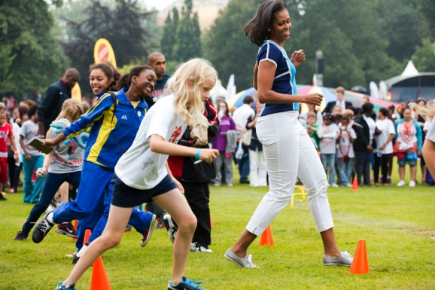
Figure A-6. Field day Jumping jacks on the lawn of the White House. Source: Letsmove.org

The Task Force’s recommendations focus on the five pillars of the First Lady’s Let’s Move! Initiative (Let’s Move 2014):
- Creating a healthy start for children
- Empowering parents and caregivers
- Providing healthy food in schools
- Improving access to healthy, affordable foods
- Increasing physical activity
Department of Interior Program
Driven by a desire to reconnect youth to nature and restore our aging workforce with a new generation of stewards, the U.S. Department of the Interior has also created an initiative to inspire young people to play, learn, serve and work outdoors (USDOI 2014).
Interior Secretary Sally Jewell outlined the initiatives four guiding principles:
- Play: Develop and enhance outdoor recreation partnerships in 50 cities to create systemic opportunities for outdoor play.
- Learn: Provide education opportunity to at least 10 million of the nation’s K-12 student population.
- Serve: Engage 1 million volunteers annually on public lands.
- Work: To develop the next generation of lifelong conservation stewards and ensures our own skilled and diverse workforce pipeline via veterans and youth.

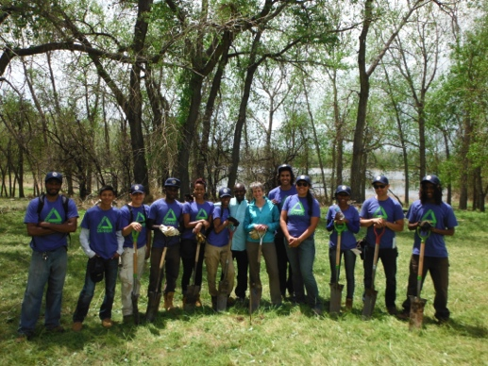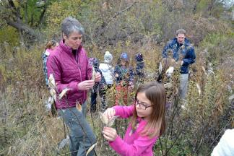
Figure A-7. Senator Jewel with youth outdoors. Source: groundworksusa.org & naturalstart.org

In May of 2014, the Obama Administration announced $6.7 Million to hire young people and veterans to work on public lands across the nation further promoting the support of youth engagement (USDOI 2014).

Every Child Outdoors-Tennessee

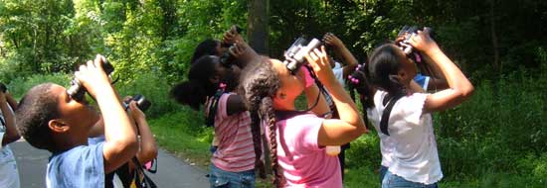
Figure A-8. Bird tour with ECO-TN. Source: Eco-tn.org

‘Every Child Outdoors- Tennessee’ (ECO-TN) is a coalition of more than 100 organizations including local, state and national agencies. The goals of ECO-TN are centered on concerns about youth detachment from nature lack of physical exercise and associated health risks. “ECO-TN lists experiences that every child should experience. The Bill of Rights states that every child, before entering high school, should have the opportunity to: Walk in the woods; Play outside; Explore nature; Watch wildlife; Grow a garden; Splash in the water; Camp under the stars; Learn to swim; Climb a tree; Go fishing; Fly a kite; Visit a farm“ (ECO-TN 2014). Multi-dimensional initiatives must continue to be put in place and sustained in order to help combat these issues, as many will continue to face chronic obesity-related health problems like heart disease, high blood pressure, cancer, and asthma.

2.2 HEALTH-RELATED QUALITY OF LIFE (HRQOL)
The Healthy People 2020 initiative was launched in 2010 by the United States Department of Health and Human Services as a program for health-promotion and disease prevention. As a primary component of HP 2020, Health-Related Quality of Life (HRQOL) is a metric used by the World Health Organization that emphasizes the importance of physical, mental, emotional and social functioning. HRQOL was found to be such an important concept that it was adopted as one of four overarching goals by the Department of Health (USDHHS 2014).
HRQOL goes beyond the typical measures of health and focuses on the quality-of-life consequences that one’s health condition can affect. Its measures of well-being typically assess the positive aspects of a person’s life such as positive emotions and life satisfaction, which can directly affect how a person functions at work, at home and at play. The excerpt below is taken from the US Department of Health and Human Services’ Health People 2020 Report and identifies the benefits of well-being.
“Positive evaluations of a person’s life can include the presence of positive emotions in daily activities, participation in society, satisfying relationships, and overall life satisfaction. These attributes are commonly referred to as well-being and are associated with numerous benefits related to health, work, family, and economics. For example, positive emotions and evaluations of life are associated with decreased risk of disease, illness, and injury; better immune functioning; speedier recovery; and increased longevity.” (2)
HRQOL is different than other initiatives because it looks at the economy and equity associated with physical, mental, emotional and social health. From health costs to environmental responses, the program provides a holistic approach to measurement by qualifying and quantifying results.

2.3 Art of Healing
An artscape is an intervention in the landscape that manifests as a work of art through such methods as landform, sculpture, performance and reflection (Galofaro 23). No matter what the art form, research conducted by Americans for the Arts Organization reported that arts enhance coping, reducing levels of depression, anxiety and healthcare visits (2014). In addition, art helps contribute to life satisfaction, and improves well-being by fostering social interactions and engagement in self expression (AFA 2014).

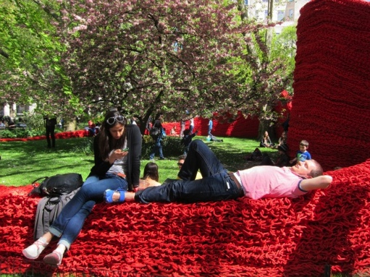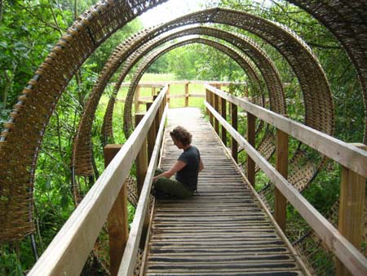
Figure A-9. Sculpture relaxation and reflection. Sources: wf360.typepad.com and dartington.org

Over the past decade, health psychologists have begun looking at how the arts might be used in multiple ways to heal emotional injuries, increase understanding of oneself and others, develop a capacity for self-reflection, reduce symptoms, and alter behaviors and thinking patterns (Stuckey 2010). It was revealed that art can be a refuge for emotions associated with mental stresses and illness and help to foster better social relationships.
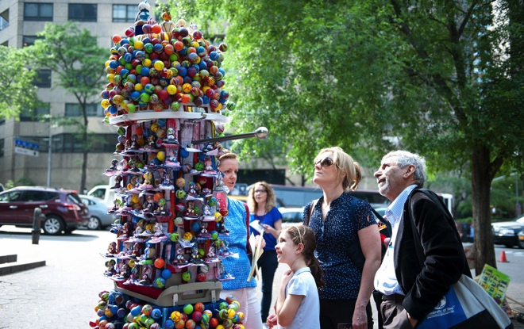
Figure A-10. Contemplative Art. Source: mylottmanning.com

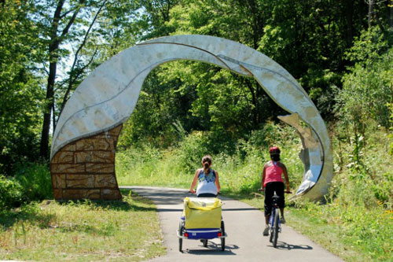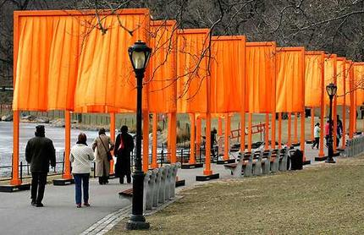
Figure A-11. Passive public art. Sources: bikeiowa.org and worldyrise.blogspot.com

2.4 The Roles of Nature, Parks and How Has it Evolved
In urban landscapes, nature typically takes the form of parks or green spaces located amongst, around, and in between the built environment. Parks have historically performed as places that unite communities and provide for physical, social and mental stimulation. The connection of communities to nature is one that is increasing in importance as areas become urbanized and public open space is limited. What defines today’s public open spaces and how does that definition begin to transform the contemporary urban issues such as physical and mental health? For the purpose of this thesis, it is understood that the park is synonymous with public open space.
Connection to Nature

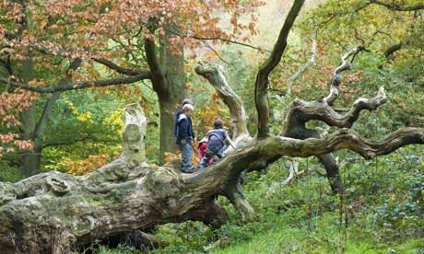
Figure A-12. Exploring nature. Source: theguardian.org

An individual’s connection to nature is mental and physical, as well as social and environmental. Parks can provide these connections on multiple levels for all users of an urban ecosystem, including as an emotional attachment known as biophilia. “Human health and well-being are inextricably linked to nature and a connection to the environment is part of our biological inheritance” (Kellert 2012). Although some underlying social and mental issues support the idea of the birthright to nature, another principle related to biophilia is the overall health of the natural ecosystems (Kellert 49). The quantity of scientific studies that document the benefits of human contact with nature is overwhelming.

A study conducted by the Centers for Disease Control reports nature’s ability to reduce recovery time from illness, lessen the affects of depression, and aids in relaxation. They also found that children’s cognitive functions and concentration where heightened by greener surroundings (CDC 2012). In a study conducted in Chicago public housing development, residents that had more trees and grass reported that they knew their neighbors better and socialized with them more often than those participants without these natural amenities (Kuo 1998). They also felt a stronger sense of community that helped them feel safer and better adjusted. Ecologists, Nancy Rottle and Ken Yocom emphasize the importance for contemporary populations to experience the benefits of ecological diversity first hand by providing communities access to such spaces (59). It is with this observation in mind that this thesis will make such natural diversity immediately accessible to communities with health related stresses and declining urban amenities.
The City Park
It is easy to trivialize the value that a park offers a city, but the factors supporting the need for such spaces go beyond popular preconceptions. Historically, urban parks have fit into four categories: The Pleasure Ground, Small Park Movement, The Reform Park and lastly the Recreational Facility (PPS 2014). Design and programming of the Recreational Facility focuses on the provision of sporting venues, which often removes natural elements that can be found in other park types to the extent of creating a sterile environment of manicured turf grass for the sake of utility.

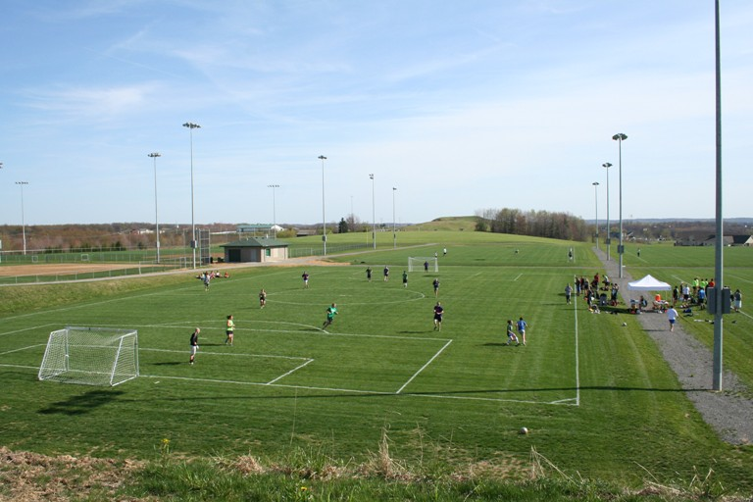
Figure A-13. Recreational Facility. Source: sru.edu

The Reform Park Movement offers elements of safe places for children’s play, communal gathering and occur in small parcels or city lots. The Pleasure Ground is one that is largely associated with Frederick Law Olmstead in the United State in that he gave such landscapes a large presence with buildings being subordinate. Olmstead utilized an aesthetic typifying the pastoral landscape but presented in a way that introduced the wildness of nature within the civility of the city. His parks were active, included large open meadows that allowing for diverse, flexible programming including sport, but also presented a picturesque image of nature for passive enjoyment and contemplative reflection (PPS 2014).

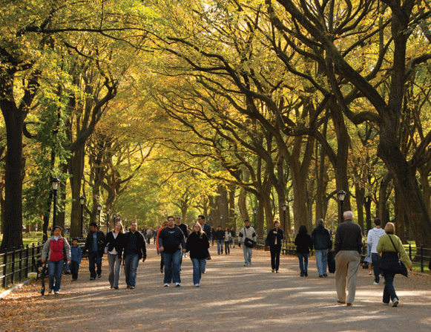
Figure A-14. Central Park. Source: olmstead.org

Frederick Law Olmstead acknowledged early on in part through his work as a farmer and then during his time with the Sanitary Commission that parks had the ability to provide relief from the strain of city living and the rigidity of urban conditions (Beveridge 34). He saw problems posed by the ‘dangerous classes’ in the city by the rich nouveaux and the uneducated poor. Still, he sought to provide spaces for all individuals of urban dwelling to provide places of natural reprieve (Beveridge 46). Olmstead’s strong position on the psychological benefits of nature became the focus for his city parks, knowing that the rapid growth would also create rapid disparities (Beveridge 45). The social and environmental elements that exist in city parks perform a function and support a greater system of overall well-being. These include ecological systems that can have a significant impact on a city’s inhabitants ranging from air quality to food source. The size, program and location of a park affect its social and environmental performance (Rottle 2010).
Urban parks can exist as outdoor lobbies that serve as extensions of the streetscape. These small, or pocket parks, can and also serve major metropolitan destinations for city dwellers (Jacobs 91). The latest function of parks to hit the neighborhood scale is the ‘community vegetable’ or ‘flower garden’ park. These types of gardens can reside in vacant lots, street corners or even lawns converted to support the production of edible plants. In Knoxville, TN, such a garden can be seen in a vacant lot of the Fourth and Gill Neighborhood. The lot is adorned with children’s art as well as a variety of vegetables, herbs and volunteers weeds that have seeded themselves in the fertile plots.

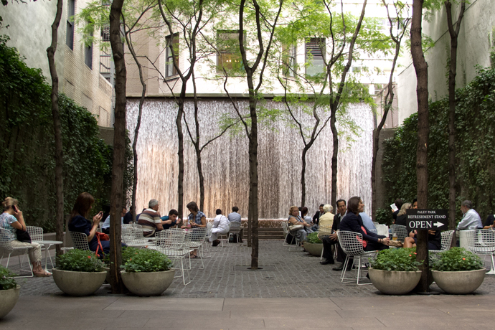
Figure A-15. Paley Park. Source: ohhowcivilized.com

City parks reside in small parcels called pocket parks such as Paley Park in New York, as well as vacant lots, corporate squares, roof tops, or more recently, over portions of interstates as seen in Boston. As Jane Jacobs points out, smaller, neighborhood parks are typically intended for general ‘bread-and-butter’ use as public yards, residential, or a mixture of communal activity (91). Larger scaled parks provide a venue for a variety of physical and social activity. Central Park in New York City, for example, attracts varying participants ranging from tourists, local joggers, to a co-op having an annual meeting. Millennium Park in Chicago is anchored in the many art installations and play features that promote social engagement and interaction. Its scale and engaging program draws users from neighborhoods across the city.
For a city dweller, parks are sometimes the only connection to nature without having to travel beyond city limits, an opportunity not always available to all segments of the socio-economic strata. Providing adequate access to parks and green space is immensely important to those city inhabitants that rarely have the means to leave the city in search of a connection to nature. For some individuals, trees on a street block are a luxury. It is important to look to earlier examples of success and failures of park design to understand how to proceed in the future. In an urban context, park can fill spaces such buffers, streams or small lots known as pocket parks. As a forward thought, parks that are successful rarely serve as barriers or as interruptions to the intricate functioning of the city around them (Jacobs 101). Successful city parks help to knit together diverse social functions as well as the natural and environmental systems that coexist in that space.

2.5 Design Direction
The American Planning Association released an executive summary outlining four key arguments for how public heath can be improved through the use of city parks; this plan will serve as the motivation and design direction for this thesis. The four key points highlight benefits and contributions that parks provide communities, environment and health are
Key Point #1: Parks provide people with contact with nature, known to impart certain health benefits and enhance well-being. Health studies have shown that contact with the natural environment- plants, animals, landscapes and wilderness- provides and series of medical benefits. The benefits include lower blood pressure and cholesterol levels, enhanced recovery from surgery, heart attacks and ailments (APA 2014). Nature has also been reported to lower stress and aid behavioral disorders in teens (Frumkin 2001). Enhanced tranquility and more relief from anxiety and depression are results of exercising in nature, also known as “green exercise” as opposed to exercising along urban streets (Bodin 2003).
Key Point #2: Physical activity opportunities in parks help to increase fitness and reduce obesity. Factors identifying greater park use are accessibility, proximity, good lighting in addition to well-designed and attractive scenery to name a few (Frumkin 2003). Physical activity equates to less money on medical bills. In a study conducted by The Physician and Sports medicine, active individuals had lower direct medical costs than did inactive people. The difference amounts to $330 per person, posing a potential savings of $29.2 billion dollars annually (APA 2014).
Key Point #3: Parks resources can mitigate climate, air and water pollution impacts on public health. Roadways, parking lots and rooftops absorb the day’s heat and radiate it at night, creating a heat cycle and taking much longer cool than rural areas. A mature tree canopy can reduce air temperatures by approximately five to ten degrees. Trees in parks also help improve air quality by removing pollutants from the atmosphere. In Atlanta, and Urban Ecosystem Analysis revealed that trees removed 19 million pounds of pollutants annually, a valued service at $47 million (APA 2014).
Key Point #4: Cities need to provide all types of parks, to provide their various citizen groups with a range of health benefits. Depending on the size of the park, it has the potential to provide numerous benefits and opportunities for its users. Acknowledging different races and socio-economic groups allows for a much more diverse range of elements, activities, and spaces in a park additionally creating melting pot for social interactions. People with varying cultures, ages and races activate space in different ways. Asians and Latinos were observed to prefer more group social activities and passive sitting and relaxing. Blacks were more likely to use facility based urban parks while whites were more likely to use wildland parks for hiking and camping (APA 2014).
Based on the information above, the benefits that parks have on individuals is without question irreplaceable. The research shed light on the restorative qualities and potential that parks can provide urban areas. The principle design intervention of this thesis will be based on a park system that performs both socially and environmentally.

      - Contributing Factors
In today’s digital age, social wellness is challenged by the increased use of insular technology for entertainment and reliance on maintaining relationship through online social media portals such as Facebook, twitter, and Snap Chat. Lack of social engagement may also be experienced as a social threat or as chronic social stress, both of which are likely to occur as a direct consequence of urban setting and high population densities (Adli 2011). Interpersonal relationships provide a sense of community and a sense of belonging. They allow individuals to cope with issues by finding support from people who understand and share the same principles. Transportation corridors are a driving force shaping cities and communities, affecting not only patterns of physical movement but also fundamental social interactions and patterns of social health and well-being. Transportation patterns center around getting from point a to point b as quickly as possible, increasing the need for vehicle use. Sprawl has also aided in the over saturation of vehicles. With amenities spread out, vehicles are the only option. It is typically more evident in low-income areas of cities (WHO 2009).
An Understanding
The research above provides the background for this thesis, establishing physical, mental and social health challenges within urban environments. These health issues among urban inhabitants will continue to be exacerbated simultaneously as urban populations increase if corrective measures are not taken. What is being done to address these issues is the subject of the following chapter, and the role that design in the urban environment may play is the subsequent focus of this thesis and the design proposal.

Chapter 3 – Designing for Health
Designing for health is a movement rooted in Olmstead’s work and writings that has now has gained wide-spread attention amongst planner, designers and city officials. The stresses of modern day life have uncovered the need for reform and planning organizations such as the Urban Land Institute are responding with guidelines promoting healthy communities and individuals. In early 2013, ULI’s Board of Directors began a study that focused primarily on healthy communities and how human health and city development are inextricably linked. ULI’s cross-disciplinary members identified that health is a core component of thriving communities. Designing space with a user’s health in mind is the initial step to improving mental and social health, in addition, creating environments that promote physical activity have the potential to slow down and even reverse that rate at which obesity grows.

3.1 Design Principles for Building Healthy Places
Following an extensive review of contemporary design guidelines by the Centers for Disease Control, the Department of Human Health, and the American Planning Association, ULI’s recently released design principles for Building Healthy Places are what I believe, provides the most holistic and well-rounded structure for designing for health and ultimately shapes the guiding criteria for this thesis’ design intervention. While the other guidelines provided insightful feedback into physical and mental health, they did not include provide strategies for affecting the built environment.
The Urban Land Institute established a ‘Building Healthy Places Initiative’ detailing ten principles for urban design of healthy communities. These ten principles provide guidelines for designers but also outline the components of a healthy community. Its goal is to promote a consistent language between medical and land use experts. This initiative is collaboration among research in healthcare, architecture, planning, development, finance and academia (ULI 2013).
The ULI’s Ten Principles for building Healthy Places are:
- “Put People First:” ULI states that a healthy community is one where basic necessities and amenities are accessible by walking or biking. In addition, access to space for physical activity such as walking paths and exercise facilities near home or work is associated with an increase in exercise, as is proximity to parks and playgrounds.
- “Recognize the Economic Value:” Healthy places can create enhanced economic value. Recent shifts show an increase of individuals wanting to live in walk able cities and present an opportunity for developers and investors.
- “Empower Champions for Health:” This principle centers on community engagement and support by encouraging citizens and leaders to come together for a healthy future.
- “Energize Shared Spaces: Public gathering places have a direct, and positive impact on human health.” Loneliness, depression and anxiety can stem from social isolation and occur among all age groups. A healthy community engages all residents regardless of race or class and importantly can foster social interaction.
- “Make Healthy Choices Easy:” ULI stresses that communities should be safe, accessible, fun and easy. Meaning that barriers often limit one’s activity and will to leave home. Creating safe streets with bike lanes and inviting spaces for activity fosters a mental association with well-being.
- “Ensure Equitable Access:” Design should provide access for all ages, abilities and demographics. Disparities are alive and well in urban areas and these groups also have the right to a healthy community.
- “Mix It Up: A variety of land uses, building types and public spaces can be used to improve physical and social activity.” This is a key component of this thesis and provides support for multiple functions for multiple groups.
- “Embrace Unique Character: Places that are different, unusual or unique can help promote physical activity.” Embracing a city’s character can set spaces apart to celebrate diversity.
- “Promote Access to Healthy Food:” Because diet affects human health, cities should provide access to healthy food choices in close proximity as part of any development proposal.
- “Make It Active:” Recreational opportunities should provide universal appeal. Adults and children alike require varying levels of recreation.
(ULI 2013).
By leveraging better design choices, providing access to open space amenities and places for community members to interact, the physical, mental and social issues facing urban populations can be addressed (Eitler 2013).

3.2 Design Precedents
In an effort to understand how contemporary cities design and use parks and open space to successfully addressing health issues in their communities, a series of strategically selected design precedents were studied. The comprehensive nature of the Urban Land Institute’s recent release of the healthy design principles increased the challenge of finding studies that meet all of their criteria. As such precedents that embodied as many principles as possible were selected that also reflected similar conditions, challenges and users to that of my eventual project site. Preliminary research of thesis sites revealed that many of the health and built environment challenges facing urban populations occur within blighted neighborhoods in close proximity to vacant or abandoned industrial plots. Through the reclamation of blighted areas, vacant and industrial relics, each of the precedents address specific health impacts that combine to provide insight for further design integration. It is important to note that while each of these studies vary considerably in scope and scale, each possess key features that are consistent with ULI’s design principles.
The ‘Buffalo Bayou Promenade’ is a 3000 linear foot public park reclaimed from blighted conditions under interstate viaducts in Houston, TX, that benefits whole human and environmental health. The second precedent is New York City’s 1.45 mile long Highline that transforms an abandoned eyesore into an ecological gem. It offers a connection nature and reprieve from the busy streets below. On the High Line, art programs, and social events stimulate mental and social engagements. Some events feature dance lessons and healthy ‘farm to table’ food events. Both case studies provide surrounding communities with access to nature amongst intensely constructed urban landscapes enhances sense of community and provides users an opportunity to improve their physical, mental and social wellbeing through deliberate programming and design. Each precedent varies in scale, is found within an urban context and is located on sites that were previously inaccessible due to isolation by infrastructure or previous industrial uses.
3.2.1 Buffalo Bayou Promenade | Houston, Texas

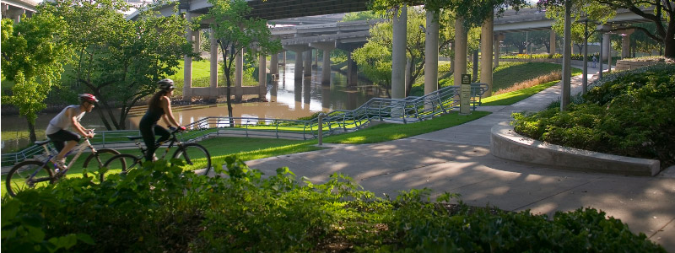
Figure A-16. Buffalo Bayou bikes. Source: buffalobayou.org

Buffalo Bayou Promenade is a 23-acre urban park and recreation area designed by SWA Group. Located in Houston, Texas, the once declining area below interstate viaducts is now public open space and provides neighboring communities new opportunities for physical activity and safe green space. A study conducted by researchers at the Landscape Architecture Foundation suggests that it improves quality of life for 99% of park users and increases outdoor activity for 88% (LAF 2013). Prior to becoming a public park, the area was overgrown with invasive plant species that weaved through the space just like the interstate overpasses. The ground surfaces were impervious and site was inaccessible prior to invasive clean up and the implementation of the pedestrian bridge shown in Figure A-17. Now the north and south sides of the bayou connect for the very first time.
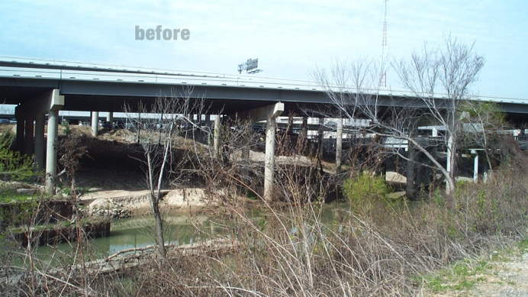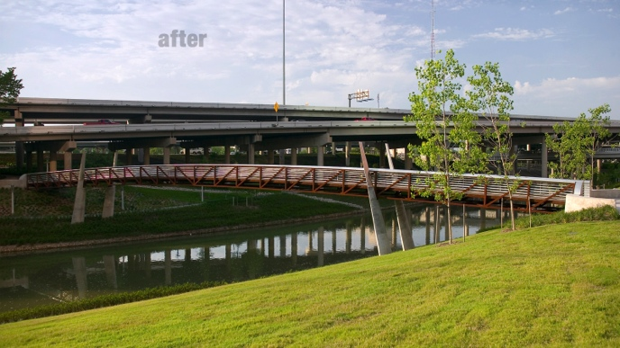
Figure A-17. BB-Before and After Pedestrian Bridge. Source: swagroup.com.

Buffalo Bayou Promenade demonstrates a number of ULI’s Healthy Communities Initiative’s principles. It boasts physical, mental and social qualities by energizing public space for mixed community use, using extensive native landscaping, hike and bike trails for activity, public art for mental and visual interest, lighting for night safety and finally multiple points of entry. To aid in way finding and education, interpretive signage is placed throughout the space (LAF 2013). The pedestrian bridge opens up the city to new spaces and increases further connection and support for social interaction and emergence of new businesses (LAF 2013). The Landscape Architecture Foundation promoted the performance benefits of this park in 2013. The park serves as a venue for physical, recreational, interpretive and education opportunities. 641 new trees planted help sequester 29.74 tons of carbon dioxide which was calculated to be the equivalent to CO2 emitted from driving approximately 79,226 miles in a single passenger vehicle (LAF 2012). This performance benefit is a very important benefit to the project due to its prime location beneath a stream of interstate viaducts. This project embodies the essence of a city working to reclaim abandoned landscapes as open space for the social and ecological betterment of its community and residents.

3.2.2 The Highline | New York, New York

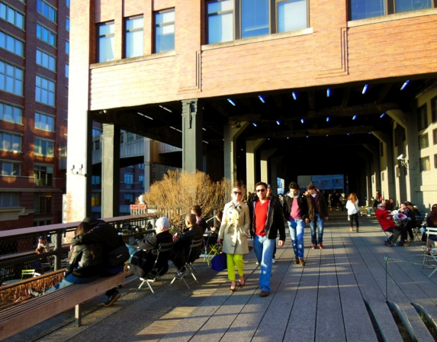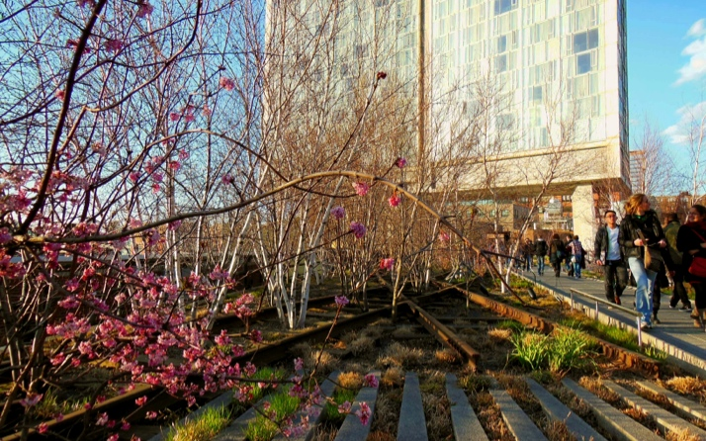
Figure A-18. Spring on the Highline. Source: author

The High Line is a public park built on an historic freight rail line elevated above the streets on Manhattan’s West Side. It is owned by the City of New York, and maintained and operated by Friends of the High Line. Prior to its transformation the abandoned rail line became vegetated through natural succession, providing an elevated green scape that nearby residents enjoyed. Even without programing, dedicated walkways, or regular maintenance, those who appreciated its wild disposition frequented this emergent open space for walks and relaxation.

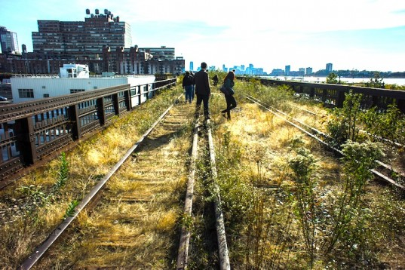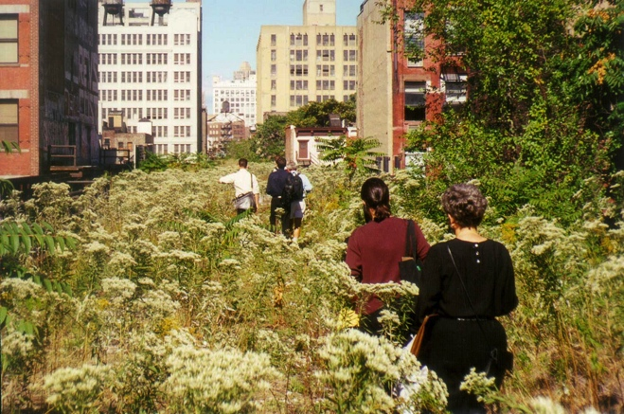
Figure A-19. Users in the wild landscape. Source: inhabitat.com and thehighline.org
It is important to note that the origins of the Highline stem from the city’s need for safer pedestrian and vehicular circulation. Prior to the rail line’s elevation, numerous accidents and fatalities caused by at-grade rail lines overwhelmed the city causing the need for reform. Although the elevated rail lines are no longer used for trains, this transformation still provides for pedestrian health and safety.
With this history that spans decades, in mind, the designers, Diller Scofidio + Renfro, were able to capture the art culture of the city while creating an ecological habitat for birds, butterflies and humans; an environment “inspired by the melancholic, unruly beauty; nature has reclaimed a vital piece of infrastructure” (DSRNY 2013). Contemporary approaches to layout, systems and site furnishings make this project a destination for users seeking physical, mental and social stimulation. Local runners and walkers use the 1.45 mile elevated park for their daily exercise while events like yoga and dance offer a different level of physical activity. Healthy food is available but not by tradition garden means. Pop up dinner events occur on the Highline mixing social interaction with food by offering organic or farm-to-table creations amidst the textured landscape backdrop. All of those program elements not only support a number of ULI’s principles for healthy places, including its provision of a nature refuge for city dwellers, a social meeting ground for interaction and a path for those seeking to be physical active.

Conclusions
Both precedents provide insight into the varying levels of design integration for ‘Building Healthy Places’ by responding to the needs of its surrounding communities. Just as the Urban Land Institute suggests, providing a mix and variety to land use creates access for everyone and interest for anyone. Reclamation of abandoned and underutilized conditions enhances its surrounding counterparts and revitalizes the spirit of place and users. By using these existing sites, areas are not only improved but resources are replenished through direct access, further-linking parts of cities to one another. Both sites are in close proximity to the communities they serve ensuring safe and easy access for individuals and additionally providing a connection where there might not have been one. Variety and unique programming is essential for both of these precedents. Equitable access, opportunities and spaces are possible by ensuring this ULI principle is addressed in design integration. These sites are not only energized, but the energy has spread to the surrounding communities as a result of their redevelopment.

Chapter 4 – Site Selection

4.1 The Process and Criteria
The site selection process for this thesis’ urban park is driven by both challenges and opportunities for public open space to address the physical, mental, and social health challenges facing nearby urban communities. Based on the preceding research and precedent studies, this process seeks a site for a new and innovative form of the urban park that is
- Central to a metropolitan area
- Within walking distance of communities with documented physical, mental, and social health challenges
- Within walking distance of communities that lack access to restorative natural landscapes
- Ample in size to accommodate meaningful program to address holistic health
- Abandoned from its community context due to infrastructure impediments or former industrial uses
- Blighted in its present condition and capable of performing a greater benefit to its surrounding communities than its present use
This list provides criteria to narrow my study to a specific site the will effect its surrounding context and influence a broad audience. Location and surrounding context provide the initial parameters for the project’s site selection. The desired site separates communities from their context or valued amenities. The causes of this separation, as stated above, would be a result of infrastructural impediments or industrial land uses that further contribute to community isolation.

4.1.1 Black Stock Area
After thorough consideration of alternative sites in Old North St. Louis, Missouri and the Historic Train Depot in Knoxville, TN, the site selected for this thesis and that best demonstrated all of the established criteria is the Blackstock Area in Downtown Knoxville. Blackstock is central to the city of Knoxville and is with walking distance to four neighborhoods with reported adverse health conditions. Currently these neighborhoods have little to no park space that helps foster physical activity or restorative qualities. The site, highlighted in Figure A-20 in a rust color, is approximately 107 acres of underutilized urban landscape that is isolated underneath interstate viaducts and vertically separated from surrounding communities by an active rail line, retaining walls and interstate interchanges.

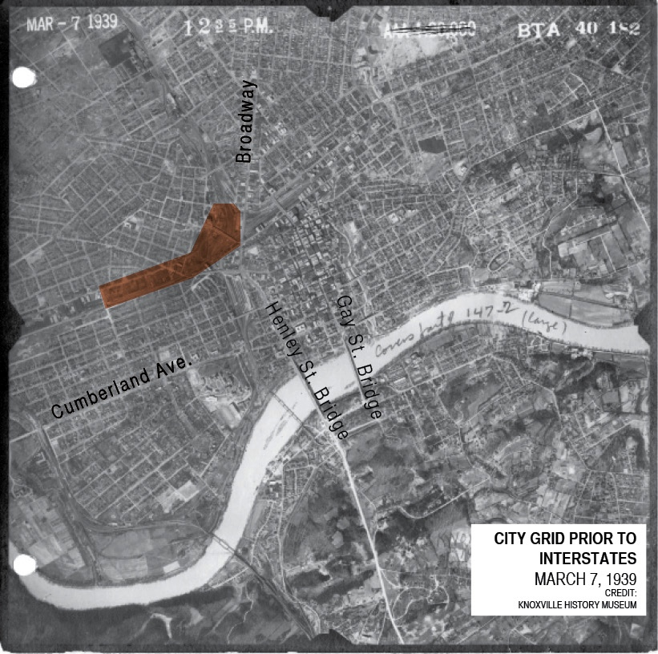
Figure A-20. Knoxville City Grid 1939. Source: Knoxville History Museum

Following years of industrial transitions and railway activity, the site sits mostly vacant, laid out with parking lots and forgotten buildings. While some buildings are still in use, the years have taken their toll on the structures still holding on to their past charm. Prior to the interstate system, the site was a part of the city grid, enabling access for the workforce living in the neighboring communities to its job centers. (See Figure A-20)
Those days have since past along with the once thriving industry that used to occupy the site. In the 1960’s, the interstate highway system was built through the site, further compromising connectivity between adjacent neighborhoods and displacing businesses and residents. Downtown Knoxville’s economy started to decline in part due to the suburban shopping malls. Mile after mile, large highways and overpasses began to plow through this landscape making it quicker and easier to connect from the suburbs to downtown Knoxville. Though new connections were made, connections to this landscape were lost as a result.
Barriers were erected separating entire communities from one another as well as the Blackstock site. From east, west, north and south the very neighborhoods that housed Knoxville’s industrial workforce were split apart and segregated from city functions. These functions provided community, commerce and most importantly the products used to fuel Knoxville’s industrial economy. The interstate highway system was elevated immediately along Knoxville’s periphery, weaving intricately across the open sky and hovering over the land below. The infrastructures that divide these neighborhoods and isolate the site are Interstate 275 and Interstate 40 in addition to active railroad lines.

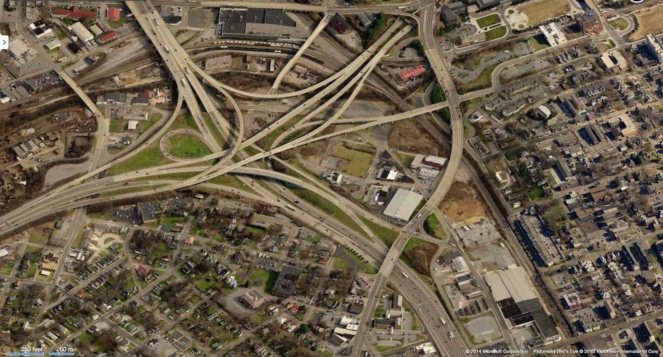
Figure A-21. Current Aerial image facing south. Source: Bing

Chapter 5 – Site Inventory and Analysis
5.1 Health Report
A study of US health trends and Tennessee health averages suggests obesity is on the rise and as a result could lead to other health issues. Currently Tennessee is the 10th most obese state in the nation (TFAH 2013). Enlisting the information and survey reports from the Plan East Tennessee initiative, the study of the 5 counties (Knox, Anderson, Union, Blount and Loudon) revealed that the region faces issues of obesity, diabetes and asthma. The region’s issue of healthy food connections was also identified a new food dessert study.
Comparing Knoxville’s obesity rate along side that of the state’s indicates that Knoxville’s rate is 3% lower. Although Knoxville’s obesity rate is lower than the state’s average, it is still higher than the national average. 30.5% of Knoxville’s adults are obese, 34.1% are overweight leaving only 35.4% at what the CDC considers a healthy weight. In the region, diabetes cases increased by 20% between 2004 and 2008 and asthma rates among children increased by 12% (PlanET 2012). Four of the five counties, including Knox, did not meet federal standards for air quality. In 2009, Knoxville was one of the top 25 metropolitan areas for year-round particle pollution and ozone pollution. It ranked 33rd for 24 hour particle pollution (PlanET 2012).
It is difficult for many to find healthy food choices, which could assist in the reduction of obesity. These food desserts are mostly predominate in Anderson County and Central Knox County seen in Figure A-22, which includes a 5-7 mile radius around the selected Blackstock site, these are tracts with a high percentage of lower-income residents and poor access to a grocery store (PlanET 2012). In 2009-2010, almost 21 percent of the region’s residents did not have enough money to buy adequate food on at least one occasion.
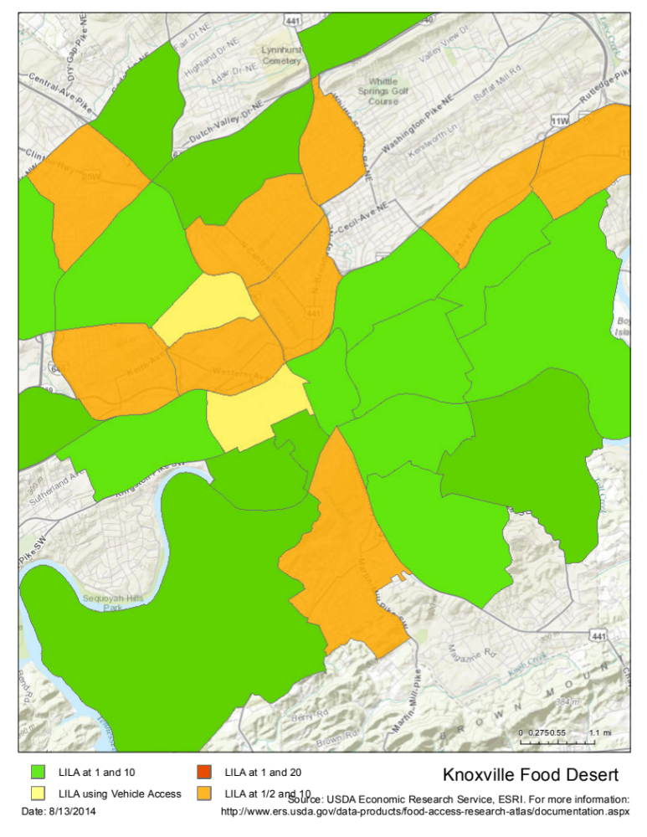
Figure A-22. Knoxville Food Desert. Source: USDA Economic Research Service and ESRI ARCGIS
Demonstrating the constituents of the region’s attention to health-related design and programming challenges, PlanET survey respondents ranked the following in the top 10 desired improvements for Knox County:
- Increased sidewalks/ walking trails/ biking trails
- Improve morality and interpersonal relationships
- Increase parks and activities for all ages (PlanET 2012).

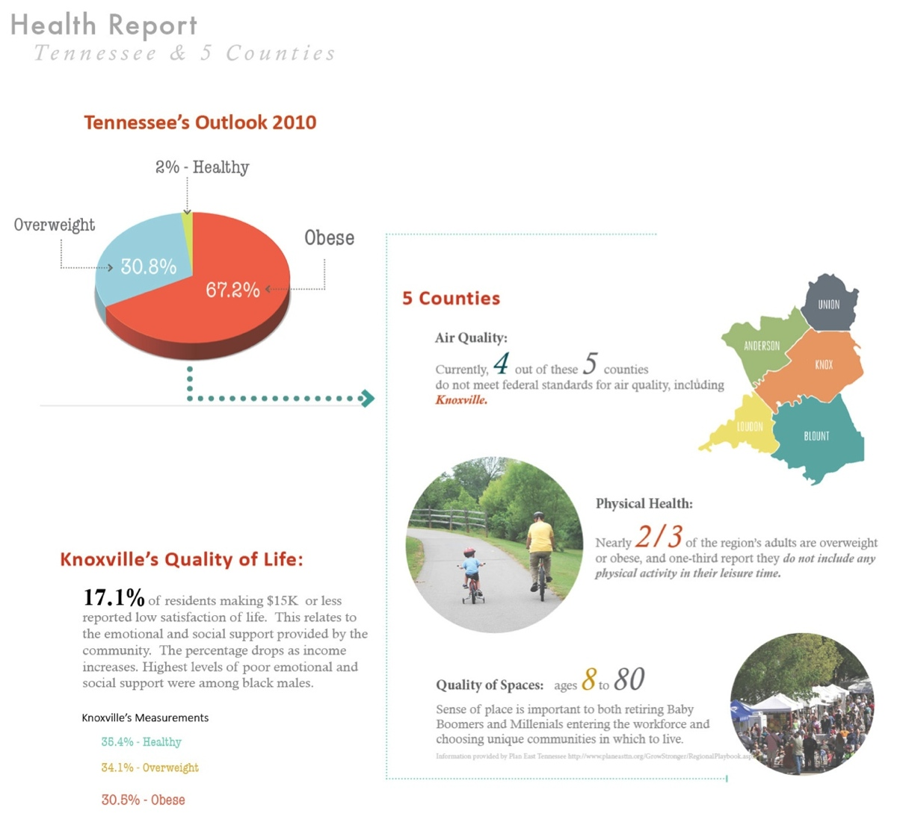
Figure A-23. Knoxville’s Health Report. Source images: PlanET, chart: author

The Knox County health assessment correlates these health problems with regional race and income levels. The assessment identifies Mechanicsville, Downtown Knoxville, Fourth & Gill and some portions of Fort Sanders as specific areas within the region where these health challenges are especially evident. As such, these communities were selected as the area of influence for this thesis investigation (see Figure A-23). A detailed inventory of these neighborhoods revealed a number of candidate sites that satisfied site selection criteria, but the Blackstock site presented the best opportunity to connect to these four neighbors in a central location. The fragmented site of Blackstock provides adequate space and unique character to test ULI’s initiatives for healthy places, the opportunity to reconnect parts of the city that are divided by the interstate and a central location to wider urban systems.

5.2 Existing Conditions
The Blackstock site provides the space, proximity and central location to test concepts of Healthy Places. This landscape embodies opportunities to implement the major principles set forth by ULI and address the health needs of the surrounding four neighborhoods and the broader City of Knoxville. Figure A-24 contextualizes the City of Knoxville, TN, and its current census information. Highlighted in yellow is the site boundary and its relationship to the surrounding neighborhoods.

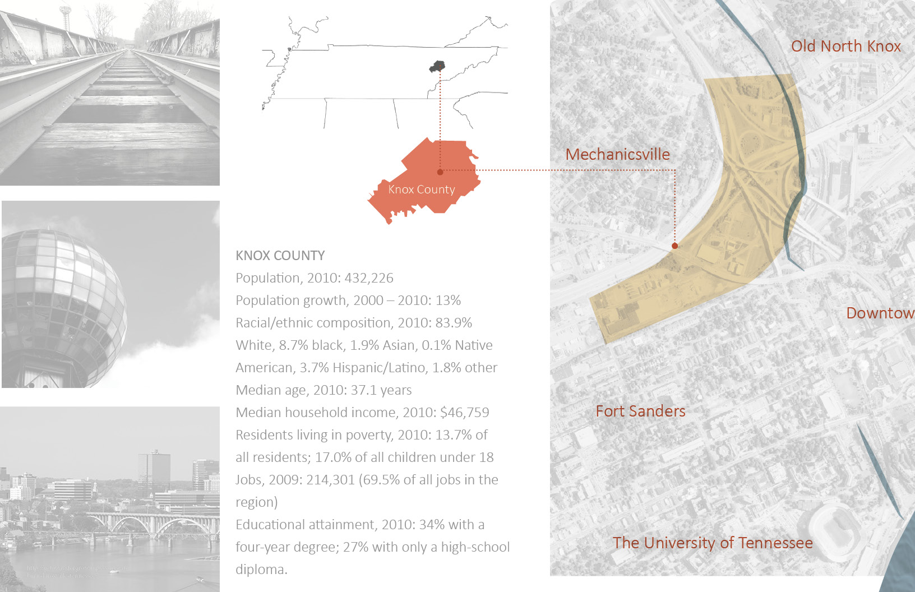
Figure A-24. Context Locator. Image Credits: author. Map Credits: Google

5.2.1 Photo Inventory
The following photo inventory reveals a relationship between beauty and isolation found on the Blackstock site. Monumental viaduct pillars are erected throughout the site to support the interstate overpasses and interchanges that create an overhead canopy like that of a forest of trees. Each site visit further reinforced its abandoned disposition, as there was no one in sight. The sounds of the highly elevated interstate were faint and the experience was serene. The site has an untapped beauty and element of calm amidst the chaotic tangles of roadway infrastructure. (See Figures A-25 and A-26)
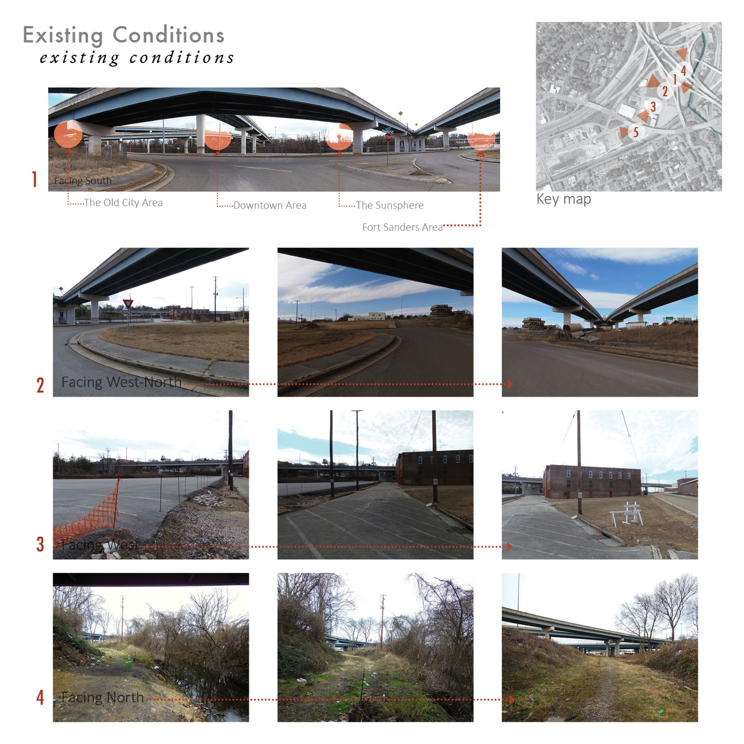
Figure A-25. Site photos credit: author. Aerial image credit: Google

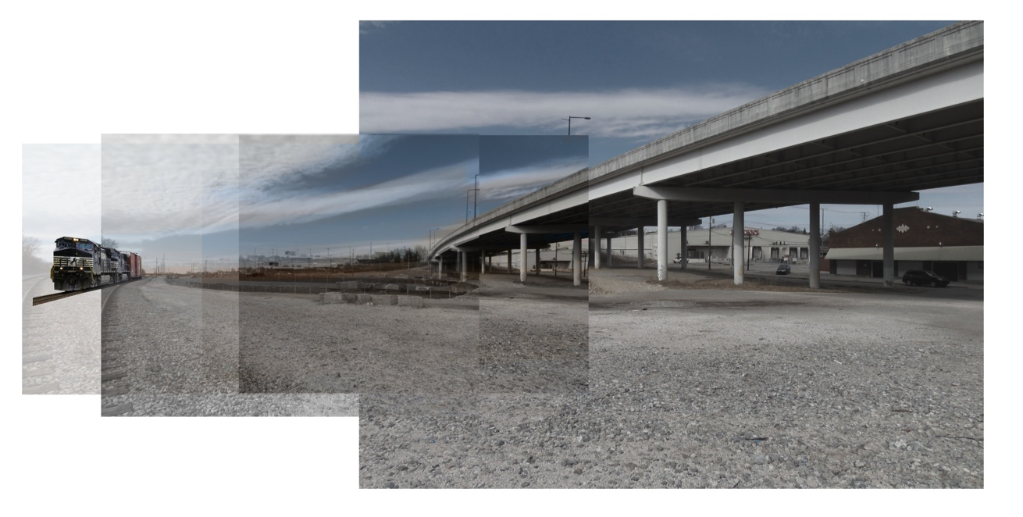
Figure A-26. View towards Mechanicsville, Next to the Valarium. Site photo credit: Author.

5.2.2 The Neighborhoods
The targeted communities that may be served by an improved Blackstock site include Fort Sanders, Mechanicsville, Downtown and Fourth & Gill (See Figure A-24). These neighborhoods border this forgotten site and share demographics such as low income, race, limited green space, irregular street conditions and limited availability to grocery stores. In a 2010 Community Health Status Assessment for Knox County, 17.1% of residents making $15K or less reported low satisfaction of life. This relates to the emotional and social support provided by the community, and the percentage drops as income increases. Highest levels of poor emotional and social support were among black males (2010). The areas with the lowest reported income levels and education levels exist within the Knoxville City limits and include Mechanicsville, portions of Fort Sanders and Fourth and Gill (CHSA 2010). Figure A-27 illustrates income compared to Knoxville median income levels. It reveals a large gap among those living in the city limits and further linking disparities to income levels and even race. Correlating with national statistics, the greatest income disparities occur predominantly within African American and Hispanic populations, all found in the four neighborhoods of study.

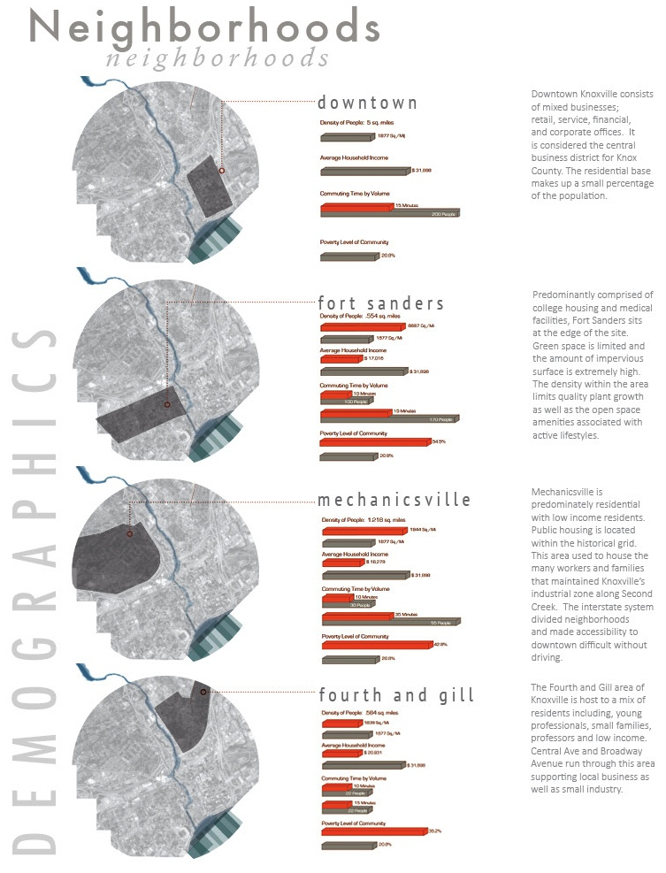
Figure A-27. Neighborhood demographics & location. Map image credit: Google. Analysis: author

5.2.3 Diagrams
Disparities are not only present in race and income levels. They are also visible in geographic locations via poor infrastructure, increased barriers and lack of open space. Diagrams below detail the barriers, the number of schools within close proximity, the lack of park space available within the core of the City of Knoxville, and lastly the areas that would be directly impacted from design intervention at the site. The barriers of this site include the interstate, Norfolk Southern Rail lines, Second Creek and topography. These barriers pose a significant challenge, as they cut off connection between downtown and each individual neighborhood. A redesign of existing infrastructure could link neighborhoods back to large plots within the city and join users to available open space.

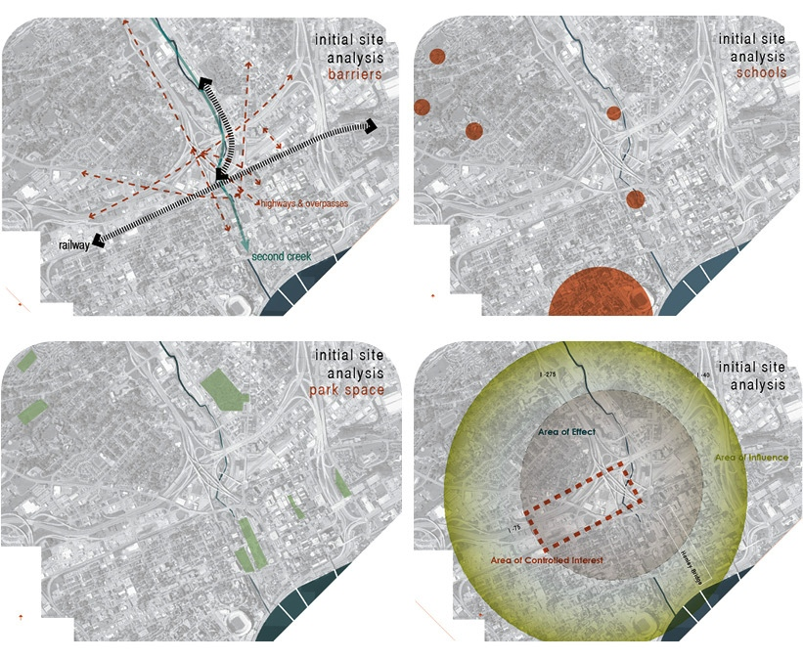
Figure A-28. Existing conditions diagrams: author, Aerial image credit: Google
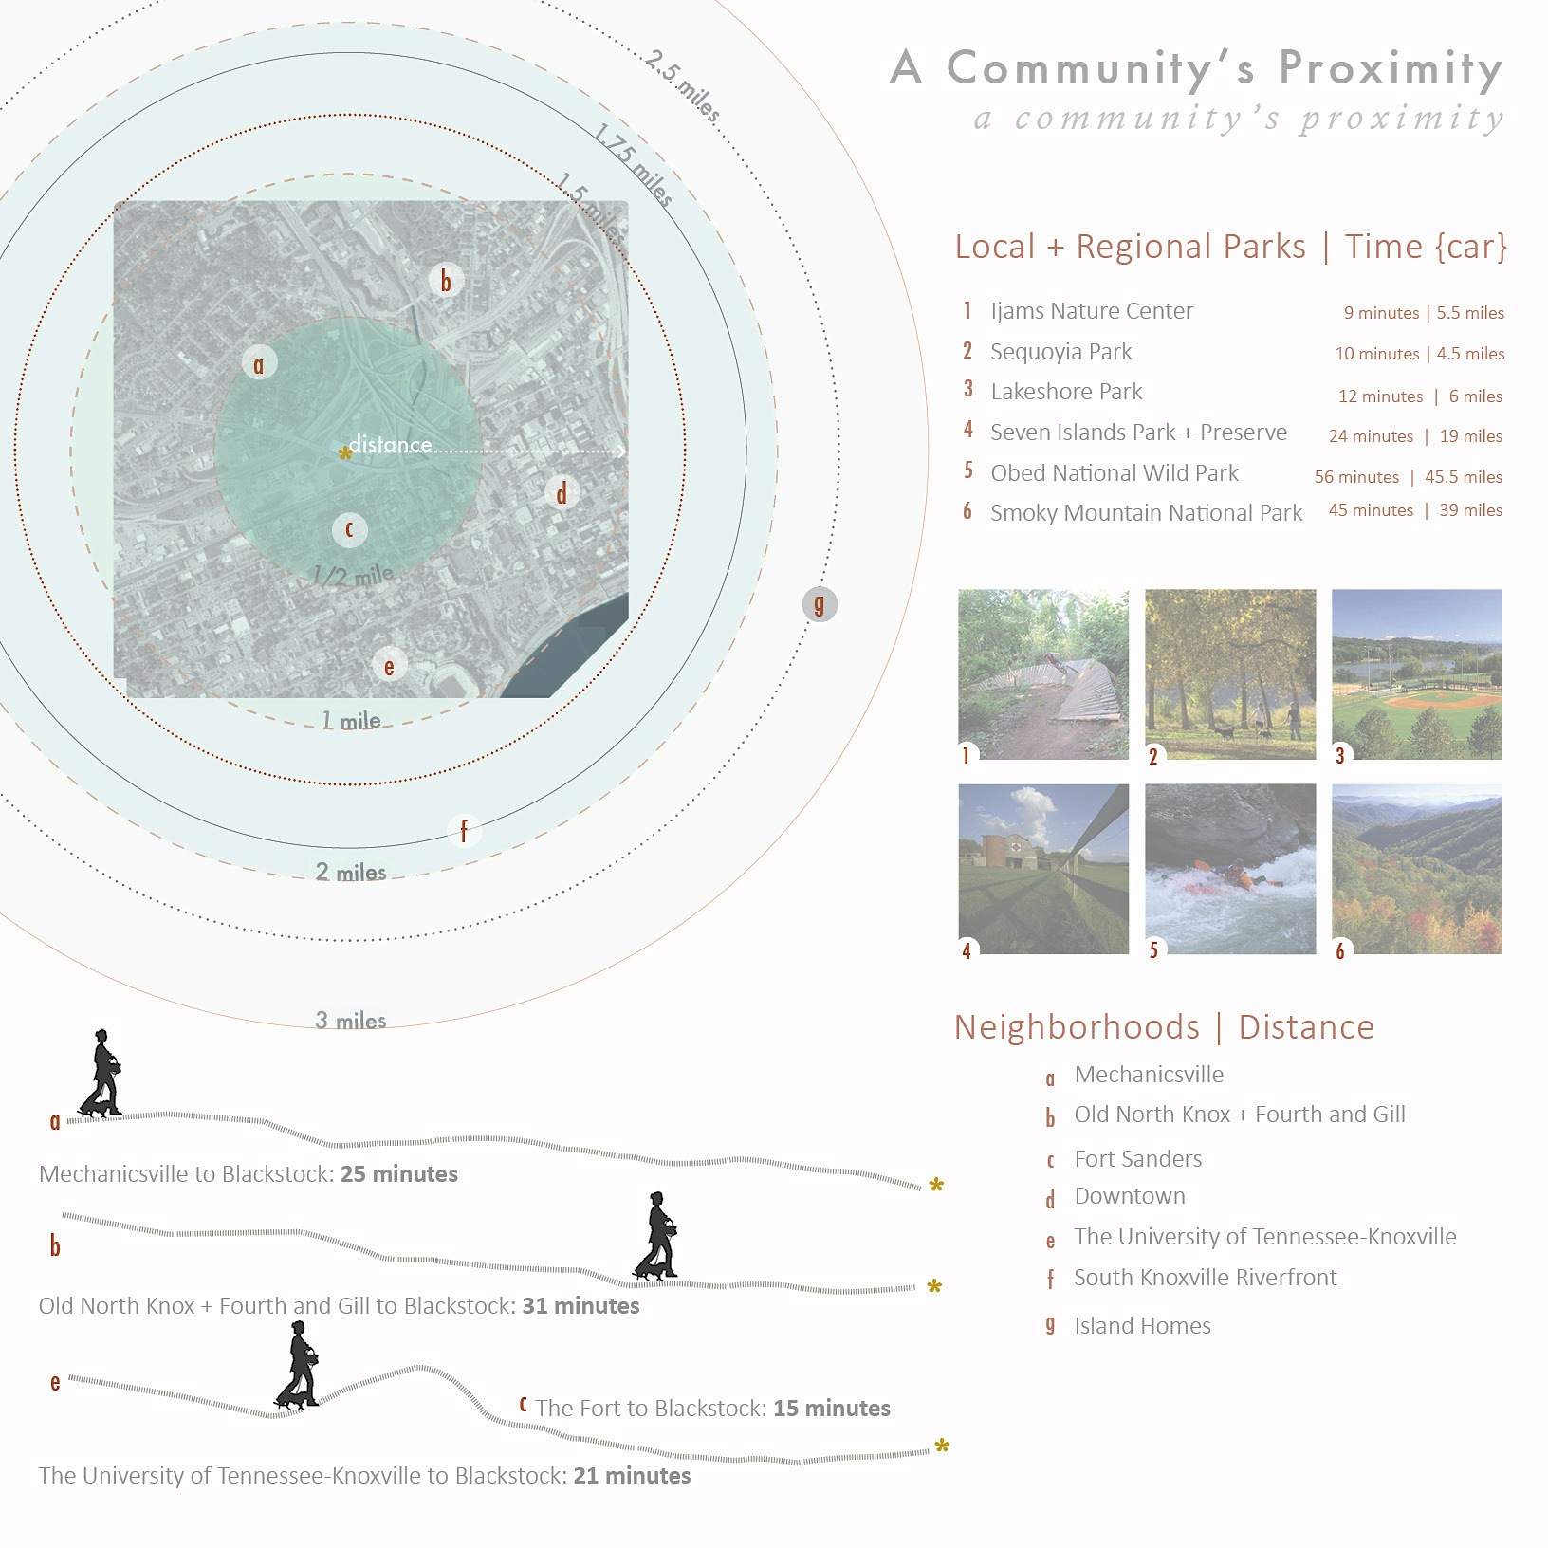
Figure A-29. Proximity to Parks and Green space: author. Image credits see appendix.

Figure A-29 represents the distance traveled that city dwellers would need to make in order to arrive at a large park or natural area. Currently, individuals in the four key neighborhoods would have to travel by vehicle to reach green space.

Chapter 6- Actions for Change | Design Response
6.1 Project Overview
A proposed 107 acre Performance Park on the Blackstock site aims to provide spaces for various aerobic exercises to combat increasing rates of obesity, an urban garden to provide access to healthy food choices, an urban tree farm to improve air quality and increase the city’s canopy, sculpture for mental stimulation, extensive landscaping for natural restoration and relaxation and lastly a community center with active programming for social interaction and public engagement.

6.2 Objectives
‘A Symbiotic Endeavor’ is a set of objectives that leverages landscape performance to achieve healthy design. These objectives were developed through careful review the body of research discussed in preceding chapters, ULI’s Building Healthy Communities Initiatives, and the needs and context of the surrounding communities. The design proposal keys into the Mind, Body and Soul to provide a holistic approach to human and environmental well-being. Although each objective is listed separately in Figure A-30, there is a clear symbiotic relationship that develops between all three. Some design interventions perform benefits across multiple objectives.
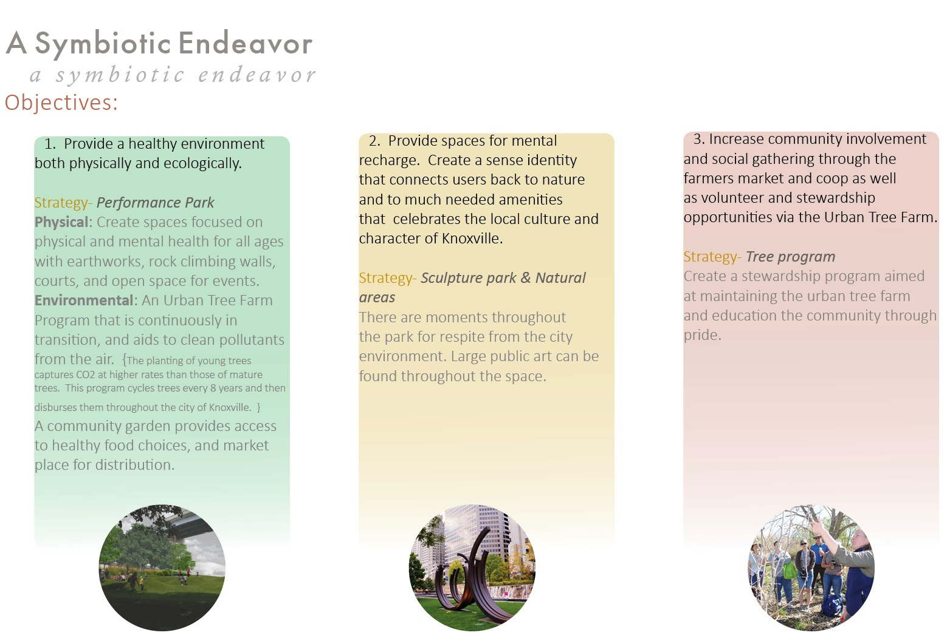
Figure A-30. Objectives: Author. Image credits: Author, CityGardenstl.org, treeutah.org/education-2/community-workshops/
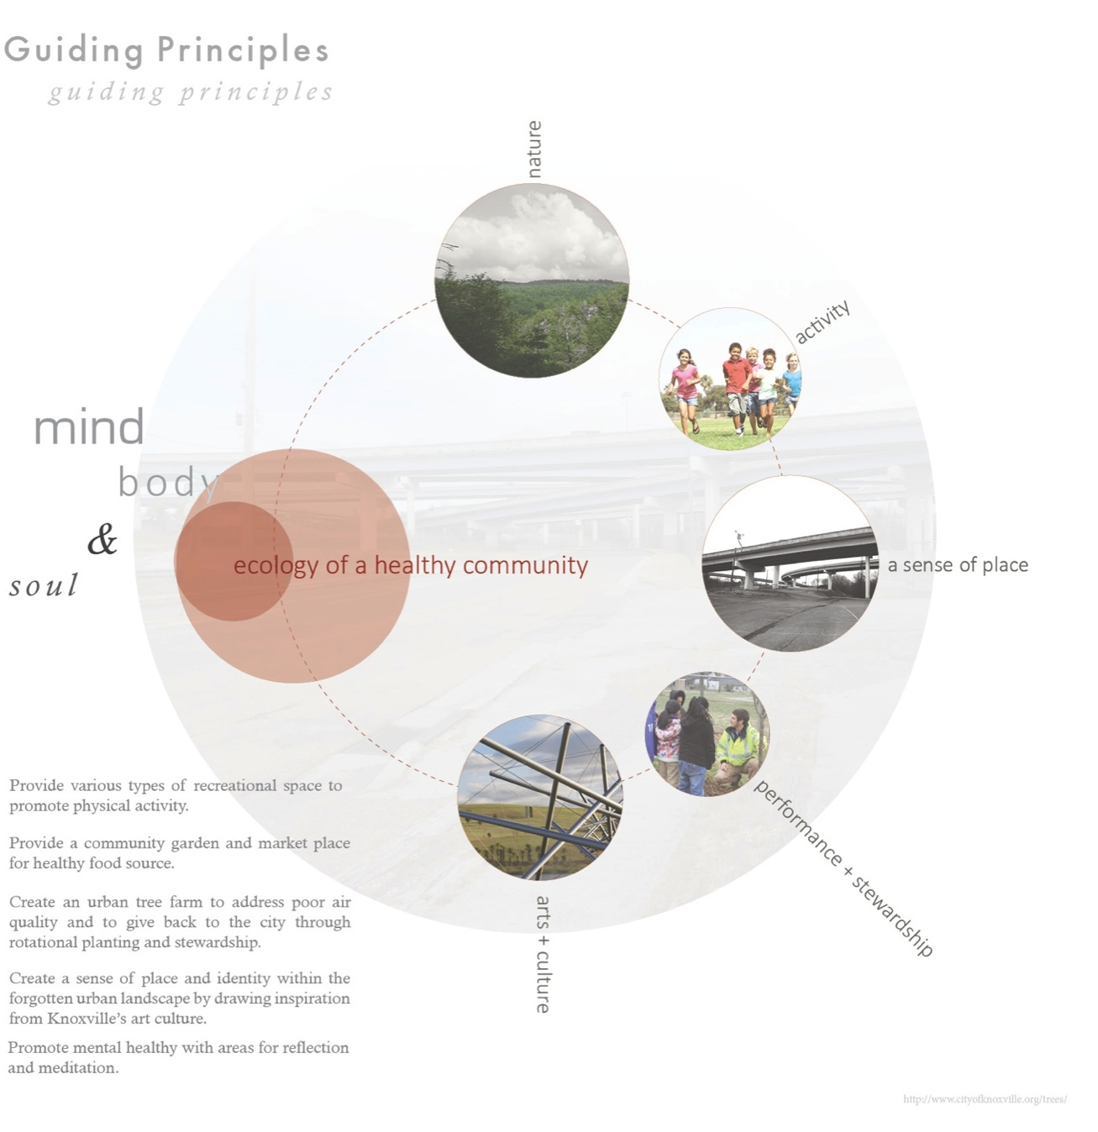
Figure A-31. Guiding Principles: author

The ecology of a healthy community is as complex as it is connected. Taking the objectives a step further, the Guiding Principles in Figure A-31 provide a strategy for implementation that leverages a holistic approach to design. The site’s ecology focuses on five key elements: Nature, Activity, A Sense of Place, Performance & Stewardship and Arts & Culture. Theses elements are a further refinement of prior objectives and encompass what I believe to be the center of the park’s principle goals. Design concepts were developed and structure around these principles to provide a well-rounded space for various user groups. The variables of lifestyle, environment and access to these components all play important roles in how individuals approach health. For this thesis, the diagram above combines the strategies to transform people and place of the Knoxville neighborhoods of Downtown, Mechanicsville, Fort Sanders and Fourth & Gill.

6.3 Performance Park Site Design
(Figure A-32)
The plan for the proposed Performance Park creates a public landscape capable of enhancing the health of human users and environmental systems through a holistic approach. While many design moves were made with a primary physical, mental, or social health benefit in mind, they each have the potential to perform multiple benefits on the site, a realization of a holistic health. For example, many program elements that primarily target physical health issues also provide opportunities for social engagement, as do certain mental stimulants programmed within the design.

6.4 Provide a Healthy Environment, Physically and Ecologically
Strategy- Performance Park
Physical Health is addressed in the proposed design by including spaces for basketball and volleyball courts, rock climbing, bouldering and interstate pillar climbing; all active and socially engaging forms of activity that provide cardiovascular exercise, elevate heart rate, and muscle strengthening. Six miles of pedestrian-only pathways include a trail system with varying degrees of difficulty and incline that provides low to medium exercise intensity.

Program elements for active recreation and exercise include:
- Trail System (6 miles of trail, elevation incline and decline)
- Children’s tree climbing area
- Rock Climbing (2 areas for varying level expertise)
- 3 Volleyball Courts & 2 Basketball Courts
- Strength Training Stations along trail & Indoor Gym
- Dance classes at the local Square Dance studio
- Yoga & Tai Chi are located in the Upper Lawn surrounded by plant buffers and tree canopies for immersion. In inclement weather, classes are also provided in the indoor gym.
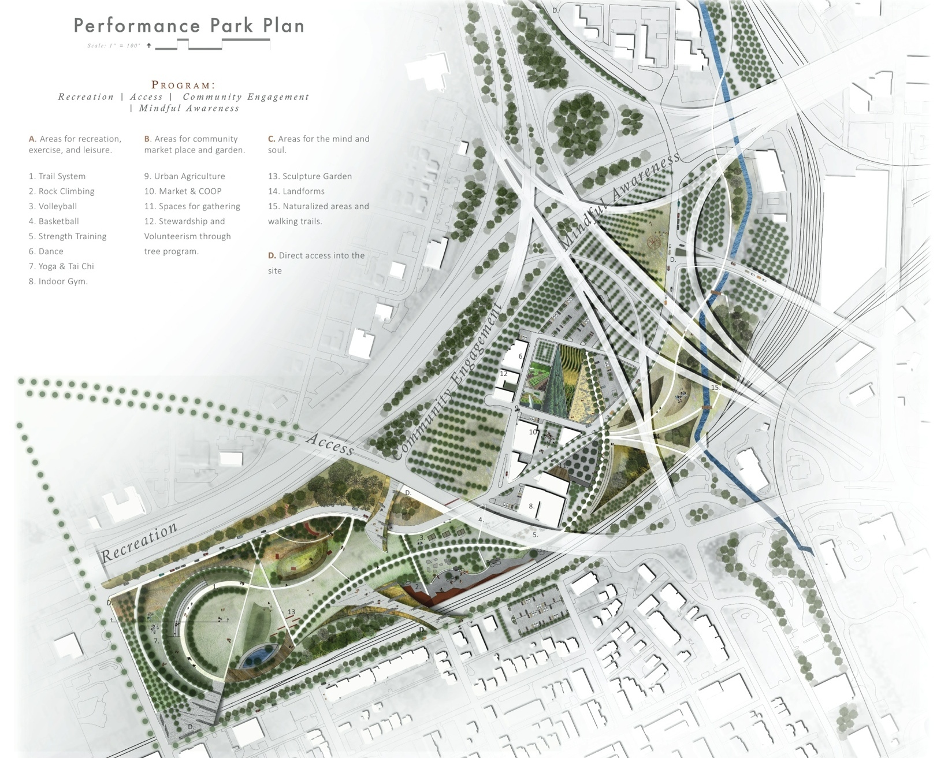

Figure A-32. Site Plan for Performance Park: author

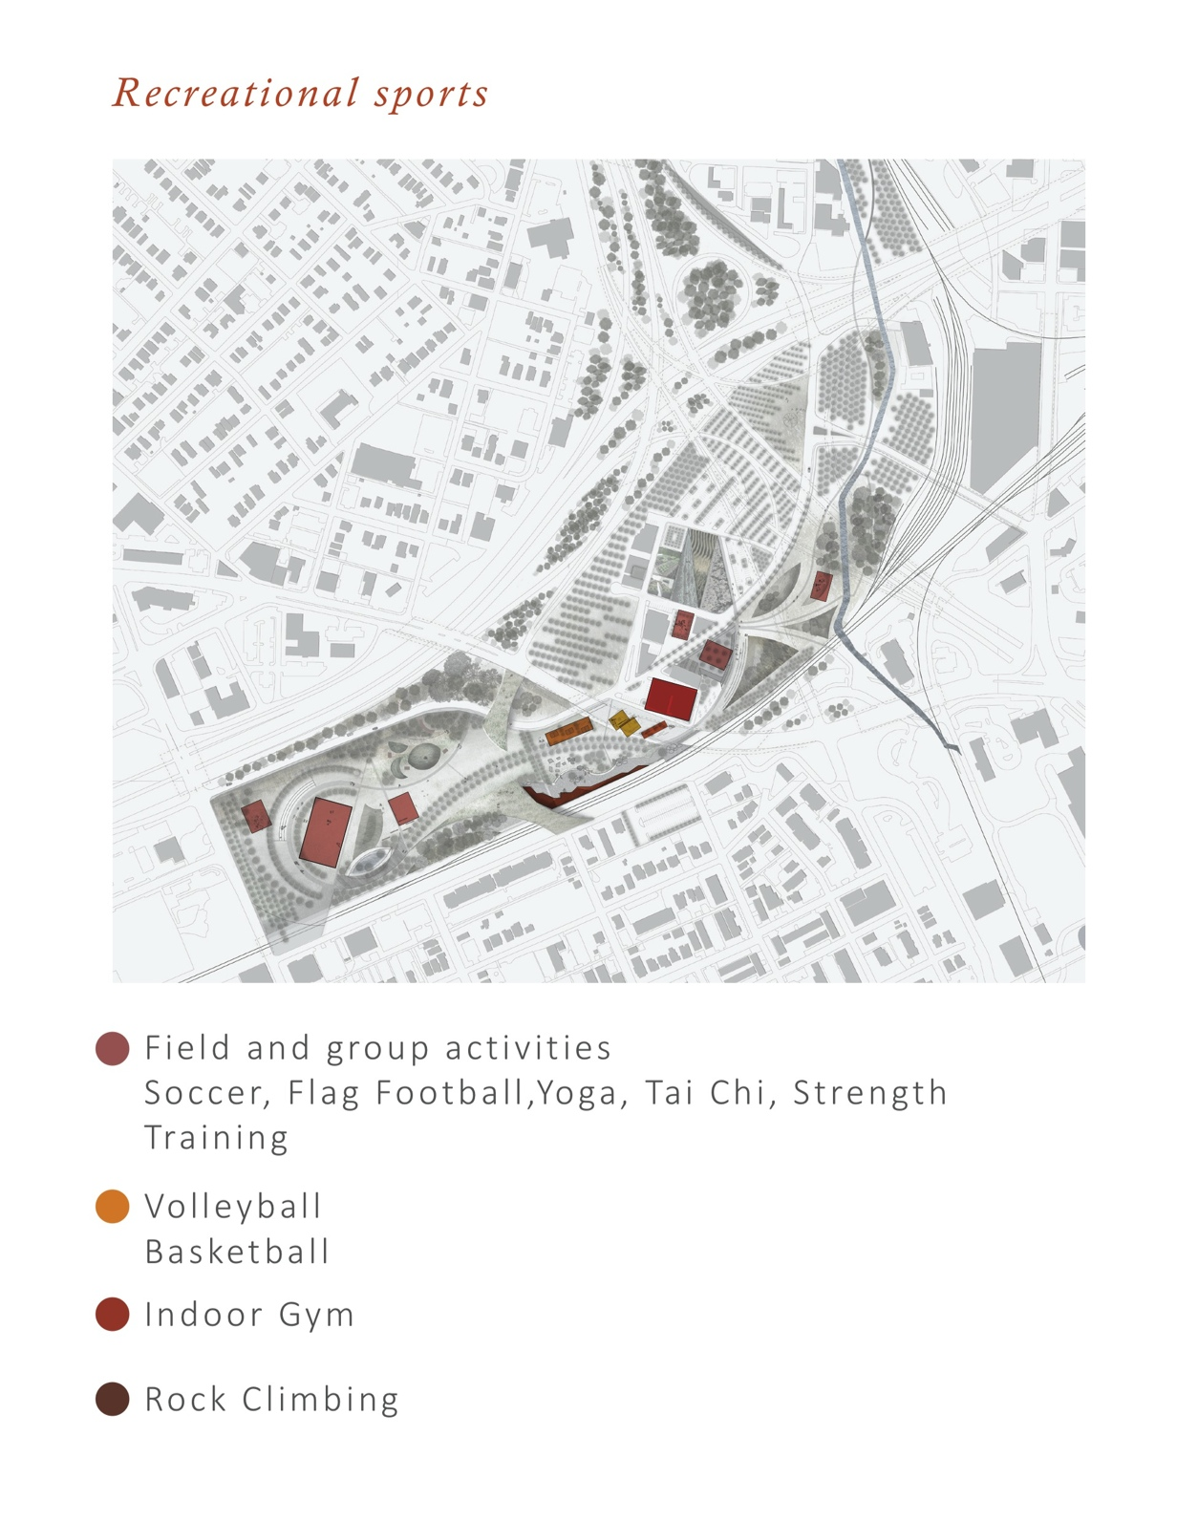

Figure A-33. Recreational Sports Diagram Source: author

Figure A-33 shows primary sport activation, but additional areas can be established throughout the park. Even in inclement weather, strength training, cardio, cycling and aerobics classes are still available in the Indoor Gym Facility located center.
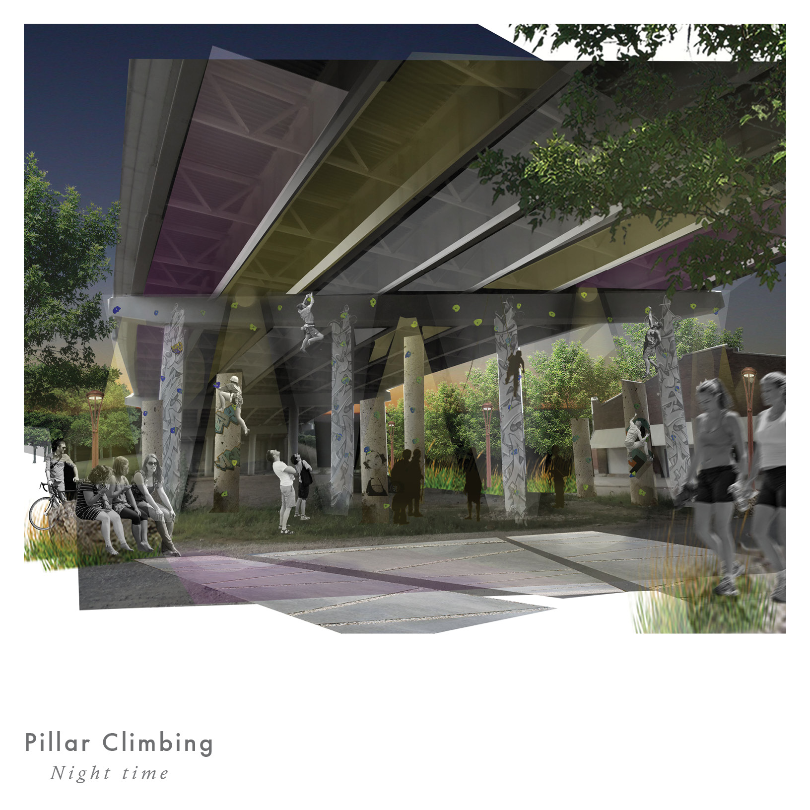
Figure A-34. Pillar Climbing. Source: author

Interstate pillar climbing is the ‘urban’ compliment to rock climbing. It provides a beginner level of intensity targeting first time climbers. Skilled climbers and boulderers’ have an adjacent area allows for higher level of experience and agility.

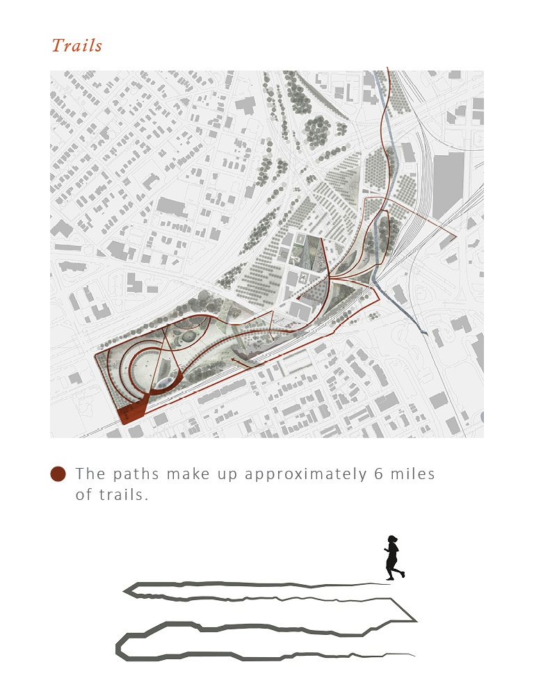
Figure A-35. Trails and Paths Diagram. Source: author

Highlighted in maroon in Figure A-34, the six miles of trails provide safe exercise opportunities for walkers, runners and bikers. The pathways measure between 10’-20’ depending on the type of trail. The runner diagram offers insight into the range in elevation (from ground to + 10’). The park’s internal trail system connects to the existing Second Creek Greenway and a proposed trail to the north connects to the future Second Creek Greenway proposed by the City.
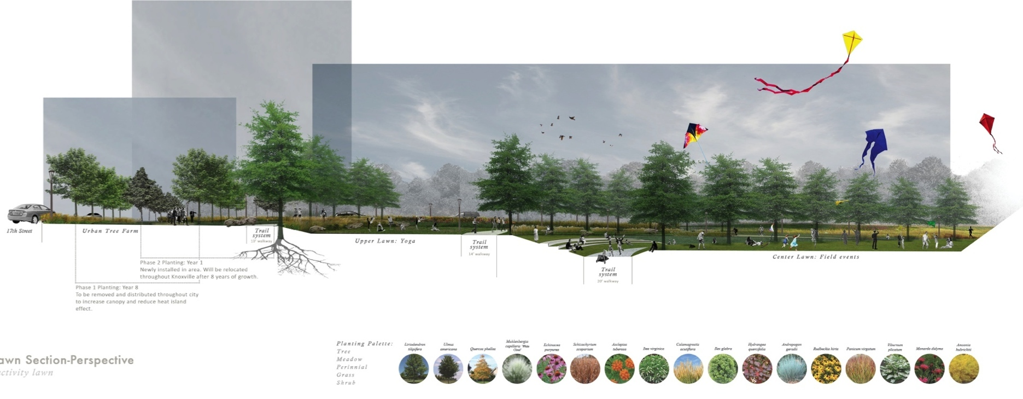

Figure A-36. Main Lawn Section Perspective: author

Figure A-35 illustrates the varying levels of tree canopy, elevation and activity. Yoga classes can occupy one space while being densely buffered by grasses, perennials and trees while a main lawn field measures the standard size for soccer and flag football. The Tree Farm weaves in and out of the site creating multiple allées.

Figure A-37. Landforms Diagram. Source: author

Figure A-36 shows the varying levels of landforms and land bridges that make up the sites interesting character. They can be used for leisurely play or for hill climb strength training.
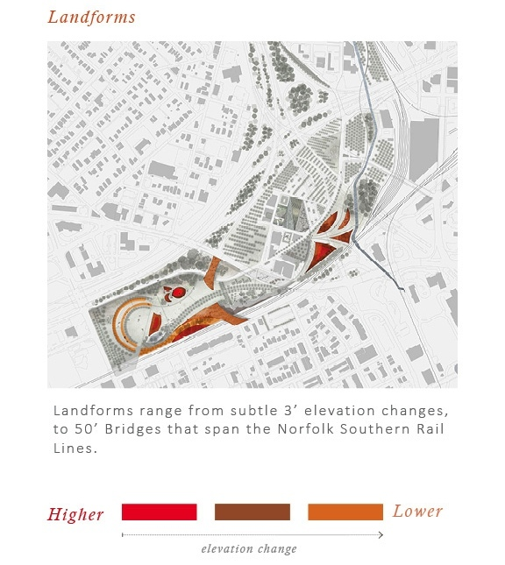

Figure A-38. Urban Tree Farm Diagram. Source: author

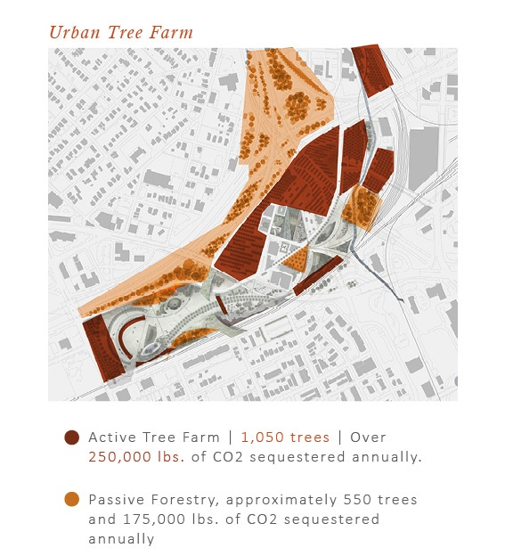
Environmental efforts are addressed with Urban Tree Farm Program that is continuously in production transition, and aids to clean pollutants from the air. The planting of young trees captures CO2 at higher rates than those of mature trees (DEOC 2014).

Figure A-39. Urban Tree Program. Source: author

Figure A-39 displays the species use and rotation plan for the city tree program. This program cycles trees every 6-8 years and then disburses trees throughout the city of Knoxville. These tree species were chosen by their native classification and level of sequestration.
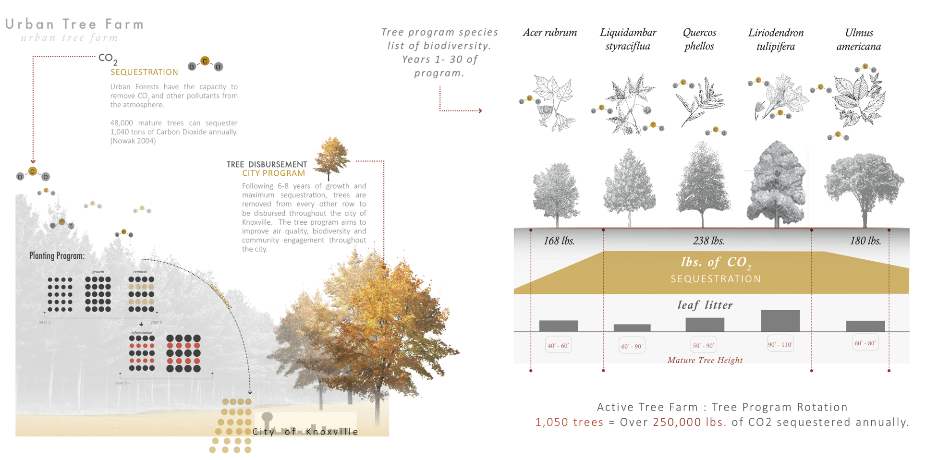
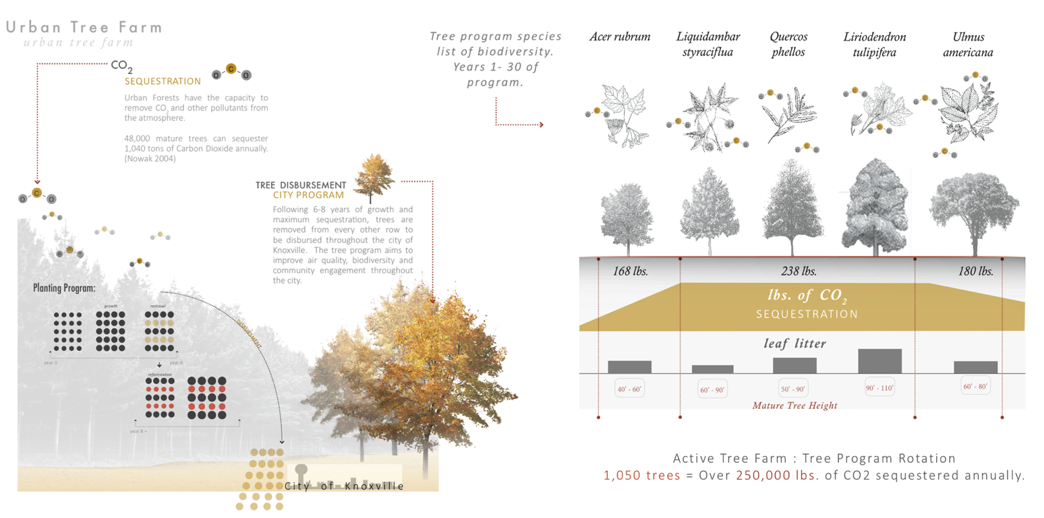

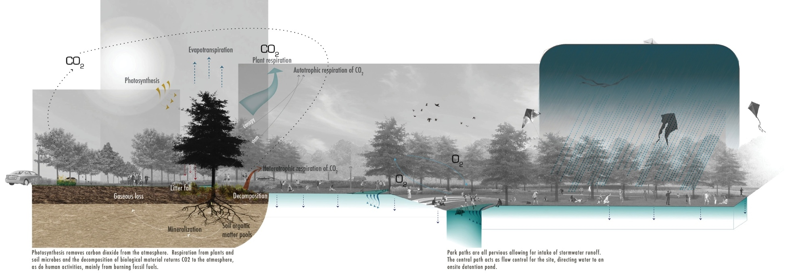

Figure A-40. Systems and Processes Section-CO2 sequestration: author

Representing the multiple functions on site, Figure A-39 is a Systems diagram that shows the sequestration process via photosynthesis on the left. To the right of the drawing is the storm water viaduct at the convergence of two watersheds. It can hold up to a 50’ year flood while the second lawn marks the 100’ year flood.

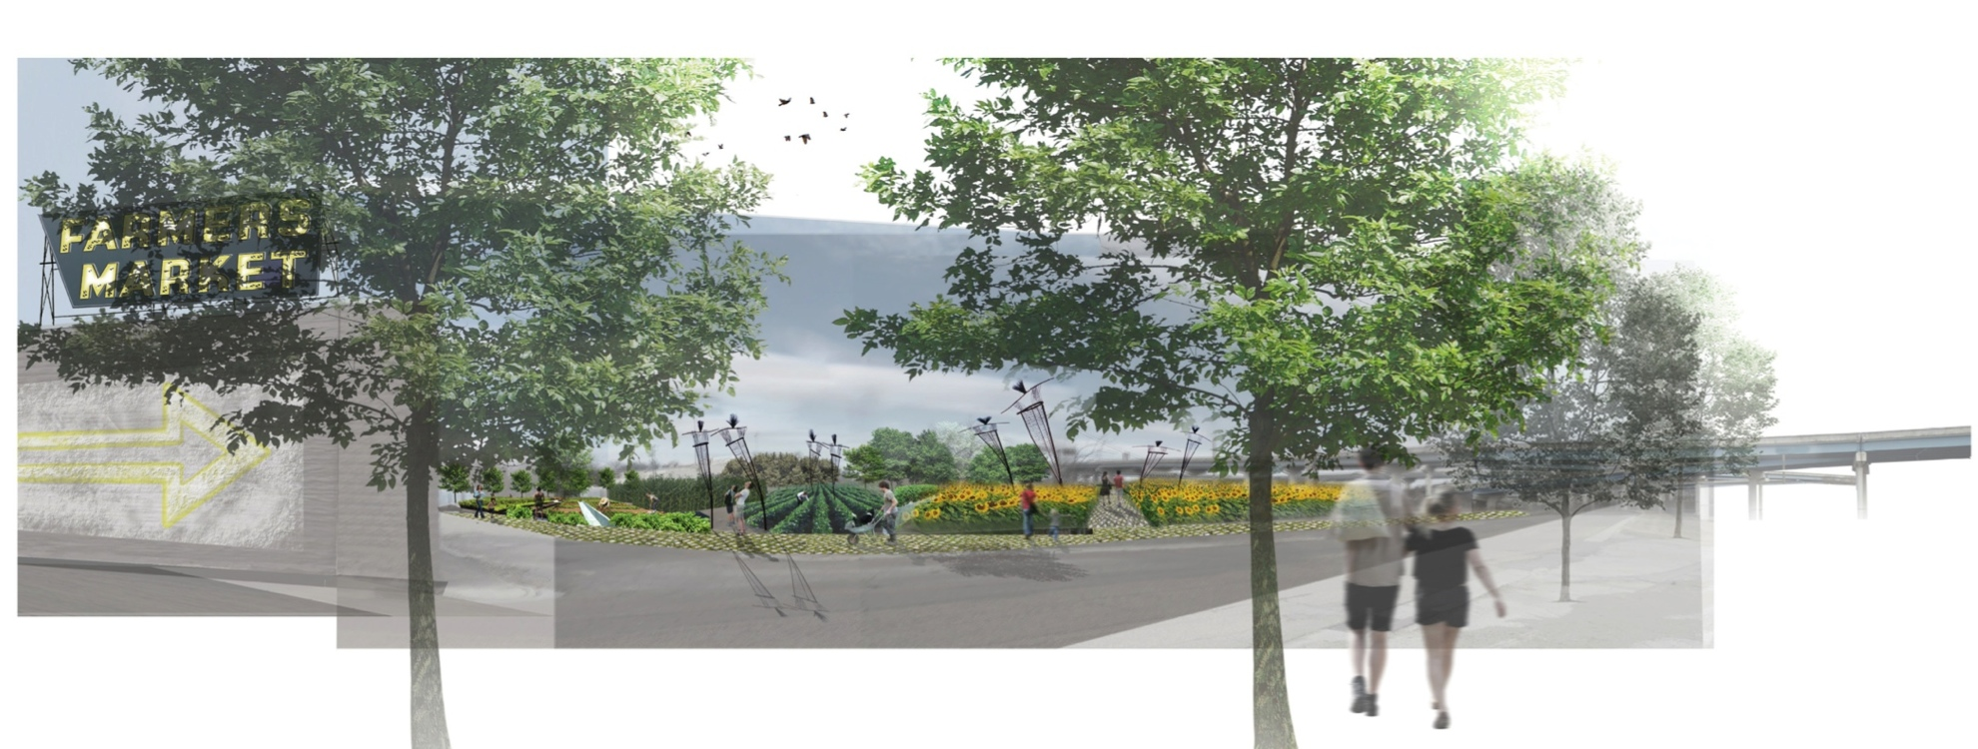

Figure A-41. Community Garden and Market Perspective: author
Another aspect of physical health involves the access to healthy food choices. For this purpose, a community garden is located in the center of the site and a Farmer’s Market and Co-op serves the social response of the site. Here, individuals can grow their own crops and the option of selling to the community. Education is key and the garden provides the potential for nutritional, agricultural and communal awareness.

6.5 Increase Community Involvement and Social Gathering
Strategy: Market and Stewardship
Encouraging social engagement and providing communal space is a key aspect for social health in this park. The Farmers Market (Figure A-40) provides the opportunity to not only engage with neighbors but also those from outside the direct vicinity. The Urban Tree Farm concept includes a citywide volunteer program through which community residents may participate, elevating pride and ownership in their community and allowing for social interaction. Recreational areas also promote social interaction and support such as Rock Climbing, Basketball and Volleyball. The central lawn is a flexible space providing opportunities for impromptu soccer, football, and other organized sports activities as wells kite flying, and Frisbee toss, fairs and festivals, and other social gatherings.
Additional program that fosters community interaction in the community center are
- Urban Garden (Figure A-40)
- Farmer’s Market and Co-op
- Spaces for gathering
- Stewardship & Volunteerism through tree program

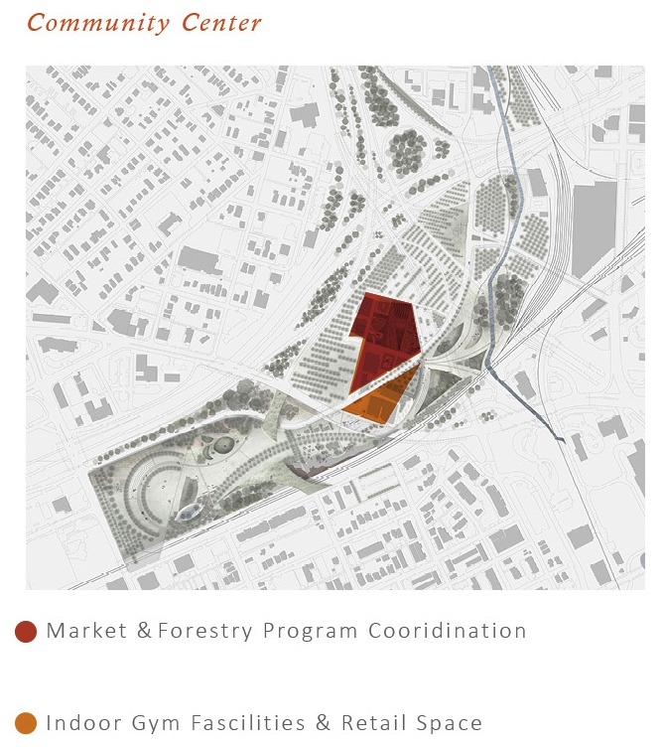
Figure A-42. Community Center Diagram Source: author

The existing buildings provide space for the Urban Forestry Department to facilitate the Tree Program, help train volunteers and maintain the trees. The center also provides areas for retail such as a ‘Farm to Table’ restaurant using the site’s garden for seasonal vegetables.

6.6 Provide Spaces for Natural Recharge
Strategy: Sculpture Park and Natural Areas
One’s connection to nature has proven health benefits as discussed in previous chapters and is provided throughout the proposed design. Programming for mental health is focused primarily on the abundant green spaces, landforms, meadows and woodlands that weave in and out of the space. The extensive native plant palette offers seasonal interest, beauty and promote butterfly and bird habitat. Diverse species list of the Urban Tree Farm provides multiple levels of canopies and shade cover for relaxing walks or even mediation. In addition, the Urban Tree Farm blends in from the physical side by serving as a catalyst for clean air pollution and filtering particulates. Crossing the spectrum into social health is the sculpture garden. Large public art is echoed throughout the 100 acres park providing introspective thought or an engaging conversation with others enjoying the view. Another mental benefit is derived from exercise and is linked to the reduction of depression. Regular exercise causes the body to release endorphins that interact with brain receptors, reducing pain perception and trigger a positive feeling in the body (CDC 2012).
Program Elements for the mind & soul include:
- Landforms & meadows
- Naturalized area & walking trails
- Extensive plant palette for the senses.
- Sculpture garden

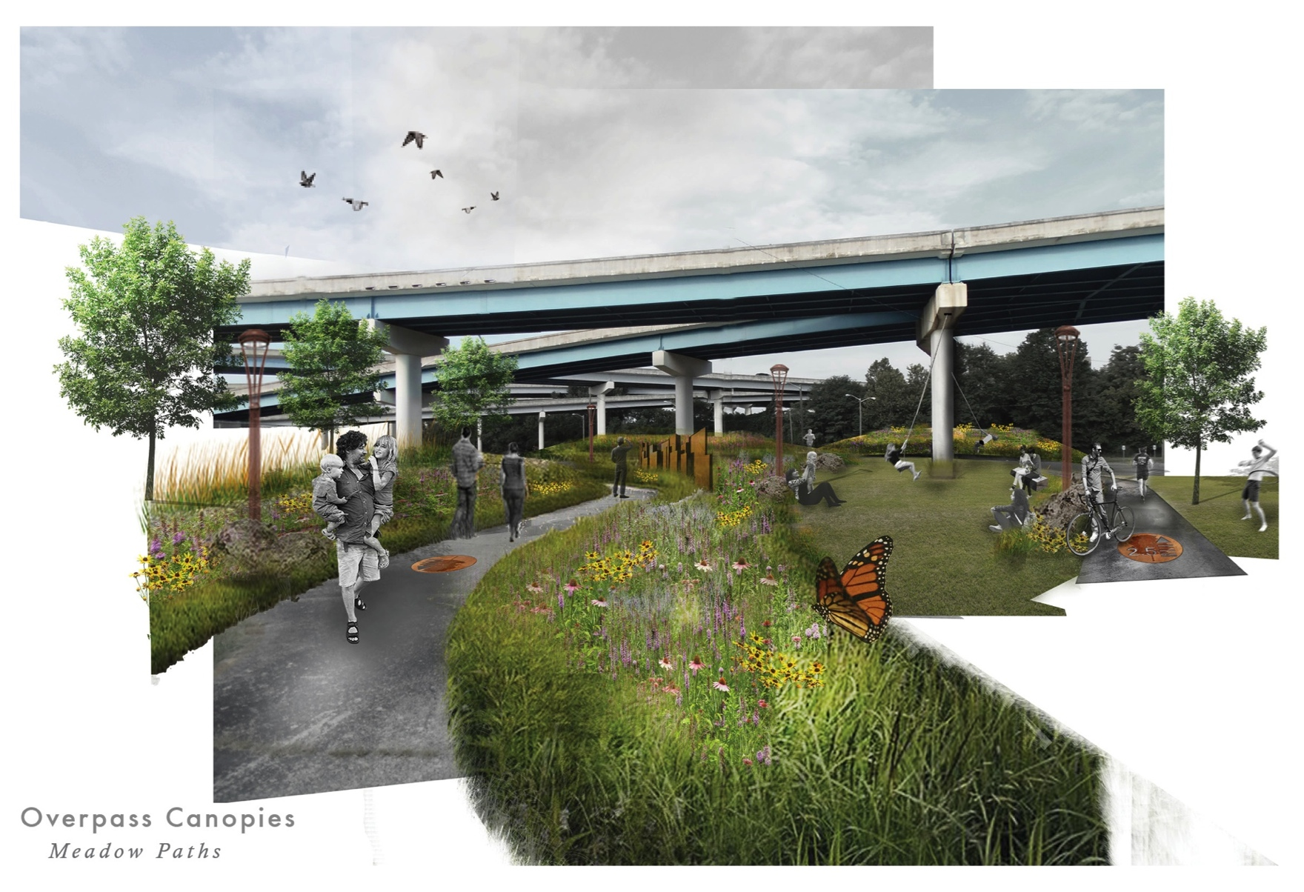

Figure A-43. Overpass Canopies Perspective. Source: author
Landforms and meadows are echoes throughout the site. The overpassed form a monument canopy over the site and provides a unique perspective for users.

Figure A-44. Section Perspective: Native Woodlands and Riparian area. Nature as Respite: author

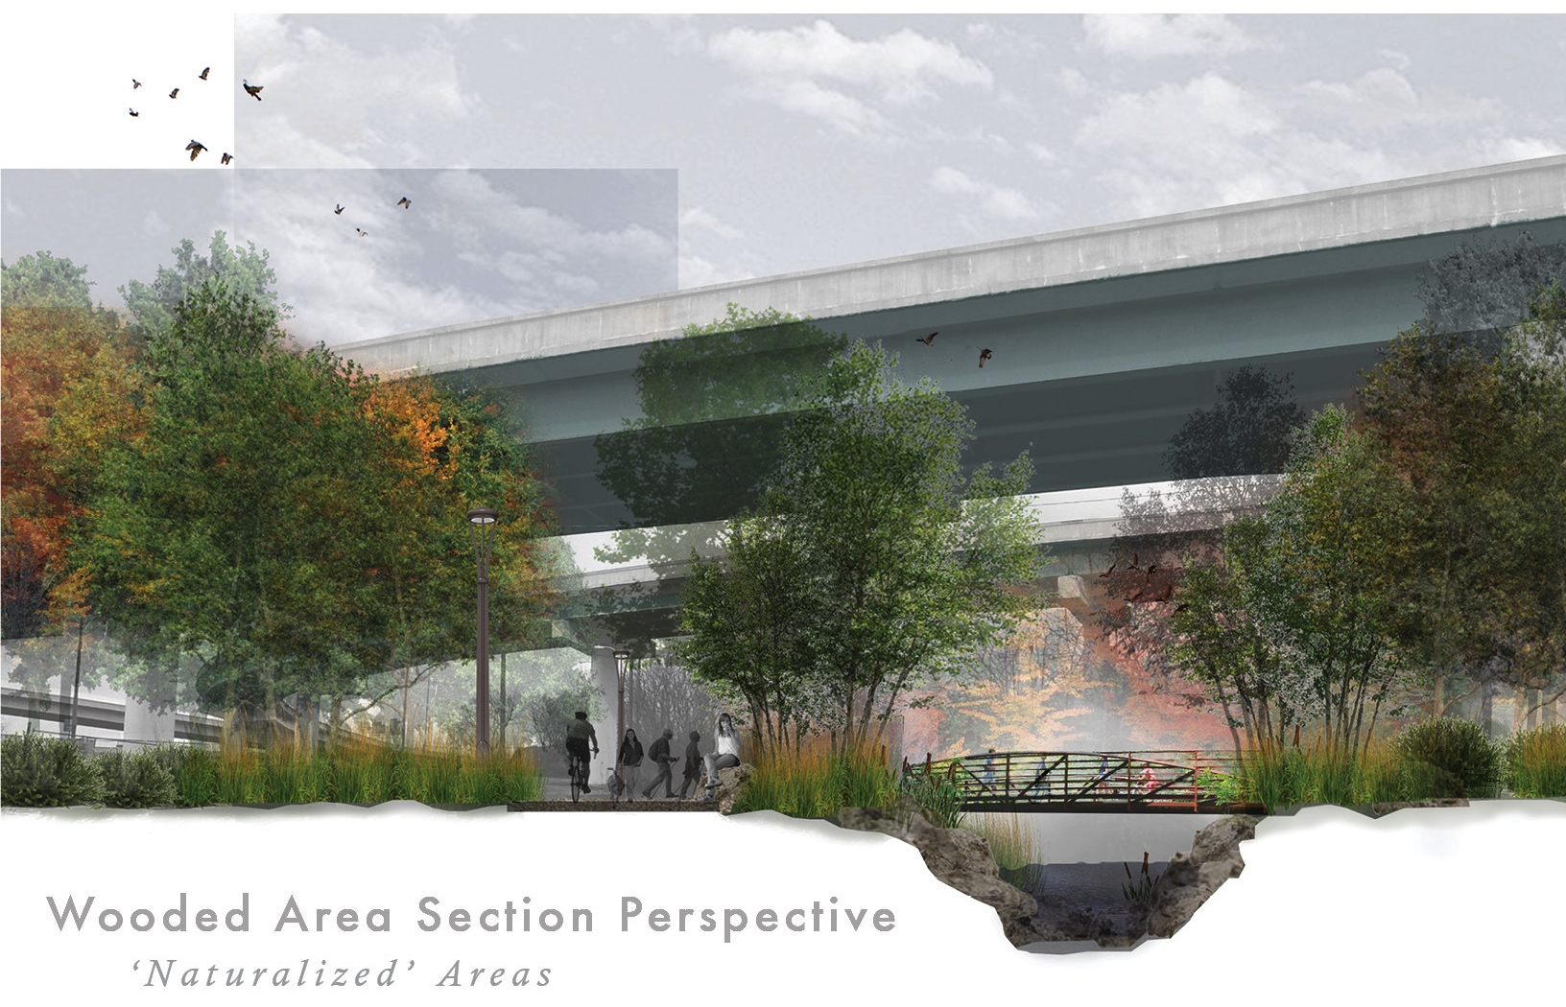
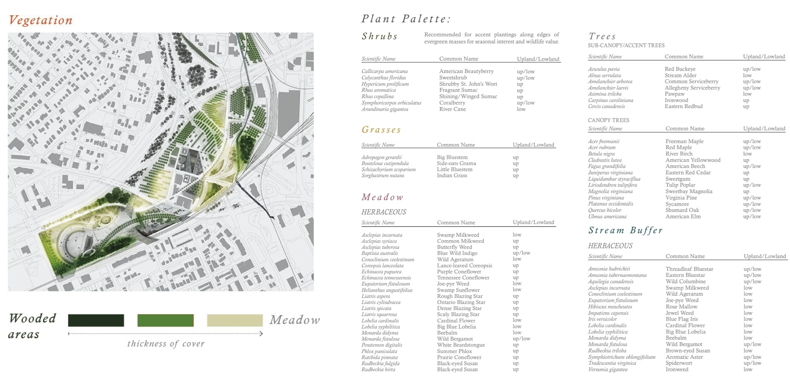
Figure A-45. Vegetation Diagram & Plant List. Source: author
This extensive native plant palette heightens seasonal interest. The mind is able to explore the many plants along a relaxing nature walk while also watching for birds and butterflies in newly introduced habitats.

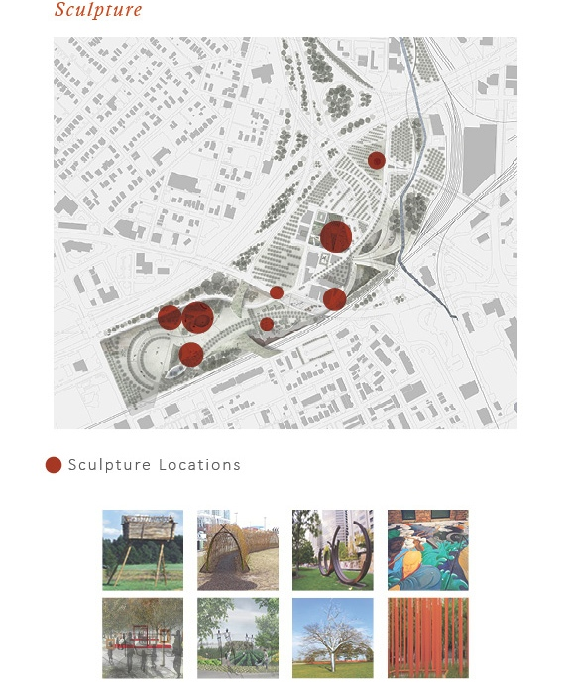
Figure A-46. Sculpture diagram. Source: author

Capturing the vibrant culture and character of Knoxville is a key component to the park’s sculpture garden. Not only does it provide mental stimulation but it is also design to be interactive (See Figure A-46) and can stimulate conversation between onlookers. Art is further integrated into the site design through sculptural landforms, colorful plantings, and the projects way finding elements (See Figure A-48).

Figure A-47. Perspective Rendering-Art in the Park Sculpture: author

Art in the park features family friendly art that is playful, interactive and highlights the texture of materials. This installation encourages users to seek and different perspective on life from different frames of view. All angles are varied and all perceptions of space are altered.
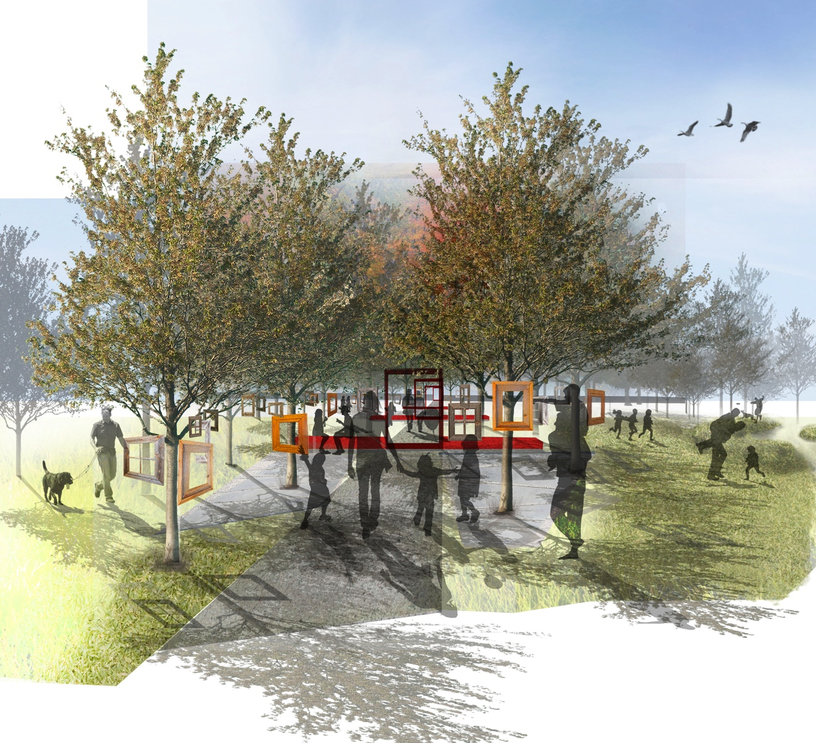


6.7 Provide Access for All
The location of the park provides walkable access for residents of neighborhoods that are otherwise deficient in equitable amenities. The surrounding neighborhoods lack the physical space to provide park access as well as basic street infrastructure to allow for safe pedestrian mobility. Access and way finding is key to the equitable use of this space. Proposed streetscapes detailing signage, lighting and bike lanes help to direct users to the site safely while also featuring the street trees grown in the Urban Tree Farm. The proposed street conditions shown in Figure A-48 are for corridors presently lacking in pedestrian access and safety. Three land bridges seamlessly integrate the park into its contextual landscape, provide safe passage over multiple rail lines, vehicle traffic, and other topographic impediments that otherwise prohibit ready access to the Blackstock site. Parking has been allocated on and off site to account for patrons arriving by vehicle.

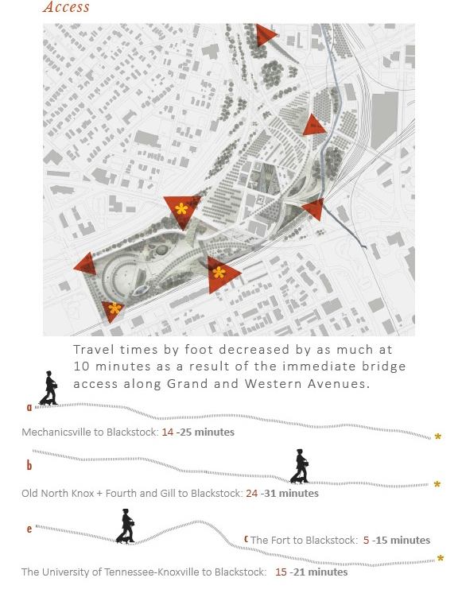
Figure A-48. Access Diagram. Source: author

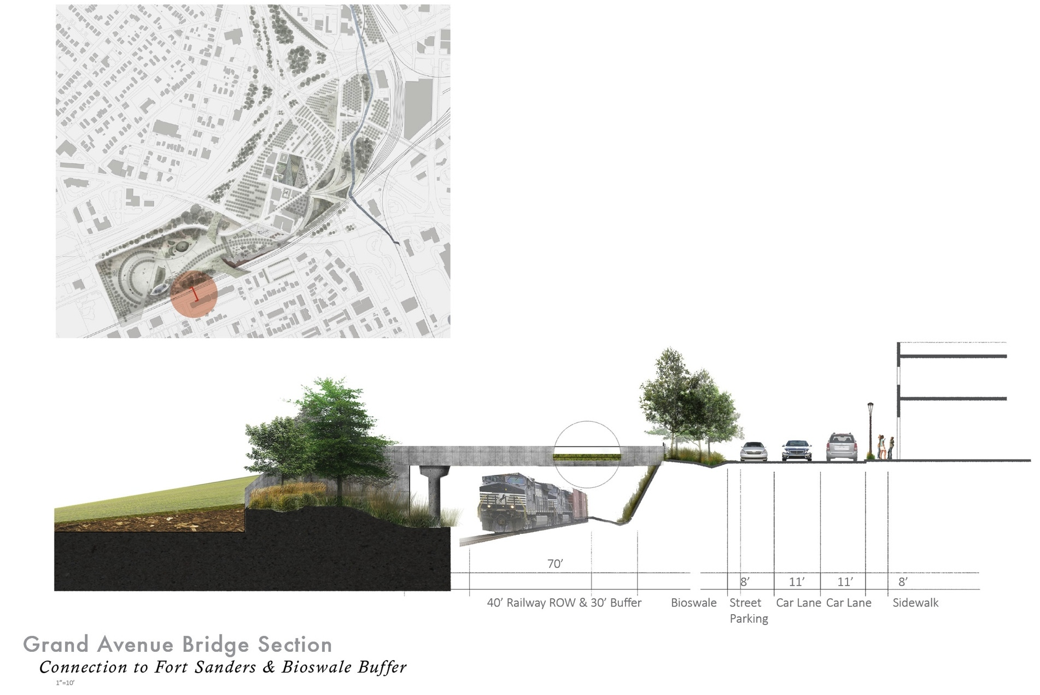
Figure A-49. Grand Avenue Bridge Access. Source: author

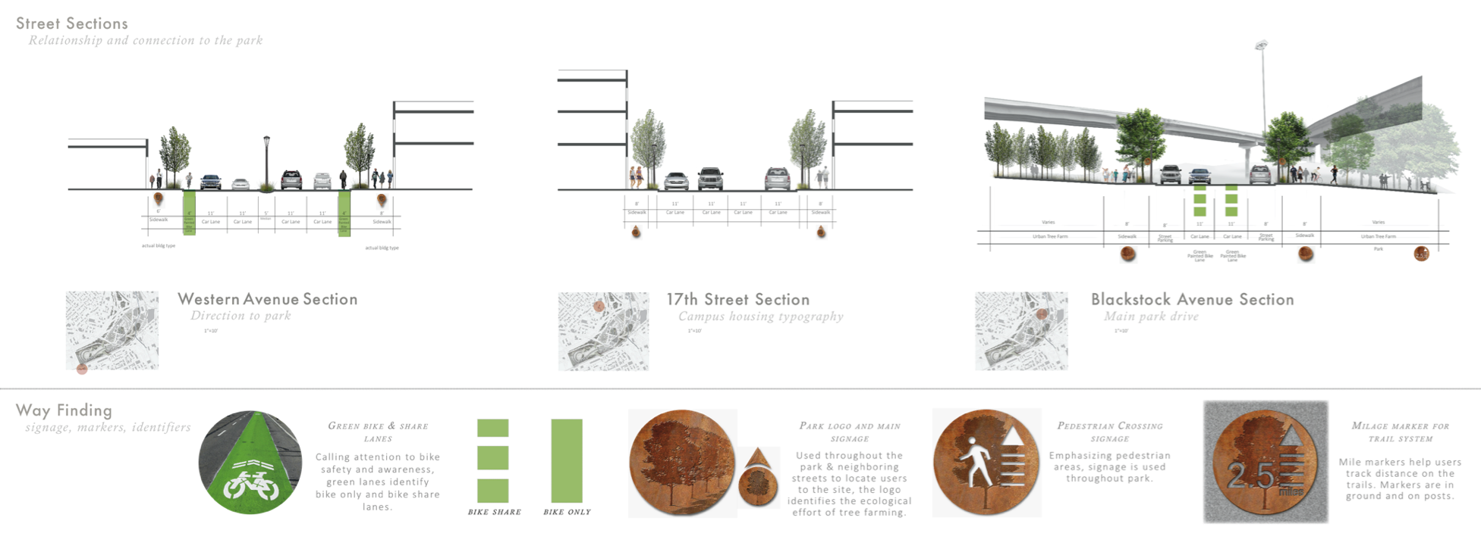
Street Access & Way Finding

Figure A-50. Street Access and Way Finding: author
The street sections show how neighborhood streets can benefit from redesign create safe access for pedestrians and bikers.
Way finding plaques and green paint are used to promote awareness of bikers and the guide users directly to the performance park.

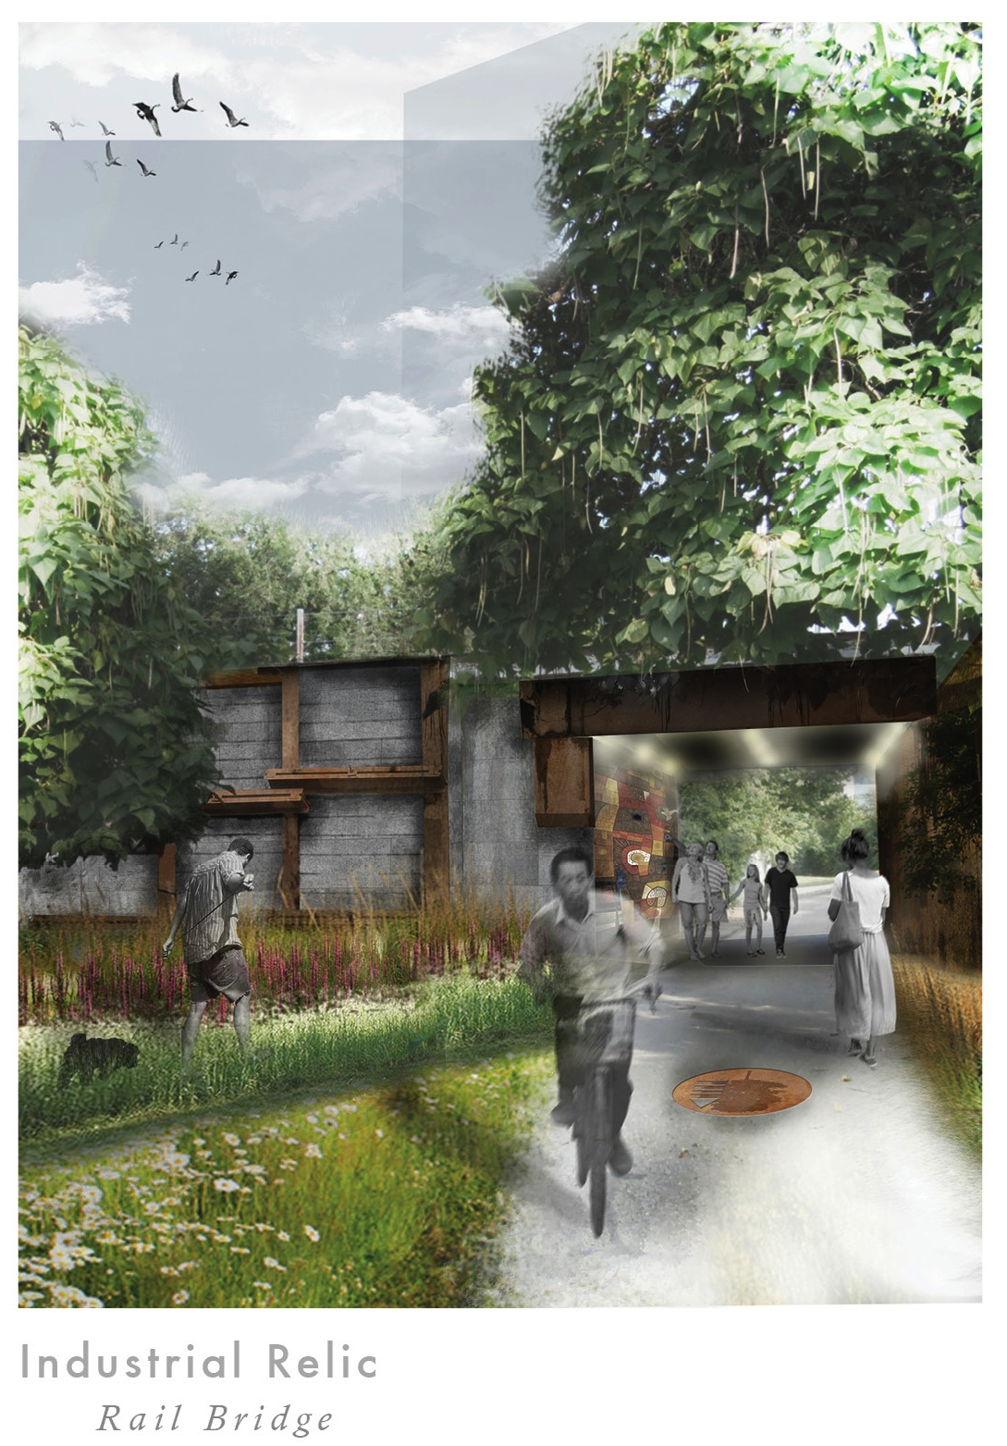

Figure A-51. Access to Downtown and Museum of Art. Source: author

Maintaining the existing bridge structure provides addition points of safe access to and from the city and popular destinations like the Sun sphere and Museum of Art.
Chapter 7 – Conclusion
This thesis sought to explore how to reunite the surrounding communities for betterment of physical, social and mental health, a transformation of Mind, Body and Soul through the reclamation of the forgotten industrial zone of Blackstock in downtown Knoxville. This study demonstrates the possibilities through the stated guiding principles and objectives that were informed by ULI’s Building Healthy Place Initiatives.

The proposed Performance Park landscape improves physical health through:
- Provides over ten different programs that promote a full body aerobic workout through strength training, cardiovascular exercise and stretching.
- Creates six miles of ample paths for walking, running or biking.
- Establishes an Urban Tree Farm that performs multiple benefits. Plants over 1,050 trees that sequesters 125 Tons of CO2 and improves air quality for park users and the surrounding city. It provides the city of Knoxville an outlet for canopy expansion through distribution, of 100 trees every six to eight years.
- Provides two acres of community garden access to healthy food choices and for individuals to have a place to grow their own vegetables.
Social interaction is a strong component of the Performance Park. These features include:
- The Farmer’s Market and Co-op gives users and community members a chance to buy and sell goods with one another often sparking conversation and meeting new people in the process.
- The Urban Tree Farm stewardship program aims to create a sense of pride among the community through education and training programs dedicated to instilling knowledge in volunteers about the health and maintenance of the trees. Volunteers are active participants digging up and replanting trees throughout the site. Education of proper tree care can lead to possible certifications within forestry and even create opportunities for job placement.
- Public Art Sculptures address both social and mental health by sparking dialogue among the curious and providing mental stimulation through exploration of ideas.
- Physical activities such as rock climbing, basketball, and volleyball have been known to spark interactions between onlookers and those looking for participants.
A connection to nature though the reclamation of this derelict landscape as a Performance Park will have healing qualities and provide mental restoration opportunities. The Park serves as an oasis in the center of the city by:
- Providing 107 acres of green space to explore and relax.
- An extensive plant palette provides interest year-round, additionally creating appeal for sight and smell.
- The plant palette stimulates the increase of habitat for pollinators and birds.
- 17.4 Acres of areas designed for reprieve by providing long stretches of landforms, meadows and woodlands.
The existing buildings on site have the potential to offer additional retail and event space drawing in new crowds. Currently the building proposals include an existing dance studio, a Co-op, Urban Forestry Department, Indoor Gym and additional space for artist studios. Repurposing this site can impact the communities it serves by providing them the very things they need. There is no doubt that reallocating the use of the Blackstock site can benefit an entire city, but can also serve as a pilot project for Healthy Community Design, an emerging genre growing in importance.
Currently, street conditions do not provide a safe environment for neither pedestrians nor bikers. This was addressed by providing safe access and way finding for city inhabitants, users can follow the marked bike lanes and marked sidewalks for assistance to the site. Calling attention to green painted bike lanes and pedestrian signage, vehicular traffic can be aware of the conflicting typology of the street condition now alluring different modes of transportation.
The topography, interstate and railway infrastructure posed additional access challenges by creating substantial barriers. As a way for pedestrians to have direct access onto the site, three land bridges are proposed. Bridges span over the active rail lines and also over Blackstock Avenue, providing a complete pedestrian experience without worry of vehicular traffic or traveling an addition 15 minutes around the rail lines. Through the proposed design intervention, users are given an opportunity to engage in a wide variety of activities, to suit the needs of the mind, body and soul.
Lessons Learned
The research process for this thesis proved to be enlightening. Designing for an individual’s health contains a level of complexity that I only now understand can be achieved through a holistic approach by those wishing to implement healthy places. As understood from the extensive body of research in previous chapters, a city official, a design professional or a health expert cannot accomplish this task alone. Yet it must be a successful cross collaboration among professions of varying strengths; a team set out to provide equal health opportunity for all. The Urban Land Institute encourages a development approach in this manner and has a strong following of multidisciplinary professions to provide knowledge and support. Developers, investors, designers, and community leaders are only a few of the contributors that the organization leans on for such knowledge and experience. ULI has demonstrated the ability to gather experts for the betterment of urban environments and continue to provide resources to those who need them.
These resources, I feel, would be needed to initiate the Mind, Body and Soul project. First to provide feasibility studies in the way of economics. Where do the funds come from to launch the study and furthermore how does funding continue to report on the environment and health impacts this design could bring to a city, and are cities ready to go all-in financially in the name of public health? My recent work with the Landscape Architecture foundation and the Atlanta BeltLine has proven to me that with the right amount of public and city support anything is possible. Economic teams developed a TAX Allocation District to allocate funding strictly for the implementation of the Atlanta BeltLine (ABI 2009). This approach to funding has proved beyond successful for the city of Atlanta and has been a catalyst for over 775 million dollars in new development (ABI 2014). Most importantly, a survey conducted on the Eastside Trail reports that it has improved the physical activity of 90% of its users with 70% saying that they exercise more because it exists. 94% of users also benefit from the sense of community that the BeltLine provides (LAF 2014).
The connection to Mind, Body and Soul is real and details a parallel for lessons learned. I learned that finding time for reflection and providing myself with an adequate physical, mental and social health balance provides a sense of clarity and big picture visualization my goals. The issues of human health are problems worth solving. We function as a society through multiple means of communication yet we struggle to communicate and implement changes that can better our lives. Adverse health effects have been going up since the 1990’s, yet it is just recently that the healthy places movement is gaining attention. Advocacy and awareness can promote positive change like the new Healthy Places Initiatives. Urban populations are rising and without efforts to mitigate obesity, depression and social exclusion, our society will continue down a costly path of health problems. Healthy places are not to be limited to special urban parks. Physical, mental and social health must manifest as a deliberately integrated consideration of the planning and design of all aspect of the built environment.

LIST OF REFERENCES

Aelred Gray and Susan Adams, Lucile Deaderick (ed.), “Goverment,” Heart of the Valley: A
History of Knoxville Tennessee (Knoxville, Tenn, East Tennessee Historical Society, 1976). 91-113.

Adli, Mazda. “Urban Stress and Mental Health.” The London School of Economics and Politics. LSE Cities. 2011. November.
<http://lsecities.net/media/objects/articles/urban-stress-and-mental-health/en-gb/>

America for the Arts. “Arts and Healing.” 2014. 4 July. <http://www.americansforthearts.org/by-topic/arts-and-healing>

APA. American Planning Association. “How cities use parks to Improve Public Health.” 2014. Retrieved: July 23, 2014.
< https://www.planning.org/cityparks/briefingpapers/physicalactivity.htm>

Bleich, Sara N., Jarlenski, Marian P., Bell, Caryn N., LaVeist, Thomas. “Health Inequalities: Trends, Progress, and Policy.” National Institute of Health. 2012. April. Vol 33. 7-40. < file:///Users/AngelikeAngelopoulos/Downloads/nihms501067.pdf>

Campbell, Marilyn, A. (2005). Cyberbullying: An Old Problem in a New Guise?. Australian Journal of Guidance and Counseling. 15 (1) :68-76. Retrieved from http://eprints.qut.edu.au/1925/1/1925.pdf

Carol, Claudia. “How Good Design Can Improve Public Health.” 2014. 6 June. Retrieved: June 30, 2014.
<http://www.gensleron.com/cities/2014/6/30/how-good-design-can-improve-public-health.html>

Centers for Disease Control and Prevention. “CDC Features” 2012. 5 April.

< http://www.cdc.gov/features/dsobesityadults/>

Centers for Disease Control and Prevention. “Mental Health.” 2012. 31 December. <http://www.cdc.gov/obesity/adult/defining.html>

Centers for Disease Control and Prevention. “Obesity: Halting the Epidemic by Making Health Easier.” 2011. 26 May. <http://www.cdc.gov/chronicdisease/resources/publications/aag/obesity.htm>

Centers for Disease Control and Prevention. “Overweight and Obesity.” 2012. 27 April. <http://www.cdc.gov/obesity/adult/defining.html>

Department of Environmental Conservation. “Trees: The Carbon Storage Experts.” 2014. <http://www.dec.ny.gov/lands/47481.html>

Diller Scofidio + Renfro. “The Highline.” 2013. 1 Oct. <http://www.dsrny.com/#/projects/high-line-three>

ECO-TN. Every Child Outdoors-Tennessee. 2014. 28 January. <http://eeintennessee.org/net/org/info.aspx?s=98786.0.114.37935>

FCCC. Fox Chase Cancer Center. “Health Disparities.” 2014. July.
<http://www.fccc.edu/prevention/hchd/what-is-hchd.html#sthash.TMBzi6MY.dpufThere>

Friends of the Highline. “About the Highline.” 2010-2013. 1 Oct.
<http://www.thehighline.org/>

Galofaro, Luca. “Artscapes: Art as an approach to contemporary landscape.” (Barcelona, Aleu, SA) 2007. 23

Giovanna Di Chiro, William Cronon (ed.), “Nature as Community: The Convergence of Environment and Social Justice.” Uncommon Ground. (New York, London; W. W. Norton & Company Ltd. 1996). 318.

Goodrich, Geoffrey G. “Does Obesity Cause Asthma?” 2013. 21 January.
< http://www.criver.com/about-us/eureka/blog/january-2013/does-obesity-cause-asthma>

Hood, Ernie. Dwelling disparities: how poor housing leads to poor health. Environ Health Perspect. Volume 113(5); 2005. May. A310–A317.

HSPH. Harvard School for Public Health. “Obesity Causes.” 2014. July.
<http://www.hsph.harvard.edu/obesity-prevention-source/obesity-causes/>

USDHHS. HealthyPeople.gov. The Department of Health and Human Services. 2014. 4 July. “Healthy People 2020: Objectives.”
<http://www.healthypeople.gov/2020/about/QoLWBabout.aspx>

USDHHS. “Healthy People 2020: Foundation Health Measure Report: Health-Related Quality of Life and Well-Being.” 2010. November. (2) <http://www.healthypeople.gov/2020/about/HRQoLWBFullReport.pdf>

Jane Jacobs. The Death and Life of Great American Cities. (New York: Vintage Books, A Division of Random House, Inc. 1961; reprinted 1992). 91, 95, 101.

John Wooldridge, George Mellen, William Rule (ed.). Standard History of Knoxville, Tennessee (Chicago: Lewis Publishing Company, 1900; reprinted by Kessinger Books, 2010). 204-206.

Kellert, Stephen R. “Birthright, People and Nature in the Modern World.” (Yale University Press. New Haven and London. 2012). Print. book jacket, xi, 49.

Klopfer Martin Design Group. “The Steel Yard.” 2013. 15 Oct.
<http://www.klopfermartin.com/>

Kjellstrom, Tord, Sharon Friel, Jane Dixon, Carlos Corvalan, Eva Rehfuess, Diarmid Campbell-Lendrum, Fiona Gore, Jamie Bartram. “Urban Environmental Health Hazards and Health Equity.” Journal of Urban Health. 2007 May; 84(Suppl 1): 86–97. Published online 2007 April 21.

Community Health Status Assessment: Knox County, Tennessee. Knox County Health Department. 2010. < www.healthyknox.org/assessments>

Knox Heritage, Inc. “318 W. Depot Ave. • Southern Railway Passenger Station.” 2009. 15 Nov.<http://www.knoxheritage.org/downtown-walking-tour-7>

Kuo, F.E., Sullivan, W.C., Coley, R.L, & Brunson, L. (1998). Fertile ground for community: Inner-city neighborhood common spaces. American Journal Community Psychology 26, 823-851

Kuo, F.E., & Sullivan, W.C. “Environment and crime in the inner city: Does vegetation reduce crime?” (2001). Environment and Behavior, 33(3), 343-367.

Land Life. “Benefits for People and Nature.” 2014. 4 July. <http://www.landstewardship.eu/land-stewardship/benefits>

Landscape Architecture Foundation. “Buffalo Bayou Promenade.” 2010-2013. 15 Oct.
<http://www.lafoundation.org/research/landscape-performance-series/case-studies/case-study/623/>

Landscape Urbanism. “Buffalo Bayou Promenade.” 2013. 15 Oct.
< http://landscapeurbanism.com/strategy/buffalo-bayou-promenade/>

Let’s Move. “The Epidemic of Childhood Obesity.” 2014. 1 July.
<http://www.letsmove.gov/learn-facts/epidemic-childhood-obesity>

Old North Saint Louis Restoration Group. “A Short History of Old North.” 2013. 2 Oct. <http://onsl.org/>

PPS. Project for Public Spaces. “Urban Parks for the Past and Future.” Galen Cranz. 2014. August. < http://www.pps.org/reference/futureparks/>

Rodrigue, Dr. Jean-Paul. “THE GEOGRAPHY OF TRANSPORT SYSTEMS” 1998-2013. 4 Dec.
<http://people.hofstra.edu/geotrans/eng/ch6en/conc6en/dynamicsurbanchange.html>

Rottle, Nancy, and Yocom, Ken. Basics Landscape Architecture 02: Ecological Design. (Switzerland, United Kingdom, Tennessee: AVA Publishing SA, 2010). 28, 59, 134.

Stuckey, Heather., and Nobel, Jeremy., “The Connection Between Art, Healing, and Public Health: A review of current literature.” Am J Public Health. 2010 February. <http://www.ncbi.nlm.nih.gov/pmc/articles/PMC2804629/#bib8>

Srivastava, Kalpana. Urbanization and Mental Health. Industrial Psychiatry Journal. 2009. July-December; 18(2): 75-76.

TFAH. Trust for America’s Health. “F as in Fat: How Obesity threatens America’s Future.” 2013 August. <http://healthyamericans.org/report/108/>

U.S. Census Bureau. 2010 Census Urban Area Facts. (2013, March 7). Retrieved June 30, 2014 from http://www.census.gov/geo/reference/ua/uafacts.html

USDA. United States Department of Agriculture. “Food Deserts.” 2014. 11 August. < https://apps.ams.usda.gov/fooddeserts/foodDeserts.aspx>

USDOI. U.S Department of the Interior. 2014 Youth in the Great Outdoors. Retrieved 2014. 2 July. <http://www.doi.gov/youth/about/index.cfm>

University of New Hampshire Health Services. “Social Wellness.” 2014. July.
<http://unh.edu/health-services/ohep/social-wellness>

W. Bruce Wheeler, “Knoxville.” The Tennessee Encyclopedia of History and Culture, 2002, Retrieved: 28 February 2008.

William MacArthur, Lucile Deaderick (ed.), "Knoxville's History: An Interpretation," Heart of the Valley: A History of Knoxville, Tennessee (Knoxville, Tenn.: East Tennessee Historical Society, 1976). 29 - 46, 48-49, 59-60.

WHO, World Health Organization. Hidden cities: unmasking and overcoming health inequities in urban settings. (Geneva, Switzerland, WHO Press. 2010). 29

WHO, World Health Organization. Health and Environment Linkages Initiative (HELI). (Geneva, Switzerland, WHO Press. 2009). <http://www.who.int/heli/risks/urban/transportpolicybrief2010.pdf?ua=1>

Appendix

Page 60: Image credits below:
- http://www.outdoorknoxville.com/places/trails/south/ijams-nature-center-trails
- http://www.outdoorknoxville.com/places/parks/west/sequoyah-park
- http://knoxkoupons.com
- http://www.outdoorknoxville.com/places/parks/east/seven-islands-state-birding-park
- http://www.outdoorknoxville.com/play/paddling
- http://kids.britannica.com/elementary/art-90441/Great-Smoky-Mountains-National-Park-covers-parts-of-western-North
VITA

Prior to enrolling in the University of Tennessee-Knoxville’s MLA program in the summer of 2011, Angelike spent six years developing her career in the Landscape industry throughout parts of the Southeast. With a BS in Plant Sciences, she has been in numerous roles as manager and consultant throughout her career focusing on client relations, business development and large-scale commercial landscape design. Her leadership roles continued into graduate school as she served as Vice President and President of the TN ASLA Student Chapter, representative on the Dean’s Student Advisory Council and Graduate Teaching assistant throughout her tenure at UTK.
Ms. Angelopoulos has had the privilege of serving as ambassador for the MLA program as an intern at Oak Ridge National Laboratory, attendee at two National ASLA conferences and a student presenter at this year’s CELA conference. In 2013, she was awarded the Tennessee ASLA Student Design- Award of Excellence for re-envisioning stormwater management in Knoxville’s Happy Holler District. Angelike was recognized by the faculty and awarded the Landscape Architecture Award of Excellence in Leadership in 2014.
Angelike has a passion for photography, design, traveling, and outdoor activities that enhances her cross-cultural understanding of people and place. Her current research endeavors are highlighted with a fellowship through the Landscape Architecture Foundation-Case Study Investigation program measuring the performance benefits of the Atlanta BeltLine-Eastside Trail. With hopes of returning to academia in the future, she plans to work in a professional firm following graduation to move toward licensure and to increase her level of skill and experience within the field of Landscape Architecture.

