Incorporating the “Invisibles” in Ant Seed Dispersal:

Microbial Mortality Agents in Myrmecochory

A Dissertation Presented for the

Doctor of Philosophy

Degree

The University of Tennessee, Knoxville

Chloe Leigh Lash

August 2020

Copyright © 2020 by Chloe Leigh Lash
All rights reserved.

DEDICATION

For Grandma White
“It’s a fine life lived and the privilege of standing there in the afterlight”

ACKNOWLEDGEMENTS

First, thank you to my advisor, Dr. Charlie Kwit. Thank you for your advice and guidance, and thanks for always having my back. Thank you to Dr. Kimberly Gwinn, Dr. Jim Fordyce, and Dr. Kimberly Sheldon, my dissertation committee. Thank you for sharing your science with me, making my science better and reminding me of the big picture. Thank you to my co-authors on the chapters presented here: Dr. Charlie Kwit, Samantha Kisare, Samantha Sturiale, Dr. Jim Fordyce, and Dr. Melissa Cregger. Your expertise made these projects possible.
Thank you to the Kwit lab, the community at Mountain Lake Biological Station, and all undergraduate assistants I have had the pleasure of working with for your feedback, long science conversations, sharing your expertise, and fun adventures. Particularly thank you to: Dr. Chelsea Miller, Hannah Mullaly, Kane Lawhorn, Jamie Albert, Joanna Huntoon, Elizabeth Evans, Kristen Salonga, Sierra Sullivan, Brianna Reynolds, Alana Messier, Austin Davis, Parker Stevenson, Bruce Martin, Dr. Butch Brodie, Dr. Eric Nagy, Tom McNamara, Dr. Vince Formica, Phoebe Cook, Lisa Mitchem, Robin Costello, Dr. Catherine Debban, Dr. Michael Miller, Jaime Jones, Dr. Mary Jane Epps, Dr. Courtney Thomason, and Drs. Henry and Becky Wilbur. Also thank you to Veronica Brown for her patience and assistance with next generation DNA sequencing. Thanks to Janice Harper, Lisa Boling, Karin Grindall, and Marva Anderson.
Funding for this dissertation was provided in part by: the Program for Excellence and Equity in Research, the University of Tennessee Herbarium, Breedlove, Dennis Fund for Student Botanical Field Experiences, the Phi Kappa Phi Love of Learning Award, the University of Tennessee, Knoxville’s Student/Faculty Research Award, Mountain Lake Biological Station Graduate Student Research Fellowships (Margaret Walton Scholarship, Johns Creek Endowment, Horton Hobbs Endowment), the Dept of Ecology and Evolutionary Biology at the University of Tennessee, Knoxville, the American Philosophical Society’s Lewis and Clark Fund for Exploration and Field, and the Genomic Science Program, U.S. Department of Energy, Office of Science, Biological and Environmental Research, as part of the Plant Microbe Interfaces Scientific Focus Area at ORNL (http://pmi.ornl.gov). All collections were done under permitting through The Nature Conservancy and the Virginia Department of Natural Heritage or on private land with permission from the landowners. Thanks to Sam Truslow, Ryan Klopf, and Steve and Carol Croy for assistance with permitting and field access.
Finally, I would like to extend a special thanks to the EEB graduate student community, especially Dr. Chelsea Miller, Morgan Roche, Harmony Yomai, Hailee Korotkin, Jess and Keith Dreyer, Maggie Mamantov, John Reese, Jordan Bush, Dr. Angela Chuang, Miranda Chen, and Dr. Cassie Dresser for lending the support necessary to succeed in grad school. Thank you to all who helped make me a better instructor: Dr. Beth Schussler, Dr. Caroline Weinhold, Dr. Charlie Kwit, Dr. Nina Fefferman, Mali Hubert, Shannon Bayliss, and my students. Thank you to the musicians whose art served as the background for brainstorming, writing, analyzing, and agonizing. Most importantly, thank you to my family (especially Dad, Mom, Grandma White, Grandma and Grandpa Lash, and Emma) and Sam for unwavering support throughout these past five years, for hearing my complaints, and for listening to me blabber on about ants. Your belief in me carried me through the moments when I did not believe in myself. And of course, thanks to Ted the cat, who reminds me to stop and watch the birdfeeder every now and again.

ABSTRACT

Ant-mediated seed dispersal, myrmecochory, is a diffuse mutualism in which ants are rewarded for seed dispersal services with food via a seed-coat derived appendage, the elaiosome. Seeds gain dispersal benefits including escape from distance- and density- dependent mortality agents, protection from seed predators, and a nutrient-rich germination site in or near ant nests. However, microbes, have been essentially overlooked in this mutualism, despite their pathogenicity to the ants and plants involved. The work presented here investigates the effects of microbial mortality agents on the risks and benefits offered to ant and plant partners in myrmecochory. First, I investigate the effects of a plant-produced chemical on the growth of a ubiquitous entomopathogen and on ant survival and foraging. Then, I investigate ant effects on the microbiomes associated with seed dispersal location and the seed coat. While a plant-produced chemical, sanguinarine, promotes the growth of an ant pathogen at certain concentrations, it did not influence ant survival or foraging patterns. These results suggest that though plant chemicals may increase pathogenic risk to ants in myrmecochory, ant social immune behaviors help counteract this threat. Ant activity influences both the ant nest and the seed coat microbiome. Increasing or stable ant activity in ant nests reduces turnover of 1) the plant pathogenic fungal community in soil substrates and 2) the myrmecochore pathogenic fungal community in log substrates. The handling of seeds by ants also alters the seed coat microbiome. Though seed species also influences the seed coat bacterial and fungal communities, ant handling and the removal of the elaiosome decreases the alpha diversity of plant pathogens on the seed coat. These results suggest that seeds are provided with additional benefits in myrmecochory in the form of pathogen defense in the ant nest environment and with ant handling. These findings, overall, suggest the importance of including microbial communities in the consideration of the risks and rewards in ant seed dispersal. Generally, this dissertation advances the field of ecological interactions by extending studies of a pairwise mutualism to include ecological community members that act as mortality agents for mutualistic partners.

TABLE OF CONTENTS

INTRODUCTION 1
References 4
CHAPTER 1 7
The effects of a myrmecochore-produced chemical on entomopathogenic fungal growth and seed-dispersing ant survival rates and foraging patterns 7
Abstract 8
Introduction 9
Materials and Methods 11
Study System: 11
Measuring Effects of Sanguinarine on B. bassiana: 12
Monitoring Exposed Ant Survival on an Elaiosome-based Diet: 13
Investigating Foraging Preferences in Exposed Ant Colonies: 14
Statistical Analyses: 16
Results 17
Measuring Effects of Sanguinarine on B. bassiana: 17
Monitoring Exposed Ant Survival on an Elaiosome-based Diet: 18
Investigating Foraging Preferences in Exposed Ant Colonies: 18
Discussion 19
References 23
Appendix 27
CHAPTER 2 Ants, Seeds, and Pathogens: Ant activity and nest substrate influence fungal pathogen communities in seed-dispersing ant nests 34
Abstract 35
Introduction 36
Materials and Methods 38
Field Collections 38
Next Generation DNA Sequencing 39
Data Processing 40
Statistical Analyses 41
Community Analyses 41
Microbial Community Turnover 42
Results 43
Community Analyses 43
Microbial Community Turnover 43
Discussion 45
References 50
Appendix 54
Qiime2 Pipeline 61
CHAPTER 3 87
Ant handling changes myrmecochore seed coat microbiomes and reduces diversity of seed-borne plant pathogenic fungi 87
Abstract 88
Introduction 89
Materials and Methods 91
Study System 91
Seed Treatments 91
Seed Washes 92
Next generation DNA sequencing 93
Data Processing 94
Fungal Functional Guild Assignment 94
Statistical Analysis 95
Microbial Community Dissimilarity 95
Beta Diversity 95
Indicator Species Analysis 96
Results 97
Microbial Community Dissimilarity 97
Beta Diversity 97
Indicator Species Analysis 99
Discussion 100
References 104
Appendix 109
CONCLUSION 115
References 118
VITA 119

LIST OF FIGURES

Figure 1-1 Growth of Beauveria bassiana with varying concentrations of sanguinarine after six days. 27
Figure 1-2 Growth of Beauveria bassiana with varying concentrations of sanguinarine between Days 1-2. 28
Figure 1-3 Growth of Beauveria bassiana with varying concentrations of sanguinarine between Days 4-6. 29
Figure 1-4 Ant survival by diet and Beauveria bassiana exposure regime. 30
Figure 1-5 Effects of brood, gland access and pathogen presence on dispersal of food items into the ant nest. 31
Figure 1-6 Effects of brood, gland access and pathogen presence on dispersal of food items off the seed grid. 32
Figure 2-1 Multivariate ordination plot of the different fungal communities. 54
Figure 2-2 Δ⁰T by change in ant activity and nest type for the fungal community. 55
Figure 2-3 Δ⁰T by nest type for the animal pathogenic fungal community. 56
Figure 2-4 Change in animal pathogen community turnover (Δ^{q}T) by change in ant activity over order q. 57
Figure 2-5 Change in plant pathogen community turnover (ΔT) by change in ant activity and nest substrate over order q. 58
Figure 2-6 Δ¹T by change in ant activity for the myrmecochory pathogenic fungal community. 59
Figure 2-7 Change in myrmecochory pathogen community turnover (Δ^{q}T) by change in ant activity and nest substrate over order q. 60
Figure 3-1 Ordination of constrained axes from a dbRDA of the (a) bacterial community; (b) fungal community, (c) animal pathogenic fungal community, (d) plant pathogenic fungal community, and (e) myrmecochore pathogenic fungal community. 109
Figure 3-2 Pairwise beta diversity from q=0 to q=4 for bacterial ASVs on seed coats of ant dispersed plants. 110
Figure 3-3 Pairwise beta diversity from q=0 to q=4 for fungal ASVs on seed coats of ant dispersed plants. 111
Figure 3-4 Pairwise beta diversity from q=0 to q=4 for animal pathogenic fungal ASVs on seed coats of ant dispersed plants. 112
Figure 3-5 Pairwise beta diversity from q=0 to q=4 for plant pathogenic fungal ASVs on seed coats of ant dispersed plants. 113
Figure 3-6 Pairwise beta diversity from q=0 to q=4 for myrmecochore pathogenic fungal ASVs on seed coats of ant dispersed plants. 114

INTRODUCTION

Seed dispersal by animals has fascinated scientists for centuries (Berger 1996). While many studies of animal-mediated seed dispersal focus on vertebrate dispersers, ant seed dispersal (myrmecochory) is a widespread mutualism that has implications for plant population dynamics (Kalisz et al. 1999), plant community structure (Prior et al. 2015) and ant nutrition (Clark and King 2012). Approximately 11,000 plant species worldwide rely on ants for dispersal services and this mutualistic relationship has evolved over 100 times (Lengyel et al. 2010). Although ant seed dispersal exists on every continent (except Antarctica), eastern North America is a myrmecochore diversity hotspot (Lengyel et al. 2010). In the deciduous forests of the eastern United States, approximately 30% of the herbaceous plants are myrmecochorous (Beattie and Culver 1981) and most seed dispersal is done by Aphaenogaster ants, the keystone seed dispersing ant genus (Ness et al. 2009). Myrmecochorous seeds have a seed-coat derived appendage known as the elaiosome, which attracts ant dispersers (Beattie 1985) through chemicals, primarily oleic acid (Brew et al. 1989; Turner and Frederickson 2013). Ants pick up seeds (sometimes using the elaiosome as a handle) and return the diaspore (seed-elaiosome complex) to the nest (Beattie 1985). There, the elaiosome is removed and typically fed to larvae (Beattie 1985; Fischer et al. 2005). Seeds remains in the nest or are, more often, redispersed outside of the nest into a refuse pile or surrounding leaf litter (Beattie 1985; Canner et al. 2012). Thus, myrmecochory is normally purported as a similar pairwise mutualism. Ants are rewarded with food in the form of the elaiosome for their seed dispersal services, and seeds benefit from release from distance- and density-dependent mortality agents, dispersal to a nutrient-rich germination site in or near ant nests, and protection from seed predators, such as rodents (Beattie 1985).
Microbes are abundant in soil and decaying woody debris, where ants nest and seeds are dispersed and germinate (Bruehl 1987; Meyling and Eilenberg 2006). Despite their abundance, microbes have essentially been neglected in myrmecochory. Furthermore, some microbes are pathogenic to ant or plant partners (Bruehl 1987; Meyling and Eilenberg 2006); thus, microbes exert pressure on both partners in this mutualism. Nonetheless, ants and plants are not defenseless against their own microbial pathogens. Ants have a number of glands that produce chemicals, which are used for a variety of purposes, including antiseptic grooming behaviors (Vander Meer 2012). Chemicals released from the ants’ metapleural and venom glands during active grooming reduce fungal pathogen loads (Fernandez-Marin et al. 2006; Tragust et al. 2013). Ants’ mandibular glands also produce antimicrobial chemicals (Brough 1983). While the chemicals produced by seed-dispersing ants are understudied compared to other ant species, Aphaenogaster ants produce the antimicrobial chemical, anabasine, in their venom glands (Abdulina et al. 2002; Leclercq et al. 2001). Likewise, plants, including some myrmecochores, produce chemicals that inhibit the growth of their microbial pathogens. Sanguinaria canadensis produces alkaloids in all plant tissues including the seeds (Campbell et al. 2007), and the most abundant alkaloid, sanguinarine, has antimicrobial activity (Croaker et al. 2016). Another myrmecochore, Asarum canadense, produces at least two antibacterial secondary chemicals (Cavallito and Bailey 1946).
Because both ants and plants produce chemical compounds, the partners in myrmecochory might help mitigate or might exacerbate the pathogenic microbial pressure for the other partner. Ant glandular chemicals inhibit the growth of plant pathogenic fungi (Beattie et al. 1985), increasing advantages to seeds during the dispersal process. Furthermore, the ant nest environment might provide an ideal germination and growth location for seeds if ant glandular secretions control plant pathogen loads in the ant nest. Indeed, ant nests have lower fungal species richness and plant pathogen species richness compared to surrounding soils (Tarsa et al. 2018; Zettler et al. 2002). If ants provide beneficial reductions in plant pathogens in the ant nest environment and alter plant pathogen communities associated with the seed itself (perhaps through glandular secretions), plants may be provided with additional benefits in myrmecochory. Likewise, plant antimicrobial secondary compounds could influence the growth of entomopathogens (insect-specific pathogens). If plant chemicals inhibit the growth of entomopathogens, ants might be provided with additional rewards in seed dispersal. However, if plant chemicals enhance the growth of entomopathogens (as some plant chemicals do (Cory and Hoover 2006)), ants might have additional risks via introduction of chemicals into the ant nest.
Here, I begin to incorporate microbial pathogens into the myrmecochory mutualism framework by investigating the effects of plant-produced chemicals on growth of an entomopathogenic fungus, ant survival and ant foraging behaviors (Chap 1). I also investigate differences in different fungal communities (including plant pathogenic fungi) in ant nests compared to surrounding non-ant-inhabited environments with particular attention to the effects of time, nest substrate and ant activity on these different fungal communities (Chap 2). Finally, I explore the effects of ant handling on the seed coat-associated bacterial and fungal communities, again with particular attention to plant pathogens (Chap 3).
The studies presented here are the beginning of the incorporation of microbial mortality agents into ant seed dispersal. Understanding the benefits offered to plants during the dispersal process will contribute to our evaluation of ants’ seed dispersal effectiveness (SDE; see (Schupp 1993; Schupp et al. 2010)). Particularly, studying the plant pathogen load in ant nests and on the seed coat throughout the dispersal process will address the qualitative aspect of SDE through ant treatment of seeds in the ant nest. Furthermore, by incorporating microbial entomopathogens into myrmecochory, we can more fully understand the challenges presented and rewards offered to ants in myrmecochory. Indeed, the benefits to ants in myrmecochory are understudied and conflicted, leading some to suggest that myrmecochory should not be considered a mutualism from the ants’ perspective (Warren et al. 2019). These studies carry important implications for not only ant seed dispersal mutualisms, but pairwise mutualisms in general. Recent interest in community effects on mutualistic partners suggests that to fully understand mutualistic relationships, mutualisms must be studied in a community context (Bronstein and Barbosa 2002; Palmer et al. 2015). Viewing mutualisms in a community context will also contribute to our understanding of the evolution and persistence of mutualistic interactions (Palmer et al. 2015). Ant seed dispersal is an ideal system in which to being to parse out effects of ecological community members on a widespread mutualistic interaction.

References

Abdulina GA, Gazaliev AM, Baikenova GG, Fazylov SD, Kudaibergenova SZ (2002) A
comparative study of the antibacterial and antifungal activity of anabasine hydrochloride and dialkythiophosphates. Pharmaceutical Chemistry Journal 36:119-120. doi: 10.1023/A:1019670008920
Beattie AJ (1985) The dispersal of seeds and fruits by ants. The evolutionary ecology of
ant-plant mutualisms. Cambridge University Press, Cambridge, pp 73-95
Beattie AJ, Culver DC (1981) The guild of myrmecochores in the herbaceous flora of
West Virginia forests. Ecology 62:107-115. doi: 10.2307/1936674
Beattie AJ, Turnbull C, Hough T, Jobson S, Knox RB (1985) The vulnerability of pollen
and fungal spores to ant secretions: evidence and some evolutionary implications. American Journal of Botany 72:606-614. doi: 10.1002/j.1537-2197.1985.tb08315.x
Berger M (1996) Henry David Thoreau's science in The Dispersion of Seeds. Annals of
Science 53:381-197
Brew CR, O’Dowd DJ, Rae ID (1989) Seed dispersal by ants: behaviour-releasing
compounds in elaiosomes. Oecologia 80:490-497
Bronstein JL, Barbosa P (2002) Multitrophic/multispecies mutualistic interactions: the
role of non-mutualists in shaping and mediating mutualisms. In: Tscharntke T, Hawkins BA (eds) Multitrophic Level Interactions. Cambridge University Press, pp 44-66
Brough EJ (1983) The antimicrobial activity of the mandibular gland secretion of a
formicine ant, Calomyrmex sp. (Hymenoptera: Formicidae). Journal of Invertebrate Pathology 42:306-311. doi: 10.1016/0022-2011(83)90168-4
Bruehl GW (1987) Soilborne plant pathogens. Macmillan Publishing Company, New
York
Campbell S, Affolter J, Randle W (2007) Spatial and temporal distribution of the alkaloid
sanguinarine in Sanguinaria canadensis L. (bloodroot). Economic Botany 61:223-234
Canner JE, Dunn RR, Giladi I, Gross K (2012) Redispersal of seeds by a keystone ant
augments the spread of common wildflowers. Acta Oecologica 40:31-39. doi: 10.1016/j.actao.2012.02.004
Cavallito CJ, Bailey JH (1946) Antibacterial substances from Asarum canadense. L.
isolation, physical properties and antibacterial action. Journal of the American Chemical Society 68:489-492
Clark RE, King JR (2012) The ant, Aphaenogaster picea, benefits from plant elaiosomes
when insect prey is scarce. Environmental Entomology 41:1405-1408. doi: 10.1603/EN12131
Cory JS, Hoover K (2006) Plant-mediated effects in insect-pathogen interactions. Trends
Ecology and Evolution 21:278-286. doi: 10.1016/j.tree.2006.02.005
Croaker A, King GJ, Pyne JH, Anoopkumar-Dukie S, Liu L (2016) Sanguinaria
canadensis: traditional medicine, phytochemical composition, biological activities and current uses. International Journal of Molecular Studies 17. doi: 10.3390/ijms17091414
Fernandez-Marin H, Zimmerman JK, Rehner SA, Wcislo WT (2006) Active use of the
metapleural glands by ants in controlling fungal infection. Proceedings of the Royal Society B 273:1689-1695. doi: 10.1098/rspb.2006.3492
Fischer RC, Ölzant SM, Wanek W, Mayer V (2005) The fate of Corydalis cava
elaiosomes within an ant colony of Myrmica rubra: elaiosomes are preferentially fed to larvae. Insectes Sociaux 52:55-62. doi: 10.1007/s00040-004-0773-x
Kalisz S, Hanzawa FM, Tonsor SJ, Thiede DA, Voigt S (1999) Ant-mediated seed
dispersal alters pattern of relatedness in a population of Trillium grandiflorum. Ecology 80:2620-2634
Leclercq S, Charles S, Daloze D, Braekman J-C, Aron S, Pasteels JM (2001) Absolute
configuration of anabasine from Messor and Aphaenogaster Ants. Journal of Chemical Ecology 27:945-952. doi: 10.1023/A:1010335003297
Lengyel S, Gove AD, Latimer AM, Majer JD, Dunn RR (2010) Convergent evolution of
seed dispersal by ants, and phylogeny and biogeography in flowering plants: a global survey. Perspectives in Plant Ecology, Evolution and Systematics 12:43-55. doi: 10.1016/j.ppees.2009.08.001
Meyling NV, Eilenberg J (2006) Occurrence and distribution of soil borne
entomopathogenic fungi within a single organic agroecosystem. Agriculture, Ecosystems & Environment 113:336-341. doi: 10.1016/j.agee.2005.10.011
Ness JH, Morin DF, Giladi I (2009) Uncommon specialization in a mutualism between a
temperate herbaceous plant guild and an ant: are Aphaenogaster ants keystone
mutualists? Oikos 118:1793-1804. doi: 10.1111/j.1600-0706.2009.17430.x
Palmer TM, Pringle EG, Stier A, Holt RD (2015) Mutualism in a community context. In:
Bronstein JL (ed) Mutualism. Oxford University Press, New York, NY, pp 159-180
Prior KM, Robinson JM, Meadley Dunphy SA, Frederickson ME (2015) Mutualism
between co-introduced species facilitates invasion and alters plant community structure. Proceedings of the Royal Society B: Biological Sciences 282:20142846. doi: 10.1098/rspb.2014.2846
Schupp EW (1993) Quantity, quality and the effectiveness of seed dispersal by animals.
Vegetatio 107/108:15-29
Schupp EW, Jordano P, Gomez JM (2010) Seed dispersal effectiveness revisited: a
conceptual review. New Phytologist 188:333-353. doi: 10.1111/j.1469-8137.2010.03402.x
Tarsa C, McMillan A, Warren RJ (2018) Plant pathogenic fungi decrease in soil
inhabited by seed-dispersing ants. Insectes Sociaux 65:315-321. doi: 10.1007/s00040-018-0618-7
Tragust S, Mitteregger B, Barone V, Konrad M, Ugelvig LV, Cremer S (2013) Ants
disinfect fungus-exposed brood by oral uptake and spread of their poison. Current Biology 23:76-82. doi: 10.1016/j.cub.2012.11.034
Turner KM, Frederickson ME (2013) Signals can trump rewards in attracting seed-
dispersing ants. PLoS One 8. doi: 10.1371/journal.pone.0071871
Vander Meer R (2012) Ant interactions with soil organisms and associated
semiochemicals. Journal of Chemical Ecology 38:728-745. doi: 10.1007/s10886-012-0140-8
Warren RJ, Elliott KJ, Giladi I, King JR, Bradford MA (2019) Field experiments show
contradictory short- and long-term myrmecochorous plant impacts on seed-dispersing ants. Ecological Entomology 44:30-39. doi: 10.1111/een.12666
Zettler JA, Thomas M McInnis J, Allen CR, Spira TP (2002) Biodiversity of Fungi in
Red Imported Fire Ant (Hymenoptera: Formicidae) Mounds. Annals of the Entomological Society of America 95:487-491. doi: 10.1603/0013-8746(2002)095[0487:BOFIRI]2.0.CO;2

CHAPTER 1

The effects of a myrmecochore-produced chemical on entomopathogenic fungal growth and seed-dispersing ant survival rates and foraging patterns

A version of this chapter is under review at Insectes Sociaux and was coauthored by Chloe L. Lash, Samantha L. Sturiale, Samantha A. Kisare and Charles Kwit:
Chloe L. Lash, Samantha L. Sturiale, Samantha A. Kisare and Charles Kwit. “The effects of a myrmecochore-produced chemical on entomopathogenic fungal growth and seed-dispersing ant survival rates and foraging patterns.” Insectes Sociaux In review.

All authors contributed to experiment planning and design. Chloe Lash and/or Samantha Kisare or Samantha Sturiale ran experiments. All authors contributed to data analysis. Chloe Lash wrote the first draft of the manuscript and all authors commented on previous versions of the manuscript. All authors read and approved the final manuscript.

Abstract

Myrmecochory, a type of ant-mediated seed dispersal, is a diffuse, widespread mutualism in which both partners are purported to benefit from the services or rewards of the other. However, ant benefits in this interaction are conflicted and understudied, especially in the context of microbial third parties. Here, we investigate the effect of a myrmecochore plant-produced antimicrobial chemical (sanguinarine) on the growth of a common entomopathogenic fungus (Beauveria bassiana). We then explore whether sanguinarine, through its effect on entomopathogen growth, might influence ant survival and foraging behavior. At high concentrations, sanguinarine increased the growth of B. bassiana, but fungal growth was not affected at concentrations of sanguinarine near natural levels produced in seeds. When ant colonies were exposed to B. bassiana, survival was not affected by a sanguinarine-supplemented diet. Furthermore, ant foraging patterns (preference for or avoidance of food items with sanguinarine) did not change when ants were exposed to the entomopathogen. Though sanguinarine promotes the growth of an entomopathogen at higher concentrations, which might pose an additional risk for ants in myrmecochory, we assert that social immune behavioral defenses help ants mitigate this risk. By incorporating a microbial third party into this ant-plant interaction, we seek to more fully understand the risks and benefits provided to both partners in this mutualism. We encourage the investigation of third-party influences in reciprocal pairwise interactions to assist in the understanding of the evolution and persistence of mutualisms.

Introduction

Though ants participate in numerous mutualisms with plant partners (see Beattie and Hughes 2002), myrmecochory, a pervasive form of ant seed dispersal, is the only one that actively and directly promotes the recruitment of the next plant generation. Myrmecochory exists on almost every continent and has evolved independently over one hundred times (Lengyel et al. 2010). Over 11,000 myrmecochorous plant species are dependent on ants for dispersal (Lengyel et al. 2010). Upon myrmecochorous fruit dehiscence, foraging ants are attracted to a fleshy seed-coat derived appendage, known as the elaiosome, which signals ants to bring diaspores (seed-elaiosome complex) back to the nest (Rico-Gray and Oliveira 2007). In the nest, elaiosomes are removed and preferentially fed to larvae (Fischer et al. 2005). Then, ants most often redisperse seeds outside of the nest into a midden pile (Beattie 1985). Thus, in this purported mutualism, plants gain a number of benefits, including but not limited to: 1) escape from distance- and density-dependent mortality agents, 2) protection from seed predators, such as rodents, and 3) a nutrient-rich germination site in or near ant nests (Beattie 1985). For their services, ants are rewarded with food in the form of the elaiosome (Beattie 1985).
Evidence for the quality of the elaiosome reward to the ant partners in the above-posed framework of myrmecochory, however, is either conflicted or lacks support. Compared to studies of the plant partners, there are relatively few studies that investigate benefits to the ant (Caut et al. 2013), and the lack of evidence of long-term benefits to the ant partners has led some to question the classification of this interaction as a mutualism (Warren et al. 2019). Elaiosome diets may increase gyne (reproductive female) production (Fischer et al. 2005; Fokuhl et al. 2007; Morales and Heithaus 1998), or they may not (Bono and Heithaus 2002; Fokuhl et al. 2007). Elaiosomes increase larvae production (Bono and Heithaus 2002; Fischer et al. 2005; Fokuhl et al. 2007) perhaps due to essential nutrients in the elaiosome (Gammans et al. 2005), but that benefit might only occur when insect prey are not abundant (Clark and King 2012). However, other studies show that elaiosome diets, even as a supplement to a standard diet, do not increase brood production (Caut et al. 2013), which suggests lack of nutritional supplementation in the elaiosome (Marussich 2006). Furthermore, some seeds have misleading chemical cues, which advertise greater nutritional benefits to ants than they actually provide (Turner and Frederickson 2013). Finally, myrmecochory is a facultative, not an obligate, mutualism from the ants’ perspective (Ness et al. 2009). For example, myrmecochores in eastern North America are primarily dependent on one ant genus (Aphaenogaster spp.) for dispersal while the ants can functionally exist without the plant species (Ness et al. 2009).
The roles of chemicals and microbes within myrmecochory have been largely overlooked in the context of benefits and costs to each partner. Though antimicrobial secondary compounds are produced primarily to benefit the plant, ants likely encounter these antimicrobials throughout the dispersal process, especially during the removal and consumption of the elaiosome. For example, Sanguinaria canadensis (bloodroot), a common myrmecochore of forests in the eastern United States, contains an alkaloid called sanguinarine in all of its tissues, including its seeds (Campbell et al. 2007). If plant-based chemicals, such as sanguinarine, inhibit growth of entomopathogens (insect-specific pathogens), then ants exposed during seed-dispersal may experience additional byproduct benefits (sensu (Sachs et al. 2004)) beyond nutritional gain. Furthermore, ant colonies already suffering from high pathogen loads could augment this benefit by preferentially collecting food sources containing plant secondary compounds. However, the ability of these plant-produced chemicals to limit microbial growth is unclear. Though most studies show inhibitory effects of plant chemicals on entomopathogens, some chemicals have the opposite effect (Cory and Ericsson 2009). For example, certain plant chemicals increase the toxicity of an entomopathogenic bacterium (Ludlum et al. 1991; Shikano et al. 2018), and methyl salicylate, a plant volatile, increased growth (but not germination) of an entomopathogenic fungus that infects mites (Hountondji et al. 2006). If plant chemicals promote entomopathogenic growth, ant colonies might be increasing infection risk through dispersal actions, and might therefore preferentially avoid food sources with fungal growth-promoting chemicals.
Here, we investigate the effects of a known plant antimicrobial on a virulent seed-dispersing ant entomopathogen. By understanding the effects of plant chemicals on ant partners, we can consider byproduct benefits or additional challenges for seed-dispersing ants in a myrmecochorous system. We first measure effects of a plant-produced antimicrobial compound, sanguinarine, on the growth of an entomopathogenic fungus. Then, we examine the effects of a plant-produced antimicrobial diet on ant survival when ant colonies are exposed to the entomopathogen. Finally, we document foraging preferences for food sources with and without plant-produced antimicrobials in ant colonies exposed to the entomopathogen.

Materials and Methods

Study System:
All ants used in our work are in the genus Aphaenogaster, the keystone seed-dispersing ant genus in eastern North America (Ness et al. 2009). We used both A. picea and A. rudis ants, which are species within the Aphaenogaster rudis-fulva-texana species complex (Umphrey 1996). Ant colonies were collected from the field using wooden nest boxes (Lubertazzi 2012) placed at our field sites (Blake Tract Nature Preserve and Falls Ridge Nature Preserve, Montgomery County, VA) in April of 2016 and 2017. Nest boxes were opened and ant colonies were placed into large plastic containers (23cm x 14cm x 8cm) with mesh-covered holes in the lid. We lined plastic containers with Insect-a-Slip (Bioquip) to prevent escape. Colonies were housed in environmental chambers located at Mountain Lake Biological Station (MLBS- University of Virginia, Giles County, VA) with the following settings:14 hr 24°C:10 hr 13°C day/night cycle; ~60% relative humidity. These settings mimic the natural summer conditions at MLBS. We provided ant colonies with water ad libitum and fed colonies a modified Bhatkar-Whitcomb diet (Dussutour and Simpson 2008) on a weekly basis. An aluminum foil-covered test tube with a water-soaked cotton ball in the base served as a makeshift nesting place for the colony in the plastic container. Test tubes were cleaned and replaced approximately every other week or when dirty. Feeding, water provisioning, and cleaning were modified when colonies were being used in an experiment.
Because of its antimicrobial compounds (primarily sanguinarine) and its abundance in eastern North America, we used S. canadensis for our experiments. Sanguinaria canadensis fruits were collected from field sites in late May and early June of 2016 and 2017 when the fruits were close to natural dehiscence or were beginning to open. Fruits were frozen at -20°C upon return to the lab and remained frozen until used in experiments. In 2016, we supplemented collected S. canadensis fruits with fruits ordered from Amanda’s Garden (Springwater, NY). Seeds were shipped on ice and immediately moved to a -20°C freezer upon arrival.
To challenge ants with infection, we used Beauveria bassiana, a common, generalist entomopathogen that is known to infect ants (Meyling and Eilenberg 2007; Zimmermann 2007). Beauveria bassiana spores attach to the cuticle of insects, penetrate the cuticle, kill the host, and sporulate from the cadaver (Zimmermann 2007); thus, cause of death can be identified. For our experiment investigating the effects of sanguinarine on fungal growth, we used B.bassiana strain Bb11-98 that was isolated from a click beetle and has been shown to infect numerous insects (Ownley et al. 2004). The isolate was a generous gift from B.H. Ownley, University of Tennessee, Knoxville. For all experiments involving ants, we used Beauveria bassiana strain GWA (BotaniGard).

Measuring Effects of Sanguinarine on B. bassiana:
To analyze the impact of sanguinarine on B. bassiana growth, we conducted growth assays using Bioscreen C (Oy Growth Curves Ab Ltd, Helsinki, Finland), an instrument that measures fungal growth as a function of increased turbidity of the medium. A stock solution of 0.8mM sanguinarine was made by dissolving 1.5mg of Sanguinarine Chloride (Tocris Bioscience) in 5mL of sterile deionized water. Potato Dextrose Agar (PDA) was prepared at 0.125% strength for semi-solid media, which promoted germination of fungal spores and subsequent hyphal growth (Medina et al. 2012). Beauveria bassiana spores were harvested from stock plates and placed in a sterile 0.05% Tween 20 solution at a concentration of approximately 10⁴ B. bassiana spores/mL; based on results of preliminary tests, spore germination was not inhibited at this concentration and hyphal growth was supported. Wells of a 100-well microtitre plate were filled with a mixture of the following: 98 µL of Potato Dextrose Broth, 50 µL of semi-solid PDA, and 20 µL of the B. bassiana spore solution. Then the stock solution of sanguinarine was added to the wells at the following amounts: 0 µL, 0.5 µL, 1 µL, 2 µL, 4 µL, and 8 µL. This exposes B. bassiana to sanguinarine at 0mM, 0.00231mM, 0.00463mM, 0.00926, 0.01852mM, and 0.03705mM respectively. For reference, the approximate concentration of sanguinarine in S. canadensis seeds is 0.0037mm (Campbell et al. 2007). To ensure all wells contained the same amount of liquid, sterile water was added to each well to achieve a total volume of 176 µL. Ten replicates of each sanguinarine concentration were used. Plates were incubated at 25°C, and optical density was measured at the wide band setting (450-580 nm) typically used for turbidity measurements. Optical density of each well was measured every 15 mins for 22 hours for days 1, 2, 3, 4, and 6 (day 5 was skipped due to limited lab access). Measurements began approximately the same time every day, and at those times, hyphal growth was confirmed using a light microscope.

Monitoring Exposed Ant Survival on an Elaiosome-based Diet:
In summer 2016, we conducted a laboratory-based experiment to investigate the effects of an elaiosome-based diet on ants exposed to B. bassiana. We selected 63 captive ant colonies and pruned the colonies down to 20 workers for use in the experiment. The queen was retained in the experimental colonies to ensure normal colony behavior. Each colony was randomly placed into one of three B. bassiana exposure regimes: no exposure, low exposure, and high exposure. Ten workers from each colony were randomly selected for exposure. First, those ants were placed in Petri dish in a refrigerator (4°C) for one hour to slow movement. Then for the given exposure regime, each ant received a 0.3µL droplet of the following solutions on their thorax: a sterile 0.05% Triton-X solution (no exposure), a 1.88x10⁶ B. bassiana spores/mL suspension in 0.05% Triton-X (low exposure), or a 2.44 x 10⁸ B. bassiana spores/mL suspension in 0.05% Triton-X (high exposure). The exposed ants were returned to their colonies. Each colony was fed twice per week on one of three diets: 1- the modified Bhatkar-Whitcomb diet (Dussutour and Simpson 2008), 2- the modified Bhatkar-Whitcomb diet with a sanguinarine addition, or 3- S. canadensis diaspores. Diet 2 had a sanguinarine addition at approximately 1.2μg of sanguinarine per gram of the modified Bhatkar-Whitcomb diet. This is approximately the concentration of sanguinarine that occurs naturally in S. canadensis seeds (Campbell et al. 2007).
Ant colonies were maintained for four weeks (28 days). We checked for dead ants in each colony daily. All dead ants were removed and surface-sterilized (Lacey and Brooks 1997). Surface-sterilized dead ants were placed on PDA plates and were left at room temperature for 14 days. After 14 days, PDA plates were checked to determine if B. bassiana was the presumed cause of death. Carcasses with a white, powdery fungal growth coming out of the carcass were presumed to have died from a B. bassiana infection. We also counted the eggs present in the nest at the end of the 28-day period to use as a measure of reproductive health of the colony.

Investigating Foraging Preferences in Exposed Ant Colonies:
In summer 2017, we conducted preference experiments with captive ant colonies to determine if colonies exposed to B. bassiana would selectively feed on or avoid diaspores with sanguinarine. We pruned 56 colonies to include 60 workers and the queen. Then those colonies were split into 8 different treatments based off of three binomial factors (explained below): Brood Presence, Exposure to B. bassiana and Metapleural Gland Blockage. For Brood Presence treatments: colonies were either allowed to retain 100 larvae (B+) or all larvae were removed (B-). For Exposure to B. bassiana treatments: colonies were either exposed to B. bassiana inoculum or to a control solution. Ants from an unrelated colony were frozen at -20°C and beheaded (this ensured observers did not confuse dead ants with ants from the experimental colonies). Beheaded ants were then either surface sterilized (Lacey and Brooks 1997) and sprayed with 2.44 x 10⁸ B. bassiana spores/mL suspension (P+) in a 0.05% Triton-X solution or were surface sterilized then coated in a sterile 0.05% Triton-X solution (P-). Four Bb-coated or control ant carcasses were placed in front of the test tube nest three days prior to preference trials. For Metapleural Gland Treatments: the metapleural glands (MG) of workers were blocked (see below) or remained accessible to the ants. Ants secrete antimicrobial chemicals from metapleural glands, as a primary defense against pathogens (Yek and Mueller 2011). Ants actively apply metapleural gland secretions to exposed nestmates, brood, and nest material (Fernandez-Marin et al. 2006; Tranter et al. 2013) and brood survival decreases when ants do not have access to metapleural gland secretions when challenged with an entomopathogen (Tranter et al. 2013). For treatments that did not have access to their metapleural glands (MG-), we randomly selected 30 of the 60 workers and using a single bristle paintbrush, applied a drop of dental resin to the posterior end of the ant’s thorax at the opening of the metapleural gland. Then, we dried the dental resin by holding the ant under a UV light for 10-15 seconds. For treatments that had open access to their metapleural glands (MG+), an equivalent amount of dental resin was applied to the top of the ant’s thorax and was dried in the same manner. Prior to experimental colony set up, we experimented with the duration of the hold of the dental resin. Dental resin stayed in place for at least 5-6 days after application before needing reapplication; thus, one application was sufficient for the duration of experimentation.
All original colonies were starved for three days prior to experimental colony set up to ensure adequate hunger levels upon food presentation. Then all experimental treatments were established and given three more days to acclimate prior to the preference trials. After acclimation, experimental ant colonies were subject to food preference trials. Plastic seed grids (4cm x 5cm) were sterilized with ethanol, and 20 spots in the grids were filled with alternating food choices: S. canadensis diaspores or cricket halves. Small crickets were frozen at -20°C. Limbs were removed from dead crickets after freezing and bodies were cut in half to ensure that the cricket pieces were approximately the same size as the diaspores. We observed the experimental colonies for 60 mins after food placement, recording which food items were taken into the test tube nest or moved elsewhere in the nest environment. We also scored ant behavior based on interactions with the food types. A score of 1 indicated antennation of the food type. A score of 2 indicated that the food was moved somewhere on the seed grid but was not removed from the seed grid. A score of 3 indicated removal from the seed grid to somewhere else in the container, and a score of 4 indicated that the food item was moved into the ant nest. After the initial 60-minute observation, the colonies were left for 48 hours. After 24 hours and 48 hours, food choices taken into the nest and removed from the grid were counted again. Care was taken to minimally disturb colonies during 24 and 48 hours checks. We removed lids from plastic containers to count food items, and only if necessary, removed aluminum foil from test tubes to count any changes in number of dispersed food items taken into the test tube nest.

Statistical Analyses:
All analyses were done in R (version 3.6.0).
To determine effects of sanguinarine on the growth of B. bassiana, we ran a beta regression (package “glmmTMB”) on the final optical density readings from each day with day, treatment and their interaction as response variables. We included replicate as a random variable. Wald Chi-Squared tests (package “car”) were used to determine significant factors. Post-hoc pairwise comparisons were made using estimated least squares means (package “emmeans”) to determine differences between pairs of treatments and between days.
For survival analysis of ants on different diets, we used mixed effects Cox Proportional Hazard Regression models (package “coxme”) with diet and exposure level as explanatory variables, and colony, ant species ID and collection location as random effects. The interaction between diet and exposure level was tested, but was not significant (Χ²=2.9385, df=4, p= 0.5682) and hence, was not included in the final model. We ran a Wald Chi-Squared test on the final model to determine significant factors and ran post-hoc pairwise comparisons testing using estimated least squares means for differences within significant variables. We used a Wald Chi-Squared test to test effects of diet and exposure level on final egg counts.
Dispersal of food types back to the ant nest and to other locations in the nest environment were analyzed using generalized linear models with a quasibinomial distribution (package “stats”). Brood presence, metapleural gland access, pathogen exposure and their interactions were included as response variables at each time point (60 mins, 24 hours, or 48 hours). We used Wald Chi-Squared tests to identify significant predictors. Ant behavior scores by food type were analyzed via a contingency table with a Chi-square test for independence. To test the different treatments (brood presence, MG access, pathogen exposure) on behavior types, we ran a generalized linear model using the Poisson distribution. The interaction between food choice and behavior type as well as brood presence, metapleural gland access and pathogen exposure were included as response variables. Wald Chi-Squared tests and post-hoc pairwise comparisons were used to determine significant predictors.

Results

Measuring Effects of Sanguinarine on B. bassiana:
The effect of sanguinarine on B. bassiana growth was concentration dependent with higher concentrations of sanguinarine promoting B. bassiana growth. We found a significant interaction of the effects of day and treatment on B. bassiana growth (Χ²=139.816, df =20, p< 2.2e-16). Until Day 6, there were no significant differences between pairs of treatments on the same day (based on pairwise comparisons of means; all ps>0.05). On Day 6, the control and the two treatments with the lowest concentrations of sanguinarine (0.00231mM and 0.00463mM), all had significantly less growth than the three treatments with the highest concentrations of sanguinarine (0.00926mM, 0.01852mM, and 0.03705mM) (based on pairwise comparisons of means; all ps<0.0001; Fig 1-1 All figures and tables for this chapter are located in this chapter’s Appendix). On average, the lower concentrations of sanguinarine exhibited half the growth of the higher concentrations of sanguinarine.
Significant growth of B. bassiana for many treatments occurred between Days 1 and 2 and between Days 4 and 6. Generally, in lower sanguinarine concentration treatments, fungal growth as measured by an increase in turbidity was greater on Day 2 than on Day 1, and in the higher sanguinarine concentration treatments, turbidity increased from Day 4 to Day 6. Pairwise comparisons of means indicated that growth in the same treatments on consecutive reading days significantly increased for the following treatments: 0.00231mM (Days 1-2, p=0.0270; Fig 1-2), 0.00463mM (Days 1-2, p=0.0482; Fig 1-2), 0.01852mM (Days 1-2, p=0.0312; Fig 1-2), 0.00463mM (Days 4-6, p<0.0001; Fig 1-3), 0.00926mM (Days 4-6, p<0.0001; Fig 1-3), 0.01852mM (Days 4-6, p<0.0001; Fig 1-3) and 0.03705mM (Day 4-6, p< 0.0001; Fig 1-3).

Monitoring Exposed Ant Survival on an Elaiosome-based Diet:
Of 1206 ants, 217 died from a presumed B. bassiana infection with most deaths occurring in the high exposure treatments. Survival differed by treatment (Χ²=290.75, df=7, p<0.0001; Fig 1-4), and exposure level was the only significant predictor (Χ²=196.529, df=2, p<2 x 10⁻¹⁶). Ants exposed to a high dosage of B. bassiana had approximately a 25-40% reduction in survival rate compared to ants exposed to a low dosage of B. bassiana or a control solution. Post-hoc testing revealed that high exposure level survival rates were significantly lower than low exposure levels and control treatments (p<0.0001 in both instances), but that low exposure levels and control treatments did not differ significantly from one another (p=0.0908). Diet had no significant impact on survival (Χ²=1.427, df=2, p=0.4899). Egg production did not significantly differ by diet (F=1092, df=2, p=0.53) or by exposure level (F=214, df=2, p=0.88).

Investigating Foraging Preferences in Exposed Ant Colonies:
We found no evidence of foraging preferences in ant colonies. Neither brood presence, nor metapleural gland access, nor pathogen exposure predicted the type of food (cricket or diaspore) taken into the ant nest at any time point (all ps>0.05, Fig 1-5). Likewise, no significant interactions were found between explanatory variables (all ps>0.05). Furthermore, no explanatory variables or combination predicted the food items moved off of the grid but elsewhere in the nest environment at any time point (all ps>0.05, Fig 1-6).
There was no difference in ant dispersal behavior by food type (Χ²=2.94, df=3, p=0.401; Table 1-1). We also found no effects of treatment on behavior by food type (Χ²=2.99, df=3, p=0.393811). However, absence of brood decreased foraging behavior overall (based on pairwise comparisons of means; all ps <0.05) and decreased metapleural gland access increased foraging behavior overall (based on pairwise comparisons of means; all ps <0.05).

Discussion
We found that growth of B. bassiana was promoted at concentrations of sanguinarine higher than those found naturally in S. canadensis seeds, but growth was not affected at concentrations close to the natural concentration in seeds. More specifically, we found that concentrations of sanguinarine over 0.00926mM had a greater effect on growth of the entomopathogen at Day 6 of the experiment. The approximate concentration of sanguinarine in S. canadensis diaspores is 0.0037mm (Campbell et al. 2007). Though this concentration is for the seed-elaiosome complex (diaspore) rather than just the elaiosome, we expect that the ants are being exposed to sanguinarine at a relatively lower concentration, which may not be enough to promote the growth of B. bassiana in the nest. However, sanguinarine concentration might not be static in plant tissues. In the opium poppy (Papaver somniferum), cell cultures increase the production of sanguinarine when challenged with a common plant pathogen (Botrytis sp.) (Facchini et al. 1996; Holkova et al. 2010). Thus, if challenged with a pathogen, plant tissues might respond with increasing production of antimicrobials. If this occurs in S. canadensis tissues, ants might indeed be exposed to sanguinarine at a higher concentration during the dispersal process, which might result in increased growth of their own entomopathogens.
While we might expect that an antimicrobial chemical would inhibit the growth of all fungi, insect-plant-fungal interactions are complicated. Most studies conducted on insect-plant-entomopathogenic fungal interactions have been done in a herbivory context (Shikano 2017). Some plant chemicals increased the toxicity of an entomopathogenic bacterium (Ludlum et al. 1991; Shikano et al. 2018). However, investigations into the effects of plant compounds on cuticle-entering entomopathogens (like B. bassiana) are few (Shikano 2017). A plant volatile increased sporulation in an entomopathogenic fungus that infects mites (Hountondji et al. 2006). Likewise, a combination of plant volatiles induced by herbivory promotes germination, sporulation, pathogenicity and virulence of another entomopathogenic fungus (Lin et al. 2016; Lin et al. 2017). At a certain concentration sanguinarine appears to signal increased B. bassiana growth. Overall, our work suggests that the effects of plant chemicals on the growth of entomopathogens or pests in general should be examined in other plant-insect relationships, rather than just herbivory.
Ant behaviors (both foraging and social immune defenses) likely help to counteract any risk associated with growth-promoting compounds. This idea is supported by the results of our survival analysis, as exposed ant colonies did not suffer decreases in survival rates or egg production when maintained on a sanguinarine-enhanced diet. One such behavior may be redispersal. Redispersal, or the removal of the seeds from the nest after elaiosome removal and consumption, has been primarily investigated in a plant-centric view (Canner et al. 2012; Connell et al. 2016), but we suggest that this practice might also benefit the ant colonies. Aphaenogaster ants redisperse most of the seeds that they take into the nest after seven days (Canner et al. 2012). In laboratory and field experiments, we have observed that seeds often do not remain in the nest longer than 48 hours. Though sanguinarine is low in concentration in seeds, timing is also important. A stockpile of seeds left for days could act as a Petri dish of growth for B. bassiana, even at lower concentrations. Even the concentrations of sanguinarine slightly higher than natural concentrations had higher growth of B. bassiana after Day 6. Thus, quick removal of the elaiosome for consumption and rapid redispersal of the seed from the nest might reduce the risk of pathogen growth on seeds in the ant nest.
Furthermore, ants, like other social insects, exhibit a variety of behaviors that contribute to overall nest sanitation (Cremer et al. 2007; Meunier 2015; Vander Meer 2012; Yek and Mueller 2011), which must not be disregarded in our consideration of entomopathogen presence in the nest. Ant behavioral defenses include the cleaning of nest material through active grooming of the metapleural glands, which allows ants to lower entomopathogen loads (Tranter et al. 2013). It is likely that seeds come into contact with antimicrobial secretions from the metapleural and perhaps other glands during the elaiosome removal and consumption process, and also passively as a byproduct of being in the nest environment. Thus, even if plant chemicals promote the growth of a ubiquitous entomopathogen at certain concentrations, ants are not defenseless against infection. We saw that the addition of sanguinarine to the ant diet (either supplemental or through elaiosomes) did not alter the survival of the colony overall, regardless of the level of exposure. We assert that this can be attributed to the robust social immunity exhibited by Aphaenogaster ants.
Application of chemical secretions is not the only aspect of ant social immunity. Ant behavior, beyond grooming, also changes upon detection of a pathogen (Bos et al. 2012). For example, infected Camponotus aethiops ants spend more time outside of the nest and less time with brood than their non-infected nestmates (Bos et al. 2012), and Lasius niger ants change social interactions after pathogen exposure (Stroeymeyt et al. 2018). Research such as this suggests that ants are aware of their immunocompromised states and alter behaviors accordingly. Thus, ants might be able to detect the presence of an entomopathogen and alter their foraging behaviors. We found no preference for or avoidance of sanguinarine-containing diaspores in ant colonies whether or not they had brood present, access to their metapleural gland, or exposure to B. bassiana. Though overall documented behaviors decreased when brood were absent and when the metapleural gland was accessible (which can both be attributed to the energetic needs of the colony), preference did not change. Thus, other aspects of social immunity may eliminate the need for this kind of food choice, or behaviors might be specific to entomopathogen presence on seeds rather than the presence of a potential entomopathogen growth promoting compound. Furthermore, perhaps the antimicrobial chemicals from the seed signal nothing for ant foraging. This lack of preference also indicates that the plants are not sending misleading signals, as far as antimicrobial action. Some myrmecochores cue higher nutritional value than what is actually available to ants in the elaiosome (Turner and Frederickson 2013), but, in this experiment, ants did not select or avoid food with sanguinarine when exposed to a pathogen.
Overall, this work demonstrates that there are no byproduct benefits to ants in the form of antimicrobials in plant tissue in the S. canadensis system. Instead, our work suggests that, during their myrmecochorous interactions, ants may experience additional challenges resulting from the influences of a microbial third party, such as B. bassiana. However, there is much work left to be done to fully understand the effects of plant chemicals on seed-dispersing ants and their entomopathogens. Other myrmecochores have antimicrobial or antibiotic properties (such as Asarum canadense (Cavallito and Bailey 1946)) and B. bassiana is not the only entomopathogen to challenge Aphaenogaster ants. We suggest future work should incorporate larger sample sizes or maintain focus on specific aspects of ant behavior or factors that alter their susceptibility, which will allow us to make more firm conclusions about diaspore-related myrmecochore chemicals and seed-dispersing ant survival. Finally, by incorporating microbes into what is traditionally framed as a simple pairwise ant-plant interaction, we can begin to understand mutualisms in a community context (Palmer et al. 2015), which will aid in the understanding of the evolution and persistence of mutualistic interactions.

References

Beattie AJ (1985) The dispersal of seeds and fruits by ants. In: The evolutionary
ecology of ant-plant mutualisms. Cambridge University Press, New York, NY, pp 73-95
Beattie AJ, Hughes L (2002) Ant-plant interactions. In: Herrera CM, Pellmyr O
(eds) Plant animal interactions: an evolutionary approach. Blackwell Science Ltd, pp 211-235
Bono J, Heithaus E (2002) Sex ratios and the distribution of elaiosomes in
colonies of the ant, Aphaenogaster rudis. Insectes Sociaux 49:320-325
Bos N, Lefevre T, Jensen A, D'ettorre P (2012) Sick ants become unsociable.
Journal of Evolutionary Biology 25:342-351
Campbell S, Affolter J, Randle W (2007) Spatial and temporal distribution of the
alkaloid sanguinarine in Sanguinaria canadensis L. (bloodroot). Economic Botany 61:223-234
Canner JE, Dunn RR, Giladi I, Gross K (2012) Redispersal of seeds by a
keystone ant augments the spread of common wildflowers. Acta Oecologica 40:31-39. doi:10.1016/j.actao.2012.02.004
Caut S, Jowers MJ, Cerda XIM, Boulay RR (2013) Questioning the mutual
benefits of myrmecochory: a stable isotope-based experimental approach. Ecological Entomology 38:390-399. doi:10.1111/een.12028
Cavallito CJ, Bailey JH (1946) Antibacterial substances from Asarum canadense.
L. isolation, physical properties and antibacterial action. Journal of the American Chemical Society 68:489-492
Clark RE, King JR (2012) The ant, Aphaenogaster picea, benefits from plant
elaiosomes when insect prey is scarce. Environmental Entomology 41:1405-1408. doi:10.1603/EN12131
Connell RK, Pfennigwerth AA, Classen AT, Kwit C (2016) Incorporating
redispersal microsites into myrmecochory in eastern north american forests. Ecosphere 7:1-10
Cory JS, Ericsson JD (2009) Fungal entomopathogens in a tritrophic context.
BioControl 55:75-88. doi:10.1007/s10526-009-9247-4
Cremer S, Armitage S, Schmid-Hempel P (2007) Social immunity. Current
Biology 17:693-702
Dussutour A, Simpson S (2008) Description of a simple synthetic diet for
studying nutritional responses in ants. Insectes Sociaux 55:329-333
Fernandez-Marin H, Zimmerman JK, Rehner SA, Wcislo WT (2006) Active use of
the metapleural glands by ants in controlling fungal infection. Proceedings of the Royal Society B 273:1689-1695. doi:10.1098/rspb.2006.3492
Fischer RC, Ölzant SM, Wanek W, Mayer V (2005) The fate of Corydalis cava
elaiosomes within an ant colony of Myrmica rubra: elaiosomes are preferentially fed to larvae. Insectes Sociaux 52:55-62. doi:10.1007/s00040-004-0773-x
Fokuhl G, Heinze J, Poschlod P (2007) Colony growth in Myrmica rubra with
supplementation of myrmecochorous seeds. Ecological Research 22:845-847. doi:10.1007/s11284-006-0331-2
Gammans N, Bullock JM, Schonrogge K (2005) Ant benefits in a seed dispersal
mutualism. Oecologia 146:43-49 doi:10.1007/s00442-005-0154-9
Holkova I, Bezakova L, Bilka F, Balazova A, Vanko M, Blanarikova V (2010)
Involvement of lipoxygenase in elicitor-stimulated sanguinarine accumulation in Papaver somniferum suspension cultures. Plant Physiology and Biochemistry 48:887-892. doi:10.1016/j.plaphy.2010.08.004
Hountondji FC, Hanna R, Sabelis MW (2006) Does methyl salicylate, a
component of herbivore-induced plant odour, promote sporulation of the mite-pathogenic fungus Neozygites tanajoae? Experimental and Applied Acarology 39:63-74. doi:10.1007/s10493-006-0023-1
Facchini PJ, Johnson AG, Poupart J, De Luca V (1996) Uncoupled defense gene
expression and antimicrobial alkaloid accumulation in elicited opium poppy cell cultures. Plant Physiology 111:687-697
Lacey LA, Brooks WM (1997) Initial handling and diagnosis of diseased insects.
In: Lacey LA (ed) Manual of techniques in insect pathology. Academic Press, San Diego, CA, pp 5
Lengyel S, Gove AD, Latimer AM, Majer JD, Dunn RR (2010) Convergent
evolution of seed dispersal by ants, and phylogeny and biogeography in flowering plants: a global survey. Perspectives in Plant Ecology, Evolution and Systematics 12:43-55. doi:10.1016/j.ppees.2009.08.001
Lin Y, Hussain M, Avery PB, Qasim M, Fang D, Wang L (2016) Volatiles from
plants induced by multiple aphid attacks promote conidial performance of Lecanicillium lecanii. PLoS One 11:e0151844. doi:10.1371/journal.pone.0151844
Lin Y, Qasim M, Hussain M, Akutse KS, Avery PB, Dash CK, Wang L (2017) The
herbivore-induced plant volatiles methyl salicylate and menthol positively affect growth and pathogenicity of entomopathogenic fungi. Scientific Reports 7:40494. doi:10.1038/srep40494
Lubertazzi D (2012) The biology and natural history of Aphaenogaster rudis.
Psyche: A Journal of Entomology 2012:1-11. doi:10.1155/2012/752815
Ludlum C, Felton G, Duffy S (1991) Plant defenses: chlorogenic acid and
polyphenol oxidase enhance toxicity of Bacillus thuringiensis subsp. kurstaki to Heliothis zea. Journal of Chemical Ecology 17:217-237
Marussich WA (2006) Testing myrmecochory from the ant’s perspective: the
effects of Datura wrightii and D. discolor on queen survival and brood production in Pogonomyrmex californicus. Insectes Sociaux 53:403-411. doi:10.1007/s00040-005-0888-3
Medina A, Lambert RJ, Magan N (2012) Rapid throughput analysis of
filamentous fungal growth using turbidimetric measurements with the bioscreen c: a tool for screening antifungal compounds. Fungal Biology 116:161-169. doi:10.1016/j.funbio.2011.11.001
Meunier J (2015) Social immunity and the evolution of group living in insects.
Proceedings of the Royal Society B 370. doi:10.1098/rstb.2014.0102
Meyling NV, Eilenberg J (2007) Ecology of the entomopathogenic fungi
Beauveria bassiana and Metarhizium anisopliae in temperate agroecosystems: potential for conservation biological control. Biological Control 43:145-155. doi:10.1016/j.biocontrol.2007.07.007
Morales MA, Heithaus ER (1998) Food from seed-dispersal mutualism shifts sex
ratios in colonies of the ant Aphaenogaster rudis. Ecology 79:734-739
Ness JH, Morin DF, Giladi I (2009) Uncommon specialization in a mutualism
between a temperate herbaceous plant guild and an ant: are Aphaenogaster ants keystone mutualists? Oikos 118:1793-1804. doi:10.1111/j.1600-0706.2009.17430.x
Ownley B, Pereira R, Klingeman W, Quigley N, Leckie B (2004) Beauveria
bassiana, a dual purpose biological control with activity against insect pests and plant pathogens. In: Caesar RTLaAJ (ed) Emerging Concepts in Plant Health. Research Signpost, Kerala, India, pp 255-269
Palmer TM, Pringle EG, Stier A, Holt RD (2015) Mutualism in a community
context. In: Bronstein JL (ed) Mutualism. Oxford University Press, New York, NY, pp 159-180
Rico-Gray V, Oliveira P (2007) Mutualism from antagonism: ants as primary seed
dispersers. In: Ecology and Evolution of Ant-Plant Interactions. Interspecific Interactions. University of Chicago Press, Chicago, IL, pp 42-67
Sachs JL, Mueller UG, Wilcox TP, Bull JJ (2004) The evolution of cooperation.
The Quarterly Review of Biology 79:135-160
Shikano I (2017) Evolutionary ecology of multitrophic interactions between
plants, insect herbivores and entomopathogens. Journal of Chemical Ecology 43:586-598. doi:10.1007/s10886-017-0850-z
Shikano I, Pan Q, Hoover K, Felton GW (2018) Herbivore-induced defenses in
tomato plants enhance the lethality of the entomopathogenic bacterium, Bacillus thuringiensis var. kurstaki. Journal of Chemical Ecology 44:947-956. doi:10.1007/s10886-018-0987-4
Stroeymeyt N, Grasse AV, Crespi A, Mersch DP, Cremer S, Keller L (2018)
Social network plasticity decreases disease transmission in a eusocial insect. Science 362:941-945
Tranter C, Graystock P, Shaw C, Lopes JFS, Hughes WOH (2013) Sanitizing the
fortress: protection of ant brood and nest material by worker antibiotics. Behavioral Ecology and Sociobiology 68:499-507. doi:10.1007/s00265-013-1664-9
Turner KM, Frederickson ME (2013) Signals can trump rewards in attracting
seed-dispersing ants. PLoS One 8:e71871. doi:10.1371/journal.pone.0071871
Umphrey GJ (1996) Morphometric discrimination among sibling species in the
fulva-rudis-texana complex of the ant genus Aphaenogaster
(Hymenoptera: Formicidae). Canadian Journal of Zoology 74:528-559
Vander Meer R (2012) Ant interactions with soil organisms and associated
semiochemicals. Journal of Chemical Ecology 38:728-745. doi:10.1007/s10886-012-0140-8
Warren RJ, Elliott KJ, Giladi I, King JR, Bradford MA (2019) Field experiments
show contradictory short- and long-term myrmecochorous plant impacts
on seed-dispersing ants. Ecological Entomology 44:30-39. doi:10.1111/een.12666
Yek SH, Mueller UG (2011) The metapleural gland of ants. Biology Reviews
86:774-791. doi:10.1111/j.1469-185X.2010.00170.x
Zimmermann G (2007) Review on safety of the entomopathogenic fungi
Beauveria bassiana and Beauveria brongniartii. Biocontrol Science and Technology 17:553-596. doi:10.1080/09583150701309006

Appendix
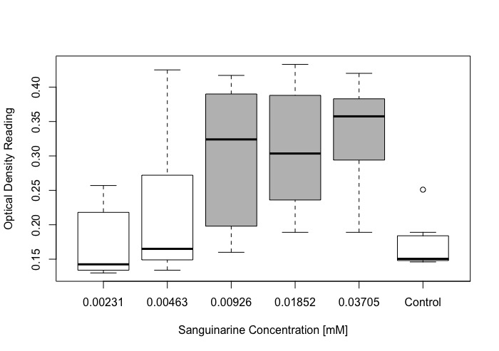
Figure 1-1 Growth of Beauveria bassiana with varying concentrations of sanguinarine after six days.
On Day 6, the last day of growth monitoring of Beauveria bassiana, treatments with higher concentrations of the plant-produced chemical sanguinarine had greater growth than those with lower sanguinarine concentrations. Higher optical density measures indicate increased growth of B. bassiana. Treatments in gray (0.00926mM, 0.01852mM, 0.03705mM) showed significantly more growth than treatments in white (0.00231mM, 0.00463mM, Control) (Pairwise comparisons: all ps <0.0001).

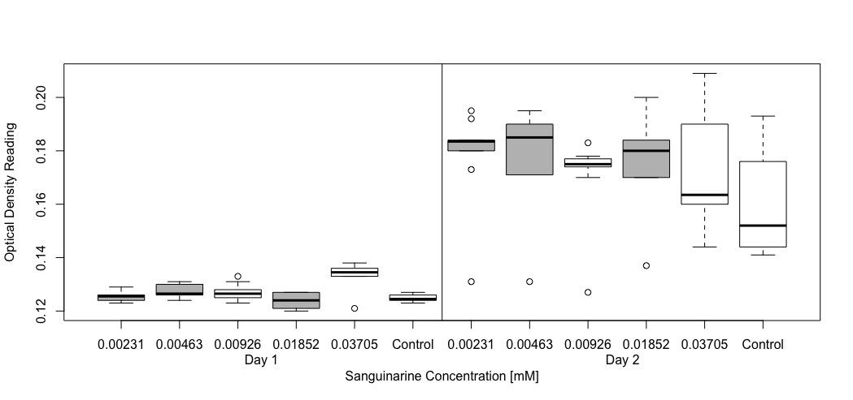
Figure 1-2 Growth of Beauveria bassiana with varying concentrations of sanguinarine between Days 1-2.
Growth comparisons of Beauveria bassiana from Day 1 to Day 2 at different concentrations of sanguinarine. Treatments in gray (0.00231mM, 0.00462mM, and 0.01852mM) showed a significant increase in growth from Day 1 to Day 2 (Pairwise comparisons: 0.00231mM (p=0.0270), 0.00463mM (p=0.0482), 0.01852mM (p=0.0312)

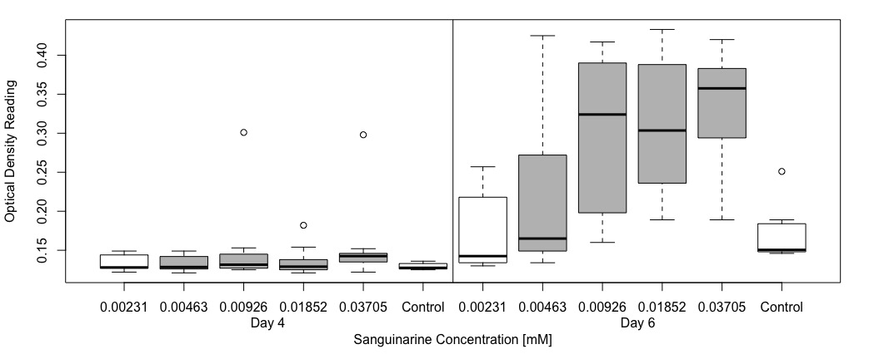
Figure 1-3 Growth of Beauveria bassiana with varying concentrations of sanguinarine between Days 4-6.
Growth comparisons of Beauveria bassiana from Day 4 to Day 6 at different concentrations of sanguinarine. Treatments in gray (0.00462mM, 0.00926mM, 0.01852mM, 0.03705mM) showed a significant increase in growth from Day 4 to Day 6 (Pairwise comparisons: 0.00463mM (p<0.0001), 0.00926mM (p<0.0001), 0.01852mM (p<0.0001) and 0.03705mM (p< 0.0001)

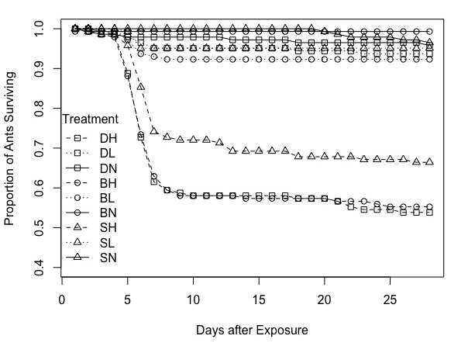
Figure 1-4 Ant survival by diet and Beauveria bassiana exposure regime.
Shape corresponds to diet treatment: squares are the diaspore diet (“D”), circles are the modified Bhatkar-Whitcomb diet (“B”), and triangles are the modified Bhatkar-Whitcomb diet with the sanguinarine addition (“S”). Line type corresponds to the exposure level to Beauveria bassiana: solid lines are the no exposure level treatments (“N”), dotted lines are the low exposure level treatment (“L”), and dashed lines are high exposure level treatment (“H”). Survival differed by treatment (Χ²=290.75, df=7, p<0.0001). Exposure level was the only significant predictor (Χ²=196.529, df=2, p<2 x 10⁻¹⁶). High exposure level treatments differed significantly from low and no exposure levels (p<0.0001 in both instances). Low and no exposure level treatments did not differ significantly from one another (p=0.0908)

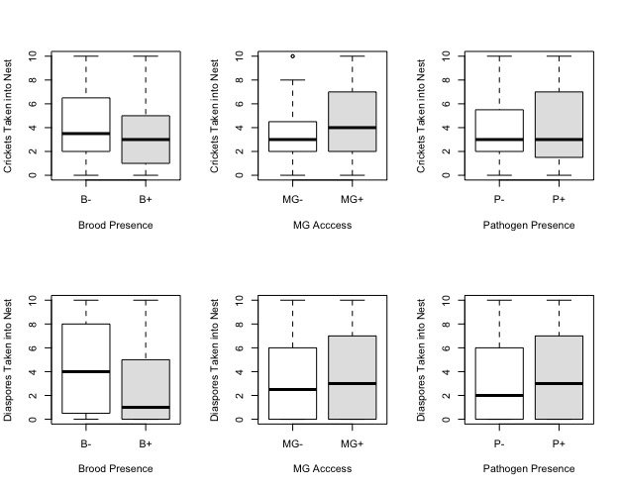
Figure 1-5 Effects of brood, gland access and pathogen presence on dispersal of food items into the ant nest.
Brood presence (B+/B-), access to metapleural glands (MG+/MG-), and exposure to the pathogen Beauveria bassiana (P+/P-) had no effect on movement of food items into ant nests (all ps > 0.05). These independent variables did not affect ant preference for movement of crickets (top row) or diaspores (bottom row) taken into the ant nest

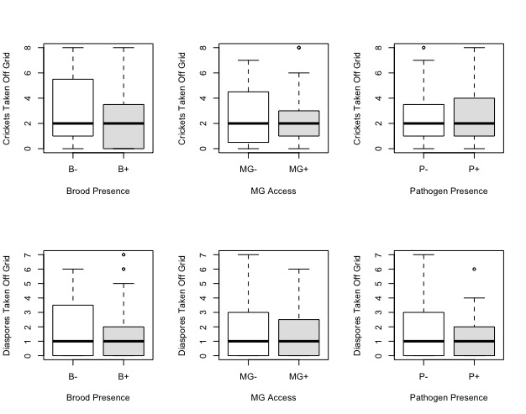
Figure 1-6 Effects of brood, gland access and pathogen presence on dispersal of food items off the seed grid.
Brood presence (B+/B-), access to metapleural glands (MG+/MG-), and exposure to the pathogen Beauveria bassiana (P+/P-) had no effect on the movement of food items in feeding trials (all ps > 0.05). These independent variables did not affect ant preference for movement of crickets (top row) or diaspores (bottom row) off the seed grid and elsewhere in the ant nest environment

Table 1-1 Counts of behavior scores by food choice.
Type 1 behavior indicates an instance of antennation of a food choice. Type 2 behavior indicates that a food item was moved but not off of the seed grid. Type 3 indicates removal of a food item from the seed grid. Type 4 indicates movement of a food item into the ant nest. There was no difference between behavior scores by food type (Χ²=2.94, df=3, p=0.401)

Food Choice | Behavior Type 1 | Behavior Type 2 | Behavior Type 3 | Behavior Type 4
Cricket | 214 | 21 | 17 | 22
Diaspore | 197 | 11 | 11 | 17

CHAPTER 2
Ants, Seeds, and Pathogens: Ant activity and nest substrate influence fungal pathogen communities in seed-dispersing ant nests
A version of this chapter has been submitted to Oecologia and was coauthored by Chloe L. Lash, James A. Fordyce, and Charles Kwit:
Chloe L. Lash, James A. Fordyce, and Charles Kwit. “Ants, Seeds, and Pathogens: Ant activity and nest substrate influence fungal pathogen communities in seed-dispersing ant nests” Oecologia In review.

Chloe L. Lash and Charles Kwit originally formulated the idea and developed methodology. Chloe L. Lash conducted all field and lab work. Chloe L. Lash and James A. Fordyce generated the statistical framework and conducted all statistical analyses. Chloe L. Lash wrote the first draft of the manuscript and Charles Kwit and James A. Fordyce commented on subsequent versions of the manuscript. All authors read and approved the final manuscript.

Abstract
Myrmecochory is a widespread mutualism in which plants benefit from seed dispersal services by ants. Ants might also be providing seeds with an additional byproduct benefit via reduced plant pathogen loads in the ant nest environment through their antimicrobial glandular secretions. We investigate this byproduct benefit to seeds in myrmecochory by identifying fungal communities in ant nests and surrounding environments and quantifying community change (1) through time, (2) between different nest substrates, and (3) as a function of changes in ant activity levels within nests. We split fungal communities by functional guild to determine seed dispersing ant-induced changes in the overall fungal community, the animal pathogen fungal community, the plant pathogen fungal community, and the myrmecochore pathogen fungal community. Where comparisons allowed, nest substrate (soil or log) explained much of the variation in all fungal communities. Change in ant activity level also had a direct effect on the community turnover in all fungal communities. Increasing or stable ant activity over time resulted in more stable animal pathogen communities in ant nests. This pattern repeated for the plant pathogenic fungal community (but only in soil substrates) and the myrmecochore pathogenic fungal community (but only in log substrates). However, decreasing ant activity over time resulted in more stable plant pathogen communities in log nests and in more stable myrmecochore pathogen communities in soil nests. Our results are consistent with the possibility that a byproduct benefit to seeds exists in the ant nest through reduction of fluctuation of pathogen loads through time in ant nests.

Introduction
Ants are responsible for the seed dispersal of approximately 11,000 plant species worldwide through the mutualistic interaction known as myrmecochory (Lengyel et al. 2010). In this interaction, ants are attracted to the elaiosome, a fleshy seed-coat derived appendage, on myrmecochore seeds (Rico-Gray and Oliveira 2007). Foraging ants pick up the seed-elaiosome complex (diaspore) after dehiscence and return with it to their nest (Rico-Gray and Oliveira 2007). There, the elaiosome is removed and primarily fed to ant larvae (Fischer et al. 2005). The seed then remains in the nest or is redispersed outside of the nest, sometimes into a refuse pile (Beattie 1985; Canner et al. 2012). Thus, both parties benefit from this interaction. Ants receive food in the form of an elaiosome, and plants gain a number of benefits including but not limited to: escape from distance- and density-dependent mortality agents, protection from seed predators, and a nutrient-rich germination site in or near ant nests (Beattie 1985).
Benefits to plant partners in myrmecochory are not solely due to the act of dispersal away from the maternal plant, but the place of deposition plays a pivotal role in plant growth and development. Ant nests are high in organic matter, potassium, phosphorous, sodium, and nitrogen (Berg-Binder and Suarez 2012; Davidson and Morton 1981; Horvitz and Schemske 1986; McGinley et al. 1994), and myrmecochore germination and seedling emergence is higher in ant nests than surrounding soils (Beattie and Culver 1982; Culver and Beattie 1980). However, ants might not only influence nutrients in the nest, but also microbial communities, which could provide extra benefits to seeds dispersed into the ant nest. Indeed, seed dispersing ant nests have reduced fungal species richness (Zettler et al. 2002) and have lower plant pathogenic fungal diversity (Tarsa et al. 2018). Thus, ants may be providing an additional benefit to the seeds that they disperse in the form of pathogen deterrence.
This benefit to plants is likely a function of the extensive chemical production of multiple ant glands (as suggested by Tarsa et al. 2018). Ants, including seed dispersing ants, have a number of glands that secrete chemicals used for a variety of purposes, including trail following behaviors, nestmate recognition, and sanitation (Vander Meer 2012). A few ant glands secrete antimicrobial chemicals, including the venom gland (Tragust et al. 2013), mandibular gland (Brough 1983), and the metapleural gland (Cabrera et al. 2004; Fernandez-Marin et al. 2015; Jones et al. 2005; Vieira et al. 2012; Yek and Mueller 2011). The metapleural gland, which is present in most ant species, is located at the posterior end of the thorax and is the primary gland used in sanitary grooming behaviors (Yek and Mueller 2011). Ants actively apply some of these secretions to themselves, their brood, their nestmates, and the nest material through grooming (Fernandez-Marin et al. 2006; Tragust et al. 2013; Tranter et al. 2013). Ant glandular secretions, notably those from the metapleural gland, have documented negative effects on entomopathogens as well as the growth of other soil-associated microbes, including some plant pathogens (Beattie et al. 1985; Bot et al. 2002). Thus, ant behavior involved with grooming of the metapleural and other glands likely contributes to the reduction of plant pathogens in the ant nest, providing a byproduct benefit (see Sachs et al. 2004) to the seeds in myrmecochory. While little work in this regard has been conducted on seed-dispersing ants, some characterization has occurred of the chemicals in glandular secretions of the keystone seed-dispersing ant genus in eastern North America, Aphaenogaster (Ness et al. 2009). For a number of Aphaenogaster species, the chemicals anabasiene and/or anabasine, which have antimicrobial properties (Abdulina et al. 2002; Anthony et al. 2015), are primary components in the venom gland (Attygalle et al. 1998; Leclercq et al. 2001; Lenoir et al. 2011; Wheeler et al. 1981). Thus, fungi in Aphaenogaster ant nests, often in soil and rotting logs (Lubertazzi 2012), have the potential to be affected by antimicrobial gland secretions.
While it has been established that ant nests have decreased plant pathogen fungal species richness (Tarsa et al. 2018) and overall fungal species richness (Zettler et al. 2002), which might be advantageous for the seeds that are dispersed therein, the finer details of the microbial composition in seed-dispersing ant nests have not yet been investigated. Here, we seek to further clarify how the presence of seed-dispersing ants and their activity in nests of different substrates might alter microbial communities to potentially benefit dispersed seeds with regard to plant and myrmecochore pathogens. Specifically, our study is the first to link ant nests and ant activity levels in the nests to pathogen loads, which has not yet been studied in the context of spatiotemporal turnover. If byproduct benefits exist in this mutualism, we would expect reduced fluctuations in plant pathogenic fungal communities through time with stable or increasing ant activity in the nest.

Materials and Methods

Field Collections
During the last two weeks of May 2018, we identified 23 Aphaenogaster ant nests between two locations in Montgomery County, Virginia (12 nests at Falls Ridge Preserve [37.193452 °N, -80.321685°W] and 11 nests at Mill Creek Springs Natural Area Preserve [37.16148°N, -80.343398°W]). Nests were of ant species A. picea or A. rudis, which are both in the Aphaenogaster fulva-rudis-texana species complex (Umphrey 1996). Nests occurred in two substrate types: (1) soil or (2) decaying woody debris (hereafter referred to as “log” nests). We baited for ants with tuna and followed foraging ants back to the nest entrances, which were marked with flags to ensure nest material collection from the same site on each sample collection day.
The first week of June and the last week of July, we returned to each nest to collect nest material samples by scraping soil or decaying woody debris out of the ant nest entrance. This was done with sterile disposable plastic spatulas (smartSpatulas, LevGo). All nest material was placed into a 3.7 mL sterile glass vial. For every ant nest sample, we also collected a paired control sample. If the sample was a soil sample, we collected a non-nest soil sample from approximately 1m away (as in Tarsa et al. 2018); if the sample was a log sample, we collected a sample from a non-nest part of the same log at approximately 1m away from the nest entrance. Samples were transported on ice then stored at -80°C.
We also scored ant activity at the nest entrance with visual observations of foraging workers. Though observations for ant nest entrance activity date back decades (for example, Talbot 1946), we found no universal method for scoring ant activity at the nest entrance, so we scored activity as follows: A score of 1 indicated a very active ant nest, in which ants would swarm the entrance while we were collecting the sample. A score of 2 indicated that an ant was seen near or in the ant nest entrance, but the researchers were met with no defensive behaviors against the taking of the samples. A score of 3 indicated that no ants were seen in the vicinity of the ant nest entrance. This might indicate that the ant nest relocated, or the nest was particularly inactive that day. Our study species of Aphaenogaster ants are less active when temperatures fall below 15°C and are most active between 25°C- 29°C (Lynch et al. 1980), and their thermal tolerance ranges from approximately -1 - 6°C (CT_{min}) to 40 - 44°C (CT_{max}) (Warren and Chick 2013). Additionally, rain is known to decrease foraging activity in some ant species (Farji-Brener et al. 2018). We collected samples in the late morning or afternoon on our collection days, which had high temperatures around 25.5°C with less than 0.2 inches of rain (NOAA Climatological Observations for Montgomery Co. VA).

Next Generation DNA Sequencing
After field collections, 92 samples were prepared for next generation DNA sequencing via Illumina MiSeq. These 92 samples consisted of 23 separate location-oriented groups, each with four relevant spatial and temporal connections: 1) an ant nest sample taken in the first week of June, 2) an ant nest sample taken during the last week of July, 3) a control sample taken in the first week of June, and 4) a control sample taken in the final week of July. These groupings based on location (Mill Creek Springs Natural Area Preserve and Falls Ridge Preserve) allowed for analysis of fungal communities over time and between ant nest and control samples.
For DNA extractions, we used Qiagen’s DNeasy PowerSoil Kit. Extractions were performed following manufacturer’s instructions, except for lengthening both 2-8°C incubation steps from 5 mins to 30 mins. We also allowed the samples to sit in the final solution for 5 mins before the final spin down. DNA was quantified with a ThermoScientific Nanodrop. Nanodrop readings for samples ranged from 5.5ng/μL to 115ng/μL with an average of approximately 50ng/μL. All DNA samples were stored at -20°C until library preparation.
For library preparation, we followed Illumina’s Metagenomic Sequencing Library Preparation Instructions. We used custom mix of primers for the ITS region of fungal rRNA (see Cregger et al. 2018) for the amplification of DNA by polymerase chain reaction (PCR). This mix of primers is better suited to pick up a wide range of fungal taxa that are often missed when universal primers are used (Cregger et al. 2018). The PCR was performed with the following cycles: 95°C for 3 minutes, 25 cycles of: 95°C for 30 seconds, 55°C for 30 seconds, and 72°C for 30 seconds, and a final elongation of 72°C for 5 minutes. All PCR products were visualized using gel electrophoresis with 5μL of product on a 2% agarose gel with ethidium bromide staining. The PCR products were purified with AMPure XP magnetic beads (Agencourt), and cleaned products were individually tagged with different combinations of Nextera XT (Illumina) indexes. Indexes were attached with a second round of PCR with the following cycles: 95°C for 3 minutes, 8 cycles of: 95°C for 30 seconds, 55°C for 30 seconds, and 72°C for 30 seconds, and 72°C for 5 minutes. Another clean-up with AMPure beads was performed after indexing. Products were normalized after quantification with a BioAnalyzer and pooled. We diluted final library concentrations to 4pM and 10pM Phi-X at 20% was spiked in. Samples were loaded on a v3, 600 cycle flowcell, set to read 2x275 bases, for Illumina MiSeq in the University of Tennessee, Knoxville, Genomics Core Facility.

Data Processing
We processed raw sequences using a Qiime2 pipeline (see Appendix for this chapter). First, sequences were joined and then run through FastQC and MultiQC for quality control. Sequences were trimmed based on a Phred score of greater than 20 and primers were removed. Chimeras were detected and removed. Taxonomy was assigned to the sequences using BLAST and version 8 of the UNITE database (Nilsson et al. 2018). Amplicon Sequencing Variants (ASVs) were assigned taxonomy at 97% matching. Before further processing, we filtered out species that were not identified as fungi and rarefied all fungal data to 22,000 sequences to control for variation in sequencing depth. After rarefication, we had 14,783 identified fungal ASVs.
To assign ecological guilds to each fungal ASV, we uploaded our ASV table to FUNGuild (Nguyen et al. 2016). For analysis of plant and animal pathogens in ant nests and control samples, we filtered the resulting ASV table from FUNGuild by Guild. For animal pathogens, any ASV that was listed as an “Animal Pathogen” for at least one possible guild was included. For plant pathogens, any ASV that was listed as a “Plant Pathogen” for at least one possible guild was included. We also wanted to investigate pathogens that are known to infect myrmecochores. To filter our fungal table by myrmecochore pathogens, we first created a list of myrmecochorous plant genera in eastern North America using the following sources: Beattie and Culver (1981); Lengyel et al. (2010); Schultz (2014). All genera compiled in this list were then entered into the Host Name search in the Fungus-Host Distributions page of the Fungal Database of the Agricultural Research Service of the United States Department of Agriculture (https://nt.ars-grin.gov/fungaldatabases/fungushost/fungushost.cfm). Any known fungal pathogenic genera were copied from the database and added to a list of myrmecochore pathogens. We searched for those genera in our BLAST identified taxonomic ASV list. All genera that included potential myrmecochore pathogens were included. Myrmecochore list by genus and myrmecochore pathogen list by genus can be found in the supplemental materials (Table 2-1 All figures and tables for this chapter are located in this chapter’s Appendix). Each subset of ASV tables were analyzed in the following way and from here on are referred to as: All Fungi (every ASV identified in Kingdom Fungi through BLAST), Animal Pathogens (any ASV identified as a possible animal pathogen by guild in FUNGuild), Plant Pathogens (any ASV identified as a possible plant pathogen by guild in FUNGuild), and Myrmecochore Pathogens (any ASV identified as a pathogen to a myrmecochorous plant through the USDA ARS Fungal Database).

Statistical Analyses

Community Analyses
We examined variation in fungal communities with distance-based Redundancy Analyses (db-RDAs) with a dissimilarity-matrix based on the quantitative generalization of Jaccard dissimilarity (Ružička index). We separately analyzed Falls Ridge Preserve and Mill Creek Springs Natural Area Preserve because Falls Ridge only had a single log nest, which resulted in a singularity if nest substrate were included in a model with both locations. We selected models using forward stepwise selection. Possible predictors included treatment (ant nest or control sample), nest substrate (soil or log nest—only used in Mill Creek Springs datasets), month of sampling (June or July) and all possible two-way interactions. We conducted hypothesis testing on retained predictors via 99,0000 permutations of the data (Legendre and Legendre 2012). These analyses were conducted in R (version 3.6.0) in the package “vegan” (version 2.5-5) (Oksanen et al. 2019).

Microbial Community Turnover
To understand the influence of different explanatory variables on fungal community turnover between ant nest samples and control samples over time, we used Hill Numbers (Hill 1973) (^{q}D) to measure beta diversity of communities in this spatially-explicit temporal context. Hill Numbers is a diversity metric that calculate the effective number of species for each sample, which provides advantages over traditional ecological diversity calculations (Chao et al. 2014; Hill 1973; Jost 2006; Jost 2007). As order q increases, the importance of rare species in diversity calculations decrease (Hill 1973): at q=0, diversity calculations are equivalent to species richness. At q=1, diversity calculations are equivalent to exponential Shannon’s entropy, and at q=2, diversity calculations are equivalent to inverse Simpson’s diversity. Here, we conduct analyses from q=0 to q=5.
In R using the package “vegetarian” (version 1.2) (Charney and Record 2015), we calculated community turnover (T) for each ant nest from June to July, and for each control nest from June to July (function “d”). Thus, T is calculated as: 1-|D₁-D₂| and represents the expected proportional change in communities in that sample from June to July. A turnover (T) value of 1 indicates a 100% change in community composition in that sample from June to July, and a T value of 0 indicates the sample had identical communities in June and July. Then, we calculated differences in T between individual ant nests and their control samples (which we will refer to as Δ^{q}T). Values of Δ^{q}T < 0 indicate that there is more community turnover (or less community stability) in control samples than in ant nest samples through time. Values of Δ^{q}T > 0 indicate that there is more community turnover in ant nest samples than in control samples through time. Values of Δ^{q}T ~0 indicate that the community turnover through time is similar between ant nest samples and control samples.
We analyzed Δ^{q}T with linear mixed-effects models using the “lmerTest” package (Kuznetsova et al. 2019). Nest substrate and change in ant activity (ΔA) and their interaction were included as fixed effects, and location of the sample pair (Mill Creek Springs Natural Area Preserve or Falls Ridge Preserve) was included as a random effect. To calculate ΔA, we subtracted the ant activity score in July from the ant activity score in June for the ant nest sample. Most ant nests decreased or remained stable in activity over time (only two nests increased in ant activity); thus, we binned all calculated values of ΔA into “decreasing” or “no change/increasing” ant activity categories. We conducted hypothesis testing on the models using Wald Chi-Squared tests. Pairwise post hoc testing was conducted via estimated marginal means with the package “emmeans” (version 1.4.4) (Lenth et al. 2020).

Results

Community Analyses
At Mill Creek Springs Natural Area Preserve, for all subsets of data (All Fungi, Animal Pathogens, Plant Pathogens and Myrmecochore Pathogens), nest substrate was the only predictor chosen for models. This indicates that fungal community variations were most associated with substrate (log vs soil) as opposed to other variables of interest (ant nests/control, time). Likewise, in all subsets, dbRDAs revealed a significant difference in soil and log substrates: All Fungi (R²_{adj} = 4.77%, p<0.05; Fig 2-1a), Animal Pathogens (R²_{adj} =7.98%, p<0.05; Fig 2-1b), Plant Pathogens (R²_{adj} =5.37%, p<0.05; Fig 2-1c), and Myrmecochore Pathogens (R²_{adj} =3.30%, p<0.05; Fig 2-1d). At Falls Ridge Nature Preserve, for which we did not include substrate as a potential predictor, for all subsets of data (All Fungi, Animal Pathogens, Plant Pathogens and Myrmecochore Pathogens), model selection chose the intercept-only model with no explanatory variables.

Microbial Community Turnover
Our estimates of Δ^{q}T (change in turnover) were affected by nest substrate, ΔA, or their interaction for all data subsets (All Fungi, Animal Pathogens, Plant Pathogens and Myrmecochore Pathogens). For All Fungi, the interaction between ΔA and nest substrate was a significant predictor of Δ⁰T (Χ²= 11.28, df=1, p<0.01; Fig 2-2). For soil substrates, decreases in ant activity at nests resulted in lower (and more negative) Δ⁰T values (t= -3.06, df=18, p<0.01). This indicates that when ant activity decreases in nests, there is more turnover in the overall fungal community in control soil samples than in soil ant nests. When ant activity is stable or increases in soil nests, there is a smaller difference in turnover in the overall fungal community between ant nests and control samples. At all higher order q’s for All Fungi, we failed to detect the effect of ΔA, nest substrate and their interaction on Δ^{q}T values.
For Animal Pathogens, nest substrate was a significant predictor of Δ⁰T (Χ²= 4.38 df=1, p=0.04; Fig 2-3). Log substrates tended to have lower Δ⁰T values (more negative) than soil substrates; thus, log environments had higher turnover in control samples than ant nest samples. For Δ¹T and Δ²T for the animal pathogenic fungal community, ΔA, nest substrate and their interaction had no effect on Δ^{q}T values. However, at all higher order q’s, decreases in ant activity results in higher (and positive) Δ^{q}T values (Fig 2-4: Δ³T (Χ²= 4.22, df=1, p=0.04); Δ⁴T (Χ²= 4.39, df=1, p=0.04); Δ⁵T (Χ²= 4.27, df=1, p=0.04). For these Δ^{q}Ts, when ant activity decreased in nests, ant nests have higher turnover in the animal pathogenic fungal communities than control samples.
For Plant Pathogens, at q=0 through q=3, Δ^{q}T was not affected by ΔA, nest substrate or their interaction. The interaction between nest substrate and ΔA was a significant predictor of Δ^{q}T for the plant pathogenic fungal community at Δ⁴T (Χ²= 4.84, df=1, p=0.03; Fig 2-5) and Δ⁵T (Χ²= 5.61, df=1, p=0.02; Fig 2-5). Thus, differences in turnover were detected when the importance of rare plant pathogenic ASVs were reduced. For log substrates, decreases in ant activity at nests tended to be associated with Δ^{q}T values close to zero, which indicates similar turnover in ant nests and control samples. No change or increases in ant activity at nests in log substrates tended to be associated with positive Δ^{q}T values, indicating higher turnover in ant nests than control samples. Soil substrates, however, show the opposite trend. Increases in ant activity in soil nests tended to be associated with Δ^{q}T values, indicating higher turnover in control samples than in ant nests in soil substrates. In cases with decreases in ant activity in soil nests, Δ^{q}T values were near zero, which indicates little difference in turnover between ant nests and control samples in the plant pathogenic fungal community.
For Myrmecochore Pathogens, Δ⁰T was not affected by ΔA, nest substrate or their interaction. ΔA affected Δ¹T values (Χ²= 4.56, df=1, p=0.03; Fig 2-6); decreases in ant activity in nests resulted in higher turnover of the myrmecochore pathogenic fungal community in control samples than in ant nests (negative Δ¹T values). No change or increases in ant activity in nests resulted in little difference between turnover in the myrmecochore pathogenic fungal community between ant nests and control samples (Δ¹T values near zero). The interaction between nest substrate and ΔA was a significant predictor of Δ²T for the myrmecochore pathogenic fungal community (Χ²= 3.94, df=1, p<0.05; Fig 2-7). Log substrates with no change or increasing ant activity in nests contributed to more negative Δ²T values than cases where log substrates exhibited decreasing ant activity in nests. Thus, in cases where log nests exhibited no change or increases in ant activity, there was more turnover in the myrmecochore pathogenic fungal community in control samples than in ant nest samples. Soil substrates showed the opposite trend. Soil substrates with decreasing ant activity in nests were associated with negative Δ²T values, indicating higher turnover in control samples than in ant nests. Soil substrates with no change or increasing ant activity in nests were associated with Δ²T values near zero, which indicates little difference in the turnover between ant nests and control samples. At all higher order q’s for the myrmecochore pathogenic fungal community, we failed to detect the effect of ΔA, nest substrate and their interaction on Δ^{q}T values.

Discussion
Our results suggest that both ant activity and nest substrate are important for changes in the animal, plant, and myrmecochore pathogenic fungal community, which has ramifications for both the ant and the plant partners in this mutualism. While nest substrate explains variation for all fungal groups, both ant activity and nest substrate influence the differences in community turnover between ant nests and control samples. For some substrates for plant pathogens and myrmecochore pathogens, increased ant activity in the nest resulted in lower pathogen community turnover in ant nests than in control samples, and decreases in ant activity in the nest showed more pathogen community turnover in ant nests than in control samples. Specifically, this pattern occurred in the plant pathogen fungal community for soil nests and the myrmecochore pathogen community for log nests. These trends in reduced community turnover in ant nests with increasing or stable ant activity in the plant pathogenic fungal community (soil substrates) and in the myrmecochore pathogen community (log substrates) would be expected if ants and their chemicals are responsible for control of fungal communities. Thus, our results are consistent with a byproduct benefit framework, in which ants control pathogen loads in ant nests compared to surrounding substrate. Furthermore, this pattern of reduced turnover in ant nests compared to control samples when ant activity is stable or increases in the nest is repeated in the animal pathogen community, which supports the well-established idea that ants suppress their pathogens in the nest.
FUNGuild output classifies an “animal pathogen” guild and not specifically entomopathogens (insect infecting pathogens), but our results are consistent with expected entomopathogen load fluctuations in active ant nests. That is, increased or consistent ant activity through time lead to more stable animal pathogen communities. Ant colonies have social immunity, or a collection of defenses against pathogen takeover of the nest (Meunier 2015). Chemical defenses in ants’ social immunity include active application of glandular chemical secretions to reduce the growth of ant pathogens (Fernandez-Marin et al. 2006; Tragust et al. 2013; Tranter et al. 2013; Yek et al. 2012). Our results support the idea of repression, or at least consistency, in the animal pathogen community with increased or stable ant activity. Furthermore, Aphaenogaster ant colonies abandon nests and move regularly, anywhere from 2-3 times a year (Lubertazzi 2012) to every 21 days (Smallwood and Culver 1997). Though seasonal cues are likely one reason for nest relocation, ants might also move due to parasite loads in the nest (as suggested by Smallwood and Culver 1997) or pathogen takeover of the nest. Reduction of ant activity in our study could correspond with nest abandonment. If abandonment of the nest occurred due to fungal pathogen takeover, we would expect our documented increase in Δ^{q}T (i.e., higher turnover in nests compared to control samples in cases where ant activity dropped), as monopolization of the nest by animal fungal pathogens over time would increase the community turnover in ant nests.
Though there is little to no overlap between the animal pathogen community and the plant and myrmecochore pathogen communities, ant abandonment of the nest could have ramifications for the seeds that remain behind, especially by nest substrate. Our results not only have implications for seeds brought into active ant nests, but also suggest potential benefits for seeds in ant nests that are decreasing in ant activity. We found that reduced ant activity results in a more stable myrmecochore pathogen community in ant nests than in control samples for soil substrates and more stable plant pathogen community in ant nests than in control samples for log substrates. Stability in these pathogen communities could be beneficial for seeds, even during a short time in the ant nest, as changes in pathogen communities could present new challenges to seeds, especially if these fluctuations involve more virulent pathogens. Stability of plant pathogens in the ant nest might even provide more advantages for the seeds that are abandoned in the ant nest (specifically in soil nests when considering the myrmecochore pathogen community and in log nests when considering the plant pathogen community). Though most seeds dispersed by Aphaenogaster rudis ants are redispersed outside of the nest (Canner et al. 2012), our results suggest that seeds that remain or are abandoned in the ant nest might have the advantage of reduced fluctuations in pathogens in certain nest substrates, compared to seeds that are redispersed to non-ant nest locations. However, seeds abandoned in newly decaying logs are likely at a disadvantage for successful germinations and subsequent seedling growth and success than seeds that are abandoned in soil substrates. Thus, substrate type alone and in conjunction with different pathogenic communities has ramifications for seeds abandoned in the nest.
There are issues with FUNGuild’s general classification of plant pathogens, and this may be why our results do not exactly match those of Tarsa et al. (2018), who conducted their own general classification of phytopathogenic fungi. In particular, FUNGuild simplifies what are likely far more complex plant-associated fungal relationships that can be context-dependent (Kogel et al. 2006; Schulz and Boyle 2005). Endophytic fungi can turn parasitic if the plant is stressed, though in the majority of instances they remain as beneficial endophytic partners, and fungi can have different classifications when associated with different plant species (Kogel et al. 2006). Because of difficulties with fungal guild classification, we note that the scale at which studies of fungal communities are conducted is important. This was, in part, the motivation behind choosing to separate out myrmecochore pathogens from FUNGuild’s classification of plant pathogens. The potential problems with broad classifications of plant pathogens is illustrated by the differences in our results for the plant pathogen fungal community and the myrmecochore pathogen fungal community, as well as the differences by nest substrate. We found that the effects of ant activity on the myrmecochore pathogen community and plant pathogen community differed by substrate, and this influence might have been missed by looking at the broader plant pathogen community only in soil nests. Indeed, Aphaenogaster ants are known to nest in soil, decaying woody debris, and leaf litter (Lubertazzi 2012). Thus, we hope that future studies consider both the scale at which fungal communities are analyzed and the nest substrate in which the ant nest occurs. Furthermore, we suggest that future work consider factors contributing to ant nest location choice. Because our results show stability in pathogenic communities in ant nests with stable or increasing ant activity, we propose that ants are actively contributing to the stability of fungal communities in the nest. However, ants may avoid nesting in locations that are high in pathogen loads, which could have further implications for byproduct benefits to seeds dispersed to ant nests.
Previous work has determined that plant pathogenic fungal species richness is reduced in ant nest environments compared to surrounding soils (Tarsa et al. 2018), but our work is the first to demonstrate direct effects of changes in ant activity on different fungal pathogen communities. As suggested by Tarsa et al. (2018), we speculate that the changes in fungal communities (especially in instances where ant activity was stable or increasing) within the ant nest result from the chemical secretions from ant glands, which are used in sanitary behaviors to clean the ant nest (Tranter et al. 2013). Future work could investigate the effects of Aphaenogaster glandular secretions on known myrmecochore plant pathogens. Identification of the primary components of the metapleural glands of Aphaenogaster will also be helpful for understanding the impacts of ant glandular chemicals on the plant pathogen community. Investigating what fungal communities are present on myrmecochore seed coats and how that seed coat-associated community changes throughout the dispersal process will also be important for understanding the effects of ant chemicals on plant-associated fungal communities. Thus, our work contributes to the beginning of a better understanding of the benefits offered to plants in myrmecochory, especially when considering byproduct benefits, such as reduction in microbial myrmecochore pathogen loads in the ant nest via ant-associated chemicals. By investigating the dynamics of fungal communities and specific fungal species in myrmecochory, we can contribute to a better understanding of the evolution and persistence of mutualistic seed dispersal.

References

Abdulina GA, Gazaliev AM, Baikenova GG, Fazylov SD, Kudaibergenova SZ (2002) A
comparative study of the antibacterial and antifungal activity of anabasine hydrochloride and dialkythiophosphates. Pharmaceutical Chemistry Journal 36:119-120 doi: 10.1023/A:1019670008920
Anthony WE, Palmer-Young EC, Leonard AS, Irwin RE, Adler LS (2015) Testing dose-
dependent effects of the nectar alkaloid anabasine on trypanosome parasite loads in adult bumble bees. PLoS One 10:e0142496 doi: 10.1371/journal.pone.0142496
Attygalle AB, Kern F, Huang Q, Meinwald J (1998) Trail pheromone of the myrmicine
ant Aphaenogaster rudis (Hymenoptera: Formicidae). Naturwissenschaften 85:38-41 doi: 10.1007/s001140050450
Beattie AJ (1985) The dispersal of seeds and fruits by ants. In: The evolutionary ecology
of ant-plant mutualisms. Cambridge University Press, Cambridge, pp 73-95 doi: 10.1017/CBO9780511721878.007
Beattie AJ, Culver DC (1981) The guild of myrmecochores in the herbaceous flora of
West Virgina forests. Ecology 62:107-115 doi: 10.2307/1936674
Beattie AJ, Culver DC (1982) Inhumation: how ants and other invertebrates help seeds.
Nature 297:627 doi: 10.1038/297627a0
Beattie AJ, Turnbull C, Hough T, Jobson S, Knox RB (1985) The vulnerability of pollen
and fungal spores to ant secretions: evidence and some evolutionary implications. American Journal of Botany 72:606-614 doi: 10.1002/j.1537-2197.1985.tb08315.x
Berg-Binder MC, Suarez AV (2012) Testing the directed dispersal hypothesis: are native
ant mounds (Formica sp.) favorable microhabitats for an invasive plant? Oecologia 169:763-772 doi: 10.1007/s00442-011-2243-2
Bot A, Ortius-Lechner D, Finster K, Maile R, Boomsma J (2002) Variable sensitivity of
fungal and bacteria to compounds produced by the metapleural glands of leaf-cutting ants. Insectes Sociaux 49:363-370 doi: 10.1007/PL00012660
Brough EJ (1983) The antimicrobial activity of the mandibular gland secretion of a
formicine ant, Calomyrmex sp. (Hymenoptera: Formicidae). Journal of Invertebrate Pathology 42:306-311 doi: 10.1016/0022-2011(83)90168-4
Cabrera A, Williams D, Hernandez JV, Caetano FH, Jaffe K (2004) Metapleural- and
postpharyngeal-gland secretions from workers of the ants Solenopsis invicta and S. geminata. Chemistry & Biodiversity 1:303-311 doi: 10.1002/cbdv.200490027
Canner JE, Dunn RR, Giladi I, Gross K (2012) Redispersal of seeds by a keystone ant
augments the spread of common wildflowers. Acta Oecologica 40:31-39 doi: 10.1016/j.actao.2012.02.004
Chao A et al. (2014) Rarefaction and extrapolation with hill numbers: a framework for
sampling and estimation in species diversity studies. Ecological Monographs 84:45-67 doi: 10.1890/13-0133.1
Charney N, Record S (2015) Package ‘vegetarian’. CRAN
Cregger MA et al. (2018) The Populus holobiont: dissecting the effects of plant niches
and genotype on the microbiome. Microbiome 6:31 doi: 10.1186/s40168-018-0413-8
Culver DC, Beattie AJ (1980) The fate of viola seeds dispersed by ants. American
Journal of Botany 67:710-714 doi: 10.1002/j.1537-2197.1980.tb07701.x
Davidson DW, Morton SR (1981) Myrmecochory in some plants (F. chenopodiaceae) of
the Australian arid zone. Oecologia 50:357-366 doi: 10.1007/BF00344976
Farji-Brener AG et al. (2018) Working in the rain? Why leaf-cutting ants stop foraging
when it’s raining. Insectes Sociaux 65:233-239 doi: 10.1007/s00040-018-0605-z
Fernandez-Marin H et al. (2015) Functional role of phenylacetic acid from metapleural
gland secretions in controlling fungal pathogens in evolutionarily derived leaf-cutting ants. Proceedings of the Royal Society B 282:20150212 doi: 10.1098/rspb.2015.0212
Fernandez-Marin H, Zimmerman JK, Rehner SA, Wcislo WT (2006) Active use of the
metapleural glands by ants in controlling fungal infection. Proceedings of the Royal Society B 273:1689-1695 doi: 10.1098/rspb.2006.3492
Fischer RC, Ölzant SM, Wanek W, Mayer V (2005) The fate of Corydalis cava
elaiosomes within an ant colony of Myrmica rubra: elaiosomes are preferentially fed to larvae. Insectes Sociaux 52:55-62 doi: 10.1007/s00040-004-0773-x
Hill MO (1973) Diversity and evenness: A unifying notation and its consequences.
Ecology 54:427-432 doi: 10.2307/1934352
Horvitz CC, Schemske DW (1986) Ant-nest soil and seedling growth in a neotropical
ant-dispersed herb. Oecologia 70:318-320 doi: 10.1007/BF00379258
Jones TH, Brunner SR, Edwards AA, Davidson DW, Snelling RR (2005) 6-
Alkylsalicylic acids and 6-akylresorcylic acids from ants in the genus Crematogaster from Brunei. Journal of Chemical Ecology 31:407-417 doi: 10.1007/s10886-005-1349-6
Jost L (2006) Entropy and diversity. Oikos 113:363-375 doi: 10.1111/j.2006.0030-
1299.14714.x
Jost L (2007) Partitioning diversity into independent alpha and beta components. Ecology
88:2427-2439 doi: 10.1890/06-1736.1
Kogel KH, Franken P, Huckelhoven R (2006) Endophyte or parasite--what decides?
Current Opinion in Plant Biology 9:358-363 doi: 10.1016/j.pbi.2006.05.001
Kuznetsova A, Brockhoff PB, Christensen RHB, Jensen SP (2019) Package ‘lmerTest’.
Leclercq S, Charles S, Daloze D, Braekman J-C, Aron S, Pasteels JM (2001) Absolute
configuration of anabasine from Messor and Aphaenogaster ants. Journal of Chemical Ecology 27:945-952 doi: 10.1023/A:1010335003297
Legendre P, Legendre L (2012) Numerical Ecology 3rd English Edition. Elsevier
Lengyel S, Gove AD, Latimer AM, Majer JD, Dunn RR (2010) Convergent evolution of
seed dispersal by ants, and phylogeny and biogeography in flowering plants: a global survey. Perspectives in Plant Ecology, Evolution and Systematics 12:43-55 doi: 10.1016/j.ppees.2009.08.001
Lenoir A, Benoist A, Hefetz A, Francke W, Cerdá X, Boulay R (2011) Trail-following
behaviour in two Aphaenogaster ants. Chemoecology 21:83-88 doi: 10.1007/s00049-011-0071-9
Lenth R, Singmann H, Love J, Buerkner P, Herve M (2020) Package ‘emmeans’. doi:
10.1080/00031305.1980.10483031
Lubertazzi D (2012) The biology and natural history of Aphaenogaster rudis. Psyche: A
Journal of Entomology 2012:1-11 doi: 10.1155/2012/752815
Lynch JF, Balinsky EC, Vail SG (1980) Foraging patterns in three sympatric forest ant
species, Prenolepis imparis, Paratrechina melanderi and Aphaenogaster rudis (Hymenoptera : Formicidae). Ecological Entomology 5:353-371 doi: 10.1111/j.1365-2311.1980.tb01160.x
McGinley MA, Dhillion SS, Neumann JC (1994) Environmental heterogeneity and
seedling establishment: Ant-plant-microbe interactions. Functional Ecology 8:607-615 doi: 10.2307/2389922
Meunier J (2015) Social immunity and the evolution of group living in insects.
Proceedings of the Royal Society B 370: 20140102 doi: 10.1098/rstb.2014.0102
Nguyen NH et al. (2016) FUNGuild: An open annotation tool for parsing fungal
community datasets by ecological guild. Fungal Ecology 20:241-248 doi: 10.1016/j.funeco.2015.06.006
Nilsson R et al. ( 2018) The UNITE database for molecular identification of fungi:
handling dark taxa and parallel taxonomic classifications. Nucleic Acids Research doi: 10.1093/nar/gky1022
Oksanen J et al. (2019) Package 'vegan'.
Rico-Gray V, Oliveira P (2007) Mutualism from antagonism: ants as primary seed
dispersers. In: Ecology and Evolution of Ant-Plant Interactions. University of Chicago Press, Chicago, Il, pp 42-67 doi: 10.7208/chicago/9780226713540.003.0003
Sachs JL, Mueller UG, Wilcox TP, Bull JJ (2004) The evolution of cooperation. The
Quarterly Review of Biology 79:135-160 doi: 10.1086/383541
Schultz MN (2014) Effects of myrmecochore species abundance, diversity, and fruiting
phenology on Aphaenogaster (Hymenoptera: Formicidae) nesting and foraging in Southern Appalachian rich cove forests. Master thesis, Western Carolina University, Cullowhee, North Carolina, USA
Schulz B, Boyle C (2005) The endophytic continuum. Mycological Reserach 109:661-
686 doi: 10.1017/s095375620500273x
Smallwood J, Culver D (1997) Colony movements of some North American ants. Journal
of Animal Ecology 48:373-382 doi: 10.2307/4167
Talbot M (1946) Daily fluctuations in aboveground activity of three species of ants.
Ecology 27:65-70 doi: 10.2307/1931019
Tarsa C, McMillan A, Warren RJ (2018) Plant pathogenic fungi decrease in soil
inhabited by seed-dispersing ants. Insectes Sociaux 65:315-321 doi:
10.1007/s00040-018-0618-7
Tragust S, Mitteregger B, Barone V, Konrad M, Ugelvig LV, Cremer S (2013) Ants
disinfect fungus-exposed brood by oral uptake and spread of their poison. Current Biology 23:76-82 doi: 10.1016/j.cub.2012.11.034
Tranter C, Graystock P, Shaw C, Lopes JFS, Hughes WOH (2013) Sanitizing the
fortress: protection of ant brood and nest material by worker antibiotics. Behavioral Ecology and Sociobiology 68:499-507 doi: 10.1007/s00265-013-1664-9
Umphrey GJ (1996) Morphometric discrimination among sibling species in the fulva –
rudis –texana complex of the ant genus Aphaenogaster (Hymenoptera: Formicidae). Canadian Journal of Zoology 74:528-559 doi: 10.1139/z96-060
Vander Meer R (2012) Ant interactions with soil organisms and associated
semiochemicals. Journal of Chemical Ecology 38:728-745 doi: 10.1007/s10886-012-0140-8
Vieira AS, Morgan ED, Drijfhout FP, Camargo-Mathias MI (2012) Chemical
composition of metapleural gland secretions of fungus-growing and non-fungus-growing ants. Journal of Chemical Ecology 38:1289-1297 doi: 10.1007/s10886-012-0185-8
Warren RJ II, Chick L (2013) Upward ant distribution shift corresponds with minimum,
not maximum, temperature tolerance. Global Change Biology 19:2082-2088 doi: 10.1111/gcb.12169
Wheeler JW, Olubajo O, Storm CB, Duffield RM (1981) Anabaseine: Venom alkaloid of
Aphaenogaster ants. Science 211:1051-1052 doi: 10.1126/science.211.4486.1051
Yek SH, Mueller UG (2011) The metapleural gland of ants. Biology Reviews 86:774-791
doi: 10.1111/j.1469-185X.2010.00170.x
Yek SH, Nash DR, Jensen AB, Boomsma JJ (2012) Regulation and specificity of
antifungal metapleural gland secretion in leaf-cutting ants. Proceedings of the Royal Society B 279:4215-4222 doi: 10.1098/rspb.2012.1458
Zettler JA, Thomas M McInnis J, Allen CR, Spira TP (2002) Biodiversity of fungi in red
imported fire ant (Hymenoptera: Formicidae) mounds. Annals of the Entomological Society of America 95:487-491 doi: 10.1603/0013-8746(2002)095[0487:BOFIRI]2.0.CO;2

Appendix

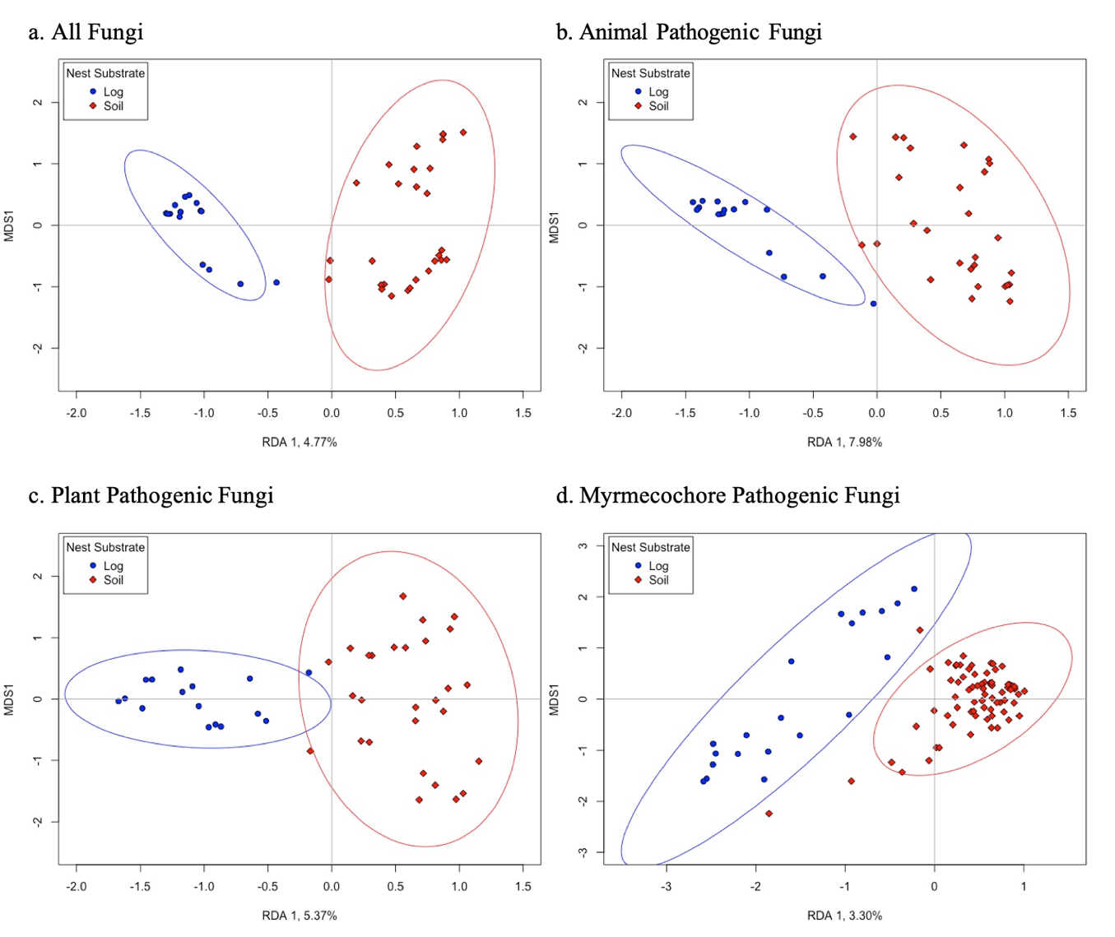
Figure 2-1 Multivariate ordination plot of the different fungal communities.
Nest substrate is separated into log nests (blue and circles) and soil nests (red and diamonds). Ellipses represent 95% confidence limits. For all fungi (a) nest substrate explained 4.77% of the variation (R²_{adj}). For the animal pathogenic fungal community (b), nest substrate explained 7.98% of the variation (R²_{adj}). For the plant pathogenic fungal community (c), nest substrate explained 5.37% of the variation (R²_{adj}). For the myrmecochore pathogenic fungal community (d) nest substrate explained 3.30% of the variation (R²_{adj}). In all communities, nest substrate is the only significant predictor of the fungal communities (p<0.05).

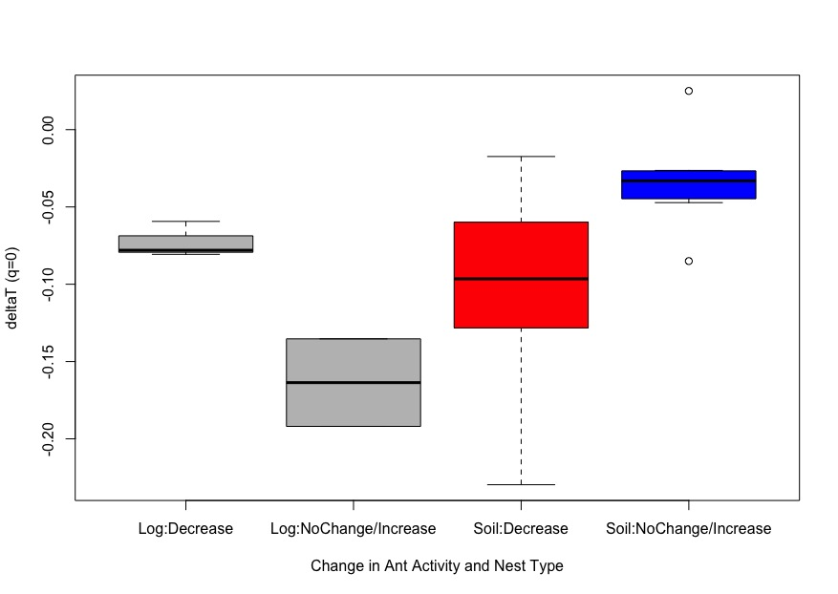
Figure 2-2 Δ⁰T by change in ant activity and nest type for the fungal community.
For All Fungi, at q=0, the interaction between ΔA (change in ant activity) and nest substrate was a significant predictor of Δ⁰T: (Χ²= 11.28, df=1, p<0.01). For soil substrates, decreases in ant activity in nests resulted in lower negative Δ⁰T values (t= -3.06, df=18, p<0.01). When ant activity decreased in soil nests, this corresponded to more turnover in control samples than in ant nest samples. However, when ant activity was stable or increases, fungal community turnover is more consistent between ant nest and non-ant nest samples.

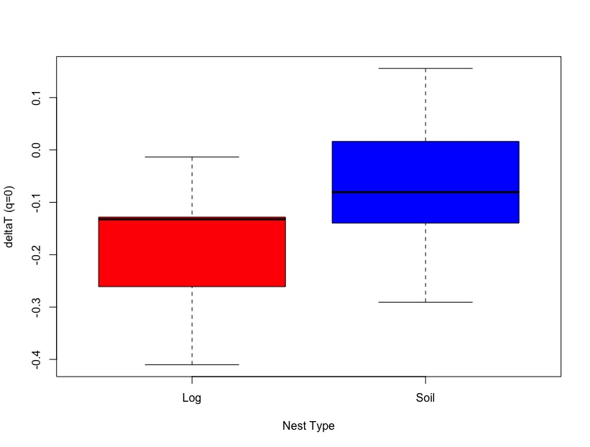
Figure 2-3 Δ⁰T by nest type for the animal pathogenic fungal community.
For Animal Pathogens, nest substrate was a significant predictor of Δ⁰T (Χ²= 4.38, df=1, p=0.04). Log substrates tended to have lower Δ⁰T values than soil substrate; thus, log environments had higher turnover in control samples than ant nest samples. Soil substrates had similar turnover between ant nest samples and control samples for the animal pathogenic fungal community.

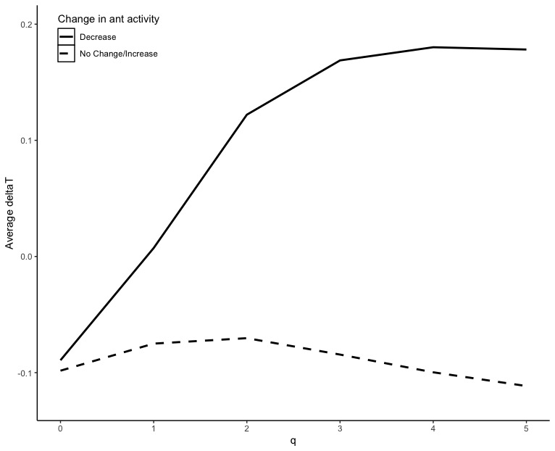
Figure 2-4 Change in animal pathogen community turnover (Δ^{q}T) by change in ant activity over order q.
Decreases in ant activity in ant nests results in higher Δ^{q}T values. This indicates that decreasing ant activity in nests results in higher community turnover for the animal pathogenic fungal community in ant nests than in control samples. At q=3 through q=5, change in ant activity was a significant predictor of ΔT: Δ³T (Χ²= 4.22, df=1, p=0.04); Δ⁴T (Χ²= 4.39, df=1, p=0.04); Δ⁵T (Χ²= 4.27, df=1, p=0.04).

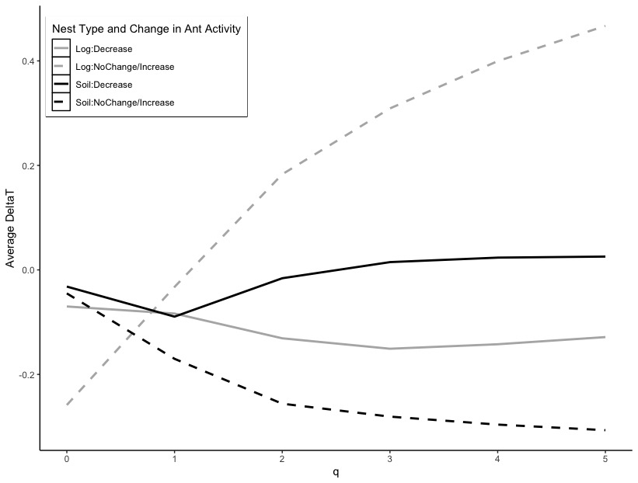
Figure 2-5 Change in plant pathogen community turnover (ΔT) by change in ant activity and nest substrate over order q.
The interaction between nest substrate and ΔA was a significant predictor of Δ^{q}T for the plant pathogenic fungal community at Δ⁴T (Χ²= 4.84, df=1, p=0.03; Fig 6) and Δ⁵T (Χ²= 5.61, df=1, p=0.02; Fig 6). For log substrates, no change or increases in ant activity in nests results in more change in ant nest than in control samples (positive ΔT values), and decreases in ant activity in nests for log substrates corresponds to little difference between turnover in ant nests and control samples (ΔT values near zero). For soil substrates, no change or increases in ant activity in nests results in more change in control samples than in ant nest samples (negative ΔT values), and decreases in ant activity in nests for soil substrates corresponds to little difference between turnover in ant nests and control samples (ΔT values near zero).

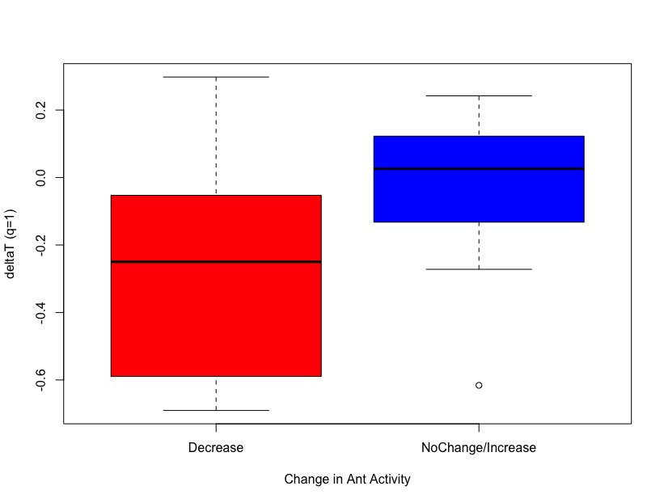
Figure 2-6 Δ¹T by change in ant activity for the myrmecochory pathogenic fungal community.
For the myrmecochore pathogenic fungal community, at q=1, ΔA affected Δ¹T values (Χ²= 4.56, df=1, p=0.03; Fig 7). Decreases in ant activity in nests resulted in higher turnover the myrmecochore pathogenic fungal community in control nest than in ant nest (negative Δ¹T values). When ant activity was stable or increased in nests, the turnover in the myrmecochore pathogenic fungal community was similar between ant nest and control samples.

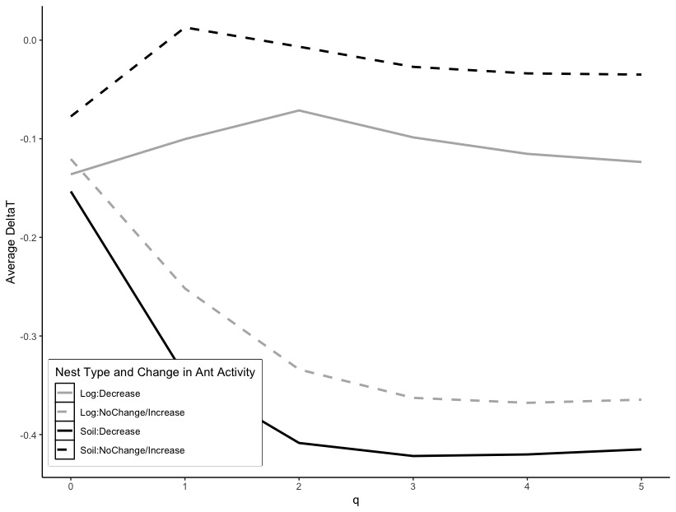
Figure 2-7 Change in myrmecochory pathogen community turnover (Δ^{q}T) by change in ant activity and nest substrate over order q.
The interaction between nest substrate and ΔA was a significant predictor of Δ^{q}T for the myrmecochore pathogenic fungal community at Δ²T (Χ²= 3.94, df=1, p<0.05). Log substrates with no change in or increasing ant activity in nests had more turnover in the myrmecochore pathogenic fungal community in control samples than in ant nest samples (negative Δ²T values). Log substrates with decreasing ant activity in nests also showed more turnover in control samples than in ant nests, but this difference was not as great. Soil substrates with decreasing ant activity in nests had higher turnover in control samples than in ant nests (negative Δ²T values). Soil substrates with no change or increasing ant activity in nests had little difference in the turnover between ant nests and control samples (Δ²T values near zero).

Qiime2 Pipeline
(base) cllashmac:Desktop chloelash$ fastqc -o ITS_Qiime_AntNest/FastQC/ Chloe_ITS_Jan2019/FASTQ/*/*

(base) cllashmac:Desktop chloelash$ multiqc ITS_Qiime_AntNest/FastQC -o ITS_Qiime_AntNest/MultiQC -f

(base) cllashmac:~ chloelash$ conda activate qiime2-2019.4

(qiime2-2019.4) cllashmac:Desktop chloelash$ qiime tools import \
> --type 'SampleData[PairedEndSequencesWithQuality]' \
> --input-path ITS_Qiime_AntNest/Manifest_Dups_Excluded.csv \
> --output-path ITS_Qiime_AntNest/ITS_Paired_End_Demux.qza \
> --input-format PairedEndFastqManifestPhred33
Imported ITS_Qiime_AntNest/Manifest_Dups_Excluded.csv as PairedEndFastqManifestPhred33 to ITS_Qiime_AntNest/ITS_Paired_End_Demux.qza

(qiime2-2019.4) cllashmac:Desktop chloelash$ qiime demux summarize --i-data ITS_Qiime_AntNest/ITS_Paired_End_Demux.qza --o-visualization ITS_Qiime_AntNest/demux.qzv
Saved Visualization to: ITS_Qiime_AntNest/demux.qzv

(qiime2-2019.4) cllashmac:Desktop chloelash$ qiime tools view ITS_Qiime_AntNest/demux.qzv
Press the 'q' key, Control-C, or Control-D to quit. This view may no longer be accessible or work correctly after quitting.

(qiime2-2019.4) cllashmac:Desktop chloelash$ qiime dada2 denoise-paired --i-demultiplexed-seqs ITS_Qiime_AntNest/ITS_Paired_End_Demux.qza --p-trim-left-f 20 --p-trunc-len-f 250 --p-trim-left-r 20 --p-trunc-len-r 250 --o-table ITS_Qiime_AntNest/dada2table.qza --o-representative-sequences ITS_Qiime_AntNest/rep-seqs.qza --o-denoising-stats ITS_Qiime_AntNest/denoising-stats.qza
Saved FeatureTable[Frequency] to: ITS_Qiime_AntNest/dada2table.qza
Saved FeatureData[Sequence] to: ITS_Qiime_AntNest/rep-seqs.qza
Saved SampleData[DADA2Stats] to: ITS_Qiime_AntNest/denoising-stats.qza

(qiime2-2019.4) cllashmac:Desktop chloelash$ qiime feature-table summarize --i-table ITS_Qiime_AntNest/dada2table.qza --o-visualization ITS_Qiime_AntNest/dada2table.qzv --m-sample-metadata-file ITS_Qiime_AntNest/Metadata_Dups_Excluded.txt
Saved Visualization to: ITS_Qiime_AntNest/dada2table.qzv

(qiime2-2019.4) cllashmac:Desktop chloelash$ qiime tools view ITS_Qiime_AntNest/dada2table.qzv
Press the 'q' key, Control-C, or Control-D to quit. This view may no longer be accessible or work correctly after quitting.

(qiime2-2019.4) cllashmac:Desktop chloelash$ qiime feature-classifier classify-consensus-blast \
> --i-reference-reads UNITE/vers8_97.qza \
> --i-reference-taxonomy UNITE/vers8_97_TAX.qza \
> --i-query ITS_Qiime_AntNest/rep-seqs.qza \
> --o-classification ITS_Qiime_AntNest/blasttaxonomy.qza
Saved FeatureData[Taxonomy] to: ITS_Qiime_AntNest/blasttaxonomy.qza

(qiime2-2019.4) cllashmac:Desktop chloelash$ qiime metadata tabulate --m-input-file ITS_Qiime_AntNest/blasttaxonomy.qza --o-visualization ITS_Qiime_AntNest/blasttaxonomy.qzv
Saved Visualization to: ITS_Qiime_AntNest/blasttaxonomy.qzv

(qiime2-2019.4) cllashmac:Desktop chloelash$ qiime tools view ITS_Qiime_AntNest/blasttaxonomy.qzv
Press the 'q' key, Control-C, or Control-D to quit. This view may no longer be accessible or work correctly after quitting.
Press the 'q' key, Control-C, or Control-D to quit. This view may no longer be accessible or work correctly after quitting.

(qiime2-2019.4) cllashmac:Desktop chloelash$ qiime taxa filter-table --i-table ITS_Qiime_AntNest/dada2table.qza --i-taxonomy ITS_Qiime_AntNest/blasttaxonomy.qza --p-include k__Fungi --o-filtered-table ITS_Qiime_AntNest/Filter_Tables/KingdomFungiTable.qza
Saved FeatureTable[Frequency] to: ITS_Qiime_AntNest/Filter_Tables/KingdomFungiTable.qza

(qiime2-2019.4) cllashmac:Desktop chloelash$ qiime feature-table summarize --i-table ITS_Qiime_AntNest/Filter_Tables/KingdomFungiTable.qza --o-visualization ITS_Qiime_AntNest/Filter_Tables/KingdomFungiTable.qzv --m-sample-metadata-file ITS_Qiime_AntNest/Metadata_Dups_Excluded.txt
Saved Visualization to: ITS_Qiime_AntNest/Filter_Tables/KingdomFungiTable.qzv

(qiime2-2019.4) cllashmac:Desktop chloelash$ qiime tools view ITS_Qiime_AntNest/Filter_Tables/KingdomFungiTable.qzv
Press the 'q' key, Control-C, or Control-D to quit. This view may no longer be accessible or work correctly after quitting.

(qiime2-2019.4) cllashmac:Desktop chloelash$ qiime diversity core-metrics \
> --i-table ITS_Qiime_AntNest/Filter_Tables/KingdomFungiTable.qza \
> --p-sampling-depth 22000 \
> --m-metadata-file ITS_Qiime_AntNest/Metadata_Dups_Excluded.txt |
> qiime diversity core-metrics --i-table ITS_Qiime_AntNest/Filter_Tables/KingdomFungiTable.qza --p-sampling-depth 22000 --m-metadata-file ITS_Qiime_AntNest/Metadata_Dups_Excluded.txt \
> --output-dir ITS_Qiime_AntNest/CoreDiversityFilterFungi
Saved FeatureTable[Frequency] to: ITS_Qiime_AntNest/CoreDiversityFilterFungi/rarefied_table.qza
Saved SampleData[AlphaDiversity] to: ITS_Qiime_AntNest/CoreDiversityFilterFungi/observed_otus_vector.qza
Saved SampleData[AlphaDiversity] to: ITS_Qiime_AntNest/CoreDiversityFilterFungi/shannon_vector.qza
Saved SampleData[AlphaDiversity] to: ITS_Qiime_AntNest/CoreDiversityFilterFungi/evenness_vector.qza
Saved DistanceMatrix to: ITS_Qiime_AntNest/CoreDiversityFilterFungi/jaccard_distance_matrix.qza
Saved DistanceMatrix to: ITS_Qiime_AntNest/CoreDiversityFilterFungi/bray_curtis_distance_matrix.qza
Saved PCoAResults to: ITS_Qiime_AntNest/CoreDiversityFilterFungi/jaccard_pcoa_results.qza
Saved PCoAResults to: ITS_Qiime_AntNest/CoreDiversityFilterFungi/bray_curtis_pcoa_results.qza
Saved Visualization to: ITS_Qiime_AntNest/CoreDiversityFilterFungi/jaccard_emperor.qzv
Saved Visualization to: ITS_Qiime_AntNest/CoreDiversityFilterFungi/bray_curtis_emperor.qzv

Table 2-1 Myrmecochore pathogen list by genus
Myrmecochorous Genus | Citation |  |  |  |  |  |  |  |  | Pathogens by Genus (as identified by USDA ARS Fungal Database) |  | Alternative Genus Names - Pathogens - (as identified by USDA ARS Fungal Database)
Adlumia | Lengyel et al., 2010 (and references therein) |  |  |  |  |  |  |  |  | N/A
Adonis | Lengyel et al., 2010 (and references therein) |  |  |  |  |  |  |  |  | Aecidium
 |  |  |  |  |  |  |  |  |  | Cercospora |  | Pseudocercospora
 |  |  |  |  |  |  |  |  |  | Didymella |  | Heterophoma
 |  |  |  |  |  |  |  |  |  | Erysiphe
 |  |  |  |  |  |  |  |  |  | Heterophoma
 |  |  |  |  |  |  |  |  |  | Laetinaevia
 |  |  |  |  |  |  |  |  |  | Leptosphaeria
 |  |  |  |  |  |  |  |  |  | Mycosphaerella
 |  |  |  |  |  |  |  |  |  | Oidium
 |  |  |  |  |  |  |  |  |  | Paraphaeosphaeria
 |  |  |  |  |  |  |  |  |  | Phoma
 |  |  |  |  |  |  |  |  |  | Plasmopara pygmaea |  | Plasmoverna
 |  |  |  |  |  |  |  |  |  | Podosphaera
 |  |  |  |  |  |  |  |  |  | Pseudocercospora
 |  |  |  |  |  |  |  |  |  | Puccinia
 |  |  |  |  |  |  |  |  |  | Sphaerotheca
 |  |  |  |  |  |  |  |  |  | Spongospora
 |  |  |  |  |  |  |  |  |  | Tuburcinia |  | Urocystis
 |  |  |  |  |  |  |  |  |  | Urocystis |  | Urocystis
 |  |  |  |  |  |  |  |  |  | Wettsteinina
Table 2-1 Continued
Anemone | Lengyel et al., 2010 (and references therein); Schultz, 2014; Beattie and Culver, 1981 |  |  |  |  |  |  |  |  | Aecidium
 |  |  |  |  |  |  |  |  |  | Alternaria
 |  |  |  |  |  |  |  |  |  | Ascochyta
 |  |  |  |  |  |  |  |  |  | Botrytis
 |  |  |  |  |  |  |  |  |  | Cercospora |  | Pseudocercospora
 |  |  |  |  |  |  |  |  |  | Clathrospora
 |  |  |  |  |  |  |  |  |  | Colletotrichum
 |  |  |  |  |  |  |  |  |  | Comoclathris
 |  |  |  |  |  |  |  |  |  | Crocicreas
 |  |  |  |  |  |  |  |  |  | Dicaeoma
 |  |  |  |  |  |  |  |  |  | Didymaria |  | Ramularia
 |  |  |  |  |  |  |  |  |  | Entyloma
 |  |  |  |  |  |  |  |  |  | Eriosphaeria |  | Wettsteinina
 |  |  |  |  |  |  |  |  |  | Erysiphe
 |  |  |  |  |  |  |  |  |  | Fusarium
 |  |  |  |  |  |  |  |  |  | Heteropera |  | Mazzantia
 |  |  |  |  |  |  |  |  |  | Leptosphaeria
 |  |  |  |  |  |  |  |  |  | Lipospora
 |  |  |  |  |  |  |  |  |  | Micropuccinia
 |  |  |  |  |  |  |  |  |  | Mycosphaerella
 |  |  |  |  |  |  |  |  |  | Peronospora |  | Plasmoverna
 |  |  |  |  |  |  |  |  |  | Phloeospora |  | Septoria
 |  |  |  |  |  |  |  |  |  | Phoma
 |  |  |  |  |  |  |  |  |  | Phyllosticta |  | Phyllosticta
 |  |  |  |  |  |  |  |  |  | Physalospora |  | Mazzantia
 |  |  |  |  |  |  |  |  |  | Plasmopara |  | Plasmoverna
 |  |  |  |  |  |  |  |  |  | Pleospora |  | Graphyllium
 |  |  |  |  |  |  |  |  |  | Polythelis |  | Tranzschelia
 |  |  |  |  |  |  |  |  |  | Puccinia |  | Tranzschelia
 |  |  |  |  |  |  |  |  |  | Pyrenophora
Table 2-1 Continued
 |  |  |  |  |  |  |  |  |  | Ramularia
 |  |  |  |  |  |  |  |  |  | Rhabdospora
 |  |  |  |  |  |  |  |  |  | Rhizoctonia
 |  |  |  |  |  |  |  |  |  | Scelobelonium |  | Crocicreas
 |  |  |  |  |  |  |  |  |  | Sclerotinia
 |  |  |  |  |  |  |  |  |  | Sclerotium |  | Athelia
 |  |  |  |  |  |  |  |  |  | Selenophoma
 |  |  |  |  |  |  |  |  |  | Septoria
 |  |  |  |  |  |  |  |  |  | Sorosporium
 |  |  |  |  |  |  |  |  |  | Sphaerella
 |  |  |  |  |  |  |  |  |  | Stagonospora
 |  |  |  |  |  |  |  |  |  | Synchytrium
 |  |  |  |  |  |  |  |  |  | Tranzschelia
 |  |  |  |  |  |  |  |  |  | Urocystis
 |  |  |  |  |  |  |  |  |  | Wettsteinina
Arenaria | Lengyel et al., 2010 (and references therein) |  |  |  |  |  |  |  |  | Ascochyta
 |  |  |  |  |  |  |  |  |  | Cladosporium
 |  |  |  |  |  |  |  |  |  | Clathrospora |  | Comoclathris
 |  |  |  |  |  |  |  |  |  | Erysiphe
 |  |  |  |  |  |  |  |  |  | Graphyllium |  | Comoclathris
 |  |  |  |  |  |  |  |  |  | Hendersonia
 |  |  |  |  |  |  |  |  |  | Leptosphaeria
 |  |  |  |  |  |  |  |  |  | Mollisia
 |  |  |  |  |  |  |  |  |  | Mycosphaerella |  | Cladosporium
 |  |  |  |  |  |  |  |  |  | Phoma
 |  |  |  |  |  |  |  |  |  | Phyllosticta
 |  |  |  |  |  |  |  |  |  | Phymatotrichum |  | Phymatotrichopsis
 |  |  |  |  |  |  |  |  |  | Pleospora
 |  |  |  |  |  |  |  |  |  | Pseudopeziza
 |  |  |  |  |  |  |  |  |  | Puccinia
 |  |  |  |  |  |  |  |  |  | Pyrenophora |  | Pleospora
 |  |  |  |  |  |  |  |  |  | Rhizoctonia
 |  |  |  |  |  |  |  |  |  | Septoria
Table 2-1 Continued
 |  |  |  |  |  |  |  |  |  | Sorosporium |  | Thecaphora
 |  |  |  |  |  |  |  |  |  | Uromyces
 |  |  |  |  |  |  |  |  |  | Ustilago |  | Microbotryum
Asarum | Schultz, 2014; Beattie and Culver, 1981 |  |  |  |  |  |  |  |  | Ascochyta
 |  |  |  |  |  |  |  |  |  | Colletotrichum
 |  |  |  |  |  |  |  |  |  | Erysiphe
 |  |  |  |  |  |  |  |  |  | Laestadia
 |  |  |  |  |  |  |  |  |  | Mycosphaerella
 |  |  |  |  |  |  |  |  |  | Puccinia
 |  |  |  |  |  |  |  |  |  | Sclerotinia
 |  |  |  |  |  |  |  |  |  | Septoria
 |  |  |  |  |  |  |  |  |  | Synchytrium
Azetekium | Lengyel et al., 2010 (and references therein) |  |  |  |  |  |  |  |  | N/A
Bocconia | Lengyel et al., 2010 (and references therein) |  |  |  |  |  |  |  |  | Leptosphaeria
 |  |  |  |  |  |  |  |  |  | Sphaeria
Bongardia | Lengyel et al., 2010 (and references therein) |  |  |  |  |  |  |  |  | Aecidium
 |  |  |  |  |  |  |  |  |  | Uromyces
Carex | Beattie and Culver, 1981 |  |  |  |  |  |  |  |  | Stagonospora
Chelidonium | Lengyel et al., 2010 (and references therein) |  |  |  |  |  |  |  |  | Ascochyta
 |  |  |  |  |  |  |  |  |  | Phymatotrichum |  | Phymatotrichopsis
Table 2-1 Continued
 |  |  |  |  |  |  |  |  |  | Septoria
Chrysogonum | Lengyel et al., 2010 (and references therein) |  |  |  |  |  |  |  |  | Golovinomyces
 |  |  |  |  |  |  |  |  |  | Sclerotinia
 |  |  |  |  |  |  |  |  |  | Sclerotium |  | Athelia
Claytonia | Lengyel et al., 2010 (and references therein); Schultz, 2014; Beattie and Culver, 1981 |  |  |  |  |  |  |  |  | Allodus |  | Puccinia
 |  |  |  |  |  |  |  |  |  | Endophyllum
 |  |  |  |  |  |  |  |  |  | Entyloma
 |  |  |  |  |  |  |  |  |  | Microbotryum |  | Bauhinus
 |  |  |  |  |  |  |  |  |  | Mycosphaerella |  | Cladosporium
 |  |  |  |  |  |  |  |  |  | Peronospora
 |  |  |  |  |  |  |  |  |  | Phymatotrichum |  | Phymatotrichopsis
 |  |  |  |  |  |  |  |  |  | Physoderma
 |  |  |  |  |  |  |  |  |  | Pleospora
 |  |  |  |  |  |  |  |  |  | Puccinia
 |  |  |  |  |  |  |  |  |  | Ramularia
 |  |  |  |  |  |  |  |  |  | Sorosporium |  | Tolyposporium
 |  |  |  |  |  |  |  |  |  | Synchytrium
 |  |  |  |  |  |  |  |  |  | Uromyces
 |  |  |  |  |  |  |  |  |  | Ustilago |  | Bauhinus
Corydalis | Lengyel et al., 2010 (and references therein); Beattie and Culver, 1981 |  |  |  |  |  |  |  |  | Aecidium
 |  |  |  |  |  |  |  |  |  | Albugo
Table 2-1 Continued
 |  |  |  |  |  |  |  |  |  | Crocicreas
 |  |  |  |  |  |  |  |  |  | Peronospora
 |  |  |  |  |  |  |  |  |  | Phyllosticta
 |  |  |  |  |  |  |  |  |  | Puccinia
 |  |  |  |  |  |  |  |  |  | Septoria
Cysticapnos | Lengyel et al., 2010 (and references therein) |  |  |  |  |  |  |  |  | N/A
Dactylocapnos | Lengyel et al., 2010 (and references therein) |  |  |  |  |  |  |  |  | N/A
Datura | Lengyel et al., 2010 (and references therein) |  |  |  |  |  |  |  |  | Alternaria
 |  |  |  |  |  |  |  |  |  | Cercospora |  | Alternaria
 |  |  |  |  |  |  |  |  |  | Colletotrichum
 |  |  |  |  |  |  |  |  |  | Curvularia
 |  |  |  |  |  |  |  |  |  | Diplodia
 |  |  |  |  |  |  |  |  |  | Dothiorella
 |  |  |  |  |  |  |  |  |  | Fusarium
 |  |  |  |  |  |  |  |  |  | Helminthosporium
 |  |  |  |  |  |  |  |  |  | Leptosphaeria
 |  |  |  |  |  |  |  |  |  | Macrophomina
 |  |  |  |  |  |  |  |  |  | Macrosporium
 |  |  |  |  |  |  |  |  |  | Phomopsis
 |  |  |  |  |  |  |  |  |  | Phyllosticta |  | Boeremia
 |  |  |  |  |  |  |  |  |  | Phymatotrichum |  | Phymatotrichopsis
 |  |  |  |  |  |  |  |  |  | Physalospora |  | Lasiodiplodia
 |  |  |  |  |  |  |  |  |  | Phytophthora
 |  |  |  |  |  |  |  |  |  | Pseudocercospora
 |  |  |  |  |  |  |  |  |  | Puccinia |  | Aecidium
 |  |  |  |  |  |  |  |  |  | Rhizoctonia
Table 2-1 Continued
 |  |  |  |  |  |  |  |  |  | Sclerotium |  | Athelia
 |  |  |  |  |  |  |  |  |  | Septoria
 |  |  |  |  |  |  |  |  |  | Thielaviopsis |  | Berkeleyomyces
Delphinium | Lengyel et al., 2010 (and references therein) |  |  |  |  |  |  |  |  | Ascochyta |  | Calophoma
 |  |  |  |  |  |  |  |  |  | Botrytis
 |  |  |  |  |  |  |  |  |  | Cercospora |  | Ramularia
 |  |  |  |  |  |  |  |  |  | Cercosporella |  | Oculimacula
 |  |  |  |  |  |  |  |  |  | Cicinobolus
 |  |  |  |  |  |  |  |  |  | Cladosporium
 |  |  |  |  |  |  |  |  |  | Crocicreas
 |  |  |  |  |  |  |  |  |  | Dasyscyphus |  | Belonidium
 |  |  |  |  |  |  |  |  |  | Davidiella |  | Cladosporium
 |  |  |  |  |  |  |  |  |  | Diaporthe
 |  |  |  |  |  |  |  |  |  | Didymella
 |  |  |  |  |  |  |  |  |  | Diplodina |  | Calophoma
 |  |  |  |  |  |  |  |  |  | Entyloma
 |  |  |  |  |  |  |  |  |  | Erysiphe |  | Golovinomyces
 |  |  |  |  |  |  |  |  |  | Fusarium
 |  |  |  |  |  |  |  |  |  | Golovinomyces
 |  |  |  |  |  |  |  |  |  | Heterosporium
 |  |  |  |  |  |  |  |  |  | Hyalopeziza
 |  |  |  |  |  |  |  |  |  | Leptosphaeria
 |  |  |  |  |  |  |  |  |  | Metasphaeria
 |  |  |  |  |  |  |  |  |  | Mycocentrospora
 |  |  |  |  |  |  |  |  |  | Mycosphaerella |  | Cladosporium
 |  |  |  |  |  |  |  |  |  | Oidium
 |  |  |  |  |  |  |  |  |  | Ovularia
 |  |  |  |  |  |  |  |  |  | Peronospora
 |  |  |  |  |  |  |  |  |  | Phoma |  | Calophoma
 |  |  |  |  |  |  |  |  |  | Phyllosticta |  | Stagonosporopsis
 |  |  |  |  |  |  |  |  |  | Phymatotrichum |  | Phymatotrichopsis
 |  |  |  |  |  |  |  |  |  | Phytophthora
Table 2-1 Continued
 |  |  |  |  |  |  |  |  |  | Pleospora |  | Comoclathris/ Graphyllium
 |  |  |  |  |  |  |  |  |  | Pseudomonas
 |  |  |  |  |  |  |  |  |  | Puccinia
 |  |  |  |  |  |  |  |  |  | Pythium |  | Globisporangium/ Phytopythium
 |  |  |  |  |  |  |  |  |  | Ramularia
 |  |  |  |  |  |  |  |  |  | Rhizoctonia
 |  |  |  |  |  |  |  |  |  | Sclerotinia
 |  |  |  |  |  |  |  |  |  | Sclerotium |  | Athelia
 |  |  |  |  |  |  |  |  |  | Septoria
 |  |  |  |  |  |  |  |  |  | Sphaeromyces
 |  |  |  |  |  |  |  |  |  | Sphaerotheca |  | Podosphaera
 |  |  |  |  |  |  |  |  |  | Synchytrium
 |  |  |  |  |  |  |  |  |  | Trichopezizella
 |  |  |  |  |  |  |  |  |  | Urocystis
 |  |  |  |  |  |  |  |  |  | Verticillium
 |  |  |  |  |  |  |  |  |  | Volutella
Dendromecon | Lengyel et al., 2010 (and references therein) |  |  |  |  |  |  |  |  | Entyloma
 |  |  |  |  |  |  |  |  |  | Massaria
 |  |  |  |  |  |  |  |  |  | Pleosphaerulina
 |  |  |  |  |  |  |  |  |  | Pleospora
 |  |  |  |  |  |  |  |  |  | Pocosphaeria
Dicentra | Lengyel et al., 2010 (and references therein); Schultz, 2014 |  |  |  |  |  |  |  |  | Colletotrichum
 |  |  |  |  |  |  |  |  |  | Cylindrocarpon
 |  |  |  |  |  |  |  |  |  | Dendryphion
 |  |  |  |  |  |  |  |  |  | Fusarium
 |  |  |  |  |  |  |  |  |  | Peronospora
 |  |  |  |  |  |  |  |  |  | Phytophthora
Table 2-1 Continued
 |  |  |  |  |  |  |  |  |  | Pythium
 |  |  |  |  |  |  |  |  |  | Sclerotinia
 |  |  |  |  |  |  |  |  |  | Sclerotium |  | Athelia
 |  |  |  |  |  |  |  |  |  | Stemphylium
Eomecon | Lengyel et al., 2010 (and references therein) |  |  |  |  |  |  |  |  | Albugo
Epimedium | Lengyel et al., 2010 (and references therein) |  |  |  |  |  |  |  |  | Aecidium
 |  |  |  |  |  |  |  |  |  | Erysiphe
 |  |  |  |  |  |  |  |  |  | Microsphaera |  | Erysiphe
 |  |  |  |  |  |  |  |  |  | Oidium
 |  |  |  |  |  |  |  |  |  | Phyllosticta
 |  |  |  |  |  |  |  |  |  | Puccinia
Erythronium | Lengyel et al., 2010 (and references therein); Schultz, 2014; Beattie and Culver, 1981 |  |  |  |  |  |  |  |  | Asteroma
 |  |  |  |  |  |  |  |  |  | Botrytis
 |  |  |  |  |  |  |  |  |  | Ciborinia
 |  |  |  |  |  |  |  |  |  | Colletotrichum
 |  |  |  |  |  |  |  |  |  | Epicoccum
 |  |  |  |  |  |  |  |  |  | Phyllosticta
 |  |  |  |  |  |  |  |  |  | Puccinia
 |  |  |  |  |  |  |  |  |  | Sclerotium
 |  |  |  |  |  |  |  |  |  | Synchytrium
 |  |  |  |  |  |  |  |  |  | Typhula
 |  |  |  |  |  |  |  |  |  | Urocystis
 |  |  |  |  |  |  |  |  |  | Uromyces
 |  |  |  |  |  |  |  |  |  | Ustilago |  | Vankya
Table 2-1 Continued
 |  |  |  |  |  |  |  |  |  | Vankya
Galanthus | Lengyel et al., 2010 (and references therein) |  |  |  |  |  |  |  |  | Botrytis
 |  |  |  |  |  |  |  |  |  | Sclerotium
Galium | Schultz, 2014 |  |  |  |  |  |  |  |  | Aecidium
 |  |  |  |  |  |  |  |  |  | Allodus
 |  |  |  |  |  |  |  |  |  | Ceratobasidium |  | Rhizoctonia
 |  |  |  |  |  |  |  |  |  | Cercospora |  | Passalora/ Pseudocercospora
 |  |  |  |  |  |  |  |  |  | Cercosporidium |  | Passalora
 |  |  |  |  |  |  |  |  |  | Dicaeoma
 |  |  |  |  |  |  |  |  |  | Erysiphe |  | Golovinomyces
 |  |  |  |  |  |  |  |  |  | Hainesia
 |  |  |  |  |  |  |  |  |  | Hendersonia
 |  |  |  |  |  |  |  |  |  | Leptosphaeria
 |  |  |  |  |  |  |  |  |  | Leptotrochila
 |  |  |  |  |  |  |  |  |  | Marssonia
 |  |  |  |  |  |  |  |  |  | Mazzantia
 |  |  |  |  |  |  |  |  |  | Melasmia
 |  |  |  |  |  |  |  |  |  | Metasphaeria |  | Leptosphaeria
 |  |  |  |  |  |  |  |  |  | Micropuccinia
 |  |  |  |  |  |  |  |  |  | Mollisia
 |  |  |  |  |  |  |  |  |  | Mycosphaerella
 |  |  |  |  |  |  |  |  |  | Nectria |  | Nectriella
 |  |  |  |  |  |  |  |  |  | Ophiobolus
 |  |  |  |  |  |  |  |  |  | Peronospora
 |  |  |  |  |  |  |  |  |  | Phyllosticta
 |  |  |  |  |  |  |  |  |  | Phymatotrichum |  | Phymatotrichopsis
 |  |  |  |  |  |  |  |  |  | Physalospora |  | Mazzantia
 |  |  |  |  |  |  |  |  |  | Placosphaeria |  | Mazzantia
 |  |  |  |  |  |  |  |  |  | Plectosphaerella
 |  |  |  |  |  |  |  |  |  | Pseudopeziza |  | Leptotrochila
 |  |  |  |  |  |  |  |  |  | Puccinia
 |  |  |  |  |  |  |  |  |  | Pucciniastrum
Table 2-1 Continued
 |  |  |  |  |  |  |  |  |  | Pyrenopeziza
 |  |  |  |  |  |  |  |  |  | Rhabdospora
 |  |  |  |  |  |  |  |  |  | Septoria |  | Rhabdospora
 |  |  |  |  |  |  |  |  |  | Sphaeropsis
 |  |  |  |  |  |  |  |  |  | Sporonema
 |  |  |  |  |  |  |  |  |  | Uromyces
Gymnocalycium | Lengyel et al., 2010 (and references therein) |  |  |  |  |  |  |  |  | Dichotomophthora
 |  |  |  |  |  |  |  |  |  | Fusarium
Hannonia | Lengyel et al., 2010 (and references therein) |  |  |  |  |  |  |  |  | N/A
Helleborus | Lengyel et al., 2010 (and references therein) |  |  |  |  |  |  |  |  | Botrytis
 |  |  |  |  |  |  |  |  |  | Coniothyrium
 |  |  |  |  |  |  |  |  |  | Peronospora
Hepatica | Lengyel et al., 2010 (and references therein); Beattie and Culver, 1981 |  |  |  |  |  |  |  |  | Aecidium |  | Tranzschelia
 |  |  |  |  |  |  |  |  |  | Colletotrichum
 |  |  |  |  |  |  |  |  |  | Discosia
 |  |  |  |  |  |  |  |  |  | Gloeosporium |  | Ascochyta
 |  |  |  |  |  |  |  |  |  | Plasmopara |  | Plasmoverna
 |  |  |  |  |  |  |  |  |  | Puccinia |  | Tranzschelia
 |  |  |  |  |  |  |  |  |  | Septoria
 |  |  |  |  |  |  |  |  |  | Tranzschelia
 |  |  |  |  |  |  |  |  |  | Urocystis
Table 2-1 Continued
Jeffersonia | Beattie and Culver, 1981 |  |  |  |  |  |  |  |  | Colletotrichum
Lamium | Lengyel et al., 2010 (and references therein) |  |  |  |  |  |  |  |  | Erysiphe |  | Golovinomyces/ Neoerysiphe
 |  |  |  |  |  |  |  |  |  | Neoerysiphe
 |  |  |  |  |  |  |  |  |  | Peronospora
 |  |  |  |  |  |  |  |  |  | Rhizoctonia
 |  |  |  |  |  |  |  |  |  | Sclerotinia
 |  |  |  |  |  |  |  |  |  | Septoria
 |  |  |  |  |  |  |  |  |  | Verticillium
Lapiedra | Lengyel et al., 2010 (and references therein); Schultz, 2014; Beattie and Culver, 1981 |  |  |  |  |  |  |  |  | N/A
Leucojum | Lengyel et al., 2010 (and references therein) |  |  |  |  |  |  |  |  | Botrytis
 |  |  |  |  |  |  |  |  |  | Stagonospora |  | Didymella
Luzula | Beattie and Culver, 1981 |  |  |  |  |  |  |  |  | Ascochyta
 |  |  |  |  |  |  |  |  |  | Bauerago
 |  |  |  |  |  |  |  |  |  | Botrytis
 |  |  |  |  |  |  |  |  |  | Cintractia |  | Stegocintractia
 |  |  |  |  |  |  |  |  |  | Clathrospora
 |  |  |  |  |  |  |  |  |  | Comoclathris
 |  |  |  |  |  |  |  |  |  | Gaeumannomyces
 |  |  |  |  |  |  |  |  |  | Graphyllium |  | Comoclathris
 |  |  |  |  |  |  |  |  |  | Hysteropezizella
 |  |  |  |  |  |  |  |  |  | Microthyrium
Table 2-1 Continued
 |  |  |  |  |  |  |  |  |  | Mycosphaerella
 |  |  |  |  |  |  |  |  |  | Ophiobolus |  | Gaeumannomyces
 |  |  |  |  |  |  |  |  |  | Phaeosphaeria
 |  |  |  |  |  |  |  |  |  | Phyllosticta
 |  |  |  |  |  |  |  |  |  | Platysporoides
 |  |  |  |  |  |  |  |  |  | Puccinia
 |  |  |  |  |  |  |  |  |  | Septoria
 |  |  |  |  |  |  |  |  |  | Stagonospora
 |  |  |  |  |  |  |  |  |  | Stegocintractia
 |  |  |  |  |  |  |  |  |  | Thanatephorus |  | Rhizoctonia
 |  |  |  |  |  |  |  |  |  | Ustanciosporium
 |  |  |  |  |  |  |  |  |  | Ustilago |  | Bauerago
Macleaya | Lengyel et al., 2010 (and references therein) |  |  |  |  |  |  |  |  | Trichometasphaeria |  | Massarina
Melica | Lengyel et al., 2010 (and references therein) |  |  |  |  |  |  |  |  | Ascochyta
 |  |  |  |  |  |  |  |  |  | Cercospora |  | Spermospora
 |  |  |  |  |  |  |  |  |  | Cercosporidium |  | Graminopassalora
 |  |  |  |  |  |  |  |  |  | Claviceps
 |  |  |  |  |  |  |  |  |  | Colletotrichum
 |  |  |  |  |  |  |  |  |  | Dilophospora
 |  |  |  |  |  |  |  |  |  | Epichloe
 |  |  |  |  |  |  |  |  |  | Erysiphe |  | Blumeria
 |  |  |  |  |  |  |  |  |  | Fusarium
 |  |  |  |  |  |  |  |  |  | Gloeosporium |  | Microdochium
 |  |  |  |  |  |  |  |  |  | Hendersonia |  | Stagonospora
 |  |  |  |  |  |  |  |  |  | Ovularia |  | Ramularia
 |  |  |  |  |  |  |  |  |  | Phaeosphaeria
 |  |  |  |  |  |  |  |  |  | Phyllachora
 |  |  |  |  |  |  |  |  |  | Phyllosticta
 |  |  |  |  |  |  |  |  |  | Pseudoseptoria
 |  |  |  |  |  |  |  |  |  | Puccinia
Table 2-1 Continued
 |  |  |  |  |  |  |  |  |  | Pythium
 |  |  |  |  |  |  |  |  |  | Ramularia
 |  |  |  |  |  |  |  |  |  | Scolicotrichum |  | Graminopassalora
 |  |  |  |  |  |  |  |  |  | Selenophoma |  | Pseudoseptoria
 |  |  |  |  |  |  |  |  |  | Septoria |  | Parastagonospora
 |  |  |  |  |  |  |  |  |  | Spermospora
 |  |  |  |  |  |  |  |  |  | Stagonospora |  | Parastagonospora
 |  |  |  |  |  |  |  |  |  | Urocystis
 |  |  |  |  |  |  |  |  |  | Ustilago |  | Tranzscheliella
Montia | Lengyel et al., 2010 (and references therein) |  |  |  |  |  |  |  |  | Microbotryum |  | Bauhinus
 |  |  |  |  |  |  |  |  |  | Peronospora
 |  |  |  |  |  |  |  |  |  | Phyllosticta
 |  |  |  |  |  |  |  |  |  | Puccinia
 |  |  |  |  |  |  |  |  |  | Ramularia
 |  |  |  |  |  |  |  |  |  | Sorosporium |  | Tolyposporium
 |  |  |  |  |  |  |  |  |  | Ustilago |  | Bauhinus
Narcissus | Lengyel et al., 2010 (and references therein) |  |  |  |  |  |  |  |  | Armillaria
 |  |  |  |  |  |  |  |  |  | Aspergillus
 |  |  |  |  |  |  |  |  |  | Botryotinia |  | Botrytis
 |  |  |  |  |  |  |  |  |  | Botrytis
 |  |  |  |  |  |  |  |  |  | Ceratocystis |  | Sporothrix
 |  |  |  |  |  |  |  |  |  | Cladosporium
 |  |  |  |  |  |  |  |  |  | Curvularia
 |  |  |  |  |  |  |  |  |  | Cylindrocarpon |  | Ilyonectria
 |  |  |  |  |  |  |  |  |  | Fusarium
 |  |  |  |  |  |  |  |  |  | Gloeosporium
 |  |  |  |  |  |  |  |  |  | Heterosporium
 |  |  |  |  |  |  |  |  |  | Leptosphaeria
 |  |  |  |  |  |  |  |  |  | Nectria |  | Ilyonectria
Table 2-1 Continued
 |  |  |  |  |  |  |  |  |  | Ophiostoma |  | Sporothrix
 |  |  |  |  |  |  |  |  |  | Pellicularia |  | Athelia
 |  |  |  |  |  |  |  |  |  | Penicillium
 |  |  |  |  |  |  |  |  |  | Ramularia
 |  |  |  |  |  |  |  |  |  | Rhizoctonia
 |  |  |  |  |  |  |  |  |  | Rhizopus
 |  |  |  |  |  |  |  |  |  | Sclerotinia |  | Botrytis
 |  |  |  |  |  |  |  |  |  | Sclerotium |  | Athelia
 |  |  |  |  |  |  |  |  |  | Septoria
 |  |  |  |  |  |  |  |  |  | Stagonospora |  | Didymella
 |  |  |  |  |  |  |  |  |  | Stromatinia
 |  |  |  |  |  |  |  |  |  | Verticillium
Nemophilia | Lengyel et al., 2010 (and references therein) |  |  |  |  |  |  |  |  | N/A
Omphalodes | Lengyel et al., 2010 (and references therein) |  |  |  |  |  |  |  |  | Botrytis
 |  |  |  |  |  |  |  |  |  | Golovinomyces
 |  |  |  |  |  |  |  |  |  | Mycocentrospora
Pedicularis | Lengyel et al., 2010 (and references therein) |  |  |  |  |  |  |  |  | Apiosporella
 |  |  |  |  |  |  |  |  |  | Ascochyta
 |  |  |  |  |  |  |  |  |  | Crocicreas
 |  |  |  |  |  |  |  |  |  | Cronartium
 |  |  |  |  |  |  |  |  |  | Cyathicula |  | Crocicreas
 |  |  |  |  |  |  |  |  |  | Diplodina
 |  |  |  |  |  |  |  |  |  | Eriomycopsis
 |  |  |  |  |  |  |  |  |  | Erysiphe |  | Golovinomyces
 |  |  |  |  |  |  |  |  |  | Heteropatella
 |  |  |  |  |  |  |  |  |  | Hyponectria |  | Charonectria
Table 2-1 Continued
 |  |  |  |  |  |  |  |  |  | Leptosphaeria |  | Entodesmium
 |  |  |  |  |  |  |  |  |  | Leptostroma
 |  |  |  |  |  |  |  |  |  | Leptothyrella
 |  |  |  |  |  |  |  |  |  | Lophiostoma
 |  |  |  |  |  |  |  |  |  | Mycosphaerella |  | Cladosporium
 |  |  |  |  |  |  |  |  |  | Nodulosphaeria
 |  |  |  |  |  |  |  |  |  | Peronospora
 |  |  |  |  |  |  |  |  |  | Phoma |  | Ascochyta/ Leptosphaeria
 |  |  |  |  |  |  |  |  |  | Phyllosticta
 |  |  |  |  |  |  |  |  |  | Pleospora |  | Stemphylium/ Murispora/ Massariosphaeria
 |  |  |  |  |  |  |  |  |  | Puccinia
 |  |  |  |  |  |  |  |  |  | Pyrenophora |  | Pleospora
 |  |  |  |  |  |  |  |  |  | Ramularia
 |  |  |  |  |  |  |  |  |  | Sphaerotheca |  | Podosphaera
 |  |  |  |  |  |  |  |  |  | Synchytrium
 |  |  |  |  |  |  |  |  |  | Synchytrium
 |  |  |  |  |  |  |  |  |  | Thanatephorus |  | Rhizoctonia
Potentilla | Lengyel et al., 2010 (and references therein) |  |  |  |  |  |  |  |  | Cercospora |  | Passalora
 |  |  |  |  |  |  |  |  |  | Coleroa
 |  |  |  |  |  |  |  |  |  | Colletotrichum |  | Colletotrichum
 |  |  |  |  |  |  |  |  |  | Cylindrosporium
 |  |  |  |  |  |  |  |  |  | Diplodina
 |  |  |  |  |  |  |  |  |  | Discosia
 |  |  |  |  |  |  |  |  |  | Dothidea |  | Venturia
 |  |  |  |  |  |  |  |  |  | Erysiphe
 |  |  |  |  |  |  |  |  |  | Fabraea |  | Leptotrochila
 |  |  |  |  |  |  |  |  |  | Frommea |  | Phragmidium
 |  |  |  |  |  |  |  |  |  | Frommeella |  | Phragmidium
 |  |  |  |  |  |  |  |  |  | Gnomonia |  | Gnomoniopsis
Table 2-1 Continued
 |  |  |  |  |  |  |  |  |  | Gnomoniopsis
 |  |  |  |  |  |  |  |  |  | Hainesia |  | Pilidium
 |  |  |  |  |  |  |  |  |  | Leptosphaeria
 |  |  |  |  |  |  |  |  |  | Leptosphaerulina
 |  |  |  |  |  |  |  |  |  | Leptothyrium
 |  |  |  |  |  |  |  |  |  | Leptotrochila
 |  |  |  |  |  |  |  |  |  | Lophiostoma
 |  |  |  |  |  |  |  |  |  | Marasmius
 |  |  |  |  |  |  |  |  |  | Marssonia
 |  |  |  |  |  |  |  |  |  | Marssonina
 |  |  |  |  |  |  |  |  |  | Mollisia |  | Diplocarpon
 |  |  |  |  |  |  |  |  |  | Mycosphaerella |  | Pseudocercosporella
 |  |  |  |  |  |  |  |  |  | Peronospora
 |  |  |  |  |  |  |  |  |  | Pezizella |  | Pilidium
 |  |  |  |  |  |  |  |  |  | Phoma
 |  |  |  |  |  |  |  |  |  | Phragmidium
 |  |  |  |  |  |  |  |  |  | Phyllosticta
 |  |  |  |  |  |  |  |  |  | Phymatotrichum |  | Phymatotrichopsis
 |  |  |  |  |  |  |  |  |  | Physalospora
 |  |  |  |  |  |  |  |  |  | Physoderma
 |  |  |  |  |  |  |  |  |  | Phytophthora
 |  |  |  |  |  |  |  |  |  | Plagiostoma
 |  |  |  |  |  |  |  |  |  | Pleospora |  | Stemphylium/ Murispora/ Massariosphaeria
 |  |  |  |  |  |  |  |  |  | Pucciniastrum
 |  |  |  |  |  |  |  |  |  | Pyrenopeziza
 |  |  |  |  |  |  |  |  |  | Ramularia
 |  |  |  |  |  |  |  |  |  | Rhizoctonia
 |  |  |  |  |  |  |  |  |  | Sclerotium
 |  |  |  |  |  |  |  |  |  | Scopinella
 |  |  |  |  |  |  |  |  |  | Sebacina
 |  |  |  |  |  |  |  |  |  | Septogloeum |  | Phloeospora
 |  |  |  |  |  |  |  |  |  | Septoria
 |  |  |  |  |  |  |  |  |  | Sphaerellopsis
 |  |  |  |  |  |  |  |  |  | Sphaeria
Table 2-1 Continued
 |  |  |  |  |  |  |  |  |  | Sphaeropezia
 |  |  |  |  |  |  |  |  |  | Sphaerotheca |  | Podosphaera
 |  |  |  |  |  |  |  |  |  | Stagonospora
 |  |  |  |  |  |  |  |  |  | Stigmatea |  | Venturia
 |  |  |  |  |  |  |  |  |  | Synchytrium
 |  |  |  |  |  |  |  |  |  | Taphrina
 |  |  |  |  |  |  |  |  |  | Venturia
 |  |  |  |  |  |  |  |  |  | Verticillium
Primula | Lengyel et al., 2010 (and references therein) |  |  |  |  |  |  |  |  | Acremonium
 |  |  |  |  |  |  |  |  |  | Alternaria
 |  |  |  |  |  |  |  |  |  | Ascochyta
 |  |  |  |  |  |  |  |  |  | Asteroma
 |  |  |  |  |  |  |  |  |  | Botrytis
 |  |  |  |  |  |  |  |  |  | Cercospora
 |  |  |  |  |  |  |  |  |  | Cercosporella
 |  |  |  |  |  |  |  |  |  | Colletotrichum
 |  |  |  |  |  |  |  |  |  | Erysiphe
 |  |  |  |  |  |  |  |  |  | Fusarium
 |  |  |  |  |  |  |  |  |  | Hendersonia |  | Seimatosporium
 |  |  |  |  |  |  |  |  |  | Mycosphaerella
 |  |  |  |  |  |  |  |  |  | Naemacyclus |  | Cyclaneusma
 |  |  |  |  |  |  |  |  |  | Phyllosticta
 |  |  |  |  |  |  |  |  |  | Phymatotrichum |  | Phymatotrichopsis
 |  |  |  |  |  |  |  |  |  | Phytophthora
 |  |  |  |  |  |  |  |  |  | Pleospora |  | Stemphylium
 |  |  |  |  |  |  |  |  |  | Puccinia
 |  |  |  |  |  |  |  |  |  | Pythium |  | Globisporangium
 |  |  |  |  |  |  |  |  |  | Ramularia
 |  |  |  |  |  |  |  |  |  | Rhizoctonia
 |  |  |  |  |  |  |  |  |  | Septoria
 |  |  |  |  |  |  |  |  |  | Synchytrium
 |  |  |  |  |  |  |  |  |  | Uromyces
Prosartes | Schultz, 2014 |  |  |  |  |  |  |  |  | Pseudocercospora
Table 2-1 Continued
Pseudofumaria | Lengyel et al., 2010 (and references therein) |  |  |  |  |  |  |  |  | N/A
Rupicapnos | Lengyel et al., 2010 (and references therein) |  |  |  |  |  |  |  |  | N/A
Sanguinaria | Lengyel et al., 2010 (and references therein); Schultz, 2014; Beattie and Culver, 1981 |  |  |  |  |  |  |  |  | Ascochyta
 |  |  |  |  |  |  |  |  |  | Botrytis
 |  |  |  |  |  |  |  |  |  | Cercospora
 |  |  |  |  |  |  |  |  |  | Colletotrichum
 |  |  |  |  |  |  |  |  |  | Cylindrosporium
 |  |  |  |  |  |  |  |  |  | Fusarium
 |  |  |  |  |  |  |  |  |  | Gloeosporium |  | Aureobasidium
 |  |  |  |  |  |  |  |  |  | Phyllosticta
 |  |  |  |  |  |  |  |  |  | Pythium |  | Globisporangium
 |  |  |  |  |  |  |  |  |  | Stromatinia
Scoliopus | Lengyel et al., 2010 (and references therein) |  |  |  |  |  |  |  |  | N/A
Sternbergia | Lengyel et al., 2010 (and references therein) |  |  |  |  |  |  |  |  | Stagonospora |  | Didymella
 |  |  |  |  |  |  |  |  |  | Tuburcinia |  | Urocystis
 |  |  |  |  |  |  |  |  |  | Urocystis
Table 2-1 Continued
Stylophorum | Lengyel et al., 2010 (and references therein) |  |  |  |  |  |  |  |  | Erysiphe
Tiarella | Schultz, 2014 |  |  |  |  |  |  |  |  | Puccinia
 |  |  |  |  |  |  |  |  |  | Ramularia
 |  |  |  |  |  |  |  |  |  | Septoria sp.:
 |  |  |  |  |  |  |  |  |  | Sphaerotheca |  | Podosphaera
 |  |  |  |  |  |  |  |  |  | Synchytrium
Trillium | Lengyel et al., 2010 (and references therein); Schultz, 2014; Beattie and Culver, 1981 |  |  |  |  |  |  |  |  | Aecidium |  | Uromyces
 |  |  |  |  |  |  |  |  |  | Ciborinia
 |  |  |  |  |  |  |  |  |  | Cladosporium
 |  |  |  |  |  |  |  |  |  | Colletotrichum
 |  |  |  |  |  |  |  |  |  | Cylindrogloeum
 |  |  |  |  |  |  |  |  |  | Didymella
 |  |  |  |  |  |  |  |  |  | Gloeosporium |  | Cylindrogloeum
 |  |  |  |  |  |  |  |  |  | Heterosporium
 |  |  |  |  |  |  |  |  |  | Neomarssoniella
 |  |  |  |  |  |  |  |  |  | Phyllosticta
 |  |  |  |  |  |  |  |  |  | Ramularia |  | Pseudocercospora
 |  |  |  |  |  |  |  |  |  | Sclerotinia
 |  |  |  |  |  |  |  |  |  | Sclerotium
 |  |  |  |  |  |  |  |  |  | Septoria
 |  |  |  |  |  |  |  |  |  | Urocystis
 |  |  |  |  |  |  |  |  |  | Uromyces
Table 2-1 Continued
Trollius | Lengyel et al., 2010 (and references therein) |  |  |  |  |  |  |  |  | Ascochyta
 |  |  |  |  |  |  |  |  |  | Cercosporella |  | Ramularia
 |  |  |  |  |  |  |  |  |  | Cylindrosporium |  | Pseudocercosporella
 |  |  |  |  |  |  |  |  |  | Mycosphaerella
 |  |  |  |  |  |  |  |  |  | Phomopsis
 |  |  |  |  |  |  |  |  |  | Phyllosticta
 |  |  |  |  |  |  |  |  |  | Pleospora
 |  |  |  |  |  |  |  |  |  | Pseudocercosporella
 |  |  |  |  |  |  |  |  |  | Sphaerella |  | Mycosphaerella
 |  |  |  |  |  |  |  |  |  | Urocystis
Uvularia | Schultz, 2014; Beattie and Culver, 1981 |  |  |  |  |  |  |  |  | Aecidium
 |  |  |  |  |  |  |  |  |  | Botrytis
 |  |  |  |  |  |  |  |  |  | Colletotrichum
 |  |  |  |  |  |  |  |  |  | Dicaeoma |  | Puccinia
 |  |  |  |  |  |  |  |  |  | Guignardia
 |  |  |  |  |  |  |  |  |  | Macrophoma
 |  |  |  |  |  |  |  |  |  | Phyllosticta |  | Macrophoma
 |  |  |  |  |  |  |  |  |  | Puccinia
 |  |  |  |  |  |  |  |  |  | Sphaeropsis |  | Phyllosticta
 |  |  |  |  |  |  |  |  |  | Uromyces
Vagaria | Lengyel et al., 2010 (and references therein) |  |  |  |  |  |  |  |  | N/A
Vancouveria | Lengyel et al., 2010 (and references therein) |  |  |  |  |  |  |  |  | Ovularia |  | Ramularia
 |  |  |  |  |  |  |  |  |  | Phragmodothis
 |  |  |  |  |  |  |  |  |  | Ramularia
Table 2-1 Continued
Viola | Schultz, 2014; Beattie and Culver, 1981 |  |  |  |  |  |  |  |  | Aecidium
 |  |  |  |  |  |  |  |  |  | Alternaria
 |  |  |  |  |  |  |  |  |  | Aphanomyces
 |  |  |  |  |  |  |  |  |  | Ascochyta
 |  |  |  |  |  |  |  |  |  | Botrytis
 |  |  |  |  |  |  |  |  |  | Bremiella |  | Plasmopara
 |  |  |  |  |  |  |  |  |  | Centrospora |  | Mycocentrospora
 |  |  |  |  |  |  |  |  |  | Cercospora |  | Passalora/ Mycocentrospora
 |  |  |  |  |  |  |  |  |  | Ciborinia
 |  |  |  |  |  |  |  |  |  | Colletotrichum
 |  |  |  |  |  |  |  |  |  | Cryptostictis
 |  |  |  |  |  |  |  |  |  | Cylindrocarpon |  | Ilyonectria
 |  |  |  |  |  |  |  |  |  | Cylindrosporium
 |  |  |  |  |  |  |  |  |  | Dicaeoma |  | Puccinia
 |  |  |  |  |  |  |  |  |  | Discosia
 |  |  |  |  |  |  |  |  |  | Elsinoe
 |  |  |  |  |  |  |  |  |  | Erysiphe
 |  |  |  |  |  |  |  |  |  | Fusarium
 |  |  |  |  |  |  |  |  |  | Gloeosporium
 |  |  |  |  |  |  |  |  |  | Heterosporium
 |  |  |  |  |  |  |  |  |  | Marssonina
 |  |  |  |  |  |  |  |  |  | Mycocentrospora
 |  |  |  |  |  |  |  |  |  | Myrothecium
 |  |  |  |  |  |  |  |  |  | Nectria |  | Neonectria
 |  |  |  |  |  |  |  |  |  | Peronospora
 |  |  |  |  |  |  |  |  |  | Phragmidium
 |  |  |  |  |  |  |  |  |  | Phyllosticta
 |  |  |  |  |  |  |  |  |  | Phymatotrichum |  | Phymatotrichopsis
 |  |  |  |  |  |  |  |  |  | Phytophthora
 |  |  |  |  |  |  |  |  |  | Plasmopara |  | Novotelnova
 |  |  |  |  |  |  |  |  |  | Pleosphaerulina
 |  |  |  |  |  |  |  |  |  | Podosphaera
 |  |  |  |  |  |  |  |  |  | Pseudocercospora
Table 2-1 Continued
 |  |  |  |  |  |  |  |  |  | Puccinia
 |  |  |  |  |  |  |  |  |  | Pythium |  | Globisporangium
 |  |  |  |  |  |  |  |  |  | Ramularia
 |  |  |  |  |  |  |  |  |  | Rhizoctonia |  | Helicobasidium
 |  |  |  |  |  |  |  |  |  | Sclerotinia
 |  |  |  |  |  |  |  |  |  | Sclerotiomyces
 |  |  |  |  |  |  |  |  |  | Sclerotium |  | Athelia
 |  |  |  |  |  |  |  |  |  | Scorias
 |  |  |  |  |  |  |  |  |  | Sebacina
 |  |  |  |  |  |  |  |  |  | Septoria
 |  |  |  |  |  |  |  |  |  | Sphaceloma |  | Elsinoe
 |  |  |  |  |  |  |  |  |  | Sphaerotheca |  | Podosphaera
 |  |  |  |  |  |  |  |  |  | Stemphylium
 |  |  |  |  |  |  |  |  |  | Synchytrium
 |  |  |  |  |  |  |  |  |  | Thanatephorus |  | Rhizoctonia
 |  |  |  |  |  |  |  |  |  | Thielaviopsis |  | Berkeleyomyces
 |  |  |  |  |  |  |  |  |  | Ulocladium
 |  |  |  |  |  |  |  |  |  | Urocystis
 |  |  |  |  |  |  |  |  |  | Uromyces
 |  |  |  |  |  |  |  |  |  | Vermicularia
 |  |  |  |  |  |  |  |  |  | Zygodesmus
Wedelia | Lengyel et al., 2010 (and references therein) |  |  |  |  |  |  |  |  | Aecidium
 |  |  |  |  |  |  |  |  |  | Alternaria
 |  |  |  |  |  |  |  |  |  | Cercospora |  | Pseudocercospora
 |  |  |  |  |  |  |  |  |  | Colletotrichum
 |  |  |  |  |  |  |  |  |  | Corynespora
 |  |  |  |  |  |  |  |  |  | Oidium
 |  |  |  |  |  |  |  |  |  | Rhizoctonia
 |  |  |  |  |  |  |  |  |  | Uromyces

CHAPTER 3

Ant handling changes myrmecochore seed coat microbiomes and reduces diversity of seed-borne plant pathogenic fungi

A version of this chapter will be submitted as a Report to Ecology and will be coauthored by Chloe L. Lash, Melissa A. Cregger, Anne Kinkopf, Nicole Buerger and Charles Kwit:
Chloe L. Lash, Melissa A. Cregger, Anne Kinkopf, Nicole Buerger and Charles Kwit. “Ant handling changes myrmecochore seed coat microbiomes and alters diversity of seed-borne plant pathogenic fungi.” Ecology In prep.

Chloe Lash, Melissa Cregger and Charlie Kwit planned and designed the experiment. Chloe Lash conducted field and lab work. Sequencing was done in Melissa Cregger’s lab. All authors contributed to data analysis. Chloe Lash wrote the first draft of the manuscript and all authors commented on previous versions of the manuscript. All authors read and approved the final manuscript.

Abstract
Ant-mediated seed dispersal, myrmecochory, offers several benefits to its plant partners. In myrmecochory, seeds are dispersed away from parent plants to nutrient-rich ant nests, and sometimes thereafter to nutrient-rich middens. The resultant benefits include escape from vertebrate seed predators, as well as placement in favorable germination and establishment sites with decreased sibling competition. However, microbes have been mostly overlooked as plant mortality agents in this mutualism, particularly with regard to how ants may alter the seed coat-associated microbial community. Here we experimentally investigated the effects of ant handling on the diversity of the bacterial and fungal communities, as well as fungal pathogen communities, on seed coats of three different myrmecochorous seed species. Ant treatment altered the overall bacterial and fungal communities and changed the diversity of different pathogenic communities. Specifically, the plant pathogenic fungal community showed high dissimilarity (or high measures of beta diversity) between ant-handled and control seeds, while beta diversity measures for ant-handled seeds and seeds with elaiosomes manually removed was lower. Thus, the plant pathogenic fungal community on ant-handled seed coats is more dissimilar to the plant pathogenic fungal community on seeds with elaiosomes than on seeds without elaiosomes. This may suggest there is an additional benefit offered to seeds in myrmecochory in the alteration of the seed coat plant pathogenic community with ant handling. This benefit may be driven by the act of elaiosome removal or is perhaps a byproduct of ant cleaning behaviors with antimicrobial glandular secretions in the ant nest and during elaiosome removal and consumption.

Introduction
During the process of ant-mediated seed dispersal that is referred to as myrmecochory, plants receive numerous benefits from their ant partners, who in turn are rewarded for seed dispersal services via a seed-borne nutrient-rich food source called the elaiosome (Beattie 1985). In this process, seeds are released from mortality agents and demographic pressures, including density- and distance-dependent agents, such as seed predators (Beattie 1985), and competition with siblings at the seedling stage (Kalisz et al. 1999). Perhaps the most well studied mortality agents in this context are rodents (Heithaus 1981; Kiel et al. 2020; Kwit et al. 2012; Ness and Morin 2008; O'Dowd and Hay 1980). Microbes constitute another ecological community whose members potentially serve as mortality agents for seeds in myrmecochory. Surprisingly, microbes have been mostly overlooked in this mutualism, despite their documented roles in density-dependent mortality, thereby conferring advantages to seed dispersal in wind- and animal-dispersed plants (Augspurger 1983; Fricke et al. 2014).
The investigation of the role of microbes in the context of myrmecochory is just beginning, and studies thus far have centered on microbial communities in and around seed-dispersing ant nests. Areas immediately adjacent to ant nests have different microbial activity than surrounding soil sites (Connell et al. 2016), and ant nests have lower fungal species richness (Tarsa et al. 2018; Zettler et al. 2002). Furthermore, seed-dispersing ant nests harbor lower richness of fungal phytopathogens than non-nest soils; this has been suggested to be the result of ant-produced antimicrobial glandular secretions (Tarsa et al. 2018), thereby increasing the likelihood of myrmecochore establishment at these nutrient-rich safe sites. Thus, the incorporation of microbial mortality agents in myrmecochory expands the benefits offered to seeds, perhaps via removal of vulnerable plant tissues, or more remarkably, the application of antimicrobial glandular secretions.
The benefits of ant-derived chemicals for plants involved in this putative framework are “byproducts” of selfish actions of seed-dispersing ants. Such byproduct benefits (sensu Sachs et al. 2004) are not offered in exchange for goods or services, as in a directly reciprocal relationship. Ants, including seed dispersing ants, have numerous glands that produce antimicrobial chemicals for a variety of selfish purposes, such as sanitation of the nest and deterrence of entomopathogens (Vander Meer 2012). Through a variety of behaviors, ants can apply these chemicals to nest mates, brood, and nest material (Tragust et al. 2013; Tranter et al. 2013). With enough broad-ranging action, these glandular chemicals could indeed be responsible for lower fungal and phytopathogen diversity at nest locations.
We take this byproduct benefit even further by arguing that exposure of seeds to glandular chemicals of seed-dispersing ants can beneficially alter myrmecochore seed coat microbiomes. During their time in the ant nest and during the elaiosome removal and consumption process, seeds undoubtedly come into contact, directly and indirectly, with ant glandular secretions; this may result in reductions in plant pathogenic pressure to dispersed seeds. This general process has not yet been studied in myrmecochorous systems, though it could have long-lasting implications for ant-dispersed seeds. Recent interest in the seed microbiome (Nelson 2017) and long-standing knowledge that seeds carry pathogens on their seed coats (Baker and Smith 1966; Narayanasamy 2017) illustrate implications of this microbial community to plant demography (Baker and Smith 1966) and seed dispersal effectiveness (sensu Schupp et al., 2010).
We test the potential for byproduct benefits in myrmecochory by investigating the seed coat fungal and bacterial communities of three common eastern North American myrmecochorous plants and the changes in these microbiomes brought about via handling by a keystone seed-dispersing ant species. In this study, we ask: How does ant handling change the seed coat microbial community? Our experimental approach provides insights into whether elaiosome removal or other aspects of ant handling confer protection from relevant microbial mortality agents, contributing to our understanding of potential byproduct benefits offered to plants in myrmecochory.

Materials and Methods

Study System
We used Aphaenogaster rudis and A. picea ants in our experiment. Aphaenogaster is the keystone seed-dispersing ant genus in eastern North America (Ness et al. 2009). Aphaenogaster rudis and A. picea are both members of the Aphaenogaster fulva-rudis-texana complex (Umphrey 1996). Aphaenogaster colonies were collected from Falls Ridge Nature Preserve (Montgomery Co., VA), Mill Creek Springs Natural Area Preserve (Montgomery Co., VA), Mountain Lake Biological Station (Giles Co., VA) and Dean’s Woods (Knox Co., TN) in the summers of 2017 and 2018. We collected ant colonies using wooden nest boxes (Lubertazzi 2012) and maintained colonies in the lab in plastic containers (23cm x 14cm x 8cm) with a mesh-covered hole in the lid. Aluminum foil-covered test tubes with a water-soaked cotton ball were provided to ants as a nest environment. Colonies were provided water ad libitum and were maintained with weekly feedings of a modified Bhakter-Whitcomb diet (Dussutour and Simpson 2008) when colonies were not being used in experiments. We cleaned the nest environment and replaced test tubes every other week. All ant colonies were starved for a week and individual workers per colony were counted using ImageJ 1.45s (Schneider et al. 2012) before the beginning of the experiment.
We used seeds of three common ant-dispersed plants in our experiment: bloodroot (Sanguinaria canadensis [Papaveraceae]), wild ginger (Asarum canadensis [Aristolochiaceae]), and twinleaf (Jeffersonia diphylla [Berberidaceae]). Fruits of all species were collected from Mill Creek Springs Natural Area Preserve, Falls Ridge Preserve and private land (collected with permission, Montgomery Co., VA) in the summer of 2016, 2017, and 2018. Fruits were collected when ripe and near dehiscence in late May and early June. Fruits were frozen at -20°C upon return from the field and remained frozen until processing or presentation to ant colonies.

Seed Treatments
To investigate the microbial community on seed coats, we separated diaspores (seed-elaiosome complex) of our three target species into three different treatments: Control, No Elaiosome, and Ant-handled. For all three species, fruits were opened and diaspores were separated into 0.5g groups. Due to variation in diaspore weight, each 0.5g group contained approximately: 40 Asarum canadense diaspores (from approximately 2.5 fruits), 30 Sanguinaria canadensis diaspores (from approximately 3 fruits) and 14 Jeffersonia diphylla diaspores (from approximately 0.75 fruits). This sample weight ensured enough seed surface area to wash for adequate microbial DNA for downstream processing (preliminary experiments). We used 16 replicates for each treatment for each seed species. Diaspores in the control treatment were washed after separation into groups. For diaspores in the no elaiosome treatment, we manually removed all elaiosomes with sterile forceps in a biosafety cabinet before washing seeds. Seeds in ant-handled treatments were presented to Aphaenogaster colonies and were allowed to remain in the plastic container for one week. We then removed seeds (which are a combination of seeds and diaspores, as ants did not remove all elaiosomes in all samples) for washes.

Seed Washes
Seed washes were done with methods modified from Links et al. 2014. A sterile peptone buffer (10g peptone, 5g NaCl, 3.5g Na₂HPO₄, 1.5g KH₂PO₄) with 0.05% Triton-X was prepared and each 0.5g group of seeds was added to 10mL of peptone buffer in a 15mL sterile centrifuge tube. Seeds were shaken at room temperature for 1 hour on a vortex set to constant shaking between setting 2-3 (approximately 300 rpm). All liquid was removed from the seed wash. For each seed sample, one 2mL aliquot was centrifuged (10,000rpm/9,300rcf) for 2 minutes and the supernatant was discarded. The pellet was re-suspended in a second 2mL aliquot of the seed wash; the sample was centrifuged and supernatant removed. This process was repeated for each sample until all 10mL of the seed wash were processed. If DNA extractions could not be performed immediately, the last 2mL of each sample’s wash was frozen at -20ºC. Before extraction, the sample was thawed and centrifuged. We discarded supernatant before moving to DNA extractions.

Next generation DNA sequencing
DNA extractions were performed using Qiagen’s DNeasy Powersoil Kit. We followed the manufacturer’s instructions except for the following modifications. Pellets from the seed washes were suspended in 60μL of the Powersoil Kit’s C1 solution and added into the bead beating tube. All incubations at 2-8°C were lengthened to 30 mins and samples incubated for 5 mins at room temperature before the final centrifugation. We then quantified DNA using a ThermoFisher Nanodrop. Most readings ranged from 1ng/μL to 20ng/μL, with readings a high of 104ng/μL. Samples were frozen at -20°C until downstream processing and, when necessary, were transported on dry ice.
Next generation DNA sequencing was performed via Illumina MiSeq at Oak Ridge National Laboratory. We followed Illumina’s Metagenomic Sequencing Library Preparation Instructions and ran two separate Illumina MiSeq runs for a 1) 16S rRNA library for bacteria community processing and 2) ITS rRNA library for fungal community processing. All samples were included in both preparations. We used a custom mix of 515F and 806R primers to target the 16S V4 rRNA region (Cregger et al. 2018). Likewise, we targeted the ITS region of fungal rRNA genes with a custom mix of ITS3 and ITS4 primers (Cregger et al. 2018). These custom primer sets target a wide range of bacterial and fungal taxa that might be missed when using universal primer sets (Cregger et al. 2018). We performed PCR with the following cycles: 95°C for 3 minutes, 25 cycles of: 95°C for 30 seconds, 55°C for 30 seconds, and 72°C for 30 seconds, and 72°C for 5 minutes. Then we visualized PCR products with 3μL of product on a 1% agarose gel. We completed post-PCR clean up with AMPure XP beads (Agencourt) and tagged products with combinations of Nextera XT (Illumina) indexes using the following PCR cycles: 95°C for 3 minutes, 8 cycles of: 95°C for 30 seconds, 55°C for 30 seconds, and 72°C for 30 seconds, and 72°C for 5 minutes. We then cleaned products with AMPure beads. Products were quantified on a ThermoFisher Nanodrop, pooled equimolarly, and validated on an Agilent BioAnalyzer. Products were pooled and cleaned with AMPure beads. Sample concentration was determined via a Qubit and libraries were diluted to the final sequencing concentration. Phi-X was added due to low base diversity. Paired end sequencing runs (2 x 251 x 8 x 8) were completed via Illumina MiSeq using v2 chemistry.

Data Processing
We processed raw sequences using a Qiime2 pipeline. Briefly, we paired sequences and used FastQC and MultiQC for quality control. We trimmed samples based on a Phred score of 20. We removed primers and chimeras. To assign taxonomy to Amplicon Sequence Variants (ASVs), we used the BLAST algorithm (Altschul et al. 1990) and the SILVA 132 database (Quast et al. 2013) with 97% matching for bacterial sequences. We used BLAST (Altschul et al. 1990) and version 8 of the UNITE database (Nilsson et al. 2018) with 97% matching to assign taxonomy for fungal sequences. Before further processing, we filtered out sequences that were not identified as bacteria or fungi. Bacteria samples were rarefied to 22,000 sequences and fungal data was rarefied to 1,000 sequences. These rarefication values were chosen to minimize sample loss but ensure even sampling depth. After rarefication, we retained all 144 samples for bacterial community diversity analysis and 116 of our samples for fungal community diversity analyses. This process resulted in the identification of 8,141 bacterial ASVs and 1,178 fungal ASVs.

Fungal Functional Guild Assignment
For fungal ASVs, we chose to assign functional guilds to identified taxonomy. To do this, we uploaded our ASV table to FUNGuild (Nguyen et al. 2016). To analyze animal pathogens, we filtered out ASVs from the FUNGuild output that did not include “Animal Pathogen” in any guild. To analyze plant pathogens, we filtered out ASVs from the FUNGuild output that did not include “Plant Pathogen” in any guild. These filtered ASV tables were used to analyze changes in the animal pathogenic fungal community and the plant pathogenic fungal community, respectively.
We also wanted to analyze fungal communities that are known to infect myrmecochores. We compiled a list of myrmecochorous plants in eastern North America from: (Beattie and Culver 1981; Lengyel et al. 2010; Schultz 2014) and searched each genus Host Name in the Fungus-Host Distributions page of the Fungal Database of the Agricultural Research Service of the United States Department of Agriculture (https://nt.ars-grin.gov/fungaldatabases/fungushost/fungushost.cfm). All fungal genera that were identified as pathogenic to any genus of myrmecochore were included in our analysis of myrmecochore pathogens. Our list of myrmecochores by genus and myrmecochore pathogens by genus is available in the appendix to Chap 2.

Statistical Analysis
All analyses were done separately on the following data subsets: bacterial ASVs, fungal ASVs, animal pathogenic fungal ASVs, plant pathogenic fungal ASVs and myrmecochore pathogenic fungal ASVs. All analyses were conducted in R (version 3.6.0).

Microbial Community Dissimilarity
We analyzed dissimilarity in microbial communities with distance-based Redundancy Analyses (dbRDAs) in the package “vegan” (version 2.5-5) (Oksanen et al. 2019). When we filtered out ASVs by guild, some samples contained zero ASVs for different guilds. This occurred in all pathogenic ASV tables. To account for this, in the data subsets for animal pathogens, plant pathogens and myrmecochore pathogens, we added a “dummy” ASV with a count of 1 to all samples. This allowed us to retain biologically important samples and minimally alter clumping with dbRDAs. We used a dissimilarity matrix based on the quantitative generalization of Jaccard dissimilarity to analyze separation as explained by treatment (ant-handled, control, or no elaiosome samples) with conditioning by seed species (bloodroot, twinleaf or wild ginger). We ran hypothesis testing on predictors via 99,000 permutations of the data (Legendre and Legendre 2012).

Beta Diversity
Pairwise beta diversity comparisons were done with Hill Numbers (Hill 1973). Hill Numbers (^{q}D) offer an improved alternative to traditional ecological diversity indices by estimating effective species numbers in each sample (Chao et al. 2014; Hill 1973; Jost 2006; Jost 2007). However, Hill Numbers can still be compared to more traditional diversity indices (Hill 1973): at q=0, diversity measures are species richness; at q=1, diversity calculations are identical to exponential Shannon’s entropy calculations; at q=2, diversity calculations are the inverse Simpson’s diversity. As orders of q increases, the importance of rare species in effective species number calculations decrease (Hill 1973); thus, we can infer if rare species are driving community composition by looking across orders of q. Our samples with zero pathogenic ASVs also presented problems in beta diversity calculations. To complete pairwise beta comparisons, we removed samples with zero pathogenic ASVs.
We calculated pairwise beta diversity comparisons between each sample from q=0 to q=4 using the function “hill_taxa_parti_pairwise” in the package “hillR” (version 0.4.1) (Li 2018) for all data subsets. These pairwise beta diversity comparisons between each sample results in 6 treatment pairs: Ant-Ant, Ant-No Elaiosome, Ant-Control, No Elaiosome- No Elaiosome, Control- No Elaiosome and Control-Control. An Ant-Ant pair, for example, would be the beta diversity measure between one ant-handled sample and a different ant-handled sample, while an Ant-Control pair would be the beta diversity measure between one ant-handled sample and one control sample. Then we ran linear mixed effects models on pairwise beta diversity values at all orders of q with treatment pairs as the explanatory variable and seed species pairs as a random effect. We conducted hypothesis testing on the models using Wald Chi-Squared tests. Pairwise post-hoc testing was conducted via estimated marginal means with the package “emmeans” (version 1.4.4) (Lenth et al. 2020).

Indicator Species Analysis
We conducted indicator species analyses with point-biserial correlations (r_{g}) using “multipatt” in the package “indicspecies” (version 1.7.9) (DeCaceres and Legendre 2009). We used this approach to explore ASV associations within combinations of treatments and individual treatments. This analysis was conducted on all subsets of data and was blocked by seed species. ASVs are labelled as indicators if they significantly associate (p<0.05) with a particular treatments or combinations of treatments.

Results

Microbial Community Dissimilarity
For all subsets of data (Bacteria, Fungi, Animal Pathogenic Fungi, Plant Pathogenic Fungi, and Myrmecochore Pathogenic Fungi), treatment was a significant (p<0.05) predictor of community dissimilarity according to our dbRDAs (Fig. 3-1 All figures and tables for this chapter are located in this chapter’s Appendix). Percent overall model variation explained by the first dbRDA axis are as follows: (Bacteria- 7.98%; Fungi- 4.50%; Animal Pathogenic Fungi- 2.12%; Plant Pathogenic Fungi- 3.08%; Myrmecochore Pathogenic Fungi- 2.23%). The second dbRDA axis explained the following percentages of overall model variation: (Bacteria- 1.24%; Fungi- 2.04%; Animal Pathogenic Fungi- 1.73%; Plant Pathogenic Fungi- 2.05%; Myrmecochore Pathogenic Fungi- 1.40%).

Beta Diversity
For all subsets of data, treatment pair significantly affected pairwise beta diversity. For bacteria, at all orders of q, treatment pair predicted beta diversity (Fig3-2): q=0: (Χ²=3005.5, df=5, p< 2.2 x 10⁻¹⁶), q=1: (Χ²=1382.6, df=5, p< 2.2 x 10⁻¹⁶), q=2: (Χ²=924.66, df=5, p< 2.2 x 10⁻¹⁶), q=3: (Χ²=839.35, df=5, p< 2.2 x 10⁻¹⁶), q=4: (Χ²=806.36, df=5, p< 2.2 x 10⁻¹⁶). Posthoc testing at q=0 showed that all pairwise turnover groups (treatment pairs) differed from one another (all ps<0.05), expect for Control-Control and Control-No Elaiosome. At all higher orders of q, Ant-No Elaiosome and Ant-Control pairs did not differ in beta diversity from each other but did have higher turnover values than all other pairs (all ps<0.05). Likewise, all other pairs did not differ from each other.
For fungi, at all orders of q, treatment pair significantly affected beta diversity (Fig 3-3): q=0: (Χ²=1155.8, df=5, p< 2.2 x 10⁻¹⁶), q=1: (Χ²=808.56, df=5, p< 2.2 x 10⁻¹⁶), q=2: (Χ²=581.05, df=5, p< 2.2 x 10⁻¹⁶), q=3: (Χ²=471.1, df=5, p< 2.2 x 10⁻¹⁶), q=4: (Χ²=419.32, df=5, p< 2.2 x 10⁻¹⁶). At q=0, Ant-No Elaiosome and Ant-Control pairs had higher beta diversity than all other pairs and No Elaiosome- No Elaiosome pairs had lower beta diversity that all other pairs (all ps<0.05). At q=1, Ant-Ant, Ant- No Elaiosome and Ant-Control pairs had higher beta diversity than all other pairs (all ps<0.05), which did not differ from each other. This pattern repeated at q=2, q=3 and q=4; however, at these orders of q, Control-Control pairs had significantly lower beta diversity than Control- No Elaiosome pairs (p<0.05).
For animal pathogenic fungi, treatment pair significantly affected beta diversity at all orders of q (Fig 3-4): q=0: (Χ²=48.33, df=5, p< 3.04 x 10⁻⁹), q=1: (Χ²=116.27, df=5, p< 2.2 x 10⁻¹⁶), q=2: (Χ²=140.47, df=5, p< 2.2 x 10⁻¹⁶), q=3: (Χ²=149.62, df=5, p< 2.2 x 10⁻¹⁶), q=4: (Χ²=153.29, df=5, p< 2.2 x 10⁻¹⁶). At q=0, generally, Control- No Elaiosome pairs had the highest beta diversity measures, but pairs were close in beta diversity measurements. At all higher orders of q, No Elaiosome- No Elaiosome pairs showed the lowest beta diversity measurements.
For plant pathogenic fungi, at all orders of q, treatment pair affected beta diversity (Fig 3-5): q=0: (Χ²=210.59, df=5, p< 2.2 x 10⁻¹⁶), q=1: (Χ²=466.97, df=5, p< 2.2 x 10⁻¹⁶), q=2: (Χ²=463.22, df=5, p< 2.2 x 10⁻¹⁶), q=3: (Χ²=460.93, df=5, p< 2.2 x 10⁻¹⁶), q=4: (Χ²=459.03, df=5, p< 2.2 x 10⁻¹⁶). At q=0 and q=1, No Elaiosome- No Elaiosome pairs had the lowest measures of beta diversity and Ant-Control, Control- No Elaiosome and Control-Control pairs had the highest measure of beta diversity (all ps<0.05). At all higher orders of q, No Elaiosome-No Elaiosome and Ant- No Elaiosome pairs had the lowest beta diversity measurements, while Ant-Control, Control- No Elaiosome and Control-Control pairs had the highest (all ps<0.05).
For the myrmecochore pathogenic fungi, treatment pair affected beta diversity at all orders of q (Fig 3-6): q=0: (Χ²=134.5, df=5, p< 2.2 x 10⁻¹⁶), q=1: (Χ²=136.52, df=5, p< 2.2 x 10⁻¹⁶), q=2: (Χ²=137.52, df=5, p< 2.2 x 10⁻¹⁶), q=3: (Χ²=140.13, df=5, p< 2.2 x 10⁻¹⁶), q=4: (Χ²=141.89, df=5, p< 2.2 x 10⁻¹⁶). At all orders of q, No Elaiosome- No Elaiosome pairs had the lowest beta diversity (all ps<0.05) and Ant- Control pairs had the highest beta diversity. Ant-Control pairs were not significantly higher in measures of beta diversity than Ant-Ant and Ant- No Elaiosome pairs.

Indicator Species Analysis
For bacteria, there were 644 ASVs that associated to one treatment and 41 ASVs that associated to two treatments (all ps<0.05). Ant treatments had 187 ASVs identified as indicators, and Control and No Elaiosome treatments had 435 and 22, respectively. The combination of Ant and Control treatments had 2 indicator ASVs (one Devosia (r_{g} median=0.20) and one Sphinobacterium (r_{g} median= 0.19)) and the combination of Ant and No Elaiosome treatments had 3 indicator ASVs, two of which were of the family Pseudomonadacae. The combination of Control and No Elaiosome treatments had 36 indicator ASVs.
For fungi, indicator species analysis associated 79 fungal ASVs with one treatment group and 5 ASVs to two treatment groups (all ps<0.05). Ant treatments had 28 indicator ASVs. Control treatments had 23 indicator ASVs associated with that treatment and No Elaiosome treatments had 28 indicator ASVs. No ASVs associated with a combination of Ant and Control treatments or Ant and No Elaiosome treatments. The combination of Control and No Elaiosome treatments had 5 indicator ASVs associations.
For animal pathogenic fungi, 9 ASVs associated with one treatment and no ASVs associated with two treatments (all ps<0.05). One ASV (identified as the genus Coniochaeta (r_{g} median=0.23)) was associated with Ant treatments. Three ASVs (two in the family Didymellaceae (r_{g} median= 0.34 and 0.23) and one in the family Coniochaetaceae (r_{g} median=0.21)) were associated with Control treatments, and 5 ASVs (three in the genus Alternaria and two in the family Didymellaceae) were associated with No Elaiosome treatments.
For plant pathogenic fungi, 24 ASVs were associated with one treatment and no ASVs were associated with two treatments (all ps<0.05). Ant treatments had 3 ASV associations: one in the genus Pestalotiopsis (r_{g} median=0.23), one in the genus Coniochaeta (r_{g} median=0.23), and Aspergillus niger (r_{g} median=0.16). Control treatments had 7 ASVs associated with that treatment, and No Elaiosome treatments had 14 ASV associations.
For myrmecochore pathogenic fungi, 9 ASVs associated with one treatment and no ASVs associated with two treatments (all ps<0.05). Five ASVs associated with Ant treatments: four in genus Penicillium (r_{g} medians= 0.32, 0.27, 0.25, 0.19) and Aspergillus niger (r_{g} median=0.16). One ASV (in the genus Ramularia (r_{g} median=0.23)) associated with Control treatments, and three ASVs (all in the genus Alternaria (r_{g} medians= 0.33, 0.26, 0.24)) associated with No Elaiosome treatments.

Discussion
Here we document for the first time evidence that ant handling of myrmecochore seeds changes the microbial community associated with the seed coat. Ant handling is a predictor of the dissimilarly of all microbial communities analyzed and also was associated with more dissimilarity in pairwise comparisons by treatment of microbial communities. Ant handling was also associated with some indicator ASVs for each microbial community analyzed. The effects of ant handling on the seed coat microbial community has important implications for both ant and plant partners in this mutualism. Overall, the dissimilarity in the seed coat microbial community with ant handling suggests that microbial mortality agents must be considered in ant-plant and other seed dispersal mutualisms.
The most relevant finding in this study to the consideration of a byproduct benefit provided to plants by ants in myrmecochory is our calculation of pairwise beta diversity measures for the plant pathogenic fungal community and the myrmecochore pathogenic fungal community. At all orders of q for the plant pathogenic fungal community, pairwise beta diversity was higher for Ant-Control treatment pairs than for Ant- No Elaiosome pairs. This indicates that the plant pathogen community associated with ant-handled seeds is more dissimilar from control diaspores than from seeds without elaiosomes. This suggests ants alter the plant pathogenic community on seed coats, perhaps due to the removal of the elaiosome; this is akin to the removal of fruit pulp by vertebrate dispersers, which reduces pathogenic microbes (Fricke et al. 2013). Treatment during gut passage in vertebrate-dispersed systems confers advantages to dispersed seeds through removal of fungal pathogens (Fricke et al. 2013), and our results here suggested similar advantages conferred during passage through the ant nest. However, Control- No Elaiosome did not differ from Ant-Control pairs. Likewise, for the myrmecochore pathogen community, the highest beta diversity values were associated with Ant-Control pairs, which indicates that the myrmecochore pathogen community on seed coats were most dissimilar between ant and control treatments. In the myrmecochore pathogen community, Control-No Elaiosome pairs had relatively lower beta diversity, which indicates more similarity between these two communities. Thus, ant handling might have more impact on the dissimilarity of the myrmecochore pathogen community than the removal of the elaiosome, unlike the plant pathogenic fungal community.
Because plant pathogenic fungi are a leading cause of mortality for seedlings (Moles and Westoby 2004), alterations of fungal pathogen communities on the seed coat could have implications for successful seed germination and seedling survival of ant dispersed seeds. Ant-handling effects on germination rates of myrmecochorous seeds have often been studied in the context of elaiosome removal and seed scarification (though elaiosome removal is often manually done by researchers rather than through ant handling). These studies have shown positive (Culver and Beattie 1978; Culver and Beattie 1980; Garrido et al. 2009; Horvitz and Beattie 1980; Horvitz 1981; Leal et al. 2007; Lobstein and Rockwood 1993; Ohkawara 2005), negative (Fernandes et al. 2018; Imbert 2006) and neutral (Boyd 2001; Castro et al. 2009; Christian and Stanton 2004; Lobstein and Rockwood 1993; Prior et al. 2014) effects of elaiosome removal on germination and seedling emergence. Our results suggest another factor that must be considered in the benefits of ant handling and elaiosome removal for subsequent germination and growth of seeds: the seed coat plant pathogenic fungal community.
The plant pathogenic community has been studied in other contexts in myrmecochory, specifically with the ant nest microbiome. Ant nests have reduced plant pathogenic fungal species richness compared to neighboring soils that are not ant-inhabited (Tarsa et al. 2018). Our results further support the notion that ant nests are advantageous locations for seeds in relation to plant pathogens. Like the researchers who studied the ant nest microbiomes, we attribute changes in the plant pathogen community to ant glandular chemicals in the nest. Ants have a number of glands that secrete antimicrobial chemicals (Vander Meer 2012), including the venom (Attygalle et al. 1998; Tragust et al. 2013; Wheeler et al. 1981), metapleural (Fernandez-Marin et al. 2006; Mackintosh et al. 1995; Veal et al. 1992; Yek and Mueller 2011; Yek et al. 2012) and mandibular (Brough 1983) glands. These chemicals are produced to defend the ant nest against fungal takeover (Tranter et al. 2013) and inhibit the growth of plant pathogenic fungi (Beattie et al. 1985; Bot et al. 2002). Thus, ants are likely providing a byproduct benefit (see Sachs et al. 2004) to seeds not only through a more favorable microbiome in the ant nest, but also via the alteration of the plant pathogenic community associated with the diaspores.
Indicator species analysis could be helpful in understanding some key ASVs in different treatments. In both the plant pathogenic fungal community and the myrmecochore pathogenic fungal community, ant treatments were associated with Aspergillus niger. Postharvest fruit rot is commonly caused by Aspergillus niger in a number of fruits (Snowden 2010), and its identification as an indicator species suggests that ants are exposing plants to this pathogen. However, for the plant pathogens, there were more indicator ASVs for both control and no elaiosome treatments than for ant treatments, so overall pathogen load might still be improved with ant handling, even if a new pathogen is introduced at this stage. Indicator species for the overall fungal and bacterial communities were numerous. This is perhaps expected as it is likely that the overall fungal and bacterial communities would differ widely in plant and ant environments.
Furthermore, results from the overall fungal and overall bacterial communities show similar patterns to the plant pathogenic fungal community and the myrmecochore pathogenic fungal community. For bacteria at orders of q=1 and above, Ant-Control and Ant- No Elaiosome pairs exhibited high beta diversity. This suggests that the bacterial community on ant-handled seeds is more dissimilar from control diaspores and seeds without elaiosomes than the bacterial communities on control diaspores and seeds without elaiosomes are from each other. This pattern repeats for the overall fungal community at all orders of q. However, for fungi, Ant-Ant pairs also exhibited high beta diversity, which may indicate a lot of variation in overall fungal community by ant colony. This pattern only occurred at orders of q=1 and above. Thus, only looking at species richness of the microbial community could only tell part of the story. We also assert that the scale at which microbial communities are evaluated should be chosen with careful consideration, as only looking at broad microbial categories, could result in different conclusions than consideration of specific pathogenic communities.
Microbial diversity could also be important to the ant partners in this mutualism. Ants could be transporting entomopathogenic (insect-infecting) pathogens into their ant nests with seeds. Overall, the lowest measures of beta diversity were in No Elaiosome-No Elaiosome pairs at orders of q=1 and above. This suggests that removing the elaiosome reduces change in the animal pathogenic fungal, which could mean that ants in the act of removing the elaiosome protect the colony from some variation in pathogen communities. However, overall, we saw the most variation by pair in beta diversity in our animal pathogenic fungal community. Therefore, this relationship must be parsed out more to fully understand this risk, especially because multiple pairs of treatments overlapped in their pairwise beta diversity.
We document changes in the microbial community with ant handling of myrmecochorous seeds, which has important implications for the benefits offered to plant in myrmecochory, specifically with the additional benefit of reducing plant pathogenic fungal diversity on seed coats. However, this work is only the beginning of the incorporation of microbial mortality agents into ant seed dispersal and mutualistic interactions more broadly. Future work in myrmecochory could investigate more seed-species specific pathogens. Likewise, future work should document effects of ant glandular secretions on the growth of plant pathogenic fungi to see if ant chemicals do directly inhibit growth of some plant pathogens. Because no complete pathology of myrmecochore pathogens exist, we also recommend future work consider new known pathogens to myrmecochores. Our dataset, while based on available information, may not fully reflect the pathogen complex. Finally, our work was conducted in a laboratory setting. To solidify our conclusions, we suggest that a similar study be conducted in a field setting and incorporate subsequent microbial communities at redispersal sites. Regardless, our work suggests that ant handling of myrmecochorous seeds provides additional benefits to seeds in the form of plant pathogenic fungal diversity reduction, perhaps as a byproduct benefit of ant glandular secretions.

References

Altschul SF, Gish W, Miller W, Myers EW, Lipman DJ (1990) Basic local alignment
search tool. Journal of Molecular Biology 215:403-410
Attygalle AB, Kern F, Huang Q, Meinwald J (1998) Trail Pheromone of the Myrmicine
Ant Aphaenogaster rudis (Hymenoptera: Formicidae). Naturwissenschaften 85:38-41. doi: 10.1007/s001140050450
Augspurger CK (1983) Seed dispersal of the tropical tree, Platypodium elegans, and the
escape of its seedlings. Journal of Ecology 71:759-771
Baker KF, Smith SH (1966) Dynamics of seed transmission of plant pathogens. Annual
Review of Phytopathology 4:311-332
Beattie AJ (1985) The dispersal of seeds and fruits by ants. The evolutionary ecology of
ant-plant mutualisms. Cambridge University Press, Cambridge, pp 73-95
Beattie AJ, Culver DC (1981) The guild of myrmecochores in the herbaceous flora of
West Virginia forests. Ecology 62:107-115. doi: 10.2307/1936674
Beattie AJ, Turnbull C, Hough T, Jobson S, Knox RB (1985) The vulnerability of pollen
and fungal spores to ant secretions: evidence and some evolutionary implications. American Journal of Botany 72:606-614. doi: 10.1002/j.1537-2197.1985.tb08315.x
Bot A, Ortius-Lechner D, Finster K, Maile R, Boomsma J (2002) Variable sensitivity of
fungal and bacteria to compounds produced by the metapleural glands of leaf-cutting ants. Insectes Sociaux 49:363-370. doi: 10.1007/PL00012660
Boyd RS (2001) Ecological benefits of myrmecochory for the endangered chaparral
shrub Fremontodendron decumbens (Sterculiaceae). American Journal of Botany 88:234-241
Brough EJ (1983) The antimicrobial activity of the mandibular gland secretion of a
formicine ant, Calomyrmex sp. (Hymenoptera: Formicidae). Journal of Invertebrate Pathology 42:306-311. doi: 10.1016/0022-2011(83)90168-4
Castro S, Ferrero V, Loureiro J, Espadaler X, Silveira P, Navarro L (2009) Dispersal
mechanisms of the narrow endemic Polygala vayredae: dispersal syndromes and spatio-temporal variations in ant dispersal assemblages. Plant Ecology 207:359-372. doi: 10.1007/s11258-009-9679-z
Chao A et al. (2014) Rarefaction and extrapolation with Hill numbers: a framework for
sampling and estimation in species diversity studies. Ecological Monographs 84:45-67. doi: 10.1890/13-0133.1
Christian CE, Stanton ML (2004) Cryptic consequences of a dispersal mutualism: seed
burial, elaiosome removal, and seed-bank dynamics. Ecology 85:1101-1110
Connell RK, Pfennigwerth AA, Classen AT, Kwit C (2016) Incorporating redispersal
microsites into myrmecochory in eastern North American forests. Ecosphere 7:1-10. doi: 10.1002/ecs2.1456
Cregger MA et al. (2018) The Populus holobiont: dissecting the effects of plant niches
and genotype on the microbiome. Microbiome 6:31. doi: 10.1186/s40168-018-0413-8
Culver DC, Beattie AJ (1978) Myrmecochory in Viola: Dynamics of Seed-Ant
Interactions in Some West Virginia Species. Journal of Ecology 66
Culver DC, Beattie AJ (1980) The Fate of Viola Seeds Dispersed by Ants. American
Journal of Botany 67:710-714. doi: 10.1002/j.1537-2197.1980.tb07701.x
DeCaceres M, Legendre P (2009) Associations between species and groups of sites:
indices and statistical inference. Ecology 90:3566-3574
Dussutour A, Simpson S (2008) Description of a simple synthetic diet for studying
nutritional responses in ants. Insectes Sociaux 55:329-333
Fernandes TV, Paolucci LN, Carmo FMS, Sperber CF, Campo aRI (2018) Seed
manipulation by ants: disentangling the effects of ant behaviours on seed germination. Ecological Entomology 43:712-718. doi: 10.1111/een.12655
Fernandez-Marin H, Zimmerman JK, Rehner SA, Wcislo WT (2006) Active use of the
metapleural glands by ants in controlling fungal infection. Proceedings of the Royal Society B 273:1689-1695. doi: 10.1098/rspb.2006.3492
Fricke EC et al. (2013) When condition trumps location: seed consumption by fruit-
eating birds removes pathogens and predator attractants. Ecology Letters 16:1031-1036. doi: 10.1111/ele.12134
Fricke EC, Tewksbury JJ, Rogers HS (2014) Multiple natural enemies cause distance-
dependent mortality at the seed-to-seedling transition. Ecology Letters 17:593-598. doi: 10.1111/ele.12261
Garrido JL, Rey PJ, Herrera CM (2009) Influence of elaiosome on postdispersal
dynamics of an ant-dispersed plant. Acta Oecologica 35:393-399. doi: 10.1016/j.actao.2009.02.001
Heithaus ER (1981) Seed predations by rodents on three ant-dispersed plants. Ecology
62:136-145
Hill MO (1973) Diversity and Evenness: A Unifying Notation and Its Consequences.
Ecology 54:427-432. doi: 10.2307/1934352
Horvitz C, Beattie A (1980) Ant dispersal of Calathea (Marantaceae) seeds by
carnivorous ponerines (Formicidae) in a tropical rain forest. American Journal of Botany 67:321-326
Horvitz CC (1981) Analysis of How Ant Behaviors Affect Germination in a Tropical
Myrmecochore Calatheamicrocephala(P. & E.) Koernicke (Marantaceae): Microsite Selection and Aril Removal by Neotropical Ants, Odontomachus,Pachycondyla,and Solenopsis(Formicidae). Oecologia 51:47-52
Imbert E (2006) Dispersal by ants in Centaurea corymbosa (Asteraceae): What is the
elaiosome for? Plant Species Biology 21:109-117. doi: 10.1111/j.1442 1984.2006.00156.x
Jost L (2006) Entropy and diversity. Oikos 113:363-375. doi: 10.1111/j.2006.0030-
1299.14714.x
Jost L (2007) Partitioning diversity into independent alpha and beta components. Ecology
88:2427-2439. doi: 10.1890/06-1736.1
Kalisz S, Hanzawa FM, Tonsor SJ, Thiede DA, Voigt S (1999) Ant-mediated seed
dispersal alters pattern of relatedness in a population of Trillium grandiflorum. Ecology 80:2620-2634
Kiel NG, Griffiths GR, McGee GG (2020) Can Disruption of an Ant–Plant Mutualism
Explain a Lack of Recovery of Forest Herbs in Post-Agricultural Forests of New York? Northeastern Naturalist 27. doi: 10.1656/045.027.0204
Kwit C, Marcello GJ, Gonzalez JL, Shapiro AC, Bracken RD (2012) Advantages of seed
dispersal for a myrmecochorous temperate forest herb. American Midland Naturalist 168:9-17
Leal IR, Wirth R, Tabarelli M (2007) Seed dispersal by ants in the semi-arid Caatinga of
North-East Brazil. Ann Bot 99:885-894. doi: 10.1093/aob/mcm017
Legendre P, Legendre L (2012) Numerical Ecology 3rd English Edition. Elsevier
Lengyel S, Gove AD, Latimer AM, Majer JD, Dunn RR (2010) Convergent evolution of
seed dispersal by ants, and phylogeny and biogeography in flowering plants: a global survey. Perspectives in Plant Ecology, Evolution and Systematics 12:43-55. doi: 10.1016/j.ppees.2009.08.001
Lenth R, Singmann H, Love J, Buerkner P, Herve M (2020) Package ‘emmeans’. doi:
10.1080/00031305.1980.10483031>
Li D (2018) hillR: taxonomic, functional, and phylogenetic diversity and similarity
through Hill Numbers. Journal of Open Source Software 3. doi: 10.21105/joss.01041
Links MG, Demeke T, Grafenhan T, Hill JE, Hemmingsen SM, Dumonceaux TJ (2014)
Simultaneous profiling of seed-associated bacteria and fungi reveals antagonistic interactions between microorganisms within a shared epiphytic microbiome on Triticum and Brassica seeds. New Phytol 202:542-553. doi: 10.1111/nph.12693
Lobstein MB, Rockwood LL (1993) Influence of elaiosome removal on germination in
five ant-dispersed plant species. Virginia Journal of Sciences 44:59-72
Lubertazzi D (2012) The biology and natural history of Aphaenogaster rudis. Psyche: A
Journal of Entomology 2012:1-11. doi: 10.1155/2012/752815
Mackintosh J, Trimble J, Jones M, Karuso P, Beattie A, Veal D (1995) Antimicrobial
mode of action of secretions from the metapleural gland of Myrmecia gulosa (australian bull ant). Can J Microbiol 41:136-144
Moles AT, Westoby M (2004) What do seedlings die from and what are the implications
for evolution of seed size? Oikos 106:193-199
Narayanasamy P (2017) Introduction. Microbial Plant Pathogens : Detection and
Management in Seeds and Propagules, vol 1. John Wiley & Sons
Nelson EB (2017) The seed microbiome: Origins, interactions, and impacts. Plant and
Soil 422:7-34. doi: 10.1007/s11104-017-3289-7
Ness JH, Morin DF (2008) Forest edges and landscape history shape interactions between
plants, seed-dispersing ants and seed predators. Biological Conservation 141:838-847. doi: 10.1016/j.biocon.2007.12.029
Ness JH, Morin DF, Giladi I (2009) Uncommon specialization in a mutualism between a
temperate herbaceous plant guild and an ant: are Aphaenogaster ants keystone mutualists? Oikos 118:1793-1804. doi: 10.1111/j.1600-0706.2009.17430.x
Nguyen NH et al. (2016) FUNGuild: An open annotation tool for parsing fungal
community datasets by ecological guild. Fungal Ecology 20:241-248. doi: 10.1016/j.funeco.2015.06.006
Nilsson R et al. ( 2018) The UNITE database for molecular identification of fungi:
handling dark taxa and parallel taxonomic classifications. Nucleic Acids Research. doi: 10.1093/nar/gky1022
O'Dowd DJ, Hay ME (1980) Mutualism between harvester ants and a desert ephemeral:
seed escape from rodent. Ecology 61:531-540
Ohkawara K (2005) Effect of timing of elaiosome removal on seed germination in the
ant-dispersed plant, Erythronium japonicum (Liliaceae). Plant Species Biology 20:145-148
Oksanen J et al. (2019) Package 'vegan'.
Prior KM, Saxena K, Frederickson ME (2014) Seed handling behaviours of native and
invasive seed-dispersing ants differentially influence seedling emergence in an introduced plant. Ecological Entomology 39:66-74. doi: 10.1111/een.12068
Quast C et al. (2013) The SILVA ribosomal RNA gene database project: improved data
processing and web-based tools. Nucleic Acids Res 41:D590-596. doi: 10.1093/nar/gks1219
Sachs JL, Mueller UG, Wilcox TP, Bull JJ (2004) The evolution of cooperation. The
Quarterly Review of Biology 79:135-160. doi: 10.1086/383541
Schneider CA, Rasband WS, Eliceiri KW (2012) NIH Image to ImageJ: 25 years of
image analysis. Nat Methods 9:671-675. doi: 10.1038/nmeth.2089
Schultz MN (2014) Effects of myrmecochore species abundance, diversity, and fruiting
phenology on Aphaenogaster (Hymenoptera: Formicidae) nesting and foraging in Southern Appalachian rich cove forests. Master of Science, Western Carolina University, Cullowhee, North Carolina
Snowden AL (2010) Post-Harvest Diseases and Disorders of Fruits and Vegetables.
Manson Publishing
Tarsa C, McMillan A, Warren RJ (2018) Plant pathogenic fungi decrease in soil
inhabited by seed-dispersing ants. Insectes Sociaux 65:315-321. doi: 10.1007/s00040-018-0618-7
Tragust S, Mitteregger B, Barone V, Konrad M, Ugelvig LV, Cremer S (2013) Ants
disinfect fungus-exposed brood by oral uptake and spread of their poison. Current Biology 23:76-82. doi: 10.1016/j.cub.2012.11.034
Tranter C, Graystock P, Shaw C, Lopes JFS, Hughes WOH (2013) Sanitizing the
fortress: protection of ant brood and nest material by worker antibiotics. Behavioral Ecology and Sociobiology 68:499-507. doi: 10.1007/s00265-013-1664-9
Umphrey GJ (1996) Morphometric discrimination among sibling species in the fulva –
rudis -texana complex of the ant genus Aphaenogaster (Hymenoptera: Formicidae). Can J Zool 74:528-559. doi: 10.1139/z96-060
Vander Meer R (2012) Ant interactions with soil organisms and associated
semiochemicals. Journal of Chemical Ecology 38:728-745. doi: 10.1007/s10886-012-0140-8
Veal D, Trimble JE, Beattie A (1992) Antimicrobial properites of secretions from the
metapleural glands of Myrmecia gulosa (the Australian bull ants). Journal of Applied Bacteriology 72:188-194
Wheeler JW, Olubajo O, Storm CB, Duffield RM (1981) Anabaseine: Venom Alkaloid
of Aphaenogaster Ants. Science 211:1051-1052. doi: 10.1126/science.211.4486.1051
Yek SH, Mueller UG (2011) The metapleural gland of ants. Biology Reviews 86:774-
791. doi: 10.1111/j.1469-185X.2010.00170.x
Yek SH, Nash DR, Jensen AB, Boomsma JJ (2012) Regulation and specificity of
antifungal metapleural gland secretion in leaf-cutting ants. Proceedings of the Royal Society B 279:4215-4222. doi: 10.1098/rspb.2012.1458
Zettler JA, Thomas M McInnis J, Allen CR, Spira TP (2002) Biodiversity of Fungi in
Red Imported Fire Ant (Hymenoptera: Formicidae) Mounds. Annals of the Entomological Society of America 95:487-491. doi: 10.1603/0013-8746(2002)095[0487:BOFIRI]2.0.CO;2

Appendix
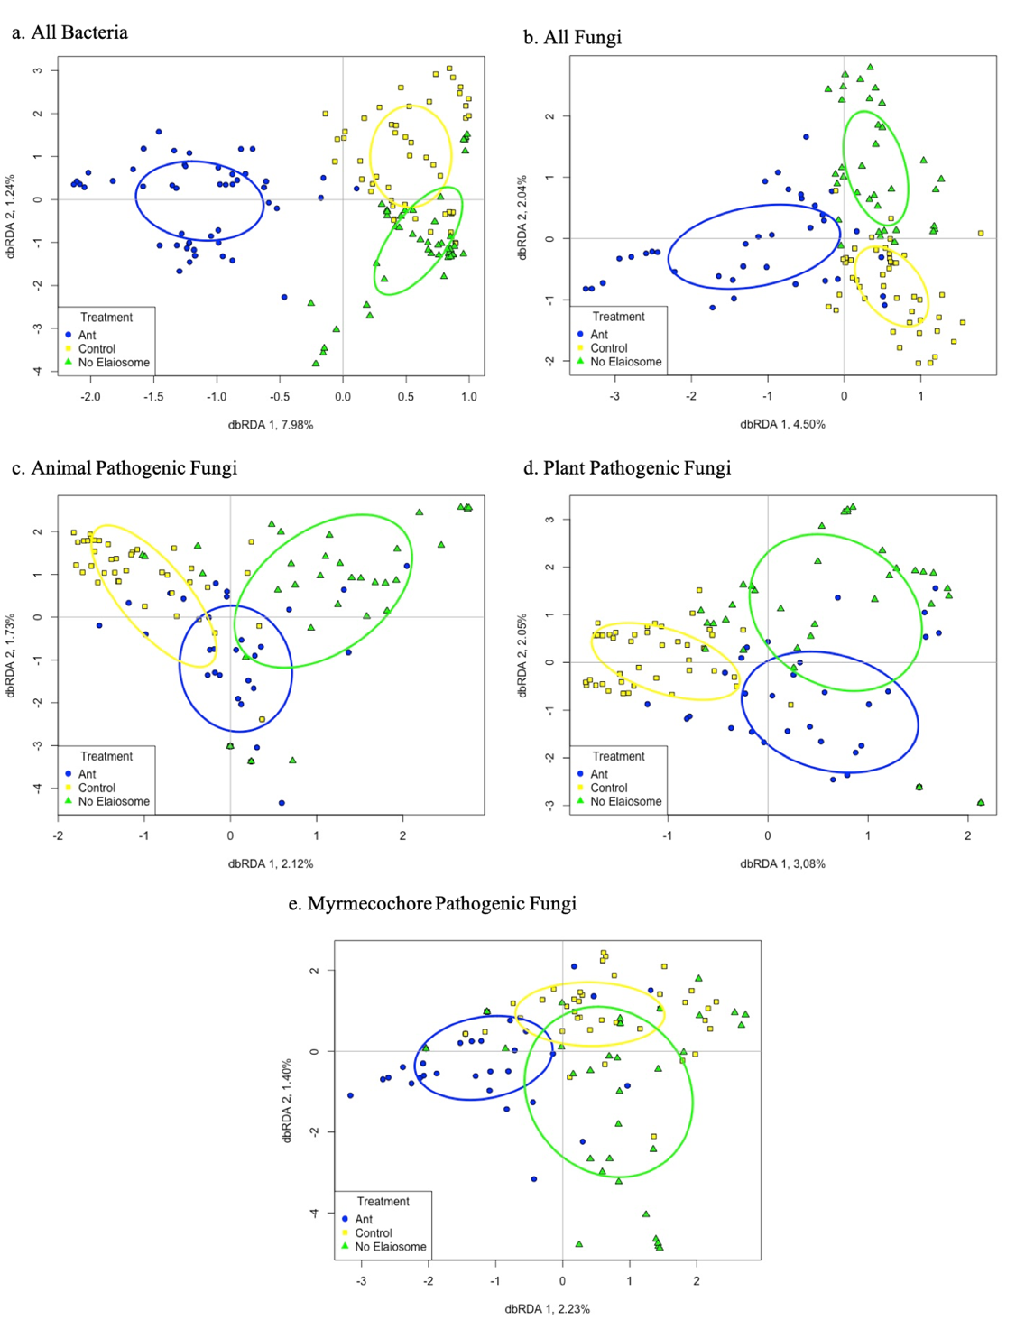
Figure 3-1 Ordination of constrained axes from a dbRDA of the (a) bacterial community; (b) fungal community, (c) animal pathogenic fungal community, (d) plant pathogenic fungal community, and (e) myrmecochore pathogenic fungal community.
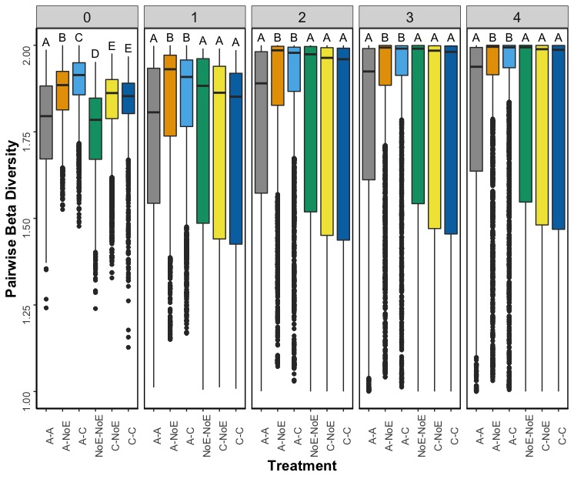
Figure 3-2 Pairwise beta diversity from q=0 to q=4 for bacterial ASVs on seed coats of ant dispersed plants.
Panels are blocked by orders of q (0 through 4). Treatment pairs are separated by ant-handled seeds (A), control seeds (C), and no elaiosome seeds (NoE). Two letter designations indicate community dissimilarity between two treatment types. For example, A-NoE indicates dissimilarity between pairs of ant and no elaiosome treatments. Higher beta diversity indicates more dissimilarity between communities. Letters above boxes indicated differences between samples; samples that share a letter are not significantly different from one another.

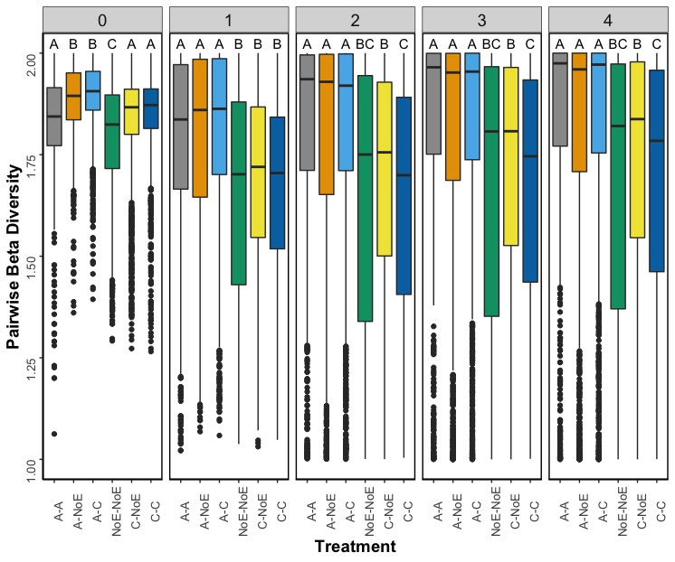
Figure 3-3 Pairwise beta diversity from q=0 to q=4 for fungal ASVs on seed coats of ant dispersed plants.
Panels are blocked by orders of q (0 through 4). Treatment pairs are separated by ant-handled seeds (A), control seeds (C), and no elaiosome seeds (NoE). Two letter designations indicate community dissimilarity between two treatment types. For example, A-C indicates dissimilarity between pairs of ant and control treatments. Higher beta diversity indicates more dissimilarity between communities. Letters above boxes indicated differences between samples; samples that share a letter are not significantly different from one another.

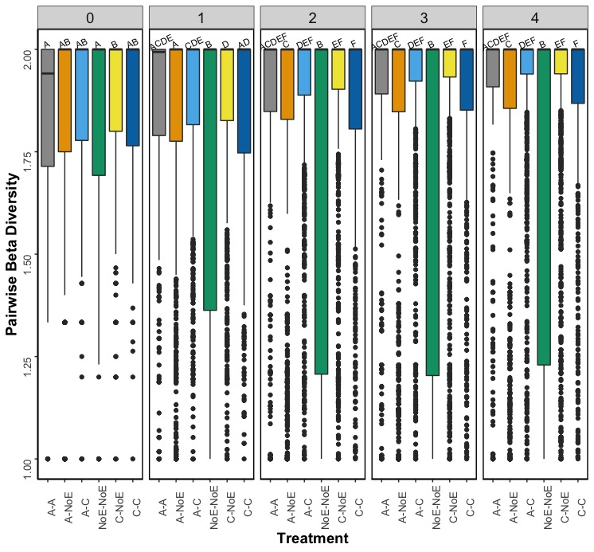
Figure 3-4 Pairwise beta diversity from q=0 to q=4 for animal pathogenic fungal ASVs on seed coats of ant dispersed plants.
Panels are blocked by orders of q (0 through 4). Treatment pairs are separated by ant-handled seeds (A), control seeds (C), and no elaiosome seeds (NoE). Two letter designations indicate community dissimilarity between two treatment types. For example, A-A indicates dissimilarity between pairs of ant and ant treatments. Higher beta diversity indicates more dissimilarity between communities. Letters above boxes indicated differences between samples; samples that share a letter are not significantly different from one another.

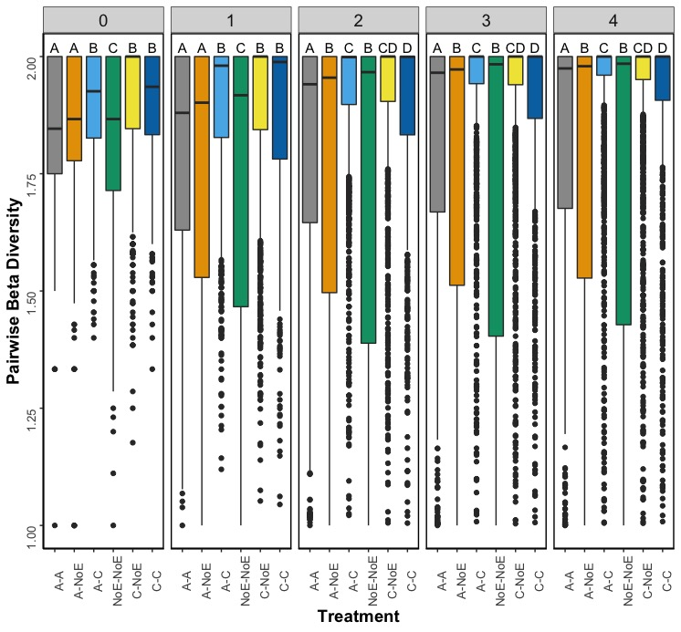
Figure 3-5 Pairwise beta diversity from q=0 to q=4 for plant pathogenic fungal ASVs on seed coats of ant dispersed plants.
Panels are blocked by orders of q (0 through 4). Treatment pairs are separated by ant-handled seeds (A), control seeds (C), and no elaiosome seeds (NoE). Two letter designations indicate community dissimilarity between two treatment types. For example, C-NoE indicates dissimilarity between pairs of control and no elaiosome treatments. Higher beta diversity indicates more dissimilarity between communities. Letters above boxes indicated differences between samples; samples that share a letter are not significantly different from one another.

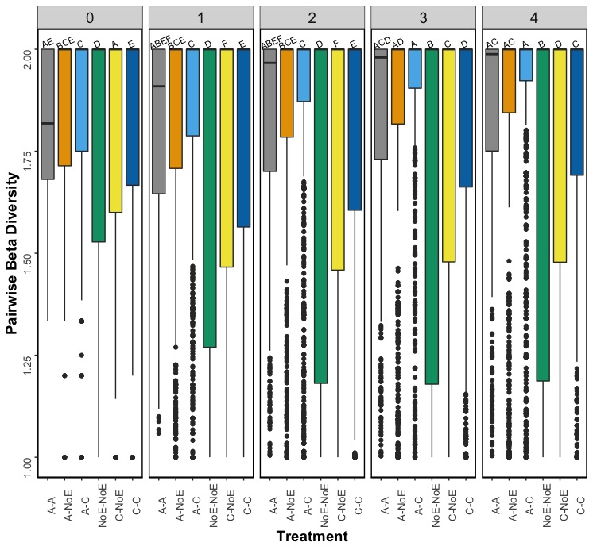
Figure 3-6 Pairwise beta diversity from q=0 to q=4 for myrmecochore pathogenic fungal ASVs on seed coats of ant dispersed plants.
Panels are blocked by orders of q (0 through 4). Treatment pairs are separated by ant-handled seeds (A), control seeds (C), and no elaiosome seeds (NoE). Two letter designations indicate community dissimilarity between two treatment types. For example, NoE-NoE indicates dissimilarity between pairs of no elaiosome and no elaiosome treatments. Higher beta diversity indicates more dissimilarity between communities. Letters above boxes indicated differences between samples; samples that share a letter are not significantly different from one another.

CONCLUSION

Myrmecochory, ant seed dispersal, is a widespread mutualism, but the influence of microbial mortality agents has been mostly overlooked in this ant-plant interaction. However, as presented in the proceeding chapters, ants affect the microbial community that is pathogenic to plants and vice versa. The influence of one partner on the other partner’s pathogenic microbes is perhaps a byproduct of antimicrobial chemicals produced by plant and ants, which are used to defend against their own microbial pathogens. These studies, which incorporate microbial mortality agents into what is normally purported as a simple pairwise mutualism, increased understanding of the risks and benefits offered to each partner in myrmecochory.
Because a myrmecochore-produced chemical promotes the growth of an ant-infecting pathogen, ants, during the dispersal process, might be aiding their own pathogens in the ant nest. However, ants are not defenseless against microbial mortality agents and though a pathogen-growth promoting compound is present in myrmecochore seeds, ant survival rates and foraging behaviors were not altered. This suggests that though microbial risks to ants exist in the dispersal process, ants’ own social immunity helps counteract this risk. Nonetheless, future studies examining the effects of other plant secondary compounds on the growth of ant microbial pathogens will help measure the risks presented to ants during the seed dispersal process. This is particularly important as the rewards to ants in myrmecochory are conflicted, which has led some to question the validity of the “mutualism” from the ants’ perspective (Warren et al. 2019). Indeed, as shown here, myrmecochore seed dispersal presents risks to ants because plant-produced chemicals accelerate the growth of an entomopathogen, thereby calling into question if the benefits to ants outweigh the risks in myrmecochory.
Ant nests provide safe locations with reduced fluctuations in plant pathogenic fungi in some nesting environments. My second chapter is the first to directly measure the effects of ant activity on fluctuations in the nest microbiome in different nesting substrates (soil and decaying logs). Increasing or stable ant activity resulted in reduced turnover of the plant pathogenic community in ant nests samples compared to control samples in soil substrates. This pattern was repeated for the myrmecochore pathogen community in log substrates. Based on these results, there is likely an additional benefit offered to seeds brought into the nest in the form of reduced pathogen fluctuations in the ant nest in certain substrates. Furthermore, decreasing ant activity in the nest over time resulted in less turnover in the plant pathogen community in ant nests than in control samples in log substrates. This pattern was again repeated for the myrmecochore pathogen community in soil substrates. Based on these results, seeds left behind in the ant nest might also benefit from reduced fluctuations in pathogen loads in certain substrates. I recommend that future work concentrate on identifying the main chemical components in the glands used for antiseptic behavior in Aphaenogaster ants. These glandular components should then be tested for inhibitory effects on the growth of common plant pathogens.
Ant handling alters the microbiome associated with seed coats. In my third chapter, I show that ant handling, in general, increases the alpha diversity of the bacterial community and decreases the alpha diversity of the fungal community on the seed coats of three common myrmecochorous plants. More pertinent to the incorporation of microbial mortality agents, however, ant handling and the removal of the elaiosome reduces the alpha diversity of plant pathogenic fungi on the seed coat. This suggests that ants reduce the pathogen load on seed coats, which is perhaps driven by the removal of the elaiosome. Again, I recommend that future studies investigate the effects of ant chemicals on the growth of different plant pathogenic fungi. My work with captive ant colonies in a laboratory setting may have eliminated variables that inform this pathogen system, so future work should also be conducted on the seed coat microbiome in field settings.
Overall, the work presented here illustrates the importance of the consideration of microbial mortality agents in myrmecochory and expands our understanding of this mutualism beyond the typical pairwise framework. As scientists begin to investigate the effects of the ecological community on mutualistic interactions (Bronstein and Barbosa 2002; Palmer et al. 2015), the results presented here could serve as the foundation for incorporating some important community actors (microbes) into what is generally purported as a simple pairwise mutualism between ants and plants. Finally, the incorporation of microbial mortality agents contributes to our understanding of the seed dispersal effectiveness (Schupp 1993; Schupp et al. 2010) of ants. Particularly, reduced plant pathogen loads in the ant nest and on the seed coat post-ant handling suggests high quality of ant-mediated seed dispersal. These results are similar to the benefits offered via pathogen fungal reduction through treatment in the vertebrate gut, also indicating high quality dispersal (Fricke et al. 2013). This qualitative aspect of seed dispersal effectiveness relies on both quality of deposition of the seed (here the ant nest and surrounding soils) and the quality of treatment by the disperser (here the effects of ant handling on the microbiome of the seed). The latter two chapters of my work address both of those aspects respectively. Future work could certainly delve even further into the influence of microbial plant pathogens on the qualitative aspects of ant seed dispersal, perhaps by conducting long-term studies monitoring germination and seedling success of ant handled seeds.

References

Bronstein JL, Barbosa P (2002) Multitrophic/multispecies mutualistic interactions: the
role of non-mutualists in shaping and mediating mutualisms. In: Tscharntke T, Hawkins BA (eds) Multitrophic Level Interactions. Cambridge University Press, pp 44-66
Fricke EC et al. (2013) When condition trumps location: seed consumption by fruit-
eating birds removes pathogens and predator attractants. Ecology Letters 16:1031-1036. doi: 10.1111/ele.12134
Palmer TM, Pringle EG, Stier A, Holt RD (2015) Mutualism in a community context. In:
Bronstein JL (ed) Mutualism. Oxford University Press, New York, NY, pp 159-180
Schupp EW (1993) Quantity, quality and the effectiveness of seed dispersal by animals.
Vegetatio 107/108:15-29
Schupp EW, Jordano P, Gomez JM (2010) Seed dispersal effectiveness revisited: a
conceptual review. New Phytologist 188:333-353. doi: 10.1111/j.1469-8137.2010.03402.x
Warren RJ, Elliott KJ, Giladi I, King JR, Bradford MA (2019) Field experiments show
contradictory short- and long-term myrmecochorous plant impacts on seed-dispersing ants. Ecological Entomology 44:30-39. doi: 10.1111/een.12666

VITA

Chloe L. Lash was born in Columbus, OH to Randy and Lisa Lash. She grew up outside of a one stoplight town, Plain City, OH (which has since gained a couple more stoplights). When her nose wasn’t in a book, she was collecting acorns at Ohio State Parks or playing outside with her sister and her dog. She cultivated her love of science in elementary school science fairs (which even included a trip to the state science fair, in which she did not (heartbreakingly so) win a session with the MythBusters). Science nerd, Chloe, continued on to high school, which was surrounded by corn fields, where she participated in Envirothon, Science Club and Quick Recall, which only increased her love of the natural world. In high school, she also was privileged to deal with the ridiculous antics of Mr. Rohrig, who taught the science behind the ordinary and held his students to the highest expectations (and because of whom she can still solve a Rubik’s cube and explain the science behind a Galileo Thermometer). She then traveled to Northwest Indiana to brave lake effect snow and get degrees in biology and chemistry at Valparaiso University. Valpo remains one of her favorite places in the world. While in college, she spent a summer studying water fleas in MI, fell in love with ants during a summer research program in KY, and scooped a bunch of bird poop as an intern at the National Zoo. She continued to scoop bird poop with her advisor, Dr. Laurie Eberhardt, at Valparaiso University for a senior research project on the movement of invasive plant species. She also discovered her love of teaching at Valpo during her time as an SI leader for biology. Then, she abandoned the plains for the mountains of TN and VA. The sum of her five years in TN can apparently be summarized in just over 100 pages (see above). But she believes these pages cannot contain all the growth and change accomplished during graduate school. Nor do they contain the challenges. In August, she starts as an Assistant Professor of Biology at the University of St. Francis in Joliet, IL. She’s excited to return to the Midwest (the South is too hot for her liking) and to join a supportive, vibrant faculty environment with experts from all science fields. She’s also excited to convince innumerable undergraduates that ants are the coolest organisms on the planet. If you run into Chloe, she’s always up for a chat about ants or best practices in teaching science. Or, more than likely, she might not even notice you’re there because she’s staring at the ground watching ants or discussing some abstract concept in her own head or thinking about what she’s going to cook for dinner tonight or pondering the ending of the last best-selling novel she read. She hopes that the next stages of her career are as rewarding and as challenging as grad school has been.

