Development and Implementation of a Novel Resonantly Ionized Photoemission Thermometry Technique for One-Dimensional Measurements

A Dissertation Presented for the
Doctor of Philosophy
Degree
The University of Tennessee, Knoxville

Walker Bryce McCord
December 2022
Copyright © 2022 by Walker McCord
All rights reserved.

DEDICATION
To my younger self, always have the courage to follow your dreams and be the good you want to see in the world.

ACKNOWLEDGEMENTS
Conducting my research at the University of Tennessee Knoxville has been an incredible rewarding, exciting, and enjoyable experience. At the same time, there were moments of doubt and difficulties, however, through the guidance, encouragement, and support of many, I persevered.
First, I would like to thank my advisor and friend Dr. Zhili Zhang, who provided me with the opportunity to come to UTK and conduct fascinating research. He has been a great advisor, and his kindness, enthusiasm, and wonder for science is contagious. He taught me how to be a scientist and through his guidance, wisdom, and mentorship, he has provided me the tools necessary to be successful in not only this Ph.D. program, but also in my future professional career. He believed in, helped, and pushed me to realize my true potential and for that I am eternally grateful.
I would like to thank Dr. David Plemmons for his friendship and mentorship during my time at Arnold Engineering Development Complex. His patience for listening and providing thorough explanations for the seemingly endless questions I had was always greatly appreciated. I would like to thank the rest of my committee members, Dr. John Schmisseur for his continued support and guidance of not only my research, but my future professional career. Dr. Damiano Baccarella, for his continued participation in my pursuit of a Ph.D. degree. I would like to thank my friends and former lab colleagues Mark Gragston and Cary Smith. Their friendship made the transition to Knoxville easy and even after their departure remained not only great friends, but great mentors. Thank you to the administrative staff, librarians, and anyone else that has played a role in my success here at UTK. I would like to thank Julie Knoefel for her help with all things regarding the completion requirements for the Ph.D. program and I always enjoyed our casual discussions.
Ultimately, none of this would be possible without the support of those closest to me. Thanks to my family; my father Peter McCord, my mother Elizabeth McCord, and grandparents Betty and Bob Willey for providing endless support and encouragement along the way. Furthermore, I want to thank Angel. Meeting you in Knoxville and having you by my side throughout this adventure has made everything so much more meaningful. You have been a tremendous source of joy, and I cannot wait to see what the future holds for us. Finally, I want to thank God. God has blessed me in immeasurable ways throughout my entire life, and has provided me with a loving family, great friends, prestigious education, and dream career. God also provided what I have found strength in and needed the most, his Son.

“You are only a success in the moment you perform a successful act; you have to keep doing it again.”
- Phil Jackson

ABSTRACT
In this work, Resonantly Ionized Photoemission Thermometry (RIPT) is established and validated as a novel, non-intrusive, non-seeded, One-Dimensional (1D) line thermometry technique. The RIPT technique resonantly ionizes a target molecule via REMPI (Resonant Enhanced Multi-Photon Ionization) of selectively chosen rotational peaks within a resonant absorption band. Thus, efficiently ionizing and subsequently exciting local nitrogen molecules either by direct or indirect schemes. The excited nitrogen deexcites through photoemissions of the first negative band of N₂⁺ [molecular nitrogen], specifically near 390, 425, and 430nm [nanometers], that is then acquired as a 1D line signal. The signal strength at all transitions shares a direct relationship with the line strength of the selectively excited rotational peak, which are temperature sensitive. The thermal distribution of the REMPI rotational levels is given by a statistically weighted (i.e., quantum degenerated) Boltzmann factor, thus with knowledge of the rotational spectrum, a statistical fit can be applied that relates the slope of the Boltzmann plots to a gas temperature.
The RIPT technique bypasses the need for a fully rotational-resolved spectrum of the ionized region, instead directly probing up to four rotational lines within the spectrum. By relation, the acquired photoemissions strength directly represents the line strengths at each of the probed rotational wavelengths enabling a rotational state distribution analysis to be applied via the photoemission intensities and generating Boltzmann plots at each probed peak. The slope of a statistical fit to the Boltzmann plots allows a gas temperature assignment. The groundwork is laid for both oxygen and nitrogen-based RIPT techniques through detailed calibration studies that will allow ease-of-use in future applications by scientists and researchers. Furthermore, the potential for 1D thermometry applications is realize for oxygen-based RIPT by implementation in various high-speed, low enthalpy flow environments.

TABLE OF CONTENTS
Chapter 1 Introduction and Background 1
A Brief History of Hypersonic Research 2
Laser Diagnostics 4
Technique Impact 7
Chapter 2 One dimensional O₂ temperature measurements by resonantly ionized photoemission thermometry 10
Abstract 12
Introduction 13
Experimental Setup 23
Results and Discussions 25
O₂ RIPT signal dependence on laser power 25
N₂⁺ emission spectra via O₂ RIPT 27
O₂ discrete analysis for temperature determination 34
O₂ non-discrete analysis for temperature determination 42
Conclusions 47
Chapter 3 O₂ based resonantly ionized photoemission thermometry analysis of supersonic flows 49
Abstract 51
Introduction 52
Experimental Setup 55
Supersonic Jet 55
O₂ RIPT Laser and Camera Setup 58
ps-CARS setup 60
CFD simulation details 62
Results and Discussions 62
Temperature measurements 62
Conclusions 74
Chapter 4 O₂ temperature measurements by resonantly ionized photoemission thermometry in Mach 4 Wind Tunnel 77
Abstract 79
Introduction 80
Experimental Setup 83
Tunnel Facility 83
Cylinder Model 85
Results and Discussions 87
Freestream 87
Model: Vertical 96
Model: Horizontal 99
Conclusions 104
Chapter 5 One Dimensional N₂ Temeprature Measurments by resonantly ionized photoemission thermometry 107
Abstract 109
Introduction 110
N₂ Photoemissions via REMPI 114
N₂ REMPI Structure 117
Experimental Setup 121
Results and Discussions 124
N₂ RIPT signal dependence 124
N₂⁺ emission spectra via N₂ RIPT 128
N₂ discrete analysis for temperature determination 134
N₂ non-discrete analysis for temperature determination 142
Conclusions 147
Chapter 6 Summary 150
References 158
VITA 173

LIST OF TABLES
Table 2.1 Adopted constant for the $C3Π(v=2)$ excited state of molecular oxygen. 18
Table 2.2 Selected Rotational line of S₂₁ branch for temperature measurements. 22
Table 2.3 Results for specific N₂⁺ fluorescence bands (Δv₀, Δv₂, and Δv₁) for O₂ RIPT. 41
Table 2.4 Suggested rotational peak groups for the various temperature setpoints with corresponding predicted and actual temperatures. 46
Table 3.1 Resonantly excited O₂ wavelengths for 180 and 293 Kelvin. 56
Table 5.1 Branches and allowed ΔJ cases for N₂ (3+1) REMPI 118
Table 5.2 Selected rotational lines for N₂-based temperature measurements. 123
Table 5.3 Results for specific N₂⁺ fluorescence bands (Δv₀, and Δv₁) for N₂ RIPT. 141
Table 5.4 Expected and experimental temperatures from N₂ RIPT integrated emission study. 146

LIST OF FIGURES
Figure 2.1 Energy diagram (a), and normalized spectrum (b) of N₂⁺ first negative band. 15
Figure 2.2 Normalized theoretical O₂ REMPI spectrum for 180, 293, and 473 Kelvin. 20
Figure 2.3 O₂ RIPT calibration schematic. 24
Figure 2.4 Laser power dependence of O₂ RIPT signal (a); RIPT photoemission line from 287.33nm excitation (b); averaged intensity profile of the photoemissions from 287.33nm excitation (c). 26
Figure 2.5 N₂⁺ emission spectra at 293 Kelvin for selected O₂ resonant wavelengths. 28
Figure 2.6 N₂⁺ emission spectra at 180 Kelvin for selected O₂ resonant wavelengths. 29
Figure 2.7 N₂⁺ emission spectra at 233 Kelvin for selected O₂ resonant wavelengths. 30
Figure 2.8 N₂⁺ emission spectra at 367 Kelvin for selected O₂ resonant wavelengths. 31
Figure 2.9 N₂⁺ emission spectra at 460 Kelvin for selected O₂ resonant wavelengths. 32
Figure 2.10 (a) 287.28nm excited peak (non-temperature sensitive). (b) 286.51nm excited peak (temperature sensitive). (c) rotational line positions within REMPI spectrum. 33
Figure 2.11 Integrated peak signal values for Δv₀, 390nm (a), Δv₂,425nm (b), Δv₁, 430nm (c), and temperature determinations for Δv₀ (d), Δv₂ (e), and Δv₁ (f) for actual temperature of 293 Kelvin. 35
Figure 2.12 Integrated peak signal values for Δv₀, 390nm (a), Δv₂, 425nm (b), Δv₁, 430nm (c), and temperature determinations at Δv₀ (d), Δv₂ (e), and Δv₁ (f) for actual temperature of 180 Kelvin. 36
Figure 2.13 Integrated peak signal values for Δv₀, 390nm (a), Δv₂, 425nm (b), Δv₁, 430nm (c), and temperature determinations at Δv₀ (d), Δv₂ (e), and Δv₁ (f) for actual temperature of 233 Kelvin. 37
Figure 2.14 Integrated peak signal values for Δv₀, 390nm (a), Δv₂, 425nm (b), Δv₁, 430nm (c), and temperature determinations at Δv₀ (d), Δv₂ (e), and Δv₁ (f) for actual temperature of 367 Kelvin. 38
Figure 2.15 Integrated peak signal values for Δv₀, 390nm (a), Δv₂, 425nm (b), Δv₁, 430nm (c), and temperature determinations at Δv₀ (d), Δv₂ (e), and Δv₁ (f) for actual temperature of 460 Kelvin. 39
Figure 2.16 N₂⁺ first negative band integrated signal values for 180K (a), 293K (b), and 460K (c). 43
Figure 2.17 Statistical fits of the Boltzmann plots for (a)180, (b)233, (c)293, (d)367, and (e)460 Kelvin assigned temperatures. 44
Figure 3.1 Mach 1 nozzle geometry and jet assembly. 57
Figure 3.2 O₂ RIPT experimental setup for jet shock-train thermal characterization. 59
Figure 3.3 ps-CARS setup. 61
Figure 3.4 3D mesh image around jet (a), and detailed regions of the mesh highlighting the various meshing sizes (b). 63
Figure 3.5 180 Kelvin captured photoemissions for (a) no flow, and (b) flow cases. Line average profiles down the centerline of the emissions for (c) no flow, and (d) flow. 65
Figure 3.6 293 Kelvin captured photoemissions for (a) no flow, and (b) flow cases. Line average profiles down the centerline of the emissions for (c) no flow, and (d) flow. 66
Figure 3.7 1D+ temperature map from photoemission analysis (a), and CFD generated temperature map (b). 67
Figure 3.8 ps-CARS measurement locations overlaid on a schlieren image of the under expanded supersonic jet. 70
Figure 3.9 CARSFIT spectrums to the ps-CARS data at corresponding measurement locations. 71
Figure 3.10 CFD, O₂ RIPT, and ps-CARS temperature measurements within the under expanded supersonic jet shock train. 73
Figure 4.1 UTSI Mach 4 Ludwieg tube and accessories. 84
Figure 4.2 UTSI Mach 4 O₂ RIPT setup. 86
Figure 4.3 Cylindrical model vertical orientation (a) and, horizontal orientation (b). 88
Figure 4.4 Cylinder model mounted in tunnel for vertical orientation (a), and horizontal orientation (b). 89
Figure 4.5 O₂ RIPT emission line images from 286.98nm laser excitation in a Mach 4 freestream. 90
Figure 4.6 O₂ RIPT emission line images from 287.15nm laser excitation in a Mach 4 freestream. 91
Figure 4.7 O₂ RIPT emission line images from 287.28nm laser excitation in a Mach 4 freestream. 92
Figure 4.8 O₂ RIPT emission line images from 287.33nm laser excitation in a Mach 4 freestream. 93
Figure 4.9 O₂ RIPT line temperature measurement of the tunnel freestream. 95
Figure 4.10 Schlieren image of cylinder model depicting model centerline and shock standoff distance. 97
Figure 4.11 Image of model and O2 RIPT line (a), and O₂ RIPT temperature measurement behind shock (b). 98
Figure 4.12 Image of horizontal model and generated O₂ RIPT line (a), and O₂ RIPT temperature measurement across shock (b). 100
Figure 4.13 CFD of cylinder model showing Mach contour (a), and the temperature contour (b). 102
Figure 4.14 Comparisons of the horizontal and vertical oriented O₂ RIPT measurements. 103
Figure 5.1 N₂ ultraviolet laser excitation spectrum at standard temperature and pressure, with labeled b¹ band head. 113
Figure 5.2 Energy level diagram of N₂ (3+1) REMPI schemes (a) at low pressure, and (b) at standard pressure. 115
Figure 5.3 Normalized theoretical N₂ REMPI spectra for 150, 293, and 460 Kelvin. 122
Figure 5.4 N₂ RIPT calibration experiment schematic. 125
Figure 5.5 N₂⁺ photoemission delay study showing short lifetimes of first negative band contributions. 127
Figure 5.6 N₂⁺ emission spectra at 293 Kelvin for selected N₂ resonant wavelengths. 129
Figure 5.7 N₂⁺ emission spectra at 165 Kelvin for selected N₂ resonant wavelengths. 130
Figure 5.8 N₂⁺ emission spectra at 230 Kelvin for selected N₂ resonant wavelengths. 131
Figure 5.9 N₂⁺ emission spectra at 376 Kelvin for selected N₂ resonant wavelengths. 132
Figure 5.10 N₂⁺ emission spectra at 455 Kelvin for selected N₂ resonant wavelengths. 133
Figure 5.11 Integrated peak signal values for (a) Δv₀, 390nm, (b) Δv₁, 430nm, and temperature determinations at (c) Δv₀, and (d) Δv₁ for actual temperature of 293 Kelvin. 135
Figure 5.12 Integrated peak signal values for (a) Δv₀, 390nm, (b) Δv₁, 430nm, and temperature determinations at (c) Δv₀, and (d) Δv₁ for actual temperature of 165 Kelvin. 136
Figure 5.13 Integrated peak signal values for (a) Δv₀, 390nm, (b) Δv₁, 430nm, and temperature determinations at (c) Δv₀, and (d) Δv₁ for actual temperature of 230 Kelvin. 137
Figure 5.14 Integrated peak signal values for (a) Δv₀, 390nm, (b) Δv₁, 430nm, and temperature determinations at (c) Δv₀, and (d) Δv₁ for actual temperature of 376 Kelvin. 138
Figure 5.15 Integrated peak signal values for (a) Δv₀, 390nm, (b) Δv₁, 430nm, and temperature determinations at (c) Δv₀, and (d) Δv₁ for actual temperature of 455 Kelvin. 139
Figure 5.16 N₂⁺ first negative band integrated signal values for (a) 165K, (b) 230K, (c) 293K, (d) 376K, and (e) 460K. 143
Figure 5.17 Integrated N₂⁺ Boltzmann temperature assignments for (a) 165K, (b) 230K, (c) 293K, (d) 376K, and (e) 460K. 145

Introduction and Background

A Brief History of Hypersonic Research
Hypersonic and high-supersonic flight vehicles are designed to approach and maintain exceptionally high air speeds. It is not uncommon for these vehicles flight envelope to contain velocities greater than a mile per second or even quicker. Obviously, traveling at such extreme speeds results in tremendous design and engineering challenges that arise from various unique fluid dynamic phenomena that occur within this flow regime. Thin shock layers, increased entropy generation and viscous interactions, high-temperatures, and low densities are examples of some of the challenges encompassing the design of a hypersonic vehicle. Historically, hypersonic research has been cyclical in nature. With two previous distinct periods of activity that first began in the late 1950’s and continued through the 1960’s; and again, beginning in the mid-1980’s and into the 1990’s. The periods of dormancy can in-part be attributed to material and technological limitations. By the late 1990’s both manned and unmanned hypersonic flight had been conducted, however it is by no means commonplace and the era of practical hypersonic flight is still to be achieved [1]. A recently renewed interest has garnered greater support than ever from both academia and government officials; as it is now critical to advanced hypersonic technology to advanced fields of aerospace science and maintain the upper-hand in security and defense against adversaries [2].
For atmospheric hypersonic flight (<100 km) high temperature gas dynamics play a critical role as aerodynamic heating dramatically increases due to various factors such as, strong shock formations, thin shock layers, an entropy layer, and enhanced viscous interactions. Strong dissipation of these effects within the boundary layer creates temperatures high enough to excite vibrational and rotational energy within the gas molecules which, can lead to molecular dissociation and redistribution of energy among the available vibrational energy modes enabling changes in the physical transport properties of the gas. This phenomenon is characterized as “real-gas effects” and includes dissociation, ionization, vibrational and electronic excitation, non-equilibrium chemistry, and vibrational non-equilibrium. These high-temperature environment results in oxidation, nitridation, and spallation occurring on the surface of the flight vehicle; and if not properly accounted for can lead to aerothermal structural failure and/or loss of control authority leading to mission critical failure.
Thus, to successfully design hypersonic flight vehicles these phenomena all need to be understood to a sufficient level of detail to allow for quantitative prediction of aerodynamic, aerothermodynamic, thermos-structural, and flow-control behaviors. Since the early 2000’s, engineering design and flow analysis for hypersonic regimes has been revolutionized by recent advances in the computer industry. Aggressive advancements in computational power have made powerful simulation tools more readily accessible to researchers. Now, CFD methods that use to take weeks or months to run on some of the most powerful computers twenty years ago, can be ran by a modern consumer desktop in days or hours. Thus, computationally expensive solving methods can be more easily implemented to highly resolve hypersonic flow simulations [3]. Furthermore, with the only main operational costs associated with CFD simulations being the electricity needed to power the computer, the industry is becoming more CFD design biased [4]. However, the physics associated with real-gas effects and non-equilibrium flow chemistry can be difficult to accurately model, and often the boundary layers will be chemically reacting further complicating the transition process and modeling [2, 4]. Additionally, the variability and uncertainty of inputs (boundary and initial conditions, parameters, etc.) to fluid dynamics problems are largely unquantified [5]. To ensure accurate and repeatable modeling requires precise and reliable experimentally collected data to be used to develop and validate flow simulation results. In kind, high-quality data will require accurate and sensitive measurements.

Laser Diagnostics
Laser diagnostics seeks to use intense laser light as a tool for making precise, quantitative measurements of various flow parameters of interest. Because of the unique properties of light, and with the development of burst mode lasers and high-speed camera systems, information of high spatiotemporal resolution can readily be obtained, which is important for highly dynamic systems [6, 7]. Laser diagnostics are typically non-intrusive by nature. This is important as within hypersonic regimes the use of physical probes is detrimental, as they induce perturbations of sufficient strength that can change characteristic flow phenomena and invalidate most measurements taken in the downstream region of interest [5]. Furthermore, in the high-temperature and chemically reactive environments typically associated with hypersonic vehicles, invasive hardware and particulates can degrade or completely disintegrate [8]. The fundamental underlying physics upon which almost all laser diagnostics are placed under use can be divided into four different categories. They are (1) elastic scattering processes (i.e., Rayleigh scattering), (2) inelastic scattering processes (i.e., Laser-Induced Fluorescence [LIF]), (3) absorption processes (i.e., Wavelength Modulation Spectroscopy [WMS]), and (4) nonlinear optical processes (i.e., Degenerate Four-Wave Mixing [DFWM]).
As stated earlier, high temperature gas dynamics play a key role in the design of hypersonic flight vehicles, thus techniques that can quantitively measure with high precision the rates of heat transfer and gas temperatures will play a critical role in flow simulation validation. There exist many non-intrusive techniques to measure gas temperature. Some examples are (1) absorption and emission spectroscopy (i.e., Tunable-Diode Laser Absorption Spectroscopy [TDLAS]), (2) line reversal method, (3) Degenerative Four-Wave Mixing, (4) Planar Laser Induced Fluorescence [PLIF], (5) Coherent Anti-Stokes Raman Scattering [CARS], and (6) Radar REMPI [5, 9-14]. The aforementioned techniques have been shown to provide adequate thermometry capabilities within a wide range of environments (i.e., hydrocarbon flames, liquids, gaseous and high-speed flows). However, they all have some drawback that either limits their applicability for ground-based wind tunnel facilities or places an upper limit on achievable spatial or temporal resolution.
TDLAS suffers from being limited to an average measurement that is path integrated, which can enhance the nosiness and make it difficult to get accurate measurements that represent the flow properties near the surface of a test article [15-17]. Line reversal method relies upon some known continuum intensity and is only applicable within a confined thermal range [18]. Degenerative Four-Wave Mixing is limited by depth of probe species available, and it has limited environments that it is applicable in [14, 19]. PLIF has to employ the use of tracer molecules such as Nitric Oxide, Hydroxide[20], or an aromatic molecule[21, 22], which could negatively impact the flow chemistry resulting in nonreal flow features and altered flow dynamics [9, 23-25].
CARS is a non-intrusive technique that does not require flow seeding and is non-path integrated, making it an attractive option for thermal measurements [5, 10, 26-28]. CARS also has a credible track-record of use in notable hypersonic facilities, such as Tunnel 9, Sandia National Laboratories, and various other locations [29-32]. However, CARS suffers from difficult optical alignment, that is in-part due to the requirement to spatiotemporally overlap three focused laser beams perfectly. As a result, CARS systems are highly influenced by environmental noise and thus can be prone to misalignment in wind tunnel facilities. Furthermore, measurement accuracy is dependent upon the goodness of fit between the theoretical and experimental obtained spectrum. In low-enthalpy, cold-flow tunnels, the static temperatures are low enough that the population distributions will occupy only the first few ground state levels, thus the acquired CARS spectrum can have little to no structure. This decreases measurement accuracy and can make temperature fitting difficult [33]. In CARS, a femtosecond laser must be employed, as femto-pulse widths are the minimal width needed to probe the Raman coherence prior to significant dephasing from gas-phase collisions [34, 35].
Another promising technique is Coherent microwave scattering from laser induced plasmas (Radar REMPI) which has been demonstrated as an important tool for measurements of electron number density, species concentrations, and rotational gas temperature measurements in reactive and non-reactive flows [36]. A REMPI mechanism uses highly focused light tuned to a resonant wavelength to ionize atoms or molecules through a multiphoton process. The REMPI steps are usually given by an (m + n); where m-photons are used in a multiphoton excitation step to some intermediate electronic state, followed by an n-photon absorption to continue the ionization process to a continuum [37]. The ionization process results in the formation of a very weak, short-lived plasma that is inherently different from non-resonantly, induced plasmas. In this work, O₂ RIPT will use a (2+1) REMPI scheme and N₂ RIPT will use a (3+1) or (3+2) REMPI scheme.
A REMPI plasma typically has no detectable sound by human ears and no optical emissions detectable by the human eye. Since the resonant absorption mechanism is highly-efficient, little laser energy is required. If a short focal length lens is used to create the plasma, typically it can be spatially confined to a single point [37]. It has been found in this work, that if a long focal length lens (>100mm) [millimeters] in conjunction with a more powerful tuning laser (>4 mj/pulse) [millijoules], the ionization region extends pre and post focus of the lens; creating a line of weak plasma along the beam path. It is this property that has enabled the one-dimensional line measurements. Furthermore, Radar REMPI is only limited by the known electronic transitions and ground state energies of the target species desired for measurement. It has been used for measurements of multiple different species such as, (N₂, O₂, Ar, OH, NO, etc.) [38-40]. However, while REMPI plasmas use lower lasing energies, it is inherently limited by the need to scan across a selectively chosen resonant absorption spectrum. Probing of the complete rotational spectrum is required in order to assign a rotational state distribution to deduce an accurate gas temperature measurement [41]. This limits the techniques applicability in facilities where the test times are generally not long enough for a complete scan to be made [42]. Finally, CARS, Radar REMPI, and TDLAS are mostly limited to point measurements at low pressure conditions, thus rendering them inadequate to fully characterize the dynamic thermal gradients typically present within the high-speed flow environments.

Technique Impact
The proposed work aims to utilize REMPI plasma generation mechanism to produce 1D ionization regions that induce photoemissions that can be related to gas-temperature measurements. Specifically, by directly exciting various hyperfine structures within a target species rotational branch using REMPI, the locally ionized region created will have enough energy to induce electron avalanche ionization of locally available molecules. If O₂ is selectively excited in standard air, high-energy liberated electrons can result in electron impacted excitation of nearby N₂ molecules, subsequently generating ionized N₂⁺, where the dominate deexcitation pathway is through photoemissions. The fluorescence signal can then be captured by an intensified camera. This new technique will use Resonant Ionized Photoemission Thermometry (RIPT) to realize a novel capability enabling non-seeded 1D line thermometry measurements.
First, the feasibility of relating the transitional line strengths at various frequencies to captured photoemissions generated during deexcitation must be studied. If a relationship or dependence exists between the selectively excited resonant absorption bands and the photoemissions then they can be related through a rotational state distribution analysis of the target species. This will allow the acquired photoemission signals to be fitted to a Boltzmann distribution, similar to Radar REMPI measurements, that can assign a local gas temperature measurement of high accuracy (±2%) or better. A similar idea has been conducted previously by Adams et al. where, REMPI induced photoemissions from molecular nitrogen were used for temperature assignments [43]. However, Adams et al. work used a spectrometer and scanned along the rotational absorption spectrum, and by fitting the experimentally acquired spectrum to a theoretical spectrum he was able to deduce temperature at that point. The proposed technique will significantly differ from aforementioned studies. The RIPT technique will directly excite various resonant absorption peaks to probe the rotational spectrum. This bypasses the inherent need to probe the rotational spectrum of the target species, enabling single-shot measurements.
an in-depth study was required in order to identify absorption peaks for each target species that demonstrates high temperature sensitivity, relevant population distributions, and enables strong photoemission generation. Furthermore, population distributions will trend toward or away from the ground state as gas temperatures decrease or increases respectively. For relevance, thermal setpoints were carefully chosen that were representative of temperatures observed for cold-flow supersonic and hypersonic tunnel facilities. At each setpoint, resonant absorption peaks were chosen that enabled accurate temperature assignments. The selectively chosen absorption peaks are presented in a manner that enables outside researchers and technicians to be able to quickly tune a laser to the peaks that are relevant to the expected thermal environment. This work also explored the capability of two different test gases for RIPT based measurements; (1) molecular oxygen [O₂] for standard air-based environments, and (2) molecular nitrogen [N₂] for pure nitrogen-based environments.
It is found that using a REMPI scheme, an ionized line of sufficient energy is generated within both test mediums to produce a 1D line of photoemissions. The work encompasses the undertaking of establishing the RIPT technique. In doing so, many parameters and relevant information for successful implementation of RIPT based measurements were quantified such as, max line length generation, capability utilizing various target species, robustness, pressure dependence, thermal operating constraints, quenching effects, and validation through comparison to established techniques.

One dimensional O₂ temperature measurements by resonantly ionized photoemission thermometry

Versions of this chapter were originally published by Walker McCord, Aleksander Clark, and Zhili Zhang and can be found at the following:

- Walker McCord¹, Aleksander Clark¹, and Zhili Zhang¹. "1D Temperature Measurements by Air REMPI Thermometry (ART)." AIAA SCITECH 2022 Forum. 2022.

- Walker McCord¹, Aleksander Clark¹, and Zhili Zhang¹. "One-dimensional air temperature measurements by air resonance enhanced multiphoton Ionization thermometry (ART)." Optics Express 30.11 (2022).

Author Affiliations:
¹Department of Mechncial, Aerospace, and Biomedical Engineering, University of Tennessee, Knoxville, TN 37996 USA

The ideas in this chapter were first present at AIAA SciTech 2022 forum and published as a peer-revied journal paper in Optics Express. After the publication of both articles, the (ART) acronym was dropped in preference for the (RIPT) acronym. For coherency, the text in the original documents was edited to reflect this. Furthermore, a more detailed description of the O₂ REMPI spectrum is included. Walker McCord was the lead author and presenter in both instances.

Abstract
In this work, a detailed calibration study is performed to establish non-intrusive one-dimensional (1D) rovibrational temperature measurements in unseeded air of oxygen based Resonantly Ionized Photoemission Thermometry (O₂ RIPT). The O₂ RIPT is generated by a (2+1) REMPI (Resonance Enhanced Multi-Photon Ionization) scheme of molecular oxygen and subsequent avalanche ionization of molecular nitrogen during a single laser pulse. The O₂ RIPT signal results from the photoemissions within the first negative band of molecular nitrogen and that are generated from deexcitation. Furthermore, it is found that there exists a one-to-one relationship between the photoemission’s strength and the rotational peak strength within the $C^{3}Π,\left(v=2\right)←X^{3}Σ,(v^{'}=0)$ resonant absorption band of molecular oxygen. This relationship allows direct probing of the rotational state distribution through photoemission strength, thus enabling a vibrational gas-temperature assignment. Experimentally, hyperfine structures of the O₂ rotational branches with high temperature sensitivity are selectively excited through a frequency-doubled dye laser. Electron-avalanche ionization of N₂ results in the fluorescence emissions from the first negative bands of N₂⁺ near 390, 425, and 430nm, which are dispersed via a spectrometer allowing both discrete and indiscrete studies. Post processing of the N₂⁺ fluorescence yields a vibrational gas temperature assignment that is representative of the total gas temperature. It is demonstrated that the technique provides RIPT photoemissions of approximately 6 centimeters in length within an unseeded air medium. The novel O₂ RIPT technique presents an attractive solution for 1D thermometry characterizations for facilities and environments that use an air medium.

Introduction
Here, we propose and demonstrate a novel laser-based line thermometry technique for use in low-enthalpy high-speed flows, which can resolve a 1D line thermal profile without particulate or gas seeding. The technique builds upon advances in Resonance Enhanced Multi-Photon Ionization (REMPI) of molecular oxygen, which has been demonstrated to have the capability to achieve high spatial and temporal resolution measurements of concentration profiles and species-specific rotational temperatures in combustion and air-discharge environments [44-48]. The RIPT technique resonantly ionizes the target molecules by REMPI; since REMPI is a highly non-linear optical process, the energy deposition into the surrounding medium is sufficiently small [49]. However, RIPT differentiates from Radar REMPI, in that a weak plasma discharge is produced to yield the RIPT photoemission signal. To achieve O₂ RIPT, specifically chosen rotational bands of O₂ are resonantly excited via focusing a frequency doubled dye laser of sufficient energy such that regions of high laser energy density is able to briefly populate with excited O₂ molecules given by Eq. 2.1.

$$O_{2}+3hν_{REMPI}→O_{2}^{+}+e^{-}$$ | (2.1)

For Eq. 2.1, $hν_{REMPI}$ is the photon used to resonantly ionize O₂, and $e^{-}$ is a liberated electron. The resulting free electrons are then amplified by the laser pulse to induce electron-impacted collisional excitation and electron avalanche ionizations of N₂ given by Eq. 2.2.

$$N_{2}^{+}:N_{2}+e^{-}+hν→N_{2}^{+}+{2e}^{-}$$ | (2.2)

The recombination of electrons and molecular nitrogen ions produces emissions of the first negative band of $N_{2}^{+}(B^{2}Σ_{u}^{+}→X^{2}Σ_{g}^{+})$, or further decay by first positive band $N_{2}^{+}\left(B^{3}Π_{g}→A^{3}Σ_{u}^{+}\right)$ emissions, which are given by Eq. 2.3 and Eq. 2.4 respectively [45].

$$N_{2}^{+}(B)→N_{2}^{+}(X)+hν_{1^{-}}$$ | (2.3)

$$N_{2}^{+}+e^{-}→N_{2}\left(B\right)→N_{2}\left(A\right)+hν_{1^{+}}$$ | (2.4)

Where, $hν_{1^{-}}$ corresponds to emissions of the first negative band of N₂, and $hν_{1^{+}}$ are emissions of the first positive band of N₂. The resulting emissions from the first negative band are at three distinct peaks (Δv₀, 390nm; Δv₂, 425nm; Δv₁, 430nm), resulting from the $1→0$, $2→1$, and $1→1$ transitions, respectively. An energy diagram detailing the rotational band transitions and an experimentally acquired photoemissions of the $N_{2}^{+}(B^{2}Σ_{u}^{+}-X^{2}Σ_{g}^{+})$ from 287.33nm laser excitation are shown in Fig. 2.1 [50]. Since the N₂ emission strength is directly related to number density of liberated photoelectrons from resonantly excited and ionized O₂, an in-depth analysis is required of the various O₂ REMPI rotational lines and the resulting collisional rates for N₂⁺.Furthermore, to apply a rotational state distribution analysis to assign temperature from O₂ REMPI generated N₂⁺ emissions, a rotationally resolved spectrum of molecular oxygen must be obtained and corresponding two-photon transition cross-sectional data is needed to identify suitable rotational peaks for direct excitation.
The REMPI structure of O₂ can be summarized as the following [38, 51]. The ground state, O₂(X²Σ), can be best described as Hund’s case (b), in which the projected component of orbital angular momentum on the molecular axis is $Λ^{'}=0$, the projected component of the spin on the molecular axis $Σ^{'}$ can take -1, 0, 1, and the projected total angular momentum on the molecular axis $Ω^{'}$ is not defined. The hyperfine splitting due to $Λ^{'}$ leads to the rotational terms’ values G₁, G₂, and G₃ in the ground state. The $O_{2}\left(X^{3}Σ\right)$ ground-state term can be expressed as Eq. 2.5, Eq. 2.6, and Eq. 2.7.

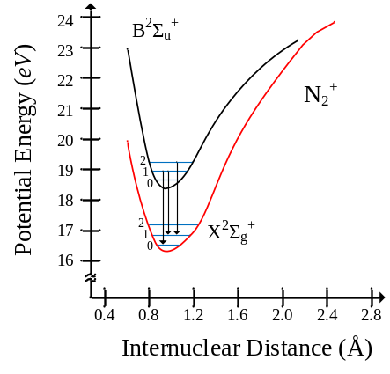
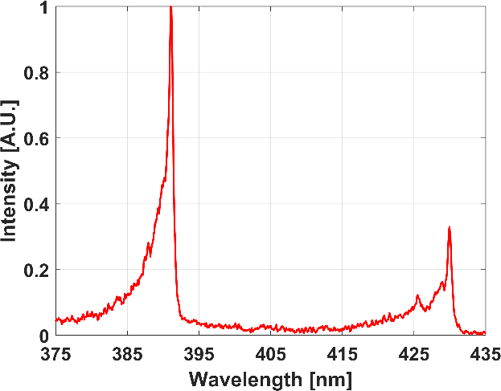
Figure 2.1 Energy diagram (a), and normalized spectrum (b) of N₂⁺ first negative band.
(a)
(b)

$$G_{1}=B_{v}J\left(J+1\right)-D_{v}J^{2}{\left(J+1\right)}^{2}+\left(2J+3\right)B_{v}-L-\sqrt{{\left(2J+3\right)}^{2}B_{v}+L^{2}-2LB_{v}}+G\left(J+1\right)$$ | (2.5)

$G_{2}=B_{v}J\left(J+1\right)-D_{v}J^{2}{\left(J+1\right)}^{2}$ | (2.6)

$$G_{3}=B_{v}J\left(J+1\right)-D_{v}J^{2}{\left(J+1\right)}^{2}+\left(2J+1\right)B_{v}-L-\sqrt{{\left(2J-1\right)}^{2}B_{v}^{2}+L^{2}-2LB_{v}}+GJ$$ | (2.7)

in which the splitting due to $Σ^{'}$ = -1, 0, and 1 lead to the hyperfine structure in the ground state, which can be denoted as G₁, G₂, and G₃, respectively. The excited $O_{2}\left(C^{3}Π\left(v=2\right)\right)$ state, which is used as an intermediate state in this study, can best be described as Hund’s case (a), which for Λ=1,$Σ$ can take -1, 0, 1, and $Ω$ can take 0, 1, or 2 respectively. The coupling of these angular momenta results in hyperfine splitting and leads to the respective rotational term values F₁, F₂, and F₃ in the $C^{3}$ state. For the excited-state $C^{2}Π$ of the molecular oxygen, the energy levels are thus calculated using Eq. 2.8, Eq. 2.9, and Eq. 2.10.

$$F_{1}\left(Ω=0\right)=n_{01}+B_{eff1}J\left(J+1\right)-D_{v1}J^{2}{\left(J+1\right)}^{2}$$ | (2.8)

$$F_{2}\left(Ω=1\right)=n_{02}+B_{eff2}J\left(J+1\right)-D_{v2}J^{2}{\left(J+1\right)}^{2}$$ | (2.9)

$F_{3}\left(Ω=3\right)=n_{03}+B_{eff3}J\left(J+1\right)-D_{v3}J^{2}{\left(J+1\right)}^{2}$ | (2.10)

The derived constants of the excited-state $C^{3}Π\left(v=2\right)$ of the molecular oxygen have been published previously in literature [52, 53]. Compared to the ground state values there is much greater uncertainty in the molecular constants for the excited $C^{3}Π\left(v=2\right)$ state of O₂. From previous literature, this study adopted the values listed in Table 2.1.
Both the ground and excited states contribute to the hyperfine structures in the REMPI spectra, this presents a challenge in resolving the common two-photon rotational branches of O, P, Q, R, and S. The REMPI spectra includes multiple lines for each branch due to the existence of hyperfine splitting of the ground and the excite state. It should be noted, the linewidth of the laser is sufficiently wide that the spectrum cannot be resolved for the ground-state hyperfine splitting. This study utilizes an adopted convention of adding subscripts of the hyperfine structures to the rotational branch, for example, S₂₁ represents the S branch which originates from G₁ and transits to F₂. The focus of this study is the two-photon transition line strength $T_{f,g}^{(2)}$ between the excited state C³Π and the ground state X³Σ of their respective Hund’s cases and has been modeled in detail in literature [51] and can be expressed by Eq. 2.11.

$$T_{f,g}^{(2)}=\sum_{k=0,2}{\frac{{\left|β_{k}^{(2)}\right|}^{2}}{2k+1}\left(2J+1\right)\left(2J^{'}+1\right)\left(2N^{'}+1\right){\left[\begin{matrix}J^{'} & S & N^{'} \\ Λ^{'}+Σ & -Σ & -Λ^{'}\end{matrix}\right]}^{2}{\left[\begin{matrix}J & k & J^{'} \\ Ω & -ΔΛ & -Λ^{'}-Σ\end{matrix}\right]}^{2}}$$ | (2.11)

Where, […] is the Wigner 3-j symbol, J is the rotational quantum number, N is total angular momentum except the spin, $β_{k}^{(2)}$ is polarization coefficient, primed parameters are for the ground state of X³Σ and unprimed parameters are for the excited state of C³Π. For linearly polarized light, terms of both k = 0 and 2 contribute to the final line strength, $β_{k}^{(2)}=\sqrt{10/3}$, while for circularly polarized light, only k = 2 contributes and $β_{k}^{(2)}=\sqrt{5}$.

Table 2.1 Adopted constant for the $C^{3}Π(v=2)$ excited state of molecular oxygen.
cm⁻¹ | $$F_{1}(Ω=0)$$ | $$F_{1}(Ω=1)$$ | $$F_{1}(Ω=2)$$
$$n_{o}$$ | 69369(2) | 69449(1) | 69552(1)
$$B_{eff}$$ | 1.61(5) | 1.65(1) | 1.69(1)
$$D_{v}$$ | 1.9(5) x 10⁻⁵ | 1.6(2) x 10⁻⁵ | 1.9(2) x 10⁻⁵

The S₂₁ branch transitions were selected for this analysis due their spectral distinctness and position that made them readily accessible via frequency double dye laser emissions. It should be noted the S₂₁ branch transitions used in this study are acceptable for gas temperatures (<700K), as above this the lines become congested due to overlap of multiple branches between 286 and 287.5 nanometers [46]. A theoretical O₂ REMPI spectral model capable of resolving the S-branch transitions has been previously developed, studied, and described in literature [46]. It was shown the model exhibited high accuracy when compared to experimentally obtained spectra, and was validated up to 1700 K [44, 46]. This model was used to replicate the REMPI spectra at various temperatures and when used in conjunction with Eq. 2.1 is suitable to identify two-photon transitional line strengths to identify potential peaks suitable for RIPT measurements. An example of the REMPI spectra produced by the model at 180, 293, and 473 Kelvin is shown in Fig. 2.2. The model indicates that as the temperature rises from 180 Kelvin, population distributions of molecular oxygen shift towards higher rotational states, resulting in increased structure in the spectrum. Thus, peaks that serve as suitable contenders for O₂ RIPT will change depending on the temperature of the test medium. A more in-depth look at the model reveals that certain peaks signal does not vary as a function of temperature (i.e., band heads), furthering the importance of peak selection.
Additionally, while O₂ RIPT is driven by (2+1) REMPI and subsequent vibrationally excited N₂⁺; comparison of REMPI spectra of air by coherent microwave scattering (Radar REMPI) [44] and N₂⁺ fluorescence from the $1→0$ transition at atmospheric pressure and room temperature has shown great similarity, showing all major ro-vibrational lines of molecular oxygen [46]. Still, an in-depth analysis of the generated photoemissions is required.

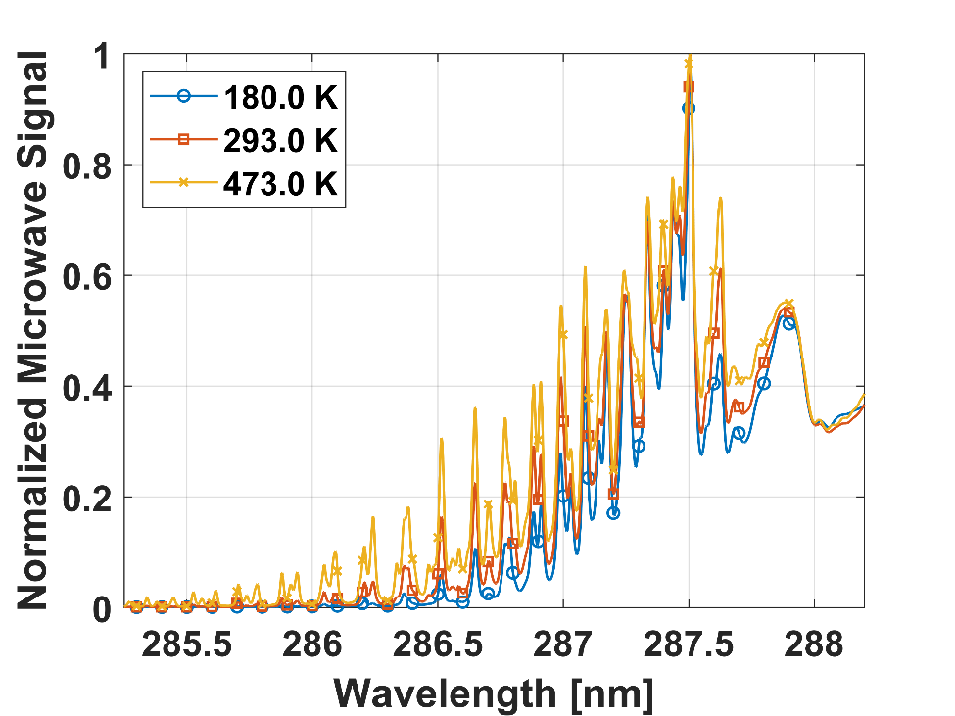
Figure 2.2 Normalized theoretical O₂ REMPI spectrum for 180, 293, and 473 Kelvin.

This is the first work that examines the N₂⁺ photoemission intensity relationship with corresponding O₂ two-photon transition peak intensity. Furthermore, the intensity of the photoemission (${∆v}_{0},∆v_{1},∆v_{2}$) will need to closely follow the (2+1) REMPI excitation of molecular oxygen. The prominent band representing (2+1) REMPI with the initial 2-photon transition O₂(C³Π (v=2) ← X³Σ (v’=0)) lies between 285-289nm. Utilizing the modeled spectra from Fig. 2.2 along with a previous study of the calculated rotational strengths of the S₂₁ branch transitions based on Eq. 2.11 were used to find multiple resonant wavelengths of interest for the calibration of O₂ RIPT and are listed in Table. 2.2.
Using the values from Table.2.1, the O₂ two-photon transition from state g to f will produce a theoretical resultant fluorescence intensity $I_{λ_{n}}$ of the first negative band of vibrationally excited N₂, which can be expressed by Eq. 2.12.

$$I_{λ_{n}}∝N_{0}∙T_{f_{n},g_{n}}^{2}I^{2}∙exp\left(-E_{g_{n}}/k_{B}T\right)$$ | (2.12)

where, $N_{0}$ is the number of O₂ molecules, $I$ is laser beam intensity, $E_{g_{n}}$ is the ground state energy, $k_{B}$ is the Boltzmann constant, and $T$ is the medium temperature. It should be noted, subscript “$λ_{n}$” denotes the laser excitation wavelength. By rearranging Eq. 2.12, a more useful form can be derived for relating the photoemission signal to a rotational state distribution for temperature assignment, thus Eq. 2.13.

$$-\frac{1}{k_{B}T}∝ \log\left(\frac{I_{λ_{n}}}{T_{f_{n},g_{n}}^{2}}\right)/E_{g_{n}}$$ | (2.13)

Conventionally, for Radar REMPI measurement, when a region of the spectrum including multiple rotational lines is measured, a statistical fit of the Boltzmann plot gives an accurate measurement of the rotational populations and thus the rotational temperature.
Table 2.2 Selected Rotational line of S₂₁ branch for temperature measurements.
Wavelength | $$J^{'}$$ | $$G_{1}$$ | $$T_{f,g}^{(2)}$$
nm |  | cm⁻¹
286.40 | 21 | 664.15 | 12.73
286.51 | 19 | 546.62 | 11.72
286.65 | 17 | 440.49 | 10.72
286.78 | 15 | 345.79 | 9.72
286.88 | 13 | 262.54 | 8.71
286.99 | 11 | 190.74 | 7.70
287.09 | 9 | 130.42 | 6.69
287.18 | 7 | 81.57 | 5.66
587.26 | 5 | 44.20 | 4.62
287.34 | 3 | 18.33 | 3.50

RIPT based measurements operate under the assumption that the generated photoemission strength at various rotational peaks (i.e., ${I_{λ}}_{n}$in Eq. 2.13) are directly representative of the populations within that peak. For O₂ RIPT the photoemission signal is generated from vibrationally excited N₂⁺ photoemissions, thus, the photoemission measurements are representative of the vibrational gas temperature. It should be noted, the time for the vibrational gas temperature to reach Local Thermodynamic Equilibrium (LTE) is longer than for a rotational gas-phase temperature measurement. Furthermore, depending on the level of ionization and activated molecular energies mechanisms, the vibrational energy modes and distributions may never reach LTE conditions in non-equilibrium flow environments. Limiting the overall applicability for O₂ RIPT based measurements to environments that are relatively low-enthalpy.

Experimental Setup
To identify specific rotational peaks most suitable for statistical fits of the Boltzmann plots, a calibration study was conducted at 180, 233, 293, 367, and 460 Kelvin in a gas cell. A general rendering for the calibration experiment for O₂ RIPT is shown in Fig. 2.3. The second harmonic of an Nd:YAG Laser (Continuum Surelite SL-10) with a pulse width of 8 nanoseconds (ns), repetition rate of 10 Hertz (Hz), and 220 mJ/pulse lasing energy was used to pump a dye laser (Continuum ND6000) that utilized a mixture of Rhodamine 590 and Rhodamine 610 to produce lasing light around 574 nm (0.02 cm⁻¹ linewidth). The dye laser was frequency doubled to generate ultraviolet (UV) beam using an auto-tracker (Continuum UVT-1) to maintain a constant conversion efficiency from the frequency doubling crystal. The UV beam had energy of approximately 10 mJ/pulse from 285 to 287.5 nm. The UV beam was focused using a fused-silica spherical lens with focal length of +150 mm, which generated a fluorescence line.

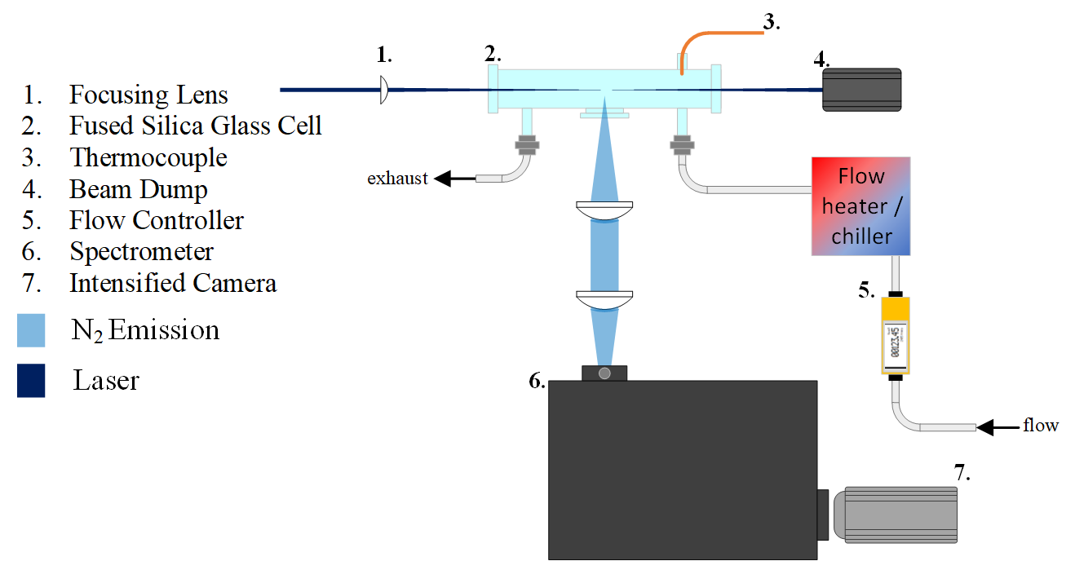
Figure 2.3 O₂ RIPT calibration schematic.

The line was centered in a cylindrical, fused-silica glass cell. The emission spectra were collected via two +100 mm spherical fused silica lenses that served to focus the light onto the slit of a spectrometer (Princeton Instruments, 600 grooves per millimeter [gr/mm], blazed at 500nm) with a 50μm slit width. The spectrum was captured via an intensified scientific camera (PI-MAX4 1024f) with the sensor size of 1024x1024 pixels. To avoid local heating and maintain a uniform species number density in the area of interest, a constant flow of standard air was provided to the cell at a rate of 0-50 liters per minute (L/min) via an electronic flow controller (OMEGA). Depending on the desired calibration temperature the air passed through either a flow heater (OMEGA) or through a custom-built flow-chiller to achieve temperatures ranging from 180 to 470 Kelvin and cell temperature was monitored by a K-type thermocouple and maintained within a tolerance of ±1% of the set point.

Results and Discussions

O₂ RIPT signal dependence on laser power
To find the point of saturation and confirm the dependence of fluorescence on (2+1) O₂ REMPI, a dye-laser of similar design was used that achieved per pulse energies up to 38 mj. Figure 2.4(a) shows the RIPT signal power dependence with a 287.33-nm laser beam in ambient air. It clearly shows that the signal intensity scales quadratically with laser power in the range from 0 to 30 mJ/pulse for a +300 mm focal length spherical lens. The quadratic dependence of the RIPT signal on the laser power at a chosen resonant excitation wavelength confirm that O₂ (2+1) REMPI is the driving mechanism for signal production. When the laser pulse energy is beyond approximately 30 mJ/pulse, saturation effects occur which is consistent with a typical multiphoton absorption phenomenon. Figure 2.4(b) shows a typical RIPT image in ambient air in false color. The laser pulse energy of 30 mJ/pulse focused by a spherical lens with +300 mm focal length, generated a RIPT line of 50 mm long.

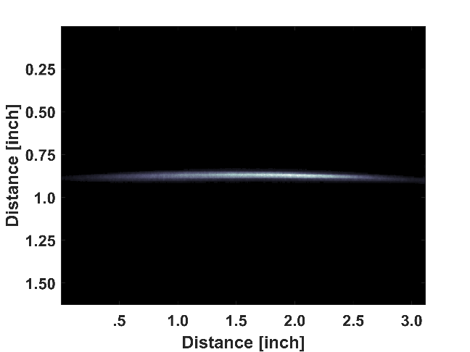
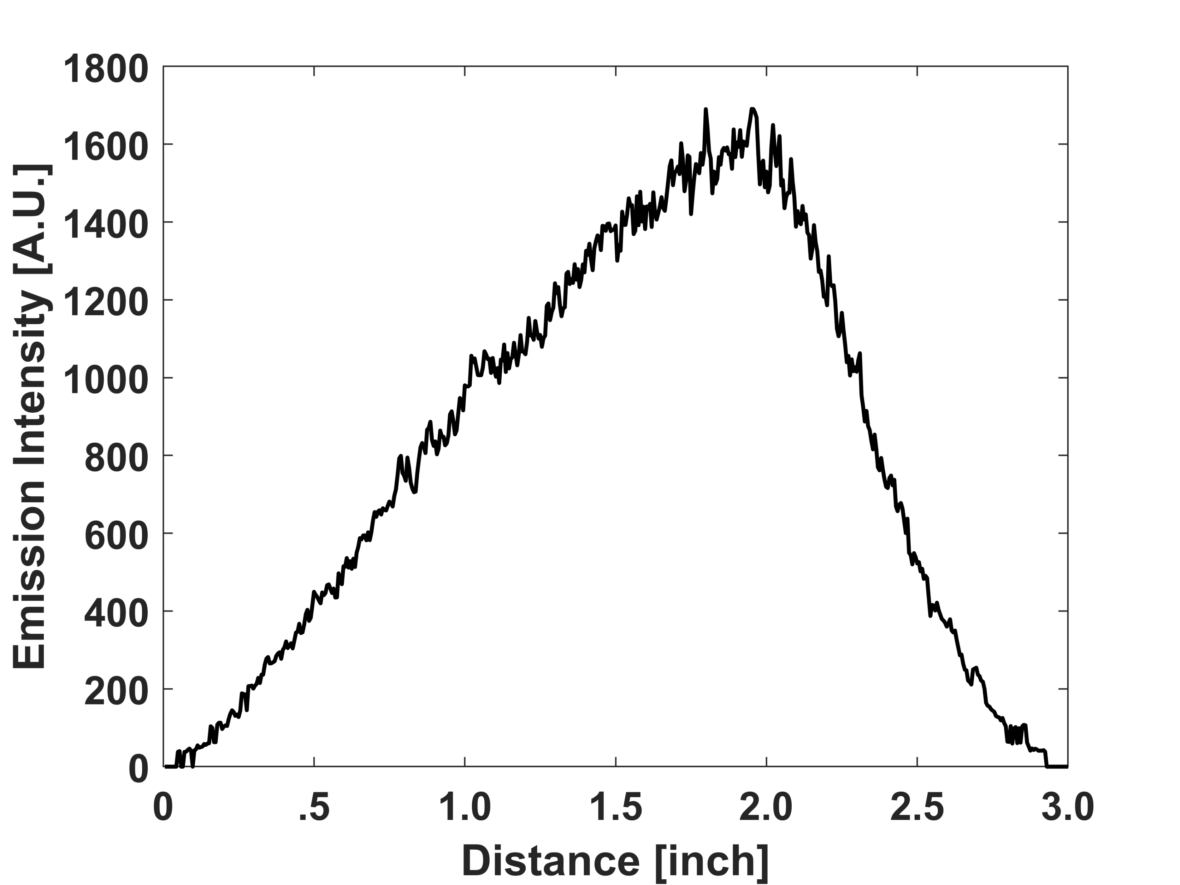
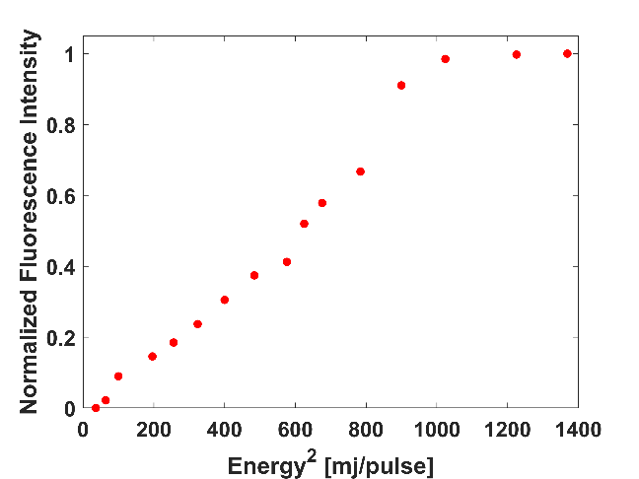
Figure 2.4 Laser power dependence of O₂ RIPT signal (a); RIPT photoemission line from 287.33nm excitation (b); averaged intensity profile of the photoemissions from 287.33nm excitation (c).
(a)
(b)
(c)

Additionally, in an attempt to quantify the energy deposition of the laser into the surrounding medium a measurement was conducted using a scientific grade, high-sensitivity thermopile meter (1mW detection at ±0.5% repeatability). The sensor was unable to detect any change in output energy from pre-focal spot to post-focal spot of a +300 mm spherical lens using an input wavelength of 287.5nm at 30mJ/pulse.

N₂⁺ emission spectra via O₂ RIPT
Visualized in Fig. 2.5. are the imaged N₂⁺ emissions at 293 Kelvin for all resonant wavelengths listed in table 2.1. The spectra at the selected wavelengths over the range of temperatures showed similar features, changes in the bands emitted signal intensity was the only observable change. Spectra of all ten wavelengths at the remaining calibration temperatures are shown in Fig. 2.6, Fig. 2.7, Fig. 2.8, and Fig. 2.9 for 180, 233, 367, and 460 Kelvin, respectively. To minimize shot-to-shot laser fluctuations and remove background effects, the captured emission signals are 20-image averaged and background subtracted. The use of the spectrometer allowed for discrete analysis of each emission peak in the first negative band of N₂⁺, (Δv₀, 390nm; Δv₂, 425nm; Δv₁, 430nm) of a high spectral accuracy.
To confirm the resonantly excited O₂ and the resulting N₂⁺ emissions were indeed temperature sensitivity, a study was conducted that compared signal intensity at various rotational bands that were temperature dependent or independent. It was found that when non-temperature sensitive peaks of the O₂ REMPI spectra were selectively excited the resultant N₂⁺ emissions were also independent of medium temperatures. The reciprocal relationship also holds true. This result is visualized in Fig. 2.10(a) where a 287.28 nm O₂ resonant line is directly excited and resultant fluorescence signal is temperature insensitive; while in Fig. 2.10(b) the 286.51 nm directly excited resonant line and resultant fluorescence signal is temperature sensitive.

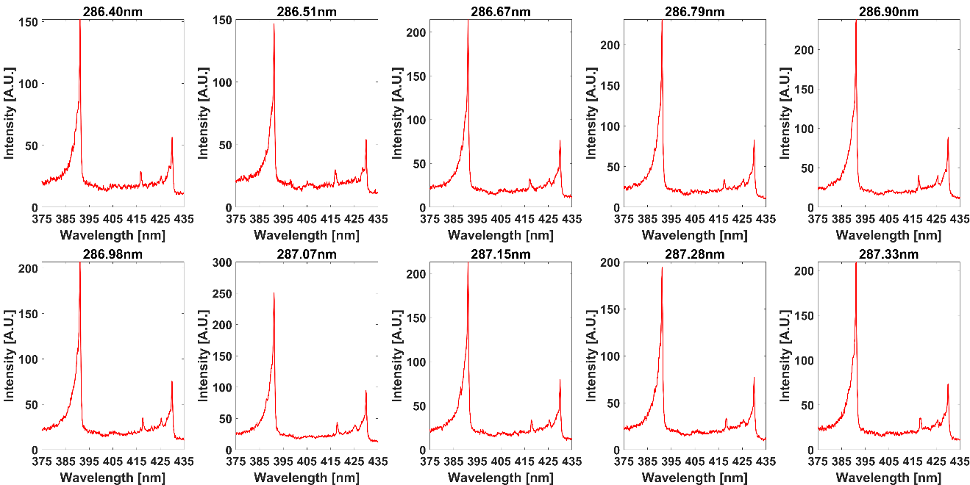
Figure 2.5 N₂⁺ emission spectra at 293 Kelvin for selected O₂ resonant wavelengths.

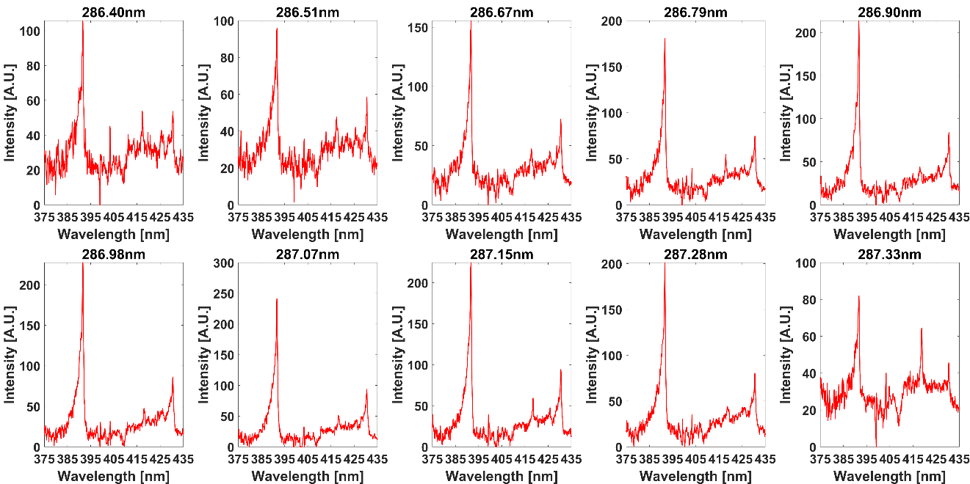
Figure 2.6 N₂⁺ emission spectra at 180 Kelvin for selected O₂ resonant wavelengths.

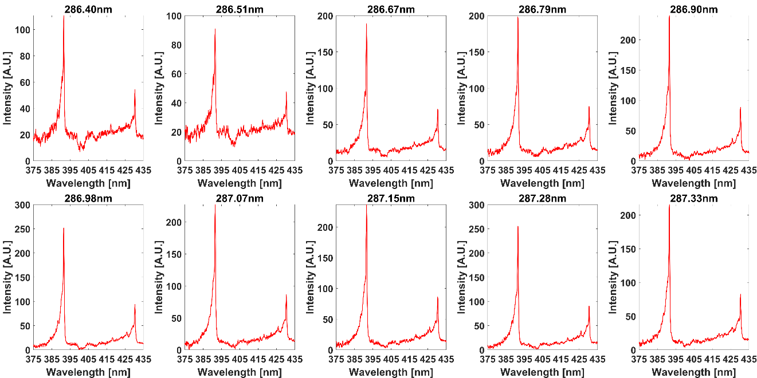
Figure 2.7 N₂⁺ emission spectra at 233 Kelvin for selected O₂ resonant wavelengths.

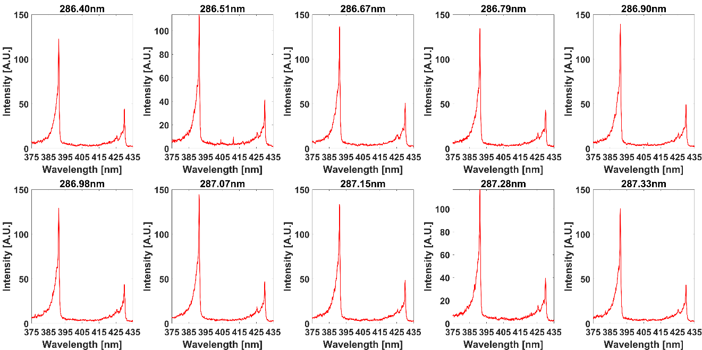
Figure 2.8 N₂⁺ emission spectra at 367 Kelvin for selected O₂ resonant wavelengths.

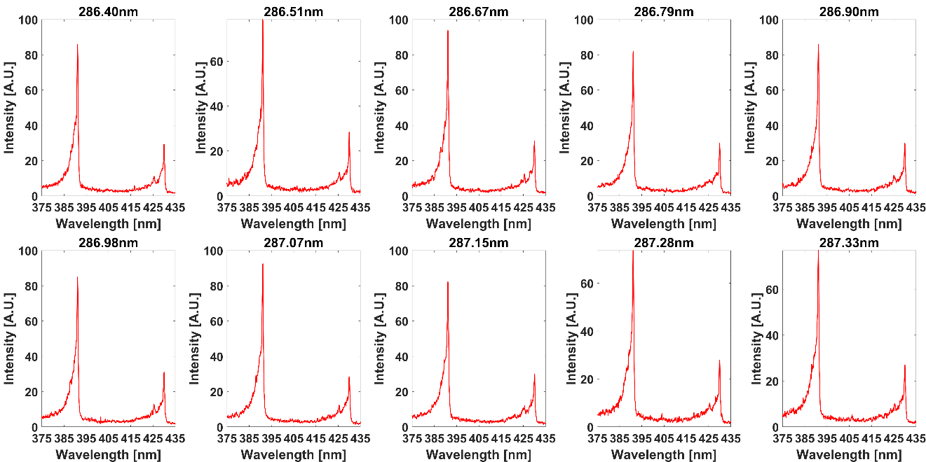
Figure 2.9 N₂⁺ emission spectra at 460 Kelvin for selected O₂ resonant wavelengths.

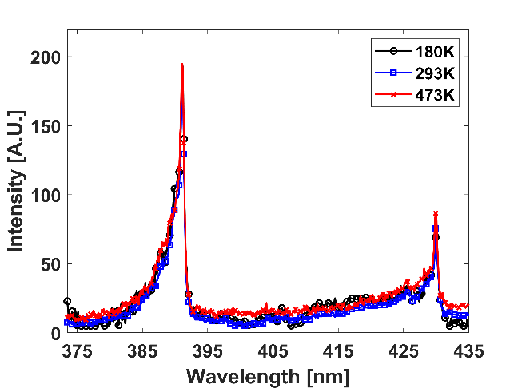
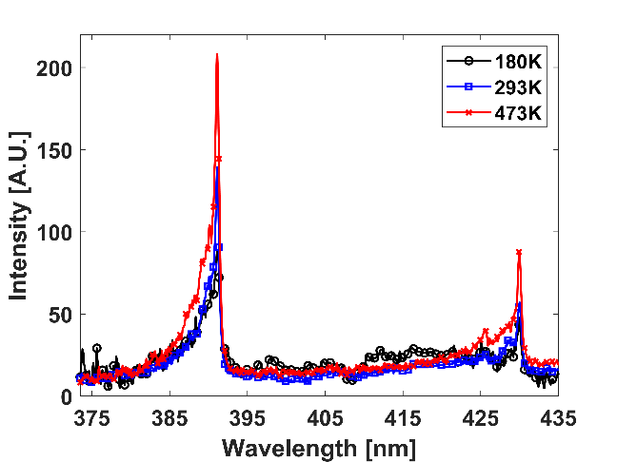
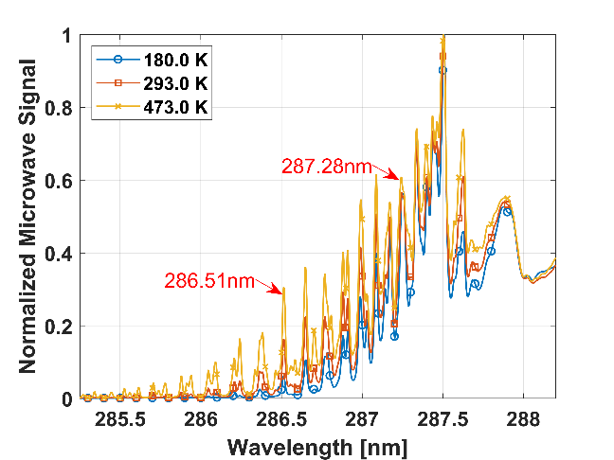
Figure 2.10 (a) 287.28nm excited peak (non-temperature sensitive). (b) 286.51nm excited peak (temperature sensitive). (c) rotational line positions within REMPI spectrum.
(a)
(b)
(c)

This behavior is foreshowed by the aforementioned theoretical REMPI spectrum in Fig. 2.2 and for ease of comparison shown again in Fig. 2.10(c). A visual inspection of the 286.51 nm peak signal varies drastically at various temperatures, whereas the 287.28 nm signal exhibits small intensity variation. This further highlights the importance of peak selection, as certain resonant wavelengths are suitable for thermometry applications.

O₂ discrete analysis for temperature determination
The N₂⁺ emission spectra similar to the ones depicted in Fig. 2.5 were captured and post-processed. The raw images were averaged and background subtracted to remove any light scattering or artifacts present. Integration was performed under each band, with care taken to not include any contributions that were not associate with the band emission. The resultant signal was then plotted for each temperature, this allowed for identification of possible groups that would yield a high coefficient of correlation and thus an accurate temperature. The peak signals for 293 Kelvin are visualized in Fig. 2.11 (a, b, and c). It should be noted, potential groups for other temperatures and peaks were not as easily found from a visual inspection; thus, a more iterative selection process was used till a fit with high linear correlation was found. Summed signal intensities for 180, 233, 367, and 460 Kelvin are shown in Fig. 2.12 (a, b, and c), Fig. 2.13 (a, b, and c), Fig. 2.14 (a, b, and c), and Fig. 2.15 (a, b, and c) respectively.
Four wavelengths are selected that have the highest fit metrics at each calibration temperature. The slope of the fit in the Boltzmann plot is applied to Eq. 7 to yield a temperature. More and less than four wavelengths were examined for temperature fitting and it was found that four wavelengths are result in the highest fitting accuracy. The resultant O₂ RIPT measurements of the 390, 425, and 430nm peaks at 293 Kelvin are shown in Fig. 2.11 (d, e, and f).

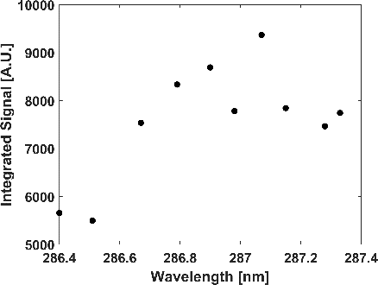
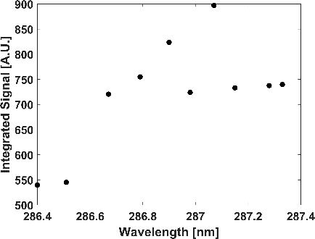
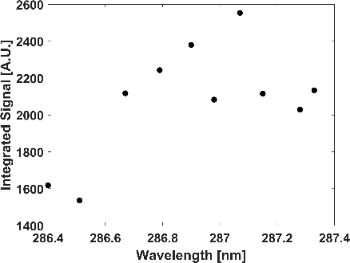
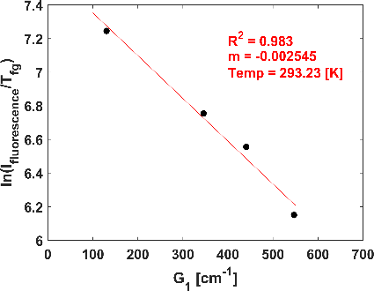
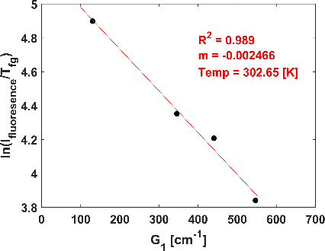
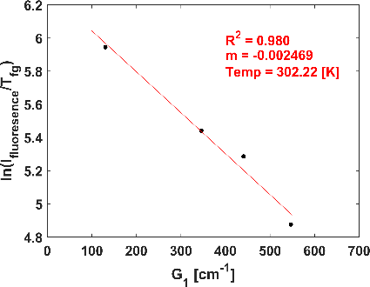
Figure 2.11 Integrated peak signal values for Δv₀, 390nm (a), Δv₂,425nm (b), Δv₁, 430nm (c), and temperature determinations for Δv₀ (d), Δv₂ (e), and Δv₁ (f) for actual temperature of 293 Kelvin.
(a)
(b)
(c)
(d)
(e)
(f)

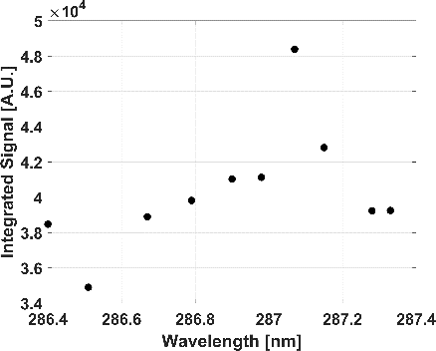
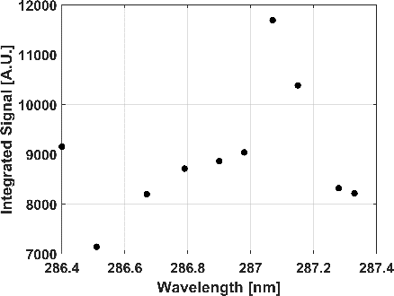
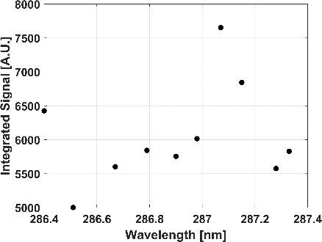
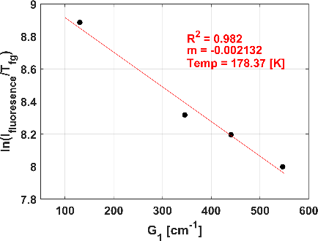
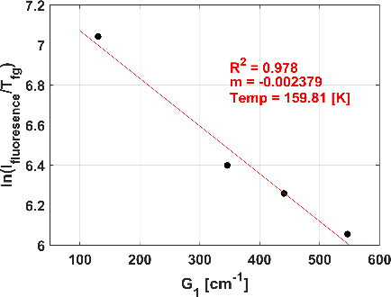
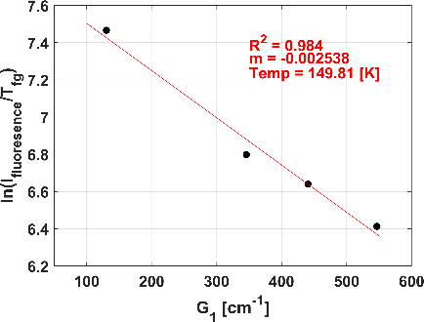
Figure 2.12 Integrated peak signal values for Δv₀, 390nm (a), Δv₂, 425nm (b), Δv₁, 430nm (c), and temperature determinations at Δv₀ (d), Δv₂ (e), and Δv₁ (f) for actual temperature of 180 Kelvin.
(a)
(b)
(c)
(d)
(e)
(f)

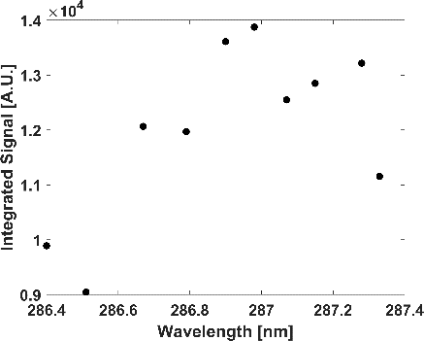
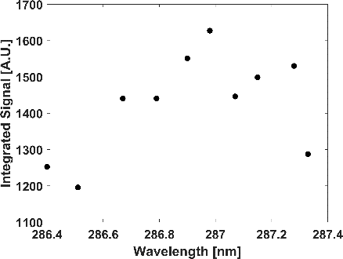
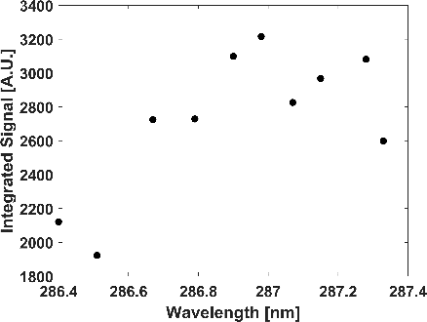
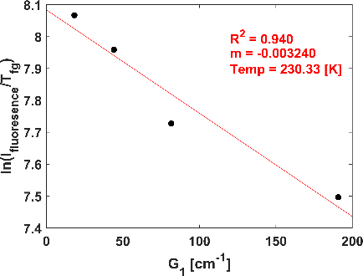
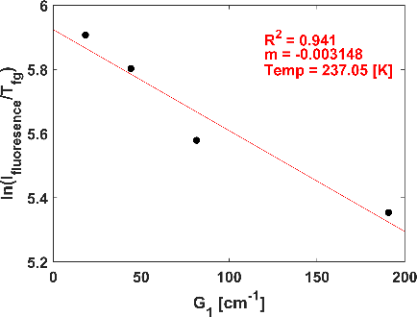
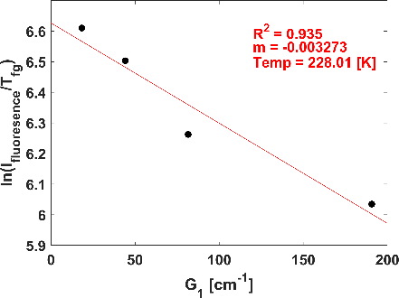
Figure 2.13 Integrated peak signal values for Δv₀, 390nm (a), Δv₂, 425nm (b), Δv₁, 430nm (c), and temperature determinations at Δv₀ (d), Δv₂ (e), and Δv₁ (f) for actual temperature of 233 Kelvin.
(a)
(b)
(c)
(d)
(e)
(f)

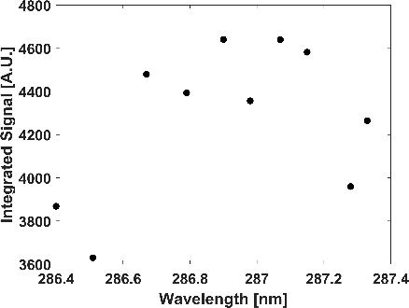
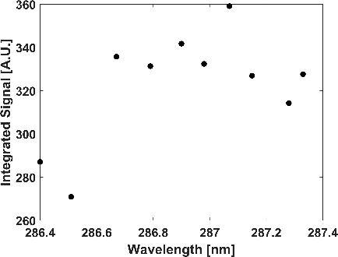
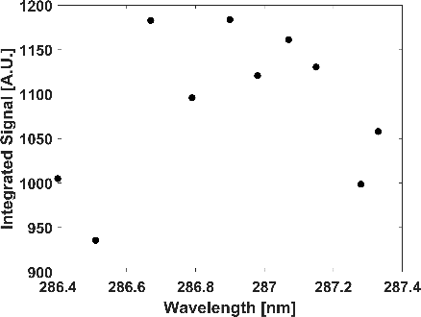
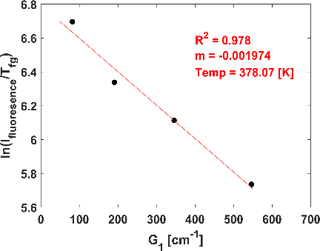
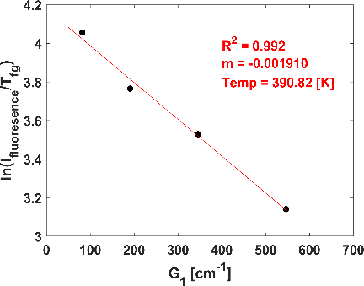
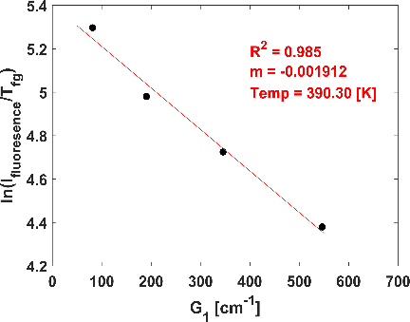
Figure 2.14 Integrated peak signal values for Δv₀, 390nm (a), Δv₂, 425nm (b), Δv₁, 430nm (c), and temperature determinations at Δv₀ (d), Δv₂ (e), and Δv₁ (f) for actual temperature of 367 Kelvin.
(a)
(b)
(c)
(d)
(e)
(f)

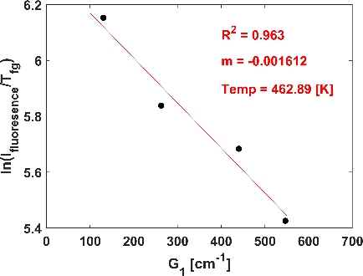
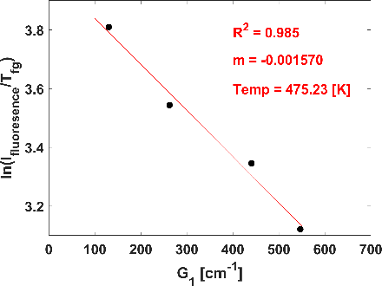
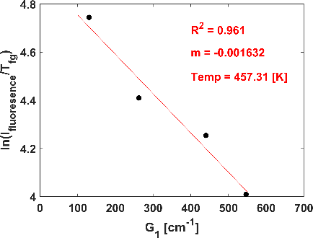
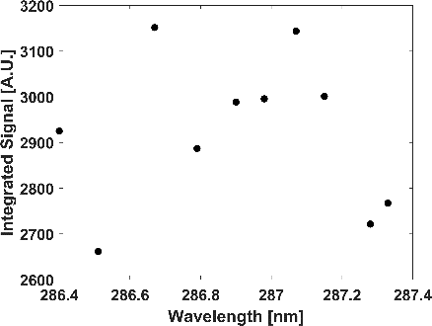
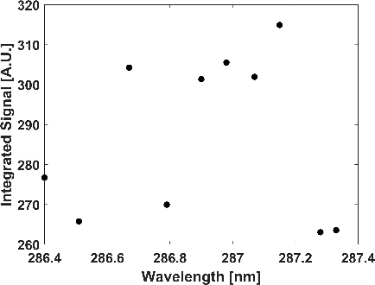
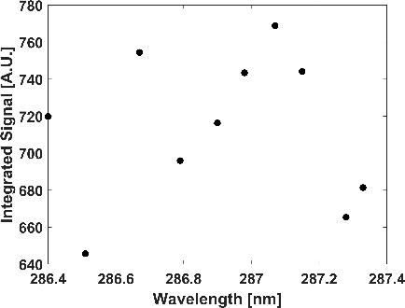
Figure 2.15 Integrated peak signal values for Δv₀, 390nm (a), Δv₂, 425nm (b), Δv₁, 430nm (c), and temperature determinations at Δv₀ (d), Δv₂ (e), and Δv₁ (f) for actual temperature of 460 Kelvin.
(d)
(e)
(f)
(a)
(b)
(c)

Each emission peak yields an approximate temperature close to the actual measured cell temperature of within ±10 Kelvin, and all have a high coefficient of correlation (R² > 98%) suggesting a very linear relationship exists between N₂⁺ photoemissions and the resonant excited O₂. O₂ RIPT measurements for 180, 233, 367, and 460 Kelvin are visualized in Fig. 2.12 (d, e, and f), Fig. 2.13 (d, e, and f), Fig. 2.14 (d, e, and f), and Fig. 2.15 (d, e, and f), respectively. The acquired O₂ RIPT temperatures at each emission peak for all calibration temperatures are tabulated in Table 2.3.
Through the studies of the individual emission peaks from the first negative band of N₂⁺, it is proven that O₂ RIPT is a viable non-seeded, non-intrusive thermometry method for resolving temperature gradients with sufficiently high accuracy. The high accuracy and low error of the calculated temperature suggests the vibrational N₂⁺ temperature is useable for temperature determination. The excited vibrational temperature of a molecule is typically slower to respond to medium temperature changes, this inherent characteristic is due to the fundamental physical time required for molecular collisional rates to occur and enter a vibrationally excited temperature state. However, the results show the N₂⁺ fluorescence that is generated and resultant measurements are outside this time requirement and the vibrational read emissions has achieved near true medium temperatures. The data in Table 2.3 suggests an accurate temperature reading of the gas medium across the calibration temperatures can be extracted from the unique peaks of the emission spectrum. The Δv₀ (390nm) exhibits the best capability of accurate thermal measurements, with the highest percent error difference between actual and measured being 2.94%. Additionally, Δv₁ (430nm) and Δv₂ (425nm) yield decent results for all ranges except at the coldest cell temperature of 180K. Since these transitions are of higher rotational states, it is expected the signal would weaken at low

Table 2.3 Results for specific N₂⁺ fluorescence bands (Δv₀, Δv₂, and Δv₁) for O₂ RIPT.
Cell Temp.  (K) | Experimentally determined Temperatures (K) |  |  | Error (%)
Cell Temp.  (K) | Δv₀ (390nm) | Δv₂ (425nm) | Δv₁ (430nm) | Δv₀ | Δv₂ | Δv₁
180 | 178 | 160 | 150 | 1.12 | 12.50 | 20.0
233 | 230 | 237 | 228 | 1.30 | 1.69 | 2.19
293 | 293 | 302 | 302 | 0.10 | 2.98 | 2.98
367 | 378 | 390 | 390 | 2.91 | 5.90 | 5.90
460 | 462 | 475 | 457 | 0.43 | 3.16 | 0.66

temperatures as the populations distributions will trend more towards the ground state thus, less energy will be imparted as the transitional strengths diminish directly reducing the collisional rates.

O₂ non-discrete analysis for temperature determination
To expand O₂ RIPT’s applicability, useability, and enable measurements across a 1D line, a study is conducted; here the signal used fitting to a Boltzmann distribution is found via integrating along the first negative band $N_{2}^{+}(B^{2}Σ_{u}^{+}-X^{2}Σ_{g}^{+})$, (370 to 435nm). This would simulate the removal of the spectrometer and direct imaging of the emission fluorescence through an optical bandpass filter that blocks light outside of the N₂⁺ spectral region.
Figure 2.16 visualizes the peak intensity values found from the aforementioned integration scheme for calibration wavelengths at 180, 293, and 460 Kelvin. An inspection of Fig. 2.16 and Fig. 2.11 (a, b, and c) suggest the summed peak intensity values trend towards the Δv₀ emission. This is expected as its emission intensity strength dominates the Δv₁ and Δv₂ bands. Using the previous approach for finding peaks that could related temperature, the best fit was found from a selected group of the integrated signal intensities, and fitted to a Boltzmann plot to assign a vibrational temperature measurement.
The integrated signals Boltzmann plots with accompanying statistical fits detailing assigned vibrational gas temperatures are shown in Fig. 2.17 for all thermal setpoints. Only the rotational peaks that resulted in the highest accurate assigned temperature were chosen. Table 2.3 summarizes the findings nicely, detailing the experimental error between the assigned and expected temperatures and listing the ideal rotational lines for each temperature setpoint. Overall, the Boltzmann plots of Fig. 2.17 demonstrate high linearity for their respective rotational lines across the 180, 233, 293, 367, and 460 Kelvin setpoints.

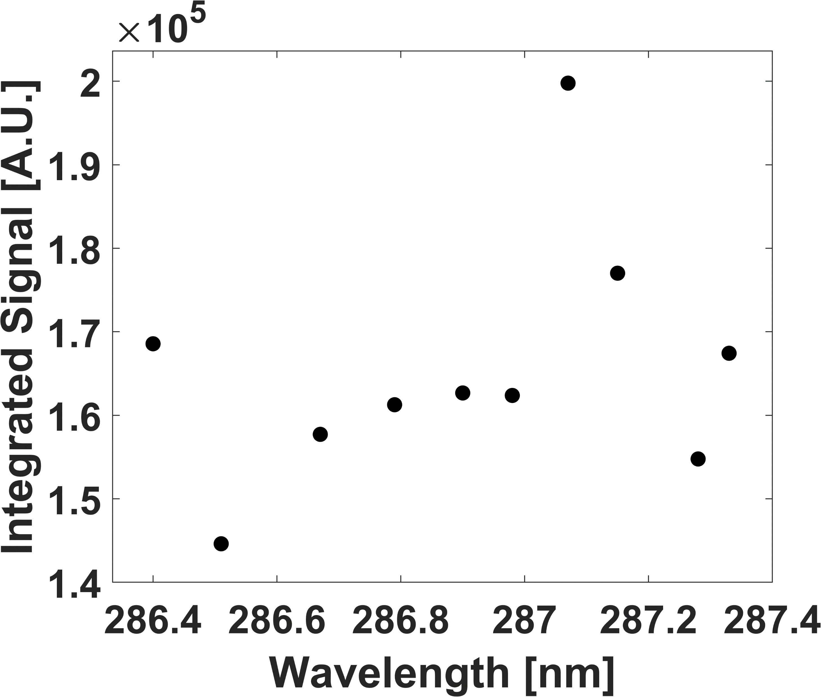
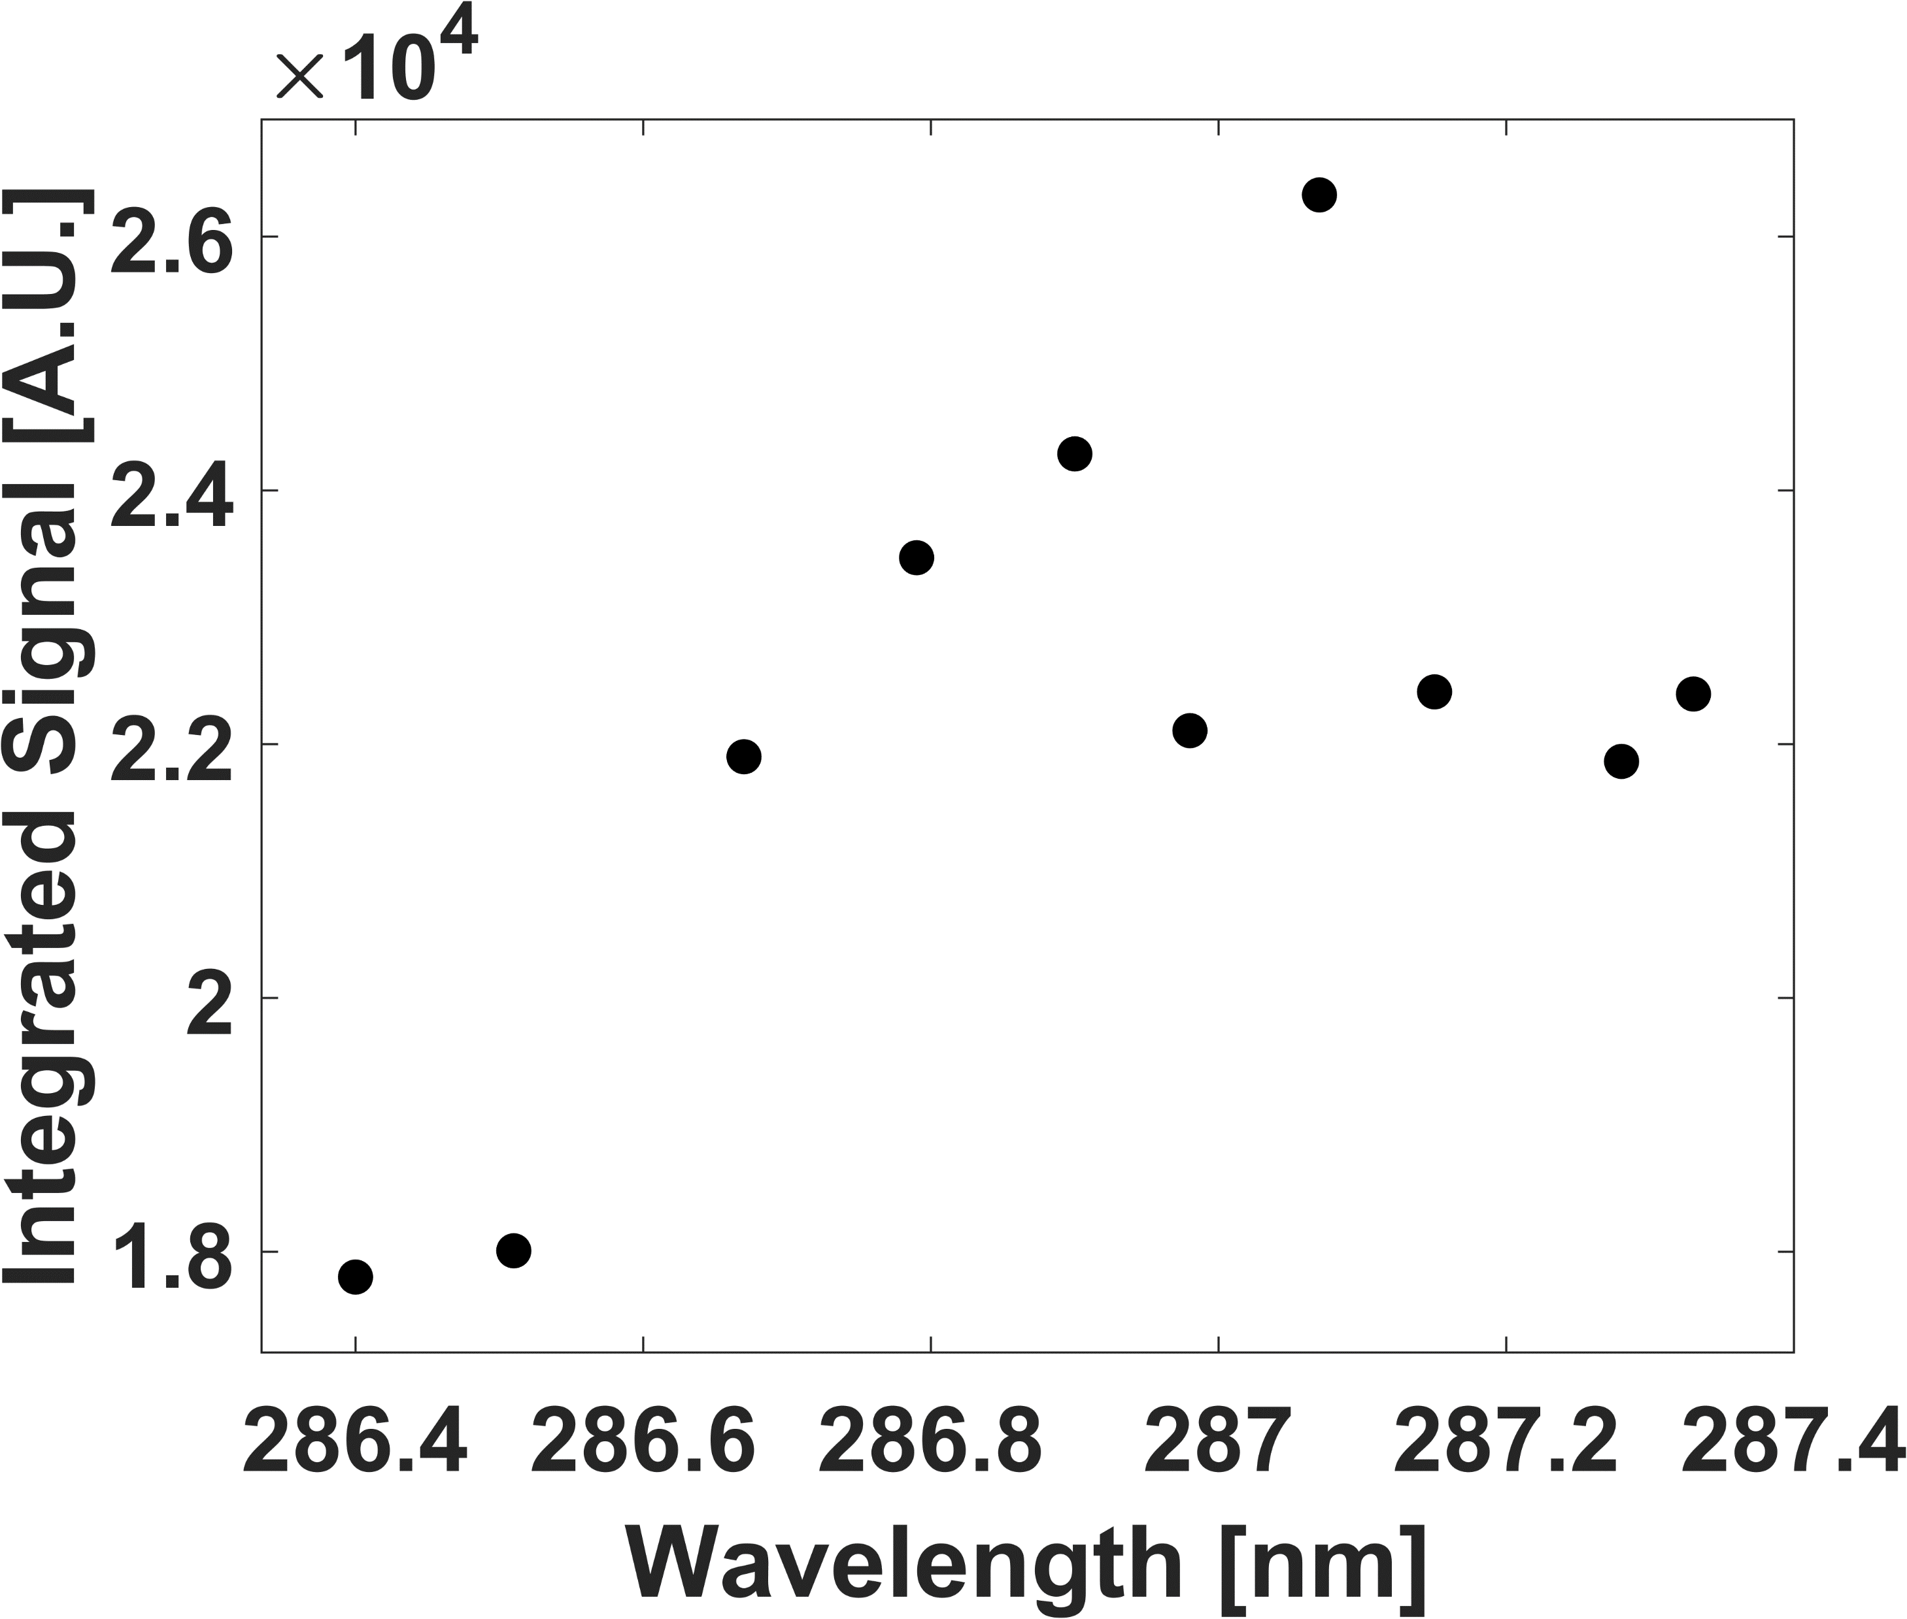
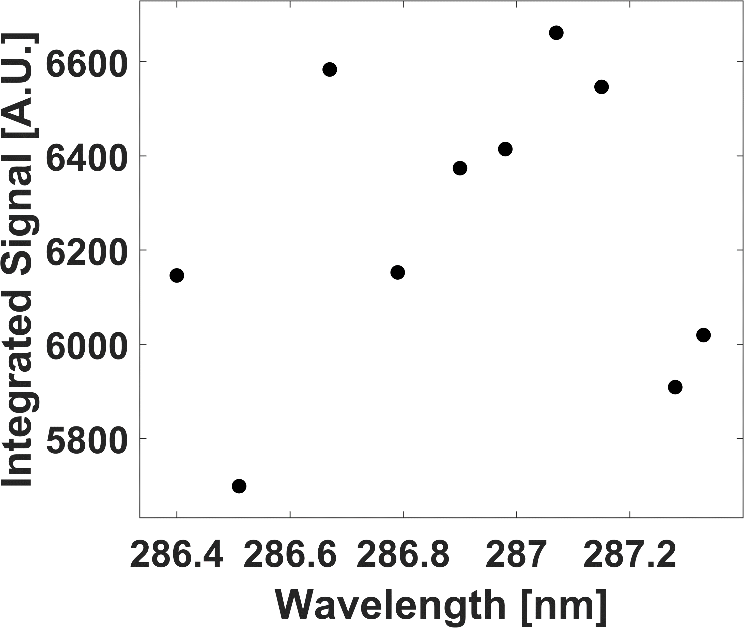
Figure 2.16 N₂⁺ first negative band integrated signal values for 180K (a), 293K (b), and 460K (c).
(a)
(b)
(c)

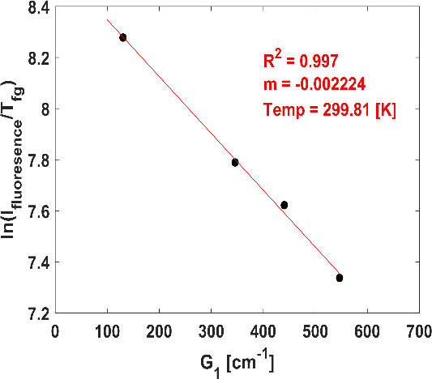
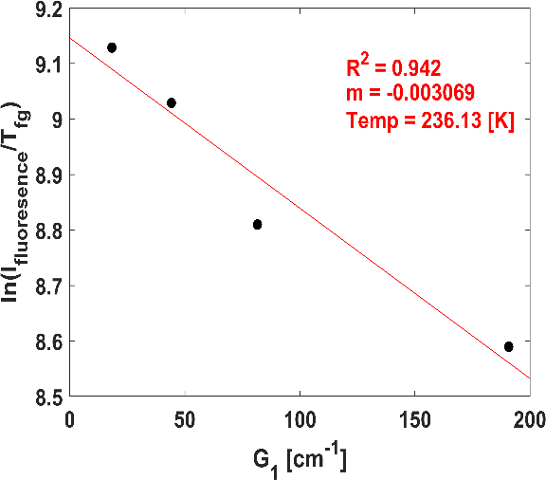
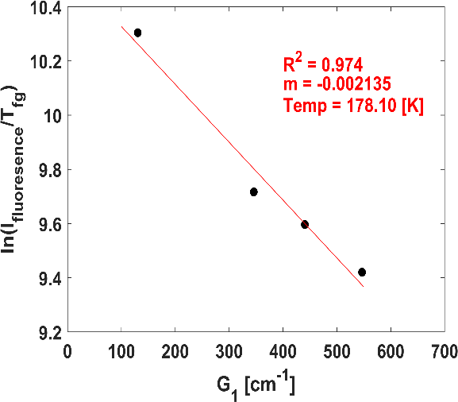
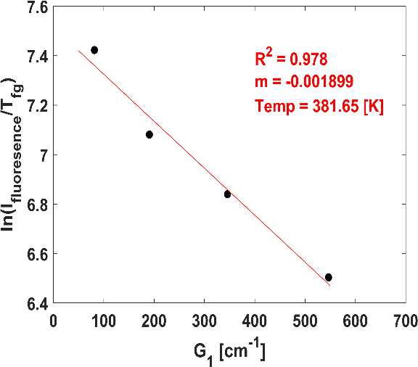
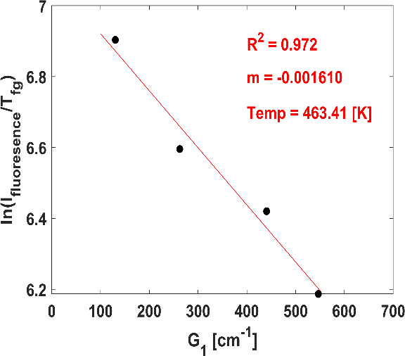
(a)
(b)
(c)
(d)
(e)
Figure 2.17 Statistical fits of the Boltzmann plots for (a)180, (b)233, (c)293, (d)367, and (e)460 Kelvin assigned temperatures.

The ability for signals that represent the fully integrated $N_{2}^{+}(B^{2}Σ_{u}^{+}→X^{2}Σ_{g}^{+})$ emissions to maintain high linearity and characteristics emission strength to the related rotational peak realizes the ability for accurate temperature assignments. Furthermore, the $N_{2}^{+}(B^{2}Σ_{u}^{+}→X^{2}Σ_{g}^{+})$ fully integrated signals ability for gas temperature assignment suggests that direct imaging of the N₂⁺ first negative band emissions for thermometry is a viable method and realizes the critical potential of the O₂ RIPT technique by enabling 1D measurements. Direct imaging of the $N_{2}^{+}(B^{2}Σ_{u}^{+}→X^{2}Σ_{g}^{+})$ photoemissions using a camera, imaging lens, and simple filter that blocks outside contributions not only allows 1D line thermometry measurements, but this setup removes the spectrometer resulting in reduce experiment setup time, complexity, space, and expense.
Table 2.4 suggests as temperature decreases, the resonant wavelength selection trends towards lower rotational states of molecular oxygen. This is expected, as temperature decreases there is less structure in the REMPI spectrum as population distributions trend towards lower rotational levels. Thus, the lower rotational states become the most viable for maintaining collisional rates for sufficient N₂⁺ emissions and maintain measurement repeatability. Furthermore, the integrated signal assigned vibrational temperature only differs slightly from the actual cell temperatures, ensuring a high quality, repeatable thermometry measurements. By comparing the integrated result with the per peak results, the integrated signal maintains accurate measurements over a greater thermal range than Δv₁ or Δv₂. The integrated signal measurement capability and accuracy closely resembles the Δv₀ emission band, but differs in that the integrated signal will have a greater SNR ratio due to the emission signal being sufficiently stronger as it is a contribution from all three bands. Furthermore, there is only an approximate difference of (±1%) between the fully integrated signal and Δv₀ signal assigned gas temperatures and actual cell

Table 2.4 Suggested rotational peak groups for the various temperature setpoints with corresponding predicted and actual temperatures.
Excitation Wavelengths |  |  |  | Temp. (actual) | Temp.  (Measured) | Error
nm | nm | nm | nm | K | K | %
286.98 | 287.15 | 287.28 | 287.33 | 180 | 178 | 1.11
286.98 | 287.15 | 287.28 | 287.33 | 233 | 236 | 1.29
286.51 | 286.67 | 286.79 | 287.07 | 293 | 299 | 2.05
286.51 | 286.79 | 286.98 | 287.15 | 367 | 381 | 3.81
286.51 | 286.67 | 286.90 | 287.07 | 460 | 463 | 0.65

temperatures, further suggesting the Δv₀ band is the major contributor of the photoemission fluorescence intensity. The Δv₀ signal dominance is maintained across all temperature setpoints.

Conclusions
In this study, O₂ Resonantly Ionized photoemission thermometry (RIPT), a novel, non-intrusive, non-seeded technique is established and verified through a detailed calibration analysis. Oxygen molecules are targeted via a (2+1) REMPI scheme to selectively excite various rotational bands of O₂, thus the technique is dubbed O₂ RIPT. Through avalanche ionization process, the first negative band of N₂⁺ is weakly vibrationally excited, producing spectral emissions in the visible region from 395 – 430nm. The resulting emissions are processed and fed into a Boltzmann relationship that yields a 1D line temperature measurement. The emissions have been extensively studied that resulted in ideal peak selections and thermal relationships for individual emission bands (Δv₀, ~390nm; Δv₂, ~425nm; Δv₁, ~430nm), and fully integrated emissions (Δv₀ + Δv₁ + Δv₂). It has been shown through individual band analysis, the dominating emission Δv₀ produces accurate reference temperature measurements with a max total error of ±4% for <700K medium temperatures. While Δv₁ and Δv₂ emissions are not ideal for standalone thermal measurements, having total errors of 14% and 25% respectively. The high measurement error from the Δv₁ and Δv₂ primary stems from the 180K test-point, suggesting that the bands may be more suitable for higher temperature applications.
The fully integrated emissions analysis yielded temperature measurements with accuracies similar to the Δv₀ bands; having max total error of ±5%. Additionally, the ideal resonant peaks found are given for each temperature setpoint in Table 2.3. Furthermore, direct imaging of the emission will reduce experiment setup time, complexity, space, and expense and helps realize the techniques full potential. It is the suggested to utilize the full emission spectrum for O₂ based RIPT measurements in test environments that are <700K; as the greater SNR from the summed contributions of Δv₀, Δv₁, and Δv₂ result in sufficiently greater signal intensity. Additionally, direct imaging must be used to realize the full novelty of the proposed technique; 1D thermometry. O₂ RIPT suffers from a few drawbacks and limitations. In its current state, four wavelengths are needed to achieve an accurate and repeatable thermometry fit. A dye laser that is capable of generating approximately 10 mj/pulse or greater is needed to achieve a RIPT 1D line of sufficient length. It was shown that a 3-inch emission line is possible with a 30mj-pulse, with the measurement distance and lasing energy being the main limiting factors. In this study, the resonantly ionized oxygen molecules rely upon free-electrons to induce electron impacted excitation of local nitrogen molecules; the measurement is of the vibrational gas temperature. The specifically chosen O₂ s-rotational branch used is limited to environments (<700 Kelvin), above which populations distributions trend towards higher levels and thus various branches that are typically not present in the s-branch become present causing congestion. Typically, within the confined test region used in this study the vibrational temperature was in LTE and thus was representative of the total gas temperature. Since O₂ RIPT specifically is most accurate when the test gas is in LTE, it shows great promise for low-enthalpy, cold environments.

O₂ based resonantly ionized photoemission thermometry analysis of supersonic flows

The following data was collected for publication by Walker McCord, Mark Gragston, David Plemmons, and Zhili Zhang. At the time of writing, versions of this chapter are awaiting publication into a peer review journal. Walker McCord is the lead author for this work.

Abstract
Characterization of the thermal gradients within supersonic and hypersonic flows is essential for understanding transition, turbulence, and aerodynamic heating. However, existing flow thermometry techniques are physically intrusive, requiring particulate or gas seeding, or are incapable of one-dimensional spatially-resolved measurements. Here photoelectron induced emissions in air is demonstrated as a non-intrusive, one-dimensional (1D) ro-vibrational temperature measurement technique capable of probing regions up to approximately 7 cm in length in supersonic flows. The 1D signals are generated by exciting temperature-sensitive hyperfine structures of C³Π (v=2) in molecular oxygen (O₂). Subsequent photoelectron induced avalanche ionization of molecular nitrogen and de-excitation of molecular nitrogen ions (N₂⁺) yield the first negative band photoemissions (Δν₀, 390nm; Δν₂, 425nm; Δν₁, 430nm), which are captured by a nanosecond gated camera. The resulting photoemissions are directly proportional to the 2-photon transitions of molecular oxygen $O^{2}\left(Σ\left(v^{'}=0\right)→C^{3}Π\left(v=2\right)\right)$ allowing for accurate temperature determination. As a 1D thermometry technique, resonantly ionized photoelectron induced emissions can play instrumental roles in numerous pivotal scientific studies that rely upon acute characterization of thermal gradients within a medium.

Introduction
Oxygen based resonantly ionized photoemission thermometry (O₂ RIPT) is a novel, nonintrusive, non-seeded thermometry technique that utilizes spectroscopy of resonantly enhanced molecular oxygen and subsequent ionization of molecular nitrogen to yield 1D line thermometry measurements. RIPT is demonstrated and validated through characterization of temperature gradients present within developed shock structures aft of a supersonic under expanded free jet. Historically, under-expanded jets have long been studied due to the many areas of interest in which they arise. They are commonly observed everywhere, from natural events, to daily life, and critically, within challenging engineering environments. They are found within the exhaust plumes of high-speed aircraft and rockets, where the geometry and characterization of the under expanded shock structures is critical as it effects the thermal signature, jet noise, and screech of the engine [54-56]. They have been used to study and develop methods of mixing and fuel ignition within supersonic combustors [57-59]. They have even been used to model the flow dynamics of a volcanic ash-cloud ejecting from a vent (volcano) into the atmosphere [60].
This study focuses on the “diamond” like structures that emanates downstream of the nozzle exit and are conveniently referenced throughout this study as shock-train structures. A shockwave in nature is essentially an entropy generator, thus the shock-train structures produce localized areas of varying temperature, density, and pressure at a supersonic speed. This makes them a highly studied feature and environment that can have both positive and negative implications on a flight vehicle. The design of a flight vehicle to appropriately account for shock structures that form when the speed of sound is breached is paramount to its success and fundamental in nature. The moderately under expanded shock train generated in this study by a benchtop size free jet presents an attractive small-scale environment upon which impinging shock interactions and other complicated fluid dynamics can be studied for relatively low cost. The shock train structure primarily consists of alternating areas of high and low pressure, temperature, and density. The complex shock structures, small scale flow features, and dramatic thermal gradients created from the passing of the high-speed air through shock and expansion features creates a challenging and highly dynamic environment where great insight could be gained through the characterization of the entire under expanded flow region by O₂ RIPT [61, 62]. This work will conduct the first ever O₂ RIPT based measurements in non-controlled environment. Additionally, picosecond (ps) Coherent Anti-Stokes Raman Scattering (ps-CARS) measurements and Computational Fluid Dynamic (CFD) simulations will be utilized to validate the technique through stringent comparison.
The core idea behind the resonantly ionized photoelectron technique is by utilizing an O₂ (2+1) REMPI scheme, that is two photons excite an oxygen molecule to an intermediate state followed by the absorption of an additional photon to ionize. By specifically selecting wavelengths within a resonant absorption band of O₂, focused laser light can induce a 1D weakly ionized plasma line. In this work, lines within the s-rotational branch of the $C^{3}Π,(v=2)←X^{3}Σ(v^{'}=0)$ band of O₂ was selected due to spectral distinctness and relevant population distributions for the thermal conditions within the expanded jet test environment. The photoemission generation mechanisms are detailed in Chapter 2 of this paper, but for conciseness a brief overview is given. Using a frequency doubled dye laser, a 1D line of weakly ionized O₂ molecules is generated, this can be expressed by Eq. 3.1.

$$O_{2}+3hν_{REMPI}→O_{2}^{+}+e^{-}$$ | (3.1)

The resulting photoelectrons are then accelerated by the remaining laser pulse via inverse Bremsstrahlung absorption to induce photoelectron avalanche ionizations and electron-impacted collisional excitation of N₂. This can be expressed by Eq. 3.2.

$$N_{2}^{+}:N_{2}+e^{-}+ℏν→N_{2}^{+}+{2e}^{-}$$ | (3.2)

The recombination of electrons and molecular nitrogen ions produces photoemissions of the first negative band of $N_{2}^{+}(B^{2}Σ_{u}^{+}-X^{2}Σ_{g}^{+})$, or further decay by the first positive band of N₂ [63]. This can be expressed by Eq. 3.3 and Eq. 3.4.

$$N_{2}^{+}(B)→N_{2}^{+}(X)+ℏν_{1^{-}}$$ | (3.3)

$$N_{2}^{+}+e^{-}→N_{2}\left(B\right)→N_{2}\left(A\right)+ℏν_{1^{+}}$$ | (3.4)

The resulting photoemissions from the $N_{2}^{+}$ first negative band are at three distinct spectral peaks (Δv₀, 390 nm; Δv₂, 425 nm; Δv₁, 430 nm), resulting from the $1→0$, $2→1$, and $1→1$ transitions, respectively. These spectral emissions make up the thermometry signal. Fundamentally, RIPT measurements are enabled from two unique relationships; (1) the electron impacted induced excited N₂⁺ photoemissions share a direct relationship with two-photon line strength factor of the specifically selected absorption peak within the s-rotational branch. (2) The two-photon transitional line strengths ($T_{f,g}^{2})$ at various resonant frequencies either exhibits temperature sensitivity or insensitivity, thus if the selection of a group of absorption peaks is known temperature can be deduced.
Using the data from the O₂ RIPT calibration experiment presented in Chapter 2 of this paper with some basic fluid dynamic knowledge, the resonant absorption wavelengths for 180 and 293 Kelvin temperature setpoints were used. A feature that was found from the O₂ calibration experiment is the ideal resonant absorption peaks that enable a highly accurate temperature assignment for both 180 and 233 Kelvin environments is maintained. Thus, it can be inferred that the population distributions below 293 Kelvin do not shift dramatically. Furthermore, the moderately under expanded jet shock train will first be dominated by a strong expansion fan aft of the exit plane creating an area downstream of the expansion that will see a strong decrease in temperature. Subsequent compression heating and further expansions processes will reciprocate as the flow travels through the shock train creating the characteristics “diamond” structures. Due to the laws of thermodynamics, the flow temperature will never be higher that the air outside the jet boundary layer. Thus, the 180 and 293 Kelvin wavelengths should be sufficient for complete thermal characterization. For convenience, the wavelengths and related properties for the selected temperatures are provided in Table 3.1.

Experimental Setup

Supersonic Jet
An axisymmetric, converging-only nozzle designed for Mach 1.0 flow at the exit plane was used for this study and has previously been detailed in literature [64]. The nozzle geometry and assembly used throughout this study is shown in Fig. 3.1. Moderately under-expanded supersonic free jets are governed by compressible effects and tend to be steady once developed. They are characterized by strong shock-interactions and turbulent fluid dynamics that result in a “diamond” like structure downstream of the nozzle exit that will reciprocate until viscous forces and turbulent mixing result in a fully-developed flow. This type of jet structure is achieved for nozzle exit pressure ratio (NPR) of $1.1\tilde{≤}\frac{P_{e}}{P_{∞}}\tilde{≤}3$ [65, 66]. The nozzle assembly in Fig. 3.1 was coupled to a high-pressure air bottle through a high-flow dual-stage regulator (5,000 L/min) and was used to maintain a pressure of 50 PSIG at the regulator exit.

Table 3.1 Resonantly excited O₂ wavelengths for 180 and 293 Kelvin.
Transition wavelengths for 180 Kelvin
ʎ  nm | $$J^{'}$$ | $$G_{1}$$  cm⁻¹ | $$T_{f,g}^{(2)}$$
286.99 | 11 | 190.74 | 7.70
287.18 | 7 | 81.57 | 5.66
287.26 | 5 | 44.20 | 4.62
287.34 | 3 | 18.33 | 3.50
Transition wavelengths for 293 Kelvin
ʎ  nm | $$J^{'}$$ | $$G_{1}$$  cm⁻¹ | $$T_{f,g}^{(2)}$$
286.51 | 19 | 546.62 | 12.73
286.65 | 17 | 440.49 | 10.72
286.78 | 15 | 345.79 | 9.72
287.09 | 9 | 130.42 | 6.69

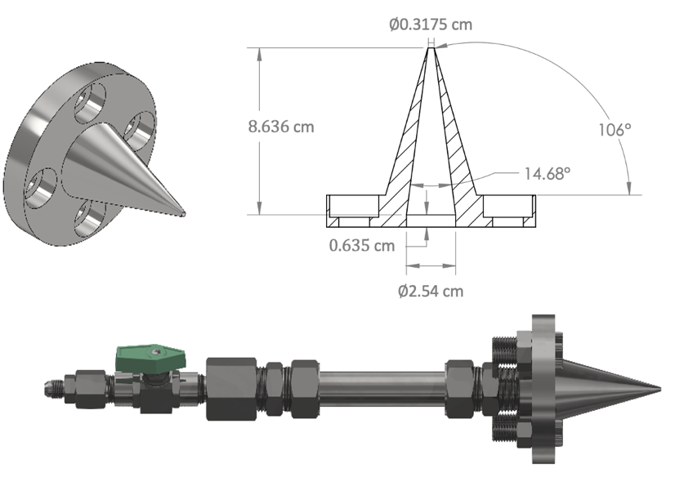
Figure 3.1 Mach 1 nozzle geometry and jet assembly.

This maintained an NPR of 2.3 ensuring a traditional moderately under-expanded jet with ensuing shock-train structures was generated consistently.

O₂ RIPT Laser and Camera Setup
The setup for O₂ RIPT measurements is relatively straightforward and has minimal optical alignment, a general rendering of the setup is shown in Fig. 3.2. The second harmonic of an Nd:YAG laser (Spectra Physics Pro – 290) with a pulse width of 10 ns, repetition rate of 10 Hz, and approximately 1 Joule per pulse (J/pulse) lasing energy was used to pump a dye laser (Sirah PrecesionScan) which utilized a mixture of Rhodamine 590 and Rhodamine 610 to yield high energy conversions near 574 nm with an 0.06 cm⁻¹ linewidth. The output of the dye laser was frequency doubled via a look-up table system (Sirah Tunable Frequency Conversion unit), to produce ultraviolet (UV) light and maintain high conversion efficiencies across the entire absorption range. The UV beam has nominal per pulse energies of approximately 30 mj/pulse within the $C^{3}Π,(v=2)←X^{3}Σ(v^{'}=0)$ band of O₂. The UV beam was focused using a +300 spherical fused silica lens, generating a photoemission line of approximately 100 mm in length. It should be noted, due to quenching effects, only half of the generated line was useable for temperature measurements. The photoemission line was positioned down the centerline axis of the jet and occupied the region from the nozzle exit to approximately 50 mm downstream. The length of the line was sufficiently long enough to capture all shock-structures within the jet until fully-developed flow had been reached. The fluorescence line emissions were captured via an intensified scientific camera (PI-MAX4 1024f) where sensor binning was implemented that resulted in an effective sensor size of (512 x 512 pixels). A 2mm thick BG3 Schott’s glass (UV-blue) bandpass filter was positioned in-front of the imaging lens to filter out any contributions from laser, scattered, or background light that may produce non-real results.

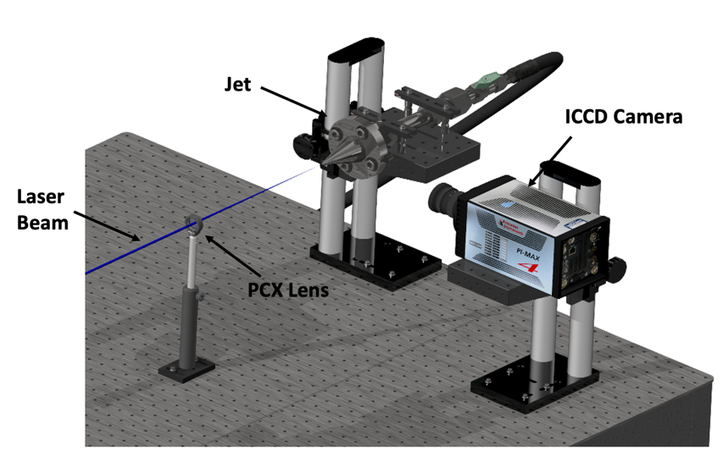
Figure 3.2 O₂ RIPT experimental setup for jet shock-train thermal characterization.

ps-CARS setup
To validate photoelectron induced emissions measurements, ps-CARS (pico-second vibrational Coherent Anti-Stokes Raman Scattering) was performed at various locations downstream of the nozzle exit. To the authors knowledge, CARS is the only one other method that currently exists that can acquire non-intrusive non-seeded thermometry measurements from the local vibrational N₂ gas temperatures, making it well suited for comparison to photoelectron induced emissions. The CARS system utilized here has been previously demonstrated in literature [67], it is a transportable system and utilizes a BOXCARS configuration to enable highly spatiotemporally resolved thermometry measurements. The experimental setup is shown in Fig. 3.3.
The system consists of a 100-ps laser (Ekspla SL234, 532 nm, approximately 0.2 cm⁻¹) at 106 mJ/pulse energy, which was used to pump a custom built, tunable ps-capable dye laser (607 nm) with FWHM of 135 cm⁻¹ and pulse duration of 115 ps that yielded maximum outputs of 5 mJ/pulse lasing energy. The energies for the pump, probe, and Stokes beam were measured to be approximately 5.6 mJ, 5.6mJ, and 4.7mJ respectively. The system and all required optics are housed on two 4 x 3-foot breadboards that are mounted to an aluminum t-slot frame that allows for transportation of the system with minimal disturbance to the optical alignment. The three output beams were focused using a +300 mm fused silica lens. The focal region of the lens was positioned on the centerline of the jet. The jet assembly, shown in Fig. 3.1, was secured to a linear translation stage to provide precise control over measurement locations. A narrow bandpass filter (Semrock, LD01-473/10-25.4) was used to remove any background scattering from the anti-Stokes signal beam, which was then dispersed via a 1 m spectrometer (Jobin Yvon Model SPEX 1000M) that utilized a 2400 groove/mm grating. The signal was collected with a CCD camera (Andor Technologies Model DU 440BU).

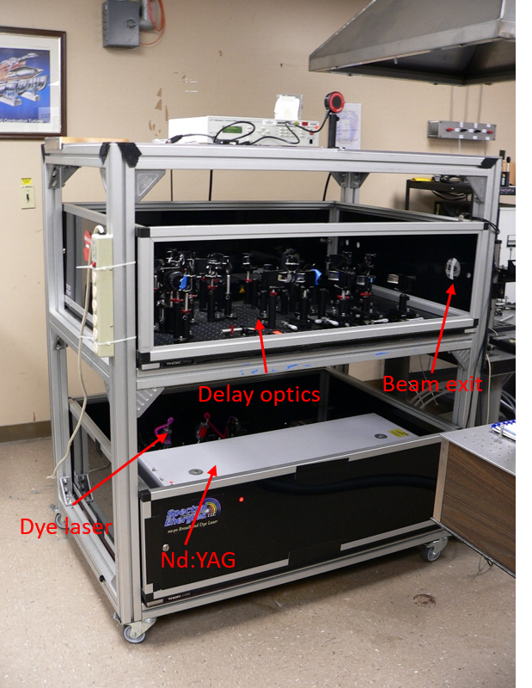
Figure 3.3 ps-CARS setup.

CFD simulation details
To better validate the measurements, a simple RANS-based simulation of the supersonic jet was done using ANSYS Fluent CFD software. Since the free jet used in this study is axisymmetric, only a quarter slice of the 3D nozzle geometry was used in the meshing parameters to reduce computational time and energy required. Structured meshing was used beyond the nozzle exit to better accommodate viscous effects, while an unstructured meshing was used elsewhere. Figure 3.4 shows the meshing used for the computations. Region 1 meshing had a mesh sizing restriction of 2 mm and Region 3 had a 0.1 mm sizing. Region 2b was also subject to mesh sizing of 0.1 mm. For each case, program-controlled matching of the regions was allowed.
The RANS computations utilized the Spalart-Allmaras turbulence model [68]. The inlet boundary condition for the jet was specified as a 220.6 kPa pressure with temperature of 300 K and reverse flow was prevented. The working gas was assumed to be ideal air, with the Sutherland viscosity formula used for determining viscosity during the computations. Far-field pressure outlet conditions were used for the non-symmetry walls with exception of base plane, which was modeled as a solid wall for simplicity.

Results and Discussions

Temperature measurements
One-dimensional line thermometry measurements via photoelectron induced emissions were obtained by directing the laser beam down the center axis of the axisymmetric supersonic free-jet and focusing the beam such that the beam-waist location was exactly half the length of the resulting N₂⁺ emission region. This allowed for 1D measurements of up to 5 cm in length. The N₂⁺ emission line was captured using the wavelengths listed in Table 3.1.

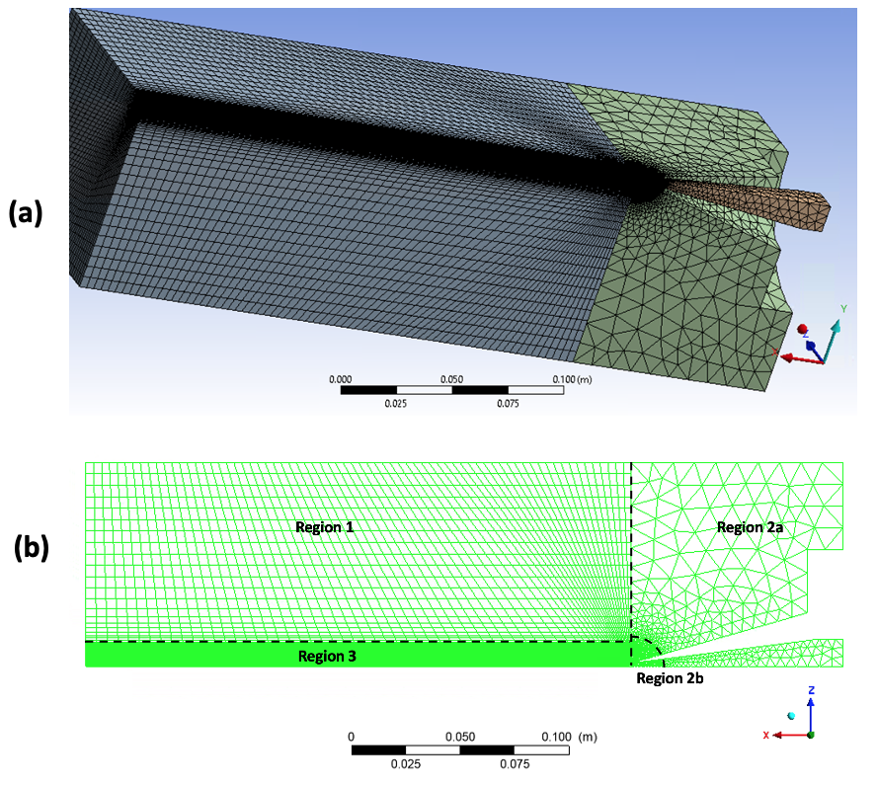
Figure 3.4 3D mesh image around jet (a), and detailed regions of the mesh highlighting the various meshing sizes (b).

The raw emission images for the 180 Kelvin setpoint wavelengths are shown in Fig. 3.5(a) and Fig. 3.5(b) for flow off and flow on cases, respectively. The raw emissions images for the 293 Kelvin setpoint wavelengths are shown in Fig. 3.6(a) and Fig. 3.6(b) for flow off and flow on cases, respectively. The raw emission images shown in Figs. 2 and 3 are 20-shot averages and background subtracted to minimize laser energy fluctuations and background artifacts. Signal intensity of photoelectron induced emissions is affected by the number density of local nitrogen molecules, it is possible to resolve the shock-train structure locations downstream of the nozzle exit by taking a line average across the emission image. This is shown in Fig. 3.5(d) and Fig. 3.6(d). The peaks and valleys within the averaged signal represent reflected shocks and expansion fans, respectively. Finally, the line average of the flow off cases is shown for coherency in Fig. 3.5(c) and Fig. 3.6(c). Corrected images are taken and stacked into a three-dimensional (3D) array, which allows for the intensity in each pixel to be processed using the aforementioned equations and ensures that pixel locations are maintained for each image set. Thus, by analyzing individual pixels, each pixel represents a spatial temperature measurement and places the upper limit on the spatial resolution of O₂ RIPT technique. A spatial resolution of 50 µm was achieved and maintained in the current measurements.
Theoretically, O₂ RIPT’s spatial resolution is only limited by the resolving capacity of the imaging camera used (i.e., pixel scale). The post-processing code computes the Boltzmann plots and assigns temperature through a statistical fit of those plots across the entire camera chip, thus with sufficient laser power the ionizing region may extend past the beam waist allowing a temperature “map”. Figure 3.7(a) shows an extended semi two-dimensional temperature map of the supersonic jet. Additionally, CFD predicted total gas temperature is shown in Fig. 3.7(b) for comparison. The region for which the processing occurred was confined to areas of sufficient emission intensity that yielded adequate SNR (>10).

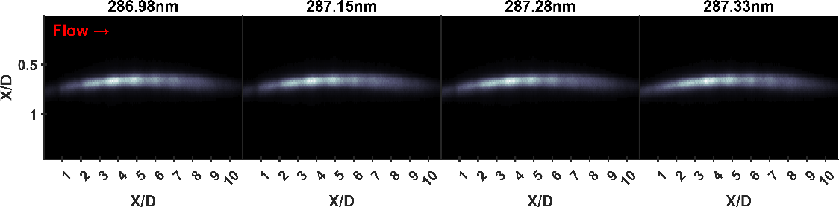
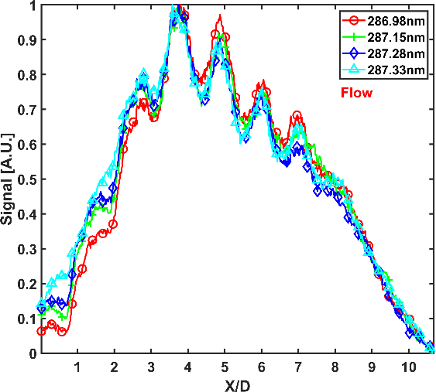
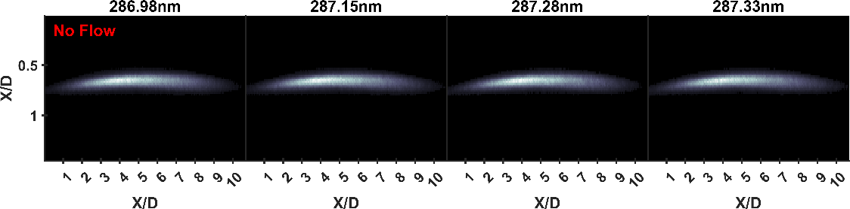
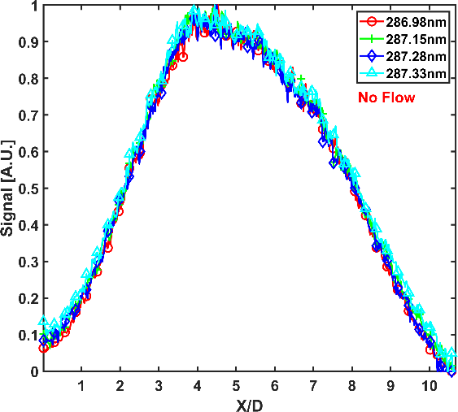
Figure 3.5 180 Kelvin captured photoemissions for (a) no flow, and (b) flow cases. Line average profiles down the centerline of the emissions for (c) no flow, and (d) flow.
(a)
(b)
(c)
(d)

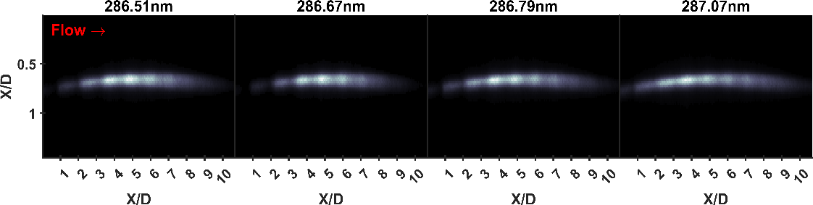
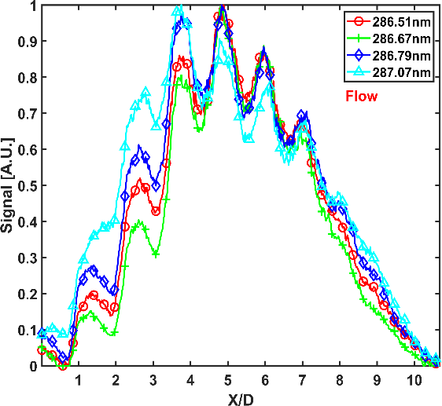
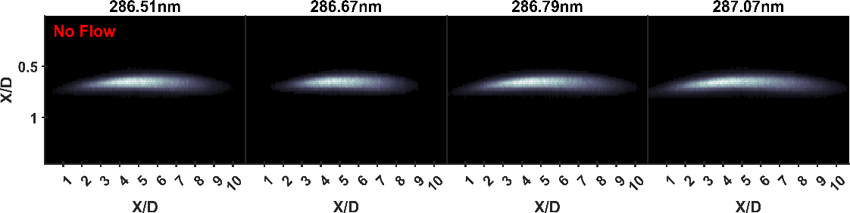
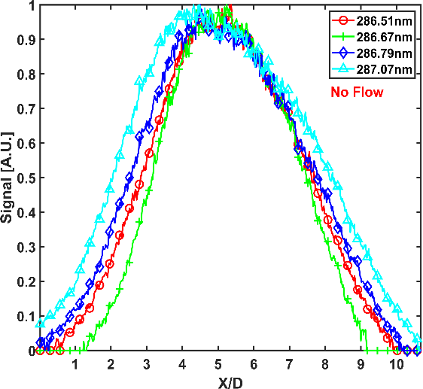
Figure 3.6 293 Kelvin captured photoemissions for (a) no flow, and (b) flow cases. Line average profiles down the centerline of the emissions for (c) no flow, and (d) flow.
(b)
(a)
(c)
(d)

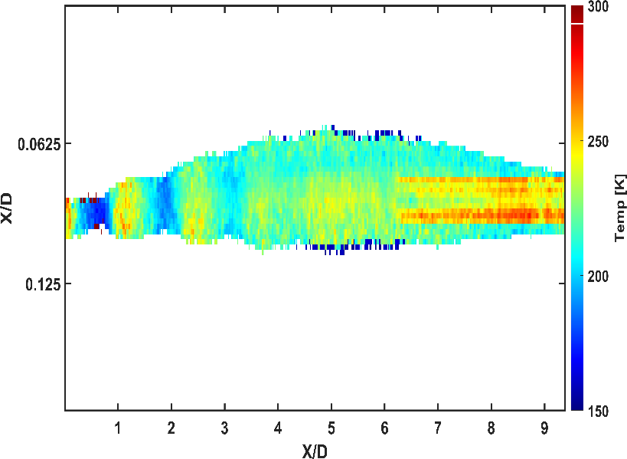
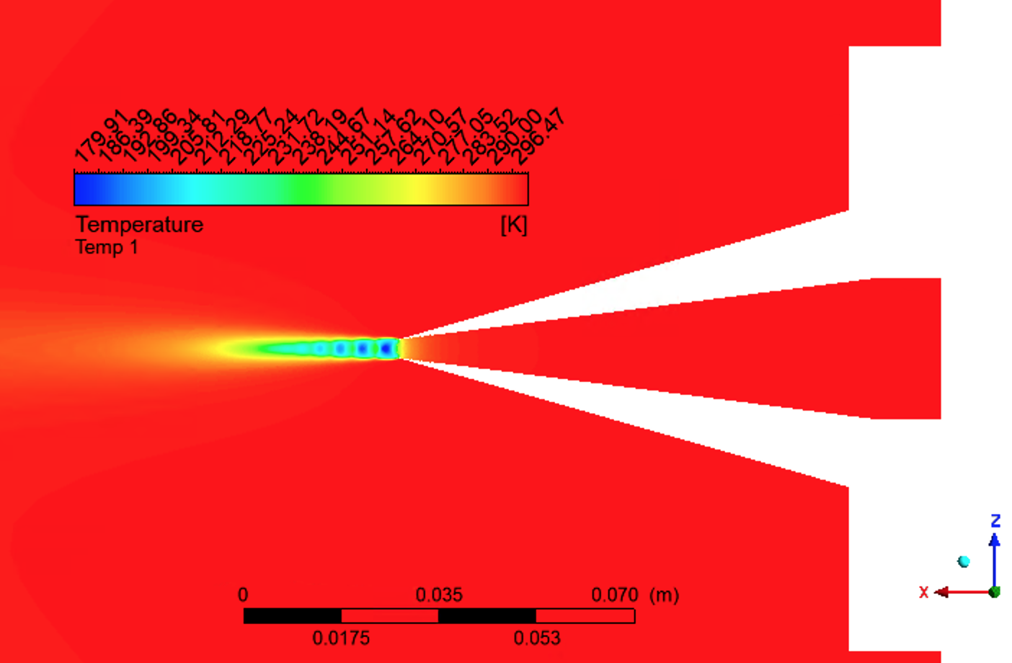
Figure 3.7 1D+ temperature map from photoemission analysis (a), and CFD generated temperature map (b).
(a)
(b)

The accuracy of O₂ RIPT is heavily dependent upon correctly selecting resonant O₂ peaks that demonstrate high linearity within some specified range of gas temperatures. Since the gas temperature through the supersonic moderately under-expanded jet dramatically fluctuates as it passes through the complex shock-interactions aft of the nozzle exit plane, the post-processing code used the coefficient of determination (R²) in each pixel to determine which temperature-wavelength set should be used. This method resulted in O₂ RIPT measurements with of high accuracy and demonstrated sufficient thermal sensitivity to resolve the thermal gradients present throughout the shock structures with an estimated error of ±12 K.
It should be noted, it was found the lasing energy was sufficiently strong at (approximately 31 mJ/pulse) to enable N₂⁺ fluorescence emission outside of the direct beam propagation region through photoelectron avalanche ionization, this enabled temperatures to be resolved outside the immediate beam area to create a one-dimensional+ (1D+) thermal map. The 1D+ thermal map is widest within the region of highest laser energy density in Joules per square centimeter (J/cm²), and tapers off as energy density decreases either pre or post beam waist location. This is expected, as regions of higher energy density result in greater ionization which could ionize nearby nitrogen molecules through additional collisions [69, 70]. To compare the sensitivity and accuracy of O₂ RIPT thermometry, ps-CARS spectra were recorded at six different locations of interest that were within the shock train of the under expanded supersonic free jet. These locations were identified as points of interest, as they were regions of either dramatically decreasing or increasing gas temperatures. The ps-CARS system in this study is limited to point measurements, thus the CARS data will aid in quantifying the thermal sensitivity and spatial resolution of RIPT measurements.
The jet assembly, shown in Fig. 3.1, was placed on a manual linear translation stage that allowed precise adjustments over a 25 mm range with axial position sensitivity of (1µm). The measurement spatial locations are overlaid onto a Schlieren image of the under-expanded jet shown in Fig. 3.8.
The ps-CARS spectra were acquired at a repetition rate of 10 Hz. The free jet flow was initiated and allowed to run for a few seconds prior to data collection to ensure shock-train stability was reached. The ps-CARS spectra signal was a 30-shot average acquired over 100µs exposures and background subtracted. Average signal levels were approximately 120,000 counts with an SNR of approximately 4,000. To extract thermodynamic information from the experimentally obtained spectra, theoretically spectra was generated by the N₂ spectral modeling program CARSFT [71] in a least-squares fitting manner. The experimentally acquired spectra and corresponding CARSFT fits with the predicted vibrational temperature measurements are shown for every measurement location in Fig. 3.9, where the red dots indicate measurement points and the distances are from the nozzle exit.
Conventionally, CARSFT is best utilized in high enthalpy environments where there exists higher vibrational modes and greater structure that enables accurate thermodynamic fitting. Due to the cold gas temperatures within the shock train, the captured spectra are sparse in structure only having a single observable peak at approximately 2330 cm⁻¹ that is from the Q-branch transition between vibrational levels 1 → 0. The CARS probe has a pulse width of approximately 100 picoseconds that is not capable of yielding pressure-insensitive temperature measurements. This complicates the fitting aspect due to multiple reasons. First, local gas pressure plays in integral role in defining the shape of the emitted CARS spectra. Specifically, in this study that exhibits relatively high static pressure (>0.1atm) collisional broadening is the dominating broadening effect and occurs when a molecule that is absorbing or emitting radiation collides with another molecule, changing the phase and lifetime of the radiating dipole’s vibration and rotation.

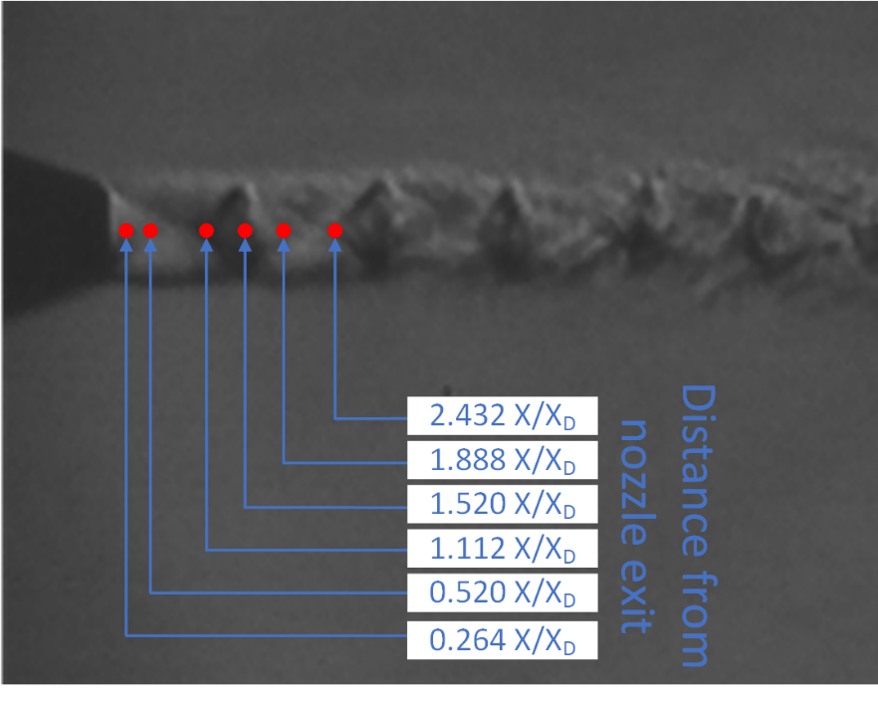
Figure 3.8 ps-CARS measurement locations overlaid on a schlieren image of the under expanded supersonic jet.

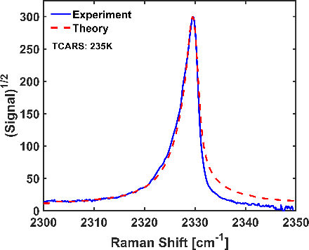
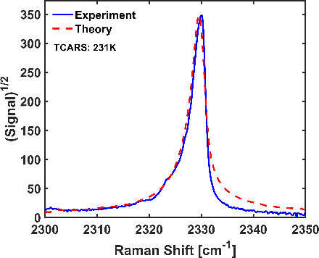
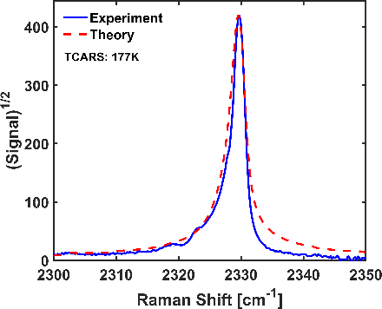
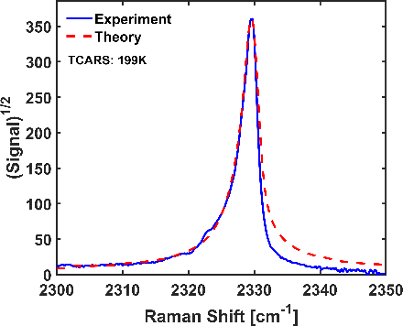
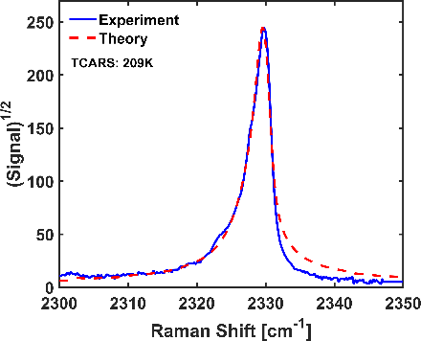
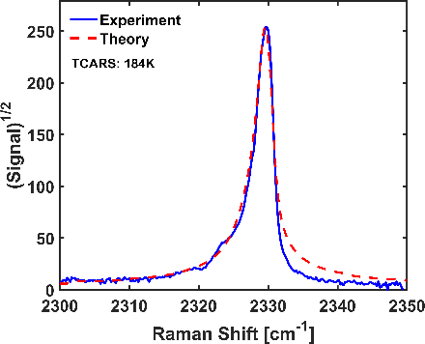
Figure 3.9 CARSFIT spectrums to the ps-CARS data at corresponding measurement locations.
0.264 X/X_{D}
0.520 X/X_{D}
1.112 X/X_{D}
1.520 X/X_{D}
1.888 X/X_{D}
2.432 X/X_{D}
This is why there is only one observable peak in the experimental CARS spectra, as collisional broadening has eliminated the individual transitions that would normally be observable at low pressures (<0.1atm). Furthermore, due to the complex fluid interactions occurring within the shock-train structure, there is no constant pressure term that could be used as pressure will fluctuate as the flow travels downstream and through the complex interactions occurring aft of the nozzle exit. This makes it nearly impossible to obtain a reasonably accurate theoretical fit with no known or approximated pressure terms. To circumvent this, pressure approximations were calculated from a numerical approach that yielded approximate values at the various measurement locations. An arbitrarily selected error of ±10% was chosen and a range of pressure values was determined by this error amount from the numerically solved pressure values at each location. This determined pressure range served as the input to CARSFT, where an iterative least-squares fit was applied to each experimentally obtained spectra and the code was allowed to run through potentially hundreds of iterations until a best fit was found. This method yielded sufficient temperature predictions that when compared to the photoelectron induced emissions measurement shows very good agreement as shown in Fig. 3.10.
A comparison of the CFD, O₂ RIPT, and ps-CARS temperature measurements is shown in Fig. 3.10. The agreement between the various methods is good and shows promising capabilities for O₂ RIPT based measurements. The ps-CARS predicted temperature better aligns with the O₂ RIPT measured temperature than the CFD results. This is expected as the CARS and O₂ RIPT are measurements of the vibrational N₂ temperatures and the CFD is a total temperature measurement. The O₂ RIPT and CFD data align well through the shock-train, but near X/D = 4 diverge slightly. The indicated O₂ RIPT thermal line measurement displayed in Fig. 3.10 is achieved by taking a four-pixel tall average down the centerline of the emissions.

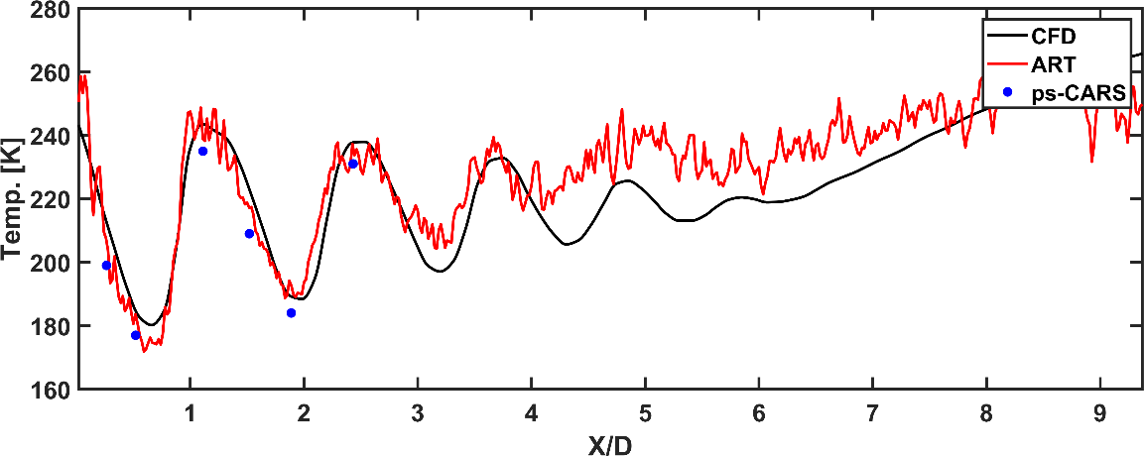
Figure 3.10 CFD, O₂ RIPT, and ps-CARS temperature measurements within the under expanded supersonic jet shock train.

A small temperature discrepancy between O2 RIPT and CFD does not occur until the flow is nearing its fully-developed region. It is believed that photoelectron induced emissions gives a relatively higher temperature measurement within the fully developed region to be due to mixing and other viscous fluid interactions that are not fully accounted for within the CFD’s turbulence model.

Conclusions
The complex excitation and energy transfer mechanisms that are involved with O₂ RIPT technique inherently induce constraints to the properties of the working medium. The emission from the first negative band of N₂⁺ directly results from electron impact excitation of local nitrogen molecules that is procured through electron avalanche ionization of resonantly excited and ionized O₂. Thus, O₂ RIPT fundamentally relies upon strong stochastic effects of the electron avalanche ionization within the locally ionized region of the focused laser emission. Special care must be taken into the actual formation of the ionization region and selection of the lens to focus the laser emission. As regions of very intense laser energy induces ionization and results in a plasma density with greater frequency than the incoming light frequency, back propagation and back scattering of the laser emissions will occur creating regions of more and less dense plasma that could impact the N₂⁺ photoemission Boltzmann dependence. Furthermore, there will exist some time delay between resonantly exciting O₂ and the N₂⁺ photoemission. It has been previously studied and found in literature that this delay is approximately 80 picoseconds for standard temperature and pressure [70]. Furthermore, until local thermal equilibrium (LTE) is reached in the ionized region, the vibrational energy populations will not adhere to a Boltzmann distribution, thus the N₂⁺ emissions will not directly be representative of the O₂ rotational S-branch two-photon transitional line strengths [72]. Additionally, LTE may never be reached in high-enthalpy gas environments, which would render O₂ RIPT measurements invalid. For this study, O₂ RIPT is conducted in a low-enthalpy flow and a lasing pulse width of 10 ns is used, thus the ionized region is assumed to instantaneously be in LTE and the lasing pulse and energy is sufficiently longer than the temporal delay of the electron avalanche ionization and subsequent electron impacted excitation of N₂.
Resonant Enhanced Photoemission Thermometry utilized resonant wavelengths to selectively excite various rotational bands of O₂ that results in weakly ionizing a local region of the medium gas. Through electron avalanche ionization and electron impact excitation of local nitrogen molecules; the first negative band of N₂⁺ is weakly vibrationally excited. Deexcitation from the first negative band of N₂⁺ results in photoemissions in the visible region from 395 to 430nm. The spectral emissions are captured by an ICCD camera. The resulting emission intensities have extensively been studied and demonstrate a 1:1 relationship with the two-photon transitional line strengths of the selectively excited O₂ wavelengths. The 1D nature of O₂ RIPT measurements enables high spatial resolutions to be obtained and demonstrated here at 50 µm spatial resolution. Additionally, the spatial resolutions upper limit is only defined by the camera sensor used (pixel size) and experimental specific optical magnification of signal.
In summary, a moderately under expanded supersonic free jet with a focus on the ensuing shock-train formations aft of the nozzle exit plane is rigorously analyzed through multiple methods to serve as a means of validation of O₂ RIPT technique and its capabilities. The measured local gas vibrational temperature via O₂ RIPT is compared at various measurement locations via picosecond vibrational Coherent Anti-Stokes Raman Scattering (ps-CARS). Signal analysis through CARFT reveals theoretical temperature measurements that are close to predicted measurements of resonantly ionized photoemission thermometry. The flow regime downstream of the nozzle exit is low enthalpy; thus, the molecular vibrational temperatures are assumed to be representative of the total gas temperature enabling a direct comparison between a CFD simulation, CARS, and O₂ RIPT measurements. The CFD and O₂ RIPT measurements show good agreement through the shock structures and diverge slightly once the flow becomes fully-developed. It is shown that O₂ RIPT measurements are capable of resolving the temperature fluctuations very closely to those predicted via CFD through the complex shock-interactions and fluid-dynamics downstream of the nozzle exit. Finally, inherent limitations and required gas dynamics are briefly discussed that enable strong photoelectron induced emissions signals and where the signals can be assumed to have a Boltzmann distribution. Overall, O₂ RIPT is shown to be a promising, novel, thermometry technique that is just beginning to be explored. Additionally, while demonstrated here in a supersonic regime, it can be used for thermometry applications within any gas medium that contains O₂ and N₂ and is not undergoing real-gas effects.

O₂ temperature measurements by resonantly ionized photoemission thermometry in Mach 4 Wind Tunnel

The following data was collected for publication by Walker McCord, Mark Gragston, Alek Clark, Shelby Ledbetter, and Zhili Zhang. At the time of writing, versions of this chapter are awaiting publication into a peer review journal. Additionally, the data presented here will be presented at the AIAA SciTech 2023 conference. The text descriptions and general layout of the data has been edited slightly for added coherency. Walker McCord is the lead author for this work.

Abstract
In this work, one-dimensional (1D) Oxygen-based Resonantly Ionized Photoelectron Thermometry (O₂ RIPT) technique is used to characterize thermal gradients present within supersonic flow (Mach 4). Specifically, O₂ RIPT is used to 1) characterize the free stream test section temperature across a 2-inch line and, 2) study shock wave compression heating induced by a detached shock from a blunt 1” diameter cylinder. O₂ RIPT first resonantly ionizes O₂ molecules via (2+1) Resonant Enhanced Multiphoton Ionization (REMPI) process; subsequent ionization via electron impacted avalanche ionization of molecular nitrogen produces fluorescence emissions from the first negative band of N₂ through photoemission deexcitation. The fluorescence emissions of the N₂ first negative band occur at (Δv₀, ~390nm; Δv₂, ~425nm; Δv₁, ~430nm) and are captured by a gated intensified scientific camera. The fluorescence emission shares a direct relationship with the two-photon line strength thus is representative of the rotational state distribution of the molecule, enabling a gas vibrational temperature assignment through a statistically fitted weighted sum of the acquired signal (i.e., a Boltzmann distribution). The O₂ RIPT signal is demonstrated to generate strong emission lines of approximately 4 cm in length, providing an attractive thermometry solution for measurements in supersonic and hypersonic flow where thermal gradients are highly dynamic and of high importance.

Introduction
A fundamental design challenge associated with hypersonic vehicles is the reduction of aerodynamic heating imparted to the vehicle. At high-supersonic and especially hypersonic speeds, all bodies must be blunt nosed to an extent in order to reduce the heat transfer rates to manageable proportions and to allow for internal heat conduction. Depending on the relative bluntness at the nose of the flight vehicle and the speed at which it is traveling, a strong detached bow shock or normal shock will develop. This detached shock converts most of the kinetic energy associated with high flight velocities to thermal and chemical energy. This conversion of energy creates a high temperature region directly aft of the shock and while this region is associated with high total stagnation heating, the detached shock reduces imparted heating to the aerothermal structure by dissipating the thermal energy into the surrounding air via shock wave compression with the remaining heating arising within the boundary layer [73]. Furthermore, the detached shock represents a trade-off between thermal management and aerodynamic efficiency, as the strong entropy change through the shock will result in high surface pressures on the body resulting in an increase in the aerodynamic drag [74]. However, the reduced surface heating accomplished from detached shocks makes the tradeoff worthwhile, and there are ways to mitigate the negative impact of aerodynamic efficiency (i.e., aerospikes, forward mass injection, and freestream energy deposition) [75-79].
Since the maximum local heat transfer rate in most cases will occur in the vicinity of this forward stagnation point, the fluid interactions and flow dynamics within this region have been of considerable interest in the research community. Because of the strong falling pressure gradients and large heat transfer to the surface, the boundary layer within this region can be expected to be laminar [80]. However, relative to flight velocity, the thermal and chemical energy within this area is sufficiently strong enough to dissociate oxygen and nitrogen molecules resulting in non-equilibrium flow and real gas effects, making it a challenging area for CFD simulations to model accurately [81]. Thus, it is critically important to obtain experimental measurements that can provide dependable benchmark validation data.
Furthermore, following Moore’s law, powerful computational hardware has become less expensive and thus can be accommodated by a wider range of researchers than ever before. This has led to a plethora of computational simulation data on models of high fidelity and wide parameters. Thus, worsening the void of experimental benchmark data to back up the simulated models. A need exists for experimental data and optical, non-intrusive flow characterization techniques are preferred for obtaining experimental benchmark validation within high-supersonic and hypersonic flows. As the use of physical probes can induce disturbances that can propagate downstream disturbing characteristic flow phenomena and gas chemistry, invalidating measurements around critical regions of interest. Specifically, optical thermometry techniques capable of resolving the thermal gradients within the flow are critical. Some current non-intrusive optical thermometry techniques that have been used to study heating around blunt bodies include Planar-Laser Induced Fluorescence (PLIF), Tunable-Diode Laser Absorption Spectroscopy (TDLAS), and Coherent Anti-stokes Raman Scattering (CARS) [4, 25, 30, 82, 83]. PLIF must employ the use of a tracer molecule such as Nitric Oxide or an aromatic molecule, which can alter the flow chemistry and can result in nonreal flow features and behavior [9, 11, 84]. TDLAS is path-integrated and limited to point measurements, making it difficult to isolate acquired data to within the test vehicle region [15-17]. CARS does not require flow seeding and is non-path integrated historically making it an attractive option. However, CARS is limited to point measurements within low-enthalpy, low density flows and is prone to misalignment in high-noise environments typically associated with ground-based test facilities.
A relatively new technique, oxygen-based Resonantly Ionized photoemission thermometry (O₂ RIPT), is capable of resolving vibrational gas temperature measurements across a 1D line within low-enthalpy, high-speed flows without the need for particulate or gas seeding. O₂ RIPT builds upon advances in Resonant Enhanced Multi-Photon Ionization (REMPI) to resonantly excite oxygen molecules inducing electron impacted excitation of locally available nitrogen molecules, generating N₂⁺. The technique is enabled through the proven assumption that the photoemissions strength within the first negative band of nitrogen, i.e., $N_{2}^{+}(B^{2}Σ_{u}^{+}-X^{2}Σ_{g}^{+})$, are directly related to the two-photon transitional line strength of the selectively excited absorption peak within oxygen’s $O_{2}(X^{3}Σ(v^{'}=0)→C^{3}Π\left(v=2\right)$ absorption band that lies between 285 to 289 nm. Fundamentally, the technique works by assuming that the selectively chosen peaks within the resonant absorption bands, which are temperature sensitive, can be directly represented by the excited molecular nitrogen’s photoemissions of the first band. Thus, the photoemissions indirectly are representative of the rotational state distribution of the oxygen molecule. Thus, by probing multiple resonant absorption lines a statistically weighted (Boltzmann) distribution can be applied to the emission signals; enabling a temperature assignment. Furthermore, since the generated photoemissions result from electron impacted excitation processes of nitrogen from oxygen, the temperature assignment is of the vibrational state.
The REMPI structure of O₂ and details of the underlying physics for the O₂ RIPT signal generation are described in detail in Chapter 2. Using the results of the calibration study in Chapter 2, O₂ RIPT is demonstrated within a high-speed, low-enthalpy Mach 4 wind tunnel at UTSI. Two different measurements will be conducted; Characterization of the free stream, and shock-wave compression heating study of a detached shock generated from a blunt cylinder. This will be first demonstration of the novel O₂ RIPT technique within a ground-based wind tunnel facility providing insight on technique robustness, hardware dependence, and measurement ability in turbulent flows.

Experimental Setup

Tunnel Facility
The UTSI Mach 4 Ludwieg tube located within the Tennessee Aerothermodynamics Laboratory (TALon) lab was utilized for conducting the O₂ RIPT experiments and a CAD rendering of the tunnel is shown in Fig.4.1 [85, 86]. The facility has a 61 by 61-centimeter (24 by 24 inch) nozzle exit area and a 1.82-meter test-section. The facility has a total run time of approximately 200 milliseconds, of which about 130 milliseconds is considered steady state flow conditions. The nominal pressure and total temperature for these tests were 439.7 kPa [kilopascals] and 287 Kelvin respectively. The static pressure and temperature were approximately 3500 Pa [pascals] and 80 Kelvin respectively. The freestream per length Reynolds number was $21.2×{10}^{6}$ m⁻¹ [meters]. The second harmonic of an injection seeded Nd:YAG laser (Spectra Physics Quanta Ray Pro 290) with a pulse width of 8ns [nanoseconds], repetition rate of 10 Hz [Hertz], with average lasing energy of 1 joule per pulse was used to pump a dye laser (Sirah Precision Scan) that utilized a mixture of Rhodamine 590 and Rhodamine 610 to produce lasing light around 574nm (0.02 cm⁻¹ linewidth).
The dye laser was frequency doubled to generate deep ultraviolet (UV) light around 287nm [nanometers] for probing the $O_{2}(X^{3}Σ(v^{'}=0)→C^{3}Π\left(v=2\right)$ resonant absorption band of oxygen. Nominal pulse energies of approximately 30 mJ/pulse [millijoules] were measured at the output of the frequency doubling unit and was maintained over the range of 285nm to 288nm [nanometers]. The beam was steered vertically using a UV fused silica right-angle prism and was focused using a fused silica plano-convex lens of 500mm [millimeter] focal length. The focusing distance of the lens was selected that allowed the beam to pass through the fused silica windows in the tunnel floor unimpeded and creating the beam waist near the center of the tunnel test section.

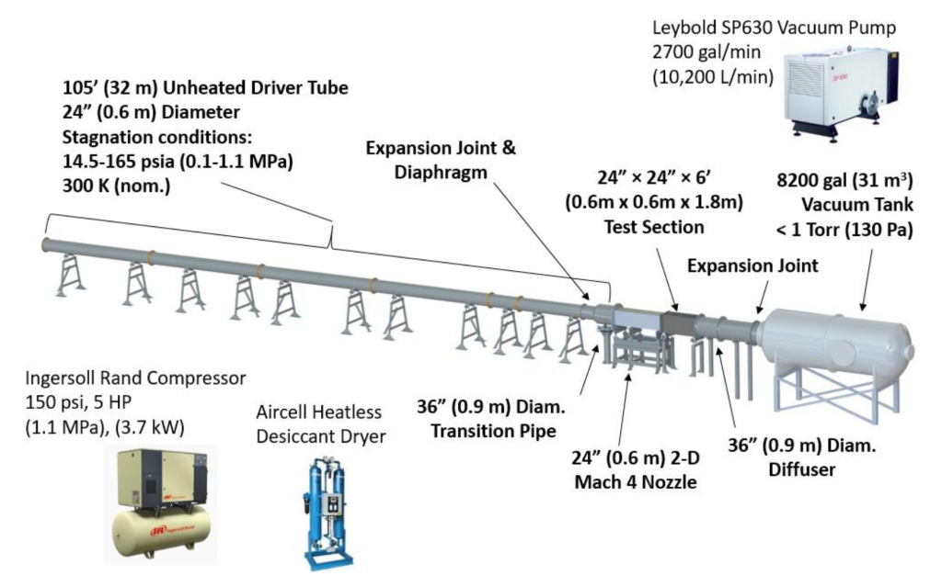
Figure 4.1 UTSI Mach 4 Ludwieg tube and accessories.

The generated O₂ RIPT signal was magnified and relayed via a +1000mm [millimeter] camera lens and captured via an intensified scientific camera (PI-MAX4 1024f) with a sensor size of 1024x1024 pixels. A square (50mm x 50mm) Schott’s® glass BG3 filter of 1mm thickness was used to filter out laser, scattering, and other background light contributions from the signal. Visualizations of the full setup within the TALon lab are shown in Fig. 4.2.

Cylinder Model
In addition to measuring the tunnel freestream temperature, a near model measurement would be conducted using O₂ RIPT. A circular cylinder model was used to generate a strong normal shock that create an environment that is relevant for studies regarding shock-wave compression heating phenomena. The dissipation of strong viscous interactions and flow mixing behind the detached shockwave generates a high-temperature region behind the detached shockwave. The strong temperature gradient from free stream to behind shock generated presented a good study to examine O₂ RIPT’s ability for measuring through-shock temperatures in turbulent flow and help quantify the upper limits of robustness for the technique.
The model consisted of a 25.4mm diameter cylinder that is 10.16cm in length was 3D printed using a Form 3L printer. The cylinder model was mounted on a 700cm long rod allowed the model to be translated either upstream or downstream of the tunnel for precise alignment with the laser beam. Additionally, the UV laser beam was focused 3mm orthogonal to the surface of the model. This represented the closest distance to the model that prevented laser breakdown from tunnel movement during runs. Black photography tape was used to minimize laser reflections on the model. A black marker was then used to cover the black photography tape with black ink, it was found this reduced the reflections off the model to negligible amounts.

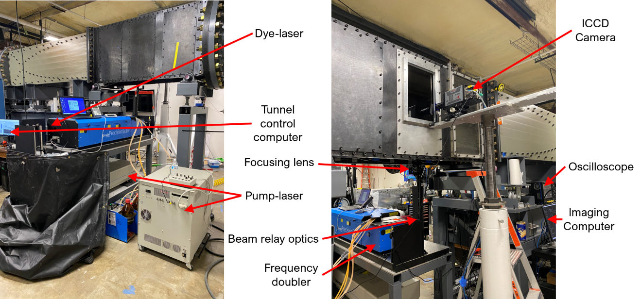
Figure 4.2 UTSI Mach 4 O₂ RIPT setup.

Two configurations of the cylinder were used, first the cylinder was positioned vertically (i.e., orthogonal to the tunnel floor) to allow the O₂ RIPT line to be generated along the length of the surface and behind the detached shock. Second, the cylinder was positioned horizontally (i.e., parallel with the tunnel floor) to allow the O₂ RIPT line to be generated such that the thermometry signal would pass through the shock from the freestream. Computer generated designs of the cylinder model for vertical and horizontal configurations are shown in Fig. 4.3(a) and Fig. 4.3(b) respectively. Additional images that show the model for the vertical and horizontal orientation mounted in the tunnel are shown in Fig. 4.4(a) and Fig. 4.4(b).

Results and Discussions

Freestream
One-dimensional oxygen-based RIPT measurements using only direct imaging of photoemissions generated from $N_{2}^{+}(B^{2}Σ_{u}^{+}-X^{2}Σ_{g}^{+})$ first negative band were acquired to measure the freestream temperature within the test section of the tunnel across a line 5 cm in length. Four wavelengths were selected for probing to enable a temperature assignment via RIPT, and they were chosen based on the 180 Kelvin temperature setpoint of the calibration study found in Chapter 1. The 180 Kelvin wavelengths were chosen specifically because they were closest to the theoretical predicted static freestream temperature. At each wavelength an O₂ RIPT line was generated by focusing the laser using a 300mm plano-convex lens, this allowed positioning of the line within the test section such that effects from the wall boundary layer were avoided. Due to steady state tunnel run time and laser repetition speed, only two single shot RIPT signals were able to be acquired for each wavelength. The pre-run image along with the RIPT signal images at 286.98, 287.15, 287.28, and 287.33nm are shown in Fig.4.5, Fig.4.6, Fig.4.7, and Fig.4.8 respectively.

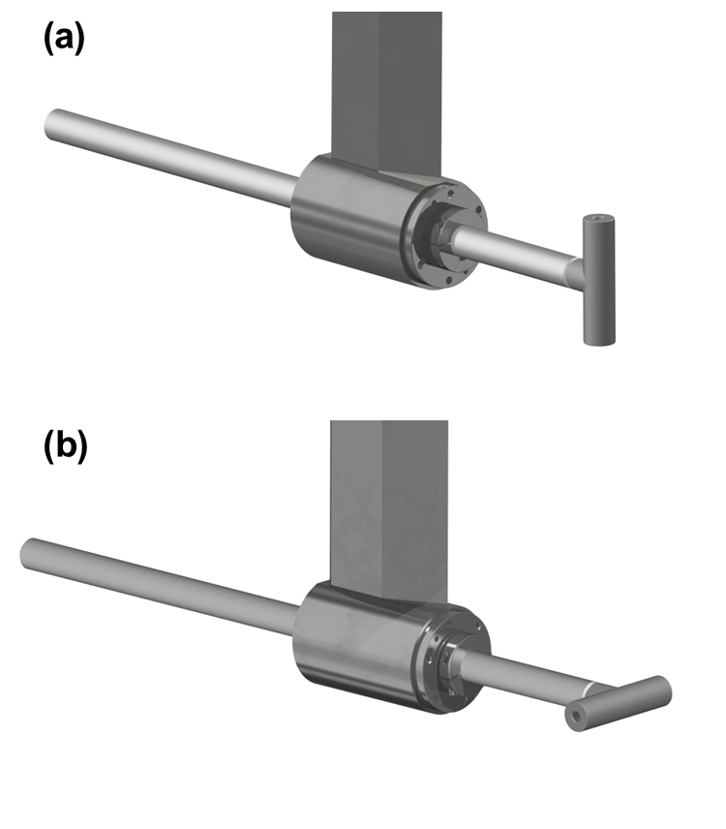
Figure 4.3 Cylindrical model vertical orientation (a) and, horizontal orientation (b).

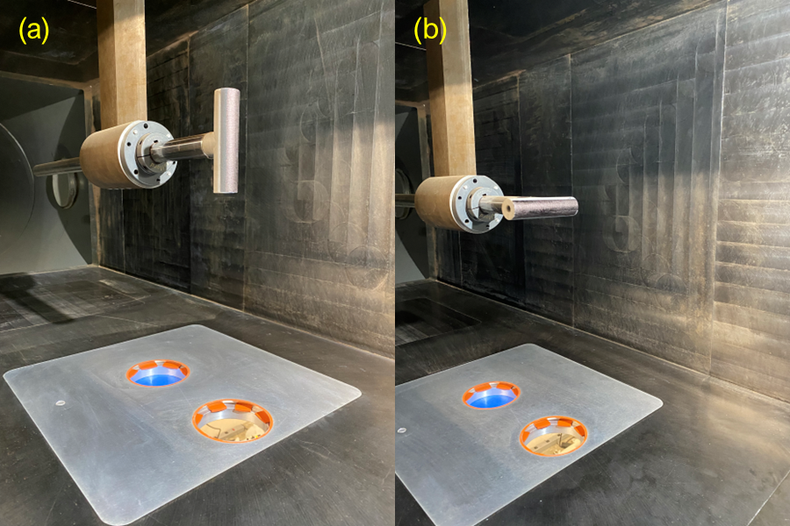
Figure 4.4 Cylinder model mounted in tunnel for vertical orientation (a), and horizontal orientation (b).

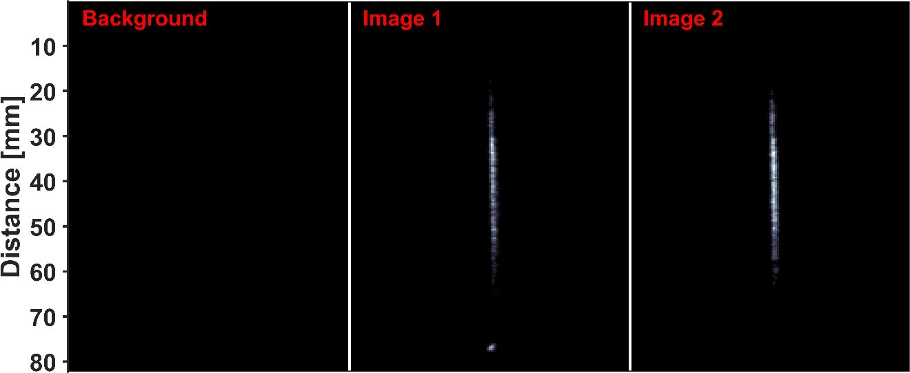
Figure 4.5 O₂ RIPT emission line images from 286.98nm laser excitation in a Mach 4 freestream.

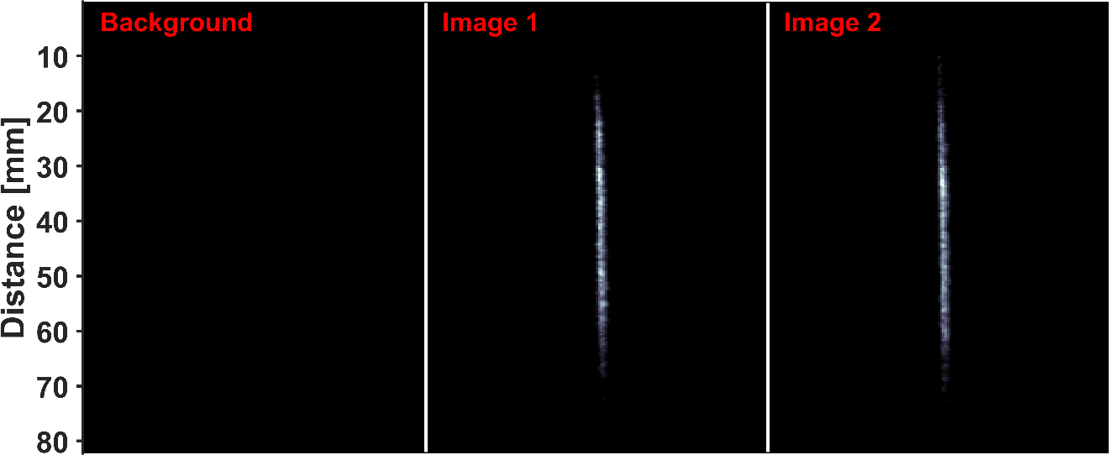
Figure 4.6 O₂ RIPT emission line images from 287.15nm laser excitation in a Mach 4 freestream.

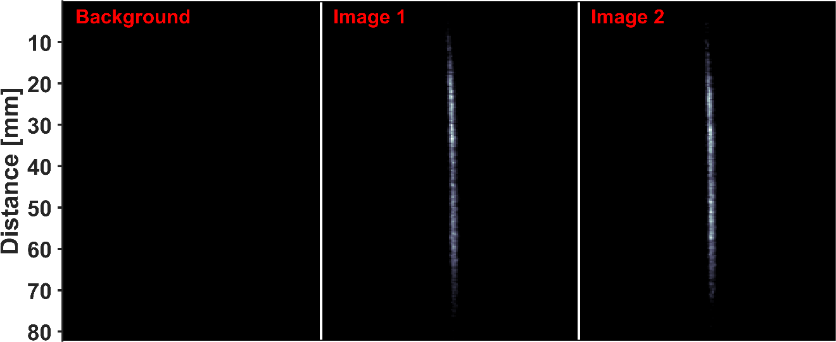
Figure 4.7 O₂ RIPT emission line images from 287.28nm laser excitation in a Mach 4 freestream.

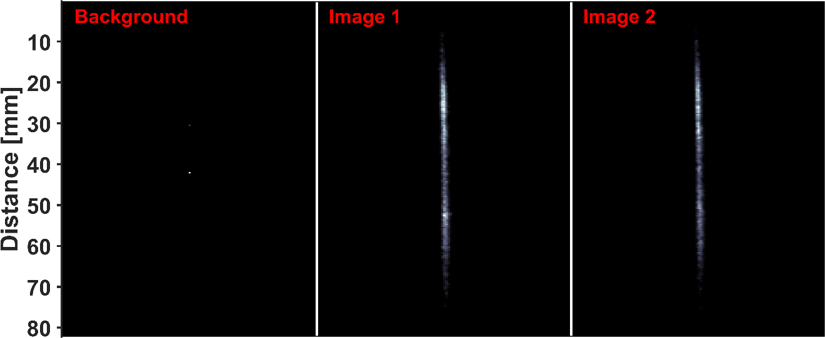
Figure 4.8 O₂ RIPT emission line images from 287.33nm laser excitation in a Mach 4 freestream.

Previous studies of signal pressure dependence within a closed environment found that as pressure decreases from atmospheric the signal emission strength is drastically reduced until it is indistinguishable from background noise around 6psia [pounds per square foot absolute]. However, even though the tunnel’s freestream static pressure is 0.5psia, it was found the number density increases due to flow velocity, thus all RIPT lines demonstrated strong single shot intensities on the order of thousands of counts post background subtraction. Upon visual inspection, it is obvious that as the wavelength increases so does the RIPT emission line length. This is due to as the two-photon transitional line strength decreases, the resonance energy increases, and subsequently there will be higher populations within those branches, thus the emitted fluorescence intensity and line length increases.
The emissions were post processed using the same technique and equations covered in Chapter 1 to relate the photoemission strength to a vibrational gas temperature. The resulting O₂ RIPT temperature measurement of the free stream across a 52mm line length is shown in Fig. 4.9. Furthermore, the camera utilized a 1000mm telephoto focusing lens for imaging, which magnified the photoemission line to such a degree the spatial resolution became hardware limited (i.e.,13μm). The average free stream temperature as measured by O₂ RIPT was approximately 75.7 Kelvin. The shape of the resulting line measurement is in a traditional sense not “smooth”, with mean fluctuations of approximately ±1 Kelvin. These fluctuations are inherently due to a variety of phenomena that together increase the overall noise in the measurement. Slight temperature drops at the pixel level from viscous mixing and other dissipations forces within the flow, camera readout noise, and shot-to-shot fluctuations in laser energy due to the single shot nature all contributed to the observed fluctuations. Isentropic flow theory is used to compare and validate the O₂ RIPT measurement.

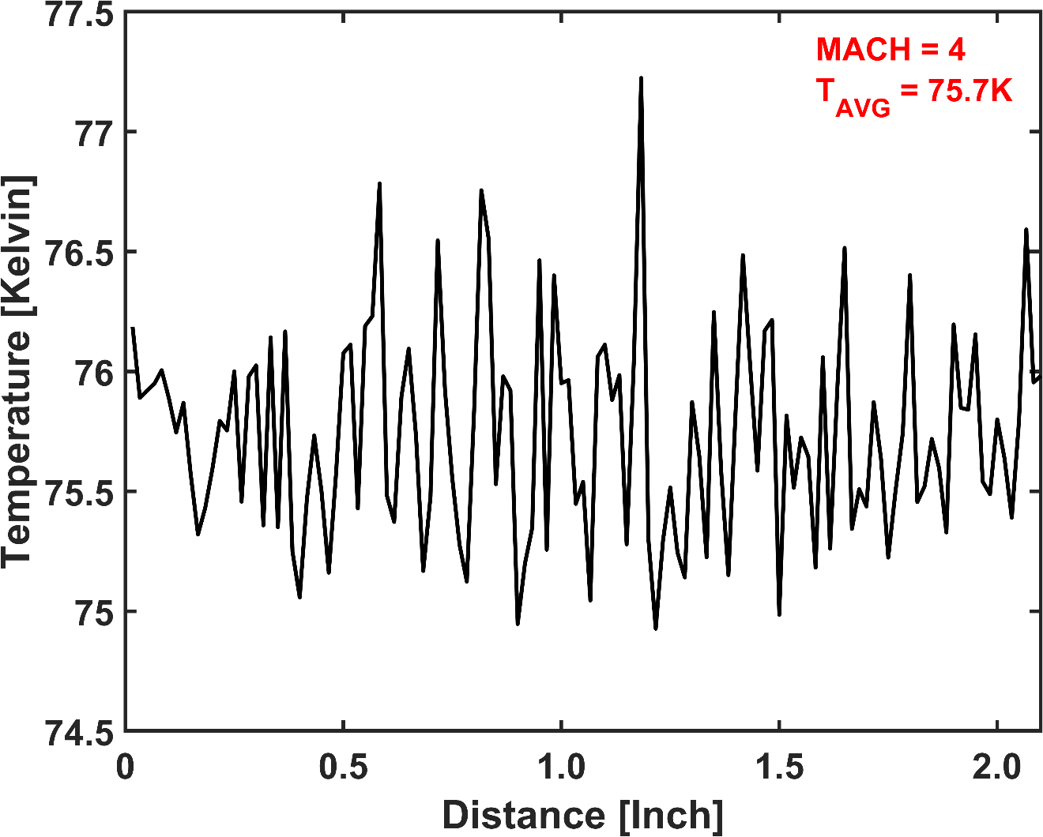
Figure 4.9 O₂ RIPT line temperature measurement of the tunnel freestream.

For non-heated, low-enthalpy Mach 4 conditions the $T/{T_{0}}=0.238$, thus the theoretical freestream static temperature is approximately 72 Kelvin. If the ±3 Kelvin error associated error of the O₂ RIPT technique is considered, then the experimental values show good agreement with the expected temperature values. Furthermore, if non-idealized flow parameters are considered the O₂ RIPT measurement may be a better representation of the actual flow temperature. Indicating that due to unknown factors the actual free stream tunnel temperature is slightly higher than what is given by theoretical approximations.

Model: Vertical
One-dimensional oxygen-based RIPT measurements were obtained by directing the laser beam along the center axis of the cylinder model in the vertical orientation and focusing the beam such that the beam waist was positioned centered on the model. Furthermore, the beam was orthogonally offset from the model by 3mm, (i.e., upstream). It was necessary to offset the beam from the model as the tunnel was built on rollers that allow slight movement during runs. Thus, it was found that the minimum distance to avoid laser breakdown from the model moving with the tunnel and impinging upon the laser was 3mm. Schlieren images were taken of the model at 50 kHz rates to examine the shock stability and characterize stand-off distance. A schlieren image of the model is shown in Fig.4.10. It was found that the shock stand-off distance at the centerline of the model is approximately 6.4mm from the model surface. Thus, the RIPT measurement line can be maintained behind the shock over the entire course of the run even with the tunnel movement. Figure 4.11(a) shows an experimentally collected raw image of the RIPT signal and with the model location artificially added to the image to aid in line stand-off distance visualization.

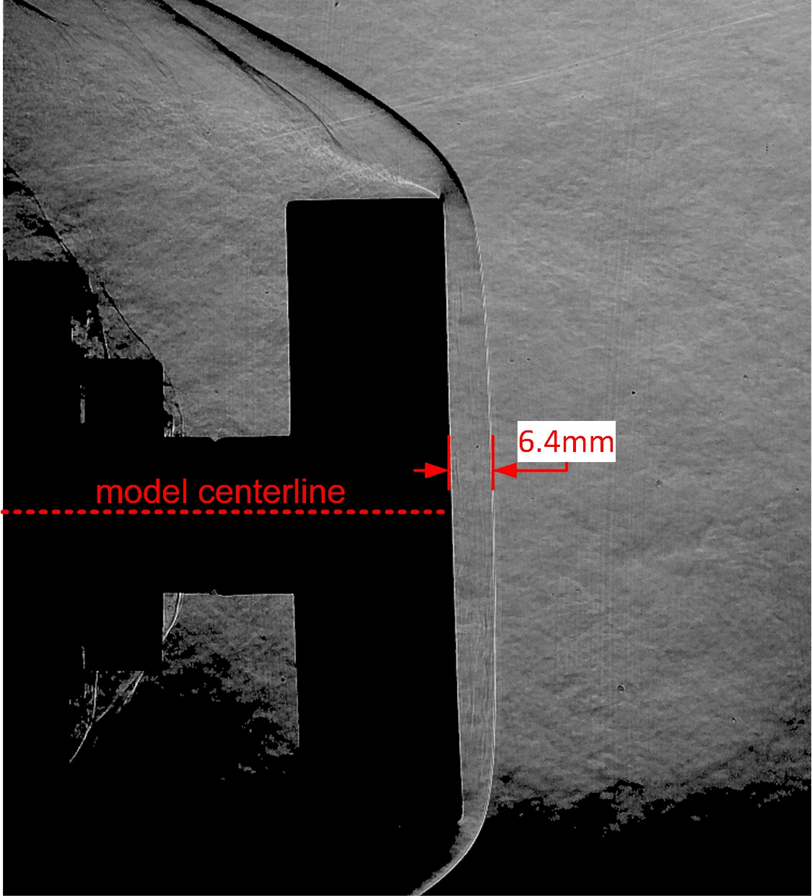
Figure 4.10 Schlieren image of cylinder model depicting model centerline and shock standoff distance.

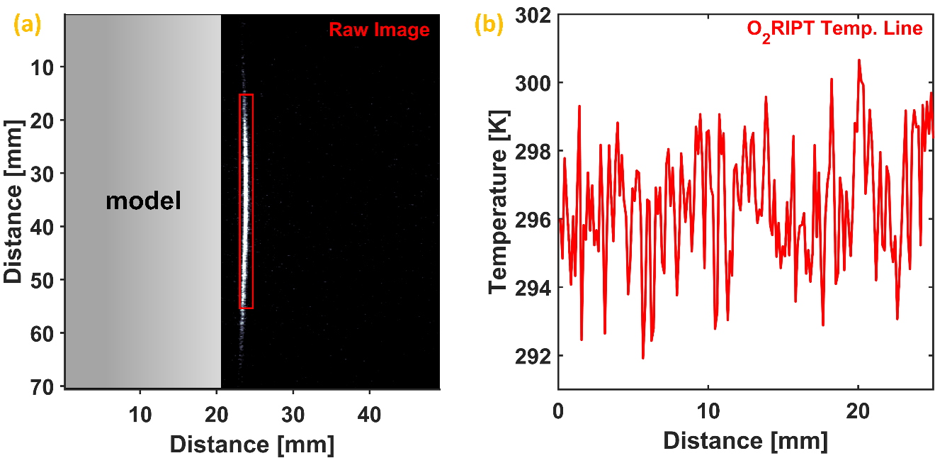
Figure 4.11 Image of model and O2 RIPT line (a), and O₂ RIPT temperature measurement behind shock (b).

Using compressible flow theory and an assumed freestream temperature of 72 Kelvin results in a static temperature behind the shock of 293 Kelvin. The O₂ RIPT measurement predicted an average temperature of 296.5 Kelvin (±2% error) across a one-inch line, which is depicted in Fig.4.11(b). The average experimental value is well within the expected value, both showing great agreement with only slight deviations observed. Furthermore, since the difference between experimental and expected values are almost identical to that of the free stream measurement; further indicating that the tunnel free stream temperature is slightly higher than the theoretical value.

Model: Horizontal
The generated O₂ RIPT measurement line used for thermometry measurements across the horizontal orientation of the model was approximately 4.0 cm in length which was sufficient to cross the shock, measuring both the free stream and behind shock temperature. The O₂ RIPT generated line crossed the shock at approximately half the line length (i.e., 2.0 cm) enabling 2.0 cm line temperature assignments for both outside and behind the shock. A raw image of the RIPT signal for the horizontal orientation is shown in Fig. 4.12(a), with an augmented cylinder shape overlaid to visual aid in spatial placement of the generated line with respect to the model. Due to the 3D relief affects there exists a thermal gradient across the diameter of the model; with highest total temperatures located along the axis of the cylinder where stagnation effects are most relevant, and gradually decreasing on either side as shock curvature and flow slippage becomes more prevalent.
For the horizontal study, eight wavelengths O₂ RIPT wavelengths were probed for measurements. These wavelengths were used in resolving 180 and 293 Kelvin temperatures in the calibration study of Chapter 2.

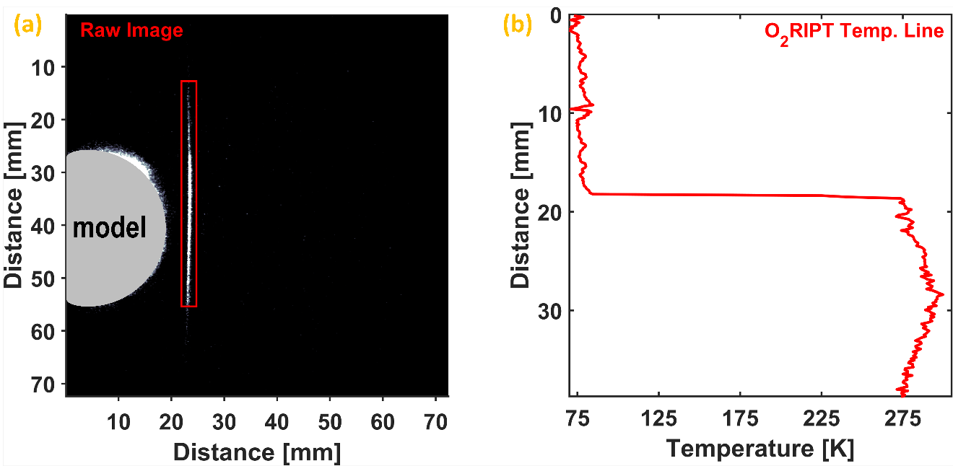
Figure 4.12 Image of horizontal model and generated O₂ RIPT line (a), and O₂ RIPT temperature measurement across shock (b).

The resulting emissions were post processed in a similar fashion to the vertical study, except a code was used that monitored the coefficient of correlation for the individual pixel fits. This was done to allow the code to know when to switch from using the 180 Kelvin wavelengths to the 293 Kelvin wavelengths for temperature assignments. This method was used as it yielded the highest accurate and overall best gas temperature assignment. The portion of the generated O₂ RIPT line that was within the free stream assigned an average gas temperature of approximately 75.2 Kelvin (±2%), aligning well with the theoretical and previous free stream measurement. The portion of the signal that was behind the shock demonstrated sufficient sensitivity to resolve the thermal gradient due to the 3D relief effects; with a max gas temperature assignment of 296 Kelvin (±2%) at the model centerline. Additionally, the location which the RIPT line crosses the shock, the assigned gas temperature was approximately 276 Kelvin (±2%). To compare and validate all O₂ RIPT measurements a CFD analysis was performed on the cylinder. The resulting Mach contour and 2D temperature around the model for Mach 4 flow conditions are shown in Fig.4.13(a) and Fig.4.13(b) respectively.
Finally, a comparison of the O₂ RIPT temperature measurements for the two different orientations was made and is shown in Fig. 4.14. The comparison of the two orientation measurements validated two things; first that the horizontal measurement of the temperature gradient is correct because it and the vertical temperature overlap at the peak static temperature location, which spatially was determined by the horizontal measurement. Second, because the two overlap at the horizontal determined max temperature, it confirms that the generated O₂ RIPT line for the vertical orientation was positioned accurately along the centerline of the model and is highly representative of the total gas temperature behind the shock along the model surface.

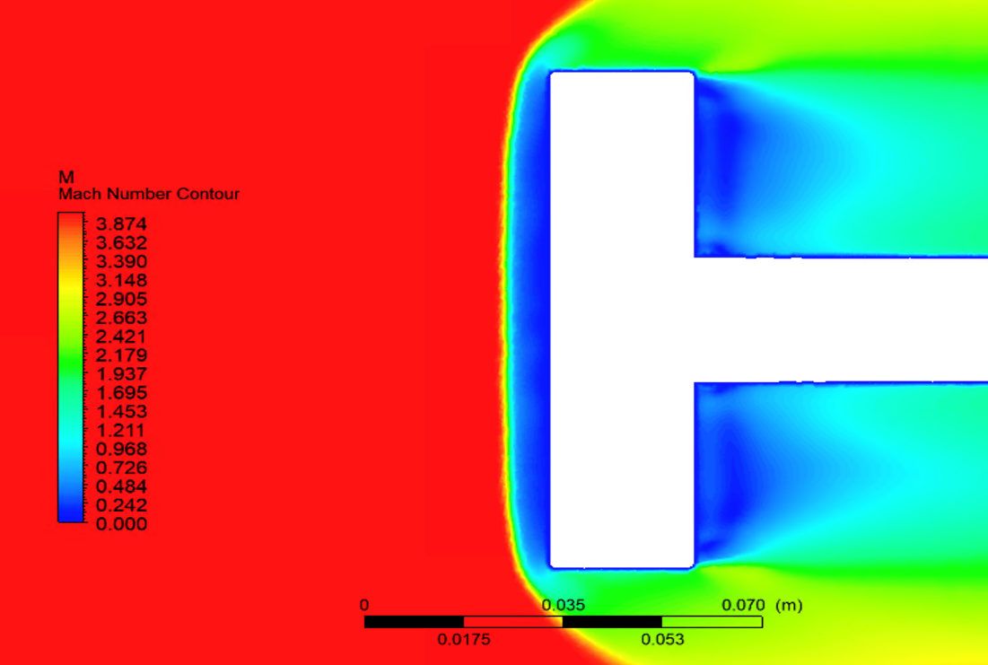
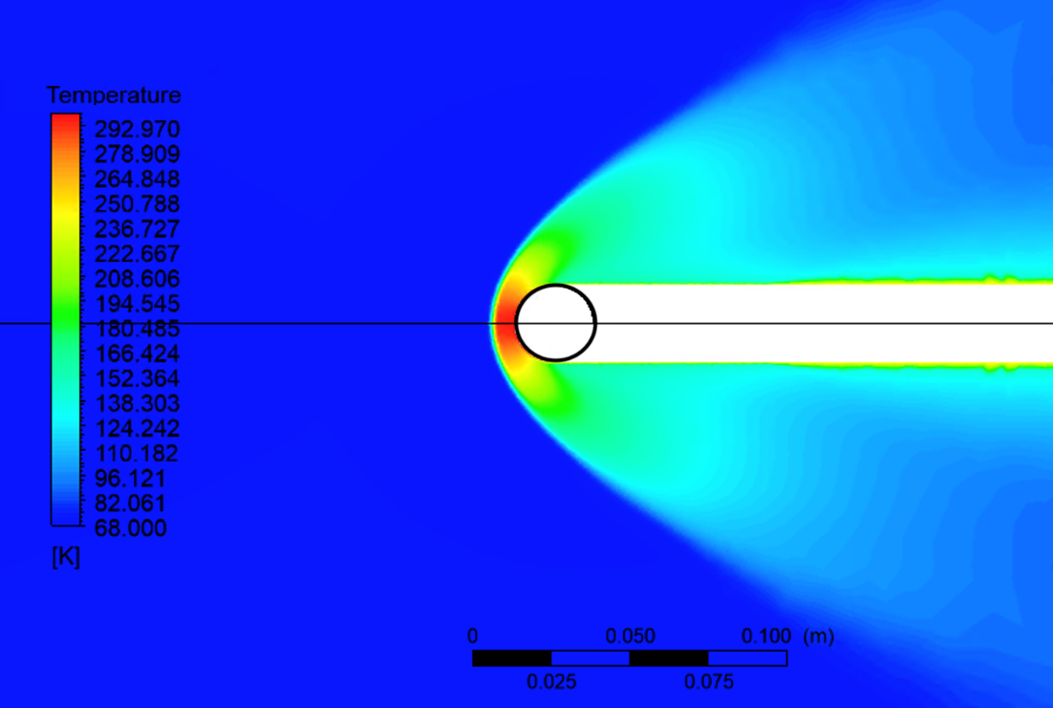
Figure 4.13 CFD of cylinder model showing Mach contour (a), and the temperature contour (b).
(a)
(b)

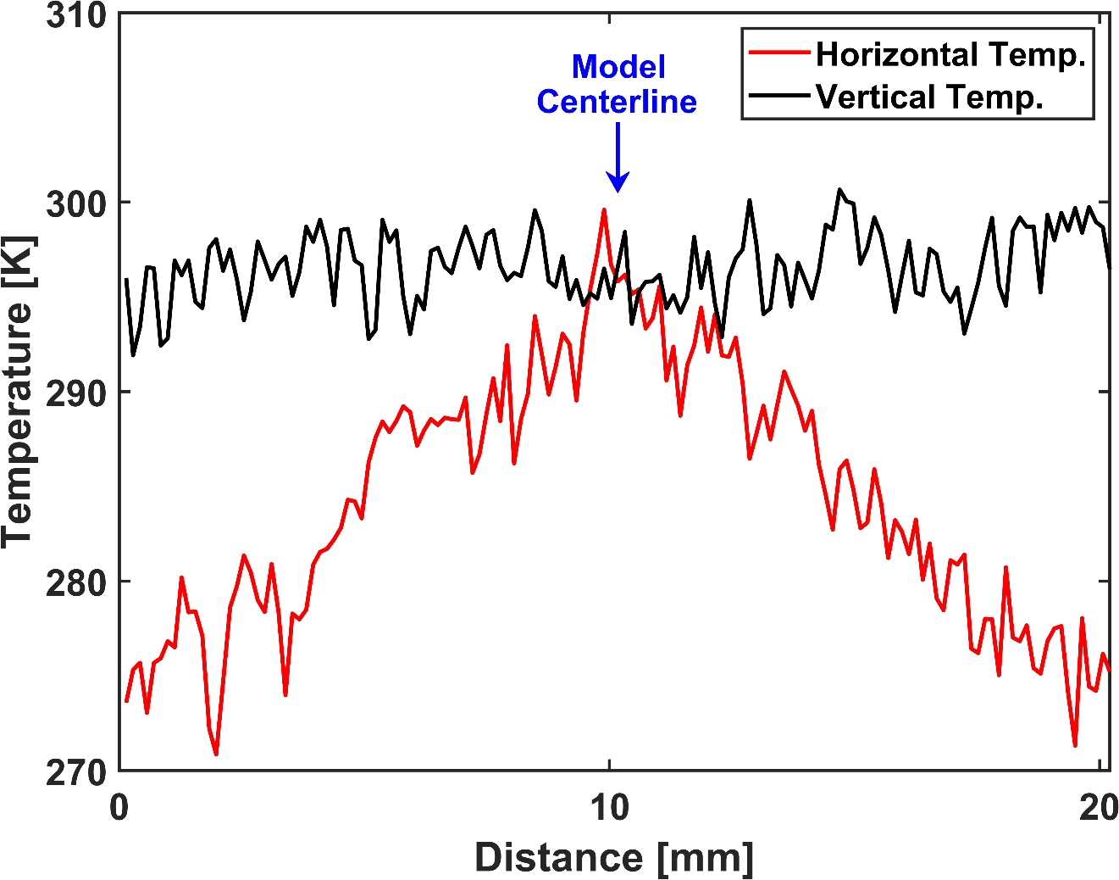
Figure 4.14 Comparisons of the horizontal and vertical oriented O₂ RIPT measurements.

Conclusions
In summary, Oxygen-based Resonantly Ionized Photoemission Thermometry has been demonstrated for one-dimensional line temperature measurements of up to approximately 5.2cm in length in a Mach 4 wind tunnel environment. First, the free stream temperature within the test section was characterized over a 5.2cm long O₂ RIPT line. Since the tunnel is non-heated and low-enthalpy, the theoretical static temperature (approximately 74 Kelvin), was well outside the calibration range that O₂ RIPT had been demonstrated to. Furthermore, the O₂ RIPT measurement assigned an average vibrational gas temperature across the 5.2cm line of approximately 75.7 Kelvin; this is within the theoretical temperature considering the technique error (±4 Kelvin). This confirms that the calibration wavelengths found in Chapter 2 for the cold-gas temperatures (<293 Kelvin) are widely applicable; maintaining relevant population distributions for accurate temperature assignments far outside the lowest calibration setpoint. Additionally, the number density increases due to flow velocity results in sufficient single shot signal emission strength for adequate SNR values. Minimal discrepancy between the experimental obtained and expected values indicate that the gas in the free stream of this tunnel is in Local Thermodynamic Equilibrium (LTE) and the vibrational gas temperature is indicative of the total gas temperature.
A cylinder model that generated a strong detached shock and induces flow phenomena that is relevant to shock wave compression heating was studied. First, the cylinder model was centered in the tunnel test and positioned such that the height of the cylinder was orthogonal to the tunnels floor and ceiling. This was dubbed the “vertical” orientation and allowed an O₂ RIPT measurement to be conducted entirely behind the shock, along the face of the model. An O₂ RIPT measurement along a 2.5cm line assigned an average vibrational temperature of approximately 296 Kelvin. Ideal normal shock relations equated the temperature jump across the shock to be 4.07; if the theoretical static free stream temperature is used this results in a behind shock temperature of 295 Kelvin. The O₂ RIPT measurement for the vertical orientation matches well with the theoretical stagnation temperature along the centerline of the model. Furthermore, the reduction in measurement discrepancy is likely due to the increased number density behind the shock; generating higher photoemissions and thus the increasing the SNR.
Next, the cylinder model’s spatial location relative to the test section was maintained, but the model was rotated 90-degrees such that the main axis of the cylinder was orthogonal to the tunnel’s side walls (i.e., “horizontal” orientation). An O₂ RIPT measurement line of 4.0 cm was sufficient in length to cross the shock, measuring both the free stream and behind shock temperature. The portion of the generated O₂ RIPT line that was within the free stream assigned an average gas temperature of approximately 75.2 Kelvin, aligning well with the theoretical and previous free stream measurements. The portion of the signal that crossed the shock demonstrated sufficient thermal sensitivity to resolve the gradient due to the 3D relief effects; with a max gas temperature assignment of 296 Kelvin at the model centerline and a min of 276 Kelvin at the position the line crosses the shock.
For both model orientations the O₂ RIPT measurements were validated and compared against theoretical approximations, CFD simulations and each other. All measurements agreed well with the theoretical approximations with minimal differences between them. The CFD simulations were critically for comparisons to the behind shock thermal gradient measurement of the horizontal configuration, with the O₂ RIPT measurement aligning well with the CFD predicted thermal gradient. Furthermore, the CFD stagnation temperature along the model centerline of 296 Kelvin agreed well with the average experimental measurements at the centerline for both orientations. The two orientations RIPT temperature assignments were compared, showing temperature overlap at the model centerline as indicated by the cross-shock measurement. This confirmed that the laser focus and thus the generated RIPT line for the vertical orientation was positioned accurately along the centerline of the model, and that the two different measurements overlapped with one another spatially at the model center.
O₂ RIPT has been demonstrated to achieve accurate gas temperature assignments within the free stream and for characterizing the strong thermal dissipation effects induced by a detached normal shock on a blunt cylinder model in Mach 4 flow. The measurements achieved spatial resolutions of 13μm, and were validated and showed good agreements from comparisons to CFD simulations and theoretical approximations. The O₂ RIPT technique demonstrated high robustness to facility induced noise, and the relative simplistic setup eases implementation efforts for environments that have reduced optical access and confined working space. Furthermore, the setup is very robust to optical misalignment.

One Dimensional N₂ Temeprature Measurments by resonantly ionized photoemission thermometry

The following data was collected for publication by Walker McCord, Alek Clark, and Zhili Zhang. At the time of writing, versions of this chapter are awaiting publication into a peer review journal. Additionally, the data presented here will be presented at the AIAA SciTech 2023 conference. The text descriptions and general layout of the data has been edited slightly for added coherency. Walker McCord is the lead author for this work.

Abstract
A detailed calibration study of a non-intrusive, non-seeded one-dimensional (1D) rotational temperature measurement of molecular Nitrogen at atmospheric pressure is presented based on resonantly ionized and subsequent photoelectron induced fluorescence analysis for thermometry (N₂ RIPT). The RIPT signal is generated via directly probing various peaks within the resonant absorption band corresponding to the 3-photon transition N₂ ($X^{1}Σ_{g}^{+},v=0→b^{1}Π_{u},v=6$) near 285nm. This results in photoemission de-excitation that has significant fluorescence signal from the first negative band N₂⁺ ($B^{2}Σ_{u}^{+}-X^{2}Σ_{g}^{+}$). Discrete analysis of the fluorescence emissions found that the emission strength was directly related to the selected 3-photon transitional line strength ($T_{f,g}^{3}$) of the corresponding absorption band; enabling non-scanning two-wavelength thermometry. It is demonstrated that the technique is capable of generating RIPT signals of up to ~5cm in length within a pure N₂ environment. Found wavelengths that are best suited for RIPT are tabulated and signal generation mechanisms and properties are discussed.

Introduction
Non-intrusive thermometry techniques are ideal for probing gaseous systems where physical probes are prohibitive, as within high supersonic and hypersonic flight regimes that require minimal disturbances to the flow to maintain accuracy within regions of interest around test vehicles. Thermal gradients and heating play a critical role as significant aerodynamic heating occurring at high Mach numbers from reduced boundary layer heights and increased skin-friction dominates the design of test vehicles and their supporting aerothermal structures [87]. Weakening or failure of the thermal protection system or structure itself can lead to mission critical failures. While CFD simulations are ever increasing in fidelity and capacity, the complex fluid dynamics, dissociation, and real-gas effects often associated with hypersonic flight are still not fully understood [88]. The ability to experimentally quantify thermal loads and heating imparted upon a vehicle is necessary to serve as validation for CFD simulations; driving the successful design of flight vehicles.
Non-intrusive thermometry techniques that exist include planar laser induced fluorescence (PLIF), tunable diode laser absorption spectroscopy (TDLAS), and Coherent Anti0Stokes Raman Spectroscopy (CARS). While, they have all been successfully demonstrated to enable non-intrusive thermometry measurements in high-supersonic or hypersonic facilities; they suffer from inherent drawbacks. PLIF has to rely upon the use of tracer molecules, which can negative impact flow chemistry and alter the fundamental flow features at smaller scales [89, 90]. TDALAS suffers from path integration effects that make it difficult to filter unwanted noise from wall boundary layers and other fluid dynamic anomalies that lie outside the Region-of-interest (ROI) [91, 92]. CARS is capable of obtaining measurements in non-seeded environments, and is non-path integrated, historically making it an attractive option. However, it requires precise optical alignment and can be very sensitive to outside disturbances (i.e., facility vibrations, noise, etc.), making it difficult to implement into real-world facilities [26].
There is a relatively new technique that utilizes Resonant Enhanced Multiphoton Ionization (REMPI) to ionize oxygen with sufficient energy to enable electron impacted excitation and subsequent ionization of local nitrogen molecules to produce sufficient photoemissions for thermometry applications; and is dubbed O₂ RIPT. The ionized nitrogen’s main decay pathway is through photoemissions; the intensity of the emissions are directly related to the two-photon transitional line strengths of the corresponding excitation wavelength within the O₂ REMPI spectrum. By assigning a rotational state distribution analysis through fitting the captured signals to a Boltzmann distribution, vibrational gas temperature can be deduced. Additionally, the resonantly excited oxygen ionizes regions both pre and post focus of the laser allow for line thermometry measurements in approximately 7 cm have been reported [93]. This makes the newly developed technique an attractive option, but it suffers two inherent drawbacks; first it is a vibrational gas temperature measurement which in regions of non-equilibrium may never reach Local Thermodynamic Equilibrium (LTE) thus, the vibrational gas temperature may not be highly representative of the total gas temperature. Secondly, the technique relies upon oxygen molecules being present, ground test facilities can limit its applicability depending on the test gas being used.
Regarding ground-based test facilities, the standard threshold for hypersonic flow regime’s is anything above Mach 5. At Mach 5 conditions, the criteria is met for standard air that requires heating to avoid liquification of O₂ within the flow expansion process. Liquification and subsequent solidification of O₂ generates small ice-like particles that can greatly disrupt the flow characteristics and potential damage the facility or test article within the test section [94]. To circumvent this, many hypersonic test facilities 9 run pure N₂ mediums (i.e., AEDC Tunnel 9), as the liquefaction point is below that of O₂. Furthermore, heating is still required, but the heating power is much less than if a standard air gas medium was used. The reduced heating requirement of pure N₂ gas mediums results in lower operational costs, and lower material costs; for more exotic materials would be needed to manage the increased thermal induced fatiguing and creep from higher heating for standard air [95-97].
In this work, a non-intrusive, non-seeded one-dimensional (1D) N₂-based Resonantly Ionized Photoemission Thermometry (N₂ RIPT) technique is established and demonstrated for use in low-enthalpy, high-speed flow environments through an extensive calibration study. N₂ RIPT will resonantly ionize nitrogen for induced photoemissions; thus, it is relevant in either pure nitrogen or standard air mediums. O₂ RIPT works by resonantly ionizing oxygen molecules inducing electron impacted ionization of local nitrogen molecules, which mainly decay through photoemissions of the first negative band of nitrogen. The O₂ RIPT technique reliance upon the electron impacted excitation of N₂ means it is inherently constrained as a vibrational temperature measurement. N₂ RIPT fundamentally differs from O₂ RIPT in that by directly resonantly ionizing nitrogen molecules and using the photoemissions of the first negative band, the rotational states are directly probed thus, a 1D rotational gas temperature measurement is achieved.
It is well known that the REMPI process in nitrogen using ultraviolet (UV) laser excitation proceeds via resonant multi-photon absorption transitions from the ground state $N_{2}(X^{1}Σ_{g}^{+})$ state up to various intermediate states, proceeding to a photo-ionization mechanism that normally consists of one or two ionization steps. It can be found in literature that the range between 275nm to 290nm laser emissions contains the strongest of the N₂ resonant absorption wavelengths [98-100]. Thus, this band was selected for studies of N₂ RIPT as signal generation ability is critical. Shown in Fig. 5.1 is the UV laser excitation spectrum for N₂ in standard temperature and pressure (293 Kelvin and 1 atmosphere).

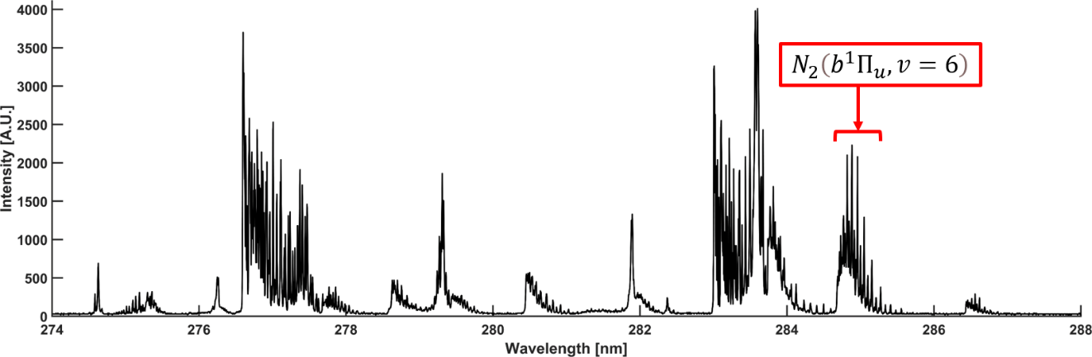
Figure 5.1 N₂ ultraviolet laser excitation spectrum at standard temperature and pressure, with labeled b¹ band head.

The $N_{2}\left(b^{1}Π_{u}, v=6\right)$ absorption band that corresponds to the b¹ band head that represents the intermediate REMPI transition used in this study is identified in Fig. 5.1 [43]. The two strongest resonant transitions are the 2-photon absorption to the $N_{2}(a^{1}Π_{g})$ and the 3-photon absorption to the $N_{2}(b^{1}Π_{u})$ intermediate sates, with band heads at $N_{2}(a^{1}Π_{g}, v=1)$ (approximately 283.05nm), and $N_{2}\left(b^{1}Π_{u}, v=6\right)$ (approximately 284.8nm) respectively [100-102]. This study utilizes the $N_{2}\left(b^{1}Π_{u}, v=6\right)$ intermediate state.

N₂ Photoemissions via REMPI
The N₂ RIPT technique uses a (3+1) REMPI scheme that corresponds to 3-photon excitation step from ground state to intermediate state, which is then excited by the addition of a single 1-photon to the ionization state. Specifically, the 3-photon resonant absorption band, $N_{2}(X^{1}Σ_{g}^{+},v=0→b^{1}Π_{u},v=6)$ used in this study occurs around 285 nm and has been well defined in previous literature [103, 104]. The $N_{2}\left(b^{1}Π_{u}, v=6\right)$ absorption band was chosen for its temperature sensitivity and demonstrated strong photoemissions post-excitation. N₂ REMPI, specifically the 3+1 scheme used here, inherently suffers from collisional influenced processes at near atmospheric pressures. The collisional processes include the deactivation of the REMPI intermediate state during the laser pulse, which may preclude the ionization step. Effectively this requires another admission of a photon to permit the N₂ molecule to reach the excited state, thus resulting in the (3+1) becoming a (3+2) scheme. The energy diagram for both collisional and non-collisional influence is depicted graphically in Fig. 5.2 [105]. However, it should be noted the emission intensity increases linearly with pressure as a result of higher probabilities due to greater number densities. Additionally, there is no “jump” in signal across the entire pressure range, thus it is possible to correct for increased photoemission in areas of low pressure that will undergo the (3+1) scheme relative to the (3+2) scheme [105].

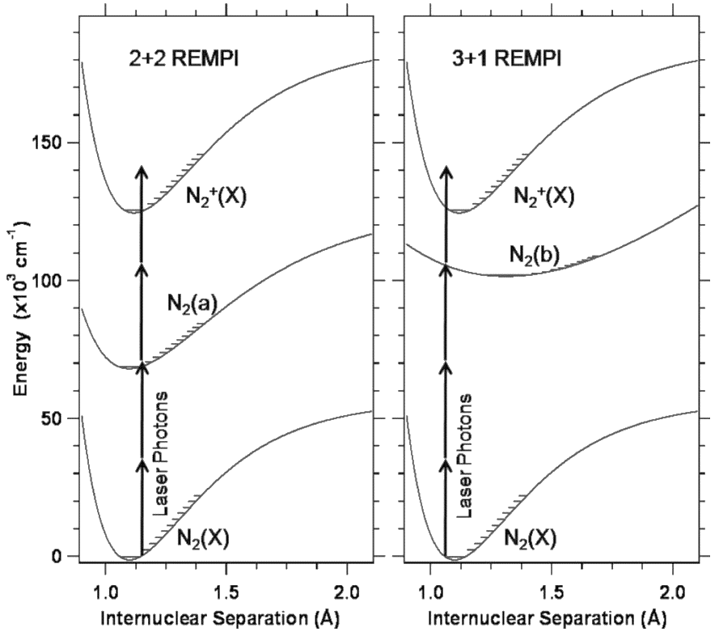
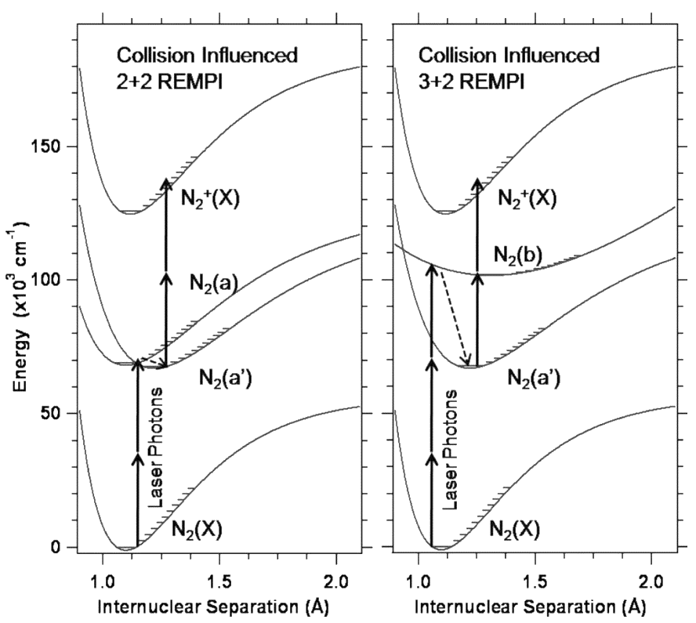
(a)
(b)

Figure 5.2 Energy level diagram of N₂ (3+1) REMPI schemes (a) at low pressure, and (b) at standard pressure.
To achieve N₂ RIPT, specifically chosen rotational peaks within the $N_{2}(X^{1}Σ_{g}^{+},v=0→b^{1}Π_{u},v=6)$ absorption band are resonantly excited via focusing a frequency doubled dye laser of sufficient energy such that regions of high laser energy density if able to briefly populate an area with excited N₂ molecules via a (3+1) or (3+2) REMPI scheme given by Eq. 5.1 and Eq. 5.2 respectively.
$$N_{2}+4hν_{REMPI}→N_{2}^{+}+e^{-}$$ | (5.1)

$$N_{2}+5hν_{REMPI}→N_{2}^{+}+e^{-}$$ | (5.2)

Where, $hν_{REMPI}$ is the photon used to resonantly ionize N₂ and $e^{-}$ is the emitted electron. The recombination of electrons and molecular nitrogen ions produces emissions of the first negative band of $N_{2}^{+}(B^{2}Σ_{u}^{+}-X^{2}Σ_{g}^{+})$, given by Eq. 5.3 or further decay by first positive band given by Eq. 5.4.

$$N_{2}^{+}(B)→N_{2}^{+}(X)+hν_{1^{-}}$$ | (5.3)

$$N_{2}^{+}+e^{-}→N_{2}\left(B\right)→N_{2}\left(A\right)+hν_{1^{+}}$$ | (5.4)

Where, $hν_{1^{-}}$ is the first negative band of N₂, and $hν_{1^{+}}$ is the first positive band of N₂. The resulting emissions from the first negative band are at three distinct peaks (Δv₀, 390nm; Δv₂, 425nm; Δv₁, 430nm), resulting from the $1→0$, $2→1$, and $1→1$ transitions, respectively. For N₂ RIPT the resulting N₂ photoemission strength is influenced by both pressure and number density, however this study will only look at the capacity of using nitrogen’s first negative band emissions for thermometry applications at standard pressure (760 Torr). In order to apply a rotational state distribution analysis to N₂ from REMPI, and subsequently assign temperature of resulting N₂⁺ photoemissions, a rotationally resolved spectrum of molecular nitrogen must be obtained and corresponding three-photon transition cross-sectional data is needed to identify suitable peaks.

N₂ REMPI Structure
The (3+1) and (3+2) REMPI structure of N₂ is described in detail in previous literature [100, 106-108]. For this purpose, a brief summary is given. Both the ground state, N₂(X¹Σ) and the excited state, N₂(B²Π) can both be described by Hund’s case (a), in which hyperfine splitting is apparent in both the ground and excited states. For simplicity hyperfine structures apparent in the ground state will be denoted G₁, G₂, G₃, while hyperfine splitting in the excited state will be denoted F₁, F₂, and F₃. There is an adapted convention of adding subscripts of the hyperfine structures to the rotational branch, for example, Q₁₄ represents the Q-branch which originates from G₄ and transits to F₁. For the nitrogen spectra resulting form 3-photon absorbance, the vibrational selection rules are governed by the Franck-Condon factor. Rotational selection rules dictate that seven rotational branches occur, given by Table 5.1.
The theoretical line strength factors, $S(J^{'},J^{''})$ for 3-photon transitions, which are relevant to the $N_{2}(X^{1}Σ_{g}^{+},v=0→b^{1}Π_{u},v=6)$ absorption band studied here, have been previously derived [106, 109]. The 3-photon factors include terms for the allowed ΔJ cases in Table 2, where the relative strength of the branches is dependent on the sum of the first and third order coupling terms. However, for the 3-photon resonant absorbance band $N_{2}(X^{1}Σ_{g}^{+},v=0→b^{1}Π_{u},v=6)$, only the P, Q, and R-branches contributed to the individual ro-vibronic lines. This indicates a dominance in of the first order coupling terms. Thus, the resulting line strength factors can be expressed by Eq. 5.5, Eq. 5.6, and Eq. 5.7. for the P, Q, and R-branches respectively.

Table 5.1 Branches and allowed ΔJ cases for N₂ (3+1) REMPI
Branch | ΔJ
N | -3
O | -2
P | -1
Q | 0
R | 1
S | 2
T | 3

$$S_{P}\left(J^{'},J^{''}\right)=\frac{1}{27}(J^{''}-1)$$ | (5.5)

$$S_{Q}\left(J^{'},J^{''}\right)=\frac{1}{27}(2J^{''}+1)$$ | (5.6)

$$S_{R}\left(J^{'},J^{''}\right)=\frac{1}{27}(J^{''}+2)$$ | (5.7)

It should be noted, the 3-photon Hӧnl-London $S(J^{'},J^{''})$ factors are accurate for modeling an unperturbed transition, but are not always accurate for experimental line intensities due to anomalies. The deviations are attributed to same state-mixing and pre-dissociation of the N₂ $(b^{1}Π_{u},v=6)$ and require modifications to be made to the $J''$ dependence of the prior $S(J^{'},J^{''})$ factors. The correction is made by multiplying the $J^{''}\left(J^{''}+1\right)$ by polynomial parameters, and varying those parameters until a best fit is achieved. The modified 3-photon transitional line strength factors are given by Eq. 5.8, Eq. 5.9, and Eq. 5.10 for the P, Q, and R-transitions respectively.

$$S_{P}\left(J^{'},J^{''}\right)=\frac{1}{27}\left(J^{''}-1\right)+C_{P}J^{''}\left(J^{''}+1\right)+D_{P}{\left[J^{''}\left(J^{''}+1\right)\right]}^{2}$$ | (5.8)

$$S_{Q}\left(J^{'},J^{''}\right)=\frac{1}{27}\left(2J^{''}+1\right)+C_{Q}J^{''}\left(J^{''}+1\right)+D_{Q}{\left[J^{''}\left(J^{''}+1\right)\right]}^{2}$$ | (5.9)

$$S_{R}\left(J^{'},J^{''}\right)=\frac{1}{27}\left(J^{''}+2\right)+C_{R}J^{''}\left(J^{''}+1\right)+D_{R}{\left[J^{''}\left(J^{''}+1\right)\right]}^{2}$$ | (5.10)

Assuming LTE conditions, the relative amplitude/strength of the individual ro-vibronic lines for the 3-photon resonant transition can be calculated using Eq. 5.11.

$$I_{calc}=Fg\left(J^{''}\right)S(J^{'},J^{''})exp⁡(-E_{rot}/kT)$$ | (5.11)

Where, F is the global factor that accounts for vibrational and electronic transition probabilities independent of the rotational transitions, $g(J^{''})$ is the nuclear spin statistical weight, $S(J^{'},J^{''})$ is the multi-photon line strength factor, and $exp⁡(-E_{rot}/kT)$, is the Boltzmann rotational populational distribution. It should be noted, the nuclear spin statistical weight $g(J^{''})$ is 2 for even $J''$ and 1 for odd $J''$. Finding the $S(J^{'},J^{''})$ factors for each branch from Eq. 5.5, Eq. 5.6, and Eq. 5.7, values are used as inputs to Eq. 5.8 to create a theoretical absorption spectrum that has contributions from the P, Q, and R-branches at selected temperatures. A similar model has been previously developed in literature and was used for photoemission fitting to the simulated spectrum for temperature assignment; similar to the CARSFIT applied to experimental CARS spectrums for temperature in Chapter 3. The model from literature exhibited high accuracy up to 600 Kelvin [43].
The N₂ REMPI absorption spectrum is made up of congested contributions from the P, Q, and R-branches, peak selection is not a trivial matter, as the individual contributions may vary independently of each other. Thus, the simulated spectrums were instrumental in gaining insight on population distributions and contributions from each branch of the absorption band. This model is shown in Fig. 5.3 for 180, 293, and 460 Kelvin. Using this model, peaks were identified that had relevant population distributions at the various temperature test points and demonstrated temperature sensitivity. Furthermore, the model shows that as temperature increases population distributions trend towards higher rotational states, resulting in increased structure in the spectrum. Similar to O₂ RIPT, suitable peaks change depending on temperature of the test medium. Furthermore, while not graphically shown, it was found the P and Q branches contribute to distinct peaks, while the R-branch has its own distinct peaks. A more in-depth look at Fig. 5.3 reveals that the 293 and 460 Kelvin spectrums share some peaks that do not vary as a function of temperature, but the population distributions trend so greatly towards the ground state at 150 Kelvin that all peaks are affected, furthering the importance of peak selection.
Additionally, while RIPT is driven by N₂ REMPI and deexcitation photoemissions, the intensity of the nitrogen fluorescence $({∆v}_{0},∆v_{1},∆v_{2})$ closely follows the (3+1) or (3+2) REMPI scheme [43, 105]. This relationship allows for direct utilization of the modeled spectra along with the previous study of the calculated emission intensity based on Eq. 5.8 to find multiple resonant wavelengths of interest to be used in the calibration study. The select wavelengths for this study are tabulated in Table 5.2. and were chosen due to population distributions being relevant across the selected range of calibration temperatures. Using the values from Table. 5.2, the N₂ three-photon transition from state g to f will produce a theoretical resultant fluorescence intensity $I_{λ_{n}}$ of the first negative band of vibrationally excited N₂, which can be expressed by substituting $I_{calc}$ in Eq. 5.11 for $I_{λ_{n}}$, where the “$λ_{n}$” subscript denotes the selected laser excitation wavelength from Table 5.2.

Experimental Setup
To identify specific rotational peaks most suitable for statistical fits of the Boltzmann plots, a calibration study was conducted at 165, 230, 293, 376, and 455 K in a gas cell. The second harmonic of an Nd:YAG Laser (Continuum Surelite SL-10) with a pulse width of 8 ns, repetition rate of 10 Hz, and 220 mJ/pulse lasing energy was used to pump a dye laser (Continuum ND6000) that was paired to a frequency doubling unit (Continuum UVT).

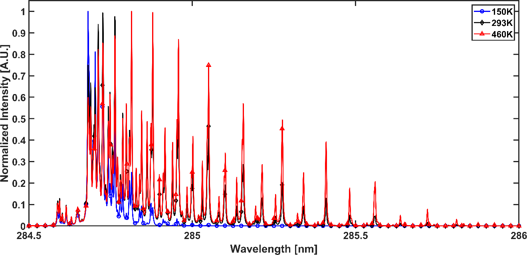
Figure 5.3 Normalized theoretical N₂ REMPI spectra for 150, 293, and 460 Kelvin.

Table 5.2 Selected rotational lines for N₂-based temperature measurements.
ʎ_{laser} | branch | $$J'$$ | G₁ | $$S(J^{'},J^{''})$$
nm |  |  | cm⁻¹
284.712 | Q(3),R(6) | 3 | 1259.62 | 6.03
284.726 | R(7),Q(4) | 4 | 1215.67 | 6.91
284.748 | Q(5),R(8) | 5 | 1319.55 | 7.52
284.763 | Q(6) | 6 | 1259.62 | 9.99
284.787 | Q(7) | 7 | 1287.59 | 5.77
284.798 | R(10) | 10 | 1395.45 | 9.00
284.814 | P(6) | 8 | 1319.55 | 13.07
284.845 | Q(9) | 9 | 1355.50 | 7.30
284.862 | R(12) | 12 | 1487.29 | 10.49
284.879 | Q(10) | 10 | 1395.45 | 16.15
284.917 | Q(11),P(9) | 11 | 1439.38 | 8.84
284.940 | R(14) | 14 | 1595.09 | 11.98
284.958 | Q(12) | 12 | 1487.29 | 19.23
285.002 | Q(13),P(11) | 13 | 1539.20 | 10.38
285.031 | R(16) | 16 | 1718.80 | 13.47
285.050 | Q(14),P(12) | 14 | 1595.09 | 22.31
285.101 | Q(15),P(13) | 15 | 1654.95 | 11.92
285.157 | Q(16),P(14) | 16 | 1718.80 | 25.38
285.214 | Q(17),P(15) | 17 | 1786.63 | 13.46
285.276 | Q(18),P(16) | 18 | 1858.43 | 28.46
285.341 | Q(19),P(17) | 19 | 1934.21 | 15.00
285.409 | P(18) | 20 | 1858.43 | 12.63
285.482 | Q(21) | 21 | 2097.67 | 16.54
285.558 | P(20) | 22 | 2013.95 | 14.12

The Dye laser utilized a mixture of Rhodamine 590 and Rhodamine 610 to produce lasing light around 570nm (0.02 cm⁻¹ linewidth).The dye laser was frequency doubled to generate ultraviolet (UV) beam using an auto-tracker (Continuum UVT-1) to maintain a constant conversion efficiency from the frequency doubling crystal. The UV beam had energy of approximately 10 mJ/pulse from 284 to 286.5 nm. The UV beam was focused using a fused-silica spherical lens with focal length of +150 mm, which generated a fluorescence line. The line was centered in a cylindrical, fused-silica glass cell. The emission spectra were collected via two +100 mm spherical fused silica lenses that served to focus the light onto the slit of a spectrometer (Princeton Instruments, 600 grooves per millimeter [gr/mm], blazed at 500 nm with a 50 μm slit width.
The spectrum was captured via an intensified scientific camera (PI-MAX4 1024f) with the sensor size of 1024x1024 pixels. To avoid local heating and maintain a uniform species number density in the area of interest, a constant flow of pure nitrogen gas was provided to the cell at a rate of 0-50 liters per minute (L/min) via an electronic flow controller (OMEGA). Depending on the desired calibration temperature the air passed through either a flow heater (OMEGA) or through a custom-built flow-chiller to achieve temperatures ranging from 160 to 470 Kelvin and cell temperature was monitored by a K-type thermocouple and maintained within a tolerance of ±1% of the set point. A general rendering for the calibration experiment for N₂ RIPT is shown in Fig. 5.4.

Results and Discussions

N₂ RIPT signal dependence
The laser power dependence of the relative N₂⁺ photoemission intensity from (3+2) and (3+1) REMPI excitation / ionization process from the $N_{2}(b^{1}Π)$ intermediate state has been studied and found they both exhibit a cubic power dependence [103, 105].

Figure 5.4 N₂ RIPT calibration experiment schematic.

Furthermore, the (3+1) REMPI induced photoemissions vary linearly with pressure. Pressure increase correspond to a higher number density of $N_{2}(X)$, which will increase the rate of $N_{2}^{+}(B)$ production via laser excitation. This precludes the (3+1) scheme from dominating signal strength at low pressure and maintains the linearity fit for higher pressure were a less efficient, collisional induced (3+2) scheme results. This indicates that the excitation steps are rate determining and are indifferent to the scheme utilized, and further confirms the identification of the intermediate states from the fit of the laser excitation spectrum and the corresponding multiphoton processes that are driving the transitions. Furthermore, for all data collected the maximum laser flux was kept below the limit [10³⁰ photons/(cm²· s)], where saturation effects have been readily observable in diatomic molecules, which would result in a departure from the cubic power fitting and decrease in overall fluorescence invalidating any photoemission measurements [110].
The radiative lifetime for the $N_{2}^{+}(B^{2}Σ_{u}^{+}-X^{2}Σ_{g}^{+})$ first negative band photoemissions has been measured to be on the order of 10⁻⁸ seconds [101]. It was found experimentally this holds true, as shown in Fig. 5.5, from the initial excitation of the N₂ the resulting photoemissions are essentially gone post laser pulse. If a high-repetition rate laser or multiple dye-lasers were used to enable single run N₂ RIPT measurements, a very fast decay rate is ideal. If the decay rate was significant, the first pulse emissions could impact the succeeding pulse emissions negatively influencing the photoemission rotational state relationship and temperature dependence. Finally, a measurement was conducted to quantify the amount of energy deposited into the test medium using a scientific grade, high-sensitivity thermopile meter (1mW detection at ±0.5% repeatability). The sensor was unable to any changes in output energy from pre-focal to post-focal spots of a +300 mm spherical lens with input wavelength of 284.748 nm at 10 mj/pulse.

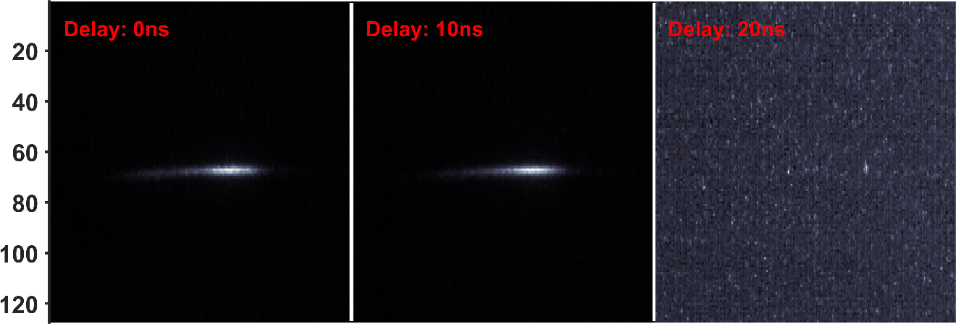
Figure 5.5 N₂⁺ photoemission delay study showing short lifetimes of first negative band contributions.

N₂⁺ emission spectra via N₂ RIPT
Visualized in Fig. 5.6 are the imaged N₂⁺ emissions at 293 Kelvin for all resonant wavelengths listed in Table 5.2. The spectra collected at the selected wavelengths over the range of temperatures showed similar features, changes in the bands emitted signal intensity was the only observable change. At all temperatures, there are only two distinct peaks that are shown in the spectra (Δv₀, 390nm; Δv₁, 430nm), resulting from the $1→0$, and $1→1$ transitions, respectively. This indicates the ionization region is cooler than the O₂ RIPT ionization. This is due to the higher ionization energy requirements for N₂ compared to O₂ thus, more of the laser energy is used to achieve ionization than can be used for further heating of the plasma. Spectra of all wavelengths at the remaining calibration temperatures are shown in Fig. 5.7, Fig. 5.8, Fig. 5.9, and Fig. 5.10 for 165, 230, 376, and 455 Kelvin, respectively. To minimize shot-to-shot laser fluctuations and remove background effects, the captured emission signals are 20-image averaged and background subtracted. The use of the spectrometer allowed for discrete analysis of each emission peak in the first negative band of N₂⁺, (Δv₀, 390nm; Δv₁, 430nm) of a high spectral accuracy.
Due to the congestion of the P, Q, and R-branches in the $N_{2}(b^{1}Π)$ resonant band, all peaks are temperature sensitive. The laser used in this study was unable to individually resolve the P and Q branches, but the R-branch was able to be resolved independently. However, there exists minimal population distributions in the R-branch for cold gas temperatures, thus is not suitable for low temp RIPT. The R-branch only becomes more relevant at very high temperatures outside of those tested in this study. Thus, the peaks selected for temperature determination are primarily a result of the P and Q-branch congested transitions.

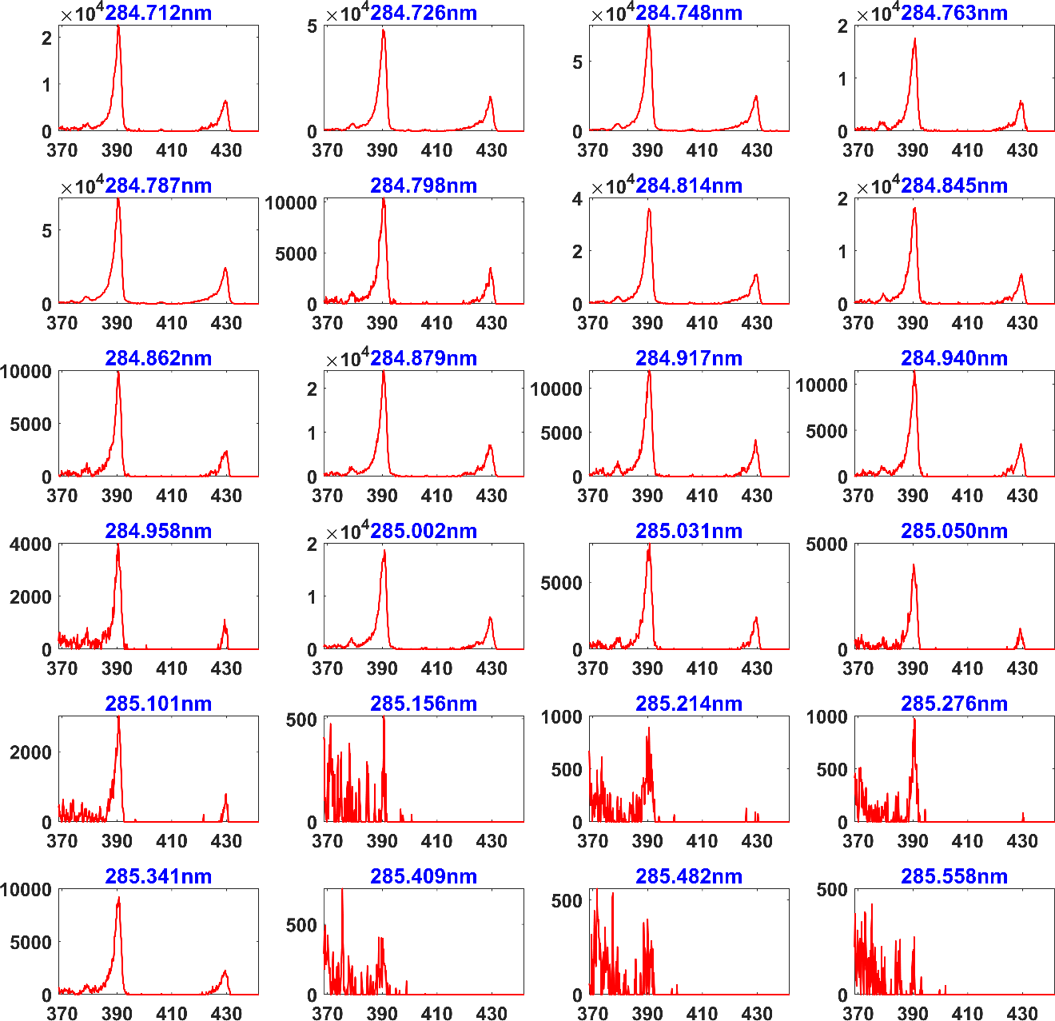
Figure 5.6 N₂⁺ emission spectra at 293 Kelvin for selected N₂ resonant wavelengths.

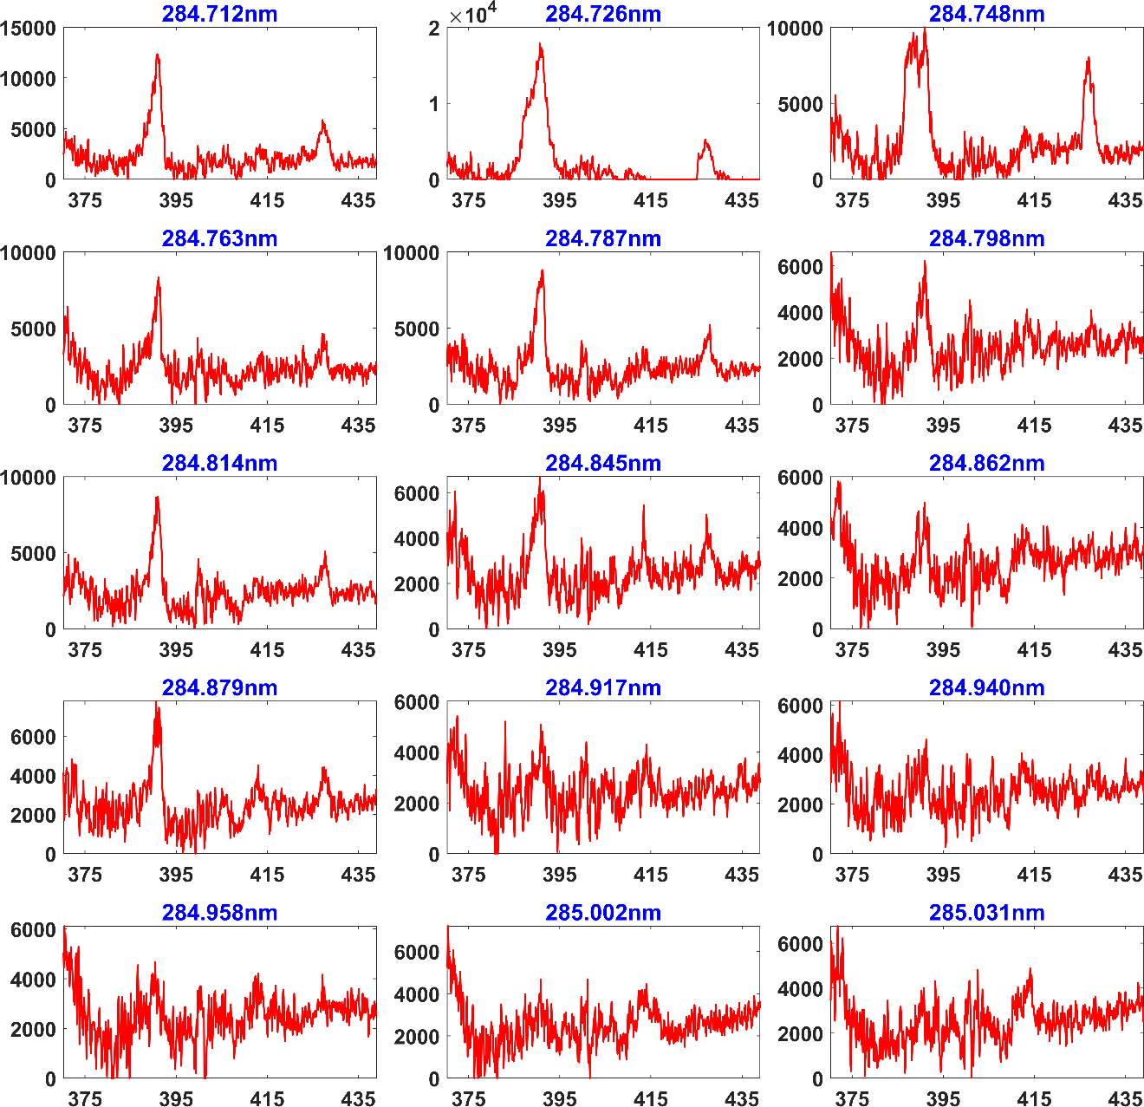
Figure 5.7 N₂⁺ emission spectra at 165 Kelvin for selected N₂ resonant wavelengths.

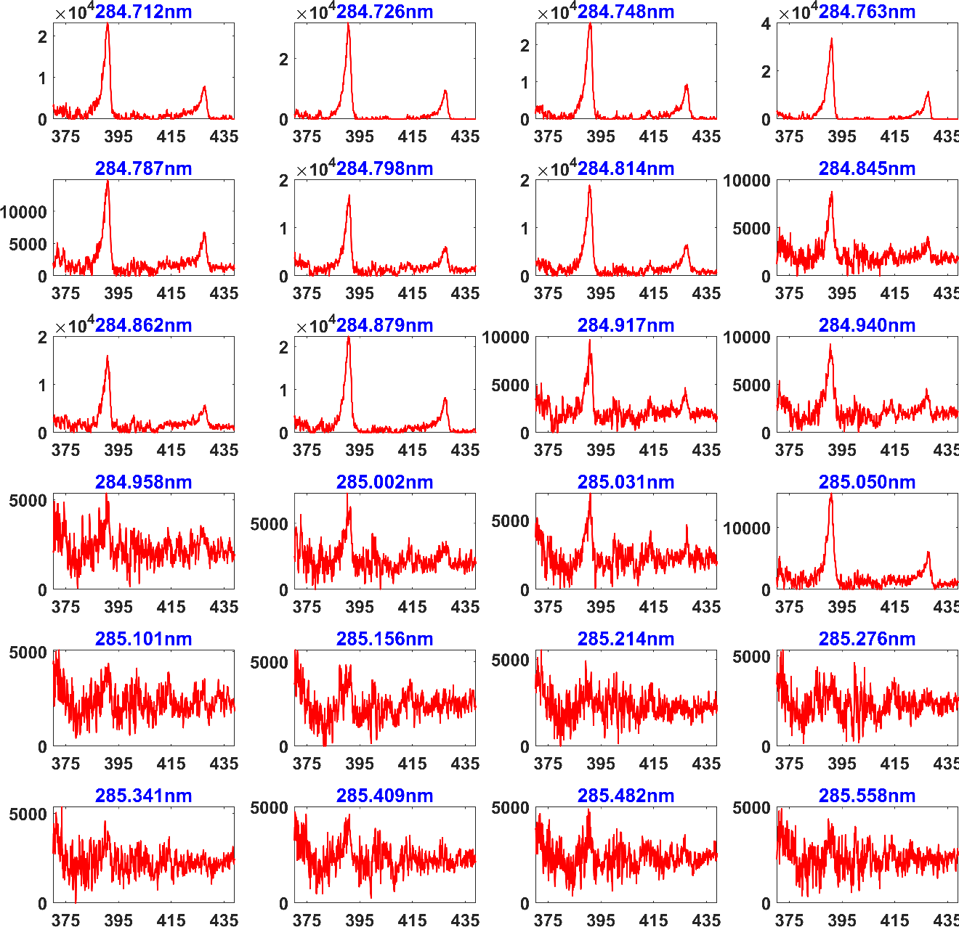
Figure 5.8 N₂⁺ emission spectra at 230 Kelvin for selected N₂ resonant wavelengths.

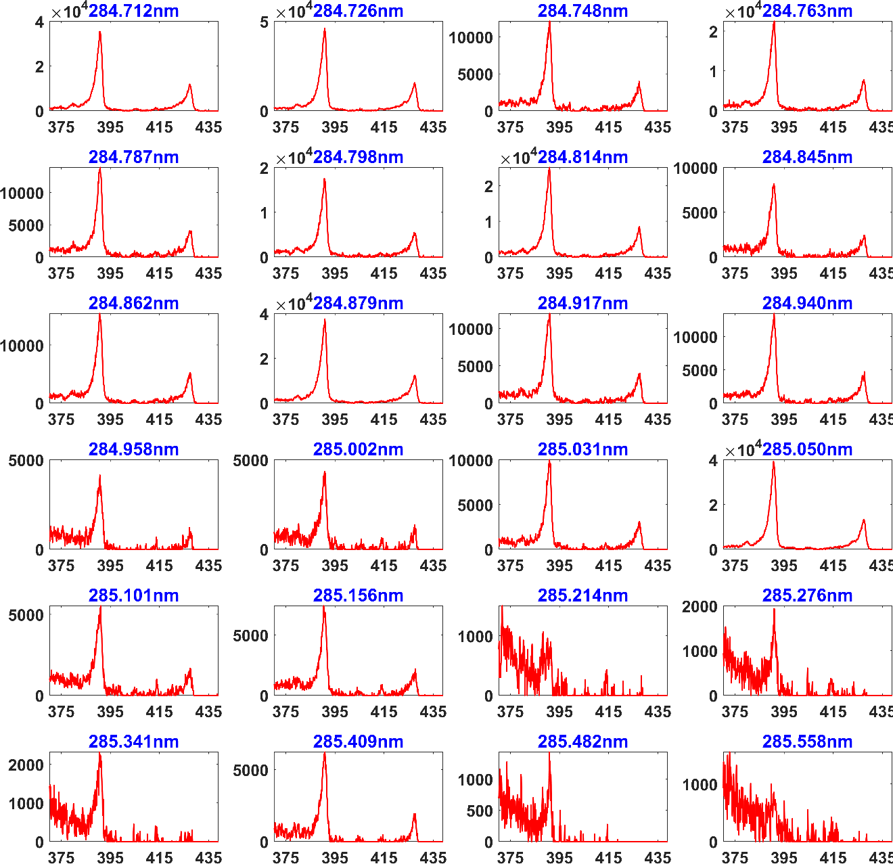
Figure 5.9 N₂⁺ emission spectra at 376 Kelvin for selected N₂ resonant wavelengths.

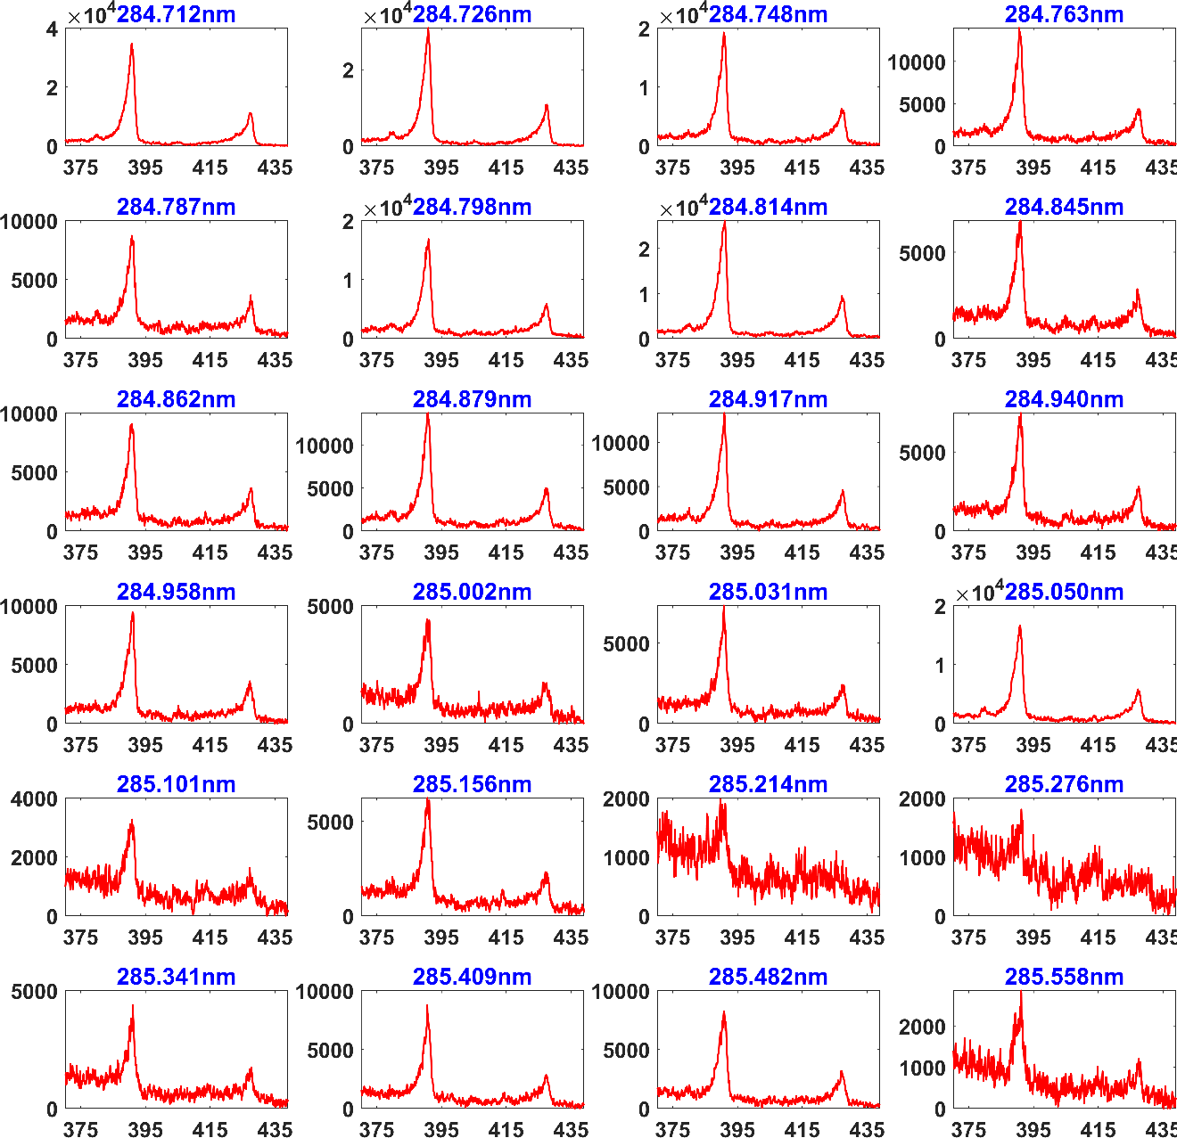
Figure 5.10 N₂⁺ emission spectra at 455 Kelvin for selected N₂ resonant wavelengths.

N₂ discrete analysis for temperature determination
The aforementioned $N_{2}^{+}(B^{2}Σ_{u}^{+}-X^{2}Σ_{g}^{+})$ photoemission spectra were captured and post-processed. The raw images were averaged and background subtracted to remove any light scattering or artifacts. Integration was performed under each band, with care taken to not include any contributions that were not associate with the band emission. A study was conducted for identification of possible groups that exhibited a linear fit of high correlation and thus an accurate temperature determination, from a pure signal intensity analysis standpoint. The peak signals for 293 Kelvin are visualized in Fig. 5.11 (a, and b). It was found for N₂ RIPT the raw signal intensity deviates substantially from the processed signal properties; thus, a pure visual inspection of the raw signal intensities is not possible. This is mainly attributed to the 3-photon line strength factors deviating from the predicted theoretical values, and the resulting polynomial (2nd order) law fit used to correct for them as mathematically expressed in Eq. 5.8, Eq. 5.9, and Eq. 5.10. The 390 nm and 430 nm signal intensities for 165, 230, 376, and 455 Kelvin are shown in Fig. 5.12 (a, and b), Fig. 5.13 (a, and b), Fig. 5.14 (a, and b), and Fig. 5.15 (a, and b) respectively.
Four wavelengths are selected that have the highest fit metrics at each calibration temperature. The slope of the fit in the Boltzmann plot is applied to Eq. 5.11 to fit a Boltzmann distribution for rotational temperature assignment. More and less than four wavelengths were examined for temperature fitting and it was found that four wavelengths are result in the highest fitting accuracy. The resultant N₂ RIPT measurements of the 390 and 430nm peaks at 293 Kelvin are shown in Fig. 5.11 (c, and d). It was found that the Δv₀ (390 nm) peak yielded approximate temperature fits within ±10 Kelvin, and all have a high coefficient of correlation (R² > 97%). The Δv₁ (430 nm) peak yielded approximate temperature fits within ±25 Kelvin, and still maintained a relatively high coefficient of correlation (R² > 96%).

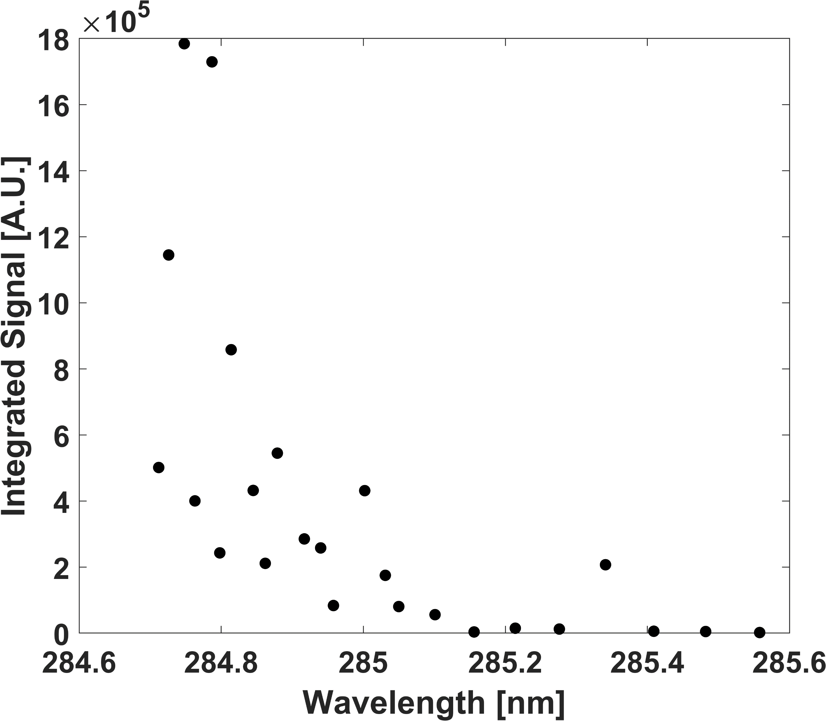
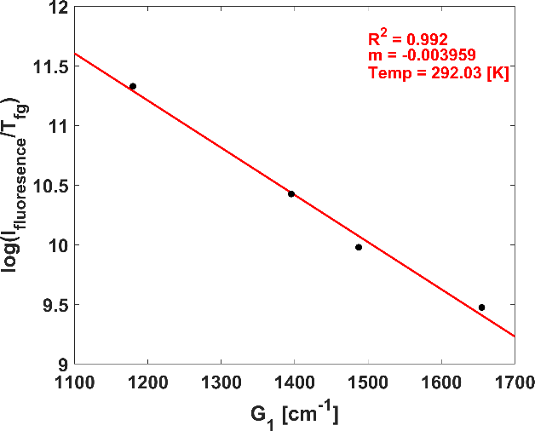
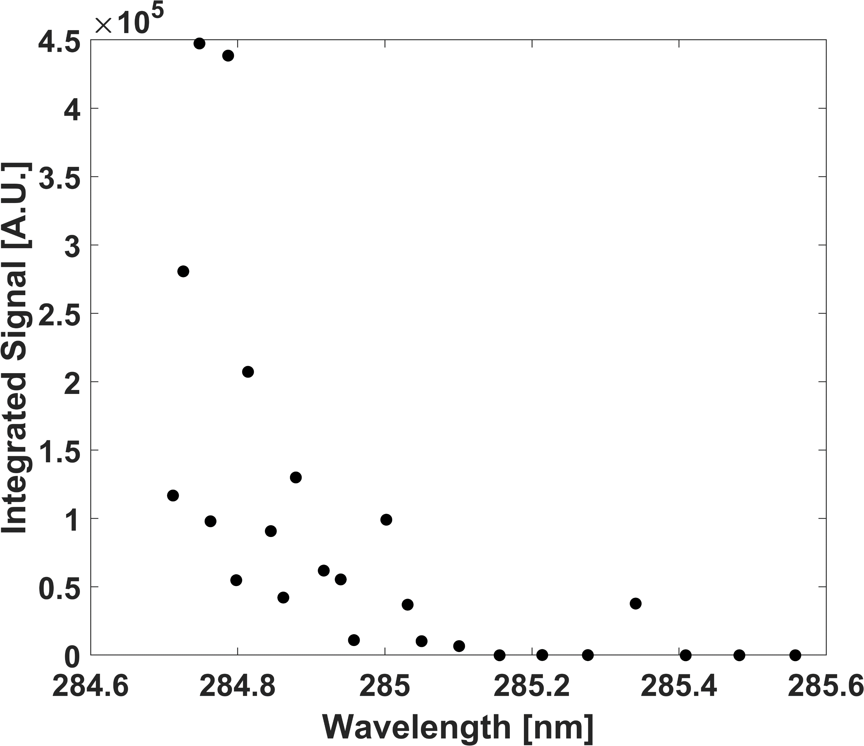
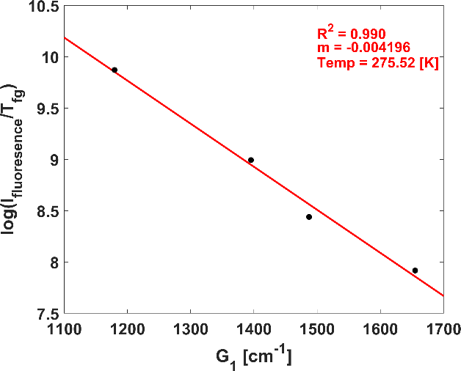
Figure 5.11 Integrated peak signal values for (a) Δv₀, 390nm, (b) Δv₁, 430nm, and temperature determinations at (c) Δv₀, and (d) Δv₁ for actual temperature of 293 Kelvin.
(a)
(b)
(c)
(d)

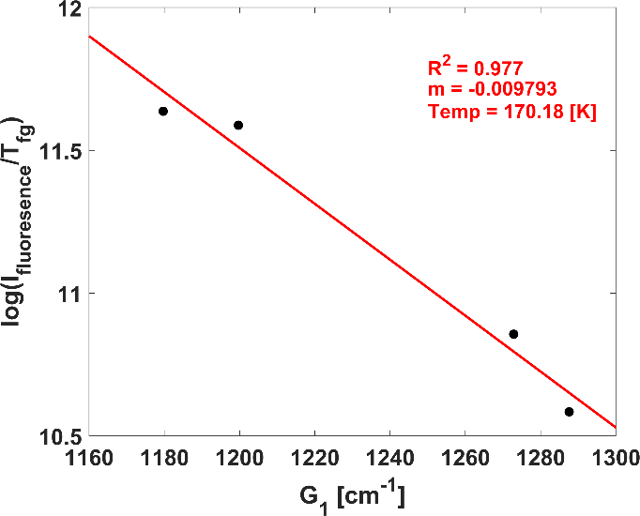
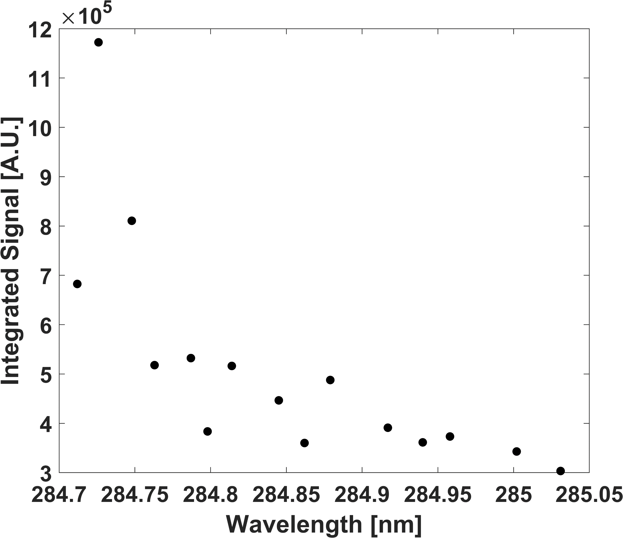
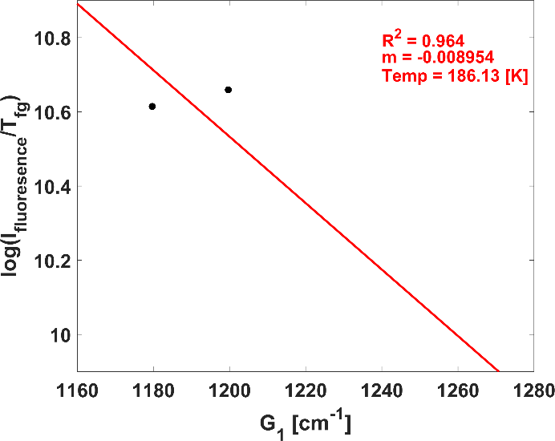
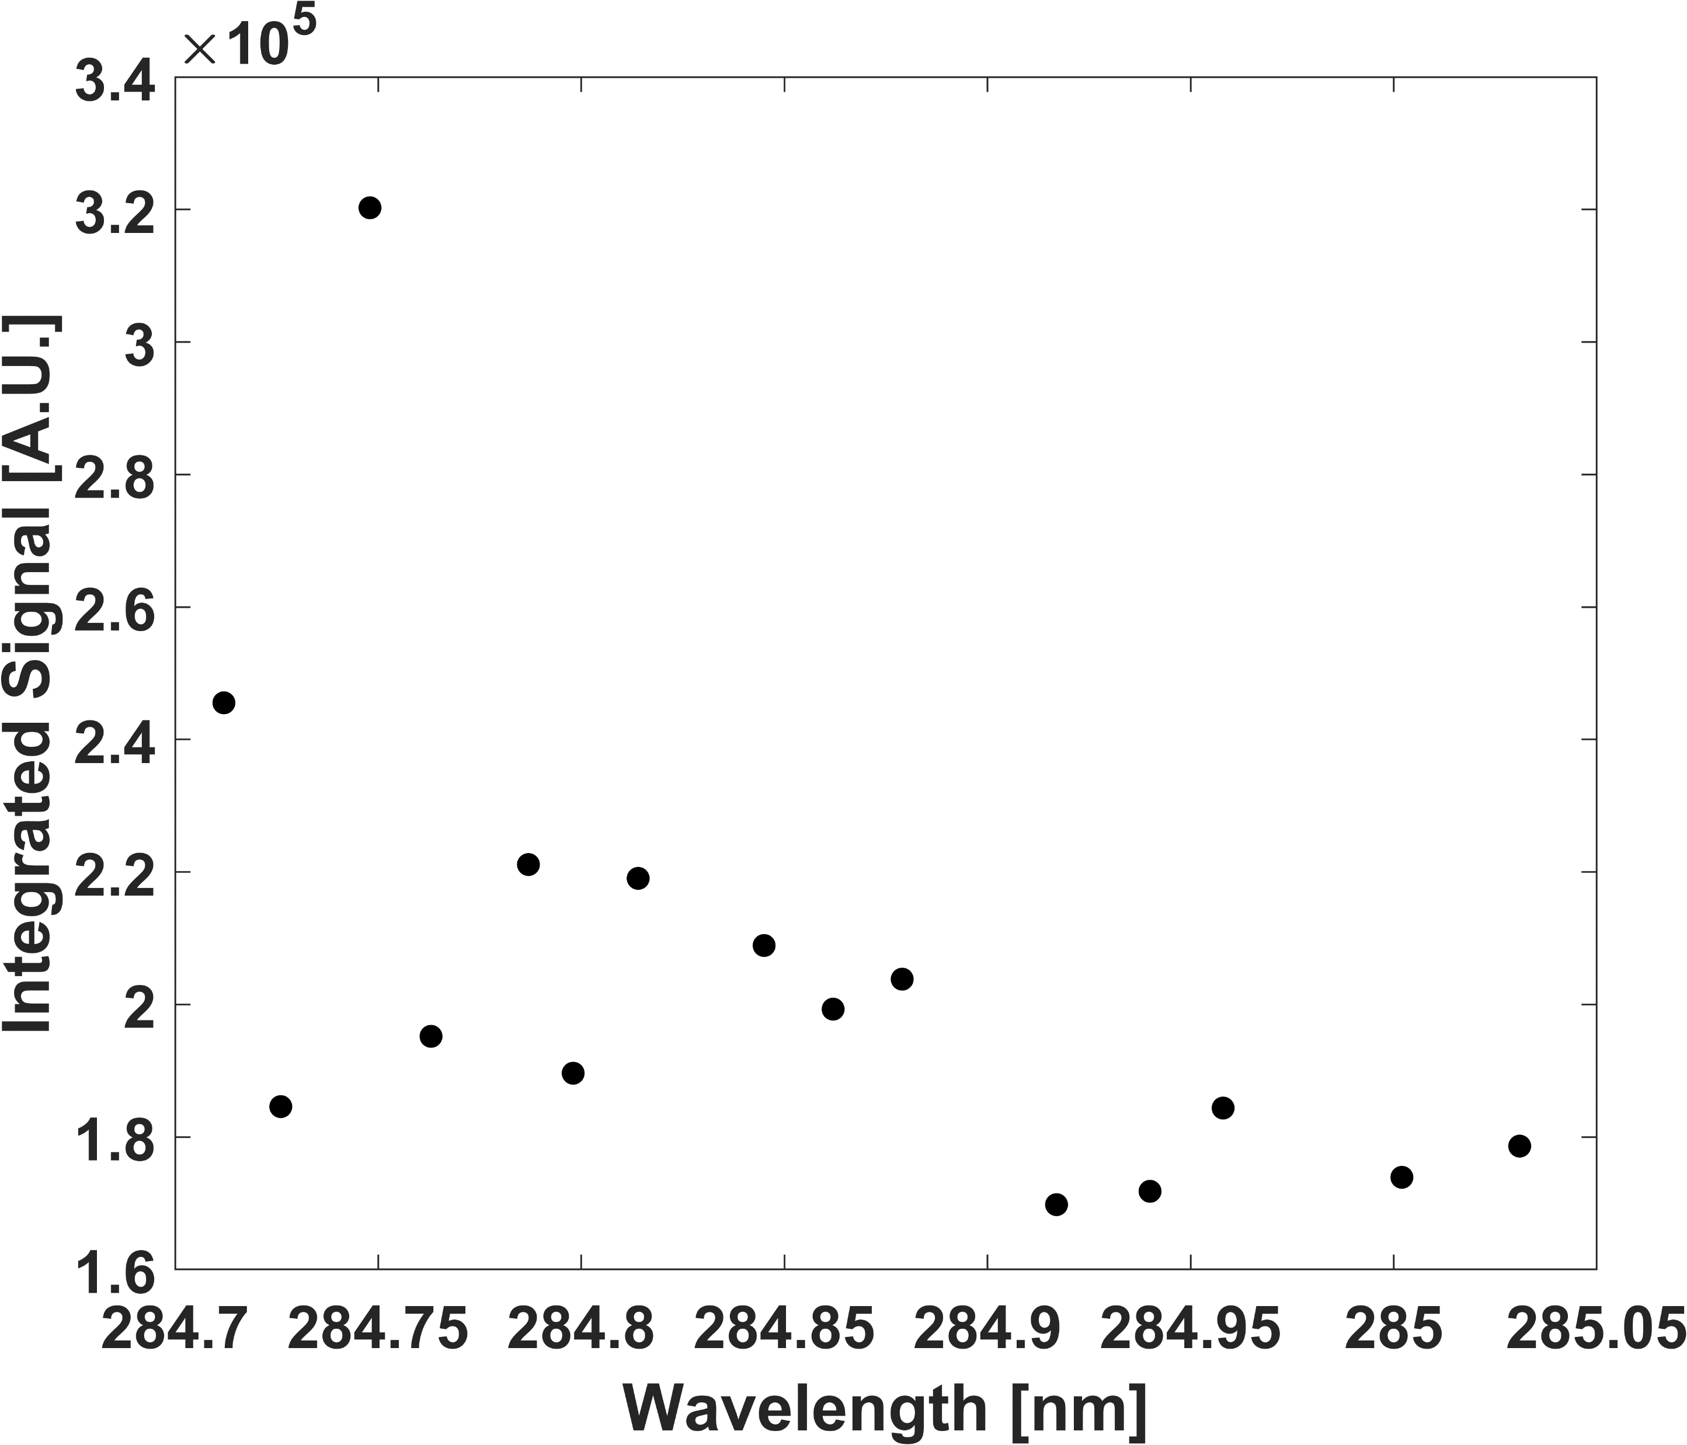
Figure 5.12 Integrated peak signal values for (a) Δv₀, 390nm, (b) Δv₁, 430nm, and temperature determinations at (c) Δv₀, and (d) Δv₁ for actual temperature of 165 Kelvin.
(a)
(c)
(d)
(b)

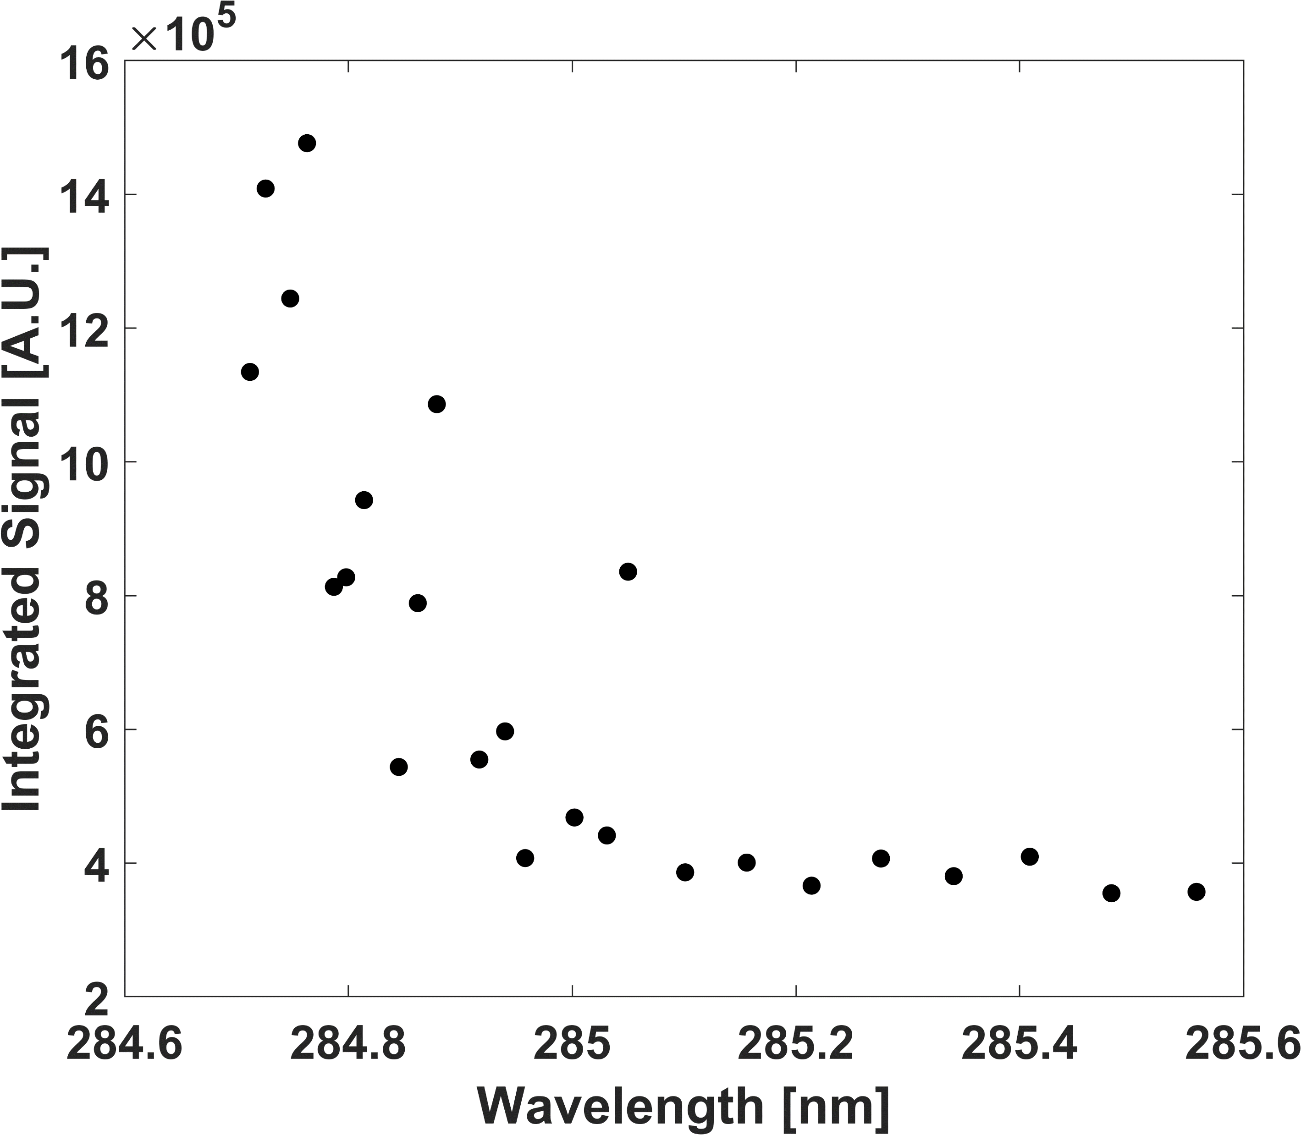
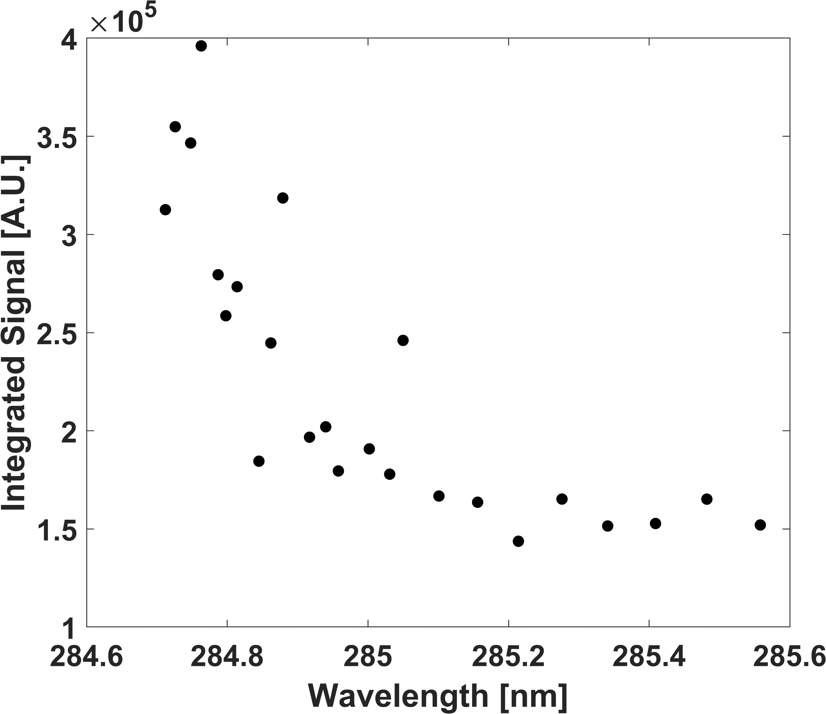
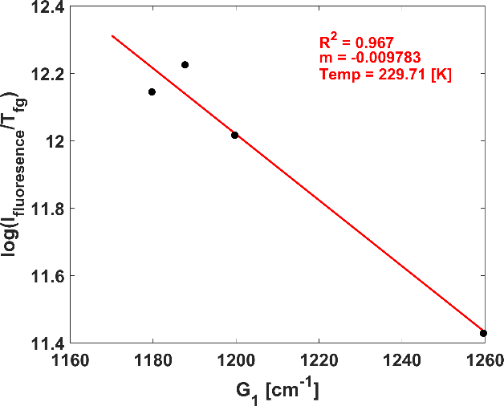
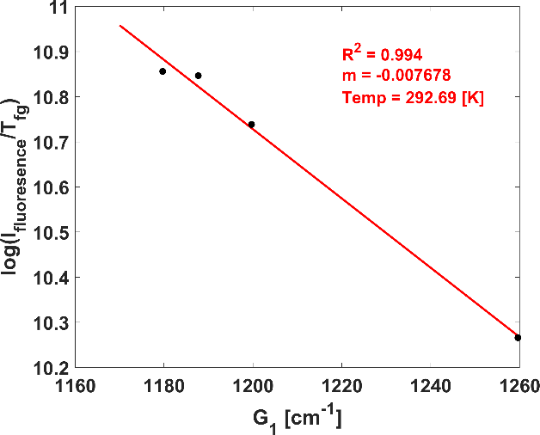
Figure 5.13 Integrated peak signal values for (a) Δv₀, 390nm, (b) Δv₁, 430nm, and temperature determinations at (c) Δv₀, and (d) Δv₁ for actual temperature of 230 Kelvin.
(a)
(b)
(c)
(d)

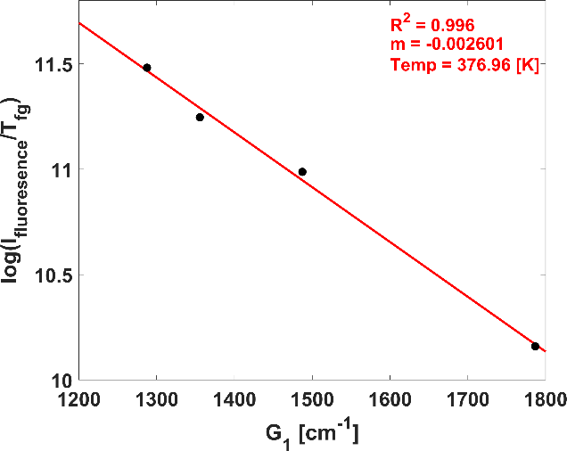
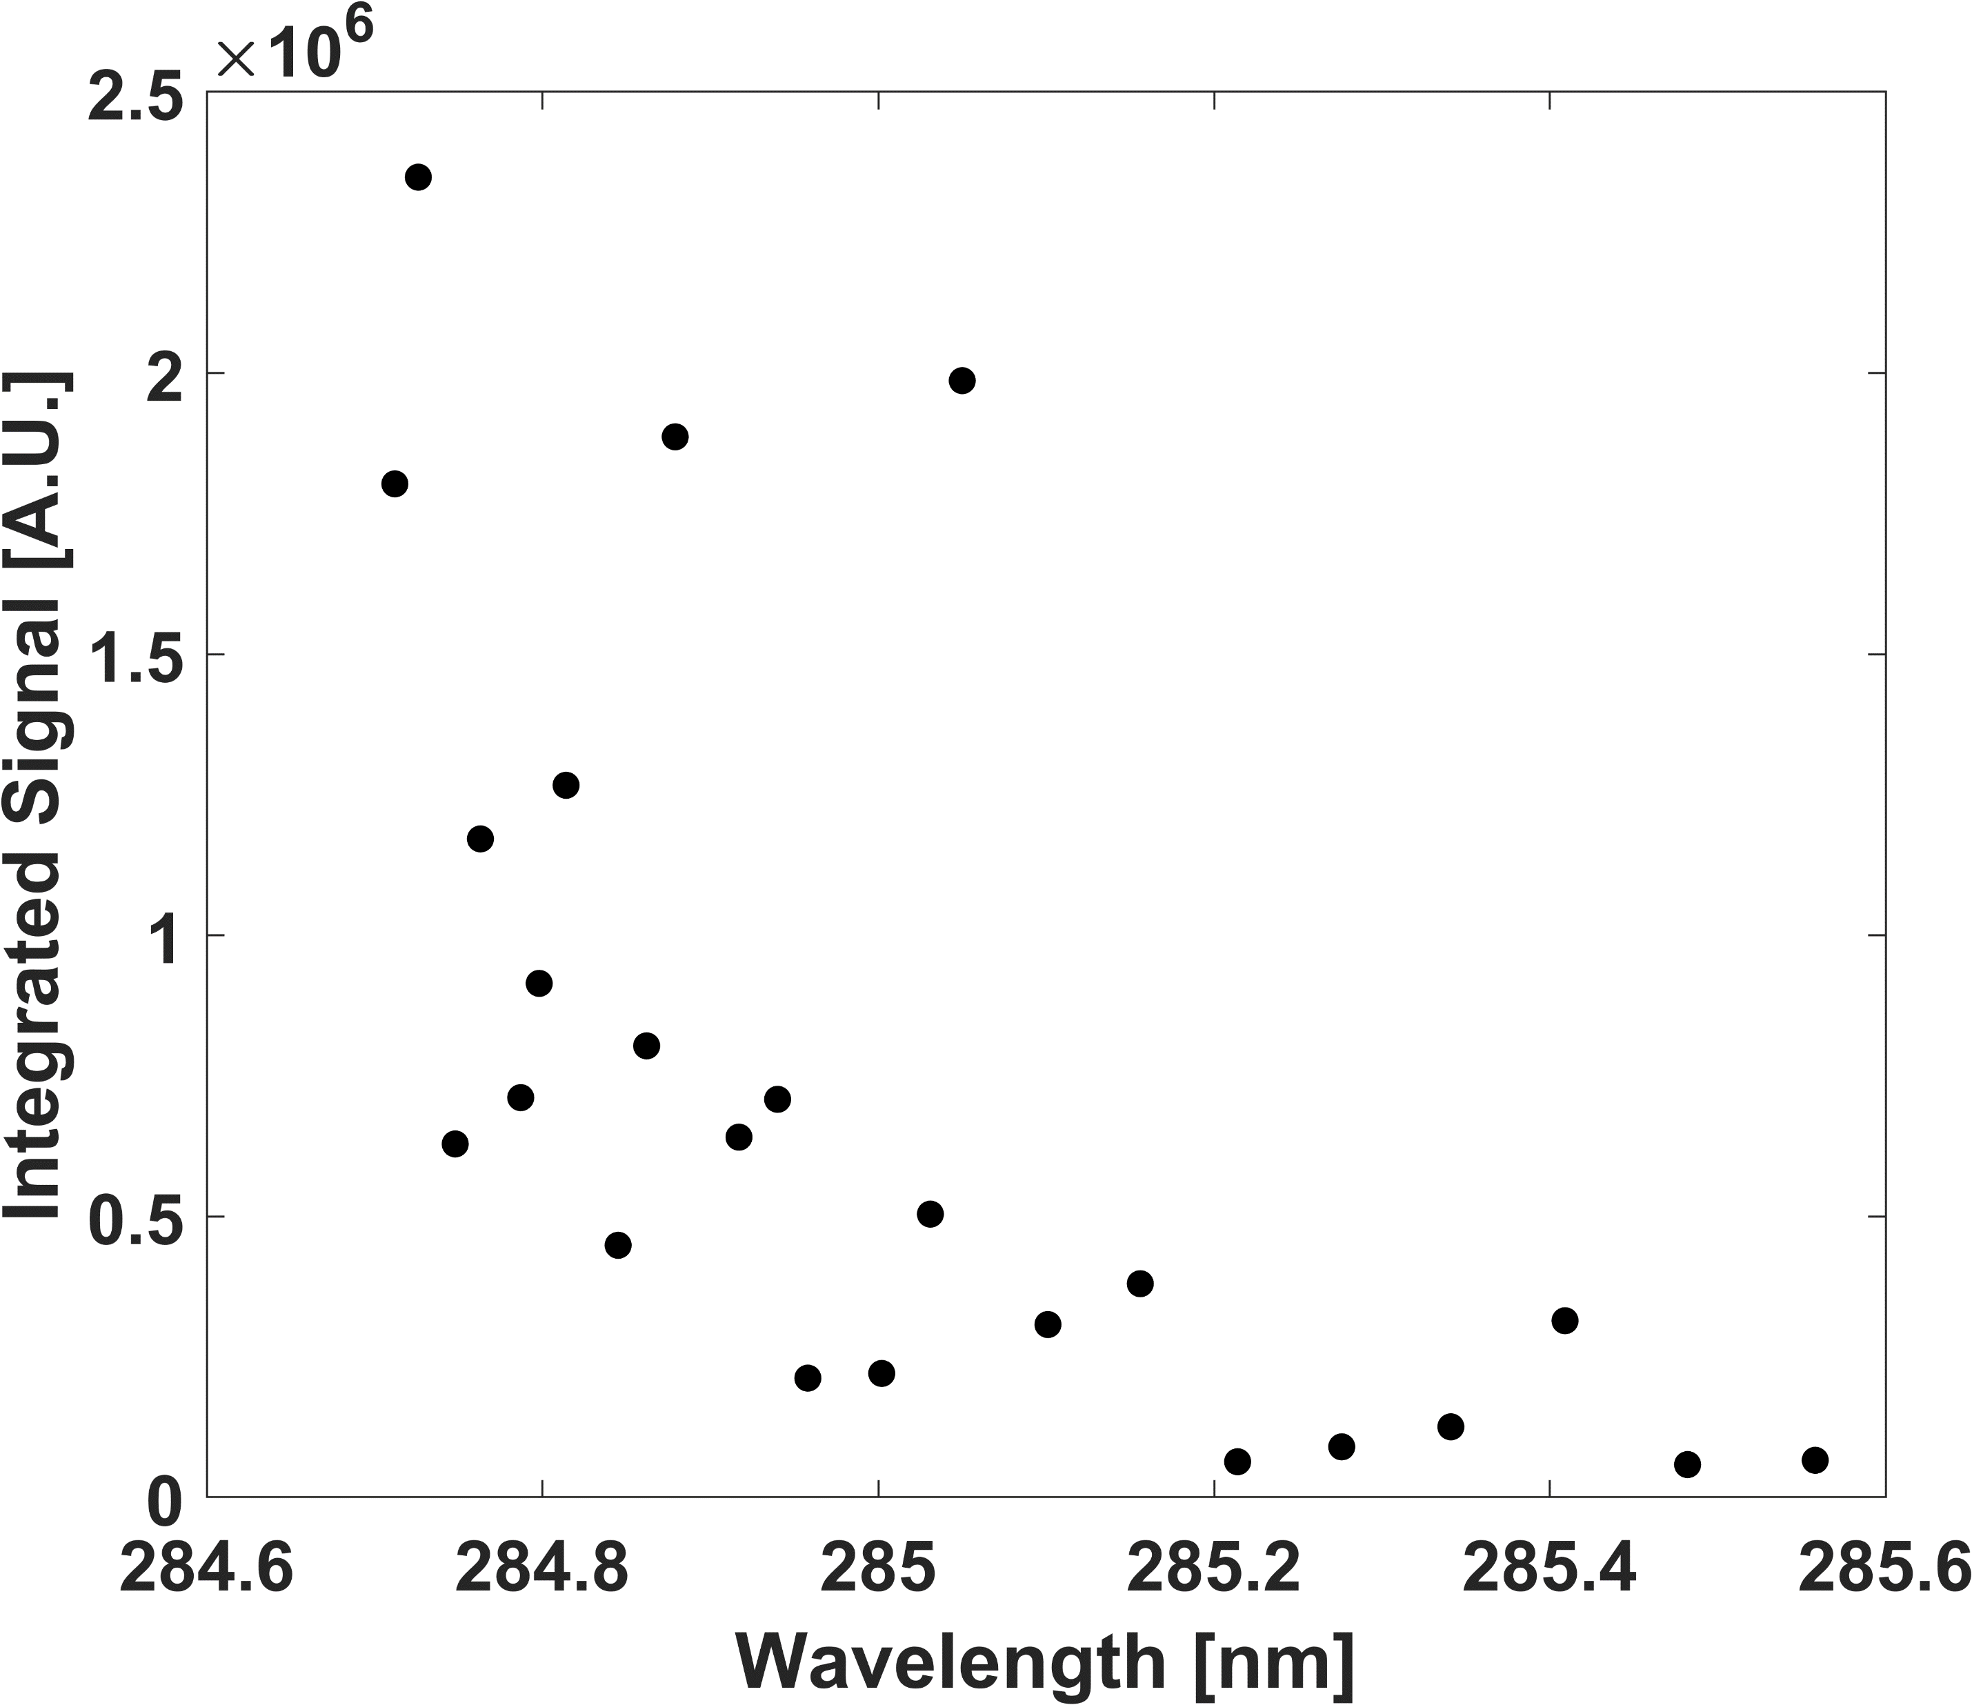
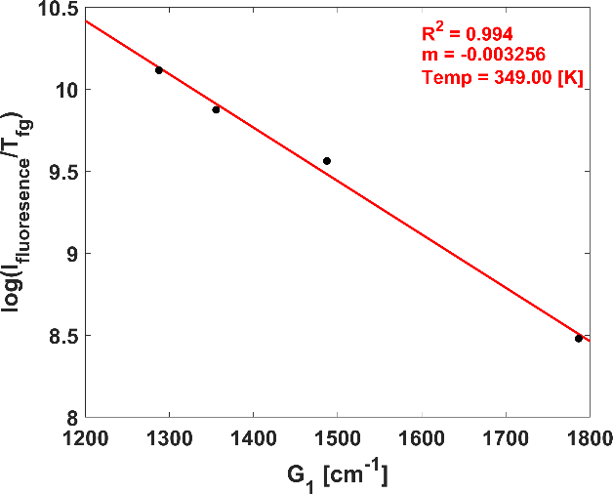
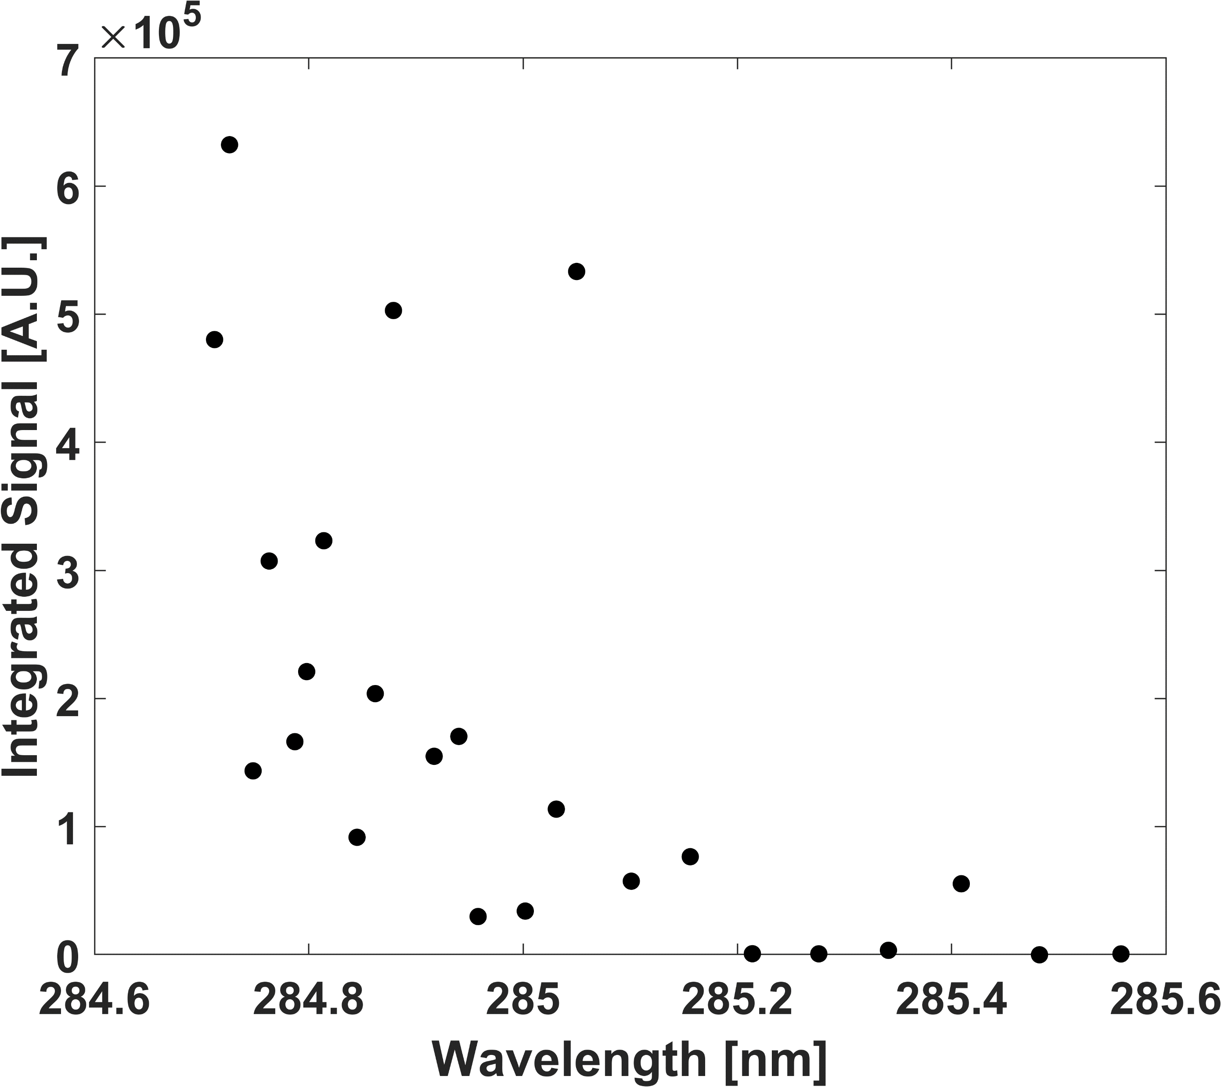
Figure 5.14 Integrated peak signal values for (a) Δv₀, 390nm, (b) Δv₁, 430nm, and temperature determinations at (c) Δv₀, and (d) Δv₁ for actual temperature of 376 Kelvin.
(a)
(b)
(c)
(d)

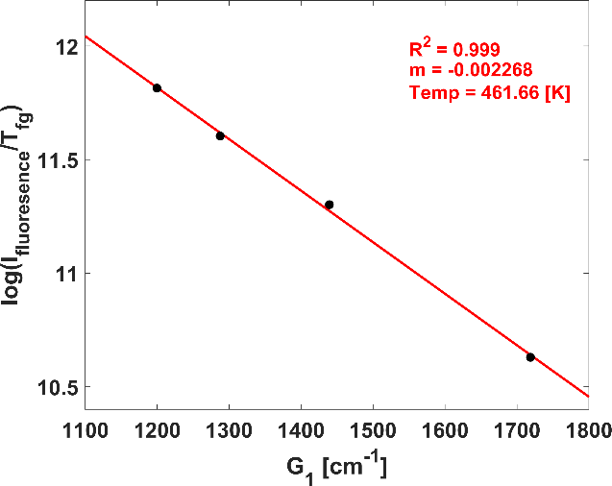
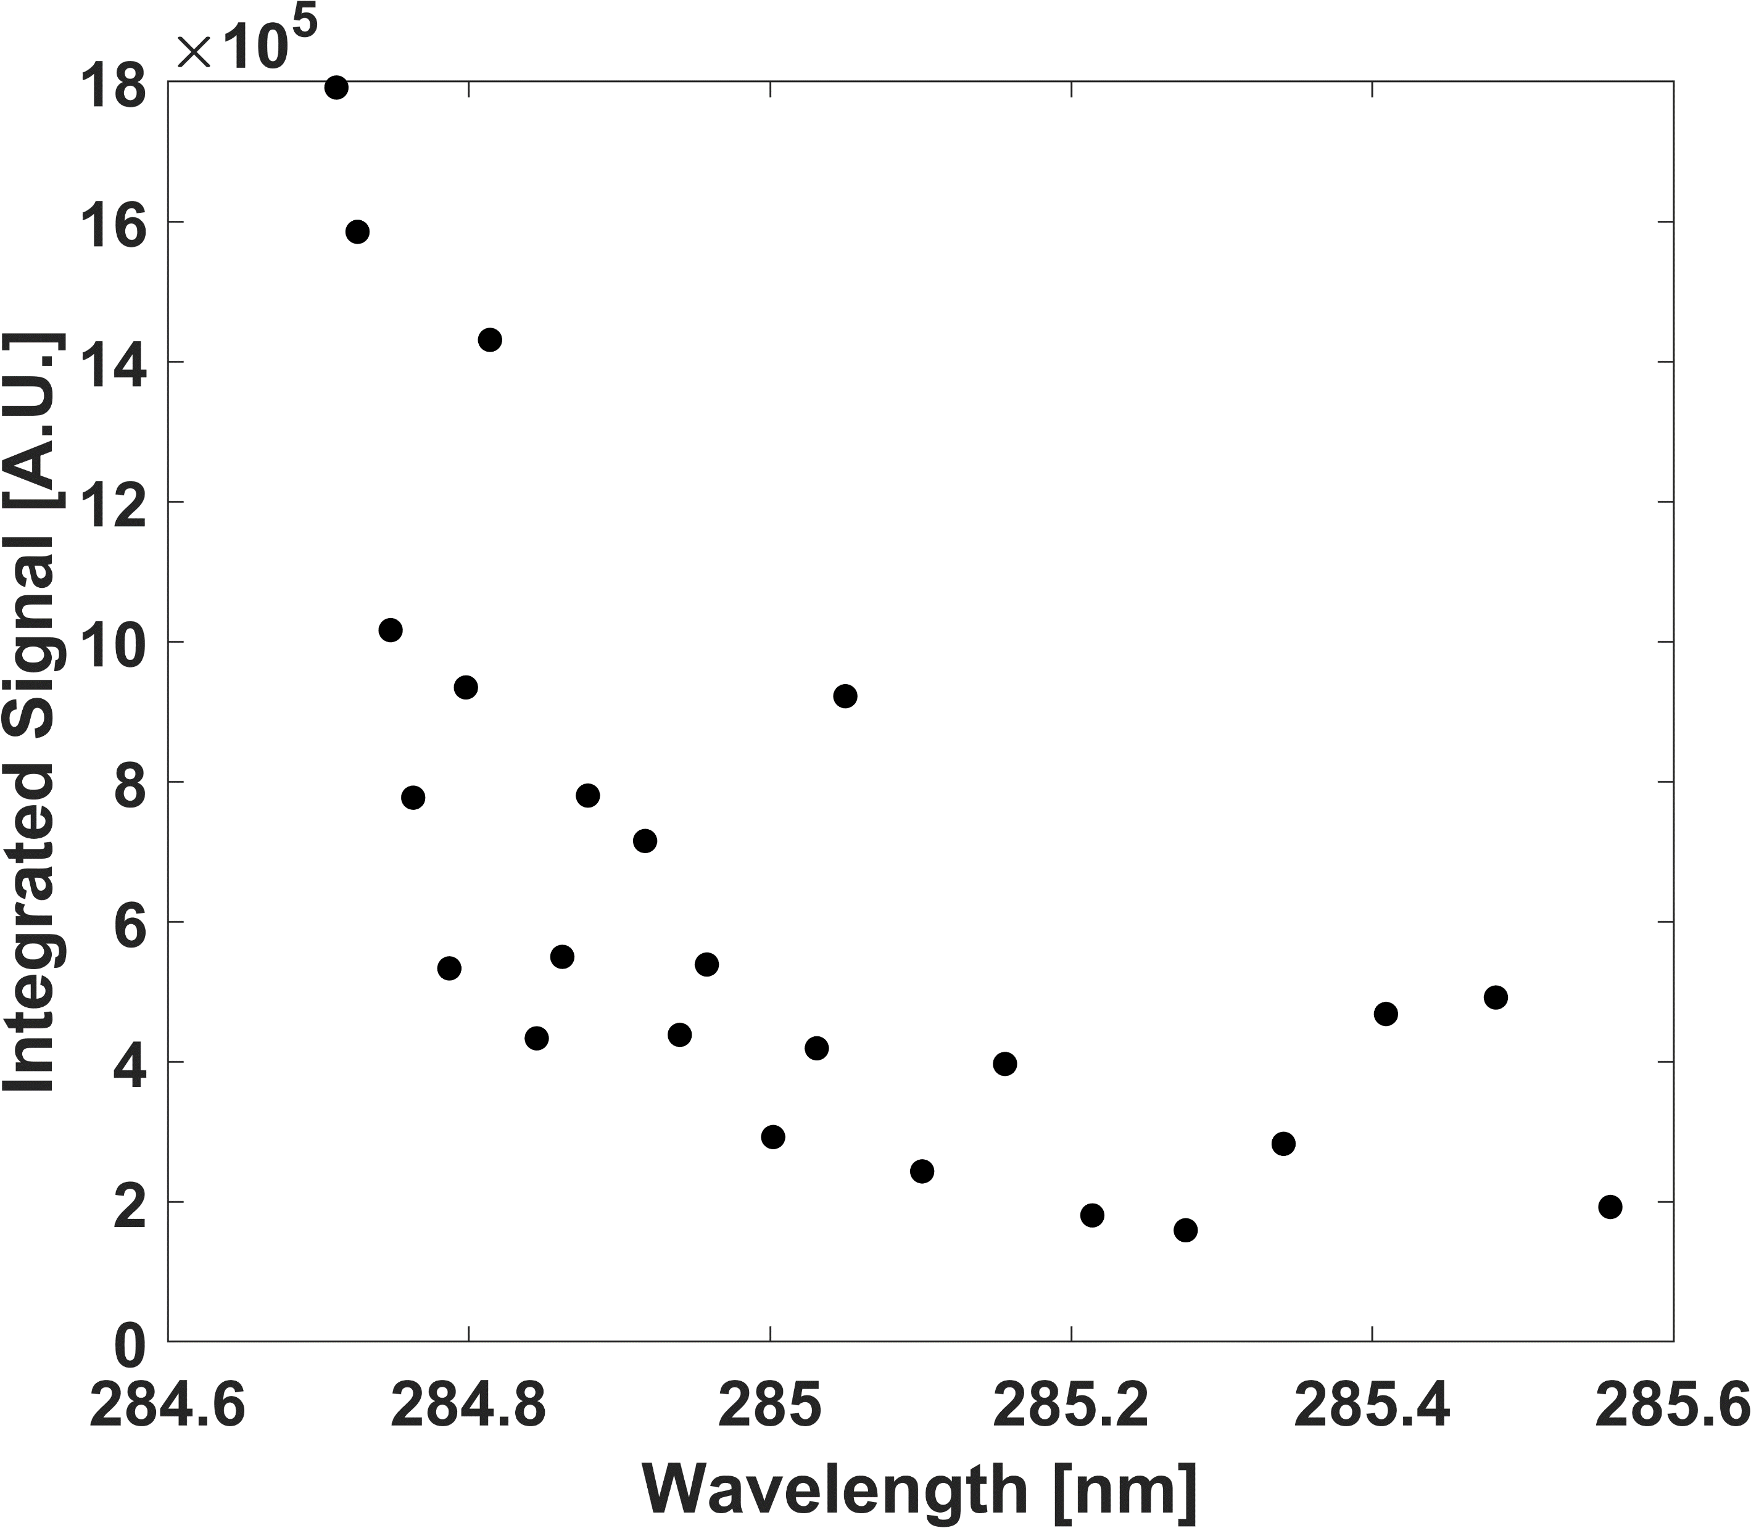
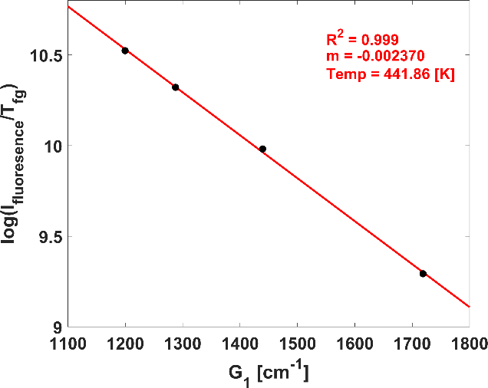
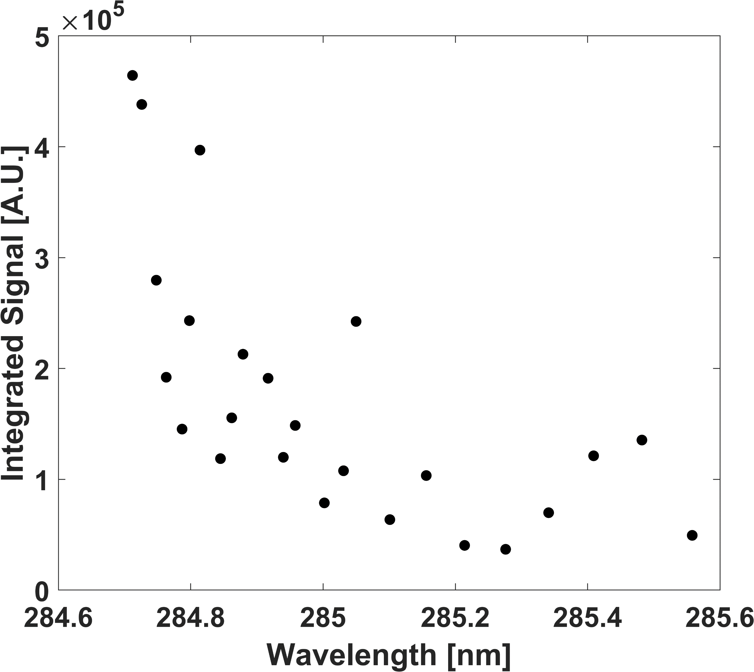
Figure 5.15 Integrated peak signal values for (a) Δv₀, 390nm, (b) Δv₁, 430nm, and temperature determinations at (c) Δv₀, and (d) Δv₁ for actual temperature of 455 Kelvin.
(a)
(b)
(c)
(d)

Suggesting that there exists a very linear relationship between the Δv₀ (390 nm) peak and the N₂⁺ photoemissions and resonant excited N₂. The Δv₁ (430 nm) peak demonstrates a linear relationship, but is not suitable for temperature determination due to relatively high error in the temperature assignments. Additionally, the Δv₁ (430 nm) predicted temperature trended to overshoot the actual cell temperature, and no such relationship or trend existed with the Δv₀ (390 nm) peak. It should be noted the Δv₁ (430 nm) signal was typically an order of magnitude or more less than the Δv₀ (390 nm) peak signal, which results in worse SNR and could have contributed to the relatively high temperature error. N₂ RIPT measurements for 165, 230, 376, and 455 Kelvin are visualized in Fig. 5.12 (c, and d), Fig. 5.13 (c, and d), Fig. 5.14 (c, and d), and Fig. 5.15 (c, and d), respectively. The acquired N₂ RIPT temperatures at each emission peak for all calibration temperatures are tabulated in Table 5.3 along with the error difference between experimentally determined and actual cell temperatures.
Through the studies of the individual emission peaks form the first negative band of N₂⁺, it is proven that using the correct transition peak N₂ RIPT is a viable, non-seeded, non-intrusive thermometry technique for resolving temperature gradients with sufficiently accuracy. A few key points of the analysis are, the Δv₁ (430 nm) peaks demonstrated low accuracy, with an average error between expected and experimentally measured temperatures of 11.22%. Additionally, it tends to over-predict low temperatures (<293 Kelvin) and under-predict high temperatures (>293 Kelvin), with the max difference in experimental and expected being (+62.69) and (-27.00) Kelvin respectively. Since the $1→1$ transitions are of higher rotational states it is expected the signal would weaken at low temperatures as the populations distributions will trend more towards the ground state thus, less energy will be imparted as the translational strengths diminish directly reducing the collisional rates.

Table 5.3 Results for specific N₂⁺ fluorescence bands (Δv₀, and Δv₁) for N₂ RIPT.
Cell Temperature (K) | Experimentally Determined Temperatures (K) |  | Error (%)
Cell Temperature (K) | Δv₀  (390nm) | Δv₁  (430nm) | Δv₀ | Δv₁
165 | 170.18 | 186.13 | 3.14 | 12.81
230 | 229.71 | 292.69 | 0.13 | 27.26
293 | 292.03 | 275.52 | 0.33 | 5.97
376 | 376.96 | 349.00 | 0.26 | 7.18
455 | 461.66 | 441.86 | 1.46 | 2.89

The Δv₀ (390 nm) peak exhibits the best capability of accurate thermal measurements, with the highest percent error difference between expected and experimental values being 3.14%, with an average error of 1.06%. The excited rotational temperature of a molecule is typically relatively quick to respond to medium temperature changes, this inherent characteristic is due to the fundamental physics where the rotational temperature is not dependent on extrinsic events occurring outside the molecule’s immediate region, thus the direct thermal energy of the environment is typically accounted for almost instantaneously by rotational states. Furthermore, it is shown that for the Δv₀ (390 nm) peak the rotational state is representative of near true medium temperatures.

N₂ non-discrete analysis for temperature determination
To expand O₂ RIPT’s applicability, useability, and enable measurements across a 1D line, a study is conducted; here the signal used fitting to a Boltzmann distribution is found via integrating along the first negative band $N_{2}^{+}(B^{2}Σ_{u}^{+}-X^{2}Σ_{g}^{+})$, (370 to 435nm). This would simulate the removal of the spectrometer and direct imaging of the emission fluorescence through an optical bandpass filter that blocks light outside of the N₂⁺ spectral region. Figure 5.16 visualizes the peak intensity values found from the aforementioned integration scheme for calibration wavelengths at 165, 230, 293, 376, and 455 Kelvin. An inspection of Fig. 5.16 and Fig. 5.11 (a, and b) suggest the summed peak intensity values trend towards the Δv₀ emission for standard air temperature (i.e., 293 Kelvin). This is expected as its emission intensity strength dominates the Δv₁ band, typically by an order of magnitude or greater. Using an iterative approach to find peaks that could relate temperature, the best fit was found from a selected group of the integrated signal intensities, and fitted to a Boltzmann plot to assign a vibrational temperature measurement.

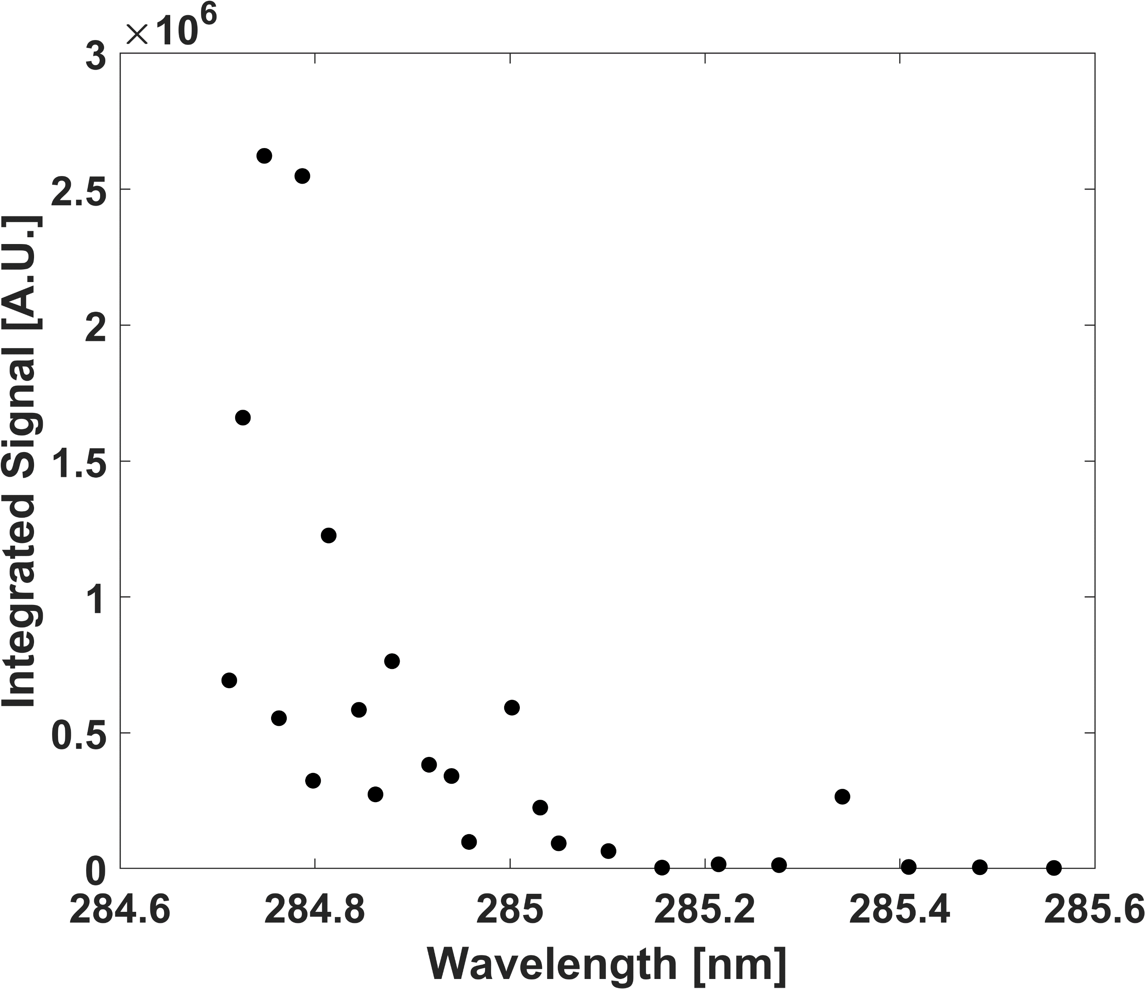
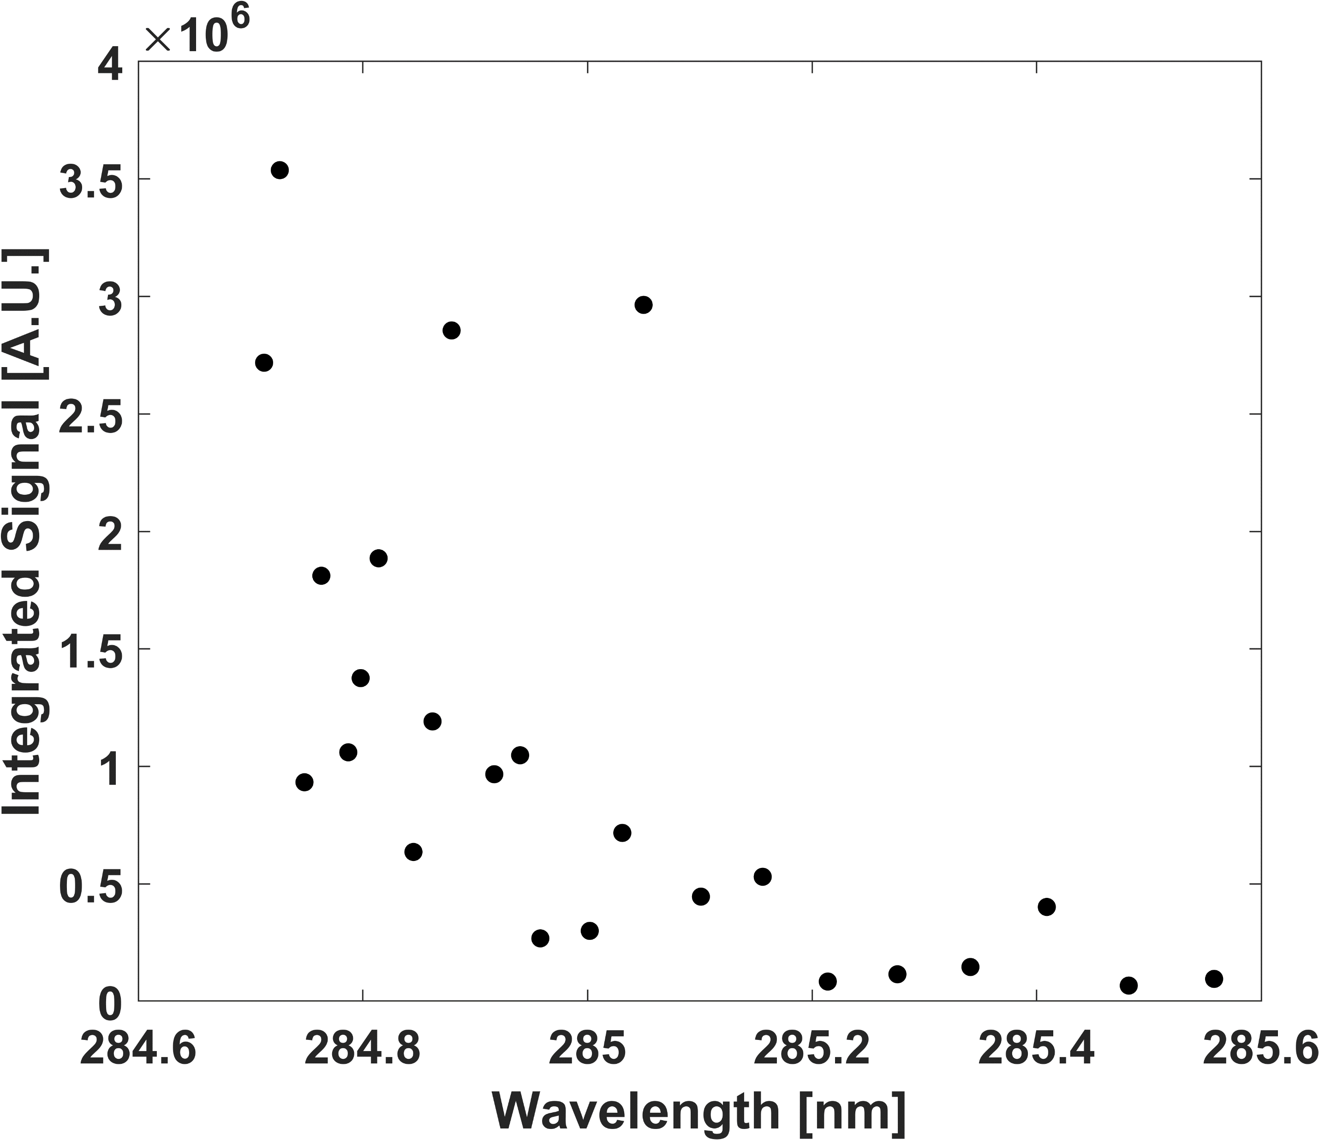
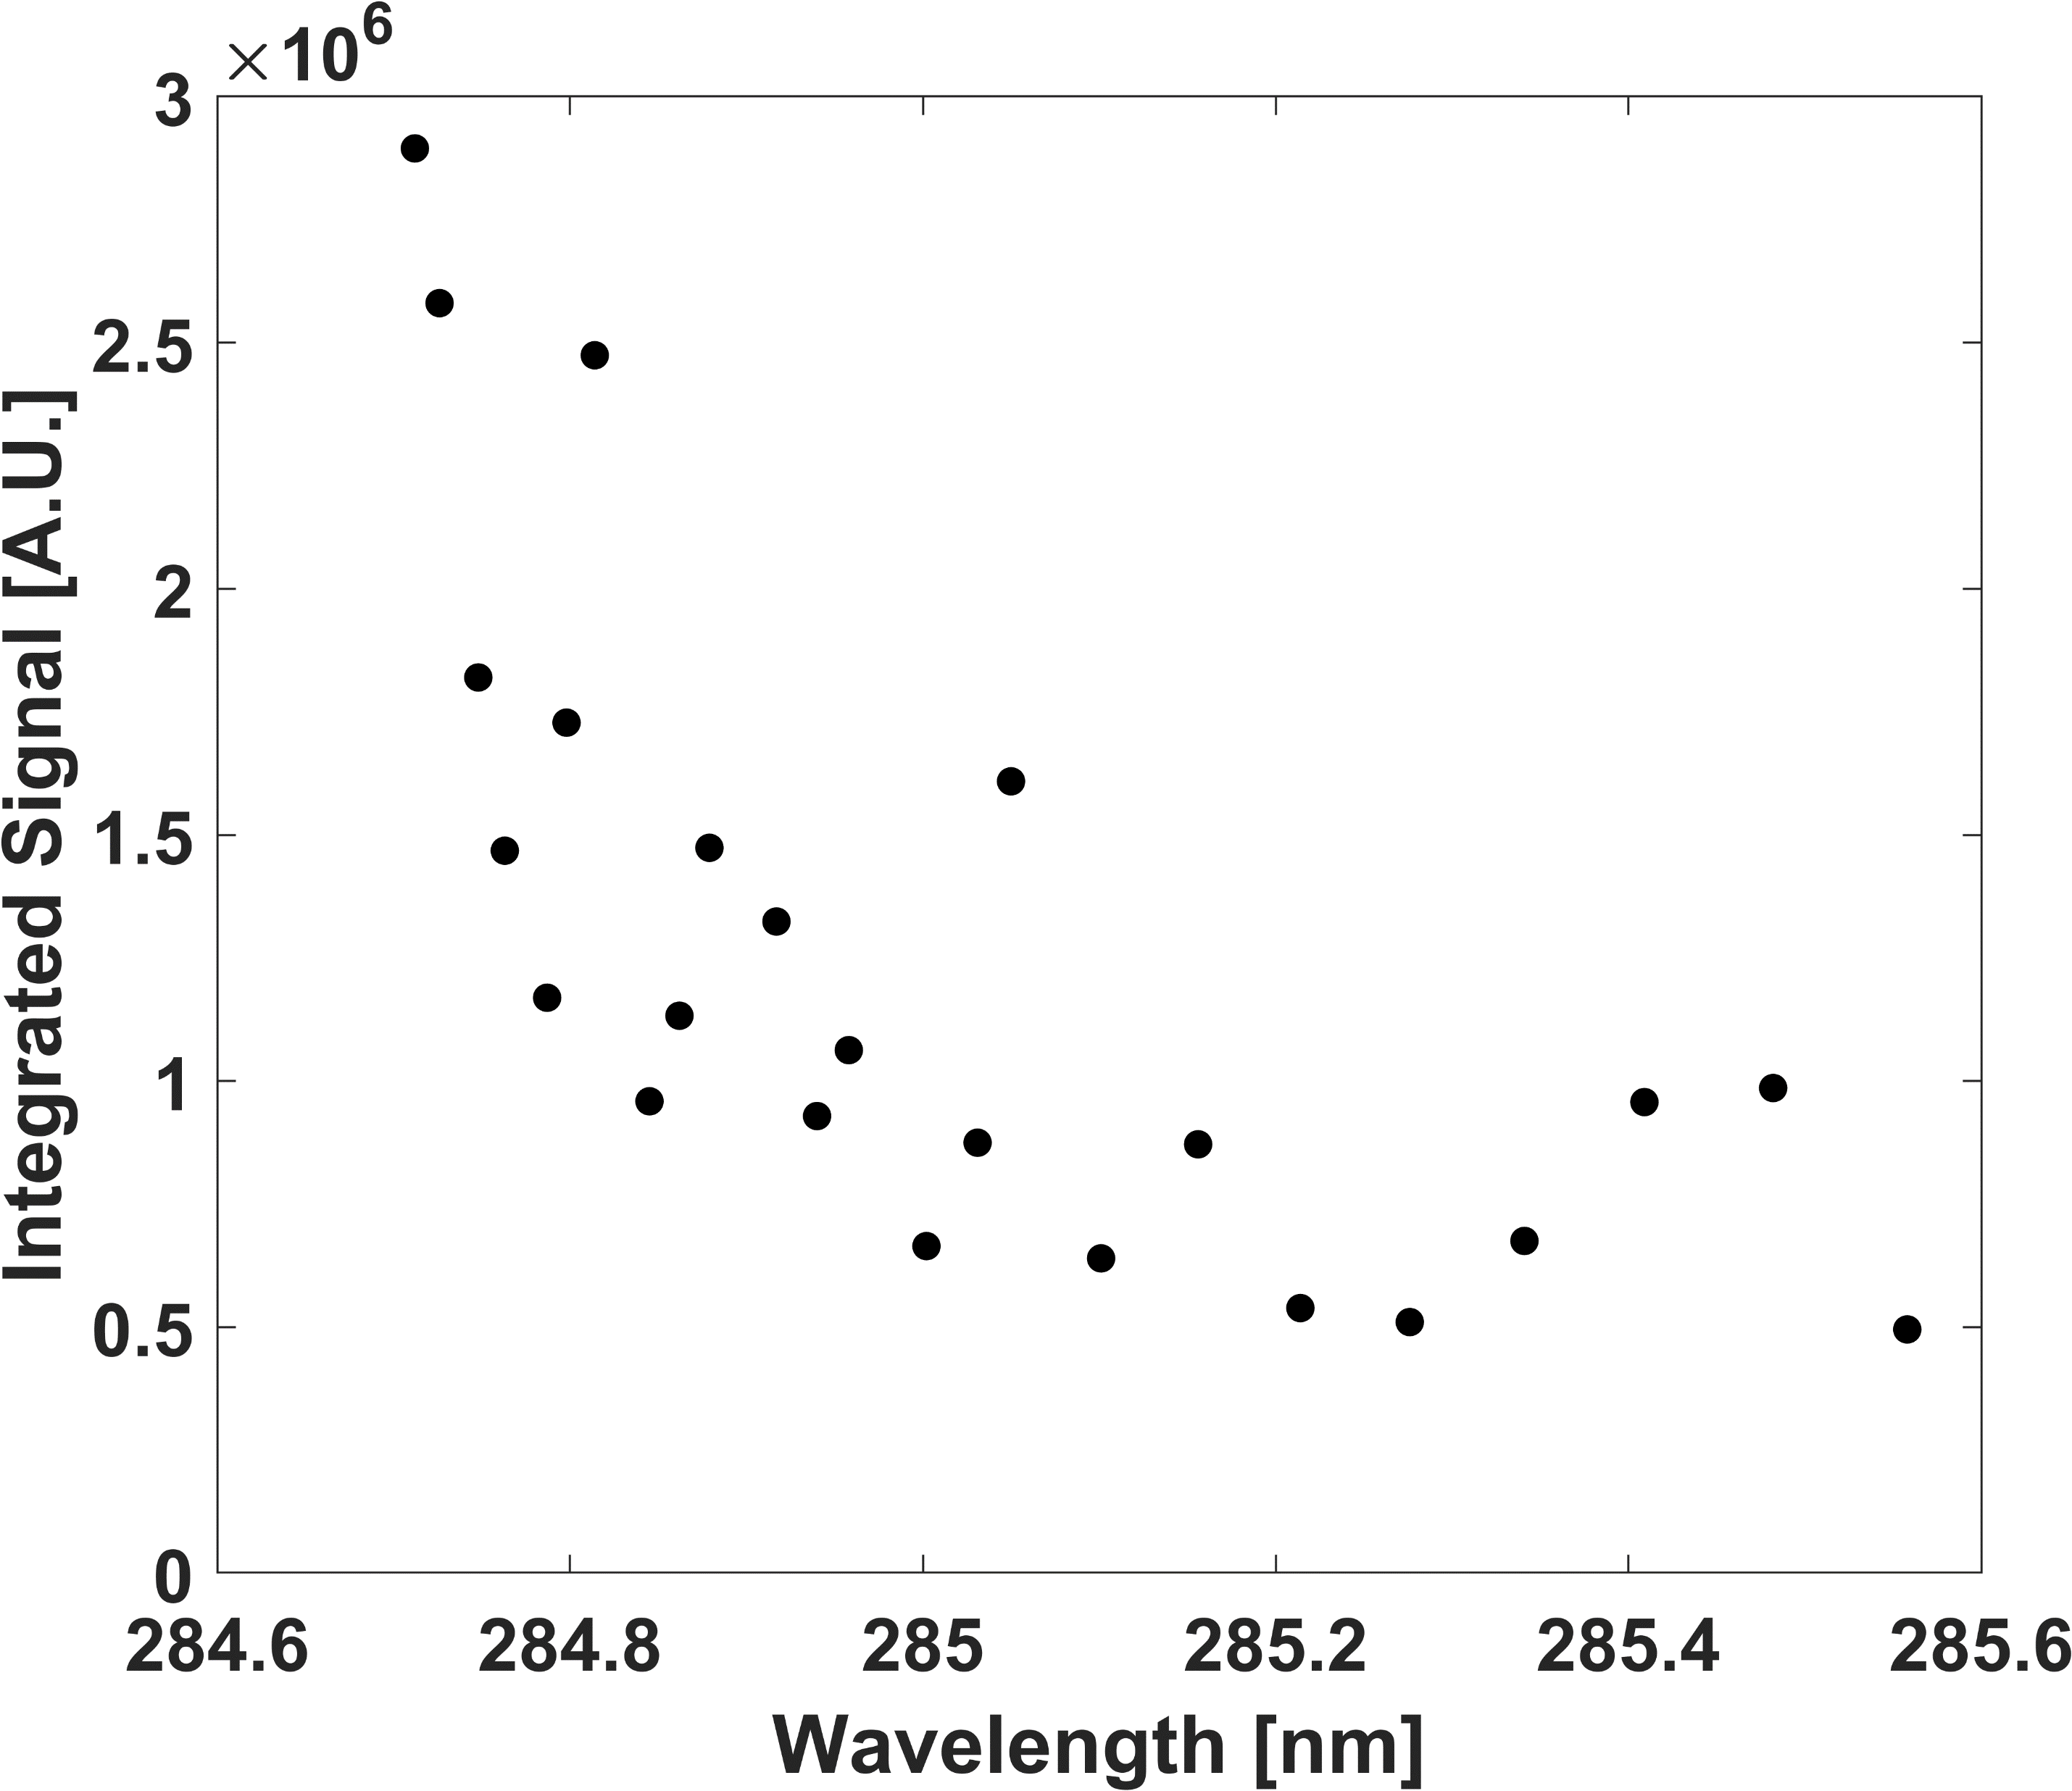
(a)
(b)
(c)
(d)
(e)
Figure 5.16 N₂⁺ first negative band integrated signal values for (a) 165K, (b) 230K, (c) 293K, (d) 376K, and (e) 460K.
The iterative approach used sometimes resulted in hundreds of peak group combinations until an ideal set was found. The Boltzmann plots in Fig. 5.17 show the temperature determination for the integrated signals at all calibration temperatures. Only the most temperature sensitive rotational lines were chosen and are listed in Table 5.4, this includes the error between the expected and experimental cell temperatures. The plots show high linearity among the four selected rotational lines for temperatures of 165, 230, 293, 376, and 455 Kelvin, thus enabling accurate thermal measurements to be achieved. Furthermore, this suggests that direct imaging of the N₂⁺ emission is not only viable, but the preferred method for N₂ RIPT measurements. The capability to direct image the photoemissions is important as it enables realizes the 1D line potential in RIPT based measurements, and requires only an intensified gated camera, thus reducing experiment setup time, complexity, space, and expense.
Table 5.4 suggests as temperature decreases, the resonant wavelength selection trends towards lower wavelengths. This is expected, as temperature decreases there is less structure in the REMPI spectrum as population distributions trend towards lower rotational levels. Thus, the lower rotational states become the most viable for maintaining collisional rates for generating sufficient N₂⁺ emissions which are key for maintaining measurement repeatability and accuracy. Inspection of the assigned rotational gas temperatures for the integrated signals only differs slightly from the actual cell temperatures; providing confirmation and enabling high quality thermometry measurements via signal integration. By comparing the integrated result with the per peak results, the integrated signal maintains accurate measurements over a greater thermal range than Δv₁ or Δv₂. The integrated signal measurement capability and accuracy closely resembles the Δv₀ emission band, but differs in that the integrated signal will have a greater SNR ratio due to the overall signal benefiting from contributions of all three bands.

Figure 5.17 Integrated N₂⁺ Boltzmann temperature assignments for (a) 165K, (b) 230K, (c) 293K, (d) 376K, and (e) 460K.
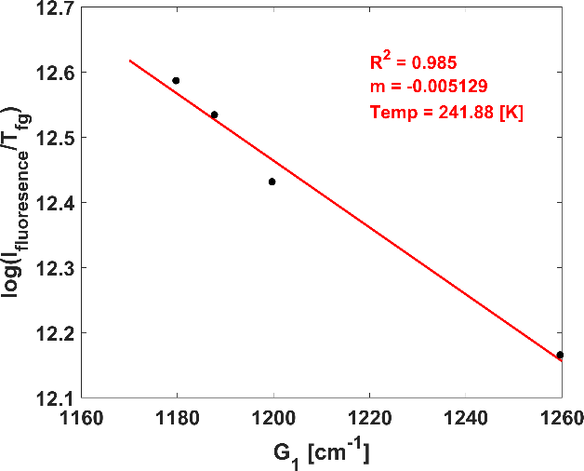
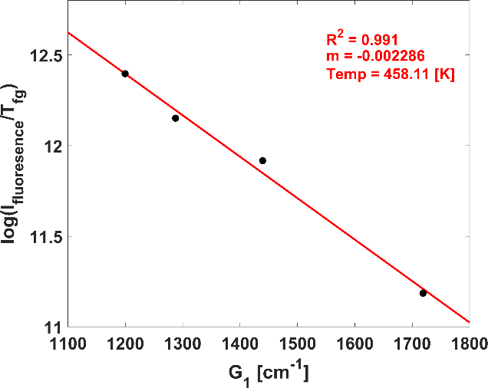
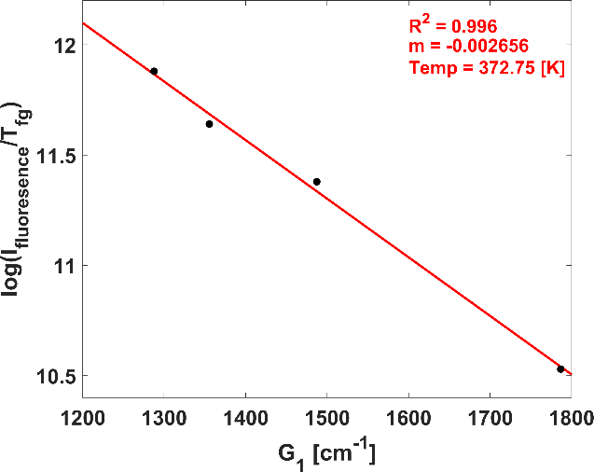
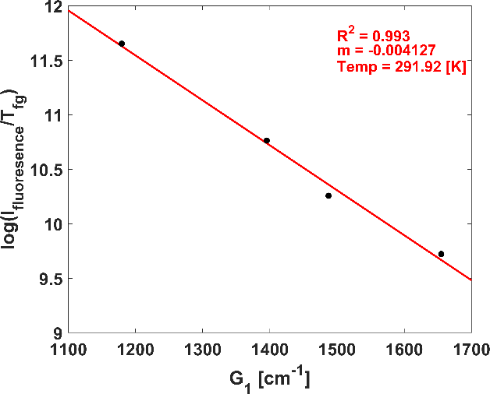
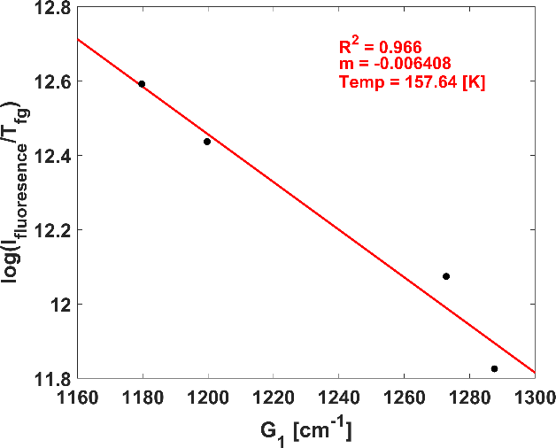
(a)
(b)
(c)
(d)
(e)
Table 5.4 Expected and experimental temperatures from N₂ RIPT integrated emission study.
Excitation Wavelengths |  |  |  | Temp. (actual) | Temp.  (Measured) | Error
nm | nm | nm | nm | K | K | %
284.712 | 284.748 | 284.763 | 284.814 | 165 | 157 | 4.85
284.712 | 284.726 | 284.748 | 284.798 | 230 | 242 | 5.22
284.712 | 284.879 | 284.940 | 285.031 | 293 | 292 | 0.34
284.814 | 284.862 | 284.940 | 285.101 | 376 | 373 | 0.80
284.748 | 284.814 | 284.917 | 285.050 | 455 | 458 | 0.66

It should be noted, even though the integrated signal benefits from contributions from the various transitions, the Δv₀ signal still dominates the photoemissions, thus the integrated signal will still closely follow the Δv₀ accuracy for gas temperature assignments.

Conclusions
In this work, nitrogen based and REMPI induced Resonantly Ionized Photoemission Thermometry (N₂ RIPT), a novel, non-intrusive, non-seeded technique is established and verified through a detailed calibration analysis. The dominate mechanism of plasma generation is REMPI, which is a highly nonlinear process that results in minimal deposited energy and disturbances to the surrounding environment, allowing for applications in highly-sensitive areas. Furthermore, N₂ RIPT utilizes resonant wavelengths to selectively excite various rotational bands of nitrogen to weakly ionize a medium gas that contains some mass fraction of nitrogen molecules. Through multiphoton ionization process, the first negative band of N₂⁺ is weakly rotationally excited; subsequent deexcitation yields photoemissions in the visible region from 390 to 430 nm. The resulting emissions are processed and fitted to a Boltzmann distribution that yields a temperature measurement.
A discrete analysis of the emissions of the individual transitions band was conducted for the $N_{2}^{+}(B^{2}Σ_{u}^{+}-X^{2}Σ_{g}^{+})$ transition. Additionality, the N₂ RIPT generated ionization is a relatively cold plasma only displaying emissions (Δv₀, ~390nm; Δv₁, ~430nm) that result from the $0→1$ and $1→1$ transitions respectively. Sets of resonant wavelengths that correspond to specific rotational peaks within the 3-photon $N_{2}(X^{1}Σ_{g}^{+},v=0→b^{1}Π_{u},v=6)$ absorption transition and demonstrated high-temperature sensitivity and strong photoemission signal at various temperature setpoint were found through an iterative process and the results tabulated in Table 5.3. It has been shown through the discrete analysis, the Δv₀ dominates emissions and produces accurate experimental gas temperature measurements with a max total error of approximately ±3% for <700 Kelvin environmental temperatures. The Δv₁ emission is not ideal for standalone temperature measurements, having max total error of approximately 27%. The high measurement error of the Δv₁ emission primarily stems from low temperatures and weak signal, suggesting that the band may be more suitable for higher temperature measurements.
One-dimensional capabilities are realized only through the removal of the spectrometer. The emission signal was fully integrated across the spectrum from approximately 375 to 435 nm to simulate direct imaging of the emissions with a camera. The non-discrete emission analysis yielded temperature measurements with accuracies similar to the discrete Δv₀ band, having max total error of approximately 5%. Sets of resonant wavelengths ideal for various temperature ranges are given in Table 5.4. The ability to accurately measure gas-temperature via direct imaging of the $N_{2}^{+}(B^{2}Σ_{u}^{+}-X^{2}Σ_{g}^{+})$ transition allows not only 1D line capability, but reduces experimental setup time, optical complexity, associated costs, and space helping realize the techniques full potential. Furthermore, the non-discrete signal is sum of the discrete emissions increasing the overall signal intensity and SNR.
The 3-photon $N_{2}(X^{1}Σ_{g}^{+},v=0→b^{1}Π_{u},v=6)$ absorption band and REMPI mechanism that is used by N₂ RIPT is collisional influenced, with a (3+1) scheme occurring at low pressure and a (3+2) scheme occurring near standard pressure conditions (approximately 14.7 psi [pounds per square inch]). The calibration study maintained standard pressure conditions across all measurement temperatures. However, the signal dependence on pressure maintains a linear relationship. Physically, as pressure increases so does the number density and availability of nitrogen molecules, thus signal generation is strengthened. However, as pressure further increases the collisional induced REMPI scheme results in a decrease in signal generation, but this is balanced by the increases in number density, thus maintaining a linear relationship.
The main drawback to N₂ RIPT is four wavelengths are currently needed to probe the rotational state distribution and acquire enough information to fit signals to a Boltzmann distribution for accurate and repeatable temperature measurements. Additionally, a dye-laser that is capable of generating near 10 mj/pulse is needed to achieve 1D line lengths of sufficient length. It was shown that a 2-inch emission line is possible with 10 mj/pulse beam energy, with the measurement distance and lasing energy being the main limiting factors of emission line length generation.

Summary

The work presented in this dissertation has effectively laid the ground work for a novel, non-seeded, non-intrusive one-dimensional (1D) line thermometry technique. Specifically, the results in Chapter 2 found that for oxygen-based gas-temperature measurements the technique efficiently ionizes oxygen via (2+1) REMPI scheme with minimal induced disturbance to the surrounding flow. This makes it ideal for use in sensitive environments. Furthermore, it was found that within standard air composition, the excited O₂ generates a sufficient number of free-electrons to induce electron impacted avalanche ionization of nearby nitrogen molecules; generating N₂⁺. The main deexcitation pathway for the N₂⁺ is via the $N_{2}^{+}(B^{2}Σ_{u}^{+}-X^{2}Σ_{g}^{+})$ first negative band emissions, thus generating strong visible fluorescence near 390nm wavelengths.
The N₂⁺ first negative band photoemission strengths at all transitions share a direct one-to-one relationship to line strength of the selectively excited rotational peak within the $C^{3}Π,\left(v=2\right)←X^{3}Σ,(v^{'}=0)$ band of O₂. The line strengths of individual rotational lines are temperature sensitive and, thus by relation so are the photoemissions of the $N_{2}^{+}(B^{2}Σ_{u}^{+}-X^{2}Σ_{g}^{+})$. Typically, to apply a rotational state distribution analysis to assign a temperature from a REMPI spectrum, a rotationally-resolved spectrum and transition cross-sectional data are essential. Since the thermal distribution of the rotational levels is given by a statistically weighted (i.e., quantum degenerated) Boltzmann factor, that is the rotational level with the maximum population shifts either towards or away from higher $J$ values for increasing or decreasing temperatures respectively. This shift is reflected across the REMPI spectrum through variation in the individual rotational lines. If the ionization cross section is assumed to be constant over the REMPI spectrum wavelengths, then probing of the rotational lines via some method (i.e., microwave scattering, acoustic detection) from which a Boltzmann plot can be formulated. Applying a statistical fit to the Boltzmann plots yields a gas temperature.
The O₂ RIPT technique bypasses the need for a fully rotational-resolved spectrum of the ionized region and instead only requires knowledge of the transition line strength for the individual rotational lines within the REMPI spectrum. The results of the calibration study in Chapter 2 identified four rotational lines for various temperature setpoints within the REMPI spectrum that through direct laser excitation allows a statistically weighted vibrational gas temperature assignment via the $N_{2}^{+}(B^{2}Σ_{u}^{+}-X^{2}Σ_{g}^{+})$ photoemissions. The calibration study both a discrete and indiscreet analysis, that is examined the statistically weighted fits of the Boltzmann plots for thermometry capabilities of the individual transitions and integrated $N_{2}^{+}(B^{2}Σ_{u}^{+}-X^{2}Σ_{g}^{+})$ band respectively. The study found that the $Δv_{0},390nm$ peak was the most representative of expected gas temperatures and suitable across all thermal setpoints. The $Δv_{1},430nm$ and $Δv_{2},425nm$ peaks had an overall higher experimental error that the $Δv_{0},390nm$, and were not suitable for cold gas temperatures. For the integrated (indiscrete) thermal fit, it was found to be suitable across all thermal setpoints and was highly representative of the $Δv_{0},390nm$ signal. Additionally, groups of ideal wavelengths were given for each temperature setpoint, thus creating a look up table for future researchers or scientists to use depending on the range of environmental temperatures to be measured.
In Chapter 3, a benchtop scale moderately under expanded supersonic free jet was studied. Specifically, the thermal gradient was characterized through the generated shock train aft of the nozzle exit using O₂ RIPT. Utilizing the identified ideal wavelengths from the previous study, rotational lines corresponding to the 180 and 293 Kelvin setpoints were excited and resulting photoemissions captured across a 50mm line length that enabled the full shock train to be studied. Furthermore, this was the first measurement that realized O₂ RIPT’s full potential of 1D direct imaging using only an intensified scientific camera and bandpass filter that allowed direct acquisition of only the $N_{2}^{+}(B^{2}Σ_{u}^{+}-X^{2}Σ_{g}^{+})$ photoemissions.
It was proven that the direct imaging scheme for O₂ RIPT was able to accurately assign the temperature through the reciprocating expansion fan and converging shock structure that is characteristic of conventional shock diamonds. The imaging camera used a 1000mm focusing telephoto lens which magnified the fluorescence line to such a degree that the limiting spatial resolution became hardware limited by the pixel-by-pixel size on the ICCD chip. The study also found that the (2+1) O₂ REMPI scheme used does not suffer from collisional influence processes and thus is pressure insensitive. It should be noted though that the signal is dependent on local number density which, has relatively no impact on the thermometry ability as long as imaging position sufficient number densities are maintained to generate signal intensities with adequate SNR. Furthermore, the signal strength reliance on number density enables another means of characterizing the geometry of the shock train.
The type of jet used in this study is governed by compressibility effects and tends to be steady once fully developed; thus, the O₂ RIPT line can be averaged over multiple shots to remove various anomalies and contributions that could negatively impact the statistically fitted slope of the Boltzmann plots. The O₂ RIPT temperature measurement was validated through comparisons to a well-known experimental technique, Coherent Anti-Stokes Raman Scattering (CARS) and Computational Fluid Dynamics (CFD) simulations of the under expanded jet’s shock train. It was found that O₂ RIPT showed good agreement with all three techniques, aligning slightly better with the vibrational CARS measurements, and slightly diverging from the CFD measurement once the flow had become fully developed. The mean deviations between the CFD and O₂ RIPT results occurring after X/D = 4 are sufficiently small such that they are most likely due to slight differences between the physical experiment hardware and pure theoretical CFD model and not attributed to a lack of capacity of the O₂ RIPT technique.
In Chapter 4, 1D direct imaging O₂ RIPT technique is used for characterizing thermal gradients present in the freestream and behind the detached shock generated by a cylinder model in a Mach 4 Ludweig tube. This was the first demonstration of O₂ RIPT in a ground-based high-speed test facility. The relative simplicity of the O₂ RIPT direct imaging experimental setup allowed relative ease of implementation into the facility and with little to no signal related optical alignment, the technique demonstrated a high level of robustness to facility induced noise and vibrations. The ideal rotational peaks associated with the 180 Kelvin setpoint found in Chapter 2 maintained relevant population distributions and number densities for accurate temperature assignments down to 72 Kelvin (i.e., theoretical free stream temperature). Furthermore, the O₂ RIPT free stream temperature measurement assigned an average vibrational gas temperature across a 5.0cm line length of 75.7 Kelvin with a ±3 Kelvin associated error. The associated error was the result of induced noise to the signal that is inherently associated with single shot acquisitions. The experimental result was compared and validated via the expected result that was found using Isentropic flow theory, predicting a theoretical temperature of 72 Kelvin. Considering the associated error of the O₂ RIPT technique, the experimental result aligns well with the expected result.
A blunt cylinder model (one-inch diameter) that generated a strong bow shock was used in the Mach 4 tunnel for studies relevant to shock-wave compression heating effects. First, the model was oriented with respect to the tunnel such that, the O₂ RIPT line could be generated centered along the model surface and behind the detached shock. The O₂ RIPT temperature measurement assigned an averaged vibrational gas temperature of 296.5 Kelvin (±2%) across a 2.5cm line length. Secondly, the model such that the generated O₂ RIPT measurement line could be positioned to pass through the shock, measuring both free stream and the temperature gradient behind the shock that results from 3D relief effects. The O₂ RIPT assigned a temperature of 75.2 Kelvin (±2%) for the 2.0cm portion of the line located in the free stream, and assigned a max gas temperature behind the shock of 297 Kelvin (±2%). This showed great agreement to the previous free stream and behind shock O₂ RIPT measurements, and if considering the associated error was well within the expected values. Furthermore, the demonstrated measurement sensitivity of O₂ RIPT was sufficient enough to resolve the thermal gradient generated by 3D relief effects across the model behind the shock. Finally, CFD results of the model showed good agreement for all the different experimentally measured temperature values.
Chapter 5 moved away from the oxygen-based RIPT studies, and instead examined the feasibility of nitrogen-based RIPT measurements (N₂ RIPT). While O₂ RIPT was proven in Chapters 2, 3, and 4 to be an excellent new thermometry method, it inherently suffers a few drawbacks. First, since O₂ RIPT is in indirect scheme, that is it relies upon vibrationally excited nitrogen molecules to emit fluorescence, it is by design a vibrational gas temperature measurement. Typically, the vibrational gas temperature takes sufficiently longer to reach equilibrium and be representative of total gas temperature, thus in higher enthalpy environments that are partially or fully dissociated the vibrational temperature will take longer, if ever, to reach equilibrium and will not be highly representative of the total gas temperature. Furthermore, hypersonic flow in terms of wind tunnel design is achieved when heating of the flow is required to avoid liquification of the oxygen in air during the expansion process. As Mach number increases so does the heating requirement, resulting in both construction and running costs becoming prohibitively expensive. To circumvent this and greatly reduce the overall heating requirement many high Mach number tunnel facilities will utilize a pure nitrogen test gas. Obviously, O₂ RIPT would not work in a pure nitrogen environment due to the lack of available oxygen molecules.
To circumvent the inherent drawbacks and limiting applicability of O₂ RIPT an in-depth study was conducted to realize N₂ RIPT. N₂ RIPT efficiently ionized nitrogen molecules through a (3+1) N₂ REMPI scheme that utilized the 3-photon resonant absorption band $N_{2}(X^{1}Σ_{g}^{+},v=0→b^{1}Π_{u},v=6)$. This absorption band suffers from collisional influenced processes that come into effect near atmospheric pressures, resulting in an additional photon (i.e.,3+2 scheme) needed to ionize the molecule. However, any increase in signal at low pressure that is directly related to the lower excitation energy of the (3+1) scheme is negated by lower number density. Thus, the signal intensity is linearly related to pressure. Nevertheless, it was found that sufficient photoemission intensities within the first negative band $N_{2}^{+}(B^{2}Σ_{u}^{+}-X^{2}Σ_{g}^{+})$ could be achieved to enable N₂ RIPT line generation of adequate length. Thus, a calibration study identical to the one in Chapter 2 was conducted, examining both the discrete and indiscreet signals that resulted from the individual or summed photoemissions within the first negative band for thermometry capabilities.
It was found that only the $Δv_{0}$ and $Δv_{1}$ transitions were visible, with the $Δv_{0},390nm$ peak and the $Δv_{1},430nm$ peak being highly representative and poorly representative of actual gas temperature respectively. Furthermore, the integrated (indiscrete) thermal fit was found to be suitable across all thermal setpoints and was highly influenced by the $Δv_{0},390nm$ signal. Additionally, groups of ideal wavelengths were given for each temperature setpoint, thus creating a look-up table for various temperature ranges. The realization of N₂ RIPT gains the 1D measurement capability proven by O₂ RIPT but bypasses the inherent drawback associated with O₂ RIPT. Since N₂ RIPT directly pumps nitrogen molecules the generated photoemissions are representative of the rotational line strengths and the Boltzmann plots are giving the rotational state distributions. Thus, N₂ RIPT is a rotational gas-temperature measurement; due to the relatively quick time rotational temperatures reach equilibrium it is more applicable within partial or fully non-equilibrium flows. Furthermore, since N₂ RIPT utilizes multiphoton ionization for signal production, it could potentially be achieved using high-repetition rate lasers with ultrafast pulse widths. Finally, N₂ RIPT is not only suitable, but gains signal strength benefits from reduced quenching by oxygen in pure N₂ environments.
In summary, the work presented in this dissertation lays the groundwork for a novel, non-seeded, one-dimensional, laser based, technique that utilizes REMPI to resonantly ionize a target molecule for photoemission-based thermometry applications. Detailed calibrations for two target molecules, oxygen and nitrogen, were carried out to establish two variations of the RIPT technique. Furthermore, benchtop and large facility-based experiments were conducted to help realize the full potential of the technique. Information is provided that quickly allows future scientists and researchers to identify which rotational peaks to selectively excite depending on expected temperatures for accurate measurements. Together, O₂ RIPT and N₂ RIPT have been shown to provide unprecedented insight for aerothermodynamic measurements, and are suited well for characterizing thermal gradients within dynamic flow environments. The RIPT based technique has potential for wide ranging implications across various scientific fields and studies, and hopefully will continue to evolve and become an industry standard for 1D line thermometry measurements.

References

1. Anderson, J. D. Hypersonic and high temperature gas dynamics: Aiaa, 2000.
2. Bertin, J. J., and Cummings, R. M. "Critical hypersonic aerothermodynamic phenomena," Annual Review of Fluid Mechanics Vol. 38, 2006, p. 129.
3. Candler, G. V., Subbareddy, P. K., and Brock, J. M. "Advances in computational fluid dynamics methods for hypersonic flows," Journal of Spacecraft and Rockets Vol. 52, No. 1, 2015, pp. 17-28.
4. Dolvin, D. "Hypersonic international flight research and experimentation (HIFiRE) fundamental science and technology development strategy," 15th AIAA International Space Planes and Hypersonic Systems and Technologies Conference. 2008, p. 2581.
5. Danehy, P., Weisberger, J., Johansen, C., Reese, D., Fahringer, T., Parziale, N., Dedic, C., Estevadeordal, J., and Cruden, B. "Non-intrusive measurement techniques for flow characterization of hypersonic wind tunnels." 2018.
6. Sick, V. "High speed imaging in fundamental and applied combustion research," Proceedings of the Combustion Institute Vol. 34, No. 2, 2013, pp. 3509-3530.
7. Slipchenko, M. N., Miller, J. D., Roy, S., Gord, J. R., Danczyk, S. A., and Meyer, T. R. "Quasi-continuous burst-mode laser for high-speed planar imaging," Optics Letters Vol. 37, No. 8, 2012, pp. 1346-1348.
8. Childs, P. R., Greenwood, J., and Long, C. "Review of temperature measurement," Review of scientific instruments Vol. 71, No. 8, 2000, pp. 2959-2978.
9. Abram, C., Fond, B., and Beyrau, F. "Temperature measurement techniques for gas and liquid flows using thermographic phosphor tracer particles," Progress in energy and combustion science Vol. 64, 2018, pp. 93-156.

10. Dogariu, A., Dogariu, L. E., Smith, M. S., Lafferty, J., and Miles, R. B. "Single shot temperature measurements using coherent anti-Stokes Raman scattering in Mach 14 flow at the Hypervelocity AEDC Tunnel 9," AIAA Scitech 2019 Forum. 2019, p. 1089.
11. Jiang, N., Webster, M., Lempert, W. R., Miller, J. D., Meyer, T. R., Ivey, C. B., and Danehy, P. M. "MHz-rate nitric oxide planar laser-induced fluorescence imaging in a Mach 10 hypersonic wind tunnel," Applied Optics Vol. 50, No. 4, 2011, pp. A20-A28.
12. Clouston, J., Gaydon, A. G., and Glass, I. "Temperature measurements of shock waves by the spectrum-line reversal method," Proceedings of the Royal Society of London. Series A. Mathematical and Physical Sciences Vol. 248, No. 1255, 1958, pp. 429-444.
13. Lloyd, G., Hughes, I., Bratfalean, R., and Ewart, P. "Broadband degenerate four-wave mixing of OH for flame thermometry," Applied Physics B: Lasers & Optics Vol. 67, No. 1, 1998.
14. Dreier, T., and Rakestraw, D. J. "Degenerate four-wave mixing diagnostics on OH and NH radicals in flames," Applied Physics B Vol. 50, No. 6, 1990, pp. 479-485.
15. Chang, L. S., Strand, C. L., Jeffries, J. B., Hanson, R. K., Diskin, G. S., Gaffney, R. L., and Capriotti, D. P. "Supersonic mass-flux measurements via tunable diode laser absorption and nonuniform flow modeling," AIAA journal Vol. 49, No. 12, 2011, pp. 2783-2791.
16. Zhou, X., Liu, X., Jeffries, J. B., and Hanson, R. "Development of a sensor for temperature and water concentration in combustion gases using a single tunable diode laser," Measurement Science and Technology Vol. 14, No. 8, 2003, p. 1459.

17. Farooq, A., Jeffries, J. B., and Hanson, R. K. "In situ combustion measurements of H2O and temperature near 2.5 µm using tunable diode laser absorption," Measurement Science and Technology Vol. 19, No. 7, 2008, p. 075604.
18. Gaydon, A. G., Wolfhard, H. G., and Penner, S. "Flames, their structure, radiation and temperature," 1960.
19. Kiefer, J., and Ewart, P. "Laser diagnostics and minor species detection in combustion using resonant four-wave mixing," Progress in Energy and Combustion Science Vol. 37, No. 5, 2011, pp. 525-564.
20. Webb, A. M., Athmanathan, V., Fisher, J., Crabtree, C. Q., Slipchenko, M., and Meyer, T. R. "Megahertz-rate Femtosecond Laser Activation and Sensing of Hydroxyl for Velocimetry in a Rotating Detonation Combustor Exhaust," AIAA SCITECH 2022 Forum. 2022, p. 2372.
21. Lempert, W. R., Jiang, N., Sethuram, S., and Samimy, M. "Molecular tagging velocimetry measurements in supersonic microjets," AIAA journal Vol. 40, No. 6, 2002, pp. 1065-1070.
22. Beuting, M., Dreier, T., Schulz, C., and Endres, T. "Low-temperature and low-pressure effective fluorescence lifetimes and spectra of gaseous anisole and toluene," Applied Physics B Vol. 127, No. 4, 2021, pp. 1-15.
23. Kidd, F. G., Narayanaswamy, V., Danehy, P. M., Inman, J. A., Bathel, B. F., Cabell, K. F., Hass, N., Capriotti, D., Drozda, T. G., and Johansen, C. T. "Characterization of the NASA Langley arc heated scramjet test facility using NO PLIF," 30th AIAA Aerodynamic Measurement Technology and Ground Testing Conference. 2014, p. 2652.
24. Gross, K. P., McKenzie, R. L., and Logan, P. "Measurements of temperature, density, pressure, and their fluctuations in supersonic turbulence using laser-induced fluorescence," Experiments in Fluids Vol. 5, No. 6, 1987, pp. 372-380.
doi: 10.1007/bf00264400
25. Miller, V. A., Gamba, M., Mungal, M. G., and Hanson, R. K. "Single-and dual-band collection toluene PLIF thermometry in supersonic flows," Experiments in fluids Vol. 54, No. 6, 2013, pp. 1-13.
26. Cutler, A., Danehy, P., Springer, R., O’byrne, S., Capriotti, D., and DeLoach, R. "Coherent anti-Stokes Raman spectroscopic thermometry in a supersonic combustor," AIAA journal Vol. 41, No. 12, 2003, pp. 2451-2459.
27. Woodmansee, M. A., Lucht, R. P., and Dutton, J. C. "Development of high-resolution N 2 coherent anti-Stokes Raman scattering for measuring pressure, temperature, and density in high-speed gas flows," Applied Optics Vol. 39, No. 33, 2000, pp. 6243-6256.
28. Roy, S., Gord, J. R., and Patnaik, A. K. "Recent advances in coherent anti-Stokes Raman scattering spectroscopy: Fundamental developments and applications in reacting flows," Progress in Energy and Combustion Science Vol. 36, No. 2, 2010, pp. 280-306.
29. Lucht, R. P., Roy, S., Meyer, T. R., and Gord, J. R. "Femtosecond coherent anti-Stokes Raman scattering measurement of gas temperatures from frequency-spread dephasing of the Raman coherence," Applied Physics Letters Vol. 89, No. 25, 2006, p. 251112.
30. Cutler, A. D., Cantu, L. M., Gallo, E. C., Baurle, R., Danehy, P. M., Rockwell, R., Goyne, C., and McDaniel, J. "Nonequilibrium supersonic freestream studied using coherent anti-Stokes Raman spectroscopy," AIAA Journal Vol. 53, No. 9, 2015, pp. 2762-2770.
31. Knopp, G., Radi, P., Tulej, M., Gerber, T., and Beaud, P. "Collision induced rotational energy transfer probed by time-resolved coherent anti-Stokes Raman scattering," The Journal of chemical physics Vol. 118, No. 18, 2003, pp. 8223-8233.
32. Lang, T., Motzkus, M., Frey, H., and Beaud, P. "High resolution femtosecond coherent anti-Stokes Raman scattering: Determination of rotational constants, molecular anharmonicity, collisional line shifts, and temperature," The Journal of Chemical Physics Vol. 115, No. 12, 2001, pp. 5418-5426.
33. Richardson, D. R., Kearney, S. P., and Beresh, S. J. "Femtosecond Coherent Anti-Stokes Raman Spectroscopy in a Cold-Flow Hypersonic Wind Tunnel for Simultaneous Pressure and Temperature Measurements," AIAA SCITECH 2022 Forum. 2022, p. 0895.
34. Kearney, S. P., and Danehy, P. M. "Pressure measurements using hybrid femtosecond/picosecond rotational coherent anti-Stokes Raman scattering," Optics letters Vol. 40, No. 17, 2015, pp. 4082-4085.
35. Miller, J. D., Roy, S., Gord, J. R., and Meyer, T. R. "Communication: Time-domain measurement of high-pressure N2 and O2 self-broadened linewidths using hybrid femtosecond/picosecond coherent anti-Stokes Raman scattering," The Journal of chemical physics Vol. 135, No. 20, 2011, p. 201104.
36. Zhang, Z., Shneider, M., and Miles, R. B. "Coherent microwave scattering from resonance enhanced multi-photon ionization (radar REMPI): a review," Plasma Sources Science and Technology, 2021.
37. Miles, R. B., Zhang, Z., Zaidi, S. H., and Shneider, M. N. "Microwave Scattering from Laser Ionized Molecules: A New Approach to Noninstrusive Diagnostics," AIAA journal Vol. 45, No. 3, 2007, pp. 513-515.
38. Wu, Y., Bottom, A., Zhang, Z., Ombrello, T. M., and Katta, V. R. "Direct measurement of methyl radicals in a methane/air flame at atmospheric pressure by radar REMPI," Optics express Vol. 19, No. 24, 2011, pp. 23997-24004.

39. Wu, Y., Zhang, Z., and Adams, S. F. "O2 rotational temperature measurements by coherent microwave scattering from REMPI," Chemical Physics Letters Vol. 513, No. 4-6, 2011, pp. 191-194.
40. Wu, Y., Zhang, Z., Ombrello, T. M., and Katta, V. R. "Quantitative Radar REMPI measurements of methyl radicals in flames at atmospheric pressure," Applied Physics B Vol. 111, No. 3, 2013, pp. 391-397.
41. Gragston, M. "Application of Resonant and Non-Resonant Laser-Induced Plasmas for Quantitative Fuel-to-Air Ratio and Gas-Phase Temperature Measurements," 2018.
42. Zhang, Z., Zaidi, S., Brennan, C., Dogariu, A., Shneider, M., and Miles, R. "Radar REMPI detection of NO2 by NO photo-fragments," 47th AIAA Aerospace Sciences Meeting including The New Horizons Forum and Aerospace Exposition. 2009, p. 525.
43. Adams, S. F., Williamson, J. M., and Fisher, D. M. "Rotational temperature analysis of N2 by resonant enhanced multi-photon ionization with fluorescence detection," Journal of Applied Physics Vol. 110, No. 8, 2011, p. 083309.
44. Zhang, Z., Shneider, M. N., and Miles, R. B. "Coherent microwave scattering from resonance enhanced multi-photon ionization (radar REMPI): a review," Plasma Sources Science and Technology Vol. 30, No. 10, 2021, p. 103001.
doi: 10.1088/1361-6595/ac2350
45. Wu, Y., Gragston, M., and Zhang, Z. "Acoustic detection of resonance-enhanced multiphoton ionization for spatially resolved temperature measurement," Optics Letters Vol. 42, No. 17, 2017, pp. 3415-3418.
doi: 10.1364/OL.42.003415
46. Wu, Y., Zhang, Z., and Adams, S. F. "Temperature sensitivity of molecular oxygen resonant-enhanced multiphoton ionization spectra involving the C 3 Π g intermediate state," Applied Physics B Vol. 122, No. 5, 2016, p. 149.
47. Sawyer, J., Wu, Y., Zhang, Z., and Adams, S. F. "O2 rotational temperature measurements in an atmospheric air microdischarge by radar resonance-enhanced multiphoton ionization," Journal of Applied Physics Vol. 113, No. 23, 2013, p. 233304.
doi: 10.1063/1.4811533
48. Wu, Y., Sawyer, J., Zhang, Z., and Adams, S. F. "Flame Temperature Measurements by Radar REMPI of Molecular Oxygen," Applied Optics Vol. 51, No. 28, 2012.
49. Lambropoulos, P. "Topics on multiphoton processes in atoms," Advances in atomic and molecular physics Vol. 12, 1976, pp. 87-164.
50. Western, C. M. "PGOPHER: A program for simulating rotational, vibrational and electronic spectra," Journal of Quantitative Spectroscopy and Radiative Transfer Vol. 186, 2017, pp. 221-242.
51. Wu, Y., Sawyer, J., Zhang, Z., and Adams, S. F. "Flame temperature measurements by radar resonance-enhanced multiphoton ionization of molecular oxygen," Applied optics Vol. 51, No. 28, 2012, pp. 6864-6869.
52. Zhang, Z. Coherent microwave scattering from laser-induced plasma: Princeton University, 2008.
53. Zhang, Z., and Shneider, M. N. "Measurement of plasma decay processes in mixture of sodium and argon by coherent microwave scattering," Physics of Plasmas Vol. 17, No. 3, 2010, p. 033108.
54. Adamson Jr, T. C., and Nicholls, J. A. "On the structure of jets from highly underexpanded nozzles into still air," Journal of the Aerospace sciences Vol. 26, No. 1, 1959, pp. 16-24.
55. Behrouzi, P., and McGuirk, J. J. "Underexpanded jet development from a rectangular nozzle with aft-deck," AIAA Journal Vol. 53, No. 5, 2015, pp. 1287-1298.

56. Franquet, E., Perrier, V., Gibout, S., and Bruel, P. "Free underexpanded jets in a quiescent medium: A review," Progress in Aerospace Sciences Vol. 77, 2015, pp. 25-53.
57. Crist, S., Glass, D., and Sherman, P. "Study of the highly underexpanded sonic jet," AIAA journal Vol. 4, No. 1, 1966, pp. 68-71.
58. Santiago, J. G., and Dutton, J. C. "Velocity measurements of a jet injected into a supersonic crossflow," Journal of propulsion and power Vol. 13, No. 2, 1997, pp. 264-273.
59. Gamba, M., Miller, V., Mungal, G., and Hanson, R. "Combustion characteristics of an inlet/supersonic combustor model," 50th AIAA aerospace sciences meeting including the new horizons forum and aerospace exposition. 2012, p. 612.
60. Ogden, D. E., Wohletz, K. H., Glatzmaier, G. A., and Brodsky, E. E. "Numerical simulations of volcanic jets: Importance of vent overpressure," Journal of Geophysical Research: Solid Earth Vol. 113, No. B2, 2008.
61. André, B., Castelain, T., and Bailly, C. "Experimental exploration of underexpanded supersonic jets," Shock Waves Vol. 24, No. 1, 2014, pp. 21-32.
62. Raman, G. "Supersonic jet screech: half-century from Powell to the present," Journal of Sound and Vibration Vol. 225, No. 3, 1999, pp. 543-571.
63. Linstorm, P. "NIST chemistry webbook, NIST standard reference database number 69," J. Phys. Chem. Ref. Data, Monograph Vol. 9, 1998, pp. 1-1951.
64. Price, T. J., Gragston, M., and Kreth, P. A. "Analysis of Screech Phenomena in a Mach 1.0 Jet with Linear Array Focused Laser Differential Interferometry," AIAA SCITECH 2022 Forum. 2022, p. 1798.
65. Cumber, P., Fairweather, M., Falle, S., and Giddings, J. "Predictions of the structure of turbulent, highly underexpanded jets," 1995.

66. Wilkes, J., Glass, C., Danehy, P., and Nowak, R. "Fluorescence imaging of underexpanded jets and comparison with CFD," 44th AIAA Aerospace Sciences Meeting and Exhibit. 2006, p. 910.
67. Alexander, A., Hsu, P., Wehrmeyer, J. A., Roy, S., Gord, J. R., and Kriesel, J. "Gas-phase temperature measurements at the exhaust of a J85 engine using coherent anti-stokes Raman scattering," 53rd AIAA Aerospace Sciences Meeting. 2015, p. 1482.
68. Allmaras, S. R., and Johnson, F. T. "Modifications and clarifications for the implementation of the Spalart-Allmaras turbulence model," Seventh international conference on computational fluid dynamics (ICCFD7). Vol. 1902, ICCFD7-1902 Big Island, Hawaii, 2012.
69. Wu, Y., Zhang, Z., Jiang, N., Roy, S., and Gord, J. R. "Resonant- and avalanche-ionization amplification of laser-induced plasma in air," Journal of Applied Physics Vol. 116, No. 14, 2014, p. 143304.
doi: 10.1063/1.4896789
70. Wu, Y., Sawyer, J. C., Su, L., and Zhang, Z. "Quantitative measurement of electron number in nanosecond and picosecond laser-induced air breakdown," Journal of Applied Physics Vol. 119, No. 17, 2016, p. 173303.
doi: 10.1063/1.4948431
71. Palmer, R. "The CARSFT computer code calculating coherent anti-Stokes Raman spectra: User and programmer information." Sandia National Lab.(SNL-CA), Livermore, CA (United States), 1989.
72. McCord, W., Clark, A., and Zhang, Z. "One Dimensional Air Temperature Measurements by Air Resonance Enhanced Multiphoton Ionization Thermometry (ART)," Optics Express Vol. accepted, 2022.

73. Eggers, A. J., Allen, H. J., and Neice, S. E. A comparative analysis of the performance of long-range hypervelocity vehicles: National Advisory Committee for Aeronautics, 1957.
74. Mehta, R. "Numerical heat transfer study around a spiked blunt-nose body at Mach 6," Heat and Mass Transfer Vol. 49, No. 4, 2013, pp. 485-496.
75. Marley, C. D., and Riggins, D. W. "Numerical study of novel drag reduction techniques for hypersonic blunt bodies," AIAA journal Vol. 49, No. 9, 2011, pp. 1871-1882.
76. Zhong, K., Yan, C., Chen, S.-s., Zhang, T.-x., and Lou, S. "Aerodisk effects on drag reduction for hypersonic blunt body with an ellipsoid nose," Aerospace science and technology Vol. 86, 2019, pp. 599-612.
77. Riggins, D., Nelson, H. F., and Johnson, E. "Blunt-body wave drag reduction using focused energy deposition," AIAA journal Vol. 37, No. 4, 1999, pp. 460-467.
78. Alexander, S. R. "Results of Tests of determine the Effect of a Conical Windshield on the Drag of a Bluff Body at Supersonic Speeds." National Aeronautics and Space Administration Hampton Va Langley Research Center, 1947.
79. Gerdroodbary, M. B., Imani, M., and Ganji, D. "Investigation of film cooling on nose cone by a forward facing array of micro-jets in hypersonic flow," International Communications in Heat and Mass Transfer Vol. 64, 2015, pp. 42-49.
80. Lees, L. "Laminar heat transfer over blunt-nosed bodies at hypersonic flight speeds," Journal of Jet Propulsion Vol. 26, No. 4, 1956, pp. 259-269.
81. Schmidt, D. P., Gopalakrishnan, S., and Jasak, H. "Multi-dimensional simulation of thermal non-equilibrium channel flow," International journal of multiphase flow Vol. 36, No. 4, 2010, pp. 284-292.

82. Danehy, P., Wilkes, J. A., Alderfer, D. W., Jones, S. B., Robbins, A., Patry, D., and Schwartz, R. "Planar laser-induced fluorescence (PLIF) investigation of hypersonic flowfields in a Mach 10 wind tunnel," 25th AIAA Aerodynamic Measurement Technology and Ground Testing Conference. 2006, p. 3442.
83. Steelant, J., Langener, T., Hannemann, K., Marini, M., Serre, L., Bouchez, M., and Falempin, F. "Conceptual design of the high-speed propelled experimental flight test vehicle HEXAFLY," 20th AIAA international space planes and hypersonic systems and technologies conference. 2015, p. 3539.
84. Gross, K., McKenzie, R., and Logan, P. "Measurements of temperature, density, pressure, and their fluctuations in supersonic turbulence using laser-induced fluorescence," Experiments in Fluids Vol. 5, No. 6, 1987, pp. 372-380.
85. Gragston, M., and Smith, C. D. "10 kHz molecular tagging velocimetry in a Mach 4 air flow with acetone vapor seeding," Experiments in Fluids Vol. 63, No. 5, 2022, pp. 1-9.
86. Kreth, P. A., Gragston, M., Davenport, K., and Schmisseur, J. D. "Design and initial characterization of the UTSI Mach 4 Ludwieg tube," AIAA Scitech 2021 Forum. 2021, p. 0384.
87. Lu, F. K. Advanced hypersonic test facilities: AIAA, 2002.
88. Cary, A. W., Chawner, J., Duque, E. P., Gropp, W., Kleb, W. L., Kolonay, R. M., Nielsen, E., and Smith, B. "Cfd vision 2030 road map: Progress and perspectives," AIAA AVIATION 2021 FORUM. 2021, p. 2726.
89. Arisman, C., Johansen, C., Bathel, B., and Danehy, P. "Investigation of gas seeding for planar laser-induced fluorescence in hypersonic boundary layers," AIAA Journal Vol. 53, No. 12, 2015, pp. 3637-3651.

90. Balakumar, B., Orlicz, G., Tomkins, C., and Prestridge, K. "Simultaneous particle-image velocimetry–planar laser-induced fluorescence measurements of Richtmyer–Meshkov instability growth in a gas curtain with and without reshock," Physics of Fluids Vol. 20, No. 12, 2008, p. 124103.
91. Li, J., Yu, B., Zhao, W., and Chen, W. "A review of signal enhancement and noise reduction techniques for tunable diode laser absorption spectroscopy," Applied Spectroscopy Reviews Vol. 49, No. 8, 2014, pp. 666-691.
92. Werle, P., Mücke, R., and Slemr, F. "The limits of signal averaging in atmospheric trace-gas monitoring by tunable diode-laser absorption spectroscopy (TDLAS)," Applied Physics B Vol. 57, No. 2, 1993, pp. 131-139.
93. McCord, W., Clark, A., and Zhang, Z. "One-dimensional air temperature measurements by air resonance enhanced multiphoton Ionization thermometry (ART)," Optics Express Vol. 30, No. 11, 2022, pp. 18539-18551.
94. Cheng, H. K., Hall, J. G., Golian, T., and Hertzberg, A. "Boundary-layer displacement and leading-edge bluntness effects in high-temperature hypersonic flow," Journal of the Aerospace Sciences Vol. 28, No. 5, 1961, pp. 353-381.
95. Sivells, J. C. "Aerodynamic design of axisymmetric hypersonic wind-tunnel nozzles," Journal of Spacecraft and Rockets Vol. 7, No. 11, 1970, pp. 1292-1299.
96. Trimmer, L., CARY, J., Aubrey, and Voisinet, R. "The optimum hypersonic wind tunnel," 14th Aerodynamic Testing Conference. 1968, p. 739.
97. Marren, D., and Lafferty, J. "The AEDC hypervelocity wind tunnel 9," Progress in Astronautics and Aeronautics Vol. 198, 2002, pp. 467-478.

98. Bray, R., and Hochstrasser, R.-M. "Two-photon absorption by rotating diatomic molecules," Molecular Physics Vol. 31, No. 4, 1976, pp. 1199-1211.
99. Johnson, P. M., and CE, O. "Molecular multiphoton spectroscopy with ionization detection," 1981.
100. Pratt, S. T., Dehmer, P. M., and Dehmer, J. L. "Photoelectron studies of resonant multiphoton ionization of molecular nitrogen," The Journal of chemical physics Vol. 81, No. 8, 1984, pp. 3444-3451.
101. Lofthus, A., and Krupenie, P. H. "The spectrum of molecular nitrogen," Journal of physical and chemical reference Data Vol. 6, No. 1, 1977, pp. 113-307.
102. Van Veen, N., Brewer, P., Das, P., and Bersohn, R. "Detection of the a 1Π g (v′= 0, 1)← X 1Σ+ g (v ″= 0) transition in N2 by laser‐induced fluorescence," The Journal of Chemical Physics Vol. 77, No. 9, 1982, pp. 4326-4329.
103. Aldén, M., and Wendt, W. "Detection of nitrogen molecules through multi-photon laser excitation and N+ 2 fluorescence," Optics Communications Vol. 69, No. 1, 1988, pp. 31-36.
104. Johnson, P. M., and Otis, C. E. "Molecular multiphoton spectroscopy with ionization detection," Annual Review of Physical Chemistry Vol. 32, No. 1, 1981, pp. 139-157.
105. Adams, S., DeJoseph Jr, C., and Williamson, J. "Formation and electron-ion recombination of N 4+ following photoionization in near-atmospheric pressure N 2," The Journal of chemical physics Vol. 130, No. 14, 2009, p. 144316.
106. Kvaran, A., Waage, B. G., and Wang, H. "What to see and what not to see in three-photon absorption:(3+ 1) REMPI of HBr," The Journal of Chemical Physics Vol. 113, No. 5, 2000, pp. 1755-1761.

107. McGuire, S., and Miles, R. "Collision induced ultraviolet structure in nitrogen radar REMPI spectra," The Journal of Chemical Physics Vol. 141, No. 24, 2014, p. 244301.
108. Kaminski, C., Löfstedt, B., Fritzon, R., and Aldén, M. "Two-photon polarization spectroscopy and (2+ 3)-photon laser induced fluorescence of N2," Optics communications Vol. 129, No. 1-2, 1996, pp. 38-43.
109. Halpern, J., Zacharias, H., and Wallenstein, R. "Rotational line strengths in two-and three-photon transitions in diatomic molecules," Journal of Molecular Spectroscopy Vol. 79, No. 1, 1980, pp. 1-30.
110. Zakheim, D. S., and Johnson, P. M. "Rate equation modelling of molecular multiphoton ionization dynamics," Chemical Physics Vol. 46, No. 3, 1980, pp. 263-272.

VITA
Walker Bryce McCord was born in Ashland, Kentucky. After graduation from Shady Spring High School, Walker attended West Virginia University where he completed dual B.S degrees with honors in Aerospace and Mechanical engineering. Upon conferral of his B.S. degrees, Walker enrolled in the Ph.D. Aerospace Engineering program at The University of Tennessee in Knoxville, TN. During his time in the program, Walker was awarded outstanding graduate student award in aerospace engineering, the Tennessee Fellowship for Graduate Excellence, a NASA sponsored Tennessee Space Grant Consortium Graduate Fellowship, and multiple graduate student senate travel awards for presenting research at various conferences.

