MORBIDITY, MORTALITY, AND MARGINALIZATION:
AN INTERSECTIONAL INVESTIGATION OF RESPIRATORY STRESS AND DIFFERENTIAL FRAILTY IN INDUSTRIAL-ERA ENGLAND

A Dissertation Presented for the
Doctor of Philosophy
Degree
The University of Tennessee, Knoxville

Derek Anthony Boyd
December 2022
Copyright © 2022 by Derek Anthony Boyd
All rights reserved.

ACKNOWLEDGEMENTS
There are not enough words to express my gratitude to all the individuals who guided and supported me through the ups and downs of the past six years. First, I would like to thank my dissertation committee, Drs. Dawnie Steadman, Barbara Heath, Tricia Redeker-Hepner, James Fordyce, and Sharon DeWitte. Dawnie, I am extremely grateful for your guidance in all aspects of this dissertation and for challenging me to be a better science communicator. Barbara, thank you for always reminding me that histories are particular and that cultural context matters. Trish, thank you for being so incredibly supportive and encouraging, even when I had no idea what Bourdieu was talking about. Jim, thank you for introducing me to the world of Bayes and for talking me off the ledge every time I questioned the integrity of my models. And, finally, Sharon, thank you so much for your guidance, support, and advocacy, especially when COVID-19 nearly derailed this project. I have always admired your cautious optimism of all things osteological paradox and appreciate our shared angst regarding the misuse of epidemiological terms and statistical methods in bioarchaeology.
Next, I’d like to thank Drs. Benjamin Auerbach, Amy Mundorff, and Steven Lautzenheiser. Ben, thank you for reminding me of the value of soft tissue anatomy in bioarchaeological research, for mentoring me in the art of teaching anatomy to students who do not actually care about anatomy, and for always being willing to lend an ear or a scalpel. Amy, you have been a beacon of support since the first day I arrived to good ol’ Rocky Top. Thank you so much for being a fierce advocate for me and for others in the department. I will sorely miss your cryptic post-it notes. Steven, thank you for the countless hours you spent mentoring me through my final year in the Ph.D. program, for showing me how my queer and academic identities can co-exist, and, most importantly, all the free coffee. Maybe someday you’ll let me pay for the coffee instead! I would also like to thank Jelena Bekvalac (Museum of London), Dr. Jo Buckberry (University of Bradford), Drs. Tina Jakob, Anwen Caffell, Charlotte Roberts, and Rebecca Gowland (Durham University), and Kevin Booth and Dr. Simon Mays (English Heritage) for granting me access to their skeletal collections. I am indebted to you all for making this research possible and for showing me the true value of international collaboration.
To my family, thank you for supporting me through the trials and tribulations of the past six years. Mom, thank you for fostering in me a passion for human anatomy and physiology at a very young age. It has been an important source of passion and motivation for what I do. More than that, thank you for helping me to become the person I am today, for pushing me to be my best, and for nerding out with me over epidemiology and skeletal pathology. Christie, thank you for your unwavering support and for always knowing how to make me laugh when I was down. Chris and Zack, I have greatly appreciated your support these past six years. You may not understand or care about what I do, but you support me nonetheless and I thank you for that.
To my friends, thank you for supporting me on this long and arduous journey. Kasey, although we live in different areas of the country now, you have been a pillar of support. Thank you for lending your ear and your Netflix password, and for always being willing to review my work. Lucia, I do not think I could have finished this dissertation without you. We have been in the trenches together for six years and I would not have it any other way. Thank you for being so incredibly supportive, for making me laugh constantly, and for showing me that I really do not like salty licorice. Jenna, thank you for being my partner in crime and for being so supportive when I really needed it. We will always be the same person, even if we have different cars now. Meg, we may be from opposite ends of the country – and the west coast, of course, is the best coast, but your support knows no bounds. Our banter has kept me alert and on my feet over the years and I thank you for that. Sky, thank you for your kindness and support. You have been there for me through this last leg of the journey when I needed emotional support the most. Also, you are the sole reason I have maintained a healthy diet in the last year of the program. My arteries thank you for that. Tatianna, thank you for being my gym buddy, for keeping me fit, and for giving me the opportunity to be a good mentor even if we never actually got that secret handshake down. And thank you to everyone else who I would single out for their contributions if I had limitless space.
Lastly, I would like to thank Dr. Samantha Yaussy for providing me with age-at-death and biological sex estimates for the individuals in this study, Hanna Polasky for providing photographs of the General Register Office Reports, the Wellcome Library for granting access to archival documents, St. Bride’s Church for granting me access to the crypt sample, and the Fenwick Human Osteology Laboratory at Durham University and the Forensic Anthropology Center at the University of Tennessee – Knoxville for loaning me the equipment for endoscopic analyses. I would also like to thank the McClure Scholarship for World Affairs and the Thomas Fellowship for funding this research. Finally, I would like to thank the very individuals who are the subject of this dissertation. Although you never got the chance to consent to this research, it is my hope that your lived experiences will benefit your descendants, as well as the countless others around the world who face threats to their health simply because they live in urban or urbanizing areas.

ABSTRACT

Respiratory disease affects more than one billion people today, particularly in urbanizing areas of low- and middle-income countries due to overcrowding, air pollution, poor sanitation, and differential access to life-sustaining resources. We can look to the past to understand the social, economic, and environmental factors that influence respiratory disease burden among urban dwellers because conditions in the urbanizing areas of antiquity mimic those observed in lower- and middle-income countries today. This study explored the impact of classism, sexism, and regional inequalities on respiratory disease burden among urban dwellers with differing levels of social and economic marginalization in England during the Industrial Revolution (AD 1700-1857). Individuals over 18 years at death from four skeletal samples (Coach Lane, New Bunhill Fields, St. Bride’s Fleet Street, and St. Peter’s Church) were examined for skeletal evidence of chronic maxillary sinusitis (CMS) and pleural disease (rib PNB). Skeletal data were combined with historic mortality records to estimate (1) the probability of presenting CMS and rib PNB and (2) age-at-death among those with these lesions using hierarchical Bayesian modeling. Estimates were compared between intersectional groups defined simultaneously by biological sex, social class, and region of burial. I hypothesized that respiratory disease burden would be highest for individuals with multiple marginalizations (lower/middle-class northern females) and lowest for those with multiple privileges (middle/upper-class southern males).
The results of this study provide evidence of intersectionality in respiratory disease burden among urban dwellers in industrializing England. Everyone exhibited similar CMS morbidity except middle/upper-class Londoners whose environmental privileges (well-ventilated homes, countryside vacations, and at-home medical care) buffered them against respiratory disease. Additionally, lower/middle-class female Londoners with rib PNB were more likely to die at a younger age than anyone else. These findings suggest that the devaluation of women’s work combined with the squalid conditions in London created health inequalities that were amplified by respiratory disease, resulting in premature death among working-class women. While neither hypothesis was fully supported, this study was able to lend insight into the living and working conditions of marginalized communities in the urbanizing areas of industrial-era England, particularly working-class women from London.

TABLE OF CONTENTS
Chapter One: Introduction 1
Research Objectives 2
Fundamental Concepts 3
Study Design 4
Research Hypotheses 4
Organization of Dissertation 5
Chapter Two: Historical Background 8
The English Industrial Revolution 8
Causes of the Industrial Revolution 9
Socioeconomic Differentiation and the Conditions of the Working Class 12
The Centralization of Production 13
The Urban Poor 16
Avenues for Medical Care 18
The Poor Laws 20
Sexism and Employment Opportunities for Women 21
Women’s Opportunities for Work Across the Life Course 22
Women in the Factory System 25
Women’s Health 27
Regional Disparities in Wealth and Health 29
Northern Provincial Towns and the Great Northern Coal Field 30
London 32
Regional Health Disparities 33
Urbanization and Respiratory Disease in Industrializing England 35
The Rise of Coal 35
Industrial Uses of Coal 36
Domestic Uses of Coal 38
Popularization of Tobacco Smoking 39
Respiratory Diseases and Their Treatment 40
The Role of Bioarchaeology in the Study of Industrial-Era England 45
Site Background 46
The South 48
St. Bride’s Fleet Street, Parish of St. Bride, London 48
New Bunhill Fields, Parish of Southwark, London 48
The North 49
Coach Lane, North Shields, North Tyneside 49
St. Peter’s Church, Barton-upon-Humber, North Lincolnshire 50
Building an Intersectional Hypothesis 50
Summary 51
Chapter Three: Theoretical Orientation 55
The Osteological Paradox 55
Life Tables, Taphonomic Bias, and Demographic Non-Stationarity 56
Selective Mortality and Hidden Heterogeneity in Frailty 58
Response to the Osteological Paradox 60
The Meaning of Skeletal Lesions 61
Immunity, Inflammation, and Skeletal Lesion Formation 62
The Immune Response 62
Inflammation and Bone Remodeling 63
Inflammation and Periosteal New Bone Formation 64
Physiological Stress, Inflammation, and Bone Homeostasis 67
Physiological Stress and Inflammation 67
Physiological Stress and the Skeleton 71
Stress, Frailty, and Intersectionality 73
Biocultural Model of Physiological Stress 74
Connecting Stress to Frailty: Allostasis and Resilience 75
Towards an Intersectional Biocultural Model of Physiological Stress 78
Intersectionality 79
Intersectionality as an Analytical Approach 81
Intersectionality and Health 84
Intersectionality and Respiratory Health 88
Intersectionality in Bioarchaeology 92
Embracing the Intersection 95
Summary 98
Chapter Four: Skeletal Biology of Respiratory System Disease 101
Upper Respiratory Tract 102
Functional Anatomy of the Nose and Paranasal Sinuses 103
Chronic Maxillary Sinusitis 108
Pathogenesis of CMS 109
Etiology of CMS 110
Complications of CMS 115
Skeletal Response to CMS 116
Bioarchaeological Studies of CMS 118
Lower Respiratory Tract 123
Functional Anatomy of the Lungs and Pleurae 124
Tracheobronchial Tree and the Lungs 125
Air-Blood Barrier 131
Pleural Cavity 132
Pleural Disease 133
Pathogenesis and Etiology of Pleural Disease 134
Skeletal Response to Pleural Disease 137
Bioarchaeological Studies 139
Summary 147
Chapter Five: Materials and Methods 148
Skeletal Samples 148
Sampling Strategy 149
Sex Estimation 155
Age-at-Death Estimation 159
Skeletal Indicators of Respiratory Stress 161
CMS 162
Preservation 162
Classification 162
Endoscopy 164
Reporting 165
Rib PNB 165
Preservation 165
Classification 166
Reporting 169
Secondary Data Constraints 170
CMS 170
Rib PNB 170
Statistical Analysis 171
Model Description 173
Respiratory Morbidity 176
Respiratory Mortality 177
Selection of Prior Probabilites 178
Model Selection 180
Intercategorical Analysis 183
Evaluation of Hypotheses 184
Summary 185
Chapter Six: Results 186
Demography 186
Skeletal Preservation and Lesion Frequencies 188
Maxillary Sinusitis 188
Preservation 188
Lesion Frequencies 191
Preservation and CMS Frequency 193
Periosteal New Bone Formation on the Visceral Rib 195
Preservation 195
Lesion Frequencies 198
Preservation and Rib PNB Frequency 204
Intraobserver Error 206
Respiratory Morbidity 206
CMS 206
Model Description 206
Model Selection 207
HMC Diagnostics 210
Model Summary 210
Posterior Predictions 217
Rib PNB 219
Model Description 219
Model Selection 219
HMC Diagnostics 222
Model Summary 222
Posterior Predictions 227
Post Hoc Analysis 229
Respiratory Mortality 230
CMS 230
Model Description 230
Model Selection 231
HMC Diagnostics 234
Model Summary 234
Posterior Predictions 239
Rib PNB 241
Model Description 241
Model Selection 242
HMC Diagnostics 246
Model Summary 246
Posterior Predictions 250
Post Hoc Analysis 252
CMS 253
Rib PNB 253
Co-Occurrence 256
Summary 258
Chapter Seven: Discussion 261
Respiratory Morbidity 261
Independent Effects: Biological Sex, Social Class, and Region of Burial 262
Biological Sex 262
Social Class 264
Region of Burial 267
Interaction Effect: Social Class and Region of Burial 269
CMS 273
Rib PNB 275
Respiratory Mortality 278
Independent Effects: CMS and Rib PNB 278
Interaction Effect Revisited: Social Class and Region of Burial 280
Intersectionality and Respiratory Mortality 285
Rib PNB in Focus: Impacts on Survivorship 288
Summary 294
Chapter Eight: Conclusion 296
Respiratory Stress and the Dynamics of Death in Industrializing England 296
Respiratory Morbidity 297
Respiratory Mortality 298
Limitations and Future Research 300
Impact of the COVID-19 Pandemic on this Study 300
The Role of Intersectionality in Bioarchaeology 302
Modeling Intersectionality in Bioarchaeology 304
Sample Size 304
Modeling Environment 305
Addressing Mortality Bias: Analytical Methods 306
Demographic Non-Stationarity 306
Hidden Heterogeneity in Frailty 306
Lessons Learned 308
The North-South Health Divide in England 308
Urbanization in Lower/Middle-Income Countries 311
Summary 312
List of References 316
Appendices 394
Appendix One: Data Set 394
Appendix Two: Bayesian Visualizations 409
Appendix Three: Survival Tables 496
Vita 498

LIST OF TABLES
Table 5.1. Final study sample prior to analysis 150
Table 5.2. Conditions required for inclusion in the current study 150
Table 5.3. Results of the Cohen’s kappa test for observer agreement 157
Table 5.4. Classification system for lesions indicative of CMS 163
Table 5.5. Fragmentation scoring system devised by Davies-Barrett and colleagues (2019) 167
Table 6.1. Distribution of individuals in the study sample by skeletal sample, biological sex,
social class, and region of burial 187
Table 6.2. Mean estimated age-at-death in years based on Transition Analysis 2.0 (Boldsen et al.,
2002) by skeletal sample, region of burial, social class, and estimated biological sex. Mean denoted as $\overline{\text{x}}$ and standard deviation denoted as sd 189
Table 6.3. Definitions for each intersectional group included in this study and associated mean
estimated age-at-death in years. Mean denoted as $\overline{\text{x}}$ and standard deviation denoted as
sd 189
Table 6.4. Percent preservation of the left and right maxillary sinuses by skeletal sample, region
of burial, social class, and biological sex excluding the St. Bride’s Fleet Street
sample 190
Table 6.5. Number of individuals with at least one maxillary sinus present in each intersectional
group. n_{total} denotes the total number of individuals per group 192
Table 6.6. CMS frequency by lesion type for the left (n = 374) and right sinuses (n = 367). Some
individuals presented multiple lesion types in a single sinus. Thus, the same sinuse may be reported in multiple lesion types 192
Table 6.7. Mean estimate age-at-death for individuals with and without CMS by skeletal sample,
region of burial, social class, and biological sex. Mean denoted as $\overline{\text{x}}$ and standard deviation denoted as sd 194
Table 6.8. Mean estimated age-at-death based on CMS presence/absence by intersectional
group 194
Table 6.9. Percent preservation of the left and right ribs excluding the St. Bride’s Fleet Street
sample 196
Table 6.10. Number of left ribs greater than one percent complete by skeletal sample, region of
burial, social class, and biological sex excluding the St. Bride’s Fleet Street sample 196
Table 6.11. Number of right ribs greater than one percent complete by skeletal sample, region of
burial, social class, and biological sex excluding the St. Bride’s Fleet Street sample 197
Table 6.12. Distribution of rib cage fragmentation scores by skeletal sample, region of burial,
social class, and biological sex. Mean scores for the factors within each variable are indicated by $\overline{\text{x}}$. Standard deviation indicated by sd. Detailed preservation information was not available for the St. Bride’s Fleet Street sample 199
Table 6.13. Frequency of rib PNB by lesion type, rib number, and side. Percentages appear
above counts. Detailed preservation information was not available for the St. Bride’s Fleet Street sample 201
Table 6.14. Frequency of rib PNB by lesion type and rib segment for fragments that could not be
seriated to number or region of thorax. Percentages appear above counts. Detailed preservation information was not available for the St. Bride’s Fleet Street sample 202
Table 6.15. Mean estimate age-at-death for individuals with and without rib PNB by skeletal
sample, region of burial, social class, and biological sex. Mean denoted as $\overline{\text{x}}$ and standard deviation denoted as sd 203
Table 6.16. Frequency of individuals in each intersectional group by rib PNB lesion type.
Percentages appear above counts. The “Total” column reflects distribution of all lesions observed (n=104) across intersectional groups 205
Table 6.17. Mean estimated age-at-death based on rib PNB presence/absence by intersectional
Group 205
Table 6.18. Rib PNB frequency by rib cage fragmentation score. Detailed preservation
information was not available for the St. Bride’s Fleet Street sample 205
Table 6.19. WAIC estimates for CMS-related morbidity models with different prior probability
configurations. ${\text{β}}_{\text{0}}$ is the intercept and ${\text{β}}_{1-5}$ are the coefficients for each predictor
variable 209
Table 6.20. HMC Diagnostics for the CMS-related morbidity model. Priors based on the London
Bills of Mortality 211
Table 6.21. Model summary for the CMS-related morbidity model. Priors informed by the
London Bills of Mortality. Point estimates for the log odds of presenting CMS and their 90% confidence intervals are provided for each parameter, as are the converted odds ratios and their 90% credibility intervals 216
Table 6.22. Posterior predictions for the age-adjusted probability of presenting CMS by
intersectional group. Priors inform by the London Bills of Mortality 218
Table 6.23. WAIC estimates for rib PNB-related morbidity models with different prior
probability configurations. ${\text{β}}_{\text{0}}$ is the intercept and ${\text{β}}_{1-5}$ are the coefficients for each predictor variable 221
Table 6.24. HMC Diagnostics for the rib PNB-related morbidity model. Priors based on the
London Bills of Mortality 223
Table 6.25. Model summary for the rib PNB-related morbidity model. Priors informed by the
London Bills of Mortality 226
Table 6.26. Posterior predictions for the age-adjusted probability of presenting rib PNB by
intersectional group. Priors inform by the London Bills of Mortality 228
Table 6.27. WAIC estimates for CMS-related mortality models with different prior probability
configurations. ${\text{β}}_{\text{0}}$ is the intercept, ${\text{β}}_{1-5}$ are the coefficients for each predictor variable, and $\text{σ}$ is the residual standard deviation 233
Table 6.28. HMC Diagnostics for the CMS-related mortality model. Priors based on the London
Bills of Mortality 235
Table 6.29. Model summary for the CMS-related mortality model. Priors informed by the
London Bills of Mortality 238
Table 6.30. Posterior predictions for the most likely age-at-death for each intersectional group
based on the CMS-related respiratory mortality model. Priors informed by the London Bills of Mortality 240
Table 6.31. WAIC estimates for rib PNB-related mortality models with different prior
probability configurations. ${\text{β}}_{\text{0}}$ is the intercept, ${\text{β}}_{1-5}$ are the coefficients for each predictor variable, and $\text{σ}$ is the residual standard deviation 244
Table 6.32. HMC Diagnostics for the rib PNB-related mortality model. Priors based on the
London Bills of Mortality 247
Table 6.33. Model summary for the rib PNB-related mortality model. Priors informed by the
London Bills of Mortality 249
Table 6.34. Posterior predictions for the most likely age-at-death for each intersectional group
based on the rib PNB-related respiratory mortality model. Priors informed by the London Bills of Mortality 251
Table A.1. Data set used to generate Bayesian models for respiratory morbidity and
mortality 394
Table A.2. MAPs and 90% HDIs describing the age-adjusted posterior probability of presenting
CMS by intersectional group. Priors informed by the General Register Office
Reports 424
Table A.3. MAPs and 90% HDIs describing the age-adjusted posterior probability of presenting
rib PNB by intersectional group. Priors informed by the General Register Office Reports models 443
Table A.4. MAP and 90% HDIs describing the most likely age-at-death by intersectional group
and CMS presence/absence. Priors informed by the General Register Office
Reports 468
Table A.5. MAP and 90% HDIs describing the most likely age-at-death by intersectional group
and rib PNB presence/absence. Priors informed by the General Register Office
Reports 493

LIST OF FIGURES
Figure 2.1. Number of deaths due to cough, consumption, and asthma in London between the
years 1676-1799 based on the Bills of Mortality 42
Figure 2.2. Proportion (%) of deaths due to respiratory causes in London between the years
1676-1799 based on the Bills of Mortality 42
Figure 2.3. Location of skeletal assemblages in England 47
Figure 4.1. Anatomy of the nose and nasal cavity 104
Figure 4.2. Anatomy of the paranasal sinuses. See Figure 4.1 for the sphenoid sinus 106
Figure 4.3. Anatomy of the mucoperiosteum 106
Figure 4.4. Layers of the thoracic wall 126
Figure 4.5. Anatomy of the tracheobronchial mucosa 128
Figure 5.1. Types of lesions indicative of maxillary sinusitis, including (A) spicules (right sinus,
COL10 #92), (B) remodeled spicules (left sinus, COL10 #96), (C) pitting (left sinus, COL10 #170), and (D) porous new bone (right sinus, COL10 #221) 163
Figure 5.2. Types of lesions indicative of rib PNB, including (A) woven (right rib #6, DVL05
#1867), (B) mixed (left rib #6, DVL05 #723), and (C) remodeled periosteal new bone (left rib #5, DVL05 #759) 168
Figure 5.3. Model iteration scheme for respiratory morbidity and mortality analyses. Red boxes
indicate model selection clusters 181
Figure 6.1. Posterior distributions for b_Intercept in the CMS-related morbidity models weakly
informed by the London Bills of Mortality and the GRO Reports 211
Figure 6.2. Posterior parameter distributions for the CMS-related morbidity model parameters
and accompanying HMC chains. Priors based on the London Bills of Mortality. The posterior parameter distributions depicted on the left describe the log odds of presenting CMS based on the predictor variables in the model. The central tendency of the distribution reflects the most credible value for the log odds of presenting CMS. The less credible values are distributed around the peak. The HMC chains on the right visually depict how reliable the posterior parameter distributions are given the data. Here, the chains recovered similar values at each random walk of the posterior parameter space, suggesting that the posterior parameter distributions are reliable 212
Figure 6.3. Autocorrelation plots for each CMS-related morbidity model parameter by HMC
chain. Priors based on the London Bills of Mortality. Autocorrelation occurs when sequential HMC samples from the posterior parameter space are correlated. This typically happens when predictor variables are correlated with one another. The greater the autocorrelation, the slower the HMC simulation will be. Greater lag in the sampling process results in a less efficient exploration of the posterior parameter space. The autocorrelation plots depicted here suggest minimal lag in the HMC simulation due to negligible, if any, autocorrelation 213
Figure 6.4. Density (left) and histogram (right) depicting posterior draws of the probability of
presenting CMS based on the interaction model for CMS-related respiratory morbidity (n_{draws}=200). Dark blue lines reflect the observed mean. Priors based on the London Bills of Mortality. That the light blue lines representing random draws from the posterior parameter space are distributed approximately symmetrically around the observed mean suggests that appropriate priors were chosen and that the model behaved well 214
Figure 6.5. Age-adjusted posterior prediction distributions for the probability of presenting CMS
(x-axis) in each intersectional group (y-axis). See Table 6.22 for descriptions of each intersectional group. Priors based on the London Bills of Mortality. Each distribution includes credible probabilities for presenting CMS given biological sex, social class, and region of burial with the peak representing the most likely value 218
Figure 6.6. Posterior distributions for b_Intercept in the rib PNB-related morbidity models
weakly informed by the London Bills of Mortality and the General Register Office Reports 223
Figure 6.7. Posterior parameter distributions for the rib PNB-related morbidity model parameters
and accompanying HMC chains. Priors provided by the London Bills of Mortality 224
Figure 6.8. Autocorrelation plots for each rib PNB-related morbidity model parameter by HMC
chain. Priors based on the London Bills of Mortality 225
Figure 6.9. Density (left) and histogram (right) depicting posterior draws of the probability of
presenting rib PNB based on the interaction model for rib PNB-related respiratory morbidity (n_{draws}=200). Dark blue lines reflect observed mean. Priors based on the London Bills of Mortality 225
Figure 6.10. Age-adjusted posterior prediction distributions for the probability of presenting rib
PNB in each intersectional group. See Table 6.26 for descriptions of each intersectional group Priors based on the London Bills of Mortality 228
Figure 6.11. Posterior distributions for b_Intercept in the CMS-related mortality models weakly
informed by the London Bills of Mortality and the General Register Office Reports 235
Figure 6.12. Posterior parameter distributions for the CMS-related mortality model parameters
and accompanying HMC chains. Priors provided by the London Bills of Mortality. The posterior parameter distributions depicted on the left describe the most likely age-at-death based on the predictor variables in the model. The central tendency of the distribution reflects the most credible value for the unit change in age-at-death (in years) between factors within the predictor variable (e.g., males vs. females within biological sex). The less credible values are distributed around the peak. The HMC chains on the right visually depict how reliable the posterior parameter distributions are given the data. Here, the chains recovered similar values at each random walk of the posterior parameter space, suggesting that the posterior parameter distributions are reliable 236
Figure 6.13. Autocorrelation plots for each CMS-related mortality model parameter by HMC
chain. Priors based on the London Bills of Mortality. Autocorrelation occurs when sequential HMC samples from the posterior parameter space are correlated. This typically happens when predictor variables are correlated with one another. The greater the autocorrelation, the slower the HMC simulation will be. Greater lag in the sampling process results in a less efficient exploration of the posterior parameter space. The autocorrelation plots depicted here suggest minimal lag in the HMC simulation due to negligible, if any, autocorrelation 237
Figure 6.14. Density (left) and histogram (right) depicting posterior draws of age-at-death based
on the interaction model for CMS-related respiratory mortality (n_{draws}=200). Dark blue lines reflect observed mean. Priors based on the London Bills of Mortality. That the light blue lines representing random draws from the posterior parameter space are distributed approximately symmetrically around the observed mean suggests that appropriate priors were chosen and that the model behaved well 238
Figure 6.15. Comparisons of the posterior predictions of age-at-death for intersectional groups
based on CMS presence or absence. See Table 6.30 for descriptions of each group. Priors based on the London Bills of Mortality 240
Figure 6.16. Posterior distributions for b_Intercept in the rib PNB-related mortality models
informed by the London Bills of Mortality and the General Register Office Reports 245
Figure 6.17. Posterior parameter distributions for the rib PNB-related mortality model
parameters and accompanying HMC chains. Priors provided by the London Bills of Mortality 247
Figure 6.18. Autocorrelation plots for each rib PNB-related mortality model parameter by HMC
chain. Priors based on the London Bills of Mortality 248
Figure 6.19. Density (left) and histogram (right) depicting posterior draws of age-at-death based
on the interaction model for rib PNB-related respiratory mortality (n_{draws}=200). Dark blue lines reflect observed mean. Priors based on the London Bills of Mortality 248
Figure 6.20. Comparisons of the posterior predictions of age-at-death (x-axis) for intersectional
groups (y-axis) based on rib PNB presence or absence. See Table 6.34 for descriptions of each intersectional group. Prior information based on the London Bills of Mortality. Each distribution includes credible estimates of age-at-death given biological sex, social class, and region of burial with the peak representing the most likely value 251
Figure 6.21. Kaplan-Meier survival functions for individuals with and without CMS 254
Figure 6.22. Kaplan-Meier survival functions for individuals with and without rib PNB 254
Figure 6.23. Kaplan-Meier survival functions for individuals with and without rib PNB by lesion
Type 255
Figure 6.24. Kaplan-Meier survival functions for individuals with single and multiple lesion
types within the same ribcage 257
Figure 6.25. Kaplan-Meier survival functions for individuals with both CMS and rib PNB, CMS
only, rib PNB only, and neither CMS nor rib PNB 257
Figure A.1. Posterior draws of CMS frequency by sex based on the morbidity model for the
sinuses (n_{draws}=200). Priors based on the London Bills of Mortality 409
Figure A.2. Posterior draws of CMS frequency by sex based on the morbidity model for the
sinuses (n_{draws}=200). Dark blue lines reflect observed means. Priors based on the London Bills of Mortality 410
Figure A.3. Posterior draws of CMS frequency by class based on the respiratory morbidity model
for the sinuses (n_{draws}=200). Priors based on the London Bills of Mortality 410
Figure A.4. Posterior draws of CMS frequency by class based on the morbidity model for the
sinuses (n_{draws}=200). Dark blue lines reflect observed means. Priors based on the London Bills of Mortality 411
Figure A.5. Posterior draws of CMS frequency by region based on the morbidity model for the
sinuses (n_{draws}=200). Priors based on the London Bills of Mortality 411
Figure A.6. Posterior draws of CMS frequency by region based on the morbidity model for the
sinuses (n_{draws}=200). Dark blue line reflects observed means. Priors based on the London Bills of Mortality 412
Figure A.7. Marginal effect of sex on CMS frequency. Priors based on the London Bills of
Mortality 412
Figure A.8. Marginal effect of class on CMS frequency. Priors based on the London Bills of Mortality 413
Figure A.9. Marginal effect of region on CMS frequency. Priors based on the London Bills of
Mortality 413
Figure A.10. Marginal effect of age on CMS frequency. Priors provided by the London Bills of
Mortality 414
Figure A.11. Marginal effect of the interaction between class and region on CMS frequency.
Priors based on the London Bills of Mortality 414
Figure A.12. Posterior draws of CMS frequency based on the morbidity model for the sinuses
(n_{draws}=200). Priors based on the General Register Office Reports 415
Figure A.13. Posterior draws of CMS frequency based on the morbidity model for the sinuses
(n_{draws}=200). Dark blue lines reflect observed mean. Priors based on the General Register Office Reports 415
Figure A.14. Posterior draws of CMS frequency by sex based on the morbidity model for the
sinuses (n_{draws}=200). Priors based on the General Register Office Reports 416
Figure A.15. Posterior draws of CMS frequency by sex based on the morbidity model for the
sinuses (n_{draws}=200). Dark blue lines reflect observed means. Priors based on the General Register Office Reports 416
Figure A.16. Posterior draws of CMS frequency by class based on the morbidity model for the
sinuses (n_{draws}=200) 417
Figure A.17. Posterior draws of CMS frequency by class based on the morbidity model for the
sinuses (n_{draws}=200). Dark blue lines reflect observed means. Priors based on the General Register Office Reports 417
Figure A.18. Posterior draws of CMS frequency by region based on the morbidity model for the
sinuses (n_{draws}=200). Priors provided by the Priors based on the General Register Office Reports 418
Figure A.19. Posterior draws of CMS frequency by region based on the morbidity model for the
sinuses (n_{draws}=200). Dark blue line reflects observed means. Priors based on the General Register Office Reports 418
Figure A.20. Autocorrelation plots for each morbidity model parameter by HMC chain. Priors
based on the General Register Office Reports 419
Figure A.21. Posterior distribution of model parameters and accompanying HMC chains. Priors
based on the General Register Office Reports 420
Figure A.22. Marginal effect of sex on CMS frequency. Priors based on the General Register
Office Reports 421
Figure A.23. Marginal effect of class on CMS frequency. Priors based on the General Register
Office Reports 421
Figure A.24. Marginal effect of region on CMS frequency. Priors based on the General Register
Office Reports 422
Figure A.25. Marginal effect of age on CMS frequency. Priors based on the General Register
Office Reports 422
Figure A.26. Marginal effect of the interaction between class and region on CMS frequency.
Priors based on the General Register Office Reports 423
Figure A.27. Age-adjusted posterior prediction distributions for the probability of presenting
CMS in each intersectional group. Priors based on the General Register Office
Reports 423
Figure A.28. Posterior distributions for b_SexMale in the models weakly informed by the
London Bills of Mortality and the General Register Office Reports 424
Figure A.29. Posterior distributions for b_ClassUpper in the models weakly informed by the
London Bills of Mortality and the General Register Office Reports 425
Figure A.30. Posterior distributions for b_RegionSouth in the models weakly informed by the
London Bills of Mortality and the General Register Office Reports 425
Figure A.31. Posterior distributions for b_Age in the models weakly informed by the London
Bills of Mortality and the General Register Office Reports 426
Figure A.32. Posterior distributions for b_ClassUpper.RegionSouth in the models weakly
informed by the London Bills of Mortality and the General Register Office Reports 426
Figure A.33. Posterior draws of rib PNB frequency by sex based on the morbidity model for the
ribs (n_{draws}=200). Priors provided by the London Bills of Mortality 427
Figure A.34. Posterior draws of rib PNB frequency by sex based on the morbidity model for the
ribs (n_{draws}=200). Dark blue lines reflect observed means. Priors based on the London Bills of Mortality 428
Figure A.35. Posterior draws of rib PNB frequency by class based on the morbidity model for the
ribs (n_{draws}=200). Priors provided by the London Bills of Mortality 428
Figure A.36. Posterior draws of PNB frequency by class based on the morbidity model for the
ribs (n_{draws}=200). Dark blue lines reflect observed means. Priors based on the London Bills of Mortality 429
Figure A.37. Posterior draws of rib PNB frequency by region based on the morbidity model for
the ribs (n_{draws}=200). Priors provided by the London Bills of Mortality 429
Figure A.38. Posterior draws of rib PNB frequency by region based on the morbidity model for
the ribs (n_{draws}=200). Dark blue lines reflect observed means. Priors based on the London Bills of Mortality 430
Figure A.39. Marginal effect of sex on PNB frequency. Priors based on the London Bills of
Mortality 430
Figure A.40. Marginal effect of class on PNB frequency. Priors based on the London Bills of
Mortality 431
Figure A.41. Marginal effect of region on PNB frequency. Priors based on the London Bills of
Mortality 431
Figure A.42. Marginal effect of age on PNB frequency. Priors based on the London Bills of
Mortality 432
Figure A.43. Marginal effect of the interaction between class and region on PNB frequency.
Priors based on the London Bills of Mortality 432
Figure A.44. Posterior draws of PNB frequency based on the morbidity model for the ribs
(n_{draws}=200). Priors based on the General Register Office Reports 433
Figure A.45. Posterior draws of PNB frequency based on the morbidity model for the ribs
(n_{draws}=200). Dark blue lines reflect observed means. Priors based on the General Register Office Reports 434
Figure A.46. Posterior draws of PNB frequency by sex based on the morbidity model for the ribs
(n_{draws}=200). Priors based on the General Register Office Reports 434
Figure A.47. Posterior draws of PNB frequency by sex based on the morbidity model for the ribs
(n_{draws}=200). Dark blue lines reflect observed means. Priors based on the General Register Office Reports 435
Figure A.48. Posterior draws of PNB frequency by class based on the morbidity model for the
ribs (n_{draws}=200). Priors based on the General Register Office Reports 435
Figure A.49. Posterior draws of PNB frequency by class based on the morbidity model for the
ribs (n_{draws}=200). Dark blue lines reflect observed means. Priors provided by the General Register Office Reports 436
Figure A.50. Posterior draws of PNB frequency by region based on the morbidity model for the
ribs (n_{draws}=200). Priors based on the General Register Office Reports 436
Figure A.51. Posterior draws of PNB frequency by region based on the morbidity model for the
ribs (n_{draws}=200). Dark blue lines reflect observed means. Priors provided by the General Register Office Reports 437
Figure A.52. Autocorrelation plots for each respiratory morbidity model parameter by HMC
chain. Priors based on the General Register Office Reports 438
Figure A.53. Posterior distribution of model parameters and accompanying HMC chains. Priors
based on the General Register Office Reports 439
Figure A.54. Marginal effect of sex on PNB frequency. Priors based on the General Register
Office Reports 440
Figure A.55. Marginal effect of class on PNB frequency. Priors based on the General Register
Office Reports 440
Figure A.56. Marginal effect of region on PNB frequency. Priors based on the General Register
Office Reports 441
Figure A.57. Marginal effect of age on PNB frequency. Priors based on the General Register
Office Reports 441
Figure A.58. Marginal effect of the interaction between class and region on PNB frequency.
Priors based on the General Register Office Reports 442
Figure A.59. Age-adjusted posterior prediction distributions for the probability of presenting rib
PNB in each intersectional group. Priors based on the General Register Office
Reports 442
Figure A.60. Posterior distributions for b_SexMale in the models weakly informed by the
London Bills of Mortality and the General Register Office Reports 443
Figure A.61. Posterior distributions for b_ClassUpper in the models weakly informed by the
London Bills of Mortality and the General Register Office Reports 443
Figure A.62. Posterior distributions for b_RegionSouth in the models weakly informed by the
London Bills of Mortality and the General Registrar Officer Reports 444
Figure A.63. Posterior distributions for b_Age in the models weakly informed by the London
Bills of Mortality and the General Register Office Reports 445
Figure A.64. Posterior distributions for b_ClassUpper.RegionSouth in the models weakly
informed by the London Bills of Mortality and the General Register Office Reports 445
Figure A.65. Posterior draws of age-at-death by sex based on the mortality model for the sinuses
(n_{draws}=200). Priors based on the London Bills of Mortality 446
Figure A.66. Posterior draws of age-at-death by sex based on the mortality model for the sinuses
(n_{draws}=200). Dark blue lines reflect observed means. Priors based on the London Bills of Mortality 447
Figure A.67. Violin plots of posterior draws of age-at-death by sex based on the mortality model
for the sinuses (n_{draws}=200). Priors based on the London Bills of Mortality 447
Figure A.68. Posterior draws of age-at-death by class based on the mortality model for the
sinuses (n_{draws}=200). Priors based on the London Bills of Mortality 448
Figure A.69. Posterior draws of age-at-death by class based on the mortality model for the
sinuses (n_{draws}=200). Dark blue lines reflect observed means. Priors based on the London Bills of Mortality 448
Figure A.70. Violin plots of posterior draws of age-at-death by class based on the mortality
model for the sinuses (n_{draws}=200). Priors based on the London Bills of Mortality 449
Figure A.71. Posterior draws of age-at-death by region based on the mortality model for the
sinuses (n_{draws}=200). Priors based on the London Bills of Mortality 449
Figure A.72. Posterior draws of age-at-death by region based on the mortality model for the
sinuses (n_{draws}=200). Dark blue lines reflect observed means. Priors based on the London Bills of Mortality 450
Figure A.73. Violin plots of posterior draws of age-at-death by region based on the mortality
model for the sinuses (n_{draws}=200). Priors based on the London Bills of Mortality 450
Figure A.74. Posterior draws of age-at-death by CMS status based on the mortality model for the
sinuses (n_{draws}=200). Priors based on the London Bills of Mortality 451
Figure A.75. Posterior draws of age-at-death by CMS status based on the mortality model for the
sinuses (n_{draws}=200). Dark blue lines reflect observed means. Priors based on the London Bills of Mortality 451
Figure A.76. Violin plots of posterior draws of age-at-death by CMS based on the mortality
model for the sinuses (n_{draws}=200). Priors based on the London Bills of Mortality 452
Figure A.77. Marginal effect of sex on age-at-death. Priors based on the London Bills of
Mortality 452
Figure A.78. Marginal effect of class on age-at-death. Priors based on the London Bills of
Mortality 453
Figure A.79. Marginal effect of region on age-at-death. Priors based on the London Bills of
Mortality 453
Figure A.80. Marginal effect of CMS on age-at-death. Priors based on the London Bills of
Mortality 454
Figure A.81. Marginal effect of the interaction between class and region on age-at-death. Priors
based on the London Bills of Mortality 454
Figure A.82. Posterior draws of age-at-death based on the mortality model for the sinuses
(n_{draws}=200). Priors based on the General Register Office Reports 455
Figure A.83. Posterior draws of age-at-death based on the mortality model for the sinuses
(n_{draws}=200). Blue lines reflect observed mean. Priors based on the General Register Office Reports 456
Figure A.84. Posterior draws of age-at-death based on the mortality model for the sinuses
(n_{draws}=200). Dark blue lines reflect observed means. Priors based on the General Register Office Reports 456
Figure A.85. Posterior draws of age-at-death by sex based on the mortality model for the sinuses
(n_{draws}=200). Priors based on the General Register Office Reports 457
Figure A.86. Posterior draws of age-at-death by sex based on the mortality model for the sinuses
(n_{draws}=200). Dark blue lines reflect observed means. Priors based on the General Register Office Reports 457
Figure A.87. Violin plots of posterior draws of age-at-death by sex based on the mortality model
for the sinuses (n_{draws}=200). Priors based on the General Register Office Reports 458
Figure A.88. Posterior draws of age-at-death by class based on the mortality model for the
sinuses (n_{draws}=200). Priors based on the General Register Office Reports 458
Figure A.89. Posterior draws of age-at-death by class based on the mortality model for the
sinuses (n_{draws}=200). Dark blue lines reflect observed means. Priors based on the General Register Office Reports 459
Figure A.90. Violin plots of posterior draws of age-at-death by class based on the mortality
model for the sinuses (n_{draws}=200). Priors based on the General Register Office
Reports 459
Figure A.91. Posterior draws of age-at-death by region based on the mortality model for the
sinuses (n_{draws}=200). Priors based on the General Register Office Reports 460
Figure A.92. Posterior draws of age-at-death by region based on the mortality model for the
sinuses (n_{draws}=200). Dark blue lines reflect observed means. Priors based on the General Register Office Reports 460
Figure A.93. Violin plots of posterior draws of age-at-death by region based on the mortality
model for the sinuses (n_{draws}=200). Priors based on the General Register Office
Reports 461
Figure A.94. Posterior draws of age-at-death by CMS status based on the mortality model for the
sinuses (n_{draws}=200). Priors based on the General Register Office Reports 461
Figure A.95. Posterior draws of age-at-death by CMS based on the mortality model for the
sinuses (n_{draws}=200). Dark blue lines reflect observed means. Priors based on the General Registe r Office Reports 462
Figure A.96. Violin plots of posterior draws of age-at-death by CMS based on the mortality
model for the sinuses (n_{draws}=200). Priors based on the General Register Office
Reports 462
Figure A.97. Autocorrelation plots for each mortality model parameter by HMC chain. Priors
based on the General Register Office Reports 463
Figure A.98. Posterior distribution of model parameters and accompanying HMC chains. Priors
based on the General Register Office Reports 464
Figure A.99. Marginal effect of sex on age-at-death. Priors based on the General Register Office
Reports 465
Figure A.100. Marginal effect of class on age-at-death. Priors based on the General Register
Office Reports 465
Figure A.101. Marginal effect of region on age-at-death. Priors based on the General Register
Office Reports 466
Figure A.102. Marginal effect of CMS on age-at-death. Priors based on the General Register
Office Reports 466
Figure A.103. Marginal effect of the interaction between class and region on age-at-death. Priors
based on the General Register Office Reports 467
Figure A.104. Comparison of the posterior age-at-death distributions for intersectional groups
based on CMS presence or absence. Prior information based on the General Register Office Reports 467
Figure A.105. Posterior distributions for b_SexMale in the models weakly informed by the
London Bills of Mortality and the General Registrar Officer Reports 468
Figure A.106. Posterior distributions for b_ClassUpper in the models weakly informed by the
London Bills of Mortality and the General Registrar Officer Reports 469
Figure A.107. Posterior distributions for b_RegionSouth in the models weakly informed by the
London Bills of Mortality and the General Registrar Officer Reports 469
Figure A.108. Posterior distributions for b_CMSPresent in the models weakly informed by the
London Bills of Mortality and the General Registrar Officer Reports 470
Figure A.109. Posterior distributions for b_ClassUpper.RegionSouth in the models weakly
informed by the London Bills of Mortality and the General Registrar Officer
Reports 470
Figure A.110. Posterior draws of age-at-death by sex based on the mortality model for the ribs
(n_{draws}=200). Priors based on the London Bills of Mortality 471
Figure A.111. Posterior draws of age-at-death by sex based on the mortality model for the ribs
(n_{draws}=200). Dark blue lines represent observed means. Priors based on the London Bills of Mortality 472
Figure A.112. Violin plots of posterior draws of age-at-death by sex based on the mortality
model for the ribs (n_{draws}=200). Priors based on the London Bills of Mortality 472
Figure A.113. Posterior draws of age-at-death by class based on the mortality model for the ribs
(n_{draws}=200). Priors based on the London Bills of Mortality 473
Figure A.114. Posterior draws of age-at-death by class based on the mortality model for the ribs
(n_{draws}=200). Dark blue lines represent observed means. Priors based on the London Bills of Mortality 473
Figure A.115. Violin plots of posterior draws of age-at-death by class based on the mortality
model for the ribs (n_{draws}=200). Priors based on the London Bills of Mortality 474
Figure A.116. Posterior draws of age-at-death by region based on the mortality model for the ribs
(n_{draws}=200). Priors based on the London Bills of Mortality 474
Figure A.117. Posterior draws of age-at-death by region based on the mortality model for the ribs
(n_{draws}=200). Dark blue lines reflect observed means. Priors based on the London Bills of Mortality 475
Figure A.118. Violin plots of posterior draws of age-at-death by region based on the mortality
model for the ribs (n_{draws}=200). Priors based on the London Bills of Mortality 475
Figure A.119. Posterior draws of age-at-death by PNB status based on the mortality model for
the ribs (n_{draws}=200). Priors based on the London Bills of Mortality 476
Figure A.120. Posterior draws of age-at-death by PNB status based on the mortality model for
the ribs (n_{draws}=200). Dark blue lines reflect observed means. Priors based on the London Bills of Mortality 476
Figure A.121. Violin plots of posterior draws of age-at-death by rib PNB based on the mortality
model for the ribs (n_{draws}=200). Priors based on the London Bills of Mortality 477
Figure A.122. Marginal effect of sex on age-at-death. Priors based on the London Bills of
Mortality 477
Figure A.123. Marginal effect of class on age-at-death. Priors based on the London Bills of
Mortality 478
Figure A.124. Marginal effect of region on age-at-death. Priors based on the London Bills of
Mortality 478
Figure A.125. Marginal effect of rib PNB on age-at-death. Priors based on the London Bills of
Mortality 479
Figure A.126. Marginal effect of the interaction between class and region on age-at-death. Priors
based on the London Bills of Mortality 479
Figure A.127. Posterior draws of age-at-death based on the mortality model for the ribs
(n_{draws}=200). Priors based on the General Register Office Reports 480
Figure A.128. Posterior draws of age-at-death based on the mortality model for the ribs
(n_{draws}=200). Dark blue line reflects observed mean. Priors based on the General Register Office Reports 481
Figure A.129. Posterior draws of age-at-death by sex based on the mortality model for the ribs
(n=200). Priors based on the General Register Office Reports 481
Figure A.130. Posterior draws of age-at-death by sex based on the mortality model for the ribs
(n_{draws}=200). Dark blue lines reflect observed means. Priors based on the General Register Office Reports 482
Figure A.131. Violin plots of posterior draws of age-at-death by sex based on the mortality
model for the ribs (n=200). Priors based on the General Register Office Reports 482
Figure A.132. Posterior draws of age-at-death by class based on the respiratory mortality model
for the ribs (n=200). Priors provided by the General Registrar Officer Reports 483
Figure A.133. Posterior draws of age-at-death by class based on the mortality model for the ribs
(n_{draws}=200). Dark blue lines reflect observed means. Priors based on the General Register Office Reports 483
Figure A.134. Violin plots of posterior draws of age-at-death by class based on the mortality
model for the ribs (n_{draws}=200). Priors based on the General Register Office Reports 484
Figure A.135. Posterior draws of age-at-death by region based on the mortality model for the ribs
(n_{draws}=200). Priors based on the General Register Office Reports 484
Figure A.136. Posterior draws of age-at-death by region based on the mortality model for the ribs
(n_{draws}=200). Dark blue lines reflect observed means. Priors based on the General Register Office Reports 485
Figure A.137. Violin plots of posterior draws of age-at-death by region based on the mortality
model for the ribs (n_{draws}=200). Priors based on the General Register Office
Reports 485
Figure A.138. Posterior draws of age-at-death by PNB status based on the mortality model for
the ribs (n_{draws}=200). Priors based on the General Register Office Reports 486
Figure A.139. Posterior draws of age-at-death by PNB status based on the mortality model for
the ribs (n_{draws}=200). Dark blue lines reflect observed means. Priors based on the General Register Office Reports 486
Figure A.140. Violin plots of posterior draws of age-at-death by rib PNB based on the mortality
model for the ribs (n_{draws}=200). Priors based on the General Register Office
Reports 487
Figure A.141. Autocorrelation plots for each respiratory mortality model parameter by HMC
chain. Priors based on the General Register Office Reports 488
Figure A.142. Posterior distribution of model parameters and accompanying HMC chains. Priors
based on the General Register Office Reports 489
Figure A.143. Marginal effect of sex on age-at-death. Priors based on the General Register
Office Reports 490
Figure A.144. Marginal effect of class on age-at-death. Priors based on the General Register
Office Reports 490
Figure A.145. Marginal effect of region on age-at-death. Priors based on the General Register
Office Reports 491
Figure A.146. Marginal effect of rib PNB on age-at-death. Priors based on the General Register
Office Reports 491
Figure A.147. Marginal effect of the interaction between class and region on age-at-death. Priors
based on the General Register Office Reports 492
Figure A.148. Comparison of the posterior age-at-death distributions for intersectional groups
based on rib PNB presence or absence. Prior information based on the General Register Office Reports 492
Figure A.149. Posterior distributions for b_SexMale in the models weakly informed by the
London Bills of Mortality and the General Register Office Reports 493
Figure A.150. Posterior distributions for b_ClassUpper in the models weakly informed by the
London Bills of Mortality and the General Register Office Reports 494
Figure A.151. Posterior distributions for b_RegionSouth in the models weakly informed by the
London Bills of Mortality and the General Register Office Reports 494
Figure A.152. Posterior distributions for b_PNBPresent in the models weakly informed by the
London Bills of Mortality and the General Register Office Reports 495
Figure A.153. Posterior distributions for b_ClassUpper.RegionSouth in the models weakly
informed by the London Bills of Mortality and the General Register Office Reports 495
Figure A.154. Survival estimates for individuals with and without CMS 496
Figure A.155. Survival estimates for individuals with and without rib PNB 496
Figure A.156. Survival estimates for individuals with woven, mixed, lamellar, or no rib PNB 496
Figure A.157. Survival estimates for individuals with evidence of one or more episodes of rib
PNB 496
Figure A.158. Survival estimates for individuals with both CMS and rib PNB, CMS only, rib
PNB only, and neither CMS nor rib PNB 497

CHAPTER ONE:
INTRODUCTION

According to the Forum of International Respiratory Societies (2017), acute and chronic respiratory conditions are a significant global disease burden, affecting the lives of more than one billion people, particularly in low- and middle-income countries (LMICs). In these countries, socially and economically disadvantaged persons, especially those living in areas undergoing industrial and urban development, suffer disproportionately from respiratory morbidity and mortality. Respiratory health inequalities flourish in these developing areas as a result of overcrowding, air pollution, poor sanitation, and differential access to food, shelter, and medicine. These characteristics of life in the developing areas of LMICs mimic lifeways in some of the earliest cities in history (Zuckerman et al., 2014). Ancient urban populations can therefore provide models for identifying individuals who are most susceptible to poor respiratory health and indicate how their position within society influences that susceptibility (Roberts, 2020).
The English Industrial Revolution of the 18th and 19th centuries arguably laid the foundations for modern societies, international relations, and even health (Stearns, 2007; Trinder, 2013). Thus, the early modern cities of England are ideal candidates for the exploration of the relationship between social inequality and respiratory health disparities. However, historical research is limited due to the underrepresentation of women and the elderly in parish records, marriage forms, and other documents that would otherwise provide important biometric and socioeconomic information about these marginalized groups (Nicholas & Oxley, 1993). Bioarchaeologists are uniquely equipped to shed light on the respiratory health experiences of not just men but women and the elderly as well by combining historical data with the analysis of human skeletal remains (Paynter & McGuire, 1991). Until very recently, researchers have been unable to move past simple univariate and bivariate analyses due to the limitations of our theoretical tools, resulting in an inability to make sense of complex, multi-dimensional relationships (Yaussy, 2019). Moreover, previous bioarchaeological research in industrializing England has lacked a regional or multi-city focus (Newman et al., 2019). There is a need for a better understanding of how respiratory morbidity and mortality were spatially distributed in England’s urban centers during the 18th and 19th centuries. In this dissertation, I address these issues by combining a recently proposed intersectional biocultural model of physiological stress (Yaussy, 2019) with hierarchical Bayesian modeling to elucidate the extent to which interlocking forms of privilege and oppression may have created new or amplified existing respiratory health inequalities in and around early modern cities in England during the Industrial Revolution.

Research Objectives
The objectives of this dissertation are twofold. The first objective is to map the burden of respiratory disease among adult urban dwellers (>18 years at death) with varying levels of social and economic marginalization who lived in northern and southern England during the 18th and 19th centuries. Within the context of this dissertation, respiratory disease burden is measured in terms of morbidity (the frequency of disease) and mortality (age at death). The second objective of this dissertation is to explore the extent to which differences in respiratory morbidity and mortality among these individuals were influenced by overlapping and interdependent forms of interpersonal and institutional discrimination (classism, sexism, and regional wealth disparities).

Fundamental Concepts
My study exploits the concepts of physiological stress and intersectionality to meet the objectives outlined above. Physiological stress refers to a disruption in homeostasis that can be caused by a disease that triggers cellular signaling pathways in the body that function to restore and maintain homeostasis (Klaus, 2014; Temple & Goodman, 2014). This process can affect bone homeostasis, resulting in osseous changes to the skeleton that can be both measured and counted. Respiratory diseases, including maxillary sinusitis, tuberculosis, and pneumonia, can elicit a stress response, leading to the formation of lesions in the maxillary sinuses and on the visceral ribs (Eyler et al., 1996; Perloff et al., 2000). Individuals exhibiting these lesions are thought to have experienced respiratory disease in life. Lesion frequencies among the dead can lend insight into respiratory disease burden in the past.
Because respiratory diseases are commonly caused by exposure to airborne allergens, pollutants, and microbes that are ubiquitous in the physical environment, evidence of respiratory stress in the skeleton serves as a reflection of environmental exposure (Orlandi et al., 2016; Porcel & Light, 2006). I incorporate the concept of intersectionality to understand how individuals may have varied in their respiratory disease burden due to the social, economic, and environmental circumstances that shaped their respiratory exposures. Intersectionality posits that social categorizations, such as race, class, and gender, intersect to produce layered experiences of privilege and oppression (Collins, 2015; Crenshaw, 1989). Using an intersectional framework, I focus my investigation of respiratory disease burden on groups of people defined simultaneously by social class, biological sex, and region of residence, emphasizing the interdependent and reciprocal nature of the relationships between classism, sexism, and regional inequality, as well as their synergistic impact on the living and working conditions in industrial-era England.
Study Design
I explore the dynamics of respiratory morbidity and mortality in industrializing England by using human skeletal samples (Coach Lane, New Bunhill Fields, St. Bride’s Fleet Street, and St. Peter’s Church) and historic death records (London Bills of Mortality and General Register Office Reports) to estimate the probability of presenting respiratory disease and dying young potentially because of it. Using Bayesian inference, I combine prior information about respiratory morbidity and mortality derived from the historic death records with frequencies of skeletal indicators of non-specific respiratory stress (chronic maxillary sinusitis or CMS and periosteal new bone formation on the visceral rib or rib PNB) and age-at-death distributions derived from the skeletal data to generate posterior (updated) estimates of (1) the probability of presenting respiratory stress and (2) the most likely (modal) age at death for individuals with or without these respiratory stress indicators. These estimates are then compared between intersectional groups defined simultaneously by biological sex (male vs. female), social class (lower/middle vs. middle/upper), and region of residence (north vs. south). Biological sex is estimated from the skeleton using characteristics of the pelvis, cranium, and long bones. Social class is estimated in consultation with archaeological reports and burial context. Lastly, region of residence is estimated using region of burial as a proxy.

Research Hypotheses
I use Bayesian inference to test two intersectional hypotheses. First, I hypothesize that the posterior probability of presenting respiratory stress (CMS and rib PNB) will be highest for individuals with multiple social and economic marginalizations (termed the multiply-marginalized) and lowest for individuals with multiple social and economic privileges (termed the multiply-privileged). Second, I hypothesize that posterior estimates of average age-at-death will be lowest for the multiply-marginalized and highest for the multiply-privileged. In this dissertation, lower/middle-class females from the north are the multiply-marginalized and middle/upper-class males from London in the south are the multiply-privileged. For both hypotheses, posterior estimates of respiratory morbidity and mortality for the remaining intersectional groups, which are comprised of individuals with both privileged and marginalized identities, are expected to fall between these two extrema.

Organization of Dissertation
Chapter Two provides the historical background for this study. It is divided into four sections. The first section details the causes of the Industrial Revolution and its consequences for health among middle- and working-class men and women in various regions. The second section identifies opportunities for exposure to respiratory hazards at home, in the workplace, and outdoors, paying special attention to changes in coal and tobacco consumption. The third section explains the role of this dissertation in contributing to outstanding scholarship concerning respiratory health during the Industrial Revolution. The final section provides background on the skeletal assemblages analyzed in this dissertation.
Chapter Three outlines the theoretical orientation used in this dissertation. It is divided into three sections. The first section describes the implications of the “Osteological Paradox” (Wood et al., 1992b) for the study of health and mortality in the archaeological record. The second section draws on the clinical and cellular biology literature to demystify the meaning of skeletal lesions, making the argument that they reflect a skeletal response to physiological stress. The final section of this chapter discusses current approaches to studying the relationship between physiological stress, frailty, and mortality in bioarchaeology. In this final section, I reference theoretical advancements in epidemiology and bioarchaeology to build intersectional hypotheses about respiratory disease burden in industrializing England.
Chapter Four discusses how CMS and rib PNB can be used to make inferences about the living and working conditions of the past through their correlation with respiratory health in the living. It is divided into two sections. The first section describes the pathogenesis, etiology, and complications of CMS. Included in this section is a discussion of how bone responds to sinus inflammation and how bioarchaeologists have used this information to reconstruct patterns of upper respiratory health in the past. The second section discusses the etiology, pathogenesis, and complications of common pulmonary diseases primarily through the lens of pleural disease. Included in this section is a discussion of how the ribs respond to pleural disease, how that response has been interpreted by bioarchaeologists, and how researchers have begun to address critiques of the use of rib PNB as indicators of lower respiratory disease in bioarchaeology.
Chapter Five describes the materials and methods used in this study. It is divided into six sections. The first section describes my sampling strategy. The subsequent two sections outline methods for estimating biological sex and age-at-death from the skeleton. The fourth section describes the protocols for identifying, classifying, and reporting frequencies of CMS and rib PNB. The fifth section introduces the hierarchical Bayesian methods used in this study to map the burden of respiratory morbidity and mortality among intersectional groups in industrial-era England. The final section describes how my hypotheses were evaluated.
Chapter Six provides the results of this dissertation. It is divided into five sections. The first section presents the results of demographic analyses pertaining to biological sex and age-at-death. The second section reports on skeletal preservation and observed frequencies of CMS and rib PNB. The third section presents the results of the intra-observer analysis. The remaining two sections present the Bayesian models that will be used to describe patterns of respiratory morbidity and mortality in Chapter Seven.
Chapter Seven discusses the results of this dissertation. It is divided into two sections. The first section evaluates the independent and intersectional effects of biological sex, social class, and region of burial on CMS and rib PNB frequency. The second section evaluates the independent and intersectional effects of CMS and rib PNB on age-at-death. Included in this section is a discussion of survivorship with respect to rib PNB and what that might indicate about the causes of these lesions in this study.
Chapter Eight presents the conclusions of this study. It is divided into three sections. The first section discusses the overall findings of this dissertation. The second section describes the major limitations of this work and identifies avenues for future research. The final section considers the broader impacts of this research.

CHAPTER TWO:
HISTORICAL BACKGROUND

This chapter provides information on the history of the Industrial Revolution in England that is necessary for understanding the impacts that classism, sexism, and regional inequalities may have had on experiences of respiratory disease among men and women in the 18th and 19th centuries. The first section details the causes of the Industrial Revolution and its consequences for health among middle- and working-class men and women in various regions. Included are discussions about the rise of the factory system, amendments to Poor Relief, and opportunities for women’s employment. The second section identifies opportunities for exposure to respiratory hazards at home, in the workplace, and outdoors, paying special attention to changes in coal and tobacco consumption. This section also reports trends in respiratory mortality based on archival sources and situates these trends within the context of treatments available for infectious, chronic, and occupational respiratory diseases. The third section explains the role of this dissertation in contributing to outstanding scholarship concerning respiratory health during the Industrial Revolution. The final section provides background on the four skeletal assemblages analyzed in this dissertation and discusses potential hypotheses.

The English Industrial Revolution
The English Industrial Revolution arguably laid the foundations for modern societies, international relations, and even health, but England did not become an industrial powerhouse and global influence overnight (de Vries, 2008; Trinder, 2013; Stearns, 2007; Szreter, 2004). Rather, social and economic changes that occurred in the centuries prior to the traditional boundaries of the Industrial Revolution (i.e., 1750-1850) are in large part responsible for England’s transformation from a late medieval mercantile nation to an early modern industrial society.
Causes of the Industrial Revolution
The Black Death (1347-1351) significantly reduced the English population size (Cohn, 2002; Poos, 1991; Wood et al., 2003). From the latter half of the 14th century through the 16th century, England’s population rebounded (Bailey, 1996). For those who survived or were untouched by plague, opportunities for well-paid work increased, diets improved due to increases in the availability of food, and living standards rose, such that by 1740, the English population reached 5.7 million (Davenport, 2021). As England’s population increased, so did the demand for food, housing, and consumer goods (de Vries, 2008). Parliament believed that enclosing communal farmlands would improve the efficiency of agriculture. It is thus unsurprising that the frequency of parliamentary enclosure acts increased during the 17th century, forcibly displacing individuals from the lands that they had freely subsisted on since at least the early medieval period (5th-11th centuries) (de Vries, 2008; Trinder, 2013). Individuals had three options: attempt to subsist on compensated plots of land with limited agricultural utility; work enclosed lands as wage-laborers and generate supplemental income through small-scale manufacturing in the home (i.e., cottage or proto-industry); or migrate to urban centers to find work in, for example, domestic service or cottage industry.
Prior to the 18th century, many urban industries in England were regulated by guilds, which were associations of craftspersons or merchants who participated in the same trade (Burnette, 2008; Root, 1994; de Vries, 2008). There were typically three types of individuals, particularly among crafters guilds: masters, journeymen, and apprentices. Masters of a given trade set up shop in many of England’s towns and cities, provided goods and services through local marketplaces, and were responsible for training apprentices who might spend several years under the tutelage of their masters. Journeymen had successfully completed their apprenticeships and often roamed the country in search of work that would help them gain capital in the hopes of opening their own shop in the future as a master. This hierarchical structure to the medieval guilds of England served an important function: to limit the available workforce within a given industry by increasing the demand for goods and services, which drove up wages. To be successful in regulating the economy, guilds needed to establish monopolies with government permission (e.g., letters of patent).
The War of the Three Kingdoms (1642-1651) radically altered the relationship between the monarchy, Parliament, and the medieval guild system (Root, 1994; de Vries, 2008). Prior to the war, the monarchy played a role in regulating the economy. However, a series of parliamentary acts following the war severed this relationship, relegating control of the English economy to Parliament. Competing interests among members of Parliament served to impair the ability of guilds to obtain monopolies, which weakened the guild system and ultimately led to its decline in the 18th century. At this time, Parliament was comprised of public officials who had investments in different industries and were influenced by the Enlightenment and the laissez-faire economic philosophy of unregulated markets and free trade. Monopolies were antithetical to free trade and began to fall out of favor during the 17th century.
In the absence of monopolies, people were able to pursue work in many industries that previously required apprenticeship (Burnette, 2008; Mokyr, 2010; Root, 1994; de Vries, 2008). Entrepreneurs, in particular, benefitted from this new mobility with the English market. Often, these individuals were merchants or craftspersons. Merchants either had access to capital or were familiar with the mechanisms for acquiring it, whereas craftspersons were previously trained in agriculture, manufacturing, or transportation industries and could intuit ways to improve their trade. Merchants and craftspersons worked together in partnerships to build their own companies by developing business plans, acquiring start-up funds, hiring laborers, and serving in managerial and leadership roles. Good entrepreneurs paid attention to new techniques and technologies, emerging markets, and fluctuations in prices.
As guilds began to lose power over urban markets, entrepreneurs were able to move their companies from the countryside into urban centers (Mokyr, 2010; Root, 1994; de Vries, 2008). The tradeoff for direct access to growing urban markets was an increase in the cost of transporting domestic raw materials and fuel sources such as coal (Brimblecombe, 1987). Fortunately, technological advances in transportation during the 17th century that permitted river canalization and improvements to eroded medieval roadways reduced transportation costs, providing entrepreneurs with opportunities to improve the revenue generated from their businesses (Trinder, 2013; de Vries, 2008).
Prior to the Industrial Revolution, England’s entrepreneurs and business owners also increasingly had access to imported raw materials, fuel sources, and consumer goods (Mokyr, 2010; Stearns, 2007; Trinder, 2013; de Vries, 2008). During the Age of Exploration (15th-17th centuries), England employed naval technology to traverse the globe in search of trade routes to Asia. Upon arriving in the Americas, the English gained access to natural resources, such as cotton, iron, and lumber, through widespread, often violent colonization efforts. During this time, England were also able to reach Africa, using coastal settlements to set the foundations for the Atlantic slave trade, which provided them with access to raw materials, such as ivory, gold, tropical woods, and spices, and fibers as cotton, grains (millet, sorghum), and a variety of fruits and vegetables. The importation of these raw materials to England provided entrepreneurs and business owners with access to the resources necessary to manufacture a variety of consumer goods, such as textiles, cutlery, and buttons.
Thus, by the eve of the Industrial Revolution, England had a government-sponsored, free-market economy comprised of entrepreneurs and businesspersons who had the capital to access domestic and imported raw materials from which to manufacture consumer goods (Stearns, 2007; Trinder, 2013; de Vries, 2008). Companies also had access to novel technologies that improved revenue, wage-laborers who were torn from their communal lands and were desperate for income, and an intense demand for food and consumer goods that was, in part, exacerbated by post-plague population growth.
Socioeconomic Differentiation and the Conditions of the Working Class
The Industrial Revolution radically altered the English social structure during the 18th and 19th centuries (Stearns, 2007; Trinder, 2013; de Vries, 2008). Independently wealthy individuals, as well as the owners of large corporations, manufacturing facilities, and mining operations were members of England’s upper class. Below this social stratum were the entrepreneurs, bureaucrats, small business owners, merchants, and some skilled laborers who together comprised the new middle class. Towards the bottom of the social hierarchy was the working class, which was populated largely by unskilled laborers, most of whom were either forcibly displaced from their communal farmlands through enclosure or were their descendants.
With industrialization, it became exceedingly rare for individuals to successfully move up the social hierarchy (Boberg-Fazlic et al., 2011). Individuals from upper-class families who did not take over the family business often entered middle-class occupations or went into business for themselves without the same prospects as their parents given the presence of unregulated, competitive markets. Those children of middle-class families might do the same, but the cost was greater. This is because the smaller businesses of the middle class seldom could outcompete the large corporations owned by members of the upper class. Indeed, it was often the case that small businesses failed and their owners, if themselves unskilled, dropped down into the working class.
The Centralization of Production. As mentioned previously, agriculturalists who were removed from their communal lands due to enclosure had three options for work. First, they could try to subsist off small plots of land with little agricultural utility that were provided to them by Parliament as compensation. Second, they could continue to work the land as either a live-in or day wage-laborer, the latter of which typically involved seasonal agricultural work supplemented by contracted work for the owners of local cottage industries. Lastly, they could migrate into rural villages, small towns on the periphery of larger urban centers, provincial towns (e.g., Manchester), or London, the country’s capital and the largest city in Europe during the 18th century (Trinder, 2013). It should be noted that enclosure was a gradual process, which started in the 12th century and gained traction in the 15th and 16th centuries (de Vries, 2008).
Cottage industry, a common source of employment for many working-class individuals, had always existed in rural areas (Stearns, 2007; Trinder, 2013; de Vries, 2008). Merchants sent raw materials to rural homes to be manufactured into consumer goods that were then returned to and sold by the merchant. To meet the demands of a rapidly expanding consumer society, cottage industries in the 15th and 16th centuries became more common, appearing in villages, towns, and urban centers. Indeed, cottage industries were still prevalent in the 19th century, though they all but disappeared by the early 20th century due to competition with factories and other manufacturing facilities.
Technological advancements during the latter half of the 18th century created opportunities for the establishment of manufacturing facilities or factories, though few large-scale factories were in use prior to the latter half of the 19th century (Stearns, 2007; Trinder, 2013; de Vries, 2008). The production of consumer goods in cottage industries, such as textiles, was unable to meet rising consumer demands. It took time and money to send raw materials to wage-laborer homes and even more time and money to receive the consumer goods produced by the manufacturing of those materials. The invention of machinery, including the spinning jenny (1770), water frame (1775), mule (1779), and power loom (1785) provided opportunities for wealthy upper-class business owners and middle-class entrepreneurs to purchase these machines and put them in buildings where wage-laborers could work (Trinder, 2013). This arrangement cut transportation costs, reduced manufacturing time, and provided an opportunity to monitor the progress of their workers. These early factories appeared along rivers because of the reliance on water to power their machinery, especially the water frame and the first power looms.
The invention of a steam engine that was powered by atmospheric pressure (as opposed to waterpower) in 1776 sped up the development of the factory system in England (Trinder, 2013; de Vries, 2008). Most of the machinery in early factories was not automated and required multiple wage-laborers to operate. With the invention of the steam engine came improvements to these machines such that many were now semi-automated; they required wage-laborers to monitor their activities. However, steam engines used coal as a fuel source, which increased pressure on the mining industry to produce more coal (Brimblecombe, 1987). Conveniently, the steam engine was vital in improving the process of mining coal, as well as other materials such as iron, that resulted in the increased production of a low-cost fuel source.
By the first decades of the 19th century, the factory system had become a permanent feature on the landscape, though it had not yet outcompeted cottage industry (Stearns, 2007; Trinder, 2013; de Vries, 2008). While some factories remained tied to river systems, others were able to move to urban centers with large unskilled laboring populations once they invested in airpower. Unskilled laborers – men, women, and children – were a cheap source of human capital compared to their skilled counterparts (i.e., the old masters and journeymen of the guild system) (de Vries, 2008).
Parliament’s adoption of laissez-faire economics prevented it from intervening with industrial processes, which could pose a threat to economic progress (de Vries, 2008). Therefore, in the early decades of the Industrial Revolution, factory work remained largely unregulated. Men, women, and children worked long hours under physically and mentally demanding conditions for little pay or under the truck system for credit (Engels, 1892; Stearns, 2007; Trinder, 2013; de Vries, 2008). They worked with dangerous machinery capable of taking their lives, especially those of children whose job was often to fit into small spaces to repair damages. Of course, another option was to take up work in the mines, which produced equally appalling working conditions but added to them the potential for mortality related to explosions, collapses, and floods. These working conditions were made worse by periodic commercial crises that at best lowered wages and at worse resulted in unemployment for extended periods of time, though there is evidence of a moderate increase in wages throughout this time (Clark, 2005; Engels, 1892; Feinstein, 1998). Working conditions generally improved during the latter half of the 19th century in large part due to the formation of worker’s unions, advances in medicine, and parliamentary intervention (Porter, 1995; Granshaw, 1993; de Vries, 2008; Wear, 1995; Waddington, 1984).

The Urban Poor. With the centralization of production came rapid urbanization. As enclosure continued to displace people from their lands and cottage industries began to die out in the 19th century, many individuals increasingly turned to urban centers for factory work (Stearns, 2007; Trinder, 2013; de Vries, 2008). Crowding, poor housing quality, sanitation issues, and increased transmission of communicable diseases were characteristics of most of England’s urban centers during the Industrial Revolution (Brimblecombe, 1987; de Vries, 2008; Waddington, 1984). The foul stench emanating from defunct sewage systems and massive plumes of smoke seeping from the chimneys of factories and densely clustered houses enticed many middle- and upper-class families to seek housing further away from centers of industrial activity (Brimblecombe, 1987). As a result, many vibrant neighborhoods in urban centers were replaced with working-class slums over the course of the 18th and 19th centuries. For those wealthy families that did not move away from urban centers, vacations became common practice as a way to get fresh air. For the urban poor, however, vacations were a commodity that they could not afford. It was not until the middle of the 19th century that Parliament established public health boards to oversee and mitigate the appalling conditions of England’s urban centers (Brimblecombe, 1987; Crane-Kramer & Buckberry, 2020; Trinder, 2013).
There is historical evidence that urban working-class individuals experienced poor health during the 18th and 19th centuries. For example, Nicholas and Steckel (1991) investigated differences in growth spurt, terminal height, and age at terminal height between rural and urban English working-class males using historical data on 11,303 convicts. They found that convicts from rural and urban areas of the country reached peak growth spurt and terminal height at roughly the same age, but that terminal height declined over time, particularly for urban convicts. The authors attribute these findings to the negative health effects associated with urbanization and the dangers of the industrial environment.
As another example, Cinnirella (2008) analyzed demographic and growth data from 45,000 army recruits who were born from 1740 to 1865 to explore trends in nutritional status over the course of early industrialization in England. Using stature as a proxy for nutritional status, the author found that nutritional status declined over the course of the first 130 years of industrialization with a brief disruption during the Napoleonic Wars. Importantly, the author found a statistically significant negative effect of urbanization on nutritional status for the 19th but not the 18th century birth cohorts associated with urban disamenities like high population density, poor sanitation, increased risk of infectious disease, high cost of living and low quality of available nutritional resources. The author argues that the decline in nutritional status that began in the latter half of the 18th century may be, at least in part, influenced by enclosure. A majority of the individuals affected were from the working class. Those who remained in rural areas of the country became reliant on unstable wages that fluctuated with changes in the cost of food, thereby exposing themselves to periods of food scarcity that may have influenced growth and development during childhood. The author also argues that the temporal trends in nutritional status observed in this study may be influenced by the decline of rural cottage industry, leading to a decline in access to high quality food and consequent declines in stature. The findings of this study are in line with what a majority of historians have found, namely that the standard of living declined early in the process of industrialization with a subsequent rise in the later decades of the 19th century. The overall finding is that even though wages may have risen during the Industrial Revolution, the increase was not enough to combat the nutritional deficits that accompanied the early decades of industrialization.
The historical evidence for poor health among the urban working-class is supported by bioarchaeological evidence of socioeconomic differences in survivorship and mortality during the Industrial Revolution. DeWitte and colleagues (2016), for example, investigated the effects of socioeconomic status on survivorship and mortality in industrial-era London. The authors estimated age-at-death and biological sex for adults and sub-adults from three skeletal assemblages dating to the 18th and 19th centuries. Two skeletal series contained individuals of high socioeconomic status (SES) (St. Bride’s Fleet Street and Chelsea Old Church) whereas the remaining skeletal series contained individuals of low SES (St. Bride’s Lower Churchyard). When adults and sub-adults were combined, the authors observed reduced survivorship and increased mortality in the low SES group compared to the high SES group. When analyzed separately, however, the socioeconomic mortality differential was present in the sub-adults only. These findings are consistent with historical literature documenting the perils of childhood during early industrialization. In particular, the authors cite the important effects of weaning practices, as well as the deleterious conditions of urban life on sub-adult mortality, highlighting the role that childhood SES may have had on adult health and mortality.
Avenues for Medical Care. Previous historical and bioarchaeological research has demonstrated the presence of medical pluralism in industrializing England (e.g., Boyd, 2016; Granshaw, 1993; Mant, 2016; Porter, 1995; Risse, 1993; Waddington, 1984). Minor injuries and ailments were commonly treated either in the home, by members of the clergy, or other members of the local parish. More severe injuries and illnesses often fell under the purview of the physician, surgeon, or apothecary. Middle- and upper-class individuals in need of medical attention were treated by paid medical professionals from the comfort of their own homes. In contrast, lower-class individuals were treated in voluntary hospitals by trained medical professionals with their own private practices who consulted for honor and prestige (as opposed to monetary compensation).
Voluntary hospitals were funded by wealthy individuals, charitable organizations, and business owners who thought that tending to the health of their workers would improve productivity and increase revenue (Andrew, 1989; Granshaw, 1993; Porter, 1995; Waddington, 1984). However, admission into a voluntary hospital was not a guarantee. Indeed, voluntary hospitals were highly selective of their patients. Admissions were often based on the conditions set by funding sources as opposed to medical criteria and these conditions were often social. Prostitutes, drunkards, and other social invalids were typically barred from admission.
During the 19th century, voluntary hospitals became sites of education, training, and medical innovation (Porter, 1995). Surgery was a dangerous, painful procedure that killed more patients than it saved (Lawrence, 1993; Porter, 1995; Wear, 1995). The accidental discovery of the anesthetic properties of chloroform in 1847 reduced surgical pain but did nothing to prevent iatrogenic or post-surgical infection (Wear, 1995). This changed with the advent of anti-septic techniques spurred by the discovery of germ theory in 1861 that significantly reduced iatrogenic infection and subsequent mortality. Consequent with these medical innovations was an increase in knowledge of disease and its pathophysiology. This meant that by the end of the Industrial Revolution, medical professionals were better able to diagnose and treat disease (Porter, 1995).
Of course, these medical discoveries did nothing for individuals in the early years of industrialization, regardless of social class. However, where diseases could be diagnosed and treated, many working-class individuals could not afford to take the time necessary to rest and recover. This was the case even when their injuries or illnesses were caused by accidents or exposures in the workplace. Indeed, worker’s compensation laws did not exist prior to the 1880s (Bronstein, 2008). In some cases, employers might provide compensation on their own terms. However, in most cases, working-class individuals had to rely on charities, public funds, or community support to afford the time to rest and recover. Their only other option was to sue the employer, which was a lengthy legal process that often took longer than the actual healing process. Even then, suing was no guarantee, as employers could argue either that the worker caused their own injury or illness, that other workers were responsible, or that the worker knew the risks and were responsible for the outcome.
The Poor Laws. Working-class individuals who were too old or otherwise unable to work (e.g., injured or chronically ill) were either cared for by their families, if they had any, or were provided for under the Poor Laws (Harley, 2019; Humphries & Weisdorf, 2015; Pinchbeck, 1969; Rule, 1986; Williams, 2020), legislation designed to accommodate the indigent. The earliest Poor Laws were enacted in the 14th century. During the first half of the Industrial Revolution, the Old Poor Law of 1601 (also known as the Act for the Relief of the Poor) was in place (Harley, 2019; Pinchbeck, 1969). Under this legislation, parishes were responsible for providing the funds to care for the indigent. They could provide outdoor relief, such as clothing and food, and indoor relief in almshouses or poorhouses. A major source of Poor Law funds were taxes paid by wealthier parishioners, which increased over time with the cost of living and the increasing number of indigents.
As industrialization progressed, members of the working class became more vocal about working conditions, which led to riots and protests around the country (Engles, 1892; Roberts et al., 2009; de Vries, 2008; Williams, 2020). Fearing that their taxes were being wasted on poor individuals who could work but were too lazy to do so, these wealthier individuals began to push for an amendment to the Old Poor Law (Engels, 1892; Pinchbeck, 1969). This resulted in the enactment of the New Poor Law in 1834 (also known as the Poor Law Amendment Act), which abolished outdoor relief, particularly for the able-bodied (Humphries & Weisdorf, 2015; Pinchbeck, 1969; Rule, 1986; Williams, 2020). Instead, the able-bodied poor were sent to live in workhouses where they received room and board in exchange for labor. Workhouses were deliberately oppressive (Harley, 2019; Pinchbeck, 1969; Williams, 2020). Families were separated and the work itself was laborious. Many workhouse inmates were subjected to poor diets, sometimes leading to starvation. In the decades after its enactment, a series of workhouse scandals prompted Parliament to re-evaluate the New Poor Law (e.g., Moss, 2020). The establishment of worker’s unions and friendly societies in the late 19th century combined with welfare reforms in the first few decades of the 20th century ultimately led to the decline of the Poor Law system and the rise of England as a welfare state (Stearns, 2007; Trinder, 2013; de Vries, 2008; Waddington, 1984).
Sexism and Employment Opportunities for Women
Although gender inequality existed among English men and women as early as the medieval period, discrimination against women intensified during the 18th and 19th centuries (Burnette, 2008; Bythell, 1993; Nicholas & Oxley, 1993; Pinchbeck, 1969; de Vries, 2008). Changing gender ideologies increasingly positioned women as dependent on their husbands and it is no coincidence that women also experienced a decline in the availability of work during this time, especially in the first half of the 19th century (Bythell, 1993; Pinchbeck, 1969; de Vries, 2008). This decline has been attributed to multiple factors, including lower age at marriage and at first birth, as well as the increased demand for strength in mechanizing industries, which favored men over women. Yet there is evidence that men deliberately barred women from certain occupations by restricting access to apprenticeships (Burnette, 2008). This economic impact hit working-class women the hardest as is evinced by a decline in women’s health during the Industrial Revolution (Nicholas & Oxley, 1993; Yaussy, 2019).
Women’s Opportunities for Work Across the Life Course. During the industrial revolution, a woman’s opportunities for work depended on where she was located within the life course. Young unmarried women either aided their mothers with cottage industry work or sought employment in domestic service, particularly as live-in servants of middle- and upper-class households (Burnette, 2008; Bythell, 1993; de Vries, 2008). This latter situation was more common among working-class young women from low-income households. Live-in servants were usually paid annually and provided with room and board, which was an ideal situation for poor households because it meant one less mouth to feed (Burnette, 2008). As an alternative, some young women turned to prostitution as a way to either save up for marriage or acquire the capital to start their own business (Bythell, 1993).
Especially among the middle- and upper-classes, young women received at best a rudimentary education, involving such topics as literature, art, music, and language (Burnette, 2008; Pinchbeck, 1969; de Vries, 2008). That is, the purpose of a woman’s education was to provide them with the ability to navigate social situations, including courtship, which was a delicate social process that involved the potential bride and groom as well as their respective families. It was more important for a woman to develop the skills necessary to run a household than it was for them to achieve higher education. As a result, unmarried women were treated as unskilled workers and given low wages because their skills were not valued by the market. This was particularly the case for working-class women who were lucky to receive an education at all.
Once a woman was married and without children, she might continue to work in her previous occupations if her work was needed to supplement her husband’s income (Burnette, 2008; Bythell, 1993; Pinchbeck, 1969; de Vries, 2008). Alternatively, she might take up work in the same industry or occupation as her husband, though often for less pay given her lack of education and unskilled status. Continuing to work after marriage was arguably more common among working-class women than their middle- and upper-class counterparts. A middle- or upper-class woman might work with her husband if he was a business owner, or she might take up charity work. However, it was generally expected that a wealthier married woman should not have to work given their husband’s ability to provide for the household with his income alone.
There were some instances where a married woman might be a business owner herself (Burnette, 2008; Curran, 1993; Green & Owens, 2003; Pinchbeck, 1969). Women who were business owners were often widows. They took over the family business after the death of their husbands since they had gained a working knowledge of their husband’s occupation through working with them previously. Married women who were not widows could allocate some of their husband’s wealth towards starting a business for themselves, if allowed, though they often did not own the rights to their own business given that marriage laws at the time dictated that a woman’s financial assets were relinquished to her husband (Burnette, 2008; Bythell, 1993).
Additionally, because of these marriage laws, many women received their inheritance in the form of a trust (Burnette, 2008; Bythell, 1993). This meant that women did not have direct access to their inheritance, which could have served as capital for their own business. Rather, unlike their male siblings, women could only access the income from their inheritance. This way, the money could stay within a woman’s family and not be under claim by her husband. Despite this financial arrangement, many women had entrepreneurial aspirations and may have worked similarly to a journeyman from the guild system to acquire capital over time. This would have been especially the case for women with access to apprenticeships, which became increasingly rare throughout the 18th and 19th centuries.
Many women lost flexibility in their employment opportunities once they had children (Burnette, 2008; Bythell, 1993; Pinchbeck, 1969; de Vries, 2008), especially middle- and upper-class women during the early years of motherhood. Once their children were old enough to take care of themselves or had left the home, women often returned to work, especially if their husbands did not make enough money by themselves to financially support the household. In contrast, most working-class women could not afford to step away from work during early motherhood. Fortunately, cottage industry provided these women with the flexibility to manage a household, rear their children, and generate income. However, as the cottage industry went into decline during the 19th century due to the rise of the factory system, married women’s opportunities became increasingly constrained, making it difficult for working-class households in particular to generate enough income to make ends meet (Burnette, 2008; Bythell, 1993).
Married women who became widows, as well as aged women who never married, occupied an incredibly precarious position in English society during the 18th and 19th centuries (Curran, 1993; Green & Owens, 1993; Humphries & Weisdorf, 2015). Unless their husbands were independently wealthy or owners of a large corporation, many women were left without financial stability following the death of their husbands. Combined with a decline in the availability of women’s work, this meant that the threat of the workhouse loomed over the heads of many older women during the Industrial Revolution. While life insurance had existed as early as the 16th century, most policies were used for covering loans, particularly among entrepreneurs (Curran, 1993). Moreover, many life insurance policies at the time were fraudulent, in part, due to the lack of regulation. It was not until the late 19th century that the market for life insurance became both competitive and regulated. Thus, women, especially working-class women, who survived their husbands often found themselves indigent, particularly when there were no other family members available to support them.
It should be noted that being a widow or an unmarried woman did not guarantee indigency (Burnette, 2008; Curran, 1993; Green & Owens, 1993). In fact, many widows and single women who never married were active participants in the English economy during the Industrial Revolution. Among middle- and upper-class women, there is evidence of investment in public funds to maintain an affluent lifestyle even among those who were previously economically dependent on their husbands. Likewise, working-class widows and unmarried women commonly found employment in domestic service or familial employment, though with age came an increase in reliance on Poor Relief and kin (Anderson, 1984).
Women in the Factory System. As enclosure continued to limit women’s access to communal farmlands and the factory system pushed the cottage industry further to the margins, opportunities for women’s work became increasingly limited (Burnette, 2008; Bythell, 1993; de Vries, 2008). Indeed, by the 19th century, the most common occupations for women included domestic service and textiles (Burnette, 2008). Women in domestic service typically worked as live-in maids, cleaners, or launderers, though some jobs also required a fair amount of agricultural work. In contrast, women in textiles often worked first as spinners and later as weavers. Of course, women also worked in a variety of other industries, including mining, but occupied few positions relative to men.
Women’s employment in the textile industry provides a particularly compelling vignette of their experiences of discrimination during the Industrial Revolution (Burnette, 2008). When cottage industry was a prominent avenue for employment prior to the 19th century, many women worked as hand spinners. The invention of the spinning jenny, water frame, and mule made hand spinning obsolete. The mule was difficult to work with, often requiring a fair amount of strength. As a result, an industry that was once dominated by women came to be increasingly dominated by men. Because the market became saturated, spinner’s wages declined over time.
Although worker’s unions were outlawed in 1799, many had already appeared in various industries, one of which included textiles (Burnette, 2008). Both men and women spinners voiced their concerns but ultimately the needs of men took precedence over those of women. Because spinning required the use of heavy machinery, men argued that their work was more valuable than women’s work. In many instances, men spinners refused to teach women the techniques for working with the machinery that would allow them to keep their jobs. Over time, this resulted in the exclusion of women from the spinning industry.
Weaving, an industry which had been dominated by men, required little skill (Burnette, 2008). Because of this, many women who were forced out of spinning took up weaving. As with spinning, the market became saturated, driving down wages. However, the newly invented power loom was simple to use and did not require much strength, making it difficult for men to make the argument for excluding women from the weaving industry. As a result, women weavers increasingly outnumbered men, many of which left the industry in search of higher wages or were promoted to managerial positions over women.
In 1847, Parliament passed the Factories Act, which restricted the working hours for women and children to ten hours per day (Burnette, 2008; Bythell, 1993; Pinchbeck, 1969; Trinder, 2013). This was among some of the first legislation that Parliament passed to limit women’s employment. From a public health perspective, limiting workplace exposures to ten hours reflects an important political shift towards a focus on the health and well-being of the working class. But some historians have interpreted this legislation as reflecting an anxiety over women’s role in society, that they should be taking more time to rear their children and manage the household (Bythell, 1993; Pinchbeck, 1969). Regardless, the outcome was a reduction in women’s work in factories, which would have decreased their already meager wages.
Women’s Health. Given the decline in employment opportunities for women during the Industrial Revolution, it is unsurprising that there is both historical and bioarchaeological evidence of a decline in women’s health throughout the 18th and 19th centuries. For example, Nicholas and Oxley (1993) examined the living statures of English and Irish female convicts who were transported to New South Wales from the United Kingdom from 1826 to 1840, as well as the heights of contemporaneous English and Irish male convicts. The authors chose to include Irish convicts because they represent a pre-industrial sample. While England imported food from Ireland to feed its rapidly growing population, Ireland did not industrialize at the same time as England. The authors argue that the convict status of the individuals included in this study is negligible and should impart no biases because the distribution of occupations among the convicts was similar to the distribution of occupations among the English and Irish populations. They found that timing and duration of growth spurts were different among the Irish and English living during the 19th century compared to their modern counterparts, reflecting long-held associations between industrialization, adverse environmental conditions, and poor nutrition. The authors also found that the living statures of English women decreased sharply over time, more so than their male counterparts. They attribute these findings to gender-based differences in access to resources within the household caused, in part, by declining opportunities for women’s employment. In reducing the available opportunities for work, women became unable to contribute to the household income, leading to the emergence of the view of men as the primary breadwinners, which further legitimized the marginalization of women in the labor market and created a new narrative whereby men should have better access to household resources like nutrition, education, and health care so that they can provide for their families.
As another example, Yaussy (2019) observed an association between age-at-death and biological sex in a sample of adult skeletons from four archaeological sites in 18th and 19th century England, one in North Shields, one in Wolverhampton, and two in London. Specifically, males tended to live longer than females, regardless of socioeconomic status. The author attributed these findings to malnourishment among working-class women and increased maternal mortality among middle- and upper-class women. Declining opportunities for women’s employment impacted household dynamics by creating a situation in which women’s economic contributions to the household increasingly diminished. As a result, a woman’s diet was comparatively poorer than her husband’s. Given that malnutrition impacts the host’s ability to fend off infection and disease, poorer diets among working-class women may, in part, explain patterns of age-at-death among females observed in this study.
Yaussy (2019) argues that while middle- and upper-class women likely did not suffer the same dietary issues faced by their working-class counterparts, there is evidence that they faced greater maternal mortality. Working-class women gave birth with the help of midwifery, a profession dominated by women that had been around for hundreds of years. In contrast, middle- and upper-class women gave birth with the help of physicians in the 18th and 19th centuries. Given that advances in pain management and anti-septic techniques did not appear until the latter half of the 19th century, maternal mortality was higher among affluent women who suffered complications, such as infection and hemorrhage, as a result of physician interference in the birthing process. Combined with the fact that women were getting married and having children younger compared to previous centuries, high maternal mortality may explain why middle- and upper-class females also died at younger ages compared to their male counterparts in her study.
Regional Disparities in Wealth and Health
Industrialization did not happen at the same time or in the same way in every region of England. Some of the factors that impacted where and when industrialization began included the location of natural resources (e.g., mines, rivers, raw materials), transportation costs of raw materials and manufactured goods, whether communal lands had been enclosed, and the costs of land (Trinder, 2013). For example, the northern regions of England, including the Midlands (e.g., the Staffordshire potteries), were known for heavy industry in the 18th and 19th centuries. There was an abundance of coal and iron deposits, several river systems that produced plenty of waterpower, and a high concentration of enclosure, which created a pool of cheap labor for entrepreneurs and business owners.
Work in cottage industry was more prominent in regions experiencing enclosure (Trinder, 2013; de Vries, 2008). Households in the east midlands were lace-makers, while those in Lancashire and West Riding were hand loom weavers. Households in the west midlands made hardware, while those in Northamptonshire made shoes and boots. Many factories in specific industries appeared in areas with a high concentrations of cottage industries that made the same consumer goods, likely because there was already a laboring population who knew how to manufacture commodities on a small scale.
Working conditions in factories were highly dependent on where the factory was located, what goods were manufactured, and who the owner was (Engels, 1892; Trinder, 2013; de Vries, 2008). In some instances, workers were paid through the exploitative truck system. Workers were given credit as wages and were allowed to exchange that credit for goods sold by the employer. In other instances, workers were given money to spend on whatever commodities they wanted, wherever those commodities were sold. Likewise, in some instances, working conditions were sufficient and wages fairly high, while in others, such as textiles, conditions were dismal.
Women’s opportunities for employment varied by region (Burnette, 2008; de Vries, 2008). In regions where certain industries, such as textiles, were prominent, it was not unheard of for the woman to be the primary source of income for the household. Moreover, in certain regions, women and men worked in the same occupations, performing the same tasks. Though, depending on whether workers were paid by the number of goods produced or the amount of time worked, women’s wages were lower (Burnette, 2008; Bythell, 1993; Pinchbeck, 1969). This was especially the case after the Factories Act of 1847.
Northern Provincial Towns and the Great Northern Coal Field. The Industrial Revolution transformed England’s provincial towns, many of which had existed since Roman occupation (1st to 5th century), into major industrial centers by the 19th century (Trinder, 2013). Manchester had become the cotton capital of the world and its factories were among some of the most appalling in terms of working conditions and wages. Sheffield had become a major producer of iron and steel given its location near coal and iron deposits, though unskilled workers were also paid fairly low wages. Unlike Manchester or Sheffield, which used cheap labor to mass produce one or few commodities, Birmingham, the workshop of the world, was home to many workshops involved in the production of a variety of consumer goods, such as metals, toys, jewelry, and guns, that paid their workers well.
Outside of northern provincial towns like Manchester, Birmingham, and Sheffield, the northern regions of England were known for mining (Trinder, 2013). One important center for coal mining was the Great Northern Coalfield, which was located in the counties of Durham and Northumberland in the northeast. Another important center for coal mining was the Black Country, which was located in the west midlands. Smaller towns located within the Black Country included Wolverhampton, Sandwell, Walsall, and Dudley. Massive amounts of coal were transported from these coalfields all over the country, particularly to manufacturing industries in the north and in London (Brimblecombe, 1987; Trinder, 2013).
As with factories, men, women, and children worked together in the coal mines (Burnette, 2008; Trinder, 2013). Men typically mined the coal, while women and children transported coal outside the mines. Children were also involved in regulating ventilation in the mines through opening and closing trap doors. Indeed, whole households living in small villages and towns surrounding the coal mines worked in mining. However, the working conditions were so appalling that Parliament passed the Mines and Collieries Act in 1842, which prevented women and children from working underground. As with the Factories Act of 1847, this was a good move for public health, but resulted in the loss of yet another source of income for women, though there is evidence that many continued to work in the mining industry (Burnette, 2008).
Miner’s unions were established in the latter half of the 19th century to combat economic and physical abuse by their employers (Jaffe, 2008). Wages were fairly high for miners during the Industrial Revolution; however, they depended on how much coal was produced (measured in weight). Employers would deduct fees from miner’s wages for poor quality coal and were known to rig their scales to artificially lower the weight of the coal (Jaffe, 2008). Some employers would use any excuse to deduct fees from a miner’s wages until they were left with barely anything. When workers would strike in protest of these working conditions, whole families would risk periods of intermittent starvation.
By the latter half of the 19th century, industrializing countries like France, Germany, and the United States of America had caught up to England (Stearns, 2007; Trinder, 2013). They created competition for consumer goods and fuel sources in the international marketplace. As a result, the demand for English commodities, including coal, declined. Factories and mines began to close in the northern regions of England, creating a dire situation for families and towns whose entire income was dependent on these industries. Thus, the distribution of wealth among the northern regions of England had begun to shift, favoring provincial towns with large-scale manufacturing and nearby mining operations over their more rural, smaller-scale counterparts.
London. London was the largest metropolis and capital of England during the 18th and 19th centuries (Trinder, 2013). It was a major port city and hub for the international market. Indeed, many of the raw materials and manufactured goods produced in the northern and other regions of England were transported to London to build up the city and to be sold on the international market (Brimblecombe, 1987; Trinder, 2013). Like Birmingham, London was home to a variety of manufacturing industries (Trinder, 2013). But unlike the northern provincial towns, London was not an epicenter for heavy industry. While there were mines, shipyards, and workshops, London’s primary role in the English economy was administrative, serving as the seat of Parliament and home of the monarchy.
Although heavy industry was absent from London, its outward appearance still mirrored that of the northern provincial towns (Brimblecombe, 1987; Trinder, 2013). In fact, the living conditions in London may have been arguably much worse than in norther urban centers, owing largely to the fact that the city limits did not grow proportionately to the population (Brimblecombe, 1987). More and more people migrated to and lived within London without consequent increases in the geographical size of the city. Among London’s many problems were inadequate drainage systems, incredibly dense neighborhoods, extremely poor air quality, and high rates of communicable disease.
Nowhere were class differences more apparent than in London (Belchem, 1990; Mayhew, 2012; White, 2007). Wealthy and impoverished communities occupied similar spaces within the city limits but lived entirely different lives, some in affluence and others on the brink of starvation. Bureaucrats, businesspersons, entrepreneurs, and merchants with small fortunes and second homes in the countryside breathed the same air and walked the same streets as unskilled laborers who were threatened by the specter of the workhouse. The austerity of English classism was evident even in death. Many burial grounds were segregated, with the affluent buried within or immediately next to the church, and the impoverished buried further away, sometimes in a different plot of land, as was the case with residents of the Parish of St. Bride (Herman, 2010; Miles & Conheeney, 2009).
Indeed, London served as a model for the rest of England (Borsay, 2001; Trinder, 2013). It was the metropolis, a symbol of austerity, respectability, morality, and opportunity. Many of the cultural norms surrounding class and gender were fostered within London’s domestic and public spheres and forced upon outlying regions. Yet there is ample historical evidence that these cultural norms were merely the central tendency around which men and women lived their lives, employers selected their workers, and local authorities enforced or adhered to parliamentary legislation (Burnette, 2008; Trinder, 2013). Therefore, to better understand what life was like in industrializing England, it is important to look beyond the London model and consider the regional heterogeneity in cultural norms and living and working conditions that shaped English society during the 18th and 19th centuries (Newman et a., 2019; Trinder, 2013).
Regional Health Disparities. Declining demand for northern industries in the latter half of the 19th century combined with the continuous funneling of raw materials and consumer goods into London from the north intensified long-held regional disparities in wealth during the Industrial Revolution (Burnette, 2008; Stearns, 2007; Trinder, 2013). There is historical and bioarchaeological evidence that these differences in wealth may have translated into regional health disparities. We know that northern regions, such as Cumberland, Northumberland, and South Scotland, were generally better nourished than London and this trend intensified during the first half of the 19th century (Cinnirella, 2008). We also know that skeletal evidence of traumatic injury, respiratory disease, and cancer was greater among Londoners compared to urban and rural communities in the midlands and north (Western & Bekvalac, 2020). However, weaning practices alongside reductions in immune competency associated with poor maternal health, child labor practices, and deteriorating living conditions may have contributed to the development of particularly severe health insults in the north (Newman et al., 2019).
Ultimately, whether and to what extent regional health disparities in industrializing England existed depends on what disease experiences are of interest, which environmental variables were at play (e.g., climate, altitude), and which industries were prominent in the region (Crane-Kramer & Buckberry, 2020). That is, the answer to whether health was better in one region compared to another depends on which aspects of health are considered. This is why an intersectional approach is imperative. It is likely that social, economic, and environmental factors operated reciprocally and synergistically to differentially shape health in England’s urban centers during the Industrial Revolution in ways that are not readily apparent. The focus of this dissertation is to uncover this regional variation in health by mapping the burden of respiratory disease among adult individuals from different regions of England who may have experienced varying levels of classism and sexism throughout their lives that ultimately shaped their probability of contracting a respiratory disease and dying from it.

Urbanization and Respiratory Disease in Industrializing England
Respiratory diseases are caused by exposure to airborne allergens, microbes, and pollutants that are ubiquitous in the environment (Kern et al., 2008; Slavin et al., 2005). Whether at home, in the workplace, or outdoors, the respiratory system is vulnerable to disease, particularly in densely populated urban centers (Hu et al., 2013), when exposed to heavy industry (Cohen et al., 2008), and within households with access to low quality fuels (Whitehead & Barr, 2022). Thus, respiratory disease is as much an important indicator of living and working conditions in the past as it is in the present. We know that urbanization and industrialization together create particularly poor environments, especially within urban centers that are organized around heavy industries (Lin et al., 2016; Manisalidis et al., 2020). In industrializing England, industrial and domestic consumption of coal was largely responsible for the incredibly poor air quality in many urban centers, though the popularization of tobacco smoking was another source of air pollution that likely increased the risk of respiratory diseases such as lung cancer, tuberculosis, and chronic lung disease (Brimblecombe, 1987). What this dissertation seeks to understand is the distribution of respiratory diseases by region, class, and biological sex, and the long-term health impact of these disparities.
The Rise of Coal
Coal was introduced to England during the 13th century in response to the declining availability of wood and charcoal associated with the development of urban centers, namely London (Brimblecombe, 1987). Coal was abundant, cheap, and easy to transport, often along coastal routes from Newcastle to London. However, wood was still the preferred fuel source in households as it did not give off a foul, dark stench. Indeed, coal was primarily used as a source of fuel for industrial processes (e.g., brewing and glass making).
As England’s urban population began to grow in the 16th century, wood became a scarce resource, accessible only to those households that could afford it (Brimblecombe, 1987). Technological advances in the coal mining industry in the latter half of the 18th century increased the efficiency and availability of coal. By the first half of the 19th century, improvements in transportation, such as the canalization of rivers, invention of the railways, and improvements to medieval roads, reduced transport costs (Brimblecombe, 1987; Trinder, 2013). Together, these technological advances in coal mining and transportation significantly reduced the cost of coal. As a result, coal became a common fuel source for domestic use. It is when households began to burn coal en masse that England’s urban centers began to experience plumes of rancid smog that middle- and upper-class individuals tried to escape through visits to the countryside often at the expense of working-class individuals who were forced to endure it (Brimblecombe, 1987).
Industrial Uses of Coal
Coal consumption prior to the 16th century, while primarily for industrial purposes, was small in scale and confined only to those cottage industries or workshops that required it (Brimblecombe, 1987). While occupations, such as blacksmithing and baking, that involved sources of heat (e.g., ovens, kilns, furnaces, and fires) had long created workspaces rife with air pollution, their emissions were relatively low outside of the workshop (Dyer, 1998; Ross, 2008; Schofield & Vince, 2003). With the rise of the factory system in the 18th and 19th centuries, however, coal consumption became vital to the production of consumer goods (Brimblecombe, 1987; Trinder, 2013). The invention of steam led to the augmentation of older machinery, such as the power loom, and the creation of new machines, such as the power mule, that required coal as a fuel source. Moreover, outside the factory, coal burning was necessary for coal mining and for powering the first trains. The rising scale of industry and consequent demands for coal increased industrial emissions, which became a major source of outdoor air pollution, especially in urban centers (Brimblecombe, 1987).
As England’s population grew and its demand for consumer goods generated by industrial processes increased, many working-class individuals became chronically exposed to coal emissions in the workplace (Brimblecombe, 1987; Trinder, 2013). Evidence of these hazardous working conditions accumulated over the first few decades of the 19th century, resulting in the establishment of Factory Inspectors with the enactment of the Factory Act of 1833 (Brimblecombe, 1987; Burnette, 2008; Pinchbeck, 1969; Trinder, 2013). This legislation was but one of many that emerged during the middle of the 19th century that challenged the notion that all things industrial should be regulated by the market as opposed to government.
The Factory Act of 1833 only appointed four Factory Inspectors to oversee all the textile factories in England (Grundfossen, 1965; Nardinelli, 1980). While they could enter the premises of any factory whenever they wanted, they were seldom able to visit regularly given their workload. Thus, it is unlikely that much changed in the first decade that followed. One exception was that machinery was expected to be clean and safe upon inspection. Machinery was typically cleaned when it was not operating, but stopping the machines meant a loss of revenue. Children were forced to clean the machines while they operated, resulting in many fatalities.
In 1844, the Factory Act was amended by Parliament (Nardinelli, 1980). The new Factory Act emphasized the safe handling of machinery in factories. For example, it banned the cleaning of actively working machines. While incremental amendments to the Factory Acts occurred throughout the 19th century, the focus was largely on restricting work hours for women and children and preventing physical damage to the body through fencing off machinery (Burnette, 2008; Nardinelli, 1980; Pinchbeck, 1969). Respiratory exposures in factories, it appears, were largely overlooked, potentially owing to limited medical knowledge of the causes of respiratory disease at the time. This was also the case in the mines. Parliament passed the Mines and Collieries Act of 1842, which did little more than limit who could work in the mines and when (Burnette, 2008; Trinder, 2013; Pinchbeck, 1969). The focus was, once again, more on preventing physical injuries, which were often fatal, than minimizing respiratory exposures.
Domestic Uses of Coal
If coal was consumed for domestic purposes prior to the 16th century, poor households were the principal consumers (Brimblecombe, 1987). By the 19th century, however, households in all echelons of English society actively burned coal in their homes. Coal was a multi-purpose commodity. The heat it generated was useful for cooking food and warming the home, whereas the smoke that coal burning emitted was effective at driving out pests and curing meat. For these reasons, many households were reluctant to invest in the newly designed chimneys, smokeless grates, and stoves that appeared in the 19th century.
Indeed, as early as the 18th century, scientists and public officials recognized the noxious fumes emanating from the chimneys of homes in urban working-class neighborhoods, many of which were densely packed (Brimblecombe, 1987). These homes were cheaply built with poor ventilation and chimneys that were ineffective at funneling the smoke from coal burning out of the home. The sheer number of homes and the time spent burning coal together created urban centers with dense, noxious smog that was only exacerbated by emissions from nearby factories.
By the middle of the 19th century, legislation had been passed by Parliament, such as the Smoke Nuisance Abatement Act of 1853 and the Public Health Acts of 1858 and 1866, that was designed to regulate emissions from the industrial and public sectors (Brimblecombe, 1987). However, public officials were unable to regulate household emissions and instead left it up to common sense among members of the public, many of whom were uneducated or otherwise apathetic to the cause. Indeed, many wealthier individuals who hired domestic servants were not directly exposed to the noxious fumes of coal smoke in their large, uncrowded homes that were often located at the periphery of the city or in the nearby countryside. And many working-class households did not have the time or money to care. While some of this legislation did regulate overcrowding in homes, it was not until the Public Health Act of 1875 that housing construction had become regulated by Parliament in the interests of public health.
Popularization of Tobacco Smoking
Tobacco was introduced to England from the Americas in the 16th century (Goodman, 1994). It was initially thought to have medicinal properties. Some had argued that tobacco could be used topically to treat wounds and sores, chewed to prevent thirst and hunger, or burnt and inhaled to relieve the humors. It was reported to even combat plague! Of course, the opposition claimed that tobacco harmed health – it threatened male fertility, caused melancholy, and caused people to shrivel up.
During the 17th century, tobacco imports sharply rose to meet the rising demands of the growing English population (Goodman, 1994). Pipes became a popular vessel for tobacco smoking and the pipe making industry in London reached its peak at mid-century. With the growing popularity of snuff – tobacco that is inhaled but not burnt, the pipe making industry declined, and the popularity of pipe smoking plateaued. It is also possible that the popularity of pipe smoking plateaued because the use of unrefined tobacco caused intense bouts of coughing. The introduction of the cigarette in the middle of the 19th century and the invention of the machine-made cigarette in the 1880s led to a dramatic increase in tobacco smoking and the consequent decline of snuff before the turn of the 20th century.
In England, there is evidence that tobacco smoking was an activity that cut across class lines, though this was likely not the case until the cost of tobacco declined in the 18th century (Goodman, 1994). There is also evidence that both men and women participated in tobacco consumption given its alleged medicinal properties. By the 19th century, however, tobacco had become more of a commodity of leisure than one of health as the debate over its medicinal properties continued. In fact, smoking clubs grew in popularity during this time. But as the 19th century continued, smoking increasingly became a private affair. This meant that many men and women, particularly those from the working class, likely smoked tobacco in their poorly ventilated homes while burning coal to warm their homes, dry their meats, and keep out pests.
Respiratory Diseases and their Treatment
As is evident in the discussions provided in the previous three subsections, there were ample opportunities for exposure to agents of respiratory disease in the home, in the workplace, and outdoors (Brimblecombe, 1987). Thus, it is not surprising that there is documentary evidence of infectious diseases ranging from small colds and sinus infections to potentially fatal diseases, such as tuberculosis, pneumonia, and bronchitis (General Register Office for England and Wales, 1843; Worshipful Company of Parish Clerks, 1759). There is also evidence of chronic and occupational lung diseases, such as asthma and coal miner’s lung (Donaldson et al., 2017). Many of these diseases were known by different names, such as consumption instead of tuberculosis. Advances in medicine brought to light their causes and health consequences, especially in the latter half of the 19th century with the discovery of germ theory (Porter, 2006).
Starting in the 16th century due to bouts of plague, the Worshipful Company of Parish Clerks began to monitor burials in London (Boyce, 2020). The resulting Bills of Mortality were annually published beginning in 1603 and continued through 1858, though I only had access to records from 1676 to 1799. Information on decedents was gathered by searchers, who were typically older women without a medical education. Thus, the exact number of burials associated with specific causes of death are likely inaccurate. Moreover, only churchyard burials were monitored. As a result, with the establishment of commercial burial grounds in the 19th century as a solution to the overcrowding of churchyards, the Bills of Mortality became increasingly unrepresentative of the London populations. Despite these issues, the Bills of Mortality provide a snapshot of some of the earliest trends in cause-specific mortality that we have for London.
The number of deaths due to specific respiratory causes outlined in the London Bills of Mortality is provided in Figure 2.1 (Worshipful Company of Parish Clerks, 1759). These causes included cough, consumption, and asthma. From 1676 to 1799, consumption was the leading cause of death due to respiratory causes. While the number of deaths due to cough were generally lowest, there is also evidence of an increase in mortality due to cough during the 18th century. Asthma, which was not included as a cause of death until 1701, averaged 436 deaths per year but did not show clear signs of an increase during the 18th century. When grouped together, the proportion of mortality due to respiratory causes steadily increased during the 18th century from just under 0.20 to just over 0.30, beginning in the 1730s (Figure 2.2).
Prior to 1837, England did not have a civil registration system for births, baptisms, marriages, and deaths (Crane-Kramer & Buckberry, 2020). Until then, it was the responsibility of individual parishes to keep records of their membership. However, with the rise of non-
conformism and citizens’ refusal to adhere to the demands of the Anglican Church, many births, baptisms, marriages, and deaths were unrecorded. To address this issue, Parliament passed the Births and Deaths Registration Act in 1836, which established a General Register Office to oversee a new national civil registration system. The resulting General Register Office Reports
Figure 2.1. Number of deaths due to cough, consumption, and asthma in London between the years 1676-1799 based on the Bills of Mortality.

Figure 2.2. Proportion of deaths (%) due to respiratory causes in London between the years 1676-1799 based on the Bills of Mortality.

contain the number of births, marriages, and deaths per year from 1837 to present. I had access to the reports for 1838-1841 (General Register Office for England and Wales, 1843), which included many more respiratory causes than the London Bills of Mortality, such as bronchitis, laryngitis, pneumonia, and lung disease. Over this period, tuberculosis was still the leading cause of death due to respiratory causes followed by pneumonia. When these respiratory causes were grouped together, proportional mortality due to respiratory causes averaged 26%, which is slightly lower than what was observed in London in the previous century. For London only, the average was 31%, which is closer to the estimates reported in the Bills of Mortality.
The apparent increase in mortality due to respiratory causes is unsurprising given rapid urbanization and industrialization that created many opportunities for exposure to respiratory hazards. Tuberculosis, in particular, was not a new respiratory disease. It was prevalent in England by the Medieval period but did not reach epidemic levels until the 18th and 19th centuries (Roberts et al., 1994). Increases in population density associated with urbanization led to the establishment of overcrowded, polluted, and unsanitary urban centers where infectious diseases like tuberculosis are known today to flourish. Unfortunately, until the middle of the 20th century, there was no cure for tuberculosis, though there were a plethora of different treatment options available, such as cod liver oil (Iseman, 2002; McCullough & Lehrer, 2018).
As with tuberculosis, the medical community has known about chronic lung diseases, such as asthma and chronic obstructive pulmonary disease (COPD), for centuries. Asthma, in particular, was first described by Aretaeus of Cappadocia in the second century B.C. (Siegel, 1987). By the 18th and 19th centuries, the medical community was aware of some of the causes of asthma and the conditions that increased susceptibility to death. There were even treatments available whose efficacy may be questionable by today’s standards but were nevertheless implemented to prevent mortality with some success. COPD, in contrast, may have a much more recent history, especially as the odds of surviving to older age has increased closer to the present. English and French physicians in the first few decades of the 19th century discovered the two major phenotypes of COPD: chronic bronchitis and emphysema (Petty, 2006). They believed that air pollution was an important determinant for the development and progression of COPD, though it would later be recognized that tobacco smoking is a leading cause of COPD. Effective treatments were unfortunately not available until the middle of the 20th century.
Although not included in the Bills of Mortality or the General Register Office Reports, occupational lung diseases, such as coal miner’s lung, were undoubtedly on the rise during the Industrial Revolution, as factory work and mining operations picked up pace in the 19th century. While miners were known to have generally poor health, the connection between dust inhalation and respiratory disease had not yet been established (Donaldson et al., 2017). By the 1830s, medical professionals, particularly those from Scotland where heavy industry was ubiquitous, recognized the causal link between inhaling mine dust and the development of black pigmentation and lung disease, but they were unable to find a cure. Unfortunately, even today there is no cure for coal miner’s lung. Rather, the management of the disease requires adequate nutrition and avoidance of respiratory infections, two aspects of working-class life that were difficult to control in England during the 18th and 19th century.
In comparison to the historical literature on respiratory disease in industrial-era England, bioarchaeological research is comparatively sparse. There is skeletal evidence that upper respiratory disease was more prevalent among urban dwellers compared to their rural counterparts in the north (Roderick, 2011). There is also evidence that upper respiratory disease was more prevalent among the London poor compared to their affluent counterparts (Bernofsky, 2010; Western & Bekvalac, 2020). With respect to lower respiratory disease, there is skeletal evidence of an increase in burden over time, particularly among London males, and a higher burden among Londoners compared to their northern counterparts (Western & Bekvalac, 2020). This dissertation seeks to use an intersectional approach to clarify these disparate findings by considering the ways in which classism, sexism, and regional inequalities may have simultaneously shaped respiratory disease burden among urban dwellers in England during the 18th and 19th centuries.

The Role of Bioarchaeology in the Study of Industrial-Era England
Bioarchaeology is uniquely equipped to reconstruct the living and working conditions during the Industrial Revolution. Whereas historians consult different types of documentary evidence, such as wages (Clark, 2001; Feinstein, 1998), fertility (Boberg-Fazlic et al. 2011), and stature (Cinnirella 2008; Nicholas and Oxley 1993; Nicholas and Steckel 1991), to vehemently disagree with one another regarding the impact of industrialization on life (Davenport, 2021), bioarchaeologists have access to the actual bodies of the individuals, including men, women, and children, who may or may not be represented in those historical documents (c.f., Paynter & McGuire, 1991). Because we biologically embody our lived experiences, the human body can be treated as material culture, much like the grave goods or the clothing and jewelry with which it is buried (Krieger, 1999; Sofaer, 2006). The features of the body reflect our daily habits, major milestones in life, and our health experiences. The body is very much a biological and cultural entity. This is evident in the statures of individuals that reflect, to a degree, access to nutritional resources, and in the skeletal evidence of disease and injury associated with urban disamenities and life in overcrowded and polluted neighborhoods. And it is evident osteobiographically in the corset-shaped rib cages of Victorian females (Gibson, 2015) and a child with phossy jaw who worked in the mines up north (Roberts et al., 2016).
In making this argument, I do not disregard the biases associated with bioarchaeological studies, which are discussed in Chapter Three. Rather, I argue that archival documents and skeletal assemblages are complementary to one another. Whereas historical studies that rely on archival documents to understand life in the past risk committing ecological fallacies by trying to use population-level data to describe individual experiences, bioarchaeological studies that examine skeletal assemblages risk committing atomistic fallacies by trying to extrapolate to the population from isolated cases. Therefore, this dissertation combines archival documents, specifically the London Bills of Mortality and the General Register Office Reports described above, with four skeletal assemblages described below to make inferences about the burden of respiratory disease in England during the 18th and 19th centuries.

Site Background
Of the four skeletal assemblages included in this dissertation, two are located in London, while the other two assemblages are located in more northern parts of the country, specifically Barton-upon-Humber and North Shields (Figure 2.3). While Barton and North Shields were not provincial towns or major industrial centers, such as Manchester, Newcastle, or Hull, they still represent industrializing towns at the outskirts of these major urban centers that experienced rapid growth and urbanization during the Industrial Revolution.

Coach Lane
St. Peter’s Church
New Bunhill Fields
St. Bride’s Fleet Street
Legend
N

Figure 2.3. Location of skeletal assemblages in England.

The South
St. Bride’s Fleet Street, Parish of St. Bride, London. The parish of St. Bride is located within London’s historic city limits but outside the London Wall and north of the River Thames. St. Bride was home to members of all social classes but was notorious for its overcrowded working-class neighborhoods and its connections with the printing and publishing industries along Fleet Street (Milne, 1997). The St. Bride’s Fleet Street skeletal sample curated by St. Bride’s Church in conjunction with the Museum of London is comprised of 213 named adult individuals who were interred in the vault spaces within the church crypt from 1740 to 1852 (Milne, 1997). Evidence from coffin plates, parish registers, and historical accounts suggest that these were middle- and upper-class individuals who were either independently wealthy or worked as merchants, artisans, or craftspersons (Miles & Conheeney, 2009; Milne, 1997).
New Bunhill Fields, Parish of Southwark, London. The parish of Southwark is located outside the historic city limits of London south of the River Thames. While Southwark had become known as a center for recreation and entertainment beginning in the 15th century, it was also the home of many impoverished working-class communities (Miles & Connell, 2012). The New Bunhill Fields skeletal sample on loan to Bradford University from the Museum of London is comprised of 514 individuals who were interred in a commercial burial ground from 1821 to 1853 (Miles & Connell, 2012). This burial ground was favored by nonconformists or Christian individuals who were socially marginalized in life due to their refusal to conform to the Church of England. Historical records documenting occupational information suggest that most of the individuals interred in the burial ground were from the working class. These documents also suggest that the fees for interment in the burial ground were low, which means lower-class survivors may have been more likely to utilize this space to bury their loved ones. Southwark as a borough was home to many different industries, including brewing, glass manufacturing, and hat making (Godley, 1996; Miles & Connell, 2012). Therefore, it is likely that many of the individuals interred in the burial ground may have worked in these industries.
The North
Coach Lane, North Shields, North Tyneside. North Shields was a small coastal town just outside Newcastle and north of the River Tyne. The town’s development and economic stability during the late medieval and early post-medieval periods was controlled by the wealthy merchants of Newcastle (Proctor et al., 2014). These merchants wanted to control imports and exports in the northeast and were threatened by the potential for North Shields to become a major port town given its proximity to the coast. In the end, the merchants of Newcastle were successful in monopolizing imports and exports along the River Tyne, which delayed the growth of North Shields. By the 19th century, however, the town began to transform into a major port town and center for coal mining, salt mining, shipbuilding, and fishing in the northeast.
The Coach Lane skeletal sample curated by Durham University is comprised of 146 adult individuals who were interred in a Quaker burial ground in North Shields from 1711 to 1857 (Proctor et al., 2014). This burial ground was affiliated with the Society of Friends Meeting House, which was established in 1698. While there is some evidence that wealthier Quakers were buried at Coach Lane, recent studies suggest that the burial ground was primarily designated for working- and middle-class individuals who worked either in factories or in the coal mining, shipping, and fishing industries (Gowland et al., 2018; Newman et al., 2019; Proctor et al., 2014; Roberts et al., 2016).

St. Peter’s Church, Barton-upon-Humber, North Lincolnshire. Like Coach Lane, Barton-upon-Humber was a small market town just south of the River Humber in North Lincolnshire. Its growth during the 17th and 18th centuries was stunted by competition from the rapidly developing city of Hull as well as the port town of Grimsby nearby (Waldron, 2007). As a result, Barton was also late to industrialize. Despite this delay, Barton was still affected by enclosure, which forced many to leave nearby farmlands to obtain work in non-farming industries, predominantly trade and construction. By the 19th century, the town had become known for its construction industry, namely brick and tilemaking as well as stone quarrying.
The St. Peter’s Collegiate Church skeletal sample curated by English Heritage is comprised of 245 adult individuals who were interred within and adjacent to the church located just south of the River Humber in Barton from 1700 to 1855 (Waldron, 2007). Given burial location, as well as the high cost of interment, it is likely that these individuals were from the middle and upper classes (Clapson, 2005; Rodwell and Atkins, 2011). Moreover, occupational information from burial registers indicates that some of these individuals were drapers, clerks, tailors, and shopkeepers (Watts, 2013).

Building an Intersectional Hypothesis
Based on the historical record and what little bioarchaeological research has been conducted on this topic, one could generate the following independent hypotheses. First, considering broadly the impacts of classism on exposure to respiratory hazards and access to resources like food and medical treatment, it could be hypothesized that working-class individuals will exhibit a higher burden of respiratory disease compared to middle- and upper-class individuals. Second, based broadly on the evidence for the decline in opportunities for women’s employment and their subsequent marginalization within the context of access to household resources, it could be hypothesized that women will exhibit a higher burden of respiratory disease compared to men, especially given an increased amount of time spent in overcrowded and often multiple occupancy, coal-burning homes. Lastly, although air pollution was ubiquitous in both the north and the south, greater wealth among Londoners and higher rates of vitamin D deficiency among northerners associated with differences in climate and latitude (Brimblecombe, 1987) might justify the hypothesis that the burden of respiratory disease was higher among northerners compared to southerners. Yet, as the historical record demonstrates, people varied in their experiences of class and gender within and between regions, such that we do not have much to gain from testing these broad hypotheses independently. In the next chapter, I will use the concept of intersectionality to combine these three independent hypotheses into a single hypothesis that promotes the investigation of the impacts that classism, sexism, and regional inequalities simultaneously had on respiratory health during the Industrial Revolution.

Summary
The English Industrial Revolution arguably laid the foundations for modern societies, international relations, and even health. But England did not become an industrial powerhouse and global influence overnight. The political, economic, social, technological, and demographic changes that needed to kickstart the Industrial Revolution took centuries to occur. By the 17th century, England had a government-sponsored, free-market economy comprised of entrepreneurs who had the capital to access domestic and imported raw materials from which to manufacture consumer goods. Companies had access to novel technologies that improved revenue; wage-laborers who were torn from their communal lands and were desperate for income; and an intense demand for food and consumer goods that was exacerbated, in part, by post-plague population growth and a highly mobile population compared to earlier generations.
Members of the new working class took up unskilled, low-wage positions in cottage industries and small businesses that were owned by middle- and upper-class individuals. With the rise of the factory system came a gradual decline in cottage industry, which drew more and more unskilled workers desperate for income to the harsh working conditions of factories and mining operations. In an era of laissez-faire economics, there was a lack of government regulation of industrial activities, resulting in workplace accidents and occupational exposures that created situations where individuals were unable to work. A lack of worker’s compensation laws combined with unequal access to voluntary hospitals meant that many workers could not afford to seek care and spend the time to recover from their health insults. If they tried, they risked institutionalization in oppressive workhouses as required by the New Poor Law.
During the Industrial Revolution, a woman’s opportunities for work depended, in part, on their age and marital status. As enclosure continued to limit women’s access to communal farmlands and the factory system pushed the cottage industry further to the margins, opportunities for women’s work became increasingly limited. In 1847, Parliament passed the Factories Act, which restricted the working hours for women to ten hours per day, increasing the prospect of poverty. In households where men were the primary breadwinners, women’s access to nutritional and medical resources was tenuous at best, contributing to the decline in women’s health observed in historical and bioarchaeological research.
Industrialization did not happen at the same time or in the same way in every region of England. Outside of northern provincial towns like Manchester, the northern regions of England were known for mining. In London, wealthy and impoverished communities occupied similar spaces within the city limits but lived entirely different lives, some in affluence and others on the brink of starvation. Bureaucrats, entrepreneurs, and merchants with small fortunes and second homes in the countryside breathed the same air and walked the same streets as unskilled laborers who were threatened by the specter of the workhouse. Declining demand for northern industries in the 19th century combined with the continuous funneling of raw materials and consumer goods into London from the north intensified long-held regional wealth disparities during the Industrial Revolution. There is historical and bioarchaeological evidence that these differences in wealth translated into regional health disparities.
As England’s population grew and its demand for consumer goods generated by industrial processes increased, many working-class individuals became chronically exposed to coal emissions in the workplace. The rising scale of industry and consequent demands for coal increased industrial emissions, which became a major source of outdoor air pollution, especially in urban centers. Technological advances in coal mining and transportation significantly reduced the cost of coal. As a result, households in all echelons of English society were actively burning coal in their homes during the 19th century. Scientists and public officials recognized the noxious fumes emanating from the chimneys of homes in urban working-class neighborhoods, many of which were densely packed. Unfortunately, they were unsuccessful in reducing household coal consumption. Coal served many purposes. It provided heat that was useful for cooking food and warming the home, and its emissions were useful for driving out pests and curing meat. In addition to coal consumption, the English became avid consumers of tobacco beginning in the 17th century. Tobacco smoking was an activity that cut across class lines and there is evidence that both men and women participated.
Given ample opportunities for exposure to poor air quality in urbanizing areas during the Industrial Revolution, it is no surprise that there is documentary evidence of infectious diseases ranging from small colds and sinus infections to potentially fatal diseases, such as tuberculosis, pneumonia, and bronchitis at the time. There is also evidence of chronic and occupational lung diseases, such as asthma and coal miner’s lung. As with tuberculosis and many other diseases, the exact causes of these diseases were unknown and effective treatments would not become available until the 20th century.
This dissertation uses archival documents and skeletal assemblages to make inferences about the burden of respiratory disease during the English Industrial Revolution. Archival documents include the London Bills of Mortality and the General Register Office Reports. Skeletal assemblages include two from London (New Bunhill Fields and St. Bride’s Fleet Street) and two from the north (Coach Lane and St. Peter’s Church). As discussed in the next chapter, I will test an intersectional hypothesis that is designed to clarify the ways in which classism, sexism, and regional inequalities may have simultaneously shaped respiratory disease burden among urban dwellers during the 18th and 19th centuries.

CHAPTER THREE:
THEORETICAL ORIENTATION

As demonstrated in the previous chapter, our understanding of respiratory health in 18th and 19th century England is largely based on an incomplete historic record. Bioarchaeological research has the potential to improve understanding of the respiratory health experiences of not just men but also women, children, and the elderly in the past by searching for indicators of respiratory disease on the skeleton. However, bioarchaeologists face three pressing issues: How can we reconstruct health in the living using the dead? What do skeletal lesions, when present, say about an individual’s health in life? Lastly, how can we use this information to make inferences about respiratory health among heterogeneous groups of people at the population level? To tackle these questions, this chapter first describes the implications of the
“Osteological Paradox” (Wood et al., 1992b) for the study of health in the archaeological record. It then draws on clinical and cellular biology literature to demystify the meaning of skeletal lesions, making the argument that lesions reflect a skeletal response to physiological stress. This chapter ends with an introduction to and critique of current approaches to studying the relationship between stress, frailty, and mortality in bioarchaeology. In this final section, I reference theoretical advancements in epidemiology and bioarchaeology to build an intersectional hypothesis about respiratory health disparities in industrializing England.

The Osteological Paradox
For centuries, anatomists and more recently biological anthropologists have been concerned with the identification of pathological conditions on human remains and what that might mean for the health-related experiences of the individual (Zuckerman et al., 2012). Within the last several decades, there has been an increased focus on trying to reconstruct these experiences in the once-living population. This move away from descriptions of individual skeletons towards large-scale studies of skeletal samples has lent bioarchaeologists greater insight into morbidity and mortality in the past. As population-level research became more common, so did concerns about how well skeletal samples actually represent past populations and their health-related experiences (Bocquet-Appel & Masset, 1982; Sattenspiel & Harpending, 1983; Vaupel et al., 1979; Wood et al., 1992b). Drawing on decades of research by population biologists, demographers, and bioarchaeologists, Wood and colleagues (1992) identified three conceptual biases collectively referred to as the “Osteological Paradox” that problematize interpretations about morbidity and mortality in past populations generated from skeletal samples: demographic non-stationarity, hidden heterogeneity in frailty, and selective mortality.
Life Tables, Taphonomic Bias, and Demographic Non-Stationarity
Historically, bioarchaeologists have used age distributions generated from skeletal samples to make inferences about life table parameters, such as mean age-at-death, which was thought to reflect mortality in past populations (Hooton 1930; Wood et al., 1992b). However, age-at-death distributions derived from skeletal samples cannot be used to reliably approximate the mortality conditions of the past for three reasons. First, skeletal samples are biased by taphonomic processes that affect the survivability of skeletal elements, as well as methods of excavation and curation that may affect the preservation of those elements post-exhumation (Angel, 1969; Walker et al., 1988; Jackes, 2011). Non-adult skeletal elements are less likely to preserve due to underlying differences in skeletal biology (e.g., cortical and trabecular density) (Guy et al., 1997; Manifold, 2012). Likewise, male skeletons are more likely to preserve than female skeletons due to sex-related differences in skeletal robusticity (Walker, 1995). A skeletal sample archaeologically recovered from a cemetery may not contain everyone who was interred for a variety of logistical reasons, including time constraints and lack of funding (Jackes, 2011). Lastly, differences in curatorial practices may affect how well the cortical surfaces of bone remain intact (Jackes, 2011). Together, these taphonomic biases impact how well skeletal samples represent the living populations from which they are derived. As a result, life tables based on skeletal samples are inherently biased and do not reflect the demographic profiles of past populations (Sattenspiel & Harpending, 1993; Konigsberg & Frankenberg, 1992, 1994; Milner et al., 2000).
Second, skeletal samples are biased by the methods that bioarchaeologists use to estimate age-at-death. Populations may age differently (Bocquet-Appel & Masset, 1982). As a result, the accuracy and reliability of a particular aging method may be influenced by differences in the rate and skeletal expression of aging between the reference and target samples. Further, traditional aging methods cannot generate age-at-death estimates for the oldest individuals in a skeletal sample because they cannot capture the variation in aging that occurs in the later decades of life due to a greater impact of environmental influences, such activity patterns and health (Bocquet-Appel & Masset, 1982). Moreover, traditional aging methods create age-at-death distributions of target samples that mimic those in the reference sample (Bocquet-Appel & Masset, 1982). As a result of these three problems of traditional age estimation, the life table parameters generated from a target skeletal sample will be biased by the age composition of the reference sample and will not reflect the actual age composition of the once-living population from which the target sample is derived.
Lastly, bioarchaeologists have historically assumed that skeletal samples are derived from stationary populations, which are closed to migration and exhibit zero growth, stable age distributions, and age-constant birth and death rates (Sattenspiel & Harpending 1983; Wood et al., 1992b). This assumption of population stationarity is untenable because many of the skeletal samples that we study are derived from periods of cultural change (e.g., transition to agriculture, the Industrial Revolution). During these tumultuous time periods, populations may have experienced significant growth or even decline; however, this information is hidden within the archaeological record. Sattenspiel and Harpending (1983) demonstrated through simulation studies that changes in the mean age-at-death in non-stationary populations are more sensitive to changes in fertility than mortality. Under conditions of population growth, a greater number of non-adults in a skeletal sample will drive the mean age-at-death down, leading to underestimates of life expectancy based on life table parameters. Conversely, under conditions of population decline, a smaller number of non-adults in a skeletal series will drive the mean age-at-death up, leading to overestimates of life expectancy. Together, taphonomic biases, systematic errors associated with aging methods, and demographic non-stationarity impair our ability to make direct inferences about demographic conditions in once-living populations using life tables informed by skeletal samples.
Selective Mortality and Hidden Heterogeneity in Frailty
Estimates of morbidity and mortality derived from skeletal samples do not directly reflect patterns of disease and death in living populations for reasons related to hidden heterogeneity in frailty (i.e., susceptibility to disease and death) and selective mortality (Wood et al., 1992b). If one were to assume that everyone is born with a certain level of frailty that does not change throughout their lifetime, then as the frailest individuals in each age cohort are removed from the living population over time, mean frailty among the survivors will decrease, while the mean frailty among the non-survivors will increase (Vaupel et al., 1979). These findings suggest that mortality selectively removes the frailest individuals from the living population, creating a sample of non-survivors that is biased by the most frail (Wood et al., 1992b). Therefore, skeletal samples cannot be used to make inferences about morbidity and mortality in living populations because those samples are comprised of individuals who were most at risk of dying.
Together, demographic non-stationarity, selective mortality, and heterogenous frailty have several implications for the study of morbidity and mortality in the past (Wood et al., 1992b). First, morbidity in the once-living population will be overestimated in a skeletal sample because it contains the frailest individuals of their respective birth cohorts. At the same time, morbidity in the skeletal sample will be underestimated because of heterogeneity in the skeletal manifestation of disease. That is, some individuals will present lesions and others will not. Moreover, the type and distribution of lesions between individuals with the same disease process may look different due to a myriad of intrinsic (e.g., genetics, host immune competency, pathogen virulence factors, pre-existing disease) and extrinsic factors (e.g., diet, activity, environment). Second, the selectivity of mortality will depend on the overall mortality conditions experienced by the living population. Mortality is less selective towards the frail under conditions of high mortality because the baseline risk of death is high for everyone regardless of frailty status. Conversely, mortality is more selective towards the frail under conditions of low mortality because the baseline risk of death is low and very few people are dying. Third, different causes of mortality compete independently and even interdependently with one another to selectively remove individuals from the once-living population. Thus, while a skeletal lesion may be associated with mortality, it may not have directly caused death. Lastly, skeletal lesions may vary in their relationship to frailty in ways that are elusive to bioarchaeologists given limited clinical understanding of the skeletal biology of lesion formation. While researchers have traditionally interpreted the presence of skeletal lesions as a sign of poor health, it is possible that the reverse may be true. This is because skeletal lesions require time and energy to develop. Therefore, if skeletal lesions are present, it would logically follow that the individual survived long enough to develop those lesions. If so, then the absence of skeletal lesions could indicate one of two outcomes: either the individual was so sick that they did not survive long enough to develop skeletal lesions, or they never experienced the disease in the first place.
Response to the Osteological Paradox
The immediate response to Wood and colleagues (1992) was variable with some feeling that the task of overcoming these issues was impossible and others downright rejecting the Osteological Paradox in its entirety. Cohen (1994, 1997) and Goodman (1993), long-standing proponents of the traditional way of interpreting health and mortality from skeletal remains (whereby mortality is random and lesion presence means poor health), critiqued the Osteological Paradox for failing to contextualize these problems within bioarchaeology. They argued that researchers studying ancient disease consider multiple lines of evidence before making interpretations about health and mortality in past populations. Goodman (1993) argued that inclusion of multiple indicators of health would alleviate problems of selective mortality making the skeletal sample a composite of many causes of death and, thus, a random sample. Cohen (1994, 1997) argued that mortality is not selective because people die of random causes all the time. Others were less starkly opposed to the Osteological Paradox. For example, Saunders and Hoppa (1993) recognized the existence of the Osteological Paradox but argued that it may not apply in every context, particularly the use of stature as a proxy for health in children.
Since its publication, the Osteological Paradox has been largely recognized as an issue in bioarchaeology, yet few researchers have attempted to meaningfully engage with it (DeWitte & Stojanowksi, 2015). Rather, most researchers either ignore the Osteological Paradox or relegate it to the limitations section as a post hoc problem instead of developing and testing hypotheses around it. To ameliorate this issue and improve our understanding of how selective mortality operates on heterogeneous frailty in specific sociocultural contexts, DeWitte and Stojanowski (2015) urge investigators to (1) explore the clinical and cell biology literature to develop a better understanding of the meaning of skeletal lesions, and (2) use that information to test hypotheses about their relationship with age-at-death in skeletal samples from well-defined archaeological sites. This dissertation incorporates these recommendations by mobilizing current clinical information about maxillary sinus and visceral rib lesions (see Chapter Four) to test hypotheses about respiratory morbidity and mortality in industrializing England within an intersectional framework.

The Meaning of Skeletal Lesions
A major implication of the Osteological Paradox is that the meaning of skeletal lesions matters. Bioarchaeologists have historically treated skeletal lesions as indicators of poor health; however, health is not merely the absence of disease (Temple & Goodman, 2014). Rather, health is a term that encompasses the physical, psychological, and even social aspects of well-being. Given this more inclusive definition, skeletal lesions reveal very little about the health experiences of the living, much less the dead. This poses two questions: how do lesions form and what can that tell us about health?

Immunity, Inflammation, and Skeletal Lesion Formation
The Immune Response. The skin and mucosal lining of the eyes, nose, and mouth comprise simple physical barriers against pathogens or any non-self (i.e., foreign) molecules (termed antigens) (Crespo et al., 2017). The immune system may respond to a breach of any of these barriers by mobilizing various types of white blood cells (WBCs), such as macrophages, monocytes, and leukocytes (i.e., neutrophils, eosinophils, T cells, B cells, etc.), and their cellular products to the site of infection or invasion (Nicholson, 2016). The initial response is referred to as the innate immune response and is characterized by cell-mediated phagocytosis or ingestion of antigens by WBCs. These phagocytes will either dissolve the antigen or present it to cells of the adaptive immune system (i.e., B and T cells). Upon presentation, B cells produce antibodies that can recognize and immobilize that same type of antigen should it be encountered again in the future. T cells, in contrast, are involved in eliminating the antigen upon presentation. The mechanisms by which these various cells of the innate and adaptive immune systems work interdependently to mount an immune response to invading antigens involves a combination of direct cell-cell contact and intercellular communication via cell signaling products (i.e., cytokines and chemokines). Both mechanisms function to maintain tight coordination between immune cells at sites of infection or tissue injury; however, cytokines and chemokines are vital for recruiting and activating immune cells from the bone marrow and systemic circulation.
One of the primary ways in which the immune system uses these mechanisms of cell communication to mount an effective response to the presence of an antigen is through inflammation (Chen et al., 2017; Crespo, 2021; Crespo et al., 2017; Nicholson, 2016). At sites of infection or tissue injury, damaged cells and nearby patrolling WBCs will secrete pro-inflammatory cytokines that function to recruit other WBCs to the local tissue microenvironment (Chen et al., 2017). In addition to their ability to eliminate antigens, these cells will also remove dead tissues and cellular debris to facilitate tissue repair. However, the weapons that WBCs use to eliminate antigens and debride tissue, namely the cytotoxic molecules they secrete, can cause damage to healthy tissues if unchecked by anti-inflammatory cytokines, which are secreted by WBCs to induce WBC apoptosis (Chen et al., 2017; Crespo, 2021; Crespo et al., 2017; Nicholson, 2016). Conversely, if WBC activity is suppressed by excessive anti-inflammatory cytokine secretion, the antigens may persist and perpetuate tissue injury or disease. Thus, too much or too little anti-inflammatory cytokine signaling can have devastating effects on the immune system’s ability to eliminate invading antigens and restore damaged tissue. In other words, cytokine expression, which is shaped by a myriad of genetic, epigenetic, and environmental factors, determines, in part, the outcome of the immune response (i.e., immunity, tolerance, or immunopathology) (Crespo et al., 2017; Williams et al., 1992).
Inflammation and Bone Remodeling. Clinicians are increasingly recognizing the role that inflammation plays in regulating bone remodeling or the formation of new bone tissue at sites where old bone tissue is removed. Bone remodeling is a complicated process that involves considerable physical and biochemical interaction between a variety of different cells (Matsuo & Irie, 2008). Remodeling occurs primarily on trabecular, intracortical, and endocortical surfaces. It begins with the activation of osteoclasts, which are bone resorbing cells that secrete osteolytic proteins that degrade bone matrix. Once the old bone is removed, osteoclasts will communicate with the precursor cells of bone-forming osteoblasts via three possible mechanisms: direct cell-cell contact, paracrine factors transmitted from one cell to the other, and free-floating proteins released from bone matrix through the process of resorption (Matsuo & Irie, 2008). The result of this communication is osteoblast maturation and new bone deposition. Once completed, remodeling ceases, osteoclasts become apoptotic, and osteoblasts either mature into osteocytes, convert into bone lining cells, or undergo apoptosis as well.
Bone remodeling is a life-long process regulated by several biological mechanisms, including the receptor activator of nuclear factor kappa-B (RANK)/RANK ligand (RANKL)/osteoprotegrin (OPG), Wingless-related integration site (Wnt), and ephrinB2/ephrin receptor B4 (Ephb4) pathways (Martin & Seeman, 2008; Matsuo & Irie, 2008). Disease processes arising from inflammation can dysregulate the coupled activities of osteoclasts and osteoblasts during remodeling, leading to skeletal lesion formation. The basic mechanism by which this occurs is through modifying the RANKL/OPG ratio. Inhibition of RANKL downregulates osteoclast formation and can upregulate osteoblast formation leading to cortical thickening. Conversely, inhibition of OPG downregulates osteoblast formation and upregulates osteoclast formation leading to cortical rarefaction or thinning.
Inflammatory diseases that disturb the balance of pro- and anti-inflammatory cytokine signaling can trigger chronic inflammation resulting in the dysregulation of bone remodeling (Jiao et al., 2015; Dougall & Chaisson, 2006; Redlich & Smolen, 2012). This occurs when anti-inflammatory cytokine production fails to suppress the inflammatory response. Pro-inflammatory cytokines, such as RANKL, Tumor Necrosis Factor (TNF)-α, Macrophage Colony-Stimulating Factor (M-CSF), and Interleukins (IL)-1 -4, -6, and -17, can promote osteoclast formation and activity while at the same time suppressing osteoblasts, resulting in sustained osteoclast activity and cortical bone loss (Boissier et al., 2012; Haseeb & Haqqi, 2013).
Inflammation and Periosteal New Bone Formation. Inflammation is also clinically recognized to alter the physiological conditions of the periosteum, resulting in periosteal new bone (PNB) formation (Gallay et al., 1994; Lin et al., 2014; Nahian & Chauhan, 2021; Ragsdale & Lehmer, 2012). Periosteum is a double-layered dense, fibrous connective tissue that envelops bone diaphyses (Dwek, 2010; Malizos & Papatheodorou, 2005; Nahian & Chauhan, 2021). The outer (fibrous) layer of the periosteum contains fibroblasts, while the inner (cellular) layer of the periosteum, termed the cambium, is innervated and functions as a reservoir containing undifferentiated or pluripotent mesenchymal stem cells (MSCs), growth factors, and cells of the osteoblast lineage, including osteoblasts and pre-osteoblasts (Aaron, 2012; Evans et al., 2013; Gosman et al., 2011; Ito et al., 2001; Malizos & Papatheodorou, 2005; Nahian & Chauhan, 2021; Ragsdale & Lehmer, 2012; Weston, 2008). Importantly, both periosteal layers are highly vascularized containing a high density of microvessels that pierce the periosteum to reach the Haversian systems or osteons of cortical bone by way of Volkmann’s canals (Dwek, 2010; Lin et al., 2014; Malizos & Papatheodorou, 2005; Nahian & Chauhan, 2021). These blood vessels are important for nourishing bone as well as providing a two-way transport system for calcium.
The functional morphology of the periosteum changes throughout the life course (Dwek, 2010; Malizos & Papatheodorou, 2005; Nahian & Chauhan, 2021). During growth and development, the periosteum is an active, highly vascularized tissue that is thick and loosely attached to the underlying cortical bone to provide space for longitudinal and appositional growth. It plays a vital role in bone modeling and remodeling of the superficial layers of cortical bone. With advancing age, the periosteum thins out and loses some of its vascularity. While the aged periosteum continues to contribute to cortical remodeling, it is largely inactive. However, the periosteum can reactivate when traumatized following injury or irritation due to direct or adjacent infection and malignancy, among other disease processes.
The inflammatory response to infection, malignancy, and a wide array of other disease processes has long been associated with PNB formation (Aries et al., 2005; Astudillo et al., 2001; Lovell & Scott, 1956; Rana et al., 2009; Saville, 1956); however, the exact mechanisms by which inflammatory signaling stimulates osteoblast activity within the periosteum are still under investigation. Localized inflammation resulting from a disease process can result in angiitis (inflammation of blood vessels) and hyperemia (increased blood flow) (Klaus, 2014; Ragsdale & Lehmer, 2012; Redlich & Smolen, 2012). Either scenario results in vascular leakage into the surrounding tissue. Specifically regarding the periosteal capillary system, it is thought that vascular leakage introduces growth factors, such as vascular endothelial growth factor (VEGF) and platelet-derived growth factor (PDGF), into the periosteal tissue (Klaus, 2014; Malizos & Papatheodorou, 2005; Ragsdale & Lehmer, 2012). These growth factors have biochemical properties that promote blood vessel formation (termed angiogenesis), maintenance, and repair, as well as osteoblast formation and bone deposition (Chen et al., 2012; Duan et al., 2015; Hu & Olsen, 2016; Huang et al., 2016; Kenan et al., 1993; Rana et al., 2009; Resnick, 2002; Wenaden et al., 2005). VEGF can recruit and compel MSCs to differentiate into vascular endothelial cells (VECs) (Duan et al., 2015; Hu et al., 2017; Hu & Olsen, 2016; Huang et al., 2016). PDGF upregulates VEGF in VECs, acting as a promoter and stabilizer of angiogenesis (Caplan & Correa, 2011). However, VEGF and PDGF can also compel MSCs to differentiate into osteoblasts, which then deposit new bone atop the existing cortical bone surface adjacent to the periosteal capillaries (Caplan & Correa, 2011; Malizos & Papatheodorou, 2005). Osteoblasts also express VEGF and are thought to contribute to the coupling of angiogenesis and PNB formation (Duan et al., 2015; Hu & Olsen, 2016; Huang et al., 2016). This is important because it creates a positive feedback loop whereby newly formed osteoblasts contribute to and perpetuate osteoblast formation and new bone deposition.

Physiological Stress, Inflammation, and Bone Homeostasis
As the previous subsection demonstrates, inflammatory cytokine expression can impact bone homeostasis leading to dysregulated cortical bone remodeling and PNB formation. This subsection explores how physiological perturbations or stressors might impact bone homeostasis through inflammatory mechanisms (Black, 2003; Black & Berman, 1993; Crespo, 2021; Crespo et al., 2017). It considers research in skeletal biology, osteoimmunology, and evolutionary immunology that identifies multiple axes upon which the immune system mounts an inflammatory response to stress (Bullock & Vidmar, 2000; Crespo, 2021; Crespo et al., 2017; de Gorter & ten Tijke, 2013; Klaus, 2014; Porth, 2011; Redlich & Smolen, 2012; Ross, 2013). This subsection also considers the fact that these axes exert site-specific effects such that microenvironments within the same tissue (e.g., bone) can experience different physiological conditions with variable net results (e.g., formation vs. destruction vs. both).
Physiological Stress and Inflammation. Advances in our understanding of evolutionary immunology suggest that inflammation is an adaptive process that is shaped and reshaped by environmental and social factors over the life course and across generational lines (Crespo, 2021; Crespo & Lawrenz, 2014). There is even evidence to suggest population variation in immune system function and the intensity of the immune response (Brodin & Davis, 2017; Crespo, 2021). Despite this variation, humans and other biota have evolved regulatory networks for cytokine expression with built-in redundancies that can work independently or synergistically (through antagonism, for example) to mount an immune response (Commins et al., 2010; Crespo & Lawrenz, 2014; Ollier, 2004). At the individual level, however, the ability to mount an effective immune response will depend on their own biology as well as the nature of the pathogen or environmental agent such that an individual with a deficient inflammatory response may become susceptible to pathogens and other agents of disease (Crespo, 2021; Crespo et al., 2017; Williams et al., 1992). In contrast, an individual with an excessive response may develop a heightened immune response that can damage host tissues leading to disease.
An important consideration for bioarchaeologists is that an array of non-infectious diseases can elicit an inflammatory response, including but not limited to injury, metabolic disease, cancer, arthritis, and autoimmune diseases (Crespo, 2021). This is due, in part, to the fact that the immune system does not exert exclusive control over inflammation. Rather, inflammation can be triggered by regulatory networks outside of the immune system that interact with immune cells to cause localized inflammation (Silverman & Sternberg, 2012; Zhu et al., 2014). In fact, any disruption of homeostasis at the systemic level can trigger an inflammatory response that arises from interactions between the hypothalamus and the pituitary and adrenal glands (Black, 2003; Dunn, 2000; Maier & Watkins, 1998; Redlich & Smolen, 2012; Silverman & Sternberg, 2012). The interactions between these organs make up the hypothalamic-pituitary-adrenal (HPA) axis, which is one of the body’s primary mechanisms for combating homeostatic perturbations due to physiological disruption or stress (Maier & Watkins, 1998; Zhu et al., 2014).
Stress is considered to be a “state of threatened homeostasis,” (Black, 2003, p. 351) that is caused by an array of psychosocial as well as physical insults, the latter of which includes infectious and non-infectious disease. The immediate response to a stressor is mediated by the sympathetic nervous system and results in physiological changes (e.g., increased heart rate, perspiration, etc.) associated with the secretion of epinephrine and norepinephrine (Black, 2003; Black & Berman, 1999; Maier & Watkins, 1998; Saxbe, 2008; Silverman & Sternberg, 2012). These hormones activate the HPA axis by triggering the hypothalamus to secrete corticotropin-releasing hormone (CRH), which stimulates the pituitary gland to release adrenocorticotropic hormone (ACTH) into the bloodstream. ACTH then travels to the adrenal glands through systemic circulation where it triggers a signaling cascade that results in the secretion of glucocorticoids, such as cortisol. Cortisol is an important hormone that functions to aid the body to return to homeostasis in instances where stress lasts longer than a few minutes (Saxbe, 2008; Silverman & Sternberg, 2012). As such, it can impact the functioning of a variety of organ systems. Specifically, it increases blood glucose levels to provide the body with energy to combat the stressor, while also shutting down physiological processes that are energetically costly and do not contribute to the alleviation of stress (Saxbe, 2008).
Impairments to the HPA axis can happen at any level and are associated with an array of disease outcomes, including cardiac disease, obesity, insulin resistance, and excessive inflammation (Black, 2003; Black & Berman, 1999; Saxbe, 2008; Silverman & Sternberg, 2012). Factors affecting these impairments are numerous and include genetic (e.g., mutations, polymorphisms, etc.), epigenetic (e.g., alternative splicing, post-translational protein modification, etc.), environmental (e.g., pre-existing chronic inflammation, infection etc.), and social variables (e.g., early life caregiving, family environment, social support) as well as chronic physiological stress (termed stress for brevity) (Hostinar & Gunnar, 2013; Saxbe, 2008; Silverman & Sternberg, 2012; Wang & Campos, 2018). For example, defects in glucocorticoid receptors, which are expressed by nearly all organs and tissues, can result in resistance (Silverman & Sternberg, 2012). Under homeostatic conditions, glucocorticoids downregulate pro-inflammatory cytokine expression by immune cells. They can also prevent the recruitment of WBCs to sites of inflammation. Thus, under conditions of glucocorticoid resistance, unchecked pro-inflammatory cytokine expression can result in elevated vulnerability to excessive inflammation. This is the case for a variety of inflammatory diseases, including inflammatory bowel disease, chronic obstructive pulmonary disease, asthma, and rheumatoid arthritis (Barnes & Adcock, 2009). Thus, HPA axis impairment associated with stress can cause excessive or hyper-inflammatory phenotypes (Crespo, 2021; Graham et al., 2005; Shaddox et al., 2010).
It is thought that even under conditions where the HPA axis functions normally, stress can induce chronic inflammation (Black, 2003; Black & Berman, 1999). This hypothesis is supported by clinical and cell biology research demonstrating the ability of acute and chronic stress to trigger the same types of innate inflammatory reactions as those involved in the response to injury and infection through the release of major stress hormones (e.g., corticosteroids, growth hormone) (see Black, 2003). Further evidence in support of this hypothesis is provided by the deep evolutionary relationship between physiological mechanisms for combatting stress and inducing inflammation (Black, 2003; Ortega et al., 2021). In invertebrates and other non-vertebrate biota that lack adaptive immune systems, phagocytes are weaponized by the immune and nervous systems to mount both stress and inflammatory responses to external stimuli, effectively serving as both innate and adaptive immune cells.
At the same time, there is evidence that stress causes immunosuppression (Black, 2003; Ortega et al., 2021). It has been suggested that its immunosuppressive effects are associated with impairments to the adaptive immune response that follows the initial innate response (Black, 2003; Ortega et al., 2021). That is, stress can cause inflammation, but the adaptive immune system struggles to mount an effective response because it is unable to recognize and eliminate pathogens. This might especially be the case when an individual experiences psychosocial stress, which is not caused by a physical antigen that can be recognized by the immune system (Black, 2003; Ortega et al., 2021). Thus, it seems that even in situations where stress results in immunosuppression, inflammation is integral to the stress response. This suggests that stress – whether caused by a psychosocial stressor or active disease – can contribute to skeletal lesion formation through inflammation.
Physiological Stress and the Skeleton. The previous subsections in this section demonstrate four important facts pertinent for understanding the meaning of skeleton lesions. First, the immune system is involved in many infectious and non-infectious diseases. Second, inflammation is one of the most common mechanisms for mounting an immune response to invading antigens. Third, inflammation is implicated in the dysregulation of bone remodeling as well as PNB formation. Lastly, inflammation shares an evolutionary relationship with and is integral to the stress response. It would follow that stress could be implicated in inflammation-induced perturbations to bone homeostasis.
For decades, bioarchaeologists have made this interpretive leap from stress to inflammation to skeletal lesion formation to get at health, much to the dismay of some researchers in the field (Temple & Goodman, 2014; Weston, 2012). Weston (2012) critiques the use of PNB formation as an indicator of stress, arguing that stress hormones like glucocorticoids impair bone deposition. Therefore, it is physiologically impossible for the periosteum to produce new bone when the body is under stress. This argument is based on clinical and cellular biology literature demonstrating a negative association between glucocorticoid secretion and osteoblast development and activity (e.g., Ducy et al., 2000; Redlich & Smolen, 2012).
Klaus (2014) argues that while glucocorticoids might prevent new bone formation, their effects on bone may vary within and between microenvironments such that in some instances new bone formation might occur even when the body is under stress. That is, the physical and chemical conditions in any given bone microenvironment are influenced by multiple regulatory axes that can operate independently and synergistically to influence skeletal lesion formation (Bullock & Vidmar, 2000; Klaus, 2014; Porth, 2011). Thus, while glucocorticoid secretion has the potential to systemically arrest bone formation, its effects are contingent on other regulatory axes operating within local bone microenvironments (de Gorter & ten Tljke, 2013; Lian et al., 2011; Ross, 2013). For example, parathyroid hormone, the master regulator of calcium homeostasis, can antagonize cortisol secretion and downregulate cellular signals (e.g., sclerostin) that would otherwise impair bone formation when the body is under stress (Aslan et al., 2012; Bermeo et al., 2014; Gossman, 2011; Kniessel, 2009; Marie, 2012; Martin et al., 2015; Robinson, 2012; Sherman 2012; Silva & Bilezikian, 2015; Suarez-Bregua et al., 2018). Osteopontin, a bone protein, is upregulated when the body is under stress and can recruit and stimulate osteoblasts, resulting in new bone formation, particularly during infection (Wang & Denhardt, 2008). Osteocalcin, another bone protein, has been shown to promote bone formation during acute episodes of stress (Berger et al., 2019; Suarez-Bregua et al., 2018). Lastly, calcitonin gene-related peptide is activated when the body is under stress and may promote new bone formation in the presence of inflammation (Bowe et al., 2005; Gomes et al., 2005).
Klaus (2014) argues that just because one signaling pathway antagonizes another does not mean that it completely shuts that pathway down. Rather, one antagonistic signaling pathway or cascade merely reduces the degree of expression of the other and vice versa, resulting in site-specific co-stimulatory cellular signaling. Therefore, systemic factors (e.g., stress hormones) may reduce the amount of new bone formed in a specific bone microenvironment, but they may not completely prevent PNB formation in other areas of the skeleton. This may be the case even for adjacent bone microenvironments, such as the margins of a lesion compared to its center, but further research is needed. Combined with recent evidence suggesting a relationship between anti-inflammatory cytokine signaling and osteoblast development and activity (Matzelle et al., 2012), Klaus’ (2014) argument suggests that PNB formation, like linear enamel hypoplasia, may reflect stress abatement and even host resiliency.
The current clinical and cellular biology literature seems to suggest that skeletal lesions reflect stress-induced inflammatory conditions associated with adjacent tissues that result in either dysregulated cortical bone remodeling or PNB formation, or some combination of both. However, this dissertation does not presume skeletal evidence of stress to reflect health and well-being. Health is difficult to define in the living, much less observe in the dead. It encompasses psychological and physical well-being, as well as individual perceptions of what it means to be and feel healthy, which can vary between individuals and whole communities (Temple & Goodman, 2014). Instead, I treat stress in this dissertation as a state of physiological perturbation that may be associated with health and is (to some extent) correlated with morbidity and, potentially, mortality. As a result, I do not seek to make inferences about health in the living from skeletal evidence of stress in the dead. Rather, I attempt to move beyond frequencies of skeletal (stress) lesions towards testing hypotheses about the relationship between stress, survivorship, and mortality within the context of industrializing England. Such an investigation can lend insight into aspects of human disease ecology, such as changes in immune competency and disease susceptibility across the life course, that are pertinent to broader conversations about human evolutionary biology and the adaptability of our species across space and time (Temple & Goodman, 2014).

Stress, Frailty, and Intersectionality
As demonstrated in the previous section, the body’s response to infection, injury, malignancy, and many other types of stressors involves the concerted effort of multiple regulatory axes and bodily systems. Importantly, this response relies on immune mechanisms, such as inflammation, to prevent disease and, ultimately, death. However, the outcome of the inflammatory response may be that of immunity, tolerance, or immunopathology. More important, genetic, epigenetic, and environmental factors work independently and synergistically in the individual to determine what the outcome will be. It is a goal of the bioarchaeologist to identify which factors may have affected an individual’s ability to fight off disease and prevent an early death (Grauer, 2012). One of the ways that bioarchaeologists have achieved this goal is by applying a biocultural model of physiological stress to skeletal samples from historically particular contexts to understand how the social and physical environment interacted with the underlying biology of the individual to shape health outcomes in the past (Goodman et al., 1984; Temple & Goodman, 2014).
Biocultural Model of Physiological Stress
The concept of stress became increasingly popular among scientific disciplines beginning in the 1950s when biologists and psychologists co-opted notions of stress and strain from physics (Temple & Goodman, 2014). Notable researchers, such as Hans Seyle, used the concept of stress to link the body to the mind and to describe the effects of stress-related experiences on health and well-being (Klaus, 2014). Beginning in the late 1970s, biological anthropologists latched onto and further developed the concept of stress to address anthropological questions about ancient populations. Goodman and colleagues (1984) were responsible for developing the first biocultural model of physiological stress (termed stress model for brevity). The authors argued that, although bioarchaeologists are limited in terms of the information about stress that they can elicit from skeletal remains, such as growth disruption and disease, it was possible to contextualize this information within a culture ecological and processual archaeological framework, improving understanding of human-environment interactions in the past.
Goodman and colleagues (1984) examined temporal changes in stress, which they defined as physiological disruption, in Late Woodland through Middle Mississippian communities from Dickson Mounds, Illinois, USA (AD 950-1300) to outline and demonstrate how their proposed stress model could provide researchers with a better understanding of the ways in which local and regional culture-ecological systems might have affected health in the past. To build their model, the authors argued that health is constrained by environmental pressures that limit the natural abundance of available resources and expose individuals to varying hazards that might cause disease or early death. They posit that human culture may buffer against poor health or, conversely, predispose individuals to disease and death through, for example, socially restricting access to resources. However, the authors argue that host resistance factors, such as age, biological sex, or underlying genetic makeup, may also mediate the effects of these cultural and environmental constraints. Because bioarchaeologists work with the dead, they cannot directly measure stress; however, they can observe the skeletal effects of stress (e.g., growth disruption, disease, and mortality). Thus, bioarchaeologists can work backwards to make inferences about environmental and cultural constraints on health through examining skeletal evidence of stress in the past.
Connecting Stress to Frailty: Allostasis and Resilience. The Goodman et al. (1984) stress model was developed prior to the OP when skeletal lesions were thought to reflect poor health. The very fact that multiple regulatory axes and bodily systems work synergistically to produce skeletal lesions in response to stress suggests instead that the presence of these lesions may actually reflect a state of resiliency or the ability to avoid mortality despite the presence of stress and disease rather than the traditional interpretation of poor health (Klaus, 2014; Marklein et al., 2016; Temple & Goodman 2014). If so, then skeletal evidence of stress may be considered a marker of allostasis, which refers to the physiological processes required to help the body return to homeostasis (Klaus 2014). Individuals with higher allostatic loads are more stressed than their counterparts and thus may have a harder time returning to homeostasis thereby increasing their susceptibility to death. Thus, bioarchaeologists can use skeletal evidence of stress as a potential source of heterogeneity in frailty to make sense of the dynamics of mortality in the past by exploring associations between skeletal lesions and age-at-death (DeWitte 2014; Klaus 2014; Kelmelis et al., 2017; Temple & Goodman, 2014; Yaussy, 2019).
As an example, DeWitte (2010) used multiple skeletal indicators of non-specific stress (i.e., linear enamel hypoplasia, porotic hyperostosis, cribra orbitalia, and periosteal tibial lesions) to explore the effects of heterogeneous frailty on the selectivity of mortality associated with the Black Death in the East Smithfield cemetery from medieval London. The purpose of this study was to determine whether mortality associated with this epidemic operated to a similar extent on both males and females to preferentially remove the frailer individuals from the once living population. Age-at-death estimates were built into a multi-stage model of health and mortality alongside sex estimates and skeletal indicators of non-specific stress. Results indicated that the Black Death was at least partially selective towards individuals with skeletal evidence of stress, more so for males than females. These results suggest that males were comparatively frailer than women and that this frailty differential translated into higher selectivity towards stressed males as compared to stressed females. While inconsistent with some studies demonstrating better nutrition (and therefore higher immunocompetency and physiological resilience) among males as compared to females in medieval England, these findings instead provide evidence supporting hypotheses about improvements in female diet throughout the medieval period. Alternatively, these results may suggest that the Black Death indiscriminately selected females out of the population regardless of their stress-related experiences (i.e., higher mortality conditions among females than males) while preferentially removing stressed males over their healthier counterparts.
As another example, Gamble and colleagues (2017) examined associations between microscopic evidence of childhood stress (i.e., accentuated striae of Retzius (AS)) and adult mortality in skeletal remains from medieval Denmark. Because AS reflect stress events during tooth formation, the authors sought to examine whether age-at-death might vary with AS count as well as whether there would be sex-based differences in the relationship between AS and mortality. They indicated that age-at-death was variably correlated with AS count and that there were significant sex-based differences in mortality with respect to AS. Based on these findings, the authors posit that experiences of physiological stress at different stages in fetal, infant, and juvenile development might shape sex-differentials in survivorship among adults.
The findings from both studies demonstrate the potential that biocultural approaches to stress have for informing understanding of the dynamics of mortality in the past. Evaluating associations between skeletal lesion frequencies and age-at-death has the potential to expose the ways in which biological, social, and environmental variables impact experiences of stress and shape the frailty differentials that emerge from the allostatic interactions between multiple regulatory axes and bodily systems occurring in response to that stress (Klaus, 2014). Taking such an analysis one step further by considering morphological differences in skeletal lesions related to healing may allow investigators to move beyond studying the frailest or the least frail and consider factors that placed individuals somewhere between the two (DeWitte, 2014).

Towards an Intersectional Biocultural Model of Physiological Stress
Any bioarchaeological study of identity, health, and mortality necessarily requires engagement with social theory because identities are complex. They are multiply-constituted (Geller, 2009; Meskell, 2007) and, in some cases, multiply-authored (Fowler, 2004). Moreover, the composition of one’s identity is also subject to change throughout their life (Buikstra & Scott, 2009; Fisher & Loren, 2003; Gilchrist, 2004). It is through intersubjective and subject-object interactions at many levels of society that identities are configured and re-configured over time (Buikstra & Scott, 2009; Csordas, 1993; Fisher & Loren, 2003; Giddens, 1984; Insoll, 2007; Sofaer, 2006; Wurst, 1999). Importantly, these interactions are socially structured and power-laden (Paynter & McGuire, 1991). They shape and re-shape not only one’s identity but also access to resources (Krieger, 1999). As a result, studies of health and mortality in the past are easily complicated by processes of discrimination that may have operated heterogeneously on people in the past based on their identities, ultimately affecting morbidity and mortality.
Biocultural approaches to stress allow bioarchaeologists to explore how macro-level social systems and institutions may have differentially exposed individuals to environmental hazards that impacted their health in the past based on micro-level characteristics or identities (e.g., age, sex, and class) (Zuckerman & Armelagos, 2011). However, bioarchaeologists seldom consider how health disparities associated with structural inequalities might be multiplied and magnified along the lines of these micro-level identities (Yaussy, 2019). That is, in seeking to connect individuals to the ideologies and social institutions that structured their exposure to environmental hazards in the past, bioarchaeologists seldom consider how identities pertaining to age, sex, and class, for example, might intersect to produce heterogeneity in frailty.
This issue was brought to light in a recent study by Hughes-Morey (2016) whose purpose was to determine whether adult stature could be informative of mortality conditions for males and females from wealthy and impoverished parish communities in industrializing London during the 18th and 19th centuries. The author collected osteometric data on 279 adults, 153 from a wealthy rural parish to the west of London (Chelsea) and 126 from the poorer members of an urban parish (St. Brides) within the walls of the city. The author found that mean age-at-death was significantly higher for high-status males and females than for low-status females and that high-status females were more likely to be taller than individuals in any of the other groups. Drawing on historical context, namely infant feeding practices, preferential treatment of male youth, and the socioeconomic differentials in living conditions, the author concludes that high-status males – even the short ones – were buffered against mortality through better access to resources compared to high-status females and low-status males and females. These findings are significant because they demonstrate that considering multiple socially meaningful categories of identity (e.g., biological sex and socioeconomic status) simultaneously can expose layers of heterogeneity in frailty between subgroups of people that are otherwise obscured by analyses of aggregate data.
Intersectionality. Because identity is multiply-constituted, researchers cannot assume that discrimination is experienced similarly by everyone who identifies the same way (Bauer, 2014; Bowleg, 2012; Evans et al., 2018). Rather, some individuals may experience more discrimination than other, more privileged individuals in their identity group (Crenshaw, 1989). For these reasons, it is not enough to make interpretations about health in the past by simply counting lesions and considering one or few aspects of identity. Instead, social theorists argue that scholars should treat the body, including the skeleton, as a locus of experience and situate it within the relevant historically contingent and culturally specific social milieu (Bourdieu, 1992; Csordas, 1993; Fisher & Loren, 2003; Geller, 2009; Insoll, 2007). They should also draw connections between the physical aspects of the skeleton (i.e., biological profile, skeletal pathology, etc.) and the material and social worlds within which it navigated in life (Conkey & Spector, 1984; Dornan, 2002; Fahlander, 2012; Fowler, 2004; Scheper-Hughes & Lock, 1987; Sofaer, 2006). This is because the experiences that people embody will vary by categories of identity, such as age, sex, class, gender, and race (Joyce, 2005; Krieger, 1999; Robb, 2010).
Taking this argument one step further, anti-racist and Black feminist scholars have theorized that how multiple identities coalesce within the individual has the potential to shape their embodied experiences (Collins, 2015). Crenshaw (1989), for example, critiqued unidimensional approaches to addressing discrimination, which treated social categories of identity as mutually exclusive. They argued that unidimensional thinking limits an investigator’s ability to understand the experiences of individuals within the same group (e.g., sex) who might vary from others in that group in one or more socially meaningful ways (e.g., race), resulting in differences in experiences of discrimination. The author cautioned that this limited mindset would ensure that the experiences of individuals who could otherwise escape discrimination if not for their membership in an oppressed group would come to represent the experiences of that group, resulting in the silencing of marginalized individuals within that group. Through multi-dimensional thinking (i.e., considering multiple social categories simultaneously), Crenshaw (1989) argues that investigators may improve their understanding of how identity shapes experiences of privilege and oppression. Specifically, the author calls for antiracist politicians and feminist activists to consider the intersections of race and sex and the discriminatory processes of sexism and racism that work independently, synergistically, and even reciprocally to shape the experiences of Black women in their struggle for social justice and equity.
Some scholars have interpreted this idea of intersectionality as a content specialization bounded to a specific discipline, while others have characterized it as a “broad-based knowledge project” (Collins, 2015, p. 3) because of its general focus on the relationship between power and social inequality. Still others have labeled it as a “normative and empirical research paradigm,” (Hancock, 2007a, p. 249) because of its utility as an analytical framework for addressing research questions beyond the scope of traditional models. Indeed, despite originating as a content specialization focused on improving our understanding of the lived experiences of women of color and other marginalized persons, intersectionality as a general concept has been adopted by many disciplines with modification (Collins, 2015). Although this makes the prospect of a unifying and totalizing definition of intersectionality difficult to achieve, Collins (2015) argues that intersectionality shows great potential as a field of study, an analytical strategy with potential application in a variety of disciplines, and a framework for social justice work.
Intersectionality as an Analytical Approach. Although there is heterogeneity in methods of doing intersectional research, there are certain characteristics of intersectionality that supersede disciplinary boundaries (Collins, 2015; Hancock, 2007a, 2007b). For example, intersectional scholars treat social categories as relational instead of isolated phenomena (Collins, 2015). That is, they recognize that these categories are co-constitutive and mutually constructed. Scholars also recognize that this synergism between social categories shapes and is shaped by intersecting systems of power, which create new or amplify existing social inequalities (Collins, 2015). How social categories intersect to shape these inequalities is historically contingent, culturally specific, and results in unequal social and material conditions.
There are several key assumptions shared by intersectional scholarship that define intersectionality as an analytical approach (Bowleg, 2008; Hancock, 2007a). First, unlike approaches that treat social categories as a priori known entities with fixed boundaries, an intersectional approach assumes that categories are dynamic entities whose interactions are the subject of empirical investigation (Hancock, 2007a, 2007b). Intersectional scholars are interested in how these categories are created, contested, enforced, and destabilized through interactions between systems of power operating at multiple levels of society. They are also concerned with the consequences of these interactions for the material and social conditions of life.
Second, intersectional scholars assume that social categories exhibit within-group diversity (Hancock, 2007a, 2007b). That is, within a single category, there is a hierarchy of social positions that influences lived experience. Intersectional approaches seek to understand how the social locations created by multiple, intersecting categories combine these hierarchies in meaningful ways to shape inequality (Crenshaw, 1989, 1991; Collins, 2015). Moreover, scholars are interested in the heterogeneity of lived experiences that may or may not exist within a given intersectional group (i.e., a collectivity of individuals sharing the same social position or location) (Collins, 2015; Hancock, 2007a). This interest reflects an important theoretical component of intersectionality, namely that identities are not merely the sum of their individual parts (Bowleg, 2008; Hancock, 2007b); they are the product of multiple interlocking identities, each with its own within-category hierarchy. For this reason, individuals who belong to a given intersectional group may still have lived experiences that differ from others in their group.
One of the main reasons for this intersectional multiplicativity is that social categories (e.g., race, class, gender, and sexuality) differ in terms of their centrality to identity; some categories are important shapers of lived experience most of the time while others less so, but these categories are present at all times in a person’s daily life (Veenstra, 2011; Collins, 1993). Moreover, different identities are leveraged in different social contexts to minimize experiences of disprivilege. Therefore, an individual’s lived experience may differ from others that share their intersectional identity because they have participated in different social contexts over the life course (Ben-Shlomo & Kuh, 2002; Holman & Walker, 2021; Phillips et al., 2020). While this difference might make it seemingly impossible to make comparisons within and among intersectional groups, there is no doubt that individuals with multiple marginalized identities, who are referred to as the multiply-marginalized, will experience a lifetime of systemic discrimination or oppression compared to their counterparts who have multiple privileged identities (referred to as the multiply-privileged) (Bauer, 2014; Collins, 2015; Nash, 2008, Yaussy, 2021). Ultimately, one of the many purposes of intersectionality as an analytical approach is to examine associations between intersecting categories of identity and certain kinds of experiences, such as health and well-being, to interrogate the integrity and boundedness of those a priori constructed categories while simultaneously determining whether and to what extent their intersections produce heterogeneity in lived experience (Bauer, 2014; Collins, 2015; Hancock, 2007a). Because investigators cannot assume intersectionality to manifest in the same way across space and time, analytical intersectionality studies are typically conducted within contexts bounded by space and/or time (Collins, 2015; Hancock, 2007a).
Third, intersectional scholarship assumes that systems of power interact at multiple levels of society to shape relationships between social categories. Therefore, an intersectional approach requires multi-scalar thinking (Hancock, 2007a, 2007b). That is, intersectional research considers how social categories and the systems of power that shape them interact at different levels of society to structure social inequality. It is important to take a multi-scalar approach to studying intersectionality because we cannot assume that interlocking systems of power shape the social and material conditions of life in the same way at the individual, household, community, or even societal levels (Collins, 2015; Hancock, 2007a, 2007b).
Lastly, as an analytical approach, intersectionality demands that scholars pay close attention to both the theoretical and methodological components of their research questions (Hancock, 2007b). This means expanding their purview to consider multiple methods of analysis and, as a result, gathering multiple lines of evidence to support their hypotheses. Such an endeavor requires a study design that can generate empirical results, embed them within the relevant sociocultural milieu, and use this information to interrogate the boundedness of social categories, their real-world impacts, and their contributions to theories of social inequality and justice. An intersectional analysis that subscribes to the aforementioned assumptions would necessarily be multi-dimensional, multi-scalar, and multi-methodological, capable of examining the various terrains on which systems of power operate in tandem to create layered experiences of privilege and oppression (Collins, 2015; Hancock, 2007b).
Intersectionality and Health. Epidemiologists and public health practitioners (termed epidemiologists for brevity) have been concerned with the effects of political and economic conditions on health and well-being at least as early as John Snow’s popular study of Vibrio cholera in 19th-century London (Inhorn & Whittle, 2001). However, the beginnings of intersectional thinking in epidemiology can be arguably traced back to Nancy Krieger and colleagues (Fee & Krieger, 1994; Krieger, 1999; Krieger et al., 1993; Kriger & Fee, 1994; Krieger & Zierler, 1995, 1996) who put forth the hypothesis that discrimination harms health. Indeed, prior to this work, only twenty studies had incorporated self-reported experiences of discrimination into their research designs (Krieger, 2014).
Krieger (1999) provides a cohesive critical epidemiologic framework for identifying and combating health discrimination. The author approaches the relationship between discrimination, inequality, and health through an ecosocial framework that connects social experiences of the body politic with individual biological bodies through the process of embodiment. In defining discrimination as making adverse distinctions between people with respect to particular characteristics, the author draws attention to three fundamental ways that discrimination is perpetuated within society: via state (e.g., public schools) and non-state institutions (e.g., private employers), as well as interpersonally. As a sanctioned, socially structured phenomenon, discrimination is justified by and persists within society because of ideology. This ideology manifests itself within and between institutions and individuals, privileging some at the expense of others. Importantly, these discriminatory interactions can be characterized as legal/illegal, overt/covert, institutional (i.e., occurring within certain institutions) and/or structural (i.e., occurring across institutions and within society at large). They can be experienced on a daily basis or episodically and in one or more forms both in public and in private by anyone based on their self-perceived and ascribed class characteristics (e.g., race, gender, and class). The author argues that researchers can observe the health effects of discrimination on subordinate groups because individuals in these groups embody biological expressions of discrimination. Assuming that the social and economic conditions generated by discrimination affect physiology, investigators should expect to see health differences between dominant and subordinate groups because, through ideology, dominant groups create and socially structure exposure to environmental hazards that produce negative health outcomes in the subordinate groups.
Simultaneous with this development of critical epidemiology in the early years of the twenty-first century was the birth of feminist epidemiology (Inhorn & Whittle, 2001). Drawing attention to anti-feminist bias, Inhorn and Whittle (2001) proposed a feminist epidemiology that incorporates the critical lens of Krieger and colleagues. The authors envisioned feminist epidemiology to actively engage women in the production of epidemiological knowledge as informants of women’s health experiences. Through engaging with women in this way, the authors argued that feminist epidemiology could shed light on women’s health by documenting their lived experiences based on their sociocultural identity and their geographical location. Moreover, through documenting these experiences, the authors argued that investigators would be able to evaluate how interlocking forms of oppression, including gender, shape women’s health. In treating gender in this way, the authors challenged investigators to stop treating gender as a decontextualized variable in their analyses and instead consider it as embedded within the larger social, economic, and political systems of power that actively oppress women.
Neither Krieger (1999) nor Inhorn and Whittle (2001) explicitly engaged with intersectionality in the development of their respective epidemiologies, although they did exhibit some of the assumptions that are associated with intersectionality as an analytical approach. More recently, epidemiologists have begun to build upon these schools of thought in epidemiology to include both the theoretical and analytical aspects of intersectionality (Bauer, 2014, Bowleg, 2008; Hankivsky & Cormier, 2011; Hankivsky et al., 2012; Iyer et al., 2007; Iyer et al., 2008; Schulz & Mullings, 2006; Sen et al., 2009; Weber & Fore, 2007). Despite their work, there is still a major tension within intersectional epidemiology involving discordance between the need to group people into rigid categories for quantitative analysis and the intersectional prerogative to treat those categories as dynamic, contested, and mutable (Bauer, 2014; Phillips et al., 2020).
Bauer (2014) recognizes this tension within epidemiology and draws on intersectional scholarship from other disciplines to outline what a quantitative, intersectional epidemiology might look like. Beginning with accepting that social categories are dynamic and, therefore, subject to empirical analysis, the author recommends that investigators consider not just the health-related experiences of the multiply-marginalized or the multiply-privileged but also those individuals with a combination of both marginalized and privileged identities. The author also suggests that researchers treat all intersectional positions included in any given analysis equally. Rather than trying to rank these groups by perceived degree of oppression a priori, especially those groups with both marginalized and privileged identities, investigators should go into an analysis without biases and simply map the incidence and prevalence of a health outcome of interest among all intersectional groups. Doing so promotes intra- and inter-group comparisons that have the potential to reveal the health impacts of differential privilege and marginalization for all individuals without neglecting the multiply-marginalized.
In articulating a quantitative intersectional epidemiology, Bauer (2014) also calls attention to critiques that there are potentially limitless categories that might intersect in socially meaningful ways to shape health. Taking cues from Collins (2015), the author argues that because social categories are historically contingent and culturally specific, certain categories will matter more in certain research contexts (e.g., geographical location and time period). Therefore, investigators need only consider those categories that are most relevant to their investigation of a health outcome of interest. However, the author cautions that investigators must exercise reflexivity when deciding on which categories should be included in the study of a particular health outcome for a particular demographic.
Lastly, Bauer (2014) draws attention to problems with conflating identity with position in intersectional analyses of health. Identity describes both self and ascribed perceptions of personhood within a specific social milieu. Position, in contrast, locates the individual within multiple interlocking and socially meaningful categories of identity. Therefore, it is possible that the health impact of one’s social position may differ from (or interact with) that of their identity. Both position and identity are different from intersectional processes of privilege and oppression (e.g., discriminatory public health policies and structured practices) that connect intersectional groups to larger social-structural forms of discrimination (e.g., racism, sexism, etc.). Carefully distinguishing between identity, position, and process provides opportunities for asking a variety of intersectional research questions and studying interactions across multiple levels of society.
Intersectionality and Respiratory Health. Due to the COVID-19 pandemic, epidemiologists are becoming increasingly aware of the importance of examining the effects of intersectionality on respiratory health in living people. Intersectionality has been demonstrated to influence the risk of contracting a respiratory infection and dying from it (Hawkes & Buse, 2021; Ryan & El Ayadi, 2020; Zipfel et al., 2021). Although the data are still being compiled, Ryan and El Ayadi (2020) surveyed the population health literature to demonstrate how sexism and racism intersect to shape SARS-CoV-2 infection incidence and mortality risk in the United States of America (USA). They identified key associations between workplace exposure, gendered household responsibilities, and maternal health services and COVID-19 disease incidence. That is, because women were more likely to work as frontline health and social care workers, were more likely to assume the role of caretaker for ill family members in the home, and, in the case of pregnancy, were expected to schedule routine doctor’s appointments, they were more likely to be exposed to SARS-CoV-2. This was especially the case for Black pregnant women who were at heightened risk of hospitalization. The authors hypothesized that women of color, particularly African American, Native American, and Latina women, would be more likely to experience the long-term health impacts of COVID-19 disease arising, in part, from impaired access to overwhelmed healthcare systems and economic instability associated with job loss.
Intersectionality has also been demonstrated to influence the incidence of chronic respiratory disease (Curry et al., 2020; DeBolt & Harris, 20201; Lett et al., 2020; Liew et al., 2015; Patterson & Veenstra, 2016). For example, Fisk and colleagues (2018) examined the incidence of chronic obstructive pulmonary disease (COPD) in Sweden across 96 different intersectional groups. Their findings suggest that class, gender, migrant status (i.e., migrant or native), and cohabitation status (i.e., living with family members or living alone) intersect in socially meaningful ways to shape COPD risk. This is evinced by an estimated COPD incidence of 0.02% among well-educated, cohabitating Swedish men aged 45-54 with high-paying jobs (i.e., the multiply-privileged) compared to 0.98% among similarly-aged, poorly educated Swedish women working in low-income occupations and living alone (i.e., the multiply-marginalized). Although income and education level have been demonstrated to be important indicators of COPD, well-educated, native Swedish men aged 45-54 were always located within intersectional groups containing low COPD incidence regardless of income level. Similarly, non-native Swedish men aged 55-65 working in low-income occupations and cohabitating experienced elevated COPD risk despite being well-educated. These findings highlight the dynamic nature of intersectionality. In some cases, protective factors may shield an individual from the negative health exposures associated with their marginalized identities. In other cases, those negative health exposures associated with an individual’s marginalized identities might nullify or dampen the protective effects of their other, more privileged identities.
There is even evidence that associates intersectionality with barriers to treatment for respiratory diseases, particularly tuberculosis (DeBolt et al., 2021; Ilunga et al., 2020; Khalaf et al., 2020; Kigozi et al., 2017; Liew et al., 2015; Muture et al., 2011; de Seixas Maciel et al., 2018; Tola et al., 2015). For example, Ilunga and colleagues (2020) examined factors influencing an individual’s decision to forgo treatment for tuberculosis (termed lost to follow-up or LTFU) in Mamelodi, South Africa. Over the course of three years, the authors observed a tuberculosis incidence of 427 cases per 100,000 persons and a LTFU of 23%. They found statistically significant univariate and multivariate associations between LTFU and age, migrant status, and the loss of a family member within the past year (i.e., either due to outmigration or death). Specifically, non-native South Africans over 60 years old who were at risk of poverty and had recently lost a family member were more likely to end treatment prematurely or refuse treatment altogether. The authors ascribe these intersectional associations to the synergistic effects of dealing with (1) a lack of emotional support due to the loss of a family member, (2) barriers to healthcare associated with migrant status, (3) discrimination experienced within care facilities, and (4) the prospects of poverty should treatment cause job loss.
Lastly, epidemiologists have demonstrated that intersectionality can influence respiratory mortality risk (DeBolt et al., 2021; Liew et al., 2015; William et al., 2012). For example, Williams and colleagues (2012) examined the intersections of race, gender, education, and income through a survey of the literature to map lung cancer mortality risk, treatment, and outcomes among citizens of the USA. They found that lung cancer mortality was higher among Black men and women compared to their White counterparts. The authors also note that lung cancer mortality risk was comparable between Black and White men from lower socioeconomic backgrounds. However, lung cancer mortality was higher among well-educated Black men compared to their similarly educated White counterparts. A similar trend was observed with Black and White women. These lung cancer mortality differentials shaped by the intersections of race and gender manifested differently when considering other aspects of identity or social position, including socioeconomic status. The authors note that White men and women tended to be wealthier than their non-White counterparts. They were also more likely to be buffered against exposure to occupational hazards than people of color who were employed in similar industries. Moreover, people of color in the higher socioeconomic strata tended to experience more stress than their White counterparts, resulting in a greater risk of developing coping strategies, such as smoking that led to poor respiratory health outcomes, namely lung cancer.
These studies provide tangible evidence that intersectionality impacts respiratory health in the living by creating opportunities for exposure to environmental hazards and barriers to the diagnosis and treatment of the respiratory health problems that arise from that exposure. Importantly, these studies demonstrate that race, class, and gender are not the only variables that intersect in socially meaningful ways to shape respiratory health. Rather, there are a myriad of other variables including sexuality, occupation, education, and migrant status. Moreover, previous health experiences potentially shaped by intersectional experiences, such as asthma, may confer susceptibility to subsequent environmental exposures, resulting in a greater likelihood of contracting a respiratory disease and dying young potentially because of it (e.g., Gibb et al., 2020). However, because the ways in which social categories intersect to shape experiences of privilege and oppression are historically contingent and culturally specific, we cannot assume that intersectionality manifests in the same way or has the same respiratory health effects across space and through time. Bioarchaeologists can look to the past to strengthen our understanding of the historical contingency of these social categories and the myriad ways in which the social constructions of these categories and their intersections may have shaped the respiratory health experiences of marginalized persons in human history (Yaussy, 2021).

Intersectionality in Bioarchaeology. Bioarchaeologists have taken note of the developments in intersectional epidemiology and are beginning to recognize the importance of intersectionality as a theoretical framework for addressing questions about identity, social inequality, and health disparities in the past (Byrnes 2017; Knudson & Torres-Rouff, 2017; Mant et al., 2021; Yaussy 2019, 2021). The few bioarchaeologists who have explicitly implemented intersectionality theory in their research have done so in different ways and in different temporal, geographical, and sociocultural contexts.
Byrnes (2017) applied an intersectional lens to an analysis of the remains of 207 adults who lived and died in the Erie County Poorhouse cemetery (AD 1880-1913) in New York. The author first quantified the degree of impairment (i.e., “none” to “severe”) experienced by individuals with skeletal evidence of injury (i.e., fracture and dislocation). Then, she made intercategorical comparisons between individuals based on biological sex and age-at-death. Results indicated that individuals accumulated injuries with age and that impairment was most frequent and severe among males compared to females. The author attributed these findings to occupational hazards associated with unskilled labor. Drawing upon historical documentation associated with the inmates of the poorhouse, the author went on to argue that ethnicity likely shaped lived experiences of impairment. By combining skeletal data and historical documentation, the author concluded that age, gender, SES, and ethnicity influenced not just the likelihood of injury and impairment but also access to resources, employment opportunities, and the potential for upward social mobility in New York at the turn of the 20th century.
Torres-Rouff and Knudson (2017) proposed a multi-scalar, intersectional methodology for analyzing identity in the archaeological record. This approach integrates bioarchaeological and biogeochemical data to reconstruct the multiplicity of identities located at the level of the individual, community, and society at large. It begins with assumptions about identity and embodiment, mainly that individuals physically embody their identities through historically contingent structured practices and movements along the landscape. The authors make important distinctions between dimensions of identity as being either mutable (e.g., gender, cranial vault modification, and mortuary practices) or immutable (e.g., population affinity and geographic origin) and biological (e.g., sex and biological affinity) or social (e.g., gender, cranial vault modification, and mortuary context). Different dimensions are better suited for describing identity at different levels of analysis (i.e., individual- vs. population-level). For example, biological relatedness is a measure of population-level identity, whereas geographic origin reflects individual-level identity. By connecting individual and population-level dimensions of identity, the authors argue that bioarchaeologists may be able to reconstruct the biological and social identities that influenced lived experiences in the past. As an example, the authors draw on their previous and ongoing work in northern Chile during the Middle Horizon (AD 500-1100) and Late Intermediate Period (AD 1100-1400). Integrating multiple lines of evidence from bioarchaeology, such as age, sex, population affinity, disease, evidence of cranial modification, and mortuary context, and stable isotope biogeochemistry, such as radioactive strontium and stable oxygen isotope values that reflect geographical origin, the authors showed that individuals living in the Atacama Desert became increasingly homogeneous over time. That is, notions of eliteness and expressions of individual identity became increasingly overwhelmed by collective identities. The authors attribute at least part of this pattern to the collapse of Tiwanaku and the emergence of localized forms of resource depression associated with environmental change. Yet, in taking a closer look at cemetery communities and, specifically, the individuals belonging to those communities, the authors found that this temporal process of homogenization varied in locally meaningful ways. Moreover, throughout the course of this temporal change, nearby settlements in the Loa River Valley consciously worked to maintain their own collective identities through, for example, adopting distinctly different forms of head binding practices.
Mant and colleagues (2021) combined multiple lines of evidence (i.e., biological, histomorphological, and sociocultural) to argue that traumatic injuries and the intersecting social identities that shape injury risk are “inextricably linked” (Mant et al., 2020, p. 590). To do this, they applied an intersectional lens to osteobiographies of two individuals from different contemporaneous cultures. The first osteobiography involved a 67-year-old White male from 19th century Missouri, USA, who presented fractures to multiple areas of their cranial and post-cranial skeleton that exhibited differential healing, suggesting the individual was an injury recidivist. Although this individual is part of the Robert J. Terry Anatomical Collection, which is comprised of mostly impoverished and unclaimed persons, historical documents indicated that they were from a wealthy Missouri family. However, from the available documentation, the authors surmised that the individual had a history of alcohol abuse paired with multiple instances of interpersonal violence that together ultimately led to their death and unclaimed status.
The second osteobiography involved an older female (46+ years at death) from 19th century London, UK, who presented an antemortem fracture to the distal radius and a perimortem fracture to the proximal tibia. Like the older male from the Terry Collection, differential healing suggests that this individual was an injury recidivist (Mant et al., 2021). Unlike the older male, however, the authors did not have historical documentation specific to the older female. They surmised that the individual, who was buried in a cemetery associated with the Royal London Hospital, was hospitalized for the tibial fracture, given that considerable force is required for the tibial plateau to fracture. It is also likely that they died from soft tissue injuries that may have been sustained at the same time. Because the authors had little historical documentation to work with, they instead relied on historical context, citing the impact that the English Poor Laws had on access to medical treatment, particularly for women. From this, the authors concluded that the individual was likely a wage laborer or unemployed and experienced a traumatic event that left them hospitalized until they died. Both osteobiographies demonstrate the utility of an intracategorical approach for the study of intersectionality and health in the past.
As indicated by these studies, there is a place for intersectionality in bioarchaeological research pertaining to health and mortality. By treating identities as mutable, multiply-constitutive, and dynamic, bioarchaeologists can achieve a greater understanding of how systems of power operated at different intersections to shape the human experience (Byrnes, 2017). Incorporating multiple methods, such as stable isotope analysis, has the potential to expose heterogeneity in the human experience that is otherwise hidden within the archaeological record (Torres-Rouff and Knudson, 2017). Even where sample size might be an issue, which is typically the case in bioarchaeology, investigators can combine case studies or osteobiographies with historical context and other lines of evidence to learn a great deal about intersectionality and its impact on lived experience (Mant et al., 2020). This information can then be used to, “shed light on how historically generated patterns of inequality and systems of oppression can be dismantled to the benefit of living populations,” (Yaussy, 2021, p. 18).
Embracing the Intersection. As is demonstrated above, intersectionality is inherently biocultural. It emphasizes connecting heterogeneity in lived experience (here, stress and frailty) at the micro-level along the lines of biological (e.g., age, sex) and social identity parameters (e.g., social class, region of residence) to macro-level social ideologies and institutions that contribute to this heterogeneity through the legitimization and enforcement of discrimination (Yaussy, 2019). Yaussy (2019) argues that intersectionality can complement biocultural approaches to the study of stress and frailty in the past by making connections between (1) physiological stressors, (2) the biological profile of the individuals presenting skeletal evidence of those stressors, and (3) the social inequalities that differentially exposed those individuals to stress-inducing environmental hazards that may have affected their risk of disease and death.
To provide evidence for their argument, Yaussy (2019) applied an intersectional lens to explore associations between stress, frailty, and mortality in 18th-19th century England. The author examined multi-way associations between age-at-death, biological sex, SES, and skeletal evidence of stress. Using the skeletal remains of adults from four archaeological sites in England, they tested the intersectional hypothesis that physiological stressors (e.g., cribra orbitalia, dental enamel hypoplasia, and tibial PNB) were less common among the multiply-privileged than the multiply-marginalized and those with both privileged and marginalized identities in the 18th and 19th centuries. Overall, the results of this study suggest that social and biological factors were additively and multiplicatively associated with stress and mortality. The author observed a three-way association between tibial PNB, age, and sex, which revealed a higher likelihood of presenting these lesions among middle-aged males compared to females and males from other age cohorts. The author also observed a three-way association between cribra orbitalia, sex, and SES, with high SES females being the least likely to present cribrotic lesions compared to low SES females and both high and low SES males. In addition to these three-way associations, the author observed relationships between age and SES (i.e., high SES individuals, on average, lived longer than their low SES counterparts), as well as age and sex (i.e., males, on average, lived longer than females). The author attributes these micro-level trends in stress and mortality to macro-level processes of classism and sexism that generated social inequalities with real-world health impacts during the Industrial Revolution. Specifically, the author cited historical and bioarchaeological literature documenting the deteriorating urban living conditions of working-class adults and the marginalization of women in the workplace and at home as sources of social inequality that disproportionately affected the multiply-marginalized members of English society in the 18th and 19th centuries.
Although bioarchaeologists have begun to embrace the intersection in a variety of temporal, spatial, and sociocultural contexts, Yaussy (2019) is the only scholar to quantitatively analyze the intersections of stress, frailty, and mortality. Her approach demonstrates the potential for intersectionality to uncover the lived experiences of subgroups of individuals who would have otherwise been hidden within the archaeological record. By considering and quantitatively comparing health outcomes at different social locations, bioarchaeologists have the potential to provide evidence of and commentary on (1) the production and perpetuation of structural inequalities in human history, (2) the health consequences of marginalization associated with those inequalities, (3) how different groups of people may have responded to or coped with experiences of marginalization, and (4) how the health impact of intersecting social identities may have changed over time (Yaussy, 2021).
In this dissertation, I explore how experiences of privilege and oppression shaped the respiratory health outcomes of individuals living in the rapidly expanding urban areas of industrializing England. I employ Yaussy (2019)’s intersectional biocultural approach to map the burden of respiratory disease among the multiply-privileged (i.e., middle/upper-class males), multiply-marginalized (i.e., lower/middle-class females), and those with privileged and marginalized identities in the 18th and 19th centuries. I use this information to explore the extent to which differences in respiratory morbidity and mortality between intersectional groups at the micro-level were influenced by overlapping and interdependent forms of discrimination (i.e., classism and sexism) at the macro-level. I combine hypotheses about the respiratory health effects of classism, sexism, and region of residence to test the intersectional hypothesis that respiratory morbidity and mortality will be highest for the multiply-marginalized (i.e., lower/middle-class females from the north) and lowest for the multiply-privileged (i.e., middle/upper-class males from the south) with those with privileged and marginalized identities located between the two extrema.
Summary
Human skeletal remains are thought to offer direct insight into the lived experiences of the dead, supplementing historical documentation to provide a voice to marginalized and underrepresented persons in human history. However, analyses of these lived experiences are plagued by issues of demographic non-stationarity, hidden heterogeneity in frailty, and selective mortality, which together create samples of the frailest individuals in each age cohort. As a result, bioarchaeologists cannot make direct inferences about health in the living using the remains of the dead, especially after burial practices, taphonomic processes, and post-excavation curation practices further bias our skeletal samples. Complicating matters further is the fact that health is not just the absence of disease; being “healthy” is a state of physical, social, and mental well-being in life that cannot be reconstructed simply by counting lesions among the dead.
Despite these issues, bioarchaeologists can mobilize knowledge of the skeletal biology of lesion formation to make inferences about the kinds of stressors that individuals experienced in the past and whether they coped with these stressors or succumbed to them. This is because skeletal lesions reflect an inflammatory immune response to a physiological stressor that involves differing degrees of synergism between multiple bodily systems whose interactions shape the physical and biochemical conditions in local bone microenvironments through multiple regulatory axes. Bioarchaeologists can examine associations between lesion frequencies and age-at-death to better understand how mortality operated on heterogeneity in frailty in historically contingent and culturally specific ways to selectively remove individuals from the living population. Doing so has the potential to lend insight into aspects of human disease ecology, such as changes in immune competency and disease susceptibility across the life course, that are pertinent to broader conversations about evolutionary biology and the adaptability of our species through time and across space.
Bioarchaeologists traditionally apply biocultural approaches like the Goodman et al. (1984) stress model to skeletal samples to examine the relationship between skeletal lesions, survivorship, and mortality in specific sociocultural contexts. However, they seldom consider how health disparities associated with structural inequalities might be multiplied and magnified along the lines of multiple intersecting social categories, such as race, class, and gender. As a result, studies of health in the past may be confounded by processes of discrimination that operated heterogeneously on people based on their multiply-constitutive identities, ultimately affecting risk of disease and even death. Bioarchaeologists have taken note of developments in intersectional epidemiology pertaining to the importance of intersectionality as an analytical approach for addressing questions about identity, social inequality, and health disparities. Some have even argued that intersectionality is inherently biocultural and can, for example, complement biocultural approaches by making multi-dimensional connections between stressors, sociodemographic variables, and social inequalities that structured exposure to environmental hazards and access to resources. Building on these developments in intersectional bioarchaeology, I combine three hypotheses outlined in the previous chapter into a single intersectional hypothesis: respiratory morbidity and mortality will be highest for the multiply-marginalized and lowest for the multiply-privileged with those exhibiting privileged and marginalized identities located between the two extrema. The next chapter surveys the clinical and cellular biology literature to identify skeletal indicators of respiratory stress that can be used to test this intersectional hypothesis and deepen our understanding of the living and working conditions that shaped life in England during the Industrial Revolution.

CHAPTER FOUR:
SKELETAL BIOLOGY OF RESPIRATORY SYSTEM DISEASE

Every day, the respiratory system is exposed to anywhere between 10,000 to 20,000 liters of ambient air (Jones, 2001; Tamashiro et al., 2009). The composition of this air is influenced by the local environment and may include microbes (e.g., bacteria, viruses), pollutants (e.g., ozone, particulate matter, nitrogen oxides, sulfur dioxide), or allergens (e.g., dust, mold, pollen) (Samitas et al., 2018; Shusterman, 2011; Tamashiro et al., 2009). In concert with genetic predispositions and epigenetic triggers, these environmental agents can affect the integrity of the respiratory system, leading to acute and chronic respiratory diseases (e.g., asthma, lung cancer, pneumonia, sinusitis, tuberculosis) that negatively impact health and well-being (Kern et al., 2008; Slavin et al., 2005). Depending on the type, location, severity, and duration of disease, pathological conditions of the respiratory system may involve the underlying bone (Buikstra, 2019; Roberts & Manchester, 2005). Because respiratory health is influenced by human-environment interactions, bioarchaeologists can use skeletal evidence of respiratory disease to make inferences about the living and working conditions of past populations (Boocock et al., 1995; DiGangi & Sirianni, 2017; Krenz-Niedbała & Łukasik, 2016; Lewis et al., 1995; Liebe‐Harkort, 2012; Merrett & Pfeiffer, 2000; Roberts, 2007; Sundman & Kjellström, 2013).
The purpose of this chapter is to examine how lesions of the maxillary sinuses and visceral ribs can be used to make inferences about the living and working conditions of the past through their correlation with respiratory health in the living. It is divided into two sections. The first section describes the functional anatomy of the upper respiratory tract and discusses the pathogenesis, etiology, and complications of chronic maxillary sinusitis (CMS). Included in this section is a discussion of how bone responds to sinus inflammation and how bioarchaeologists have used this information to reconstruct patterns of upper respiratory health in the past. The second section describes the functional anatomy of the lower respiratory tract and discusses the etiology, pathogenesis, and complications of common pulmonary diseases primarily through the lens of pleural disease. Included in this section is a discussion of how the ribs respond to pleural disease, how that response has been interpreted by bioarchaeologists, and how researchers have begun to address critiques of the use of rib lesions as indicators of lower respiratory health in bioarchaeology. I end both sections by advancing the argument that the skeletal lesions formed in response to chronic sinus inflammation and pleural disease should be considered non-specific indicators of upper and lower respiratory stress, respectively, given their complex etiologies.

Upper Respiratory Tract
The upper respiratory tract comprises the nose, paranasal sinuses, pharynx, and larynx. Together, these structures are responsible for warming, humidifying, and conducting air into the lungs of the lower respiratory tract where gas exchange occurs (Jones, 2001). They are also responsible for removing potentially harmful environmental agents like allergens, microbes, particulate matter, and pollutants from the inhaled air to prevent infection, irritation, or blockage of the bronchi, bronchioles, or alveoli of the lungs (Jones, 2001; Shusterman, 2011; van Cauwenberge et al., 2006). Although these upper respiratory structures are lined by mucosa whose physical, chemical, and immune properties help protect against respiratory challenge, genetic, epigenetic, and environmental factors may operate in tandem to compromise the integrity of the upper respiratory tract leading to disease and dysfunction (Kern et al., 2008; Licari et al., 2014; Staudacher & Stevens, 2019; Taziki et al., 2019).
This section focuses on the nose and paranasal sinuses, which together make up the nasal cavity. Inflammatory changes to the mucosal lining of these structures that occur in response to environmental exposure can cause acute and chronic rhinosinusitis (Bachert et al., 2004; Birdi et al., 1998; Brook, 2009; Hamilos, 2000; Jones, 2001; Kern et al., 2008; Kouzaki et al., 2009; Licari et al., 2014; Newman et al., 1994; Ramanathan & Lane, 2007; Ramanathan et al., 2007; Rehl et al., 2007; Samitas et al., 2018; Shusterman, 2011; Taziki et al., 2019), the latter of which has been demonstrated clinically to exhibit bone involvement relevant to bioarchaeological research (Brook, 2009; Ghegan et al., 2007; Hamilos, 2000; Khalid et al., 2002; Lee et al., 2006; Mafee et al., 2006; Perloff et al., 2000; Roberts, 2007; Tovi et al., 1992). Below, I describe the functional anatomy of the nose and paranasal sinuses and then discuss both the pathogenesis and etiology of rhinosinusitis with a specific focus on chronic maxillary sinusitis (CMS). Afterwards, I identify complications of CMS, describe the mechanisms by which sinus inflammation affects the underlying bone, and discuss previous bioarchaeological applications.
Functional Anatomy of the Nose and Paranasal Sinuses
The anatomy of the nose and nasal cavity is illustrated in Figure 4.1. The nasal cavity is defined anteriorly by the nasal vestibule, which is enclosed by the nares and alar cartilages of the nose, and posteriorly by the nasopharynx (Gilroy & MacPherson, 2016). It is divided at the mid-sagittal plane into left and right halves by the nasal septum, which consists of a wall of cartilage in the anterior half of the nasal cavity and the perpendicular portions of the ethmoid and vomer in the posterior half. The lateral walls of both halves of the nasal cavity are formed anteriorly by the articulation of the frontal process of the maxilla with the lacrimal and nasal conchae of the ethmoid superiorly and the inferior nasal concha inferiorly. The lateral walls of the nasal cavity near the opening into the nasopharynx are formed by the articulation of the perpendicular plate
Figure 4.1. Anatomy of the nose and nasal cavity.
Frontal Sinus
Superior Turbinate
Middle Turbinate
Inferior Turbinate
Nasal Vestibule
Sphenoid Sinus
Nasopharynx
Eustachian Tube
Palate

of the palatine and the medial pterygoid plate of the sphenoid.
The anatomy of the paranasal sinuses is illustrated in Figure 4.2. The paranasal sinuses, which are located within the frontal, ethmoid, maxilla, and sphenoid, connect to the nasal cavity through openings or meatuses in the lateral walls (Brook, 2009; Hamilos, 2000; Jones, 2001). The superior meatus is located just inferior to the superior nasal concha of the ethmoid. It serves as a drainage channel for the sphenoid and posterior ethmoid sinuses via the sphenoethmoidal recess. The middle meatus is located just inferior to the middle nasal concha of the ethmoid and serves as a drainage channel for the frontal, anterior ethmoid, and maxillary sinuses via the osteomeatal complex (OMC). All three of these sinuses drain into the OMC together through the hiatus semilunaris. However, the frontal sinus drains into the hiatus semilunaris via the frontonasal duct, while the anterior ethmoid and maxillary sinuses drain into the hiatus semilunaris via the infundibulum. The ethmoid bulla, which forms the posterior and superior walls of the ethmoidal portion of the infundibulum and hiatus semilunaris, serves as the drainage channel for the anterior ethmoid sinus into the infundibulum (Yong et al., 2018). In contrast, the maxillary sinus drains into the infundibulum via the maxillary ostium, which is positioned posteromedially near the roof of the sinus (Jones, 2001).
The walls of the nasal cavity and paranasal sinuses are lined with a special type of mucosa referred to as mucoperiosteum (see Figure 4.3), which develops from ectoderm-derived nasal placodes in utero (Beule, 2010; Wake et al., 1994). In adults, the mucoperiosteum consists of three tissue layers (Beule, 2010). The external layer contains ciliated pseudostratified columnar epithelial cells and goblet cells, the latter of which produce mucus. Beneath this respiratory epithelium is the lamina propria, which is a thin layer of loose connective tissue that contains blood vessels and a variety of different cell types, including fibroblasts, mesenchymal
Figure 4.2. Anatomy of the paranasal sinuses. See Figure 4.1 for the sphenoid sinus.
1 - Superior Meatus
2 - Middle Meatus
3 - Inferior Meatus
4 - Nasal Cavity
5 - Osteomeatal Complex
1
2
3
4
5
Frontal Sinus
Ethmoidal Sinus
Maxillary Sinus

Mucosa
Mucus
Respiratory Epithelium
Basement Membrane
Lamina Propria
Periosteum
Bone
Goblet Cell
Gland

Figure 4.3. Anatomy of the mucoperiosteum.

stem cells (MSCs), mucous or serous glands (that produce the majority of mucous in the healthy nasal cavity), and immune cells (e.g., eosinophils, lymphocytes, macrophages, mast cells, neutrophils, and plasma cells) (Beule, 2010; Choi et al., 2020). The respiratory epithelium is anchored to the lamina propria via a basement membrane, which functions to modulate cell communication and migration by relaying complex biochemical signals between cells in the respiratory epithelium and the underlying lamina propria (Beule, 2010). The basement membrane contains basal cells, which serve as the progenitors of both ciliated epithelial cells and goblet cells and thus play a major role in airway repair following injury. The lamina propria is firmly anchored to bone via the periosteum, which is a dense sheath of vascular connective tissue with osteogenic potential. The periosteum is comprised of two layers (Malizos & Papatheodorou, 2005). The fibrous outer layer of the periosteum contains fibroblasts and anchors the lamina propria. The cambium, the cellular inner layer, is highly vascularized, contains growth factors and MSCs, and is anchored to the underlying bone via Sharpey’s fibers. As with other areas of the skeleton, stimulation of the periosteum due to a health insult, such as trauma, infection, or cancer, may cause cambium MSCs to differentiate into osteoprogenitor cells, ultimately leading to the deposition of new bone on the cortical surface (Malizos & Papatheodorou, 2005).
Like the respiratory mucosa, the mucoperiosteum and the mucus it produces in the upper respiratory tract has chemical, immune, and physical properties that contribute to its role in preventing respiratory disease (Kern et al., 2008). The mucoperiosteum contains immune cells (e.g., B- and T-lymphocytes, antigen presenting cells) that contribute to local immunity in healthy individuals (Jani & Hamilos, 2005; Jones, 2001; Samitas et al., 2018). It also contains ciliated epithelial cells, which function to transport mucus secreted by goblet cells and serous glands towards either the anterior nasal cavity where it is expelled through the nostril via sternutation (sneezing) or the posterior nasal cavity where it is either swallowed or expectorated (Beule, 2010; Jones, 2001). Mucus contains mucins and other glycoproteins that give mucus its viscous properties and its ability to trap roughly 80% of inhaled environmental agents (Beule, 2010). This viscosity also contributes to the ability of mucus to dissolve water-soluble gas and vapor particles (e.g., ammonia, chlorine, formaldehyde, and sulfur dioxide) that may be accidentally inhaled during respiration (Shusterman, 2011). In addition to its chemical properties, mucus contains immunoglobulins, enzymes, and protective proteins that neutralize the potentially harmful microbes and microbial products (e.g., lipopolysaccharides) that it entraps (Jones, 2001).
Chronic Maxillary Sinusitis
Injury to the mucoperiosteum arising from inhalation of allergens, pollutants, and infectious microbes may result in acute and chronic inflammatory sinonasal disease, most commonly rhinitis and sinusitis (Ah-See & Evans, 2007; Khalid et al., 2002). Rhinitis typically precedes sinusitis and is characterized by inflammation of the nasal mucosal and mucoperiosteal lining with concomitant excess mucus production. Symptoms include nasal congestion, nasal discharge, and cough. Sinusitis, in contrast, is characterized by inflammation of the mucoperiosteal lining of the paranasal sinuses. The symptoms of sinusitis are similar to rhinitis, but may also include fever, fatigue, reduction or loss of smell (hyposmia), and facial pressure or pain. Because rhinitis and sinusitis share common symptomatologies, particularly during the early stages of disease, and commonly co-occur in clinical contexts, they are often collapsed under the term rhinosinusitis (Jani & Hamilos, 2005; Slavin et al., 2005). However, only the chronic form of sinusitis has been demonstrated to affect the underlying bone (Ghegan et al., 2007; Khalid et al., 2002; Lee et al., 2006; Mafee et al., 2006; Perloff et al., 2000). Therefore, efforts to reconstruct patterns of upper respiratory disease in archaeological populations have focused almost exclusively on chronic sinusitis, though there has been recent interest in the contributions of otitis media and mastoiditis to the burden of upper respiratory disease in the past (Bernofsky, 2010; Boocock et al., 1995; Collins, 2019; Davies-Barrett, 2018; DiGangi & Sirianni, 2017; Krenz-Niedbała & Łukasik, 2016, 2017; Lewis et al., 1995; Liebe‐Harkort, 2012; Merrett & Pfeiffer, 2000; Qvist & Grøntved, 2001; Roberts, 2007; Sundman & Kjellström, 2013). Although chronic sinusitis can affect any of the paranasal sinuses, the maxillary sinus is most commonly affected in clinical contexts due to the position of its ostium (Hamilos, 2000). While the ethmoidal sinus (i.e., the anterior air cells) is also commonly affected, it neither preserves as well as the maxillary sinus nor is it as easy to access for paleopathological observation (Hamilos, 2000; Roderick, 2011). Therefore, I use chronic maxillary sinusitis (CMS) in this dissertation as an indicator of upper respiratory disease.
Pathogenesis of CMS. Exposure to allergens, microbes, or pollutants may elicit an immune response that results in acute inflammation of the respiratory epithelium lining the walls of the maxillary sinus, excess mucus production, and blockage of the ostium (Ah-See & Evans, 2007; Brook, 2009; Khalid et al., 2002). Roughly 99% of cases of acute sinusitis resolve naturally within ten days of the onset of symptoms (Brook, 2009). In the remaining one percent of cases, entrapment of aerobic bacteria (e.g., Haemophilus influenzae, Moraxella catarrhalis, and Streptococcus pneumoniae) within the maxillary sinus concomitant with ostial blockage may cause an acute secondary bacterial infection (Brook, 2009; Newman et al., 1994; Staudacher & Stevens, 2019). Secondary infection may develop and resolve during the acute phase of the disease (i.e., less than four weeks following onset of symptoms) (Brook, 2009; Hamilos, 2000). Sinusitis that lasts longer than four weeks is classified as sub-acute. During this phase of the disease, sustained inflammation results in the continued production of excess mucus whose oxygen content is consumed by the aerobic bacilli, leading to reduced oxygen tension within the entrapped sinus (Brook, 2009; Slavin et al., 2005). By the beginning of the chronic phase (i.e., greater than 12 weeks following symptom onset), the hypoxic conditions created by reduced oxygen tension within the entrapped sinus may promote the proliferation of anaerobic bacteria (e.g., Peptostreptococcus, Prevotella, and Porphyromonas spp.) (Ah-See & Evans, 2007; Brook, 2009; Brook & Hausfeld, 2011; Hamilos, 2000; Perloff et al., 2000). During this phase of the disease, chronic inflammation results in the paralysis and denudement of cilia within the respiratory epithelium, further impairing mucociliary clearance within the sinus and contributing to the sustainment of purulent infection (Brook, 2009; Slavin et al., 2005).
Etiology of CMS. The etiological mechanisms that inhibit the body’s ability to resolve the inflammatory response that triggers chronic inflammation of the sinus mucoperiosteum are complex and poorly understood (Kern et al., 2008; Khalid et al., 2002; Orlandi et al., 2016). Understanding of CMS etiology is hindered by issues with (1) quantifying exposure; (2) biases associated with the positionalities of the researchers (i.e., whether they are radiologists, dentists, or otolaryngologists) that influence what definitions and classifications of CMS are used to determine who is and is not a case (as opposed to a control); (3) and a dearth of experimental literature on in vivo human models as compared to in vitro and ex vivo non-human animal models (Longhini & Ferguson, 2011; Orlandi et al., 2016).
Under normal conditions, injured epithelial cells and resident macrophages located within the respiratory epithelium secrete cytokines and chemokines in the presence of environmental agents (i.e., allergens, microbes, and pollutants) (Hamilos, 2000; Kern et al., 2008; Kouzaki et al., 2009; Ramanathan & Lane, 2007; Ramanathan et al., 2007; Taziki et al., 2019). These cell-signaling proteins activate immune cascades, initiating an inflammatory response that results in neutrophilic invasion, microbicidal activity, and the removal of diseased or damaged tissues (Hamilos, 2000; Kern et al., 2008; Ramanathan & Lane, 2007; Ramanathan et al., 2007; Taziki et al., 2019). Mucociliary clearance facilitates this immune response in two main ways: entrapment and movement. Mucus overlaying the respiratory epithelium has viscoelastic properties that allow for the entrapment of environmental agents (Hamilos, 2000; Jones, 2001; Kern et al., 2008; Shusterman, 2011). Its physiochemical properties also allow mucus to serve as a substrate through which immune cells may either destroy or simply immobilize these agents (Antunes et al., 2009). Over time, the ciliated epithelial cells lining the respiratory epithelium vibrate in unison, propelling the mucus containing immobilized or destroyed environmental agents, as well as damaged tissues and dead immune cells, away from the site of injury ultimately to be expelled from the sinuses and nasal cavity (Ah-See & Evans, 2007; Khalid et al., 2002; Shusterman, 2011; Tilley et al., 2015). The rate of mucociliary clearance is determined by the density of cilia in the respiratory epithelium, the length of those ciliary structures, the frequency of their movement, and the quality of the mucus that is produced (Hamilos, 2000; Jones, 2001; Tamashiro et al., 2009). Once the debris is removed, nearby epithelial cells begin to express cytokines, growth factors, and adhesion molecules that induce tissue repair, resulting in the proliferation, migration, and attachment of ciliated epithelial cells (Samitas et al., 2018; Tamashiro et al., 2009). Efficient mucociliary clearance is, thus, integral for ensuring an effective immune response to the presence of inhaled environmental agents.
Impairments to mucociliary clearance can lead to sustained or chronic inflammation (Ah-See & Evans, 2007; Birdi et al., 1998; Brooks, 2009; Khalid et al., 2002; Newman et al., 1994). In turn, chronic inflammation may result in local areas of mucoperiosteal edema or tissue swelling (Bachert et al., 2004; Brooks, 2009; Jones, 2001 Kouzaki et al., 2009). If near the sinus ostia, edema may result in ostial blockage, leading to secondary bacterial infection and prolonged disease (Brooks, 2009; Hamilos, 2000; Orlandi et al., 2016). How environmental agents trigger chronic inflammation in this context, however, is not well understood (Kern et al., 2008; Orlandi et al., 2016). Multiple hypotheses have been proposed, including the fungal (Braun et al., 2003; Davis et al., 2004; Ponikau et al., 1999; Shin et al., 2004) and superantigen (Bachert et al., 2001; Seiberling et al., 2005; Zhang et al., 2005) hypotheses. The more recently proposed immune barrier hypothesis (Kern et al., 2008), however, has received the most support from the scientific literature to date, appearing in a recent publication by Orlandi and colleagues (2016) who utilized evidence-based reviews to draft an international consensus statement on the pathogenesis and etiology of various forms of acute and chronic rhinosinusitis.
The immune barrier hypothesis posits that genetic, epigenetic, and environmental factors may work independently or synergistically to create mechanical and/or immune defects in the mucoperiosteum that impair its ability to defend the body from invading environmental agents, resulting in chronic sinus inflammation (Kern et al., 2008). Examples of mechanical defects include abnormal cilia morphology and altered mucus viscoelasticity that can impair mucociliary clearance. Another example of a mechanical defect is a reduction in the level of tight junction proteins produced by respiratory epithelial cells that would normally allow these cells to adhere to one another to create an impermeable barrier (Merrett & Pfeiffer, 2000; Staudacher & Stevens, 2019). This type of mechanical defect may facilitate the invasion and potential hematogenous spread of environmental agents (Kern et al., 2008). Examples of innate immune barrier defects include abnormalities in cell signaling mechanics (e.g., pattern recognition receptors such as Toll-like receptors, or TLRs) that affect the production of immune cascades that coordinate the migration, maturation, and infiltration of immune cells, such as neutrophils and eosinophils (Licari et al., 2014; Ramanathan & Lane, 2007; Ramanathan et al., 2007; Taziki et al., 2009).
Genetic factors that influence CMS morbidity primarily include genetic syndromes, single nucleotide polymorphisms (SNPs), and anatomical variants (Kern et al., 2008). Genetic syndromes, such as cystic fibrosis and primary ciliary dyskinesia, can affect ciliary structure and function (Ah-See & Evans 2007; Jones, 2001; Kern et al., 2008; Orlandi et al., 2016). Other genetic syndromes, such as primary immunodeficiency syndrome, can affect the type, strength, and duration of the immune response (Orlandi et al., 2016). Aside from genetic syndromes, genetic variants, such as SNPs, have been identified as potential bioindicators of disease susceptibility through genome-wide association studies (GWAS) that explore associations between clinical disease phenotypes and genetic polymorphisms at one or more loci (Froidure et al., 2016; Orlandi et al., 2016). Though currently few in number, GWAS focusing on rhinosinusitis have identified several candidate genes associated with innate immunity and immunoregulation. For example, there is evidence that genetic abnormalities associated with TLRs may play an important role in the pathogenesis of CMS (Kern et al., 2008). Given the role of these receptors in recognizing the presence of pathogens and facilitating the immune response, these findings suggest that genetic factors may merely confer susceptibility to CMS and that exposure to environmental agents is integral for the progression of disease (Kern et al., 2008). Lastly, anatomical variants, including accessory ostia, concha bullosa, and septal deviation, among many others, may affect susceptibility to CMS (Alsowey et al., 2017; Choby et al., 2018; Hamilos, 2000; Tiwari & Goyal, 2015; Turna et al., 2014); however, the evidence to date is conflicting (Bolger 2001; van Cauwenberge et al., 2006; Hamilos, 2000; Nacleiro & Gungor, 2001). In the case of CMS, however, an accessory ostium is present in 20% of cases, suggesting that infected mucus that is successfully drained from the maxillary sinus may recirculate back into the sinus, sustaining the infection and the inflammatory response (Hamilos, 2000). It should be noted that it is possible that this anatomical variant develops following previous exacerbations of CMS that result in a rupture of the thin, membranous portion of the nasal wall (Bani-ata et al., 2020). If so, this would suggest that accessory sinus ostia are not de facto anatomical variants in as much as they are pathological characteristics of chronic sinus disease.
Epigenetic mechanisms that predispose to CMS include DNA methylation, histone modification, and non-coding microRNAs (miRNAs) (Kern et al., 2008). DNA methylation has been identified as a biomarker of airway inflammation, asthma, allergic rhinitis, and nasal polyp formation (Cardenas et al., 2019; Harb & Renz, 2015; Kim et al., 2018; Liu et al., 2020; Nicodemus-Johnson et al., 2016; Sarnowski et al., 2016). Histone modification has been shown to influence inflammatory cytokine production and expression, allergic inflammation, airway remodeling, and nasal polyp development (Cho et al., 2013; Lai et al., 2019; Lu et al., 2019; Ren et al., 2016). Lastly, non-coding miRNAs have been shown to affect the production of pro-inflammatory cytokines and the recruitment of immune cells in CMS patients (Li et al., 2019; Li et al., 2018; Luo et al., 2017; Qing et al., 2019; Xia et al., 2015; Xuan et al., 2019). Importantly, DNA methylation, histone modification, and miRNAs can act independently or synergistically to modify gene expression, ultimately affecting the susceptibility to and progression of diseases like CMS (Chhabra, 2015; Liu et al., 2020; Wang et al., 2007).
Environmental factors that trigger chronic sinus inflammation include exposure to bacterial superantigens (SAgs), allergens, and poor air quality. Staphylococcus aureus, as well as other bacteria, can release SAgs that may sensitize the body to future SAg exposure (Muluk et al., 2018; Van Zele et al., 2007). Hypersensitivity or allergy to future SAg exposure can produce an allergic inflammatory response that predisposes to CMS (Bachert et al., 2001; Seiberling et al., 2005; Zhang et al., 2005). Exposure to pollen, dust, fungal spores, and mold, can also trigger inflammation in sensitized individuals, leading to mucosal edema and ostial blockage (van Cauwenberge et al., 2006; Hamilos, 2000; Kern et al., 2008; Slavin et al., 2005; Mafee et al., 2006). However, studies linking genetic polymorphisms and epigenetic mechanisms associated with allergy and atopy to chronic inflammation associated with sinusitis are lacking (Orlandi et al., 2016). Lastly, exposure to air pollutants, such as particulate matter (e.g., dust particles and burned soot), heavy metals (Cd, Pb, and Hg), persistent organic pollutants (e.g., industrial chemicals like pesticides), and gaseous pollutants (e.g., O3, SO2, CO, nitric oxides, and volatile organic compounds) can trigger inflammation in the nose and paranasal sinuses through oxidative stress pathways (Bhattacharyya, 2009; Hiraiwa & van Eeden, 2013; Taziki et al., 2019; Trevino, 1996). Other environmental factors include temperature and humidity (Jones, 2001), smoking (Brook & Hausfeld, 2011; Christensen et al., 2018; Clennell et al., 2008; Licari et al., 2014; Mortaz et al., 2010; Tamashiro et al., 2009), dental disease (Akhlaghi et al., 2015; Arias-Irimia et al., 2010; Brook, 2006; Lee & Lee, 2010; Longhini & Ferguson, 2011; Mehra & Jeong, 2009; Simuntis et al., 2014), and nutritional deficiencies, particularly vitamin D deficiency (Fraczek et al. 2012; Mulligan et al. 2011, 2012, 2014; Orlandi et al., 2016; Rostkowska-Nadolska et al. 2007, 2010; Sultan et al. 2013; Schlosser et al. 2014; Wang et al. 2013).
Complications of CMS. CMS is not typically a fatal disease. However, if left untreated, complications involving the orbits and the neural cavity may arise (Orlandi et al., 2016; Mafee et al., 2006; Ah-See & Evans, 2007). Orbital complications include diplopia (double vision), enophthalmos (posterior displacement of the eye), epiphora (excessive eye watering), optic neuropathy (damage to optic nerve), proptosis (bulging eyes), and vision loss. Additional complications include compression and erosion of the orbits and skull base. Complications involving the neural cavity include cavernous sinus thrombosis, epidural abscess, meningitis, and neurological deficits (e.g., altered mental state). It should be noted that these complications are rare in the present due to the development of effective treatment strategies, such as broad-spectrum antibiotics, corticosteroids, and endoscopic sinus and ocular reconstructive surgery (Orlandi et al., 2016).
Skeletal Response to CMS. Clinical studies indicate that bone involvement in chronic sinus disease is fairly common, occurring in 32.50-79.00% of patients (Orlandi et al., 2016; Lee et al., 2006). Bone involvement in earlier stages of the disease – potentially as early as the later phases of the acute stage – occurs in the walls of the maxillary sinus and is characterized by the presence of new woven bone formation beneath the periosteum and cortical bone rarefaction associated with earlier stages of remodeling (Hamilos, 2000; Lee et al., 2006; Maffee et al., 2006; Perloff et al., 2000). In contrast, bone involvement in later stages of the disease presents in the walls of the maxillary sinus as sclerosis of the periosteal surface and hyperostosis or thickening of cortical bone associated with the later stages of remodeling. However, our understanding of the mechanisms that trigger bone involvement in chronic sinusitis are poorly understood (Orlandi et al., 2016). This is because animal and human studies tend to focus on the mechanisms that produce mucosal changes; osteological findings are typically incidental because slight bony changes do not appear on radiographic images and are, thus, not considered diagnostic criteria for the differential diagnosis of chronic sinusitis in clinical contexts (Boocock et al., 1995; Cho et al., 2006; Lewis et al., 1995).
Of the few animal and human studies that have explicitly examined bone involvement in chronic sinusitis, there is some evidence that osseous changes in the walls of the paranasal sinuses are permanent and contribute to sinusitis chronicity (Hamilos, 2000; Khalid et al., 2002; Lee et al., 2006; Maffee et al., 2006). Lee et al. (2006) provide evidence to support the hypothesis that periosteal and cortical bone changes may serve as a reservoir for microbe-induced inflammation, contributing to mucosal edema and ostial blockage that lead to chronic sinus inflammation. However, there are currently no data that demonstrate a direct relationship between microbial infection and cortical bone remodeling (Orlandi et al., 2016). Khalid and colleagues (2002) provide evidence to support their hypothesis that increased accessibility to bone vasculature associated with cortical bone remodeling and Haversian canal system expansion may create a hematogenic mechanism through which inflammation in one sinus may spread to other sinuses, contributing to chronic sinus inflammation. However, there is not enough evidence to establish a causal relationship between bone remodeling and subsequent sinus inflammation in patients with preexisting chronic sinus disease. It is possible that inflammation in one sinus may be independent of subsequent inflammation in another. Lastly, Giacchi and colleagues (2001) and Telmesani and Al-Shawarby (2010) provide evidence to support the hypothesis that sinus lesions may reflect more severe forms of chronic sinus disease given the potential role of bone involvement in both sustaining as well as contributing to the hematogenic spread of sinus inflammation. However, future research is needed to determine whether and how osteitis contributes to the worsening of chronic sinusitis (Orlandi et al., 2016). Regardless of the specific role of bone in chronic sinusitis, it is clear from the clinical literature that periosteal new bone formation and cortical remodeling accompany inflammatory sinus disease. Moreover, there is some evidence that bony changes associated with chronic sinusitis might be permanent (Maffee et al., 2006). Therefore, it can be argued that bony changes to the sinuses clinically reflect the presence of CMS, which means that they are relevant to studies focused on
reconstructing patterns of upper respiratory health in past populations (Roberts, 2007).
Bioarchaeological Studies of CMS. Recognizing the interpretive potential for sinus lesions in bioarchaeological research, Boocock and colleagues (1995) developed a classification system for recording the presence of sinus lesions on human skeletal remains. Lesions may either appear as fine or white pitting, thin spicules of cancellous periosteal bone, or remodeled spicules that together form a plaque- or molten wax-like structure. An additional variant termed inflammatory pitting, which the authors suggest reflects a more extensive and potentially more severe form of active chronic sinusitis, is characterized by diffuse, thick, and porous bone lining the walls of the sinus with white lobules of bone. Images of these different sinus lesion types can be seen in Figure 5.1 in the next chapter. Although the authors were unable to determine the meaning of each sinus lesion type, they recommend that researchers use this system of lesion classification to record evidence of CMS in skeletal remains. They suggest that future clinical findings may improve our understanding of the mechanisms that produce specific sinus lesion types and, thus, may provide a clearer picture of upper respiratory health in the past.
Since then, several peer-reviewed bioarchaeological studies have used CMS to make inferences about past environmental exposures and the living conditions that they reflect at individual sites. Merrett and Pfeiffer (2000) quantified the frequency of CMS in a skeletal sample of 207 southern Ontario Iroquois adults dating to AD 1410-1483. They found that half of the sample presented CMS and attributed this high upper respiratory burden, which was more frequent in older adults, to disease transmission associated with crowded living and poor indoor air quality associated with fires in longhouses that were used for heating and cooking. Liebe-Harkort (2012) quantified the frequency of CMS in a skeletal sample of adults and subadults from the Early Bronze Age (150 BC- AD 260) agricultural site Smörkullen located in Östergötland, Sweden. They found that 45.00% of subadults (9/20) and 88.41% of adults (61/69) presented CMS and attributed this high upper respiratory burden to close contact with animals, widespread malnutrition, and impaired immune competency reflecting poor living conditions of the time. Sundman and Kjellström (2013) quantified the frequency of CMS among adult and adolescent males and females from multiple skeletal samples associated with the medieval town of Sigtuna, Sweden, over time (AD 970-1530). Overall frequency of CMS was 98.72% (155/157) with males (93/93 or 100.00%) more affected than females (38/40 or 95.00%) and a significant increase in frequency over time (86/97 or 88.66% to 12/12 or 100.00%) attributed to declining working conditions for males and living conditions for both sexes. DiGangi and Sirianni (2017) examine the frequency of CMS and odontogenic CMS in impoverished individuals who died in an almshouse in 19th century New York (AD 1826-1863). They found that 47.47% (47/99) of adults and adolescents presented CMS and attributed these findings to the poor living conditions reflecting social marginalization associated with living in an almshouse, which included overcrowding, poor ventilation, and a contaminated water supply. More recently, Davies-Barrett and colleagues (2020) explored changes in the frequency of CMS in 427 skeletons from the Middle Nile Valley (4900 BC - AD 1500). The author found a significant increase in CMS frequency over time (32.50% in 4900 BC vs. >50.00% after 2500 BC), especially in the medieval period (c. AD 550-1500). From these findings, the author infers that declining air quality and increasing aridification in the Middle Nile Valley negatively impacted upper respiratory health.
Other bioarchaeological studies have compared CMS frequencies between sites to make inferences about how living conditions may have differed between individuals in, for example, rural as opposed to urban contexts. Lewis and colleagues (1995) tested the hypothesis that the frequency of CMS would differ between urban (St. Helen-on-the-Walls) and rural (Wharram Percy) adult skeletal samples from late medieval England (AD 1100-1600). The difference between these sites, 54.69% (134/245) versus 39.55% (106/268) respectively, was statistically significant (p<0.10) and was attributed to poor air quality associated with urban industrial pollution and coal-burning in the home. Krenz-Niedbała and Łukasik (2016) tested the hypothesis that the frequency of CMS would differ between Polish subadults from the urban stronghold of Cedynia (AD 10th-14th c.) and rural village of Słaboszewo (AD 14th–17th c.). CMS frequency was not significantly different between Cedynia and Słaboszewo (18/100 or 18.00% vs. 2/28 or 7.14%), which the authors attributed to widespread issues of poor housing, air quality, and hygiene, as well as water contamination. Roberts (2007) compared the frequency of CMS between seven skeletal samples from three continents and multiple time periods (archaic to post-medieval). They found that CMS frequency was generally more common in urban than in rural sites, in females than in males, and among the impoverished as compared to the affluent.
These previous studies have brought to light some limitations associated with studying CMS in the archaeological record. While many of these studies use the Boocock et al. (1995) method to score maxillary sinuses for presence or absence of CMS, several have attempted to modify the method without providing a strong argument for such modifications that is grounded in the clinical literature. Lewis and colleagues (1995), for example, included additional characteristics in their diagnosis of CMS, including cysts, lobules, and plaques. As another example, Sundman and Kjellström (2013) re-organized the Boocock et al. (1995) classification scheme into a three-stage system of CMS progression and severity. These modifications have impaired the comparability of findings across studies. Another factor contributing to the difficulties associated with comparing CMS frequencies between studies is whether researchers have performed invasive (e.g., Lewis et al., 1995; Merrett & Pfeiffer, 2000) or non-invasive (e.g., Liebe-Harkort, 2012; Sundman & Kjellström, 2013) endoscopy, the former of which is a requisite for examining the sinuses of complete maxillae. Estimates of CMS frequency that use invasive endoscopy will better approximate the true frequency of CMS in a skeletal sample than estimates of CMS frequency derived from non-invasive endoscopy (Boocock et al., 1995). Thus, comparisons of CMS frequency between sites or studies may be compromised if the methods for diagnosing CMS in individual skeletons differ in their level of invasiveness.
Additional limitations involve the relationship between the maxillary sinus and the dentition. Observations of CMS in the sinuses of subadults and the elderly is precluded by age-related changes in the maxillary dentition. Prior to the eruption of the second adult molars, it can be difficult to view the maxillary sinuses of subadults (Krenz-Niedbała & Łukasik, 2016; Sundman & Kjellström, 2013). Moreover, the presence of developmental pitting in subadult sinuses may mimic pathological pitting associated with CMS (Lewis et al., 1995). Likewise, dental crypt remodeling associated with edentulism or antemortem posterior tooth loss may result in remodeling of the antral floor of the maxillary sinus, which may also mimic pathological changes associated with CMS (Lewis et al., 1995). In addition to age-related changes in the dentition, previous dental disease predisposing to CMS cannot be distinguished from rhinogenic CMS in skeletal remains (DiGangi & Sirianni, 2017; Merrett & Pfeiffer, 2000; Roberts, 2007). This is because osseous changes to the antral floor and walls of the maxillary sinus cannot be separated temporally from the osseous changes associated with periapical abscess, oro-antral fistula, or other potential direct routes from the dental crypt. To address this issue, some researchers have examined the co-occurrence of dental disease and CMS to determine whether there is an association within specific skeletal samples prior to making interpretations about CMS burden (e.g. Bernofsky, 2010), while others have excluded individuals with suspected odontogenic sinusitis, treating estimates of CMS derived from individuals without evidence of dental disease as minimum frequencies of rhinogenic CMS (e.g., Merrett & Pfeiffer, 2000). However, clinical studies show that pathogenic oral microbes are actually more likely to migrate into the maxillary sinus via penetration of the anterior wall of the sinus by way of the levator labii and orbicularis oculi muscles than directly through the antral floor from the infected dental crypt (Mehra & Jeong, 2009). They may even enter the maxillary sinus via the sinus ostia by way of the oral cavity (Paju et al. 2003). Thus, the absence of dental crypt modification or Schneiderian membrane perforation in individuals with CMS cannot be used to rule out the possibility of an odontogenic etiology in dry bone. As a result, given current clinical knowledge regarding bone involvement in CMS, it is not possible to identify the specific environmental agents responsible for sinus lesions in individual cases.
That it is currently impossible to identify the specific etiological agent(s) responsible for most cases of maxillary sinusitis in individual skeletons has the potential to limit the intellectual space available for making inferences about the specific causes of upper respiratory health in the past. However, I approach upper respiratory health at the group- or population-level from the stress concept (Temple & Goodman, 2014) as opposed to the differential diagnosis of specific diseases in individual skeletons. CMS, whether caused by rhinitis or dental disease, is itself a type of respiratory disease. As mentioned previously, CMS causes nasal congestion, which can obstruct airflow in the upper respiratory tract, making it difficult to breathe. Affected individuals may also experience other symptoms like cough, fever, and fatigue. I am interested in identifying what groups of people are most likely to develop these symptoms and die from them. Therefore, I treat maxillary sinus lesions as skeletal indicators of non-specific respiratory stress and consider a posteriori what their possible causes might be and what that might say about the living and working conditions of the past. Treating maxillary sinus lesions in this way provides the space to consider how multiple aspects of the physical and social environment may have influenced respiratory health and mortality in the past.

Lower Respiratory Tract
The lower respiratory tract comprises the trachea, bronchial tree, lungs, and pleurae. Like the structures of the upper respiratory tract, the trachea and bronchial tree function to warm, humidify, and conduct inhaled air into the alveolar ducts and sacs of the lungs where gas exchange occurs. These structures are lined with mucosa that has physical, chemical, and immune properties similar to the sinonasal mucosa (Bachert et al., 2004; Jani et al., 2005; Samitas et al., 2018). The pleurae, in contrast, is a double layer of connective tissue that surrounds the lungs, separating them from the chest wall. It secretes pleural fluid with chemical properties that provide a friction-free surface for lung expansion and contraction during respiration. The pleurae also have immune functions that are activated in the presence of lung infection, inflammation, and disease (Davies et al., 2010; Kass et al., 2007; Kroegel & Antony, 1997; Rahman et al., 2004). Like the upper respiratory tract, there are an array of genetic, epigenetic, and environmental factors that can operate independently or interdependently to affect an individual’s susceptibility to lower respiratory disease (Hiemstra et al., 2015; Huertas et al., 2018; Meiners et al., 2015; Rupani et al., 2013).
This section focuses primarily on the relationship between the lungs and pleurae. It requires a discussion of the dynamic interactions between the respiratory epithelial barrier and pulmonary endothelial barrier that occur during the process of lower respiratory disease. Failure of these barriers to protect the body against invasion by environmental agents (e.g., microbes, allergens, and pollutants) not only compromises lung function but may also lead to pleural disease (e.g., pleurisy, pleural effusion, or pleural empyema) (Kass et al., 2007; Porcel & Light, 2006). Importantly, there is sufficient clinical evidence to suggest that pleural disease may result in skeletal changes to the ribs, which, like maxillary sinus lesions, are relevant to bioarchaeological research (Eyler et al., 1996; Davies-Barrett et al., 2019; Kelley & Micozzi, 1984; Madeo et al., 2013; Molto, 1990; Pfeiffer, 1991; Roberts et al., 1998; Roberts et al., 1994; Santos & Roberts, 2001, 2006). Below, I describe the functional anatomy of the lungs and pleurae, paying special attention to histological relationships between the respiratory epithelium and pulmonary endothelium within the context of airway injury or challenge. Afterwards, I discuss three common types of pleural disease and the mechanisms by which epithelial-endothelial barrier dysfunction leads to pathological changes to the pleura. I also identify the common respiratory and non-respiratory causes of pleural disease. Lastly, I describe the mechanisms by which pleural disease may cause skeletal changes to the ribs and discuss previous and recent bioarchaeological applications.
Functional Anatomy of the Lungs and Pleurae
The walls of the thoracic cavity that protect the structures of the lower respiratory tract consist of twelve thoracic vertebrae posteriorly, twelve pairs of ribs laterally, and the sternum anteriorly. The intercostal, subcostal, and transversus thoracis muscles anchor the ribs to one another and to the vertebral column, aiding respiration by adjusting the volume of the thoracic cavity during inhalation and exhalation (Moore et al., 2017). Deep to this musculature lies the endothoracic fascia, which is a layer of loose connective tissue that separates the walls of the thoracic cavity from the pleural cavity as well as the lower respiratory tract structures that it invests (see Figure 4.4).
Tracheobronchial Tree and the Lungs. The trachea is a tube-like structure comprised of a series of incomplete hyaline cartilaginous rings that are invested by fibrous connective tissue called adventitia (Amador et al., 2021; Moore et al., 2017). These rings are important for preventing airway collapse or overexpansion. The ends of the cartilaginous rings are connected posteriorly by the trachealis muscle, which functions to control the diameter of the trachea. The trachea begins inferior to the cricoid cartilage in the neck and extends inferiorly into the thoracic cavity where it bifurcates at the carina to form the left and right bronchi, which are the first segments of the bronchial tree. Once the primary bronchi enter the lung at the hilum or root, they divide into secondary lobar bronchi, one for each lobe of the lung (Amador et al., 2021; Moore et al., 2017). The right lung has three lobes while the left lung only has two due to the position of the heart within the mediastinum, namely its slight encroachment into the left side of the thoracic cavity. Each of these secondary lobar bronchi divides into eight to ten tertiary segmental bronchi, which further divide into 20-25 conducting bronchioles (Amador et al., 2021). As the conducting bronchioles continue further into the lungs, their diameters decrease and they turn into terminal bronchioles, which divide into thousands of respiratory bronchioles, each containing two to eleven alveolar ducts (Amador et al., 2021). Clusters of three to twelve respiratory bronchioles and their associated alveolar structures are referred to as lobules. Finally, each alveolar duct gives rise to between five and six alveolar sacs containing clusters of alveoli, which are the functional units of gas exchange (Amador et al., 2021; Moore et al., 2017). The result of this complex branching is a bronchial tree containing, on average, 480 million alveoli (Ochs et al., 2004). The thin walls of these millions of alveoli comprise the lung tissue or parenchyma,
Skin
Superficial Fascia
Intercostal Muscles
Bone
Lung
Visceral Pleura
Pleural Space
Parietal Pleura
Endothoracic Fascia

Figure 4.4. Layers of the thoracic wall.

spanning a surface area of 540-810 square feet or 50-75 square meters (Pawlina & Ross, 2018).
Like the trachea, the bronchial tree is enveloped by cartilage and adventitia (Amador et al., 2021; Moore et al., 2017). The amount of cartilage lining the walls of the bronchial tree decreases with each successive branching until it is completely absent in the distal segments. To accommodate for this loss of structure, the bronchial tree contains a layer of smooth muscle deep to the cartilage that increases in density with each successive branching (Amador et al., 2021; Moore et al., 2017). Bronchial smooth muscle functions to adjust the diameter of the airways via bronchoconstriction and bronchodilation.
The internal surfaces of the trachea and bronchial tree are lined with endodermally-derived mucosa (Schoenwolf et al., 2015). Like the sinonasal mucosa, the tracheobronchial mucosa is comprised of (1) the respiratory epithelium containing a single layer of ciliated pseudostratified columnar epithelial cells interspersed with mucus-secreting goblet cells; (2) the lamina propria, which contains seromucous glands, capillaries, mesenchymal stem cells, fibroblasts, and immune cells; and (3) a basement membrane that anchors the two (see Figure 4.5) (Lowe & Anderson, 2015; Rokicki et al., 2016; Samitas et al., 2018). However, unlike the sinonasal mucosa, which is directly anchored to the periosteum overlying the bony walls of the paranasal sinuses, an extra connective tissue layer called submucosa anchors the tracheobronchial mucosa to the perichondrium overlying the bronchial cartilage (Lowe & Anderson, 2015; Pawlina & Ross, 2018). Submucosa is a thin layer of dense irregular connective
tissue that contains adipocytes, seromucous glands, and capillaries. In the lower respiratory tract, the submucosa is anchored to the lamina propria by smooth muscle. Moreover, unlike the sinonasal mucoperiosteum, the composition of the tissues (i.e., mucosa, submucosa, and cartilage) in the walls of the lower respiratory tract changes with increasing proximity to the lung
Figure 4.5. Anatomy of the tracheobronchial mucosa.
Mucus
Respiratory Epithelium
Basement Membrane
Lamina Propria
Submucosa
Smooth Muscle
Mucosa
Goblet Cell
Gland

parenchyma (Amador et al., 2021; Lowe & Anderson, 2015). Specifically, ciliated respiratory epithelial cells become increasingly homogenized (i.e., cuboidal) and less pseudostratified. Goblet cell and seromucous gland numbers decrease. Lastly, the lamina propria and submucosa become thinner with successive branching.
Changes in the composition of the walls of the tracheobronchial tree are such that the respiratory bronchioles, which are the smallest airways in the lungs, contain simple ciliated columnar or cuboidal epithelial cells with no goblet cells or seromucous glands and are completely enveloped by dense, spiraling smooth muscle (Amador et al., 2021; Lowe & Anderson, 2015). Instead of mucus-secreting structures, the epithelial lining of these bronchioles contains Clara or club cells, which are low columnar or cuboidal cells that serve as progenitors for ciliated epithelial cells and secrete various protective glycoproteins, lipids, and proteins (Amador et al., 2021; Lowe & Anderson, 2015; Rokicki et al., 2016). Through their secretions, these cells are responsible for producing and regulating the composition of the extracellular matrix lining the respiratory epithelium (Rokicki et al., 2016). Importantly, these functions allow club cells to play a prominent immunomodulatory role in detoxifying inhaled air through the process of biotransformation or chemical alteration (Rokicki et al., 2016).
The club-cell containing respiratory bronchioles are transitory structures that connect the tracheobronchial tree to the alveolar structures of the lung parenchyma (Amador et al., 2021; Lowe & Anderson, 2015; Moore et al., 2017; Rokicki et al., 2016). As mentioned previously, these bronchioles contain alveolar ducts that give rise to alveolar sacs that contain clusters of alveoli. An alveolus is a tiny air sac whose wall is chiefly comprised of type I pneumocytes, which are large, flat airway epithelial cells that are connected to one another via tight junctions (Frank, 2012). As flat cells, type I pneumocytes function as thin diffusion barriers that facilitate gas exchange. Interspersed within the epithelial lining of the alveolus are type II pneumocytes, which are large cuboidal cells that serve as progenitor cells for type I pneumocytes and secrete surfactant (Reid et al., 2005). Surfactant is a lipoprotein complex containing lipids and proteins that serve both mechanical and innate immune functions (Rokicki et al., 2016; Rubins, 2003; Schicht et al., 2014). Surfactant prevents alveolar collapse during exhalation by reducing the surface tension between alveolar surfaces within the same alveolus. Certain surfactant proteins (SPs) also bind to inhaled microbes and activate nearby macrophages that patrol the alveolar surfaces (Rubins, 2003). When overwhelmed by a high volume of pathogens, pollutants, or particulates (e.g., dust), these alveolar macrophages will recruit and activate neutrophils through cytokine and chemokine secretion. They will also initiate anti-inflammatory signaling cascades that result in neutrophil removal and tissue repair (Rubins, 2003; Schicht et al., 2014).
Both the bronchial tree and alveoli are surrounded by pulmonary interstitium, which is comprised of connective tissues, as well as supporting structures (Lowe & Anderson, 2015; Troy & Corte, 2019; Tayler & Parker, 2011). It can be divided into three zones (Bergin & Muller, 1987). The axial zone surrounds the conducting portion of the bronchial tree from the hilum of the lung to the terminal bronchioles (Bergin & Muller, 1987). It contains pulmonary arteries and lymphatic vessels (Tayler & Parker, 2011). The parenchymal zone surrounds the respiratory portion of the bronchial tree from the respiratory bronchioles to the alveoli (Bergin & Muller, 1987). It contains pulmonary arterioles and capillaries, as well as lymphatic vessels (Tayler & Parker, 2011). Lastly, the peripheral zone surrounds the lobules of the lung (Bergin & Muller, 1987). This zone contains perilobular venules, fat, and lymphatic ducts (Tayler & Parker, 2011).

Air-Blood Barrier. The air-blood barrier is comprised of three layers of tissue: the alveolar respiratory epithelium, the pulmonary endothelium, and the basement membrane that anchors the two. Like the respiratory epithelium, squamous pulmonary endothelial cells, which line the walls of the pulmonary capillaries in the parenchymal zone of the pulmonary interstitium, are held together by tight junctions, creating a barrier that is permeable to oxygen, carbon dioxide, and other gases (Bergin & Muller, 1987; Huertas et al., 2018; Tayler & Parker, 2011). Through simple diffusion, oxygen molecules move across the respiratory epithelium and into vasculature by passing through the pulmonary endothelium during inhalation. Likewise, carbon dioxide molecules move across the pulmonary endothelium and into the alveolar space by passing through the respiratory epithelium during exhalation.
Clinicians increasingly recognize the importance of the pulmonary endothelium in lung homeostasis (Huertas et al., 2018; Millar et al., 2016). As a dynamic tissue, it plays pivotal roles in regulating blood pressure, coagulation, and air-blood barrier permeability. The pulmonary endothelium regulates blood pressure by influencing vascular smooth muscle tension (Yau et al., 2015). It regulates coagulation through signaling cascades that either trigger or impair fibrin formation and platelet aggregation (Yau et al., 2015). Lastly, the pulmonary endothelium regulates air-blood barrier permeability by coordinating changes in tight junctions and other cell-cell complexes (Boivin & Schmidt-Ott, 2017). For example, pulmonary vascular endothelial cells will recruit immune cells via signaling cascades and adjust their junctional complexes to allow these immune cells to move across the barrier and into the alveolar tissues in the presence of respiratory epithelial inflammation (Burke-Gaffney & Hellewell, 2000; Huertas et al., 2018).
Inflammation associated with infectious, malignant, and other lung diseases can impair the pulmonary endothelium’s regulatory capabilities, leading to increased endothelial permeability or vascular leakage (Mammoto et al., 2013; Millar et al., 2016; Murray, 2011). However, vascular leakage can also be caused by changes in hydrostatic or oncotic pressure associated with heart disease, embolism, cirrhosis, or nephrotic syndrome (Mammoto et al., 2013; Murray, 2011). Regardless of specific cause, the result is fluid infiltration into the pulmonary interstitium. Interstitial lymphatic vessels function to remove this excess fluid, preventing pulmonary edema or fluid build-up (Murray, 2011; Reed et al., 2019). This lymphatic transport system may become impaired due to a variety of intrinsic and extrinsic factors. Intrinsic factors commonly include infiltration of lymphatics by immune cells, cancer cells, and their secretory products. Extrinsic factors commonly include blockage due to cancer cells and other molecules (e.g., fibrins and other free-floating proteins), as well as intrathoracic pressure changes associated with pulmonary vasculature, the pleural space, or limited respiratory motion (e.g., atelectasis or lung collapse, pneumothorax, and diaphragm paralysis) (Hosking & Makinen, 2007; Quick et al., 2008). Increased vascular endothelial permeability combined with impairment of the lymphatic transport system may result in pulmonary interstitial edema (Murray, 2011).
Pleural Cavity. The pleural cavity is a paired, fluid-filled space comprised of a continuous, double-layered serous membrane called pleura (Charalampidis et al., 2015). The outermost layer of pleura is called the parietal pleura and lines the thoracic wall deep to the endothoracic fascia. The parietal pleura also lines the inferior portion of the trachea, the primary bronchus, and the walls of the superior mediastinum superiorly, as well as the diaphragm and walls of the inferior mediastinum inferiorly. The parietal pleura folds in on itself at the hilum of the lung where it becomes the visceral pleura, which invests the lungs.
In adults, the mesodermally-derived parietal and visceral pleurae are lined internally by simple cuboidal mesothelial cells that secrete a low volume of pleural fluid (i.e., 10-20 millimeters), which functions to reduce the friction between the pleurae during respiration (Charalampidis et al., 2015; Lee et al., 2006). Beneath the single layer of mesothelial cells is a layer of thin connective tissue containing a superficial elastic layer and a layer of loose connective tissue that contains blood vessels, lymphatics, and nerves (Charalampidis et al., 2015; Lee et al., 2006). In the parietal pleura, these tissue layers are lined by adipose tissue, a layer of endothoracic fascia, and the periosteum, which invests the ribs (Lowe & Anderson, 2015). In contrast, in the visceral pleura, the connective tissue layers are lined by fibroelastic tissue that invests the peripheral pulmonary interstitium (Charalampidis et al., 2015; Lee et al., 2006).
The parietal pleura secretes most of the pleural fluid in the pleural cavity due to the hydrostatic pressure differential created by its proximity to the systemic vasculature (Broaddus & Light, 2016; Montgomery, 2012; Negrini & Moriondo, 2013). Likewise, the lymphatic vessels embedded within the connective tissues lining the parietal pleural mesothelium are the primary regulators of the amount and composition of fluid in the pleural cavity (Broaddus & Light, 2016; Montgomery, 2012; Negrini & Moriondo, 2013). These vessels form channels or stomata that conduct fluid out of the pleural space and into the lymphatic system to be deposited into the systemic venous system at the commencement of the brachiocephalic veins. Much like the lymphatic vessels in the pulmonary interstitium, pleural lymphatic function can become impaired by cellular infiltration, blockage, and intrathoracic pressure changes, causing pleural disease.
Pleural Disease
The pleural cavity is a dynamic space that not only aids in respiration but also plays a critical immunological role in responding to local and systemic disease (Antony, 2003). Inflammatory foci in adjacent tissues, particularly the lung parenchyma, can spread into the pleural cavity by impairing the functional integrity of the pleurae, resulting in pleural disease. There are multiple types of pleural disease, including pleurisy, pleural effusion, and pleural empyema (Kroegel & Antony, 1997; Feller-Kopman & Light, 2018; Rahman, 2004). Pleurisy refers to inflammation of the pleura. Depending on the nature of the adjacent inflammatory focus, pleural inflammation can be accompanied by extrapulmonary fluid build-up within the pleural cavity termed pleural effusion. Empyema is a special type of pleural effusion that results in pus formation and pleural scarring or fibrosis. All three types of pleural disease share a similar symptomatology, which includes chest pain, shortness of breath, cough, and fever; however, some patients with pleural effusion may never develop any symptoms at all.
Respiratory bioarchaeologists are interested in pleural disease because of its hypothesized link to periosteal new bone formation on the visceral surface of the ribs (termed rib PNB) (Davies-Barrett et al., 2019). Given the proximity of the pleurae to the lungs and their sensitivity to the inflammatory processes therein, researchers have used rib PNB to reconstruct patterns of lower respiratory disease in the past (Bernofsky, 2010; Davies-Barrett, 2018; Kelley & Micozzi, 1984; Lambert, 2002; Matos & Santos, 2006; Mariotti et al., 2015; Molto, 1990; Nicklisch et al., 2012; Pfeiffer, 1991; Raff et al., 2007; Roberts et al., 1994, 1998; Santos & Roberts, 2001, 2006; Steyn et al. 2013). However, interpretations about lower respiratory disease based on rib PNB alone are complicated by their possible non-respiratory etiologies, including heart disease and malignancy (Davies-Barrett et al., 2019).
Pathogenesis and Etiology of Pleural Disease. The mesothelial cells lining the parietal and visceral pleurae play many vital roles in maintaining homeostasis in the thoracic cavity. As mentioned previously, these cells secrete pleural fluid to create a friction-free surface during respiration. They also serve as a protective, semi-permeable barrier against invading microbes (Davies et al. 2010). However, within the last two decades, clinicians have begun to recognize the roles that these cells play in antigen presentation, immune signaling, and fluid transport (Mutsaers, 2004). Mesothelial cells can activate pro-inflammatory signaling cascades in the presence of infectious microbes or malignant cells that recruit immune cells to the pleural space (Davies et al., 2010; Kroegel & Antony, 1997; Mutsaers, 2004). They can also activate anti-inflammatory signaling cascades to facilitate tissue repair following injury. This balance between pro- and anti-inflammatory cytokine and chemokine expression is vital for maintaining homeostasis in the pleural cavity. Disruption of this balance can trigger pleural inflammation, leading to increased mesothelial barrier permeability and consequent fluid-build up. Chronic pleural inflammation and effusion can lead to pleural adhesion, fibrosis, and consequent impaired lung function (Davies et al. 2010; Kroegel & Antony, 1997).
Pleurisy can be either primary or secondary, arising from local (e.g., pleural infection or malignancy such as mesothelioma) or systemic disease processes (e.g., pulmonary disease, trauma, or metastatic cancer), respectively (Bozza & Salluh, 2009). Disease processes affecting the lung are among the most common causes of secondary pleurisy and result in the coordinated production of pleural fluid containing proteins and immune cells (i.e., exudate) by mesothelial cells and resident macrophages. Inflammation of the visceral pleura can affect the parietal pleura, resulting in pleural friction during respiration (Kass et al., 2007). Because the parietal pleura contains pain receptors, parietal pleurisy presents as pleuritic chest pain. Pleurisy is treated by
targeting the underlying cause and administering anti-inflammatory drugs.
If the excess exudative pleural fluid secreted by mesothelial cells in the inflamed pleurae exceeds the resorptive capacity of the parietal lymphatic transport system, exudative effusion may occur (Porcel & Light, 2006; Rahman et al., 2004). This is especially the case when the lymphatic drainage system is compromised either by cellular infiltration or blockage. Pulmonary disease (e.g., infection or malignancy) is one of the most common causes of exudative pleural effusion (Porcel & Light, 2006; Valdés et al., 1996). It occurs when inflammatory changes in the lung parenchyma cause fluid to build up in the peripheral zone of the pulmonary interstitium and impair the local lymphatic transport system (Huertas et al., 2018; Murray, 2011; Reed et al., 2019). This fluid eventually reaches a critical mass and passes through the visceral pleura along a pressure gradient into the pleural cavity via simple diffusion, leading to excess fluid-build up within the space. Treatment of exudative pleural effusions, like pleurisy, involves targeting the underlying cause (e.g., chemotherapy for malignancy and antibiotics for infection). In many cases, a chest tube is inserted into the pleural cavity to allow the pleural fluid to drain. However, thoracic surgery may be necessary to clear away the abnormal pleural fluid.
Exudative pleural effusions caused by lung infections (e.g., pneumonia, tuberculosis, etc.) may develop into empyema if left untreated (Davies et al., 2010; Yu, 2011). Bacteria from the adjacent pulmonary infectious focus will move into the pleural cavity during the process of effusion, aggravating the mesothelial pro-inflammatory immune response. This results in an influx of immune cells and platelets, the expression of pro-coagulant factors, and the consequent production of pus containing fibrins, which provide a substrate for fibroblasts to grow and proliferate within the pleural space. During this stage of empyema development, the pleura may begin to stick together, forming pockets of pus. Treatment of empyema at this stage is similar to the treatment of pleural effusion (Davies et al., 2010; Yu, 2011). If left untreated, this fibrinopurulent pleural fluid will continue to build up over time, creating fibrous pleural peels or membranes that envelop the lungs, impair respiration, and increase susceptibility to subsequent infection. Treatment of empyema at this stage involves surgically removing the fibrous peels as well as any remaining pus pockets. Post-operative treatments may include therapy that targets and degrades fibrous materials that may still be present in the pleural space (Davies et al., 2010; Yu, 2011).
Secondary pleurisy arising from non-respiratory causes occurs when systemic disease (e.g., heart disease, liver cirrhosis, and nephrotic syndrome) affects the hydrostatic and oncotic pressure in the pulmonary and/or pleural vasculature (Huertas et al., 2018; Porcel & Light, 2006; Rahman et al., 2004). Increases in hydrostatic pressure or decreases in oncotic pressure affect the permeability of the vascular endothelium, which can result in vascular leakage. In the case of the pulmonary endothelium, the result of this vascular leakage is interstitial edema followed by simple diffusion through the visceral pleura into the pleural space. If the source of the effusion is the pleural endothelium, then vascular leakage results in direct entry into the pleural space. Unlike exudative effusion, the vascular endothelium is not inflamed or damaged. It thus retains its ability to prevent leakage of immune cells and proteins into the pleural space. This results in the formation of transudate pleural fluid characterized clinically by a low protein count. Because the vascular endothelium remains intact during transudative pleural effusion, treatment usually involves targeting the underlying cause without the need for surgery, as the effusion will subsequently self-resolve (Huertas et al., 2018; Porcel & Light, 2006; Rahman et al., 2004).
Skeletal Response to Pleural Disease. There is clinical evidence of bone involvement in pleural disease (Davies-Barrett et al., 2019; Eyler et al., 1996; Guttentag & Salwen, 1999). Given their proximity to the pleural cavity, much of this evidence is confined to the ribs. Bone destruction is typically confined to the cortical bone in the ribs and is associated with the hematogenic spread of infection and malignancy that disrupts the bone remodeling process, resulting in net bone loss. It is uncommon for pleural disease to elicit a purely destructive bony response, the exception being tuberculous empyema, which can cause chest wall abscess and consequent rib destruction (Ip et al., 1989; Jeung et al., 1999; Madeo et al., 2013). Moreover, while possible, it is uncommon for pulmonary diseases like tuberculosis to cause rib destruction via hematogenic spread (Davies-Barrett et al., 2019; Ip et al., 1989).
Bone formation can occur on the periosteal surfaces of the ribs and is typically associated with chronic pulmonary disease, especially when the lesions are located on the pleural surface. Clinicians hypothesize that inflammatory changes to the pleural cavity associated with pleurisy, pleural effusion, and empyema, can create areas of inflammation on the parietal pleura that may cause localized hyperemia or increased blood flow in nearby tissues, including the underlying periosteum (Davies-Barrett et al., 2019; Eyler et al., 1996; Asnis & Niegowska, 1997). Hyperemic conditions in the periosteal vasculature can cause capillary rupture or increased capillary permeability, resulting in periosteal new bone formation via the mechanism described previously. The hyperemia hypothesis is supported by recent skeletal biological evidence of the role of the periosteal vasculature in new bone formation on the visceral rib (Rothschild & Jellema, 2020).
When present simultaneously, bone formation and destruction on ribs can reflect one of two possible etiologies (Davies-Barrett et al., 2019). Their co-presentation might reflect the presence of a pulmonary disease that produces an anabolic bony response indirectly through the pleural cavity and a catabolic bony response directly by hematogenic spread via systemic circulation. Alternatively, mixed visceral rib lesions might reflect a combination of respiratory and non-respiratory diseases that induce periosteal bone formation and cortical bone destruction, respectively.

Bioarchaeological Studies. It is clear that rib PNB is largely associated with pleural disease. However, our understanding of the causal mechanisms that lead to the formation of these lesions is limited due to the constraints imposed by the lack of clinical literature on this subject (Davies-Barret et al., 2019; Roberts et al., 1998; Roberts et al., 1994). Clinical practitioners do not consider rib PNB in the differential diagnosis of intrathoracic disease. This is due, in part, to the limitations of imaging technology (i.e., periosteal new bone formation is not easily distinguished from cortical bone in radiographs) and to the fact that these lesions are not pathognomonic to a specific disease process. Thus, there has been much debate between bioarchaeologists concerning the etiology of periosteal rib lesions.
Bioarchaeologists have historically considered tuberculosis (TB) as the most common cause of rib PNB (Kelley & Micozzi, 1984; Roberts et al., 1994; Wakely et al., 1991). TB is an infection caused by Mycobacterium tuberculosis, M. bovis, or any other bacterium of the Mycobacterium TB complex that affects the lungs (Buikstra, 2019; Santos and Roberts, 2006; Waldron, 2008). TB in humans is spread via inhalation of mycobacterium-containing droplets that are expelled from an infected host’s respiratory system through coughing, sneezing, or simply talking to an uninfected individual (Baker et al., 2008; Bourke, 2007; Elkington et al., 2011; GTR, 2020; Martinez et al., 2017). Inhalation of infected droplets results in one of four outcomes. The immune system will (1) immediately clear the invading TB bacilli; (2) suppress mycobacterial growth and proliferation, causing latent TB; (3) fail to suppress mycobacterial activity leading to primary (active) TB within the first three years after infection; or (4) result in post-primary or reactivation (active) TB following a period of latency.
Pleural disease (i.e., pleurisy and pleural effusion, less commonly empyema) is a common complication of active TB, occurring in approximately 25% of cases (Kroegel & Antony, 1997; Porcel, 2009). Clinicians hypothesize that TB pleural disease develops as a result of the breakdown or rupture of subpleural tubercles in the lung parenchyma and adjacent peripheral pulmonary interstitium, causing spillover of their proteins into the pleural space via simple diffusion (Berger & Mejia, 1973; Porcel, 2009; Rahman et al., 2004). The presence of TB proteins in the fluid within the pleural space then triggers an inflammatory response that results in pleurisy and pleural effusion, potentially leading to periosteal rib lesion formation through the cellular mechanisms described previously (Porcel, 2009).
The clinical associations between TB and periosteal rib lesions are borne out by the bioarchaeological literature. In fact, several studies of anatomical collections containing the skeletal remains of individuals with known cause of death have demonstrated an association between TB and rib PNB. Kelley and Micozzi (1984) examined the skeletal remains of 445 individuals with pulmonary TB and 385 individuals with non-TB pulmonary disease (e.g., pneumonia) in the Hamann-Todd Osteological Collection from early 20th century Cleveland, OH. The authors found that 31 individuals with pulmonary TB presented rib PNB. In contrast, only two individuals with pulmonary non-TB disease presented rib PNB. Both individuals died from pneumonia; however, the authors suggest that their causes of death may have been misdiagnosed and conclude that the most likely cause of rib PNB is TB.
Roberts and colleagues (1994) examined the remains of 1,718 individuals in the Terry Collection (AD 1899-1941) from St. Louis, MO. The authors compared the frequency of rib PNB across three groups: individuals with pulmonary TB, individuals with non-TB pulmonary disease (i.e., pneumonia, bronchitis, emphysema, and pleurisy), and controls. The authors found that 61.89% (164/265) of individuals with pulmonary TB presented periosteal rib lesions, while only 22.17% (51/230) of individuals with pulmonary non-TB disease and, similarly, 15.19% (165/1086) of controls presented lesions. These differences were statistically significant across all three groups. Echoing Kelley and Micozzi (1984), Roberts and colleagues (1994) suggest that at least some proportion of the individuals within the pulmonary non-TB and control groups may have died from TB but were misdiagnosed due to overlapping symptomatologies and a poorer understanding of TB at the time. They conclude that among those with some form of pulmonary disease, individuals with TB will be the most likely to present rib PNB.
Since the publication of these foundational studies, researchers have continued to explore the possible etiologies of rib PNB using documented skeletal collections and have reached similar conclusions (Mariotti et al., 2015; Matos & Santos, 2006; Santos & Roberts, 2001, 2006). The findings from these studies have been used to support the study of rib PNB as a potential indicator of TB in the archaeological record. Lambert (2002) found evidence of rib PNB in 28.13% (9/32) of their sample of individuals from the American Southwest (AD 1075-1280) and interpreted these findings as evidence of a heavy TB burden among the Ancestral Puebloans. Raff and colleagues (2007) found evidence of rib PNB in 2.26% (5/221) of individuals from a Mississippian cemetery assemblage. Unlike Lambert (2002), however, the authors use ancient DNA (aDNA) analysis to confirm the presence of the Mycobacterium complex in individuals with rib PNB. aDNA analysis yielded positive results for all five individuals as well as an additional two individuals without lesions. The authors interpret these findings as evidence of a high TB burden in early Mississippian peoples. Nicklisch and colleagues (2012) found evidence of a high frequency of rib PNB (8.1-32.1%) across three different samples containing individuals from Early Neolithic Germany (5450-4780 BC). The authors interpret these findings as evidence of a high TB burden deep in the human past confirmed by aDNA analysis. They also note the presence of three individuals with positive test results who did not present rib PNB. More recently, Toyne and colleagues (2020) did not find any evidence of rib PNB in a sample of 207 pre-Incan and Incan skeletons (AD 900-1535), though they did find evidence of spinal lesions suggestive of TB.
Within the last decade, however, some researchers have begun to cast doubt on the association between TB and rib PNB. Naples and Rothschild (2011) and Anson and colleagues (2012), for example, urge caution in using periosteal rib lesions as diagnostic indicators of TB for two reasons. First, researchers must be careful not to misidentify the presence of rib PNB. Naples and Rothschild (2011) use cadaveric dissection to demonstrate the existence of multiple tissue layers between the periosteum and parietal pleura that may leave soft tissue markers or muscle attachment sites that mimic periosteal reaction. Given these findings, Anson and colleagues (2012) suggest that previous researchers may have overreported the frequency of rib PNB in their studies. If so, this may undermine the validity of previously reported rib PNB frequencies and invalidate conclusions about the relationship between TB and rib PNB in those studies. That there is consistency in the general findings across several studies, however, suggests otherwise. Second, Anson and colleagues (2012) directly target Roberts and colleagues’ (1994) conclusion that TB is the most likely cause of rib PNB in the Terry Collection. The authors argue that 43.42% (165/380) of the individuals presenting rib PNB in the total (pooled) sample died from non-pulmonary causes, which suggests that these lesions are not useful diagnostic indicators of TB at all. Their argument is supported by recent skeletal biological research that casts doubt on the sensitivity and specificity of rib PNB to the presence or absence of specific disease processes (Rothschild & Jellema, 2020).
Davies-Barrett and colleagues (2019) address both critiques in their attempt to develop a standardized methodology for identifying and reporting frequencies of rib PNB. First, the authors provide clear descriptions, images, and an operational definition for rib PNB that guide the reader through the identification process. They urge researchers to ignore external surface rib PNB and purely lytic lesions that likely reflect the presence of non-pulmonary disease, as well as sclerotic nodules on the rib neck that are likely associated with intercostal enthesopathy (Naples & Rothschild, 2011). Davies-Barret and colleagues (2019) also indicate that rib PNB must be diffuse and exclusive to the visceral surface. Lamellar or healed periosteal rib lesions must exhibit evidence of a layer of new bone resting on top of the original bone cortex, as well as clearly defined margins and an irregular surface texture to be scored as present.
Second, Davies-Barrett and colleagues (2019) clearly articulate the complex etiology of rib PNB. They indicate that aside from TB, pneumonia and actinomycosis are the most likely pulmonary diseases to cause pleural inflammation and, therefore, rib PNB. Pneumonia is a disease caused by infection of the alveoli of the lungs that is most commonly caused by Streptococcus pneumonia (39% of incident cases) but can also be caused by other microorganisms, including Chlamydia pneumoniae, Mycoplasma pneumoniae, and Haemophilus influenza (Loebinger & Wilson, 2012; Wilkinson & Woodhead, 2004). Pneumonia can be transmitted from person to person via inhalation (Loebinger & Wilson, 2012; Van der Poll & Opal, 2009). However, it can also develop from an existing infection within the host that spreads to the lower respiratory tract or through aspiration of microorganisms from the gastrointestinal tract or nasopharynx (Loebinger & Wilson, 2012; Wilkinson & Woodhead, 2004). In approximately 50% of incident cases of pneumonia, individuals will develop pleural or parapneumonic effusion (Clouet et al., 2001; Rahman et al., 2004; Ward et al., 2015). This results from the spread of infection from the alveolar space into the pulmonary interstitium and the pleural space (Bourke, 2007; Clouet et al., 2001; Kroegel & Antony, 1997; Rahman et al., 2004; Ward et al., 2015). If left untreated, the parapneumonic effusion may develop into chronic empyema, pleural fibrosis, and impaired lung function (Davies et al., 2010; Kroegel & Antony, 1997; Light, 2013; Rahman et al., 2004).
Actinomycosis is a disease in which anaerobic bacteria of the Actinomyces family infect one area of the body and spread to another areas through abscesses and drainage sinuses, causing fibrosis of the affected tissues (Chernihovski et al., 2007; Light, 2013; Smego & Foglia, 1998; Wong et al., 2011). Pulmonary actinomycosis accounts for 15-50% of incident cases of actinomycosis and typically occurs when aspirates from the oropharynx or gastrointestinal tract make their way into the lungs (Chernihovski et al., 2007; Jeung et al., 1999; Mabeza & Macfarlane, 2003; Wong et al., 2011). From the lungs, the infection may spread into the major structures of the thorax, including the pleurae, mediastinum, and chest wall (Chernihovski et al., 2007; Smego & Foglia, 1998). Between 15-50% of incident cases of pulmonary actinomycosis are associated with pleural disease, specifically pleural effusion caused by chest wall abscess (Light, 2013; Smego & Foglia, 1998; Valour et al., 2014; Wong et al., 2011).
In addition to TB, pneumonia, and actinomycosis, Davies-Barrett and colleagues (2019) identify several other possible pulmonary causes of rib PNB, including chronic inflammatory diseases like bronchitis and emphysema, as well as interstitial lung fibrosis, which may develop from prolonged exposure to air pollution and particulate matter (Bagchi, 1992; Bhattacharyya, 2009; Bruce et al., 2000; Hooper et al., 2018; Lebowitz, 1996; Ross & Murray, 2004; Scalia et al., 2020; Sirajuddin & Kanne, 2009). They also identify several non-pulmonary causes of rib PNB, including congestive heart failure, embolism, and malignancy.
Despite this complex etiology, Davies-Barrett and colleagues (2019) forgo a conversation about the consequences of these non-pulmonary causes of rib PNB for the study of lower respiratory disease in the past. Instead, they invoke the hypothesis made by previous authors that the specific location within the rib cage where a lesion occurs may suggest the presence of a specific disease process. For example, individuals who died from TB are more likely to exhibit periosteal rib lesions on the heads and necks of the middle ribs (Marriotti et al., 2015; Matos & Santos, 2006; Roberts et al., 1994; Santos & Roberts, 2006). In contrast, individuals who died from a pulmonary disease other than TB are more likely to exhibit lesions on the sternal end of the ribs (Matos & Santos, 2006). Yet, Roberts and colleagues (1994) suggest that non-pulmonary causes may also affect the sternal ends. Moreover, Matos and Santos (2006) suggest that non-pulmonary causes may also affect the vertebral ends. Thus, even when the researcher focuses on the specific location of the periosteal lesions within the ribcage, there is still potential for overlapping pulmonary and non-pulmonary etiologies.
In addition to the location of the lesion, previous researchers have also identified differences in lesion type between TB, pulmonary non-TB, and control groups. Roberts et al. (1994) suggest that individuals who died from TB are more likely to present lamellar rib PNB, while those who died from non-pulmonary causes are more likely to present woven rib PNB. Similarly, Matos and Santos (2006) suggest that lamellar rib PNB is more commonly encountered in individuals who died from TB. However, they found that woven rib PNB was more commonly encountered in individuals who died from a pulmonary non-TB disease. Thus, it is clear that further research is needed to explore the utility of lesion location and type in the differential diagnosis of rib PNB. Importantly, this research should ideally be conducted within clinical contexts, as much of the previous work has been done using skeletal remains with no soft tissue and somewhat unreliable cause of death information.
Yet, there is emerging evidence that may suggest that different populations experience respiratory disease differently (A.L. Santos, personal communication, 12 April 2021). Thus, cross-culturally, there may be differences in the patterning of rib PNB within the ribcage, which, if true, would preclude the development of a robust system for differentially diagnosing the specific causes of rib PNB in individuals. Therefore, researchers interested in identifying the specific disease process(es) responsible for rib PNB in individual skeletons need to consider the potential for non-pulmonary causes.
In a study such as mine, which approaches lower respiratory health at the group- or population-level from the stress concept as opposed to the differential diagnosis of specific diseases in individual skeletons, the concern over the non-pulmonary causes of rib PNB is largely irrelevant. The pleurae are a component of the lower respiratory system. Therefore, pleural disease is technically a form of respiratory system disease. As mentioned previously, pleural disease can cause chest pain and shortness of breath, affect susceptibility to pulmonary infection and chronic lung disease, and may even contribute to lung fibrosis. I am interested in identifying what groups of people are most likely to develop these symptoms and die from them. Thus, rather than grapple with the myriad possible causes of rib PNB a priori, I treat these lesions as skeletal indicators of non-specific respiratory stress (c.f., Pfeiffer, 1991) and consider a posteriori what their possible causes might be, as well as what those causes might say about the living and working conditions of the past. Treating rib PNB in this way provides space to consider how multiple aspects of the physical and social environment may have influenced respiratory health.

Summary
Decades of clinical research has established a relationship between chronic inflammation and osseous changes to the sinuses and the visceral surfaces of the ribs. As discussed in the previous chapter, inflammation involves a coordinated response between immune cell recruitment from the bone marrow and localized hyperemia (Crespo 2020). The result of this coordination is the movement of recruited immune cells and their cellular products to sites of tissue injury or infection. However, this process can also affect adjacent tissues like the periosteum, which mounts a stress response to chronic sinus mucosal inflammation and pleural disease that involves the deposition of new bone atop the cortical surface of the sinus walls and the visceral ribs, respectively. Yet, the factors that trigger chronic inflammation in the sinuses and the specific disease processes responsible for the pleural changes associated with pleurisy, pleural effusion, and pleural empyema are multifactorial and nearly impossible to distinguish in dry bone given the current state of clinical knowledge. Treating periosteal lesions of the maxillary sinuses and visceral ribs as indicators of non-specific respiratory stress has the potential to alleviate the interpretive hurdles posed by differential diagnosis. It also provides bioarchaeologists with a broader intellectual space from which to use patterns of respiratory morbidity and mortality to make inferences about the living and working conditions of the past by considering other factors, such as pulmonary comorbidities and even cardiovascular health.

CHAPTER FIVE:

MATERIALS AND METHODS

This chapter describes the sampling strategy and demographic, paleopathological, and statistical methods for testing the hypotheses presented in Chapter One. Criteria for sample inclusion in this study are discussed first, followed by methods of biological sex and age-at-death estimation. Afterwards, protocols for identifying, classifying, and reporting frequencies of maxillary sinusitis (termed CMS) and periosteal new bone formation on the visceral surface of the ribs (termed visceral rib PNB) are outlined. This chapter ends with a discussion of the hierarchical Bayesian methods used in this study to map the burden of respiratory morbidity and mortality in industrial-era England.

Skeletal Samples
Four contemporaneous, industrial-era skeletal samples from England were included in this study. The Coach Lane sample (site code COL10) from North Shields, North Tyneside, and the St. Peter’s Church sample (site code BOH) from Barton-upon-Humber, North Lincolnshire, are curated by Durham University and English Heritage, respectively. The New Bunhill Fields sample (site code DVL05) from Southwark, London, is currently on loan to the University of Bradford from the Museum of London. Lastly, the St. Bride’s Fleet Street sample (site code SB79) from Farringdon, London, is curated by St. Bride’s Church but accessed through the Museum of London. As mentioned in the previous chapter, the Coach Lane (AD 1711-1857) and St. Peter’s Church (AD 1700-1855) samples represent members of the lower/middle and middle/upper classes, respectively, from northern England. In contrast, the New Bunhill Fields (AD 1821-1853) and St. Bride’s Fleet Street (AD 1740-1852) samples represent members of the lower/middle and middle/upper classes, respectively, from southern England. This information is summarized in Table 5.1.
Sampling Strategy
Individuals from the Coach Lane sample were analyzed in 2019, while individuals from the St. Peter’s Church and New Bunhill Fields samples were analyzed in 2021. Due to time and access constraints imposed by the COVID-19 pandemic, individuals from the St. Bride’s Fleet Street sample were not analyzed. Instead, previously recorded data were approved for extraction from the Wellcome Osteological Research Database (WORD) curated by the Centre for Human Bioarchaeology at the Museum of London. For each sample, databases containing information about demography and preservation were consulted prior to analysis to prepare the study sample. Multiple conditions were required for inclusion in this study (see Table 5.2).
To be included in this study, burials needed to date to the 18th and 19th centuries. This period in England’s history represents a major shift in culture, demography, economy, and health (Stearns, 2007). The movement of labor out of the household and into factories and mining operations increased exposure to workplace hazards among the working class. At the same time, increased population density and crowding facilitated transmission of communicable diseases and created opportunities for exposure to poor air quality, especially for the lower social classes. Moreover, changes in gender roles contributed to the marginalization of women at home and in the workplace, affecting their access to critical resources (Bythell, 1993; Horrell et al., 2009; Horrel & Oxley, 2012; Meredith & Oxley, 2015). These changes in England’s physical and social landscape provide an excellent opportunity to explore how classism and sexism may have shaped respiratory health within the context of developing cities in the past.

Table 5.1. Final study sample prior to analysis.
Sample | Time Period | Sample Size | Social Class | Region of Burial
New Bunhill Fields | 1821-1853 | 104 | Lower/Middle | South
St. Bride’s Fleet Street | 1740-1852 | 208 | Middle Upper | South
Coach Lane | 1711-1857 | 107 | Lower/Middle | North
St. Peter’s Church | 1700-1855 | 101 | Middle Upper | North

Table 5.2. Conditions required for inclusion in the current study.
Condition | Classification | Explanation
Time Period | Industrial | AD 1700-1857
Region of Burial | Northern England  Southern England | Based on geographical location of skeletal sample*
Urban Status | Urban  Semi-Urban | Based on historic documents extracted from site reports**
Class | Middle/Upper Class  Lower/Middle Class | Based on mortuary context and historic documents extracted from site reports
Age at Death | $\text{≥}$18 years at death | Based on estimates of age-at-death extracted from databased***
Skeletal Preservation | Good  Fair  Poor | Based on skeletal inventories extracted from databases****
*Region of burial is a proxy for residence
** Samples considered semi-urban if located outside but nearby rapidly urbanizing towns/cities
***Where available, known ages-at-death were used to rule out individuals prior to analysis
****Well-preserved individuals analyzed first, followed by remaining individuals if time permitted

Inclusion in this study was also dependent on the region in which a burial was located.
Historic and bioarchaeological evidence suggests that regional wealth disparities in England associated with industry specialization may have created heterogeneous living and working conditions for individuals across the country (Boberg-Fazlic et al., 2011; Cinnerella, 2008; Clark, 2001; Newman et al., 2019; Yaussy, 2019). Combined with additional factors, such as climate and latitude, these suspected regional inequalities may have shaped occupational and environmental health problems in different ways. Thus, incorporating region of burial into this study has the potential to shed light on the various ways in which social, environmental, and geographical factors may have shaped respiratory health in different areas of the country.
Burials from northern and southern England were selected for this study to maximize between-group differences. These differences were expected to be associated, in part, with the movement of many industries towards the northern areas of the country and the concomitant funneling of wealth southwards towards London (Stearns, 2007; Trinder, 2013). This is not to say that the midlands did not industrialize or that industrialization was not as meaningful in the middle of the country. Indeed, major cities in the midlands, such as Birmingham, Leeds, and Manchester, were among the first to industrialize. However, there are few, if any, accessible skeletal samples in the midlands that met the criteria for inclusion in this study. Further, time constraints associated with the COVID-19 pandemic precluded inclusion of additional samples in this study. Northern samples include the Coach Lane and St. Peter’s Church samples. Southern samples include the New Bunhill Fields and St. Bride’s Fleet Street samples.
The next requirement for inclusion was that all burials must be associated with urban (e.g., cities) or semi-urban (e.g., towns) settlements. The Industrial Revolution radically transformed small towns and rural settlements into overcrowded and polluted urban centers or cities and semi-urban towns (Stearns, 2007; Trinder, 2013). Many agricultural laborers moved to these areas in search of work due to enclosure of common farmlands, which was exacerbated in the 18th and 19th centuries, in part, by the demands of England’s increasing population. Thus, urban and semi-urban samples have the potential to provide a snapshot of the living and working conditions in industrializing England for those who were desperate for work, as well as those who profited from that desperation. Additional reasons for excluding rural samples include time constraints as well as the scarcity of contemporaneous rural samples. Urban samples in this study include New Bunhill Fields and St. Bride’s Fleet Street, which are in London. In contrast, Coach Lane and St. Peter’s Church are considered semi-urban because of their location a few miles outside of the major developing cities of Newcastle and Kingston-Upon-Hull, respectively.
Another requirement for inclusion was that burials could be associated with social class. Because of an increasingly rigid and immobile social hierarchy, many burial populations were either wholly divided or spatially subdivided along class lines (Herman, 2010). However, the relative impact of social class on burial practices changed over the course of the 18th and 19th centuries, in part, due to overcrowding in cemeteries (Herman, 2010; Rugg et al., 2014). As a result, some cemetery populations and the skeletal samples derived from them represent a single social class, while other do not. To examine the effect of social class on respiratory morbidity and mortality, only individuals from majority upper- or working-class skeletal samples were included. However, because the middle class was highly variable with some individuals on the verge of poverty and others at the margins of the upper class, it is possible that some individuals from the middle class may be present in the skeletal samples included in this study (Clapson, 2005; Gowland et al., 2018; Miles & Connell, 2012; Newman et al., 2019; Proctor et al., 2014; Rodwell & Atkins, 2011). This possibility is supported by burial records and other historical documents indicating the presence of individuals from the middle class in each of the skeletal samples included here (Gowland et al., 2018; Miles & Connell, 2012; Milne, 1997; Newman et al., 2019; Watts, 2013). Therefore, samples comprised of working-class individuals (i.e., Coach Lane and New Bunhill Fields) are considered to contain lower/middle-class individuals. Likewise, samples comprised of upper-class individuals (i.e., St. Peter’s Church and St. Bride’s Fleet Street) are considered to contain middle/upper-class individuals.
Once the previous criteria regarding burial context (i.e., time period, region of burial, urban/semi-urban status, and social class) were met, inclusion in this study became contingent on age. Only individuals estimated to be greater than 18 years at death were included for several reasons. First, the maxillary sinuses do not stop developing until around 18 years of age (Lawson et al., 2008; Slavin et al., 2005). Although the sinuses do not have to fully develop before they are susceptible to infection, risk of a false positive may be increased in children and juveniles where bone growth may present as porous pseudopathology (Lewis et al., 1995). Second, the lungs, pleurae, and bones of the thorax do not stop developing until late adolescence at the earliest (Larson, 2014; Ranganathan, 2010). Periosteal new bone on the ribs in developing subadults may be confused with pathological lesion formation, increasing the risk of a false positive (Lewis, 2018). Lastly, sex estimation is macroscopically inaccurate until mid-to-late adolescence at the earliest (Steyn, 2013). Therefore, the effects of sexism on respiratory health cannot be estimated in sub-adults without the use of analytical methods (e.g., DNA analysis), which are costly and require training (Afonso et al., 2019; Stone et al., 1996).
The last criterion for inclusion in this study was skeletal preservation. Due to time constraints, it was not possible to analyze all the adults in each skeletal sample. Therefore, I consulted with databases for each sample prior to analysis to identify the adults with the best overall preservation (i.e., >75%) and analyzed them first. If time permitted, I analyzed the remaining individuals by level of overall preservation beginning with those who were fairly well-preserved (i.e., 25-75%). For each preservation group, I randomly analyzed individuals using an online list randomizer in case I was unable to analyze everyone within that group.
The sampling protocol described above represents an ideal scenario. However, there were deviations from this protocol in each of the skeletal samples included in this study. The Coach Lane sample did not have an accessible database from which to create a randomized list of individuals. Instead, I gauged the relative completeness of individual skeletons based on the size of the boxes containing them and randomly analyzed the largest boxes first. Using this sampling protocol, I analyzed 82.31% (or 107/130) of the adults in the sample that were available at the time of study. The database for the St. Peter’s Church sample included an estimate of the percent of elements present for each individual. Using this information, I analyzed 78.91% (or 101/128) of adults whose skeletons were greater than 80% complete. There was no database for the New Bunhill Fields sample from which to derive a randomized list a priori. Instead, I randomized the list of adults analyzed by Dr. Samantha Yaussy who provided me with biological sex and age-at-death estimates for these individuals (see Age Estimation). Of the 157 adults in the sample, I analyzed 104 (or 66.24%). All individuals were at least 80% complete (Miles & Connell, 2012). Lastly, because I extracted data for the St. Bride’s Fleet Street sample from the Museum of London Wellcome Osteological Research Database, time constraints were not an issue, and all 213 adults were considered for analysis. Dr. Yaussy provided age-at-death estimates for 208 (or 97.65%) adults in this sample. Therefore, I only included those individuals in this study. Considering these sampling deviations, a total of 520 adults were included in this study. Of these, 15 individuals were re-analyzed to evaluate intra-observer agreement.
Sex Estimation
Biological sex was estimated using a combination of metric and non-metric methods. Metric methods included the sectioning points for maximum humeral and femoral head diameter created by Spradley and Jantz (2011). Specifically, the sectioning points for White individuals were preferred over those for Black individuals given a larger sample size. With this method, individuals whose maximum humeral head diameter is greater than 46mm are classified as male. Likewise, individuals whose maximum femoral head diameter is greater than 45mm are classified as male. Individuals whose maximum humeral and femoral head diameters fall below these sectioning points are classified as females. All others are classified as indeterminate.
Non-metric methods included the Klales and colleagues (2012) pelvic and Walker (2008) cranial non-metric methods. Non-metric traits of the pelvis include the ventral arch, subpubic concavity, and ischiopubic ramus width. Non-metric traits of the cranium include the nuchal crest, mastoid process, glabella, supraorbital margin, and mental eminence. Each of these traits was scored using an ordinal scale. These scores were then input into formulae generated by the authors to provide a posterior probability of male sex that is equal to one minus the posterior probability for female sex. The formula provided by Kenyhercz and colleagues (2017) was used in place of the Klales et al. (2012) formula because it provides more robust posterior probabilities. Skeletal remains that yield a high posterior probability of male will yield a low posterior probability of female and vice versa. In this study, sex was estimated using each method. For each method, the higher of the two posterior probabilities was used to provide an estimate of sex (e.g., if pp_{male}=0.95 and pp_{female}=0.05, then sex was estimated as male). For either method, if the highest posterior probability fell below 0.80, then the skeletal remains were assigned to the indeterminate sex category. The threshold of 0.80 was selected following consultation with the skeletal sex estimation literature, which suggests that most cranial and pelvic methods exhibit accuracies above 80% (e.g., Berg, 2013; Garvin, 2012; Spradley and Jantz, 2011).
Non-metric pelvic characteristics are more accurate and reliable than non-metric cranial characteristics. Moreover, post-cranial metrics have been demonstrated to be more accurate and reliable than non-metric cranial traits (Spradley & Jantz, 2011). However, the reliability of metric sex estimation based on one population can be compromised by the variation in sexual dimorphism that exists among other populations (Ubelaker & DeGaglia, 2017). This is problematic, particularly when the pelvis and cranium are absent. To determine whether the sectioning points provided by Spradley and Jantz (2011) generated reliable sex estimates for the skeletal samples under study, I examined concordance among the pelvic and metric methods (see Table 5.3). This a priori analysis of data integrity was confined to the Coach Lane, St. Peter’s Church, and New Bunhill Fields samples for which I was able to make sex estimations. Considering only those individuals where both pelvic and metric methods were applied, I determined the number of times that both methods reached the same estimate and the number of times that they did not in all three samples combined. Inconclusive estimates were removed from the analysis. Then, I calculated a Cohen’s kappa statistic, which considers random chance in inter-observer agreement for dichotomous outcomes (McHugh, 2012). In this case, the observer is the pelvic or the metric method and the outcome is either male or female. Cohen’s kappa compares the number of concordant observations with the number of concordant observations expected by chance and computes a statistic between -1 and +1. A kappa statistic above 0.60 combined with evidence of greater than 80% concordance suggests substantial agreement. A kappa statistic above 0.81 suggests near perfect agreement.
Table 5.3. Results of the Cohen’s kappa test for observer agreement
Method | n | % Agreement | Cohen’s Kappa | Std. Error | 95% CI
Humerus | 111 | 80.18 | 0.599 | 0.069 | 0.463-0.735
Humerus* | 112 | 83.04 | 0.667 | 0.067 | 0.535-0.798
Femur | 131 | 91.60 | 0.826 | 0.050 | 0.728-0.924
Femur* | 128 | 92.97 | 0.851 | 0.048 | 0.757-0.945
Cranium | 127 | 81.10 | 0.562 | 0.074 | 0.416-0.708
*Indicates adjusted sectioning points

Of the 312 individuals analyzed, 35.58% (111/312) had an intact pelvis and at least one maximum humeral head diameter whose value was above or below the 46mm sectioning point. There was a total of 89 concordant observations (80.18%) and 23 discordant observations (20.72%). The Cohen’s kappa statistic fell below the 0.60 threshold ($κ$=0.599, 95% CI: 0.463-0.735), suggesting only moderate agreement between sex estimates generated from the pelvis and those estimated from the maximum humeral head diameter. When the sectioning point was adjusted so that individuals with maximum humeral head diameters equal to or greater than 46mm were classified as males (as opposed to treating individuals with diameters measuring exactly 46mm as indeterminate), concordance increased from moderate to substantial ($κ$=0.667, 95% CI: 0.535-0.798). This improved sectioning point was used as the threshold for sex estimates based on maximum humeral head diameter in this dissertation.
Of the 312 individuals analyzed, 41.99% (131/312) had an intact pelvis and at least one maximum femoral head diameter whose value was above or below the 45mm sectioning point. There was a total of 120 concordant observations (91.60%) and 11 discordant observations (8.40%). The Cohen’s kappa statistic fell above the 0.81 threshold ($κ$=0.826, 95% CI: 0.728-0.954), suggesting near perfect agreement between sex estimates generated from the pelvis and those estimated from the maximum femoral head diameter. When the sectioning point was adjusted so that individuals with maximum femoral head diameters equal to or greater than 45mm were classified as males (as opposed to treating individuals with diameters measuring exactly 45mm as indeterminate), concordance also increased but remained near perfect ($κ$=0.851, 95% CI: 0.757-0.945). This improved sectioning point was used as the threshold for sex estimates based on maximum femoral head diameter in this dissertation.
To test that non-metric traits of the cranium perform poorer than post-cranial metrics in the samples included in this study, I also examined concordance among the pelvic and cranial methods using Cohen’s kappa (see Table 5.3). Individuals with estimates of indeterminate sex from either method were excluded from this a priori analysis. Of the 312 individuals analyzed, 40.71% (127/312) had an intact pelvis and cranium. There was a total of 103 concordant observations (81.10%) and 24 discordant observations (18.90%). The Cohen’s kappa statistic fell below the 0.60 threshold ($κ$=0.562, 95% CI: 0.416-0.708), suggesting only moderate agreement between sex estimates generated from the pelvis and cranium.
Given these findings, the Klales and colleagues (2012) non-metric pelvic method with the Kenyhercz and colleagues (2017) formula substitution was preferred over all other sex estimation methods. When the pelvis was absent or damaged, the maximum femoral head diameter was preferred. Likewise, when the femoral head was absent or fragmented, the maximum humeral head diameter was preferred. When the pelvis and humeral and femoral heads were absent or damaged, the Walker (2008) method was used to estimate sex.

Age-at-Death Estimation
Age at death was estimated using Transition Analysis 2.0 (TA) (Boldsen et al., 2002), which was performed in age estimation software associated with the Anthropological Database curated by Odense University. TA uses a continuation ratio model, which is a series of binary logistic models, to estimate p(c_{j}|a) or the conditional probability of observing a particular skeletal age indicator state, c_{j}, given known age-at-death, a, in the reference sample. This conditional probability is then combined with an a priori determined mortality schedule f(a), such as a robust mortality law or a uniform distribution, using Bayes’ theorem to calculate p(a|c_{j}) or the posterior probability that an individual died at a certain age given age indicator state. The skeletal indicators used to estimate age-at-death with TA include cranial sutures and the topographic features of the pubic symphysis and auricular surface.
TA alleviates three biases associated with traditional aging methods that were synthesized by Bocquet-Appel and Masset (1982). First, the inclusion of f(a) alleviates the issue of age mimicry, which occurs with traditional aging methods when the age structure of the reference sample influences the age structure of the target sample such that mean age-at-death in the former is similar if not equal to mean age-at-death in the latter. Second, whereas traditional aging methods generate broad age intervals, TA produces point estimates of age-at-death as well as associated confidence intervals that describe uncertainty in those estimates. Lastly, TA can be used to estimate age-at-death in the oldest of the old, which is typically difficult if not impossible to do with most traditional aging methods.
I estimated age-at-death using TA 2.0 for individuals in the St. Peter’s Church sample. However, TA 2.0 estimates for the Coach Lane, New Bunhill Fields, and St. Bride’s Fleet Street samples were provided by Dr. Yaussy. This was due to time and access constraints associated with the COVID-19 pandemic. To ensure that TA 2.0 was consistently applied across all skeletal samples in the same way, I estimated age-at-death a priori for a random subset of 31 individuals in the New Bunhill Fields sample and compared my estimates to those of Dr. Yaussy. Because the age estimates provided by TA 2.0 are sex specific, I first calculated a Cohen’s kappa to determine the level of concordance between the sex estimates provided by Dr. Yaussy who used characteristics features of the pelvis and skull (Buikstra & Ubelaker, 1994) and those that were generated using the protocol described in the previous section. This analysis was performed using the individuals from both the Coach Lane and New Bunhill Fields skeletal samples with an estimated sex of male or female (n=198). There was a total of 186 concordant observations (93.94%) and 12 discordant observations (6.06%). The Cohen’s kappa statistic fell above the 0.81 threshold ($κ$=0.877, 95% CI: 0.810-0.945), suggesting near perfect agreement between sex estimates generated by Dr. Yaussy and me. Afterwards, I used a two-way random effects model to estimate an intra-class correlation coefficient (ICC), which is a statistic that describes both the level of agreement and degree of correlation between measurements taken on the same subjects by different observers (Koo & Li, 2016). In this case, the measurement was age-at-death (in years) estimated from the remains of a random sample of 31 individuals from the New Bunhill Fields sample and the observers included Dr. Yaussy and me. The ICC for inter-observer reliability was excellent being 0.905 (95% CI: 0.801-0.954). Taken together, these findings support the use of Dr. Yaussy’s sex and age estimates for individuals from the Coach Lane, New Bunhill Fields, and St. Bride’s Fleet Street skeletal samples included in this study.

Skeletal Indicators of Respiratory Stress
All individuals who met the criterion identified in the sampling protocol described in the first section were assessed for the presence or absence of skeletal indicators of respiratory stress in the maxillary sinuses and ribs. Observations involving the maxillary sinuses were both macroscopic and endoscopic, whereas all observations of the ribs were macroscopic only. Each individual was classified as present or absent for CMS and visceral rib PNB based on scoring criteria described below. Individuals with rib PNB were further classified based on the level of lesion healing present as suggested by DeWitte (2014). In this section, the protocols for the assessment of CMS and rib PNB are outlined. Included in these protocols is information about skeletal element preservation, lesion identification and classification, and methods for reporting lesion frequencies.
CMS
Preservation. Each individual was macroscopically examined to evaluate the extent of preservation of both maxillary sinuses. Percent preservation was used to determine inclusion in the analysis of CMS. Individual sinuses were scored as “0” if they were absent or 0% complete; “1” if they were 1-25% complete; “2” if they were 26-50% complete; “3” if they were 51-75% complete; “4” if they were 76-99% complete; and “5” if they were 100% complete.
Only individuals who presented at least one maxillary sinus that was 1-25% complete were included in the analysis. Those who did not were recorded as unobservable for CMS. Individuals who presented a complete (inaccessible) maxillary sinus were also excluded from the analysis.
Classification. Individuals were macroscopically and, when necessary, endoscopically examined for CMS using the scoring system developed by Boocock and colleagues (1995) (see Table 5.4). Maxillary sinus lesions may present as spicules, remodeled spicules, or white pitted bone (see Figure 5.1). Lesions classified as “white pitted bone” often present as off-white or soil stained. Therefore, as recommended by Davies-Barrett (2018), this term was replaced with “porous new bone” to prevent confusion.
If an individual presented a minimum of one focal lesion in at least one location within the maxillary sinus, they were scored as “1” or present for CMS. Otherwise, they were scored as
“0” or absent for CMS. Individuals who did not present at least one sinus were scored “2” or unobservable for CMS.
Although information about maxillary sinus lesion type did not factor into the final classification of CMS presence or absence, Boocock and colleagues (1995) recommend that
Table 5.4. Classification system for lesions indicative of CMS.
Score | Criteria
0 | Spicule – Thin, cancellous bony projections originating from the periosteum that extend into the sinus and may form a web of new bone
1 | Remodeled Spicule – Spicules that have merged to form a plaque-like layer of new bone or present with a molten wax-like appearance
2 | Pitting – Fine pits not to be confused with developmental pitting or taphonomic damage
3 | Porous New Bone – Porous new bone with the potential to extend  outside the sinus

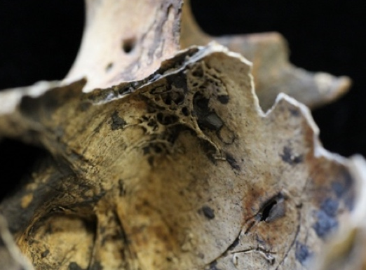
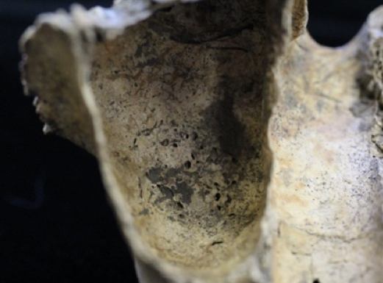
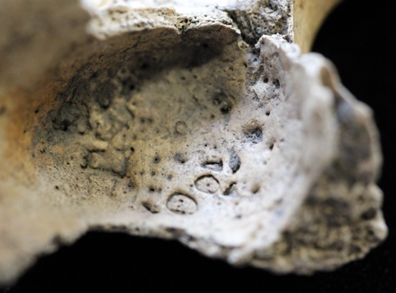
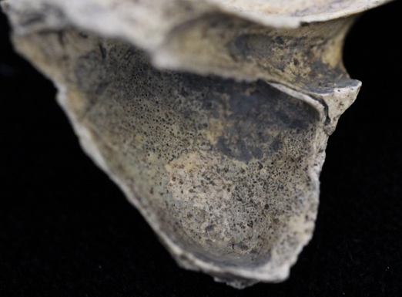
A
B
C
D

Figure 5.1. Types of lesions indicative of maxillary sinusitis, including (A) spicules (right sinus, COL10 #92), (B) remodeled spicules (left sinus, COL10 #96), (C) pitting (left sinus, COL10 #170), and (D) porous new bone (right sinus, COL10 #221).

investigators collect this information. This is because future research may reveal
clinically important associations between specific disease processes and their skeletal manifestations in the maxillary sinuses.
Endoscopy. Endoscopy was performed on individuals who presented maxillary sinuses with either natural (e.g., medial wall) or taphonomically-created (e.g., lateral and posterior wall) openings. I used a Rimmer Brothers CLS150-2 endoscope generously provided by the Fenwick Osteology Laboratory at Durham University to access these near-complete sinuses in the Coach Lane sample. Image capture software was not available for this endoscope. Therefore, images of these sinuses were not taken for the Coach Lane sample. I later used a Supereyes® Y001 digital otoscope generously provided by the Forensic Anthropology Center at the University of Tennessee, Knoxville, to access sinuses in the St. Peter’s Church and New Bunhill Fields samples. Image capture software was available for this endoscope. All images were stored as JPEG files using Photobooth for Mac. It should be noted that neither endoscope had a built-in scale. Therefore, it was not possible to measure lesion dimensions when encountered.
To minimize damage to the sinuses during endoscopic examination, the otoscope was carefully inserted and adjusted as necessary. In many instances, only part of the sinus was viewable. As a result, it is possible that an individual presented lesions on surfaces of the maxillary sinus that could not be accessed by the otoscope. Therefore, the frequencies of CMS reported in this study should be considered minimum estimates.
Not all studies of CMS are able to incorporate endoscopic methods of examination into their research designs. Lesion frequencies reported by such studies cannot be meaningfully compared to studies, such as the current one, that apply endoscopy to the identification of CMS. To remedy this issue, I recorded whether assessment of each sinus was performed using endoscopy. If a sinus was examined with an endoscope, it was scored “1” otherwise it was scored “0”. Individuals who did not satisfy the preservation criteria and were excluded from the analysis were scored as “2” for not applicable.
Reporting. Because the objective of this study was to map the burden of respiratory disease among individuals associated with different intersectional groups, CMS frequencies were reported as percentages of individuals:
$$\frac{\text{\# of individuals with CMS in at least one sinus}}{\text{Total \# of individuals with at least one sinus}}$$
As mentioned previously, for an individual to be recorded as present for CMS (i.e., the numerator), they needed to present at least one maxillary sinus with a lesion. Otherwise, they were recorded as absent. Individuals who did not present at least one partial maxillary sinus were excluded from the analysis (i.e., not included in the denominator). These percentages were calculated for the whole study sample and by skeletal sample, sex, class, region of burial, and intersectional group. Recognizing that studies vary in how they report frequencies of CMS (Boocock et al., 1995; Panhuysen et al., 1997; Roberts, 2007; Liebe-Harkort, 2012), I also included percentages of CMS for individual sinuses by side (Bernofsky, 2010; Davies-Barrett, 2018). However, only frequencies reported at the level of the individual (as opposed to the level of the sinus) were analyzed quantitatively (see below).
Rib PNB
Preservation. Individuals were examined macroscopically to evaluate the extent of ribcage preservation as suggested by Davies-Barrett and colleagues (2019). The ribs were first sided and then seriated based on morphological features described by Dudar (1993), Mann (1993), and Cirillo and Hennberg (2012). If present, rib fragments were sided and then re-associated with other rib fragments based on refitting. After all ribs and rib fragments were accounted for, the total number of complete left and right ribs was recorded. Additionally, the number of upper (i.e., ribs 1-3), upper-middle (i.e., ribs 4-6), lower-middle (i.e., ribs 7-9), and lower ribs (i.e., ribs 10-12) present was recorded for each side. In instances where preservation was such that individual ribs could be seriated and numbered, information about percent completeness was recorded. The ribs were scored on the same scale as the maxillary sinuses, whereby individual ribs were scored as “0” if they were absent or 0% complete; “1” if they were 1-25% complete; “2” if they were 26-50% complete; “3” if they were 51-75% complete; “4” if they were 76-99% complete; and “5” if they were 100% complete.
In instances where preservation was such that rib fragments could not be associated with
specific ribs, they were sided and separated into three groups: neck, angle, and shaft. If the fragment was identifiable to segment but not side, it was recorded as unsided for that segment. Afterwards, the number of fragments in each of these three groups was recorded. Rib
fragments smaller than 1cm² were not included in the counts.
Once a ribcage had been reconstructed as much as possible and recorded, each rib was evaluated in terms of its overall preservation. Each ribcage was assigned a fragmentation score of either “none” (0), “minor” (1), “moderate” (2), or “severe” (3) (Davies-Barrett et al., 2019) (see Table 5.5 for definitions). Scores were based on the number of complete ribs as well as the number and size of rib fragments.
Classification. All ribs and rib fragments greater than 1cm² were examined macroscopically for evidence of PNB on the visceral surface using the naked eye as well as a handheld magnifying glass (x100 magnification). A rib or rib fragment was scored as present (“1”) for visceral rib PNB if a distinct area of irregular/disorganized or wax-like new bone rested atop the original cortical surface (see Figure 5.2). Otherwise, it was scored a “0” for absent. As
Table 5.5. Fragmentation scoring system devised by Davies-Barrett and colleagues (2019).
Score | Criteria
0 | None – No fragmentation except for very minor “chipping” at peripheral and vulnerable areas
1 | Minor – Fragmentation consists of large fragments, easily pieced back together; less than 25% of each element is affected
2 | Moderate – Between 25 and 75% of each element is fragmented; pieces may range in size; the morphology of the elements may still be recognized when pieces are aligned together
3 | Severe – Fragmentation is extreme, with small, often unidentifiable fragments consisting of more than 75% of each element

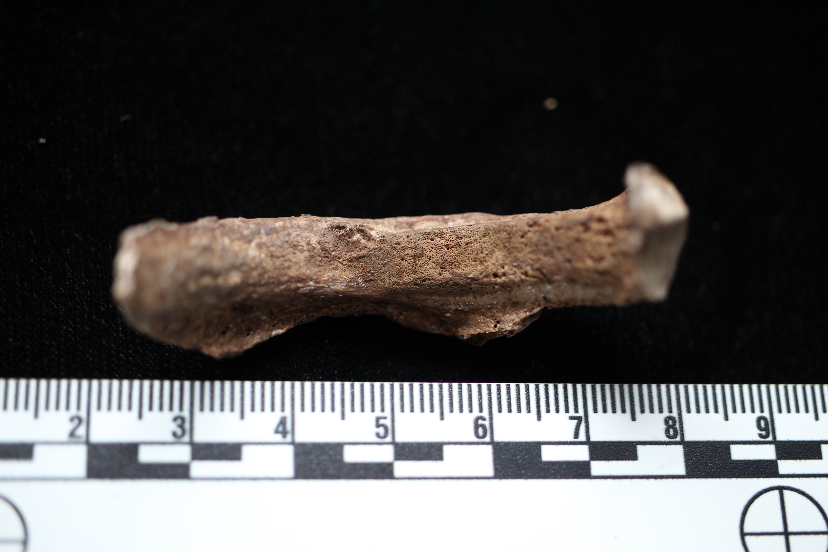
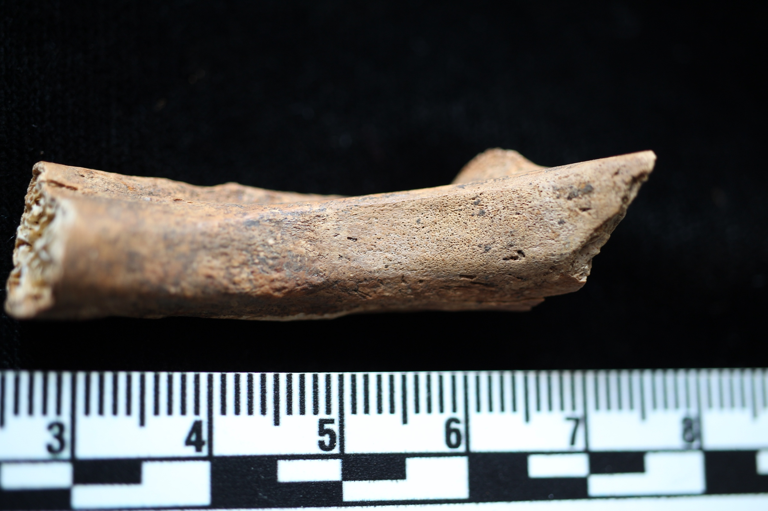
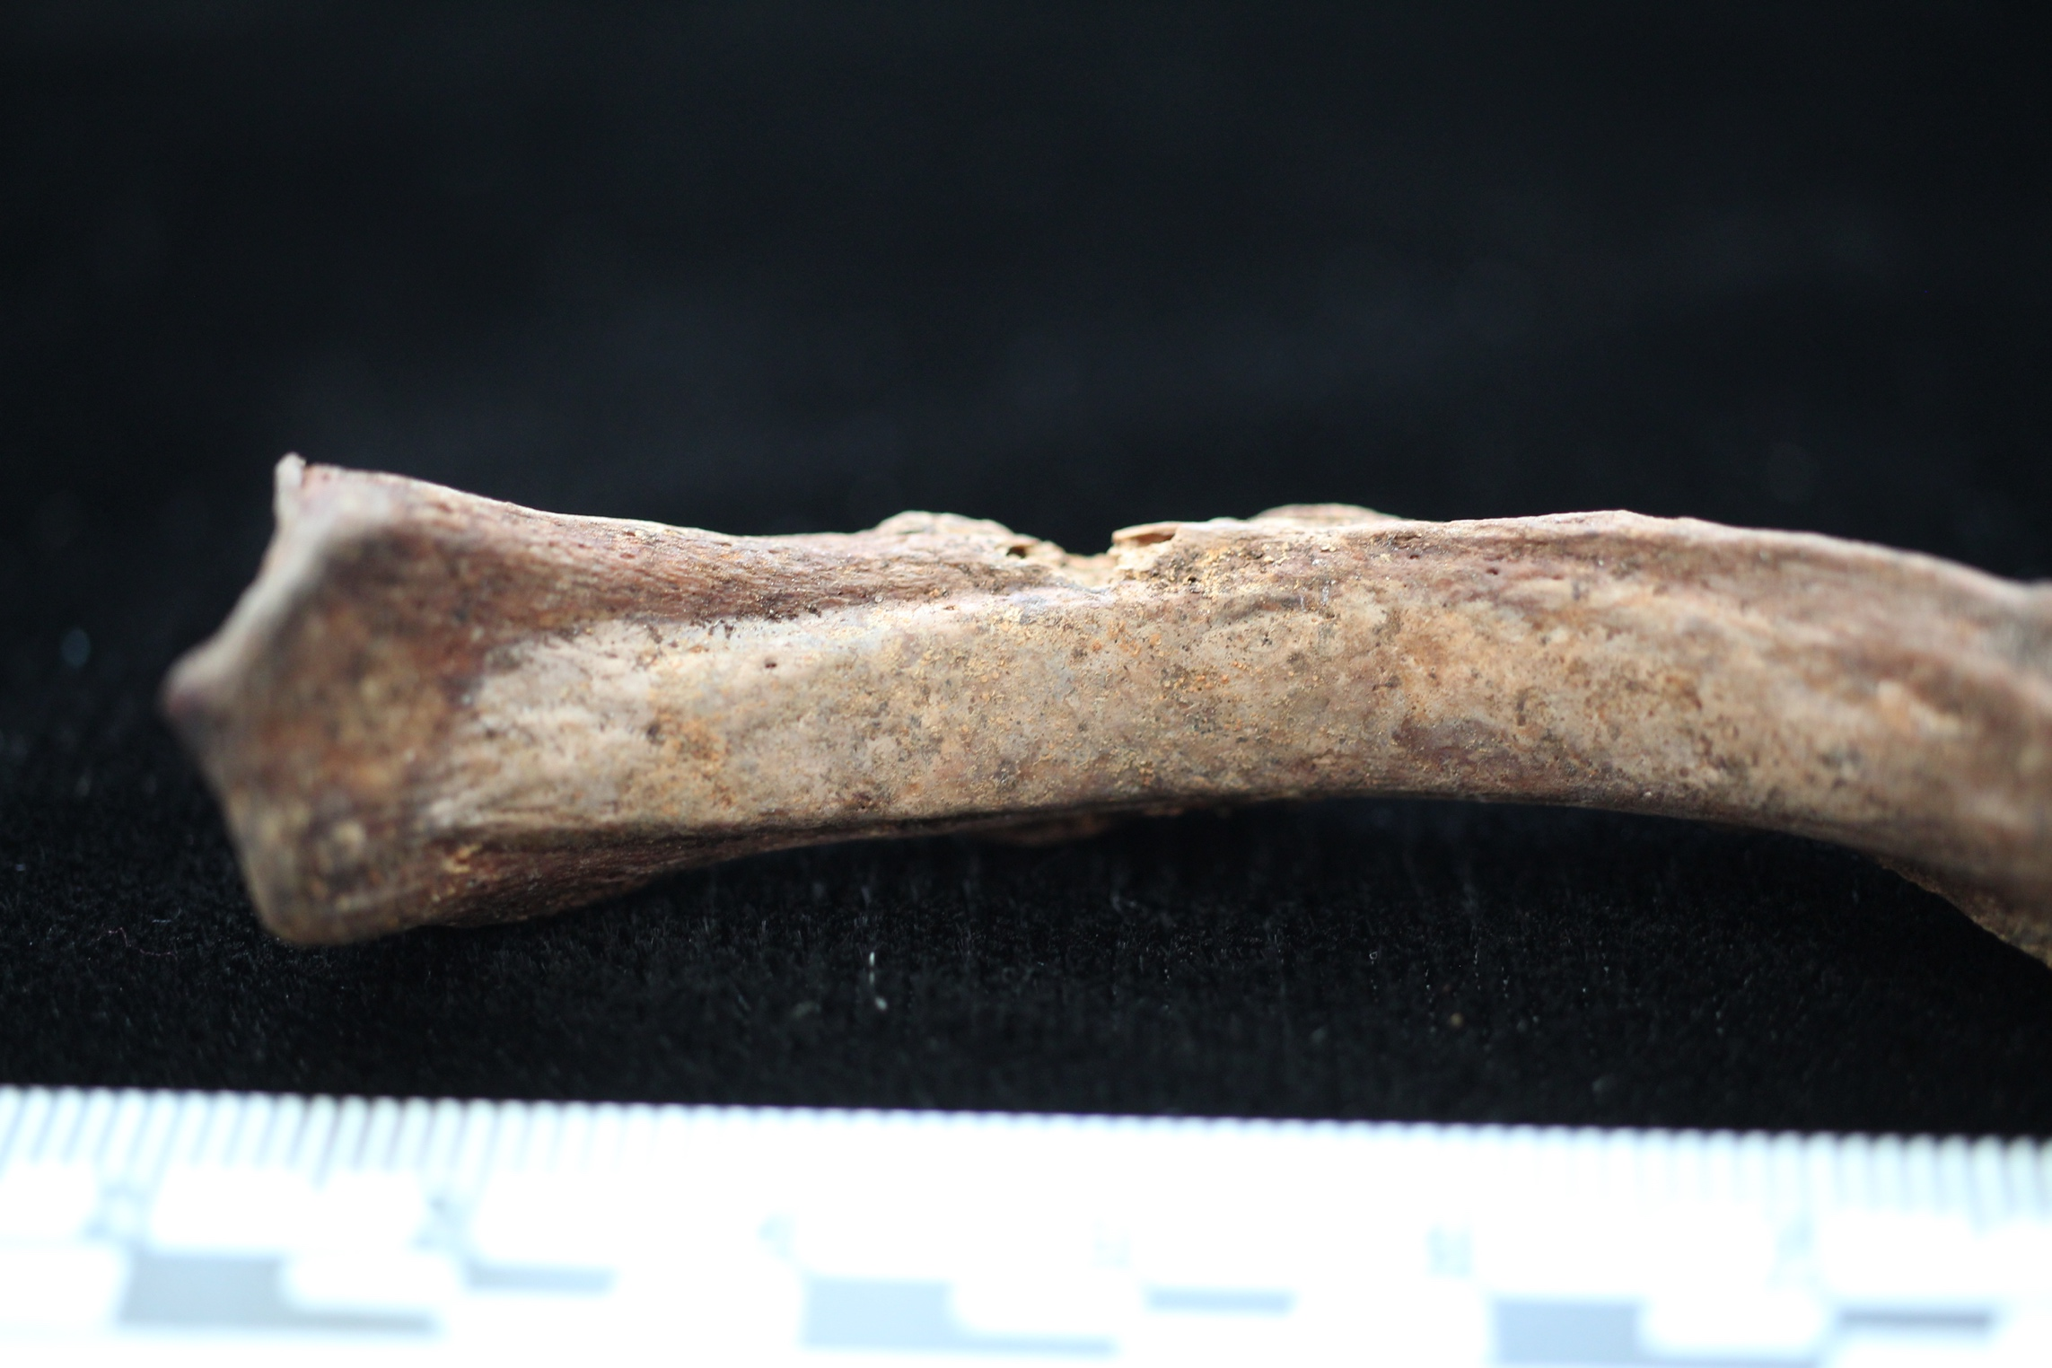
A
B
C
A

B

C

Figure 5.2. Types of lesions indicative of rib PNB, including (A) woven (right rib #6, DVL05 #1867), (B) mixed (left rib #6, DVL05 #723), and (C) remodeled periosteal new bone (left rib #5, DVL05 #759).

suggested by Davies-Barrett and colleagues (2019), small elevations on the visceral surface of the neck or angle of the ribs, which most likely reflect sites of intercostal muscle attachment rather than respiratory stress, were ignored, as was the external surface and the cranial and caudal edges. Additionally, as suggested by Anson and colleagues (2012), each lesion of new bone was checked for evidence of residual soft tissues prior to being recorded.
Once a rib lesion was recorded as present, it was further classified by type as suggested by Davies-Barrett and colleagues (2019). New bone appearing disorganized or irregular was scored as “1” for woven (Figure 5.2A), while wax-like new bone was scored as “3” for lamellar (Figure 5.2C). Areas of new bone containing characteristics of both woven and lamellar bone were scored as “2” for mixed (see Figure 5.2B). Whereas Davies- Barrett and colleagues (2019) used the term mixed to reflect the presence of a lytic and blastic lesion, I use it here to reflect the presence of a purely blastic response that contains a mixture of woven and lamellar characteristics. In instances where a single rib had isolated lamellar and woven lesions, it was recorded as mixed. Likewise, if one rib had a lamellar lesion and another rib within the same location had a woven lesion, the location was classified as mixed. Areas of new bone on rib fragments that could not be re-associated were recorded and counted separately by side, segment, and type. Finally, the total number of lesions was calculated by side and lesion type.
Reporting. Because the objective of this study was to map the burden of respiratory disease among individuals associated with different intersectional groups, frequencies of visceral rib PNB were reported as percentages of individuals:
$$\frac{\text{\# of individuals with at least one rib lesion }}{\text{Total \# of individuals with at least one rib fragment}}$$
For an individual to be recorded as present for visceral rib PNB (i.e., the numerator), they needed
to present at least one rib lesion. Otherwise, they were recorded as absent. Individuals who did not present at least one rib fragment were excluded from the analysis (i.e., not included in the denominator). These percentages were calculated for the whole study sample and by skeletal sample, sex, class, region of burial, and intersectional group.
Secondary Data Constraints
As mentioned previously, the COVID-19 pandemic imposed both time and access constraints on data collection for this dissertation. As a result, I did not collect data for the St. Bride’s Fleet Street skeletal sample. Instead, with approval by the Centre for Human Bioarchaeology at the Museum of London, I extracted information about CMS and rib PNB from the Wellcome Osteological Research Database (WORD). This information was later combined with demographic data provided by Dr. Yaussy prior to analysis.
CMS. Use of the WORD constrained the analysis of CMS in three ways. First, there were no data on maxillary sinus preservation. Instead, I used the presence of at least 50% of the maxilla as a criterion for inclusion in the CMS analysis. Second, individuals with complete maxillary sinuses (i.e., 100%) could not be separated from their counterparts with incomplete sinuses (i.e., 1-99% complete). Therefore, the frequency of CMS is likely higher than what is reported in this dissertation. Lastly, endoscopy was not performed on the individuals in the St. Bride’s Fleet Street sample, which likely further reduced the frequency of CMS reported here because individuals with nearly complete but technically accessible sinuses could not be scored.
Rib PNB. Use of the WORD constrained the analysis of rib PNB in two main ways. First, whereas I included individuals in the analysis if they presented at least one rib fragment, individuals in the WORD were scored as present for a ribcage if they presented at least one rib head fragment. Second, data collection for the St. Bride’s Fleet Street sample pre-dates the recently proposed methodology for recording and classifying rib PNB by Davies-Barrett and colleagues (2019). As a result, certain types of data were unavailable. For example, there are no rib fragmentation scores, which means that information about the relative completeness of the ribcage and observability of the elements present is unavailable. Therefore, I was unable to report lesion frequencies with the same level of detail as the other skeletal samples.

Statistical Analysis
Within intersectional epidemiology, there has been a push towards implementing
hierarchical modeling (Bauer, 2014; Black & Veenstra, 2011; Evans et al., 2018). Hierarchical models sort individual data points into clusters or groups based on a grouping variable (e.g., region of burial). This, in turn, creates a hierarchy containing two or more levels of analysis. Hierarchical models are better able to evaluate multi-variable interactions than non-hierarchical models because they exploit model shrinkage. This process involves anchoring the parameters that describe morbidity and mortality in intersectional groups to the parameters of the overall study sample, which produces conservative estimates of parameter values (Kruschke, 2015). Hierarchical models are also able to evaluate patterns among not only the multiply-marginalized and multiply-privileged, but also those with both privileged and marginalized identities (Bauer, 2014; Evans et al., 2018). Moreover, they allow for a multi-dimensional investigation of the health effects of intersectionality by stratifying groups defined by the combination of main effects, such as biological sex and social class, across a random effect, such as region of burial. This is important because we cannot assume that intersectionality operates homogeneously in a population (Crenshaw, 1989; Evans et al., 2018).
Bayesian inference is commonly implemented in epidemiological research (Etzioni & Kadane, 1995; Greenland & Poole, 1994; Leyland & Davies, 2005; MacLehose et al., 2018; Marucci-Wellman et al., 2015; Rushton, 2003; So & Sham, 2017). It updates prior beliefs about the influence that predictor variables have on the outcome of interest by taking into account new information derived from the collection of new data. Unlike frequentist methods, which typically rely on null hypothesis testing and utilize p values to make dichotomous decisions about continuous variation, Bayesian inference describes the credibility of different, often competing variables or factors along a continuous probability gradient (McElreath, 2016; Smith, 2018). As a result, Bayesian statistical methods can tell investigators more than just whether there are differences within or between groups; they can tell them about how those differences are probabilistically distributed. This is because Bayesian inference is process oriented. It utilizes prior knowledge about the contributions that predictors make towards describing the central tendency of an outcome to make decisions about reallocating credibility across those variables after taking into account new observations (Kruschke, 2015). In doing so, Bayesian inference allows researchers to quantify uncertainty in our updated beliefs about the relationships between predictor and outcome variables by recovering the shape of the probability distributions that describe those relationships (Kruschke, 2015; McElreath, 2016).
Uncertainty reflects the extent to which the additive effects of the predictor variables are
unable to explain the variation in the outcome of interest (Kruschke, 2015; McElreath, 2016). The more uncertainty in parameter estimates, the greater the deviance between the predicted and observed data and, thus, the greater the departure from the additive effects of the predictor variables under investigation. In other words, greater uncertainty suggests the presence of non-additive or intersectional effects, although other factors may include the effects of other predictor variables (e.g., identity parameters like race or sexuality) not considered in this study as well as measurement error (Evans et al., 2018). An added benefit of Bayesian approaches is that they work well with small sample sizes assuming investigators use distributions that appropriately describe their prior knowledge about a predictor or its effect(s) on the outcome (McNeish, 2016).
Because of the benefits of Bayesian inference, I implemented a hierarchical Bayesian approach to explore the respiratory health effects of intersectionality in industrializing England by interrogating the relationship between respiratory stress and differential frailty within and between intersectional groups from the northern and southern areas of the country. To explore respiratory morbidity, individuals (level 1) were clustered within intersectional groups (level 2) based on age-at-death, biological sex, and social class. To explore respiratory mortality, individuals (level 1) were clustered within intersectional groups (level 2) based on biological sex, social class, and respiratory stress. For both analyses, region of burial was included as third level variable to allow for a multi-dimensional investigation of the effects of intersectionality on respiratory morbidity and mortality. Setting up the models in this way allowed for the estimation of both the overall effects of age-at-death, biological sex, social class, and region of burial, as well as the uncertainty in those estimates across all three levels of the hierarchy (i.e., individuals, intersectional groups, and regions) (Fordyce et al., 2011).
Model Description
Respiratory morbidity and mortality analyses were performed for CMS and rib PNB separately. All analyses were performed in RStudio (v. 1.2.5033) using the brms (v. 2.8.0), rstan (v. 2.18.2), and shinystan (v. 2.5.0) packages (Bürkner, 2017; Gabry, 2018; Guo et al., 2018). The basic formula for any hierarchical model is:
$${\text{y}}_{\text{i}}\text{\sim D}\left(\text{f}\left({\text{η}}_{\text{i}}\right)\text{,θ}\right)$$
where $\text{y}$ is a vector of values representing the response variable (i.e., age-at-death or respiratory stress), ${\text{y}}_{\text{I}}$ is a specific value in that vector, $\text{D}$ is a certain distribution, $\text{η}$ is a linear combination of predictors, ${\text{η}}_{\text{I}}$ is the linear combination of predictors for given individual or observation, $\text{f}\left({\text{η}}_{\text{I}}\right)$ is the inverse link function connecting the predictors to the response variable, and $\text{θ}$ is a fixed distribution-specific parameter (e.g., standard deviation of a Gaussian distribution) (Bürkner, 2017). Elaborating further on this equation, $\text{η}$ can be expressed as:
$$\text{η=Xβ+Zu}$$
where $\text{β}$ and u represent the population- and group-level effects, respectively, and X and Z represent associated design matrices. Together, the model can be defined as:
$${\text{y}}_{\text{i}}\text{\sim D}\left(\text{f}\left({\left(\text{Xβ+Zu}\right)}_{\text{i}}\right)\text{,θ}\right)$$
where the data are represented by ${\text{y}}_{\text{I}}$, X, and Z, and the parameters are represented by $\text{β}$ and u. The difference between Bayesian and frequentist versions of this general formula lies with the treatment of u. Frequentist methods treat u as a component of the model error term, whereas Bayesian methods treat u as another parameter to be estimated. Treating u as a parameter is what allows Bayesian methods to estimate the uncertainty around the grouping variable.
Hierarchical models assume that the distribution of parameters that represent possible values of u follows a multivariate normal distribution N expressed as:
$$\text{u\sim N}\left(\text{0,Σ}\right)$$
with an unknown covariance matrix $\text{Σ}$ and a mean of zero (Bürkner, 2017). Because the parameters that describe the covariances between different grouping factors are assumed to be zero, this formula can be further elaborated:
$${\text{u}}_{\text{k}}\text{\sim N}\left(\text{0,}{\text{Σ}}_{\text{k}}\right)$$
where k represents different grouping factors. In most cases, grouping factors have more than one level each (e.g., region can be split into two factors: north and south). Therefore, this formula can be even further elaborated:
$${\text{u}}_{\text{k}}\text{j\sim N}\left(\text{0,}{\text{V}}_{\text{k}}\right)$$
where ${\text{V}}_{\text{k}}$ represents the covariance matrices, which are treated as parameters. The brms package utilizes diagonal matrices comprised of vectors of standard deviations ${\text{σ}}_{\text{k}}$ alongside a correlation matrix ${\text{Ω}}_{\text{k}}$ to parameterize ${\text{V}}_{\text{k}}$:
$${\text{V}}_{\text{k}}\text{=D}\left({\text{σ}}_{\text{k}}\right){\text{Ω}}_{\text{k}}\text{D}\left({\text{σ}}_{\text{k}}\right)$$
Because ${\text{V}}_{\text{k}}$ is now a parameter to be estimated, priors must be specified for the right side of the equation. By default, the brms package uses the weakly informed LKJ-Correlation prior ($\text{ζ}$=1) for ${\text{Ω}}_{\text{k}}$ and a half student-t prior for$\text{ σ}$ parameters associated with u (Lewandowski et al., 2009).
The brms package in R relies on the rstan package to translate the R code to C++ code, compile that code, and fit the model in Stan, which uses Hamiltonian Monte Carlo (HMC) simulation with a No-U-Turn sampler (NUTS) to sample the posterior distribution (Bürkner, 2017). HMC simulation generates random walks of the posterior distribution that are more efficient and less autocorrelated than other Markov Chain Monte Carlo algorithms (Creutz, 1988; Hoffman & Gelman, 2014). These random walks are fewer in number but take longer to process due to additional calculations, which are more computationally heavy (Griewank & Walther, 2008). Despite this drawback, HMC simulation is ideally suited for hierarchical models because it works adaptively with priors of varying type and concentration to quickly converge on the most likely parameter values (Bürkner, 2017). Once HMC simulation ceases, each of the chains can be assessed for convergence using the Rhat statistic (Gelman & Rubin, 1992). Rhat values greater than 1.1 indicate that the chains have not converged and will need to explore the posterior distribution through a greater number of random walks.
Respiratory Morbidity. Because the outcome of interest for the respiratory morbidity model is dichotomous, the hierarchical Bayesian approach used resembled a hierarchical logistic regression (Kruschke, 2015). The varying intercepts, varying slopes hierarchical Bayesian model for respiratory morbidity was defined as:
$${\text{stress}}_{\text{i}}\text{\sim Bernoulli}\left(\text{f}\left({\left({\text{β}}_{\text{1}}\left(\text{age}\right)\text{+}{\text{β}}_{\text{2}}\left(\text{sex}\right)\text{+}{\text{β}}_{\text{3}}\left(\text{class}\right)\text{+}{\text{u}}_{\text{1}}\left(\text{age}\right)\text{+}{\text{u}}_{\text{2}}\left(\text{sex}\right)\text{+}{\text{u}}_{\text{3}}\left(\text{class}\right)\right)}_{\text{i}}\right)\text{,σ}\right)$$
In this model, respiratory stress was a Bernoulli distributed, dichotomous variable. A Bernoulli distribution is just a special case of a binomial distribution involving a single trial (Kruschke, 2015). Biological sex, social class, and region of burial were also dichotomous variables. Age-at-death was a normally distributed continuous variable.
The respiratory morbidity model described above served as the likelihood describing the probability of observing a particular configuration of intersecting identities given the presence or absence of respiratory stress and whether they lived in the north or the south (e.g., lower/middle class young adult females). This probability was expressed as p(age+sex+class|stress, region). This information was combined with prior information about the probability of an individual presenting respiratory stress given their region of burial or p(stress|region) as well as the prior probability of respiratory stress in a given region or p(region) to calculate the posterior probability of presenting respiratory stress in a certain region given a particular configuration of intersecting identities or p(stress, region|age+sex+class) (see Selection of Prior Probabilities below). This produced a hierarchical Bayesian respiratory morbidity generally expressed as:
$$\text{p}\left(\text{stress,region} | \text{age+sex+class}\right)\text{∝}\text{p}\left(\text{age+sex+class} | \text{stress}\right)\text{p}\left(\text{stress} | \text{region}\right)\text{p}\left(\text{region}\right)$$
Respiratory Mortality. The varying intercepts, varying slopes hierarchical Bayesian model for respiratory mortality can be defined as:
$$\text{ag}{\text{e}}_{\text{i}}\text{\sim Normal}\left(\text{f}\left({\left({\text{β}}_{\text{1}}\left(\text{sex}\right)\text{+}{\text{β}}_{\text{2}}\left(\text{class}\right)\text{+}{\text{β}}_{\text{3}}\left(\text{stress}\right)\text{+}{\text{u}}_{\text{1}}\left(\text{sex}\right)\text{+}{\text{u}}_{\text{2}}\left(\text{class}\right)\text{+}{\text{u}}_{\text{3}}\left(\text{stress}\right)\right)}_{\text{i}}\right)\text{,σ}\right)$$
where the grouping factor, u, is region of burial and $\text{σ}$ is the residual standard deviation (Bürkner, 2017). In this model, age-at-death is a normally distributed, continuous variable and biological sex, social class, respiratory stress, and region of burial are all dichotomous variables.
The respiratory mortality model described above served as the likelihood function describing the probability of observing a particular configuration of intersecting identities (e.g., low SES females) with or without evidence of respiratory stress at a particular age depending on whether they lived in the north or the south. This probability can be expressed as p(sex+class+stress|age,region). This information was combined with prior information about the probability of an individual dying at a certain age given their region of burial or p(age|region) as well as the prior probability of dying in a given region or p(region) to calculate the posterior probability of dying at a certain age in a certain region given a particular configuration of intersecting identities or p(age,region|sex+class+stress) (see Selection of Prior Probabilities below). While the exact form of Bayes’ Rule requires that the investigator knows something about the probability of observing the data that were collected or p(data), there is no way for me to be able to calculate this probability. Because the purpose of this study was to calculate p(age,region|sex+class+stress) with the data that were collected, the posterior probability was treated as being proportional to the likelihood function times the prior probability (Kruschke, 2015). This produced a hierarchical Bayesian respiratory mortality model generally expressed as:
$$\text{p}\left(\text{age,region} | \text{sex+class+stress}\right)\text{∝}\text{p}\left(\text{sex+class+stress} | \text{age}\right)\text{p}\left(\text{age} | \text{region}\right)\text{p}\left(\text{region}\right)$$
Selection of Prior Probabilities. Bayesian statistical approaches treat parameters as something to be estimated from the data rather than descriptors for that data (Fordyce et al., 2011; Kruschke, 2015). Therefore, to estimate each of the parameters in the respiratory morbidity and mortality models, appropriate prior probability distributions for those parameters needed to be identified. This was particularly important given that I treated the posterior probability as proportional to the likelihood function times the prior probability. If an informed prior is combined with either a small data set or a likelihood that only weakly explains the variation in the outcome variable, the former will overwhelm the latter, leading to a posterior that closely resembles the prior (Kruschke, 2015). Alternatively, use of an uninformed or flat prior can underwhelm the likelihood, leading to a posterior that closely resembles the likelihood.
One way to remedy this issue is to examine how different priors interact with the likelihood to produce the posterior probability distribution (Kruschke, 2015). To do this, I generated multiple model iterations for the respiratory morbidity and mortality analyses using flat, weakly informed, and strongly informed priors. For the respiratory mortality models, strong and weak priors for p(region) and p(age|region) were informed by historic all-cause mortality records. This is because all individuals included in this study represent a sample of the deceased English population from the 18th and 19th centuries. To understand how respiratory disease shaped mortality in the living using members of the deceased population, it is important to have prior knowledge of how all-cause mortality was distributed by region in aggregate and by age.
For the respiratory morbidity models, strong and weak priors for p(region) and p(stress|region) were informed by historic all-cause and cause-specific (i.e., respiratory) mortality records, respectively. The information used to generate priors for p(region) are the same for both the respiratory morbidity and mortality models. This is because, for both models, it is important to know what the mortality differential was between the north and the south given that the individuals included in this study represent a sample of the deceased populations in those respective regions. The information used to generate priors for p(stress|region) in the respiratory morbidity model, in contrast, derived from historic respiratory mortality records. This is because the probability of presenting respiratory stress in a skeletal sample is influenced by how many people died from a respiratory cause and became part of the deceased population from which that skeletal sample was drawn. Thus, respiratory mortality records can serve as a rough proxy for the true prevalence of respiratory disease in a skeletal sample, assuming that sample is randomly drawn from the deceased population.
The London Bills of Mortality (Worshipful Company of Parish Clerks, 1759) contain information about cause of death among Londoners throughout the study period (i.e., AD 1676-1857). However, they do not include mortality records for those who lived and died outside the city. In contrast, the General Register Office Reports (e.g., General Register Office for England and Wales, 1843) contain information about cause of death across England. However, these reports are only available for the latter part of the study period (i.e., AD 1837-1857). Because there was no way to meaningfully combine the information contained within these different historic documents, I generated separate respiratory morbidity and mortality models for each.
Appropriate hyperpriors, which are a priori expectations for the shape of the distribution of hyperparameters that describe the chosen priors (Kruschke, 2015), were also identified. The issue of selecting appropriate hyperpriors is complicated in hierarchical models. Hyperpriors restrict the area of the posterior parameter space that can be explored to generate the posterior probability distribution (Kruschke, 2015). In hierarchical Bayesian models, the priors magnify these restrictions, further limiting the exploration of the posterior parameter space. Increasing the number of levels in the hierarchy further intensifies these restrictions. For these reasons, all model iterations were built using flat hyperpriors (i.e., normal for $\text{μ}$ and half Cauchy for $\text{σ}$).
Model Selection
I performed two separate analyses, one for respiratory morbidity and the other for respiratory mortality (see Figure 5.3). The respiratory morbidity analyses were performed separately for CMS and rib PNB. For each of these lesion types, five hierarchical Bayesian models were generated. Two of these models contained weakly informed priors, one built using the London Bills of Mortality and the other using the General Register Office Reports. Another two models contained strong priors based on these historic documents. The last model incorporated flat priors only. This model iteration scheme was repeated for the respiratory mortality analysis. In total, I generated 20 models and used model comparison to identify the best-fit model for each analytic cluster: one for CMS morbidity, one for CMS mortality, one for rib PNB morbidity, and one for rib PNB mortality.
I assessed the fit of each model using posterior predictive checks (Kruschke, 2015; McElreath, 2016). Models within each analytic cluster were compared using widely applicable information criteria to determine the respiratory morbidity and mortality models that best fit the data collected (Bürkner, 2017). Once the best-fit hierarchical models were identified, they were compared to non-hierarchical models with interaction terms to determine whether the hierarchical form is most parsimonious given the data. Comparisons were made visually using violin plots as well as quantitatively using the Watanabe-Akaike information criterion (WAIC) (Watanabe, 2010) and Bayes’ factors (BFs) (Kruschke, 2011). The WAIC is a generalized form of the Akaike Information Criterion (AIC) (Akaike, 1973), whose value for a given model reflects its prediction error relative to that of other models. The lower the WAIC, the better the
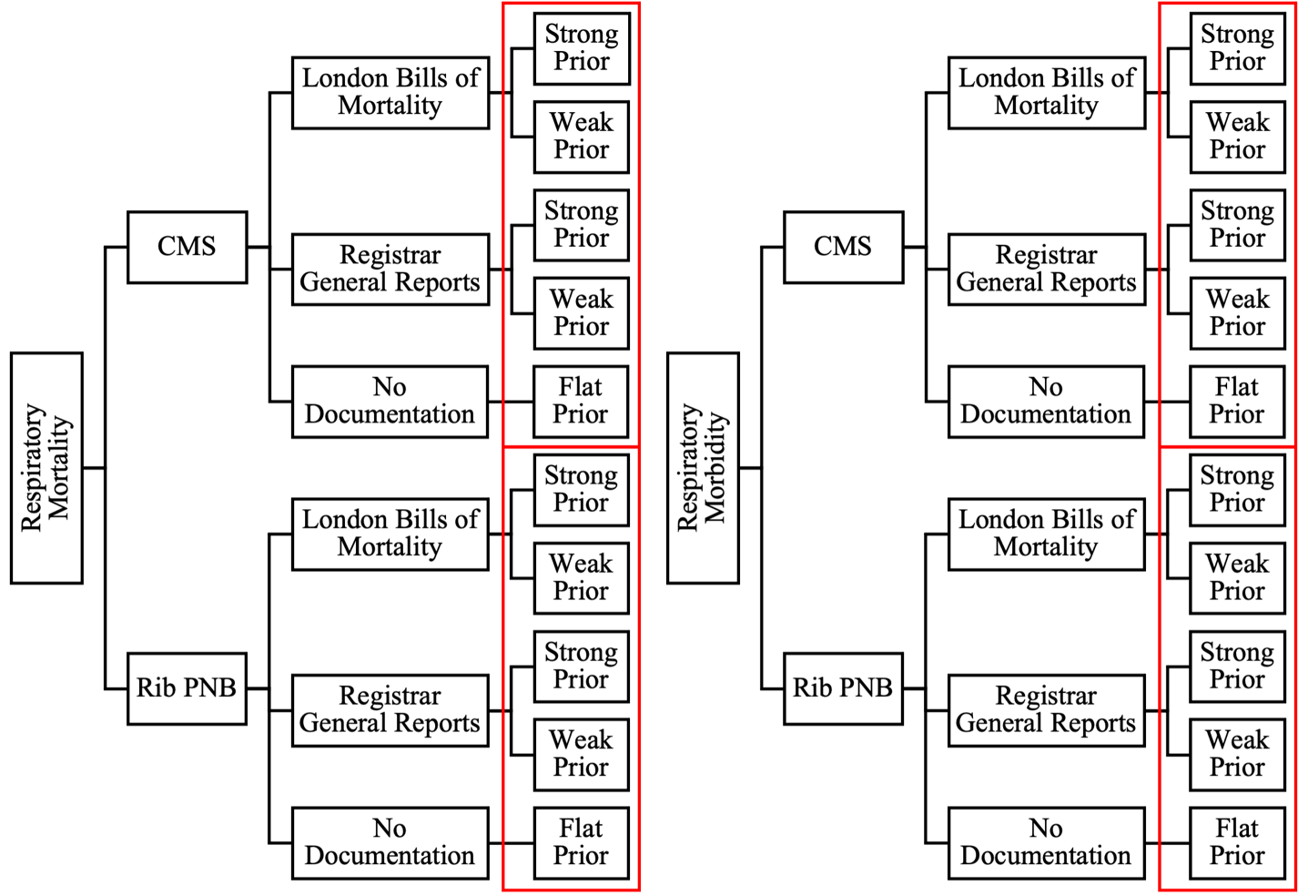
Figure 5.3. Model iteration scheme for respiratory morbidity and mortality analyses. Red boxes indicate model selection clusters.

model fit. Within each analytic cluster, WAIC values were compared between models derived from the same historic mortality records to determine the best fit model based on those records.
To determine the best fit model for an analytic cluster, the hierarchical model derived from each archival source with the lowest WAIC value was compared to a non-hierarchical interaction model derived from the same archival source using BFs. A BF is a ratio of how well one model fits the data compared to another (Kruschke, 2011). The general formula for the Bayes’ factor is:
$${\text{B}}_{\text{10}}\text{=}\left(\text{p}\left(\text{D} | {\text{H}}_{\text{1}}\right)\right)\text{/}\left(\text{p}\left(\text{D} | {\text{H}}_{\text{0}}\right)\right)$$
where B₁₀ refers to the Bayes’ factor, D refers to the data collected, H₀ refers to the best-fit model that does not contain an interaction term for the predictor variables (referred to as the null model or hypothesis), and H₁ refers to an alternative version of the best-fit model that contains an interaction term (referred to as the alternative model or hypothesis) (Kass & Raftery, 1995). Values for B₁₀ between one and three suggest minimal differences between the null and alternative models, whereas values above three favor the alternative model. Likewise, values less than 0.33 favor the null model. If 0.33 < B₁₀ < 3, then both models were reported. Afterwards, the best fit model derived from the London Bills of Mortality was compared to the best fit model derived from the General Register Office Reports using this same scheme.
Once the best fit model was identified for each analytic cluster its residual standard deviation, $\text{σ}$, was evaluated. The higher the maximum a posteriori (modal) value (MAP) of $\text{σ}$, the poorer the fit of the regression line and the greater the likelihood of nonlinear relationships between predictor and outcome variables (Kruschke, 2015; McElreath, 2016). If the 90% highest density interval (HDI) for $\text{σ}$ did not overlap zero, then the model needed to be reconfigured to remove any nonlinear relationships.
Intercategorical Analysis
Once the best-fit models for respiratory morbidity and mortality were identified through model selection, the posterior probability distributions, maximum MAPs, and 90% highest density intervals (HDIs) for those models were extracted and graphically visualized (Kruschke, 2015; McElreath, 2016). Comparisons were made between groups by overlaying the posterior probability distributions for all intersectional groups within and between regions. Groups whose HDIs did not overlap were classified as different from one another. Conversely, groups whose 90% HDIs did overlap were classified as similar to one another. If the 90% HDIs overlapped but the posterior probabilities were distributed differently, then those groups were classified as probabilistically different despite the overlap. MAPs, or peak values were then compared between these groups to quantify differences in the most likely values for respiratory morbidity and mortality. Afterwards, a post hoc pairwise analysis of intersectional groups was conducted to determine the extent to which posterior estimates of respiratory morbidity and mortality differed between groups at each step in the HMC simulation (Kruschke, 2015). To do this, the joint posterior probability distribution was used to generate a distribution of differences in the posterior estimates between groups. The MAP for this distribution of differences was considered to reflect the modal difference in respiratory morbidity or mortality between intersectional groups across all the random walks
of the posterior parameter space as well as the variability in that difference.
Comparisons of the posterior probability distributions are useful for mapping the burden of respiratory disease across intersectional groups. However, it cannot be assumed that intersectionality influences all intersectional groups in the same way or to the same extent (Collins, 2015; Crenshaw, 1989). Therefore, the variance or uncertainty in the MAPs for respiratory morbidity and mortality within each intersectional group were examined. Uncertainty in the within-group MAPs of an additive linear model reflects the extent to which the additive effects of the predictors are able to explain variation in the outcome of interest in a specific group (Kruschke, 2015; McElreath, 2016). This uncertainty is evaluated by examining both the width of the 90% HDI and the concentration or height of the peak representing the MAP for each group. Wider HDIs and lower peak heights suggest greater uncertainty in MAPs and a greater contribution of non-additive (intersectional) effects. Thus, the magnitude of the effects of intersectionality on respiratory morbidity and mortality will be greater in intersectional groups with wider HDIs and lower peak heights. Because non-additivity can also be influenced by additional intersecting identities that are not considered in this study as well as by measurement error (Evans et al., 2018), the extent to which the intersections of classism and sexism contributed to respiratory morbidity and mortality could not be directly inferred. Rather, this non-additivity was interrogated alongside historiographic research, mortuary context, and archaeological site information during inference-making.

Evaluation of Hypotheses
This study tests two hypotheses. First, the probability of presenting skeletal evidence of respiratory stress will be probabilistically highest for the multiply-marginalized and lowest for the multiply-privileged. Second, among those with respiratory stress, the average (modal) age-at-death will be probabilistically lowest for the multiply-marginalized and highest for the multiply-privileged. For the first hypothesis to be supported, the MAP for the multiply-marginalized (i.e., lower/middle-class females from the north) that represents the probability of presenting skeletal evidence of stress must be higher than the MAP for all other groups. Additionally, the MAP for the multiply-privileged (i.e., middle/upper-class males from the south) must be the lowest MAP of all groups. Moreover, the 90% HDIs for the multiply-marginalized and multiply-privileged groups must not overlap each other or any other group. For the second hypothesis to be supported, the MAP for the multiply-privileged that represents the most likely mean age-at-death must be higher than the MAP for all other groups. Additionally, the MAP for the multiply-marginalized must be the lowest MAP for all other groups. Moreover, the 90% HDIs for the multiply-privileged and multiply-marginalized must not overlap each other or any other group.

Summary
The skeletal remains of 520 adult individuals were analyzed to examine the effects of
intersectionality on respiratory morbidity and mortality in northern and southern England during the Industrial Revolution. Demographic and paleopathological data from four urban and semi-urban skeletal samples were combined with historic mortality records within a hierarchical Bayesian modeling environment to map the burden of respiratory disease among the multiply-marginalized, multiply-privileged, and those with both marginalized and privileged identities. The results of this analysis will be presented and discussed in subsequent chapters.

CHAPTER SIX:
RESULTS

This chapter presents the results of this study and is divided into five sections. The first section presents the results of demographic analyses pertaining to biological sex and age-at-death. The second section reports on skeletal preservation and frequencies of maxillary sinusitis (CMS) and periosteal new bone formation on the visceral surface of the rib (rib PNB). The third section presents the results of the intra-observer analysis. The remaining two sections present the Bayesian models that will be used to describe patterns of respiratory morbidity and mortality in the next chapter. Included in each of these final two sections are model descriptions, summaries of parameter estimates, posterior predictions by intersectional group, and post hoc analyses.

Demography
Of the 520 individuals who were eligible for inclusion in this study, 13 were excluded due to preservation issues. Thus, data derived from 507 individuals contribute to this study (see Table 6.1). Of these individuals, 19.13% (97/507) were from the Coach Lane (COL10) sample, 20.51% (104/507) were from the New Bunhill Fields (DVL05) sample, 40.63% (206/507) were from the St. Bride’s Fleet Street (SB79) sample, and 19.72% (100/507) were from the St. Peter’s Church (BOH) sample. Southerners comprised 61.14% (310/507) of the sample and northerners made up the remaining 38.86% (197/507). Similarly, middle/upper-class individuals comprised 60.36% (306/507) of the sample and lower/middle-class individuals made up the remaining 39.64% (201/507). Males comprised 54.43% (276/507) of the sample and females made up the remaining 45.56% (231/507). Mean estimated age-at-death for the total study sample was 50.04
Table 6.1. Distribution of individuals in the study sample by skeletal sample, biological sex, social class, and region of burial.
Variable | n | %
Sample
COL10 | 97 | 19.13
DVL05 | 104 | 20.51
SB79 | 206 | 40.63
BOH | 100 | 19.72
Region
North | 197 | 38.86
South | 310 | 61.14
Social Class
Lower/Middle | 201 | 39.64
Middle/Upper | 306 | 60.36
Biological Sex
Female | 231 | 45.56
Male | 276 | 54.43

years (sd = 20.05). Descriptive statistics for mean age-at-death by skeletal sample, region of burial, social class, and biological sex are provided in Table 6.2.
I divided the individuals in this study into eight different intersectional groups defined by biological sex, social class, and region of burial. Definitions for each group are provided in Table 6.3. Among middle/upper-class southerners, there were 110 males (53.40% of 206) and 96 females (46.60% of 206). In comparison, there were 56 lower/middle-class males (53.85% of 104) and 48 females from the south (46.15% of 104). Among middle/upper-class northerners, there were 56 males (56.00% of 100) and 44 females (44.00% of 100). In contrast, there were 54 lower/middle-class males (55.67% of 97) and 43 females from the north (44.33% of 97). Estimates for mean age-at-death for each intersectional group are also provided in Table 6.3.

Skeletal Preservation and Lesion Frequencies
This section presents information about skeletal preservation and lesion frequencies. Information about sinus and rib preservation will be reported at the level of the skeletal element as well as the level of the individual. However, sinus and rib lesion frequencies will only be analyzed at the level of the individual because the focus of this dissertation is on the respiratory health experiences of individuals as opposed to individual skeletal elements.
Maxillary Sinusitis
Preservation. Of the 507 individuals included in this study, 77.32% (392/507) presented at least one maxillary sinus. Sinus preservation information for the left and right maxillary sinuses by skeletal sample, region of burial, social class, and biological sex is provided in Table 6.4. Mean age-at-death among individuals who did not present at least one maxillary sinus was 49.40 years (sd= 20.71). Mean age-at-death among individuals who presented at least one
Table 6.2. Mean estimated age-at-death in years based on Transition Analysis 2.0 (Boldsen et al., 2002) by skeletal sample, region of burial, social class, and estimated biological sex. Mean denoted as $\overline{\text{x}}$ and standard deviation denoted as sd.
Variable | $$\overline{\text{x}}$$ | sd
Sample
COL10 | 52.69 | 20.64
DVL05 | 37.68 | 15.65
SB79 | 53.60 | 19.13
BOH | 53.00 | 20.66
Region
North | 52.85 | 20.60
South | 48.26 | 19.52
Social Class
Lower/Middle | 44.92 | 19.68
Middle/Upper | 53.41 | 19.61
Biological Sex
Female | 45.99 | 18.43
Male | 53.43 | 20.75

Table 6.3. Definitions for each intersectional group included in this study and associated mean estimated age-at-death in years. Mean denoted as $\overline{\text{x}}$ and standard deviation denoted as sd.
Group | Definition |  |  | Age-at-Death
Group | Region | Class | Sex | n | $$\overline{\text{x}}$$ | sd
A | North | Upper/Middle | Male | 56 | 61.68 | 19.53
B | South | Upper/Middle | Male | 110 | 55.69 | 19.88
C | North | Lower/Middle | Male | 54 | 54.95 | 21.82
D | South | Lower/Middle | Male | 56 | 39.28 | 15.62
E | North | Upper/Middle | Female | 44 | 41.95 | 16.48
F | South | Upper/Middle | Female | 96 | 51.21 | 18.04
G | North | Lower/Middle | Female | 43 | 49.86 | 18.92
H | South | Lower/Middle | Female | 48 | 35.80 | 15.64

Table 6.4. Percent preservation of the left and right maxillary sinuses by skeletal sample, region of burial, social class, and biological sex excluding the St. Bride’s Fleet Street sample.
Variable | Preservation (%) of the Left Maxillary Sinus |  |  |  |  |  | Total  n | Preservation (%) of the Right Maxillary Sinus |  |  |  |  |  | Total  n
Variable | 0 | 1-25 | 26-50 | 51-75 | 76-99 | 100 | Total  n | 0 | 1-25 | 26-50 | 51-75 | 76-99 | 100 | Total  n
Sample
COL10 | 25.77 | 3.09 | 16.49 | 14.43 | 13.40 | 26.80 | 97 | 23.71 | 11.34 | 13.40 | 19.59 | 28.87 | 3.09 | 97
DVL05 | 7.69 | 11.54 | 5.77 | 13.46 | 27.88 | 33.65 | 104 | 7.69 | 5.77 | 11.54 | 12.50 | 24.04 | 38.46 | 104
BOH | 20.00 | 12.00 | 13.00 | 16.00 | 17.00 | 22.00 | 100 | 18.00 | 12.00 | 12.00 | 14.00 | 18.00 | 26.00 | 100
Region
North | 22.84 | 14.21 | 13.71 | 14.72 | 21.83 | 12.69 | 197 | 20.81 | 11.68 | 12.69 | 16.75 | 23.35 | 14.72 | 197
South | 7.69 | 11.54 | 5.77 | 13.46 | 27.88 | 33.65 | 104 | 7.69 | 5.77 | 11.54 | 12.50 | 24.04 | 38.46 | 104
Social Class
Lower/Middle | 16.42 | 13.93 | 9.95 | 13.43 | 27.36 | 18.91 | 201 | 15.42 | 8.46 | 12.44 | 15.92 | 26.37 | 21.39 | 201
Middle/Upper | 20.00 | 12.00 | 13.00 | 16.00 | 17.00 | 22.00 | 100 | 18.00 | 12.00 | 12.00 | 14.00 | 18.00 | 26.00 | 100
Biological Sex
Female | 19.26 | 12.59 | 11.85 | 14.81 | 23.70 | 17.78 | 135 | 17.04 | 11.11 | 15.56 | 13.33 | 22.96 | 20.00 | 135
Male | 16.27 | 13.86 | 10.24 | 13.86 | 24.10 | 21.69 | 166 | 15.66 | 8.43 | 9.64 | 16.87 | 24.10 | 25.30 | 166

maxillary sinus was 50.2 years (sd= 19.88). Information about sinus preservation at the level of the individual in each intersectional group is provided in Table 6.5. Detailed sinus preservation information was unavailable for the St. Bride’s Fleet Street skeletal sample. Individual sinuses were coded “1” if they were at least 50% complete. Otherwise, they were coded “0” (Powers, 2012). Of the 206 individuals from this sample, 89.32% (184/206) presented at least one maxillary sinus that was greater than 50% complete. Of these 184 individuals, 51.09% (94/184) were males and the remaining 48.91% (90/184) were females.
Lesion Frequencies. Of the 392 individuals with at least one maxillary sinus present, 27.81% (109/392) presented evidence of maxillary sinusitis (CMS). Frequencies of CMS by lesion type for the left and right maxillary sinuses are provided in Table 6.6. Of the 109 individuals with CMS, 44.04% (48/109) presented spicules, 52.29% (57/109) presented remodeled spicules, 29.36% (32/109) presented pitting, and 5.5% (6/109) presented white pitting. These data on CMS lesion type were not analyzed further given the lack of understanding regarding the clinical significance of each type (see Chapter Four).
The lower/middle-class New Bunhill Fields sample from the south had the highest frequency of CMS (52.46% or 32/61) and the middle/upper-class St. Bride’s Fleet Street sample from that same region had the lowest CMS frequency (2.17% or 4/184). The frequency of CMS in the lower/middle-class Coach Lane and middle/upper-class St. Peter’s Church samples from the north was 50.00% (39/78) and 49.28% (34/69), respectively. CMS was much more frequent among northerners compared to southerners (49.66% or 73/147 vs. 14.70% or 36/245) and the lower/middle class compared to the middle/upper class (51.08% or 71/139 vs. 15.02% or 38/253) but marginally more frequent in females compared to males (28.34% or 53/187 vs. 27.32% or 56/205). Mean estimated age-at-death among individuals with and without CMS was 49.21 years
Table 6.5. Number of individuals with at least one maxillary sinus present in each intersectional group. n_{total} denotes the total number of individuals per group.
Group | Description |  |  | Sinus Preservation
Group | Region | Class | Sex | n_{sinus} | n_{total} | %
A | North | Upper/Middle | Male | 38 | 56 | 67.86
B* | South | Upper/Middle | Male | 94 | 110 | 85.45
C | North | Lower/Middle | Male | 44 | 54 | 81.48
D | South | Lower/Middle | Male | 29 | 56 | 51.79
E | North | Upper/Middle | Female | 31 | 44 | 70.45
F* | South | Upper/Middle | Female | 90 | 96 | 93.75
G | North | Lower/Middle | Female | 34 | 43 | 79.07
H | South | Lower/Middle | Female | 32 | 48 | 66.67
*Preservation information derived from the Wellcome Osteological Research Database

Table 6.6. CMS frequency by lesion type for the left (n = 374) and right sinuses (n = 367). Some individuals presented multiple lesion types in a single sinus. Thus, the same sinuse may be reported in multiple lesion types.
Side | Spicules |  | Remodeled Spicules |  | Pitting |  | White Pitting
Side | n | % | n | % | n | % | n | %
Left | 35 | 9.36 | 38 | 10.16 | 13 | 3.48 | 2 | 0.53
Right | 31 | 8.45 | 33 | 8.99 | 24 | 6.54 | 5 | 1.36

(sd = 20.47) and 50.64 years (sd = 19.70), respectively. Descriptive statistics for mean age-at-death between individuals based on CMS presence/absence by skeletal sample, region of burial, social class, and biological sex are provided in Table 6.7.
Among middle/upper-class southerners, 2.13% (2/94) of males and 2.22% (2/90) of females presented CMS. In contrast, 55.17% (16/29) of males and 50.00% (16/32) of females from the lower/middle class in the south presented CMS. Among middle/upper-class northerners, 44.74% (17/38) of males and 54.84% (17/31) of females presented CMS. Similarly, 47.73% (21/44) of males and 52.94% (18/24) of females from the lower/middle class in the north presented CMS. Estimates of mean age-at-death for individuals with and without CMS in each intersectional group are provided in Table 6.8.
Preservation and CMS Frequency. This section reports observed associations between maxillary sinus preservation and the frequency of CMS. Observations from the St. Bride’s Fleet Street skeletal sample are not reported due to the lack of detailed preservation information.
There were 194 left and 189 right sinuses available for observation in the Coach Lane, New Bunhill Fields, and St. Peter’s Church skeletal samples. Of the 194 left sinuses present, 20.62% (40/194) were from 1-25% complete; 17.01% (33/194) were 26-50% complete; 22.16% (43/194) were 51-75% complete; and 36.08% (70/194) were 76-99% complete. CMS was diagnosed in 36.08% (70/194) of the left sinuses present. The highest frequency of CMS was observed in sinuses that were 51-75% complete (51.16% or 22/43) and the lowest frequency was observed in sinuses that were from 1-25% complete (20.00% or 8/40). The frequency of CMS was 34.29% (24/70) and 48.48% (16/33) in sinuses that were 76-99% and 26-50% complete, respectively. There was a statistically significant association between CMS frequency and the level of left sinus preservation at the p<0.10 level (X² = 10.642, df = 3, p = 0.014) with a
Table 6.7. Mean estimated age-at-death for individuals with and without CMS by skeletal sample, region of burial, social class, and biological sex. Mean denoted as $\overline{\text{x}}$ and standard deviation denoted as sd.
Variable | CMS Present |  |  | CMS Absent
Variable | n | $$\overline{\text{x}}$$ | sd | n | $$\overline{\text{x}}$$ | sd
Sample
COL10 | 39 | 55.84 | 20.77 | 39 | 45.65 | 19.65
DVL05 | 32 | 38.3 | 16.13 | 29 | 35.90 | 14.74
SB79 | 4 | 30.88 | 11.19 | 180 | 53.96 | 18.66
BOH | 34 | 54.05 | 19.65 | 35 | 51.35 | 22.20
Region
North | 73 | 55.00 | 20.13 | 74 | 48.35 | 20.95
South | 36 | 37.48 | 15.71 | 209 | 51.45 | 19.18
Social Class
Lower/Middle | 71 | 47.93 | 20.65 | 68 | 41.50 | 18.26
Middle/Upper | 38 | 51.61 | 20.16 | 215 | 53.53 | 19.25
Biological Sex
Female | 53 | 42.73 | 16.88 | 134 | 47.66 | 18.83
Male | 56 | 55.35 | 21.77 | 149 | 53.32 | 20.08

Table 6.8. Mean estimated age-at-death based on CMS presence/absence by intersectional group.
Group | Definition |  |  | CMS Present |  |  | CMS Absent
Group | Region | Class | Sex | n | $$\overline{\text{x}}$$ | sd | n | $$\overline{\text{x}}$$ | sd
A | North | Upper/Middle | Male | 17 | 67.81 | 16.30 | 21 | 57.70 | 20.72
B | South | Upper/Middle | Male | 2 | 25.65 | 4.45 | 92 | 56.06 | 19.33
C | North | Lower/Middle | Male | 21 | 60.25 | 21.00 | 23 | 45.43 | 20.76
D | South | Lower/Middle | Male | 16 | 39.41 | 16.35 | 13 | 40.83 | 15.92
E | North | Upper/Middle | Female | 17 | 40.29 | 11.33 | 14 | 41.83 | 21.58
F | South | Upper/Middle | Female | 2 | 36.1 | 15.70 | 88 | 51.76 | 17.77
G | North | Lower/Middle | Female | 18 | 50.69 | 19.83 | 16 | 45.98 | 18.61
H | South | Lower/Middle | Female | 16 | 37.19 | 16.37 | 16 | 31.90 | 12.82

moderate effect size ($φ_{C}$ = 0.239), suggesting that CMS frequency scales positively with the level of left sinus preservation.
Of the 189 right sinuses present, 15.34% (29/189) were from 1-25% complete; 19.58% (37/189) were 26-50% complete; 24.34% (46/189) were 51-75% complete; and 36.51% (69/189) were 76-99% complete. CMS was diagnosed in 39.68% (75/189) of the right sinuses present. The highest frequency of CMS was observed in sinuses that were 26-50% complete (45.95% or 17/37) and the lowest frequency was observed in sinuses that were from 1- 25% complete (31.03% or 9/29). The frequency of CMS was 41.30% (19/46) and 43.48% (30/69) in sinuses that were 51-75% and 76-99% complete, respectively. There was no statistically significant association between CMS frequency and the level of right sinus preservation at the p<0.10 level (X² = 1.722, df = 3, p = 0.632), suggesting that CMS frequency does not change with the level of right sinus preservation.
Periosteal New Bone Formation on the Visceral Rib
Preservation. Of the 507 individuals included in this study, 95.27% (483/507) presented at least one rib fragment. Aggregate rib preservation information for the left and right ribs is provided in Table 6.9. Rib preservation information by skeletal sample, region of burial, social class, and biological sex is provided in Tables 6.10 and 6.11. Detailed rib preservation information was unavailable for the St. Bride’s Fleet Street skeletal sample. Individuals were coded “1” if they presented at least one rib head. Otherwise, they were coded “0” (Powers, 2012). Of the 206 individuals from this sample, 91.75% (189/206) presented at least one rib head. Of these 189 individuals, 52.91% (100/189) were males and the remaining 47.09% (89/189) were females.
Rib cage fragmentation scores (Davies-Barrett et al., 2019) were assigned to 97.67% (or
Table 6.9. Percent preservation of the left and right ribs excluding the St. Bride’s Fleet Street sample.
Rib | Preservation (%) of the Left Ribs |  |  |  |  |  |  |  |  |  | Total n | Preservation (%) of the Right Ribs |  |  |  |  |  |  |  |  |  | Total n
Rib | 1-25 |  | 26-50 |  | 51-75 |  | 76-99 |  | 100 |  | Total n | 1-25 |  | 26-50 |  | 51-75 |  | 76-99 |  | 100 |  | Total n
Rib | n | % | n | % | n | % | n | % | n | % | Total n | n | % | n | % | n | % | n | % | n | % | Total n
1 | 13 | 6.44 | 11 | 5.45 | 14 | 6.93 | 71 | 35.15 | 93 | 46.04 | 202 | 14 | 7.22 | 8 | 4.12 | 15 | 7.73 | 69 | 35.57 | 88 | 45.36 | 194
2 | 15 | 7.50 | 19 | 9.50 | 47 | 23.50 | 77 | 38.50 | 42 | 21.00 | 200 | 10 | 5.24 | 19 | 9.95 | 41 | 21.47 | 78 | 40.84 | 43 | 22.51 | 191
3 | 14 | 7.04 | 25 | 12.56 | 40 | 20.10 | 83 | 41.71 | 37 | 18.59 | 199 | 15 | 7.50 | 22 | 11.00 | 38 | 19.00 | 77 | 38.50 | 48 | 24.00 | 200
4 | 15 | 7.85 | 16 | 8.38 | 44 | 23.04 | 72 | 37.70 | 44 | 23.04 | 191 | 12 | 6.12 | 20 | 10.20 | 36 | 18.37 | 81 | 41.33 | 47 | 23.98 | 196
5 | 14 | 7.37 | 18 | 9.47 | 47 | 24.74 | 73 | 38.42 | 38 | 20.00 | 190 | 13 | 6.84 | 19 | 10.00 | 36 | 18.95 | 78 | 41.05 | 44 | 23.16 | 190
6 | 12 | 6.22 | 21 | 10.88 | 27 | 13.99 | 91 | 47.15 | 42 | 21.76 | 193 | 12 | 6.38 | 10 | 5.32 | 33 | 17.55 | 79 | 42.02 | 54 | 28.72 | 188
7 | 11 | 5.95 | 16 | 8.65 | 29 | 15.68 | 82 | 44.32 | 47 | 25.41 | 185 | 11 | 5.70 | 10 | 5.18 | 26 | 13.47 | 91 | 47.15 | 55 | 28.50 | 193
8 | 11 | 5.98 | 15 | 8.15 | 19 | 10.33 | 92 | 50.00 | 47 | 25.54 | 184 | 10 | 5.52 | 15 | 8.29 | 27 | 14.92 | 76 | 41.99 | 53 | 29.28 | 181
9 | 10 | 5.95 | 14 | 8.33 | 22 | 13.10 | 61 | 36.31 | 61 | 36.31 | 168 | 11 | 6.18 | 15 | 8.43 | 19 | 10.67 | 81 | 45.51 | 52 | 29.21 | 178
10 | 9 | 5.26 | 19 | 11.11 | 18 | 10.53 | 76 | 44.44 | 49 | 28.65 | 171 | 13 | 7.43 | 17 | 9.71 | 20 | 11.43 | 75 | 42.86 | 50 | 28.57 | 175
11 | 9 | 5.06 | 16 | 8.99 | 25 | 14.04 | 76 | 42.70 | 52 | 29.21 | 178 | 10 | 5.71 | 15 | 8.57 | 28 | 16.00 | 69 | 39.43 | 53 | 30.29 | 175
12 | 10 | 6.67 | 14 | 9.33 | 20 | 13.33 | 52 | 34.67 | 54 | 36.00 | 150 | 12 | 8.96 | 9 | 6.72 | 16 | 11.94 | 48 | 35.82 | 49 | 36.57 | 134

Table 6.10. Number of left ribs greater than one percent complete by skeletal sample, region of burial, social class, and biological sex excluding the St. Bride’s Fleet Street sample.
 | Sample |  |  |  |  |  | Region of Burial |  |  |  | Social Class |  |  |  | Biological Sex |  |  |  | Total n
 | COL10 |  | DVL05 |  | BOH |  | North |  | South |  | Lower/  Middle |  | Middle/  Upper |  | Female |  | Male |  | Total n
Rib | n | % | n | % | n | % | n | % | n | % | n | % | n | % | n | % | n | % | Total n
1 | 41 | 20.30 | 90 | 44.55 | 71 | 35.15 | 112 | 55.45 | 90 | 44.55 | 131 | 64.85 | 71 | 35.15 | 88 | 43.56 | 114 | 56.44 | 202
2 | 33 | 16.50 | 93 | 46.50 | 74 | 37.00 | 107 | 53.50 | 93 | 46.50 | 126 | 63.00 | 74 | 37.00 | 84 | 42.00 | 116 | 58.00 | 200
3 | 33 | 16.58 | 92 | 46.23 | 74 | 37.19 | 107 | 53.77 | 92 | 46.23 | 125 | 62.81 | 74 | 37.19 | 83 | 41.71 | 116 | 58.29 | 199
4 | 33 | 17.28 | 90 | 47.12 | 68 | 35.60 | 101 | 52.88 | 90 | 47.12 | 123 | 64.40 | 68 | 35.60 | 79 | 41.36 | 112 | 58.64 | 191
5 | 34 | 17.89 | 91 | 47.89 | 65 | 34.21 | 99 | 52.11 | 91 | 47.89 | 125 | 65.79 | 65 | 34.21 | 77 | 40.53 | 113 | 59.47 | 190
6 | 33 | 17.10 | 91 | 47.15 | 69 | 35.75 | 102 | 52.85 | 91 | 47.15 | 124 | 64.25 | 69 | 35.75 | 78 | 40.41 | 115 | 59.59 | 193
7 | 32 | 17.30 | 88 | 47.57 | 65 | 35.14 | 97 | 52.43 | 88 | 47.57 | 120 | 64.86 | 65 | 35.14 | 76 | 41.08 | 109 | 58.92 | 185
8 | 31 | 16.85 | 86 | 46.74 | 67 | 36.41 | 98 | 53.26 | 86 | 46.74 | 117 | 63.59 | 67 | 36.41 | 78 | 42.39 | 106 | 57.61 | 184
9 | 29 | 17.26 | 80 | 47.62 | 59 | 35.12 | 88 | 52.38 | 80 | 47.62 | 109 | 64.88 | 59 | 35.12 | 70 | 41.67 | 98 | 58.33 | 168
10 | 27 | 15.79 | 83 | 48.54 | 61 | 35.67 | 88 | 51.46 | 83 | 48.54 | 110 | 64.33 | 61 | 35.67 | 75 | 43.86 | 96 | 56.14 | 171
11 | 29 | 16.29 | 88 | 49.44 | 61 | 34.27 | 90 | 50.56 | 88 | 49.44 | 117 | 65.73 | 61 | 34.27 | 77 | 43.26 | 101 | 56.74 | 178
12 | 23 | 15.33 | 64 | 42.67 | 63 | 42.00 | 86 | 57.33 | 64 | 42.67 | 87 | 58.00 | 63 | 42.00 | 63 | 42.00 | 87 | 58.00 | 150

Table 6.11. Number of right ribs greater than one percent complete by skeletal sample, region of burial, social class, and biological sex excluding the St. Bride’s Fleet Street sample.
 | Sample |  |  |  |  |  | Region of Burial |  |  |  | Social Class |  |  |  | Biological Sex
 | COL10 |  | DVL05 |  | BOH |  | North |  | South |  | Lower/  Middle |  | Middle/  Upper |  | Female |  | Male |  | Total n
Rib | n | % | n | % | n | % | n | % | n | % | n | % | n | % | n | % | n | % | Total n
1 | 40 | 20.62 | 87 | 44.85 | 67 | 34.54 | 107 | 55.15 | 87 | 44.85 | 127 | 65.46 | 67 | 34.54 | 85 | 43.81 | 109 | 56.19 | 194
2 | 35 | 18.32 | 86 | 45.03 | 70 | 36.65 | 105 | 54.97 | 86 | 45.03 | 121 | 63.35 | 70 | 36.65 | 79 | 41.36 | 112 | 58.64 | 191
3 | 35 | 17.50 | 90 | 45.00 | 75 | 37.50 | 110 | 55.00 | 90 | 45.00 | 125 | 62.50 | 75 | 37.50 | 83 | 41.50 | 117 | 58.50 | 200
4 | 36 | 18.37 | 91 | 46.43 | 69 | 35.20 | 105 | 53.57 | 91 | 46.43 | 127 | 64.80 | 69 | 35.20 | 79 | 40.31 | 117 | 59.69 | 196
5 | 37 | 19.47 | 89 | 46.84 | 64 | 33.68 | 101 | 53.16 | 89 | 46.84 | 126 | 66.32 | 64 | 33.68 | 74 | 38.95 | 116 | 61.05 | 190
6 | 37 | 19.68 | 87 | 46.28 | 64 | 34.04 | 101 | 53.72 | 87 | 46.28 | 124 | 65.96 | 64 | 34.04 | 75 | 39.89 | 113 | 60.11 | 188
7 | 36 | 18.65 | 87 | 45.08 | 70 | 36.27 | 106 | 54.92 | 87 | 45.08 | 123 | 63.73 | 70 | 36.27 | 77 | 39.90 | 116 | 60.10 | 193
8 | 35 | 19.34 | 83 | 45.86 | 63 | 34.81 | 98 | 54.14 | 83 | 45.86 | 118 | 65.19 | 63 | 34.81 | 72 | 39.78 | 109 | 60.22 | 181
9 | 34 | 19.10 | 83 | 46.63 | 61 | 34.27 | 95 | 53.37 | 83 | 46.63 | 117 | 65.73 | 61 | 34.27 | 74 | 41.57 | 104 | 58.43 | 178
10 | 31 | 17.71 | 83 | 47.43 | 61 | 34.86 | 92 | 52.57 | 83 | 47.43 | 114 | 65.14 | 61 | 34.86 | 73 | 41.71 | 102 | 58.29 | 175
11 | 31 | 17.71 | 88 | 50.29 | 56 | 32.00 | 87 | 49.71 | 88 | 50.29 | 119 | 68.00 | 56 | 32.00 | 76 | 43.43 | 99 | 56.57 | 175
12 | 21 | 15.67 | 62 | 46.27 | 51 | 38.06 | 72 | 53.73 | 62 | 46.27 | 83 | 61.94 | 51 | 38.06 | 74 | 55.22 | 60 | 44.78 | 134

294) of the 301 individuals that were macroscopically examined. The remaining seven individuals presented no rib fragments or rib cages were comprised of mostly bone dust and a few very small fragments with extremely poor cortical preservation. Of the 294 individuals assigned a fragmentation score, 5.78% (or 17/294) presented a complete rib cage (score = 0). Fragmentation was minor (score = 1) in 21.77% (or 64/294) individuals, moderate (score =2) in 36.39% (or 107/294) individuals, and severe (score = 3) in the remaining 36.05% (or 106/294) individuals. Information about rib fragmentation score by skeletal sample, region of burial, social class, and biological sex is provided in Table 6.12. Mean age-at-death was 38.94 years (sd=13.90) for individuals with no fragmentation, 39.79 years (sd=19.10) for individuals with minor fragmentation, 47.77 years (sd=20.90) for individuals with moderate fragmentation, and 52.99 years (sd=19.20) for individuals with severe fragmentation.
Mean rib cage fragmentation score for the study sample overall was 2.03 (sd=0.90). Mean scores are provided in Table 6.12 by skeletal sample, region of burial, social class, and biological sex. Among middle/upper-class northern males and females, mean rib cage fragmentation score was 2.02 (sd=0.75) and 2.16 (sd=0.81), respectively. Mean rib cage fragmentation score for lower/middle-class northern males and females was 2.20 (sd=0.72) and 2.48 (sd=0.72), respectively. Lastly, among lower/middle-class southern males and females, mean rib fragmentation score was 1.69 (sd=1.12) and 1.75 (sd=0.98), respectively. Data on rib fragmentation was not available for middle/upper-class southern males and females who derived from the St. Bride’s Fleet Street sample for which there is no detailed preservation information.
Lesion Frequencies. Of the 483 individuals with at least one rib fragment present, 21.53% (104/483) presented evidence of periosteal new bone (PNB) formation on the visceral
surface of the rib. Frequencies of rib PNB by rib number, side, and segment are provided in
Table 6.12. Distribution of rib cage fragmentation scores by skeletal sample, region of burial, social class, and biological sex. Mean scores for the factors within each variable are indicated by $\overline{\text{x}}$. Standard deviation indicated by sd. Detailed preservation information was not available for the St. Bride’s Fleet Street sample.
Variable | None |  | Minor |  | Moderate |  | Severe |  | Mean Score
Variable | n | % | n | % | n | % | n | % | $$\overline{\text{x}}$$ | sd
Sample
COL10 | 0 | 0.00 | 14 | 15.38 | 34 | 37.36 | 43 | 47.25 | 2.32 | 0.73
DVL05 | 17 | 16.50 | 24 | 23.30 | 33 | 32.04 | 29 | 28.16 | 1.72 | 1.05
BOH | 0 | 0.00 | 26 | 26.00 | 40 | 40.00 | 34 | 34.00 | 2.08 | 0.77
Region
North | 0 | 0.00 | 40 | 20.94 | 74 | 38.74 | 77 | 40.31 | 2.19 | 0.76
South | 17 | 16.50 | 24 | 23.30 | 33 | 32.04 | 29 | 28.16 | 1.72 | 1.05
Social Class
Lower/Middle | 17 | 8.76 | 38 | 19.59 | 67 | 34.54 | 72 | 37.11 | 2.00 | 0.96
Middle/Upper | 0 | 0.00 | 26 | 26.00 | 40 | 40.00 | 34 | 34.00 | 2.08 | 0.77
Biological Sex
Female | 6 | 4.55 | 28 | 21.21 | 44 | 33.33 | 54 | 40.91 | 2.11 | 0.89
Male | 11 | 6.79 | 36 | 22.22 | 63 | 38.89 | 52 | 32.10 | 1.96 | 0.90

Tables 6.13-6.14. Of the 104 individuals with rib PNB, 12.50% (13/104) presented woven new bone, 55.77% (58/104) presented lamellar new bone, and 31.73% (33/104) presented a mix of both woven and lamellar new bone.
The lower/middle-class New Bunhill Fields sample from the south had the highest number of individuals with rib PNB (51.46% or 53/103) and the middle/upper-class St. Bride’s Fleet Street sample from that same region had the lowest (3.17% or 6/189). The number of individuals with rib PNB in the lower/middle-class Coach Lane and middle/upper-class St. Peter’s Church samples from the north was 23.08% (21/91) and 24.00% (24/100), respectively. Rib PNB was much more frequent in the lower/middle class compared to the middle/upper class (38.14% or 74/149 vs. 10.38% or 30/289) but marginally more frequent among northerners compared to southerners (23.56% or 45/191 vs. 20.21% or 59/292) and males compared to females (21.76% or 57/262 vs. 21.27% or 47/221). Mean estimated age at death among individuals with and without rib PNB was 41.25 years (sd = 17.75) and 51.98 years (sd = 19.81), respectively. Descriptive statistics for mean age-at-death based on rib PNB presence/absence by skeletal sample, region of burial, social class, and biological sex are provided in Table 6.15.
Among individuals with rib PNB, mean estimated age-at-death varied by lesion type. Individuals who presented at least one woven lesion on their rib cage, regardless of the presence of either mixed or lamellar lesions, were coded as woven. This is because the presence of a woven lesion on the rib cage suggests active or recently active disease at the time of death (Buikstra & Ubelaker, 1994). These individuals died, on average, at 36.02 years (sd=19.01). Individuals who presented only lamellar lesions were coded as lamellar, suggesting that the disease was largely if not completely resolved at the time of death (Buikstra & Ubelaker, 1994). These individuals died, on average, at 44.14 years (sd=17.56). Individuals who presented lesions

Table 6.13. Frequency of rib PNB by lesion type, rib number, and side. Percentages appear above counts. Detailed preservation information was not available for the St. Bride’s Fleet Street sample.
Lesion Type | Side | Rib Number |  |  |  |  |  |  |  |  |  |  |  | Total  n
Lesion Type | Side | 1 | 2 | 3 | 4 | 5 | 6 | 7 | 8 | 9 | 10 | 11 | 12 | Total  n
Woven | Left | 16.67  1/6 | 9.38  3/32 | 5.26  2/38 | 2.27  1/44 | 2.70  1/37 | 8.11  3/37 | 3.13  1/32 | 3.33  1/30 | 0.00  0/32 | 0.00  0/29 | 9.52  2/21 | 0.00  0/1 | 4.42  15/339
 | Right | 0.00  0/6 | 13.04  3/23 | 5.88  2/34 | 11.11  4/36 | 0.00  0/42 | 6.25  2/32 | 0.00  0/39 | 0.00  0/38 | 0.00  0/32 | 0.00  0/25 | 0.00  0/17 | 0.00  0/3 | 3.36  11/327
Mixed | Left | 0.00  0/6 | 12.50  4/32 | 39.47  15/38 | 31.82  14/44 | 48.65  18/37 | 32.43  12/37 | 37.50  12/32 | 26.67  8/30 | 21.88  7/32 | 6.90  2/29 | 4.76  1/21 | 0.00  0/1 | 27.43  93/339
 | Right | 0.00  0/6 | 30.43  7/23 | 23.53  8/34 | 16.67  6/36 | 23.81  10/42 | 21.88  7/32 | 17.95  7/39 | 26.32  10/38 | 9.38  3/32 | 8.00  2/25 | 17.65  3/17 | 0.00  0/3 | 19.27  63/327
Lamellar | Left | 83.33  5/6 | 78.13  25/32 | 55.26  21/38 | 65.91  29/44 | 48.65  18/37 | 59.46  22/37 | 59.38  19/32 | 70.00  21/30 | 78.13  25/32 | 79.31  23/29 | 85.71  18/21 | 100.00  1/1 | 66.96  227/339
 | Right | 100.00  6/6 | 56.52  13/23 | 70.59  24/34 | 72.22  26/36 | 76.19  32/42 | 71.88  23/32 | 82.05  32/39 | 73.68  28/38 | 90.63  29/32 | 92.00  23/25 | 82.35  14/17 | 100.00  3/3 | 77.37  253/327
Total | Left | 1.27  6/472 | 7.34  32/436 | 8.92  38/426 | 10.60  44/415 | 9.34  37/396 | 8.83  37/419 | 7.62  32/420 | 7.18  30/418 | 8.49  32/377 | 7.46  29/389 | 5.01  21/419 | 0.28  1/355 | 6.86  339/4942
 | Right | 1.32  6/453 | 5.53  23/416 | 7.89  34/431 | 8.59  36/419 | 10.37  42/405 | 7.49  32/427 | 9.03  39/432 | 9.55  38/398 | 8.12  32/394 | 6.49  25/385 | 4.47  17/380 | 0.97  3/308 | 6.75  327/4848

Table 6.14. Frequency of rib PNB by lesion type and rib segment for fragments that could not be seriated to number or region of thorax. Percentages appear above counts. Detailed preservation information was not available for the St. Bride’s Fleet Street sample.
Lesion Type | Side | Rib Segment |  |  | Total  n
Lesion Type | Side | Neck | Angle | Shaft | Total  n
Woven | Left | 0.00  0/6 | 0.00  0/3 | 8.00  2/25 | 5.88  2/34
 | Right | 0.00  0/2 | 0.00  0/2 | 0.00  0/26 | 0.00  0/30
 | Unsided | 0.00  0/3 | 0.00  0/1 | 0.00  0/70 | 0.00  0/74
Mixed | Left | 16.67  1/6 | 33.33  1/3 | 24.00  6/25 | 23.53  8/34
 | Right | 100.00  2/2 | 100.00  2/2 | 26.92  7/26 | 36.67  11/30
 | Unsided | 66.67  2/3 | 0.00  0/1 | 50.00  35/70 | 50.00  37/74
Lamellar | Left | 83.33  5/6 | 66.67  2/3 | 68.00  17/25 | 70.59  24/34
 | Right | 0.00  0/2 | 0.00  0/2 | 73.08  19/26 | 63.33  19/30
 | Unsided | 33.33  1/3 | 100.00  1/1 | 50.00  35/70 | 50.00  37/74
Total | Left | 1.52  6/395 | 1.00  3/299 | 0.79  25/3152 | 0.88  34/3846
 | Right | 0.55  2/364 | 0.96  2/209 | 0.79  26/3292 | 0.78  30/3865
 | Unsided | 6.00  3/50 | 2.56  1/39 | 3.62  70/1933 | 3.66  74/2022

Table 6.15. Mean estimate age-at-death for individuals with and without rib PNB by skeletal sample, region of burial, social class, and biological sex. Mean denoted as $\overline{\text{x}}$ and standard deviation denoted as sd.
Variable | PNB Present |  |  | PNB Absent
Variable | n | $$\overline{\text{x}}$$ | sd | n | $$\overline{\text{x}}$$ | sd
Skeletal Sample
Coach Lane | 21 | 43.10 | 16.08 | 70 | 54.77 | 20.93
New Bunhill Fields | 53 | 35.12 | 13.73 | 50 | 40.72 | 17.11
St. Bride’s Fleet Street | 6 | 48.42 | 17.28 | 183 | 53.35 | 18.96
St. Peter’s Church | 24 | 51.36 | 22.05 | 76 | 53.52 | 20.33
Region
North | 45 | 47.50 | 19.72 | 146 | 54.12 | 20.56
South | 59 | 36.47 | 14.53 | 233 | 50.64 | 19.25
Social Class
Lower/Middle | 74 | 37.39 | 14.77 | 120 | 48.91 | 20.57
Middle/Upper | 30 | 50.77 | 20.94 | 259 | 53.40 | 19.33
Biological Sex
Female | 47 | 37.06 | 13.77 | 174 | 47.95 | 18.56
Male | 57 | 44.70 | 19.93 | 205 | 55.40 | 20.24

with both woven and lamellar bone were coded as mixed, as were individuals who presented mixed and lamellar lesions. These individuals died, on average, at 38.22 years (sd=17.15). Due to low sample size, descriptive statistics for mean age-at-death by lesion type, skeletal sample, region of burial, social class, and biological sex were not reported.
Among middle/upper-class southerners, 4.00% (4/100) of males and 2.25% (2/89) of females presented rib PNB. In contrast, 54.55% (30/55) of males and 47.92% (23/48) of females from the lower/middle class in the south presented rib PNB. Among middle/upper-class northerners, 21.82% (12/56) of males and 27.27% (12/44) of females presented rib PNB. Similarly, 26.83% (11/41) of males and 25.00% (10/40) of females from the lower/middle class in the north presented rib PNB. Frequencies of individuals with rib PNB among intersectional groups are provided in Table 6.16 by lesion type. Estimates of mean age-at-death among individuals with and without rib PNB in each intersectional groups are provided in Table 6.17.
Preservation and Rib PNB Frequency. This section reports observed associations between the level of preservation of the ribs and the frequency of rib PNB. Observations from the St. Bride’s Fleet Street skeletal sample are not reported due to the lack of detailed preservation information. Frequencies of rib PNB by rib cage fragmentation score are provided in Table 6.18. The frequency of rib PNB decreased with increasing rib cage fragmentation from 52.94% (9/17) among those assigned a score of zero (no fragmentation) to 22.64% (24/106) among those assigned a score of three (severe fragmentation). This association was statistically significant at the p<0.10 level (X² = 11.594, df = 3, p = 0.009) with a moderate effect size ($φ_{C}$ = 0.199), suggesting that rib PNB frequency scales positively with the level of rib cage fragmentation.

Table 6.16. Frequency of individuals in each intersectional group by rib PNB lesion type. Percentages appear above counts. The “Total” column reflects the distribution of all lesions observed (n=104) across intersectional groups.
Group | Region | Class | Sex | Woven | Mixed | Lamellar | Total
A | North | Upper/Middle | Male | 8.33  1/12 | 41.67  5/12 | 50.00  6/12 | 11.54  12/104
B | South | Upper/Middle | Male | 0.00  0/4 | 25.00  1/4 | 75.00  3/4 | 3.85  4/104
C | North | Lower/Middle | Male | 9.09  1/11 | 27.27  3/11 | 63.64  7/11 | 10.58  11/104
D | South | Lower/Middle | Male | 20.00  6/30 | 30.00  9/30 | 50.00  15/30 | 28.85  30/104
E | North | Upper/Middle | Female | 0.00  0/12 | 41.67  5/12 | 58.33  7/12 | 11.54  12/104
F | South | Upper/Middle | Female | 50.00  1/2 | 0.00  0/2 | 50.00  1/2 | 1.92  2/104
G | North | Lower/Middle | Female | 0.00  0/10 | 30.00  3/10 | 70.00  7/10 | 9.62  10/104
H | South | Lower/Middle | Female | 17.39  4/23 | 30.43  7/23 | 52.17  12/23 | 22.12  23/104

Table 6.17. Mean estimated age-at-death based on rib PNB presence/absence by intersectional group.
Group | Definition |  |  | PNB Present |  |  | PNB Absent
Group | Region | Class | Sex | n | $$\overline{\text{x}}$$ | sd | n | $$\overline{\text{x}}$$ | sd
A | North | Upper/Middle | Male | 12 | 61.40 | 21.98 | 44 | 61.76 | 19.09
B | South | Upper/Middle | Male | 4 | 47.20 | 18.92 | 96 | 55.68 | 19.76
C | North | Lower/Middle | Male | 11 | 43.40 | 19.48 | 40 | 56.51 | 21.76
D | South | Lower/Middle | Male | 30 | 38.16 | 15.96 | 25 | 41.35 | 15.22
E | North | Upper/Middle | Female | 12 | 41.32 | 17.70 | 32 | 42.18 | 16.28
F | South | Upper/Middle | Female | 2 | 50.85 | 20.01 | 87 | 50.77 | 17.78
G | North | Lower/Middle | Female | 10 | 42.77 | 12.37 | 30 | 52.45 | 19.89
H | South | Lower/Middle | Female | 23 | 31.16 | 8.97 | 25 | 40.08 | 19.12

Table 6.18. Rib PNB frequency by rib cage fragmentation score. Detailed preservation information was not available for the St. Bride’s Fleet Street sample.
Rib Fragmentation Score | Rib PNB |  | Total n
Rib Fragmentation Score | n | % | Total n
0 (None) | 9 | 52.94 | 17
1 (Minor) | 28 | 43.75 | 64
2 (Moderate) | 37 | 34.58 | 107
3 (Severe) | 24 | 22.64 | 106

Intraobserver Error
As indicated in Chapter Five, interobserver error in estimates of age-at-death and biological sex was negligible. To evaluate intraobserver error, I re-examined fifteen randomly selected individuals, five from each archaeological sample excluding the St. Bride’s Fleet Street sample. Because I used Dr. Samantha Yaussy’s estimates of biological sex and age at death for the Coach Lane, New Bunhill Fields, and St. Bride’s Fleet Street samples, I only considered the five individuals from the St. Peter’s Church crypt for demographic analysis. There was 100% agreement between first and second estimates of biological sex. For the first set of observations, mean age at death was 36.80 years (sd =16.81). For the second set of observations, mean age at death was 33.26 years (sd =15.38). The mean difference in age at death between the first and second set of observations was 5.9 years (sd =2.80). With respect to lesion frequencies, there was 100% agreement between first and second observations of CMS and rib PNB (n=15). When lesion type was considered, there was 80.00% agreement for CMS (n=5) and 75% agreement for rib PNB (n=4).

Respiratory Morbidity
CMS
Model Description. The initial varying slopes, varying intercepts hierarchical Bayesian model for CMS-related respiratory morbidity was defined as:
$${\text{CMS}}_{\text{i}}\text{\sim Bernoulli}\left(\text{f}\left({\left({\text{β}}_{\text{0}}\text{+}{\text{β}}_{\text{1}}\left(\text{age}\right)\text{+}{\text{β}}_{\text{2}}\left(\text{sex}\right)\text{+}{\text{β}}_{\text{3}}\left(\text{class}\right)\text{+}{\text{u}}_{\text{1}}\left(\text{age}\right)\text{+}{\text{u}}_{\text{2}}\left(\text{sex}\right)\text{+}{\text{u}}_{\text{3}}\left(\text{class}\right)\right)}_{\text{i}}\right)\text{,σ}\right)$$
where $\text{β}$ is the slope for the intercept and each predictor, u is the grouping factor (i.e., region of burial), and $\text{σ}$ is the residual standard deviation (Bürkner, 2017). In this model, CMS is Bernoulli distributed (i.e., a special case of the binomial distribution involving a single trial), biological sex, social class, and region of burial are dichotomous variables, and age-at-death is scalar.
Prior probabilities for the $\text{β}$ coefficients were all normal and weakly informed. The $\text{β}$ coefficient for the intercept, $β_{0}$, was informed by historical mortality records from the London Bills of Mortality (Worshipful Company of Parish Clerks, 1759) and the General Register Officer Reports (General Register Office for England and Wales, 1843). Proportional mortality ratios were calculated by dividing the number of deaths due to respiratory causes in one year by the total number of deaths due to all causes in that same year for individuals of all ages. The average proportional mortality ratio across all years was used to inform the $β_{0}$ prior. The London Bills of Mortality are specific to London and mortality data were available for the years 1676-1799. The average proportional mortality ratio for these data was 0.20 (sd = 0.05). The General Register Office Reports contain mortality data for all regions of England and were available for the years 1838-1841. The average proportional mortality ratio for these data was 0.26 (sd =0.004). From the available historical mortality records, there were insufficient data to justify de-centering the $\text{β}$ coefficients for each predictor from zero (i.e., no a priori expectation for an effect). However, multiple model iterations were created with different values for the variance around all $\text{β}$ priors, including ${\text{β}}_{\text{0}}$, to allow for more flexibility in the Hamiltonian Monte Carlo (HMC) simulation (Depaoli et al., 2020).
Model Selection. Separate CMS-related morbidity models were created with the prior specifications informed by the London Bills of Mortality and General Register Office Reports. The HMC simulation for each iteration of both models failed to converge. Adjusting the size and number of random walks of the posterior parameter space did not solve the problem. Therefore, the models were reparametrized, and the hierarchical component removed to determine the presence of an interaction effect between predictors. Reparameterization did not affect choice of priors. The resulting interaction model was defined as:
$${\text{CMS}}_{\text{i}}\text{\sim Bernoulli}\left(\text{f}\left({\left({\text{β}}_{\text{0}}\text{+}{\text{β}}_{\text{1}}\left(\text{age}\right)\text{+}{\text{β}}_{\text{2}}\left(\text{sex}\right)\text{+}{\text{β}}_{\text{3}}\left(\text{class}\right)\text{+}{\text{β}}_{\text{4}}\left(\text{region}\right)\text{+}{\text{β}}_{\text{5}}\text{(age)*(sex)*(class)*(region)}\right)}_{\text{i}}\right)\text{,σ}\right)$$
Multiple versions of this interaction model were run to identify meaningful statistical interactions. An interaction was statistically meaningful if the 90% credibility interval for the estimate of its $\text{β}$ coefficient did not contain zero (Krushke, 2015). The only meaningful interaction observed after iteratively removing interaction terms with insufficient explanatory power was between social class and region of burial.
The final interaction model for CMS-related respiratory morbidity was defined as:
$${\text{CMS}}_{\text{i}}\text{\sim Bernoulli}\left(\text{f}\left({\left({\text{β}}_{\text{0}}\text{+}{\text{β}}_{\text{1}}\left(\text{age}\right)\text{+}{\text{β}}_{\text{2}}\left(\text{sex}\right)\text{+}{\text{β}}_{\text{3}}\left(\text{class}\right)\text{+}{\text{β}}_{\text{4}}\left(\text{region}\right)\text{+}{\text{β}}_{\text{5}}\text{(class)*(region)}\right)}_{\text{i}}\right)\text{,σ}\right)$$
Multiple iterations of this model were compared using Watanabe-Akaike information criteria (WAIC) (Watanabe, 2010). First, comparisons were made separately for models informed by the London Bills of Mortality and the General Register Office Reports. The model with the lowest WAIC value in each group was selected as the best fit model. Afterwards, the two best fit models were compared using Bayes factor (BF) (Kruschke, 2011) to determine which combination of archival and skeletal data most parsimoniously explained CMS-related respiratory morbidity.
WAIC values for each iteration of the CMS-related morbidity model informed by the London Bills of Mortality and the General Register Office Reports are provided in Table 6.19. The best fit model informed by the London Bills of Mortality was the interaction model with the following prior specification:
${\text{β}}_{\text{0}}$~Normal(0.20, 2)
${\text{β}}_{\text{1}}$~Normal(0, 2)
${\text{β}}_{\text{2}}$~Normal(0, 2)
${\text{β}}_{\text{3}}$~Normal(0, 2)
${\text{β}}_{\text{4}}$~Normal(0, 2)
${\text{β}}_{\text{5}}$~Normal(0, 2)

Table 6.19. WAIC estimates for CMS-related morbidity models with different prior probability configurations. ${\text{β}}_{\text{0}}$ is the intercept and ${\text{β}}_{1-5}$ are the coefficients for each predictor variable.
 | London Bills of Mortality |  |  |  |  | General Register Office Reports
Fit | Priors |  |  |  |  | Priors |  |  | WAIC | SE
Fit | $${\text{β}}_{\text{0}}$$ | $${\text{β}}_{1-5}$$ |  | WAIC | SE |  | $${\text{β}}_{\text{0}}$$ | $${\text{β}}_{1-5}$$ | WAIC | SE
1 | Flat | Flat |  | 336.6 | 21.0 |  | Flat | Flat | 336.8 | 21.1
2 | Normal (0.20,1) | Normal (0,1) |  | 338.1 | 18.3 |  | Normal (0.26,1) | Normal (0,1) | 338.0 | 18.3
3 | Normal (0.20,2) | Normal (0,2) |  | 336.2* | 20.1 |  | Normal (0.26,2) | Normal (0,2) | 336.3* | 20.0
4 | Normal (0.20,3) | Normal (0,3) |  | 336.5 | 20.7 |  | Normal (0.26,3) | Normal (0,3) | 336.5 | 20.7
5 | Normal (0.20,4) | Normal (0,4) |  | 336.5 | 20.9 |  | Normal (0.26,4) | Normal (0,4) | 336.6 | 20.9
6 | Normal (0.20,5) | Normal (0,5) |  | 336.7 | 21.0 |  | Normal (0.26,5) | Normal (0,5) | 336.7 | 21.0
7 | Normal (0.20,1) | Normal (0,5) |  | 336.4 | 20.2 |  | Normal (0.26,1) | Normal (0,5) | 336.3 | 20.2
8 | Normal (0.20,1) | Normal (0,10) |  | 336.3 | 20.3 |  | Normal (0.26,1) | Normal (0,10) | 336.4 | 20.3
9 | Normal (0.20,2) | Normal (0,5) |  | 336.5 | 20.8 |  | Normal (0.26,2) | Normal (0,5) | 336.7 | 20.8
10 | Normal (0.20,2) | Normal (0,10) |  | 336.6 | 21.0 |  | Normal (0.26,2) | Normal (0,10) | 336.6 | 20.9
11 | Normal (0.20,3) | Normal (0,5) |  | 336.7 | 20.9 |  | Normal (0.26,3) | Normal (0,5) | 336.6 | 21.0
12 | Normal (0.20,3) | Normal (0,10) |  | 336.8 | 21.1 |  | Normal (0.26,3) | Normal (0,10) | 336.8 | 21.1
13 | Normal (0.20,4) | Normal (0,5) |  | 336.8 | 21.0 |  | Normal (0.26,4) | Normal (0,5) | 336.5 | 21.0
14 | Normal (0.20,4) | Normal (0,10) |  | 336.6 | 21.1 |  | Normal (0.26,4) | Normal (0,10) | 336.7 | 21.2
15 | Normal (0.20,5) | Normal (0,10) |  | 336.6 | 21.2 |  | Normal (0.26,5) | Normal (0,10) | 336.9 | 21.2
*Denotes most parsimonious model

where, for example, the prior for age-at-death, ${\text{β}}_{\text{1}}$, was normally distributed with a mean of zero and a standard deviation of two. The best fit model informed by the General Register Office Reports was the interaction model with a similar prior specification. However, the prior for ${\text{β}}_{\text{0}}$ was Normal(0.26, 2). Neither model was favored over the other given a BF of 1.03. In fact, the posterior estimates generated by both models were virtually identical (see Figure 6.1 for an example). For this reason, only the interaction model informed by the London Bills of Mortality was reported here. The other model informed by the General Register Office Reports is reported in Appendix Two.
HMC Diagnostics. The HMC simulation for the interaction model involved a total of 20,000 random walks of the posterior parameter space divided equally among four chains with a warmup of 1,000 random walks per chain. HMC diagnostics are provided in Table 6.20. As indicated by $\hat{\text{R}}$ values less than 1.01 and effective sample sizes greater than 400, all chains converged (Vehtari et al., 2021). These findings are confirmed by visual assessment of the HMC chains (Figure 6.2) and a lack of autocorrelation between these chains (Figure 6.3). These diagnostics indicate that the HMC simulation produced a representative sample of the posterior probability distribution for the CMS morbidity model and that the posterior estimates of model parameters are reliable given the data.
Model Summary. The interaction model fit the data well. The rstanarm r package created by Goodrich and colleagues (2020) was used to calculate a Bayesian R². Based on this, the model was able to explain 29.44% of the variation in CMS frequency observed in this study (90% HDI: 24.25-34.35). The posterior predictive check supports this assertion. As depicted in Figure 6.4, posterior draws based on model specifications are distributed approximately symmetrically around the observed mean of the skeletal data. Posterior parameter estimates for the $\text{β}$
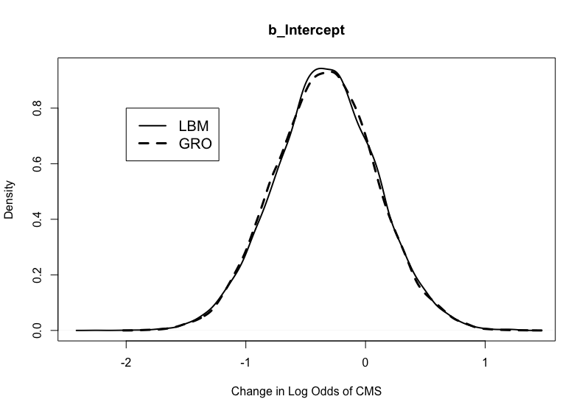
Figure 6.1. Posterior distributions for b_Intercept in the CMS-related morbidity models weakly informed by the London Bills of Mortality and the GRO Reports.

Table 6.20. HMC Diagnostics for the CMS-related morbidity model. Priors based on the London Bills of Mortality.
Parameter | $$\hat{\text{R}}$$ | Effective Sample Size
Parameter | $$\hat{\text{R}}$$ | Bulk | Tail
Intercept | 1.00 | 12985 | 11929
SexMale | 1.00 | 13802 | 11102
ClassMiddle/Upper | 1.00 | 11302 | 10232
Age | 1.00 | 14572 | 11510
RegionSouth | 1.00 | 10441 | 9005
ClassMiddle/Upper:RegionSouth | 1.00 | 8553 | 8944

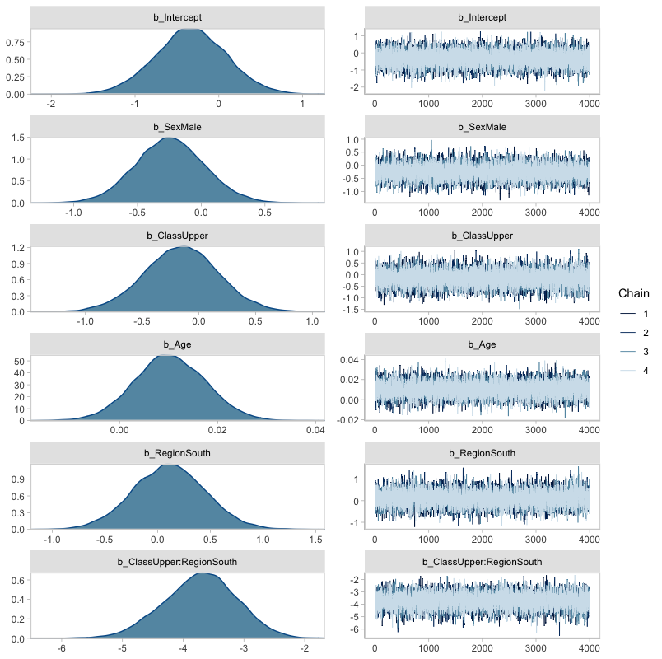
Figure 6.2. Posterior parameter distributions for the CMS-related morbidity model parameters and accompanying HMC chains. Priors based on the London Bills of Mortality. The posterior parameter distributions depicted on the left describe the log odds of presenting CMS based on the predictor variables in the model. The central tendency of the distribution reflects the most credible value for the log odds of presenting CMS. The less credible values are distributed around the peak. The HMC chains on the right visually depict how reliable the posterior parameter distributions are given the data. Here, the chains recovered similar values at each random walk of the posterior parameter space, suggesting that the posterior parameter distributions are reliable.

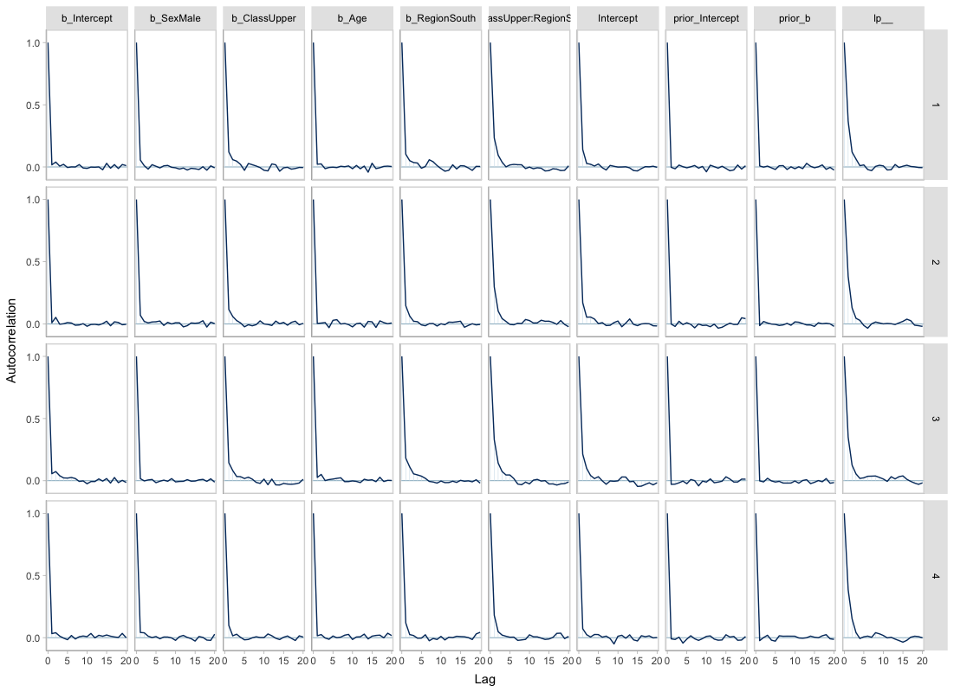
Figure 6.3. Autocorrelation plots for each CMS-related morbidity model parameter by HMC chain. Priors based on the London Bills of Mortality. Autocorrelation occurs when sequential HMC samples from the posterior parameter space are correlated. This typically happens when predictor variables are correlated with one another. The greater the autocorrelation, the slower the HMC simulation will be. Greater lag in the sampling process results in a less efficient exploration of the posterior parameter space. The autocorrelation plots depicted here suggest minimal lag in the HMC simulation due to negligible, if any, autocorrelation.

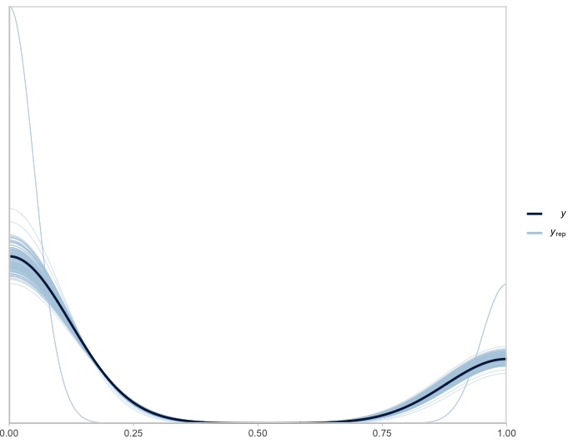
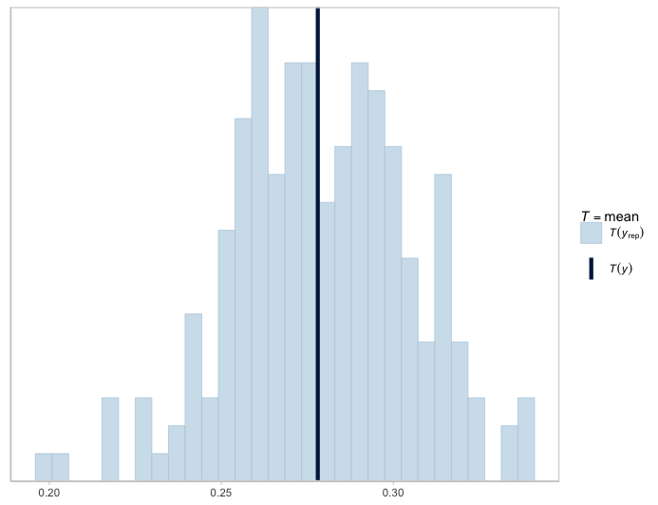
Figure 6.4. Density (left) and histogram (right) depicting posterior draws of the probability of presenting CMS based on the interaction model for CMS-related respiratory morbidity (n_{draws}=200). Dark blue lines reflect the observed mean. Priors based on the London Bills of Mortality. That the light blue lines representing random draws from the posterior parameter space are distributed approximately symmetrically around the observed mean suggests that appropriate priors were chosen and that the model behaved well.

coefficients and their 90% credibility intervals (CIs) are provided in Table 6.21. Each estimate reflects a marginal effect – a change in the log odds of presenting CMS given a change in the value of the associated predictor variable. The posterior distributions for each of these estimates are depicted in Figure 6.2. Marginal effects plots are provided in Appendix Two. Estimates whose 90% CIs overlap zero were not credibly different from chance. Parameter estimates were converted into odds ratios (ORs) to quantify effect size and for ease of interpretation by taking the natural log of each estimate. These conversions are also provided in Table 6.21. ORs with 90% CIs that overlap one suggested no credible difference in the odds between groups.
Although the log odds of CMS were lower among males compared to females (log odds= -0.24, 90%CI= -0.69-0.21), the effect was not credibly different from chance (OR= 0.79, 90% CI= 0.50-1.23). However, in only 18.48% (2956/16000) of random walks of the posterior parameter space were the log odds of presenting CMS greater among males compared to females. Likewise, the log odds of CMS were lower among middle/upper-class compared to the lower/middle-class (log odds= -0.16, 90%CI= -0.70-0.38), though the effect was not credibly different from chance (OR= 0.85, 90% CI= 0.50-1.46). However, in only 31.86% (5,097/16000) of random walks were the log odds of presenting CMS greater among the middle/upper class compared to the lower/middle class. The log odds of CMS marginally increased by 0.01 (90%CI= -0.00-0.02) with a unit increase in age-at-death but, again, the effect was not credibly different from chance. In only 7.65% (1224/16000) of random walks did the log odds of presenting CMS decline with advancing age.
Being a southerner was associated with a marginally higher log odds of presenting CMS that was not credibly different from chance (log odds= 0.11, 90%CI= -0.46-0.68). Despite this, in only 37.13% (5940/16000) of random walks, the odds of presenting CMS were greater among
Table 6.21. Model summary for the CMS-related morbidity model. Priors informed by the London Bills of Mortality. Point estimates for the log odds of presenting CMS and their 90% confidence intervals are provided for each parameter, as are the converted odds ratios and their 90% credibility intervals.
Parameter | Estimate |  | 90% Credibility Interval |  |  | 90% Credibility Interval
Parameter | Estimate | Error | Lower | Upper | OR | Lower | Upper
Intercept | -0.33 | 0.43 | -1.04 | 0.37 | 0.72 | 0.35 | 1.45
SexMale | -0.24 | 0.27 | -0.69 | 0.21 | 0.79 | 0.50 | 1.23
ClassMiddle/Upper | -0.16 | 0.33 | -0.70 | 0.38 | 0.85 | 0.50 | 1.46
Age | 0.01 | 0.01 | -0.00 | 0.02 | 1.01 | 1.00 | 1.02
RegionSouth | 0.11 | 0.35 | -0.46 | 0.68 | 1.12 | 0.63 | 1.97
ClassMiddle/Upper:RegionSouth | -3.72 | 0.60 | -4.73 | -2.75 | 0.02 | 0.01 | 0.06

northerners compared to southerners. Interestingly, being a southerner from the middle/upper-class was associated with a much lower log odds of presenting CMS (log odds= -3.72, 90%CI= -4.73- -2.75) and the magnitude of the effect was large (OR= 0.02, 90%CI: 0.01-0.06). In fact, in all random walks, middle/upper-class southerners exhibited a lower log odds of presenting CMS.
Posterior Predictions. Estimates of the maximum a priori (MAP) or modal odds of presenting CMS and their associated 90% highest density intervals (HDIs) were converted into
probabilities for ease of interpretation using the following formula:
$$\text{Probability of CMS = }\frac{{\text{e}}^{\text{(}{{\text{β}}_{\text{0}}\text{+β}}_{\text{1}}\text{(Age)+}{\text{β}}_{\text{2}}\text{(Sex)+}{\text{β}}_{\text{3}}\text{(Class)+}{\text{β}}_{\text{4}}\text{(Region)+}{\text{β}}_{\text{5}}\text{(Class)*(Region))}}}{\text{1+}{\text{e}}^{\text{(}{{\text{β}}_{\text{0}}\text{+β}}_{\text{1}}\text{(Age)+}{\text{β}}_{\text{2}}\text{(Sex)+}{\text{β}}_{\text{3}}\text{(Class)+}{\text{β}}_{\text{4}}\text{(Region)+}{\text{β}}_{\text{5}}\text{(Class)*(Region))}}}$$
Age-adjusted MAPs and HDIs for each intersectional group are provided in Table 6.22. Density plots describing the shape of the posterior prediction distributions for each intersectional group are depicted in Figure 6.5. The middle/upper-class females and males from London in the south exhibited the lowest posterior probability of presenting CMS (females= 0.01; 90% HDI= 0.00-0.03; males= <0.01, 90% HDI= 0.00-0.03). The credibility of different probability values was distributed similarly between the two groups. The remaining six intersectional groups exhibited a much higher probability of presenting CMS compared to the middle/upper-class females and males from London with MAPs between 0.31 (90% HDI= 0.16-0.50) for middle/upper-class males from the north and 0.46 (90% HDI= 0.30-0.59) for lower/middle-class females from the south. The 90% HDIs for all six of these groups overlapped one another, suggesting a similar probability of presenting CMS between these groups. There was greater certainty in CMS probability among middle/upper-class Londoners compared to all other groups as demonstrated by a narrow 90% HDI and a higher peak.

Table 6.22. Posterior predictions for the age-adjusted probability of presenting CMS by intersectional group. Priors inform by the London Bills of Mortality.
Group | Definition |  |  |  | 90% Highest Density Interval
Group | Region | Class | Sex | MAP | Lower | Upper
A | North | Upper/Middle | Male | 0.31 | 0.16 | 0.50
B | South | Upper/Middle | Male | <0.01 | 0.00 | 0.03
C | North | Lower/Middle | Male | 0.35 | 0.19 | 0.53
D | South | Lower/Middle | Male | 0.38 | 0.23 | 0.55
E | North | Upper/Middle | Female | 0.37 | 0.22 | 0.55
F | South | Upper/Middle | Female | 0.01 | 0.00 | 0.03
G | North | Lower/Middle | Female | 0.40 | 0.26 | 0.59
H | South | Lower/Middle | Female | 0.46 | 0.30 | 0.59

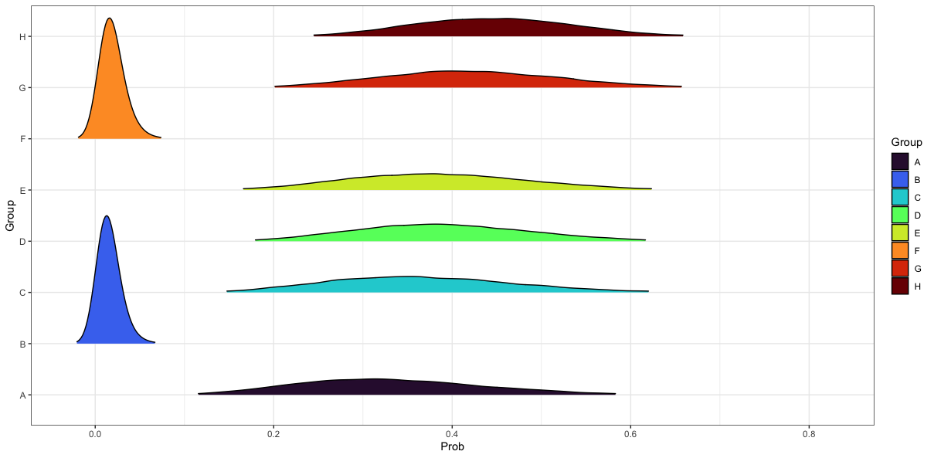Figure 6.5. Age-adjusted posterior prediction distributions for the probability of presenting CMS (x-axis) in each intersectional group (y-axis). See Table 6.22 for descriptions of each intersectional group. Priors based on the London Bills of Mortality. Each distribution includes credible probabilities for presenting CMS given biological sex, social class, and region of burial with the peak representing the most likely value.

Rib PNB
Model Description. The initial varying slopes, varying intercepts hierarchical Bayesian model for rib PNB-related respiratory morbidity was defined similar to the model for CMS:
$${\text{Rib PNB}}_{\text{i}}\text{\sim Bernoulli}\left(\text{f}\left({\left({\text{β}}_{\text{1}}\left(\text{age}\right)\text{+}{\text{β}}_{\text{2}}\left(\text{sex}\right)\text{+}{\text{β}}_{\text{3}}\left(\text{class}\right)\text{+}{\text{u}}_{\text{1}}\left(\text{age}\right)\text{+}{\text{u}}_{\text{2}}\left(\text{sex}\right)\text{+}{\text{u}}_{\text{3}}\left(\text{class}\right)\right)}_{\text{i}}\right)\text{,σ}\right)$$
Like with the hierarchical form of the CMS-related morbidity model, prior probabilities for the $\text{β}$ coefficients were all normal and weakly informed. The same proportional mortality ratios based
on the London Bills of Mortality (Worshipful Company of Parish Clerks, 1759) and the General Register Officer Reports (General Register Office for England and Wales, 1843) were used to inform the ${\text{β}}_{\text{0}}$ prior. But again, from the available historical mortality records, there were insufficient data to justify de-centering the $\text{β}$ coefficients for each predictor from zero. However, multiple model iterations were created with different values for the variance around all $\text{β}$ priors, including ${\text{β}}_{\text{0}}$, to allow for more flexibility in the HMC simulation (Depaoli et al., 2020).
Model Selection. Separate rib PNB-related morbidity models were created with the prior specifications informed by the London Bills of Mortality and General Register Office Reports. Like with the hierarchical form of the CMS-related morbidity model, the HMC simulation for each iteration of both models failed to converge. Adjusting the size and number of random walks of the posterior parameter space did not solve the problem. Therefore, the models were reparametrized, and the hierarchical component removed to determine the presence of an interaction effect between predictors. Reparameterization did not affect choice of priors. The resulting interaction model was defined as:
$${\text{PNB}}_{\text{i}}\text{\sim Bernoulli}\left(\text{f}\left({\left({\text{β}}_{\text{0}}\text{+}{\text{β}}_{\text{1}}\left(\text{age}\right)\text{+}{\text{β}}_{\text{2}}\left(\text{sex}\right)\text{+}{\text{β}}_{\text{3}}\left(\text{class}\right)\text{+}{\text{β}}_{\text{4}}\left(\text{region}\right)\text{+}{\text{β}}_{\text{5}}\text{(age)*(sex)*(class)*(region)}\right)}_{\text{i}}\right)\text{,σ}\right)$$
Multiple versions of this interaction model were run to identify meaningful statistical interactions. The only meaningful interaction observed after iteratively removing interaction terms with insufficient explanatory power was between social class and region of burial.
The final interaction model for rib PNB-related respiratory morbidity was like that of the CMS-related morbidity model:
$${\text{PNB}}_{\text{i}}\text{\sim Bernoulli}\left(\text{f}\left({\left({\text{β}}_{\text{0}}\text{+}{\text{β}}_{\text{1}}\left(\text{age}\right)\text{+}{\text{β}}_{\text{2}}\left(\text{sex}\right)\text{+}{\text{β}}_{\text{3}}\left(\text{class}\right)\text{+}{\text{β}}_{\text{4}}\left(\text{region}\right)\text{+}{\text{β}}_{\text{5}}\text{(class)*(region)}\right)}_{\text{i}}\right)\text{,σ}\right)$$
Multiple iterations of this interaction model were compared using WAICs (Watanabe, 2010). First, comparisons were made separately for models informed by the London Bills of Mortality and the General Register Office Reports. Comparisons included an intercept-only and non-interaction iteration of the interaction model. The model with the lowest WAIC value in each group was selected as the best fit model. Afterwards, the two best fit models were compared using BFs (Kruschke, 2011) to determine which combination of archival and skeletal data most parsimoniously explained rib PNB-related respiratory morbidity.
WAIC values for each iteration of the rib PNB-related morbidity model informed by the London Bills of Mortality and the General Register Office Reports are provided in Table 6.23. The best fit model informed by the London Bills of Mortality was the interaction model with the same prior specification as the CMS-related morbidity model:
${\text{β}}_{\text{0}}$~Normal(0.20, 2)
${\text{β}}_{\text{1}}$~Normal(0, 2)
${\text{β}}_{\text{2}}$~Normal(0, 2)
${\text{β}}_{\text{3}}$~Normal(0, 2)
${\text{β}}_{\text{4}}$~Normal(0, 2)
${\text{β}}_{\text{5}}$~Normal(0, 2)
The best fit model informed by the General Register Office Reports was the interaction model with a similar prior specification. However, the prior for ${\text{β}}_{\text{0}}$ was Normal(0.26, 2). Neither model

Table 6.23. WAIC estimates for rib PNB-related morbidity models with different prior probability configurations. ${\text{β}}_{\text{0}}$ is the intercept and ${\text{β}}_{1-5}$ are the coefficients for each predictor variable.
Fit | London Bills of Mortality |  |  |  | General Register Office Reports
Fit | Priors |  |  |  | Priors
Fit | $${\text{β}}_{\text{0}}$$ | $${\text{β}}_{1-5}$$ | WAIC | SE | $${\text{β}}_{\text{0}}$$ | $${\text{β}}_{1-5}$$ | WAIC | SE
1 | Flat | Flat | 409.2 | 24.9 | Flat | Flat | 409.2 | 24.9
2 | Normal (0.20,1) | Normal (0,1) | 409.9 | 23.2 | Normal (0.26,1) | Normal (0,1) | 409.9 | 23.2
3 | Normal (0.20,2) | Normal (0,2) | 408.8* | 24.4 | Normal (0.26,2) | Normal (0,2) | 408.7* | 24.3
4 | Normal (0.20,3) | Normal (0,3) | 409.0 | 24.7 | Normal (0.26,3) | Normal (0,3) | 409.0 | 24.7
5 | Normal (0.20,4) | Normal (0,4) | 409.1 | 24.8 | Normal (0.26,4) | Normal (0,4) | 409.2 | 24.8
6 | Normal (0.20,5) | Normal (0,5) | 409.3 | 24.9 | Normal (0.26,5) | Normal (0,5) | 409.1 | 24.9
7 | Normal (0.20,1) | Normal (0,5) | 408.9 | 24.2 | Normal (0.26,1) | Normal (0,5) | 408.9 | 24.3
8 | Normal (0.20,1) | Normal (0,10) | 409.0 | 24.3 | Normal (0.26,1) | Normal (0,10) | 408.8 | 24.3
9 | Normal (0.20,2) | Normal (0,5) | 409.0 | 24.8 | Normal (0.26,2) | Normal (0,5) | 409.1 | 24.8
10 | Normal (0.20,2) | Normal (0,10) | 409.1 | 24.8 | Normal (0.26,2) | Normal (0,10) | 409.2 | 24.8
11 | Normal (0.20,3) | Normal (0,5) | 409.3 | 24.9 | Normal (0.26,3) | Normal (0,5) | 409.2 | 24.8
12 | Normal (0.20,3) | Normal (0,10) | 409.3 | 24.9 | Normal (0.26,3) | Normal (0,10) | 409.3 | 24.9
13 | Normal (0.20,4) | Normal (0,5) | 409.1 | 24.9 | Normal (0.26,4) | Normal (0,5) | 409.1 | 24.9
14 | Normal (0.20,4) | Normal (0,10) | 409.3 | 24.9 | Normal (0.26,4) | Normal (0,10) | 409.3 | 25.0
15 | Normal (0.20,5) | Normal (0,10) | 409.3 | 25.0 | Normal (0.26,5) | Normal (0,10) | 409.3 | 25.0
*Denotes most parsimonious model

was favored over the other given a BF of 1.03. In fact, the posterior estimates generated by both models were virtually identical (see Figure 6.6 for an example). For this reason, only the interaction model informed by the London Bills of Mortality was reported here. The other model
informed by the General Register Office Reports is reported in Appendix Two.
HMC Diagnostics. The HMC simulation for the interaction model involved a total of 20,000 random walks of the posterior parameter space divided equally among four chains with a warmup of 1,000 random walks per chain. HMC diagnostics are provided in Table 6.24. As indicated by $\hat{\text{R}}$ values less than 1.01 and effective sample sizes greater than 400, all chains converged (Vehtari et al., 2021). These findings are confirmed by visual assessment of the HMC chains (Figure 6.7) and a lack of autocorrelation between these chains (Figure 6.8). These diagnostics indicate that the HMC simulation produced a representative sample of the posterior probability distribution for the rib PNB morbidity model and that the posterior estimates of model parameters are reliable given the data.
Model Summary. The interaction model fit the data well. It was able to explain 20.60% of the variation in rib PNB frequency observed in this study (90% HDI: 15.46-25.67). The posterior predictive check supports this assertion. As depicted in Figure 6.9, posterior draws based on model specifications are distributed approximately symmetrically around the observed mean of the skeletal data. Posterior parameter estimates for the $\text{β}$ coefficients, their 90% credibility intervals (CI), and converted ORs are provided in Table 6.25. The posterior distributions for each parameter estimate are depicted in Figure 6.7. Marginal effects plots are provided in Appendix Two. Although the log odds of rib PNB were higher among males compared to females (log odds= 0.17, 90% CI= -0.24-0.59) the effect was not credibly different from chance (OR= 1.19, 90% CI= 0.79-1.80). However, in only 25.63% (4101/16000) of random
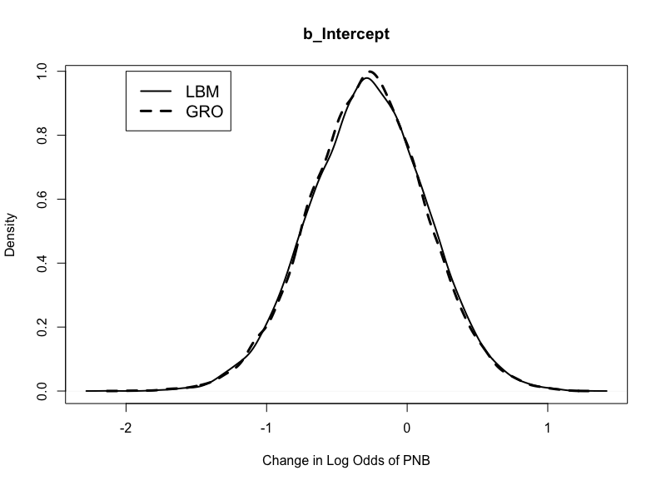
Figure 6.6. Posterior distributions for b_Intercept in the rib PNB-related morbidity models weakly informed by the London Bills of Mortality and the General Register Office Reports.

Table 6.24. HMC Diagnostics for the rib PNB-related morbidity model. Priors based on the London Bills of Mortality.
Parameter | $$\hat{\text{R}}$$ | Effective Sample Size
Parameter | $$\hat{\text{R}}$$ | Bulk | Tail
Intercept | 1.00 | 13260 | 12263
SexMale | 1.00 | 16249 | 12515
ClassMiddle/Upper | 1.00 | 9837 | 10321
Age | 1.00 | 16105 | 12728
RegionSouth | 1.00 | 10215 | 11244
ClassMiddle/Upper:RegionSouth | 1.00 | 8588 | 9750

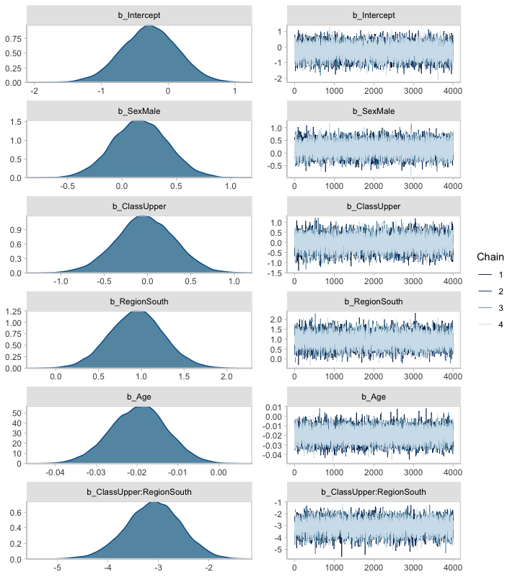
Figure 6.7. Posterior parameter distributions for the rib PNB-related morbidity model parameters and accompanying HMC chains. Priors provided by the London Bills of Mortality.

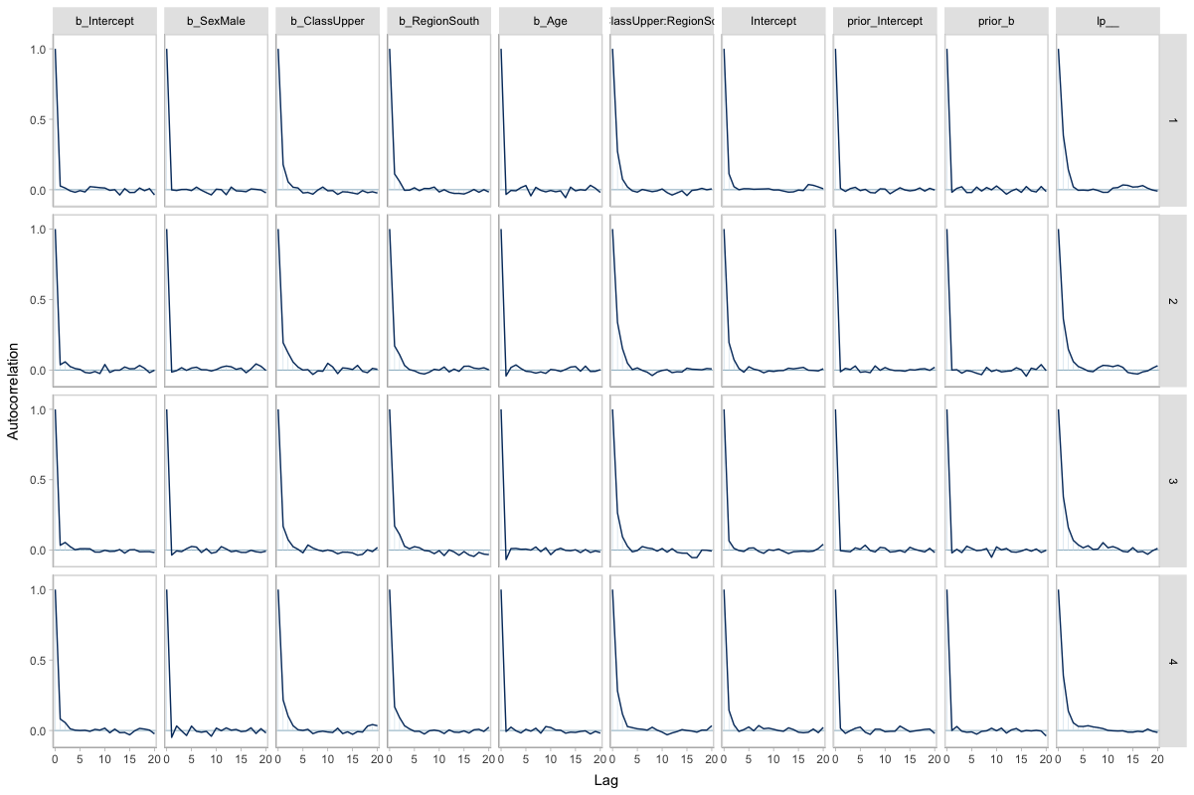Figure 6.8. Autocorrelation plots for each rib PNB-related morbidity model parameter by HMC chain. Priors based on the London Bills of Mortality.

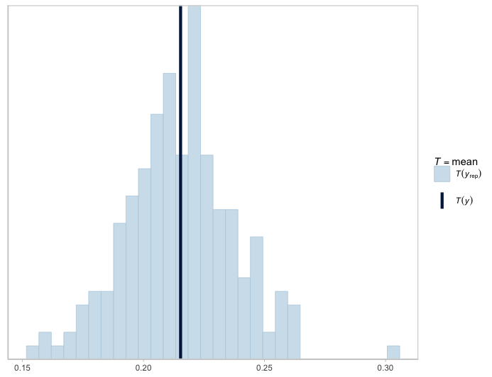
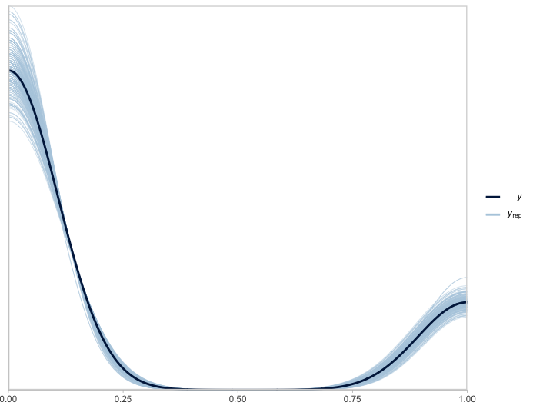
Figure 6.9. Density (left) and histogram (right) depicting posterior draws of the probability of presenting rib PNB based on the interaction model for rib PNB-related respiratory morbidity (n_{draws}=200). Dark blue lines reflect observed mean. Priors based on the London Bills of Mortality.

Table 6.25. Model summary for the rib PNB-related morbidity model. Priors informed by the London Bills of Mortality.
Parameter | Estimate |  | 90% Credibility Interval |  |  | 90% Credibility Interval
Parameter | Estimate | Error | Lower | Upper | OR | Lower | Upper
Intercept | -0.28 | 0.42 | -0.96 | 0.40 | 0.76 | 0.38 | 1.49
SexMale | 0.17 | 0.25 | -0.24 | 0.59 | 1.19 | 0.79 | 1.80
ClassMiddle/Upper | -0.03 | 0.34 | -0.59 | 0.53 | 0.97 | 0.55 | 1.70
Age | -0.02 | 0.01 | -0.03 | -0.01 | 0.98 | 0.97 | 0.99
RegionSouth | 0.94 | 0.32 | 0.42 | 1.47 | 2.56 | 1.52 | 4.35
ClassMiddle/Upper:RegionSouth | -3.10 | 0.54 | -4.01 | -2.21 | 0.05 | 0.02 | 0.11

walks of the posterior parameter space were the odds of presenting rib PNB greater among females compared to males. Likewise, the log odds of rib PNB were not lower among the middle/upper-class compared to the lower/middle-class (log odds= -0.03, 90% CI= -0.59-0.53; OR= 0.97, 90% CI= 0.55-1.70). In nearly half of random walks (46.58% or 7452/16000), the odds of presenting rib PNB were greater among the middle/upper-class. While the log odds of rib PNB decreased by 0.02 (90% CI= -0.03- -0.01) with each unit increase in age-at-death, the magnitude of the effect was small (OR= 0.98, 90% CI= 0.97-0.99). However, in only 0.19% of random walks were the odds of presenting rib PNB positively associated with advancing age.
In contrast to these findings, being a southerner was associated with a higher log odds of presenting rib PNB (log odds= 0.94, 90%CI= 0.42-1.47) and the effect was moderate to large (OR= 2.56, 90% CI= 1.52-4.35). In fact, in 99.81% (15969/16000), the odds of presenting rib PNB were higher among southerners compared to northerners. However, being a southerner from the middle/upper-class was associated with a lower log odds of presenting rib PNB (log odds= -3.10, 90% CI= -4.01- -2.21) and the magnitude of the effect was large (OR= 0.05, 90% CI= 0.02-0.11). In fact, none of the random walks resulted in a greater odds of presenting rib PNB among middle/upper-class southerners.
Posterior Predictions. Age-adjusted MAPs and HDIs for each intersectional group are provided in Table 6.26. Density plots describing the shape of the posterior prediction distributions for each intersectional group are depicted in Figure 6.10. The middle/upper-class females and males from London in the south exhibited the lowest posterior probability of presenting rib PNB (females= 0.07; 90% HDI= 0.03-0.14; males= 0.08, 90% HDI= 0.03-0.17). The credibility of different probability values was distributed similarly between the two groups. In contrast, the lower/middle-class females and males from London in the south exhibited the
Table 6.26. Posterior predictions for the age-adjusted probability of presenting rib PNB by intersectional group. Priors inform by the London Bills of Mortality.
Group | Definition |  |  |  | 90% Highest Density Interval
Group | Region | Class | Sex | MAP | Lower | Upper
A | North | Upper/Middle | Male | 0.45 | 0.29 | 0.65
B | South | Upper/Middle | Male | 0.08 | 0.03 | 0.17
C | North | Lower/Middle | Male | 0.47 | 0.31 | 0.65
D | South | Lower/Middle | Male | 0.70 | 0.57 | 0.82
E | North | Upper/Middle | Female | 0.43 | 0.26 | 0.59
F | South | Upper/Middle | Female | 0.07 | 0.03 | 0.14
G | North | Lower/Middle | Female | 0.43 | 0.27 | 0.59
H | South | Lower/Middle | Female | 0.67 | 0.54 | 0.78

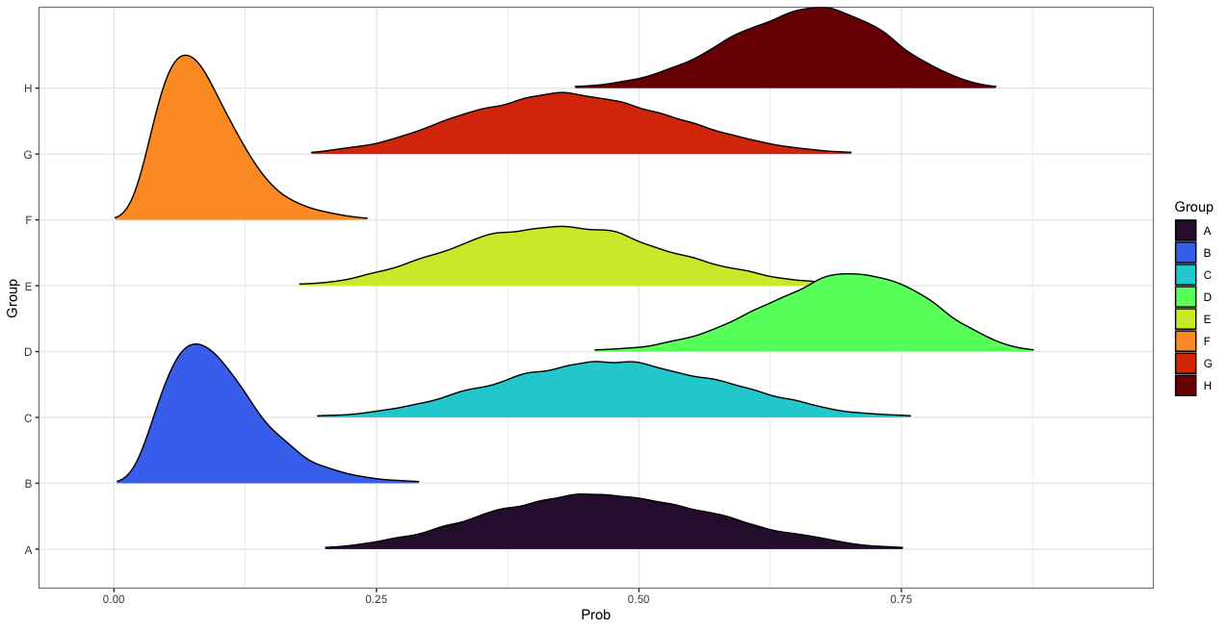
Figure 6.10. Age-adjusted posterior prediction distributions for the probability of presenting rib PNB in each intersectional group. See Table 6.26 for descriptions of each intersectional group Priors based on the London Bills of Mortality.

highest posterior probability of presenting rib PNB (females= 0.67, 90% HDI= 0.54-0.78, males= 0.70, 90% HDI= 0.57-0.82). Again, the credibility of different probability values was distributed similarly between the two groups. The remaining four intersectional groups exhibited probabilities of presenting rib PNB located between these two extremes with MAPs between 0.43 (90% HDI= 0.26-0.59) and 0.47 (90%HDI= 0.31-0.65). The 90% HDIs for all four groups overlapped, suggesting similar probabilities of presenting rib PNB. While the probability of presenting rib PNB was lower for middle/upper-class Londoners compared to all other groups, there was some overlap in the 90% HDIs for the lower/middle-class Londoners and all four northern intersectional groups, which would suggest similarity in rib-related or lower respiratory morbidity between these groups. However, differences in the shape of the posterior prediction distributions for these groups suggests that lower respiratory morbidity was probabilistically higher among the lower/middle-class Londoners compared to the four intersectional groups from the north. The middle/upper-class Londoners exhibited the greatest certainty in the posterior probability of presenting rib PNB, while all four northern intersectional groups exhibited the least certainty as demonstrated by a wide 90% HDI and low peak.
Post Hoc Analysis
An odds ratio was calculated post hoc to evaluate the association between CMS and rib PNB. Of the 507 individuals included in this study, only 73.18% (371/507) presented at least one maxillary sinus and rib fragment. Of these individuals, 33 (or 8.89%) presented both CMS and rib PNB, 42 (or 11.32%) presented rib PNB but no CMS, 75 (or 20.22%) presented CMS but no rib PNB, and the remaining 221 individuals (or 59.57%) presented neither CMS nor rib PNB. The odds of rib PNB among individuals with CMS was 2.32 times the odds of rib PNB among individuals without CMS, indicating a statistically significant association between CMS and rib PNB as the 90% confidence interval did not overlap the null value of one (90% CI = 1.49-3.60).

Respiratory Mortality
CMS
Model Description. The initial varying slopes, varying intercepts hierarchical Bayesian model for CMS-related respiratory mortality was defined as:
$$\text{ag}{\text{e}}_{\text{i}}\text{\sim Normal}\left(\text{f}\left({\left({\text{β}}_{\text{1}}\left(\text{sex}\right)\text{+}{\text{β}}_{\text{2}}\left(\text{class}\right)\text{+}{\text{β}}_{\text{3}}\left(\text{CMS}\right)\text{+}{\text{u}}_{\text{1}}\left(\text{sex}\right)\text{+}{\text{u}}_{\text{2}}\left(\text{class}\right)\text{+}{\text{u}}_{\text{3}}\left(\text{CMS}\right)\right)}_{\text{i}}\right)\text{,σ}\right)$$
where $\text{β}$ is the slope for the intercept and each predictor, u is the grouping factor (i.e., region of burial), and $\text{σ}$ is the residual standard deviation (Bürkner, 2017). In this model, age is a normally distributed, continuous variable and biological sex, social class, CMS presence/absence, and region of burial are all dichotomous variables.
Prior probabilities for the $\text{β}$ coefficients were all normal and weakly informed. Priors for the intercept, ${\text{β}}_{\text{0}}$, and $\text{σ}$ were t-distributed and weakly informed. The $\text{β}$ coefficient for the intercept, ${\text{β}}_{\text{0}}$, was informed by the London Bills of Mortality (Worshipful Company of Parish Clerks, 1759) and the General Register Officer Reports (General Register Office for England and Wales, 1843). The number of deaths per year were divided into age bins. For the London Bills of Mortality, these bins included (in years) 10.00-19.99, 20.00-29.99, 30.00-39.00, 40.00-49.99, 50.00-59.99, 60.00-69.99, 70.00-79.99, 80.00-89.99, 90.00-99.99, and 100.00+. These data were available for the years 1728-1799. For the General Register Office Report, these bins included 15.00-24.99, 25.00-34.99, 35.00-44.99, 45.00-54.99, 55.00-64.99, 65.00-74.99, 75.00-84.99, 85.00-94.99, and 95.00+. These data were available for the years 1838-1841. Younger age bins were not included in the creation of the ${\text{β}}_{\text{0}}$ prior because the purpose of the prior within the context of this model is to inform the probability that an adult randomly drawn from the skeletal sample would have died at a certain estimated age given model parameters. Therefore, it is necessary to know the prior probability of death at a given age within the adult population. It would not make sense to include non-adults in the creation of model priors in this case because doing so would skew the a priori expected average age-at-death towards a younger age given high infant mortality rates at the time.
For each archival source separately, the number of deaths in each age bin was summed across all available years, multiplied by the midpoint of that age bin, summed across all age bins, and then divided by the total number of deaths for a given year to calculate an average age-at-death. For the London Bills of Mortality, the average age-at-death was 47.19 years (sd= 19.09 years). For the General Register Office Reports, the average age-at-death was 52.91 years (sd= 21.80 years). From the available historical mortality records, there were insufficient data to justify de-centering the $\text{β}$ coefficients for each predictor from zero (i.e., no a priori expectation for an effect). This was also the case for $\text{σ}$. However, multiple model iterations were created with different values for the variance around all $β$ priors, including ${\text{β}}_{\text{0}}$, as well as $\text{σ}$ to allow for more flexibility in the Hamiltonian Monte Carlo (HMC) simulation (Depaoli et al., 2020).
Model Selection. Separate CMS-related mortality models were created with the prior specifications informed by the London Bills of Mortality and General Register Office Reports. Like with the hierarchical form of the CMS-related morbidity model, the HMC simulation for each iteration of both models failed to converge. Adjusting the size and number of random walks of the posterior parameter space did not solve the problem. Therefore, the models were reparametrized, and the hierarchical component removed to determine the presence of an interaction effect between predictors. Reparameterization did not affect choice of priors. The resulting interaction model was defined as:
$${\text{age}}_{\text{i}}\text{\sim Normal}\left(\text{f}\left({\left({\text{β}}_{\text{0}}\text{+}{\text{β}}_{\text{1}}\left(\text{sex}\right)\text{+}{\text{β}}_{\text{2}}\left(\text{class}\right)\text{+}{\text{β}}_{\text{3}}\left(\text{region}\right)\text{+}{\text{β}}_{\text{4}}\left(\text{CMS}\right)\text{+}{\text{β}}_{\text{5}}\text{(sex)*(class)*(region)*(CMS)}\right)}_{\text{i}}\right)\text{,σ}\right)$$
Multiple versions of this interaction model were run to identify meaningful statistical interactions. The only meaningful interaction observed after iteratively removing interaction terms with insufficient explanatory power was between social class and region of burial.
The final interaction model for CMS-related respiratory morbidity was defined as:
$${\text{age}}_{\text{i}}\text{\sim Normal}\left(\text{f}\left({\left({\text{β}}_{\text{0}}\text{+}{\text{β}}_{\text{1}}\left(\text{sex}\right)\text{+}{\text{β}}_{\text{2}}\left(\text{class}\right)\text{+}{\text{β}}_{\text{3}}\left(\text{region}\right)\text{+}{\text{β}}_{\text{4}}\left(\text{CMS}\right)\text{+}{\text{β}}_{\text{5}}\text{(class)*(region)}\right)}_{\text{i}}\right)\text{,σ}\right)$$
Multiple iterations of this interaction model were compared using WAIC (Watanabe, 2010). First, comparisons were made separately for models informed by the London Bills of Mortality and the General Register Office Reports. Comparisons included an intercept-only and non-interaction iteration of the interaction model. The model with the lowest WAIC value in each group was selected as the best fit model. Afterwards, the two best fit models were compared using BFs (Kruschke, 2011) to determine which combination of archival and skeletal data most parsimoniously explained CMS-related respiratory mortality.
WAIC values for each iteration of the CMS-related mortality model informed by the London Bills of Mortality and the General Register Office Reports are provided in Table 6.27. The best fit model informed by the London Bills of Mortality was the interaction model with the following prior specification:
${\text{β}}_{\text{0}}$~t(3,47, 10)
${\text{β}}_{\text{1}}$~Normal(0, 10)
${\text{β}}_{\text{2}}$~Normal(0, 10)
${\text{β}}_{\text{3}}$~Normal(0, 10)
${\text{β}}_{\text{4}}$~Normal(0, 10)
${\text{β}}_{\text{5}}$~Normal(0, 10)
$\text{σ}$~t(3, 0, 10)

where, for example, the prior for biological sex, ${\text{β}}_{\text{1}}$, was normally distributed with a mean of zero

Table 6.27. WAIC estimates for CMS-related mortality models with different prior probability configurations. ${\text{β}}_{\text{0}}$ is the intercept, ${\text{β}}_{1-5}$ are the coefficients for each predictor variable, and $\text{σ}$ is the residual standard deviation.
Fit | London Bills of Mortality |  |  |  |  | General Register Office Reports
Fit | Priors |  |  | WAIC | SE | Priors |  |  | WAIC | SE
Fit | $${\text{β}}_{\text{0}}$$ | $${\text{β}}_{1-5}$$ | $$\text{σ}$$ | WAIC | SE | $${\text{β}}_{\text{0}}$$ | $${\text{β}}_{1-5}$$ | $$\text{σ}$$ | WAIC | SE
1 | t(3, 48.2, 28) | Flat | t(3, 0, 28) | 3418.4 | 18.6 | t(3, 48.2, 28) | Flat | t(3, 0, 28) | 3418.4 | 18.6
2 | t(3, 47, 20) | Normal(0,10) | t(3, 0, 20) | 3418.2 | 18.1 | t(3, 53, 40) | Normal(0,10) | t(3, 0, 20) | 3418.2 | 18.1
3 | t(3, 47, 10) | Normal(0,5) | t(3, 0, 10) | 3420.1 | 17.3 | t(3, 53, 40) | Normal(0,5) | t(3, 0, 10) | 3420.1 | 17.3
4 | t(3, 47, 15) | Normal(0,10) | t(3, 0, 15) | 3418.3 | 18.1 | t(3, 53, 25) | Normal(0,10) | t(3, 0, 25) | 3418.0* | 18.1
5 | t(3, 47, 15) | Normal(0,5) | t(3, 0, 15) | 3420.1 | 17.3 | t(3, 53, 25) | Normal(0,5) | t(3, 0, 25) | 3420.3 | 17.3
6 | t(3, 47, 20) | Normal(0,5) | t(3, 0, 20) | 3420.1 | 17.6 | t(3, 53, 30) | Normal(0,5) | t(3, 0, 30) | 3420.2 | 17.3
7 | t(3, 47, 10) | Normal(0,10) | t(3, 0, 10) | 3418.0* | 18.1 | t(3, 53, 20) | Normal(0,10) | t(3, 0, 20) | 3418.2 | 18.1
*Denotes most parsimonious model

and a standard deviation of ten. The best fit model informed by the General Register Office Reports was the interaction model with a similar prior specification. However, the prior for ${\text{β}}_{\text{0}}$ was t(3, 53, 25) and the prior for $\text{σ}$ was t(3, 0, 25). Neither model was favored over the other given a BF of 1.75. In fact, the posterior estimates generated by both models were virtually identical (see Figure 6.11 for an example). For this reason, only the interaction model informed by the London Bills of Mortality was reported here. The other model informed by the General Register Office Reports is reported in Appendix Two.
HMC Diagnostics. The HMC simulation for the interaction model involved a total of 20,000 random walks of the posterior parameter space divided equally among four chains with a warmup of 1,000 random walks per chain. HMC diagnostics are provided in Table 6.28. As indicated by $\hat{\text{R}}$ values less than 1.01 and effective sample sizes greater than 400, all chains converged (Vehtari et al., 2021). These findings are confirmed by visual assessment of the HMC chains (Figure 6.12) and a lack of autocorrelation between these chains (Figure 6.13). These diagnostics indicate that the HMC simulation produced a representative sample of the posterior probability distribution for the CMS mortality model and that the posterior estimates of model parameters are reliable given the data.
Model Summary. The interaction model fit the data well. It was able to explain 11.27% of the variation in age-at-death observed in this study (90% HDI: 6.96-15.82). The posterior predictive check supports this assertion. As depicted in Figure 6.14, posterior draws based on model specifications are distributed approximately symmetrically around the observed mean of the skeletal data. Posterior parameter estimates for the $β$ coefficients and their 90% CIs are provided in Table 6.29. The posterior distributions for each parameter estimate are depicted in Figure 6.12. Marginal effects plots are provided in Appendix Two. Although individuals from

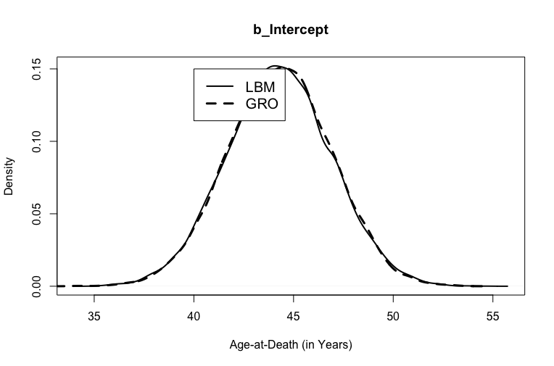
Figure 6.11. Posterior distributions for b_Intercept in the CMS-related mortality models weakly informed by the London Bills of Mortality and the General Register Office Reports.

Table 6.28. HMC Diagnostics for the CMS-related mortality model. Priors based on the London Bills of Mortality
Parameter | $$\hat{\text{R}}$$ | Effective Sample Size
Parameter | $$\hat{\text{R}}$$ | Bulk | Tail
Intercept | 1.00 | 13955 | 11690
SexMale | 1.00 | 16479 | 11626
ClassMiddle/Upper | 1.00 | 12207 | 12525
RegionSouth | 1.00 | 11464 | 11807
CMSPresent | 1.00 | 14352 | 11844
ClassMiddle/Upper:RegionSouth | 1.00 | 9618 | 11047

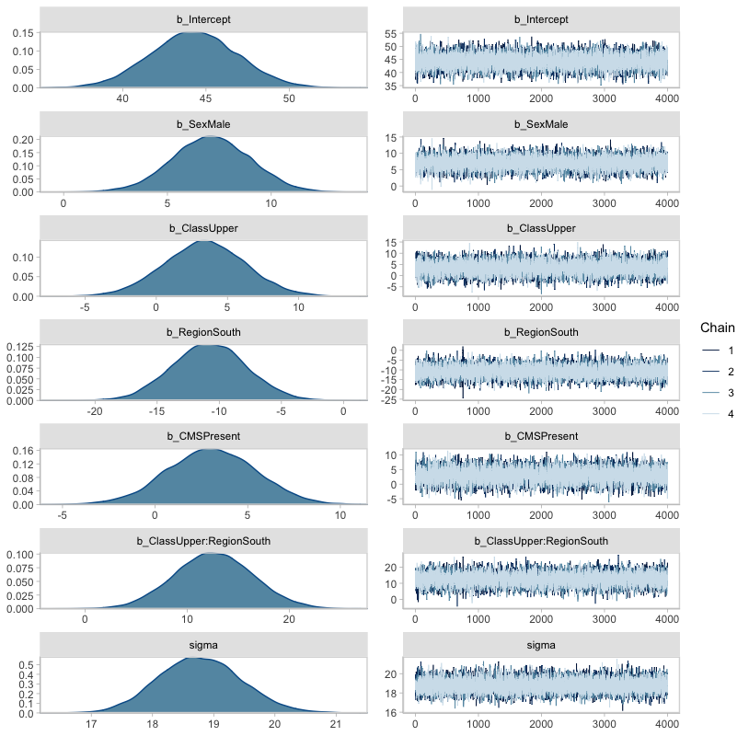
Figure 6.12. Posterior parameter distributions for the CMS-related mortality model parameters and accompanying HMC chains. Priors provided by the London Bills of Mortality. The posterior parameter distributions depicted on the left describe the most likely age-at-death based on the predictor variables in the model. The central tendency of the distribution reflects the most credible value for the unit change in age-at-death (in years) between factors within the predictor variable (e.g., males vs. females within biological sex). The less credible values are distributed around the peak. The HMC chains on the right visually depict how reliable the posterior parameter distributions are given the data. Here, the chains recovered similar values at each random walk of the posterior parameter space, suggesting that the posterior parameter distributions are reliable.

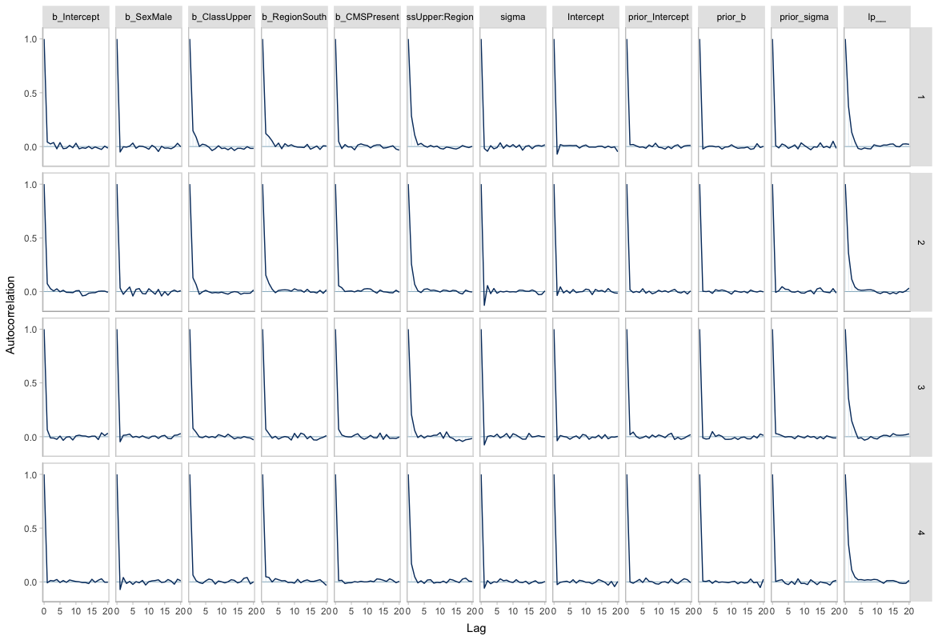
Figure 6.13. Autocorrelation plots for each CMS-related mortality model parameter by HMC chain. Priors based on the London Bills of Mortality. Autocorrelation occurs when sequential HMC samples from the posterior parameter space are correlated. This typically happens when predictor variables are correlated with one another. The greater the autocorrelation, the slower the HMC simulation will be. Greater lag in the sampling process results in a less efficient exploration of the posterior parameter space. The autocorrelation plots depicted here suggest minimal lag in the HMC simulation due to negligible, if any, autocorrelation.

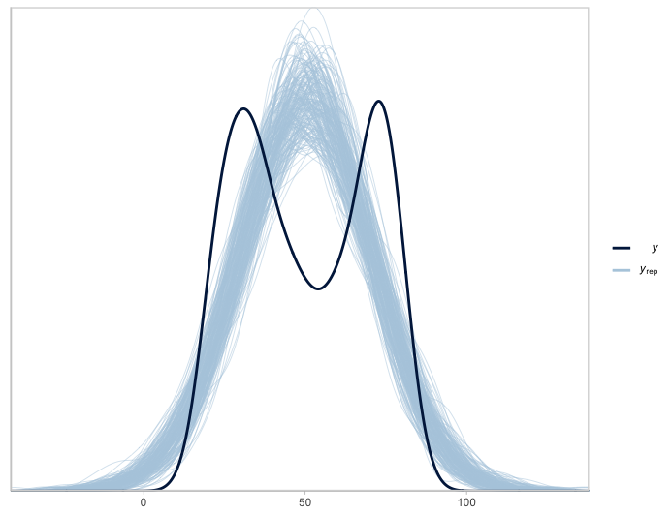
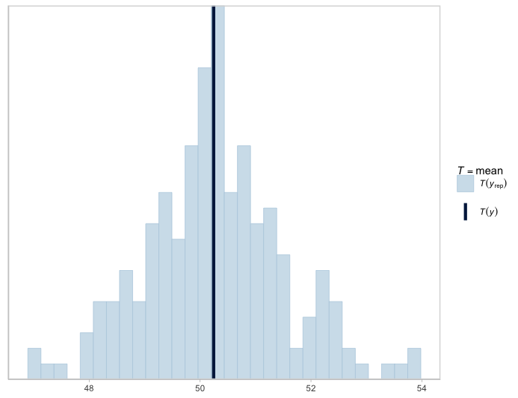
Figure 6.14. Density (left) and histogram (right) depicting posterior draws of age-at-death based on the interaction model for CMS-related respiratory mortality (n_{draws}=200). Dark blue lines reflect observed mean. Priors based on the London Bills of Mortality. That the light blue lines representing random draws from the posterior parameter space are distributed approximately symmetrically around the observed mean suggests that appropriate priors were chosen and that the model behaved well.

Table 6.29. Model summary for the CMS-related mortality model. Priors informed by the London Bills of Mortality.
Parameter | Estimate |  | 90% Credibility Interval
Parameter | Estimate | Error | Lower | Upper
Intercept | 44.27 | 2.61 | 39.98 | 48.62
SexMale | 7.12 | 1.88 | 4.04 | 10.21
ClassMiddle/Upper | 3.41 | 2.85 | -1.31 | 8.14
RegionSouth | -10.80 | 2.98 | -15.69 | -5.87
CMSPresent | 3.06 | 2.40 | -0.89 | 7.00
ClassMiddle/Upper:RegionSouth | 12.59 | 3.86 | 6.26 | 19.01
Residual Standard Deviation | 18.78 | 0.68 | 17.70 | 19.91

the middle/upper-class tended to live an average of 3.41 years longer than their lower/middle-class counterparts, the difference was not credibly different from chance (90% CI= -1.31-8.14). However, in 88.26% (14122/1600) of random walks of the posterior parameter space, individuals from the middle/upper class lived longer than those from the lower/middle class. Likewise, individuals with CMS tended to live an average of 3.06 years longer than those without CMS (90% CI= -0.89-7.00), but the difference was not credibly different from chance. Yet, 90.01% (14402/16000) of random walks resulted in a higher age at death among individuals with CMS.
In contrast to these findings, males tended to live longer than females by an average of 7.12 years (90% CI= 4.04-10.21). In fact, in 99.99% (15998/16000) of random walks, being male was associated with a higher age at death. Likewise, southerners tended to live an average of 10.80 fewer years than northerners (90% CI= -15.69- -5.87). Again, these findings are supported by the fact that only 0.02% (3/16000) of random walks resulted in a higher age-at-death for southerners compared to northerners. However, southerners from the middle/upper class tended to live an average of 12.59 years longer than anyone else (90% CI= 6.26-19.01). In 99.93% (15989/1600) of random walks, middle/upper-class southerners lived longer than everyone else. As indicated by the residual standard deviation, $\text{σ}$, the model was able to predict age-at-death with an average error of 18.78 years (90% CI= 17.70-19.91).
Posterior Predictions. MAPs and HDIs of age-at-death for each intersectional group are provided in Table 6.30. Density plots describing the shape of the posterior prediction distributions for each intersectional group are depicted in Figure 6.15. Lower/middle-class females from London in the south with CMS tended to die around the estimated age of 36.08 Years (90% HDI= 32.13-41.05). These individuals were more likely to die younger than females in the other three intersectional groups whose most likely estimated ages-at-death ranged from
Table 6.30. Posterior predictions for the most likely age-at-death for each intersectional group based on the CMS-related respiratory mortality model. Priors informed by the London Bills of Mortality.
 |  |  |  | CMS (+) |  |  | CMS (-)
 | Definition |  |  |  | 90% Highest Density Interval |  |  | 90% Highest Density Interval
Group | Region | Class | Sex | MAP | Lower | Upper | MAP | Lower | Upper
A | North | Upper/Middle | Male | 57.68 | 53.55 | 62.16 | 54.88 | 50.55 | 58.96
B | South | Upper/Middle | Male | 59.78 | 54.98 | 64.45 | 56.62 | 53.83 | 59.29
C | North | Lower/Middle | Male | 54.75 | 50.39 | 58.54 | 51.09 | 47.23 | 55.43
D | South | Lower/Middle | Male | 43.77 | 39.08 | 48.24 | 40.50 | 36.12 | 45.30
E | North | Upper/Middle | Female | 50.55 | 46.48 | 55.18 | 47.58 | 43.36 | 52.08
F | South | Upper/Middle | Female | 52.34 | 47.84 | 57.15 | 49.69 | 46.76 | 52.22
G | North | Lower/Middle | Female | 47.62 | 43.27 | 51.64 | 44.13 | 39.82 | 48.40
H | South | Lower/Middle | Female | 36.08 | 32.13 | 41.05 | 33.68 | 28.95 | 38.13

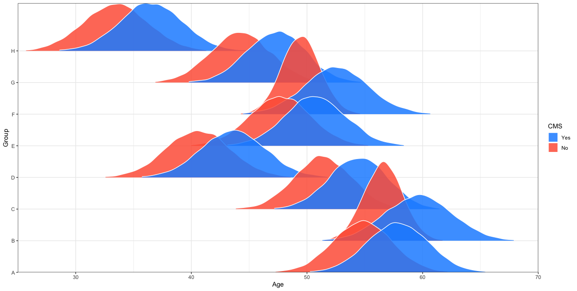
Figure 6.15. Comparisons of the posterior predictions of age-at-death for intersectional groups based on CMS presence or absence. See Table 6.30 for descriptions of each group. Priors based on the London Bills of Mortality.

47.62 years (90% HDI= 43.27-51.64) and 52.34 years (90% HDI= 47.84-57.15). They were also more likely to die younger than males from the north and middle/upper-class males from London whose most likely ages-at-death ranged from 54.75 years (90% HDI= 50.39-58.54) to 59.78 years (90% HDI= 54.98-64.45). Lower/middle-class males from London in the south with CMS tended to die around the estimated age of 43.77 years (90% HDI= 39.08-48.24). These individuals were more likely to die younger than CMS+ males in the other three intersectional groups, as well as CMS+ middle/upper-class females from the north and south. Their 90% HDI overlapped with those of CMS+ middle/lower-class females from the north and south, which suggests similarity in CMS-related (upper) respiratory mortality between these groups. However, the shape of the posterior prediction distributions for CMS+ lower/middle-class males and females from London suggest probabilistic differences in upper respiratory mortality between these two groups with the former living, on average, 7.69 years longer than the latter. Among intersectional groups with CMS, the width and height of the posterior distribution was largely homogeneous, suggesting similar levels of statistical certainty regarding parameter estimates.
Rib PNB
Model Description. The initial varying slopes, varying intercepts hierarchical Bayesian model for rib PNB-related respiratory mortality was defined as:
$$\text{ag}{\text{e}}_{\text{i}}\text{\sim Normal}\left(\text{f}\left({\left({\text{β}}_{\text{1}}\left(\text{sex}\right)\text{+}{\text{β}}_{\text{2}}\left(\text{class}\right)\text{+}{\text{β}}_{\text{3}}\left(\text{PNB}\right)\text{+}{\text{u}}_{\text{1}}\left(\text{sex}\right)\text{+}{\text{u}}_{\text{2}}\left(\text{class}\right)\text{+}{\text{u}}_{\text{3}}\left(\text{PNB}\right)\right)}_{\text{i}}\right)\text{,σ}\right)$$
where $\text{β}$ is the slope for the intercept and each predictor, u is the grouping factor (i.e., region of burial), and $\text{σ}$ is the residual standard deviation (Bürkner, 2017). In this model, age is a normally distributed, continuous variable and biological sex, social class, rib PNB, and region of burial are all dichotomous variables.
Like with the hierarchical form of the CMS-related mortality model, prior probabilities for the $\text{β}$ coefficients were all normal and weakly informed. And priors for the intercept, ${\text{β}}_{\text{0}}$, and $\text{σ}$ were t-distributed and weakly informed. The same average ages at death based on the London Bills of Mortality (Worshipful Company of Parish Clerks, 1759) and the General Register Office Reports (General Register Office for England and Wales, 1843) were used to inform the ${\text{β}}_{\text{0}}$ prior. But again, from the available historical mortality records, there were insufficient data to justify de-centering the $\text{β}$ coefficients for each predictor from zero. This was also the case for $\text{σ}$. However, multiple model iterations were created with different values for the variance around all $\text{β}$ priors, including ${\text{β}}_{\text{0}}$, as well as $σ$ to allow for more flexibility in the HMC simulation (Depaoli et al., 2020).
Model Selection. Separate rib PNB-related mortality models were created with the prior specifications informed by the London Bills of Mortality and General Register Office Reports. Like with the hierarchical form of the CMS-related mortality model, the HMC simulation for each iteration of both models failed to converge. Adjusting the size and number of random walks of the posterior parameter space did not solve the problem. Therefore, the models were reparametrized, and the hierarchical component removed to determine the presence of an interaction effect between predictors. Reparameterization did not affect choice of priors. The resulting interaction model was defined as:
$${\text{age}}_{\text{i}}\text{\sim Normal}\left(\text{f}\left({\left({\text{β}}_{\text{0}}\text{+}{\text{β}}_{\text{1}}\left(\text{sex}\right)\text{+}{\text{β}}_{\text{2}}\left(\text{class}\right)\text{+}{\text{β}}_{\text{3}}\left(\text{region}\right)\text{+}{\text{β}}_{\text{4}}\left(\text{PNB}\right)\text{+}{\text{β}}_{\text{5}}\text{(sex)*(class)*(region)*(PNB)}\right)}_{\text{i}}\right)\text{,σ}\right)$$
Multiple versions of this interaction model were run to identify meaningful statistical interactions. The only meaningful interaction observed after iteratively removing interaction terms with insufficient explanatory power was between social class and region of burial.
The final interaction model for rib-related respiratory mortality was like that of the CMS-related mortality model:
$${\text{age}}_{\text{i}}\text{\sim Normal}\left(\text{f}\left({\left({\text{β}}_{\text{0}}\text{+}{\text{β}}_{\text{1}}\left(\text{sex}\right)\text{+}{\text{β}}_{\text{2}}\left(\text{class}\right)\text{+}{\text{β}}_{\text{3}}\left(\text{region}\right)\text{+}{\text{β}}_{\text{4}}\left(\text{PNB}\right)\text{+}{\text{β}}_{\text{5}}\text{(class)*(region)}\right)}_{\text{i}}\right)\text{,σ}\right)$$
Multiple iterations of this interaction model were compared using WAIC (Watanabe, 2010). First, comparisons were made separately for models informed by the London Bills of Mortality and the General Register Office Reports. Comparisons included an intercept-only and non-interaction iteration of the interaction model. The model with the lowest WAIC value in each group was selected as the best fit model. Afterwards, the two best fit models were compared using BFs (Kruschke, 2011) to determine which combination of archival and skeletal data most parsimoniously explained PNB-related respiratory mortality.
WAIC values for each iteration of the PNB-related mortality model informed by the London Bills of Mortality and the General Register Office Reports are provided in Table 6.31. The best fit model informed by the London Bills of Mortality was the interaction model with the following prior specifications that were similar to the CMS-related mortality model:
${\text{β}}_{\text{0}}$~t(3,47, 20)
${\text{β}}_{\text{1}}$~Normal(0, 10)
${\text{β}}_{\text{2}}$~Normal(0, 10)
${\text{β}}_{\text{3}}$~Normal(0, 10)
${\text{β}}_{\text{4}}$~Normal(0, 10)
${\text{β}}_{\text{5}}$~Normal(0, 10)
$\text{σ}$~t(3, 0, 20)
The best fit model informed by the General Register Office Reports was the interaction model with a similar prior specification. However, the prior for ${\text{β}}_{\text{0}}$ was t(3, 53, 40) and the prior for $\text{σ}$ was t(3, 0, 20). Neither model was favored over the other given a BF of 1.98. In fact, the posterior estimates generated by both models were virtually identical (see Figure 6.16 for an example). For this reason, only the interaction model informed by the London Bills of Mortality was reported here. The other model informed by the General Register Office Reports is reported in Appendix Two.

Table 6.31. WAIC estimates for rib PNB-related mortality models with different prior probability configurations. ${\text{β}}_{\text{0}}$ is the intercept, ${\text{β}}_{1-5}$ are the coefficients for each predictor variable, and $\text{σ}$ is the residual standard deviation.
Fit | London Bills of Mortality |  |  |  |  | General Register Office Reports
Fit | Priors |  |  | WAIC | SE | Priors |  |  | WAIC | SE
Fit | $${\text{β}}_{\text{0}}$$ | $${\text{β}}_{1-5}$$ | $$\text{σ}$$ | WAIC | SE | $${\text{β}}_{\text{0}}$$ | $${\text{β}}_{1-5}$$ | $$\text{σ}$$ | WAIC | SE
1 | t(3, 47.2, 27.6) | Flat | t(3, 0, 27.6) | 4195.6 | 21.6 | t(3, 47.2, 28) | Flat | t(3, 0, 28) | 4195.8 | 21.6
2 | t(3, 47, 20) | Normal(0,10) | t(3, 0, 20) | 4195.2* | 21.1 | t(3, 53, 40) | Normal(0,10) | t(3, 0, 20) | 4195.3* | 21.2
3 | t(3, 47, 10) | Normal(0,5) | t(3, 0, 10) | 4196.2 | 20.4 | t(3, 53, 40) | Normal(0,5) | t(3, 0, 10) | 4196.3 | 20.4
4 | t(3, 47, 15) | Normal(0,10) | t(3, 0, 15) | 4195.2 | 21.2 | t(3, 53, 25) | Normal(0,10) | t(3, 0, 25) | 4195.4 | 21.2
5 | t(3, 47, 15) | Normal(0,5) | t(3, 0, 15) | 4196.3 | 20.4 | t(3, 53, 25) | Normal(0,5) | t(3, 0, 25) | 4196.2 | 20.3
6 | t(3, 47, 20) | Normal(0,5) | t(3, 0, 20) | 4196.4 | 20.3 | t(3, 53, 30) | Normal(0,5) | t(3, 0, 30) | 4196.2 | 20.3
7 | t(3, 47, 10) | Normal(0,10) | t(3, 0, 10) | 4195.2 | 21.2 | t(3, 53, 20) | Normal(0,10) | t(3, 0, 20) | 4195.5 | 21.2
*Denotes most parsimonious model

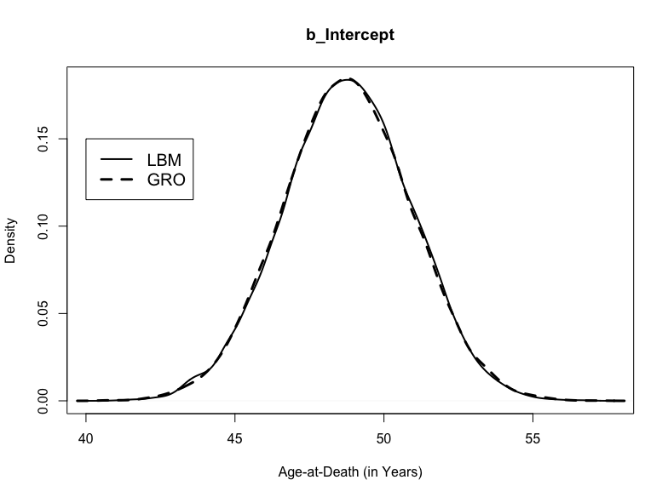

Figure 6.16. Posterior distributions for b_Intercept in the rib PNB-related mortality models informed by the London Bills of Mortality and the General Register Office Reports.

HMC Diagnostics. The HMC simulation for the interaction model involved a total of 20,000 random walks of the posterior parameter space divided equally among four chains with a warmup of 1,000 random walks per chain. HMC diagnostics are provided in Table 6.32. As indicated by $\hat{\text{R}}$ values less than 1.01 and effective sample sizes greater than 400, all chains converged (Vehtari et al., 2021). These findings are confirmed by visual assessment of the HMC chains (Figure 6.17) and a lack of autocorrelation between these chains (Figure 6.18). These diagnostics indicate that the HMC simulation produced a representative sample of the posterior probability distribution for the rib PNB mortality model and that the posterior estimates of model parameters are reliable given the data.
Model Summary. The interaction model fit the data well. It was able to explain 13.89% of the variation in age-at-death observed in this study (90% HDI: 9.65-18.26). The posterior predictive check supports this assertion. As depicted in Figure 6.19, posterior draws based on model specifications are distributed approximately symmetrically around the observed mean of the skeletal data. Posterior parameter estimates for the $β$ coefficients and their 90% CIs are provided in Table 6.33. The posterior distributions for each parameter estimate are depicted in Figure 6.17. Marginal effects plots are provided in Appendix Two. Although individuals from the middle/upper-class tended to live an average of 1.97 years longer than their lower/middle-class counterparts, the difference was not credibly different from chance (90% CI= -2.09-6.02). However, in 78.97% (12635/16000) random walks of the posterior parameter space, being from the middle/upper-class was associated with a higher age at death.
In contrast to these findings, males tended to live longer than females by an average of 7.16 years (90% CI= 4.39-9.91). In fact, being male was associated with a higher age at death in all random walks. Conversely, individuals who presented rib PNB tended to live an average of
Table 6.32. HMC Diagnostics for the rib PNB-related mortality model. Priors based on the London Bills of Mortality.
Parameter | $$\hat{\text{R}}$$ | Effective Sample Size
Parameter | $$\hat{\text{R}}$$ | Bulk | Tail
Intercept | 1.00 | 13845 | 13244
SexMale | 1.00 | 15837 | 11433
ClassMiddle/Upper | 1.00 | 10849 | 11640
RegionSouth | 1.00 | 10111 | 11212
PNBPresent | 1.00 | 15136 | 11896
ClassMiddle/Upper:RegionSouth | 1.00 | 8570 | 10136

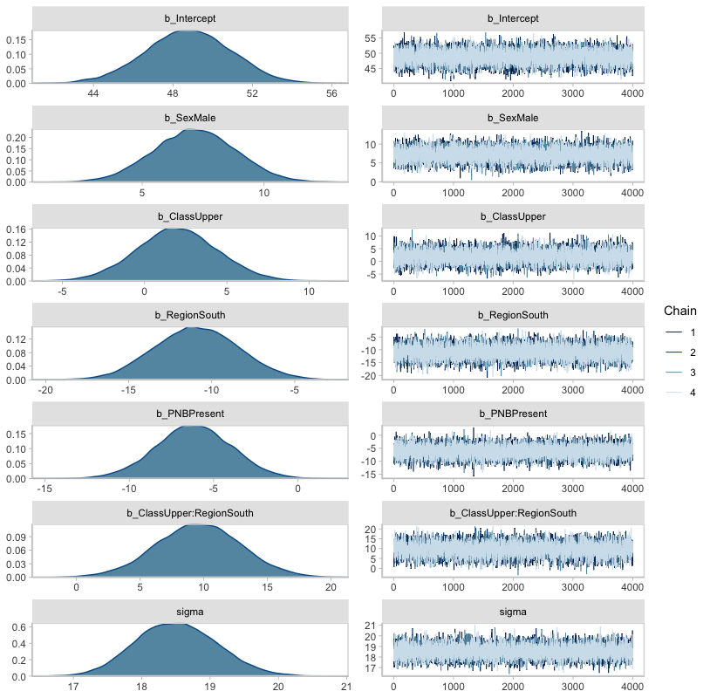

Figure 6.17. Posterior parameter distributions for the rib PNB-related mortality model parameters and accompanying HMC chains. Priors provided by the London Bills of Mortality.

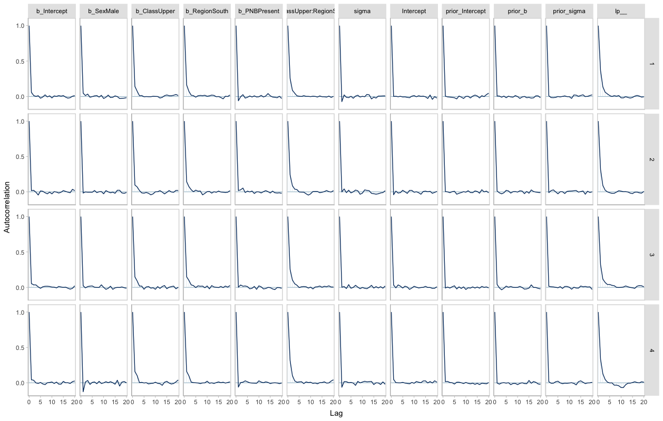
Figure 6.18. Autocorrelation plots for each rib PNB-related mortality model parameter by HMC chain. Priors based on the London Bills of Mortality.

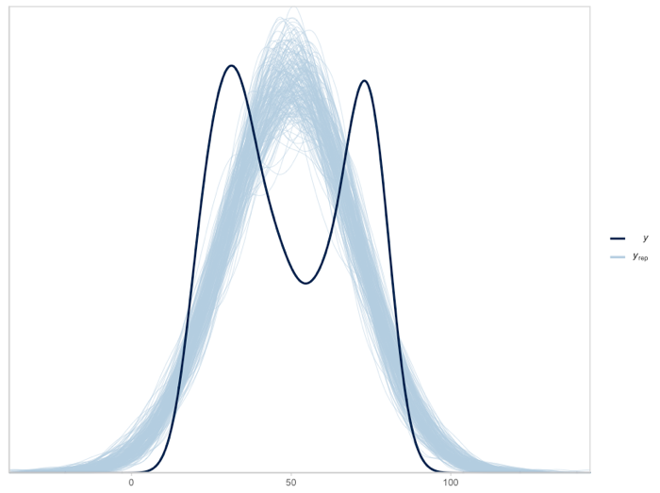
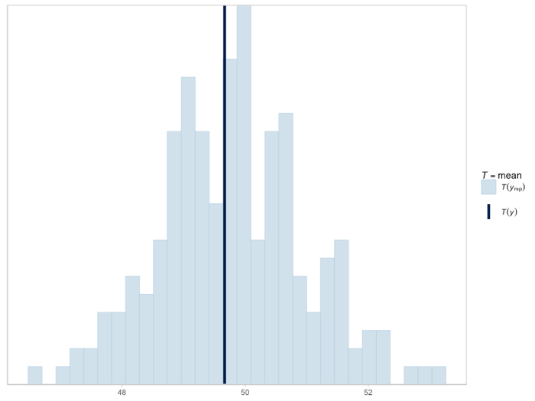
Figure 6.19. Density (left) and histogram (right) depicting posterior draws of age-at-death based on the interaction model for rib PNB-related respiratory mortality (n_{draws}=200). Dark blue lines reflect observed mean. Priors based on the London Bills of Mortality.

Table 6.33. Model summary for the rib PNB-related mortality model. Priors informed by the London Bills of Mortality.
Parameter | Estimate |  | 90% Credibility Interval
Parameter | Estimate | Error | Lower | Upper
Intercept | 48.77 | 2.14 | 45.22 | 52.25
SexMale | 7.16 | 1.68 | 4.39 | 9.91
ClassMiddle/Upper | 1.97 | 2.46 | -2.09 | 6.02
RegionSouth | -10.90 | 2.53 | -15.02 | -6.73
PNBPresent | -6.17 | 2.23 | -9.87 | -2.53
ClassMiddle/Upper:RegionSouth | 9.59 | 3.33 | 4.09 | 15.05
Residual Standard Deviation | 18.51 | 0.60 | 17.57 | 19.52

6.17 fewer years compared to individuals without rib PNB (90% CI= -9.87 - -2.53). Only 0.24% (39/16000) of random walks resulted in a higher age at death for individuals who presented rib PNB. Likewise, southerners tended to live an average of 10.90 fewer years compared to northerners (90% CI= -15.02- -6.73). None of the random walks associated being a southerner with a higher age at death. However, southerners from the middle/upper class tended to live an average of 9.59 years longer than anyone else (90% CI= 4.09-15.05). In only 0.18% of random walks were middle/upper-class southerners associated with a lower age at death. As indicated by the residual standard deviation, $\text{σ}$, the model was able to predict age-at-death with an average error of 18.51 years (90% CI= 17.57-19.52).
Posterior Predictions. MAPs and HDIs of age-at-death for each intersectional group are provided in Table 6.34. Density plots describing the shape of the posterior prediction distributions for each intersectional group are depicted in Figure 6.20. Lower/middle-class females from London in the south with rib PNB tended to die around the estimated age of 31.57 (90% HDI= 27.98-35.41). These individuals were more likely to die younger than females in the other three intersectional groups whose most likely estimated ages-at-death ranged from 42.83 years (90% HDI= 38.16-46.85) and 44.53 years (90% HDI= 40.33-49.02). They were also more likely to die younger than males from the north and middle/upper-class males from London whose most likely ages-at-death ranged from 49.90 years (90% HDI= 45.63-54.05) to 52.08 years (90% HDI= 47.53-55.91). Lower/middle-class males from London in the south with CMS tended to die around the estimated age of 38.96 years (90% HDI= 35.28-42.57). These individuals were more likely to die younger than rib PNB+ males in the other three intersectional groups but their 90% HDI overlapped with those of rib PNB+ females in the north and south, which suggests no difference in rib PNB-related (lower) respiratory mortality between these
Table 6.34. Posterior predictions for the most likely age-at-death for each intersectional group based on the rib PNB-related respiratory mortality model. Priors informed by the London Bills of Mortality.
 |  |  |  | Rib PNB (+) |  |  | Rib PNB (-)
 | Definition |  |  |  | 90% Highest Density Interval |  |  | 90% Highest Density Interval
Group | Region | Class | Sex | MAP | Lower | Upper | MAP | Lower | Upper
A | North | Upper/Middle | Male | 52.08 | 47.53 | 55.91 | 58.02 | 54.61 | 61.17
B | South | Upper/Middle | Male | 50.23 | 46.20 | 54.78 | 56.75 | 53.95 | 59.09
C | North | Lower/Middle | Male | 49.90 | 45.63 | 54.05 | 56.12 | 52.58 | 59.38
D | South | Lower/Middle | Male | 38.96 | 35.28 | 42.57 | 45.19 | 41.33 | 48.66
E | North | Upper/Middle | Female | 44.53 | 40.33 | 49.02 | 50.76 | 47.40 | 54.19
F | South | Upper/Middle | Female | 43.55 | 38.87 | 47.62 | 49.51 | 46.71 | 51.98
G | North | Lower/Middle | Female | 42.83 | 38.16 | 46.85 | 48.76 | 45.23 | 52.26
H | South | Lower/Middle | Female | 31.57 | 27.98 | 35.41 | 37.75 | 34.23 | 41.61

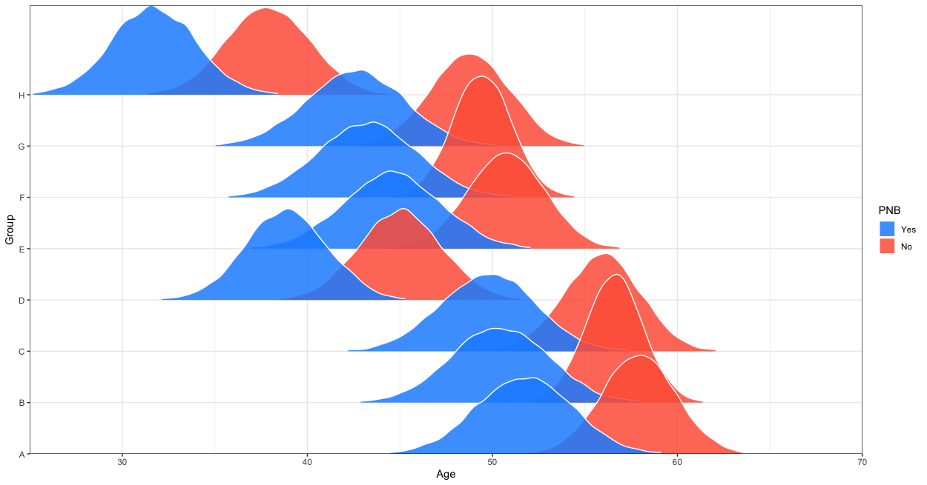Figure 6.20. Comparisons of the posterior predictions of age-at-death (x-axis) for intersectional groups (y-axis) based on rib PNB presence or absence. See Table 6.34 for descriptions of each intersectional group. Prior information based on the London Bills of Mortality. Each distribution includes credible estimates of age-at-death given biological sex, social class, and region of burial with the peak representing the most likely value.

groups. However, the shape of the posterior prediction distribution for these groups suggests probabilistic differences in lower respiratory mortality between lower/middle-class males from London and females from London as well as middle/upper-class females from the north. Lower/middle-class males from London lived, on average, 7.39 years longer than lower/middle class females from London, but 4.59 fewer years than middle/upper-class females from London and 5.57 fewer years than middle/upper-class females from the north. As with the CMS-related respiratory mortality model, among intersectional groups with rib PNB, the width and height of the posterior prediction distributions were largely homogeneous, which suggests similar levels of statistical certainty regarding parameter estimates.
Post Hoc Analysis
Survival analyses were performed post hoc using the non-parametric Kaplan-Meier
estimator to evaluate the time-dependent association between respiratory disease and risk of death, which cannot be elucidated from empirical modeling alone (Wood et al., 1992a). These analyses were performed for both CMS and rib PNB, which were treated as dichotomous outcome variables (i.e., presence or absence). For rib PNB, additional Kaplan-Meier estimates were generated by lesion type (i.e., woven, mixed, lamellar, absent) and chronicity. Here, chronicity refers to the presence of more than one episode of respiratory stress as suggested by the presence of multiple lesion types within the same ribcage. Lastly, a Kaplan-Meier estimate was generated to examine mortality differentials among individuals with both CMS and rib PNB, CMS only, rib PNB only, and neither. Statistical significance was determined by comparing the 90% confidence intervals and determining whether they overlap.

CMS. Of the 507 individuals included in this study, 77.32% (or 392/507) presented at least one maxillary sinus. Of these, 27.81% (109/392) presented CMS. The Kaplan-Meier survival functions for individuals with and without CMS are depicted in Figure 6.21. Median survival time among individuals without CMS was 49.80 years (90% CI= 44.70-54.90). Although median survival time among individuals with CMS was slightly lower at 44.50 years (90%CI= 36.54-52.46), the difference was not statistically significant. A survival table detailing the time until death for individuals with and without CMS is provided in Appendix Three.
Rib PNB. Of the 507 individuals included in this study, 95.27% (483/507) presented at least one rib fragment. Of these, 21.53% (104/483) presented rib PNB. The Kaplan-Meier survival functions for individuals with and without rib PNB are depicted in Figure 6.22. Median survival time among individuals without rib PNB was 53.00 years (90% CI= 48.99-57.04). Median survival time among individuals with rib PNB was significantly lower at 34.20 years (90%CI= 31.82-36.58). A survival table detailing the time until death for individuals with and
without rib PNB is provided in Appendix Three.
Of the 104 individuals with rib PNB, 12.50% (13/104) presented woven, 31.73% (33/104) presented mixed, and the remaining 55.77% (58/104) presented lamellar lesions. The Kaplan-Meier survival functions for individuals with rib PNB by lesion type are depicted in Figure 6.23. As indicated previously, median survival time among individuals without rib PNB was 53.00 years (90% CI= 48.99-57.04). Among individuals with rib PNB, those presenting woven lesions exhibited the lowest median survival time at 29.4 years (90% CI= 23.39-35.41), while individuals with lamellar lesions exhibited the highest median survival time at 36.5 years (90% CI= 30.65-42.35). While median survival time was significantly higher among individuals without rib PNB, median survival time was not significantly different among individuals with
Figure 6.21. Kaplan-Meier survival functions for individuals with and without CMS.

Figure 6.22. Kaplan-Meier survival functions for individuals with and without rib PNB.

Figure 6.23. Kaplan-Meier survival functions for individuals with and without rib PNB by lesion type.

woven, mixed, or lamellar PNB. A survival table detailing the time until death for individuals
with rib PNB by lesion type is provided in Appendix Three.
Of the 104 individuals with rib PNB, 35.58% (37/104) presented evidence of multiple lesion types within the same ribcage, whereas the remaining 64.42% (67/104) of individuals with rib PNB did not. The Kaplan-Meier survival functions for individuals with one or more lesion types within the same ribcage are depicted in Figure 6.24. As indicated previously, median survival time among individuals without rib PNB was 53.00 years (90% CI= 48.99-57.04). Among individuals with rib PNB, those with only one lesion type exhibited the highest median survival time at 36.50 years (90% CI= 32.65-40.35), while those with evidence of multiple lesion types exhibited the lowest median survival time at 30.3 years (90% CI= 27.38-33.22). While median survival time was significantly higher among individuals without rib PNB, median survival time was not significantly different among individuals with one or more lesion types within the same ribcage. A survival table detailing the time until death for these individuals is
provided in Appendix Three.
Co-Occurrence. Of the 507 individuals included in this study, only 73.18% (371/507) presented at least one maxillary sinus and at least one rib fragment. Of these individuals, 33 (or 8.89%) presented both CMS and rib PNB, 42 (or 11.32%) presented rib PNB but no CMS, 75 (or 20.22%) presented CMS but no rib PNB, and the remaining 221 individuals (or 59.57%) presented neither CMS nor rib PNB. The Kaplan-Meier survival functions for co-occurrence of CMS and rib PNB are depicted in Figure 6.25. Individuals who presented both CMS and rib PNB exhibited the lowest median survival time at 34.3 years (90% CI= 30.33-38.27). Individuals who presented neither CMS nor rib PNB exhibited a significantly higher median survival time of 51.60 (90% CI= 46.92-56.28). Likewise, individuals who only presented CMS also exhibited a
Figure 6.24. Kaplan-Meier survival functions for individuals with single and multiple lesion types within the same ribcage.

Figure 6.25. Kaplan-Meier survival functions for individuals with both CMS and rib PNB, CMS only, rib PNB only, and neither CMS nor rib PNB.

significantly higher median survival time compared to individuals who presented both CMS and rib PNB (median= 53.2 years, 90% CI= 44.42-61.98). However, individuals who only presented rib PNB exhibited a similar median survival time compared to individuals who presented both CMS and rib PNB (median= 36.7, 90% CI= 23.84-49.56). A survival table detailing the time until death for individuals with both CMS and rib PNB, CMS only, rib PNB only, and neither CMS nor rib PNB is provided in Appendix Three.

Summary
The objective of this study was to map the burden of respiratory disease among individuals with varying levels of social and economic marginalization. A high burden of respiratory disease was defined as exhibiting the highest odds of presenting respiratory stress and dying at a younger age. I hypothesized that multiply-marginalized individuals (i.e., lower/middle-class females from the north) would exhibit the highest burden of respiratory disease and that the multiply-privileged (i.e., middle/upper-class males from London) would exhibit the lowest burden. Moreover, I expected individuals with a combination of privileged and marginalized identities to fall somewhere between these two extremes. To test this hypothesis, 507 individuals over the estimated age-at-death of 18 years from four skeletal samples were analyzed for skeletal evidence of respiratory stress, including maxillary sinusitis (CMS) and periosteal new bone formation on the visceral surface of the ribs (rib PNB). Following analysis, these individuals were divided into eight intersectional groups defined simultaneously by biological sex, social class, and region of burial (as a proxy for region of residence). These data were embedded in Bayesian respiratory morbidity and mortality models to compare ages-at-death and frequencies of CMS and rib PNB between intersectional groups.
CMS was present in 27.81% of the 392 individuals who presented at least one maxillary sinus. Similarly, rib PNB was present in 21.53% of the 483 individuals who presented at least one rib fragment. The results of an intraobserver analysis indicated 100% agreement in the identification of CMS (n= 15) and rib PNB (n= 15) presence/absence between first and second observations. Agreement was reduced to 80% for CMS (n= 5) and 75% for rib PNB (n= 5) when lesion type was considered.
Hierarchical Bayesian models were run and analyzed in R. Separate respiratory morbidity and mortality models were created for CMS and rib PNB. These models were informed a priori by the London Bills of Mortality and the General Register Office Reports. Because the mortality data from these historic records could not be combined into a single prior probability, separate models were created for each archival source. The Hamiltonian Monte Carlo (HMC) simulation for all hierarchical models failed to converge. Adjusting the size and number of random walks of the posterior parameter space did not solve the problem. Therefore, the models were reparametrized by removing the hierarchical component and model selection tactics (i.e., WAIC and BF) were used to identify the best fit models for CMS- and rib PNB-related respiratory morbidity and mortality models. In all cases, a non-hierarchical model with an interaction between social class and region of burial was preferred.
According to the respiratory morbidity models, middle/upper-class females and males from London in the south exhibited the lowest probability of presenting either CMS or rib PNB. While predictions for the remaining intersectional groups overlapped each other for CMS, the lower/middle-class males and females from London exhibited a probabilistically higher probability of presenting rib PNB compared to the four intersectional groups from the north. A post hoc analysis revealed a significantly higher odds of presenting rib PNB among individuals with CMS compared to those without CMS.
According to the respiratory mortality models, lower/middle-class females and males with either CMS or rib PNB exhibited the lowest average age-at-death, while northern males and middle/upper-class males from London with either of these lesions exhibited the highest average age-at-death. Although the CMS mortality model suggested a marginally higher age-at-death for CMS+ individuals from all intersectional groups compared to their CMS- counterparts, a post hoc survival analysis revealed no statistically significant CMS-related mortality differential. In contrast, the rib PNB mortality model reported a probabilistically lower age-at-death for rib PNB+ individuals from all intersectional groups. These findings were corroborated by a series of post hoc survival analyses, which suggested the presence of a rib PNB-related mortality differential.
Taken together, these findings do not support either of my hypotheses. Except for CMS-related respiratory morbidity, it was the lower/middle-class females from the south – rather than their northern counterparts – who were more likely to experience respiratory disease and then die young potentially because of it. Moreover, middle/upper-class males from the south overlapped with their female counterparts in terms of respiratory morbidity and their northern male counterparts from both social classes in terms of respiratory mortality. Although my hypotheses were not supported, this study revealed intersectional associations that suggest that experiencing multiple social and economic marginalizations influenced respiratory morbidity and mortality. These associations will be discussed within the context of industrializing England alongside additional lines of evidence, including historical research, mortuary context, and archaeological site information in Chapter Seven.

CHAPTER SEVEN:
DISCUSSION

The purpose of this dissertation was to map the burden of respiratory disease among adult urban dwellers from industrial-era England who experienced varying levels of social and economic marginalization in the 18th and 19th centuries. I hypothesized that the probability of presenting respiratory stress would be highest for lower/middle-class females from the north (i.e., the multiply-marginalized) and lowest for middle/upper-class males from the south (i.e., the multiply-privileged). Among those with respiratory stress, I also hypothesized that the most likely age-at-death would be lowest for the multiply-marginalized and highest for the multiply-privileged. The two sections within this chapter evaluate these intersectional hypotheses using the results presented in Chapter Six.

Respiratory Morbidity
According to the respiratory morbidity models presented in Chapter Six, neither biological sex nor social class were credible predictors for presenting maxillary sinusitis (CMS) or periosteal new bone (PNB) formation on the visceral rib. Likewise, the model for CMS failed to detect an association between region of burial and upper respiratory stress, though the model for rib PNB was able to demonstrate a relationship between region of burial and lower respiratory stress. However, for both respiratory morbidity models, the inclusion of interaction terms revealed three-way associations between social class, region of burial, and both CMS and rib PNB that were credibly different from chance. Moreover, the posterior predictions for the probability of presenting CMS and rib PNB among intersectional groups revealed evidence of variation in upper and lower respiratory morbidity, though not to the extent expected by my first hypothesis.
Independent Effects: Biological Sex, Social Class, and Region of Burial
Biological Sex. Males and females exhibited similar odds of presenting CMS and rib PNB. It is generally understood that the sexual division of labor intensified during the Industrial Revolution with men working in occupations, such as mining, construction, and metalwork, where strength was required to operate heavy machinery, and women working in textile factories, domestic service, and agriculture (Burnette, 2008; Bythell, 1993; de Vries, 2008; Trinder, 2013). Thus, one might have expected to see differences in the odds of presenting CMS and rib PNB presumably due to differences in exposure to pollutants, microbes, and allergens in the workplace. However, previous studies of industrial-era urban communities (e.g., Boyd, 2020; Casna et al., 2021; Roberts, 2007; Western & Bekvalac, 2020) have been unable to demonstrate sex differences in CMS and rib PNB morbidity. Studies of living populations in industrializing (e.g., Kim et al., 2016; Shi et al., 2015) and industrialized countries (e.g., Buele, 2015; Smith et al., 2009) have also been unable to demonstrate sex differences. However, previous studies suggest that tuberculosis (Holmes et al., 1998) and other lower respiratory tract infections (Falagas et al., 2007) are more prevalent in males compared to females globally. Falagas and colleagues (2007) hypothesize that the sex differences in the prevalence of lower respiratory disease are associated with anatomical, behavioral, and socioeconomic factors. For example, peripheral airways are narrower in males compared to females in early life, which may increase susceptibility to lower respiratory tract infections in adulthood.
That males and females exhibited similar odds of presenting CMS provides evidence in support of the argument made by feminist historians, such as Joyce Burnette (2008), that women were active participants in England’s industrial-era economy despite a changing gender ideology that sought to marginalize women’s work outside the home. They were working similar jobs to men and were thus exposed to similar occupational hazards. It should be noted that the odds of presenting CMS were higher among males compared to females but only in 18.48% of 16,000 random walks of the posterior parameter space. Thus, though the odds were not credibly different from chance based on the 90% HDI for the effect of biological sex (i.e., the 90% HDI contained the null value of zero), the slightly higher odds of presenting CMS among females in a majority of the random walks is consistent with the epidemiological literature (e.g., Falgas et al., 2007) and may suggest that women were more susceptible to CMS because of prolonged exposure to coal consumption in the home. This may have been the case for women who did not work for wages as well as for their counterparts who worked in cottage industry or as live-in servants. However, that females have smaller sinus ostia and, consequently, less efficient mucociliary clearance compared to males may also explain the increased susceptibility to CMS among females observed in this study (Falgas et al., 2007).
That there were similarities in the odds of presenting rib PNB between males and females provides further support for Burnette’s (2008) argument. However, the presence of a negative association between age-at-death and rib PNB frequency suggests that mortality may not have discriminated between males and females when selectively removing individuals with previous experiences of lower respiratory disease from the once-living population (Wood et al., 1992b). That is, similar frequencies of rib PNB between males and females may reflect similarities in mortality risk between the sexes due to lower respiratory stress as opposed to similarities in respiratory morbidity in the once-living population.
Social Class. The lower/middle- and middle/upper-classes exhibited similar odds of presenting CMS and rib PNB. There is ample evidence to suggest that experiences of respiratory stress were likely greater among the working- than the upper-classes. Although individual experiences likely varied across industries and regions of the country, working-class wage-laborers endured long work hours in hazardous environments due to a lack of safety regulations until at least the middle of the 19th century (Engels, 1892; Stearns, 2007; Trinder, 2013; de Vries, 2008). Working-class individuals lived in poorly ventilated, multi-occupancy homes, which facilitated the spread of infectious diseases, including tuberculosis (Brimblecombe, 1987). Until the latter half of the 19th century when advances in medicine generated anxiety about health, most working-class individuals lacked adequate nutrition (de Vries, 2008). They did not have time to cook healthy meals or the financial resources to access fresh fruits, vegetables, and meat. Instead, they ate foods, such as bread, porridge, and cheese that were cheap or required little to no preparation. These living and working conditions were in stark contrast to those of many upper-class individuals who often owned large manors, employed live-in servants to prepare their meals, and were able to flee the city during periods of heavy smog to get fresh air either by staying in their second homes in the nearby countryside, visiting rural family members for prolonged periods of time, or vacationing to other places (Brimblecombe, 1987). These differences in the living and working conditions between social classes have been invoked in previous bioarchaeological research (Bernofsky, 2010) to explain associations between social class and CMS and rib PNB frequencies observed in industrial-era London. Even studies of living populations have cited increased exposure to air pollution and poor nutrition, as well as exposure to dusts in the workplace, limited access to health care, and tobacco smoking, to explain observed associations between socioeconomic status and respiratory health (Akinbami et al., 2016; Bhan et al., 2015; Chen et al., 2003; Hegewald & Crapo, 2017; Kim et al., 2011; Miller et al., 2014; Rocha et al., 2019). These studies show that the negative impact of poverty on respiratory health persists after over a century of regulations designed to reduce indoor and outdoor pollution, prevent occupational exposures, and dissuade people from smoking! Thus, the lack of an association between social class and CMS and rib PNB morbidity is perplexing.
There is some evidence of a greater odds of presenting CMS among the lower/middle class. In 68.14% of 16,000 random walks of the posterior parameter space, the odds of presenting CMS were higher among the lower/middle class. This may suggest that a larger sample size is needed for the model to be able to detect an effect. In contrast, there is no evidence of a greater odds of presenting rib PNB among the lower/middle class as nearly half (53.42%) of the random walks of the posterior parameter space resulted in a higher odds of presenting lesions. It is possible that the popularization of tobacco smoking, particularly among the middle- and upper-classes could have increased their susceptibility to respiratory disease given the negative impact of tobacco smoke on the mechanical and immune functions of the respiratory mucosa (Goodman, 1994; Bourke, 2007; Brook & Hausfeld, 2011; Christensen et al., 2018; Loebinger & Wilson, 2012; Tamashiro et al., 2009; Van der Poll & Opal, 2009). Moreover, coal was a common domestic fuel source during the 18th and 19th century regardless of social class, which suggests that even wealthier individuals were exposed to the noxious fumes emanating from fireplaces (Brimblecombe, 1987). However, exposure would have likely been more direct among servants of middle- and upper-class homes, which further suggests that a difference in respiratory morbidity should have been observed between social classes.
At face value, these findings suggest that poor air quality was ubiquitous in urban centers regardless of social class. However, as with biological sex, the presence of a negative relationship between age-at-death and rib PNB frequency suggests that similarities in rib PNB frequency between social classes may reflect greater mortality risk regardless of social class. That is, mortality selectively removed everyone with rib PNB from the once-living population creating a skeletal sample biased by those who experienced lower respiratory disease (Wood et al., 1992b). This would have been especially the case prior to the development of antibiotics and other curatives for diseases, such as tuberculosis and pneumonia (Brimblecombe, 1987).
Another important factor to consider is that social class is a difficult concept to apply to skeletal samples, especially in the absence of biographic information for individual skeletons. Unlike the working- and upper-classes, the middle-class was economically diverse (Boberg- Fazlic & Sharp, 2011). At the lower end of the income scale were skilled laborers, such as artisans, carpenters, blacksmiths, and bakers. At the upper end were business owners, bureaucrats, entrepreneurs, lawyers, and doctors. Individuals from a diverse array of economic circumstances occupied the same social stratum of English society yet likely lived very different lives, with some at risk of falling into the working class and others on the cusp of rising into the upper class (Boberg-Fazlic & Sharp, 2011; Engels, 1892). However, biographical information about individual skeletons was not available for a majority of the individuals included in this study. While archaeological site context and archival records can be used to generate a rough estimate of the social class(es) represented by a particular skeletal assemblage, there will likely be outliers who introduce statistical noise into group-level analyses that consider the effect of social class. In this study, I used the categories of lower/middle and middle/upper to denote the reality that my skeletal samples are imperfect representations of impoverished and affluent communities in England. Yet, even with this distinction, it is possible that wealthy middle-class individuals are present in the lower/middle-class samples and that relatively unwealthy middle-class individuals are present in the middle/upper-class samples. This may explain observed similarities in CMS and rib PNB morbidity.
Region of Burial. Northerners and southerners exhibited similar odds of presenting CMS but differed in their odds of presenting rib PNB. The north was known as the epicenter for heavy industry in England (Trinder, 2013). Coal fields were abundant, particularly in the northeast, and provincial towns were built around large-scale manufacturing. While London was a center for manufacturing as well, it was primarily an administrative center. Moreover, differences in latitude and climate between the north and south meant that northerners were more likely to experience vitamin D deficiency and spend more time inside poorly ventilated, coal-burning homes due to colder weather (Brimblecombe, 1987; Mays et al., 2018). This historical evidence is supported by bioarchaeological studies whose findings suggest that northerners in urban centers may have experienced a greater risk of recurrent vitamin D deficiency, particularly during the winter months (e.g., Mays et al., 2008; Newman et al., 2019). Because vitamin D is vital for immune function (Mostafa et al., 2015; Shahangian & Schlosser, 2016), a heavier burden of vitamin D deficiency among northerners likely increased susceptibility to upper and lower respiratory infection. More time spent indoors to keep warm would have increased exposure to indoor air pollution, which may have also increased susceptibility to respiratory disease. Air pollution can also damage the respiratory mucosa, predisposing affected individuals to respiratory infection (Bagchi, 1992; Bhattacharyya, 2009; Bruce et al., 2000; Hiraiwa & van Eeden, 2013; Hooper et al., 2018; Lebowitz, 1996; Ross & Murray, 2004; Scalia et al., 2020; Sirajuddin & Kanne, 2009; Taziki et al., 2019; Trevino, 1996). Given all of this, I expected to observe greater CMS and rib PNB morbidity among northerners compared to southerners, but this was not the case. In fact, there was no observed association between region and CMS frequency and the association that was observed between region and rib PNB was the reverse of what was expected.
Despite no observed association between region of burial and CMS, 62.87% of random walks of the posterior parameter space resulted in a greater odds of CMS among southerners compared to northerners. This pattern held for rib PNB as well but occurred in 99.13% of random walks. London was the largest city in the world in the 18th and 19th centuries, and Brimblecombe (1987) has argued that it was likely also the most polluted. The city limits did not expand proportionately to accommodate London’s growing population, creating a situation in which many individuals were exposed to massive amounts of indoor and outdoor air pollution largely due to domestic and industrial coal consumption. The threat of infectious disease was also heightened in London, as tuberculosis devastated impoverished communities (Landers, 2006; Loddenkemper & Murray, 2021, Roberts & Cox, 2003).
At face value, the findings of this study suggest that the deleterious living and working conditions in London exerted a greater impact on respiratory morbidity than the combined effects of vitamin D deficiency and colder weather in the north. While these findings are perplexing given the historical and bioarchaeological evidence discussed above, they do make sense within the context of this study. Two of my samples derive from London, the metropolis of the world and capital of England. My other two samples, however, derive from the northern industrial towns of North Shields and Barton-upon-Humber. These towns were smaller than the great northern provincial towns (e.g., Birmingham and Manchester). And they did not experience rapid development until the 19th century (Proctor et al., 2014; Waldron, 2007). Moreover, even today, these towns are nowhere near the size or influence of London or the northern provincial towns. Thus, it is unsurprising that CMS and rib PNB morbidity was greater in London. As a result, my use of skeletal samples from industrial towns calls into question whether the effect of region observed in this study reflects an actual regional effect or sampling bias. It should be noted, however, that North Shields and Barton were located just outside northern provincial towns. In light of recent evidence suggesting a spillover effect of outdoor air pollution from urban centers into the nearby English countryside during the 18th and 19th centuries (Boyd, 2020), it could be argued that patterns of respiratory stress observed in the Coach Lane and St. Peter’s Church skeletal samples reflect the living and working conditions of the urban north.
It is important to note that I used region of burial as a proxy for region of residence. That is, I made the assumption that people lived and died in the same place throughout the life course. However, during the 18th and 19th centuries, enclosure of communal farmlands and technological advances in transportation facilitated the movement of people across the landscape (Brimblecombe, 1987; Trinder, 2013). Thus, this assumption may not hold for the individuals included in my study. Individuals moved from rural to urban areas and from the north to the south in search of opportunities for work. Moreover, wealthier individuals may have owned homes in different areas of the country and likely took vacations to get fresh air (Brimblecombe, 1987). Therefore, migration and intermittent, short-term movement across the landscape during one’s life may have impacted their respiratory health and biased my findings.
Interaction Effect: Social Class and Region of Burial
The independent effects of biological sex, social class, and region of burial make more sense when examined through the lens of intersectionality. Posterior predictions for each intersectional group derived from the CMS morbidity model revealed two clusters (see Figure 6.5). The first cluster included middle/upper-class males and females from London who were positioned at the lower end of the probability gradient with maximum a posteriori (MAP) estimates between 0.00-0.01 or 0-1%. The second cluster included all remaining intersectional groups who were positioned at the higher end of the gradient with MAPs ranging between 0.31-0.46 or 31-46%. Importantly, the 90% highest density intervals (HDIs) for these clusters did not overlap, indicating that the intersectional groups comprising the first cluster were much less likely to present CMS compared to the intersectional groups comprising the second cluster. Moreover, the posterior distributions for the first cluster were narrow with high peaks, which suggests greater certainty in the MAPs for the intersectional groups in this cluster. In contrast, the posterior distributions for the second cluster were extremely wide with low peaks, suggesting comparatively greater uncertainty in the MAPs for the groups in this cluster.
Likewise, posterior predictions for each intersectional group derived from the rib PNB morbidity model revealed three clusters (see Figure 6.10). As with CMS, the first cluster included middle/upper-class males and females from London who were positioned at the lower end of the probability gradient with MAP estimates between 0.07-0.08 or 7-8%. The second cluster included the lower/middle-class males and females from London who were positioned at the higher end of the probability gradient with MAP estimates between 0.67-0.70 or 67-70%. The third cluster included all four intersectional groups from the north who were positioned in the middle of these two extrema with MAP estimates between 0.43-0.47 or 43-47%. The 90% HDIs for the first and second clusters did not overlap, which suggests that the posterior probability of presenting rib PNB was much lower among middle/upper-class Londoners compared to their lower/middle-class counterparts. Likewise, the 90% HDIs for the first and third clusters did not overlap, suggesting that the posterior probability was much lower among the former. In contrast, the 90% HDIs for the second and third clusters did overlap, which might suggest that the intersectional groups within these clusters exhibited a similar probability of presenting rib PNB. However, the shapes of the posterior distributions suggest that the probability of presenting rib PNB was probabilistically different between these two clusters. Moreover, the posterior distributions for the first cluster were narrow with high peaks, though comparatively less narrow for rib PNB compared to CMS morbidity. The posterior distributions for the second and third clusters were wider with lower peaks. However, the distributions for the second cluster were narrower and taller than the third.
It is interesting that the impact of social class on the posterior probability of presenting CMS and rib PNB was drastically different between intersectional groups in the north and the south. Middle- and upper-class Londoners were some of the wealthiest people in England if not the world during the 18th and 19th centuries (Stearns, 2007; Trinder, 2013). They included bureaucrats, business owners, administrators, merchants, craftspersons, and the independently wealthy. They had access to enough capital to afford to live in London and, in the case of business owners, to run a business within the city limits, which was much more expensive than elsewhere in the country (Engels, 1892; Stearns, 2007; Trinder, 2013). Their wealth afforded them the political power to influence legislation in their favor, the privilege to access medical care from their homes, and the means to spend time away from work to recover from their injuries and illnesses (Engels, 1892; Waddington, 1982). Such privileges were not available to the working class whose members lived in poorly ventilated, multi-occupant homes in crowded neighborhoods where they risked exposure to infectious diseases, noxious fumes due to domestic coal consumption, and waterborne illnesses, such as cholera, because of a lack of access to clean water (Brimblecombe, 1987; DeWitte et al., 2016). Their ability to access medical care was dependent on charity and even if they could afford treatment, they were not always able to take the time to recover from their health insults (Andrew, 1989; Bronstein, 2008; Granshaw, 1993; Porter, 1995; Waddington, 1984). Thus, differences in the living and working conditions among the social classes in London may explain why social class impacted CMS and rib PNB morbidity in the south but not in the north.
As discussed above, another reason for regional differences in the impact of social class on CMS and rib PNB morbidity may be that Barton-upon-Humber and North Shields did not experience rapid urbanization until the 19th century (Proctor et al., 2014; Waldron, 2007). Without the backdrop of an already massive, polluted cityscape with residential and workplace segregation being heavily influenced by social class, it is possible that the living and working conditions were similar or, more likely, less polarized between the working-class occupants of North Shields and their upper-class counterparts in Barton.
As mentioned previously, a factor complicating interpretations of the interaction between class and region within the context of CMS and rib PNB morbidity is the lack of biographic information about individual skeletons in the skeletal samples included in this study. While it is easier to classify London samples into categories of social class owing to an abundance of historical and archaeological information, it is much more difficult to classify samples outside the metropolis. The Coach Lane sample represents a Quaker community in the northeast (Proctor et al., 2014). Despite social and economic marginalization by the Church of England in previous centuries, many Quakers prospered during the industrial period (Mingins, 2003; O’Donnell, 2009; Pratt, 1985; Roberts, 2004; Vann, 1969). They strived towards a plain lifestyle free of vanity and greed but were commonly employed in manufacturing, commerce, and agriculture. While historical documents and burial context suggests that the Quakers in the Coach Lane sample were mostly working-class individuals (Boyce, 1889; Grzybowska, 2011; Watson, 1864), it is possible that there are some wealthier middle-class individuals included in the sample as well. Likewise, the individuals in the St. Peter’s Church sample are predominantly from the middle and upper classes (Watts, 2013), though it is possible that some of the individuals buried outside the church that were included in this study were from the working and lower classes. This is evinced by coffin construction materials (e.g., nails, grips, and hinges) that suggest the presence of parishioner’s coffins, which were provided for those whose surviving family members could not afford a coffin (Rodwell & Atkins, 2011). Only 19.39% (19/98) of the individuals included in the St. Peter’s Church sample whose burial locations were recorded had been interred within the church. The greater number of individuals buried outside the church questions how representative the St. Peter’s Church sample is of the middle- and upper-classes in Barton. The potential overlap in terms of social class between the skeletal samples in the north may account for similarities in CMS and rib PNB morbidity observed among northern intersectional groups in this study.
CMS. Considering similarities in CMS morbidity between the Coach Lane and St. Peter’s Church skeletal samples, it is interesting that the posterior distributions for the northern intersectional groups derived from these skeletal samples overlapped completely with the lower/middle-class Londoners. At face value, this suggests that northerners from both the lower/middle- and middle/upper-classes were exposed to similar CMS-inducing environmental hazards. It is possible that urban living conditions in the north were similar to the living conditions among the lower/middle-class in London, namely in terms of domestic coal consumption, crowded housing, and poor sanitation (Brimblecombe, 1987; Newman et al., 2019). This possibility is supported by historical research suggesting that rapid urbanization in North Shields and Barton in the 19th century may have created similar conditions to what Londoners had been experiencing for centuries (Proctor et al., 2014; Waldron, 2007). As mentioned above, it is also possible that the location of these industrial towns just outside major provincial towns may have resulted in excessive outdoor air pollution that, when combined with sources of indoor air pollution and close quarters living, increased the burden of upper respiratory disease in the north (c.f. Boyd, 2020).
These findings support the idea that middle/upper-class Londoners were among the wealthiest members of English society with environmental privileges (e.g., owning large homes in the countryside and going on vacation to get some fresh air) that protected them from prolonged exposure to allergens, pollutants, and microbes that cause CMS. This idea that wealth was a protective factor for CMS is further supported by the fact that the posterior distributions for middle/upper-class males and females from London were narrower and taller than any of the other intersectional groups. The protective effect of wealth may have been so great that – barring any measurement error – it negated the upper respiratory health impacts of other potentially marginalizing identities hidden within the archaeological record.
It should be noted that middle/upper-class males and females from London derive from the St. Bride’s Fleet Street sample, which I was unable to examine due to the COVID-19 pandemic. While researchers at the Museum of London relied on the same methodology for recording CMS that was used in this dissertation, they did not use endoscopy to examine nearly complete maxillary sinuses (Powers, 2012). Therefore, the frequency of CMS in the St. Bride’s Fleet Street sample is likely higher than reported. This possibility is further suggested by evidence of a higher frequency of CMS in the St. Bride’s Fleet Street sample reported by Bernofsky (2010). Moreover, although I used endoscopy in my study, I did not drill into complete maxillary sinuses. Therefore, CMS morbidity is likely underestimated for the Coach Lane, St. Peter’s Church, and New Bunhill Fields samples as well. This is especially the case for the latter two samples that contained a high proportion of complete and inaccessible sinuses.
Despite these limitations, there is evidence of intersectionality in the effects of biological sex, social class, and region of residence on CMS morbidity. However, the distribution of burden was not as expected. I expected middle/upper-class males from London to exhibit the lowest and lower/middle-class females from the north to exhibit the highest posterior probability of CMS. Instead, both middle/upper-class males and females from London exhibited equally low CMS morbidity and all four of the remaining intersectional groups exhibited equally high CMS morbidity. Given these findings, the CMS data do not support my first hypothesis.
Rib PNB. In contrast to CMS, rib PNB morbidity among lower/middle- and middle/upper-class intersectional groups from the north differed from the lower/middle-class intersectional groups from London in the south. Although the 90% HDIs for these two clusters of intersectional groups overlapped, the clusters were distributed differently such that presenting rib PNB was probabilistically more likely among lower/middle-class Londoners compared to all the intersectional groups from North Shields and Barton-upon-Humber. These findings explain why, contrary to my expectation, the posterior probability of presenting rib PNB was greater among southerners compared to northerners.
In line with the argument made by Brimblecombe (1987), the deleterious living and working conditions among the London poor rendered them susceptible to lower respiratory infections, such as tuberculosis and pneumonia. These findings are important because they suggest, first, that classism in industrial-era London disproportionately impacted the respiratory health of the working-class, and second, that this impact outweighed the negative health impacts of heavy industry on northerners from all social classes. However, as mentioned above, that there was an association between age-at-death and rib PNB frequency suggests the presence of mortality bias. It could be that working-class Londoners were more likely to experience lower respiratory stress. Alternatively, it could be that they were more likely to succumb to their lower respiratory stressors, increasing the number of individuals with evidence of rib PNB in the skeletal samples from London (c.f. Wood et al., 1992b).
These possible scenarios are supported by epidemiological research that posits a relationship between early life respiratory insults and increased susceptibility to respiratory morbidity and mortality in adulthood (Galobardes et al., 2007). During the 18th and 19th centuries, children’s health declined, and rates of infant and child mortality increased (Chadwick, 1842; Wohl, 1983). Overcrowding, air pollution, inadequate sanitation, and poor diets resulted in recurrent or cyclical experiences of metabolic diseases among children, such as vitamin C and vitamin D deficiency (Ives, 2018; O’Donoghue et al., 2021). Ives (2017) demonstrates that in impoverished parish communities in London, such as Benthal Green, respiratory and gastrointestinal infections were prominent among children as well. Thus, it is unsurprising that adult males and females from the lower/middle-class in London exhibited the highest posterior probability of presenting rib PNB. While they represent a cohort of individuals who were able to survive the perils of childhood, the adversity that these individuals experienced in childhood may have translated into increased susceptibility to lower respiratory disease in adulthood.
These findings support the idea that wealthy Londoners had environmental privileges that buffered them against lower respiratory disease. They also suggest that impoverished individuals living in the same city as these wealthy Londoners occupied spaces that exposed them to environmental hazards that negatively impacted their respiratory health. Importantly, these impoverished individuals may have already been at a disadvantage compared to their wealthier counterparts due to adverse respiratory health experiences in childhood that rendered them susceptible to lower respiratory disease in adulthood. These inferences are supported by the fact that the posterior distributions for middle/upper-class males and females from London were narrower and taller than any of the other intersectional groups. As with CMS, the protective effect of wealth was so great that it may have negated the lower respiratory health impacts of other potentially marginalizing identities hidden within the archaeological record. Unlike CMS, the posterior distributions for lower/middle-class London males and females were narrower and taller than those of all four northern intersectional groups, which suggests that – barring any measurement error – the negative effect of poverty may have been sufficient to have diminished the protective effects of other potentially privileging identities unaccounted for in this study.
It should be noted that information about rib preservation was limited for the St. Bride’s Fleet Street sample due to the restrictions placed on access to the remains in response to the COVID-19 pandemic. Recent methodological changes proposed by Davies-Barrett and colleagues (2019) were implemented in this study but were non-existent at the time that researchers at the Museum of London analyzed the individuals from the St. Bride’s Fleet Street. Therefore, I was unable to calculate individual and mean ribcage fragmentation scores, which are useful for comparing preservation between skeletal samples. This is problematic because I observed a statistically significant association between rib cage fragmentation score and rib PNB frequency, which suggests that differences in preservation between sites may have impacted my findings.
Despite this limitation, there is evidence of intersectionality in the effects of biological sex, social class, and region of residence on rib PNB morbidity. However, the distribution of burden was not as expected. I expected middle/upper-class males from London to exhibit the lowest and lower/middle-class females from the north to exhibit the highest posterior probability of rib PNB. Instead, middle/upper-class Londoners exhibited the lowest posterior probability, their lower/middle-class counterparts exhibited the highest posterior probability, and the four intersectional groups from the north fell between these two extremes. Given these findings, the rib PNB data also do not support my first hypothesis.

Respiratory Mortality
According to the respiratory mortality models presented in Chapter Six, there was no detectable relationship between CMS and age-at-death when biological sex, social class, and region of burial were held constant. However, there was a negative relationship between rib PNB and age-at-death. These findings were confirmed by post hoc Kaplan-Meier survival analysis. Additionally, the posterior predictions of age at death among intersectional groups revealed evidence of variation in respiratory mortality, though not to the extent expected in my second hypothesis.
Independent Effects: CMS and Rib PNB
There were similarities in the most likely age-at-death between individuals with CMS and those without. These empirical findings were confirmed by a Kaplan-Meier survivorship analysis, which revealed no significant difference in mean survival time based on the presence or absence of CMS (44.50 vs. 49.80 years). Together, these findings suggest that individuals who experienced CMS were no more likely to die younger than their counterparts without CMS. Therefore, it is unlikely that the inferences made about CMS morbidity are influenced by mortality bias, which makes sense given that the case fatality rate for CMS in living populations is low, even without antibiotics (Orlandi et al., 2016). As a result, differences in CMS morbidity between the intersectional groups reported in the previous section likely reflect differences in exposure to environmental hazards that predisposed all but the wealthiest individuals in this study (i.e., middle/upper-class Londoners) to experiences of upper respiratory disease. It should be noted, however, that in 90.01% of 16,000 random walks, individuals with CMS were predicted to have died at older ages than those without CMS. These findings might suggest that CMS morbidity reflects an accumulation of upper respiratory infections over the life course. If so, then the presence of CMS in older individuals would paint a picture of a lifelong struggle with environmental hazards at home, in the workplace, and outdoors that may have negatively impacted quality of life (Klonaris et al., 2019; Marambaia et al., 2013; Nguyen et al., 2019).
There was a probabilistic difference in the most likely age-at-death between individuals with rib PNB and those without rib PNB. Individuals with rib PNB were more likely to die an average of 6.17 years earlier than their counterparts without rib PNB. This negative association between age-at-death and rib PNB presence or absence was confirmed by a Kaplan-Meier survivorship analysis, which revealed a significant difference in median survival time of 18.80 years. A follow-up survivorship analysis revealed no significant difference in median survival time between individuals with both CMS and rib PNB and those with rib PNB only. Thus, while individuals with CMS were twice as likely to present rib PNB compared to those without (see Chapter Six), the mortality risk for individuals with both lesion types was no different from their counterparts with just rib PNB. Together, these findings suggest that individuals with rib PNB were dying at much younger ages than those without rib PNB. These findings make sense given that tuberculosis is one of the most common causes of pleural disease, especially among younger populations (Cargill et al., 2019; Marel et al., 1993; Mbata et al., 2015; Porcel & Light, 2006; Valdés et al., 1996). As mentioned in Chapter Two, prior to the development of antibiotics in the middle of the 20th century, there was no cure for tuberculosis (Iseman, 2002; McCullough & Lehrer, 2018). While there were various treatments that differed in their ability to alleviate symptoms and prolong life, tuberculosis was a fatal disease that took the lives of nearly a quarter of the English population during the 18th and 19th centuries (Landers, 2006). There were also no available cures for other less common respiratory causes of rib PNB, such as pneumonia, actinomycosis, and the pneumoconioses (i.e., silicosis, asbestosis, mesothelioma) (Donaldson et al., 2017; Porter, 2006). It should be noted that while there is an association between age-at-death and rib PNB presence or absence, it is impossible to know what the ultimate cause of death was for the individuals in this study. It may be that lower respiratory disease caused death. However, it may also be that experiences of lower respiratory disease simply exacerbated existing health insults or impacted the exposure-outcome relationship for some other, competing cause of death (c.f., Wood et al., 1992b).
Given the presence of mortality bias, frequencies of rib PNB in this study likely do not reflect lower respiratory morbidity. That is, the findings of this study suggest that mortality selectively removed individuals with current or previous experiences of lower respiratory disease from the once-living population, creating a death assemblage with a higher proportion of individuals with evidence of lower respiratory disease than what would have been observed among the living (c.f., Wood et al., 1992b). This means that the direct inferences about rib PNB morbidity made in the previous section are likely biased and that the alternative explanations involving the dynamics of mortality that were also discussed are more probable.
Interaction Effect Revisited: Social Class and Region of Burial
The independent effects of CMS and rib PNB on age-at-death make more sense when viewed through an intersectional lens. Posterior predictions for each intersectional group derived from the CMS mortality model did not reveal any clusters (see Figure 6.15). Rather, all intersectional groups appeared to be individually located along a gradient with CMS+ middle/upper-class London males exhibiting the highest and their lower/middle-class female counterparts exhibiting the lowest MAP estimates for age-at-death. In general, CMS+ middle/upper-class males from both the north and south, as well as lower/middle-class males from the north, were dying in their 50s or 60s, and their female counterparts were dying in their 40s or 50s. In contrast, CMS+ lower/middle-class males and females from London were dying in their 30s and 40s. The 90% HDI for lower/middle-class females from the south overlapped with (but was probabilistically different from) their male counterparts. They did not overlap with any other intersectional group. In contrast, the 90% HDI for CMS+ middle/upper-class males from the south overlapped with multiple CMS+ intersectional groups, including lower/middle- and middle/upper-class males from the north. CMS+ middle/upper-class males from London also overlapped with middle/upper-class females from the north and south but were probabilistically different. The posterior distributions for all CMS+ intersectional groups were similar in terms of width and height.
In contrast, posterior predictions for each intersectional group derived from the rib PNB mortality model revealed four clusters (see Figure 6.20). The first cluster included rib PNB+ middle/upper-class males from the north and south, as well as rib PNB+ lower/middle-class males from the north, whose MAP estimates for age-at-death were between 49.90-52.08 years. The second cluster included rib PNB+ middle/upper-class females from the north and south, as well as rib PNB+ lower/middle-class females from the north, whose MAP estimates for age-at-death were between 42.83-44.53 years. The third cluster included rib PNB+ lower/middle-class males from London whose MAP estimate for age-at-death was 38.96 years. Lastly, the fourth cluster included rib PNB+ lower/middle-class females from London whose MAP estimate for age-at-death was 31.57 years. The 90% HDIs of the first and second clusters overlapped but were probabilistically different, suggesting that individuals in the former were dying at older ages compared to their counterparts in the latter. This pattern also held for the second and third clusters, who overlapped but were probabilistically different with the former dying at older ages compared to the latter. In contrast, the first and third clusters did not overlap and neither did the second and fourth nor the third and fourth clusters. Additionally, as with CMS, the posterior distributions for all intersectional groups with rib PNB were similar in terms of width and height.
Although the intersectional groups included in the CMS mortality model did not cluster as neatly as those in the rib PNB mortality model, the general distributions of modal age-at-death are similar, possibly due to an underlying mortality schedule for these groups that exists regardless of respiratory disease experience. That is, the difference in most likely age-at-death between CMS+ or rib PNB+ intersectional groups and their CMS- or rib PNB- counterparts is similar across different intersectional groups, suggesting that respiratory diseases, particularly those that can cause rib PNB, may have merely exacerbated mortality risk as opposed to completely altering the dynamics of mortality at the time. This is supported by historical and bioarchaeological evidence that can explain the intersectional distributions of age-at-death observed in this study.
Differences in age-at-death between middle/upper-class males and females regardless of region of burial can be explained, in part, by changes in maternal mortality that took place during the 18th and 19th centuries. At this time, middle- and upper-class women experienced heightened maternal mortality arising from the replacement of midwifery, an ancient profession, with obstetrics, which was a comparatively nascent branch of medicine that did not gain traction until the 18th century (Buer, 2013; Loudon, 1986). While advances in medicine during the Industrial Revolution resulted in improvements in knowledge of the female urogenital system, obstetric practices were arguably more invasive than the techniques used by midwives during childbirth. Prior to the development of anti-septic techniques in the latter half of the 19th century, such invasive practices likely increased rates of postpartum hemorrhage and sepsis (Buer, 2013; Loudon, 1986; Porter, 2006), resulting in an increase in maternal mortality risk. However, according to the CMS and rib PNB mortality models, middle/upper-class females were more likely to die in their 40s and 50s during the transition to menopause (Diers, 1974; Hin et al., 2016; McKinlay et al., 1992). This suggests that increased maternal mortality was likely not the sole factor driving the difference in age-at-death between middle/upper-class males and females.
Observed differences in age-at-death between lower/middle-class males and females can be explained by household dynamics. In industrial-era working-class households, it was common for all members of the family to work outside the home, including women, children, and the able-bodied elderly (Burnette, 2008; Trinder, 2013; de Vries, 2008). Women often worked for lower wages compared to men with similar occupations (Burnette, 2008; Bythell, 1993). Where occupations were different, women often worked in industries, such as textiles, that tended to pay lower wages compared to other industries, such as mining (Burnette, 2008; Pinchbeck, 1969). There is evidence that wages, particularly among men, declined with age because of a decrease in productivity (e.g., ability to handle machinery or withstand exhaustion from long hours at work) (Burnette, 2008). Children usually received lower wages than either parent, which meant that they lacked the autonomy of other members of the household (Trinder, 2013; de Vries, 2008). This lack of autonomy is exemplified by the fact that women did not get to choose where they worked when they were younger. Parents determined whether their daughters would earn wages alongside them or as live-in servants in middle- and upper-class homes (Burnette, 2008; de Vries, 2008). Thus, even in working-class households where all members of the family were wage-laborers, men were often the primary breadwinners. This pattern would have especially been the case as women became increasingly marginalized in the workplace over time.
Because working-class households became increasingly reliant on the income of one individual, the home became a site of negotiation. Men, women, children, and the elderly were forced to bargain for access to finite resources, such as food and medical care (Bythell, 1993; Nicholas & Oxley, 1993; de Vries, 2008). Where they were the primary breadwinner, men were entitled to better quality diets than other members of the household, just as they were prioritized for medical care when they were sick, because the household economy depended on their ability to work (Granshaw, 1993; Meredith & Oxley, 2015; Nicholas & Oxley, 1993; Oren, 1973). As a result, women, children, and the elderly endured comparatively poorer diets and were less likely to be admitted to voluntary hospitals for their health issues. This was likely the case regardless of region of burial because, according to both respiratory mortality models, lower/middle-class females from both the north and south were more likely to die younger than their male counterparts by an average of approximately seven years.
Despite the presence of similar sex differentials in mortality between regions, the ages-at-death for lower/middle-class males and females in both respiratory mortality models were lower among Londoners compared to their northern counterparts by an average of 11 years. Yet again, these differences may be generally explained by the fact that Barton-upon-Humber and North Shields were smaller industrial towns, while London was a much larger urban metropolis. Thus, while the data suggest that working-class women tended to die younger than men, the effect of sex on mortality differed between regions largely because of the combined effects of sexism in the workplace and the squalid living conditions in London during the Industrial Revolution.
Intersectionality and Respiratory Mortality. The interaction effect between social class and region of burial identified in the respiratory mortality models for CMS and rib PNB suggests the presence of intersectionality with respect to respiratory mortality during the 18th and 19th centuries. For example, according to the rib PNB model, a lower/middle-class female from London without rib PNB was more likely to die an average of 19 years earlier than a middle/upper-class male from London who also did not present evidence of lower respiratory stress. If that female experienced rib PNB during their life, they were more likely to die even younger than the middle/upper-class London male without rib PNB by 25.18 years, suggesting again that respiratory stress merely exacerbated existing intersectional health inequalities. However, in both respiratory mortality models, the interaction effect described the average difference in age-at-death between only two groups: middle/upper-class southerners from London and everyone else. This makes it difficult to separate out the additive from the non-additive (intersectional) effects for all the groups included in this study. As with the respiratory morbidity models, the height and width of the posterior distributions for each intersectional group can be examined to evaluate uncertainty in the posterior parameter estimates generated by the additive model (i.e., the extent to which intersectional effects may be impairing model fit). That all the posterior distributions recovered from the respiratory mortality models were similar in height and width suggests that other factors outside of biological sex, social class, and region of burial may be influencing respiratory mortality. That is, intersectionality is present to some unknown extent, but the contributing factors are unobservable within the current study design due in large part to the lack of biographic documentation for the individuals in this study.
Another important factor that impaired the quantification of intersectionality in respiratory mortality in this study was measurement error (Evans et al., 2018). Age-at-death estimation is less precise in adults, particularly the elderly, compared to subadults owing to the influence of lifestyle, behavior, and activity levels on the rate at which the skeletons degenerates. While this dissertation incorporated Transition Analysis 2.0 (Boldsen et al., 2002) to generate point estimates of age at death, it did not incorporate the full range of possible ages at death for each individual. This means that in the statistical analysis, age-at-death was essentially treated as if it was known rather than estimated (Konigsberg & Frankenberg, 2002). As a result, the variance around the posterior estimates for respiratory morbidity and mortality is likely different than what was reported in this dissertation.
Biological sex is arguably easier to estimate from the skeleton compared to age-at-death. However, as with age-at-death, this study did not incorporate error in individual estimates of biological sex. Therefore, biological sex was treated in the statistical analysis as a known variable as well. Moreover, the extent to which an individual’s biological sex reflected their gendered experiences of sexism in life during the 18th and 19th centuries is questionable. While it is likely that a majority of the population was cisgender (i.e., their gender and biological sex corresponded), there is no way to indicate whether this was true for all the individuals in this study. For these reasons, it is possible that some of the individuals may have been included in the wrong intersectional groups.
As mentioned previously, I consulted archaeological site reports to categorize each skeletal sample as including individuals from either the lower/middle- or middle/upper-classes. While these categories were meant to account for the variation in the middle-class experience (i.e., that some were closer to poverty than others), it is possible that wealthier individuals were included in the lower/middle-class samples and that poorer individuals were included in the middle/upper-class samples. This may have been especially the case in the Coach Lane and St. Peter’s Church samples for the reasons outlined above.
Also as mentioned previously, I used region of burial as a proxy for region of residence. Recognizing that the English were incredibly mobile during the 18th and 19th centuries due to enclosure of communal farmlands and improvements in transportation (Brimblecombe, 1987; Trinder, 2013), the likelihood that someone remained within a single region, much less a single town or even parish community for the entirety of their life was very low. Because of this level of mobility, there is no way of knowing whether and to what extent the specific urban and semi-urban environments of London and the northern industrial towns included in this study were responsible for the experiences of respiratory-related mortality observed here.
A final important consideration regarding the quantification of intersectional effects on respiratory mortality pertains to the meaning of the skeletal lesions included in this study. CMS reflects exposure to a variety of different agents of disease, including allergens, microbes, and pollutants (Ah-See & Evans, 2007; Khalid et al., 2002). Likewise, rib PNB reflects experiences of pleural disease that may arise from pulmonary, cardiovascular, or, less commonly, abdominal causes (Asnis & Niegowska, 1997; Bagchi, 1992; Bhattacharyya, 2009; Bruce et al., 2000; Davies-Barrett et al., 2019; Eyler et al., 1996; Hooper et al., 2018; Kroegel & Antony, 1997; Lebowitz, 1996; Malizos & Papatheodorou, 2005; Porcel, 2009; Rahman et al., 2004; Ross & Murray, 2004; Scalia et al., 2020; Sirajuddin & Kanne, 2009; Valour et al., 2014). Each of these different agents of disease reflects different aspects of the living and working conditions of 18th and 19th century England. Yet the skeletal response to these different disease processes is non-specific, which means that at the individual level I cannot, for example, distinguish between someone who experienced rib PNB due to tuberculosis versus someone who experienced rib PNB due to congestive heart failure. These diseases have different case fatality rates, which means that they influence mortality in different ways. For example, tuberculosis can be contracted at any age but is particularly common in children and young adults (Cargill et al., 2019; Marel et al., 1993; Mbata et al., 2015; Porcel & Light, 2006; Valdés et al., 1996). It can be latent and might, therefore, delay mortality for decades if the host does not succumb to active disease. In contrast, congestive heart failure commonly develops in the middle decades of life and can either slightly delay mortality by a couple of years or result in sudden death (Kannel, 2000; Rich, 2015). The outcome from these health insults is generally a lower age-at-death among those with tuberculosis and a higher age-at-death among those with congestive heart failure. That these different diseases carry different mortality risks yet manifest skeletally in much the same way may explain the uncertainty in age-at-death within each of the intersectional groups. The individuals with rib PNB in each intersectional group may have developed pleural disease due to different causes, each with their own mortality risk. As a result, the uncertainty around the posterior estimates of age-at-death for each intersectional groups probably reflects an average of the individual mortality risks of each of these different causes that cannot be explicitly quantified due to the non-specificity of rib PNB.
Rib PNB in Focus: Impacts on Survivorship. As mentioned previously, the respiratory morbidity and mortality models suggest a negative association between rib PNB and age-at-death. The probability of presenting rib PNB decreases with advancing age. Likewise, the most likely age at death was consistently lower for individuals with rib PNB compared to their counterparts without rib PNB. While these models can examine associations between rib PNB and age-at-death, they cannot be used to determine whether these lesions are associated with survival or mortality risk, which is vital for investigating mortality bias in skeletal assemblages (Wood et al., 1992b). For this reason, non-parametric Kaplan-Meier survival curves were generated to quantify differences in median survival times between individuals with and without rib PNB. Unfortunately, sample sizes were too small to compare median survival times between intersectional groups. Therefore, the survival curves combined all individuals into two groups: those with rib PNB and those without. Fortunately, I was able to further investigate whether median survival time differed by lesion type (i.e., woven, mixed, lamellar) and chronicity (i.e., number of episodes).
The survival curves confirmed the empirical results. Individuals with rib PNB were more likely to die younger than their counterparts without rib PNB. However, the difference was far greater than what was predicted by the respiratory mortality models (18.8 years vs. 6.2 years). In the pre-antibiotic era, many of the respiratory, cardiovascular, and abdominal causes of pleural disease would have likely carried a high mortality risk. Given that the samples included in this study derive from a younger, industrializing population, one could argue that a majority of the cases of rib PNB observed in this study were likely caused by a respiratory disease, particularly tuberculosis, as opposed to congestive heart failure or nephrotic disease, which are dominant causes in older, industrialized populations today, such as the United States of America (Blair et al., 2013; Kodner, 2009). This is especially likely given that previous studies of documented human skeletal collections have found that a majority of cases of rib PNB were associated with tuberculosis-related mortality (Kelley & Micozzi, 1984; Matos & Santos, 2006; Mariotti et al., 2015; Roberts et al., 1994; Santos & Roberts, 2001, 2006).
Subsequent survival analyses are consistent with this scenario. Median survival time was not significantly different between individuals with woven, mixed, or lamellar rib PNB. These findings suggest that mortality risk was similar between individuals regardless of whether they experienced lower respiratory disease around the time of death or had survived for a few years after the health insult given relatively rapid bone turnover in the ribs compared to other skeletal elements (Fahy et al., 2017). While it is possible that a larger sample size will reveal a significant difference in median survival time between woven, mixed, and lamellar rib PNB, it is also possible that the negative findings reflect the complex dynamics of tuberculosis mortality. That is, an individual experiencing active tuberculosis might develop woven lesions that remodel overtime into lamellar lesions if they survived disease onset and entered a period of latency. Upon exposure to new tuberculous bacilli or a loss of immune competence, the individual might experience reactivation disease that leads to woven bone formation as well (Bourke, 2007). This complex pathogenesis may explain why some individuals exhibited multiple lesion types within their ribcages.
It should be noted that other forms of respiratory disease can result in periods of latency, including the pneumoconioses (e.g., coal miner’s lung, silicosis, and asbestosis) (Barber & Fishwick, 2016; Cullinan & Reid, 2013). As with tuberculosis, latency can last for decades. But the length of the latency period is largely determined by the intensity and chronicity of exposure to particulate matter (i.e., coal, dust, and asbestos fibers) (Cullinan & Reid, 2013). While symptoms of pneumoconiosis, particularly lung fibrosis and necrosis, may impair pulmonary function, cause cardiovascular problems (e.g., hypertension), increase susceptibility to respiratory infection, and induce pleural disease that results in rib PNB formation, individuals with milder cases may survive for several years beyond the onset of disease (Barber & Fishwick, 2016; Qi et al., 2021; Jun et al., 2013). As a result, individuals with pneumoconiosis tend to die in later adulthood (Bell & Mazurek, 2020; Mazurek et al., 2018). Although our understanding of pneumoconiosis latency and prognosis is based on living populations, there is no cure for the disease (Barber & Fishwick, 2016; Qi et al., 2021). Treatment strategies, including the use of bronchodilators to improve respiration, merely prolong life. They cannot reverse the lung damage that arises from chronic exposure to high levels of particulate matter. Therefore, it is likely that individuals with pneumoconiosis died at older ages than those with tuberculosis, further supporting my argument that most cases of rib PNB were likely caused by tuberculosis.
It is also possible that an individual could have experienced multiple episodes of pneumonia or other lower respiratory disease multiple times within the last decade. Such chronicity could also explain why some individuals presented multiple lesion types within their ribcages. However, median survival time was not significantly different between individuals with evidence of one or more episodes of rib PNB. These findings suggest that mortality risk was similar between individuals with skeletal evidence of one or more episodes of lower respiratory disease. If so, then the presence of multiple lesion types within the same ribcage may reflect temporally distinct manifestations of the same disease process (i.e., active, latent, and reactivation tuberculosis) rather than multiple separate episodes of potentially different lower respiratory diseases that might carry their own mortality risks.
Taken together, the post hoc Kaplan-Meier survival curves for rib PNB point to tuberculosis as the primary – but likely not the only – cause of rib PNB in this study. These findings are further supported by the posterior distributions generated by the respiratory morbidity model for rib PNB, which suggest that upper-class Londoners were buffered against tuberculosis compared to their working-class counterparts and all four northern intersectional groups. This makes sense given the environmental privileges described earlier in this chapter. Tuberculosis is a disease of poverty that is facilitated by overcrowding, inadequate housing, air pollution, poor sanitation, malnutrition, and limited access to medical care (Spence et al., 1993). As discussed above, these living conditions were characteristic of life in London and regional provincial towns during the 18th and 19th centuries, particularly among the working class. Therefore, it is unsurprising that rib PNB would be more common among lower/middle-class individuals in this study. This is especially the case for lower/middle-class Londoners who exhibited the highest posterior probability of presenting rib PNB. Not only were the living conditions in London at the time conducive to the spread of tuberculosis, but many of the working-class individuals who lived there likely experienced respiratory infections during childhood that increased their susceptibility to tuberculosis and other types of respiratory infections during adulthood.
Yet, to focus solely on poverty would negate the real impact that sexism also clearly had on respiratory morbidity and mortality. Although lower/middle-class males and females from London exhibited similar posterior probabilities of presenting rib PNB, the latter were much more likely to die younger. In fact, in a time where no amount of social or economic privilege could grant access to antibiotics for infectious diseases like tuberculosis, lower/middle-class females with rib PNB were more likely to die younger than any of the other intersectional groups in this study. These findings suggest that working-class London females carried the heaviest burden of respiratory disease at the time. This makes sense given what is known about women’s experiences in industrial-era London.
The women who grew up in working-class households in London often worked from a very young age in occupations not of their choosing (Burnette, 2008; de Vries, 2008). Their purpose was to contribute what monetary income they could to the family. As with their mothers, these young women had to bargain for access to household resources until they were old enough to marry into another household (Burnette, 2008; de Vries, 2008). High rates of malnutrition (Meredith & Oxley, 2015; Nicholas & Oxley, 1993; Oren, 1973) combined with squalid living conditions (Brimblecombe, 1987) likely increased risk of respiratory infection, which would have predisposed these women to respiratory morbidity and mortality in adulthood (Galobardes et al., 2007). At the same time, chronic exposure to poor air quality at home, in the workplace, and outdoors combined with close quarters living would have increased the probability of contracting a sinus infection (Bhattacharyya, 2009; Brimblecombe, 1987; Hiraiwa & van Eeden, 2013; Kern et al., 2008; Orlandi et al., 2016; Taziki et al., 2019; Trevino, 1996), which would have also increased their chances of contracting a lower respiratory disease like tuberculosis as demonstrated in this study by a greater odds of rib PNB among individuals with CMS compared to those without CMS. As these women grew older and married, they would have continued to bargain for access to household resources and risk malnutrition, possibly even while pregnant. This would have been especially the case as their economic contributions continued to decline during the Industrial Revolution with the marginalization of women in the workplace (Burnette, 2008; Bythell, 1993; Meredith & Oxley, 2015; Nicholas & Oxley, 1993; Pinchbeck, 1969). If they survived pregnancy and childbirth, these new mothers would likely spend the next few years rearing their children, exposing themselves to noxious fumes in the home as domestic coal consumption increased over time (Brimblecombe, 1987). Once their children were old enough to work, these women might resume their work in factories or as domestic servants in wealthier households where they would inevitably be exposed to the same respiratory hazards that once characterized their previous workplace given a lack of legislation regulating occupational hazards at the time (Brimblecombe, 1987; Burnette, 2008; Trinder, 2013; de Vries, 2008). Tuberculosis could have very easily taken a young girl’s life given these conditions. Even if she survived into adulthood with latent tuberculosis, she risked reactivation of the disease, especially when malnourished because of her poor-quality diet. Such a scenario might explain why the respiratory mortality model for rib PNB predicted that lower/middle-class London females died on average much younger than everyone else. Although this scenario fits the respiratory morbidity model for rib PNB well, it is but one of many different examples of how classism, sexism, and regional inequalities might have simultaneously shaped respiratory morbidity and mortality among working-class women in England during the 18th and 19th centuries.
In sum, the Bayesian models provide evidence of intersectionality in respiratory mortality that was supported by post hoc survivorship analyses, particularly for rib PNB. Estimated age-at-death among individuals with CMS and rib PNB varied with respect to biological sex, social class, and region of residence. However, the distribution of burden was not as expected. I expected middle/upper-class males from London to exhibit the highest and lower/middle-class females from the north to exhibit the lowest average age at death. Instead, lower/middle-class females from London exhibited the lowest average age at death. Given these findings, the data do not support my second hypothesis.

Summary
This chapter mapped the burden of respiratory disease among urban dwellers from England who experienced differing levels of social and economic marginalization during the 18th and 19th centuries. Bayesian linear modeling provided evidence of intersectionality in respiratory disease burden and post hoc survival analyses revealed a mortality bias for rib PNB that may be associated with elevated tuberculosis mortality at the time. Barring measurement error and other limitations, these findings suggest that classism, sexism, and regional inequalities simultaneously and reciprocally shaped exposure to respiratory hazards at home, in the workplace, and outdoors. Wealthy Londoners experienced environmental privileges that buffered them against contracting a respiratory disease and dying young potentially because of it, whereas their poorer counterparts experienced a much higher respiratory disease burden with working-class women who experienced lower respiratory disease dying younger compared to all other intersectional groups. Despite this evidence of intersectionality in respiratory disease burden, the data did not support my research hypotheses. While the north may have been an epicenter for heavy industry with its inhabitants experiencing colder climates, nutritional deficiencies, and increased exposure to indoor air pollution, the findings of this study suggest that the squalid working and living conditions in London posed a greater threat to respiratory health. Final conclusions, potential considerations, and future work will be discussed in Chapter Eight.

CHAPTER EIGHT:
CONCLUSION

This chapter presents the conclusions of this study. It is divided into three sections. The first section discusses the overall findings of this study. The second section describes the major limitations of this work and identifies avenues for future research. The final section considers the broader impacts of this research, focusing on urban environmental health in England and abroad.

Respiratory Stress and the Dynamics of Death in Industrializing England
The purpose of this study was to map the burden of respiratory disease among urban dwellers with different levels of social and economic marginalization who lived in England during the Industrial Revolution. I approached this study from the lens of intersectionality, considering the ways in which classism, sexism, and regional inequalities may have intersected to shape exposure to respiratory hazards and access to medical care, thereby impacting patterns of respiratory morbidity and mortality in the skeletal assemblages examined here (i.e., Coach Lane, New Bunhill Fields, St. Bride’s Fleet Street, St. Peter’s Church). To facilitate this intersectional analysis, I developed a series of Bayesian models, using historic mortality records (i.e., the London Bills of Mortality and General Registrar Office Reports) as prior information and the skeletal data (i.e., age-at-death, biological sex, and respiratory stress) as new evidence to inform the likelihood function. These data were used to estimate the posterior probability of presenting upper (i.e., maxillary sinusitis or CMS) and/or lower respiratory stress (i.e., periosteal new bone formation on the visceral rib or rib PNB) in the skeletons of individuals within a specific intersectional group (e.g., lower/middle-class female from London), as well as the most likely (modal) age-at-death for the individuals within that groups who presented these lesions.
Using these Bayesian models, I tested two hypotheses. First, I hypothesized that individuals with multiple marginalized identities or the multiply-marginalized (i.e., lower/middle-class females from the north) would exhibit the highest posterior probability of presenting CMS and rib PNB, and that the individuals with multiple privileged identities or the multiply-privileged (i.e., middle/upper-class males from London) would exhibit the lowest posterior probability of presenting these lesions. Second, I hypothesized that the most likely age-at-death for individuals with CMS and rib PNB would be lowest for the multiply-marginalized and highest for the multiply-privileged. For both hypotheses, I also expected the remaining intersectional groups exhibiting a mixture of privileged and marginalized identities to fall somewhere between the two extremes. Despite evidence of intersectionality in respiratory morbidity and mortality, the findings of this study did not support either hypothesis.
Respiratory Morbidity
Patterns of CMS suggest that exposure to poor air quality was ubiquitous among all urban dwellers except for the wealthiest members of society who, despite living in London, maintained environmental privileges that benefited their respiratory health. These privileges included living in large, well-ventilated homes, which were sometimes located in the countryside, going on vacation during periods of intense air pollution, and accessing medical care in the home as opposed to the voluntary hospital, which became a breeding ground for infectious disease (Brimblecombe, 1987; Waddington, 1984). I expected to see a higher posterior probability of presenting CMS among the northern intersectional groups given the health risks associated with a colder climate, including increased time spent inside coal-burning homes and chronic vitamin D deficiency, which have been demonstrated in living populations to increase CMS morbidity (Brimblecombe, 1987; Mays et al., 2018; Newman et al., 2019). That the posterior probability of presenting CMS was similar between all four northern intersectional groups and lower/middle-class Londoners suggests an even match between the health risks associated with colder climates in the north and the squalid living and working conditions in London.
I observed a mortality differential between individuals with and without rib PNB that suggests the presence of mortality bias. As a result, differences in the posterior probabilities of presenting rib PNB between intersectional groups more likely reflect differences in mortality risk than morbidity among the once-living population (c.f. Wood et al., 1992b). This a posteriori hypothesis is supported by post hoc survival analyses, which demonstrated a statistically significant difference in median survival time between individuals with and without rib PNB. Thus, neither the CMS nor the rib PNB data support my first hypothesis.
Respiratory Mortality
There was no association between CMS and age-at-death. These findings were confirmed by a post hoc survival analysis and suggest that patterns of age-at-death among individuals with CMS more likely reflect the intersectional mortality schedule described by Yaussy (2019) than respiratory or even respiratory-related mortality. In fact, the only mechanism by which CMS may have influenced mortality among the individuals in this study is through its association with rib PNB. Thus, the CMS data do not support my second hypothesis.
The presence of a negative association between rib PNB and age-at-death suggests that individuals with these lesions were dying younger than their counterparts without these lesions. However, the general pattern of age-at-death among intersectional groups observed in the analysis of CMS held for rib PNB as well. Lower/middle-class Londoners with rib PNB died younger than their middle/upper-class counterparts who died at similar ages to individuals from all four northern intersectional groups. Importantly, females died younger than their male counterparts in each intersectional group likely due, in part, to issues of maternal mortality among upper-class women (Buer, 2013; Loudon, 1986; Porter, 2006) and access to household resources among their working-class counterparts (Bythell, 1993; Nicholas & Oxley, 1993; de Vries, 2008). It should be noted, however, that despite being similar, age-at-death was empirically much lower among individuals with rib PNB than it was for individuals with CMS. These findings were confirmed by a post hoc survival analysis, which revealed a significant difference in median survival time between individuals with these lesions. Given that CMS was not associated with age-at-death, these findings suggest that lower respiratory disease may have merely exacerbated existing intersectional health inequalities. Based on these findings, the rib PNB data also failed to support my second hypothesis as well.
Although the findings of this study suggest that lower respiratory disease merely exacerbated existing intersectional health inequalities, a closer look at the respiratory morbidity data for rib PNB in light of evidence of mortality bias suggests that mortality may have selectively removed lower/middle-class Londoners and all four northern intersectional groups from the once-living population at a much higher rate than it did middle/upper-class Londoners. This scenario is supported by evidence of environmental privileges among middle/upper-class Londoners gleaned from the analysis of CMS-related morbidity. However, survival analyses comparing age-at-death among these intersectional groups is needed to confirm the empirical findings. Unfortunately, sample sizes were too small to provide reliable estimates of survivorship for the intersectional groups in this study.
If these findings were to be confirmed via survival analysis, then they would suggest that mortality selectively removed lower/middle-class Londoners from the once-living population at an even higher rate than the northern intersectional groups. This scenario is feasible for three reasons. First, historical and bioarchaeological research provide ample evidence of the squalid living and working conditions in London that likely predisposed lower/middle-class individuals to bouts of respiratory infection in childhood (Chadwick, 1842; Wohl, 1983; Ives, 2018; O’Donoghue et al., 2021). Second, studies of living populations have demonstrated an association between experiences of respiratory infection in early life and adult respiratory morbidity and mortality (Galobardes et al., 2007). Lastly, the respiratory morbidity model for rib PNB demonstrated a slightly higher posterior probability of presenting rib PNB among lower/middle-class Londoners compared to the northern intersectional groups.

Limitations and Future Research
There are several limitations of this study that warrant discussion. They pertain to the impact of the COVID-19 pandemic on this dissertation, the role of intersectionality in bioarchaeological research, the importance of building better statistical models, and the need to incorporate analytical methods to address issues of demographic non-stationarity and hidden heterogeneity in frailty. Each of these limitations opens up avenues for future research that will also be discussed in this section.
Impact of the COVID-19 Pandemic on this Study
The COVID-19 pandemic impacted this study in several ways. First, issues with staffing reduced the number of hours that I was able to access the St. Peter’s Church sample each day. To make up for this deficit, I was given the opportunity to work one additional day each week. This allowed me to meet my goal of analyzing 100 individuals. An increase in the number of working days combined with the constant threat of COVID-19 exposure resulted in elevated anxiety and experiences of fatigue, which may have introduced cognitive biases into this study.
Second, I was unable to visit the Wellcome Library to obtain historic mortality data from the London Bills of Mortality (Worshipful Company of Parish Clerks, 1759) and General Registrar Office Reports (General Register Office for England and Wales, 1843). Fortunately, one of my colleagues in London, Hanna Polasky, was willing to spend a day at the Wellcome Library taking photographs of some of these documents for me. However, I was unable to access these documents in their entirety, precluding the construction of informed priors for the predictor variables in the respiratory morbidity and mortality models. In the future, I will visit the Wellcome Library and examine these documents in their entirety to generate reliable priors for subsequent analyses.
Lastly, the COVID-19 pandemic impacted this study by preventing access to the St. Bride’s Fleet Street. Fortunately, I was able to access a secondary data set for this sample through the Wellcome Osteological Research Database, which is curated by the Centre for Human Bioarchaeology at the Museum of London. However, the use of this secondary data set likely affected the validity of my findings in several ways. First, the Museum of London osteologists who recorded CMS did not use endoscopy to record maxillary sinusitis. As a result, the frequency of these lesions is likely underreported in this study. Second, there is no preservation information regarding the maxillary sinuses. Therefore, I was unable to examine whether there was an association between maxillary sinus preservation and CMS frequency in the St. Bride’s Fleet Street sample. This is problematic given evidence of an association between preservation and CMS frequency observed in the other three skeletal samples. Lastly, there is little preservation information regarding the ribs. For example, an individual was scored as present for ribs if they presented at least one rib head. As a result, I was unable to calculate a rib fragmentation score for the individuals in the St. Bride’s Fleet Street sample. This, too, is problematic given evidence of an association between rib fragmentation score and rib PNB frequency in this study.
Should the St. Bride’s Fleet Street sample have been excluded from this study, there would still be evidence of intersectionality in the burden of respiratory disease. Although CMS morbidity was similar between lower/middle-class Londoners and all four northern intersectional groups, there is tentative evidence suggesting that mortality removed individuals from London with rib PNB at a greater frequency than their northern counterparts with rib PNB. Moreover, individuals within the northern intersectional groups generally died at older ages than lower/middle-class Londoners. As concluded previously, these findings highlight the respiratory health impacts of the squalid living and working conditions in London compared to the combined effects of colder climate and heavy industry in the north.
The data included in this dissertation will be re-analyzed prior to publication once I have gathered more historical mortality data and examined the individuals from the St. Bride’s Fleet Street.
The Role of Intersectionality in Bioarchaeology
Intersectionality is a broad theoretical framework with research applications in various disciplines, including legal studies, sociology, anthropology, and public health (Bauer, 2014; Collins, 2015). How intersectionality is implemented in research varies between and even within disciplines. Because of its flexibility, there are no clear instructions for performing an intersectional analysis (Collins, 2015). This is particularly problematic for quantitative research where the goal is to quantify the magnitude of intersectional effects on an outcome of interest (Bauer, 2014). I chose to model respiratory morbidity and mortality hierarchically in this study because previous scholars have demonstrated the importance of incorporating multidimensionality in accounting for individual- and group-level patterns (e.g., Evans et al., 2018). That is, socially meaningful categories can intersect in different ways at different levels of society (e.g., individual vs. community). Thus, intersectional scholars need statistical methods that can handle multidimensional data. Moreover, I chose to embed the hierarchical models within a Bayesian framework, in part, to approach the quantification of intersectional effects from the perspective of statistical uncertainty. By their very nature, Bayesian methods are designed to recover posterior parameter distributions that visually depict how uncertainty is distributed around the most credible estimate given the data (Kruschke, 2015). Yet, as demonstrated in this dissertation, these posterior distributions reflect not just the potential for intersectional (i.e., non-additive) effects but also measurement error, which can be difficult to quantify without access to biographic information. Thus, despite the added benefits of Bayesian modeling, I was unable to directly quantify intersectionality. However, by consulting archaeological site reports, archival documents, historical research, and studies of living populations, I was able to comment on, for example, the protective effect of wealth with respect to rib PNB morbidity and provide a reason for future research into contributing factors, such as occupation, tobacco smoking, and migrant status.
Another important issue regarding the application of intersectionality to quantitative research pertains to its role in hypothesis testing. In bioarchaeology, intersectional scholars have taken a primarily hypothetico-deductive approach. Yaussy (2019), for example, tested the hypothesis that the multiply-privileged individuals (i.e., high socioeconomic status males) would exhibit lower frequencies of skeletal stress indicators (i.e., tibial PNB, dental enamel hypoplasia, and cribra orbitalia) compared to the multiply-marginalized (i.e., low socioeconomic status females) and those with a mixture of both privileged and marginalized identities. As with the current study, the author’s hypothesis was not supported even though there was evidence of intersectionality in the distribution of skeletal stress among the individuals in her study. These scenarios challenge the idea that hypothesis-driven analyses are useful in intersectional research.
Rather, a better alternative might be to map the outcome of interest, such as respiratory disease burden, at different social positions without using a priori expectations to predict which intersectional groups might be more greatly impacted in particular ways.
Modeling Intersectionality in Bioarchaeology
Sample Size. One of the problems that plagues bioarchaeological analyses is sample size, which is often small because burial grounds are typically exhumed only when they are encountered during development and re-development projects. These burial grounds are usually not excavated in their entirety, and in many cases only well-preserved individuals are retained for osteological analysis. Moreover, it can be difficult to incorporate multiple skeletal assemblages into a single study design due, for example, to the particularities of the historical and burial contexts associated with each assemblage. For these reasons, it can be difficult to create a sufficiently large study sample in bioarchaeology. This study incorporated semi-urban industrial towns from North Shields and Barton-upon-Humber because there were no accessible urban samples in northern England at the time of analysis. As a result, I was unable to control for differences in settlement type between regions. To address this problem, I plan to incorporate northern urban samples in the future as they become accessible. However, I’d also like to expand this research to consider how classism, sexism, and regional inequalities shaped respiratory morbidity and mortality in rural areas as well, which will require the incorporation of rural samples where available.
It should be noted that issues of sample size routinely restrict the types of analyses that bioarchaeologists can perform. In fact, it is likely that the hierarchical Bayesian models in this study failed to converge because there were only two regions analyzed. The parameters that described the distribution of respiratory morbidity and mortality within each of these regions were essentially averages of individual experiences (see Kruschke, 2015 for an explanation of the hierarchical component). Because these parameters were very different from one another purportedly due to regional differences in the respiratory health-related experiences of classism at the time, the Hamiltonian Monte Carlo simulation was unable to find a compromise between the two regions, resulting in divergent transitions. I hope to address this issue in the future by incorporating additional skeletal samples from other regions of England.
Modeling Environment. It was perhaps naively expected that combining intersectionality theory with Bayesian modeling would facilitate an examination of the relationship between respiratory stress, heterogeneous frailty, and selective mortality. In the end, survival analysis was still needed post hoc to confirm the presence of mortality bias in this study. Due to small sample sizes, I was unable to generate reliable survival curves for each intersectional group. Even if it was possible to generate these curves for each group, it would have been impossible to determine the extent to which predictor variables were individually responsible for observed patterns of mortality risk (Bauer, 2014). Thus, on their own, each of these statistical methods was unable to provide sufficient evidence with which to draw conclusions about the role of intersectionality in shaping respiratory morbidity and mortality in the past. Ultimately, a modeling environment that can facilitate quantification of multidimensional associations between predictor and outcome variables is needed for bioarchaeologists to be able to examine the effects of intersectionality on distributions of disease and death in the past. Importantly, this modeling environment needs to be able to combine information about statistical uncertainty generated by additive empirical models with information about mortality risk gleaned from non-additive survival analyses.
Addressing Mortality Bias: Analytical Methods
Demographic Non-Stationarity. The English population experienced immense social, cultural, and environmental change during the 18th and 19th centuries. As a result, it is very unlikely that the skeletal assemblages examined in this study represent a stationary population (i.e., zero growth rate, constant age structure, and closed to migration) (Wood et al., 1992b). This is especially the case given access to improved transportation at the time, which may have reduced the number of individuals in this study that lived and died in the same place that they were born (Brimblecombe, 1987; Stearns, 2007; Trinder, 2013). Therefore, migration may have influenced patterns of respiratory morbidity and mortality observed in this study. For example, it is possible that individuals who migrated to urban centers in search of work were healthier than their counterparts who remained behind (Fennelly, 2007). If so, then posterior estimates of respiratory morbidity and mortality among the lower/middle-class individuals included in this study could be inflated. In the future, I plan to collaborate with experts in stable isotope analysis to reconstruct individual migration histories by extracting strontium and oxygen isotope signatures from bone. This information will then be incorporated into the Bayesian models as an additional predictor variable affecting the posterior probability of presenting skeletal evidence of respiratory stress and the most likely age-at-death among intersectional groups.
Hidden Heterogeneity in Frailty. Individuals vary in their susceptibility to disease and death in ways that are not readily known to bioarchaeologists, especially those who work with skeletal remains that lack biographical information (Wood et al., 1992b). In this study, I was able to estimate biological sex and age-at-death from the skeleton, social class using archaeological site reports, and region of residence using region of burial as a proxy. Despite this, there was immense variation in the posterior parameter estimates for CMS- and rib PNB-related morbidity and mortality that could be explained by other aspects of identity or lived experience hidden within the archaeological record. In the future, I would like to use analytical methods, such as proteomics and stable isotope analysis, to work towards uncovering these hidden layers of heterogeneity in respiratory frailty.
One of these layers of heterogeneity is host immune competence. The outcome of an exposure to an agent of disease, such as Mycobacterium tuberculosis, is either immunity, tolerance, or immunopathology (Crespo, 2021). There is evidence that individuals who experience physiological stress caused by chronic disease have elevated levels of inflammatory cytokines in their systemic circulation due to cytokine spillover (Black & Berman, 1999; Black, 2003). This immunopathology is referred to as a hyperinflammatory phenotype. It is thought that individuals with this phenotype are more likely to present skeletal stress lesions in response to subsequent disease (Crespo, 2021; Crespo et al., 2017). Therefore, it is possible that the probability of presenting a skeletal stress lesion, such as CMS or rib PNB, is influenced by an individual’s previous experiences of chronic disease. If so, then frequencies of CMS and rib PNB may only reflect exposure to respiratory hazards among those with a hyperinflammatory phenotype. In the future, I plan to address this issue in two ways. First, I plan to collect data on additional skeletal stress lesions to determine the extent to which they co-occur with CMS or rib PNB. Evidence of co-occurrence could suggest the presence of a hyperinflammatory phenotype and affect my conclusions. Second, I plan to collaborate with specialists in proteomics and osteoimmunology to verify these findings in vitro.
Another of these layers of heterogeneity in frailty is diet. Individuals with low quality diets are generally at a greater risk of morbidity and mortality due to reductions in immune competency (Childs et al., 2019). If individuals are malnourished, then they would be theoretically more likely to succumb to disease before it manifests on the skeleton. Given that working-class individuals had poor diets in the 18th and 19th centuries (Engels, 1892; de Vries, 2008), it is possible that individuals without CMS or rib PNB may still have suffered from respiratory disease but died before they developed these lesions due to their poor diets. In the future, I plan to work with experts in stable isotope analysis to reconstruct the diets of the individuals in this study by extracting carbon and nitrogen signatures from bone. As with migration, this information will be incorporated into the Bayesian models as an additional predictor variable affecting the posterior probability of presenting skeletal evidence of respiratory disease and the most likely age-at-death among intersectional groups.

Lessons Learned
In this final section, I discuss the broader impacts of this dissertation, focusing on the north-south health divide in England and, more broadly, urbanization in lower/middle income countries.
The North-South Health Divide in England
In England today, the chances of a long and healthy life depend, in part, on whether one lives in the north (i.e., the Midlands, Yorkshire and the Humber, the northwest, or the northeast) or the south (i.e., London, East Anglia, the southwest, or the southeast) (Bisset, 2002; Buchan et al., 2017; Ellis & Fry, 2010; Hacking et al., 2011; Hall, 2008; Koster et al., 2004; Law & Morris, 1998; Leck, 1989; Phillimore et al., 1994; Phillimore & Reading, 1992). As recently as 2015, excess mortality (i.e., deaths per 10,000 aged less than 75 years) in the north reached 21.5% from 17.5% in 1965 (Buchan et al., 2017). Over time, this increase has amounted to a total of 1,173,360 excess deaths in the north compared to the south. These findings suggest that excess mortality in the north has increased over time despite the efforts of five successive English governments to reduce this mortality differential (Buchan et al., 2017; Hacking et al., 2011; Whitehead, 2014).
Some scholars posit that de-industrialization in the north during the 1970s and 1980s exacerbated the already growing economic and health divide between the north and south (Bailoni, 2014; Buchan et al., 2017; Erdem & Glyn, 2001; Hacking et al., 2011; Hall, 2008; Phillimore et al., 1994; Whitehead, 2014). However, although there is evidence of an economic divide between the north and south that extends as far back as the 11th century (Buchan et al., 2017), little is known about the health divide prior to the 1960s. As a result, it is unknown whether and to what extent one’s chances of living a long and healthy life is dependent on residence in the north or the south prior to the 1960s. This lack of data is problematic because to argue that de-industrialization exacerbated the north-south health divide suggests that health disparities between the north and south were less severe in the past than they are today. Such an assumption would also implicitly suggest that the effects of industrialization on regional health disparities, if any, were not as severe as the effects of de-industrialization. However, there is insufficient historical evidence to support this assumption.
The findings of this dissertation challenge this idea that the north-south health divide in England today stems from de-industrialization in the north during the latter half of the 20th century. There is now evidence prior to the 20th century of regional respiratory health disparities in England. This evidence suggests that merely being a northerner or southerner was in and of itself unimportant with respect to respiratory health. Rather, it was the combined impacts of social class and region of residence that shaped respiratory disease burden in the 18th and 19th centuries so much so that individuals living in the same city may have had vastly different respiratory health experiences owing, in part, to their privileged and/or marginalized identities.
While these findings are arguably novel for the 18th and 19th centuries, they mirror recent public health scholarship, which suggests that factors other than being a northerner or southerner, such as age (Buchan et al., 2017), sex and gender (Bisset, 2001; Ellis & Fry, 2010; Hacking et al., 2011), social class (Law & Morris, 1998; Möller et al., 2013; Whitehead, 2014), settlement type (i.e., rural, semi-urban, or urban) (Blane et al., 2000; Hall, 2008; Phillimore & Reading, 1992), and previous disease experiences (Bisset, 2001; Buchan et al., 2017) are responsible for regional health disparities in England today. Thus, two things are certain. One, there are regional health disparities in England today that are not intrinsically related to living in the north or the south. Multiple factors intersect to produce heterogeneity in health and mortality in socially meaningful ways that reflect structural or institutional and interpersonal forms of health discrimination. And two, as this dissertation demonstrates, this intersectionality in health and mortality existed prior to de-industrialization in the north in the 20th century.
The findings of this study demonstrate that there is a place for bioarchaeological research within public health discourse. To better understand the factors influencing health and mortality in England today, it is important to explore how those factors shaped morbidity and mortality in the past. Bioarchaeologists are uniquely equipped to do this because we work directly with the physical bodies of those whose experiences of disease and death are, for a lack of better words, written in their bones. Within the context of the north-south health divide in England, it is recommended that future research efforts consider not just urban and semi-urban samples in various regions of the country, but rural ones as well. This is because historical documents are particularly sparse for rural areas. Thus, further research is needed to understand the living and working conditions of rural peoples in the 18th and 19th centuries as well.
Urbanization in Lower/Middle-Income Countries
The future is urban. It is projected that by 2050, 68% of the world’s population will live in urban areas, making research into urban environmental health risks all the more necessary for the foreseeable future (World Health Organization, 2022). This is especially the case in light of recent and ongoing events like the COVID-19 pandemic that have exposed structural inequalities that are veritably built into urban centers. Bioarchaeology has the potential to provide a temporal perspective on the history of social and economic marginalization and its impact on urban health (Betsinger & DeWitte, 2021). This dissertation does so in two ways. First, it provides evidence suggesting that poor respiratory health is not an inevitable outcome of urban living. Middle/upper-class Londoners, for example, had environmental privileges that granted them access to clean air, high quality diets, and adequate housing, which may have protected them from respiratory disease.
Second, the findings of this study suggest that rapid urbanization can create urban centers with living and working conditions that mimic those of a large city, such as London. Individuals from the northern industrial towns of Barton-upon-Humber and North Shields underwent rapid urbanization during the 19th century, whereas London had experienced this intense development in the centuries prior (Brimblecombe, 1987; Davenport, 2021; Proctor et al., 2014; Waldron, 2007). Yet, the posterior probabilities of presenting CMS and rib PNB for all four northern intersectional groups derived from these industrial towns were nearly identical to or overlapped with those of the lower/middle-class Londoners. The squalid living and working conditions in these rapidly urbanizing industrial towns may best be explained by the fact that they were also in the process of industrializing. If so, then these findings suggest that efforts to prevent health decline in lower/middle-income countries should focus on areas undergoing rapid urbanization. Importantly, that both lower/middle- and middle/upper-class northerners experienced similar posterior probabilities of presenting CMS and rib PNB – and were also more likely to die at similar ages with these skeletal lesions – suggests that the protective effect of wealth may have been dampened by the speed at which urbanization and industrialization occurred in the 19th century, resulting in a dire situation for all inhabitants of these northern industrial towns regardless of environmental privilege. These findings are unsurprising given that Parliament did not begin to invest in public health and occupational safety until the middle of the 19th century (Brimblecombe, 1987; Engels, 1892; Stearns, 2007; Trinder, 2013; de Vries, 2008). They do, however, suggest that proactive investment in public health and occupational safety could mitigate the health impacts of urbanization and industrialization in lower/middle-income countries. Future research into the respiratory health effects of urbanization and industrialization in England during the 18th and 19th centuries may further clarify the ways in which bioarchaeology can inform efforts to mitigate the health impacts of development in lower/middle-income countries in the future.

Summary
This study mapped the burden of respiratory disease among urban dwellers with varying levels of social and economic marginalization from industrial-era England. Bayesian linear modeling identified middle/upper-class Londoners as the least likely individuals to present CMS. While these individuals were also least likely to present rib PNB, findings were biased by the empirical association between age-at-death and rib PNB frequency. These findings were confirmed by a post hoc survival analysis, which tentatively suggested that mortality selectively removed middle/upper-class Londoners from the once-living population at a much lower rate than any other intersectional group, especially lower/middle-class Londoners who were most likely to present rib PNB. Together, these findings suggest that middle/upper-class Londoners maintained environmental privileges that buffered them against experiences of respiratory disease in one of the most hazardous urban centers in the world at the time. They also suggest that the squalid living and working conditions in London may have had a greater impact on respiratory health than the combined effects of heavy industry, cold climate, and nutritional deficiencies that characterized life in the north.
Bayesian linear modeling failed to detect an association between age-at-death and CMS frequency. However, there was an association between age-at-death and rib PNB frequency. When considered alongside biological sex, social class, and region of burial, the Bayesian models indicated that lower/middle-class London females died, on average, at a much younger age than any other intersectional group in this study. These findings suggest that the devaluation of women’s work at home and in the workplace combined with the squalid living conditions in London amplified respiratory health disparities, resulting in a greater burden of respiratory disease for working-class women in the metropolis. Importantly, that there were similarities in patterns of age-at-death among intersectional groups with CMS and rib PNB despite evidence of statistically significant differences in median survival times between individuals with these lesions suggests that the posterior age-at-death distributions generated by the Bayesian respiratory mortality models reflect pre-existing intersectional health inequalities that were merely exacerbated by the presence of rib PNB.
Ultimately, neither research hypothesis was supported. However, the findings of this study provide evidence of intersectionality in respiratory morbidity and mortality such that respiratory disease burden was highest for individuals with multiple social and economic marginalizations and lowest for their multiply-privileged counterparts. Despite the limitations associated with this study, including a lack of preservation information for the St. Bride’s Fleet Street sample, the inability to directly quantify intersectionality, and the potential for migration bias, the findings of this study suggest that exposure to poor air quality in urbanizing areas is not ubiquitous nor is its health impact. That is, poor respiratory health is not an inevitable outcome of urban living. Rather, the structural inequalities that are veritably built into cities disproportionately impact the health of individuals with multiple social and economic marginalizations. However, as demonstrated by the northern industrial towns included in this study, rapid urbanization can create a situation in which the protective effect of environmental privilege is insufficient for combating hazardous living and working conditions, which is why public health and occupational safety are important considerations in urban planning.
In an increasingly urbanizing world, we need a bioarchaeology of urbanization that can look to the past to improve understanding of the environmental health risks associated with urban living, as well as how those risks are distributed among individuals. This dissertation is one such example that combined an intersectionally-informed biocultural approach with Bayesian modeling to map the burden of respiratory disease among the multiply-privileged, multiply-marginalized, and those with a mixture of both privileged and marginalized identities. By incorporating the concept of intersectionality in this way, this dissertation extends the temporal purview of feminist epidemiology into the past, showing how classism, sexism, and regional inequalities simultaneously and reciprocally structured experiences of respiratory disease in England during the Industrial Revolution. Future work, including the collection of additional samples and the incorporation of additional variables, such as diet and migration, is planned.

REFERENCES

Aaron, J. E. (2012). Periosteal Sharpey's fibers: a novel bone matrix regulatory system? Frontiers
in Endocrinology, 3, 98-98. doi:10.3389/fendo.2012.00098
Afonso, C., Nociarova, D., Santos, C., Martinez-Labarga, C., Mestres, I., Duran, M., & Malgosa, A. (2019). Sex selection in late Iberian infant burials: Integrating evidence from morphological and genetic data. American Journal of Human Biology, 31(1), e23204. doi:https://doi.org/10.1002/ajhb.23204
Ah-See, K. W., & Evans, A. S. (2007). Sinusitis and its management. BMJ (Clinical research ed.), 334(7589), 358-361. doi:10.1136/bmj.39092.679722.BE
Akaike, H. (1973). Information theory and an extension of the maximum likelihood principle. In:
Petrov, B.N., Csáki, F. (eds.), 2nd International Symposium on Information Theory, Tsahkadsor, Armenia, USSR, September 2-8, 1971, Budapest: Akadêmiae Kiadó, pp. 267-281. Republished in Kotz, S., Johnson, N.L., eds. (1992), Breakthroughs in Statistics, vol. 1, Springer-Verlag, pp. 610-624.
Akhlaghi, F., Esmaeelinejad, M., Safai, P. (2015). Etiologies and treatments of odontogenic maxillary sinusitis: A systematic review. Iranian Red Crescent Med J, 17(12), e25536.
Akinbami, L.J., Simon, A.E., Rossen, L.M. (2016). Changing trends in asthma prevalence among
children. Pediatrics, 137(1), 1-7.
Alsowey, A. M., Abdulmonaem, G., Elsammak, A., & Fouad, Y. (2017). Diagnostic Performance of Multidetector Computed Tomography (MDCT) in Diagnosis of Sinus Variations. Polish journal of radiology, 82, 713-725. doi:10.12659/PJR.903684
Amador, C., Weber, C., & Varacallo, M. (2021, August 10 2020). Anatomy, Thorax, Bronchial. StatsPearls [Internet]. Retrieved from https://www.ncbi.nlm.nih.gov/books/NBK537353/
Andrew, D.T. (1989). Philanthropy and police: London charity in the eighteenth century.
Princeton, New Jersey: Princeton University Press.
Angel, J. L. (1969). The bases of paleodemography. American Journal of Physical
Anthropology, 30(3), 427-437. doi:https://doi.org/10.1002/ajpa.1330300314
Anson, C., Rothschild, B, and Naples, V. (2012). Soft tissue contributions to pseudopathologuy
of ribs. Advances in Anthropology, 2(2), 57-63.
Antony, V. B. (2003). Immunological mechanisms in pleural disease. European Respiratory Journal, 21(3), 539. doi:10.1183/09031936.03.00403902
Antunes, M. B., Gudis, D. A., & Cohen, N. A. (2009). Epithelium, cilia, and mucus: their importance in chronic rhinosinusitis. Immunol Allergy Clin North Am, 29(4), 631-643. doi:10.1016/j.iac.2009.07.004
Arias-Irimia, O., Barona-Dorado, C., Santos-Marino, J. A., Martínez-Rodriguez, N., & Martínez-González, J. M. (2010). Meta-analysis of the etiology of odontogenic maxillary sinusitis. Med Oral Patol Oral Cir Bucal, 15(1), e70-73. doi:10.4317/medoral.15.e70
Aries, P. M., Reuter, M., Lamprecht, P., & Gross, W. L. (2005). Periostitis as the initial
manifestation of systemic vasculitis. Annals of the Rheumatic Diseases, 64(2), 329.
doi:10.1136/ard.2004.022723
Aslan, D., Anderson, M. D., Gede, L. B., Kellemann de Franca, T., Jørgensen, S. R., Schwartz,
P., & Jørgensen, N. R. (2012). Mechanisms for the bone anabolic effect of parathyroid hormone treatment in humans. Scandinavian Journal of Clinical and Laboratory Investigation, 72, 14-22.
Asnis, D. S., & Niegowska, A. (1997). Tuberculosis of the Rib. Clinical infectious diseases, 24(5), 1018-1019. doi:10.1093/clinids/24.5.1018
Astudillo, L. M., Rigal, F., Couret, B., & Arlet-Suau, E. (2001). Localized polyarteritis nodosa
with periostitis. The Journal of Rheumatology, 28(12), 2758. Retrieved from http://www.jrheum.org/content/28/12/2758.abstract
Axelsson Fisk, S., Mulinari, S., Wemrell, M., Leckie, G., Perez Vicente, R., & Merlo, J. (2018).
Chronic Obstructive Pulmonary Disease in Sweden: An intersectional multilevel analysis of individual heterogeneity and discriminatory accuracy. SSM - population health, 4, 334-346. doi:10.1016/j.ssmph.2018.03.005
Bachert, C., Gevaert, P., Holtappels, G., Johansson, S. G., & van Cauwenberge, P. (2001). Total and specific IgE in nasal polyps is related to local eosinophilic inflammation. J Allergy Clin Immunol, 107(4), 607-614. doi:10.1067/mai.2001.112374
Bachert, C., Vignola, A., Gevaert, P., Leynaert, B., Van Cauwenberge, P., & Bousquet, J. (2004). Allergic rhinitis, rhinosinusitis, and asthma: one airway disease. Immunology and Allergy Clinics of North America, 24, 19-43.
Bagchi, N. (1992). What makes silica toxic? British Journal of Industrial Medicine, 49(3), 163-166. doi:10.1136/oem.49.3.163
Bailey M. (1996). Demographic decline in late medieval England: Some thoughts on recent
research. The Economic History Review, 49, 1–19.
Bailoni, M. (2014). The effects of Thatcherism in the urban north of England. Metropolitics.
URL: http://www.metropolitiques.eu/The-effects-of-Thatcherism-in-the.html.
Baker, M., Das, D., Venugopal, K., & Howden-Chapman, P. (2008). Tuberculosis associated with household crowding in a developed country. Journal of Epidemiology and Community Health, 62(8), 715-721. doi:10.1136/jech.2007.063610
Bani-Ata, M., Aleshawi, A., Khatatbeh, A., Al-Domaidat, D., Alnussair, B., Al-Shawaqfeh, R., & Allouh, M. (2020). Accessory Maxillary Ostia: Prevalence of an Anatomical Variant and Association with Chronic Sinusitis. International journal of general medicine, 13, 163-168. doi:10.2147/IJGM.S253569
Barber, C., Fishwick, D. (2016). Pneumoconiosis. Medicine, 44(6), 355-358.
Barnes, P. J., & Adcock, I. M. (2009). Glucocorticoid resistance in inflammatory diseases. The
Lancet, 373(9678), 1905-1917. doi:10.1016/S0140-6736(09)60326-3
Bascom, R., & Kesavanathan, J. (1997). Differential susceptibility to inhaled pollutants: effects of demographics and diseases. Environmental Toxicology and Pharmacology, 4(3), 323-330. doi:https://doi.org/10.1016/S1382-6689(97)10033-3
Bauer, G. R. (2014). Incorporating intersectionality theory into population health research
methodology: Challenges and the potential to advance health equity. Social Science & Medicine, 110, 10-17. doi:https://doi.org/10.1016/j.socscimed.2014.03.022
Bell, J.L., Mazurek, J.M. (2020). Trends in pneumoconiosis deaths – United States, 1999-2018.
Morbidity and Mortality Weekly Report (MMWR), 69(23), 693-698.
Ben-Shlomo, Y., & Kuh, D. (2002). A life course approach to chronic disease epidemiology:
conceptual models, empirical challenges and interdisciplinary perspectives. Int J Epidemiol, 31(2), 285-293.

Berg, G. E. (2013). Determining the sex of unknown human skeletal remains. In: M.T. A.
Tersigni-Tarrant & N. R. Shirley (eds.) Forensic anthropology: An introduction. Boca Raton, FL: CRC Press. P.p. 139-160.
Berger, H. W., & Mejia, E. (1973). Tuberculous Pleurisy. CHEST, 63(1), 88-92.
doi:10.1378/chest.63.1.88
Berger, J. M., Singh, P., Khrimian, L., Morgan, D. A., Chowdhury, S., Arteaga-Solis, E., . . .
Karsenty, G. (2019). Mediation of the Acute Stress Response by the Skeleton. Cell Metabolism, 30(5), 890-902.e898. doi:10.1016/j.cmet.2019.08.012
Bergin, C. J., & Muller, N. L. (1987). CT of interstitial lung disease: a diagnostic approach. American Journal of Roentgenology, 148(1), 9-15. doi:10.2214/ajr.148.1.9
Bermeo, S., Gunaratnam, K., & Duque, G. (2014). Fat and bone interactions. Curr Osteoporos
Rep, 12(2), 235-242. doi:10.1007/s11914-014-0199-y
Bernofsky, K. (2010). Respiratory health in the past: A bioarchaeological study of chronic maxillary sinusitis and rib periostitis from the Iron Age to the Post Medieval Period in Southern England. (PhD Dissertation). Durham University,
Betsinger, T. K., DeWitte, S.N. (2021). Toward a bioarchaeology of urbanization: Demography,
health, and behavior in cities in the past. Yearbook of Physical Anthropology, 175(S72), 79-118.
Beule, A. G. (2010). Physiology and pathophysiology of respiratory mucosa of the nose and the paranasal sinuses. GMS current topics in otorhinolaryngology, head and neck surgery, 9, Doc07-Doc07. doi:10.3205/cto000071

Beule, A. (2015). Epidemiology of chronic rhinosinusitis, selected risk factors, comorbidities,
and economic burden. GMS Current Topics in Otorhinolaryngology – Head and Neck Surgery, 14, 1-31.
Bhan, N., Kawachi, I., Glymour, M.M., Subramanian, S.V. (2015). Time trends in racial and
ethnic disparities in asthma prevalence in the United States from the Behavioral Risk Factor Surveillance System (BRFSS) study (1999-2011). American Journal of Public Health, 105(6), 1269-1275.
Bhattacharyya, N. (2009). Air quality influences the prevalence of hay fever and sinusitis. The Laryngoscope, 119(3), 429-433. doi:10.1002/lary.20097
Birdi, S. M., Singh, S., & Singh, A. (1998). Mucociliary clearance in chronic sinusitis. Indian Journal of Otolaryngology and Head & Neck Surgery, 50(1), 15-19. doi:10.1007/BF02996761
Bisset, B. (2002). Healthy life expectancy in England at subnational level. Health Statistics
Quarterly, 14, 13-29.
Black, P. H. (2003). The inflammatory response is an integral part of the stress response:
Implications for atherosclerosis, insulin resistance, type II diabetes and metabolic syndrome X. Brain Behav Immun, 17(5), 350-364. doi:10.1016/s0889-1591(03)00048-5
Black, P. H., & Berman, A. S. (1999). Stress and inflammation. In N. P. Plotnikoff, R. E. Faith,
A. G. Murgo, & R. A. Good (Eds.), Cytokines: Stress and immunity (pp. 115-132). Orlando, FL: CRC Press.

Black, J., & Veenstra, G. (2011). A cross-cultural quantitative approach to intersectionality and
health: Using interactions between gender, race, class and neighbourhood to predict self-rated health in Toronto and New York City. Health Inequities in Canada: Intersectional Frameworks and Practices, 71-91.
Blair, J.E.A., Huffman, M., Shah, S.J. (2013). Heart failure in north America. Current
Cardiology Reviews, 9(2), 128-146.
Blane, D., Mitchell, R., & Bartley, M. (2000). The “inverse housing law” and respiratory health.
Journal of Epidemiology and Community Health, 54, 745-749.
Boberg-Fazlic, N., & Sharp, P. (2013). North and south: Social mobility and welfare spending in
preindustrial England. Working Papers 0037, European Historical Economics Society.
Bocquet-Appel, J.-P., & Masset, C. (1982). Farewell to paleodemography. Journal of Human
Evolution, 11(4), 321-333. doi:https://doi.org/10.1016/S0047-2484(82)80023-7
Boissier, M. C., Semerano, L., Challal, S., Saidenberg-Kermanac'h, N., & Falgarone, G. (2012).
Rheumatoid arthritis: from autoimmunity to synovitis and joint destruction. J Autoimmun, 39(3), 222-228. doi:10.1016/j.jaut.2012.05.021
Boivin, F. J., & Schmidt-Ott, K. M. (2017). Transcriptional mechanisms coordinating tight junction assembly during epithelial differentiation. Annals of the New York Academy of Sciences, 1397(1), 80-99. doi:https://doi.org/10.1111/nyas.13367
Boldsen, J. L., Milner, G. R., Konigsberg, L. W., Wood, J. W. (2002). Transition analysis: a new
method for estimating age from skeletons. In: R. D. Hoppa & J. W. Vaupel (eds.) Paleodemography: Age distributions from skeletal samples. Cambridge Studies in Biological and Evolutionary Anthropology. Cambridge, UK: Cambridge University Press. P.p. 73-106.
Bolger, W. E. (2001). Anatomy of the paranasal sinuses. In D. W. Kennedy, Bolger, W.E., Zinreich, S.J. (Ed.), Diseases of the sinuses: Diagnosis and management (pp. 1-11). London: B.C. Decker Inc.
Boocock, P., Roberts, C. A., & Manchester, K. (1995). Maxillary sinusitis in Medieval Chichester, England. American Journal of Physical Anthropology, 98(4), 483-495. doi:10.1002/ajpa.1330980408
Borsay, P. (2001). London, 1660-1800: A distinctive culture? Proceedings of the British Society,
107, 167-184.
Bourdieu, P. (1992). The logic of practice. Stanford, CA: Stanford University Press.
Bourke, S. J. (2007). Respiratory medicine (7th ed.). Oxford: Blackwell Publishing.
Bousquet, J., Khaltaev, N., Cruz, A. A., Denburg, J., Fokkens, W. J., Togias, A., . . . Williams, D. (2008). Allergic Rhinitis and its Impact on Asthma (ARIA) 2008*. Allergy, 63(s86), 8-160. doi:10.1111/j.1398-9995.2007.01620.x
Bowe, J. E., Li, X. F., Kinsey-Jones, J. S., Paterson, S., Brain, S. D., Lightman, S. L., &
O'Byrne, K. T. (2005). Calcitonin gene-related peptide-induced suppression of luteinizing
hormone pulses in the rat: the role of endogenous opioid peptides. J Physiol, 566(Pt 3), 921-928. doi:10.1113/jphysiol.2005.085662
Bowleg, L. (2008). When Black + Lesbian + Woman ≠ Black Lesbian Woman: The
Methodological Challenges of Qualitative and Quantitative Intersectionality Research. Sex Roles, 59(5), 312-325. doi:10.1007/s11199-008-9400-z
Bowleg, L. (2012). The Problem With the Phrase Women and Minorities: Intersectionality—an
Important Theoretical Framework for Public Health. American Journal of Public Health, 102(7), 1267-1273. doi:10.2105/AJPH.2012.300750.
Boyce, A.O. (1889). Records of a Quaker family: The Richardsons of Cleveland. London:
Samuel Harris & Co.
Boyce, N. (2020). Bills of mortality: Tracking disease in early modern London. The Lancet,
395(10231), 1186-1187.
Boyd, D.A. (2016). Putting fracture reduction on repeat: An investigation of the long-term health
consequences of differential treatment in industrial-era London. M.A. Thesis, California State University, Chico.
Boyd, D.A. (2020). Respiratory stress at the periphery of industrial-era London: Insight from
parishes within and outside the city. In: T.K. Betsinger & S.N. DeWitte (eds.), The bioarchaeology of urbanization: The biological, demographic, and social consequences of living in cities. Switzerland: Springer Nature. P.p. 379-402.
Bozza, P. T., & Salluh, J. I. (2009). Pleurisy. In F. Lang (Ed.), Encyclopedia of Molecular Mechanisms of Disease (pp. 1658-1659). Berlin, Heidelberg: Springer Berlin Heidelberg.
Braun, H., Buzina, W., Freudenschuss, K., Beham, A., & Stammberger, H. (2003). 'Eosinophilic fungal rhinosinusitis': a common disorder in Europe? Laryngoscope, 113(2), 264-269. doi:10.1097/00005537-200302000-00013
Brimblecombe, P. (1987). The big smoke: A history of air pollution in London since medieval
times. London: Routledge.
Broaddus, V. C., & Light, R. W. (2016). 79 - Pleural Effusion. In V. C. Broaddus, R. J. Mason, J. D. Ernst, T. E. King, S. C. Lazarus, J. F. Murray, J. A. Nadel, A. S. Slutsky, & M. B. Gotway (Eds.), Murray and Nadel's Textbook of Respiratory Medicine (Sixth Edition) (pp. 1396-1424.e1310). Philadelphia: W.B. Saunders.

Brodin, P., & Davis, M. M. (2017). Human immune system variation. Nature reviews.
Immunology, 17(1), 21-29. doi:10.1038/nri.2016.125
Bronstein, J.L. (2008). Caught in the machinery: Workplace accidents and injured workers in
nineteenth-century Britain. Stanford: Stanford University Press.
Brook, I. (2006). Sinusitis of odontogenic origin. Otolaryngology–Head and Neck Surgery, 135(3), 349-355. doi:10.1016/j.otohns.2005.10.059
Brook, I. (2009). Sinusitis. Periodontology 2000, 49(1), 126-139. doi:10.1111/j.1600-0757.2008.00293.x
Brook, I., & Hausfeld, J. N. (2011). Microbiology of Acute and Chronic Maxillary Sinusitis in Smokers and Nonsmokers. Annals of Otology, Rhinology & Laryngology, 120(11), 707-712. doi:10.1177/000348941112001103
Brown, P. (1992). Popular Epidemiology and Toxic Waste Contamination: Lay and Professional
Ways of Knowing. Journal of Health and Social Behavior, 33(3), 267-281. doi:10.2307/2137356
Brown, P. (1997). Popular Epidemiology Revisited. Current Sociology, 45(3), 137-156.
doi:10.1177/001139297045003008
Bruce, N., Perez-Padilla, R., & Albalak, R. (2000). Indoor air pollution in developing countries:
A major environmental and public health challenge. World Health Organization. Bulletin of the World Health Organization, 78(9), 1078-1092.
Buchan I. E., Kontopantelis E., Sperrin M., Chandola T., & Doran T. (2017). North-south
disparities in English mortality 1965-2015: Longitudinal population study. Journal of Epidemiology and Community Health, 71, 928-936.

Buer, M.C. (2013). Health, wealth and population in the early days of the industrial revolution.
Abingdon, UK: Routledge.
Brunekreef, B., & Holgate, S. T. (2002). Air pollution and health. The Lancet (British edition), 360(9341), 1233-1242. doi:10.1016/s0140-6736(02)11274-8
Buikstra, J. E. (2019). Ortner’s identification of pathological conditions in human skeletal remains (3rd ed.): Academic Press.
Buikstra, J. E., & Scott, R. E. (2009). Key concepts in identity studies. In K. J. Knudson & C. M.
Stojanowski (Eds.), Bioarchaeology and identity in the Americas (pp. 24-58).
Gainesville, FL: University of Florida Press.
Buikstra, J.E. & Ubelaker, D.H. (1994). Standards for data collection from human skeletal
remains. Fayetteville, AR: Arkansas Archaeology Survey Research Series No. 44.
Bullock, B. A., & Vidmar, P. (2000). Concepts of stress, exercise, and sleep. In B. A. Bullock &
R. L. Henze (Eds.), Focus on pathophysiology (pp. 138-157). Philadelphia, PA: Lippincott.
Burke-Gaffney, A., & Hellewell, P. G. (2000). Contribution of endothelial cells to airway inflammation. In C. P. Page, K. H. Banner, & D. Spina (Eds.), Cellular Mechanisms in Airways Inflammation (pp. 223-244). Basel: Birkhäuser Basel.
Bürkner, P.-C. (2017). brms: An R Package for Bayesian Multilevel Models Using Stan. Journal
of Statistical Software, 80(1).
Burnette, J. (2008). Gender, work and wages in industrial revolution Britain. Cambridge:
Cambridge University Press.

Byrnes, J. F. (2017). Injuries, impairment, and intersecting identities: The poor in Buffalo, NY
1851-1913. In J. F. Byrnes & J. F. Muller (Eds.), Bioarchaeology of impairment and disability: Theoretical, ethnohistorical, and methodological perspectives (pp. 201-222). Cham, CH: Springer International Publishing.
Bythell, D. (1993). Women in the workforce. In P.K. O’Brien & R. Quinault (Eds.), The
industrial revolution and British society (pp. 31-53). Cambridge: Cambridge University Press.
Caplan, A. I., & Correa, D. (2011). PDGF in bone formation and regeneration: new insights into
a novel mechanism involving MSCs. J Orthop Res, 29(12), 1795-1803. doi:10.1002/jor.21462
Cappello, Z. J., Minutello, K., & Dublin, A. B. (2020). Anatomy, Head and Neck, Nose Paranasal SinusesStatPearls [Internet]. Retrieved from https://www.ncbi.nlm.nih.gov/books/NBK499826
Cardenas, A., Sordillo, J. E., Rifas-Shiman, S. L., Chung, W., Liang, L., Coull, B. A., . . . Gold, D. R. (2019). The nasal methylome as a biomarker of asthma and airway inflammation in children. Nat Commun, 10(1), 3095. doi:10.1038/s41467-019-11058-3
Cargill, T. N., Hassan, M., Corcoran, J. P., Harriss, E., Asciak, R., Mercer, R. M., . . . Rahman, N. M. (2019). A systematic review of comorbidities and outcomes of adult patients with pleural infection. European Respiratory Journal, 54(3), 1900541. doi:10.1183/13993003.00541-2019

Casna, M., Burrell, C.L., Schats, R., Hoogland, M.L.P., Schrader, S.A. (2021). Urbanization and
respiratory stress in the northern Low Countries: A comparative study of chronic maxillary sinusitis in two early modern sites from the Netherlands (AD 1626-1866). International Journal of Osteoarchaeology, 31(5), 891-901.
Chadwick, E. (1842). Report from the poor law commissioners on an inquiry into the sanitary
condition of the laboring population of Great Britain. London: W. Clowes and Sons.
Charalampidis, C., Youroukou, A., Lazaridis, G., Baka, S., Mpoukovinas, I., Karavasilis, V., . . . Zarogoulidis, P. (2015). Pleura space anatomy. Journal of thoracic disease, 7(Suppl 1), S27-S32. doi:10.3978/j.issn.2072-1439.2015.01.48
Chen, E. M., Masih, S., Chow, K., Matcik, G., & Patel, D. (2012). Periosteal Reaction: Review
of Various Patterns Associated With Specific Pathology. Contemporary Diagnostic Radiology, 35(17), 6. doi:10.1097/01.CDR.0000418465.87546.2d
Chen, L., Deng, H., Cui, H., Fang, J., Zuo, Z., Deng, J., . . . Zhao, L. (2017). Inflammatory
responses and inflammation-associated diseases in organs. Oncotarget, 9(6), 7204-7218. doi:10.18632/oncotarget.23208
Chen, Y., Dales, R., Lin M. (2003). The epidemiology of chronic rhinosinusitis in Canadians.
Laryngoscope, 113(7), 1199-1205.
Chernihovski, A., Loberant, N, Cohen, I, Nassar, F, Lemer, J, and Altman, E. (2007). Chest wall actinomycosis. The Israel Medical Association Journal, 9, 686-687.
Chhabra, R. (2015). miRNA and methylation: a multifaceted liaison. Chembiochem, 16(2), 195-203. doi:10.1002/cbic.201402449
Childs, C.E., Calder, P.C., Miles, E. A. (2019). Diet and immune function. Nutrients, 11(8), 1-9.

Collins, P. H. (2015). Intersectionality's Definitional Dilemmas. Annual Review of Sociology,
41(1), 1-20.
Cho, J. S., Moon, Y. M., Park, I. H., Um, J. Y., Kang, J. H., Kim, T. H., . . . Lee, H. M. (2013). Effects of histone deacetylase inhibitor on extracellular matrix production in human nasal polyp organ cultures. Am J Rhinol Allergy, 27(1), 18-23. doi:10.2500/ajra.2013.27.3827.
Cho, S. H., Min, H. J., Han, H. X., Paik, S. S., & Kim, K. R. (2006). CT analysis and histopathology of bone remodeling in patients with chronic rhinosinusitis. Otolaryngology–Head and Neck Surgery, 135(3), 404-408. doi:10.1016/j.otohns.2006.04.005
Choby, G., Thamboo, A., Won, T. B., Kim, J., Shih, L. C., & Hwang, P. H. (2018). Computed tomography analysis of frontal cell prevalence according to the International Frontal Sinus Anatomy Classification. Int Forum Allergy Rhinol, 8(7), 825-830. doi:10.1002/alr.22105
Choi, R., Goncalves, S., Durante, M. A., & Goldstein, B. J. (2020). On the in vivo origin of human nasal mesenchymal stem cell cultures. Laryngoscope Investigative Otolaryngology, n/a(n/a). doi:https://doi.org/10.1002/lio2.472
Christensen, D. N., Franks, Z. G., McCrary, H. C., Saleh, A. A., & Chang, E. H. (2018). A Systematic Review of the Association between Cigarette Smoke Exposure and Chronic Rhinosinusitis. Otolaryngology–Head and Neck Surgery, 158(5), 801-816. doi:10.1177/0194599818757697
Cinnirella, F. (2008). Optimists or pessimists? A reconsideration of nutritional status in Britain,
1740-1865. European Review of Economic History, 12, 325-54.
Ciprandi, G., Caimmi, D., Miraglia del Giudice, M., La Rosa, M., Salpietro, C., & Marseglia, G. L. (2012). Recent Developments in United Airways Disease. Allergy Asthma Immunol Res, 4(4), 171-177. Retrieved from https://doi.org/10.4168/aair.2012.4.4.171
Cirillo, J., & Henneberg, M. (2012). Sequencing human ribs into anatomical order by
quantitative multivariate methods. HOMO, 63(3), 182-201. doi:10.1016/j.jchb.2012.04.001
Clark, G. (2001). Farm wages and living standards in the Industrial Revolution: England, 1670-
1869. Economic History Review, 54, 477-505.
Clark G. (2005). The condition of the working class in England 1209-2004. Journal of Economic
History 58:830-843.
Clapson, R. (2005). The later history of Barton-on-Humber: Part four: Barton and the River
Humber 1086-1900. Worker’s Educational Association, G. W., Belton, Gainsborough.
Clennell, S., Kuh, D., Guralnik, J. M., Patel, K. V., & Mishra, G. D. (2008). Characterisation of smoking behaviour across the life course and its impact on decline in lung function and all-cause mortality: evidence from a British birth cohort. Journal of Epidemiology and Community Health, 62(12), 1051-1056. doi:10.1136/jech.2007.068312
Clouet, P. I., Berthezene, Y., Marchand, B., Nesme, P., & Mornex, J. F. (2001). Pneumonias. In M. Sperber (Ed.), Radiologic diagnosis of chest disease (2nd ed., pp. 171-179). London: Spring.
Cohen, M. N. (1997). Does paleopathology measure community health? A rebuttal of ‘the
osteological paradox’ and its implication for world history. In R. Paine (Ed.), Integrating archaeological demography (pp. 242-259). Carbondale, IL: Center for Archaeological Investigations, Southern Illinois University.
Cohen, M. N., Wood, J. W., & Milner, G. R. (1994). The Osteological Paradox Reconsidered.
Current Anthropology, 35(5), 629-637. Retrieved from http://www.jstor.org/stable/2744088
Cohen, R.A.C., Patel, A., Green, F.H.Y. (2008). Lung disease caused by exposure to coal mines
and silica dust. Seminars in Respiratory and Critical Care Medicine, 29(6), 651-661.
Cohn, SK. (2002). The Black Death transformed: Disease and culture in early Renaissance
Europe. London: Arnold.
Collins, P. H. (1993). Toward a New Vision: Race, Class, and Gender as Categories of Analysis
and Connection. Race, Sex & Class, 1(1), 25-45. Retrieved from http://www.jstor.org/stable/41680038
Collins, P. H. (2015). Intersectionality's Definitional Dilemmas. Annual Review of Sociology,
41(1), 1-20. doi:10.1146/annurev-soc-073014-112142
Collins, C. (2019). The paleopathology of maxillary sinusitis, otitis media, and mastoiditis in medieval Iceland. (PhD). University of Reading,
Commins, S. P., Borish, L., & Steinke, J. W. (2010). Immunologic messenger molecules:
cytokines, interferons, and chemokines. J Allergy Clin Immunol, 125(2 Suppl 2), S53-72. doi:10.1016/j.jaci.2009.07.008
Conkey, M. W., & Spector, J. D. (1984). Archaeology and the Study of Gender. Advances in
Archaeological Method and Theory, 7, 1-38. Retrieved from http://www.jstor.org/stable/20170176

Crane-Kramer, G.M.M., Buckberry, J. (2020). Is the pen mightier than the sword? Exploring
urban and rural health in Victorian England and Wales using the Registrar General reports. In T. K. Begtsinger, & S. N. DeWitte (eds.) The Bioarchaeology of urbanization: The biological, demographic, and social Consequences of living in cities. Bioarchaeology and Social Theory Book Series. Springer.
Crater, S. E., Peters, E. J., Phillips, C. D., & Platts-Mills, T. A. (1999). Prospective analysis of CT of the sinuses in acute asthma. American Journal of Roentgenology, 173(1), 127-131. doi:10.2214/ajr.173.1.10397112
Crenshaw, K. (1989). Demarginalizing the intersection of race and sex: A black feminist critique
of antidiscrimination doctinre, feminist theory and antiracist politics. University of Chicago Legal Forum, 1989.
Crenshaw, K. (1991). Mapping the Margins: Intersectionality, Identity Politics, and Violence
against Women of Color. Stanford Law Review, 43(6), 1241-1299. doi:10.2307/1229039
Crespo, F. (2021). Reconstructing immune competence in skeletal samples: A theoretical and methodological approach. In C. Cheverko, J. Prince-Buitenhuys, & M. Hubbe (Eds.), Theoretical approaches in bioarchaeology. (pp. 77-92). New York, NY: Routledge Press.
Crespo, F., & Lawrenz, M. B. (2014). Heterogeneous immunological landscapes and medieval
plague: An invitation to a new dialogue between historians and immunologists. The Medieval Globe, 1(1).

Crespo, F. A., Klaes, C. K., Switala, A. E., & DeWitte, S. N. (2017). Do leprosy and tuberculosis
generate a systemic inflammatory shift? Setting the ground for a new dialogue between experimental immunology and bioarchaeology: Leprosy, TB, and Systemic Inflammation. American Journal of Physical Anthropology, 162(1), 143-156. doi:10.1002/ajpa.23104
Creutz, M. (1988). Global Monte Carlo algorithms for Many-Fermion systems. Physical Review
D, 38(4), 1228.
Csordas, T. J. (1993). Somatic Modes of Attention. Cultural Anthropology, 8(2), 135-156.
doi:https://doi.org/10.1525/can.1993.8.2.02a00010
Cullinan, P., Reid, P. (2013). Pneumoconiosis. Primary Care Respiratory Journal, 22, 249-252.
Curran, C. (1993). Private women, public needs: Middle-class widows in Victorian England.
Albion: A Quarterly Journal Concerned with British Studies, 25(2), 217-236.
Curry, C. W., Felt, D., Beach, L. B., Ruprecht, M. M., Wang, X., & Phillips, G. L. (2020).
Lifetime Asthma Prevalence and Correlates Among US Youths by Sexual Identity and Race/Ethnicity, 2009–2017. American Journal of Public Health, 110(7), 1076-1083. doi:10.2105/AJPH.2020.305664
D’Ambrosio, L., Spanevello, A., & Centis, R. (2012). Epidemiology of TB. In C. Lange & G. B. Migliori (Eds.), Tuberculosis (pp. 14-24). Sheffield: European Respiratory Society.
Davenport, R.J. (2021). Mortality, migration and epidemiological change in English cities, 1600-
1870. International Journal of Paleopathology, 34, 37-49.
Davies, H. E., Davies, R. J. O., & Davies, C. W. H. (2010). Management of pleural infection in adults: British Thoracic Society pleural disease guideline 2010. Thorax, 65(Suppl 2), ii41-ii53. doi:10.1136/thx.2010.137000
Davies-Barrett, A. (2018). Respiratory disease in the Middle Nile Valley: A bioarchaeological analysis of the impact of environmental and sociocultural change from the Neolithic to Medieval periods. (PhD). Durham University,
Davies-Barrett, A. M., Antoine, D., & Roberts, C. A. (2019). Inflammatory periosteal reaction on
ribs associated with lower respiratory tract disease: A method for recording prevalence from sites with differing preservation. American Journal of Physical Anthropology, 168(3), 530-542. doi:10.1002/ajpa.23769
Davies-Barrett, A. M., Antoine, D., & Roberts, C. A. (2020). Respiratory disease in the Middle Nile Valley: The impact of environment and aridification. In G. Robbins Schug (Ed.), The Routledge Handbook of the Bioarchaeology of Climate and Environmental Change (pp. 122-140). Abingdon: Routledge.
Davis, L. J., & Kita, H. (2004). Pathogenesis of chronic rhinosinusitis: role of airborne fungi and bacteria. Immunol Allergy Clin North Am, 24(1), 59-73. doi:10.1016/s0889-8561(03)00103-6
de Gorter, D. J. J., & ten Tijke, P. (2013). Signal transduction cascades controlling osteoblast
differentiation. In C. J. Rosen, R. J. Bouillon, J. E. Compston, & V. Rosen (Eds.), Primer on the metabolic bone diseases and disorders of mineral metabolism (8th ed.). Chichester, UK: Wiley-Blackwell.
DeBolt, C., & Harris, D. (2021). The Impact of Social Determinants of Health on Gender
Disparities Within Respiratory Medicine. Clinics in chest medicine, 42(3), 407-415. doi:10.1016/j.ccm.2021.04.003

Depaoli, S., Winter, S.D., Visser, M. (2020). The importance of prior sensitivity analysis in
Bayesian statistics: Demonstrations using an interactive shiny app. Frontiers in Psychology, 11, 608045.
deShazo, R. D., Chapin, K., & Swain, R. E. (1997). Fungal Sinusitis. The New England journal of medicine, 337(4), 254-259. doi:10.1056/nejm199707243370407
DeWitte, S. N. (2010). Sex differentials in frailty in medieval England. American Journal of
Physical Anthropology, 143(2), 285-297. doi:https://doi.org/10.1002/ajpa.21316
DeWitte, S. (2014). Differential survival among individuals with active and healed periosteal
new bone formation. International Journal of Paleopathology, 7, 38–44. doi:10.1016/j.ijpp.2014.06.001
DeWitte, S. N., Hughes-Morey, G., Bekvalac, J., Karsten, J. (2016). Wealth, health, and frailty
in industrial-era London. Annals of Human Biology, 43(3), 241-254.
DeWitte, S. N., & Stojanowski, C. M. (2015). The Osteological Paradox 20 Years Later: Past
Perspectives, Future Directions. Journal of Archaeological Research, 23(4), 397-450. doi:10.1007/s10814-015-9084-1
DeWitte, S. N., & Yaussy, S. L. (2021). Bioarchaeological applications of intersectionality. In C.
M. Cheverko, J. R. Prince-Buitenhuys, & M. Hubbe (Eds.), Theoretical approaches in bioarchaeology (pp. 45-58). Abingdon, UK: Routledge.
Diers, C.J. (1974). Historical trends in the age at menarche and menopause. Psychological
Reports, 34(3), 931-937.
DiGangi, E. A., & Sirianni, J. E. (2017). Maxillary Sinus Infection in a 19th-Century Almshouse Skeletal Sample: Maxillary Sinus Infection in 19th-Century Rochester, NY. International Journal of Osteoarchaeology, 27(2), 155-166. doi:10.1002/oa.2526
Donaldson, K., Wallace, W.A., Elliot, T.A., Henry, C. (2017). James Craufurd Gregory, 19th
century Scottish physicians, and the link between occupation as a coal miner and lung disease. Journal of the Royal College of Physicians in Edinburgh, 47(3), 296-302.
Dornan, J. L. (2002). Agency and Archaeology: Past, Present, and Future Directions. Journal of
Archaeological Method and Theory, 9(4), 303-329. doi:10.1023/A:1021318432161
Dougall, W. C., & Chaisson, M. (2006). The RANK/RANKL/OPG triad in cancer-induced bone
diseases. Cancer Metastasis Rev, 25(4), 541-549. doi:10.1007/s10555-006-9021-3
Duan, X., Murata, Y., Liu, Y., Nicolae, C., Olsen, B. R., & Berendsen, A. D. (2015). Vegfa
regulates perichondrial vascularity and osteoblast differentiation in bone development. Development, 142(11), 1984-1991. doi:10.1242/dev.117952
Ducy, P., Amling, M., Takeda, S., Priemel, M., Schilling, A. F., Beil, F. T., . . . Karsenty, G.
(2000). Leptin inhibits bone formation through a hypothalamic relay: a central control of bone mass. Cell, 100(2), 197-207. doi:10.1016/s0092-8674(00)81558-5
Dudar, J. C. (1993). Identification of rib number and assessment of intercostal variation at the
sternal rib end. J Forensic Sci, 38(4), 788-797.
Dunn, A. J. (2000). Cytokine Activation of the HPA Axis. Annals of the New York Academy of
Sciences, 917(1), 608-617. doi:https://doi.org/10.1111/j.1749-6632.2000.tb05426.x
Dwek, J. R. (2010). The periosteum: what is it, where is it, and what mimics it in its absence?
Skeletal radiology, 39(4), 319-323. doi:10.1007/s00256-009-0849-9
Dyer, C. (1998). Standards of living in the middle ages: Social change in England C1200-1520.
Cambridge: Cambridge University Press.

Elkington, P. T., Ugarte-Gil, C. A., & Friedland, J. S. (2011). Matrix metalloproteinases in
tuberculosis. European Respiratory Journal, 38(2), 456. doi:10.1183/09031936.00015411
Ellis, A., & Fry, R. (2010). Regional health inequalities in England. Regional Trends, 42, 60-79.
Engels, F. (1892). The conditions of the working-class in England in 1844. Edinburgh: Riverside
Press.
Erdem, E., Glyn, A. (2001). Job deficits in UK regions. Oxford Bulletin of Economics and
Statistics, 63, 737-752.
Etzioni, R. D., & Kadane, J. B. (1995). Bayesian statistical methods in public health and
medicine. Annual Review of Public Health, 16(1), 23–41.
Evans, C. R., Williams, D. R., Onnela, J. P., & Subramanian, S. V. (2018). A multilevel
approach to modeling health inequalities at the intersection of multiple social identities. Soc Sci Med, 203, 64-73. doi:10.1016/j.socscimed.2017.11.011
Evans, S. F., Parent, J. B., Lasko, C. E., Zhen, X., Knothe, U. R., Lemaire, T., & Knothe Tate,
M. L. (2013). Periosteum, bone's "smart" bounding membrane, exhibits direction-dependent permeability. J Bone Miner Res, 28(3), 608-617. doi:10.1002/jbmr.1777
Eyler, W., Monsein, LH, Beute, G, Tilley, B, Schultz, LR, Schmitt, WGH. (1996). Rib
enlargement in patients with chronic pleural disease. American Journal of Radiology, 167, 921-926.
Fahlander, F. (2012). Facing gender corporeality, materiality, intersectionality and resurrection.
In I. M. B. Danielsson & S. Thedeen (Eds.), To tender gender: The pasts and futures of gender research in archaeology (pp. 137-152). Stockholm, SE: Stockholm University.

Fahy, G.E., Deter, C., Pitfield, R., Miszkiewicz, J.J., Mahoney, P. (2017). Bone deep: Variation
in stable isotope ratios and histomorphometric measurements of bone remodelling within adult humans. Journal of Archaeological Science, 87, 10-16.
Falagas, M.E., Mourtzoukou, E.G., Vardakas, K.Z. (2007). Sex differences in the incidence and
severity of respiratory tract infections. Respiratory Medicine, 101(9), 1845-1863.
Fee, E., & Krieger, N. (Eds.). (1994). Women’s health, power and politics: Essays on sex/gender,
medicine and public health. Amityville, NY: Baywood Publishing.
Feinstein, C. H. (1998). Pessimism perpetuated: Real wages and the standard of living in Britain
during and after the industrial revolution. Journal of Economic History, 58, 625-658.
Feller-Kopman, D., & Light, R. (2018). Pleural Disease. New England Journal of Medicine, 378(8), 740-751. doi:10.1056/NEJMra1403503
Fennelly, K. (2007). The “healthy migrant” effect. Minnesota Medicine, 90(3), 51-53.
Fisher, G., & Loren, D. D. (2003). Introduction. Cambridge Archaeological Journal, 13(2), 225-
230. doi:10.1017/S0959774303210143
Fordyce, J. A., Gompert, Z., Forister, M. L., & Nice, C. C. (2011). A hierarchical Bayesian
approach to ecological count data: A flexible tool for ecologists. PLoS ONE, 6(11), e26785.
Forum of International Respiratory Societies. (2017). The global impact of respiratory disease
(2nd ed.). Sheffield, UK: European Respiratory Society.
Fowler, C. (2004). The archaeology of personhood: An anthropological approach. Abingdon,
UK: Routledge.
Frank, J. A. (2012). Claudins and alveolar epithelial barrier function in the lung. Annals of the New York Academy of Sciences, 1257, 175-183. doi:10.1111/j.1749-6632.2012.06533.x
Froidure, A., Mouthuy, J., Durham, S. R., Chanez, P., Sibille, Y., & Pilette, C. (2016). Asthma phenotypes and IgE responses. European Respiratory Journal, 47(1), 304. doi:10.1183/13993003.01824-2014
Gabry, J. (2018). Interactive visual and numerical diagnostics and posterior analysis for Bayesian
models. R Topics Documented.
Gallay, S. H., Miura, Y., Commisso, C. N., Fitzsimmons, J. S., & O'Driscoll, S. W. (1994).
Relationship of donor site to chondrogenic potential of periosteum in vitro. J Orthop Res, 12(4), 515-525. doi:10.1002/jor.1100120408
Galobardes, B., McCarron, P., Jeffreys, M., Davey Smith, G. (2007). Association between early
life history of respiratory disease and morbidity and mortality in adulthood. Thorax, 63(5), 423-429.
Gamble, J. A., Boldsen, J. L., & Hoppa, R. D. (2017). Stressing out in medieval Denmark: An
investigation of dental enamel defects and age at death in two medieval Danish cemeteries. International Journal of Paleopathology, 17, 52-66. doi:https://doi.org/10.1016/j.ijpp.2017.01.001
Garcia-Aymerich, J., Tobías, A., Antó, J. M., & Sunyer, J. (2000). Air pollution and mortality in
a cohort of patients with chronic obstructive pulmonary disease: a time series analysis. Journal of Epidemiology and Community Health, 54(1), 73-74. doi:10.1136/jech.54.1.73
Garvin, H. M. (2012). Adult sex determination: Methods and application. In: D. C. Dirkmaat
(ed) A companion to forensic anthropology. Chichester, UK: Wiley-Blackwell. P.p. 239-247.
Geller, P. L. (2009). Identity and Difference: Complicating Gender in Archaeology. Annual
Review of Anthropology, 38(1), 65-81. doi:10.1146/annurev-anthro-091908-164414
Gelman, A., & Rubin, D. (1992). Inference from iterative simulation using multiple sequences.
Statistical Science, 457–472.
General Register Office for England and Wales. (1843). Fifth annual report of the registrar-
general of births deaths and marriages in England. London: HMSO.
Ghegan, M. D., Wise, S. K., Gorham, E., & Schlosser, R. J. (2007). Socioeconomic factors in allergic fungal rhinosinusitis with bone erosion. American Journal of Rhinology, 21(5), 560-563. doi:10.2500/ajr.2007.21.3082
Giacchi, R. J., Lebowitz, R. A., Yee, H. T., Light, J. P., & Jacobs, J. B. (2001). Histopathologic Evaluation of the Ethmoid Bone in Chronic Sinusitis. American Journal of Rhinology, 15(3), 193-198. doi:10.2500/105065801779954148
Giavina-Bianchi, P., Aun, M. V., Takejima, P., Kalil, J., & Agondi, R. C. (2016). United airway disease: current perspectives. J Asthma Allergy, 9, 93-100. doi:10.2147/jaa.S81541
Gibb, J. K., DuBois, L. Z., Williams, S., McKerracher, L., Juster, R.-P., & Fields, J. (2020).
Sexual and gender minority health vulnerabilities during the COVID-19 health crisis. American Journal of Human Biology, 32(5), e23499. doi:https://doi.org/10.1002/ajhb.23499
Gibson, R. (2015). Effects of long term corseting on the female skeleton: A preliminary
morphological examination. PhD Dissertation, American University.
Giddens, A. (1984). The constitution of society: Outline of the theory of structuration.
Cambridge, UK: Polity Press.
Gilchrist, R. (2004). Archaeology and the life course: A time for age and gender. In L. Meskell
& R. W. Preucel (Eds.), A companion to social archaeology (pp. 142-160). Malden, MA: Blackwell Publishing.
Gilroy, A. M., & MacPherson, B. R. (2016). Atlas of Anatomy (3rd ed.). New York, NY: Thieme
Medical Publishers, Inc.
Glaziou, P., Dodd, PJ, Zignol, M, Sismanidis, C, and Floyd, K. (2018). Methods used by WHO to estimate the global burden of TB disease. Retrieved from Geneva, Switzerland:
Global tuberculosis report. (2020). Geneva: World Health Organization. License: CC-BY-NC-
SA 3.0 IGO.
Godley, R. J. (1996). Southwark: A history of Bankside, Bermondsey, and the borough. London,
UK: Southwark Heritage Association.
Gomes, R. N., Castro-Faria-Neto, H. C., Bozza, P. T., Soares, M. B., Shoemaker, C. B., David, J.
R., & Bozza, M. T. (2005). Calcitonin gene-related peptide inhibits local acute
inflammation and protects mice against lethal endotoxemia. Shock, 24(6), 590-594. doi:10.1097/01.shk.0000183395.29014.7c
Gonzalez-Garcia, M., Caballero, A., Jaramillo, C., & Torres-Duque, C. A. (2018). Chronic bronchitis: High prevalence in never smokers and underdiagnosis— A population-based study in Colombia. Chronic Respiratory Disease, 16, 1479972318769771. doi:10.1177/1479972318769771
Goodman, A. H. (1993). On the Interpretation of Health From Skeletal Remains. Current
Anthropology, 34(3), 281-288. Retrieved from http://www.jstor.org/stable/2743669
Goodman, A. H., Lallo, J., Armelagos, G. J., & Rose, J. C. (1984). Health changes at Dickson
Mounds, Illinois (A.D. 950-1300). In M. N. Cohen & G. H. Armelagos (Eds.), Paleopathology at the origins of agriculture: Bioarchaeological interpretations of the human past: Local, regional, and global (pp. 271-306). Gainesville, FL: University Press of Florida.
Goodman, J. (1994). Tobacco in history: The cultures of dependence. London: Routledge Press.
Goodrich B., Gabry J., Ali I., Brilleman, S. (2020). rstanarm: Bayesian applied regression
modeling via Stan. R package version 2.21.1 https://mc-stan.org/rstanarm.
Gowland, R. L., Caffell, A. C., Newman, S., Leven, A., & Holst, M. (2018). Broken childhoods:
Rural and urban non-adult health during the industrial revolution in northern England (eighteenth-nineteenth centuries). Bioarchaeology International, 2(1), 44-62.
Gosman, J. H., Stout, S. D., & Larsen, C. S. (2011). Skeletal biology over the life span: a view
from the surfaces. Am J Phys Anthropol, 146 Suppl 53, 86-98. doi:10.1002/ajpa.21612
Graham, A. L., Allen, J. E., & Read, A. F. (2005). Evolutionary Causes and Consequences of
Immunopathology. Annual Review of Ecology, Evolution, and Systematics, 36(1), 373-397. doi:10.1146/annurev.ecolsys.36.102003.152622
Granshaw, L. (1993). The hospital. In W.F. Byunum and Roy Porter, (eds.) The companion
encyclopedia of the history of medicine, volume 2. London, UK: Routledge. P.p. 1180-1203.
Grauer, A. L. (2012). Introduction: The scope of paleopathology. In A companion to
paleopathology (pp. 1-14). Chichester, UK: Wiley-Blackwell.
Green, D.R., Owens, A. (2003). Gentlewomanly capitalism? Spinsters, widows, and wealth
holding in England and Wales, c. 1800-1860. The Economic History Review, 56(3).
Greenland, S., & Poole, C. (1994). Empirical-Bayes and semi-Bayes approaches to occupational
and environmental hazard surveillance. Arch Environ Health, 49(1), 9-16. doi:10.1080/00039896.1994.9934409
Griewank, A., & Walther, A. (2008). Evaluating derivatives: Principles and techniques of
algorithmic differentiation. Siam.
Grundfossen, P.D. (1965). A study of the arguments for and against the Factory Act of 1833 used
by members of Parliament in the House of Commons. Master’s Thesis, Portland State University.
Grzybowska, M. (2011). Investigating health stress in non-adults from an urban post-medieval
population. Master’s Thesis, Durham University.
Guirado, E., & Schlesinger, L. S. (2013). Modeling the Mycobacterium tuberculosis Granuloma – the Critical Battlefield in Host Immunity and Disease. Frontiers in Immunology, 4, 98. doi:10.3389/fimmu.2013.00098
Guo, J., Gabry, J., & Goodrich, B. (2018). Package “rstan.” R Topics Documented.
Guttentag, A. R., & Salwen, J. K. (1999). Keep your eyes on the ribs: the spectrum of normal variants and diseases that involve the ribs. Radiographics, 19(5), 1125-1142. doi:10.1148/radiographics.19.5.g99se011125
Guy, H., Masset, C., & Baud, C.-A. (1997). Infant taphonomy. International Journal of
Osteoarchaeology, 7(3), 221-229. doi:https://doi.org/10.1002/(SICI)1099-1212(199705)7:3<221::AID-OA338>3.0.CO;2-Z
Hacking, J. M., Muller, S., Buchan, I. E. (2011). Trends in mortality from 1965 to 2008 across
the English north-south divide: Comparative observational study. BMJ, 342, d508.
Håkansson, K., Konge, L., Thomsen, S. F., Backer, V., & von Buchwald, C. (2013). Sinonasal inflammation in COPD: a systematic review. European Respiratory Journal, 42(5), 1402. doi:10.1183/09031936.00119712
Hall, N. B., Wood, J. M., Laney, A. S., & Blackley, D. J. (2019). Hypersensitivity Pneumonitis Mortality by Industry and Occupation. American journal of respiratory and critical care medicine, 200(4), 518-518. doi:10.1164/rccm.201904-0810LE
Hall, P. (2008). A spatial typology of the emerging post-industrial geography of England and
Wales. Géocarrefour, 83(2), 73-77.
Hamilos, D. L. (2000). Chronic sinusitis. Journal of Allergy and Clinical Immunology, 106(2), 213-227. doi:10.1067/mai.2000.109269
Hancock, A.-M. (2007). Intersectionality as a Normative and Empirical Paradigm. Politics
&amp; Gender, 3(2), 248-254. doi:10.1017/S1743923X07000062
Hancock, A.-M. (2007). When Multiplication Doesn't Equal Quick Addition: Examining
Intersectionality as a Research Paradigm. Perspectives on Politics, 5(1), 63-79. doi:10.1017/S1537592707070065
Hankivsky, O., & Cormier, R. (2011). Intersectionality and Public Policy: Some Lessons from
Existing Models. Political Research Quarterly, 64(1), 217-229. Retrieved from http://www.jstor.org/stable/41058335
Hankivsky, O., Grace, D., Hunting, G., Giesbrecht, M., Fridkin, A., Rudrum, S., . . . Clark, N.
(2014). An intersectionality-based policy analysis framework: critical reflections on a methodology for advancing equity. International journal for equity in health, 13(1), 119. doi:10.1186/s12939-014-0119-x
Harb, H., & Renz, H. (2015). Update on epigenetics in allergic disease. J Allergy Clin Immunol, 135(1), 15-24. doi:10.1016/j.jaci.2014.11.009
Harley, J. (2019). Pauper inventories, social relations, and the nature of poor relief under the old
poor law, England, c. 1601-1834. The Historical Journal, 62(2), 375-398.
Haseeb, A., & Haqqi, T. M. (2013). Immunopathogenesis of osteoarthritis. Clin Immunol,
146(3), 185-196. doi:10.1016/j.clim.2012.12.011

Hawkes, S., & Buse, K. (2021). COVID-19 and the gendered markets of people and products:
explaining inequalities in infections and deaths. Canadian Journal of Development Studies, 42(1-2), 37-54. doi:10.1080/02255189.2020.1824894
Hegewald, M.J., Crapo, R.O. Socioeconomic status and lung function. Chest, 132(5), 1608-1614.
Herman, A. (2010). Death has a touch of class: society and space in Brookwood Cemetery,
1853–1903. Journal of Historical Geography, 36(3), 305-314. doi:https://doi.org/10.1016/j.jhg.2009.11.001
Heymans, F., Fischer, A., Stow, N. W., Girard, M., Vourexakis, Z., Des Courtis, A., . . . Lacroix,
J. S. (2010). Screening for staphylococcal superantigen genes shows no correlation with the presence or the severity of chronic rhinosinusitis and nasal polyposis. PloS one, 5(3), e9525. doi:10.1371/journal.pone.0009525
Hiemstra, P. S., McCray, P. B., & Bals, R. (2015). The innate immune function of airway epithelial cells in inflammatory lung disease. European Respiratory Journal, 45(4), 1150. doi:10.1183/09031936.00141514
Hin, S., Ogórek, B., Hedefalk, F. (2016). An old mom keeps you young: Mother’s age at last
birth and offspring longevity in nineteenth-century Utah. Biodemography and Social Biology, 62, 164-181.
Hiraiwa, K., & van Eeden, S. F. (2013). Contribution of Lung Macrophages to the Inflammatory Responses Induced by Exposure to Air Pollutants. Mediators of Inflammation, 2013, 1-10. doi:10.1155/2013/619523
Hoffman, M., & Gelman, A. (2014). The no-u-turn sampler: Adaptively setting path lengths in
Hamiltonian Monte Carlo. Journal of Machine Learning Research, 15(1), 1593–1623.

Holman, D., & Walker, A. (2021). Understanding unequal ageing: towards a synthesis of
intersectionality and life course analyses. European Journal of Ageing, 18(2), 239-255. doi:10.1007/s10433-020-00582-7
Holmes, C.B., Hausler, H., Nunn, P. (1998). A review of sex differences in the epidemiology of
tuberculosis. The International Journal of Tuberculosis and Lung Disease, 2(2), 96-104.
Hooper Laura, G., Young Michael, T., Keller Joshua, P., Szpiro Adam, A., O’Brien Katie, M., Sandler Dale, P., . . . London Stephanie, J. (2018). Ambient Air Pollution and Chronic Bronchitis in a Cohort of U.S. Women. Environmental Health Perspectives, 126(2), 027005. doi:10.1289/EHP2199
Horrell, S., Meredith, D., & Oxley, D. (2009). Measuring misery: Body mass, ageing and gender inequality in Victorian London. Explorations in Economic History, 46, 93-119. doi:10.1016/j.eeh.2007.12.001
Horrell, S., & Oxley, D. (2012). Bringing home the bacon? Regional nutrition, stature, and
gender in the industrial revolution. The Economic History Review, 65(4), 1354-1379. Retrieved from http://www.jstor.org/stable/23271693
Hosking, B., & Makinen, T. (2007). Lymphatic vasculature: a molecular perspective. Bioessays, 29(12), 1192-1202. doi:10.1002/bies.20672
Hooton, E. A. (1930). The Indians of Pecos Pueblo: A study of their skeletal remains, Vol. 4,
Papers of the Southwestern Expedition. New Haven, CT: Yale University Press.
Hostinar, C.E., Gunnar, M.R. (2013). Future directions in the study of social relationships as
regulators of the HPA axis across development. Journal of Clinical Child & Adolescent Psychology, 42(4): 564-575.

Hu, D. P., Ferro, F., Yang, F., Taylor, A. J., Chang, W., Miclau, T., . . . Bahney, C. S. (2017).
Cartilage to bone transformation during fracture healing is coordinated by the invading vasculature and induction of the core pluripotency genes. Development, 144(2), 221-234. doi:10.1242/dev.130807
Hu, H., Nigmatulina, K., Eckhoff, P. (2013). The scaling of contact rates with population density
for the infectious disease models. Mathematical Biosciences, 244(2), 125-134.
Hu, K., & Olsen, B. R. (2016). Osteoblast-derived VEGF regulates osteoblast differentiation and
bone formation during bone repair. J Clin Invest, 126(2), 509-526. doi:10.1172/jci82585
Huang, B., Wang, W., Li, Q., Wang, Z., Yan, B., Zhang, Z., . . . Bai, X. (2016). Osteoblasts
secrete Cxcl9 to regulate angiogenesis in bone. Nat Commun, 7, 13885. doi:10.1038/ncomms13885
Huertas, A., Guignabert, C., Barberà, J. A., Bärtsch, P., Bhattacharya, J., Bhattacharya, S., . . . Wilkins, M. R. (2018). Pulmonary vascular endothelium: the orchestra conductor in respiratory diseases. European Respiratory Journal, 51(4), 1700745. doi:10.1183/13993003.00745-2017
Hughes-Morey, G. (2016). Interpreting adult stature in industrial London. Am J Phys Anthropol,
159(1), 126-134. doi:10.1002/ajpa.22840
Humphries, J., Weisdorf, J. (2015). The wages of women in England, 1260-1850. The Journal of
Economic History, 75(2), 405-447.
Ikeda, A., Ikdea, M., & Komatsuzaki, A. (1998). A CT study of the course of growth of the maxillary sinus: Normal subjects and subjects with chronic sinusitis. ORL, 60, 147-152.

Ilunga, B. B., Eales, O. O., Marcus, T. S., Smith, S., & Hugo, J. F. (2020). Interpreting
Mamelodi Community-Oriented Primary Care data on tuberculosis loss to follow-up through the lens of intersectionality. Afr J Prim Health Care Fam Med, 12(1), e1-e6. doi:10.4102/phcfm.v12i1.2081
Inhorn, M. C., & Whittle, K. L. (2001). Feminism meets the "new" epidemiologies: toward an
appraisal of antifeminist biases in epidemiological research on women's health. Soc Sci Med, 53(5), 553-567. doi:10.1016/s0277-9536(00)00360-9
Insoll, T. (2007). Introduction: Configuring identities in archaeology. In T. Insoll (Ed.), The
archaeology of identities: A reader (pp. 1-18). Abingdon, UK: Routledge.
Ip, M., Chen, N.-K., So, S.-Y., Chiu, S.-W., & Lam, W.-K. (1989). Unusual Rib Destruction in
Pleuropulmonary Tuberculosis. CHEST, 95(1), 242-244. doi:10.1378/chest.95.1.242
Iseman, M.D. (2002). Tuberculosis therapy: Past, present and future. European Respiratory
Journal, 20, 87S-94s.
Ito, Y., Fitzsimmons, J. S., Sanyal, A., Mello, M. A., Mukherjee, N., & O'Driscoll, S. W. (2001).
Localization of chondrocyte precursors in periosteum. Osteoarthritis and Cartilage, 9(3), 215-223. doi:10.1053/joca.2000.0378
Ives, R. (2018). Rare paleopathological insights into vitamin D deficiency rickets, co-occurring
illnesses, and documented cause of death in mid-19th century London, UK. International Journal of Paleopathology, 23, 76-87.
Iyer, A., Sen, G., & George, A. (2007). The dynamics of gender and class in access to health
care: evidence from rural Karnataka, India. Int J Health Serv, 37(3), 537-554. doi:10.2190/1146-7828-5l5h-7757

Iyer, A., Sen, G., & Ostlin, P. (2008). The Intersections of Gender and Class in Health Status and
Health Care. Global public health, 3 Suppl 1, 13-24. doi:10.1080/17441690801892174
Jackes, M. (2011). Representativeness and bias in archaeological skeletal samples. In S. C.
Agarwal & B. A. Glencross (Eds.), Social bioarchaeology (pp. 197-146). Chichester, UK: Blackwell Publishing Ltd.
Jaffe, J.A. (2008). The struggle for market power: Industrial relations in the British Coal
Industry, 1800-1840. New York: Cambridge University Press.
Jani, A. L., & Hamilos, D. L. (2005). Current Thinking on the Relationship Between Rhinosinusitis and Asthma. Journal of Asthma, 42(1), 1-7. doi:10.1081/JAS-200044744
Jee, S. H., Golub, J. E., Jo, J., Park, I. S., Ohrr, H., & Samet, J. M. (2009). Smoking and Risk of Tuberculosis Incidence, Mortality, and Recurrence in South Korean Men and Women. American Journal of Epidemiology, 170(12), 1478-1485. doi:10.1093/aje/kwp308
Jennifer, R., Della Collins, C., & Frederika, K. (2007). Tuberculosis in the New World: a study of ribs from the Schild Mississippian population, West-Central Illinois. Memórias do Instituto Oswaldo Cruz, 101(s2).
Jeung, M.-Y., Gangi, A., Gasser, B., Vasilescu, C., Massard, G., Wihlm, J.-M., & Roy, C. (1999). Imaging of Chest Wall Disorders. Radiographics, 19(3), 617-637. doi:10.1148/radiographics.19.3.g99ma02617
Jiao, H., Xiao, E., & Graves, D. T. (2015). Diabetes and Its Effect on Bone and Fracture Healing.
Current Osteoporosis Reports, 13(5), 327-335. doi:10.1007/s11914-015-0286-8
Jones, N. (2001). The nose and paranasal sinuses physiology and anatomy. Advanced Drug Delivery Reviews, 51(1), 5-19. doi:https://doi.org/10.1016/S0169-409X(01)00172-7

Joyce, R. A. (2005). Archaeology of the body. Annual Review of Anthropology, 34(1), 139-158.
doi:10.1146/annurev.anthro.33.070203.143729
Jun, J.S., Jung, J.I., Kim, H.R., Ahn, M.I., Han, D.H., Ko, J.M. et al. (2013). Complications of
pneumoconiosis: Radiologic overview. European Journal of Radiology, 82(10), 1819-1830.
Kannel, W.B. (2000). Incidence and epidemiology of heart failure. Heart Failure Reviews, 5,
167-173.
Kass, R. E., & Raftery, A. E. (1995). Bayes factors. Journal of the American Statistical
Association, 90(430), 773-795.
Kass, S. M., Williams, P. M., & Reamy, B. V. (2007). Pleurisy. American family physician,
75(9), 1357.
Kelley, M. A., & Micozzi, M. S. (1984). Rib lesions in chronic pulmonary tuberculosis. American Journal of Physical Anthropology, 65(4), 381-386. doi:10.1002/ajpa.1330650407
Kelmelis, K. S., Price, M. H., & Wood, J. (2017). The effect of leprotic infection on the risk of
death in medieval rural Denmark. American Journal of Physical Anthropology, 164(4), 763-775. doi:10.1002/ajpa.23314
Kenan, S., Abdelwahab, I. F., Klein, M. J., Hermann, G., & Lewis, M. M. (1993). Lesions of
juxtacortical origin (surface lesions of bone). Skeletal radiology, 22(5), 337-357. doi:10.1007/bf00198395

Kenyhercz, M. W., Klales, A. R., Stull, K. E., McCormick, K. A., & Cole, S. J. (2017).
Worldwide population variation in pelvic sexual dimorphism: A validation and recalibration of the Klales et al. method. Forensic Science International, 277, 259.e1-259.e8.
Kern, R. C., Conley, D. B., Walsh, W., Chandra, R., Kato, A., Tripathi-Peters, A., . . . Schleimer,
R. P. (2008). Perspectives on the Etiology of Chronic Rhinosinusitis: An Immune Barrier Hypothesis. American Journal of Rhinology, 22(6), 549-559. doi:10.2500/ajr.2008.22.3228
Khalaf, K., Axelsson Fisk, S., Ekberg-Jansson, A., Leckie, G., Perez-Vicente, R., & Merlo, J.
(2020). Geographical and sociodemographic differences in discontinuation of medication for Chronic Obstructive Pulmonary Disease - A Cross-Classified Multilevel Analysis of Individual Heterogeneity and Discriminatory Accuracy (MAIHDA). Clinical epidemiology, 12, 783-796. doi:10.2147/CLEP.S247368
Khalid, A. N., Hunt, J., Perloff, J. R., & Kennedy, D. W. (2002). The Role of Bone in Chronic Rhinosinusitis. The Laryngoscope, 112(11), 1951-1957. doi:10.1097/00005537-200211000-00008
Kigozi, G., Heunis, C., Chikobvu, P., Botha, S., & van Rensburg, D. (2017). Factors influencing
treatment default among tuberculosis patients in a high burden province of South Africa. Int J Infect Dis, 54, 95-102. doi:10.1016/j.ijid.2016.11.407
Kim, D.H., Han, K., Kim, S.W. (2016). Effect of chronic rhinosinusitis with or without nasal
polyp on quality of life in South Korea: 5th Korea National Health and Nutrition Examination Survey Korean. Clinical and Experimental Otorhinolaryngology, 9(2), 150-156.
Kim, D.-K., Eun, K. M., Kim, M.-K., Cho, D., Han, S. A., Han, S.-Y., . . . Kim, D. W. (2019). Comparison Between Signature Cytokines of Nasal Tissues in Subtypes of Chronic Rhinosinusitis. Allergy Asthma Immunol Res, 11(2), 201-211. Retrieved from https://doi.org/10.4168/aair.2019.11.2.201
Kim, D. K., & Kim, D. W. (2019). Does Inflammatory Endotype Change in Patients With Chronic Rhinosinusitis? Allergy, asthma & immunology research, 11(2), 153-155. doi:10.4168/aair.2019.11.2.153
Kim, J. S., & Rubin, B. K. (2007). Nasal and sinus inflammation in chronic obstructive pulmonary disease. Copd, 4(2), 163-166. doi:10.1080/15412550701341228
Kim, J. Y., Kim, D. K., Yu, M. S., Cha, M. J., Yu, S. L., & Kang, J. (2018). Role of epigenetics in the pathogenesis of chronic rhinosinusitis with nasal polyps. Mol Med Rep, 17(1), 1219-1227. doi:10.3892/mmr.2017.8001
Kim, Y.S., Kim, N.H., Seong, S.Y., Kim, K.R., Lee, G.B., Kim, K.S. (2011). Prevalence and risk
factors of chronic rhinosinusitis in Korea. American Journal of Rhinology & Allergy, 25(3), 117-121.
Klales, A. R., Ousley, S. D., & Vollner, J. M. (2012). A revised method of sexing the human
innominate using Phenice’s nonmetric traits and statistical methods. American Journal of Physical Anthropology, 149(1), 104–114.
Klaus, H. D. (2014). Frontiers in the bioarchaeology of stress and disease: Cross-disciplinary
perspectives from pathophysiology, human biology, and epidemiology. American Journal of Physical Anthropology, 155(2), 294-308. doi:https://doi.org/10.1002/ajpa.22574

Klonaris, D., Doulaptsi, M., Karatzanis, A., Velegrakis, S., Milioni, A., Prokopakis, E. (2019).
Assessing quality of life and burden of disease in chronic rhinosinusitis: A review. Rhinology Online, 2, 6-13.
Kneissel, M. (2009). The Promise of Sclerostin Inhibition for the Treatment of Osteoporosis.
Ibms Bonekey, 6, 259-264. doi:10.1138/20090388
Knüsel, C. J., & Outram, A. K. (2004). Fragmentation: The Zonation Method Applied to Fragmented
Human Remains from Archaeological and Forensic Contexts. Environmental Archaeology, 9(1), 85-98. doi:10.1179/env.2004.9.1.85
Kodner, C. (2009). Nephrotic syndrome in adults: Diagnosis and management. American Family
Physician, 80(10), 1129-1134.
Konigsberg, L. W., & Frankenberg, S. R. (1992). Estimation of age structure in anthropological
demography. American Journal of Physical Anthropology, 89(2), 235-256. doi:https://doi.org/10.1002/ajpa.1330890208
Konigsberg LW, Frankenberg SR. 2002. Deconstructing death in paleodemography. American
Journal of Physical Anthropology, 117(4):297-309.
Konigsberg, L. W., & Frankenberg, S. R. (1994). Paleodemography: “Not quite dead”.
Evolutionary Anthropology: Issues, News, and Reviews, 3(3), 92-105. doi:https://doi.org/10.1002/evan.1360030306
Koo, T. K., & Li, M. Y. (2016). A Guideline of Selecting and Reporting Intraclass Correlation
Coefficients for Reliability Research. Journal of chiropractic medicine, 15(2), 155-163. doi:10.1016/j.jcm.2016.02.012

Koster, A., Bosma, H., Kempen, G., I., J., M., van Lenthe, F. J., van Eijk, J., Th., M., &
Mackenbach, J. P. (2004). Socioeconomic inequalities in mobility decline in chronic disease groups (asthma/COPD, heart disease, diabetes mellitus, low back pain): Only a minor role for disease severity and comorbidity. Journal of Epidemiology and Community Health, 58, 862-869.
Kouzaki, H., Seno, S., Fukui, J., Owaki, S., & Shimizu, T. (2009). Role of Platelet-Derived Growth Factor in Airway Remodeling in Rhinosinusitis. American journal of rhinology & allergy, 23(3), 273-280. doi:10.2500/ajra.2009.23.3310
Krenz-Niedbała, M., & Łukasik, S. (2016). Prevalence of chronic maxillary sinusitis in children from rural and urban skeletal populations in Poland. International Journal of Paleopathology, 15, 103-112. doi:10.1016/j.ijpp.2016.10.003
Krenz-Niedbała, M., & Łukasik, S. (2017). Skeletal Evidence for Otitis Media in Mediaeval and Post-Mediaeval Children from Poland, Central Europe. International Journal of Osteoarchaeology, 27(3), 375-386. doi:https://doi.org/10.1002/oa.2545
Krieger, N., Rowley, D., Herman, A. A., Avery, B., & Phillips, M. T. (1993). Racism, sexism,
and social class; Implications for the studies of health, disease, and well being. Racial differences in preterm delivery: Developing a new research paradigm, 6, 82-122.
Krieger, N., & Fee, E. (1994). Man-made medicine and women's health: the biopolitics of
sex/gender and race/ethnicity. Int J Health Serv, 24(2), 265-283. doi:10.2190/lwlh-nmcj-uacl-u80y
Krieger, N., & Zierler, S. (1996). What explains the public's health?--A call for epidemiologic
theory. Epidemiology, 7(1), 107-109. doi:10.1097/00001648-199601000-00020

Krieger, N., & Zierler, S. (1997). Accounting for health of women. Critical Public Health, 7(1-
2), 38-49. doi:10.1080/09581599708409077
Krieger, N. (1999). Embodying inequality: a review of concepts, measures, and methods for
studying health consequences of discrimination. Int J Health Serv, 29(2), 295-352.
doi:10.2190/m11w-vwxe-kqm9-g97q
Krieger, N. (2014). Discrimination and Health Inequities. International Journal of Health
Services, 44(4), 643-710. doi:10.2190/HS.44.4.b
Kroegel, C., & Antony, V. B. (1997). Immunobiology of pleural inflammation: potential
implications for pathogenesis, diagnosis and therapy. European Respiratory Journal, 10(10), 2411-2418. doi:10.1183/09031936.97.10102411
Kruschke, J. (2015). Doing Bayesian data analysis: A tutorial with R, JAGS, and STAN (2nd
ed.). London, UK: Academic Press.
Kruschke, J. K. (2011). Bayesian assessment of null values via parameter estimation and model
comparison. Perspect. Psychol. Sci. 6, 299–312.
Lai, T., Wu, M., Zhang, C., Che, L., Xu, F., Wang, Y., . . . Chen, Z. (2019). HDAC2 attenuates airway inflammation by suppressing IL-17A production in HDM-challenged mice. Am J Physiol Lung Cell Mol Physiol, 316(1), L269-l279. doi:10.1152/ajplung.00143.2018
Lambert, P. M. (2002). Rib lesions in a prehistoric Puebloan sample from southwestern Colorado. American Journal of Physical Anthropology, 117(4), 281-292. doi:10.1002/ajpa.10036
Landers, J. (2006). Death and the metropolis: Studies in the demographic history of London, 1670-1830. Cambridge: Cambridge University Press.
Larsen, K., & Tos, M. (2002). The estimated incidence of symptomatic nasal polyps. Acta Otolaryngol, 122(2), 179-182. doi:10.1080/00016480252814199
Larsen, P. L., & Tos, M. (1995). Site of origin of nasal polyps. Transcranially removed naso-ethmoidal blocks as a screening method for nasal polyps in autopsy material. Rhinology, 33(4), 185-188.
Larsen, P. L., Tos, M., & Baer, S. (1994). En bloc removal of the ethmoid and ostiomeatal complex in cadavers, with a practical application. Rhinology, 32(2), 62-64.
Law, M. R., & Morris, J. K. (1998). Why is mortality higher in poorer areas and in more
northern areas of England and Wales? Journal of Epidemiology and Community Health, 52, 344-352.
Lawrence, G. (1993). Surgery (traditional). In W.F. Byunum and Roy Porter, (eds.) The
Companion Encyclopedia of the History of Medicine, volume 2. London, UK: Routledge. P.p. 961-983.
Lawson, W., Patel, Z. M., & Lin, F. Y. (2008). The Development and Pathologic Processes that Influence Maxillary Sinus Pneumatization. The Anatomical Record, 291(11), 1554-1563. doi:10.1002/ar.20774
Lebowitz, M. D. (1996). Epidemiological studies of the respiratory effects of air pollution. European Respiratory Journal, 9(5), 1029.
Leck, I. (1989). The north-south divide in England: Implications for health care resource
allocation. Community Medicine, 11(2), 102-107.
Lee, J. T., Kennedy, D. W., Palmer, J. N., Feldman, M., & Chiu, A. G. (2006). The Incidence of Concurrent Osteitis in Patients with Chronic Rhinosinusitis: A Clinicopathological Study. American Journal of Rhinology, 20(3), 278-282. doi:10.2500/ajr.2006.20.2857
Lee, K. C., & Lee, S. J. (2010). Clinical Features and Treatments of Odontogenic Sinusitis. Yonsei medical journal, 51(6), 932-937. doi:10.3349/ymj.2010.51.6.932
Lee, Y. C. G., Clelland, C. A., & Rahman, N. M. (2006). PLEURAL SPACE. In G. J. Laurent & S. D. Shapiro (Eds.), Encyclopedia of Respiratory Medicine (pp. 397-402). Oxford: Academic Press.
Lett, E., Dowshen, N. L., & Baker, K. E. (2020). Intersectionality and Health Inequities for
Gender Minority Blacks in the U.S. American Journal of Preventive Medicine, 59(5), 639-647. doi:https://doi.org/10.1016/j.amepre.2020.04.013
Lewandowski, D., Kurowicka, D., & Joe, H. (2009). Generating random correlation matrices
based on vines and extended onion method. Journal of Multivariate Analysis, 100(9), 1989–2001.
Lewis, M. E. (2018). Paleopathology of children: Identification of pathological conditions in the human skeletal remains of non-adults (1st ed.). Cambridge, MA: Academic Press.
Lewis, M. E., Roberts, C. A., & Manchester, K. (1995). Comparative study of the prevalence of maxillary sinusitis in later Medieval urban and rural populations in Northern England. American Journal of Physical Anthropology, 98(4), 497-506. doi:10.1002/ajpa.1330980409
Leyland, A. H., & Davies, C. A. (2005). Empirical Bayes methods for disease mapping.
Statistical Methods in Medical Research, 14(1), 17–34.
Li, L., Feng, J., Zhang, D., Yong, J., Wang, Y., Yao, J., & Huang, R. (2019). Differential expression of miR-4492 and IL-10 is involved in chronic rhinosinusitis with nasal polyps. Experimental and therapeutic medicine, 18(5), 3968-3976. doi:10.3892/etm.2019.8022
Li, S., Wong, E. M., Dugué, P.-A., McRae, A. F., Kim, E., Joo, J.-H. E., . . . Hopper, J. L. (2018). Genome-wide average DNA methylation is determined in utero. International Journal of Epidemiology, 47(3), 908-916. doi:10.1093/ije/dyy02
Lian, J., Gravallese, E. M., & Stein, G. S. (2011). Osteoblasts and their signaling pathways: New
frontiers for the linkage to the immune system. In J. Lorenzo, Y. Choi, M. Horowitz, & H. Takayanagi (Eds.), Osteoimmunology: Interactions of the immune and skeletal systems (pp. 101-140). Amsterdam, NL: Elsevier.
Licari, A., Caimmi, S., Bosa, L., Marseglia, A., Marseglia, G., & Caimmi, D. (2014). Rhinosinusitis and asthma: A very long engagement. International Journal of Immunopathology and Pharmacology, 27(4), 499-508.
Liebe‐Harkort, C. (2012). Cribra orbitalia, sinusitis and linear enamel hypoplasia in Swedish Roman Iron Age adults and subadults. International Journal of Osteoarchaeology, 22(4), 387-397. doi:10.1002/oa.1209
Liew, S. M., Khoo, E. M., Ho, B. K., Lee, Y. K., Mimi, O., Fazlina, M. Y., . . . Jiloris, F. D.
(2015). Tuberculosis in Malaysia: predictors of treatment outcomes in a national registry. Int J Tuberc Lung Dis, 19(7), 764-771. doi:10.5588/ijtld.14.0767
Light, R. W. (2013). Pleural diseases (6th ed.). Philadelphia: Lippincott Williams & Wilkins.
Lin, R.T., Christiani, D.C., Kawachi, I., Chan, T.C., Chiang, P.H., Chan, C.C. (2016). Increased
risk of respiratory mortality associated with the high-tech manufacturing industry: A 26-year study.
Lin, Z., Fateh, A., Salem, D. M., & Intini, G. (2014). Periosteum: biology and applications in
craniofacial bone regeneration. Journal of Dental Research, 93(2), 109-116. doi:10.1177/0022034513506445
Liu, T., Sun, Y., & Bai, W. (2020). The Role of Epigenetics in the Chronic Sinusitis with Nasal Polyp. Curr Allergy Asthma Rep, 21(1), 1. doi:10.1007/s11882-020-00976-8
Loddenkemper, R., Murray, J.F. (2021). History of tuberculosis. In: Migliori, G.B., Raviglione,
M.C. (eds), Essential tuberculosis. Cham: Springer. P.p. 3-9.
Loebinger, M. R., & Wilson, R. (2012). Pneumonia. Medicine, 40(6), 329-334. doi:https://doi.org/10.1016/j.mpmed.2012.03.005
Longhini, A. B., & Ferguson, B. J. (2011). Clinical aspects of odontogenic maxillary sinusitis: a case series. International forum of allergy & rhinology, 1(5), 409-415. doi:10.1002/alr.20058
Loudon, I. (1986). Obstetric care, social class, and maternal mortality. British Medical Journal
(Clinical Research Ed.), 293(6,547), 606-608.
Lovell, R. R., & Scott, G. B. (1956). Hypertrophic osteo-arthropathy in polyarteritis. Annals of
the Rheumatic Diseases, 15(1), 46-50. doi:10.1136/ard.15.1.46
Lowe, J. S., & Anderson, P. G. (2015). Chapter 10 - Respiratory System. In J. S. Lowe & P. G. Anderson (Eds.), Stevens & Lowe's Human Histology (Fourth Edition) (Fourth Edition) (pp. 166-185). Philadelphia: Mosby.
Lu, Y., Li, Z., Xie, B., Song, Y., Ye, X., & Liu, P. (2019). hsa-miR-20a-5p attenuates allergic inflammation in HMC-1 cells by targeting HDAC4. Molecular Immunology, 107, 84-90. doi:https://doi.org/10.1016/j.molimm.2019.01.010
Luo, X. Q., Shao, J. B., Xie, R. D., Zeng, L., Li, X. X., Qiu, S. Q., . . . Yang, P. C. (2017). Micro RNA-19a interferes with IL-10 expression in peripheral dendritic cells of patients with nasal polyposis. Oncotarget, 8(30), 48915-48921. doi:10.18632/oncotarget.16555

Luzak, A., Fuertes, E., Flexeder, C., Standl, M., von Berg, A., Berdel, D., . . . Schulz, H. (2017). Which early life events or current environmental and lifestyle factors influence lung function in adolescents? – results from the GINIplus & LISAplus studies. Respiratory research, 18(1), 138. doi:10.1186/s12931-017-0619-5
Mabeza, G. F., & Macfarlane, J. (2003). Pulmonary actinomycosis. The European respiratory journal, 21(3), 545-551. doi:10.1183/09031936.03.00089103
Maciel, E. M. G. d. S., Amancio, J. d. S., Castro, D. B. d., & Braga, J. U. (2018). Social
determinants of pulmonary tuberculosis treatment non-adherence in Rio de Janeiro, Brazil. PloS one, 13(1), e0190578. doi:10.1371/journal.pone.0190578
MacLehose, R. F., Bodnar, L. M., Meyer, C. S., Chu, H., & Lash, T. L. (2018). Hierarchical
semi-Bayes methods for misclassification in perinatal epidemiology. Epidemiology, 29(2), 183–190.
Madeo, J., Patel, R., Gebre, W., & Ahmed, S. (2013). Tuberculous empyema presenting as a persistent chest wall mass: case report. Germs (Bucureşti), 3(1), 21-25. doi:10.11599/germs.2013.1033
Mafee, M. F., Tran, B. H., & Chapa, A. R. (2006). Imaging of rhinosinusitis and its complications: Plain film, CT, and MRI. Clinical Reviews in Allergy & Immunology, 30(3), 165-185. doi:10.1385/CRIAI:30:3:165
Maier, S. F., & Watkins, L. R. (1998). Cytokines for psychologists: implications of bidirectional
immune-to-brain communication for understanding behavior, mood, and cognition. Psychol Rev, 105(1), 83-107. doi:10.1037/0033-295x.105.1.83
Malizos, K. N., & Papatheodorou, L. K. (2005). The healing potential of the periosteum molecular aspects. Injury, 36 Suppl 3, S13-19. doi:10.1016/j.injury.2005.07.030
Mammoto, A., Mammoto, T., Kanapathipillai, M., Wing Yung, C., Jiang, E., Jiang, A., . . . Ingber, D. E. (2013). Control of lung vascular permeability and endotoxin-induced pulmonary oedema by changes in extracellular matrix mechanics. Nat Commun, 4, 1759. doi:10.1038/ncomms2774
Manifold, B. M. (2012). Intrinsic and Extrinsic Factors Involved in the Preservation of Non-
Adult Skeletal Remains in Archaeology and Forensic Science. Bulletin of the International Association for Paleodontology, 6(2), 51-69.
Manisalidis, I., Stavropoulou, E., Stavropoulos, A., Bezirtzolgou. (2020). Environmental and
health impacts of air pollution: A review. Frontiers in Public Health, 8(14), 1-13.
Mann, R. W. (1993). A method for siding and sequencing human ribs. J Forensic Sci, 38(1),
151-155.
Mant, M. (2016). Slips, trips, brawls, and falls: Fractures of the working poor in London during
the long eighteenth century. PhD Dissertation, McMaster University.
Mant, M., de la Cova, C., & Brickley, M. B. (2021). Intersectionality and trauma analysis in
bioarchaeology. American Journal of Physical Anthropology, 174(4), 583-594. doi:https://doi.org/10.1002/ajpa.24226
Marambaia, P.P., Lima, M.G., Santos, K.P., Gomes, A.M., de Sousa, M.M., Marques, M.E.M.
(2013). Evaluation of the quality of life of patients with chronic rhinosinusitis by means of the SNOT-22 questionnaire. Brazilian Journal of Otorhinolaryngology, 79(1), 54-58.
Marc, S. (2000). Exposures and Health Effects from Inorganic Agricultural Dusts. Environmental Health Perspectives, 108(suppl 4), 661-664. doi:10.1289/ehp.00108s4661
Marel, M., Zrůstová, M., Stasný, B., & Light, R. W. (1993). The incidence of pleural effusion in a well-defined region. Epidemiologic study in central Bohemia. CHEST, 104(5), 1486-1489. doi:10.1378/chest.104.5.1486
Marie, P. J. (2012). Signaling pathways affecting skeletal health. Curr Osteoporos Rep, 10(3),
190-198. doi:10.1007/s11914-012-0109-0
Marino, M. J., Riley, C. A., Wu, E. L., Weinstein, J. E., & McCoul, E. D. (2019). The Unified Airway: Does Asthma Influence Paranasal Sinus Pneumatization? Ear, Nose & Throat Journal, 99(2), 89-93. doi:10.1177/0145561319848992
Mariotti, V., Zuppello, M., Pedrosi, M.E., Bettuzzi, M., Brancaccio, R., Peccenini, E., Morigi,
M.P., Belcastro, M.G. (2015). Skeletal evidence of tuberculosis in a modern identified human skeletal collection (Certosa Cemetery, Bologna, Italy). American Journal of Physical Anthropology, 157, 389-401.
Marklein, K. E., Leahy, R. E., & Crews, D. E. (2016). In sickness and in death: Assessing frailty
in human skeletal remains. American Journal of Physical Anthropology, 161(2), 208-225. doi:10.1002/ajpa.23019
Marrie, T. J. (1993). Bacteremic Pneumococcal Pneumonia Mortality Rate: Is It Really Different
in Sweden? CHEST, 103(3), 658-660. doi:10.1378/chest.103.3.658
Martin, R. B., Burr, D., Sharkey, N. A., & Fyhrie, D. P. (2015). Skeletal biology. In Skeletal
tissue mechanics. New York, YN: Springer.
Martin, T. J., & Seeman, E. (2008). Bone remodelling: its local regulation and the emergence of
bone fragility. Best Pract Res Clin Endocrinol Metab, 22(5), 701-722. doi:10.1016/j.beem.2008.07.006
Martinez, L., Shen, Y., Mupere, E., Kizza, A., Hill, P. C., & Whalen, C. C. (2017). Transmission of Mycobacterium Tuberculosis in Households and the Community: A Systematic Review and Meta-Analysis. American Journal of Epidemiology, 185(12), 1327-1339. doi:10.1093/aje/kwx025
Marucci-Wellman, H. R., Lehto, M. R., & Corns, H. L. (2015). A practical tool for public health
surveillance: Semi-automated coding of short injury narratives from large administrative
databases using Naïve Bayes algorithms. Accident Analysis & Prevention, 84, 165–176.
Matos, V., Santos, A.L. (2006). On the trail of pulmonary tuberculosis based on rib lesions:
Results from the human identified skeletal collection from the Museu Bocage (Lisbon,
Portugal). American Journal of Physical Anthropology, 130, 190-200.
Matsuo, K., & Irie, N. (2008). Osteoclast-osteoblast communication. Arch Biochem Biophys,
473(2), 201-209. doi:10.1016/j.abb.2008.03.027
Matzelle, M. M., Gallant, M. A., Condon, K. W., Walsh, N. C., Manning, C. A., Stein, G. S., . . .
Gravallese, E. M. (2012). Resolution of inflammation induces osteoblast function and regulates the Wnt signaling pathway. Arthritis Rheum, 64(5), 1540-1550. doi:10.1002/art.33504
Mayhew, H. (2012). London labor and the London poor. Oxford: Oxford University Press.
Mays, S., Brickley, M., Ives, R. (2008). Growth and vitamin D deficiency in a population from
19th century Birmingham, England. International Journal of Osteoarchaeology, 19(3), 406-415.
Mays, S., Prowse T., George M., Brickley M. (2018). Latitude, urbanization, age, and sex as risk
factors for vitamin D deficiency in the Roman Empire. American Journal of Physical Anthropology, 167(3), 484-496.
Mazurek, J.M., Wood, J., Blackley, D.J., Weissman, D.N. (2018). Coal workers’ pneumoconiosis – Attributable years of potential life lost to life expectancy and potential life lost before age 65 years – United States, 1999-2016. Morbidity and Mortality Weekly Report (MMWR), 67(30), 819-824.
Mbata, G., C, A., O, O., Okeke, C., Chukwuonye, I., & Aguwa, E. (2015). Pleural Effusion:
Aetiology, Clinical Presentation and Mortality Outcome in a Tertiary Health Institution in Eastern Nigeria – A Five Year Retrospective Study. Journal of AIDS & Clinical Research, 6, 426.
McCullough, P.J., Lehrer, D.S. (2018). Vitamin D, cod liver oil, sunshine, and phototherapy:
Safe, effective and forgotten tools for treating and curing tuberculosis infections – A comprehensive review. Journal of Steroid Biochemistry and Molecular Biology, 177, 21-29.
McElreath, R. (2016). Statistical rethinking: A Bayesian course with examples in R and STAN.
Boca Raton, FL: CRC Press.
McHugh, M. L. (2012). Interrater reliability: the kappa statistic. Biochem Med (Zagreb), 22(3),
276-282.
McKinlay, S.M., Brambilla, D.J., Posner, J.G. (1992). The normal menopause transition.
Maturitas, 14(2), 103-115.
McKinley, J. I. (2004). Compiling a skeletal inventory: Disarticulated and co-mingled remains. In M. B. Brickley & J. I. McKinley (Eds.), Guidelines to the standards for recording human remains (pp. 14-17). Southampton & Reading: BABAO & IFA.
McNeish, D. (2016). On Using Bayesian Methods to Address Small Sample Problems.
Structural Equation Modeling: A Multidisciplinary Journal, 23(5), 750–773.
Mehra, P., & Jeong, D. (2009). Maxillary sinusitis of odontogenic origin. Current Allergy and Asthma Reports, 9(3), 238-243. doi:10.1007/s11882-009-0035-0
Meiners, S., Eickelberg, O., & Königshoff, M. (2015). Hallmarks of the ageing lung. European Respiratory Journal, 45(3), 807. doi:10.1183/09031936.00186914
Meredith, D., & Oxley, D. (2015). Blood and bone: body mass, gender and health inequality in
nineteenth-century British families. The History of the Family, 20(2), 204-230. doi:10.1080/1081602X.2015.1036902
Merrett, D. C., & Pfeiffer, S. (2000). Maxillary sinusitis as an indicator of respiratory health in past populations. American Journal of Physical Anthropology, 111(3), 301-318. doi:10.1002/(SICI)1096-8644(200003)111:3<301::AID-AJPA2>3.0.CO;2-0
Meskell, L. (2007). Archaeologies of identity. In T. Insoll (Ed.), The archaeology of identities: A
reader (pp. 23-43). Abingdon, UK: Routledge.
Miles, A., & Conheeney, J. (2009). A post-medieval population from London: Excavations in the
St. Bride’s Lower Churchyard, 75-82 Farringdon street, city of London, EC4. Museum of London, Archaeology Services: MoLAS Studies Series.
Miles, A., & Connell, B. (2012). New Bunhill fields burial ground, Southwark: Excavations at
Globe Academy, 2008. London, UK: Museum of London Archaeology.
Millar, F. R., Summers, C., Griffiths, M. J., Toshner, M. R., & Proudfoot, A. G. (2016). The pulmonary endothelium in acute respiratory distress syndrome: insights and therapeutic opportunities. Thorax, 71(5), 462. doi:10.1136/thoraxjnl-2015-207461
Miller, J.D., Deal, A.M., McKinney, K.A., McClurg, S.W., Rodriguez, K.D., Thorp, B.D., et al.
(2014). Markers of disease severity and socioeconomic factors in allergic fungal rhinosinusitis. International Forum of Allergy and Rhinology, 4(4), 272-279.
Milne, G. (1997). St. Bride’s church, London: Archaeological research 1952-60 and 1992-5
(Vol. 11). Swindon, UK: English Heritage.
Milner, G. R., Wood, J. W., & Boldsen, J. L. (2000). Paleodemography. In S. R. Saunders & M.
A. Katzenberg (Eds.), Biological anthropology of the human skeleton (1st ed., pp. 467-497). New York, NY: Wiley-Liss.
Mingins, R. (2003). “Light within or beacon without?” An evaluation of the impact of
Evangelicalism on Quakers 1820-1840. Quaker Studies, 8(1), 51-67.
Mokyr, J. (2010). Entrepreneurship and the industrial revolution in Britain. In: DS Landes, J
Mokyr, WJ Baumol (eds) The invention of enterprise: Entrepreneurship from ancient Mesopotamia to modern times. Princeton: Princeton University Press. Pp. 183-210.
Möller, H., Haigh, F., Harwood, C., Kinsella, T., & Pope, D. Rising unemployment and
increasing spatial health inequalities in England: Further extension of the north-south divide. Journal of Public Health, 35(2), 313-321.
Molto, J. E. (1990). Differential diagnosis of rib lesions: A case study from middle woodland southern Ontario Circa 230 A.D. American Journal of Physical Anthropology, 83(4), 439-447. doi:10.1002/ajpa.1330830405
Montgomery, M. (2012). 70 - Air and Liquid in the Pleural Space. In R. W. Wilmott, T. F. Boat, A. Bush, V. Chernick, R. R. Deterding, & F. Ratjen (Eds.), Kendig & Chernick's Disorders of the Respiratory Tract in Children (Eighth Edition) (pp. 976-994). Philadelphia: W.B. Saunders.
Moore, K. L., Dalley, A. F., & Agur, A. M. R. (2017). Clinically oriented anatomy (8 ed.). Philidelphia, PA: Lippincott Williams & Wilkins.
Moro, L., Pedone, C., Scarlata, S., Malafarina, V., Fimognari, F., & Antonelli-Incalzi, R. (2008). Endothelial Dysfunction in Chronic Obstructive Pulmonary Disease. Angiology, 59(3), 357-364. doi:10.1177/0003319707306141
Mortaz, E., Adcock, I. M., Ito, K., Kraneveld, A. D., Nijkamp, F. P., & Folkerts, G. (2010). Cigarette smoke induces CXCL8 production by human neutrophils <em>via</em> activation of TLR9 receptor. European Respiratory Journal, 36(5), 1143. doi:10.1183/09031936.00062209
Moss, E. (2020). Sexual harassment, victimhood and affective self-fashioning in Victorian
England: The Bolton workhouse scandal, 1889-1890. Gender & History, 32(2), 465-481.
Mostafa, B.E.D., Taha, M.S., Hamid, T.A., Omran, A., Lotfi, N. (2015). Evaluation of vitamin D
levels in allergic fungal sinusitis, chronic rhinosinusitis, and chronic rhinosinusitis with polyposis. International Forum of Allergy and Rhinology, 6(2), 185-190.
Müller-Quernheim, J. (2011). MMPs are regulatory enzymes in pathways of inflammatory disorders, tissue injury, malignancies and remodelling of the lung. European Respiratory Journal, 38(1), 12. doi:10.1183/09031936.00079311
Muluk, N. B., Altın, F., & Cingi, C. (2018). Role of Superantigens in Allergic Inflammation: Their Relationship to Allergic Rhinitis, Chronic Rhinosinusitis, Asthma, and Atopic Dermatitis. Am J Rhinol Allergy, 32(6), 502-517. doi:10.1177/1945892418801083
Murray, J. F. (2011). Pulmonary edema: pathophysiology and diagnosis. Int J Tuberc Lung Dis, 15(2), 155-160, i.
Mutsaers, S. E. (2004). The mesothelial cell. The International Journal of Biochemistry & Cell Biology, 36(1), 9-16. doi:https://doi.org/10.1016/S1357-2725(03)00242-5

Muture, B. N., Keraka, M. N., Kimuu, P. K., Kabiru, E. W., Ombeka, V. O., & Oguya, F. (2011).
Factors associated with default from treatment among tuberculosis patients in nairobi province, Kenya: A case control study. BMC Public Health, 11(1), 696. doi:10.1186/1471-2458-11-696
Naclerio, R. M., Gungor, A. (2001). Etiological factors in inflammatory sinus disease. In D. W. Kennedy, Bolger, W.E., Zinreich, S.J. (Ed.), Diseases of the sinuses: Diagnosis and management (pp. 47-55). London: B.C. Decker Inc.
Nahian, A., & Chauhan, P. R. (2021, 10 May 2021). Histology, periosteum and endosteum.
Retrieved from https://www.ncbi.nlm.nih.gov/books/NBK557584/
Nardinelli, C. (1980). Child labor and the factory acts. The Journal of Economic History, 40(4),
739-755.
Nash, J. C. (2008). Re-Thinking Intersectionality. Feminist Review, 89(1), 1-15.
doi:10.1057/fr.2008.4
Negrini, D., & Moriondo, A. (2013). Pleural function and lymphatics. Acta Physiologica, 207(2), 244-259. doi:https://doi.org/10.1111/apha.12016
Newman, L. J., Platts-Mills, T. A. E., Phillips, C. D., Hazen, K. C., & Gross, C. W. (1994). Chronic Sinusitis: Relationship of Computed Tomographic Findings to Allergy, Asthma, and Eosinophilia. JAMA : the journal of the American Medical Association, 271(5), 363-367. doi:10.1001/jama.1994.03510290045035
Newman, S. L., Gowland, R. L., & Caffell, A. C. (2019). North and south: A comprehensive
analysis of non-adult growth and health in the industrial revolution (AD18th-19th C), England. American Journal of Physical Anthropology, 169, 104-121.

Nguyen, D.T.M., Vo, T.Q., Nguyen, T.D., Vu, T.Q., Phan, T.T.C. (2019). Non-surgical chronic
rhinosinusitis and quality of life: A Vietnamese perspective. Journal of Pakistan Medical Association, 69(6), S20-S27.
Nicholas S., Oxley, D. (1993). The living standards of women during the industrial revolution,
1795-1820. Economic History Review, 46, 723-749.
Nicholas, S., Steckel, R. H. (1991). Heights and living standards of English workers during the
early years of industrialization, 1770-1815. Journal of Economic History, 51, 937-957.
Nicholson, L. B. (2016). The immune system. Essays in biochemistry, 60(3), 275-301.
doi:10.1042/EBC20160017
Nicklisch, N., Maixner, F., Ganslmeier, R., Friederich, S., Dresely, V., Meller, H., . . . Alt, K. W. (2012). Rib lesions in skeletons from early neolithic sites in Central Germany: On the trail of tuberculosis at the onset of agriculture. American Journal of Physical Anthropology, 149(3), 391-404. doi:10.1002/ajpa.22137
Nicodemus-Johnson, J., Naughton, K. A., Sudi, J., Hogarth, K., Naurekas, E. T., Nicolae, D. L., . . . Ober, C. (2016). Genome-Wide Methylation Study Identifies an IL-13-induced Epigenetic Signature in Asthmatic Airways. Am J Respir Crit Care Med, 193(4), 376-385. doi:10.1164/rccm.201506-1243OC
Ochs, M., Nyengaard, J. R., Jung, A., Knudsen, L., Voigt, M., Wahlers, T., . . . Gundersen, H. J. (2004). The number of alveoli in the human lung. Am J Respir Crit Care Med, 169(1), 120-124. doi:10.1164/rccm.200308-1107OC
O’Donoghue, R., Walker, D., Beaumont, J. (2021). Children of the abyss: Investigating the
association between isotopic physiological stress and skeletal pathology in London during the industrial revolution. International Journal of Paleopathology, 35, 61-80.
O’Donnell, E.A. (2009). ‘There’s death in the pot!’ The British free produce movement and the
religious society of friends, with particular reference to the north-east of England. Quaker Studies, 13(2),184-204.
Øie, M. R., Dahlslett, S. B., Sue-Chu, M., Helvik, A.-S., Steinsvåg, S. K., & Thorstensen, W. M. (2020). Rhinosinusitis without nasal polyps in COPD. ERJ Open Research, 6(2), 00015-02020. doi:10.1183/23120541.00015-2020
Ollier, W. E. (2004). Cytokine genes and disease susceptibility. Cytokine, 28(4-5), 174-178.
doi:10.1016/j.cyto.2004.07.014
Oren, L. (1973). The welfare of women in laboring families: England, 1860-1950. Feminist
Studies, 1(3/4), 107-125.
Orlandi, R. R., Kingdom, T. T., Hwang, P. H., Smith, T. L., Alt, J. A., Baroody, F. M., . . . Kennedy, D. W. (2016). International Consensus Statement on Allergy and Rhinology: Rhinosinusitis. Int Forum Allergy Rhinol, 6 Suppl 1, S22-209. doi:10.1002/alr.21695
Ortega, V. A., Mercer, E. M., Giesbrecht, G. F., & Arrieta, M.-C. (2021). Evolutionary
Significance of the Neuroendocrine Stress Axis on Vertebrate Immunity and the Influence of the Microbiome on Early-Life Stress Regulation and Health Outcomes. Frontiers in Microbiology, 12(768). doi:10.3389/fmicb.2021.634539
Paju, S., Bernstein, J. M., Haase, E. M., & Scannapieco, F. A. (2003). Molecular analysis of bacterial flora associated with chronically inflamed maxillary sinuses. Journal of Medical Microbiology, 52(7), 591-597. doi:10.1099/jmm.0.05062-0

Panhuysen, R. G. A. M., Coened, V., & Bruintjes, T. D. (1997). Chronic maxillary sinusitis in
Medieval Maastricht, The Netherlands. International Journal of Osteoarchaeology, 7(6), 610-614. doi:https://doi.org/10.1002/(SICI)1099-1212(199711/12)7:6<610::AID-OA366>3.0.CO;2-Q
Patterson, A. C., & Veenstra, G. (2016). Black-White health inequalities in Canada at the
intersection of gender and immigration. CANADIAN JOURNAL OF PUBLIC HEALTH-REVUE CANADIENNE DE SANTE PUBLIQUE, 107(3), E278-E284. doi:10.17269/CJPH.107.5336
Pawlina, W., & Ross, M. H. (2018). Histology: A text and atlas with correlated cell and molecular biology (8th ed.). Philidelphia, PA: Wolters Kluwer Health.
Paynter, R., & McGuire, R. H. (1991). The archaeology of inequality, material culture,
domination, and resistance. In R. H. McGuire & R. Paynter (Eds.), The archaeology of inequality (pp. 1-27). Oxford, UK: Blackwell.
Perloff, J. R., Gannon, F. H., Bolger, W. E., Montone, K. T., Orlandi, R., & Kennedy, D. W. (2000). Bone Involvement in Sinusitis: An Apparent Pathway for the Spread of Disease. The Laryngoscope, 110(12), 2095-2099. doi:10.1097/00005537-200012000-00023
Petty, T. L. (2006). The history of COPD. International Journal of Chronic Obstructive
Pulmonary Disease, 1(1), 3-14.
Pfeiffer, S. (1991). Rib lesions and New World tuberculosis. International Journal of Osteoarchaeology, 1(3‐4), 191-198. doi:10.1002/oa.1390010309
Phillimore, P., Beattie, A., Townsend, P. (1994). Widening inequality of health in northern
England, 1981-91. BMJ, 308, 1125-1128.

Phillimore, P., Reading, R. (1992). A rural advantage? Urban-rural health differences in
northern England. Journal of Public Health Medicine, 14(3), 290-299.
Phillips, S. P., Vafaei, A., Yu, S., Rodrigues, R., Ilinca, S., Zolyomi, E., & Fors, S. (2020).
Systematic review of methods used to study the intersecting impact of sex and social locations on health outcomes. SSM Popul Health, 12, 100705. doi:10.1016/j.ssmph.2020.100705
Pinchbeck, I. (1969). Women workers and the industrial revolution, 1750-1850. London:
Routledge.
Ponikau, J. U., Sherris, D. A., Kern, E. B., Homburger, H. A., Frigas, E., Gaffey, T. A., & Roberts, G. D. (1999). The diagnosis and incidence of allergic fungal sinusitis. Mayo Clin Proc, 74(9), 877-884. doi:10.4065/74.9.877
Poos, LR. (1991). A rural society after the Black Death: Essex, 1350–1525. Cambridge:
Cambridge University Press.
Porcel, J. M. (2009). Tuberculous Pleural Effusion. Lung, 187(5), 263. doi:10.1007/s00408-009-9165-3
Porcel, J. M., & Light, R. W. (2006). Diagnostic approach to pleural effusion in adults. American family physician, 73(7), 1211.
Porter, R. (1995). The eighteenth century. In L.I. Conrad, M. Neve, V. Nutton, R. Porter, and A.
Wear (eds.) The Western Medical Tradition: 800 BC-1800 AD. Cambridge, UK: Cambridge University Press. P.p. 371-476.
Porter, R. (2006). The Cambridge history of medicine. Cambridge: Cambridge University Press.
Porth, C. M. (2011). Essentials of pathophysiology (3rd ed.). Philadelphia, PA: Wolters
Kluwer/Lippincott.
Powers, N. (2012). Human osteology method statement. Museum of London.
Pratt, D.H. (1985). English Quakers and the first industrial revolution: A study of the Quaker
community in 4 industrial counties – Lancashire, York, Warwick, and Gloucester, 1750-1830. New York: Garland.
Proctor, J. Gaimster, M., & Langthorne, J. (2014). A quaker burial ground in North Tyneside:
Excavations at Coach lane, North Shields. London: Preconstruct Archaeology Monograph Series.
Qazi, S., Aboubaker, S., MacLean, R., Fontaine, O., Mantel, C., Goodman, T., . . . Cherian, T. (2015). Ending preventable child deaths from pneumonia and diarrhoea by 2025. Development of the integrated Global Action Plan for the Prevention and Control of Pneumonia and Diarrhoea. Arch Dis Child, 100 Suppl 1, S23-28. doi:10.1136/archdischild-2013-305429
Qi, X.M., Luo, Y., Song, M.Y., Liu, Y., Shu, T., Liu, Y., Pang, J.L., Wang, J., Wang, C. (2021).
Pneumoconiosis: Current status and future prospects. Chinese Medical Journal, 134(8), 898-907.
Qing, X., Zhang, Y., Peng, Y., He, G., Liu, A., & Liu, H. (2019). Mir-142-3p Regulates Inflammatory Response by Contributing to Increased TNF-α in Chronic Rhinosinusitis With Nasal Polyposis. Ear, Nose & Throat Journal, 100(1), NP50-NP56. doi:10.1177/0145561319847972
Qing, X., Zhang, Y., Peng, Y., He, G., Liu, A., & Liu, H. (2021). Mir-142-3p Regulates Inflammatory Response by Contributing to Increased TNF-α in Chronic Rhinosinusitis With Nasal Polyposis. Ear Nose Throat J, 100(1), Np50-np56. doi:10.1177/0145561319847972
Quick, C. M., Venugopal, A. M., Dongaonkar, R. M., Laine, G. A., & Stewart, R. H. (2008). First-order approximation for the pressure-flow relationship of spontaneously contracting lymphangions. Am J Physiol Heart Circ Physiol, 294(5), H2144-2149. doi:10.1152/ajpheart.00781.2007
Qvist, M., & Grøntved, A. M. (2001). Chronic otitis media sequelae in skeletal material from medieval Denmark. Laryngoscope, 111(1), 114-118. doi:10.1097/00005537-200101000-00020
Ranganathan, S. (2010). Lung development, lung growth and the future of respiratory medicine. European Respiratory Journal, 36(4), 716. doi:10.1183/09031936.00070210
Ragsdale, B. D., & Lehmer, L. M. (2012). A knowledge of bone at the cellular (histological)
level is essential to paleopathology. In A. L. Grauer (Ed.), A companion to paleopathology (pp. 227-249). Chichester, UK: Blackwell Publishing Ltd.
Rahman, N. M., Chapman, S. J., & Davies, R. J. O. (2004). Pleural effusion: a structured approach to care. British medical bulletin, 72(1), 31-47. doi:10.1093/bmb/ldh040
Ramanathan, M., & Lane, A. P. (2007). Innate immunity of the sinonasal cavity and its role in chronic rhinosinusitis. Otolaryngology–Head and Neck Surgery, 136(3), 348-356. doi:10.1016/j.otohns.2006.11.011
Ramanathan, M., Lee, W.-K., Dubin, M. G., Lin, S., Spannhake, E. W., & Lane, A. P. (2007). Sinonasal epithelial cell expression of toll-like receptor 9 is decreased in chronic rhinosinusitis with polyps. American Journal of Rhinology, 21(1), 110-116. doi:10.2500/ajr.2007.21.2997
Rana, R. S., Wu, J. S., & Eisenberg, R. L. (2009). Periosteal Reaction. American journal of
roentgenology (1976), 193(4), W259-W272. doi:10.2214/ajr.09.3300
Ranganathan, S. (2010). Lung development, lung growth and the future of respiratory medicine. European Respiratory Journal, 36(4), 716. doi:10.1183/09031936.00070210
Redlich, K., & Smolen, J. S. (2012). Inflammatory bone loss: pathogenesis and therapeutic
intervention. Nat Rev Drug Discov, 11(3), 234-250. doi:10.1038/nrd3669
Reed, H. O., Wang, L., Sonett, J., Chen, M., Yang, J., Li, L., . . . Kahn, M. L. (2019). Lymphatic impairment leads to pulmonary tertiary lymphoid organ formation and alveolar damage. The Journal of Clinical Investigation, 129(6), 2514-2526. doi:10.1172/JCI125044
Rehl, R. M., Balla, A. A., Cabay, R. J., Hearp, M. L., Pytynia, K. B., & Joe, S. A. (2007). Mucosal remodeling in chronic rhinosinusitis. American Journal of Rhinology, 21(6), 651-657. doi:10.2500/ajr.2007.21.3096
Reid, L., Meyrick, B., Antony, V. B., Chang, L.-Y., Crapo, J. D., & Reynolds, H. Y. (2005). The mysterious pulmonary brush cell: a cell in search of a function. American journal of respiratory and critical care medicine, 172(1), 136-139. doi:10.1164/rccm.200502-203WS
Ren, Y., Su, X., Kong, L., Li, M., Zhao, X., Yu, N., & Kang, J. (2016). Therapeutic effects of histone deacetylase inhibitors in a murine asthma model. Inflamm Res, 65(12), 995-1008. doi:10.1007/s00011-016-0984-4
Resnick, D. (2002). Diagnosis of bone and joint disorders (Vol. 5). Philadelphia, PA: Saunders.
Rich, M.W. (2015). Congestive heart failure in older adults: Epidemiology, pathophysiology,
and etiology of congestive heart failure in older adults. Journal of the American Geriatrics Society, 45(8), 968-974.
Risse, G. B. (1993). Medical care. In WF Bynum and R Porter, (eds.) Companion Encyclopedia
of the History of Medicine, Volume 1. London: Routledge. P.p. 45-77.
Robb, J. (2010). Beyond agency. World Archaeology, 42(4), 493-520.
doi:10.1080/00438243.2010.520856
Roberts, C., Lucy, D., & Manchester, K. (1994). Inflammatory lesions of ribs: An analysis of the Terry Collection. American Journal of Physical Anthropology, 95(2), 169-182. doi:10.1002/ajpa.1330950205
Roberts, C. A. (2007). A bioarcheological study of maxillary sinusitis. American Journal of Physical Anthropology, 133(2), 792-807. doi:10.1002/ajpa.20601
Roberts, C. A. (2020). What lies beneath those urban settings? The value of bioarchaeology in
understanding the complexities of urban health and well-being. In: T.K. Betsinger, & S.N. DeWitte (eds), The bioarchaeology of urbanization: The biological, demographic, and social consequences of living in cities. Cham, CH: Springer Nature Switzerland. P.p. 485-510.
Roberts, C. A., Boylston, A., Buckley, L., Chamberlain, A. C., & Murphy, E. M. (1998). Rib lesions and tuberculosis: the palaeopathological evidence. Tubercle and Lung Disease, 79(1), 55-60. doi:10.1054/tuld.1998.0005
Roberts, C. A., Caffell, A., Filipek-Ogden, K. L., Gowland, R., & Jakob, T. (2016). “Til poison
phosphorous brought them death”: A potentially occupationally-related disease in a post-medieval skeleton from north-East England. International Journal of Paleopathology, 13, 39-48.
Roberts, C.A., Cox, M. (2003). Health and disease in Britain: From prehistory to the present day.
Gloucestershire: Sutton Publishing.
Roberts, C. A., Lucy, D., & Manchester, K. (1994). Inflammatory lesions of ribs: An analysis of
the Terry collection. American Journal of Physical Anthropology, 95, 169-182.
Roberts, C. A., & Manchester, K. (2005). Archaeology of disease (3rd ed.). Gloucestershire, UK: The History Press.
Roberts, C., Roberts, D., Bisson, D.R. (2009). A history of England, volume 2: 1688 to the
present, 5th edition. New Jersey: Prentice Hall.
Roberts, H.E. (2004). Friends in business: Researching the history of Quaker involvement in
industry and commerce. Quaker Studies, 8(2), 172-193.
Robinson, M. (2012). Sclerostin: A key bone regulatory molecule. Cytokine, 59, 492.
Rocha, V., Soares, S., Stringhini, S., Fraga, S. (2019). Socioeconomic circumstances and
respiratory function from childhood to early adulthood: A systematic review and meta-analysis. BMJ Open, 9(6), e027528.
Roderick, L. (2011). Respiratory health in post-medieval England: A bioarchaeological study of
chronic maxillary, sphenoid, and frontal sinusitis & inflammatory rib lesions. M.Sc. Thesis, Department of Archaeology, Durham University.
Rodwell, W., & Atkins, C. (2011). St. Peter’s, Barton-upon-Humber, Lincolnshire. A parish
church and its community, volume 1: History, archaeology, and architecture. Oxford, UK: Oxbow Books.
Root, H.L. (1994). The fountain of privilege: Political foundations of markets in old regime
France and England. Berkley: University of California Press.
Ross, F. P. (2013). Osteoclast biology and bone resorption. In C. J. Rosen, R. J. Bouillon, J. E.
Compston, & V. Rosen (Eds.), Primer on the metabolic bone diseases and disorders of mineral metabolism (8th ed., pp. 25-33). Chichester, UK: Wiley-Blackwell.
Ross, M. H., & Murray, J. (2004). Occupational respiratory disease in mining. Occupational medicine (Oxford), 54(5), 304-310. doi:10.1093/occmed/kqh073
Ross, S. (2008). The industrial revolution. London: Evans Brothers.
Rothschild, B., & Jellema, L. (2020). Periosteal reaction recognition and specificity assessed by surface microscopy. International Journal of Osteoarchaeology, 30(3), 355-361. doi:10.1002/oa.2864
Rubins, J. B. (2003). Alveolar macrophages: wielding the double-edged sword of inflammation. American journal of respiratory and critical care medicine, 167(2), 103-104. doi:10.1164/rccm.2210007
Rupani, H., Sanchez-Elsner, T., & Howarth, P. (2013). MicroRNAs and respiratory diseases. European Respiratory Journal, 41(3), 695. doi:10.1183/09031936.00212011
Rugg, J., Stirling, F., & Clayden, A. (2014). Churchyard and cemetery in an English industrial
city: Sheffield, 1740–1900. Urban History, 41(4), 627-646. doi:10.1017/S0963926814000285
Rushton, G. (2003). Public health, GIS, and spatial analytic tools. Annual Review of Public
Health, 24(1), 43–56.
Ryan, N. E., & El Ayadi, A. M. (2020). A call for a gender-responsive, intersectional approach
to address COVID-19. Glob Public Health, 15(9), 1404-1412. doi:10.1080/17441692.2020.1791214
Samitas, K., Carter, A., Kariyawasam, H. H., & Xanthou, G. (2018). Upper and lower airway remodelling mechanisms in asthma, allergic rhinitis and chronic rhinosinusitis: The one airway concept revisited. Allergy, 73(5), 993-1002. doi:10.1111/all.13373

Santos, A. L., & Roberts, C. A. (2006). Anatomy of a serial killer: Differential diagnosis of tuberculosis based on rib lesions of adult individuals from the Coimbra identified skeletal collection, Portugal. American Journal of Physical Anthropology, 130(1), 38-49. doi:10.1002/ajpa.20160
Santos, A. L. s., & Roberts, C. A. (2001). A picture of tuberculosis in young Portuguese people in the early 20th century: A multidisciplinary study of the skeletal and historical evidence. American Journal of Physical Anthropology, 115(1), 38-49. doi:10.1002/ajpa.1054
Sarnowski, C., Laprise, C., Malerba, G., Moffatt, M. F., Dizier, M. H., Morin, A., . . . Bouzigon, E. (2016). DNA methylation within melatonin receptor 1A (MTNR1A) mediates paternally transmitted genetic variant effect on asthma plus rhinitis. J Allergy Clin Immunol, 138(3), 748-753. doi:10.1016/j.jaci.2015.12.1341
Sattenspiel, L., & Harpending, H. (1983). Stable Populations and Skeletal Age. American
Antiquity, 48(3), 489-498. doi:10.2307/280557
Saunders, S. R., & Hoppa, R. D. (1993). Growth deficit in survivors and non-survivors:
Biological mortality bias in subadult skeletal samples. American Journal of Physical
Anthropology, 36(S17), 127-151. doi:https://doi.org/10.1002/ajpa.1330360608
Saville, P. D. (1956). Polyarteritis nodosa with new bone formation. Journal of Bone and Joint
Surgery, 38, 327-333.
Saxbe, D. E. (2008). A field (researcher's) guide to cortisol: tracking HPA axis functioning in
everyday life. Health Psychology Review, 2(2), 163-190. doi:10.1080/17437190802530812
Scalia Carneiro, A. P., Algranti, E., Chérot‐Kornobis, N., Silva Bezerra, F., Tibiriça Bon, A. M., Felicidade Tomaz Braz, N., . . . Talvani, A. (2020). Inflammatory and oxidative stress biomarkers induced by silica exposure in crystal craftsmen. American Journal of Industrial Medicine, 63(4), 337-347. doi:10.1002/ajim.23088
Scheper-Hughes, N., & Lock, M. M. (1987). The Mindful Body: A Prolegomenon to Future
Work in Medical Anthropology. Medical Anthropology Quarterly, 1(1), 6-41. Retrieved from http://www.jstor.org/stable/648769
Schicht, M., Rausch, F., Finotto, S., Mathews, M., Mattil, A., Schubert, M., . . . Bräuer, L. (2014). SFTA3, a novel protein of the lung: three-dimensional structure, characterisation and immune activation. European Respiratory Journal, 44(2), 447. doi:10.1183/09031936.00179813
Schoenwolf, G. C., Bleyl, S. B., Brauer, P. R., & Francis-West, P. H. (2015). Larsen’s human embryology (5th ed.). Philadelphia, PA: Elsevier.
Schofield, J., Vince, A. (2003). Medieval towns: The archaeology of British towns in their
European setting. Sheffield: Equinox Publishing.
Schulz, A. J., & Mullings, L. (Eds.). (2006). Gender, race, class, & health: Intersectional
approaches. Washington, DC: Jossey-Bass/Wiley.
Seiberling, K. A., Grammer, L., & Kern, R. C. (2005). Chronic rhinosinusitis and superantigens. Otolaryngol Clin North Am, 38(6), 1215-1236, ix. doi:10.1016/j.otc.2005.08.006
Sen, G., Iyer, A., & Mukherjee, C. (2009). A Methodology to Analyse the Intersections of Social
Inequalities in Health. Journal of Human Development and Capabilities, 10, 397-415. doi:10.1080/19452820903048894

Shaddox, L., Wiedey, J., Bimstein, E., Magnuson, I., Clare-Salzler, M., Aukhil, I., & Wallet, S.
M. (2010). Hyper-responsive phenotype in localized aggressive periodontitis. J Dent Res, 89(2), 143-148. doi:10.1177/0022034509353397
Shahangian, A., Schlosser, R.J. (2016). Pathogenesis of chronic sinusitis with nasal polyposis.
Advanced Otorhinolaryngology, 79, 86-90.
Sherman, K. P. (2012). Metabolic bone disease. Orthopaedics and Trauma, 26(3), 220-225.
doi:https://doi.org/10.1016/j.mporth.2012.04.003
Shi, J.B., Fu, Q.L., Zhang, H., Cheng, L., Wang, Y.J., Zhu, D.D., Lv, W., Liu, S.X., Li, P.Z., Ou,
C.Q., Xu, G. (2015). Epidemiology of chronic rhinosinusitis: Results from a cross-sectional survey in seven Chinese cities. European Journal of Allergy and Clinical Immunology, 70(5), 533-539.
Shin, S. H., Ponikau, J. U., Sherris, D. A., Congdon, D., Frigas, E., Homburger, H. A., . . . Kita, H. (2004). Chronic rhinosinusitis: an enhanced immune response to ubiquitous airborne fungi. J Allergy Clin Immunol, 114(6), 1369-1375. doi:10.1016/j.jaci.2004.08.012
Shusterman, D. (2011). The effects of air pollutants and irritants on the upper airway. Proceedings of the American Thoracic Society, 8(1), 101-105. doi:10.1513/pats.201003-027RN
Siegel, S.C. (1987). History of asthma deaths from antiquity. Journal of Allergy and Clinical
Immunology, 80, 458-462.
Silva, B. C., & Bilezikian, J. P. (2015). Parathyroid hormone: anabolic and catabolic actions on
the skeleton. Current Opinion in Pharmacology, 22, 41-50. doi:https://doi.org/10.1016/j.coph.2015.03.005

Silverman, M. N., & Sternberg, E. M. (2012). Glucocorticoid regulation of inflammation and its
functional correlates: from HPA axis to glucocorticoid receptor dysfunction. Annals of the New York Academy of Sciences, 1261, 55-63. doi:10.1111/j.1749-6632.2012.06633.x
Simuntis, R., Kubilius, R., & Vaitkus, S. (2014). Odontogenic maxillary sinusitis: a review.
Stomatologija, 16(2), 39-43.
Sirajuddin, A., & Kanne, J. P. (2009). Occupational Lung Disease. Journal of Thoracic Imaging, 24(4).
Slavin, R. G., Spector, S. L., Bernstein, I. L., Slavin, R. G., Kaliner, M. A., Kennedy, D. W., . . . Vandewalker, M. L. (2005). The diagnosis and management of sinusitis: A practice parameter update. The Journal of Allergy and Clinical Immunology, 116(6), S13-S47. doi:10.1016/j.jaci.2005.09.048
Smego, R. A., Jr., & Foglia, G. (1998). Actinomycosis. Clinical infectious diseases, 26(6), 1255-1261. doi:10.1086/516337
Smith, R. J. (2018). The continuing misuse of null hypothesis significance testing in biological
anthropology. American Journal of Physical Anthropology, 166(1), 236–245.
Smith, W.M., Davidson, T.M., Murphy, C. (2009). Regional variations in chronic rhinosinusitis,
2003-2006. Otolaryngology – Head and Neck Surgery, 141(3), 347-352.
Snidvongs, K., McLachlan, R., Chin, D., Pratt, E., Sacks, R., Earls, P., & Harvey, R. J. (2012). Osteitic bone: a surrogate marker of eosinophilia in chronic rhinosinusitis. Rhinology, 50(3), 299-305. doi:10.4193/Rhino12.022
So, H.-C., & Sham, P. C. (2017). Improving polygenic risk prediction from summary statistics
by an empirical Bayes approach. Scientific Reports, 7, 41262.
Sofaer, J. (2006). The body as material culture: A theoretical osteoarchaeology. Cambridge,
UK: Cambridge University Press.
Spence, D.P.S., Hotchkiss, J., Williams, C.S.D., Davies, P.D.O. (1993). Tuberculosis and
poverty. BMJ, 307, 759-761.
Spradley, M. K., & Jantz, R. L. (2011). Sex Estimation in Forensic Anthropology: Skull Versus
Postcranial Elements. Journal of Forensic Sciences, 56(2), 289–296.
Staudacher, A., & Stevens, W. (2019). Sinus infections, inflammation, and asthma. Immunology and Allergy Clinics of North America, 39, 403-415.
Stearns, P. N. (2007). The industrial revolution in world history. Boulder, CO: Westview Press.
Steyn, M. (2013). Sexing. In J. A. Siegel, P. J. Saukko, & M. M. Houck (Eds.), Encyclopedia of Forensic Sciences (Second Edition) (pp. 34-41). Waltham: Academic Press.
Stone, A. C., Milner, G. R., Pääbo, S., & Stoneking, M. (1996). Sex determination of ancient human skeletons using DNA. Am J Phys Anthropol, 99(2), 231-238. doi:10.1002/(sici)1096-8644(199602)99:2<231::Aid-ajpa1>3.0.Co;2-1
Suarez-Bregua, P., Guerreiro, P. M., & Rotllant, J. (2018). Stress, Glucocorticoids and Bone: A
Review From Mammals and Fish. Frontiers in Endocrinology, 9(526). doi:10.3389/fendo.2018.00526
Sundman, E. A., & Kjellström, A. (2013). Chronic Maxillary Sinusitis in Medieval Sigtuna, Sweden: A Study of Sinus Health and Effects on Bone Preservation: Chronic Maxillary Sinusitis in Medieval Sigtuna. International Journal of Osteoarchaeology, 23(4), 447-458. doi:10.1002/oa.1268
Szreter, S. (2004). Industrialization and health. British Medical Bulletin, 69, 75-86.
Tamashiro, E., Xiong, G., Anselmo-Lima, W. T., Kreindler, J. L., Palmer, J. N., & Cohen, N. A. (2009). Cigarette smoke exposure impairs respiratory epithelial ciliogenesis. American journal of rhinology & allergy, 23(2), 117-122. doi:10.2500/ajra.2009.23.3280
Taylor, A. E., & Parker, J. C. (2011). Pulmonary Interstitial Spaces and Lymphatics. In Comprehensive Physiology (pp. 167-230).
Taziki, M. H., Azarhoush, R., Taziki, M. M., Naghavi-Alhosseini, M., Javid, N., & Davoodi, H. (2019). Correlation Between HMGB1 and TLR4 Expression in Sinonasal Mucosa in Patients With Chronic Rhinosinusitis. Ear, Nose & Throat Journal, 98(10), 599-605. doi:10.1177/0145561319858915
Telmesani, L. M., & Al-Shawarby, M. (2010). Osteitis in chronic rhinosinusitis with nasal polyps: a comparative study between primary and recurrent cases. Eur Arch Otorhinolaryngol, 267(5), 721-724. doi:10.1007/s00405-009-1146-x
Temple, D. H., & Goodman, A. H. (2014). Bioarcheology has a “health” problem:
Conceptualizing “stress” and “health” in bioarcheological research. American Journal of Physical Anthropology, 155(2), 186-191. doi:https://doi.org/10.1002/ajpa.22602
Tiemersma, E. W., van der Werf, M. J., Borgdorff, M. W., Williams, B. G., & Nagelkerke, N. J. D. (2011). Natural History of Tuberculosis: Duration and Fatality of Untreated Pulmonary Tuberculosis in HIV Negative Patients: A Systematic Review. PloS one, 6(4), e17601. doi:10.1371/journal.pone.0017601
Tilley, A. E., Walters, M. S., Shaykhiev, R., & Crystal, R. G. (2015). Cilia Dysfunction in Lung Disease. Annual review of physiology, 77(1), 379-406. doi:10.1146/annurev-physiol-021014-071931
Tiwari, R., & Goyal, R. (2015). Study of Anatomical Variations on CT in Chronic Sinusitis. Indian journal of otolaryngology and head and neck surgery : official publication of the Association of Otolaryngologists of India, 67(1), 18-20. doi:10.1007/s12070-014-0734-2
Tola, H. H., Tol, A., Shojaeizadeh, D., & Garmaroudi, G. (2015). Tuberculosis Treatment Non-
Adherence and Lost to Follow Up among TB Patients with or without HIV in Developing Countries: A Systematic Review. Iranian journal of public health, 44(1), 1-11. Retrieved from https://pubmed.ncbi.nlm.nih.gov/26060770
Torres, C., & Knudson, K. (2017). Integrating Identities: An Innovative Bioarchaeological and
Biogeochemical Approach to Analyzing the Multiplicity of Identities in the Mortuary Record. Current Anthropology, 58, 000-000. doi:10.1086/692026
Tovi, F., Benharroch, D., Gatot, A., & Hertzanu, Y. (1992). Osteoblastic osteitis of the maxillary sinus. The Laryngoscope, 102(4), 426-430. doi:10.1288/00005537-199204000-00010
Trevino, R. J. (1996). Air pollution and its effect on the upper respiratory tract and on allergic rhinosinusitis. Otolaryngology - Head and Neck Surgery, 114(2), 239-241. doi:https://doi.org/10.1016/S0194-5998(96)70174-2
Trinder, B. S. (2013). Britain's Industrial Revolution: The Making of a Manufacturing People, 1700-1870. Lancaster, UK: Carnegie Publishing.
Troy, L. K., & Corte, T. J. (2019). The Physiology of Interstitial Lung Disease. In Reference Module in Biomedical Sciences: Elsevier.
Turna, O., Aybar, M., Karagoz, Y., & Tuzcu, G. (2014). Anatomic Variations of the Paranasal Sinus Region: Evaluation with Multidetector CT. Istanbul Medical Journal, 15. doi:10.5152/imj.2014.74429
Ubelaker, D. H., & DeGaglia, C. M. (2017). Population variation in skeletal sexual dimorphism. Forensic Sci Int, 278, 407.e401-407.e407. doi:10.1016/j.forsciint.2017.06.012
Valdés, L., Alvarez, D., Valle, J. M., Pose, A., & José, E. S. (1996). The Etiology of Pleural Effusions in an Area With High Incidence of Tuberculosis. CHEST, 109(1), 158-162. doi:10.1378/chest.109.1.158
Valour, F., Sénéchal, A., Dupieux, C., Karsenty, J., Lustig, S., Breton, P., . . . Ferry, T. (2014). Actinomycosis: etiology, clinical features, diagnosis, treatment, and management. Infect Drug Resist, 7, 183-197. doi:10.2147/idr.S39601
Van Cauwenberge, P., Van Hoecke, H., & Bachert, C. (2006). Pathogenesis of chronic rhinosinusitis. Current Allergy and Asthma Reports, 6(6), 487-494. doi:10.1007/s11882-006-0026-3
Van der Poll, T., & Opal, S. M. (2009). Pathogenesis, treatment, and prevention of pneumococcal pneumonia. The Lancet (British edition), 374(9700), 1543-1556. doi:10.1016/S0140-6736(09)61114-4
van Drunen, C. M., Reinartz, S., Wigman, J., & Fokkens, W. J. (2009). Inflammation in Chronic Rhinosinusitis and Nasal Polyposis. Immunology and Allergy Clinics of North America, 29(4), 621-629. doi:https://doi.org/10.1016/j.iac.2009.07.003
Van Zele, T., Gevaert, P., Holtappels, G., Van Cauwenberge, P., & Bachert, C. (2007). Local immunoglobulin production in nasal polyposis is modulated by superantigens. Clinical & Experimental Allergy, 37(12), 1840-1847. doi:https://doi.org/10.1111/j.1365-2222.2007.02838.x
Vann, R.T. (1969). The social development of English quakerism, 1655-1755. Harvard: Harvard
University Press.
Vaupel, J. W., Manton, K. G., & Stallard, E. (1979). The impact of heterogeneity in individual
frailty on the dynamics of mortality. Demography, 16(3), 439-454. doi:10.2307/2061224
Veenstra, G. (2011). Race, gender, class, and sexual orientation: intersecting axes of inequality
and self-rated health in Canada. International journal for equity in health, 10, 3-3. doi:10.1186/1475-9276-10-3
Vehtari, A., Gelman, A., Simpson, D., Carpenter, B., Bürkner, P.C. (2021). Rank-normalization,
folding, and localization: An improved $\hat{\text{R}}$ for assessing convergence of MCMC (with discussion). Bayesian Analysis, 16(2), 667-718.
de Vries, J. (2008). The industrious revolution: Consumer behavior and the household economy,
1650-present. Cambridge: Cambridge University Press.
Waddington, I. (1984). The medical profession in the industrial revolution. Dublin, Ireland: Gill
and Macmillan Ltd.
Wake, M., Takeno, S., & Hawke, M. (1994). The early development of sino-nasal mucosa. The
Laryngoscope, 104(7), 850-855. doi:https://doi.org/10.1288/00005537-199407000-00013
Wakely, J., Manchester, K., & Roberts, C. (1991). Scanning electron microscopy of rib lesions. International Journal of Osteoarchaeology, 1(3‐4), 185-189. doi:10.1002/oa.1390010308
Waldron, T. (2008). Palaeopathology: Cambridge University Press.
Waldron, T. (2007). St. Peter’s Barton-upon-Humber, Lincolnshire: A parish church and its
community, volume 2: The human remains. Oxford, UK: Oxbow Books.
Walker, P. L. (1995). Problems of preservation and sexism in sexing: Some lessons from
historical collections for palaeodemographers. In S. R. Saunders & A. Herring (Eds.), Grave reflections: Portraying the past through cemetery studies (pp. 31-47). Toronto, CAN: Canadian Scholars’ Press.
Walker, P. L. (2008). Sexing skulls using discriminant function analysis of visually assessed
traits. American Journal of Physical Anthropology, 136(1), 39–50.
Walker, P. L., Johnson, J. R., & Lambert, P. M. (1988). Age and sex biases in the preservation of
human skeletal remains. American Journal of Physical Anthropology, 76(2), 183-188. doi:https://doi.org/10.1002/ajpa.1330760206
Walter, N., & Daley, C. L. (2012). Tuberculosis and nontuberculous mycobacterial infections. In S. G. Spiro, G. A. Silvestri, & A. Augusti (Eds.), Clinical respiratory medicine (4th ed., pp. 383-405). Philadelphia: Elsevier Saunders.
Wang, G. G., Allis, C. D., & Chi, P. (2007). Chromatin remodeling and cancer, Part I: Covalent histone modifications. Trends Mol Med, 13(9), 363-372. doi:10.1016/j.molmed.2007.07.003
Wang, K. X., & Denhardt, D. T. (2008). Osteopontin: role in immune regulation and stress
responses. Cytokine Growth Factor Rev, 19(5-6), 333-345. doi:10.1016/j.cytogfr.2008.08.001
Wang, S.-W., Campos, B. (2018). Cultural experiences, social ties, and stress: Focusing on the
HPA axis. In: J.M. Causadias, E.H. Telzer, N.A. Gonzales (eds.), The handbook of culture and biology. Hoboken, NJ: John Wiley & Sons, Inc. Pp. 317-343.
Ward, J. P. T., Ward, J., & Leach, R. M. (2015). The respiratory system at a glance (4th ed.). Chichester: John Wiley & Sons Ltd.
Watanabe, S. (2010). Asymptotic equivalence of Bayes cross validation and widely applicable
information criterion in singular learning theory. Journal of Machine Learning Research 11, 3571-3594.

Watson, E.S. (1864). Family chronicles. Transcripts of diaries. Available online:
http://benbeck.co.uk/fh/transcripts/esw.htm.
Watts, R. (2013). Childhood development and adult longevity in an archaeological population
from Barton-upon-Humber, Lincolnshire, England. International Journal of Paleopathology, 3, 95-104.
Wear, A. (1995). Medicine in early modern europe, 1500-1700. In L.I. Conrad, M. Neve, V.
Nutton, R. Porter, and A. Wear (eds.) The Western Medical Tradition: 800 BC-1800 AD. Cambridge, UK: Cambridge University Press. P.p. 215-362.
Weber, L., & Fore, M. E. (2007). Race, ethnicity, and health: An intersectional approach. In H.
Vera & J. R. Feagin (Eds.), Handbooks of the sociology of racial and ethnic relations (pp. 191-218). New York, NY: Springer.
Weiss, K. M. (1990). The biodemography of variation in human frailty. Demography, 27(2),
185-206.
Wenaden, A. E., Szyszko, T. A., & Saifuddin, A. (2005). Imaging of periosteal reactions
associated with focal lesions of bone. Clin Radiol, 60(4), 439-456. doi:10.1016/j.crad.2004.08.017
Western G., Bekvalac, J. (2020). Manufactured bodies: The impact of industrialisation on
London health. Oxford: Oxbow Books.
Weston, D. A. (2008). Investigating the specificity of periosteal reactions in pathology museum
specimens. Am J Phys Anthropol, 137(1), 48-59. doi:10.1002/ajpa.20839
Weston, D. A. (2012). Nonspecific infection in paleopathology: Interpreting periosteal reactions.
In A. L. Grauer (Ed.), A companion to paleopathology (pp. 492-512). Chichester, UK: Blackwell Publishing Ltd.
White, J. (2007). London in the nineteenth century: ‘A human awful wonder of God’. London:
Vintage.
Whitehead, M. (2014). Due north: Report of the inquiry on health equity for the north.
University of Liverpool and Centre for Local Economic Strategies.
Whitehead, M., Barr, B. (2022). Fuel poverty is intimately linked to poor health. BMJ, 376,o606.
Wilkinson, M., & Woodhead, M. (2004). Pneumonia. Medicine, 32(2), 129-134. doi:https://doi.org/10.1383/medc.32.2.129.28463
Williams, S. (2020). Paupers behaving badly: Punishment in the Victorian workhouse. Journal of
British Studies, 59, 764-792.
Williams, D. R., Kontos, E. Z., Viswanath, K., Haas, J. S., Lathan, C. S., MacConaill, L. E., . . .
Ayanian, J. Z. (2012). Integrating multiple social statuses in health disparities research: the case of lung cancer. Health Serv Res, 47(3 Pt 2), 1255-1277. doi:10.1111/j.1475-6773.2012.01404.x
Williams, O., Gonzalo, J. A., Martínez, C., & Kroemer, G. (1992). Coevolution of hosts and
microorganisms: an analysis of the involvement of cytokines in host-parasite interactions. Mem Inst Oswaldo Cruz, 87 Suppl 5, 11-21. doi:10.1590/s0074-02761992000900002
Wohl, A.S. (1983). Endangered lives: Public health in Victorian Britain. Cambridge: Harvard
University Press.
Wong, V. K., Turmezei, T. D., & Weston, V. C. (2011). Actinomycosis. BMJ (Clinical research ed.), 343(oct11 3), d6099-d6099. doi:10.1136/bmj.d6099
Wood, J.W., Holman, D.J., Wiess, K.M., Buchanan, A.V., LeFor, B. (1992a). Hazards models
for human population biology. Yearbook of Physical Anthropology, 35, 43-87.

Wood, JW, Ferrell, RJ, DeWitte-Avina, SN. (2003). The temporal dynamics of the fourteenth-
century Black Death: new evidence from English ecclesiastical records. Hum Biol 75:427-448.
Wood, J. W., Milner, G. R., Harpending, H. C., Weiss, K. M., Cohen, M. N., Eisenberg, L. E., . .
. Wilkinson, R. G. (1992b). The Osteological Paradox: Problems of Inferring Prehistoric Health from Skeletal Samples [and Comments and Reply]. Current Anthropology, 33(4), 343-370. Retrieved from http://www.jstor.org/stable/2743861
World Health Organization. (2022). Urban health. Accessed on 9 May 2022. URL:
https://www.who.int/news-room/fact-sheets/detail/urban-health.
Worshipful Company of Parish Clerks. (1759). A collection of the yearly bills of mortality, from
1657 to 1758 inclusive. London, UK.
Wurst, L. (1999). Internalizing Class in Historical Archaeology. Historical Archaeology, 33(1),
7-21. Retrieved from http://www.jstor.org/stable/25616669
Xia, G., Bao, L., Gao, W., Liu, S., Ji, K., & Li, J. (2015). Differentially Expressed miRNA in Inflammatory Mucosa of Chronic Rhinosinusitis. J Nanosci Nanotechnol, 15(3), 2132-2139. doi:10.1166/jnn.2015.9161
Xuan, L., Luan, G., Wang, Y., Lan, F., Zhang, X., Hao, Y., . . . Zhang, L. (2019). MicroRNAs regulating mucin type O-glycan biosynthesis and transforming growth factor β signaling pathways in nasal mucosa of patients with chronic rhinosinusitis with nasal polyps in Northern China. Int Forum Allergy Rhinol, 9(1), 106-113. doi:10.1002/alr.22230
Yaussy, S. L. (2019). The intersections of industrialization: Variation in skeletal indicators of
frailty by age, sex, and socioeconomic status in 18th‐ and 19th‐century England. American Journal of Physical Anthropology, 170(1), 116-130. doi:10.1002/ajpa.23881
Yaussy, S. L. (In Review). Intersectionality and the interpretation of past pandemics.
Yong, C., Sia, D. S. Y., Hallinan, J. T. P. D., & Chong, V. (2018). Chapter 2 - Imaging of the Paranasal Sinuses and Their Surgical Relevance. In V. Chong (Ed.), Skull Base Imaging (pp. 21-38): Elsevier.
Yu, H. (2011). Management of pleural effusion, empyema, and lung abscess. Seminars in interventional radiology, 28(1), 75-86. doi:10.1055/s-0031-1273942
Zhang, N., Gevaert, P., van Zele, T., Perez-Novo, C., Patou, J., Holtappels, G., . . . Bachert, C. (2005). An update on the impact of Staphylococcus aureus enterotoxins in chronic sinusitis with nasal polyposis. Rhinology, 43(3), 162-168.
Zhu, L.-J., Liu, M.-Y., Li, H., Liu, X., Chen, C., Han, Z., . . . Zhou, Q.-G. (2014). The Different
Roles of Glucocorticoids in the Hippocampus and Hypothalamus in Chronic Stress-
Induced HPA Axis Hyperactivity. PloS one, 9(5), e97689. doi:10.1371/journal.pone.0097689
Zipfel, C. M., Colizza, V., & Bansal, S. (2021). Health inequities in influenza transmission and
surveillance. PLOS COMPUTATIONAL BIOLOGY, 17(3). doi:10.1371/journal.pcbi.1008642
Zuckerman, M., & Armelagos, G. (2011). The Origins of Biocultural Dimensions in
Bioarchaeology. In S. C. Agarwal & B. A. Glencross (Eds.), Social bioarchaeology (pp. 13-43). Chichester, UK: Blackwell Publishing Ltd.
Zuckerman, M., Harper, K., Barrett, R., Armelagos, G. (2014). The evolution of disease:
Anthropological perspectives on epidemiologic transitions. Global Health Action, 7(1), 23303.

Zuckerman, M. K., Turner, B. L., & Armelagos, G. J. (2012). Evolutionary thought in
paleopathology and the rise of the biocultural approach. In A. L. Grauer (Ed.), A
companion to paleopathology (pp. 34-57). Chichester, UK: Blackwell Publishing Ltd.

APPENDIX ONE:
DATA SET

Table A.1. Data set used to generate Bayesian models for respiratory morbidity and mortality.
Sample | Context | Region | Class | Sex | Age | CMS | PNB
SB79 | 2 | South | Middle/Upper | Male | 33.0 | Absent | Absent
SB79 | 7 | South | Middle/Upper | Female | 35.6 | Absent | Absent
SB79 | 8 | South | Middle/Upper | Female | 31.2 | Absent | Absent
SB79 | 10 | South | Middle/Upper | Female | 19.9 | Absent | Absent
SB79 | 11 | South | Middle/Upper | Male | 31.0 | Absent | Absent
SB79 | 12 | South | Middle/Upper | Male | 27.5 | Absent | Present
SB79 | 13 | South | Middle/Upper | Female | 21.1 | Absent | Absent
SB79 | 14 | South | Middle/Upper | Male | 34.8 | Absent | Present
SB79 | 15 | South | Middle/Upper | Male | 28.8 | Present | Absent
SB79 | 16 | South | Middle/Upper | Female | 43.7 | Absent | Absent
SB79 | 17 | South | Middle/Upper | Female | 49.8 | Absent | Absent
SB79 | 20 | South | Middle/Upper | Male | 66.5 | Unobservable | Absent
SB79 | 28 | South | Middle/Upper | Male | 78.8 | Absent | Absent
SB79 | 29 | South | Middle/Upper | Male | 51.3 | Absent | Absent
SB79 | 31 | South | Middle/Upper | Female | 24.6 | Absent | Absent
SB79 | 33 | South | Middle/Upper | Female | 68.2 | Absent | Absent
SB79 | 43 | South | Middle/Upper | Female | 25.8 | Absent | Absent
SB79 | 44 | South | Middle/Upper | Female | 25.5 | Absent | Absent
SB79 | 45 | South | Middle/Upper | Female | 55.4 | Absent | Absent
SB79 | 46 | South | Middle/Upper | Male | 18.0 | Absent | Absent
SB79 | 47 | South | Middle/Upper | Male | 71.7 | Absent | Absent
SB79 | 50 | South | Middle/Upper | Male | 18.2 | Unobservable | Absent
SB79 | 51 | South | Middle/Upper | Male | 25.3 | Absent | Absent
SB79 | 52 | South | Middle/Upper | Female | 19.5 | Absent | Absent
SB79 | 53 | South | Middle/Upper | Male | 20.5 | Absent | Unobservable
SB79 | 54 | South | Middle/Upper | Male | 25.1 | Absent | Absent
SB79 | 56 | South | Middle/Upper | Male | 39.8 | Absent | Absent
SB79 | 58 | South | Middle/Upper | Male | 62.3 | Absent | Absent
SB79 | 59 | South | Middle/Upper | Male | 56.2 | Absent | Absent
SB79 | 60 | South | Middle/Upper | Male | 18.5 | Unobservable | Absent
SB79 | 61 | South | Middle/Upper | Male | 25.9 | Absent | Absent
Table A.1. (continued)
Sample | Context | Region | Class | Sex | Age | CMS | PNB
SB79 | 62 | South | Middle/Upper | Female | 25.3 | Absent | Absent
SB79 | 63 | South | Middle/Upper | Female | 25.0 | Present | Absent
SB79 | 64 | South | Middle/Upper | Male | 31.2 | Absent | Absent
SB79 | 65 | South | Middle/Upper | Male | 24.5 | Unobservable | Absent
SB79 | 66 | South | Middle/Upper | Female | 67.8 | Absent | Absent
SB79 | 67 | South | Middle/Upper | Male | 22.5 | Present | Absent
SB79 | 68 | South | Middle/Upper | Male | 31.4 | Absent | Absent
SB79 | 69 | South | Middle/Upper | Female | 23.4 | Absent | Absent
SB79 | 70 | South | Middle/Upper | Male | 21.2 | Absent | Absent
SB79 | 71 | South | Middle/Upper | Male | 71.5 | Absent | Absent
SB79 | 72 | South | Middle/Upper | Female | 21.6 | Absent | Absent
SB79 | 73 | South | Middle/Upper | Male | 21.7 | Absent | Absent
SB79 | 74 | South | Middle/Upper | Female | 28.8 | Absent | Absent
SB79 | 75 | South | Middle/Upper | Male | 21.0 | Absent | Absent
SB79 | 76 | South | Middle/Upper | Female | 71.4 | Absent | Absent
SB79 | 77 | South | Middle/Upper | Female | 18.3 | Unobservable | Absent
SB79 | 78 | South | Middle/Upper | Male | 58.2 | Absent | Absent
SB79 | 79 | South | Middle/Upper | Male | 73.2 | Unobservable | Absent
SB79 | 81 | South | Middle/Upper | Male | 25.8 | Absent | Absent
SB79 | 83 | South | Middle/Upper | Female | 69.1 | Absent | Absent
SB79 | 84 | South | Middle/Upper | Male | 66.7 | Absent | Absent
SB79 | 85 | South | Middle/Upper | Male | 79.0 | Absent | Absent
SB79 | 86 | South | Middle/Upper | Male | 40.6 | Absent | Absent
SB79 | 87 | South | Middle/Upper | Male | 18.5 | Absent | Absent
SB79 | 88 | South | Middle/Upper | Female | 55.8 | Absent | Absent
SB79 | 89 | South | Middle/Upper | Female | 63.7 | Absent | Absent
SB79 | 90 | South | Middle/Upper | Male | 62.8 | Absent | Absent
SB79 | 91 | South | Middle/Upper | Male | 42.0 | Unobservable | Absent
SB79 | 92 | South | Middle/Upper | Male | 74.3 | Unobservable | Absent
SB79 | 93 | South | Middle/Upper | Female | 53.0 | Absent | Absent
SB79 | 94 | South | Middle/Upper | Male | 73.4 | Absent | Absent
SB79 | 96 | South | Middle/Upper | Female | 60.4 | Absent | Absent
SB79 | 97 | South | Middle/Upper | Female | 54.0 | Absent | Absent
SB79 | 98 | South | Middle/Upper | Female | 36.7 | Absent | Present
SB79 | 99 | South | Middle/Upper | Female | 53.5 | Absent | Absent
SB79 | 100 | South | Middle/Upper | Male | 47.6 | Absent | Absent
Table A.1. (continued)
Sample | Context | Region | Class | Sex | Age | CMS | PNB
SB79 | 101 | South | Middle/Upper | Female | 57.2 | Absent | Absent
SB79 | 102 | South | Middle/Upper | Male | 71.0 | Absent | Absent
SB79 | 103 | South | Middle/Upper | Female | 29.8 | Unobservable | Absent
SB79 | 104 | South | Middle/Upper | Female | 72.8 | Absent | Absent
SB79 | 105 | South | Middle/Upper | Male | 73.8 | Absent | Absent
SB79 | 106 | South | Middle/Upper | Female | 29.3 | Absent | Absent
SB79 | 107 | South | Middle/Upper | Male | 79.9 | Absent | Unobservable
SB79 | 108 | South | Middle/Upper | Male | 28.7 | Absent | Absent
SB79 | 109 | South | Middle/Upper | Female | 51.6 | Absent | Absent
SB79 | 110 | South | Middle/Upper | Male | 66.2 | Absent | Present
SB79 | 111 | South | Middle/Upper | Female | 73.2 | Absent | Absent
SB79 | 112 | South | Middle/Upper | Male | 77.3 | Absent | Absent
SB79 | 113 | South | Middle/Upper | Female | 49.2 | Absent | Absent
SB79 | 114 | South | Middle/Upper | Male | 67.9 | Absent | Absent
SB79 | 115 | South | Middle/Upper | Male | 48.5 | Absent | Absent
SB79 | 116 | South | Middle/Upper | Female | 77.3 | Absent | Absent
SB79 | 117 | South | Middle/Upper | Female | 65.0 | Absent | Present
SB79 | 119 | South | Middle/Upper | Male | 30.2 | Absent | Unobservable
SB79 | 120 | South | Middle/Upper | Female | 42.7 | Absent | Absent
SB79 | 121 | South | Middle/Upper | Female | 79.6 | Absent | Absent
SB79 | 122 | South | Middle/Upper | Female | 28.3 | Absent | Absent
SB79 | 123 | South | Middle/Upper | Female | 47.7 | Absent | Absent
SB79 | 124 | South | Middle/Upper | Male | 60.3 | Absent | Present
SB79 | 125 | South | Middle/Upper | Male | 35.4 | Absent | Absent
SB79 | 126 | South | Middle/Upper | Female | 67.2 | Absent | Absent
SB79 | 127 | South | Middle/Upper | Male | 67.0 | Unobservable | Absent
SB79 | 128 | South | Middle/Upper | Female | 73.6 | Absent | Absent
SB79 | 129 | South | Middle/Upper | Female | 66.2 | Absent | Absent
SB79 | 130 | South | Middle/Upper | Female | 61.6 | Absent | Absent
SB79 | 131 | South | Middle/Upper | Male | 70.2 | Absent | Absent
SB79 | 132 | South | Middle/Upper | Male | 75.9 | Absent | Absent
SB79 | 133 | South | Middle/Upper | Female | 47.7 | Absent | Unobservable
SB79 | 134 | South | Middle/Upper | Female | 50.0 | Absent | Absent
SB79 | 135 | South | Middle/Upper | Female | 35.7 | Unobservable | Absent
SB79 | 136 | South | Middle/Upper | Male | 79.3 | Absent | Unobservable
SB79 | 137 | South | Middle/Upper | Male | 62.7 | Absent | Absent
Table A.1. (continued)
Sample | Context | Region | Class | Sex | Age | CMS | PNB
SB79 | 138 | South | Middle/Upper | Male | 69.5 | Absent | Absent
SB79 | 139 | South | Middle/Upper | Male | 71.4 | Absent | Absent
SB79 | 140 | South | Middle/Upper | Male | 40.4 | Absent | Absent
SB79 | 141 | South | Middle/Upper | Male | 59.4 | Absent | Absent
SB79 | 143 | South | Middle/Upper | Male | 38.9 | Absent | Absent
SB79 | 144 | South | Middle/Upper | Female | 38.8 | Absent | Absent
SB79 | 145 | South | Middle/Upper | Male | 31.2 | Absent | Absent
SB79 | 146 | South | Middle/Upper | Female | 48.9 | Absent | Absent
SB79 | 147 | South | Middle/Upper | Female | 28.7 | Absent | Unobservable
SB79 | 148 | South | Middle/Upper | Female | 33.7 | Absent | Absent
SB79 | 149 | South | Middle/Upper | Male | 66.7 | Absent | Absent
SB79 | 150 | South | Middle/Upper | Male | 59.5 | Absent | Absent
SB79 | 151 | South | Middle/Upper | Female | 75.8 | Absent | Absent
SB79 | 152 | South | Middle/Upper | Female | 41.6 | Absent | Absent
SB79 | 153 | South | Middle/Upper | Female | 30.9 | Absent | Absent
SB79 | 154 | South | Middle/Upper | Female | 35.1 | Absent | Absent
SB79 | 155 | South | Middle/Upper | Male | 45.5 | Unobservable | Absent
SB79 | 156 | South | Middle/Upper | Female | 41.2 | Absent | Absent
SB79 | 157 | South | Middle/Upper | Male | 60.8 | Unobservable | Absent
SB79 | 158 | South | Middle/Upper | Male | 74.1 | Absent | Absent
SB79 | 159 | South | Middle/Upper | Female | 70.5 | Absent | Absent
SB79 | 160 | South | Middle/Upper | Male | 69.8 | Absent | Absent
SB79 | 161 | South | Middle/Upper | Male | 76.9 | Absent | Absent
SB79 | 163 | South | Middle/Upper | Female | 76.1 | Absent | Absent
SB79 | 164 | South | Middle/Upper | Male | 69.9 | Absent | Absent
SB79 | 165 | South | Middle/Upper | Female | 56.4 | Absent | Absent
SB79 | 166 | South | Middle/Upper | Male | 74.4 | Absent | Absent
SB79 | 167 | South | Middle/Upper | Female | 57.0 | Absent | Absent
SB79 | 168 | South | Middle/Upper | Male | 54.2 | Absent | Absent
SB79 | 169 | South | Middle/Upper | Male | 75.3 | Unobservable | Absent
SB79 | 170 | South | Middle/Upper | Male | 38.1 | Absent | Absent
SB79 | 171 | South | Middle/Upper | Male | 40.1 | Absent | Absent
SB79 | 172 | South | Middle/Upper | Female | 56.6 | Absent | Absent
SB79 | 173 | South | Middle/Upper | Male | 71.3 | Absent | Absent
SB79 | 174 | South | Middle/Upper | Female | 71.3 | Absent | Absent
SB79 | 175 | South | Middle/Upper | Female | 70.5 | Absent | Absent
Table A.1. (continued)
Sample | Context | Region | Class | Sex | Age | CMS | PNB
SB79 | 176 | South | Middle/Upper | Male | 71.0 | Absent | Unobservable
SB79 | 177 | South | Middle/Upper | Female | 24.8 | Absent | Absent
SB79 | 178 | South | Middle/Upper | Female | 44.6 | Absent | Absent
SB79 | 179 | South | Middle/Upper | Male | 59.5 | Absent | Absent
SB79 | 180 | South | Middle/Upper | Male | 70.6 | Absent | Absent
SB79 | 181 | South | Middle/Upper | Male | 62.8 | Absent | Absent
SB79 | 182 | South | Middle/Upper | Female | 62.9 | Absent | Absent
SB79 | 183 | South | Middle/Upper | Male | 68.5 | Absent | Absent
SB79 | 184 | South | Middle/Upper | Female | 65.4 | Absent | Absent
SB79 | 185 | South | Middle/Upper | Female | 73.2 | Absent | Unobservable
SB79 | 186 | South | Middle/Upper | Female | 50.0 | Absent | Absent
SB79 | 187 | South | Middle/Upper | Female | 47.2 | Present | Absent
SB79 | 188 | South | Middle/Upper | Male | 62.9 | Absent | Absent
SB79 | 190 | South | Middle/Upper | Female | 56.0 | Absent | Absent
SB79 | 191 | South | Middle/Upper | Male | 42.3 | Absent | Unobservable
SB79 | 192 | South | Middle/Upper | Male | 72.2 | Absent | Absent
SB79 | 193 | South | Middle/Upper | Female | 66.2 | Unobservable | Absent
SB79 | 194 | South | Middle/Upper | Male | 76.8 | Unobservable | Absent
SB79 | 195 | South | Middle/Upper | Male | 73.2 | Absent | Absent
SB79 | 196 | South | Middle/Upper | Male | 70.5 | Absent | Absent
SB79 | 197 | South | Middle/Upper | Male | 79.2 | Absent | Absent
SB79 | 198 | South | Middle/Upper | Male | 44.1 | Absent | Absent
SB79 | 199 | South | Middle/Upper | Male | 78.8 | Absent | Unobservable
SB79 | 200 | South | Middle/Upper | Female | 25.1 | Absent | Unobservable
SB79 | 201 | South | Middle/Upper | Male | 70.2 | Absent | Absent
SB79 | 202 | South | Middle/Upper | Female | 40.1 | Absent | Absent
SB79 | 203 | South | Middle/Upper | Female | 26.2 | Absent | Absent
SB79 | 204 | South | Middle/Upper | Female | 62.2 | Absent | Absent
SB79 | 205 | South | Middle/Upper | Male | 73.7 | Absent | Absent
SB79 | 206 | South | Middle/Upper | Male | 71.9 | Absent | Absent
SB79 | 207 | South | Middle/Upper | Male | 45.2 | Unobservable | Absent
SB79 | 208 | South | Middle/Upper | Female | 75.8 | Absent | Absent
SB79 | 209 | South | Middle/Upper | Female | 41.2 | Absent | Absent
SB79 | 210 | South | Middle/Upper | Male | 78.0 | Absent | Absent
SB79 | 211 | South | Middle/Upper | Female | 65.8 | Absent | Absent
SB79 | 212 | South | Middle/Upper | Male | 58.2 | Absent | Absent
Table A.1. (continued)
Sample | Context | Region | Class | Sex | Age | CMS | PNB
SB79 | 213 | South | Middle/Upper | Male | 69.5 | Absent | Absent
SB79 | 214 | South | Middle/Upper | Female | 47.8 | Absent | Absent
SB79 | 215 | South | Middle/Upper | Female | 50.1 | Absent | Absent
SB79 | 216 | South | Middle/Upper | Male | 78.1 | Absent | Absent
SB79 | 218 | South | Middle/Upper | Male | 68.1 | Absent | Absent
SB79 | 219 | South | Middle/Upper | Female | 43.7 | Absent | Absent
SB79 | 220 | South | Middle/Upper | Female | 70.1 | Absent | Absent
SB79 | 221 | South | Middle/Upper | Male | 46.5 | Absent | Unobservable
SB79 | 222 | South | Middle/Upper | Male | 77.1 | Absent | Absent
SB79 | 223 | South | Middle/Upper | Female | 78.1 | Absent | Absent
SB79 | 224 | South | Middle/Upper | Male | 40.7 | Absent | Absent
SB79 | 225 | South | Middle/Upper | Female | 33.8 | Absent | Absent
SB79 | 226 | South | Middle/Upper | Male | 43.0 | Absent | Absent
SB79 | 227 | South | Middle/Upper | Female | 53.8 | Absent | Absent
SB79 | 228 | South | Middle/Upper | Female | 67.4 | Absent | Absent
SB79 | 229 | South | Middle/Upper | Female | 77.1 | Absent | Unobservable
SB79 | 230 | South | Middle/Upper | Female | 65.8 | Unobservable | Absent
SB79 | 231 | South | Middle/Upper | Male | 74.9 | Absent | Unobservable
SB79 | 232 | South | Middle/Upper | Female | 69.1 | Absent | Unobservable
SB79 | 233 | South | Middle/Upper | Male | 68.8 | Absent | Unobservable
SB79 | 234 | South | Middle/Upper | Male | 72.3 | Absent | Absent
SB79 | 235 | South | Middle/Upper | Female | 74.2 | Absent | Absent
SB79 | 236 | South | Middle/Upper | Female | 62.2 | Absent | Absent
SB79 | 237 | South | Middle/Upper | Male | 75.5 | Unobservable | Absent
SB79 | 238 | South | Middle/Upper | Female | 73.2 | Unobservable | Absent
SB79 | 239 | South | Middle/Upper | Male | 34.1 | Absent | Absent
SB79 | 240 | South | Middle/Upper | Male | 77.4 | Unobservable | Absent
SB79 | 241 | South | Middle/Upper | Female | 59.9 | Absent | Absent
SB79 | 242 | South | Middle/Upper | Female | 76.2 | Absent | Unobservable
SB79 | 243 | South | Middle/Upper | Male | 76.5 | Unobservable | Absent
SB79 | 244 | South | Middle/Upper | Male | 72.1 | Absent | Absent
COL10 | 5 | North | Lower/Middle | Female | 72.5 | Present | Absent
COL10 | 7 | North | Lower/Middle | Male | 23.7 | Absent | Absent
COL10 | 8 | North | Lower/Middle | Male | 73.7 | Present | Unobservable
COL10 | 11 | North | Lower/Middle | Female | 31.2 | Absent | Present
COL10 | 12 | North | Lower/Middle | Male | 78.3 | Absent | Unobservable
Table A.1. (continued)
Sample | Context | Region | Class | Sex | Age | CMS | PNB
COL10 | 15 | North | Lower/Middle | Male | 32.8 | Absent | Absent
COL10 | 17 | North | Lower/Middle | Female | 77.2 | Absent | Absent
COL10 | 22 | North | Lower/Middle | Female | 59.7 | Absent | Present
COL10 | 26 | North | Lower/Middle | Male | 44 | Unobservable | Present
COL10 | 27 | North | Lower/Middle | Female | 77.8 | Present | Absent
COL10 | 29 | North | Lower/Middle | Female | 73.9 | Absent | Absent
COL10 | 30 | North | Lower/Middle | Male | 44.8 | Absent | Absent
COL10 | 32 | North | Lower/Middle | Male | 30.7 | Absent | Absent
COL10 | 38 | North | Lower/Middle | Male | 29.5 | Absent | Present
COL10 | 42 | North | Lower/Middle | Male | 74 | Present | Absent
COL10 | 43 | North | Lower/Middle | Male | 74.7 | Present | Absent
COL10 | 45 | North | Lower/Middle | Female | 36.2 | Present | Absent
COL10 | 51 | North | Lower/Middle | Female | 63.7 | Unobservable | Absent
COL10 | 52 | North | Lower/Middle | Female | 70.3 | Present | Absent
COL10 | 53 | North | Lower/Middle | Male | 75 | Present | Absent
COL10 | 54 | North | Lower/Middle | Female | 73 | Present | Absent
COL10 | 58 | North | Lower/Middle | Male | 71.7 | Absent | Absent
COL10 | 63 | North | Lower/Middle | Female | 48.2 | Present | Present
COL10 | 65 | North | Lower/Middle | Female | 59.5 | Absent | Absent
COL10 | 70 | North | Lower/Middle | Female | 67.1 | Absent | Absent
COL10 | 77 | North | Lower/Middle | Female | 80.4 | Present | Absent
COL10 | 79 | North | Lower/Middle | Female | 37.2 | Present | Absent
COL10 | 80 | North | Lower/Middle | Female | 77.3 | Unobservable | Absent
COL10 | 82 | North | Lower/Middle | Male | 35.9 | Absent | Absent
COL10 | 83 | North | Lower/Middle | Male | 71.7 | Unobservable | Absent
COL10 | 86 | North | Lower/Middle | Male | 71.9 | Unobservable | Present
COL10 | 87 | North | Lower/Middle | Male | 22.5 | Absent | Absent
COL10 | 89 | North | Lower/Middle | Male | 73 | Absent | Absent
COL10 | 92 | North | Lower/Middle | Female | 25.6 | Present | Present
COL10 | 93 | North | Lower/Middle | Male | 76.6 | Absent | Absent
COL10 | 94 | North | Lower/Middle | Female | 35.8 | Present | Absent
COL10 | 96 | North | Lower/Middle | Male | 74.5 | Present | Present
COL10 | 97 | North | Lower/Middle | Male | 76.3 | Absent | Absent
COL10 | 99 | North | Lower/Middle | Female | 46.7 | Absent | Absent
COL10 | 101 | North | Lower/Middle | Female | 31.1 | Unobservable | Present
COL10 | 102 | North | Lower/Middle | Male | 77.3 | Present | Absent
Table A.1. (continued)
Sample | Context | Region | Class | Sex | Age | CMS | PNB
COL10 | 103 | North | Lower/Middle | Female | 38.1 | Absent | Absent
COL10 | 109 | North | Lower/Middle | Male | 23 | Absent | Absent
COL10 | 112 | North | Lower/Middle | Male | 40.7 | Absent | Present
COL10 | 113 | North | Lower/Middle | Female | 38.6 | Absent | Absent
COL10 | 115 | North | Lower/Middle | Male | 33.4 | Absent | Present
COL10 | 119 | North | Lower/Middle | Male | 76.4 | Unobservable | Absent
COL10 | 120 | North | Lower/Middle | Male | 72.8 | Absent | Absent
COL10 | 121 | North | Lower/Middle | Male | 67 | Present | Absent
COL10 | 125 | North | Lower/Middle | Male | 77.8 | Present | Absent
COL10 | 126 | North | Lower/Middle | Male | 71.5 | Present | Absent
COL10 | 129 | North | Lower/Middle | Female | 29.4 | Absent | Absent
COL10 | 130 | North | Lower/Middle | Female | 36.7 | Absent | Absent
COL10 | 132 | North | Lower/Middle | Male | 77.2 | Unobservable | Absent
COL10 | 133 | North | Lower/Middle | Female | 44.5 | Present | Absent
COL10 | 134 | North | Lower/Middle | Male | 67.6 | Unobservable | Absent
COL10 | 137 | North | Lower/Middle | Male | 29 | Present | Absent
COL10 | 138 | North | Lower/Middle | Male | 77.9 | Present | Absent
COL10 | 140 | North | Lower/Middle | Male | 41.1 | Absent | Present
COL10 | 162 | North | Lower/Middle | Male | 72.2 | Present | Absent
COL10 | 163 | North | Lower/Middle | Female | 75.6 | Unobservable | Absent
COL10 | 164 | North | Lower/Middle | Female | 46 | Present | Present
COL10 | 167 | North | Lower/Middle | Female | 37.3 | Unobservable | Absent
COL10 | 170 | North | Lower/Middle | Male | 21 | Present | Absent
COL10 | 174 | North | Lower/Middle | Male | 68.4 | Present | Present
COL10 | 175 | North | Lower/Middle | Male | 21 | Unobservable | Present
COL10 | 176 | North | Lower/Middle | Male | 47.7 | Present | Absent
COL10 | 177 | North | Lower/Middle | Male | 48.2 | Absent | Absent
COL10 | 178 | North | Lower/Middle | Male | 77 | Unobservable | Absent
COL10 | 181 | North | Lower/Middle | Female | 61.9 | Absent | Present
COL10 | 210 | North | Lower/Middle | Male | 47.5 | Present | Absent
COL10 | 211 | North | Lower/Middle | Female | 48.4 | Unobservable | Absent
COL10 | 217 | North | Lower/Middle | Female | 22.7 | Absent | Absent
COL10 | 219 | North | Lower/Middle | Male | 20.5 | Absent | Absent
COL10 | 221 | North | Lower/Middle | Female | 33.4 | Present | Present
COL10 | 225 | North | Lower/Middle | Female | 26.8 | Present | Absent
COL10 | 226 | North | Lower/Middle | Female | 29.2 | Present | Absent
Table A.1. (continued)
Sample | Context | Region | Class | Sex | Age | CMS | PNB
COL10 | 229 | North | Lower/Middle | Female | 65.3 | Present | Absent
COL10 | 232 | North | Lower/Middle | Male | 38.5 | Present | Absent
COL10 | 233 | North | Lower/Middle | Female | 22.1 | Absent | Absent
COL10 | 234 | North | Lower/Middle | Female | 48.4 | Absent | Present
COL10 | 236 | North | Lower/Middle | Female | 75.3 | Present | Absent
COL10 | 242 | North | Lower/Middle | Male | 69.1 | Present | Absent
COL10 | 243 | North | Lower/Middle | Male | 29.8 | Absent | Absent
COL10 | 247 | North | Lower/Middle | Male | 22.5 | Present | Absent
COL10 | 249 | North | Lower/Middle | Male | 77.6 | Unobservable | Unobservable
COL10 | 251 | North | Lower/Middle | Female | 22.4 | Absent | Unobservable
COL10 | 255 | North | Lower/Middle | Male | 71.3 | Absent | Absent
COL10 | 257 | North | Lower/Middle | Male | 81.3 | Present | Absent
COL10 | 258 | North | Lower/Middle | Female | 35 | Present | Absent
COL10 | 259 | North | Lower/Middle | Male | 72.7 | Unobservable | Absent
COL10 | 261 | North | Lower/Middle | Female | 43.9 | Unobservable | Unobservable
COL10 | 262 | North | Lower/Middle | Female | 76.2 | Unobservable | Unobservable
COL10 | 263 | North | Lower/Middle | Male | 40 | Absent | Absent
COL10 | 264 | North | Lower/Middle | Male | 24.6 | Present | Present
COL10 | 265 | North | Lower/Middle | Male | 28.3 | Absent | Present
COL10 | 267 | North | Lower/Middle | Female | 42.2 | Unobservable | Present
BOH | 1 | North | Middle/Upper | Female | 25.8 | Unobservable | Absent
BOH | 13 | North | Middle/Upper | Male | 45.3 | Absent | Absent
BOH | 28 | North | Middle/Upper | Male | 81.3 | Absent | Absent
BOH | 31 | North | Middle/Upper | Male | 83.9 | Present | Absent
BOH | 37 | North | Middle/Upper | Male | 26.7 | Absent | Absent
BOH | 66 | North | Middle/Upper | Female | 75.7 | Absent | Absent
BOH | 72 | North | Middle/Upper | Male | 76.8 | Absent | Present
BOH | 89 | North | Middle/Upper | Female | 57.8 | Present | Absent
BOH | 91 | North | Middle/Upper | Female | 26 | Absent | Absent
BOH | 97 | North | Middle/Upper | Male | 49.8 | Absent | Absent
BOH | 104 | North | Middle/Upper | Male | 72.6 | Unobservable | Absent
BOH | 107 | North | Middle/Upper | Male | 43.2 | Absent | Present
BOH | 144 | North | Middle/Upper | Male | 75.7 | Absent | Present
BOH | 145 | North | Middle/Upper | Male | 45.4 | Unobservable | Absent
BOH | 150 | North | Middle/Upper | Female | 37.4 | Present | Absent
BOH | 155 | North | Middle/Upper | Male | 58.6 | Present | Absent
Table A.1. (continued)
Sample | Context | Region | Class | Sex | Age | CMS | PNB
BOH | 159 | North | Middle/Upper | Female | 33.5 | Absent | Absent
BOH | 174 | North | Middle/Upper | Female | 54.8 | Unobservable | Absent
BOH | 184 | North | Middle/Upper | Male | 35.1 | Absent | Absent
BOH | 191 | North | Middle/Upper | Male | 49.5 | Present | Absent
BOH | 194 | North | Middle/Upper | Male | 47.9 | Unobservable | Absent
BOH | 214 | North | Middle/Upper | Male | 76.9 | Unobservable | Absent
BOH | 232 | North | Middle/Upper | Male | 75.4 | Unobservable | Absent
BOH | 252 | North | Middle/Upper | Male | 33 | Unobservable | Absent
BOH | 256 | North | Middle/Upper | Male | 81.2 | Present | Absent
BOH | 257 | North | Middle/Upper | Female | 30.1 | Present | Present
BOH | 265 | North | Middle/Upper | Female | 43.4 | Present | Absent
BOH | 278 | North | Middle/Upper | Female | 35.1 | Unobservable | Absent
BOH | 301 | North | Middle/Upper | Male | 82.3 | Absent | Absent
BOH | 304 | North | Middle/Upper | Male | 80 | Absent | Absent
BOH | 348 | North | Middle/Upper | Female | 37.5 | Present | Absent
BOH | 367 | North | Middle/Upper | Female | 69.3 | Unobservable | Absent
BOH | 404 | North | Middle/Upper | Male | 72 | Unobservable | Absent
BOH | 406 | North | Middle/Upper | Female | 19.3 | Unobservable | Present
BOH | 407 | North | Middle/Upper | Male | 37.2 | Unobservable | Absent
BOH | 426 | North | Middle/Upper | Male | 77.2 | Absent | Absent
BOH | 451 | North | Middle/Upper | Male | 66.2 | Present | Absent
BOH | 547 | North | Middle/Upper | Female | 57.8 | Present | Present
BOH | 559 | North | Middle/Upper | Male | 66.8 | Unobservable | Absent
BOH | 640 | North | Middle/Upper | Female | 42.3 | Unobservable | Absent
BOH | 740 | North | Middle/Upper | Male | 79.8 | Present | Absent
BOH | 1014 | North | Middle/Upper | Female | 38.7 | Present | Absent
BOH | 1337 | North | Middle/Upper | Female | 21.5 | Absent | Absent
BOH | 1339 | North | Middle/Upper | Male | 43.6 | Unobservable | Present
BOH | 1340 | North | Middle/Upper | Male | 79.9 | Unobservable | Absent
BOH | 1342 | North | Middle/Upper | Female | 25.9 | Absent | Absent
BOH | 1343 | North | Middle/Upper | Male | 73.6 | Present | Absent
BOH | 1345 | North | Middle/Upper | Female | 25.2 | Unobservable | Absent
BOH | 1348 | North | Middle/Upper | Female | 54.3 | Unobservable | Absent
BOH | 1350 | North | Middle/Upper | Male | 76.6 | Present | Absent
BOH | 1354 | North | Middle/Upper | Male | 74.8 | Absent | Absent
BOH | 1356 | North | Middle/Upper | Female | 51.7 | Present | Absent
Table A.1. (continued)
Sample | Context | Region | Class | Sex | Age | CMS | PNB
BOH | 1362 | North | Middle/Upper | Male | 79.8 | Present | Absent
BOH | 1363 | North | Middle/Upper | Male | 51.1 | Absent | Absent
BOH | 1365 | North | Middle/Upper | Female | 70.3 | Absent | Absent
BOH | 1366 | North | Middle/Upper | Male | 82.9 | Absent | Present
BOH | 1369 | North | Middle/Upper | Female | 45.3 | Absent | Present
BOH | 1370 | North | Middle/Upper | Male | 67.1 | Absent | Absent
BOH | 1379 | North | Middle/Upper | Female | 20.6 | Present | Absent
BOH | 1390 | North | Middle/Upper | Female | 19.2 | Absent | Absent
BOH | 1399 | North | Middle/Upper | Male | 79 | Unobservable | Present
BOH | 1414 | North | Middle/Upper | Male | 25.9 | Unobservable | Present
BOH | 1419 | North | Middle/Upper | Female | 50.2 | Present | Absent
BOH | 1434 | North | Middle/Upper | Female | 31.7 | Present | Present
BOH | 1448 | North | Middle/Upper | Male | 27.2 | Absent | Present
BOH | 1450 | North | Middle/Upper | Female | 71.7 | Unobservable | Absent
BOH | 1481 | North | Middle/Upper | Female | 54.4 | Unobservable | Absent
BOH | 1636 | North | Middle/Upper | Female | 60.8 | Absent | Present
BOH | 1649 | North | Middle/Upper | Male | 78.7 | Unobservable | Absent
BOH | 1702 | North | Middle/Upper | Male | 31.2 | Absent | Absent
BOH | 1934 | North | Middle/Upper | Female | 21.1 | Absent | Absent
BOH | 1938 | North | Middle/Upper | Female | 59.7 | Present | Present
BOH | 1943 | North | Middle/Upper | Male | 35.2 | Present | Absent
BOH | 1945 | North | Middle/Upper | Male | 53.2 | Present | Absent
BOH | 1949 | North | Middle/Upper | Male | 78 | Absent | Present
BOH | 1950 | North | Middle/Upper | Female | 58 | Absent | Absent
BOH | 1951 | North | Middle/Upper | Female | 34.6 | Present | Absent
BOH | 1952 | North | Middle/Upper | Female | 74.3 | Absent | Present
BOH | 1954 | North | Middle/Upper | Male | 80.4 | Present | Present
BOH | 1964 | North | Middle/Upper | Male | 25.4 | Unobservable | Absent
BOH | 1965 | North | Middle/Upper | Female | 29.9 | Present | Present
BOH | 1966 | North | Middle/Upper | Female | 36.2 | Present | Absent
BOH | 1969 | North | Middle/Upper | Male | 70.1 | Unobservable | Absent
BOH | 1970 | North | Middle/Upper | Male | 75.9 | Unobservable | Present
BOH | 1974 | North | Middle/Upper | Female | 34.2 | Present | Absent
BOH | 1975 | North | Middle/Upper | Male | 33.6 | Absent | Absent
BOH | 1983 | North | Middle/Upper | Female | 22.6 | Absent | Present
BOH | 1985 | North | Middle/Upper | Female | 34.7 | Unobservable | Absent
Table A.1. (continued)
Sample | Context | Region | Class | Sex | Age | CMS | PNB
BOH | 1992 | North | Middle/Upper | Male | 77.5 | Present | Absent
BOH | 1996 | North | Middle/Upper | Male | 44.1 | Absent | Absent
BOH | 2010 | North | Middle/Upper | Male | 82.7 | Present | Absent
BOH | 2026 | North | Middle/Upper | Male | 67.1 | Present | Absent
BOH | 2039 | North | Middle/Upper | Female | 33.4 | Present | Absent
BOH | 2056 | North | Middle/Upper | Male | 33.2 | Present | Absent
BOH | 2060 | North | Middle/Upper | Male | 48.2 | Absent | Present
BOH | 2072 | North | Middle/Upper | Male | 74.2 | Present | Absent
BOH | 2088 | North | Middle/Upper | Female | 55.3 | Unobservable | Absent
BOH | 2163 | North | Middle/Upper | Female | 32.9 | Unobservable | Present
BOH | 2633 | North | Middle/Upper | Male | 84.2 | Unobservable | Absent
BOH | 2636 | North | Middle/Upper | Female | 31.4 | Absent | Present
DVL05 | 330 | South | Lower/Middle | Female | 34.7 | Present | Present
DVL05 | 367 | South | Lower/Middle | Male | 39.7 | Unobservable | Absent
DVL05 | 425 | South | Lower/Middle | Female | 32.3 | Absent | Present
DVL05 | 439 | South | Lower/Middle | Male | 21.7 | Present | Present
DVL05 | 447 | South | Lower/Middle | Male | 76.4 | Absent | Present
DVL05 | 467 | South | Lower/Middle | Female | 21.8 | Unobservable | Absent
DVL05 | 475 | South | Lower/Middle | Female | 60.6 | Unobservable | Absent
DVL05 | 512 | South | Lower/Middle | Male | 65 | Present | Absent
DVL05 | 527 | South | Lower/Middle | Male | 23.2 | Unobservable | Present
DVL05 | 553 | South | Lower/Middle | Male | 34.2 | Absent | Present
DVL05 | 578 | South | Lower/Middle | Male | 40.5 | Absent | Absent
DVL05 | 586 | South | Lower/Middle | Male | 34.3 | Present | Present
DVL05 | 588 | South | Lower/Middle | Male | 23.8 | Unobservable | Absent
DVL05 | 622 | South | Lower/Middle | Male | 36.1 | Absent | Present
DVL05 | 625 | South | Lower/Middle | Female | 58.6 | Present | Absent
DVL05 | 671 | South | Lower/Middle | Female | 39.8 | Present | Present
DVL05 | 719 | South | Lower/Middle | Female | 20.4 | Absent | Absent
DVL05 | 723 | South | Lower/Middle | Male | 19.4 | Present | Present
DVL05 | 753 | South | Lower/Middle | Male | 29.7 | Unobservable | Absent
DVL05 | 759 | South | Lower/Middle | Male | 71.1 | Absent | Present
DVL05 | 766 | South | Lower/Middle | Female | 28.7 | Absent | Present
DVL05 | 769 | South | Lower/Middle | Male | 72.9 | Unobservable | Absent
DVL05 | 795 | South | Lower/Middle | Female | 32 | Unobservable | Absent
DVL05 | 812 | South | Lower/Middle | Female | 78.1 | Present | Absent
Table A.1. (continued)
Sample | Context | Region | Class | Sex | Age | CMS | PNB
DVL05 | 818 | South | Lower/Middle | Male | 38.3 | Unobservable | Present
DVL05 | 847 | South | Lower/Middle | Male | 31.4 | Absent | Absent
DVL05 | 855 | South | Lower/Middle | Female | 23.1 | Absent | Absent
DVL05 | 857 | South | Lower/Middle | Female | 29.7 | Absent | Absent
DVL05 | 897 | South | Lower/Middle | Female | 18.8 | Present | Present
DVL05 | 914 | South | Lower/Middle | Female | 20.1 | Absent | Present
DVL05 | 921 | South | Lower/Middle | Female | 32.1 | Unobservable | Present
DVL05 | 925 | South | Lower/Middle | Male | 23.6 | Unobservable | Present
DVL05 | 977 | South | Lower/Middle | Male | 34.5 | Unobservable | Absent
DVL05 | 983 | South | Lower/Middle | Male | 36.5 | Present | Present
DVL05 | 1008 | South | Lower/Middle | Female | 25.4 | Present | Absent
DVL05 | 1022 | South | Lower/Middle | Male | 32.5 | Absent | Present
DVL05 | 1072 | South | Lower/Middle | Male | 72.6 | Present | Absent
DVL05 | 1084 | South | Lower/Middle | Female | 21 | Absent | Absent
DVL05 | 1111 | South | Lower/Middle | Male | 36.8 | Absent | Absent
DVL05 | 1131 | South | Lower/Middle | Male | 61.7 | Present | Present
DVL05 | 1136 | South | Lower/Middle | Female | 29.4 | Unobservable | Present
DVL05 | 1141 | South | Lower/Middle | Male | 40.3 | Present | Present
DVL05 | 1157 | South | Lower/Middle | Female | 34.9 | Present | Present
DVL05 | 1159 | South | Lower/Middle | Female | 34 | Present | Absent
DVL05 | 1161 | South | Lower/Middle | Female | 64 | Absent | Present
DVL05 | 1175 | South | Lower/Middle | Male | 34.1 | Unobservable | Absent
DVL05 | 1190 | South | Lower/Middle | Female | 77.6 | Unobservable | Absent
DVL05 | 1192 | South | Lower/Middle | Male | 46.6 | Absent | Present
DVL05 | 1198 | South | Lower/Middle | Male | 28.4 | Present | Present
DVL05 | 1223 | South | Lower/Middle | Male | 29.5 | Absent | Present
DVL05 | 1238 | South | Lower/Middle | Male | 29.7 | Unobservable | Present
DVL05 | 1244 | South | Lower/Middle | Male | 35.3 | Unobservable | Absent
DVL05 | 1283 | South | Lower/Middle | Male | 30.4 | Unobservable | Absent
DVL05 | 1303 | South | Lower/Middle | Female | 22.1 | Unobservable | Present
DVL05 | 1309 | South | Lower/Middle | Female | 27.1 | Present | Absent
DVL05 | 1321 | South | Lower/Middle | Male | 18 | Unobservable | Present
DVL05 | 1327 | South | Lower/Middle | Male | 36.7 | Present | Absent
DVL05 | 1353 | South | Lower/Middle | Female | 22.7 | Unobservable | Absent
DVL05 | 1389 | South | Lower/Middle | Male | 45.7 | Present | Present
DVL05 | 1397 | South | Lower/Middle | Female | 20.8 | Absent | Absent
Table A.1. (continued)
Sample | Context | Region | Class | Sex | Age | CMS | PNB
DVL05 | 1407 | South | Lower/Middle | Male | 32.7 | Unobservable | Present
DVL05 | 1447 | South | Lower/Middle | Female | 25.3 | Present | Present
DVL05 | 1493 | South | Lower/Middle | Female | 31.4 | Absent | Absent
DVL05 | 1499 | South | Lower/Middle | Male | 75.6 | Unobservable | Absent
DVL05 | 1518 | South | Lower/Middle | Male | 32.9 | Absent | Present
DVL05 | 1521 | South | Lower/Middle | Male | 47 | Unobservable | Absent
DVL05 | 1527 | South | Lower/Middle | Female | 30.4 | Unobservable | Present
DVL05 | 1529 | South | Lower/Middle | Male | 36.6 | Unobservable | Absent
DVL05 | 1538 | South | Lower/Middle | Female | 72.2 | Unobservable | Absent
DVL05 | 1548 | South | Lower/Middle | Female | 27 | Absent | Present
DVL05 | 1625 | South | Lower/Middle | Female | 42.6 | Absent | Absent
DVL05 | 1633 | South | Lower/Middle | Male | 26 | Present | Absent
DVL05 | 1635 | South | Lower/Middle | Female | 28.5 | Unobservable | Present
DVL05 | 1646 | South | Lower/Middle | Male | 21 | Absent | Unobservable
DVL05 | 1662 | South | Lower/Middle | Male | 55.8 | Present | Absent
DVL05 | 1664 | South | Lower/Middle | Male | 28.1 | Unobservable | Absent
DVL05 | 1670 | South | Lower/Middle | Female | 30 | Absent | Absent
DVL05 | 1672 | South | Lower/Middle | Male | 25.5 | Present | Present
DVL05 | 1676 | South | Lower/Middle | Female | 65.8 | Present | Absent
DVL05 | 1692 | South | Lower/Middle | Male | 70.2 | Unobservable | Present
DVL05 | 1696 | South | Lower/Middle | Female | 39.3 | Unobservable | Absent
DVL05 | 1700 | South | Lower/Middle | Female | 30.3 | Present | Present
DVL05 | 1712 | South | Lower/Middle | Male | 41.8 | Absent | Absent
DVL05 | 1752 | South | Lower/Middle | Male | 37.9 | Unobservable | Absent
DVL05 | 1780 | South | Lower/Middle | Female | 37.1 | Present | Present
DVL05 | 1786 | South | Lower/Middle | Female | 31.6 | Present | Absent
DVL05 | 1802 | South | Lower/Middle | Female | 28.5 | Unobservable | Present
DVL05 | 1817 | South | Lower/Middle | Male | 26.2 | Present | Present
DVL05 | 1830 | South | Lower/Middle | Male | 34.7 | Present | Present
DVL05 | 1837 | South | Lower/Middle | Male | 31.2 | Unobservable | Present
DVL05 | 1853 | South | Lower/Middle | Female | 28.1 | Absent | Present
DVL05 | 1867 | South | Lower/Middle | Female | 33.4 | Absent | Present
DVL05 | 1877 | South | Lower/Middle | Female | 57.8 | Absent | Absent
DVL05 | 1881 | South | Lower/Middle | Female | 50.4 | Unobservable | Absent
DVL05 | 1882 | South | Lower/Middle | Male | 29.1 | Unobservable | Absent
DVL05 | 1883 | South | Lower/Middle | Male | 44.3 | Unobservable | Present
Table A.1. (continued)
Sample | Context | Region | Class | Sex | Age | CMS | PNB
DVL05 | 1890 | South | Lower/Middle | Male | 67.5 | Unobservable | Present
DVL05 | 1892 | South | Lower/Middle | Female | 23.1 | Present | Present
DVL05 | 1894 | South | Lower/Middle | Female | 30.5 | Present | Present
DVL05 | 1896 | South | Lower/Middle | Male | 44 | Unobservable | Absent
DVL05 | 1919 | South | Lower/Middle | Male | 28.5 | Unobservable | Absent
DVL05 | 1921 | South | Lower/Middle | Female | 37.5 | Unobservable | Present
DVL05 | 1925 | South | Lower/Middle | Male | 32.4 | Unobservable | Present
DVL05 | 1937 | South | Lower/Middle | Female | 28 | Unobservable | Absent

APPENDIX TWO:
BAYESIAN VISUALIZATIONS

CMS Morbidity Models
London Bills of Mortality
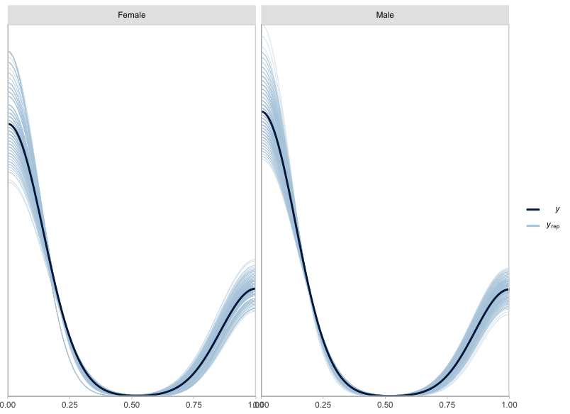
Figure A.1. Posterior draws of CMS frequency by sex based on the morbidity model for the sinuses (n_{draws}=200). Priors based on the London Bills of Mortality.

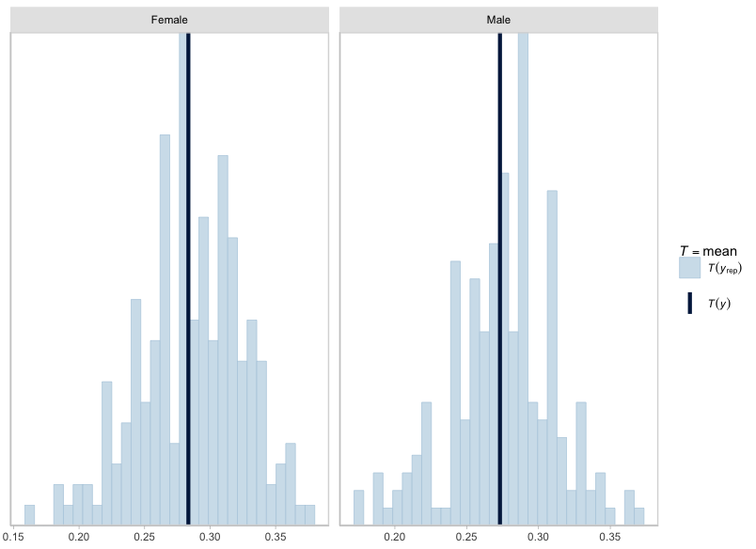
Figure A.2. Posterior draws of CMS frequency by sex based on the morbidity model for the sinuses (n_{draws}=200). Dark blue lines reflect observed means. Priors based on the London Bills of Mortality.

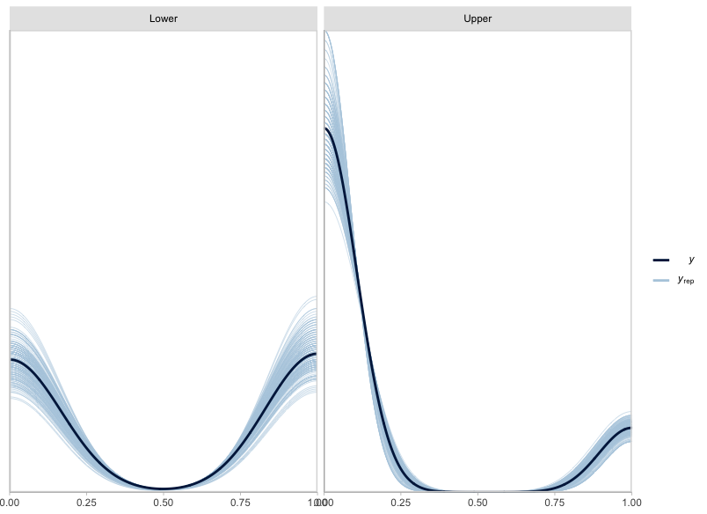
Figure A.3. Posterior draws of CMS frequency by class based on the respiratory morbidity model for the sinuses (n_{draws}=200). Priors based on the London Bills of Mortality.

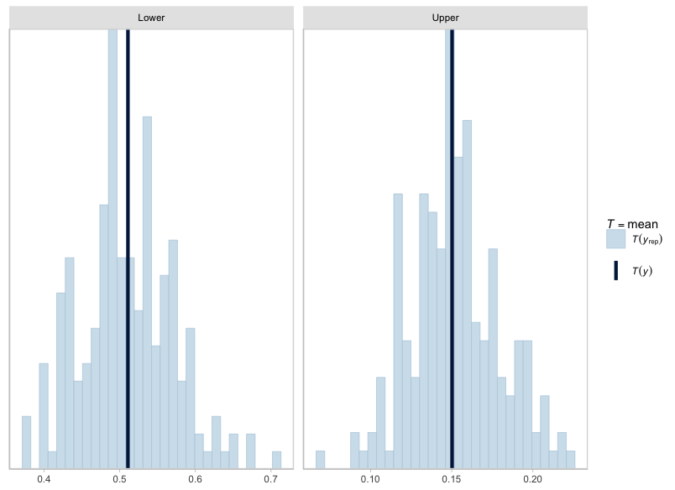
Figure A.4. Posterior draws of CMS frequency by class based on the morbidity model for the sinuses (n_{draws}=200). Dark blue lines reflect observed means. Priors based on the London Bills of Mortality.

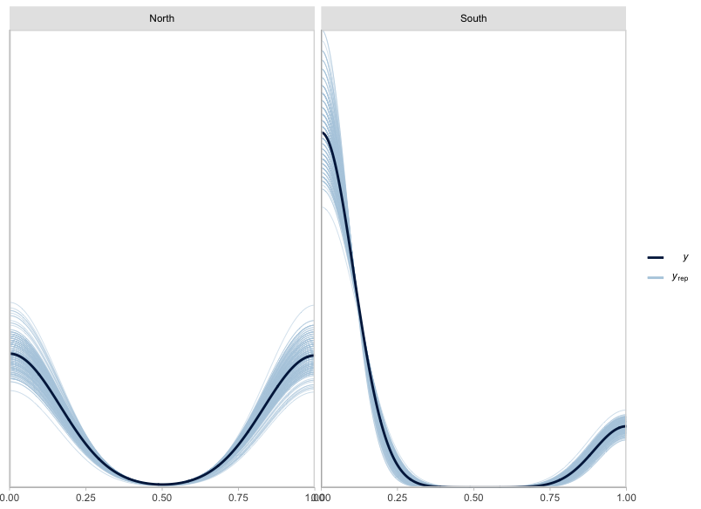
Figure A.5. Posterior draws of CMS frequency by region based on the morbidity model for the sinuses (n_{draws}=200). Priors based on the London Bills of Mortality.

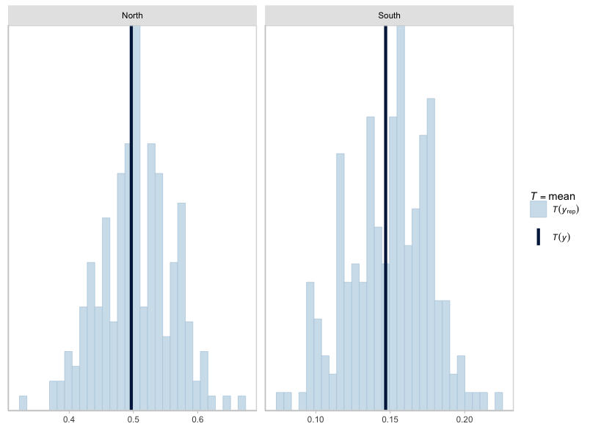
Figure A.6. Posterior draws of CMS frequency by region based on the morbidity model for the sinuses (n_{draws}=200). Dark blue line reflects observed means. Priors based on the London Bills of Mortality.

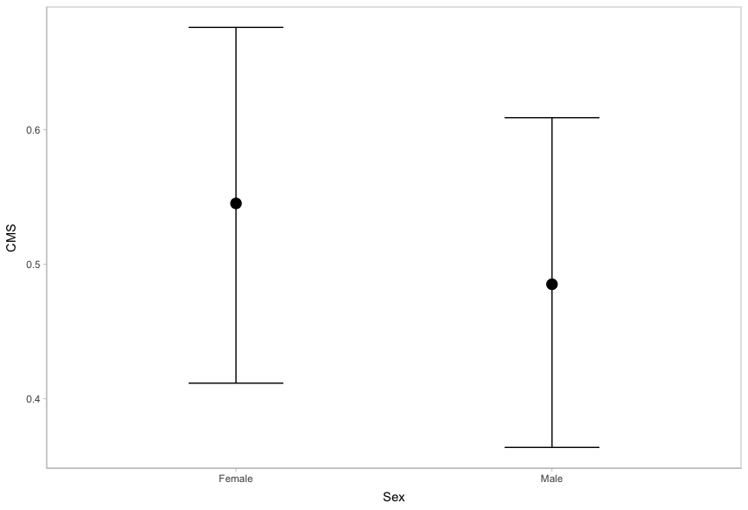
Figure A.7. Marginal effect of sex on CMS frequency. Priors based on the London Bills of Mortality.

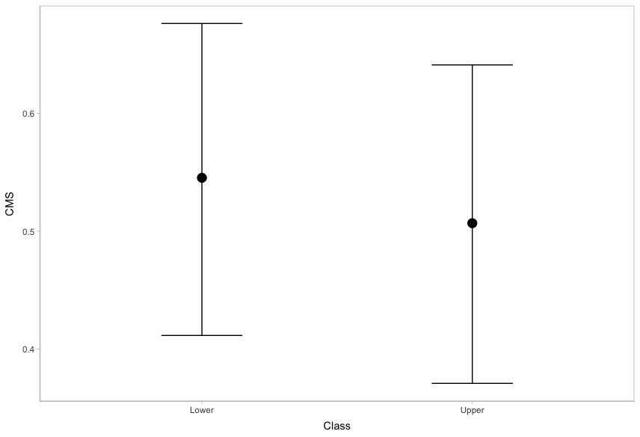
Figure A.8. Marginal effect of class on CMS frequency. Priors based on the London Bills of Mortality.

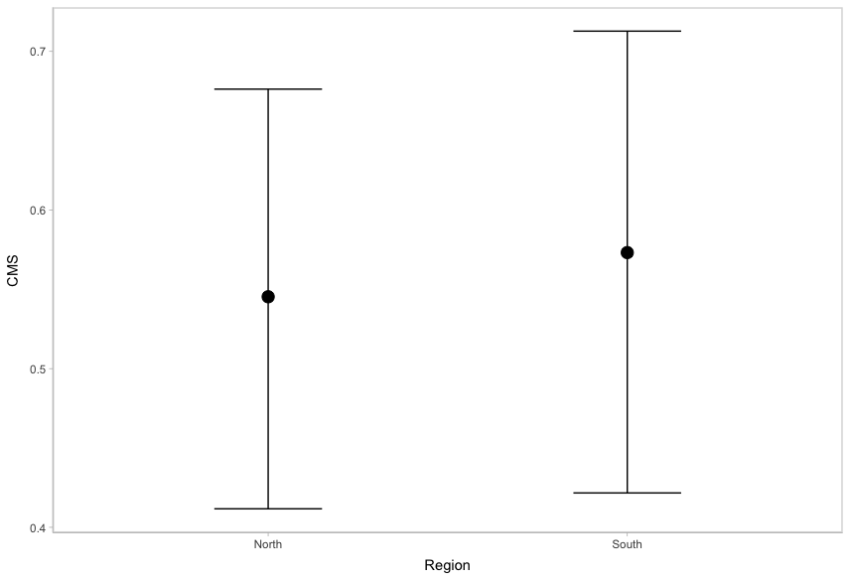
Figure A.9. Marginal effect of region on CMS frequency. Priors based on the London Bills of Mortality.

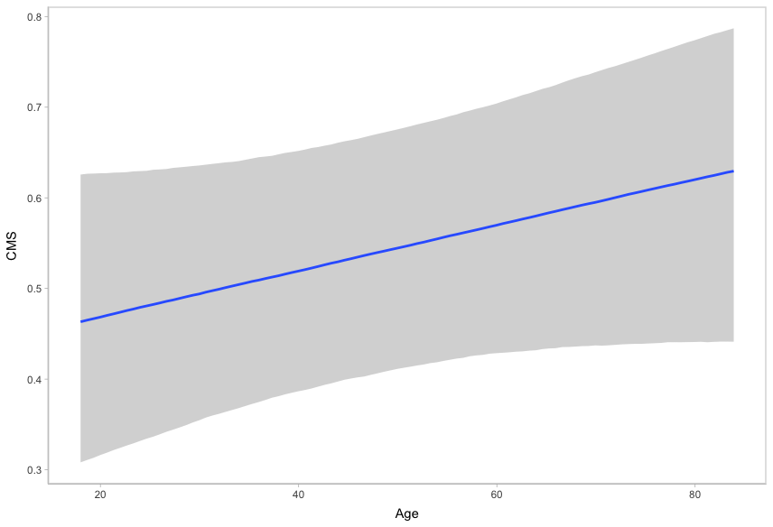
Figure A.10. Marginal effect of age on CMS frequency. Priors provided by the London Bills of Mortality.

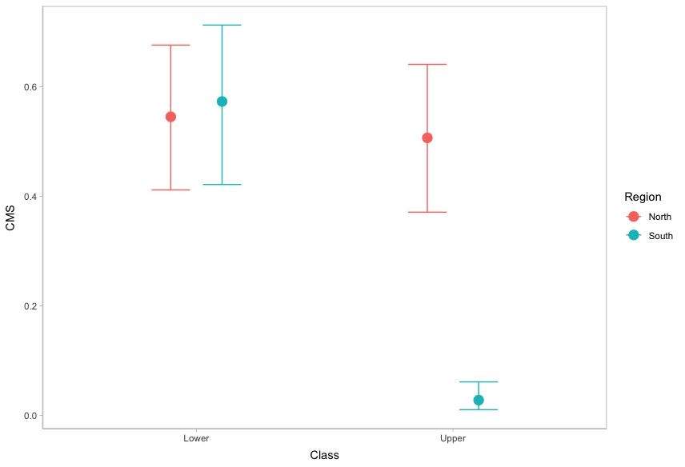
Figure A.11. Marginal effect of the interaction between class and region on CMS frequency. Priors based on the London Bills of Mortality.

General Register Office Reports
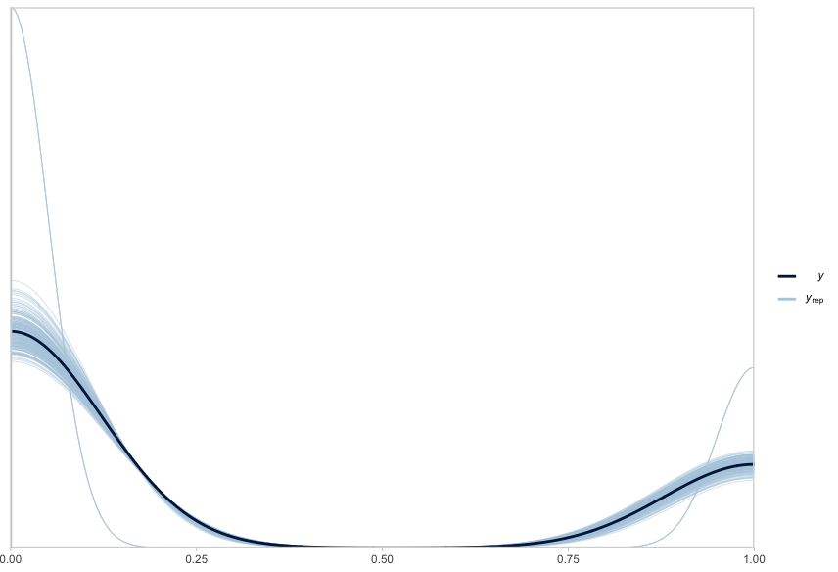
Figure A.12. Posterior draws of CMS frequency based on the morbidity model for the sinuses (n_{draws}=200). Priors based on the General Register Office Reports.

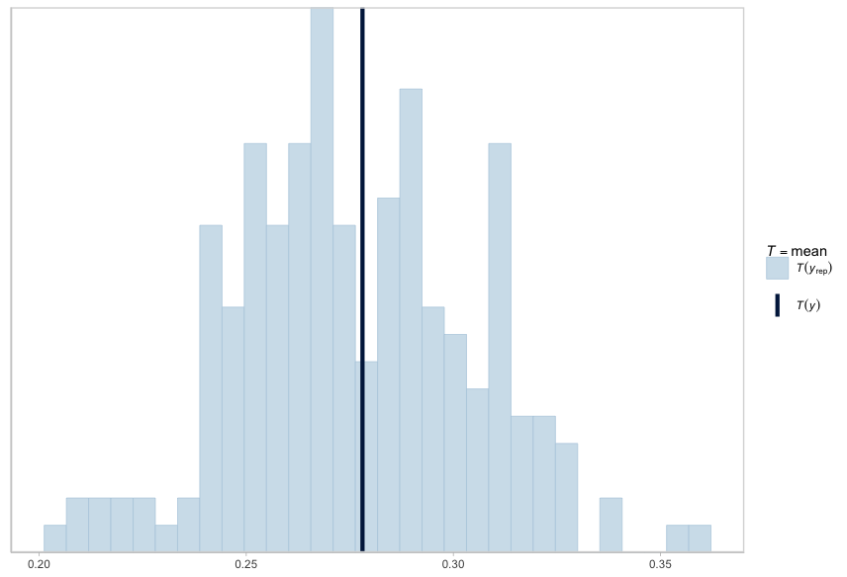
Figure A.13. Posterior draws of CMS frequency based on the morbidity model for the sinuses (n_{draws}=200). Dark blue lines reflect observed mean. Priors based on the General Register Office Reports.

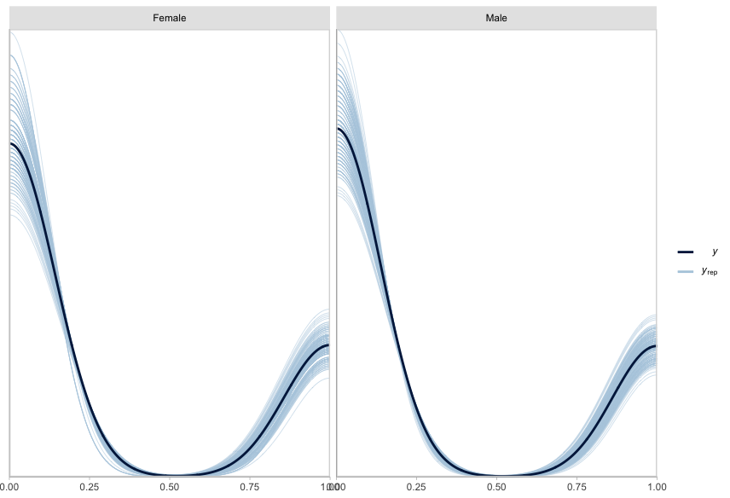
Figure A.14. Posterior draws of CMS frequency by sex based on the morbidity model for the sinuses (n_{draws}=200). Priors based on the General Register Office Reports.

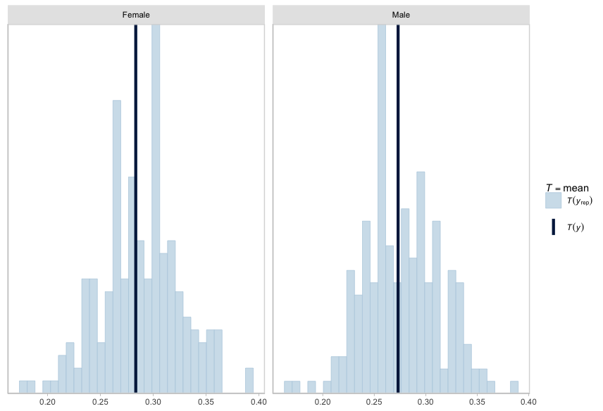
Figure A.15. Posterior draws of CMS frequency by sex based on the morbidity model for the sinuses (n_{draws}=200). Dark blue lines reflect observed means. Priors based on the General Register Office Reports.

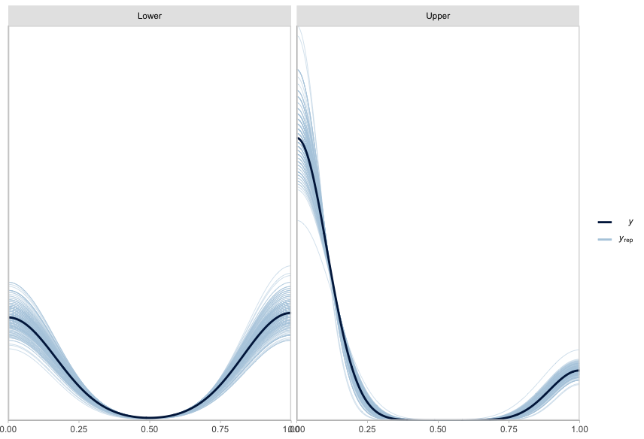
Figure A.16. Posterior draws of CMS frequency by class based on the morbidity model for the sinuses (n_{draws}=200). Priors based on the General Register Office Reports.

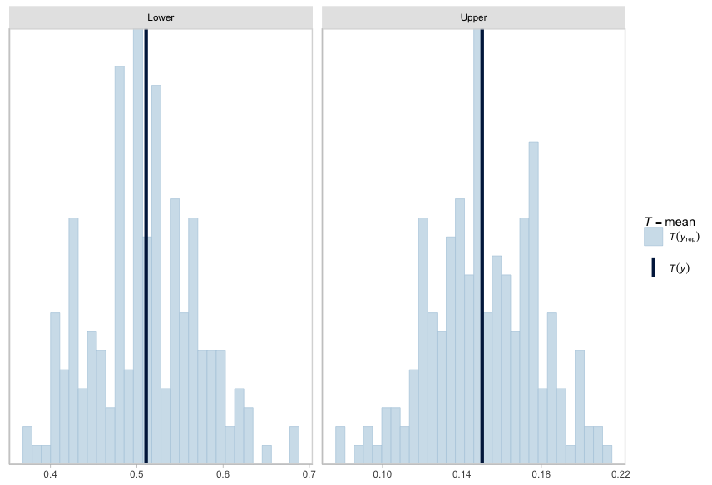
Figure A.17. Posterior draws of CMS frequency by class based on the morbidity model for the sinuses (n_{draws}=200). Dark blue lines reflect observed means. Priors based on the General Register Office Reports.
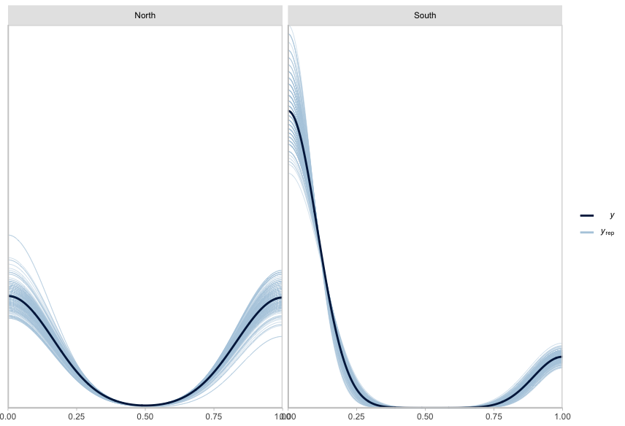
Figure A.18. Posterior draws of CMS frequency by region based on the morbidity model for the sinuses (n_{draws}=200). Priors provided by the Priors based on the General Register Office Reports.

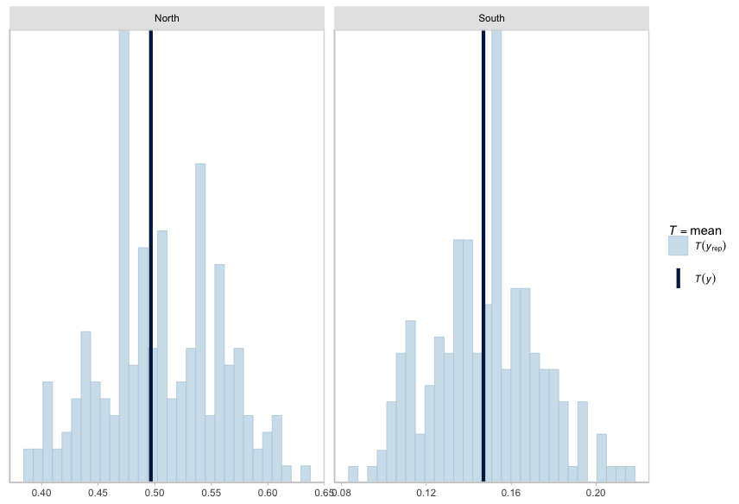
Figure A.19. Posterior draws of CMS frequency by region based on the morbidity model for the sinuses (n_{draws}=200). Dark blue line reflects observed means. Priors based on the General Register Office Reports.

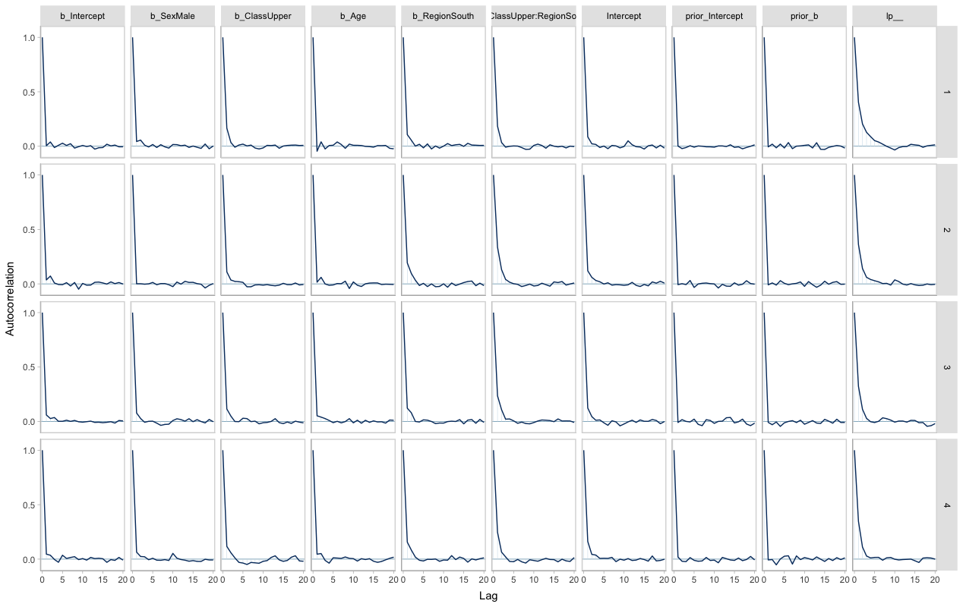
Figure A.20. Autocorrelation plots for each morbidity model parameter by HMC chain. Priors based on the General Register Office Reports.

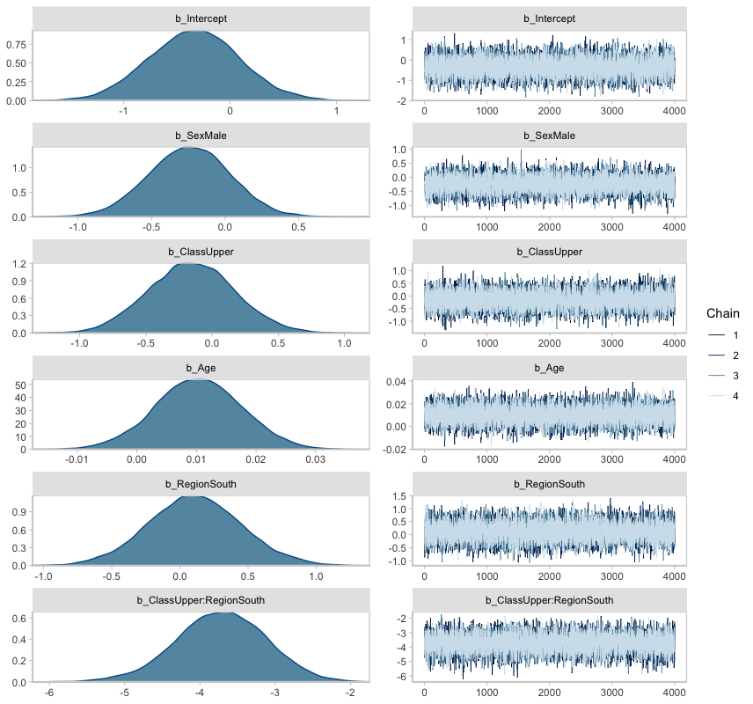
Figure A.21. Posterior distribution of model parameters and accompanying HMC chains. Priors based on the General Register Office Reports.

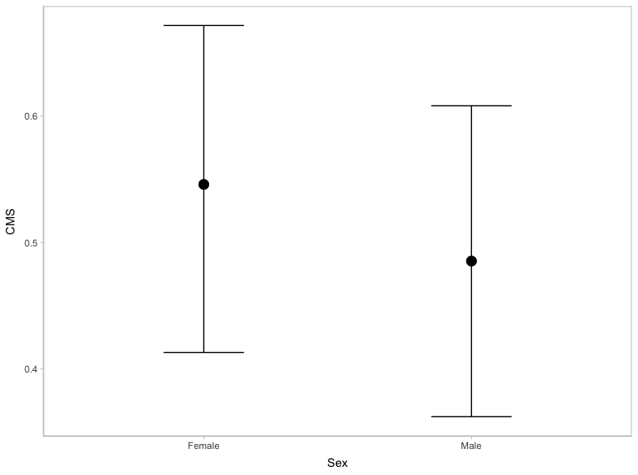
Figure A.22. Marginal effect of sex on CMS frequency. Priors based on the General Register Office Reports.

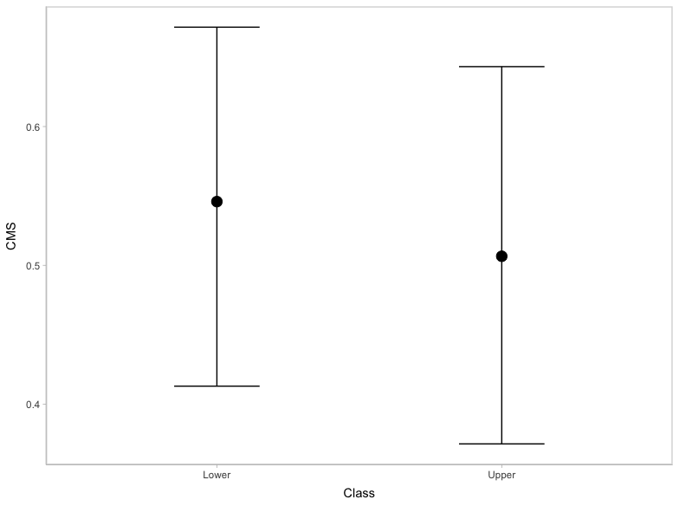
Figure A.23. Marginal effect of class on CMS frequency. Priors based on the General Register Office Reports.

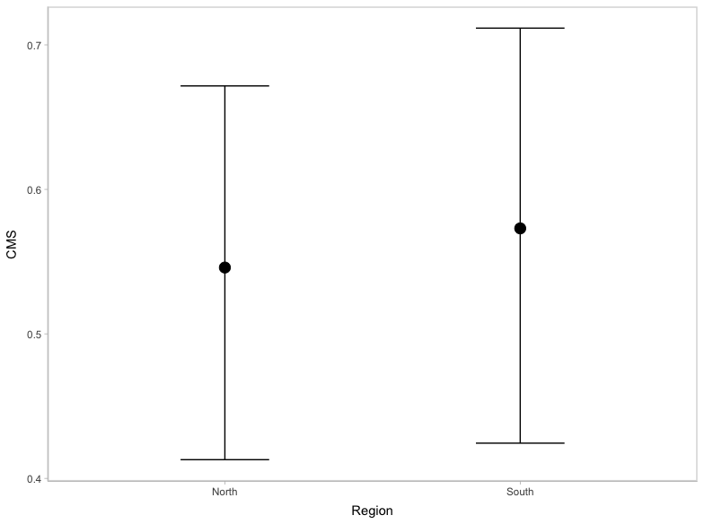
Figure A.24. Marginal effect of region on CMS frequency. Priors based on the General Register Office Reports.

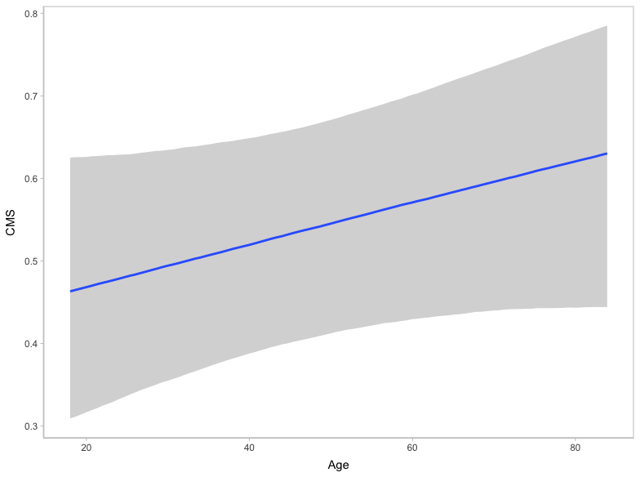
Figure A.25. Marginal effect of age on CMS frequency. Priors based on the General Register Office Reports.

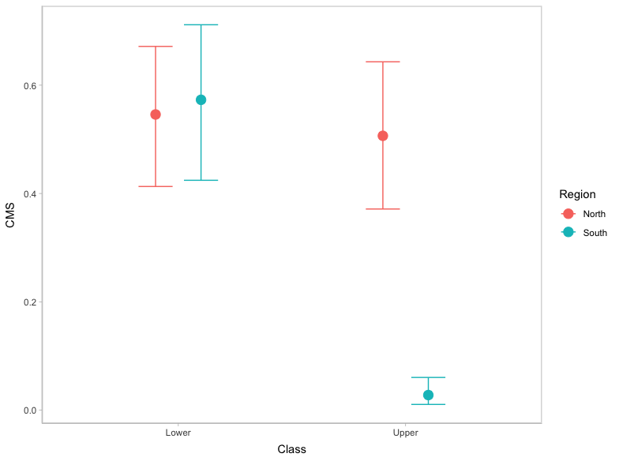
Figure A.26. Marginal effect of the interaction between class and region on CMS frequency. Priors based on the General Register Office Reports.

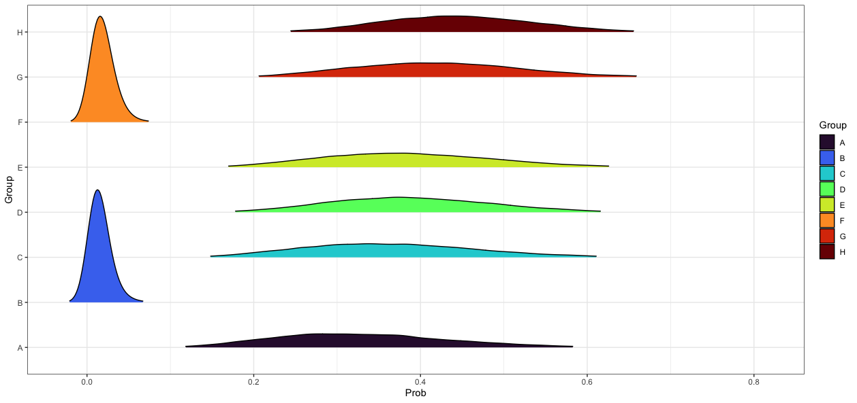
Figure A.27. Age-adjusted posterior prediction distributions for the probability of presenting CMS in each intersectional group. Priors based on the General Register Office Reports.

Table A.2. MAPs and 90% HDIs describing the age-adjusted posterior probability of presenting CMS by intersectional group. Priors informed by the General Register Office Reports.
Group | General Registrar Officer Reports
Group | MAP | Lower 90% HDI | Upper 90% HDI
A | 0.29 | 0.17 | 0.50
B | <0.01 | 0.00 | 0.03
C | 0.34 | 0.19 | 0.53
D | 0.38 | 0.23 | 0.54
E | 0.37 | 0.22 | 0.55
F | 0.01 | 0.00 | 0.03
G | 0.41 | 0.26 | 0.58
H | 0.44 | 0.30 | 0.59

Comparison Between Archival Sources
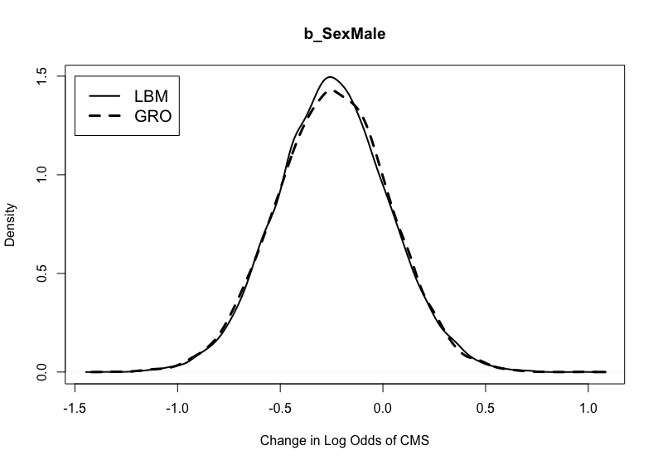
Figure A.28. Posterior distributions for b_SexMale in the models weakly informed by the London Bills of Mortality and the General Register Office Reports.

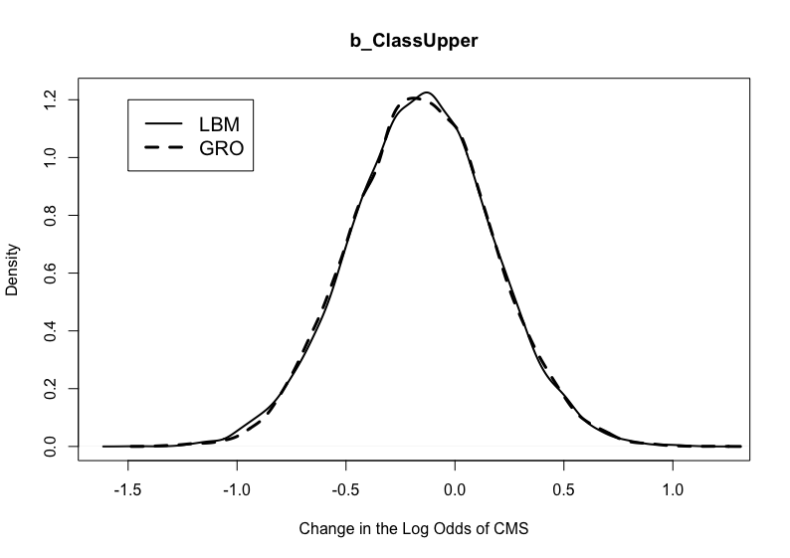

Figure A.29. Posterior distributions for b_ClassUpper in the models weakly informed by the London Bills of Mortality and the General Register Office Reports.

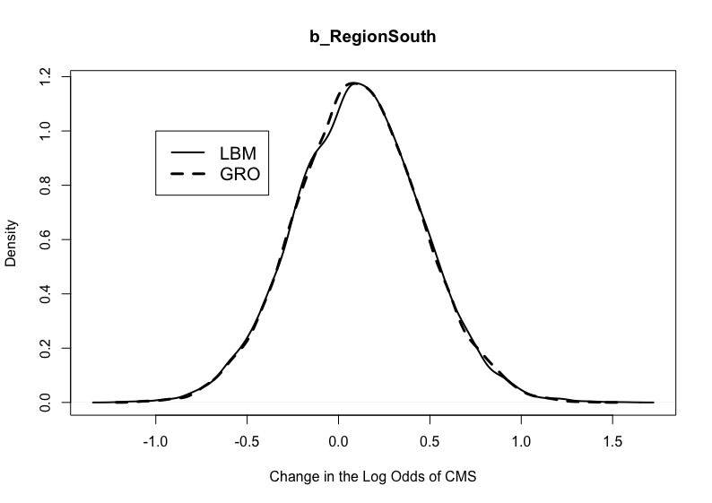

Figure A.30. Posterior distributions for b_RegionSouth in the models weakly informed by the London Bills of Mortality and the General Register Office Reports.

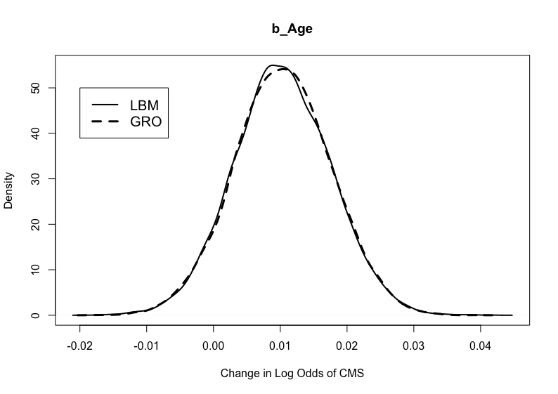
Figure A.31. Posterior distributions for b_Age in the models weakly informed by the London Bills of Mortality and the General Register Office Reports.

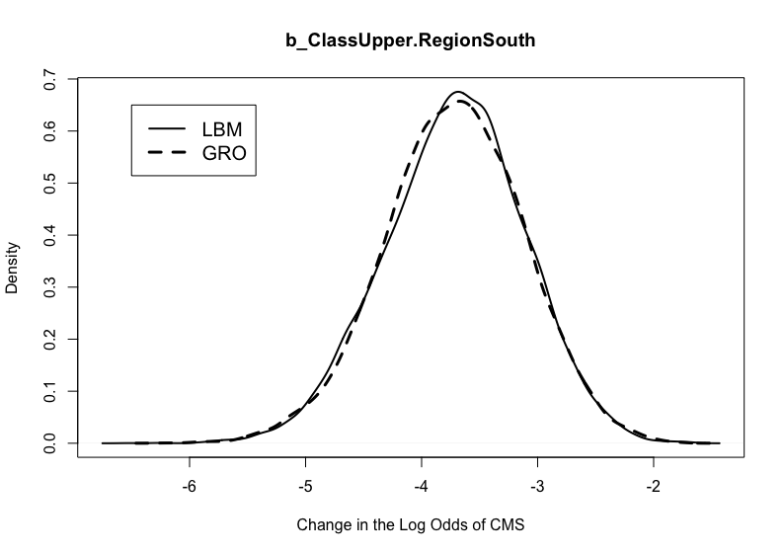
Figure A.32. Posterior distributions for b_ClassUpper.RegionSouth in the models weakly informed by the London Bills of Mortality and the General Register Office Reports.

Rib PNB Morbidity Models
London Bills of Mortality
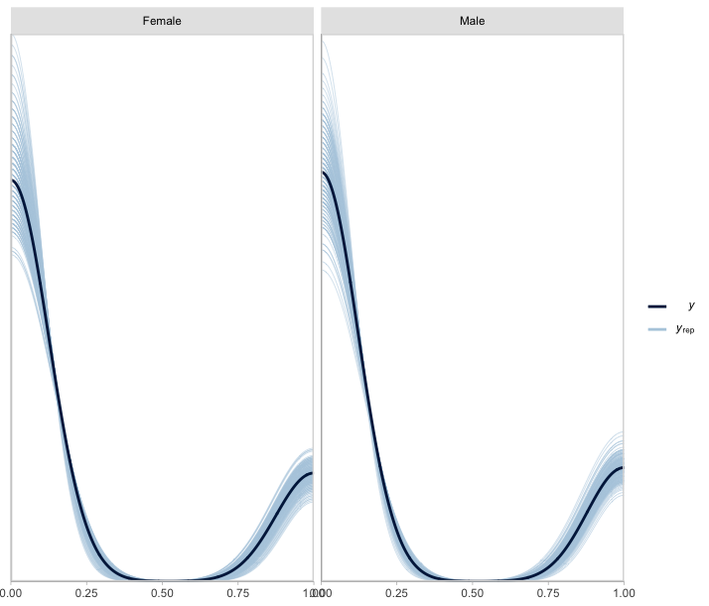
Figure A.33. Posterior draws of rib PNB frequency by sex based on the morbidity model for the ribs (n_{draws}=200). Priors provided by the London Bills of Mortality.

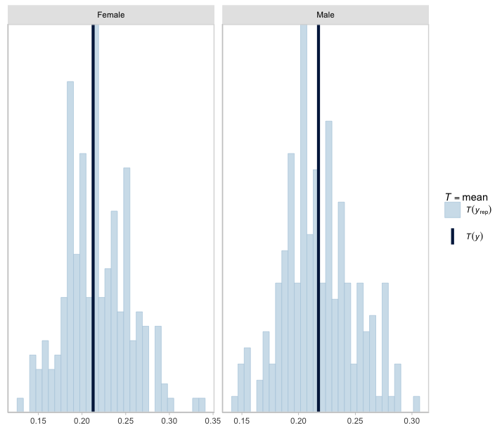
Figure A.34. Posterior draws of rib PNB frequency by sex based on the morbidity model for the ribs (n_{draws}=200). Dark blue lines reflect observed means. Priors based on the London Bills of Mortality.

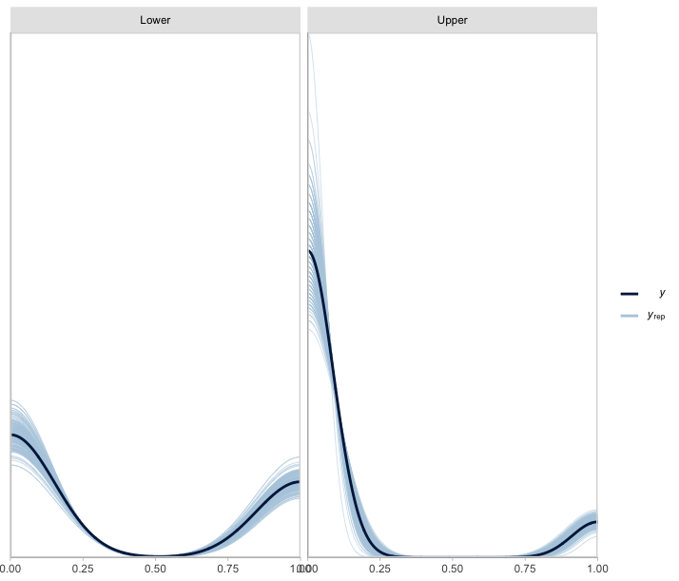
Figure A.35. Posterior draws of rib PNB frequency by class based on the morbidity model for the ribs (n_{draws}=200). Priors provided by the London Bills of Mortality.
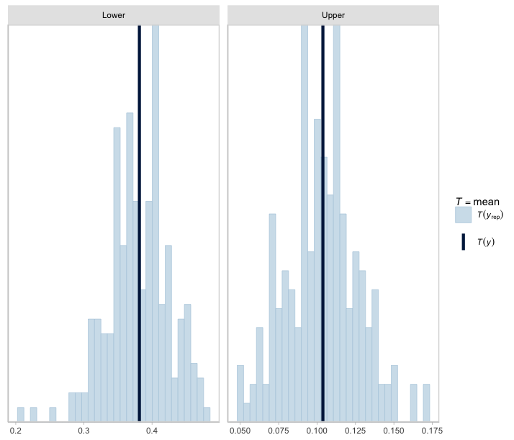
Figure A.36. Posterior draws of PNB frequency by class based on the morbidity model for the ribs (n_{draws}=200). Dark blue lines reflect observed means. Priors based on the London Bills of Mortality.

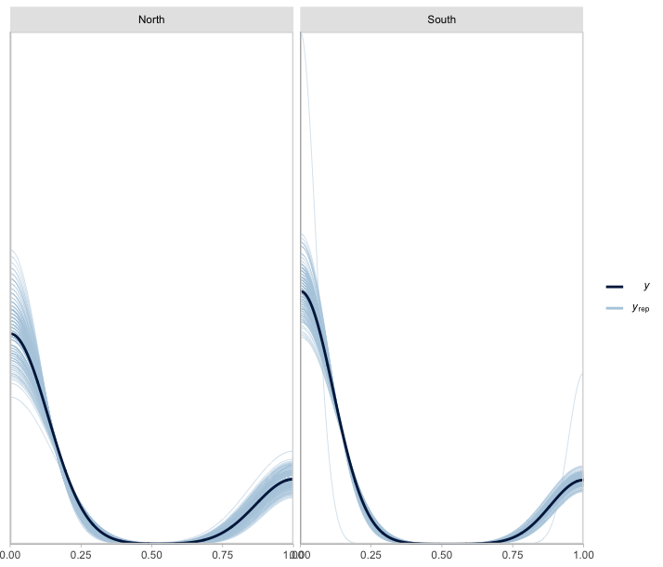
Figure A.37. Posterior draws of rib PNB frequency by region based on the morbidity model for the ribs (n_{draws}=200). Priors provided by the London Bills of Mortality.
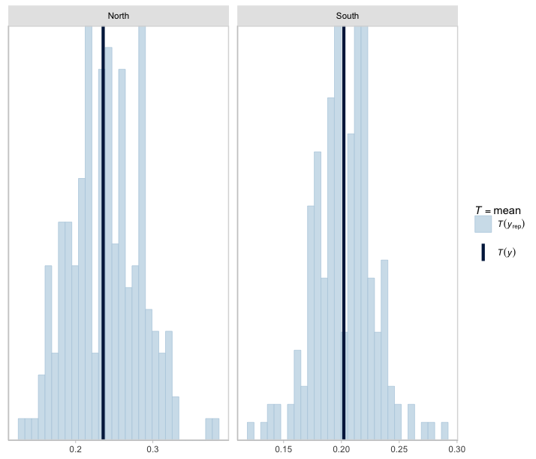
Figure A.38. Posterior draws of rib PNB frequency by region based on the morbidity model for the ribs (n_{draws}=200). Dark blue lines reflect observed means. Priors based on the London Bills of Mortality.

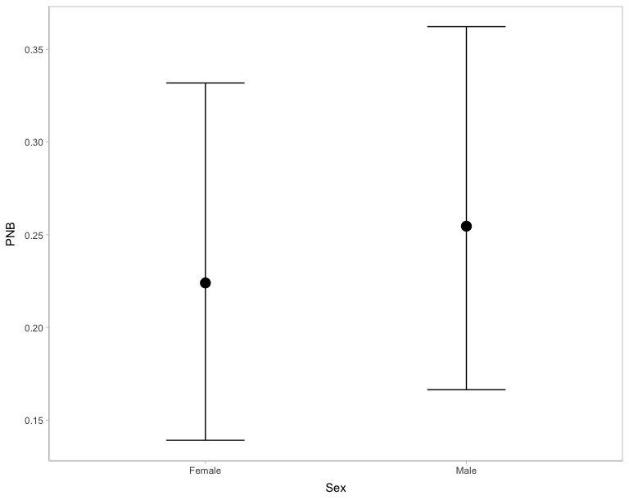
Figure A.39. Marginal effect of sex on PNB frequency. Priors based on the London Bills of Mortality.

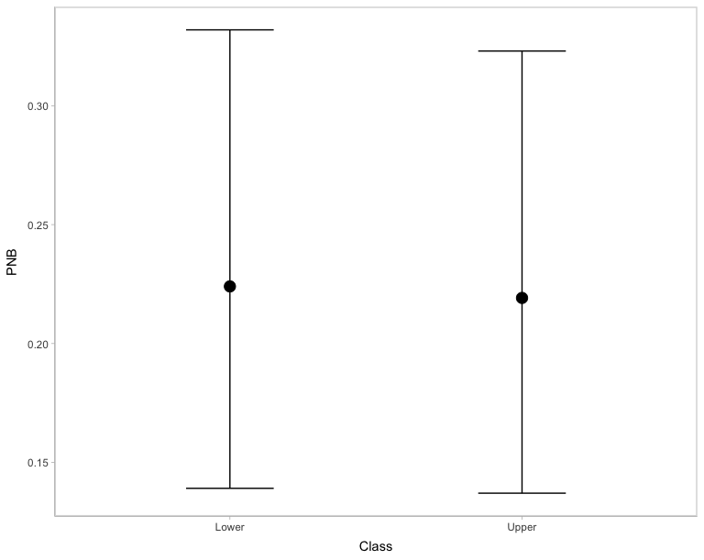
Figure A.40. Marginal effect of class on PNB frequency. Priors based on the London Bills of Mortality.

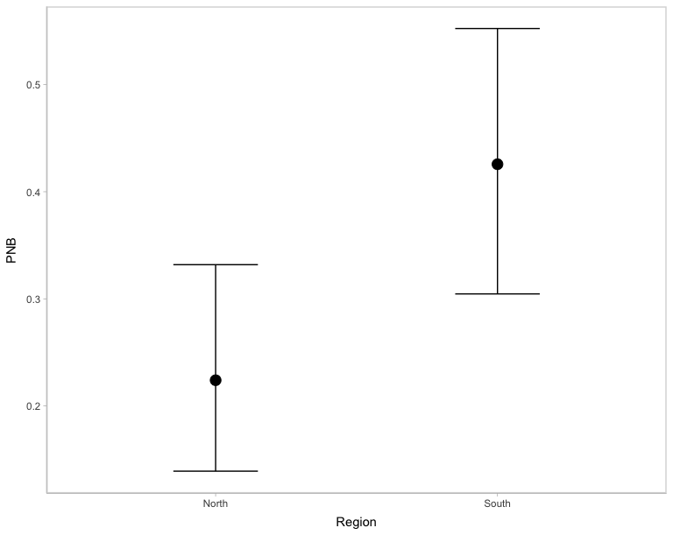
Figure A.41. Marginal effect of region on PNB frequency. Priors based on the London Bills of Mortality.
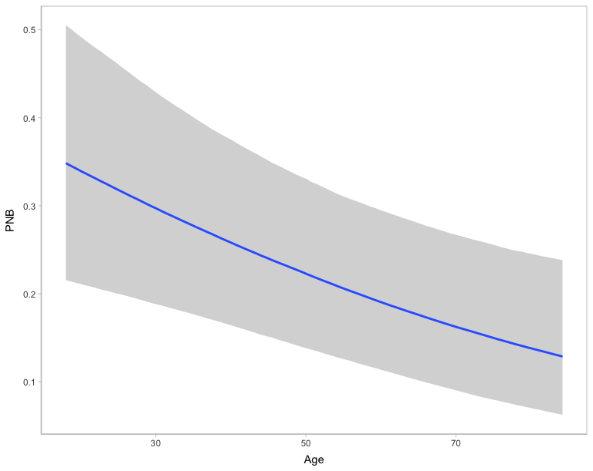
Figure A.42. Marginal effect of age on PNB frequency. Priors based on the London Bills of Mortality.

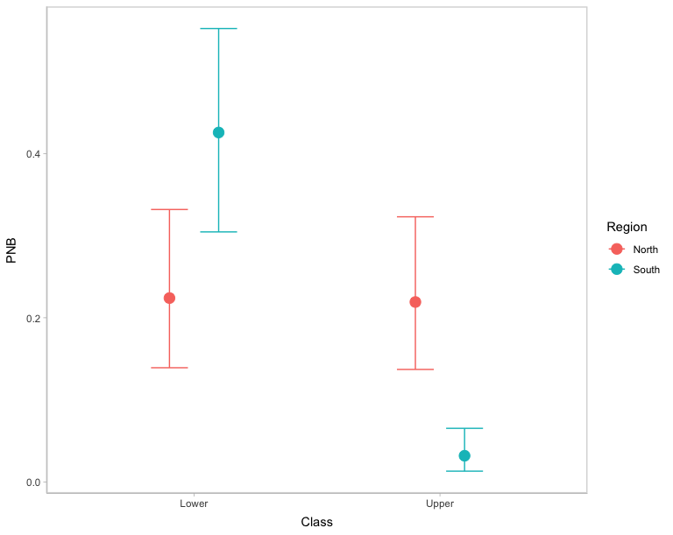
Figure A.43. Marginal effect of the interaction between class and region on PNB frequency. Priors based on the London Bills of Mortality.

General Register Office Reports
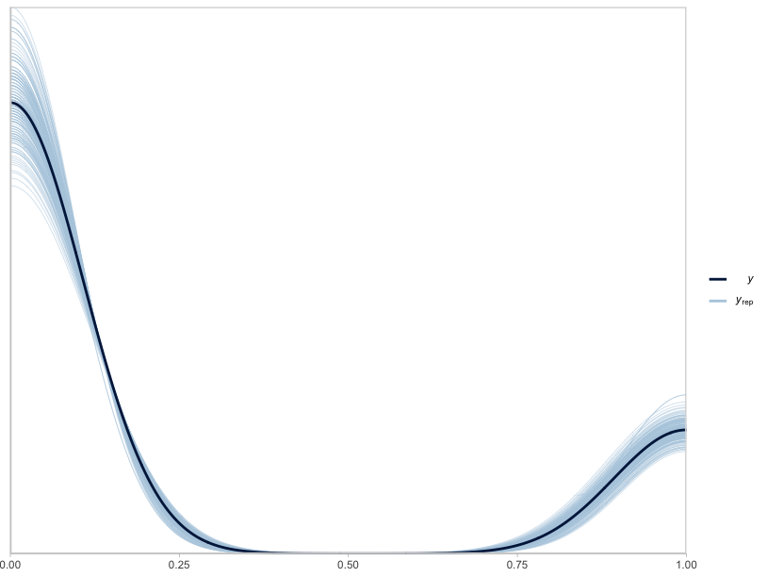
Figure A.44. Posterior draws of PNB frequency based on the morbidity model for the ribs (n_{draws}=200). Priors based on the General Register Office Reports.

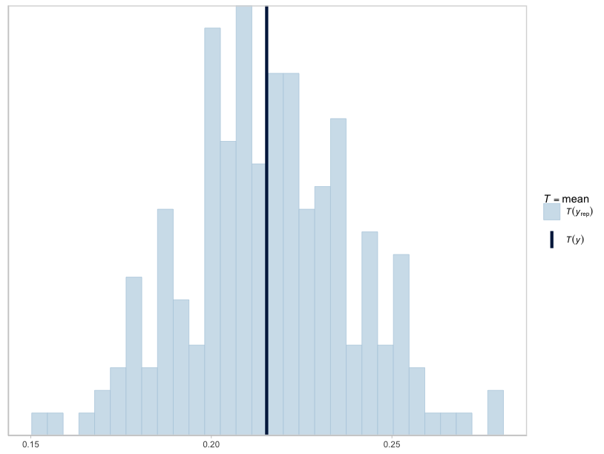
Figure A.45. Posterior draws of PNB frequency based on the morbidity model for the ribs (n_{draws}=200). Dark blue lines reflect observed means. Priors based on the General Register Office Reports.

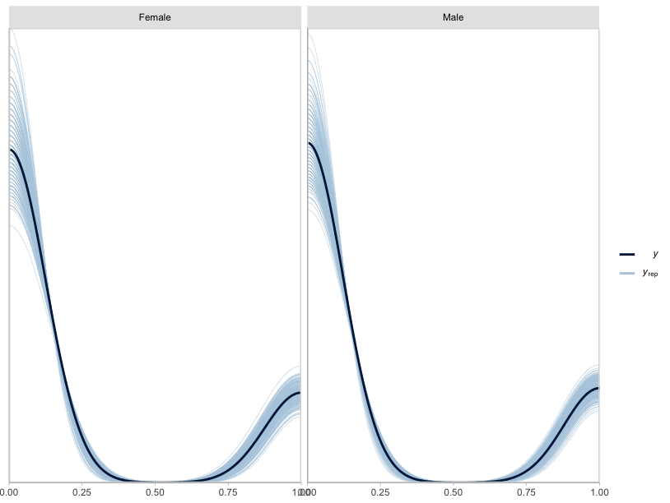
Figure A.46. Posterior draws of PNB frequency by sex based on the morbidity model for the ribs (n_{draws}=200). Priors based on the General Register Office Reports.

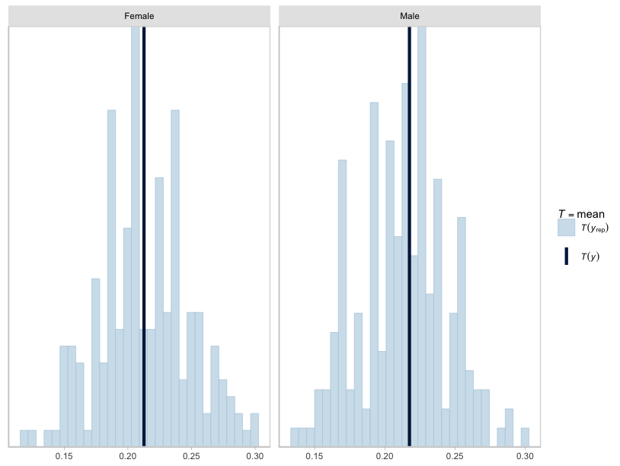
Figure A.47. Posterior draws of PNB frequency by sex based on the morbidity model for the ribs (n_{draws}=200). Dark blue lines reflect observed means. Priors based on the General Register Office Reports.

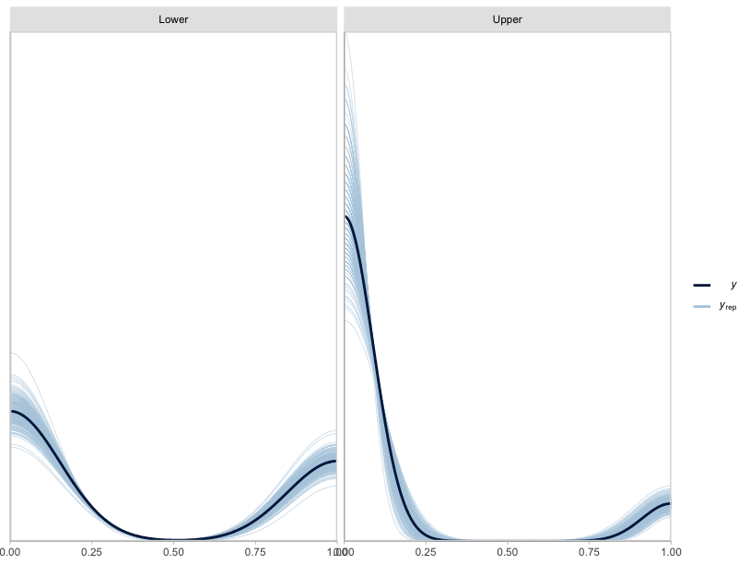
Figure A.48. Posterior draws of PNB frequency by class based on the morbidity model for the ribs (n_{draws}=200). Priors based on the General Register Office Reports.

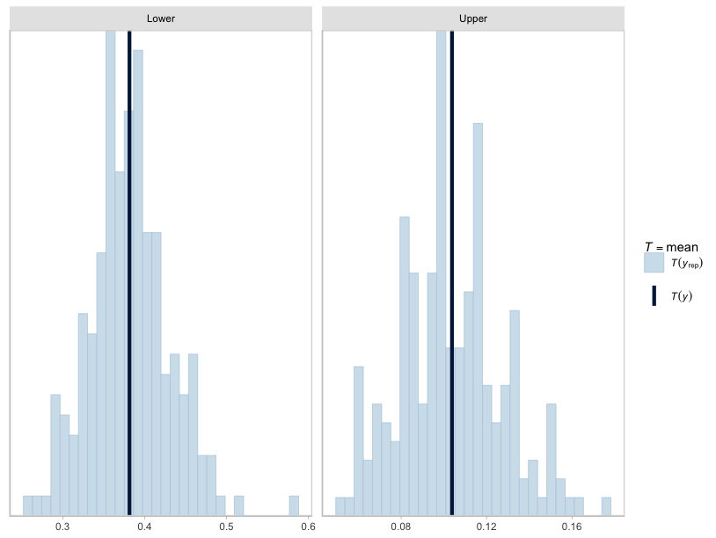
Figure A.49. Posterior draws of PNB frequency by class based on the morbidity model for the ribs (n_{draws}=200). Dark blue lines reflect observed means. Priors provided by the General Register Office Reports.

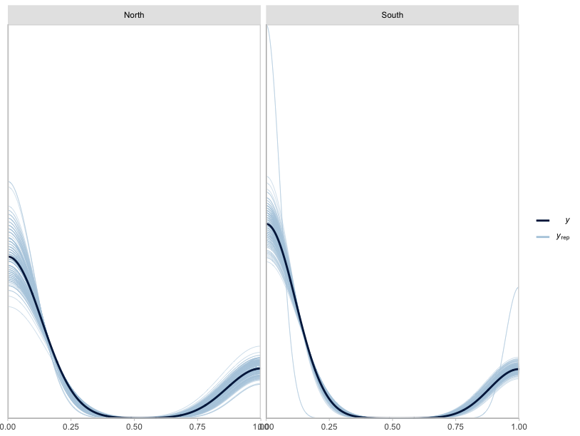
Figure A.50. Posterior draws of PNB frequency by region based on the morbidity model for the ribs (n_{draws}=200). Priors based on the General Register Office Reports.

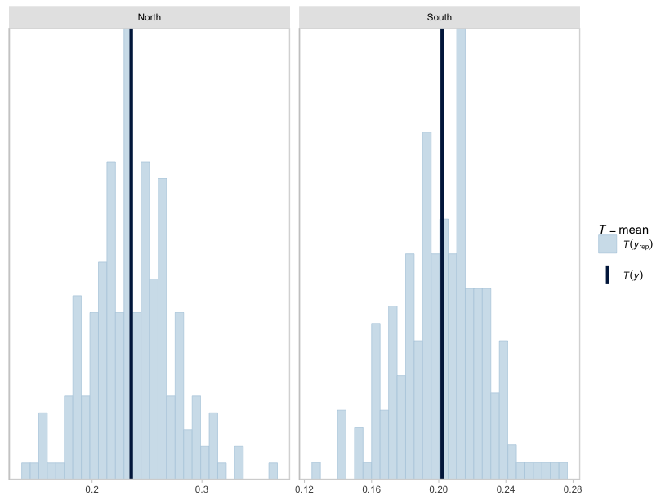
Figure A.51. Posterior draws of PNB frequency by region based on the morbidity model for the ribs (n_{draws}=200). Dark blue lines reflect observed means. Priors provided by the General Register Office Reports.

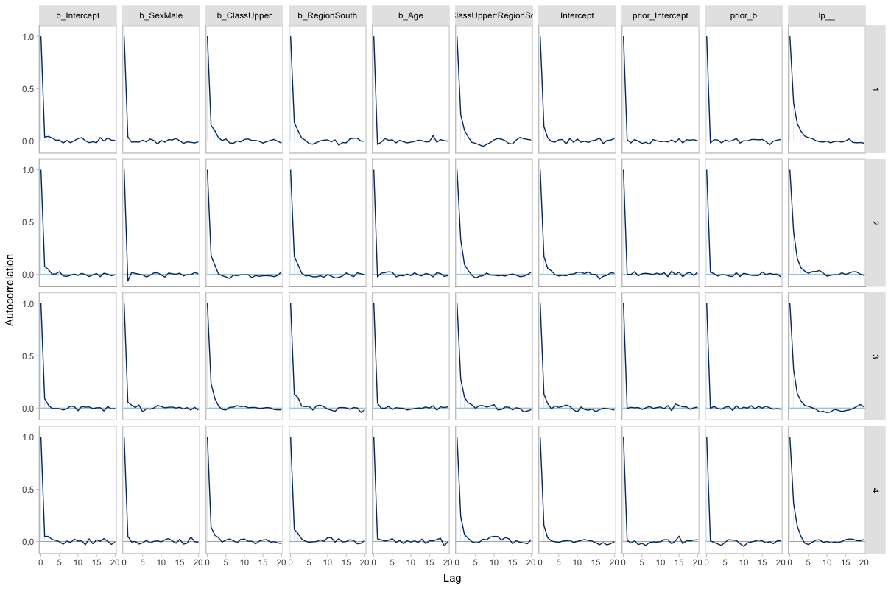
Figure A.52. Autocorrelation plots for each respiratory morbidity model parameter by HMC chain. Priors based on the General Register Office Reports.

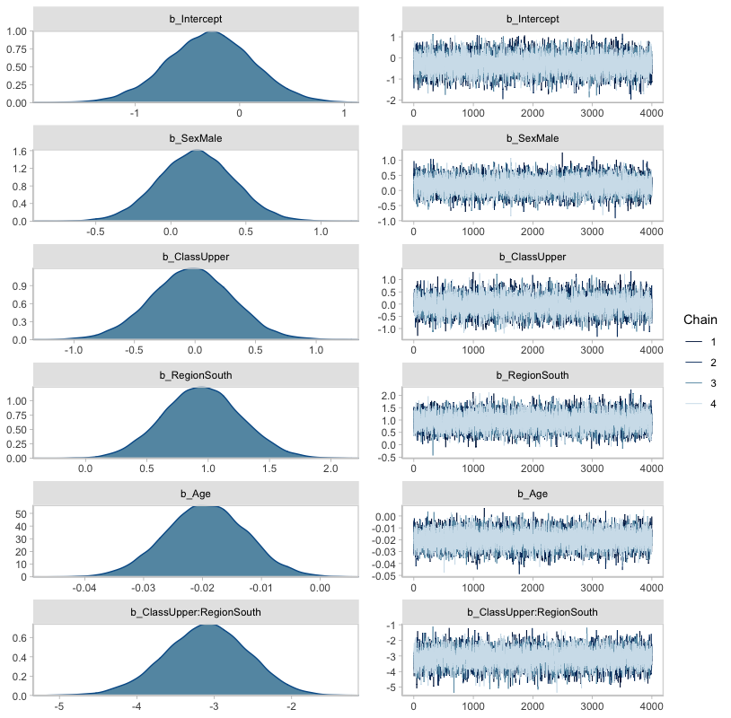
Figure A.53. Posterior distribution of model parameters and accompanying HMC chains. Priors based on the General Register Office Reports.

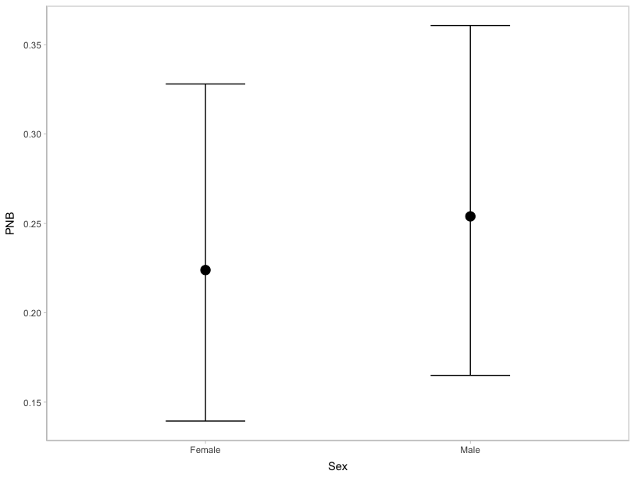
Figure A.54. Marginal effect of sex on PNB frequency. Priors based on the General Register Office Reports.

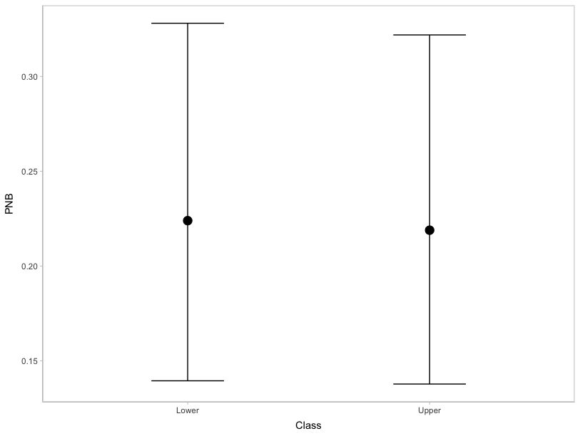
Figure A.55. Marginal effect of class on PNB frequency. Priors based on the General Register Office Reports.

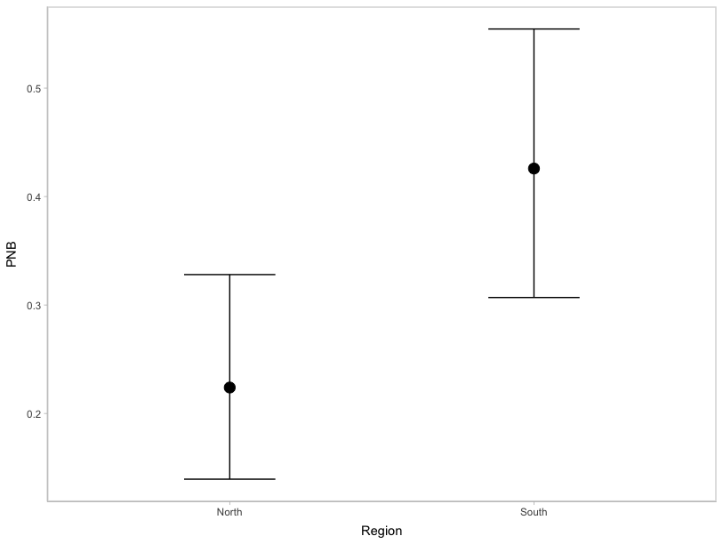
Figure A.56. Marginal effect of region on PNB frequency. Priors based on the General Register Office Reports.

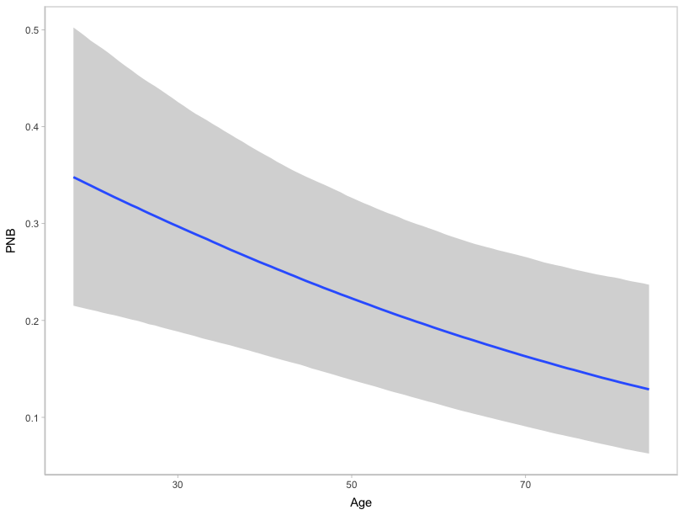
Figure A.57. Marginal effect of age on PNB frequency. Priors based on the General Register Office Reports.

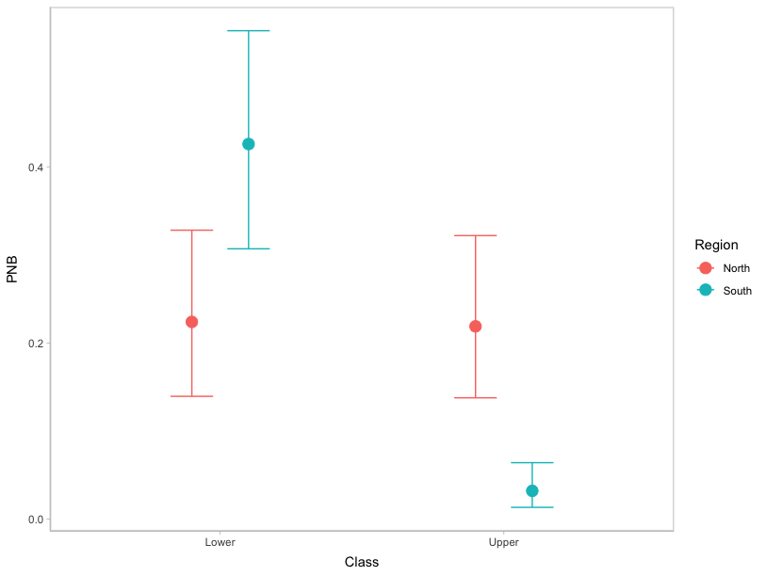
Figure A.58. Marginal effect of the interaction between class and region on PNB frequency. Priors based on the General Register Office Reports.

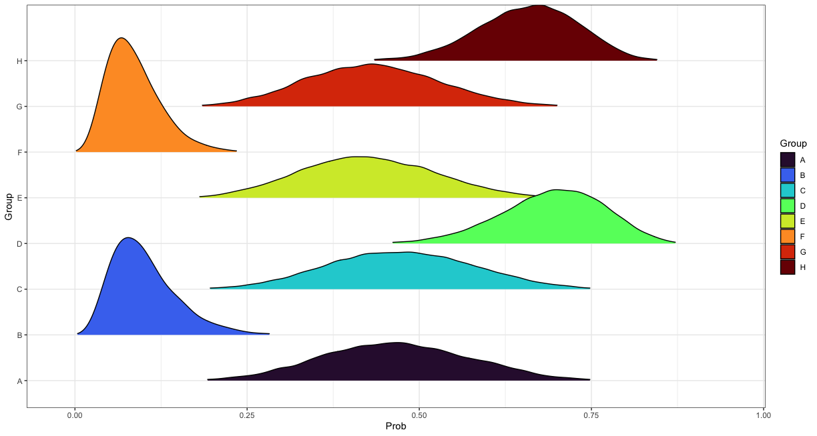
Figure A.59. Age-adjusted posterior prediction distributions for the probability of presenting rib PNB in each intersectional group. Priors based on the General Register Office Reports.

Table A.3. MAPs and 90% HDIs describing the age-adjusted posterior probability of presenting rib PNB by intersectional group. Priors informed by the General Register Office Reports models.
Group | General Registrar Officer Reports
Group | MAP | Lower 90% HDI | Upper 90% HDI
A | 0.46 | 0.29 | 0.64
B | 0.07 | 0.03 | 0.17
C | 0.48 | 0.30 | 0.65
D | 0.70 | 0.57 | 0.82
E | 0.41 | 0.27 | 0.59
F | 0.07 | 0.03 | 0.14
G | 0.43 | 0.28 | 0.60
H | 0.67 | 0.54 | 0.78

Comparison Between Archival Sources
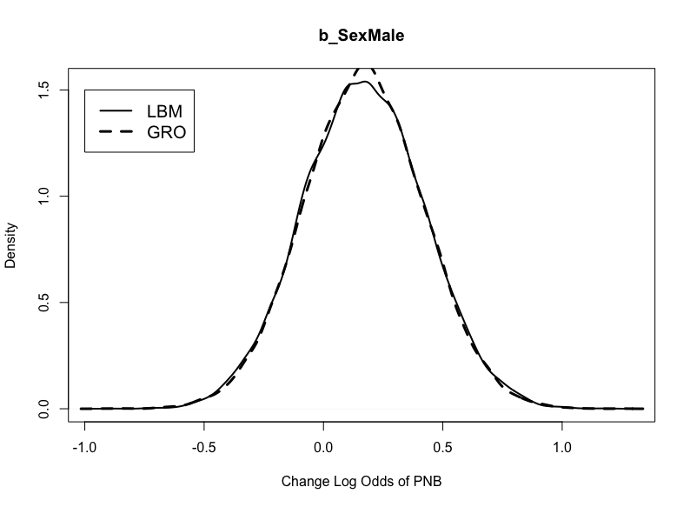
Figure A.60. Posterior distributions for b_SexMale in the models weakly informed by the London Bills of Mortality and the General Register Office Reports.

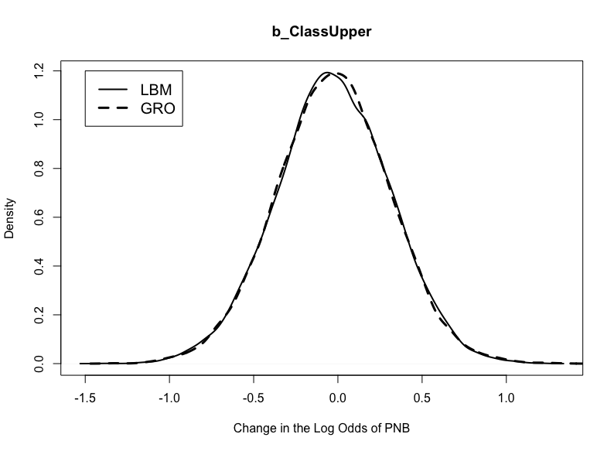
Figure A.61. Posterior distributions for b_ClassUpper in the models weakly informed by the London Bills of Mortality and the General Register Office Reports.

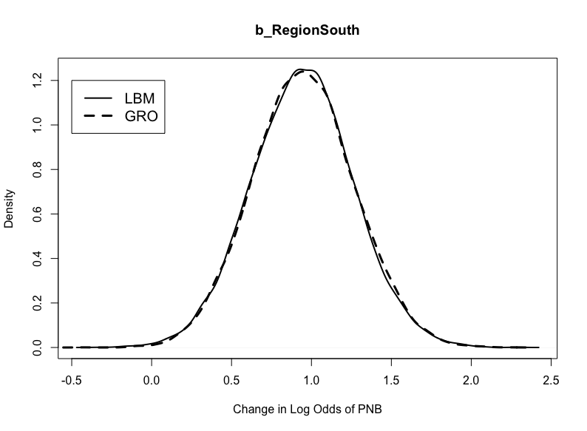

Figure A.62. Posterior distributions for b_RegionSouth in the models weakly informed by the London Bills of Mortality and the General Registrar Officer Reports.

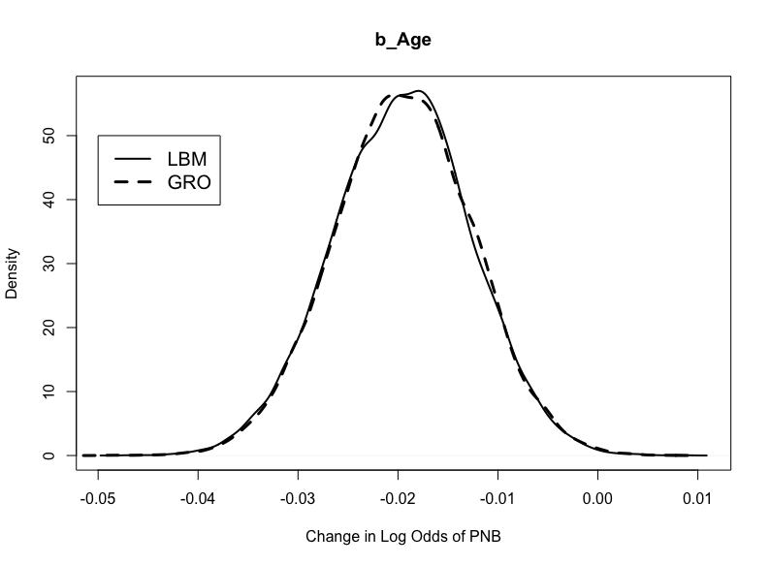
Figure A.63. Posterior distributions for b_Age in the models weakly informed by the London Bills of Mortality and the General Register Office Reports.

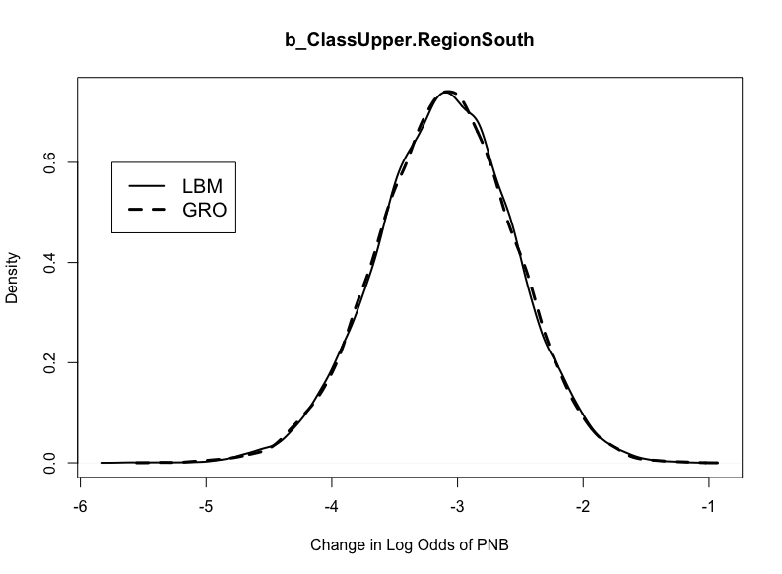
Figure A.64. Posterior distributions for b_ClassUpper.RegionSouth in the models weakly informed by the London Bills of Mortality and the General Register Office Reports.

CMS Mortality Models
London Bills of Mortality
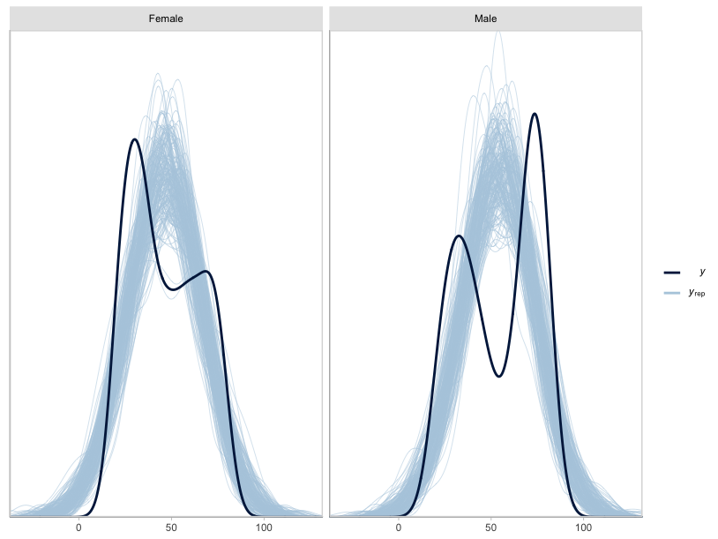
Figure A.65. Posterior draws of age-at-death by sex based on the mortality model for the sinuses (n_{draws}=200). Priors based on the London Bills of Mortality.

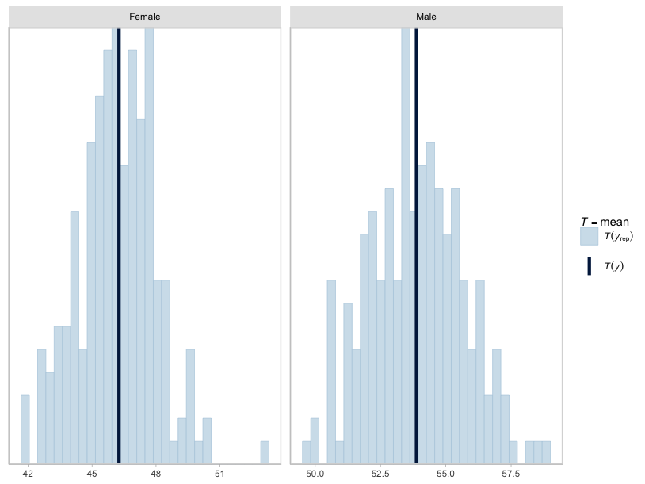
Figure A.66. Posterior draws of age-at-death by sex based on the mortality model for the sinuses (n_{draws}=200). Dark blue lines reflect observed means. Priors based on the London Bills of Mortality.

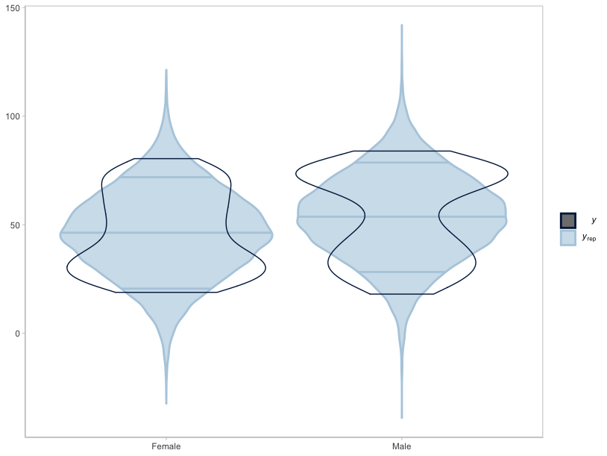
Figure A.67. Violin plots of posterior draws of age-at-death by sex based on the mortality model for the sinuses (n_{draws}=200). Priors based on the London Bills of Mortality.
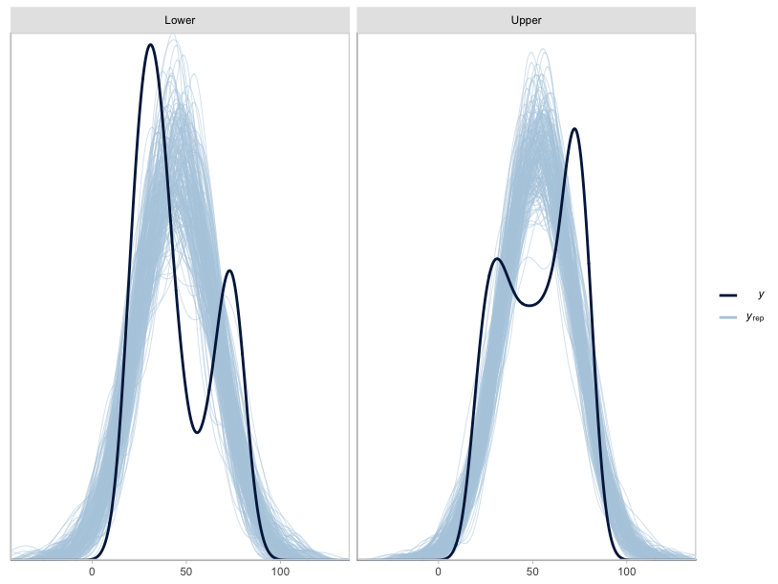
Figure A.68. Posterior draws of age-at-death by class based on the mortality model for the sinuses (n_{draws}=200). Priors based on the London Bills of Mortality.

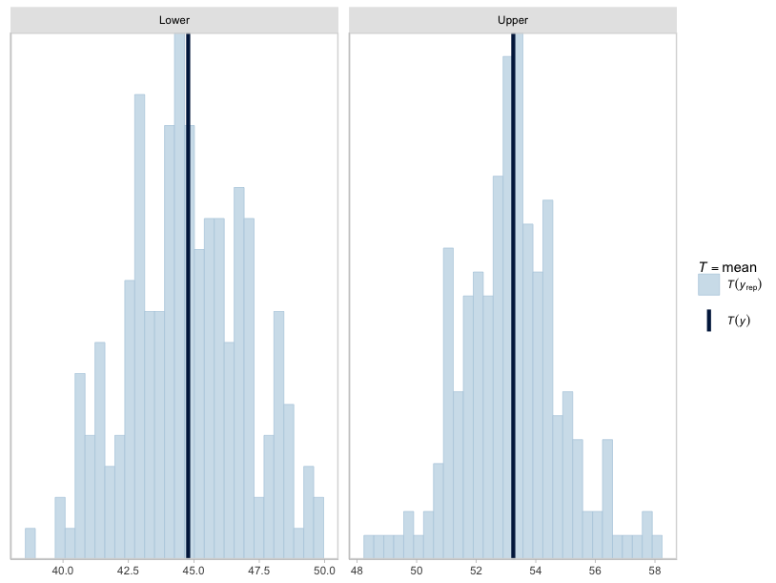
Figure A.69. Posterior draws of age-at-death by class based on the mortality model for the sinuses (n_{draws}=200). Dark blue lines reflect observed means. Priors based on the London Bills of Mortality.

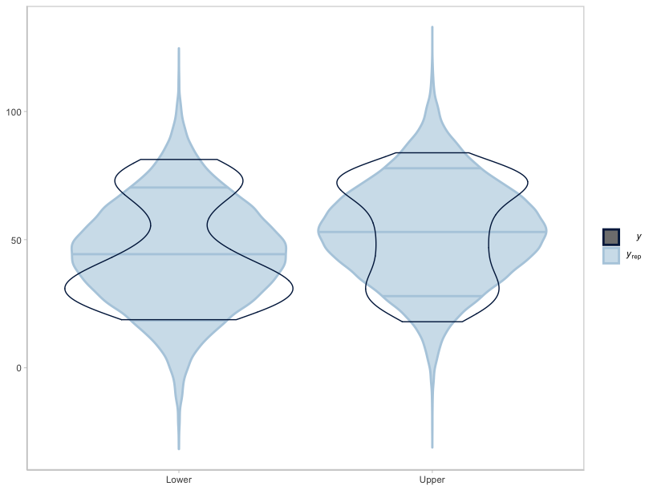
Figure A.70. Violin plots of posterior draws of age-at-death by class based on the mortality model for the sinuses (n_{draws}=200). Priors based on the London Bills of Mortality.

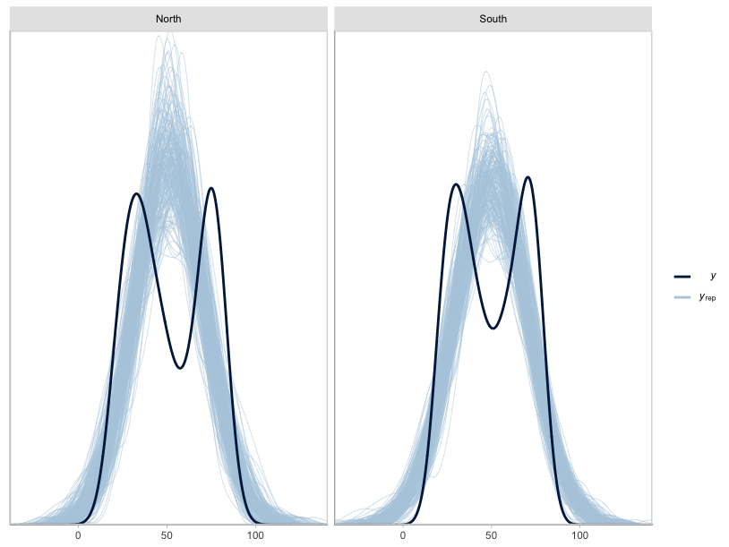
Figure A.71. Posterior draws of age-at-death by region based on the mortality model for the sinuses (n_{draws}=200). Priors based on the London Bills of Mortality.

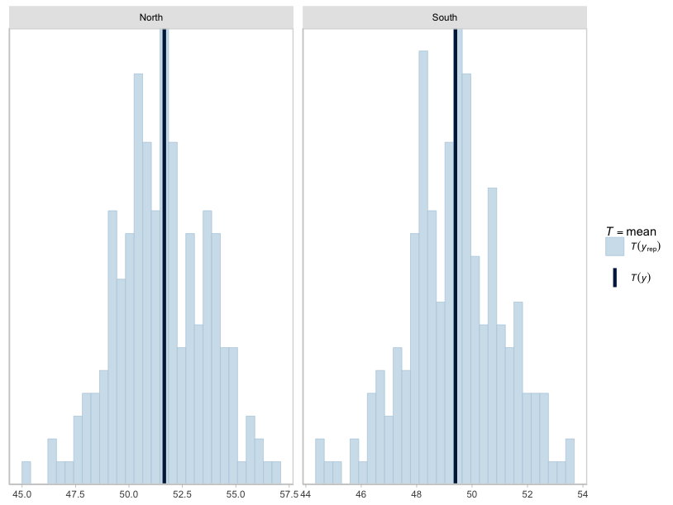
Figure A.72. Posterior draws of age-at-death by region based on the mortality model for the sinuses (n_{draws}=200). Dark blue lines reflect observed means. Priors based on the London Bills of Mortality.

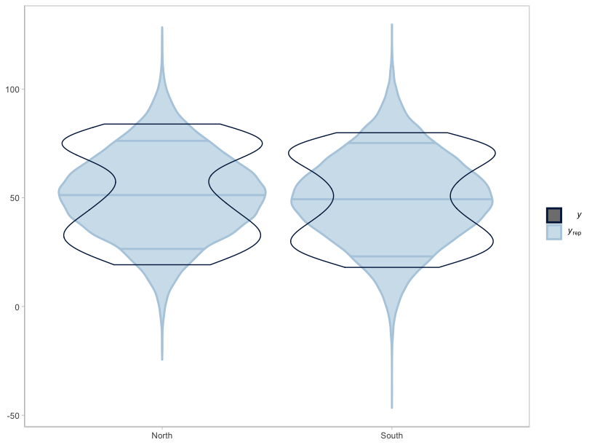
Figure A.73. Violin plots of posterior draws of age-at-death by region based on the mortality model for the sinuses (n_{draws}=200). Priors based on the London Bills of Mortality.

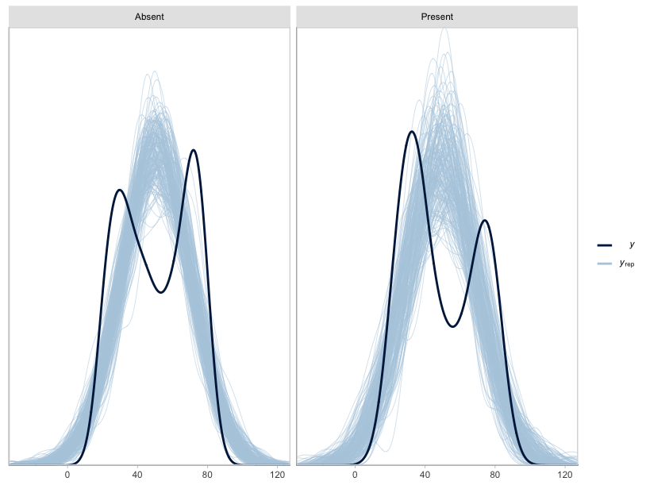
Figure A.74. Posterior draws of age-at-death by CMS status based on the mortality model for the sinuses (n_{draws}=200). Priors based on the London Bills of Mortality.

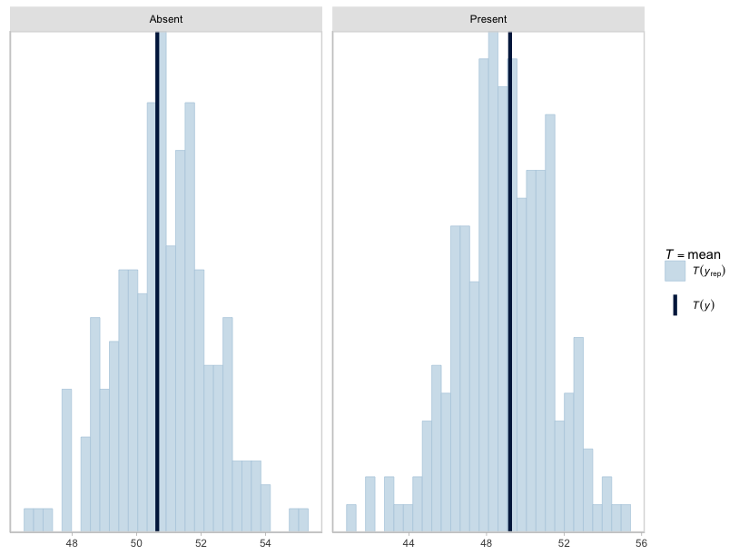
Figure A.75. Posterior draws of age-at-death by CMS status based on the mortality model for the sinuses (n_{draws}=200). Dark blue lines reflect observed means. Priors based on the London Bills of Mortality.
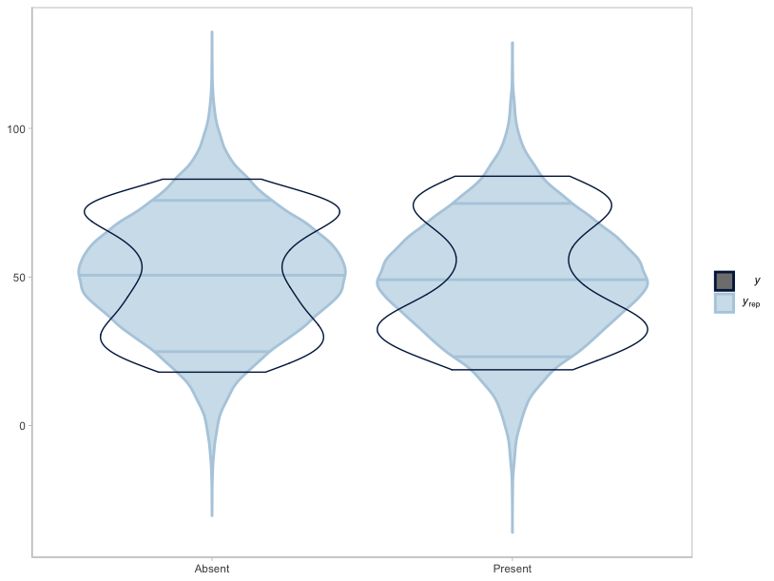
Figure A.76. Violin plots of posterior draws of age-at-death by CMS based on the mortality model for the sinuses (n_{draws}=200). Priors based on the London Bills of Mortality.

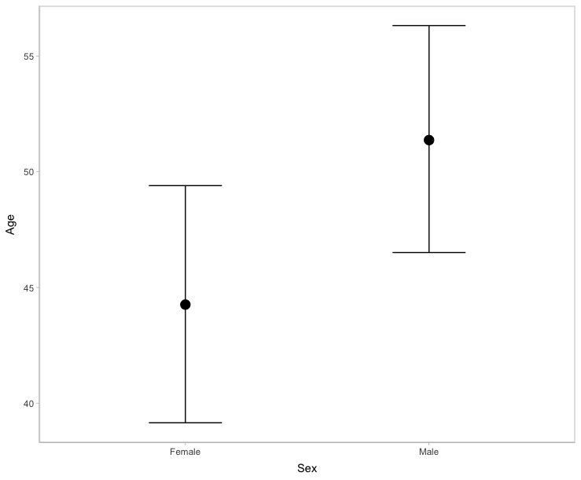
Figure A.77. Marginal effect of sex on age-at-death. Priors based on the London Bills of Mortality.

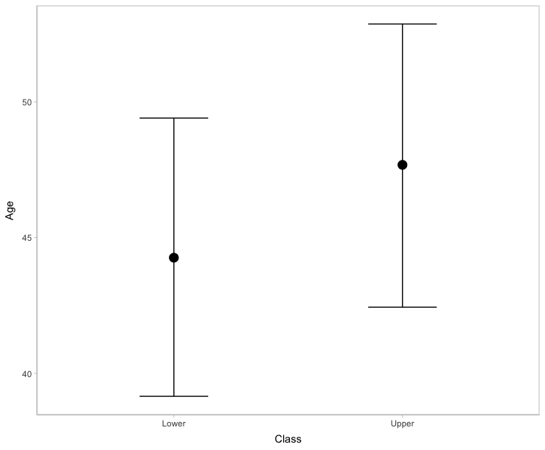

Figure A.78. Marginal effect of class on age-at-death. Priors based on the London Bills of Mortality.

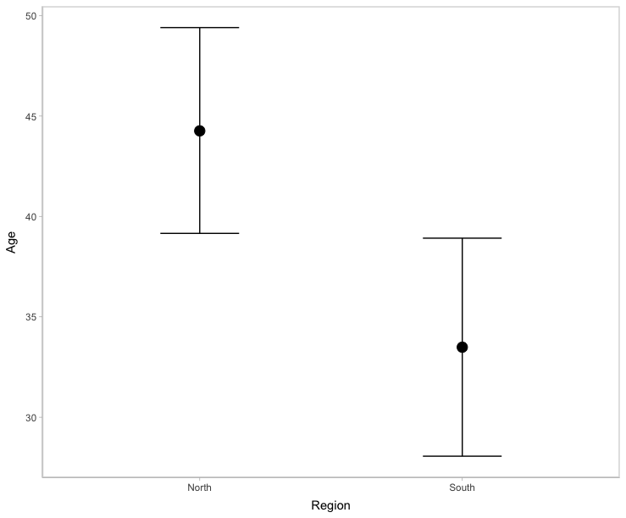
Figure A.79. Marginal effect of region on age-at-death. Priors based on the London Bills of Mortality.

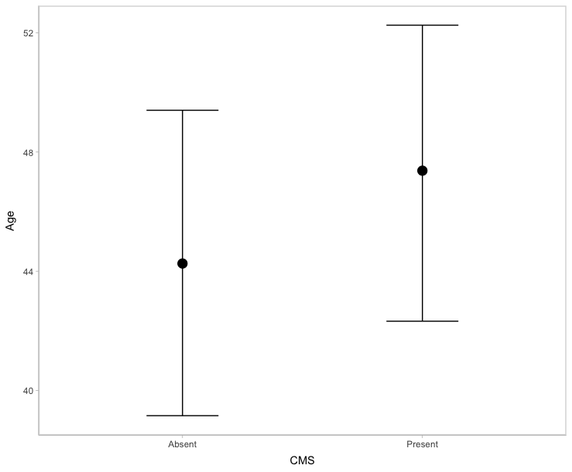

Figure A.80. Marginal effect of CMS on age-at-death. Priors based on the London Bills of Mortality.

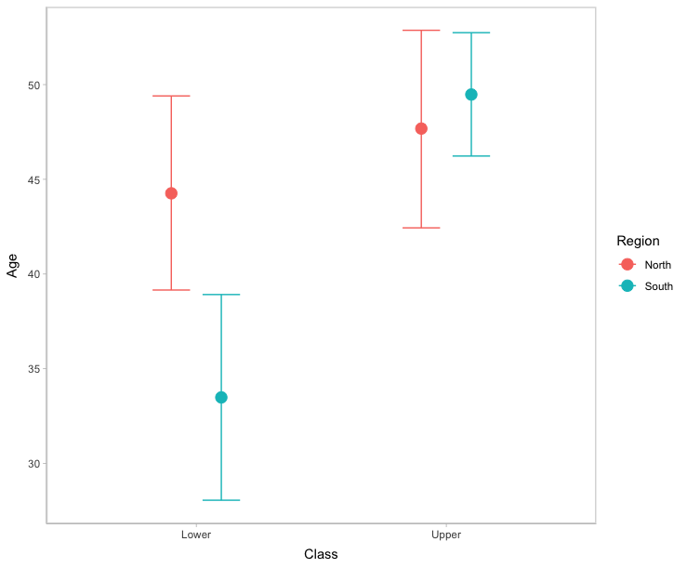
Figure A.81. Marginal effect of the interaction between class and region on age-at-death. Priors based on the London Bills of Mortality.

General Register Office Reports
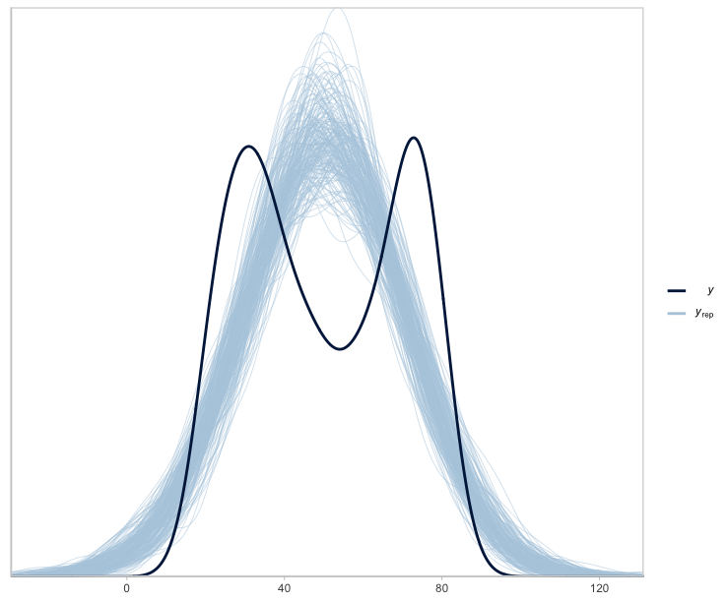
Figure A.82. Posterior draws of age-at-death based on the mortality model for the sinuses (n_{draws}=200). Priors based on the General Register Office Reports.

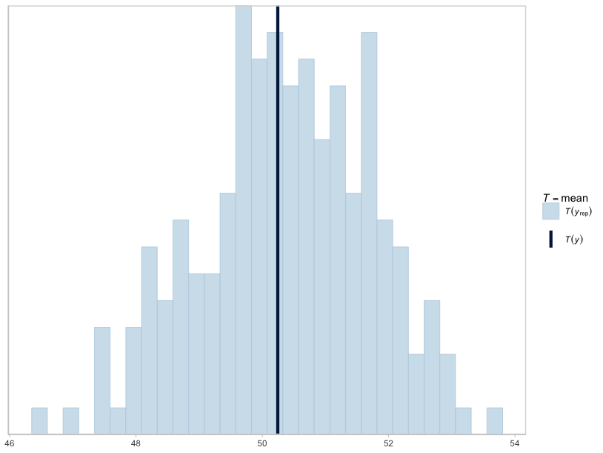
Figure A.83. Posterior draws of age-at-death based on the mortality model for the sinuses (n_{draws}=200). Blue lines reflect observed mean. Priors based on the General Register Office Reports.

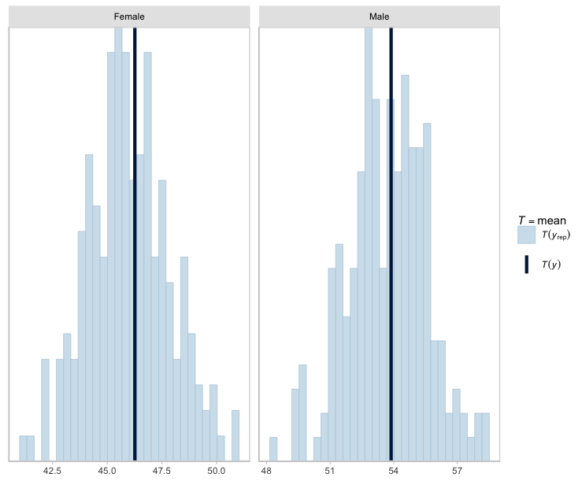
Figure A.84. Posterior draws of age-at-death based on the mortality model for the sinuses (n_{draws}=200). Dark blue lines reflect observed means. Priors based on the General Register Office Reports.

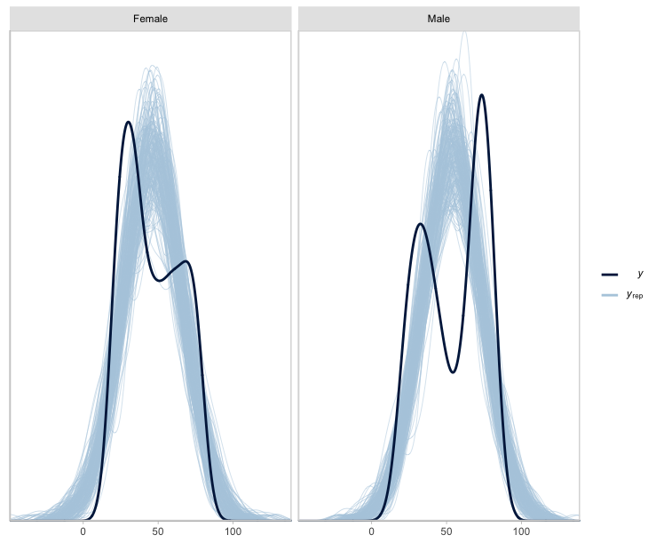

Figure A.85. Posterior draws of age-at-death by sex based on the mortality model for the sinuses (n_{draws}=200). Priors based on the General Register Office Reports.

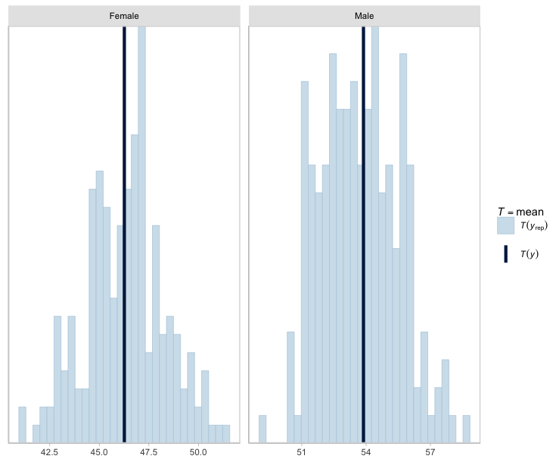
Figure A.86. Posterior draws of age-at-death by sex based on the mortality model for the sinuses (n_{draws}=200). Dark blue lines reflect observed means. Priors based on the General Register Office Reports.

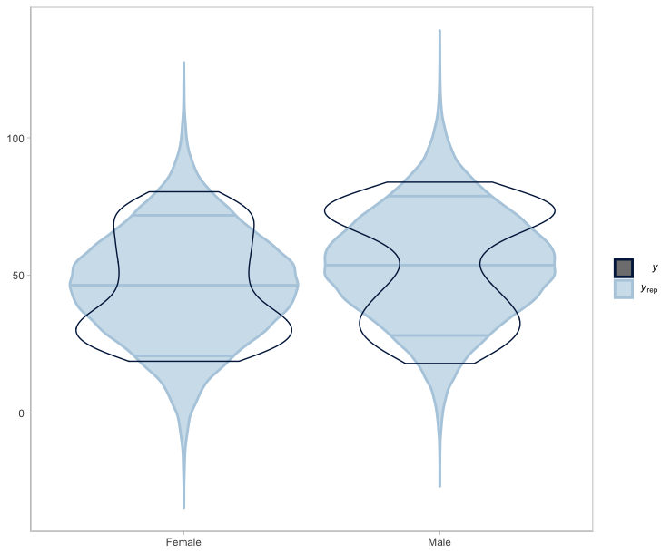
Figure A.87. Violin plots of posterior draws of age-at-death by sex based on the mortality model for the sinuses (n_{draws}=200). Priors based on the General Register Office Reports.

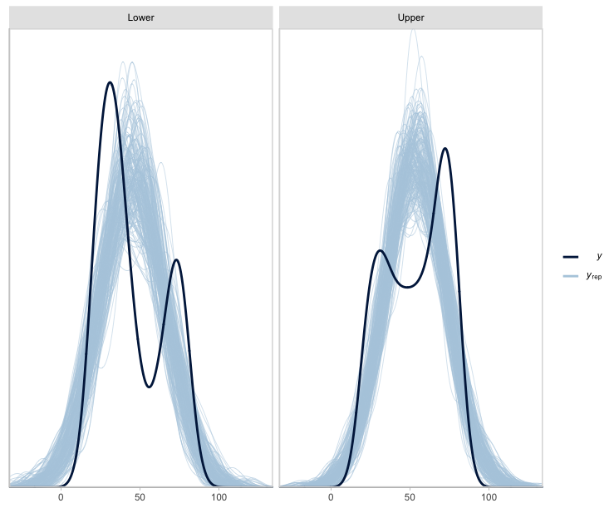
Figure A.88. Posterior draws of age-at-death by class based on the mortality model for the sinuses (n_{draws}=200). Priors based on the General Register Office Reports.

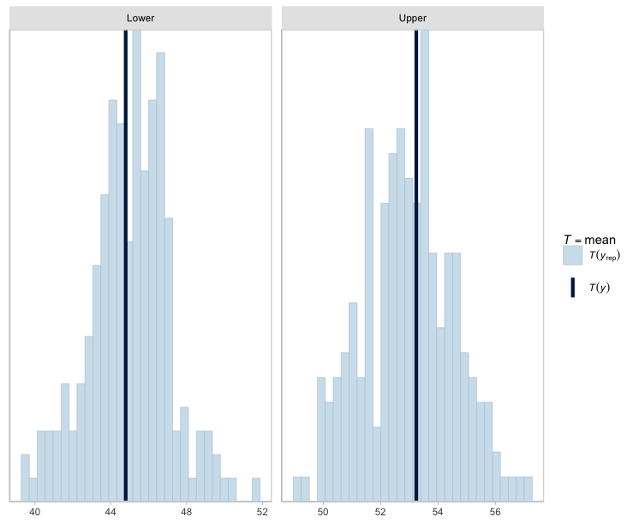
Figure A.89. Posterior draws of age-at-death by class based on the mortality model for the sinuses (n_{draws}=200). Dark blue lines reflect observed means. Priors based on the General Register Office Reports.

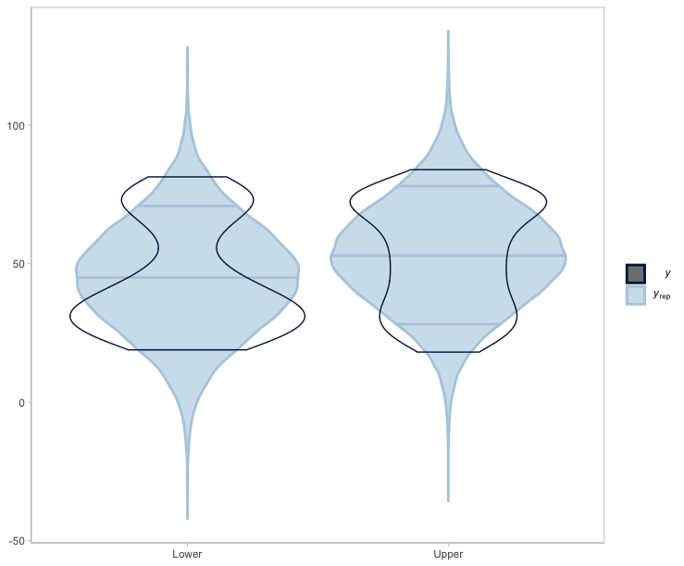
Figure A.90. Violin plots of posterior draws of age-at-death by class based on the mortality model for the sinuses (n_{draws}=200). Priors based on the General Register Office Reports.

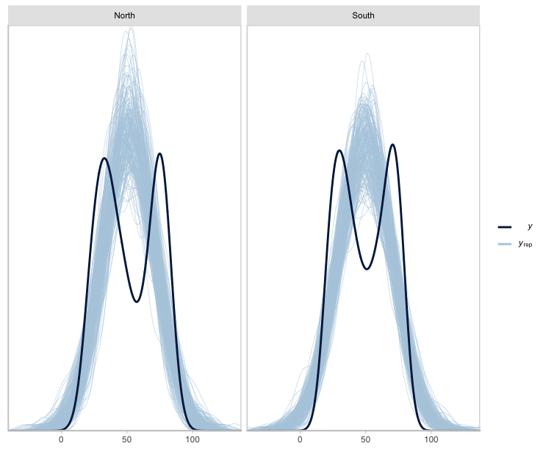
Figure A.91. Posterior draws of age-at-death by region based on the mortality model for the sinuses (n_{draws}=200). Priors based on the General Register Office Reports.

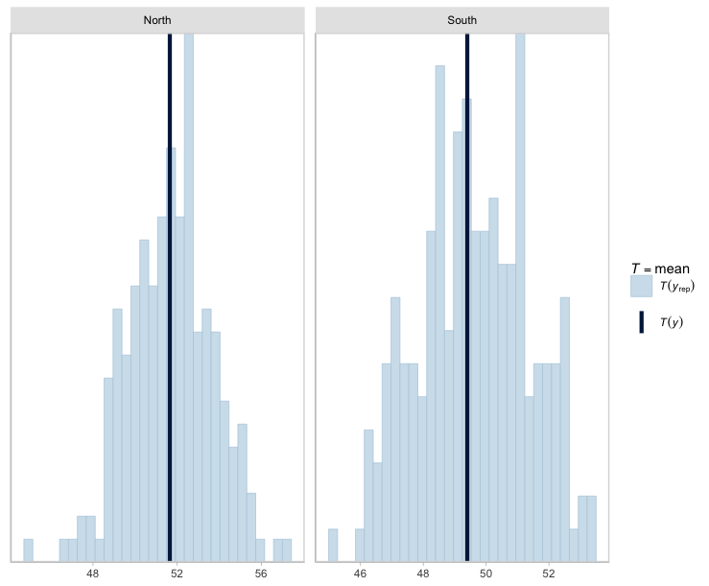
Figure A.92. Posterior draws of age-at-death by region based on the mortality model for the sinuses (n_{draws}=200). Dark blue lines reflect observed means. Priors based on the General Register Office Reports.

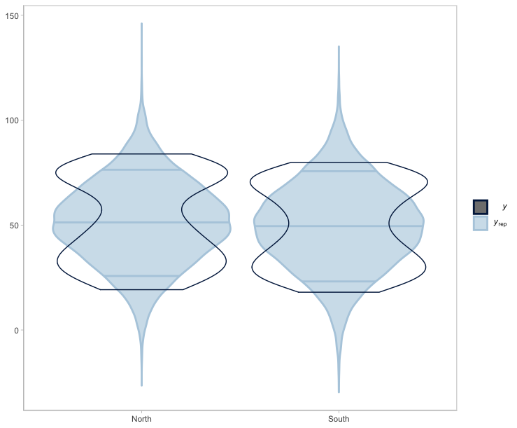
Figure A.93. Violin plots of posterior draws of age-at-death by region based on the mortality model for the sinuses (n_{draws}=200). Priors based on the General Register Office Reports.

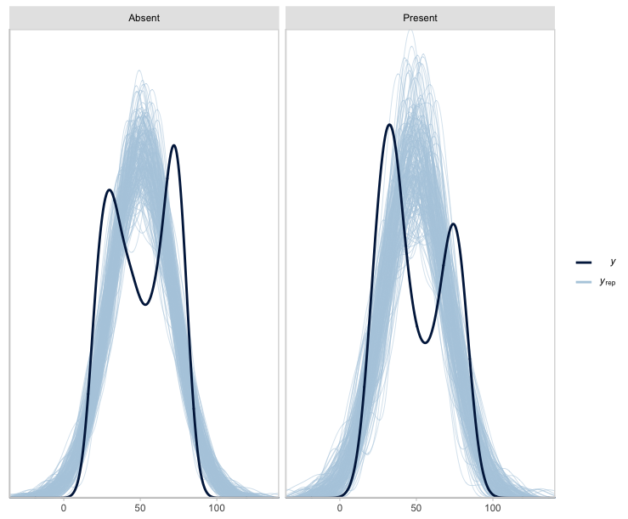
Figure A.94. Posterior draws of age-at-death by CMS status based on the mortality model for the sinuses (n_{draws}=200). Priors based on the General Register Office Reports.

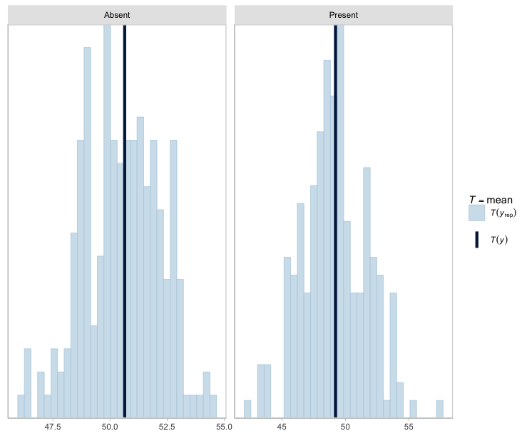
Figure A.95. Posterior draws of age-at-death by CMS based on the mortality model for the sinuses (n_{draws}=200). Dark blue lines reflect observed means. Priors based on the General Register Office Reports.

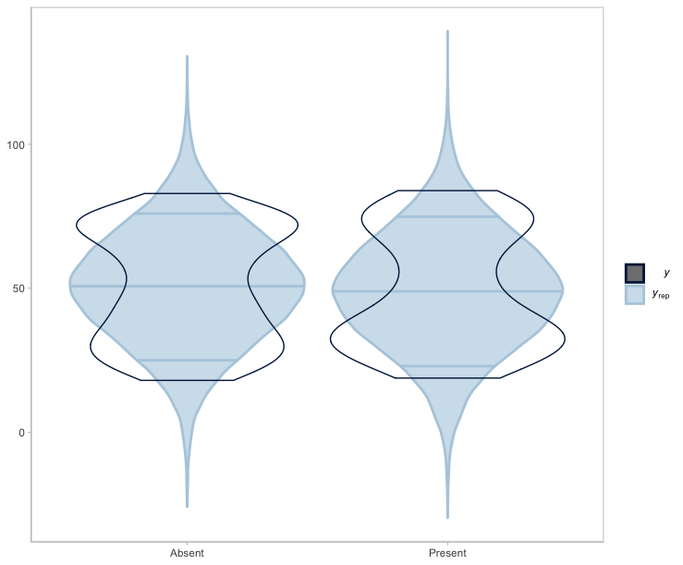
Figure A.96. Violin plots of posterior draws of age-at-death by CMS based on the mortality model for the sinuses (n_{draws}=200). Priors based on the General Register Office Reports.

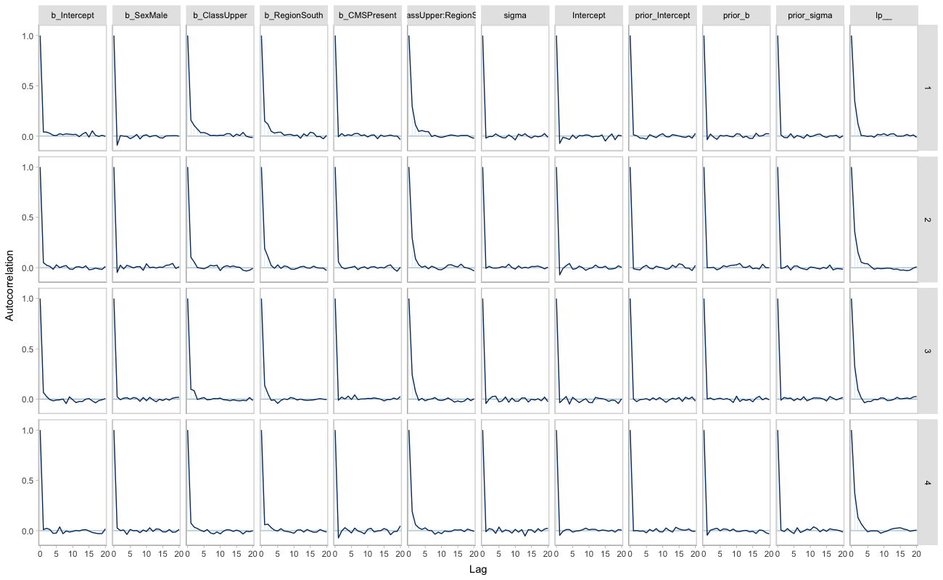
Figure A.97. Autocorrelation plots for each mortality model parameter by HMC chain. Priors based on the General Register Office Reports.

\
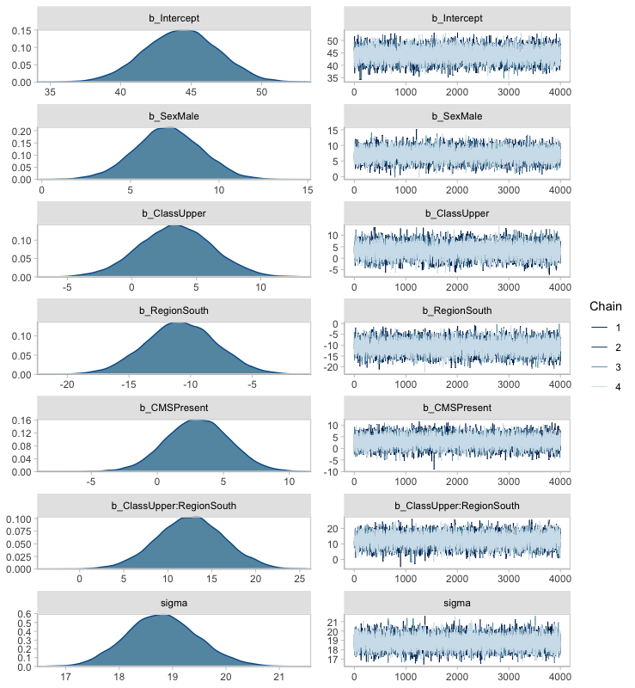
Figure A.98. Posterior distribution of model parameters and accompanying HMC chains. Priors based on the General Register Office Reports.

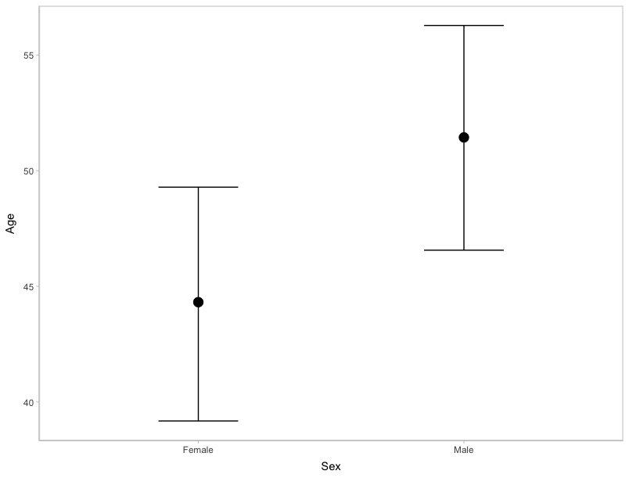
Figure A.99. Marginal effect of sex on age-at-death. Priors based on the General Register Office Reports.

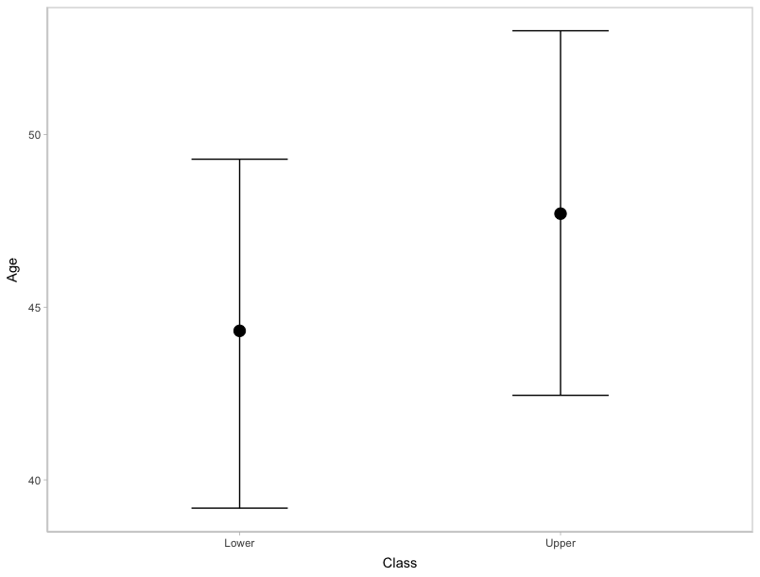
Figure A.100. Marginal effect of class on age-at-death. Priors based on the General Register Office Reports
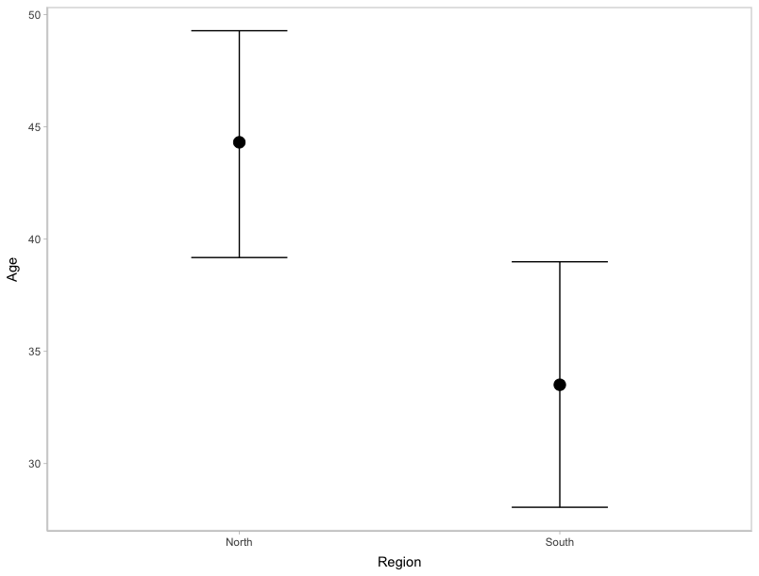
Figure A.101. Marginal effect of region on age-at-death. Priors based on the General Register Office Reports.

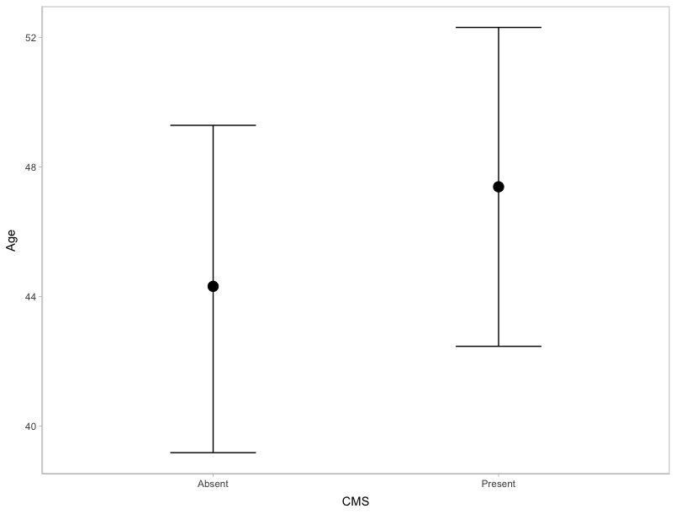
Figure A.102. Marginal effect of CMS on age-at-death. Priors based on the General Register Office Reports.

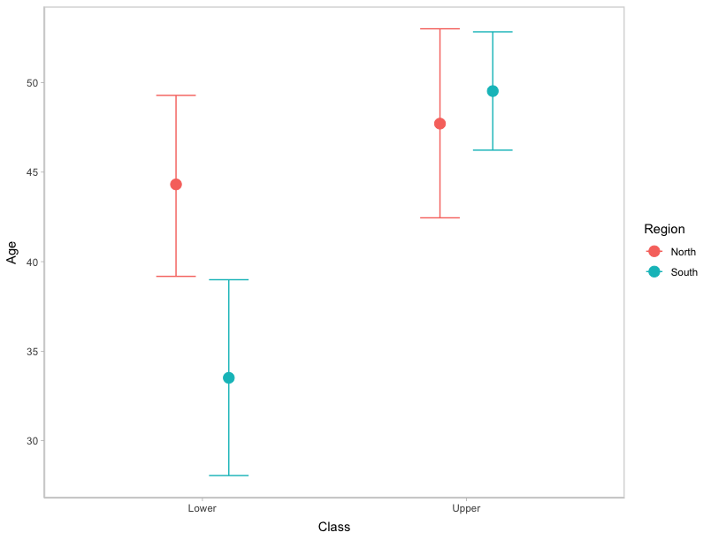
Figure A.103. Marginal effect of the interaction between class and region on age-at-death. Priors based on the General Register Office Reports.

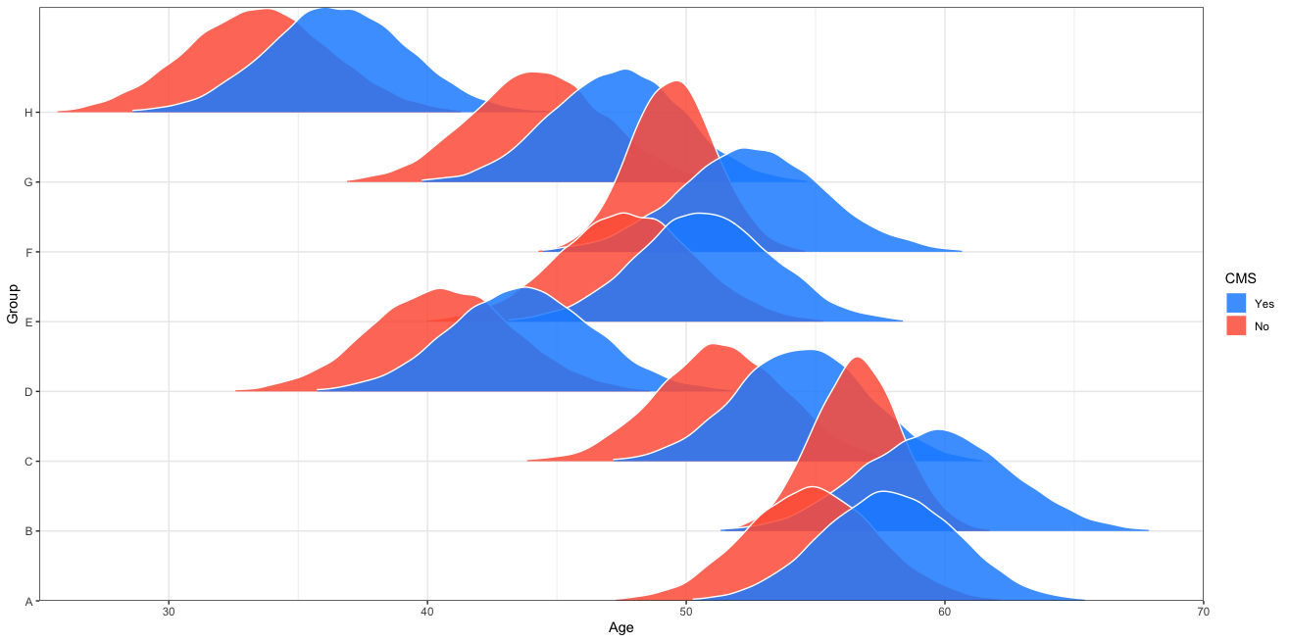
Figure A.104. Comparison of the posterior age-at-death distributions for intersectional groups based on CMS presence or absence. Prior information based on the General Register Office Reports.

Table A.4. MAP and 90% HDIs describing the most likely age-at-death by intersectional group and CMS presence/absence. Priors informed by the General Register Office Reports.
 |  |  |  | CMS (+) |  |  | CMS (-)
 | Definition |  |  |  | 90% Highest Density Interval |  |  | 90% Highest Density Interval
Group | Region | Class | Sex | MAP | Lower | Upper | MAP | Lower | Upper
A | North | Upper/Middle | Male | 57.81 | 53.85 | 62.54 | 55.00 | 50.46 | 58.89
B | South | Upper/Middle | Male | 59.91 | 54.79 | 64.18 | 56.73 | 53.95 | 59.31
C | North | Lower/Middle | Male | 54.75 | 50.37 | 58.47 | 51.67 | 47.14 | 55.29
D | South | Lower/Middle | Male | 43.54 | 39.20 | 48.36 | 40.27 | 36.09 | 45.22
E | North | Upper/Middle | Female | 50.72 | 46.37 | 55.24 | 47.54 | 43.12 | 51.93
F | South | Upper/Middle | Female | 52.66 | 47.95 | 57.31 | 49.70 | 46.80 | 52.34
G | North | Lower/Middle | Female | 47.81 | 43.37 | 51.73 | 44.46 | 40.09 | 48.61
H | South | Lower/Middle | Female | 36.38 | 32.12 | 41.14 | 33.72 | 28.81 | 37.99

Comparison Between Archival Sources
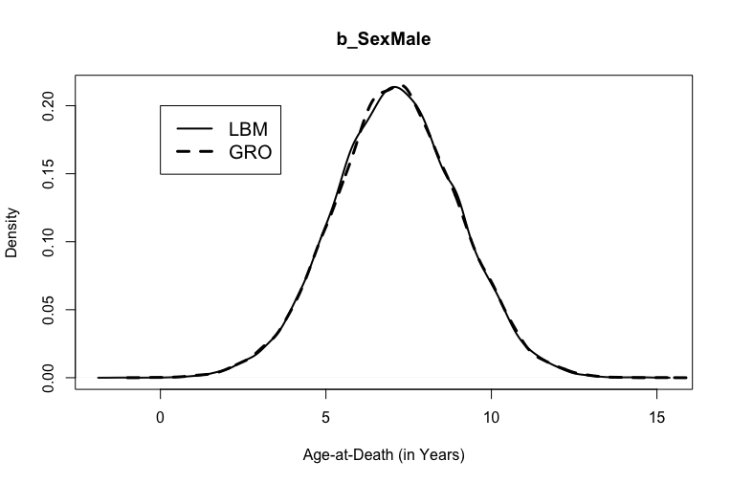
Figure A.105. Posterior distributions for b_SexMale in the models weakly informed by the London Bills of Mortality and the General Registrar Officer Reports.

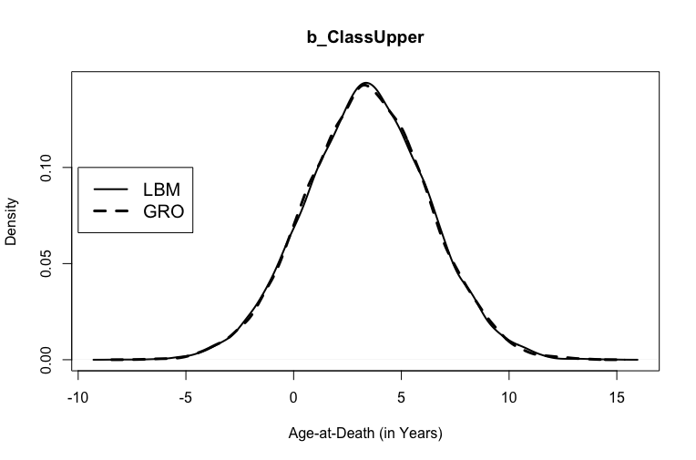
Figure A.106. Posterior distributions for b_ClassUpper in the models weakly informed by the London Bills of Mortality and the General Registrar Officer Reports.

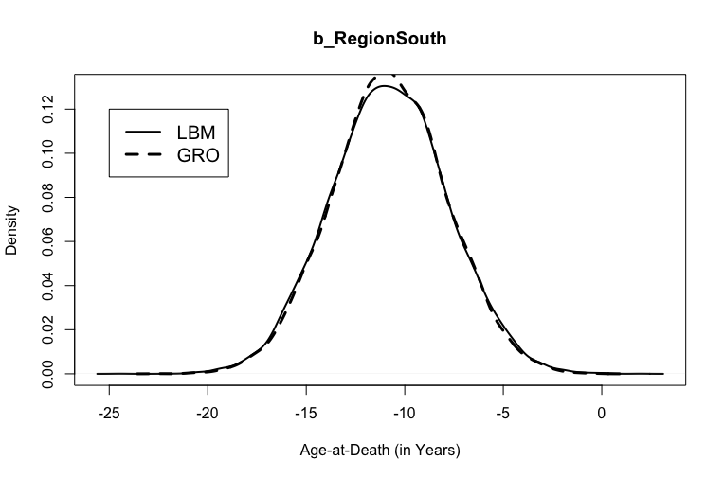
Figure A.107. Posterior distributions for b_RegionSouth in the models weakly informed by the London Bills of Mortality and the General Registrar Officer Reports.

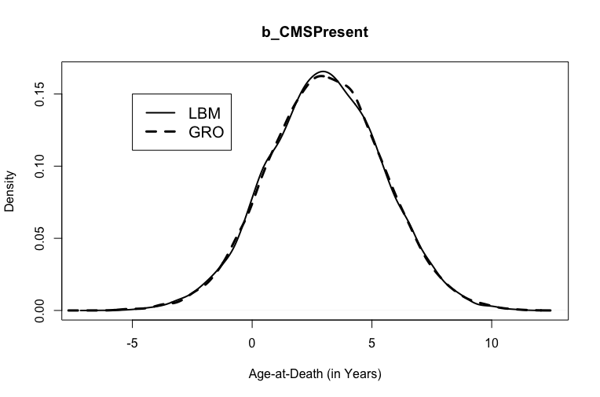
Figure A.108. Posterior distributions for b_CMSPresent in the models weakly informed by the London Bills of Mortality and the General Registrar Officer Reports.

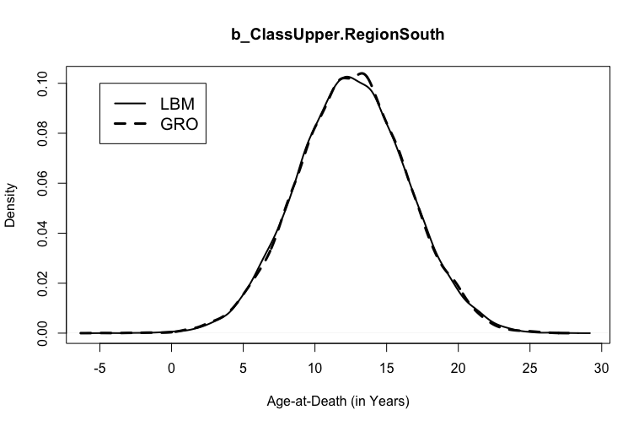
Figure A.109. Posterior distributions for b_ClassUpper.RegionSouth in the models weakly informed by the London Bills of Mortality and the General Registrar Officer Reports.

Rib PNB Mortality Models
London Bills of Mortality
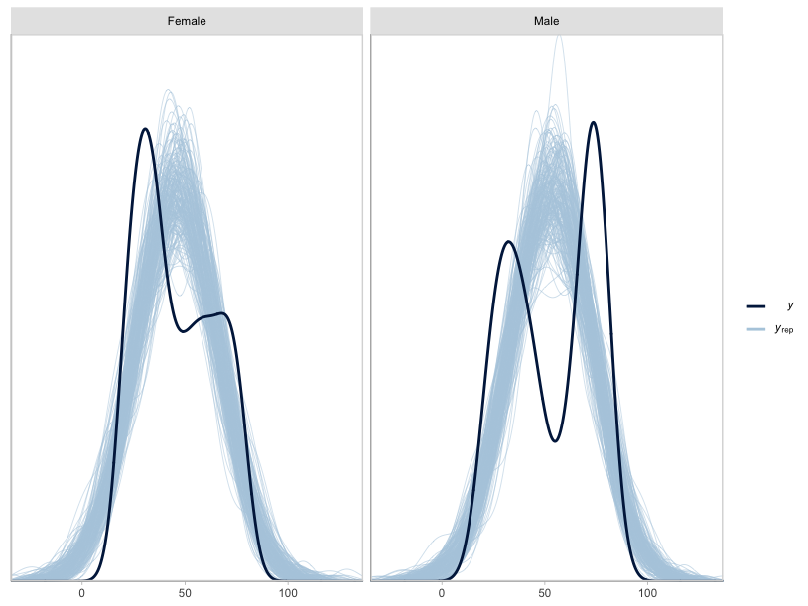
Figure A.110. Posterior draws of age-at-death by sex based on the mortality model for the ribs (n_{draws}=200). Priors based on the London Bills of Mortality.

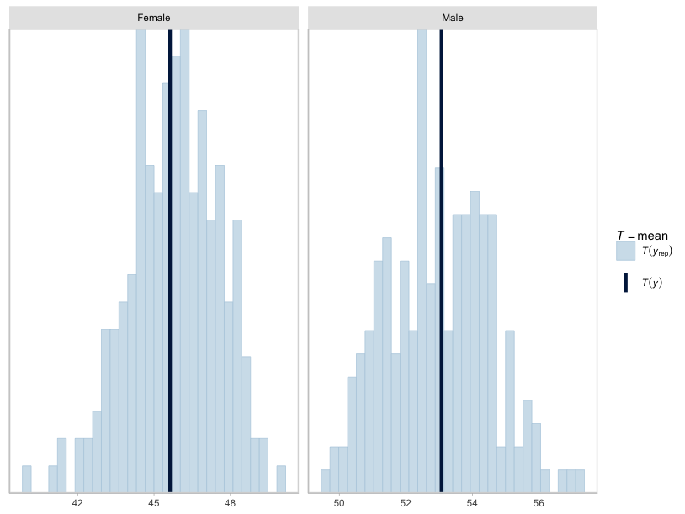
Figure A.111. Posterior draws of age-at-death by sex based on the mortality model for the ribs (n_{draws}=200). Dark blue lines represent observed means. Priors based on the London Bills of Mortality.

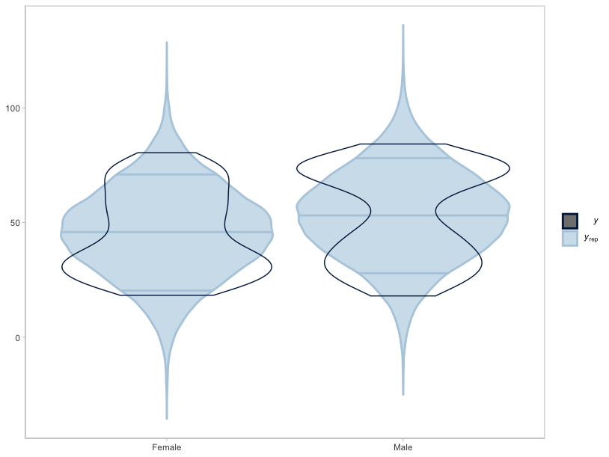
Figure A.112. Violin plots of posterior draws of age-at-death by sex based on the mortality model for the ribs (n_{draws}=200). Priors based on the London Bills of Mortality.

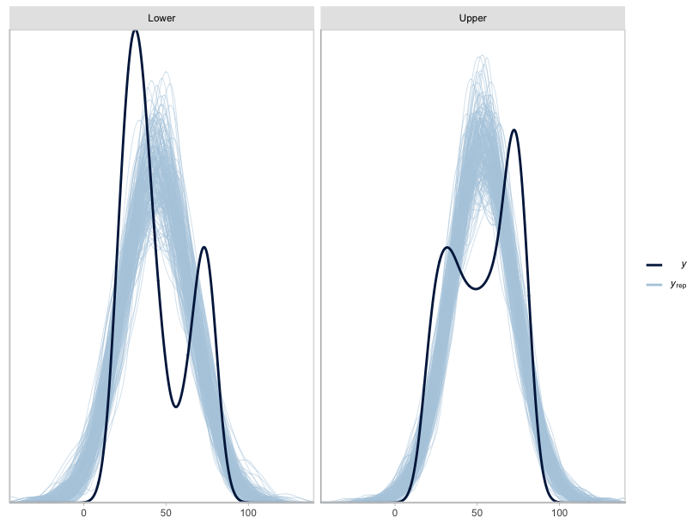
Figure A.113. Posterior draws of age-at-death by class based on the mortality model for the ribs (n_{draws}=200). Priors based on the London Bills of Mortality.

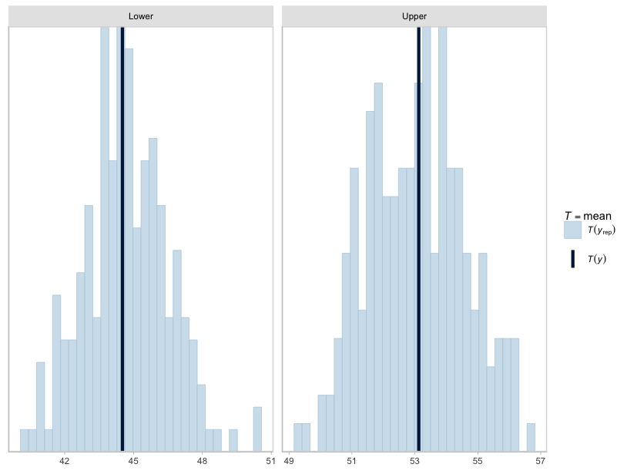
Figure A.114. Posterior draws of age-at-death by class based on the mortality model for the ribs (n_{draws}=200). Dark blue lines represent observed means. Priors based on the London Bills of Mortality.

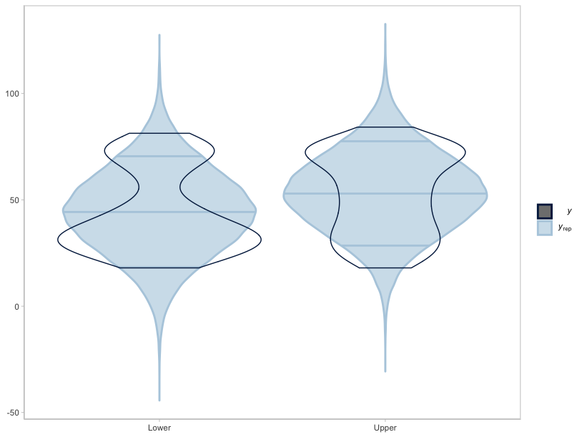
Figure A.115. Violin plots of posterior draws of age-at-death by class based on the mortality model for the ribs (n_{draws}=200). Priors based on the London Bills of Mortality.

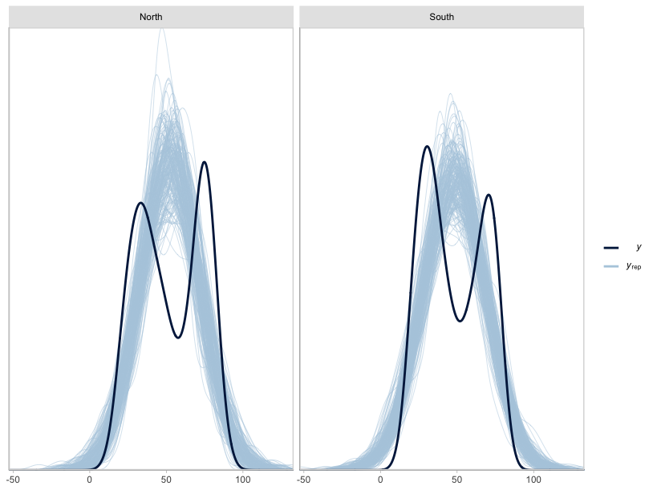
Figure A.116. Posterior draws of age-at-death by region based on the mortality model for the ribs (n_{draws}=200). Priors based on the London Bills of Mortality.

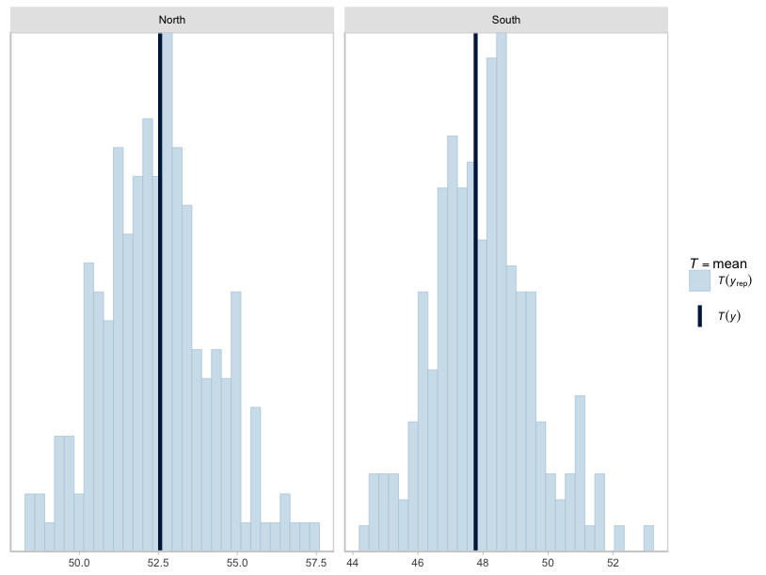
Figure A.117. Posterior draws of age-at-death by region based on the mortality model for the ribs (n_{draws}=200). Dark blue lines reflect observed means. Priors based on the London Bills of Mortality.

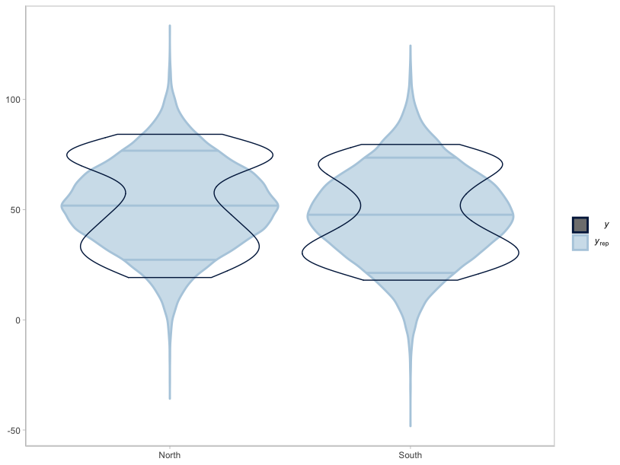
Figure A.118. Violin plots of posterior draws of age-at-death by region based on the mortality model for the ribs (n_{draws}=200). Priors based on the London Bills of Mortality.

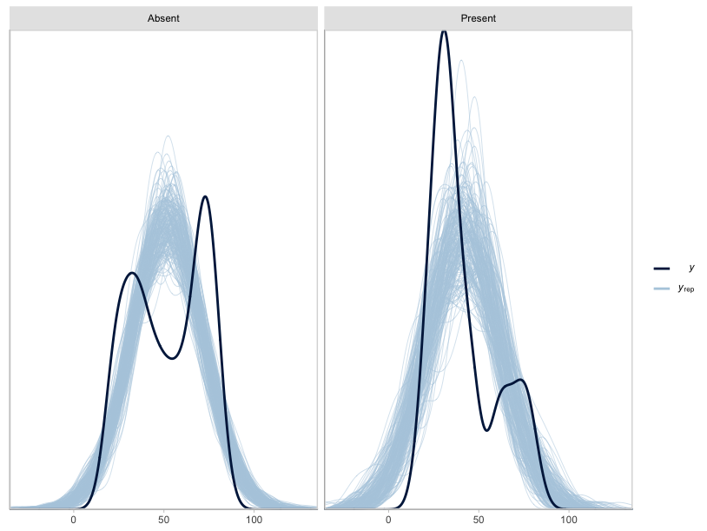
Figure A.119. Posterior draws of age-at-death by PNB status based on the mortality model for the ribs (n_{draws}=200). Priors based on the London Bills of Mortality.

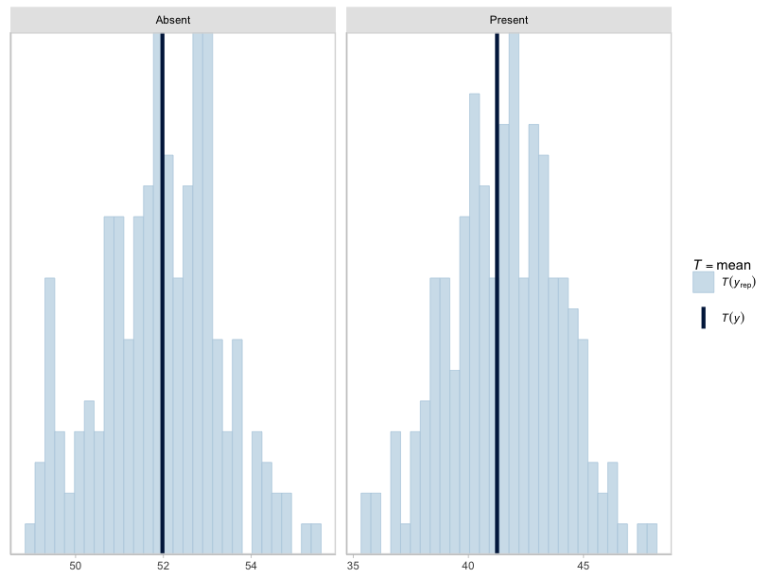
Figure A.120. Posterior draws of age-at-death by PNB status based on the mortality model for the ribs (n_{draws}=200). Dark blue lines reflect observed means. Priors based on the London Bills of Mortality.

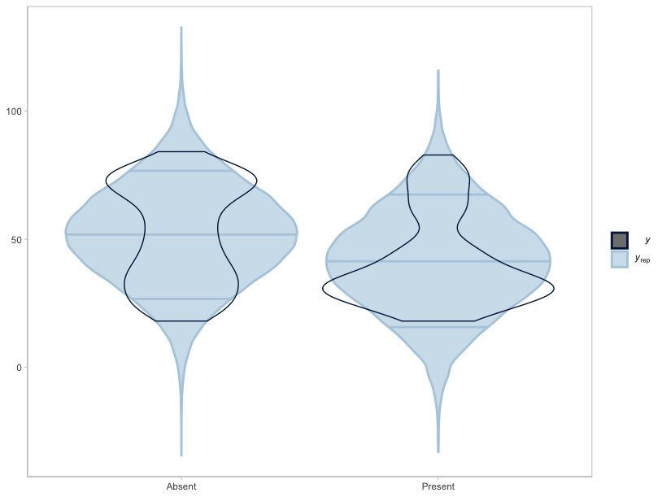
Figure A.121. Violin plots of posterior draws of age-at-death by rib PNB based on the mortality model for the ribs (n_{draws}=200). Priors based on the London Bills of Mortality.

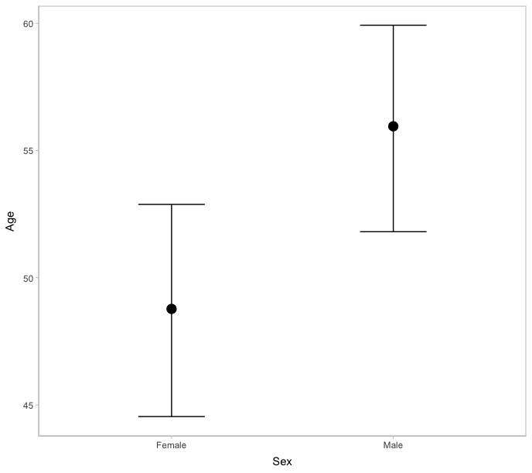
Figure A.122. Marginal effect of sex on age-at-death. Priors based on the London Bills of Mortality.

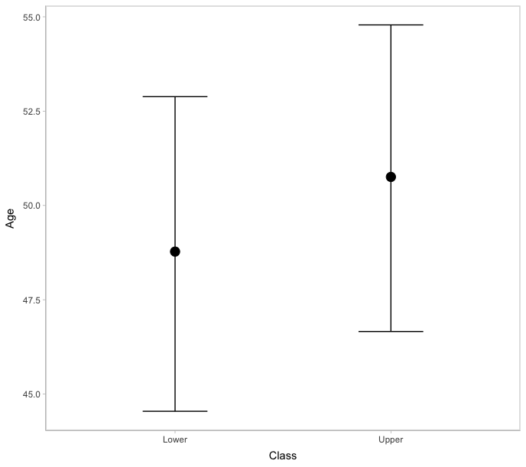
Figure A.123. Marginal effect of class on age-at-death. Priors based on the London Bills of Mortality.

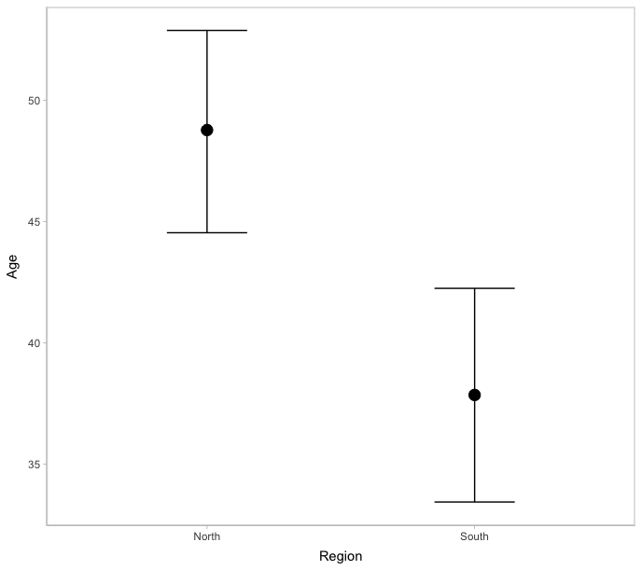
Figure A.124. Marginal effect of region on age-at-death. Priors based on the London Bills of Mortality.

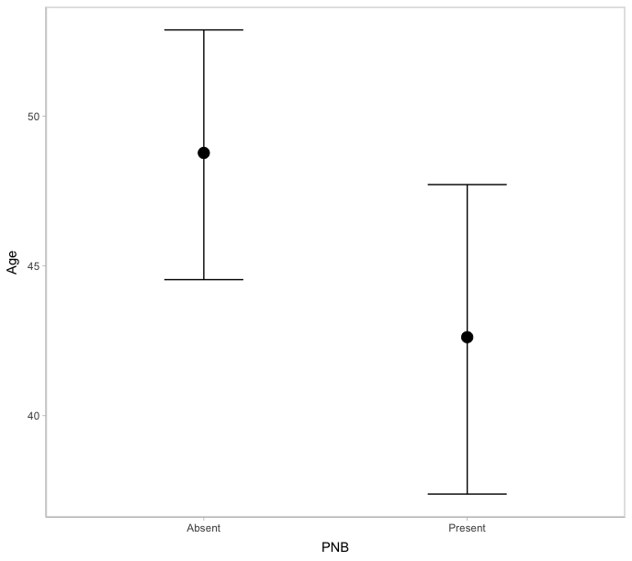
Figure A.125. Marginal effect of rib PNB on age-at-death. Priors based on the London Bills of Mortality.

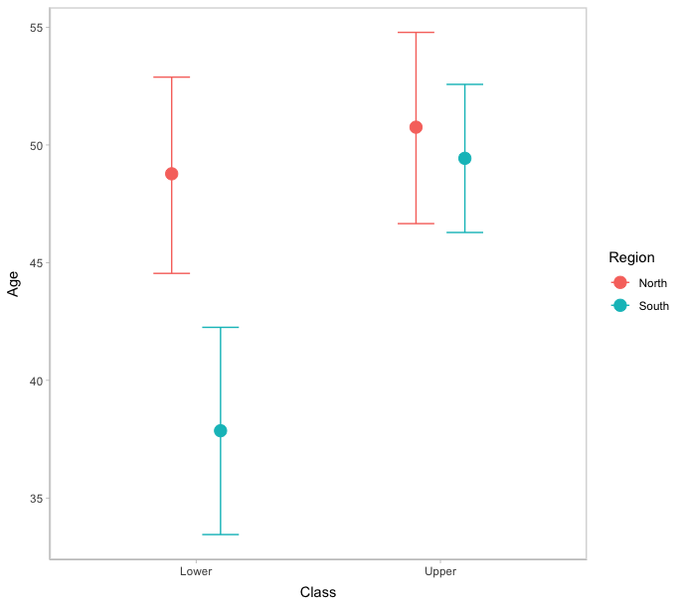
Figure A.126. Marginal effect of the interaction between class and region on age-at-death. Priors based on the London Bills of Mortality.

General Register Office Reports
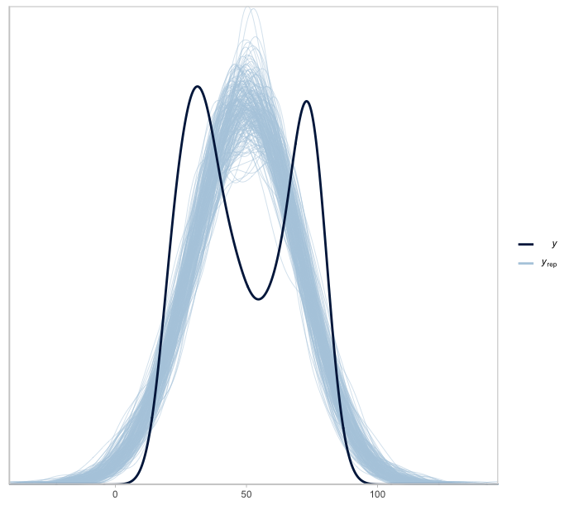
Figure A.127. Posterior draws of age-at-death based on the mortality model for the ribs (n_{draws}=200). Priors based on the General Register Office Reports.

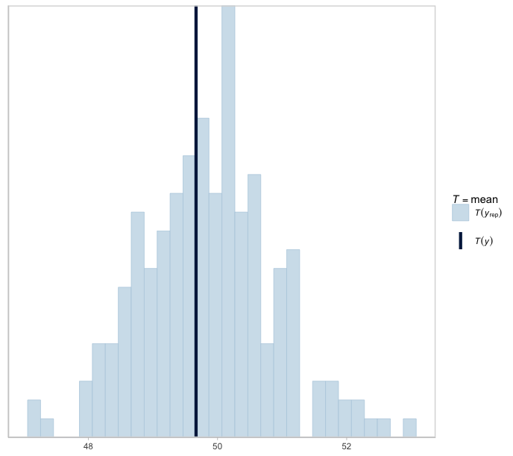
Figure A.128. Posterior draws of age-at-death based on the mortality model for the ribs (n_{draws}=200). Dark blue line reflects observed mean. Priors based on the General Register Office Reports.

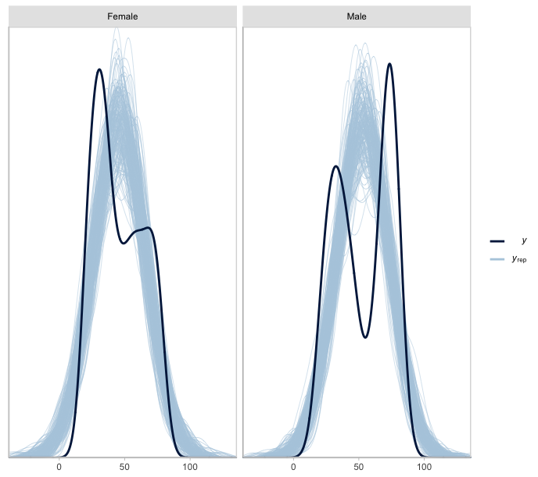
Figure A.129. Posterior draws of age-at-death by sex based on the mortality model for the ribs (n=200). Priors based on the General Register Office Reports.
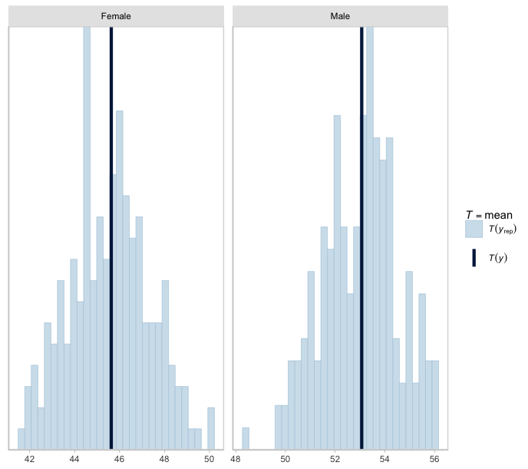
Figure A.130. Posterior draws of age-at-death by sex based on the mortality model for the ribs (n_{draws}=200). Dark blue lines reflect observed means. Priors based on the General Register Office Reports.

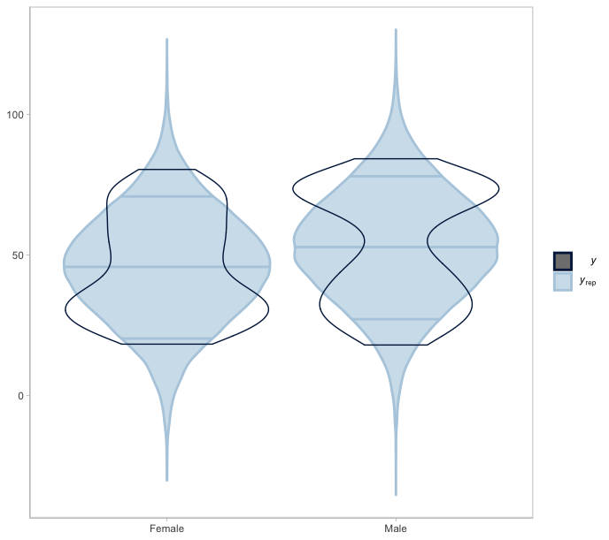
Figure A.131. Violin plots of posterior draws of age-at-death by sex based on the mortality model for the ribs (n=200). Priors based on the General Register Office Reports.
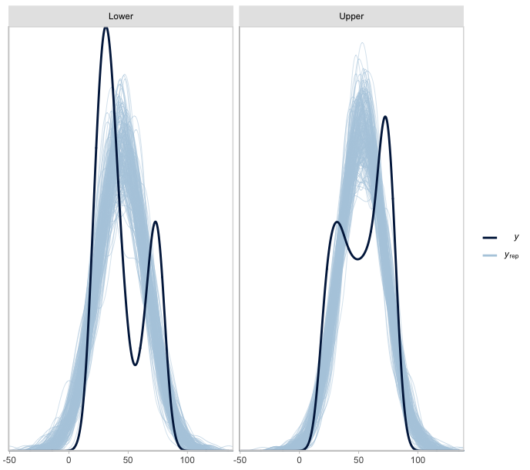
Figure A.132. Posterior draws of age-at-death by class based on the respiratory mortality model for the ribs (n=200). Priors provided by the General Registrar Officer Reports.

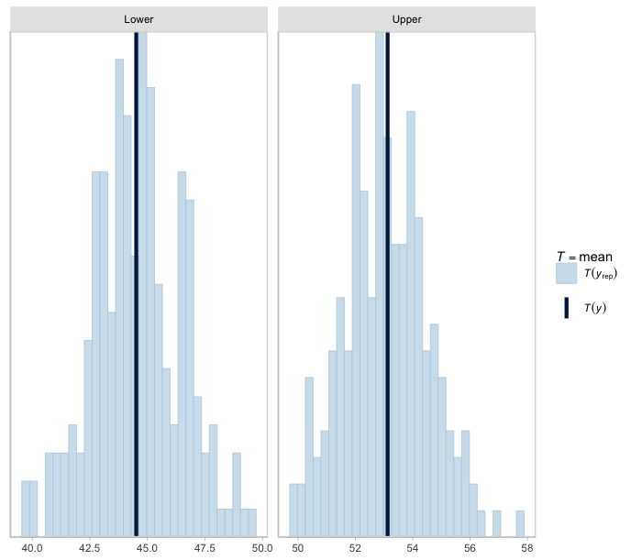
Figure A.133. Posterior draws of age-at-death by class based on the mortality model for the ribs (n_{draws}=200). Dark blue lines reflect observed means. Priors based on the General Register Office Reports.
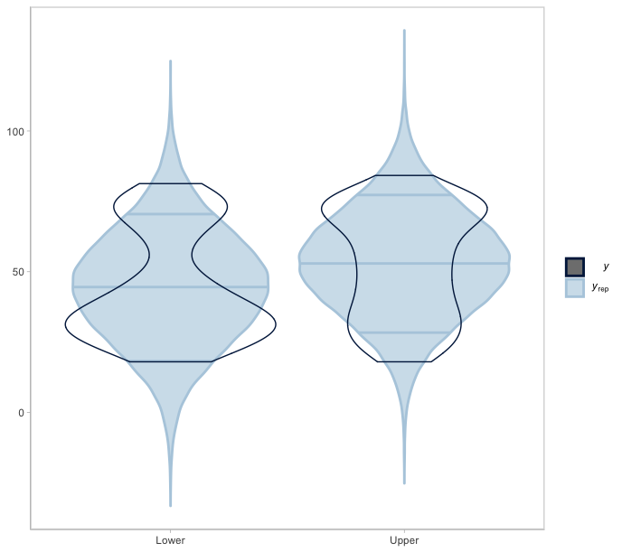
Figure A.134. Violin plots of posterior draws of age-at-death by class based on the mortality model for the ribs (n_{draws}=200). Priors based on the General Register Office Reports.

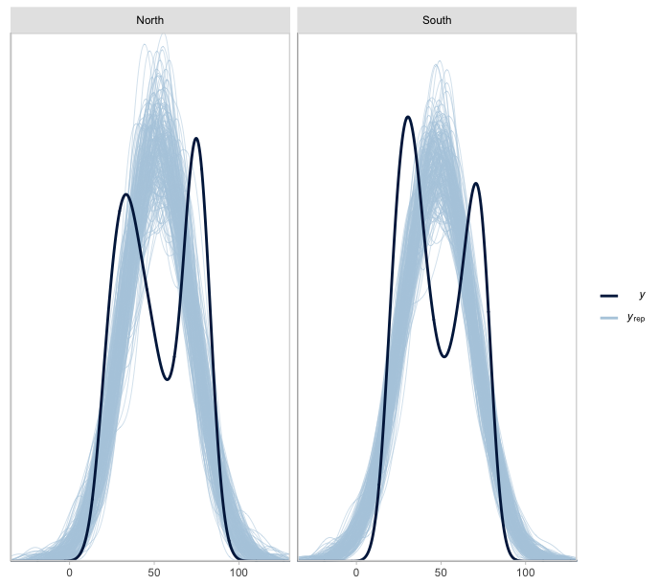
Figure A.135. Posterior draws of age-at-death by region based on the mortality model for the ribs (n_{draws}=200). Priors based on the General Register Office Reports.
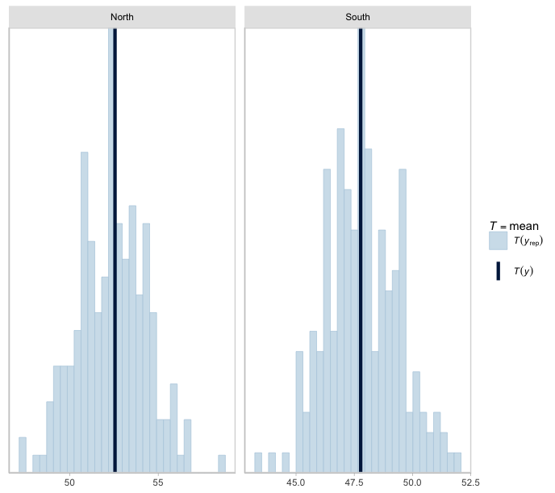
Figure A.136. Posterior draws of age-at-death by region based on the mortality model for the ribs (n_{draws}=200). Dark blue lines reflect observed means. Priors based on the General Register Office Reports.

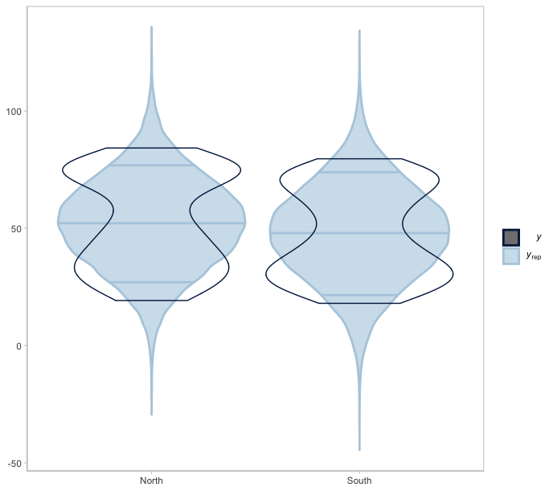
Figure A.137. Violin plots of posterior draws of age-at-death by region based on the mortality model for the ribs (n_{draws}=200). Priors based on the General Register Office Reports.
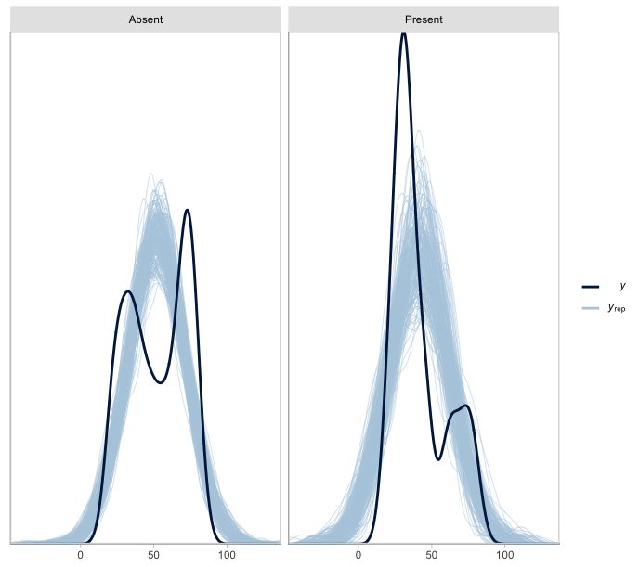
Figure A.138. Posterior draws of age-at-death by PNB status based on the mortality model for the ribs (n_{draws}=200). Priors based on the General Register Office Reports.

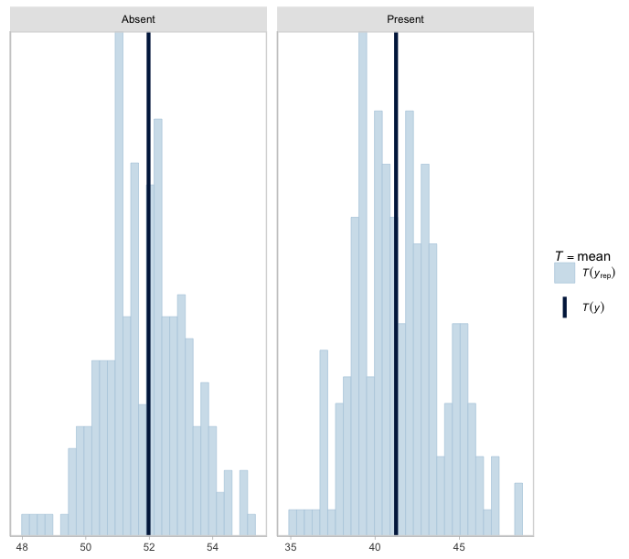
Figure A.139. Posterior draws of age-at-death by PNB status based on the mortality model for the ribs (n_{draws}=200). Dark blue lines reflect observed means. Priors based on the General Register Office Reports.

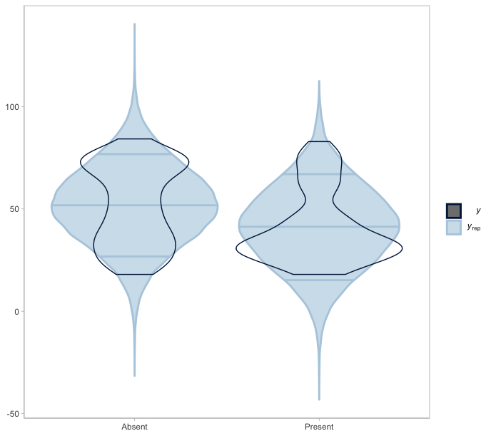
Figure A.140. Violin plots of posterior draws of age-at-death by rib PNB based on the mortality model for the ribs (n_{draws}=200). Priors based on the General Register Office Reports.

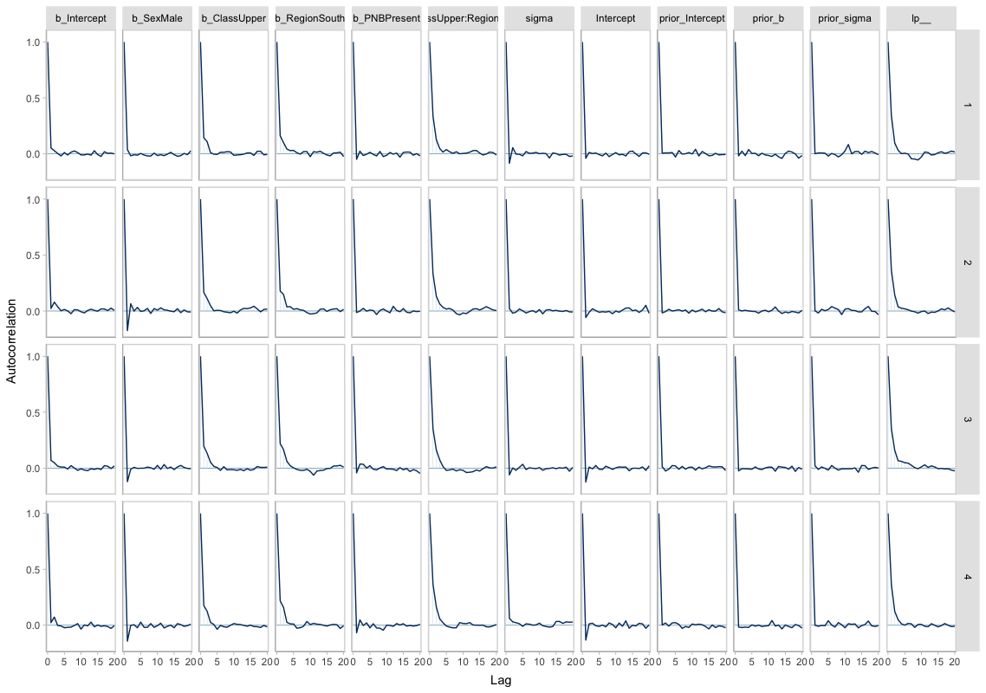
Figure A.141. Autocorrelation plots for each respiratory mortality model parameter by HMC chain. Priors based on the General Register Office Reports.

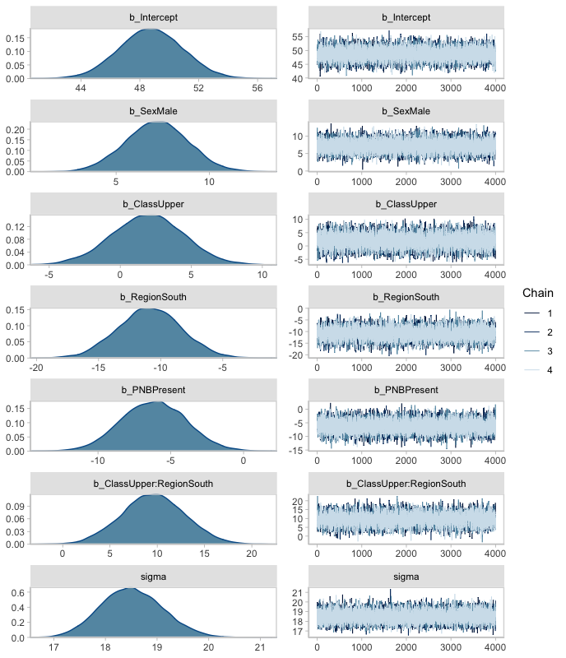
Figure A.142. Posterior distribution of model parameters and accompanying HMC chains. Priors based on the General Register Office Reports.

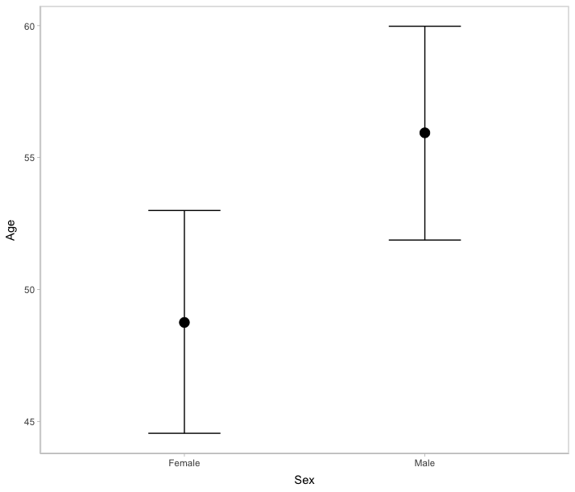
Figure A.143. Marginal effect of sex on age-at-death. Priors based on the General Register Office Reports.

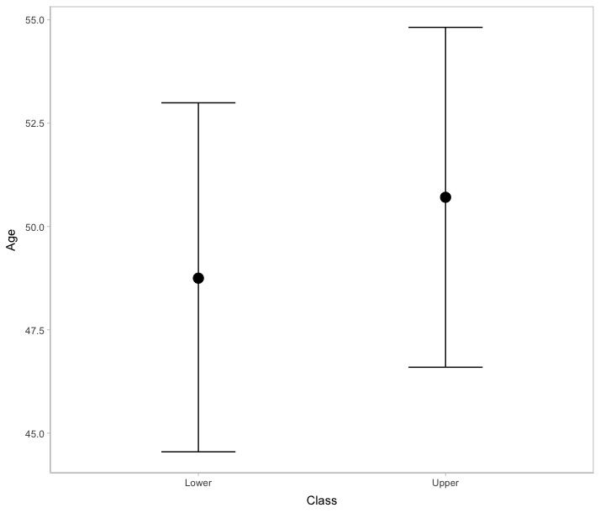
Figure A.144. Marginal effect of class on age-at-death. Priors based on the General Register Office Reports.

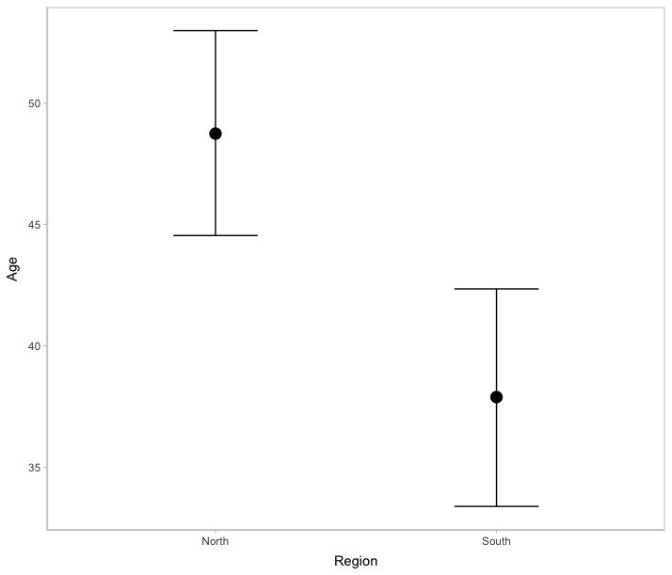
Figure A.145. Marginal effect of region on age-at-death. Priors based on the General Register Office Reports.

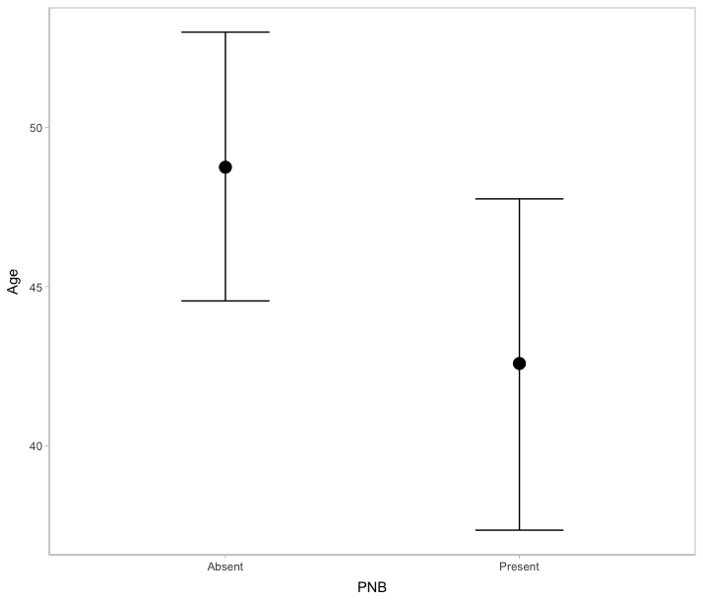
Figure A.146. Marginal effect of rib PNB on age-at-death. Priors based on the General Register Office Reports.

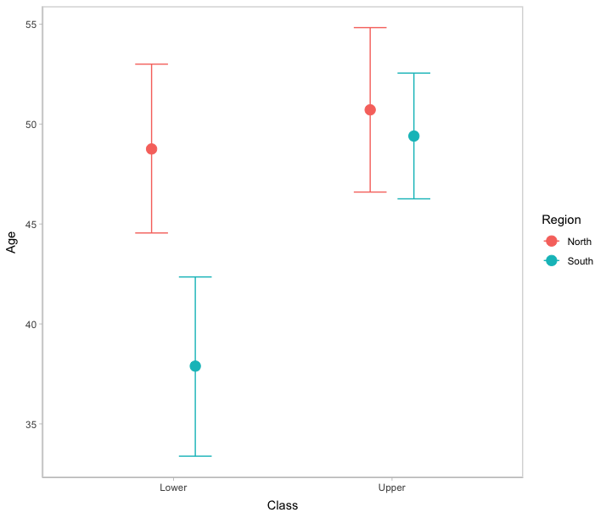
Figure A.147. Marginal effect of the interaction between class and region on age-at-death. Priors based on the General Register Office Reports.

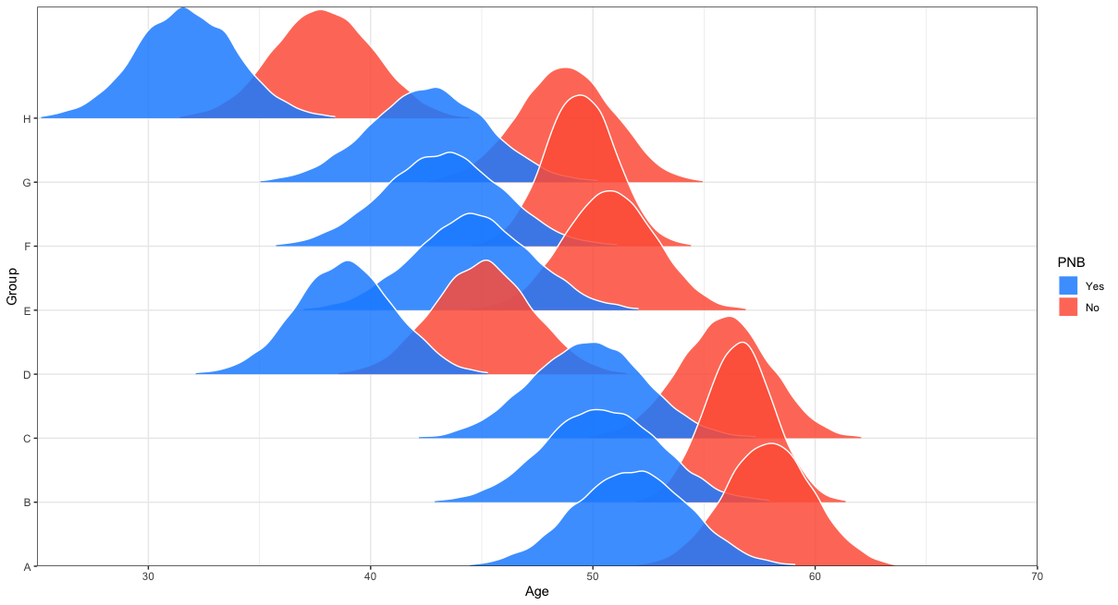
Figure A.148. Comparison of the posterior age-at-death distributions for intersectional groups based on rib PNB presence or absence. Prior information based on the General Register Office Reports.

Table A.5. MAP and 90% HDIs describing the most likely age-at-death by intersectional group and rib PNB presence/absence. Prior informed by the General Register Office Reports.
 |  |  |  | Rib PNB (+) |  |  | Rib PNB (-)
 | Definition |  |  |  | 90% Highest Density Interval |  |  | 90% Highest Density Interval
Group | Region | Class | Sex | MAP | Lower | Upper | MAP | Lower | Upper
A | North | Upper/Middle | Male | 51.52 | 47.45 | 55.98 | 57.94 | 54.66 | 61.42
B | South | Upper/Middle | Male | 50.40 | 46.02 | 54.65 | 56.63 | 54.03 | 59.11
C | North | Lower/Middle | Male | 49.94 | 45.28 | 53.81 | 55.70 | 52.51 | 59.31
D | South | Lower/Middle | Male | 38.99 | 35.17 | 42.46 | 45.31 | 41.59 | 48.87
E | North | Upper/Middle | Female | 44.50 | 40.11 | 48.86 | 51.04 | 47.25 | 54.18
F | South | Upper/Middle | Female | 43.54 | 38.79 | 47.49 | 49.46 | 46.94 | 52.22
G | North | Lower/Middle | Female | 42.48 | 38.38 | 47.07 | 48.74 | 45.37 | 52.43
H | South | Lower/Middle | Female | 31.72 | 27.87 | 35.33 | 37.92 | 34.05 | 41.53

Comparison Between Archival Sources
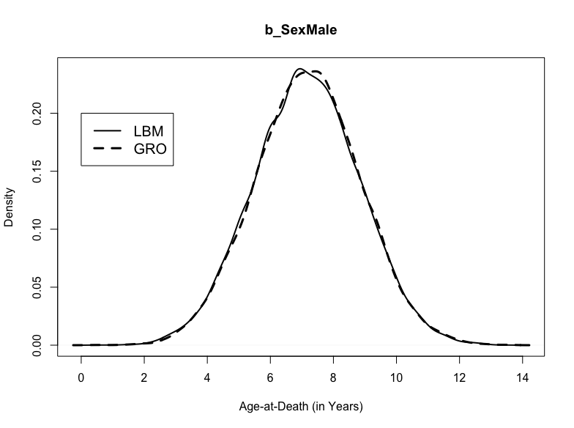
Figure A.149. Posterior distributions for b_SexMale in the models weakly informed by the London Bills of Mortality and the General Register Office Reports.

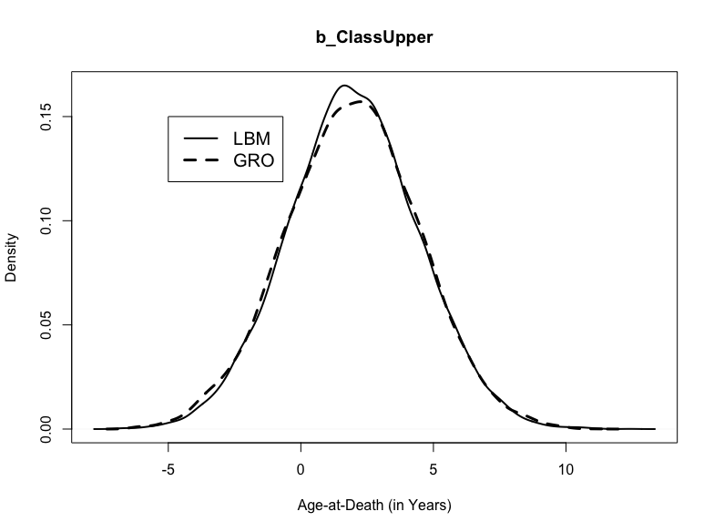
Figure A.150. Posterior distributions for b_ClassUpper in the models weakly informed by the London Bills of Mortality and the General Register Office Reports.

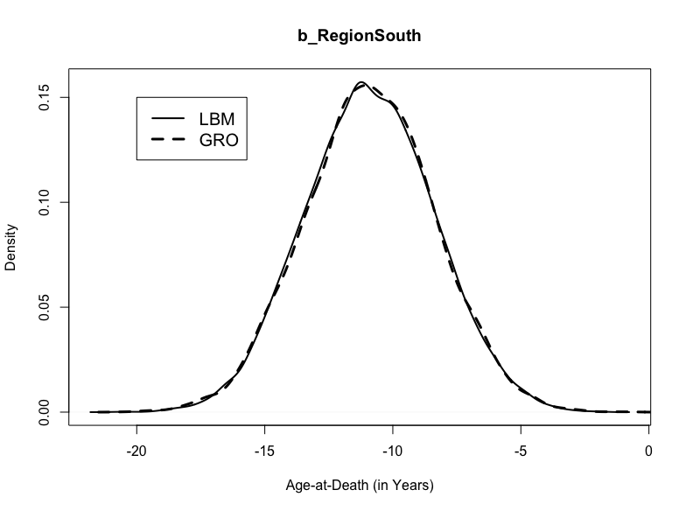
Figure A.151. Posterior distributions for b_RegionSouth in the models weakly informed by the London Bills of Mortality and the General Register Office Reports.

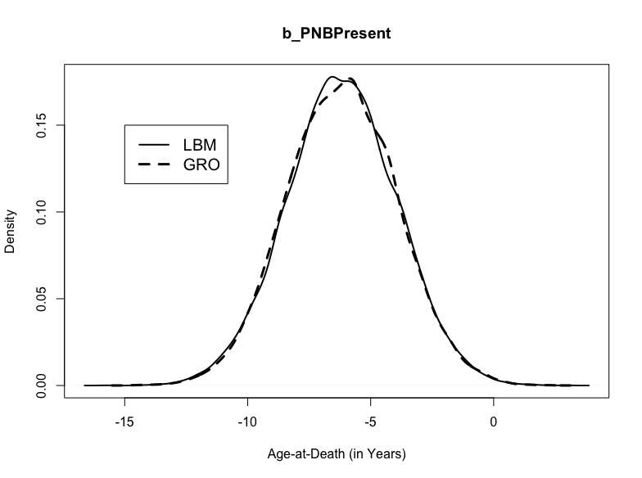
Figure A.152. Posterior distributions for b_PNBPresent in the models weakly informed by the London Bills of Mortality and the General Register Office Reports.

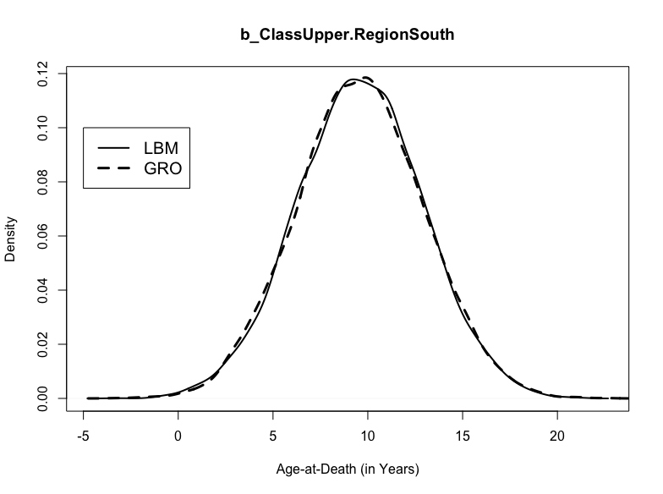
Figure A.153. Posterior distributions for b_ClassUpper.RegionSouth in the models weakly informed by the London Bills of Mortality and the General Register Office Reports.

APPENDIX THREE:

SURVIVAL TABLES
Figure A.154. Survival estimates for individuals with and without CMS.

Figure A.155. Survival estimates for individuals with and without rib PNB.

Figure A.156. Survival estimates for individuals with woven, mixed, lamellar, or no rib PNB.

Figure A.157. Survival estimates for individuals with evidence of one or more episodes of rib PNB.

Figure A.158. Survival estimates for individuals with both CMS and rib PNB, CMS only, rib PNB only, and neither CMS nor rib PNB.

VITA
Derek A. Boyd was born on April 12th, 1991, in Orange, CA. He graduated from Chaparral High School in 2009 and attended California State University (CSU)-Fullerton until 2013 at which time he graduated summa cum laude with his B.A. in anthropology. Afterwards, Derek moved to Chico, CA, and enrolled in the M.A. program in anthropology at CSU-Chico. While working on his master’s thesis in bioarchaeology, Derek taught as a Laboratory Instructor for Survey of Physical Anthropology, assisted with forensic anthropological casework through the Human Identification Lab, and conducted research through the Stable Isotope Preparation Lab. In 2014, he also participated in a summer internship with the Harris County Institute of Forensic Sciences in Houston, TX. He earned his M.A. with distinction from CSU-Chico, in 2016. Afterwards, Derek moved to Knoxville, TN, and enrolled in the Ph.D. program in anthropology at the University of Tennessee (UT)-Knoxville. While working on his dissertation in bioarchaeology, Derek taught courses in biological anthropology and human anatomy, assisted with forensic anthropological casework and research through the Forensic Anthropology Center, managed the William M. Bass Donated Skeletal Collection, and served as a Graduate Student Senator, the Chair of the Graduate Student Senate Equity and Diversity Subcommittee, and the Diversity Chair for the Anthropology Graduate Student Association. He also participated in two summer internships, one with the Department of Defense in Quantico, VA, in 2017, and the other with the New York City Office of Chief Medical Examiner in New York City, NY, in 2018. He received his Ph.D. in anthropology from UT Knoxville in 2022. He is now a Lecturer in the Department of Social, Cultural, and Justice Studies at UT-Chattanooga.

