Experiencing Iconic Landscapes: A Study of Vistas in the Great Smoky Mountains National Park

Thesis Document
Master of Landscape Architecture Degree Program
University of Tennessee, Knoxville

Jessica Christine Bundy
March 2012

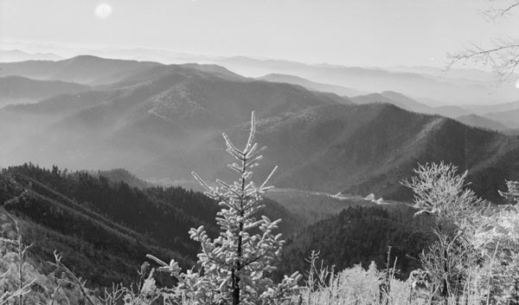
Image 1

“Park design, or landscape architecture, has figured in the history of national parks since the 19th century. This may seem a paradox since many people intuitively reject the importance of human design in an environment valued primarily for its pristine, natural condition.
The natural wonders of national parks obviously brook no comparison to any works of landscape ark; but the significance of landscape architecture in such a setting lines in how and where these natural features are appreciated, not in the creation of alternative attractions. Designed landscapes guide the experience of many park visitors and enhance their appreciation of the vast wilderness beyond” (Carr 1).

ABSTRACT
Experiencing Iconic Landscapes
For nearly a century, auto touring has been one of America’s favorite ways to experience nature. Since its creation in 1916, the National Park Service (NPS) has accommodated the needs of the auto tourists by designing easily accessible scenic routes, vistas, and recreational opportunities. “The agency had to convey to a public, a few of whom would never step out of their cars into the backcountry, the significance of the wilderness park they could not see” (Louter 7). Vistas, or framed windows into nature, reveal America’s most iconic picturesque landscapes and cultural history for the enjoyment of people. Vistas still play an intricate role in the visitor experience of national parks – a history worth continuing. However, the integrity of vistas has been compromised by years of inadequate management, primarily due to NPS budget constraints and insufficient planning. Overgrown and disappearing vistas have led to numerous complaints and concerns from park visitors, especially within Great Smoky Mountains National Park. This thesis focuses on the current state of vistas along Newfound Gap Road, arguably, the Park’s most scenic corridor. In this proposal, I will examine historic and current NPS vista management challenges and utilize site analysis to develop recommendations for Great Smoky Mountains National Park that will satisfy the needs of park visitors and management.

METHODS AND OBJECTIVES
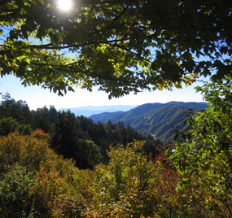
This objective of this thesis is to develop vista recommendations for eight major vista groups along Newfound Gap Road. Each recommendation will address site specific challenges, such as vegetation and geology types, topography. Research has revealed that vista management must satisfy several objectives: restore and maintain picturesque vistas for the enjoyment of park visitors; utilize the most economical clearing methods to mimic natural openings and encourage low-growing vegetation; recognize the Park’s ecological needs; and respect the threatened and endangered species that have emerged in former vista clearings.
This thesis intends to focus on Newfound Gap Road because it is the Park’s most scenic road and exhibits the greatest biological diversity within its corridor. Designated as a State Scenic Byway in 2009, Newfound Gap Road “provides motorists with the chance to experience beautiful mountain views, diversity of plant and animal life, and remnants of the South Appalachians” (NPS.gov, 2012). According to the official NPS website,
Image 2
“A trip over the Newfound Gap Road has often been compared to a drive from Georgia to Maine in terms of the variety of forest ecosystems one experiences. Starting from either Cherokee, North Carolina or Gatlinburg, Tennessee, travelers climb approximately 3,000 feet, ascending through cove hardwood, pine-oak, and northern hardwood forest to attain the evergreen spruce-fir forest at Newfound Gap (5,046'). This fragrant evergreen woodland is similar to the boreal forests of New England and eastern Canada” (NPS.gov, 2012).
Several issues must be addressed. Methods of collecting and organizing data include but are not limited to:
- Conducting site analysis and generate maps of vegetation and geology, determining areas of threatened and endangered species habitat, topography challenges, and past land uses.
- Analyzing site specific challenges, including changes in development outside of the Park (particularly in the viewsheds of vistas) and air pollution.
- Research past and present vista conditions.
- Acknowledging the comments/concerns of Park visitors.
- Interview employees within multiple divisions of the Park.
- Addressing current Park management goals and objectives as well as budget restrictions.
- Generating potential views for overgrown vistas to ensure that framed views, focal points, foreground, and background are enhanced and not compromised.
- Establishing a site specific maintenance schedule and vegetation clearing recommendation for each vista.
The methods in developing recommendations include using intended viewsheds and focal points to establish a predetermined area in which vegetation will need to be managed and recommending mechanical techniques for selectively clearing to reopen vistas. After the vista is reopened, low growing vegetation should be encouraged through natural processes to maintain these clearings. Because vegetation types differ throughout the Park, minimal work will vary to remove potentially obstructing vegetation.

TABLE OF CONTENTS

Abstract…….…………………………………..………………………………………………… 2

Chapter 1: Introduction

1.2 Objectives………………………..…………………………..………………………....…… 2
1.3 Brief History……...…………………………………………………………………….……. 6
1.4 The Park’s Scenic Highways………….………………………………………………..…... 10

Chapter 2: Wilderness
2.1 Windshield Wilderness……………………..……………………………………..………... 12
2.2 Balancing nature and Heritage in Preservation Practice: Cultural Landscapes…………..… 13
2.3 Design with Culture: Claiming America's Landscape Heritage…………..…………….….. 18

Chapter 3: National Park Vistas
3.1 Yosemite…………………………………………………..………………………………... 21
3.2 Blue Ridge…………………………………………………………………………………

Chapter 4: Great Smoky Mountains National Park
4.1 Issues to be Addressed ………………………………………………………………………..
4.2 Methods ………………………………………………………………………………………..
4.3 Site-context analysis ……………………………………………………………………….…..
4.4 Critique ...............................................................................................................

Chapter 5
5.1 Site Introduction ………………………………………………..…………….………………
5.2 Site context analysis ………………….………………………………………………………
5.3 ……………………………………………………………….…………………………………

Chapter 6 Conclusion
Developing a cohesive Vista Management Plan ………………………………………………….

References .............................................................................................................

Appendix ……………………………………………………………….…………………………
Vita………………………………………………………………………………………………

INTRODUCTION
“While many present-day visitors recognize that motorways greatly influence their park experience, most are unaware that the history of Great Smoky Mountains National Park has always been intimately linked to the history of its roads.”
- Neil Maher in Highways in Harmony

Americans have a respect and affection for national parks, founded on their natural beauty and the romantic ideal of wilderness and national symbolism associated with them. There is a longstanding conviction that this nation was “forged by the pioneer encounter with wilderness”, and that our national parks should be preserved as if they were “one of the last places on earth where the primitive conditions of the frontier could be experienced firsthand” (Sutter, 2002, pg. vii and xi). According to the National Parks Conservation Association (NPCA), the “world’s first national park, Yellowstone, was created by an act of Congress in 1872 as a ‘pleasuring ground for the benefit and enjoyment of the people in order to protect for all time this outstanding natural area.’ As Congress created more parks, the need for an agency to administer the park system became clear, yielding the National Park Service in 1916. The National Park System Organic Act, which created the Park Service, also set the purpose of the park system: ‘The fundamental purpose of the parks is to conserve the scenery and the natural and historic objects and the wildlife therein and to provide for the enjoyment of the same in such manner and by such means as will leave them unimpaired for the enjoyment of future generations’” (NPCA). However, with the introduction of the automobile, there was a radical shift how Americans experienced nature.

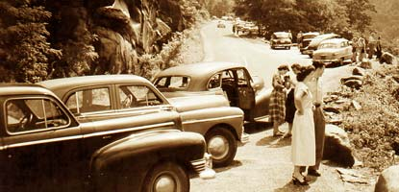
Image 3

BRIEF HISTORY OF THE AUTO TOURISM IN NATIONAL PARKS
The recreational opportunities for Americans of the Progression Era changed forever as public lands experienced a drive toward maximum accessibility. “The automobile helped reinvent the nineteenth-century idea of national parks as products of America’s cultural achievements and vestiges of the nation’s disappearing wilderness for a modern, mobile audience” (Louter, 1984, pg. 4). During the 1920’s and 30’s Stephen Mather and Horace Albright, the first and second directors of the National Park Service, “embarked on a massive promotional campaign to encourage Americans to visit their ‘national playgrounds’ by constructing “some of the most heroic feats of highway engineering of the twentieth century” (Sutter 2002, pg. x). “When this impulse toward maximum accessibility was coupled with the cheap labor of the Civilian Conservation Corps during the New Deal, the result was a large-scale proliferation of highways leading to and through the national parks” (Louter, 1984, pg. X). This allowed park visitors to “experience” national parks through the windows of their automobiles. Auto-based tourism flourished as middle-class tourists could use automobiles and highways travel to “shorten the distance and time in which it takes to reach national parks” which “brought the cities in which we live and the parks we visit closer together (Louter, 1984, pg. 3).
America’s current use of parkways, state highways, and national scenic byways stems from a "See America First" movement established during the the first half of the twentieth century, as well as modern notions of leisure and mobility established after WWII. Scenic views and scenic road corridors continue to be the primary way tourists experience preserved wilderness - from a distance. “This vision of national parks and automobiles reflects how many millions of Americans encounter their national parks. Although a park road may look ‘natural’, a great deal of thought and effort has gone into making it appear this way, particularly through landscape architecture” (Louter, 1984, pg. 3). “We pass beneath a massive log portal and enter a landscape for the car in nature. It is a landscape that seems pristine. The road travels through a dark forest, passes through meadows, and gradually ascends the mountain in a long series of turns that, like stanzas in a poem, reveal an unfolding panorama of glaciers, rock, and sky. Conforming to the topography and edged with guard walls of stone, the road seems to belong in the landscape. It frames our view. It is how we see the park. It is how we know nature in this place” (Louter, 1984, pg. 3).
The NPCA states that “The National Park Service is required to keep park units in an unimpaired state in perpetuity. Areas in parks designated as natural zones must be managed to ensure that natural ecological processes operate unimpaired unless otherwise specifically provided for in the law creating them. Historic zones must be managed to provide full protection for cultural resources. The Park Service also is required to provide the highest quality of use and enjoyment of the National Park System by visitors today and in the future. The Service also is required to manage native animal life for its essential role in natural ecosystems” (NPCA, 2011).
The Park was established for public benefit by the federal government in 1934 and designated as an International Biosphere Reserve in 1976. “Great Smoky Mountains National Park has always been famous for its biological and scenic diversity. Yet rather than experience this natural abundance first hand, most visitors see much of it from their automobiles for only short periods of time” (Maher 1996). A 2008 survey conducted by the University of Idaho revealed that ninety five percent of visitors plan to view scenery/take a scenic drive while at the Great Smoky Mountains National Park. “An auto tour of the park offers a variety of experiences, including panoramic views, tumbling mountains streams, weathered historic buildings, and mature hardwood forests stretching to the horizon” (Kemp 2007). Over nine-million visitors come to the Park each year to experience its natural wonders and scenic grandeur, nearly twice as many visitors as any other National Park in the United States.
Surrounding towns, notably Gatlinburg, Pigeon Forge, Sevierville, and Townsend in Tennessee, and Cherokee, Sylva, Maggie Valley, and Bryson City in North Carolina receive a significant portion of their income from tourism associated with the Park. Over the years tourists have become growingly frustrated with the state of the scenic views within the Park. Several heartfelt complaints have shown Park management how strongly people feel about the condition of scenic vistas and their importance to the "visitor experience along roads within the park". Channel 8 News is also contacted the Park, interested in finding out how Great Smokies is planning on addressing vistas since so many people have taken notice their current overgrown state. Local officials are concerned with the Park’s management of these vistas, worried that dissatisfied visitors or a reduction in tourists would cause their tourism based economy to suffer.
Today, many of the Park’s breathtaking scenic vistas are obscured by vegetation and are hardly visible. There has not been a current formal system for evaluating and maintaining vistas at Great Smoky Mountains National Park for some time. The Park hopes to develop a vista management plan in efforts to reestablish many of the expansive vistas that are now lost. Over time, certain vistas have become habitats for threatened and endangered species or impaired by development outside of the Park. Currently several parks are now faced with the dilemma of how to best handle overgrown vistas. Several issues that contribute to the vista management include There are multiple issues confronting parks when it comes to maintaining vistas: including limited personnel available to do the work, budget restraints that have limited the amount of work parks can accomplish each year, and threatened and endangered species within the proximity to vistas.
Additional concerns affecting scenic vistas are development along ridge tops and within existing viewsheds and air pollution created by power plants, industry, and automobiles. The National Park Service (NPS) reported that “Since 1948, based on regional airport records, average visibility in the southern Appalachians decreased 40% in winter and 80% in summer.
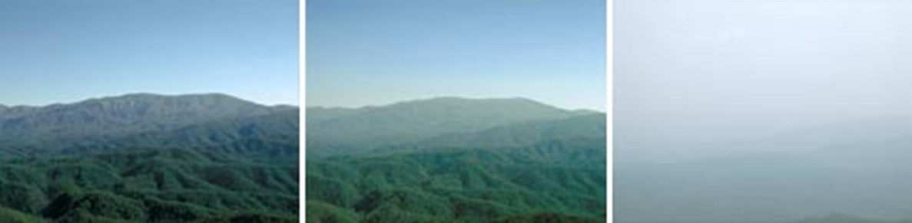
Image 3
These degradations in visibility not only affect how far one can see from a scenic overlook, they also reduce how well one can see. Pollution causes colors to appear washed out and obscures landscape features. Pollution typically appears as a uniform whitish haze, different from the natural mist-like clouds for which the Smokies were named.” This is significant since the “Annual average visibility at Great Smoky Mountains National Park is 25 miles, compared to natural conditions of 93 miles. During severe haze episodes, visibility has been reduced to less than one mile”. A NPS survey conducted in 1996 showed that “74% of summer visitors to the Smokies said clean air was “extremely important” to them during their stay in the park; 84% said scenic views were “extremely important.” (NPS, 2010).

THE PARK’S SCENIC HIGHWAYS
“A scenic foothills drive offers vistas of the park impossible anywhere else. Roads into the heart of the backcountry, excursions into the wilderness you might have thought impossible in the confines of a car.”
- Jerry DeLaughter in Smokies Road Guide
Vistas along these scenic highways frame breath-taking views of nature and “some of the highest points of any U.S. highway east of the Mississippi River” (Gove 2008). Great Smoky Mountains National Park significant demonstration of how auto touring continues to be America’s preferred way to see wilderness. “More than 70 percent of recreational activities undertaken in the Park are pursued within a stone’s throw of a roadway. For every hour spent behind the wheel, visitors spend only eight minutes outside of their cars” (Maher 1996). Visitors enjoy new aspects of the Park with each trip, discovering the “different seasons, different weather conditions, and even different times of day” within over half-million preserved acres (DeLaughter 1986). Several different publications and self- guided tours highlight natural and cultural resources along road corridors, allowing visitors to experience from the comfort of their cars. Jerry DeLaughter’s official road guide explains that “many wonders await discovery…Most visitors follow Newfound Gap Road through the park and its spur leading to Clingmans Dome” (DeLaughter 1986). Vistas along other road corridors, including Little River Road, Roaring Fork Motor Nature Trail, Cades Cove Loop Road, Foothills Parkway, and Heintooga Ridge Road offer visitors unique views of “one of the most pristine natural areas in the East” (Kemp 2007).
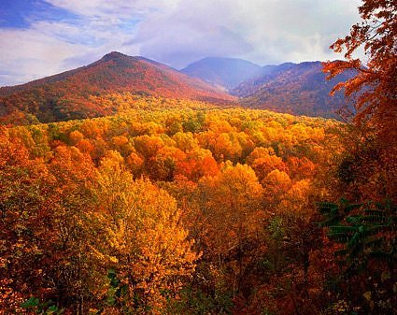
Image 4

NEWFOUND GAP ROAD
Newfound Gap Road is the most traveled, and arguably the most impressive, scenic highway within the Park. A trip over the Newfound Gap Road has often been compared to a drive from Georgia to Maine in terms of the variety of forest ecosystems one experiences. Starting from Cherokee, North Carolina or Gatlinburg, Tennessee, travelers climb approximately 3,000 feet, ascending through cove hardwood, pine-oak and northern hardwood forests to attain the evergreen spruce forests at Newfound Gap (elev. 5,046’). This fragrant evergreen woodland is similar to the boreal forests of New England and eastern Canada.
Designated as a Scenic Byway in 2009, Newfound Gap Road (NPS Route 10) is a principal north-south roadway within Great Smoky Mountains National Park, and the only roadway that completely transverses the Park. Newfound Gap Road is a regional corridor that allows travelers from North Carolina or Tennessee to access the other side of the Park with ease, without travelling around the mountain ridge or outside the Park. It stretches approximately 31 miles from Cherokee, North Carolina, to Gatlinburg, Tennessee. The posted speed limit along the entire road varies from 25 to 45 miles per hour.
The initial road was completed in 1930. From the time the Park was officially created through the 1960’s, the National Park Service realigned sections of the road to take advantage of more scenic views and reduce steep grades, and to adhere to National Park Service design guidelines.
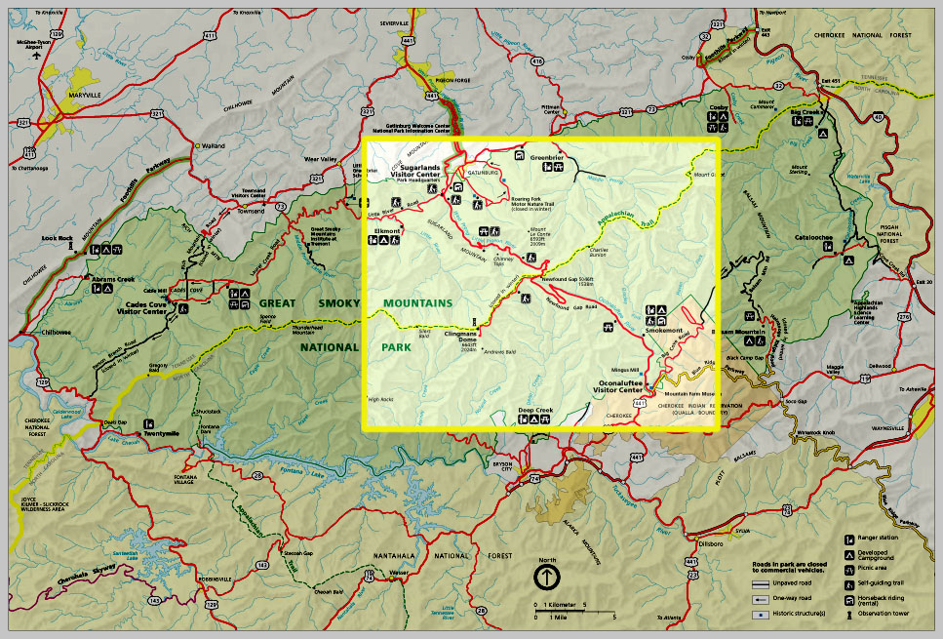
Newfound Gap Road
Context Map

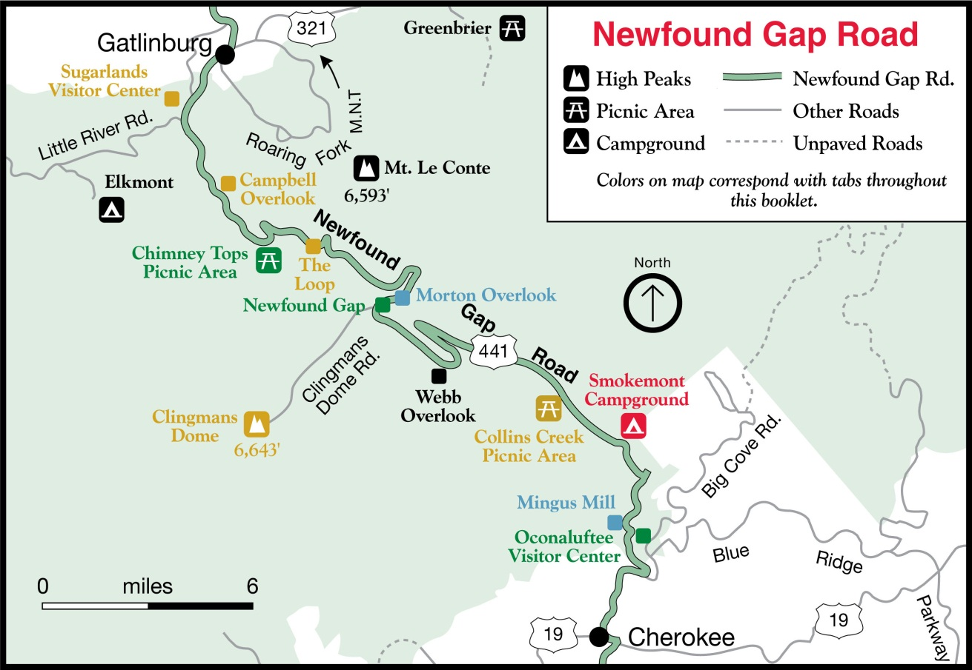
Amenity Map

WILDERNESS:

A CRITIQUE OF ROADWAYS IN NATIONAL PARKS
LITERATURE REVIEW – WINDSHIELD WILDERNESS
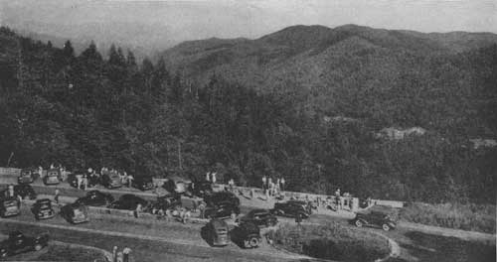
In his book, Windshield Wilderness, “David Louter…used the three great national parks of the state of Washington to produce an invaluable case study of the radical shifts in attitudes toward automobiles that affected most national parks in the United States over the course of the twentieth century”.
Image 5
In the beginning of the book, William Cronon introduces Louter’s core argument as an investigation “about the changing role of automobiles in the twentieth-century American experience of wild nature and the history it explore…of parks and wild places all across the nation” (pg. IX).
Louter uses the ironic phrase “windshield wilderness” to discuss how people can “experience” nature in national parks through car-based tourism. He describes how “Early park managers actively embraced the automobile as an ideal way to expose a growing number of Americans to wild nature. Roads were carefully designed to provide a beautifully unfolding series of views…the windshield in effect serving as the screen in which images of wild nature were projected for maximum visual impact” (pg. XI). Funding from the New Deal in conjunction with cheap labor from the Civilian Conservation Corps (CCC) lead to the explosion of highways leading to and around the national parks. Louter explains that, “When the National Park Service was created in 1916 as the agency with primary responsibility for managing parks, its first and second directors, Stephen Mather and Horace Albright, put enormous energy into promoting parks and encouraging as many people as possible to visit them” (pg. X). This initiative made national parks greatly accessible to middle class Americans, shortening the travel time and distance. Louter goes on to explain how “Parks were not only reservoirs of wilderness, characterized by an uninhabited, pristine nature, to which Americans retreated to escape their urban-industrial lives. They were also landscapes in which people could engage wilderness in a new way, in which automobiles and highways seemed to be mutually beneficial” (pg. 5).
Louter reveals that in 1930 a group of activists, concerned by the rapid proliferation of infrastructure within wilderness areas, would form the Wilderness Society. Their belief that national parks were becoming “too accessible to automobiles” would result in the establishment of regulations that would guide future development in national parks. As development within national parks progressed, roads would be designed to created views into wilderness, no longer directly cutting through it.
Throughout the book, Louter examines the national park’s “classic struggle driven by the management paradox of preservation and use” (pg. 9). He acknowledges that, “Beginning in the late 1960s, the Park Service approached a rather daunting task for an agency wedded to the idea that wilderness was a scenic experience viewed from the road. The agency had to convey to a public, few of whom would never step out of their cars into the backcountry, the significance of the wilderness park they could not see” (pg. 7). This is a struggle that continues today as millions of visitors continue use roads and highways within national parks to experiencing “nature”, and nature continues to decline as levels man-made pollutants continues to rise.
In conclusion, Louter explains that “…the narrative proposed here suggests that many Americans do not have as strict a definition of wilderness. They like ‘wild’ nature but less restrictive about its meaning. To many traveling Americans, national parks represent – in the past as well as the present – their expectations about and experiences with a wild landscape; ‘wilderness’ in this sense is something they encountered while driving” (pg. 8).

LITERATURE REVIEW – BALANCING NATURE AND HERITAGE IN PRESERVATION PRACTICE: CULTURAL LANDSCAPES
“A vernacular landscape illustrates people’s attitudes and values toward the land and reflects patterns of settlement, use, and development over time.” – National Park Service, Cultural Resource Management Guidelines, 1998
“Unless we reconsider our attitudes towards landscape resources, the way we describe those resources, and our professional and intellectual boundaries, we will continue to be limited in land management and protection potentials.” – Robert Z. Melnick, 1996

The authors addressed key concepts of preservation for most kinds of landscapes – rural, cultural, ethnographic, public, and historic – from several different aspects. They examine how people manage landscapes, how visitors view landscapes differently from locals, and the differences between preserving or “freezing” a landscape to represent a specific period in history and letting the landscape change as a “living” entity.
Richard Longstreth, in his chapter The Challenges of Cultural Landscape for Preservation, explains how “The concept of cultural landscape has evolved over several generations. Yet that concept is still relatively new to the field of historic preservation, and while it has made a substantial contribution, it remains misunderstood or marginalized in many quarters” (Longstreth 1). To me this means that even though cultural landscape has been around in both prehistoric and historic eras, people still do not have a shared definition of what it is, or a common consensus of how to preserve it (or if to preserve it at all). Brilliant minds from many different professions – architects, landscape architects, historians, geologists, ecologists, environmentalists, anthropologists, and researchers – all have different opinions of the best way to manage landscapes, especially those with historical and cultural significance. One thing that they can agree on is that it takes the insight of several different professions to make sure that the landscape is managed correctly. “…application of the cultural landscape concept to preservation endeavors now necessitates the involvement of many professional spheres, drawing from a variety of hard and social sciences, humanistic fields, and design professionals. Such work challenges all those involved not simply with thinking broadly and inclusively, but doing with others who have different skills, and perhaps, different concerns and priorities” (2). I agree with this idea, because there are a multitude of user groups – past, present, and future – as well as other ecosystems and species that depend on landscapes for survival.
Longstreth goes on to describe how, “Irrespective of such misunderstandings, many preservationists tend to view cultural landscape simply as comprising physical entities – comparable to historic districts, for instance – instead of also as a method of considering, analyzing, and evaluating places. Studying cultural landscapes entails natural and man-made components of the environment and the ways in which they have changed over time” (Longstreth 1). In order to preserve the integrity of a cultural landscape, it is essential to incorporate or examine the context belonging to each landscape. It is impossible to determine what the representation is supposed to be if you only have a piece of the puzzle. "An important point here is that it is necessary to be much more explicit about landscape management goals; it is insufficient to allude to the notions of preservation and restoration without explaining them and considering them in context” (Longstreth 117).
Susan Calafate Boyle explains in her chapter, Natural and Cultural Resources: The Protection of Vernacular Landscapes, that before you can decide if a landscape should be preserved, it is important to examine the four treatments acknowledged by the National Register, as well as several other influential landscape preservation organizations. “These standards include four treatments – preservation, rehabilitation, restoration, and reconstruction – which can be applied to all historic resource types encompassed by National Register criteria; buildings, structures, sites, objects, districts, and landscapes” (Boyle 152). There are benefits to each of the four treatments, one maybe significantly more accommodating to a landscape than the others; certain options are more cost effective than others, while specific landscapes do not need to be as intensively managed as others. No matter what type of treatment is utilized, the outcome should result in a protected landscape.
Now that we have addressed the different types of treatments for cultural landscape, it is important to know the different categories of landscape. “Cultural resource management guidelines developed by the Park Service identify four types of historic landscapes: historic sites, designed, vernacular, and ethnographic (traditional cultural properties).
- Historic sites are significant for their association with important events, activities, and persons.
- Designed landscapes are deliberate, artistic creations reflecting recognized artistic patterns of expression.
- Vernacular landscapes illustrate people’s values and attributes toward the land and reflect patterns of settlement, use, and development. Most of the methodology for their analysis has focused on agricultural properties.
- Ethnographic landscapes are those used or valued in traditional ways by contemporary ethnic groups” (Boyle 152).
When asking the question, “why cultural landscape preservation?”, it is just as important to know when cultural landscape preservation appropriate as when it is not. Catherine Howett explains in the chapter, Integrity as a Value in Cultural Landscape Preservation, that “In spite of this awareness of the difficulties involved in selecting and interpreting a particular period within the past life of a historic landscape, NPS guidelines – and the landscape preservation community generally – accepts the idea that recommendations supported well-defined interpretations dated ‘nothing earlier than (year) and nothing later than (year)’ were essential outcome of the research and analysis phase of master-planning project for a historical site. Applying this standard to vernacular and rural cultural landscapes proved especially difficult” (Howett 190). This means that it is not possible to “freeze” or preserve a landscape to depict a certain time period. Many landscapes are best suited to remain as “living” landscapes, continuing to evolve and change with the communities around them.
It is extremely important that we know the difference between preserving landscapes for the benefit of current users and for future generations instead of “stopping” the evolution of a landscape based on false history. Bonnie Stepenoff explains in her chapter, Wild Lands and Wonders: Preserving Nature and Culture in National Parks, how “Traditional notions of saving original fabric and preventing future alternations might reasonably apply to building or a work of art but cannot apply to a living landscape. The idea of restoring a piece of wild land back to a particular historical period and expecting it to remain there is a condition of stasis is absurd on the face of it. But landscapes, even wild ones, need our protection. If we cannot prevent them from changing, we can minimize human impacts upon them. Where humans have already encroached, we can try to understand the dialect between the cultural and the natural world. We can respect the legacy of the previous generations and pass it along. A conflict between nature and history need not exist” (Stepenoff 104).
Howett describes that “Since they are primarily corridors, transportation networks are excellent examples of vernacular landscapes where natural components are ubiquitous and where the application of traditional historic preservation standards is difficult, if not impossible” (Howett 155). She elaborates on the fact that “Yet well before many people outside the academy had become aware of deconstructionist challenges to the notion that ‘text’ (object, place, or narrative) is able to communicate unambiguous essential meanings, David Lowenthal had forced historians and preservationists to acknowledge two painful realities:
- That it is impossible to know, much less to experience or to reconstruct, the past and
- That historical bias in recording, describing, and interpreting the past is inevitable.
- ‘No process of verification can totally satisfy us that we know the truth about the past, for we accept or reject an account solely on the basis of its internal plausibility and its conformity with other known or trusted accounts…
- The past we know or experience is always contingent on our own views, our own perspectives, above all our own present. Just as we are products of the past, so is the known past an artifact of ours’” (Lowenthal 199-200).
Longstreth clarifies that, “Misapplied, cultural landscape becomes an excuse for passivity in the preservation field, with the implicit assumption that historic resources – and natural ones as well – do not suffer serious depletion in a laissez-faire climate. Used with purpose and imagination, on the other hand, cultural landscape can, and should, be an essential underpinning of preservation, opening a whole new chapter in our understanding of, and respect for, the world around us” (Longstreth 15).
“Preservation is, on the one hand, a social and political movement and, on the other, a set of institutionalized practices that expressly seek to retain, stabilize, and breathe new life into material remnants of the past. The secretary of the interior’s Standards defines preservation…as the act or process of applying measures necessary to sustain the existing form, integrity, and materials of an historic property. Work, including preliminary measures to protect and stabilize the property, generally focuses upon the ongoing maintenance and repair of historic materials and features rather than extensive replacement and new construction
Grounded in notions of fixed real property, preservation is concerned with visible, material things that survive from the past with maintaining the present their appearance in the past” (Longstreth 28).
This is one of the clearest explanations of why cultural landscape preservation is important. I appreciate how the author emphasizes the idea, “retain, stabilize, and breathe new life into material remnants of the past”. To me that is what is essential to preservation – protecting the landscape to serve its most suitable resolution. If the landscape is best suited as a “living” landscape, then it should be allowed or “preserved” in such a way that it can continue to change, for better or worse. If the landscape best serves as a memorial to a time long past, then it should be preserved for present visitors and future generations, so that we do not forget its historical significance. Robert Melnick “reminds us so poignantly that these landscapes are central to our personal and collective identities as they create and reinforce self-images and value structures. Historic preservation is thus a powerful process for designing landscapes that, while they form the ‘take-for-granted’ settings of daily life, silently engage in shaping who we are.
This is not only the most convincing argument for preservation but it also renders it a serious responsibility. The most important lesson preservationists should take from critical landscape geographers is thus a caution to consider carful what we preserve, why we preserve it, and for whom it is preserved” (Melnick 32).
I think Howett says it best in her section on Rethinking the Integrity of Cultural Landscapes, when she declares that, “Cultural landscape preservation, as a form of history telling” (Howett 205). “Perhaps the whole field of cultural landscape preservation needs to be renamed ‘cultural landscape interpretation’. It would be helpful, certainly, to unload the inaccurate connotations of ‘preservation’ and put the emphasis on an expanding understanding of ‘interpretation’, which in fact begins with the research phase, is inseparable from every design decision, and is then documented through the interpretive program that visitors experience” (Howett 206-207). “To speak of the integrity of historic sites is rightly to define their potential to provide that important meaningful physical reality; they are more or less complete fragments of the record, and we want to hold on to as much as we can of what might help us to make sense of the past” (Howett 207).
Longsteth explains that “Since the early 1980s, the National Park Service has taken a leading role in the advancement of a landscape approach to preservation. This initiative at first focused on agrarian settings under tutelage but was soon applied to the parks more broadly with growing importance given to cultural resources developed to serve the parks themselves” (Longstreth 9). It is essential in understanding what the role of National Parks is in cultural landscape and their important mission of preserving the integrity of the landscape.

LITERATURE REVIEW - DESIGN WITH CULTURE: CLAIMING AMERICA'S LANDSCAPE HERITAGE
This section addresses specific ideas and incentives for the National Park Service to establish, protect, and manage natural “preserves” for the “enjoyment of visitors”. Even though the park service’s reasoning for creating national parks has changed throughout the years, national parks have built a legacy that Americans can be proud of(….mostly). The National Park Service idea grew out of a group of preservationists who wanted to protect the most iconic scenic areas in American, and is now the leading agency in historic preservation and park management.
Alfred Runte, in his book National Parks: The American Experience, argues that
“No institution is more symbolic of the conservation movement in the United States than the national parks. Although other approaches to conservation, such as the national forests, each have their own following, only the national parks have both the individuality and uniqueness to fix the indelible image of the American mind” (Runte xi).
“When national parks were first established, protection of the ‘environment’ as now defined was the least of preservationists’ aims. Rather American’s incentive for the national park idea lay in the persistence of a painfully felt desire for time-honored traditions in the United States” (Runte 11).
Americans desperately craved for a history or traditional foundation to relate to, similar to the most people had experienced in Europe. Congress, along with chief preservationists, writers, and other leaders, set out to establish a magnificent collection of landscapes in an effort to boost ‘cultural nationalism’. Runte reveals that, “More than a century ago, a small group of Americans pioneered a unique idea – the national park idea. It was the contention of this group that the natural ‘wonders’ of the United States should not be handed out to a few profiteers, but rather held in trust for all people of all time” (Runte 1). After learning what had happened to several ‘natural wonders’ (Niagara Falls and Hetch Hetchy) once private business started carving away at them for their own personal gain, Congress and the American public were determined to preserve their remaining natural resources for the greater enjoyment of all.
Unfortunately, with tremendous use came excessive destruction, as people flooded in to experience these newly founded iconic American landscapes. “Especially because most Americans still seek out spectacular scenery and natural phenomena, environmentalists caution that the public has little understanding of the restraints on visitation needed to protect the diversity of the park as a whole” (Runte 1-2). Preservationists and other agencies began to struggle to balance preservation and use. A century later, The National Park Service is still torn with these issues; as more automobiles traverse outdated roads and an increasing number of tourists continue to misuse already deficient and inadequate facilities through vandalism or neglect. “As early as 1865, for example, Fredrick Law Olmstead warned the Yosemite Park Commission that most Americans considered the (land) grant a mere ‘wonder or curiosity’. It followed they did not appreciate the preserve’s ‘tender’ esthetic resources, namely the ‘foliage of noble and lovely trees and bushes, tranquil meadows, playful streams,’ and other varieties of ‘soft and peaceful pastoral beauty. A quarter of a century later he repeated the charge; the traditional perception of Yosemite as a spectacle, he maintained, was still ‘a vulgar blunder’” (Runte 30). Olmstead is arguing that people were visiting these natural wonders more often out of curiosity than to experience the awe and wonder of nature in all its glory. And in the process, tourist pushed their way through the landscape, and left a wake of destruction in their path. “Nearer to the point, Muir recognized that the public ranked scenery according to its size and ruggedness. ‘Tourists make their way through the foot-hill landscapes as if blind to all their best beauty’, he observed, ‘and like children seek the emphasized mountains – the big alpine capitals whitened with glaciers and adorned with conspicuous spires.’ Such understanding awaited an age receptive to the life-giving properties and esthetic beauty of all ecosystems. Well into the twentieth century, Americans valued to the natural wonders of the West almost exclusively for their scenic impact” (Runte 31). It wasn’t until many years after the parks’ establishment that the concept of creating “tourist accessible areas” apart from areas strictly for preservation really take root. Now many parks have areas that are intentionally restricted to ensure protection for the natural, unaltered landscape.
“Conceivably, the United States might have originated the national park idea in the absence of cultural nationalism; with it, however, the nation had clear and immediate justification to go beyond simply appreciating its natural wonders to preserving them” (Runte 32). This paradigm shift in American nationalism and cultural appreciation awakened an era of recreation and then an age of conservation. This means that even though cultural nationalism was the catalyst for preserving natural landscape, the park service eventually established a ‘standard’ for landscape preservation. “Our national parks system is a national museum. Its purpose is to preserve forever…certain areas of extraordinary scenic magnificence in a condition of a primitive nature. Its recreational value is also very great, but recreation is not distinctive of the system. The function which alone distinguishes the national parks…is the museum function made possible only by the parks’ complete conservation” (Birnbaum 106).
Another aspect of landscape preservation emphasized the difference between “naturally scenic areas” and “man-made scenic areas.” “As a catalyst of the national park idea, the search for an American past through landscape was nothing new. The preservation of a sense of history itself, for example, as recalled through broad expanses of native, living landscapes, was coming to be considered as crucial to establishing the identity of United States as the protection of scientific natural wonders. It followed that preservationists might, for the first time, draw a clear distinction between all parks and ‘national’ parks” (Birnbaum 107). It was decided that even though most parks, including state and local parks, had scenic qualities, only ‘national’ parks were considered ‘entirely natural’ and primarily unaltered landscape.
In the chapter, The “Noblest Landscape Problem” by Ethan Carr, he describes the role that Thomas Vint played in historic landscape preservation in the National Park Service and the impact of his success as a park master planner. Carr explains that, “Thomas C. Vint is best known as the landscape architect, who, more than any other individual, guided landscape planning and design at the National Park Service (NPS). Vint developed a specialized design discipline in the 1920s that addressed the modernization of national parks at that time when large numbers of automotive tourists were overwhelming facilities built for a pre-automobile era” (Carr 157). It was around this time that The National Park Service realized the need to establish a way to create efficient, uniform park development if it was going to successful protect the integrity of the natural landscape.
The Park Service was undergoing a crucial transformation at this time. Carr states, “Between the late 1920s and the early 1930s, the NPS went from having very limited responsibilities in the management of historic sites to becoming the leading national institution in the field of historical preservation” (Carr 157). He describes how, “Under NPS directors Stephen T. Mather and Horace M. Albright, Vint devised sensitive approaches to road construction, ‘park village’ design, and ‘rustic’ architecture that aesthetically ‘harmonized’ park development with landscape scenery” (Carr 157). This is very important, because without ‘guided design’ you end up with uncoordinated and disconnect sprawl of random buildings and awkward developed areas. “The scope of Vint’s practice ranged from individual landmarks of what came to be called Park Service rustic style….to establishment of park service ‘master planning’ procedures that standardized the planning approach for every park and historic site in the national park system” (Carr 157).
Carr reveals that, “By 1930 Vint had helped establish what would be described as a ‘public practice’ of landscape architecture. The greatest achievement of this practice was the park ‘general development plan’ which by 1931 was known as the ‘master plan’” (Carr 160). This just reaffirms the need for “harmonized park development” and sensitive park growth. He goes on to explain that, “The goal of producing rational, comprehensive plans that would coordinate and control all aspects of park development had been put forward for decades; but the reality was that hotels, roads, and other facilities had usually been built on an ad hoc basis. Lack of sewers and permanent campgrounds, in particular, caused severe damage to parks as well as unpleasant experiences for tourists. This was situation the NPS had been created in 1916 to correct, and the implementation of a successful master planning process was at the heart of the new agency’s mandate” (Carr 160).
The statement that best answers the question, “What is the role of National Parks in cultural landscape”, is summed up by Carr in this section. He explains how, “Vint argued that landscape architecture was a profession that attempted to offer ‘a practical solution to the problem at hand,’ but could be attained in park development, he observed, only when the ‘congruity of parts gives harmonious form to the whole… the first work of the National Park Service is the protection and preservation of these landscapes. Its second work is to make these areas accessible to the people that might be used and enjoyed. What is the work of the Park Service but landscape work? What organization was ever given to a nobler landscape problem?” (Carr 160-161). To me there is no nobler a landscape problem, and I would agree with Carr and many others that the National Park Service has been, and will continue to be, the greatest advocate of cultural landscape preservation.

NATIONAL PARK VISTAS:
Through extensive research public park design, I discovered that nineteenth century America was greatly influenced by landscape architects such as Fredrick Law Olmsted and the public’s enthusiasm for carefully developed “wilderness spaces with roads, paths, and plantings that harmonized with the surrounding landscape and highlighted its scenic qualities” (1-pg. 15). Even before the federal donation of Yosemite to the state of California in 1864, early public park development invigorated “a growing sense of ‘seeing land as landscape’. This aesthetic, according to Ethan Carr and others, celebrated the scenic beauty as a core cultural value and landscape as an art form” (1- pg. 15). The surge of automobile tourism in the 1910s and 1920s prompted a “new era of park-oriented travel” (1-pg. 14). “Perhaps no project of this era exemplifies the national tourism-automobiles-national parks interconnection as full as the New Deal’s Blue Ridge Parkway” (1- pg. 14). This iconic 469 mile scenic corridor across North Carolina into Virginia contains over 3,000 vista openings for the enjoyment of over 20 million visitors a year. A visual preference survey interviewed travelers along the Blue Ridge Parkway, and revealed that scenic quality of vistas and vista management techniques directly affect the visitor experience. The study also revealed that “cutting activity that removes large amounts of woody vegetation from an overgrown vista to establish an open view was preferred” (2). According to the current Blue Ridge Parkway vista management plan “Vistas were designated on Park Land Use Maps (PLUMS) as an element of the landscape to be maintained and preserved. Vistas are considered a contributing resource in the parks eligibility for the National Historic Register. It is imperative that the park complete an assessment of current vista conditions, including: slope, area, vegetation composition (exotics), and intactness and define a desired future condition recommendation” (3- pg.3).
After reviewing vista management documents for Yosemite National Park and Blue Ridge Parkway, it was evident that vista management strategies vary throughout the National Park Service (NPS). Since each park is met with a different set of vista challenges – topography, vegetation, and land use – parks tends to develop unique, creative and efficient standards to meet their specific goals. The greatest difference in vista management strategies are between western and eastern parks. Typically, vistas in western parks are framed by slower growing species and require less cyclic work to maintain, while eastern parks and parkways frequently clear through dense, fast growing vegetation.
Many parks have defined scenic routes that highlight the unique characteristics and iconic landscapes; some routes encircle the park while others connect communities and extend across state lines. But no matter the size, shape, or location of the park and its scenic roadways, the message was clear: parks intend to protect and enhance the visitor experience by maintaining vistas. However, by examining parks with significant vista management experience, I have been able to glean valuable information that I have incorporated and adapted into recommendations for Great Smoky Mountains National Park.
CASE STUDY – YOSEMITE NATIONAL PARK, CALIFORNIA

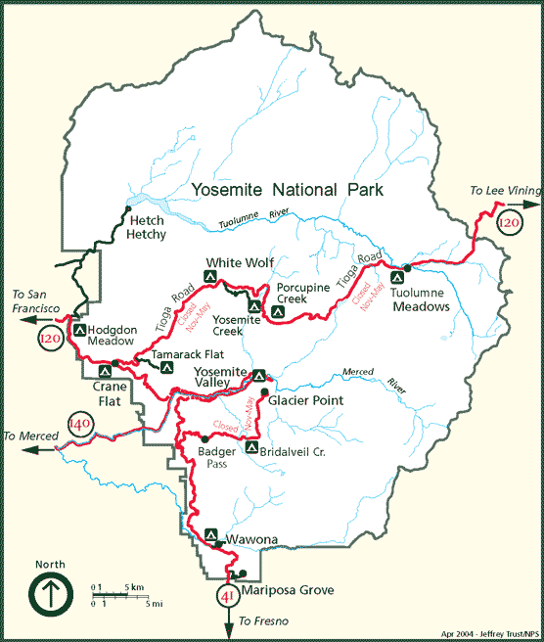
Yosemite National Park
According to the NPS website, “Yosemite National Park, one of the first wilderness parks in the United States, is best known for its waterfalls, but within its nearly 1,200 square miles, you can find deep valleys, grand meadows, ancient giant sequoias, a vast wilderness area, and much more”. Over 3.5 million visitors explore Yosemite annually (NPS.gov).
Like many national parks, Yosemite was originally set aside in efforts to preserve its extraordinary scenery. “All of the roads in Yosemite National Park are scenic, but the most famous scenic drive is along the Tioga Road, a 39-mile drive from Crane Flat to Tioga Pass. The road is typically open from late May or early June through sometime in November” (NPS.gov).
The NPS reports that “Ongoing scientific research abounds at Yosemite from vista management to soundscape preservation to human carrying capacity issues” (NPS.gov). Recent scenic vista management strategies have replaced the Park’s former ad hoc approach. Yosemite’s Scenic Vista Management Plan was developed to “reestablish and maintain Yosemite National Park's iconic views, vistas, and discrete lines of sight that are obscured by vegetation growth”(NPS.gov). By utilizing a comprehensive plan, Yosemite was able to “prioritize viewpoints for management and identify which methods of vegetation clearing are appropriate; when and where to use them” (NPS.gov).
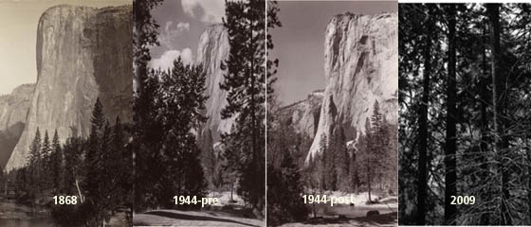
For high priority vistas, the Park suggested that select trees and brush may need to be removed to restore the view. The above photos of El Capitan show how vegetation greatly impacts the quality of scenic vistas. Recently, Yosemite National Park reopened the iconic Tunnel View which had been obscured by vegetation. The photos below compare historic views to current views.
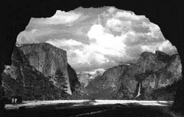
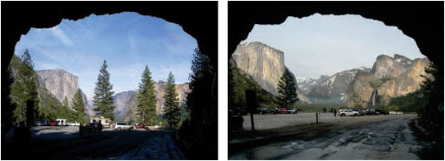
Historic Tunnel View
After Vista Clearing
Before Vista Clearing

The restoration of this vista received mixed reviews from visitors. An article in the Los Angeles Times written by Judy Cart, reported that “Yosemite National Park officials say thousands of trees will be felled to preserve the iconic views of the park's waterfalls and the craggy faces of El Capitan and Half Dome. Rare or ecologically sensitive trees such as California black oaks, sugar pines and white bark pines will be spared. None of the thousand-year-old sequoias will be cut, nor will any tree over 130 years old” (Cart 2011). The author goes on to explain that “Officials here have been thinking about the sightline issue for some time. In 2009, the park analyzed 181 scenic views around Yosemite, excluding wilderness areas. The survey revealed that encroaching vegetation obscured the view at 28% of the sites and partially blocked it at 54% of them” (Cart 2011). The Park’s Superintendent, Don Neubacher, “understands visitors' concerns about cutting trees in Yosemite, but says ‘this will create views for visitors, views that were here before’. Kevin McCardle, a park service historical architect who headed up the scenic vista team, describes that, ‘We are managing the park for people. We have to create roads, we have to create parking lots, and we have to create space for people. We are creating space for visitors to see the park’" (Cart 2011). Even though Park management reminds visitors that this is an effort to restore former vistas, there was opposition from the public. Some visitors felt that it was not necessary to remove any trees, and that national parks are a “tree hugger‘s paradise” (Cart 2011). However many visitors, who were previously unaware of the park’s intentions, were pleased to see the views restored. Gary Lockhart, a long time visitor of Yosemite explains, “I've been coming here since the '50s and I know what this used to look like. You used to be able to see from there," he said, waving his stick to one end of the valley, ‘to there.’ This valley was wide open. This place is honeycombed with trails, but you'd never know because of the trees" (Cart 2011).
Vista Management Methods and Critiques
I believe that Yosemite National Park successfully summarizing the scenic importance of the park, outlining current issues, informing the public of its intentions through public meetings. I’m glad to see that a historic landscape architect was able to use historic photographs to reveal the original view of and intended focal points. Fortunately for the Park, they did not have to remove many trees to restore the view. The trees that they did leave serve to frame the view as historically intended. I could not find out how frequently these vistas would need to be maintained, but judging from the slow growing nature of the vegetation and short growing season, I imagine it would not be very often. Overall, I feel that Yosemite National Park was very successful at establishing a vista management plan and fulfilling the park’s goal to restore historic views.
Similar to Yosemite, Great Smoky Mountains National Park has been aware of encroaching vegetation is blocking a majority of their vistas for some time. However, the vistas at Great Smokies are surrounded by dense deciduous forest with a longer growing season at a much lower elevation. This makes the challenge of maintaining vistas more difficult, as vegetation needs to be maintained more frequently. I think that Great Smokies would greatly benefit from using public meetings to explain the benefits of vista management to visitors. This allows knowledgeable park staff to address the comments and concerns of the public on a personal level. However, Yosemite’s approach of using historic photos to guide vista clearing may not be as successful at Great Smoky Mountains National Park because most photos were taken while the slopes were starting to heal and vegetation was slowly reclaiming the sides of vistas. Once World War II started all efforts to establish a formal Park vista plan was abandoned. The only historical Park record I have been able to find was a 1942 document which described various vistas and their intended views along three major roads in the Park. This document confirms the idea that most vistas were historically intended maintain panoramic. Unfortunately, any photographic information that went with it has been lost.

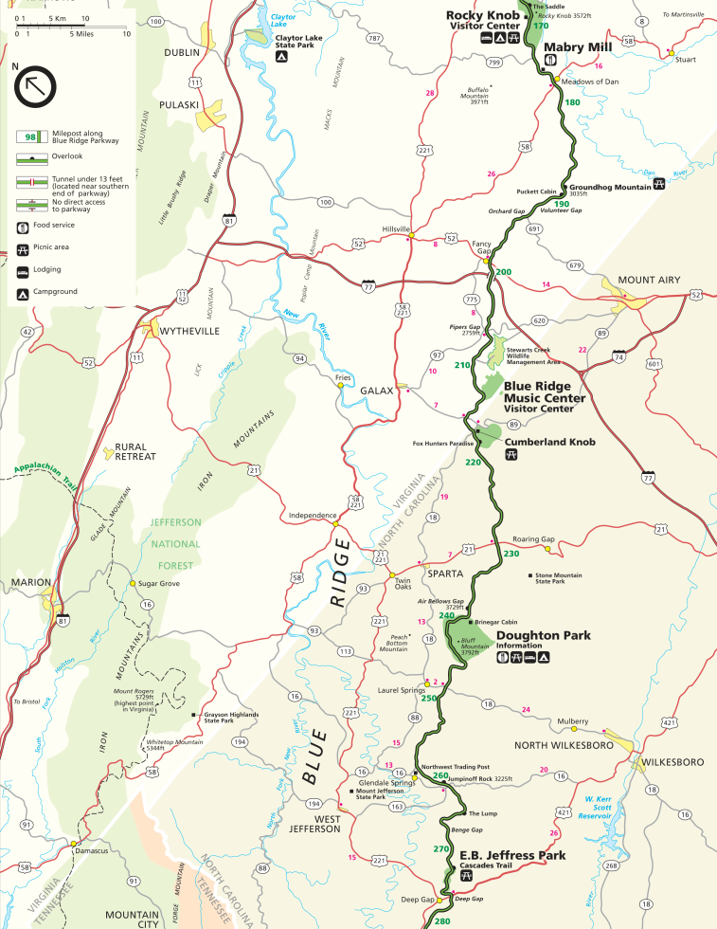
Blue Ridge Parkway, North Carolina and Virginia
Marketed by the NPS as “America’s Favorite Drive” (5), “the Blue Ridge Parkway emerged at the end of a century-long process of developing an American aesthetic and style for public parks, first in nineteenth-century cities and later in the huge expanses of national parklands”. Author Anne Mitchell Whisnant discusses how “both national trends and regional dynamics gave birth to the Parkway, and the roads-auto-tourism connection shaped the road in crucial ways” (1). The road’s surface was “laid gently on the land” which adhered to the “Park Service ‘rustic’ design aesthetic” (1).
http://www.visitblueridgeparkway.com/maps/brpmap003.gif
The National Park Service website describes the Parkway experience as “unlike any other, a slow paced and relaxing drive revealing stunning long-range vistas and close-up views of the mountains and pastoral landscapes of the Appalachian highlands” (5). The iconic landscape of the Parkway is a formation of diverse geology and topography. The NPS states that this regional-scale Parkway meanders for 469 miles, offering visitors a window into the natural, historic, and cultural character and resources that make this part of the country so special.
The experience along the Blue Ridge parkway varies depending on the section you travel. According to the NPS, the Virginia section of the Parkway “highlights the rolling agricultural scenery that is so much a part of the Blue Ridge” and “how humans have interacted with the land in these mountains”. In this section, visitors are introduced to a variety of cultural sites and landscapes associated with communities in the southern Appalachians including evidence of human occupation from prehistoric to contemporary times”, including stories of early tourism, arts and crafts, music, and social institutions of the mountain region (6). The NPS explains that “much of the road travels through US National Forest lands as well and, north of Roanoke, the drive is dominated by a ridge-top experience with magnificent views of the flora and fauna of Appalachian hardwood forests and sweeping vistas of the Great Valley of Virginia” (6).
The North Carolina section of the Blue Ridge Parkway highlights the natural history preserved along the corridor (6). The NPS explains that portion of the Parkway south of Asheville, specifically along Grandfather Mountain, offer “dramatic views less affected by human presence dominate the visitors' experience” (6). This section is has the highest overall elevation and biological diversity, which can be best experienced through secluded natural areas.
The Parkway has kept extensive vista management documentation and has succeeded in maintaining open views along many of their vistas. Unfortunately, recent budget shortfalls have required Parkway staff to re-examine the amount of vista maintenance they can accomplish each year. Shifting the way we manage vistas – Moving towards a resource and landscape management approach outlines the Parkway’s new strategy of maintaining vistas on a 3,6, and 9 year clearing cycle with a smaller workforce. The document states that, “The maintenance division is to be commended for its dedication to keeping these vistas maintained for the park visitor. While the primary purpose of vistas is to provide scenic views for the park visitor, it has recently been recognized that the current management approach has negative impacts on natural resources and native plant communities” (3). Other issues addressed in the Parkway’s assessment include adapting vistas to meet current goals and reshaping vistas for modern viewsheds.
Vista Management Methods and Critiques
The new vista management strategy for Blue Ridge Parkway begins by examining vista challenges. “Because of the downward sloping topography that typifies most vistas, species located closer to the motor road (at the top of the vista) often obstruct views sooner than do species located furthest away (at the bottom of the vista). Despite the 3-year frequency of cutting, views are often obstructed by species (generally exotics) occurring at the top of a vista. In recent years, the use of herbicide has been approved under specific conditions in an attempt to keep the scenic view open” (3). Since vegetation types in Great Smoky Mountains National Park are very similar to those found along the Blue Ridge Parkway, the use of herbicide on taller, faster growing vegetation should be just as beneficial. This would also allow native low growing vegetation to dominate the clearing without having to compete with undesirable species for sunlight and nutrients. The Parkway’s document also points out that vistas are often obstructed by exotics that often flourish once vista clearings are cut.
Further research could also show that the selective use of herbicides while clearing could help control certain exotic species along vistas. Exotics that could not be effectively controlled with herbicide could be suppressed by lower vegetation already found on site, such as rhododendron, mountain laurel, and native grapevine. Using controlled burns along vistas can be very effective in eliminating exotics, especially in clearings where cutting large amounts vegetation removal can be very expensive. However, many vistas along Great Smoky Mountains National Park and Blue Ridge Parkway are at such high elevations that steep slopes render using controlled burns next to impossible.
Unfortunately, exotics are not the only vegetation that needs to be controlled. Native trees in this climate have a very long growing season and can also obscure vistas within a very short time. The Parkway’s assessment hopes to determine if “trees at the vista edge can be selectively cut to provide views which have been lost due to native trees reaching mature height” (3- pg.3). Vegetation along the Blue Ridge Parkway and within the Great Smoky Mountains National Park varies from low growing natives to old growth forests. The Parkway document does not list the types of vegetation, but I know from previous research that the Appalachian region is home to diverse forest types, including spruce-fir, northern hardwood, cove hardwood, hemlock, and pine-oak forests. The fastest growing trees, yellow poplar, sweet gum, white pine, yellow birch, black birch, black locust, are usually found in the cove hardwood and pine-oak forests which are found in the lower to mid elevations along Newfound Gap Road. Vistas surrounded by these fast growing trees are currently the most impaired.
Vistas with trees at our boundary may need to be removed from the program or maintained as vegetative openings. Some vistas require reshaping to focus views from intruding development” (3- pg. 3). This means that some vistas that were historically maintained as panoramic views may now be negatively impacted by development outside of the park. The National Park Service relies on local and state ordinances to prevent development within key viewsheds of the park. Because parks and parkways are protected natural spaces which offer fantastic scenic opportunities, development frequently occurs along ridgelines or in valleys right outside of NPS boundaries.

METHODS
There are several issues that must be considered when addressing scenic vista conditions. Because national parks are preserved by a diverse, interdisciplinary team, it is essential to meet the needs of all management divisions. Since the National Park Service is a government agency, considerations must be made in order to protect sensitive information.
- Conducting a site inventory in addition to generating maps of vegetation, threatened and endangered species habitat, slope, and past land uses.
Image 9
Image 10
Since the 1920’s, Lumber companies have dominated the Smoky Mountain’s landscape.
Image 11

“Several typical mountain communities remain intact within the park boundaries, and may constitute valuable outdoor exhibits in a proposed "museum of mountain culture" (NPS.gov)

- Analyzing site conditions, including changes in development outside of the Park (particularly in the viewsheds of vistas).
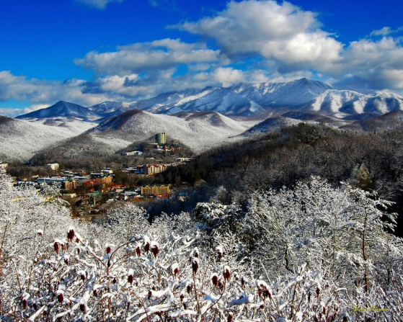
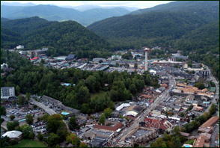

Image 13
Image 12

- Creating an inventory of past and present vista conditions for key vistas along Newfound Gap Road.

- Acknowledging the comments/concerns/values of Park visitors.
Collect, organize, and document written comments regarding vista conditions and vista management. Take these comments and concerns into consideration when making recommendations to management.

Example:

Review studies and surveys conducted that outline the activities/places tourist plan on visiting during their trip to national parks/Great Smoky Mountains National Park.

“Beyond the sheer enjoyment of scenery, a heightened aesthetic sensibility may have inspired in many a deeper understanding of, and concern for, the natural environment. This benefit defies quantification, but surely it has had consequences of immense values both for individuals and the nation”.
-Richard West Sellers in Preserving Nature in the National Parks (Sellars 1997)

Example:
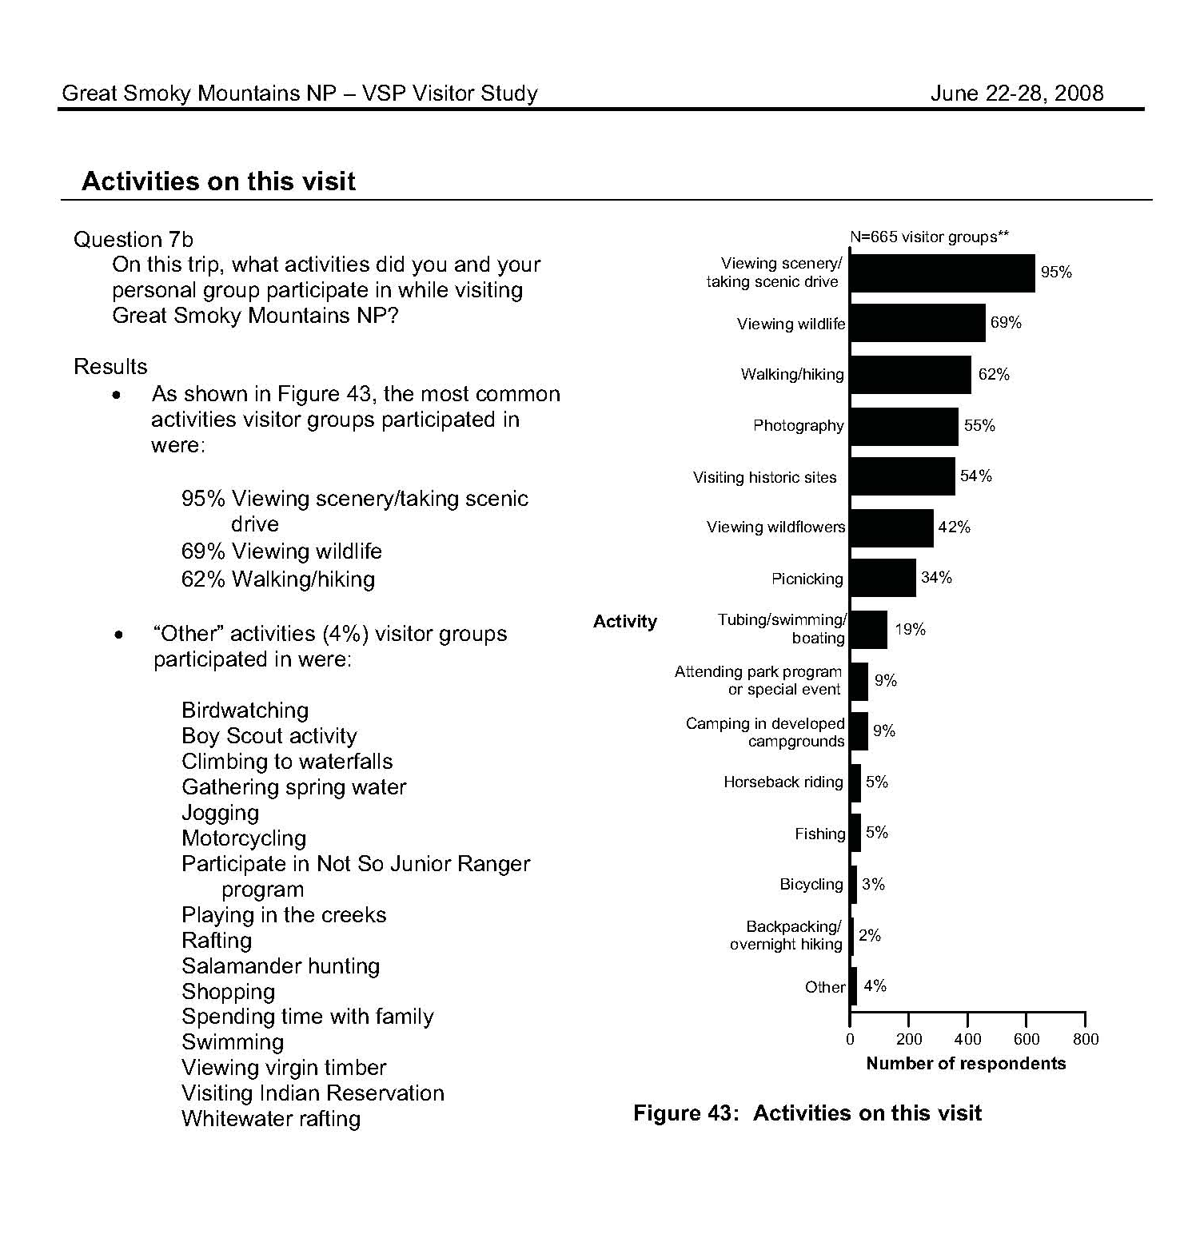

- Interview employees within multiple divisions of the Park.

Develop and conduct interviews with employees from a variety of management divisions within the Park. Questions should be formulated to address vista management and ecological/environmental impacts.

- Addressing current Park management goals and objectives as well as budget restrictions.
“The Interior Department would see a $715 million cut under a bill passed by the House Appropriations Committee on Tuesday. The National Park Service would see its construction budget cut 28 percent from $210 million to $152 million.
Craig Obey, senior vice president of government affairs, National Parks Conservation Association, said the National Park Service would see its $10 billion backlog of maintenance and construction projects worsen under the proposed budget. He said the Park Service would need an additional $350 million a year to keep up. ‘When you cut back on the amount of funds devoted to that activity you are digging that hole deeper,’ Obey said.
The overall funding levels are barely enough to fund the operation of parks, he said. The agency will use its construction funding to make repairs to a number of facilities, according to budget documents released by the Interior Department” (http://www.federaltimes.com/article/20110713/AGENCY01/107130305/).
“As it is, our national parks are failing to keep up with maintenance needs; the maintenance backlog is now nearly $11 billion. But that's not all. They are short on funding for staff and resources to operate parks--to the tune of more than $600 million each year! Our national parks are already making do with less--they simply can't afford additional cuts” (http://my.npca.org/site/MessageViewer?em_id=3561.0).
- Examining how air pollution impacts visibility within scenic vistas.

Examine research and monitoring studies conducted by Great Smoky Mountains National Park and other partnerships/agencies. It is essential to understand how haze can affect scenic views.

- Generating potential views for overgrown vistas to ensure that framed views, focal points, foreground, and background are enhanced and not compromised.

- Establishing a site specific maintenance schedule and vegetation clearing recommendation for each vista.
Research multiple vegetation clearing methods and establish guidelines for implementation. A mock vista management recommendation should be developed for each site, and then reviewed by management. Each mock plan should contain a location map, description, existing condition and proposed recommendation.

REFERENCES
Birnbaum, Charles A., and Mary V. Hughes. Design with Culture: Claiming America's Landscape Heritage.
Charlottesville: University of Virginia, 2005. Print.
Cart, Julie. “Yosemite’s overcrowded – with trees”. Los Angeles Times. July 30, 2011
http://articles.latimes.com/2011/jul/30/local/la-me-yosemite-trees-20110730
DeLaughter, Jerry. Smokies Road Guide. Gatlinburg, TN: Great Smoky Mountains Natural History
Association, 2004. Print.
Foresta, Ronald A. America's National Parks and Their Keepers. Washington, D.C.: Resources for the
Future, 1984. Print.
Gove, Doris. Newfound Gap Road Auto Tour. Great Smoky Mountains Association, 2008. Print.
Garder, John. “Take Action”. http://my.npca.org/site/MessageViewer?em_id=3561.0
Johnson, Nicole Blake. “Spending bill deals steep budget cuts to EPA, Interior”. July 2011.
http://www.federaltimes.com/article/20110713/AGENCY01/107130305/
Longstreth, Richard W. Cultural Landscapes: Balancing Nature and Heritage in Preservation Practice.
Minneapolis: University of Minnesota, 2008. Print.
Louter, David. Windshield Wilderness: Cars, Roads, and Nature in Washington's National Parks. Seattle:
University of Washington, 2006. Print.
National Park Service Website
http://www.nps.gov/grsm
http://www.nps.gov/yose
http://www.nps.gov/history/history/online_books/brochures/1941/grsm/sec1.htm
Sutter, Paul. Driven Wild: How the Fight against Automobiles Launched the Modern Wilderness
Movement. Seattle: University of Washington, 2002. Print.
Case Study Citations:
(1): Whisnant, Anne Mitchell. Super-Scenic Motorway: A Blue Ridge Parkway History. 2006. (pg. 14-15)
(2): Palmer, James F. Timothy R. Day, Richard C. Smardon, Tad Redway, and Lawrence Reichardt
Visual Preferences of Travelers Along the Blue Ridge Parkway State University of New York, Syracuse, New York (pg. 12).
(5): The National Park Service Website. January 5, 2012. http://www.nps.gov/blri/index.htm
(6): The National Park Service Website. January 5, 2012. http://www.nps.gov/blri/developed-areas-along-the-parkway.htm.
(7): Anderson, David. Chris Ulrey, and Bob Cherry. “Shifting the way we manage vistas –
Moving towards a resource and landscape management approach”. Blue Ridge Parkway. (pg. 1)

Image Library:
Image 1: http://www.lib.utk.edu/cic/smokymaps.html
Image 2: http://www.nps.gov/grsm/planyourvisit/nfg.htm
Image 3: http://www.nps.gov/grsm/planyourvisit/autotouring.htm
Image 4:
Image 4: http://blog.webshots.com/2009/06/
Image 5: http://www.nps.gov/history/history/online_books/brochures/1941/grsm/sec1.htm
Image 6:
Image 7:
Image 8:
Image 9:
Image 10: http://www.jstor.org/pss/4033564
Image 11: http://www.nps.gov/history/history/online_books/brochures/1941/grsm/images/map.pdf
Image 12: http://www.gatlinburg-mountainmall.com/
Image 13: http://smoky-moments.photoshelter.com/gallery-image/Great-Smoky
Mountains/G0000hm_mYNsdNLg/I0000.LJqARoreQM

