Estimates of Glacier Mass Loss and Contribution to Streamflow:
Wind River Range (Wyoming, USA)

A Thesis Presented for the
Master of Science
Degree
The University of Tennessee, Knoxville

Jeffrey Allen Marks
December 2012
ABSTRACT
The Wind River Range is a continuous mountain range approximately 160 km in length in west-central Wyoming. The Wind River Range is host to roughly 680 snow and ice bodies with 63 of these considered glaciers including seven of the ten largest glaciers in the American Rocky Mountains. The presence of glaciers results in meltwater contributions to streamflow during the late summer (July, August, and September – JAS) when snowmelt is decreasing, temperatures are high, precipitation is low, and irrigation demand continues. Most studies indicate that the glaciers in the Wind River Range have been retreating since the 1850’s, the approximate end of the Little Ice Age. Thus, the quantification of glacier meltwater (e.g., volume, mass) contributions to late-summer/early-fall streamflow is important given this resource is dwindling due to glacier recession.
The current research expands upon previous research efforts and identified two glaciated watersheds, one on the east slope (Bull Lake Creek) and one on the west slope (Green River) of the Wind River Range in which unimpaired streamflow is available from 1966 to 2006. Glaciers were delineated within each watershed and area estimates (with error) were obtained for the years 1966, 1989 and 2006. Glacier volume (mass) loss (with error) was estimated using empirically based volume-area scaling relationships. For 1966 to 2006, glacier mass contributions to JAS streamflow on the east slope were approximately 8% while on the west slope were approximately 2%. The volume-area scaling glacier mass estimates compared favorably with measured (stereo-pairs remote sensed data) estimates of glacier mass change for three glaciers (Teton, Middle Teton, Teepe) in the nearby Teton Range and one glacier (Dinwoody) in the Wind River Range. While glacier mass contribution to JAS streamflow was estimated at 8% (east slope) and 2% (west slope) from 1966 to 2006, an increase was observed during the period of 1989 to 2006 (>11% - east slope and >3% - west slope). Historic climate data, including precipitation (snowpack) and temperature (JAS average) showed a decrease in snowpack and rapid increase in temperatures during the 1989 to 2006 period, which most likely explains this increase in glacier melt.

TABLE OF CONTENTS

Introduction…………………………………………………………………………..……………1
Data……………………………………………………………………………………..…………4
Streamflow from Glaciated Watersheds………………………………………..…………4
Glacier Area……………………………………………………………………..………...6
Methods and Results………………………………………………………………………..……11
Methods……………………………………………………………………………..…....11
Results…………………………………………………………………………..………..12
Discussion and Conclusions…………………………………………………………………..…15
References Cited…………………………………………………………………………………19
Appendices……………………………………………………………………………………….24
Appendix A………………………………………………………………………………25
Appendix B………………………………………………………………………………28
Appendix C………………………………………………………………………………33
Appendix D………………………………………………………………………………35
VITA……………………………………………………………………………………………..41

INTRODUCTION
The Wind River Range is a continuous mountain range approximately 160 km in length in west-central Wyoming (Figure 1). The barrier (continental divide) serves as the dividing entity for three major river basins: Wind-Bighorn/Missouri/Mississippi, Green/Colorado, and the Snake/Columbia (Marston et al., 1991). The Wind River Range is host to roughly 680 snow and ice bodies with 63 of these considered glaciers including seven of the ten largest glaciers in the American Rocky Mountains (Bonney, 1987). The east slope of the divide contains roughly 77% of the total glacier area while the west slope contains the remaining area (Marston et al., 1991). Glaciers serve as valuable frozen, fresh water reservoirs, storing water in the winter and releasing it during the warmer summer months (Marston, 1989). The presence of glaciers results in meltwater contributions to streamflow during the late summer months (July, August and September – JAS) when snowmelt is decreasing, temperatures are still high, precipitation is generally low, and irrigation demand continues (Fountain and Tangborn 1985; Pochop et al., 1990). Thus, watersheds with glaciers are shown to provide a more stable source of water than non-glaciated watersheds (Ferguson, 1973; Fountain and Tangborn, 1985; Braithwaite and Olsen, 1988). Glaciers also affect the annual hydrograph by delaying seasonal runoff through internal storage of liquid water, resulting from snow melt, for release later in the year. The melt water from these glaciers is thought to be important during the warmer summer and fall months to supplement flows needed for irrigation, fisheries and the fulfillment of interstate water compacts. Most studies (e.g., Dyson, 1952; Mears, 1972; Meier, 1951) indicate that the glaciers in the Wind River Range have been retreating since the 1850’s, the approximate end of the Little Ice Age (Marston et. al., 1991). Thus, the quantification of glacier meltwater (e.g., volume, mass) contributions to late-summer/early-fall streamflow is important given this resource is dwindling due to glacier recession.
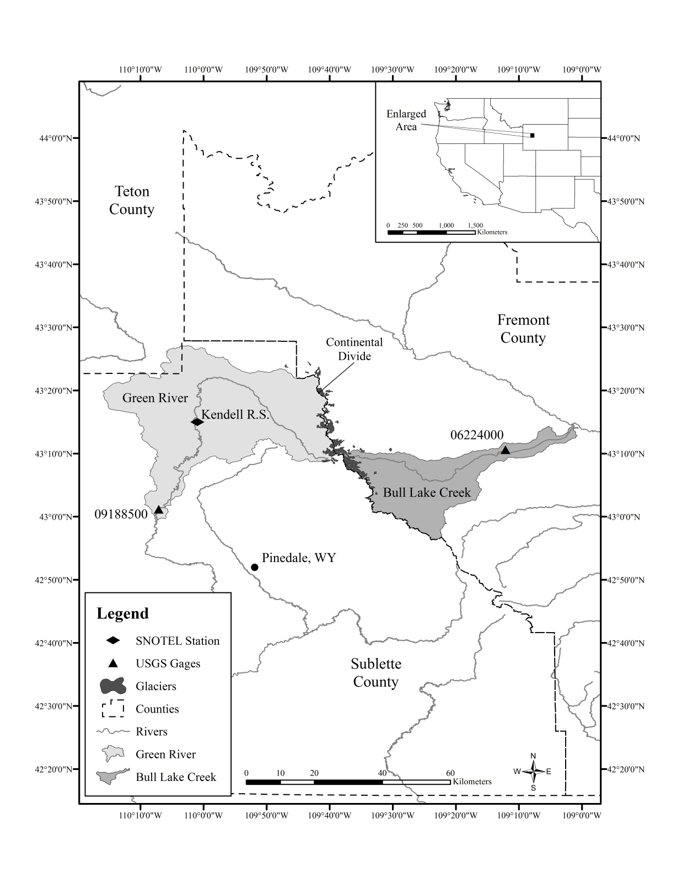
Figure 1: Location map of watersheds (Bull Lake Creek and Green River), SNOTEL stations, and USGS streamflow gages
Mark F. Meier was the first person to study the glaciers around Gannett and Fremont Peak within the Wind River Range in 1950. His study reported the surface area of Dinwoody Glacier to be approximately 3.47 km² (Meier, 1951). Consequently, later studies by Marston et al. (1989) and Wolken (2000) determined the area to be 2.91 km² and 2.19 km² respectively. Along with the analysis of glacier surface ice, Marston et al. (1991) utilized aerial photography stereo-pairs to determine Dinwoody Glacier lost 0.064 km³ of water equivalent between 1958 and 1983. Wolken (2000) updated the volume loss values using aerial photography stereo-pairs from 1983 to 1994, which determined Dinwoody Glacier lost an additional 0.043 km³. Cheesbrough (2007) again updated these volume loss estimates for Dinwoody Glacier using aerial photography stereo-pairs from 1983 to 2001, which determined Dinwoody Glacier 0.060 km³. Cheesbrough et al. (2009) studied area changes for 42 glaciers in the Wind River Range using Landsat imagery (30 meter resolution) from 1985 to 2005 which showed an average loss of surface area of approximately 25%. Thompson et al. (2011) studied area changes for 44 glaciers in the Wind River Range using aerial photographs (1 meter resolution) from 1966 to 2006 which showed an average loss of surface area of approximately 38%. Bell et al. (2012) identified two glaciated and two non-glaciated watersheds in the Wind River Range and, using a paired watershed approach, examined how glaciers influence late-summer/early-fall (July-August-September) streamflow. Bell et al. (2012) determined the influence of glaciers accounted for 23–54% of the late summer (JAS) flow in glaciated watersheds. The majority of the increased flow was because of the glaciers decelerating the snowmelt runoff through internal storage/delayed release of liquid water. The glaciated watersheds provided a more stable source of streamflow because they displayed less year-to-year streamflow variability.
Thompson (2009) estimated that the percentage of July-August-September streamflow contributed by Wind River Range glacier melt varied from 2.9 to 12.4% from 1989 to 2006. This was based on volume-area scaling relationships developed by Bahr et al. (1997). However, the focus of Thompson (2009) was to assess glacier area change, and, thus, a more definitive study is required to estimate glacier volume contributions (with error) to July-August-September streamflow in the Wind River Range.
The current research expands upon previous research efforts and identified two glaciated watersheds, one on the east slope (Bull Lake Creek) and one on the west slope (Green River) of the Wind River Range in which unimpaired streamflow is available from 1966 to 2006. Glaciers were delineated within each watershed and area estimates (with error) were obtained for the years 1966, 1989 and 2006 (Thompson 2009; Thompson et al., 2011). Glacier volume (mass) loss (with error) was estimated using the volume-area scaling relationships developed by Bahr et al. (1997). These results were then compared to measured glacier mass loss using stereo-pairs and remote sensed data for glaciers in the neighboring Teton Range (Wyoming) and Dinwoody Glacier (Wind River Range, Wyoming). The percentage of glacier mass contribution (with error) to July-August-September streamflow was estimated for three periods: 1966 to 1989, 1989 to 2006, and 1966 to 2006, and, the variability of the glacier mass contributions over these periods was explained through precipitation (snowpack) and temperature datasets.

DATA

Streamflow from Glaciated Watersheds
An unimpaired stream gage station is defined as a station with minimal effects of anthropogenic uses including storage, diversion, and consumptive use. Unimpaired stations were identified using the Hydro-Climatic Data Network (HCDN) (Slack et al., 1993; Wallis et al., 1991). United States Geological Survey (USGS) stream gage information was obtained for all stream gages in this study from the National Water Information System – NWIS (2012).
Although there are many gages recording streamflow from both slopes of the Wind River Range, it was difficult to find unimpaired stations with continuous data from glaciated watersheds (Bell et al., 2012; Barnett et al., 2010; Watson et al., 2009). The gage stations were evaluated to meet the stated criteria above and two stations were selected: West Slope – USGS Station #09188500: Green River at Warren Bridge near Daniel, WY (hereon referred to as Green River) and, East Slope – USGS Station #06224000 Bull Lake Creek above Bull Lake, WY (heron referred to as Bull Lake Creek). The Green River watershed has a drainage area of 1,212 square kilometers while the Bull Lake Creek watershed has a drainage area of 484 square kilometers. The majority of glacier melt and contribution to streamflow occurs during the late-summer / early-fall season (July-August-September) (Bell et al., 2012). Thus, this is the season of interest in the current research.
For the period of record of 1967 to 2006, the Green River gage station was missing data for the 1993 water year (October 1992 to September of 1993). To estimate streamflow for the missing water year (1993), a value of 93% of the average streamflow for the available years was used. This was determined by:
- Bell et al. (2012) established climatic similarity between the Green River and Bull Lake Creek watersheds.
- The correlation of yearly (1966 to 1992 and 1994 to 2006) Green River and Bull Lake Creek July-August-September or JAS (glacier meltwater season) streamflow was 0.95.
- The 1992 JAS streamflow for Bull Lake Creek was 93% of the long term average.
For each gage, the average monthly discharge data in cubic feet per second (cfs) was converted to volume (cubic meters). This was accomplished by taking the monthly runoff in cfs and multiplying * 60 seconds/minute * 60 minutes/hour * 24 hours/day * the number of days in the month of interest (30 or 31) * 0.0283 cubic meters/cubic feet (Table 1, Appendix A).
Table 1: Total streamflow (JAS) (m³ x 10⁶).
Watershed | 1967-1989 | 1990-2006 | 1967-2006
Green River | 3,689 | 2,237 | 5,926
Bull Lake Creek | 2,625 | 1,702 | 4,327

Glacier Area
Thompson et al (2011) evaluated area change for forty-four glaciers in the Wind River Range using aerial photography (Table 2, Appendix B). Aerial photos were used due to their extremely high resolution (approximately one-meter), allowing both large and small glaciers to be examined thoroughly. The aerial photographs for this research were taken during the late summer/early fall months when snowpack has disappeared and the glacier terminus is clearly visible. Per Thompson et al (2011):
- The aerial photos were obtained from the Wyoming Geographic Information Science Center (WyGisc) in Laramie, WY and the University of Wyoming Geology Library in Laramie, WY. The images include aerial photographs for the years of 1966, 1989 and 2006.
- The geo-referencing process involved assigning spatial coordinates to each non-referenced photo. Unknown spatial coordinates were estimated by digitally registering the 1966 and 1989 photos to the 2001 Fremont County compressed county mosaic (CCM) aerial photo (which was used as the “base”) to enable calculation of area change between years. All photos were geo-referenced to the Universal Transverse Mercator (UTM) zone 12 coordinate system and are tied to the North American Datum 1983 (NAD83) units. The scanned image was projected using a two to four polynomial transformation and nearest neighbor, re-sampling until the root mean square error (RMSE) of the control points equaled 0.1 or less.
- Once RMSE was calculated for each individual geo-referenced paper photo, the RMSE was summed together with the base photo’s (2001 CCM) state average RMSE of 2.50 m. For 1966 photos, this resulted in an average RMSE of 2.57 pixels (2.57 m) and for 1989, an average RMSE of 2.55 pixels (2.55 m) was calculated. The 2006 Fremont county mosaic was pre-digitized by the United States Department of Agriculture (USDA) with a calculated RMSE value of 4.19 pixels (4.19 m).
- Glaciers were identified and digitized by their glacier ice boundary, ice extents and stagnant ice (ice physically separated from the main glacier body). After all 44 glaciers were digitized, the surface area was calculated using the ArcGIS calculate area geometry function.
- The methods used for digitization and delineation of glacier boundaries as well as, the calculation of area are relatively straightforward, however positional and interpreter errors are potential uncertainties that are still present. Geo-referencing area error was estimated using a method developed from Hall et al. (2003). The total error for each individual glacier’s surface area was calculated from Debeer and Sharp (2007).
For the current research it is assumed the glacier aerial photos were taken in early October. These assumptions were made such that Table 1 could be developed and reflect the estimated total JAS streamflow for time periods in between when the aerial photos were taken. For example, we will assume the 1966 aerial photo is taken after September 30, 1966 and the 1989 aerial photo is taken after September 30, 1989. Thus, the total JAS streamflow in between the aerial photo dates would be 1967 thru 1989 (per Table 1). Similarly, we will assume the 1989 aerial photo is taken after September 30, 1989 and the 2006 aerial photo is taken after September 30, 2006. Thus, the total JAS streamflow in between the aerial photo dates would be 1990 thru 2006 (per Table 1). The total JAS streamflow from 1966 to 2006 would be the sum of these two, or, the total JAS streamflow for 1967 thru 2006 (per Table 1). While the aerial photographs were likely taken during August or September, this assumption simplifies the estimate of glacier meltwater as a percentage of JAS total streamflow and, given the long periods of record (23, 17 and 40 years), the small portion of streamflow was negligible.
The Green River and Bull Lake Creek watersheds were delineated and glaciers in each watershed (per Thompson et al., 2011) were identified (Figure 2). For the Green River watershed, eight glaciers were identified and for the Bull Lake Creek watershed, 12 glaciers were identified (Table 2). For the Green River watershed, glacier area within the watershed was approximately 7.5, 6.5 and 4.8 square kilometers in 1966, 1989 and 2006, respectively. For the Bull Lake Creek watershed, glacier area within the watershed was approximately 14.7, 11.9 and 8.0 square kilometers in 1966, 1989 and 2006, respectively. 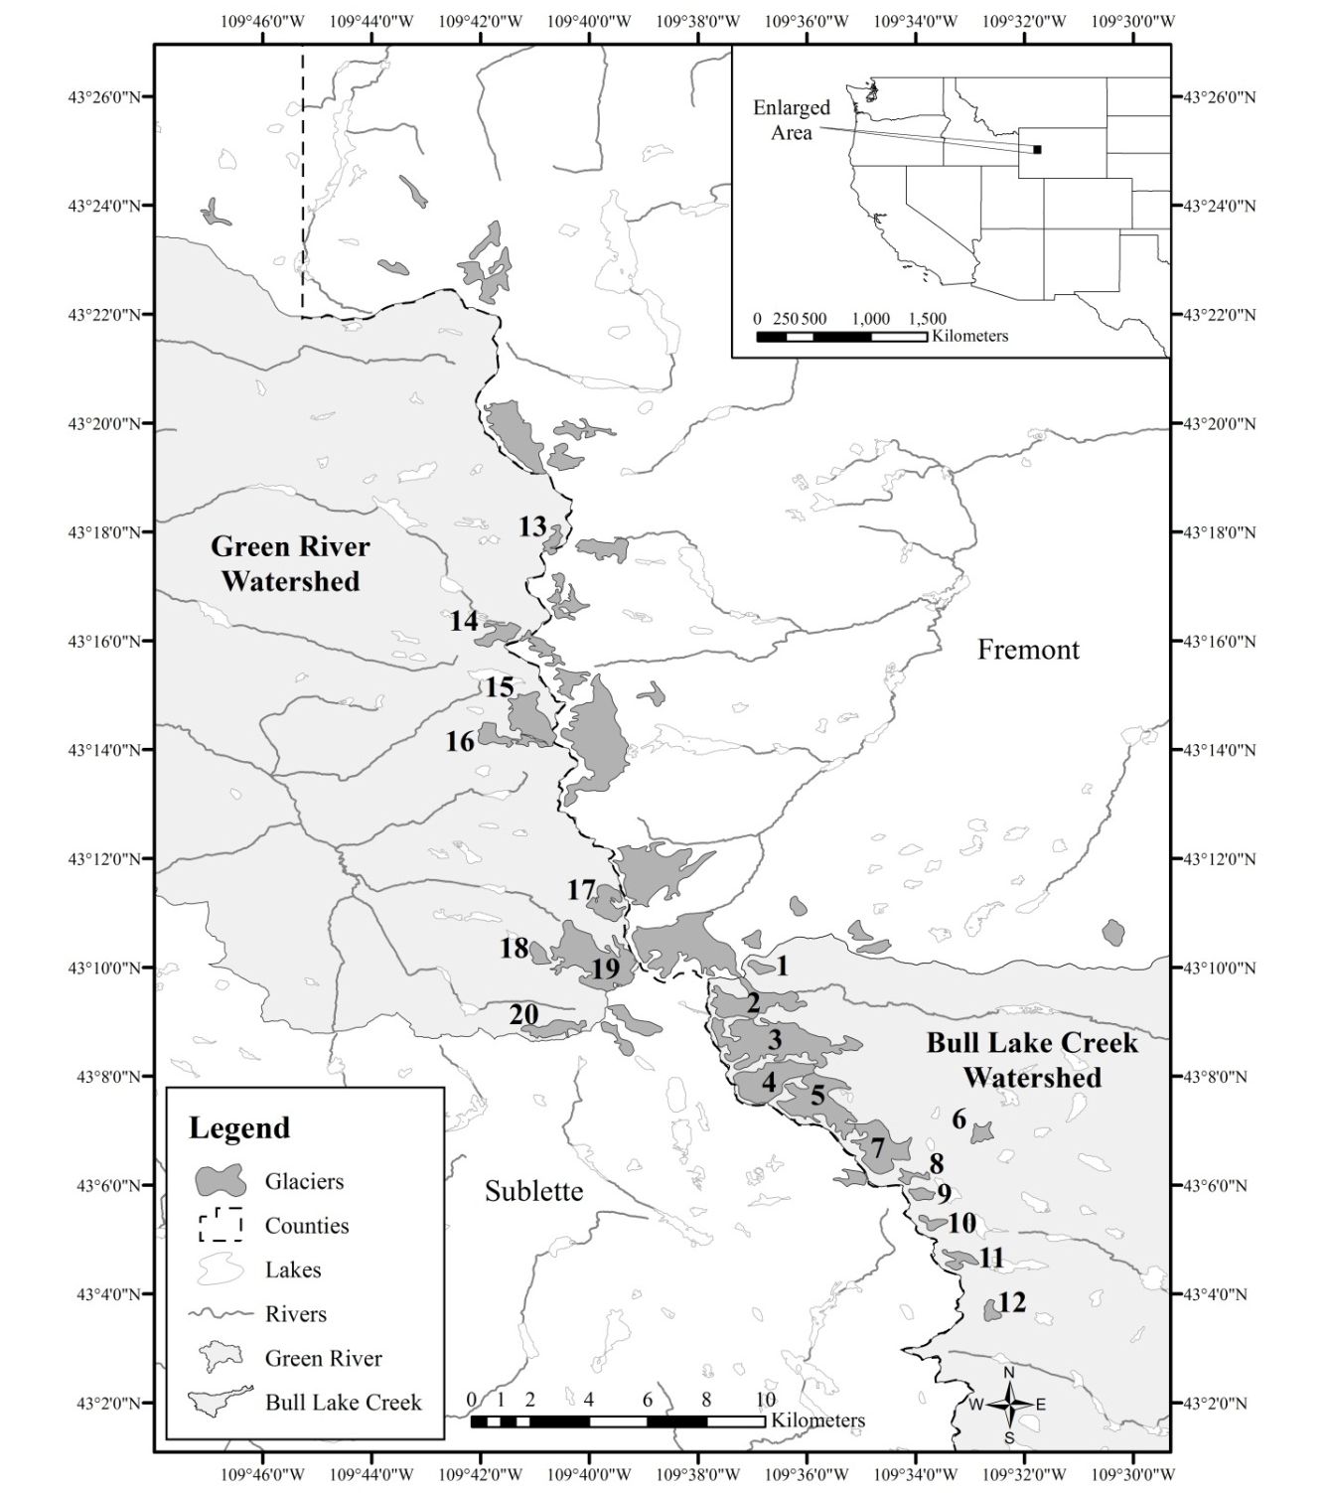
Figure 2: Location map of 20 glaciers (ID provided) in the Wind River Range
Table 2: Glacier ID, watershed, glacier name and glacier area (km²) with error for 1966, 1989 and 2006 (from Thompson et al., 2011).
 |  |  | Glacier Surface Area (km²)
Glacier ID | Watershed | Glacier Names | 1966 | 1989 | 2006
13 | GR | NN | 0.351 ± 0.046 | 0.244 ± 0.000 | 0.127 ± 0.004
14 | GR | Connie Glacier | 0.532 ± 0.011 | 0.510 ± 0.002 | 0.332 ± 0.003
15 | GR | Sourdough Glacier | 1.274 ± 0.018 | 1.139 ± 0.006 | 0.922 ± 0.001
16 | GR | J Glacier | 0.676 ± 0.053 | 0.506 ± 0.004 | 0.344 ± 0.004
17 | GR | Minor Glacier | 0.720 ± 0.008 | 0.629 ± 0.005 | 0.425 ± 0.004
18 | GR | Baby Glacier | 0.326 ± 0.002 | 0.287 ± 0.028 | 0.221 ± 0.004
19 | GR | Mammoth Glacier | 2.959 ± 0.064 | 2.558 ± 0.007 | 2.028 ± 0.015
20 | GR | Stroud Glacier | 0.638 ± 0.041 | 0.599 ± 0.036 | 0.409 ± 0.007
1 | BLC | NN | 0.154 ± 0.003 | 0.195 ± 0.003 | 0.147 ± 0.003
2 | BLC | Helen Glacier | 1.393 ± 0.040 | 1.494 ± 0.025 | 1.075 ± 0.046
3 | BLC | Sacagawea Glacier | 3.351 ± 0.143 | 3.150 ± 0.002 | 2.046 ± 0.030
4 | BLC | Upper Fremont | 2.233 ± 0.199 | 1.904 ± 0.014 | 1.306 ± 0.006
5 | BLC | Bull Lake Glacier | 3.195 ± 0.107 | 2.312 ± 0.080 | 1.716 ± 0.051
6 | BLC | NN | 0.277 ± 0.009 | 0.193 ± 0.007 | 0.174 ± 0.005
7 | BLC | Knife Point Glacier | 1.874 ± 0.009 | 1.317 ± 0.031 | 0.790 ± 0.004
8 | BLC | NN | 0.440 ± 0.007 | 0.394 ± 0.027 | 0.142 ± 0.004
9 | BLC | NN | 0.365 ± 0.004 | 0.232 ± 0.007 | 0.181 ± 0.003
Table 2. Continued.
 |  |  | Glacier Surface Area (km²)
Glacier ID | Watershed | Glacier Names | 1966 | 1989 | 2006
10 | BLC | NN | 0.399 ± 0.018 | 0.193 ± 0.016 | 0.177 ± 0.004
11 | BLC | NN | 0.778 ± 0.046 | 0.369 ± 0.011 | 0.176 ± 0.007
12 | BLC | NN | 0.225 ± 0.014 | 0.167 ± 0.009 | 0.095 ± 0.001

METHODS AND RESULTS
Methods
Several methods are available to estimate glacier volume based on glacier area (volume-area scaling relationships). It should be noted that volume-area scaling relationships are most accurate when applied to glaciers that are in equilibrium with climate. Given the Wind River Range glaciers are in recession, this may impact the estimate of glacier mass (see Discussion and Conclusions). These volume-area scaling methods determined that glacier volumes (V expressed in m³) and areas (A expressed in m²) could be related by a power law expressed as:
$V=αA^{β}$ (1)
Chen and Ohmura (1990) derived α and β by analyzing 63 glaciers having known areas and volumes using topographic surveys and radio-echo soundings in North America, Europe and Asia. They derived α (0.120) and β (1.396) by using a regression analysis on an area versus volume plot of the glaciers. Driedger and Kennard (1986) used similar methods as Chen and Ohmura (1990) but focused more on examining the relationship between glacier flow and geometry of 25 glaciers in Washington and the Oregon Cascades. They found their relationship was most appropriate for small alpine glaciers less than 2.6 km long when using α (3.93) and β (1.124).
A method presented by Bahr et al. (1997) was selected because of its ability to reasonably estimate smaller glacier volumes (Granshaw and Fountain, 2006). The Bahr et al. (1997) method is based on the width, slope, side drag and mass balance of 144 glaciers located in Europe, North America, central Asia and the Arctic (Bahr et al., 1997). Bahr et al. (1997) then tested the parameters against the known volumes (calculated with radio echo soundings) and the areas of each individual glacier. Bahr et al. (1997) empirically derived α and β from a regression analysis plot. Based on units, there are several variations of this equation:
α = 0.226 when Area (A) is input as m² and the resulting Volume (V) is in m³
α = 32.7 when Area (A) is input as km² and the resulting Volume (V) is in million m³
α = 0.033 when Area (A) is input as km² and the resulting Volume (V) is in km³
β = 1.36 for all variations based on the Bahr regression analysis plot
For the current research, glacier area (with error) is provided for each glacier in the Green River watershed and the Bull Lake Creek watershed for 1966, 1989 and 2006 (Thompson et al., 2011). Thus, the volume of each glacier (with error) was calculated for 1966, 1989 and 2006 using the Bahr equation. To determine the glacier mass loss, three periods were selected (1966 to 1989, 1989 to 2006 and 1966 to 2006).
Results
Utilizing the glacier surface areas with error (Table 2), we can estimate the volume of each glacier in 1966, 1989 and 2006 using the Bahr equation, and, by subtracting the 2006 volume estimated from the 1966 volume estimate, we can estimate the volume (mass) of glacier loss from 1966 to 2006. This is repeated for the period of 1966 to 1989 and 1989 to 2006.
For example, to determine the volume loss for single glacier (Mammoth Glacier) in the Green River watershed from 1966 to 2006, we first determine the volume of Mammoth Glacier in 1966. For 1966, three volume calculations are performed using the estimated average glacier area (2.959 km²), the estimated maximum glacier area (2.959 + 0.064 = 3.023 km²), and the estimated minimum glacier area (2.959 – 0.064 = 2.895 km²). Using Bahr, this resulted in 142.8, 147.1 and 138.7 m³ x 10⁶, respectively. For 2006, three volume calculations are performed using the estimated average glacier area (2.028 km²), the estimated maximum glacier area (2.028 + 0.015 = 2.043 km²), and the estimated minimum glacier area (2.028 – 0.015 = 2.0.13 km²). Using Bahr, this resulted in 85.5, 86.3 and 84.6 m³ x 10⁶, respectively (Table 3, Appendix C).
Table 3: Glacier ID, watershed, glacier name and average, maximum and minimum glacier volume estimates (per Bahr et al., 1997) in m³ x 10⁶.

 |  |  | Average/Maximum/Minimum Glacier Volume (m³ x 10⁶)
Glacier ID | Watershed | Glacier Names | 1966 | 1989 | 2006
13 | GR | NN | 7.9/9.3/6.5 | 4.8/4.8/4.8 | 2.0/2.1/1.9
14 | GR | Connie Glacier | 13.8/14.2/13.5 | 13.1/13.1/13.0 | 7.3/7.4/7.2
15 | GR | Sourdough Glacier | 45.4/46.3/44.5 | 39.0/39.3/38.7 | 29.3/29.3/29.2
16 | GR | J Glacier | 19.2/21.3/17.2 | 12.9/13.1/12.8 | 7.7/7.8/7.5
17 | GR | Minor Glacier | 20.9/21.2/20.6 | 17.4/17.6/17.2 | 10.2/10.3/10.1
18 | GR | Baby Glacier | 7.1/7.2/7.1 | 6.0/6.8/5.2 | 4.2/4.3/4.1
19 | GR | Mammoth Glacier | 142.8/147.1/138.7 | 117.2/117.6/116.7 | 85.5/86.3/84.6
20 | GR | Stroud Glacier | 17.7/19.3/16.2 | 16.3/17.6/15.0 | 9.7/9.9/9.5
1 | BLC | NN | 2.6/2.6/2.5 | 3.5/3.6/3.5 | 2.4/2.5/2.3
Table 3. Continued.
 |  |  | Average/Maximum/Minimum Glacier Volume (m³ x 10⁶)
Glacier ID | Watershed | Glacier Names | 1966 | 1989 | 2006
2 | BLC | Helen Glacier | 51.3/53.3/49.3 | 56.4/57.7/55.1 | 36.0/38.2/34.0
3 | BLC | Sacagawea Glacier | 169.2/179.1/159.4 | 155.5/155.7/155.4 | 86.5/88.2/84.8
4 | BLC | Upper Fremont | 97.4/109.4/85.8 | 78.4/79.2/77.6 | 47.0/47.3/46.7
5 | BLC | Bull Lake Glacier | 158.6/165.8/151.4 | 102.1/107/97.3 | 68.1/70.9/65.3
6 | BLC | NN | 5.7/6.0/5.4 | 3.5/3.7/3.3 | 3.0/3.1/2.9
7 | BLC | Knife Point Glacier | 76.7/77.3/76.2 | 47.5/49.0/46.0 | 23.7/23.9/23.5
8 | BLC | NN | 10.7/10.9/10.5 | 9.2/10.1/8.4 | 2.3/2.4/2.2
9 | BLC | NN | 8.3/8.4/8.2 | 4.5/4.7/4.3 | 3.2/3.3/3.1
10 | BLC | NN | 9.4/9.9/8.8 | 3.5/3.9/3.1 | 3.1/3.2/3.0
11 | BLC | NN | 23.2/25.1/21.4 | 8.4/8.8/8.1 | 3.1/3.2/2.9
12 | BLC | NN | 4.3/4.7/3.9 | 2.9/3.1/2.7 | 1.3/1.3/1.3

To determine the estimated volume loss (with error), three volumes were calculated. First, the 2006 average volume (85.5 m³ x 10⁶) was subtracted from the 1966 average volume (142.8 m³ x 10⁶) which resulted in 57.3 m³ x 10⁶. Next, the 2006 minimum volume (84.6 m³ x 10⁶) was subtracted from the 1966 maximum volume (147.1 m³ x 10⁶) which resulted in 63.1 m³ x 10⁶. Finally, the 2006 maximum volume (86.3 m³ x 10⁶) is subtracted from the 1966 minimum volume (138.7 m³ x 10⁶) which resulted in 52.4 m³ x 10⁶. Thus, for Mammoth Glacier, the estimated glacier volume (mass) loss ranged from 52.4 m³ x 10⁶ to 63.1 m³ x 10⁶ with an average loss of 57.3 m³ x 10⁶. This was repeated for each glacier in the Green River and Bull Lake Creek watersheds and the total volume (mass) for the average, maximum and minimum were summed for each glacier, for each period (Table 4, Appendix C). These values were then divided by the total JAS streamflow (see Table 1) for each watershed, for each period to determine the percentage of glacier volume (mass) contributing to streamflow.
Table 4: Watershed, average, maximum and minimum total glacier volume estimates (m³ x 10⁶) for 1966-1989, 1989-2006 and 1996-2006, and percentage of JAS streamflow.

 |  | Estimated Glacier Volume (m³ x 10⁶) and percentage of JAS streamflow
Watershed | Avg, Mx, Min | 1966-1989 | 1989-2006 | 1966-2006
GR | Average | 48.3(1.3%) | 70.9 (3.2%) | 119.2 (2.0%)
GR | Maximum | 62.4 (1.7%) | 75.8 (3.4%) | 131.8 (2.2%)
GR | Minimum | 34.3 (0.9%) | 66.1 (3.0%) | 106.8 (1.8%)
BLC | Average | 141.8 (5.4%) | 195.7 (11.5%) | 337.6 (7.8%)
BLC | Maximum | 187.7 (7.2%) | 214.2 (12.6%) | 380.4 (8.8%)
BLC | Minimum | 96.5 (3.7%) | 177.3 (10.4%) | 295.4 (6.8%)

DISCUSSION AND CONCLUSIONS
There are several interesting observations with regards to JAS streamflow and the influence of glaciers. Referring to Table 1, for the various periods of record, the JAS streamflow for the Bull Lake Creek watershed was 71% to 76% of the JAS streamflow for the Green River watershed. However, the Bull Lake Creek watershed area (484 km²) is smaller (approximately 40%) than the Green River watershed area (1,212 km²) and both watersheds experience similar climatic influences (Bell et al., 2012). This is likely explained by the higher percentage of glacier coverage in Bull Lake Creek (1966 – 3.0% and 2006 – 1.7%) when compared to Green River (1966 – 0.6% and 2006 – 0.4%) (Table 2). Bell et al (2012) observed that the impacts of glaciers on local streamflows during JAS were shown to be much greater than glacier melt alone and glaciers accounted for 23% to 54% of the late summer (JAS) flow in glaciated watersheds due to the glaciers decelerating the snowmelt runoff through internal storage/delayed release of liquid water. When comparing annual streamflow, the Bull Lake Creek watershed annual streamflow was 58% of the Green River watershed annual streamflow. Thus, the annual streamflow comparison was more in line with the watershed area scaling relationship (40%).
Referring to Table 4, the contribution (percentage) of glacier volume (mass) was greatest during the 1989 to 2006 period for both watersheds. Historic records of observed precipitation (snowpack) and temperature were investigated (Appendix D). The Natural Resource Conservation Service (NRCS) maintains an extensive data collection system (SNOwpack TELemetry or SNOTEL) in the western United States in which snowpack (Snow Water Equivalent – SWE) is collected (NRCS, 2012). The Kendall R.S. station, located in the Green River watershed (Figure 1) was selected and has been utilized in previous research efforts (Aziz et al., 2010; Hunter et al., 2006). April 1st snow water equivalent, which typically represents the peak snowpack accumulation, was accessed and yearly values were plotted with a 10-year filter (10-year running average) (Figure 3). The United States Historical Climatology Network (USHCN) is a high-quality data set of daily and monthly records of basic meteorological variables from 1218 observing stations across the 48 contiguous United States (USHCN, 2012; Easterling et al., 1996). Monthly data were accessed from Pinedale, Wyoming (Figure 1) and yearly JAS average temperatures were calculated and plotted with a 10-year filter (10-year running average) (Figure 3). The increased contribution of glacier mass from 1989 to 2006 is most likely associated with rapid JAS temperature increases and lower snowpack when compared to historical averages (Figure 3). Edmunds et al. (2012) observed similar temperature and snowpack patterns in the Teton Range (Wyoming), located approximately 150 kilometers from the Wind River Range.
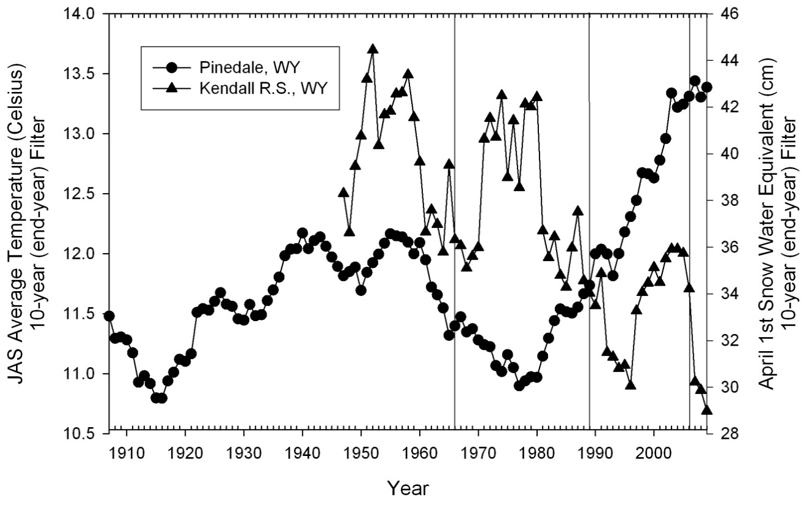
Figure 3: April 1st Snow Water Equivalent (cm) from the Kendall R.S. (Wyoming) SNOTEL station and JAS average temperatures (Celsius) from Pinedale (Wyoming). A 10-year filter was applied to each dataset.

When referring to Table 4, glacier mass contributions to JAS streamflow was approximately 2% for the Green River watershed and 8% for the Bull Lake Creek watershed. As previously discussed, this difference is most likely attributed to increased glacier coverage in the Bull Lake Creek watershed. The Bahr equation has been found to be most effective when glaciers are in equilibrium with climate. Obviously, this is not the case with Wind River Range glaciers as they are in a state of recession. Edmunds et al. (2012) utilized stereo-pairs and remote sensed data to measure ice (glacier) mass loss in the Teton Range. Three glaciers (Teton, Middle Teton and Teepe) were evaluated and it was estimated that these glaciers lost 3.2 x 10⁶ m³ (+/- 0.46 x 10⁶ m³) from 1967 to 2002. Glacier area data (with error) was obtained for the three glaciers for 1967 and 2002. This data was input into the Bahr equation to estimate glacier mass loss for comparison. Using the Bahr equation, these glaciers lost 2.8 x 10⁶ m³ (+/- 0.43 x 10⁶ m³) from 1967 to 2002. Thus, the Bahr equation slightly (about 88%) underestimated glacier mass loss when compared to measured values. Cheesbrough (2007) utilized similar techniques (stereo-pairs and remote sensed data) to measure ice (glacier) mass loss for Dinwoody glacier in the Wind River Range for 1983 to 2001. It was estimated that 60 x 10⁶ m³ of glacier mass was lost from 1983 to 2001. Using the Bahr equation, it was estimated that 50 x 10⁶ m³ of glacier mass was lost from 1983 to 2001 (Cheesbrough et al., 2009). Thus, a similar slight underestimation of glacier mass loss was observed. Based on these comparisons, it was concluded that the Bahr equation provides an adequate estimate of mass loss in Wind River Range glaciers, despite the glaciers being in recession.

References Cited
REFERENCES
Aziz, O. A., G. A. Tootle, S. T. Gray, and T. C. Piechota. (2010). Identification of Pacific Ocean sea surface temperature influences of Upper Colorado River Basin snowpack. Water Resources Research, 46:W07536.
Bahr, D., Meier, M., and Peckman, S. (1997) “The physical basis of glacier volume area scaling.” J. Geophys. Res. 102, 20, 355-362.
Barnett, F. A., Gray, S., and Tootle, G. (2010). “Upper green river basin (united states) streamflow reconstructions.” J. Hydrol. Eng., 15(7), 567-579.
Bell, J., G. Tootle, G. Kerr, L. Pochop and R. Sivanpillai, (2012). Glacier Impacts on Summer Streamflow in the Wind River Range, Wyoming, USA. American Society of Civil Engineers Journal of Hydrologic Engineering, 17(4):521-527.
Bonney, L. G. (1987). Wyoming mountain ranges. Wyoming geographic series No. 1, American Geographic Publishing, Helena, MT, 104.
Braithwaite, R. J., and Olesen, O. B.. (1988). “Effect of glaciers on annual run-off, Johan Dahl Land, South Greenland.” J. Glaciol., 34(117), 200-207.
Cheesbrough, K., J. Edmunds, G. Tootle, G. Kerr and L. Pochop. (2009). Estimated Wind River Range (Wyoming, USA) Glacier Melt Water Contributions to Agriculture. Remote Sensing, 2009, 1(4):818-828.
Cheesbrough, K. S.. (2007). “Glacial recession in Wyoming’s Wind River Range.” M.S. thesis, Univ. of Wyoming, Laramie, WY.
Chen, J. and A. Ohmura. (1990). Estimation of alpine glacier water resources and their change since the 1870s. In Lang, H. and A. Musy, eds. Hydrology in Mountainous Regions I: Hydrological Measurements; the Water Cycle. Wallingford, Oxon., International Association of Hydrological Sciences, 127– 135. (IAHS Publication 193.)
DeBeer, C. M., and Sharp, M. (2007). “Recent changes in glacier area and volume within the southern Canadian Cordillera.” Ann. Glaciol., 46, 215-221.
Driedger, C.L. and P.M. Kennard. (1986). Ice volumes on Cascade volcanoes: Mount Rainier, Mount Hood, Three Sisters, and Mount Shasta. USGS Prof. Pap. 1365.
Dyson, J.L. (1952). Glaciers of the American Rocky Mountains: Triennial rep., Committee on Glaciers, American Geophysical Union and American Geographical Society, New York, 1950-1952.
Easterling, D. R., T. R. Karl, E.H. Mason, P. Y. Hughes, and D. P. Bowman. 1996. United States Historical Climatology Network (U.S. HCN) Monthly Temperature and Precipitation Data. ORNL/CDIAC-87, NDP-019/R3. Carbon Dioxide Information Analysis Center, Oak Ridge National Laboratory, U.S. Department of Energy, Oak Ridge, Tennessee.
Edmunds, J., G. Tootle, G. Kerr, R. Sivanpillai and L. Pochop, 2012. Glacier Variability (1967-2006) in the Teton Range, Wyoming, USA. Journal of the American Water Resources Association, 48(1):187-196.
Ferguson, R. I. (1973). “Sinuosity of supraglacial streams.” Geol. Soc. Am. Bull., 84, 251-255.
Fountain, A. G., and Tangborn, W. V. (1985). “The effect of glaciers on streamflow variations.” Water Resour. Res., 21(4), 579-586.
Granshaw, F. D., and Fountain, A. G. (2006). “Glacier change (1958-1998) in the north cascades national park complex. Washington USA.” J. Glaciol., 52(177), 251-256.
Hall, D. K., Bayr, K., Bindschadler, R. A., and Chien, Y. L. (2003). “Consideration of the errors inherent in mapping historical glacier positions in Austria from ground and space (1893-2001).” Remote Sens. Environ., 86, 566-577.
Hunter, T., Tootle, G.A., and T.C. Piechota, 2006. Oceanic-atmospheric variability and western U.S. snowfall. Geophysical Research Letters, 33(13):L13706.
Martson, R. A., Pochop, L. O., Kerr, G. L., and Varuska, M. L. (1989). “Recent trends in glaciers and glacier runoff, wind river range, Wyoming.” Headwaters Hydrologic, W W. Woessner, and D. F. Potts, eds., American Water Resources Association, Bethesda, MD, 159-169.
Martson, R. A., Pochop, L. O., Kerr, G. L., Varuska, M. L., and Veryzer, D. J. (1991) “Recent glacier changes in the wind river range, Wyoming.” Phys. Georg., 12(2), 115-123.
Mears, B., Jr. (1972). Wyoming’s glaciers, past and present. Wyoming Game and Fish Commission, Laramie, WY.
Meier, M. F. (1951). “Glaciers of the gannett peak-fremont peak area, Wyoming.” M.S. thesis, State of Univ. of Iowa, Iowa City, IA.
Natural Resources Conservation Service (NRCS). (2012). “SNOTEL data and products.” <http://www.wcc.nrcs.usda.gov/snotel/> (Sept. 2012)
Oubeidillah, A.A., G.A. Tootle, C. Moser, T. Piechota and K. Lamb, 2011. Upper Colorado River and Great Basin Streamflow and Snowpack Forecasting using Pacific Oceanic-Atmospheric Variability. Journal of Hydrology, 410(3-4):169-177.
Pochop, L. O., Martson, R. A., Kerr, G. L., Veryzer, D. J., and Jacobel, R. (1990). “Glacial icemelt in the wind river range, Wyoming.” Watershed Planning and Analysis in Action, American Society of Civil Engineers, Durango, CO, 118-124.
Slack, J. R., Lumb, A., and Landwehr, J. M. (1993). “Hydro-climatic data network (HCDN) streamflow data set, 1874-1998. (CD-ROM).” U.S> Geological Survey, Reston, VA.
Thompson, D., G. Tootle, G. Kerr, R. Sivanpillai and L. Pochop, 2011. Glacier Variability in the Wind River Range, Wyoming, USA. American Society of Civil Engineers Journal of Hydrologic Engineering, 16(10):798-805.
Thompson, D. (2009). “Glacier variability in the Wind River Range, Wyoming, U.S.A.” M.S. thesis, Dept. of Civil and Architectural Engineering, Univ. of Wyoming, Laramie, WY.
United States Historical Climatology Network (USHCN). (2012). “Long-term daily and monthly climate records from stations across the contiguous United States.” <http://cdiac.ornl.gov/epubs/ndp/ushcn/ushcn.html> (Sept. 2012)
Wallis, J. R., Lettenmaier, D. P., and Wood, E. F. (1991). “A daily hydro-climatical data set for the continental United States.” Water Resour. Res., 27(7), 1657-1663.
Watson, T., Barnett, F. A., Gray, S., and Tootle, G. (2009). “Reconstructed streamflow for the headwaters of the wind river, Wyoming USA.” J. Am. Water Resour. Assoc., 45(1), 224-236.
Wolken, G. J. (2000). “Energy balance and spatial distribution of net radiation on dinwoody glacier, wind river range, Wyoming, USA.” M.S. thesis, Dept. of Geography and Recreation, Univ. of Wyoming Laramie, WY.

Appendices
Appendix A

Streamflow Data (cfs) for Green River at Warren Bridge near Daniel, WY. Please note, the “blue” identifiers in September 1966, 1989 and 2006 represent the approximate time the USGS aerial photographs of the glaciers were taken.
Website: http://waterdata.usgs.gov/nwis/monthly/?referred_module=sw&site_no=09188500&por_09188500_7=802361,00060,7,1931-10,2011-10&format=html_table&date_format=YYYY-MM-DD&rdb_compression=file&submitted_form=parameter_selection_list

Total flow (cubic meters) for July-August-September (JAS):

Streamflow Data (cfs) for Bull Lake Creek above Bull Lake, WY. Please note, the “blue” identifiers in September 1966, 1989 and 2006 represent the approximate time the USGS aerial photographs of the glaciers were taken.
Website: http://waterdata.usgs.gov/nwis/monthly/?referred_module=sw&site_no=06224000&por_06224000_1=801584,00060,1,1941-10,2012-05&format=html_table&date_format=YYYY-MM-DD&rdb_compression=file&submitted_form=parameter_selection_list

Appendix B
From Thompson et al (2011):
- Figure identifying 44 glaciers in which area was estimated using aerial photographs for 1966, 1989, and 2006
- Glacier information
- Glacier area with error
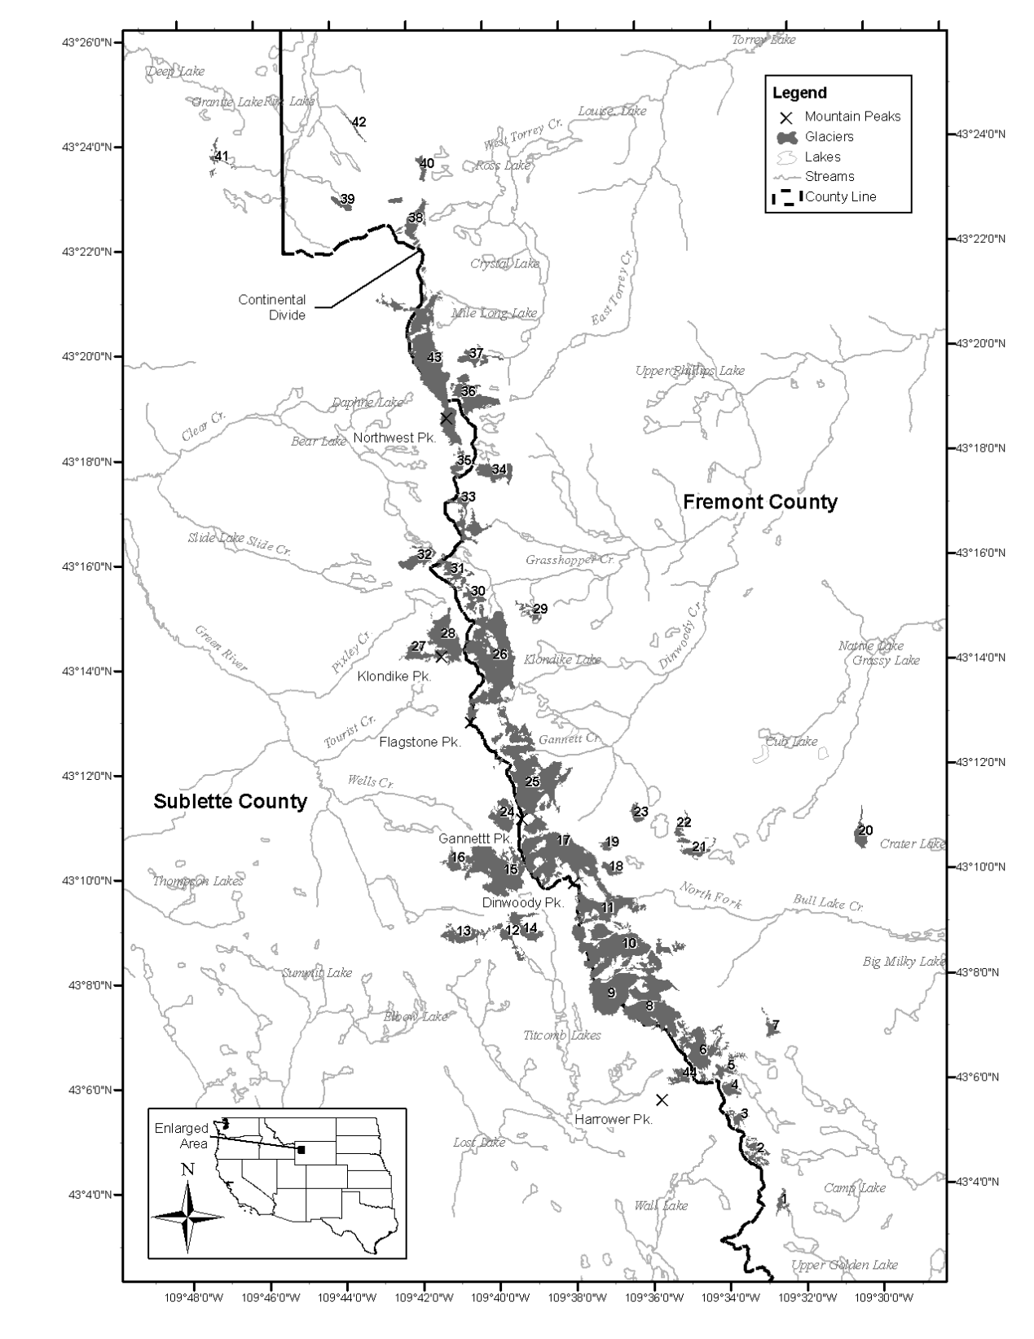
(a)

 |  |  |  |  |  | Elevation (m)
Site ID | Glacier Names | Latitude | Longitude | Aspect (°) | Slope (%) | Min | Max | Mean
1 | NN | 43.0613 | -109.5441 | 144.9 | 17.1 | 3545 | 3724 | 3629
2 | NN | 43.0758 | -109.5546 | 115.1 | 26.8 | 3349 | 3917 | 3658
3 | NN | 43.0865 | -109.5648 | 148.3 | 36.2 | 3508 | 3899 | 3717
4 | NN | 43.0965 | -109.5678 | 119.9 | 33.5 | 3550 | 3895 | 3728
5 | NN | 43.1029 | -109.5710 | 138.5 | 28.3 | 3481 | 3945 | 3756
6 | Knife Point Glacier | 43.1117 | -109.5797 | 109.0 | 22.3 | 3359 | 3947 | 3592
7 | NN | 43.1165 | -109.5478 | 93.8 | 28.6 | 3403 | 3867 | 3560
8 | Bull Lake Glacier | 43.1225 | -109.5995 | 122.7 | 24.9 | 3507 | 4118 | 3789
9 | Upper Fremont | 43.1314 | -109.6143 | 120.6 | 17.7 | 3676 | 4178 | 3966
10 | Sacagawea Glacier | 43.1439 | -109.6124 | 114.4 | 19.6 | 3397 | 4125 | 3716
11 | Helen Glacier | 43.1566 | -109.6192 | 103.8 | 23.2 | 3418 | 4147 | 3712
12 | NN | 43.1451 | -109.6593 | 124.3 | 21.1 | 3417 | 3848 | 3590
13 | Stroud Glacier | 43.1481 | -109.6788 | 132.1 | 28.8 | 3425 | 3910 | 3610
14 | Twins Glacier | 43.1499 | -109.6532 | 89.2 | 22.5 | 3345 | 3838 | 3557
15 | Mammoth Glacier | 43.1684 | -109.6671 | 188.3 | 19.1 | 3386 | 4016 | 3680
16 | Baby Glacier | 43.1704 | -109.6843 | 176.0 | 28.3 | 3423 | 3908 | 3609
17 | Dinwoody Glacier | 43.1716 | -109.6385 | 146.8 | 22.3 | 3390 | 4147 | 3687
18 | NN | 43.1671 | -109.6154 | 97.4 | 23.3 | 3742 | 4017 | 3829
19 | Heap Steep Glacier | 43.1749 | -109.6179 | 69.1 | 36.5 | 3459 | 3959 | 3656
20 | NN | 43.1780 | -109.5070 | 77.3 | 16.6 | 3508 | 3761 | 3669
21 | NN | 43.1720 | -109.5799 | 130.4 | 29.7 | 3509 | 3953 | 3728
22 | NN | 43.1776 | -109.5851 | 91.1 | 29.7 | 3667 | 4012 | 3757
23 | NN | 43.1849 | -109.6059 | 125.7 | 17.0 | 3803 | 4000 | 3862
24 | Minor Glacier | 43.1856 | -109.6626 | 205.0 | 24.8 | 3495 | 4054 | 3696
25 | Gannett Glacier | 43.1992 | -109.6520 | 102.0 | 21.2 | 3343 | 4199 | 3768
26 | Grasshopper Glacier | 43.2355 | -109.6659 | 130.8 | 14.6 | 3345 | 4087 | 3704
27 | J Glacier | 43.2368 | -109.6945 | 198.4 | 26.0 | 3532 | 3991 | 3771
28 | Sourdough Glacier | 43.2430 | -109.6865 | 167.0 | 16.8 | 3581 | 3942 | 3691
29 | NN | 43.2500 | -109.6490 | 79.0 | 28.1 | 3432 | 3734 | 3612
30 | NN | 43.2543 | -109.6747 | 63.5 | 23.6 | 3378 | 3754 | 3559
31 | NN | 43.2635 | -109.6832 | 118.9 | 15.2 | 3502 | 3898 | 3766
32 | Connie Glacier | 43.2682 | -109.6972 | 150.1 | 24.2 | 3522 | 3884 | 3708
33 | NN | 43.2823 | -109.6791 | 132.1 | 18.4 | 3472 | 3975 | 3772
34 | Downs Glacier | 43.2959 | -109.6645 | 90.1 | 23.6 | 3392 | 3937 | 3677
35 | NN | 43.2983 | -109.6809 | 185.3 | 26.2 | 3646 | 3943 | 3812
36 | NN | 43.3196 | -109.6727 | 96.1 | 18.7 | 3545 | 4027 | 3742
37 | NN | 43.3304 | -109.6712 | 65.3 | 28.0 | 3298 | 3875 | 3696
38 | NN | 43.3755 | -109.6986 | 88.5 | 11.1 | 3568 | 3757 | 3658
39 | NN | 43.3808 | -109.7282 | 157.7 | 13.2 | 3509 | 3637 | 3600
40 | NN | 43.3919 | -109.6939 | 94.4 | 4.7 | 3560 | 3597 | 3573
41 | NN | 43.3949 | -109.7831 | 80.2 | 23.4 | 3276 | 3524 | 3422
42 | NN | 43.4062 | -109.7227 | 259.2 | 13.9 | 3244 | 3487 | 3363
43 | Continental Glacier | 43.3313 | -109.6903 | 97.3 | 12.7 | 3291 | 4028 | 3814
44 | Harrower Glacier | 43.1015 | -109.5889 | 225.6 | 23.2 | 3496 | 3794 | 3634

(b)

 |  | Glacier Surface Area (km²)
Site ID | Glacier Names | 1966 | 1989 | 2006
1 | NN | 0.225 ± 0.014 | 0.167 ± 0.009 | 0.095 ± 0.001
2 | NN | 0.778 ± 0.046 | 0.369 ± 0.011 | 0.176 ± 0.007
3 | NN | 0.399 ± 0.018 | 0.193 ± 0.016 | 0.177 ± 0.004
4 | NN | 0.365 ± 0.004 | 0.232 ± 0.007 | 0.181 ± 0.003
5 | NN | 0.440 ± 0.007 | 0.394 ± 0.027 | 0.142 ± 0.004
6 | Knife Point Glacier | 1.874 ± 0.009 | 1.317 ± 0.031 | 0.790 ± 0.004
7 | NN | 0.277 ± 0.009 | 0.193 ± 0.007 | 0.174 ± 0.005
8 | Bull Lake Glacier | 3.195 ± 0.107 | 2.312 ± 0.080 | 1.716 ± 0.051
9 | Upper Fremont | 2.233 ± 0.199 | 1.904 ± 0.014 | 1.306 ± 0.006
10 | Sacagawea Glacier | 3.351 ± 0.143 | 3.150 ± 0.002 | 2.046 ± 0.030
11 | Helen Glacier | 1.393 ± 0.040 | 1.494 ± 0.025 | 1.075 ± 0.046
12 | NN | 0.295 ± 0.001 | 0.246 ± 0.008 | 0.142 ± 0.003
13 | Stroud Glacier | 0.638 ± 0.041 | 0.599 ± 0.036 | 0.409 ± 0.007
14 | Twins Glacier | 0.553 ± 0.007 | 0.535 ± 0.039 | 0.385 ± 0.009
15 | Mammoth Glacier | 2.959 ± 0.064 | 2.558 ± 0.007 | 2.028 ± 0.015
16 | Baby Glacier | 0.326 ± 0.002 | 0.287 ± 0.028 | 0.221 ± 0.004
17 | Dinwoody Glacier | 3.453 ± 0.147 | 2.920 ± 0.052 | 2.474 ± 0.054
18 | NN | 0.154 ± 0.003 | 0.195 ± 0.003 | 0.147 ± 0.003
19 | Heap Steep Glacier | 0.212 ± 0.003 | 0.137 ± 0.007 | 0.109 ± 0.002
20 | NN | 0.390 ± 0.001 | 0.347 ± 0.004 | 0.286 ± 0.005
21 | NN | 0.359 ± 0.018 | 0.286 ± 0.088 | 0.133 ± 0.010
22 | NN | 0.271 ± 0.010 | 0.234 ± 0.005 | 0.0986 ± 0.001
23 | NN | 0.269 ± 0.003 | 0.189 ± 0.001 | 0.159 ± 0.003
24 | Minor Glacier | 0.720 ± 0.008 | 0.629 ± 0.005 | 0.425 ± 0.004
25 | Gannett Glacier | 4.801 ± 0.149 | 3.957 ± 0.029 | 3.270 ± 0.025
26 | Grasshopper Glacier | 3.927 ± 0.064 | 3.558 ± 0.051 | 2.480 ± 0.026
27 | J Glacier | 0.676 ± 0.053 | 0.506 ± 0.004 | 0.344 ± 0.004
28 | Sourdough Glacier | 1.274 ± 0.018 | 1.139 ± 0.006 | 0.922 ± 0.001
29 | NN | 0.218 ± 0.002 | 0.200 ± 0.005 | 0.087 ± 0.003
30 | NN | 0.296 ± 0.009 | 0.334 ± 0.001 | 0.286 ± 0.005
31 | NN | 0.582 ± 0.024 | 0.527 ± 0.008 | 0.275 ± 0.016
32 | Connie Glacier | 0.532 ± 0.011 | 0.510 ± 0.002 | 0.332 ± 0.003
33 | NN | 1.037 ± 0.082 | 0.701 ± 0.000 | 0.442 ± 0.003
34 | Downs Glacier | 0.620 ± 0.028 | 0.598 ± 0.003 | 0.518 ± 0.003
35 | NN | 0.351 ± 0.046 | 0.244 ± 0.000 | 0.127 ± 0.004
36 | NN | 0.950 ± 0.020 | 1.033 ± 0.002 | 0.770 ± 0.011
37 | NN | 0.382 ± 0.000 | 0.373 ± 0.003 | 0.246 ± 0.000
38 | NN | 0.604 ± 0.014 | 0.659 ± 0.001 | 0.389 ± 0.008
39 | NN | 0.205 ± 0.000 | 0.181 ± 0.002 | 0.146 ± 0.000
40 | NN | 0.147 ± 0.006 | 0.165 ± 0.000 | 0.010 ± 0.000
41 | NN | 0.252 ± 0.097 | 0.165 ± 0.006 | 0.051 ± 0.001
42 | NN | 0.093 ± 0.017 | 0.070 ± 0.000 | 0.039 ± 0.001
43 | Continental Glacier | 3.501 ± 0.039 | 3.630 ± 0.011 | 2.671 ± 0.009
44 | Harrower Glacier | 0.306 ± 0.003 | 0.275 ± 0.004 | 0.141 ± 0.002
 | Total | 45.9 ± 1.6 | 39.7 ± 0.7 | 28.5 ± 0.4

(c)

Appendix C
- Green River watershed estimates of glacier mass using Bahr equation.
- Bull Lake Creek watershed estimates of glacier mass using Bahr equation.
(a)

(b)
Appendix D
- SNOTEL data for Kendall, R.S. site in Wyoming, USA
- Monthly temperature for Pinedale, Wyoming

(a)

(b)
VITA
Jeffrey Allen Marks is currently a graduate student at The University of Tennessee. Upon graduating from The University of Tennessee with a Bachelor of Science in Civil Engineering spring 2011, he was immediately presented the opportunity to further his education by working towards a Master of Science in Environmental Engineering with a concentration in Water Resources working as a Graduate Research Assistant for Dr. Glenn Tootle at The University of Tennessee. During summer 2012, he was selected by his graduate advisor, Dr. Glenn Tootle, to be Dr. Tootle’s teaching assistant for a study abroad course in Innsbruck, Austria. The three week study abroad program titled, “Climate and Climate Change Impacts in the European Alps,” focused on glacier mass contributions to streamflow and the use of dendrochronology (tree rings) in water resources. Jeffrey has attended professional conferences in San Francisco, CA, Las Vegas, NV, and New Orleans, LA. He currently holds his Engineer in Training (EIT) Certificate and has plans to receive his Professional Engineering (PE) License in three years. Jeffrey’s professional interests include the research, design, and implementation of environmental friendly solutions to the many water resource challenges that our world presents.

